UNIVERSITY OF OKLAHOMA
GRADUATE COLLEGE

SEMIOTIC ANALYSIS OF IDOLIC COMMUNICATION AT THE CORE OF THE OKLAHOMA CITY MEMORIAL MUSEUM

A THESIS
SUBMITTED TO THE GRADUATE FACULTY
in partial fulfillment of the requirements for the
Degree of
MASTER OF ARTS

By
ANTONIO GUARDADO
Norman, Oklahoma
2022
SEMIOTIC ANALYSIS OF IDOLIC COMMUNICATION AT THE CORE OF THE OKLAHOMA CITY MEMORIAL MUSEUM

A THESIS APPROVED FOR THE
DEPARTMENT OF COMMUNICATION

BY THE COMMITTEE CONSISTING OF

Dr. Eric Kramer, Chair

Dr. Elaine Hsieh

Dr. Justin Reedy

© Copyright by ANTONIO GUARDADO 2022
All Rights Reserved.
Table of Contents
Introduction……………………………………………………………………………………1
Theory…………………………………………………………………………………………1
Literature Review………………………………………………………………………………5
- Narrative Manipulation…………………………………………………………8
  - General vs Individual…………………………………………………...8
  - Political…………………………………………………………………9
  - Manipulation for Resilience…………………………………………..10
  - Narrative for Melancholy……………………………………………..11
Methods……………………………………………………………………………………….13
Oklahoma City Memorial Museum & Community…………………………………………..17
- History…………………………………………………………………..……17
- Community Importance………………………………………………………19
Analysis……………………………………………………………………………….………20
- Entrance………………………………………………………………….……20
- Audio Room…………………………………………………..……….………21
- Pillars Room……………………………………………..……………………22
- Bombing…………………………………………………………….…………22
- Exit Room……………………………………………………..………………23
- Analysis……………………………………………………..…………………23
  - Space………………………………………………..…………………24
  - Time……………………………………………..……………………36
  - Death………………………………………………….………………45
  - Tragic Entertainment…………………………………………………54
- Magic & Dissociation…………………………………………………………59
Conclusion……………………………………………………………………………………64
References………………………………………………………………………….…………66
Appendixes……………………………………………………………………………………80

Abstract
Traumatic events leave generational scars in communities around the world. In Oklahoma City, the bombing of the Alfred P. Murrah Federal Building on April 19, 1995 left deep scars. The community then banded together to create a memorial museum in honor of the victims. Many years later, the community still grieves the lives lost. The purpose of this thesis is to take a look at the trauma and magic found inside the Oklahoma City Memorial Museum utilizing semiotics and the dimensional accrual dissociation theory in an attempt to understand the signification of traumatic signs.

Semiotic analysis of idolic communication at the core of the Oklahoma City memorial museum
The inherent assumption behind the building of most memorial museums is that they positively impact their communities and that most intend to help communities remember and honor those lost in tragedies and thus aid in the healing process. Museums are considered guides for society to reflect and learn from the past, not to repeat history. They are the centers of a negotiated historical narrative (Radonić, 2017 & Sommer-Sieghart, 2006). Well, that can only be true if they properly tell the narrative.
When a memorial fails to tell the narrative in a manner that supports healing, it becomes a collection of artifacts at best. At worst, a memorial can harm a community that is supposed to heal. In such cases, a narrative may arise that repeatedly re-opens the wound. To make matters worse, new community members that visit said memorial run the risk of being wounded or emotionally scarred even though they were not present for the original incident.
This is the unfortunate case for the Oklahoma City Memorial Museum (OKCMM). The narrative from the OKCMM traumatizes and retraumatizes the community. With melancholia at its core, the OKCMM narrative can transport visitors through space and time and have them live the traumatic moments again.
Theory
The theoretical background used for this research is Eric Kramer's Dimensional Accrual and Dissociation theory, also known as DAD theory. This theory dictates that people can have different communication behaviors unbound by a single universal trait. In Kramer's own words, "The theory of dissociation and dimensional accrual explains the variety of communicative behaviors that have been widely observed and reported by initiating the explanation at the fundamental levels of space and time" (Kramer & Ikeda, 1998, p. 37). Jafri (2003) adds to this by stating “Since in cultures with dominant magic/idolic dimension there is a complete identity between the members and the identity is not bound by space or time, members are not only inescapably responsible to their immediate family members for the repercussions of their acts but also responsible to their ancestors and progeny for what they do.” This is due to the connection that exists between the individual and everyone else in the community. With no separation between life and death, the ancestors are always present. Kramer (1997) describes it as magic is “filled with vital force or energy such as mana, karma, or chi. Everything is alive ... the world is full of life or ‘spirit,’ one must be very careful about what one does.” With space and time not being separated, the magic dimension allows for behaviors and phenomenon not seen elsewhere. Furthermore, the theory defines categories of space and time with their corresponding behavioral traits and the identity accrual side effects.
Kramer utilizes two philosophies as the groundwork for this theory. On the one hand, the works of Jean Gebser (1949/1984) explored the "relationship between culture, communication, and synthetic constitutionality…[as well as how] Cultural differences explain the variety of spatial and temporal behaviors experienced around the world and across historical change" (Kramer & Ikeda, 1998, p. 40). Gebser's line of research followed the philosophy of the Kantian constitutive process. Said process that uses a "top-down cosmos allow[ing] for multiple histories that depend on various observers' positions in time" (Kramer, 2013, p. 165). On the other hand, Lewis Mumford (1934) presented the concept of dissociation. "The term dissociation is used to describe a state of affairs whereby a phenomenon observed, and the subjective observer becomes increasingly and mutually 'objectified,' separated, fragmentary" (Kramer & Ikeda, 1988, p. 42). This dissociation makes people move away from the traditional natural and magical world that societies long ago believed in and brings them into the modern world with abstract models trying to predict the natural world. Worth (2003) sees it as “The mythic form of communication, the symbol, is shown to be more dissociated than the magic, but less than the mental-rational. Mythic communication is ambivalent because it is both dissociative compared to the magic, but associative compared to the mental-rational.” For his work on dissociation, Mumford uses a bottom-up philosophy. "Bottom-up cosmology presumes a single objective history that is observer-independent, progressing away from…unknown initial boundary conditions at the "beginning of time" (Kramer, 2013, p. 165).
When combined, Kramer sought to take the logical best from both philosophies/processes used by Gebser and Mumford. Instead of having a single, absolute observer or multiple perspectives of the same phenomena, Kramer argues "[t]hat there is a third integrative modality whereby a single observer perceives multiple histories at once" (Kramer, 2013, p. 165). A single individual is capable of experiencing different perspectives from a single phenomenon depending on the level of dissociation its cultural relationship has between space and time. For example, an individual from Ecuador may constantly be cutting their hair to keep cool from the intense heat felt in the region. Meanwhile, an individual from some of the Native American/Indigenous tribes and nations in the United States would not dare to cut their hair as it represents an extension of their soul and can only cut it when mourning the death of a loved one. The phenomenon is a simple haircut, but the level of dissociation of what it represents in a particular time and space differs for each culture.
Gebser claims, "Three different world orientations are proposed in an attempt to explain the variety of human behaviors people exhibit" (Kramer & Ikeda, 1998, p. 43). They are Magic, Mythic, and Perspectival. Borrowing these terminologies, "the theory of dimensional accrual/dissociation states that as one moves from the magic univalent to the mythic bivalent, and the perspectival trivalent worlds, dimensional awareness accrues or increases" (Kim, 2002, p. 115). Nevertheless, the movements do not mean that one is better than the other or that there is progress between the movements. "So-called 'previous' orientations, like the Magic and the mythic, are not 'displaced' or 'surpassed' (these being perspectival spatial concepts). No linear progressivism (positivism) is presupposed. Rather, all 'previous' orientations are present in more complex ones" (Kramer & Ikeda, 1998, p. 43).
For the research presented here, the world orientation focused on is Magic. The one-dimensional worldview of Magic is what could be considered the strings that hold together the most basic and pure essences of culture and society. Before Magic existed, the zero-dimensional Archaic worldview entailed pure instinctual primitive behaviors. Once humanity starts to impose its will upon nature and tries to make sense of the phenomena around it, that is when Magic begins. "The magic worldview manifestly exhibits an idolic incantatory mode of communication that is identically univalent. This means that, to the magic person, the statue of god is god" (Kramer, 2012, p. 145). As such, humanity has sacred places belonging to its culture. Religious people in the modern world would probably not bat an eye at demolishing an old, abandoned building to construct a mall, but if that person identifies with one of the many Christian-based religions, never in a million years would they consider doing the most negligible damage to any of the structures found in Temple Mount [sacred area in Jerusalem]. Igiel (2014) says that “In the magic worldview, harmony and stability is preferred at the expense of change. The one-dimensional structure bestows magic objects with great power to influence people through their emotional qualities” (p. 31). Hence, the divine is not in a special place somewhere else, it is here with the people and always intervening. The choices that people make are not going to determine rewards or punishments in the future, they will happen immediately.
The core of Magic is not just religion. There is no separation of the self from the other. Both the physical and the spiritual worlds are the same. A natural relationship exists between all living and non-living things as a robust emotional identification that expands beyond space and time. In this sense, incantations and names [language in general] have immense inherent power for using the name of something to invoke its presence. To call upon one's ancestors is to spiritually and physically have them appear and intervene in the world. To curse at someone invokes the evil spoken to befall that person and the non-living thing. "Magic people feel a strong obligation toward others, including other animistic 'objects' 'in' the world" (Kramer, 2013, p. 163). An extension of this power of language is that, combined with the human tendency of storytelling, it allows others to profoundly share experiences, wisdom, and emotions as if they have gone through the same events. "Hence, a veteran of the U.S./Viet Nam conflict can share with me his experiences in the 1960's Saigon, a nurse can take me into a Halloween night emergency room, or my neighbor can offer me an understanding of what it means to work on commission" (Kramer, 2013, p. 128). Still, this is only when a Magic worldview is present. "As dimensions accrue, dissociation increases, emotional intensity and identification decreases, and so change becomes less traumatic" (Kramer, 2013, p. 127). The opposite can also be valid since the person can move up and down the dimensions.
Literature Review
A memorial museum provides multiple services to a community and comprises two building identities: museum and memorial. A museum is an institution that collects, maintains, and displays artifacts from human history so that future generations can appreciate and learn from them. A memorial is a place, not necessarily a building, designed to pay tribute and honor the memory of people or events. A memorial does not need to have authentic artifacts to honor, nor does it try to teach future generations. It is there to remember that person, group, or event. Combined into a memorial museum, they become much more.
Initially, the first memorial museums were with a specific purpose. It was a term for Holocaust remembrance institutions outside Germany (Radonić, 2017). For example, the United States Holocaust Memorial Museum and the Yad Vashem of Jerusalem are considered the original memorial museums. As people became highly enamored with how these new institutions combined both styles, it became the archetypical method for many other museums (Köhr, 2007). As with the growth of popularity, the new style of memorial museums became a transgenerational beacon that honors those lost and guides the surrounding communities toward a better future. However, this future is only possible if the narrative portrayed in the memorial museum is designed to do so.
M. Sommer-Sieghart (2006) addressed the concept of narrative inside museums and exhibitions, "Museums and exhibitions are therefore by no means neutral spaces for imparting and popularizing knowledge that show what 'it' was like in the past; rather, what is shown manifest cultural patterns, mechanisms of inclusion and exclusion and - in social science terms - social, ethnic ones or religious in and out-groups."
How the building is structured is also part of the narrative. It is a combination of "confrontation therapy" with "cathartic theater" (Zibart, 1994). When talking about the United States Holocaust Memorial Museum, Bukiet (1993) echoes this idea when describing the interaction between the visitors and the building. "The architecture and exhibits spoke volumes about the people who built them (the "Rememberers"), but precious little about wartime realities. To make matters worse, such structures might exacerbate the problem of denial and contribute to the nation's cultural amnesia." The erected frame of the buildings helps the narrative by forcing visitors to interact with the exhibitions and their placement inside them.
The items of an exhibition, whether original articles of the event or items made by the institution (such as flyers, posters, and other literature), are inherently symbols that connect the audience to the traumatic event represented. Freud (1961) mentions that people are obsessed with the past and makes a metaphor by comparing the obsession with the ruins of a great city. Stewart (2020) adds by saying, "We seem to have a talent for imbuing ruins with meaning, yet those meanings remind us that the material is the empty ground of meaning, where meaning stops or has not yet started—and that there is little, if any, intrinsic relation between what signs are made of and what they have to say." Stewart later added, "As we respond to ruins, we transform materiality into ideas, learning something about the value of human making and the place of our made world within the natural world." In other words, both Freud and Stewart believe that humans will take something, materialistic or not, and give it an added meaning by relating it to some memory from the past. This phenomenon is true from something small such as a seashell picked up the first time someone went to the sea to the literal ruins of the last building standing in Hiroshima after the nuclear bomb dropped on the city. In Germany, schools take students on tours of what used to be concentration camps, and they study the history and the buildings as relics of times gone. Hence, the items inside the memorial are a type of ruin that acquire new meaning. They are no longer remains of what used to be, but now they are also a valuable connection to the past, portals to a different time.
Narrative Manipulation
General vs. Individual Manipulation.
Combined, the building, the items, and the cultural patterns make up the narrative inside a memorial museum. Given the nature of all the components, the narrative falls under two options: General and Individual. The general narrative shows the event as a single unit. It focuses on telling the event's story and refers to people in the third person. For example, when talking about the victims of a large earthquake, the narrative would use terms such as the victims, the injured, and the unfortunate ones, among others. All speak about a group or the event as an entity. A significant benefit of this narrative style is how the trauma behind the horrible event softens. Visitors of the memorial museum would learn and experience the event in a third-person, distant observer position, which lowers the risk of second-hand trauma. A drawback is a void that consumes details about the heroes, victims, or even villains.
On the other hand, the individual narrative does speak of the group or event, but it also takes time to focus on particular individuals involved. The individual narrative (using the same example of an earthquake) would dedicate a section of the memorial museum to highlight Mr. John Smith, the lead rescuer, or Ms. Theresa Williams, a God-fearing mother of two who perished saving her co-workers. Focusing on the individual allows the visitor to participate in the event. They become part of the community, so it no longer seems like learning about something that happened to some strangers at a distant place, but it becomes learning about an event that happened to neighbors. This intimacy is suitable for creating empathy among the visitors and, as such, having a stronger sense of wanting to prevent a similar event from happening again or even a stronger sense of community. However, that also means that the visitors are left open to second-hand trauma, and the closer they empathize with the victims, the more open to second-hand trauma they become.
Political Manipulation.
Using this concept of narrative structures influencing how the story is perceived, some entities have sought to manipulate how history is told for their benefit or the dismay of others. Governments are the most common entities that look to manipulate how a memorial museum, or even just a museum, tells the narrative of a particular event. This manipulation can be achieved either through control of the planning committee or specific laws revolving around the museum practices of a nation.
Sometimes, it is best to manipulate the narrative to benefit the entity. Such was the case in Europe during the fascist Croat and Bosnian regimes that mass murdered Serbs, Roma, and Jews (Radonić, 2010). Once the war with the Nazis was over, Europe kept pushing for a universalized identity above all other identities to unify cultures as a countermeasure to Nazi propaganda (Leggewie, C., & Lang, A., 2011). However, this caused a wave of what Knigge (2008) calls "negative memory," leading to museums using, as Sniegon (2008) puts it, the "national-European narrative" to shift the focus away from their local crimes. Ergo, it was not until the 1960's when the crimes against the Serbs, Roma, and Jews of the region came to public light with a memorial, but still to this day, many downplay or even annul the crimes (Radonić, 2017).
The narrative for political manipulation can also target another entity. Instead of erasing the history or changing it to make the local government not be seen in a negative light, some opted to redirect the blame to others, and themselves be either victims or heroes. The Slovak Museum of the National Uprising manipulated the narrative so that the exhibits show the Slovaks fighting against the Nazis from the view of the victims but fail to mention the crimes against Slovak Jews by other Slovaks (Sniegon, 2008). This way, all crimes during that time against the Slovaks and the Slovak Jews were the sole responsibility of the Nazi regime, cleansing the Slovakian government of the time from any responsibility.
Manipulation for Resilience.
Not all manipulation needs to hide or blame some entity for horrible crimes. Sometimes, narrative manipulation is positive and used for good reasons. Mainly for resilience purposes. Psychologically speaking, it is understood that a person capable of seeing others go through adversity and overcome it is more likely to sympathize with others and have higher mental resilience. The opposite is also true. The American Psychological Association (2022) establishes how focusing on "Connecting with empathetic and understanding people can remind you that you are not alone amid difficulties…The pain of traumatic events can lead some people to isolate themselves, but it is important to accept help and support from those who care about you." Hence, knowing that people sympathize with the individual can help the individual overcome the trauma.
One of the most effective ways to connect with others is through storytelling. Today, like in the olden times of legends and fables, stories are used to pass information. It is most effective when people can emotionally put themselves in the story. Because of this, the field of psychology has found it very useful to have all sorts of story books, for children and adults alike, that show people going through turmoil and eventually overcoming it. It has been found very effective in teaching resilience. Online resource understood.org, for educational and psychological professionals, mentions, "One way you can teach resilience is by using books. When kids read or hear stories of how others face challenges, they learn from seeing resilience in action."
Furthermore, the same applies to the story, and the narrative, found at memorial museums. The way these museums tell the narrative can still have the same effects. Arranging the items and symbols of a memorial museum, where they display a narrative of trials and tribulations overcome by the people connected to the artifacts, also gives that sense of resilience.
Narrative for Melancholy.
Sometimes, as the people tasked with developing these memorial museums perform their job, the feeling of loss is still so fresh in their memory that it seeps into the structures and narratives. With that in mind, it is critical to understand the difference between Mourning and Melancholy. Even though both are inevitable in memorial museums, only one causes issues.
The similarities between the two, Mourning and Melancholy, are so many that it genuinely requires careful examination of the tiniest of differences. Mourning is the natural reaction to losing a person or abstract concept. It is vital to acknowledge the intentional avoidance of the definition that utilizes sadness as the primary reaction because there could be many intensity levels of sadness and an absence of it. In Mourning, for example, the person may not be happy about the loss of a friend but may not be sad due to believing the friend is no longer suffering, nevertheless, still missing said friend. Regardless, a strong reaction of sadness due to a loved one passing away, but for a short period, is also a form of Mourning. The outside world seems to lose its appeal momentarily, as the outside world has caused suffering.
Similarly of Melancholy, except that "the distinguishing mental features of melancholia are profoundly painful dejection, cessation of interest in the outside world, loss of the capacity to love, inhibition of all activity, and a lowering of the self-regarding feelings to the degree that finds utterance in self-reproaches and self-revilings, and culminates in a delusional expectation of punishment" (Freud, 1961, p. 244). Simply put, the individual suffering from Melancholy does not value their connection and importance to the surrounding world, for it is not the world but themselves that is to blame for the suffering. While the world loses sense in Mourning, the ego loses sense in melancholia (Freud, 1961, p. 246). That is not to say that the individual has turned suicidal. They do not wish to end their suffering as they seek punishment. All anger and lashing out that someone in Mourning would do to the outside world is turned inwards during Melancholy.
During Mourning, the person externalizes the loss, while in melancholy, it is internalized. While observing a series of patients that had similar symptoms of melancholia, findings showed that "often the most violent of them [self-accusations] are hardly at all applicable to the patient himself, but that with insignificant modifications they do fit someone else, someone whom the patient loves or has loved or should love…the self-reproaches are reproaches against a loved object which have been shifted away from it on to the patient's ego" (Freud, 1961, p. 248). This internalization of what is lost makes it to where the person may not even be aware of what is wrong. Freud (1961) goes on to say "that he [the individual] knows whom he has lost but not what he has lost in him. This suggests that melancholia is somehow related to an object-loss which is withdrawn from consciousness, contrary to Mourning, in which there is nothing about the loss that is unconscious." Hence, the individual suffering from melancholia is subconsciously mourning unknowingly, and if nothing is done to help move on by replacing what is lost, the individual goes through years, even a lifetime, of suffering.
[It] was not displaced onto another object; it was withdrawn into the ego. There, however, it was not employed in any unspecified way but served to establish an identification of the ego with the abandoned object. Thus, the object's shadow fell upon the ego, and the latter could henceforth be judged by a particular agency as though it were an object, the forsaken object. In this way, an object loss was transformed into an ego loss, and the conflict between the ego and the loved person into a cleavage between the critical activity of the ego and the ego as altered by identification (Freud, 1961, p. 249).
Simply put, the individual that internalizes their Mourning does so unconsciously, leading to a shift in the person's self-identity due to feeling like something of themselves has been lost. They try to replace it, but since it was never there to begin with, since what was lost was initially outside of themselves, the individual is left perpetually mourning. Forever going through the cycle of grief with each phase aimed at their internal self as if by punishing the so-called culprit, healing can begin. This cycle of grief, in turn, creates a vicious cycle of torment where "melancholia behaves like an open wound, drawing to itself cathectic energies—which in the transference neuroses we have called 'anticathexes'—from all directions, and emptying the ego until it is impoverished" until the ego, the brain, can no longer sustain more punishment and sustains a mental breakdown (Freud, 1961, p. 253).
When creating a memorial museum, the people directly involved in the traumatic event that are also participating in creating the museum run a risk of internalizing the Mourning into the museum's narrative in a way that it becomes melancholia. It is one thing to mourn and remember that which was lost and another thing to utilize the memorial as a punishing reminder that bashes away at the community's identity, at the social ego.
Methods
The methods used for this paper are based on semiotics and hermeneutic phenomenological research structure. Since "Hermeneutic phenomenology is concerned with the life world or human experience as it is lived. The focus is toward illuminating details and seemingly trivial aspects within an experience that may be taken for granted in our lives to create meaning and achieve a sense of understanding" (Wilson & Hutchinson, 1991). The research conducted in this paper fits well into the philosophy. There is a stretch of classical hermeneutics where the text is the narrative told inherently through the artifacts inside the museum. The text holds the cultural narrative in hermeneutics, but as W. Fisher (1987) claims, narrative can happen through anything that tells a story. In this case, the artifacts tell a story; they hold the narrative to which hermeneutics apply. Hence, instead of text, this research paper will use narrative as the terminology as it better represents the medium of the data.
Semiotics focuses on learning the many interpretations and uses of signs and symbols. Signs are anything designed to stand for something else, object, event, feeling, etc. (Sebeok, 2001). They are composed of three dimensions: physical, referent that calls attention, and the evocation of a meaning (Aristotle, 384 B.C. qt. in Lagopoulos and Boklund-Lagopoulou, 2022).
The premise that guides structuralist semiotics is, in fact, that the recurring patterns that characterize sign systems are reflective of innate structures in the sensory, emotional, and intellectual composition of the human body and the human psyche…Saussure emphasized that the study of signs should be divided into two branches-the synchronic and the diachronic. The former refers to the study of signs at a given point in time, normally the present, and the latter to the investigation of how signs change in form and meaning over time (Sebeok, 2001).
For the purpose of this research, the analysis will focus on a diachronic approach as the traumatic event is in the past and the meaning behind the signs are in the present. Furthermore,
"The subject matter of semiotics, it is often credited, is the exchange of any messages whatsoever - in a word, communication. To this must at once be added that semiotics is also focally concerned with the study of signification. Semiotics is therefore classifiable as that pivotal branch of an integrated science of communication to which its character as a mothodical inquiry into the nature and constitution of codes provides an indispensable counterpoint." (Sebeok, 2001).
Within communication, the study of signification focuses on the many types of signs. Verbal signs are the most common type of signs that communication researchers think about when working with signs. "Words in general are symbolic signs. But any signifier - object, sound, figure, etc. - can be symbolic" (Sebeok, 2001). For example, "[f]or both Lèvi-Strauss and Greimas and Courtés, verbal communication is one form of the more general communication between subjects, the other form being, for Greimas and Courtés, the transfer of objects of value." (Lagopoulos and Boklund-Lagopoulou, 2022). Objects can be of different forms, and some of them may not even be considered to hold signification. Eco claims that architectural objects are non-signifying, material objects. However, this in turn makes them become vehicles of signification creating a communication system (Eco, 1972). "For Greimas, magical objects, goods or services are invested with collective or individual cultural values, which are values for some subject. A narrative is a transformation or a series of transformations that start with a specific relation of a Subject to an Object of value and conclude with a different relation between them" (Lagopoulos and Boklund-Lagopoulou, 2022).
The narrative will be collected and compiled directly from the museum based on observations and how the story is structured and delivered. This data will be in the form of real-life observations as well as photographs that will act as the signifiers. The researcher will spend as much time as is needed to write notes and make observations of the artifacts and visitors while also taking care not to spend so much time there to muddle observations through an overload of experiences. Traditionally, the narrative is gathered through interviews to "begin to enter into a dialogue and collect concrete descriptions" (Suddick et al., 2020, p. 4). Furthermore, when one enters into a dialogue with another person and then is carried on further by the dialogue, it is no longer the will of the person holding itself back or exposing itself, that is determinative. Rather, the law of the subject matter is at issue in the dialogue and elicits statement and counterstatement and in the end plays them into each other (Gadamer, 2008, p. 66).
With this in mind, as the narrative is experienced, written, and captured in photographs, sharing the experience with other visitors becomes the dialogue. Hence, instead of interviewing and potentially corrupting the data, for this paper, the researcher has chosen to observe and take notes as they share the experience with others.
Once the narrative is collected, the notes and observations will be consolidated into a descriptive text that will then be subjected to analysis. The photographs will then be analyzed as signs to find magic within them and understand the signification. The analysis structure will also follow social semiotics and the hermeneutic phenomenology structure where the experience, the phenomenon, will be brought to light with an interpretation to find intended or expressed meaning (Polkinghorne, 1983; Annells, 1996; Kvale, 1996; Sebeok, 2001). As not every single sign and signification can be recorded, only those signs with the most magic found will be reported in this paper. This will allow for the biggest and most clear understandings of the signification and their significance to not be lost in the data.
In the end, over 300 hundred photos were taken, over 5 pages of hand written notes containing field observations, and approximately 3 days of work hours went into gathering the data. The process of analysis, from finding the magic within the signs to grouping the signs in to digestible categories and finally interpreting the signification, took around 6 months.
Oklahoma City Memorial Museum & Community
History
The history that revolves around the Oklahoma City Memorial Museum dates back many decades. It all started in the 1930s when a group of Seventh-Day Adventists decided that their beliefs were different enough to start their religious group. These people were led by Victor Houteff, who gave the group the name of the Davidian Movement until he died in 1955. His wife took over and predicted judgment day, but when she failed to deliver, the group split again, this time into the Branch Davidians with Benjamin and Lois Roden at the lead. After they died in 1986, their son George Roden took charge, that is, until 1987 when Vernon Wayne Howell, better known as David Koresh, and seven men went to Mount Carmel and assassinated George (Killelea, 2018). Koresh and the company were unhappy with G. Roden's leadership, so they sought to take it themselves.
Under the command of Koresh, the Branch Davidians were again led to believe that judgment day was upon them, but they were to prepare for war this time. A trial by fire was to come, and they needed to amass weaponry. Although it is every American citizen's right to own firearms if they so wish, talks that the weapons were illegally obtained, as well as rumors of Koresh taking so-called spiritual wives as young as 11 years old (it is important to note that even though these rumors are mentioned in multiple sources, none of them have confirmed them to be true), caught the attention of the U.S. government (Encyclopedia Britannica, 2022). Eventually, these rumors could no longer be ignored, and federal agencies mobilized.
By this time, the Branch Davidians had moved to a more extensive compound located in Waco, Texas, that they named Mount Carmel. On February 28, 1993, agents of the Bureau of Alcohol, Tobacco, Firearms, and Explosives (ATF) approached the compound at Mount Carmel, looking to confirm whether the Branch Davidians were indeed stockpiling weapons and if it had been done legally. Unfortunately, the people inside the compound were not given warm welcomes, and conflict ensued. Gunfire broke out, which ended with 5 ATF agents and 5 Branch Davidians dead, with 16 more injured. This then escalated into a 51-day standoff between hundreds of Branch Davidians and approximately 600 FBI agents and federal officers from other agencies. At some point, a fire was started at the compound, which led to numerous deaths for the Branch Davidians (Chan, 2018). Ultimately, the chaotic fire ended the standoff, but this was not the end of the situation.
Many people who witnessed the Waco standoff felt relieved that they were no longer allowed to continue their practices. Others saw the situation as the primary example of the Federal government having too much power and imposing itself upon the citizens of this country. This sentiment continued throughout the decades from the Johnson era and most recently with George Bush Sr. making policies that drove the economy to the ground, with many losing their jobs and lifestyles (Zeits, 2018). Among those was Timothy McVeigh, an ex-military member that decided to take matters into his own hands. McVeigh and affiliates targeted the Oklahoma City Murrah Building due to regional housing offices of federal agencies such as the Drug Enforcement Administration, the Secret Service, and the Bureau of Alcohol, Tobacco and Firearms and Explosives, among others (Oklahoma, history, 2021). It would take a few years to get everything together for the attack as they would have to get components from all across the nation.
On the second anniversary of the Waco incident, April 19, 1995, as fate would have it on the same day of the Waco incident, McVeigh parked a van with fertilizer and other assorted chemicals. At exactly 9:02 A.M., the bomb exploded with enough force to destroy most of the Murrah Building and damage 300 buildings that surrounded ground zero (Hamilton, 1995; Meddis, 1995). One hundred sixty-nine people perished that day, 19 children in the building's daycare, and hundreds more were injured. During the next few hours, the culprits, McVeigh and an accomplice, Terry Nichols, were identified and captured; Nichols in a few days, and McVeigh within hours (Boczkiewecz, 1995; Morava, 2009). McVeigh was executed with lethal injection on June 11, 2001.
Community Importance
After the explosion, the local community came together to support each other, especially those directly affected by the bombing. As first responders showed up at the scene and started working, the people from the surrounding area had already set up a parameter to help the victims under the rubble. From here, the idea of "Oklahoma's Standard" took a solid grasp on the community (Office, 2000). This phrase is used to exemplify the way the community came together in a time of need. It has been used to foster specific values in younger generations and those who come from out of state.
To illustrate this spirit of unity, one of the most significant events ongoing since 2002, the same year and exact date as the opening of the memorial, an annual marathon is organized as a remembrance of the people who were lost, those affected, those who cannot forget and those who cannot be forgotten. This event comprises a full 26-mile marathon, a 13-mile half marathon, a 5-person 25-mile relay, a 5-kilometer race, and a kids marathon of 25 miles over 8-10 weeks, with the last mile and half run on the day of the event. The memorial does not receive funds from the local, state, or federal government, making the marathon event their largest fundraiser. Every year, hundreds of people participate, and even more people attend the event bringing in enough revenue to offset the funds needed but not produced by the admission tickets of the museum.
During the construction of the OKCMM, a task force of 350 local people was formed. Even more than that, "committees were drawn from the families of those who were killed in the bombing, survivors, first responders and volunteers who participated in the rescue and recovery efforts, and community volunteers" (Clinton, 2022). Many of those families that participated in the construction of the memorial museum, statistically speaking, are not only still in the city or state but most likely have increased in number, thus, inherently making the connection to the community that much easier.
Analysis
The structure of the OKCMM is designed to create a narrative as the visitors walk through it, as well as keep a certain pace. The museum divides into five sections: Entrance, Audio Room, Pillar Room, Bombing History, and Exit. Officially, the OKCMM does not have sections, but for the analysis, these sections are going to structure and define the transition that visitors go through.
Entrance
When visitors enter the building, they first find themselves in the lobby, where they buy tickets next to the gift shop and two elevators: one elevator is only used for people that are going in, while the second is only for people going out. Other than the emergency stairs, the elevators are the only way in and out of the museum. Once inside, there are a few areas where the second elevator can be accessed to leave the exhibition area and return to the entrance.
Taking the first elevator up to the third floor, the start of the museum, the first things that the visitor can observe are artifacts from when the original buildings had been constructed. Some pictures of the construction of different sizes and media can be observed next to pictures of the completed building. Items such as architecture plans are also present, as diagrams of the buildings. Informative spaces are scattered throughout, telling the story of how the buildings came to be and what agencies were hosted there.
As it stands, the only people mentioned in this area are the engineers and other individuals that helped make the buildings possible. Not much is said about them, mainly their role in the construction process and the different offices and divisions they worked for. The visitors are funneled towards an automatic wood door at the end of all this.
Audio Room
As the automatic door opens, the visitors move into a rectangular room approximately 8 feet wide and 15 feet long. On the side of the door, up against the wall, some seats can be found where the visitors are expected to wait. In front of them, a long meeting room-style table, sawn diagonally and placed against the wall, hold a tape-recording machine encased in glass. To the left of the chairs, there is the entrance door. To the right, two similar doors are already closed shut.
When the entrance door closes seconds later, the lights dim down a little, a small light brightens the recording machine, and a voice recording can be heard—This recording is the last recording made in the Murrah building minutes before the bombing happened. It is a meeting about water rights property, and after a few minutes, a thunderous explosion echoes throughout the room while the lights flicker fast from a dim state to a very bright light repeatedly. At this time, the two doors to the right of the seats fling open, and the visitors are expected to move on to the next area.
Pillars Room
This area is named after the five pillars that make a triangle in the middle of the room. Consequently, the pillars are triangularly shaped, while the room itself is hexagonal. Its walls and the pillars have display windows where artifacts from the Murrah building and the people that perished there are conserved. Among these artifacts are things such as pieces of rubble from the Murrah building, purses and wallets, prescription glasses and sunglasses, a planner of a man whose day was composed of meetings and plans for his daughter to start driving lessons, shoes of all types, sets of keys, office paraphernalia, and other everyday items that people were wearing at the moment of destruction.
As the visitors move into this room from the Audio Room, they are encapsulated by a sound barrier. Multiple speakers, each one with their unique feed, blare news recordings of when the world first found out what had happened. Visitors then walk around the room doing lots of circles around the pillars as they must see everything in the room while listening to chaotic and clashing news reports.
Bombing
After leaving the Pillars Room, what follows is a floor and a half of photos and stories of the people who died that day. Sometimes, the stories are told from a general perspective. Information about the building or the people who helped during the critical first few days follows a distant third-person, general narrative format. Artifacts include pictures of an area where these people can be seen. For example, the medical tents, emergency respondents clearing rubble, and literature on wall plaques telling general and detailed information about the operations performed that day.
The museum opts for a third-person, individual narrative format when discussing the people who died, the victims, and the first responders. Artifacts used for this format tend to have at least a picture of the person, although some had videos specially made to highlight the person's heroism. Some of these had physical artifacts, such as a firefighter's helmet, among other personally identifiable items. The literature around these artifacts focuses on utilizing their name instead of their profession in contrast to the other artifacts. Some people highlighted have giant portraits of themselves posted next to the literature. These portraits are highly lifelike and are placed in a way that visitors cannot miss if they are in that room.
This section spans a timeline from the immediate aftermath of the bombing to the search, capture, and execution of McVeigh. Some big and semi-interactive maps are utilized to show the many places the conspirators visited during their planning period after Waco to procure all the materials necessary. The other artifacts worth noting are the gun and driver's license McVeigh was carrying at the time of his arrest. They are located off the side next to a mock-up of the area.
Exit Room
Finally, the exit room is a big, mostly empty room just before the elevator that brings the visitors down to the gift shop. There is a display window with a uniform of the OKC Thunder, the local basketball team, a set up for quizzes for classes that tour the museum, and an extensive view of the memorial grounds located outside of the museum.
Analysis
As far as memorial museums go, the Oklahoma City Memorial Museum is an anomaly. Within the museum, many things behave differently than they do in the outside world--sometimes even than they do in other memorial museums. Such anomalies are the key concepts that allow for the melancholy to survive and for the visitors to time travel. Among those anomalies, The OKCMM is capable of creating its own dimensional space, fluctuate time, embody death, turn tragedy into entertainment, morph narrative, and perpetually cast a magical ritual.
Space.
A plethora of definitions exist for the concept of space, yet no definition fully describes the complexity of this enigmatic concept. In its rawest and purest version, space is the materialization of another lesser abstract idea, the concept of where. Space allows things to take up a part of the universe/dimension in various amounts.
Taking up parts of the universe is observed in two main subclassifications of space: physical and metaphysical. Physical space can then, in turn, also be split into two main subcategories: Positive Space and Negative Space.
Positive Space is composed of all things related to the scientific terminology of matter. The tiniest components of all atomic molecules in the universe, bosons, are matter. These super minimal components take up space, a minuscule amount of space, but it does nonetheless. As bosons join together to form quarks that make up electrons, then atoms, molecules, and so on, eventually make up incredibly vast galaxies, they take up space. The cars making a line at the local drive-thru, people, buildings, desks, artifacts at a museum, all of those things are taking up a piece of the universe. That specific occupation is Positive Space.
On the other hand, Negative Space is more complicated to describe. It is the absence of Positive Space or observable matter. Referencing back to the bosons, they do not occupy the universe entirely. Scientists have theorized that the space around them is empty. This emptiness has been called dark matter. That is Negative Space. However, Negative Space is also the emptiness of observable matter humans can perceive. The space between cars during rush hour, the absence of food in the pantry, the lack of exhibitions between museum artifacts, and so on are all types of Negative Space.
Once again, the existence and absence of matter, or Physical Space, is one of the two major categories of space. The other major category is Metaphysical Space. Composing this category are abstract concepts such as mental spaces (conceptual projection revealed through the structure and use of language) as theorized by Fauconnier, G. (1985). Also, the physical and abstract spaces people allow themselves to occupy based on abstract concepts such as culture and social and economic status.
Sociocultural spaces are placed upon people by their peers. Each culture has things they find inherently good or inherently evil. Some cultures may find that eating another human is inherently evil, while other cultures may find cannibalism as their modus operandi. These things are the values found in each society and culture which are fundamental to their existence. People do not want to live with others that differ significantly from their values since no person wants to live next to evil; moreover, since human nature dictates the protection of children and the next generation, people are very likely to instill those values into others. At this point, a set of values passed down becomes the culture's belief system. When a few belief systems are combined, cultures gain what most people know as morals.
As people find themselves with different experiences, they will naturally deviate slightly from their beliefs. Not so much that they will no longer be able to stay within that culture, but enough to have a label placed upon them. This differentiation is how little communities, or micro-societies, are formed inside cultures and larger societies. With the labels of the micro-societies come the spaces that the larger society allows them to exist. A micro-society of people who enjoy dressing up as their favorite cartoon characters, known as cosplayers, will probably not be welcomed to dress up at a hockey game; nevertheless, if the cosplayers go to Comic-Con, a yearly convention explicitly designed for comics, cartoons, cosplay, and the sort, they would be welcomed and may even shun someone who shows up only wearing sporting clothing. No physical force stops a fan of the University of Oklahoma college football team from roaming the grounds of the Texan Longhorns, but the label of the rival, that metaphysical space, will dictate that the Oklahoma fan is not to exist on Longhorn grounds.
In the same manner that others in society dictate the metaphysical, sometimes physical, spaces where individuals can exist, so too can an individual dictate their own metaphysical space. Economic spaces are ever present in societies. A person's economic status may dictate what spaces they allow themselves to use. Someone at the bottom of the economic status may feel inadequate to apply for a university, while someone from a higher economic status would expect to attend a university as a normal progression of their life. A high school student during lunch may not want to sit at the big round table with the soccer players and cheerleaders, even though there is physical space available, due to believing they will not fit in with the crowd if they also do not like soccer. The opposite is true as well. People may decide to exist in specific spaces because of their labels. Someone who deems themselves part of the academic social label will want to partake in museum visits as it is a space where they can exist.
The labels, restrictions, and allowances in physical and metaphysical spaces are essential for cultures and societies. Urban planning is not a modern concept. Humans have been doing so since they first decided to set their homes beside a river for easy access to water. Throughout the ages, innumerable examples show up, from the great pyramids of Egypt and the Greek temples to the Empire State Building and Golden Gate bridge.
The placements of landmarks tend to follow the values found in a culture. Some cultures have placed cemeteries on the city's outskirts because they do not want a reminder of their final destination. Meanwhile, other cultures tend to place them all over the city so they can visit their loved ones more often. Certain cultures even go to the extent of celebrating death and spending a few days decorating cemeteries in festival adorns. The landmark does not need to be religious. Statues that symbolize those essential values are erected in public areas like plazas and parks so that more people can see them. Skyscrapers, courthouses, and governmental buildings are always found in the center of the city, symbolizing society's core or supporting pillars. Everything is placed somewhere based on society's values. People even use physical space among themselves to maintain those values. The concept of personal space comes from this. Only the people that meet specific criteria are allowed to come close, while others who are just as human are kept at lengths.
The way metaphysical spaces are used is more directly related to people's identities. As aforementioned, the metaphysical spaces are dictated by others and the individual. These spaces allow cultures to maintain order within the large society by dictating where the micro-societies exist or should exist. The spaces can be split into two classes: public and private. In public spaces, the individual can partake in the activities that their socioeconomic status deems appropriate but, most importantly, deems necessary. In individual spaces, the person forges their intimate social groups based on those labels placed by society and their self-placed labels. A tennis player will hang out with other people from the tennis court and not with someone that skateboards all the time unless there is a shared label between those two people. The use of these spaces helps constitute the human identity within a society.
Social identity helps give cultures and society the necessary maintenance to stay alive. Materially speaking, identities help people determine their roles to play in society. Children of lawyers and doctors are more likely to become people in those professions. In the same manner, people of car mechanics and welders are also more likely to take up a trade job. The division of labor among the members of society allows essential tasks to be done more efficiently. A single person is not capable of farming their food, making their clothes, healing their diseases, and so forth without losing efficacy.
Psychologically speaking, social identity helps people cope with the harshness of everyday life. Humans are social creatures that utilize social groups as forms of stress relief. Parties, dance clubs, work events, celebrations, casual dinners, and so forth count as justifications for the innate need to use space and socialize. Inside particularly designated social spaces, humans can then relate to each other through the many different activities that can arise from such gatherings. L. Festinger (1954 & 1957) talks about this in his Cognitive Dissonance Theory. Festinger's theory shows how "inconsistency among beliefs or behaviours causes an uncomfortable psychological tension (i.e., cognitive dissonance), leading people to change one of the inconsistent elements to reduce the dissonance or to add consonant elements to restore consonance" (Britannica, 2022). Hence, metaphysical spaces of social gatherings are utilized as a form to reinforce those labels of identity. The more the people within the social groups have the same values and beliefs, the more consonance they will feel.
As people keep to their values and use spaces to reinforce them, they also create ways to live their worldview. It becomes a cycle of self-sustained reinforcement. Social identities reinforce people's worldviews, values, and morals; in return, they reinforce the need to have those social identities. Although, as with universal rules, exceptions are usually a factor.
For the most part, regular museums are exceptions for how public spaces work. Even though museums can be categorized as landmarks or structures, they are not physical spaces. Museums are metaphysical. That is different from saying that no museum is a physical space. Some museums are, in fact, physical spaces, and as they gain fame, it makes them landmarks. The Smithsonian museum is one of these landmarks. As time passed, the more artifacts it collected. Eventually, it collected so many artifacts that its popularity grew, and it became known as a giant vault of valuable historical artifacts. Similarly, The Museum of Modern Art in New York, The Louvre Museum in Paris, The British Museum in London, The Museo Nacional del Prado in Madrid, and The State Hermitage Museum in Saint Petersburg have transcended past regular everyday museums and become physical spaces as landmarks.
Those museums that are not so famous classify more as metaphysical spaces. They are not centers of attraction in which many people would find some interest. The stereotypical labels apply here. Those individuals that consider themselves studios, academics, history buffs, art lovers, and other similar identities are the individuals that are most likely to visit a museum since museums are considered a place for learning.
The information inside museums is entirely neutral. It is not active, and it is not dormant. Active information would be writing that solicits a response from a visitor. Questions, hypothetical situations, and references are examples of active information. Dormant, or passive information, is when cold facts are stated without a sense of narrative or what is important. To illustrate this point, imagine a museum with beautiful paintings. Among them are plaques with the painting's information. Here, the artist's name is mentioned, along with the title of the painting and the brand and sizes of brushes used. The first two pieces of information, the names of the artist and the painting, are important to know as they help appreciate the art. The brand of the brushes and the sizes are not important. It does not help the visitor appreciate the art piece better, nor does it allow for a connection between the artist and the visitor to occur.
Neutral information is a mixture of both active and dormant information. It is when the information presented is important and worthy of being learned, but at the same time, it does not work a narrative that demands interaction from the visitor.
One way to achieve neutral information is to utilize third-person language in the informative writing. Instead of using a sentence structure that speaks directly to visitors, using a sentence structure that speaks in a general tone as if to tell the tale to those willing to listen. For instance:
Instead of "If you take a closer look, you will see the hundreds of tiny scratches made on the armor from the times it was used at war."

Neutral information phrases it: "Upon closer inspection, the armor shows battle damage from war times during the Shogunate era."
The first sentence shows active information. It utilizes the word you talking directly to the visitor and also invites the visitor to take action, to interact by suggesting a closer inspection. The second sentence, showing neutral information, presents the same information, but it leaves the visitor the option to do a closer inspection or not. No attempt at convincing the visitor to act, to interact with the artifact, is made.
One more way museums create neutral information is by presenting artifacts as standalone pieces. Museums do have exhibitions and themes, those are not being discounted. Considering that museum exhibitions are advertised as a group of artifacts, they are still presented as standalone items. The artifacts presented in museums, in these exhibitions, have their information structured neutrally. Artifacts are grouped up as part of a theme, but visitors can choose to skip sections of it and not lose out on the overall lesson. Each artifact tells a self-contained story and neither adds nor takes away from the exhibition.
As aforementioned, museums do have a narrative even though the artifacts are standalone items. It sounds contradicting to state that a series of standalone items will contain a common narrative, but they do. Here is a clarification of what the researcher means by that statement. The narrative exists inside the themes of the museum. The museum will have a theme that will dictate what sub-themes are allowed in that space. If the museum of science decides to do an exhibition on telephones, it will focus on showing neutral information based on the science and technology that allows telephones to work. It will not showcase the different types of shapes and colors that telephones can have. In that same manner, a museum of art will focus on showcasing the many shapes, colors, and creative ways to have a telephone and not display how electricity flows inside copper wires and gets transformed into pulses that make sound happen through a speaker.
The narrative found in the themes of each museum may sustain emotional topics but will not actively seek to create specific emotions within the visitors. If a museum of U.S. national history decides to put an exhibition on American slavery, it will focus on showing the historical artifacts as tools from that time, the type of clothing worn during the era, and the type of food and diet. Nevertheless, the museum would not try to create a sense of shame in White visitors, nor would it create a sense of anger in Black visitors. Naturally, the museum would not present information as if in favor of slavery, but it would highlight the importance of how slavery should not exist in the world anymore without intentionally raising a specific emotion from the visitors.
For the most part, visitors can choose whether to use the space in a museum. Since the artifacts are standalone, visitors can choose to interact with them or not. Unfortunately, only some museums work this way.
The OKCMM contains a unique space within its walls. It is a space that is both physical and metaphysical. Some benefits come from that duality, although it also comes with some detriments. Unfortunately, visitors do not have any control over whether they would like to use the space or even interact with it.
Regarding the duality of space found in the museum, it is only possible as it is both a museum and a memorial. On top of that, the building is a repurposed structure from ruins. When McVeigh placed that bomb in front of the Murrah building, the following explosion left ruins, literally and figuratively, around the blast zone. The building behind the Murrah building was used as a record-keeping governmental building at the time. It received damage from the explosion, and due to being so closely connected to the offices previously hosted in the Murrah building, it made sense to use it as the place to host the memorial. The area where the memorial grounds are located is quite literally situated where the Murrah building used to reside. Hence, literally, ruins compose half of the memorial museum.
The figurative ruins that make up the other half come from the collective memory of the local community. People had a mental image of where those buildings used to exist and can still picture how that area used to look. The museum building is still there, and it reminds the community of what used to reside around it, of what is now missing. This area, especially the memorial museum, is classified as a landmark just from the history of the dreadful event. On top of that, it is a designated national park affiliate helping to cement the landmark status(Oklahoma City Memorial Museum, 2022).
The OKCMM is also a metaphysical space due to its connection with the local community's collective identity. As aforementioned, the many events that revolve around the OKCMM and the history that it represents are heavily ingrained in the community. It is considered highly valuable for the label of being a "true Oklahoman" to participate in one of these events held by the OKCMM, to at least visit the OKCMM, or to strive to best embody the "Oklahoma Standard" mindset. A sense of a unified community is a great thing, but it also means that those who choose not to partake in any of these things will receive the label of a "not quite a member." Typically, this labeling can be observed when people say, "Are you really from ____ if you have not done ____?" and in this case, it would be one of the OKCMM activities. Since the bombing affected thousands of people, it is not an exaggeration to assume some of those people directly affected are among those that refuse to participate in activities due to emotional stress caused by trauma.
Inside the OKCMM, the narrative is far from being composed of neutral information. The language used along with the artifacts is active. Throughout the museum, the visitors are involved in a conversation. Some artifacts do have lesser active language, closer to neutral. Nevertheless, the museum utilizes phrases such as "Here in this picture, notice how many community members rushed to the scene to help the victims." The keywords in this phrase are Here and Notice. The word Here calls attention from the visitor and establishes a connection, similar to how a person would call the attention of someone they are conversing with. The word Notice tells the visitor to act. Notice is a command in that phrase.
Along with having commands in the phrases used, the artifacts are also connected in the narrative. The information will make references to previous artifacts. One of the most proliferating ways the narrative is connected is by introducing people and telling a story across multiple artifacts. A few fire department members are used to tell the story of first responders that sacrificed their health to help the victims. The most famous is the story of Chris Fields and how, through immense efforts and heroic feats, Fields was able to rescue a young girl and carry her out of the rubble.
Looking to incite strong emotions within the visitors, the OKCMM opted for active language and conversational narrative. From the types of stories told, the two primary emotions incited are sorrow and anger. One of the stories inside the OKCMM that greatly elicits sorrow and anger is the story of a little girl who walks up to the first responders, sees a rescue dog with them, and asks the dog to find her friends from daycare as she is worried about them.
Stereotypically, people would assume that memorial museums, or just museums that deal with disasters and tragedies, would naturally have narrative structures that create sorrow and anger. Those people would be wrong. A neutral information structure is possible even when dealing with complex topics such as war, terrorism, and famine. The First Americans Museum, also located in Oklahoma City, functions as a memorial for those First Americans that were forcefully moved from their homes. The memorial sections utilize a neutral information structure and can show the importance, pain, and tragedy of this heinous act of violence upon the First Americans without relying on such strong emotions.
Forcing such strong emotions to last for a prolonged period will naturally be mentally exhausting. Leonard, J. (2018) mentions, "When people experience emotional exhaustion, it can make them feel emotionally drained, overwhelmed, and fatigued. These feelings tend to build up over a long period, though people may not notice the early warning signs." Hence, the more time visitors take walking through the museum, the greater the chance of the visitor feeling emotionally drained.
Because of how the OKCMM is designed, visitors do not have control over how to interact with the space around them or if they even want to interact with the spaces. The Audio and Pillars rooms, located early in the tour, must be experienced before moving on to the rest of the museum. No signs, warnings of emotional stress, trauma triggers, or any form of information is present that would tell the visitor about the experience awaiting inside those rooms. With no warning and no alternative route for visitors, people are not given a choice as to whether they would like to experience such emotional turmoil.
Past the two rooms, the situation does not improve for the visitors. The artifacts in the following rooms are placed very close to each other. There are no alternate paths. Moreover, the benches placed there for rest are within viewing and hearing distance of big screens showing micro-documentaries related to the artifacts displayed. The elevator that takes visitors back to the entrance is only accessible at the end of the 3rd and 2nd floors. If any visitor would like to leave early due to emotional distress, they would need to traverse the rest of the floor before being able to access the elevator.
Ultimately, the space inside the OKCMM has a much stronger impact than other museums or memorial museums. The innate necessity created in the community to utilize the space for identity and the lack of control of the space visitors are allowed to interact with make the OKCMM have a more enormous and traumatic impact. Even if the visitors were not part of the actual event, if the emotional distress is strong enough through the museum, they could also have some traumatic effects. Psychologists call this phenomenon secondary traumatic stress (NCTSN, 2022).

Time.
Similarly to space, people give time a handful of definitions, usually depending on the field they are familiar with. On the one hand, some people believe that time is a structural, natural, universal law that dictates how other laws can work. While on the other hand, others believe that time is simply an illusion given by how natural laws interact. As either side can give substantial evidence in favor of their respective arguments, it is impossible to take either side as the definitive truth. Curiously enough, both sides apply to museums and the people that visit them.
At its simplest definition, time is the perception of change. Through his Special Theory of Relativity, Einstein (1920) philosophizes that time is relative, connected to the point of reference. In other words, only if something can observe or experience change can time exist. Under this understanding of time, two significant forms of time exist: Physical and Metaphysical.
Going even further, time as physical change breaks down into two categories: growth and decay. The ultimate extremes in the universe, when it comes to generally speaking of matter, are the point of creation and the point of destruction. The process in between is the perception of time. With growth or creation, the process starts from the scattered atoms and molecules throughout space that come together to create the elements. It is how a seed can take the nutrients inside itself to form roots, accumulate more nutrients from the surrounding earth, and amass them to make longer roots and eventually sprout from the ground. It is the lion's cub growing bigger and bigger, stronger, and getting a mane as it reaches adulthood.
All of these changes take time. All of these changes are what represent the concept of time. That seed did not spontaneously create roots and a stalk. It first had to take the nutrients and move them where its cells could use them for reproduction. The seed then repeated this process over and over until it finally had enough of the right cells to constitute a root.
Similarly, the lion's cub did not spontaneously get bigger. It slowly had its bones, muscles, and tissues do what the seed's cells did and create more of their cells to grow. With this proliferation of cells, the lion cub is then able to have that growth and reach adulthood.
Changes do not even have to relate to life. The simple movement of water in the rivers as they flow from the mountains to the ocean, and the wind moving from valley to valley, are changes that represent the concept of time. Although, these types of changes also have a beginning and an end. Once the water reaches the ocean, unless perturbed by the wind to create waves or swept away by the underwater currents, it will settle down until something makes it change again.
The process where the changes slow down or even stop is decay. In any growth process, there is a culmination point where no more growth can occur. Different processes have different culminations. Past the culmination point, the process of decay starts. There cannot be created without destruction as matter can only morph and not be created nor destroyed, as per Lavoisier, A. (1789). When talking about living things, this culmination point is called maturity. Specifically, in humans, it is called becoming an adult.
Even though it is physical, decay also impacts the metaphysical form of time. People's mental maturity is a metaphysical representation of time. The changes that happen in the human brain are physical because of decay, but the concepts of perspective and mental maturity are metaphysical. Freud, S. (1917) talks about how people have levels of maturity and self-fulfillment that they go through one level after the next. However, when one level is complete, but the person cannot handle the pressure and stress of moving on to the next level, the person can stagnate or even regress to previous maturity levels. Some say that a person's maturity level also drops with age caused decay, but it has not been proven by modern science. What has been proven is that a person's cognitive power can decrease with age (Murman, 2015).
With a decrease in cognitive power, it would not be a stretch to assume that a person's ability to see different perspectives would be affected. Looking at different angles to the same problem or issue requires understanding how time typically would affect a particular object or situation requires an understanding of how time would affect a particular object or situation. In other words, time flow and its surrounding effects on the material world are indispensable to metaphysical time.
Most things usually have one structure that dictates how the concept or phenomena will interact with the material world, but not in this case. Time is a duality of structure. It is both linear and licentious. Most people in the world have an understanding of time being linear in structure, which is what a timeline is. It is a graphical representation of the linear structure of time. As it moves forward, time progresses the growth or decay processes. Imagine an apple tree in Spring. As time passes, the branches sprout leaves, then sprout buds that bloom into flowers, from which apples are grown. Once the apples mature, they fall from the branches and are either eaten by various creatures or rot away.
If time moves backward, then the processes of growth and decay are reversed. In this case, the dirt would turn into mush, which would then turn back into an apple, it would float back to hanging on a branch, grow smaller and turn back into a flower, and so on until the tree grew back to a seed that would go back into another apple. This phenomenon is rarely observed in the natural world, in the material realm people call reality, but it can be observed. The infamous immortal jellyfish, as nicknamed, reverses time and controls its growth and decay processes. Osterloff, E. (2022) mentions in their article for the Natural History Museum,
When the medusa of this species is physically damaged or experiences stresses such as starvation, instead of dying it shrinks in on itself, reabsorbing its tentacles and losing the ability to swim. It then settles on the seafloor as a blob-like cyst. Over the next 24-36 hours, this blob develops into a new polyp - the jellyfish's previous life stage - and after maturing, medusae bud off.
This jellyfish species can change through life stages as it needs to survive. Imagine that a person could return to 19 years old and start their life and career all over again. Although a person cannot do this feat physically, they can do so metaphysically.
Time inside the human mind can play in a nonlinear structure. Interestingly enough, the understanding of the linear structure of time allows people to use their imagination and skip sections of it and move back and forth without having to spend days or even years for the process to happen. Weather predictions are based on this concept. It started with ancient civilizations observing the clouds and predicting whether rain was likely to happen. Around 300 B.C., Chinese astronomers came up with a calendar that had 24 festivals, one for each weather season they had observed (Earth, 2022). The observations made of the clouds were patterns. Well, patterns are a sequence of changes that happen repeatedly, and as previously mentioned, this is what time does. With an understanding of how changes occur, humans developed a sense of metaphysical time skip that allows meteorologists today to save lives with their predictions. "With the aid of modern observing systems... forecasters can usually identify where conditions will be favourable for tornado formation one to seven hours in advance" allowing people in the area to take preventive measures which raise their probability of survival in case of a strong tornado (Brittanica, 2022).
Predictions can also merge with perspectives and create a complex metaphysical time concept known as the alternative timeline. The alternative timeline is a prediction following a different perspective of what could also be if a particular factor changes. Literature, films, and other forms of entertainment, such as video games, have used this as a trope to tell a story. Most recently, the Marvel film series used it in "Doctor Strange and the Multiverse of Madness." In serious topics, the alternative timeline is used to have contingency planning to prepare for the randomness of life. Last year, the CDC updated its website's page for the Covid-19 Pandemic Planning Scenarios section. This section of the website describes five scenarios along with measures and actions that must be taken (Covid, 2021). All of these measures and actions are uses of metaphysical time.
Just as it is possible to skip around a timeline or multiple timelines, it is also possible to sustain a moment. When people recall memories, they can replay the events as they happened or freeze time. A mother who holds her baby for the first time can likely recall that moment vividly thirty years later and suspend the first few seconds. In recent decades, neuroscience and cognitive research have shown evidence that the brain captures information and stores it in frames similar to a film (VanRuller & Koch, 2003; VanRuller, 2014; VanRuller et al., 2016). Hence, being capable of suspending or sojourning a moment in time does not seem out of human reach.
Since time is relevant, how people perceive time inside a museum will differ from open space. Moreover, time inside the OKCMM is different from a regular museum. Time flows in a linear structure inside a typical museum. The artifacts's position and the museum layout are done in a natural beginning, middle, and end format--considering that many different approaches to creating exhibitions exist; generally speaking, the linear approach is the most popular version (Smithsonian, 2002). Visitors can get a feeling for where they are on the touring visit. Usually, exhibitions will have introductory artifacts and information at the start, main attractions and densest information in the middle, and supplementary presentations towards the end. Nevertheless, a linear time progression happens with either a chronological show of time using growth or decay as the center plot or a narrative plot that shows time advancement based on concepts. For example, a weapons exhibit might show stone axes, swords, spears, old guns, and modern guns in that order.
Inside the OKCMM, time flows chaotically. Where the regular museum would have a linear structure that shapes a beginning, middle, and end, the OKCMM jumps around between growth, decay, and perspectives. It starts by presenting how the OKCMM was built and similar construction-related information and artifacts. Next, time takes a backward jump at the moment of the explosive blast and chronologically shows growth as the exhibit presents debris from the Murrah building. Then, the exhibition follows up by showing artifacts and information about the community that sprung into action right before first responders arrived. Abruptly, time shifts perspectives, growth and decay structure, as the narrative changes between testimonies of witnesses, interviews and press conferences that came about after the bombing, heroic first responders, and examples of how the community banded together. At the exhibit's end, time goes back to about a year before the bombing as the story of how McVeigh came to plan it all. Quickly followed by the moment McVeigh gets arrested, the exhibit ends, and it is time for visitors to check out the gift shop. With how often and licentious time shifts throughout the museum, visitors need to estimate how much progress they have made, but cannot estimate accurately.
Stereotypically speaking, regular museums usually have ways to utilize natural light. Hunt, E. G. (2009) mentions the importance of light inside a museum when saying, "Typically, environments have two types of light–natural and artificial. For a museum, the role of light is an essential part of creating an atmosphere prime for discovery, while also preserving artifacts." As most museums want the visitor to feel comfortable and enjoy their experience with the exhibitions, windows are used to bring in natural light since it is scientifically proven that natural light has many benefits physically and psychologically (Davis, 2014). Among those benefits, the circadian rhythm becomes stimulated, helping the visitors observe a perception of how much time has passed.
Within the OKCMM, an incredibly minuscule amount of natural light, if any, is utilized. Artificial light is also scarce. Most of the exhibit situates in rooms without windows, not many bright lights, and walls of grey. Scientific research on exposure to light and human well-being has shown that a person's mental health can be negatively or positively affected depending on how much natural light the person gets. Some people even suffer from Seasonal Affective Disorder. This disorder makes the effects of a lack of natural light exposure have an increased impact. Wehr et al. (2001) found that "patients with seasonal affective disorder generate a biological signal of change of season that is absent in healthy volunteers and that is similar to the signal that mammals use to regulate seasonal changes in their behavior." While the few hours that a visitor might spend in the OKCMM exhibit may typically not be enough to cause the side effects of prolonged lacking of sunlight exposure, if any visitor suffers from Season Affective Disorder, it may just be enough time to create those side effects.
Furthermore, as the time flows chaotically inside the OKCMM and visitors may not have a clear understanding of how long they have left; plus, on top of that, under high stress and strong emotional stimulation, people have reported having their perception of time increase making things around them slow down and last longer. Although it has not been scientifically proven, research does show signs of time slowing down, at least from a memory recall. Stetson et al. (2007) found "that time-slowing is a function of recollection, not perception: a richer encoding of memory may cause a salient event to appear, retrospectively, as though it lasted longer." Either way, predicting the emergence of lasting effects of emotional exhaustion in visitors would be plausible.
Within historical museums, time flows through the artifacts. That is not to claim a lack of time in other museums, but historical artifacts are the most connected to a temporal space. Artifacts of this nature are called temporal objects. Husserl, E. (1964) describes it as "temporal objects...not only are unities in time but also include temporal extension in themselves." Hence, artifacts of historical nature are temporal objects as they not only have unity to a time, an era, but also have the temporal extension inside themselves connecting past to present. He takes the limitations of a temporal object even further to connect with the observer of the object. Husserl (1964) claims, "It is indeed evident that the perception of a temporal Object itself has temporality, that perception of duration itself presupposes duration of perception, and that perception of any temporal configuration whatsoever itself has its temporal form." In other words, when a temporal object is observed, the visitor is also observing the temporal unity it contains, which makes the observation have temporal unity.
Artifacts found in historical museums usually have their temporal unity restricted. The artifacts are presented, as aforementioned, in a singular, unconnected way. With an independent time structure, the visitors observe the temporal unity, and when done observing, they return to the present. Even though the exhibitions may be thematic, it does not mean that they must be connected. For example, an exhibit of the first moon landing may have pieces of the rocket, the landing modular, moon rocks, space suits, and other paraphernalia. Each artifact represents part of the moon landing theme, but the artifact's temporal unity may not connect to other items and keep an ongoing narrative. Having independent statements such as:
"The landing modular was covered in moon dust when it came back to Earth, but the dust was lost in the sea." "The astronauts brought this moon rock home."
Unlike the dependent or connected statements:
"Astronaut John Smith wanted to bring back moon material, so when he found out the landing modular was covered in moon dust, he screamed with joy." "Not being one to leave things to chance, Astronaut John Smith collected moon rocks and dirt to bring home inside the landing modular."
Prolonged exposure to the past can cause a decline in mental health.
This prolonged exposure to temporal unity is called haunting. Scott, H. (2020) defines haunting as "‘the communication of disease to convey the agency of contagion upon unwitting subjects...tied to emotions...‘memories, cares, feelings, thoughts’—and more negatively to patterns of repetition...further connotations centre on the extremes of violation related to pursuit and psychic abuse." Granted, the visitors would usually be witting and consenting to exposure in regular museums. However, this would not be the case in the OKCMM because no warning is given to the visitors pertaining to the intensity of the temporal unity found within the artifacts and how forced the visitors are to interact with the exhibit.
Trigg, D. (2009) came to a similar conclusion during his research on ruins, "By using the notion of ‘spectrality’ as a transitional point between the subject and the place...the ruin’s capacity to haunt the viewer effectively undercuts a claim of temporal continuity and, instead, offers a counter-narrative in which testimony becomes guided by voids rather than points of presence." In the case of the OKCMM, these voids are related to loss and tragedy. Ruins are a great conductor of haunting, especially if strong emotions, such as suffering, are connected to the ruins (Lamia, 2012). Artifacts can hold strong emotional connections too. Research has found that people make emotional connections with artifacts despite their monetary value (Sherman, 1991).
Artifacts inside the OKCMM sometimes act as both ruins and emotionally connected artifacts. The pieces of debris displayed inside a literal ruin people now call a museum will have a much grander haunting effect. Even bigger hauntings happen when the debris is a pair of glasses that one of the workers used to wear, the shoes displayed, wallets with I.D.s still in them, keys to houses and cars belonging to victims, and a planner that shows a person's schedule for their daughter to the take driving lessons. Research has shown that "some past experiences can keep haunting you for years. Life-threatening events — things like getting mugged or escaping from a fire — can be impossible to forget" (Debiec, 2018). Visitors could still get haunted after they leave the museum, or even worse, if the visitors are family or friends of one of the victims and they happened to see a cherished artifact, the haunting's intensity's exponential growth would be catastrophic for that person.
Death.
Cultures worldwide have values and beliefs dictating the stereotypical behavioral traits expected in the area. Among those are the values relating to death. How a culture addresses death and its outlook on people dying is almost unique to each culture. Some places share beliefs, but for the most part, they have much more differences.
Some cultures prefer to see the bright side and celebrate when death comes to pay a visit. In the Southern part of the United States, Louisiana houses a mixture of cultures, especially in the New Orleans area. The city boasts of having such a unique set of roots for the local culture. Descending from European, African, and First Nations roots, the Creole culture transcends beyond a single set of values (Creole, 2022). Within this particular culture, the perception of death may have started differently within the many mixed cultures, but it has evolved into something much more. Initially, with the birth of Jazz in the city, people wanted to celebrate the life of famous musicians and ethnic leaders of the area. As such, the funeral services would play loud music as the body was carried down to the cemetery in its last goodbye parade. "With the formalization and institutionalization of the African American music-scene in New Orleans, such “jazz” funerals became highly stylized. Bands got bigger, and marchers often began appearing in costumes inspired by iconic figures in African American Carnival life" (Coclanis, 2005). Once the body is buried, the band will begin to play again, and the attendants will dance and joyfully listen to the music as a celebration of life (talkdeath, 2022). Creole people in New Orleans have done their best to see the good side of life, especially through the countless hardships that they have experienced. With that heavily ingrained belief, it is no wonder they choose to celebrate instead of cry.
Ghana is another culture that celebrates death. Although the cultural shift has happened recently, Ghanaians have opted for a new style of caskets. The fantasy caskets come in all shapes and sizes. This is because, according to their creator, and the new belief of the Ghanaians, the casket should reflect the person's personality and favorite thing in this life. Similar to how the ancient Egyptians believed people could take their belongings to the afterlife, the Ghanaians now believe that with the help of the casket, people in the afterlife will be able to continue enjoying what they loved in this life. Paa Joe, creator of the fantasy caskets, mentioned in an interview with CNN,
The Ga community, to which I belong, believe in the afterlife and they believe also that the coffins I make will deliver them to this new beginning...We are not happy when people die...We feel pity. We feel like giving them a befitting farewell, like giving them what they were doing when they were alive to continue because we believe life continues after life her...If you were in Ghana...you may be buried in a camera coffin so you continue journalism after life (Amah & Uanikhehi, 2018).
Thanks to Paa Joe and this creative approach to something that would otherwise be another tragic moment for Ghanaians, people in this culture can now celebrate life.
On the opposite site of a celebratory worldview, some cultures opt for mourning the loss of a person. Traditionally, Korean culture used to have a considerably strict mourning process. The person would mourn the death of their parents for three years (Moontaek, 2022). As time passed, people thought three years was excessive. In modern-day Korea, the mourning process is different, but it still holds a high seriousness. Mourning lasts for about three days before the body is buried. For the most part, the main family members are the ones that mourn while the relatives and friends of the deceased are present and help to create distractions for the family. It is not done in a way that will be considered a celebration, but at the same time, it is to keep the mourning of the family from becoming a huge burden. Funerals are also considered formal events; Koreans dress impeccably and keep a light-hearted but serious mood (Njoku, 2022).
In France, the small towns keep a mourning tradition that seems to have been lost to the big cities. Many decades ago, this tradition could be observed practically everywhere in the country. What French people do is, after the funeral is announced, hang a journal from their door. In this book, people write their condolences, wishes, and other sympathetic phrases they want to express (Goldade, 2018). In a way, it gives the family more privacy to mourn their loved one without dealing with a company they may not have the energy to have around. Oddly enough, something similar occurred when Paris found itself the target of a terrorist attack in 2015. A modern sympathy journal was placed on a government website. The Ministère de l'Europe et des Affaires étrangères had a subpage set up on their website so people wanting to express their sympathy and condolences for Parisians could do so there (Paris, 2015). This tradition of mourning may not be a long mourning period or some extreme showing of pain, but it is still stoic in the sense that French people want privacy to process their loss.
Whether it be a celebratory tradition or an appeal to seriousness, cultures will have superstitions surrounding the concept of death. In the Eastern world, some superstitions are based on colors. For example, Koreans have a superstition revolving around the color red and writing people's names. They believe that "writing a living person’s name in red ink. Traditional Korean culture uses red to write the names of the dead and doing the opposite (writing the names of the living) is a big no-no and considered very unlucky and potentially life threatening" (5 Korean, 2022). Since people are not sure where the tradition comes from, many speculations are made about its origin. Either way, it can be assumed that death, blood, the color red, and a central part of a person's identity, the name, should not be combined just in case it summons terrible luck.
In Chinese culture, the color red plays a different role as a superstition related to death. When a person passes away, the Chinese people will cover any deities and mirrors in red paper. The belief is that red paper will protect the deities and mirrors from being tainted by death and bring about misfortune (Chinese, 2022). Sometimes, the mirrors are completely removed from sight as "it is believed that one who sees the reflection of a coffin in a mirror will shortly have a death in his/her family" (MOFCOM, 2022). Whether it be as the color red or as a mirror, it seems that Eastern cultures believe death is not something to joke about.
In the Western world, people also have superstitions revolving around death. The Irish believe that mirrors are also to be covered. Instead of bringing bad luck, the Irish believe that a person's soul might get entrapped inside a mirror, keeping them from reaching the afterlife (Funeral, 2022). Granted, people would not be too happy having a haunted mirror, but in general understanding, they want their loved ones to find peace and not be trapped. The Irish also have a superstition about windows. The belief states that a soul will leave through the window; as such, it should not be impeded by glass, items, or even people (Traditional, 2022). The research did not show why they prefer windows and not doors.
Cuba has a peculiar superstition surrounding death. According to Gomez, I. in an interview with Bell, S. (2018), "We (Cubans) also consider it unlucky to rock an empty chair — beware, death is close if you do." Because an empty chair rocking is considered unnatural, Cubans believe the action calls the spiritual world. In which case, it may bring grave unfortunate upon the household.
Not all deaths are naturally of old age or some commonly found diseases. Disasters abound the world over, and unfortunately, people die. Natural disasters happen in all forms of weather, from earthquakes and landslides to hurricanes and floodings. Japan is a country that sits on top of a fault line; "Japan's stretch of the Ring of Fire is where the North American, Pacific, Eurasian and Philippine plates come together" (Israel, 2011). With so many tectonic plates clashing in one area, it is no wonder that Japan constantly encounters earthquakes. As such, the Japanese have often suffered significant spread deaths due to collapsing structures during an earthquake. They changed and reinvented the definition of what a building can become. A building in Japan is fluid and capable of flexing its structure so much that the naked eye can observe it (Henriques, 2019). However, this change took a long time to happen.
It is said that people who have witnessed a disaster do not want others to experience all the stress, fear, pain, and countless other emotions that come with a natural disaster. It is also said that those people will be the first to help as they know what it is to be in that place. In 1985, Mexico City suffered a devastating earthquake that left thousands of people dead almost instantly. The Japanese knew what it felt like to have earthquakes steal precious lives, so they sought to help. Mexico received help in workforce and monetary aid for the reconstruction(JICA, 2022). During this time of need after the earthquake, a group of Mexican community members sprung to action. This group called themselves Topos (moles) as they would gladly and boldly dive into the earth, searching for survivors when no one else would (Historia, 2022). A year later, the government officially recognized the group as an independent organization contractor and continually funded their efforts to help around the world. Nine years later, Japan suffered from a disastrous earthquake, and within hours the Topos were on their way to Japan ( Rescatistas, 2011). In an interview, Hector Mendez, a 74-year-old accountant that helps the organization manage finances, stated
The Los Topos brigade has been involved in rescue efforts in more than 70 operations on five continents, including the 2010 mine collapse in Chile, the tsunami in Indonesia and the earthquake in Haiti, as well as the Sept. 11, 2001, terrorist attacks on the World Trade Center...When you have seen death and have had the opportunity to rescue someone … that instinct inside of you to preserve the human race just awakens (Villegas, 2021).
When faced with death, some people find that sense of unity and do their best to help others.
Disasters are not only a force of nature; humans also do them. Even though some cases exist where the disaster is related to nature but caused by humans, most man-made disasters are related to violence. Moreover, most violence comes from a political or ethnic difference between the people in power and the victims. Just two years ago, in 2020, the controlling regime in Myanmar, mostly of Buddhist beliefs, performed attacks in a part of the country where "The Rohingya, who numbered around one million in Myanmar at the start of 2017, are one of the many ethnic minorities in the country" (Myanmar, 2020). The Rohingya are a group of people who follow the Muslim faith in Myanmar. Even though the United States of America and the United Nations have condemned the actions as an attempt at Ethnic Cleansing, this violence which has happened on and off since the 1970s, continues to this day (Ching, 2021).
As for political violence, the world is filled with countless examples. Latin America is notoriously known for political violence plaguing the lands and consuming its people. Decades of abuse and corruption perpetuate violence creating a particular health concern of long-term exposure to violence causing trauma (Asner-Self & Marotta, 2005; Simalchik, 2021). This trauma persists as memory as a cycle of remembering and forgetting where psychological and somatic manifestations will vary in diagnosis and understanding, and expressions and meanings are culturally specific (Hinton & Hinton, 2015). To make matters worse, "the vast majority of those who experience great hardship during their formative years don’t go on to become murderous tyrants. However, it would be foolish to discount how these experiences contributed to the molding of the ruthless, callous, power-hungry psychological profile that is a common thread amongst these men" (Synergia, 2018). Trauma from violence also brings about more trauma.
Culture and disasters are not the sole factors in how people shape their views on death. Religion plays a critical role as well. Research has found that some parts of religion help accept death (Harding et al., 2005; Bassett, J., & Bussard, M., 2021). Having faith in what comes after death helps people confront it. Some religions believe in a form of an afterlife. Christianity believes in eternal life, mostly called Heaven; "For God so loved the world, that he gave his only Son, that whoever believes in him should not perish but have eternal life" (English Standard Version Bible, 2001, John 3:16); “Tell them, the death angels, who is assigned for you will revive you fully and wholly at your death, and return you to God” (Quran, 32:11, Oxford World's Classics edition). This afterlife is depicted as a special place that is an eternal reward for good people who follow the religion's doctrine.
Although some religions have an afterlife, they do not see it as a Heaven. More as a spiritual version of the earthly life. Judaism talks about it this way, "They went down alive into Sheol, with all that belonged to them; the earth closed over them and they vanished from the midst of the congregation" (Torah, Num. 16:33, The Contemporary Torah). In the Japanese Shinto religion, "a human spirit is believed to remain forever like the spirit of kami... These other worlds, however, are not described as utopia nor as a hell. There is no difference at all from this world." (After, 2011). For people of these religions, the spirit world is more of a continuation of life on earth.
Lastly, some religions do not focus on the afterlife but instead focus on reincarnation. Hinduism, Sikhism, and Buddhism believe in some variation of reincarnation. What they all agree on is that life is a learning experience that must be repeated endlessly until "reaching the truth and renouncing to everything else. Thereafter, overcoming the weight of karma" (What, 2022). People of these religious beliefs are less concerned about death than other religions.
Culture and religion are considered two of the most central parts of human identity. As such, how a person reacts to world events dramatically affects how they were raised to see the world. "The use of core symbols... names, labels and norms...that a cultural community share and follow in order to show that they belong to a particular group, demonstrates shared identity" and in turn the demonstration of a shared identity becomes expected behavior as well (Cultural, 2022). It becomes a cycle of reinforcement solidifying the person's worldview that only absurdly strong traumatic events could shake their identity.
Experiencing death as a ubiquitous event will have a different reaction on a person, whether they are religious or not, and whether they come from a culture that mourns or celebrates death. For example, nurses that find themselves constantly face-to-face with death are highly likely to suffer from mental health stress. Unless, the nurse comes from a culture that sees death as a transition or a celebration or even has a religious faith that provides moral support (Harris, & Tao, 2022; Osterweis et al., 1984). Similarly, the average person will have news of death from their personal life or the world around them, like the news channel.
When interacting with death, as a person would do in a museum, the centralized identity structures of culture and religion shape the visitor's experience. The visitor interacts with the artifacts, the building, and the crowds; as the visitor does so, their worldview makes each experience unique to them (Kelly, 1955). To illustrate, someone from New Orleans with a Christian faith would observe the OKCMM and feel like the victims deserve to have an annual event where the community comes together, prays, and then a celebration of life in their honor would ensue.
Meanwhile, an Irish visitor with Pagan viewpoints would have a much different experience than someone from New Orleans. With the Irish cultural background, finding out that the glasses and mirrors in the exhibition were not covered, the person might feel that the victims could be trapped and get bothered. Although the Pagan faith would have this person not worried about the victims, not that the visitor would not be empathetic, but that they would believe the victims are in the spirit realm, ready to continue the reincarnation cycle.
Through the OKCMM, with all of the space and time manipulations happening, the visitors will have highly unique experiences. Their cultures and religious worldviews will be much stronger or weaker depending on how the combination of these factors faces death. In the end, if the combination results in a more robust, more death-resilient worldview, the haunting will have a weaker effect, and the person is less likely to not suffer from long-term effects.
This hyper-personal interaction between the individual and the OKCMM is a personification of death. Each person, with their cultural and religious interpretation of death, absorbs the showcased death and personifies it within themselves inside a worldview that matches their beliefs.
Tragic Entertainment.
Throughout history, people have been attracted to the morbid side of life. Some people have always sought to witness the darker side of life, whether it be violence in the colosseum or the bull runs at Pamplona. In 1994, the terminology Dark Tourism was founded in academia to label the fascination some people have related to sites of death.
The definition of Dark Tourism has changed as the years have passed, and smaller branches have sprouted, making the term Dark Tourism an umbrella terminology. While some Dark Tourists believe that museums showcasing death and tragedy, battle reenactments, witnessing public deaths, memorial sites, and sites of tragedy are, in fact, Dark Tourism, other Dark Tourists believe that only places not reenacting violence, not of paranormal history or any place designed for adrenaline are places of Dark Tourism (Dark, 2022; McKinney, 2022). Nevertheless, academics have most recently defined Dark Tourism as people traveling specifically to places characterized by pain, sadness, and mental distress. Moreover, if the place is part of the aftermath of a disaster or traumatic event, then under the Dark Tourism umbrella, the term Disaster Tourism would take its place (Gotham, 2015). It is not about whether the visiting site is macabre or not; it is about the intentions of the person visiting.
With a brand new terminology, first coined in 1996 by Scotland, J. John Lennon and Malcolm Foley in their paper Dark Tourism: The Attraction to Death and Disaster, the ethical lines and the pure definitions of what it truly is will be a little all over the place (Cramer, 2022). The most common overlapping definitions and ethical lines agree: the primary intent is to visit and experience a place of death, but under no circumstances are serious places to be disrespected by being treated as an amusement park unless a tour is locally designed to have amusement park style atmosphere (Seaton, 1996; Dark, 2022; McKinney, 2022). It is believed that attraction to the morbid does not mean disrespecting the deceased. On the contrary, the community's consensus shuns those who would take selfies at a funeral or pose for pictures at a concentration camp.
Recent studies have found that people visit sites of death as a way to gain information about the world crudely and not through the analysis and experience of someone else (Israfilova & Khoo-Lattimore, 2019). Something more that was found through the study is that when analyzing the responses, Dark Tourists, especially children, reflected a sense of patriotism and personal cognition(Cohen, 2011; Tinson et al., 2015). This is due to a few correlating factors. As aforementioned, many of the violent events in history have been politically influenced. As such, the death sites are inherently interlaced with the political narrative of the controlling governmental ideal at the time. When museums and memorials display the artifacts and narratives from a death site, that political narrative goes along with the artifacts. Stone, P. (2006) found that the darker the site, the more political inclinations the site will have (see Appendix A).
Greenberg, Solomon, & Pyszczynski (1997) proposed an explication of why people tend to do certain things when dealing with the concept of death and their morality. The Terror Manage Theory describes how in facing mortality, humans fall back on their culture and religious beliefs, other things too, but mainly those two, in hopes of reinforcing their worldview and mitigating the anxiety that arises from facing mortality. This process of mitigating anxiety is what Greenberg, Solomon, and Pyszczynski call mortality salience.
In Terror Management Theory of Self-Esteem and Cultural Worldviews: Empirical Assessments and Conceptual Refinements, Greenberg, Solomon, and Pyszczynski (1997) claim that
According to terror management theory, the human species used the same cognitive abilities that gave rise to the potential for terror to bring this terror under control by creating culture: a world of meaning that supersedes the natural world and elevates humans to a higher plane of existence than all other living things. Presumably, as our ancestors acquired the increasingly complex capacities to comprehend their vulnerabilities and mortality, cultural conceptions of reality evolved commensurately sophisticated ways to effectively assuage these concerns.
Meaning that because of how culture is, in a way, a giant-scale mortality salient designed to help mitigate the anxiety that comes from facing mortality, people are naturally going to go back and find ways to reinforce it when something has forced them to face mortality through the cultural barrier. They then go on to mention how people seek immortality as a way to reinforce their value in the culture.
Meeting the standards of value of the culture in turn confers literal and/or symbolic immortality. Literal immortality is provided through spiritual concepts such as an immortal soul and afterlife. Symbolic immortality is provided through identification with entities larger and longer-lasting than the self, such as the nation or the corporation, and through ongoing tangible reflections of one’s existence, such as children, money, and culturally valued achievement (Greenberg, Solomon, and Pyszczynski (1997).
With this in mind, it is clear to see how the political ideology inherent in death sites and the human nature to control anxiety caused by facing mortality can create a strong sense of nationalism.
Although, it is not just facing mortality in general but facing personal mortality. Nelson et al. (1997) found that "The nationalistic bias was found only among individuals who reported that they had thought about their own deaths while watching the mortality salience video; this bias was absent among participants who thought about death...but did not indicate that personal mortality had been in their thoughts, and it was absent among participants in the control condition who did not think about death at all." In other words, the need to reinforce their nationalistic bias to fight mortality salience would not be present if the participant did not think they could die soon.
In certain ways, people participating in Dark Tourism are activating their mortality salience. Visiting death sites and directly observing violence, trauma, death, and other disaster-related emotions, the probability that their mortality salience activates is high. The learning that dark tourists partake in is of much more significant impact because of how wrapped up the information is with emotions that trigger mortality salience.
Referencing Stone's graph again (Appendix A), it is no wonder that darker death sites have a much pronounced political influence and ideology. The darker the site, the stronger mortality salience; with that, the stronger the urge to connect with the culture and reinforce that nationalistic mentality. It is similar to how soldiers tend to have an unwavering nationalistic mentality—country before man--Dulce et decorum est pro patria mori.
It is important to note that Dark Tourism can be addicting. As most people know by now, serotonin is the chemical in the brain that makes humans feel good. It is released as a reaction to feeling good as well. When dark tourists visit sites and reinforce their nationalism, they feel good about their country, making them feel good about themselves (Association, 2011). This cycle can create an addictive personality. Scientists believe that serotonin is a significant key in the addiction of drugs and other behaviors (Serotonin, 2022).
The OKCMM is a prime example of a death site. The dozens of artifacts found in the museum and the ruins around it prime visitors to face their mortality. As such, the chances of reinforcing nationalism and religion as mortality salience are high. Especially with museum sections highlighting the "Oklahoma Standard" and how the country stood together as one big community.
Magic and Dissociation
Magic abounds the OKCMM. At the edges of the memorial grounds, the Time Gates, as they are named for having the time the bomb was delivered to the Murrah building and the time of the explosion carved in them, are actual gates of time. The space between those two gates has been frozen to that particular day and moment. Referencing what Jafri (2003) and Kramer (1997) said about the connections between the expressed and the expression being inseparable, the Time Gates keep everything between them and extending to the OKCMM building, unified in a magic connection. Inside this space, no separation exists between them and us, past and future. It is both present day and April 19, 1995 perfectly, perpetually, unified.
The next thing visitors are immediately aware of is the reflecting pool. This pool spans most of the way from gate to gate. It is shallow, but the purpose is not to have a big body of water, but to have the reflection effect. This pool acts as a reflection of society and as a portal.
A social reflection because society, the Oklahoma Community, is infinite and timeless. In magic, ancestors, people currently living, and descendants of generations to come are connected. The trees, the gates, the birds, everything in existence is connected. In many cultures, water and mirrors (mirror-like reflections) are considered to be portals to the spirit world. For example, the Mayans believed all reflective surfaces would be portals (Schele & Miller, 1983; Blainey, 2007; Taube, 1992). The people of Southeastern India believed that "In stories told by Southeastern Indians, the Underwater Spirit sometimes came up from lakes or other water bodies and attacked the people they found" (Sabo, 2022). Moreover, cultures also believe water to have a purifying effect (Khayat & Jara, 2021; Izanagi, 2022). All of this is magic. Ancient cultures believed in the purifying property of water and its magical portal to the spirit world through its reflections. Well, the reflecting pool at the OKCMM is there for that reason. It is a purified portal to the spirit world; through it, people on this side can see the spirits through its reflection. The time gates and the buildings reflecting in the water are not made up. They are real, but they exist in the spirit world, and visitors can see it through magic. The portal allows people from this side to send messages to the victims on the other side; moreover, it allows the victims to communicate with their loved ones that were left behind.
On the coast of the reflecting pool, 168 chairs are placed in nine rows to represent the people that died on each floor that day (Oklahoma City Memorial, 2022). The top part of the chair is made of brass, while the bottom is made of glass. The magic presented here is plain and simple. Each chair represents the emptiness left behind by that person. They cannot be replaced, and they will not be forgotten.
When walking through the gates, a change in the atmosphere is felt. The space inside the Time Gates truly feels different from the space outside. Traffic cannot be heard, and people become so absorbed in what is in front of them that they are no longer interested in how much time they spend here. Time is experienced differently. People are not in a hurry. They calmly move about or stand still and allow themselves to become one with the area. They allow themselves to be part of that empty space.
Worth (2003) mentions that some authors assert that urban and suburban empty spaces as meaningless but that there is meaning in the empty spaces. The fact itself that it is empty contains a strong meaning. It is the absence of something. In this case, the emptiness represents the absence of those victims that are no longer here. By becoming part of that space, the visitors become magically connected with the memory of the victims. In that unification of empathy, a part of the visitors truly is missing because the part of them that were the victims no longer exists. Here is when melancholy set its roots in the community.
As Freud (1961) describes it, mourning is when the world loses sense, and melancholy is when the ego loses meaning instead. At first, the world loses meaning as the first impressions of walking into the area are formed. The visitor tends to read the message written on the outside of the 9:01 Time Gate, "We come here to remember those who were killed, those who survived and those who changed forever. May all who leave here know the impact of violence. May this memorial offer comfort, strength, peace, hope and serenity" and has a vague understanding of a catastrophic loss but is not, unless very familiar with the OKCMM, fully aware of to what extent this loss is. Hence, at this point, it can be said that only the world has lost meaning since it is hard to imagine why people would do such great acts of violence and evil.
While the visitor spends time looking at the gates, the reflecting pool, and the chairs, little by little, the visitors meld with the emptiness surrounding them. They understand that what was lost is irreplaceable. With this realization, they can come face to face with their mortality, becoming one with the community as mortality salience. This, in turn, brings them back from the perspectival world to magic. Moreover, it is here in the magic that the emptiness becomes one with the visitors. The loss is no longer an external event that happened to someone else. All of a sudden, the loss happened to the visitor. The visitor loses a part of themselves they never knew they had. In magic, everything and everyone is an extension of themselves; they, indeed, are one. The ego, as psychology presents it, is "that portion of the human personality which is experienced as the “self” or “I” and is in contact with the external world through perception" (Ego, 2022). Hence, the loss changes from the external world and becomes internalized, with the ego losing meaning instead.
As it follows for people that suffer from melancholy, some self-punishment comes into play. This is where the museum does its job. Freud (1961) discovered that people suffering from melancholy are bound to punish themselves. Current research shows that
Self-punishment can either be a mental or a physical act. Mental punishments can manifest as feelings of prolonged guilt over past experiences or actions. A prime example is survivor’s guilt or any situation where someone takes on an unreasonable level of guilt for actions beyond their control (Buckley, 2022).
Just like the local community members, visitors from out of state might show symptoms of survivor's guilt by being exposed to the tragic event (Understanding, 2022). If the outside magic areas do not cause enough stress to warrant survivor's guilt, the museum itself will.
The punishment begins in the Audio Room. As the room door opens, the visitors are asked to step into the room and away from the door. This is when the room turns into a time-traveling machine taking the visitors from the present day straight back to April 19, 1995. The audio recording starts to play, and the visitors are subjected to experiencing the bombing themselves. This room would change the odds if people had small chances of becoming melancholic or even having secondary trauma. After a few minutes of the recording playing, a loud explosion is heard, the doors behind the visitors burst open, flashing lights engulf the room, and photos of the victims get projected into the walls.
Bombarding the senses with powerful lights (including bright lights, strobe or flashing lights) and loud noises (loud music, screams and constant noise) are used to inflict extreme physical and mental pain... Strobe lights can induce stress responses, effecting heart rate and blood pressure (Hidden, 2017).
Through the magic connection that visitors have, the torture of strobe lights with loud noises enhances the desire to have done better as a community for those victims.
Inside the Pillars Room, the torture continues. Well, not only does the torture continues, but it increases in intensity. As previously mentioned, the room is filled with debris, scraps, and all sorts of paraphernalia from the victims, now displayed as realia. Because of how magic works, the visitors are well aware that each of those artifacts not only used to belong to one of the victims, but they are pieces of the victims. It is as if the visitors are surrounded by limbs, torsos, and heads, just pieces of the victims' bodies. Those artifacts still represent the people that used them; they are still an extension of their being even though they are in the spirit world now. As Jafri (2003) mentions, "life and death in magical or mythical sense are not Cartesian; there is no duality, no split between them." No division or distinction is made between life and death in magic. They are not separated; if anything, they are merely two sides of the same coin.
On top of that, throughout the rest of the museum, voices from the past haunt the visitors. Trigg, D. (2009) explained how a transitional point between subject and place creates a spectrality that undercuts any temporal continuity. The voices heard from videos and screens throughout the museum, without a single space for respite, create that transitional point (see Appendixes for photos). This haunting is also possible because of magic. The lack of duality between life and death allows temporal continuity to be undercut.
The only dichotomy observable in the OKCMM is between victims and heroes. Throughout the museum, artifacts and stories take turns utilizing the space. If the left side of the room talks about victims, the right side will highlight heroes from the community. Oddly enough, it creates a cycle of making the heroic stories stronger by depicting human fragility right before the heroic feats. Moreover, this allows the visitors more straightforward access to nationalism to use as mortality salience. The same magic that gives way to haunting, melancholy, emptiness, etc., is the same magic that gives more accessible access to what could help combat those mental stress factors.
Conclusion
The OKCMM, as a place for healing, is found inadequate. Memorial Museums are supposed to help remember those lost as well as be a safe place for the community's healing, but instead, the OKCMM does the opposite. Subconsciously, the designers created a place for melancholia where they, and the community, can go and be tortured as a form of atonement for not having been able to do more for the victims. If a few changes were made, the OKCMM could become a much needed place for healing the community could rely on. Visitors should not be forced to go through those key rooms, especially without a mental health warning, and if no windows can be added as a rest area due to the building's structure, the exit, at least, needs to remind the community about the good things that surround them to bring all visitors to a positive state of mind before leaving.
With this in mind, Kramer’s Dimensional Accrual and Disassociation theory is much needed in the OKCMM. From start to finish, the visitors are kept in magic and a heightened sense of sadness, guilt, and melancholy. Kramer and Ikeda (2001) mention how "As a person becomes aware of more and more dimensions, that person’s identity shifts accordingly. One becomes more and more dissociated from other phenomena in the world. The world increasingly fragments, not only psychologically and interpersonally but also in terms of measurement and mechanism" (p. 37). In other words, the more the person can dissociate from the magic dimension, the less melancholy they will face due to no longer being unified as one with the victims and the past.
Although it may sound contradicting, hopefully, this will clarify why dissociating is the cure to the melancholy problems in the OKCMM and not doubling down on nationalism, religion, and other magic connections. Simply put, if a person is having mental stress problems due to having too much connection with their community members and taking the afflictions of the culture as their own personal problems, then the cure is not to double down and increase that connection. The solution to reduce the mental stress of the person is to have said person dissociate from the community. Psychologists recommend partially disassociating from the world in order to help manage anxiety (Brickel, (2022). The same applies to magic. If being too close and connected is causing anxiety and other mental stress, only dissociation can cure it. Achievable through the changes as mentioned earlier with a third-person, distant narrative, the visitors have an opportunity to create space between them and the event before returning to their lives.

References
After death and the ancestral worship (2022). Jinjahoncho.or.jp https://www.jinjahoncho.or.jp/en/spiritual/index2.html
Amah, M. & Uanikhehi, I. (2018). Celebrating death in style: Ghana’s fantasy coffins cnn.com
American Psychological Association (2022). Building your resilience. apa.org. https://www.apa.org/topics/resilience
Annells, M. (1996). Hermeneutic phenomenology: Philosophical perspectives and current use in nursing research. Journal of Advanced Nursing, pp. 23, 705–713.
Asner-Self K.K. and Marotta S.A. (2005). Developmental indices among Central American immigrants exposed to war-related trauma: Clinical implications for counselors. Journal of Counseling and Development. 83(2):162–171.
Association for Psychological Science (2011). "National pride brings happiness, but what you're proud of matters." ScienceDaily. www.sciencedaily.com/releases/2011 /12/111209171944.htm
Bassett, J., & Bussard, M. (2021). Examining the Complex Relation Among Religion, Morality, and Death Anxiety: Religion Can Be a Source of Comfort and Concern Regarding Fears of Death. Omega: Journal of Death and Dying, 82(3), 467-487.
Bell, S. (2018). Ideas of luck and superstition vary among cultures around the world. dornsife.usc.edu https://dornsife.usc.edu/news/stories/2836/friday-the-13th-superstitions- and-luck/
Benefits of natural light (2022). sustainability.ncsu.edu https://sustainability.ncsu.edu/blog/ changeyourstate/benefits-of-naturallight/#:~:text=Natural%20light%20improves %20your%20mood&text=Scientists%20believe%20that%20the%20%E2%80%9Chappy, help%20prevent%20or%20treat%20depression.
Blainey, M.G. (2007) Surfaces and Beyond: The Political, Ideological, and Economic Significance of Ancient Maya Iron-ore mirrors, Anthropology, Trent
Boczkiewecz, R. and Associated Press. (1995). Army of agents seeks 2nd suspect: Jailed militant's political views called radical. The Sunday Oklahoman. Printed on April 23, 1995
Brickel, R.E. (2022). Is worrying about the world impacting your emotional wellbeing? psychalive.org https://www.psychalive.org/worrying-about-the-world-impacting- emotional-wellbeing/
Brittanica (2022). Cognitive dissonance of Leon Festinger. Brittanica.com. https://www.britannica.com/topic/University-of-Rochester
Bukiet, M. J. (1993, April 18). The museum vs. memory: The taming of the Holocaust. The Washington Post, p. C-13.
Buvkley, D. (2022). Can self punishment be a bad thing? betterhelp.com. https://www.betterhelp.com/advice/punishment/the-long-and-short-term-effects-of-self- punishment/
Cane river creole (2022). nps.gov https://www.nps.gov/cari/learn/historyculture/creole-history- and-culture.htm
Center for victims of torture (2017). The hidden harm. cvt.org. https://www.cvt.org/sites /default/files/attachments/u160/downloads/2017_hidden_harm_v2_1.pdf
Chan, M. (2018). The real story behind the Waco siege: Who were David Koresh and the Branch Davidians? Time.com. https://time.com/5115201/waco-siege-standoff-fbi-david-koresh/
Chinese customs, superstitions and traditions (2004). Ministryofcomerce.gov.cn. http://us.mofcom.gov.cn/article/aboutchina/202011/20201103012645.shtml
Ching, N. (2021). US calls out genocide, atrocities committed in 6 countries. voanews.com https://www.voanews.com/a/usa_us-calls-out-genocide-atrocities-committed-6- countries/6208177.html
Clinton Digital Library (2022). Oklahoma city bombing. Presidentiallibraries.us https://clinton.presidentiallibraries.us/okc-bombing
Coclanis, A. P., & Coclanis, P. A. (2005). Jazz Funeral: A Living Tradition. Southern Cultures, 11(2), 86–92. http://www.jstor.org/stable/26390987
Cohen, E. (2011). Educational dark tourism at an in populo site: The Holocaust Museum in Jerusalem. Annals of Tourism Research 38(1): 193–209.
Cultural identity theory (2022). communicationtheory.org https://www.communicationtheory.org /cultural-identity-theory/
Cultures That Celebrate Death (2017). talkdeath.com https://www.talkdeath.com/cultures-that- celebrate-death/
Dark tourism (2022). dark-tourism.com https://www.dark-tourism.com/
Debiec, J. (2018) Memories of trauma are unique because of how we respond to threat. labblog.uofmhealth.org https://labblog.uofmhealth.org/lab-report/a-traumatic-memory- can-be-near-impossible-to-shake
Eco, U. (1972). La structure absente : Introduction à la recherche sémiotique. U. Esposito- Torrigiani (trans). France : Mercure de France.
Ego (2022). britannica.com. https://www.britannica.com/topic/ego-philosophy-and-psychology
Encyclopedia Britannica (2022). Waco siege: American history [1993]. Britannica.com https://www.britannica.com/event/Waco-siege
English Standard Version Bible. (2001). ESV Online. https://esv.literalword.com/
Expat School Korea (2022). How to Follow Korean Funeral Customs and Etiquettes as a Foreigner in Korea. folkency.nfm.go.kr https://expatschoolskorea.com/article/how-to- follow-korean-funeral-customs-and-etiquettes-as-a-foreigner-in-korea.html
Fauconnier, G. 1985. Mental Spaces. Cambridge, Mass.: MIT Press.
Festinger, L. (1954). A Theory of Social Comparison Processes, https://www.humanscience.org/ docs/Festinger%20%281954%29%20A%20Theory%20of%20Social%20Comparison%2 0Processes.pdf
Fisher, W.R. (1987). Human communication as narration: Towards a philosophy of reason, value, and action. University of South Carolina Press.
Freud, S. (1961/2017). Civilization and its discontents. Trans. and Ed. James Strachey. Indie books.
Gadamer, H.-G. (2008). Philosophical hermeneutics (D. E. Linge, Trans.). University of California Press.
Giorgi, A. (1997). The theory, practice, and evaluation of the phenomenological
Goldade, J. (2018). Cultural Spotlight: French Funeral Traditions. frazerconsultants.com
Gotham, K.F. (2015). Dark Tourism and Disaster Tourism. In The Blackwell Encyclopedia of Sociology, G. Ritzer (Ed.). https://doi.org/10.1002/9781405165518.wbeosd045.pub2
Greenberg, J., Solomon, S., & Pyszczynski, T. (1997). Terror management theory of self-esteem and cultural worldviews: Empirical assessments and conceptual refinements. In M. P. Zanna (Ed.), Advances in Experimental Social Psychology (Vol. 29, pp. 61–139). San Diego, CA, US: Academic Press.
Hamilton, A. (1995). Terror: Oklahoma City car bomb kills at least 26. The Dallas Morning News. Printed on April 20, 1995.
Harding, S., Flannelly, K., Weaver, A., & Costa, K. (2005). The influence of religion on death anxiety and death acceptance. Mental Health, Religion & Culture, 8(4), 253–261.
Harris, S., & Tao, H. (2022). The Impact of US Nurses' Personal Religious and Spiritual Beliefs on Their Mental Well-Being and Burnout: A Path Analysis. Journal of religion and health, 61(3), 1772–1791. https://doi.org/10.1007/s10943-021-01203-y
Henriques, M. (2019). How Japan’s skyscrapers are built to survive earthquakes. bbc.com https://www.bbc.com/future/article/20190114-how-japans-skyscrapers-are-built-to- survive-earthquakes
Hinton D. E. & Hinton A. L. Genocide and mass violence: Memory, symptom, and recovery. Cambridge: Cambridge University Press; 2015.
Historia (2022). topos.mx https://www.topos.mx/nosotros/historia#:~:text=A%20consecuencia %20del%20sismo%20que,comenz%C3%B3%20a%20llamar%20%22TOPOS%22.
https://franceintheus.org/spip.php?article7193
https://www.cnn.com/2017/12/29/africa/ghana-fantasy-coffin
https://www.frazerconsultants.com/2018/01/cultural-spotlight-french-funeral-traditions/
Husserl (1964/2003) Idead: General introduction to pure phenomenology. Routledge, New York. ISBN 9780415606561
Husserl, E. (1931/2017) Ideas: General introduction to pure phenomenology. Martino fine books.
Israel, B. (2011). Japan’s explosive geology explained. livescience.com https://www.livescience.com/30226-japan-tectonics-explosive-geology-ring-of-fire- 110314.html#:~:text=Japan's%20tectonic%20shuffle&text=These%20faults%20accumul ate%20strain%20over,of%20the%20North%20American%20plate.
Israfilova, F., & Khoo-Lattimore, C. (2019). Sad and violent but I enjoy it: Children’s engagement with dark tourism as an educational tool. Tourism and Hospitality Research, 19(4), 478–487. https://doi-org.ezproxy.lib.ou.edu/ 10.1177/1467358418782736
JICA (2022). Latin America. jica.go.jp https://www.jica.go.jp/english/our_work /types_of_assistance/south/project04.html
Kelly, G. (1955). The psychology of personal constructs. (1st ed.]. ed.). New York: Norton.
Khayat, L. & Jara, D. (2021). An insight into the cultural and spiritual value of water. iucn.org. https://www.iucn.org/news/environmental-law/202104/insight-cultural-and-spiritual- value-water
Killelea, E. (2018). Flashback: Waco cult showdown ends in disaster. Rollingstone.com https://www.rollingstone.com/culture/culture-news/flashback-waco-cult-showdown-ends- in-disaster-124074/
Kim, Moontaek (2022). Three-year mourning period. folkency.nfm.go.kr https://folkency.nfm.go.kr/en/topic/detail/215
Knigge, V. (2008). Europäische Erinnerungskultur. Identitätspolitik oder kritisch- kommunikative historische Selbstvergewisserung. In Kulturpolitische Gesellschaft e. V. (Ed.), Kultur.macht.europa – europa.macht.kultur. Begründungen und Perspektiven europäischer Kulturpolitik. p. 150–161.
Köhr, K. (2007). Flucht in die moral? Museale Darstellungen des Holocaust zwischen nationalen Fragen und universellen Zugängen. Medaon, p. 1. http://medaon.de/pdf/AKoehr-1- 2007.pdf
Korean superstitions you should probably know about (2022). gone2korea.com https://www.gone2korea.com/5-korean-superstitions-you-should- probablyknowabout/#:~:text=Another%20deadly%20Korean%20superstition%20is,unluc ky%20and%20potentially%20life%20threatening
Kvale, S. (1996). InterViews: An introduction to qualitative research. Thousand Oaks, CA: Sage.
Lagopoulos, A. Ph. And Boklund-Lagopoulou, K. (2022). Theory and Methodology of Semiotics: The Tradition of Fedinand de Saussure. De Gruyter: Boston.
Lamia, M.C. (2012) Emotional Memories: When People and Events Remain With You. psychologytoday.com https://www.psychologytoday.com/us/blog/intense-emotions-and- strong-feelings/201203/emotional-memories-when-people-and-events-remain
Lavoisier, A. L. (1789). Traité élémentaire de chimie. library.si.edu https://library.si.edu/digital- library/book/traiteyeyleyment1lavo
Leggewie, C., & Lang, A. (2011). Der Kampf um die europäische Erinnerung. Ein Schlachtfeld wird besichtigt. München: Beck.
Leonard, J. (2018). How to recognize and cope with emotional exhaustion. Medically reviewed by Dillon Browne, Ph.D. medicalnewstoday.com. https://www.medicalnewstoday. com/articles/323441
McKinney, D. (2022). Dark tourism: What is it and why is it important? culturaobscura.com https://www.culturaobscura.com/what-is-dark-tourism/
Meddis, S.V. (1995). Oklahoma learns 'no place is safe. USA Today. Printed April 20, 1995.
Method as a qualitative research procedure. Journal of Phenomenological Psychology, 28(2), 235–260.
Morava, K. (2009). Trooper who arrested Timothy McVeigh shares story. Archive.com. https://web.archive.org/web/20110609033905/http://www.news-star.com/localnews /x844642367/Trooper-who-arrested-Timothy-McVeigh-shares-story
Murman D. L. (2015). The Impact of Age on Cognition. Seminars in hearing, 36(3), 111–121. https://doi.org/10.1055/s-0035-1555115
NASA (2002). Weather forecasting through the ages. earthobservatory.nasa.gov https://earthobservatory.nasa.gov/features/WxForecasting/wx2.php
NCTSN (2022). Secondary traumatic stress. nctsn.org. nctsn.org/trauma-informed- care/secondary-traumatic-stress#:~:text=Secondary%20traumatic%20stress% 20is%20the,disasters%2C%20and%20other%20adverse%20events.
Nelson, L. J.; Moore, D. L. ; Olivetti, J.; Scott, T. (1997) Personality & social psychology bulletin, Vol.23 (8), p.884-892
Office of Justice Program (2000). Chapter II: The immediate crisis response. jop.gov. HTTPS:// ovc.ojp.gov/sites/g/files/xyckuh226/files/publications/infores/respterrorism/chap2.html#: ~:text=In%20the%20aftermath%20of%20the,Oklahoma%20City%20Disaster%20Relief %20Fund
Oklahoma City Bombing (2021). History.com. https://www.history.com/topics /1990s/Oklahoma-city-bombing
Oklahoma City Bombing (2022). Fbi.com. https://www.fbi.gov/history/famous- cases/Oklahoma-city-bombing
Oklahoma City Memorial Museum (2022). About us. Memorialmuseum.com. https://memorial museum.com/museum/about-us/
Oklahoma City Memorial Museum (March, 2022). History and mission. Archive.org. HTTPS:// web.archive.org/web/20110314210644/http://www.oklahomacitynationalmemorial.org/se condary.PHP?section=1&catid=193
Osterloff, E. (2022). Immortal jellyfish: the secret to cheating death. nhm.ac.uk https://www.nhm.ac.uk/discover/immortal-jellyfish-secret-to-cheating- death.html#:~:text=The%20hydrozoan%20Turritopsis%20dohrnii%2C%20an,been%20d ubbed%20the%20immortal%20jellyfish.
Osterweis, M., Solomon, F., Green, M., editors (1984). Bereavement: Reactions, consequences, and care. Washington (DC): National Academies Press; CHAPTER 8, Sociocultural Influences. Retrieved from https://www.ncbi.nlm.nih.gov/books/NBK217844/
Pandemic planning scenarios (2021). cdc.gov https://www.cdc.gov/coronavirus/2019- ncov/hcp/planning-scenarios.html
Polkinghorne, D. (1983). Methodology for the human sciences: Systems of inquiry. Albany: State University of New York Press.
Radonić, L. (2010). Krieg um die Erinnerung. Kroatische Vergangenheitspolitik zwischen Revisionismus und europäischen standards. Frankfurt am Main: Campus. 116-118.
Radonić, L. (2017). Post-communist invocation of Europe: Memorial museums' narratives and the Europeanization of memory. National Identities. Vol. 19. 269-288
Reincarnation (2022). buddhismzone.org https://buddhismzone.org/what-religion-believes-in- reincarnation/
Relation of myths to other narrative forms (2022). britannica.com https://www.britannica.com/topic/myth/Relation-of-myths-to-other-narrative-forms
Rufin VanRullen and Christof Koch, “Is Perception Discrete or Continuous?,” Trends in Cognitive Science 7, no. 5 (2003): 207–13, doi:10.1016/s1364-6613(03)00095-0;
Rufin VanRullen, “Perceptual Cycles,” Trends in Cognitive Science 20, no. 10 (2016): 723–35, 10.1016/j.tics.2016.07.006.
Rufin VanRullen, Benedikt Zoefel, and Barkin Ilhan, “On the Cyclic Nature of Perception in Vision versus Audition,” Philosophical Transactions of the Royal Society B: Biological Sciences 369, no. 1,641 (2014), doi:10.1098/rstb.2013.0214. https://www.si.edu/content/opanda/docs/rpts2002/02.10.makingexhibitions.final.pdf
Sabo, D. (2022). Portals between the worlds/underwater spirit. archeology.uark.edu http://archeology.uark.edu/rockart/printerfriendly.html?pageName=Portals%20Between %20the%20Worlds%20/%20Underwater%20Spirit
Schele, L. and Miller. J.H. (1983) The Mirror, The Rabbit, and The Bundle: “Accession" Expressions from the Classic Maya Inscriptions. Studies in Pre-Columbian Art and Archaeology 25:1-99.
Scott, H. (2020) Haunted selves, haunting places in English literature and culture: 1800-Present. Movable type, Vol. 12, DOI 10.14324/111.1755-4527.112
Seaton, A.V. (1996) Guided by the dark: From thanatopsis to thanatourism, International Journal of Heritage Studies, 2:4, 234–244, DOI: 10.1080/13527259608722178
Sebeok, T.A. (2001) Signs. 2nd edition. University of Toronto Press.
Serotonin and addiction explained (2022). uk-rehab.com. https://www.uk- rehab.com/addiction/psychology/serotonin/
Sherman, E. (1991). Reminiscentia: Cherished objects as memorabilia in late-life reminiscence. International Journal of Aging and Human Development, 33(2), 89-100.
Simalchik, J. (2021). Disrupting legacies of trauma. ncbi.nlm.nih.gov https://www.ncbi.nlm.nih.gov/pmc/articles/PMC8233019/
Sniegon, T. (2008). Den Försvunna Historien. Förintelsen i tjeckisk och slovakisk historiekultur. Lund: Lund University Press.
Sommer-Sieghart, M. (2006). Historische Ausstellungen als 'contested space'. In J. Feichtinger, E. Großegger, G. Marinelli-König, P. Stachel, & Heidemarie Uhl (Eds.), Schauplatz Kultur – Zentraleuropa 159–166
Stetson C, Fiesta MP, Eagleman DM (2007) Does Time Really Slow Down during a Frightening Event? PLoS ONE 2(12): e1295. https://doi.org/10.1371/journal.pone.0001295
Stewart, S. (2020). The ruins lesson: Meaning and material in western culture. Chicago: The University of Chicago. p. 4-5.
Stone, P. (2006). A Dark Tourism Spectrum: towards a typology of death and macabre related tourist sites, attractions and exhibitions. TOURISM: An Interdisciplinary International Journal Vol. 54 Iss. 2 Retrieved from https://works.bepress.com/philip_stone/4/
Suddick, K. M., Cross, V., Vouskoski, P., Galvin, K. T., and Stew, G. (2020). The work of hermeneutic phenomenology. International Journal of Qualitative Methods. Volume 19: 1-14
Synergia, (2018). Trauma begets trauma: The personal life of dictators. synergiafoundation.org https://www.synergiafoundation.org/insights/op-eds/trauma-begets-trauma-personal-life- dictators
Talkdeath (2020). Funeral traditions from Ireland: How the Irish embrace death. Talkdeath.com https://www.talkdeath.com/funeral-traditions-from-ireland-how-the-irish-embrace- death/#:~:text=Funeral%20Traditions%20from%20Ireland%20%E2%80%93%20The%2 0Irish%20Wake&text=The%20body%20would%20be%20wrapped,spirits%20away%20f rom%20the%20body.
Taube, K.A. (1992). The Iconography of Mirrors at Teotihuacan. In Art, Ideology, and the City of Teotihuacan: A Symposium at Dumbarton Oaks, 8th and 9 th October 1988. Dumbarton Oaks 1992.
Tinson, J.S., Saren, M.A.J., Roth, B.E. (2015) Exploring the role of dark tourism in the creation of national identity of young Americans. Journal of Marketing Management 31(7/8): 856–880.
Traditional Irish wakes called for drinks, pranks, games, and songs, (2022). irishcentral.com https://www.irishcentral.com/roots/traditional-irish-wake
Trigg, D. (2009). The place of trauma: Memory, hauntings, and the temporality of ruins. Memory Studies. University of Sussex, UK.
Understanding survivor’s guilt (2022). centerstone.org. https://centerstone.org/our- resources/health-wellness/understanding-survivors-guilt/#:~:text=Survivor's%20guilt %20is%20a%20response,that%20are%20important%20to%20people.
Understood Team (2022). Building resilience: 8 books to help kids face challenges. Understood.org. https://www.understood.org/articles/en/childrens-books-that-build- resilience
Villegas, P. (2021). washingtonpost.com https://www.washingtonpost.com/world/2021 /06/29/mexico-rescuers-condo-collapse/
Wehr, T. A., Duncan, W. C., Jr, Sher, L., Aeschbach, D., Schwartz, P. J., Turner, E. H., Postolache, T. T., & Rosenthal, N. E. (2001). A circadian signal of change of season in patients with seasonal affective disorder. Archives of general psychiatry, 58(12), 1108–1114. https://doi.org/10.1001/archpsyc.58.12.1108
White, H. (1980). The Value of Narrativity in the Representation of Reality. Critical Inquiry, 7(1), 5–27. http://www.jstor.org/stable/1343174
Wilson, H., & Hutchinson, S. (1991). Triangulation of qualitative methods: Heideggerian hermeneutics and grounded theory. Qualitative Health Research, 1, 263-276.
Yeo, T.A. (2022). Chinese death rituals. nlb.gov. https://eresources.nlb.gov.sg /infopedia/articles/SIP_2015-11-30_175737.html#:~:text=When%20a%20death% 20occurs%2C%20the,%E2%80%9Cexposing%E2%80%9D%20them%20to%20death.
Zeitz, J. (2018) How Americans lost faith in government. The Washington Post. https://www.washingtonpost.com/news/made-by-history/wp/2018/01/30/how-americans- lost-faith-in-government/
Zibart, E. (1994, February 8). A light in the darkness. The Washington Post, p. E-1.

Appendix A
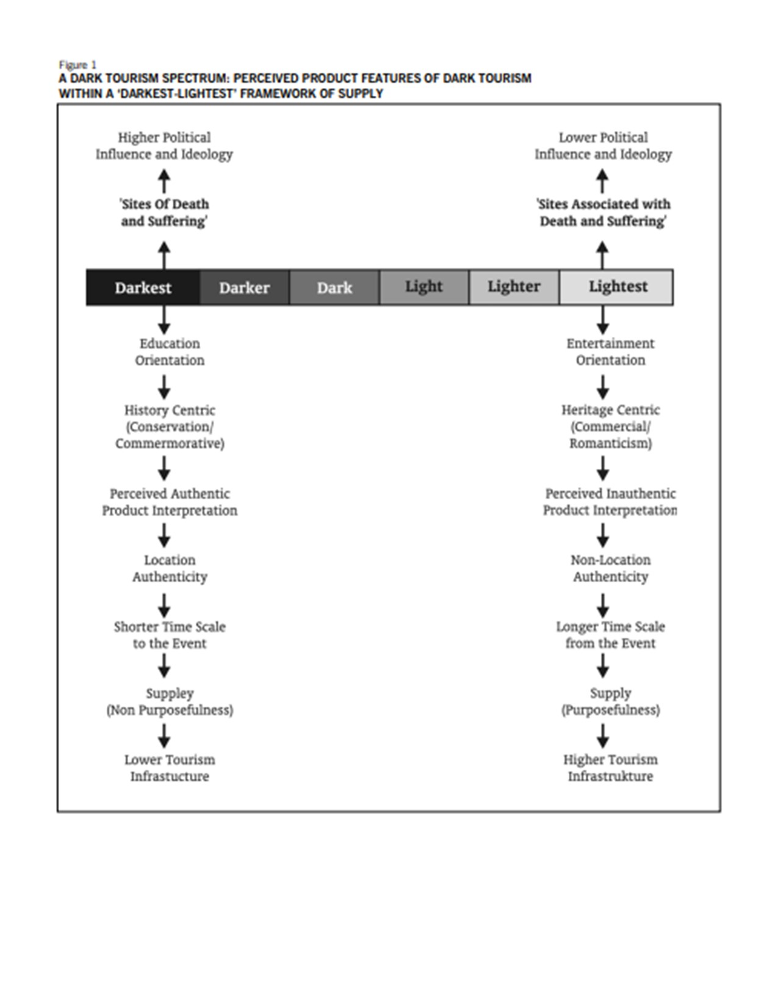
Stone, P. (2006). A Dark Tourism Spectrum: towards a typology of death and macabre related tourist sites, attractions, and exhibitions.
Appendix B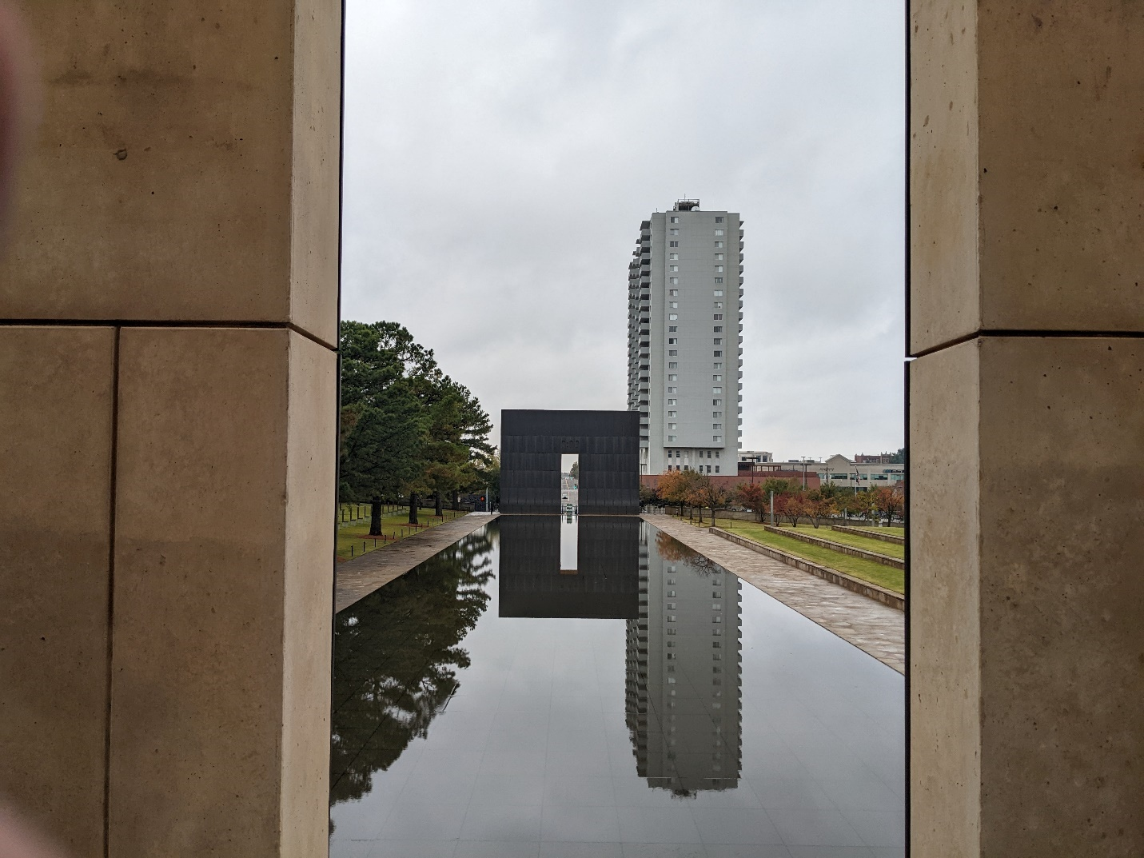

Appendix C
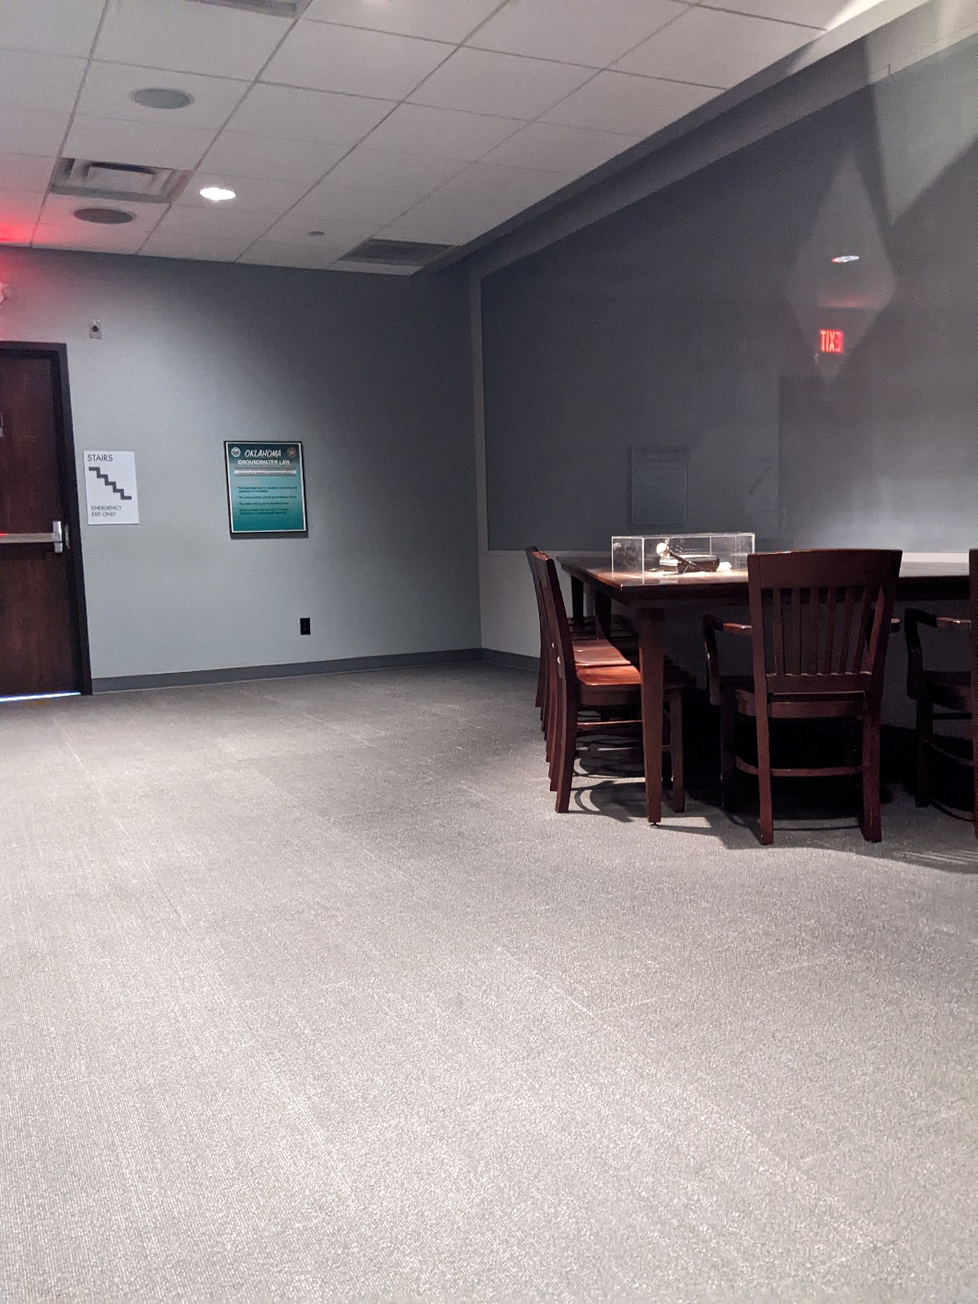

Appendix D
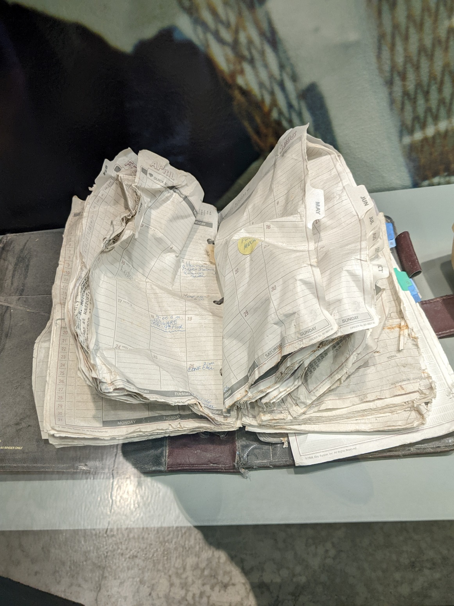

Appendix E
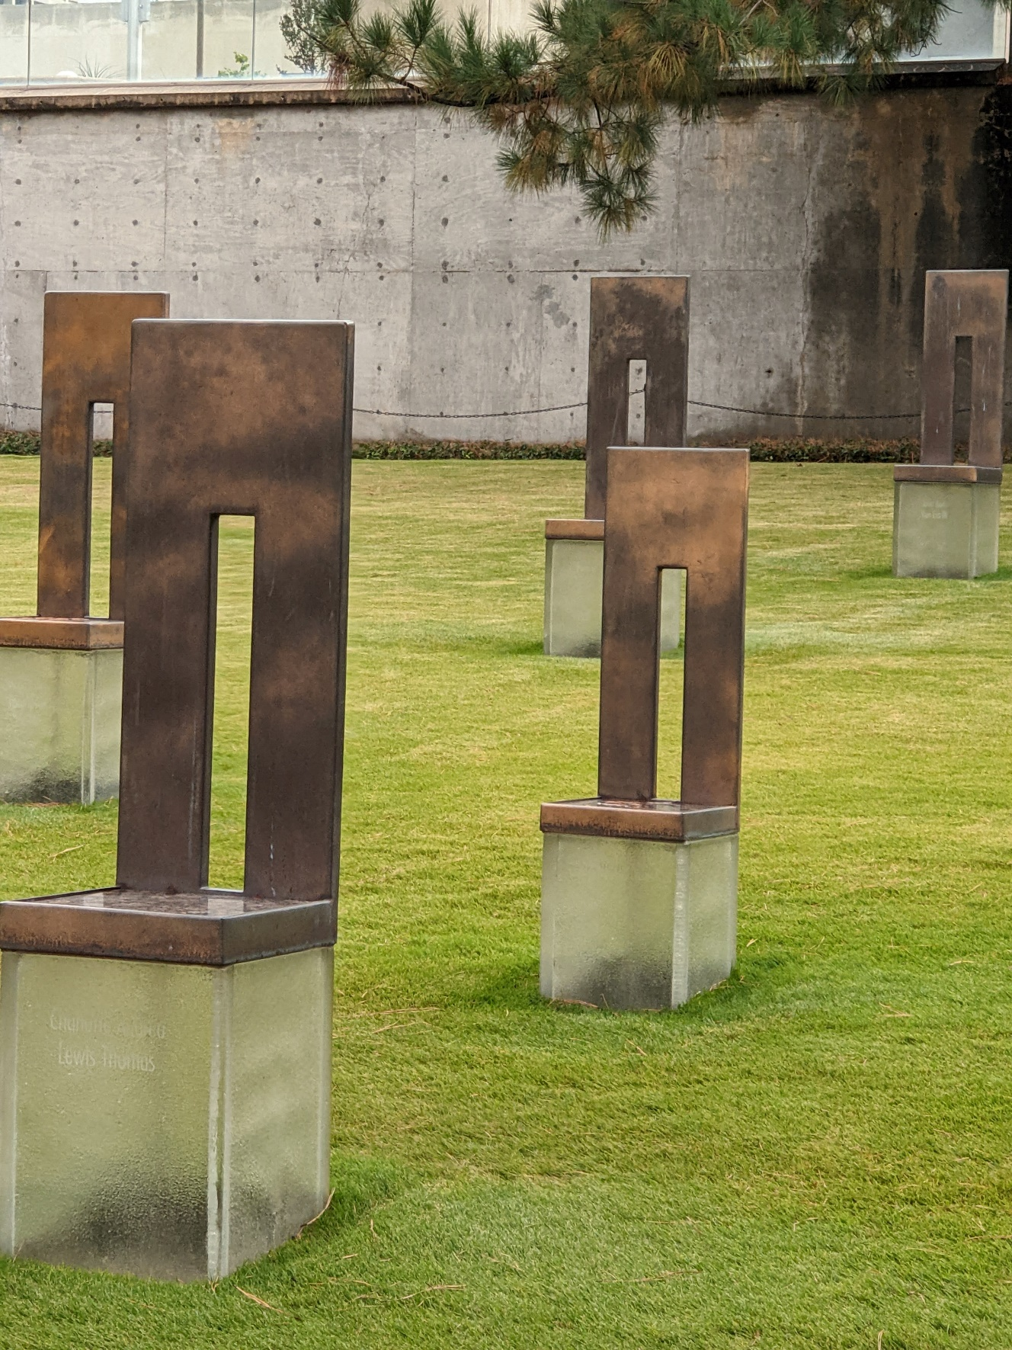
Appendix F
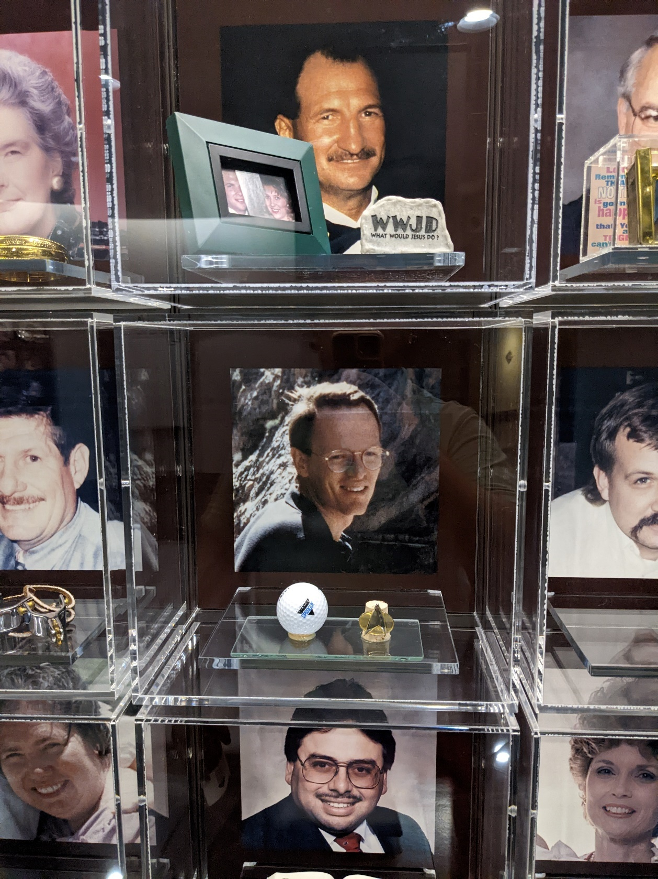

Museen und Ausstellungen sind also keineswegs neutrale Räume der Wissensvermittlung und -popularisierung, die zeigen, wie ‚es' früher war, vielmehr manifestieren sich im Gezeigten kulturelle Muster, Ein- und Ausschlussmechanismen und – sozialwissenschaftlich gesprochen – soziale, ethnische oder religiöse In- und Outgroups.

