UNIVERSITY OF OKLAHOMA
GRADUATE COLLEGE

STABILIZATION OF DRILLING FOAMS USING NANOPARTICLES

A THESIS
SUBMITTED TO THE GRADUATE FACULTY
in partial fulfillment of the requirements for the
Degree of
MASTER OF SCIENCE

By
MOHAMED SALIH
Norman, Oklahoma
2023
STABILIZATION OF DRILLING FOAMS USING NANOPARTICLES

A THESIS APPROVED FOR THE
MEWBOURNE SCHOOL OF PETROLEUM AND GEOLOGICAL ENGINEERING

BY THE COMMITTEE CONSISTING OF

Dr. Ahmed Ramadan, Chair

Dr. Catalin Teodoriu

Dr. Hamidreza Karami

© Copyright by MOHAMED SALIH 2023
All Rights Reserved.

ACKNOWLEDGEMENTS
I first and foremost give my humble thanks and gratitude to (Allah) the Almighty God, for all of his blessings and gifts bestowed upon me, for giving me the strength to complete this research, and for guiding me along the path to success.
I'll be eternally grateful to Dr. Ramadan Ahmed for accepting me as a graduate student and for his unwavering support. Dr. Ahmed has been a pillar for me throughout this project, helping me hone my research skills and pushing me to work harder and go beyond my boundaries. This achievement would not have been possible without his inspiration, knowledge, and helpful input. I will always cherish the principles, values, and resources Dr. Ahmed taught me, and I am convinced that they will be crucial in my next chapter of life.
I'd also like to thank Dr. Catalin Teodoriu and Dr. Hamidreza Karami for taking time out of their busy schedules to serve on the thesis committee. My first interaction with Dr. Teodoriu occurred during a challenging time at OU when I needed his assistance as a graduate student liaison, and he did not disappoint. He was friendly and understanding; without his help, I would not have gotten this far, and I am delighted to have him as our department’s student liaison. I'm also grateful for the knowledge and perspective I acquired from Dr. Karami's advanced production class, one of the most exciting and informative classes I took at OU.
I am grateful to my parents for their love and support throughout my life. Thank you for giving me the courage to pursue my ambitions for the heavens. My sisters, younger brothers, aunts, and cousins also deserve my heartfelt gratitude. Also, I'd like to thank my OU friends for making this adventure so wonderful.
I want to thank Karan Shah for his thoughts and for describing the experimental setup and data analysis needed for the project. Additionally, I'd like to thank Jeff McCaskill for providing all the technical assistance necessary throughout the tests at the Well Construction Technology Centre (WCTC). Thanks to him, I've learned how to utilize a range of new tools. Lastly, I would like to thank all of my colleagues at WCTC who assisted me in many ways.
The Qatar National Research Fund NPRP award [NPRP 10-0115-170165] made this project feasible, and I would like to thank them for their generous contribution. In addition, I want to thank the University of Oklahoma and Texas A&M University in Qatar for their support and assistance in this study.

TABLE OF CONTENTS

ACKNOWLEDGEMENTS iv
TABLE OF CONTENTS vi
LIST OF FIGURES ix
LIST OF TABLES xi
ABSTRACT xii
CHAPTER ONE 1
INTRODUCTION 1
1.1 Overview 1
1.2 Foam Applications 2
1.2.1 Geothermal Application 2
1.2.2 Hydraulic Fracturing 3
1.3 Foam Properties 4
1.3.1 Rheology 5
1.3.2 Quality 6
1.3.3 Stability 7
1.4 Factors Affecting Foam 8
1.4.1 Temperature 8
1.4.2 Pressure 9
1.4.3 Surfactant 11
1.4.4 Additives 12
1.4.5 Generation method 12
1.4.6 Test section height 13
1.4.7 Test column diameter 14
1.4.8 Contaminants 14
1.5 Problem Statement 15
1.6 Objectives and Scope of Study 15
CHAPTER TWO 17
LITERATURE REVIEW 17
2.1 Foam Structure 17
2.2 Foam Decay Mechanism 18
2.3 Foam Drainage Models 20
2.4 Effect of Nanoparticles on Foam Stability 23
CHAPTER THREE 26
METHODOLOGY 26
3.1 Experimental Setup 26
3.2 Experimental Materials 28
3.2.1 Surfactant 29
3.2.2 Silicon Oxide (SiO₂) Nanoparticles 30
3.2.3 Nitrogen Gas 31
3.3 Experimental Procedure 32
3.4 Experimental Scope 35
3.5 Data Analysis 37
CHAPTER FOUR 41
RESULTS AND DISCUSSIONS 41
4.1 Effect of Silica Nanoparticles on Rheology 41
4.2 Effect of Silica Nanoparticles on Stability 43
4.2.1 Effect of Foam Quality on Stability 44
4.2.2 Effect of unfunctionalized Silica Nanoparticles (NS1) on stability 45
4.2.3 Effect of Silica Nanoparticles Modified with Amino Group (NS2) on Stability 48
4.2.4 Effect of Silica Nanoparticles treated with silane coupling agents (NS3) on Foam Stability 52
4.3 Effect of Silica-nanoparticles/Surfactant Dispersion 55
CHAPTER FIVE 60
CONCLUSIONS AND RECOMMENDATIONS 60
5.1 Conclusions 60
5.2 Recommendations 61
REFERENCES 62

LIST OF FIGURES
Figure 1.1: Relative viscosity vs. foam quality (Ahmed et al. 2003) modified 7
Figure 1.2: Effect of pressure on liquid drainage times (after Rand and Kraynik 1983) 10
Figure 1.3: Effect of pressure on foam bubble structure (after Rand and Kraynik 1983) 11
Figure 2.1: Foam structure, a polyhedral gas bubble, a liquid film, and a plateau boundaries cross-section 19
Figure 3.1: Experimental Setup Schematic. 27
Figure 3.2: Rheology testing section of the experimental setup 27
Figure 3.3: Stability testing section of the experimental setup 28
Figure 3.4: Howco Suds surfactant 29
Figure 3.5: Silicon oxide nanoparticles, NS1 (Left), NS2 (Middle), and NS3 (Right) 30
Figure 3.6: Nitrogen gas cylinder with a pressure regulator 32
Figure 3.7: Multiple-speed laboratory blender with speed regulator 33
Figure 3.8: Sonicator with generator (Left), converter, and probe (Right) 33
Figure 3.9: Base liquid tank 34
Figure 3.10: Pressure distribution across the vertical cell for generated foams 37
Figure 4.1: shear rate vs. shear stress for (a) baseline foam, (b) foam mixed with NS1, (c) foam mixed with NS2, and (d) foam mixed with NS3 42
Figure 4.2: shear rate vs. shear stress for (a) baseline foam and NS1 foam, (b) baseline foam and NS2 foam, (c) baseline foam and NS2 foam 43
Figure 4.3: Fractional drainage obtained by S3 for 40%, 50%, and 60% foam qualities for (a) 0% NS, (b) 1% NS1, (c) 0.5% NS2, (d) 1% NS2, (e) 3% NS2, (f) 1% NS3 45
Figure 4.4: Compares the drainage obtained by S3 for baseline foam (0% NS) and foam with 1% NS1 at: (a) 40% foam quality, (b) 50% foam quality, and (c) 60% foam quality 46
Figure 4.5: The drainage of the liquid phase obtained by S9 for baseline foam (0% NS) and foam with 1% NS1 at: (a) 40% foam quality, (b) 50% foam quality, and (c) 60% foam quality 47
Figure 4.6: Compares the drainage obtained by S3 for baseline foam (0% NS) and foam with 0.5% NS2, 1%NS2, and 3% NS2 at (a) 40% foam quality, (b) 50% foam quality, and (c) 60% foam quality 49
Figure 4.7: The drainage of the liquid phase obtained by S9 for baseline foam (0% NS) and foam with 0.5% NS2, 1%NS2, and 3% NS2 at (a) 40% foam quality, (b) 50% foam quality, and (c) 60% foam quality 50
Figure 4.8: Comparison of the drainage obtained by S3 for baseline foam (0% NS) and foam with 1% NS3 at different qualities: (a) 40%, (b) 50%, and (c) 60% 53
Figure 4.9: The drainage of the liquid phase obtained by S9 for baseline foam (0% NS) and foam with 1% NS3 at: (a) 40% foam quality, (b) 50% foam quality, and (c) 60% foam quality 54
Figure 4.10: Image foam silica-nanoparticles dispersion (Top three rows) and pure surfactant foam dispersion (Bottom) overtime 56
Figure 4.11: Foam volume vs. time 57
Figure 4.12: Optical microscope images of (a) baseline foam, (b) NS1 foam, (c) NS2 foam, and (d) NS3 foam 58

LIST OF TABLES
Table 2.1: Nanoparticles used in previous studies and their effect on foam stability 25
Table 3.1: Properties of Howco Suds surfactant 30
Table 3.2: Characteristics of Silicon oxide nanoparticles NS1, NS2, and NS3 31
Table 3.3: Test matrix 36

ABSTRACT
Underbalanced drilling often uses foam because of its superior hole-cleaning capacity, low density, and reduced liquid requirements. However, it must be stable under borehole conditions to function as a drilling fluid. When the foam is unstable, it loses its viscosity, causing the liquid to drain and create slugging flow, causing a temporary overbalance that may damage the formation. This study aims to improve aqueous foam stability using nanoparticles with unique surface properties.
Nanoparticles possess unique properties due to their small size and high specific surface area. Furthermore, their surfaces can be modified to display desired properties. As part of this study, bare (NS1) and functionalized silicon oxide nanoparticles (NS2, and NS3) were studied to improve the stability of aqueous foams. A foam circulating flow loop with horizontal pipe viscometers and a vertical drainage testing cell was used to create foam and analyze its characteristics. Foams with varying nanoparticle concentrations (1 to 3% by wt.) and foam qualities (40 to 60%) were generated at 1000 psi. The rheology and stability of these materials were then investigated. To assess the drainage, the hydrostatic pressure distribution was measured as a function of time after a fully generated foam was trapped in a vertical test cell.
A significant increase in apparent viscosity and reduction in liquid drainage was observed when the baseline foam quality (in-situ gas volumetric concentration) was raised from 40% to 60%. Similar changes in property were also observed in nanoparticles containing foam. In addition to this, experiments showed that nanoparticles have an impact on the properties of foams. With the addition of nanoparticles, foams became more viscous and stable. The type (coating) of nanoparticles also influences their effectiveness. For instance, amino-functionalized silica nanoparticles (NS2) provide better foam stability than regular nanoparticles (NS1) and nanoparticles treated with silane (NS3).

CHAPTER ONE

INTRODUCTION

Overview
Aqueous foams are concentrated dispersions of gas bubbles (dispersed phase) entrapped in a small volume of liquid (continuous phase), forming different sizes of bubbles. A thin layer of liquid films coats the gas compartments. Mechanical agitation or shearing and the surfactant's presence are crucial to generating foams. Mechanical agitation forms foams by upsetting the molecules of the two fluids in the mixture. The surfactant adds energy and creates foam by increasing the area between the gas-liquid interface, reducing the liquid phase's surface tension.
Foam is a low-density with high viscosity fluid and high cutting transport capacity. As a result, foam fluids have been widely used in several industrial applications. In the oil and gas industry, foam reduces gas mobility and increases sweep efficiency in enhanced oil recovery operations (EOR). It is also used as fracturing fluid in hydraulic fracturing and well stimulation and drilling fluid to transport cuttings to the surface. In addition, unconventional wells are being drilled using advanced drilling methods such as managed pressure drilling and underbalanced drilling (A drilling technique in which the wellbore pressure is maintained below the formation's pressure). Conventional drilling methods are extremely difficult to use in depleted and low-pressure formations. These formations often require underbalanced drilling. Achieving successful underbalanced drilling operations is possible by using stable foam with high viscosity and low density. However, water-sensitive formations complicate well drilling with traditional aqueous-based foams. Formations sensitive to water may damage due to a momentary imbalance overbalance, a chemical reaction, or sudden imbibition oil-Based foam help to solve the problems. Generally, drilling with foam proved highly beneficial because of its various advantages, such as increasing penetration rates, limiting deferential pipe sticking, reducing lost circulation, minimizing formation damage with less or no stimulation, and improving drilling in water-sensitive formations. However, although foams have many applications in the petroleum and natural gas industry, they are inherently unstable from a thermodynamic and kinetic perspective, particularly at high temperatures and pressures (Wang et al., 2016). Such extreme conditions often impact the rheology, stability, bubble size, drainage, and hydraulics of foam. This impact is best known as foam decay.

Foam Applications

1.2.1 Geothermal Application
Foam has been utilized in various geothermal applications, including drilling, completion, and production (Lyons, 2009). In geothermal drilling, foam is used as a drilling fluid to reduce the weight and hydrostatic pressure of the drilling fluid, which can help reduce the risk of wellbore instability and damage to the geothermal reservoir. Foam is commonly used in geothermal drilling as a drilling fluid. Geothermal drilling involves drilling deep into the earth to access geothermal energy resources. During this process, the drilling fluid serves several purposes, including carrying rock cuttings to the surface, cooling and lubricating the drill bit, and maintaining the stability of the borehole.
Foam has several advantages as a drilling fluid in geothermal drilling. First, it can help to reduce the weight of the drilling fluid, which can be crucial in geothermal drilling because the deeper the borehole, the higher the pressure and temperature of the formation fluids. Foam can also help to minimize the circulation of formation fluids into the borehole, which can be important in preventing damage to the drilling equipment or the surrounding formations.
In addition, foam can help to reduce the amount of water used in geothermal drilling. This can be beneficial in areas where water resources are scarce, as it can reduce the overall impact of the drilling on the environment. Foam can also be easier to clean up and dispose of than traditional drilling fluids, which can help reduce drilling operations' environmental impact.
Foam can also help improve drilling efficiency and reduce the risk of lost circulation, which occurs when drilling fluid escapes into the formation, leading to a decrease in drilling fluid volume and an increase in the cost of the drilling operation. In geothermal completion, foam can help control the flow of fluids within the wellbore and prevent damage to the geothermal reservoir. Foam can also help improve the efficiency of the completion process by reducing the amount of fluid needed to complete the well (Song et al., 2022).
In geothermal production, foam can help control the flow of fluids within the wellbore and prevent the production of unwanted fluids, such as water or steam, from the geothermal reservoir (Yuan and Wood, D.A., 2018). Foam can also help improve the production process's efficiency by reducing the energy needed to lift fluids to the surface.
Using foam in geothermal applications can improve drilling efficiency, reduce the risk of wellbore instability and damage to the reservoir, and improve production efficiency. However, the specific application of foam in geothermal operations depends on several factors, including the composition of the geothermal reservoir, the drilling conditions, and the desired outcomes of the process.

1.2.2 Hydraulic Fracturing
Foam is commonly used in hydraulic fracturing, also known as "fracking," which is a technique used to extract oil and gas from shale rock formations (King, 2012). In this process, a mixture of water, sand, and chemicals is injected into the well at high pressure, creating fractures in the rock that allow the oil and gas to flow more freely.
Foam can be used in place of water in hydraulic fracturing, and it offers several advantages over traditional water-based fracking fluids. One key benefit is that foam can create smaller and more uniform fractures, which can improve the efficiency of the fracturing process and increase the amount of oil and gas that can be extracted (Gu et al., 2014).
Foam can also help reduce the amount of water needed in hydraulic fracturing, which can be important in areas with limited water resources. In addition, foam-based fracturing fluids can be less damaging to the environment than water-based fluids, as they can reduce the amount of wastewater produced and the risk of groundwater contamination (Al-Muntasheri et al.,2017).
A foaming agent is added to the fracturing fluid, along with air or nitrogen gas, to create foam for hydraulic fracturing. The mixture is then pressurized and injected into the well, where it expands to fill the fractures in the rock. The foam helps to create a more uniform pressure distribution within the fractures, which can improve the flow of oil and gas to the well (Wang and Elsworth., 2020).
Foam-based fracturing fluids offer a promising alternative to traditional water-based fluids, and they are becoming increasingly popular in the oil and gas industry. Nonetheless, more research is needed to fully understand the long-term environmental and economic impacts of foam-based hydraulic fracturing.

Foam Properties
As previously said, foam has many valuable characteristics that allow it to be used in various applications. The manner of foam creation, surfactant type, fluid parameters, pressure, temperature, and pollutants in the fluid system heavily influences these characteristics. This section discusses some of the vital features of foams.

Rheology
Foam rheology plays a crucial role in comprehending its flow behavior. The rheological properties of foam, such as viscosity, elasticity, and yield stress, can be influenced by several factors, including foam composition, structure, and processing conditions (Ahmed et al., 2003; Leal-Calderon et al., 2007).
Foam exhibits complex rheological behavior as a two-phase system with gas bubbles dispersed in a liquid or solid matrix. The properties of the gas and liquid phases and the interface between them can significantly impact the rheological properties of the foam. For instance, adding surfactants or other stabilizers can increase the foam's surface tension and yield stress, making it more resistant to deformation and flow (Binks & Lumsdon, 2000). Moreover, the presence of solid particles or fibers in the liquid matrix can affect the rheology of foam by increasing its viscosity and elasticity (Zhao et al,. 2018).
The rheological properties of foam can also be altered by processing conditions such as the shear rate, temperature, and pressure. For instance, increasing the shear rate of foam can lead to thinning and make it more liquid-like, while decreasing the shear rate can cause thickening and make it more solid-like (Brown and Jaeger, 2014).
The knowledge of foam rheology is fundamental for various applications, including hydraulic fracturing and geothermal drilling. By controlling the rheological properties of foam, it is possible to optimize its performance and ensure that it meets the desired specifications for a given application.

Quality
The quality of the foam is a critical property that has a considerable impact on the foam's physical properties. It is the ratio of the volume of gas already present in the foam to the entire foam volume. It is a function of pressure and temperature. The quality of the foam may be determined using the formula.
$Γ \left(T,P\right)=\frac{VG}{VL+VG}$ (1.1)
VG and VL represent the volume of gas and liquid phases in the foam. The quality of the foam has a variety of effects on its structure and properties. When the quality of the foam improves, there is a transition that takes place in the structure of the foam (Figure 1.1). Foams below 60% are classed as bubbly liquids, while foams with quality over 96% are categorized as mists. With a moisture content of 63%, aqueous foams see a change in stiffness (Kraynik 1983; Ahmed et al. 2003). Wet foams contain more liquid than dry foams, which causes wet foams to have thicker films and a more spherical structure. Dry foams, on the other hand, have thinner films and a more polyhedral network structure.
Since it is a blend of the densities of the gas and liquid phases, foam density also varies depending on the quality of the foam. This is because the proportion of liquid within the foam's structure drops as the foam's quality improves while the fraction of gas within the foam's structure grows. This results in an appreciable reduction in the density of the foam as a whole.

Figure 1.1: Relative viscosity vs. foam quality (Ahmed et al. 2003) modified
The quality of the foam affects the other aspects of the foam as well, including its stability, viscosity, and bubble size distribution. The capacity of foam to preserve its structure and resist collapsing throughout its lifetime is referred to as its stability. Viscosity is a measurement of the foam's resistance to flow, and it depends on the gas concentration. The capacity of the foam to maintain a consistent distribution of bubble sizes is one factor that determines its look and performance. Bubble size distribution is one of the factors.
In conclusion, foam quality is an essential factor that plays a role in forming various foam characteristics. Therefore, it is possible to improve foam quality for a given application by first understanding the influence that foam quality has on its physical and flow characteristics.

1.3.3 Stability
Foams possess unique characteristics; however, their qualities degrade shortly after their formation due to drainage. The stability of foam is significantly influenced by the properties of the base liquid, particularly its quality and rheology (Govindu et al., 2020; Leal-Calderon et al., 2007). Foams with higher quality have been shown to be more stable. Dry foams, as compared to wet foams, disintegrate at a much faster rate. A popular method for determining the stability of a foam is to observe how fluid escapes from the structure of the foam. The foam breakdown can be divided into four distinct processes: gravitational drainage, coalescence, Ostwald ripening, and coarsening (Binks and Lumsdon, 2000). The thinning and brittleness of the bubble film occur as the liquid drips out of the foam structure. The size of the bubbles also influences foam stability. Smaller bubbles, as opposed to larger bubbles, are more resistant to changes in temperature and pressure (Crum, 1980). As dry foams are created, the bubbles are packed in so tightly together, forming polyhedral bubble structures (Durian, 1997). Surfactants improve the durability of foam by reducing surface tension. Nevertheless, increasing the surfactant concentration beyond the critical micelle concentration does not improve the foam's stability (Leal-Calderon et al., 2007).

Factors Affecting Foam

Temperature
The temperature may considerably influence the foam’s stability, structure, and quality. As the temperature is raised at constant pressure, the gas bubbles inside the foam expand, reducing the foam's stability (Tyowua and Binks, 2020). The increasing gas pressure inside the bubbles might force them to rupture or combine with surrounding bubbles, collapsing the foam structure. Decreasing the temperature, however, causes the gas bubbles to shrink and migrate closer together, increasing the foam's stability. If the temperature is too low, the liquid inside the foam may freeze, causing the foam to harden and lose its beneficial properties (Abd Karim and Wai,1999).
It is also possible for temperature to affect the texture, appearance, and other properties of foams. Foams, for example, may become more elastic or less viscous as temperatures rise (Gu and Mohanty 2015; Li et al. 2012). Foam's response to temperature depends on its kind, composition, and environmental conditions.
Furthermore, as temperature increases, the apparent viscosity of the base liquid decreases due to its thermal thinning. At a constant quality, the base fluid's thinning causes foam viscosity reduction and exacerbation of liquid drainage. The decline in viscous resistance in the foam structure due to the thinning of the liquid phase exacerbates the drainage. Especially in low-quality foams, the impact of temperature on foam viscosity is significant (Akhtar 2017). Therefore a similar level of influence is expected on drainage due to the temperature effect. At high foam qualities, temperature's effect on viscosity is still noticeable (Gu and Mohanty 2015). Moreover, if the foam expands with increasing temperature, the volume of gas inside the bubble grows, causing the film to rupture. As a result, the foam becomes unstable (Li et al. 2012). However, it is essential to note that the stability of aqueous foams can be enhanced at high temperatures by incorporating surface-modified nanoparticles into the system (Singh and Mohanty 2017, Zhu et al. 2017).

1.4.2 Pressure
To employ aqueous foams as a drilling fluid for high-pressure petroleum and geothermal wells, we must first understand how pressure affects aqueous foams. The Literature has examined how pressure affects the stability of aqueous foams (Rand and Kraynik 1983). Rand and Kraynik 1983 conducted a series of experiments with various surfactant and gas type combinations to evaluate the foam drainage time as pressure was increased (Figure 1.2). Although foam quality was maintained constant, they reported a significant increase in drainage times as generating pressure increased. This phenomenon appears to be caused by reduced bubble size resulting from pressure increase.

Figure 1.2: Effect of pressure on liquid drainage times (after Rand and Kraynik 1983)

Higher pressure reduces bubble diameter and generates a homogeneous foam structure (Figure 1.3). The foam's homogeneous structure inhibits drainage and deterioration of the foam. Raising pressure while maintaining consistent foam quality affects foam stability by altering surface elastic properties (Ruckenstein and Jain 1974). Its increased surface elasticity avoids thin film rupture and slows bubble coalescence. Also, when pressure was raised (Fuseni et al. 2014), amine oxide surfactant foam demonstrated greater stability and delayed foam drainage compared to anionic surfactant foam. Moreover, foam flooding studies revealed that foam stability increased with pressure (Holt et al. 1996). On the other hand, extreme pressures may cause the inner layer to break down and destabilize foam (Sheng 2013).
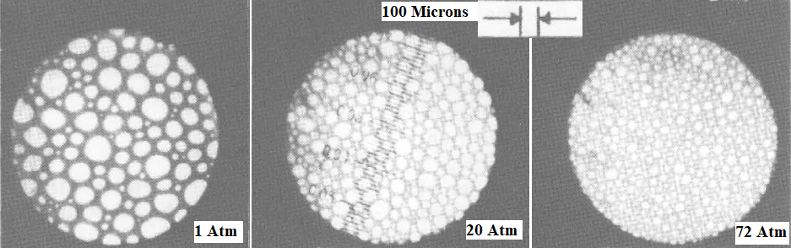
Figure 1.3: Effect of pressure on foam bubble structure (after Rand and Kraynik 1983)

1.4.3 Surfactant
Foam stability, texture, and other properties can be significantly influenced by the presence of contaminants and the choice of surfactant types. Surfactants play a significant role in modifying the interfacial tension between the gas and liquid phases, affecting the stability of aqueous foams. If the surfactants have a lower interfacial tension, the foam can be more stable. In addition, surfactant type can also impact the texture of foam, including its viscosity and coarseness. For instance, surfactants with higher molecular weight can lead to more viscous foam, while surfactants with lower molecular weight can result in a thinner foam (Binks & Lumsdon, 2000).
Moreover, surfactants can affect the liquid drainage rate from the foam bubbles, which also plays a role in foam stability. Surfactants that reduce the drainage rate can lead to more stable foam. Additionally, the surfactant type can affect the amount of foam generated, with surfactants with higher surface activity producing more foam (Rand and Kraynik 1983). Surfactants can also prevent the coalescence of foam bubbles, leading to more stable foam. If surfactants have a higher degree of steric hindrance, they can prevent coalescence. The surfactant type can also affect the lifetime of foam, with more resistant surfactants leading to longer-lasting foam (Rand and Kraynik 1983). Therefore, careful selection of surfactant types and attention to processing and storage conditions are essential for achieving the desired foam properties for a specific application.

1.4.4 Additives
Recent studies have shown that additives such as nanoparticles, fibers, and polymers can significantly affect the foams' properties. Specifically, adding nanoparticles can increase foam's stability and structural rigidity by strengthening the interfaces between the gas and liquid phases (She et al., 2018). In addition, nanoparticles can also modify foam's thermal and electrical conductivity (Shi et al., 2014).
Polymers are another type of additive that can be used to modify the properties of foams. The incorporation of polymers results in an increase in both the foam's stability and its half-life duration, which contributes to an overall quality improvement (Zvada et al. 2021)
It should be noted that the specific effects of these additives on foam properties will depend on the type and concentration of the additive and the specific conditions under which the foam is being used. However, adding additives can provide a means of tailoring foam properties for particular applications.

1.4.5 Generation method
The method used to create foam significantly impacts its properties, such as structure, stability, and bubble size distribution (Garrett, 1993). The generation method refers to how foam is produced, and this process affects the size, shape, and distribution of the gas bubbles within the foam.
Different methods are used to create foam with different properties (Garrett 1993; Skauge et al. 2020). Mechanical techniques like whipping or stirring produce foam with relatively large bubbles and wide size distribution. In contrast, methods that use surfactants or stabilizers, such as sonication or microfluidics, produce foam with smaller and more uniformly sized bubbles (Chen et al., 2014; Costantini et al., 2016; Critello et al., 2017).
The method used to create foam can also affect its stability. Often foams produced using mechanical methods are less stable than those generated using surfactants or stabilizers. This is because mechanical methods create foam with large bubbles and weak interfaces between the bubbles and the liquid phase. Surfactants and stabilizers strengthen these interfaces, enhancing foam stability (Farhadi et al., 2016).
Choosing the appropriate foam generation method for a specific application depends on several factors, including desired foam properties, processing conditions, and the characteristics of the liquid and gas phases involved.

1.4.6 Test section height
The effect of test section height on foam behavior and properties is determined by the specific conditions and properties of the foam being tested (Saint-Jalmes 2006). Studies by Ramani et al. (1993) have shown that increasing the test section's height can increase the foam's drainage time. This increase in drainage time allows for a more thorough observation of the behavior and properties of the foam, which is beneficial in some experiments. Furthermore, in some instances, a taller test section may allow for observing gravity-driven drainage effects on the foam. As the foam drains and the liquid phase is expelled, the properties of the foam may change, such as its stability and bubble size distribution. In a recent study, Obisesan et al. (2022) investigated the influence of test section height on the drainage behavior of aqueous foams. The results showed that foam drainage slows down with increasing column height since the drainage rate changes across the column's length.
From a deferent prospective, increasing the test section height can also lead to increased pressure drop and flow resistance, which can adversely affect the behavior of the foam. According to Rand and Kraynik (1983), the increased pressure drop can cause changes in the flow patterns and properties of the foam, such as an increase in bubble coalescence or rupture.
Therefore, selecting the appropriate test section height for a foam experiment is crucial. The selection depends on several factors, such as the properties of the foam being tested, the flow rate and pressure drop requirements, and the specific goals of the experiment.

1.4.7 Test column diameter
Ramani and colleagues (1993) investigated how the diameter of the test section impacted the rate of drainage. The studies were carried out using glass columns that ranged in diameter from 0.03 to 0.05 meters. The findings of this experiment demonstrated that the diameter of the column had only a marginal impact on the foam drainage. In a more recent study, Govindu et al. (2019) examined the stability of different foams by capturing foam samples in both pipe and annular sections and then comparing their drainage rates. The findings indicated that foams were more stable in the annular section than the straight pipe, possibly because of the more substantial wall confinement effect in the annulus.

1.4.8 Contaminants
Contaminants can significantly impact foam's characteristics, including its stability, structure, and texture. Often contaminants come in the form of substances like oils, salts, or organic matter that disrupt the foam's stability by interfering with the liquid-gas interface, leading to foam collapse or decreased stability, especially in higher-quality foams (Obisesan et al. 2021). For instance, oil can hinder foam formation by disturbing the liquid-gas interface. At the same time, salts affect osmotic pressure and surface tension, and organic matter alters surface tension, all affecting the liquid-gas interface. On the other hand, at lower quality levels, adding oil increases foam stability (Obisesan 2020, Obisesan et al. 2021, Obisesan et al. 2023). Furthermore, clays such as bentonite and kaolinite increase the stability of foams and reduce their drainage rate. The improvement in stability is related to the amount and type of clay present in the liquid phase (Obisesan 2020).

Problem Statement
Foam is the preferred fluid for underbalanced drilling due to its superior hole-cleaning capacity and reduced liquid requirements. However, it must have good stability to function as a drilling fluid under borehole conditions. Unstable foam loses its viscosity and generates drained liquid that causes slugging flow, resulting in temporary overbalance that can damage the formation. This study aims to improve the foam stability of aqueous foam using nanoparticles with unique surface properties.

Objectives and Scope of Study
This study contributes to formulating a new generation of drilling foams that can be used in harsh borehole environments where foam instability becomes a major concern. This research aims to improve the stability of aqueous foam using silicon oxide nanoparticles. To achieve this objective, extensive drainage tests were performed at ambient temperature and 1000 psi of pressure to examine the impact of nanoparticles and concentration on the stability of aqueous foams. The concentrations of three different nanoparticles ranged from 0.5 to 3 wt% of solvent. 40%, 50%, and 60% foam qualities were considered. Foam rheology measurements were obtained in addition to drainage data. The rheology studies were carried out at various flow rates ranging from 35%, 50%, 65%, 80%, and 100% of pump capacity to determine foam flow behavior at various shear rates. System temperature, pressure, flow rate, density, and differential pressures were monitored and recorded across the rheology and stability testing sections.

CHAPTER TWO

LITERATURE REVIEW

Foam Structure
Aqueous foams are complex systems that exhibit various structures depending on multiple factors. The gas phase used to generate the foam is one factor that influences the aqueous foam structure. Aqueous foams can be generated using different gases, such as air, nitrogen, and carbon dioxide. The choice of gas affects the foam's properties, density, stability, and structure (Binks & Lumsdon, 2000).
Another factor that affects the structure of aqueous foams is the presence of surfactants. Surfactants can reduce the interfacial tension between the gas and liquid phases, forming more stable foams with smaller bubble sizes (Binks & Lumsdon, 2000). The surfactant concentration and type can also affect foam structure. For example, increasing the surfactant concentration can decrease bubble size and create a more uniform bubble size distribution (Leal-Calderon et al., 2007).
The method used to generate the foam also influences its structure. Aqueous foams can be generated using various techniques, such as mechanical agitation, gas injection, and ultrasound. The choice of generator affects the foam properties, including its structure and stability. For instance, ultrasound can generate more stable and uniform foams with smaller bubble sizes than mechanical agitation (Critello et al., 2017).
Aqueous foams can exhibit different structures depending on their composition and the foam generation method and conditions. One common type of aqueous foam structure is the lamellar structure, where the bubbles are stacked in layers and separated by thin liquid films. Another structure is the polygonal structure, where the bubbles have a polygonal shape and are closely packed together. Other structures include the spherical structure, where the bubbles are spherical and uniformly distributed, and the network structure, where the bubbles are interconnected to form a network (Engelsen et al., 2002).
In summary, the structure of aqueous foams is influenced by various factors, including the stability of the foam, the properties of the gas and liquid phases, as well as the method of foam generation. The structure of aqueous foams can be characterized using various techniques, including microscopy and scattering techniques. Understanding the structure of aqueous foams is vital for their development and optimization for different applications in multiple fields.

Foam Decay Mechanism
There are three main categories of foam decay, gravitational drainage, bubble coalescence, and Ostwald ripening (Akhtar et al., 2017; Bhakta et al.,1997; Gallego-Juárez et al., 2015; Sinha et al., 2019). Gravitational drainage is the thinning of bubble walls when the liquid phase drains from the foam structure due to the difference in density between the liquid and gas phases. As coalescence implies, it is the joining or merging of gas bubbles within the foam structure to form bigger bubbles (Eren 2004). Additionally, Ostwald ripening is the process of gas migrating from smaller to larger bubbles due to the Laplace pressure difference. All three foam decay categories cause the separation of the gas-liquid phases from the foam structure, minimizing the system's energy. Therefore, if no new energy is added to the system, all foams will eventually decay. Thus, foam stabilizers are commonly used to improve foam stability. Numerous foam stabilizers have been developed over the years, including hydroxyethyl cellulose (HEC), carboxymethyl cellulose (CMC), polyacrylamide, and triethanolamine. However, these soluble foam stabilizers degrade when exposed to harsh high-temperature and high-pressure borehole conditions.
Solid particles could be used to stabilize foams as an alternative approach. The high adsorption energy of particles at fluid interfaces explains their significant effectiveness in stabilizing foams. Moreover, the adsorption of solid particles at the gas-liquid interface is irreversible due to their high adsorption energies. At the same time, the dilational elasticity of liquid films increases dramatically. When particles are positioned at an interface, bubbles acquire the "solid-like shield" characteristics that protect them from coalescence. Thus, foams can exist for long periods. Particles can also hinder the drainage of foams by acting as gelling agents, aggregating in the liquid channels of the foam (Plateau boundaries), and increasing bulk viscosity (Bhakta and Ruckenstein, 1997). Figure 2.1 shows a microscopic image of foam featuring its structure, plateau border channels, liquid films, and gas bubbles.
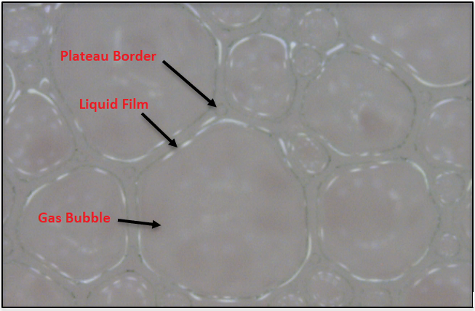
Figure 2.1: Foam structure, a polyhedral gas bubble, a liquid film, and a plateau boundaries cross-section
This study investigates a new generation of foams that can be used in harsh borehole environments where foam instability is a major concern (Aveyard et al., 2003; Cervantes-Martinez et al., 2008; Chevalier and Bolzinger, 2013; Stocco et al., 2011). Nanoparticles exhibit unique features because of their small size and large specific area. Furthermore, their surfaces can be coated/functionalized to display the desired properties tailored for a particular application. To improve the stability of foams, bare (regular) and functionalized silicon oxide nanoparticles were used in this study.

2.3 Foam Drainage Models
To properly use foams in oil field applications, having some degree of control over their stability is crucial. Thus, a thorough understanding of foam persistence and decay mechanisms is desired. Aqueous foams are frequently regarded as metastable systems. Consequently, they have a natural inclination to split into two discrete phases. The time frame for foam decay, on the other hand, varies greatly. Based on the circumstances and its constituent, foams might last a few minutes or several hours. In foams, the continuous liquid phase is contained in the liquid films that develop between the faces of the polyhedral bubbles and the channels (Plateau border channels) that emerge where adjacent films converge in a foam structure. Through this intricately interlinked network of Plateau border channels and nodes, liquid drains from the foam structure under the influence of gravity. Simultaneously, the liquid in the films is drawn into the Plateau border channels. Consequently, the films eventually thin down and rupture. When the film at the boundary between interconnected bubbles ruptures, they coalesce and form a bigger bubble with higher diameter and volume, decreasing the interfacial area. Therefore, gravitational drainage of the liquid phase is a major contributor to foam decay (Bhakta and Ruckenstein, 1997).
Much of the earlier research on foam decay mechanisms was empirical, and most experimental studies didn’t consider bubble size as a critical factor (Bikerman 1973). Hence, there was a necessity for credible theoretical models that could be utilized to evaluate experimental findings. Narsimhan and Ruckenstein presented a reasonably comprehensive review of the theoretical research conducted in this area up to 1990 (Narsimhan and Ruckenstein, 1997). The literature (Miles et al., 1945; Jacobi et al., 1956; Haas and Johnson, 1967; Krotov 1981; Narsimhan 1991; Bhakta and Khilar, 1991; Ramani et al., 1993; Verbist et al., 1996) has referenced several theoretical models for the drainage of foams. The papers by Krotov (1981) and Narsimhan (1991) are the most significant. The fundamental equations and boundary conditions were developed by Krotov (1981), who was the first to realize the impact of Plateau border suction (capillary pressure) on foam drainage. He demonstrated that drainage in a foam finally stops when gravity is balanced by the capillary pressure gradient created as drainage continues. He developed the fundamental equations but did not attempt to solve them. Narsimhan (1991) acknowledged the significance of the technique for generating foam and used a quasi-steady state approximation to mimic the drainage during bubbling to solve the drainage equations numerically for foams formed by bubbling. He investigated how several factors, such as bubble size and viscosity, affected foam drainage.
Bhakta and Ruckenstein (Bhakta and Ruckenstein, 1995a and b; Bhakta and Ruckenstein, 1996; Bhakta and Ruckenstein, 1997; Ruckenstein and Bhakta, 1996) investigated the topic of foam degradation in depth in several publications. They developed an unsteady state model (Bhakta and Ruckenstein, 1995a) to replicate the drainage during bubbling for aqueous foams formed by bubbling. The reported results differed notably from those produced by Narsimhan using a quasi-steady state technique and, in some instances, demonstrated higher consistency with the experiment. In subsequent work, they also looked at the drainage of homogeneous foams (Bhakta and Ruckenstein, 1995b). The pertinent differential equations' numerical solution was used in most models mentioned above. However, some efforts have been undertaken to obtain analytical solutions (Verbist et al., 1996). Such drainage models gave insightful information on the drainage mechanism. They did not, however, address the more complicated issues surrounding foam stability, such as the reduction in interfacial area and foam volume with time. These behaviors directly result from film rupture, previously overlooked in drainage modeling. Therefore, Bhakta and Ruckenstein incorporated film rupture into their model (Bhakta and Ruckenstein, 1995b; Bhakta and Ruckenstein, 1996; Bhakta and Ruckenstein, 1997; Ruckenstein and Bhakta, 1996). The incorporation allowed them to effectively assess the influence of drainage on different foam degradation mechanisms, including foam coalescence and bubble collapse.
Recent modeling studies (Govindu 2019; Ibizugbe 2012) stressed the relevance of node-dominated flow in hydrophilic foam drainage. The node-dominated method (Koehler et al., 1999) outlined in Eq. 1 emphasizes the significance of fluid characteristics on foam drainage rate, which is strongly connected to the change in the liquid percentage with time ∂ε/∂t. These characteristics include base fluid density, viscosity, and surface tension. This model will be considered to describe how nanoparticles affect foam drainage (Koehler et al., 1999).
$\frac{∂ε}{∂t}=\frac{1}{μ}\left[ρg.\frac{∂\left(Kε\right)}{∂z}+\frac{σ \sqrt{δ_{e}}}{L}\frac{δ}{δz}\left(K \frac{δε^{-0.5}}{∂z}\right)\right]$ (2.1)
Where foam quality or gas volume fraction is denoted by G and ε represents the liquid volume fraction given by: ε =1-Г. μ is the fluid viscosity, ρ is the density of the fluid. The gravitational acceleration is presented by g. The surface tension between the interface is represented by σ, and K represents the permeability. The non-dimensional parameter δ_{e} for hydrophilic foams is 0.171. The edge length, L, depends on the bubble size.

2.4 Effect of Nanoparticles on Foam Stability
Stabilizing foams with nanoparticles is an alternative approach. Foam stabilization is attributed to the high adsorption energy of particles at fluid interfaces. Due to their considerable adsorption energies, solid particles are irreversibly adsorbed at gas-liquid interfaces. At the same time, liquid films' dilutional elasticity increases considerably. The result is bubbles acquire "solid-like shields" that prevent coalescence at interfaces. Consequently, foams can persist for long periods. Additionally, particles can obstruct foam drainage by acting as gelling agents, gathering in liquid channels (Plateau borders), and raising bulk viscosity.
Interest in foam stabilized by nanoparticles and surfactants has recently emerged. The synergistic advantage of surfactants as a foaming agent and nanoparticles as a stabilizing agent is utilized in formulating nanoparticles containing foams.
Several experimental studies (AlYousef et al., 2018; Hunter et al., 2009; Shojaei et al.,2021; Sonn et al., 2018; Sun et al., 2015; Vatanparast et al., 2017; Yekeen et al., 2017) were conducted to investigate silica nanoparticles' potential to improve foam's stability. These studies focused on experimenting with different surfactants (anionic, cationic, and non-ionic) with varied surfactants and NPs concentrations. All these studies concluded that the concentrations of NPs and surfactants play an essential role in stabilizing aqueous foams. For example, ALYousef et al. (2018) reported that in the presence of a constant surfactant concentration, adding NPs at low to moderate concentrations can generate a more stable foam due to the formation of flocs in the mixture. Additionally, the presence of flocs creates a barrier between gas bubbles, slow coalescence, and increased fluid viscosity, decreasing liquid drainage and enhancing foam stability. On the other hand, the study stated that mixing high concentrations of surfactant and nanoparticles may have a detrimental influence on foam stability and decrease the coalescence's capillary pressure due to the formation of aggregates.
From another perspective, Shojaei et al. (2021) concluded that nanoparticles may not always have a favorable impact on foam stability, despite their capacity to situate themselves at gas-liquid interfaces and decrease the resultant surface tension coefficient. The composition of the surfactant, its concentration, and the concentration of nanoparticles all significantly impact their effectiveness in improving foam stability. On another note, Yekeen et al. (2017) observed increased stability and foamability reduction when increasing nanoparticles concentration at an optimum surfactant concentration of 3 wt%. Table 2.1 summarizes the findings of previous studies, showing the nanoparticles used and their effect and benefits on foam stability. Despite these benefits, the future uses of silicon oxide (SiO2) nanoparticles for enhancing the stability of traditional air foams have not been well examined. Similarly, due to limited research, nanoparticle concentration's effect on these foams' behavior at high pressure is not yet apparent. This study investigates the influence of silicon oxide nanoparticles (bare and functionalized) on the stability of foams under high-pressure conditions.
Publication | Nanoparticle | Size, nm | Coating | Surfactant | Gas | T, ⁰F | P, Psi | Stability
ALYousef et al. (2018) | Silica | 22 ±2 | Green, unfired abrasive aggregates | Alcohol  Ethoxylate (Non-ionic) | N₂ | 68 | 150 | Increase
Shojaei et al. (2021) | Silica | 16 | NO | -Sodium dodecyl sulfate (Anionic)  -Dodecyl trimethyl ammonium bromide (Cationic)  -Triton X100 (Non-ionic) | Air | 68 | _ | No effect
Yekeen et al. (2017) | Hydrophilic silica nanoparticles | 15-20 | _ | Sodium dodecyl sulfate (Anionic) | Air  CO₂ | 68 | _ | Increase
Yekeen et al. (2017) | Modified silica nanoparticles | 12 | 50% methyl silyl capped,  50% SiOH) | Sodium dodecyl sulfate (Anionic) | Air  CO₂ | 68 | _ | Increase
Yekeen et al. (2017) | Aluminum oxide | 20 | _ | Sodium dodecyl sulfate (Anionic) | Air  CO₂ | 68 | _ | Increase
Vatanparast et al. (2017) | Silica | 9 | NA | -Sodium dodecyl sulfate (Anionic)  -Dodecyl trimethyl ammonium bromide (Cationic) | Air | 77 | _ | No effect
Hunter et al. (2009) | Silica | 260-270 | NA | Triton X100 (Non-ionic) | Air | 68 | _ | Increase
Sonn et al. (2018) | Silica | 12 | Dimethyldichlorosilane | -Dodecyl trimethyl ammonium bromide (Cationic)  -Cetyltrimethylammonium  Bromide (Cationic)  -Sulfonate fluorinated (Anionic) | Air | 77 | 14.7 | Increase
Sun et al. (2015) | Silica | 14nm | partially hydrophobic modified | Sodium dodecyl sulfate (Anionic) | N₂ | 77 | _ | Increase
Table 2.1: Nanoparticles used in previous studies and their effect on foam stability

CHAPTER THREE

METHODOLOGY
This research employed uncoated (NS1) and coated (NS2 and NS3) silicon oxide nanoparticles to enhance foam stability. The experiments were conducted under identical environmental conditions to ensure accuracy and allow reasonable comparison. This section thoroughly explains the experimental configuration, materials employed, methodology used, the investigation's extent, and the analysis of the results.

3.1 Experimental Setup
An experimental setup (flow loop) that can create stable foams at high pressure was used to conduct foam stability and rheology investigations using a vertical stability test cell and pipe viscometers. Figure 3.1 displays a comprehensive illustration schematic of the experimental setup. The setup is made up of three major sections: (i) Foam generating section, which comprises a base liquid tank with a capacity of 1000 mL that is utilized to introduce the liquid phase into the system, a needle valve, two static mixers, a differential pressure cell, a flow meter that gauges temperature, flow rate and density, pressure gauges, and a nitrogen gas supply cylinder; (ii) Rheology testing section (Figure 3.2) which consist of two differential pressure transmitters to measure pressure drop across the pipe viscometer, stainless steel pipe viscometers (3 mm pipe, 6 mm pipe, and 12.6 mm annulus) that can withstand high-pressure and high-temperature conditions, and valves to control the flow through the pipe viscometers; and (iii) The stability testing section (Figure 3.3) which includes a vertical cell to trap the fully generated foam, ten differential pressure transmitters mounted along the vertical cell to measure hydrostatic pressure distribution and evaluate foam drainage, and a circulating pump with flow controller to circulate the foam at different flow rates. The setup also has a data acquisition system to digitalize, collect, and monitor test data.
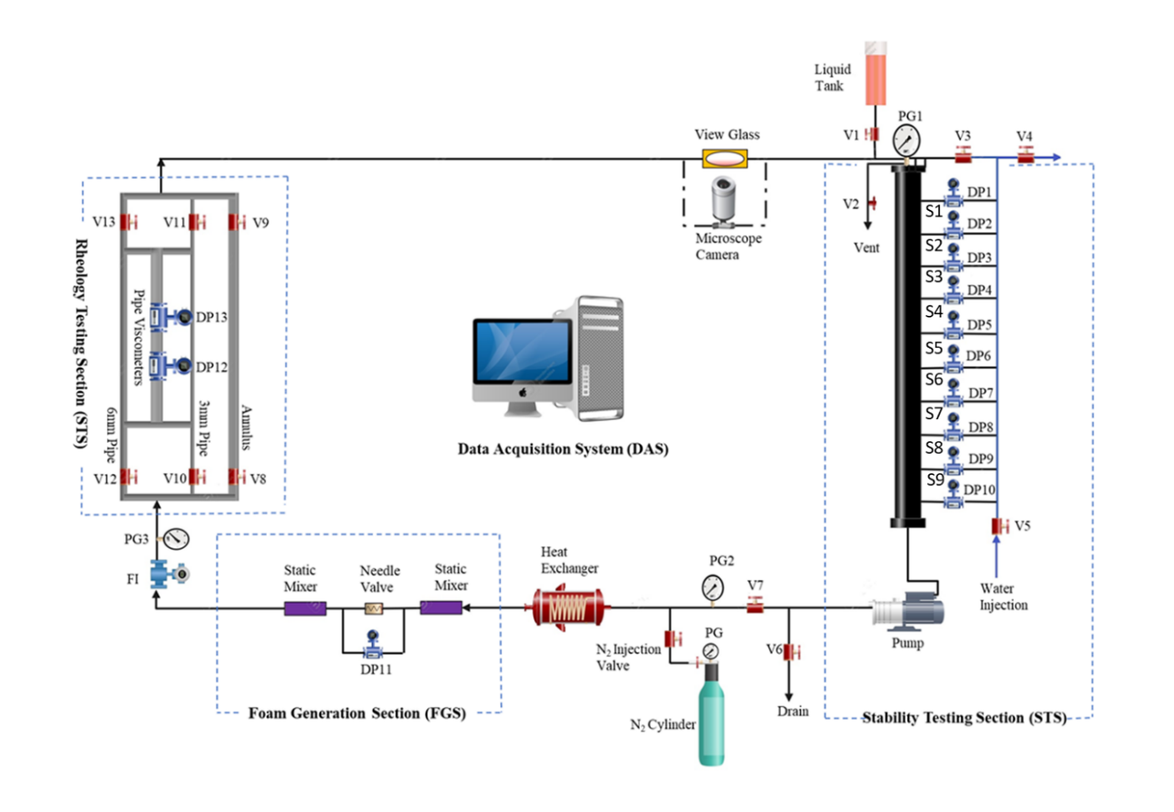
Figure 3.1: Experimental Setup Schematic.

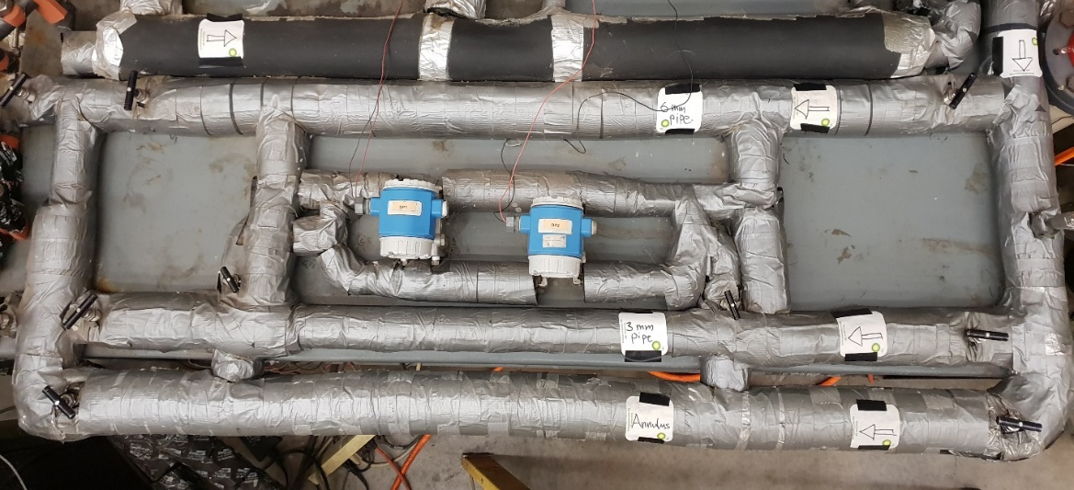
Figure 3.2: Rheology testing section of the experimental setup
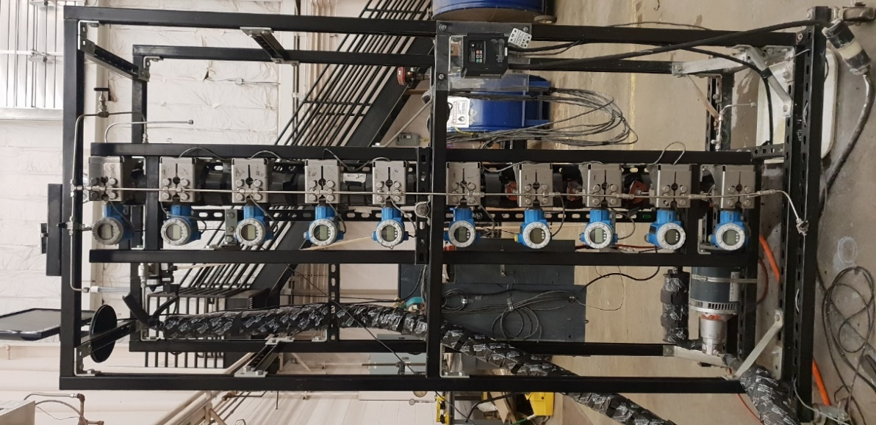
Figure 3.3: Stability testing section of the experimental setup

3.2 Experimental Materials
The liquid phase of aqueous foam was prepared by mixing fresh tap water and an anionic surfactant widely known as Howco SudsTM, with a critical micelle concentration (CMC) of 2 wt.% at 23◦C. Nitrogen gas with a purity of 99.9%wt supplied by Airgas and used as the gas phase of the foam. SkySpring Nanoparticles, Inc. provided the nanoparticles used in this experiment. Three nanoparticles were investigated, bare Silicon Oxide Nanoparticles (NS1), Silicon Oxide Nanoparticles surface modified with an amino group (NS2), and Silicon Oxide Nanoparticles treated with Silane Coupling Agents (NS3).

3.2.1 Surfactant
Howco Suds surfactant (Figure 3.4) is known for producing a stable foam. Additionally, it is compatible with a wide range of other chemicals and ingredients, making it easy to incorporate into formulations. Moreover, Howco Suds surfactant is biodegradable, which means it breaks down easily in the environment and does not accumulate in waterways or other ecosystems. Lastly, Howco Suds surfactant has low irritancy to the skin, eyes, and respiratory system, making it safe to handle and use in foam applications. The physical and chemical properties of Howco SudsTM are summarized in Table 3.1.

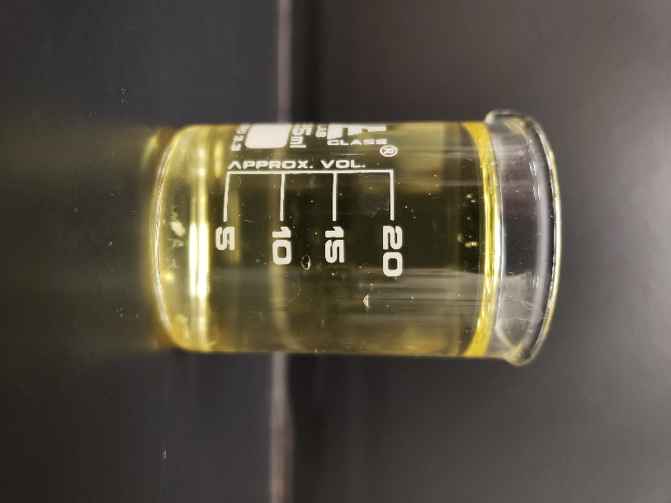
Figure 3.4: Howco Suds surfactant

Property | Description
Name | Howco SudsTM
Appearance | Clear, colorless to pale yellow liquid
Odor | Mild
Solubility | Soluble in water and polar organic solvents
pH Range | 7-9 (1% solution)
Viscosity | 1000-3000 cP (at 25°C)
Boiling Point | >300ºF
Surface Tension Gravity | 35-45 mN/m (at 1% concentration)
Critical Micelle Concentration (CMC) | 2 % (w/v)
Biodegradability | Biodegradable
Compatibility | Compatible with a wide range of other chemicals and ingredients
Foam Stability | Produces stable foam
Cleaning Power | Excellent cleaning power
Low Irritancy | Low irritancy to skin, eyes, and respiratory system
Table 3.1: Properties of Howco Suds surfactant

3.2.2 Silicon Oxide (SiO₂) Nanoparticles
Three Silicon Oxide nanoparticles (Figure 3.5) were utilized to study their effect on foam stability. All three types were white in color, and their texture was fine and powdery. The texture of NS2 was finer than NS1 and NS3, indicating a smaller particle size. The characteristics of the SiO2 nanoparticles utilized in the experiment are displayed in Table 3.2.
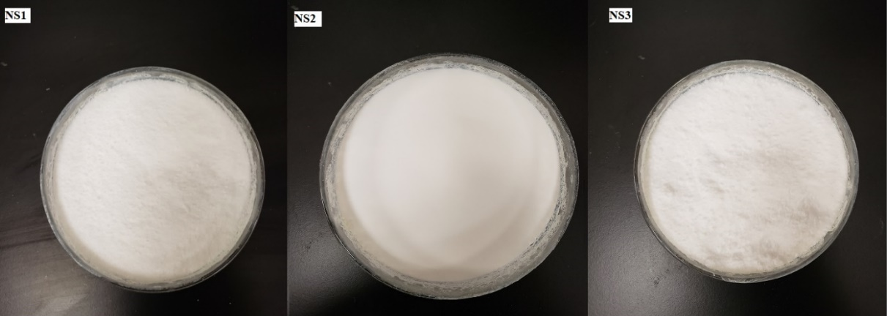
Figure 3.5: Silicon oxide nanoparticles, NS1 (Left), NS2 (Middle), and NS3 (Right)

Type of nanoparticle | Size (nm) | Specific Surface Area (m²/g) | Purity (%) | Morphology | Density (g/cm³) | Color
(NS1) Bare Silicon Oxide | 10-20 | 160 | 99.5 | nearly spherical | 0.06 | white
(NS2) Modified Silicon Oxide (amino group) | 10-20 | 90-130 | 99.8 | nearly spherical | 0.15 | white
(NS3) Treated Silicon Oxide (Silane Coupling gents) | 10-20 | >400 m2/g | 99 | nearly spherical | NA | white
Table 3.2: Characteristics of Silicon oxide nanoparticles NS1, NS2, and NS3

3.2.3 Nitrogen Gas
Nitrogen gas was used to generate foam. The foam was produced using technical-grade nitrogen gas with a purity of 99.9%. A high-pressure cylinder equipped with a pressure regulator (Figure 3.6) was utilized to supply the gas at 6.7 MPa. This gas was introduced into the flow loop to regulate foam quality and system pressure. Nitrogen foams offer numerous advantages due to their unique properties, including:
- Non-flammable: Nitrogen foam is non-flammable and does not support combustion. This makes it useful for fire suppression applications.
- Low toxicity: Nitrogen foam is non-toxic and environmentally friendly. It does not contain any harmful chemicals or substances.
- Good stability: Nitrogen foam is stable and does not break down easily. It can maintain its properties over a long period.
- Good flow properties: Nitrogen foam has good flow properties and can be easily pumped and injected into various applications.
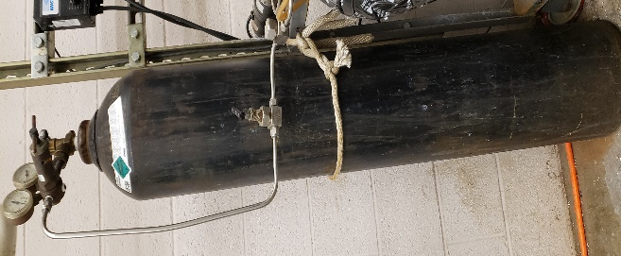
Figure 3.6: Nitrogen gas cylinder with a pressure regulator

3.3 Experimental Procedure
To prepare the baseline foam that doesn’t contain nanoparticles, a laboratory blender (Figure 3.7) was used to mix 30 ml of surfactant concentration (2 wt% of water) with 1500 ml of water for 15 minutes to prepare the baseline liquid phase. However, to investigate the effect of nanoparticles on foam stability, the required concentration of nanoparticles was first added to 1500 ml of water and mixed using a sonicator (Figure 3.8) until the nanoparticles were dispersed entirely in the water. Then, 30 ml of surfactant (2 wt% of water) was added to the mixture and stirred for 15 minutes using a laboratory mixer to achieve homogeneity.
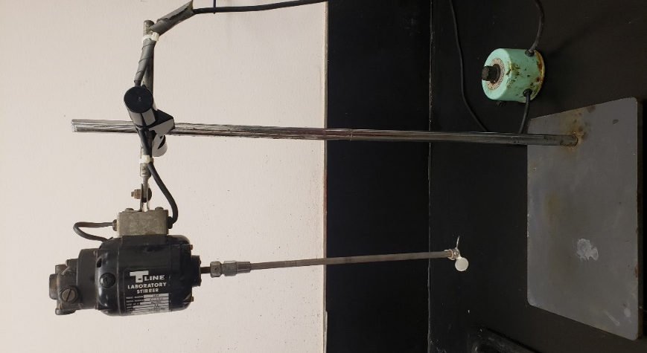
Figure 3.7: Multiple-speed laboratory blender with speed regulator
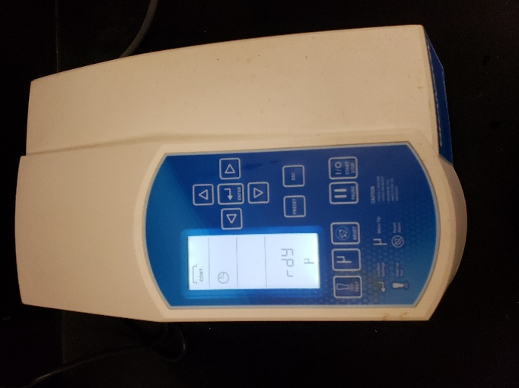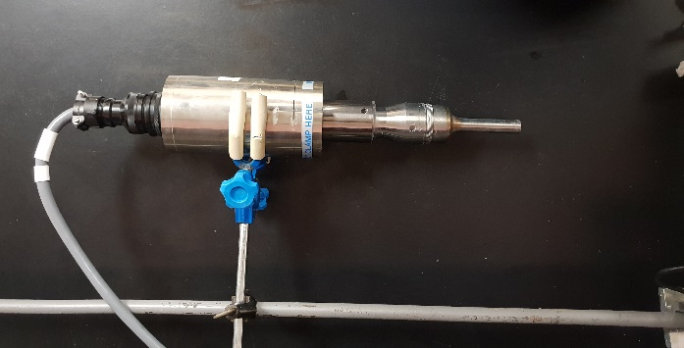
Figure 3.8: Sonicator with generator (Left), converter, and probe (Right)

When the base liquid was ready, it was poured into the liquid tank (Figure 3.9), and valve V1 was opened to fill the flow loop. A check valve was used to restrict the base liquid from flowing backward. The valve V1 is left open to relieve system back pressure and enable unrestricted passage of base liquid into the flow loop. After filling the system with base liquid, both valves (V1 and V3) were closed, and the pump was started at full capacity. The base liquid was then circulated through the whole system while maintaining all pipe viscometers open to obtain maximal fluid flow area. Subsequently, the nitrogen cylinder was opened to inject the gas phase into the system. The gas pressure regulator was set to 1000 Psi to prevent overpressurization. The needle valve was first fully opened to enable circulation while mixing the gas and liquid phases. The valve was then throttled to produce foam. A differential pressure of 500 inches of water across the valve was maintained during the investigation to achieve homogeneous foam.
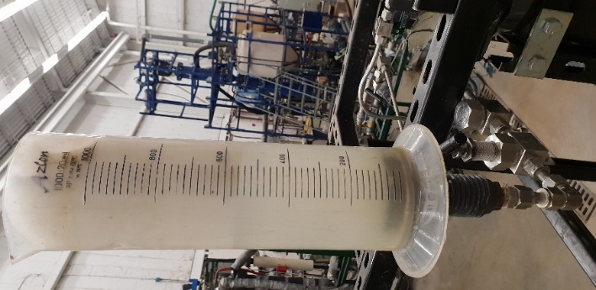
Figure 3.9: Base liquid tank

After circulating the mixture of a small amount of nitrogen and base liquid in the flow loop, the mixture evolved into low-quality foam. To reach the desired foam quality, the liquid phase was slowly drained through Valve V6 while the gas phase was introduced into the loop to keep the pressure constant by slowly opening the nitrogen injection valve. The pump was then restarted to circulate the foam and assess its quality. This step-by-step procedure was repeated until the required foam quality was achieved. The foam was circulated for 10 minutes after attaining the desired quality to ensure it was fully generated/equilibrated and stable while flowing.
During the stability test, the motor was turned off, and the foam was quickly trapped in the vertical cell to assess foam drainage by measuring the pressure profile in the foam column. For two hours and 15 minutes, differential pressure sensors installed on the vertical cell were used to monitor the pressure profile in the foam column. The pressure profile data from the stability test is evaluated, and foam drainage is computed as an indicator of foam stability.

3.4 Experimental Scope
This study aimed to investigate the effect of silica nanoparticles on the rheological behavior and stability of the aqueous foam. The scope of the study included conducting experiments to generate homogenous foams with varying qualities, measuring foam quality, analyzing the rheological behavior of the baseline foam and foam with silica nanoparticles, and evaluating the stability of aqueous foam containing silica nanoparticles through drainage tests. The study compared three different silica nanoparticle/surfactant foams (NS1, NS2, and NS3) and the baseline (a pure surfactant foam, NS0).
The rheological behavior of the foams was analyzed by plotting the logarithm of wall shear stress against the nominal Newtonian shear rate. The effect of silica nanoparticles on foam viscosity was investigated, and the type of nanoparticle used was found to play a significant role in determining the efficiency of the foam. The stability of aqueous foam containing silica nanoparticles was evaluated through drainage tests, which involved measuring the hydrostatic pressure distribution of the liquid column as a function of time. The study also involved analyzing the bubbles' images to determine the foam's homogeneity and stability, as well as the size of the bubbles and liquid content in the foam.
A total of 30 experiments were carried out using similar conditions while varying the type of silica nanoparticles, concentrations, and foam quality. The results were purely observational, and the experiments were conducted under passive conditions using the vertical cell to trap the foam. The pressure distribution was measured using differential pressure transmitters to determine the amount of drainage in each segment as a function of time. Table.3.3 describes the test matrix.
Foam type | Aqueous Foam
Liquid phase | Tap water
Surfactant (wt.%) | Howco SudsTM at 2 wt.%
Gas phase | Nitrogen
Nanoparticles | NS1, NS2, and NS3
Nanoparticles concentration (wt.%) | 0%,0.5%, 1%, 2%, and 3%
Foam qualities | 40%, 50 %, and 60%
System pressure (psi) | 1000
System temperature | Ambient temperature
Table 3.3: Test matrix

3.5 Data Analysis
The pressure profile is measured across the vertical cell in the stability test section, where the foam is confined to assess the drainage. The vertical column is divided into nine segments using ten pressure transducers spaced vertically equidistance, as shown in Figure 3.3. The segments are numbered from top (S1) to bottom (S9) according to their vertical position. By measuring the pressure profile, we can evaluate the uniformity of the foam generated in the vertical column. A linear pressure profile indicates that the foam in the column is homogeneous and fully generated (as shown in Figure 3.10). In contrast, a non-linear profile suggests that the foam is degraded/drained, losing its liquid phase from its structure.

Figure 3.10: Pressure distribution across the vertical cell for generated foams

The measurements collected by the pressure sensors were in inches of water (in. H20) and converted into Kilopascals (kPa) for the analysis. To determine the foam drainage for each segment, non-linear regression analysis is applied to the pressure profile plots using a second-degree polynomial function (Eq. 3.1).
$y=C2*x^{2}+\left(C1*x\right)+b$ (3.1)
The constants b, C1, and C2 are parameters that vary with time as the foam degrades, and they are calculated using the following Excel functions:
C2 = INDEX(LINEST(y, x^{1,2}),1)
C1 = INDEX(LINEST(y, x^{1,2}),1,2)
b = INDEX(LINEST(y, x^{1,2}),1,3)
The pressure data is referred to as 'y', and the column height is represented by the letter 'x'. Therefore, Eq. 3.1 can express as follows (Obisesan, 2020; Shah, 2022):
$P=C2*H^{2}+\left(C1*H\right)+b$ (3.2)
The derivative of Eq. 3.2 with respect to 'H' yields the following expression:
$\frac{dP}{dH}=2*C2*H+C1$ (3.3)
Considering the hydrostatic pressure head, the pressure P can be expressed as follows.
dP = 𝜌 * g * dH (3.4)
Substituting Eq. 3.4 into 3.3 yields the following equation that calculates the density of foam of the function of H.
$ρ =\frac{1}{g}(2*C2*H+C1)$ (3.5)
Equation 3.6 can be used to determine the density of foam at any given height along the vertical cell. To calculate the average foam density between two points, one can substitute 'H' with the average height given by (h1 + h2)/2. By doing so, Equation 3.5 can be modified to calculate the average density in a foam segment in the column:
$ρ_{avg}=\left(\frac{1}{g}\right)*[C2*(h1+h2)+C1]$ (3.6)
The heights h1 and h2 correspond to the positions of differential pressure transmitters defining the segment. By utilizing the constants b, C1, and C2 obtained at different times, the average density (𝜌_{avg}) of the confined foam can be determined for each segment when there is liquid column formation is not detected. As the liquid drains from the foam, liquid columns begin forming in the lower segments of the column, and gradually, the liquid column quickly reaches the middle of the test section. Therefore, for the regression analysis, only the top 3 segments are considered because these segments do not accumulate liquid from the drainage from the upper segments. The formation of a liquid column results in a linear pressure profile and invalidates a single second-degree polynomial assumption. Once the average density is obtained, the following equation can be applied to calculate the quality of the foam (Obisesan, 2020; Shah, 2022):
$Γ=\frac{\left(\frac{1-ρ_{avg}}{ρ_{liq}}\right)}{\left(\frac{1-ρ_{gas}}{ρ_{liq}}\right)}$ (3.7)
The symbol 𝜌_{avg} represents the average density, while 𝜌_{liq} denotes the density of the liquid, and 𝜌_{gas} represents the density of the gas. Furthermore, given the volume (V_{segment}) of a foam segment in the vertical cell, the liquid volume (V_{liq}) can be calculated for any segment as a function of foam quality as follows:
$V_{liq}= (1-Γ)* V_{segment}$ (3.8)
The amount of gas within the foam grows when the liquid drips out from the foam structure, increasing the quality foam with time. The amount of drained liquid at a given time (t) can be determined using the following equation.
$V_{drained}(t)= (1-Γ(t))* V_{liq}$ (3.9)
$Drainage(t)=V_{drained}\left(initial\right)-V_{drained}(t)$ (3.10)
Drainage experiments were conducted for at least two hours. At the start of the experiment, the drainage of a segment is zero, and it increases with time if the segment loses more liquid than it gains. Therefore, fractional drainage is introduced to compare the loss of liquid to the origin of liquid in a segment. Furthermore, fractional drainage helps to compare the drainage occurring in different quality foams. The fractional drainage (FD) of a segment is mathematically expressed as:
$FD(t)= \frac{Drainage(t)}{V_{liq}}*100$ (3.11)

CHAPTER FOUR

RESULTS AND DISCUSSIONS

4.1 Effect of Silica Nanoparticles on Rheology
To ensure reliability and consistency of the results, foam rheology experiments were first carried out to generate homogenous foams with different qualities. The foam quality is an essential parameter that determines the foam's stability, coarseness, and drainage behavior. The rheological behavior of the baseline foam and foam with silica nanoparticles was analyzed by resenting the data in a logarithmic plot of wall shear stress against the nominal Newtonian shear rate. It was found that the foam exhibited a power-law flow behavior, which is common in non-Newtonian fluids.
The apparent viscosity of the baseline foam as a function of foam quality is illustrated in Figure 4.1a. It shows that the apparent viscosity augmented significantly when the foam quality was increased from 40% to 60%. This trend is consistent with measurements presented in the literature, which suggests that foam viscosity increases with foam quality. The effect of silica nanoparticles on the rheological behavior of aqueous foam was also examined. Figures 4.1b, 4.1c, and 4.1d showed that similar property changes with foam quality trends were observed in foams incorporating silica nanoparticles. However, it was found that the addition of silica nanoparticles resulted in a further increase in foam viscosity, indicating that nanoparticles could influence foam rheological properties.

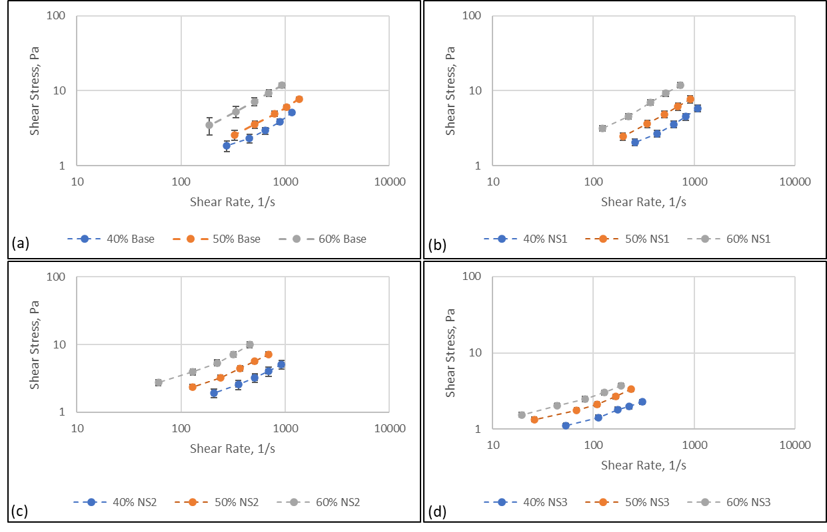
Figure 4.1: shear rate vs. shear stress for (a) baseline foam, (b) foam mixed with NS1, (c) foam mixed with NS2, and (d) foam mixed with NS3

Figure 4.2 demonstrates the impact of adding nanoparticles on the rheological properties of foams at different foam qualities. Results show that the inclusion of nanoparticles improved the viscosity of foams. Furthermore, the kind of nanoparticle used also played a substantial role in determining the impact of nanoparticles on the rheological characteristics of the foam. For example, the experiments revealed that some nanoparticles were more effective in improving foam rheological properties than others. These findings suggest that using nanoparticles could provide a promising route for enhancing the properties of foams. Furthermore, by carefully selecting the type of nanoparticle used and controlling its concentration, it may be possible to create foams with tailored properties suited for specific applications.
Therefore, the results of this study provided insights into the complex behavior of aqueous foam and the influence of silica nanoparticles on foam rheology. Furthermore, the findings could be helpful in the development of new foam formulations for various applications, such as enhanced oil recovery, cementing, and geothermal drilling.
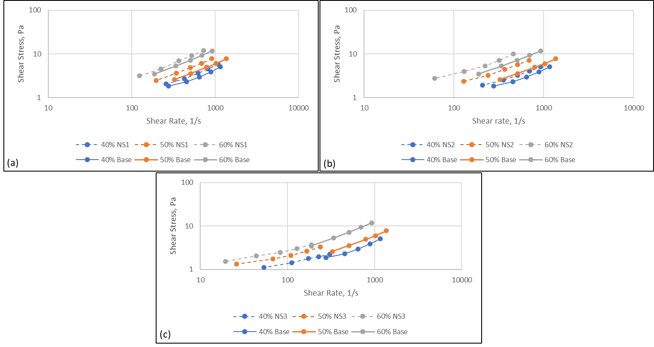
Figure 4.2: shear rate vs. shear stress for (a) baseline foam and NS1 foam, (b) baseline foam and NS2 foam, (c) baseline foam and NS2 foam

4.2 Effect of Silica Nanoparticles on Stability
The stability of aqueous foam containing silica nanoparticles was evaluated through drainage tests that were performed. Similar conditions were used for all the tests while varying the type of silica nanoparticles, concentrations, and foam quality. During the test, the drainage fraction was zero at the start of the test. As the test progressed, the liquid phase in the top segments (S1 to S5) was lost while the bottom segments gained liquid. As a result, the pressure curves in the bottom segments were linear, whereas the pressure curves in the top segments were parabolic as the foam decayed. In addition, cavity formation was observed at the very top segment (S1). Therefore, only the pressure distribution of the upper segments (S3 to S6) was utilized to analyze drainage. It should be noted that the experiments were conducted under calm conditions, and the results were purely observational. The vertical cell was used to trap the foam and allow the drainage process to take place without any external influence.

4.2.1 Effect of Foam Quality on Stability
In Figure 4.3, the effect of foam quality on the fractional drainage of the baseline foam (0% NS) and foam with varying concentrations and types of silica nanoparticles (1% NS1, 0.5% NS2, 1% NS2, 3% NS2, and 1% NS3) is shown. The results indicated that increasing the foam quality led to a reduction in drainage and an increase in foam stability, as expected. However, the decrease in liquid phase drainage varied significantly when different silica nanoparticles were used. Some silica nanoparticles showed impressive results in reducing liquid drainage and increasing foam stability. These results suggest that specific silica nanoparticles can significantly impact the stability of aqueous foams, and further investigation is necessary to understand their effects fully.
In the following section, the effect of different silica nanoparticles on aqueous foam stability will be discussed in detail. This will involve thoroughly analyzing the experimental data and comparing the results obtained using different types and concentrations of silica nanoparticles.
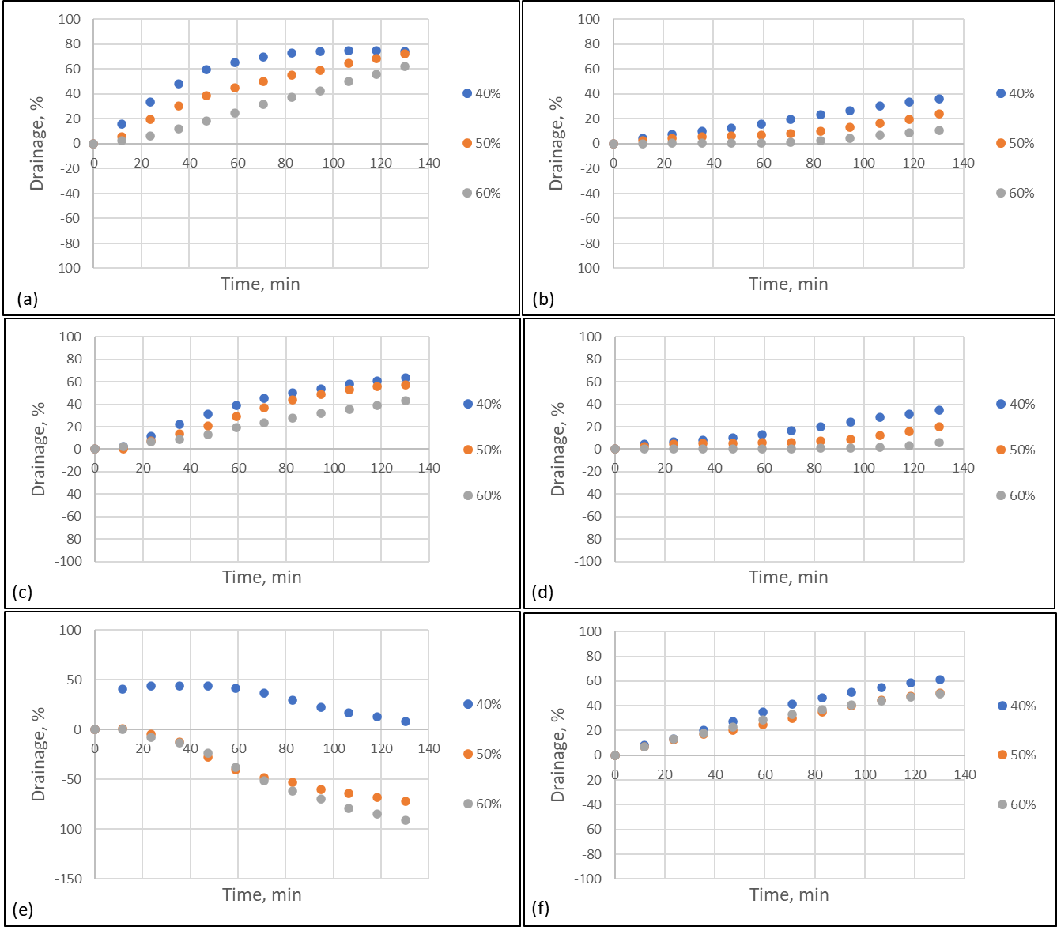
Figure 4.3: Fractional drainage obtained by S3 for 40%, 50%, and 60% foam qualities for (a) 0% NS, (b) 1% NS1, (c) 0.5% NS2, (d) 1% NS2, (e) 3% NS2, (f) 1% NS3

4.2.2 Effect of unfunctionalized Silica Nanoparticles (NS1) on stability
Figure 4.4 presents the effect of bare silica nanoparticles on aqueous foam drainage. The experiments were conducted at varying foam qualities (40%, 50%, and 60%) and compared with the baseline foam (0% NS). At 40% foam quality, the baseline foam experienced increasing liquid drainage over time, reaching 75% at 130 minutes. However, when 1% bare silica nanoparticles (NS1) were added, the liquid drainage reduced significantly and reached 37%. Similar effects were observed at 50% and 60% foam qualities (Figures 4.4b and 4.4c).
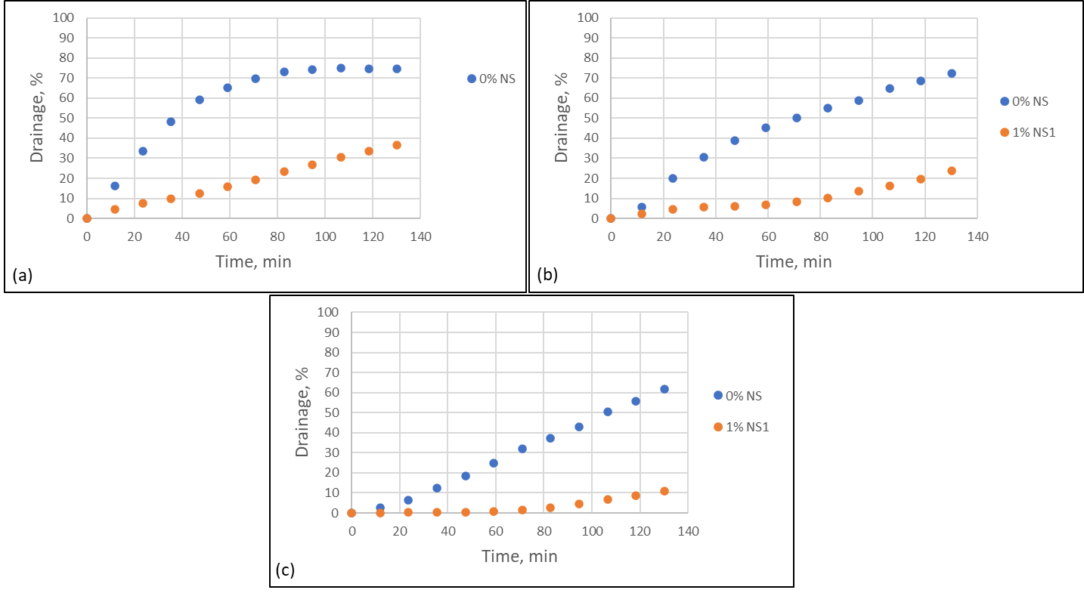
Figure 4.4: Compares the drainage obtained by S3 for baseline foam (0% NS) and foam with 1% NS1 at: (a) 40% foam quality, (b) 50% foam quality, and (c) 60% foam quality

These results suggest that adding bare silica nanoparticles significantly influences the stability of aqueous foams by reducing liquid drainage. This effect may be attributed to the high adsorption energy of silica nanoparticles, which enhances liquid film elasticity and inhibits bubble coalescence, ultimately leading to foam stabilization. Additionally, the nanoparticles can act as a physical barrier to prevent liquid drainage through the foam structure. As a result, the foam stays stable for longer periods and maintains its structural integrity, making it useful in applications such as oil recovery, hydraulic fracturing, and geothermal applications.
In this study, further analysis was conducted to investigate how the liquid phase accumulates in the lowest segment (S9) of the vertical cell. The drainage of the liquid phase over time was examined, and the results of using a foam with and without the addition of 1% NS1 were compared.
The drainage of the liquid phase in cm3 with time in minutes was shown in the Figure 4.5. The effect of incorporating 1% NS1 for 40% foam quality was examined (Figure 4.5a).
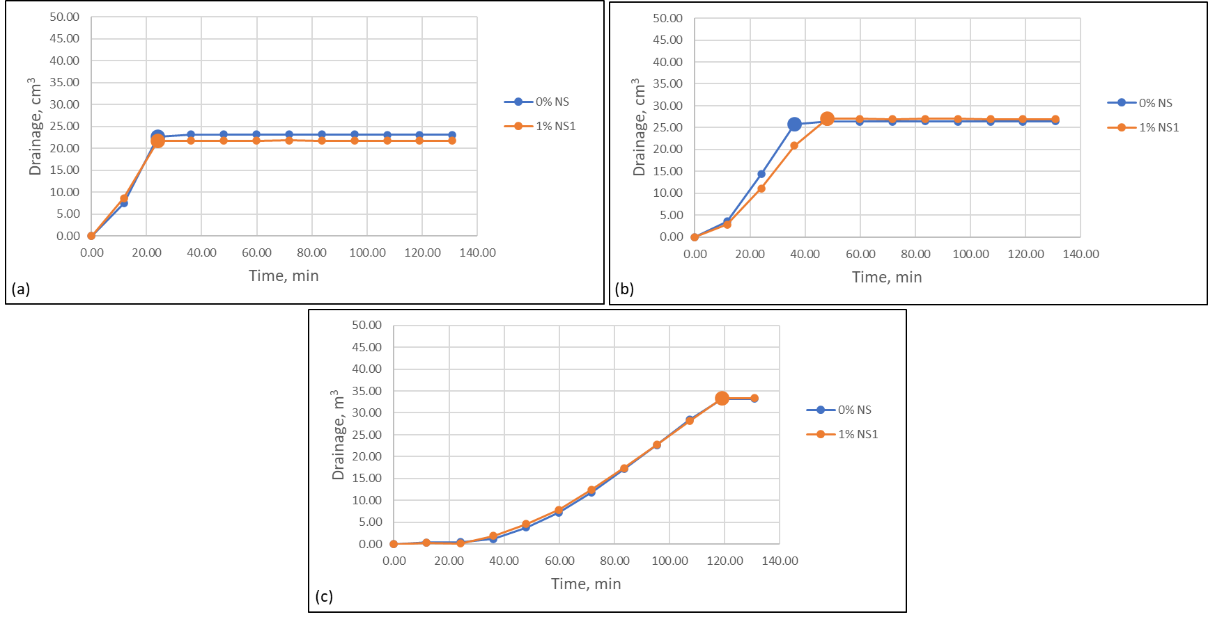
Figure 4.5: The drainage of the liquid phase obtained by S9 for baseline foam (0% NS) and foam with 1% NS1 at: (a) 40% foam quality, (b) 50% foam quality, and (c) 60% foam quality
It was observed that, for the baseline foam (0% NS), the drainage volume increased rapidly at the early stages of the test, indicating that the foam column was being filled with the liquid phase. The filling point was reached at 24 minutes, after which the drainage volume remained constant, indicating that the column was completely filled with liquid. No significant difference was observed in the results when 1% NS1 was added to the foam. When the foam quality was increased to 50% (Figure 4.5b), the filling time for the baseline foam increased to 36 minutes, while for the foam with 1% NS1, the filling time was 47 minutes, showing a slight improvement in foam stability by adding NS1 to the mixture.
Increasing the foam quality further to 60% resulted in a significant increase in stability (Figure 4.5c), delaying the filling time to 119 minutes. However, adding 1% NS1 showed a similar trend, indicating that the addition of NS1 had an insignificant effect at this point in the test. One should note that the difference in fill-up point was caused by the error from adjusting the zero in the pressure sensors.
The findings suggest that there is a difference in foam stability between the upper segments and the lowest segment. Specifically, the foam stabilized at the upper segments (S3 to S6), but there was no improvement in stability observed for the lowest segment (S9). This suggests that the use of silica nanoparticles work best with stabilizing the foam at the upper sections of the wellbore, which could have implications for the effectiveness of foam drilling in different sections of the wellbore.

4.2.3 Effect of Silica Nanoparticles Modified with Amino Group (NS2) on Stability
Drainage experiments were also conducted to evaluate the effect of amino-coated silica nanoparticles (NS2) on the stability of aqueous foams. The NS2 concentrations and foam quality varied in the experiments. The graph in Figure 4.6a depicts the fractional drainage as a function of time for aqueous foams containing different concentrations of NS2 and a baseline foam with 0% NS2. The results show that the final drainage percentage of the baseline foam was 74%, whereas adding 0.5% NS2 marginally reduced the drainage by 9%. As the NS2 concentration was increased to 1%, the drainage was significantly reduced by around 40%, indicating that the foam was stabilized. However, further increasing the NS2 concentration to 3% showed a rapid increase in drainage during the early stages of the test (approximately 45% after 30 minutes). Still, the foam began to gain more liquid from the upper segment after 60 minutes and reached 8% drainage at the end of the experiment (130 minutes). Similar results were obtained for 50% and 60% foam quality, as shown in Figures 4.6b and 4.6c.
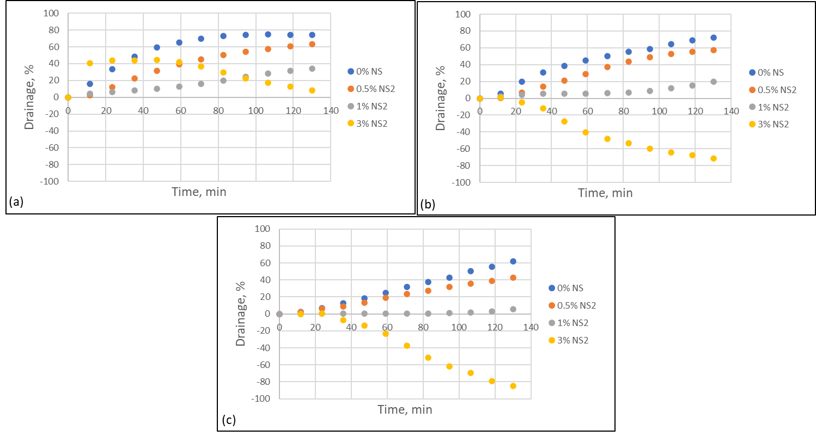
Figure 4.6: Compares the drainage obtained by S3 for baseline foam (0% NS) and foam with 0.5% NS2, 1%NS2, and 3% NS2 at (a) 40% foam quality, (b) 50% foam quality, and (c) 60% foam quality
The effect of NS2 on the liquid phase drainage volume in the lowest segment (S9) of the vertical cell was investigated and the results are described in Figure 4.7. The study involved varying NS2 concentration (0%, 0.5%, 1%, and 3%) and foam quality (40%, 50%, and 60%). The aim was to evaluate the impact of NS2 on the stability of the foam and to optimize the NS2 concentration to achieve the best results.
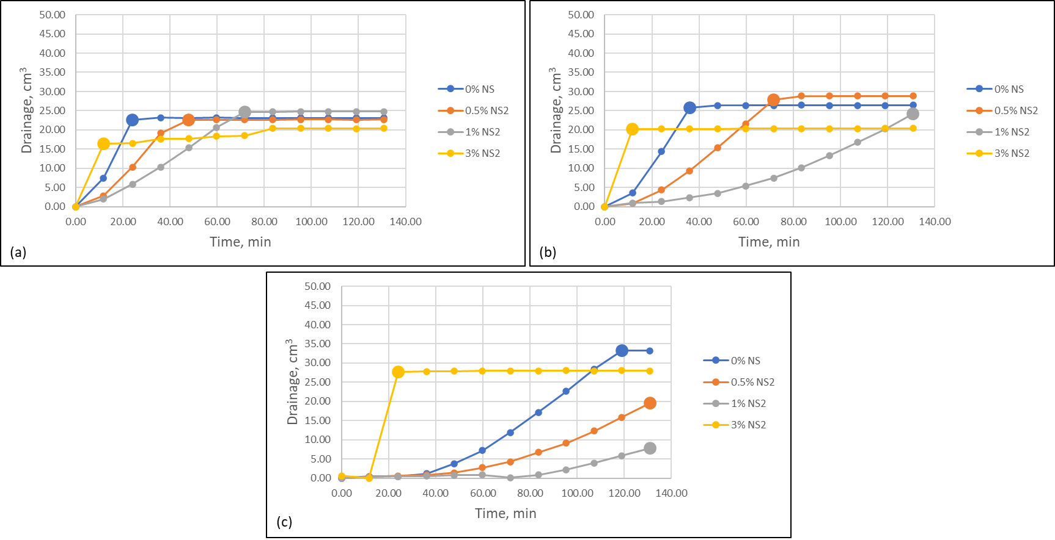
Figure 4.7: The drainage of the liquid phase obtained by S9 for baseline foam (0% NS) and foam with 0.5% NS2, 1%NS2, and 3% NS2 at (a) 40% foam quality, (b) 50% foam quality, and (c) 60% foam quality

At 40% foam quality (Figure 4.7a), the results showed that adding 0.5% of NS2 helped delay the filling time from 24 minutes for baseline foam (0% NS) to 48 minutes, and significantly to 72 minutes for 1% NS2, which significantly stabilized the foam. However, increasing NS2 concentration to 3% caused a rapid filling of the foam column by 11 minutes, which was shorter than the filling time for the baseline. This indicates that there is an optimal concentration of NS2 that should be used to obtain the best result, and exceeding this concentration can be counterproductive. It's worth noting that the rapid filling of the foam column observed at 3% NS2 could be due to the drainage of the liquid phase, which is caused by the trapping of smaller bubbles in the liquid.
At 50% foam quality (Figure 4.7b) and 0.5% NS2, the liquid drainage time increased from 36 minutes for baseline foam (0% NS) to 72 minutes. Furthermore, increasing the concentration of NS2 to 1% significantly reduced the filling time until the end of the test at 130 minutes, and the liquid drainage volume was slowly increasing until it reached the filling point. However, increasing NS2 concentration to 3% rapidly increased the liquid drainage and filling of the column just 11 minutes. Similar trends were observed at 60% foam quality (Figure 4.7c).
These results suggest that the addition of NS2 can improve the stability of the foam, but the optimum concentration of NS2 depends on the foam quality. It is important to optimize the concentration to achieve the best results and to prevent rapid filling of the foam column.
The mechanism behind this improvement is related to the surface chemistry and morphology of the nanoparticles (Murray, 2015; Yokoi et al.,2012; Yoon et al.,2021). The amino groups on the surface of the nanoparticles can modify the interfacial properties of the foam-forming surfactants, increasing the foam lamellae's elasticity and strength. The interaction between the amino-functionalized silica nanoparticles and the surfactants is attributed to electrostatic and hydrogen bonding between the amino groups and the polar head groups of the surfactants (Yokoi et al.,2012). The nanoparticles' adsorption onto the foam lamellae's surface forms a rigid network structure that can resist the coalescence and collapse of the foam bubbles, leading to improved foam stability and reduced drainage (Murray, 2015).
In addition to the electrostatic and hydrogen bonding, the amino-functionalized silica nanoparticles' morphology could also play a role in improving foam stability and reducing drainage (Yoon et al.,2021). For example, nanoparticles can form a network structure with high surface area and roughness, which can trap gas bubbles and prevent coalescence, further improving foam stability.
The positive surface charge of amino-functionalized silica nanoparticles might also be a reason to improve aqueous foam stability and reduce drainage. The positive charge can interact with negatively charged surfactant molecules, leading to the electrostatic attraction between the nanoparticles and the surfactant molecules. This attraction would enhance the rigidity and strength of the foam lamellae by adsorbing the nanoparticles onto the surface of the foam lamellae and creating a repulsive barrier that resists the drainage and coalescence of the foam by electrostatic repulsion between the positively charged nanoparticles and the foam bubbles (Cui et al., 2010). These findings are consistent with previously reported results (AlYousef et al., 2018; Hunter et al., 2009; Shojaei et al.,2021; Sonn et al., 2018; Sun et al., 2015; Vatanparast et al., 2017; Yekeen et al., 2017).
The use of amino-functionalized silica nanoparticles represents a simple and effective approach to improving the stability of aqueous foams and reducing drainage, with potential applications in various industrial and commercial sectors.

4.2.4 Effect of Silica Nanoparticles treated with silane coupling agents (NS3) on Foam Stability
The experiment involved conducting drainage tests on foam containing silica nanoparticles treated with silane coupling agents (NS3). The experiment aimed to determine the foam's stability under different conditions. The experimental results are presented in Figure 4.8, showing the drainage behavior of the foam over time. The figure compares the drainage of the foam under two different conditions: baseline foam (without NS3) and foam mixed with 1% of NS3. The experiments were conducted at various foam qualities (40%, 50%, and 60%). At 40% quality (Figure 4.8a), it was observed that adding 1% of NS3 to the foam reduced the final drainage (i.e., at the end of the test) slightly (i.e., 74% to 61%). However, the foam containing NS3 reached its half-life (the time required to get 50% fractional drainage) approximately 60 minutes after the baseline foam reached its half-life.
At 50% quality (Figure 4.8b), a slight change (about 11%) in drainage behavior was observed between the baseline foam and foam containing NS3. At 60% quality (Figure 4.8c), there was no effect observed on foam stability when NS3 was added.
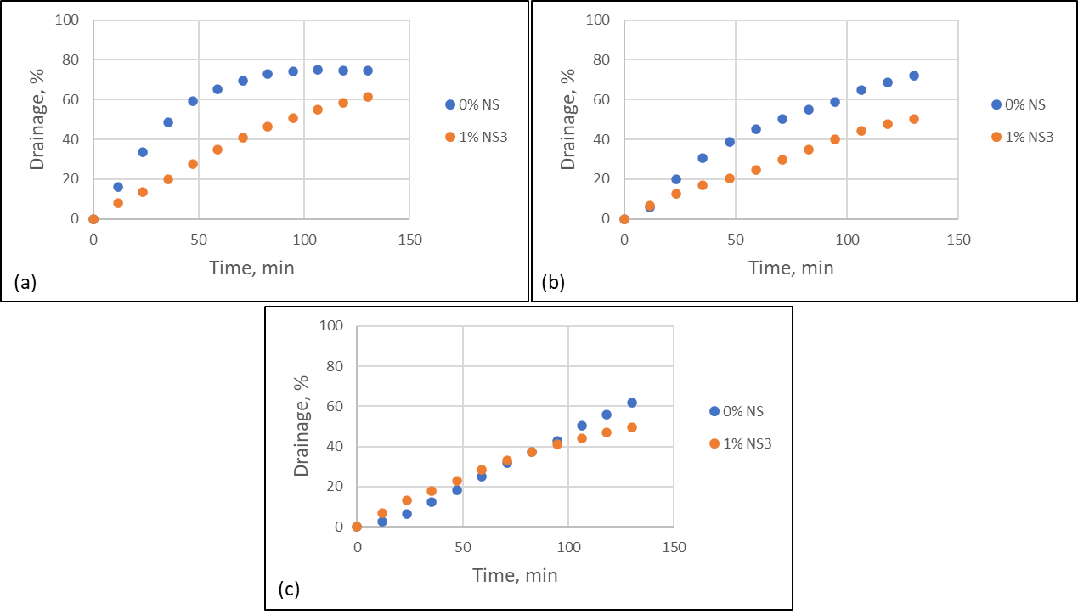
Figure 4.8: Comparison of the drainage obtained by S3 for baseline foam (0% NS) and foam with 1% NS3 at different qualities: (a) 40%, (b) 50%, and (c) 60%
In this experiment, the effect of adding 1% NS3 to the baseline foam was studied to investigate how the liquid phase accumulates in the lowest segment (S9) of the vertical cell. The results obtained from the experiment are depicted in Figure 4.9. The experiment was conducted at different foam qualities, including 40%, 50%, and 60%.
At a foam quality of 40% (Figure 4.9a), the addition of 1% NS3 to the baseline foam helped to delay the filling time by 36 minutes. This indicates an improvement in foam stability with the incorporation of NS3. Similarly, at a foam quality of 50% (Figure 4.9b), the addition of 1% NS3 helped to delay the filling time by 60 minutes, indicating a significant improvement in foam stability. However, at a foam quality of 60% (Figure 4.9c), the addition of 1% NS3 did not have any effect on the liquid filling time. This suggests that at higher foam qualities, the effect of NS3 on foam stability becomes less significant. Therefore, the optimum concentration of NS3 needs to be optimized based on the desired foam quality.
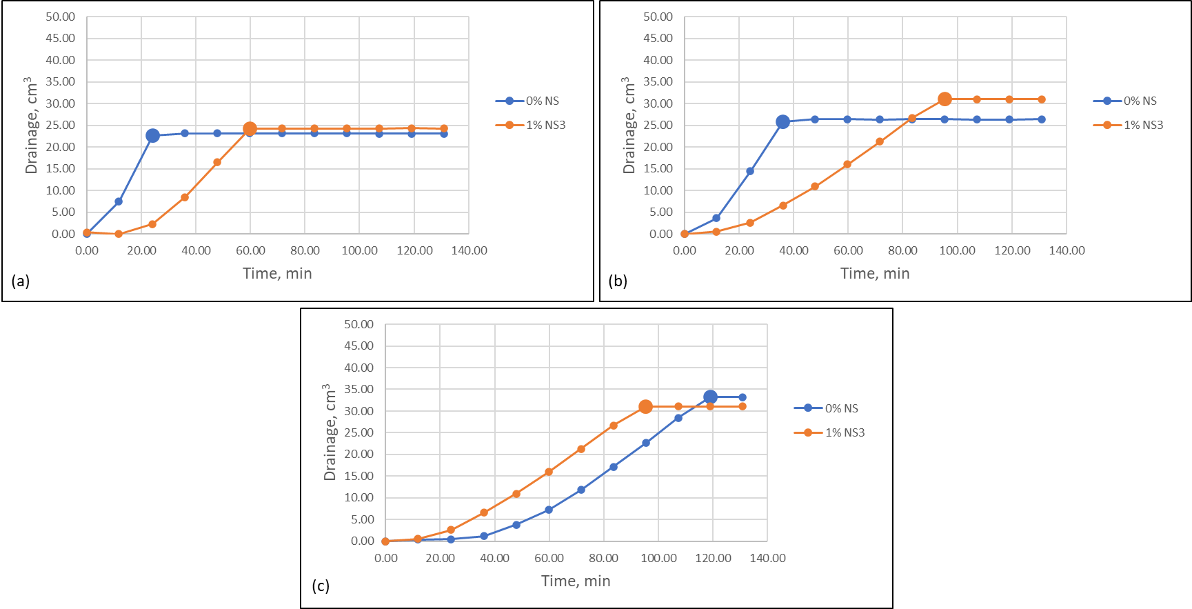
Figure 4.9: The drainage of the liquid phase obtained by S9 for baseline foam (0% NS) and foam with 1% NS3 at: (a) 40% foam quality, (b) 50% foam quality, and (c) 60% foam quality

The positive effect of NS3 on the drainage of foams may be due to the synergistic benefit of combining surface-modified SiO2 nanoparticles with a constant surfactant concentration, stabilizing the foam by serving as a gelling agent, accumulating in the plateau channels, and reducing liquid drainage. Moreover, the coupling agents can modify the surface chemistry of the nanoparticles by creating a covalent bond between the silane molecules and the silica surface. This interaction can lead to the formation of a hydrophobic layer on the surface of the nanoparticles, which can interact with the foam-forming surfactants and modify their interfacial properties. The hydrophobic coating created by the silane coupling agents can increase the foam lamellae's elasticity and strength, improving the foam stability and reducing the drainage rate. Additionally, the hydrophobic layer can enhance the nanoparticles' adsorption onto the foam lamellae's surface, forming a rigid network structure that can resist the coalescence and collapse of the foam bubbles.
Furthermore, silane coupling agents can also increase the compatibility between the silica nanoparticles and the foam-forming surfactants, leading to a more uniform distribution of the nanoparticles in the foam structure. This improved compatibility can further enhance the stability of the foam and reduce drainage. These conclusions are congruent with earlier studies (AlYousef et al., 2018; Hunter et al., 2009; Shojaei et al.,2021; Sonn et al., 2018; Sun et al., 2015; Vatanparast et al., 2017; Yekeen et al., 2017).

4.3 Effect of Silica-nanoparticles/Surfactant Dispersion
Figure 4.10 in the experiment shows photographs of the different silica nanoparticles/surfactant foams generated from 1.0 wt% nanoparticle dispersions with varying types of nanoparticles at 2 wt% surfactant concentrations. The top three rows show nanoparticle-containing foams (NS1, NS2, and NS3), while the bottom row displays the baseline foam (NS0). The photographs were taken immediately after foam generation and at 5, 30, 60, and 120 minutes of aging, allowing for the observation of changes in foam texture over time. First, 250 mL of water/silica nanoparticles dispersion was sonicated for 10 minutes to generate foams. The mixture was then stirred with a blender at 20 rpm for 10 minutes while adding surfactant. The foam was then transferred to a glass beaker.
The initial volume of baseline foam (NS0) was 500 ml, with a liquid volume of 100 ml. The initial baseline foam volume was higher than those of nanoparticle-containing foams. The initial volumes were 400 ml for NS1 and NS2 and 350 ml for NS3. As time progressed, the foam volume decreased for all samples, which was expected as the foam collapsed over time. However, the foams with silica nanoparticles maintained a relatively stable foam volume over time, indicating that the nanoparticles provided steric stabilization and interfacial foam film reinforcement. The photographs in Figure 4.10 also showed that some of the silica nanoparticles were found within the dried foam structure on the inner surface of the cylinder, indicating that the nanoparticles indeed took part in stabilizing the foams.
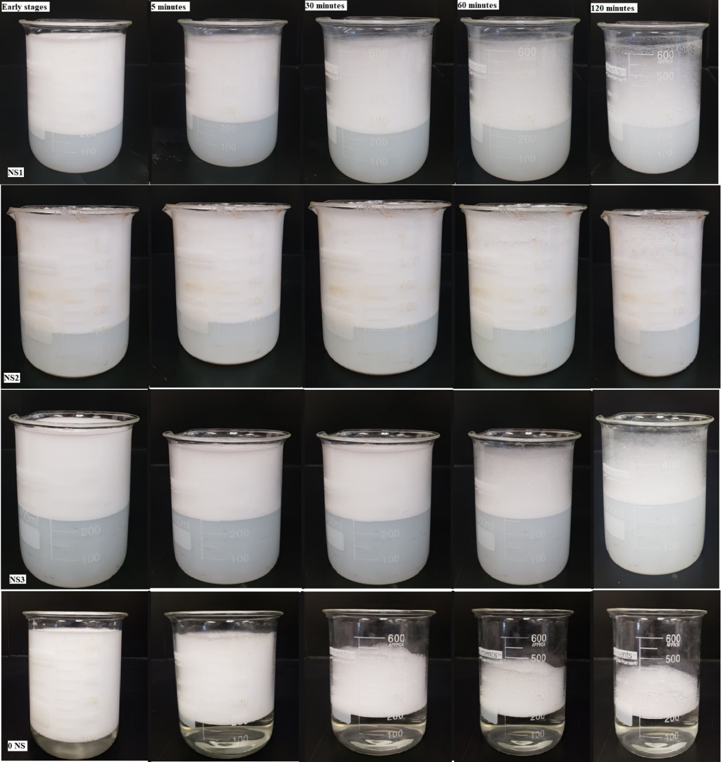
Figure 4.10: Image foam silica-nanoparticles dispersion (Top three rows) and pure surfactant foam dispersion (Bottom) overtime
Figure 4.11 presents measured foam volume versus time for the different foams. The foam volume measurements compared the stability of different foams over time and further highlighted the benefits of silica nanoparticles in foam stabilization under atmospheric conditions. Even though the baseline foam's foamability was high compared to nanoparticles containing foams, it degraded faster than the others.

Figure 4.11: Foam volume vs. time

Figure 4.12 presents microscopic images of tested foams. The bubble structures were examined to assess the homogeneity of the foams, the size of the bubbles, and the distribution of the liquid in the foam. The results showed that the uniformity of the foam decreased over time for both baseline and nanoparticle-containing foams. And the bubble size grew with time due to the pressure differences caused by the Young–Laplace effect. This pressure difference acted as a driving force for gas diffusion from small to large bubbles, making the foam more heterogeneous over time and indicating fewer stable bubbles.
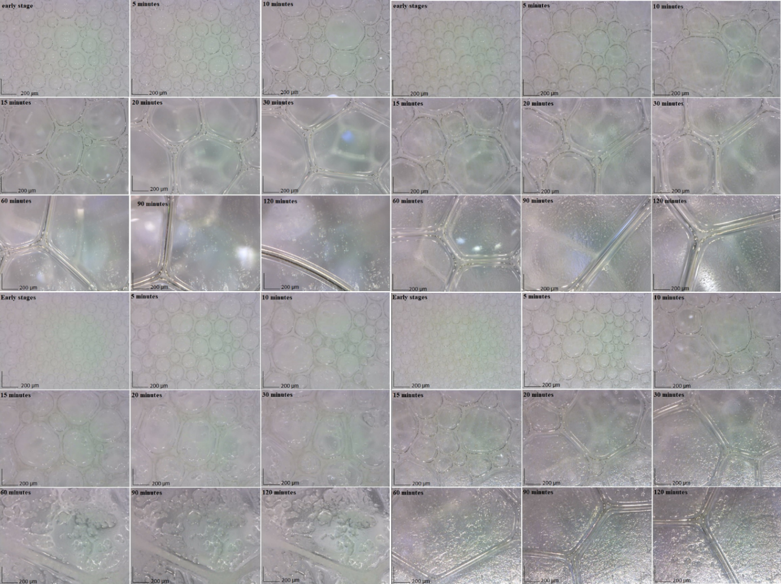
d
b
a
c
Figure 4.12: Optical microscope images of (a) baseline foam, (b) NS1 foam, (c) NS2 foam, and (d) NS3 foam
The most stable bubbles appeared at 1 wt% concentration for NS2 foam (Figure 4.12c), and the bubble size of the most durable foam was the smallest throughout the test period. The liquid content in foams was also recorded (Figure 4.10). It was observed that the liquid content in foam decreased rapidly for the baseline and slower nanoparticles-containing foams. NS2 exhibited the least reduction in the liquid content of all samples, indicating that the nanoparticles reduced the drainage rate and stabilized the foam. It was also observed in Figure 4.12c that NS2 was adsorbed at bubble interfaces as asteric barrier, which means that it forms a barrier around the bubbles to prevent coalescence and maintain the stability of the foam. The experiment showed that adding silica nanoparticles to the surfactant foam improved its stability and reduced liquid drainage, and NS2 was the most effective at stabilizing the foam.

CHAPTER FIVE

CONCLUSIONS AND RECOMMENDATIONS

5.1 Conclusions
This study investigated the effect of silica nanoparticles on the rheological behavior and stability of aqueous foams. The stability of the foams was evaluated through drainage tests. Based on the outcomes of the investigation, the following conclusions can be made:
- The inclusion of silica nanoparticles led to an increase in foam viscosity and stability. The type and concentration of silica nanoparticles used played a significant role in determining the impact of nanoparticles on foam properties.
- Nanoparticles could influence foam stability and rheological properties. Foam stability and viscosity noticeably increased with the addition of surface-coated silica nanoparticles. Nanoparticles containing foams exhibit power-law fluid flow behavior, typical in aqueous foams.
- Increasing the foam quality led to a reduction in drainage and an increase in foam stability. The use of specific silica nanoparticles was found to have a significant impact on the stability of aqueous foams.
- The use of nanoparticles could provide a promising route for enhancing the foams' properties in drilling and completion operations. By carefully selecting the type of nanoparticle and controlling its concentration, it may be possible to create foams with tailored properties suited for specific applications.
- Incorporating amino-coated silica nanoparticles (NS2) with 2 wt.% anionic surfactant into the liquid phase of foam is the most effective at stabilizing the foam.

5.2 Recommendations
Future research could investigate the effect of other types of nanoparticles on foam rheology and stability. The research could involve studying different concentrations of nanoparticles, surface functionalization, and their impact on foam properties. To better understand the potential applications of nanoparticle-enhanced foams, further research could focus on the behavior of these foams in real-world conditions. For instance, in the case of enhanced oil recovery, it would be beneficial to investigate the stability and efficiency of these foams under oil reservoir conditions. Future research could also use other techniques to enhance foam stability and rheology. For example, using surfactants and other chemical additives could provide an alternative method for modifying foam properties.
Finally, computer simulation techniques could also be employed to gain a deeper understanding of the complex behavior of nanoparticle-enhanced foams. By modeling the interactions between nanoparticles, surfactants, and foam bubbles, it may be possible to predict these foams' stability and rheological properties under different conditions.

REFERENCES
Abd Karim, A. and Wai, C.C., 1999. Foam-mat drying of starfruit (Averrhoa carambola L.) puree. Stability and air drying characteristics. Food Chemistry, 64(3), pp.337-343. https://doi.org/10.1016/S0308-8146(98)00119-8
Ahmed, R., Kuru, E. and Saasen, A., 2003. Critcal Review of Drilling Foam Rheology. Annual Transactions-Nordic Rheology Society, 11, pp.63-72.
Akhtar, T.F., 2017. Rheology Of Aqueous and Polymer-Based Nitrogen Foams At High Pressure And High Temperature (HPHT) Conditions. Master’s Thesis, University of Oklahoma: Norman, Oklahoma.
Akhtar, T. F., Ahmed, R., Elgaddafi, R. et al. 2018. Rheological behavior of aqueous foams at high pressure. Journal of Petroleum Science and Engineering, 162, 214-224. https://doi.org/10.1016/j.petrol.2017.12.050.
Al-Muntasheri, G.A., Liang, F. and Hull, K.L., 2017. Nanoparticle-enhanced hydraulic-fracturing fluids: A review. SPE Production & Operations, 32(02), pp.186-195. https://doi.org/10.2118/185161-PA
AlYousef, Z. A., Almobarky, M. A., and Schechter, D. S. 2018. The effect of nanoparticle aggregation on surfactant foam stability. Journal of colloid and interface science, 511, 365-373. https://doi.org/10.1016/j.jcis.2017.09.051.
Aveyard, R., Binks, B. P., and Clint, J. H. 2003. Emulsions stabilized solely by colloidal particles. Advances in Colloid and Interface Science, 100, 503-546. https://doi.org/10.1016/S0001-8686(02)00069-6.
Bhakta, A. R., and Khilar, K. C. 1991. A network simulation for drainage of static foam columns. Langmuir, 7(8), 1827-1832.
Bhakta, A., & Ruckenstein, E. 1997. Decay of standing foams: drainage, coalescence and collapse. Advances in colloid and interface science, 70, 1-124. https://doi.org/10.1016/S0001-8686(97)00031-6.
Bhakta, A., & Ruckenstein, E. 1997. Drainage and coalescence in standing foams. Journal of colloid and interface science, 191(1), 184-201. https://doi.org/10.1006/jcis.1997.4953.
Bhakta, A., and Ruckenstein, E. 1995. Drainage of a standing foam. Langmuir, 11(5), 1486-1492.
Bhakta, A., and Ruckenstein, E. 1995. Foams and Concentrated Emulsions: Dynamics and" Phase" Behavior. Langmuir, 11(12), 4642-4652.
Bhakta, A., and Ruckenstein, E. 1996. Modeling of the generation and collapse of aqueous foams. Langmuir, 12(12), 3089-3099.
Bhakta, A., and Ruckenstein, E. 1997. Drainage and coalescence in standing foams. Journal of colloid and interface science, 191(1), 184-201.
Bikerman, J. J. 1973. Foams. Springer-Verlag, Berlin.
Binks, B. P., & Lumsdon, S. O. (2000). Influence of particle wettability on the type and stability of surfactant-free emulsions. Langmuir, 16(22), 8622-8631. https://doi.org/10.1021/la000189s
Brown, E. and Jaeger, H.M., 2014. Shear thickening in concentrated suspensions: phenomenology, mechanisms and relations to jamming. Reports on Progress in Physics, 77(4), p.046602. https://doi.org/10.1088/0034-4885/77/4/046602
Chen, H., Li, J., Zhou, W., Pelan, E.G., Stoyanov, S.D., Arnaudov, L.N. and Stone, H.A., 2014. Sonication–Microfluidics for fabrication of nanoparticle-stabilized microbubbles. Langmuir, 30(15), pp.4262-4266. https://doi.org/10.1021/la5004929
Chevalier, Y., and Bolzinger, M. A. 2013. Emulsions stabilized with solid nanoparticles: Pickering emulsions. Colloids and Surfaces A: Physicochemical and Engineering Aspects, 439, 23-34. https://doi.org/10.1016/j.colsurfa.2013.02.054.
Costantini, M., Colosi, C., Mozetic, P., Jaroszewicz, J., Tosato, A., Rainer, A., Trombetta, M., Święszkowski, W., Dentini, M. and Barbetta, A., 2016. Correlation between porous texture and cell seeding efficiency of gas foaming and microfluidic foaming scaffolds. Materials Science and Engineering: C, 62, pp.668-677. https://doi.org/10.1016/j.msec.2016.02.010
Critello, C.D., Fiorillo, A.S. and Matula, T.J., 2017. Size of sclerosing foams prepared by ultrasound, mechanical agitation, and the handmade Tessari method for treatment of varicose veins. Journal of Ultrasound in Medicine, 36(3), pp.649-658. https://doi.org/10.7863/ultra.16.02052
Crum, L.A., 1980. Measurements of the growth of air bubbles by rectified diffusion. The Journal of the Acoustical Society of America, 68(1), pp.203-211. https://doi.org/10.1121/1.384624
Cui, Z.G., Cui, Y.Z., Cui, C.F., Chen, Z. and Binks, B.P., 2010. Aqueous foams stabilized by in situ surface activation of CaCO3 nanoparticles via adsorption of anionic surfactant. Langmuir, 26(15), pp.12567-12574. https://doi.org/10.1021/la1016559
Den Engelsen, C.W., Isarin, J.C., Gooijer, H., Warmoeskerken, M.M.C.G. and Wassink, J.G., 2002. Bubble size distribution of foam, Autex Res. J, 2, pp.14-27.
Durian, D.J., 1997. Bubble-scale model of foam mechanics: Melting, nonlinear behavior, and avalanches. Physical Review E, 55(2), p.1739.
Eren, T. 2004. Foam characterization: Bubble size and texture effects. MS thesis, Middle East Technical University.
Farhadi, H., Riahi, S., Ayatollahi, S. and Ahmadi, H., 2016. Experimental study of nanoparticle-surfactant-stabilized CO2 foam: Stability and mobility control. Chemical Engineering Research and Design, 111, pp.449-460. https://doi.org/10.1016/j.cherd.2016.05.024
Gallego-Juárez, J. A., Rodríguez, G., Riera, E. et al. 2015. Ultrasonic defoaming and debubbling in food processing and other applications. In Power Ultrasonics, Woodhead Publishing, Cambridge, UK, 793-814. https://doi.org/10.1016/B978-1-78242-028-6.00026-0.
Garrett, P.R. 1993. Recent Developements in the Understanding of Foam Generation and Stability. Chemical Engineering Science 48(2), 367-392. https://doi.org/10.1016/0009-2509(93)80023-J
Govindu, A. 2019. Drainage Behavior of Aqueous, Polymeric, and Oil-Based Nitrogen Foams: Theoretical and Experimental Investigation. https://hdl.handle.net/11244/321048.
Govindu, A., Ahmed, R., Shah, S. and Amani, M., 2019. Stability of foams in pipe and annulus. Journal of Petroleum Science and Engineering, 180, pp.594-604. https://doi.org/10.1016/j.petrol.2019.05.075
Govindu, A., Ahmed, R., Shah, S. and Amani, M., 2020, March. Foam Stability-Does Well Inclination Matter?. In SPE/ICoTA Well Intervention Conference and Exhibition. OnePetro. https://doi.org/10.2118/199821-MS
Gu, M. and Mohanty, K.K., 2014. Effect of foam quality on effectiveness of hydraulic fracturing in shales. International Journal of Rock Mechanics and Mining Sciences, 70, pp.273-285. https://doi.org/10.1016/j.ijrmms.2014.05.013
Gu, M. and Mohanty, K.K., 2015. Rheology of polymer-free foam fracturing fluids. Journal of Petroleum Science and Engineering, 134, pp.87-96. https://doi.org/10.1016/j.petrol.2015.07.018
Haas, P. A., and Johnson, H. F. 1967. A model and experimental results for drainage of solution between foam bubbles. Industrial & Engineering Chemistry Fundamentals, 6(2), 225-233.
https://doi.org/10.1016/j.anucene.2017.12.007.
Jianlong Wang, Anh V. Nguyen, Saeed Farrokhpay, A critical review of the growth, drainage and collapse of foams, Advances in Colloid and Interface Science, Volume 228, 2016, Pages 55-70, ISSN 0001-8686, https://doi.org/10.1016/j.cis.2015.11.009.
Vineet Sinha, Ramadan Ahmed, Tarek Akhtar, Subhash Shah, Mahmood Amani, Rheology and hydraulics of polymer-based foams at elevated temperatures, Journal of Petroleum Science and Engineering, Volume 180, 2019, Pages 330-346, ISSN 0920-4105, https://doi.org/10.1016/j.petrol.2019.05.047.
Hunter, T. N., Wanless, E. J., Jameson, G. J. et al. 2009. Non-ionic surfactant interactions with hydrophobic nanoparticles: Impact on foam stability. Colloids and Surfaces A: Physicochemical and Engineering Aspects, 347(1-3), 81-89. https://doi.org/10.1016/j.colsurfa.2008.12.027.
Ibizugbe, N. O. 2012. Drainage Behavior of Oil-based Drilling Foam under Ambient Conditions. MS thesis, University of Oklahoma.
Jacobi, W. M., Woodcock, K. E., & Grove, C. S. (1956). Theoretical investigation of foam drainage. Industrial & Engineering Chemistry, 48(11), 2046-2051.
King, G. E. (2012). Thirty years of gas shale fracturing: What have we learned? SPE Journal, 17(03), 418-438. https://doi.org/10.2118/133456-MS
Koehler, S. A., Hilgenfeldt, S., & Stone, H. A. (1999). Liquid flow through aqueous foams: the node-dominated foam drainage equation. Physical review letters, 82(21), 4232. https://doi.org/10.1103/PhysRevLett.82.4232.
Kraynik, A.M., 1983. Foam drainage (No. SAND-83-0844). Sandia National Laboratory, Albuquerque, NM (USA). https://doi.org/10.2172/5518540
Krotov, v. v. 1981. Theory of syneresis of foams and concentrated emulsions. 3. local equation of syneresis and formulation of boundary conditions. Colloid journal of the USSR, 43(1), 33-39.
Leal-Calderon, F., Schmitt, V. and Bibette, J., 2007. Emulsion science: basic principles. Springer Science & Business Media.
Li, Z., Liu, Z., Li, B., Li, S., Sun, Q. and Wang, S., 2012, April. Aqueous foams stabilized with particles and surfactants. In SPE Saudi Arabia Section Technical Symposium and Exhibition. OnePetro. https://doi-org.ezproxy.lib.ou.edu/10.2118/160840-MS
Lyons, W.C., 2009. Air and gas drilling manual: applications for oil and gas recovery wells and geothermal fluids recovery wells. Elsevier.
Martinez, A. C., Rio, E., Delon, G. et al. 2008. On the origin of the remarkable stability of aqueous foams stabilised by nanoparticles: link with microscopic surface properties. Soft matter, 4(7), 1531-1535. https://doi.org/10.1039/B804177F.
Miles, G. D., Shedlovsky, L., and Ross, J. 1945. Foam drainage. The Journal of Physical Chemistry, 49(2), 93-107.
Murray, B.S., 2007. Stabilization of bubbles and foams. Current Opinion in Colloid & Interface Science, 12(4-5), pp.232-241. https://doi.org/10.1016/j.cocis.2007.07.009
Narsimhan, G and Ruckenstein, E. 1995. Theory, Measurements, and Applications. Marcel Dekker, New York, p. 99.
Narsimhan, G. 1991. A model for unsteady state drainage of a static foam. Journal of Food Engineering, 14(2), 139-165. https://doi.org/10.1016/0260-8774(91)90005-D.
Obisesan, O., 2021. Stability of aqueous foams at high pressure and the impact of contaminants.
Obisesan, O., Ahmed, R. and Amani, M., 2021. The effect of salt on stability of aqueous foams. Energies, 14(2), p.279. https://doi.org/10.3390/en14020279
Obisesan, O., Ahmed, R. and Amani, M., 2022. The effects of pressure and column height on drainage behavior of oilfield foams. Upstream Oil and Gas Technology, 9, p.100076. https://doi.org/10.1016/j.upstre.2022.100076
Obisesan, O., Ahmed, R. and Amani, M., 2023. The effects of oil contamination on the stability and flow behavior of drilling foams under high-pressure conditions. Results in Engineering, p.100885. https://doi.org/10.1016/j.rineng.2023.100885
Ramani, M. V., Kumar, R., and Gandhi, K. S. 1993. A model for static foam drainage. Chemical engineering science, 48(3), 455-465. https://doi.org/10.1016/0009-2509(93)80300-F.
Rand, P.B. and Kraynik, A.M., 1983. Drainage of aqueous foams: generation-pressure and cell-size effects. Society of Petroleum Engineers Journal, 23(01), pp.152-154. https://doi.org/10.2118/10533-PA
Ruckenstein, E., and Bhakta, A. 1996. Effect of surfactant and salt concentrations on the drainage and collapse of foams involving ionic surfactants. Langmuir, 12(17), 4134-4144.
Saint-Jalmes, A. 2006. Physical Chemistry in Foam Drainage and Coarsening. Soft Matter 2(10), 836-849. https://doi.org/10.1039/B606780H
Shah, K.D., 2022. Effects of Pressure and Oil Contamination on Drainage and Bubble Size Distribution of Aqueous Foams.
She, W., Du, Y., Miao, C., Liu, J., Zhao, G., Jiang, J. and Zhang, Y., 2018. Application of organic-and nanoparticle-modified foams in foamed concrete: Reinforcement and stabilization mechanisms. Cement and Concrete Research, 106, pp.12-22. https://doi.org/10.1016/j.cemconres.2018.01.020
Shi, H., Shi, D., Yin, L., Yang, Z., Luan, S., Gao, J., Zha, J., Yin, J. and Li, R.K., 2014. Ultrasonication assisted preparation of carbonaceous nanoparticles modified polyurethane foam with good conductivity and high oil absorption properties. Nanoscale, 6(22), pp.13748-13753. https://doi.org/10.1039/C4NR04360J
Shojaei, M. J., Méheust, Y., Osman, A. et al. 2021. Combined effects of nanoparticles and surfactants upon foam stability. Chemical Engineering Science, 238, 116601. https://doi.org/10.1016/j.ces.2021.116601.
Singh, R. and Mohanty, K.K., 2017, October. Nanoparticle-stabilized foams for high-temperature, high-salinity oil reservoirs. In SPE Annual Technical Conference and Exhibition. OnePetro. https://doi.org/10.2118/187165-MS
Sinha, V., Ahmed, R., Akhtar, T., Shah, S. et al. 2019. Rheology and hydraulics of polymer-based foams at elevated temperatures. Journal of Petroleum Science and Engineering, 180, 330-346.
Skauge, A., Solbakken, J., Ormehaug, P. A., Aarra, M. G. 2020. Foam Generation, Propagation and Stability in Porous Medium. Transport in Porous Media 131(1), 5–21. https://doi.org/10.1007/s11242-019-01250-w
Song, X., Li, G., Huang, Z., Shi, Y., Wang, G., Song, G. and Xu, F., 2022. Review of high-temperature geothermal drilling and exploitation technologies. Gondwana Research.
Sonn, J. S., Lee, J. Y., Jo, S. H. et al. 2018. Effect of surface modification of silica nanoparticles by silane coupling agent on decontamination foam stability. Annals of Nuclear Energy, 114, 11-18.
Stocco, A., Rio, E., Binks, B. P. et al. 2011. Aqueous foams stabilized solely by particles. Soft Matter, 7(4), 1260-1267. https://doi.org/10.1039/C0SM01290D.
Sun, Q., Li, Z., Wang, J. et al. 2015. Aqueous foam stabilized by partially hydrophobic nanoparticles in the presence of surfactant. Colloids and Surfaces A: Physicochemical and Engineering Aspects, 471, 54-64. https://doi.org/10.1016/j.colsurfa.2015.02.007.
Tyowua, A.T. and Binks, B.P., 2020. Growing a particle-stabilized aqueous foam. Journal of colloid and interface science, 561, pp.127-135.https://doi.org/10.1016/j.jcis.2019.11.103
Vatanparast, H., Samiee, A., Bahramian, A. et al. 2017. Surface behavior of hydrophilic silica nanoparticle-SDS surfactant solutions : I. Effect of nanoparticle concentration on foamability and foam stability. Colloids and Surfaces A: Physicochemical and Engineering Aspects, 513, 430-441. https://doi.org/10.1016/j.colsurfa.2016.11.012.
Verbist, G., Weaire, D., and Kraynik, A. M. 1996. The foam drainage equation. Journal of Physics: Condensed Matter, 8(21), 3715. https://doi.org/10.1088/0953-8984/8/21/002.
Wang, J. and Elsworth, D., 2020. Fracture penetration and proppant transport in gas-and foam-fracturing. Journal of Natural Gas Science and Engineering, 77, p.103269. https://doi.org/10.1016/j.jngse.2020.103269
Wang, J., Nguyen, A. V., and Farrokhpay, S. 2016. A critical review of the growth, drainage and collapse of foams. Advances in colloid and interface science, 228, 55-70.
Yekeen, N., Idris, A. K., Manan, M. A. et al. 2017. Bulk and bubble-scale experimental studies of the influence of nanoparticles on foam stability. Chinese Journal of Chemical Engineering, 25(3), 347-357. https://doi.org/10.1016/j.cjche.2016.08.012.
Yuan, B. and Wood, D.A., 2018. A holistic review of geosystem damage during unconventional oil, gas and geothermal energy recovery. Fuel, 227, pp.99-110. https://doi.org/10.1016/j.fuel.2018.04.082
Yokoi, T., Kubota, Y. and Tatsumi, T., 2012. Amino-functionalized mesoporous silica as base catalyst and adsorbent. Applied Catalysis A: General, 421, pp.14-37. https://doi.org/10.1016/j.apcata.2012.02.004
Zhao, J., Zhao, Q., Wang, L., Wang, C., Guo, B., Park, C.B. and Wang, G., 2018. Development of high thermal insulation and compressive strength BPP foams using mold-opening foam injection molding with in-situ fibrillated PTFE fibers. European Polymer Journal, 98, pp.1-10. https://doi.org/10.1016/j.eurpolymj.2017.11.001.
Zhu, Y., Tian, J., Hou, Q., Luo, Y. and Fan, J., 2017, November. Studies on nanoparticle-stabilized foam flooding EOR for a high temperature and high salinity reservoir. In Abu Dhabi International Petroleum Exhibition & Conference. OnePetro. https://doi.org/10.2118/188964-MS
Zvada, M.V., Belovus, P.N., Sergeev, E.I., Glavnov, N.G., Varfolomeev, M.A. and Saifullin, E.R., 2021, October. Study of the Efficiency of Gel and Polymer-Stabilized Foam Systems for Gas Shut-Off in Horizontal Wells. In SPE Russian Petroleum Technology Conference. One Petro. https://doi.org/10.2118/206404-MS.

