UNIVERSITY OF OKLAHOMA
GRADUATE COLLEGE

ADVERTISING THE IMPOSSIBLE EARTH:
THE VISUAL CULTURE OF POST-APOLLO SPACE COLONY CONCEPT ART

A THESIS
SUBMITTED TO THE GRADUATE FACULTY
in partial fulfillment of the requirements for the
Degree of
MASTER OF ARTS

By
REBECCA MARCOLINA
Norman, Oklahoma
2022
ADVERTISING THE IMPOSSIBLE EARTH:
THE VISUAL CULTURE OF POST-APOLLO SPACE COLONY CONCEPT ART

A THESIS APPROVED FOR THE
DEPARTMENT OF HISTORY OF SCIENCE, TECHNOLOGY, AND MEDICINE

BY THE COMMITTEE CONSISTING OF

Dr. Katherine Pandora, Chair
Dr. Peter Soppelsa
Dr. Robert Bailey

© Copyright by Rebecca Marcolina 2022
All Rights Reserved.
Table of Contents
Acknowledgements vi
Abstract vii
Introduction 1
Historiography: Space Colony and Space Art Studies 7
Chapter One: Gerard O’Neill Looks to Space 18
“Bad Moon Rising”: The Long 1960s and The Limits to Growth 18
“Home, Home on ‘Lagrange’”: Gerard O’Neill’s Space Colony Designs 22
Chapter Two: Space Art, Advertisements, and Place-Making 28
Space Art and the Practice of Slow Looking 28
Astronomical Art or Astronomical Advertising? 33
Chapter Three: The “Impossible Earths” of Endcap, Sunflower, Main Street, and Sport 38
Evacuating Spaceship Earth: (Un)Natural Environments in the Colony 41
Endcap View with Suspension Bridge 41
Interior of “Sunflower” 44
Extraterrestrial Edens: Endcap, Sunflower, and O’Neill’s “New Earths” 47
Settling (Sub)Urban Space: Built Environments in the Colony 55
Main Street, Hometown, Cosmos 55
Sport in Space Colony 58
Cosmic Communities: Main Street, Sport, and O’Neill’s “Cities in the Sky” 60
“Free Space” for Sale: The Legacy of O’Neill’s “Impossible Earths” 69
Bibliography 76
Appendix | Advertising the Impossible Earth: A Visual Album 81
Album I: Gerard O’Neill’s New Worlds 81
Album II: (Un)Natural Environments in the Colony 92
Album III: Built Environments in the Colony 102

Acknowledgements
“Science fiction is the most important literature in the history of the world, because it's the history of ideas, the history of our civilization birthing itself…science fiction is central to everything we've ever done, and people who make fun of science fiction writers don't know what they're talking about.”

Ray Bradbury

I have been extraordinarily fortunate to explore a topic near and dear to my heart for the past two years. Endcap, Sunflower, Main Street, and Sport have been both a challenge and a joy to study, and I am quite thankful to have stumbled across a motley crew of astronomical artists, space enthusiasts, and historians of science and technology along the way.

I would like to extend a heartfelt note of thanks to everyone that has supported me throughout the research and writing process, especially Robert Marcolina Jr., Claire Wasowski, Carolyn Backus, Gabrielle Hogan, Téa Thomas, Matt Lowe, Andrew Rausch, Jacob Lipina, Remington Ibarra, Dylan Yegge, Harinya Potluri, Emily Scholten, Michele Powers, Anna Reser, Kristin Raffa, and Camille Testa. To Dr. Kathleen Sheppard and Jeanine Bruening, thank you for encouraging me to pursue graduate studies and for supporting me over the past two years. To Dr. Stephen Weldon and Dr. Hunter Heyck, thank you for fostering my fledgling interest in space studies and modern American history. To Dr. Weldon and Dr. Peter Barker, thank you for your flexibility during a particularly stressful spring semester. To my wonderful thesis committee – Dr. Katherine Pandora, Dr. Peter Soppelsa, and Dr. Robert Bailey – thank you for taking a chance on a thorny, tangled thesis project. I am eternally grateful for your patience, encouragement, and insight.

Lastly, to my parents, Elizabeth and Robert Marcolina, thank you for fielding every frantic phone call and for believing in me every step of the way. This project would not have been possible without your unwavering support.

Abstract
In post-Apollo America, speculative visions of life in space were shaped by the unabashedly optimistic space colonization proposals of physicist Gerard Kitchen O’Neill. O’Neill presented these self-contained artificial worlds as affordable solutions to the swelling economic, environmental, and industrial problems that threatened late twentieth century life. Proponents of space colonies commissioned concept art to translate their technical designs into accessible, attainable, and, most importantly, appealing places in their audiences’ imaginations. To paint attractive pictures of life aboard space colonies, however, artists first had to decide what made contemporary life on Earth desirable to their audiences. Pieces of space colony concept art produced in the mid-1970s advertise a specific vision of life in space, one unequivocally shaped by popular anxieties and fantasies about postmodern American life. By interpreting these artworks as advertisements, I aim to understand how artists and scientists alike employed concept art as a place-making tool to code space colonies as both bountiful natural oases and novel [American] cities – places ultimately designed for and inhabited by a new class of citizens.

Introduction
Two government administrators, two scholars, and a businessman walk into a cathedral. Although such a scene sounds like the perfect buildup to a punchline, it truly occurred this past fall. Avril Haines, the Director of National Intelligence; Bill Nelson, the Administrator of the National Aeronautics and Space Administration; Dr. Avi Loeb of Harvard University; Reverend Professor David Wilkinson of Durham University; and Jeffrey Bezos, the founder of both Amazon and Blue Origin, all met in the hallowed halls of the Washington National Cathedral on November 10, 2021, to participate in a program titled “Our Future in Space”. Sponsored by the Nancy and Paul Ignatius Program, the event’s prestigious panelists discussed contemporary space science and space exploration efforts. Jeffrey Bezos even spoke to the possibility of space colonization in his portion of the program, memorably suggesting that people living and working in space “will eventually visit Earth like you would visit Yellowstone National Park”. Bezos may not be the first person to recast the planet as a sanctuary in space, but the concept clearly fascinates him. At a Blue Origin technology exposition in May 2019, for example, Bezos debuted a small collection of digital artworks that depicted colossal, Earth-like space colonies. Some of these artworks are particularly striking, such as the untitled piece that I have come to call “Space Elk” (Figure 1).
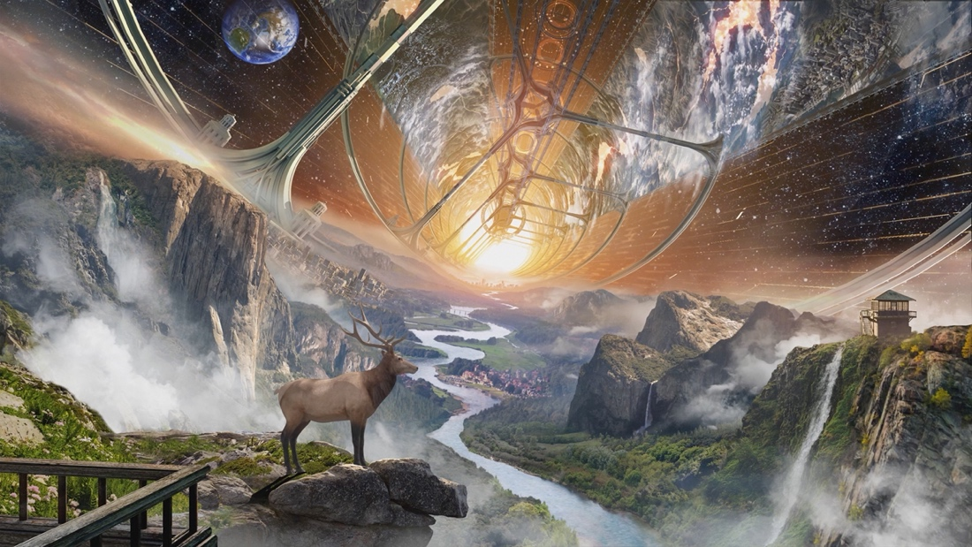
Figure 1: Untitled. Blue Origin, 2019.
Space Elk pictures a self-contained space colony founded, in part, on future Blue Origin technologies. Modeled after an archetypal American national park, the colony’s thick forests and thundering waterfalls exemplify the complex ecosystems and comfortable lifestyles that Bezos believes will be possible aboard these megastructures. Yet space colonies will be more than “really pleasant places to live”: they will be an invaluable safeguard for extraterrestrial and terrestrial citizens alike. As these megastructures provide unlimited natural resources, unlimited space, and unlimited energy in principle, Bezos posits that their construction could completely eliminate the threats that pollution, population growth, and modern industry pose to “our fragile planet”. Space Elk, like other hypermodern Blue Origin-branded visualizations of space colonies, imparts specific fantasies for the future upon its audience, but these fantasies are far from futuristic; in fact, many of them can be seen across the avant-garde, “socially conscious” space settlement designs that emerged in the early 1970s.
In post-Apollo America, fantasies of life in space were shaped by the optimistic space colonization proposals of Dr. Gerard Kitchen O’Neill (1927-1992). A particle physicist and science fiction enthusiast, O’Neill completed his graduate studies at Cornell University in 1954. He accepted a teaching position with the Princeton University physics department shortly after his graduation, and by 1965, O’Neill had become an accomplished research scientist and a full professor of physics. His ability to “combine far-reaching visions with practical work in the machine shop” greatly contributed to his success in the lab and in the classroom, and it played an equally important part in his space colonization proposals. O’Neill stumbled across the “space colony problem” in 1969, and it quickly captured his attention; he spent the rest of his career advocating for the continued exploration and eventual “humanization” of outer space.
Instead of settling the surface of a planet or a moon, O’Neill imagined humans living inside “huge rotating primitive shapes [such as] spheres, toruses, and cylinders”. His approach to space colonization acknowledged outer space itself as a “culture medium” capable of supporting “the entire human race”, and his designs consequently capitalized on its readily accessible energy sources and raw materials. O’Neill’s space colonies would float in “free space” at a site 384,000 kilometers (240,000 miles) from Earth known to scientists as Lagrange Point 5 (L5). These megastructures would be fashioned from aluminum, glass, and industrial slag produced from raw materials shipped from the Earth and mined from the Moon. Their interiors would resemble earthly commercial, recreational, and residential properties; agricultural and industrial activities would occur in discrete supporting structures affixed to the colony.
Such a proposal may have “shared a vision of space settlements, right down to how they might look, with ‘blue-skying’ futurists and science fiction writers”, but O’Neill supported his vision with “extensive mathematical calculations and careful but bold extrapolations of existing technological trends”. His foresight can be attributed, in part, to his own experiences as the inventor of a seemingly impossible technology for high-energy physics experiments, but he also developed his space colony designs amidst a “culmination of growing ambivalence, confusion, and pessimism about the future and technology’s place in it”. Concerns for “Spaceship Earth” and its limited supplies grew in the wake of economic crises and environmental disasters, but O’Neill steadfastly believed that space colonies were a practical solution to the contemporary problems of overcrowding, pollution, and scarcity. Thus, to garner support for space colonization, O’Neill and his likeminded colleagues “engaged in promotion, popularizing, and fund-raising that created and connected different communities”. Visual and material objects often played a significant role in this process. Artifacts like paintings, graphs, and models could translate O’Neill’s ambitious plans and elaborate designs into accessible actions and places in their audiences’ imaginations more effectively than technical reports alone, and a specific visual culture rapidly flourished around O’Neill’s space colony concept.
I aim to describe and scrutinize this visual culture in my master’s thesis by examining four paintings of space colonies created in the late 1970s: Endcap View with Suspension Bridge, painted by Don Davis in 1975 (Figure 2; Album II, Plate A); Interior of “Sunflower”, painted by Paul R. Alexander in 1976 (Figure 3; Album II, Plate D); Main Street, Hometown, Cosmos, painted by Pierre Mion in 1976 (Figure 4; Album III, Plate A); and Sport in Space Colony, painted by Rick Guidice in 1977 (Figure 5; Album III, Plate C). All four paintings are, in effect, elaborate examples of concept art commissioned to aid in the visualization of O’Neill’s space colony technology. Endcap View with Suspension Bridge and Sport in Space Colony were both produced as a part of formal design studies hosted by NASA’s Ames Research Center; Davis and Guidice collaborated with O’Neill himself to produce technically accurate depictions of hypothetical space colony interiors. Interior of “Sunflower” and Main Street, Hometown, Cosmos, on the other hand, accompanied articles about space colonies written for popular audiences; these images appeared in Science Year and National Geographic, respectively.
Endcap View with Suspension Bridge; Interior of “Sunflower”; Main Street, Hometown, Cosmos; and Sport in Space Colony all communicate the feasibility and functionality of O’Neill’s space colonies, but they also craft a specific vision of life in space – one unequivocally shaped by their artists and audiences’ attitudes about life in late twentieth century America. I propose to examine the art of Davis, Alexander, Mion, and Guidice through a new lens – one that allows me to more effectively connect the places and people their paintings depict to the historical and social contexts within which they were produced. I reinterpret these paintings as advertisements, communicative objects purposefully constructed to sell space colonies as not only feasible near-future technologies, but as fashionable future homes. On one hand, Davis and Alexander advertise these megastructures as bountiful “oases in space”, perpetual natural paradises free from overcrowding and pollution. Their paintings synthesize popular [American] conceptualizations of nature to present space colony interiors as sites of pleasure and preservation akin to terrestrial gardens, resorts, and national parks. Mion and Guidice, by contrast, advertise space colonies as prosperous “cities in space”, novel urban communities free from violence and disorder. Their paintings juxtapose scenes of [American] suburbs and metropolises to transform space colony interiors into cosmopolitan communities suited to a new class of citizens.
To produce truly attractive pictures of life aboard space colonies, however, all four artists had to determine what made life on Earth desirable to their audiences and incorporate those elements into their compositions. Their depictions of space colony interiors consequently reflect the experiences of each artist and the expectations of his intended audience. By studying these samples of space colony concept art according to the art historical technique of slow looking – a technique I describe at length in Chapter Two: Space Art, Advertisements, and Place-Making – my master’s thesis aims to articulate these actors’ experiences and expectations as they arise across Endcap View with Suspension Bridge; Interior of “Sunflower”; Main Street, Hometown, Cosmos; and Sport in Space Colony.
I begin my analysis in the Introduction with a brief synthesis of relevant scholarship, paying particular attention to the works of visually and culturally oriented space historians. The two chapters that follow describe these paintings’ subjects – O’Neill’s space colonies – and address the work they perform as advertisements. The third chapter describes the visual elements present in these paintings and reconnects them to the broader visual and cultural history of late twentieth century America.

Historiography: Space Colony and Space Art Studies
As a cultural study of space colony concept art, my master’s thesis contributes to ongoing conversations among historians of technology and space science, scholars of visual and cultural history, and academics engaged in urban and environmental studies. One conversation of great importance to my analysis situates space colonies within the larger history of space exploration. Endcap View with Suspension Bridge (Endcap); Interior of “Sunflower” (Sunflower); Main Street, Hometown, Cosmos (Main Street); and Sport in Space Colony (Sport) envision a technology that has yet to materialize, but space and space policy historians Roger D. Launius and Howard E. McCurdy comment on the feasibility of O’Neill’s “special solution to global stress” and its impact on the modern “Greening of Space” in their 2001 work Imagining Space. Imagining Space complements McCurdy’s earlier examinations of space colonies; his excellent cultural study Space and the American Imagination (1997), for example, connects O’Neill’s space colonies to popular perceptions of outer space as a “final frontier” and a “new frontier”.
McCurdy asserts that O’Neill’s advocacy for space colonization drew on broader American cultural traditions that encouraged individualism, innovation, and utopianism. Space colonies combined “the desire for new places with the idea that technology will make their settlement possible”, although I believe it is important to note that O’Neill adamantly positioned these new places as being better than those left behind. Despite its cultural appeal, the romanticized frontier narrative that surrounded O’Neill’s space colonies is fatally flawed; as McCurdy notes, “frontiers are rarely utopian in spite of [the] efforts of their advocates to portray them as such…new settlers bring society and all its imperfections with them”. By arguing in this thesis that many of these “imperfections” are evident across Endcap, Sunflower, Main Street, and Sport, my analysis contributes to ongoing conversations about space exploration, popular culture, and the place of imagination in science and science policy.
Questions concerning the cultural influences evident in O’Neill’s designs also arise in the works of American studies scholar De Witt Douglas Kilgore and environmental historian Neil M. Maher. Published in 2003, Kilgore’s compelling book Astrofuturism: Science, Race, and Visions of Utopia in Space investigates “America’s dream of its future” as it appears across the “tradition of speculative fiction and science writing inaugurated by scientists and science popularizers during the space race of the 1950s”. He argues that the serious study of astrofuturists such as Robert A. Heinlein and Gerard K. O’Neill “provides a window into the way we construe the relationship between scientific knowledge, the uses of technology, the entertainments we find attractive, and the political arrangements we proclaim desirable”. Like McCurdy, he acknowledges the shortcomings of O’Neill’s supposedly utopian brand of astrofuturism; Kilgore claims that the physicist’s “rhetoric of diversity and social experimentation” was repeatedly “undermined by his reliance on the [American] suburban ideal…a tradition of middle-class environmental planning which emphasizes the value of family and domestic life”. Far from fashioning new worlds “free of boundaries and regimentation”, O’Neill’s space colonies crafted territories “that would allow national growth to continue ad infinitum, guaranteeing an eternal regeneration of the social, political, and economic constants of American values”.
Maher traces the suburban American slant of O’Neill-inspired space colonies in a similar manner. His exemplary work Apollo in the Age of Aquarius (2017) “tells the story of the shared history of the space race and the social and political movements of the 1960s era”. The book’s fifth chapter, “The New Right’s Stuff”, recounts the “cultural battle between hippies…and Nixon’s silent majority” – the latter of which Kilgore would likely identify as the pinnacle proponents of the American suburban ideal. Apollo in the Age of Aquarius explicitly articulates this connection. Maher notes, for example, that “while [O’Neill’s] overall designs were radical, even within scientific circles, the aesthetics of the colonies were far from it”. Images of O’Neill-inspired space colonies showcased the styles and structures of “aerospace suburbs”; the colonies’ built environments, in other words, closely resembled those of the subdivisions spreading across the “space crescent” in the American South as well as the development sites “near NASA’s contractors in Southern California and the Northeast”. Kilgore and Maher inform my study of O’Neill’s miniature Earths because the cultural, economic, political, and social landscapes the pair probe are the same landscapes that I identify in the art of Davis, Alexander, Mion, and Guidice. Astrofuturism and Apollo in the Age of Aquarius consequently serve as important foundations for my study of space colony concept art.
Perhaps the most prominent consideration of modern space colonization efforts is historian W. Patrick McCray’s outstanding book The Visioneers (2013). The Visioneers traces the story of O’Neill-inspired space colonies and nanotechnologies, two late twentieth century innovations that promised to alleviate the environmental, political, and planetary pressures threatening modern society. Their developers positioned these technologies as the path to a “limitless future”, and McCray’s work “explores how and why this select group of scientists and engineers developed their broad and expansive visions”. Whether they operated on the scale of space colonies or nanotechnologies, future-oriented figures like O’Neill engaged in a new sort of technical-creative practice that McCray terms “visioneering”:
Visioneering means developing a broad and comprehensive vision for how the future might be radically changed by technology, doing research and engineering to advance this vision, and promoting one’s ideas to the public and policy makers in the hopes of generating attention and even realization.
McCray describes O’Neill’s visioneering efforts, his network of supporters and adversaries, and his lasting impact on other visioneers in detail and this information is critical background for my thesis. His most important influence on my analysis, however, resides in his discussion of “space as a place”.
McCray argues that “what sparked public and media curiosity in O’Neill’s ideas was his description of space not as a government-run program but as a place”. McCray subsequently argues that “this critical shift in perspective, of seeing space as real estate for potential habitation and manufacturing, was essential in motivating the first wave of people excited by [O’Neill’s] visioneering”. I explicitly draw on the notion of “space as place” in my analysis of space colony concept art. However, instead of ascribing the act of place-making to O’Neill’s space colony proposal alone, I acknowledge the place-making power of O’Neill’s proposal and the images of space colonies it inspired. Moreover, while McCray describes the hypothetical interiors of O’Neill’s megastructures, he does not devote attention to the concept art that accompanied the physicist’s technical designs. My master’s thesis therefore attempts to build on McCray’s observations by examining the role material and visual objects play in the processes of place-making and visioneering.
Conversations about the material and visual artifacts of space exploration, for that matter, are also relevant to my research. Several key studies on the subject have appeared in recent years: designer Nicholas de Monchaux’s Spacesuit: Fashioning Apollo (2011) studies the spacesuit as a fashion object, as a cultural object, and as a technological object, for example, and science journalist Piers Bizony’s The Art of NASA (2020) retells the history of the American space program through its visual culture, a rich vein of artifacts that extend from commercial infographics to NASA-sponsored astronomical art. Illustrator Ron Miller has also worked to trace the emergence and evolution of astronomical art, and his edited volumes – The Art of Space (2014) and The Beauty of Space Art (2021) – have greatly informed my analysis of space colony concept art. Miller and other practitioners of astronomical art define the practice as “a modern artistic expression emerging from knowledge and ideas associated with outer space, both as a source of inspiration and as a means for visualizing and promoting space travel”. Although I interpret the paintings of Davis, Alexander, Mion, and Guidice as advertisements as opposed to fine art objects, it is useful to note that Miller cites their space colony concept artworks as examples of “hardware art”.
Popularly known as “nuts and bolts” art among practitioners, hardware art is a subgenre of astronomical art that “focuses on envisioning the technological methods that allow or will allow humans to travel, live, and work in space”. Endcap, Sunflower, Main Street, and Sport share this focus, but it should also be stated that hardware art and advertisements perform similar work. Aerospace engineer and concept artist Aldo Spadoni, for instance, asserts that “artists who specialize in capturing the wonder and allure of space vehicles must create art that is aesthetically pleasing as well as technically accurate”. Hardware artists “communicate some key aspect of the…subject being depicted” in their compositions so that their art can answer basic questions for their audiences, such as “How will [the hardware] be used?”, “What is intriguing about it?”, and “Why is it better than a competitor’s idea?”. With this communicative work in mind, “nuts and bolts” artworks like Endcap, Sunflower, Main Street, and Sport easily lend themselves to my analytical framework, especially when compared to other subgenres of astronomical art that perform more aesthetic or emotive work instead.
Of all the conversations concerning visual culture and space colonization, however, architect Fred Scharmen’s Space Settlements has been the most important source for consultation. Published in 2019, Space Settlements is the first book-length scholarly analysis of space colony concept art. Scharmen examines thirteen “artistic renderings” of “habitat concepts” produced as a part of the Summer Studies between 1975 and 1978. As a result of our shared interests, I grapple with some of the same questions that Scharmen raises throughout his work, most notably those introduced in his third chapter, “Densities: Highest and Best Use”. “Densities” probes the purposes of space colonies and discusses the ways in which the colonies’ designers coded these purposes into the megastructures’ environments and occupants. Scharmen comments, for example, that:
The question of just how dense these new human habitats would be, and the question of whom they would be for, created ongoing tension within the project’s development, emerging in the literature, in conversations, and in the renderings produced for the Summer Study. Would these habitats be metropolis or wilderness? Would the inhabitants be colonizers or citizens?
I, too, interrogate the purpose of these megastructures as they appear in Endcap, Sunflower, Main Street, and Sport, and I, too, identify the inhabitants for which these places have been designed. Like Scharmen, I ask how the environments depicted across the works of Davis, Alexander, Mion, and Guidice “produce new (or old) ways of life” and how “aesthetics translate and mediate these future worlds”.
I am fortunate to have Scharmen’s substantive volume as a foundation for my own analysis, and I aim to extend his approach to additional examples of space colony concept art – specifically the artworks of Davis, Alexander, Mion, and Guidice. Scharmen construes his core collection of paintings as if they are architectural designs and scientific illustrations, and this framework allows him to investigate the “political and social agendas embedded in acts of design” more effectively. He comments on their composition and content, but he does not typically offer a detailed account of their visual elements; Scharmen is interested in the larger architectural – and, subsequently, spatial work – his selected paintings perform. I, on the other hand, interpret Endcap, Sunflower, Main Street, and Sport as advertisements meant to appease specific cultural anxieties and foster support for O’Neill’s alternative technologies.
My analysis purposefully focuses on the smallest components of these paintings to describe the places they project aboard space colonies and to draw attention to the neglected cultural dimension of concept art more generally; I am interested, in other words, in the ideological work these paintings perform in pursuit of place-making.
Our related yet divergent research objectives result in our reliance on different sets of scholarly traditions and techniques. Where Scharmen largely speaks to the specialties of architecture, urban studies, and systems design, I engage with those of art history, visual and cultural studies, and environmental and technological histories. My master’s thesis thus becomes another set of threads in the “broad net” of interdisciplinary work for which Scharmen himself advocates:
The paintings produced for O’Neill’s project are part of a lineage of radical images from the 1970s that link the mainstream concerns of these concrete spatial practices with the technosocial speculations of science fiction, technology, politics, apocalypse, and utopia…
These paintings also are part of a longer history of the ways in which humans have thought about living in the future, and about living in outer space, but a close focus on this particular moment within that history shows that the concerns driving it are not so distant in time or space after all. A broad net that brings together many approaches to examine that moment can trace the connections that are still present.
To fully appreciate the connections between O’Neill’s space colony designs, modern space colony concept art, and this “longer history”, though, my analysis must briefly revisit the anxieties that inspired O’Neill.

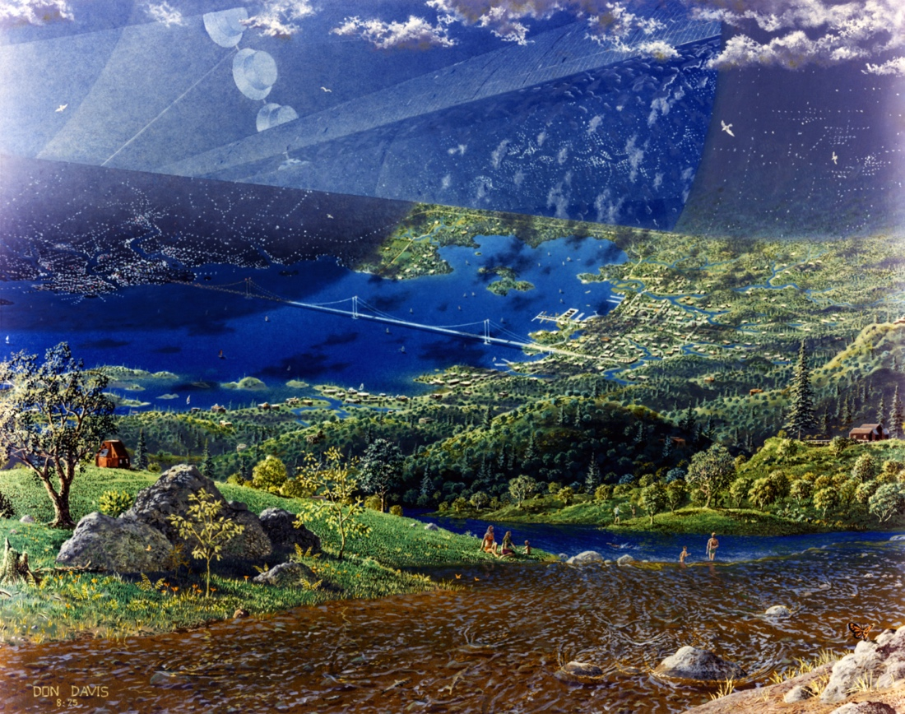
Figure 2: Endcap View with Suspension Bridge. Don Davis, 1975.

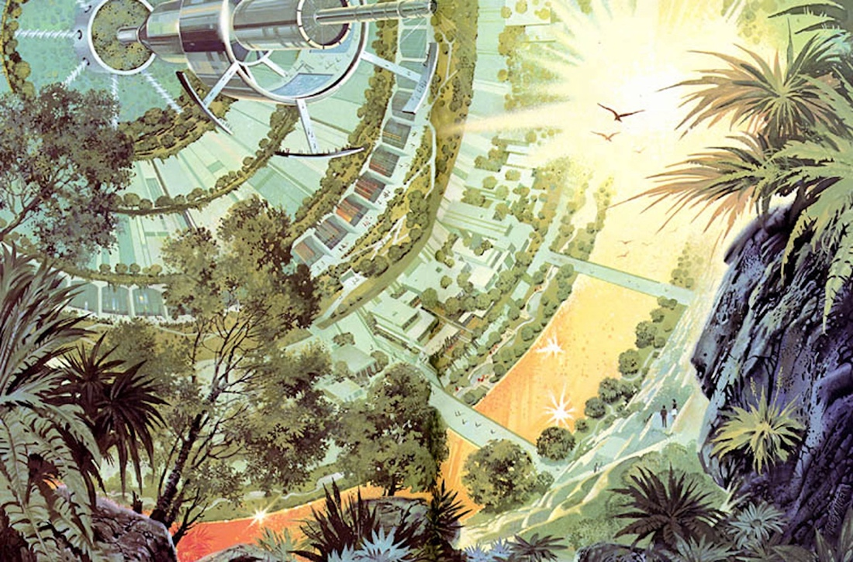
Figure 3: Interior of “Sunflower”. Paul R. Alexander, 1976.
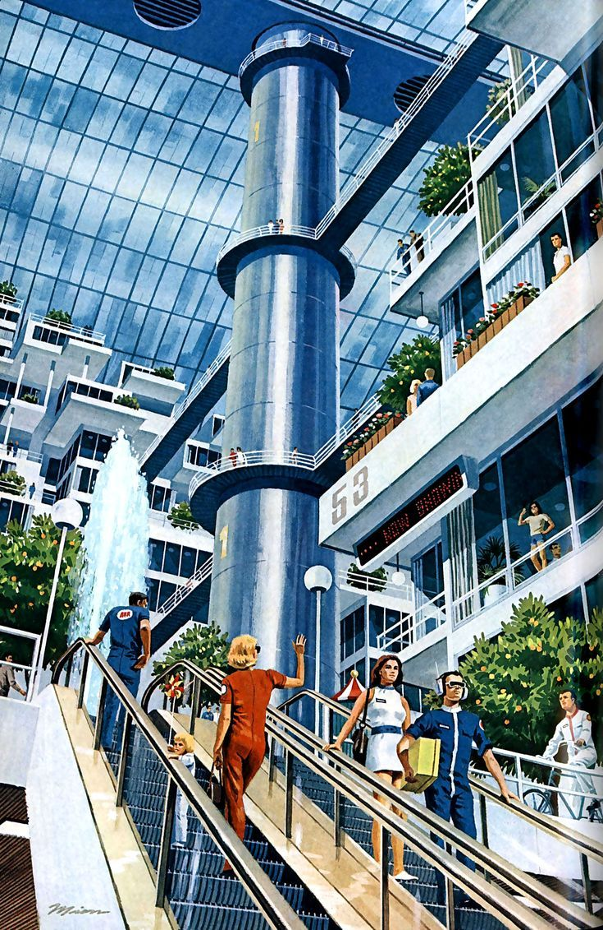
Figure 4: Main Street, Hometown, Cosmos. Pierre Mion, 1976.

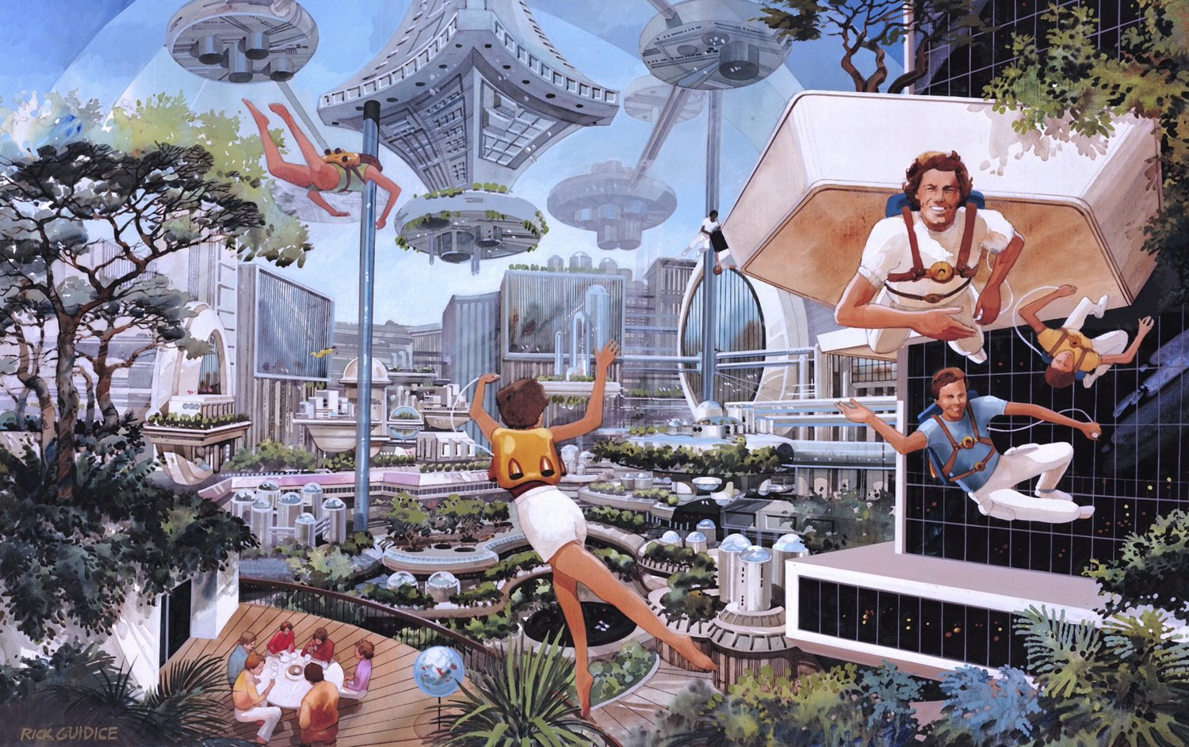
Figure 5: Sport in Space Colony. Rick Guidice, 1977.

Chapter One: Gerard O’Neill Looks to Space

“Bad Moon Rising”: The Long 1960s and The Limits to Growth
In the fall of 1969, Princeton University Professor Gerard O’Neill desperately wanted to raise his students’ spirits. “Civil rights marches, anti-war sit-ins, demonstrations by environmentalists and feminists, and…the protest songs of the counterculture” had become “common, everyday experiences” for citizens of the long 1960s. Faith in science and technology seemed to be falling nationwide; in fact, in the wake of atrocities like the Mỹ Lai massacre and disasters like the Santa Barbara oil spill, even O’Neill’s best students were starting to become disheartened with their discipline. To prove to his classes that “improvements in the human condition could [still] be reached by using science and engineering in the right ways”, O’Neill redesigned his introductory physics seminar to include practical yet socially relevant engineering problems. His first problem sets were inspired by the recent success of NASA’s Project Apollo. O’Neill integrated “examples from the first series of human voyages into space” into each area of the course, and he eventually assigned his students a unique essay prompt: “is the surface of a planet really the right place for an expanding technological civilization?”. O’Neill “was infected with [his students’] enthusiasm”, according to colleague and fellow physicist Freeman Dyson, and he soon began his own work on the subject.
O’Neill “treated the entire topic as a rational and detailed engineering problem”. He and a small party of interested students considered solutions to prominent social, industrial, and environmental problems over the course of the semester. To their surprise, though, the group surmised that energy, raw materials, and “open space” were readily available in outer space – they only had to find a way to occupy it. O’Neill and his students started to explore the idea of self-contained, self-sustaining space habitats. They scoured the publications and proposals of pioneering aerospace engineers, and they even performed sample calculations to determine the limitations of hypothetical space habitat structures. O’Neill pondered the problem of practical “space communities” long after the fall semester ended, too. He shared his ideas in casual meetings with colleagues and in formal lectures to students at various universities, but a sense of urgency started to color these conversations as time progressed.
In the spring of 1972, a group of intellectuals, industry leaders, and civil servants collectively known as “The Club of Rome” published a grim report titled The Limits to Growth. This document, in the words of W. Patrick McCray, was a sort of “doomsday timetable” that “predicted the inevitable collapse of societies all around the planet unless politicians and business leaders…restrict[ed] the growth of populations, industrialization, and resource use”. Although its conclusions incited fierce debates among academics and politicians, The Limits to Growth drew attention to the same issues that O’Neill and his students had discussed three years earlier: overpopulation, pollution, poverty, and scarcity. Its frenzied reception inspired O’Neill to pursue financial and intellectual support for his space colony proposal, but his first scholarly article on the subject would not appear until 1974.
Evocatively titled “The Colonization of Space”, O’Neill’s article for Physics Today was modest in length but massive in aspiration. It outlines the properties of a hypothetical space colony and the opportunities for its inhabitants, but as McCray observes:
O’Neill was, in effect, designing miniature Spaceship Earths. These space habitats [space colonies] were more complex and ambitious than the relatively modest-size earth-orbiting space stations, like Skylab, that the United States and the Soviet Union built in the 1970s. What O’Neill envisioned were microcosms of entire earthbound ecological systems.
Although this objective may seem more appropriate for the pages of science fiction, O’Neill positioned his space colonization proposal as a logical progression of modern space exploration efforts. His later writings, for example, exclusively connect his space colony studies to those of aerospace engineers and scientific figures, including Konstantin Tsiolkovsky’s Beyond the Planet Earth (1900); Hermann Oberth’s The Rocket into Interplanetary Space (1923); J. D. Bernal’s The World, The Flesh, and the Devil (1929); and Wernher von Braun’s “Crossing the Last Frontier” (1952). O’Neill further differentiated his space colony proposal – and, by extension, the concept art that supported it – from “descriptive ‘literary blueprints’ for change”
by appending “engineering studies, detailed designs, machinery schematics, and cost analyses” to his publications.
To the physicist and his supporters, orbiting space colonies were a “sane, sensible, and humane solution to pressing problems”. “The Colonization of Space” asserts that:
…if we begin to use [the space-colonization technique] soon enough, and if we employ it wisely, at least five of the most serious problems now facing the world can be solved without recourse to repression: bringing every human being up to a living standard now enjoyed only by the most fortunate; protecting the biosphere from damage caused by transportation and industrial pollution; finding high-quality living space for a world population that is doubling every 35 years; finding clean, practical energy sources; [and] preventing overload of Earth’s heat balance.
O’Neill’s proposal countered the bleak predictions found in The Limits to Growth with an optimistic, even utopian picture of the future, yet “The Colonization of Space” appeared at a rather precarious moment in the history of the American space program. Space colonies appeared in scientific and popular publications of the late 1950s and early 1960s, but they were more commonly linked to military activities in lieu of civilian or scientific endeavors. Despite the concept’s lingering popularity, serious technical studies of space colonies only emerged in the aftermath of the Apollo program. O’Neill attributes this delay to the fact that “the technical basis for serious calculation did not exist until the late 1960s” with the development and public demonstration of crewed spaceflight technologies.
Most importantly, crewed spaceflight missions “proved that people could live far from the surface of our planet” through technological mediation. The landscape of space exploration efforts, however, was dramatically transformed in the early 1970s. NASA’s iconic Apollo program formally came to a close with the safe return of Apollo 17 on December 19th, 1972, but the agency had already started to turn its attention toward more “sustainable” approaches to spaceflight. Despite the drastic budget cuts and mission restrictions that followed Apollo 11, Skylab – the first American orbital space station – launched in the spring of 1973. Construction on the space shuttle Enterprise likewise began the following summer. These missions are indicative of NASA’s attempts to redefine its purpose and readjust its mission plans to suit a new age – one in which humans had not only walked on the Moon, but one in which the act of space exploration itself was rapidly being eclipsed by terrestrial social concerns.
Critics on both sides of the political spectrum had long blamed NASA and its moonshot for diverting attention away from the decidedly earthbound crises of racism, sexism, pollution, poverty, and war. When coupled with the “rise of détente between the United States and the Soviet Union”, these domestic and international issues demanded a new sort of space program for the post-Apollo era, one willing to redirect some of its technologies toward earthly bodies as opposed to heavenly ones. As O’Neill conceived of space colonies as near future technologies capable of solving present problems, his designs seemed perfectly poised to align with the agency’s shifting aims and the public’s shifting expectations.

“Home, Home on ‘Lagrange’”: Gerard O’Neill’s Space Colony Designs
O’Neill believed that space colonies were possible with present technologies; “Settlers in Space”, for example, suggests that:
We require no new breakthroughs, no superstrength materials, not even any new inventions to carry through a space colonization program that could have as many as one million people living and working in space by the year 2000.
This program would also allow “nearly all [of] our industrial activity [to] be moved away from Earth’s fragile biosphere within less than a century”. To accomplish such an aggressive goal, O’Neill conceived of distinct “generations” of space colonies that gradually increased in capacity and functionality. The first space colony – a megastructure O’Neill often calls “Colony One” or “Island One” in his publications – would support 10,000 colonists. Its immediate successor, “Colony Two” or “Island Two”, would be designed to sustain a population of 100,000. “Island Three”, O’Neill’s last and largest space colony model, would house 1,000,000 colonists. In spite of his proposal’s immense scale, O’Neill predicted that the first space colonies could be completed as early as 1988 at a cost equal to that of the Apollo program.
Though the geometry of these megastructures could vary between cylinders, spheres, and toruses, all three generations of space colonies had to align with strict habitability constraints. “The Colonization of Space” claims that successful long-term space habitats would provide their occupants with “normal gravity”, “normal day and night cycles”, “natural sunlight”, and an “earthlike appearance”. O’Neill’s space colony designs added an additional constraint to this list: proximity to Earth. As stated earlier, O’Neill’s space colonies would rest at the L5 point of the Earth-Sun system, a region his students and supporters casually referred to as “Lagrangia”. This position would allow the structure to safely follow a relatively stable orbit, but it would also facilitate the easy exchange of materials and individuals between Earth, the moon, and the colony. Although colonists would likely visit Earth with some regularity, this proximity would be most pressing in the colonies’ construction phases; O’Neill proposed to assemble these megastructures in space using a mix of materials shipped from the Earth and mined from the Moon to reduce the colonies’ construction costs.
Like three of my chosen space colony concept artworks, “The Colonization of Space” visualizes a second or third generation space colony. O’Neill’s article describes a pair of counter-rotating parallel cylinders approximately seven kilometers (four miles) in diameter and twenty-six kilometers (sixteen miles) in length. Tension cables would connect the pair to form a single system spanning approximately ninety kilometers (fifty-six miles) in width. Each cylinder would be divided into six alternating segments: three strips of land area, or “valleys”, and three strips of windows, or “solars”. In smaller colony designs, the valleys in each cylinder would be reserved for agricultural activities; colonists would instead live in domed enclosures or “endcaps” situated at the end of each cylinder. In larger colony designs, on the other hand, all valleys would be devoted to living space and recreational areas. Agricultural activities would be housed in an additional ring of discrete greenhouses attached to the end of the cylinder system via steel cables. Each greenhouse would have “the best climate for the particular crop it is to grow”, but to omit the need for insecticides and pesticides, it would not simulate an “earthlike appearance”. Solar stations affixed to the end of each cylinder would supply an endless source of energy to the colony, and a series of three mirrors attached to each solar would control both a cylinder’s day and night cycle and its internal climate and seasonal variation.
Although “The Colonization of Space” devotes most of its ink to an analysis of design constraints, material properties, fabrication costs, and projected timelines, O’Neill also includes his own speculations about the colonists’ lives onboard these megastructures. With their “abundance of food and clean electrical energy, controlled climates and temperate weather”, he describes the colonies as pleasant places to live – words Jeffrey Bezos would echo nearly forty years later in his introduction of Space Elk. O’Neill writes of colonists exploring the cylinder’s interiors by bicycle and low-speed electric vehicle and of their children enjoying low gravity sports like sailing, swimming, and man-powered flight. In later essays, he suggests that the colony’s amenities and activities would be similar to those of a “small, wealthy resort community on Earth…good restaurants, movie theatres, libraries, and perhaps small discothèques”.
Each space colony would form, as McCray writes, “a closed ecological system where air and water were generated, equilibrated, and recirculated”; this cycle would transform the interior of the colony into a “lush place replete with streams, small lakes, and productive farm plots”. O’Neill and his contemporaries did appreciate the challenge of sustaining complex ecosystems aboard space colonies. Science fiction author Isaac Asimov, for example, noted that only “larger colonies will afford…more natural atmospheric phenomena [like] clouds and rainfall…artificial hills and mountains”. Hills and valleys sculpted from “tons of rock and soil from the moon” would complete the picturesque landscape. O’Neill himself offers the “Grand Teton range in Wyoming” as a possible environmental model in “The Colonization of Space”, although in his later works he would also point to French villages and California coastlines as appealing environments that could easily be recreated onboard the colony.
With these details in mind, then, what were contemporary audiences to make of O’Neill’s space colony designs? Despite his arguably starry-eyed optimism, O’Neill:
…never made a strong claim that space colonies would result in a perfect society or solve humanity’s problems of environmental degradation, racism, and so forth. He did, however, believe that the permanent expansion of human habitation into space could at least provide an opportunity to ameliorate social, environmental, and economic anxieties.
Such caveats aside, visualizations of space colonies imagine a specific society all the same. I examine this society and its physical environments in Chapter Three: The “Impossible Earths” of Endcap, Sunflower, Main Street, and Sport, but I would like to note that Scharmen, McCray, Kilgore, and Maher all argue that O’Neill and his contemporaries envisioned different societies from one another. O’Neill, for example, employed the phrase “humanization of space” in lieu of the early space race era shorthand “the conquest of space”. He believed that his megastructures would be safe places wherein colonists could enjoy serene natural environments and participate in “free, diverse social experimentation”.
Carl Sagan, by contrast, hoped to avoid images of “seemingly ‘uncolonized’ wilderness” altogether; he himself preferred the term “space city”. To Sagan, space colonies that mimicked terrestrial urban models offered more attractive arguments for “extensive manned spaceflight” initiatives because, as Scharmen notes, the word “city” positions “space as already there for the human user”. Beyond placing outer space, the phrase “space city” also jettisoned historical baggage; in Sagan’s opinion, the term “‘Space Colonies’ conveys an unpleasant sense of colonialism which is not, [he] think[s] the spirit behind the idea”. Questions of colonial language are even points of contention among modern space scientists and science popularizers; Bill Nye, for example, prefers to use phrases like “space settlement” because it supposedly distances itself from “the word ‘colonize’ and all the freight it carries”.
With respect to my childhood hero, I disagree with Sagan’s rationale; I, like Kilgore, Maher, McCray, McCurdy, and Scharmen, wish to confront this “freight” directly. I purposefully employ the term “space colony” throughout my master’s thesis, and I do so for two reasons. Firstly, O’Neill deliberately infuses his proposals with colonial ideologies; in doing so, these ideologies permeate the visual and material artifacts associated with his work. Secondly, by employing the term “space colony” in a study of place-making, my analysis can complement and even pose new questions for conventional colonial histories. O’Neill acknowledges the astronomical costs of his space colonization proposal in his Physics Today article, for example, but he asserts that these costs could be offset by using “the matter and energy available in space to colonize and build”. This approach would also enable space colonies to be built and settled “without robbing or harming anyone and without polluting anything”. O’Neill employs a similar logic in his later writings; in his Science Year article, O’Neill defends his proposal to mine lunar resources by arguing that “no one owns [the asteroids and the moon]” and that “there are no living creatures [on their surfaces] whose needs and wishes must be balanced against exploitation”. The mining of uninhabited extraterrestrial bodies – as well as the rhetorical practices that surround it and the visual and material artifacts that accompany it – could thus serve as a compelling case study for scholars interested in colonial histories. Opportunities for this sort of scholarship become even more evident when these subjects are read as advertisements, as the following passages explain.

Chapter Two: Space Art, Advertisements, and Place-Making

Space Art and the Practice of Slow Looking
Davis, Alexander, Mion, and Guidice produced works that truly reveal “the inner worlds, feelings, aspirations, and disappointments of people in the past”, to borrow the words of American studies scholar George Lipsitz. I unlock the personal and cultural experiences encoded in their paintings through the practice of “slow looking”, an approach to analyzing artifacts popularly employed by art historians, material culture scholars, and visual culture scholars. Slow looking challenges observers to fully digest art objects by being “physically and psychologically present” with them for long periods of time. Art historian Jules David Prown’s landmark essay “Mind in Matter” describes this process in detail:
Slow looking ‘progresses through three stages…the analysis proceeds from description, recording the internal evidence of the object itself; to deduction, interpreting the interaction between the object and the perceiver; to speculation, framing hypotheses and questions which lead out from the object to external evidence for testing and resolution’.
I incorporate all three stages of slow looking into my analyses of Endcap, Sunflower, Main Street, and Sport, but because I aim to produce scholarship that moves beyond a “physical inventory of the object”, I tend to favor the deductive and speculative stages. My master’s thesis consequently explores the connections between “the represented world” within these paintings and “the perceiver’s world of existence and experience” – in this case, the late twentieth century world of Davis, Alexander, Mion, Guidice, and their audiences. Prown defends such exploratory work, noting that “even if… [an observer’s] hypotheses or speculations remain unproved, they are not necessarily invalid”. He is far from the only art historian to acknowledge artworks as “excellent and special indexes of culture”, however.
The 1960s and 1970s saw the rise of a “new” art history that treated “the work of art itself…as a piece of history”. Seminal scholars of the era such as Michel Baxandall and T. J. Clark advocated for a relational approach to art history that “concentrate[d] on the circumstances of the making of an individual work”. In the essay “On the Social History of Art”, Clark identifies these circumstances as the “processes of conversion and relation” through which artists “experience, answer, and give form to their environment”, and he argues that these processes reveal how art both shapes and is shaped by social structures. Art history grew into a more politically conscious discipline following the publication of works such as Baxandall’s Painting and Experience in Fifteenth Century Florence (1972) and Clarke’s Image of the People (1973). This politicization, in turn, inspired a new generation of art historians to interrogate how art possessed and expressed agency. Linda Nochlin’s essay “Women, Art, and Power”, for example, illustrates how art and art making can advance specific ideological agendas like “discourses of gender difference”. Two of Nochlin’s observations are particularly applicable to my own analysis. Firstly, she argues that social ideologies and assumptions manifest in both the visual structures of her selected artworks and in what is left “unspoken” or “unrepresentable”. Secondly, she emphasizes that “the success of a discourse in confirming an ideological position rests not in its reliance upon evidence but rather in…the ‘obviousness’ of its assumptions”. It is therefore the case, as Nochlin contends, that art is not only an active participant in ideological discourses, but that it participates in a manner that often presents given ideologies as both rational and routine. This participation can be both overt – that is, explicitly observable in the subject and formal qualities of a given artwork – and covert – that is, implicitly observable in all that an artist chose to omit from a given artwork.
In the spirit of these art historians, I apprehend Endcap, Sunflower, Main Street, and Sport as complicated and highly mediated visual artifacts. I, too, discern and describe the cultural ideologies at play in each painting, but my artifacts arguably differ from theirs. Baxandall, Clark, and Nochlin largely analyze fine art objects as fine art objects; such objects still, as Prown would say, “open the way to cultural understanding”, but their intentions are typically “more decorative (or aesthetic)”. I reinterpret Endcap, Sunflower, Main Street, and Sport as advertisements. All four paintings are aesthetically driven works of art to be sure, but their artists nevertheless employed the medium of paint to accomplish specific rhetorical objectives. Davis and Guidice were directly commissioned by Gerard K. O’Neill and NASA’s Ames Research Center to visualize the technologies developed by participants of formal design studies. Endcap and Sport complemented two technical reports: NASA SP-413, Space Settlements: A Design Study, and NASA SP-428, Space Resources and Space Settlements, respectively. These paintings had to immediately present space colonies as attractive, attainable technologies to an audience of academics and policy makers. Alexander and Mion were likely employed by the staff of Science Year and National Geographic to produce Sunflower and Main Street; unlike their NASA-adjacent counterparts, these artists purposefully painted for the public. As Sunflower and Main Street accompany specific articles, the pair had to translate complex technologies into comprehensible pictures accessible to a broad range of readers.
All four paintings are now enmeshed in popular culture, where they continue to share not only visions of future megastructures, but visions of future societies. Although I set aside a more conventional focus on these images as fine art objects, I argue that techniques commonly employed by art historians – specifically those of comparative analysis and slow looking – are effective methodologies. I also contend that these methodologies are applicable to my present analysis, even as I adopt a framework that interprets Endcap, Sunflower, Main Street, and Sport as advertisements. All visual objects – the works of Davis, Alexander, Mion, and Guidice included – uphold a foundational tenet of material culture regardless of their creators’ intentions or their observers’ interpretations. Their existence as made objects necessitates that they “reflect, consciously or unconsciously, directly or indirectly, the beliefs of individuals who made, commissioned, purchased, or used them, and by extension the beliefs of the larger society to which they belonged”. As Prown argues, scholars can understand culture, that is, the “beliefs…values, ideas, attitudes, and assumptions…of a particular community or society at a given time”, by studying artifacts, that is, material objects “made or modified by man”, as they exist in the world. Even though I read these objects as advertisements, Endcap, Sunflower, Main Street, and Sport remain “concretions of the realities of belief of other people in other times and places, ready and able to be reexperienced and interpreted”.
Moreover, the methodologies employed by art historians have long been useful to scholars interested in more traditional studies of space science, space technologies, and space exploration. Elizabeth Kessler, for example, is a formidable figure whose research exemplifies the practice of slow looking in space histories. Her book Picturing the Cosmos (2012) examines the composition and mediation of deep space images credited to the NASA Hubble Space Telescope. In the tradition of art historians like W.J.T. Mitchell, Kessler’s work is a powerful plea for visually conscious scholarship that will “give images the attention they are due”. She challenges historians of science and technology, philosophers, and other like-minded scholars to:
…recognize the power that [images] hold; to acknowledge their ability to move, to persuade, to inform, to inspire; and to interrogate them fully, to excavate the sources of their meanings and…the reasons behind their popularity.
Picturing the Cosmos employs slow looking to perform this very work. By tracing “their position within the history of scientific and artistic representations”, and the processes through which they are crafted, Kessler reveals how Hubble images actively “participate in debates about how best to observe and represent the universe, commenting on and ultimately influencing NASA’s decisions about their very means of production”. My work attempts to answer Kessler’s call for rich visual scholarship. By reinterpreting the art objects of Davis, Alexander, Mion, and Guidice as advertisements, I can break apart their composition more effectively so that, through slow looking, I can “interrogate them fully” and “excavate the sources of their meanings”. Additionally, just as Kessler’s work probes the enduring popularity and propagation of Hubble images, my conclusions may also help explain how such a narrow set of artworks inspired a preeminent vision of space colony technology in modern popular culture.

Astronomical Art or Astronomical Advertising?
On March 1, 1973, a NASA photographer captured a special luncheon at Johnson Space Center. Three astronauts – Joseph P. Kerwin, Paul K. Weitz, and Charles Conrad Jr. – enjoyed “specially prepared Skylab space food” in the cramped quarters of the Skylab Orbital Workshop trainer (Figure 6). Kerwin, Weitz, and Conrad would eat lunch in space aboard the first American space station scarcely three months later, but their meals would be a far cry from the pleasant patio dining depicted in Guidice’s painting of an O’Neill-inspired space colony. If Endcap, Sunflower, Main Street, and Sport could differ so drastically from astronauts’ actual experiences of spaceflight in the 1970s, then they almost certainly depict an impossible picture of life aboard early space colonies. Why, then, paint such idealistic visions of these megastructures and their interiors?
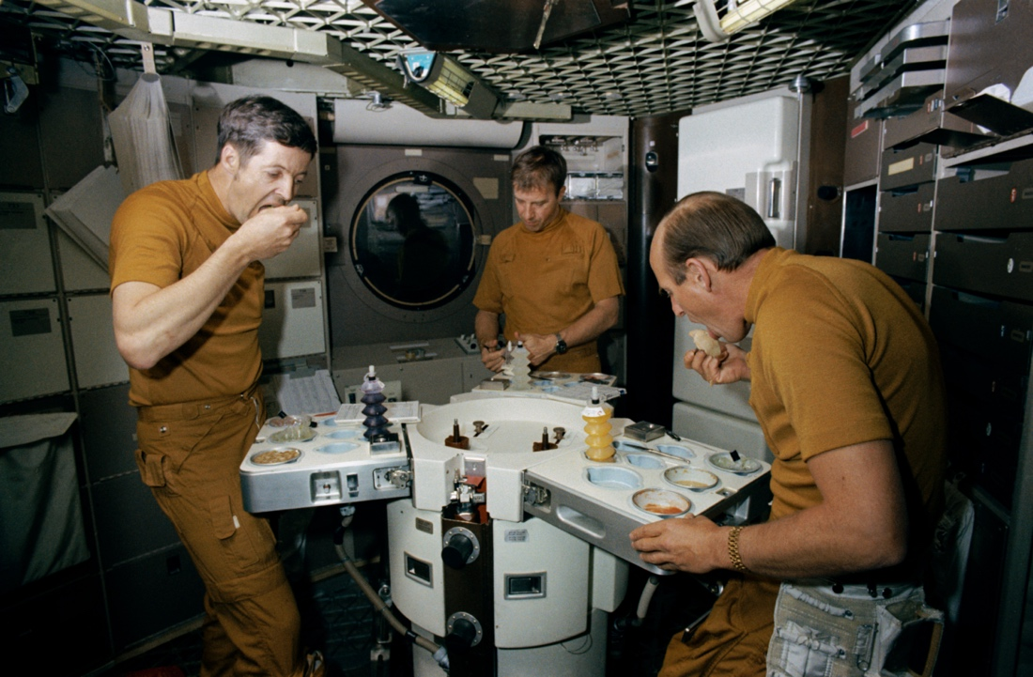
Figure 6: Skylab Crew Members Joseph P. Kerwin (L), Paul J. Weitz (C), and Charles Conrad Jr. (R) enjoy an “out of this world” meal in the Skylab Orbital Workshop trainer.
In short, these artists collaborated with teams of scientists, architects, and other visioneers to sell the concept of space colonies to peers, politicians, and the public at large. Endcap, Sunflower, Main Street, and Sport were four of many artworks explicitly commissioned to aid in the advertising process, but advertisements perform more work than just describing, publicizing, and generating interest for a product or service. Historian Roland Marchand notes that American advertisements of the 1920s and 1930s purposefully depicted “the product or its benefits ‘situationally’…that is, in the life of the consumer”. A space colony may not fit in a living room quite like a carton of Lucky Strike cigarettes or a Hoover vacuum, but Endcap, Sunflower, Main Street, and Sport nonetheless introduce their audiences to fantastic technologies in a manner that codes these megastructures as familiar places. Each painting projects scenes of everyday life into these extraordinary habitats: a family enjoys a quiet outing to the countryside in Endcap, for example, and Main Street showcases colonists comfortably running errands.
Yet ads do not simply mirror the present lives and lifestyles of consumers; they instead seek to present “life as it ought to be” by reflecting “public aspirations rather than contemporary circumstances” and mirroring “popular fantasies rather than social realities”. These four paintings similarly draw on their audiences’ attitudes and expectations about “the future” to present an idealized vision of the lives and environments possible aboard space colonies. O’Neill himself notes that “a much reduced colonization project would be little more than a re-named space station, perhaps able to maintain itself but incapable of building…larger models”. Re-named space stations would not be able to support the verdant pastures, picturesque swimming pools, high-tech shopping centers, and scenic cityscapes that appear across these paintings – nor could they promise to alleviate any of the anxieties that first inspired their construction.
Endcap, Sunflower, Main Street, and Sport thus share a carefully cultivated vision of life in space that blends present environmental, social, and technical realities with future possibilities to produce a more attractive picture of space colonization. Like ads, Endcap, Sunflower, Main Street, and Sport draw these realities from the experiences of both their creators and their intended audiences. In doing so, they consequently “communicate broader assumptions about social values” by drawing on “ideas and images that reinforce and intensify existing patterns and conceptions”. Some of these patterns arise in the paintings’ subjects. The very concept of space colonization itself, for example, arguably appeared in science fiction as early as the late nineteenth century. Prominent space scientists and engineers popularized the technology in the mid-twentieth century by publishing articles about the benefits of space exploration alongside striking astronomical artworks in general interest magazines like Collier’s. In this sense, the propagation of Endcap, Sunflower, Main Street, and Sport – four “scientific images created in collaboration with subject matter experts” – lent a greater sense of authority to a concept already percolating in the public imagination.
Other patterns arise in the rhetoric of the paintings’ “visual dialogue”. Cultural historian Megan Preligner, for example, notes that mid-twentieth century aerospace industry ads employed “art and design…to persuade the audience of the imperative need for funding to build the human future in space”. Ads of the era operated within “the gray area between fact and fiction”, often connecting emerging technologies to the “science fiction vernaculars” that surrounded satellites, manned spaceflight, spacecraft, and even outer space itself. One particularly powerful vernacular Prelinger traces in her book Another Science Fiction: Advertising the Space Race, 1957-1962 (2010) is the construction of outer space as not only a “new place in the cultural imagination”, but a place that is “ready to receive established patterns of human habitation”. Endcap, Sunflower, Main Street, and Sport candidly draw from this discursive tradition, as all four paintings “seem to export ‘home’ into space rather than bringing space to earth”.
The notion of “home in space”, however, points to another set of patterns that arise across these paintings: assumptions, biases, and ideologies. Although I interrogate a number of the ideologies encoded within these paintings in the passages that follow, one particularly powerful assumption that all four share is the utopian belief that life will be better aboard these megastructures. Hardships are surprisingly absent across Endcap, Sunflower, Main Street, and Sport; we audience members observe neither disease nor disaster, neither neglect nor conflict. While it may be difficult to read the facial expressions and body language of individual colonists in these paintings – especially in dramatically scaled pieces like Endcap – all appear to express feelings of relaxation and contentment as opposed to frustration, confusion, or agitation. Space colony interiors are also shown as established places fit for habitation. Small technologies scattered throughout the colony appear to work without fail: streetlamps illuminate, fountains gurgle, even jetpacks lift off the ground. More importantly, the infrastructures that the colonists’ lives quite literally depend upon seem to function properly. The colonies’ windows remain unbroken by space debris, for example, and life support systems seem to circulate breathable air and remove waste. Endcap even boasts an extensive internal ecosystem complete with an active water cycle and healthy, vibrant foliage – a development that clearly suggests some temporal distance from the colony’s initial construction.
By incorporating these small details into their art, Davis, Alexander, Mion, and Guidice not only portray space colonies as pleasant places to live, but as successful technologies in and of themselves. The space colonies of Endcap, Sunflower, Main Street, and Sport appear as true solutions to the terrestrial concerns that inspired their construction: their interiors offer spacious, uncontaminated natural environments rich with limitless resources for populations to use at their leisure. These megastructures are also conveniently situated within an expanse of uncontrolled, uninhabited empty space in which colonists can not only use said resources, but craft additional colonies ad infinitum. Taken as advertisements, then, Endcap, Sunflower, Main Street, and Sport ultimately complement the rhetorical objectives of the larger media ecologies in which they appear: to introduce the concept of space colonies to their audiences and to actively sell these manufactured worlds as familiar, feasible, and – above all – desirable places. The work of artists like Davis, Alexander, Mion, and Guidice thus encouraged their audiences to not only become excited about the prospect of space colonization, but to actively participate in this “next step” of the space program – presumably through their financial or political support for space exploration initiatives, but perhaps even through their eagerness to one day live and work in space.

Chapter Three: The “Impossible Earths” of Endcap, Sunflower, Main Street, and Sport
Commissioned to not only visualize but familiarize fantastic futuristic technologies for their respective clients, Davis, Alexander, Mion, and Guidice crafted intimate scenes of everyday life aboard space colonies. O'Neill and his contemporaries incorporated both natural and built environments into the colonies’ habitable areas, but different artists emphasized different attributes of these environments. Davis and Alexander accentuate the complex ecosystems supposedly attainable aboard these megastructures; Mion and Guidice draw attention to the colonies’ trendy cityscapes and intricate infrastructures. These predilections produced markedly different paintings of life aboard space colonies, but all four artists transformed O’Neill’s abstract megastructures into accessible worlds by incorporating value-laden visual elements into their compositions. As artworks are shaped by the broader contexts in which they are created and circulated, the visual elements present in – and absent from – Endcap, Sunflower, Main Street, and Sport arguably relate to scenes of life in late twentieth century America more than those of life in a future space colony. Davis and Alexander synthesize popular conceptualizations of nature to recast space colonies as “oases in space”, domesticated sites of pleasure and preservation akin to terrestrial gardens, resorts, and national parks. Mion and Guidice similarly juxtapose scenes of suburbs and metropolises to refashion these megastructures as novel “cities in space”, cosmopolitan communities suited for a new class of citizens. Although Endcap, Sunflower, Main Street, and Sport certainly familiarize space colonies for their audiences, the colonies they advertise can hardly be called miniature Earths; rather, in their efforts to paint attractive pictures of life aboard these megastructures, Davis, Alexander, Mion, and Guidice inadvertently code the places they depict as idealized American environments.
The following passages aim to catalog these paintings’ notable visual elements, to articulate the places these elements construct and the values they advertise, and to reconnect all four artworks to the broader visual and cultural history of late twentieth century America. I first turn my attention to space colonies’ natural environments as advertised by Davis and Alexander in Endcap and Sunflower; I then examine their built environments as advertised by Mion and Guidice in Main Street and Sport. Each analysis includes a brief biographical sketch of the artist and a detailed description of the painting in question. Before I can begin this work, though, it is necessary to address the use of the word “natural” as it occurs in my analysis. Space colonies are not “natural” in any way; O’Neill envisioned these megastructures as artificial worlds constructed wholly in space. While natural environments – or, at the very least, natural elements like flowerbeds and fruit trees – were to be incorporated into the colonies’ residential areas, these environments were still to be fashioned out of materials mined from the Moon and inhabited by species shipped from the Earth.
Greenery and green spaces aboard O’Neill’s megastructures, in other words, would be synthetic; in fact, the only “natural” nature colonists would experience everyday would be the black expanse of starry space visible through the colonies’ solars. The limitations of terms such as “natural”, “wild”, “artificial”, “built”, and even “environment” are therefore on full display in my study. In lieu of contributing to the debates concerning their application in environmental histories and urban studies, I exclusively employ these terms in my analysis as markers of habitation. Areas of the colony that I refer to as “natural environments” are simply places inhabited by a smaller number of colonists; those that I refer to as “built environments” are likewise areas inhabited by a greater number of colonists. As I previously noted, Endcap and Sunflower privilege the less-populous areas aboard space colonies. Main Street and Sport, by contrast, privilege the more-populous areas aboard them. By carefully restricting my use of these terms, I am not only able to study these paintings in neat pairings, but to do so in a manner that neither confines their interrelated ideological work nor challenges a principle technical property of O’Neill’s original space colony proposal.

Evacuating Spaceship Earth: (Un)Natural Environments in the Colony

Endcap View with Suspension Bridge
Enamored by space and space science “ever since Sputnik 1 was announced to [his] kindergarten class”, Don Davis (1952 – present) began his decades-long art career as a scientific illustrator with the United States Geological Survey’s Division of Astrogeological Studies in 1968. This position shaped the “meticulous style and almost obsessive attention to detail and scientific accuracy” that has come to characterize his art, but Davis’s credited creative projects range from planetarium shows and special effects to album art and computer animations. Despite his eclectic oeuvre, Davis’s most recognizable pieces are often the watercolor, acrylic, and gouache paintings he produced for the 1975 Summer Study – especially the controversial piece Endcap View with Suspension Bridge (Endcap). Perhaps Stewart Brand best describes its infamy in his introduction to Space Colonies:
Endcap ‘has inspired more belief and roused more ire than any other [space colony] artifact…the man-made idyll is too man-made, too idyllic, or too ecologically unlikely – say the ired. It’s a general representation of the natural scale of life attainable in a large rotating environment – say the inspired. Either way, it makes people jump’.
An undoubtedly utopian vision of life in space, Endcap depicts a romantic rural scene aboard a large late-model space colony. A small group of colonists enjoy an outing to a muddy riverbank in the foreground of the painting; two are pictured playing in the water as the other three relax along the shore. Although identifying features are difficult to distinguish due to their small size within the scene, the figures are posed in a manner reminiscent of a young couple on vacation with their three children. Three additional colonists can be seen in the distance: a pair plays frisbee on the opposite bank of the river and a solitary swimmer moves downstream. Rivers wind their way through gently rolling hills and thick forests to a large body of water – likely a lake or a bay – in the middle ground of the painting. This geographical feature essentially divides the scene in two: solitary cabins, farms, and small communities dot the land to the east of the bay and an arguably larger cityscape lies to the west. A sloping suspension bridge connects each half of the colony. This tranquil scene would not be out of place in an idyllic landscape painting; in fact, if it were not for the mirror and agricultural enclosures visible through the solar in the background, a viewer might mistake the subject of this painting as nothing more than a lazy summer afternoon on Earth.
Time is far more fluid aboard the colony, however. Sunlight filters through the solar from the upper left corner of the painting, but because several patches of shadow obscure the rest of the valley, the entire scene appears a bit “out of time”. Its action may take place, for example, in either the early morning or the late afternoon. The climate aboard the colony is far easier to infer; its temperature is warm enough for colonists to sport popular “warm weather” clothing like swimsuits, t-shirts, and shorts, and its water temperature is pleasant enough to encourage outdoor activities like swimming and sailing. Aquatic creatures and large mammals are curiously absent from both the stream and the forest in the foreground, but the rest of the colony’s ecosystem teems with life. Butterflies and birds flit through the scene, and a variety of wildflowers, shrubs, grasses, and trees dot the landscape. Overall, Davis describes the design of his colony as a conscious choice, explaining on his personal website that “it was painted this way under the direction of space colonization popularizer Gerard O’Neill himself”. From its suspension bridge to its flora, Endcap directly draws from the scenery of the San Francisco Bay area. The wildflowers along the stream’s shoreline appear to be Eschscholzia californica, or California poppies. These flowers are a prominent feature of the coastal sage scrub plant community that peppers California, as are the strands of Artemisia californica, or California sagebrush, peeking over the boulder in the foreground. A Quercus agrifolia, or evergreen coast live oak, can also be seen along the left edge of the painting.
All three plant species are native to the San Francisco Bay area, but Davis also alludes to some of bay’s unique architecture. The marinas that line its shores, for example, are suggestive of those that anchor Sausalito’s longstanding houseboat communities. These parallels are purposeful; according to Davis, O’Neill “related a recent impression of [how] the vantage point from Sausalito [would be] an excellent scale reference for a possible setting inside a later model cylindrical colony”. Endcap captures the landscape of northern California at large, but as Scharmen points out, the placement and purpose of green spaces within the colony were a subject of bitter debate during the Summer Study. Humans tend to appreciate “green and growing things” as a part of our day-to-day sensory perception, but the “contradictions about the uses, and the users, of ‘green and growing’ things played out on a larger scale” in the setting of the Summer Study. Participants battled to balance the “psychological and cultural considerations” of placing plants aboard the colony with the colonists’ nutritional requirements, with the megastructure’s spatial demands, and with the expedient agricultural practices necessary to sustain large populations over extended periods of time, to name a few contested topics. Davis offers his own perspective on the matter, explaining that he wanted Endcap to “deliberately imply the challenge of trying to transplant a workable ecosystem to a giant terrarium in space”. His words support O’Neill’s grand plans for the “humanization of space” as they do not suggest that this challenge is impossible, but they do express a clear desire for “green and growing things” aboard these megastructures – a desire Paul R. Alexander certainly echoes in his own space colony paintings.

Interior of “Sunflower”
Often recognized as “one of the top ‘gadget’ artists” active between the late 1970s and the early 1990s, Paul R. Alexander (1937-2021) excelled at depicting detailed visions of future machinery for technical advertisements and science fiction publications. Fans of his work may be more familiar with his intricate paperback covers for Ace Books and Del Ray Books – two late twentieth century science fiction and fantasy publishing powerhouses – but Alexander also produced pieces for more general audiences. Five of his colorful gouache paintings, for example, accompany an article written by O’Neill for the 1976 edition of Science Year: The World Book Science Annual. Titled “Settlers in Space”, the article describes life aboard a hypothetical space colony in the late 1990s. Interior of “Sunflower” (Sunflower) shines as one of the article’s more memorable paintings, as it is the only piece to probe the interior of the megastructure in any detail. Awash with a warm color palette rich in varying shades and tints of green, Sunflower depicts a residential area in one of the end caps of a small O’Neill space colony. Dense foliage grows in clusters around the scene: ferns, mosses, and shrubs cover the jagged cliffs that crowd the foreground of the painting, and the tufted tops of trees can be seen scattered throughout the colony. Three square windows separate the cliffs from the rest of the interior, but the two spaces are clearly connected by broad metallic walkways.
These walkways continue through the rest of the colony, carving neat patches out of grassy plains and connecting curved rows of modular buildings that almost appear to grow out of the metallic structure of the end cap itself. Although the specific functions and features of these buildings are difficult to discern due to their relatively small size within the scene, the inclusion of arched windows and colorful gardens does suggest that the colonists paid some attention to aesthetic detail when designing and constructing their living arrangements. Buildings aboard the colony, in other words, do not seem to simply provide shelter; they offer something more intangible, be that beauty, individuality, or even gaiety. The colony’s built environment extends into the background of Sunflower and ends at a “foliage covered partition”; according to the caption that accompanies the painting, this partition “separates the inhabitants from the farming area and protects them against cosmic rays”. A metallic tube extends from the partition into the hollow center of the geodesic end cap, but it surprisingly supports platforms that hold at least two swimming pools. Miniature diving boards and a small group of swimmers complete the subdivision-esque scene. Eight metal rods – presumably some sort of structural support – protrude from the base of the tube and extend unseen into the structure of the end cap.
Colonists stroll throughout the end cap, but one pair notably stands alone atop a small rocky ledge toward the lower right edge of the painting. As if to emphasize the ease of life within the colony, Alexander portrays the pair as a stylish couple; the woman sports a white tennis skirt, black top, and short dark bob, while her companion stands with their back to the observer in what seems to be a smart black suit. Sunflower offers few cues as to how the couple climbed the cliff, but additional colonists situated below the pair suggest the presence of a stairway or pathway carved into the cliffside. Bright sunlight streams into the space through the end cap’s large windows, and while we viewers lack any concrete details about how Alexander composed his paintings for Science Year, we can infer from the colonists’ clothing that the colony’s climate is at least warm enough for its inhabitants to wear shorter – and presumably lighter – ensembles. Interestingly, we can glean few details about the climate from the flora and fauna that sprawl across the scene. Animals and insects are wholly absent from Sunflower, save an incredibly small flock of birds spread across the right side of the painting and backlit by sunlight. Trees, shrubs, and grasses sprawl across the colony as well, yet it is almost impossible for a viewer to identify specific species of plants without examining the reference materials Alexander used to compose the piece – that is, if he used any at all.

Extraterrestrial Edens: Endcap, Sunflower, and O’Neill’s “New Earths”
Although Davis and Alexander’s paintings likely depict different ecosystems and climates, both artists recast space colonies as bountiful natural oases. These oases serve as sites of preservation for terrestrial flora and fauna, but they also act as sites of recreation and restoration for the colonies’ occupants. As both artists sought the attention – and, ultimately, the approval – of their respective audiences, Endcap and Sunflower reflect perceptions of nature already present in American popular culture – especially those associated with cultivated natural environments such as gardens and national parks. Ideas and images of cultivated nature are often presented as the antithesis of “wild nature”. Gardens are not, to borrow the phrasing of Dave Foreman, “The Big Outside”; they are neither vast tracts of virgin land free from human intervention nor inhospitable savage “places on the margins of civilization”. Gardens irrevocably demand intervention from those who plant and sustain them, and while nature – wild or not – is admittedly a product of “particular human cultures and very particular moments in human history”, Endcap and Sunflower nonetheless visualize natural environments under the complete control of their creators. Consider, for example, the flora and fauna present in these paintings. Gerard O’Neill often cast the recreation of Earth-like environments on his megastructures as an opportunity to improve their occupants’ quality of life. “Settlers in Space” suggests that:
There could be insects for the birds to eat [aboard the colonies], but perhaps we can do without mosquitos or cockroaches…we can also exclude other pests such as mice and rats.
The colonies of Endcap and Sunflower arguably demonstrate O’Neill’s proposition of “selective biodiversity”. Their landscapes contain broad arrays of botanical specimens but few zoological ones; in fact, the only animals that appear in either painting are birds, colonists, and butterflies. This discrepancy becomes especially curious when recalling O’Neill’s frequent assurance that “species…endangered on Earth by agricultural and industrial residues may find havens for growth in space colonies”. From rabbits and frogs to beetles and flies, the omission of additional wildlife – especially endangered wildlife – from Endcap and Sunflower accentuates the domesticity of the natural environments aboard O’Neill’s megastructures. After all, while space colonies will host Earth-like ecosystems, their creators will control where and how specific species are to flourish within them. As these decisions appear to depend on the predilections of future colonists – such as O’Neill’s aversion to cockroaches – the oases of Endcap and Sunflower are, in a sense, carefully cultivated gardens.
These paintings were not the only late-twentieth century American media to draw on images of gardens in the context of space exploration and space settlement, though. In the spring of 1972, the post-apocalyptic science fiction classic Silent Running introduced theatregoers to the “Valley Forge”, a colossal space freighter carrying greenhouses filled with the last surviving samples of terrestrial plant and animal life. The film follows the freighter’s resident botanist and ecologist, Freeman Lowell, as he desperately tries to save and sustain the fledgling Eden under his care. Silent Running admittedly portrays spaceships as opposed to space colonies, but it still shares several attributes with Davis and Alexander’s artworks. Silent Running, Endcap, and Sunflower, for example, ascribe to the techno-utopian conviction that technology can restore and conserve earthly environments, and all three illustrate this application of technology as well. Director Douglas Trumbull famously modeled the greenhouses aboard the Valley Forge after an acclaimed conservatory at the Missouri Botanical Garden in St. Louis, Missouri.
Colloquially known as the “Climatron”, this conservatory celebrates the designs of futurist architect R. Buckminster Fuller by gathering “four whole plant ecologies…under a single geodesic dome”. The Climatron became “the world’s first completely air-conditioned greenhouse” upon its opening in the early 1960s; to contemporary horticulturalists, botanists, and ecologists, it represented a “radical new kind of facility”, one with the potential to replicate and even replenish entire ecosystems within its walls. Just as the greenhouses aboard the Valley Forge fulfill this potential in the world of Silent Running, so, too, do space colonies fulfill this potential in the paintings of Davis and Alexander. Endcap and Sunflower reimagine O’Neill’s megastructures as planet-sized conservatories complete with carefully controlled climates and a myriad of botanical samples – samples that may even mirror the diversity of the Climatron’s extensive collections.
The colonies of Endcap and Sunflower also seemingly ascribe to the same “shining, aluminum, geodesic future” evident in the Climatron’s alternative architecture. Fred Scharmen suggests that countercultural structures and communes captivated – or at least influenced – astronomical artists like Don Davis. Space Settlements repeatedly points to the similarities between standalone structures built within the colony and those built on Earth; Scharmen comments, for example, that “the geometry of the cabin in the foreground of [Endcap] would not be out of place among [Steve] Baer’s Drop City dome homes”. To Scharmen, the presence of countercultural architecture in Davis’s painting accentuates the natural environment aboard the colony and alludes to the colonists’ attitudes toward nature. With respect to Scharmen, I interpret the alternative architecture in Endcap as an appeal to environmentalists skeptical of the space program. The technologies showcased in Endcap, Sunflower, and even Silent Running demonstrate “the benefits of space technology for Earth environments”. Space colonies and spaceship-mounted conservatories preserve earthly environments and organisms, but they do so in a manner that still ensures a pleasant experience for their inhabitants. Endcap and Sunflower thus advertise space colonies as oases that emulate the ecological and aesthetic practices on display in earthly conservatories.
And yet, despite their focus on scenes of domestic nature, Davis and Alexander repeatedly draw on a visual tradition more commonly associated with depictions of “wild” nature: that of the sublime. Elizabeth Kessler defines the sublime as “an extreme aesthetic experience, one that threatens to overwhelm even as it affirms humanity’s potential”. Her interpretation reflects the work of prominent Romantic philosophers such as Edmund Burke and Immanuel Kant, but it also connects to a particular mode of perceiving natural environments that emerged in the eighteenth and nineteenth centuries. For Burke, Kant, and their like-minded peers, wilderness was no longer a savage wasteland to be feared; it was a sacred space in which “the supernatural lay just beneath the surface”. Sublime landscapes were particularly special places within this wilderness, those “rare places on Earth where one had more chance than elsewhere to glimpse the face of God”. These places were vast and powerful; so much so that that they demanded their own “visual language”, one capable of emphasizing “powerful forces of nature” in artistic compositions and evoking “a sense of awe and grandeur” in audiences. Nineteenth century Romantic landscapes – especially those of the American West – typify this visual language of the sublime, but Davis and Alexander deploy it in Endcap and Sunflower as well. By infusing space colony interiors with a sense of the sublime, Davis and Alexander attempted to illustrate the magnitude of O’Neill’s megastructures more clearly and to provoke emotional responses from their audiences more easily.
Romantic landscapes like Cliffs of the Upper Colorado River, Wyoming Territory (1882) by American artist Thomas Moran (1837 – 1926) “convey great size and scale” through an artist’s careful manipulation of the forms that compose their work. For example, to express the immensity of the Green River and the geological formations that surround it, Moran focuses on a small yet discernible feature of the landscape. His painting obscures most of the cliffs spread across the scene; two appear in detail in its middle ground, but the remaining cliffs fade into the haze of an oncoming storm. Moran’s inclusion of human figures in the scene – a small group of Native Americans on horseback – adds an additional sense of scale for his audience. Davis and Alexander manipulate size and scale within their own paintings in a strikingly similar fashion. Just as Romantic landscapes “never depict an entire mountain range”, neither Endcap nor Sunflower depict O’Neill’s space colonies in their entirety. Davis’s work displays one of the three valleys aboard an advanced cylindrical colony, and Alexander’s work showcases the apartments and shops tucked into the end cap of a simple cylindrical colony. Colonists appear in both scenes, and as do the figures in Cliffs of the Upper Colorado River, their small stature emphasizes the scale of O’Neill’s megastructures. Additionally, while Endcap and Sunflower focus on small segments of space colonies, these segments are still comprehensible to the viewer. Davis and Alexander privilege familiar features of space colonies such as their residential areas, rather than obscure technical details such as the colonies’ life support systems, or reengineered environments such as the colonies’ industrial complexes. This decision likely corresponds to the demands of the artists’ respective clients, but it also discloses Davis and Alexander’s assumptions about the interests of their intended audiences.
The artist’s oases in space, after all, had to sell O’Neill’s space colonization efforts to predominantly public audiences that included politicians, educators, and everyday Americans. Therefore, to emphasize that space colonies “were intended for ordinary people [and] not just astronauts”, Davis and Alexander also presented their interiors as sites of recreation and restoration. Endcap evokes images of health spas and summer camps where colonists enjoy cool streams, tranquil scenery, and an “escape [from] the confining strictures of civilized life” present elsewhere in the colony. Sunflower, by contrast, conjures the bright colors and inclusive accommodations of tropical resorts, theme parks, and vacation destinations; colonists crowd zero gravity swimming pools, stroll along shady shop-lined walkways, and explore scenic cliffsides flush with “exotic” flora. Both paintings position the colonies’ natural environments as adventures accessible to all of their occupants, but as environmental historians like William Cronon point out, this form of recreation is often “best enjoyed by those whose class privilege give them the time and resources to leave their jobs behind and ‘get away from it all’”.
Concerns of classism frequently haunt the concept of space colonies. From Robert Heinlein’s novel The Moon is a Harsh Mistress (1966) to Neill Blomkamp’s film Elysium (2013), these megastructures magnify the substantial social, political, and economic divides that exist between different inhabitants of earthly environments. Endcap and Sunflower, for example, supposedly offer all colonists access to “virgin, uninhabited land”, that is a true “final frontier” to be shared, settled, and shaped. Yet, just as romantic images of the Western frontier cannot persist when confronted with the “perspective of the Indians who had once called that land home”, so too does the idea of “virgin land” aboard space colonies fail when the environments sacrificed to create these megastructures are actually acknowledged.
As O’Neill’s space colony designs again “treat[ed] the region beyond Earth not as a void but as a culture medium rich in matter and energy”, he consequently positioned other extraterrestrial bodies as new frontiers “up for grabs”. “The Colonization of Space”, for example, outlines different opportunities for extraterrestrial resource extraction and application:
To reduce the mass [of materials] needed from Earth, most of the repetitive structural members (aluminum) and window panels (glass) must be produced at L5 from lunar material…The asteroid belt is [also] a rich source of raw materials, already exposed and differentiated…[but] if we are so prodigal as to run through the entire material of the asteroid belt in the next 500 years, we can…gain another 500 years by using up the moons of the outer planets.
As both Andrew Kirk and W. Patrick McCray note, this attribute of space colonization outraged environmentalists such as Wendell Berry and David Brower. These individuals already believed space exploration efforts to be “a dangerous distraction from the very immediate environmental problems on Earth”, but O’Neill’s proposed colonies also infringed upon extraterrestrial bodies, “a wilderness that [Berry and Brower thought] should be preserved in perpetuity”. Berry and Brower’s comment complicates the notion of nature for scholars of space exploration, postcolonialism, and the environment, but it also points to an important conceptualization of nature confronted in the artworks of Davis and Alexander: the image of an environment in crisis.
By the year 1970, Americans had already witnessed two decades of serious environmental advocacy, but a string of highly publicized environmental disasters – including a serious oil spill in Santa Barbara, California and a fire atop the Cuyahoga River in Cleveland, Ohio – had reignited popular concerns about pollution, environmental degradation, and public health. O’Neill’s own research efforts aligned with many of these concerns, as he sought to colonize space “without harming anyone” and “without polluting anything”; as extensions of his technical designs, Endcap and Sunflower consequently express these aims. Consider, for example, the paintings’ panoramas. Endcap portrays a vast countryside interspersed with small communities that gradually grow into a crowded city, and Sunflower presents a single community tucked into an expansive landscape. Densely populated areas appear in both panoramas, but the pollutants that such areas commonly produce are nowhere to be seen. The cool streams of Endcap and the grassy meadows of Sunflower are free of garbage and debris, and the skies in both paintings are free of smog and smoke. Davis and Alexander’s depictions of unpolluted atmospheres are more striking when we recall the smoggy West Coast communities that initially inspired Endcap, but they can be explained in part by O’Neill’s space colony designs. His megastructures would rely on “clean, practical energy sources” such as solar power, and their modest interiors would reduce prominent sources of air pollution such as “fuel-burning cars, powered aircraft, and combustion heating” because colonists could easily walk or bike around the colony. Endcap and Sunflower depict clean Earth-like environs to demonstrate the positive impact of these practices; consequently, these paintings also proclaim the potential of technology “to solve seemingly intractable social problems” both aboard space colonies and on the surface of the Earth itself.

Settling (Sub)Urban Space: Built Environments in the Colony

Main Street, Hometown, Cosmos
Self-described as “two-thirds illustrator, one-third fine artist”, Pierre Mion (1931-2021) often claimed his career began with his interest in drawing and painting at the age of two-and-a-half. He contributed illustrations to preeminent publications like Life, National Geographic, and Popular Science as early as 1961, and many of Mion’s pieces now appear in astronomical art collections at prominent institutions like the National Air and Space Museum. Nine of his magazine illustrations are particularly memorable, as they accompany a short speculative tale penned by the celebrated science fiction author Isaac Asimov. First published in a special bicentennial edition of National Geographic in July 1976, “The Next Frontier?” recounts a terrestrial journalist’s visit to a space colony in the year 2026. Although toroidal in shape, Asimov’s space colony design draws inspiration directly from the 1975 Summer Study; his megastructure would be situated at L5 and consist of a central hub – a “sphere 130 meters in diameter” – connected to the “torus proper” by six spokes. The torus itself would be subdivided into six separate sectors that would alternate between earthlike residential and agricultural areas, but as Asimov’s journalist observes, “it was not just…the [colony’s] gravity [that] was like that of Earth…it was everything else as well”. Asimov described a colony that resembled “a compact American community with glass and aluminum buildings on every side”, and his vision comes to life in Mion’s painting Main Street, Hometown, Cosmos (Main Street).
Main Street “finds colonists on the move passing the stacked, modular habitations and shops of L5”. Towering vertical “neighborhoods” of residential and commercial properties crowd the middle ground and background of the painting, and while Mion offers few insights into the plan that arranged this “city” aboard the colony, its neighborhoods appear to border a busy public thoroughfare decorated with fruit trees and fountains. This thoroughfare effectively sits at “street level”, as it forms the foundation for the commercial and residential properties stacked atop it. A support beam labeled with a bright yellow “1” cuts through the center of Main Street; metal “sidewalks” suspended in midair connect the neighborhoods that sit on either side of this divide. The beam itself extends upward into a transportation system that passes through each residential and agricultural area of the torus, but an escalator also connects the thoroughfare to another unseen section of the colony situated beyond the bottom edge of the painting. Of the twenty to thirty colonists scattered throughout Main Street, six figures emerge as its central actors. Five of these actors are positioned on the escalator in the foreground of the painting: two adults and a child ride the escalator toward the city, and two additional adults travel away from it. The sixth actor passes a neighborhood marked with a gray “53” on a blue bicycle in the lower right-hand corner of the painting.
An opaque glass roof envelops the entire scene, and Mion reflects its cool color palette elsewhere in the colony’s residential and commercial spaces. Blue and green curtains, for example, are hung on the tall windows of the apartments in Neighborhood 53, and the light fixtures that line the thoroughfare are topped with round white bulbs. Warm colors, by contrast, are almost wholly absent from this cityscape aside from the occasional fruit tree or flowerbed. A neon sign situated in the midground of Main Street is one of the final few outlying additions of color; its design features scrolling red text set against a black background. Although its text – the partial phrase “ ****NOW SHOWIN ” – suggests that the sign accompanies a movie theatre situated somewhere within Neighborhood 53, it is possible that the sign advertises apartment units available for new residents to tour or serves as a sort of centralized communication service for the city. Curiously, Mion offers few clues as to the types of stores and services available in the colony. Individual properties offer neither ads nor names, yet colonists scattered throughout the scene carry packages, purses, electronic devices, and other luxury goods. The presence of these products in Main Street points to an active consumer culture aboard the colony, and while we cannot discern the details of its economy from observations alone, Mion’s portrayal of colonists casually shopping in space positions the colony as not only an earthlike environment, but an affluent community in which colonists possess both financial and economic power – a community Rick Guidice captures in his depictions of space colonies as well.

Sport in Space Colony
Arguably one of the most widely recognized NASA-adjacent space artists of the post-Apollo era, Rick Guidice (1942 – present) started drawing professionally as an architectural illustrator at the age of sixteen. He turned to freelance advertising and editorial art in the late 1960s, and when his talent for technical illustration caught the attention of engineers at NASA’s Ames Research Center, Guidice joined a small circle of local artists regularly commissioned to produce “imagery for [the center’s] technical publications” – including those associated with the 1975 and 1977 Summer Studies. Guidice partnered with Gerard O’Neill and fellow astronomical artist Don Davis to “translate highly technical data into fully-developed, highly imaginative visualizations that brought [the study’s] hypothetical colonies to life”. Artworks commissioned by NASA ARC were often incorporated into formal technical reports, and Guidice’s watercolor, acrylic, and gouache painting Sport in Space Colony (Sport) is no exception.
Published as a part of NASA SP-428, Space Resources and Space Settlements, Sport depicts a cheerful cityscape aboard an advanced O’Neill-inspired space colony. Eight colonists float amid skyscrapers in the foreground and middle ground of the scene, and while some of these actors may merely be moving about the colony, curators Joseph Corn and Brian Horrigan contend that the colonists’ futuristic flight technologies are being used for exercise instead of transportation. Despite the technology’s true purpose, its “high-flying” users soar above another small group of colonists gathered on a balcony in the lower left-hand corner of the painting. These colonists are presumably drinking or dining outdoors, as they are all seated around a large circular table. The balcony seems to be attached to a private residence, but because the dining area may extend beyond the bottom of the painting, this property could also be reasonably interpreted as a restaurant or café. Curiously, this structure is one of the few elements of Sport that explicitly demonstrates how colonists interact with their surroundings. These actors assemble on the balcony in Sport, but they likely use it to eat, to rest, and to work as well. Most of the structures that crowd the middle ground and background of the painting, by contrast, hide their functionality.
Despite this ambiguity, all the structures across Sport still reflect individuality and, arguably, beauty. Circular constructions complement traditional multistory towers, domed cylinders loom over public thoroughfares, and prismatic edifices dripping with greenery cut across the colony’s skyline. Guidice groups these structures into distinct “layers”, but it is difficult to determine how many there are – let alone how they are used, how they are connected to one another, and how available they are to the colony’s inhabitants. Nevertheless, three broad layers can be seen in Sport. Interlocking pathways and green spaces snake through the lowest level of the colony; structures are sparse in this level, save the occasional glass-topped cylinder or skyscraper foundation. Most of the colony’s structures are confined to an intermediate “middle level”. These structures vary in shape and size, but they are all dwarfed by the platforms that form the colony’s artificial “upper level”. Thrust into the sky atop thick metal poles, these platforms likely serve as communication or transportation hubs for the colonists, but it is possible that they contain residential, commercial, industrial, or agricultural space instead. On the subject of transportation, though, typical terrestrial technologies like buses, cars, and trains are almost wholly absent from Sport. Their absence is notable, especially if one considers the colony’s dimensions; O’Neill predicted that space colonies could eventually support a “population of several million people”, but such megastructures would need “a diameter of four miles, a length of twenty miles, and a total land area of five hundred square miles”.

Cosmic Communities: Main Street, Sport, and O’Neill’s “Cities in the Sky”
Although Mion and Guidice visualize different iterations of Gerard O’Neill-inspired space colonies, both artists consciously construct novel communities aboard these megastructures. These communities are both physical and social; Main Street and Sport reimagine the colonies’ built environments as clean, orderly metropolises, and they repopulate these environments with an ideal class of citizens. As in the case of Davis and Alexander’s “oases in space”, Mion and Guidice’s “cities in space” were shaped by late twentieth century American culture – most notably the emergence of cityscapes that were “neither urban nor rural nor suburban in the usual meaning of these words”. Architectural historian Robert Fishman suggests that these cityscapes are “best summed up in the inevitable world ‘sprawl’”. Bereft of clear boundaries, the “new American city” of the late twentieth century:
…has become a self-sufficient world of its own, with varied housing, extensive employment opportunities, a full range of educational and cultural institutions, and, of course, the ubiquitous malls…[it] may be hard to define, but it is definitely not a suburb.
Nor were such places true urban metropolises; new American cities “generated urban complexity without traditional urban concentration”, as they typically emerged from postwar suburban communities that occupied the periphery of the “conventional” city. In addition to encouraging low-density housing by design, these suburban communities offered “centers of activity” such as shopping malls, commercial strips, and recreation centers that “came to be seen as alternatives to downtown”. Main Street and Sport picture high-density housing aboard space colonies, but these paintings replicate the built environments – and, by extension, the attributes and biases – of new American cities. Buildings present in both paintings, for example, express “architectural similarity” and “economic and racial homogeneity”, characteristics that urban historian Kenneth T. Jackson claims are “typical of American urban development between 1945 and 1973”. Main Street and Sport, however, depict colonies at different scales; Mion depicts a modest toroidal space colony and Guidice depicts an advanced space colony of an unspecified – albeit colossal – size. As such, their artworks display different aspects of new American cities.
Main Street, for example, appears to have been wholly modeled after a significant architectural and cultural staple: the indoor shopping mall. Department stores had “establish[ed] suburban branches to serve customers with automobiles” as early as the 1920s, but the first fully enclosed, climate-controlled shopping complex in the country opened on October 8, 1956 in Edina, Minnesota, USA. Designed by Viennese architect Victor Gruen, Edina’s Southdale Shopping Center featured “stores on two levels connected by escalators and fed by two-tiered parking” as well as a pseudo “town square” at its center. This square largely functioned as a place for shoppers to rest; situated under a skylight, it offered a “‘garden court’ with a fishpond, enormous sculpted trees, a twenty-one-foot-cage filled with bright-colored birds, balconies with hanging plants, and a café”. The thoroughfare in Main Street may exchange a fishpond for a fountain, but the layout of its residential area mimics several attributes of Gruen’s mall design. For one, the colony’s apartments and storefronts clearly occupy distinct levels. These levels are connected by escalators and elevators, but unlike Southdale’s two story structure, Mion’s space colony interior contains approximately four stories: a main level complete with garden-lined walkways; two upper levels presumably packed with apartments and shops; and a lower level situated just outside the viewer’s line-of-sight.
Shops across Main Street also adhere to Gruen’s “introverted” organizational schema, as the exterior walls of buildings aboard the colony are devoid of traditional advertisements and signage. And, while the larger design of the colony’s main level may be difficult to discern, Mion clearly mimics Gruen’s pleasant town square. Flowerbeds and fruit trees appear throughout Main Street, for example. These green spaces “relieve the stark simplicity of [the colony’s] manufactured environment”, but they also serve as a central location for colonists to rest and socialize. A café may even appear in this area, as a small red-and-white striped umbrella – a style often seen over food vendors or outdoor eating areas – can be seen just below the emblem “53”. In addition to these physical similarities, though, space colonies and modern shopping malls also share a seminal ideology: “by putting everything under one roof, the retailer and the developer [or, in the case of space colonies, the creators and the engineers] gained, for the first time, complete control over their environment”. Just as architects could dictate the design and control the environs of a shopping mall more easily than a downtown storefront, so, too, could O’Neill and his contemporaries control the layout and aesthetics of cities in space more easily than those of cities on Earth. Science fiction author Isaac Asimov even extends this control to the colonists themselves, suggesting that the “alumni of Earth can order buildings, climate, and sunlight to suit” aboard space colonies like those seen in Main Street and Sport.
Despite these opportunities for originality, Mion and Guidice drew on the aesthetic of new American cities for their space colony interiors, and its influence pervades the built environment of Sport. Its layout, like that of the colony in Main Street, is multilevel; buildings sprawl across three distinct layers, and patches of greenery akin to those in Gruen’s town squares flourish around them. Although Mion’s space colony interior is certainly crowded, its residential and commercial properties vary in size to create the illusion of open space. Perhaps most importantly, however, the chrome cityscapes of Main Street and Sport uphold the strict standards for safety and sanitation seen in shopping malls, subdivisions, and other prominent centers of suburban life. Jackson, for example, stresses that postwar shopping malls “contain[ed] no unsavory bars or pornography shops, no threatening-looking characters, no litter, no rain, and no excessive heat or cold”. Bars, pornography shops, casinos, and other popular sites of “vice” do not explicitly appear aboard O’Neill’s space colonies, but a visual analysis alone cannot completely confirm the products and services available to colonists of legal age. Garbage, junk, and other forms of waste, on the other hand, are wholly absent from these paintings; Mion and Guidice do not even include trash cans or dumpsters in their cityscapes. The colonies’ atmospheres are similarly unpolluted, and their skylines – or roofs, in the case of Main Street – are unobstructed by antennae, billboards, construction equipment, and other such objects. Walkways and roadways appear well-maintained and well-managed, although they are admittedly difficult to examine in detail due to the paintings’ particular compositions.
However, historian John M. Findlay notes that the cleanliness of new American cities – and, by extension, the cleanliness of the built environments seen in Main Street and Sport – not only concerned dirt and litter, but appearance and order as well. Mion and Guidice picture peaceful cities aboard space colonies; viewers see neither violence nor unrest, neither injury nor malaise. By purposefully painting utopian scenes of life in space, the pair demonstrate a lingering awareness of – or even a deliberate attention to – the perceived “problems” of urban areas in late twentieth century America. Real estate advertisements for suburban properties alluded to issues of “race, crime, drugs, congestion, and filth” as early as the 1950s, and as time passed, the close association of central cities and social problems fostered specific images of urban decline. Consider Jackson’s own description of St. Louis, Missouri from the late 1970s and early 1980s:
Many of its old neighborhoods have become dispiriting collections of burned-out buildings, eviscerated homes, and vacant lots. Although the drone of traffic on the nearby interstate highways is constant, there is an eerie remoteness to the pock-marked streets. The air is polluted, the sidewalks are filthy, the juvenile crime rate is horrendous, and the remaining industries are languishing. Grimy warehouses and aging loft factories are landscaped by weed-grown lots adjoining half-used rail yards.
Jackson comments that such conditions existed in cities across the United States, but they are notably absent from the orderly cityscapes of Main Street and Sport. These paintings promote a specific “visual order” aboard space colonies instead, one that perpetuated the “image of suburbia as a place of refuge from the problems of race, crime, and poverty” that supposedly pervaded conventional cities. Lingering Cold War anxieties and rising tides of social unrest reinforced this image as well. American studies scholar Elaine Tyler May, for example, contends that “fears of communists and protesters, hippies and feminists, atomic bombs and muggers…coalesced in an exaggerated sense of personal and national peril”. Political rhetoric and popular media of the 1960s and 1970s fostered fears of crime, but rather than collectively addressing the social problems that led to it, Americans invested in “do-it-yourself defense” by “fortify[ing] their bodies, their houses, and their neighborhoods”. Private homes, gated communities, and sport utility vehicles became bastions of both individualistic ideologies and personal security; citizens of new American cities, in short, “locked themselves inside private spaces” to protect themselves from the chaos and violence of modern society. And yet, amidst this terrestrial push for private space, Main Street and Sport primarily display public spaces aboard space colonies. Mion and Guidice depict “outdoor” scenes in which colonists move about their environs; consequently, viewers observe public properties as opposed to private residences. Small enclaves of private space like patios and gardens do appear in these scenes, but Mion and Guidice present the colonies’ residential areas as “wholes” rather than “parts”. Although this choice may correlate to the artists’ aims of introducing their audiences to space colonies, it also emphasizes the communities space colonies were designed to foster.
O’Neill imagined specific bodies aboard his megastructures long before Davis, Alexander, Mion, and Guidice were hired to visualize his designs. As sociologist Michel Callon asserts, after all, actors that design, develop, and diffuse technologies inevitably design ideal users of their technologies as a part of the engineering process. Although my work privileges visualizations of a technology in lieu of the technology itself, Callon’s “sociological tool of analysis” remains both applicable to and profitable for my research. Endcap, Sunflower, Main Street, and Sport are extensions of O’Neill’s technical designs; their artists collaborated with scientists and engineers to produce visualizations “consistent with the known facts” about space colonies. These paintings are also some of the only objects associated with this technology to actually exist, as O’Neill-inspired space colonies have yet to be constructed. Therefore, by designing – and visualizing – ideal built environments aboard space colonies, O’Neill and his contemporaries also designed – and visualized – an ideal populace to inhabit these environments.
In the artworks of Mion and Guidice – and Davis and Alexander, for that matter – this “ideal populace” shares a specific demography: colonists overwhelmingly appear able-bodied, cisgendered, white, and young. In fact, out of all four artworks, only Sport includes a BIPOC colonist, but it should be noted that Guidice places this colonist in the background of his painting. O’Neill, by contrast, initially envisioned diverse populations aboard his megastructures; he “hoped”, for example, that “the [colonies’] early residents [would] include a wide spectrum of settlers from all countries…not only men and women in their working years, but also children and elderly persons”. Main Street and Sport refrain from imagining more inclusive communities aboard space colonies, but Main Street may even restrict the occupants of its colony to Americans; its colonists are almost entirely clad in red, white, and blue outfits. While these outfits may simply be uniforms of some kind, the colors appear more symbolic when we recall that this painting appeared in an issue of National Geographic that explicitly celebrated the United States Bicentennial.
Main Street and Sport offer insights into the colonists’ occupations and social order as well. In “The Colonization of Space”, O’Neill anticipates that the “migration of people and industry into space” will likely “encourage self-sufficiency, small-scale governmental units, cultural diversity, and a high degree of independence”. Main Street and Sport depict colonists in moments of leisure, but O’Neill suggests that they would “probably be occupied in architecture, landscaping, forestry, zoological planning, botany, and other activities that…require a sense of art and beauty”. His later articles add varied scientific and technical occupations to this list as well. While it is impossible to discern the colonists’ financial or social standing from paintings alone, Mion and Guidice depict colonists participating in the same activities that many middle- and upper-class individuals enjoy on Earth, including dining out, playing sports, and shopping. Neither painting seems to portray colonists struggling with unemployment or homelessness, but they may possibly erase a significant portion of the colonies’ work force.
According to “Settlers in Space”, O’Neill’s megastructures were to be built in free space out of materials shipped from Earth and mined from the Moon. This approach, to O’Neill, would necessitate the creation of “a [separate] space station big enough to house a work force of 2,000 persons”, as well as “a self-sustaining outpost of some 200 persons” on the Moon. The construction of the initial space colony “will take several years”, but O’Neill predicts that “colonists…[will] begin travelling to their new homes” immediately upon its completion. O’Neill’s pointed use of the terms “persons” and “colonists” in his prose suggests that workers involved with agricultural, construction, mining, maintenance, transportation, and other such activities are largely excluded from occupying the very space colonies they helped to manufacture. Consequently, regardless of O’Neill’s initial intentions, visualizations of his megastructures like Main Street and Sport “describe a social order easily recognizable as an idealized version of mid-century America”.

“Free Space” for Sale: The Legacy of O’Neill’s “Impossible Earths”
For one electrifying moment, a not-insignificant portion of the American public almost seemed to accept the possibility and practicality of space colonization. O’Neill became, as W. Patrick McCray writes, a “minor celebrity” following the publication of his Physics Today article. His ideas appeared in magazines like Time and Penthouse, in newspapers like The New York Times and The Washington Post, and even on national television programs like The Tonight Show and 60 Minutes. Correspondence from “other scientists, curious citizens, and cranks” flooded O’Neill’s Princeton office, and the physicist soon found himself surrounded by college students, countercultural icons, and space enthusiasts eager to settle “Lagrangia”. In short, “O’Neill’s expansive vision for the humanization of space catalyzed a small-scale social movement”. This movement produced prominent space advocacy organizations such as the National Space Society, but it also prompted scientific research and some political action.
As O’Neill sought to talk about space colonies with “people with a range of technical and artistic talents”, he organized modest conferences on space colonization and space manufacturing. Held on the Princeton University campus in May 1974 and May 1975, these conferences featured technical presentations and discussions “oriented around themes such as industrial production in space, ‘new options for self-governance in space habitats’, and ‘diversity and lifestyle enrichment’”. O’Neill joined “an interdisciplinary group of some few dozen engineers, physicists, social scientists, and students” to participate in the first Summer Study scarcely two months after the second Princeton conference. Cohosted by NASA’s Ames Research Center and Stanford University, the Summer Studies sought to “flesh out and visualize the [space colony] proposals [O’Neill] and his freshman had first sketched at Princeton” more than four years earlier. Two additional Summer Studies followed in 1976 and 1977. Amidst his many interviews, lectures, and research studies, O’Neill also appeared before the United States House of Representatives and the United States Senate to advocate for space colonization and solar energy research initiatives.
Enthusiasm for space colonies reached a fever pitch with the publication of O’Neill’s book The High Frontier: Human Colonies in Space, but by the early 1980s, support for space colonies ideas started to wane. The physicist’s failure to secure lasting public support and government financing for space colonization cannot be attributed to any particular cause, but it did coincide with the country’s shifting attitudes toward human space exploration. Utopian models of space colonization “began to seem more unattainable than ever” amidst the Regan administration’s growing interest in the commercialization and militarization of outer space, and public support for human spaceflight initiatives wavered in the aftermath of the Space Shuttle Challenger disaster in early 1986. O’Neill himself died six years later after a longstanding battle with leukemia. Although the physicist did not witness the development and deployment of his megastructures, his drive to colonize the “final frontier” persists to the present day. As McCray notes:
A new pro-space movement [has emerged] from the community O’Neill helped inspire. Known variably as ‘Space 2.0’ and ‘NewSpace’, this new cohort of enthusiasts, builders, and entrepreneurs aimed to privatize spaceflight and space launch activities. They also…[aim] to show that they [can] put people and cargo into space better and more cheaply than NASA and the world’s giant aerospace firms. Here, we find O’Neill’s influence, given his idea that space should not be a government-run program, but a place.
The notion of “space as place” is, as McCray points out, foundational to O’Neill’s space colony concept, but it is also, as I argue, foundational to the visual culture that grew to surround it.
In the hands of Don Davis, Paul R. Alexander, Pierre Mion, and Rick Guidice, concept art became a technology of place-making, one that crafted space colony interiors according to their artists and audiences’ attitudes about life in late twentieth century America. Davis and Alexander drew on popular American images of nature to recast space colonies as bountiful oases; Mion and Guidice relied on images of new American cities to reimagine space colonies as cosmopolitan communities in a similar manner. Although these artists were initially commissioned to visualize O’Neill’s space colony technology for public, political, and scientific audiences, their artworks were also used to advertise and, ideally, to sell this technology as well. Endcap View with Suspension Bridge; Interior of “Sunflower”; Main Street, Hometown, Cosmos; and Sport in Space Colony subsequently depict attractive, attainable futures in which their audiences were encouraged to invest.
Yet the futures for sale across Endcap, Sunflower, Main Street, and Sport shape present efforts to imagine and fashion space colonies and habitats as well. O’Neill-inspired space colonies appear, of course, in modern space colony concept artworks like Space Elk but they also appear in modern science fiction films such as Neill Blomkamp’s Elysium (2013) and Christopher Nolan’s Interstellar (2014). Moreover, films like Adam McKay’s Don’t Look Up (2021), books like Nnedi Okorafor’s Who Fears Death (2010), and social movements like “School Strike for Climate” (2018 – present), accentuate the fact that anxieties about limits and scarcities continue to color cultural and political discourses. With these connections in mind, my current study of space colony concept art will evolve to analyze these “images and their relations in historical time”, to borrow the phrasing of visual culture scholar Sally Promey.
Some of these relations arise between these paintings and other visual artifacts, such as the rich collections of science fiction media that emerged in the late twentieth century, but others arise between these paintings and the actors that commissioned, created, and circulated them. Astronomical artists operated within wide, diverse social networks of engineers, scientists, and subject matter experts, but they also collaborated with animators, designers, directors, industry leaders, and visual effects artists. Guidice, for example, produced technical illustrations for NASA missions “between stints illustrating game advertisements for Atari and military maneuvers for the United States Air Force”.
Astronomical artists are not the only foci of these social networks, either. Consider, for example, visual effects artist – and famed Silent Running director – Douglas Trumbull. Trumbull assisted with the production of shorts for NASA and the 1964 New York World’s Fair as a part of his work with the Graphic Films Corporation, but he eventually created visual effects for popular science fiction films, including 2001: A Space Odyssey (1968), Close Encounters of the Third Kind (1977), and Blade Runner (1982). His career introduced him to a motley crew of artists like Syd Mead – a popular neo-futurist artist who produced concept art for blockbuster productions like Blade Runner and for industry leaders like United States Steel Corporation – and Ralph McQuarrie – a prolific illustrator whose many credits include diagrams of the 747 Jumbo Jet for Boeing, animations of Project Apollo for CBS News, and a collection of character, costume, and set designs for the original Star Wars film trilogy (1977, 1980, 1983). Trumbull’s career only serves as a small example of the rich social networks that surround and support astronomical artworks, but even it demonstrates how the serious study of these networks could further our understanding of the cultural, social, and technical “lenses” that inform place-making practices.
Still other relations connect the American visions of life in space seen in Endcap, Sunflower, Main Street, and Sport to those of other countries and cultures. How, for example, did Soviet astronomical artists visualize life in space? In what ways do their artworks draw on, disseminate, or even delete elements of Soviet visual culture, such as those associated with Russian Cosmism? And, to move beyond the classic Cold War dichotomy altogether, how do other astronomical artists depict space colonies and habitats? How might a survey of indigenous or afrofuturist visions of life in space challenge these megastructures’ deeply colonial and racially biased designs? Such questions could extend my current analysis of space colony efforts and concept art from the 1970s, but they could color studies of modern space colony efforts and concept art as well.
With these questions in mind, I would like to return to Space Elk and all the other elaborate renderings of space colonies that Jeffrey Bezos exhibited to the employees of Blue Origin. Space Elk, like Endcap and Sunflower, positions space colonies as “oases in space”. It, too, draws on pervasive images of nature in American visual culture such as that of the sublime and the “Big Outdoors”, and it, too, sells a specific vision of life in space – a vision that assumes its environs will be better than those left behind. Although it does not acknowledge the cosmic communities of Main Street and Sport, its presentation of the colony as a national park – a site of leisure – reminds its viewers that these megastructures are sites of privilege, despite what their creators may say. As De Witt Douglas Kilgore emphasizes, these serene spaces full of seemingly “ordinary” people “must represent an elite group selected and tested by an elite group” nonetheless.
Space Elk may echo some of the same aspirations and shortcomings as Davis and Alexander’s paintings, but the landscapes of human space exploration have shifted dramatically from those of the 1970s. Most notably, space exploration and colonization efforts no longer rely on public funds and popular support; where O’Neill had to appeal to government agencies like NASA and to private donors like Stewart Brand’s Point Foundation to support his research, modern aerospace moguls like Bezos and Elon Musk are founding their own spaceflight and spacecraft engineering companies and funding their own spaceflight and spacecraft research. The rise of the private spaceflight industry consequently complicates the environments that modern space colony concept artworks advertise, but it also complicates the role of concept art itself. If companies like Blue Origin and SpaceX no longer need to secure political or financial support for their space colonization efforts, why else might these companies produce striking images of life in space for various audiences? The scenic vistas of Space Elk should therefore challenge scholars of space history and visual culture to not only question what purposes and populations space colonies truly serve, but to question the changing roles of concept art and place-making practices within the context of modern space exploration efforts.

Bibliography
Alpers, Svetlana. “Is Art History?” Daedalus 106, no. 3 (1977): 1–13.
arthistoxford. “Slow Looking.” History of Art at Oxford University (blog), July 26, 2017. https://oxfordarthist.wordpress.com/2017/07/26/slow-looking/.
Asimov, Isaac. “The Next Frontier?” National Geographic 150, no. 1 (July 1976): 76–89.
Brand, Stewart. Space Colonies. Whole Earth Catalog, 1977.
Clark, T. J. “On the Social History of Art.” In Modern Art and Modernism: A Critical Anthology, by Francis Frascina and Charles Harrison, 249–58, 1st ed. Routledge, 2018. https://doi.org/10.4324/9780429498909-45.
Cronon, William. “The Trouble with Wilderness: Or, Getting Back to the Wrong Nature.” Environmental History 1, no. 1 (January 1, 1996): 7–28. https://doi.org/10.2307/3985059.
Davis, Don. “Bio.” Personal site. Don Davis: Space Artist and Animator. Accessed March 28, 2022. http://www.donaldedavis.com/PARTS/SHORTBIO.html.
Dyson, Freeman J. “Gerard Kitchen O’Neill.” Physics Today 46, no. 2 (February 1993): 97–98. https://doi.org/10.1063/1.2808821.
Eichler Network. “Visions Reaching for the Stars: NASA Paintings Envision Suburban America Taking to Space for South Bay NUMU Exhibit.” EichlerNetwork. Accessed April 2, 2022. https://www.eichlernetwork.com/article/visions-reaching-stars.
Fate, Vincent Di. Infinite Worlds: The Fantastic Visions of Science Fiction Art. London: Virgin Books, 1997.
Findlay, John M. Magic Lands: Western Cityscapes and American Culture After 1940. First Edition. Berkeley London: University of California Press, 1992.
Fishman, Robert. “The Post-War American Suburb: A New Form, A New City.” In Two Centuries of American Planning, edited by Daniel Schaffer, 265–78. Baltimore: Johns Hopkins University Press, 1988. http://archive.org/details/twocenturiesofam0000unse.
Gladwell, Malcolm. “The Terrazzo Jungle.” The New Yorker, March 7, 2004. http://www.newyorker.com/magazine/2004/03/15/the-terrazzo-jungle.
Going to Space to Benefit Earth (Full Event Replay), 2019. https://www.youtube.com/watch?v=GQ98hGUe6FM.
Hardy, David A. Visions of Space. First Edition. London ; New York: Paper Tiger, 1990.
Historic American Buildings Survey. “Missouri Botanical Garden, Climatron, 2345 Tower Grove Avenue, Saint Louis, Independent City, MO.” National Park Service, September 22, 1983. https://web.archive.org/web/20121024051527/http://lcweb2.loc.gov/pnp/habshaer/mo/mo0400/mo0413/data/mo0413data.pdf.
International Association of Astronomical Artists. “What Is Space Art?” International Association of Astronomical Artists (IAAA), 2022 2015. https://iaaa.org/what-is-space-art/.
Jackson, Kenneth T. Crabgrass Frontier: The Suburbanization of the United States. New York: Oxford University Press, 1985. http://archive.org/details/crabgrassfrontie00jackrich.
Kessler, Elizabeth A. Picturing the Cosmos: Hubble Space Telescope Images and the Astronomical Sublime. 1st edition. Minneapolis: Univ Of Minnesota Press, 2012.
Kilgore, De Witt Douglas. Astrofuturism: Science, Race, and Visions of Utopia in Space. Philadelphia: University of Pennsylvania Press, 2003.
Kirk, Andrew G. Counterculture Green: The Whole Earth Catalog and American Environmentalism. Reprint edition. Lawrence: University Press of Kansas, 2007.
Launius, Roger, Howard McCurdy, and Ray Bradbury. “The Greening of Space.” In Imagining Space: Achievements, Predictions, Possibilities: 1950-2050, First Edition., 135–52. San Francisco: Chronicle Books, 2001.
Lipsitz, George. “Cultural Theory, Dialogue, and American Cultural History.” In A Companion to American Cultural History, edited by Karen Halttunen, 1st edition., 265–78. Malden, Mass.: Wiley-Blackwell, 2014.
Maher, Neil M. Apollo in the Age of Aquarius. Cambridge, Massachusetts: Harvard University Press, 2017.
Marchand, Roland. Advertising the American Dream: Making Way for Modernity, 1920-1940. First edition. Berkeley: University of California Press, 1985.
May, Elanie Tyler. “Gimme Shelter: Do-It-Yourself Defense and the Politics of Fear.” In The Cultural Turn in U. S. History: Past, Present, Future, edited by James W. Cook, Lawrence B. Glickman, and Michael O’Malley, 217–41. Chicago: The University of Chicago Press, 2008.
McCray, W. Patrick. The Visioneers: How a Group of Elite Scientists Pursued Space Colonies, Nanotechnologies, and a Limitless Future. Princeton: Princeton University Press, 2012.
McCurdy, Howard E. Space and the American Imagination. Second edition. Baltimore: Johns Hopkins University Press, 2011.
Miller, Ron. The Art of Space: The History of Space Art, from the Earliest Visions to the Graphics of the Modern Era. Minneapolis, MN: Zenith Press, 2014.
Munns, David P.D. “Climatron.” Worldoftrons.Com (blog), March 7, 2017. http://www.worldoftrons.com/blog/2017/2/25/climatron.
NASA Johnson. Skylab Crew Members Dine on Specially Prepared Space Food. August 19, 2008. Photo. https://www.flickr.com/photos/nasa2explore/11070751783/.
Nochlin, Linda. Women, Art, And Power And Other Essays. 1st edition. Harper & Row, 1989.
O’Neill, Gerard K. “Settlers in Space.” In Science Year: The World Book Science Annual, 26–41. Field Enterprises Educational Corporation, 1976.
———. “The Colonization of Space.” Physics Today 27, no. 9 (September 1974): 32–40. https://doi.org/10.1063/1.3128863.
———. The High Frontier: Human Colonies in Space. William Morrow and Company, Inc., 1977.
Our Future in Space, Ignatius Forum, Washington Cathedral, November 10, 2021, 2021. https://www.youtube.com/watch?v=67KZfeZyw_U.
Prelinger, Megan. Another Science Fiction: Advertising the Space Race 1957-1962. New York: Blast Books, Inc., 2010.
Promey, Sally M. “Situating Visual Culture.” In A Companion to American Cultural History, edited by Karen Halttunen, 1st edition., 279–94. Malden, Mass.: Wiley-Blackwell, 2014.
Prown, Jules David. “Mind in Matter: An Introduction to Material Culture Theory and Method.” Winterthur Portfolio 17, no. 1 (April 1982): 1–19. https://doi.org/10.1086/496065.
Ramer, Jon, and Ron Miller, eds. The Beauty of Space Art: An Illustrated Journey Through the Cosmos. 2nd ed. 2021 edition. Springer, 2020.
Scharmen, Fred. Space Settlements. New York: Columbia Books on Architecture and the City, 2019.
Astrogram: The Newsletter of NASA Ames Research Center, Moffett Field, California. “Space Settlement Paintings Depict Possible Future Habitats.” October 2015. Astrogram NP-2015-10-01-ARC.
Wall, Mike. “Bill Nye: It’s Space Settlement, Not Colonization.” Space.com, October 25, 2019. https://www.space.com/bill-nye-space-settlement-not-colonization.html.
Young, Lauren J. “This ’70s Artist Painted Our Future In Space.” Science Friday (blog), October 19, 2015. https://www.sciencefriday.com/articles/this-70s-artist-painted-our-future-in-space/.

Appendix | Advertising the Impossible Earth: A Visual Album

Album I: Gerard O’Neill’s New Worlds
Plate A: Space Elk

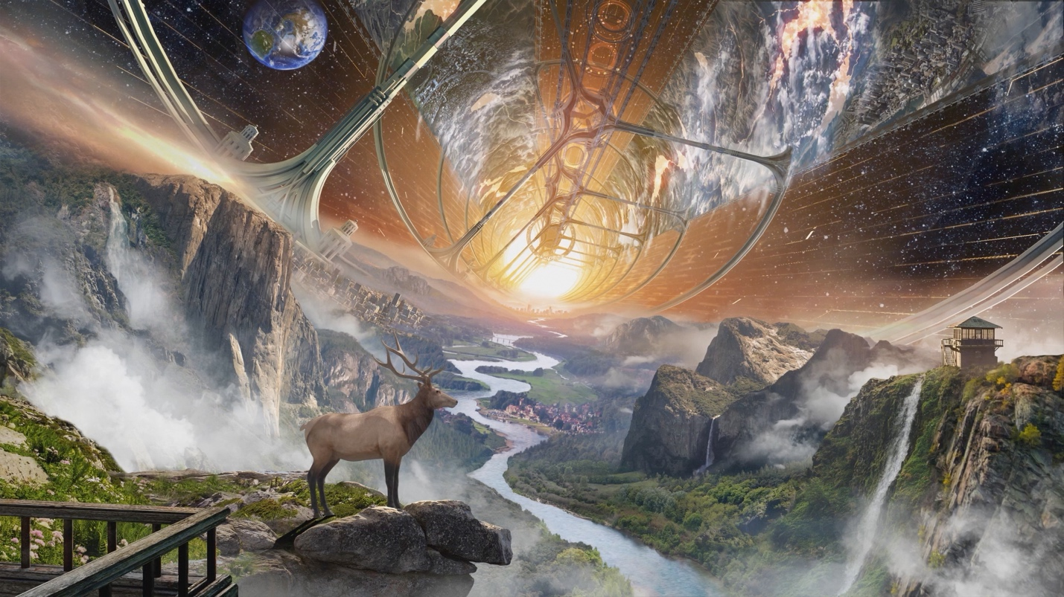
Untitled. Blue Origin, 2019. Likely digital art.

Plate B: Physicist Gerard Kitchen O’Neill

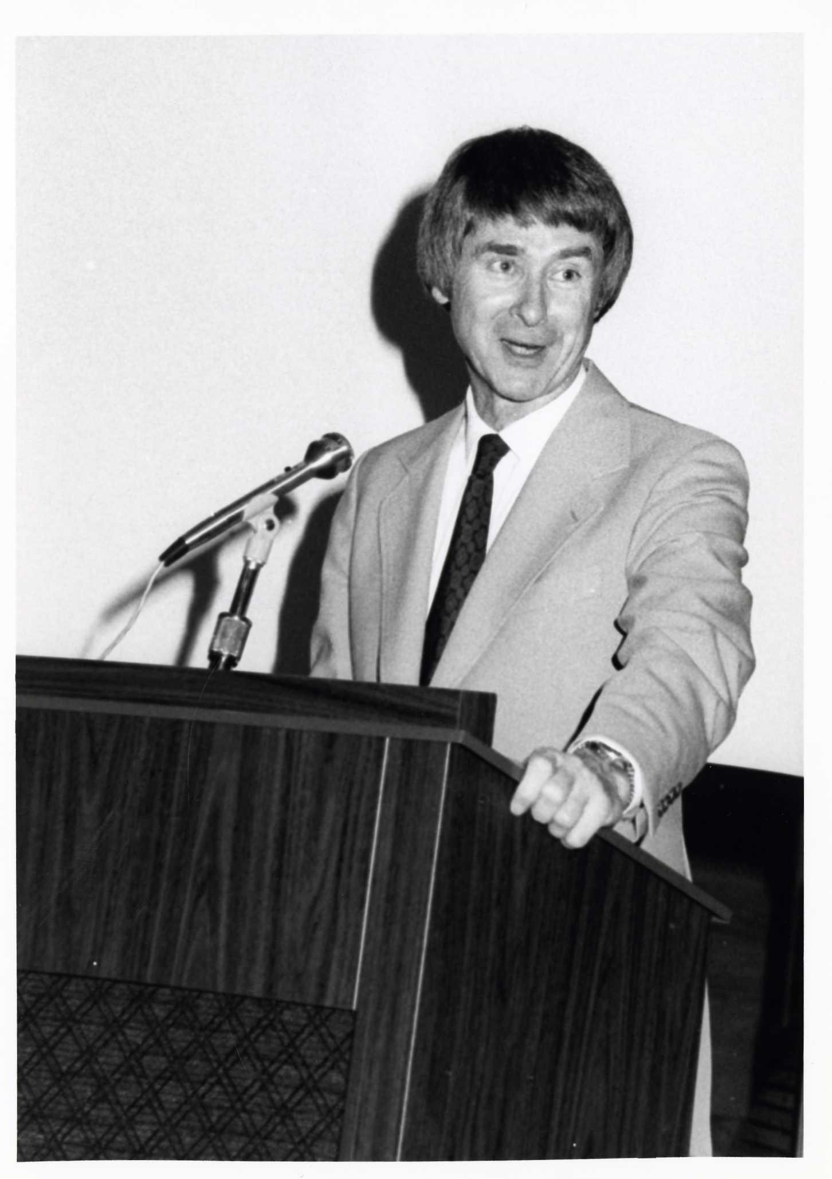
Gerard K. O’Neill speaking at an appreciation dinner hosted on the campus of Cincinnati State Technical and Community College.
Photographer unknown, n.d. Courtesy of the Cincinnati State College Archives. Cincinnati State Archive ID U5S6B04F39P003.

Plate C: Space Colonies in Science Fiction

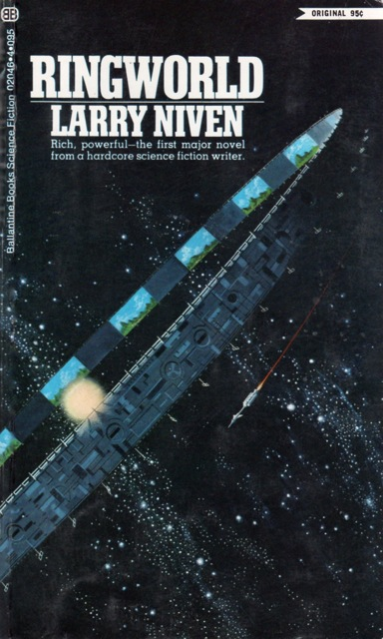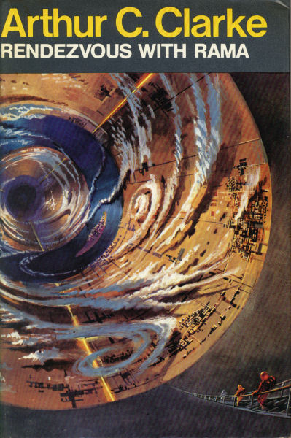
(L) Cover art for Larry Niven’s Ringworld.
Ringworld. Dean Ellis, 1970. Courtesy of the Internet Speculative Fiction Database.
(R) Cover art for Arthur C. Clarke’s Rendezvous with Rama.
Rendezvous with Rama. Bruce Pennington, 1973. Courtesy of the Internet Speculative Fiction Database.

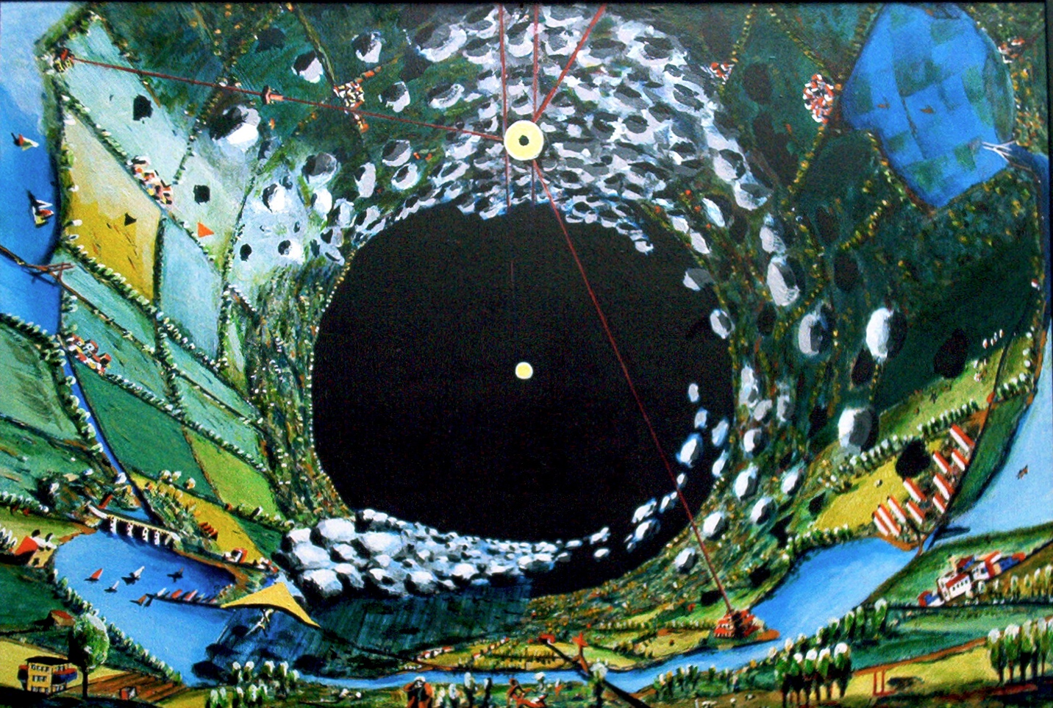
An artist’s interpretation of the landscape within the cylindrical alien starship “Rama” from Clarke’s novel.
Romana. Laurens van Lieshout, 1995. Courtesy of Laurens van Lieshout via Wikimedia Commons.

Plate D: Gerard O’Neill’s Space Colony Designs
Sample Space Colony Geometry
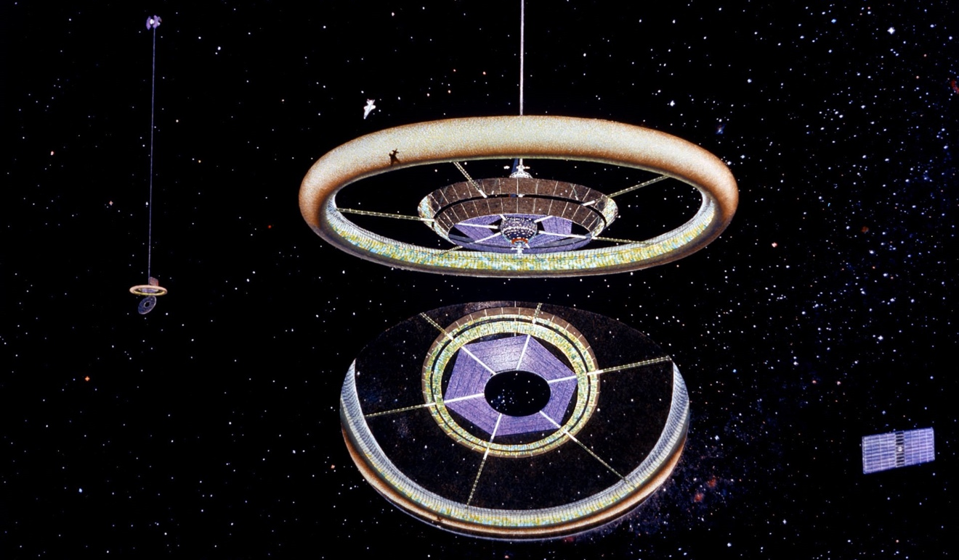
Exterior view of a “Stanford torus” model space colony.
Exterior View. Don Davis, 1976. Acrylic. Courtesy of NASA Ames Research Center. NASA ID AC76-0525.
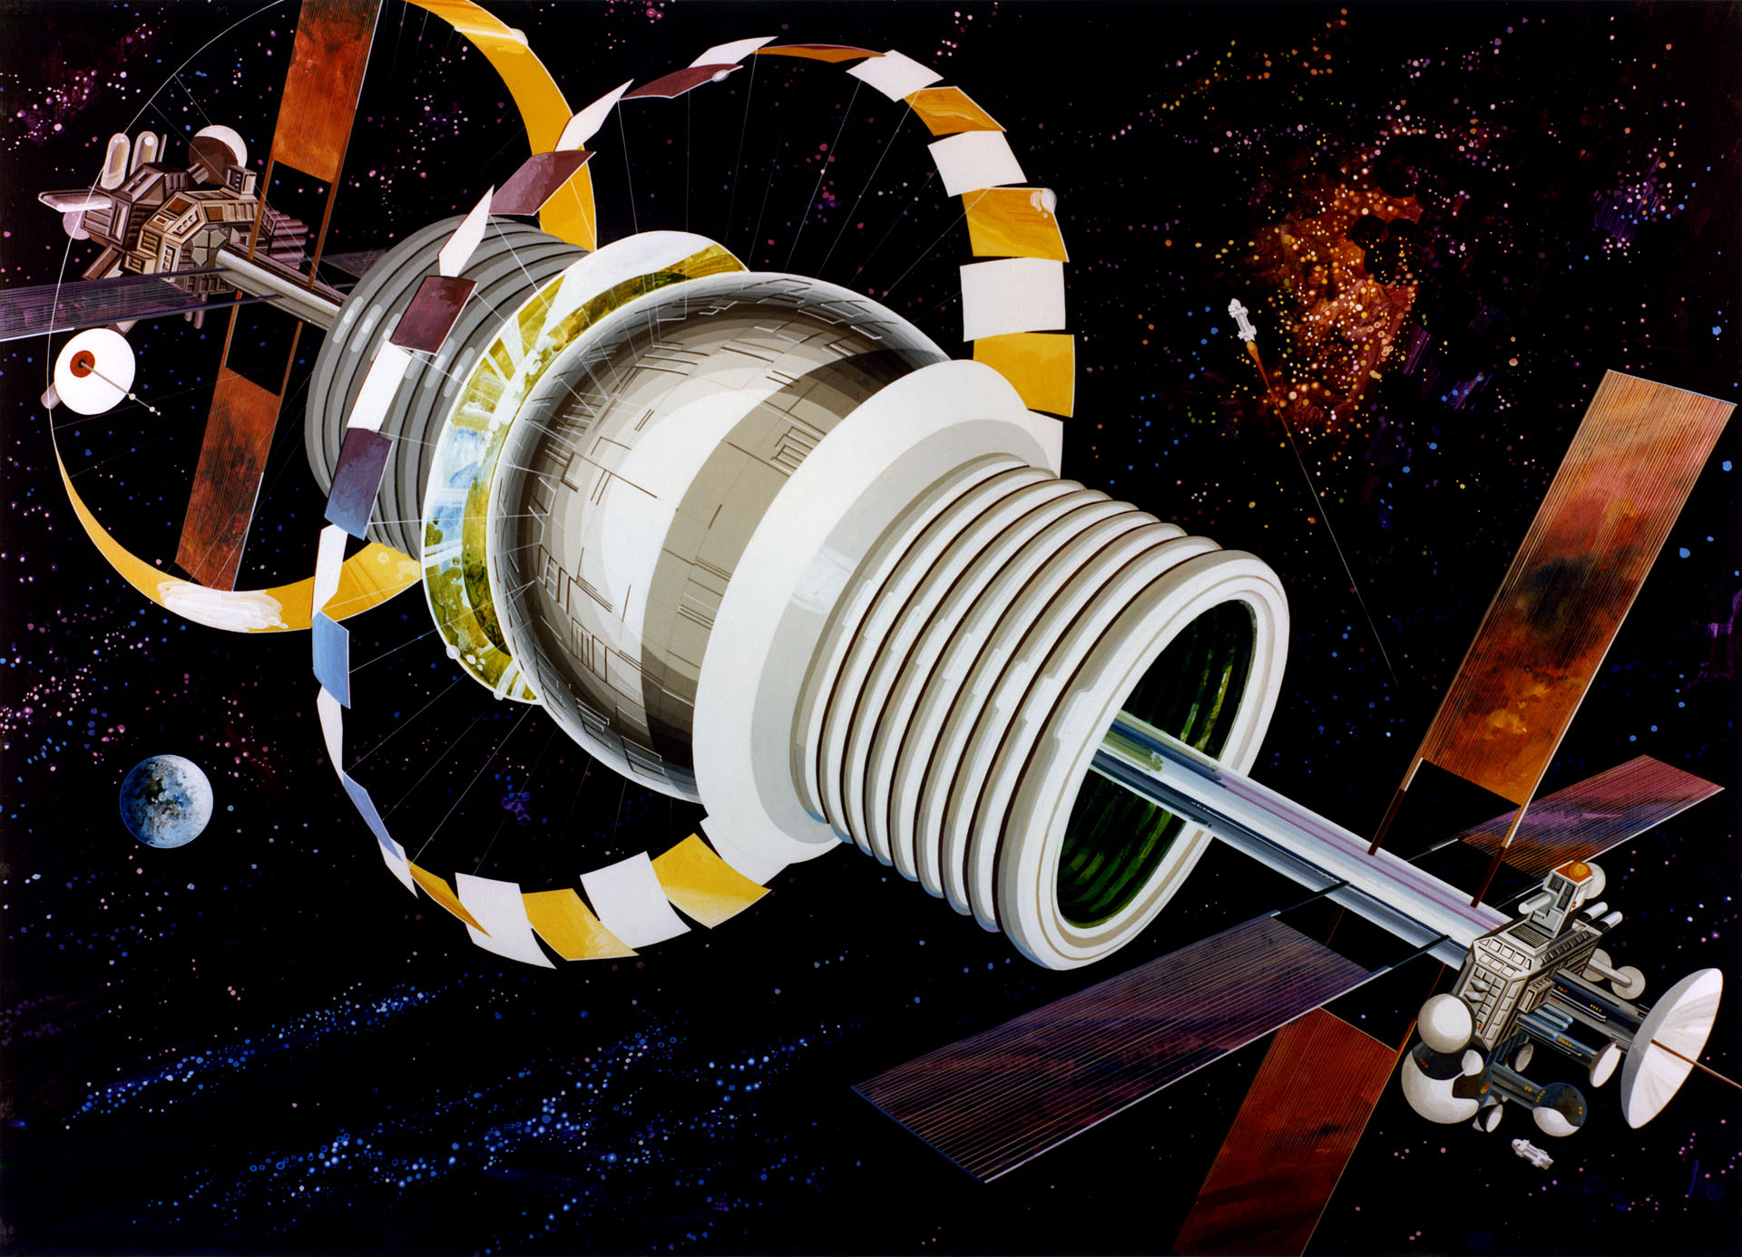
Exterior view of a “Bernal sphere” model space colony.
Bernal Exterior. Rick Guidice, 1976. Acrylic. Courtesy of NASA Ames Research Center. NASA ID AC76-0965.
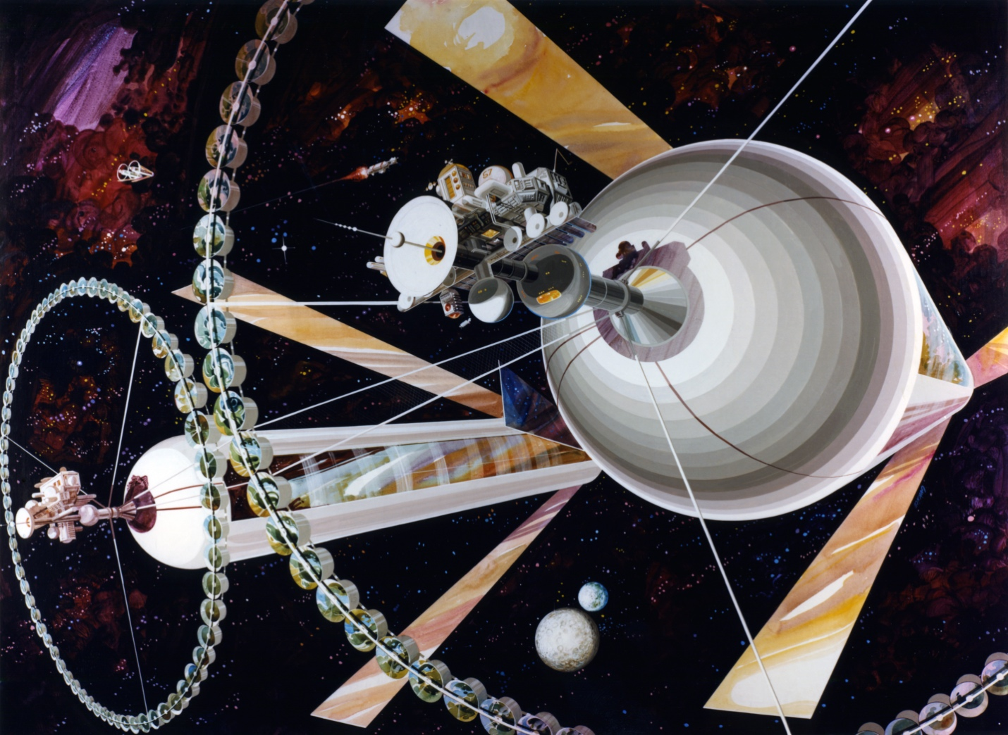
Exterior view of a double O’Neill Cylinder model space colony.
Cylinder Exterior. Rick Guidice, 1975. Acrylic. Courtesy of NASA Ames Research Center. NASA ID AC75-1085.
Lagrange Point 5, or “L5”
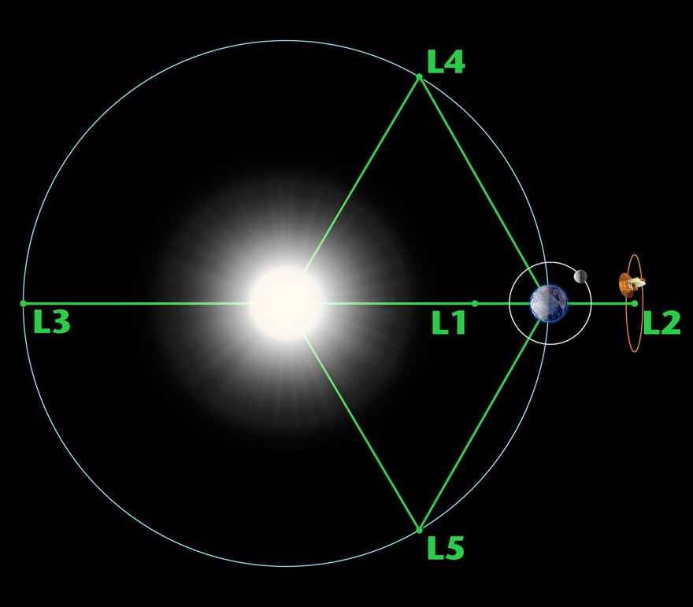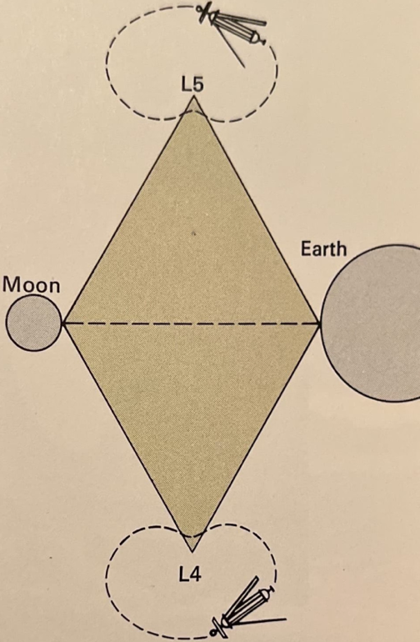
(L) Lagrange Points 1-5 of the Sun-Earth System. NASA Wilkinson Microwave Anisotropy Probe (WMAP) Science Team, 2004. Courtesy of NASA Science: Solar System Exploration.
(R) O’Neill style space colonies situated at Lagrange points 4 and 5 of the Moon-Earth system.
Where Colonies Roam. Diagram of L4 and L5 for Science Year. Mas Nakagawa, 1976.
The O’Neill Cylinder
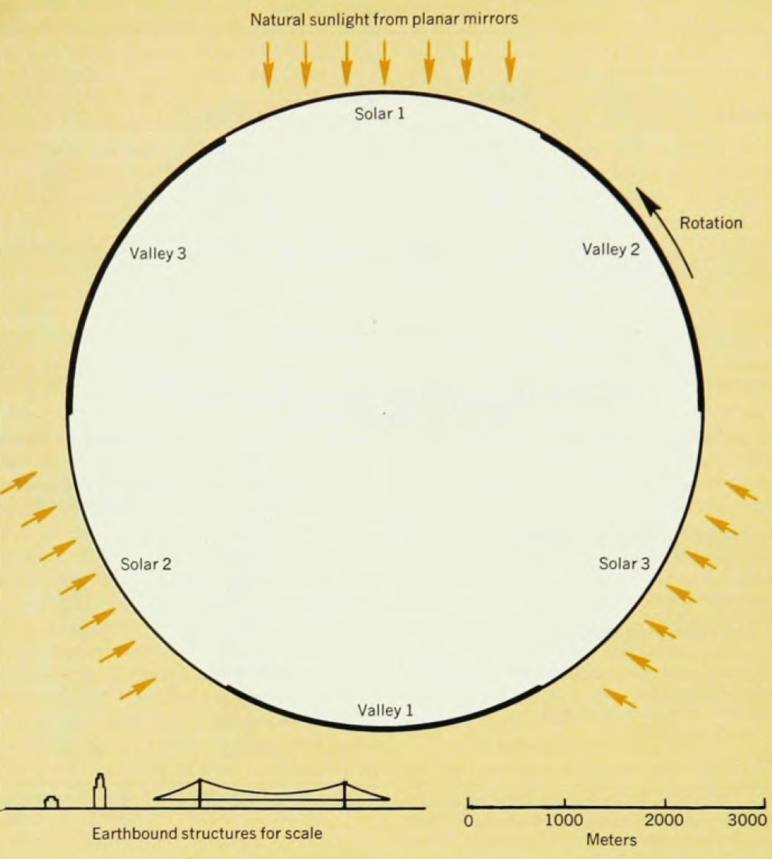
Diagram of an O’Neill Cylinder circumference for Physics Today.
Section of a space-community main cylinder. Unknown, 1974.
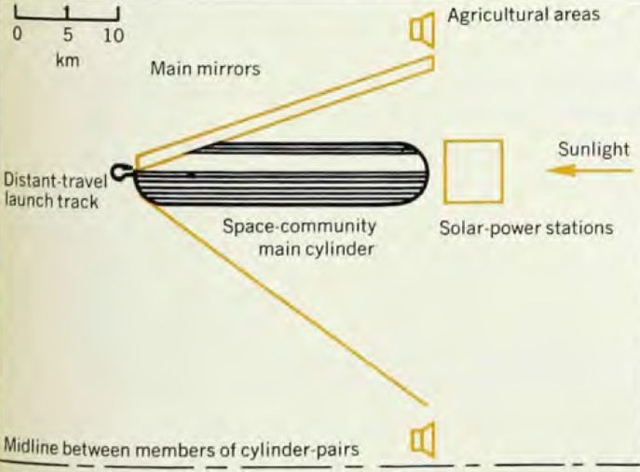
Diagram of an O’Neill Cylinder (side view) for Physics Today.
Space community as a whole. Unknown, 1974.

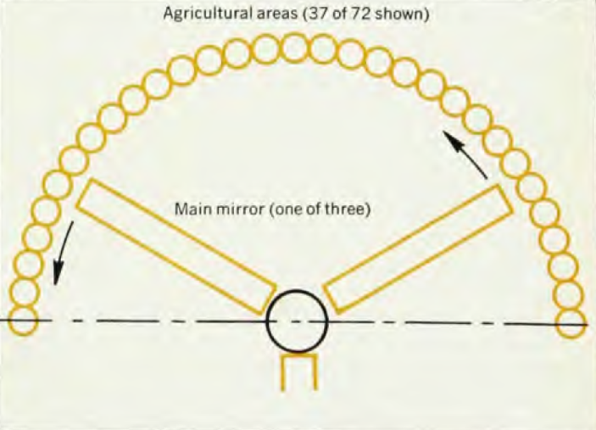
Diagram of an O’Neill Cylinder (end view) for Physics Today.
Space community as a whole. Unknown, 1974.
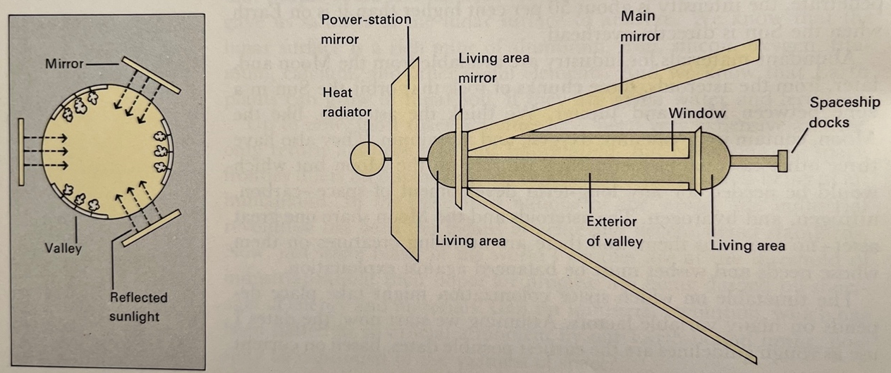
Diagram of a small O’Neill cylinder for Science Year.
It’s All Done with Mirrors. Mas Nakagawa, 1976.

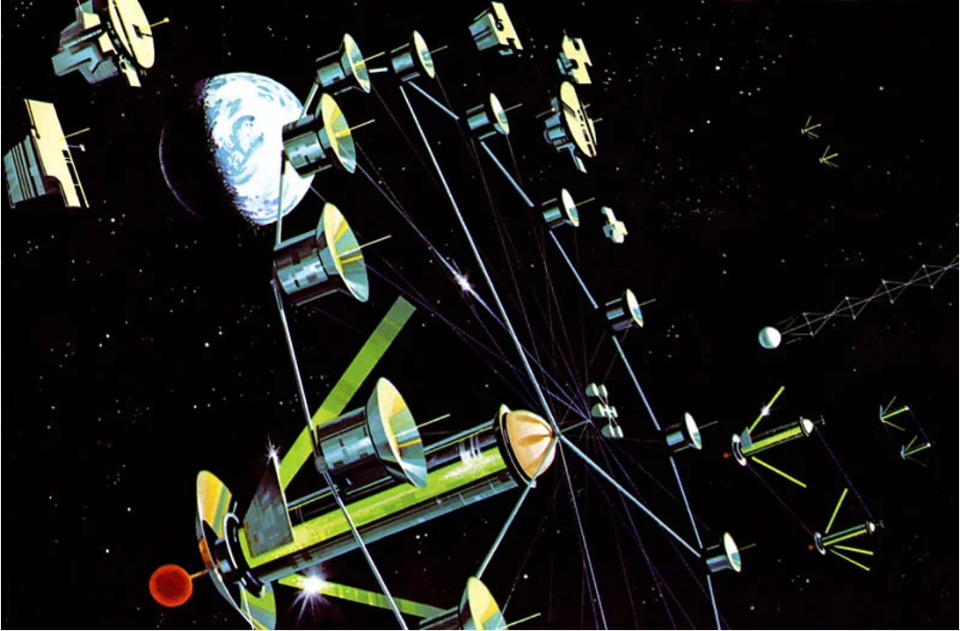
A community of O’Neill Cylinder model space colonies facing the sun.
Untitled. Paul R. Alexander, 1976.

Album II: (Un)Natural Environments in the Colony
Plate A: Endcap View with Suspension Bridge
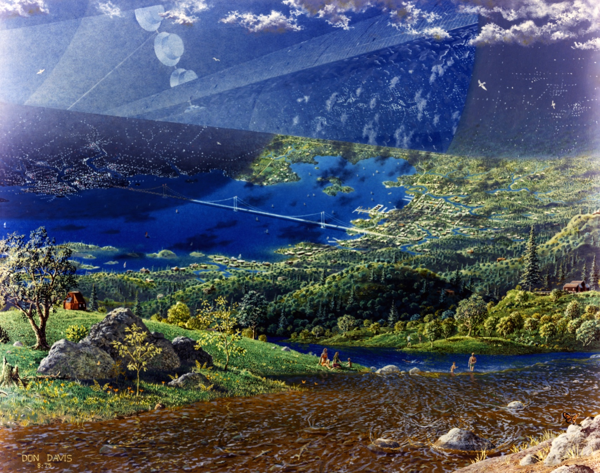
Endcap View with Suspension Bridge. Don Davis, 1975. Acrylic.

Plate B: Endcap Ecology
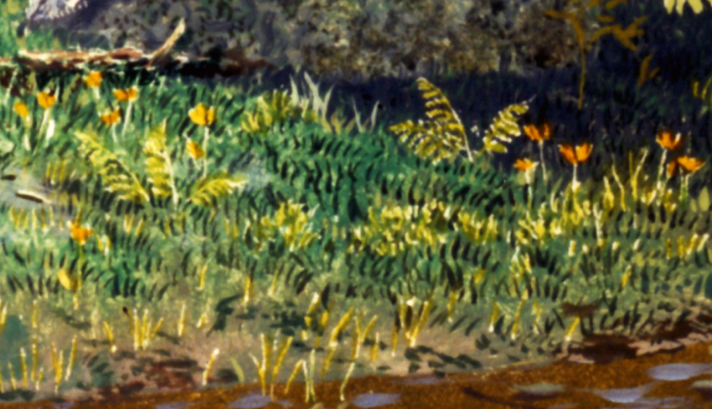
Eschscholzia californica (California poppy)
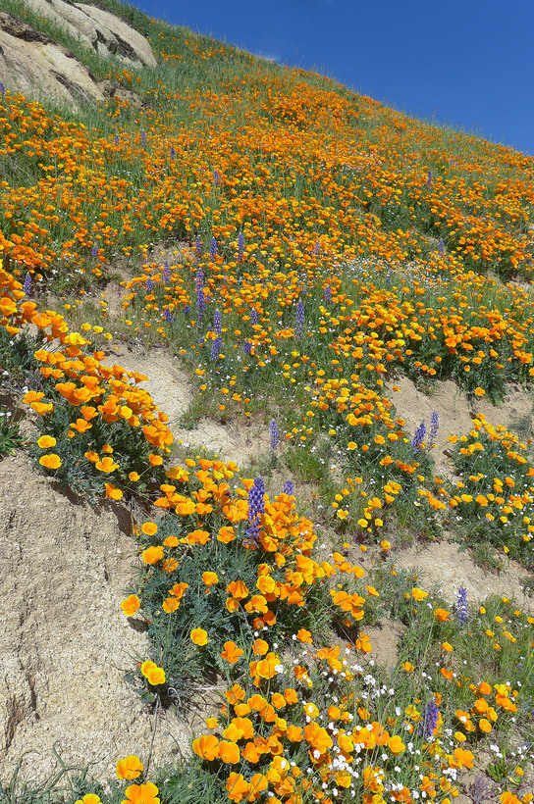
Eschscholzia californica. Neal Kramer, 2016. Courtesy of the California Native Plant Society.

Eschscholzia californica. Calscape, 2015. Courtesy of the California Native Plant Society.
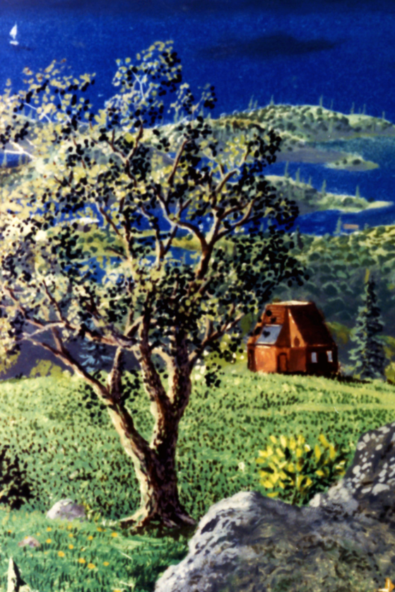
Quercus agrifolia (Coast live oak)
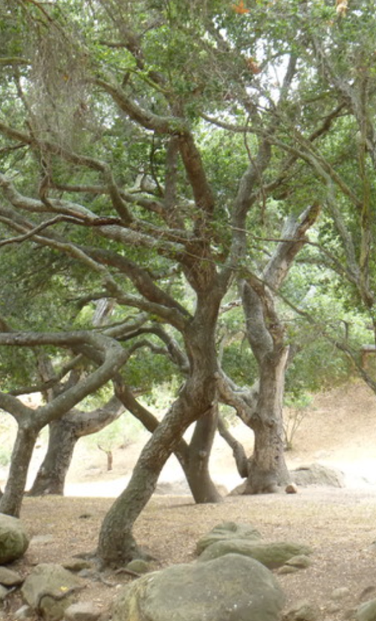
(L): Quercus agrifolia. Zoya Akulova, 2016. Courtesy of the California Native Plant Society.
(R): Quercus agrifolia. Calscape, 2010. Courtesy of the California Native Plant Society.

Plate C: Endcap Marina
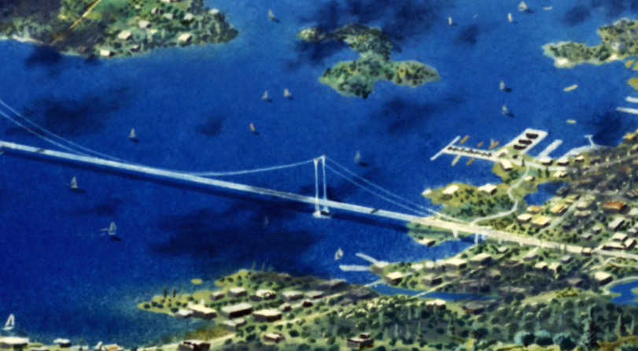
Archival Photographs of the Sausalito Houseboat Community
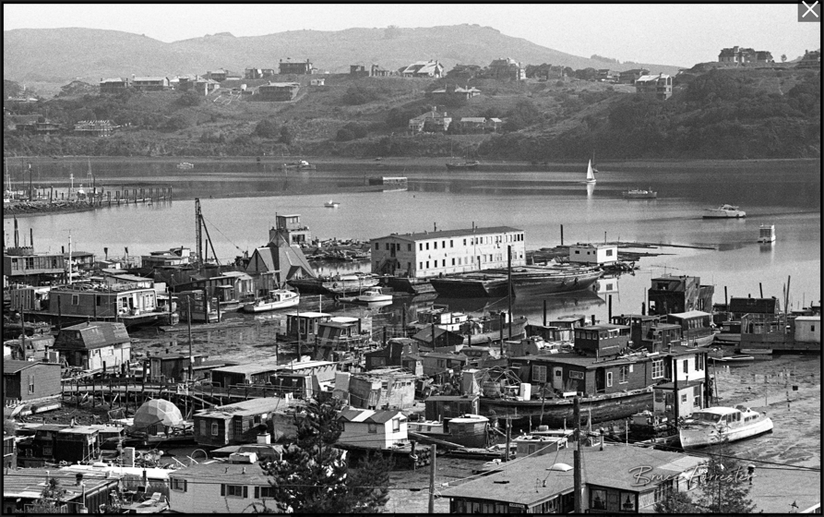
View of Gate 6 from Waldo Point with Strawberry Point in the background. Bruce Forrester, 1977-79.
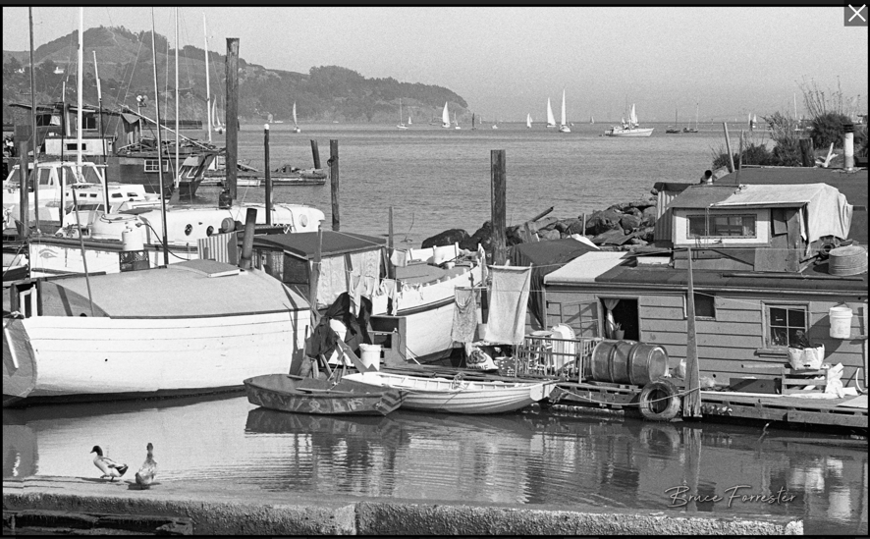
View of the bay and Angel Island with the Tiger Lily (left) & Mudlark (right), Gate 3. Bruce Forrester, 1977-79.
Plate D: Interior of “Sunflower”
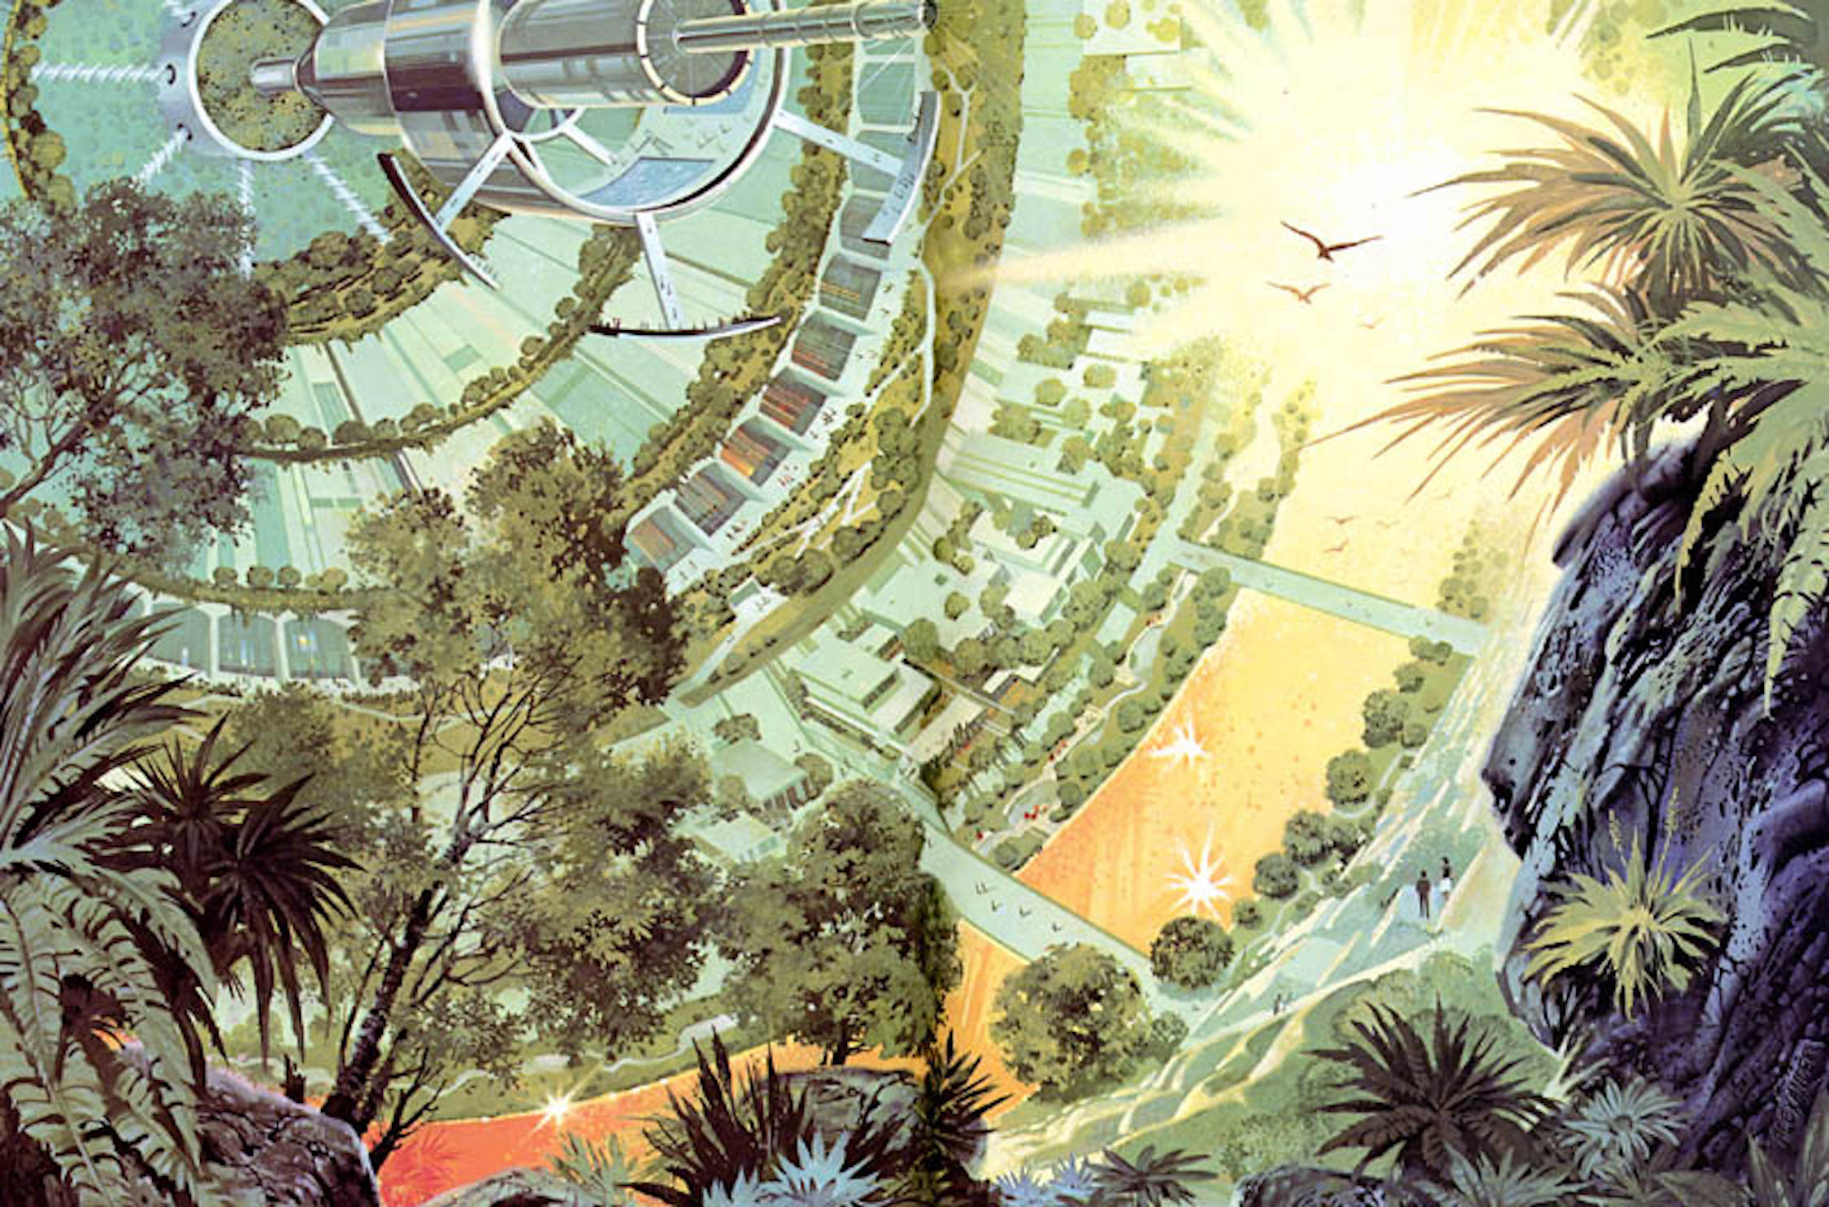
Interior of “Sunflower”. Paul R. Alexander, 1976. Likely gouache.
Plate E: Silent Running and Environmental Technologies
Silent Running Promotional Poster
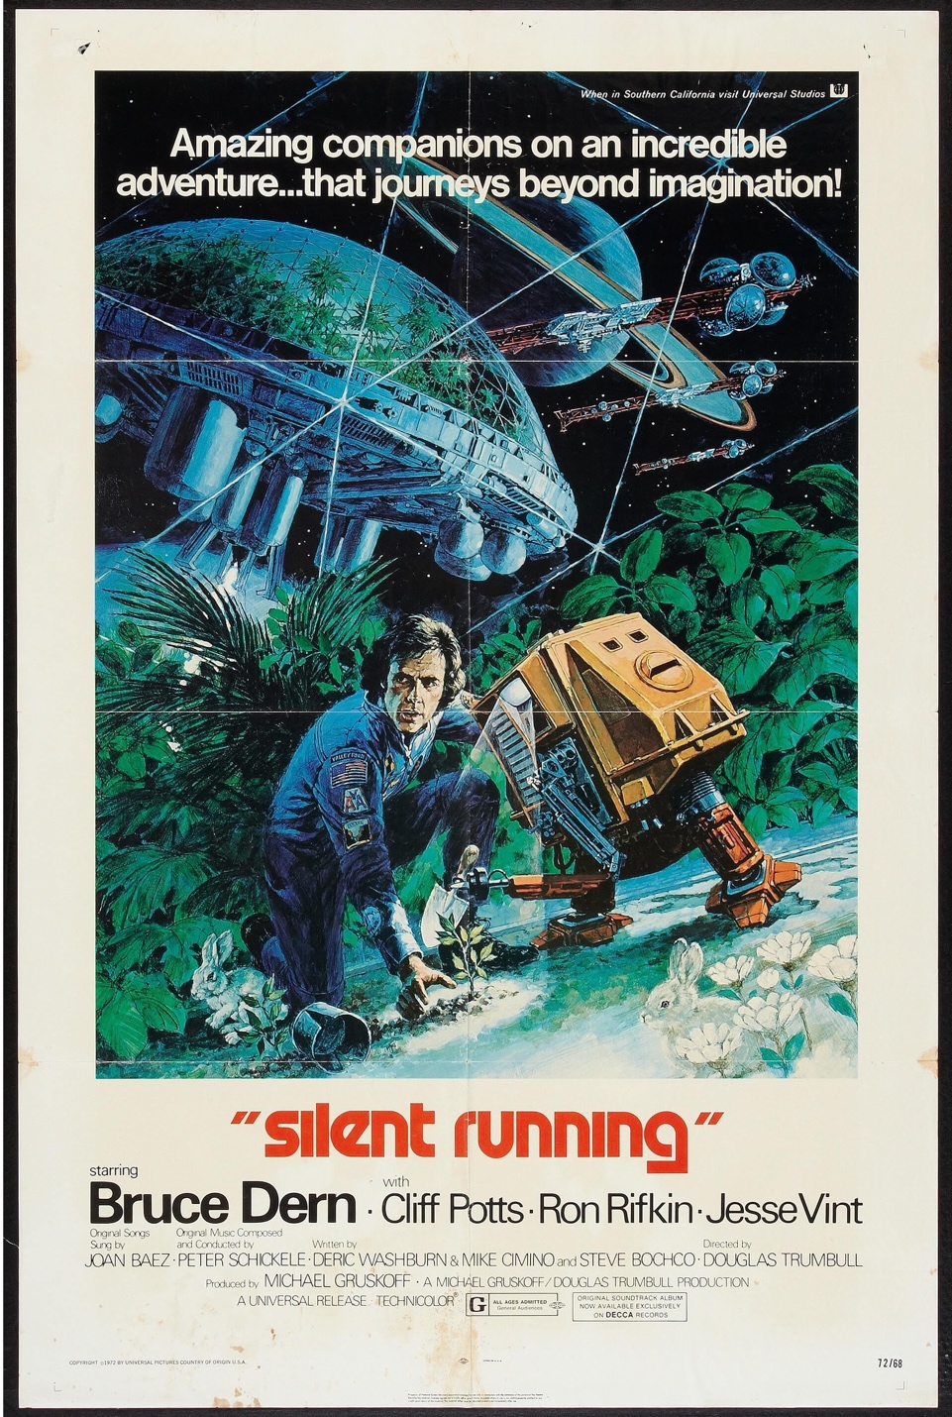
Silent Running. George Akimoto, 1972.
The Missouri Botanical Garden Climatron
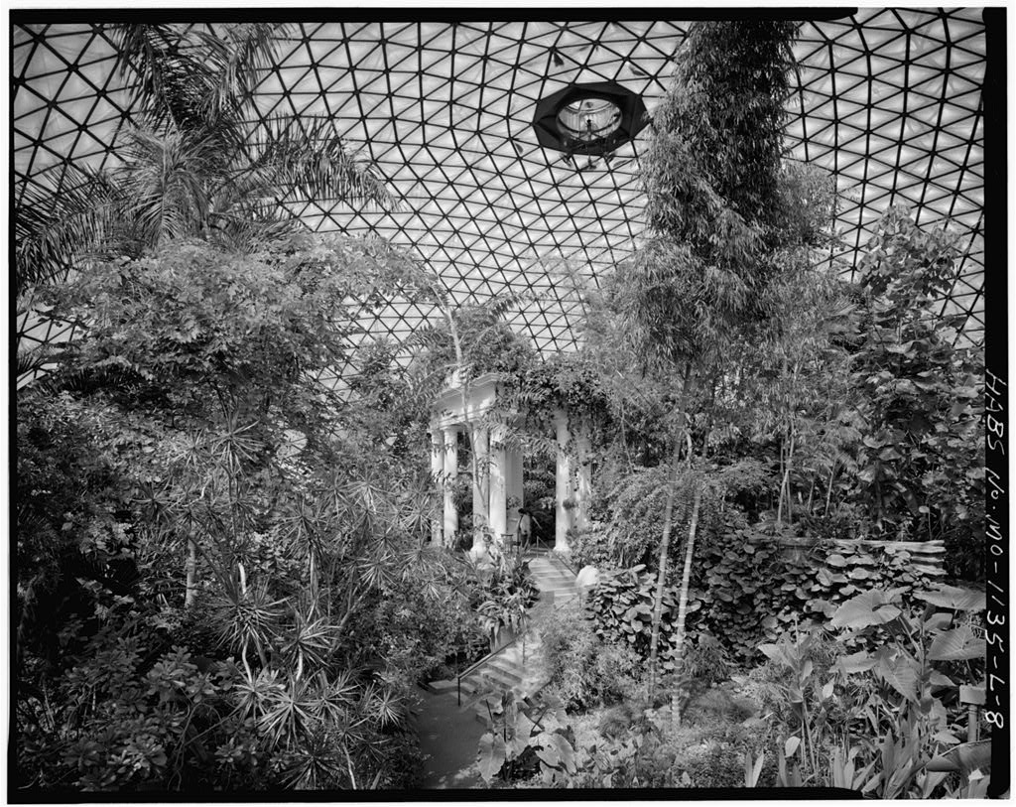
INTERIOR VIEW LOOKING NORTH, SHOWING PAVILION – Missouri Botanical Garden, Climatron, 2345 Tower Grove Avenue, Saint Louis, Independent City, MO. Jet Lowe, 1983.
A Geodesic Greenhouse Aboard the Valley Forge
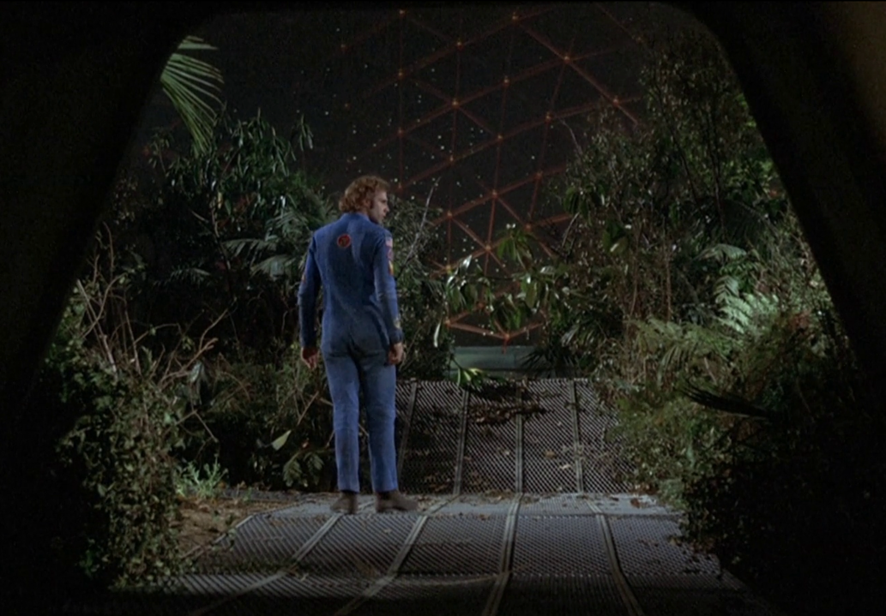
Botanist and ecologist Freeman Lowell (played by Bruce Durn) enters a geodesic greenhouse in this still of Douglas Trumbull’s Silent Running (1972).
Plate F: Endcap, Sunflower, and the Sublime
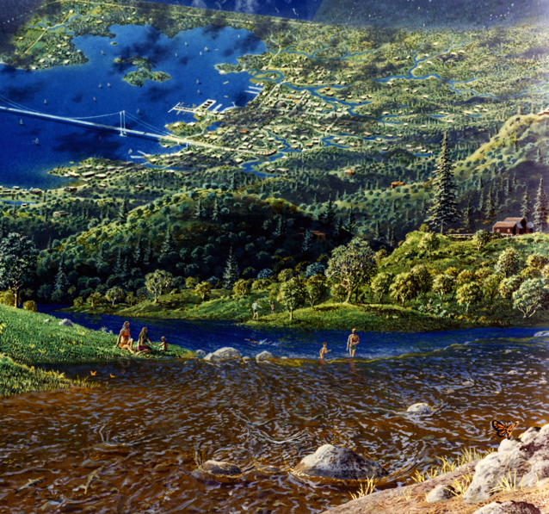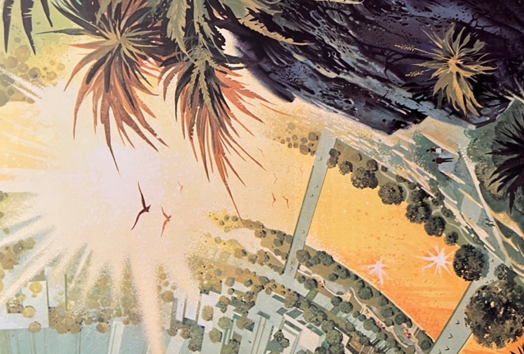
Cliffs of the Upper Colorado River, Wyoming Territory
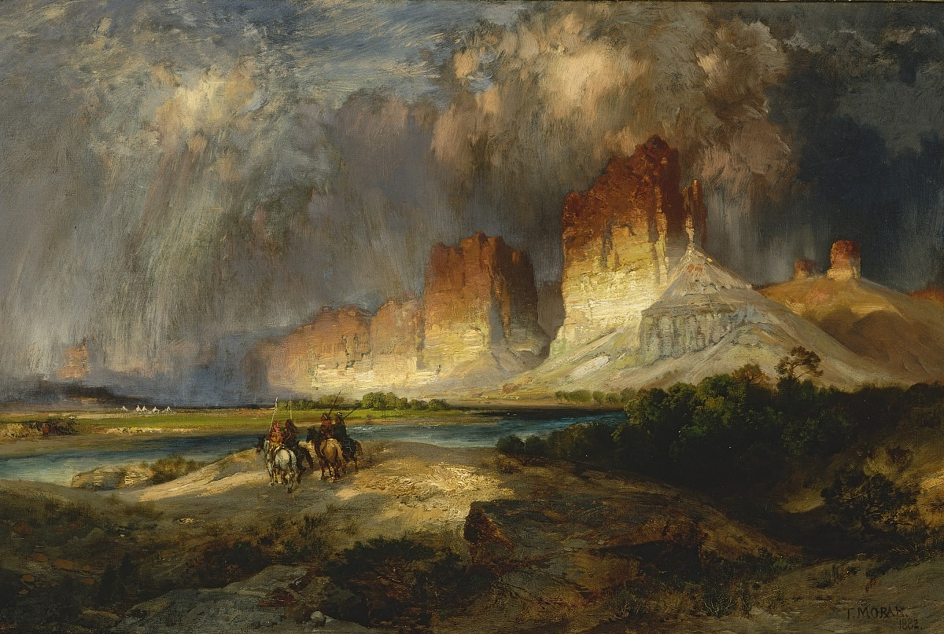
Cliffs of the Upper Colorado River, Wyoming Territory. Thomas Moran, 1882. Oil on canvas.
Plate G: Sunflower and 1970s Escapism
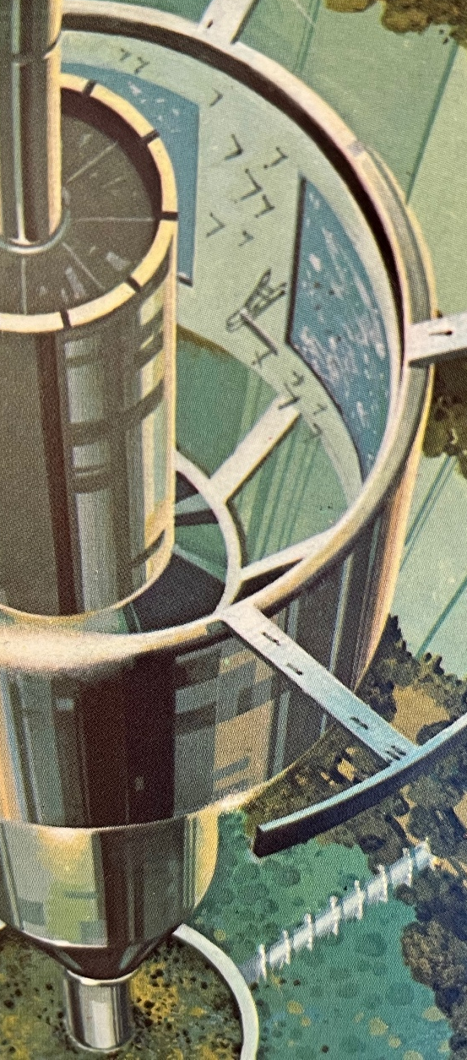

1970s Travel Posters
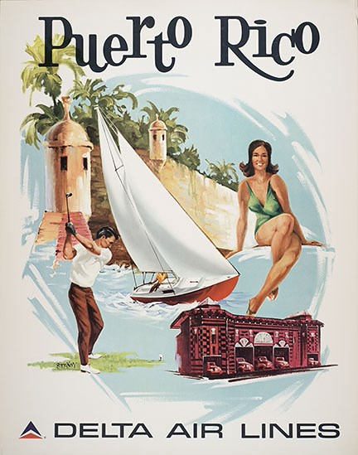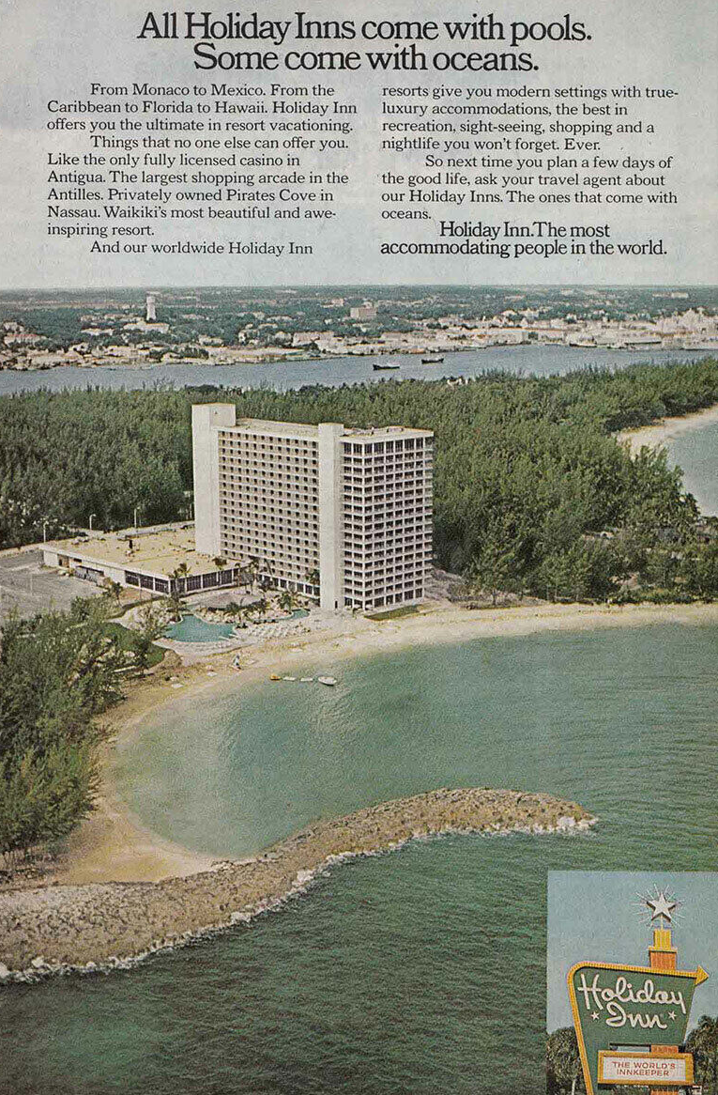
(L) Delta Puerto Rico Travel Poster. Frederic Sweney, 1971. Courtesy of the Delta Flight Museum.
(R) Untitled. Holiday Inn, 1973. Print ad.
Plate H: (Un)Polluted Landscapes
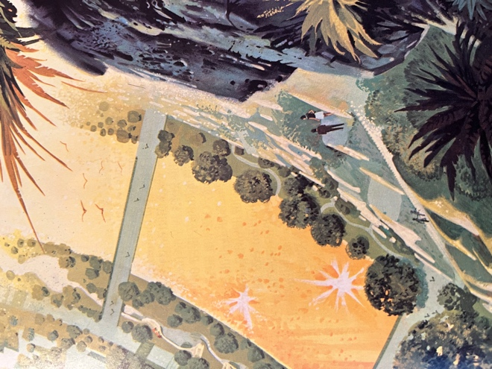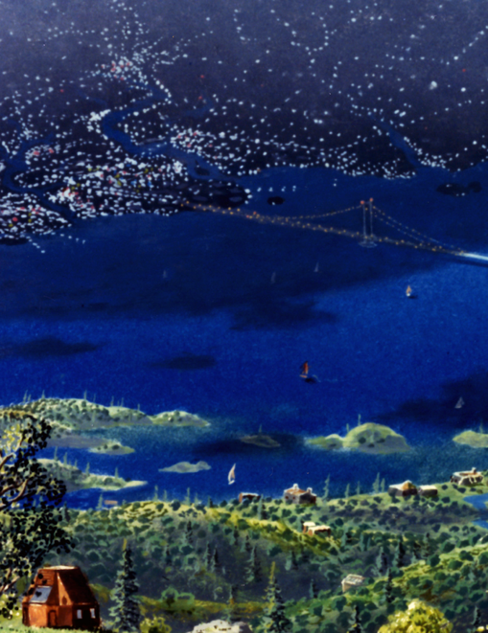
American Landscapes of the 1970s
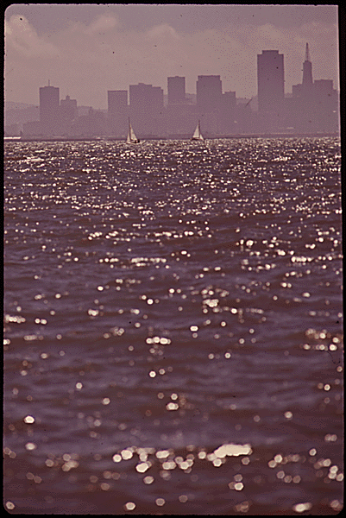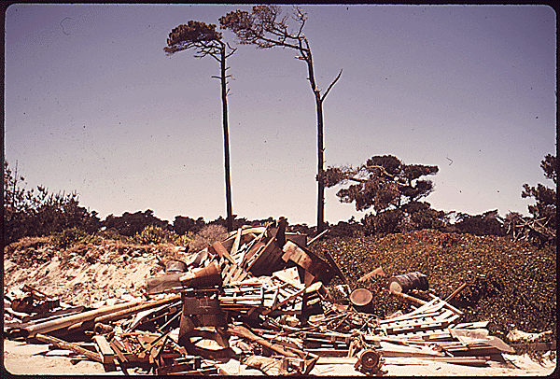
(L) WATER-TO-LAND PHOTO SHOWS SMOG OVER SAN FRANCISCO. Belinda Rain, 1972. Courtesy of the Environmental Protection Agency’s DOCUMERICA Project. National Archives ID 544697.
(R) TRASH ON BEACH. Dick Rowan, 1972. Courtesy of the Environmental Protection Agency’s DOCUMERICA Project. National Archives ID 543165.

Album III: Built Environments in the Colony
Plate A: Main Street, Hometown, Cosmos
Main Street, Hometown, Cosmos. Pierre Mion, 1976. Likely acrylic and gouache.
Plate B: Cosmic Commodities
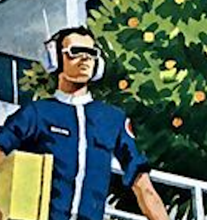
Radio Shack Portable Radio Advertisements, 1974-1975
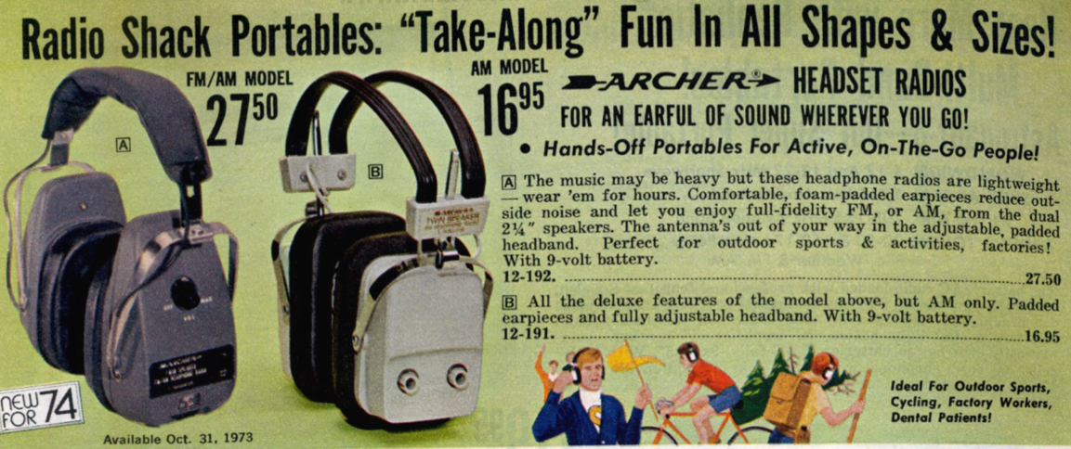
Archer Headset Radios advertisement. RadioShack, 1974. Courtesy of RadioShackCatalogues.com.
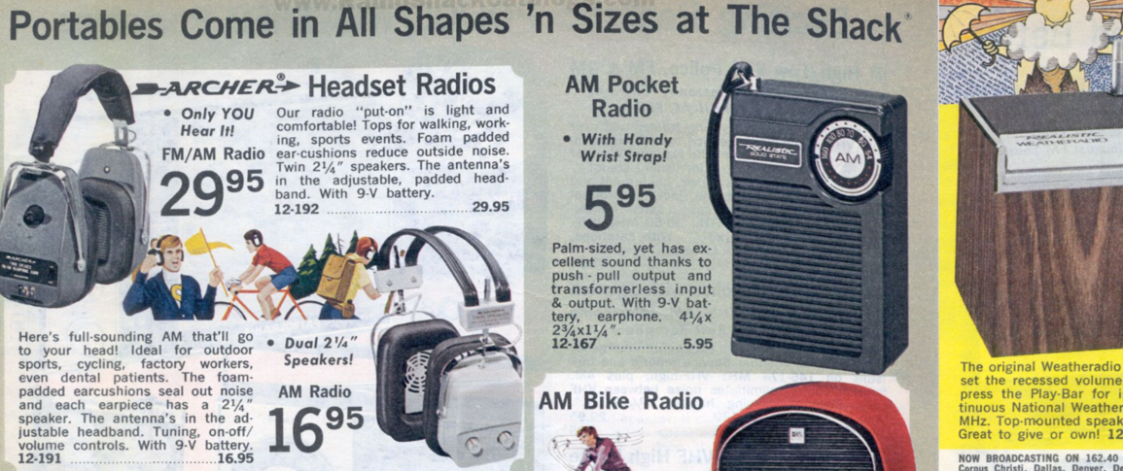
Archer Headset Radios advertisement. RadioShack, 1975. Courtesy of RadioShackCatalogues.com.
Plate C: Sport in Space Colony
Sport in Space Colony. Rick Guidice, 1977. Acrylic.
Plate D: Main Street and the Southdale Shopping Center
Southdale Shopping Center
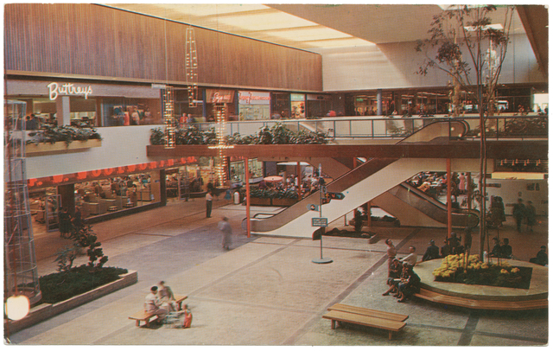
Garden Court – Southdale Shopping Center, Edina. Unknown, 1965. Courtesy of the Minnesota Historical Society.
Space Colony Cafés
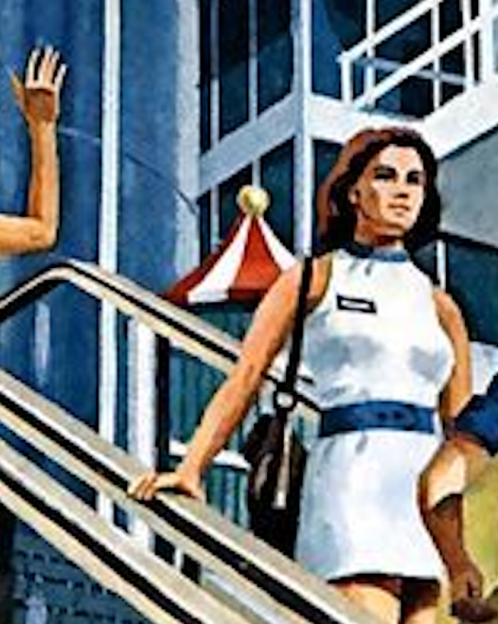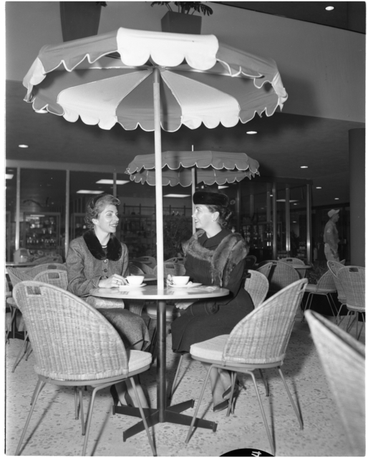
(R) Southdale, View of Courtyard Restaurant, Edina. Minneapolis Star Journal Tribune, 1956. Courtesy of the Minnesota Historical Society.
Plate E: Sport and the New American City
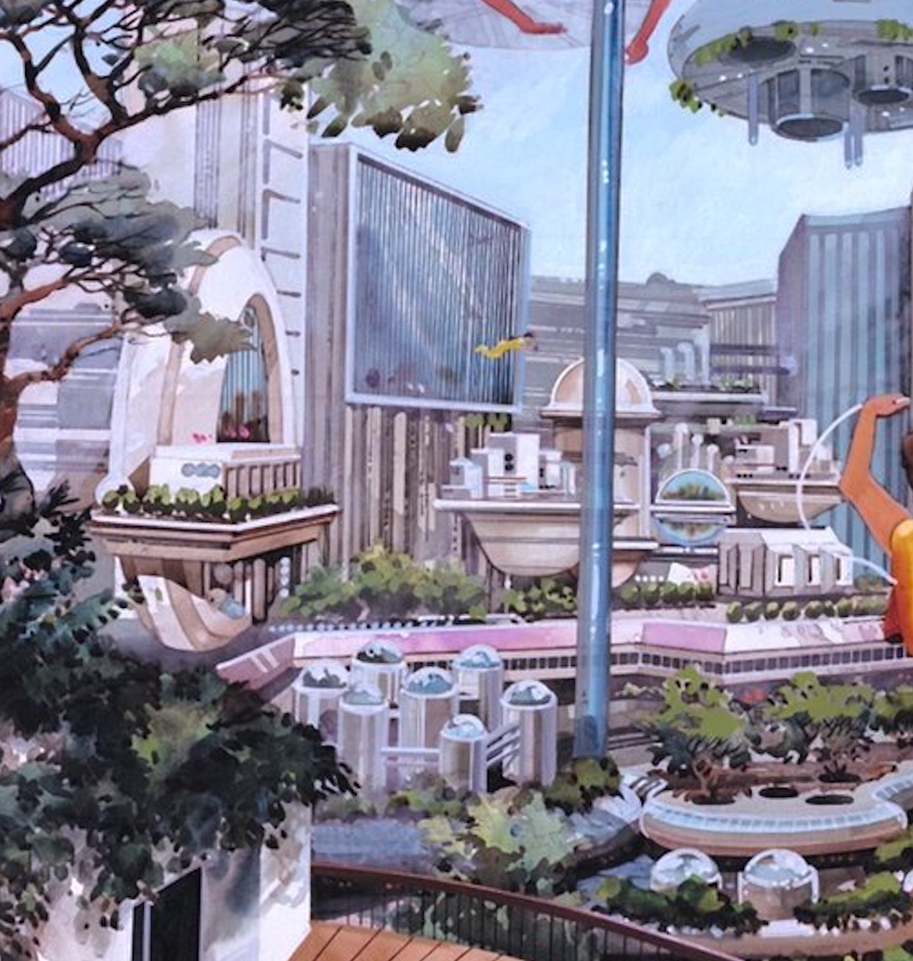

American Cityscapes of the 1970s
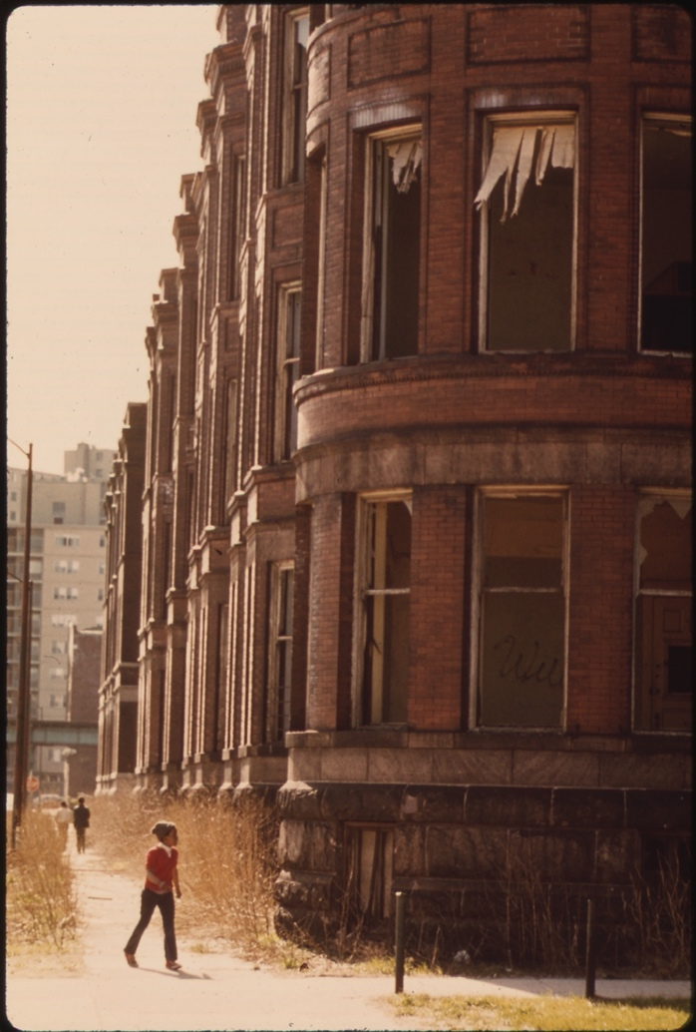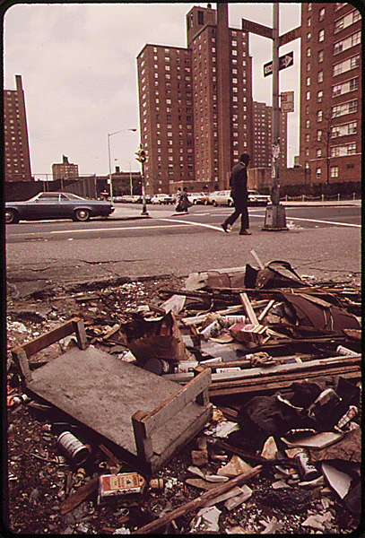
(L) EMPTY HOUSING IN THE GHETTO ON CHICAGO’S SOUTH SIDE. STRUCTURES SUCH AS THIS HAVE BEEN SYSTEMATICALLY VACATED AS A RESULT OF FIRES, VANDALISM, OR FAILURE BY OWNERS TO PROVIDE BASIC TENANT SERVICES. THEN THE VACATED BUILDINGS, OFTEN SUBSTANTIALLY SALVAGEABLE, ARE RAZED AND REPLACED WITH HIGHRISE APARTMENTS WHICH APPEAL TO FEW MEMBERS OF THE BLACK COMMUNITY AND ALMOST NONE OF THE AREA’S PREVIOUS RESIDENTS. John H. White, 1973. Courtesy of the Environmental Protection Agency’s DOCUMERICA Project. National Archives ID 556164.
(R) EMPTY LOT STREWN WITH TRASH AT 108TH STREET AND LEXINGTON AVENUE, MANHATTAN. Gary Miller, 1973. Courtesy of the Environmental Protection Agency’s DOCUMERICA Project. National Archives ID 549784.

Plate F: Main Street, Sport, and the New American Citizen
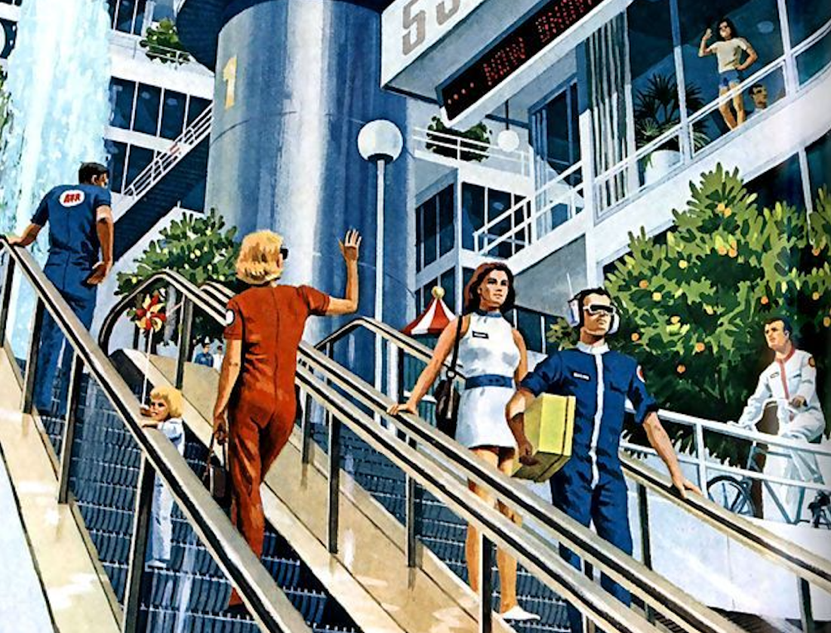
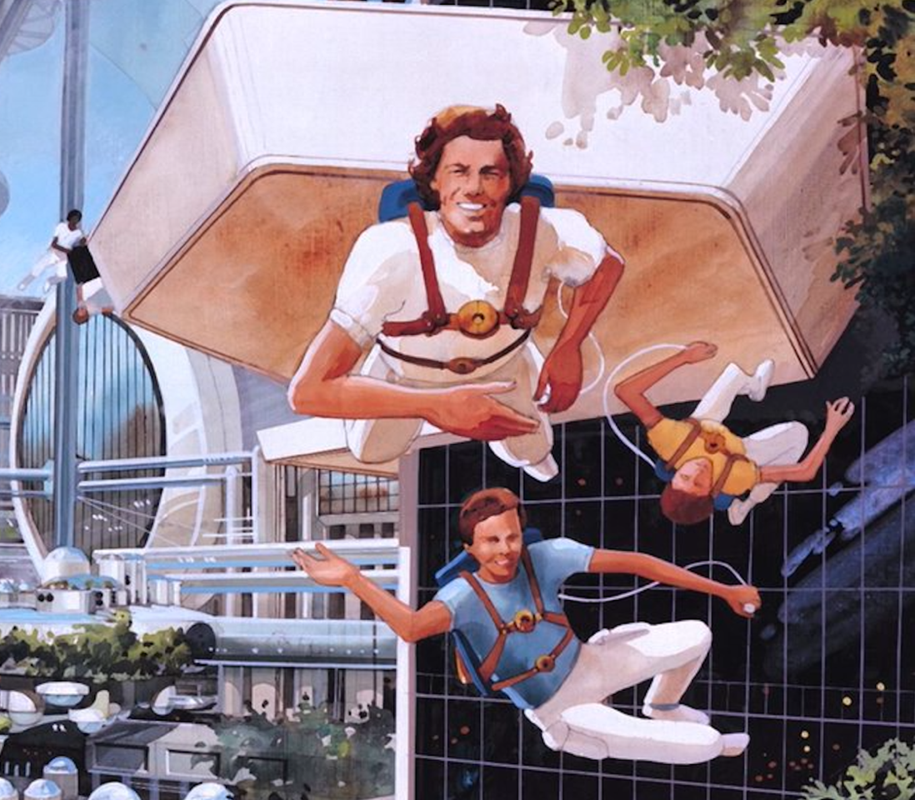

Our Future in Space, Ignatius Forum, Washington Cathedral, November 10, 2021.
Going to Space to Benefit Earth (Full Event Replay).
Going to Space to Benefit Earth (Full Event Replay).
Dyson, “Gerard Kitchen O’Neill,” 98.
Scharmen, Space Settlements, 16.
O’Neill, “The Colonization of Space,” 32.
As NASA’s Planetary Science Communication team eloquently explains, Lagrange points are special positions in a two-body system – such as the Earth and the Sun or the Earth and the Moon – where “the gravitational pull of the two large masses precisely equals the centripetal force required for a small object to move with them”. These positions are ideal sites for spacecraft – or, in this case, orbiting space colonies – because they allow spacecraft to sustain stable orbits while reducing their fuel consumption (Cornish, “What is a Lagrange Point?”).
McCray, The Visioneers, 7.
McCray, 7.
As colleague and fellow physicist Freeman J. Dyson explains, O’Neill “invented and developed the technology of storage rings that is now the basis of all high-energy particle accelerators” (Dyson, “Gerard Kitchen O’Neill”, 97). O’Neill developed his storage ring concept in a brief letter printed in Physical Review shortly after he started working at Princeton University as a physics instructor. His idea was widely met with skepticism: in short, “his special storage ring design for increasing the collision energies of atomic beams from particle accelerators was simply a theory that had not been proven” (Narins, “Gerard K. O’Neill”). He received funds from the Office of Naval Research and the Atomic Energy Commission nonetheless, and by 1962, O’Neill had constructed and successfully tested the world’s first particle storage ring.
McCray, The Visioneers, 20.
McCray, 12.
O’Neill saw space colonies as true megastructures capable of supporting populations of ten thousand, one hundred thousand, and even one million colonists; space habitats of this size do not presently exist, despite his best efforts. In fact, the only quasi-analogous space habitats developed to date are the Salyut space stations (launched [l.] throughout 1971-1986) that had a crew capacity of three cosmonauts; the Mir space station (l. 1986) that had a crew capacity of three cosmonauts; the Skylab space station (l. 1973) that had a crew capacity of three astronauts; the International Space Station (l. 1998) that has a crew capacity of seven astronauts; and the Tiangong space stations (l. throughout 2011-present) that have a crew capacity of six astronauts. For more detailed discussions of space habitats and space stations, see Roger D. Launius’s Space Stations: Base Camps to the Stars (1970).
Launius, McCurdy, and Bradbury, “The Greening of Space,” 141.
McCurdy, Space and the American Imagination, 167.
McCurdy, 177.
Kilgore, Astrofuturism, 1–2.
Kilgore, 4.
Kilgore, 156–57.
Kilgore, 159.
Maher, Apollo in the Age of Aquarius, 2.
Maher, 9.
Maher, 206.
Maher, 219.
McCray, The Visioneers, 6.
McCray, 13.
The Visioneers offers readers a comprehensive history of O’Neill and his space colony proposal. Its first chapter, “Utopia or Oblivion for Spaceship Earth”, presents the historical context responsible for the “theme of limits” that permeated popular and scholarly culture in the 1970s. Its second chapter, “The Inspiration of Limits”, pivots to a brief biography of O’Neill’s personal and professional life, particularly those moments that would influence his later scholarship on space settlements. Its third chapter, “Building Castles in the Sky”, probes the reception of O’Neill’s colonies, identifies its supporters and protestors, and follows the evolution of O’Neill’s ideas through the 1970s and early 1980s.
McCray, The Visioneers, 68.
McCray, 68.
International Association of Astronomical Artists, “What Is Space Art?”
Ramer and Miller, The Beauty of Space Art, 171.
Ramer and Miller, 171.
Ramer and Miller, 172.
See, for example, “cosmic impressionism”, a subgenre of space art that typically takes the “impact of space travel on the human psyche” as its subject (Ramer and Miller, The Beauty of Space Art, 191). Cosmic impressionist artists “explore the sciences of psychology, sociology, and even religion and spirituality” to “focus on the wonder and awe of the universe at large” (Ibid.). Their artworks tend to employ a broader variety of “artistic modes of expression” than the typically realistic and hyper-realistic renderings of hardware artists; these modes typically include abstract art, impressionism, expressionism, and surrealism.
I am indebted to Dr. Anna Reser for bringing Scharmen’s work to my attention.
Scharmen, Space Settlements, 139.
Scharmen, 33.
I would like to note that while Scharmen examines Endcap in Space Settlements and briefly points to Main Street as an example, I discuss both paintings’ visual elements in greater detail in the pages that follow – particularly those of Chapter Three: The “Impossible Earths” of Endcap, Sunflower, Main Street, and Sport. Space Settlements does not mention Sunflower. Additionally, while the thirteen images that “form the core” of Space Settlements were all painted by Don Davis or Rick Guidice, Scharmen does not discuss Guidice’s Sport in Space Colony in his 2019 text.
Scharmen, Space Settlements, 33.
Scharmen, 33.
Maher, Apollo in the Age of Aquarius, 6.
McCray, The Visioneers, 41.
O’Neill, The High Frontier, 234.
Scharmen, Space Settlements, 15.
Dyson, “Gerard Kitchen O’Neill,” 98.
McCray, The Visioneers, 42.
McCray, 5.
For an overview of the controversies surrounding the publication of The Limits to Growth, see the fifth chapter of Astrofuturism, “The Domestication of Space: Gerard K. O’Neill’s Suburban Diaspora”, and the first chapter of The Visioneers, “Utopia or Oblivion for Spaceship Earth?”.
O’Neill went to great lengths to bring his ideas to both the public and the broader scientific community. As Scharmen explains, O’Neill “spent four years collecting rejection slips from peer-reviewed publications” (Scharmen, Space Settlements, 16). His “pitches for publishing the space settlement work [initially] went to scientific journals like Scientific American and Science, but his first chance at funding and possible exposure came from the Point Foundation” established by Stewart Brand (Ibid.). This foundation “offered O’Neill a grant to host his first conference on space settlement” in May 1974, but when Princeton University’s public relations department issued a small press release about the event, “O’Neill’s work made front page news in the New York Times”; in fact, by the time Physics Today published “The Colonization of Space”, “his ideas on space settlement had already run in the Los Angeles Times and the Washington Post, as well as on the BBC” (Ibid.).
McCray, The Visioneers, 52–53.
It should be mentioned that two famous late-twentieth century science fiction novels prominently feature space colonies. Larry Niven’s Ringworld (1970) follows an expedition to a wheel-shaped alien space station and Arthur C. Clarke’s Rendezvous with Rama (1973) recounts a run-in with a cylindrical alien starship. O’Neill vehemently denied these works as a source of technical inspiration; in fact, when asked about Ringworld and Rama, he famously stated “although I admire the work of Arthur Clarke and Larry Niven, the recent science-fiction stories were not mentioned [as a precedent to my colony designs] because, in my opinion, they contained no useful ideas contributory to a practical scheme for space colonization” (Scharmen, Space Settlements, 22).
McCray, The Visioneers, 69.
Kilgore, Astrofuturism, 160.
O’Neill, “The Colonization of Space,” 36.
O’Neill, 32.
O’Neill, “Settlers in Space,” 30.
For a more detailed analysis of the space agency’s activities amidst the rapidly changing political landscape of the 1960s and 1970s, see Maher’s Apollo in the Age of Aquarius.
McCray, The Visioneers, 48.
O’Neill, “Settlers in Space,” 92.
O’Neill, “The Colonization of Space,” 32.
According to O’Neill, “the earliest possible schedule would see Colony One [the first space colony] completed by 1988, Colony Two [a larger second space colony] by 1994, and ten more colonies the size of Colony Two by the year 2000” (O’Neill, “Settlers in Space”, 40-41). Colonies the size of O’Neill’s Island Three model were likely to follow, though “Settlers in Space” does not offer any predictions about their construction; for those predictions, see O’Neill’s The High Frontier.
According to McCray, O’Neill’s first cost estimate for his first space colony model “was in the neighborhood of $30 billion” (McCray, The Visioneers, 55). Casey Dreier of The Planetary Society, for comparison, calculated that “the United States spent $25.8 billion on Project Apollo between 1960 and 1973, or approximately $257 billion when adjusted for inflation to 2020 dollars” (The Planetary Society, “How much did the Apollo program cost”?). Dreier notes, however, that the total cost of Project Apollo rises to $28 billion ($280 billion adjusted) when one adds the costs of Project Gemini and the Robotic Lunar Program, two projects technically outside Project Apollo but critical to the “total lunar effort” (Ibid.).
O’Neill, “The Colonization of Space,” 32–33.
Davis, Mion, and Guidice depict at least second or third generation space colonies in their paintings. Alexander’s Sunflower, by contrast, portrays a possible design for a first generation space colony.
O’Neill, “The Colonization of Space,” 34–35.
O’Neill, 36.
O’Neill, “Settlers in Space,” 39.
McCray, The Visioneers, 56.
Asimov, “The Next Frontier?,” 84.
McCray, The Visioneers, 56.
O’Neill, “The Colonization of Space,” 33.
McCray, The Visioneers, 69.
O’Neill, “The Colonization of Space,” 36.
Scharmen, Space Settlements, 139.
Scharmen, 139.
Kilgore, Astrofuturism, 168.
Wall, “Bill Nye.”
O’Neill, “The Colonization of Space,” 32.
O’Neill, 32.
O’Neill, “Settlers in Space,” 31.
Lipsitz, “Cultural Theory, Dialogue, and American Cultural History,” 267–68.
In many ways, this methodology that may feel familiar to historians of science, technology, and medicine. Art historian Robert Bailey, for example, notes that art historical scholarship like T.J. Clark’s Image of the People: Gustave Courbet and the 1848 Revolution resembles exemplary histories of science like Simon Schaffer and Steven Shapin’s Leviathan and the Air Pump: Hobbes, Boyle, and the Experimental Life. Both books strive to reconstruct the social networks in which their central actors were embedded, for example, and both examine the influence of these structures on their actors’ creations.
arthistoxford, “Slow Looking.”
Prown, “Mind in Matter,” 7.
Prown, 8.
Prown, 8.
Prown, 12.
Prown, 16.
Alpers, “Is Art History?,” 1.
Alpers, 2.
Clark, “On the Social History of Art,” 252.
Nochlin, Women, Art, And Power And Other Essays, 1.
Nochlin, 2.
Nochlin, 8.
Prown, “Mind in Matter,” 15.
Prown, 1–2.
Prown, 1–2.
Prown, 16.
Kessler, Picturing the Cosmos, 11.
Kessler, 11.
Kessler, 4, 15.
NASA Johnson, Skylab Crew Members Dine on Specially Prepared Space Food.
Marchand, Advertising the American Dream, xvi.
Marchand, xvii.
O’Neill, “The Colonization of Space,” 38.
Marchand, Advertising the American Dream, xviii.
While space colonies are a staple of modern science fiction, their initial appearance sparks considerable controversy among the genre’s purists. Space artist Ron Miller describes and extends this debate in his work The Art of Space: “while one might point to the earth-orbiting satellite in Edward Everett Hale’s short story ‘The Brick Moon’ (1869) as a space colony since its residents lived on it permanently, they were there by accident…the Brick Moon was not intended to be a colony” (Miller, The Art of Space, 142-143). Miller criticizes Jules Verne’s 1877 novel Off on a Comet! and André Laurie’s 1889 novel Conquest of the Moon in a similar manner. He himself posits Kurd Lasswitz’s 1896 work On Two Planets as the first literary image of an “artificial self-contained world…deliberately built to be inhabited” (Ibid.). Scientific communities, by contrast, only turned to the concept of space colonies in the early twentieth century, with figures like Herman Potočnik (Hermann Noordung) and Wernher von Braun developing and later popularizing wheel-shaped space stations suited for long-term habitation.
For further insights into this process, see the “selections from the personal archives of the two primary Summer Study artists” appended to Space Settlements. These drawings “demonstrate the collaboration between the artists, architects, and engineers in real time” and reveal how the Summer Study paintings adhere to the basic principles of mathematics and physics recognized by the scientific community in the mid-seventies (Scharmen, Space Settlements, 347).
Prelinger, Another Science Fiction: Advertising the Space Race 1957-1962, 15.
Prelinger, 15.
Prelinger, 18.
Prelinger, 156.
For the purposes of my analysis, visual elements are simply those structures that contribute to the substance, reception, and interpretation of a painting. My use of the term is inspired by Linda Nochlin’s essay “Women, Art, and Power”, though she employs the phrase “visual structures” in lieu of “visual elements”. I do not limit visual elements to any specific matter or form; they may be a specific detail within a painting, such as a flower or a skyline, or they may be more abstract like a color or a texture. Visual elements can be situated in the foreground, middle ground, or background of a painting, or they can be completely omitted from it altogether.
These descriptions draw attention to key details in each painting that contribute to my analysis. Like Kessler, I strive to construct a visual argument by taking the visual elements of Endcap, Sunflower, Main Street, and Sport as my subjects. However, as I also hope to reorient these images within their cultural contexts by placing them in conversation with other visual objects, I have chosen to develop three distinct collections of visual artifacts that correspond to each portion of my master’s thesis. My collections are modeled after the albums of “found objects” included throughout William Cronon’s edited volume Uncommon Ground: Rethinking the Human Place in Nature, and all three are appended to my master’s thesis in a collection titled “Advertising the Impossible Earth: A Visual Album”.
See, for example, William Cronon’s “The Trouble with Wilderness; or, Getting Back to the Wrong Nature” in Uncommon Ground: Rethinking the Human Place in Nature (1996) or Raymond Williams’s The Country and the City (1973).
Davis, “Bio.”
Miller, The Art of Space, 152.
Brand, Space Colonies, 3.
Tightly clustered groups of lights suggest that this distant city is more densely populated than the communities nestled amongst the colony’s rolling hills.
Davis, “Bio.”
According to local Sausalito photographer Bruce Forrester, “the area at the north end of Sausalito had been a World War II shipyard that produced cargo ‘Liberty’ ships…after the war, the abandoned ships, landing craft, and materials…became a home for a variety of people living outside of conventional norms” (Forrester, Celebration and War, Introduction). The community flourished as an “artist colony of sorts", and by the 1970s, it was “a place of creativity and high energy with theater, art, boat building, music, and more” (Ibid.). Forrester “lived on land across the street from the houseboats and spent much of his time photographing…the community” in the late 1970s; his work Celebration & War: The Sausalito Houseboat Community in the 1970s collects some of his more memorable photographs to document the community and its fight for its lifestyle in the face of local development initiatives (Ibid.). For a more complete history of the community, see Phil Frank’s Houseboats of Sausalito (2008).
Davis, “Bio.”
Scharmen, Space Settlements, 142.
See the first twenty pages of Scharmen’s third chapter, “Densities: Highest and Best Use”, for a more detailed discussion of this debate.
Davis, “Bio.”
Fate, Infinite Worlds, 102.
Alexander’s other four artworks in Science Year visualize additional aspects of O’Neill’s space colonization proposal: two paintings depict the entire structure of the colony suspended in free space (seen on pgs. 26-27 and pg. 39 of “Settlers in Space”), and another presents a hypothetical “mining town” on the surface of the Moon (see “Settlers in Space”, 30-31). The last painting (seen on pg. 33 of “Settlers in Space”) does picture an agricultural area within one of the main cylinders, but it offers few details about the varieties of crops grown in the colony, the agricultural practices its inhabitants employ, or the workforce responsible for these activities. Instead, this painting purposefully emphasizes how “large, flat mirrors reflect the Sun’s rays into a colony through long windows” to “provide sunlight for intensive farming in the central land area” (O’Neill, “Settlers in Space”, 32). Sunlight (as seen on pgs. 36-37 of “Settlers in Space”) thus becomes the best picture of daily life in the colony, as it illustrates the “end caps of the colony, where concentric terraces hold [the] apartments, shops, and parks” that make up the colonists’ living space (O’Neill, 35).
O’Neill, “Settlers in Space,” 35.
By studying other paintings produced in collaboration with O’Neill, the physicist advocated for the replication of specific terrestrial landscapes aboard space colonies, most notably those of California, Hawaii, New England, and France. Scharmen comments on O’Neill’s preferences in Space Settlements, but even his insights may not be of use to my analysis of the natural environment aboard Sunflower. Davis and Guidice, the subjects of Scharmen’s research, are intimately familiar with the ecology of the California coast because the pair lived and worked in the region, but at this time it is impossible for me to determine how often Alexander visited the region – if he did at all.
Cronon, “The Trouble with Wilderness,” 8.
Cronon, 7.
O’Neill, “Settlers in Space,” 38.
For O’Neill, space colonies afforded organisms certain environmental advantages over their terrestrial counterparts. Colonists’ agricultural practices, for example, were presumed to pose little danger to other organisms; as seeds would be cultivated in a “sterile, isolated environment” in a separate location, pesticides would be wholly unnecessary aboard the colony (O’Neill, “The Colonization of Space”, 35).
O’Neill, “The Colonization of Space,” 34.
For the intriguing tale of the Climatron’s conception and construction, see historian David P.D. Muns’s Engineering the Environment (2017).
Munns, “Climatron.”
Historic American Buildings Survey, “Climatron,” 2.
Munns, “Climatron.”
The Climatron famously contains over 2,800 botanical samples “from the Amazonian rainforests to the cool uplands of India” (Historic American Buildings Survey, 2). Its specimens include more common plant species such as chocolate trees (theobroma cacao) and banana plants (musa acuminata) as well as rare plant species such as the double coconut palm (lodoicea maldivica) (Climatron Plants, Missouri Botanical Garden).
Munns, “Climatron.”
Scharmen, Space Settlements, 148.
Kirk, Counterculture Green, 172.
Kessler, Picturing the Cosmos, 5.
See Burke’s A Philosophical Enquiry into the Origin of Our Ideas of the Sublime and Beautiful (1757).
See Kant’s Observations on the Feeling of the Beautiful and Sublime (1764) and Critique of Judgment (1790).
Cronon, “The Trouble with Wilderness,” 10.
Cronon, 10.
Kessler, Picturing the Cosmos, 20.
Kessler, 20.
Kessler, 33.
Eichler Network, “Visions Reaching for the Stars: NASA Paintings Envision Suburban America Taking to Space for South Bay NUMU Exhibit.”
Cronon, “The Trouble with Wilderness,” 13.
Cronon, 21.
Cronon, 15.
Cronon, 15.
O’Neill, “The Colonization of Space,” 32.
O’Neill, 38–39.
Kirk, Counterculture Green, 175.
O’Neill, “The Colonization of Space,” 32.
O’Neill, 36.
McCray, The Visioneers, 18.
Hardy, Visions of Space, 52–53.
Although his paintings of space exploration are by far his most popular pieces, Mion often depicted a wide range of scientific, historical, and cultural subjects. He worked for both the United States Marine Corps and the National Geographic Society, for example, to produce combat art and story illustrations during the Vietnam War. Mion also “work[ed] with Jacques Cousteau in Monaco, cover[ed] the great Alaskan earthquake of 1964, [explored] South African and South American gold mines, and test[ed] deep diving submersibles in the Bahamas”, to name a few of his more notable adventures (Pierre Mion, Biography).
O’Neill contributed many ideas of spherical and cylindrical space colonies to the Summer Study, but one of the alternative geometric structures to emerge from the program became known as the “Stanford Torus”. This toroidal or “doughnut-shaped” colony consisted of an exterior ring affixed to a central hub. Asimov explicitly modeled his L5 colony on the Stanford Torus; Space Settlements briefly comments on Asimov’s collaboration with NASA-adjacent architect Patrick Hill throughout the development of “The Next Frontier?”. According to Scharmen, Hill was one of the nineteen faculty fellows that participated in the 1975 Summer Study, and when he was not working with O’Neill, he taught architecture and environmental design at California Polytechnic State University.
Asimov, “The Next Frontier?,” 76.
Asimov, 82.
Asimov, 82.
Asimov, 81.
Elsewhere in his article, Asimov explains that “a monorail along the top [of the torus] serves for mass transit, with stations at each of the six supporting spokes”, such as the beam labeled “1” in Mion’s painting. He continues by noting that “within the spokes, elevators carry passengers to the torus’s low-gravity hub”, a space that primarily serves as a centralized entryway to the colony (Asimov, “The Next Frontier?”, 79).
“Astrogram.”
“Astrogram.”
Interestingly, these technologies appear to function akin to scuba divers’ buoyancy control devices (BCDs). Both BCDs and the colonists’ “jet packs” are worn around the upper body like a backpack, for example, with the tanks – or, in the case of the colonists’ technologies, the jets – strapped to the back of the user. Both sets of users also appear to control their motions through small apparatuses connected to their respective systems; just as scuba divers can manually adjust the amount of air in their BCDs through a combined inflator and purge valve, so too do colonists seem to adjust their jetpacks through a small handheld remote.
O’Neill, The High Frontier, 62.
Fishman, “The Post-War American Suburb,” 266.
Fishman, 275.
Fishman, 266.
Fishman, 269.
As urban historian Kenneth T. Jackson explains, postwar subdivisions allotted “a higher proportion of their land area to streets and open spaces” and advertised “[detached] single-family dwellings…surrounded on every side by their own plots” (Jackson, Crabgrass Frontier, 239).
Findlay, Magic Lands, 280.
Jackson, Crabgrass Frontier, 238.
Comparisons to shopping malls are not always complimentary in the context of space colonization, however. As Scharmen explains, Mion’s illustrations “emphasize the constructed nature of [the colony’s] environment…with plantings merely serving as additions to a fabric that is mostly architectural” (Scharmen, Space Settlements, 152). Opinions on this “architectural fabric” varied greatly among the artists hired to visualize it. Some, like Rick Guidice, purposefully crafted space colony interiors that resembled terrestrial plans for high-density public housing. Others, like Don Davis, dismissed such depictions as “dreary mega-shopping mall like structures”; Davis himself favored space colony interiors that presented the “territory as a complete landscape” as opposed to an Escher-esque maze of interlocking platforms and terraces (Scharmen, 152).
Fishman, “The Post-War American Suburb,” 273.
Gladwell, “The Terrazzo Jungle.”
Gladwell.
Asimov, “The Next Frontier?,” 81.
Gladwell, “The Terrazzo Jungle.”
Asimov, “The Next Frontier?,” 81.
New American cities were shaped by suburban forms. The swift and successful proliferation of suburbanization in postwar America prompted conventional city planners and builders to “[turn] to such suburban models as shopping malls, business parks, and planned neighborhoods for guidance”; their subsequent designs established a new urban form, one Fishman calls the “new American city” (Findlay, Magic Lands, 279).
Jackson, Crabgrass Frontier, 260.
It should be stressed that Findlay does not employ the phrase “new American city” in his research; instead, he groups Sun City with cityscapes that he terms “magic lands”. Findlay positions Sun City and three other “planned districts” of postwar America – Disneyland in Anaheim, California; Stanford Industrial Park in Palo Alto, California; and the Century 21 Exposition in Seattle, Washington – as new urban forms that “confirmed and strengthened people’s identities by helping them come to terms with unwieldy cities” (Findlay, Magic Lands, 5). Magic lands were spaces of physical and cultural transformation; they “changed the look of cities…represented achievements in the realm of culture as well as contributions to a sense of community…[and] appeared to uphold the promise of amenities, prosperity, spaciousness, freedom, and autonomy that loomed so large in expectations of what the West and its cities should be” (Findlay, 267). Although O’Neill’s space colonies were intended to be “miniature Earths” as opposed to an extraterrestrial American West, they nonetheless share a striking number of attributes with Findlay’s magic lands. I do not examine space colonies and space colony visualizations as if they are magic lands at present, but Findlay’s analytical framework invites additional inquiry – especially in light of the close associations between the space industry and the American West in geography, industry, politics, and popular culture.
Jackson, Crabgrass Frontier, 285.
Jackson, 217.
Jackson, 219.
May, “Gimme Shelter,” 225.
For a more detailed discussion of the nation’s infatuation with safety in the late twentieth century, see May’s Fortress America: How We Embraced Fear and Abandoned Democracy (2017).
May, “Gimme Shelter,” 238.
O’Neill, “The Colonization of Space,” 36.
It should be noted that O’Neill and his supporters did produce models of space colony habitats as well as a “working model of a mass driver, a device invented by O’Neill for cheap and efficient movement of materials from the Moon or an asteroid into orbit” (Dyson, “Gerard Kitchen O’Neill”, 98). For a more detailed description of the mass driver and the model O’Neill and Massachusetts Institute of Technology Professor Henry Kolm constructed, see O’Neill’s The High Frontier.
It should also be noted that some BIPOC colonists may appear in the background of Mion’s Main Street, but many figures are simply too small to analyze in any detail. The positioning of BIPOC colonists is problematic in both pieces, of course, but it is particularly surprising in Guidice’s work; as Scharmen explains, Guidice “explained that he [often] drew on his large collection of reference figures, and on his background in graphic art and advertising, to compose the group[s]” of colonists in his paintings (Scharmen, Space Settlements, 167).
O’Neill, “Settlers in Space,” 38.
Two colonists in the background of the painting appear to sport gray or black suits, but specific details are difficult to discern due to their small size within Mion’s scene.
O’Neill, “The Colonization of Space,” 32.
O’Neill, 36.
In the article “Settlers in Space”, for example, O’Neill suggests that scientists and technicians aboard space colonies could develop, deploy, and maintain “large optical telescopes”, “enormous radio telescopes”, “large low-thrust exploration ships”, and “large solar power stations” – technologies that would not only benefit the inhabitants of space colonies, but the inhabitants of Earth as well. (O’Neill, Settlers in Space, 38-39)
O’Neill, “Settlers in Space,” 32.
O’Neill, 35.
Kilgore, Astrofuturism, 171.
McCray, The Visioneers, 75.
McCray, 75.
McCray, 73.
The National Space Society (NSS) defines itself as an “independent, nonpartisan, educational, grassroots, non-profit organization dedicated to the creation of a spacefaring civilization” (National Space Society, “NSS Mission & History”). It grew out of the unification of two distinct organizations: the National Space Institute, founded in 1974 around the ideas of aerospace engineer Werner Von Braun, and the L5 Society, founded in 1975 around the ideas of physicist Gerard O’Neill. The two organizations merged in 1987. Today, the NSS “has chapters in the United States and around the world”; in addition to advocating for the continued exploration of space, the NSS publishes Ad Astra, a quarterly periodical that catalogues “the latest news in space exploration”, and organizes the International Space Development Conference, an annual event that brings together “NSS leaders and members with leading managers, engineers, scientists, educators, and businessmen from civilian, military, commercial, entrepreneurial, and grassroots advocacy space sectors” (NSS, “Ad Astra: The Magazine of the National Space Society”; NSS, “International Space Development Conference – ISDC”).
McCray, The Visioneers, 75.
McCray, 80.
McCray, 81.
Scharmen, Space Settlements, 18.
O’Neill testified before the “Sub-Committee on Space Science and Applications of the [House] Committee on Science and Technology” on July 23, 1975. His presentation was titled “Space Colonization and Energy Supply to the Earth” (O’Neill, The High Frontier, 282). A year later, he participated in the “Hearings before the Subcommittee on Aerospace Technology and National Needs of the [Senate] Committee on Aeronautical and Space Sciences”. He gave a presentation titled “Solar Power from Satellites” on January 19, 1976 (O’Neill, 264).
See, for example, Regan’s Strategic Defense Initiative proposal of 1983 that “called for high-tech defensive missiles, lasers, and other weapons that would destroy incoming nuclear warheads before they could reach their targets” (McCray, The Visioneers, 140).
McCray, The Visioneers, 116.
McCray, 262–63.
Promey, “Situating Visual Culture,” 286.
Young, “This ’70s Artist Painted Our Future In Space.”
Kilgore, Astrofuturism, 174.

