UNIVERSITY OF OKLAHOMA
GRADUATE COLLEGE

LIVING WALLS AND THEIR EFFECT ON INOOR ENVIRONMENTAL QUALITY AND OCCUPANT SATISFACTION IN THE WORKPLACE

A THESIS
SUBMITTED TO THE GRADUATE FACULTY
In partial fulfillment of the requirements for the
Degree of
MASTER OF SCIENCE IN INTERIOR DESIGN

By
CASADY MICHELLE BALL
Norman, Oklahoma
2021
LIVING WALLS AND THEIR EFFECT ON INOOR ENVIRONMENTAL QUALITY AND OCCUPANT SATISFACTION IN THE WORKPLACE

THESIS APPROVED FOR THE
CHRISTOPHER C. GIBBS COLLEGE OF ARCHITECTURE

BY THE COMMITTEE CONSISTING OF

Dr. Tiziana Proietti, Chair
Prof. Mia Kile
Dr. Suchismita Bhattacharjee

© Copyright by CASADY BALL 2021
All Rights Reserved.
Table of Contents
List of Figures vi
List of Tables vii
Abstract viii
1. Introduction 1
1.1 Background 1
1.2 Statement of the Problem 5
1.3 Research Purpose and Significance 6
1.4 Research Objectives 7
1.5 Research Strategy 7
1.6 Limitations 8
1.7 Conclusion 9
2. Literature Review 11
2.1 Well-being and Restoration 11
2.2 Improvements in Indoor Air Quality 15
2.3 Acoustic Comfort 18
2.4 Lighting Impacts 21
2.5 Conclusion 25
3. Methodology 26
3.1 Sample Selection 26
3.2 Case Study Analysis 27
3.3 Data Collection Procedure 29
3.4 Data Analysis Procedure 31
3.5 Conclusion 32
4. Analysis 34
4.1 Nixon Peabody 34
4.2 Toyota Motor North America 42
4.3 OFS Corporate Headquarters 48
4.4 Delos Headquarters 55
4.5 Etsy Headquarters 60
4.6 Cross-case Analysis 66

5. Discussion 68
References 76
Appendix A: Proposed Occupant Survey Tool 80

LIST OF FIGURES
Figure 1 Multiple-Case Study Procedure 28
Figure 2 Scoring scale 29
Figure 3 Scoring criteria for each category 31
Figure 4 Gsky versa wall section diagram 36
Figure 5 Versa wall tray system diagram 37
Figure 6 Nixon Peabody monumental stair 37
Figure 7 Supplemental LED lighting for the living wall 39
Figure 8 Nixon Peabody DC - LEED ID+C Platinum 41
Figure 9 View of living wall from corridor 44
Figure 10 View of living wall from dining space 44
Figure 11 Toyota Motor North America - LEED BD+C Platinum 46
Figure 12 Sage Greenlife biotile with planting 50
Figure 13 Living wall installation diagram 50
Figure 14 OFS living wall and central atrium 51
Figure 15 OFS Headquarters Scorecard - WELL v2 Platinum 53
Figure 16 Naava active living wall air purifying process 56
Figure 17 Living wall in monumental stairwell 58
Figure 18 Living walls in open office space 58
Figure 19 Living wall in conference room 59
Figure 20 Lobby with living wall 62
Figure 21 Green library with custom planters 64
Figure 22 Corridor with living walls 65
Figure 23 Structure and flow of survey 72
Figure 24 Health assessment question example 73
Figure 25 Symptom assessment question example 73

LIST OF TABLES
Table 1 Nixon Peabody IEQ Scores 42
Table 2 Toyota Motor North America IEQ Scores 47
Table 3 OFS Headquarters IEQ Scores 54
Table 4 Delos Headquarters IEQ Scores 60
Table 5 Etsy Headquarters IEQ Scores 66

ABSTRACT
Occupant health and comfort has suffered as a result of tightly sealed buildings and construction that divides humans from nature (Wolverton, Douglas, & Bounds, 1989). Biophilic design is a way of reconnecting occupants with nature. Integrating nature with the built environment is crucial to improve the occupants’ experience in a building. Applying plants to walls is a way to directly incorporate nature in an interior environment. Living walls have emerged as not only an aesthetic biophilic design solution, but a true representation of the benefits nature being utilized in the built environment. These planting systems enhance indoor environmental quality by way of natural processes of air filtration, acoustic attenuation, and even thermal control (Gunawardena & Steemers, 2019). A visual connection to nature also offers occupants mental restoration through fascination, or a gentle distraction that requires no effort or directed attention (R. Kaplan & Kaplan, 1989).
The purpose of this study is to investigate the impact living walls have on indoor environmental quality and occupant satisfaction. After reviewing the literature surrounding the benefits of living walls, it can be hypothesized that living walls can improve indoor air quality, thermal comfort, acoustics, and even positively affect the lighting design in a space. A multiple case study approach was used to evaluate how living walls affect occupant satisfaction and indoor environmental quality. The following five commercial buildings were investigated: Nixon Peabody District of Columbia, OFS Corporate Headquarters, Toyota Motor North America, Etsy Headquarters, and Delos Headquarters. Each site houses a large-scale living wall system and is certified under either the Leadership in Energy and Environmental Design (LEED), Living Building Challenge (LBC), or the WELL Building standards. The different strategies for data collection include online research, observational analysis and field measurements in each area of indoor environmental quality, and finally an occupant survey. Due to the current state of the workforce and fall out from the COVID-19 pandemic, the last two research strategies were not able to be completed and the online research and observational analysis was completed remotely. Due to the lack of deciding evidence and the need for verification, this data is intended to be used as a preliminary analysis of each site. Based on the information gathered, it can be expected that living walls are most effective when used in a common area in an office, and the plant composition has a lot to do with the success of the living wall. The living walls studied are expected to have the strongest impact on thermal comfort and the occupants’ access to natural daylight. The Delos headquarters’ living wall systems were the overall most effective because of the built-in mechanics making it an active air purifier and the number of them located around the office. Field measurements and an occupant survey are still needed to fully understand how living walls impact occupant satisfaction. The proposal for future study is developed to build on the foundation presented in this study and to ultimately produce results that could be a tool for evidence-based design in practice.
- INTRODUCTION

  - Background
The design and construction of the built environment greatly impacts the natural environment, as well as human health and well-being (Jones, 1999; FR Torpy, Zavattaro, & Irga, 2017). Architects and interior designers need to be well informed to facilitate a positive, rather than negative, impact on both people and the planet. Greenhouse gas emissions are not the only concern with current construction practices; there is also a need for improvements within buildings (Gunawardena & Steemers, 2019; FR Torpy et al., 2017). Occupant health and wellbeing is suffering because of the tightly sealed construction and the lack of interaction people have with natural processes (Jones, 1999; Wolverton et al., 1989). Sick building syndrome (SBS) is a phenomenon where a significant percentage of the occupant population experiences a similar set of undiagnosable symptoms (Jones, 1999). These health problems can range from skin irritation to eye and nose discomfort, drowsiness, headaches, and other allergy-related symptoms (Jones, 1999). Sick building syndrome is often associated with work environments, as this is where people tend to spend most of their time. These symptoms can negatively impact productivity and feelings of satisfaction for people in any environment. Sick building syndrome is expected to be a result of an increased concentration of indoor air pollutants (Cummings, 2017; Jones, 1999; Wolverton et al., 1989).
Many green building standards and certification systems have been developed as a response to the recognition of these effects on humans and the natural environment. Green building initiatives do not only focus efforts on smoothing the impact of the built environment on the planet, but also on improving the human experience while interacting with built structures. Essentially, this is accomplished by integrating nature into the urban fabric. Biophilic design theory suggests that interaction with nature, either directly or indirectly, is restorative and crucial to human health and well-being (Browning, Ryan, & Clancy, 2014; Gillis & Gatersleben, 2015; R. Kaplan & Kaplan, 1989; Wilson, 1984). Three well known certification programs that highlight concepts of green building include: The US Green Building Council’s (USGBC) Leadership in Energy and Environmental Design (LEED) program, International WELL Building Institute’s (IWBI) WELL Standard, and the International Living Future Institute’s Living Building Challenge (LBC). There are many other organizations across the globe, with similar goals. Each of these programs have specific certification points related directly to the incorporation of natural elements in interior spaces. For example, the U.S. Green Building Council's LEED® v4 offers a credit for incorporating elements of nature in indoor environments according to 14 patterns of Biophilic Design by Browning et al. (2014). International WELL Building Institute includes this requirement in the “mind” concept of their standard. The standard requires a project to have access to indoor plants, water, and/or views of nature throughout the project to get the M02 feature credit (International WELL Building Institute, 2021). Furthermore, the LBC imperative 11 is intended to facilitate human interaction with nature in both the interior and exterior of the building (International Living Future Institute, 2019). Living Building Challenge also requires a post-occupancy evaluation (POE) that addresses the health benefits related to this access to nature imperative (International Living Future Institute, 2019). These are just a few ways that nature inspired elements are incentivized. By incorporating biophilic elements in a project, the building is another credit closer to achieving a full LEED, WELL, and/or LBC certification. Due to the growing interest in sustainability and the health of the planet, incorporating these green building practices in a project can add to the marketing value of a company, and it could improve the feelings of satisfaction or appreciation of the employees or residents of the building (United States Green Building Council, 2021). This benefit is separate, yet parallel to the potential for increased satisfaction of occupants who get to interact with these biophilic elements.
Green building programs publish standards on their websites that outline the many different ways to earn the credits discussed above. The use of living plants is one of the more common and straight forward ways that biophilia is incorporated in design. Designers have experimented with applying plants directly to facades and on the roofs of buildings. In exterior applications, green facades, also referred to as vertical greening systems, green roofs, and roof gardens, have been known to improve thermal comfort and control within the buildings, as well as mitigate carbon dioxide and other harmful gas emissions (Charoenkit, Yiemwattana, & Rachapradit, 2020; Gunawardena & Steemers, 2019; Marchi, Pulselli, Marchettini, Pulselli, & Bastianoni, 2015). Exterior applications sometimes feature climbing plants that are essentially mounted at ground level and grow upwards directly along the façade. Indirect applications consist of a substrate that is mounted to the vertical surface to host the plants (Arsenault & Darlington, 2012; Gunawardena & Steemers, 2019). Indirect systems can be continuous, modular, or they can be a tray-type application (Gunawardena & Steemers, 2019).
The terms “living wall,” “plant wall,” and “green wall" will be used in this study to refer to the interior application of plants on vertical surfaces. An active living wall is a technological advancement in these interior systems where air is actively pulled through the plant wall’s bio filter to improve air purification efforts (Gunawardena & Steemers, 2019). Interior living walls can be continuous, modular, tray, or freestanding systems (Gunawardena & Steemers, 2019).
Interior living walls are the focus of this thesis research. Planting systems of this scale have potential to benefit occupants much further than just offering psychological restoration (Browning et al., 2014); there are also many functional benefits they can offer to the rest of the building’s working systems that would help improve occupant health and overall indoor environmental quality. Plants naturally create mini ecosystems that can purify air by turning pollutants into plant nutrients (Charoenkit et al., 2020; Gunawardena & Steemers, 2019; Wolverton et al., 1989). Plant walls have also been said to be able to sequester carbon in the air, control temperature by adding humidity, and act as a sound absorbing wall material (Charoenkit et al., 2020; Connelly, Bolbolan, Akbarnejad, & Daneshpanah, 2016; Gunawardena & Steemers, 2019; Marchi et al., 2015; FR Torpy et al., 2017). Design using living plants also provides more opportunity and incentive to utilize daylight, and uniquely specified artificial light. Plants have specific lighting requirements to survive and carry out the natural process, photosynthesis (Egea, Pérez-Urrestarazu, González-Pérez, Franco-Salas, & Fernández-Cañero, 2014). Indoor environmental quality is an objective way of measuring the subjective user experience related to comfort in a space. However, adhering to indoor environmental quality standards does not always mean the overwhelming majority finds the space comfortable.
  - Statement of the Problem
As mentioned previously, natural elements and biophilic features are the key to enhancing the built environment. Nature’s ecology continues to provide healthy environments for all plants and animals, which makes a great model to reference in the design of built structures. Tightly sealed buildings interrupt natural processes and have led to health problems for occupants (Wolverton et al., 1989). Introducing plants that facilitate natural processes within these buildings can lead to improved occupant health, well-being, and overall satisfaction with a space. Many clean building concepts incentivize this and believe it to be true. Many researchers have looked into confirming that living walls naturally and passively clean indoor air, attenuate sound, control temperature, and produce oxygen (Arsenault & Darlington, 2012; Charoenkit et al., 2020; Connelly et al., 2016; Gunawardena & Steemers, 2019; Marchi et al., 2015; FR Torpy et al., 2017; Wolverton et al., 1989). These studies communicate the magnitude of impact that living walls might have on an interior space, however, the question still remains as to the effectiveness of these biophilic features in improving occupant comfort and satisfaction with the building’s indoor environmental quality. This study aims to answer the following questions:
- In what ways do living walls most affect occupants and indoor environmental quality?
- What aspects of living wall design have the most impact on occupant wellbeing? (i.e. lighting, plant composition and use, location in the building, size, etc.)
- Does the application of a living wall directly improve occupant satisfaction and comfort in the workplace?
  - Research Purpose and Significance
Living walls are growing in popularity due to their many recognized health benefits, in addition to their aesthetic appeal; but there is little occupant feedback on the success of these feature walls. The purpose of this research is to investigate the impacts that living walls have on indoor environmental quality and overall occupant satisfaction. Occupant feedback is a very important tool for feasibility assessment and may strengthen the case for biophilic design and plant walls in commercial environments. Determining the most impactful design elements of living walls can propel the development of this technology in the future. For example, one of the unique design considerations associated with living walls is lighting. Lighting must be considered because plants need light to perform photosynthesis and grow properly. Artificial and daylighting design strategies can directly impact occupants’ perception of a space and hence, add another layer to the impact living walls have on occupants that is not directly related to the foliage. This research project will be a tool for those using evidence-based design in the field.
  - Research Objectives
The following objectives guide this research and help to gain insight on the impact of living walls on indoor environmental quality and occupant satisfaction.
- Analyze the potential benefits of the integration of nature in the built environment.
- Analyze the indoor environmental quality across case study sites and find synergies that are related to the use of living walls.
- Use these findings to develop a survey tool that could be distributed to the occupants at these sites.
- Provide recommendations for further investigation on the relationship between living walls and occupants.
  - Research Strategy
To determine what ways living walls most affect indoor environmental quality, case study sites will be reviewed and systematically analyzed. Due to time and travel limitations, the study sites will be analyzed based on available literature and images found online and in print. Five buildings will be analyzed and compared across the areas of indoor environmental quality: lighting quality, acoustic comfort, thermal comfort, indoor air quality, and access to nature. Green building certification systems, LEED, WELL, and LBC standards will also be used as a tool for evaluating the quality of the indoor environment. The selection and evaluation process will be further outlined in the methodology section of this thesis.
The original strategy for analyzing the case studies involved not only content analysis, but also field observations and human subjects. Field verifications would be needed to confirm the findings from the preliminary case study analysis conducted remotely, and occupant feedback is needed to fully understand the impact that living walls have on occupant satisfaction and comfort. The original intent was to develop an occupant survey based on the information gathered about each case study site. The survey was meant to be distributed to each of the case study sites and the results would be compared to the findings from the previous analysis. This was not completed due to limitations related to the COVID-19 pandemic.
  - Limitations
This study is limited by time and restricted access to people and study sites. Due to the current restrictions resulting from the COVID-19 pandemic, study sites are not allowing tours or visitation, which impacts data collection for case study analysis. There may not currently be occupants in the buildings, which impacts data collection of both an occupant survey and observational analysis. Therefore, the original goal of this research study has shifted to creating a base theory for future analysis of occupant feedback. The survey methodology can be further developed with the results of the content analysis.
Content analysis is limited also by time due to the late shift in methodology. The study is restricted to the available literature: online, written, or published about each study site. This methodology was selected because the data collection is unobtrusive and flexible. The scope of the study includes impacts of interior living walls on occupant satisfaction with their work environment. Elements of indoor environmental quality are used as points of evaluation when drawing conclusions.

  - Conclusion
To sum up, the integration of nature with the built environment is seen to have a positive impact on the planet and human health. Living wall technology is one of the many ways to incorporate nature in an interior environment. Living walls can cover a large area and serve many purposes within a building. Through recent studies, one can begin to understand how these large plant-covered areas can impact occupant satisfaction and the overall indoor environmental quality. Occupant wellbeing and indoor environmental quality are central focuses in green building initiatives. These initiatives offer points, credits, and certification badges to buildings and designers that strive for positive impact on occupants and the environment. Biophilic design and nature are reoccurring themes in the standards written by green building organizations, and therefore are valued highly in their certification programs. For this reason, the green building certification programs LEED, WELL, and LBC will serve as a standard for reference during the research process. Qualitative content analysis of five case study sites is the methodological approach taken to understand the impact that living walls have on indoor environmental quality and essentially occupant satisfaction. The idea that indoor environmental quality and occupant satisfaction are directly related is a driving theory in this research approach. However, to confirm this theory and to determine true impact of living walls on occupants, building users should be surveyed. Due to the project’s external limitations, the analysis of occupant feedback is not a part of this thesis research. This methodology will need to be conducted at a later date.
- LITERATURE REVIEW
The following literature provides evidence of the potential impact of living walls on interior environments and building users. This investigation leads to the development of a hypothesis that living walls positively impact occupant health, wellbeing, and overall satisfaction with their interior environment. It also highlights a gap in the knowledge related to occupant feedback on living walls. This collection of literature consists of peer reviewed articles and research on the subject of interior living walls. These publications date back as far as 1989, showing the progress of this technology. The articles were obtained through keyword searches on databases such as Google Scholar, Science Direct, Research Gate, and the University of Oklahoma library. Key words searched include living walls, active living walls, green construction, indoor air quality, and biophilic design theory. The material is presented in sections, grouped based on the content and goals of the authors’ research and pertaining to the different benefits living walls provide for occupants.
  - Well-being and Restoration
The connection between living walls and occupant health and wellbeing is made through biophilic design theory and the biophilic design hypothesis. The incorporation of living walls in interior spaces falls under the category of visual access to nature in Browning et al. written patterns of biophilic design (2014). Direct access to nature, such as this is said to have positive and restorative effects on human psyche. The biophilic design hypothesis, as outlined by biologist E. O. Wilson (1984), proposes that humans are innately connected and have a biological bond to the natural world, which leads to a positive reaction in response to exposure to nature. This hypothesis has served as a basis for multiple theories in environmental psychology literature (Gillis & Gatersleben, 2015). Theories such as Attention Restoration Theory and Stress Recovery theory suggest that while some environments are considered stressful and some are not, but still there are some that can facilitate recovery from stress and mental fatigue (Gillis & Gatersleben, 2015; Joye & van den Berg, 2018; R. Kaplan & Kaplan, 1989). To facilitate mental recovery, environments should promote renewed attention through fascination, stimulation, and feelings of being away without being stressful or demanding, which are properties of natural environments (Gifford & McCunn, 2012; S. Kaplan, 1995). Kellert, Heerwagon, and Mador (2011) published an accumulation of writings by many scholars of different backgrounds communicating the theory, science and practice of biophilic design. This book, along with Kellert’s dimensions, elements, and attributes of biophilic design (2008) served as the basis for later theories of biophilic design. Although these publications are mostly speculative, they have spurred multiple research studies into the relationship humans have with nature and how bringing nature into interior spaces can improve human health and well-being.
Research into the health and well-being benefits related to living walls must be divided into physical and psychological effects of the connection to nature mentioned above. Tove Fjeld, Bo Veiersted, Leiv Sandvik, Geir Riise, and Finn Levy looked into the connection between indoor foliage plants and health and discomfort symptoms in office workers in Norway (Fjeld, Veiersted, Sandvik, Riise, & Levy, 1998). This study utilized a questionnaire to evaluate the participants’ symptoms and compared the results of the control period against the results of a period in which they were exposed to foliage plants in their office (Fjeld et al., 1998). The study relies on self-reporting, which can be a limitation, but it also can provide another layer of occupant satisfaction to analyze. It could be concluded that people reported less discomfort when in the presence of foliage plants due to the psychological relief they feel, which would be consistent with the biophilic hypothesis mentioned above. The evaluated symptoms chosen by the researcher fall into three categories: neuropsychological symptoms, mucous membrane symptoms, and skin symptoms. Each symptom is expected to be affected by indoor air quality, therefore, the results of reduced discomfort and symptoms would indicate that indoor plants have a positive effect on indoor air quality as perceived by the study subjects, no matter how minor it may be (Fjeld et al., 1998). The final analysis of the results stated that the collective improvement of symptoms could be explained by any of the three following assumptions: increased attention, increased feelings of well-being, or improvement of the indoor air quality (Fjeld et al., 1998). A more recent study by Ruth Raanaas, Katinka Horgen Evensen, Debra Rich, Gun Sjostrom, and Grete Patil looked into the effect of indoor plants on the attention capacity of office workers (2011). This was a controlled laboratory experiment, in which participants were split into two groups and one was placed in an office setting inhabited by plants, and the other was placed in a control group in the same setting, only lacking the plants (Raanaas et al., 2011). To evaluate the attention capacity of the participants, the researchers conducted a reading span test three different times throughout the experiment (Raanaas et al., 2011). This research was developed out of the attention restoration theory mentioned previously. The results confirmed the hypothesis presented in the theory. Subjects in the plant condition improved their scores from test 1 to test 2, whereas subjects in the control condition did not show improvement in their test scores as time progressed (Raanaas et al., 2011). Raanaas et al. argues that nature’s restorative properties are most effective at providing relief of the central executive function of attention (Raanaas et al., 2011). This discovery and hypothesis helped the researchers select the cognitive test used in the experimental study. The reading span test is a dual processing task that requires both information storage and manipulation (Raanaas et al., 2011). A similar study conducted by Debra Lynn Rich found contrary results and concluded that participants exposed to plants do not have a better sustained attention span (2007). This study also uses a cognitive test aimed at the central executive function of attention, however, the test was not conducted multiple times to build up the statistical evidence like the previously mentioned study (Raanaas et al., 2011; Rich, 2007).
To sum up, the connection between humans and nature is a topic of interest to many researchers. Investigation of this subject has been developing and changing for many years. Biophilic design theory and the biophilic hypothesis have led to the increased use of foliage plants indoors and the development of living walls as an interior design feature. Experimental studies on this subject can be designed very differently and have produced a wide range of conclusions on the matter of the effect of nature on occupants’ health and well-being. The hypothesis suggests that plants have a layered effect on overall indoor environmental quality, which goes much further than just visual pleasure in design. Further research on plants’ effect on environmental quality investigate air quality, as well as thermal and acoustic comfort.
  - Improvements in Indoor Air Quality
Yet another benefit of incorporating large scale planting indoors, is the natural processes of air filtration and temperature regulation performed by plants. Indoor air pollutants pose a risk to building occupants’ comfort and health. If occupants are complaining of heightened allergy symptoms or are often physically uncomfortable at work, it is likely due to poor indoor air quality in the building. Incorporating new methods of air filtration, like living walls, and adding methods of control can enhance a person’s satisfaction with his or her space.
A study conducted by the National Aeronautics and Space Administration (NASA) in 1989 seemed to spark an interest in using plants as natural air filters; and since, there have been multiple studies testing indoor plants’ ability to mitigate a wide range of air pollutants. Volatile organic compounds (VOCs) are of high concern in interior environments. A few recognizable VOCs include formaldehyde, benzene, and methylene chloride ("Volatile Organic Compounds' Impact on Indoor Air Quality," 2021). Other concerning pollutants include airborne particle matter and carbon dioxide produced by human respiration. In the 1989 study, researchers looked at leaves, roots, soil, and the associated microorganisms in varying plants to evaluate their potential for reducing indoor air pollution (Wolverton et al., 1989). The experiment screened the plants for the VOCs: benzene, trichloroethylene, and formaldehyde (Wolverton et al., 1989). The results showed that low-light tolerant house plants paired with an activated carbon filter successfully lowered concentrations of both benzene and trichloroethylene (Wolverton et al., 1989). The most successful plants in this study were the peace lily, golden pothos, janet craig, and marginate plants (Wolverton et al., 1989). This study was integral in beginning the discussion of using plants to combat sick building syndrome and highlighted how different types of foliage can be more successful at filtering certain pollutants. Further investigation from the researchers found that microorganisms in the plants’ soil were trapping the air pollutants and converting them into biomass (Wolverton et al., 1989). Irga and colleagues, Pettit and Torpy, completed a review of living wall technology development and cited a similar process of discovery among many research studies that investigate the mechanisms of pollutant removal (2018). Researchers have found that VOCs are broken down/metabolized by microbes in the substrate and airborne particulate matter is mitigated through dry deposition on the foliage (Irga et al., 2018). These discoveries are helpful when designing a living wall composition. The intended goal of the living wall will indicate a specific substrate needed as well as the types of plants mounted on it. The most tested organic contaminant is benzene, and studies prove that living plants can successfully reduce benzene levels in both potted and hydroponic applications (Irga et al., 2018; Fraser Torpy & Zavattaro, 2018a). The problem with most of the studies looking into VOC removal, is that the methodology does not necessarily mimic real world applications. The test chambers are small, and the contaminant is typically injected into the chamber at a relatively high amount compared to what is typically found in interior environments. A group of researchers lead by Fraser Torpy designed a study that tested the single-pass VOC removal efficiency of an active living wall that produced realistic results that could be compared to other air cleaning devices (Fraser Torpy et al., 2018b). The results of this study highlighted an average 57% removal rate of the VOC methyl ethyl ketone (MEK) in a single pass through the system (Fraser Torpy et al., 2018b). The system used was an active biofilter that had an integrated fan and active carbon filters in the plant growing medium, much like in the Wolverton study. The calculated clean air delivery rate of 18.9 cubic meters of clean air per hour per square meter of green wall (Fraser Torpy et al., 2018b). This rate can now be compared with typical air conditioning systems. This particular research study has provided applicable data for a specific product available for use in commercial and residential projects, the Naava one living wall.
Apart from VOC and particle filtration, passive living wall systems can be sources or clean air, as well as carbon dioxide deposits. The natural process of photosynthesis is where plants use light energy, carbon dioxide, and water to create plant nutrients and produce oxygen as a biproduct. This process insinuates that living walls could be interior sources of fresh air, while also reducing levels of the respiratory pollutant, carbon dioxide. Eric Rivera completed a research study in which he used a FloVENT modeling system to quantify carbon dioxide removal of a living wall (2014). His study highlighted a 56% reduction in CO2 levels when a living wall was present, and a greater reduction when the living wall was paired with the mechanical ventilation system (Rivera, 2014). The use of modeling technology allowed for a variety of model manipulations for a full comparative study that could isolate specific variables, which may not have been possible through in-person field measurements. Less significant removal rates were observed in a study that involved in-person field measurements. Shao et al. observed a 12% removal rate of carbon dioxide in an office corridor setting over a 10-month period (2021). More in situ field measurements are needed as the popularity of interior living walls grows to compare against the studies involving computer aided modeling technologies. Research in this area should lend a more wholistic understanding of the variables that might affect how successful a living wall is at biofiltering the air.
To sum up, breathable air is one of humans’ most vital physical needs. Hence, indoor air quality is an important aspect of overall environmental quality. Indoor air quality is commonly associated with plants and nature because outdoor air is perceived to be fresh, and the purest air is found in natural landscapes away from the pollution of urban areas. The mechanical systems in buildings introduce outdoor air into the internal circulation system as a way of diluting and cleaning the indoor air. The innovation of using plants in interior spaces is an attempt at using their natural abilities of producing pure and fresh air to relieve some of the load on the mechanical ventilation system. Through the development of this technology, it has been discovered that plants can also capture and reduce airborne pollutants in the process. These benefits are seen most in the large-scale planting systems, living walls.
  - Acoustic Comfort
Acoustic comfort is an important aspect of environmental quality and living walls have the potential to act as an acoustic wall treatment. Exterior green facades have been studied as sound insulators in urban environments. The green barrier is thought to mitigate outside noise pollution and soundproof the building. Most of the studies in this literature search were focused on green facades as sound insulators in exterior applications. These studies were left out of this literature review because the focus of this research is on the living wall’s effect on indoor environmental quality. The investigation into the acoustic properties of interior living walls is more recent and still developing. D’Alessandro, Asdrubali, and Mencarelli sited the European Hosanna Project as a boost in this specific research agenda (2015). Hosanna (Holistic and Sustainable Abatement of Noise and optimized combinations of Natural and Artificial means) was aimed at discovering innovative ways to reduce noise pollution in urban environments (D'Alessandro et al., 2015). This project took place between 2009 and 2013 (D'Alessandro et al., 2015). D’Alessandro et al. conducted a study to continue previous research completed by the same authors, in which they took the plants previously found to be the most effective for interior use in a living wall and measured the sound absorption coefficients and the foliage morphological parameters. After taking the measurements, they modeled a restaurant case study to evaluate the ability of a living wall to lower the sound pressure and reverberation time (RT) to an acceptable level. Their findings confirmed that the green wall was a successful sound absorbing material and lowered the RT to a level acceptable under the Italian Standard UNI 11532 (D'Alessandro et al., 2015). The success of this model was contingent on the substrate and growing medium used, as well as the foliage cover. They obtained the optimal conditions through their previous research and the analysis of the morphological parameters of multiple plants before selecting the fern. The shape, density, thickness, and texture of the foliage is a strong indicator of the acoustic properties of a plant (Horoshenkov, Khan, & Benkreira, 2013).
There are multiple research studies that produced similar results, confirming that living walls have the ability to attenuate sound. Porosity seems to be the key to a high absorption coefficient. Living walls can reduce sound levels by reflecting and absorbing sound waves. Vegetation and foliage absorb some, but mostly reflect and scatter sound, which still reduces sound pressure (Azkorra et al., 2015). Porous substrates and soil are responsible for most of the sound absorption (Azkorra et al., 2015). Azkorra et al. conducted an experiment in a reverberation chamber with a modular green wall. The results concluded that the soil substrate performs well in the absorption of lower frequencies, and the vegetation performs better at higher frequencies through scattering (Azkorra et al., 2015). The calculated sound absorption coefficient was 0.40. A typical gypsum wallboard finish has an absorption coefficient of 0.05, while a highly absorbent panel has an absorption coefficient of about 0.90 or even higher. Perez et al. (2016) found similar results to Azkorra et al. in regard to the performance of the green wall at different frequencies. This research concludes that for green walls to be considered an acoustic treatment, they should be fully cultivated, and designers must consider both the vegetation and the substrate material. An earlier study by Wong et al. also produced similar results to the previous two studies, and also showed that the substrates saturated in water behave more like a rigid and reverberant material (2010). This is something to consider, because most living walls use a hydroponic drip system to maintain the plant growth. The hydroponics will need to be monitored and adjusted for the living wall to optimize its acoustic benefits. A model simulation study by Magdeleen Bahour took these known acoustic properties of plant walls and tested the acoustic performance of a living wall in a case study location on her campus (2017). In her study, she found that the surface area covered by vegetation is an important factor in determining the success of the acoustic attenuation of the living wall. In the modeled case study site, Bahour was not able to lower the reverberation time to an acceptable level and concluded that the living wall would need to be used in partnership with other absorptive materials on the ceiling, walls, or floor.
To sum up, there have been quite a few studies that have confirmed the acoustic properties of living walls. However, the researchers have also highlighted many factors that should be considered if these plant features are intended to be acoustic wall treatments. Other acoustic materials will also need to be present in an interior space if optimal acoustic comfort is the goal to be achieved. Acoustic comfort and indoor air quality are not the only properties of interior design that affect the overall indoor environmental quality. Lighting also greatly impacts an occupant’s perception of space and comfort, and living walls require a unique lighting treatment to stay alive, grow, and perform natural processes of biofiltration and sound attenuation.
  - Lighting Impacts
Due to the specific lighting needs of plants, living walls can incentivize the use of natural light and uniquely specified artificial light, which can then benefit the occupants of the building. Natural and artificial light affect people differently and can affect their comfort and overall experience in a space. Browning et al. describes the importance of lighting design in stress reduction in the 14 Patterns of Biophilic Design (2014). Dynamic and diffused light (pattern 6) utilizes daylight and varying intensities to create drama, intrigue, and calm feelings (Browning et al., 2014). This can also be achieved with artificial light, but daylight offers the most consistent natural experience. In environments meant for work and focused tasks, varying light levels might not seem ideal, but there can be distinction between task lighting and interest lighting in the accessory spaces in a design. Providing layers of light and moments for visual rest can create the most effective and efficient workplaces.
There are very few peer-reviewed articles on this topic. Many studies found investigating the relationship between lighting and plants are related to crop yield and were left out of this study. Although some vertical gardens are meant to yield crops, the focus of this study is on living walls that act as an aesthetic biophilic design feature meant to improve interior space. For living walls to serve their purpose in this instance, the plants need to be healthy and hardy, and the foliage appearance should be vibrant and colorful. The pigment in the foliage and the healthiness of the roots will determine how well the living wall can clean air, attenuate sound, and act as a visual interest in the space, as mentioned in the previous sections. Poor lighting conditions can inhibit plant water intake, which could result in potentially toxic anaerobic environments that breed pathogens, mold, and root rot (Dugar, n.d.). This would make the living wall detrimental to the indoor environmental quality and the occupants’ health. Natural light is the most obvious light source for a plant wall and would be ideal when determining where to locate it. However, artificial lighting can allow for more control over the growth and maintenance of the wall, when done properly (Dugar, n.d.). Egea et al. conducted an experimental evaluation of different artificial lighting systems for indoor living walls (2014). In this study, the researchers evaluated incandescent lamps, fluorescent lamps, and metal halide lamps against a similarly built living wall placed outside to receive diffused natural light (Egea et al., 2014). The variables testd in this study were related to plant quality, growth, and cost. The results indicated that fluorescent lamps and metal halide lamps outperform incandescent lamps in overall, and they perform similarly in growth and appearance of the plants (Egea et al., 2014). However, metal halide lamps proved to be better than fluorescents when evaluating the cost of the system (Egea et al., 2014). This is because they are more efficient fixtures with a longer lamp life. The even more efficient, light emitting diodes (LED) were not tested because of the limited access/availability of the technology. Today, LEDs are widely used and customizable in color temperature and intensity. Dr. Amardeep Dugar’s study investigated the optimum correlated color temperature (CCT) and spectral power distribution (SPD) of white LED light sources for green walls. Visual and biological effectiveness were evaluated for the living walls exposed to three different color temperatures of LEDs. Visual effectiveness was evaluated by a viewer questionnaire, in which people would circle adjectives that described the visual appearance of plant walls when lit with warm light (3000 K), neutral light (4000 K), and cool light (5600 K) (Dugar, n.d.). Biological effectiveness was based on plant growth at an appropriate speed, where the leaves and the roots were measured after being exposed to one of the three color temperatures over a period of five months (Dugar, n.d.). The results showed that 4000 K, which is typical lighting used in an office environment, was preferred by viewers. Viewers described the living wall as the most natural and appealing comparatively, and it was commonly described as alive and healthy (Dugar, n.d.). When measuring biological effectiveness, the 5600 K light source allowed the plants to develop the strongest roots, and was deemed best for controlled growth (Dugar, n.d.). Dugar essentially suggested a light source with a color temperature somewhere in between 4000 K and 5600 K. The average illuminance level of 1100 lux was used in this study and produced a reasonable amount of growth over a five-month period. The living wall should have no less than 500 lux at any point on the wall. When specifying a living wall system in a project, the designer should know that supplemental lighting is going to be needed and correctly specified fixtures can impact the living wall’s ability to work efficiently and be a worthy investment.
To sum up, the lighting needs of plants in a living wall will impact the design of a project. Plants prefer natural light because it offers the widest spectrum of wavelengths, and it varies in intensity naturally throughout the day. Natural light also has a positive impact on humans, for the same reasons. Natural light regulates circadian rhythms and is a supplier of healthy vitamins. The use of a living wall may encourage the use of more natural light in the space that it inhabits, which can significantly improve occupant satisfaction and mood. If natural light is not achievable, the supplemental artificial lights can also improve occupant satisfaction in that space. It is suggested that broad spectrum lighting be specified for a living wall to be successful. There are also products that mimic circadian rhythms and self-dim through sensor technology. The necessary lighting for living walls will improve a space, by simply adding more layers of light to the project. These layers of light achieve other patterns of biophilic design, in addition to the visual access to nature and nature in the space patterns already present in the living wall, itself.
  - Conclusion
Based on the available literature and previous studies, it can be hypothesized that living walls will positively impact building occupants’ sense of comfort and satisfaction, as well as the overall indoor environmental quality. The indoor environmental quality will be improved with fresher air quality, reduced noise pollution, added natural sounds, and in addition, the direct access to nature will relieve mental fatigue and stress common in workplace environments. The aesthetic appearance of the building will also be improved by unique lighting design, green space and potentially more outdoor views due to the plant wall’s need for natural light. To test this hypothesis multiple study sites will be critically evaluated in the areas of indoor environmental quality. The information gathered from this literature review will be used to determine the success of the living walls in these case studies. This type of qualitative analysis will add to the body of knowledge, provide data for evidence-based design, and ultimately lead to a further developed study that involves direct occupant feedback.
- METHODOLODY

This section outlines a method of approach for the researcher to understand how living walls impact occupant satisfaction and comfort in an interior space. The multiple ways in which living walls impact indoor environmental quality have been identified in the previous section. The relationship between indoor environmental quality and occupant satisfaction has also been explored, and the connection has led to the hypothesis that living walls improve occupant satisfaction in the workplace. To test the hypothesis, the researcher investigated multiple commercial buildings that are home to living walls. These study sites were evaluated in each area related to indoor environmental quality and scored accordingly. The scoring system is based on the Leadership in Energy and Environmental Design (LEED), Living Building challenge (LBC), and WELL certification standards and the specific performance parameters of living walls.
  - Sample Selection
This list is not comprehensive of all certified commercial offices with living walls. These locations were chosen because of the strong amount of published information on their design and construction. The case study sites are as follows:
- Nixon Peabody – Washington D.C.
- Toyota North American Headquarters – Plano, TX
- OFS Corporate Headquarters – Huntingburg, IN
- Delos Headquarters – New York City, NY
- Etsy Headquarters – Brooklyn, NY
These buildings were chosen because they are all commercial offices that house a living plant wall on the interior of the building. All of the selected buildings are located in the United States. Each was also built and occupied within the last seven years. Each building also holds a sustainability certification. The certification levels vary across sites, as do the certification organizations. The standards from LEED, WELL, and LBC certifications will serve as a basis for analysis, as these certification programs evaluate and value the areas of indoor environmental quality in their scorecards.
  - Case Study Analysis
The approach for this research is case study analysis. Case study analysis is a strategy of for doing research relying on gathered evidence about a particular subject or phenomenon in context using multiple methods of evidence collection (Robson, 2002). The study of individual cases or situation analysis is often the base of scientific investigation (Robson, 2002). However, science is not always concerned with the individual case, and for that reason case study methodology can be seen as an exploratory study or precursor to a more “hard-nosed” experiment or survey (Robson, 2002). Case study is a common method for qualitative studies and often used in social sciences. In this research, multiple case studies were analyzed to find synergies in the indoor environmental quality across multiple buildings with living walls. Each site was thoroughly investigated through online research consisting of peer reviewed publications, company website articles, news and magazine articles, user surveys or online reviews, product documentation, and building certification scorecards and documentation. Personal observation was not carried out due to travel restrictions and external limitations out of the researcher’s control. The design of the case study research follows a template described by Robert Yin in Case Study Research: Design and Methods (2014). The steps taken in this multiple case study research design are outlined in figure 1 below. Case study sites were selected based on the criteria mentioned previously and the data collection protocol was designed based on the information gathered in the literature review regarding the ways that living walls affect the indoor environmental quality. Each case study was analyzed individually before a cross-case analysis was completed. The information gathered across cases and the conclusions that can be drawn from their comparison were then used to develop a hypothesis and direction for further study.
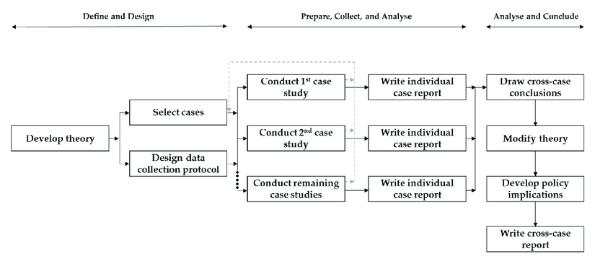
Figure 1 Multiple-Case Study Procedure (Yin, 2014)

Construct validity is one of the four tests needed to establish the quality of an empirical research study (Yin, 2014). In this study, construct validity is increased by using multiple sources of evidence to obtain results and draw conclusions. The case studies are evaluated on the operational set of measures outlined in the following section.
  - Data Collection Procedure
The hypothesis guiding this multiple case study research is living walls positively impact indoor environmental quality and thus improve occupant satisfaction and comfort in their work environment. The five study sites were selected under the parameters that they utilized living wall technology and they were certified by either LEED, WELL, or the Living Building Challenge. In the analysis of the case study sites, each of the parameters related to indoor environmental quality were rated based on their presence and design consideration and strength of impact in the space. Each of the building’s living wall systems were evaluated in each of the areas related to IEQ. The scores were determined through the analysis of images found online, as well as published news stories and articles pertaining to the interior design of the building. The scoring developed for this research study is outlined in figure 2. Living walls will receive a score of 1, 3, or 5 in each area of indoor environmental quality, revealing what part of the indoor environmental quality they affect most.
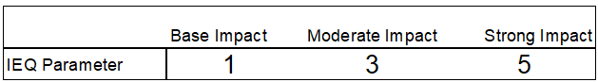
Figure 2 Scoring scale
The criteria used to evaluate the strength of the living wall’s impact was developed from the information found in the literature review. The criteria used for evaluation is specifically related to the living wall. Other design features, not related to the living wall, were not considered in the evaluation, and scoring. The scoring criteria for each parameter is outlined in figure 3. A living wall’s ability to improve indoor air quality is contingent on the type of plants used in the system, the plant coverage, the growing medium, and if the system actively engages in air circulation and/or filtration. Previous research studies have indicated that active living wall systems are the most effective living walls for improving indoor air quality. Therefore, active living walls are expected to have a strong impact in the indoor air quality parameter. Moderate impact is expected if the plant composition was designed with the reduction of indoor air pollutants in mind. Plants that have been known to filter air pollutants and are commonly used in living wall systems include golden pothos, schefflera arboricola, syngonium plants, and philodendron scandes varieties, and chlorophytum comosum (Fraser Torpy et al., 2018b; Fraser Torpy & Zavattaro, 2018a; Wolverton et al., 1989). Thermal comfort and ambient air cooling is affected most by dense foliage cover and plants with medium sized leaves (Charoenkit et al., 2020). Living walls that exhibit these qualities can be expected to have a strong impact on thermal comfort in the building. Acoustic properties of a living wall are affected by the foliage density and the porosity of the substrate material. Sound absorption coefficient is expected to be high where there is a thick, porous substrate or growth medium and sound scattering is related to full foliage cover. Both of these acoustic properties will lower sound pressure in a space and indicate the living wall’s strong impact in acoustic comfort. The living wall’s ability to impact lighting quality is based on the expectation that daylight is desirable. Strong impact will be indicated if the living wall is positioned in a way that increases occupant interaction with daylight. The artificial lighting parameter is scored based on the type of supplemental lighting used. The color temperature of lighting specified in the chart (4000K – 5000K) preferred for controlled growth, as well as visual representation of the plants (Dugar, n.d.). The use of daylighting harvesting technology indicates a strong impact in this area because it allows daylighting to still be the main source of light in the office. The access to nature parameter is evaluated based on where the living wall is located in the space and if the occupants are able to interact with it as a restorative feature. The living wall will be expected to have a strong impact in this area if it is able to be seen from a majority of the occupants’ workstations and at least once each workday.
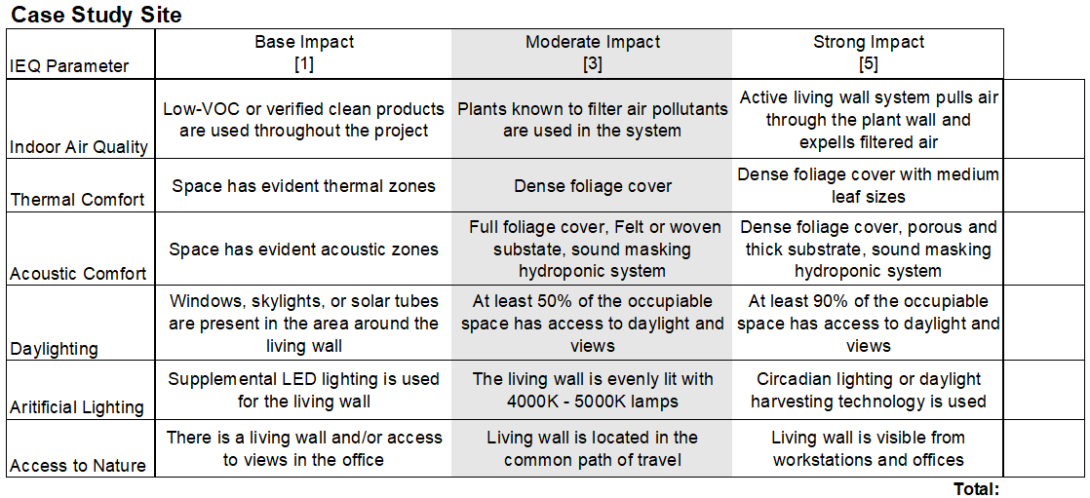
Figure 3 Scoring criteria for each category

  - Data Analysis Procedure
The scorecards developed for this study were analyzed in each area of indoor environmental quality (IEQ). This indicates the area of IEQ most impacted by the living wall system in the space. By averaging the scores across the case studies, one can determine the area with the strongest impact overall. The totals for each site were also evaluated and compared against each other to determine which living wall system was the most successful. This will quantify the impact of living walls in indoor environmental quality. The scoring method can be replicated across other cases. The information gathered in the literature review is the basis for building the scoring criteria. Previous research studies have been able to reveal the characteristics of successful living walls and this study combines these findings and evaluates different living wall’s ability to impact the occupant experience through each of the previously mentioned IEQ parameters.
  - Conclusion
To summarize, the best methodology to determine the impact living walls have on occupant satisfaction and indoor environmental quality is multiple case study analysis. The case study sites include Nixon Peabody, Toyota Motor North America, OFS Headquarters, Delos Headquarters, and the Etsy Headquarters. These sites were selected because they each have a large-scale living wall in the building and they were found while searching through LEED, WELL, and LBC certified commercial buildings. Each case study is to be evaluated through an online content analysis, followed by field verification measurements and observations, as well as an occupant survey. The use of multiple research strategies provides multiple sources of evidence and reduces the overall threat to validity. The use of multiple cases in this research is to highlight successful and potentially unsuccessful applications of living walls in commercial office spaces. Due to external limitations, field observations/measurements, and occupant surveys were not able to be completed at each of these sites. The extent of this analysis covers what is available to the researcher for remote and online access. Based on available literature and images, each of the living walls in these buildings were scored in the different areas that impact indoor environmental quality. By scoring each of these buildings in the different areas that impact indoor environmental quality, the study will reveal areas of highest impact and area that may need more consideration.
- ANALYSIS
The findings from the online case study review are outlined below. This search proved to be preliminary and should be used as a starting point for further investigation into each of these sites. As per the multiple-case study research design proposed, a brief report on each site is presented, followed by a cumulative cross-case analysis.
  - Nixon Peabody
Nixon Peabody’s Washington D.C. office was completed in 2015 and awarded LEED-CI Platinum certification in 2016. The interiors were designed specifically with occupant well-being in mind. There is space for approximately 150 employees who are typically in the office all 40 hours of the work week. However, this may not be an accurate count of full-time employees due to the current state of the national workforce impacted by the COVID-19 pandemic. Many offices are currently utilizing flexible and remote working opportunities. In the Nixon Peabody office, many sustainability factors were addressed in the interior design, but some of the most notable include the use of recycled and clean materials, as well as a reduction in HVAC energy costs, potable water usage, and overall lighting power (Buckley, 2016).
The living wall in this space is a Gsky® versa wall system. Gsky’s® living wall installations are modular tray systems, allowing for customization and large sizes. The trays hold individual 4” plants and irrigate each of them individually to ensure the proper amount of water reaches each plant. This design also allows for easy replacement of individual plants for seasonal displays or routine maintenance. This particular living wall system is irrigated using condensation from the air handling unit at the building (Buckley, 2016). The water source is remote and refills itself, reducing the need for system maintenance. Figure 4 shows a section of the system and figure 5 shows a diagram of the tray system installed, both from the versa wall product brochure (Gsky, 2017). Based on the product specification sheet, it can be assumed that this is not an active living wall, where air is intentionally pulled through the greenery as a filter. This reduces the likelihood that the living wall heavily impacts indoor air quality. However, the plant composition can be impactful. Based on images of the installation and the plants offered for versa wall systems, the living wall is most likely made up of golden pothos, ficus elastica burgundy, schefflera, and philodendron cordatum plants. These plants range from fine textured to medium textured, giving this living wall a very densely covered appearance. This living wall extends up a monumental stairwell in the building and is about 37 feet tall and covers about 272 square feet of wall space. Figure 6 shows the living wall spanning the height of the staircase. This stair is also located along a wall of exterior glazing, creating a vertical shaft filled with daylight.
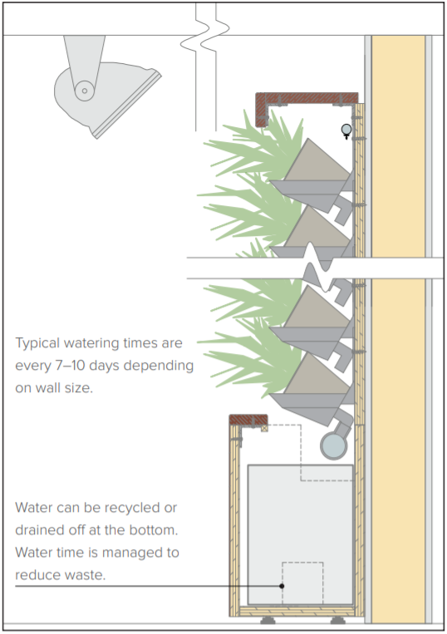 Figure 4 Gsky® versa wall section diagram (Gsky, 2017)
Individual 4” plant
Metal tray mounted to the wall
Water drips down the tray system
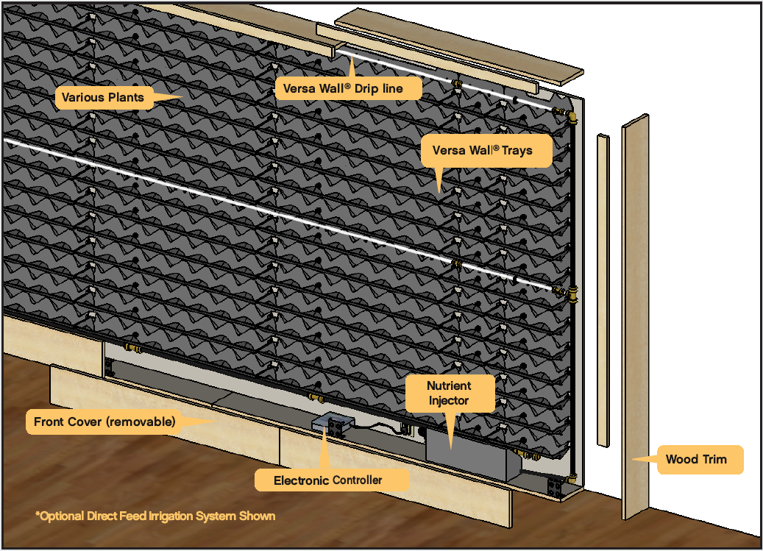 Figure 5 Versa wall® tray system diagram (Gsky, n.d.)
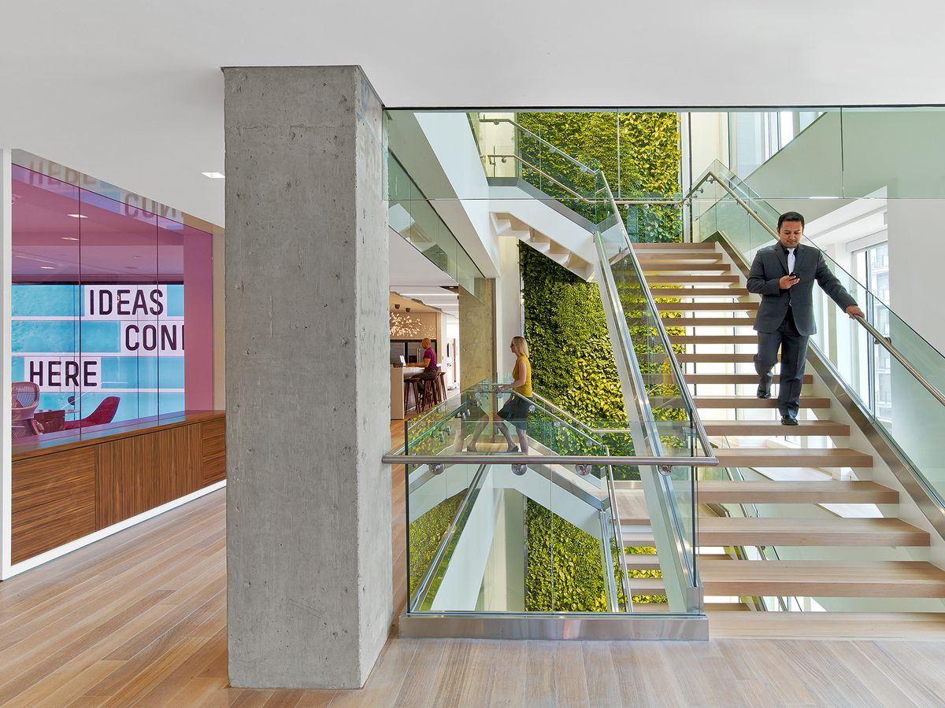
Figure 6 Nixon Peabody monumental stair (Cockrell, 2016)
In reviewing the literature published on this building, one can see that the living wall on site is a prominent design feature. It is referenced roughly seventeen times across the twelve articles written about this site. It was most notably referenced with regards to the sustainable irrigation design. The plant wall is watered using condensation runoff from one of the air handling units in the building (Buckley, 2016). This is an innovative design solution that does not burden the building’s mechanical load or the maintenance team. It also contributes to the building’s notably low potable water usage. The living wall is also referenced in regard to employee feedback. In one article, there is mention of a post-occupancy survey conducted by the company executives that yielded positive responses surrounding the active design and layout of the office (Cockrell, 2016). Many employees listed the monumental stair and accompanying living wall as a feature that makes them feel both mentally and physically refreshed (Cockrell, 2016). This route in the office was compared to a “nature walk” (Cockrell, 2016). The space planning team intuitively located the breakroom and activity hub adjacent off this monumental stair to encourage employee use, which may explain the positive reviews. The statements made by occupants, suggests that the living wall feature may enhance their experience through its visual appearance and biophilic restorative properties. The access to natural daylight can only partly be connected to the living wall feature. The two terms are referenced together, however, a majority of the exterior walls are glazed in this office. Therefore, it cannot be definitively concluded that the occupant’s access to daylight was helped or influenced by the presence of the living wall. However, the occupants’ views of nature and green space are directly impacted by the living wall feature. The living wall is featured at a focal point in the office and visible from almost every workstation and private office because of the major use of glass to maximize views. This tells the story that the living wall was in fact, used as a significant design feature.
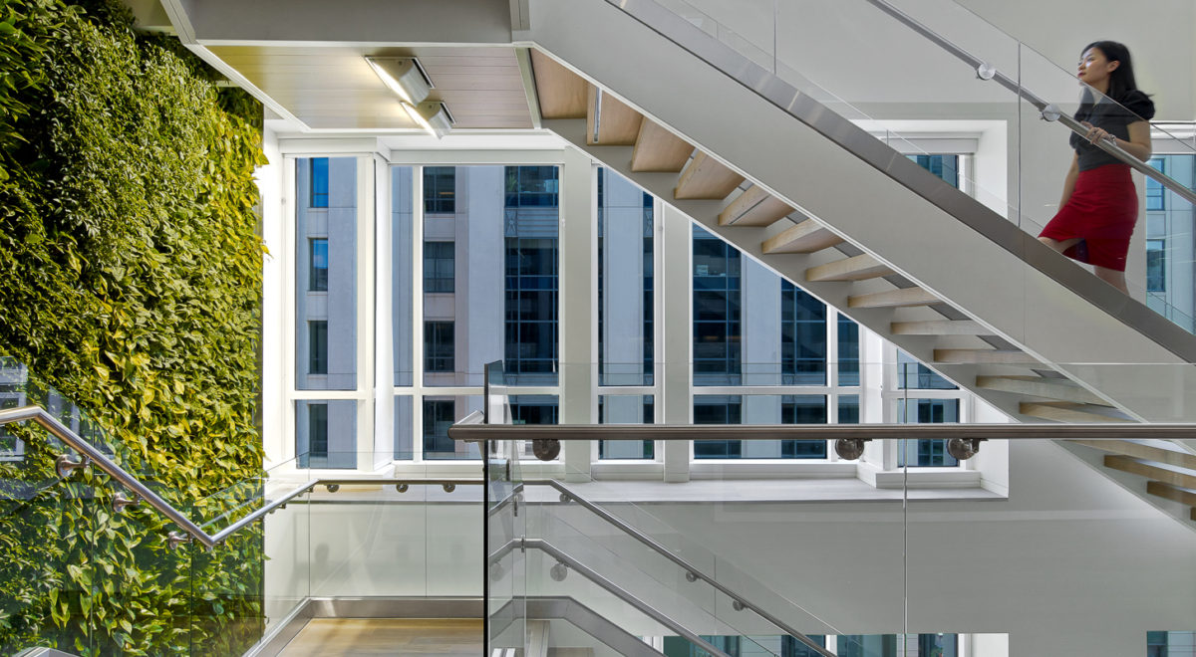
Figure 7 Supplemental LED lighting for the living wall ("Nixon Peaboody," 2015)
The articles reviewed for this study did not include any definitive data on indoor air quality, outside of referencing it in a positive manner and indicating that there was comparatively good air quality. The only conclusions that can be taken from that statement, is that it was considered in the design, and it is a feature that the company is proud of. The United States Green Building Council (USGBC) connected the space’s living wall to good indoor air quality in their article about the building’s certification achievement (Hacias, 2015). The building received LEED certification points for meeting the minimum air quality requirements (EQp 1), having a construction air quality management plan prior to occupancy (EQc 3.2), and for indoor chemical and pollutant source control (EQc 5). Without more information, it cannot be determined if the living wall on site was a factor in obtaining these certification points. No information on thermal comfort or acoustic comfort, outside of the score card certification points provided in these areas, was found in the publications related to this site. Lighting is an area that this building excels in. Many articles discussed the immense natural light in the space, as well as the technology and controls used in the artificial lighting scheme. The office has a 100% LED lighting system with zoned light levels controlled by daylight photosensors ("Nixon Peaboody," 2015). These features allowed the office to reduce its overall lighting load. The LEED scorecard for this project can be seen below in figure 8. This project obtained 13 out of 17 possible points for indoor environmental quality, making it their second strongest category, after water efficiency. The living wall directly affected the water efficiency of the building by using collected condensation from the building’s air handling unit. This indicates that the living wall is a design solution that directly helped the building obtain LEED platinum status.
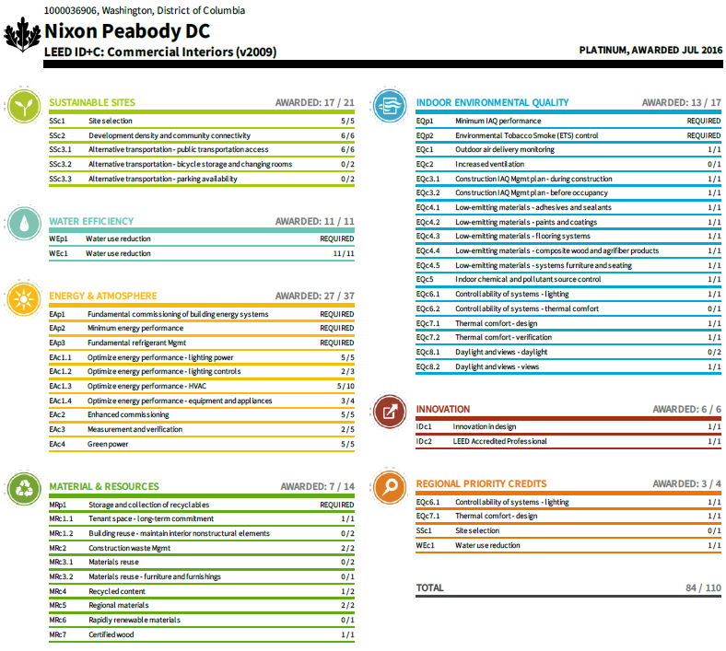
Figure 8 Nixon Peabody DC - LEED ID+C Platinum ("Nixon Peabody DC," n.d.)
Based on the information available, the site’s scores for each indoor environmental quality parameter are shown below in Table 1. Strong impact is expected for thermal comfort, daylighting, artificial lighting, and access to nature. Moderate impact is expected for indoor air quality. This is because some of the plant used are known to reduce VOC levels and sequester carbon better than others. Specific plants seen in this wall that have also shown up in multiple studies are the golden pothos and the schefflera. And lastly, the wall is expected to have a moderate to low impact on acoustic comfort. This assumption is based on the construction and substrate material. It is not continuous, and the metal trays are not porous, but the wall is densely covered with foliage, so sound scattering could still help reduce the overall sound pressure. The scores could change based on field verification measurements and in person observations of the current conditions.
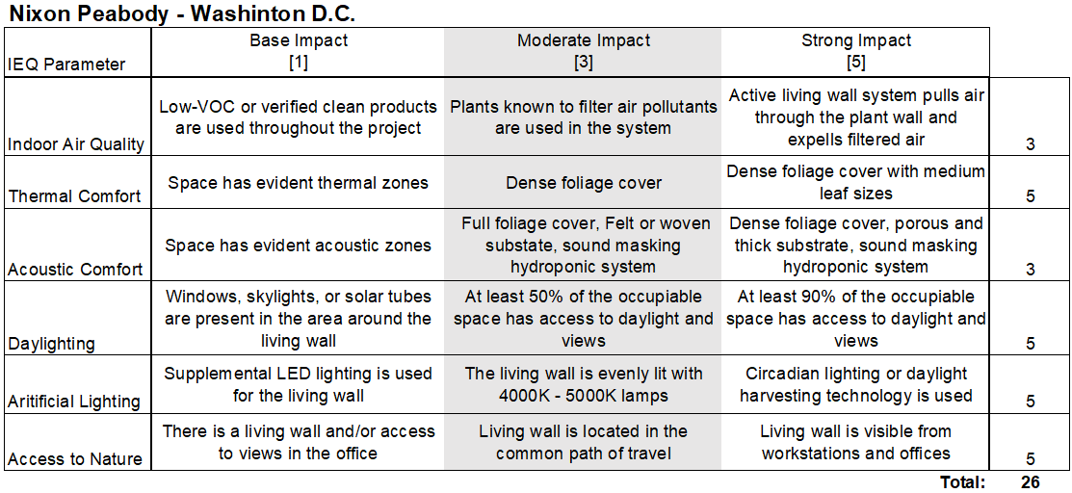
Table 1 Nixon Peabody IEQ Scores
  - Toyota Motor North America
The new one-hundred-acre Toyota campus was completed in 2017 and received LEED BD+C Platinum certification later that year (Silvestri, 2017). The campus brings together three previously separate headquarters locations all at one site. Almost all of the employees from each of those offices relocated to Plano, Texas and there is still room for the company to grow their workforce. Even though the campus is spread out, part of the design intent was bringing the employees together and creating space for interaction and collaboration. A majority of the articles written about this site focus on the sustainability and the site design, and they are all quite short.
The living wall at the Toyota campus is also a Gsky® versa wall. It is a 484 square foot modular tray system. The plants found on the wall include philodendron cordatum, epipemnum “neon” pothos, epipemnum “marble queen” pothos, schefflera arboricola, ficus elastica “burgundy,” and red anthurium ("Toyota HQ - Green Wall," n.d.). There is not much visual contrast in texture on the wall because each of these plants has a medium leaf size, but this plant coverage will likely help improve thermal comfort in its immediate area by adding humidity to the ambient air. The composition of the wall is visually interesting because of the varying colors of the plants (Figure 9). Skylights are added to this area intentionally to provide natural light for the plant wall. Otherwise, the space looks like it would be quite dark. There are also light angled towards the wall as supplemental lighting. The location of the living wall is not discernible from the available images and articles found. However, it can be assumed that it is not in a lobby space, open office space, or on the common path of travel. Although it is hard to tell the common path of travel on such a large campus, the living wall looks secluded. The design director of the project explained in an interview that the living wall is located in a corridor that would have been the darkest spot on the campus, had the design team not decided to add skylights and a green wall (Silvestri, 2017). This is a prime example of how choosing to incorporate a living wall can influence other impactful design solutions. This corridor is now decorated with foliage and soft lighting, where it might have previously been dead space. Observations of the site and occupant circulation would be needed to fully understand how occupants come to interact with the living wall.
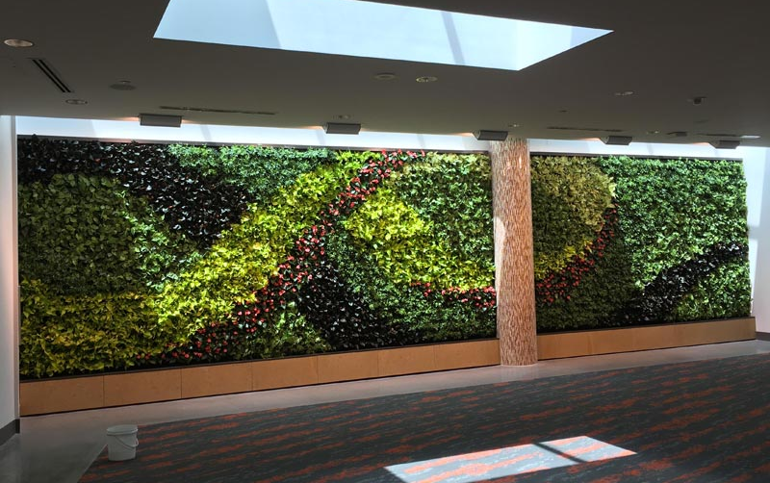
Figure 9 View of living wall from corridor ("Toyota HQ - Green Wall," n.d.)
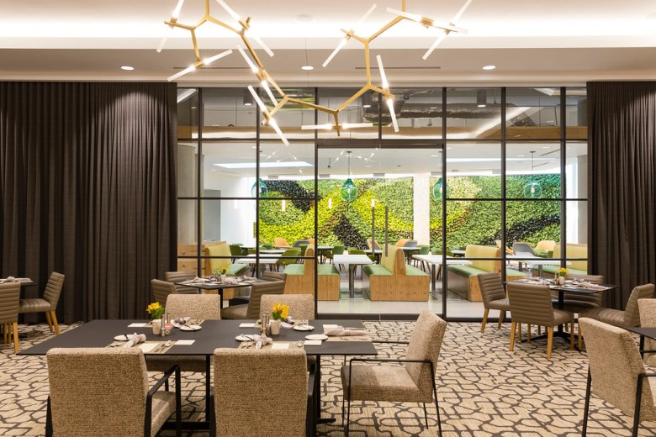
Figure 10 View of living wall from dining space (Silvestri, 2017)
The secluded location of the living wall indicated that it was likely not a prominent design feature. There is very little information to be found on it, as well. Across the eight articles found, the living wall was only discussed three times. Of those three times, only once was its benefit to air quality and occupant well-being mentioned. This project is very impressive in terms of sustainable construction, and many of the news reports focused on the campus as a whole and did not really dive into the interior design specifically. The living wall is most often referenced as a biophilic feature that reduces mental fatigue and positively impacts occupants’ personal well-being. In the literature available, there was little discussion of indoor air quality, outside of a few articles mentioning it was comparatively good. The building also received multiple certification points for their consideration of air quality. All of the building materials used are low-emitting materials and there is increased ventilation on site to ensure there is no stale air in the building. Acoustics were not discussed, nor were there points awarded in the LEED scorecard. The building received points for thermal comfort in design and verification, meaning that post-occupancy surveys have shown that more than 80% of the occupants are satisfied with the thermal comfort in the building. The central court on campus is beautifully landscaped with local plants and serves as a nice nature view from each campus building. The points achieved for daylight and views communicate that at least 90% of the building has access to views outside and at least 75% of the regular occupied spaces have access to daylight. There is no information regarding the artificial lighting design. Figure 11 shows the LEED scorecard for this case study.
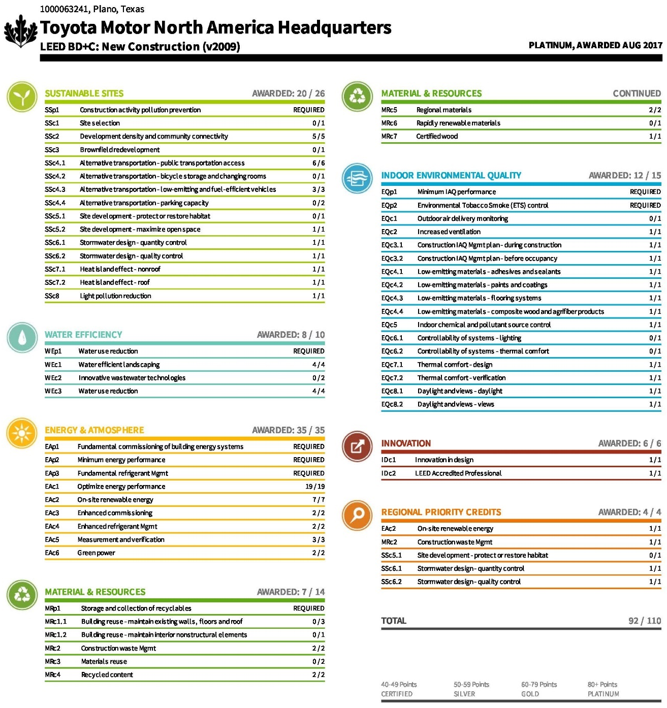
Figure 11 Toyota Motor North America - LEED BD+C Platinum ("Toyota Motor North American Headquarters," n.d.)
Based on the information available, the site’s scores for each indoor environmental quality parameter are shown below in Table 2. The scores reflect the evaluation of the livings wall’s specific impact on each parameter. The daylighting and artificial lighting scores are relatively low due to the lack of information available. This evaluation is based off of images. Occupant access to nature through the living wall is scored as a low impact, based on the fact at the living wall is out of the way for most occupants. Acoustic properties of the wall are unknown, but there looks to be dense foliage cover that could reduce some sound pressure in the surrounding space. The schefflera arboriola plant found on the wall is expected to be good at reducing VOCs in the air, but none of the other plants in the composition are known to have this quality. This indicates that air quality impact is likely moderate to low. Based on the leaf size and large area of coverage, it is expected that the ambient air in the space may be cooled by the plants’ evaporative cooling. The total score for this project is quite low and indicates that the living wall in this space is not expected to be as impactful as a living wall at one of the other case study sites. With that said, the scores could change after field verification measurements and in person observations of the current conditions are made.
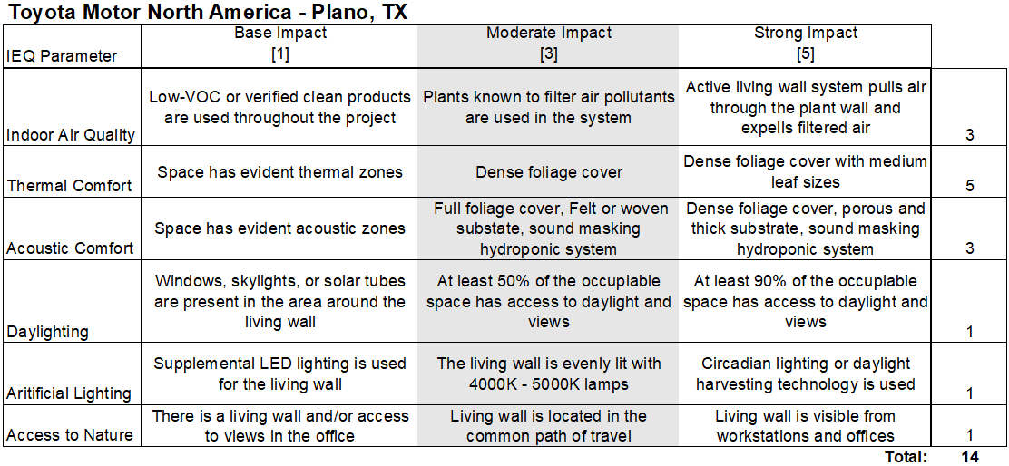
Table 2 Toyota Motor North America IEQ Scores
  - OFS Corporate Headquarters
The office located in Huntingburg, Indiana was renovated in 2017 and received WELL v2 Platinum certification at the end of 2020. The OFS corporate office is home to about 200 full time employees. The WELL program is unique because it requires annual verification for continued certification. This ensures a level of confidence in accuracy of the available sources’ information. On the OFS website there is a page dedicated to sharing their WELL story and their dedication to employee wellbeing in their own workplace. Because this company sells commercial office furniture, it is fitting for them to discuss their dedication to the building’s occupants on their website. The incorporation of the living wall was among the first design decisions made in the new space ("OFS Corporate Headquarters Achieves WELL Certification," n.d.). The other design elements first implemented were ergonomic and adjustable furniture and task lighting at each desk station. These features have to do with occupants’ sense of control of their environment and they can be accomplished with OFS products.
The living wall installed in the space is a 25-foot-tall custom Sage Greenlife product. The product specifications indicate that a biotile system is typical of this product. Figure 12 shows the composition of a typical biotile in this living wall. The tile substrate is made of rockwool, which is advetised to be extremely durable and antimicrobial, reducing the cost of maintenance and replacement. The tile’s sound absorbing properties have also been tested in an ANSI-ASQ accredited laboratory ("Benefits of Living Green Walls," n.d.). The measured noise reduction coefficient (NRC) of the planted biotile is 1.15, which is extremely absorptive ("Acoustic Performance of Sage Greenlife Living Walls," 2019). The presence of an absorptive material will reduce the overall sound pressure in a space and lower the measured reverberation time. Figure 13 shows a diagram of the full wall composition. Sage Greenlife also claims that their products improve indoor air quality and employee retention through supported mental wellbeing ("Benefits of Living Green Walls," n.d.). However, apart from the laboratory tested acoustic performance, the other claims made by the living wall manufacturer would have to be tested at the site of the installation. The plant composition is unknown, but it looks to be texturally diverse. From pictures and a virtual walkthrough of the site, one can see that the 25-foot-tall element, connects both floors in the building and is found in the central atrium, surrounded by windows and skylights. The living wall is located adjacent to a stairwell and exterior glazing. In this scenario the design intent seems to encourage people to utilize daylight-filled spaces and to increase potential for occupant interaction. It does not look like the living wall is lit by any artificial fixtures, so it can be assumed that there is ample access to daylight at all points on the wall. It is also on the main path of travel to workstations, breakroom, and the exit, to ensure that all occupants encounter the natural feature at some point during the workday. Figure 14 shows the living wall installation for this case study site.
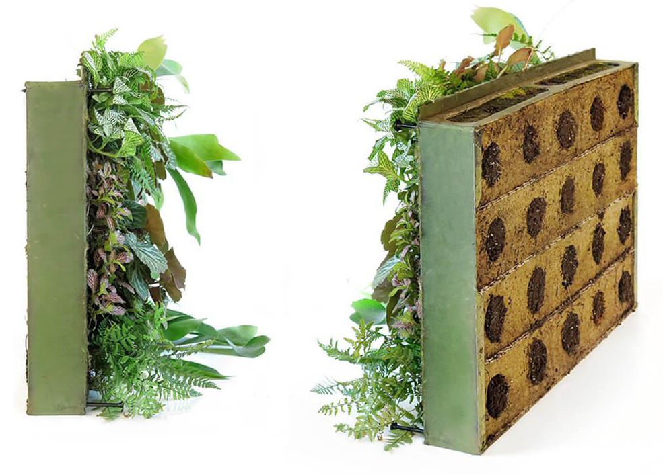
Figure 12 Sage Greenlife biotile with planting ("Technology," n.d.)
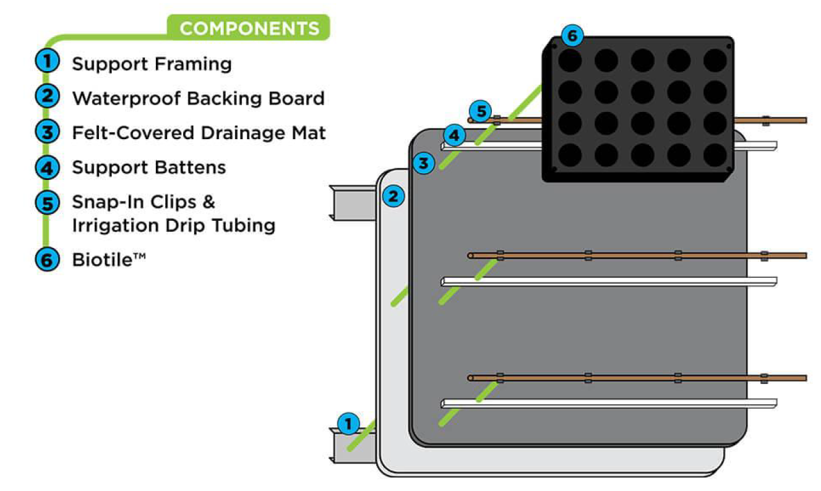
Figure 13 Living wall installation diagram ("Technology," n.d.)
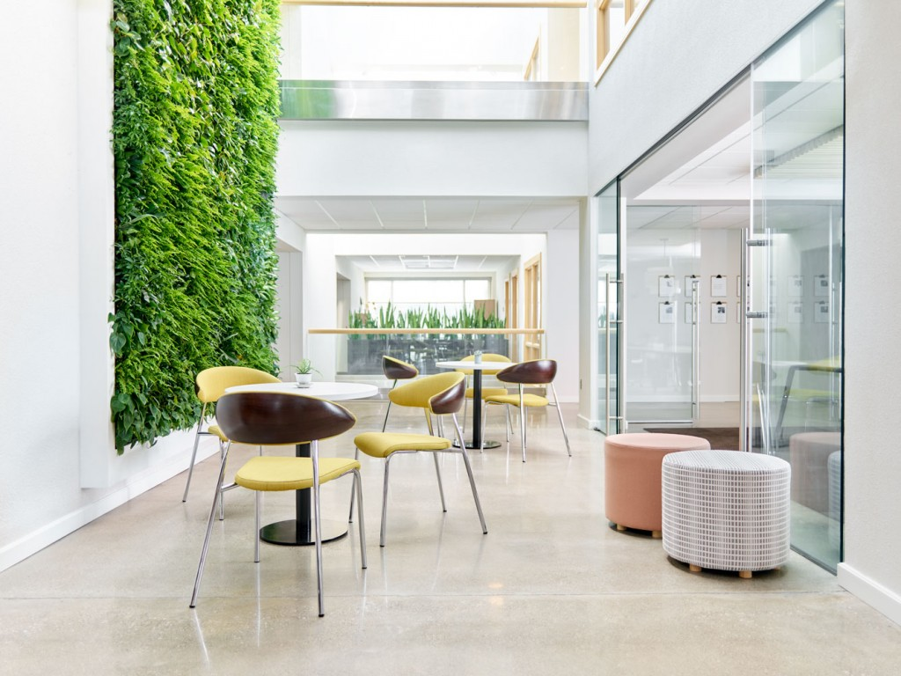
Figure 14 OFS living wall and central atrium ("OFS Corporate Headquarters Achieves WELL Certification," n.d.)
There is not much literature published on this building, and the living wall is not described as a prominent feature. Throughout the review, the living wall is referenced only four times across the five solid articles found about this site. It is mostly referenced as a visual connection to nature directly in the space. News articles and company profiles did not highlight any specific benefits of the living wall, outside of the biophilic pattern, visual connection to nature. In the online review, no definitive data or numbers were found on the thermal comfort conditions, lighting conditions, acoustics, or indoor air quality. The most impactful information was found directly on the OFS website, where they provided details on their renovation and values surrounding occupant well-being. The product specifications and testimonials provided by the living wall manufacturer provided most of the insight into what benefits to the indoor environmental quality can be expected from the living wall installation. The WELL v2 building standard provides specific prescriptive data for the points obtained on the scorecard, and that is what is taken to be true in regard to the site’s existing conditions in this preliminary evaluation of the IEQ parameters. There are ten features of WELL certification: air, water, nourishment, light, movement, thermal comfort, sound, materials, mind, and community. Based on the scorecard shown in figure 15, the OFS Headquarters seems to excel in the air, nourishment, movement, and community features ("OFS Corporate Headquarters Achieves WELL Certification," n.d.). In this case study, the living wall contributes to the WELL certification points received for enhanced access to nature and restorative space, in the “mind” concept.

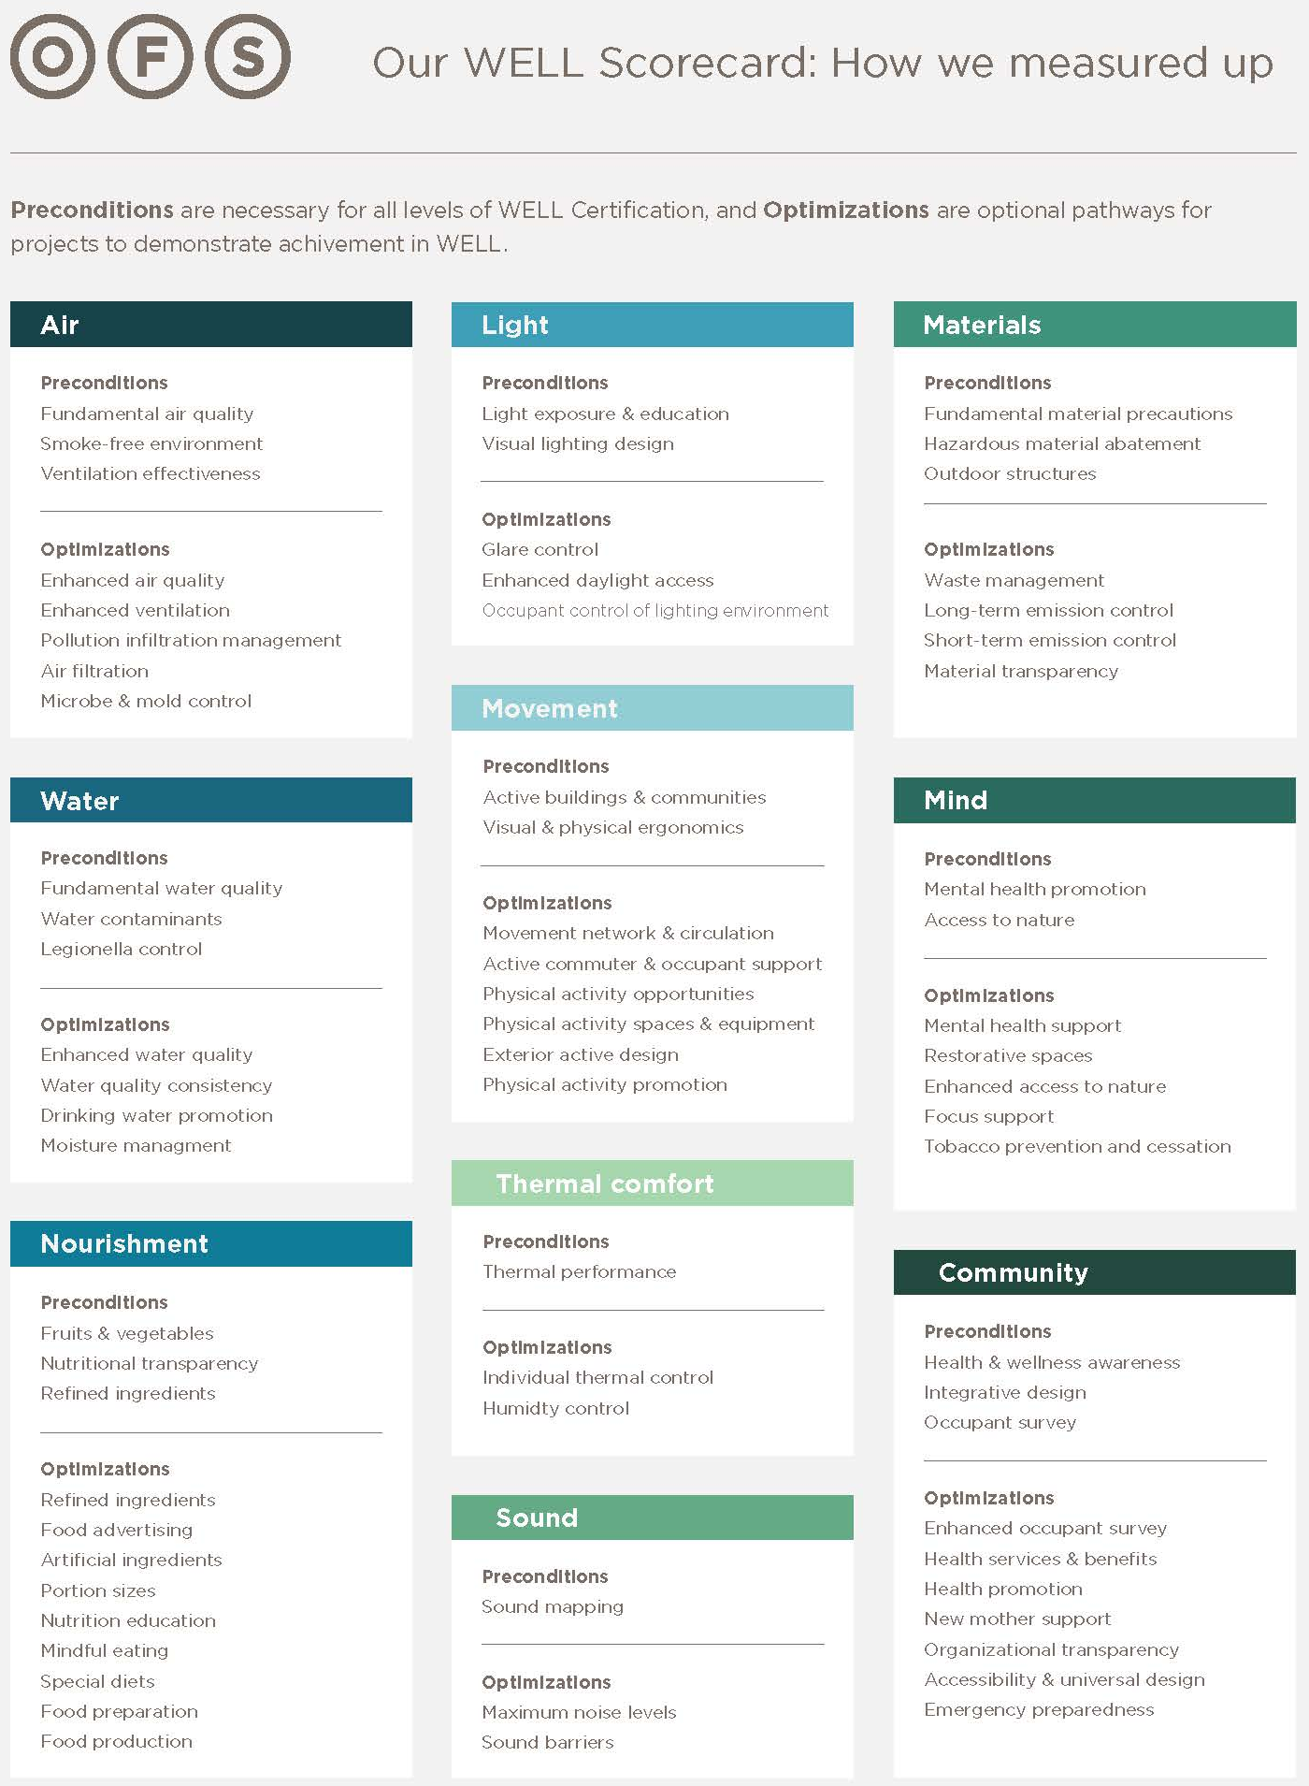
Figure 15 OFS Headquarters Scorecard - WELL v2 Platinum ("OFS Corporate Headquarters Achieves WELL Certification," n.d.)
Based on the information available, the site’s scores for each indoor environmental quality parameters are shown below in Table 3. This living wall is expected to have a strong impact on acoustic comfort in the space because of its thick and porous growing medium. Relatively high impact is also expected in the daylight area. The location of the living wall and the amount of daylight in the area surrounding it helps ensure that a high majority of the occupants will get access to natural light throughout the day. Moderate impact is expected for thermal comfort and access to nature, based the images of the living wall and the building that were found. Due to the lack of information in these areas, artificial lighting and indoor air quality are expected to be minimally impacted by the living wall. The scores could change based on field verification measurements and in person observations of the current conditions.
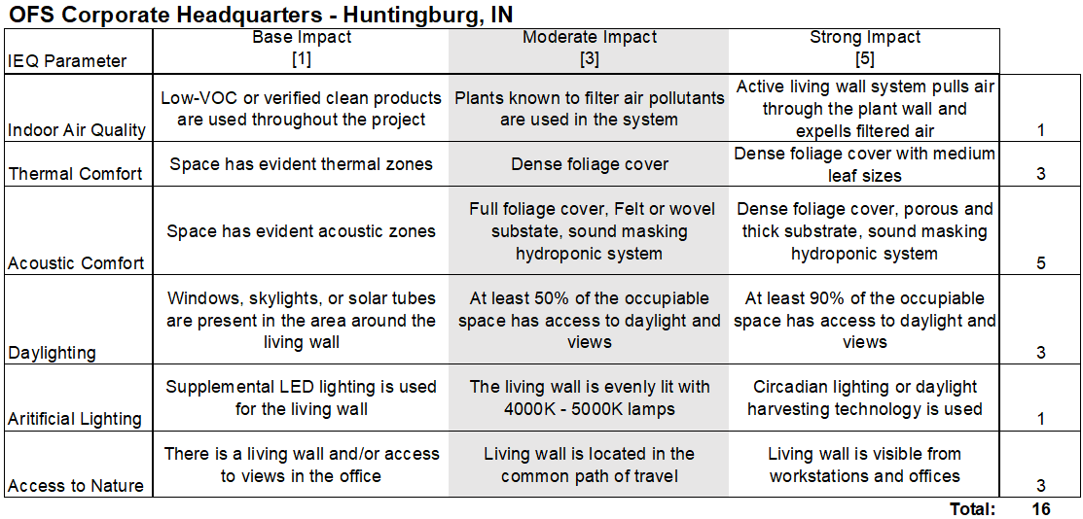
Table 3 OFS Headquarters IEQ Scores
  - Delos Headquarters
The Delos global headquarters in New York City was completed in 2017. This case study is currently WELL v1 platinum certified, LBC 3.0 petal certified, and is in pursuit of LEED v4 platinum certification. Delos is a company known for helping to create the WELL building standard and is a major advocate for wellness and evidence-based design solutions in the built environment. The goal for this project was to show off the benefits of a well-designed office space that uses new technology and products backed by research. The office occupies the fourth and fifth floors of a ten-story building. Three out of the four exterior walls on each floor are fully glazed and offer unobstructed, panoramic views of the downtown, the Hudson River, and the High Line ("Delos HQ," n.d.). Nature in the space is a prominent feature, seen in the twenty-one living walls scattered throughout the space and the large outdoor terrace on the fourth floor. This site uses innovative technology for indoor air quality control, lighting controls, and thermal comfort. A large digital display at the front of the office projects indoor environmental quality data throughout the day, showing how these systems are actually performing.
The living walls scattered around the office are Naava active green walls. Each individual plant system has a fan that pulls contaminated air through both the growth medium and hydroponic system as a filter and releases cleaned and conditioned air back into the space. A diagram of this process is shown in figure 16. In a commissioned research study, Torpy et al. proved that the Naava One active biofilter can reduce levels of VOCs, specifically methyl ethyl ketone by more about 57% in a single air exchange (2018b). To this degree, it is confirmed that the living walls in the space affect the indoor air quality. These products also can humidify the air that passes through them (Naava, 2018). This feature is controlled by artificial intelligence programmed into the system, as well as an app. By creating humidity in the air, this product can contribute to thermal comfort in it surrounding space. The plants used in Naava green walls include various types of philodendron scandens, schefflera arboricola, and dracaena deremensis (Naava, n.d.). All of which, are expected to be good air cleaners. The Delos headquarters office seems to have at least one living wall in every room or space. The living walls are smaller in scale, but the distribution of biophilia ensures occupant connection with nature that is so important in the wellness building standards. The figures 17, 18, and 19 depict some of the living walls in the space. The Naava product data page claims that the green walls have acoustic benefits (Naava, 2018). The mechanical fan in the living wall may provide some ambient sound masking. However, this would need to be tested through field observations to confirm.
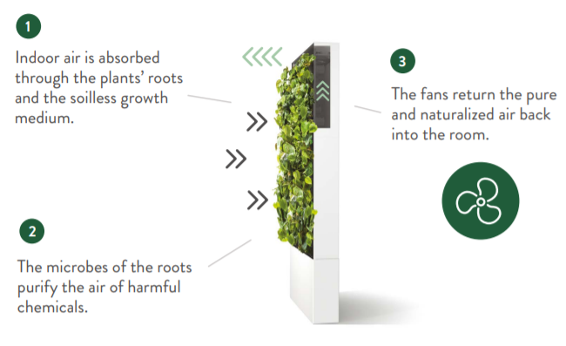
Figure 16 Naava active living wall air purifying process (Naava, n.d.)
The many living walls in this space are a prominent design feature that were carefully selected for the project. Delos places value in research-backed products and worked with Naava to fund a research study testing the effectiveness of the active biofilter in a realistic setting (Naava, 2018). The results of this study served as the basis for including the Naava active living walls in the Delos project. The living walls were mentioned fourteen times across the eighteen articles found describing this project. The interior planting was mentioned as an impactful feature in three different completed Living Building Challenge petals. The connection to nature is a prominent design feature, even in a space designed with an industrial feel. An element of biophilic design is also seen in the circadian lighting system ("Delos HQ," n.d.). The lighting design in this space is unique is that the lighting levels, as well as the color temperature subtle shift throughout the day to mimic the human body’s natural circadian rhythms that are regulated by nature and daylight (Nale, 2020). The abundance of daylight in the space also helps with this rhythm regulation for occupants. The lighting, however, is not mentioned as a factor for the living wall performance in any of literature about this case study site, and the Naava walls seem to have a lighting system integrated. There were lots of new sustainable products and technology used in the Delos project, and therefore lots of features worth noting in publications. However, they are not needed for this particular research study. Delos is expected to publish data from an occupancy evaluation of the indoor environmental quality compared to data from their previous office location. Delos’ study has yet to be completed, but it would be helpful for this research and any other study focusing on other unique design features’ effect on occupant satisfaction and comfort.
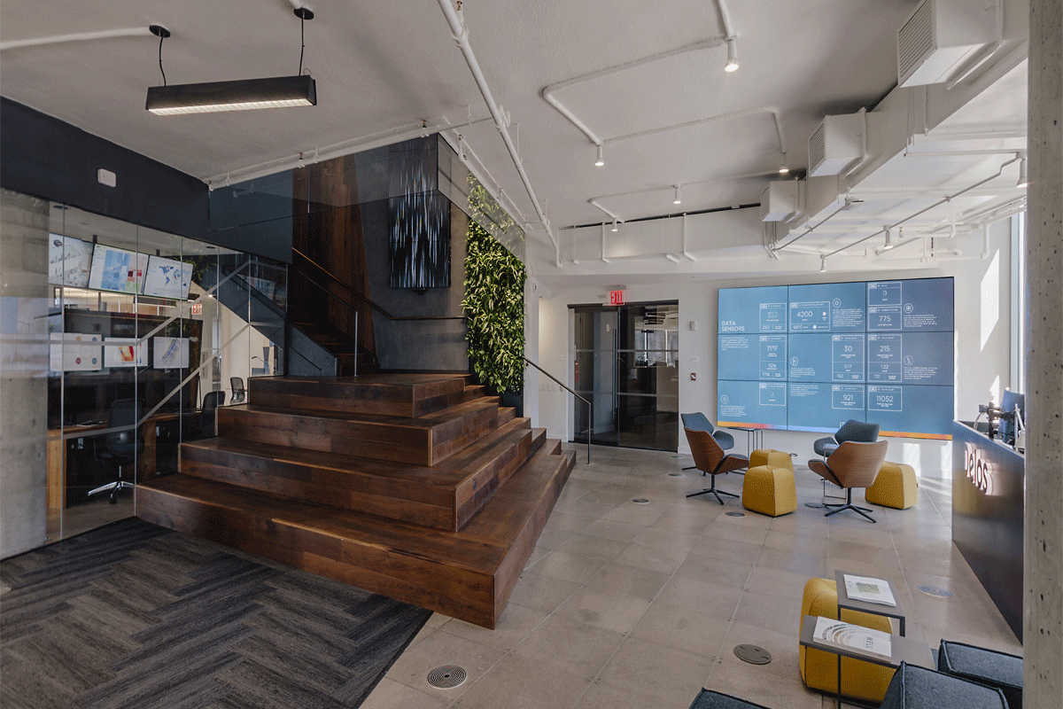
Figure 17 Living wall in monumental stairwell ("Delos HQ," n.d.)
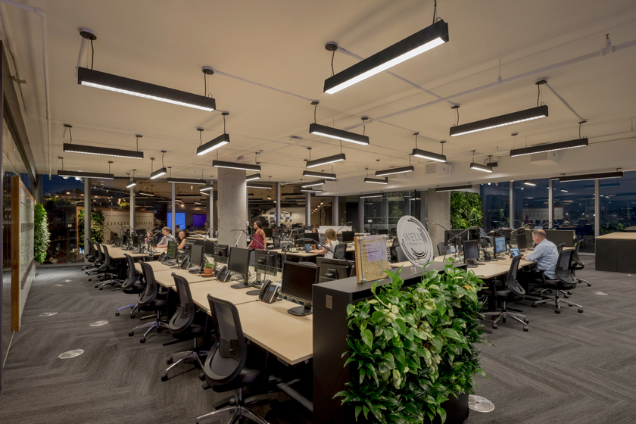
Figure 18 Living walls in open office space ("Delos Living New York Headquarters," n.d.)
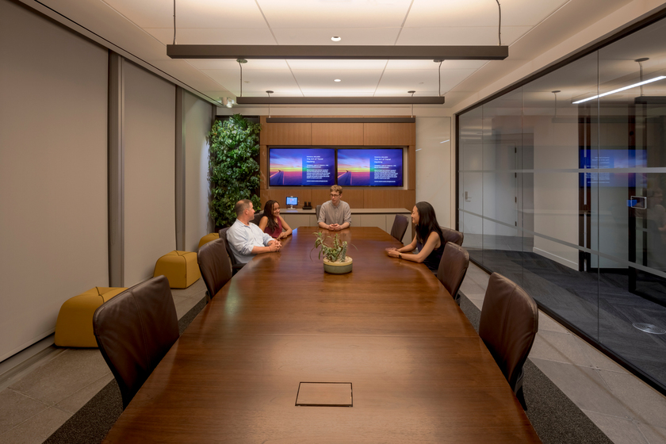
Figure 19 Living wall in conference room ("Delos Living New York Headquarters," n.d.)
Based on the information available, the site’s scores for each indoor environmental quality parameter are shown below in Table 4. The living walls in this space are expected to have a high impact on indoor environmental quality overall. A research study had proved that the active nature of this living wall product can purify the air and affect thermal comfort. The living walls are scattered throughout the space so that occupants are constantly interacting with nature, even from their desk. Moderate impact is expected related to acoustics because there is little information on the subject available and the walls are smaller in surface area than others. These scores could change based on field verification measurements and in person observations of the current conditions.
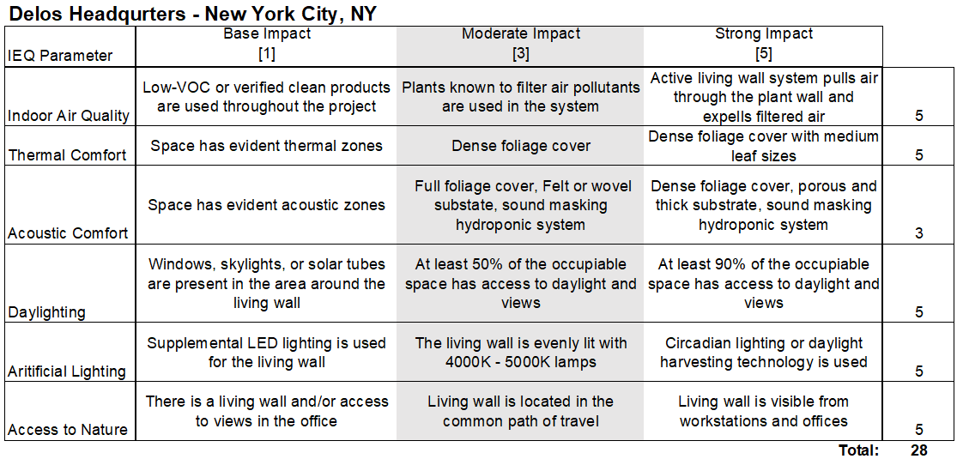
Table 4 Delos Headquarters IEQ Scores
  - Etsy Headquarters
The Etsy Headquarters in Brooklyn, New York is currently the largest Living Building Challenge 3.0 petal certified project. It was certified in 2016 and is occupied by roughly 800 employees. The site is 200,000 square feet and is designed to be a fully regenerative ecosystem that is not only self-sustaining, but also gives back to the surrounding community ("Gensler-Designed Etsy HQ Achieves Living Building Challenge Certification," 2017). Daylight, fresh air, and connection to the outdoors are abundant in the space. Biophilia was considered in most of the design decisions, apart from just the incorporation of plant life. It was considered in the space planning, art and decoration, material selection, lighting, energy use and planning, and even the company’s policies ("Etsy Headquarters," n.d.). Based on the information gathered form the articles and Etsy’s mission statement, it seems as though the materials petal was a central focus throughout the design. Most of the furniture and art installations were sourced by Etsy creators who use sustainable building materials. Post-occupancy surveys distributed to employees showed that 95% of respondents thought that the new headquarters successfully embodies Etsy’s mission and company values ("2020 COTE Top 10: Etsy Headquarters," n.d.).
There are five living wall installations at the Etsy’s headquarters office. The living walls are all Gsky® versa walls. There is about 360 square feet of plant coverage on the walls. Similar to some of the other case studies, these are modular tray systems that are highly customizable. Figure 20 shows one of the living walls wrapping around an exterior corner of a room. The living walls in this space are in circulation areas, it is not clear if they are on the common path of travel. However, there is seating and workspace in the areas around them which allows the occupants to spend time near the living walls. There is a variety of textures and colors in these walls, adding lots of visual interest to the space. The plants used in these walls are not identified, but they look like there is a variety of small and medium sized leaves, and there is very dense foliage cover across the wall. Based on the images, the plants able to be identified include silver satin pothos, austral gem fern, philodendron cordatum, chlorophytum comosum, and neon pothos plants. The plant wall is watered from a tank that collects storm runoff. This remote water source allows the walls to be thin with little framing. The plantscapes and watering system were designed, installed, and maintained by greenery NYC.

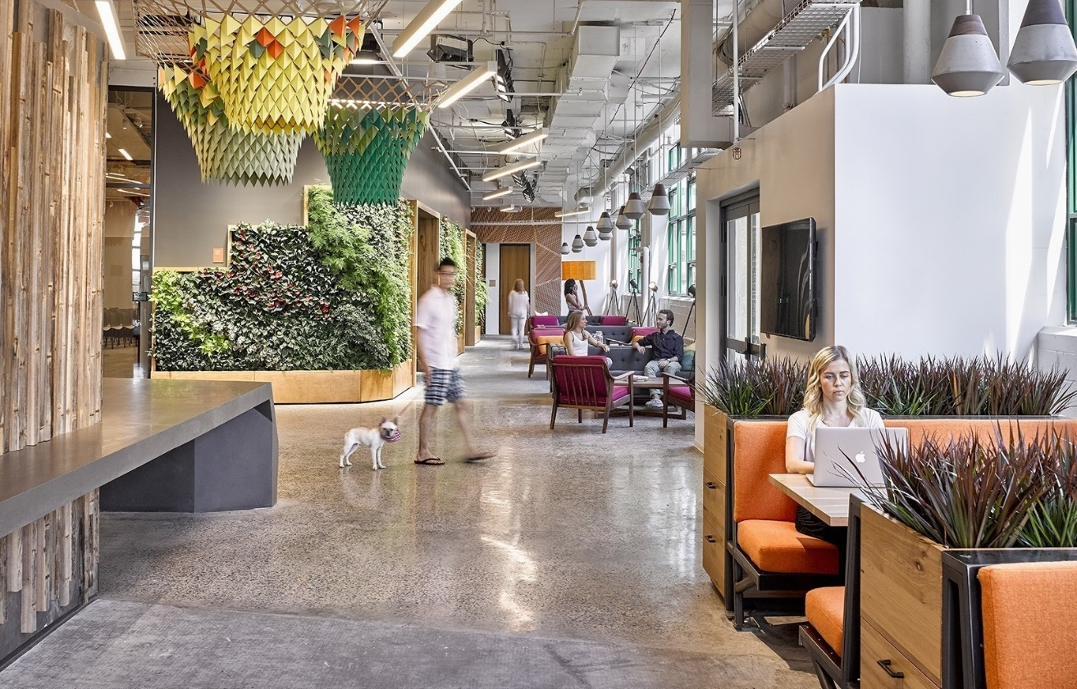
Figure 20 Lobby with living wall ("Etsy Offices - New York City," n.d.)
Almost all of the online sources highlighted biophilic design as a theme throughout the space. The patterns of biophilic design help to complete the beauty, as well as the health and happiness petals for the Living Building Challenge certification. Visual connection to nature is a prominent pattern represented through the five living walls, custom planters wrapped around each structural column, and several other planting arrangements scattered around each floor. Figure 21 shows a large planter used as a space divider in what is called the green library. Figures 22 shows the living walls that line a corridor in the office. The living walls were referenced twenty-two times throughout the twenty articles written about this site. Most frequently they are referenced in regard to the building’s sustainable rainwater usage. The building has a 3,500-gallon tank that collects storm runoff and irrigates the extensive interior green scaping ("Gensler-Designed Etsy HQ Achieves Living Building Challenge Certification," 2017). This is how the design was able to reduce the overall building water usage, as well as water waste and flooding in the surrounding community. The living wall is also often referenced in regard to indoor air quality improvements. There is no mention of the direct impact the interior greenery has on indoor air quality, but these two concepts are often discussed together, much like in the other projects explored in this study. This site is expected to have good air quality because of the strict standards for materials and products used, operable windows to let in outdoor air, and the use of advanced sensors and air quality monitoring devices. Employees have the ability to monitor indoor air quality directly through an app on their phones. This is also how employees are involved with thermal comfort and HVAC controls ("2020 COTE Top 10: Etsy Headquarters," n.d.). The living walls’ contribution to humidity levels and thermal comfort was not prominently discussed in any of the articles. It can be assumed that employees will be pleased with the office’s thermal conditions and air quality because they have opportunity to control and monitor them, but it is yet to be evaluated if occupants attribute good air quality to the presence of interior green walls. Acoustic properties of the living walls were not discussed, and neither were any of the acoustic strategies used in this workplace. The office is housed in an old manufacturing building and seems to have little acoustic treatment. Measuring the reverberation time in corridors lined with living walls and comparing them to corridors without plantscapes will provide data to evaluate the living walls’ impact on the building’s acoustics. The living walls are located at the entrance lobby and along a corridor that faces exterior glazing. From the information and images available, it looks like daylight is available to light the plant walls and there are only light fixtures placed to supplement the natural light at the lobby living wall. Many of the articles referenced the building’s energy savings from their light sensors and daylight harvesting strategies. The artificial lighting controls utilized include occupancy sensors, daylight-responsive sensors, timers, as well as window film that mitigates glare ("2020 COTE Top 10: Etsy Headquarters," n.d.).
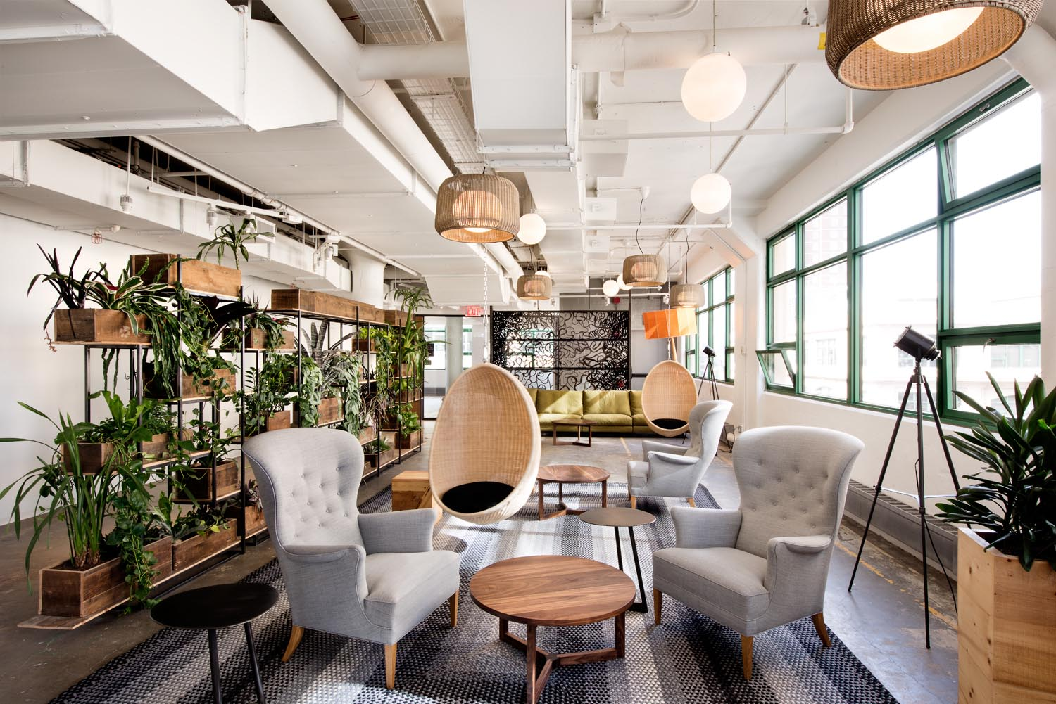
Figure 21 Green library with custom planters ("Designing our Living, Breathing Headquarters," n.d.)
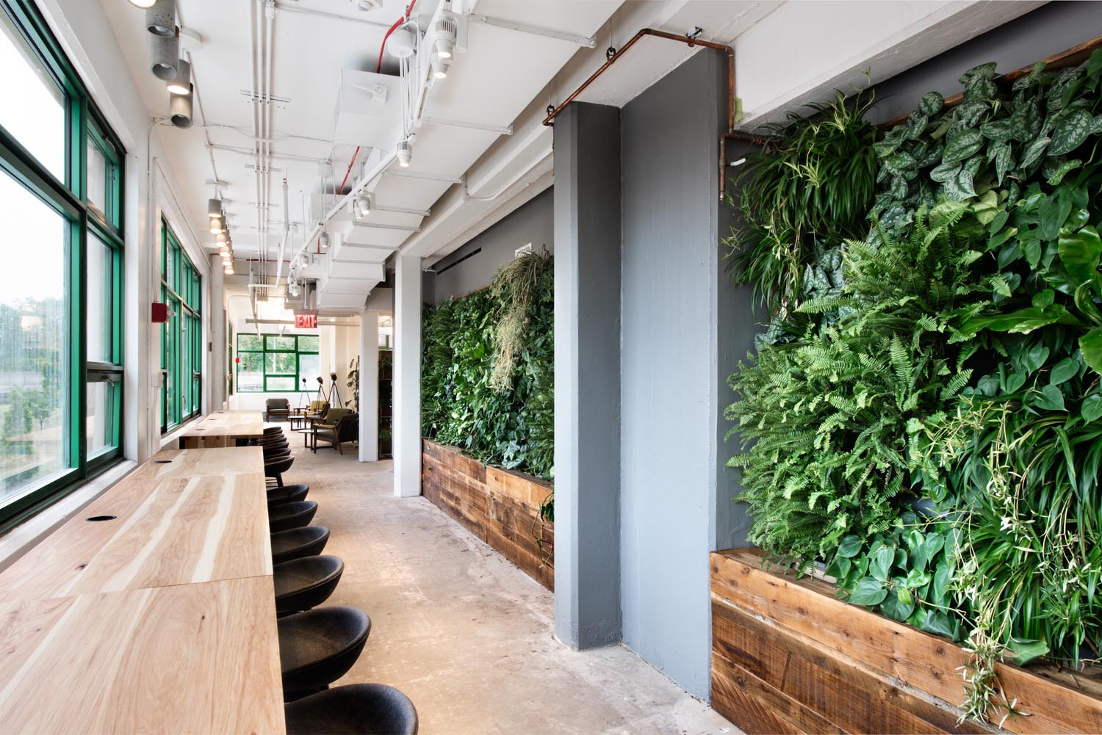
Figure 22 Corridor with living walls ("Designing our Living, Breathing Headquarters," n.d.)
Based on the information available, the site’s scores for each indoor environmental quality parameter are shown below in Table 5. The living walls strongly impact the occupants use of daylight in the space. There is seating around the living walls encouraging people to enjoy naturally lit spaces. Daylight also penetrates deep into the space because of the amount of exterior glazing and open office plan. Each of the other areas were expected to be moderately impacted by the living walls on site based on the amount of information available. These scores could change based on field verification measurements and in person observations of the current conditions.
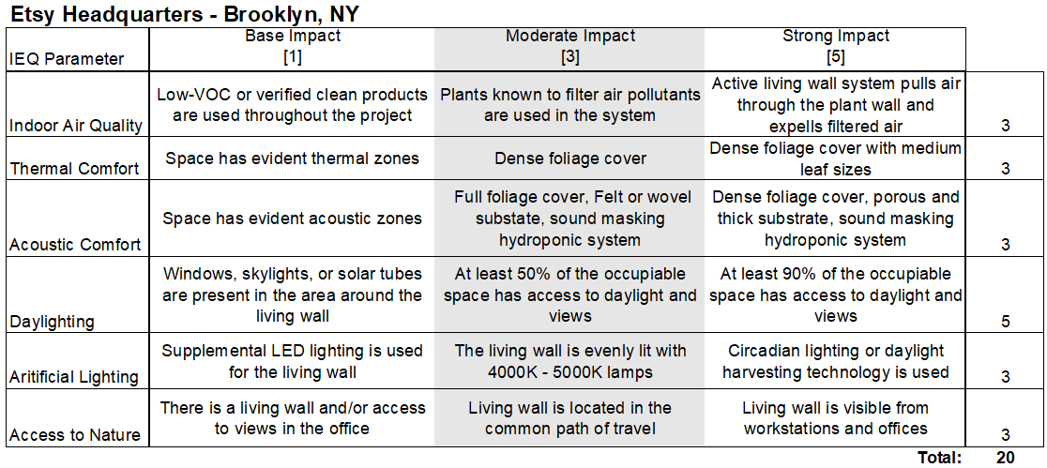
Table 5 Etsy Headquarters IEQ Scores
  - Cross-case Analysis
The impact of the living walls in each of these case studies is measured in each of the tables presented previously. The Delos headquarters received the most points for overall indoor environmental quality impact. The areas of impact that stood out in this case were the indoor air quality and access to nature parameters. Delos received the highest scores in these two areas among all of the cases. The active living wall systems have been proved to improve air quality in a realistic study, and they are scattered all over the office to maximize their impact. The Toyota headquarters’ living wall had the lowest overall indoor environmental quality impact. This is largely due to the living wall’s location away from the main workplace area. It is likely that many of the occupants will not interact with it on a regular basis. The OFS living wall stood out in this evaluation because of its construction and acoustic properties. The other case studies all scored relatively low in acoustic comfort compared to the OFS headquarters office. All of these living wall applications seemed to be well lit and increased the occupants’ likelihood of getting access to natural light in their workplace. The highest scores overall were in the thermal comfort category, which is surprising. Research related to thermal comfort and living walls is minimal and it is not discussed as a benefit of these living walls in any of the articles written about the case studies. This could be because of the lack of research on the topic. The only factor that was evaluated for this parameter was the perceived leaf size and coverage based on digital images of the site. Thermal comfort is also highly subjective and difficult to measure. This analysis indicates that a living wall’s impact on indoor environmental quality can vary between manufacturers and different types of construction. However, they are most likely to impact thermal comfort and occupant’s access to natural daylight. Looking at the tables and how each of the areas of impact were evaluated for the living walls, it should be highlighted that characteristics related to the type of plants used were often deciding factors in the strength of impact. Therefore, the impact of the living walls is largely due to the plant composition.
As the study is designed, the comparative analysis across these case studies reveals the most successful application of an interior living wall, as well as the few areas of indoor environmental quality that are most affected by the living wall in the space. The presented information does not conclusively answer the research question regarding the living walls true effect on occupant satisfaction and comfort. In-person observation and field verification measurements at each site should be done to confirm what areas of indoor environmental quality are most impacted by each case study site’s living wall. An occupant survey will also be needed to evaluate if occupants perceive the living wall as something that improves their overall satisfaction and comfort at work.
- DISCUSSION

The case studies conducted in this research study are meant to be investigated further. Based on the preliminary case study analysis, it can be hypothesized that living walls most effect thermal comfort and an occupant’s access to natural light in an office space. The Delos headquarters was the most successful because the living walls used were active living wall features, and they were placed all over the office to create multiple opportunities for occupants to interact with them. Living walls are most often viewed as a fascinating biophilic elements that enhance visual appeal in the workplace. These features are commonly associated with green building practices and are expected to be received positively in workplace environments. Many sources would associate living walls with improved air quality, without providing evidence or basis for the claim. It would be interesting to see how the living walls in an office have been marketed to the employees. It is also necessary to evaluate how the building occupants view these design features. Do they notice and feel the benefits in their everyday experience at work?
There are some questions still unanswered and because of the limited available resources, the information gathered for the case studies requires confirmation through field observations and measurements. The sources used to evaluate the sites mostly consist of news articles. Workplaces have been heavily impacted by the recent COVID-19 pandemic and have had to alter work structure, interior layout, and mode of communicating in the office, in an effort to make employees feel safe and comfortable at work. Many workforces are still working remotely or offering the option of flexible office hours to employees (Chen, 2021). Regular building use is important for thriving indoor plants. The wall-mounted plants might struggle in tightly sealed buildings without people around to release carbon dioxide needed for photosynthesis. Additionally, lack of maintenance could reduce the wall’s ability to perform as expected.
Furthermore, without employees in the office, there is no one to observe or to take an occupant survey. This is one of the limitations that prevented the remainder of this study to be carried out. However, the state of the workforce today and the expectation of flexibility is the very reason why this research is important. Finding ways to improve occupant satisfaction and comfort at work will draw employees back to the office. Well-designed work environments with informed design solutions are imperative for the evolving needs of employees.
To further strengthen the study, one should perform field verification observations and measurements to compare with the results previously presented for the case study analysis that only had access to online publications. Field observations are necessary to confirm the expected condition of the workplace and see if any of the previously mentioned factors related to the pandemic have affected the operations of the building. Field observations will allow for a more complete understanding of how people may interact with the living wall on site, and it would also reveal how the occupants work and their innate preferences for different types of workspaces. In addition to critical observations, field measurements of light levels, acoustic conditions, thermal conditions, and indoor air quality are needed to verify the findings previously presented. When measuring light levels, a simple light meter can be used. One can measure the levels of light at different spots throughout the office to evaluate the lighting variation and different layers used in the office. However, to evaluate the effectiveness of the lighting scheme with regard to the living wall performing properly, one should measure the lighting levels across various spots on the living wall plane. The wall should ideally be evenly lit with broad spectrum lights. According to a study completed by Dr. Amardeep Dugar, the optimal color temperature is between 4000 and 5600 Kelvin and optimal lighting levels are a consistent spread of light no less than 50 footcandles at any point on the wall (Dugar, n.d.). Some manufactures may suggest more light based on the plant composition and location of the wall in the space. To evaluate the living wall’s effect on acoustic comfort, one should first measure the reverberation time in the space where the living wall is to see if it is adequate for the intended use of that space. The expected reverberation time for office spaces and classrooms is around one second or less to allow for good speech intelligibility. After determining if the acoustics are adequate, one can measure the sound pressure in a few spots around the office, in addition to in the area first evaluated, and see if the space that houses the living wall has a lower sound pressure. This would indicate that it is effectively absorbing some amount of the ambient noise. What is important to note here, is if the living wall is contributing to this acceptable or unacceptable reverberation time in the space. To evaluate thermal comfort, individual leaf area is expected to have the highest impact on the walls ability to cool ambient air and is likely the easiest way to compare the living walls at each site. However, one can also measure the dry bulb temperature and relative humidity to determine if the thermal conditions in the surrounding space fall in the comfort zone prescribed by the psychometric chart. This suggested comfort zone is meant to ensure 80 percent satisfaction with thermal comfort conditions. Thermal comfort is associated with indoor air quality and can also affect occupant self-assessed health and productivity. Indoor air quality (IAQ) is the factor most related to sick building syndrome (SBS). To measure the living wall’s impact on IAQ one should take measurements of pollutants in spaces directly adjacent to the living wall, and again in another part of the building for comparison. To measure the IAQ, one should evaluate carbon dioxide levels, inhalable particulate matter (PM2.5), and common VOCs. After completing all of these field measurements, one can reevaluate the scores given to each of the case study sites and get a better understanding of how the living walls are affecting each of these indoor environments.
To verify and further explore the effect of living walls on occupant satisfaction, one should directly ask the occupants about their experience. A self-administered survey was another research strategy explored for this thesis project. A survey tool would work well as an accompanying method of data collection, as it would confirm or disprove the conclusions drawn from the presented set of results. Interior design is a profession centered around user experience, and that is why occupant surveys and questionnaires are strong tools for evidence-based design.
The survey designed for this study is based on self-assessment and evaluates personal values, motives, and feelings. It is to be distributed through email and responses are to be recorded as anonymous to encourage participation and frankness. Online mailer surveys allow for a wider distribution in a short amount of time, but they also have the possibility of a lower response rate (Robson, 2002). The questions have been adapted from the Environmental Protection Agency’s (EPA) Building Assessment Survey and Evaluation (BASE) study questionnaire and the Center for the Built Environment’s (CBE) indoor environmental quality (IEQ) benchmark. The CBE benchmark survey is a tool for building stakeholders, designed to assess the performance and success of the design of a space ("Indoor Environmental Quality Survey and Building Benchmark," n.d.). The EPA survey is a tested and validated method used to study the perceived IEQ and health symptoms of building occupants over a one week period in either the summer or winter season ("Methodology for the Building Assessment Survey and Evaluation Study," 2003). The questionnaire was administered to full-time individuals (20 or more hours per week) whose primary workstation is in the study areas ("Methodology for the Building Assessment Survey and Evaluation Study," 2003). A similar standardized method should be used in this survey related to specific impacts of living walls on IEQ and occupant satisfaction.

Figure 23 Structure and flow of survey

The survey is broken down into sections that will help draw connections between the responses and the evaluation of the building indoor environmental quality. The overall structure and flow of the survey is shown in figure 23. The background questions provide demographic information about the respondents and also asks about how often the respondent uses the building and how much contact they might have with the living wall on site. These questions are important for categorizing and validating the responses in the later sections of the survey. Following these questions are sections targeting occupant perception of their indoor environment and the success of the design in creating a productive workplace.
The health and well-being questions are related to the phenomenon of sick building syndrome (SBS) and building related illness (BRI). They will evaluate if the building has an overall positive or negative effect on the occupants’ health as reported by the occupants themselves. The first question identifies some common allergy related symptoms and asks how often, if at all, the participant experiences them while at work, and later asks if these symptoms cease when not in the building. These responses will speak to the self-assessed health of the participant and if the building is causing any physical irritations that might hinder his/her potential productivity. Examples of these questions are shown below in figures 24 and 25.
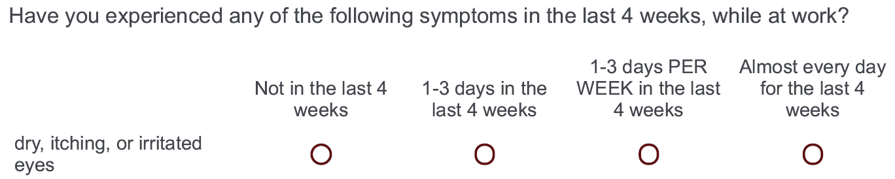
Figure 24 Health assessment question example

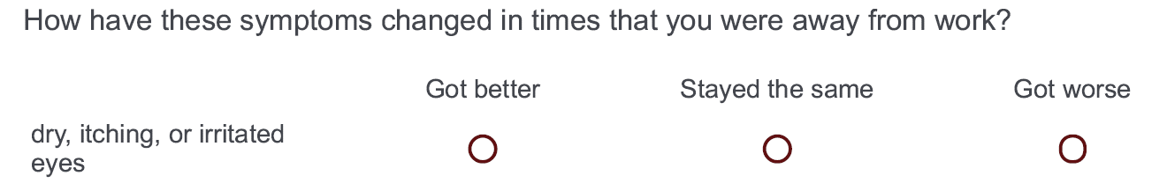
Figure 25 Symptom assessment question example

The questions related to workplace conditions use a satisfaction scale (1 = very dissatisfied, 5 = very satisfied) to ask directly about occupant satisfaction with conversational privacy, acoustic control, indoor temperature, the lighting conditions, access to nature, indoor air quality, and the overall aesthetic appearance of their workplace. Each of these aspects of design is related to indoor environmental quality and the responses may reveal areas of design that need more attention. The question pertaining to satisfaction, is followed up by a question asking if the participant sees any of these aspects of design as interfering with his/her ability to do work or if they enhance a feeling of productivity, also measured on a Likert scale (1 = significantly interfered, 5 = significantly enhances). These self-assessment questions are very important in determining what the best solution for the occupants is. After evaluating the above factors related to the environmental quality, the participants are asked if they think any of the aspects of indoor environmental quality are affected by the living wall in their space.
In the last section, the questions are written to evaluate the respondent’s values and what might make a high impact on their satisfaction with a workplace. This section asks respondents to rate workplace features on an importance scale (1 = not at all important, 5 = extremely important) and asks overall how satisfied they are with the building where they work and to identify some of their favorite and least favorite aspects of the workplace design. A full draft of the proposed survey tool can be found in Appendix A of this document.
The survey is to be distributed to the case study sites previously analyzed in this thesis: Nixon Peabody, Toyota North America, OFS Headquarters, Etsy Headquarters, and the Delos Headquarters. The survey should be distributed in either a summer or winter month, so as not to conflict with the changing of seasons and the physical stressors like cold and flu season and unpredictable weather that could impact a person’s mood. The survey will be taken online and should request a response from all of the occupants in the building, however participation is voluntary. The data received will be analyzed with the end goal of determining if the application of a living wall impacts occupant satisfaction and comfort in the workplace. Subgrouping responses can potentially reveal where living walls are perceived to be impactful in indoor environmental quality.
The results of the survey will highlight what design features are most recognizable and impactful to occupants, and it will also reveal if occupants attribute positive or negative environmental factors to the presence of a living wall, if at all. The results could reveal that occupants do not see a connection between the living wall and the indoor environmental quality. It could also reveal that they associate it with features that are unsatisfactory or features that enhance their feeling of productivity. Any of these results would still prove to be valuable with considering a living wall in a future corporate design project.

REFERENCES

2020 COTE Top 10: Etsy Headquarters. (n.d.). Retrieved from https://www.aia.org/showcases/6280254-etsy-headquarters
Acoustic Performance of Sage Greenlife Living Walls. (2019). In: Sage Vertical Gardens, LLC.
Arsenault, P. J., & Darlington, A. (2012). Indoor Air Biofilters Deliver Clean Air Naturally: Biological systems function to improve air quality while providing beautiful form. In: AIA Continuing Education Center.
Azkorra, Z., Pérez, G., Coma, J., Cabeza, L. F., Burés, S., Álvaro, J. E., . . . Urrestarazu, M. (2015). Evaluation of green walls as a passive acoustic insulation system for buildings. Applied Acoustics, 89, 46-56.
Bahour, M. H. (2017). THE APPLICATION OF LIVING WALLS FOR ACOUSTIC COMFORT.
Benefits of Living Green Walls. (n.d.). Retrieved from https://www.sagegreenlife.com/benefits/
Browning, W., Ryan, C., & Clancy, J. (2014). 14 Patterns of Biophilic Design: Improving Health and Well-Being in the Built Environment. Retrieved from http://www.terrapinbrightgreen.com/wp-content/uploads/2014/04/14-Patterns-of-Biophilic-Design-Terrapin-2014p.pdf
Buckley, B. (2016). Interior Design Best Project - Nixon Peabody. ENR MidAtlantic. Retrieved from https://www.enr.com/articles/40674-interior-design-best-project---nixon-peabody
Charoenkit, S., Yiemwattana, S., & Rachapradit, N. (2020). Plant characteristics and the potential for living walls to reduce temperatures and sequester carbon. Energy and Buildings, 225, 110286.
Chen, T.-P. (2021). Covid-19 Threatens to Blow Up Law Firms’ Intense Office Culture—for Good. Wall Street Journal. Retrieved from https://www.wsj.com/articles/covid-19-law-firm-work-from-home-11628254526
Cockrell, N. G. (2016). Nixon Peabody's Cutting-Edge D.C. Law Office. Work Design Magazine. Retrieved from https://www.workdesign.com/2016/08/nixon-peabodys-cutting-edge-dc-law-office/
Connelly, M., Bolbolan, D., Akbarnejad, M., & Daneshpanah, S. (2016). Sound Absorption and Scattering Properties of Living walls: Applications to Room Acoustics. Canadian Acoustics, 44(3). Retrieved from https://jcaa.caa-aca.ca/index.php/jcaa/article/view/2965
Cummings, B. E. (2017). Effectiveness and Energy Saving Potential of Biofiltration of Indoor Air in US Offices. (Master of Science in Architectural Engineering). Drexel University, Retrieved from https://core.ac.uk/download/pdf/190323996.pdf
D'Alessandro, F., Asdrubali, F., & Mencarelli, N. (2015). Experimental evaluation and modelling of the sound absorption properties of plants for indoor acoustic applications. Building and Environment, 94, 913-923.
Delos HQ. (n.d.). Retrieved from https://living-future.org/lbc/case-studies/23524/
Delos Living New York Headquarters. (n.d.). Retrieved from https://www.atelierten.com/projects/delos-living-new-york-headquarters/
Designing our Living, Breathing Headquarters. (n.d.). Retrieved from https://www.etsy.com/living-building-challenge#beauty
Dugar, A. M. (n.d.). Lighting Green Walls–finding the optimum CCT and SPD of white LED light sources.
Egea, G., Pérez-Urrestarazu, L., González-Pérez, J., Franco-Salas, A., & Fernández-Cañero, R. (2014). Lighting systems evaluation for indoor living walls. Urban forestry & urban greening, 13(3), 475-483.
Etsy Headquarters. (n.d.). Retrieved from https://living-future.org/lbc/case-studies/etsy-headquarters/
Etsy Offices - New York City. (n.d.). Retrieved from https://officesnapshots.com/2017/01/23/etsy-offices-new-york-city/
Fjeld, T., Veiersted, B., Sandvik, L., Riise, G., & Levy, F. (1998). The effect of indoor foliage plants on health and discomfort symptoms among office workers. Indoor and Built Environment, 7(4), 204-209.
Gensler-Designed Etsy HQ Achieves Living Building Challenge Certification. (2017). Retrieved from https://www.gensler.com/news/press-releases/etsy-headquarters-achieves-living-building-challenge
Gifford, R., & McCunn, L. J. (2012). Appraisals of built environments and approaches to building design that promote well-being and healthy behaviour.
Gillis, K., & Gatersleben, B. (2015). A review of psychological literature on the health and wellbeing benefits of biophilic design. Buildings, 5(3), 948-963. doi:https://doi.org/10.3390/buildings5030948
Gsky. (2017). Versa Wall Product Brochure. In: Gsky Plant Systems, Inc.
Gsky. (n.d.). Versa Wall Product Spec Sheet. In.
Gunawardena, K., & Steemers, K. (2019). Living walls in indoor environments. Building and Environment, 148, 478-487.
Hacias, L. (2015). Nixon Peabody: Raising the Green Bar among the D.C. Bar. Retrieved from https://www.usgbc.org/articles/nixon-peabody-raising-green-bar-among-dc-bar
Horoshenkov, K. V., Khan, A., & Benkreira, H. (2013). Acoustic properties of low growing plants. The Journal of the Acoustical Society of America, 133(5), 2554-2565.
Indoor Environmental Quality Survey and Building Benchmark. (n.d., 2021). Retrieved from https://cbe.berkeley.edu/research/occupant-survey-and-building-benchmarking/
International Living Future Institute. (2019). Living Building Challege 4.0. In Health and Hapiness: Imperative 11 Access to Nature: ILFI.
International WELL Building Institute. (2021). WELL V2. Dynamic. Resilient. Validated. In Mind.
Irga, P., Pettit, T., & Torpy, F. (2018). The phytoremediation of indoor air pollution: a review on the technology development from the potted plant through to functional green wall biofilters. Reviews in Environmental Science and Bio/Technology, 17(2), 395-415.
Jones, A. P. (1999). Indoor air quality and health. Atmospheric environment, 33(28), 4535-4564.
Joye, Y., & van den Berg, A. E. (2018). Restorative environments. Environmental psychology: An introduction, 65-75. doi:https://doi.org/10.1002/9781119241072.ch7
Kaplan, R., & Kaplan, S. (1989). The Experience of Nature: A Psychological Perspective: Cambridge University Press.
Kaplan, S. (1995). The restorative benefits of nature: Toward an integrative framework. Journal of environmental psychology, 15(3), 169-182.
Kellert, S. R. (2008). Dimensions, elements, and attributes of biophilic design. Biophilic design: the theory, science, and practice of bringing buildings to life, 3-19.
Kellert, S. R., Heerwagen, J., & Mador, M. (2011). Biophilic design: the theory, science and practice of bringing buildings to life: John Wiley & Sons.
Marchi, M., Pulselli, R. M., Marchettini, N., Pulselli, F. M., & Bastianoni, S. (2015). Carbon dioxide sequestration model of a vertical greenery system. Ecological Modelling, 306, 46-56.
Methodology for the Building Assessment Survey and Evaluation Study. (2003). Retrieved from https://www.epa.gov/indoor-air-quality-iaq/methodology-building-assessment-survey-and-evaluation-study
Naava. (2018). Science-backed Finnish green wall innovation is a quantum step for healthier indoor spaces. Retrieved from https://www.naava.io/news/science-backed-naava-green-wall-purifies-air
Naava. (n.d.). Naava Product Brochure. Retrieved from https://www.naava.io/hubfs/Downloads/naava-product-brochure-EN.pdf?utm_medium=email&_hsmi=97358930&_hsenc=p2ANqtz-8VSCemxkDWzCJslzZGK7pLbUqYDOjVFUdaR005mx8l6s7m6EVh1C7T-EZlQ1KPQbq-3HH_YjQlb1u90JulNYQa-Q04pA&utm_content=97358930&utm_source=hs_automation
Nale, K. (2020). A human-centric office sets an example in spite of strict energy requirements and a limited luminaire vocabulary. LD+A Online, (Work + Wellness).
Nixon Peabody DC. (n.d.). Retrieved from https://www.usgbc.org/projects/nixon-peabody-dc
Nixon Peaboody. (2015, 2021). Projects. Retrieved from https://ghtltd.com/projects/nixon-peabody/
OFS Corporate Headquarters Achieves WELL Certification. (n.d.). Retrieved from https://ofs.com/resources/well/certification
Pérez, G., Coma, J., Barreneche, C., de Gracia, A., Urrestarazu, M., Burés, S., & Cabeza, L. F. (2016). Acoustic insulation capacity of Vertical Greenery Systems for buildings. Applied Acoustics, 110, 218-226.
Raanaas, R. K., Evensen, K. H., Rich, D., Sjøstrøm, G., & Patil, G. (2011). Benefits of indoor plants on attention capacity in an office setting. Journal of environmental psychology, 31(1), 99-105.
Rich, D. L. (2007). Effects of exposure to nature and plants on cognition and mood: A cognitive psychology perspective. Cornell University,
Rivera, E. (2014). Quantifying CO2 removal by living walls: a case study of the Center for Design Research.
Robson, C. (2002). Real World Research: A Resource for Social Scientists and Practitioner-Researchers (Second ed.): Blackwell Publishing.
Shao, Y., Li, J., Zhou, Z., Zhang, F., & Cui, Y. (2021). The Impact of Indoor Living Wall System on Air Quality: A Comparative Monitoring Test in Building Corridors. Sustainability, 13(14), 7884.
Silvestri, R. (2017). Inside One Toyota: A look at the campus and the culture. Local Profile. Retrieved from https://localprofile.com/2017/10/25/inside-one-toyota-campus-culture/
Technology. (n.d.). Retrieved from https://www.sagegreenlife.com/process/technology/
Torpy, F., Clements, N., Pollinger, M., Dengel, A., Mulvihill, I., He, C., & Irga, P. (2018b). Testing the single-pass VOC removal efficiency of an active green wall using methyl ethyl ketone (MEK). Air Quality, Atmosphere & Health, 11(2), 163-170.
Torpy, F., & Zavattaro, M. (2018a). Bench-study of green-wall plants for indoor air pollution reduction. J. Living Archit, 5(1), 1-15.
Torpy, F., Zavattaro, M., & Irga, P. (2017). Green wall technology for the phytoremediation of indoor air: a system for the reduction of high CO 2 concentrations. Air Quality, Atmosphere & Health, 10(5), 575-585.
Toyota HQ - Green Wall. (n.d.). Portfolio. Retrieved from https://naturahq.com/portfolio_page/toyota-hq-green-wall/
Toyota Motor North American Headquarters. (n.d.). Retrieved from https://www.usgbc.org/projects/toyota-motor-north-america-headquarters
United States Green Building Council. (2021). Why LEED. Retrieved from https://www.usgbc.org/leed/why-leed
Volatile Organic Compounds' Impact on Indoor Air Quality. (2021). Retrieved from https://www.epa.gov/indoor-air-quality-iaq/volatile-organic-compounds-impact-indoor-air-quality
Wilson, E. O. (1984). Biophilia: Harvard university press.
Wolverton, B. C., Douglas, W. L., & Bounds, K. (1989). A study of Interior Landscape Plants for Indoor Air Pollution Abatement. Retrieved from https://ntrs.nasa.gov/api/citations/19930073077/downloads/19930073077.pdf
Wong, N. H., Tan, A. Y. K., Tan, P. Y., Chiang, K., & Wong, N. C. (2010). Acoustics evaluation of vertical greenery systems for building walls. Building and Environment, 45(2), 411-420.
Yin, R. K. (2014). Case Study Research: Design and Methods (5th ed.): Sage Publications.

Appendix A: Proposed Occupant Survey Tool
This survey was designed to answer the research questions stated in this thesis paper. Due to limitations, this survey was not conducted, so it is added here as a proposal for future study. The questions below are adapted from other indoor environmental quality evaluation and altered to fit the needs of this research project pertaining to living walls.
Start of Block: Background Information
1-1 Please select your age.
- 18-24 years (1)
- 25-34 years (2)
- 35-44 years (3)
- 45-64 years (4)
- 65 years and older (5)

1-2 Where do you work?
- Nixon Peabody DC (1)
- OFS Corporate Headquarters (2)
- Toyota Motor North America (3)
- Etsy Headquarters (4)
- Delos Headquarters (5)

1-3 How long (in years) have you worked in this building.
- less than 1 year (1)
- 1-3 years (2)
- 3-5 years (3)
- more than 5 years (4)

1-4 About how many hours per week do you work in this building?
- Less than 10 (1)
- 10-24 hours (2)
- 25-34 hours (3)
- 35 or more hours (4)

1-5 Please describe your current workstation type. (Ex: enclosed private office, tall partition system, low partition system, open benching, roaming/mobile, etc.)
________________________________________________________________

1-6 About how many people work in the room in which your workstation is located? (Include yourself)
- 1 (1)
- 2-4 (2)
- 5-8 (3)
- more than 8 (4)

End of Block: Background Information

Start of Block: Health and Wellbeing
2-1 Have you experienced any of the following symptoms in the last 4 weeks, while at work?
2-1 | Not in the last 4 weeks (1) | 1-3 days in the last 4 weeks (2) | 1-3 days PER WEEK in the last 4 weeks (3) | Almost every day for the last 4 weeks (4)
dry, itching, or irritated eyes (1)
wheezing (2)
headache (3)
sore or dry throat (4)
unusual tiredness, fatigue, or drowsiness (5)
chest tightness (6)
stuffy or runny nose (7)
cough (8)
tired or strained eyes (9)
tension, irritability, or nervousness (10)
sneezing (11)
dizziness or lightheadedness (12)
feelings of depression (13)
shortness of breath (14)
nausea or upset stomach (15)
dry or itchy skin (16)

2-2 How have these symptoms changed in times that you were away from work?
2-2 | Got better (1) | Stayed the same (2) | Got worse (3)
dry, itching, or irritated eyes (1)
wheezing (2)
headache (3)
sore or dry throat (4)
unusual tiredness, fatigue, or drowsiness (5)
chest tightness (6)
stuffy or runny nose (7)
cough (8)
tired or strained eyes (9)
tension, irritability, or nervousness (10)
sneezing (11)
dizziness or lightheadedness (12)
feelings of depression (13)
shortness of breath (14)
nausea or upset stomach (15)
dry or itchy skin (16)

2-3 In the last 4 weeks, how often have any of the symptoms listed above reduced your ability to work? (Specify in days)
________________________________________________________________

End of Block: Health and Wellbeing

Start of Block: Workplace Conditions
3-1 How satisfied are you with the following aspects of your workplace?
 | Very dissatisfied (1) | Dissatisfied (2) | Neither satisfied nor dissatisfied (3) | Satisfied (4) | Very satisfied (5)
Conversational privacy (1)
Freedom from distracting noise (2)
Indoor temperature (3)
Lighting conditions (4)
Access to nature (5)
Indoor air quality (6)
Overall aesthetic appearance (7)

3-2 Do these factors interfere or enhance your experience and ability to do work?
 | Significantly interferes (1) | Somewhat interferes (2) | Neither enhances nor interferes (3) | Somewhat enhances (4) | Significantly enhances (5)
Conversational privacy (1)
Freedom from distracting noise (2)
Indoor temperature (3)
Lighting conditions (4)
Access to nature (5)
Indoor air quality (6)
Overall aesthetic appearance (7)

3-3 Is there a living wall in your office building?
- Yes (1)
- No (2)

Skip To: 3-3.1 If Is there a living wall in your office building? = Yes
Skip To: 3-4 If Is there a living wall in your office building? = No

3-3.1 Do you think the living wall positively or negatively impacts any of these environmental factors?
 | made worse (6) | not affected (7) | improved (8)
Conversational privacy (1)
Freedom from distracting noise (2)
Indoor temperature (3)
Lighting conditions (4)
Access to nature (5)
Indoor air quality (6)
Overall aesthetic appearance (7)

3-4 Please describe any other workplace conditions that have either positively or negatively impacted your comfort or satisfaction with your work environment
________________________________________________________________

End of Block: Workplace Conditions

Start of Block: Green Building
4-1 How important are the following to you when looking for a place to work?
 | Not at all important (11) | Slightly important (12) | Moderately important (13) | Very important (14) | Extremely important (15)
The building's exterior or interior design (1)
Sustainable/green building affiliations and features (2)
feeling physically comfortable in your interior environment (3)
Access to nature while at work (4)
The company's dedication to sustainability (5)

4-2 Overall, how satisfied are you with the building that you work in?
- Extremely dissatisfied (21)
- Somewhat dissatisfied (22)
- Neither satisfied nor dissatisfied (23)
- Somewhat satisfied (24)
- Extremely satisfied (25)

4-3 What are some of your favorite aspects of your workplace's design? (ex: comfortable furniture, connection to nature, employee amenities, opportunity for collaboration, etc.)
________________________________________________________________

4-4 What are some of your LEAST favorite aspects of your workplace's design? (ex: furniture, presence of nature, lack of employee amenities, etc.)
________________________________________________________________

End of Block: Green Building

