UNIVERSITY OF OKLAHOMA
GRADUATE COLLEGE

FABRICATION OF IMPROVED COMPOSITE LAMINATES BY USING A SLIDING MAGNETIC TOOL DURING WET LAYUP/VACUUM BAGGING

A THESIS
SUBMITTED TO THE GRADUATE FACULTY
in partial fulfillment of the requirements for the
Degree of
MASTER OF SCIENCE

By
MARLI SUSSMANN
Norman, Oklahoma
2018

FABRICATION OF IMPROVED COMPOSITE LAMINATES BY USING A SLIDING MAGNETIC TOOL DURING WET LAYUP/VACUUM BAGGING

A THESIS APPROVED FOR THE
SCHOOL OF AEROSPACE AND MECHANICAL ENGINEERING

BY

______________________________
Dr. M. Cengiz Altan, Chair

______________________________
Dr. Mrinal C. Saha

______________________________
Dr. Yingtao Liu

© Copyright by MARLI SUSSMANN 2018
All Rights Reserved.
Acknowledgements
I would like to deeply thank Dr. Altan for the guidance and direction he provided throughout my research as both an undergraduate and graduate student. I would also like to thank the members of my committee, Dr. Saha and Dr. Liu, for their time, support, and advisement in crucial moments. I would also like to give special thanks to Maya Pishvar and Mehrad Amirkhosravi for offering exceptional help in fabricating and testing materials. They provided great assistance in helping me finish my research. I would also like to thank other members of the lab, Akif Yalcinkaya, Gorkem Guloglu, and Youssef Hamidi. They helped me obtain a better understanding of composite materials and their fabrication. I certainly could not have done the research I was able to do without the help of all of these very talented people. Thank you all so very much.

Table of Contents
Chapter 1: Introduction and Literature Survey………………………………………..... 1
1.1 Introduction…………………………………………………………………. 1
1.2 Literature Survey……………………………………………………………. 8
1.3 Scope of Research…………………………………………………………. 13
Chapter 2: Materials and Methods…………………………………………………….. 15
2.1 Laminate Materials……………………………………………………….... 15
2.1.1 Fabrics…………………………………………………………….15
2.1.2 Resin……………………………………………………………...16
2.1.3 Magnetic Lift……………………………………………………..16
2.2 Laminate Fabrication……………………………………………………….20
2.2.1 Preparation of the Fabric………………………….………………21
2.2.2 Preparation of the Resin………….……………………………….22
2.2.3 Hand Layup and Vacuum Bagging…..…………………………...23
2.2.4 Application of the Magnetic Lift………………………………….25
2.2.5 Vacuum Assisted Resin Transfer Molding (VARTM)……………31
2.3 Characterization of Laminate Properties……………………………………34
2.3.1 Cutting Layout of the Laminate.…………………………………35
2.3.2 Density Measurements…………………………………………....38
2.3.3 Fiber Volume Fraction and Void Content………………………..39
2.3.4 Scanning Electron Microscope (SEM) Imaging………………….41
2.3.5 Flexural Properties………………………………………………..42
2.3.6 Mean and Confidence Interval Calculations……………………..43
Chapter 3: Characterization Results……………………………………………………44
3.1 Laminate Thickness………………………………………………………...44
3.1.1 Random Mat Laminates………………………………………….45
3.1.2 Plain Weave Laminates…………………………………………..48
3.1.3 Pressure Application……………………………………………...49
3.2 Thickness Variation within Laminates...…………………………………...51
3.2.1 Random Mat Laminates……………………………………….....52
3.2.2 Plain Weave Laminates…………………………………………..54
3.3 Fiber Volume Fraction……………………………………………….…….56
3.3.1 Random Mat Laminates………………………………………….56
3.3.2 Plain Weave Laminates…………………………………………..58
3.4 Void Volume Fraction……………………………….……………………..60
3.4.1 Random Mat Laminates………………………………………….61
3.4.2 Plain Weave Laminates…………………………………………..62
3.5 Scanning Electron Microscope (SEM) Imaging……………………………63
3.5.1 Random Mat Laminates…………………………….……………64
3.5.2 Plain Weave Laminates………………………………………..…69
3.6 Flexural Strength and Stiffness…………………………………………….73
3.6.1 Random Mat Laminates………………………………………….74
3.6.2 Plain Weave Laminates…………………………………………..76
3.7 Vacuum Assisted Resin Transfer Molding (VARTM) Comparison……….78
3.7.1 Random Mat Laminates………………………………………….78
3.7.2 Plain Weave Laminates…………………………………………..81
Chapter 4: Conclusion………………………………………………………………….85
References……………………………………………………………...………………87

List of Tables
Table 1: Glass fabric characteristics……………………………………………............16
Table 2: PNL0250 (Mag-Mate) magnetic lift characteristics…………………………..19
Table 3: Characteristics of random mat and plain weave fabrics for laminates……..…21
Table 4: Amount of resin used during fabrication for each fabric type………………..23
Table 5: Case descriptions for the laminates fabricated with an increasing number of
passes………………………………………………………………………….26
Table 6: Percent decrease in average thickness of random mat laminates……………..47
Table 7: Average thickness and percent decrease for plain weave laminates………….49
Table 8: Increasing applied pressure as thickness is reduced based on empirical pressure
vs. distance data……………………………………………………………….50
Table 9: Data table for the 95% confidence intervals for random mat laminate
thickness………………………………………………………………...…….53
Table 10: Data table for the 95% confidence intervals for plain weave laminate
thickness…………………………………………………………………...…55
Table 11: Fiber volume fraction and percent increase for random mat laminates……..58
Table 12: Fiber volume fraction and percent increase for plain weave laminates……..60
Table 13: Void content and percent decrease for random mat laminates……………....62
Table 14: Void content and percent decrease for plain weave laminates………………62
Table 15: Flexural strength and stiffness data and percent increase of both for random
mat laminates………………………………………………………………...75
Table 16: Flexural strength, elastic modulus, and percent increase of plain weave
Laminates……………………………………………………………………77
Table 17: Material properties for wet layup/vacuum bag and VARTM fabricated
random mat laminates…………………………………………………….…81
Table 18: Material properties for wet layup/vacuum bag and VARTM fabricated plain
weave laminates……………………………………………………………...84

List of Figures
Figure 1: PowerLift Magnet PNL0250 (Mag-Mate), the magnetic lift used in
fabrication……………………………………………………………………17
Figure 2: The alignment of the two internal magnets either (a) cancelling out (‘OFF’) or
(b) combining and resulting in an attractive force (‘ON’)…………………..18
Figure 3: Bottom surface of magnetic lift……………………………………………...19
Figure 4: Pressure of the magnetic lift versus distance from the base mold. The base mold
is made of 1/4 in stainless steel ……………………………………………...20
Figure 5: Dimensions for resin constraint made with perforated release film and
tape..................................................................................................................25
Figure 6: Completed wet layup/vacuum bag procedure with vacuum pressure applied.
The magnet is applied on the greased (red) area…………………………….25
Figure 7: Vacuum bag wrapped magnetic lift, and red grease covered application
area………………………………………….……………………………….27
Figure 8: Direction of the resin outflow when a static magnetic pressure is applied by the
stationary magnetic lift………………………………………………………28
Figure 9: Resin pushed to the outlet and transported out of the laminate out by the
sliding magnet…………………………………………………………….…29
Figure 10: Completion of the side-by-side passes covering the entire laminate is counted
as a single pass ……….………………………............................................30
Figure 11: Foam edged scrapper used to redistribute grease during magnet
application…………………………………………………………………..31
Figure 12: Vacuum infusion layout for preform, flow mesh, peel ply, and tacky
tape…………………………………………………………………………32
Figure 13: Vacuum infusion layout for release film, peel ply covering inlet and outlet,
and inlet and outlet tubing………..………………………………………...33
Figure 14: VARTM layup before resin infusion and after vacuum…………………....33
Figure 15: Cutting layout for laminates made with random mat fabric……………….36
Figure 16: Cutting layout for laminates made with plain weave fabric………………..36
Figure 17: Dimensional components for determining sample length for three-point
bending…………………………………………………………….……….37
Figure 18: Reduction of laminate thickness as a function of the number of passes of
the magnetic lift for random mat laminates ………………… ………..…..46
Figure 19: Average percent decrease in thickness for random mat laminates……...….47
Figure 20: Reduction of laminate thickness as a function of the number of passes of the
magnetic lift for plain weave laminates …………………………………...48
Figure 21: Average percent decrease in thickness for plain weave laminates………....49
Figure 22: 95% confidence interval of thickness measurements for random mat
laminates……………………………………………………………..……..53
Figure 23: 95% confidence interval of thickness measurements for plain weave
laminates………………………………………………………………..…..55
Figure 24: Improvement in fiber volume fraction for chopped strand, random mat
laminates…………………………………………………………………….57

Figure 25: Correlation between the percent reduction in thickness of random mat
laminates with the percent increase in fiber volume fraction………………58
Figure 26: Improvement in fiber volume fraction for plain weave laminate………......59
Figure 27: Correlation between the percent reduction in thickness of plain weave
laminates with the percent increase in fiber volume fraction……………....60
Figure 28: Percent decrease in void content for both plain weave and random mat
laminates……………………………………………………………………63
Figure 29: SEM images with increased magnification showing types of voids in the
random mat, single pass case……………………………………………….65
Figure 30: SEM image of an elongated void in the 1-pass random mat case…………..65
Figure 31: Microstructure of (a) WLVB-RM-4-0, (b) WLVB-RM-4-1,
(c) WLVB-RM-4-6, (d) WLVB-RM-4-12, and (e) WLVB-RM-4-18
Laminates…………………………………………………………………...66
Figure 32: Microstructure of (a) WLVB-PW-6-0, (b) WLVB-PW-6-1,
(c) WLVB-PW-6-6, and (d) WLVB-PW-6-12 laminates…………………..70
Figure 33: SEM images with 150X magnification showing (a) spherical voids, (b)
elongated voids, and (c) voids within the tows in 0-pass, plain weave
laminates …………………………………………………………….……72
Figure 34: Fracture due to tension at the bottom surface of the laminate for both random
mat and plain weave laminates……………………………………………...74
Figure 35: Relationship between fiber volume fraction, flexural strength, and flexural
stiffness for random mat laminates…………………………………………75
Figure 36: Increase in flexural strength and stiffness of plain weave laminates ...…….77
Figure 37: Relationship between fiber volume fraction, flexural strength, and flexural
stiffness for plain weave laminates…………………………………………77
Figure 38: Comparison between the decrease in thickness, increase in fiber volume
fraction, decrease in void content, increase in flexural strength, and increase
in flexural stiffness for the random mat WLVB laminates and VARTM
laminate……………………………………………………...……………..79
Figure 39: Comparison between the decrease in thickness, increase in fiber volume
fraction, decrease in void content, increase in flexural strength, and increase
in flexural stiffness for the plain weave WLVB laminates and VARTM
laminate….....................................................................................................82

Abstract

A magnetic lift that utilizes magnetic polarization to create “on” and “off” conditions is used to easily and safely apply consolidation pressure on E-glass/epoxy laminates fabricated using the wet layup/vacuum bagging (WLVB) method. Chopped strand, random mat and plain weave glass fabrics are chosen to explore the effects of implementing this inexpensive and easy-to-use tool. The improvement of laminate quality is studied by investigating the fiber volume fractions, void volume fractions, and flexure properties of laminates fabricated with this modified WLVB method. These material properties were successfully improved for both fabric types. The fiber volume fraction of the random mat laminates is improved by 44.5% from 18.9% to 34.1%, and by 14.4% from 45.7% to 53.2% for the plain weave laminates. The percent reduction in void volume fractions for the random mat and plain weave laminates are 58.1% from 1.74% to 0.73%, and 57.3% from 3.44% to 1.47%, respectively. The mechanical properties were also improved by sliding the magnet across the surface of the laminates. The improvement in the flexural strength of the random mat laminates is 45.2% from 248.7 MPa to 454.0 MPa, and the improvement to the elastic modulus is 46.8% from 7.7 GPa to 14.4 GPa. For the plain weave laminates, the improvement in flexural strength and elastic modulus are 16.5% from 638.9 MPa to 765.2 MPa, and 21.3% from 24.1 GPa to 30.6 GPa, respectively.

Chapter 1: Introduction and Literature Survey
  - Introduction
The first fully synthetic thermoset plastic, Bakelite, was patented by Leo Baekeland in 1907, and began the “age of plastics” and the field of synthetic resin research [1]. Later, in 1935, Owens-Illinois, partnered with Corning Glass, began production of experimental glass fibers, primarily for use in insulation. By 1938 the two companies merged and Owens-Corning Fiberglass was established with the primary function of manufacturing fiberglass [2]. Soon after, engineers discovered that adding fiber reinforcements to plastics resulted in a very lightweight, structurally strong material. Due to the reduced weight and increased material properties, glass fiber reinforced plastics (GFRP), generally E-glass/polyester, were industrially produced for military aircraft during World War II [3]. After the war, since the infrastructure for GFRPs was already established, boat manufacturers capitalized on the technology and began developing composite boats as early as 1947 [4]. They took advantage of these cheaper, lighter materials and illustrated the advantage of using composite materials commercially, leading the advancements of today.

In the search to create high performance composites with reduced weight and increased strength and stiffness, low-cost manufacturing became less important, and less cost-effective manufacturing techniques were developed and implemented, primarily aimed at improving structural performance. The best quality composites are often achieved using an autoclave, a heated pressure vessel that can apply high temperatures and pressures to the laminates inside during fabrication. Pressure applied during the cure cycle drives out excess resin and voids and consolidates the fabric, thus minimizing the number of defects in the final laminate. The quality of autoclave laminates results in their wide use in the aerospace industry, where utilization of high performance composite materials is particularly important. However, in many applications, the cost of the equipment proves to be a disadvantage. Autoclaves used in the aerospace industry are generally sizeable, because they are used to fabricate parts of various sizes, including very large parts, such as aircraft wings and fuselages. The cost of purchasing, installing, and operating an autoclave of this size is a very expensive endeavor. Additionally, large amounts of energy are consumed during each cure cycle. The cost of operating an autoclave significantly increases the manufacturing cost per part. For comparison, the equipment costs for common out-of-autoclave (OOA) techniques, such as wet layup and vacuum assisted resin transfer molding (VARTM), range from hundreds to thousands of dollars, which is significantly less than the price of an autoclave [5].

Wet layup, one of the initial fabrication technique for composites, is an open mold technique where dry fiber mat or a preform is placed in a mold one ply at a time while resin is added using hand rollers, brushes, or squeegees until each ply is fully impregnated. This procedure makes wet layup a good alternative for small lot production because of the quick start up times, minimal tooling, and reduced overhead costs, however the quality of the materials manufactured this way are much lower than autoclave material.

The characteristics that greatly affect the overall quality of a composite material are void content and fiber volume fraction. Improvement of these will result in improved material and mechanical properties. Voids can be caused by either entrapment of air during layup, impregnation, or by volatiles that are released by particular resin systems. Voids can grow by either coalescence of smaller voids or by pressure differences that upset the equilibrium between the void and resin pressures and allow the voids to expand [6]. It is also well-known that the voids serve as crack nucleation sites and points of premature mechanical failure [7]. Additionally, they can be a potential access points for moisture penetration and cause increased and accelerated degradation of the material [8, 9]. An acceptable number of voids before the mechanical properties are negatively affected is 1% to 2%, however, most parts made by wet layup well exceed this baseline [10]. Due to the adverse effects of voids, the void content is required to be less than 5% for most applications, and less than 1% for aerospace applications.

One of the first fabrication modifications aimed at void reduction is degassing the resin. When resin is poured from the storage container to a cup for use, air mixes with the liquid during transfer. Air is also introduced when the hardener is mixed into the resin, therefore, degassing is generally implemented after pouring and after mixing. Using a vacuum chamber to reduce pressure and extract air is a popular way to remove gas from resin. As the pressure in the chamber decreases, as governed by the Henry’s Law, the solubility limit of the resin decreases until the amount of air trapped in the resin exceeds the solubility limit, and the excess gas starts to form bubbles [11]. This technique removes the trapped gas in the resin before it is applied to the fabric and reduces the number of voids in the cured laminate. However, especially with the wet layup, air is easily added back into the resin during fabrication because the entire process takes place in open air and the resin must be worked into the fabric. Even a resin that is sufficiently degassed before application will become aerated again as it is spread across the fabric. This makes removing excess air and eliminating voids in wet layup difficult yet necessary for improved performance.

In addition to void content, another disadvantage of wet layup is that to obtain good surface quality and avoid dry spots in the laminate, a large amount of resin is required. The high resin content results in low fiber volume fraction, which negatively effects the mechanical properties of the composite. Strength is a fiber governed property, therefore, an increase in fiber volume fraction directly effects the strength of the material, and even a fiber volume fraction as low as 2% to 10% can improve the strength of the composite [12, 13]. The elastic modulus of the composite is also a function of the elastic moduli, Poisson’s ratios, and fiber volume fractions of its components. As fiber volume fraction increases so does the strength and stiffness. However, there is an upper limit of fiber volume fraction when the minimum space between fibers is reached and the mechanical properties of the composite start to decrease. This is because there must be enough resin in the composite for the fibers to be completely surrounded and correctly bonded together [14]. For brittle circular fibers, such as glass fibers, this upper limit is experimentally around 60%-80% fiber volume fraction. At these high fiber volume fractions, fiber on fiber contact diminishes the strength of the composite because the fibers have been unsuccessfully bonded to the matrix. However, because of fabrication limitations and the difficulty of increasing fiber volume fraction to very high levels, it is generally expected that as fiber volume fraction increases so do the mechanical properties of the composite. The fiber volume fraction typically found in industrial applications is between 50% and 65%, traditional wet layup parts generally having the lowest fiber volume fraction of around 30% to 40%, and laminates made in an autoclave having the highest fiber volume fractions between 60% and 70% [15]. However, because of the effect of fiber volume fraction on material properties, there has been a number of studies on ways to increase the fiber volume fraction of laminates made by wet layup and other low cost OOA procedures.

One way to improve material properties and reduce part variability is to fabricate the composites using a closed mold technique. One of the closed mold, out-of-autoclave methods used to manufacture composite materials is resin transfer molding (RTM). In this technique, a dry preform is placed between two solid molds and resin is injected into the mold to impregnate the fibrous preform. RTM was introduced as a technique to increase fiber volume fraction which improves the overall quality of the composite. Using RTM, fiber volume fraction of the composite is higher than the parts made by the wet layup because of the higher level of compaction of fiber layers achieved by the closed mold. However, the cost of machining two complete and matching molds results in higher manufacturing costs per part, particularly for larger parts. VARTM, on the other hand, modestly increases fiber volume fraction, by allowing the top mold used in RTM to be replaced with a flexible vacuum bag that conforms to the preform when vacuum pressure is applied. VARTM is widely used to fabricate large parts as a cost saving measure. VARTM is a closed mold technique where a dry preform is placed on a base mold and covered with a flexible vacuum bag. Vacuum pressure is then applied, which pulls resin into the fabric until the fabric is completely saturated. Composites made using VARTM show an increase in fiber volume fraction of approximately 15% to 25% from wet layup depending on the resin and fiber used [16].

A vacuum bag can be used with wet layup as well to improve part quality by covering the saturated preform with a vacuum bag after it has been laid-up. This method is called wet layup vacuuming bagging or WLVB. The pressure applied by the vacuum results in increased fiber volume fraction, reduced void content, and improved mechanical properties when compared to unpressurized wet layup [9]. Adding a vacuum bag, however, increases the difficulty of fabrication and adds to tooling and material costs because of the materials required for securing a vacuum bag and drawing vacuum pressure. Compared to other methods, however, material and tooling costs of wet layup/vacuum bag are low, and the difficulty of fabrication is still that of infusion methods. In addition to cost, another advantage of wet layup and WLVB, is its stability. Discarding a part due to fabrication failure, especially a very large part, is an expensive mistake. Since the fabric and resin are laid up in open air, the risk of part failure is much lower than the closed mold procedures like RTM and VARTM. The more complex infusion techniques have a greater risk of failure because of the possibility of vacuum bag leakage or incomplete wet out.

A considerable drawback to wet layup, however, is that it is labor intensive. The cycle times per part are relatively high and contribute significantly to the manufacturing cost. Laying fabric ply by ply and applying resin by hand, particularly for large parts, is time consuming and requires a significant amount of labor. The quality of the materials is highly dependent on the speed and skill of the laminators. Laying fabric straight and smooth is a complex job that requires extensive training. This means that thickness, resin content, void content, and fiber volume fraction, all vital to the final mechanical properties of the part, are dependent on the skills of the laminators [17]. Since human judgment and performance is required, this kind of fabrication often results in varying properties within a part as well as inconsistencies from part to part. Thickness variation is a major concern, because it is linked to overall mass of the part, the fiber volume fraction, and the mechanical properties.

Open mold procedures, like wet layup, also present environmental and safety hazards because of the toxic pollutants that escape during fabrication and cure. The 1990 Clean Air Act increased regulations on volatile organic compound (VOC) emissions which occur when monomers from the liquid resin evaporate into the air [18]. The addition of a vacuum bag after saturation is an easy way to eliminate emissions during cure and is shown to improve the overall quality of the part. Depending on the resin used, a single bag may not eliminate all emissions, but by using two vacuum bags (double-vacuum-bag fabrication) the emissions can be successfully managed [19].

The main disadvantages of wet layup are the high void content, the low fiber volume fraction, the dependence on laminator skill, and VOC emissions. The advantages, however, of low tooling costs, quick start times, and flexibility of fabrication outweigh the disadvantages when it comes to making very large parts. Due to this, OOA manufacturing techniques have been researched and implemented by a wide range of industries, such as the wind energy, marine, and transportation industries to utilize the cost effectiveness of OOA manufacturing of large composite parts. However, neither wet layup, nor VARTM, are capable of producing laminates of the same quality as an autoclave. Therefore, an inexpensive, easy to implement modification to this method that improves material properties, minimize thickness variation, and manage VOC emissions is a meaningful goal.

  - Literature Survey
As vacuum pressure increases, the void content decreases and fiber volume fraction increases, therefore, flexural strength and stiffness also increase. The relationship between applied pressure and void content is investigated by Liu, et al. [20], by curing carbon/epoxy prepregs at different pressures inside an autoclave. It was determined that interlaminate shear, flexure, and tensile strengths all increase as the void content decreases, as well as flexure and transverse tensile moduli. Specifically, the maximum pressure applied resulted in a void reduction of 81%, from greater than 3% down to less than 1%, and an increase in flexural strength and flexural moduli of 22% and 18%, respectively.

Olivier et al. [6] also investigated the effects of void content on the mechanical properties of laminates made from unidirectional carbon/epoxy prepregs. Flexural testing is used to determine that the presence of voids leads to a decrease in both flexural strength and modulus. It is also determined that the shape and size of the voids affect the bending properties of the material. For samples with the same void volume fraction, the sample with small voids has a maximum decrease in elastic modulus of 4%, and the sample with larger voids has a maximum decrease in elastic modulus of 15%. Interlaminar shear strength is most affected when voids are present between the plies, but transverse tensile strength is also more sensitive to voids than the modulus. It is determined that the strength is more dependent on the void content than the elastic modulus, and that larger voids can have more of an effect on the mechanical properties of the material than smaller ones [6].

Further research on the effects of void reduction has been conducted by Hernandez et al. [21, 22], using compression molding with 200 kPa of pressure on laid up carbon/epoxy prepregs to facilitate void migration out of the laminate. Their research is focused on how different temperature cycles during cure effect the void content of a laminate, another area of research to improve OOA manufacturing. Decreasing the viscosity of resin by increasing temperature was reported to increase resin flow and enable void migration, and thus removing a higher percentage of voids out of the laminate. It also results in better ply consolidation because more resin flows from the space between the plies than the space between the fibers [23]. Extending gel time also increases the number of voids removed because there is time for more resin to be removed before the gelation of the resin. Hernandez et al. determined that by increasing the gel time and reducing resin viscosity of a laminate, pressure of 200 kPa can result in up to 86% reduction in voids in the final part from 2.9% to 0.4% [20].

It is important to understand how fabrication techniques affect the fiber volume fraction in addition to the effect of void content. Vacuum assisted resin infusion is compared to wet layup of chopped strand mat and plain weave fiberglass composites by Rydarowski and Koziol [24]. The variability in laminates is investigated with respect to the fabrication technique. It is determined that wet layup has a large amount of variability in laminate thickness, fiber volume fractions, and mechanical properties because of the inconsistencies associated with laying the material by hand. Vacuum infusion techniques produce more uniform laminates because of the standardized infusion and the use of a vacuum bag. Vacuum pressure applies a uniform compaction pressure to the surface of the preform, which results in a more uniform surface. Random mat fabrics also show a higher amount of variation because of the lack of fiber arrangement and uniformity, as well as the increased amount of resin needed for wet out. Wet layup laminates made of random mat fabric tend to be twice as thick as the corresponding vacuum infusion laminates and showed nearly twice the amount of deviation in fiber volume fraction than in vacuum infusion [24]. The material properties were also investigated to compare the two procedures. The results of flexural testing showed a linear increase in flexural strength as fiber volume fraction increased for both fabrication methods and both fabrics. Increased compaction leads to increased fiber volume fraction and improved flexural properties [25]. While fiber volume fraction of the vacuum assisted resin infusion (VARI) plain weave laminates shows little improvement over wet layup, the random mat fiber volume fraction is significantly increased by using vacuum infusion, to approximately 58% from 39%. This increase resulted in a 32% increase in strength for the VARI random mat laminates from 171 MPa to 225 MPa. Since the flexural strength of the material is dependent on the fiber volume fraction, the VARI plain weave laminates showed little to no improvement over wet layup.

Wang [26] showed similar results, where continuous random mat and plain weave were two of the fabrics chosen to compare resin transfer molding and wet layup. The fiber volume fraction of the continuous filament random mat fabric (CFM) was increased from the 14% of the wet layup laminate to the 40% of the RTM laminate. However, the fiber volume fraction for the plain weave was not increased by changing fabrication method from wet layup to resin transfer molding, as corroborated by Rydarowski and Koziol [24]. Similar to Rydarowski and Koziol’s [24] results, random mat resin transfer molded laminates have more uniform thicknesses and show higher flexural strength because of the increased fiber volume fraction [26]. The flexural strength of the CFM laminate was increased from 147 MPa to 402 MPa by switching to RTM from wet layup [26].

As part of the efforts to increase fiber volume fraction, external pressure is applied during the wet layup vacuum bagging procedure. One method of applying pressure is using a set of high-power magnets and a magnetic tool plate. This method is explored by Amirkhosravi et al. [27] where permanent magnets and a stainless-steel mold are used to apply up to 0.8 MPa of compaction pressure to wet layup with vacuum bag. Magnetic compaction pressure resulted in a 70% decrease in void content to 1.74% and a 55% increase in fiber volume fraction to 26.9%. As expected, the consolidation of plies and the reduction of voids positively affected the flexural properties of the material. The flexural strength was increased by 60% and the modulus was increased by 46% to 253.5 MPa and 9.9 GPa, respectively. Similar to the findings of Olivier et al. [6], it was determined that the flexural properties are influenced by the size of the voids in the material. The lowest strength and stiffness were found in the cases with the highest percentage of medium to large voids. Additionally, it was observed that the magnets only need to be applied for 15 minutes when resin viscosity is low to significantly improve the material properties.

  - Scope of Research
In this research, a consolidation pressure is applied on wet layup/vacuum bag laminates after saturation and vacuum bagging to investigate the effectiveness of external pressure on laminate quality. A commercial, hand-held magnetic lift combined with a steel base plate is used to apply this pressure. However, instead of studying the effect of stationary magnetic force, the magnet is slid across the surface to consolidate a larger laminate. Hence, the effect of moving the magnetic lift over the vacuum bag to achieve higher compaction of the laminate and properties of the resulting laminate are investigated. Experimental laminates are manufactured for characterization of flexural properties, fiber volume fraction, and void content. In addition, SEM imaging is performed for detailed inspection of the compaction of the fiber mats and microstructural features, such as voids, through the laminate thickness. This information will illustrate whether the application of sliding magnets leads to improved composite materials, and the amount of improvement that can be achieved with this procedure modification. To fully understand the effect of sliding pressure on wet layup/vacuum bagged glass fiber laminates, the following two different fabrics are selected: chopped strand, random mat and plain weave glass fabric. The difference in the characteristics of these two fabric types are such that the improvement on one does not necessarily indicate the potential improvement of the other. Since replacing random mat fabrics with woven fabrics is an easy way to improve properties, neglecting to investigate the effect the magnet has on woven fabric would leave questions about the validity of the process modification. Another common change made to improve properties of OOA materials is to switch from the wet layup procedure to a closed mold method such as RTM or VARTM. The properties of the improved wet layup/vacuum bagged laminates are compared to the properties of laminates fabricated with standard VARTM procedures without an external pressure.

Chapter 2: Materials and Experimental Procedures
for Laminate Fabrication

2.1 Laminate Materials

2.1.1 Fabrics
E-glass, chopped strand, random fiber mat (Fiber Glast), and HexForce 3733 plain weave glass fibers (Hexcel) are used in fabricated composite laminates. The properties of these materials are given in Table 1. These two types of fabrics are selected because random mat fabrics have higher permeability and allow for easier resin flow and because plain weave fabrics result in better mechanical properties than random mats. The laminates made from the random mats will clearly illustrate the effect of the magnet pressure because of the ease of resin flow, but the improvement of plain weave material is useful to illustrate the usefulness of the tool. A common approach to improve material properties is to select a woven fabric over a random mat fabric. Therefore, woven glass fibers are generally selected in industry to improve mechanical properties of parts without considerably altering the manufacturing processes despite their higher cost. In order to demonstrate that the magnetic lift can be used in industrial applications to improve laminate properties, plain weave laminates are fabricated and characterized to determine the effect the magnetic consolidation pressure has on the material.

Table 1: Glass fabric characteristics
Fabric Type | Avg. resin weight (g) | Avg. hardener weight (g)
Chopped Strand Mat [Fiber Glast] | 140.1 ± 0.13 | 38.3 ± 0.19
HexForce 3733 [Hexcel] | 40.2 ± 0.13 | 11.0 ± 0.04

2.1.2 Resin
The epoxy used with both fabrics is PROSET INF114/211. This resin has a relatively low viscosity of 245 cP at 25 ºC, and will easily flow out of the preform once the magnet is applied. It also has a medium cure speed that allows for flexibility in the manufacturing procedure. The working time is long enough, 3 to 4 hours at 25 °C, for application of pressure after saturation before the resin begins to gel, but it is not so long that part turnover rate is excessively long. The resin will gel after 3 to 4 hours at room temperature, however, the cure time at room temperature approximately is 4 weeks. However, by increasing the temperature to 49 °C - 82 °C after fill, the cure time is reduced to a more manageable 8 hours. Since it also does not require excessively high curing temperatures, the required temperature can be reached using a steel plate and heating pads instead of requiring the use of an oven or autoclave [28].

2.1.3 Magnetic Lift
Sliding pressure is applied with the PowerLift Magnet PNL0250 (Mag-Mate), pictured in Figure 1. A magnetic lift, rather than a set of permanent magnets, is used because the magnetic lift can be easily turned on and off by rotating the handle, as can be seen in Figure 2. This is because the lift has two Neodymium Iron Boron (NdFeB) rare-earth magnets inside its enclosure. One is a stationary horseshoe magnet, and the other is a square magnet, that is rotated with the handle. The orientation of the second magnet dictates whether the lift is “on” or “off.” When the lift’s handle is in the OFF position, the square magnet is in the reverse orientation of the horseshoe magnet. The magnetic fields cancel out and the lift does not produce an attractive force. Inversely, when the lift is in the ON position, the two magnets are oriented in the same direction and the magnetic fields compound, creating a force that will attract any ferromagnetic material, such as the steel base plate the laminates are fabricated on. How the magnetic lift operates is illustrated in Figure 2 [29].
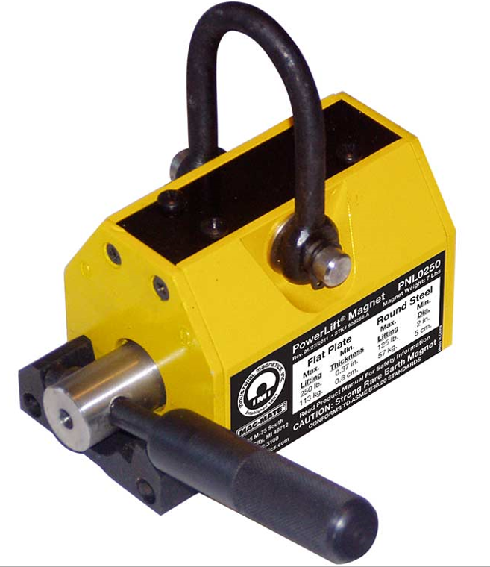

Figure 1: PowerLift Magnet PNL0250 (Mag-Mate),
the magnetic lift used in fabrication

Magnetic Lift in the ‘OFF’ Position  (a)  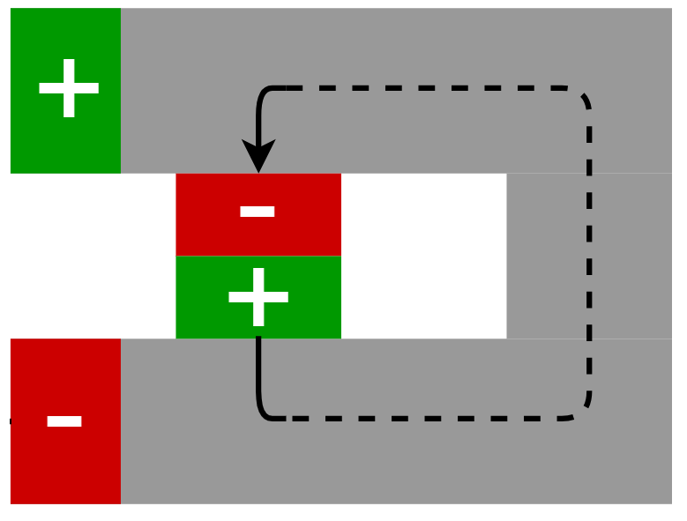 | Magnetic Lift in the ‘ON’ Position  (b)  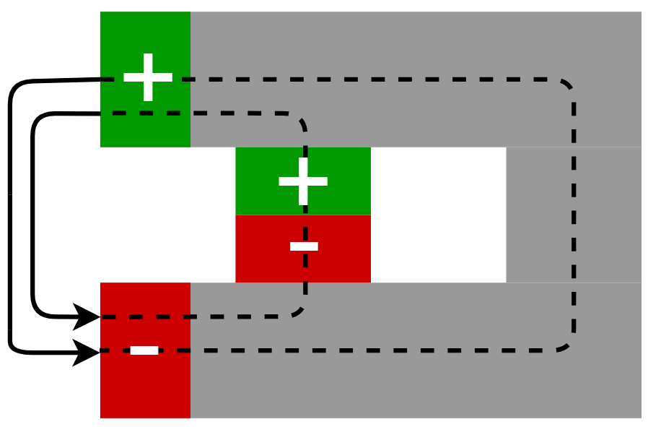
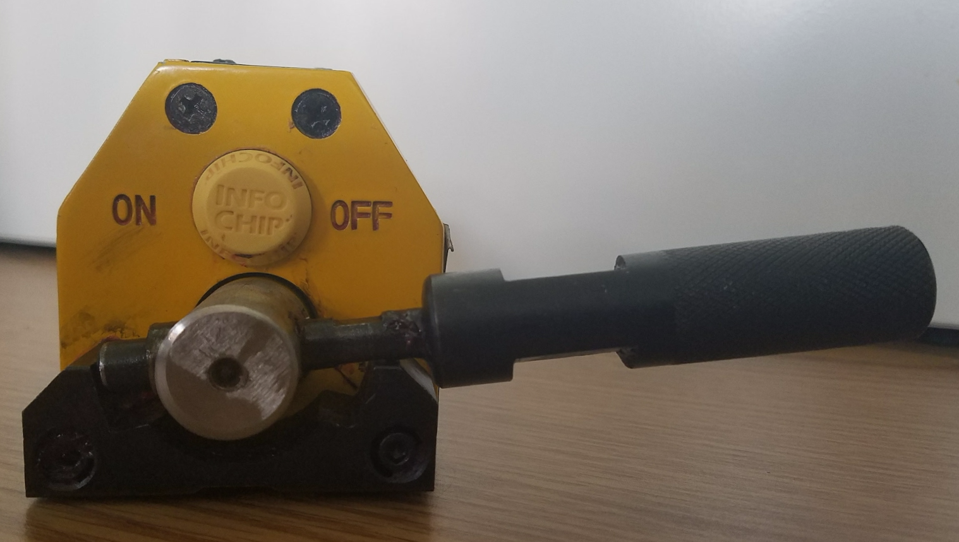 | 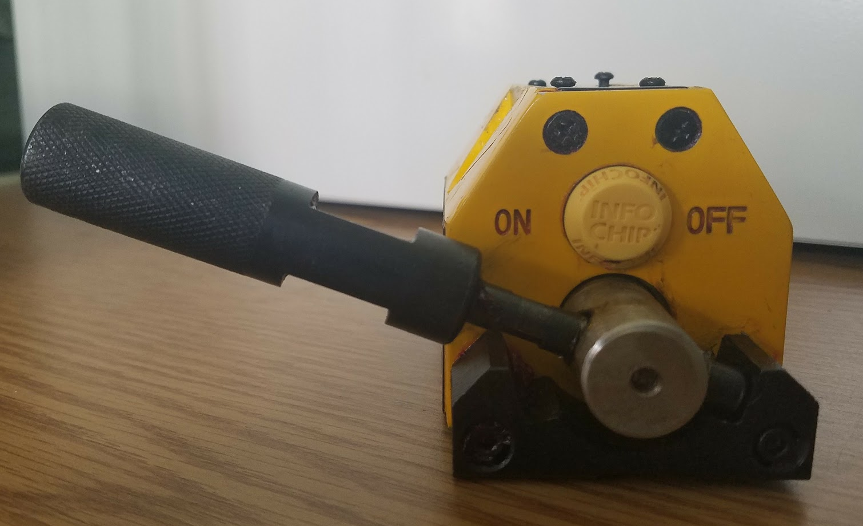

Figure 2: The alignment of the two internal magnets either (a) cancelling out (‘OFF’) or (b) combining and resulting in an attractive magnetic force (‘ON’)

$$P_{lift,on}=P_{mag}+P_{lift,off}$$ | (1)
When the magnetic lift is in the ‘on’ position, the pressure applied to the laminate by the magnetic lift is
where the pressure applied by the lift in the ‘off’ position is
$$P_{lift,off}=\frac{M_{lift}}{A_{c}}$$ | (2)
where $M_{lift}$ is the mass of the magnetic lift and $A_{c}$ is the contact area of the bottom of the lift. The bottom of the magnetic lift is not entirely flat, as seen in Figure 3, but the contact area can be determined by multiplying the area of one of the contacting tracks by 2. The weight of the magnet is approximately 7 lbs, and the contact area of the lift is
5.38 $in^{2}$, as seen in Table 2. Therefore, the pressure applied by the lift when it is off is 8.97 kPa (1.30 psi). Similarly, the pressure applied by the magnetic force is
$$P_{mag}=\frac{F\left(x\right)}{A_{c}}$$ | (3)
where $F\left(x\right)$ is the magnetic force, which is dependent on the distance from the steel base plate.
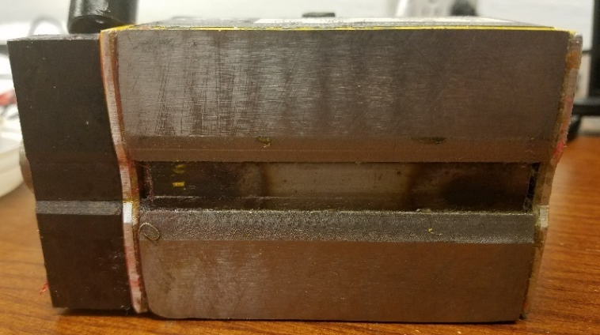
Figure 3: Bottom surface of magnetic lift

Table 2: PNL0250 (Mag-Mate) magnetic lift characteristics
Mass (lbs) | Contacting Track Width (in) | Magnetic Lift Length (in) | Total Contact Area of Both Tracks (in²)
7 | 3/4 | 3 5/8 | 5.44

Experimentally, the maximum pressure due to the magnetic force is found to be 731 kPa. This pressure is determined from the force of the magnet when the distance between the lift and the steel base plate is equal to zero. The total pressure applied during fabrication, including the weight of the magnet, is plotted with respect to the lift’s distance from the steel base in Figure 4. The maximum pressure is never applied to the laminates because there will be always a gap formed by the thickness of the lay up between the magnetic lift and the base plate. This distance is around 1 mm for the plain weave laminates, and between 2 mm and 4 mm for the random mat laminates. For the random mat laminates, uncompacted laminate lay ups are approximately 4 mm thick, and are reduced to around 2 mm as the magnetic lift is applied as the resin is removed and the fibers are consolidated. This means that the pressure applied on the laminate after each pass of the magnetic lift is increased.

Figure 4: Pressure of the magnetic lift versus distance from the base mold. The base mold is made of 1/4 in stainless steel

2.2 Laminate Fabrication
Laminate fabrication involves preparation of the fabric to create a preform, preparation of the resin including degassing and mixing, layup of the fabric and resin, coverage of the saturated fabric with a vacuum bag, and then the application of a magnetic lift to remove excess resin and consolidate plies.

2.2.1 Preparation of the Fabric
The dimension of each laminate is 6 x 8 in, regardless of the fabric used. However, because of the different densities and weights of the fabrics, the number of plies, the amount of resin needed for fabrication, and the average weight of the preform are not the same. These fiber type dependent characteristics are given in Table 3. Because of the uniformity of woven fabrics, each preform, no matter which plies are selected, has nearly the same weight. In contrast, each random mat ply can have very different weight. To minimize the effect of variations in areal density in the results, plies were carefully selected so that the dry preforms are within the accepted weight range.
Table 3: Characteristics of random mat and plain weave fabrics for laminates
Fabric | Width x Length | # of plies | Avg. dry preform weight (g)
Random Mat | 6” x 8” | 4 | 51.52 ± 0.14
Plain Weave | 6” x 8” | 6 | 34.70 ± 0.10

As is also shown in Table 3, the random mat laminates are made up of 4 plies, while the plain weave laminates are made up of 6. The reason for this can be explained with the weights of the preforms. Plain weave preforms are much thinner and lighter than random mat because of the uniform fiber orientations and denser arrangement of fibers due to the weave pattern. Thus, in order to be able to test the mechanical properties of the random mat parts obtained from the 6 x 8 in laminate, the number of plies had to be reduced to 4. Random mat preforms with 4 plies are still much thicker and heavier than the 6-ply plain weave because of the nonuniform orientation of the fibers and the increased fiber density.

2.2.2 Preparation of the Resin
The first step in the laminate fabrication is degassing the resin in a vacuum chamber. This is done for 1 hour prior to adding hardener to ensure that any bubbles present in the resin from storage or pouring are removed. After degassing, the hardener is added at a ratio of 24:1 by weight, as recommended by the supplier. It is then mixed at 350 rpm using a Caframo overhead mechanical stirrer for 5 minutes. The mixture is then placed back in the vacuum chamber for another 15 minutes for further degassing. This additional degassing ensures that any air introduced during the mixing process does not remain in the resin mixture and form voids in the final laminate.

The different weaves and densities of the two fabrics requires different amounts of resin for saturation. The random mat requires approximately 140 g of resin, plus the corresponding amount of hardener, while the plain weave only requires approximately 40 g, as listed in Table 4. The density of the random mat fabric as well as the ease with which resin can be transported out of the fabric, results in a large amount of resin being needed to avoid dry spots and result in an acceptable final laminate.
Table 4: Amount of resin used during fabrication for each fabric type
Fabric | Average resin (g) |  | Average hardener (g)
4-ply random mat |  | 140.09 ± 0.13 | 38.30 ± 0.19
6-ply plain weave | 40.19 ± 0.13 |  | 11.01 ± 0.04

2.2.3 Hand Layup and Vacuum Bagging
Once the mixture is degassed, the fabric can begin to be laid-up. The first step of this procedure is to pour resin on the polytetrafluorethylene (PTFE) Teflon film that covers the steel base plate and spread it to the desired size of the laminate using a squeegee. This helps secure the preform to the base mold, ensures a better surface quality on the bottom of the laminate, and helps with the complete saturation of the first ply. After the first ply is placed on the resin, a stainless-steel roller is used to work the resin into the fiber. Once this is completed, more resin is poured onto the ply and uniformly spread to the edges with a squeegee. Enough resin should be applied so that the fabric is completely saturated. It may also be beneficial to wait between 30 and 60 seconds after the resin has been spread to make sure enough has been applied after it has been absorbed by the fabric. Once the first ply has been satisfactorily saturated, a second ply is carefully placed on top of the first. The roller is then used again to work the resin into the fabric and secure the second ply to the first. Once finished with the roller, more resin is poured onto the ply and spread with squeegee, as was done with the first ply. This procedure is repeated until the desired number of ply is reached and all the resin is used. It is important to note that during the resin application procedure, no resin is removed from the preform area even though the roller brings resin to the surface.
After the laminate is laid-up, it is covered with a vacuum bag. A caul plate, taped to a piece of perforated release film, is sprayed with dry lubricant and placed on top of the saturated preform. The perforated release film is then taped down to the base plate to create a constraint on resin flow during vacuum and cure. For the random mat laminates, this constraint is 0.75 in, and for the plain weave laminates, it is 1 in away from the layup as depicted in Figure 5. Bleeder material is placed on top of the release film to absorb the excess resin and ensure that the resin does not flow into the outlet once vacuum pressure is applied. A vacuum bag is placed over the entire area and secured to the steel plate using sealant tape that is placed along the edge of the Teflon film. A thru-bag vacuum outlet connector is then placed on top of the bleeder a few inches away from the preform as seen in Figure 6. And finally, approximately 45 minutes after the start of fabric layup, a vacuum pump pulls a negative pressure of 95 kPa and the based plate is heated to 60 °C by the heating pads secured to the bottom surface of the tool plate. Both vacuum and temperature are held constant for 8 hours, curing the resin completely. For control parts, laminates made without pressure from the magnetic lift, this is the end of the procedure. However, for all the other laminates, pressure is applied using a magnetic lift as described below.
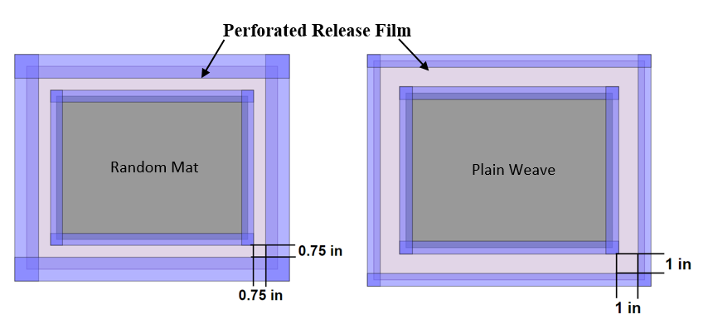
Figure 5: Dimensions for resin constraint made with perforated release film and tape

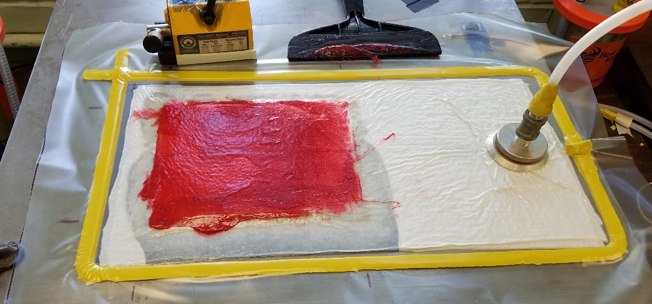
Figure 6: Completed wet layup/vacuum bag procedure with vacuum pressure applied. The magnet is applied on the greased (red) area

2.2.4 Application of the Magnetic Lift
The differences in the fabric properties mean that the random mat and plain weave laminates need to have slightly different fabrication procedures. Random mat laminates are subjected to up to 18 passes of the magnetic lift, while plain weave has a maximum number of 12 passes. As will be discussed later in this chapter, this is because further removal of resin past 12 passes results in increased void content and formation of dry spots. The random mat laminates do not exhibit this type of degradation and formation of defects at 12 passes, so 18 passes can be investigated without diminishing or reversing the positive effects of the application of magnetic pressure. Random mat fabrics also result in much thicker laminates than plain weave fabrics because of the lack of uniform fiber alignment and weave structure. In order to be able to use the similar size laminates in testing, the random mat laminates are fabricated with only 4 plies, while the plain weave laminates have 6 plies. The details of the fabrication of different experimental cases are listed in Table 5.

Table 5: Case designations and descriptions for the laminates fabricated with an increasing number of passes
Case | Description
WLVB-RM-4-0 | Wet layup/vacuum bag (WLVB) method using 4 plies of random mat fabric (RM), without magnetic pressure
WLVB-RM-4-1 | 1 pass with the magnetic lift performed after heat is increased to 60 °C
WLVB-RM-4-6 | 6 passes with the magnetic lift
WLVB-RM-4-12 | 12 passes with the magnetic lift
WLVB-RM-4-18 | 18 passes with the magnetic lift
VARTM-RM-4-0 | Vacuum assisted resin transfer molding (VARTM) method using 4 plies of random mat fabric (RM), without magnetic pressure
WLVB-PW-6-0 | Wet layup/vacuum bag method using 6 plies of plain weave fabric, without magnetic pressure
WLVB-PW-6-1 | 1 pass with the magnetic lift performed after heat is increased to 60 °C
WLVB-PW-6-6 | 6 passes with the magnetic lift
WLVB-PW-6-12 | 12 passes with the magnetic lift
VARTM-PW-6-0 | Vacuum assisted resin transfer molding (VARTM) method using 6 plies of plain weave fabric (PW), without magnetic pressure
The consolidation pressure is applied during the passes of the magnetic lift, where the lift is pushed along the length of the laminate ending at the edge nearest the outlet. When ‘on’, the magnet is very difficult to lift vertically off the layup surface. Moreover, when the aluminum surface of the magnet pressing against the vacuum bag, it is also very hard to slide. However, when the lift is wrapped in vacuum bag material and Lucas Oil Products’ anti-seize multi-purpose EP grease applied to the vacuum bag that covers the laminate as seen in Figure 7, the lift is easily pushed toward the outlet, squeezing out any excess resin. The coefficient of friction between the two vacuum bags is much lower than the coefficient between the aluminum bottom of the lift and the vacuum bag covering the laminate. Wrapping the magnet in a vacuum bag also keeps the grease off the magnet and helps with cleanup after fabrication. A thin piece of foam is also added to the leading edge of the magnet to keep the sharp metal edge from scrapping the grease off the vacuum bag ahead of the magnet. Only a small amount of foam is placed under the edge of the magnet so that there is effectively no increase in the separation between the bottom of the magnet and the surface of the saturated preform.
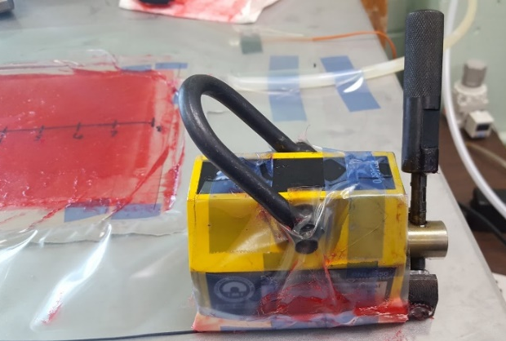
Figure 7: Vacuum bag wrapped magnetic lift, and red grease covered application area
Since the magnet slides along the laminate, the irregularity of the bottom surface of the lift, depicted in Figure 3, does not affect the overall thickness variation of the part as long as there is consistent application across the entire surface of the laminate. As discussed in section 3.2, thickness variation is actually reduced after that magnet had been applied. Even though the lift contacts the surface with two small tracks, there is no concentrated force applied at a single location where excess resin is squeezed out around the edges of the magnet, as depicted in Figure 8. Instead of resin being squeezed out at the point of pressure application, excess resin is pushed toward the outlet by the sliding motion of the magnetic lift. This creates a flow front ahead of the lift as the resin is transported by the applied pressure, as depicted in Figure 9.
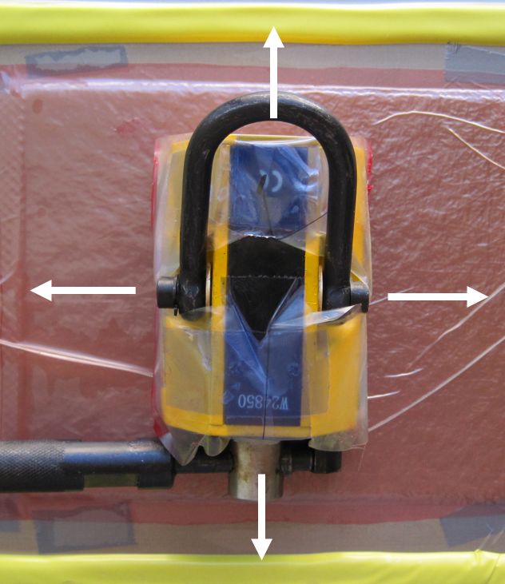
Figure 8: Direction of the resin outflow when a static magnetic pressure is applied by the stationary magnetic lift

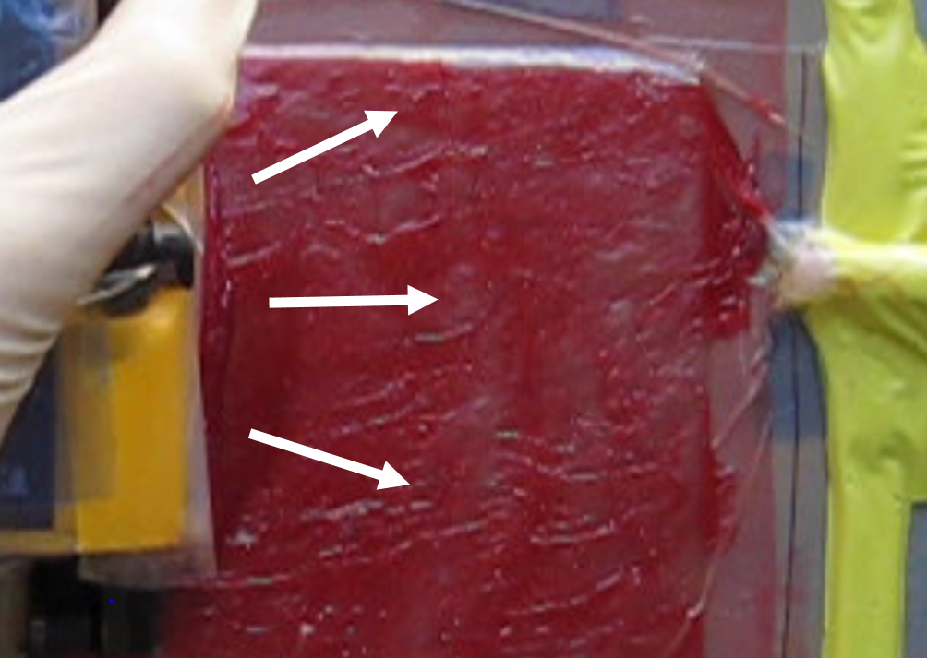
Figure 9: Resin pushed to the outlet and transported out of the
laminate by the sliding magnet

The area of the lift that contacts the laminate is 3.3 in wide. Therefore, the magnet must slide down two parallel paths to apply pressure to the entire surface of the 6-in wide laminate. The path of the lift’s motion is schematically illustrated in Figure 10. The magnet application process starts with placing the magnet on a corner of the saturated preform furthest from the outlet with the handle in the OFF position. The handle is then rotated to the ON position, aligning the magnets and “turning on” the magnetic compressive force. Now that pressure is being applied, the magnet is pushed down the length of the laminate to the outlet. Once at this location, the handle is switched to the OFF position and the magnet is easily lifted off the surface and brought to the other corner at the starting edge of the laminate. This puts the magnet in the second sliding path, so that the next pass covers the area of the laminate that the first pass did not. The two passes required to cover the entire surface are referred to as a single pass from this point on because these two passes are the minimum required for the complete coverage of the part. The magnet application process either ends here or is repeated 5, 11, or 17 more times, resulting in laminates fabricated using either 1, 6, 12, or 18 passes. Each pass should take approximately 15 to 20 seconds to cover the 8 in distance (i.e., laminate length), which results in a sliding rate of approximately 0.5 in/sec.

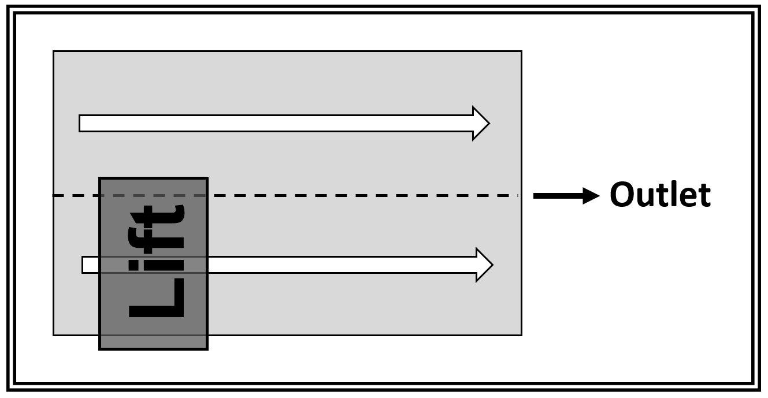
Figure 10: Completion of the side-by-side passes covering the entire laminate is counted as a single pass

When the number of passes increases, reapplication of the grease becomes necessary. As the magnet is moved across the surface, the leading edge removes the grease from the surface causing it to accumulate on the leading edge of the lift and at the outlet. Only three passes in each sliding path on the laminate can be completed before the magnet no longer slides smoothly. After these passes, a foam scraper, shown in Figure 11, is used to redistribute the grease over the lay-up surface.
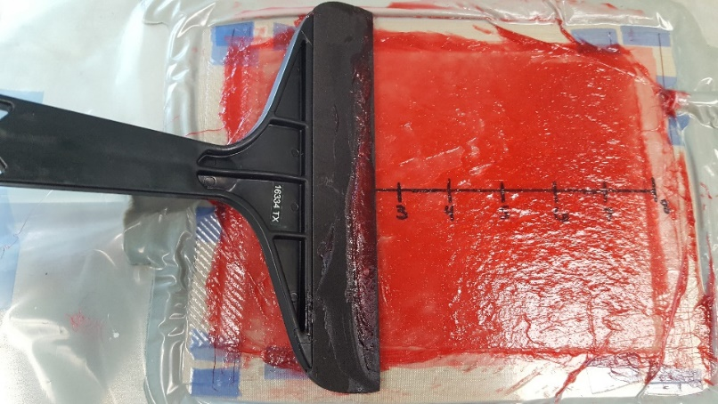
Figure 11: Foam edged scrapper used to redistribute grease during magnet application

2.2.5 Vacuum Assisted Resin Transfer Molding (VARTM)
Parts made using VARTM are fabricated for comparison with the wet layup/vacuum bag parts, presented later in Section 3.7. The resin and fabric are prepared the same way as the WLVB parts, but are then prepared for vacuum infusion. Tacky tape is laid around the edges of the Teflon film, and the dry fabric mat is placed in the center. Next, strips of peel ply are placed at both ends. The peel ply at the inlet is placed 0.25 in over the edge of the preform, and the peel ply at the outlet is placed 0.25 in underneath the edge. A strip of flow mesh, the same dimensions as the peel ply, is placed at the inlet, and covers the preform by only 0.125 in. All these materials are taped in place to that they do not move during fabrication. The dimensions and layout of these materials are depicted in Figure 12.
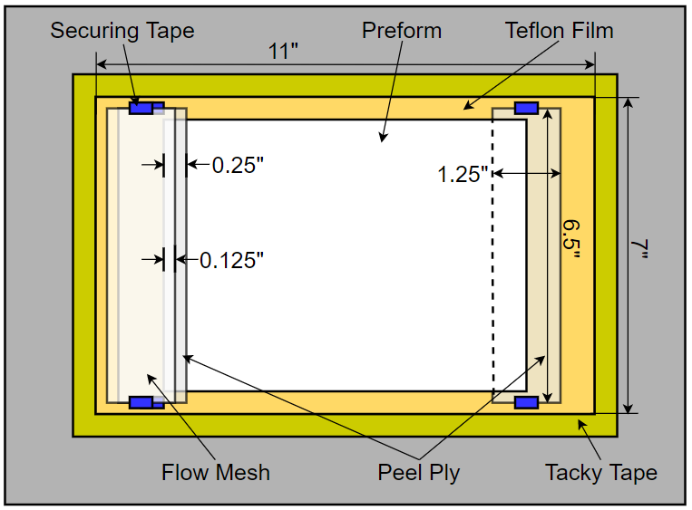
Figure 12: Vacuum infusion layout for preform, flow mesh, peel ply, and tacky tape

The next step in the procedure is placing vacuum tubes at both the inlet and the outlet, both penetrating 0.5 in into the mold. The inlet consists of two types of tubing and a connector. The tube that penetrates the mold is hard plastic, and the tube that is submerged in the resin is a soft plastic that can be clamped to stop flow of resin into the mold. The outlet tube is continuous hard tubing that attaches to the vacuum pump system. When placed on the mold, the inlet tube is centered, and the exit tube is placed 2 in from the top of the mold. Next, small pieces of peel ply are then laid on top of the inlet and outlet and taped to the base. The tips of the tubes, and the entire preform layup is then covered in release film which is also taped down to the base. The layout and dimensions are illustrated in Figure 13. The final step of the vacuum infusion layup is covering the entire area with a 24 x 18 in vacuum bag. The final layup is pictured in Figure 14.
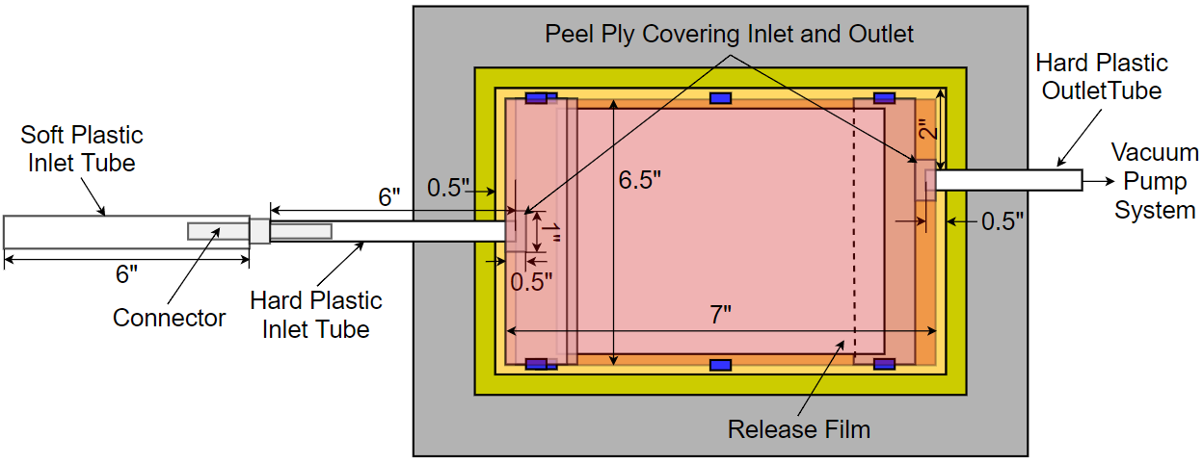
Figure 13: Vacuum infusion layout for release film, peel ply covering inlet and outlet, and inlet and outlet tubing

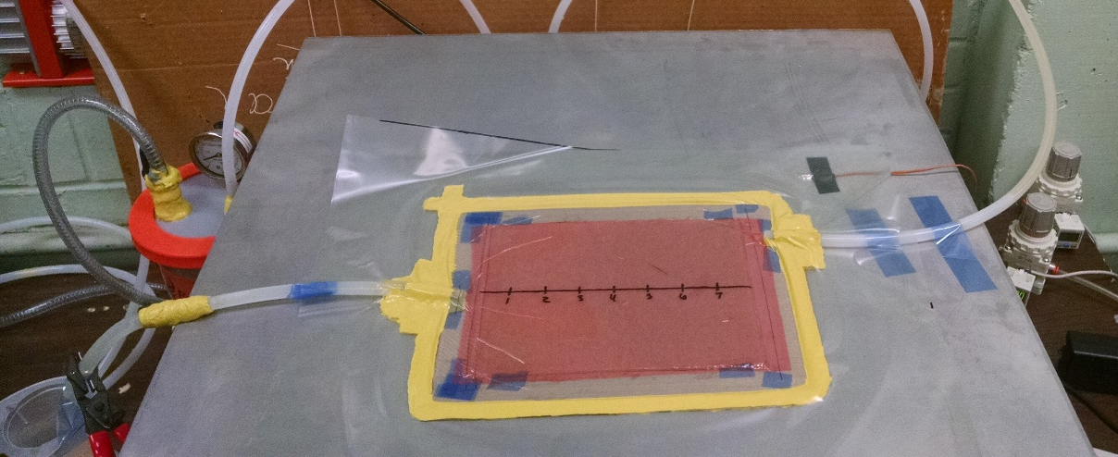
Figure 14: VARTM layup before resin infusion and after vacuum is applied

The process of adding resin to the mold starts with applying a vacuum pressure of 93 MPa 15 minutes before the resin is infused into the mold. Since the resin is prepared using the same method used in WLVB, the vacuum pump is turned on at the same time the final degassing of the resin starts, so that once 15 minutes have passed, the inlet can be opened and the resin can be pulled into the mold, starting infusion. Once the resin reaches the outlet, post fill flushing is maintained for 2 min, and then the inlet is closed. After this point, any resin exiting the mold is due to the vacuum pressure still applied at the outlet. After 45 minutes, the same time as WLVB, the temperature of the base plate is increased from 25 °C to 60 °C. Temperature and vacuum are maintained for 8 hours until the resin has cured. Once the base plate cools down, approximately 30 min after heating is stopped, the laminate can be removed from the mold.

2.3 Characterization of Laminate Properties
The effect the magnetic compaction has on the composite laminate is determined by conducting a series of tests to determine how magnetic pressure correlates to the material properties of the cured laminates. Measuring the average thickness of the laminate is a nondestructive way to gain general insight into the fiber volume fraction as well as the thickness uniformity throughout the part. A more accurate way to determine fiber volume fraction is using the burn-off method, where the resin is burned in a furnace so that the mass of the remaining fibers can be measured. However, for fiber and void volume fraction calculations, the density of the samples must first be determined using the suspension method. Fiber volume fraction and void content can also be visually inspected using a scanning electron microscope (SEM). The images taken from this procedure show the void characteristics and fiber compaction achieved by the different cases of magnet application. Void and fiber content are not the only measures of laminate quality. Three-point flexural bending test is used to determine the flexural strength and moduli of the laminates. After all of these experiments have been completed, the material properties of each case are determined and the overall quality of the laminates can be better understood.

2.3.1 Cutting Layout of the Laminate
The first step in testing is developing a cutting layout made up of all the samples required for each testing procedure. The composite laminate is then cut in accordance with this layout using a circular diamond blade. The layouts in Figures 15 and 16 illustrate how the flexure samples (F), void and fiber volume fraction samples (V), and SEM samples (S) are obtained from the laminates. Because of the difference in average thickness of the random mat laminates compared to the plain weave laminates, the minimum length for the flexure samples are much different, and thus, two different cutting layouts were developed. The standards for flexure samples are outlined in ASTM D7264 [30]. These requirements are (a) a minimum of 6 samples must be tested from each laminate, (b) the width of the samples needs to be 0.5 in, and (c) the length of the samples is dependent on the sample with the maximum thickness. Sample length is based on the support span to thickness ratio, commonly ranging from 16:1 to 32:1. These lengths are identified in Figure 17.
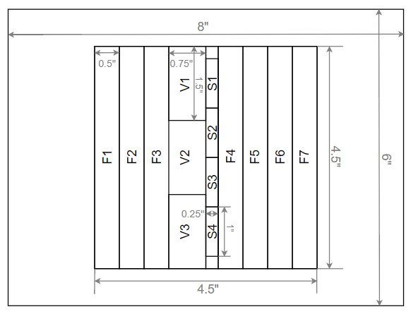
Figure 15: Cutting layout for laminates made with random mat fabric

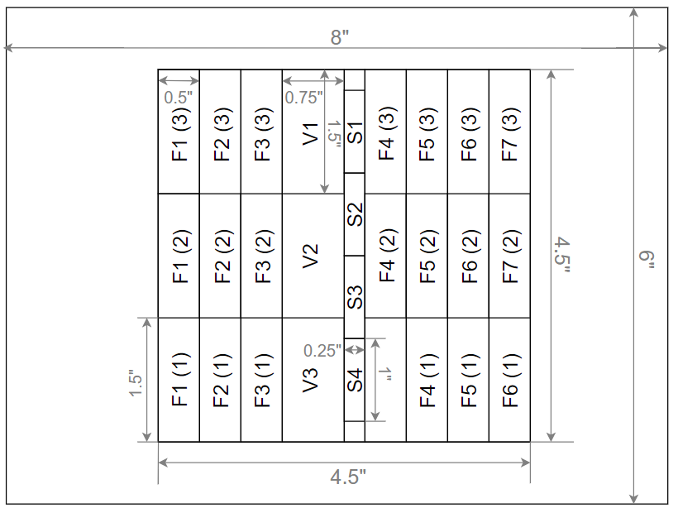
Figure 16: Cutting layout for laminates made with plain weave fabric

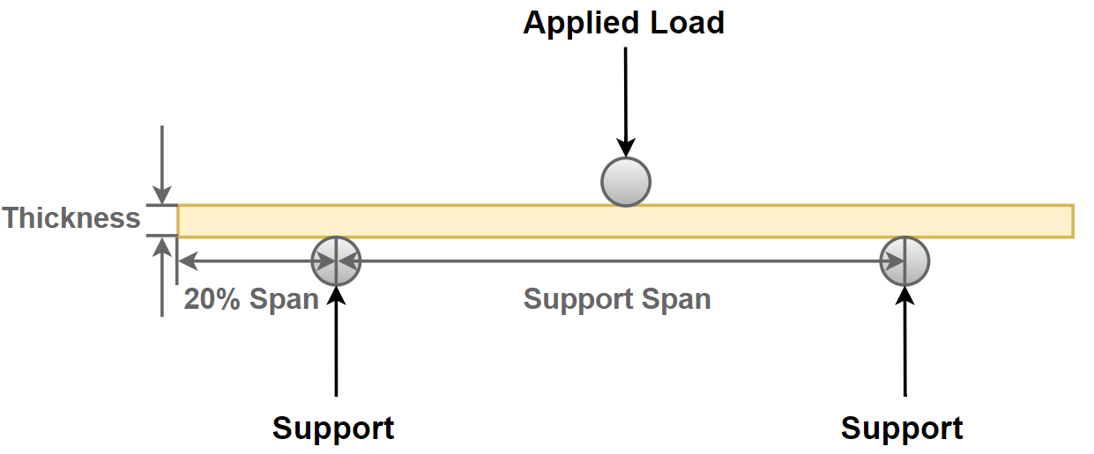
Figure 17: Dimensional components for determining sample length for three-point bending

The minimum sample length is determined by multiplying the maximum thickness by the selected span and then adding an additional 20% of that length to allow for overhang on either side of the support points. The random mat samples have a much greater average thickness, therefore much longer samples are required. In Figure 15 the flexure samples are 4.5 in long. But as shown in Figure 16, the 4.5 in samples are cut in thirds, each with a total length of 1.5 in, which is the minimum length required for the composites made with the woven fabric. Instead of only using seven flexure samples for the plain weave, as is done with the random mat, all 21 samples obtained from the available laminate area are tested.

The fiber and void fraction samples are used for both density measurement and burn-off, therefore they must comply with both sets of requirements. For density testing, a minimum of two samples per laminate are required, and they should have a volume greater than 1${cm}^{3}$ and have a weight between 1 g and 50 g [31]. For the burn off method, a minimum of three samples weighing approximately 5 g with a maximum size of 1 x 1 in² are required. These samples should also be conditioned at $23±2℃$ and $50±10\%$ relative humidity for no less than 40 hours before testing [32]. Samples of 0.75 x 1.5 in² are cut from the laminates so that all of the requirements can be met. Both testing procedures also require samples that have a width approximately equal to the length, so these samples are much wider than the other samples in the layout.

The final samples in the layout are the SEM samples. Images of the through-thickness cross-sectional area of these samples will be captured using an SEM to visually inspect the microstructure of the laminates. These samples were chosen to be 0.25 x 1 in², because 0.25 in is the smallest manageable width for these samples when cutting and during sample preparation, and 1 in-length fits easily within the sample space of the microscope and can be scanned in a reasonable amount of time [33].

2.3.2 Density Measurements
The density of each sample is determined by suspending it in a liquid of the same density and then determining the mass of the liquid in a container of known volume. A solution of heavy liquid (Cargille Laboratories, Aqueous Series: Inorganic Salts, Density = 2.49 gm/cc at 23 °C) and distilled water is mixed so that all samples float on the surface. Distilled water is then added and the solution is mixed, thus further reducing the density of the solution. Each sample is again placed in the solution one at a time. When a sample no longer floats on the surface, and is instead suspended in the solution, the fluid is poured into a container of known mass and volume and full container is weighed. The mass of the solution is this weight minus the weight of the empty container. Once the mass of the solution is known,
$$ρ_{sample}=\frac{m_{fluid}}{V_{container}}$$ | (4)
can be used to determine the density of the fluid, where $ρ$ is the density, m is the mass of the liquid, and V is the known volume of the container. The density of the liquid is considered to be the density of the sample. The container is then rinsed and dried so that the procedure can be repeated until the least dense sample is successfully suspended in the solution. Once this procedure is completed, the density of each sample has been experimentally determined and can be used in the fiber and void volume fraction calculations

2.3.3 Fiber Volume Fraction and Void Content
Fiber and void volume fraction are determined using the burn-off method. The goal is to determine what percentage of the weight the glass fibers make up in the composite laminate sample. This is done by separating the resin from the glass fibers in a furnace. The resin is burned off at high temperatures leaving only the glass reinforcement behind in the crucible that initially were in sample. Therefore, after the crucible is cooled down, the mass of the fabric $\left(M_{f}\right)$ in each sample can be calculated using
$$M_{f}=M_{cr+f}-M_{cr}$$ | (5)
where $M_{cr+f}$ is the measured weight of the fabric and crucible after being removed from the furnace, and $M_{cr}$ is the mass of the empty crucible. Once the mass of the fabric is determined, the weight percent of the fabric ${(W}_{f})$is calculated using
$$W_{f}=100 × \left(\frac{M_{f}}{M_{c}}\right)$$ | (6)
where $M_{c}$ is the mass of the initial composite. The fiber volume fraction $\left(V_{f}\right)$ is calculated using
$$V_{f}=W_{f}\left(\frac{ρ_{c}}{ρ_{f}}\right)$$ | (7)
where $ρ_{c}$ is the density of the initial composite found using the method outlined in the previous section, and $ρ_{f}$ is the density of the fabric. A correction factor that needs to be included in this calculation is the percentage of fabric weight that was lost due to the burn off. The resin content is determined in much the same way, with the weight percent of resin $\left(W_{r}\right)$ being calculated using
$$W_{r}=100 × \left(\frac{M_{c}-M_{f}}{M_{c}}\right)$$ | (8)
and the resin volume content $\left(V_{r}\right)$being calculated using
$$V_{r}=W_{r}\left(\frac{ρ_{c}}{ρ_{r}}\right)$$ | (9)
where $ρ_{r}$ is the density of the resin. Using the fiber and resin volume contents, the void volume fraction $\left(V_{v}\right)$ can be determined using
$$V_{v}=100-\left(V_{f}+V_{r}\right)$$ | (10)
since any volume that is not accounted for after the volumes of the fabric and resin added together is the volume that became voids in the composite [34].

2.3.4 Scanning Electron Microscope (SEM) Imaging
The fiber volume fraction and void content have already been calculated using the measurements from the burn-off test, however, to be able to characterize the location of the voids and visually inspect the void morphology and content and fiber volume fraction, a Tescan VEGA-II XMU SEM is used to inspect through-the-thickness cross-section of the laminates. For these components to be visible under the SEM, the samples must first be prepared. First, they are imbedded in epoxy in the circular shape the SEM sample holder requires, then polished until the voids and fibers become visible under the microscope. This is done in multiple steps, where the grinding and polish material get finer and finer, with a range of 15 μm to 1.9 μm, until the surface is completely smooth and the individual fibers become visible. The samples are then submerged in a sonication bath for 20 min to ensure that any particulates from polishing have been removed. After the samples have been polished and prepared, they are kept in a clean vacuum to prevent any contamination of the surface until a gold sputter coating is applied. This coating prevents the charging of the sample and reduces the amount of noise in the imaging. Magnifications of 35X and 150X are used to capture images of the voids, fibers, and resin that make up the plain weave laminates, and magnifications of 20X and 150X are used to view the microstructure of the random mat laminates. The location and shape of the voids, as well as the compaction of the fiber plies and individual fiber tows, can be seen from these SEM images.

2.3.5 Flexural Properties
The three-point bending method is used to determine flexural strength and modulus of the materials. This test is performed using a Com-Ten Industries testing machine. The applied force is measured with a Com-Ten, 500 lb load cell, and the deflection of the samples is determined by measuring the distance the crosshead travels with a linear variable displacement transducer (LVDT). From the force and displacement measurements, the flexural stress $\left(σ_{f}\right)$ is determined using
$$σ_{f}=\frac{3FL}{2bd^{2}}$$ | (11)
where F is the force measured by the load cell, L is the length of the support span, and b and d are the width and thickness of the beam, respectively. The elastic modulus $\left(E_{f}\right)$ can also be determined using
$$E_{f}=\frac{L^{3}F}{4bd^{3}D}$$ | (12)
where D is the maximum deflection of the beam before failure [30]. However, in cases where the deflection is greater than 10% of the span, the flexural stress equation becomes
$$σ_{f,large deflection}=σ_{f}\left[1+6{\left(\frac{D}{L}\right)}^{2}-4\left(\frac{d}{L}\right)\left(\frac{D}{L}\right)\right]$$ | (13)
where a correction factor is added to account for the large deflection of the beam [35].
2.3.6 Mean and Confidence Interval Calculations
The average value for the results from each test is calculated using
$$\overline{x}=\frac{\sum_{i=1}^{n}{x_{i}}}{n}$$ | (14)
where $x_{i}$ are the individual results for each sample, and n is the number of samples for each test. The 95% confidence interval is also calculated to determine the amount of variation in the data. This is found using
$$95\% CI=1.96\sqrt{\sum_{i=1}^{n}{{\left(x_{i}-\overline{x}\right)}^{2}}}$$ | (15)
where 1.96 is the Z value for 95% confidence [30].

Chapter 3: Characterization of Composite Laminate Properties

3.1 Average Laminate Thickness
Most research on resin flow in vacuum infusion is focused on simulation of the filling of the mold [36]. Resin transport out of the fabric follows the same principles, expressed by the well-known Darcy’s law as,
$$q=-\frac{K}{μ}∇p$$ | (16)
where q is velocity through a porous medium, K is the permeability of the porous medium, μ is the viscosity of the resin, and p is the pressure. Equation 16 indicates that the flow velocity is dependent on the permeability of the material and explains why more resin can be removed from the random fiber mats than the plain weave fabric. It also explains why the greatest rate of resin removal would be due to the first pass of the magnet. The permeability of the laminate is very high before pressure is applied because of the larger space between the mats and fiber tows. This space is filled with resin that is not tightly constrained because of the high permeability of the random mat fabric. The Kozeny-Carman model for isotropic permeability also helps explain why the first pass results in more resin removal than any other subsequent pass. The Kozeny-Carman model given as,
$$K=\frac{{\left(1-V_{f}\right)}^{3}}{5S_{0}^{2}V_{f}^{2}}$$ | (17)
where $V_{f}$ is the fiber volume fraction and $S_{0}$ is the shape factor, defines how the permeability of a porous medium is dependent on the fiber volume fraction of the laminate. As the plies are compacted and resin is removed, the fiber volume fraction of the laminate increases. This results in decreased permeability and decreased resin mobility. As less resin is removed, and as the plies are compacted, the average thickness of the part approaches to an asymptote.

3.1.1 Random Mat Laminates
Random mat fabrics have high isotropic permeability, because of the random, planar orientation of the fibers and high porosity. The rate of resin removal from the random mat laminates is reflected in the rate of thickness reduction depicted in Figure 18. The slope between the initial average thickness and the average thickness after the first pass is nearly 13 times greater than the slope between 1 pass and 6 passes. This illustrates how the permeability of the laminate is significantly decreased by the application of the magnet. Based on Equations 16 and 17 this indicates an increase in fiber volume fraction caused by the removal of resin and compaction of fibers. The relationship between the number of passes applied during fabrication and fiber volume fraction will be further explored in the section 3.3.
1
Figure 18: Reduction of laminate thickness as a function of the number of passes of the magnetic lift for random mat laminates

Passes with the lift were continued until the thickness reduction begins to reach an asymptote, as seen in Figure 18. The decrease in average thickness becomes less significant after 12 passes because the fiber volume fraction has increased to a point where the permeability is low enough that significant amounts of resin is no longer being transported out of the fabric. Resin mobility may not be as high after the first pass, however, additional passes of the magnetic lift are used for ply consolidation and additional removal of resin, which leads to improved material properties that will be discussed in following sections. The greatest thickness decrease achieved with the application of the magnetic lift for the random mat laminates is a 45.4% reduction in average thickness from the initial thickness, 3.57 mm, to 1.95 mm after 18 passes with the magnet. The percent reduction due to each case can be found in Table 6, and depicted in Figure 19.

Figure 19: Average percent decrease in thickness for random mat laminates

Table 6: Percent decrease in average thickness of random mat laminates
Case | Avg. Thickness (mm) | % Decrease
WLVB-RM-4-0 | 3.57 ± 0.17 | -
WLVB-RM-4-1 | 2.81 ± 0.11 | 21.3
WLVB-RM-4-6 | 2.50 ± 0.05 | 30.0
WLVB-RM-4-12 | 2.16 ± 0.05 | 39.5
WLVB-RM-4-18 | 1.95 ± 0.03 | 45.4

3.1.2 Plain Weave Laminates
The permeability of plain weave fabric is anisotropic and is greatest in the direction of the fibers. This means that the resin will be primarily transported either in the longitudinal or transverse directions, because these are the directions that the fibers are aligned. The plain weave laminates also have a much lower density and initial thickness, than the random mat laminates, however, the plain weave laminates show a similarly large initial reduction in thickness as the random mat fabric, as seen in Figure 20. The thickness reduction also approaches an asymptote after 12 passes, which results in a maximum thickness reduction of 12.2%, from 0.98 mm to 0.86 mm, as seen in Table 7 and Figure 20. The trend of the plots in Figures 20 and 21 suggest that further passes could have been applied to the laminate, however, any number of passes higher than 12 results in poor quality parts with dry spots and a high void content.
1
Figure 20: Reduction of laminate thickness as a function of the number of passes of the magnetic lift for plain weave laminates

Figure 21: Average percent decrease in thickness for plain weave laminates

Table 7: Average thickness and percent decrease for plain weave laminates
Case | Avg. Thickness (mm) | % Decrease
WLVB-RM-4-0 | 0.98 ± 0.01 | -
WLVB-RM-4-1 | 0.92 ± 0.01 | 6.1
WLVB-RM-4-6 | 0.88 ± 0.01 | 10.2
WLVB-RM-4-12 | 0.86 ± 0.01 | 12.2

3.1.3 Pressure Application
The average laminate thickness, based on the number of passes applied, is useful for understanding how the pressure increases as the magnetic lift is moved across the laminate surface multiple times and the laminate thickness is continually reduced. The pressure range for the plain weave laminates is 238 to 267 kPa, representing a consolidation pressure difference of 29 kPa between the first and the last passes of the magnetic lift, as shown in Table 8. The plain weave preforms are thinner, and the thickness does not decrease as significantly as it does for the random mat laminates. The pressure range between the first and the last passes for the random mat laminates is 54 kPa, nearly twice that of the plain weave. The expected pressure at the unmodified thickness is 64 kPa, whereas the pressure after the maximum number of passes is expected to be as high as 118 kPa. For both fabrics, the thickness reduction after the first pass has the greatest rate of decrease, and therefore is also when the greatest increase in pressure occurs. For plain weave laminates, the pressure variation after the first pass is only 16 kPa, and for random mat it is 37 kPa. The random mat laminates still experience a significant increase in pressure after the first pass. The change in pressure does not become as low as plain weave until after 12 passes with the magnet, where the pressure variation between 12 and 18 passes is only 12 kPa. The pressure difference, depending on the thickness of the preform, must be considered, especially for random mat, because the pressure applied by the lift can significantly change depending on thickness which will affect the properties of the final composite material.
Table 8: Increasing applied pressure as thickness is reduced based
on pressure vs. distance data
Random Mat |  |  | Plain Weave
After # of Passes | Thickness (mm) | Pressure (kPa) | After # of Passes | Thickness (mm) | Pressure (kPa)
0 | 3.57 | 63.5 | 0 | 0.98 | 237.8
1 | 2.81 | 81.0 | 1 | 0.92 | 251.8
6 | 2.50 | 91.2 | 6 | 0.88 | 261.8
12 | 2.16 | 106.0 | 12 | 0.86 | 267.0
18 | 1.95 | 117.9

The pressure applied by the magnetic lift consolidates the glass fiber mats and squeezes out excess resin. Resin can be transported out of the laminate with a stationary pressure, however, since the magnetic lift is sliding, the resin is transported out of the part by a flow front ahead of the leading edge of the magnet. In the wet layup/vacuum bag method, a large amount of resin is required to prevent dry spots and poor surface quality, especially for random mat laminates. This means that once pressure is applied, there is considerable amount of resin that can easily be transported out of the fabric through the perforated release film that forms a resin constraint around the laminate.

3.2 Thickness Variation within Laminates
Minimizing thickness variation has two positive outcomes: (i) minimizing the material property variation within a part, and (ii) improving the dimensional tolerance and repeatability of parts. Repeatability ensures that the material properties of parts fabricated using the same procedure do not vary considerably. This is important when defining mechanical properties of manufactured parts since mechanical properties are primarily dependent on fiber and void volume fraction and constituent properties. The spatial variation of the part thickness is illustrated by the confidence interval of the thickness of one laminate. A large interval means that the surface is uneven and that the fabrication technique does not result in consistent laminate thickness. The part repeatability is illustrated by the confidence interval calculated using the measurements from both laminates, where a large interval indicates that the material properties vary significantly from part to part. If the confidence interval for both laminates combined is greater than the confidence intervals of the individual laminates, then the fabrication procedure has low part repeatability.

3.2.1 Random Mat Laminates
The thickness variation for both the individual laminate and that of two laminates combined are calculated using Equation 15 and plotted in Figure 22. The thickness variation of individual laminates is investigated first. The confidence interval for both 0-pass laminates, the case when no pressure is applied by the magnetic lift, is higher than any other case. Unpressurized wet layup/vacuum bag laminates have more thickness variation than any case with the magnetic pressure even though vacuum pressure is applied by using a vacuum bag over a caul plate. Since the fiber weight is kept nearly the same for each laminate, the variation in thickness measurements is due to the amount of resin around the fibers. As previously stated, the first pass removes the greatest percentage of resin. This is reflected with the thickness variation of the 1-pass laminates. There is a sharp decrease in the thickness confidence interval from 0 passes to 1 pass, just as there is with the average thickness. The results indicate that once the magnetic compaction is applied to reduce the thickness, the thickness variation is reduced as well. However, after the first pass, additional passes of the magnet decrease the variation in thickness by smaller amounts. Nevertheless, the effect of magnetic passes on reduction of the thickness variation can be clearly observed from Figure 22 and Table 9.
1
Figure 22: 95% confidence interval of thickness measurements for random mat laminates

Table 9: Data table for the 95% confidence intervals for random mat laminate thickness
Case | 1st Laminate | 2nd Laminate | Two Laminates Combined
WLVB-RM-4-0 | 0.07 | 0.12 | 0.17
WLVB-RM-4-1 | 0.05 | 0.08 | 0.11
WLVB-RM-4-6 | 0.06 | 0.04 | 0.05
WLVB-RM-4-12 | 0.04 | 0.05 | 0.05
WLVB-RM-4-18 | 0.02 | 0.05 | 0.03

The thickness variation for individual laminates is generally down, despite fluctuation, and the thickness confidence interval for the two laminates combined continues to decrease, and is the lowest after 18 passes. This indicates that the part repeatability increases as the number of passes increases. By applying sliding pressure, the inconsistency of parts will be significantly reduced, especially if 6 or more passes are applied, as illustrated in Figure 22 and Table 9. The confidence interval for the thickness measurements of both laminates continues to decrease after the first pass, even though the intervals of the individual laminates are comparable to that of the first pass. This means that the 6 pass laminates are more like each other than the 1-pass laminates are, indicating that repeatability has been improved. Though not as rapidly, this trend continues until the variation is lowest between the 18-pass laminates, indicating the highest repeatability after 18 passes. As the fiber mats are consolidated, there is less resin between the plies to cause large variations in thickness. The planar density of fibers in random mat vary within a single ply, and will result in some variation in thickness, even after excess resin has been removed.

3.2.2 Plain Weave Laminates
For all plain weave cases, the 95% confidence interval for the thickness measurements can be rounded to 0.01 mm as the slight variation between cases is shown in Figure 23 and listed in Table 10. Clearly, the laminates made with the plain weave fabric do not show the reduction in thickness variation that the random mat laminates do. Even the unmodified wet layup/vacuum bag had a thickness confidence interval of 0.01 mm, indicating that the addition of the magnetic lift in the procedure does not improve the part repeatability of the procedure. Figure 23 also illustrates that the variation within a single laminate is still consistent with the unpressurized procedure. Woven fabrics have more repeatability and less variation in part thickness and material properties because of the structured fiber orientation. However, the application of sliding magnetic pressure still reduces the laminate thickness which leads to improvements in material properties.
1
Figure 23: 95% confidence interval of thickness measurements for plain weave laminates

Table 10: Data table for the 95% confidence intervals for plain weave laminate thickness
Case | 1st Laminate | 2nd Laminate | Two Laminates Combined
WLVB-PW-6-0 | 0.010 | 0.010 | 0.010
WLVB-PW-6-1 | 0.010 | 0.009 | 0.012
WLVB-PW-6-6 | 0.007 | 0.004 | 0.005
WLVB-PW-6-12 | 0.008 | 0.007 | 0.009

3.3 Fiber Volume Fraction
The rule of mixtures is used to predict the material properties of a composite material based on the properties of the resin and fiber and the volume fraction of both. The elastic modulus of the composite $\left(E_{c}\right)$ in the fiber direction can be predicted using
$$E_{c}=V_{f}E_{f}+\left(1-V_{f}\right)E_{r}$$ | (18)
where $V_{f}$ is the fiber volume fraction, $E_{f}$ is the elastic modulus of the fiber, and $E_{r}$ is the elastic modulus of the resin. The rule of mixtures has the critical assumptions that make the theoretical prediction of elastic modulus different from values determined experimentally. These assumptions are that the fibers are uniformly distributed, that the fiber and resin are perfectly bonded, that there are no voids in the material. Because of these assumptions, the modulus predicted by the rule of mixtures can be significantly different to the values determined experimentally. However, it is a useful tool for identifying the relationship between mechanical properties and the fiber volume fraction of the material.

3.3.1 Random Mat Laminates
The maximum increase in fiber volume fraction is 80.4% from 18.9% to 34.1% for the 18-pass laminate, and the increase after 12 passes is 8.6% to 31.4%, as seen in Figure 24 and listed in Table 11. The largest increases in fiber volume fraction are after 1 pass is applied, and after 12 passes are applied. These are the intervals where the magnetic pressure has the most effect on the fiber volume fraction of the random mat laminates. A reduction in the average thickness of a laminate is the first indication of quality improvement of the composite material. Since plies were selected so that all laminates have the same amount of fiber, a reduction in thickness is an indication of increased fiber volume fraction. The thickness reduction of random mat laminates is strongly correlated to the increase in fiber volume fraction. As shown in Figure 25, the percent decrease in average laminate thickness is almost equal to the increase in fiber volume fraction. Since no fiber is being removed when the magnet is applied, and since ply consolidation does not contribute as significantly to thickness reduction as resin removal, this correlation is understandable. As resin is removed, the percentage of the laminate volume due to the fibers must increase.
1
Figure 24: Improvement in fiber volume fraction for chopped strand, random mat laminates

Figure 25: Correlation between the percent reduction in thickness of random mat laminates with the percent increase in fiber volume fraction

Table 11: Fiber volume fraction and percent increase for random mat laminates
Case | Fiber Volume Fraction (%) | % Increase
WLVB-RM-4-0 | 18.9 ± 1.0 | -
WLVB-RM-4-1 | 24.7 ± 2.1 | 30.7
WLVB-RM-4-6 | 25.5 ± 1.1 | 34.9
WLVB-RM-4-12 | 31.4 ± 0.6 | 66.1
WLVB-RM-4-18 | 34.1 ± 1.1 | 80.4

3.3.2 Plain Weave Laminates
The greatest increase in fiber volume fraction is 16.4% from 45.7% to 53.2% after 12 passes, as shown in Figure 26 and listed in Table 12. The fiber volume fraction for woven materials is initially higher than that of random mat, and the increase in fiber volume fraction is less, just as the thickness reduction was not as great for plain weave as for random mat laminates. The greatest increases in fiber volume fraction occur after 1 pass and after 6 passes. The increase after 6 passes is not as significant. The improvement of fiber volume fraction of the 12-pass laminates is only 1.5% greater than the 6-pass laminate. After a certain number of passes, the rate of fiber volume fraction increase from case to case is not as high, because increasing the fiber volume fraction at the same rate as early cases would require more pressure than is applied by the magnetic lift. However, there is still some improvement after 6 passes that will improve the mechanical properties discussed in following sections. The plain weave laminates show the same trends as the random mat. The increase in fiber volume fraction is also directly correlated to the reduction of thickness, as seen in Figure 27. However, the increase in fiber volume fraction is not as high as the random mat laminates because of the fabric properties.
1
Figure 36: Improvement in fiber volume fraction for plain weave laminate

Figure 27: Correlation between the percent reduction in thickness of plain weave laminates with the percent increase in fiber volume fraction

Table 12: Fiber volume fraction and percent increase for plain weave laminates
Case | Fiber Volume Fraction (%) | % Increase
WLVB-PW-6-0 | 45.7 ± 0.8 | -
WLVB-PW-6-1 | 50.2 ± 1.3 | 9.8
WLVB-PW-6-6 | 52.4 ± 0.5 | 14.7
WLVB-PW-6-12 | 53.2 ± 1.0 | 16.4

3.4 Void Volume Fraction
The improvement of material properties by increasing fiber volume fraction is limited by the presence of voids in the material, which impede the mechanical properties of the composite material. However, as the magnetic lift is applied, and resin is squeezed out of the fabric, voids are also transported out of the part leading to a reduction in void content. Less than 1% void content is often considered to be a very low void content and is acceptable for most applications. Therefore, a major goal of the application of magnetic pressure is to reduce the void content as much as possible, preferably below 1%.

3.4.1 Random Mat Laminates
The void volume fraction of the laminates and the percent reduction of the void content compared to the unpressured laminate are given in Table 13. The maximum void volume fraction is 1.74% for the unpressurized laminate, and 0.66% is the lowest void volume fraction achieved sliding the magnetic lift 6 and 12 times. This results in a 62.1% reduction in void content. The 6 and 12 pass cases result in the lowest void fractions because sliding squeezes excess resin, and the voids contained within it, out of the fabric. However, the void volume fraction is found to slightly increase when the maximum number of passes, 18 passes, are applied to the fabric, resulting in a void volume fraction of 0.73%. In the fabrication of the laminates, there is a maximum number of passes when too much resin is removed from the fabric. After 12 passes, dry spots start to form and voids that are not present in the 12-pass case are induced. The increase in void content in the 18-pass laminates indicates the final case for laminate fabrication. While the trend for void content matches the trend of thickness and fiber volume fraction, the decrease in the number of voids is much greater than the increase in fiber volume fraction or decrease in thickness.

Table 13: Void content and percent decrease for random mat laminates
Case | Void Content (%) | % Decrease
WLVB-RM-4-0 | 1.74 ± 0.51 | -
WLVB-RM-4-1 | 1.25 ± 0.13 | 28.2
WLVB-RM-4-6 | 0.66 ± 0.18 | 62.1
WLVB-RM-4-12 | 0.66 ± 0.20 | 62.1
WLVB-RM-4-18 | 0.73 ± 0.17 | 58.0
3.4.2 Plain Weave Laminates
The void volume fraction is improved from 3.44% when no pressure is applied to 1.13% after 6 passes with the magnetic lift, as listed in Table 14. This results in a 67.2% reduction in void volume fraction for the plain weave laminates after 6 passes. The plain weave laminates experience the same increase in void content as the random mat laminates, but instead of a reversal in improvement after 12 passes, the reverse occurs after 6 passes. The void content of the 12-pass laminate is 30% greater than the void content of the 6-pass laminate. As is the case with the random mat laminates, the removal of resin creates dry spots and increases the number of voids in the part. It is this increase in void content that limits the maximum number of passes to 12.
Table 14: Void content and percent decrease for plain weave laminates
Case | Void Content (%) | % Decrease
WLVB-PW-6-0 | 3.44 ± 0.46 | -
WLVB-PW-6-1 | 2.33 ± 0.34 | 32.3
WLVB-PW-6-6 | 1.13 ± 0.30 | 67.2
WLVB-PW-6-12 | 1.47 ± 0.49 | 57.3

The percent change in fiber volume fraction and thickness is highly dependent on the fabric used, but the percent decrease in void fraction is not. The void content for the plain weave laminates decrease at the same rate for both the plain weave and random mat laminates, as seen in Figure 28. This indicates that the application of the magnetic lift is an effective way to remove voids in wet layup/vacuum bag independent of the type of fabric used.

Figure 28: Percent decrease in void content for both plain weave and random mat laminates

3.5 Scanning Electron Microscope (SEM) Imaging
The material characteristics discussed in the previous sections can be seen in the SEM images showing the through-the-thickness cross sections of the laminates. The reduction in thickness, the types of voids present, and the space between fibers are all meaningful to the understanding of how the application of the consolidation pressure by a magnetic lift effects the properties of the composite material. Since the magnification for each fabric type is the same, the change in laminate thickness and the space between fibers can be visually inspected, illustrating the increase in fiber volume fraction as the magnetic pressure is applied. Void frequency, shape, and size can also be seen in the SEM images, revealing voids both between and within the fiber tows.

3.5.1 Random Mat Laminates
The morphology and frequency of voids can also be seen in the SEM images in Figure 29. The two types of voids are the ones between the plies and the ones between the fiber tows. Images from the 1-pass case show both types of voids that are present in all the cases, and given in Figure 29. The voids in the resin rich regions between the plies are relatively large and are caused by air trapped in the resin, and the voids between the tows are much smaller and caused by incomplete wet out of a single tow or the smaller spaces between tows during fabrication. The larger voids can also become elongated when pressure is applied, as shown in Figure 30. However, in the random mat laminates, this elongation occurs infrequently and most voids remain circular even after pressure is applied.

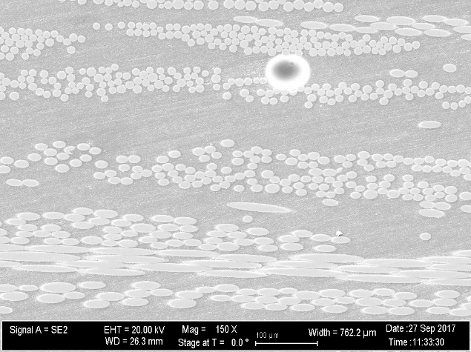 | 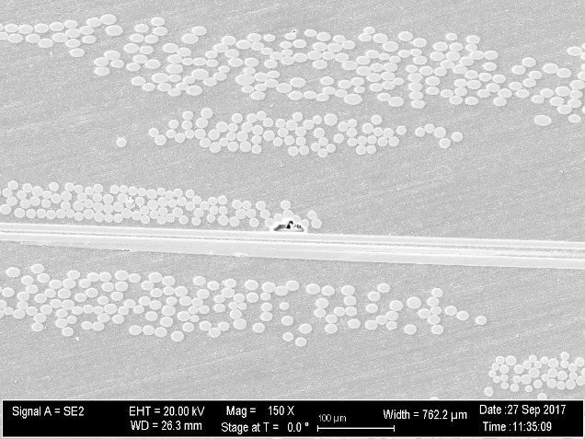
Figure 29: SEM images with increased magnification showing types of voids in the random mat, 1-pass case
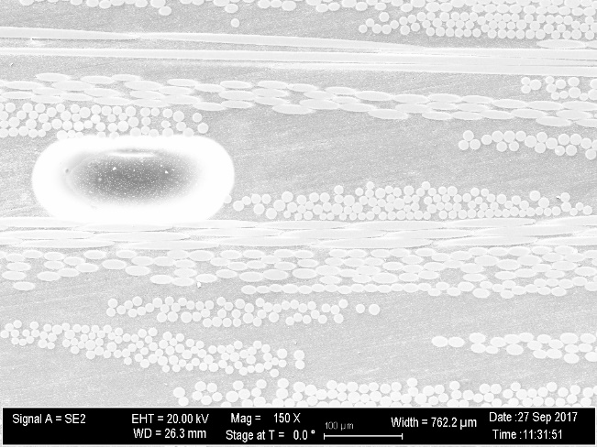
Figure 30: SEM image of an elongated void in the 1-pass random mat case

As seen in Figure 31, the void content of the 0-pass laminate, WLVB-RM-4-0, is much higher than any other case because of the presence of many more circular voids. The 1-pass laminate, WLVB-RM-4-1, has these large circular voids present in the material as well. It is not until the cases with 6 or more passes that this type of void is significantly reduced and nearly eliminated. However, these laminates have void contents greater than 0% because there are still small voids between the tows. As resin is removed, the larger voids are transported out, but the flow of the resin out of the laminate may not increase the wet out between fiber tows and this type of void will remain even as the larger voids are removed.
(a) | WLVB-RM-4-0  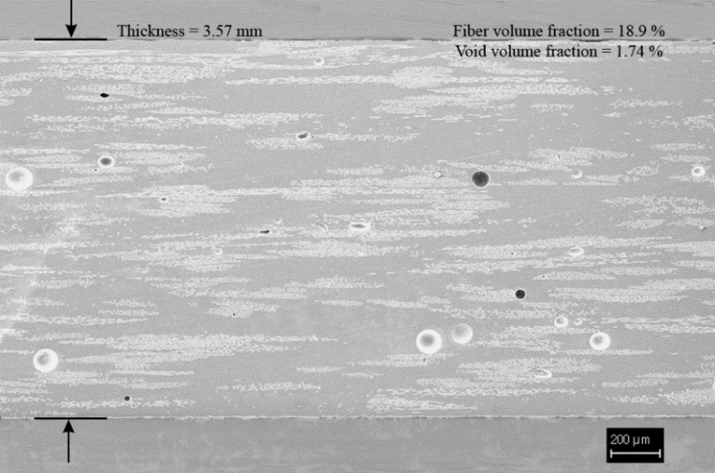
(b) | WLVB-RM-4-1  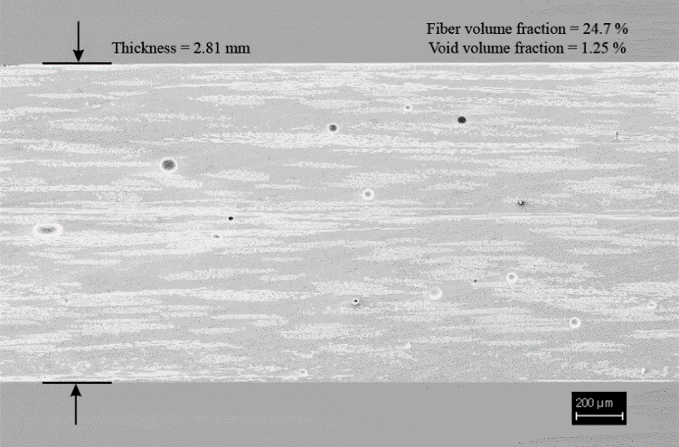
(c) | WLVB-RM-4-6
(d) | WLVB-RM-4-12
(e) | WLVB-RM-4-18
Figure 31: Microstructure of (a) WLVB-RM-4-0, (b) WLVB-RM-4-1,
(c) WLVB-RM-4-6, (d) WLVB-RM-4-12, and (e) WLVB-RM-4-18 laminates

Another notable characteristic of the random mat laminates is the high resin volume fraction and low fiber volume fraction. This is clearly seen in Figure 31a, which is the SEM image for the unpressurized, baseline laminate. The lighter colored fiber tows are surrounded by large amounts of darker colored resin. The distance between fiber tows is a visual evidence of the low fiber volume fraction. The unmodified laminate has a fiber volume fraction of under 20% and is therefore much thicker and has much more resin than the 18-pass case, seen in Figure 31e, which has a fiber volume fraction of 34.1%. In this image, the fibers have been consolidated and are closer together than in other case. For this 18-pass case, resin rich regions, although still present, are much smaller and less frequent than in the baseline laminate. This microstructure is a significant improvement over the unpressurized laminate.
A visual comparison between the SEM images reveals decreased thickness, increased fiber volume fraction, and reduced void content. The thickness reduction is seen clearly as the height of the sample decreases in Figure 31a-e. The magnification and scale are unchanged for all random mat cases, therefore the visible difference between the laminate thicknesses can easily be ascertained.

3.5.2 Plain Weave Laminates
The orientation and the weave structure of the glass fibers in the plain weave laminates can be seen in the SEM images (Figure 32a-d). The samples were cut along the transverse fiber direction, so the longitudinal fiber tows are severed and are seen as the almond shaped clusters of fibers. The fibers oriented in the transverse direction run along the cut and are the long horizontal fibers in the image. The fiber orientation and the ability to distinguish the individual plies in plain weave laminates allows the consolidation of plies to clearly be seen in the SEM images. In the unpressurized case, WLVB-PW-6-0, resin can be seen between the plies, especially at the bottom of the sample. In the 12-pass case, WLVB-PW-6-12, the amount of resin and the space between plies has been reduced, and the fibers of the individual plies are also more consolidated. The thickness of the sample has also been reduced, further indicating how the pressure applied with the magnetic lift has compacted and consolidated the plies of the plain weave laminates. The increase in fiber volume fraction is not as clear as it is in the random mat cases, however, the combination of reduced resin between plies and consolidation of the fibers results in an increased fiber volume fraction.
(a) | WLVB-PW-6-0
(b) | WLVB-PW-6-1
(c) | WLVB-PW-6-6
(d) | WLVB-PW-6-12
Figure 32: Microstructure of (a) WLVB-PW-6-0, (b) WLVB-PW-6-1,
(c) WLVB-PW-6-6, and (d) WLVB-PW-6-12 laminates

The voids in Figure 33 are from the 0-pass case, however, they illustrate the types of voids that are present in the plain weave laminates. The first image shows the larger types of voids that occur in the resin rich regions of the material. Some of these voids are spherical, similar to the voids in the random mat laminates. But most of the voids in the plain weave laminates are elongated, as shown in Figure 33. Figure 33 also shows how a void can be elongated so far that is runs along the length of the fibers, pressed between a longitudinal and transverse fiber tow. This occurs in the plain weave laminates and not the random mat laminates because the void has been trapped between the fiber tows. The amount of resin and lack of fiber structure in random mat laminates makes this type of void uncommon. However, in plain weave laminates, this type of void occurs in all the cases where the magnetic lift was applied. When pressure is applied and the plies are compacted, if the void is not removed, and it often elongates between two fabric plies creating long, narrow voids. It has been shown that these types of voids are more detrimental to the mechanical properties of the material than the spherical voids because they interfere with the bonding of the fiber and resin and may lead to premature failure of the material [37].
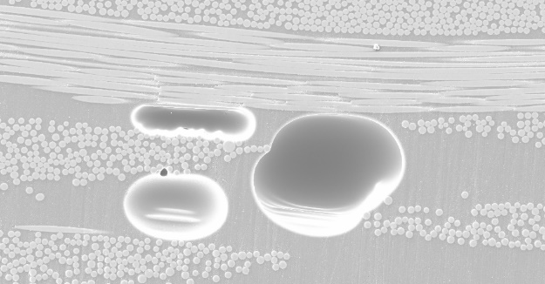 | 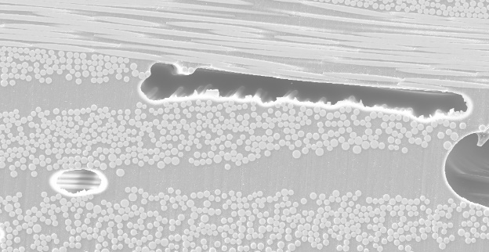
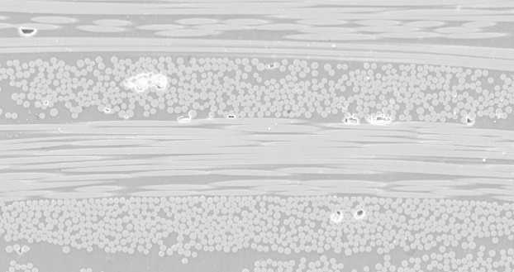

Figure 33: SEM images with 150X magnification showing (a) spherical voids, (b) elongated voids, and (c) voids within the tows in 0-pass, plain weave laminates

The final type of void shown is the voids within tows (intra-tow voids). These types of voids frequently occur in the plain weave laminates because of the alignment of the fibers. Since the fibers are tightly aligned in the longitudinal and transverse directions, complete wet out of the tows is more difficult than with the random mat. Since resin failed to flow into these regions during fabrication, small voids are formed within the tows. These small voids are present in all of the fabrication cases, even as the void content in decreased by applying the magnetic lift. The lift can remove larger voids in the resin because of the resin flow out of the laminate, however, it may not lead to perfect wetting of the fiber tows.

3.6 Flexural Strength and Stiffness
The main goal of fabrication by using a magnetic pressure is to enhance the mechanical properties of laminates fabricated out-of-autoclave. A three-point-bending test is performed to determine the flexural strength and elastic modulus of each case. The goal of applying the magnetic lift is to improve strength and stiffness while decreasing weight. By the rule of mixtures, the higher the fiber volume fraction, the better the part quality, since the properties of the resin do not as positively contribute to the material properties of the composite as the fiber properties do. The tensile strength of E-Glass fibers is between 3100-3800 MPa, and the elastic modulus is between 80-81 GPa [38]. The tensile strength of the PROSET resin is 68 MPa, and the elastic modulus is 3.5 GPa, when cured for 8 hours at 60 °C [28]. The failure due to flexure testing can be seen in Figure 34.

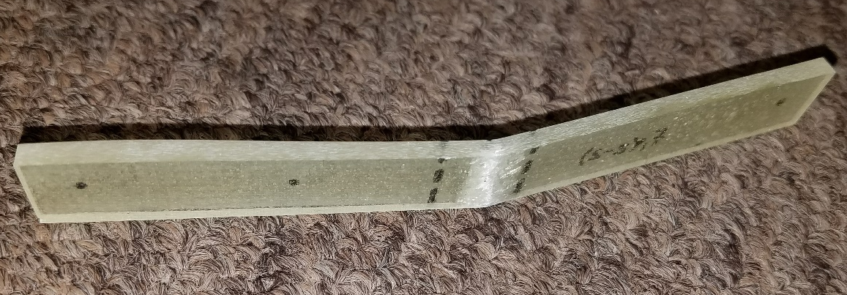
a
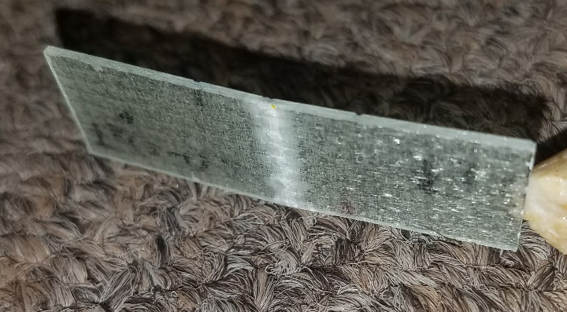
b
Figure 34: Fracture due to tension at the bottom surface of the laminate for both (a) random mat and (b) plain weave laminates

3.6.1 Random Mat Laminates
Figure 35 and Table 15 show the increase in flexural strength and stiffness for each laminate case with respect to the number of passes applied. Both properties increase as the number of passes increases. The maximum percent increase in flexural strength is 82.5% from 248.7 MPa to 454.0 MPa. This maximum strength occurs after 18 passes with the magnetic lift. The elastic modulus is increased by 87% from 7.7 GPa to 14.4 GPa. The strength is only increased 6.7% from 12 passes to 18 passes, and the stiffness is only increased by 7.5%. This is juxtaposed by the increase in strength from the first pass to 6 passes, which is 17.1%. The stiffness increase for the same interval is 22.1%. The strength and stiffness show the same trend as thickness and fiber volume fraction, where the percent change from the 12-pass laminate to the 18-pass is not as great as the increase between other increments as the improvement starts to reach an asymptote. The percent increase in fiber volume fraction is directly comparable to the increase in the flexural properties, as illustrated in Figure 35.

Figure 35: Relationship between fiber volume fraction, flexural strength, and flexural stiffness for random mat laminates

Table 15: Flexural strength and stiffness data and percent
increase of both for random mat laminates
Case | Flexural Stiffness (GPa) | % Increase in Stiffness
WLVB-RM-4-0 | 7.7 ± 0.6 | -
WLVB-RM-4-1 | 9.5 ± 0.8 | 23.4
WLVB-RM-4-6 | 11.6 ± 0.5 | 50.6
WLVB-RM-4-12 | 13.4 ± 0.6 | 74.0
WLVB-RM-4-18 | 14.4 ± 0.4 | 87.0

3.6.2 Plain Weave Laminates
As seen in Figure 36 and Table 16, as the number of passes increases the flexural strength and stiffness continue to improve. The flexural strength for the plain weave laminates are increased by a maximum of 19.8% from 638.9 MPa to 765.2 MPa after 18 passes with the magnetic lift, and the flexural stiffness is increased 27.0% from 24.1 GPa to 30.6 GPa. The elastic modulus is more improved than the flexural strength because it is less dependent on void content than flexural strength. As discussed in Section 3.5.2, applying pressure to the plain weave laminates caused spherical voids to become irregular and elongated as they interact with and are trapped between fiber tows. The effect these types of voids have on the bonding between the fibers and the resin may result in premature failure, and result in lower percent improvement of flexural strength than elastic modulus.

The improvement of both mechanical properties is not as great as the random mat results, because woven fabrics inherently have better mechanical properties than random mat. Because of the fiber orientation, the possible increase in fiber volume fraction is limited, therefore the improvement of flexural properties by pressure application is also not as high as is seen in the random mat cases. The relationship between fiber volume fraction and flexural properties can be seen in Figure 37.

Figure 36: Increase in flexural strength and stiffness of plain weave laminates

Table 16: Flexural strength, elastic modulus, and percent increase of plain weave laminates
Case | Flexural Strength (Mpa) | Flexural Stiffness (Gpa) | % Increase in Strength | % Increase in Stiffness
WLVB-PW-6-0 | 638.9 ± 27.0 | 24.1 ± 0.5 | - | -
WLVB-PW-6-1 | 661.1 ± 20.8 | 27.9 ± 0.7 | 3.5 | 15.8
WLVB-PW-6-6 | 725.4 ± 18.3 | 29.9 ± 0.4 | 13.5 | 24.1
WLVB-PW-6-12 | 765.2 ± 15.3 | 30.6 ± 0.6 | 19.8 | 27.0

Figure 37: Relationship between fiber volume fraction, flexural strength, and flexural stiffness for plain weave laminates
3.7 Vacuum Assisted Resin Transfer Molding (VARTM) Comparison
A common standard for improving part quality in out-of-autoclave manufacturing is to replace the wet layup/vacuum bag procedure with a resin infusion method such as vacuum assisted resin transfer molding. For this reason, the material properties of the improved wet layup laminates are compared to the properties of unmodified VARTM laminates made with same materials. The goal is to determine whether the application of the magnetic lift can improve laminates fabricated using the wet layup method to the quality of parts made using VARTM.

3.7.1 Random Mat Laminates
The laminates fabricated using VARTM have better material properties than the best wet layup case. As seen in Figure 38, the random mat laminates approach the properties of the VARTM laminate but do not reach them. The average thickness of the VARTM laminate is 1.56 mm, while the best thickness achieved by applying the magnetic lift for 18 passes is 1.95 mm, as listed in Table 17. The same trend follows for the rest of the material properties. The maximum fiber volume fraction achieved using the magnet is 34.1% and the minimum void content is 0.66%, compared to the 41.9% and 0.31%, respectively, of the VARTM case. The maximum achievable strength and stiffness for WLVB is 454.0 MPa and 14.4 GPa, respectively. This is compared to the 544.3 MPa strength and 15.4 GPa stiffness of the VARTM case.

Even though the application of the magnetic lift does not improve material properties to the extent that using VARTM does, the properties of the WLVB laminates are approaching those of the VARTM case. This means, depending on the manufacturing parameters, that the wet layup/vacuum bag method with the application of sliding pressure applied using a magnetic lift may be the best fabrication option based on its short start up time and fabrication reliability.
(a)

(b)

(c)

(d)

(e)
Figure 38: Comparison between the decrease in thickness, increase in fiber volume fraction, decrease in void content, increase in flexural strength, and increase in flexural stiffness for the random mat WLVB laminates and VARTM laminate
Table 17: Material properties for wet layup/vacuum bag and VARTM fabricated random mat laminates
Case | Average Thickness (mm) | Fiber Volume Fraction (%) | Void Volume Fraction (%) | Flexural Strength (MPa) | Flexural Stiffness (GPa)
WLVB-RM-4-0 | 3.57 ± 0.17 | 18.9 ± 1.0 | 1.74 ± 0.51 | 248.7 ± 13.5 | 7.7 ± 0.6
WLVB-RM-4-1 | 2.81 ± 0.11 | 24.7 ± 2.1 | 1.25 ± 0.13 | 306.6 ± 17.6 | 9.5 ± 0.8
WLVB-RM-4-6 | 2.50 ± 0.05 | 25.5 ± 1.1 | 0.66 ± 0.18 | 358.9 ± 11.1 | 11.6 ± 0.5
WLVB-RM-4-12 | 2.16 ± 0.05 | 31.4 ± 0.6 | 0.66 ± 0.20 | 425.6 ± 18.6 | 13.4 ± 0.6
WLVB-RM-4-18 | 1.95 ± 0.03 | 34.1 ± 1.1 | 0.73 ± 0.17 | 454.0 ± 15.4 | 14.4 ± 0.4
VARTM-RM-4-0 | 1.56 ± 0.02 | 41.9 ± 0.2 | 0.31 ± 0.33 | 544.3 ± 24.3 | 15.4 ± 1.1

3.7.2 Plain Weave Laminates
The plain weave laminates, contrary to the random mat data, exceed the material properties of the VARTM laminate. As seen in Figure 39, all properties except void content are greater for the WLVB laminates. The average thickness of the VARTM laminate is 1.05 mm while the most improved WLVB laminate, after 12 passes with the magnetic lift, is 0.86 mm thick, as listed in Table 18. The VARTM laminate has fiber volume fraction, flexural strength, and elastic modulus equal to 43.5%, 588.3 MPa, and 21.0 GPa, respectively. These values are much lower than the best achievable properties of the WLVB with pressure applied using a magnetic lift which have a fiber volume fraction of 53.2%, a flexural strength of 765.2 MPa, and an elastic modulus of 30.6 GPa.
(a)

(b)

(c)

(d)

(e)

Figure 39: Comparison between the decrease in thickness, increase in fiber volume fraction, decrease in void content, increase in flexural strength, and increase in flexural stiffness for the plain weave WLVB laminates and VARTM laminate

Table 18: Material properties for wet layup/vacuum bag and VARTM fabricated plain weave laminates
Case | Average Thickness (mm) | Fiber Volume Fraction (%) | Void Volume Fraction (%) | Flexural Strength (MPa) | Flexural Stiffness (GPa)
WLVB-PW-6-0 | 0.98 ± 0.01 | 45.7 ± 0.8 | 3.44 ± 0.46 | 638.9 ± 27.0 | 24.1 ± 0.5
WLVB-PW-6-1 | 0.92 ± 0.01 | 50.2 ± 1.3 | 2.33 ± 0.34 | 661.1 ± 20.8 | 27.9 ± 0.7
WLVB-PW-6-6 | 0.88 ± 0.01 | 52.4 ± 0.5 | 1.13 ± 0.30 | 725.4 ± 18.3 | 29.9 ± 0.4
WLVB-PW-6-12 | 0.86 ± 0.01 | 53.2 ± 1.0 | 1.47 ± 0.49 | 765.2 ± 15.3 | 30.6 ± 0.6
VARTM-PW-6-0 | 1.05 ± 0.01 | 43.5 ± 1.3 | 0.02 ± 0.02 | 588.3 ± 13.7 | 21.0 ± 0.6

The void content of the VARTM laminate is nearly 0%, while the void fraction of the WLVB laminate is still 1.47%. This is due to the fabrication method. The wet layup laminates are fabricated open to the air which allows air to be reintroduced into the resin after it has been degassed. VARTM eliminates this problem by using vacuum infusion to pull the resin into the mold without disturbing the resin and without introducing air that will become voids in the final laminate. However, despite the increased void content, the material properties of the wet layup laminates are much higher than the VARTM part. This is related to the increased fiber volume fraction. In VARTM the only pressure applied to the laminate is vacuum pressure, the same pressure applied to the unmodified WLVB procedure. Without increased external pressure applied after fill, VARTM results in a laminate that is thicker and has lower fiber volume fraction, flexural strength, and elastic modulus. This indicates that when sliding pressure is applied using a magnetic lift, the properties of plain weave laminates will be improved, resulting in better quality parts with lighter weight and improved mechanical properties.
Chapter 4: Conclusions
The effects of using a hand-held magnetic lift to apply compaction pressure by sliding the lift on the surface of the wet layup/vacuum bagged composite laminates after resin infusion are investigated. To determine whether the material properties are improved due to this process modification, the average laminate thickness, fiber volume fraction, void content, flexural strength, and flexural stiffness of 4-ply, chopped strand, random mat and 6-ply, plain weave glass fabrics are experimentally characterized. These properties are then compared to the laminates fabricated using vacuum assisted resin transfer molding to determine the success of sliding the magnetic lift across the surface and applying external pressure. This investigation revealed that material properties are substantially improved by applying the magnet, and in the case of the plain weave laminates, the properties of the laminates became better than those of the laminates fabricated using VARTM.

As a result of applying consolidation pressure by sliding the magnetic lift, resin and voids are transported out of the laminate resulting in reduced thickness, increased fiber volume fraction, and decreased void content. The maximum reduction in thickness for the random mat fabric is 45.4% to 1.95 mm, and for the plain weave fabric, the maximum thickness reduction is 12.2% to 0.86 mm. Corollary to these results, the maximum percent increase in fiber volume fraction is 44.5% to 34.1% for random mat laminates, and 14.4% to 53.2% for plain weave laminates. These improvements are due to the maximum number of magnet passes applied to the random mat and plain weave laminates, which are 18 passes and 12 passes, respectively. The highest number of passes for each fabric do not necessarily result in the minimum void content, because there seem to be a maximum number of passes, depending on the fabric type and resin used, where voids start to be induced by the procedure, thus increasing void content. For the random mat fabric, the void increase is caused by 18 passes, and for the plain weave fabric, it is caused by 12, defining the limiting case for both fabrics. The percent reduction in void content is 58.1% down to 0.73% for the 18-pass random mat laminates, and 57.3% down to 1.47% for the 12-pass plain weave laminates. Even though these are not the minimum values, laminates with the maximum number of passes applied are found to have better mechanical properties despite the slight increase in the amount of voids. The maximum percent increase in elastic modulus is 46.8% to 14.4 GPa for random mat laminates, and 21.3% to 30.6 GPa for plain weave laminates. The maximum percent increase in flexural strength occurs after the maximum number of passes and is determined to be 45.2% to 454.0 MPa for random mat laminates, and 16.5% to 765.2 MPa for plain weave laminates.

Fabricating materials using this modified wet layup/vacuum bagging method results in better quality parts than the conventional parts made by unpressurized wet layup/vacuum bagging. Hence, the easy and inexpensive utilization of a magnetic lift is validated by the significant improvement in part quality.

References

[1] D. Crespy, M. Bozonnet and M. Meier, “100 Years of Bakelite, the Material of a 1000 Uses,” Angewandte Chemie International Edition, vol. 47, no. 18, pp. 3322-3328, 2008.

[2] “The Owens Corning Heritage”, Ocpreferred.com, 2017. [Online]. Available: http://www.ocpreferred.com/acquainted/about/history/1930.asp. [Accessed: 22- Sep- 2017].

[3] A. Baker, S. Dutton and D. Kelly, Composite Materials of Aircraft Structures, 2nd ed. Reston, VA: American Institute of Aeronautics and Astronautics, 2004, p. 435.

[4] S. Mitchell, “The Birth of Fiberglass Boats,” Good Old Boat, vol. 2, no. 6, 1999.

[5] M. Bader, “Selection of composite materials and manufacturing routes for cost-effective performance,” Composites Part A: Applied Science and Manufacturing, vol. 33, no. 7, pp. 913-934, 2002.

[6] P. Olivier, J.P. Cottu, B. Ferret, “Effects of cure cycle pressure and voids on some mechanical properties of carbon/epoxy laminates,” Composites, vol. 26, no.7, pp. 509-515, 1995.

[7] M. R. Wisnom, T. Reynolds, N. Gwilliam, “Reduction in interlaminar shear strength by discrete and distributed voids,” Composites Science and Technology, vol. 56, pp. 93-101, 1996.

[8] B. D. Harper, G. H. Staab, R. S. Chen, “A note on the effects of voids upon the hygral and mechanical properties of AS4/3502 Graphite/Epoxy,” Journal of Composite Materials, vol. 21, pp. 280-289, 1987.

[9] A. Valenza, V. Fiore, “Influence of resin viscosity and vacuum level on mechanical performance of sandwich structures manufactured by vacuum bagging,” Advances in Polymer Technology, vol. 29, no. 1, pp. 20-30, 2010.

[10] R. J. Hinrichs, “Quality Control,” Engineered Materials Handbook Volume 1, Dostal, C.A. ed., ASM International, 1987.

[11] B. Smirnov, R. Berry, “Growth of bubbles in liquid,” Chemistry Central Journal, vol. 9, no. 48, 2015.

[12] W. Soboyejo, Mechanical properties of engineered materials. New York, NY: Dekker, 2003.

[13] R. M. Jones, “Micromechanical Behavior of a Lamina”, Mechanics of Composite Materials, 2nd ed. Philadelphia, PA: Taylor & Francis, 1999,
pp. 121-186.

[14] N. Pan, “Theoretical determination of the optimal fiber volume fraction and fiber-matrix property compatibility of short fiber composites,” Polymer Composites, vol. 14, no. 2, pp. 85-93, 1993.

[15] R. Nicholls. Composite Construction Materials Handbook. Englewood Cliffs, NJ: Prentice-Hall, Inc., 1976, pp. 394.

[16] A. Hammami, B. R. Gebart, “Analysis of the vacuum infusion molding process,” Polymer Composites, vol. 21, no. 1, pp. 28-40, 2000.

[17] K. Chawla, Composite materials, 2nd ed. New York, NY: Springer, 2013, p. 134.
[18] “1990 Clean Air Act Amendment Summary | US EPA”, US EPA, 2017. [Online]. Available:https://www.epa.gov/clean-air-act-overview/1990-clean-air-act-amendment-summary. [Accessed: 10- Oct- 2017].

[19] T. H. Hou, B. J. Jensen, “Double-Vacuum-Bag Technology for Volatile Management in Composite Fabrication,” Polymers & Polymer Composites, vol. 16, no. 2, pp. 101-113, 2008.

[20] L. Liu, B. Zhang, D. Wang, Z. Wu, “Effects of cure cycles on void content and mechanical properties of composite laminates,” Composite Structures, vol. 73, no. 3, pp. 303-309, 2006.

[21] S. Hernández, F. Sket, C. González, J. LLorca, “Optimization of curing cycle in carbon fiber-reinforced laminates: Void distribution and mechanical properties,” Composites Science and Technology, vol. 85, pp. 73-82, 2013.

[22] S. Hernández, F. Sket, J. Molina-Aldareguı´a, C. González, J. LLorca, "Effect of curing cycle on void distribution and interlaminar shear strength in polymer-matrix composites,” Composites Science and Technology, vol. 71, no.10, pp. 1331-1341, 2011.

[23] A. Long, C. Wilks, C. Rudd, “Experimental characterisation of the consolidation of a commingled glass/polypropylene composite,” Composites Science and Technology, vol. 61, no. 11, pp. 1591-1603, 2001.

[24] H. Rydarowski, M. Koziol, “Repeatability of glass fiber reinforced polymer laminate panels manufactured by hand lay-up and vacuum-assisted resin infusion,” Journal of Composite Materials, vol. 49, no. 5, pp. 573-586, 2015.

[25] D. Abraham, S. Matthews, R. McIlhagger, “A comparison of physical properties of glass fibre epoxy composites produced by wet lay-up with autoclave consolidation and resin transfer moulding,” Composites Part A: Applied Science and Manufacturing, vol. 29, no. 7, pp. 795-801, 1998.

[26] Y. Wang, “Effect of Consolidation Method on the Mechanical Properties of Nonwoven Fabric Reinforced Composites,” Applied Composite Materials, vol. 6, pp. 19-34, 1999.

[27] M. Amirkhosravi, M. Pishvar, M. C. Altan. “Improving Laminate Quality in Wet Lay-up/Vacuum Bag Processes by Magnet Assisted Composite Manufacturing (MACM),” Journal of Composites Part A: Applied Science and Manufacturing, vol. 98, pp. 227-237, 2017.

[28] PRO-SET, “Infusion epoxy combined features,” INF-114/INF-211 datasheet, Dec. 2015.

[29] "Switchable Magnets Explained - DocMagnet", DocMagnet Magnetic Workholding and Magnetic Material Handling Products, 2017. [Online]. Available: http://www.docmagnet.com/learning-center/switchable-magnets-explained/. [Accessed: 10- Oct- 2017].

[30] Standard Test Method for Flexural Properties of Polymer Matrix Composite Materials, ASTM D7264, 2015.

[31] Standard Test Methods for Density and Specific Gravity (Relative Density) of Plastics by Displacement, ASTM D792, 2013.

[32] Standard Test Method for Ignition Loss of Cured Reinforced Resins, ASTM D2584-11, 2011.

[33] Standard Practice for Scanning Electron Microscope Beam Size Characterization, ASTM E986-04, 2017.

[34] Standard Test Methods for Constituent Content of Composite Materials, ASTM D3171-15, 2015.

[35] Standard Test Methods for Flexural Properties of Unreinforced and Reinforced Plastics and Electrical Insulating Materials, ASTM D790-17, 2017.

[36] F. Zhang, S. Comas-Cardona, C. Binetruy, “Statistical modeling of in-plane permeability of non-woven random fibrous reinforcement,” Composites Science and Technology, vol. 72, no. 12, pp. 1368-1379, 2012.

[37] Y. Hamidi, L. Aktas, M. Altan, “Effect of packing on void morphology in resin transfer molded E-glass/epoxy composites,” Polymer Composites, vol. 26, no. 5, pp. 614-627, 2005.

[38] ASM Handbook Composites, Vol. 21, ASM International, 2001.

[39] G. Francucci, S. Palmer, W. Hall, “External compaction pressure over vacuum-bagged composite parts: Effect on the quality of flax fiber/epoxy laminates,” Journal of Composite Materials, vol. 52, no.1, pp. 3-15, 2017.

[40] M. Pishvar, M. Amirkhosravi, M. C. Altan, “Magnet assisted composite manufacturing: A novel fabrication technique for high-quality composite laminates,” Polymer Composites, vol. 38, no 10.
[40] M. Pishvar, M. Amirkhosravi, M. C. Altan, “Applying Magnetic Consolidation Pressure during Cure to Improve Laminate Quality: A Comparative Analysis of Wet Lay-Up and Vacuum Assisted Resin Transfer Molding Processes”, ASME 2017 International Mechanical Engineering Congress and Exposition, vol. 14, 2017.
[41] M. Amirkhosravi, M. Pishvar, M. C. Altan. “Reduction of Voids in VARTM Composites by Magnetic Compaction of Preforms before Infusion”, American Society of Composites-32th Technical Conference, 2017.

[42] M. Pishvar, M. Amirkhosravi, M. C. Altan. “Fabricating High-Quality Composite Laminates by Magnetic Compaction”, 33rd International Conference of The Polymer Processing Society, 2017.

