UNIVERSITY OF OKLAHOMA
GRADUATE COLLEGE

CROSS-EDUCATION OF THE REPEATED BOUT EFFECT AFTER UNILATERAL ECCENTRIC EXERCISE WITH AND WITHOUT MIRROR VISUAL FEEDBACK

A THESIS
SUBMITTED TO THE GRADUATE FACULTY
in partial fulfillment of the requirements for the
Degree of
MASTER OF SCIENCE

By
RICHARD T. YANG
Norman, Oklahoma
2023

CROSS-EDUCATION OF THE REPEATED BOUT EFFECT AFTER UNILATERAL ECCENTRIC EXERCISE WITH AND WITHOUT MIRROR VISUAL FEEDBACK

A THESIS APPROVED FOR THE
DEPARTMENT OF HEALTH AND EXERCISE SCIENCE

BY THE COMMITTEE CONSISTING OF

Dr. Christopher D. Black, Chair
Dr. Michael G. Bemben
Dr. Daniel J. Larson

© COPYRIGHT BY RICHARD T. YANG 2023
All Rights Reserved

ACKNOWLEDGEMENTS
Dr. Black, thank you for taking the chance on me to be a student in your lab. I am forever grateful for the opportunity you gave me and appreciate all the knowledge and wisdom you have passed onto me. Without your help I would not have been able to get through the past two years as a researcher. This experience has had a huge impact on my life, and I would not be where I am now without it, so again, thank you.
Dr. Bemben and Dr. Larson, thank you for your patience and understanding throughout this whole project and for sticking with me until the end. You both have made this smooth process for me, and I greatly appreciate the wisdom and advice both of you have handed me in writing my thesis while providing me a great learning opportunity.
I want to thank Elise, Kristina, Ryann, Claire, Gunn, Caitlin, Cy, Grant, and everyone who has been apart of the lab or the program. I greatly appreciate all the help and support that you have provided me whenever I needed it in the lab. Having gone through struggles I often did not voice, being surrounded by your guys’ energy was something I found incredibly valuable throughout these past 2 years. I am so grateful to have been part of this lab and in this program with you all.
I want to give a special thanks to my girlfriend Naly who has been with me every step of the way in any endeavor I have taken on. No matter what, you have always supported me in whatever dreams and goals I have. You’ve helped me so much whenever times were tough over the past two years and without you, I am unsure where I would be. Thank you for being in my life, I love you.

TABLE OF CONTENTS
ACKNOWLEDGEMENTS iv
LIST OF TABLES viii
LIST OF FIGURES viii
ABSTRACT ix
CHAPTER I: INTRODUCTION 1
1.01 Purpose 4
1.02 Research Questions 4
1.03 Research Hypotheses 4
1.04 Null Hypotheses 5
1.05 Significance 6
1.06 Delimitations 6
1.07 limitations 7
1.08 Assumptions 7
1.09 Operational Definitions 8
CHAPTER II: REVIEW OF LITERATURE 10
2.01 Outline 9
2.02 Muscle Damage and Delayed-Onset Muscle Soreness 9
2.03 Repeated Bout Effect 12
2.04 Cross Education 16
2.05 Mirror Neuron System 19
2.06 Contralateral-RBE 20
2.07 Sex-related Differences in Muscle Damage 21
2.08 Summary & Knowledge Gaps 22
CHAPTER III: METHODOLOGY 24
3.01 Introduction 24
3.02 Sample 24
3.03 Inclusion Criteria 25
3.04 Exclusion Criteria 25
3.05 Experimental Design and Overview 26
3.06 Experimental Procedures 30
3.07 Data Analysis 32
CHAPTER IV: RESULTS 34
4.01 Sample 34
4.02 Maximal Isometric Strength 34
4.03 Range of Motion 37
4.04 Muscle Soreness 40
4.05 EMG RMS 44
CHAPTER V: DISCUSSION & CONCLUSIONS 46
5.01 Purpose and Hypotheses 46
5.02 Contralateral RBE 46
5.03 Neural Adaptations 48
5.04 Limitations 49
5.05 Significance and Future Study Recommendations 50
5.06 Conclusions 51
REFERENCES 53
APPENDIX A: IRB APPROVAL LETTER 60
APPENDIX B: INFORMED CONSENT FORM 61
APPENDIX C: HIPAA AUTHORIZATION FORM 65
APPENDIX D: PHYSICAL ACTIVITY READINESS QUESTIONNAIRE 68
APPENDIX E: MENSTRUAL HISTORY QUESTIONNAIRE 72
APPENDIX F: HEALTH SCREENING QUESTIONNAIRE 73
APPENDIX G: RHABDOMYALYSIS SCREENING 75
APPENDIX H: RECRUITMENT FLYER 76

LIST OF FIGURES
Table 1: Descriptive statistics & Pre-Exercise MVC
Table 2: Change in Biceps Isometric Strength Data by Condition & Bout Post-Exercise
Table 3: Change in Range of Motion by Condition & Bout Post-Exercise
Table 4: Change in Muscle Soreness Ratings by Condition & Bout Post-Exercise
Figure 1: Study Design
Figure 2: Percent change in maximal isometric torque between groups over time
Figure 3: Separate group analysis comparing the change in MVC over time between bouts
Figure 4: Magnitude of protection in maximal isometric torque between bouts over time
Figure 5: Percent change in range of motion over between groups over time
Figure 6: Separate group analysis comparing the change in ROM over time between bouts
Figure 7: Magnitude of protection in range of motion between bouts over time
Figure 8: Muscle soreness VAS between groups over time
Figure 9: Separate group analysis comparing muscle soreness over time between bouts
Figure 10: Magnitude of protection in muscle soreness within each group between bouts over time
Figure 11: Biceps RMS averages by groups between bouts
Figure 12: Triceps RMS averages by groups between bouts

ABSTRACT
Previous research has demonstrated evidence of the cross education of the repeated bout effect (CL-RBE) to the untrained contralateral limb, however, it has been shown to be weaker in magnitude when compared to the ipsilateral limb. Mirror visual feedback or mirror therapy has been shown to potentially enhance the effectiveness of cross education, but this intervention has not been investigated when looking at the cross education of the repeated bout effect. PURPOSE: The purpose of this study was to investigate if mirror visual feedback could enhance the CL-RBE in the untrained contralateral limb after a single bout of unilateral eccentric exercise. METHODS: 28 participants (14 men & 14 women ages 18-35) were placed into 1 of 3 groups (control, no mirror, and mirror) and completed 10 visits which consisted of 2 familiarization visits, 2 eccentric exercise testing visits (1 or 2 weeks apart), and 6 follow-up visits. This study utilized a pre-test/post-test controlled design where participants would perform pre-exercise measurements of maximal isometric strength (MVC), range of motion (ROM), and muscle soreness rating (DOMS). For the 1st maximal eccentric exercise visit, 3 sets of 8 repetitions of maximal effort eccentric bicep curls with their dominant arm using the KinCom isokinetic dynamometer. During this 1st bout, the Mirror group had a mirror placed on the axilla of their non-dominant arm to create the mirror image illusion effect of bilateral exercise of the elbow flexors. The Control group used their dominant arm again for the 2nd eccentric exercise visit while the two experimental groups (No Mirror and Mirror) performed the bout with their non-dominant arm. After each eccentric exercise bout, they would perform the post-exercise MVC, ROM, and DOMS measurements. During these visits, surface EMG data of the biceps and triceps were recorded. These 2 eccentric exercise testing visits had 3 follow up visits (24h, 48h, and 72h) collecting data for MVC, ROM, and DOMS. RESULTS: The Control group and No Mirror group exhibited a repeated bout effect with a significant difference between bouts when looking at MVC and DOMS (p < 0.05) with the control group exhibiting the largest magnitude of protection. The No Mirror group did not show any significant differences between bouts when looking at these measures (p > 0.05). All groups did not show a significant difference when looking at ROM. All groups did not show a significant difference when looking at EMG RMS between bouts, demonstrating similar muscle activation in all groups between bouts (p > 0.05). CONCLUSIONS: In conclusion, this study demonstrates the supported findings of the RBE in the control and the CL-RBE in the no mirror group, however, there was no evidence of the cross education of the RBE in the Mirror group when looking at any of the dependent variables. Therefore, mirror visual feedback had no influence on the CL-RBE. Future studies should continue to investigate the use of a mirror to augment the CL-RBE with larger sample sizes and up to 5 follow-up visits. Investigation into mirror placement and the validity of the effectiveness of different positions for the mirror when used during various exercises should be considered as well.

CHAPTER 1: INTRODUCTION
Muscle damage may occur when the muscle receives a harmful physical, chemical, or biological stimulus. The most common occurrence in daily life is a physical stimulus through sport, exercise training, and/or daily physical activities. The performance of unaccustomed muscle contractions consisting of eccentric contractions (i.e. those where the muscle is lengthening) is often the primary physical stimulus (McHugh et al. 1999). This unaccustomed exercise results in a defined set of symptomatic, functional, and histologic changes that are referred to collectively as muscle damage (Hyldahl et al., 2017). Eccentric exercise leads to muscle damage (EIMD) by causing a disruption of the z-disc structure, intermediate filaments, and contractile proteins to a greater extent than with other types of muscle contractions. EIMD also leads to an increase muscle specific proteins such as creatine kinase (CK) and myoglobin appearing in the blood. Disruption of the sarcomere leads to a loss function that manifests as a decreased ability to generate force and a loss of range-of-motion (ROM). Symptomatically, muscle damage leads to the development of muscle pain/soreness that is often delayed in its onset and thus has been termed as delayed onset muscle soreness (DOMS) (Tiidus, 2008).
Although EIMD and its accompanying prolonged muscle soreness may be undesirable, an adaptation occurs following the recovery process that plays a “protective” role and limits EIMD from the performance of similar bouts of eccentric exercise in the future. Evidence suggests both “neural” (changes in motor-unit recruitment, etc.) and “physical” (changes in expression of structural proteins within a sarcomere, etc.) adaptations occur that attenuate muscle damage from future eccentric exercise. This occurrence of a protective effect after a bout of eccentric exercise has been termed the repeated bout effect (RBE) (McHugh et al., 1999; Mchugh, 2003). The RBE has been shown to last for 6-9 months but begins to diminish after roughly 8 weeks (Nosaka et al., 2005; Tiidus, 2008; Chen 2016). The adaptations that occur with the RBE have been widely studied but remain somewhat unclear. As mentioned previously, adaptations are generally categorized as neural (e.g. changes in motor-unit recruitment strategies) or physical/peripheral (e.g. changes in the cellular and mechanical properties of skeletal muscle) in nature. There is clear evidence that physical changes occur in skeletal muscle following EIMD, however evidence that nervous system adaptations whereby motor-unit recruitment, firing rates, and/or synchronization of motor-unit firings occur is also growing. A unique motor pattern is used when performing eccentric contractions. This has been shown to result in reduced motor-unit activation (as observed from surface EMG) at a given absolute force when compared to concentric and isometric contractions (Hight et al. 2016). This leads to greater stress being placed on a smaller number of muscle fibers during eccentric contractions which likely contributes to why EIMD occurs more often following eccentric exercise. Increased motor-unit activation as well as decreased antagonist activation (Hight et al. 2016) has been shown with the RBE indicating a change in neural strategy to reduce the stress placed on individual muscle fibers.
An emerging area of research on the RBE involves the transfer of neural adaptations from limb to the other—termed “cross-education.” Studies have observed the phenomenon in response to exercise of a single limb leads to enhanced performance of the uninvolved contralateral muscle group (Zhou, 2000; Hyldahl, 2017; Manca, 2017). This phenomenon was first observed in 1984 by researcher Edward Scripture. He observed the transfer of both strength and motor skill to the contralateral limb after unilateral exercise (Scripture, 1984). It is well accepted that neural mechanisms are responsible for cross-education, and the utility of these adaptations has been recognized in a variety of training programs, especially in clinical and rehabilitation settings (Carr, 2019). In relations to the RBE, studies have shown that performing maximal eccentric exercise in one limb confers the protective properties of the repeated-bout effect to the opposite limb and has been termed the “contralateral repeated bout effect” (CL-RBE) (Hortobagyi et al., Hyldahl, 2017; Chen et al., 2016). While the CL-RBE has been consistently observed little is known about the exact changes in neural strategies that potentially underlie the CL-RBE.
Recent research suggests that the effect of cross-education may be magnified with the use of mirror visual feedback (MVF). Mirror visual feedback involves the individual performing unilateral exercise with a mirror placed along the midsagittal plane, which shows a mirror image of the exercising limb that creates the illusion that the contralateral limb is performing exercise concurrently with working limb (Carr, 2019). This process has been shown to produce specific patterns of brain activity and is hypothesized to activate mirror neurons (Howatson et al., 2013) which are thought to be involved with sensory integration, motor planning, and movement execution (Rizzolatti & Craighero, 2004). Activation of the mirror neuron system have been shown to enhance the cross-education of muscular strength in healthy individuals as well as clinical populations with asymmetric limb disorders (Ramachandran & Altschuler, 2009; Carvalho et al., 2013; Urbin et al., 2015). For example, a study involving individuals using MVF, showed ~27% greater increase in strength in the contralateral limb following 3 weeks of unilateral strength training using a mirror compared to training without MVF (Zult et al., 2016). Given the ability of MVF to enhance the cross-education of neural adaptations following resistance training, it represents an intriguing method to potentially enhance the CL-RBE since it also is dependent upon the cross-transfer of neural adaptation.

Using this mirror visual feedback tool may be helpful in increasing the magnitude of CL-RBE as current research shows that the RBE effect in the contralateral limb is not as strong when compared to the ipsilateral limb (Howatson & Someren, 2007; Chen et al., 2016; Hyldahl et al., 2017). Results in a recent study show that the index of protection (%) gained in the contralateral limb in comparison of the ipsilateral limb (which stays at 100%) peaks at 60 to 80% after 1 day and 1 week, drops to 50% after 4 weeks, and diminishes to baseline thereafter (Chen et al., 2016). Currently to the author’s knowledge there is no research investigating the augmentation of cross education of the RBE with the use of mirror visual feedback.
1.01. Purpose
Therefore, the purpose of this study was to investigate whether the use of MVF enhances the cross-education of the RBE in the contralateral limb following a single bout of unilateral eccentric exercise.
1.02. Research Questions
- Does MVF during a single bout of unilateral eccentric exercise enhance the CL-RBE compared to unilateral eccentric exercise without MVF?
- Does MVF during a single bout of unilateral eccentric exercise alter motor unit activation, as assessed via surface EMG, of the agonist (biceps) and antagonist (triceps) muscles during a subsequent bout of eccentric exercise in the contralateral elbow flexors.
1.03. Research Hypotheses
- Unilateral eccentric exercise performed with MVF will lead to a smaller reduction in maximal voluntary isometric contraction (MVC) force, compared to no MVF, when subsequent eccentric exercise is performed 1 week later in the contralateral arm.
- Unilateral eccentric exercise performed with MVF will lead to a smaller reduction in elbow flexor range-of-motion (ROM), compared to no MVF, when subsequent eccentric exercise is performed 1 week later in the contralateral arm.
- Unilateral eccentric exercise performed with MVF will lead to less delay-onset muscle soreness (DOMS), compared to no MVF, when subsequent eccentric exercise is performed 1 week later in the contralateral arm.
- Unilateral eccentric exercise performed with MVF will lead to greater biceps EMG amplitude, compared to no MVF, when subsequent eccentric exercise is performed 1 week later in the contralateral arm.
- Unilateral eccentric exercise performed with MVF will lead to reduced triceps EMG amplitude, compared to no MVF, when subsequent eccentric exercise is performed 1 week later in the contralateral arm.
1.04. Null Hypotheses
- Unilateral eccentric exercise performed with MVF will lead to no changes in maximal voluntary isometric contraction (MVC) force, compared to no MVF, when subsequent eccentric exercise is performed 1 week later in the contralateral arm.
- Unilateral eccentric exercise performed with MVF will lead to no changes in elbow flexor range-of-motion (ROM), compared to no MVF, when subsequent eccentric exercise is performed 1 week later in the contralateral arm.
- Unilateral eccentric exercise performed with MVF will lead to no changes delay-onset muscle soreness (DOMS), compared to no MVF, when subsequent eccentric exercise is performed 1 week later in the contralateral arm.
- Unilateral eccentric exercise performed with MVF will lead to no changes in biceps EMG amplitude, compared to no MVF, when subsequent eccentric exercise is performed 1 week later in the contralateral arm.
- Unilateral eccentric exercise performed with MVF will lead to no changes in triceps EMG amplitude, compared to no MVF, when subsequent eccentric exercise is performed 1 week later in the contralateral arm.
1.05. Significance
The results of this study will provide more insight into the repeated bout effect and cross education. It will examine the magnitude of the cross education of the RBE to the contralateral limb with and without the use of mirror visual feedback, which may help elucidate what potential mechanisms of the “mirror neuron system” also overlap in cross education or vice versa. These findings can prove useful to general, athletic, and clinical populations who temporarily are unable to use one side of the body as this crossover effect can help preserve protection, recovery, and strength.
1.06. Delimitations
The findings of the study apply only to healthy men aged 18-35 years old.
The participants must not be taking any prescription pain medication(s) that interfere with neuromuscular function.
The participants must not be taking any OTC pain medications (NSAIDS) currently.
The participants must have no history of muscle disorder/ dysfunction / surgery interfering with performance of high-intensity eccentric exercise of the elbow flexors.
The participants must not be taking any performance enhancing supplements or drugs.
The findings will only apply to untrained men who have not actively resistance trained their arms for the past 6 months.
1.07. Limitations
A nonrandom sample will be used as participants were volunteers from the University of Oklahoma and the surrounding counties.
Participants will be instructed to continue to follow their normal diet, but this will not be monitored.
Participants were instructed to avoid all resistance exercise outside of that performed in the study for the duration of the study. This was confirmed via self-report, but researchers were not able to fully monitor adherence.
Due to available equipment (KinCom isokinetric dynamometer), it was impossible to completely isolate biceps muscle.
1.08. Assumptions
Participants gave maximal effort during all testing sessions.
Reliability and validity of all testing protocols was established in prior research
Participants were truthful in health screening
Participants were truthful in reporting on muscle soreness
Participants adhered to instructions and avoided resistance training outside of the lab.

1.09. Operational definitions
Repeated Bout Effect (RBE): The Repeated Bout Effect is the intrinsic neural and physical adaptation of the skeletal muscle to attenuate muscle damage from future exercise
Muscle Damage: Occurs from unaccustomed exercise and results in a defined set of symptomatic, systematic, and histologic changes in the skeletal muscles
Delayed Onset Muscle Soreness (DOMS): Moderate to severe muscle soreness usually experienced 2 to 3 days after an bout of eccentric exercise and can last up to 5-7 days
Ipsilateral RBE – Measured repeated bout effect on the same limb (Control)
Contralateral RBE – Measured repeated bout effect on the opposite limb
Mirror Neuron System (MNS)- The Mirror Neuron System (MNS) consists of a complex network of neurons across the lobes of the brain and provides a neuroanatomical basis for the development of motor learning and skill acquisition by observing actions and imitating an act (Howatson et al., 2013).
Mirror visual feedback – Illusionary mirror visual feedback is provided by placing a mirror in the midsagittal plane, with the mirror reflection of one limb superimposed over the contralateral, hidden limb (Carr et al., 2019)
H-Reflex – Reflexive jerk movement of the antagonistic muscle. Contains oligosynaptic components (Ia afferents) and provides inhibitory input on the agonist muscle (Fisher, 2014).

CHAPTER 2: LITERATURE REVIEW
2.01. Outline
As mentioned in chapter 1, this study will be looking at magnitude of the cross education of the repeated bout effect after unilateral eccentric exercise with and without the use of mirror visual feedback. This literature review will be discussing the mechanisms of action for DOMS, DOMS effect on performance, the repeated bout effect, cross education & mirror visual feedback, and cross education of the RBE. It will also review literature on the effect of the menstrual cycle on muscle damage and recovery from muscle damage. Because we are using female participants, we will be controlling for the menstrual cycle by performing the experimental testing period during the luteal phase of the menstrual cycle. Sources were searched using several databases available from the University of Oklahoma. The main databases used were google scholar, MEDLINE (EBSCO), PubMed, and SportDiscus. Keywords used were: Muscle Damage, DOMS, Eccentric Exercise, Repeated Bout Effect, Cross Education, Cross-over effect, Mirror, Mirror visual feedback.
2.02. Muscle Damage and Delayed-Onset Muscle Soreness
DOMS is described as the delay of muscle soreness in the first 24 hours after exercise. It can usually be described as an aching pain in the muscle along side with muscle stiffness and tenderness. The sensation of pain increases when mechanical stimuli such as pressure, stretching, or contractions is applied to the muscle (Tiidus, 2008). The intensity of DOMS peaks from 24 hours to 72 hours, and completely subsides by the 5th or 7th day postexercise. DOMS has often been associated with muscle damage as a result of eccentric contractions (Armstrong, 1984). It has been shown that eccentric contractions where the muscle is lengthened produces the greatest amount of DOMS versus isometric (at both short and long muscle lengths) and concentric contractions. It has been show that pure concentric contractions is not enough to induce DOMS, however, when people train concentric contractions they will also unintentionally perform eccentric contractions, especially when the person has reached muscle fatigue (Tiidus, 2008).
There are several theories proposed to help explain the mechanisms of DOMS. It was first proposed as the “Damage Theory” in 1902 where researchers concluded that DOMS was the result of ruptures within the muscle (Hough, 1902). However, it is better known now that “ruptures in muscle fibers” are generally not associated with DOMS. What researchers discovered to be associated with DOMS is disruptions of myofilaments, especially at the Z-disc, which is characterized by broadening, streaming, or smearing of the Z-disc structure, all of which can increase mechanical sensitivity of muscle nociceptors (Tiidus, 2008). It is also possible that damage to the connective tissues such as the perimysium and endomysium could be related to DOMS. Damage to the muscle and disruptions of the myofilaments has also been shown to produce a subsequent inflammatory response, which could lead to the sensitization of muscle nociceptors over time (Smith, 1991). Instead of viewing all of these mechanisms separately, it is highly likely that both damage to the muscle and its connective tissue, as well as the subsequent inflammatory response are associated with DOMS (Cheung et al., 2003). The magnitude of muscle damage induced by eccentric contractions is affected by a variety of factors. This includes intensity, velocity, number of contractions, muscle length, muscle group, age, sex, and exposure to eccentric loads in daily activity. They found that there was greater muscle damage when using a higher intensity, faster velocity, larger repetitions, and those with longer muscle lengths. The arm muscles are also more susceptible to muscle damage than the legs.
Muscle damage can only be verified by physical morphological examination; however these evaluations and procedures are difficult to perform, therefore, it is more common to see indirect markers as measurements for muscle damage. There are also several ways to measure muscle damage through subjective and objective measures. Several scales have been used to perceptually measure or quantify muscle soreness including VAS, numerical rating scales, and verbal rating scales. However, it is important to note that soreness and pain sensation vary among individuals as it is a very subjective measure. Perception of pain can vary greatly within and between individuals given their mood, health, and hormonal status. With DOMS, we also commonly see a loss of muscle function with decreases in muscle strength and range of motion. Decreases in maximal voluntary contraction (MVC) is considered the best way to quantify muscle damage (Warren et al., 1999). This can be measured by looking at the decrease in isometric strength over a period of time (post-exercise and over course of days or weeks) and the decrease in eccentric torque throughout the eccentric bouts. Muscle damage is also assessed via increases in muscle-specific proteins in the blood such as creatine kinase (CK) and myoglobin (Clarkson et al., 1992). All these measurements are often correlated with muscle damage, however some have a different time course. Muscle soreness and range of motion is more affected 2 to 3 days postexercise, however muscle strength has been shown to drop immediately. Because of the different time course, it is hard to correlate DOMS with the other indicators or symptoms of muscle damage. It has also been shown that even though resistance trained individuals have reduced muscle damage, the peak level of soreness rated does not differ from untrained individuals. So, trained individuals can feel just as sore, but with significantly much less muscle damage. It has also been shown that DOMS is not necessarily a warning sign to cease all physical activity. When performing submaximal exercise, it was observed that DOMS was significantly reduced temporarily. This shows that although maximum strength may be reduced, the muscle is still able to function as normal when continually performing activity. A study looking at 2 strenuous eccentric exercise bouts within 2-3 days (Chen & Nosaka, 2006) discovered that a 2nd high intensity eccentric exercise during the early recovery stage does not exacerbate muscle damage and does not influence the recovery process, supporting the idea that DOMS is not a signal to the body to cease exercise.
2.03. Repeated Bout Effect
Unfamiliar eccentric exercise results in muscle damage, which results in individuals receiving DOMS. However, this process has been shown to have a protective effect. Following recovery from the initial bout of eccentric exercise, individuals will exhibit protection against muscle damage during the next bout of maximal eccentric exercise. This phenomenon has been termed as the repeated bout effect (McHugh, 1999, 2003). This effect shows a decrease in muscle soreness, faster recovery of strength, decreased muscle stiffness, and decreased muscle swelling. There are several factors that will affect the magnitude of the RBE as well as several ways that the RBE can occur. First, the effect of the RBE is greater with increases in intensity. We see this in a study where they had participants perform either maximal, 80%, 60%, or 40% eccentric elbow flexor exercise. The greater the intensity, the larger the RBE. However, it has also been shown that severe muscle damage is not a prerequisite for the RBE. The RBE effect can be elicited by submaximal eccentric exercise. It was reported that 40% ECC repeated every 2 weeks for four times was able to elicit the same magnitude of protective effect as one bout of maximal ECC. Maximal voluntary isometric contractions at long muscle lengths have also been shown to elicit a RBE. It was also reported that 2 or 6 maximal eccentric repetitions was able to confer a protective effect. The 6 repetition was able to provide a similar magnitude of protection when compared to 24 maximal eccentric repetitions even though it produced less muscle damage. Muscle length also plays a role in RBE. A study looking at a long starting muscle length versus a short starting muscle length moving for the same range of motion saw that the short starting muscle length was able to produce a partial RBE (~50%) even though it produced much less muscle damage (Hyldahl et al., 2017).
In recent literature it is accepted that the possible underlying mechanisms for the RBE are due to neural adaptations, muscle-tendon complex behaviors, extracellular matrix structure remodeling, and the modified inflammatory response. This is built on the theories that McHugh (1999; 2003) presented as the possible mechanisms for the RBE. Previous studies have shown neural adaptations associated with the RBE. After a bout of maximal eccentric exercise, it has been shown that there is an increase in motor unit synchronicity and also a shift of recruitment to slow-twitch motor units during the second bout of eccentric exercise (McHugh, 2003). Using intramuscular EMG recordings, it was reported that motor unit synchronization increased up to 7 days after the eccentric exercise bout (Dartnall et al., 2007). It is possible that this increase in activation of slow twitch fibers to produce the force necessary to perform the movement is able to attenuate the muscle damage as slow-twitch muscle fibers are much less likely to experience muscle damage (McHugh, 2003). Also, the nervous system may be able to better distribute mechanical constraint over a greater motor unit sample during submaximal eccentric exercise. However, the ability to produce more force due to greater motor unit synchronization can potentially make the muscle more susceptible to damage due to the greater overall mechanical tension on the fibers. It has also been shown that eccentric contractions have a unique activation strategy that does not follow the same size principle that concentric contractions as the central nervous system is unable to maximize motor unit recruitment and discharge rate in subjects who are unaccustomed to eccentric exercise. It has also been shown that volitional drive from the supraspinal centers and transmission efficiency in the Ia afferent synapses increased after training, meaning that eccentric-induced neural responses could possibly increase the alpha motor neuron excitability in the spinal cord or decrease presynaptic inhibition of Ia terminals (Kidgell et al., 2015). Similarly, in a study researching the neural changes at the muscle by looking at the coactivation of antagonist muscles during the 1st and 2nd bout of eccentric exercise, they found that during the 2nd bout of maximal eccentric exercise that there was less coactivation of the antagonist muscle, resulting in more total force being able to be produced during a max effort and less total force required to move an identical external load (Hight et al., 2017). With continual resistance training using eccentric exercise, it has been shown that there are increases in spinal motor neuron excitability, decreased presynaptic and postsynaptic inhibition, and elevated descending motor drive (Lepley et al., 2017; Aagaard, 2018).
Another possible theory for the RBE are the muscle-tendon complex behaviors and adaptations that may occur after eccentric training. A study has shown that the addition of sarcomeres in series has been shown to reduce mechanical strain to the muscle fibers (Proske et al., 2001), however sarcomere remodeling cannot fully explain the RBE. Tendon compliance such as fascicle length may also play a role in the protection of muscle damage. It has been shown that muscle fascicle length is less prone to elongation during the 2nd eccentric bout, which has shown to lead to less DOMS (Lau et al., 2015). There are no direct studies examining tendon adaptations after a bout of eccentric exercise, and more research needs to be conducted on investigating muscle-tendon behavior changes as well as in conjunction with an neural or peripheral adaptations. In addition, extracellular matrix structural remodeling (ECM) is another possible mechanism that focuses on the structure of the muscle fiber or its tendons. This ECM is the complex network of collagen and glycoproteins that envelop single muscle fibers. One of ECM’s primary function is to buffer myofibers from mechanical strain by increasing passive tension. Eccentric exercise as well as electrical stimulation has been shown to increase the ECM restructuring rate, however it seems likely to occur some time beyond 2 days postexercise and can last up to 4 weeks (Hyldahl et al., 2017). After eccentric exercise, the muscle first undergoes a de-adhesion process causing sarcomere disruption and membrane damage, however after 3 days, the muscle sill have an increased rate of collagen expression and TGF-B signaling, resulting in a diminished de-adhesion process after the 2nd bout (Hyldahl et al., 2015).
The RBE may also be attributed to a modified inflammatory response adaptation after a bout of eccentric exercise. There is some evidence of a blunted inflammatory response after the 2nd eccentric bout in mice (Pizza et al., 2002, Hyldahl et al., 2017), however it was found that there was a greater inflammatory response after the 2nd eccentric bout in humans (Deyhle et al., 2016). It is suggested that this increase in certain markers such as cytokines, macrophages, and T-cells may play a role in muscle regeneration, however there is no clear evidence or study directly looking at this effect. Hyldahl et al. (2017) suggest that enhanced acute inflammatory response may help speed up the recovery of the muscle, however, they also state it could simply be a reduction of muscle damage and more that more research needs to be conducted looking into this question.
To summarize, we see that through repeated bouts of eccentric exercise, muscles are able to produce a protective adaptation protecting themselves from muscle damage and DOMS from future exercise. It has been shown that there are multiple intensities or specific regimens to reproduce these adaptations, however, cease of exercise longer than 8 weeks will show a reduction in the RBE. Again, it is unlikely that it is just a single mechanism that fully explains the RBE, but rather the culmination of each model that fully contributes to the RBE.
2.04. Cross Education
“Cross education”, the “cross over effect”, or the “cross-training effect” is the inter-limb phenomenon where adaptations in one limb will confer to the contralateral limb. Specifically, the increase in muscle control and voluntary force generation in the untrained, contralateral, homologous limb after a bout of unilateral training (Scripture, 1894; Lee & Carroll, 2007; Manca et al., 2021). Cross education has been extensively studied in literature for the past century and the main characteristics have been identified. Cross education can occur in both upper and lower limb muscles as well as small intrinsic muscle to gross large muscles, and does not appear dependent on direct or indirect corticospinal projections (Lee & Carroll, 2007). There is some evidence that there is a cross over but of less magnitude to synergic, nonspecific muscles (Mason et al., 2018). Cross education can occur at any age and is not gender specific (Zhou. S, 2000), however, it has been shown that the magnitude of cross education seems to decrease with age (Hinder et al., 2011). Cross education can occur through voluntary contractions, electrical stimulation (Hortobagyi et al., 1999), or mental practice of unilateral contractions (Yue & Cole, 1992; Ranganathan et al., 2004). Cross education can occur with various modalities such as isometric contractions or dynamic contractions, however, the strength gain is greatest when the same movement task is performed (Lee & Carroll, 2007). In order for cross education to occur, there needs to be an absence of muscle activity in the untrained muscle during the unilateral exercise and when there is no muscle hypertrophy occurring in the untrained limb (Lee & Carroll, 2007). Cross education also has value in the purely clinical setting as it has been demonstrated in patients with neurological disorders such as stroke and multiple sclerosis. Previously, the magnitude of strength increase in the untrained limb was determined to be about 8% (Munn et al., 2004; Carroll et al., 2006) and can also be defined as the cross education of strength is normally about a 52% of the strength increase observed in the trained limb, however, that magnitude can vary greatly with a range of no significant effect to 77% after voluntary training (Farthing 2009), and up to 104% after electrical stimulation (Hortobagyi et al., 1999). In recent literature, there has been shown to be an even greater cross education effect. In a recent meta-analysis looking at the cross education of muscular strength it was calculated that there is a greater than 8% (3.8% for the upper untrained limbs and +10.4% for the lower untrained limb) increase in strength after unilateral training. After looking at 731 subjects, there is approximately a strength increase of 11.9% (9.4% for the upper untrained limbs and 16.4% for the lower untrained limbs (Manca et al., 2017). Contraction type also plays a role as eccentric and isometric contractions have been shown to induce significantly greater contralateral gains in strength than isometric contractions (Hortobagyi et al., 1997; Manca et al., 2017; Frazer et al., 2018). Eccentric contractions have also been shown to reduce intracortical inhibition and increase corticospinal excitability compared to concentric training for the untrained limb (Kidgell et al., 2015).
Chronic unilateral motor activity affects motor output of the contralateral homologous muscle. However, this training does not contribute to muscle hypertrophy in the unused contralateral limb. This indicates an organizational and functional role for the central nervous system in cross education. Though it is well accepted that neural mechanisms are the primary reason that gives rise to the cross education effect, it is poorly understood and there is some debate on which theoretical models and neurophysiological evidence is acceptable or accurate. Imaging techniques such as fMRI and positron emission topography (PET) have improved the ability to examine the human central nervous system, which has provided some insight into the neural mechanisms of cross education. TMS has also been able to provide a way to determine excitatory and inhibitory synaptic activity of the motor cortex and corticospinal tract. As stated in the earlier subsection discussing the RBE, unilateral training can induce changes to the efficacy of the Ia neurons in the corticospinal tract. This effect has been shown to occur bilaterally in the corticospinal tract and show increased activity in the M1 (Frazer et al., 2018). There is also evidence that suggests regions functionally connected to the M1 also receive increased blood flow and activity during unilateral resistance exercise, and these structures have structural white-matter connections homologous in the opposite cerebral hemisphere (Ruddy et al., 2017). This could mean there is a structural basis for the neural mechanisms involved in the crossover from unilateral training. A study looking at neural activity of the motor cortex showed that repetitive TMS applied to the supplementary motor area abolished the cross-transfer of a motor-learning task to the untrained limb, showing support for a structural basis (Perez et al., 2007). A recent study confirmed that there is a increased structural connectivity in the bilateral supplementary motor areas and that motor performance improved in association with the increase in functional connectivity between the right and left supplementary motor area. This further supports that there is a level of engagement in the interhemispheric pathways and that the level of structural connectivity influences the magnitude of cross education (Ruddy et al., 2017). However, a meta-analysis analyzing 10 studies on the crossover of neurological adaptations to the untrained hemisphere of the motor cortex saw that only 6 of the 10 studies reported a significant increase of cross education in activity in the untrained hemisphere. (Colomer-Poveda et al., 2021). These inconsistencies could demonstrate that the cross over effects may not rely solely on interhemispheric pathways and could occur at different portions of the motor cortex.
Unilateral injuries, oseteoarthritis, tendinopathy, fractures, stroke, cerebral palsy, etc. These types of injuries can lead to patients being immobilized in that limb for 2-6 weeks and even longer depending on the dysfunction. During this time, muscle stiffness, a reduction in range of motion, a reduction in strength, and atrophy can occur due to the inability to use the limb. Because of cross education’s foundational reliance on neurophysiology, it has been identified as a strong potential rehabilitation strategy with the use of unilateral work when individuals are unable to use a limb due to neuromuscular dysfunctions or injuries. Studies have shown that when healthy individuals were induced limb immobilization, strength loss was attenuated with a cross education intervention, and some evidence of muscle sparing was observed as well (Frazer et al., 2018).
2.05. Mirror Neuron System
The Mirror Neuron System (MNS) consists of a complex network of neurons across the visual areas of the parietal, occipital, and temporal lobes of the brain and provides a neuroanatomical basis for the development of motor learning and skill acquisition by observing and imitating an act (Howatson et al., 2013). It was discovered by Giacomo Rizzolatti and colleagues (1996) when they observed that monkeys had a group of neurons of the premotor cortex fire when performing an action and also firing when observing the same action being performed by others. Brain imaging has shown this pattern in humans and that mirror neurons fire even while observing meaningless movements. Meaningful actions observed cause mirror neurons to fire in the frontal and temporal nodes of the MNS, and meaningless actions only result in firing of the frontal lobe (Rahjmohan & Mohandas, 2007). One of the main functions of the NMS this review will be focusing on is action understanding as mirror visual feedback and motor imagery are forms of action observation. There are three main hypotheses to explain the phenomenon of action understanding are visual hypothesis, direct-match hypothesis, and generate and test model. The direct match hypothesis is based on the mapping of observed action on the individual’s own motor representation of the observed action. This supports evidence that cortical structures involved with the actual execution of movement are also activated by the observation of that specific movement as well as visual input by action observation likely results in greater excitation of the system. It has been shown that motor imagery has been able to activate motor neurons involved in the imagined movement and also increase the H-reflex amplitude for both muscles (Gandevia, 1997). Continued research has also shown that motor imagery improve reflex response times and has a potent effect on the excitability of spinal reflex pathways (Li, et al., 2004; Grospretre et al., 2015)It is possible that there is overlap in the areas involved in the Mirror Neuron System and in cross-education. In a study comparing motor imagery and neuromuscular stimulation, they found that MI was an effective intervention to induce cross education. They suspect it to be due to the progressive neurological adaptation of activation of multiple cortical motor regions in the brain which can improve corticospinal neural drive such as the H-reflex (Bouguetoch et al., 2021).
2.06. Cross Education of RBE (Contralateral RBE)
It has been demonstrated in previous research that the cross-education of strength is greater in the contralateral limb when the ipsilateral limb is trained using eccentric contractions This suggests that the protective effects of the RBE is transferable from limb to limb. This was first shown in 2007 where researchers reported a CL-RBE after a single bout of maximal eccentric exercise, however, this magnitude was less than that of the ipsilateral limb (Howatson & Someren, 2007). This magnitude has varied in different studies, however, it seems that the CL-RBE falls somewhere between 40-60% of that of the ipsilateral RBE (Hyldahl, 2017). In a recent study comparing the CL-RBE for different time intervals between two bouts (0.5h, 6h, 12h, 24h, 7d, 28d, or 56d) to the RBE by the same arm after 2 weeks, we see that a significant CL-RBE at 1, 7, and 28 days (Chen, 2016). However, the magnitude of the CL-RBE seems to decrease much faster with more time between bouts as the CL-RBE was greatest (70%) after 24 hours and decreased at 7 days (55%) and 28 days (36%). The CL-RBE was diminished by 56 days, indicating a much quicker decline in the RBE. They also saw that the CL-RBE at 7 days was approximately 50% when compared to that of the ipsilateral after 14 days.
As mentioned in the earlier subsection, we see that a modified inflammatory response may also play a role in contribution to the cross education of the RBE. It was observed that certain B cells that were activated after the 1st eccentric bout was attenuated after the 2nd eccentric bout. They explained that it is plausible that the attenuation of B cells is an upstream mechanistic pathway that is transferred to the untrained limb, possibly through neural adaptation. It may suggest the possibility that cellular adaptation in exercised muscle is homologous to the contralateral muscle (Hyldahl et al., 2017).
2.07. Sex-related Differences in Muscle Damage
Previously, there was controversy surrounding the sex differences in the development of and recovery from muscle damage. Based off intuition, one might believe that the differences in strength, mass, and hormones can lead to differences in exercise induced muscle damage and in the effect of the RBE, however, it has been shown that there are very minimal differences between men and women. Multiple studies have been done illustrating that there are no significant differences between men and women when looking at muscle soreness, isometric strength loss, and eccentric torque change after and during a bout of maximal eccentric exercise (Rinnard et al., 2000; Sayers & Clarkson et al., 2001; Hubal et al., 2008, Sewright et al., 2008;). A meta-analysis looking at 24 studies found the only significant differences between men and women were in absolute eccentric torque and in levels of CK after exercise. However, when normalized to size, there was no differences in eccentric torque. They also found no differences in eccentric strength loss, isometric strength loss, and muscle soreness (Morawetz et al., 2020). The increase in CK in men could be due to larger muscle sizes and/or increases in work output. Inflammatory pathways for the marker CK seem to work differently between men and women, however, muscle damage and adaptations to eccentric exercise have often been shown to have no differences between sex.
As mentioned before, although there were observed differences in muscle damage between sexes, there is evidence that women may respond to exercise-induced muscle damage differently depending on what stage in the menstrual cycle that they are in and this may be attributed to the difference in hormone concentrations. A meta-analysis looking at 12 studies found that DOMS and strength loss is affected by MC phases in women. They found that the higher concentrations of sex hormones estrogen and progesterone during the luteal phase exhibited lower DOMS and strength loss between pre-exercise and post-exercise (Romero-Parra et al., 2021). To ensure consistency, women with a normal menstrual cycle were tested in the luteal phase of this study due to the time constraint of completing the required visits in a 2-week span.
2.08. Summary & Knowledge Gaps
This study attempts to explore the interventions, specifically mirror visual feedback, on its effects on the cross transfer of the RBE. As mentioned before in the subsections discussing cross education and the mirror neuron system, it has been shown that there is preliminary evidence that cross education is enhanced by mirror visual feedback. It has been suggested that the structures implicated in cross-education have neuroanatomical commonality with those in the mirror neuron system. To the author’s knowledge, there are no known studies looking at the cross education of the RBE with and without mirror visual feedback. Most studies conducted using mirror feedback have been on the cross education of strength or conducted in the clinical setting on those with neuromuscular dysfunction. In the modified delphi consensus, it was agreed upon that mirror feedback is a strategy to enhance the magnitude of cross education. However, the mechanisms of the RBE are multi-faceted and may or may not rely more on other non-neuroanatomical models such as the muscle-tendon complex, modified inflammatory response, or in the extracellular matrix structure remodeling. Due to it being multi-faceted, it could be possible that after a maximal bout of eccentric exercise, we do not see an enhancement of the cross education of the RBE in comparison to a group who is not using mirror feedback. This study can help determine if activation of the MNS through action observation and motor imagery enhances the magnitude of transfer of the cross education effect.
CHAPTER 3: METHODOLOGY
3.01. Introduction
This study examined cross-education of the repeated bout effect with and without mirror visual feedback. This study mimicked the design and methodology from previous studies looking at the magnitude of cross-education of RBE. The novel aspect of this study was the inclusion of mirror visual feedback with the use of a mirror placed at the midsagittal line to create a mirror image “illusion” of the performance of bilateral contractions. Mirror visual feedback has been shown to enhance the cross-education of neural adaptation to single arm isometric/resistance training, but whether it would be similarly effective at enhancing the RBE has not been tested. This study included 2 experimental groups (Mirror vs. Non-Mirror) to examine the cross-education effect and 1 ipsilateral control group (the same arm was tested twice) for comparison.
3.02. Sample
A convenience sample was recruited by word-of-mouth and emails distributed to the Department of Health & Exercise Science and other departments at the University of Oklahoma. Participants were randomized into either the control, no mirror, or mirror group. Thirty-seven men and women consented to perform the study. However, 5 participants were not able to complete all testing sessions. Additionally, 4 participants were excluded from the data set as they did not exhibit significant muscle damage (defined as a decline in MVC force of ≥10% and/or self-reported soreness). This left a total sample size of n=28 (14 women and 14 men) who were used in analysis. The mirror group contained n=10, no mirror group contained n=12 and, the control group contained n=6. This sample size was estimated using data from previous studies (Chen et al., 2016) and should be sufficient to detect a difference in performance when using a two-tailed dependent-measures t-test at an alpha level of 0.05 and power of 0.80. Men and women were included in the sample as no significant gender differences in maximal isometric strength loss and soreness after high-force eccentric exercise (Chen & Nosaka, 2006). A meta-analysis looking at sex-related differences after a single bout of maximal eccentric exercise saw that there were no differences between men and women in normalized eccentric torque, eccentric strength loss, nor muscle soreness (Morawetz et al., 2019). Women were tested during follicular phase of their menstrual cycle as perception of pain have been shown to vary across the cycle.
Participants were asked to refrain from exercise / vigorous activity and to maintain normal dietary habits as well as avoid any anti-inflammatory drugs (NSAIDS) or nutritional supplements during the experimental testing period. However, participants’ activities and food intake were not recorded. Participants were instructed to drink plenty of water before and after exercise to avoid a possible risk of rhabdomyolysis, to refrain from alcohol consumption, and to avoid treatments of the exercise muscles during the study.
3.03. Inclusion Criteria
- Male or Female between the ages of 18 and 35 years
- Those with no resistance training in the arms in the past 6 months
3.04. Exclusion Criteria
- Taking any prescription pain medication that interfere with muscle function.
- Taking any OTC pain medications (NSAIDS)
- History of muscle disorder / dysfunction
- Taking any performance enhancing drug or supplement
- Actively training elbow flexors
- Surgeries preventing exercise

3.05. Experimental Design
This study used a pre-test/post-test-controlled design with 2 experimental groups and 1 control group. This study will consist of 10 total visits with the first 2 visits being the familiarization period and the last 8 visits being the experimental testing period.
The 2 experimental groups were the mirror group and non-mirror group, and both groups performed a bout of high-intensity eccentric exercise with their dominant arm, and then performed a similar bout with their contralateral arm 1 week later as this has been previously shown to provide the largest magnitude of CL-RPE (Chen et al., 2016). The control group performed high intensity eccentric exercise in the dominant arm and then repeated the same bout of exercise in the same limb 2 weeks later. Arm dominance was confirmed via self-report through a series of questions about arm dominance for specific activities. Muscle damage was assessed by measuring DOMS, MVC, and elbow ROM prior to and immediately following eccentric exercise, and 24, 48, and 72 hours following eccentric exercise.
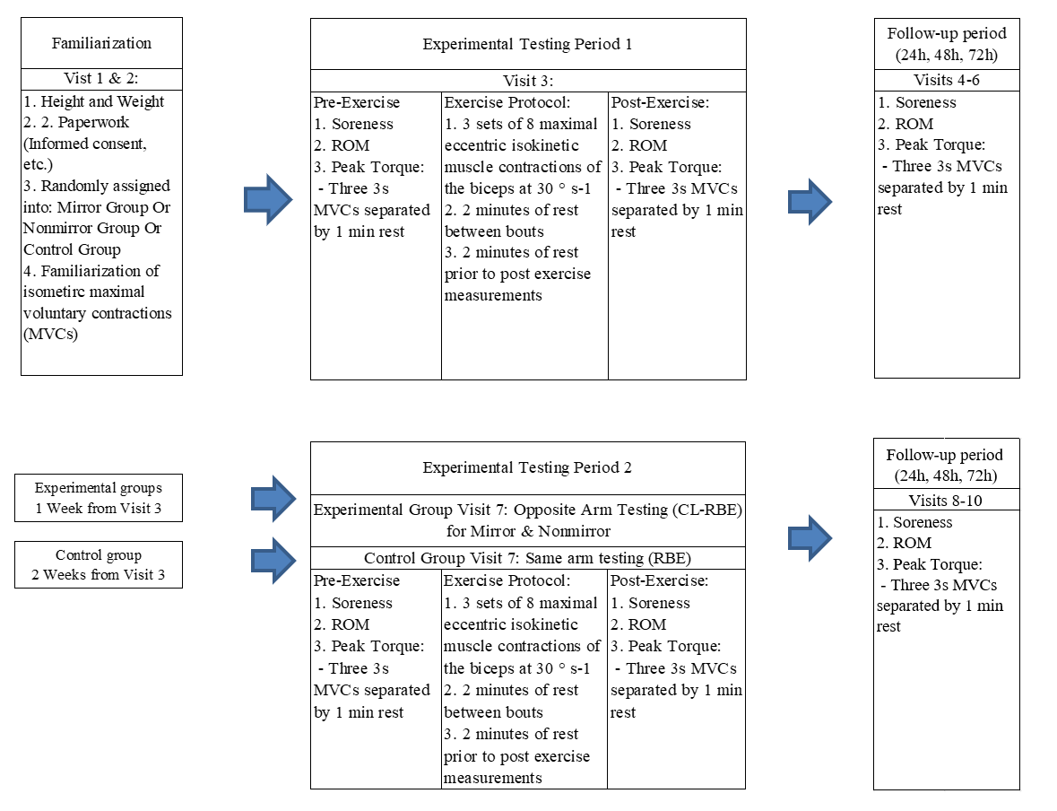
Figure 1- Study design of experimental timeline & measured outcomes
Familiarization
During the first visit the participants filled out the required paperwork which included an informed consent, HIPAA, menstrual cycle history, Physical Activity Readiness Questionnaire (PAR-Q), health screening form, and a rhabdomyolysis screening form. Once complete, body anthropometrics were measured and recorded. The participants were then familiarized with completing an isometric maximal voluntary contraction of the elbow flexors. Isometric maximal voluntary contractions (MVC) were performed on the KinCom Isokinetic Dynamometer (Isokinetic International, Chattanooga, TN, USA). Participants were set up on the KinCom with an elbow joint angle of 90 degrees while using a neutral grip. Participants were instructed to contract as hard as possible for 3 seconds and then rest for 1 minute between bouts. They performed this at least 3 times until they were comfortable with the process of performing a MVC. On the second visit, participants again practiced the MVC protocol. Participants were then randomly assigned to be in one of the experimental groups (mirror vs. no mirror) or the control group (no mirror, same arm).
Experimental Testing Period 1
This Period consisted of experimental testing, which started with the 3rd visit, and contained the 3 follow-up visits (4 through 6). During the 3rd visit participants first performed a rating of muscle soreness in their biceps and the range-of-motion of the elbow was assessed. Participants then performed 3 isometric MVCs of the elbow flexors with 1 minute of rest between bouts. Once this was completed, the participant were set up on the KinCom to where the range-of-motion of the eccentric contraction began with the bicep being fully flexed and finished with the elbow at complete lockout/extension. They were then instructed how to perform the eccentric exercise protocol. The KinCom controlled the speed of the eccentric contraction by moving at a speed of 30°^{s-1}. As the KinCom pulled their elbow down from fully flexed to full extension, participants were instructed to resist the machine and pull as hard as they could while trying to flex their elbow using their biceps. Three sets of 8 repetitions of maximal eccentric contractions were performed in this manner. In the mirror feedback group participants were instructed to watch the contractions in the mirror so it appeared their contralateral arm was also performing the contractions. Participants received 2 minutes of rest between sets. During eccentric exercise EMG data of the biceps and triceps was collected. After exercise, the participants reassessed their muscle soreness, MVC, and elbow ROM.
Participants were required to return to the lab each day for the next 3 days (24, 48, and 72 hours) for visits 4-6. During these visits, participants reassessed their muscle soreness, performed MVCs, and had elbow range-of-motion reassessed. Those in the mirror and no mirror groups waited 7 days from the 3rd visit before beginning the next testing period. Those in the control group waited 14 days from the 3rd visit.
Experimental Testing Period 2
This period consisted of the 2nd experimental testing phase, which started with the 7th visit, and the follow up visits 8 through 10. Participants in the experimental groups (Mirror vs. Non-Mirror), conducted all measurements during this period on their contralateral arm while those in the control group performed all measurements in the same arm from period 1. During the 7th visit participants first performed a rating of muscle soreness in their biceps and had their range-of-motion of the elbow assessed. Participants then performed 3 isometric MVCs of the elbow flexors with 1 minute of rest between bouts. Once this was complete, the participant was set up on the KinCom to where the range-of-motion of the eccentric contraction began with the bicep being fully flexed and finished at to complete extension of the elbow. The KinCom controlled the speed of the eccentric contraction by moving at a speed of 30°^{s-1}. As the KinCom pulled their elbow down from fully flexed to full extension, participants resisted the machine as hard as they could by trying to flex their elbow using their biceps. Again, 3 sets of 8 repetitions of maximal eccentric contractions were performed. Participants received 2 minutes of rests between sets. EMG data of the biceps and triceps of the working arm were collected during this time. After exercise, muscle soreness, MVC, and elbow ROM was reassessed.
Participants then returned to the lab each day for the next 3 days (24, 48, and 72 hours) for visits 8-10. During these visits, participants again rated muscle soreness, performed MVCs, and had their elbow ROM reassessed.
3.06. Experimental Procedures
Isometric Maximal Voluntary Contraction
Three MVCs of the elbow flexors were then performed with the elbow set at an angle of 90 degrees of flexion. One minute of rest between contractions. Strong verbal encouragement and biofeedback of force output were provided to aid in participants giving a maximal effort. The highest of the 3 efforts was considered the MVC for that time point and used in analysis.
Maximal Eccentric Exercise Protocol
This protocol consisted of performing 3 sets of 8 repetitions of a maximal effort eccentric bicep curl. Using the KinCom software, full extension of the elbow (0°) was determined for each participant as the stop angle and full flexion (varied based upon individual anatomy) was set as the starting point. Participants were instructed to resist the dynamometer by contracting their elbow flexors with maximal effort as the dynamometer lever arm extension pulls their arm down to full extension, creating an eccentric contraction. Each repetition was performed at 30°/s. Strong verbal encouragement was provided as a visual feedback of the force produced to aid in providing a maximal effort. The dynamometer lever arm extension passively returned the arm to the flexed start position upon completion of each contraction. A 2-minute rest period was administered between sets.
Mirror Visual Feedback
Participants in the mirror group performed the maximal eccentric exercise protocol with a mirror placed directly on their non dominant arm’s axilla, bisecting where the shoulder joint and chest meet. This was to create a mirror image illusion effect where it appeared the individual was performing bilateral eccentric bicep curls. The mirror was held by a researcher and clear vision of the mirror and its illusion effect was confirmed by the participant. The mirror itself was used as a way to actively hide the non-dominant arm and participants were also instructed to perform as little movement with their non-dominant arm.
Electromyography (EMG)
During MVC and eccentric contractions on testing days 3 and 7, bipolar surface EMG signals were recorded from the biceps brachii and triceps brachii muscles using a BioNomadix dual-channel wireless EMG system (Biopac, Goleta, CA). A pair of silver-silver chloride EMG electrodes (Biopac, Goleta, CA) were placed ~16 mm apart over the belly of the biceps brachii and over the lateral head of the triceps brachii. A reference/ground electrode was placed over the elbow and the wireless sEMG system was secured around the forearm with a velcro strap. Surface EMG recordings were analyzed using the Biopac AcqKnowledge software (version 4.4). The raw EMG signals from the biceps brachii and triceps brachii were collected at a sampling rate of 2000 Hz and band-pass filtered at 10 Hz and 500 Hz. The raw EMG signals were full-wave rectified using root-mean squared (RMS) averaging with a time constant of 30 ms to determine amplitude during contraction. The mean RMS amplitude was taken from the middle 2 seconds of each eccentric contraction for both muscle groups. Mean RMS values from each eccentric contraction were normalized and expressed as a percentage of the mean RMS values from biceps brachii during biceps MVC and during a triceps MVC.
Elbow ROM
The range-of-motion of the elbow joint was determined as the difference between 2 elbow joint angles—flexed angle (FANG) and relaxed angle (RANG). Briefly, a plastic goniometer was placed over the axis of rotation of the elbow. Participants were then instructed to maximally voluntary flex their elbow to determine FANG. The stationary arm of the goniometer was aligned with the humorous and should joint while the measurement arm was rotated so it aligned with the ulna and wrist. For RANG, the stationary arm remained in place and participants were instructed to relax their elbow fully. ROM was calculated as RANG-FANG.
Muscle Soreness
Muscle soreness of the elbow flexors were quantified using a 0-100mm visual analog scale with “0” indicating “no pain at all” and “100” indicating the worst pain imaginable. The participants were instructed to perform a bicep curl using a dumbbell relative to their strength at about 50% 1RM (i.e., 5lbs used if 1RM was determined to be 10lbs). This was determined during the familiarization period. This determined weight was used and consistent for every visit. They were instructed to perform the concentric portion over 2 seconds and the eccentric portion over 2 seconds with complete range of motion to the best of their ability. Once complete, participants were asked to rate their muscle soreness.
3.07 Statistical Analysis
Values for torque isometric data, range of motion, and muscle soreness were analyzed using a three-way mixed model repeated measures ANOVA: 3 Conditions (Mirror vs No Mirror vs Control) x 2 Bout (Bout 1 vs. Bout 2) x 5 Time Points (Pre, immediately post, 24hr, 48hr, and 72 hr post). A three-way RMANOVA (Condition(3) x Bout(2) x Contraction(24) was conducted to examine differences in EMG between bouts and ipsilateral and contralateral mirror or no mirror protocols. Given the importance of the comparison between Bout 1 and Bout 2 in each group, separate 2 (bout) x 4 (time) repeated measures ANOVAs were performed to determine if a RBE occurred. Additionally, a “Protection Index” (Chen et al. 2016) was calculated for each dependent measure at each time point. The was done by calculating the percent difference from Bout 1 to Bout 2 (with positive values representing smaller changes; thus protection from muscle damage). Maulchy’s sphericity test was used to check homogeneity of covariance for all ANOVA analysis. Any violations of the assumption of sphericity were corrected using the Greenhouse-Geisser adjustment. A significance level of p ≤ 0.05 was established. All analyses were performed using SPSS Ver. 28.0.

CHAPTER 4: RESULTS
4.01. Sample
There was a total of 28 participants included in the data set. There were 6 in the control, 10 in the mirror, and 12 in the no mirror groups. The mean ± SD of age, height, weight, and pre-exercise MVC (Bout 1&2) for each condition was calculated. These descriptive statistics can be found in Table 1.
Table 1 - Descriptive statistics & Pre-Exercise MVC (mean ± SD)
Condition | Control (N=6) |  | Mirror (N=10) |  | No Mirror (N=12)
Sex (M/F) | 3 M | 3 F | 3 M | 7 F |  | 6 M | 4 F
Age (Yrs) | 23 ± 3 |  | 22 ± 3 |  |  | 23 ± 4
Height (In) | 65.50 ± 4.95 |  | 64.00 ± 4.69 |  |  | 65.83 ± 3.97
Weight (Lbs) | 143.83 ± 37.87 |  | 135.10 ± 17.97 |  |  | 146.08 ± 30.79
Bout 1 Pre-MVC (N*m) | 139.5 ± 59.45 |  | 128.90 ± 21.44 |  |  | 147.67 ± 36.91
Bout 2 Pre-MVC (N*m) | 135.00 ± 50.90 |  | 120.60 ± 24.44 |  |  | 127.92 ± 32.78

4.02. Maximal Isometric Strength
The results of the three-way (Condition [Mirror, No-Mirror, Control] X bout [Bout 1, Bout 2] x time [iPost, 24hr, 48hr, 72hr]) repeated measures ANOVA for isometric MVC of the elbow flexors showed no significant three-way interaction (p = 0.10). The percent change in isometric MVC across all groups and time periods can be seen in Figure 3. The absolute data in isometric torque across groups and between bouts post-exercise can be seen in Table 2.
Table 2 - Change in Biceps Isometric Strength Data by Condition & Bout (Mean ± SD) Post-Exercise
Condition | Control |  | Mirror |  | No Mirror
 | Bout 1 | Bout 2 | Bout 1 | Bout 2 | Bout 1 | Bout 2
Isometric MVC (N*m) | 98.08 ± 33.21 | 121.04 ± 49.55 | 86.20 ± 25.28 | 81.25 ± 17.64 | 89.67 ± 32.72 | 93.96 ± 29.46

Separate analysis comparing the change in MVC over time between Bout 1 and Bout 2 in each group was performed using a 2 (Bout) x 4 (Time Point) ANOVA and can be seen in Figure 4. For the control group, the bout x time interaction was not significant (p = 0.15). There was a main effect for time (p = 0.007) with 24, 48, and 72-HR time points differing from iPost (p < 0.02). There was also a main effect for bout (p = 0.02) with Bout 2 showing less change in MVC (indicating less EIMD) than Bout 1 (Fig 4A). In the Mirror group, the bout x time interaction was not significant (p = 0.47) nor was there a main effect for bout (p = 0.70). There was a main effect for time (p = 0.03) with the 24, 48, and 72-HR post time points differing from each other (p < 0.03). Similarly, in the No Mirror condition, the bout x time interaction was not significant (p = 0.10). However, like the control group there was a main effect for bout (p = 0.009) with Bout 2 demonstrating less change in MVC (reduced EIMD) than Bout1 and a significant main effect for time (p = 0.02) with values from 72-HR post exercise differing from all other time points (p < 0.01).
Figure 2 -Maximal isometric torque before and after (post, 24H, 48H, & 72H) repeated bouts of eccentric exercise. Values are means; SD are not shown for clarity.
Figure 3 – Separate group analysis comparing the change in MVC over time (Post, 24H, 48H, 72H) between Bout 1 and Bout 2. A significant effect of bout can be seen in the Control group (A) and No Mirror Group (C)

The “protection index” for change in MVC between bouts can be seen in Figure 5. The group x time interaction was not significant (p = 0.10). Nor was there a significant main effect for condition (p = 0.11). There was a main effect for time (p = 0.045), with a larger average protection index at 72-HR post exercise compared to iPost (p = 0.02).

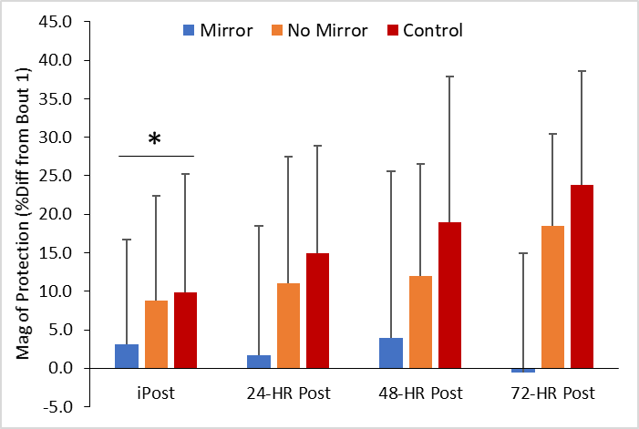

Figure 4 -Magnitude of protection in maximal isometric torque within each group between bouts after repeated bouts of eccentric exercise. (*) denotes a significance between iPost and 72-HR post with larger protection index at 72-HR post (p=0.02)

4.03. Range of Motion
The results of the three-way (Condition [Mirror, No-Mirror, Control] X bout [Bout 1, Bout 2] x time [iPost, 24hr, 48hr, 72hr]) repeated measures ANOVA for ROM of the elbow flexors showed no significant three-way interaction (p = 0.35). ROM was all groups, all conditions, and all time points can be seen in Figure 6. Absolute values for ROM across groups and between bouts post-exercise can be found in Table 3.

Figure 5 - Percent Change in Range of Motion before and after (Post, 24H, 48H, 72H) repeated bouts of eccentric exercise. Values are means; SD not shown for clarity.

Separate analysis comparing the change in ROM over time between Bout 1 and Bout 2 in each group was performed using a 2 (Bout) x 4 (Time Point) ANOVA and can be seen in Figure 7. For the control group, the bout x time interaction was not significant (p = 0.43), nor was there a main effect for time (p = 0.06) or bout (p = 0.47; Fig 7A). In the Mirror group, the bout x time interaction was not significant (p = 0.55) nor was there a main effect for bout (p = 0.26) or time (p = 0.07; Fig 7B). Similarly, in the No Mirror condition, the bout x time interaction was not significant (p = 0.32), and there was no main effect for time (p = 0.49) or bout (p =0.49; Fig 7C).
Table 3 - Change in Range of Motion by Condition & Bout (Mean ± SD) Post-Exercise
Condition |  | Control |  | Mirror |  | No Mirror
 | Bout 1 |  | Bout 2 | Bout 1 | Bout 2 | Bout 1 |  | Bout 2
Range of Motion (°) |  | 87.42 ± 17.87 | 94.04 ± 26.91 | 85.60 ± 18.57 | 88.25 ± 20.49 | 77.96 ± 22.78 | 85.83 ± 20.67

Figure 6 – Separate analysis comparing the change in ROM over time (Post, 24H, 48H, 72H) between Bout 1 and Bout 2. There was no significant effects detected.

The “protection index” for change in ROM between bouts can be seen in Figure 8. The group x time interaction was not significant (p = 0.43). Nor was there a significant main effect for group (p = 0.89) or time (p = 0.98).

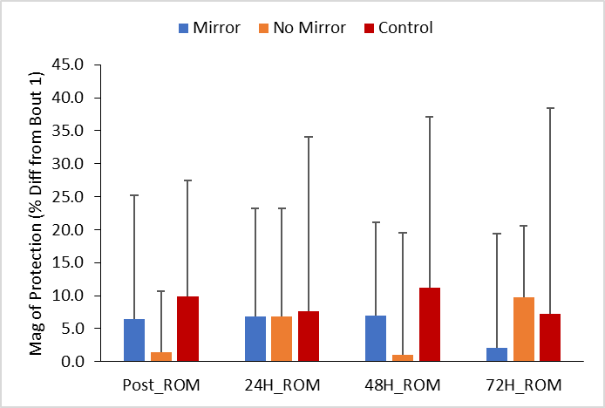
Figure 7 – Magnitude of protection in range of motion within each group between bouts after repeated bouts of eccentric exercise. No significant differences found.

4.04. Muscle Soreness
The results of the three-way (Condition [Mirror, No-Mirror, Control] X bout [Bout 1, Bout 2] x time [Pre, iPost, 24hr, 48hr, 72hr]) repeated measures ANOVA for muscle soreness of the elbow flexors showed a significant three-way interaction (p = 0.014). Muscle soreness over time in each group and in both bouts can be seen in Figure 9. Absolute values for muscle soreness ratings across conditions and between bouts post-exercise can be found in Table 4.
Table 4 Change in Muscle Soreness Ratings by Condition & Bout (Mean ± SD) Post-Exercise
Condition | Control |  | Mirror |  | No Mirror
 | Bout 1 | Bout 2 | Bout 1 | Bout 2 | Bout 1 | Bout 2
DOMS (0-100) | 38.46 ± 22.73 | 13.46 ± 12.41 | 49.73 ± 22.12 | 39.15 ± 26.28 | 57.60 ± 22.71 | 46.96 ± 24.03

Figure 8 - Muscle Soreness before and after (Post, 24H, 48H, 72H) repeated bouts of eccentric exercise. Values are means; SD not shown for clarity.

Separate analysis comparing the change in DOMS over time between Bout 1 and Bout 2 in each group was performed using a 2 (Bout) x 4 (Time Point) ANOVA and can be seen in Figure 10. For the control group, the bout x time interaction was significant (p = 0.02). Follow-up 1-way ANOVAs for each bout found that values did not differ over time in bout 1 (p = 0.38), but did in bout 2 (p < 0.001) with values from 24, 48, and 72-HR post exercise differing from each other (p < 0.04). When compared between bout 1 and bout 2, ratings of DOMS did not differ at iPost (p = 0.75), but did differ at 24-HR (p = 0.04), 48-HR (p = 0.003), and 72-HR (p = 0.02) post exercise (Fig 10A). In the Mirror group, the bout x time interaction was not significant (p = 0.54) nor was there a main effect for bout (p = 0.11) or time (p = 0.32; Fig 10B). In the No Mirror condition, the bout x time interaction was not significant (p = 0.71). However, like the control group there was a main effect for bout (p = 0.009; Fig 10C) with Bout 2 demonstrating less DOMS (reduced EIMD) than Bout1. There was no main effect for time (p = 0.13).
Figure 9 - Separate group analysis comparing muscle soreness over time (Post, 24H, 48H, 72H) between Bout 1 and Bout 2. In the control group (A) the symbol (*) denotes a significant effect of bout at the specific time point. In the No Mirror group (C) there was a significant effect of bout

The “protection index” for change in DOMS between bouts can be seen in Figure 11. The group x time interaction was significant (p = 0.02). Follow-up 1-way ANOVAs indicated no differences among the 3 groups at iPost or 24-HR post eccentric exercise. However, the groups differed at 48-HR and 72-HR post (p < 0.001) with the Control group demonstrating greater protection (p < 0.01).

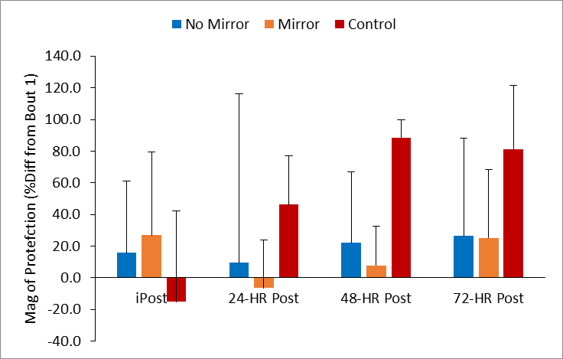
*
*

Figure 10 - Magnitude of protection in muscle soreness within each group between bouts after repeated bouts of eccentric exercise. (*) denotes a significance difference between groups at time points 48-HR and 72-HR post with the control demonstrating the largest protection index at 48HR & 72-HR post (p=0.02)

4.05. EMG RMS
Biceps EMG
The results of the three-way (Condition [Mirror, No-Mirror, Control] X bout [Bout 1, Bout 2] x contraction [1…24]) repeated measures ANOVA for EMG RMS for the biceps during the eccentric exercise bout did not show a significant three-way effect (p=0.425). As such data from each of the 24 eccentric contractions was averaged for each bout. A 2 (bout) x 3 (group) ANOVA was performed to analyze differences in EMS RMS and can be seen in Figure 12. The bout x group interaction was not significant (p = 0.72) nor was there a main effect for bout (p = 0.66) or group (p = 0.24).
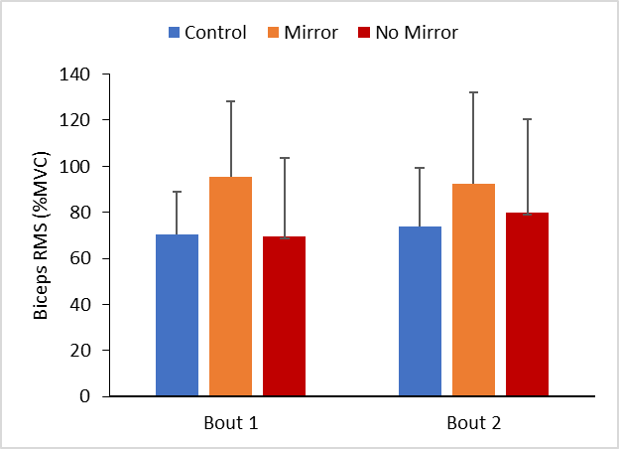
Figure 11 – Biceps RMS averages by group. Mean RMS values were normalized and expressed as a percentage of the mean RMS values from biceps brachii during biceps MVC. No significant differences found

Triceps EMG
The results of the three-way (Condition [Mirror, No-Mirror, Control] X bout [Bout 1, Bout 2] x contraction [1…24]) repeated measures ANOVA for EMG RMS for the triceps during the eccentric exercise bout did not show a significant three-way effect (p=0.656). As such data from each of the 24 eccentric contractions was averaged for each bout. A 2 (bout) x 3 (group) ANOVA was performed to analyze differences in EMS RMS and can be seen in Figure 13. The bout x group interaction was not significant (p = 0.22) nor was there a main effect for bout (p = 0.75) or group (p = 0.22).

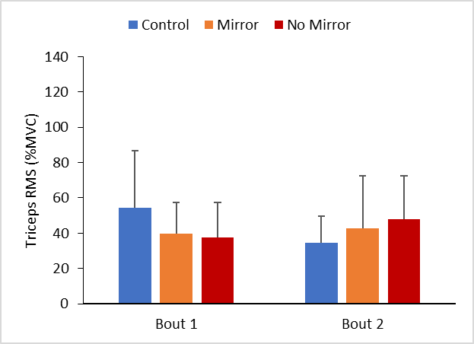
Figure 12 - Triceps RMS averages by group. Mean RMS values were normalized and expressed as a percentage of the mean RMS values from triceps during triceps MVC. No significant differences found

CHAPTER 5: DISCUSSION & CONCLUSIONS
5.01. Purpose and Hypothesis
The purpose of this study was to examine the contralateral RBE following a unilateral eccentric bout with and without visual mirror feedback. The present study showed mixed results in regards to the indirect markers muscle soreness and isometric maximal voluntary contraction. With a RBE being observed in the control group for MVC and DOMS, as expected. Interestingly, a CL-RBE was observed in the No Mirror group for MVC and DOMS, but not in the Mirror group. This finding in the Control and No Mirror group is consistent with other findings (Howatson & Someren, 2007; Chen et al., 2016; Hyldahl et al., 2017). All groups were less sore after the 2nd bout of eccentric exercise, with the control group and no mirror group reaching statistical significance. Even though there was an improvement in recovery of range of motion over time in bout 2 in all groups, it was shown to not be statistically significant and thus no RBE or CL-RBE was observed. It was hypothesized that the decrease in MVC, ROM, and amount of muscle soreness in the Mirror group would be less than that observed in the No Mirror group. Based on the results, none of the hypotheses investigating the RBE are supported, therefore, the null hypotheses are accepted. This study also looked to examine any possible neuromuscular changes that could underlie the CL-RBE. The results show that there was no differences among groups when looking at biceps and triceps EMG RMS during the 24 eccentric contractions. Therefore, we accept the null hypothesis that MVF will lead to greater EMG amplitude and accept the null hypothesis that MVF will lead to reduced triceps EMG amplitude.
5.02 – Contralateral RBE
The Control group and the No Mirror group both exhibited a RBE, with the Control group leading in magnitude, which had MVC and soreness values return very closely to pre-test values 72HR after bout 2. The No Mirror group had a weaker magnitude, showing about a significant recovery, but not reaching to pre-test values. This seems to fall in line with the protective effect observed in other studies (Hyldahl et al., 2017). Although there was a significant effect of bout in muscle soreness in the No Mirror group, it seems to have a weaker magnitude compared with what was observed from other studies. This difference in soreness rating in comparison to other studies could be due to the method performed to record soreness. Participants were asked to perform a bicep curl with a light weight relative to their strength with full range of motion. Because the participants are untrained and unfamiliar with their maximum strength and perceived effort, this could inflate muscle soreness scores. Self-reported soreness ratings already vary greatly between individuals as perception of pain and soreness are different for everyone (Tiidus, 2008). This method was chosen as it was deemed to be most practical to real life, however, including another method such as palpation of the elbow flexors, assessment of a pressure pain threshold, or passive movement of the forearm through its full range-of-motion before the bicep curl method used in this study could yield results more akin to studies done before.
The magnitude of protection in the Mirror group produced confounding results as there was an attenuation of muscle soreness at 72HR, which was very similar to the No Mirror group in rating, although statistically insignificant. Despite this, the Mirror group showed a 0% index of protection when looking at the recovery of isometric bicep MVC during this time point. It is possible that difference in recovery of MVC from the experimental groups could be a result of per person variability. It has been shown that some individuals can lose up to 75% of their MVC where as others only lose 20% (Sayers & Clarkson, 2001). There is also day to day variability within individuals that could play a large role, and due to the nature of the study using individuals who are untrained, it’s possible that some individuals exhibit a larger learning and/or training effect throughout study. It may also be beneficial to include recording more days post-exercise as this study had participants come every day for 3 days, whereas some studies have used 5 days. Recording 2 extra days could result in narrowing this variability at the 5 day mark, eliminating the difference in the index of protection seen in this study. Although very improbable, it’s also possible for individuals to not fully recover MVC after an eccentric bout longer than 26 days and even up to 89 days. (Sayers & Clarkson, 2001).
5.03. Neural adaptations
This study also looks at possible neural adaptations that may occur and cross-over to the non-dominant limb. Results show no significant changes in bicep or triceps activation between bouts during the eccentric exercise protocol. Previous studies of eccentric exercise have shown neural adaptations such as decreases in autogenic spinal inhibition and reduced H-reflex as well as decreases in antagonist muscle activation (Hight et al., 2017; Lepley et al., 2017). These adaptations were shown to have a cross-over effect from the dominant arm to the non-dominant arm, and this supports findings in general that there is a cross education of neural adaptations from unilateral training (Latella et al., 2012; Manca et al., 2017) and from unilateral eccentric exercise (Hortobagyi et al., 1997; Starbuck & Eston, 2012; Lepley et al., 2014; Kidgell et al., 2015; Hyldahl et al., 2017). One of the main hypotheses of this study would be that the Mirror group would exhibit a greater neural adaptation compared to the No Mirror group. In this case, we were expecting to see a larger decreased co-activation of the triceps and/or an increase in biceps activation during the 2nd bout in the Mirror group, but this did not occur.
A potential consequence of mirror visual feedback during exercise training is that it has the ability to significantly increase motor skill of the untrained limb. This could be the result of improved activity in the brain associated with motor function and in changes in interhemispheric neural communication. In theory, this would improve motor function of the muscle resulting from the increased excitability from increased neural drive or from decreased Ia afferent inhibition. This increase in synchronicity would cause us to activate more overall muscle fibers during maximal eccentric exercise and or allow for less co-activation of the antagonizing muscle. This would result in more activation across all fibers in the muscle leading to more total force being produced as well as tension spread across the whole muscle and its individual fibers. In theory, this could result in more muscle damage occurring, deterring recovery, however neural adaptations can also cause a shift of motor unit recruitment to lower threshold fibers, which are more fatigue and damage resistant. Perhaps it is possible after cross education, motor unit synchronization can aid in the attenuation of muscle damage, however, as mentioned before, the RBE is multifaceted and it is unclear if the muscle-tendon complex, extracellular matrix restructuring, or inflammatory response models elicit a systemic or cross over effect to the unused limb. There is little to no research on the topic, but it is unlikely that ECM may contribute to the cross education of the RBE as the unused limb does not undergo any cell remodeling after unilateral exercise. This could explain why the CL-RBE has been seen to be approximately between 40-60% of the ipsilateral RBE. In this study, activation of the biceps was statistically the same in both bouts according to the biceps EMG data. This could potentially explain why the Mirror group did not show a recovery in MVC after the 2nd bout as individuals were not able to use a larger pool of fibers or shift motor unit recruitment, thus experiencing muscle damage.

5.04. Limitations
In this study we used a mirror set up in which participant’s visual attention was directed towards the mirror with the active hand in peripheral view. Although this approach is very practical when using this intervention, it has been shown to possibly produce a less immersive illusion. The mirror placement itself was also on the axilla instead of bisecting the mid-sagittal line, which may also have an impact on immersion, however, mirror placement on the mid-sagittal line while using the dynamometer proved to be impractical and unusable. Though unlikely, the placement of the mirror on the axilla could also have inadvertently caused activation of the muscles in the unused limb due to possible proprioceptive mechanisms, causing a diminished RBE. Another limitation is our sample size. The study was powered based upon the finding of Chen et al. (2016). We encountered two issues: 1) our data were more variable than those reported by Chen, and 2) we had to remove several participants from the study due to a lack of EIMD. Also, their findings for the index of protection were based off on their data from 5 days post-exercise, where the index calculated here was based off data from 3 days post-exercise, so they are not a like for like match in time. Thus, our final sample (n =10 in the Mirror group and n = 12 in No Mirror group) fell below our desired sample size. This likely limited our ability to detect the relatively small changes that seemed to have occurred in the CL-RBE. The testing of additional participants could help clarify our findings.
5.05. Significance and Future Study Recommendations
We know that eccentric exercise provides a strong basis of enhancing neuro-motor performance in athletes, untrained individuals, older adults, and in clinical populations (Aagaard, 2018). We also know that individuals who have experienced injuries, have a history of limb injury, or are clinically unable to use the desired limb have shown to have deficits in muscle activity when attempting to use the limb post injury (Presland et al., 2021). It has also been demonstrated that continual sessions of locomotor training have had a significant improvement in upper and lower extremity motor strength and function (Morrison et al., 2018). In general, it would be recommended that programs for most individuals who are temporarily unable to use one limb to explore methods such as eccentric training and mirror therapy in order to induce the RBE as well as improve motor function in the unused limb. For future studies it is recommended that a larger sample size be used as well as the use of a dynamometer where the biceps can be completely isolated. Recording dependent variables up to 5 days post exercise is recommended and it would be interesting to see the use of MVF with lower body extremities as well as the use of MVF over various times between bouts such as 2 weeks or 4 weeks to compare results from the use without MVF. Finding a better mirror placement to improve immersion as well as ease of performing the actual protocol could improve results in neuromuscular adaptations. As stated in the limitations, previous studies have performed mirror therapy on the midsagittal line, stating the importance of the immersion of the mirror image illusion. However, to the researcher’s knowledge, there has been no validity criteria established to determine the efficacy of the mirror placement deviating from the mid sagittal line and should be investigated. Previous research using mirror therapy has also been performed over a period of time (i.e., 8 weeks) using rehabilitative or strength programs. It could be possible that the use of a mirror only in one bout could exhibit minimal beneficial effects and is an intervention that would be needed to be done over a longer period of time over multiple bouts.
5.06 Conclusions
The present study provides evidence of the cross-education of the repeated bout effect with indirect markers of muscle damage. These findings are well in line with previously performed studies. However, the main purpose of this study was to examine if there is any enhancement of cross education of the RBE using mirror visual feedback. The present study shows that there is no evidence of enhancement of the cross education effect when using mirror visual feedback. However, more research should be conducted looking at mirror visual feedback as it could possibly add another way to improve rehabilitative paradigms for individuals who are impaired on the opposite limb.
REFERENCES
Aagaard P. (2018). Spinal and supraspinal control of motor function during maximal eccentric muscle contraction: Effects of resistance training. Journal of sport and health science, 7(3), 282–293.
Carr, J. C., Bemben, M. G., Stock, M. S., & DeFreitas, J. M. (2021). Ipsilateral and contralateral responses following unimanual fatigue with and without illusionary mirror visual feedback. Journal of Neurophysiology, 125(6), 2084–2093.
Carvalho, D., Teixeira, S., Lucas, M., Yuan, T. F., Chaves, F., Peressutti, C., Machado, S., Bittencourt, J., Menéndez-González, M., Nardi, A. E., Velasques, B., Cagy, M., Piedade, R., Ribeiro, P., & Arias-Carrión, O. (2013). The mirror neuron system in post-stroke rehabilitation. International archives of medicine, 6(1), 41.
Chen, T. C., Chen, H.-L., Lin, M.-J., Yu, H.-I., & Nosaka, K. (2016). Contralateral Repeated Bout Effect of Eccentric Exercise of the Elbow Flexors. Medicine & Science in Sports & Exercise, 48(10), 2030.
Chen, T. C., & Nosaka, K. (2006). RESPONSES OF ELBOW FLEXORS TO TWO STRENUOUS ECCENTRIC EXERCISE BOUTS SEPARATED BY THREE DAYS.
Colomer-Poveda, D., Romero-Arenas, S., Hortobagyi, T., & Márquez, G. (2021). Does ipsilateral corticospinal excitability play a decisive role in the cross-education effect caused by unilateral resistance training? A systematic reviewଝ.
Dartnall, T. J., Nordstrom, M. A., & Semmler, J. G. (2011). Adaptations in biceps brachii motor unit activity after repeated bouts of eccentric exercise in elbow flexor muscles. Journal of Neurophysiology, 105(3), 1225–1235.
Deyhle MR, Gier AM, Evans KC, et al. Skeletal muscle inflammation following repeated bouts of lengthening contractions in humans. Front Physiol. 2016; 6:424.
Frazer, A. K., Pearce, A. J., Howatson, G., Thomas, K., Goodall, S., & Kidgell, D. J. (2018). Determining the potential sites of neural adaptation to cross-education: Implications for the cross-education of muscle strength. European Journal of Applied Physiology, 118(9), 1751–1772.
Hight, R. E., Beck, T. W., Bemben, D. A., & Black, C. D. (2017). Adaptations in antagonist co-activation: Role in the repeated-bout effect. PLOS ONE, 12(12).
Hinder, M. R., Schmidt, M. W., Garry, M. I., Carroll, T. J., & Summers, J. J. (2011). Absence of cross-limb transfer of performance gains following ballistic motor practice in older adults. Journal of applied physiology (Bethesda, Md. : 1985), 110(1), 166–175.
HORTOBÁGYI, TIBOR; LAMBERT, NANCY J.; HILL, JEFFREY P.. Greater cross education following training with muscle lengthening than shortening. Medicine & Science in Sports & Exercise 29(1):p 107-112.
Hortobágyi, T., Scott, K., Lambert, J., Hamilton, G., & Tracy, J. (1999). Cross-education of muscle strength is greater with stimulated than voluntary contractions. Motor control, 3(2), 205–219.
Howatson, G., Zult, T., Farthing, J. P., Zijdewind, I., & Hortobágyi, T. (2013). Mirror training to augment cross-education during resistance training: A hypothesis. Frontiers in Human Neuroscience, 7.
Hubal, M. J., Rubinstein, S. R., & Clarkson, P. M. (2008). Muscle Function in Men and Women During Maximal Eccentric Exercise. Journal of Strength and Conditioning Research, 22(4), 1332–1338.
Hyldahl, R. D., Chen, T. C., & Nosaka, K. (2017). Mechanisms and Mediators of the Skeletal Muscle Repeated Bout Effect. Exercise and Sport Sciences Reviews, 45(1), 24–33.
Kidgell, D. J., Frazer, A. K., Rantalainen, T., Ruotsalainen, I., Ahtiainen, J., Avela, J., & Howatson, G. (2015). Increased cross-education of muscle strength and reduced corticospinal inhibition following eccentric strength training. Neuroscience, 300, 566–575.
Latella, C., Kidgell, D. J., & Pearce, A. J. (2012). Reduction in corticospinal inhibition in the trained and untrained limb following unilateral leg strength training. European Journal of Applied Physiology, 112(8), 3097–3107.
Lau WY, Blazevich AJ, Newton MJ, Wu SS, Nosaka K. Reduced muscle lengthening during eccentric contractions as a mechanism underpinning the repeated-bout effect. Am. J. Physiol. Regul. Integr. Comp. Physiol. 2015; 308(10):R879–86.
Lee, M., & Carroll, T. J. (2007). Cross Education: Possible Mechanisms for the Contralateral Effects of Unilateral Resistance Training. Sports Medicine, 37(1), 1–14.
Lepley, L. K., & Palmieri-Smith, R. M. (2014). Cross-Education Strength and Activation After Eccentric Exercise. Journal of Athletic Training, 49(5), 582–589.
Lepley, L. K., Lepley, A. S., Onate, J. A., & Grooms, D. R. (2017). Eccentric Exercise to Enhance Neuromuscular Control. Sports health, 9(4), 333–340.
Manca, A., Cabboi, M. P., Dragone, D., Ginatempo, F., Ortu, E., De Natale, E. R., Mercante, B., Mureddu, G., Bua, G., & Deriu, F. (2017). Resistance Training for Muscle Weakness in Multiple Sclerosis: Direct Versus Contralateral Approach in Individuals With Ankle Dorsiflexors’ Disparity in Strength. Archives of Physical Medicine and Rehabilitation, 98(7), 1348-1356.e1.
Manca, A., Dragone, D., Dvir, Z., & Deriu, F. (2017). Cross-education of muscular strength following unilateral resistance training: A meta-analysis. European Journal of Applied Physiology, 117(11), 2335–2354.
Manca, A., Hortobágyi, T., Carroll, T. J., Enoka, R. M., Farthing, J. P., Gandevia, S. C., Kidgell, D. J., Taylor, J. L., & Deriu, F. (2021). Contralateral Effects of Unilateral Strength and Skill Training: Modified Delphi Consensus to Establish Key Aspects of Cross-Education. Sports Medicine, 51(1), 11–20.
Mason, J., Frazer, A. K., Horvath, D. M., Pearce, A. J., Avela, J., Howatson, G., & Kidgell, D. J. (2018). Ipsilateral corticomotor responses are confined to the homologous muscle following cross-education of muscular strength. Applied physiology, nutrition, and metabolism = Physiologie appliquee, nutrition et metabolisme, 43(1), 11–22.
McHugh, M. P. (2003). Recent advances in the understanding of the repeated bout effect: The protective effect against muscle damage from a single bout of eccentric exercise: Repeated bout effect. Scandinavian Journal of Medicine & Science in Sports, 13(2), 88–97.
McHugh, M. P., Connolly, D. A. J., Eston, R. G., & Gleim, G. W. (1999). Exercise-Induced Muscle Damage and Potential Mechanisms for the Repeated Bout Effect: Sports Medicine, 27(3), 157–170.
Morawetz, D., Blank, C., Koller, A., Arvandi, M., Siebert, U., & Schobersberger, W. (2020). Sex-Related Differences After a Single Bout of Maximal Eccentric Exercise in Response to Acute Effects: A Systematic Review and Meta-analysis. Journal of Strength and Conditioning Research, 34(9), 2697–2707.
Nosaka, K., Newton, M. J., & Sacco, P. (2005). Attenuation of Protective Effect Against Eccentric Exercise-Induced Muscle Damage. Canadian Journal of Applied Physiology, 30(5), 529–542.
Perez, M. A., Tanaka, S., Wise, S. P., Sadato, N., Tanabe, H. C., Willingham, D. T., & Cohen, L. G. (2007). Neural substrates of intermanual transfer of a newly acquired motor skill. Current biology : CB, 17(21), 1896–1902.
Presland, J. D., Timmins, R. G., Maniar, N., Tofari, P. J., Kidgell, D. J., Shield, A. J., Dickson, J., & Opar, D. A. (2021). Muscle Activity and Activation in Previously Strain-Injured Lower Limbs: A Systematic Review. Sports Medicine, 51(11), 2311–2327.
Proske U, Morgan DL. Muscle damage from eccentric exercise: mechanism, mechanical signs, adaptation and clinical applications. J. Physiol. 2001; 537(Pt 2):333–45.
Rajmohan, V., & Mohandas, E. (2007). Mirror neuron system. Indian journal of psychiatry, 49(1), 66–69.
Ramachandran, V. S., & Altschuler, E. L. (2009). The use of visual feedback, in particular mirror visual feedback, in restoring brain function. Brain : a journal of neurology, 132(Pt 7), 1693–1710.
Ranganathan, V. K., Siemionow, V., Liu, J. Z., Sahgal, V., & Yue, G. H. (2004). From mental power to muscle power—Gaining strength by using the mind. Neuropsychologia, 42(7), 944–956.
Rinard, J., Clarkson, P. M., Smith, L. L., & Grossman, M. (2000). Response of males and females to high-force eccentric exercise. Journal of Sports Sciences, 18(4), 229–236.
Rizzolatti G, Fadiga L, Gallese V, Fogassi L. Premotor cortex and the recognition of motor actions. Brain Res Cogn Brain Res. 1996;3:131–41.
Rizzolatti, G., & Craighero, L. (2004). The mirror-neuron system. Annual review of neuroscience, 27, 169–192.
Romero-Parra, N., Cupeiro, R., Alfaro-Magallanes, V. M., Rael, B., Rubio-Arias, J. Á., Peinado, A. B., & Benito, P. J. (2021). Exercise-Induced Muscle Damage During the Menstrual Cycle: A Systematic Review and Meta-Analysis. Journal of Strength and Conditioning Research, 35(2), 549–561.
Ruddy, K. L., Leemans, A., Woolley, D. G., Wenderoth, N., & Carson, R. G. (2017). Structural and Functional Cortical Connectivity Mediating Cross Education of Motor Function. The Journal of Neuroscience, 37(10), 2555–2564.
Sayers, S. P., & Clarkson, P. M. (2001). Force recovery after eccentric exercise in males and females. European Journal of Applied Physiology, 84(1–2), 122–126.
Sewright, K. A., Hubal, M. J., Kearns, A., Holbrook, M. T., & Clarkson, P. M. (2008). Sex Differences in Response to Maximal Eccentric Exercise. Medicine & Science in Sports & Exercise, 40(2), 242.
Starbuck, C., & Eston, R. G. (2012). Exercise-induced muscle damage and the repeated bout effect: Evidence for cross transfer. European Journal of Applied Physiology, 112(3), 1005–1013.
Tiidus, P. M. (Ed.). (2008). Skeletal Muscle Damage and Repair. Human Kinetics.
Urbin, M. A., Harris-Love, M. L., Carter, A. R., & Lang, C. E. (2015). High-Intensity, Unilateral Resistance Training of a Non-Paretic Muscle Group Increases Active Range of Motion in a Severely Paretic Upper Extremity Muscle Group after Stroke. Frontiers in neurology, 6, 119.
Warren, G. L., Lowe, D. A., & Armstrong, R. B. (1999). Measurement Tools Used in the Study of Eccentric Contraction-Induced Injury. Sports Medicine, 27(1), 43–59.
Yue, G., & Cole, K. J. (1992). Strength increases from the motor program: comparison of training with maximal voluntary and imagined muscle contractions. Journal of neurophysiology,
Zhou, S. (2000). Chronic neural adaptations to unilateral exercise: Mechanisms of cross education. Exercise and Sport Sciences Reviews, 28(4), 177–184.
Zult, T., Goodall, S., Thomas, K., Solnik, S., Hortobágyi, T., & Howatson, G. (2016). Mirror Training Augments the Cross-education of Strength and Affects Inhibitory Paths. Medicine & Science in Sports & Exercise, 48(6), 1001–1013.

APPENDIX A: IRB APPROVAL LETTER

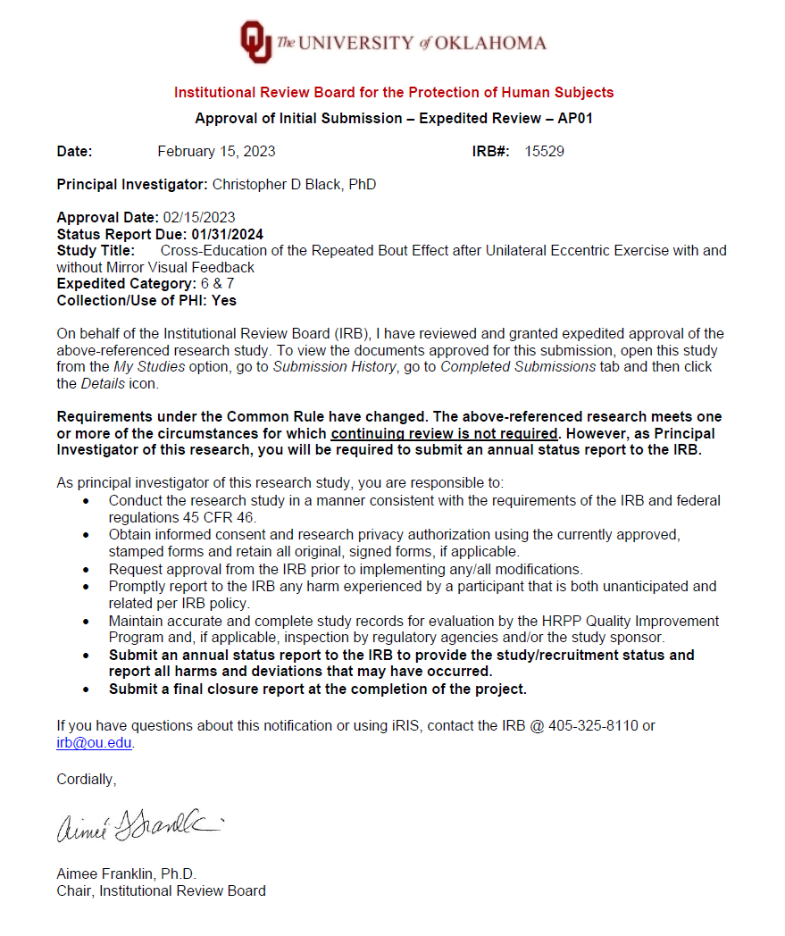

APPENDIX B: INFORMED CONSENT FORM


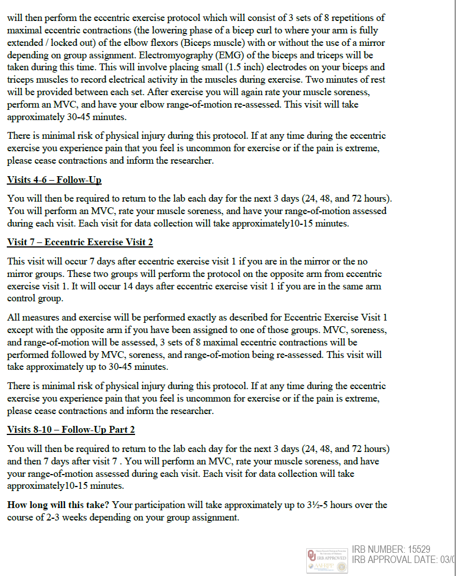

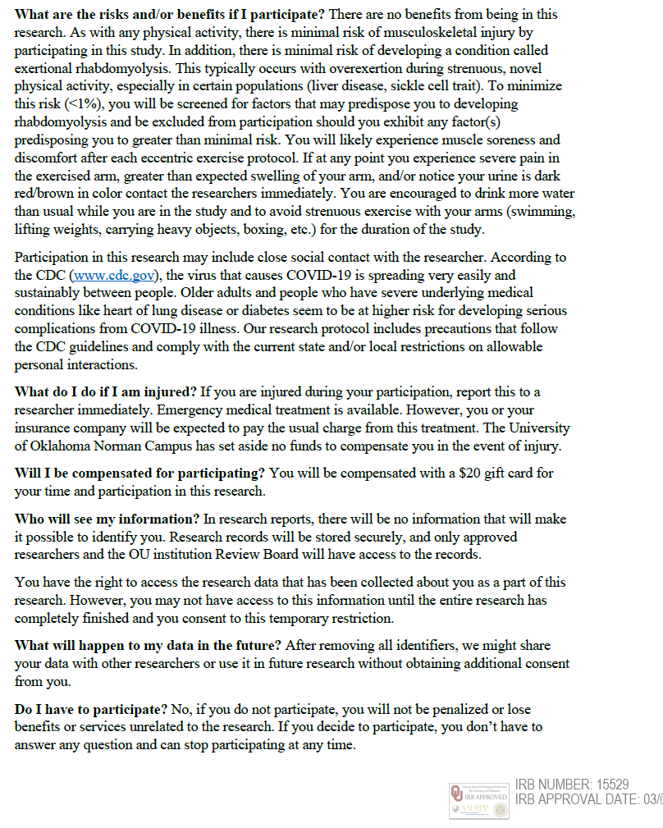


APPENDIX C: HIPAA AUTHORIZATION FORM
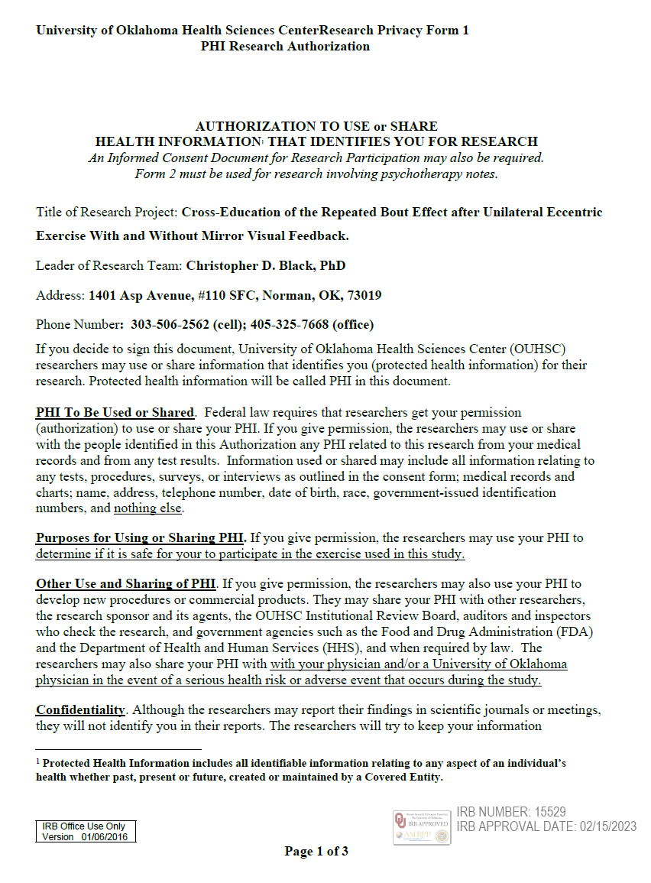

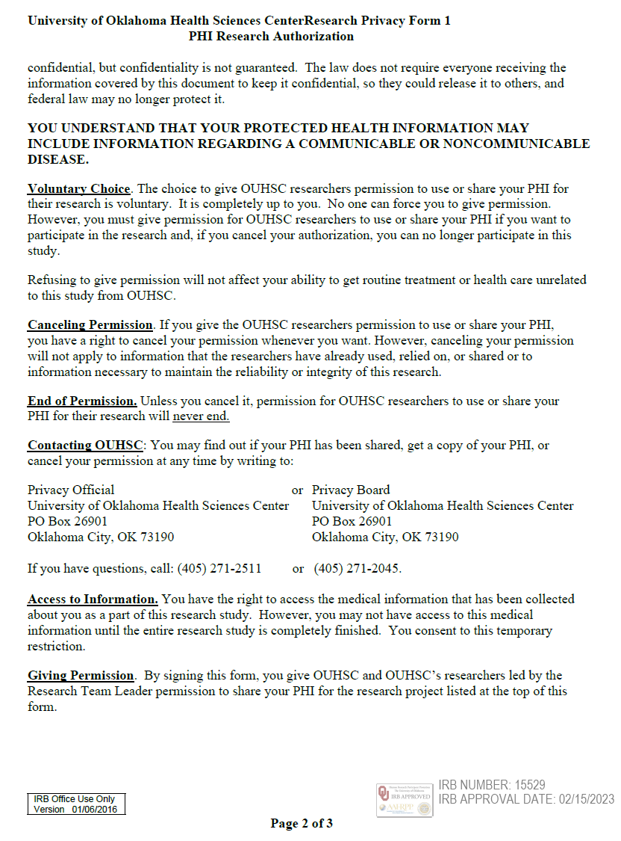
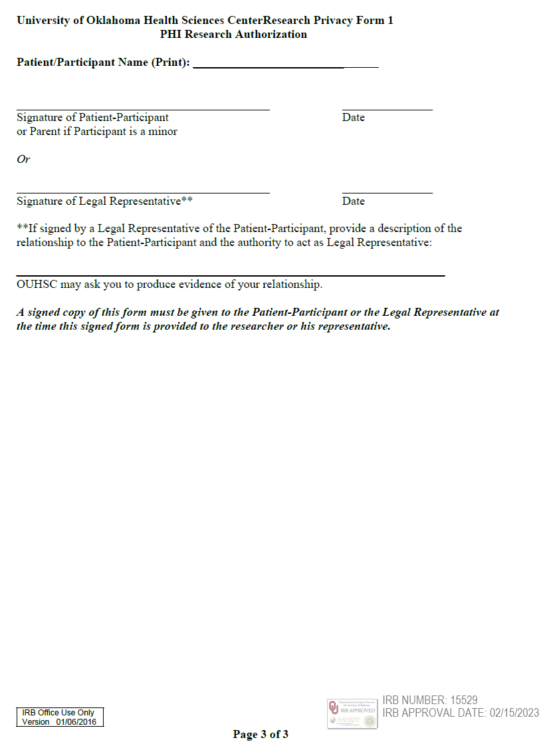

APPENDIX D: THE PHYSICAL ACTIVITY READINESS QUESTIONNAIRE


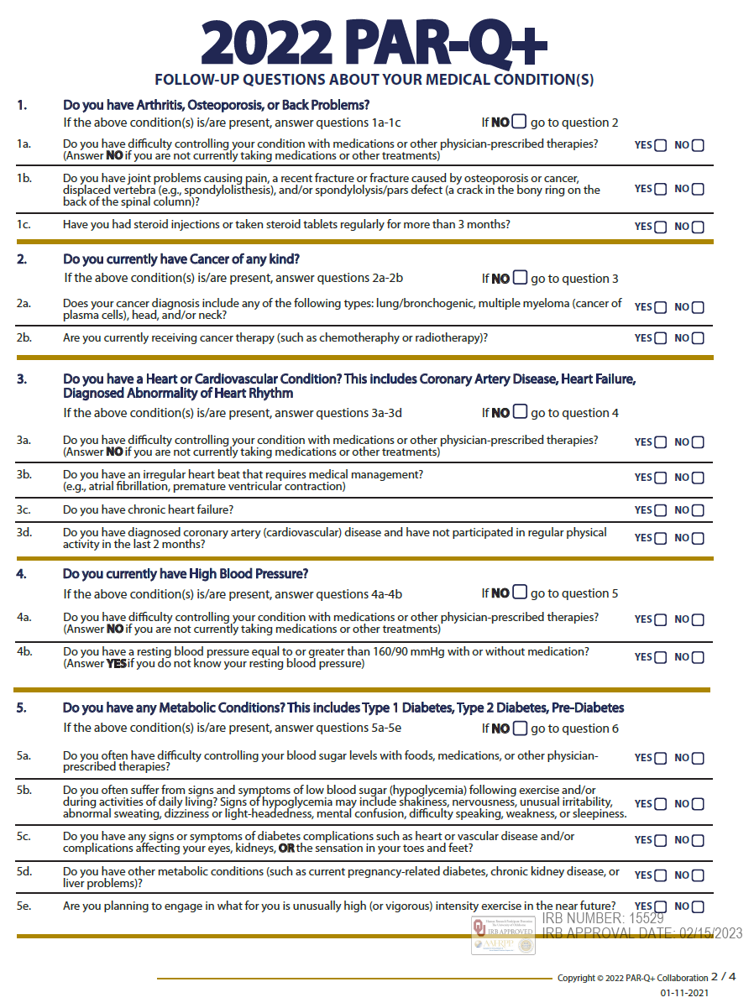


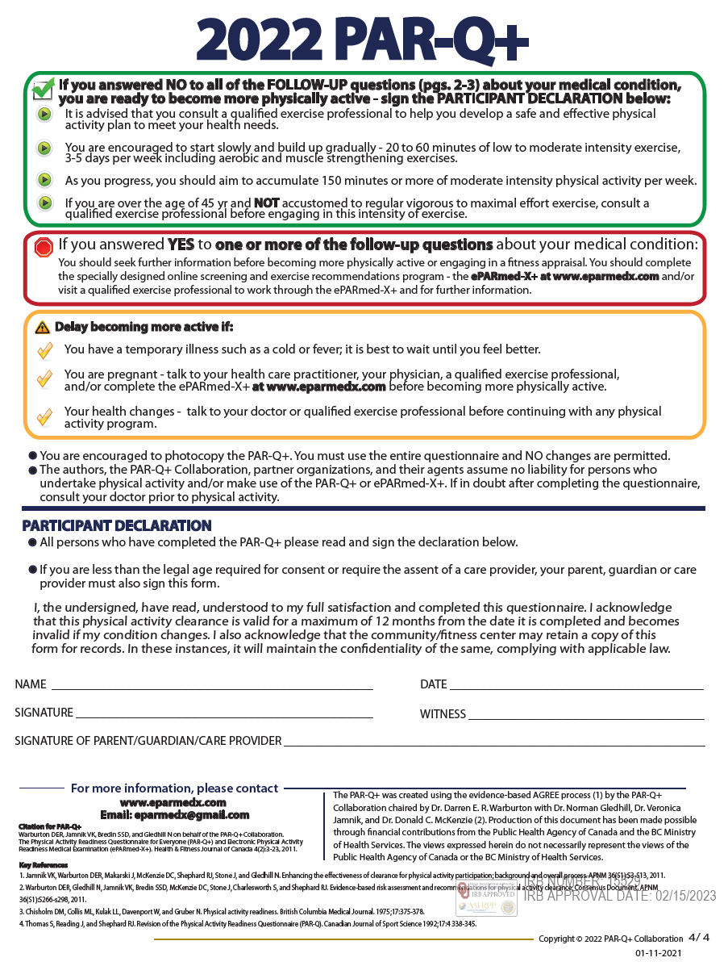

APPENDIX E: MENSTRUAL HISTORY QUESTIONNAIRE


APPENDIX F: HEALTH SCREENING QUESTIONNAIRE
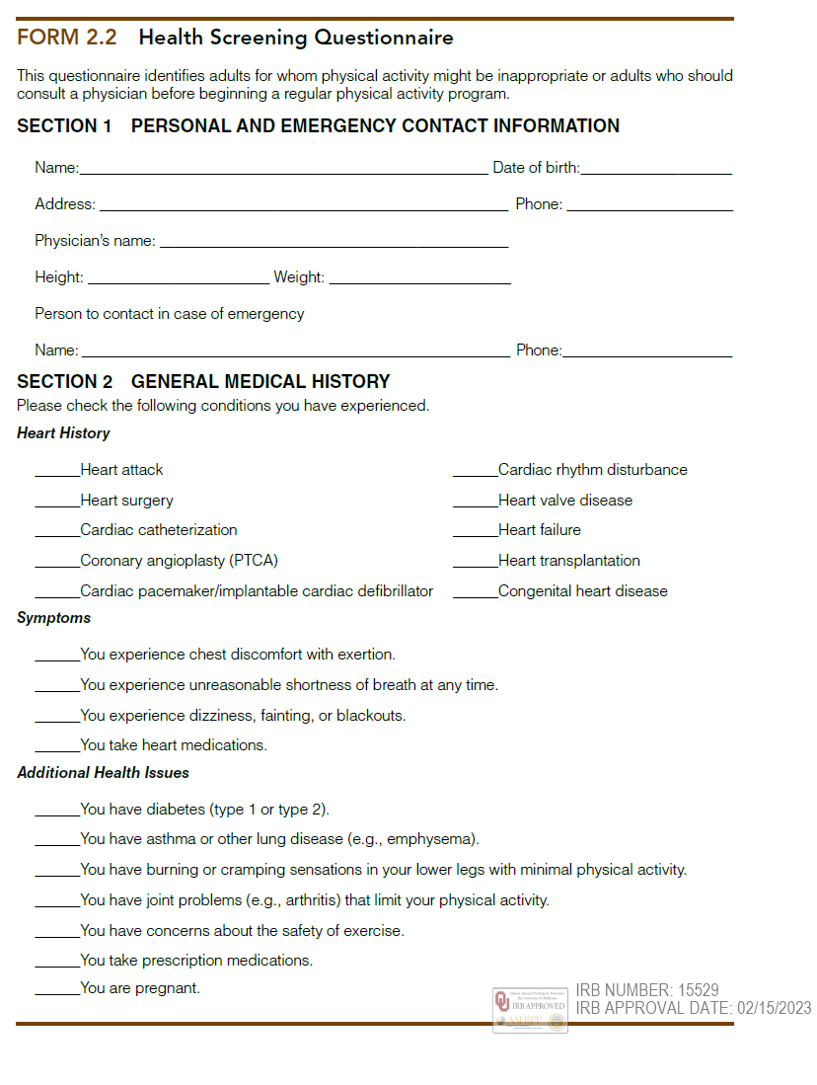

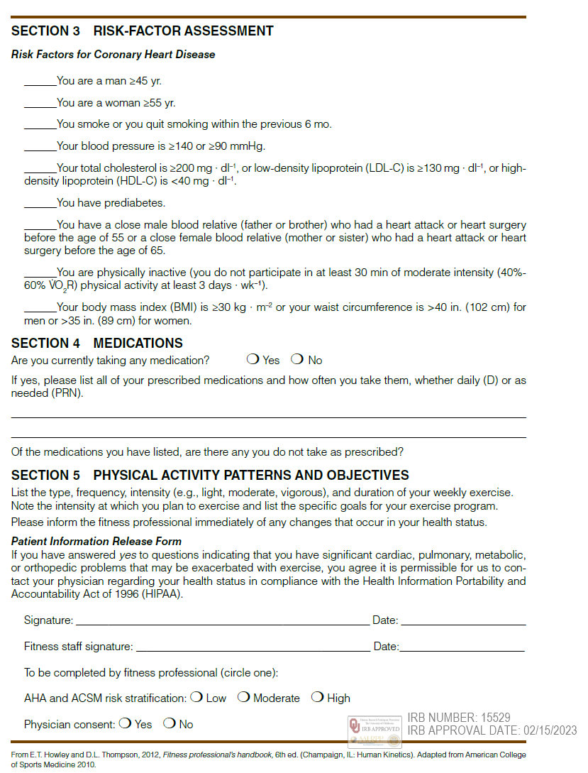

APPENDIX G: RHABDOMYALSIS SCREENING
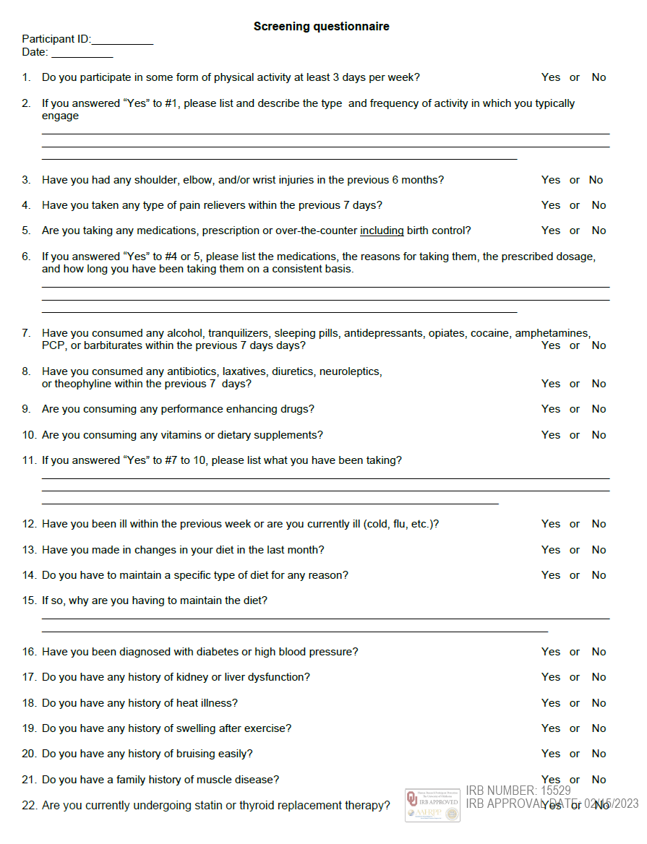

APPENDIX H: RECRUITMENT FLYER

