UNIVERSITY OF OKLAHOMA
GRADUATE COLLEGE

EXTENDING REALITY: UNDERSTANDING MODERATING VARIABLES IN SPATIAL LEARNING WITH AUGMENTED AND VIRTUAL REALITY

A DISSERTATION
SUBMITTED TO THE GRADUATE FACULTY
In partial fulfillment of the requirements for the
Degree of
DOCTOR OF PHILOSOPHY

By
TREY OLEN LEE
Norman, Oklahoma
2024

EXTENDING REALITY: UNDERSTANDING MODERATING VARIABLES IN SPATIAL LEARNING WITH AUGMENTED AND VIRTUAL REALITY

A DISSERTATION APPROVED FOR THE DEPARTMENT OF GEOGRAPHY AND ENVIRONMENTAL SUSTAINABILITY

BY THE COMMITTEE CONSISTING OF

Dr. Thomas Neeson, Chair
Dr. Jennifer Koch
Dr. Travis Gliedt
Dr. Kelly Feille
Dr. John Burns

© Copyright by TREY OLEN LEE 2024
All Rights Reserved.

Table of Contents
Abstract vii
List of Figures ix
Chapter 1: Introduction 1
Chapter 2: Augmented reality as an educational tool: gender and subject attitude effects in an informal setting 3
Chapter 3: Assessing augmented and virtual reality tools for learning about marine conservation in a university classroom 32
Chapter 4: Comparing monoscopic and stereoscopic augmented reality indoor navigational aids across age and gender identity 54
Chapter 5: Conclusion 80
Appendix A 85

Abstract
Digital learning tools like smartphones, tablets, and extended reality (XR) devices are increasingly accessible to students and teachers. These devices have the potential to be powerful educational tools and can simplify complex tasks, but they are often adopted without a full understanding of their effects on learners. This dissertation aims to evaluate how spatial technologies such as augmented and virtual reality (AR and VR), collectively referred to as extended reality, impact the learning process, and how these effects might depend on the characteristics of each individual learner. The research presented here expands on existing research by utilizing different categories of devices and multiple modes of visualization, analyzing their effects within three distinct settings and a diverse pool of participants. In our first analysis, we evaluated learning outcomes for students who used XR in a university classroom to explore key concepts from marine ecology and conservation. We found that students utilizing XR had significantly higher rates of learning achievement in a pre/post-test experimental design. While gender identity and recreational gaming habits had no significant relationship with learning achievement, women enjoyed the XR activity more than men and wished to use XR in educational contexts again in the future. In a second analysis, we evaluated learning outcomes for high school students who used gamified AR while visiting a public aquarium. In this informal educational setting, we again found that AR significantly improved learning outcomes, but we also observed a significant gender effect. Boys aged 14-18 displayed greater learning achievement than girls in response to the gamified mobile AR activity. In a third analysis, we evaluated the usefulness of XR tools for navigating a novel indoor environment. We found that stereoscopic AR improved participants’ abilities to navigate a novel indoor environment, compared to a control group with no assistance, but participants using monoscopic AR performed worse than the control group. When participants repeated the navigation task two weeks later without the use of a device, all groups demonstrated significant improvements in performance. The control group showed the greatest improvements, while participants in the stereoscopic AR group retained the least distance and time traveled. We found a significant relationship between navigational performance and the age of the participant, and a significant interaction between age and gender, but no relationships between navigational performance and gender or spatial thinking ability. Overall, this dissertation provides further evidence that XR technologies can be powerful educational tools. In all three chapters, we offer strategies and suggestions for educators who wish to implement XR in their classrooms or field trips.

List of Figures
Figure 1: Examples of what users see both inside (left) and outside (right) of the AR experience. 9
Figure 2: Questions covered in the knowledge assessment (horizontal axis) and the percentage of participants who correctly answered that question (vertical axis) in the pre-test (red) and post-test (green). 12
Figure 3: Attitude assessment results from all participants display mostly positive attitudes about the learning experience. Participants had the most positive attitudes regarding the learning experience’s ability to motivate them to care about the environment. 14
Figure 4: User perception survey results from all participants display mostly positive perceptions of the use of AR as a learning tool. While two participants found the experience to be difficult, all participants indicated that they would like to use AR as a learning tool in the future and would recommend it to other people. However, three participants preferred AR as a classroom tool instead of using it to learn outside of the classroom. 15
Figure 5: Participants’ subject attitude distributions are displayed with pre-test (top), post-test (middle), and improvement (bottom) score results. Only “Arts” (red) and “Science” (green) were used in the analysis due to “Math” (blue) only having a sample size 17
Figure 6: Participants’ gender identity distributions are displayed with pre-test (top), post-test (middle), and improvement (bottom) score results. Only “Male” (red) and “Female” (green) were used in the analysis due to “Non-binary/third gender” (blue) only havi 19
Figure 7: Question topics covered in the knowledge assessment (horizontal axis) and the percentage of students who correctly answered that question (vertical axis) in the pre-test (red) and post-test (green). 40
Figure 8: Boxplots of the post-test scores (left) and score changes (right) within each of the experimental groups, with the mean represented by a red asterisk. 41
Figure 9: Histogram showing female (left) and male (right) students along with their likelihood to play video games recreationally. 42
Figure 10: Boxplots of the score changes of non-gamers (left) and gamers (right), separated by males (red) and females (blue). The mean is represented by a red asterisk. 42
Figure 11: (left) Boxplot of each group’s total time traveled (in seconds) for Stage A (blue) and Stage B (green). (right) Boxplot of each group’s difference in time traveled (in seconds) between stages. 63
Figure 12: (left) Boxplot of each group’s average walking speed (m/s) for Stage A (blue) and Stage B (green). (right) Boxplot of each group’s difference in average walking speed (m/s) between stages 64
Figure 13: left) Boxplot of each group’s Euclidean distance traveled (in meters) for Stage A (blue) and Stage B (green). (right) Boxplot of each group’s difference in distance traveled (in meters) between stages. 64
Figure 14: (left) Boxplot of the difference in time traveled (in seconds) (y) between stages with young adults (YA-yellow) and middle-aged adults (MA-orange) across experimental groups. (right) Boxplot of the difference in Euclidean distance traveled (in meters) 65
Figure 15: (left) Linear regression of participants’ spatial thinking ability score (x) and Euclidean distance traveled (in meters) (y) for Stage A (blue) and Stage B (green). (right) Linear regression of participants’ spatial thinking ability score (x) and difference in Euclidean distance traveled (in meters) (y) between stages. 65
Figure 16: (left) Linear regression of participants’ spatial thinking ability score(x) and total time traveled (in seconds) (y) for Stage A (blue) and Stage B (green). (right) Linear regression of participants’ spatial thinking ability score (x) and difference in. 66
Figure 17: Density plots of participant’s recorded location every 2 seconds overlayed onto the floorplan in (top) the control group, (middle) the monoscopic group, and (bottom) the stereoscopic group. 69

Chapter 1: Introduction
The introduction of technology in the classroom is a double-edged sword. Computers and smartphones allow students to connect with seemingly endless online resources, but non-academic classroom internet use has become common and research shows that it can negatively impact student performance (Ravizza et al., 2017). The use of electronic devices has also been shown to reduce long-term retention of lecture material, even when it does not hurt short-term comprehension (Glass & Kang, 2018). Within informal educational settings (e.g., museums and aquaria), smartphones can give students autonomy over their learning experience by allowing them to progress at their own pace without an educator present (Hwang et al., 2016). In the context of daily spatial learning tasks, research shows that the use of global positioning systems (GPS) can make it easier to navigate a novel environment and reduce cognitive load during wayfinding, thus solving a problem for people who struggle to navigate (Allen, 1999; Brugger et al., 2019). However, the use of GPS and other navigational tools also introduced new problems by impairing our ability to navigate based on how much we use them (Montello, 2005; Gardony et al., 2013; Dahmani & Bohbot, 2020).
Extended reality (XR), an umbrella term that includes augmented, virtual, and mixed reality (AR/VR/MR), has demonstrated promise in educational contexts during recent years by solving some problems that came with existing technologies (e.g. smartphones and computers), but while introducing new problems. AR delivers content through either a smartphone or tablet’s camera feed (known as a monoscopic display) or a pair of specialized glasses that project digital information onto two transparent lenses (a stereoscopic display), giving users depth perception. VR, however, requires the use of a head mounted display (HMD) that blocks out the real world around the user. One of the core benefits of XR is the ability to visualize and interact with content in a 3D space. With AR/MR, a real-world space can be augmented with digital support information. With VR, users can become immersed in an entirely different world.
Digital learning tools like XR have the potential to enhance learning and motivation through the means of gamifying a lesson plan. Gamification (i.e., the incorporation of game elements into non-game contexts) has become an increasingly popular trend in recent years within the realm of education (Dicheva et al., 2015). Most gamified educational experiences assume that all students respond in a similar, positive manner, but research suggests that people have varying degrees of susceptibility to gamification and that variables such as age and recreational gaming habits can influence its effects (Swan, 2012; Hamari, 2013; Bockle, Novak, & Bick, 2017). While research regarding gamified AR has increased in recent years, there has been significant variability in the effect sizes of samples, suggesting the need to further look for moderating variables (Garzon & Acevedo, 2019).
The overarching goal of this dissertation is to evaluate how spatial technologies such as AR and VR impact the learning process, as well as moderating variables that drive its effects. In the following chapters, we take a critical look at XR by analyzing three case studies for its use inside the classroom (formal education), outside the classroom (informal education), and day-to-day spatial learning tasks such as indoor navigation. The purpose of the first study is to understand how different formats of XR in a university classroom compare to the use of a traditional reading worksheet with the same information, further evaluating whether gender identity and recreational gaming habits potentially moderate these effects. The purpose of the second study is to assess whether mobile AR is effective in teaching science to high school students in an informal education setting, gauge their perceptions of the technology, and assess if gender identity and subject attitude impact learning achievement. The purpose of the third study is to understand how modes of visualization (monoscopic vs. stereoscopic) affect users’ abilities to navigate an indoor environment for the first time as well as a second time two weeks later, compared to a control group with no assistance. We attempt to further understand navigational improvements by testing for significant relationships related to age, gender identity, and spatial thinking skill.

Chapter 2: Augmented reality as an educational tool: gender and subject attitude effects in an informal setting

Trey O. Lee^{1*}, Kelly Feille², Thomas Neeson¹
1. Department of Geography & Environmental Sustainability, University of Oklahoma
2. Department of Instructional Leadership and Academic Curriculum, University of Oklahoma
*Corresponding Author: treylee@ou.edu, Department of Geography & Environmental Sustainability, University of Oklahoma, 100 Boyd St, Norman, OK 73069
Abstract
Augmented reality (AR) has the potential to be a powerful educational tool, but AR may not be effective for all students. Past work has shown gender differences in students’ attitudes toward video games. Here, we investigate the effects of gender identity and subject attitude on the efficacy of an AR learning tool within an informal education setting. We developed a curriculum focused on coral reef ecology at the high school level and deployed it at a public aquarium. We measured efficacy through evaluations of knowledge retention, attitude, and user perception. Overall, our results indicate significant improvement in all students’ knowledge, motivated attitudes, and positive perceptions of the technology’s use inside and outside the classroom when learning about fundamental concepts within coral reef ecology. However, our results further suggest that learning may be more likely to occur from an AR learning tool when the content leverages the power of the technology’s visual or audio capabilities in an explicit manner. Our study shows learning outcomes were higher for boys. Given that previous work has shown gender biases in students’ attitudes towards gamification, we hypothesize that girls’ unfamiliarity or dislike of gamified, video-based learning may constrain their learning outcomes from AR. We conclude that while interest affects learning achievement from other sources, the inclusion of gamified AR mechanics arouses the interest and motivation of all student types in a similar manner regardless of prior preferences, although that effect may be moderated by gender identity.
Keywords: Augmented and virtual reality, Games, Gender studies, Informal learning, Mobile learning
2.1 Introduction
Informal learning environments are essential complements to school classrooms. While the act of learning is commonly associated with classrooms, research supports the use of informal spaces outside of the classroom to engage with students and contribute to children’s science knowledge (Rennie & McClafferty, 1995). This has become recognized as informal education and can occur across any discipline, although STEM-related content has become a focus of many research studies (Kamarainen et al., 2013; Roberts et al., 2018; Allen & Peterman, 2019; Alexandre, Washington-Nortey, & Chen, 2022). This study follows the Center for Advancement of Informal Science Education’s (CAISE) (2017) definition for informal STEM education as “lifelong learning in science, technology, engineering, and math (STEM) that takes place across a multitude of designed settings and experiences outside of the formal classroom.” A key difference between classrooms and informal education settings is grade attainment, which research has shown does not necessarily predict skills acquisition (Côté & Levine, 1997). Instead, a common thread across literature on informal education is that a student’s interest is the essential outcome to evaluate (Roberts et al., 2018). Informal learning experiences rarely focus on teaching specific knowledge and skills, but instead concentrate on trying to spark curiosity and interest to cultivate natural motivation as “stepping stones” to further science learning (Allen & Peterman, 2019). Motivation has been demonstrated to be more important than intelligence in terms of positive educational outcomes. Research shows that motivation holds consistent positive relationships with many learning outcomes (Côté, 2000). These findings warrant the exploration of new avenues for increasing engagement and motivation of students outside the classroom.
Augmented Reality (AR) has the potential to enhance students’ experiences within informal learning environments. AR technology creates a virtual 3D space where digital objects are displayed as if they are present in the real world, instead of solely a virtual one like with virtual reality (VR). AR can appear in two forms: head-mounted displays (HMDs) and AR interfaces. HMDs are devices worn on the user’s head that project digital images onto a specially designed transparent lens in a way that makes the object in the images appear as if present within the real world. AR interfaces are handheld devices, usually smartphones or tablets, with a screen that displays the image produced by the device’s camera and incorporates the digital 3D object into the device’s display. The use of smartphones to visualize AR experiences can be a bridge to connect upcoming AR glasses-style HMDs to consumers through the use of current technology they likely already use. While AR is recognized as an emerging technology, approaches on how to study and design AR systems have existed since the turn of the millennium (Dubois & Nigay, 2000). The literature for AR has since expanded immensely, particularly in the field of education. Several literature reviews have been conducted with conclusions agreeing that AR is considered effective in increasing motivation, engagement, and learning performance (Bacca, et al., 2014; Akcayir & Akcayir, 2016; Garzon et al., 2020).
AR learning tools give students the opportunity to observe and interact with content, providing a type of sensory experience. Extending from popular constructivist theories of learning, Kolb (1984) defines learning as “the process whereby knowledge is created through the transformation of experience.” The Kolb model is well-aligned with the fast-changing environment and life-long-learning approach, where learning is problem-based, situational, and experiential (Cassidy, 2014). The Kolb model also supports the finding that the most powerful learning comes from direct experience (Senge, 2015). AR empowers all students to use AR supports in the classroom and combining AR with mobile technology allows teachers the ability to create personalized supports for enabling independent and self-determined learners (Carreon, Smith, & Rowland, 2019). One example of AR within education is a study comparing the use of AR applications within two fifth-grade classrooms focused on butterfly ecology (Hwang et al., 2016). The results suggest a significant increase in both learning achievement and learning attitudes among the class that was utilizing a competitive gaming approach in the AR application in comparison with the class that did not utilize the gamified approach. The students in the study enjoyed using the technology, but another indicator of success came from the surveys given to the teachers. The aspect the teachers liked most about the technology was that it permitted the students to progress at their own pace while allowing the teachers to provide support where necessary without needing to direct every part of the lesson.
A core component of AR that helps enhance students’ interest is gamification, which is the use of game mechanics in a non-game situation to digitally engage and motivate people to achieve their goals. Gamification can be used in a learning context to encourage students to perform better in learning tasks (Helmefalk, Lundqvist, & Marcusson, 2019). It has been implied that gamification is used to stimulate learning-related behavior and can influence one’s learning, but that it does not directly affect learning (Landers, 2014). While the use of gamification is rooted in marketing techniques such as loyalty programs and membership cards that offer rewards, games have aroused human interests and engagement since prehistoric times (Kumar & Herger, 2013; Huotari & Hamari, 2017). People naturally seek reward for their participation and effort, which can be manifested in many ways such as applause, achievement badges, salary, and higher social status (Johansson & Götestam, 2004). Increasing motivation and engagement is not only important in business environments, but also for education (Dichev & Dicheva, 2017). There are several gamification mechanics that reoccur across scientific disciplines, with the three most common being badges, points, and leaderboards (Seaborn & Fels, 2015). However, people may have different responses to different gamification mechanics.
Gender identity is one example of a barrier that can affect responses to gamification. While AR and other games can be powerful learning tools, students’ orientation toward video games differs by gender and among individuals (Greenberg et al., 2010). Most gamified learning experiences do not consider individual responses, assuming that all students are affected in the same positive manner (Böckle, Novak, & Bick, 2017). Research suggests that people can have different degrees of susceptibility to gamification, one example being that younger people or those who are more familiar with games are more likely to be influenced by gamification techniques (Swan, 2012; Hamari, 2013). Recent work found through survey (n = 3,517) that 60% of American adults spend an average of nine hours per week playing video games, but that there are clear gender differences with the types of games and social experiences that gamers seek (Digital Media Trends, 2024). One study (Denden et al., 2021) found that gender and personality can affect students’ perception of specific game elements, but that gender can moderate the effect of personality on that perception. Another study (Leonhardt, 2021) found through survey analysis (n = 5,607) that male survey participants from the age of 14 and up use video games up to five times more than female survey participants. Research shows that women may feel less encouraged to play video games because of negative expectations based on gender or prior experiences while gaming (Lopez-Fernandez et al., 2019). The study of gender differences in school achievement has a history of controversy, but it is important to understand how those differences are mitigated/enhanced by emerging educational tools.
In this study, we investigate how gender identity and subject attitude differences might impact an AR learning tool’s efficacy in teaching coral reef ecology to high school students within an informal education setting. The gamified AR application offers students an alternative pedagogical approach to enhance their learning experience by visualizing complex concepts in ways traditional approaches cannot. The analysis focuses on outcomes related to knowledge retention, student attitudes, and user perception of AR technology as a learning tool.
2.2 Material and Methods
We developed an AR application that allows users to navigate the Blue Zoo aquarium in Oklahoma City, OK, USA. When using the application, users progress through gamified learning objectives appropriate for a high-school level introduction to coral reef ecology. The users can see and interact with real-world aquatic life within the aquarium’s exhibits while the AR application provides supplementary digital information and tasks overlayed onto the real-world environment using an iPad Pro.
2.2.1 Curriculum design
We compiled a list of learning objectives commonly found within instructional plans for ecology, along with extensions specific to coral reef environments (Table 1). To compile this list, we drew from the high school environmental science and ecology sections within the Next Generation Science Standards (NGSS Lead States, 2013) that is used by several states, including Oklahoma’s Academic Standards for Science (Oklahoma State Department of Education, 2020). Each standard learning objective is equally represented and guided the overall structure and content to be taught within the AR application.

Table 1: The chosen academic science standards from the Next Generation Science Standards (NGSS Lead States, 2013) used to support the content development process.
Academic Science Standards
EN.LS2.1 | Use mathematical and/or computational representations to support explanations of factors that affect carrying capacities of ecosystems at different scales.
EN.LS2.2 | Use mathematical representations to support and revise explanations based on evidence about factors affecting biodiversity and populations in ecosystems of different scales.
EN.LS2.4 | Use a mathematical representation to support claims for the cycling of matter and the flow of energy among organisms in an ecosystem.
EN.LS2.6 | Evaluate the claims, evidence, and reasoning that the complex interactions in ecosystems maintain relatively consistent numbers and types of organisms in stable conditions, but changing conditions may result in a new ecosystem.
EN.LS2.7 | Design, evaluate, and refine a solution for reducing the impacts of human activities on the environment and biodiversity.

2.2.2 AR application development
Application development utilized the C# programming language within Unity, a game engine created by Unity Technologies (San Francisco, CA) capable of managing the physics and spatial information collected by the user’s device (Haas, 2014). Applying the ARFoundation framework within Unity, an application can be developed for iOS and Android operating systems simultaneously, although only iPad Pros (iOS) were used in this study due to the lack of Android devices available for testing. However, the operating system utilized should not have relevance on the effectiveness of the methods. The AR application’s content is designed to be interactive in a variety of ways to best support students of all learning tendencies (Zaric et al., 2020). However, sound is not used here due to the loud nature of the study site. An example of what the users see can be found in Figure 1.
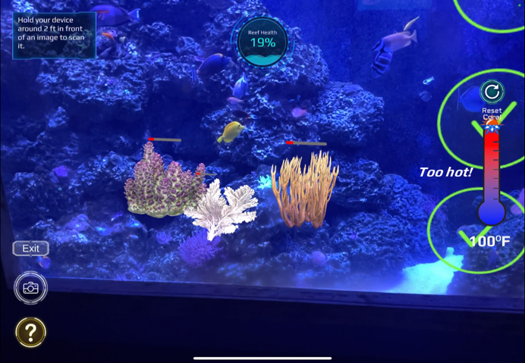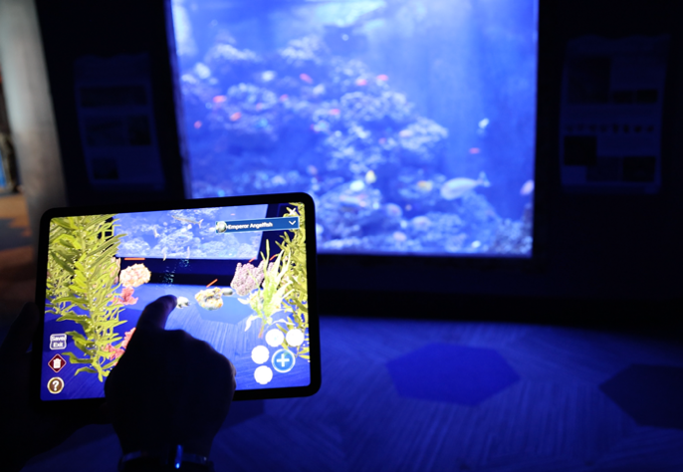
Figure 1: Examples of what users see both inside (left) and outside (right) of the AR experience.
2.2.3 Study site and participants
Blue Zoo is comprised of multiple areas with terrestrial and aquatic life, including an aquarium section that provides an informal learning environment for implementation of an AR learning tool. Participants have both real-world and digital environments to immerse themselves in and explore while learning fundamental concepts within coral reef ecology, marine conservation, and how coral reefs connect into our everyday lives. Application deployment took place at Blue Zoo’s Oklahoma City location. Participant recruitment occurred after they had made the decision to visit Blue Zoo and they were compensated for their time with free admission. To qualify for this study, participants were required to be at the high school age level (14-18). At least one parent accompanied every participant under the age of 18 throughout their participation. Observations with non-reliable pre/post-test scores indicated by lack of proper engagement (i.e. selecting choices at random for faster completion) with the surveys were excluded from the analysis.
Survey administration allowed participants to enter responses either on the iPad Pro through an online platform or on paper in print format. All print surveys were digitized and added to the online platform for analysis. The surveys were divided into the following five sections: (1) basic information/prior experience questionnaire, (2) pre-activity knowledge assessment, (3) attitude assessment, (4) user perception survey, and (5) post-activity knowledge assessment. Participants were given three options for gender identity and seven options for favorite subject. However, the non-binary group (n = 3) was excluded from the analysis due the insufficient sample size. While “Sports” was included as an option, it was removed from the analysis due to having zero selections. Furthermore, the different art options were combined into a single “Arts” category. A brief questionnaire was used to determine if participants had previously used any AR or VR applications. If they answered “yes” to either AR or VR experience, a 7-point Likert scale was used to determine how much the participant enjoyed their previous experience. The 7-point Likert scale was chosen to allow a neutral option while maintaining consistency with the other survey questions. During analysis, we coded Likert scale responses on a scale of -3 to 3.
The knowledge assessment contained a pre-activity and a post-activity evaluation of the users’ knowledge about coral reef ecology. The knowledge assessment consisted of 14 multiple-choice questions and one open-ended question, which were reviewed by content experts for alignment with high-school level environmental science content. All of the knowledge assessment questions can be found in Appendix A. We also developed an attitude assessment to provide insight into user experience while using the tool. The questions were modeled after an attitude assessment used by Hwang et al. (2011) in a previous AR research study, although their 6-point Likert scale was changed to a 7-point Likert scale for this study to include a neutral option. A second opinion-based facet of this analysis is user perception, or how useful the user believes the tool was to their learning process. It used the same scale as the attitude assessment, but the questions were directed toward the usefulness of the tool. This approach was also used by Hwang et al. (2011), which we again updated to a 7-point Likert scale for this study.
2.2.4 Analyses and Measures of Performance
We assessed overall learning outcomes (i.e., differences between pre- and post-test performance), and whether these outcomes differed by subject attitude and gender identity. Gender identity is used here as the gender participants self-identify as. To quantify learning outcomes overall, we used a paired sample t-test to determine if there was a significant difference between participants’ pre-test and post-test scores. To determine whether learning outcomes differed by subject attitude, we used an independent two-sample t-test to determine if there were any relationships between a student’s favorite subject in school and their pre-test score, post-test score, and score improvement. To determine whether learning outcomes differed by gender identity, we used independent two sample t-tests to test for significant (p < 0.05) differences between gender identities regarding pre-test scores, post-test scores, and score improvement. All analyses were performed in RStudio (RStudio Core Team, 2021) using R version 4.1.2 (Team, 2013).
2.3 Results
This study utilized a total of 30 participants. The majority of the participants identified as female (n = 20), with less than half that number identifying as male (n = 7), and even fewer identifying as non-binary (n = 3; Table 2). More than half of all participants chose one of the arts as their favorite subject (n = 18), with one-third of participants choosing science (n = 10), leaving only two participants choosing math. Male participants had an equal split between science (n = 3) and the arts (n = 3), while female participants had a different distribution between science (n = 5) and the arts (n = 14).
Table 2: Summary of gender versus subject attitude of participants. Subject attitude and gender identity distributions within the sample resulted in most participants favoring the arts in school, and two-thirds of the participants being female.
Subject Attitude | Male | Female | Non-binary/third gender | All genders
Science | 3 | 5 | 2 | 10
Math | 1 | 1 | 0 | 2
Arts | 3 | 14 | 1 | 18
All subjects | 7 | 20 | 3 | 30
2.3.1 Knowledge Assessment
We found that the AR activity significantly improved students’ understandings of coral reef ecology. The paired sample t-test resulted in highly significant (p = 2.78e⁻¹²) differences between participants’ scores on their pre-test (mean score: 37.14) and post-test (mean score: 74.99). This suggests high learning achievement within the sample. The pre/post-test design revealed some areas where participants had better and worse prior understanding of concepts (Figure 2). For example, the pre-test revealed that students generally had good prior understanding of biodiversity (Question 5; 87% of students answered correctly on the pre-test). Students generally had a poor prior understanding of energy flow (Question 14; 0% of students answered correctly on the pre-test) and the impacts corals have on humans (Question 10; 7% of students answered correctly on the pre-test). However, those low scores in energy flow and human impact increased in the post-test to 70% and 80%, respectively. The open-ended question asking, “What are some ways that you can contribute to protecting or restoring coral reefs?” had 13 responses that included a total of 15 ideas in the pre-test, implying little prior knowledge at only one idea for every two participants. Those results greatly increased in the post-test and contained 20 responses that included a total of 38 ideas, indicating that participants retained much of the information taught regarding calls to action. While most questions in the post-test resulted in satisfactory scores, question 7 about the trophic effects of overfishing had only 40% of participants answer correctly, a mere 3% increase from the pre-test.
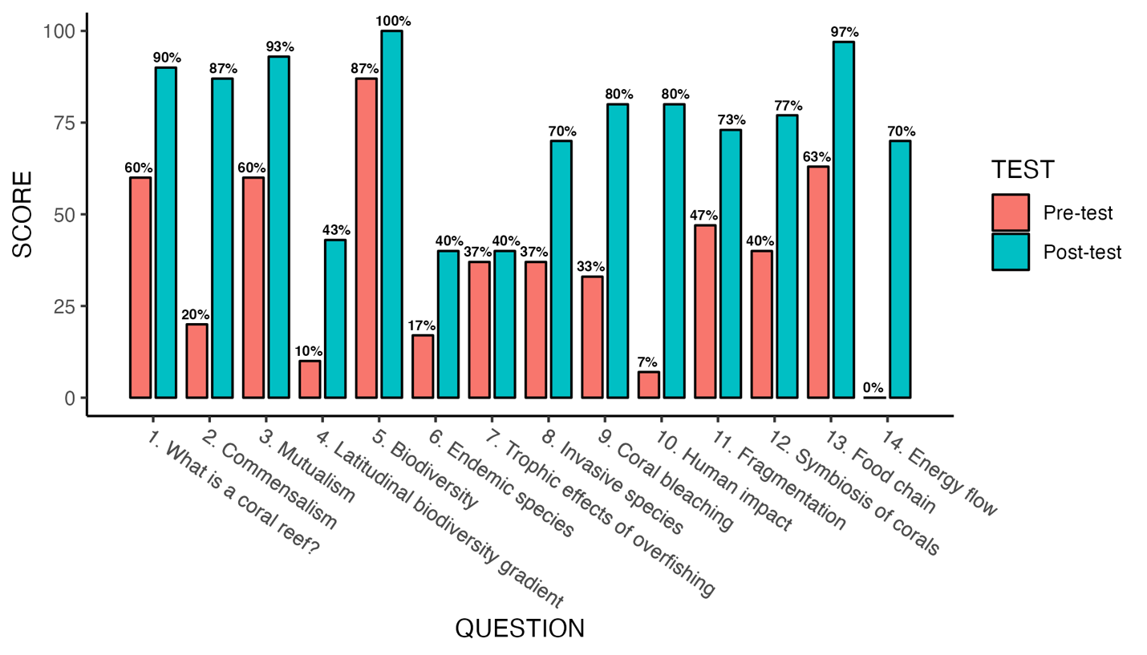
Figure 2: Questions covered in the knowledge assessment (horizontal axis) and the percentage of participants who correctly answered that question (vertical axis) in the pre-test (red) and post-test (green).
Prior AR experience did not have a statistically significant impact on the knowledge assessment scores (t-test; p > 0.05). Participants who did not know if they had prior experience were grouped with those who did not have prior experience (Table 3). We observed a minor difference in pre-test scores between the group with no prior AR experience (mean = 33.33, n = 18) and the group that did have prior AR experience (mean = 42.85, n = 12), but this difference was not statistically significant (independent two-sample t-test, p > 0.05). Regarding the post-test scores, there was a smaller difference between the group with no prior AR experience (mean = 72.62, n = 18) and the group that did have prior AR experience (mean = 78.57, n = 12); this difference was not statistically significant (p > 0.05). Furthermore, an independent sample t-test revealed there was little difference in score improvement (p = 0.57) between the group (mean = 39.29, n = 18) with no prior AR experience and the group (mean = 35.72, n = 12) that did have prior AR experience.

Table 3: Summary of gender versus previous AR and VR experience of participants. AR/VR experience was separated by gender identity to test for any relationships between prior experience, gender identity, and learning outcomes. Most participants had previously used VR technology, but less than half had previously used AR technology.
Previously used AR or VR? | Male |  | Female |  | Non-binary/third gender |  | All genders
Previously used AR or VR? | AR | VR | AR | VR | AR | VR | AR | VR
Yes | 3 | 4 | 7 | 12 | 2 | 0 | 12 | 16
No | 2 | 3 | 7 | 6 | 1 | 3 | 10 | 12
I don’t know | 2 | 0 | 6 | 1 | 0 | 0 | 8 | 1
2.3.2 Attitude and User Perception
The results of the attitude assessment showed mostly positive attitudes regarding the AR learning tool (Figure 3). There were only two participants (7% of respondents) who somewhat disagreed that using this technology allowed them to think differently about the learning content. Four participants either disagreed (n = 1; 3%) or somewhat disagreed (n = 3; 10%) that this way of learning helped them discover their personal learning problems. However, every participant either agreed (n = 7; 23%) or strongly agreed (n = 23; 77%) that this learning experience motivated them to care about the environment. Independent two-sample t-tests revealed statistically significant differences between boys (n = 7) and girls (n = 20) with the following three statements: a) “Using this technology allowed me to think differently about the learning content” (mean male = 2.67 , mean female = 1.95, p < 0.05); b) “The feedback offered by this learning tool’s ‘mission’ and dialogue systems allowed me to recognize any parts I have not learned well” (mean male = 0.33 , mean female = 1.9, p < 0.01); and c) This learning experience motivates me to care about the environment” (mean male = 3 , mean female = 2.8, p < 0.05).

Figure 3: Attitude assessment results from all participants display mostly positive attitudes about the learning experience. Participants had the most positive attitudes regarding the learning experience’s ability to motivate them to care about the environment.
The results of the user perception survey also showed mostly positive perceptions of this method of learning, with a few participants highlighting potential negative perceptions (Figure 4). Two participants (7%) agreed that this way of learning was difficult. One participant (3%) selected “disagree” for the statement, “I hope to learn in this way for other topics.” One participant (3%) disagreed with wanting to use this learning system in the future. However, all participants either agreed (37%) or strongly agreed (63%) that they liked this learning activity. All participants also either somewhat agreed (7%), agreed (30%), or strongly agreed (63%) that they would recommend this learning system to other people. Furthermore, all participants either somewhat agreed (7%), agreed (37%), or strongly agreed (57%) to wanting to use this learning system in a classroom, but three participants (10%) disagreed and one participant (3%) neither agreed nor disagreed with wanting to use this learning system outside of a school classroom. There were no statistically significant differences between gender identities and user perception.

Figure 4: User perception survey results from all participants display mostly positive perceptions of the use of AR as a learning tool. While two participants found the experience to be difficult, all participants indicated that they would like to use AR as a learning tool in the future and would recommend it to other people. However, three participants preferred AR as a classroom tool instead of using it to learn outside of the classroom.
2.3.3 Subject Attitude and Gender Identity
While there existed a significant difference between favorite school subjects and pre-test scores, we did not observe a significant difference in post-test scores nor score improvement with subject attitude. Participants who selected math as their favorite subject (n = 2) were not included here due to the insufficient sample size. The independent two-sample t-test revealed a significant difference (p < 0.05) with pre-test scores between those who selected science (mean = 43.75, n = 8) and those who selected the arts (mean = 32.77, n = 18) as their favorite subject. However, independent two-sample t-tests showed there were no statistically significant differences between subject attitude and post-test scores or subject attitude and score improvement. Distributions of all subject attitude groups’ pre-test and post-test scores can be found in Figure 5.
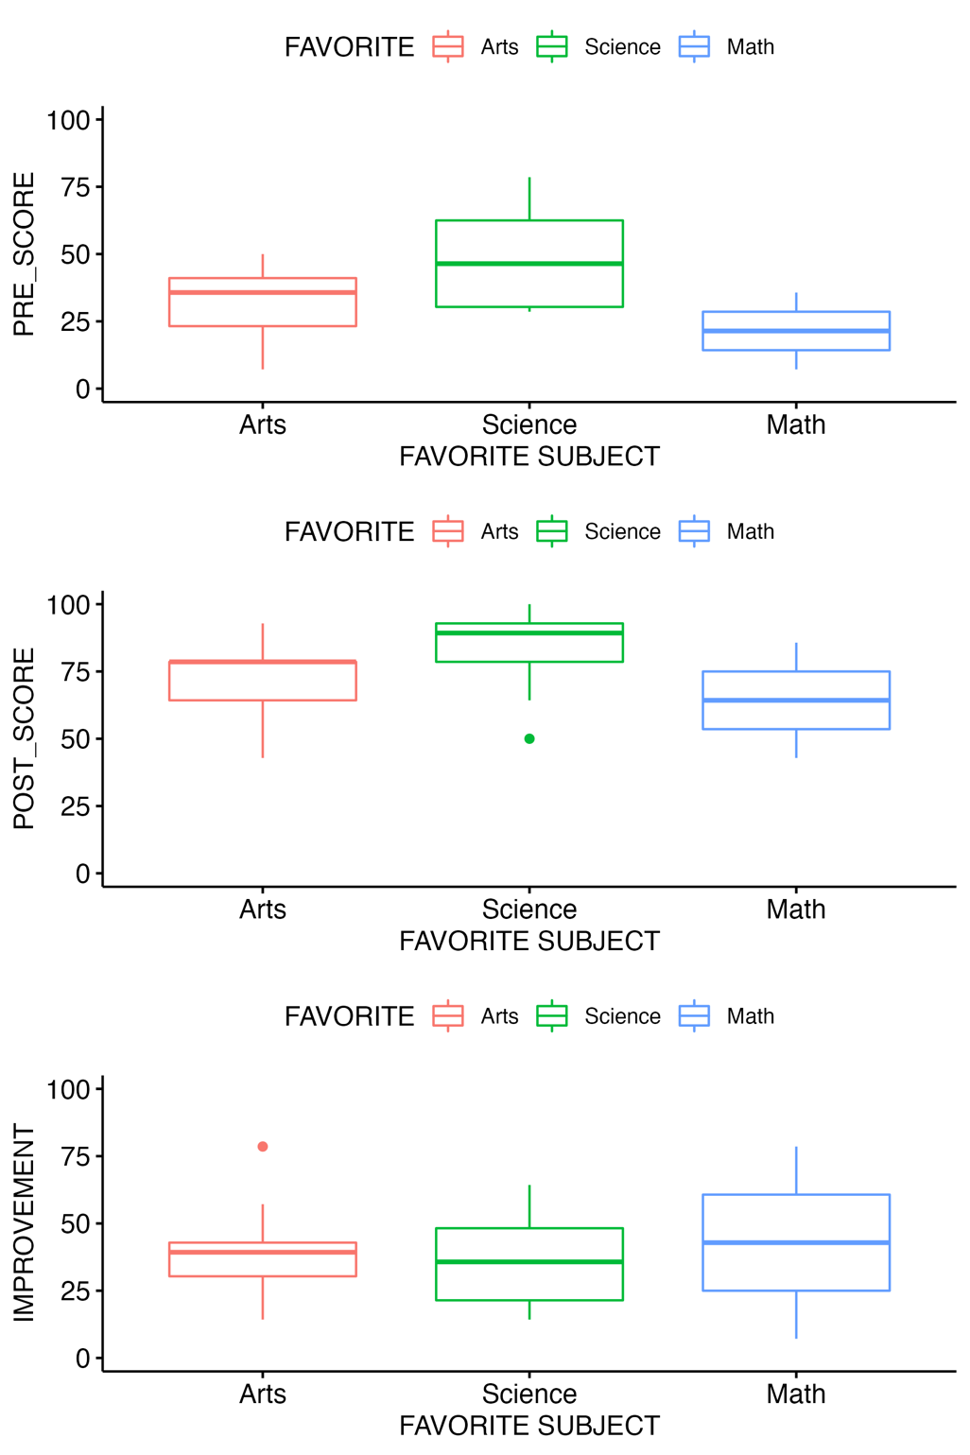
Figure 5: Participants’ subject attitude distributions are displayed with pre-test (top), post-test (middle), and improvement (bottom) score results. Only “Arts” (red) and “Science” (green) were used in the analysis due to “Math” (blue) only having a sample size
We also found that learning outcomes from AR were higher for boys than girls (Figure 6). The independent two-sample t-test found no significant differences (p = 0.25) in pre-test scores between boys (mean = 28.57 n = 7) and girls (mean = 37.5, n = 20). However, the independent two-sample t-test revealed highly significant differences (p < 0.001) between boys (mean = 86.9 n = 7) and girls (mean = 68.93, n = 20) in post-test scores. The independent two-sample t-test resulted in highly significant differences (p < 0.01) between boys (mean = 58.33, n = 7) and girls (mean = 31.43, n = 20) in score improvement between pre- and post-test.
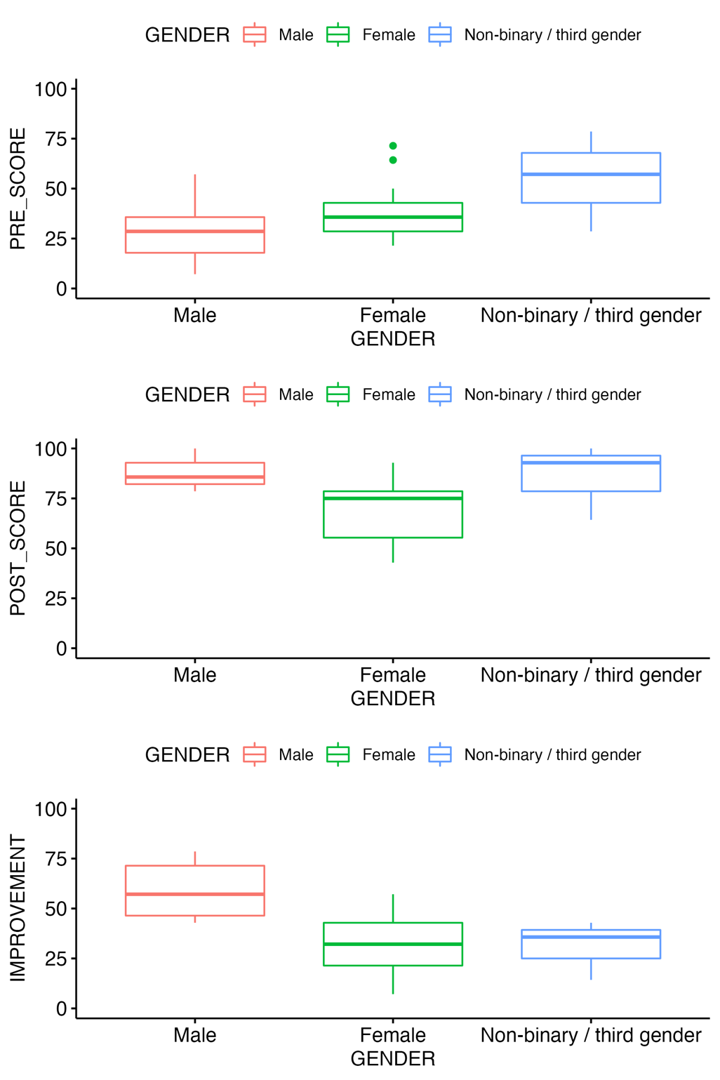
Figure 6: Participants’ gender identity distributions are displayed with pre-test (top), post-test (middle), and improvement (bottom) score results.
2.4 Discussion
We found that high school students generally liked using AR technology in an informal education setting, and that AR was an effective learning tool. Students saw the experience as an effective way to increase motivation and complement learning in both formal and informal education environments. Significant improvements in knowledge assessment scores highlight AR’s efficacy as a learning tool to increase understanding of coral reef ecology. Moreover, we found that learning outcomes were moderated by gender identity.
The significant difference between boys and girls with the post-test scores, coupled with the significant difference with score improvement, suggest that gender identity may have an effect on how young people engage with AR learning tools. Previous work shows that young people are more positively affected by gamification than older people (Hamari, 2013). However, other studies have shown that gender differences affect the perception of game elements (Koivisto & Hamari, 2014; Codish & Ravid, 2017). AR learning tools might be more effective with students that identify as male, although a larger sample size of all gender identities would provide a more accurate reflection across all gender identities. Our pre-test results are aligned with a previous review of 42 studies on gender differences in academic achievement at the global scale, which found that there are no overall differences within formal science education (females perform better in some countries, while males perform better in others), while some differences appeared in other subjects of study (Rosen, Steinmann, & Wernersson, 2022). The insignificant difference between boys and girls with the pre-test scores highlights the similar opportunities for improvement available to the two groups. One possible explanation for why girls showed less improvement than boys is that girls may be less motivated by gamification techniques. Past work shows that gender is an influential factor in the perception of gamification (Denden et al., 2021). This could be a result of previous findings that girls feel less encouraged to play video games based on the negative treatment of women within video games and the video game industry as a whole (Lopez-Fernandez et al., 2019). The most recent State of the Game Industry (2024) report found through survey (n = 3,000) that men still make up over two-thirds of game developers, women make up 23%, 21% are from the LGBTQ+ community, and 5% identify as non-binary. The report also highlights that 87% of game developers with at least 21 years of experience are men, with white men making up 92% of those. Men are also more likely to be interested in using technology than women (Ahuja & Thatcher, 2005), but women have shown increased interest in video games since the pandemic years (Digital Media Trends, 2024). Coupled with boys’ increased likelihood to play video games (Leonhardt, 2021), it may lead to a steeper learning curve for females regarding gamified interfaces within educational contexts. Only female participants within this study indicated in their survey that this way of learning is difficult, supporting this hypothesis.
Gender differences in gamification susceptibility can potentially disrupt efforts to increase gender equality in education. One review (Meinck & Brese, 2019) found that gender gaps that existed 20 years ago have persisted into the present, but also that gender equality in education is slowly increasing. If teaching approaches suddenly shift to those to which boys are more susceptible, those slow increases might reverse. When considering gamification techniques to enhance learning, it may be essential to first neutralize the culturally embedded gender stereotypes women face within video game culture (Harrison, 2016). Possible solutions to improve gender equality in gaming can be found within training solutions and strategies shown to be effective in increasing gender equality in the classroom (Hughes et al., 2020; Kollmayer et al., 2020). The brain is flexible and prone to change in accordance with physical and social environments (Halpern, 2012), which implies that any gender differences regarding susceptibility to gamification resulting from the social environment of gaming that exist today can be changed in the future. If the field of gaming sees the same increasing trends in gender equality as education has seen over the past 20 years, the gender differences in gamification will hopefully change along with them.
The two statements regarding interest and motivation in the attitude assessment and user perception survey had the highest mean scores of their respective evaluations. Cultivating interest and motivation are vital to positive educational outcomes (Côté, 2000). When considering subject attitude, the significant differences with pre-test scores suggest that students retained different levels of scientific knowledge from other sources depending on their preference of subject in school. Students who preferred science had higher pre-test scores compared to those who preferred math or the arts. Most surprising, however, was the lack of significant differences between subject attitude and post-test scores/score improvement. Students who struggle in formal STEM education settings tend to feel more interested and motivated in STEM education when it utilizes a more engaging, hands-on approach (Roberts et al., 2018). The struggles of students in formal education settings can result from unifying standards, high-stakes assessment practices, or individual learning tendencies and preferences in the way students absorb and process information (Allen & Peterman, 2019; Zaric et al, 2020). Informal learning environments offer self-directed learning opportunities for students to gain a deeper understanding that might not be possible in a school classroom (Allen & Peterman, 2019). AR technology enhances the experience within informal learning environments by affording new techniques to visualize and interact with abstract concepts (Avila-Garzon et al., 2021), potentially improving negative prior attitudes toward STEM education (Roberts et al., 2018). Our results suggest that while interest affects learning achievement from other sources, the inclusion of AR technology arouses the interest and motivation of all students in a similar manner regardless of prior subject preferences. These increased levels of interest and motivation coupled with the previously established relationship between attitude and learning performance (Côté, 2000) could very well explain the exceptional learning achievements demonstrated by all participants.
There was one question in the knowledge assessment that showed negligible improvements between the pre-test and post-test, indicating a potential problem with the content design surrounding that concept. When the content design is considered, there is one aspect that sets that section apart from the rest: it is the only concept that the correct answer in the knowledge assessment must be inferred from what is taught within the AR content. While the AR application explained and visualized energy flow through trophic levels, there were no direct examples given as to the potential effects of population changes within the different trophic levels. This suggests that learning may be more likely to occur from an AR learning tool when the content leverages the power of the technology’s visual or audio capabilities to explicitly address learning topics. AR learning tools can give students educational autonomy with their progress through a gamified experience, but the underlying mechanisms that aid gamified education must be considered during the content development process (Landers, 2014). The use of game mechanics in learning does not automatically result in successful outcomes (Helmefalk et al., 2019). With immersive technology having increased cognitive demands and relying on a level of spatial awareness (Huang et al., 2019), it is possible that the active search for visual cues pulls focus away from non-visual elements.
This study focused on subject attitude and gender differences with AR learning tools in an informal education setting, but some potential topics of future study emerged during our investigation. Participants had to be at least 14 years old to be included in this study, but most participants that were 18 years old were there either because the family and younger siblings wanted to be there or the participants were there with a significant other. Social and group dynamics in education were not within the scope of this study, but empirical research supports the use of Team Based Learning (Michaelsen, Knight, & Fink, 2004; Koles et al., 2010; Michaelsen & Sweet, 2011). Past work suggests that women are motivated to play games by feelings of achievement, power, and social interaction, and that women are more likely to play games for the social interaction than men (Taylor, 2006; Williams et al., 2009). We did not employ social interactions within our application design, which might explain the gender differences observed in our results. The single-player versus multiplayer social dynamics within informal education settings and how they relate to gender and the efficacy of AR learning tools may be a meaningful topic of future study. Another potential focus for future studies is with students who identify as non-binary/third gender. Interestingly, the participants who identified as non-binary/third gender began with noticeably higher scores and therefore had less room to improve. This may be an artifact stemming from the disadvantage of a small sample size, with the non-binary/third gender participants possibly being high-aptitude students within science. The other referenced studies did not include a third gender option in their analyses, but our survey data highlight the potential difficulty in recruiting a sufficient sample size for generalizable results.
2.5 Conclusion
This study explored AR’s potential as an emerging technology within the field of informal education, while attempting to explain the underlying mechanisms behind its effects along with how subject attitude and gender identity can potentially affect performance. We found that high school students enjoyed using AR to learn about coral reef ecology and the experience resulted in positive educational outcomes. Significant increases in knowledge assessment scores, motivated attitudes, and positive user perception further support the notion of AR being a viable supplement to traditional methods of teaching and could be successfully implemented within informal education settings other than just aquariums. AR-based learning techniques can make the learning process more engaging and enjoyable than traditional techniques, while also increasing the motivation to learn. However, questions remain about how to apply AR learning techniques in a manner equitable to all types of students. As these emerging technologies continue to develop, so will our understanding of how to best leverage the power of AR to enhance the world of education, while also addressing imbalances in educational aptitude commonly found in formal classroom settings by providing alternative modes of learning.

References
Ahuja, M. K., & Thatcher, J. B. (2005). Moving beyond intentions and toward the theory of trying: Effects of work environment and gender on post-adoption information technology use. MIS Quarterly, 29(3), 427-459. https://doi.org/10.2307/25148691
Akcayir, M., Akcayir, G., Pektas, H. M., & Ocak, M. A. (2016). Augmented Reality in Science Laboratories: The Effects of Augmented Reality on University Students’ Laboratory Skills and Attitudes toward Science Laboratories. Computers in Human Behavior, 57, 334-342.
https://doi.org/10.1016/j.chb.2015.12.054
Alexandre, S., Xu, Y., Washington-Nortey, M., & Chen, C. (2022). Informal STEM Learning for Young Children: A Systematic Literature Review. International Journal of Environmental Research and Public Health, 19(14), 8299. https://doi.org/10.3390/ijerph19148299
Allen, S., & Peterman, K. (2019). Evaluating Informal STEM Education: Issues and Challenges in Context: Evaluating Informal STEM Education. New Directions for Evaluation, 2019(161), 17–33. https://doi.org/10.1002/ev.20354
American Psychiatric Association (2013). Diagnostic and Statistical Manual of Mental Disorders, Fifth Edition (DSM-5™. Washington: American Psychiatric Association, 103–106.
Avila-Garzon, C., Bacca-Acosta, J., Duarte, J., & Betancourt, J. (2021). Augmented Reality in Education: An Overview of Twenty-Five Years of Research. Contemporary Educational Technology, 13(3). https://doi.org/10.30935/cedtech/10865
Bacca, J., Baldiris, S., Fabregat, R., Graf, S., & Kinshuk. (2014). Augmented Reality Trends in Education: A Systematic Review of Research and Applications. Educational Technology & Society, 17 (4), 133–149.
Böckle, M., Novak, J., & Bick, M. (2017). Towards adaptive gamification: A synthesis of current developments. In Proceedings of the 25th European Conference On Information Systems (ECIS), Guimaraes, Portugal.
Brillinger, D. (1984). “The Collected Works of John W. Tukey”.
Carreon, A. C., Smith, S. J., & Rao, K. (2020). A Review of Augmented Reality in K-12 Education Environments: International Journal of Virtual and Augmented Reality, 4(2), 32–61. https://doi.org/10.4018/IJVAR.2020070103
Carreon, A., Smith, S. J., & Rowland, A. (2019). Augmented Reality: Creating and Implementing Digital Classroom Supports. Journal of Special Education Technology, 35(2), 109–115. https://doi.org/10.1177/0162643419882423
Cassidy, S. (2004). Learning Styles: An Overview of Theories, Models, And Measures. Educational Psychology, 24(4), 419–444. https://doi.org/10.1080/0144341042000228834
Center for Advancement of Informal Science Education. (2017). What is informal science? Retrieved from http://www.informalscience.org/what-informal-science
Codish, D., & Ravid, G. (2017). Gender moderation in gamification: Does one size fit all? In Proceedings of the 50th Hawaii International Conference on System Sciences (pp. 2006-2015), Hilton Waikoloa Village, Hawaii.
Côté, J. E., & Levine, C. (1997). Student motivations, learning environments, and human capital acquisition: Toward an integrated paradigm of student development. Journal of College Student Development, 38(3), 229-243.
Côté, J. E., & Levine, C. (1997). Attitude Versus Aptitude: Is Intelligence or Motivation More Important for Positive Higher-Educational Outcomes? Journal of Adolescent Research, 15(1), 58-80.
Denden, M., Tlili, A., Essalmi, F., Jemni, M., Chen, N.S., Burgos, D. (2021). Effects of gender and personality differences on students’ perception of game design elements in educational gamification, International Journal of Human-Computer Studies. doi: https://doi.org/10.1016/j.ijhcs.2021.102674.
Dichev,﻿ C.,﻿ &﻿ Dicheva,﻿ D.﻿ (2017).﻿ Gamifying﻿ Education:﻿ What﻿ is﻿ Known,﻿ What﻿ is﻿ Believed﻿, and﻿ What ﻿Remains ﻿Uncertain: ﻿A﻿ Critical ﻿Review. ﻿International Journal of Educational Technology in Higher Education, 14(1), ﻿9. https://doi.org/10.1186/s41239-017-0042-5
Digital Media Trends. (2024). An introduction to Deloitte’s 2024 Digital Media Trends (18th edition). Deloitte Insights. https://www2.deloitte.com/us/en/insights/industry/technology/digital-media-trends-consumption-habits-survey/2024/how-can-gaming-industry-get-more-female-gamers.html
Dornbusch, S. M., Herman, M. R., & Morley, J. A. (1996). Domains of adolescent achievement. In G. Adams, R. Montemayor, & T. Gullotta (Eds.) Psychosocial development in adolescence, Volume 8 of advances in adolescent development (pp. 181-231) Beverly Hills, CA: Sage.
Dubois, E., & Nigay, L. (2000). Augmented reality: which augmentation for which reality? In Proceedings of DARE 2000 on Designing augmented reality environments, 165-166. https://doi.org/10.1145/354666.354695
Felder, M., & Brent, R. (2016). Teaching and Learning STEM: A Practical Guide (2nd ed.). Josses Bass.
Garzon, J., Baldiris, S., Gutierrez, J., & Pavon, J. (2020). How do pedagogical approaches affect the impact of augmented reality on education? A meta-analysis and research synthesis. Educational Research Review, 31, 100334. https://doi.org/10.1016/j.edurev.2020.100334
Greenberg, B. S., Sherry, J., Lachlan, K., Lucas, K., & Holmstrom, A. (2010). Orientations to video games among gender and age groups. Simulation & Gaming, 41(2), 238-259. https://doi.org/10.1177/1046878108319930
Haas, J. K. (2014). A history of the unity game engine.
Halpern, D. F. (2012). Sex differences in cognitive abilities (4th ed.). Psychology Press.
Hamari, J. (2013). Transforming Homo Economicus into Homo Ludens: A Field Experiment on Gamification in a Utilitarian Peer-to-Peer Trading Service. Electronic Commerce Research and Applications, 12(4), 236-245. https://doi.org/10.1016/j.elerap.2013.01.004.
Harrison, R., Drenten, J., & Pendarvis, N. (2016). “Gamer Girls: Navigating a Subculture of Gender Inequality,” in Russell W. Belk, Diego Rinallo, and Nil Özçaglar-Toulouse (Eds.), Research in Consumer Behavior: Consumer Culture Theory, Vol 18, Bingley, UK: Emerald Group Publishing Limited, 47-64.
Helmefalk, M., Lundqvist, S., & Marcusson, L. (2019). The Role of Mechanics in Gamification: An Interdisciplinary Perspective. International Journal of Virtual and Augmented Reality, 3(1), 18–41. https://doi.org/10.4018/ijvar.2019010102
Huang, K.-T., Ball, C., Francis, J., Ratan, R., Boumis, J., & Fordham, J. (2019). Augmented Versus Virtual Reality in Education: An Exploratory Study Examining Science Knowledge Retention When Using Augmented Reality/Virtual Reality Mobile Applications. Cyberpsychology, Behanvior, and Social Networking, 22(2), 105-110. https://doi.org/10.1089/cyber.2018.0150.
Hughes, R., Schellinger, J., Billington, B., Britsch, B., & Santiago, A. (2020). A Summary of Effective Gender Equitable Teaching Practices in Informal STEM Education Spaces. Journal of STEM Outreach, 3(1). https://doi.org/10.15695/jstem/v3i1.16.
Huotari, K., & Hamari, J. (2017). A Definition for Gamification: Anchoring Gamification in the Service Marketing Literature. Electronic Markets, 27(1), 21–31 https://doi.org/10.1007/s12525-015-0212-z.
Hwang, G.-J., Wu, P.-H., & Ke, H.-R. (2011). An Interactive Concept Map Approach to Supporting Mobile Learning Activities for Natural Science Courses. Computers & Education, 57(4), 2272–2280. https://doi.org/10.1016/j.compedu.2011.06.011.
Hwang, G.-J., Wu, P.-H., Chen, C.-C., & Tu, N.-T. (2016). Effects of an Augmented Reality-Based Educational Game on Students’ Learning Achievements and Attitudes in Real-World Observations. Interactive Learning Environments, 24(8), 1895–1906. https://doi.org/10.1080/10494820.2015.1057747.
Johansson, A., & Götestam, K. G. (2004). Problems with Computer Games Without Monetary Reward: Similarity to Pathological Gambling. Psychological Reports,﻿ 95(2),﻿ 641–650. https://doi.org/10.2466/pr0.95.2.641-650.
Kamarainen, A. M., Metcalf, S., Grotzer, T., Browne, A., Mazzuca, D., Tutwiler, M. S., & Dede, C. (2013). EcoMOBILE: Integrating augmented reality and probeware with environmental education field trips. Computers & Education, 68, 545–556. https://doi.org/10.1016/j.compedu.2013.02.018
Keefe, J. W. (1985) Assessment of Learning Style Variables: The NASSP Task Force Model. Theory Into Practice, 24(2), 138-144, https://doi.org/10.1080/00405848509543162.
Koivisto, J., & Hamari, J. (2014). Demographic differences in perceived benefits from gamification. Computers in Human Behavior, 35, 179-188.
Kolb, David A. (1984). Experiential Learning: Experience as the Source of Learning and Development. New Jersey: Prentice-Hall.
Koles, P. G., Stolfi, A., Borges, N. J., Nelson, S., and Parmelee, D. X. (2010). The Impact of Team-based Learning on Medical Students’ Academic Performance. Academic Medicine, 85(11), 1739–1745.
Kollmayer, M., Schultes, M.T., Lüftenegger, M., Finsterwald, M., Spiel, C., and Schober, B. (2020). REFLECT – A Teacher Training Program to Promote Gender Equality in Schools. Frontiers in Education, 5(136). https://doi.org/10.3389/feduc.2020.00136
Kumar, J., & Herger, M. (2013): Gamification at Work: Designing Engaging Business Software. Aarhus, Denmark, The Interaction Design Foundation. ISBN: 978-87-92964-06-9. Book available online at http://www.interaction-design.org/books/gamification_at_work.html.
Landers, R. N. (2014). Developing a theory of gamified learning: Linking serious games and gamification of learning. Simulation & Gaming, 45(6), 752–768. https://doi.org/10.1177/1046878114563660
Leonhardt, M., & Overa, S. (2021). Are There Differences in Video Gaming and Use of Social Media among Boys and Girls?-A Mixed Methods Approach. International Journal of Environmental Research and Public Health, 18, 6085. https://doi.org/10:3390/ijerph18116085.
Lopez-Fernandez, O., Williams, A. J., Griffiths, M. D., & Kuss, D. J. (2019). Female Gaming, Gaming Addiction, and the Role of Women Within Gaming Culture: A Narrative Literature Review. Frontiers in Psychiatry, 10. https://doi.org/10.3389/fpsyt.2019.00454
Mcmahon, Don & Cihak, David & Wright, Rachel. (2015). Augmented Reality as a Navigation Tool to Employment Opportunities for Postsecondary Education Students With Intellectual Disabilities and Autism. Journal of Research on Technology in Education. 47. 157-172. https://doi.org/10.1080/15391523.2015.1047698.
Meinck, S., Brese, F. Trends in gender gaps: using 20 years of evidence from TIMSS. Large-scale Assess Educ 7, 8 (2019). https://doi.org/10.1186/s40536-019-0076-3
Michaelsen, L. K., Knight, A. Bauman, & Fink, L. Dee. (2004). Team-based learning : a transformative use of small groups in college teaching. 1st pbk. ed. Sterling, VA: Stylus Pub.
Michaelsen, L.K. and Sweet, M. (2011), Team-based learning. New Directions for Teaching and Learning, 2011: 41-51. https://doi.org/10.1002/tl.467
Molnar, M. (2015). Half of k-12 students to have access to 1-to-1 computing by 2015-16. Education Week. Retrieved from https://marketbrief.edweek.org/marketplace-k-12/half_of_k-12_students_to_have_access_to_1-to-1_computing_by2015-16_1/
Myers, I. B., and Myers, P. B. (1995). Gifts Differing: Understanding Personality Type. Palo Alto, Calif.: Davies-Black Pub.
NGSS Lead States. (2013). Next Generation Science Standards: For States, By States. Washington, DC: The National Academies Press.
No Child Left Behind (NCLB) Act of 2001, Pub. L. No. 107-110, § 101, Stat. 1425 (2002).
Oklahoma State Department of Education. (2020). Oklahoma Academic Standards for Science. https://sde.ok.gov/sites/ok.gov.sde/files/Oklahoma%20Academic%20Standards%20for%20Science.pdf
Polanczyk, G. V., Willcutt, E. G., Salum, G. A., Kieling, C., & Rohde, L. A. (2014). ADHD prevalence estimates across three decades: an updated systematic review and meta-regression analysis. International journal of epidemiology, 43(2), 434–442. https://doi.org/10.1093/ije/dyt261
R Core Team (2021). R: A language and environment for statistical computing. R Foundation for Statistical Computing, Vienna, Austria. URL https://www.R-project.org/.
RStudio Team (2021). RStudio: Integrated Development Environment for R. RStudio, PBC, Boston, MA URL http://www.rstudio.com/.
Rennie, L. J., & McClafferty, T. P. (1995). Using visits to interactive science and technology centers,museums, aquaria, and zoos to promote learning in science. Journal of Science Teacher Education, 6(4), 175–185.
Roberts, T., Jackson, C., Mohr-Schroeder, M. J., Bush, S. B., Maiorca, C., Cavalcanti, M., Craig Schroeder, D., Delaney, A., Putnam, L., & Cremeans, C. (2018). Students’ perceptions of STEM learning after participating in a summer informal learning experience. International Journal of STEM Education, 5(1), 35. https://doi.org/10.1186/s40594-018-0133-4
Rosén, Monica & Steinmann, Isa & Wernersson, Inga. (2022). Gender differences in achievement in International Handbook of Comparative Large-Scale Studies in Education. Perspectives and Findings. Springer. 10.1007/978-3-030-38298-8_46-1.Rothmann, S., & Coetzer, E. P. (2003). The Big Five Personality Dimensions and Job Performance. SA Journal of Industrial Psychology, 29(1). https://doi.org/10.4102/sajip.v29i1.88.
Schunk, D. H. (2020). Learning Theories: An Educational Perspective (8th ed). Pearson.
Seaborn,﻿ K.,﻿ &﻿ Fels,﻿ D.﻿ I.﻿ (2015).﻿ Gamification﻿ in﻿ Theory﻿ and﻿ Action:﻿ A﻿ Survey.﻿ International Journal of Human-Computer Studies,﻿ 74, ﻿14–31. https://doi.org/10.1016/j. ijhcs.2014.09.006.
Senge, Peter M. (1990). The Fifth Discipline: The Art and Practice Of The Learning Organization. New York: Doubleday/Currency.
State of the Game Industry. (2024). 2024 State of the Game Industry. Game Developers Conference (GDC). https://reg.gdconf.com/state-of-game-industry-2024
Swan, C. (2012). Gamification: A New Way to Shape Behavior. Communication World, 29(3),
13-14.
Team, R. C. (2013). R: A language and environment for statistical computing.
Volonino, Victoria & Zigmond, Naomi. (2007). Promoting Research-Based Practices Through Inclusion?. Theory Into Practice, 46. 291-300. https://doi.org/10.1080/00405840701593873.
Walker, Zachary & Mcmahon, Don & Rosenblatt, Kara & Arner, Tracy. (2017). Beyond Pokémon: Augmented Reality Is a Universal Design for Learning Tool. SAGE Open. 7. https://doi.org/10.1177/2158244017737815.
Williams, D., Consalvo, M., Caplan, S., & Yee, N. (2009). Looking for Gender: Gender Roles and Behaviors among Online Gamers. Journal of Communication, 59(4), 700-725. https://doi.org/10.1111/j.1460-2466.2009.01453.x
Zaric, N., Lukarov, V., & Schroder, U. (2020). A Fundamental Study for Gamification Design: Exploring Learning Tendencies’ Effects. International Journal of Serious Games, 7(4), 3–25. https://doi.org/10.17083/ijsg.v7i4.356.

Chapter 3: Assessing augmented and virtual reality tools for learning about marine conservation in a university classroom

Trey O. Lee^{1*}, Thomas Neeson¹
1. Department of Geography and Environmental Sustainability, University of Oklahoma
*Corresponding Author: treylee@ou.edu, Department of Geography and Environmental Sustainability, University of Oklahoma, 100 Boyd St., Norman, OK 73069
Abstract
Augmented and virtual reality, collectively referred to as extended reality (XR), have the potential to be effective classroom tools. However, little is understood about the differences in their effectiveness and how they impact students’ learning achievement in individual and systematic ways. In this study, we compared different gamified XR technologies to a traditional reading worksheet with the same information within an undergraduate classroom and explored the effects further by distinguishing between the XR formats utilized (monoscopic augmented reality (AR), stereoscopic AR, and virtual reality (VR) along with any potential effect moderation based on gender identity and recreational gaming habits. Utilizing a pre/post-test design centered around coral reef ecology and marine conservation, students using XR displayed the greatest improvements compared to the traditional reading worksheet. However, we found no significant gender effects on learning achievement, and we also found no significant relationships with recreational gaming habits. For educators wishing to incorporate XR into the classroom, XR can be a promising replacement to traditional worksheets. However, we recommend providing adequate training time for students to become accustomed to the new technology before diving into the desired learning objectives.
3.1 Introduction
University and school classrooms are increasingly filled with technology. More than 90% of middle and high schools in the United States provide some kind of computing device to students (U.S. Dept. of Education, 2022), and laptop use is nearly ubiquitous among university students (Ravizza et al. 2017). The use of computing devices in classrooms is also growing globally, primarily through programs that provide free networked laptop computers to students (Zucker and Light 2009). Phones are also prevalent. In 2015, more than half of all K-12 students and teachers in the U.S. reported having access to a school-issued mobile device, a number that is sure to have increased since then (Molnar, 2015); the current number of mobile devices is presumably much higher.
The benefits of technology in classrooms have been mixed. Despite growth of laptops and mobile phones in classrooms, the impacts of these devices on student learning have varied. Non-academic use of the internet during class is common and negatively impacts student performance (Ravizza et al. 2017), suggesting that networked devices in classrooms may be a double-edged sword. One study found that using an electronic device in a college lecture did not reduce comprehension of the lecture, but the use of electronic devices did reduce long-term retention of the lecture (Glass & Kang, 2018). Teachers themselves also lack training about how to effectively incorporate technology into their lesson plans. A literature review of 16 journal articles found that teachers attribute high levels of stress or anxiety to the use of technology in the classroom, many of whom felt that insufficient training was a primary contributing factor (Fernandez-Batanero et al., 2021). Digital classroom supports have proven to be beneficial in both traditional classrooms as well as special education classrooms (Anderson, 2019; Carreon et al., 2020). However, technology has also shown to create barriers for some learners, particularly those with physical disabilities (U.S. Dept. of Education, 2024). Digital learning tools can facilitate the learning process for students with different learning tendencies and increase educational outcomes and engagement, though these effects are not always fully understood (Zaric et al., 2020). Overall, then, classroom devices may be most effective when implemented as part of a comprehensive curriculum that includes teacher training, minimizes opportunities for student distraction, and ensures access for students with disabilities and diverse learning styles.
One strategy for enhancing student engagement and focus while using devices is gamification (i.e., the incorporation of game elements into non-game contexts). Gamification has become increasingly popular in recent years within the realm of education (Dicheva et al., 2015). While gamification is rooted in marketing through loyalty and rewards programs, its use in education has seen great success in positively impacting student motivation, engagement, and learning achievement (Kumar & Herger, 2013; Landers, 2014; Helmefalk et al. 2019; Huang et al., 2020). There is no “one size fits all” approach to incorporating gamification techniques in a learning environment, but an educator can tailor gamification to fit the individual needs and preferences of their students (Böckle et al., 2018, Zaric et al., 2020). The most common examples of gamification techniques are badges, points, and leaderboards, but there are many other options to fit various educational needs (Seaborn & Fels, 2015). When properly tailored to students and aligned with learning objectives, gamification has demonstrated potential as a favorable pedagogical strategy to improve the learning experience of a diverse range of students.
One promising technology for gamified learning in the classroom is extended reality (XR). XR technologies have been reshaping the ways in which we visualize, interact, and teach various subjects. XR has become an umbrella term that includes augmented reality (AR), mixed reality (MR), and virtual reality (VR). At its core, XR technology provides the means to digitally visualize and interact with content in a 3-demensional (3D) space in a way that most technologies we use today (e.g. laptop and smartphone displays) cannot. While mostly used for gaming, XR devices have demonstrated promise inside and outside the classroom (Bhagat et al., 2016; Huang et al., 2019; Radianti et al., 2020; Avila-Garzon et al., 2021). VR has a more extensive collection of literature supporting its use in education, likely because consumer-grade VR became popular years before AR technology was refined into what we see today. A prevalent explanation for the high efficacy of VR in education is the ability to limit distractions by blocking out the real world around the user and providing a greater sense of immersion and presence (Rizzo et al., 2000; Kavanagh et al., 2017). One of the earliest virtual environments to be used in an educational context was Second Life, which students perceived to be more of a pedagogical tool than a video game (Storey & Wolf, 2010). VR has demonstrated to be as effective as a traditional classroom with no significant difference in learning outcomes between the two (Makransky et al., 2019). However, a different study by the same researcher resulted in a reduction of learning achievement despite increased presence when utilizing a VR science laboratory simulation (Makransky, Terkildsen, & Mayer, 2019). Cybersickness was a common problem with early VR technology, but recent advances in XR development have found ways to circumvent the issue for a wider range of users. XR has the potential to avoid issues like distraction by mobile devices or internet connectivity due to its immersive nature, but it could be causing new problems for some people while solving others (Dontre, 2020). However, many limitations still exist with the implementation of XR technologies in the classroom (Kavanagh et al., 2017). Given the complex nature of XR, there are some features that severely limit accessibility, such as motion controls (e.g. walking/jumping/moving arms) and requiring the user to be in a certain position (e.g. standing or reaching for objects at higher elevations) (Ryan, 2019). Other barriers exist in the form of financial, faculty, and institutional obstacles (Wu et al., 2023). With a decades-long foundation in gaming, XR can inherently gamify many activities by incorporating principles and strategies refined for video games and their user interaction (UI) systems, but there are many barriers to mass adoption of XR technologies such as cost, comfort, and computational requirements that exist today.
One crucial step to the incorporation of XR technologies in education is to evaluate the extent different XR technologies impact students in both individual and systematic ways. Most gamified educational experiences assume that all students are affected in a similar, positive manner (Böckle, Novak, & Bick, 2017). However, research suggests that people have varying degrees of susceptibility to gamification and that age and recreational gaming habits can influence the effects of gamification techniques (Swan, 2012; Hamari, 2013). Furthermore, other studies have shown that gender can affect students’ perception of specific video game elements (Koivisto & Hamari, 2014; Codish & Ravid, 2017; Denden et al., 2021). A meta-analysis found that AR has had a positive impact on education in studies conducted between 2010 and 2018, but they found significant variability in the effect sizes of samples, suggesting the need to look for moderating variables (Garzon & Acevedo, 2019).
In this study, we investigate how XR technologies impact learning achievement compared to a traditional reading worksheet with the same information within an undergraduate classroom. We explore these effects further by separating XR into the three formats utilized here (monoscopic AR, stereoscopic AR, and VR), and tested whether gender identity and recreational gaming habits moderate learning outcomes when gamification techniques are implemented with XR in the classroom. We hypothesize that stereoscopic AR and VR will have the greatest improvement in students’ knowledge assessment scores due to increased immersion, but that both male and female students will have a more positive response to the gamified XR lesson depending on their likelihood to play video games recreationally.
3.2 Methods
To quantify how XR technologies affect students’ ability to learn educational content in a formal classroom setting, we developed an XR application to teach students introductory coral reef ecology. We implemented this XR lab activity in an undergraduate classroom and compared student learning outcomes across four experimental groups. Students were grouped by technology, using either AR on an iPad Pro (group 1), AR glasses (group 2), or a VR headset (group 3) and compared to students in the control group using a traditional reading worksheet (group 4). We tested for significant differences among technologies and learning outcomes, and whether differences in learning outcomes were related to gender identity and recreational gaming habits.
3.2.1 Curriculum design
To develop content for our XR application, we searched for learning objectives commonly found within instructional plans for ecology at the high school and freshman/sophomore undergraduate level, specifically focusing on concepts applicable to coral reef environments. We compiled a list of concepts from the high school environmental science and ecology sections within the Next Generation Science Standards (NGSS Lead States, 2013). These science standards are used by several state educational organizations as the basis for their own academic standards, including Oklahoma’s Academic Standards for Science (Oklahoma State Department of Education, 2020). These learning objectives and science standards are also representative of those used in early undergraduate classrooms (i.e., freshman/sophomore courses) such as the University of Oklahoma’s GEOG 1114 Physical Geography, which aims to provide a broad survey of key concepts in physical geography, ecology, and climatology.
3.2.2 Application development
We programmed the XR application using the C# programming language within Unity, a game engine created by Unity Technologies (San Francisco, CA) capable of managing the spatial information collected by sensors on each device (Haas, 2014). ARKit and ARCore within the ARFoundation framework allow for applications to be developed for multiple operating systems simultaneously (Bekhit, 2021), although only iPad Pros (iOS), Magic Leap 2 AR glasses, and the Meta Quest 3 VR headset were used here. The applications’ content was primarily visual due to the potential for sound to distract the students not using a device.
3.2.3 Hardware
There were three types of hardware used in this study: tablets, AR glasses, and a VR headset. The tablets overlay all information monoscopically in AR using the device’s camera feed. When viewed using the AR glasses and VR headset, information is displayed stereoscopically to give users depth perception and the impression that the digital objects are present in front of them. Tablets rely on a touchscreen user interface that most people are likely used to using daily, but the XR devices use either hand tracking or 6DoF controllers to operate.
3.2.4 Participants
This study took place at the University of Oklahoma (OU) in the laboratory component of the course GEOG 1114 Physical Geography. This course satisfies a required science with a lab credit for most undergraduate degree programs at OU and thus attracts students from a diverse set of majors. Thus, most students in the course had no previous experience learning about marine ecosystems and conservation at the university level. Most students take this course during their freshman or sophomore year. As a result, most participants were 18 or 19 years old. We originally collected observations on 132 participants over the course of four class periods. We assumed that participants who spent less than 10 minutes combined on both the surveys and activity (n = 20) were not meaningful participants and removed them from further analysis. We also remove 13 participants who did not complete either the pre or post-test survey, leaving 99 observations for analysis. Participants in the AR glasses, iPad, and VR groups were categorized by their recreational gaming habits, where participants who answered that they played video games at least once per week were classified as “gamers” (n = 25) and all others as “non-gamers” (n = 22).
Students were randomly assigned to either the reading group or one of the XR groups. However, the limitation of only one pair of AR glasses, one VR headset, and two iPads meant fewer students were able to utilize them in the same class period. Some students required extra time to learn how to operate their device, resulting in fewer observations for those devices. Other students required the use of prescription lenses and were placed in the reading group.
3.2.5 Analyses and Measures of Performance
We assessed overall learning achievement between the pre-test and post-test, along with whether these learning outcomes differed by technology, gender identity, or recreational gaming habits. Gender identity is used here as the gender participants self-identify as. A paired sample t-test was used to determine if there was a significant (p < 0.05) difference between participants’ pre-test and post-test scores, then followed with an independent two sample t-test to determine if there was a significant (p < 0.05) difference between students who utilized one of the XR devices and those who were given the traditional reading worksheet. Analysis of variance (ANOVA) was used to determine if there were any relationships between which XR technology a student used and their post-test score and change in score between the pre-test and post-test. To determine whether learning outcomes differed by gender identity, we used independent two sample t-tests to test for significant (p < 0.05) differences between gender identities regarding post-test scores and the change in score between the pre-test and post-test. Another two sample t-test was further used to determine if there were any relationships between learning achievement and recreational gaming habits. All analyses were performed in RStudio (RStudio Team, 2021) using R version 4.1.2 (R Core Team, 2021).
Survey administration was conducted through an online platform. The surveys were divided into the following five sections: (1) basic information, (2) pre-activity knowledge assessment, (3) recreational gaming habits, (4) attitude assessment, and (5) post-activity knowledge assessment. Participants were given four options for gender identity: “male”, “female”, “non-binary/third gender” and “prefer not to answer”. The knowledge assessment contained a pre-activity and a post-activity evaluation of the users’ knowledge about coral reef ecology. The knowledge assessment consisted of 14 multiple-choice questions and one open-ended question, which can be found in Appendix A. Content experts (Two Oklahoma high school environmental science teachers and one OU faculty) reviewed these questions to ensure the environmental science content is appropriate for students of this age. The attitude assessment was designed to provide insight into user experience while using the XR applications, based on a similar attitude assessment used by Hwang et al. (2011) in a previous AR research study. However, we modified their 6-point Likert scale to a 7-point Likert scale to include a neutral option. During analysis, we coded Likert scale responses on a scale of -3 to 3.
3.3 Results
About half of the participants were male (n = 52), with slightly fewer being female (n = 47; Table 4). No students self-identified as non-binary or third gender. The reading group had the greatest number of observations (n = 52), followed by iPad (n = 20), AR glasses (n = 14), and VR (n = 13).
Table 4: Summary of the distribution of gender identities across each experimental group.
Gender | Reading | iPad | AR Glasses | VR | All groups
Male | 28 | 8 | 7 | 9 | 52
Female | 24 | 12 | 7 | 4 | 47
All subjects | 52 | 20 | 14 | 13 | 99
3.3.1 Knowledge Assessment
We found that participants significantly improved their score on the knowledge assessment after completing the activity. The paired sample t-test resulted in highly significant (p = 8.559⁻⁰⁹) differences between participants’ scores on their pre-test (mean score: 59.6 out of 100; sd: 19) and post-test (mean score: 70.3; sd: 21.7), suggesting positive learning achievement within the entire sample. Figure 7 shows the percentage of students who answered correctly on each of the questions. Only one questions had a lower percentage of correct answers in the post-test than of the pre-test, but that question also had the highest percentage correct of all the questions on both the pre-test and post-test (Question 1: 94% of students answered correctly on the pre-test and 90% answered correctly on the post-test). Question 5 about human impact had the greatest increase in correct answers (30% in the pre-test and 60% in the post-test).
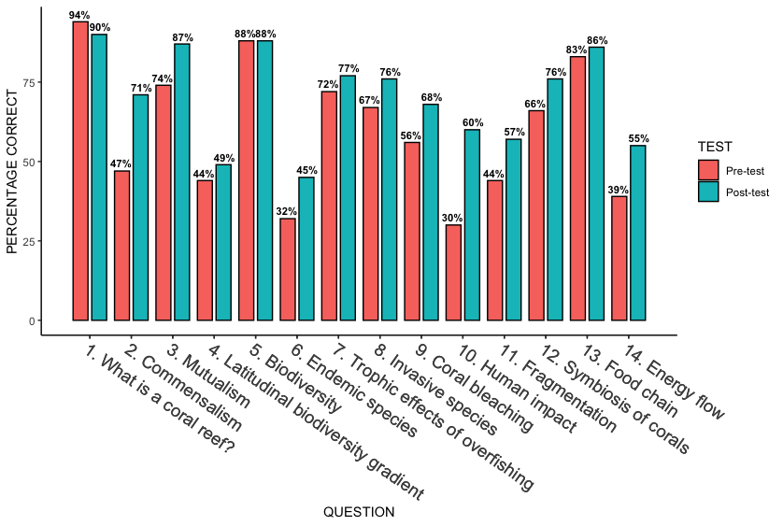
Figure 7: Question topics covered in the knowledge assessment (horizontal axis) and the percentage of students who correctly answered that question (vertical axis) in the pre-test (red) and post-test (green).
3.2. Groups
Initially, we categorized the iPad, AR glasses, and VR groups into one XR group (n = 47) to compare to the reading group (n = 52). A two sample t-test resulted in significant (p = 0.0003) differences between the reading group (mean: 4.9; sd: 14.8) and the XR group (mean: 16.9; sd: 16.8) regarding the change in score between the pre-test and post-test. When the XR group was split by technology, we also observed notable differences between groups with the change in score between the pre-test and post-test. ANOVA revealed in significant (p = 0.004) differences among all groups, but the Tukey pairwise comparisons revealed only significant differences between the reading and AR glasses groups (p = 0.02) and the reading and iPad groups (p = 0.05; Fig. 8).
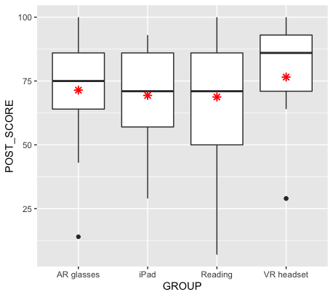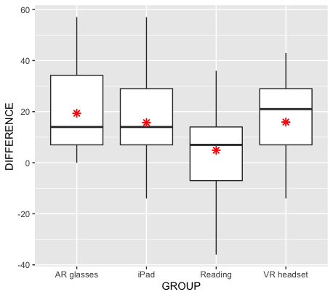
Figure 8: Boxplots of the post-test scores (left) and score changes (right) within each of the experimental groups, with the mean represented by a red asterisk.
3.3.3 Gender Identity & Recreational Gaming Habits
We observed no significant differences between men and women in pre-test scores, post-test scores, and score changes within the XR group (p > 0.05 for all three t-tests). Men were more likely than women to play video games recreationally (Fig. 9), but we observed no significant differences between gamers (i.e., those who play video games at least once per week) and non-gamers in pre-test scores, post-test scores, and score change (p > 0.05 for all three t-tests; Fig. 10). However, we did observe significant gender differences in the attitude assessment. A two sample t-test resulted in significant (p = 0.01) differences between men (mean: 2; sd: 0.9) and women (mean: 2.6; sd: 0.7) only in the XR group when asked if they liked this learning activity. Another two sample t-test resulted in significant (p = 0.03) differences between men (mean: 1.6; sd: 1.1) and women (mean: 2.2; sd: 0.7) only in the XR group when asked if they would like to use this learning tool in the future.
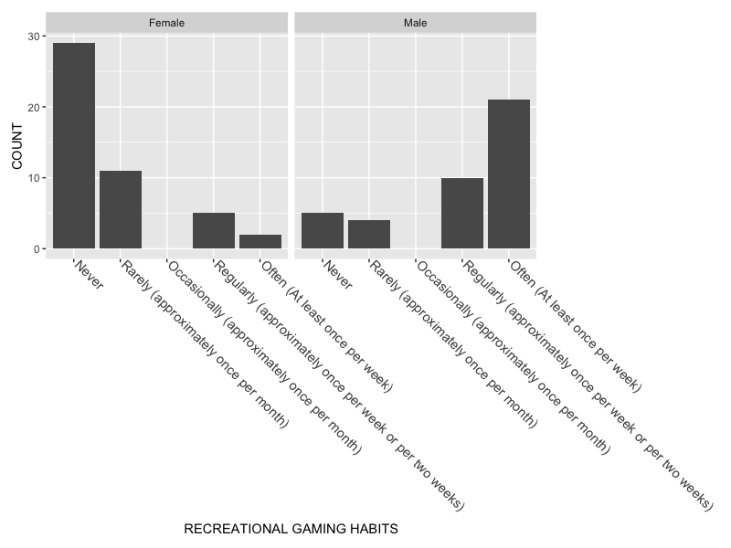
Figure 9: Histogram showing female (left) and male (right) students along with their likelihood to play video games recreationally.
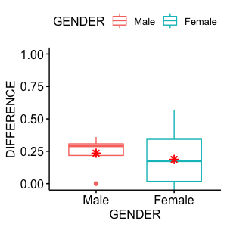
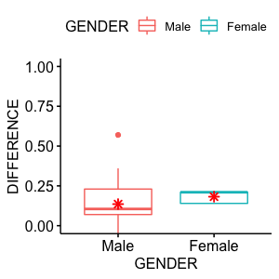
Figure 10: Boxplots of the score changes of non-gamers (left) and gamers (right), separated by males (red) and females (blue). The mean is represented by a red asterisk.

3.4 Discussion
We found that students in the XR group demonstrated the greatest learning achievement throughout the activity compared to the students in the control group. This is reflective of what has been observed in literature reviews on the use of XR technology in the classroom (Radianti et al., 2020; Avila-Garzon et al., 2021), including a study specifically focused on mobile AR in physical geography (Adedokun-Shittu et al., 2020). In our study, all forms of XR used here produced similar increases in learning.
A major problem in the XR literature is the lack of differentiation between modes of visualization with the various types of XR technologies. Some studies only use monoscopic AR on a smartphone or tablet without a separate stereoscopic AR group and then generalize their results to AR as a whole, which has been a problem noted in literature reviews (Carreon et al., 2020). A similar problem exists with some studies only comparing VR to monoscopic AR (Huang et al., 2019). Many of these studies occurred before the availability of commercial or consumer-grade stereoscopic AR glasses, leaving the uncertainty of whether divided attention or lack of immersion impacted the effectiveness of their respective AR applications. We found no significant differences between students using monoscopic AR and those using stereoscopic AR, which contrasts a similar study comparing AR-enabled windshields to heads-up displays (HUDs) (Pfannmuller, 2017). Another study comparing AR to VR found that students using VR had greater learning achievement in a pre/post-test experimental design, with the only exception being that students using AR had higher scores within the auditory knowledge section (Huang et al., 2019).
There were no differences between male and female gamers regarding post-test scores and score changes. This might be an artifact of female gamers having such a small sample size in this study (n = 7), which is reflective of other surveys that have shown boys are much more likely to play video games than girls (Leonhardt, 2021). Past work shows that men are more likely to be interested in using technology and that gender influences the perception of different gamification techniques, while other studies show that gender does not have a significant impact on how gamified lesson plans impact students’ motivation to learn (Ahuja & Thatcher, 2005; Denden et al., 2021; Almusharraf et al., 2023). Interestingly, our results did show gender differences in the attitude assessment and that women in our sample stated that they liked the XR learning activity and would like to use it again in the future more than the men did. Another study on weight loss found that gamification elements had a positive effect on weight loss for men and not women, implying that gamification might maintain long-term interest and motivation better for men (Forman et al., 2021). However, most studies gamifying education only apply the treatment during a snapshot of a participant’s day, while topics like fitness and weight loss require consistent dedication throughout the day for at least several weeks. With conflicting results across gamification research regarding gender, further research is needed to determine the underlying mechanisms driving this effect (if any). If one’s recreational gaming habits does impact the efficacy of gamification techniques in the classroom, then the small sample size of female gamers here highlights the difficulty in drawing a true comparison between men and women in the same classroom regarding gamified lesson plans. Although, the most recent reports on female gamers indicate that more women play video games than ever before. A survey of 3,517 adults found that 60% of Americans surveyed spend an average of 9 hours per week playing video games, with 25% of surveyed female gamers and 16% of male gamers stating that they only began playing video games since the COVID-19 pandemic era began around 2020 (Digital Media Trends, 2024). Another report found that 97% of teen boys and 73% of teen girls ages 13 to 17 play video games, but the percentage of teen boys and girls that play video games daily is 61% and 22%, respectively (Pew Research Center, 2024). Given how long researchers have been studying potential gender effects within gamification, the changing demographics of gamers might explain the conflicting results observed over the years.
The literature on XR technologies in education shows a clear mismatch in the understanding of the foundational principles of the different technologies. One of the core reported benefits of using XR technology is the concept of “immersion”, but there is still a non-homogenous understanding of which XR devices can be considered “immersive technology” (Radianti et al., 2020). This indicates a low maturity for the field of XR in education, which is reflected by a lack of fundamental “best practices” that are widely accepted by both scientists and academics. The way immersion has been used to describe the supremacy of XR over other media risks generating confusion between sensory involvement and emotional/narrative involvement described in social sciences (D’Armenio, 2022). The term “embodiment” has become the way researchers describe the mechanism of deriving meaning from a virtual environment through our physical movement and interaction within the digital world. The literature on the development of XR authoring tools for teachers has not seen much growth despite having begun a few decades ago, which is a commonly reported issue (Fidan & Tuncel, 2019; Avila-Garzon et al., 2021). Until the technology is further refined to use the same types of interaction systems across the most popular devices in each category, developers have limited guidance outside the documentation provided by the XR companies that manufacture each headset. There have been some efforts that attempt to remedy this, but the growth of technology often outpaces the research and makes it difficult to compare different XR applications or even the same XR application across different classes of devices (Dichev & Dicheva, 2017; Masneri et al., 2020; Dengel et al., 2022).
Our observation in the classroom was that for first-time users, the most serious barrier to immersion was difficulty using the interaction system of the XR device. While the application we developed remained the same across all XR categories, the interaction system changed for each one (e.g. touch input for iPad, two controllers for VR, and hand tracking/one controller for AR glasses). This led to much longer “training” sessions at the beginning of each student’s experience for the VR/AR glasses groups because some students struggled to pick it up right away. Many students continuously needed a reminder how to “click” something or utilize other interactions until they were approximately halfway completed with the activity. Task loading research has shown that the use of AR is associated with increased overall workload, especially mental demand and physical effort, but the same significant effect is not present with VR (Xi et al., 2022). The first learning objective in our application coincided with the only question on the knowledge assessment that had fewer students answer correctly on the post-test than the pre-test, suggesting that students were more focused on learning the technology than on learning the content in the beginning. For educators who are considering the integration of XR into the curricula, it might be beneficial to get students comfortable and confident with the technologies before jumping into the learning objectives.

Recommendations for AR and VR in classrooms
Our results highlight three key considerations for successful integration of AR and VR devices into classroom settings. First, we recommend giving both educators and students adequate training time before applying the technology to any specific topics of study. Second, educators and developers should work together to combine their expertise in pedagogical strategies and visualization/interaction to maximize learning achievement for the widest range of students possible while minimizing the stress and anxiety educators might feel with having to develop new educational materials to fit the technology. Third, we recommend that educators take into consideration exactly why they want to incorporate XR in place of current modes of content delivery. Simply applying XR to a learning objective will not always lead to positive learning achievement, but the chances are greater if the capabilities of XR are leveraged for a purpose that cannot be fulfilled by traditional media such as textbooks or presentations in a meaningful manner.
3.5 Conclusion
This study examined the use of monoscopic AR, stereoscopic AR, and VR to teach an introduction to coral reef ecology to undergraduate students in a physical geography lab classroom compared to a traditional reading worksheet with the same information. We further attempted to identify any relationships between learning achievement with a gamified XR activity and gender identity/recreational gaming habits. Our findings support the use of XR in the classroom, regardless of the format used. We found no significant gender effects on learning achievement, but we did find significant gender effects in that women liked the XR activity and wish to use it again in the future more than the men did. Regarding recreational gaming habits, we found no significant relationships. These results suggest that most students can benefit from XR in the classroom in similar ways. However, male students were much more likely to play video games than their female counterparts, resulting in the issue of low statistical power due to the small number of female gamers in our sample. Many educational XR applications utilize the same types of UI and input systems as what is found in recreational video games, which required more time for some students to learn how to use. We recommend that any formal education setting take an appropriate amount of time to allow students to become comfortable and gain confidence in using XR technologies before diving into the learning objectives.
References

Adedokun-Shittu, N.A., Ajani, A.H., Nuhu, K.M. et al. (2020). Augmented reality instructional tool in enhancing geography learners academic performance and retention in Osun state Nigeria. Educ Inf Technol 25, 3021–3033. https://doi.org/10.1007/s10639-020-10099-2
Ahuja, M. K., & Thatcher, J. B. (2005). Moving beyond intentions and toward the theory of trying: Effects of work environment and gender on post-adoption information technology use. MIS Quarterly, 29(3), 427-459. https://doi.org/10.2307/25148691
Almusharraf, Norah & Alsheikh, Dima & Aljasser, Maha & Dalbani, Hala. (2023). Gender differences in utilizing a game-based approach within the EFL online classrooms. Heliyon. 9. e13136. 10.1016/j.heliyon.2023.e13136.
Anderson, Ange. (2019). Virtual Reality, Augmented Reality and Artificial Intelligence in Special Education: A Practical Guide to Supporting Students with Learning Differences. 10.4324/9780429399503.
Avila-Garzon, C., Bacca-Acosta, J., Duarte, J., & Betancourt, J. (2021). Augmented Reality in Education: An Overview of Twenty-Five Years of Research. Contemporary Educational Technology, 13(3). https://doi.org/10.30935/cedtech/10865
Banathy, B. H. (1973). Developing a systems view of education: The systems-model approach. Belmont, CA: Fearon Publishers.
Bekhit, A.F. (2021). Computer Vision and Augmented Reality in iOS. Apress Berkeley, CA. https://doi.org/10.1007/978-1-4842-7462-0
Bhagat, K.K., Liou, W-K, & Chang, C-Y. (2016). A cost-effective interactive 3D virtual reality system applied to military live firing training. Virtual Reality, 20: 127-140. Doi: 10.1007/s10055-016-0284-x
Blackford, J.K., (2020). Paradigm Shifts in Large-Scale Educational Change: Uncovering the Oregon Education Investment Board's Theory of Change-in-Action. Dissertations and Theses. Paper 5420. https://doi.org/10.15760/etd.7293
Böckle, M., Novak, J., & Bick, M. (2017). Towards adaptive gamification: A synthesis of current developments. In Proceedings of the 25th European Conference On Information Systems (ECIS), Guimaraes, Portugal.
Böckle, M., Micheel, I., Bick, M., & Novak, J. (2018). A Design Framework for Adaptive Gamification Applications, doi: 10.24251/HICSS.2018.151.
Carreon, A. C., Smith, S. J., & Rao, K. (2020). A Review of Augmented Reality in K-12 Education Environments: International Journal of Virtual and Augmented Reality, 4(2), 32–61. https://doi.org/10.4018/IJVAR.2020070103
Codish, D., & Ravid, G. (2017). Gender moderation in gamification: Does one size fit all? In Proceedings of the 50th Hawaii International Conference on System Sciences (pp. 2006-2015), Hilton Waikoloa Village, Hawaii.
D'Armenio, E. (2022). Beyond interactivity and immersion. A kinetic reconceptualization for virtual reality and video games, New Techno Humanities, 2(2), 121-129, https://doi.org/10.1016/j.techum.2022.04.003
Denden, M., Tlili, A., Essalmi, F., Jemni, M., Chen, N-S, & Burgos, D. (2021). Effects of gender and personality differences on students’ perception of game design elements in educational gamification, International Journal of Human-Computer Studies, 154, ISSN 1071-5819, https://doi.org/10.1016/j.ijhcs.2021.102674.
Dengel, A., Iqbal, M.Z., Grafe, S. & Mangina, E. (2022). A Review on Augmented Reality Authoring Toolkits for Education. Frontiers in Virtual Reality, 3:798032. doi: 10.3389/frvir.2022.798032
Dichev,﻿ C.,﻿ &﻿ Dicheva,﻿ D.﻿ (2017).﻿ Gamifying﻿ Education:﻿ What﻿ is﻿ Known,﻿ What﻿ is﻿ Believed﻿, and﻿ What ﻿Remains ﻿Uncertain: ﻿A﻿ Critical ﻿Review. ﻿International Journal of Educational Technology in Higher Education, 14(1), ﻿9. https://doi.org/10.1186/s41239-017-0042-5
Dicheva, D., Dichev, C., Agre, G., & Angelova, G. (2015). Gamification in education: a systematic mapping study. Educational Technology & Society, 18(3), 75–88.
Digital Media Trends. (2024). An introduction to Deloitte’s 2024 Digital Media Trends (18th edition). Deloitte Insights. https://www2.deloitte.com/us/en/insights/industry/technology/digital-media-trends-consumption-habits-survey/2024/how-can-gaming-industry-get-more-female-gamers.html
Dontre, A.J. (2020). The influence of technology on academic distraction: A review. Human Behavior & Emerging Technologies, 1–12. https://doi.org/10.1002/hbe2.229
Fernández-Batanero, J-M, Román-Graván, P., Reyes-Rebollo, M-M, & Montenegro-Rueda, M. (2021). Impact of educational technology on teacher stress and anxiety: a literature review. International Journal of Environmental Research and Public Health, 18(2), 548–548. https://doi.org/10.3390/ijerph18020548
Fidan, M., & Tuncel, M. (2019). Integrating augmented reality into problem based learning: The effects on learning achievement and attitude in physics education. Computers & Education. 103635. 10.1016/j.compedu.2019.103635.
Forman, E. M., Manasse, S. M., Dallal, D. H., Crochiere, R. J., Berry, M. P., Butryn, M. L., & Juarascio, A. S. (2021). Gender differences in the effect of gamification on weight loss during a daily, neurocognitive training program. Translational behavioral medicine, 11(4), 1015–1022. https://doi.org/10.1093/tbm/ibaa091
Garzón, J. & Acevedo, J. (2019). Meta-analysis of the impact of Augmented Reality on students’ learning gains, Educational Research Review, 27: 244-260, ISSN 1747-938X, https://doi.org/10.1016/j.edurev.2019.04.001.
Glass, A.L. & Kang, M. (2018). Dividing attention in the classroom reduces exam performance, Educational Psychology, DOI: 10.1080/01443410.2018.1489046
Greenberg, B. S., Sherry, J., Lachlan, K., Lucas, K., & Holmstrom, A. (2010). Orientations to video games among gender and age groups. Simulation & Gaming, 41(2), 238-259. https://doi.org/10.1177/1046878108319930
Haas, J. K. (2014). A history of the unity game engine.
Hamari, J. (2013). Transforming Homo Economicus into Homo Ludens: A Field Experiment on Gamification in a Utilitarian Peer-to-Peer Trading Service. Electronic Commerce Research and Applications, 12(4), 236-245. https://doi.org/10.1016/j.elerap.2013.01.004.
Hargreaves, A., & Shirley, D. (2012). The global fourth way: The quest for educational excellence. Thousand Oaks, CA: Corwin.
Helmefalk, M., Lundqvist, S., & Marcusson, L. (2019). The Role of Mechanics in Gamification: An Interdisciplinary Perspective. International Journal of Virtual and Augmented Reality, 3(1), 18–41. https://doi.org/10.4018/ijvar.2019010102
Huang, K.-T., Ball, C., Francis, J., Ratan, R., Boumis, J., & Fordham, J. (2019). Augmented Versus Virtual Reality in Education: An Exploratory Study Examining Science Knowledge Retention When Using Augmented Reality/Virtual Reality Mobile Applications. Cyberpsychology, Behanvior, and Social Networking, 22(2), 105-110. https://doi.org/10.1089/cyber.2018.0150.
Hwang, G.-J., Wu, P.-H., & Ke, H.-R. (2011). An Interactive Concept Map Approach to Supporting Mobile Learning Activities for Natural Science Courses. Computers & Education, 57(4), 2272–2280. https://doi.org/10.1016/j.compedu.2011.06.011.
Janc Malone, H., Rincón-Gallardo, S., & Kew, K. (Eds.). (2018). Future directions of educational change: Social justice, professional capital, and systems change. New York, NY: Routledge
Kavanagh, S., Luxton-Reilly, A., Wuensche, B., & Plimmer, B. (2017). A systematic review of Virtual Reality in education. Themes in Science and Technology Education, 10(2), 85-119.
Koivisto, J., & Hamari, J. (2014). Demographic differences in perceived benefits from gamification. Computers in Human Behavior, 35, 179-188.
Kuhn, T. (1996). The structure of scientific revolutions (3rd ed.). Chicago, IL: The University of Chicago Press.
Kumar, J., & Herger, M. (2013): Gamification at Work: Designing Engaging Business Software. Aarhus, Denmark, The Interaction Design Foundation. ISBN: 978-87-92964-06-9. Book available online at http://www.interaction-design.org/books/gamification_at_work.html.
Landers, R. (2014). Developing a Theory of Gamified Learning: Linking Serious Games and Gamification of Learning. Simulation & Gaming, 45(6), 752–768. https://doi.org/10.1177/1046878114563660
Leonhardt, M., & Overa, S. (2021). Are There Differences in Video Gaming and Use of Social Media among Boys and Girls?-A Mixed Methods Approach. International Journal of Environmental Research and Public Health, 18, 6085. https://doi.org/10:3390/ijerph18116085.
Masneri, S., Domínguez, A., Wild, F., Pronk, J., Heintz, M., Tiede, J., Nistor, A., Chiazzese, G., & Mangina, E. (2020). ARETE-An Interactive Educational System using Augmented Reality. In Proceedings of the 2020 6th International Conference of the Immersive Learning Research Network (iLRN), San Luis Obispo, CA, USA, 21–25 June 2020, IEEE: New York, NY, USA, 2020, pp. 283–286.
McIntire, J.P., Havig, P.R., Geiselman, E.E. (2014). Stereoscopic 3D displays and human performance: A comprehensive review, Displays, 35(1),18-26, ISSN 0141-9382, https://doi.org/10.1016/j.displa.2013.10.004.
Melchert, N., & Morrow, D. R. (2019). The great conversation : a historical introduction to philosophy (Eighth edition). Oxford University Press.
Molnar, M. (2015, February 24). Half of k–12 students to have access to 1-to-1 computing by 2015-16. Education Week.
NGSS Lead States. (2013). Next Generation Science Standards: For States, By States. Washington, DC: The National Academies Press.
Oklahoma State Department of Education. (2020). Oklahoma Academic Standards for Science. https://sde.ok.gov/sites/ok.gov.sde/files/Oklahoma%20Academic%20Standards%20for%20Science.pdf
Pew Research Center, May 2024, “Teens and Video Games”. https://www.pewresearch.org/internet/2024/05/09/teens-and-video-games-today/#:~:text=Video%20games%20as%20a%20part,to%20spend%20time%20with%20others
Pfannmüller, L. (2017). Anzeigekonzepte für ein kontaktanloges Head-up Display (Doctoral dissertation). Munich, Germany: Technical University of Munich.
R Core Team (2021). R: A language and environment for statistical computing. R Foundation for Statistical Computing, Vienna, Austria. URL https://www.R-project.org/.
Radianti, J., Majchrzak, T.A., Fromm, J., & Wohlgenannt, I. (2020). A systematic review of immersive virtual reality applications for higher education: Design elements, lessons learned, and research agenda, Computers & Education, 147, ISSN 0360-1315, https://doi.org/10.1016/j.compedu.2019.103778.
Ravizza, S. M., Uitvlugt, M. G., & Fenn, K. M. (2017). Logged in and zoned out: How laptop internet use relates to classroom learning. Psychological science, 28(2), 171-180.
Rizzo, A. A., Buckwalter, J. G., Bowerly, T., Van Der Zaag, C., Humphrey, L., Neumann, U., Chua, C., Kyriakakis, C., Van Rooyen, A., & Sisemore, D. (2000). The Virtual Classroom: A Virtual Reality Environment for the assessment and rehabilitation of attention deficits. CyberPsychology & Behavior, 3(3), 483–499.
RStudio Team (2021). RStudio: Integrated Development Environment for R. RStudio, PBC, Boston, MA URL http://www.rstudio.com/.
Ryan A (2019, January 27) Thoughts on accessibility issues with VR. https://ablegamers.org/thoughts-on-accessibility-and-vr/
Scharmer C. O. (2018). The essentials of theory U: Core principles and applications. Berrett-Koehler Publishers.
Schwarz, C., & Zhu, Z. (2015). The impact of student expectations in using instructional tools on student engagement: A look through the expectation disconfirmation theory lens. Journal of Information Systems Education, 26(1), 47-58.
Seaborn,﻿ K.,﻿ &﻿ Fels,﻿ D.﻿ I.﻿ (2015).﻿ Gamification﻿ in﻿ Theory﻿ and﻿ Action:﻿ A﻿ Survey.﻿ International Journal of Human-Computer Studies,﻿ 74, ﻿14–31. https://doi.org/10.1016/j. ijhcs.2014.09.006.
Senge, P. (2010). Forward. In All systems go: The change imperative for whole system reform. Thousand Oaks, CA: Corwin.
Storey, V. A., & Wolf, A. A. (2010). Utilizing the platform of second life to teach future educators. International Journal of Technology in Teaching and Learning, 6(1), 58–70.
Swan, C. (2012). Gamification: A New Way to Shape Behavior. Communication World, 29(3), 13-14.
UNESCO (2020). Global Education Monitoring Report: Inclusion and Education, All Means. Paris: UNESCO.
UNESCO. (2021). Reimagining our futures together: a new social contract for education. Retrieved from https://unesdoc.unesco.org/ark:/48223/pf0000379707
U.S. Department of Education, Institute of Education Sciences, National Center for Education Statistics, School Pulse Panel 2021–22 and 2022–23. Retrieved from https://ies.ed.gov/schoolsurvey/
U.S. Department of Education, Office of Educational Technology, National Educational Technology Plan, Washington, DC, 2024.
Wu, W., Luo, Y., Castronovo, F., Liang, A., Gomez, F., Kassis, S., & Wolcott, A. (2023). Barriers and Pathways to Use Extended Reality in STEM Classrooms: Perspectives of Key Stakeholders. 2023 European Conference on Computing in Construction, Heraklion, Crete, Greece, July 10-12, 2023.
Xi, N., Chen, J., Gama, F., Riar, M., & Hamari, J. (2023). The challenges of entering the metaverse: An experiment on the effect of extended reality on workload. Information systems frontiers: a journal of research and innovation, 25(2), 659–680. https://doi.org/10.1007/s10796-022-10244-x
Zaric, N., Lukarov, V., & Schroder, U. (2020). A Fundamental Study for Gamification Design: Exploring Learning Tendencies’ Effects. International Journal of Serious Games, 7(4), 3-25.
Ziker, C., Truman, B., & Dodds, H. (2021). Cross Reality (XR): Challenges and Opportunities Across the Spectrum. Innovative Learning Environments in STEM Higher Education: Opportunities, Challenges, and Looking Forward, 55–77. https://doi.org/10.1007/978-3-030-58948-6_4
Zucker, A. A., & Light, D. (2009). Laptop programs for students. Science, 323(5910), 82-85.

Chapter 4: Comparing monoscopic and stereoscopic augmented reality indoor navigational aids across age and gender identity

Trey O. Lee^{1*}, Thomas Neeson¹
1. Department of Geography and Environmental Sustainability, University of Oklahoma
*Corresponding Author: treylee@ou.edu, Department of Geography and Environmental Sustainability, University of Oklahoma, 100 Boyd St., Norman, OK 73069
Abstract
Augmented reality (AR) systems are promising tools for navigation and wayfinding, but questions remain about optimal design and effectiveness. We developed an AR system to aid users’ navigation through a complex building. We then explored three research questions. First, we asked how monoscopic and stereoscopic AR tools affect a user’s abilities to navigate an indoor environment for the first time, compared to a control group using no aid. We found that stereoscopic AR improved participants’ abilities to navigate a novel environment, relative to the control group, but participants using monoscopic AR performed worse than the control group. Second, we asked how AR changed users’ abilities to navigate this indoor environment in future attempts. When users were asked to navigate the environment for a second time, two weeks later, participants in all three groups significantly improved their performance. However, users in the control group improved the most. Third, we asked how improvements in navigational skill were related to users’ age, gender identity, and spatial thinking skill. We found significant relationships between participants’ age and navigational performance, and significant interactions between age and gender, but no relationship between spatial thinking ability and navigational performance. Overall, we observed a clear benefit to using stereoscopic AR, but the monoscopic AR hindered participants’ ability to navigate the indoor environment for the first time. Given that the benefits of AR varied with users’ age and gender, our study highlights the importance of assembling a diverse pool of test users when developing an AR system.
4.1 Introduction
One of the most fundamental tasks in life is to navigate through space. Finding a destination is an essential human behavior (Montello, 2005). For millenia, humans have navigated using a combination of internal cues and external models/representations of the world (i.e., maps; Gladwin, 1970; Warren, 2001; Wolfe, 2006; Aporta, 2009; Clarke, 2013). Recently, this has included global positioning systems (GPS) and other highly interactive electronic navigational aids. These maps and tools can make it easier to navigate a novel environment for the first time and help reduce cognitive load during wayfinding (Allen, 1999; Brugger et al., 2019). They may also improve (or not improve) spatial learning about these environments, making it easier (or more difficult) to navigate the environment in future attempts without GPS assistance. For example, research shows the use of GPS navigation while walking or driving can impair our ability to learn new how to navigate new environments (Montello, 2005; Gardony et al., 2013; Dahmani & Bohbot, 2020). In other situations, navigational tools may improve spatial learning if they are able to sense specific behavioral patterns and direct the user’s attention appropriately (Brugger et al., 2019). The general consensus among human spatial navigation researchers is that the change from static representations (i.e., maps) to interactive map displays (i.e., mobile GPS) influences the way we perceive, remember, and interact with our surrounding environment due the ability to access information at potentially any time or place. However, the type of influence is dependent on the type of technology and how information is communicated (Parush et al, 2007; Ishikawa et al., 2008; Klippel et al., 2010; Ishikawa & Takahashi, 2013).
Although the effects of GPS on navigation and spatial learning are well known, there is less research on how augmented reality (AR) may affect navigation and spatial learning. AR is an emerging technology that people may use for navigating environments. Broadly defined, AR is any system that augments a space around the user by superimposing digital information using a display to appear as if present in the real world. These three-dimensional displays have been used since the 1960’s when they required entire rooms of equipment to power, but the ones in use today are compact enough to fit into a wearable headset not much larger than a pair of glasses (Sutherland, 1968). AR is understudied, because it is new, but it is important to study because it will likely be used more in the future. Vision-based positioning is considered a more modern technique with AR navigation and companies in the private sector are developing new positioning systems using these technologies (Joshi et al. 2020). Google has already implemented AR navigation in select cities around the globe (Phillips, 2023). AR comes in two different forms: head-mounted displays (HMDs) that are visualized stereoscopically and AR interfaces that are visualized monoscopically. HMDs are devices worn on the user’s head that project digital images onto a see-through lens and make it appear as if the digital object is located within the real world, depth perception included. Monoscopic AR interfaces are handheld devices, usually smartphones, with a screen that displays the image produced by the device’s camera and include digital 3D objects overlayed onto the device’s video feed. The use of smartphones to visualize AR experiences is typically seen as a bridge to connect emerging AR glasses-style HMDs to consumers through the use of current technology they likely already own.
Previous work on the use of AR for navigation reveals both the potential and limitations of this technology. Studies have shown support for the use AR navigational aids compared to traditional wayfinding methods due to the reduced task completion times and/or fewer navigational errors (Rehman & Cao, 2017; Smith et al., 2016; Rubio-Sandoval et al., 2021; Zhang et al, 2021). However, some studies have reported either no significant differences in AR vs. non-AR conditions or that a particular handheld AR navigational aid was inferior to GPS (Rehrl et al., 2014; Dong et al., 2021; Lee, 2022). AR shows great potential in many fields such as architecture, education, and navigation, but the mass adoption of the AR navigational aids will require perceived usability (the perception of the technology as being helpful for achieving goals effectively, efficiently, and enjoyably) and positive user experience (Davis, 1989; Brooke, 1996; Arifin et al., 2018, Dirin & Laine, 2018). The user experience (UX) with AR navigation is dependent not only on the degree of virtual information that is augmented, but also immersion and correctly aligned virtual information to the real world (Endsley, 1995; Bowman & McMahan, 2007; Bulu, 2012; Narzt et al., 2016). Without proper implementation of navigational information and a positive UX, AR in navigation might not gain the acceptance needed to refine the technology further.
There is also evidence that the effectiveness of GPS and AR as navigational aids varies among users in both individual and systematic ways. Some people naturally learn spatial environments more quickly and efficiently than others (Ishikawa and Montello, 2006), while others are incapable of daily spatial learning tasks without any observable medical condition (Iaria et al., 2009; Iaria & Barton, 2010; Ekstrom et al., 2018). Declines in spatial ability are part of the natural aging process, with older adults reporting increased frequencies of getting lost and being less able to stay oriented, particularly in new environments (Burns, 1999). Studies have shown greater navigational impairments in older adults compared to younger adults in both real-world (Wilkniss et al., 1997) and virtual environments (Moffat & Resnick, 2002). While studying cognitive declines with aging has wide-ranging implications, the topic of gender in the field of navigation has also been discussed extensively over the years. Gender in navigation has been a recurring and sometimes controversial topic. Most gender studies within navigation suggest that men are better navigators than women (Astur et al., 1998; Cutmore et al., 2000; Malinowski & Gillespie, 2001; Astur et al., 2004). However, other studies show that women have better memory than men for the position of objects in the absence of reference frames (Dahmani et al., 2023). Moreover, one study suggests that a concurrent and relevant stressor can motivate women to navigate comparably to men, potentially diminishing gender differences found within the navigation literature (Schinazi et al., 2023).
Here, we developed and evaluated an AR application for navigating a complex indoor environment. We explored three research questions. First, we asked how monoscopic and stereoscopic AR tools affect participants’ ability to navigate an indoor environment for the first time, compared to a control group using no aid. We hypothesized that AR will make it easier for users to navigate a novel environment, because it allows users to visualize the fastest path to a specified destination and works in a similar manner to other navigation apps people likely use while driving. Second, we asked how AR will change users’ abilities to navigate this indoor environment in future attempts. We hypothesized that users’ ability to navigate the environment on subsequent attempts with AR will be similar to other technologies like GPS (i.e., navigation would be faster), because of the reduced cognitive load when using navigational aids (Allen, 1999; Brugger et al., 2019). Third, we asked how improvements in navigational skill were related to users’ age, gender identity, and spatial thinking skill. We hypothesized that spatial learning and improvements in navigational skill over time will be related to participants’ age and spatial thinking ability, because of the natural deterioration of neural structures underlying spatial coding during aging (Weiner et al., 2009; Colombo et al., 2017). We also hypothesized that men would outperform women due to the prevalence of that observation in the navigation literature.
4.2 Methods
We developed the AR application using a game/physics engine to work on a variety of devices and operating systems. We then compared differences in navigational performance among three groups of participants: a group using our AR application on monoscopic hardware (i.e., iPhones/iPads running iOS), a second group using our AR application on stereoscopic hardware (i.e., the Magic Leap 2 AR glasses running Android), and a control group that did not use the AR application. These experimental groups were used to further understand the differences in navigational performance and spatial memory regarding age, gender identity, and spatial thinking ability.
4.2.1 Application Development
Our application development utilized the C# programming language within Unity, a game engine created by Unity Technologies (San Francisco, CA) capable of managing the physics and spatial information collected by the user’s device (Haas, 2014). We developed the application to work on both iOS (iPhone/iPad) and Android (Magic Leap 2) using the ARFoundation framework constructed from both Apple’s ARKit and Android’s ARCore libraries.
To navigate using the application, users begin by scanning a QR code to assign their device’s starting position based on the calculated offset from the QR code, and then select their destination from a dropdown menu. The local coordinates of each destination are pre-programmed into the application. Once a destination is selected, the application begins calculating the least-cost path between the device’s current position and the selected destination using a pre-baked navigation mesh, which accounts for humanoid figure dimensions and environmental obstacles while only allowing a preset maximum slope between floor elevations. This least-cost path is visualized in the form of a line or track on the floor to follow. The visualization is akin to ones used in other popular navigation applications on mobile devices such as Apple Maps and Google Maps where they display a point for the user’s location, a point for the selected destination, and a line overlayed onto a roadmap to follow.
4.2.2 Hardware
There were two types of hardware used in this study: smartphones/tablets (iPhone/iPad) and AR glasses (Magic Leap 2). When the application is running on the iOS devices, the spatial information is displayed monoscopically on the display as an overlay on the device’s camera feed. When running on the AR glasses, the spatial information is displayed stereoscopically using transparent waveguide optical lenses that reflect the projected light being directed through them, giving users depth perception and the impression that the digital line and waypoints exist in the real-world space without obstructing the user’s view. While the monoscopic devices rely on touchscreen user interaction systems, the Magic Leap 2 AR glasses use a combination of handtracking and 6DoF controllers to operate.
There are several core components that work together inside a device to manage internal sensor data and apply desired actions to a virtual version of the 3D space around the device. All AR-capable devices will utilize some type of gyroscope or accelerometer to understand the physical movements of the device itself, but the devices are also equipped with one or more cameras to interpret the world around the device (Yassin et al., 2016). These cameras can be supplemented with information from depth sensors, with light detection and ranging (LiDAR) being a common low-cost sensor option. This use of cameras to simulate changes in space for a physical device is commonly referred to as ‘vision-based positioning’ and has become an increasingly prevalent topic of study within the field of computer vision in recent years (Morar et al., 2020). One of the primary benefits of vision-based positioning within indoor environments is the ability to position a device in real time without requiring any GPS connectivity (Kunhoth et al., 2020).
4.2.3 Experimental Design
We wanted to see not only how the different AR technologies affect one’s ability to navigate an indoor area relative to age, gender identity, and spatial thinking ability, but also how the different technologies might affect their longterm spatial memory of that indoor environment. Participants were placed in groups and tasked with finding the same set of four randomly selected rooms, starting and ending in the same central location at the building’s elevator bay. In spatial navigation studies, it’s ideal to choose environments that are neither too simple nor too complex because normalization by having participants navigate many different environments is impractical (Ekstrom et al., 2018). The building we chose on the university’s campus has a reputation for being challenging to navigate, and the semi-gridded layout and room numbering system doesn’t follow an immediately identifiable pattern. We isolated this study to the 2nd floor of this building because it has the most rooms and the largest available navigable area, and the use of technology that can partially obstruct the users view could pose a danger to participants when traversing obstacles like stairs. Experimental groups were categorized as follows: 1) Control – no assistance, 2) Monoscopic – 2D version of the application running on an iPhone or iPad Pro, and 3) Stereoscopic – immersive 3D version of the application running on the Magic Leap 2 AR glasses. The application recorded participants’ positional information every two seconds during the experiment, which was used to calculate the overall time spent travelling and the Euclidean distance traveled. Once this initial task (Stage A) was completed, participants were asked to take a 16-question spatial thinking ability test (STAT), which represents extensive developmental work on the theoretical foundation of spatial thinking (Lee & Bednarz, 2012). There are several spatial thinking components measured by STAT that can reflect one’s natural ability to navigate, including map visualization and overlay, identification and classification of map symbols (point, line, area), generalized or abstract Boolean operations, map navigation or way-finding, and recognition of positive spatial correlation. All participants were asked to return after two weeks to repeat the activity without any technological assistance to test how well the navigation task applied to their longterm spatial memory (Stage B).
4.2.4 Participants
Participants aged 18-60 were recruited via email and in person. Volunteers were required to have no previous experience in the building in order to participate. Participants ages 18-30 were classified as young adults, while participants ageg 31-60 were classified as middle-aged adults. The classification of young adults varies among human navigation studies with it most often being capped at 30, and people over the age of 60 are typically classified as older adults (Meneghetti et al., 2012; Yamamoto & DeGirolamo, 2012; Korman et al., 2019; Merhav & Wolbers, 2019; Hill et al., 2024). Middle-aged adults are often omitted from age-related navigation studies, but their inclusion can still offer insight into age-related navigational decline (Van der Ham & Claessen, 2020). There were originally 90 people who participated in this experiment, which were randomly assigned to one of the three groups with a maximum of 30 per group. Some exceptions were made for the few participants who had pre-existing eye conditions that required the use of prescription lenses and prevented the use of AR glasses, and they were randomly assigned only to the control or monoscopic groups so they could wear their prescription lenses during the experiment. Observations with incomplete survey or spatial data were removed, resulting in a final participant group of 76. Incomplete data were the result of either failure to follow instructions or technological issues like the crashing of the application mid-task.
4.2.5 Analyses
Several stastistical tests were employed to investigate any potential relationships between the experimental groups’ navigational performance and longterm spatial memory regarding distance, time, average walking speed, age, gender identity, and spatial thinking ability. However, walking speed was not included in every test due to its high accuracy in being used as an indicator for age (Pawlaczyk et al., 2021). First, we used analysis of variance (ANOVA) to identify significant differences between the experimental groups regarding distance, time, and walking speed during Stage A alone. To test memory, we followed with paired sample t-tests to determine if there was a significant difference between participants’ Stage A and Stage B with the distance and time traveled. We also performed an ANOVA with Tukey pairwise comparisons between the three groups regarding time and distance traveled to test for any significant differences between specific pairs. Additionally, we performed an interaction ANOVA to further understand potentially significant interactions between variables whose main effects were often significant by themselves. Spatial data collected by the application were also used to plot the location density of participants in each group to visualize latent variables that could potentially impact other variables like distance and time.
4.3 Results
This analysis utilized a total of 76 participants. The majority of the participants identified as male (n = 45), with less than half the total number of participants identifying as female (n = 30) and a single participant identifying as non-binary/third gender. The control group had the fewest number of participants (n = 21), with the monoscopic group having the highest number of participants (n = 29). The stereoscopic group had just over one-third of the total number of participants (n = 26). The distribution of gender identity across groups can be found in Table 5.

Table 5: Distribution of participants’ gender identity across experimental groups.
Gender | CONTROL | MONO | STEREO | All groups
Male | 8 | 21 | 16 | 45
Female | 13 | 7 | 10 | 30
Non-binary/third gender | 0 | 1 | 0 | 1
All subjects | 21 | 29 | 26 | 76

We found that stereoscopic AR improved participants’ abilities to navigate a novel environment, relative to the control group, but participants using monoscopic AR performed worse than the control group. ANOVA showed significant differences (p = 2.04e⁻⁰⁸) among distance traveled between the control group (mean: 462.4 m, sd: 87 m), monoscopic group (mean: 512.2 m; sd: 146.8 m), and stereoscopic group (mean: 319.5 m; sd: 65.5 m). ANOVA also showed significant differences (p < 2e⁻¹⁶) with time traveled between the control group (mean: 486.9 s; sd: 117.3 s), monoscopic group (mean: 610.4 s; sd: 46.7 s), and stereoscopic group (mean: 361.2 s; sd: 75.9 s). Additionally, ANOVA showed significant differences (p = 0.04) with average walking speed between the control group (mean: 0.97 m/s; sd: 0.17 m/s), monoscopic group (mean: 0.84 m/s; 0.23 m/s), and stereoscopic group (mean: 0.89 m/s; sd: 0.1 m/s).
When users were asked to navigate the environment for a second time, two weeks later, participants in all three groups significantly improved their performance. However, users in the control group improved the most. The control group’s paired sample t-test resulted in highly significant differences (p < 0.001) with the change in distance traveled between Stage A (mean: 462.4 m; sd: 87 m) and Stage B (mean: 360.84 m; sd: 75 m). The monoscopic group also resulted in highly significant differences (p < 0.001) between Stage A (mean: 512.2 m; sd: 146.8 m) and Stage B (mean: 466.6 m; sd: 118.6 m). Similarly, the stereoscopic group also resulted in highly significant differences (p < 0.01) between Stage A (mean: 319.5 m; sd: 65.5 m) and Stage B (mean: 287.2 m; sd: 44.9 m). ANOVA resulted in significant differences (p < 0.01) across all groups regarding the change in distance between stages (Fig 11). The Tukey pairwise comparison resulted in significant differences (p < 0.05) between the control and monoscopic groups (p = 2.80e⁻⁰⁵), control and stereoscopic groups (p < 0.01), but none between the monoscopic and stereoscopic groups (p = 0.8). The control group’s paired sample t-test resulted in highly significant differences (p = 2.74e⁻⁰⁸) with the change in time traveled between Stage A (mean: 486.9 s; sd: 117.3 s) and Stage B (mean: 268.6 s; sd: 45.7 s). The monoscopic group also resulted in highly significant differences (p = 1.311e⁻⁰⁶) between Stage A (mean: 610.4 s; sd: 46.7 s) and Stage B (mean: 513.2 s; sd: 107 s). Similarly, the stereoscopic group also resulted in highly significant differences (p = 2.402e⁻⁰⁸) between Stage A (mean: 361.2 s; sd: 75.9 s) and Stage B (mean: 264.6 s; sd: 55.4 s). ANOVA resulted in highly significant differences (p = 5.23e⁻⁰⁶) across all groups regarding the change in time between stages (Fig 13). The Tukey pairwise comparison resulted in highly significant differences between the control and monoscopic groups (p = 2.80e⁻⁰⁵), control and stereoscopic groups (p = 3.57e⁻⁰⁵), but none between the monoscopic and stereoscopic groups (p = 1). The control group’s paired sample t-test resulted in highly significant differences (p = 9.652e⁻⁰⁸) in the change in average walking speed between Stage A (mean: 0.97 m/s; sd: 0.17 m/s) and Stage B (mean: 1.35 m/s; sd: 0.21 m/s). The stereoscopic group also resulted in highly significant differences (p = 1.488e⁻⁰⁵ ) between Stage A (mean: 0.89 m/s; sd: 0.1 m/s) and Stage B (mean: 1.12 m/s; sd: 0.21 m/s). However, the monoscopic group did not result in significant differences between Stage A (mean: 0.84 m/s; sd: 0.23 m/s) and Stage B (mean: 0.93 m/s; sd: 0.21 m/s). ANOVA resulted in highly significant differences (p = 3.25e⁻⁰⁵) across all groups regarding the change in average walking speed between stages (Fig 12). The Tukey pairwise comparison resulted in significant differences between the control and monoscopic groups (p <1e⁻⁰⁴), control and stereoscopic groups (p = 0.04), and monoscopic and stereoscopic groups (p = 0.05).
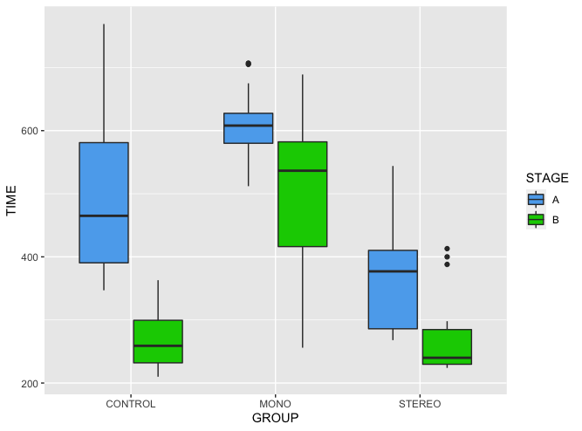
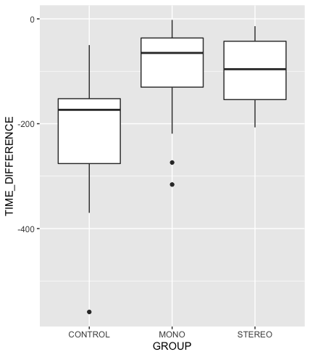
Figure 11: (left) Boxplot of each group’s total time traveled (in seconds) for Stage A (blue) and Stage B (green). (right) Boxplot of each group’s difference in time traveled (in seconds) between stages.

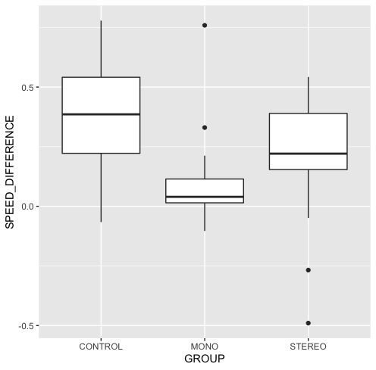
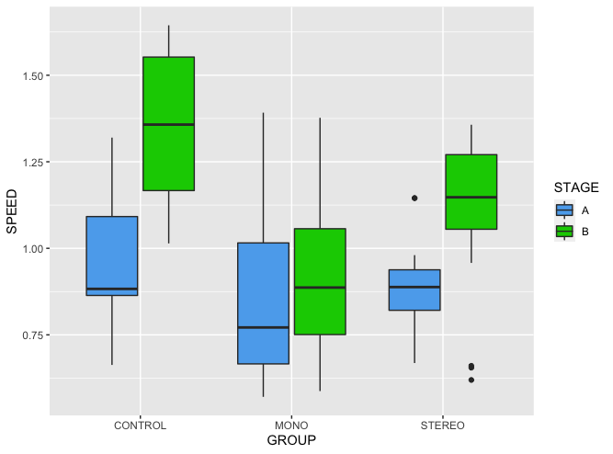
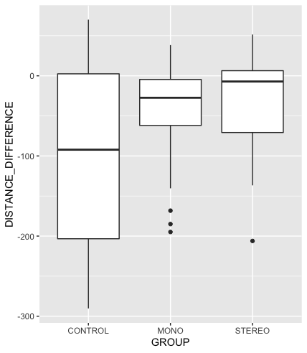
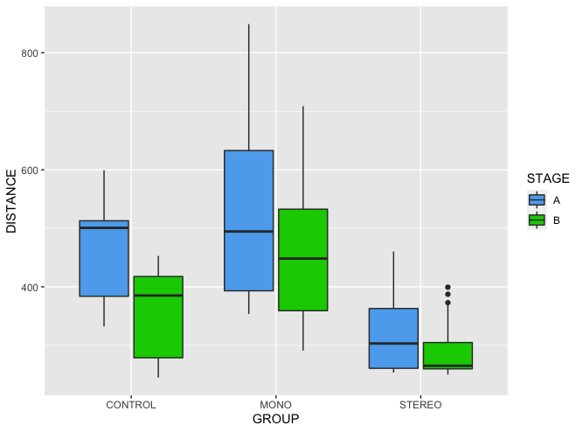
Figure 12: (left) Boxplot of each group’s average walking speed (m/s) for Stage A (blue) and Stage B (green). (right) Boxplot of each group’s difference in average walking speed (m/s) between stages
Figure 13: left) Boxplot of each group’s Euclidean distance traveled (in meters) for Stage A (blue) and Stage B (green). (right) Boxplot of each group’s difference in distance traveled (in meters) between stages.

We found some significant relationships between participants’ age and navigational performance, but no statistically significant relationship between spatial thinking ability and navigational performance. The interaction ANOVA did not result in a significant interaction between group and age regarding the distance difference between stages (Fig 14). Age resulted in significant differences (p = 0.002), and group showed a significant relationship with distance differences (p = 0.003). While the relationship between group and distance difference is significant, the interaction between age and group is not statistically significant (p = 0.06)(Fig 15). The interaction ANOVA did result in a significant interaction between group and age regarding the time difference between stages (p = 0.0004). Age did not show a significant relationship with time difference (p = 0.84), but group did show significance (p = 7.623e⁻⁰⁷). Spatial thinking ability showed no significant relationship (p = 0.87) with distance differences, nor did it show any significant relationship (p = 0.09) with time differences (Fig 16).
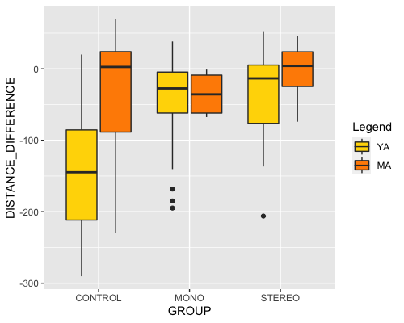
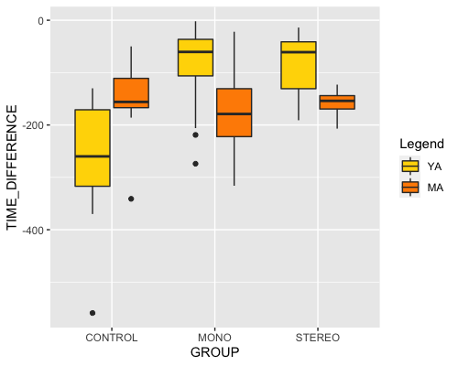
Figure 14: (left) Boxplot of the difference in time traveled (in seconds) (y) between stages with young adults (YA-yellow) and middle-aged adults (MA-orange) across experimental groups. (right) Boxplot of the difference in Euclidean distance traveled (in meters)

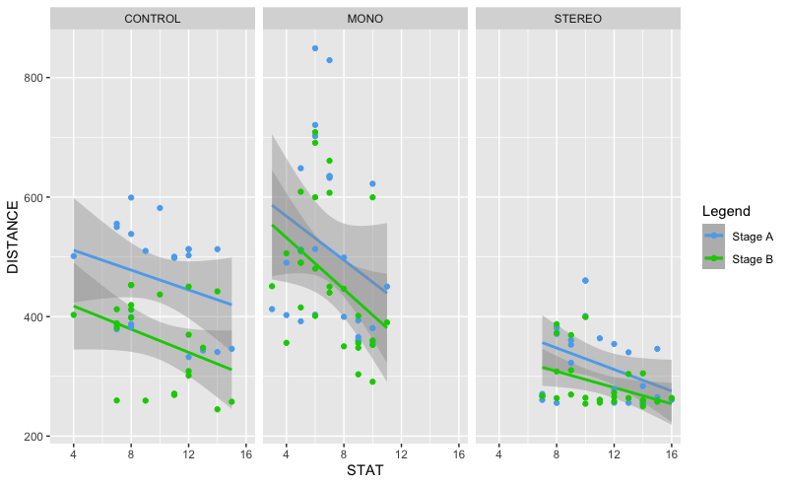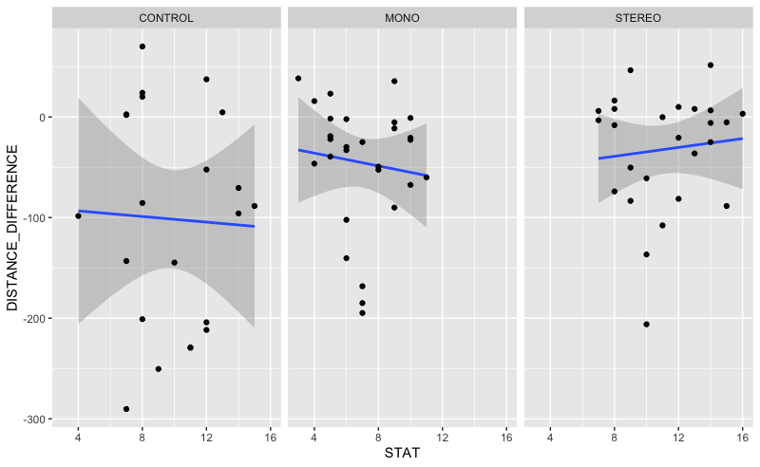
Figure 15: (left) Linear regression of participants’ spatial thinking ability score (x) and Euclidean distance traveled (in meters) (y) for Stage A (blue) and Stage B (green). (right) Linear regression of participants’ spatial thinking ability score (x) and difference in Euclidean distance traveled (in meters) (y) between stages.

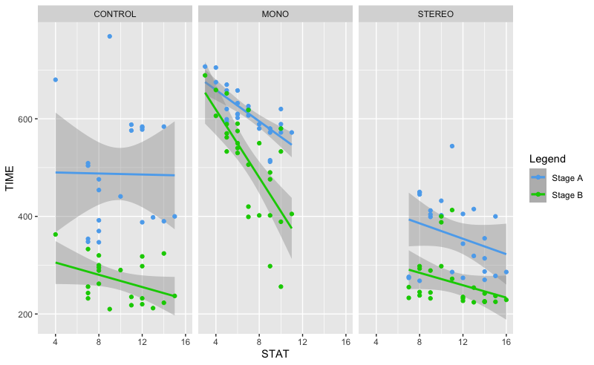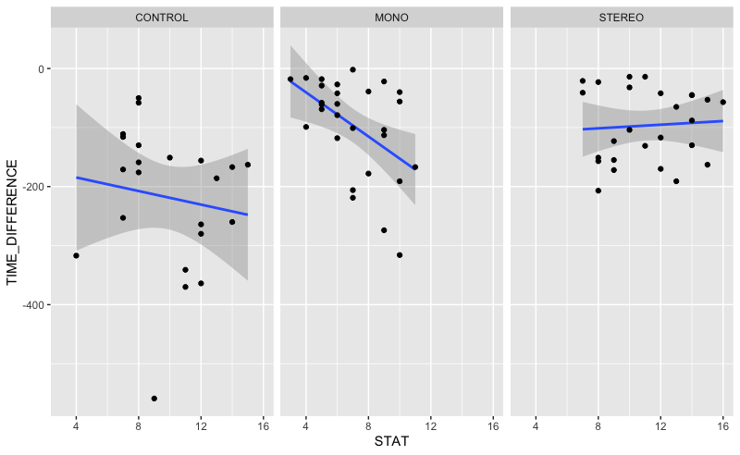
Figure 16: (left) Linear regression of participants’ spatial thinking ability score(x) and total time traveled (in seconds) (y) for Stage A (blue) and Stage B (green). (right) Linear regression of participants’ spatial thinking ability score (x) and difference in.
Adding gender identity to the equation revealed significant interactions with age. The one non-binary participant was removed from this test due to the insufficient sample size. An interaction ANOVA did not show significant relationships between gender identity or age with the change in time between stages (p = 0.27 and 0.14, respectively). However, there was a significant interaction between gender identity and age (p = 0.04). When the interaction ANOVA was performed with the change in distance between stages, there was no significant relationship with gender identity (p = 0.24) or age (p = 0.07). However, there was a significant interaction between gender identity and age (p = 0.02).
4.4 Discussion
On participants’ first attempt, the stereoscopic group had the shortest times and distances overall, while the monoscopic group had the highest times and distances. One possible explanation could be that displaying the information onto a small screen divided attention and hindered the effectiveness of the monoscopic navigational aid and created added confusion, similar to observations in AR navigation driving studies (Bauerfeind et al., 2021; Bauerfeind et al., 2022). This lack of stereoscopic superimposition requires the user to map the AR information onto the real world in front of them similar to a heads-up display (HUD) (Pfannmuller, 2017). A review of 184 experiments found that stereoscopic displays showed a clear benefit over monoscopic viewing in 65% of experiments that entailed finding objects, while only 25% of the experiments indicated no benefit (McIntire, 2014).
Upon participants’ second attempt navigating by memory alone, the trend from the first attempt continued with the stereoscopic group performing the best while the monoscopic group performed the worst. This means that the use of AR glasses helped participants remember the shortest route much better than the use of an iPhone/iPad. One explanation could be the divided attention between the monoscopic device and the real world. Studies on the use of AR-enhanced windshields while driving resulted in both younger and older participants having significantly fewer navigation errors and divided attention-related issues when compared to using a regular monoscopic HUD due to its ability to facilitate glance behavior and reduce divided attention (Kim & Dey, 2009; Gabbard et al., 2014; Bauerfeind et al., 2022).
Walking speed without the context of differences between user interaction systems can be misleading. During Stage A, one would expect differences in walking speed between the three groups. Participants in the control group did not have to learn a new user interface (UI) and interaction system, resulting in more time and attention spent on their surrounding environment as well as more natural walking speeds. Participants in the monoscopic group had the advantage of a familiar interaction system since they likely use touchscreens daily, but applying a 2D representation of a 3D space to the real world sometimes confused participants about where to turn and resulted in repeatedly alternating between looking at the device and the real world in front of them. None of the participants in the stereoscopic group had any previous experience combining handtracking and a 6DoF controller to interact with a UI that is tied to a virtual 3D space, resulting in more time spent at each waypoint attempting to select the correct next destination. Hesitation in navigation results in a clearly identifiable reduction of speed, and some types of UI have greater levels of automation and result in fewer hesitations or stops altogether (Brugger et al., 2019). If the time spent interacting with the application was recorded and subtracted from the numbers in the results, then the time spent traveling would have decreased and the average walking speed would have increased for the monoscopic and stereoscopic groups during Stage A. Walking speed with AR navigation has not been extensively studied (Pawlaczyk et al., 2021; Ahn et al., 2023). Walking speed in a general situation is typically around 1.4 m/s, but one study observed an average walking speed of 1.08 m/s in participants within a maze-like structure, suggesting that corridor shape can have a great effect on walking speed (Lee et al., 2016). Furthermore, a recent study found that AR-assisted navigation led to a slight decrease in walking speed, but a significant reduction in the time required to restart navigation after encountering obstacles like stairs (Ahn et al., 2023).
While distance traveled, time traveled, and average walking speed can be representative of this study’s observations, there are variables that are best visualized using the recorded spatial data. Less time walking resulted in fewer recorded point data during the activity. Participants in the monoscopic and stereoscopic group had to pause walking when interacting with the application to select their next destination. These pauses are apparent when overlayed onto the floor plan, displaying as hotspots at each of the destinations (fig. 17). Across all groups, the stereoscopic group had the least visual variation between stages with the only hotspots at the areas of the floor they had to travel through more than once, which can be reflective of the aforementioned study (Ahn et al., 2023) due to participants having to restart navigation after arriving at each destination.

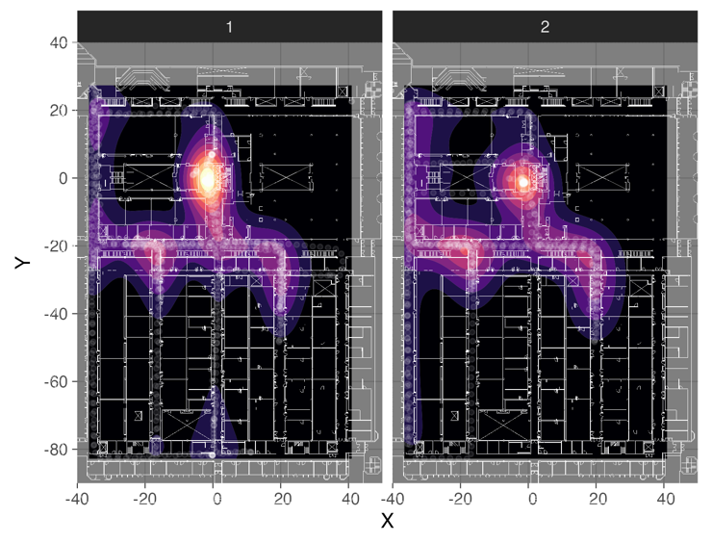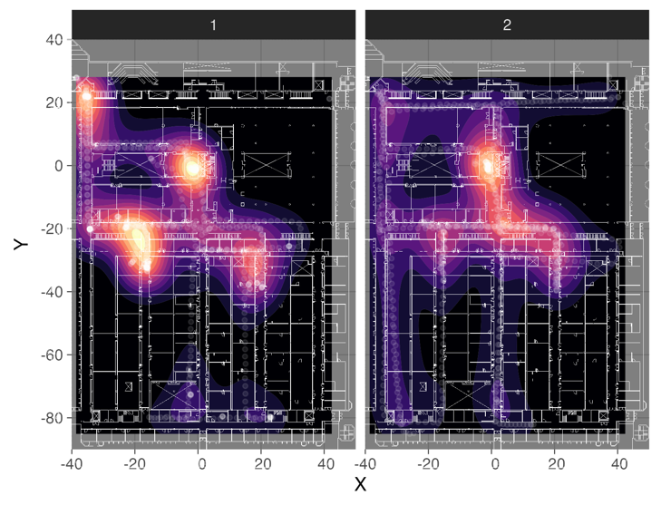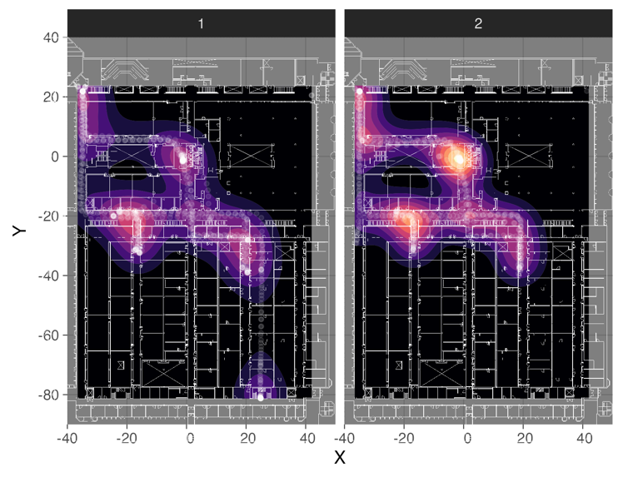
Figure 17: Density plots of participant’s recorded location every 2 seconds overlayed onto the floorplan in (top) the control group, (middle) the monoscopic group, and (bottom) the stereoscopic group.

With the varying age ranges and categories found within the literature, directly comparing our results to many other studies on the effects of age in navigation presents a problem because few studies use the same age ranges for young and old adults, often omitting middle-aged adults altogether (Van der Ham & Claessen, 2020). In our results, there were clear differences between young and middle-aged adults regarding the change in distance between stages. The control group showed young adults having the best improvement in distance, which is reflective of other studies suggesting that spatial navigation and spatial memory performance decline with age (Van der Ham & Claessen, 2020; Korman et al., 2019; Merhav & Wolbers, 2019). The distance differences between age groups in the stereoscopic group were less pronounced than in the control group, and the distance differences between age groups in the monoscopic group were miniscule. Interestingly, the middle-aged adults in the monoscopic and stereoscopic groups actually showed better improvements than the young adults regarding the time spent traveling, suggesting that young adults exhibited lower confidence or capability in their navigation abilities when asked to complete the task two weeks later without assistance. While maps were not the focus on this study, participants using either AR navigational aid had access to a real-time digital map on the UI. Adding another experimental group that is only shown a map either before or during the task could add more insight to the effectiveness of different navigational technologies on people of different ages due to the suggestion that map reading skills do not have the same decline with age as is observed with exploratory navigation (Yamamoto & DeGirolamo, 2012).
While we didn’t find significant differences between men and women in general, we did observe a clear difference when men and women were split within each age category. Most other studies found the men outperformed women in navigation tasks, but they were not split into the same age ranges that we used (Astur et al., 1998; Cutmore et al., 2000; Malinowski & Gillespie, 2001; Astur et al., 2004). Younger women displayed better improvements in both time and distance compared to younger men, but middle-aged men displayed better improvements in both time and distance compared to middle-aged women. One of the primary motivations in other navigation investigations into gender differences is to attempt to understand factors that either influence or are influenced by women’s predisposition to things like Alzheimer’s disease, which manifests in the disease’s early stages in the form of spatial disorientation, particularly in new environments but also sometimes familiar ones (Barnes et al., 2005; Hort et al., 2007; Kunz et al., 2015). Some areas of the brain related to spatial skills have also been observed deteriorating before the disease manifests and becomes diagnosable (Burggren et al., 2008; Braak et al., 2011). While medical research is not within the scope of this study, the differences of combined gender identity and age with navigational performance observed here could merit the inclusion of a middle-aged adult category into those studies that omitted them altogether to gain a better understanding of how soon and how fast those cognitive declines may appear within different demographic populations.
5. Conclusion
This study compared the performance of monoscopic and stereoscopic AR navigational aids to navigating an indoor environment without any assistance. Overall, we observed a clear benefit to using stereoscopic AR over not having any assistance at all in both distance and time traveled, but that using monoscopic AR hindered participants’ ability to navigate the indoor environment for the first time with the navigational aid as well as two weeks later without any assistance. Thus, we conclude that stereoscopic AR navigational aids can save users walking distance and time when navigating a novel indoor environment, but for areas one will need to return to repeatedly it may be easier to commit navigation to memory by using stereoscopic AR or no assistance at all compared to using monoscopic AR. However, individual and systematic difference still exist related to age and gender identity that can impact one’s ability to learn how to navigate a novel indoor environment.

References

Ahn, Y., Choi, H., Choi, R., H., Ahn, S., and Kim, B. S., (2023). Evaluating the Practicality of Augmented Reality Navigation for Indoor Emergency Evacuation: A Comparative Study. Available at SSRN: https://ssrn.com/abstract=4497236 or http://dx.doi.org/10.2139/ssrn.4497236
Allen, G. L. (1999). Cognitive abilities in the service of wayfinding: A functional approach. The Professional Geographer, 51(4), 554–561.
Aporta, Claudio. 2009. “The Trail as Home: Inuit and Their Pan-Arctic Network of Routes.” Human Ecology 37 (2): 131–46.
Arifin, Y., Sastria, T. G., & Barlian, E. (2018). User experience metric for augmented reality application:A review. Procedia Computer Science, 135, 648–656.
(1) (PDF) Use of Augmented Reality in Human Wayfinding: A Systematic Review. Available from: https://www.researchgate.net/publication/376414731_Use_of_Augmented_Reality_in_Human_Wayfinding_A_Systematic_Review
Astur, R. S. , Ortiz, M. L. & Sutherland, R. J. (1998). A characterization of performance by men and women in a virtual Morris water task: A large and reliable sex difference. Behav. Brain Res. 93, 185–190.
Astur, R. S., Tropp, J., Sava, S., Constable, R. T. & Markus, E. J. (2004). Sex differences and correlations in a virtual Morris water task, a virtual radial arm maze, and mental rotation. Behav. Brain Res. 151, 103–115.
Barnes, L. L., Wilson, R. S., Bienias, J. L., Schneider, J. A., Evans, D. A., and Bennett, D. A. (2005). Sex differences in the clinical manifestations of alzheimer disease pathology. Archives General Psychiatry 62 (6), 685. doi:10.1001/archpsyc.62.6.685
Bauerfeind, K., Drüke, J., Schneider, J., Haar, A., Bendewald, L., Baumann, M., et al. (2021). Navigating with Augmented Reality – how does it affect drivers’ mental load? Appl. Ergon. 94, 103398. Download from. doi:10.1016/j.apergo.2021.103398
Bauerfeind K, Drüke J, Bendewald L and Baumann M (2022), How does navigating with Augmented Reality information affect drivers’ glance behaviour in terms of attention allocation? Frontiers in Virtual Reality, 3:930117. doi: 10.3389/frvir.2022.930117
Bowman, D. A., & McMahan, R. P. (2007). Virtual reality: how much immersion isenough? Computer, 40(7), 36–43.
Braak, H., D. R. Thal, E. Ghebremedhin, and K. Del Tredici. (2011). “Stages of the Pathologic Process in Alzheimer Disease: Age Categories from 1 to 100 Years.” Journal of Neuropathology & Experimental Neurology 70: 960–69.
Brooke, J. (1996). SUS: A “quick and dirty” usability. Usability Evaluation in Industry, 189(3), 189–194.Taylor & Francis.
Brügger, A., Richter, K. F., & Fabrikant, S. I. (2019). How does navigation system behavior influence human behavior?. Cognitive research: principles and implications, 4(1), 5. https://doi.org/10.1186/s41235-019-0156-5
Bulu, S.T. (2012). Place presence, social presence, co-presence, and satisfaction in virtual worlds. Computers & Education, 58(1), 154-161. Elsevier Ltd.
Burgess N. Spatial cognition and the brain. Annals of the New York Academy of Sciences. 2008;1124:77–97. doi: 10.1196/annals.1440.002.
Burggren, A. C., M. M. Zeineh, A. D. Ekstrom, M. N. Braskie, P. M. Thompson, G. W. Small, and S. Y. Bookheimer. (2008). Reduced Cortical Thickness in Hippocampal Subregions among Cognitively Normal Apolipoprotein E e4 Carriers. Neuroimage 41 (4): 1177–83.
Burns, P. C. 1999. “Navigation and the Mobility of Older Drivers.” Journals of Ger- ontology: Series B, Psychological Sciences and Social Sciences 54 (1): S49–55.
Clarke, K. C. (2013). What is the world’s oldest map?. The Cartographic Journal, 50(2), 136-143.
Colombo, Desire ́e, Serino, Silvia, Tuena, Cosimo, Pedroli, Elisa, Dakanalis, Antonios, Cipresso, Pietro, Riva, Giuseppe, (2017). Egocentric and Allocentric Spatial Reference Frames in Aging: A Systematic Review.Neuroscience and Biobehavioral Reviews http://dx.doi.org/10.1016/j.neubiorev.2017.07.012
Cutmore, T. R. H., Hine, T. J., Maberly, K. J., Langford, N. M., and Hawgood, G. (2000). Cognitive and gender factors influencing navigation in a virtual environment. Int. J. Hum. Comput. Stud. 53, 223–249.
Dahmani, L., Bohbot, V.D. (2020). Habitual use of GPS negatively impacts spatial memory during self-guided navigation. Sci Rep 10, 6310. https://doi.org/10.1038/s41598-020-62877-0
Dahmani, L., Idriss, M., Konishi, K., West, G.L., and Bobot, V. (2023). Conidering environmental factors, navigation strategies, and age. Frontiers in Virtual Reality, 4:1166364. Doi.org/10.3389/frvir.2023.1166364.
Davis, F. D. (1989). Perceived usefulness, perceived ease of use, and user acceptance of informationtechnology. MIS Quarterly, 319–340.
Dirin, A., & Laine, T. H. (2018). User experience in mobile augmented reality: Emotions, challenges,opportunities and best practices. Computers, 7(2), 33.
(1) (PDF) Use of Augmented Reality in Human Wayfinding: A Systematic Review. Available from: https://www.researchgate.net/publication/376414731_Use_of_Augmented_Reality_in_Human_Wayfinding_A_Systematic_Review.
Dong, W., Wu, Y., Qin, T., Bian, X., Zhao, Y., He, Y., Xu, Y., and Yu, C. (2021).What is the difference between augmented reality and 2D navigation electronic maps in pedestrian wayfinding?, Cartography and Geographic Information Science, DOI: 10.1080/15230406.2021.1871646
Ekstrom, A.D., Spiers, H.J., Bohbot, V.D., & Rosenbaum, R.S. (2018). Human spatial navigation. Princeton University Press.
Endsley, M. R. (1995). Toward a theory of situation awareness in dynamic systems. Human Factors, 37(1),32–64.
Gabbard, J. L., Fitch, G. M., and Kim, H. (2014). Behind the glass: Driver challenges and opportunities for AR automotive applications. Proc. IEEE 102 (2), 124–136. doi:10.1109/JPROC.2013.2294642
Gardony, A. L., Brunyé, T. T., Mahoney, C. R., & Taylor, H. A. (2013). How navigational aids impair spatial memory: Evidence for divided attention. Spatial Cognition and Computation, 13(4), 319–350. https://doi.org/10.1080/ 13875868.2013.792821.
Gladwin, T. 1970. East Is a Big Bird: Navigation & Logic on Puluwat Atoll. Cam- bridge, MA: Harvard University Press.
Hill, P.F., Bermudez, S., McAvan, A.S., Garren, J.D., Grilli, M.D., Barnes, C.A., and Ekstrom, A.D. (2024). Age differences in spatial memory are mitigated during naturalistic navigation, Aging, Neuropsychology, and Cognition, DOI: 10.1080/13825585.2024.2326244
Hort, J., J. Laczo, M. Vyhnalek, M. Bojar, J. Bures, and K. Vlcek. (2007). “Spatial Navigation Deficit in Amnestic Mild Cognitive Impairment.” Proceedings of the National Academy of Sciences of the United States of America 104 (10): 4042–47.
Iaria, G.; Palermo, L.; Committeri, G.; Barton, J.J. (2009). Age differences in the formation and use of cognitive maps. Behav. Brain Res, 196, 187–191.
Iaria, G., and J. J. Barton. (2010). “Developmental Topographical Disorientation: A Newly Discovered Cognitive Disorder.” Experimental Brain Research 206 (2): 189–96.
Ishikawa, T., Fujiwara, H., Imai, O., & Okabe, A. (2008). Wayfinding with a GPS- based mobile navigation system: A comparison with maps and direct experience. Journal of Environmental Psychology, 28(1), 74–82. https://doi.org/ 10.1016/j.jenvp.2007.09.002.
Ishikawa, T., & Montello, D. R. (2006). Spatial knowledge acquisition from direct experience in the environment: Individual differences in the development of metric knowledge and the integration of sepa- rately learned places. Cognitive Psychology, 52, 93–129. https://doi. org/10.1016/j.cogpsych.2005.08.003
Ishikawa, T., & Takahashi, K. (2013). Relationships between methods for presenting information on navigation tools and users ’ wayfinding behavior. Cartographic Perspectives, 75(75), 17–28.
Joshi, R., Hiwale, A., Birajdar, S., Gound, R. (2020). Indoor Navigation with Augmented Reality. In: Kumar, A., Mozar, S. (eds) ICCCE 2019. Lecture Notes in Electrical Engineering, vol 570. Springer, Singapore. https://doi.org/10.1007/978-981-13-8715-9_20
Kim, S., and Dey, A. K. (2009). “Simulated augmented reality windshield display as a cognitive mapping aid for elder driver navigation,” in Proceedings of the SIGCHI Conference on Human Factors in Computing Systems, New York, NY, April 4-9, 2009 (ACM), 133–142. doi:10.1145/1518701.1518724
Klippel, A., Hirtle, S., & Davies, C. (2010). You-are-here maps: Creating spatial awareness through map-like representations. Spatial Cognition & Computation, 10(2–3), 83–93. https://doi.org/10.1080/13875861003770625.
Korman, M., Weiss, P.L., Hochhauser, M. et al. (2019). Effect of age on spatial memory performance in real museum vs. computer simulation. BMC Geriatr 19, 165. https://doi.org/10.1186/s12877-019-1167-2
Kunhoth, J., Karkar, A., Al-Maadeed, S. et al. (2020). Indoor positioning and wayfinding systems: a survey. Hum. Cent. Comput. Inf. Sci. 10, 18. https://doi.org/10.1186/s13673-020-00222-0
Kunz, L., T. N. Schroeder, L. Hweeling, C. Montag, B. Lachman, R. Sariyska, M. Reuter, R. Stirnberg, T. Stocker, P. C. Messing-Floeter, J. Fell, C. Doeller, and N. Axmacher. (2015). Reduced Grid-cell-like Representations in Adults at Genetic Risk for Alzheimer’s Disease. Science 350 (6259): 430–33.
Haas, J. (2014). A History of the Unity Game Engine. Worcester: Worcester Polytechnic Institute.
Lee, C. I. (2022). Benefit analysis of gamified augmented reality navigation system. Applied Sciences, 12(6), 2969.
Lee, J. and Bednarz, R.S. (2012) Components of Spatial Thinking: Evidence from a Spatial Thinking Ability Test. Journal of Geography, 111, 15-26. http://dx.doi.org/10.1080/00221341.2011.583262
Lee, S-H, Jeon, G-Y, Choi, J-H, Na, W-J, and Hong, W-H. (2016). Study on effect Size of Walking Speed According to Corridor Shape. Indian Journal of Science and Technology, 9(24). DOI: 10.17485/ijst/2016/v9i24/96074.
Lohmann, K., and Lohmann, C. (1996). Orientation and Open-sea Navigation in Sea Turtles. Journal of Experimental Biology 199: 73–81.
Malinowski, J. C., & Gillespie, W. T. (2001). Individual differences in performance on a large-scale, real-world wayfinding task. Journal of Environmental Psychology, 21, 73–82. https://doi.org/10.1006/jevp. 2000.0183
McIntire, J.P., Havig, P.R., Geiselman, E.E. (2014). Stereoscopic 3D displays and human performance: A comprehensive review, Displays, 35(1),18-26, ISSN 0141-9382, https://doi.org/10.1016/j.displa.2013.10.004.
Meneghetti, C., Borella, E., Gyselinck, V., De Beni, R., (2012). Age-differences in environ- ment route learning: the role of input and recall-test modalities in young and older adults. Learn. Individ. Differ. 22, 884–890.
Merhav, M., Wolbers, T. (2019). Aging and spatial cues influence the updating of navigational memories. Sci Rep 9, 11469. https://doi.org/10.1038/s41598-019-47971-2
Moffat, S.D., Resnick, S.M., 2002. Effects of age on virtual environment place navigation and allocentric cognitive mapping. Behav. Neurosci. 116, 851–859.
Montello, D. R. (2005). Navigation. In P. Shah & A. Miyake (Eds.), The Cambridge handbook of visuospatial thinking. (pp. 257–294). Cambridge: Cambridge University Press. https://doi.org/10.1017/CBO9780511610448.
Morar, A., Moldoveanu, A., Mocanu, I., Moldoveanu, F., Radoi, I. E., Asavei, V., Gradinaru, A., & Butean, A. (2020). A Comprehensive Survey of Indoor Localization Methods Based on Computer Vision. Sensors (Basel, Switzerland), 20(9), 2641. https://doi.org/10.3390/s20092641
Narzt, W., Pomberger, G., Ferscha, A., Kolb, D., Müller, R., Wieghardt, J., Hörtner H., and Lindinger, C. (2006). Augmented reality navigation systems. Universal Access in the Information Society, 4(3):177–187.
Parush, A., Ahuvia, S., & Erev, I. (2007). Degradation in spatial knowledge acquisition when using automatic navigation systems. In: Winter S., Duckham M., Kulik L., Kuipers B. (eds) Spatial Information Theory, COSIT 2007. Lecture Notes in Computer Science, vol 4736. Springer, Berlin, Heidelberg.
Pawlaczyk, N., Szmytke, M., Meina, M., Lewandowska, M., Ste ̨pniak, J., Bałaj, B., Dreszer, J. (2021). Gait Analysis under Spatial Navigation Task in Elderly People—A Pilot Study. Sensors, 21(270). https://doi.org/ 10.3390/s21010270.
Pfannmüller, L., Kramer, M., Senner, B., and Bengler, K. (2015). A comparison of display concepts for a navigation system in an automotive contact analog Head-up Display.
Pfannmüller, L. (2017). Anzeigekonzepte für ein kontaktanloges Head-up Display (Doctoral dissertation). Munich, Germany: Technical University of Munich.
Phillips, C. Feb 08, 2023. New ways Maps is getting more immersive and sustainable. The Keyword. https://blog.google/products/maps/sustainable-immersive-maps-announcements/\
Rehman,﻿ U.,﻿ &﻿ Cao,﻿ S.﻿ (2017).﻿ Augmented﻿ Reality-Based﻿ Indoor﻿ Navigation:﻿ A﻿ Comparative﻿ Analysis ﻿of ﻿Handheld ﻿Devices ﻿versus ﻿Google ﻿Glass. ﻿IEEE ﻿Transactions﻿ on ﻿Human-Machine ﻿Systems, ﻿47(1), ﻿140–151.
Rehrl, K., Häusler, E., Steinmann, R., Leitinger, S., Bell, D., & Weber, M. (2012). Pedestrian navigation with augmented reality, voice and digital map: Results from a field study asses- sing performance and user experience. In G. Gartner & F. Ortag (Eds.). Advances in Location-Based Services: 8th International Symposium on Location-Based Services (pp. 3–20). Springer. https://doi.org/10.1007/978-3-642-24198-7_1
Rubio-Sandoval, J. I., Martinez-Rodriguez, J. L., Lopez-Arevalo, I., Rios-Alvarado, A. B., Rodriguez-Rodriguez, A. J., & Vargas-Requena, D. T. (2021). An Indoor Navigation Methodology for Mobile Devices by Integrating Augmented Reality and Semantic Web. Sensors (Basel, Switzerland), 21(16), 5435. https://doi.org/10.3390/s21165435
Schinazi, V.R., Meloni, D., Grübel, J. et al. (2023). Motivation moderates gender differences in navigation performance. Sci Rep 13, 15995. https://doi.org/10.1038/s41598-023-43241-4
Smith, Cate & Cihak, David & Kim, Byungkeon & Mcmahon, Don & Wright, Rachel. (2016). Examining Augmented Reality to Improve Navigation Skills in Postsecondary Students With Intellectual Disability. Journal of Special Education Technology. 32. 10.1177/0162643416681159.
Sutherland, I. E. (1968). A head-mounted three dimensional display. Fall Joint Computer Conference.
Van der Ham, I.J.; Claessen, M.H. (2020) How age relates to spatial navigation performance: Functional and methodological considerations. Ageing Res. Rev. 58, 101020.
Waller D, Hodgson E. Transient and enduring spatial representations under disorientation and self-rotation. Journal of Experimental Psychology. Learning, Memory, and Cognition. 2006;32:867–882. doi: 10.1037/0278-7393.32.4.867.
Warren, W. H., B. A. Kay, W. D. Zosh, A. P. Duchon, and S. Sahuc. 2001. “Optic Flow Is Used to Control Human Walking.” Nature Neuroscience 4: 213–16.
Wiener, J. M., de Condappa, O., Harris, M. A., & Wolbers, T. (2013). Maladaptive bias for extrahippocampal navigation strategies in aging humans. The Journal of neuroscience : the official journal of the Society for Neuroscience, 33(14), 6012–6017. https://doi.org/10.1523/JNEUROSCI.0717-12.2013
Wilkniss, S.M., 1997. Age-related differences in an ecologically based study of route learning. Psychol. Aging 12, 372–375.
Wolfe, Jeremy M. 2006. Sensation and Perception. Oxford, UK: Sinauer Associates.
Yamamoto, N., and DeGirolamo, G.J. (2012). Differential effects of aging on spatial learning through exploratory navigation and map reading. Frontiers in Aging Neuroscience, 4(14).
Yassin, A., Nasser, Y., Awad, M., Al-Dubai, A., Liu, R., Yuen, C., Raulefs, R. (2016). Recent Advances in Indoor Localization: A Survey on Theoretical Approaches and Applications. IEEE Commun. Surv. Tutor., 19, 1327–1346.
Zhang, Y., Gao, F., Sun, Y., Hovakimyan, N. and Fang, Z. (2021), Guest Editorial: Autonomous systems: Navigation, learning, and control. IET Cyber-Syst. Robot, 3: 279-280. https://doi.org/10.1049/csy2.12038

Chapter 5: Conclusion
This dissertation investigated how XR technologies impact learning inside the classroom, outside the classroom, and in day-to-day spatial learning tasks such as indoor navigation. The results indicate that XR is beneficial to the learning process overall, but variables such as hardware format, gender identity, mode of visualization, and age moderate these effects in some settings. This chapter summarizes how we answered each of the research questions proposed in Chapter 1, the value and key takeaways of our findings, and suggestions for future study that could improve upon the work from this dissertation.

5.1. Summary of findings
In our first study, we asked: How do monoscopic AR, stereoscopic AR, and VR impact learning achievement in an undergraduate classroom, compared to a traditional worksheet? We observed promising results comparing XR to a traditional reading worksheet in the classroom. Students utilizing one of the XR technologies had superior learning achievement compared to those who used a traditional reading worksheet. When broken down by pairs, we observed significant differences between the reading and AR glasses groups, as well as the reading and iPad groups. We found no significant relationships between learning achievement and gender identity nor recreational gaming habits. However, we did observe significant gender differences in the attitude assessment. Women stated that they liked the XR learning activity more than men did, and women were more likely to say that they would like to use it again in the future.
In a second study, we asked: Is mobile AR effective in teaching high school students science in an informal education setting like an aquarium? We found that high school students enjoyed using AR to learn about coral reef ecology and marine conservation at a public aquarium and the experience resulted in positive educational outcomes. These students perceived there to be benefits in using AR both inside and outside the classroom. AR can make the learning process more engaging and enjoyable, while also increasing the motivation to learn. At the high school level, we found that boys had a greater positive response to gamified technology than girls, but we found no significant differences in learning achievement related to subject attitude.
In a third study, we asked: How do monoscopic and stereoscopic AR tools affect users’ abilities to navigate an indoor environment for the first time, compared to a control group using no aid? We found that stereoscopic AR improved participants’ abilities to navigate a novel indoor environment for the first time regarding distance and time traveled, relative to the control group with no aid, but participants using monoscopic AR performed worse than the control group. When participants were asked to navigate the same environment again two weeks later, we observed significant improvements in all three groups, with the control group demonstrating the greatest improvement. However, participants using stereoscopic AR still completed the navigational task more quickly than the control group. We found significant relationships between age and navigational performance, and a significant interaction between age and gender, but no relationship between spatial thinking ability and navigational performance.

5.2. Synthesis and recommendations
This research provides some insight for educators wishing to improve their learning environment, as well as end-users interested in incorporating XR into their daily lives. For educators, XR is not a “one size fits all” solution. Some students will require more scaffolding while learning a new technology, which can take away valuable time from the actual learning objectives. While students utilizing AR glasses performed the best in our study, the high cost and limited availability of today’s AR technology can be a difficult barrier to adoption. While we observed no gender differences in a formal university classroom, we did observe them in high school participants in a public aquarium setting. Despite these potential gender differences in some populations and settings, all participants in both studies displayed significant improvements in the knowledge assessment despite what school subject they considered their favorite to learn about. For users in everyday tasks, the type of task may determine which XR format will enable greater learning or performance. If one needs to navigate an indoor environment that they will not need to return to at a later date (e.g. finding a specific speaker or room at a conference), the use of AR glasses can significantly reduce the distance and time traveled compared to finding one’s way around without assistance or using a smartphone. If one needs to navigate an indoor environment repeatedly (e.g. finding a classroom or office), using a smartphone can impair their ability to learn how to navigate without it; however, the use of AR glasses remains an optimal method of navigation.
We successfully identified key strengths and weakness related to XR’s use in three different learning environments, while raising some new questions. The limitations faced here provide possible directions for future research to attain more robust conclusions. Providing results from a wider range of devices within each category could prove useful in understanding the extent variables like resolution, field-of-view (FoV), and interaction system can impact efficacy. Due to how rapidly XR technology is improving, it might be unfair to compare one application on a newer device to the same application on an older device. Some XR technologies can present difficulties for certain populations to use, particularly those with physical disabilities (Arvanitis et al., 2009). When dealing with informal education settings like aquariums, there were some interesting observations that were not relevant to our research questions, such as the social environment of a user during the activity. Some participants went through the activity with a parent present, while other parents did not want to walk around the aquarium. Many of the participants were at the aquarium because they wanted to be there, but there were some participants that were only there because a younger sibling wanted to go and the participant was forced to tag along. Comparing the use of solo XR activities versus group XR activities could provide greater insight to the efficacy of different gamification mechanics on specific populations.

5.4. Conclusion
This dissertation highlights the importance of knowing your target audience and desired task when developing and implementing XR in learning contexts. XR demonstrates the potential to “level the playing field” among many types of students and improve learning both inside and outside the classroom, but some XR formats like monoscopic AR can impair our natural capabilities in spatial learning tasks like indoor navigation. With the conflicting literature about gender gaps in gamification, this research provides examples where gender gaps were present in one age group/setting while not present in another, despite the same application being used. XR technology is continuously being refined into something that can one day reach mainstream adoption, but we have an opportunity now to better understand the underlying mechanisms that drive its effects on us before we accept it as the best next evolution in digital learning tools.

References for Intro/Conclusion

Allen, S., & Peterman, K. (2019). Evaluating Informal STEM Education: Issues and Challenges in Context: Evaluating Informal STEM Education. New Directions for Evaluation, 2019(161), 17–33. https://doi.org/10.1002/ev.20354
Arvanitis, T.N., Argeroula, P., Knight, J.F., Savas, S., Sotirious, S., Gargalakos, M., & Gialouri, E. (2009). Human factors and qualitative pedagogical evaluation of a mobile augmented reality system for science education used by learners with physical disabilities. Pers Ubiquit Comput, 13, 243-250. DOI 10.1007/s00779-007-0187-7
Böckle, M., Novak, J., & Bick, M. (2017). Towards adaptive gamification: A synthesis of current developments. In Proceedings of the 25th European Conference On Information Systems (ECIS), Guimaraes, Portugal.
Brügger, A., Richter, K. F., & Fabrikant, S. I. (2019). How does navigation system behavior influence human behavior?. Cognitive research: principles and implications, 4(1), 5. https://doi.org/10.1186/s41235-019-0156-5
Dahmani, L., Bohbot, V.D. (2020). Habitual use of GPS negatively impacts spatial memory during self-guided navigation. Sci Rep 10, 6310. https://doi.org/10.1038/s41598-020-62877-0
Dicheva, D., Dichev, C., Agre, G., & Angelova, G. (2015). Gamification in education: a systematic mapping study. Educational Technology & Society, 18(3), 75–88.
Gardony, A. L., Brunyé, T. T., Mahoney, C. R., & Taylor, H. A. (2013). How navigational aids impair spatial memory: Evidence for divided attention. Spatial Cognition and Computation, 13(4), 319–350. https://doi.org/10.1080/ 13875868.2013.792821.
Garzón, J. & Acevedo, J. (2019). Meta-analysis of the impact of Augmented Reality on students’ learning gains, Educational Research Review, 27: 244-260, ISSN 1747-938X, https://doi.org/10.1016/j.edurev.2019.04.001.
Glass, A.L. & Kang, M. (2018). Dividing attention in the classroom reduces exam performance, Educational Psychology, DOI: 10.1080/01443410.2018.1489046
Hamari, J. (2013). Transforming Homo Economicus into Homo Ludens: A Field Experiment on Gamification in a Utilitarian Peer-to-Peer Trading Service. Electronic Commerce Research and Applications, 12(4), 236-245. https://doi.org/10.1016/j.elerap.2013.01.004.
Hwang, G.-J., Wu, P.-H., Chen, C.-C., & Tu, N.-T. (2016). Effects of an Augmented Reality-Based Educational Game on Students’ Learning Achievements and Attitudes in Real-World Observations. Interactive Learning Environments, 24(8), 1895–1906. https://doi.org/10.1080/10494820.2015.1057747.
Montello, D. R. (2005). Navigation. In P. Shah & A. Miyake (Eds.), The Cambridge handbook of visuospatial thinking. (pp. 257–294). Cambridge: Cambridge University Press. https://doi.org/10.1017/CBO9780511610448.
Ravizza, S. M., Uitvlugt, M. G., & Fenn, K. M. (2017). Logged in and zoned out: How laptop internet use relates to classroom learning. Psychological science, 28(2), 171-180.
Swan, C. (2012). Gamification: A New Way to Shape Behavior. Communication World, 29(3), 13-14.

Appendix A

Knowledge Assessment:
- What is a coral reef?
  - An underwater ecosystem characterized by colonies of corals connected by calcium carbonate.
  - A large slab of stone in the ocean that provides a habitat for marine life.
  - Fossilized remnants of rainforests that were once above water.
  - Human-created underwater structures built to promote marine life, control erosion, or promote surfing.

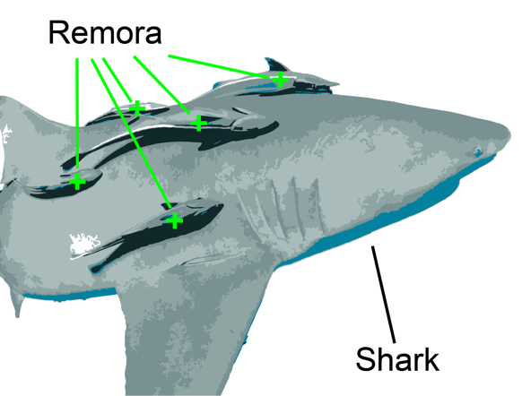
- By attaching itself to a shark, a remora can travel without having to expend its own energy to swim. The shark is completely unaffected by the remora's presence. In reference to symbiosis, this is an example of a ____ relationship.
  - Commensal
  - Parasitic
  - Synergistic
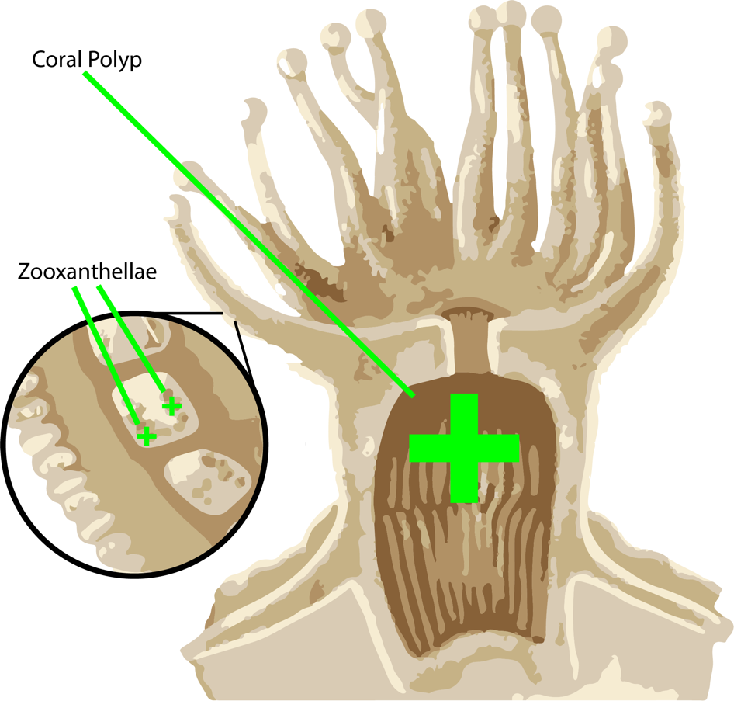
  - Mutualistic
- Corals provide zooxanthellae (algae) with a protected environment and compounds they need for photosynthesis. In return, the algae produce oxygen and provide corals with food. Because both corals and zooxanthellae benefit, this is an example of a ___ relationship.
  - Parasitic
  - Equilibrium
  - Commensal
  - Mutualistic
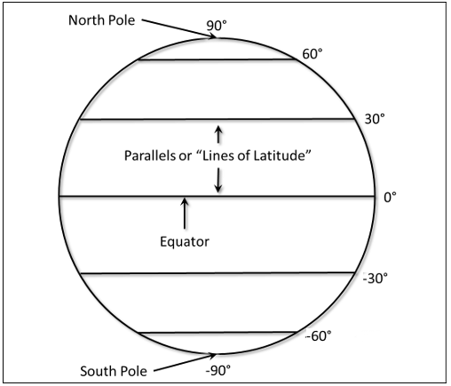
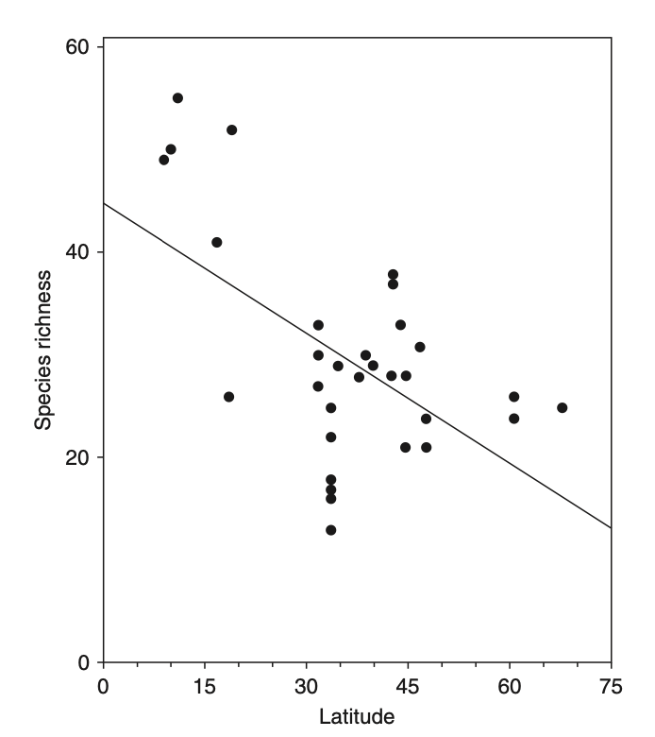

- The figure above illustrates how _________, also known as the latitudinal biodiversity gradient.
  - Species richness increases as one moves from Earth’s poles toward the tropics.
  - Species richness decreases as one moves from Earth’s poles toward the tropics.
  - Species richness increases as one moves higher above sea level. 0/0
  - Species richness decreases as one moves higher above sea level.
- The variety and variability of life, measured at the genetic, species, and ecosystem level is called _______.
  - Biodiversity
  - Bioavailability
  - Equilibrium
  - Multiplicity
- Blackfin barracuda are found only in Hawai’i, which means that they are ____ in that region.
  - A foundation species
  - Endemic
  - A keystone species
  - Invasive

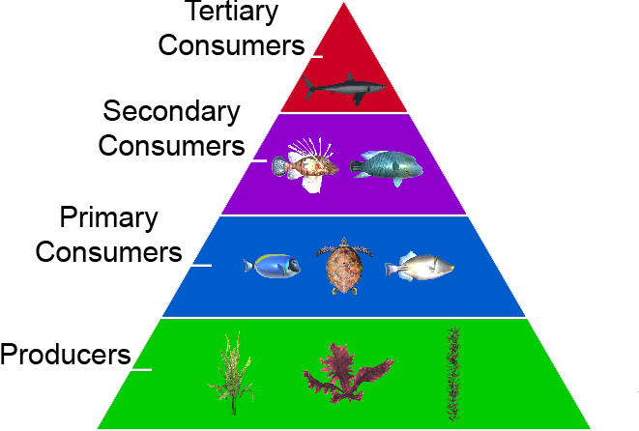
- In the ecosystem pictured in the above figure, overfishing of secondary consumers might lead to:
  - An increased abundance of plants.
  - An increase in the number of smaller fish.
  - A decrease in the number of smaller fish.
  - An increase in the number of higher-order carnivores.
- Which of the following best explains why invasive lionfish populations are increasing in the Atlantic Ocean near the United States?
  - Lionfish have no natural predators in the new ecosystem.
  - Lionfish prefer warm waters.
  - Lionfish fill a previous gap in the new ecosystem’s food web.
  - Lionfish venom can kill their prey.
- Coral bleaching is a response to environmental stress. Which of the following best defines coral bleaching?
  - When temperatures become too warm, corals expel their internal algae, causing the corals to turn white.
  - Corals get their vivid color from the colorful fish they eat, but corals lose their color when they have not had enough to eat.
  - When water clarity is too high, too much light can cause corals to fade in color.
  - Chemical pollutants in the water can “bleach” corals, causing them to lose their color.
- Which of the following is a benefit that coral reefs provide to humans?
  - Corals provide medicinal benefits to humans.
  - Corals act as a barrier between humans and deep ocean predators.
  - Coral can be used as a building material.
  - Corals improve the water quality, allowing humans to safely drink it.
- The act of cutting off small sections of corals is called fragmentation. What purpose does this serve?
  - The small fragments provide food for fish, preventing them from eating the larger corals.
  - The small fragments are transplanted in other sections of reef to grow.
  - It prevents disease from spreading to other parts of the coral.
  - It triggers a chemical response in corals to boost their natural defenses.
- What do corals gain from algae?
  - The algae supply glucose, glycerol, and amino acids to the coral.
  - The algae protect the coral from predators.
  - The algae feed on plant growths that irritate the coral.
  - The algae attract small herbivorous fish for the coral to eat.
- Great white sharks belong in the highest trophic level because _______?
  - They eat plants.
  - They eat herbivores.
  - They eat other great white sharks.
  - They eat other high-level consumers.
- Which of the following best explains why there are fewer animals at the top of the food chain?
  - They require more physical space for their habitat.
  - Only a small percentage of energy is transferred to the next trophic level.
  - Their reproduction cycles last much longer than what is found in lower trophic levels.
  - They get their energy by consuming other animals at the top of the food chain.
- What are some ways that you can contribute to protecting or restoring coral reefs?

__________________________________________________________________________________________________________________________________________________________________________________________________________________________________________

