UNIVERSITY OF OKLAHOMA
GRADUATE COLLEGE

Characterization of hydrophobic nanoporous particle liquids for energy absorption

A THESIS
SUBMITTED TO THE GRADUATE FACULTY
in partial fulfillment of the requirements for the
Degree of
MASTER OF SCIENCE

By

YI HSU
Norman, Oklahoma
2016

Characterization of Hydrophobic Nanoporous particle liquids for energy absorption

A THESIS APPROVED FOR THE
SCHOOL OF AEROSPACE AND MECHANICAL ENGINEERING

BY

______________________________
Dr. Yingtao Liu, Chair

______________________________
Dr. Kuang-Hua Chang

______________________________
Dr. Jivtesh Garg

© Copyright by YI HSU 2016
All Rights Reserved.

ACKNOWLEDGEMENTS

I would first express my deep and sincere sense of indebtedness to like to thank my advisor, Dr. Yingtao Liu, for allowing me to work on this project throughout the year. Despite his busy schedule, I have always found his accessible for suggestions and discussions. I appreciate all the time and effort he spent in guiding me through this project. Without his support, guidance, and advice, this work would not have been possible.
I would also like to thank Dr. Kuang-Hua Chang and Dr. Jivtesh Garg for their time in serving on my thesis committee. Their help on this work and in the classroom has been very much appreciated, with their encouragement and inspiration in every step of my project.
I would like to thank my friends and colleagues, Wanru, Jingyu, Shoieb, Mark, Anand, Mortaza, Mohammad, Maya and Mehrad, for their support throughout this entire endeavor. Their friendships have made this experience much more enjoyable. Without you, this would not have been possible.
Thanks to my family, Mom, Dad, for their love and support throughout two and half years that provided me with the opportunity to accomplish my academic career. I will be always grateful for everything that they have done for me.

TABLE OF CONTENTS
ACKNOWLEDGEMENTS iv
LIST OF FIGURES vii
ABSTRACT ix
CHAPTER 1. INTRODUCTION 1
1.1 Background 1
1.1.1. Traumatic Brain Injury 2
1.1.2. Mild Traumatic Brain Injuries Mechanisms 2
1.2 Properties of Energy Absorption and Mechanisms 4
1.2.1. Introduction 4
1.2.2 Materials Mechanism 4
1.3 Energy Absorption Systems Materials 9
1.3.1. Ballistic Fabrics Laminated Composites 9
1.3.2 Sandwich Shells with Honeycomb Core 11
1.4. Conclusion 12
CHAPTER 2. NANOPOROUS PARTICLE LIQUID SYSTEM FOR ENERGY ABSORPTION 13
2.1. Introduction 13
2.2 Porous Structural Material 14
2.4 Energy Absorption of Nanoporous Particle Liquid System 19
2.5 Experiment 22
2.5.1 Material Preparation 22
2.5.2 Experimental Setup 24
CHAPTER 3. NANOPOROUS PARTICLE LIQUID WITH ETHANOL PROMOTERS FOR ENERGY ABSORPTION 27
3.1 Introduction 27
3.2 Result and Conclusion 27
CHAPTER 4. NANOPOROUS PARTICLE LIQUID WITH METHANOL PROMOTERS FOR ENERGY ABSORPTION 32
4.1 Introduction 32
4.2 Result and Conclusion 32
CHAPTER 5. CHARACTERIZATION OF NANOPOROUS PARTICLE LIQUID UNDER CYCLIC LOAD 35
5.1 Introduction 35
5.2 Energy absorption 35
5.3 Result and Conclusion 36
CHAPTER 6. LONG TERM PERFORMANCE OF NANOPOROUS PARTICLE LIQUID 39
6.1 Introduction 39
6.2 Results and Conclusion 39
CHAPTER 7. CONCLUSION AND FUTURE WORK 46
7.1. Conclusion 46
7.2. Future Work 46
REFERENCES 48

LIST OF FIGURES
Fig. 1. 1. The Coup-Contrecoup Phenomenon [2]. 3

Fig. 1. 2. 1. Conventional and true strain-strain diagrams for material [8] 5
Fig. 1. 2. 2. Stress-strain curve [7]. 6
Fig. 1. 2. 3. Per-volume with stress σ 7
Fig. 1. 2. 4.The entire area under the strain-stress diagram [8]. 8

Fig. 1. 3. 1. Projectile impact into body armor [9]. 10
Fig. 1. 3. 2. Sphere impacting single ply of fabric [9]. 10
Fig. 1. 3. 3. An aluminum honeycomb [11]. 11
Fig. 1. 3. 4. Schematic of material with honeycomb [11]. 12

Fig. 2. 1 Schematic of cellular material with compression force F 14
Fig. 2. 2. The picture of silica particle through SEM 14

Fig. 2. 3. 1 Diagrams of nanoporous particle liquid system 16
Fig. 2. 3. 2. 10% Ethanol solution with silica particle in different load/unload cycle 17
Fig. 2. 3. 3. 10% Methanol solution with silica particle in different load/unload cycle 18
Fig. 2. 3. 4. 10% Methanol solution with 0.3 gram silica particle 19

Fig. 2. 4. 1. Per-volume with stress σ 21
Fig. 2. 4. 2. Demonstration of NPLs in energy absorption by using the P-∆V curve 21

Fig. 2. 5. 1. The NPL system before putting in customized cylinder 22
Fig. 2. 5. 2. Diagrammatic illusion of NPLs experiment [18]. 24
Fig. 2. 5. 3. Experimental Procedures of NPLs 25
Fig. 2. 5. 4. Experimental Setup and stainless steel cylinder used during testing. 26

Fig. 3. 2. 1. 10% ethanol solution with 0.3 gram silica particle. 29
Fig. 3. 2. 2. 20% ethanol solution with 0.3 gram silica particle. 29
Fig. 3. 2. 3. 30% ethanol solution with 0.3 gram silica particle. 30
Fig. 3. 2. 4. Comparison of different concentration of ethanol solution. 30

Fig. 4. 2. 1. 10% methanol solution with 0.3 gram silica particle. 33
Fig. 4. 2. 2. 20% methanol solution with 0.3 gram silica particle. 33
Fig. 4. 2. 3. 30% methanol solution with 0.3 gram silica particle. 34
Fig. 4. 2. 4. Comparison of different concentration of methanol solution. 34

Fig. 5. 2. 1. Demonstration of NPLs in energy absorption by using the $P-∆V$ curve. 36

Fig. 5. 3. 1. The infiltration pressure of different NPLs with ethanol or methanol promoters 37
Fig. 5. 3. 2. Energy absorption capability of NPL with ethanol promoters. 38
Fig. 5. 3. 3. Energy absorption capability of NPL with methanol promoters. 38

Fig. 6. 2. 1. Ethanol solution with silica particle in 72 hours. 40
Fig. 6. 2. 2. Ethanol solution with silica particle in 99 hours. 40
Fig. 6. 2. 3. Ethanol solution with silica particle in 110 hours. 41
Fig. 6. 2. 4. Ethanol solution with silica particle in 148 hours. 41
Fig. 6. 2. 5. Ethanol solution with silica particle in 244 hours. 42
Fig. 6. 2. 6. Methanol solution with silica particle in 72 hours. 42
Fig. 6. 2. 7. Methanol solution with silica particle in 99 hours. 43
Fig. 6. 2. 8. Methanol solution with silica particle in 134 hours. 43
Fig. 6. 2. 9. Methanol solution with silica particle in 148 hours. 44
Fig. 6. 2. 10. Methanol solution with silica particle in 244 hours. 44
Fig. 6. 2. 11. Comparison of NPLs with methanol promoter in different period. 45
Fig. 6. 2. 12. Comparison of NPLs with ethanol promoter in different period. 45

ABSTRACT
Recently, the development of hydrophobic nanoporous technologies has drawn increased attention, especially for the applications of energy absorption and impact protection. Although significant amount of research has been conducted to synthesis and characterize materials to protect structures from impact damage, the tradition methods focused on converting kinetic energy to other forms, such as heat and cell buckling. Due to their high energy absorption efficiency, hydrophobic nanoporous particle liquids (NPLs) are one of the most attractive impact mitigation materials. During impact, such particles directly trap liquid molecules inside the non-wetting surface of nanopores in the particles. The captured impact energy is simply stored temporarily and isolated from the original energy transmission path. In this paper we will investigate the energy absorption efficiency of combinations of silica nanoporous particles and with multiple liquids. Inorganic particles, such as nanoporous silica, are characterized using scanning electron microscopy. Small molecule promoters, such as methanol and ethanol, are introduced to the prepared NPLs. Their effects on the energy absorption efficiency are studied in this paper. NPLs are prepared by dispersing the studied materials in deionized water. Energy absorption efficiency of these liquids are experimentally characterized using an Instron mechanical testing frame and in-house develop stainless steel hydraulic cylinder system.

CHAPTER 1.
INTRODUCTION

1.1 Background
The application of nanoporous materials recently gained popularity in many fields. Body protection represents utilizations of nanoporous materials. Especially for the functional improvement of padding in helmets, it has a magnificent effect. First of all, in order to describe the idea of brain protection by using nanoporous materials, brain damage should be defined. For the human body, the head is the primary control center for the body, also known as central nervous system (CNS) [1]. It will cause the potentially lethal effect for the patients, when the head gets harmful injury from an external force by a sudden acceleration or deceleration which is caused by a complex sudden impact. In addition to the damage caused at the moment of injury, brain trauma causes secondary injury, a variety of events that take place in the minutes and days following the injury. These processes, which include alterations in cerebral blood flow and the pressure within the skull, contribute substantially to the damage from the initial injury. Usually, head injury can be seemed as the trauma of the skull or brain caused by accident, falls, physical assault, or traffic accident. This is called Traumatic Brain Injury (TBI) [2].

1.1.1. Traumatic Brain Injury
There are many cases of traumatic brain injury, most of them can be defined as damage to the brain resulting from external mechanical force, such as rapid acceleration or deceleration, impact, blast waves, or penetration. According to the survey from Center for Disease Control and Prevention (CDC) surveillance, over 1.5 million patients suffer in sports-related traumatic brain injuries, or called mild traumatic brain injury (MTBI) also known as concussion which Americans sustain in the great number of casualty in the United States each year [3,4]. For the study of sport-related traumatic brain injury also defined as concussion, it has been a significant health issue which will be happened in low velocity impact while in sports and military which caused mild traumatic brain injury (MTBI). A concussion results from a rotational acceleration or deceleration injury to the head that causes an alteration of mental status or various other symptoms such as headache or dizziness [2].

1.1.2. Mild Traumatic Brain Injuries Mechanisms
MTBI are occurred by different type of forces, such as angular, rotational, shear, and translational force. Even in the absence of an impact, significant acceleration or deceleration of the head can also cause MTBI [5]. Generally, there are two types of them. One is coup injury which occurs under the site of impact with an object, and the other one is contrecoup injury occurs on the side opposite the area that was hit. As Figure 1.1. is shown, coup and contrecoup injuries can occur individually or together [2].
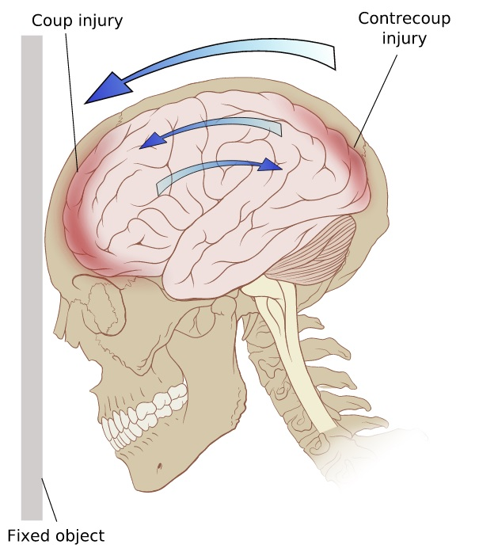
Fig. 1. 1. The Coup-Contrecoup Phenomenon [2].
Assumed that there is an impact loading, the force sends shock waves through the skull and brain causing the brain damage. Due to its inconspicuous symptom, approximately one third of these patients got MTBI by playing football and didn’t notice that [4]. However, it does not only happen in sports. In military, lots of oversea combat soldiers experience in MTBI especially with the low velocity type which can be severe and more. According to the report from invisible wounds of war, about 320,000 U.S. troopers have endured MTBI by battlefield blast during Iraq and Afghanistan wars since 2001 [6]. It didn’t recognize to be a big problem for military although most of the brain injury cases are categorized as uncomplicated concussion [7]. To improve protective capabilities of basic equipment and gears for preventing or reducing penetrating impact damage to both athletes and soldiers is becoming attractive to research. Even though plenty of protective equipment and gears have been adopted in many application, their protective abilities should be improved to prevent severe injuries that could cause long-lasting damage.

1.2 Properties of Energy Absorption and Mechanisms

1.2.1. Introduction
To identify and quantify the energy absorption and mechanisms in materials, test methodologies were developed for conducting progressive crush tests on composite specimens that have simplified test geometries. In materials science and metallurgy, toughness is the ability of a material to absorb energy and plastically deform without fracturing [8].

1.2.2 Materials Mechanism
For materials mechanism, it is possible to distinguish some common characteristics among the stress-strain diagrams of various materials. In uniaxial compression the forces are directed along one direction only, so that they act towards decreasing the object's length along that direction. To be more detail, compression may be involved in other form change type such as, all over the side surface of a cylinder, so as to reduce its area, or inwards over the entire surface of a body, so as to reduce its volume [8].
Fig. 1. 2. 1. Conventional and true strain-strain diagrams for material [8]
After compression test, it is easy to analysis from the results of stress-strain diagrams. Fig. 1.2.1. is shown that the first region, which is called elastic behavior of the material occurs when the strains in the specimen are within the elastic region shown in Fig. 1.2.1. The curve is actually a straight line throughout most of this region, so that the stress is proportional to the strain. Most of the material in this region is said to be linear. The stress limit to this linear relationship is called the proportional limit, $σ_{pl}$. If the load is removed, the specimen will still return back to its original shape. A slight increase in stress above the elastic limit will result in a breakdown of the material and cause it to deform permanently. This behavior is called yielding, and it is indicated by the rectangular dark orange region of the curve. The stress that causes yielding is called the yield stress or yield point, $σ_{Y}$ , and the deformation that occurs is called plastic deformation [8].
Fig. 1. 2. 2. Stress-strain curve [7].
The specimen of any materials is loaded into the plastic region and then unloaded, elastic strain is recovered as the material returns to its equilibrium state. The plastic strain remains, however, and as a result the material is subjected to a permanent set. This behavior can be illustrated on the stress–strain diagram shown in Fig. 1.2.2. First, the specimen is first loaded beyond its yield point $A$ to point $A'$.
If the load is reapplied, the atoms in the material will again be displaced until yielding occurs at or near the stress $A'$, and the stress–strain diagram continues along the same path as before, Fig 1.2.2. However, that this new stress–strain diagram, defined by $O'A'B$, now has a higher yield point $A^{'}$.
1.2.3. Strain Energy
In the mechanical energy of a system, energy is defined as the sum quantity of the potential energy which is measured by the position of the parts of the system, and the kinetic energy which is also called the energy of motion:
$E_{total}=U+K$ (1.1)
As a material is deformed by an external loading, it tends to store energy internally throughout its volume. Since this energy is related to the strains in the material, it is referred to as strain energy. The definition of material toughness is the amount of energy per unit volume that a material can absorb before rupturing. Fig 1.2.3 [8].

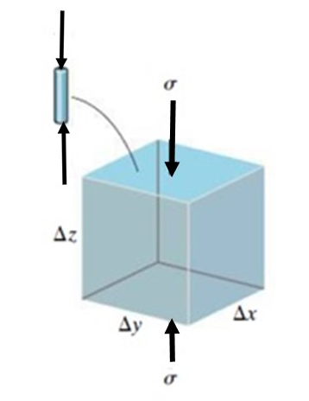
Fig. 1. 2. 3. Per-volume with stress σ
Following the definition of material mechanism, toughness, energy absorption can be determined by integrating the stress-strain curve. As the Fig 1.2.4 shown, it is the energy of mechanical deformation per unit volume prior to fracture. The explicit mathematical description is: [8]
$u_{t}=\frac{Energy}{Volume} =\int_{0}^{ϵ_{f}}{σ dϵ}$ (1.2)
where:
- $ϵ$is strain
- $ϵ_{f}$ is the strain upon failure
- $σ$ is stress
- $u_{t}$ is total energy under stress-strain diagram
Fig. 1. 2. 4.The entire area under the strain-stress diagram [8].

1.3 Energy Absorption Systems Materials
Energy absorption materials have immense importance to a wide variety of industries such as defense, transportation, construction, healthcare, among others. The conventional energy absorption materials include reinforced polymers and shape memory alloys, which can sustain widespread damages or phase transformations when subjected to external loadings.

1.3.1. Ballistic Fabrics Laminated Composites
The study of ballistic fabrics has received significant attention especially in the application of military because of its ability of reducing impact damage by its own fabric material properties and laminated composites. There are several ideals could be discussed in this study such as impact energy, projectile geometry, frictions between fibers and yarns, and interaction of multiple plies [9], as shown in Fig 1.3.1.
According to the report from Roylance [10], it has shown the characteristics of woven textile panels could be used for reducing most of the impact kinetic energy by transferring the energy into particular principal yarns are directly contacted with the kinetic energy projectile during ballistic impact on a woven panel which could be seemed as the form of strain energy. For laminated composites, it also has same methods as ballistic fabrics for impact protection. Because of the characterization of different type of laminated composites, the impact kinetic energy has depleted by converting the kinetic energy into four shape deformation like matrix cracks, delamination, fiber breakage, and penetration [11]. As Fig. 1.3.1. is shown, with these complex natural failures of composites and stress-strain curves, to exanimate these four different failure modes of laminated composites are easily indicated the value of different impact energy and velocities. See Fig. 1. 3. 2. for detail [9,10].
Fig. 1. 3. 1. Projectile impact into body armor [9].
Fig. 1. 3. 2. Sphere impacting single ply of fabric [9].
(a) Side view, (b) Top view of z displacement contours and
(c) Bottom view showing principal yarns under high stress

1.3.2 Sandwich Shells with Honeycomb Core
The energy absorption capabilities of sandwich plates with honeycomb cores and uniformly thick facings under conditions of impact made by a massive strike. Recently, it becomes interesting to discuss the applications of cellular solids such as aluminum foam just like honeycomb figure as reinforcement to thin-walled structures with each cores for sandwich panels [12,13]. Aluminum foam is becoming one of particular practical interesting study, because of its mass efficiency, its attractive mechanical behavior and the recent developments of cost-effective production process. A typical compressive stress-strain curve of aluminum foam consists of three regions: a linear elasticity at small strains, a long distinct plateau of almost constant stress, and a final densification region at very large strains [14]. This makes the aluminum foam an ideal material for energy absorption.
Fig. 1. 3. 3. An aluminum honeycomb [11].

Fig. 1. 3. 4. Schematic of material with honeycomb [11].

1.4. Conclusion
The development of studying energy absorption efficiency is still far from satisfactory. As a result, the protection devices, such as soldier armors and car bumpers, are often overweight and oversized, or would fail to protect the targets under any conditions. To produce high performance protection and damping systems, new material must be discovered.

CHAPTER 2.
NANOPOROUS PARTICLE LIQUID SYSTEM FOR ENERGY ABSORPTION

2.1. Introduction
As nanoporous technology improves, it has been used in many ways especially for the applications of energy absorption and impact protection. Fundamentally, the NPL system works by absorbing impact energy by instantly trapping liquid promotor inside the non-wetting surface of pores of nanoparticles. Unlike the conventional energy dissipation process, the captured wave energy is not necessarily converted to other forms of energy, such as thermal energy; but simply stored temporarily and isolated from the original energy transmission path.
First of all, to represent the property of NPLs by using material mechanism method, it can be represented as Fig. 2.1. is shown. Assumed that there is one cubic foam as one ideal nanoporous particle which also can be recognized as per unit in NPLs with the force no matter where it will come. Because the variation of the force is considered as a uniaxial force in any direction. Unlike composite material, the direction of force and the structural matrix should be defined before modeling it.
Fig. 2. 1 Schematic of cellular material with compression force F
In a word, nanoporous particle liquid system (NPLs) is considered as a new potential material in developing advanced energy absorption and damping systems such as soldier hamlet padding, protection layers, or blast resistant containers, etc.

2.2 Porous Structural Material
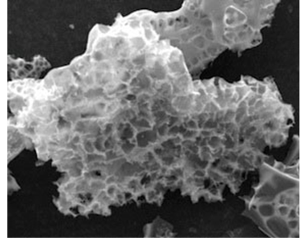
Fig. 2. 2. The picture of silica particle through SEM
Nanoporous material is classified to porous structural materials due to its own properties such as pore sizes, surface, and framework. Therefore, it can be applied in many various ways because of its properties especially in the application of head protection which is mentioned in previous chapter. First of all, the definition of porous materials is necessary. Porous materials can be classified based on their pore sizes (micropores < 2 nm, mesopores 2–50 nm, and macropores > 50 nm).[15] A porous material is a solid that has pores throughout its body. For the experiment of NPL system, silicon dioxide, also known as silica, is a key chemical compound that is an oxide of silicon with the chemical formula SiO₂. As the Fig 2.2. is shown.
2.3 Nanoporous Particle Liquid System
In NPL system consisting of hydrophobic nanoporous materials immersed in distilled water, as the pressure increases the water can be forced into the nanopores, accompanied by a large increase in system free energy. Kong et al [16,17]. first reported the energy absorption behaviors of nanoporous silica particles immersed in aqueous solutions. Ethanol or methanol was used as promoter to adjust the infiltration pressure. Therefore, the energy-absorbing capabilities of the NPLs was optimized.
Following significant amount of work completed by Dr. Yu Qiao’s group at UCSD, they describe how to design the experiment of creating NPL system with hydrophobic nanoporous particles immersed in liquid such as water, methanol or ethanol aqua solution in the costumed container[18]. Also shown in Fig. 2. 3. 1. As the pressure increases, solvent molecules, ethanol or methanol promoters are forced into the nanopore of particles. Here they observed that there are two phenomena during loading process. One is called Non-outflow which is likely to occur for pore size of 2-50 nm. The other one is called Outflow which is likely to happen in pore size of 1-2 nm. To explain these phenomena happened while giving the force in NPL system, there are several factors to cause the promoter which is trapped in 1-2 nm nanopore and cannot escape, such as temperature, pore shape, and surface morphology
Fig. 2. 3. 1 Diagrams of nanoporous particle liquid system
(a) NPLs in costumed container with force$P$
(b) Works in Nanopore of silica particle [18].
Here, to prove the mechanical property of NPLs is to analyze elastic behavior of NPLs with ethanol promoter and methanol promoter through stress-strain curves diagrams. Therefore, we designed the two experiments about explaining the definition of NPLs mechanical properties of materials. Fig. 2.3.2. & Fig. 2.3.3. Moreover, each NPLs sample with different promoter but in same percentage is given the force board from 500N to 2500N. Also it is set up to the compression test during load/unload cycles. For the result, it comes up with the $P-∆V$ curve. The 1st cycle and the 2nd cycle is during 500N and 1000N in load/unload cycles, as the pressure increases, initially the curve of both NPLs is nearly straight which is meant the system volume decreased linearly. In other words, the initial pressure is too low for water molecules to overcome the repulsion effect between the nanopore wall and the water molecules, so the linear compression behavior of pure water and empty mesoporous silica particles is dominant. But in 3rd cycle under 1500N, there is the obvious difference between NPLs with methanol promoter and NPLs with ethanol promoter. NPLs with methanol promoter is still in linear curve. On the other hand, the NPLs with ethanol is reaching to its yielding region. In the 4th cycle under 2000N, the plateau curve is happened in both of NPLs curves which is meant pressure induced infiltration began in this moment. After 5th cycle, 6th cycle and 7th cycle which are all under 2500N, the both curve of NPLs begin increasing again. It represented the nanopore of particle were filled with promoter which couldn’t come out and trapped in the pore. The linear compression of liquid was happened, it is because the linear compressible behavior of the filled nanoporous silica particles and water molecules is shown, because nanoporous silica particles have little pore volume to occupy methanol or ethanol molecules.
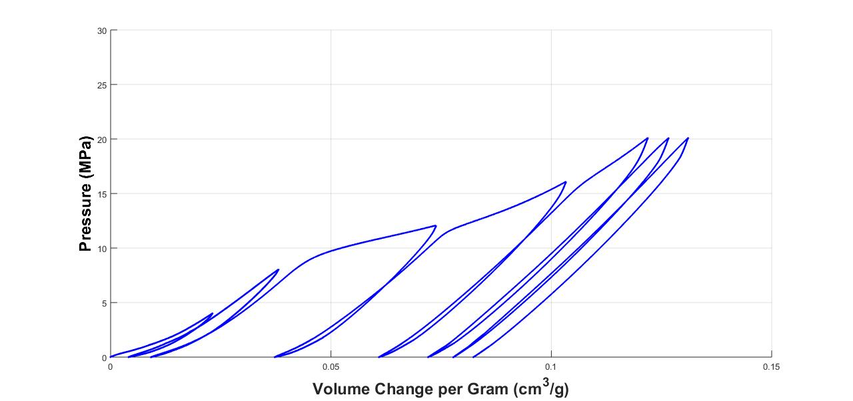
Fig. 2. 3. 2. 10% Ethanol solution with silica particle in different load/unload cycle
(a)500N (b)1000N (c)1500N (d)2000N (e)2500N
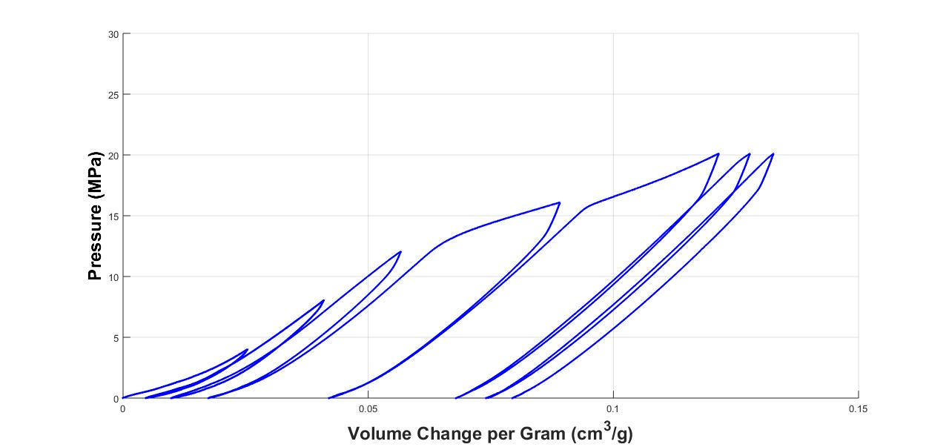
Fig. 2. 3. 3. 10% Methanol solution with silica particle in different load/unload cycle
(a)500N (b)1000N (c)1500N (d)2000N (e)2500N
As the Fig. 2.3.4. shown, here we use the diagrams of 10% Methanol solution with 0.3 gram silica particle. In elastic region, the slope is linear and equal to the Young modulus of the NPL system. As the loading increases, the NPL system begins to collapse, like foam cells depending on the mechanical properties of the cell walls preciously mentioned. Collapse progresses at roughly constant load, giving a stress plateau, until the opposing walls in the cells meet and touch, when densification causes the stress to increase steeply [19].
NPLs can be considered as the energy absorbing materials in the 1st cycle during load/unload. According to the material mechanism, we can separate the stress-strain curve of NPLs into three regions which is linear elasticity, plateau and densification. For the beginning, it occurs when the strains the curve is actually a straight line in region I, so that the stress is proportional to the strain. NPL system with methanol promoter in this region is said to be linear elastic. stress limit to this linear relationship is called the proportional limit or infiltration pressure of NPLs with methanol promotor, $σ_{pl}=12 MPa$. From previous experiment, we observe the proportional limit or infiltration pressure of NPLs with ethanol promotor, $σ_{pl}=9 MPa$. This result will be get more discussion in chapter 5. After 2nd cycle, 3rd cycle and 4th cycle which are all under 2500N as previous experimental setting, the result as the figure shown is also the same curve as the previous one.
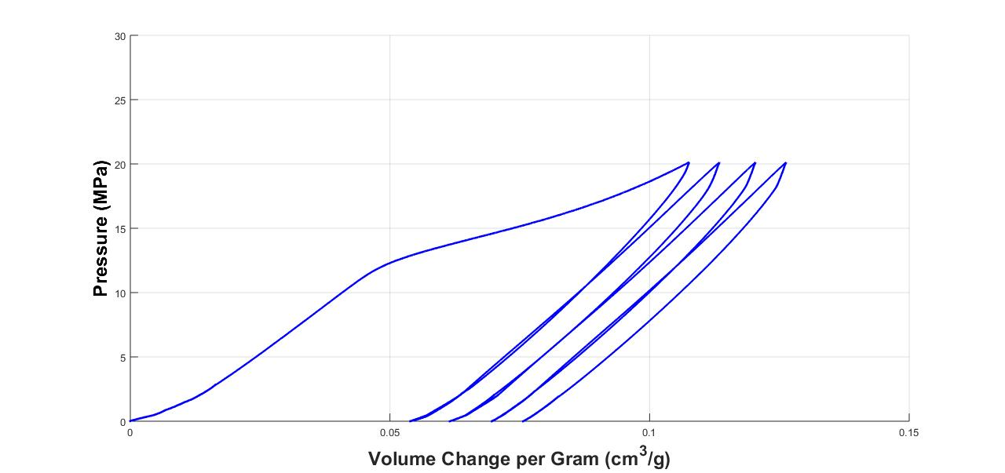
III
II
I
Fig. 2. 3. 4. 10% Methanol solution with 0.3 gram silica particle

2.4 Energy Absorption of Nanoporous Particle Liquid System
Absorption is a process that may be chemical (reactive) or physical (non-reactive). Physical absorption or non-reactive absorption is made between two phases of matter: a liquid absorbs a gas, or a solid absorbs a liquid. However, only the physical absorption of solid/liquid phase will be mentioned in this thesis.
Under the physical absorption, to calculate how much energy is absorbed by the NPLs is by using the load-unload curves. The energy absorption capabilities of different NPLs can be compared to optimize the formula of NPL system for impact protection. As previous section mentioned, the system works only when an applied external pressure reaches to precise value, called as infiltration pressure could overcome the capillary resistance and invade into the nanopore. Due to the hydrophobic nature of the nanoporous wall, the absorbed energy during the infiltration and defiltration can be defined infiltration pressure, $P_{in}$ , with the infiltrated volume of liquid,$∆V$, we get the total :
$E=P_{in}*∆V$ (2.1)
Like any energy absorption material is deformed by an external load, the load will do external work, which in turn will be stored in the material as internal energy. This energy is related to the strains in the material, and so it is referred to as strain energy. To obtain this strain energy let us consider a volume element of material from the compression test specimen Fig 2.4.1. It is subjected to the uniaxial stress $σ$. This stress develops a force which can be settled in different position.
$u_{t}=∆F∆z= σ ∆A∆z= σ(∆x∆y∆z)$ (2.2)
Fig. 2. 4. 1. Per-volume with stress σ
To find energy absorption in NPLs, we still use pervious the $P-∆V$ curve result from NPLs with methanol promoter to demonstrate. Therefore, we get energy from the area which is described the pressure in $y$ axis times and the volume change in $x$ axis. The total stored energy from loading subtracted released energy from unloading then the absorbed energy is defined. As Fig. 2.4.2. is shown.
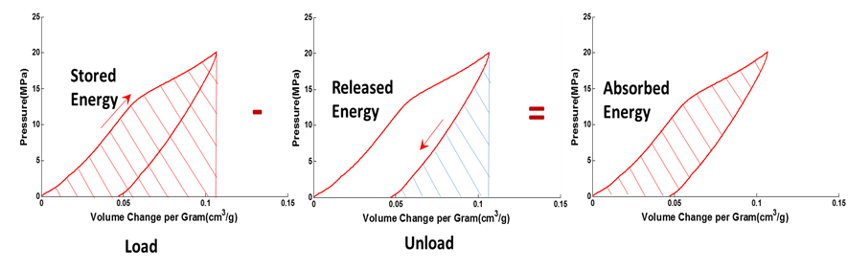
Fig. 2. 4. 2. Demonstration of NPLs in energy absorption by using the P-∆V curve

2.5 Experiment

2.5.1 Material Preparation
All the following listed materials and reagents were used as received. Silica gel 100 C₈, ethyl alcohol (≥ 99.5), anhydrous methanol (99.8%), deionized water was from Sigma Aldrich. According to the information provided by the supplier, the silica gel employed in this paper has an average pore size of 9 nm and the particle size of 40-63 um. [20]
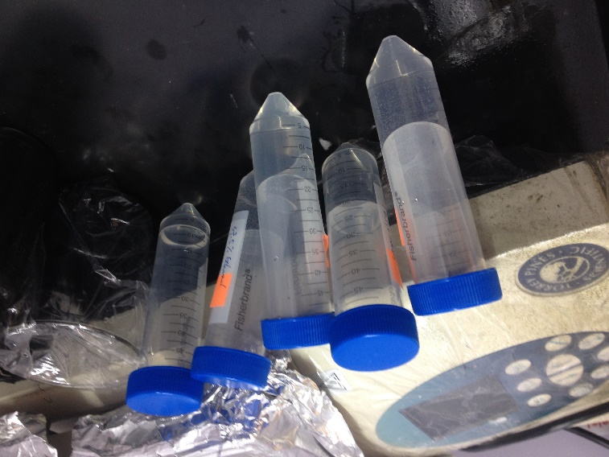
Fig. 2. 5. 1. The NPL system before putting in customized cylinder
All of the sample of NPL system tested in each experiment are 10 ml with 0.3 gram silica nanoporous particles. As Fig. 2.5.1. is shown. First, all the silica particles are kept in a vacuum oven under vacuum at 100 ºC for 24 hours to remove the trace of moisture in the materials. Second, the measured silica particle is added to the measured deionized water and stirred manually for 5 minutes. Then the promoter, such as ethanol or methanol, is measured and added to the solution. After mixing manually for 5 more minutes, all the solution is transferred to the stainless steel cylinder. All the air is removed before sealing the cylinder. The inner diameter of the cylinder is 0.5 inch and the outer diameter of the cylinder is 1.5 inch. NPLs with different concentration of methanol and ethanol promoters are tested. First, pure deionized water with only silica particles is prepared and tested as the references. Then NPLs with ethanol concentration of 10%, 20%, and 30% are prepared and tested. Finally, NPLs with methanol concentration of 10%, 20%, and 30% are prepared and tested.
The prepared NPL into costumed stainless steel cylinder is tested by using an Instron mechanical testing system under quasi-static compression load with a load speed rate of 2 mm/min, as shown in Fig 2.5.4. Experimental data including force, displacement, and cycle are recorded during the experiment. The pressure inside the cylinder is calculated using the equation:
$P=\frac{F}{A}$ (2.3)
We can determine the nominal or engineering stress by dividing the applied load $P$ by the specimen’s original cross-sectional area $A$. This calculation assumes that the stress is constant over the cross section and throughout the gauge length.
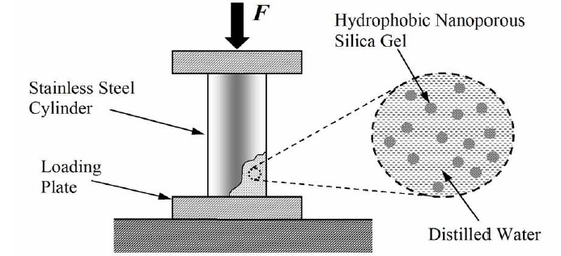
Fig. 2. 5. 2. Diagrammatic illusion of NPLs experiment [18].
In Fig 2.5.2, $P$ is the pressure inside the cylinder, where we can get the value of $F$ recorded by the load cell from the test machine, and $A$, where $A=126.67 {mm}^{2}$ is the cross-sectional area of the costumed cylinder piston, was pressed into the container, and at the critical pressure $P_{in}$, the pressure induced infiltration occurred. A full load-unload cycle is conducted in each experiment. The pressure variation and volume change are calculated accordingly.

2.5.2 Experimental Setup
As Fig. 2.5.3. is shown,
(a) All the silica particles are kept in a vacuum oven under vacuum at 100 ºC for 24 hours to remove the trace of moisture in the materials.
(b) The measured silica particle is added to the measured deionized water with or without promoter, such as ethanol or methanol and then stirred in 5 minutes by hand.
(c) The sample is put into costumed stainless steel cylinder and developed into Instron mechanical testing system
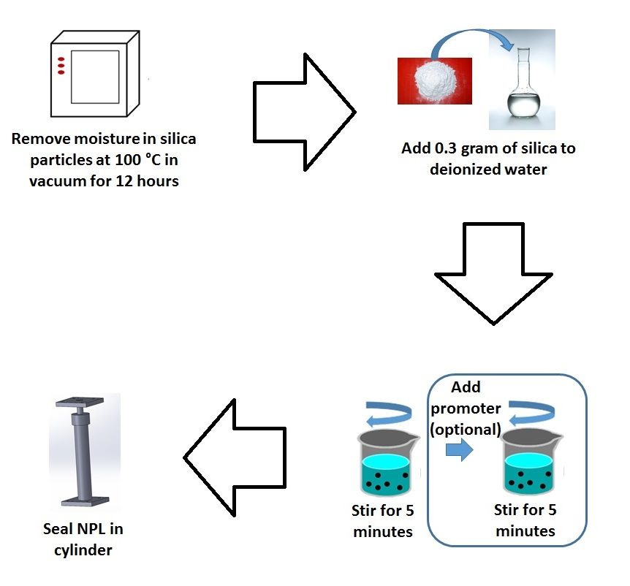
Fig. 2. 5. 3. Experimental Procedures of NPLs

Fig. 2. 5. 4. Experimental Setup and stainless steel cylinder used during testing.

CHAPTER 3.
NANOPOROUS PARTICLE LIQUID WITH ETHANOL PROMOTERS FOR ENERGY ABSORPTION

3.1 Introduction
In chapter 2, the experimental procedure is explained. The propose of this experiment in this section is try to observe the phenomenon about with different concentration of aqueous solution in NPL system included not-wetting silica particles and ethanol promoters. All the prepared NPLs are tested experimentally using a customized stainless steel cylinder under quasi-static load conditions. The load-unload curves of NPLs present critical information, such as infiltration pressure. Then NPLs with ethanol concentration of 10%, 20%, and 30% are prepared and tested

3.2 Result and Conclusion
As Fig. 3.2.1., Fig. 3.2.2. and Fig. 3.2.3. are shown, the result of NPLs with different concentration with each different ethanol concentration solution, 10%, 20%, and 30%. It indicates that the plateaus in the isotherm curves are associated with the pressure induced infiltration. Also, the relationship of infiltration pressure and volume change per gram of silica particles is shown.
For the NPL based on deionized water and silica particles, the system responds almost linearly when the pressure applied is low. Once the pressure passes the infiltration pressure of 15 MPa, the slop of the pressure curve is bend, resulting in larger volume change. The linear system response is due to the bulk modulus of the solution. Limited amount of water molecules is pushed into the large pores in silica particles. The compression of air in silica pores is the main reason of volume change. Once the pressure passes the infiltration pressure, substantial amount of water molecules is pushed into the small pores in silica particles. These water molecules are temporarily trapped in the pores. Therefore, the slop of pressure starts reducing, as shown in Fig. 3.2.4. During the unloading process, the system responses almost linearly again. Since the water has been trapped in small pores, only water molecules in large pores can be released to the solution. Therefore, we observe volume reduction of the NPLs after experiments.
Interestingly, When the concentration of ethanol increases, the infiltration pressure reduces accordingly. As we except for the significant reduction of infiltration pressure, when we increased the volume percentage of ethanol solution. Under the infiltration pressure, the system is almost linear. However, if we increase pressure over the infiltration pressure, the system responses to the plateau region.

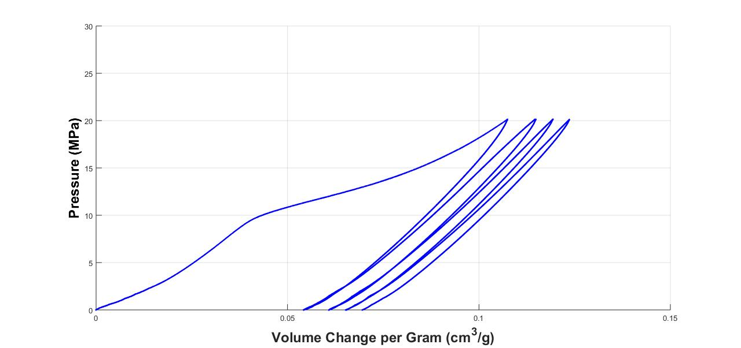
Fig. 3. 2. 1. 10% ethanol solution with 0.3 gram silica particle.

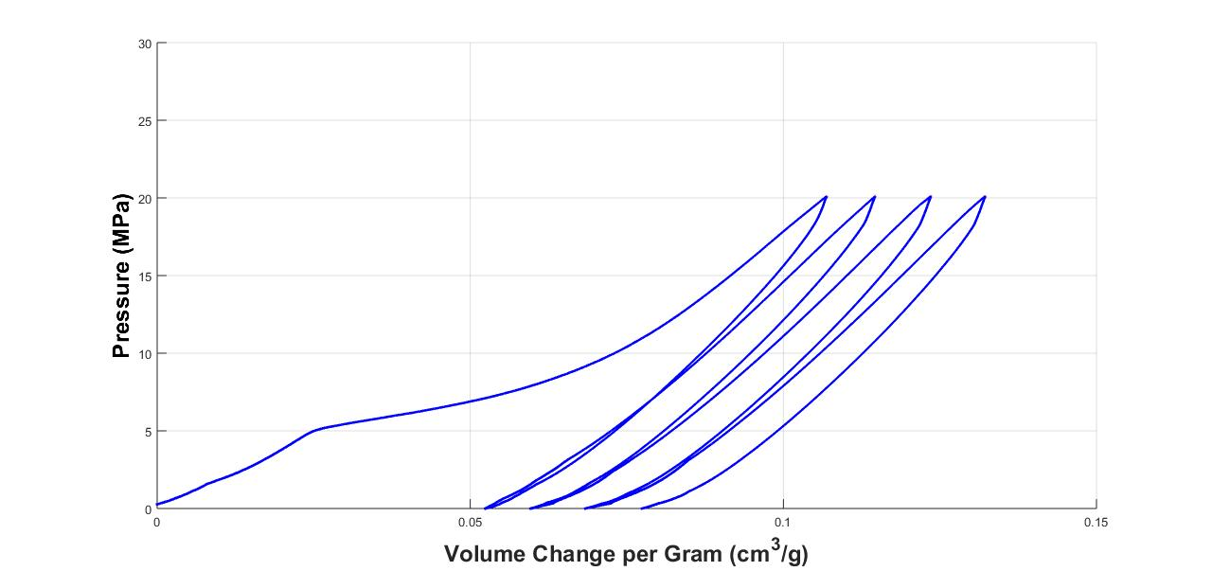
Fig. 3. 2. 2. 20% ethanol solution with 0.3 gram silica particle.

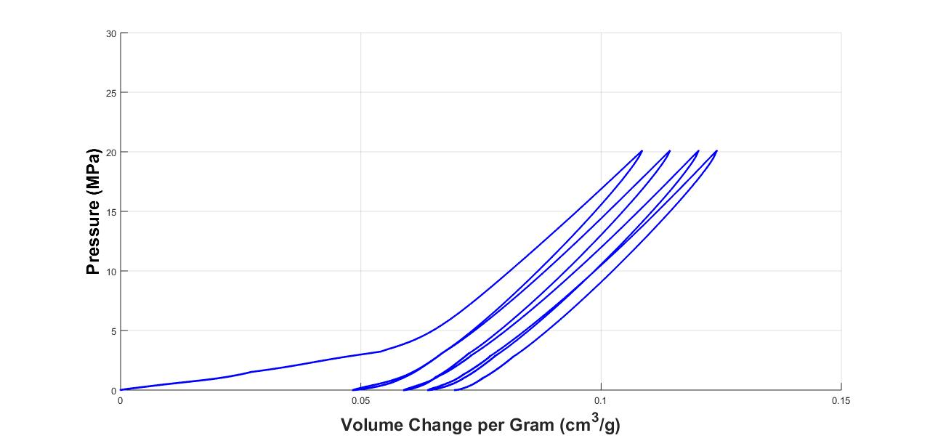
Fig. 3. 2. 3. 30% ethanol solution with 0.3 gram silica particle.
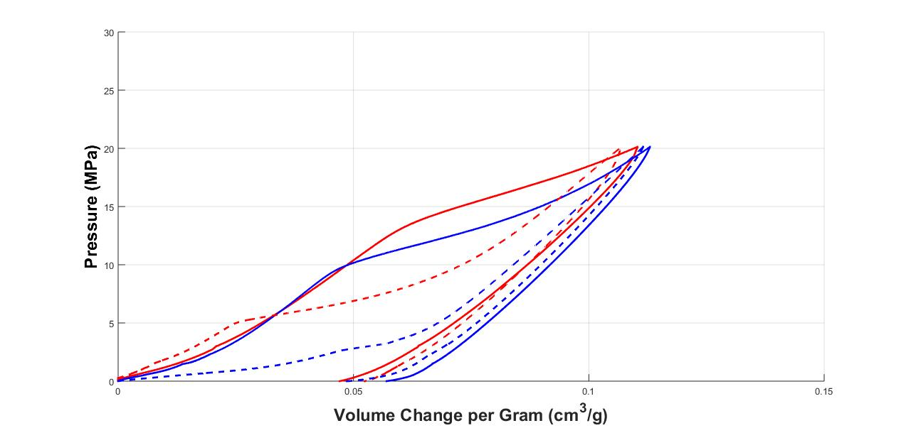
Fig. 3. 2. 4. Comparison of different concentration of ethanol solution.
The variation in promoter content, such as ethanol and methanol, can significantly reduce the infiltration pressure of the NPLs. By adding different amount of ethanol, it is noted that the infiltration pressure of NPLs can reduce from around 20 MPa to less than 1 MPa. In addition, the plateau of the pressure curves moves slightly to the larger volume change range, indicating more molecules are pushed into the pores in silica particle during the loading process. All the unloading process still shows similar linear change, as shown in Fig. 3.2.4. It proves the release of molecules from large pores in silica only [21]. The trapped water and ethanol molecules need external energy stimulation before naturally released to the solution again.

CHAPTER 4.
NANOPOROUS PARTICLE LIQUID WITH METHANOL PROMOTERS FOR ENERGY ABSORPTION

4.1 Introduction
Methanol promoter is the second type of promoter which will be discussed in this section. Basically Methanol, is the simplest alcohol, is classified in only a methyl group linked to a hydroxyl group. It is a light, volatile, colorless, flammable liquid with a distinctive odor very similar to that of ethanol [11]. Unlike ethanol, methanol is highly toxic and unfit for consumption. Also, the promoter of methanol is smaller than the promoter of ethanol. This is why we decide to test NPLs with methanol promoter under load/unload. As Fig. 4.2.1., Fig. 4.2.2. and Fig. 4.2.3. are shown, the result of NPLs with different concentration with each different methanol concentration solution, 10%, 20%, and 30%.

4.2 Result and Conclusion
When methanol was used as promoter, interestingly, we observe the same result as ethanol condition. As shown in Fig. 4.2.4., NPLs with methanol promoters show similar trend. When the concentration of methanol increases, the infiltration pressure reduces accordingly. In addition, more volume change is observed. Since the molecule size of methanol is smaller than that of ethanol, it is relatively easy to push more methanol molecules to the pores in silica particles. The NPLs with methanol systems also respond linear during the unloading process, which indicate the release of only water and methanol molecules from large pores in silica particles.
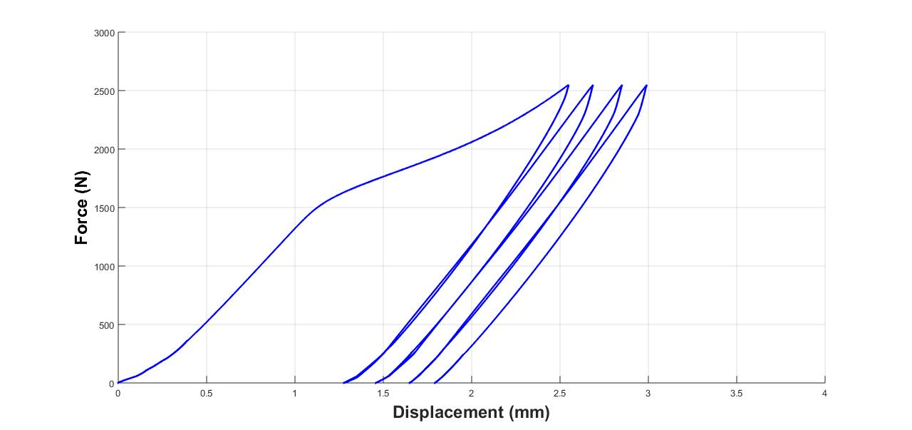
Fig. 4. 2. 1. 10% methanol solution with 0.3 gram silica particle.
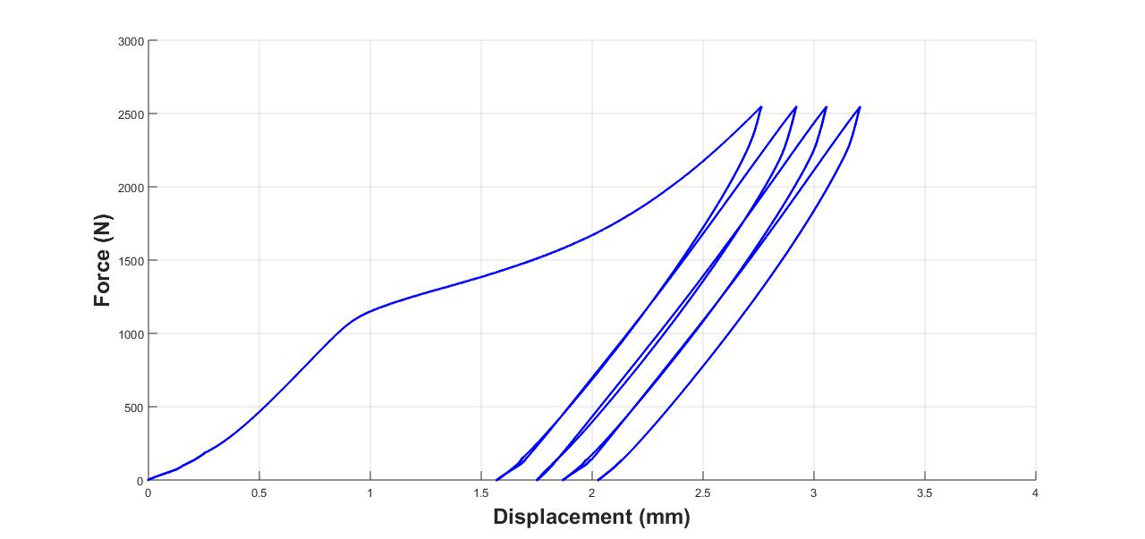
Fig. 4. 2. 2. 20% methanol solution with 0.3 gram silica particle.
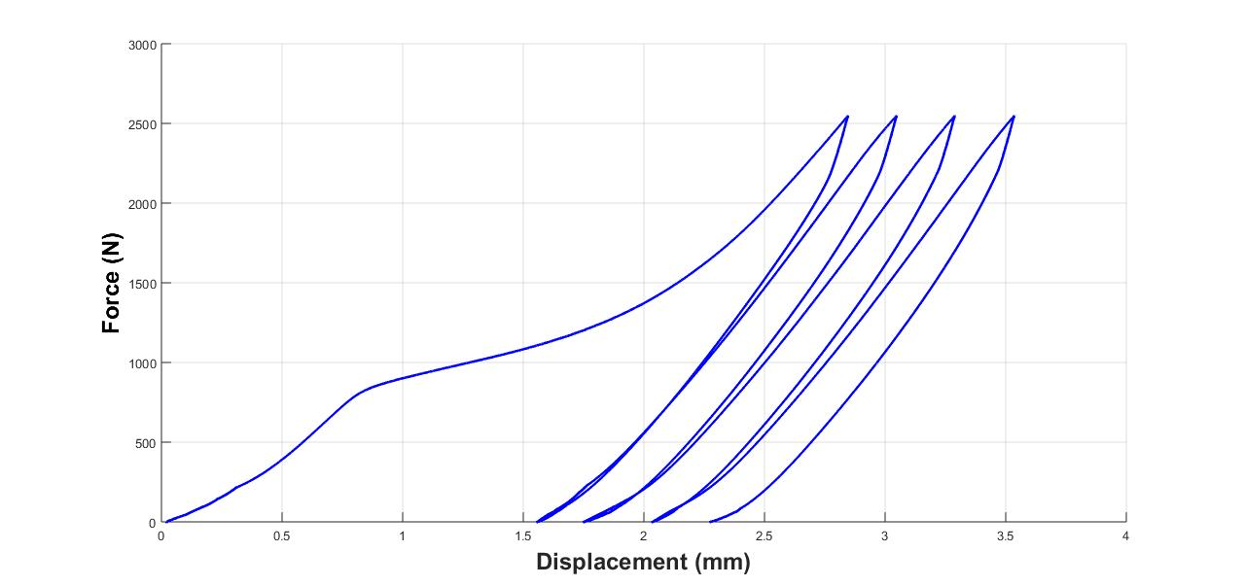
Fig. 4. 2. 3. 30% methanol solution with 0.3 gram silica particle.
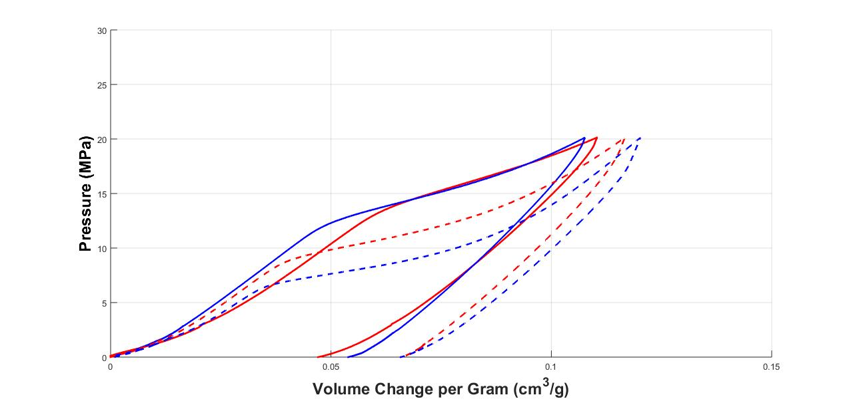
Fig. 4. 2. 4. Comparison of different concentration of methanol solution.

CHAPTER 5.
CHARACTERIZATION OF NANOPOROUS PARTICLE LIQUID UNDER CYCLIC LOAD

5.1 Introduction
In this section, we will put the both of the results from 10 ml aqueous solutions with different promoters with different concentration, such as 10%, 20%, and 30% ethanol and methanol content plus 0.3 gram silica particle, both of factors can significantly reduce the infiltration pressure of the NPLs. By adding different amount of ethanol or methanol, it is noted that the infiltration pressure of NPLs can reduce from around 20 MPa to less than 1 MPa. In addition, the plateau of the pressure curves moves slightly to the larger volume change range, indicating more molecules are pushed into the pores in silica particle during the loading process. All the unloading process still shows similar linear change. It proves the release of molecules from large pores in silica only. The trapped water and ethanol molecules need external energy stimulation before naturally released to the solution again.[18]

5.2 Energy absorption
As previous section we discussed, to find energy absorption in NPLs, we integral the area under $P-∆V$ curve from NPLs with methanol promoter to demonstrate Energy absorption. Therefore, we get energy from the area which is described the pressure in $y$ axis times and the volume change in $x$ axis. The total stored energy from loading subtracted released energy from unloading then the absorbed energy is defined. As Fig 5.2.1. is shown.
Fig. 5. 2. 1. Demonstration of NPLs in energy absorption by using the $P-∆V$ curve.

5.3 Result and Conclusion
Comparing the system performance using ethanol and methanol promoters, it is noted that the infiltration pressure of NPLs with different promoters changes differently. As shown in Fig. 5.3.1., the infiltration pressures reduce significantly when ethanol is used as promoter. As the concentration increased to 30%, the NPL with ethanol has an infiltration pressure of less than 1 MPa. However, the NPLs with methanol do not show such a significant reduce of infiltration pressure. The significant reduce of infiltration pressure for NPLs with ethanol is considered to be related to the surface energy of ethanol and silica pores. More detailed analyses are needed to demonstrate this assumption.
Fig. 5. 3. 1. The infiltration pressure of different NPLs with ethanol or methanol promoters
In a conclusion, the amount of energy absorbed by NPLs is one of the most critical parameter characterized in this section. As shown in Fig. 5.3.2. and Fig. 5.3.3., it is noted that both NPLs with ethanol and methanol promoters have the maximum energy absorption with 10% concentration. However, due to the significant reduce of infiltration for ethanol based NPLs, the energy absorption capabilities is reduced quickly as the concentration increases. The NPLs with methanol as promoters do not show such a significant reduce. Based on the application, the optimal concentration of promoter can be selected based on this study.

Fig. 5. 3. 2. Energy absorption capability of NPL with ethanol promoters.

Fig. 5. 3. 3. Energy absorption capability of NPL with methanol promoters.

CHAPTER 6.
LONG TERM PERFORMANCE OF NANOPOROUS PARTICLE LIQUID

6.1 Introduction
To prove that NPLs could be becoming manufacturing product, this section is to test this system is still performed the same property of absorbing energy during long-term period. According to previous experimental data, we select the both of sample which is performed well from different concentration solution with different promoter to exanimate each sample in long-term period from 72 hours to 244 hours with the intervals, 24 hours and 36 hours respectively in this experiment. As Figure is shown from Fig. 6.2.1. to Fig. 6.2.10.

6.2 Results and Conclusion
According to the result of this experiment, there is no doubt the NPLs would not be dissolve in aqueous solution or sabotaged by aqueous solution after being through long period. the NPLs can still work efficiently as the beginning. As Fig. 6.2.11. and Fig. 6.2.12. are shown, the infiltration pressure for both NPLs with methanol and ethanol promoter is still remain in the same value.

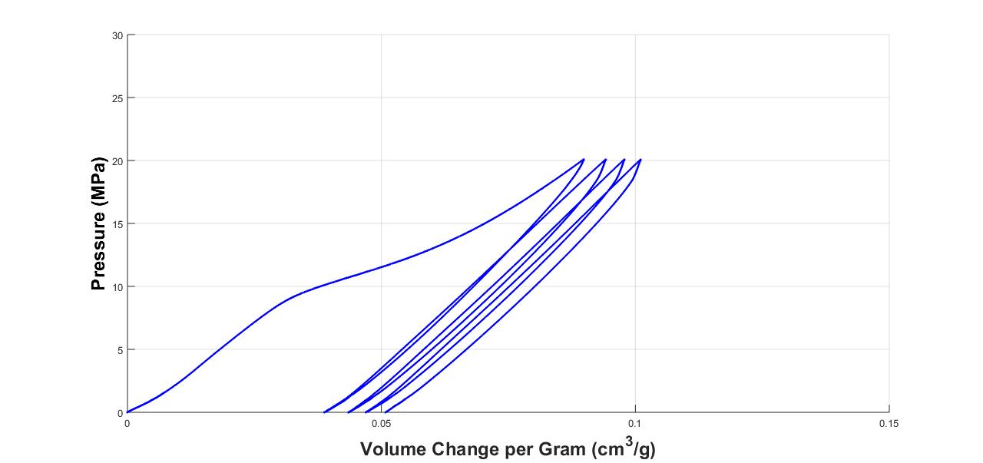
Fig. 6. 2. 1. Ethanol solution with silica particle in 72 hours.
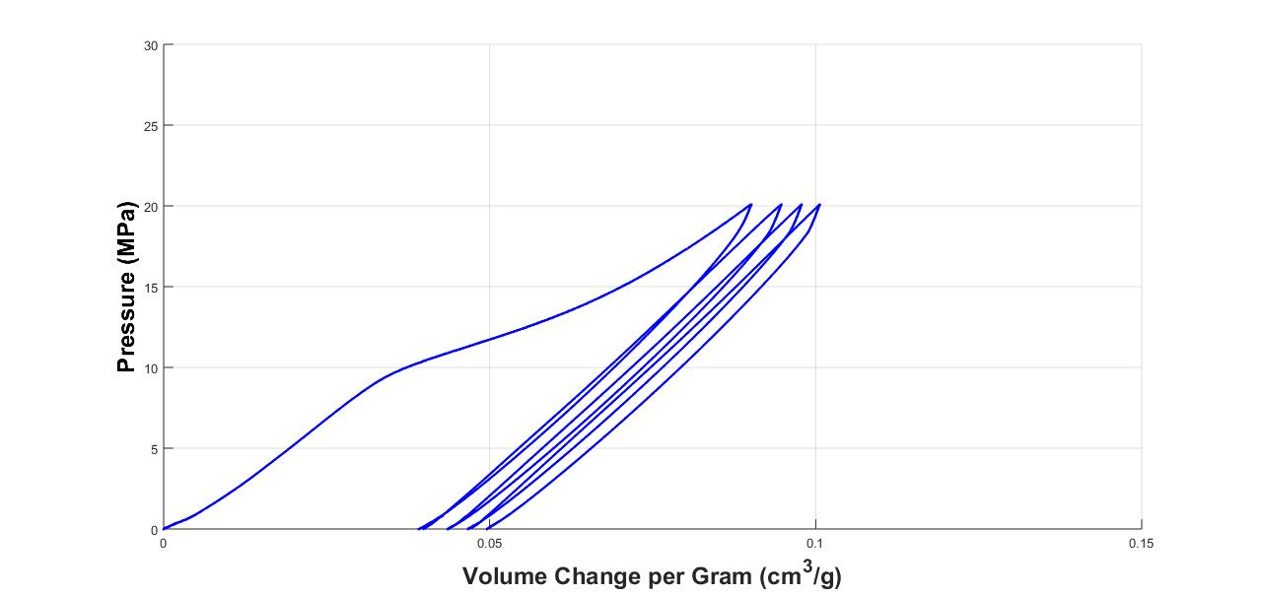
Fig. 6. 2. 2. Ethanol solution with silica particle in 99 hours.

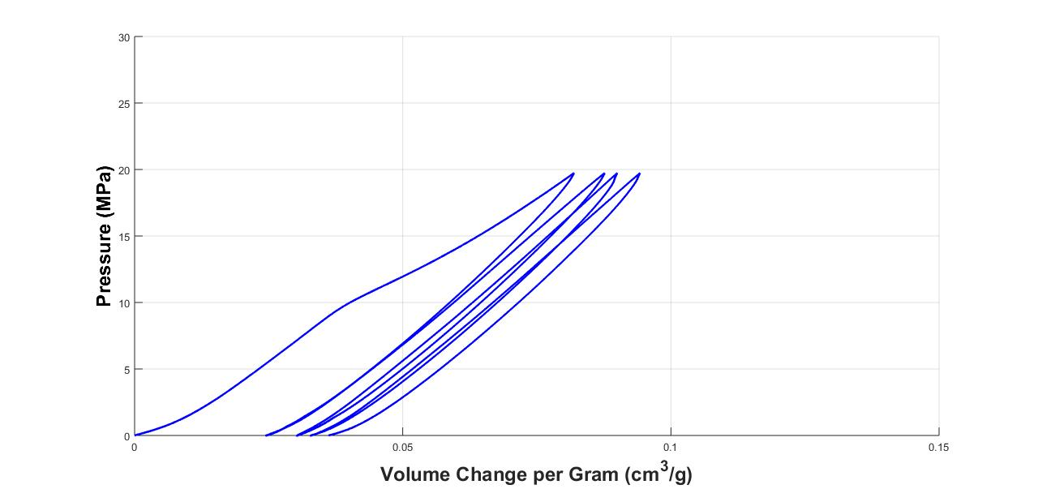
Fig. 6. 2. 3. Ethanol solution with silica particle in 110 hours.
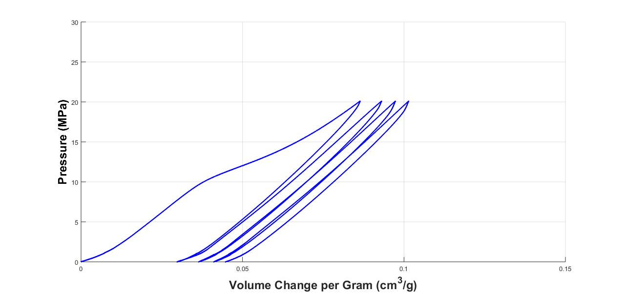
Fig. 6. 2. 4. Ethanol solution with silica particle in 148 hours.
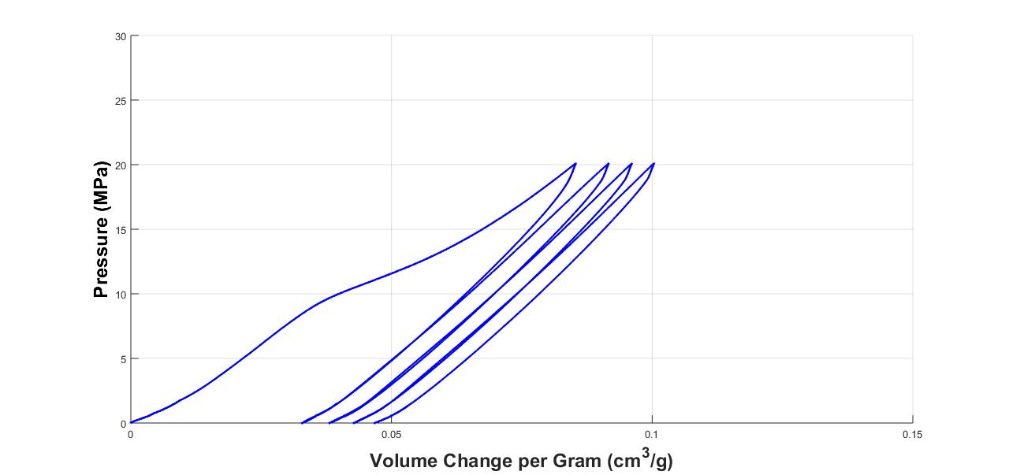
Fig. 6. 2. 5. Ethanol solution with silica particle in 244 hours.
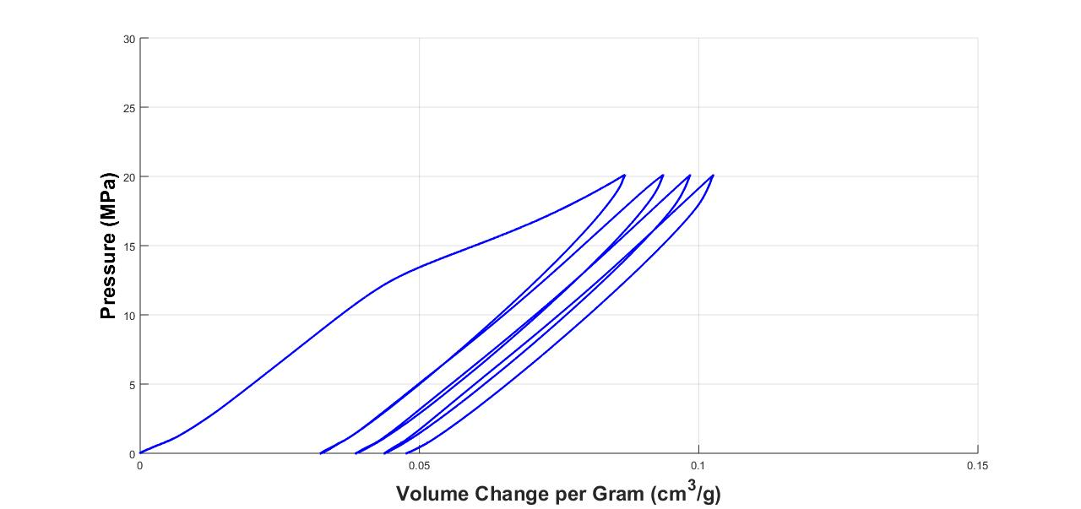
Fig. 6. 2. 6. Methanol solution with silica particle in 72 hours.
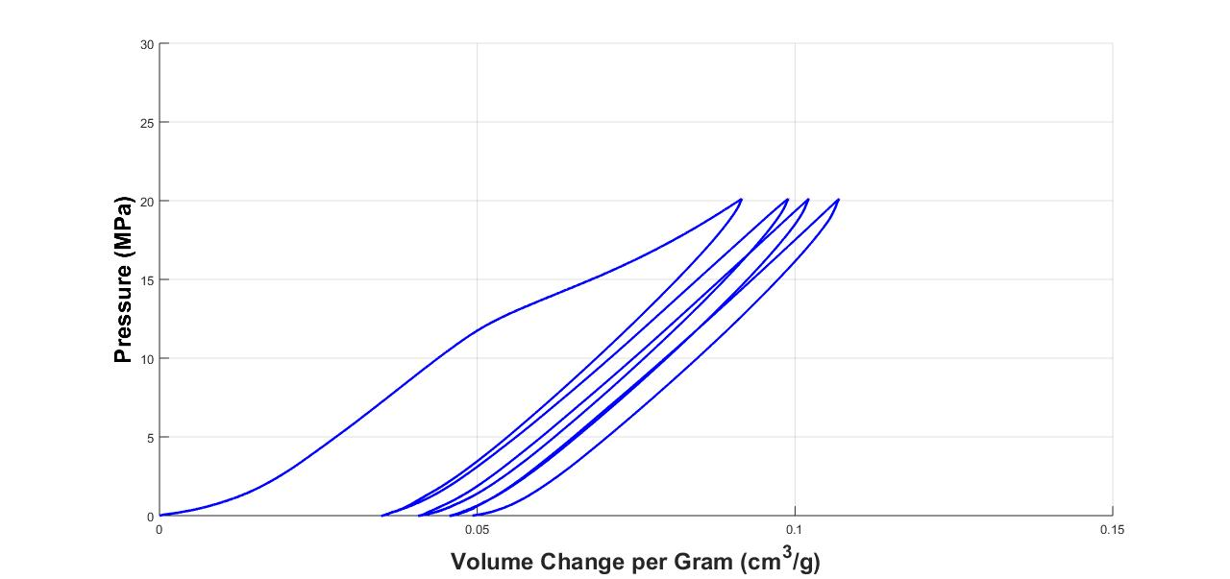
Fig. 6. 2. 7. Methanol solution with silica particle in 99 hours.
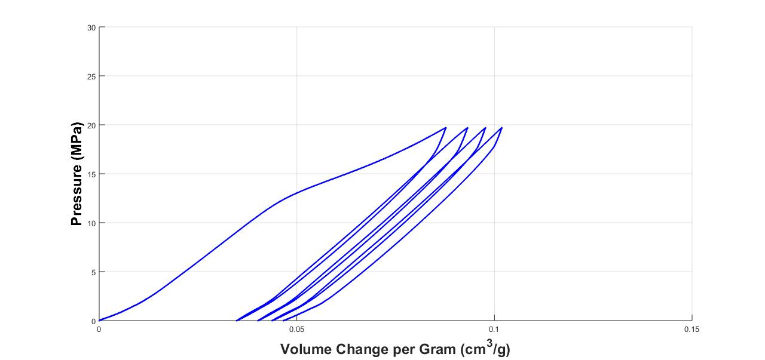
Fig. 6. 2. 8. Methanol solution with silica particle in 134 hours.
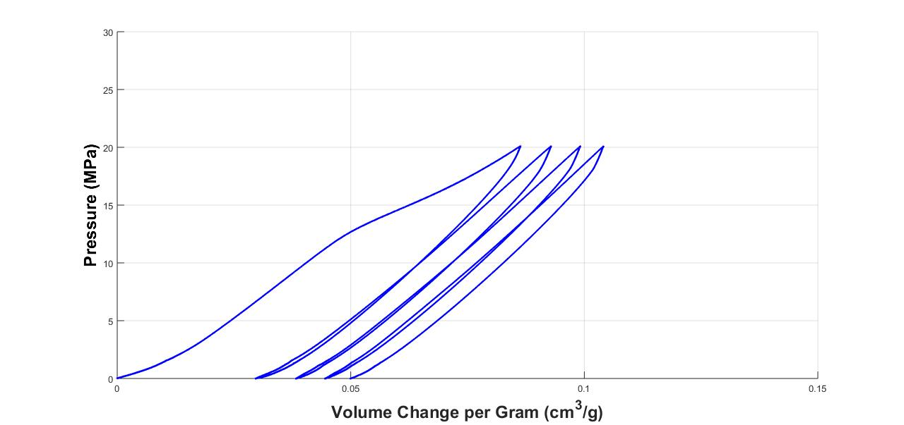
Fig. 6. 2. 9. Methanol solution with silica particle in 148 hours.
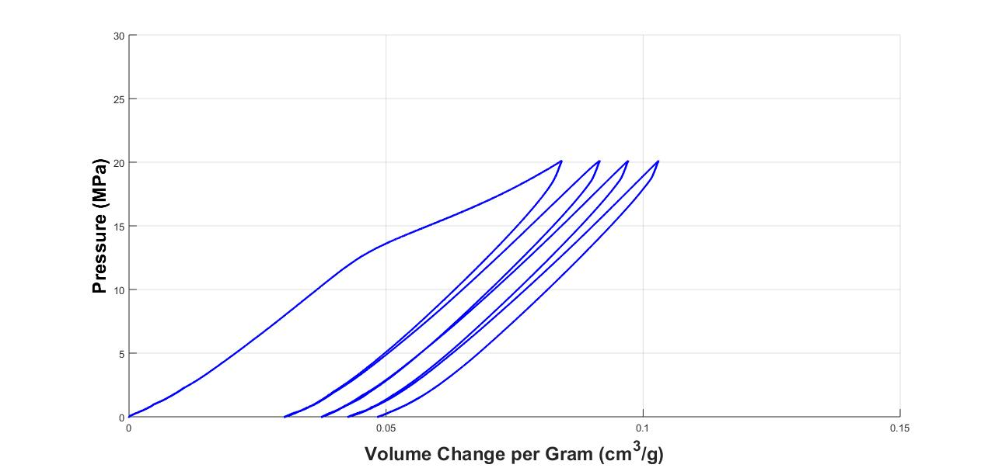
Fig. 6. 2. 10. Methanol solution with silica particle in 244 hours.

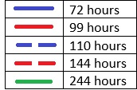
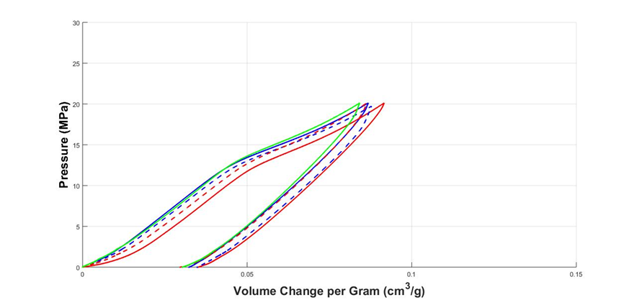
Fig. 6. 2. 11. Comparison of NPLs with methanol promoter in different period.
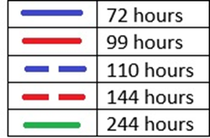
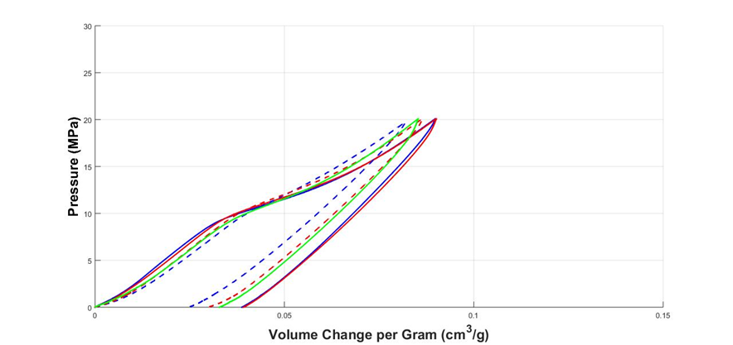
Fig. 6. 2. 12. Comparison of NPLs with ethanol promoter in different period.

CHAPTER 7.
CONCLUSION AND FUTURE WORK

7.1. Conclusion
This thesis reported an experimental characterization approach to understand the performance of NPLs using silica nanoporous particles and ethanol / methanol promoters. Both NPLs with ethanol and methanol promoters show good energy absorption capabilities under a quasi-static load conditions. Even though NPLs holds in the long-term period, still it has ability of energy absorption. At the low pressure range, the pressure increases almost linearly until it reaches the infiltration pressure. Once the pressure passes infiltration pressure, a substantial amount of water and promoter molecules are pushed into the pores of silica nanoporous particles, resulting in the non-linear performance of the system. The system shows linear responses again during the unloading process due to the molecule release only from large pores in the particles. Although both ethanol and methanol can significantly impact on the infiltration pressure, the methanol promoter is not effective in the infiltration pressure of NPLs as significant as ethanol.

7.2. Future Work
As the result from all the experiments, the energy-absorbing ability of NPLs is proved that it works as well as any other energy absorption materials. However, there are some questions still need to be solved. Because of all the tests which is set in low-velocity condition, to investigate more complex load / unload conditions including impact by using a Hopkinson bar testing system and cyclic load is necessary [23]. Obviously, its property shows that this system can be used for body protection in sport field even though it can’t be utilized in high-velocity impact protection in military. In the nano-environment, the inner surface of nanopore should be considered because the NPLs infiltration pressure is created when the promoters are forced into nanopore [18,22]. Here, we used different concentration of promoter content to control the infiltration pressure. However, pore surface structure is one of the essential factor which affect the ability of energy absorption [24]. So developing new treatment for nanopore surface and using new material like carbon materials is also important. For most of the energy absorption materials used in many protection systems, such as car bumpers and body armors, work only under the first loading. Comparison of the other materials, NPLs is easy to recover from deformation. In other words, how to solve the non-flow phenomena should be investigated.

REFERENCES

- Thunnan, D. J., et al. (1998). "The epidemiology of sports-related traumatic brain injuries in the United States: recent developments." The Journal of head trauma rehabilitation 13(2): 1-8.

- Wikipedia (2016). "Traumatic brain injury."

- Powell, J. W. and K. D. Barber-Foss (1999). "Traumatic brain injury in high school athletes." Jama 282(10): 958-963.

- Pellman, E. J., et al. (2003). "Concussion in professional football: reconstruction of game impacts and injuries." Neurosurgery 53(4): 799-814.

- Barth, J. T., et al. (2001). "Acceleration-deceleration sport-related concussion: the gravity of it all." Journal of Athletic Training 36(3): 253.

- Tanielian, T. and L. H. Jaycox (2008). "Invisible wounds of war." Santa Monica, CA: Rand Center. Retrieved on July 11: 2008.

- Shaw, N. A. (2002). "The neurophysiology of concussion." Progress in neurobiology 67(4): 281-344.

- Hibbeler, R. C. (2014). "Mechanics of materials nine edition." Pearson Education South Asia Singapore 2014.

- Cheeseman, B. A. and T. A. Bogetti (2003). "Ballistic impact into fabric and compliant composite laminates." Composite structures 61(1): 161-173.

- Roylance, D. (1980). "Stress wave propagation in fibres: effect of crossovers." Fibre Science and Technology 13(5): 385-395.

- Tabiei, A. and G. Nilakantan (2008). "Ballistic impact of dry woven fabric composites: a review." Applied Mechanics Reviews 61(1): 010801.

- Goldsmith, W. and D. L. Louie (1995). "Axial perforation of aluminum honeycombs by projectiles." International Journal of Solids and Structures 32(8): 1017-1046.

- Caccese, V., et al. (2013). "Optimal design of honeycomb material used to mitigate head impact." Composite structures 100: 404-412.

- Xie, S. and H. Zhou (2015). "Analysis and optimisation of parameters influencing the out-of-plane energy absorption of an aluminium honeycomb." Thin-Walled Structures 89: 169-177.

- Kim, T. W. (2011). "Energy absorption behaviors of nanoporous materials functionalized (NMF) liquids."

- Kong, X. and Y. Qiao* (2005). "Thermal effects on pressure-induced infiltration of a nanoporous system." Philosophical magazine letters 85(7): 331-337.

- Kong, X., et al. (2005). "Effects of addition of ethanol on the infiltration pressure of a mesoporous silica." Journal of Materials Research 20(04): 1042-1045.

- Qiao, Y., et al. (2005). Nanoporous Energy Absorption Systems. ASME 4th Integrated Nanosystems Conference, American Society of Mechanical Engineers.

- Lu, W. (2011). "Experimental investigation on liquid behaviors in nanopores."

- SIGMA-ALDRICH "Silica gel C8-Reversed phase." 60759 - Silica gel C8-Reversed phase.

- Kong, X., et al. (2005). "Effects of addition of ethanol on the infiltration pressure of a mesoporous silica." Journal of Materials Research 20(04): 1042-1045.

- Surani, F. B., et al. (2005). "Two-staged sorption isotherm of a nanoporous energy absorption system." Applied Physics Letters 87(25): 251906.

- Surani, F. B., et al. (2005). "Energy absorption of a nanoporous system subjected to dynamic loadings." Applied Physics Letters 87(16): 163111.

- Han, A. and Y. Qiao (2006). "Pressure-induced infiltration of aqueous solutions of multiple promoters in a nanoporous silica." Journal of the American Chemical Society 128(32): 10348-10349.

