University of Oklahoma

Graduate College

human-computer interface design
in human factors: weapons drop

A thesis

submitted to the Graduate Faculty

in partial fulfillment of the requirements for the

Degree of

Master of Science

By

elizabeth blanche
Norman, Oklahoma
2018

human-computer interface design
in human factors: weapons drop

A thesis approved for the
School of Industrial and Systems Engineering

by

Dr. Ziho Kang, Chair

Dr. Randa Shehab

Dr. Shivakumar Raman

© Copyright by ELIZABETH BLANCHE 2018
All Rights Reserved.

Acknowledgements
Firstly I would like to thank Dr. Ziho Kang for his guidance throughout this process and working with me on my research. Thank you for helping me expand my horizons and help me make this possible.
I would also like to thank my co-workers and volunteers for my experiment as this would not be possible without you all in ensuring this was as realistic as it could be.
Finally, I would like to thank my family for their undying support in me. Without you, I would not be where I am at today. You all have blessed me with encouragement throughout this process, and never letting me give up through the tough times. I love you.

Table of Contents
Abstract viii
1 Chapter 1: Introduction & Literature Review 1
1.1 Problem Statement 1
1.2 Background 3
1.3 Analog to Digital 4
1.4 Multitasking and Divided Attention 6
1.5 Memory 9
1.6 Design Interface 11
1.7 User Statements and User-Centered Design: Interviews 14
2 Chapter 2: Objective 16
3 Chapter 3: Methodology 17
3.1 Developed Designs 17
3.1.2 Mission designs (Easy vs. Hard) 20
3.1.1 Hard Mission 22
3.2 Methods 24
3.2.1 Experimental Setup and Data Collection 24
4 Chapter 4: Results 32
5 Chapter 5: Discussions and Conclusion 43
6 Chapter 6: Limitations and Future Research 46
7 References 49
8 Appendix A 51
9 Appendix B 55
10 Appendix C 56

List of Tables
Table 1: Participant Information and Results 32
Table 2: GLM Plot for Time 37
Table 3: GLM Plot for Error 39

List of Figures
Figure 1: OSO and DSO Screen Layout 3
Figure 2: Rotary Layout 17
Figure 3: List Layout 18
Figure 4: Inner vs Outer Store on Rotary Launcher 19
Figure 5: Stores Shown in List Based Design 19
Figure 6: Easy Mission Flow Chart 21
Figure 7: Hard Mission Flow Chart 23
Figure 8: Original SMS Panel 25
Figure 9: Modified SMS Panel 25
Figure 10: Mission Map 26
Figure 11: Bay Selection 28
Figure 12: Bay Door Opening Selection 28
Figure 13: Switch Box used to arm the bay 29
Figure 14: Station Numbers 30
Figure 15: Rotary interface showing missing weapon 30
Figure 16: List interface showing missing weapon 31
Figure 17: Mean and Standard Error for Time Measurement (Easy and Hard) 33
Figure 18: Mean and Standard Error for Error Measurement (Easy and Hard) 33
Figure 19: Anderson-Darling Normality Test for Easy Mission of Rotary and List Based Designs for Time 34
Figure 20: Anderson-Darling Normality Test for Hard Mission of Rotary and List Based Designs for Time 34
Figure 21: Anderson-Darling Normality Test for Easy Mission of Rotary and List Based Designs for Error 35
Figure 22: Anderson-Darling Normality Test for Hard Mission of Rotary and List Based Designs for Error 36
Figure 23: GLM Plot for Time 37
Figure 24: Boxplot for Time 38
Figure 25: GLM Plot for Error 39
Figure 26: Boxplot for Error 40

Abstract
In a technologically advanced world, aircraft users tend to get caught up in all of the automation. However, if the automated function stops working, the users are left with analog skills to meet their mission. For the B-1, this means the users must be able to multitask and be proficient in both digital and analog. It is important to design an interface in which the users can be competent and limit the amount of human error in the process. This experiment was performed to see which interface design the users best performed at with the least amount of human error in weapons selection. The interfaces changed between and rotary based design and list based design. Each design also consisted of 2 mission types, easy and hard. The difficulty was determined by the types of errors that could occur that were exterior to the users themselves. The results showed that for time, workload was not significantly impacted based on mission difficulty and interface type. The error results showed that workload was significantly impacted based on mission difficulty and interface type. The users were also clear that the rotary based design was much more intuitive than the list based design.

Key Words:
- Weapons Bay
- Hung Store
- MPRL
- Memory
- Human Error
- Rotary
- Design Interface

Chapter 1: Introduction & Literature Review

Problem Statement
In the current world of aircraft technology, many functions are pre-programmed to be performed for the user automatically. This is also true for the B-1B military jet with regards to how and when weapons are dropped. For a typical mission, the B-1 Avionics Group (B-1 AG) experts assert that the weapons, especially the smart ones are programmed with the exact location they need to be dropped. According to the B-1 AG experts, the users are briefed prior to their mission on many things, but are also provided the information as to when they need to ensure which weapon is deployed. In addition, the users do not get briefed on the weapon positions because it gets loaded in the manifest file by the loaders. This means the loaders are the most knowledgeable on where the bombs are located in the weapons bays. After the loaders load the information into the system, the jet does the rest.
There are occasions however when the mission changes, or worst case when the automatic function on the jet stops working. If this occurs, it becomes the user’s job to manually select the weapon for what target they are wanting to hit. This can become problematic and a major human factors situation due to the cognitive overload the user can experience. The user must be proficient in knowing where all of the buttons are and what functions are required to drop the weapons at the right time on the right target. The user in charge of all weapons drops is the Offensive System Operator (OSO). According to the B-1 AG, if the OSO is newer to the seat, there is a high risk for human error because when the systems are designed or modified, designers tend to ask the seasoned veteran rather than the new person because of the amount of experience on the system. These users typically like to see symbols because it is a quick reference and easy for them to differentiate between them; however, this creates an issue immediately because research has shown less experienced users find using symbols only to be more difficult (Salas & Maurino, 2010). This begs the question for designers to see if it would be more effective to combine words with symbols in order to better assist users across the board. As noted by one B-1 expert, if you have an inexperienced crew, which does happen quite frequently, then everyone on board is more comfortable and confident in their decisions if they had both words and symbols to utilize. This should also shorten the decision making time, as well as decrease the amount of human error experienced in these given situations. Both of which are crucial in a wartime scenario.
Another unknown is how the users prefer to see the weapons laid out on their 8x10 inch screen (i.e. rotary based vs. list based representation to increase the OSO decision making performance). Figure 1 shows what the OSO and DSO see as far as their screen layout is concerned. Testing is required to ensure the least amount of human error occurs when selecting the weapon based on time, situation, and knowledge of the weapons being used. There are a vast amount of weapons that can be used, in many different scenarios, however for the sake of this project, only the Multipurpose Rotary Launcher (MPRL) will be utilized, allowing 24 weapons total to be dropped from the B-1. With 24 weapons on board, all of which having different abilities, the OSO becomes very reliant on the loaders to know where the weapons are stored in which bay, as there are 3. In order to reduce this communication, the OSO needs to see which weapons are in which bay, and where they are stored around the MPRL.
The research interest for this experiment includes effect of Rotary vs. List for relatively easy missions, and effect of Rotary vs. List for relatively hard missions. There is no interest in effect of easy vs. hard because the hard mission is the more realistic case of what users will likely encounter in the field and the easy mission is more of a pilot scenario. It is expected that for the easy mission, there will be no significant differences, but significant differences will exist for the hard scenarios.
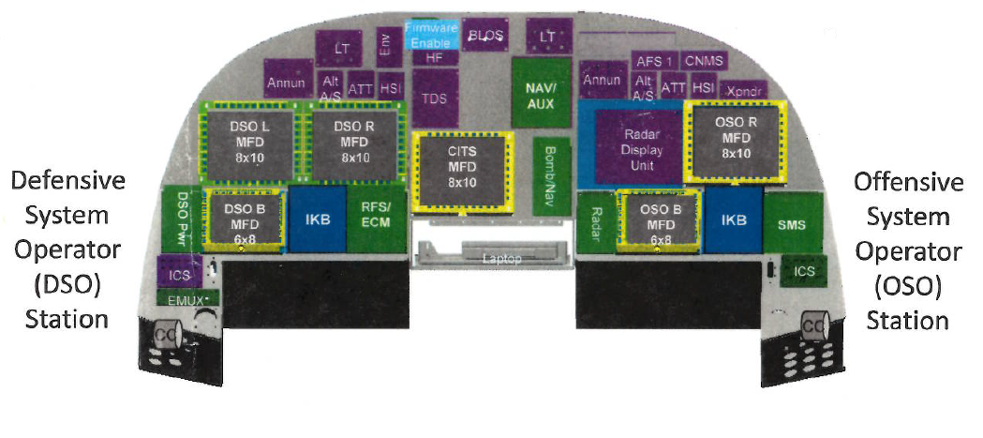
Figure 1: OSO and DSO Screen Layout

Background
In this day in age with technology, designers are mostly focused on taking the human out of the situation to ensure the least amount of human error possible. However, if the technology fails, you are left with a human trying to perform tasks as someone would on an analog panel in a digital world. This is going to greatly increase the amount of error possible, and if the users are in a combat situation and having to make split second decisions, the amount of error increases because sensory issues. This will provide opportunity to the B-1 for designing in fail safes that if the automatic function shuts down on the jet, the users will still be just as proficient as they would if the automatic function were still there.
In aircraft technology, the number of indicators, instruments, and information processing has increased by well over 900%, however the amount of time allotted for performing the user’s mission has decreased by more than 600% (Salas & Maurino, 2010). Training is one answer to this dilemma. However, what the users care about is being able to make the split second decisions in battle as though the technology were doing it for them. The users need to be able to function manually in a world of technology in a situation where the technology fails and they are left with basically analog features. In the world of weapons, that means creating the safest and most controllable environment for any user, seasoned or fresh out of flight school to be able to drop a weapon with 100% confidence that it is going to hit its target.

Analog to Digital
There have been many technological advances in the world of aviation. From the 1960-1980s, flight decks were considered very crowded as it was mostly filled with analog gauges (Salas & Maurino, 2010). For people that like clean lines and follow Gestalt patterns, they might have found this area to be overwhelming and cumbersome to learn. Designers took on the challenge for cleaning up the flight deck area to try and rid it of so many analog gauges, and due to the digital age we live in, it was possible. Flight decks now look very clean because there are few analog gauges, and in its place are computer screens that the users can scroll through different menus. The changes made were meant to address visual overload problems, but unfortunately the amount of information the users are keeping track of has drastically increased creating cognitive overload situations (Salas & Maurino, 2010). Both of which are contributing factors to human error.
Designers do not have a lot of real estate to work with when developing the layouts for the flight deck displays. It is their job to optimize the amount of information displayed at any given time in a very limited space (Reising, Liggett, & Munns, 1999). The reason the users were experiencing extreme visual overload was because the gauges were too difficult to monitor due to everything sitting on top of one another. In order to resolve this issue, computer screens were installed and now the users have menus they select their information from, which has switched from being visually demanding to cognitively demanding (Salas & Maurino, 2010). For the B-1, the critical parameters are displayed no matter what menu the user is on. Designers also made it easier for the users to know when there is an issue by creating both visual and auditory alarms. The B-1 AG experts utilize a color scheme for quick reference, such as green is the parameters are good, yellow is the parameters are getting close to being out of range, and red means something has gone wrong and the system needs attention, or the system has been lost.
As for the users, the less experienced users are having an easier time with the technological advancements. The reasoning is likely due to the technology being there in trainers and beginner aircraft. There are challenges though for the users that learned on the analog systems because of how technology advances things (Whitehurst & Rantz, 2012).The challenge for the designers at this point is merging the experienced users of the analog system, to the inexperienced. The research showed that flight simulators can assist in this transition. The research further showed that the inexperienced users could benefit greatly on working from a digital to analog transition training because it would keep them in better shape if they lost the automated function. This would be incredibly beneficial for the B-1 to ensure the users know how to handle a case in which they have to go from digital to analog if their automated system shut down.
Engineers must consider the human computer interaction more than ever now. By keeping this in consideration, better display designs can be utilized to offset human info processing limitations (Salas & Maurino, 2010; Vincente, 2002). When everything was an analog display, symbols were not used for everything, and words took their place. With the increase in technology, there was an increase in symbols. This was especially true for weapons on the B-1. The seasoned users prefer the symbols, but right now, only the outline of the symbol exists. This is one area that can be made better by utilizing a more mature display that has better graphics, as well as the names of the weapons to assist the newer users. This would also decrease the amount of training the new users required for knowing the symbols. Studies show perception, attention, and memory are all key aspects of information processing, so the more convoluted the system or display is, more training will be required to ensure the users know what to do if the automatic system shuts down (Salas & Maurnio, 2010). When all of the gauges were analog, critical systems were scattered all over the dash, and made looking for them taxing. Now with everything digital, perception has become the issue because there are pages of menus. In detail, to keep the users up to pace, the critical systems, such as the automatic function standing, should be kept at the top on all the menu screens so it is easy to see, and get to.

Multitasking and Divided Attention
The users of the B-1 are constantly multitasking. This is when errors are also at a risk of occurring. Unfortunately, errors are something that will likely never cease existing. One thing the users prefer to see is a color scheme because it provides that quick no-kidding indication on which systems are okay, and which systems pose a serious threat. Research shows colors like green, yellow, and red are helpful with multitasking because it provides a quick reference to know if systems are okay or not (Salas & Maurino, 2010). The B-1 does this already, which the users like because they find it easy to understand over looking at numbers only and deciding if they are in a good range or not.
One example in which the B-1 users multitask in a high stress situation is when they are running a battle mission. The military has performed research and not much has changed since the 1970’s for the United States Air Force (USAF). In Human Factors research, it was noted that “the capabilities of a person to receive and process information, or the “capacity of the brain” are limited. “Failures” inevitably arise when the rate of information transmission to a person and the demands upon decision making exceed these capabilities (Akhutin et. al, 1972).” With this study, it shows that more mistakes can happen in a combat mission due to the high stress environment. We as engineers must ensure that if and when the technology fails, the users can still make sound decisions with minimal mistakes because in a combat mission, mistakes are not warranted. Other research has shown that users get caught when trying to multitask, and their ability to manage all of the tasks at hand are severely limited (Loukopoulos, Dismukes, & Barshi, 2009). When the users are on a mission, and their plates are full with responsibilities, it is easy for them to get in the out of sight, out of mind mentality, and become too reliant on technology. They rely on the automatic function of the jet to maintain status quo, and if that fails and they need to drop weapons on a target, they will require a quick solution for the OSO to not make a catastrophic mistake.
Colom, Martinez-Molina, Shih & Santacreu (2010); Spink, Cole, & Waller (2008) The designers need to take into consideration individual user differences when it comes to multitasking. This means that there is a growing and crucial need to extend the understanding of multitasking behavior. Research shows multitasking different tasks are shown to have interference. However there is limited attention being paid to this. Users need to be able to switch between tasks quickly. If the users are left to deal with an analog system, they will have to be even more proficient in how they switch between systems without error. This is where simulation training will be a key player, but will also bring more attention in how the users deal with multitasking.
Casner & Schooler (2014) showed that pilots spend a smaller percentage of task-at-hand thoughts (27% vs 50%) and greater percentage of higher-level flight-related though (56% vs 29%) when using higher automation. In addition, they found out that the pilots’ task unrelated thoughts peaked at 28% when they were not interacting with automation because they were busy multitasking with functions that were normally in the automatic mode. Therefore, they concluded that automation provided more time to think, and may encourage the user to reinvest only some mental free time in thinking flight-related thoughts.
Automation should lower the user workload, as that is what it is designed to do, and allows the users to focus on more pressing matters. However, when that automatic function fails, the users have to be on their best game to ensure the mission is not a failure. Unfortunately, studies have shown there is a lot of “mind-wandering” when the users are using the automatic function, which only increases the level of risk to a greater degree. Should the automated system experience any issues, or a shutdown, then the users are significantly more behind the curve because they must now regain focus on the situation and are at a greater risk for making mistakes.
(Wiener & Nagel, 1988) Research shows that users believe workload spikes when there are “automation surprises”. For the case of this experiment, the “automation surprise” would be the lack of automation. Utilizing the automated functions in the jet will reduce workload, but creates added stress if something malfunctions. This is due to the advanced systems on board. Workload also takes a toll when the users are fatigued and flying long missions. Some aspects that can be associated with this experiment regarding workload is that the users are so used to automated system making the decisions, that now they are being forced to focus their attention from other tasks and start making the heavy decisions of what weapons to drop when and where.
This experiment will be taking users out of the automated function and into a manual function. This is forcing the users to go from any “mind-wandering” state to a fully focused state, in a high intensity situation. The users need to be able to make quick, snap decisions on what weapons they need to drop, with as few mishaps as possible. The weapons will not be released just based on a click of a button, but rather after receiving confirmation that the right weapon has been selected. However, each mistake will be recorded, as it ultimately affects the amount of time taken to make a proper weapon selection, and in this environment, every second counts.
The amount of attention users pay in any given situation shows up when things begin to go awry. Human error imposes considerable costs, and cognitive mechanics can cause a lot of errors (Dismukes, 2017; Salas & Maurino, 2010). Furthermore, human error can affect mission performance and safety. This can also cause the users to begin looking into their hindsight, rather than focusing on the tasks at hand, which can also become contributory to errors. Contrary to hopes, experiments show user’s lack of awareness to their situation by failing to correctly answer basic situational questions (Casner S., 2005). This experiment promotes this situation because the users will be more relaxed, and not expecting any issues to occur. Salas & Maurino (2010) In any case, the users will need to have the ability to multitask, making it a bigger design challenge to eliminate unnecessary information that might be detrimental to the mission. In detail, the most important thing for the designers to take into consideration here is the physical attentional limitations of the human.

Memory
Memory function for a human being becomes very critical when designing systems displays. Studies show critical items should be on permanent display, while also grouping relevant information together (Salas & Maurino, 2010). At the end of the day however, engineers and designers must consider clutter on a screen because sensory overload is still a good possibility just as it was with an all analog system. It was further noted that the amount of information on display can also cause the users to ignore lights or signals if there are too many false alarms and tend to forget which lights are the ones to really worry about. Which again leads back to grouping critical, relevant information together always.
Another hurdle that must be crossed is the number of reference screens the users have to scroll through because if the users get overwhelmed by the amount of screens they have to go through to get to where they want, they can experience attention tunneling, or an out of sight out of mind attitude, which in turn can lead to a higher risk of human error (Salas & Maurino, 2010). For the sake of this experiment, the users will only have what information they require for this mission, which should also assist in limiting attention tunneling, and will only provide an error message when a ‘show-stopper’ occurs. This is done in the attempt to make sure the users do not forget or disregard the main task at hand, and accomplished with the least amount of error possible.
Some other things to consider as they relate to this project are how symbols and words vary amongst a user’s memory. A study was done to see memory differences using numbers and letters for a pin code, versus using a picture. Numbers and letter have always been the standard for this sort of thing, but pictures are beginning to take over and technology progresses. According to research, the idea behind graphical authentication is that exact password recall is replaced by recognition of pictures (De Angeli, Coventry, Johnson, & Renaud, 2005). The researchers were thinking that this was a more secure method. Their research however found out that visual-memory capabilities were over-estimated, and usability has received scant attention. It was noted that although there was a steeper learning curve for remembering picture passwords, the users resolved issues during the training phase and made no errors during testing phase. The same can really be said for the B-1 users. The more experience the users have, the more likely they are to request pictorial representations of weapons versus the word descriptions. In order to try and bridge the gap, this experiment will utilize both word descriptions and pictures to assist in eliminating confusion for the users.
Another important key for the memory is knowing that there is a critical point in which information to a user needs to be provided (Grauman, Yeh, Tollmar, & Darrell, 2005). It has been realized that finding out information regarding an image would be easiest if the user is using the image to search with in a search engine such as Google. The research shows this is because using words can become very complex when browsing the internet. Their research also shows that you can search using images, but if you do not have the majority of the image of the object of interest, obtaining information in general, let alone pertinent information becomes less effective. In a way, the same theory can be applied to the B-1 users. The less experienced user need to see the full image with more detail in order to know which weapon is the correct weapon for the mission. The more experienced users on the other hand do not need a detailed image to make their determination. The newer users are like a search engine looking up images, the more detail there is, the more likely an answer will show up without error. For the case of this experiment, the more detail being more detailed pictures, as well as a description describing what the picture is.

Design Interface
Lintern, Waite, & Talleur (2009) There is a lot of talk over user design interfaces, and whether or not they cause the user more difficulty that the analog system. Research shows that there is an emerging concern over modern glass cockpits inducing information overload. However, it is not the increased hardware, or software design capabilities that the complexity, rather it is a nonfunctional design. Designers sought out to provide more automation and information to the users, but in turn have neglected functionality. The user at a human-machine interface should be able to interact directly with functional properties, considering the whole point of functionality is to achieve goals. For the B-1 users when dropping weapons in a manual operation is to successfully select a weapon and make it hit its target.
Some other methods designers use to assist in limiting the amount of human error in the system is using GOMS (John & Kieras, 1996). GOMS stands for goals, operators, methods, selection rules. It is useful to designers because it assists with complexity provides the “how to” on designing interfaces. Some research has also been done to show that human error is limited when using a more ecological design interface because it is designed for a human-computer interaction (Vincente, 2002). This is useful for the B-1 users because there are many situations where adaptive problem solving is required, especially if a mission changes and they have to start taking on a more manual approach.
When in a dynamic environment, it was proposed to exploit an Abstraction Hierarchy (AH), which involves a multilevel representation of a system at different scales of analysis. Different levels are linked by causal relations, or means to an end (Lintern, Waite, & Talleur, 2009). Basically, this means that whatever event or steps happen at one level are done to achieve the goal of the next level. For instance, the first level for the OSO would be to select the correct weapon for the mission, with minimal error, and then dropping the selected weapon on its target is accomplishing the goal of the next level. The experts shine a light on one major challenge, but certainly key, which is designing an interface that provides compelling perceptual representations of spatial, temporal, and relational properties. With this in mind, the experiment is utilizing more detailed pictures of the weapons to assist the users in the correct decision.
Stone, Jarrett, Woodroffe, & Minocha (2005) Some other things to consider is that the user interface design should be user-centered. The best way to do this is by obtaining active involvement from the users of the system. The users will then have the opportunity to provide their wish list, everything and the kitchen sink list to the designers in hopes of getting a product that meets their specifications. Another good data point in creating a good design interface is performing the tests with the users. Furthermore, in order to appropriately design the interface, the designer needs a good understanding of what the users will be using it for, proving the need to involve the users early on in the design process. Involving the users, designers, and testers will also keep discontinuity out and creating an adequate design for the final product (Newman, Greeley, 2017). Research also shows using direct observation of the users can assist the designers in creating a more widely accepted product. The researches detail some other helpful tactics; interview the users, understand who they are and what they do, and understand who all of the stakeholders are. For this experiment, the users were interviewed, as well as some of the loaders because they are also stakeholders with the design.
Finally, designers typically design around a perception bias, such as a past, present, future mentality; past being our experience, present being the current context, and future being the end goal (Johnson, 2014). In reality, this is the case for any new design because the design does not start until a supportability issue arises, or the customer wants a product; that is the context. Typically designers then go back through the history, depending on the situation, and try and learn from the past; that is the experience. Furthermore, after funding is figured out, the project is set in order to keep from scope creep and the product can be achieved; that is the goal. In order to avoid scope creep, and still providing what the users want, the designers must understand the goals (Johnson, 2014). In detail for this experiment, the design took shape following along the lines of Gestalt’s principle on symmetry.

User Statements and User-Centered Design: Interviews
The users that had the most to say about how operations work, and ways for it to be changed around were the OSO’s as they are the ones that control the weapons. There is limited space in the flight deck, and even more space limitations at the user stations. The most up to date screen size the OSO will be able to use is an 8x10 screen. One user stated that at this point in time, a joystick is used to maneuver around the various screens in the backseat, however, the users do feel that it would be more beneficial to have touch screens. The avionics group has not committed to supporting a touch screen for the users, but are in the process of updating the software so the graphics appear more realistic. With that in mind, this experiment is utilizing more realistic looking weapons versus the weapon outlines as this is where the platform is headed.
If the users are put into a situation in which the automatic function stops working and they are left with a manual operation mode where the OSO has to manually open the bay doors before arming the weapon. Another user shared that the user community would like to only have the weapons located in the bay they need to select from show up on their screen. This means if the users are supposed to be selecting a weapon from the intermediate weapons bay, then they do not want to see what weapons are in the aft weapons bay. That would be too much and also cause an amount of sensory overload. The users had some thoughts about grouping weapons via big, or small, but thought better of it and decided it would be easier to choose the weapons in order by station. Even if the weapons showed what station they were in once grouped between big or small, it would take too much time to rationalize where they are actually sitting on the rotary launcher to be useful in making timely decisions. There were a couple of thoughts that seemed like a good theory to experiment on, having the weapons split up in 2 columns as to which station they are at, or showing the station they are at, and how they are sitting around the rotary launcher.
It was noted that when designers come talk with the users, they typically talk with the more seasoned veterans, and while that is extremely beneficial, they still see things differently than the users that are ‘green’. For instance, the more experienced users preferred to see the weapons as a symbol, however the symbols currently are just outlines of the weapons, whereas the more inexperienced users found it easier to remember the weapons by the words. With this in mind, the inexperienced users have a more difficult time because the designers separate weapons out by symbol currently. All of the users agreed however, that it would be the most beneficial to have better graphics of the weapons as well as some description as to what the weapon is to lessen the amount of question, decrease selection time, and also decrease human error.
For the sake of this experiment, the graphics will show the level they are going to in order to be more realistic, and also have a description of the weapon written above each one. The users did not have an opinion whether the description was written above or below the weapon, but did not want the words written next to them. In the experiment, it was decided to keep everything the same and the descriptions were written above the weapons.

Chapter 2: Objective
The main objective behind this experiment is to obtain the most realistic layout for the OSO to drop weapons and minimize the amount of human error involved. For instance, the users know they will be getting better display screens, which include more realistic graphics, but what is yet to be determined is the way the weapons should be laid out on the screen. User inputs were also taken into consideration to accomplish a user-centered design (i.e. rotary based vs. list based).
The main point of this experiment is to investigate human performance, particularly the operational time in the user making the correct decisions, as well as the number of human errors created during the decision processes. This experiment holds a two-part objective. Part 1 is the most important because it will determine the most efficient way for users to make the correct weapons selection without error in the quickest amount of time. Part 2 will help develop the orientation of weapons in the bay based on user preference.

Chapter 3: Methodology
This chapter describes the methodology used to develop the manual weapons drop simulation experiment performed at Tinker AFB in Oklahoma City. The developed designs were based on informal interviews with 4 experts, 2 of which preferred the rotary based, and 2 preferred the list based designs.

Developed Designs
3.1.1. Layout designs (Rotary vs. List)
Figures 2 and 3 represent the weapons bay layouts used to perform the experiment. The rotary verse list layout will determine which one helps eliminate human error and assists the human computer relationship. The initial step consists of the simulation experiment to obtain relevant data for the different weapon layouts in the weapons bays. The details of the various stages have been described in the following subsections.
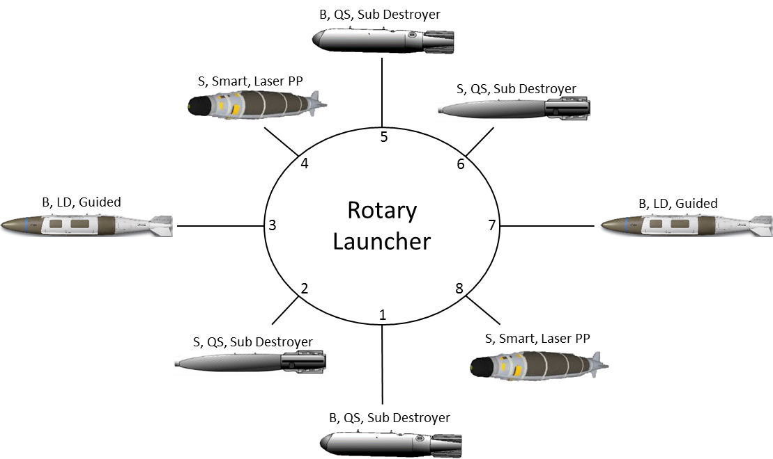
Figure 2: Rotary Layout

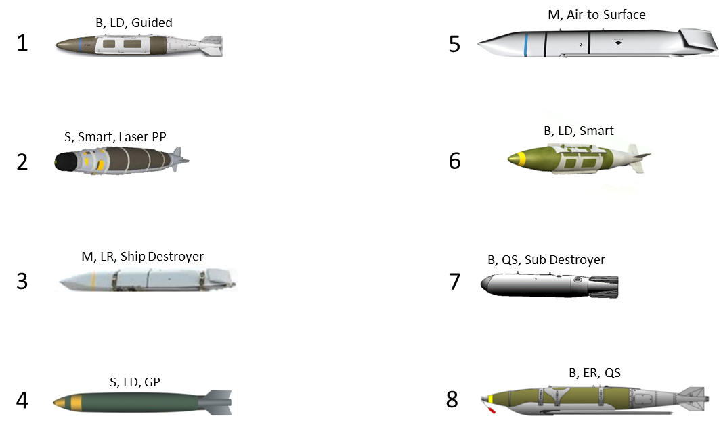
Figure 3: List Layout
The rotary design was meant to show how the weapons would look in the weapons bay at their particular station. This design also provided a visual indication of which weapons were in the inner stores verse which weapons were in the outer stores. The reason this could prove to be helpful is because some of the inner stores could be blocked in by the outer stores, meaning the outer store would have to be released/dropped before the inner store would become a viable option. The way this was shown was by the difference in length of the lines connecting the weapons off the rotary launcher. An example is shown in figure 4 below.
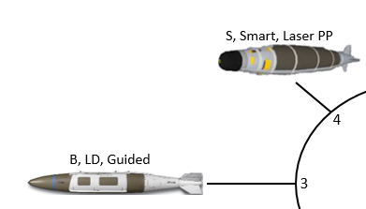
Figure 4: Inner vs Outer Store on Rotary Launcher
The list based design was meant to show the order of the weapons at their station numbers. The most notable difference here was that there was not a defining characteristic showing which weapons were potentially blocked. However the station numbers beside the weapon were easier to see and correlate to the number pad. An example of the weapons listed is shown below in figure 5.
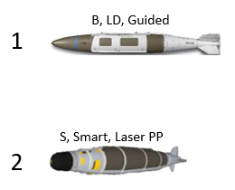
Figure 5: Stores Shown in List Based Design

3.1.2 Mission designs (Easy vs. Hard)
The mission design flow for the easy missions will follow the same flow chart design as shown in figure 6. In the aft bay, the users will make their selection, if it is correct they will move on to the next aft bay weapons selection, whereas if it is incorrect, they will be redirected to make another selection until they make the correct one. Once the user makes 2 correct aft bay selections, they will automatically be moved on to the intermediate weapons bay selection. There is only 1 selection required for the intermediate bay, and follows the same principle as the aft weapons bay. Finally the user will make the forward weapons bay selections, where just like the aft bay, they will need to make 2 correct weapons selections.
Figure 6: Easy Mission Flow Chart

Hard Mission
The mission design flow for the hard missions will follow the same flow chart design as shown in figure 7. The hard mission is treated just like the easy mission set, however in each section, there is the potential for the user to experience a hung store. This can happen in real life, and the users must know what to do next if this occurs.
Figure 7: Hard Mission Flow Chart

Methods

Experimental Setup and Data Collection
The following section provides the details of the experimental setup and the data collected from it.
Participants: In total, 20 participants volunteered to perform the experiment. (Mean year of expertise: 17.35 years + Standard Deviation: 7.33)
Apparatus: Hardware for experiment: A computer monitor (19”) in the office was utilized for displaying the simulation. For capturing the time, a stop watch was used.
Software for experiment: Windows 10 operating system was required. The simulation used PowerPoint 2016 to allow for data capture.
Software for data analysis: Minitab 17, R Studio, and SAS were used to analyze the data.
Both hardware and software were used on a laptop computer at Tinker AFB in Oklahoma City. The data obtained from the experiment has been described in detail in subsequent subsections.
Figure 8 shows what the SMS panel typically looks like, however for this experiment, figure 9 shows the modified SMS panel to eliminate any unnecessary random error.
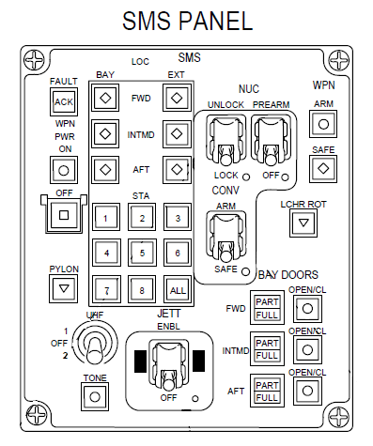
Figure 8: Original SMS Panel
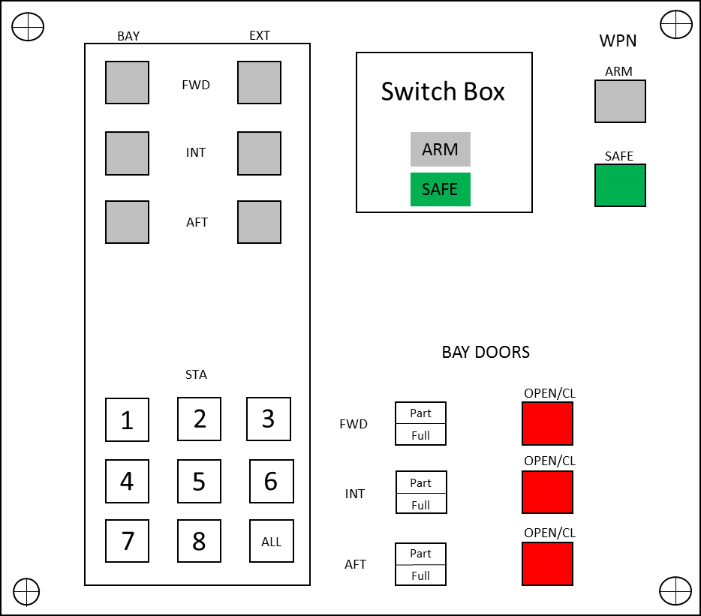
Figure 9: Modified SMS Panel

Scenario (hypothetical): This consisted of a single mission. The order never changed in which the user would select the weapons from their bays; aft bay, intermediate bay, forward bay. The users need to drop 2 weapons out of the aft bay on an enemy camp, drop 1 weapon from the intermediate bay on the road, and drop 2 weapons on a mountain that contains mines and enemy weapons. The map of mission is shown below in figure 10. The user’s job was to follow the directions on the screen to maneuver through the simulation.

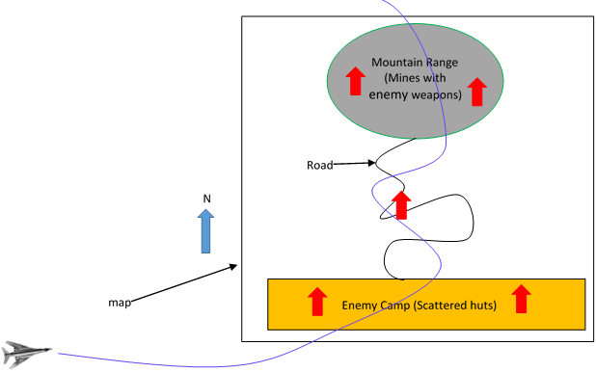
Figure 10: Mission Map
Task and Procedure: The task for the users involved was to follow the mission and select the correct weapons from the designated weapons bay and drop it on the location. The users were all provided the same amount of information prior to the start of the experiment. All of the users were familiar with how the system currently works. The detailed task description is listed below.
- The users were first prompted to read the notes slide; this provided necessary nomenclature, bay selection sequence, and number of weapons to be dropped.
- The users were then shown their mission with a map as shown above in figure 10 along with the direction on travel.
- The mission then began with 1 of 4 options (Easy Mission Part 1, Easy Mission Part 2, Hard Mission Part 1, and Hard Mission Part 2). The mission was the same for each set, the difference was the design interface layout as shown previously in figures 2 and 3.
  - Mission sets:
    - Easy Rotary, Easy List, Hard Rotary, Hard List
    - Easy List, Easy Rotary, Hard List, Hard Rotary
    - Easy Rotary, Hard Rotary, Easy List, Hard List
    - Easy List, Hard List, Easy Rotary, Hard Rotary
- The users followed the screen instructions to properly open the weapons bay and arm the launcher. The selection process is listed below (aft bay selection ONLY shown).
  - Select the bay (figure 11). There are 6 selections that can be made here, 3 external and 3 internal. Only the internal bays will be used, where the external bays are not applicable.
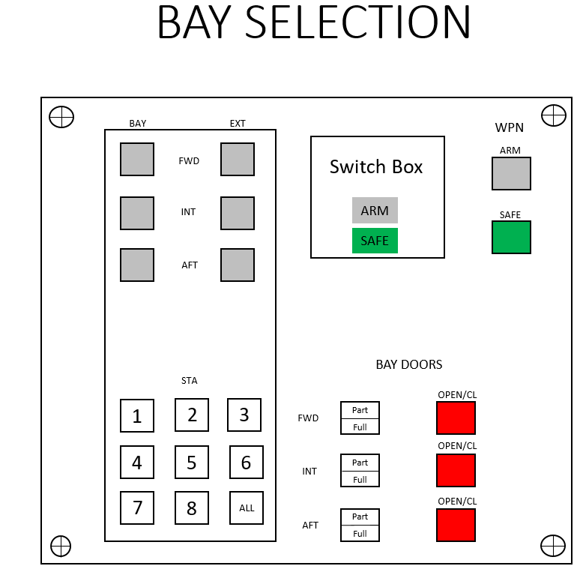
Figure 11: Bay Selection
  - Open the bay door (figure 12). Once the bay is selected, the bay doors need to be opened. For the purposes of this project, the doors were selected to be full open rather than partially open as to not further complicate the experiment.
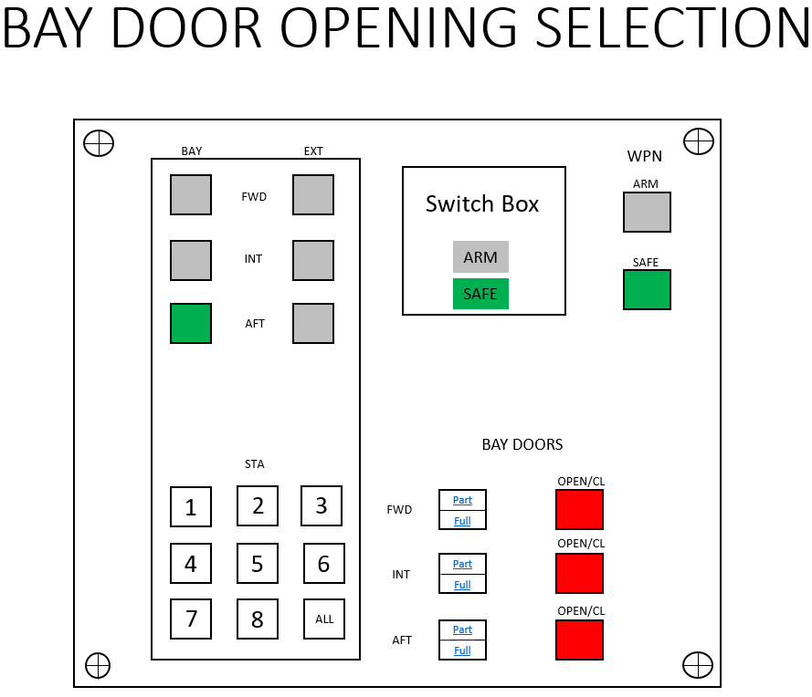
Figure 12: Bay Door Opening Selection
  - Arm the bay (figure 13). The switch box is automatically set to safe and will remain in that state until the user switches it to arm.
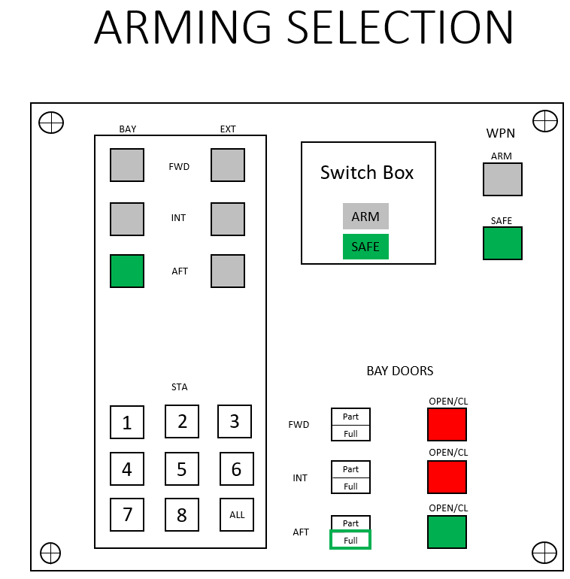
Figure 13: Switch Box used to arm the bay
  - Once the bay is armed, the weapons can be selected. This is the point in which the design interface changes. Figures 2 and 3 showed the depictions between the rotary and listed based designs. The weapon selection was made using the station numbers on the number pad. A snippet is shown below in figure 14. If the selection is incorrect, a notification pops up and the user will select again. If the selection is correct, it will either move to the next weapon selection for that bay, aft or forward, or it will move on to the next weapons bay to begin that selection process. For the hard missions, tricks were thrown into the mix to gauge how the users would react. The tricks were either a hung store, or electrical/software error.
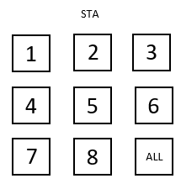
Figure 14: Station Numbers
  - Once a weapon is correctly selected, if the user is to select a second weapon from that weapons bay, the first weapon disappears off the screen to reduce confusion. This happens for both the rotary and list based design interfaces. Examples of this are shown in figures 15 and 16 below.
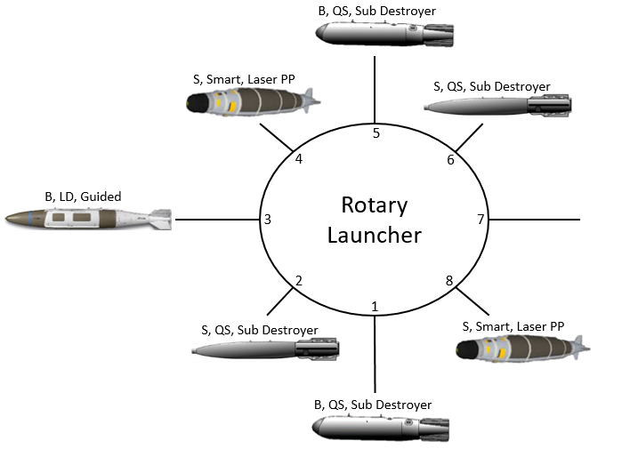
Figure 15: Rotary interface showing missing weapon
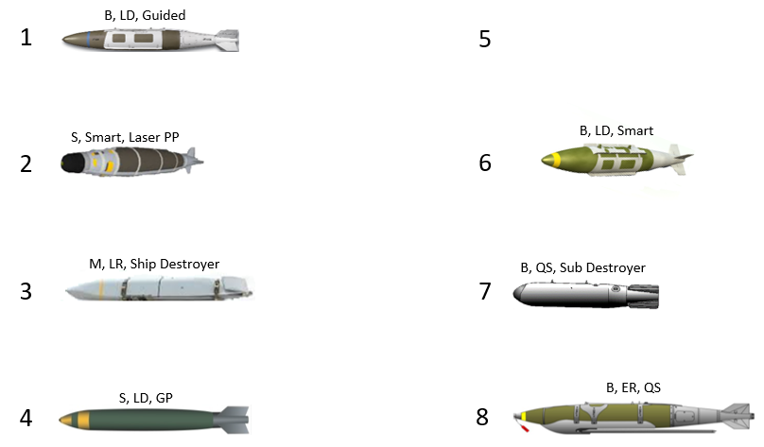
Figure 16: List interface showing missing weapon
Independent and Dependent Variables: The independent variables were layout design interface (rotary vs. list) (See section 3.1 for details). Initially, Mission complexity (easy vs. hard) was going to be analyzed, but it did not make sense to perform a 2 factor design because measuring difference between difficulty levels was not of interest. Difficulty only mattered when measuring the difference between rotary based and list based designs. For this case, the factors were analyzed separately. And can be seen below. Dependent variables were time to successfully complete each task and the number of errors occurred for each task.
- Factor 1: Interface Type $\left(\begin{aligned}List Easy or Hard \\ Rotary Easy or Hard\end{aligned}\right)$

- Factor 2: Difficulty $\left(\begin{aligned}Easy List or Rotary \\ Hard List or Rotary\end{aligned}\right)$
Data analysis: 1. Mean and S.E. were plotted. 2. Non-parametric tests were applied based on evaluating data normality, since data did not follow normal distribution so the Mann-Whitney test was applied. 3. Linear regression was performed for each treatment for Time v Error and the R² value was calculated because there were four different treatments. 4. Short interview results were summarized.

Chapter 4: Results
Table 1 below depicts the results from the users.
Table 1

Participant Information and Results
Participant | Gender | Age | Years in Service | Rotary |  |  |  | List
 |  |  |  | Time (sec) |  | Error |  | Time (sec) |  | Error
 |  |  |  | Easy | Hard | Easy | Hard | Easy | Hard | Easy | Hard
1 | M | 54 | 29 | 65 | 150 | 1 | 2 | 175 | 195 | 2 | 5
2 | M | 36 | 12 | 177 | 301 | 0 | 3 | 179 | 360 | 1 | 5
3 | F | 58 | 25 | 151 | 257 | 0 | 2 | 277 | 375 | 4 | 6
4 | M | 38 | 15 | 155 | 196 | 2 | 4 | 165 | 420 | 2 | 8
5 | M | 50 | 28 | 77 | 162 | 1 | 1 | 115 | 180 | 1 | 3
6 | M | 45 | 20 | 125 | 240 | 0 | 3 | 201 | 344 | 3 | 5
7 | M | 51 | 27 | 119 | 162 | 1 | 2 | 136 | 174 | 0 | 3
8 | M | 39 | 10 | 163 | 252 | 2 | 3 | 198 | 425 | 4 | 7
9 | M | 29 | 7 | 181 | 314 | 1 | 2 | 219 | 379 | 3 | 5
10 | M | 52 | 31 | 66 | 134 | 0 | 0 | 182 | 239 | 1 | 2
11 | F | 31 | 10 | 75 | 177 | 0 | 0 | 114 | 130 | 0 | 1
12 | F | 40 | 17 | 67 | 102 | 0 | 1 | 122 | 161 | 1 | 2
13 | M | 35 | 13 | 61 | 114 | 0 | 0 | 79 | 135 | 0 | 1
14 | M | 37 | 15 | 55 | 100 | 0 | 0 | 87 | 170 | 1 | 3
15 | M | 33 | 10 | 82 | 121 | 1 | 1 | 93 | 145 | 0 | 3
16 | M | 41 | 20 | 43 | 110 | 0 | 0 | 74 | 181 | 1 | 3
17 | M | 33 | 11 | 101 | 123 | 0 | 1 | 124 | 179 | 0 | 2
18 | M | 36 | 13 | 99 | 134 | 1 | 1 | 147 | 184 | 2 | 3
19 | M | 43 | 21 | 42 | 99 | 0 | 0 | 61 | 139 | 0 | 0
20 | F | 35 | 13 | 85 | 124 | 1 | 1 | 94 | 176 | 0 | 3

Figure 17 and 18 below show the plotted means and standard error for both time and error measurements for all cases.
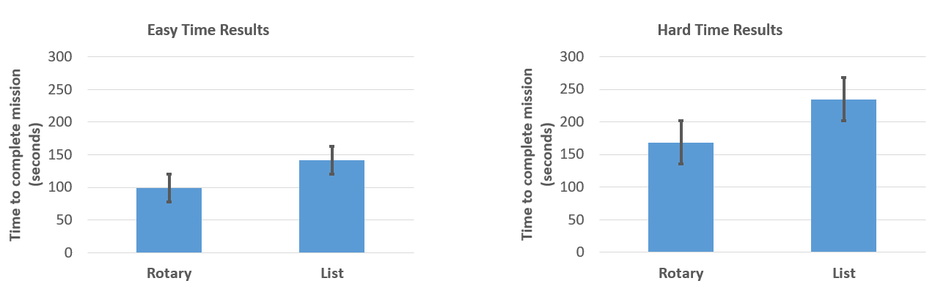
Figure 17: Mean and Standard Error for Time Measurement (Easy and Hard)
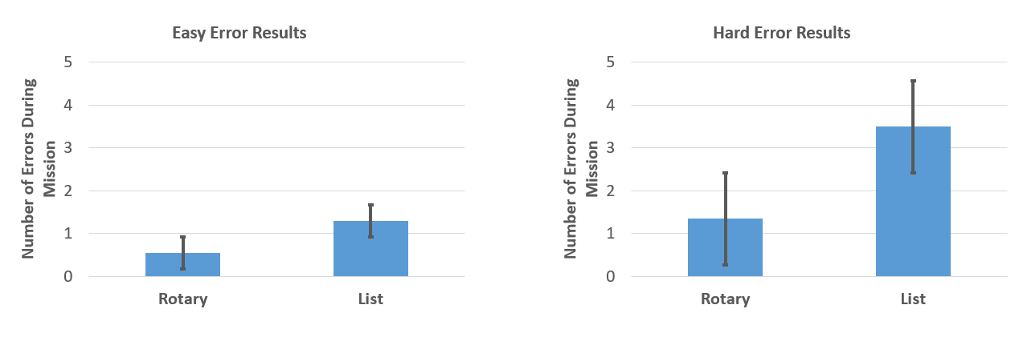
Figure 18: Mean and Standard Error for Error Measurement (Easy and Hard)
The results data were based on time and error. For each category, a normality test was conducted to determine if parametric, or non-parametric tests were to be conducted. The Anderson-Darling Normality Test was utilized to determine normality for each set. The results for both rotary easy and list easy for time are shown below in figure 19.
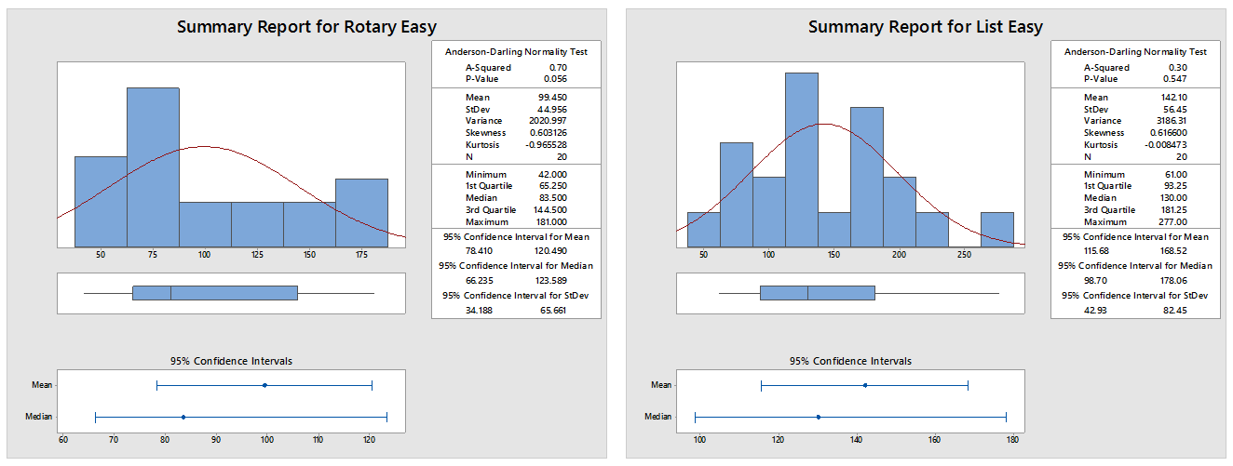
Normality test results for List
Normality test results for Rotary
P-value = 0.547
P-value = 0.056
Figure 19: Anderson-Darling Normality Test for Easy Mission of Rotary and List Based Designs for Time
The Anderson-Darling results for the hard missions of rotary and list based designs for time are shown below in figure 20.
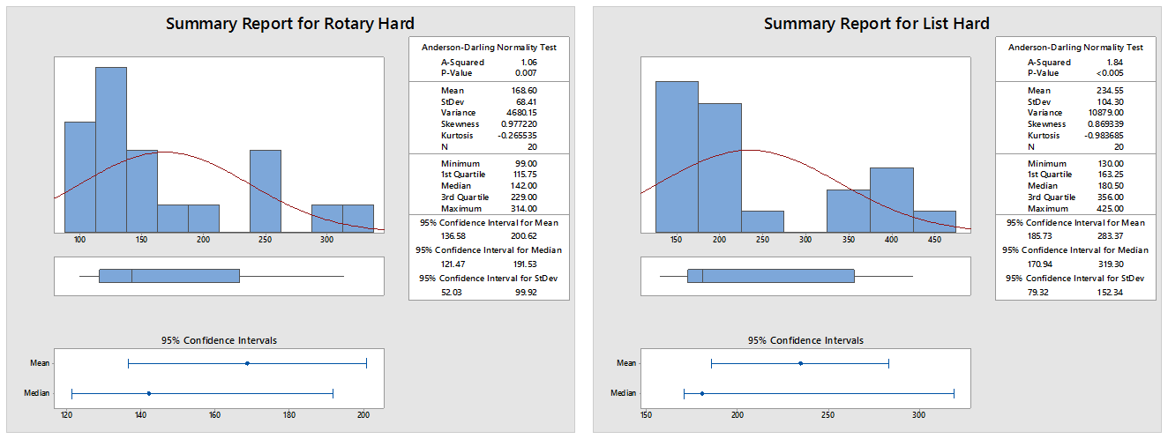
Normality test results for List
Normality test results for Rotary
P-value < 0.005
P-value = 0.007
Figure 20: Anderson-Darling Normality Test for Hard Mission of Rotary and List Based Designs for Time
The Anderson-Darling results for the easy missions of rotary and list based designs for error are shown below in figure 21.
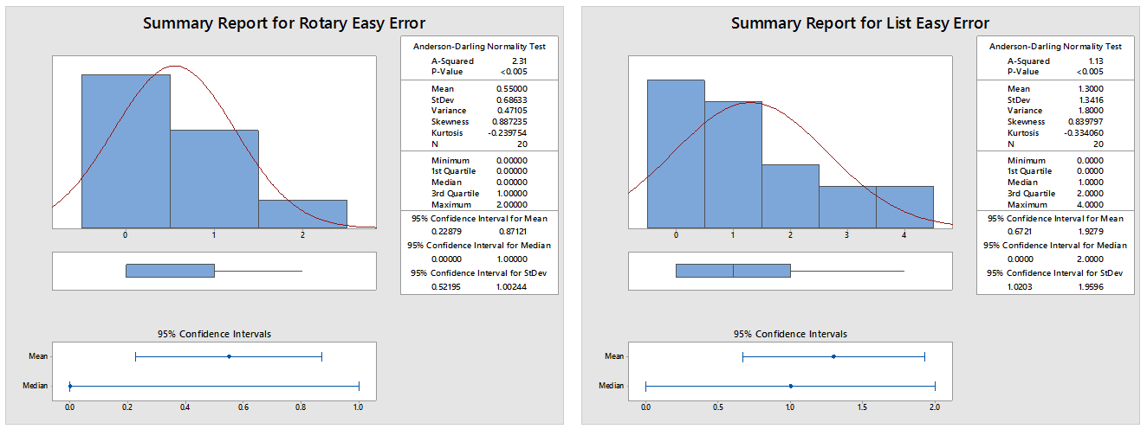
Normality test results for List
Normality test results for Rotary
P-value < 0.005
P-value < 0.005
Figure 21: Anderson-Darling Normality Test for Easy Mission of Rotary and List Based Designs for Error
The Anderson-Darling test results for error regarding the hard missions prove that they are not normal, and non-parametric tests must be utilized. This is known because the P-values are very small here.
The Anderson-Darling results for the hard missions of rotary and list based designs for error are shown below in figure 22.

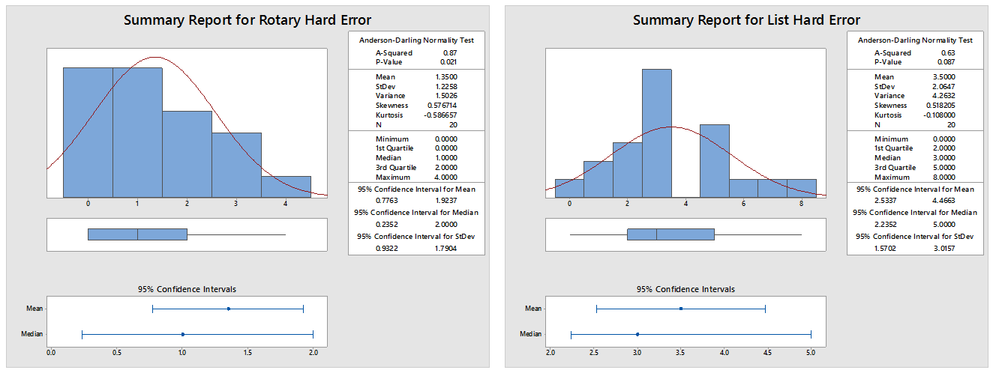
Normality test results for List
P-value = 0.087
P-value = 0.021
Normality test results for Rotary
Figure 22: Anderson-Darling Normality Test for Hard Mission of Rotary and List Based Designs for Error
The Anderson-Darling test results for error regarding the hard missions prove that they are not normal, and non-parametric tests must be utilized. This is known because the P-values are very small here.
For each of these cases, the Mann-Whitney Test was used because the results were not normal per the Anderson-Darling Normality Test. The results are shown down in the Mann-Whitney (Wilcoxon) Test section.
Generalized Linear Model (GLM) Testing for Time:
The data for the time-order effect was hand plotted to prove there was not an effect on the time data based on the mission the users performed first. The data proved there was no effect, in which case a GLM and interaction analysis could be performed. The data from the GLM analysis between the easy and hard missions, and rotary and list based designs is shown below in table 2.

Table 2

GLM Analysis Results for Time
Source | DF | Type III SS | Mean Square | F Value | Pr > F
Difficulty | 1 | 145607.1 | 145607.1 | 39.4 | < 0.0001
Interface Type | 1 | 49551.0 | 49551.0 | 13.4 | 0.0005
Difficulty*Interface Type | 1 | 5232.6 | 5232.6 | 1.4 | 0.2378
Subject | 1 | 127188.3 | 127188.3 | 34.4 | < 0.0001

The GLM plot can be seen below in figure 23.
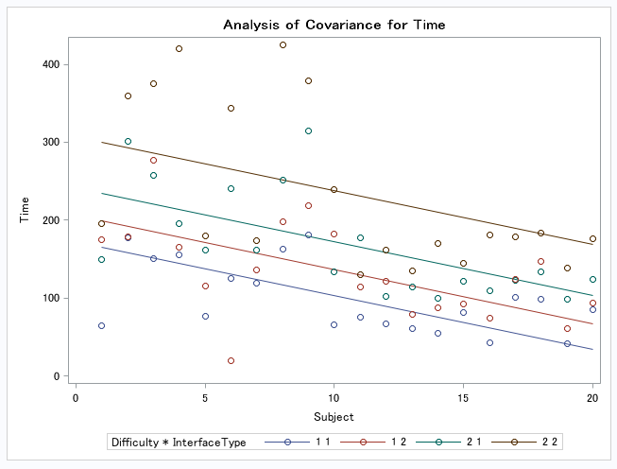
Figure 23: GLM Plot for Time
The boxplot can be seen below in figure 24.
Figure 24: Boxplot for Time
The data for the time plots shows a p-value of 0.2378, which proves for both rotary and list based designs, there is no significant effect on the amount of workload between the easy and hard missions.
Generalized Linear Model (GLM) Testing for Error:
The data for the time-order effect was hand plotted to prove there was not an effect on the error data based on the mission the users performed first. The data proved there was no effect, in which case a GLM and interaction analysis could be performed. The data from the GLM analysis between the easy and hard missions, and rotary and list based designs is shown below in table 3.

Table 3

GLM Analysis Results for Error
Source | DF | Type III SS | Mean Square | F Value | Pr > F
Difficulty | 1 | 45.0 | 45.0 | 30.9 | < 0.0001
Interface Type | 1 | 42.1 | 42.1 | 28.9 | < 0.0001
Difficulty*Interface Type | 1 | 9.8 | 9.8 | 6.7 | 0.0114
Subject | 1 | 43.5 | 43.5 | 29.8 | < 0.0001

The GLM plot can be seen below in figure 25.
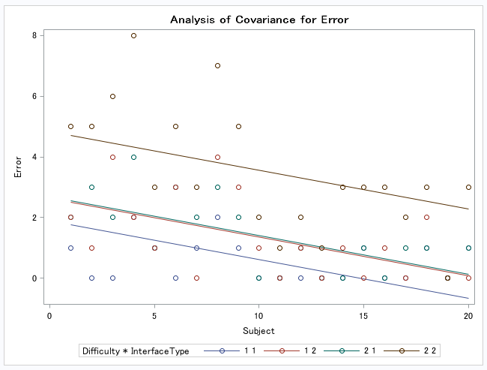
Figure 25: GLM Plot for Error
The boxplot can be seen below in figure 26.
Figure 26: Boxplot for Error
The data for the error plots shows a p-value of 0.0114, which proves for both rotary and list based designs, there is a significant effect on the amount of workload between the easy and hard missions.
Mann-Whitney (Wilcoxon) Test (Easy Scenario):
The Mann-Whitney test for rotary based easy mission operational time in relation to list based easy mission time produced a W value of 108.5 and a p-value of 0.013. The p-value results show there is a significant difference in time between using the rotary based design to the list based design for easy missions.
The Mann-Whitney test for rotary based easy mission number of errors in relation to list based easy mission error produced a W value of 137.5 and a p-value of 0.070. The p-value results show there is not a significant difference in error between using the rotary based design to the list based design for easy missions. However the results are marginal.
Mann-Whitney (Wilcoxon) Test (Hard Scenario):
The Mann-Whitney test for rotary based hard mission operational time in relation to list based hard mission time produced a W value of 107.0 and a p-value of 0.012. The p-value results show there is a significant difference in time between using the rotary based design to the list based design for hard missions.
The Mann-Whitney test for rotary based hard mission number of errors in relation to list based hard mission error produced a W value of 74.5 and a p-value of < 0.001. The p-value results show there is a significant difference in error between using the rotary based design to the list based design for hard missions.
Participant Thoughts:
For the most part, all of the participants preferred the rotary based design. A general consensus of the participants was that the hung store, or error message messed with them more than they would have anticipated. They felt like it made them second guess everything they were planning to select because the error/hung store blocked off many options that were originally available.
Participant 1 stated that they “liked the rotary design better because it was easier to comprehend which weapons were blocked”. They also said they “liked knowing how the weapons sat in the weapons bay”.
Several participants said they simply “liked rotary better”.
Participant 7 liked rotary better still, like the rest of the participants, but did take the time to comment on the list based design a little more. They said “the list was okay, but it took some extra time to think about it”.
Participant 12 said “some of the weapons in the given weapons bay could have been used on that mission, and it caused some hang ups trying to select the most correct one”.
Finally, participant 15 said “the rotary design was by far the easiest, but I forgot a couple times which bay went to which part of the mission”.

Chapter 5: Discussions and Conclusion
As far as the results are concerned, it was proven that there was not a time-order effect on the data from the hand plotted results for either time or error. For both cases, this allowed the Generalized Linear Model analysis to be applied.
Time Data:
The GLM data for time had a p-value that was greater than 0.05, which meant that there was no significant effect on the amount of workload between the easy and hard missions for both the rotary and list based designs. This makes sense because the users were still performing the same amount of work between each design, as well as each mission. The only difference they experienced was if there was a hung store or error observed in the hard mission, whereas the easy mission did not have any of these.
Error Data:
The GLM data for error had a p-value that was less than 0.05, which meant that there was a significant effect on the amount of workload between the easy and hard missions for both the rotary and list based designs. This means that the number of errors the users made between the missions was more extreme. The data also showed that the users made more errors on the list based designs, but especially so on the hard mission, which coincides with the results. One reason for this is that the users had a more difficult time in selecting the correct weapon if there was a hung-store or an error.
In conclusion, it was proven that there was no significant difference for the time data, but there was for the error data.
Before the simulation experiment was conducted, most of the users felt as though they would prefer the rotary based interface design, however a few felt like the list based design would be easier to work with. The loaders also liked the idea of the list based design better too.
After the simulation experiment, the users all seemed to agree that they liked the rotary design the best. Their reasons varied, but for the most part, they felt like the rotary based design was easy to comprehend and they did not have to think or remember which stores were the inner or outer, and which might be blocked or not. A general consensus for the list based design was that they felt like they were second guessing themselves a lot and felt pressured to make a snap decision to save time. The confident decisions were made with the rotary based designs, and the list caused more chaos than anything.
Down the line, different aircraft platforms could benefit from studies such as this to assist users in the field to determine the most effective way for them to function in whatever situation they are given so they can successfully drop weapons on their targets. Providing an interface design that is the easiest for the users to comprehend, especially one that shows the different layouts in each weapons bay could benefit them in making quicker decisions with a higher level of confidence.
This simulation experiment agreed specifically with research performed by both Salas and Maurino in 2010, and Vincente in 2002 because they noted that engineers must consider the human computer interaction more than ever in order to create better display designs that can offset human info process limitations. By taking this research into consideration, the difference between the rotary based design and list based design are quite extreme. It proves that the rotary based design is the way to go because the users had more confidence in their decisions and created fewer errors in completing the missions successfully. Other research showed the importance of including users in the design process, and that proves important with this experiment as well because if the list based design was chosen over the rotary based design, more errors would occur that would be unnecessary. Whereas utilizing the user community in determining which design is the most beneficial to them, they have a better understanding of what the designers are limited to and can assist in creating a design that is the most natural for them.

Chapter 6: Limitations and Future Research
Some limitations encountered were that the results were not normal, so the results had to be reviewed separately. Another limitation was that no actual designs were created to use in a “real world” situation. A mock design was created through PowerPoint 2016 so it was possible to have low face validity, however even with low face validity, the experiment identified the differences between the rotary based design and list based design. The number of participants was also limited due to their availability. More participants would further solidify the results.
In order to get an actual design in place and implemented would be an extensive funding effort and several years out. It is also something that would be competed against other modification efforts. For this case, it would be easier to pitch it future platforms in order to implement the best practice from the get go.
Another limitation was that the users were not overly fatigued when performing the experiment, nor were they performing all of their normal duties they have going on during each flight, so their workload was reduced. Some things this will assist with future research however is performing the experiment once the users are fatigued and make them perform more functions that just selecting the weapons. It would also be beneficial to know how the workload influenced the quality of work they perform, and how much their mental workload is affected.
One future consideration would be the use of Fitts’s Law. Considering Fitts’s Law is a predictive model used in human-computer interactions and ergonomics, it would assist in creating a clean, user friendly design. Some things to consider are the distance in which the users have to move the pointer to the buttons, and the size of the buttons themselves because if the buttons were bigger, and closer to the user, then fewer random errors would occur. When the users were making more snap decisions, and got into a rush after having a hung store scenario, or made an incorrect selection, they tended to make quicker movements with the mouse and would overshoot their targeted button, creating a speed-accuracy trade-off that is consistent with what research shows. This project is a good representation of this law because users are creating rapid, pointing movements rather than continuous motions. Something that might be useful should funding ever become available for it would be checking the amount of error created with utilizing larger selection buttons, or even making it a touch screen display that sits directly in front of the user. This would create larger symbols and make it a more direct line for the user so as to eliminate extra movements and limits room for error. The linear regression models would also assist in creating the most user friendly displays because the predictive behavior for time is equated T(Time) = a + b log₂(2D(Distance)/W(Width)), where a and b are the regression coefficients.
The future research of utilizing more users and differentiating between expert and novice could yield different result in which there could be enough difference between time and error that more than just the user preference could be taken into account.
Future research can include utilizing more users and investigate the effect of expertise (expert vs. novice) with regards to how long it takes them to successfully complete the mission, and how many errors occur. Another analysis that can be considered in the future will include performing logistic regression.
Some other future research that could be beneficial to this experiment would be to follow the NASA-TLX tool. It is widely used in aviation, and would show some of the mental, physical, and temporal demands on the users. It would also assist in showing performance measures, effort, and the amount of frustration the users felt. It would open up more doors on the analysis performed. It would be helpful to know how the users perform based on their frustration level with the number of hung stores within each interface design. It would further show which design is the best way to go.
Some other measures that can be considered later on will include visiological measures to include eye tracking and brain wave measurements such as FMRI or ERP devices. The user’s heart beats can also be measured to provide more real time data to see if there is a correlation between making errors and an increased heart rate. Users’ workloads would also be a benefit to research to better determine how information needs to be presented to them. The reason for this is that if the users are in an intense situation, they might react better to different interface layouts than others allowing them to make more sound decisions and also limit, if not eliminate human error. The level of stress the users are under might also yield different results. Being able to put the users in the kind of stress environment they experience in the field would assist designers in putting more emphasis in the areas the users need more help. Also fatigue could play a big role in human error, so it would be incredibly beneficial to be able to see how the users react when they are tired compared to when they are fresh. A way to actually test that would be to have the users fly around for several hours before performing the experiment. It would help show how stressed out the users could become with their decision making as well as how much their eyes start moving across the screen, how quick their heart starts beating, and finally what their brain waves show. There is a great amount of research that can still be performed to assist designers in creating the most efficient interface design and limit human error.

References
Akhutin et. al. (1972). Military Human Factors Engineering. Department of Commerce, JPRS 56653.
Casner, S.M. (2005). The Effect of GPS and Moving Map Displays on Navigational Awareness While Flying Under VFR. International Journal of Applied Aviation Studies, 5(1), 153-165.
Casner, S.M., & Schooler, J.W. (2014). Thoughts in flight: Automation Use and Pilots’ Task-Related and Task-Unrelated Thought. Human Factors, 56(3), 433-442.
Colom, R., Martine-Molina, A., Shih, P.C., & Santacreu, J. (2010). Intelligence, Working Memory, and Multitasking Performance. Intelligence, 38(6), 543-551.
De Angeli, A., Coventry, L., Johnson, G., & Renaud, K. (2005). Is a Picture Really Worth a Thousand Words? Exploring the Feasibility of Graphical Authentication Systems. International Journal of Human-Computer Studies, 63(1-2), 128-152.
Dismukes, R.K. (2017). Human Error in Aviation. Routledge.
Grauman, K., Yeh, T., Tollmar, K., & Darrell, T. (2005). A Picture is Worth a Thousand Keywords: Image Based Object Search on a Mobile Platform. In CHI’05 Extended Abstracts on Human Factors in Computing System (pp. 2025-2028). ACM.
John, B.E., & Kieras, D.E. (1996). Using GOMS for User Interface Design and Evaluation: Which Technique?. ACM Transactions on Computer-Human Interaction (TOCHI), 3(4), 287-319.
Johnson, J. (2013). Designing With the Mind in Mind: Simple Guide to Understanding User Interface Design Guidelines. Elsevier.
Lintern, G., Waite, T., & Talleur, D.A. (1999). Functional Interface Design for the Modern Aircraft Cockpit. The International Journal of Aviation Psychology, 9(3), 225-240.
Loukopoulos, L., Dismukes, R., & Barshi, I. (2009). Multitasking in Real World Operations: Myths and Realities. Aldershot: Ashgate.

Newman, R.L., & Greeley, K.W. (2017). Cockpit Displays: Test and Evaluation. Routledge.

Reising, J., Liggett, K., & Munns, R. (1999). Controls, Displays, and Workplace Design. Handbook of Aviation Human Factors (pp. 327-357). Mahwah: Lawrence Erlbaum.

Salas, E., & Maurino, D. (2010). Human Factors in Aviation. Burlington: Elsevier.

Spink, A., Cole, C., & Waller, M. (2008). Multitasking Behavior. Annual Review of Information Science and Technology, 42(1), 93-118.
Stone, D., Jarrett, C., Woodroffe, M., & Minocha, S. (2005). User Interface Design and Evaluation. Elsevier.
Vincente, K.J. (2002). Ecological Interface Design: Progress and Challenges. Human Factors, 44(1), 62-78.
Whitehurst, G., & Rantz, W. (2012). The Digital to Analog Risk: Should We Teach New Dogs Old Tricks?. Journal of Aviation/Aerospace Education & Research, 21(3), 17-22.
Wiener, E.L., & Nagel, D.C. (Eds.). (1988). Human Factors in Aviation. Gulf Professional Publishing.

Appendix A

GLM Data for Time
data X;
input Difficulty InterfaceType Time Subject @@;
datalines;
1 1 65 1
1 1 177 2
1 1 151 3
1 1 155 4
1 1 77 5
1 1 125 6
1 1 119 7
1 1 163 8
1 1 181 9
1 1 66 10
1 1 75 11
1 1 67 12
1 1 61 13
1 1 55 14
1 1 82 15
1 1 43 16
1 1 101 17
1 1 99 18
1 1 42 19
1 1 85 20
2 1 150 1
2 1 301 2
2 1 257 3
2 1 196 4
2 1 162 5
2 1 240 6
2 1 162 7
2 1 252 8
2 1 314 9
2 1 134 10
2 1 177 11
2 1 102 12
2 1 114 13
2 1 100 14
2 1 121 15
2 1 110 16
2 1 123 17
2 1 134 18
2 1 99 19
2 1 124 20
1 2 175 1
1 2 179 2
1 2 277 3
1 2 165 4
1 2 115 5
1 2 20 6
1 2 136 7
1 2 198 8
1 2 219 9
1 2 182 10
1 2 114 11
1 2 122 12
1 2 79 13
1 2 87 14
1 2 93 15
1 2 74 16
1 2 124 17
1 2 147 18
1 2 61 19
1 2 94 20
2 2 195 1
2 2 360 2
2 2 375 3
2 2 420 4
2 2 180 5
2 2 344 6
2 2 174 7
2 2 425 8
2 2 379 9
2 2 239 10
2 2 130 11
2 2 161 12
2 2 135 13
2 2 170 14
2 2 145 15
2 2 181 16
2 2 179 17
2 2 184 18
2 2 139 19
2 2 176 20

;
proc GLM data = X;
class Difficulty InterfaceType;
model Time = Difficulty InterfaceType Difficulty*InterfaceType Subject;
run;

GLM Data for Error
data X;
input Difficulty InterfaceType Error Subject @@;
datalines;
1 1 1 1
1 1 0 2
1 1 0 3
1 1 2 4
1 1 1 5
1 1 0 6
1 1 1 7
1 1 2 8
1 1 1 9
1 1 0 10
1 1 0 11
1 1 0 12
1 1 0 13
1 1 0 14
1 1 1 15
1 1 0 16
1 1 0 17
1 1 1 18
1 1 0 19
1 1 1 20
2 1 2 1
2 1 3 2
2 1 2 3
2 1 4 4
2 1 1 5
2 1 3 6
2 1 2 7
2 1 3 8
2 1 2 9
2 1 0 10
2 1 0 11
2 1 1 12
2 1 0 13
2 1 0 14
2 1 1 15
2 1 0 16
2 1 1 17
2 1 1 18
2 1 0 19
2 1 1 20
1 2 2 1
1 2 1 2
1 2 4 3
1 2 2 4
1 2 1 5
1 2 3 6
1 2 0 7
1 2 4 8
1 2 3 9
1 2 1 10
1 2 0 11
1 2 1 12
1 2 0 13
1 2 1 14
1 2 0 15
1 2 1 16
1 2 0 17
1 2 2 18
1 2 0 19
1 2 0 20
2 2 5 1
2 2 5 2
2 2 6 3
2 2 8 4
2 2 3 5
2 2 5 6
2 2 3 7
2 2 7 8
2 2 5 9
2 2 2 10
2 2 1 11
2 2 2 12
2 2 1 13
2 2 3 14
2 2 3 15
2 2 3 16
2 2 2 17
2 2 3 18
2 2 0 19
2 2 3 20
;
proc GLM data = X;
class Difficulty InterfaceType;
model Error = Difficulty InterfaceType Difficulty*InterfaceType Subject;
run;

Appendix B

Mann-Whitney (Wilcoxon) Test (Rotary Time v List Time):
Easy Mission:
- wilcox.test(REasyTime, LEasyTime, correct = FALSE)
- Wilcoxon rank sum test
  - data: REasyTime and LEasyTime
  - W = 108.5, p-value = 0.01332
  - alternative hypothesis: true location shift is not equal to 0

Hard Mission:

- wilcox.test(RHardTime, LHardTime, correct = FALSE)
- Wilcoxon rank sum test
  - data: RHardTime and LHardTime
  - W = 107, p-value = 0.01187
  - alternative hypothesis: true location shift is not equal to 0

Mann-Whitney (Wilcoxon) Test (Rotary Error v List Error):
Easy Mission:
- wilcox.test(REasyError, LEasyError, correct = FALSE)
- Wilcoxon rank sum test
  - data: REasyError and LEasyError
  - W = 137.5, p-value = 0.07037
  - alternative hypothesis: true location shift is not equal to 0

Hard Mission:
- wilcox.test(RHardError, LHardError, correct = FALSE)
- Wilcoxon rank sum test
  - data: RHardError and LHardError
  - W = 74.5, p-value = 0.0005494
  - alternative hypothesis: true location shift is not equal to 0

Appendix C

