UNIVERSITY OF OKLAHOMA
GRADUATE COLLEGE

DANCING WITH THE SPIRIT REALM: AN ICONOGRAPHIC ANALYSIS OF RENEWAL IMAGERY ON THE ENGRAVED SHELLS FROM CRAIG MOUND AT SPIRO, OKLAHOMA

A THESIS
SUBMITTED TO THE GRADUATE FACULTY
in partial fulfillment of the requirements for the
Degree of
MASTER OF ARTS

By
RAPHAEL ALAN SCHWARZ JR.
Norman, Oklahoma
2023

DANCING WITH THE SPIRIT REALM: AN ICONOGRAPHIC ANALYSIS OF RENEWAL IMAGERY ON THE ENGRAVED SHELLS FROM CRAIG MOUND AT SPIRO, OKLAHOMA

A THESIS APPROVED FOR THE
DEPARTMENT OF ANTHROPOLOGY

BY THE COMMITTEE CONSISTING OF

Dr. Scott Hammerstedt, Chair

Dr. Patrick Livingood

Dr. Asa Randall

Dr. George Sabo

©Copyright by RAPHAEL ALAN SCHWARZ JR. 2023
All Rights Reserved.

Acknowledgements

I want to first thank my committee: Drs. Scott Hammerstedt, Patrick Livingood, Asa Randall, and George Sabo. Your comments and advice were a tremendous help throughout the project. Scott, thank you for being willing to chat with me about our common interests outside of archaeology. These talks were always refreshing and helped keep me from burning out.

I would also like to thank everyone in the ODOT-CRP for being supportive of my time at OU, even if it extended beyond what was initially planned. My experience as a graduate research assistant with you all has been incredibly valuable, and the skills I have gained here will certainly transfer to my future pursuits.

I want to thank my family. Dad, you were always encouraging of my work and understanding of my struggles. Grandma, I could not have made it through without your wise words and delicious meals. Katrina, thank you for paving the way for advanced degrees in this family. Your success made the whole process less scary. Ben, you are my hero, and I will always look up to you. Billy, you are, and have always been, my best friend. I look forward to having a regular schedule so we can hang out more often. I want to extend a special thanks to my nieces and nephew, Laina, Ruby, and Henry. You all reminded me to laugh at myself as much as possible. I am proud to be your goofy uncle.

Kaylyn, thank you for pulling me across the finish line. You have been the ultimate source of support through these last semesters. Your work ethic is an ongoing inspiration, and I am excited to see where the future takes both of us.

Lastly, I want to thank John and Grant. Our late-night gaming sessions were a consistent source of welcome distraction. Thanks for reminding me to have fun!

Table of Contents
Acknowledgements iv
Table of Contents v
List of Tables vii
List of Figures viii
Chapter 1) Introduction 1
Overview 1
Chapter 2) Background 4
Spiro 16
Cultural History of Spiro 20
Differences Between Spiro and the Mississippian World 25
Northern and Southern Caddo 26
History of Excavation 27
Shells 36
Chapter 3) Methods 39
Erwin Panofsky 39
George Kubler 41
Vernon James Knight 43
Matthew Looper 44
Configurational Analysis 44
Summary of Potential Dance Identifiers 87
Explicit/Implicit Written Confirmation 90
Commonalities in Posturing 91
Commonalities in Regalia Type 93
On Footwear 99
On Music and Instrumentation 101
Final Criteria for Dance 105
Chapter 4) Results 107
Braden A (Plates 1-52) 107
Braden B (Plates 53-100) 123
Braden C (Plates 101-123) 125
Craig A (Plates 124-186) 131
Craig B (Plates 187-277) 149
Craig C (Plates 278-338) 167
Chapter 5) Interpretations 198
The Plates in Context 198
Thematic Groupings 199
Planar Orientation and Dance Circles 201
Differences by Style 204
The Significance of Dance 206
Chapter 6) Conclusions and Future Work 208
Conclusions 208
Potential Future Work 212
References 213

List of Tables
Table 3.1: Total number of explicit and implicit written confirmations of dance 91

Table 3.2: Frequency of specific dance related postures among the short list of confirmed dancers 93

Table 3.3: Frequency of specific dance related head regalia among the short list of confirmed dancers 95

Table 3.4: Frequency of specific dance related arm and torso regalia among the short list of confirmed dancers 96

Table 3.5: Frequency of specific dance related leg regalia among the short list of confirmed dancers 97

Table 3.6: Frequency of specific dance related feet regalia among the short list of confirmed dancers 98

Table 3.7: Frequency of various types of held objects among the short list of confirmed dancers 100

Table 4.1: Total number of plates in each dance identification category for Braden 131

Table 4.2: Total number of plates in each dance identification category for Craig 197

Table 5.1: Total number of plates pertaining to the depiction of dance separated by confirmed and potential dance depictions 199

List of Figures
Figure 2.1: Map of major Mississippian site distribution 6
Figure 2.2: The Resting Warrior Effigy Pipe 8
Figure 2.3: Map of Spiro’s location in context with other WPA sites 18
Figure 2.4: Map of Spiro’s layout 19
Figure 2.5: Image of Craig Mound 20
Figure 2.6: Spiroan Culture Phases and Chronology 24
Figure 2.7: Magnetometer Data from SLAP Showing Circular Anomalies Contemporary Interpretation of Spiro 32
Figure 2.8: Drawing of the Spirit Lodge Layout 34
Figure 2.9: Diagram of Lightning Whelk Shell 38
Figure 3.1: Plates 122.2, 234.1, & 232 showing the varying degrees of the type of plates not being considered (top two images), and one contentious example of a plate being considered (bottom) for analysis 46
Figure 3.2: Example of narrative through orientation dependent passage of time 50
Figure 3.3: Plates 76 & 127 showing both clear and abstract representations of anthropomorphic forms 52
Figure 3.4: Plate 18 53
Figure 3.5: Plate 19 55
Figure 3.6: Plate 20 56
Figure 3.7: Plate 124 58
Figure 3.8: Plate 126 60
Figure 3.9: Fragments on Plate 131 62
Figure 3.10: Fragments on Plate 133 and illustration of Fragment A at top 68
Figure 3.11: Fragments on Plate 134 70
Figure 3.12: Plate 137 73
Figure 3.13: Fragments on Plate 138 75
Figure 3.14: Plate 189 78
Figure 3.15: Plate 192 80
Figure 3.16: Plate 193 83
Figure 3.17: Plate 197.1 86
Figure 3.18: Various types of identified footwear in Phillips and Brown 99
Figure 4.1: Plate 1 108
Figure 4.2: Plate 2 110
Figure 4.3: Plate 3 113
Figure 4.4: Plate 4 115
Figure 4.5: Plate 5 117
Figure 4.6: Plate 6 118
Figure 4.7: Plate 113 126
Figure 4.8: Plate 127 132
Figure 4.9: Plate 130 135
Figure 4.10: Plate 132 136
Figure 4.11: Plate 158 143
Figure 4.12: Plate 169 148
Figure 4.13: Plate 194 152
Figure 4.14: Plate 195 153
Figure 4.15: Plate 196 153
Figure 4.16: Plate 197 155
Figure 4.17: Plate 198 156
Figure 4.18: Plate 211 161
Figure 4.19: Plate 278 168
Figure 4.20: Plate 279 168
Figure 4.21: Plate 280.1 170
Figure 4.22: Plate 305 178
Figure 4.23: Plate 306 179
Figure 4.24: Plate 309 181
Figure 4.25: Plate 314 183
Figure 4.26: Plate 315 183
Figure 4.27: Plate 316 184
Figure 4.28: Plate 317 184
Figure 4.29: Plate 318 185
Figure 4.30: Plate 319 185
Figure 4.31: Plate 320 186
Figure 4.32: Plate 321 186
Figure 4.33: Plate 322 187
Figure 4.34: Plate 323 187
Figure 4.35: Plate 336 189

Chapter 1: Introduction
Overview
The goal of this project is to determine whether or not a set of reproducible criteria can be developed and employed to identify depictions of dance in Spiroan iconography. Combining the previously identified depictions of dance with the ones gleaned from the reproducible criteria allows for additional questions to be asked. These include whether or not certain thematic groupings are more pertinent to dance, whether or not the use of the multiple-horizons technique can be used to identify dance circles, and if there are any differences in the depiction of dance based on style. Additionally, this project helps contextualize the significance of dance as a means of enacting history for the Spiroans and the descendant Caddo community. There have been calls for projects like this (Reilly 2020), and elsewhere successful attempts at dance iconography have been made, such as Looper’s (2009) Maya work. This project takes inspiration from these calls and seeks to deepen the understanding of dance iconography at the Spiro Mounds site.
Chapter 2 will discuss the background of the project, including Cahokia’s links to the broader Mississippian world, Spiro’s links to Cahokia, the development of the Mississippian Ideological Interaction Sphere (MIIS) through borrowed iconographic techniques, as well as several case studies that illustrate the effective use of iconography in helping understand cultural symbolism and the occupational and research history of Spiro. It begins with a justification for the narrowing of this project via Alt (2018), Nelson (1995), and Blitz and Lorenz (2006). This is done as a way to mitigate the degeneration of my arguments into dichotomies involving social complexity, a blunder all too familiar with broad Mississippian period research. Following this section is one on the evolution of the MIIS from the originally identified “Southern Cult.” Next, is a series of iconographic case studies that exemplify Cahokia’s connections to the Mississippian world generally, and to Spiro specifically. These studies range from the origins of the Resting Warrior Effigy Pipe, to Ramey incised vessels, and even the exportation of sacred goods from Cahokia to Spiro. After this is a review of the occupational history of Spiro, which is divided by its five chronological phases. This is then followed by some of the differences Spiro holds in contrast to the broader Mississippian world. Second to last, is a review of the excavation and interpretive history of the site. To end, there is a short word on the types of shells that comprise the corpus and their coastal origins.
Chapter 3 lays out the methods used in this project. It begins by tracing the evolution of iconographic thought, from its beginnings in the art history world via Panofsky, to its archaeological adoption and modification into configurational analysis. Next, the engraved shell corpus is introduced. Analysis on each of the confirmed dancers within this corpus helps reveal commonalities among Spiroan dance depictions generally. Some of these characteristics, such as the occasional presence of instrumentation, are expanded upon. Last, is the finalization for dance identifying criteria that will be used in the following chapter, Results.
Chapter 4 contains the application of the dance identifying criteria to the remaining plates with anthropomorphic representation. These criteria include the written confirmation of dance, the presence of instrumentation, inferred motion through axial orientation, and posturing. Plates that either depict dance or are potentially depicting dance are further contextualized with included figures. Finally, tables are produced that show the total number of plates depicting dance, those that are potentially depicting dance, and those that are not depicting dance. These tables are divided into the two broad style groups of Braden and Craig.
Chapter 5 attempts to link the importance of dance to the contemporary interpretation of the Spirit Lodge as being part of a major renewal ceremony. The importance of dance is argued through its frequency of inclusion in Spiroan engraved shell iconography. The linkage between dance and the renewal ceremony is made through the identification of dance related themes, one of which being the duel or paired figures confronting a serpent or forked staff theme. This theme spans from plate 309 to plate 323, and depicts the moment that humans are granted access to a power object by the spirit beings. Lastly, there is a discussion on the patterns revealed through the identification of dance and the implications that style distinction may have on these.

Chapter 2: Background
The Mississippian period in the southeastern United States is rife with semantic debate among archaeologists. Some broad characteristics are generally agreed upon, such as a reliance on maize-based subsistence agriculture, the building of platform mounds, centralized leadership, and a three-tiered cosmology with referents to the broader MIIS. (Anderson 1994; Blitz and Lorenz 2006; Regnier et al. 2019). However, the organizational structure of social complexity is still being deliberated. Part of these classificatory arguments regarding Mississippian culture stem from their designation as chiefdoms (Alt 2007; Beck 2003). The validity of this distinction is vehemently questioned (Muller 1997; Pauketat 2007). Perhaps two of the more fruitful conclusions to this debate come from Alt (2018:7):
“Few of these solutions to the question of Mississippian complexity— even those that subdivide categories— have produced significant new insights into the past. After all, when encumbered by taxonomy, what can we possibly end up learning beyond the attributes that supposedly accompany other examples of the type of society in question? There is simply too much variability among the societies lumped under the umbrella of the chiefdom (Feinman and Neitzel 1984).”

Furthermore, she goes on to recite Ben Nelson’s (1995) ability to circumnavigate the question altogether by eliminating its abstraction into the binary phrasing of “was this society complex?”, and instead asking “in what ways was this society complex?” In many ways this mimics the second, but earlier, fruitful conclusion via Blitz and Lorenz’s (2006) arguments in their overview of Mississippian period archaeology. Here, they propose a greater emphasis on the scope of research shifting towards a focus on scaled down questions and regionality.
It is in the vein of Alt, Nelson, and Blitz that I have chosen to discuss the Mississippian period on a more localized scale of Cahokia and its various links and disconnections with Spiro. More specifically, given that this is a project centered around iconographic research, the discussion too will revolve around this.
The borrowing of iconological/iconographic techniques and theory from art history has allowed for a string of new interpretive developments in Southeastern archaeology. The origins of these developments can be found in the identification of the “Southern Cult” by Waring and Holder (1945). These archaeologists focused primarily on the connections they were finding between Southern Cult artifacts and Muskhogean speaking peoples. They concluded that this collection of motifs, god-animal representations, ceremonial objects, and costumes represented the synthesis of a cult or cult complex in the Southeastern United States. Furthermore, Waring and Holder placed a strong emphasis on this Southern Cult’s horticulture base. Finally, they recognized some variations as likely coming from the modifications made to the cult’s tenets to better fit previous, localized ceremonial and economic traditions (Livingood 2008; Waring and Holder 1945).
Waring and Holder’s work would ultimately lead to the codification of the Mississippian Ideological Interaction Sphere (MIIS), which serves as a successor to the Southeastern Ceremonial Complex (SECC), both of which hold their roots in the aforementioned Southern Cult (Reilly and Garber 2007:1-7). Referencing back to the debates regarding definitions, these highly variable naming conventions generally stem from arguments surrounding their accuracy and connotations. For one, “cult” seemed to express a negative connotation for the people participating in it, and the Southeastern Ceremonial Complex was vehemently rejected by Knight and his maxim that it “… (1) is not Southeastern, (2) is not ceremonial, and (3) is not a complex” (Knight 2006:1). As devastating as Knight’s paper was, reference to the SECC is still widely used. These are generally all referring to the same social phenomena, an artistic tradition from the Mississippi River Valley Region during the Mississippian Period (AD 900-1600). It is for these examples of effectiveness that iconography was chosen for this project.
This brings us to the major cultural and ceremonial center of the Mississippian Period, Cahokia. This is being introduced early because any discussion on Spiro would be incomplete without the mention of Cahokia. At its peak during the Lohmann and Stirling phases (AD 1050-1200), Cahokia was the largest site in the Americas north of Mexico, occupied by the tens of thousands. It is situated in the floodplain east of the Mississippi river near modern day St. Louis. It is characterized by its nearly 200 mounds, all of which are towered over by Monk’s Mound, which stands over 100 feet tall and covers almost 14 acres at its base. (Fowler 1997; Fritz 2019:1-10).

Figure 2.1 Map of major Mississippian site distribution (Cobb 2003:64)

One of Cahokia’s artistic paradigms were the elaborate flint clay figurine pipes produced there. Research had been done on some of these figurine pipes to determine the locality of their raw material. Destructive archaeometric techniques employed by Emerson and Hughes (2000) concluded that these pipes were being made from locally sourced flint clays. This confirmed many of the previous macroscopic examinations done on Cahokia-attributed artifacts. Furthermore, the raw material sourcing study was used to frame interaction intensity and directionality. Emerson and Hughes argued that focusing too much on external interaction at Cahokia paints an unclear picture. Instead, they determined Cahokia’s forays throughout the pan-regional system of the American Bottomland were focused primarily on the effective exploitation of localized material extraction zones (Emerson and Hughes 2000). Unfortunately, this specific study does not elaborate on the symbolic powers they discuss. However, a follow-up publication by a team of researchers including Emerson and Hughes did expand upon the symbolism and iconography at play (Emerson et al. 2003).
This time the researchers employed a newly developed nondestructive spectroscopic technology, known as PIMA (Portable Infrared Mineral Analyzer) to identify the mineral composition of the raw materials composing the Cahokia-style figurine pipes. This further confirmed their previous study in 2000 that these pipes were being made at Cahokia with local Missouri flint clay obtained from a quarry near St. Louis. This information was used to ask why Cahokian produced flint clay figurine pipes were being increasingly identified in Caddoan archaeological contexts. For this they turned to iconographical analysis. More specifically, they compared the work done by Phillips and Brown (1978; 1984) with the characters, themes, and motifs depicted on the flint clay pipes. This helped date some of the appearances of specific icons, such as Red Horn and the Long-Nosed God, as well as revealing the significance and elevation of the chunkey game (Emerson et al. 2003).
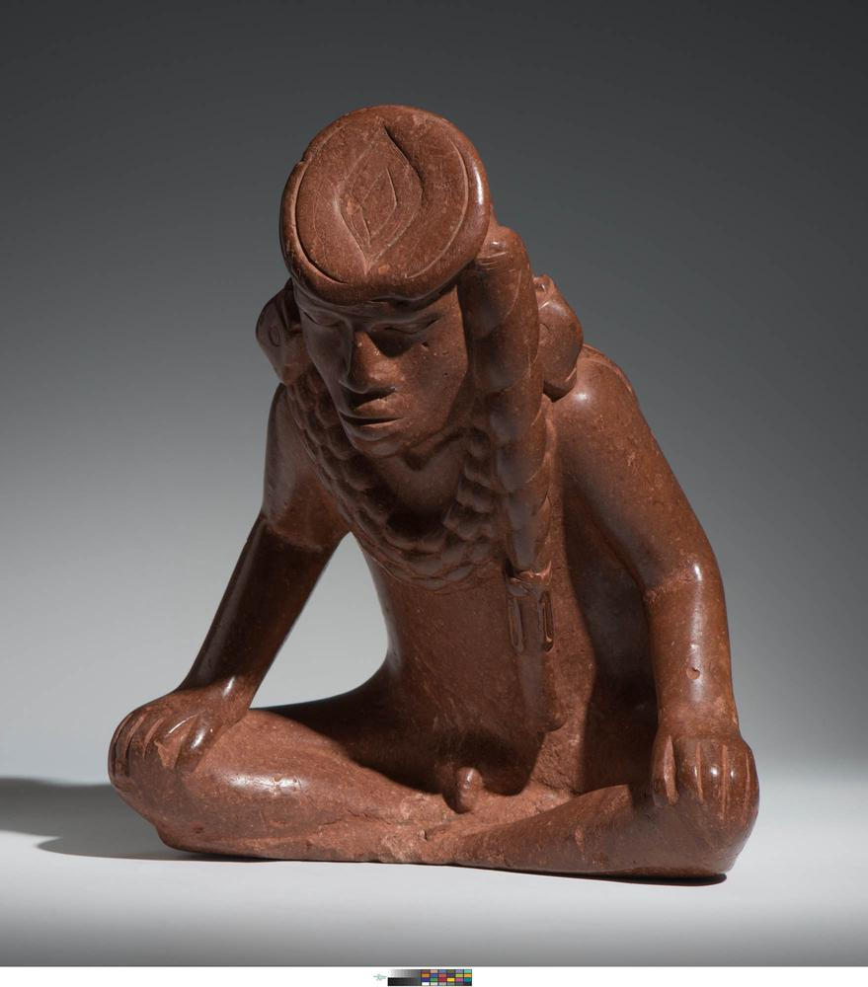
The effigy pipe found in Craig Mound at Spiro helped link all these threads together. This pipe was excavated between 1933 and 1935 in the Spirit Lodge by members of the Pocola Mining Company. Its ownership has changed hands several times, first from the Pocola Mining Company to Joe Balloun, a self-proclaimed artifact dealer. Eventually it was purchased by Sam Dellinger, curator for the University of Arkansas Museum, where it remains to this day (La Vere 2007:161; Sabo 2020). The pipe itself was likely created somewhere between the years AD 1100-1250 at the Cahokia site in Collinsville, Illinois (Emerson et al. 2003:289-306). Resting Warrior is thought to have arrived at Spiro around AD 1250, where it was likely used and then later placed inside the Spirit Lodge after its construction around AD 1400 (Brown et al 2020; La Vere 2007:77, 131)
Figure 2.2: The Resting Warrior Effigy Pipe (Singleton and Reilly 2020)

The Resting Warrior effigy pipe figurine is 5.2 kg, 26 cm in height, 23.9 cm in width, and 20.1 cm in length. This, along with other evidence, suggests that Resting Warrior was first carved as a standalone figurine and only later converted into a pipe. This red flint clay pipe depicts a male figure leaning slightly forward with his legs crossed in front of him. His head sits staring directly forward with both of his hands resting on either knee. He is depicted as sitting partially nude with his genitals exposed. His back has two drilled holes, presumably one for the pipe stem and the other for the bowl. In use, the Resting Warrior figurine would face away from the smoker of the pipe (Emerson et al. 2003:297; La Vere 2007:141).
The symbolism imbued within the pipe helps provide a cultural reading of it. Notable elements of the figurine include the Ogee motif on top of the head, the hair braid, and perhaps most telling, the Long-Nosed God earrings. These distinctions have been used to associate the pipe with the Siouan figure known as Red Horn. This figure is sometimes referred to as Morning Star (referring to the planet Venus), He-Who-Wears-Human-Heads-on-His-Ears, or He-Who-is-Struck-with-Deer-Lungs. However, the Morning Star distinction is contentious (Boles 2011:237-238; Lankford et al. 2011:73, 89-90). For one, the primary author of the ethnographic accounts that this association is based on, Paul Radin, has continuously changed his stance on associating Red Horn with Morning Star. Radin’s early to mid-twentieth century ethnographic works have since been thoroughly inspected by contemporary ethnoastronomy scholars. The consensus now is that an association between the Red Horn figure and astronomy does exist, but that a specific star name should not be linked to them (Lankford 2007:72-125).
Continuing with the symbolic elements of the pipe, the Ogee motif, found throughout the eastern woodlands, can suggest several meanings and depictions. It has been speculated to represent a vulva or eyeball and has even stood in place for a bird’s cloaca found on a vessel. All these depictions suggest meanings involving portals or transmigration (Lankford et al. 2011:84, 89-90, 211). Next, the figurine’s hair braid is suggestive of a horn through its etymology. Lastly, the Long-Nosed God earrings align closely with the Red Horn epic myth cycle,
". . . Those in the heavens who created me did not call me by this name, He-who-is-hit-with-deer-lungs. They called me He-who-wears-human-heads-as-earrings." With that he spat upon his hands and began fingering his ears. And as he did this, little faces suddenly appeared on his ears, laughing, winking and sticking out their tongues. Then he spoke again, "Those on earth, when they speak of me, call me Red Horn." (Radin, 1948:117)

As stated in the text, Red Horn is depicted as having human faces on his ears. In summary, all these elements lead to a compelling interpretation of “Resting Warrior” being a depiction of the hero Red Horn.
Alternatively, there has been an argument that the Resting Warrior pipe is not a literal depiction of Red Horn, but instead of an adoptee dressed in his likeness who has achieved elite status. There is a link between “He-who-wears-human-heads-as-earrings” and the ritualized adoption of war captives. This seems to be an especially lucrative economic practice, as members of the Hidatsa with many of these captive “children” were generally wealthy. Thus, this ritual became important for household and clan aggrandizement. Duncan and Diaz-Granados (2000) argue that this important economic function might have spurred the exchange of material goods associated with “He-who-wears-human-heads-as-earrings.” These material goods, especially earrings, may have been used to mark these adoptees. Additionally, some imagery suggests the shortening of the noses on these earrings in stages. This might suggest levels of adoption and integration into the tribe or, more generally, civilization. They cite the Resting Warrior figurine as a paradigmatic example of this. His earrings are depicted as having short noses, and therefore it is assumed that the human being depicted has been fully adopted into the group and is now perhaps part of the elite class (Duncan & Diaz-Granados 2000:20-22). Further symbolism can be inferred through the context in which the artifact was found and will be discussed later in the “History of Excavation” section. Ultimately, this discussion on the Resting Warrior effigy pipe was included to introduce some of the symbolic connections between Spiro and Cahokia.
Another iconographic study done at Cahokia involved a more thorough investigation into the specific motifs present on Ramey Incised ceramics produced during the Stirling phase (Azar 2019). The most characteristic feature of these pots are their geometric motifs incised above the shoulder. The motifs may be referencing Mississippian cosmology. Previous interpretations of these vessels initially considered them primarily as a trade commodity. However, further analysis reconsidered them as being especially associated with the Upper and Beneath worlds. Pauketat and Emerson (1991) argue that these Ramey incised vessels were used by the Cahokian elites to reinforce an ideology of authority that is innately linked by the iconography to the broader Mississippian cosmology, and especially so to the upper and under worlds. They began their iconographic analysis by distinguishing all the design motifs between “center” and “adjunct” elements. Here, “center” is in reference to a nodal point of which a motif may swirl or radiate around. “Adjunct” elements are those that fill the space between “center” elements, and thus alternate with them. They noticed that these “center” and “adjunct” design elements made a quadripartite design field along the decorated rims, making the vessel’s opening a central node as well. They noted the importance of this quadripartite division of space as occurring throughout the American Bottomland. They cite Kelly’s (1990) work on the Range site, where central fourfold pit complexes were found accompanied by a central post that predates Ramey Incised Vessels. One especially important motif that Pauketat and Emerson point out is the cross-in-circle motif that represents the order of the cosmos. With Ramey incised pots, this cosmological depiction is made implicit using the pot’s plan view via the opening. Therefore, to access the contents of the vessel, one would have to cross through the barrier of cosmological order and into the underworld to gather the contents, which, if they were comestibles, were likely also considered in association with the sun and earth, and thus associated with the underworld too. In summary, elites at Cahokia maintained authority in part by reinforcing their power as part of the cosmological order through the use of Ramey Incised vessels that are embellished with depictions of hierarchy, order, and a religiosity of which they were the primary interpreters. These vessels were likely used at ceremonies like the Green Corn ceremony, a ritualized food redistribution ceremony from elite to commoner, as a way to spread an ideology of authority made known through action and symbolism. Furthermore, they are found in both sacred and domestic contexts, and their use was thought to serve as a physical metaphor for passing through the various earthen realms (Azar 2019:209-210). Azar, building on the work of Pauketat and Emerson (1991) went on to compile a sizable corpus of Ramey Incised vessels found within the American Bottomland for the purposes of iconographic analysis. Once the corpus had been assembled, Azar categorized eight separate motif types and logged their occurrence. These motifs included arcs, chevrons, hachured scrolls, curvilinear scrolls, falconoid imagery, trapezoids, curvilinear parallel lines, and rectilinear parallel lines (Azar 2019:213). Many of these motifs were also present among the Braden Style identified by Phillips and Brown (1978), which Azar sees a connection between. Azar concludes the study by arguing that the variation among Ramey Incised vessels in the American Bottomland indicate that the pots lack the purpose of strict legitimization vehicles for the Cahokian elite, nor do they represent a monolith of Mississippian religious identity. Instead, they appear to serve the purpose of religious expression instruments which were experimented with by individuals. In this view, the vessels act as other-than-human agents that continue to symbolically interact with people beyond their initial manufacturing as a way for Mississippians to physically practice their personalized religious beliefs (Azar 2019:223-225). This section helps contextualize some of the contemporary interpretations of Cahokian religious and leadership views, and perhaps more importantly, it helps strengthen the importance of Phillips and Brown’s (1978; 1984) work as being exceptionally useful to southeastern iconography studies.
Dye (2020) explored the social contexts that facilitated the export of sacred goods from Cahokia to Spiro. He argued for a linkage between religious sodalities and social houses that form corporate groups of aggrandizing elites that use their legerdemain as a way to gatekeep access to affiliation and knowledge of esoteric and secretive in-groups. The enactment of this political mode relied heavily on ritual activities necessitated by the manufacture and circulation of inalienable sacred goods and the controlled understanding of their meanings. The specific goods associated with this social context that made their way from Cahokia to Spiro include copper goods, flint clay figurines – which were discussed in depth separately, symbolic weaponry, and most relevant to this project – carved marine shells. Two common themes associated with the iconography of these exported objects are the Chunkey game and the Birdman, both of which hold significance in the Hero Twins saga. Here, the Hero Twins engage in transcendental gaming of which the outcomes result in death or the restoration of life. The religious sodalities referred to by Dye ritualized these ideas of death and the restoration of life through their performance of legerdemain with the use of symbolic weaponry as a means for aggrandizement. Copper goods imbued with Long-Nosed God imagery found in the Great Mortuary likely came from Cahokia around the early thirteenth century. Those found in the later Spirit Lodge were likely excavated from the Great Mortuary and repurposed as the covers of petaca lids. The production of worked marine shell is well documented at Cahokia. Pauketat (1993, 1994) noted microdrills and shell refuse near the Kunnemann mound at Cahokia. Microdrills, bead blanks, and tool bits exhibiting wear consistent with shell polishing have been found at farmsteads surrounding Cahokia. These shell artifacts began arriving at Spiro in the twelfth century. Among these are pendants, shell beads, Long-Nosed god maskettes, and shell cups. Initially, many of the shell cups were unengraved as noted by their appearance as fragments within the Great Mortuary. However, later engraved cups, like those within the Spirit Lodge, probably arrived after AD 1200. The first of these were likely within the Cahokian originated Braden Style, which seems to have later inspired the Craig style, a post-13th century artistic innovation specific to the Spiroan community (Barker 2020). This discussion helps solidify the exchange of goods between Cahokia and Spiro. Before moving on, a quick note on styles, especially concerning the Braden style and its relation to the recently distinguished Holly Bluff style, is necessary for completing this introduction to Cahokia’s relation to Spiro and for contextualizing the use of iconography throughout the southeast.
Knight et al. (2017) conducted a configurational analysis of engravings that depict Beneath world creatures. More specifically, the bulk of the corpus consisted of shell cups in the Braden A and B styles that had been deposited in the Great Mortuary at Spiro. Of particular note is the inclusion of the “amphisbaena” group, a series of engravings that depict intertwined bird-headed serpents. Some of the characteristics of this style include its occurrence only on containers, its prioritization of a single animate subject, a lack of artificial framing devices, the use of overlapping as a way to convey depth, and the use of cross-hatching as a filler within, and never exteriorly to, animate subjects. The visual themes and motifs all concern the Beneath World powers, especially as they are represented bestially. These consist primarily of intertwined creatures, generally snake-like in body with bird heads and antlers. Occasionally fish fins and bird tails are present. The snake bodies’ decorations include chevrons, diamonds, ogees, etc. Furthermore, a horror vacui can be discerned through the use of free-floating motifs, such as maces, arrow-feathering, ogees, etc. It is in these free-floating motifs where the only instances of human subject matter are depicted within Holly Bluff style. These human subjects are never whole, and instead consist of disembodied skulls, hands, and forearm bones.
The Holly Bluff style can be broken into three phases, Holly Bluff I, Holly Bluff II, and Holly Bluff III. This sequence has a trend from higher to lower artistic competency. As far as chronology goes, the super majority of Holly Bluff instances were found in the Great Mortuary, which provides a relatively clean terminus ad quem. Knight et al. (2017) turned towards the outlying examples of this style for a better gauge of chronology for each Holly Bluff phase. The most promising provenience of these outlying stylistic examples for Holly Bluff I is the Bowman cup found at the Bowman site in Little River County, Arkansas. Additionally, Phillips and Brown’s (1978) Plate 7, originally assigned to Braden A (now Braden Classic) depicts a chunkey player with coiled snake bodies decorated with the same form of trilobates as one of the Holly Bluff examples on Plate 8. It is this connection that leads Knight et al. (2017) to assign Holly Bluff I as being contemporaneous to the Moorehead phase of Cahokia, AD 1200-1275. The Holly Bluff II phase similarly required the use of an external-to-Spiro example for its dating. Here, Knight et al. (2017) used a vessel from Chucalissa that had been deposited during the later Walls phase, which has been securely dated from 1350-1550. Lastly, the Holly Bluff III phase was dated using references to vessels found at the Lake George site, the Hollywood site, and Moundville. Knight et al.’s final, conservative, estimate on the chronology of Holly Bluff falls between AD 1200-1450. Additionally, they place the source area “in the northern portion of the Lower Mississippi Valley, somewhere between the Missouri boot-heel and the Norther Yazoo Basin.” Unfortunately, for this project the avoidance of whole human subject matter makes Holly Bluff engravings a rather poor candidate for inclusion within this project’s search for depictions of dancing.
These case studies highlight the effectiveness that iconographic analysis has had on Mississippian archaeology. Additionally, they introduce some of the key publications that will be vital to this project moving forward, namely Phillips and Brown (1978; 1984). What links these studies together is that they all tie Cahokia to the broader Mississippian world through iconography. More specifically, many of these links connect Cahokia to Spiro, which will be contextualized, and problematized, in a discussion on Spiro next.

Spiro
The Spiro Mounds archaeological site is located in LeFlore County, Oklahoma alongside the Arkansas river near the border with Arkansas (Figure xx). It sits within the Ouachita biotic district which is characterized by having greater similarities to the eastern woodlands than to the western grasslands. This coincides with oak-pine-hickory forests, thin ultisol soils, and an annual precipitation between 40 and 52 inches. Albert (1981) conducted a search for the most suitable place for investigating Oklahoma’s past climate. The palynological study would need a setting that had been continuously wet or continuously dry in order to possess the levels of preservation that the study required. More specifically, the Oklahoma Archeological Survey was searching for a place that could fulfill the following criteria: 1) somewhere that contained well-preserved pollen, 2) somewhere with enough preserved organic material that would allow for radiocarbon dating, and 3) the record would need to be continuous back to the last glacial episode. Two settings were identified in 1977 and 1978, Natural Lake and Ferndale Bog, respectively. Cores from both locations were taken using a modified Livingstone sampler that had been mounted on a raft. One notable result was a shift to drier conditions between 1200 and 1000 years ago. This shift would not correct back into wetter conditions until the Neo-Boreal episode of the seventeenth century. Ultimately, these intense and repeating cycles of drought and high precipitation often left the area susceptible to major climatic catastrophe. Furthermore, dendrochronological data reinforces the evidence for severe periods of drought. These tree-ring indicators place severe periods of drought chronologically near the abandonment of Spiro (Regnier et al. 2019:16-19). However, drought should be recontextualized here to provide some nuance to the overall abandonment of Spiro. Burnette et al. (2020) used the North American Drought Atlas to reconstruct the Palmer Drought Severity Index (PDSI) which allowed for a temporal, spatial, and intensity analysis of the drought affecting Spiro. Their study viewed multidecadal droughts as a hazard factor within a progression of vulnerability that involved various internal and external pressures to Spiro. At Spiro specifically, the roots of their vulnerability were embedded in their access to resources and power, which turbulently mixed with the pressures of population dynamics and environmental resources. This internal strife was multiplied by drought, which when rituals failed to answer for, resilience adjustments shifted from incremental, to transitional, and finally to transformational, which culminated in the construction of the Spirit Lodge. This resilience is present in the archaeological record through iconography. Spiroan priests would have likely intensified their efforts to bring back the rain, and symbolic evidence present on shell gorgets seems to corroborate this. For instance, the Hero Twins and their associated forms represent powerful storm deities whose iconography runs throughout artifacts from Spiro.
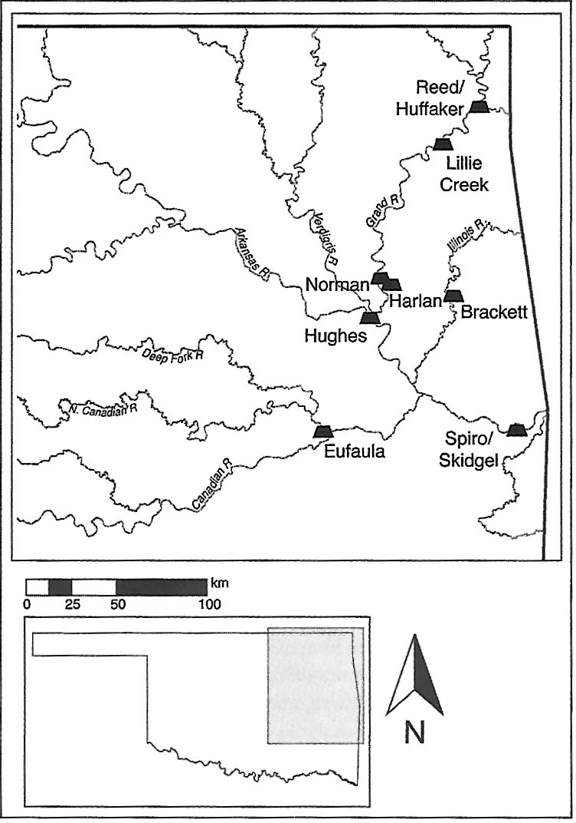
Figure 2.3: Map of Spiro’s location in context with other WPA sites (Regnier et al. 2019:12)
The site itself encompasses 14 mounds upon approximately 80 acres of land. The entire site appears to be located on a northwest-southeast axis, with the largest of the mounds, Craig Mound, inhabiting the easterly extents of the site. Additionally, the site is divided into two terraces, the upper and lower. The upper terrace contains 11 mounds, including two large platforms, Brown and Copple Mound, which are both located northwest of Craig Mound, with Copple being the most northerly. Craig Mound is located in the lower terrace, which only contains 3 mounds total, Craig, Ward 1, and Ward 2.

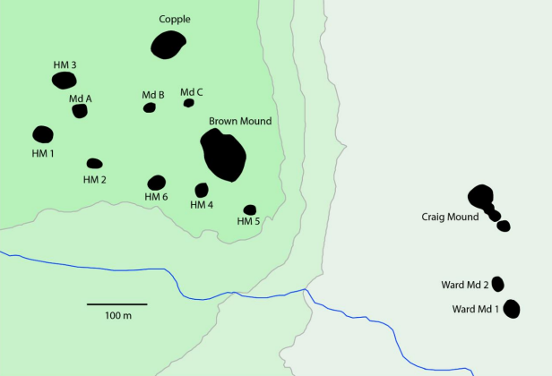
Figure 2.4: Map of Spiro’s layout (image produced by Patrick Livingood)

Furthermore, Craig Mound is multilobed with each mound tapering off in size. The fourth and smallest of these mounds is slightly disconnected, but still in clear association with the other three (Hammerstedt et al. 2017:11-15; La Vere 2007:13, 35-36).
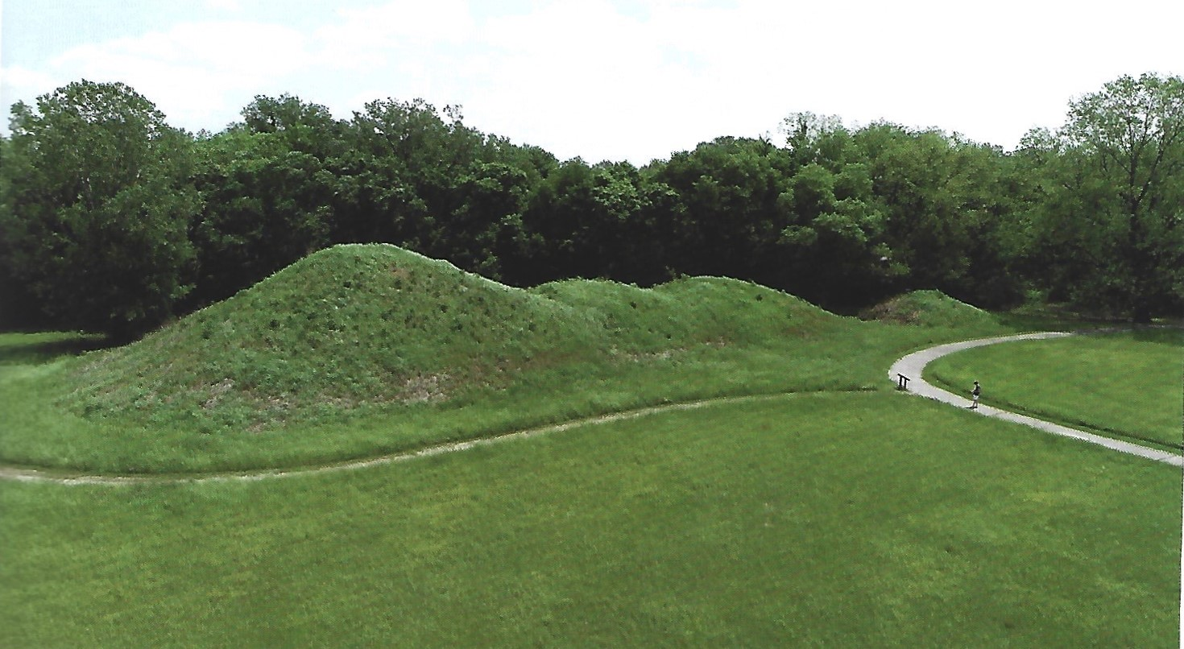
Figure 2.5: Image of Craig Mound (Courtesy of Scott Hammerstedt)

Cultural History of Spiro Mounds
Conventionally, Spiroan occupation is broken into five chronological phases, the Evans, Harlan, Norman, Spiro, and Fort Coffee (Brown 1996; Orr 1946; Regnier et al 2019; Sievert and Rogers 2011). The earliest phase, the Evans, is marked most notably by regional trade ceramics found in Craig Mound burials that suggest the early influences of Caddo culture on the site. The Evans occupation is dated from approximately AD 900-1050/1100. However, it should be noted that some of the assemblage characteristics associated with this phase are found in subsequent phases.
Furthermore, some pre-Evans burials closely associated with the Fourche Maline archaeological culture, a Woodland period Caddoan distinction, are present at Spiro. This link is based primarily on ceramic types that suggest a connection with the Plum Bayou culture in Arkansas (Regnier et al. 2019:19-20). Furthermore, it is best to consider how some of the earliest conceptions of Fourche Maline peoples were framed. Harrington’s 1920 book on the sites that would later be considered Fourche Maline was called “Certain Caddo Sites in Arkansas.” This suggests a Caddoan link to the Fourche Maline cultures that was based on the location of the Fourche Maline sites and the similarities in pottery and lithics to the later Spiroan peoples, which the modern-day Caddoan and Wichita peoples lay claim to. Although, these burials do not seem to indicate prolonged occupation (Regnier et al. 2019:20; Sievert and Rogers 2011:2). Additionally, Schambach (2002) argued against the connections between the Fourche Maline culture and early Spiroan culture. For one, the mound traditions practiced by each are quite different. Fourche Maline mounds tend to cover crematoria, which generally contained interred sets of skulls, mandibles, teeth, and grave offerings. Schambach (2002) goes on to argue that any kind of early Mississippian interest in the Fourche Maline culture likely had to do with their experience in crafting high quality bows from bois d’arc.
Following the Evans phase is the Harlan phase, dated from 1050/1100–1250 AD. This period represents an expansion and division of Spiro both in its spatiality and its ceremonial function. The three divisions of the site consist of a mortuary ritual area to the west, a residential area near the center of the site, and a final mortuary internment area to the east (Sievert and Rogers 2011). This phase is defined primarily by its square, four-post houses and its distinctively Caddoan fineware. Many of these are found in the central residential area of the site. Although, none have been interpreted as having house mounds ( Regnier et al. 2019:20-21; Regnier et al. 2020:21; Sievert and Rogers 2011:2-7).
After the Harlan phase came the Norman phase dated from 1250-1350. This phase is significant to Spiro mainly in associations with some of the burials at Craig Mound. During this period there was a major expansion in trade goods, including some of the earliest stamped copper sheets. Additionally, the Harlan phase represents the first usage of the Great Mortuary within Craig Mound.
However, it was not until the Spiro phase that the Spirit Lodge was constructed, and the bulk of the elaborate burials within Craig Mound took place. Also, during this time there was a general movement away from the residential area established in the Harlan phase in favor of habitation along the outskirts of the site. The shell gorgets and cups incised with Spiroan iconography are also attributed to this period and give a snapshot of the religious symbolism associated with the culture (Regnier et al. 2019:21; Sievert and Rogers 2011:7-8).
The final chronological distinction traditionally made at Spiro Mounds is the Fort Coffee Phase. This period runs from approximately AD 1450 – AD 1660 and is often defined by the closure of Craig Mound. In general, this coincides with a greater shift from east to west. Rogers (2006) used an existing body of AMS dates and 20 new ones to investigate the Fort Coffee Phase outside of the immediate bounds of the Spiro region. He argued that the presence of more plains-oriented domestic attributes, such as an increase in bison hunting, an expanded use of storage pits, and a tool shift towards the processing of bison serves as evidence for this shift from east to west. It is represented by the adaptation of Spiro culture to fit more in line with the Great Plains peoples (Regnier et al. 2019:21-22; Rogers 2006; Sievert and Rogers 2011:7-8, 11). Furthermore, Rogers’ (2006) study helped add weight to Rohrbaugh’s (1982) interpretation that the late Fort Coffee phase Spiroans likely held links to the Kichai and/or the Norteño focus of North Texas. These groups would represent who the Spiroans were during the first interactions with the Europeans.
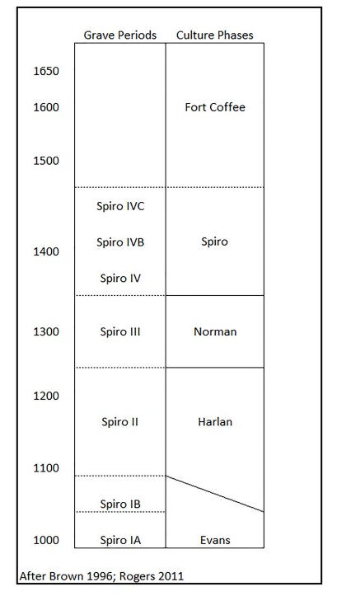
Figure 2.6 Spiroan Culture Phases and Chronology (Regnier et al. 2019:19)

Differences Between Spiro and the Mississippian World
Unlike many Mississippian sites to the east, Spiro does not appear to be a centralized chiefdom that served as a political epicenter for lower-tiered sites throughout the region. Instead, Spiro and other Arkansas Drainage mound sites were likely serving as religious complexes via the Hasinai dual system of leadership. Under this social organization leadership is separated into two spheres. The first part is represented by the caddi, a political leader that served as the head of quotidian secular functions for Hasinai Caddoan peoples. The second part is represented by the xinesi, which served as the interlocutor for the spirit realm. The xinesi complexes were housed away from the political complexes (Wyckoff and Baugh 1980; Sabo 1998, 2012). This may be reflected on a macro scale with Spiro, Harlan, Brackett, Hughes, Eufaula, Norman, Lillie Creek, and Reed, in that they do not represent highly populated polities, but instead serve as symbols of shared religious practice (Regnier et al. 2019:296-332).
Some researchers consider Spiro as Mississippian based on multiple factors. For instance, Spiro appeared to share a similar agricultural economy based on maize and central leadership. Additionally, the Caddo held ties to Cahokia and the lower Mississippi Valley (Griffin 1967:189-191). Other key factors included the veil of shared cosmological iconographic symbolism, and the concept that life is reflected in death via grave goods (Brown 1996; Peebles and Kus 1977).
Later interpretations paint Spiroan burials in a different sense, in that priestly-class groups helped construct ritualized burial mounds to honor mythologized ancestral connections. Additionally, the mounds in the Arkansas Drainage, including Spiro, were not used to elevate temples or residential structures, as was the case at many Mississippian sites, but instead elevated a space for ritual interaction, such as the working and cutting into the surfaces of mounds by a small group of permanent ritual specialists (Kay and Sabo 2006). Furthermore, maize cultivation was not a substantial subsistence strategy at Spiro. Instead, woodland-style starchy seeds make up the bulk of archaeological subsistence remains for much of Spiro’s occupation (Fritz 1989; Regnier et al. 2019:296-332).

Northern and Southern Caddo
To emphasize the uniqueness of Spiro and its occupation, it is necessary to make the further distinction of the Caddo region and its separateness from the broader Mississippian world. The Caddoan region spans through Oklahoma, Arkansas, Louisiana, and North Texas. Its emergence is attributed to Late Woodland Period cultures that had been occupying the area (Wyckoff 1980; see also Lambert 2017:26). This region can be separated archaeologically into two similar, but distinct groupings, referred to as the northern and southern Caddo. These two communities of practice held similarities in iconographic symbolism, mound building, and settlement patterns, and engaged in the long-distance trade of finewares. The northern Caddo region is centered around the Arkansas River Valley, while the southern Caddo region is centered on the Red River Valley. Spiro, which is located within the northern Caddo region, did not produce their own finewares, and instead relied upon the modes of production housed within the southern Caddo area. This separation in production led to distinctions in meaning regarding the finewares themselves. In the north, as is the case at Spiro, finewares are often limited to ritualized mortuary practices, while in the south finewares are found in abundance in mortuary, domestic, and ceremonial contexts (Lambert 2017:290). Other differences include pottery style, architecture, burial practices and genetic make-up (Perttula 2009, 2011; Lambert 2017).

History of Excavation
The earliest excavations at Spiro Mounds were conducted by Joseph Thoburn between 1916-1917, though he had originally visited them in 1913. Thoburn excavated the Ward Mounds and uncovered a collapsed house with many intrusive burials. His initial interpretation was that the house had collapsed on the people inside during the middle of the night while they were sleeping. Alongside his 28 reported burials, Thoburn uncovered artifacts that spanned the Spiro I through Spiro III periods. These included Chandler type T-shaped pipes, a Crockett Curvilinear Incised bowl, repoussé copper plates, and other miscellaneous artifacts (Brown 1996:115-122). The density and diversity of the artifacts piqued Thoburn’s research interests, but due to money and time constraints he was not able to continue. During this break period in the 1920s, Thoburn is quoted as expressing his fears regarding the mound site,
“… if an un-skilled amateur, who is interested only in gathering ‘relics’ for a personal collection or for sale, should disturb those interesting earth-works, he may easily make it impossible for us to read the story that it holds for the careful scientific investigator.” (La Vere 2007:14)

Unfortunately, these fears came true when the Pocola Mining Company conducted their own excavations between 1933-1935. These excavations were done for the sole purpose of looting artifacts to sell on the illicit art market. The grandeur of the finds was equated to the ancient Egyptian artifacts uncovered by Howard Carter in 1922, and thus Spiro was dubbed by local newspapers as “… an American Tutankhamen’s tomb” (La Vere 2007:13, 35-36, 98). Help for the site arrived in the form of protective legislation lobbied vehemently for by the late University of Oklahoma Department of Anthropology Chair, Forrest Clements. Unfortunately, by the time the Pocola Mining Company were made to stop excavations, they had destroyed much of the context of the site (La Vere 2007:15, 52-54, 88).
Academic excavations began in 1936 under the direction of Clements with assistance from crews in association with the Works Progress Administration (WPA). These excavations initially focused on salvaging the damage done by the Pocola Mining Company to Craig Mound. Unfortunately, the extensive damage led to Clements’ deeming Craig Mound as being impossible to preserve. Subsequently, he ordered the complete excavation of the mound using the profile system method. This method involved the cutting of 10ft wide rows out of the mound, leaving artifacts temporarily on a dirt pedestal before being recorded and removed. There were some flaws in this methodology. For one, it is not conducive to recording individual soil levels. Instead, this method is primarily useful for recovering artifacts. While this stint of excavation was more academically fruitful than the Pocola Mining Company’s looting, it still ended in the complete demolition of Craig Mound by late 1938 (La Vere 2007:168-181).
Rogers’ 1979-1981 excavations expanded upon the WPA era digs. His goal was to better understand the bounds of the Spiro Mounds archaeological sites by focusing on the areas not investigated by the WPA archaeologists. One of the specific research questions sought in the preliminary report was to determine whether or not Spiro was fortified. They were working under the assumptions made by the findings of the WPA archaeologists, that Spiro was a ceremonial center with a low occupation of priestly-class caretakers (Rogers 1980:3). Rogers’ excavation method involved the use of a Gradall to precisely remove the topsoil and unveil areas of activity concentration as noted by artifact clusters. Once the topsoil had been removed and potential activity areas were established, manual excavation was employed. Additionally, Rogers and his team screened the removed soils through ¼ inch mesh, and eventually wet-screened them through a 1/16-inch mesh. This screening process proved especially revealing in regard to the WPA archaeologists excavated backfill. Here, Rogers and his team uncovered a variety of conch shell fragments, copper, galena, and bead artifacts. However, their most important finding is arguably that of House Mound #5, which helped shed light on the ceremonial destruction, burial, and rebuilding of buildings. They did not find evidence for intensified fortifications though (Rogers 1980).
A follow up study by Rogers (1982) built off the previous one and had the expressed objectives of 1) continuing House Mound 5’s excavation, for which he provided an interpretation of, 2) to relocate the WPA era excavations of House 7 to determine the area’s archaeological significance and 3) to build a reconstruction of it, and lastly, 4) to conduct a proton magnetometry survey of the plaza area at Spiro. These were all generally successful.
Following the excavations and analysis of House Mound 5, Rogers (1982) provided a short interpretation outlining an event summary for this particular building and some of those like it. It begins with the construction of a special purpose building (building #15) around AD 890. Eventually, this building was abandoned and then later ceremonially burned to the ground to make way for a new building on top of the previous one. This happened two additional times before an earth mantle was placed over the top of the structural remains. The earth mantle, known here as House Mound 5, sat in association with at least five other small mounds. Within this association the cyclical construction, destruction, and reconstruction continued. When taking into consideration the other small mounds, this likely had a continued use period of about 400 years, from AD 850 to AD 1250. Rogers notes that these buildings were not common dwellings, but instead stood as ceremonial and domestic structures for the political and religious elite. Evidence of acorn, hickory, pecan, walnut, and corn, as well as various fruits, such as persimmons and grapes, were found alongside the remains of game animals, like deer, rabbit, and others. In general, this suggested a lack of scarcity for these elites, and adds to Rogers’ argument that Spiro was becoming a major ceremonial center in the Arkansas Basin during the Harlan phase. However, House Mound 5’s significance and use ceased by the Spiro Phase. This summation of Rogers’ interpretation, especially his claims about Spiro’s rise as a ceremonial center, will be expanded on more when reviewing his later work below.
The relocation of the WPA’s excavation of House 7 was a success. Rogers (1982) and his team conducted a series of four 1 x 1 m square test pits and a number of post hole digger tests. Few artifacts were recovered from this portion of the project, but it did ensure that the context of the original House 7 location would not be disturbed by the reconstruction process.
The final portion of Rogers’ (1982) project consisted of a magnetometer study of the plaza area of Spiro. For this the area was broken into three groupings of four, one to the west, one in the center, and one to the east. The eastern region contained ferrous debris from a modern farmstead that greatly interfered with the magnetometer’s readings. Although, there might have been evidence for a small mound in Blocks A and B. Two anomalies were identified in the central portion of the plaza as well as evidence suggestive of a small mound in Blocks F and H. The most fruitful of the magnetometer scans occurred in the western portion of the plaza, where a complex of anomalies were identified. The scans show this group of anomalies near a visible rise that may contain a structure, further suggestive of a mound.
Further studies by Rogers (1983) sought to explore whether or not ranked societies existed in the Arkansas River drainage of eastern Oklahoma. He was specifically focusing on the Harlan and Spiro phase time periods to determine if ranked societies were in place, and if so, what differences are exhibited between the two periods and why? He analyzed 880 burials throughout the region and conducted a cluster analysis to determine that sets of hierarchical burials, based primarily on the types and quantities of grave goods, did indeed exist during both periods. With this conclusion he moved forward to determine the difference between the ranked societies of the Harlan and Spiro phases. Rogers found that the hierarchy of Harlan burials tapered off in association with grave goods as the rankings declined. However, in the Spiro phase the intermediate burial rankings still had a relatively high amount of grave goods. Ultimately, he concluded by arguing that there were likely two distinct ranked societies during the Harlan phase, one occupying the Harlan site and the other occupying the Spiro site. Later, during the Spiro phase these ranked societies incorporated socially and economically into a base operating out of the Spiro site. Rogers argues that the Spiro site’s rise to prominence was likely due to its location alongside the Arkansas River, which allowed greater access to exotic trade goods and allowed the site first to prosper economically, and later politically (Rogers 1983).
Contemporary research at Spiro Mounds has taken advantage of remote sensing. These geophysical surveys have not only helped preserve what remaining artifacts and context are left unexcavated but has also revealed anomalies that would have been invisible without extensive ground testing. One of the more notable projects is the Spiro Landscape Archaeological Project (SLAP). Beginning in 2011, SLAP has employed an orthophotographic review of the Spiro site using aerial photographs from the WPA era. However, the project’s most revealing study was a widespread gradiometer survey throughout 30ha of the non-mound areas. The gradiometer data revealed numerous circular anomalies around Craig Mound indicative of intentional structures. Several of these anomalies were bisected by a farmer’s nearby artificial stream. With the permission of the Caddo Nation and Wichita and Affiliated Tribes, as well as the Army Corps of Engineers and the Oklahoma State Historic Preservation Office, ground truthing on these anomalies began. Excavation has revealed findings consistent with intentional structures, i.e. postholes and postmolds. However, internal storage pits and hearths were absent. This may be suggestive of a temporary functional use of the structures (Hammerstedt et al. 2017:11-27). This discovery would help shape the Great Mortuary/Spirit Lodge interpretation that will be contextualized and discussed next.
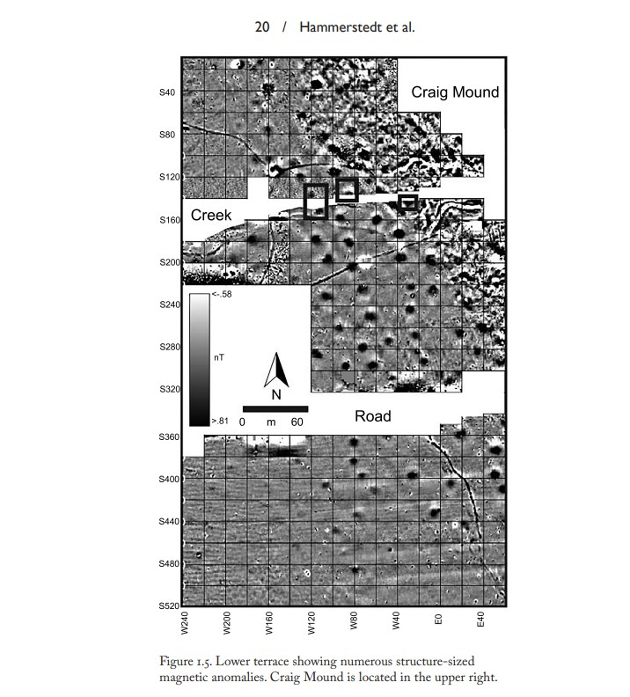

Figure 2.7 Magnetometer Data from SLAP Showing Circular Anomalies
Contemporary Interpretation of Spiro (Hammerstedt et al 2017)
Within Craig Mound was a foundational ossuary, referred to as The Great Mortuary. It had been floored with split canes aligned to the North-South axis and contained a mixture of disarticulated human remains and ritually broken artifacts. It was capped with a layer of compacted soil to symbolize the end of its usage. Current interpretations view the Great Mortuary as an ancestral veneration burial. Individual identities of Spiroans are mixed together into a collective identity/identities, occasionally considered as evidence for the presence of sodalities (Brown et al. 2020:94-97).
Above the Great Mortuary lies the Spirit Lodge. This hollow chamber within the mound contained an elaborate diorama, with character representations from both the human world and the supernatural. In the center of this arrangement sat an Earthmother figurine, a representation of the axis mundi and the continuation of life. Additionally, there was a First Man figurine with two assistants, representing the human-led oversight of sacred rituals. Facing towards the northern wall with its back turned to the Earthmother sat the Resting Warrior effigy pipe often identified as Red Horn. The Resting Warrior figurine was surrounded by depictions of weaponry and is interpreted as a defensive gesture. Near the southern wall sat a vulture figurine that clutches a stiff human body. Interpretations are preliminary, as the records of its placement are based on eyewitness accounts, but they consider the figure as part of a larger sacred bundle that included a continually handled human skull. This might have represented a lone human actor that was meant to represent humanity in its interactions with the spirit world. There were also a series of lidded baskets called petaca placed near the First Man and his assistants. These were filled with ceremonial regalia, such as woven clothes and carved beads. However, their symbolism within the diorama is still unclear. The final major artifact class within the Spirit Lodge was a series of engraved shell cups, which serves as the basis for this project and will be discussed in depth below (Brown et al. 2020:99-104).
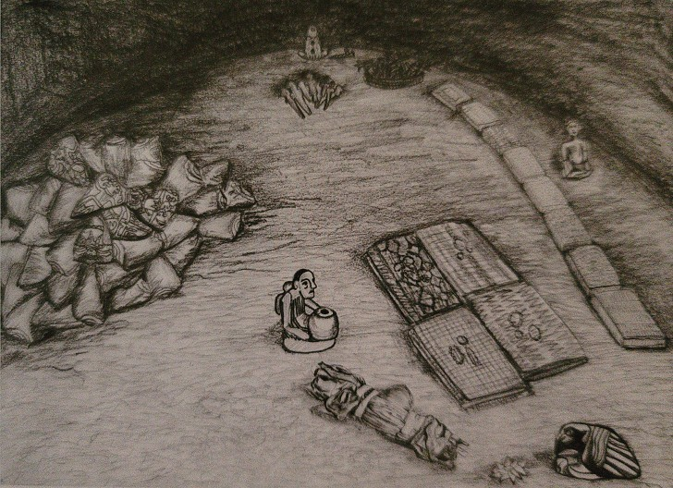
Figure 2.8 Drawing of the Spirit Lodge Layout (Brown et al. 2020:97)

What does this single depositional event have to do with the overall interpretation of Spiro? First, it is best to review and contextualize the site’s history. The beginning of the fourteenth century through the fifteenth century saw a severe drought at Spiro (Burnette et al. 2020:77-89). Additionally, the period leading up to the creation of the Spirit Lodge was a time of social shift through a series of migrations connected with the Braden Style of artifact (King 2020:57-73). All of this paired with Hammerstedt et al.’s remote sensing studies and excavations (2017, 2019) begin framing Spiro and the Spirit Lodge as parts of a major ritual event. However, while it is possible that the Spirit Lodge and the structures are contemporaneous, excavations have yet to reveal any datable material from the temporary structures. One possible missing interpretive piece is the pile of engraved shell cups and their iconographic imagery found within Craig Mound.
Given the social and climatic distress, Spiroan ritual leaders had likely been under pressure to fix things. The current interpretation suggests that they organized and promoted a large renewal ceremony with help from some neighboring regional sites. The conclusion that the ceremony was focused on renewal comes from the iconographic symbolism imbued within the diorama’s characters and arrangement, mainly, the references to life, death, and rebirth surrounding a central Earthmother figurine (Brown et al. 2020:104-106).
This large-scale renewal ceremony interpretation is further solidified through the iconographic analysis of the engraved shell cups found within the Spirit Lodge. Many of the shell engravings depict human-like figures grasping at poles. These poles range from being straight, serpentine, or even forked. Two primary classifications emerged from these human-like figures. The first, called Wedgemouth, has a distinctive geometric shape extending from the corners of its mouth. This same design is often found on human-animal/phantasmagorical figures, such as a rattlesnake with the head of an antlered Wedgemouth person. For this reason, it is interpreted as representing a spirit being. The second figure classification, called T-Bar, named for the T-shaped facial decoration extending from the bottom of the eye to the neck and back to the bottom of the earlobe, likely represents the human counterpart to Wedgemouth. This T-shaped facial decoration is not seen on phantasmagorical depictions, hence its association with humans and the human realm (Brown et al. 2020:106-107). The significance of these figures, when paired and associated with the pole objects, was identified by Phillips and Brown (1978). Referencing the narrative traditions of Caddoan speaking peoples, such as the Pawnee, reveals the identity of the forked pole as a powerful object transferred to humans from the spirit world to overcome insurmountable obstacles. Additionally, the images depict Wedgemouth and T-Bar both grasping the forked pole with speech scrolls coming out of their mouth. Altogether, this suggests a request by humans for a spiritual power from the spirit world to overcome the severe climatic and social difficulties that had befallen them. The shell engravings depict this request as being granted by showing the transfer and receival of a forked pole from a Wedgemouth to a T-Bar through an active ritual of speech and dance (Phillips and Brown 1978:104-112). This further combines with the temporary structures identified by Hammerstedt et al.’s (2017, 2019) gradiometry study, as placing this renewal ceremony in the public sphere with possible attendance from people outside of Spiro.

Shells
Since the engraved shells are the primary focus of this project, it is important to provide some exhibition on their origins. The shells found in the Craig Mound at Spiro likely originated from the Gulf of Mexico. Phillips and Brown’s (1978) initial research into these shells led them to Dr. T. E. Pulley, an expert malacologist, and Director of the Houston Museum of Natural Science at the time. Pulley’s initial conclusion was that the species of shells being used at Spiro were Busycon perversum, which can be found from the Florida Keys to the Straits of Yucatan. He went on to add that the McDannald collection housed by The Houston Museum of Natural Science had some outlying shells from the Craig Mound that were of the species Pleuroploca gigantea and Cassis madagascarensis, the latter of which are found only in the Florida Keys or Veracruz Coast. This led him to believe that all the shells likely came from this area (Phillips and Brown 1979:26-29).
Contemporary research has been conducted on the sourcing of these whelk shells. Kozuch et al. (2017) partook in a biogeographical and morphological study of various whelk shells found at Spiro, East St. Louis, and Cahokia. First, it is important to note the distinction between some of these whelk shell species. All snail shells spiral in one of two directions, right (dextral) or left (sinistral). In the Atlantic Ocean there are only two snail genera with frequently sinistral coiling shells. These being the sinistral whelks (Busycon) and the Triphora genus. Between these two genera is a massive size difference, which allows for easy identification on archaeological sites. Furthermore, within the Journal of Shellfish Research there are only three accepted Busycon species: the snow whelk, the lightning whelk, and the prickly whelk. The snow whelks are found only off the coast of New Jersey and are extremely rare. Given the abundance of whelk shell artifacts found at Spiro and Cahokia, this makes them an unlikely candidate. Additionally, prickly whelk shells have protrusions of their spikes on the inside of their outer whorl, which makes them a poor choice for carving gorgets and cups. This leaves lightning whelks as the best possibility for the Spiroan engraved cups and gorgets. Kozuch et al. (2017) went on to conduct a study on the spire angles of lightning whelks found at Spiro, Cahokia, and the Eastern St. Louis site and determined that 90% of these shells had spire angles consistent with those found in the eastern portion of the Gulf of Mexico, more specifically, off of the Florida Gulf Coast.
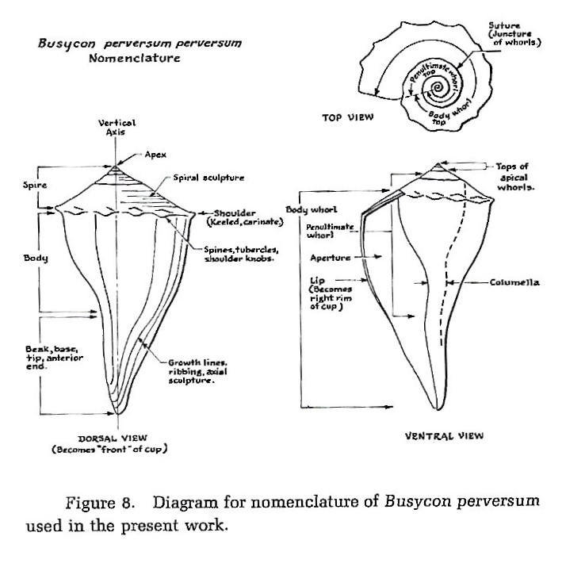
Figure 2.9 Diagram of Lightning Whelk Shell (Phillips and Brown 1979:27)

Chapter 3: Methods
This chapter discusses the methods used for the configurational analysis undertaken on the engraved shells from Spiro Mounds. Since the collection of engraved shells remains scattered, the primary source for this thesis relies on the published images within Philip Phillips and James A. Brown’s Pre-Columbian Shell Engravings From the Craig Mound at Spiro, Oklahoma Part 1 & 2 (Phillips and Brown 1978, 1984). The main methodological inspiration comes from Vernon James Knight Jr.’s Iconographic Method in New World Prehistory, more specifically his techniques for configurational analysis (Knight 2013). The roots of Knight’s configurational analysis method will also be discussed. This will begin with an overview of Erwin Panofsky’s contributions to the art history world with his works on Iconological and Iconographic analysis. Next, the introduction of archaeological principles to Panofsky’s methods by his student George Kubler will be discussed. Then, the synthesis between the two will be determined via Knight’s configurational analysis. Finally, Mathew Looper’s iconographic analysis of Mayan dance will be considered throughout the project.

Erwin Panofsky
Many of the iconographic techniques employed by southeastern archaeologists hold their origins in the art history works of Erwin Panofsky. Before discussing these, it is important to note the difference between iconography and iconology. Their differences share the same traits of differences between ethnography and ethnology, mainly the former is concerned with description, while the latter is concerned with analysis and comparison. What links them together is their pursuit of social, historical, and cultural meanings behind the themes, motifs, and subjects of visual arts. More specifically, Panofsky’s iconological method was a stadial framework for interpreting an art’s meaning. This framework is tripartite in nature and each proceeding level represents an increased depth of cultural knowledge and artistic interpretation.
The first of these parts is known as the primary or natural subject matter. This stage of interpretation is used to ascertain the face-value meaning behind an image and represents the most literal viewing of the piece. These meanings may come from the events, expressions, objects, or even the pure forms within the work. Panofsky calls these elements “motifs,” and they represent one of the simplest units within iconographic analysis. A thorough identification of these “motifs” is what Panofsky considers the starting point for pre-iconographic description (Panofsky 1939:5).
The second part of Panofsky’s iconographic analysis is called the conventional subject matter. This is the stage that considers the cultural and iconographic context within the piece. In other words, this is where the iconographer can contextualize specific “motifs” from their natural subject matter beginnings into what Panofsky calls “images” or “allegories.” These express the cultural sentiments surrounding specific “motifs” and especially considers the relationships between conventional subject matters and the “allegories” being portrayed (Panofsky 1939:6-7).
The third level, called the intrinsic meaning, or content, apprehends the artwork within the broader historical period, as well as through the nuances put into the work by the artist as a participant of their culture. Panofsky words it as “… reveal[ing] the basic attitude of a nation, a period, a class, a religious or philosophical persuasion – unconsciously qualified by one personality and condensed into one work.” (Panofsky 1939:7). Notice the phrasing “unconsciously qualified by one personality and condensed into one work.” This frees the analysis from individualistic artistic intent. In this case it is best to view the artist’s proposed intent as a heuristic vehicle for understanding the broader culture in which they work. Ultimately, this is all meant to demonstrate that Panofsky thought using this stadial method would provide a holistic interpretation behind the varying levels of meaning in art.

George Kubler
One downside to Panofsky’s iconological method was that it had difficulties considering art from ancient, non-text-based cultures. It was primarily designed for interpreting cultural contexts that could only come from written text and established artistic conventions. George Kubler, a student of Panofsky’s, recognized this issue and sought to adapt Panofsky’s method so that it could be applied to ancient cultures. More specifically, Kubler made these modifications and applied them to art at Teotihuacán and on Classic Maya sculpture before their image-based writing had been translated. He called this modified iconographic method configurational analysis. This procedure involved the assemblage of the corpus of images, and the systematic extraction of the various themes and motifs within it. Furthermore, Kubler calls for an assumption to be made, mainly that the motifs and themes within the corpus are expressions of cultural narratives, as opposed to simple literal depictions. The final step of Kubler’s configurational analysis emphasizes the importance of genre and style. The identification and periodization of these can help reveal the shifts in cultural meaning imbued within specific motifs and themes (Knight 2013:85-129, Kubler 1967).
Another important technique employed by Kubler on the iconography of Teotihuacán is the use of a linguistic analogy. This involved the categorization of motif groups through metaphorical parts of speech. In other words, symbols depicting objects or concepts should be analogized as nouns, symbols depicting attributes should be analogized as adjectives, and symbols depicting actions should be analogized as verbs. This method was designed to highlight the interconnected relationships of symbols, which can help reveal their meanings as systems. Kubler’s analysis revealed an unevenness in use frequency of these three motif categories. Noun type symbols were the most common, while the appearance of adjective and verb symbols fell into second and third, respectively. Kubler interpreted these irregularities in the frequency between types as evidence for the presence of litanies and liturgies. This allowed for a linguistic interpretation to emerge from the iconographic analysis, in which the iconography of Teotihuacán was being utilized for speaking with and asking favors of the gods (Kubler 1967:5-12).
Finally, Kubler maintained a strong stance against the use of ethnographic analysis when conducting configurational analysis. He wished for meaning to be extrapolated from the images alone. This stems from something alluded to in Panofsky’s work known as the problem of disjunction, which stands for the tendency of symbols to be greatly susceptible to shifting meanings when they are transferred through time or space. Kubler thought the use of ethnography in iconographic analysis represented a blatant ignoring of disjunction. Thus, Kubler’s method struggled with the very criticism he had placed on Panofsky, the exclusion of subject material. In Panofsky’s case this was non-literate cultures, and in Kubler’s it was a major source of cultural knowledge. For archaeological applications this restricts the repertoire of information of ethnography and ethnology from being incorporated into the analysis (Knight 2013, Kubler 1967). These issues with Kubler’s method led to neutral naming conventions when identifying specific characters or motifs. However, Knight’s (2013:85-129) deviation from Kubler’s technique to further apply this method to Mississippian iconography explicitly uses relevant ethnographic sources and will be discussed in depth next.

Vernon James Knight
As mentioned above, Knight’s main variation to Kubler’s configurational analysis involved the reclamation of ethnographic analogy. Knight took exception to Kubler’s mandate that ethnographic analogy ignores the principle of disjunction on the basis that all archaeological research is based in analogical reasoning. Additionally, Knight stressed the importance of using simple logics in composing historical analogies, arguing that they make for more compelling iconography than overly complex multicomponent historical analogy logics (Knight 2013:76, 85-129, 131-157). This sentiment is echoed in Knight’s (1990) earlier work, in which his defense of ethnographic upstreaming makes clear his general opposition to ethnographic idealism. By this it is meant that Knight believes the use of ethnographic source material in the post-contact period as a method of gaining insight into the culture’s pre-contact elements is more valid than assuming perceived cultural characteristics, such as economic status, are predictable between the pre- and post-contact periods (Knight 1990:1-2).
Knight’s cognitive archaeological approach, with the aid of relevant ethnographic materials, helps uncover the subjectivities of past peoples. However, even with all the promises supplied by Knight’s method, he chose to end his seminal work, Iconographic Method in New World Prehistory, with a stern warning of the significance of methodological rigor and theoretical cohesion. He says without them, archaeological iconography can quickly devolve into “… clever storytelling by minor bands of aficionados marginally embedded within the fields of art history and archaeology” (Knight 2013:174).

Matthew Looper
Before moving on to configurational analysis, it is important to briefly discuss Looper’s (2009) work, To Be Like Gods: Dance in Ancient Maya Civilization, as it is considered throughout this project. This comprehensive iconographic study reveals the cultural, ritual, spiritual, and aesthetic connections that dance has had within the ancient Maya civilization. The inclusion of this work was not done for the purposes of making claims regarding connections between Mesoamerica and Spiro. Instead, this project focuses on Looper’s iconographic methodology and its ability to serve as a framework for the application of iconography to dance specifically. Unfortunately, much of the applicability of Looper’s methods is lost on the absence of original Spiroan texts. Looper was able to use identified references to dance in deciphered Maya texts to help support his iconographic claims. Furthermore, some of his techniques failed to translate to Spiroan iconography. For instance, his ability to infer motion based on swaying garments – more on this later. Overall, this work did provide some somatic insights into dance’s relation to the body, and the importance of posture and gesture when identifying it. Also, he too stresses the importance of instrumentation within a composition as a way of aiding in the identification of dance. Both of these foci have been tremendously helpful for this project.

Configurational Analysis
To begin, the corpus of images must be assembled. Luckily, much of this work has been taken care of by the meticulously written Pre-Columbian Shell Engravings From the Craig Mound at Spiro, Oklahoma Part 1 & 2 (Phillips and Brown 1978, 1984). However, these images still needed to be narrowed down. I started with a visual examination of each plate in order to identify the fulfillment of the following criteria: A) does the plate depict an anthropomorphic figure in full, B) does the plate depict an anthropomorphic figure in part, and C) does the plate description by Phillips and Brown allow for an immediate likelihood of dance, dancers, or dancing. These criteria were sorted into three categories for consideration within the project: special consideration, consideration, and no consideration. Fulfillment of criteria A) and B) meant a mark for consideration, fulfillment of criterion C) meant a mark for special consideration, and a failure to fulfill any of the three criteria meant a mark for no consideration. Since this was an initial sorting, strong caution was placed against including a plate in the “no consideration” category. Cases in which there was ambiguity in a shell engraving, such as shown in Plate 232 (figure xx), were generally placed in the “consideration” category to be further sorted later. Often these ambiguous engravings included some mention of human/anthropomorphism in the plate descriptions by Phillips and Brown, and thus were placed into the category for “consideration.” Plates that were placed in the “no consideration” category clearly lack any anthropomorphic elements. These are generally depictions of geometric patterns, such as in Plate 122.2 (figure xx), or clear representations of non-anthropomorphized animals, such as shown in Plate 234.1 (figure xx).

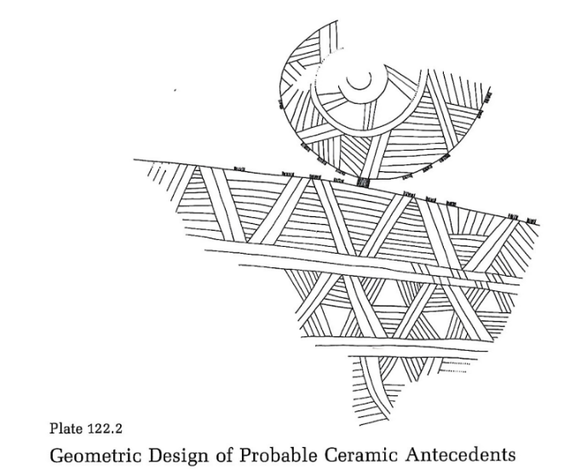

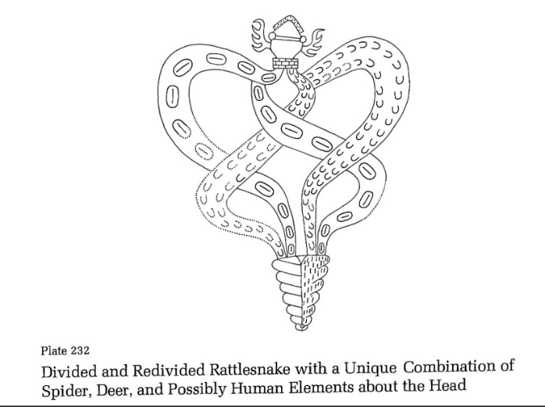

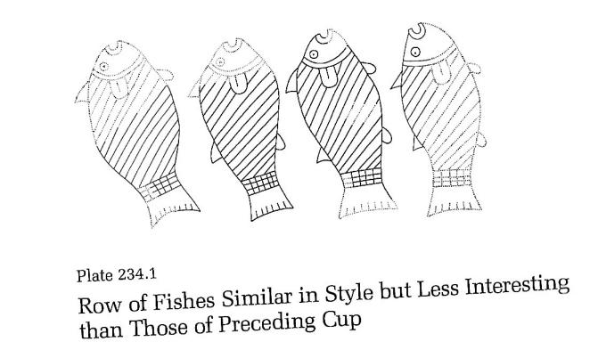

Figure 3.1: Plates 122.2, 234.1, & 232 showing the varying degrees of the type of plates not being considered (top two images), and one contentious example of a plate being considered (bottom) for analysis (Phillips and Brown 1978:Plate 122.2); Phillips and Brown (1984:Plate 232, Plate 234.1)
Following this initial sorting was a reexamination of the style distinctions for all the plates found in Pre-Columbian Shell Engravings From the Craig Mound at Spiro, Oklahoma Parts 1 & 2 (1978, 1984). This consisted of a review of all the texts surrounding individual plates in the aforementioned books, as well as a search in the broader literature. Ultimately, this was done to ensure up-to-date consistency in the style distinctions of the plates. When a discrepancy was found, such as a mention that a specific plate categorized as Braden A had similarities to Craig A, it was noted for review. Furthermore, a confirmation of consistency often involved the lack of mention of another style within the plate description. In other words, if Phillips and Brown did not mention style in the description of a plate, or only mentioned the style in which the plate was already categorized, it would be considered as confirmed in its style distinction consistency.
It is important to break down what exactly I am looking for using Knight’s analytical terms associated with configurational analysis. The goal of iconography is to identify the external referents and subject matter within a corpus of visual works. The base unit for individual visual works within this corpus will be known as compositions. Within these compositions, specifically those determined to be concerned with dance, the identification of visual themes and themes of reference will be sought. The difference between these two theme types is that visual themes are determined through configurational analysis alone and are internal to the composition. They are classes of images that are believed to represent the same subject matter. Themes of reference involve the narratives, concepts, myths, etc., to which classes of images refer, and are thus external to the composition. To begin identifying these various themes via configurational analysis, the compositions must be broken down into salient and non-salient features. These refer to the elements within a composition that are important in identifying their referent to the subject matter or not, respectively. Furthermore, salient features can be broken down further into two categories, discrete versus non-discrete. Discrete salient features are those that do not hinder the identification of the subject matter by being added or subtracted from the composition. An example may be the spots on a jaguar. Nondiscrete salient features are those that are clearly important to the identification of the subject matter within a composition. These may include the bipedal stance of a personage. The distinctions between discrete and nondiscrete salient features are not used as analytical terms within configuration analysis as much as their subcategories. These subcategories include motifs, identifying attributes, classifying attributes, locatives, action attributes, ideographs, filler motifs, narratives, and figural characters (Knight 2013:85-96).
Motifs represent subcompositional themes that carry signification and have the trait of independence in that they are transferable. Identifying and classifying attributes are elements that can either lead to the naming of a specific, or a categorical. In other words, an identifying attribute such as a shield bearing the head of a gorgon, may lead the iconographer to interpret the female figure standing next to the shield as Athena. On the other hand, a classifying attribute, such as a crown and scepter, may only lead the iconographer to interpret a member of the ruling class, rather than a specific queen or king. Locatives are elements within a composition that suggest a time and place. For instance, the use of a petaloid in Mississippian imagery is associated with the celestial realm (Reilly and Garber 2007:39-55). Action attributes are conventionalized poses or gestures that refer to walking, running, dancing, etc., within a composition. These are particularly important to the analysis in this project. Ideographs, as the name implies, are image elements that represent a particular idea, such as swiftness or intensity. Filler motifs have some connection to larger themes within a composition, but do not help in identifying them. These are often found in styles featuring horror vacui, which represents some art styles that intentionally avoid the use of blank space in compositions, instead choosing to cover this blank space in filler motifs. Narratives are superthemes that are often connected across multiple compositions, making individual compositions snapshots of a larger whole. These can be identified in three ways. The first is through the archaeological discovery of in situ arrangements that evoke a broader narrative, the second is through evidence that suggests the passage of time within a single composition [more on this later], and the third through the identification of the same animate figure/figures engaging in different activities across multiple compositions. One particular method of identifying narrative via the passage of time stands out – The passage of time condensed into a single composition without character repetition. In the case that Knight (2013:108-110) offers, a Mississippian engraved shell reveals its narrative through an orientation dependent passage of time (fig xx). Furthermore, given the suspension holes of this gorget, one event within the narrative appears primary to the other, as it would likely be the default orientation. The secondary event only appears plainly when the gorget is rotated 90 degrees against the natural hold of the suspension holes. Some condensed scenes can become conventionalized. These interculturally recognized prompts refer to a narrative familiar to those at the time and place. Contemporary analysts may struggle to recognize such narratives without the use of relevant ethnographic materials, hence their importance in configurational analysis. Lastly, figural characters are those that are identifiable and animate, such as T-Bar and Wedgemouth found on Craig C shell engravings from Spiro Mounds (Brown, Barker, and Sabo 2020:106-107).
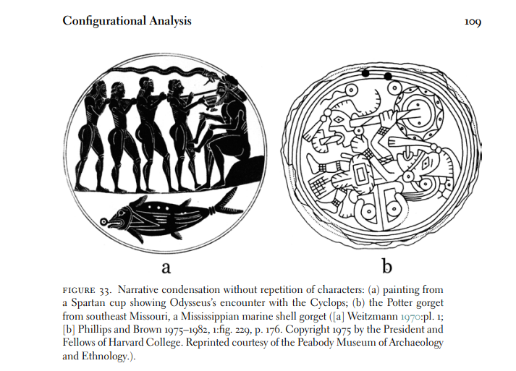
Figure 3.2 Example of narrative through orientation dependent passage of time (Knight 2013:108-110)

With the vocabulary out of the way, let us look next to Phillips and Brown’s (1978) methods for identifying what they consider dancers. After concluding the initial sorting mentioned above, I determined that out of the 369 plates, 225 included anthropomorphic forms. In other words, roughly 61% of all plates included some type of anthropomorphic form. This ranged from clearly visible human forms, like those exhibited by Plate 127, to more abstract depictions of disembodied anthropomorphic elements, like the lone human hand seen on Plate 76 (figure xx). Finally, plates that were composed of multiple fragments that had anthropomorphic forms, even on a single fragment, were included for “consideration.” Only plates with a mention of dancing/dancer/dance in the Phillips and Brown description were included in the special consideration category of this initial sorting. The idea was to try and tease out the elements that Phillips and Brown were associating with this category. Of the 369 total plates, only 14 had explicit mention of dance/dancers/dancing. In other words, roughly 3.8% of the total plates were considered by Phillips and Brown to be depicting dance. Using only the plates that depict anthropomorphic forms bumps this percentage to roughly 6.2%. The 14 plates in question are 18, 19, 20, 124, 126, 131, 133, 134, 137, 138, 189, 192, 193, and 197.1. Each of these plates will be reviewed in an attempt to pick out the reasoning behind their dance interpretation.

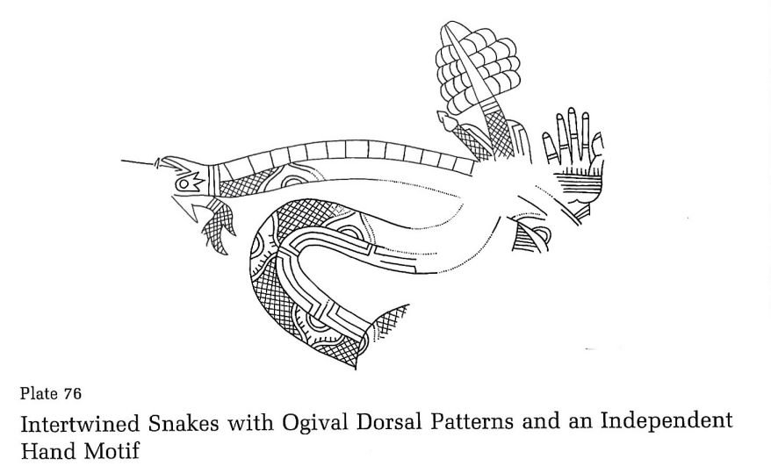
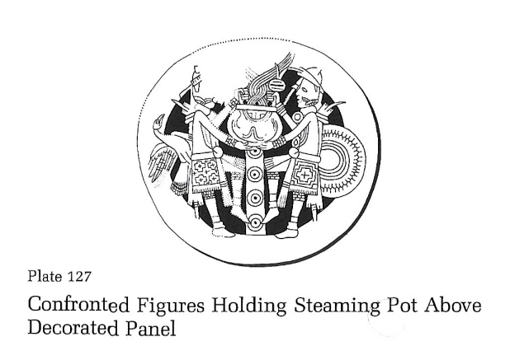

Figure 3.3: Plates 76 & 127 showing both clear and abstract representations of anthropomorphic forms (Phillips and Brown 1978:Plate 76, Plate 127)
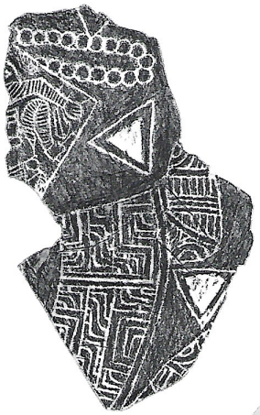
Figure 3.4 Plate 18 (Phillips and Brown 1979:Plate 18)

Plate 18, named in Phillips and Brown (1978) “Decorated Figure? An Enigmatic Design,” is a fragment from a larger shell engraving. Phillips and Brown’s description mention that only “the midportion of an anthropomorphic figure in running or dancing posture” is visible. Furthermore, they mention the visibility of the figure’s calf and knee, the decorations on the legs, the Davis rectangle motifs above the knee, and a possible string of beads hanging from the figures hand. Also mentioned is that the figure is not scaled proportionally, and that the style contains surrealist elements. This description leaves much to be desired in terms of helping me identify dancing figures. However, there are some things that can be gleaned from it. For one, Phillips and Brown seemed to only need the midportion of the anthropomorphic figure in order to interpret this as a possible dancer. This takes away some of the emphasis of arm, upper torso, and head posturing in making this distinction, and adds emphasis to leg posturing. The decorations on the legs, Davis rectangle motifs, and stringed beads all have to do with regalia, of which I would like to abstract here from these specifics and place categorically in dress as a distinguishing factor. The style and proportionality observations will be discussed later. Lastly, as to not ignore a glaring issue, Phillips and Brown interpreted this plate’s figure as running OR dancing. I imagine there will be a fine line between these two interpretations throughout this analysis, and it will be noted when necessary.

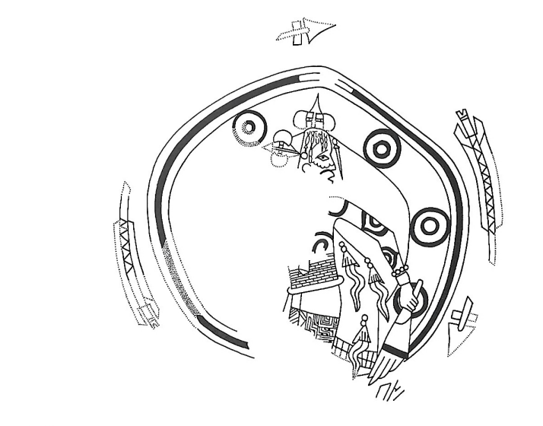

Figure 3.5: Plate 19 (Phillips and Brown 1978:Plate 19)

Plate 19 is entitled “Painted or Tattooed Figure Holding Bird-Wing Fan.” In the plate description the figure is described as a dancer. Furthermore, the description goes on to elaborate specifically on the figure’s posture, which they call the Bilbao 21 stance. Here, it is described as the thighs and legs of the figure in left profile, the torso in front view, and the head in right profile. The figure is surrounded by a circular frame, that is in turn surrounded by a rotation of arrows. Phillips and Brown hypothesize that if the feet were still intact, they might show the figure breaking out of the circular frame. Contemporary analysis on the ethnographic accounts of Caddo regalia note that the bird-wing fans help “identify their bearers as recognized practitioners of community religious ceremony” (Sabo 2021:317). More specifically, these fans would waft smoke offerings that served to symbolize the connection between the earth and spirit worlds (Sabo 2021:317). Lastly, Phillips and Brown stress the uniqueness of the figure’s tasseled cape garment.
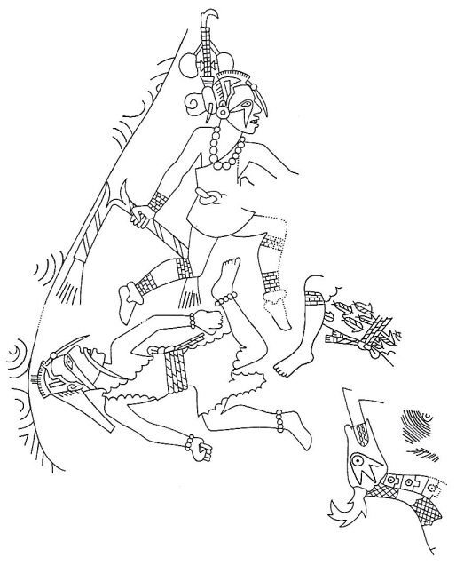
Figure 3.6 Plate 20 (Phillips and Brown 1979:Plate 20)

Plate 20 is far more intact than Plate 18. It was entitled by Phillips and Brown as “Three Running or Dancing Figures and an Antlered Snake.” Immediately we run into the same issue of difficulty distinguishing between running and dancing. This will be discussed more in depth later on when Mathew Looper’s (2009) analysis is considered. The regalia of the figures is mentioned briefly, noting that their off-the-shoulder tunics are unique to this plate and one example from Moundville, Alabama (Moore 1905, fig. 34). Also, their beaded forelocks, forked eye-surrounds, and the decorative arrow feather ends on one of the figures garments is mentioned. Little is given in terms of posturing other than that “the theme of this design is not unrelated to our multiple figures in motion.” One thing that remained unmentioned by Phillips and Brown is the bootees worn by one of the figures. They appear to be in the same style of bootee worn by the figure in Plate 18. This would fit their previous emphasis on the mid and lower portions of the body being important for determining dance. Moving forward, this will be noted for more occurrences. Finally, it is worth mentioning that this is the last plate within the Braden style to mention dancing by Phillips and Brown. The remaining 11 are contained within the Craig substyles of their second volume.

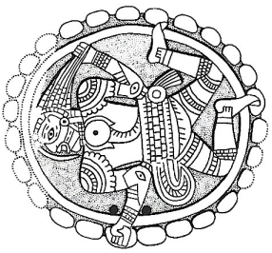
Figure 3.7 Plate 124 (Phillips and Brown 1984)

Plate 124 is titled with the same predicament as the previous plate – “Running or Dancing Figure of Unusual Character in Low Relief.” Visual elements that were noted by Phillips and Brown include the fringed ankle band, for which they used to determine its standing within Craig A style, and the fringed moccasins, which were later interpreted as x-ray bootees. What stands out is that this x-ray style of bootee reveals the figure’s big toenail and that there are two other obvious examples on Plates 192 and 193, both of which were in the shortlist for dancers. Additionally, Phillips and Brown argue against the interpretation of the figure as frenzied, characterized by the pulling of its own hair, and instead suggest that the figure may be holding something behind its head, such as a fan or other piece of regalia. This may add importance to the upper portions of the body being used to identify dance, in that the arms may be used to hold dance specific regalia. Lastly, the gorget’s odd placement of suspension holes is noted and brushed off by Phillips and Brown, stating that “the artist failed to allow sufficient space between border and head for the holes and repositioned them accordingly.” I would argue instead that this is an example of Knight’s orientation dependent passage of time, and thus could be identified as a narrative (2013:105-112). In this regard, the natural orientation allowed by the suspension holes would be a primary scene. Its secondary scene is revealed through the gorget’s rotation by 90 degrees. This adds weight to Burnett (1945:32) and Hamilton’s (1952:61) interpretation of the figure as recumbent in nature, and possibly a victim of sacrificial rite. However, the identification of a narrative does not necessarily lend itself to understanding the story at play. The secondary orientation seems to show the figure in a leap, perhaps a dance, but regardless of these specifics the figure looks very much full of life. Perhaps this is a narrative of death and rebirth, a theme of significance at Spiro, and especially at Craig Mound (Brown, Barker, and Sabo 2020).

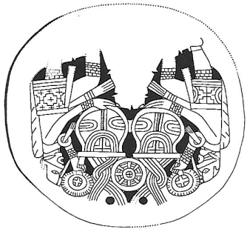
Figure 3.8 Plate 126 (Phillips and Brown 1984)

Plate 126 is of a large, incomplete shell gorget, and is titled “Confronted Figures Holding Steaming Pots.” Very little is said about the figures themselves other than them being described as “dancers.” The figures are very similar in design, although there are enough differences in their dress and facial markings to distinguish them as two individuals. This removes the possibility of narrative identification through single character duplication via passage of time. Arguably, one of the most important features within this composition is not even mentioned by Phillips and Brown in this description, mainly that both figures appear to be holding what the authors had previously interpreted as a rattle. Elsewhere, Phillips and Brown (1984:Plate 133) cite the importance of rattles and other instrumentation when interpreting dance iconography. This is also echoed by Looper (2009:58-61). While the legs of the figures are mostly intact, the feet are mostly missing. Both figures are postured with one leg bent, and the portion of visible foot on the left figure appears to be wearing a bootee, but what kind is impossible to say. Lastly, alternate interpretations of the steaming pots as musical instruments were made by Jim Rees (2012). These will be discussed later in the chapter in the section on music and instrumentation.

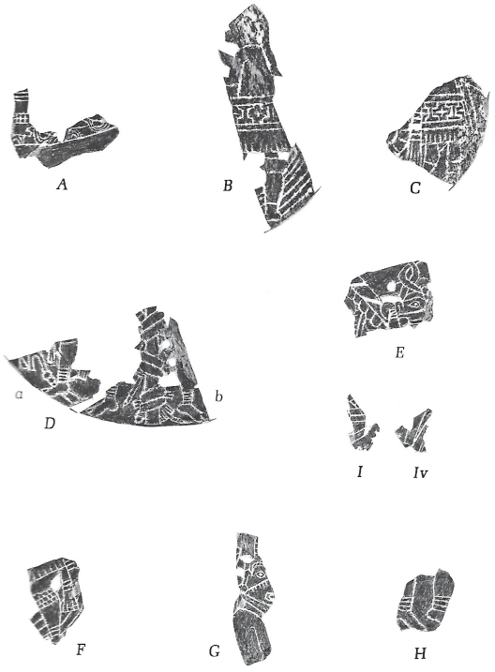
Figure 3.9 Fragments on Plate 131 (Phillips and Brown 1979:Plate 131)
The inclusion of Plate 131, 133, 134, and 138 onto the shortlist for dancers stems, in part, from the description of Plate 134, which reads,
“At least eight of the pieces on Plate 131 are unmatched fragments of paired figure gorgets presenting the pictorial formula (a better term than “theme” perhaps) that we have chosen to associate with the idea of ritual dancing. Here on plate 134 we have at least eight more. Adding to these the two fragments of the preceding plate, two more on plate 138, plus the nine gorgets or fragment sets large enough to have a plate to themselves, gives a total of 29 examples.”

Using their numbers as a measure of dancers would increase the count substantially. They argue that 8 examples can be seen on Plate 131, 8 more on Plate 134, 2 on Plate 133, and 2 on Plate 138. This brings the total to 20 examples. The other 9 “gorgets or fragments” are ambiguous. Are these the other 9 within the paired figure gorget series? Or are they just 9 other plates or fragments on the plates that depict dancing? The series begins on Plate 126 and ends on Plate 144, revealing 19 unique plates within the series. In other words, Phillips and Brown explicitly mention 4 plates containing 20 examples, which leaves 15 plates containing the other 9.
This ambiguity does not stop the review of this plate. Plate 131 was titled “Unmatched Fragments Mostly of Paired Figure Gorgets.” The plate itself contains 9 fragments, two of which, fragments D and I, contain multiple partial fragments. Additionally, there is no drawing present for these fragments, so the only visual reference is from the originals. On plates such as these, for which there are many, each fragment is given a description. Fragment A’s description emphasizes the moccasins and placement of the feet. Phillips and Brown note the decoration style and cuffing of the shoes, pointing out their similarities to those found on Plates 130 and 139. Furthermore, the placement of the feet, one directly behind the other, is what Phillips and Brown use for their justification in including this fragment within the Paired Figure Gorget series. Now, referencing back to the ambiguity associated with the dancing descriptions on Plate 134, it is important to note that Phillips and Brown associate only 8 out of the 9 fragments with dancing on Plate 131. Even this statement makes a major assumption, in that the named partial fragments, such as Da, are being counted as a unit, and not as individuals. Ultimately, this ambiguity warrants caution against what can be gleaned from these fragments. However, at least in this first case of Fragment A, the description leads to dance identifiers consistent with some of the previous plates. Mainly, that moccasins/bootees/footwear and posturing are important to the identification of dance. Furthermore, they give an explicit identifier of paired gorget figures, in that they feature “… feet, one directly behind the other.” This is highly beneficial when we consider Plate 133’s description, which reads in part,
The figure holds in its right hand an object that we have fallen into the habit of calling a “rattle” without a means of proving the identification, and in its left hand a circular object with petaloid border called with similar lack of verification a “fan.” The same combination of objects is seen in other gorgets (134B, 137), the rattle held higher than the fan. In fragments showing only one or the other (130, 134A, 134C, 134E, 134F) the same rule is followed. In cases in which one hand is otherwise occupied, as in supporting a vessel (126, 127), the other holds the rattle aloft. As already noted in the iconographic section of Volume One (p. 109) these inferred rattles and fans provide a reasonable excuse for characterizing most, but not all, Craig A paired gorget figures as “dancers.” (Plate 133, emphasis mine)
This will be discussed further when Plate 133 is addressed. However, I felt it necessary to begin contextualizing Fragment A’s description and importance.
Plate 131’s description of Fragment B emphasizes the styling of the skirt which holds similarities to skirts found on Plates 130 and Fragment A of 133. They state that what stands out about this skirt in particular is that the “broad bulbous kneeband [is] lacking the customary crosshatch or “brickwork” treatment.” They argue that this, along with the relatively plain design of the foot, makes the work look unfinished. Again, since this fragment could be one that they are not associating with dance, I will remain cautious about pulling information for the identification of dance. However, their emphasis alone matches with previous, more explicit, descriptions of dance, in that regalia is important.
Fragment C offers little in quantity. The only thing noted is that the figure is “facing in toward a circular central motif, part of which is visible.” The same figure orientation is noted in Fragment B of the same plate. It is difficult to tell if this is important to the identification of Craig A Paired Figures or dancing, or both. Something that gives any of these interpretations pause is that not all Craig A Paired Figures are facing inwards (Plate 133, 135a, 136). Arguably, I can at least abstract that they deem posturing important to the identification of dance, which again, remains consistent with more explicit descriptions of dance.
Fragment D also serves contrarily to the idea that figures facing towards a central motif help identify dance. The figures here are facing inwards towards a pole wrapped in racoon pelts. Furthermore, Phillips and Brown note the similarities this fragment has to Plate 164, which was not included in the initial list of dancers. According to Reilly (2020:231), “… among the Pawnee, a Caddoan-speaking people, in some ceremonies, raccoon skins are strongly associated with storm clouds.” Although this is getting a bit ahead of where the analysis is, weather related iconographic motifs likely bear strong importance given the greater context of Spiro’s drought (Burnette et al 2020:76-89) and the Spirit Lodge (Brown et al 2020:92-113), which will be discussed in depth elsewhere.
Fragment E depicts a birdman, as identified by its wing. However, only the head, headdress, and wing are visible. Suspension holes are present, but the fragment is so small and damaged that an identification of orientation dependent narrative via passage of time is futile. Furthermore, Phillips and Brown note that the centrality of the birdman figure with the suspension holes makes it unlikely that this was a paired figure gorget. However, they do note some similarities with Fragment A of Plate 138, which does depict inward facing paired birdmen. This fragment begs an interesting question, what to do about therianthropes? There is some debate within Phillips and Brown concerning the intertwined snake-men series. The issue with this series is that they remain ambiguous on whether the Intertwined Snake-Men are human dancers clothed in snake costumes, or human-animal composites. At one point Phillips and Brown state that the “serpent cloak idea is not implausible” (1978:132), but further on make the comment that “we have dispensed with one interpretation (snake-dancers) without attempting to substitute another” (1978:132). Lastly, in the description of Plate 189 they state that the Intertwined Snake-Men have
… already been the subject of labored rationalization, the purpose of which was to support our contention that the paired components of this and other examples of the theme are true composites of man and snake rather than “serpent dancers” dressed up for the part (vol. 1, p. 132). Parenthetically, in our zeal for composites we momentarily lost sight of Goldwater’s “lack of specific reference” (ibid., p. 106), in terms of which the forms in question could have had both meanings as well as others so far unsuspected. (Phillips and Brown 1984, Plate 189)

Here they seem to suggest that being a “serpent dancer” and being a “true composite of man and snake” are not necessarily mutually exclusive. This debate will be mentioned again in the dedicated analysis of Plate 189’s description.
Fragment F’s description is incredibly short, noting only that it is “like [fragment] B and C, of the right-hand member of a confronted pair.” The only thing that I’ll note is that the upper calf and knee have a repeating square pattern, and the ankle appears to be banded or adorned with the cuff of a moccasin.
Fragment G shows only the upper portion of a figure in semi-profile. Phillips and Brown argue that it is certainly a paired figure, although due to the damage of the fragment it is impossible to tell if the figures are facing towards or away from each other.
Fragment H is very small and shows only a pair of relatively plain feet. Phillips and Brown note the foot design as being very similar to that of the right-hand figure on Plate 129, going as far as to say that they may have been executed by the same artist. The ankles of the feet do have a similar banding pattern to Fragments D and F, although the number of distinct bands is different in all three. Fragment H’s ankles have 3 bands each, Fragment F’s single visible ankle has 2 bands, and Fragment D’s have 4 bands visible.
Ending Plate 131 is Fragment I. It is so partial that it is completely unidentifiable. However, Phillips and Brown do think it belongs somewhere on Plate 128. Perhaps this is the fragment that was not included as being identified as dance in the description of Plate 133 mentioned above. Afterall, it is the only fragment on this plate that gives no indication of anthropomorphic elements.

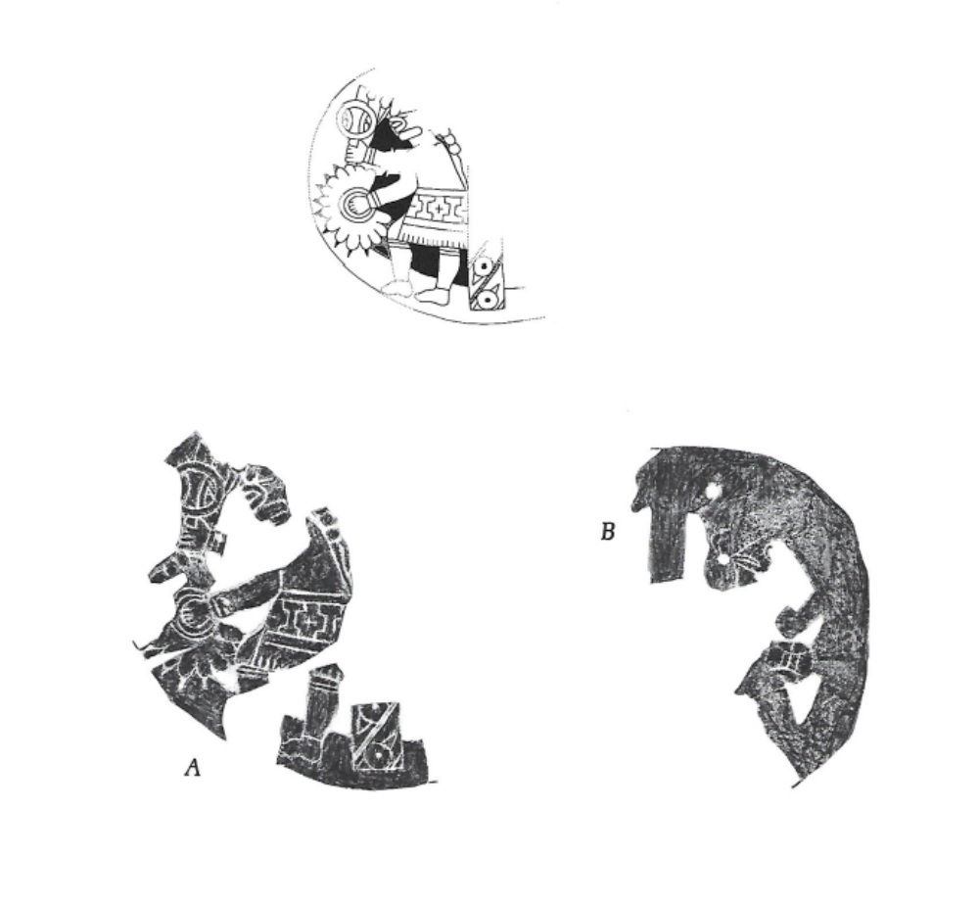
Figure 3.10 Fragments on Plate 133 and illustration of Fragment A at top (Phillips and Brown 1984:Plate 133)

Plate 133 consists of two fragments that had been joined based on their same field numbers and similarities in style. It is titled “Nonmatching Fragments Thought to Have Been from Same Gorget.” Phillips and Brown note several differences and argue that this was likely a mistake made in the field, and that these two fragments should be considered separately. Fragment A is of the bottom left portion of a paired figure gorget. One figure is visible and facing away from a central motif. In this figure’s hands, the right holds the uncorroborated but widely accepted rattle, and the left holds a petaloid fan. This petaloid motif is often associated with the celestial realm (Reilly 2007:39-55). This is the first explicit mention of instrumentation being cited in the identification of dance. However, this linkage is made more explicit elsewhere (Looper 2009:58-61; Rees 2012). Additionally, it is important to remember that Phillips and Brown states in this description that “… these inferred rattles and fans provide a reasonable excuse for characterizing most, but not all, Craig A paired gorget figures as “dancers.” Fragment B on this plate is in much worse condition than Fragment A. The head of a figure and a rattle are the most visible features. The figure is facing away from the central motif, but the motif itself is largely unseen. These rattles will be very important moving forward, and their identification will be noted when necessary.

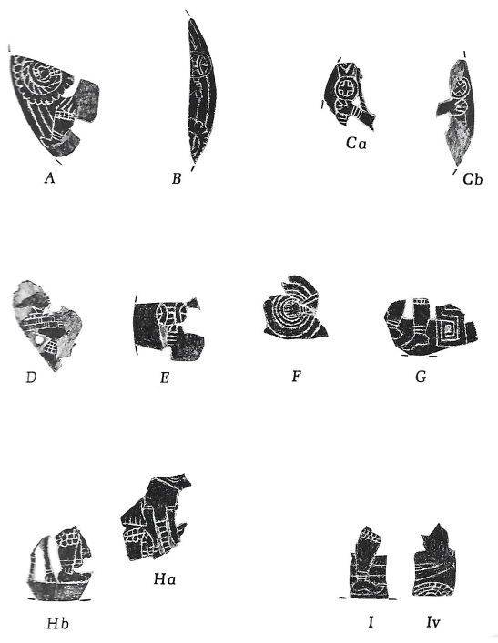
Figure 3.11 Fragments on Plate 134 (Phillips and Brown 1979:Plate 134)
Plate 134, given the title “More Fragments of Paired Figure Gorgets: One Dubious Example,” consists of 9 fragments, 3 of which consist of two fragments that are paired but unconnected. If counting them all individually, there are 12 named fragments. This is important to note because Phillips and Brown state in the opening paragraph of the description of Plate 134 that “Here on Plate 134 we have at least eight more” in reference to what they “have chosen to associate with the idea of ritual dancing.” Since this is left ambiguous as to which of the 8 out of 12 fragments they are referring, caution will be placed on what I can glean from their identifications of dance.
Fragment A of Plate 134 shows the leg of a figure and a hand holding a petaloid fan. The leg’s ankle has a two-banded adornment, similar to that of Fragment F of plate 131. Additionally, the knee and wrist of the figure are adorned with similar tessellating squares within the rectangular band. These are also visible on Fragments A and F of Plate 131.
Fragments B, Ca, and Cb all show a rattle. Fragment B also has an often-paired petaloid fan visible as well. It should be noted that Phillips and Brown argue that Fragments A and B are likely from a single gorget, and that Fragments Ca and Cb are also from the same gorget.
Fragment D is said to be of a “left-hand figure of a gorget,” although there is much to be desired in terms of what is exactly visible. There is a suspension hole in what Phillips and Brown describe as the “hock of the knee.”
Fragment E and F both depict outwardly stretched arms and hands. In Fragment E the hand is holding the typical shield-design rattle that was seen in Fragments B, Ca, and Cb. Fragment F is shown holding a circular fan without the petaloid border. However, considering the damage and positioning of the fan, the petaloid border could have simply been broken off.
Fragment G depicts two feet and calves facing away from a central motif. The motif is adorned with what Phillips and Brown refer to as “a Greek fret design.” The ankles of the legs have the two banded adornment similar to that of Fragment F of Plate 131. Furthermore, the feet themselves have the same big toenail or x-ray design mentioned on Plates 124, 192, and 193. The top portion of one of the legs, possibly the knee, has the reoccurring tessellated squares within a rectangle adornment, similar to that of Fragment A on this same plate.
Fragment H consists of 2 matching fragments. It may or may not be a paired figure design, and their orientation away from or towards the central motif is unidentifiable. What is identifiable is the racoon pelt on Fragment Ha, the bootee on Hb, and the modified knee band also on Hb. This knee band is similar to those mentioned on Fragments A and G of the same plate, except that the square tessellations are slightly irregular and rounded.
Fragment I is the last one on Plate 134 and also consists of two pieces. The description by Phillips and Brown is less than helpful. A leg and foot are visible on one piece of this fragment. The ankle of the foot has the two banded adornment mentioned several times previously, and the knee has the same tessellating squares within a rectangular band adornment.

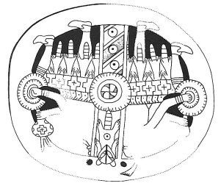
Figure 3.12 Plate 137 (Phillips and Brown 1979:Plate 137)

The inclusion of Plate 137 in this list of dancers stems from the description of Plate 133, in which the combination of rattles and fans are used to determine dance. Phillips and Brown cite that “The same combination of objects is seen in other gorgets (134B, 137), the rattle held higher than the fan.” This paired figure gorget depicts two figures facing away from a central motif. The central motif is topped with a striking racoon pelt. The bottom of the central motif is plainly striped on a diagonal and alternates with dotted circles, similar to that which appears on the racoon’s stomach. The middle of the central motif consists of a “swastika cross in concentric circles,” of which the last circle is given a petaloid border. The figures’ regalia is of special importance to the identification of dance. They each hold a fan, similar in design to the middle of the central motif, and a rattle. Furthermore, they both wear matching, distinct bootees, similar to those seen in the Braden A example on Plate 18. Each figure has one knee visible with the banded adornment, in this case with 3 bands. However, what is most striking about these figures are their racoon pelt skirts. The bodies and tails of these racoons appear to dangle off of the skirt, with their duplicated heads appearing at the uppermost portion of it. Separating the heads and the bodies is a long band on the skirt decorated with Greek crosses. The meaning behind the head duplication of the racoons, in that each pelt is shown having two heads at the top, remains unexplained. The only mention of the racoon motif’s importance here is that it does “… not necessarily enhanc[e] the sacred importance of the racoon…” Although, given Reilly’s (2020:231) aforementioned comment that “… among the Pawnee, a Caddoan-speaking people, in some ceremonies, racoon skins are strongly associated with storm clouds,” perhaps contemporary scholarship on this iconography has changed as new developments have been made. Lastly, alternate interpretations of the fans as musical instruments were made by Jim Rees (2012). These will be discussed later in the chapter in the section on music and instrumentation.
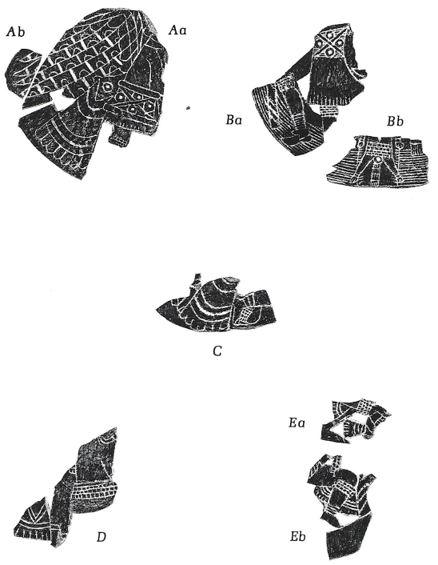
Figure 3.13 Fragments on Plate 138 (Phillips and Brown 1979:Plate 138)
Plate 138, titled “Miscellaneous Gorget Fragments Including Paired Figure Types,” is another collection of fragments included in the list via the description of Plate 134, which states that there are two fragments that coincide with what they “have chosen to associate with the idea of ritual dancing.” Unfortunately, the ambiguity lies with the fact that there are five named fragment groupings, three of which consist of two parts each, bringing the total to either five or eight, depending on if you count the fragment groupings individually as opposed to a set. Furthermore, little to no indication is given to which of these five to eight fragments are being identified as the two associated with dance on the description of Plate 134. Therefore, the analysis here will mimic the format of the other plates containing a large set of fragments (Plate 131 and 134).
Fragment A of Plate 138 is of a nonarticulated bird-man. The Phillips and Brown description notes its “broad “brickwork” kneebands” but gives nothing in terms of explicit identifiers of dance.
Fragment B of Plate 138 is a grouping of two fragments that make up a paired figure gorget. The left-hand figure on Fragment Ba is only partial, but a portion of both legs, the skirt, and a striped staff can be seen. The knees are adorned with brickwork bands, the ankle has six bands, and the moccasins are in the variety of those seen on Plate 18 and 137. Fragment Bb in the same grouping is the lower portion of a racoon hide.
Fragment C of Plate 138 is an individual fragment depicting a kneeling bird-man. One ankle can be seen and is adorned with 2 bands, similar to that of Fragment F on Plate 131. Furthermore, the feet are depicted in the x-ray/big toenail style as seen on Plate 124, Fragment G of Plate 134, Plate 192, and Plate 193. Not much can be said in terms of dance posturing, and
this particular fragment’s placement within the two noted by Phillips and Brown as being associated with dance remains ambiguous.
Fragment D of Plate 138 has a visible bird tail that is different in styling to that of Fragment A and C on this same plate. Additionally, there is a brickwork belt adorning the upper portion of the skirt, a partial torso, and according to Phillips and Brown, a racoon motif. However, the racoon motif remains largely invisible to my eyes. However, I believe they are referring to the tiny, ladderlike piece above and slightly to the left of the belt.
Ending Plate 138 is Fragment E, which is a grouping consisting of Fragments Ea and Eb. Unfortunately, the description is relatively short. Fragment Eb depicts a bent leg with a brickwork banded knee, three ankle bands, and an unremarkable moccasin.

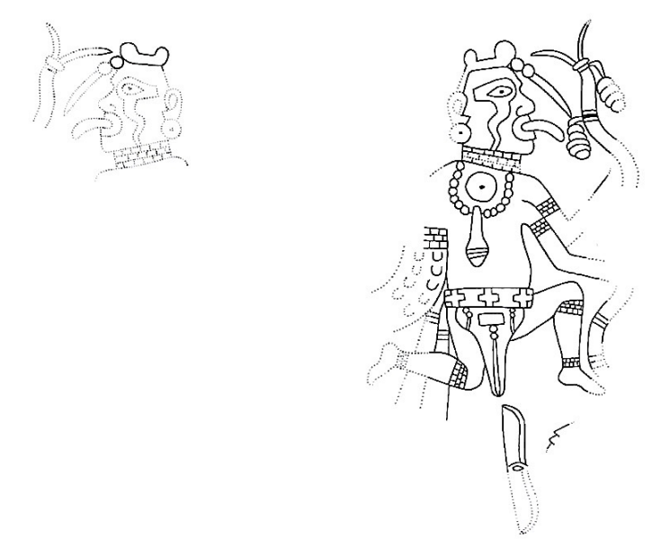
Figure 3.14 Plate 189 (Phillips and Brown 1979:Plate 189)

The final four plates being analyzed in this section (189, 192, 193, 197.1) are housed within the Craig B substyle. Plate 189, entitled “Slightly Dubious Anticipation of the Intertwined Snake-Men Theme,” represents a special case in several regards. First, this plate anticipates the Intertwined Snake-Men series that sparked the aforementioned debate concerning the difference between therianthropic composites and costumed dancers. Unfortunately, as discussed in the analysis of Fragment E of Plate 131, their conclusion to this debate seems to remain slightly ambiguous. However, given the description of Plate 189, there seems to be some settling of the debate in that both interpretations are not mutually exclusive. In other words, depictions of Snake-Men within the Intertwined Snake-Men series could represent both “serpent dancers” and “true composites of man and snake.” The second peculiar thing about this plate is the placement of the arms on the same side, one below the other, on the right-hand figure. This leaves the snake body emanating from the left side of the figure in the place of the left arm. Phillips and Brown attempt to reconcile this odd anatomy in two ways. The first is that a common aspect of the Intertwined Snake-Men series is that the figures each hold a serpent staff in both cases. This is true across the board except in a single instance on Plate 192, which is subsequently in our shortlist for dancers. The second reconciliation put forth by Phillips and Brown is that the artist was attempting to make room for the pectoral decoration, in this case a necklace. This bead and shell necklace bears striking similarity to the one found on Plate 203 of the Museum of the American Indian bird-man. The last special case surrounding this plate is in reference to the figure’s bellows-shaped apron. This style of apron appears in classic Etowah Mound C repoussé copper plates. These plates can be seen in Volume 1 of Phillips and Brown (1978) in Figures 243-245, one of which is entitled “Hawk Dancer” (Figure 245). This alludes to a possible iconographic and ideological similarity between Spiroan engraved shells and Etowah repoussé copper plates in terms of both the aprons the figures are wearing and the figures’ identification as dancers. There are several notable features of the figure on Plate 189 outside the ones already mentioned. The figure is adorned with “brickwork” ankle bands, knee bands, bicep bands, and a neck band which is seemingly independent of the previously mentioned necklace. Furthermore, the figure is in a leaping posture with both legs bent, almost like a kneeling-on-one-knee pose in mid-air. Additionally, the figure’s face has been given an eye-surround that has yet to be seen on the other dancer plates. Finally, the figure appears to either be sticking their tongue out, perhaps in the manner of the snakes for which they are modeled after, or it could be a speech bubble emanating from the mouth. These speech bubbles will be discussed in greater detail later.
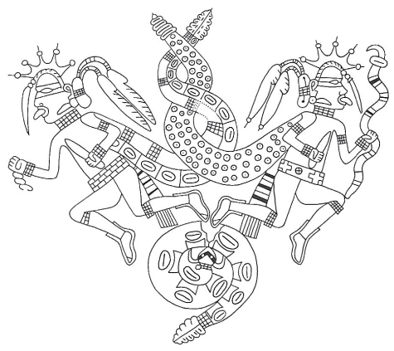
Figure 3.15 Plate 192 (Phillips and Brown 1984:Plate 192)

Plate 192 entitled “The Museum of the American Indian Intertwined Snake-Men Cup” is a more complete representation of the scene described in Plate 189. Here, two figures facing away from each other are in a leaping position. They both wear x-ray bootees similar to those seen on Plate 124, Fragment G of Plate 134, Fragment C of Plate 138, and Plate 193. However, the right-hand figure’s right-hand foot does not include the characteristic big toenail design. The three other feet shown on this engraving do include the big toenail design. Both figures wear “brickwork” style bands just below the knee, just above the biceps, on the wrists, and on their necks. Additionally, the left-hand figure is wearing a “brickwork” belt across the waist. Furthermore, the left-hand figure’s snake tail includes this “brickwork” pattern throughout. Both figures have an extended tongue or speech bubble, much like that shown on Plate 189. They both have a peculiar hand feature in which their grasp includes the visibility of their thumbs on the opposite side of their hands. The rattlesnake positioned in the lower central portion of the engraving over which they leap has elements of a racoon head, perhaps associated with storm clouds as previously mentioned. The Phillips and Brown description of Plate 192 provides a revealing history of evolving interpretation. For instance, in 1945 Burnett described the engraving as “two dancing or running figures here depicted are joined by the entwined bodies of rattlesnakes which emerge from the upper dorsal thorax of each” (1945, p.23). This is fairly ambiguous as to where Burnett falls in the debate regarding snake costume wearing humans versus human snake composites. However, what is not ambiguous is Burnett’s identification of the figures as potential dancers. In the same year as Burnett’s publication Waring and Holder described the plate as “anthropomorphized serpent representation[s]” and “god impersonators,” implying that the snake bodies were costumery. Moving forward, Hamilton describes the plate as “two dancers back to back wearing long, entwined rattlesnake mantles” and even entitled his personal illustration of the cup engraving “Two Snake Dancers” (1952, p. 68). Again, we see in this interpretation that the snake portions of the engraving are being attributed to costumery and not therianthropy. However, Hamilton still acknowledged the dance interpretation. Not all who analyzed this plate shared the same propensity for identifying dance. Howard (1968, p. 49) referred to them as “so-called snake dancers of Spiro,” suggesting his caution against this particular interpretation. Unfortunately, Howard does not elaborate on his wariness. Stuart and Stuart (1969, p. 148) were less ambiguous with their description, referring to the plate as “Entwined rattlesnakes join together the bodies of two dancing men.” Here, the emphasis is placed on the separation of the two parties, dancing humans and snakes. Lastly, Alex Krieger (1953, p. 512) had come up with an interpretation that matched Phillips and Brown’s by stating that the plate depicts “Two intertwined spotted rattlesnakes, bodies decorated differently, and each having a complete human figure in place of a head.” Here the emphasis is placed on the human/snake composite interpretation. Given the wording that the figures are the heads of the rattlesnakes may add some weight to the idea that the figures have their tongues out, as in the manner of snakes, and are not emitting speech bubbles instead. Lastly, rattles have been used as an identifier for dance in the description of Plate 133, in which the possibility that most of the Craig A paired gorgets featuring these rattles can be attributed to dancing. Perhaps there is some parallel between the human-crafted rattles and the rattles of the rattlesnakes, a potential zoomorphization of instrumentation.

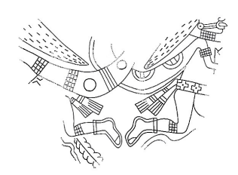
Figure 3.16 Plate 193 (Phillips and Brown 1984:Plate 193)

The inclusion of Plate 193 in the initial listing of potential dancers stems from its description as being related in theme and authorship of the preceding Plate 192. The common authorship declaration is justified via the x-ray bootee design. Phillips and Brown state that “Notwithstanding one notable shared feature [with Plate 192], the x-ray bootees – the only other example of this type of footwear in the sample – there can be no question of common authorship.” This provides an additional insight regarding x-ray bootees and the big toenail footwear designs. Whereas previously in the description for Plate 124 they state that “… the x-ray principle would have to be invoked to explain the big toenails showing in all three examples.” The three examples to which they refer remains ambiguous. There is a reference in the description of Plate 124 regarding page 102 of Volume One (Phillips and Brown 1978). More specifically they are referring to the section titled “Miscellaneous Types of Footwear” (p. 102). However, here only two examples of x-ray bootees are given, those shown on Plate 192 and Plate 193. It seems as though Phillips and Brown had initially distinguished between the two types of footwear, big toenail design and x-ray design, but later realized that to show the big toenail in the first place there needed to be some transparency in the design of those bootees. Although, given the aforementioned statement that “Notwithstanding one notable shared feature [with Plate 192], the x-ray bootees – the only other example of this type of footwear in the sample – there can be no question of common authorship” on Plate 193, perhaps they are only distinguishing x-ray bootees as those with the transparent outline of footwear with a big toenail visible. Thus, some ambiguity remains. Does the x-ray bootee principle need to be invoked to show big toenails, or is it reserved for the bootee designs shown on Plates 192 and 193? Moving forward, the only other notable mentions for the description of Plate 193 concerns the object just below the left-hand figures visible knee. Phillips and Brown make the argument that it could be “… the left part of a long feather, braid, or whatever like than on 196, or is it the tail of a rattlesnake positioned in a manner similar to that on 197.1?” While the desire to argue for a linkage between this plate and 197.1 is strong, due to their commonalities on the shortlist for dance, the object looks more similar to the one shown on Plate 196. The rattlesnake tails shown elsewhere in this series tend to have a noticeable taper from tip to base, whereas the object here appears to be rather uniform in width, as is the belt decoration Phillips and Brown were referring to on Plate 196. That said, there are some rattlesnake tails that are less tapered or altogether uniform in width (Plate 191 and 197). Regarding Plate 193’s iconographic appearance, it too shows both figures wearing brickwork style bands just below the knees. The right-hand figure also has a brickwork band around the upper portion of the bicep and the neck. The left-hand figure’s snake body emerging from its back also shows the brickwork pattern. Furthermore, both figures are in the leaping posture seen elsewhere (Plate 189 and 192). Lastly, the right-hand figure is shown with either a protruding tongue or speech bubble coming out of its mouth. What is interesting about this depiction is that the tongue is far more anatomically believable as a human tongue than some of the previous examples mentioned, in that its length seems plausibly naturalistic.

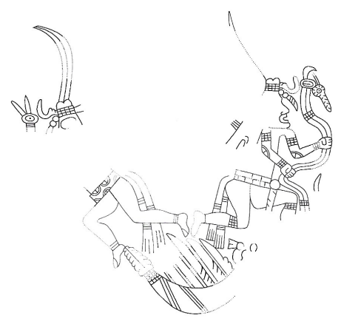
Figure 3.17 Plate 197.1 (Phillips and Brown 1984:Plate 197.1)

The last plate on the initial list for dancers is Plate 197.1 and is titled “Intertwined Snake-Men, Continued: Feathered Rattlesnake on Tip.” These figures are both adorned with the brickwork style of bands. The left-hand figure has only one, a band across the top of the head or hair. The right-hand figure has them below both knees, on the upper portions of both biceps, on one wrist, and on the top of the head or hair. Both figures are in the leaping posture. The left-hand figure is wearing the big-toenail style of bootee, while the right-hand figure’s feet are too damaged to distinguish the type of footwear worn. Additionally, the left-hand figure is wearing the non-brickwork style of plain ankle bands on the left-hand leg. In this case only two bands are worn, similar to that of Fragment F of Plate 131, Fragment G of Plate 134, and Fragment I of Plate 134. Much of Phillips and Brown’s description concerns the feathered rattlesnake placed as the lower central motif and the figures’ serpent staffs. Arguably, the most notable statement within the description regarding dance is the one Phillips and Brown made that included this plate into the list for potential dancers, saying “The statement (vol. 1, p. 132) that the cup presented here is the only case in which both “dancers,” i.e., snake-men, carry serpent staffs is no longer tenable.” Their uneasiness in distinguishing these figures as dancers, made obvious by their quotations, does not necessarily reflect their sentiments mentioned in their description of Plate 189 in my section regarding Fragment E of Plate 131.

Summary of Potential Dance Identifiers
Reviewing the plate descriptions of distinguished dance figures throughout both volumes of Phillips and Brown (1978, 1984) seemed to supply far more questions than it did answers. However, a summary of the characteristics of dance identifiers can still be made. This will then be fortified with supplemental identifiers from external sources.
For the purposes of this project, it is best to take a categorical approach to these identifiers while simultaneously weaving in Knight’s analytical terms. To start, there are five broad identifying categories in terms of dance iconography in relation to this corpus. The first is through the written descriptions of other archaeologists. This identifier was used to determine the shortlist for dancers within the Phillips and Brown volumes. The second is in regard to figure posturing. The third category seeks to identify dance through regalia. Here, this represents footwear, belts, knee bands, ankle bands, skirts, body/face painting, etc. The fourth category deals with instrumentation, singing, and more broadly with held objects. Finally, the fifth category relates to inferred movement through the axial orientation of multiple figures.
These categories will be evaluated individually. For instance, the written confirmation category will be divided into implicit and explicit subcategories. These refer to the ways in which Phillips and Brown (1978, 1984) identify them. An explicit written confirmation will be marked by the mention of “dance/dancing/dancer” within the individual plate description of any given plate. An implicit written confirmation will be marked by the mention of “dance/dancing/dancer” outside of a plate’s individual description. An example of this would be the inclusion of Plates 131, 133, and 138, which all hold an implicit connection to dance, given the definitions established here, through the description of Plate 134. Furthermore, Plate 134’s written confirmation will be listed as explicit, as it reads,
“At least eight of the pieces on Plate 131 are unmatched fragments of paired figure gorgets presenting the pictorial formula (a better term than “theme” perhaps) that we have chosen to associate with the idea of ritual dancing. Here on plate 134 we have at least eight more. Adding to these the two fragments of the preceding plate, two more on plate 138, plus the nine gorgets or fragment sets large enough to have a plate to themselves, gives a total of 29 examples.” (Phillips and Brown 1984:Plate 134, emphasis mine)

Here, Plate 134’s own description establishes its individual connection to dance explicitly, while the inclusion of Plates 131, 133, and 138 are being confirmed implicitly.
Next, in terms of posturing, a quick turn towards Looper’s (2009) methods are in order. One particularly useful distinction from Looper is the difference between dance posturing and dance gesturing. Here, posture refers to a static position and gesture refers to one in motion. Looper argues that motion can be inferred, in part, by the swaying of garments on a figure. However, most of the figures’ clothes depicted on the shell engravings from Craig Mound maintain a static position in relation to their body position. In other words, the presence of swaying garments as a way to identify inferred motion will not work here. Additionally, some of the Maya dance postures identified by Looper, such as the lifted-heel pose, are wholly confirmed by textual evidence. Since there is no text present at Spiro, inferred gestures will have to be the primary identifier in terms of posturing. There may be other forms of implied movement present on the figures or the motifs surrounding them. For instance, arrows in motion, such as shown on Plate 19, may be indicative of movement. There is some indication of how movement is implied within the Phillips and Brown interpretations. In a series of engravings under the theme “Multiple Figures in Motion,” an explanation is partially given for their interpretation of motion regarding their non-oriented design structure. Here, Phillips and Brown are referring to how multiple figures are oriented on different axes. Generally, figures are oriented vertically from spire to tip. However, in the “Multiple Figures in Motion” theme some of the figures will be oriented on a diagonal, horizontally, or in a reverse vertical orientation (upside down). There is also an implication in the text (Phillips and Brown 1978:42) that the ratio of vertically oriented figures to non-vertically oriented figures is important regarding the inference of motion. They provide the example of Plate 1 as being a “poor example of the type” because three of the four figures are oriented vertically, and yet still include it in the theme of “Multiple Figures in Motion.” Perhaps a simple majority among the figures regarding their difference in orientation is needed to determine whether axial orientation can be used to determine motion. However, the plate actually contains six figures. One can be identified by a single leg, and the other by a single foot. This will be addressed again in the analysis chapter in the section on Plate 1. There is also no mention if diagonally oriented figures can be counted towards the overall total of those typically counted as vertical. For this, personal judgement will be used.
Regalia as an identifier of dance will be analyzed in terms of its commonality within the shortlist of dancers while also minding its existence within the specific styles as mentioned by Phillips and Brown (1978, 1984). For instance, ankle bands appeared on many of the plates within the shortlist for dancers. However, this may not be as important in relation to the shortlist as it is to the relation of anthropomorphic forms in general, or to a specific style distinction, such as Craig A.
Lastly, instrumentation/singing/held objects will be analyzed based on their presence, or lack thereof. Instrumentation here refers primarily to idiophones, membranophones, and aerophones which will be discussed more later. Singing refers to the scrolling bubbles or tongues emanating from several of the figures’ mouths, such as shown in Plate 189 and 192. Finally, held objects refer to those that are not identified as instruments but are still present within the composition.

Explicit/Implicit Written Confirmation
Below is a summary of the differentiation between the explicit and implicit written confirmation (as previously defined) of each plate on the shortlist for dancers. This was included as a way to show where the initial list came from. The distinction between explicit and implicit do little in helping define which plates are dancers and are more likely a byproduct of the extent to which Phillips and Brown undertook this project. That said, the fact that there is a distinction is worth noting, even if it has only served as a way to further complicate this project.

Explicit | Implicit
Plate 18 | Plate 131
Plate 19 | Plate 133
Plate 20 | Plate 137
Plate 124 | Plate 138
Plate 126 | Plate 193
Plate 134
Plate 189
Plate 192
Plate 197.1
Total = 9 | Total = 5

Table 3.1 Total number of explicit and implicit written confirmations of dance

Commonalities in Posturing
Below is a summary of the posturing identified in the shortlist of dancers. Seven unique postures were identified and sorted by most to least occurrences within the shortlist for dancers. Here, postures focused primarily on the position of legs. This is based on two lines of evidence. First, Phillips and Brown (1978:Plate 18) place an explicit written confirmation of dance on Plate 18’s figure. Only the figure’s lower half is predominant. This implies that dance identification can be made based on the lower half of an anthropomorphic figure alone. The importance of leg positioning was also noted by Looper (2009:88). Repeated occurrences of a single plate in multiple posture categories are due to one of two things, a plate that shows multiple figures in different postures, or a plate containing multiple fragments generally connected by a theme. The most common occurrence of a posture was the half-leap. This is when both feet appear to be off the ground but is depicted either in the beginning of the incline of the leap or the end near the decline. This was determined by the feet and knee positioning. If a figure in a half-leap were to be brought straight down, they would have at least one foot in a position ready to catch them. This is different from the leap apex, where both feet are curled behind them as if it is the top of their jump. To use the same analogy, neither of the figure’s feet on Plate 124 are in a position to catch them. If they were to be brought straight down in the position that they are depicted in, they would land on their knees and the tip of their big toe. That said, single occurrences of a unique posturing, such as with Squatting, the Leap Apex, or Feet On Ground (Straight Legs), could likely be written off as self-contained if not further contextualized with other dance identifiers.

Half-Leap | Raised Knee  (Foot Off Ground) | Bent Knee (Foot On Ground) | Raised Heels | Squatting | Leap Apex | Feet On Ground (straight legs) | Bilbao 21 Stance
Plate 20 | Plate 126 | Plate 131 | Plate 131 | Plate 18 | Plate 124 | Plate 131 | Plate 19
Plate 138 | Plate 134 | Plate 133 | Plate 138
Plate 189 | Plate 137 | Plate 134
Plate 192 | Plate 138 | Plate 138
Plate 193
Plate 197.1
Total = 6 | Total = 4 | Total = 4 | Total = 2 | Total = 1 | Total = 1 | Total = 1 | Total = 1
Table 3.2 Frequency of specific dance related postures among the short list of confirmed dancers

Commonalities in Regalia by Type
Below are the tables separating the commonalities in regalia by type. Here, these are broken into four categories – Head, Arms/Torso, Legs, and Feet. Repeated occurrences of a single plate in multiple regalia categories are due to one of two things, a plate that shows multiple figures in different regalia, or a plate containing multiple fragments generally connected by a theme. It should be noted that common occurrences of regalia could be more related to the presence of an anthropomorphic form, rather than the presence of dance. For instance, the high concentration of ponytail presence among the dancer shortlist could have more to do with the depiction of anthropomorphs, rather than being specific to dance.

Head Regalia
Ponytail | Double Beaded Forelock | Bilobed Plume | Single Beaded Forelock | Beaded Necklace | 2.5 Beaded Forelock | Entwined Headdress | Truncated Eye Surround | Five-Pointed Diadem Headdress | Back Single Hair Bun | Back Double Hair Bun | Double Top Hair Bun | Brickwork Hair Wrapping
Plate 20 | Plate 124 | Plate 19 | Plate 19 | Plate 20 | Plate 192 | Plate 131 | Plate 189 | Plate 192 | Plate 192 | Plate 192 | Plate 197.1 | Plate 197.1
Plate 124 | Plate 189 | Plate 20 | Plate 20
Plate 126 | Plate 192
Plate 133 | Plate 197.1
Plate 137
Plate 193
Total = 6 | Total = 4 | Total = 2 | Total = 2 | Total = 1 | Total = 1 | Total = 1 | Total = 1 | Total = 1 | Total = 1 | Total = 1 | Total = 1 | Total = 1

Table 3.3 Frequency of specific dance related head regalia among the short list of confirmed dancers

Arms/Torso Regalia
Brickwork Wristband | Brickwork Belt | Greek Cross Skirt | Sash Present | Brickwork Bicep Bands | Greek Cross Belt | Striped Wristband | Brickwork Neck Band | Rope Belt | Beaded Bracelets | Arm Striping | Off-Shoulder Tunics | Braided Belt | Elbow Decoration (Truncated Eye Surround) | Shoulder Decorations (Petaloid Concentric Circles) | Chest Decoration (Uncertain) | “X” with Dotted Circle Skirt | Bellows Apron
Plate 20 | Plate 124 | Plate 126 | Plate 124 | Plate 189 | Plate 192 | Plate 133 | Plate 192 | Plate 19 | Plate 19 | Plate 18 | Plate 20 | Plate 20 | Plate 124 | Plate 124 | Plate 124 | Plate 138 | Plate 189
Plate 126 | Plate 138 | Plate 131 | Plate 126 | Plate 192 | Plate 193 | Plate 134 | Plate 193 | Plate 20 | Plate 20
Plate 134 | Plate 192 | Plate 133 | Plate 192 | Plate 193 | Plate 197.1 | Plate 137
Plate 192 | Plate 197.1 | Plate 137 | Plate 193 | Plate 197.1
Total = 4 | Total = 4 | Total = 4 | Total = 4 | Total = 4 | Total = 3 | Total = 3 | Total = 2 | Total = 1 | Total = 1 | Total = 1 | Total = 1 | Total = 1 | Total = 1 | Total = 1 | Total = 1 | Total = 1 | Total = 1

Table 3.4 Frequency of specific dance related arm and torso regalia among the short list of confirmed dancers
Leg Regalia
Brickwork Knee bands | Striped Ankle Bands | Brickwork ankle bands | Striped Knee bands | Full Leg Striping | Geometric Thigh Pattern | Beaded anklet | Thigh Bands | Bulbous Knee Band
Plate 20 | Plate 131 | Plate 20 | Plate 133 | Plate 18 | Plate 19 | Plate 20 | Plate 124 | Plate 131
Plate 124 | Plate 134 | Plate 189 | Plate 137
Plate 126 | Plate 138
Plate 131 | Plate 197.1
Plate 134
Plate 138
Plate 189
Plate 192
Plate 193
Plate 197.1
Total = 10 | Total = 4 | Total = 2 | Total = 2 | Total = 1 | Total = 1 | Total = 1 | Total = 1 | Total = 1
Table 3.5 Frequency of specific dance related leg regalia among the short list of confirmed dancers

Feet Regalia
X-Ray/Big Toenail Moccasins | Plain/Undecorated Feet | Cuffed Rectangular Moccasins | Fringed Cuffed Moccasins | Moccasin (Unidentifiable) | Decorated Cuffed Moccasin | Cuffed Triangular Moccasins
Plate 124 | Plate 131 | Plate 18 | Plate 124 | Plate 126 | Plate 131 | Plate 20
Plate 131 | Plate 133 | Plate 137 | Plate 134 | Plate 138
Plate 134 | Plate 134 | Plate 138
Plate 138 | Plate 189
Plate 192
Plate 193
Plate 197.1
Total = 7 | Total = 4 | Total = 3 | Total = 2 | Total = 2 | Total = 1 | Total = 1
Table 3.6 Frequency of specific dance related feet regalia among the short list of confirmed dancers

On Footwear
There are three main types of footwear depicted on the shell engravings from Craig Mound. The first, and most common, is the fringed moccasin, which can be broken into four different subcategories. These include the rectangular cuffed moccasin (see 1 in figure below), the triangular (see 132 in figure below), the fringed (see 124 in figure below), and the decorated (see Fragment A on plate 131). The second footwear type is the bootee. These extend up to ankle height and lack cuffs. Within bootees there is the designation of x-ray bootee, which are primarily identified by the visibility of the big toenail (see 192 in figure below). Lastly, there are some figures depicted as barefooted. These can be depicted with (Plate 197.1) or without (Plate 189) the big toenail visible.

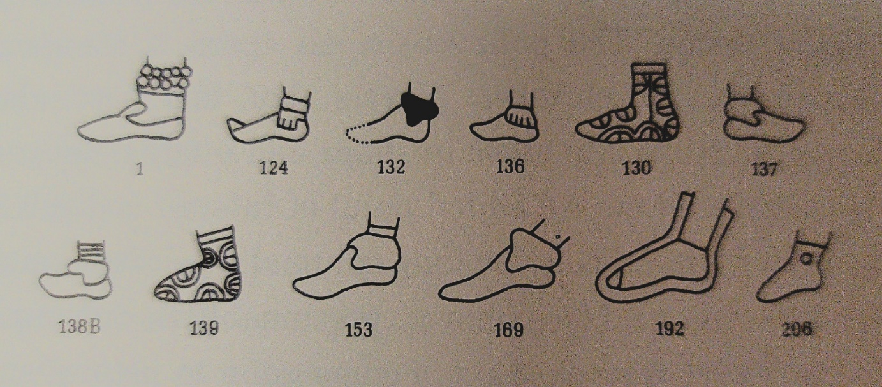
Figure 3.18 Various types of identified footwear in Phillips and Brown (1978:102)

Held Objects
Fan/Frame Drum | Rattle | Serpent Staff | Beads | Broken Staff/Chunkey Stick | Steaming Pot/Kettle Drum | Striped Staff | Blades | Bird-Wing Fan
Plate 124 | Plate 126 | Plate 189 | Plate 18 | Plate 20 | Plate 126 | Plate 138 | Plate 192 | Plate 19
Plate 126 | Plate 133 | Plate 192 | Plate 192
Plate 133 | Plate 134 | Plate 193
Plate 134 | Plate 137 | Plate 197.1
Plate 137
Total = 5 | Total = 4 | Total = 4 | Total = 2 | Total = 1 | Total = 1 | Total = 1 | Total = 1 | Total = 1

Table 3.7 Frequency of various types of held objects among the short list of confirmed dancers

On Music and Instrumentation
As noted by Rees (2012:26) musical instruments and singing are certainly linked to the idea of ritualized dancing. Rees used an ethnomusicological system and iconographic analysis to identify instrumentation types depicted on the shell engravings from Craig Mound. He argues that there are three categories represented within these engravings, idiophones, membranophones, and aerophones. Idiophones are instruments that produce sound through the vibration of their own bodies (Rees 2012:27), and in the case of the shell engravings are represented by rattles. Membranophones are instruments that produce sound through the vibration of a tightly bound membrane, analogous here to Rees’ interpretation of kettle drums – more on this later (Rees 2012:33). Lastly, aerophones, which, as the name implies, produce sound through the vibration of air. According to Rees, aerophones depicted on the shell engravings at Spiro include whistles and flutes. Here, whistles hold their differentiation from flutes in that they produce only a single tone, while flutes are multi-tonal (Rees 2012:44-46).
Rees’ arguments for presence of musical instrumentation in the shell engravings uses some rather far-reaching ethnographic analogies. Because of this, the analysis here will focus primarily on his pre-iconographic work in the “Panofskyian” sense.
First, in the case of idiophones, Rees identifies three varieties of rattles, “…gourd rattles, hide covered rattles, and possibly wooden rattles” (2012:27). He notes the combined presence of 33 rattles in total across 12 separate plates in the Phillips and Brown books (1978; 1984). This includes plates 126, 127, 133A, 133B, 134 B, 134Ca, 134Cb, 134E, 137, 184, 185, 309 (Rees 2012:27). 75% of the instances of rattles are from the same set of plates identified in the short list of dancers, those being plates 126, 133, 134, and 137. Furthermore, Rees separately identifies 3 instances of sound-making staffs on 135A, 136, and 189A&B, arguing that the objects attached to the staffs are rattles (Rees 2012:31-33). Perhaps most convincingly is the instance that appears on plate 189, in which the rattles attached to the serpent staff bear a striking visual similarity to rattlesnake rattles. Lastly, it is worth noting that plate 189 was also identified on the shortlist for dancers.
To Rees’ identification of idiophones I would add an additional example, that of the worn rattle. I am compelled to preface the colonially charged wording of these quotes as being products of their time, and their inclusion here is purely academic. This comes from Francisco Casañas de Jesus Maria and Isidro Felix de Espinosa in Swanton (1942),
These Indians knew neither gold nor silver. Many of their ornaments they have secured from other nations, such as glass beads, bells, and other things of a similar nature which are not to be found in this country. At their festivities some of the guests pride themselves on coming out as gallants, while others are of so hideous a form that they look like demons. They even go so far as to put deer horns on their heads, each con-ducting himself according to his own notion. [Casañas, 1927, p. 213.] . . . They are fond of bells . . . They also like hats, glass beads, and everything in the shape of ornaments; and things which make a noise. In lieu of these, they wear little white shells they find in the fields which are shaped like beads. They wear snake rattles, deer hoofs, and other similar things, all of which they fasten to their leather garments, so as to make a great deal of noise. The women also like these things very much . . . The men like fine feathers. [Casañas, 1927, p. 285.]

Here, Casañas notes the Caddo’s preference for the adornment of their garments with bells, beads, and “… things which make a noise.” Furthermore, Espinosa notes a particularly relevant placement of these noise makers on their bodies,
The men love very much to wear certain curious ornaments in their ears and when they secure earrings, beads, or necklaces, they wear them around their necks, or on their ankles and knees in their fiestas. [Espinosa, 1927, p. 176.]

This suggests the presence of rattle type idiophones being worn on the ankles, knees, and necks of Caddoan men. A very similar note on sound-making ornaments, including beads and their adornment on the ankles and wrists of Caddoan peoples is referenced in some contemporary analysis of Caddoan regalia (Sabo 2021:319). Since this dealt with instrumentation it was necessary to introduce here, but further examples and contextualization to this addition will be given in the Analysis chapter regarding Plate 1.
Next, the of membranophones falls into two categories on Craig Mound shell engravings. This includes kettle drums and frame drums. The former is arguably less convincing iconographically speaking than the latter. Rees argues that the “steaming pots” identified by Phillips and Brown (1984:Plates 126-127) are in fact kettle drums. His argument is four pronged, and hinges on ethnographic accounts of drum use near the region of Spiro, a reinterpretation of Phillips and Brown’s (1978) “entwined band motif,” the role of drums in Algonkian cosmology, and lastly an iconographic analysis of the presence of drum-like features rather than vessel-like features.
Focusing specifically on Rees’ visual analysis regarding the reinterpretation of the entwined band motif and the drum-like features reveals his iconographic conclusions. Phillips and Brown (1978) argue that the entwined band motif represents steam when in association with steaming pots. Rees argues that the lack of fire helps disprove this interpretation. Next, the entwined band motif occurs eight times throughout the shell engravings, seven of these occurrences (Plates 126, 127, 128, 131E, 136, 198C, and 210A) include sound-making implements. Furthermore, Rees argues that the entwined tails of the snake men seen on plates 192, 193, 194, and 197 all end in the rattlesnake rattle. Lastly, and perhaps in bold fashion, Rees analogizes the similarities between the Post-Classic Maya Santa Rita mural, which has been confirmed as depicting a drum and speech/sound bubbles (Rees 2012:34-36).
The final leg of Rees’ kettle drum argument that will be discussed is the inclusion of the rectilinear bar at the top of the kettles. He argues that this is what differentiates these from normal storage vessels, in that this bar represents the head of the drum. Iconographically, it is for these two reasons, the reinterpretation of the entwined band motif as sound/speech bubbles and the rectilinear bar as the drum’s head, that Rees concludes that the steaming pots depicted on the shell engravings are in fact drums. A further discussion on the entwined band motif and its reinterpretation as speech/sound bubbles will be discussed later in the aerophone section.
The next membranophone identified by Rees is the frame drum. According to Rees there are six instances of the frame drum on plates 130, 133A, 134A, 134B, 134F, and 137. Five of the six occurrences are also included in the shortlist for dancers. Furthermore, Rees also notes the posture of the figures as “dancing,”
There are, of course, a number of other elements present in gorget 137, which need further explication. The anthropomorphic figures, with their backs to each other and the central pole, appear to be dancing. They are identical and their mirrored positioning provides symmetry and balance to the scene. Each holds the reverse side of a probable frame drum in his outside hand and a rattle/mallet in his inside hand. It is important to note that the heads of the drums are in position to be struck by the mallets. This is why we see the reverse sides of the drums. If these discs were fans, they would most likely be turned the other way so as to display their decorated obverse sides and not their far more prosaic reverse sides with the handholds. Just as in 130 and 133, the waistbands of the dancers intersect the pole at its center forming a cross. To emphasize that feature, the artists have replicated Greek crosses in an identical manner across the waistbands of all the dancing figures in all three of the gorgets. (Rees 2012:43, emphasis mine)

The full paragraph was included to segue into the next point. His argument generally relies on contextualization and perspective. In this sense, contextualization encompasses the entirety of the composition, which as seen above, Rees regards as dancing. Here, perspective regards the orientation of how the anthropomorphic figures are holding the drums. In this case the drums are being held inward, away from the viewer and towards the natural direction for it to be struck by the internal arm holding a mallet. The orientation argument does explain the designs on the inside of the drums. For instance, this works especially well for plate 130. However, Rees goes on to justify the petaloid borders on plates 133, 134A, and 134B by arguing that this motif’s nod to the celestial realm is enough to explain away the impracticalities of the drum’s design since they are being played by spiritual beings. This line of reasoning resembles the all too tired argument of “for ritual purposes” with the intent to strengthen his decently backed, but generally bold claims.
Lastly, for aerophones Rees identifies two instances, a flute and a whistle seen on plate 211 and plate 201, respectively. He argues for the presence of flutes and whistles in the area during early post-contact via the ethnographic accounts of Densmore (1929), Hudson (1976) and Swanton (1929). Additionally, Rees uses visual cues to interpret these aerophones. For instance, on plate 211 a figure can be seen bringing a tube-like object up to their mouth. This can be further contextualized by the figure on plate 201 who is seen with a tube-like object near the mouth that appears to be emitting sound bubbles (Rees 2012:44-46). These sound bubbles are perhaps one of the most important distinctions made by Rees for this present study. These will be reviewed again later in the section on singing.

Final Criteria for Dance
The categories and distinctions listed above will be the criteria for identifying dance moving forward. First, a brief explanation is necessary as to how and why a plate may fulfill said criteria. Plates containing anthropomorphic forms and figures will be analyzed on a case-by-case basis to determine if dance is being depicted. The criteria will be hierarchically tiered, with the most dance-affirming set being the presence of instrumentation and the commonality of posturing. Just below this set is the criteria representing axial orientation and written confirmation, as both of these are dependent upon their own rules – namely, the presence of multiple figures instead of one and their external presence in reference to dance outside of Phillips and Brown (1978, 1984). Lastly, the presence of regalia will be weighted by their commonality with the shortlist of dancers and used only when necessary for edge cases of dance.
Given the information above, the ideal dance candidate would include an explicit written confirmation from an external source (as Phillips and Brown have been exhausted at this point), have preferably multiple figures posed in a half-leap posture with at least a simple majority of them axially oriented in an atypical fashion, include the presence of the following regalia – ponytails, Greek cross skirts, brickwork wristbands, brickwork belts, brickwork bicep bands, sashes, brickwork knee bands, and x-ray/big toenail bootees, as they are the most common within each category. Lastly, the figures should be in the presence of, and preferably holding, a musical instrument, such as the most common occurring – a frame drum. This is perhaps a rather unlikely scenario. That said, some of the plates yet to be identified as depicting dance will certainly fulfill some of these criteria.

Chapter 4: Results
This chapter follows through with the application of the criteria for identifying dance discussed in the Methods chapter. Here, the source material will again be Phillips and Brown (1978, 1984). More specifically, the plates for which this is applied will come from the extended list initially identified as containing anthropomorphic forms and figures. This extends 211 plates across all of the identified stylistic varieties. This number comes from the extended list of 225 plates containing anthropomorphic figures or forms minus the 14 plates discussed in the methods chapter. This analysis will be broken into categories of style, beginning with Braden A. Some of the arguments for the inclusion or exclusion of a plate or plates may be given to a group. As an example, if there are six related plates with anthropomorphic forms and all of them can be argued as not depicting dance in the same fashion, this project will not copy and paste the same argument six times. Instead, the grouping and argument will be identified as being related, and a single argument will be given. Furthermore, only plates that are argued to be depicting dance will be given figures. Once this has been completed with all 211 plates, those that were identified as depicting dance will be summarized. This will lead into the next chapter, Interpretations, which will discuss the relevance of these findings.

Braden A (Plates 1-52)
Within Braden A there are 17 plates containing anthropomorphic forms (Plates 1-7, 9-14, 17, and 21-23). This does not include Plates 18, 19, and 20 which were already listed as dancers and discussed in the Methods chapter. Also, since this set of plates opens with the Multiple Figures in Motion theme, each will be addressed individually, rather than grouping them as discussed before. This has been chosen due to the importance of this theme to the overall argument of this project, especially when dealing with inferred motion through axial orientation.
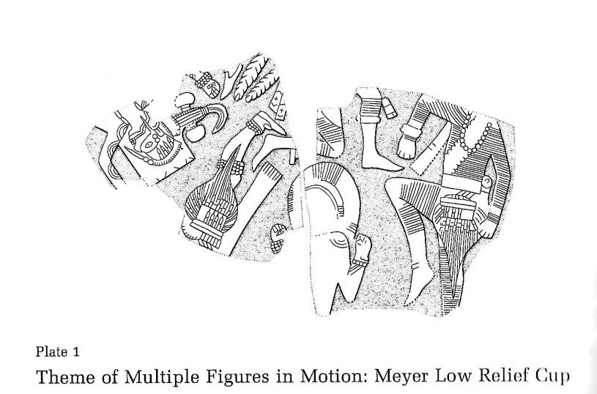
Figure 4.1: Plate 1 featuring original title from Phillips and Brown (1978:Plate 1)

Plate 1
Plate 1 offers an immediate special case in two of the fulfillment criteria. The first was brought up in the earlier section on instrumentation. There, an argument was made for an additional category of idiophone – the worn rattle. Plate 1 provides an example as to how these may be shown iconographically. Three of the figures can be seen wearing a multilayered beaded ornament. The lowest figure and the figure on the far-left wear one on their wrist, and the upside-down figure in between them can be seen wearing one on the leg and one on the knee. Notice the difference between this type of bracelet/anklet/kneeband versus the previously identified brickwork variety. Furthermore, the lowest figure on the plate can be seen wearing both a single layered beaded bracelet and a multilayered beaded bracelet. This will serve as the distinction between the presence of a sound making instrument and the presence of ornamentation. This is based primarily on the logic that a multilayered beaded bracelet would likely be noisier than a single layered one, and given the ethnographic accounts listed previously, these are more likely to fit the worn rattle description.
The next special case brought forward by this plate regards the inferred motion from axial orientation criteria. First, this plate is part of the connected theme “Multiple Figures in Motion,” in which the axial orientation argument was first made. However, Phillips and Brown (1978:48) state that this was a bad example of the theme, in that three of the four (here, four is referencing only the most complete figures and not those that can be inferred by the disembodied leg and foot) figures are oriented in the typical fashion – vertically from spire to tip. If all six of the figures are counted, and the axial orientations of the disembodied figures are inferred, then a simple majority is reached to infer motion.
Additionally, the posturing of the uppermost figure is clearly in the half-leap pose. As previously mentioned, even though only the lower half of the body is visible, this is the part that is most crucial for identifying dance iconography.
To close, Plate 1 is nearly an ideal candidate to include in the category of dance depictions. It fulfills the two most dance-affirming criteria with the presence of instrumentation (worn rattles) and the presence of the most common dance posture among the confirmed plates that depict dance (the half-leap). In addition, it fulfills the second tier of criteria in that motion can be inferred through the multiple figures’ axial orientation, and there is even some implicit written confirmation that this entire theme may represent dancers in Phillips and Brown (1978:42-44, 106-108). For these reasons regarding this plate’s fulfillment of the dance identification criteria, regalia will be overlooked, and this plate will be placed in the confirmed category of dance depictions.
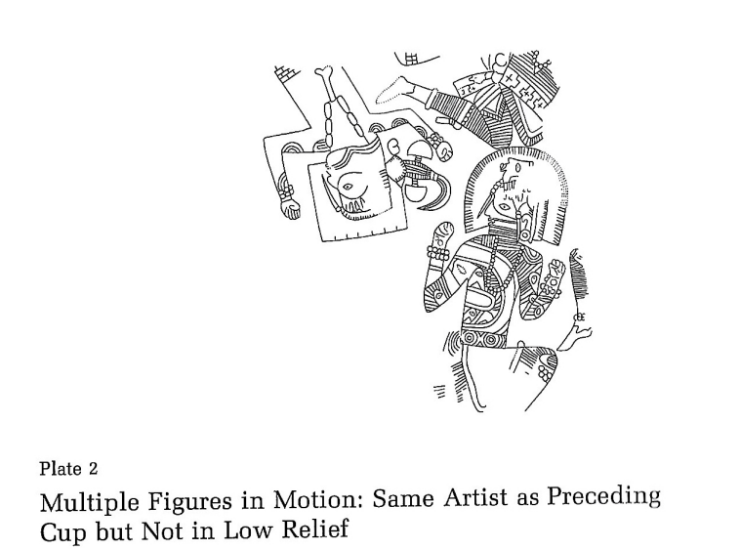
Figure 4.2: Plate 2 featuring original title from Phillips and Brown (1978:Plate 2)

Plate 2
Like Plate 1, this plate is part of the connected theme “Multiple Figures in Motion.” Here, five figures are depicted. Instrumentation is present through worn-rattles on several of the figures’ wrists and ankles. These noise makers are similar in form to those that are depicted on Plate 1, and are identified by multilayered, beaded bracelets, knee bands, and anklets. Additionally, the figure closest to the spire appears to be in the half-leap pose based on the leg posturing. Furthermore, the figure closest to the tip has a single bent knee visible. This is posed in a fashion that may complete the figure closest to the spire’s pose. The same implicit written confirmation is applicable to this plate as the previous one (Phillips and Brown 1978:42-44, 106-108). Lastly, axial orientation is particularly hard to determine for this one. The two figures whose upper body portions are visible are in direct opposition in terms of their axial orientation. The other two figures’ more partial state makes it difficult to determine. Given Phillips and Brown’s identification that this plate and Plate 1 were done by the same artist allows for some inter-plate comparisons to be made. These two plates, though in different states of condition are generally depicting the same event. For instance, notice the upside down figure whose head is visible on both plates. Both figures’ arms are decorated with halved concentric circles and both are adorned with a bilobed plume. Given the similarities in regalia, figure positioning, and the identification that both plates were done by the same artist, it is fairly safe to assume the positioning of the fourth figure known only by their leg from the knee down. This figure, like the corresponding one on Plate 1 are both axially oriented in the typical fashion. The foot of the uppermost figure on Plate 2 is angled in a more extreme manner than that of the corresponding figure on Plate 1, who has been identified as axially oriented in the typical fashion. Generally, the figures thus far have worn necklaces that stay perpendicular to the center lines of their heads. This is generally the case for most of the worn garments on these shell engravings, and the primary reason that Looper’s method for identifying inferred motion was not applicable. That said, perhaps this rigidity can be useful for determining axial orientation. If you follow the lowest and centermost point of the necklace worn by the figure closest to the spire on Plate 2, it suggests an axial orientation roughly 45 degrees off of center. I would argue that this 45-degree angle distinction could act as the cut off for determining whether or not a diagonally oriented figure can be counted as axially oriented in an atypical fashion. With this determination, a simple majority among the atypical axial orientations is reached, and thus motion can be inferred. Notice that this argument has not considered the partial knee or elbow near the top of the shell. This is due to the lack of information that can be gleaned from this figure’s partial nature. For one, it is difficult to determine what part of the body is even being depicted. This will serve as the basis for which partial figures are analyzed. To summarize, this plate fulfills both of the most important dance-affirming criteria, in that the half-leap pose found most commonly among dancers on the shortlist is present, and that instrumentation in the form of worn-rattles are also present. Furthermore, there is a simple majority in atypical axial orientations among the visibly identifiable figures. Therefore, motion can be inferred. Additionally, implicit written confirmation is fulfilled by Phillips and Brown’s discussions regarding the interpretations of the Multiple Figures in Motion theme. Lastly, while regalia was used to help make comparisons to different plates, it was not ultimately used to determine dancing since the higher tiered criteria were already fulfilled. Since these criteria have been fulfilled, this plate can be placed in the category of dance depictions.

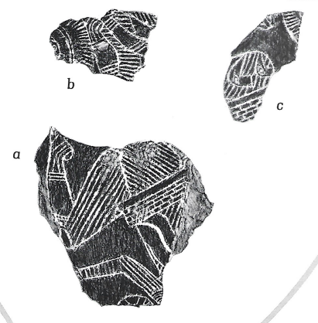

Figure 4.3: Plate 3, entitled “Multiple Figures in Motion, Continued” (Phillips and Brown 1978:Plate 3)

Plate 3
Like the previous two plates, Plate 3 is part of the Multiple Figures in Motion theme. Unfortunately, unlike the previous two plates this one is highly fragmentary. It is broken into three parts, fragments a, b, and c. Fragment a reveals the torso, arm, and leg of a figure. Fragment b contains a portion of the other leg of the figure in fragment a, as well as an arm of a second figure, and a piece of the crested headdress of a third figure. Fragment c contains a brickwork belt and decorated thigh of a fourth figure, and small portion of a crested headdress of a fifth.
There is no visible instrumentation present on this plate. Although, the most complete figure shown on fragment a does appear to be in the half-leap pose. However, this is generally where the fulfillment of criteria ends. Among the second tier of criteria, only the implicit written confirmation is fulfilled (1978:42-44, 106-108). Axial orientation cannot be determined due to the fragmentary nature of the plate. Even the visible regalia is limited to the brickwork belts, limb striping, and crested headdresses. All of which can likely be explained away by style conventions rather than dance convention. It is for these reasons that this plate will be placed in the category of potential dance depiction. If this shell had been better preserved, this would have likely been as easy an inclusion in dance as the previous two.

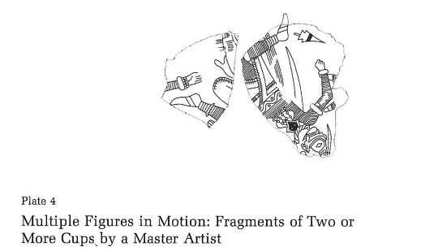
Figure 4.4: Plate 4 with original title from Phillips and Brown (1978:Plate 4)

Plate 4
Plate 4 is a special case in that it contains three separate fragments from three separate cups. These will each be evaluated individually as their own cups following the Phillips and Brown distinction of labeling them A, B, and C.
The cup A fragment contains three figures visible only by two feet and one hand. Posture cannot be determined based on the poor condition of the engraving. Instrumentation in the form of a worn-rattle can be seen on the visible hand. This worn rattle follows the same morphology of the previously identified ones, in that it depicts a multilayered, beaded bracelet. Axial orientation cannot be definitively analyzed, although the figures seem to each stand in a staunch opposition to one another, almost in a trifurcated way. Given the floating limbs’ placement, there is an argument to be made that there is a super majority of atypical axial orientations present among the three figures. This would likely be dependent on the arm alone, as the feet placement of the two figures whose feet are visible, do stand in opposing axial orientations. Additionally, since this plate is part of the Multiple Figures in Motion theme, it fulfills the criteria of written confirmation in the same way the previous plates do. Given that this fragment only definitively fulfills two criteria, presence of instrumentation and written confirmation, it is difficult to place this one firmly in the category of confirmed dance. That said, this instance allows for the addition of a category, that of potential dance, in which a plate fulfills some, but not all, of the most dance affirming categories.
Fragment B contains two visibly present anthropomorphic figures. Both appear to be axially oriented in an atypical fashion. Instrumentation is present through the identification of a worn-rattle. Written confirmation is present through plate’s inclusion in the Multiple Figures in Motion theme. Posture cannot be determined due to the condition of the fragment. In terms of regalia, the body and limb striping that has been present throughout Braden A thus far is present. There is also a forelock on one of the figures. Although, whether or not it is beaded cannot be determined due to the fragment’s condition. Additionally, there appears to be a floating, broken arrow motif present. At this point in the analysis, none of this regalia is particularly dance affirming. This fragment runs into a similar issue to the previous one, in that it fulfills some, but not all, of the dance affirming criteria. Since it fulfills three of the four most important criteria for dance confirmation, it will also be placed in the potential dance category.
Fragment C contains a single visible figure. It is axially oriented in a typical fashion from spire to tip. Furthermore, written confirmation is present due to its inclusion in the theme of Multiple Figures in Motion. Posture cannot be determined due to the limited visibility of the scene. There is an absence of instrumentation. Since this figure cannot fulfill even a simple majority of the criteria, it must be placed in the category of not depicting dance.
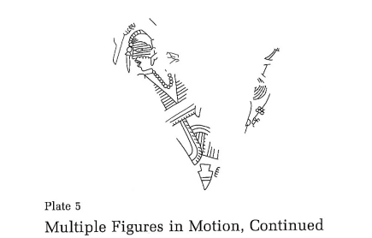
Figure 4.5: Plate 5 with original title from Phillips and Brown (1978:Plate 5)

Plate 5
Plate 5 contains two figures. One is fairly intact, showing the head and torso. The other is known only by a portion of its arm. Posturing cannot be determined due to the incompleteness of the surviving shell. Instrumentation is present, and is noted by the worn-rattle bracelet seen on the figure whose only surviving element is its arm. Axial orientation is difficult to determine, and while there are two figures present, one of them is incomplete enough to not count for this process. Written confirmation is present, as this figure too is part of the Multiple Figures in Motion theme. Given the lack of visual information and the lackluster fulfillment of the dance affirming criteria, this plate will be placed in the potential dance category.

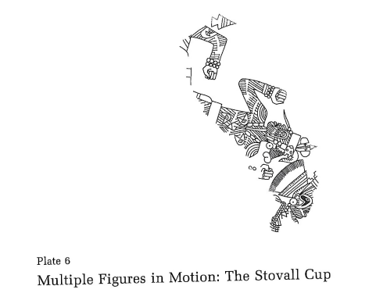

Figure 4.6: Plate 6 with original title from Phillips and Brown (1978:Plate 6)

Plate 6
Plate 6 contains three figures. The figures are generally too incomplete to make out the legs. However, Phillips and Brown (1978:Plate 6, emphasis in original) do state that “The optical effect is almost dizzying; these figures are really jumping.” Given the lack of visibility on the lower portion of these figures’ bodies, its difficult to tell if Phillips and Brown meant this in a literal sense. The fact that they were the ones to emphasize “jumping” does not help. Since the posture is not brought up again in the plate description, perhaps there is an argument to be made that this “jumping” comment is not meant literally. The context of the full sentence may suggest that they meant this in a slang sense in order to highlight the chaotic effect that the implied motion of the entire composition is conveying. Alas, using the criteria established for this project, posturing cannot be determined. Moving forward, instrumentation is present via the worn-rattle depicted on two of the figures’ wrists. Written confirmation is affirmed given the plates inclusion in the Multiple Figures in Motion theme. Lastly, inferred motion can be attained through the axial orientation of the figures, as there is a supermajority of them oriented atypically. Since this plate has fulfilled three of the four most dance affirming criteria, it can be placed in the category of dance depictions.

Plate 7
Plate 7 represents another special case that will be explicated here, so that moving forward this analysis can reference back to it, rather than rework the same argument on other plates. Plate 7 depicts two figures in court-card symmetry whose held objects clearly indicates that they are chunkee players. In cases where the actions of the figures are clearly established, this project will not attempt to reinterpret them within the framework of the dance identifying criteria. Now, this goes only for the plates that are absolutely clear in the actions of their figures. Another example that helps illustrate this point can be seen on plate 160. Here, the figures are clearly rowing a canoe, and thus, not dancing. Furthermore, there is a quote in Phillips and Brown (1978:Plate 9) that discusses the ambiguity, or lack thereof, of the actions being depicted by the figures and its relation to the objects being held,
“We have already seen a number of examples of a recurring theme entitled, for want of a better name, “multiple figures in motion.” Among other features shared by the members of this group is one that is rather peculiar for Spiro, as indeed for Southeastern shell art in general: the personages represented, though seemingly engaged in strenuous activity are empty-handed. Thereby we are given not the slightest hint as to what the activity is about. In this and the following plate (10) we have what is evidently the same theme in terms of design, but perhaps not in meaning, for the figures are holding weapons. They are, one may assume, in some way connected with the activities of warfare, hunting, or sacrifice.”

All of this to say, in cases where the action of the figures are clearly not depicting dance, they will not be included. Thus, plate 7 will be placed in the category of not depicting dance.

Plate 9
Given the rant about clearly depicted actions on plate 7, it may be assumed that the multiple figures brandishing weapons on plate 9 may be a cut and dry case of not depicting dance. However, martial depictions should not be written off so easily in terms of their relation to dance. For instance, it is important to note Swanton’s (1942:192, 234) collected ethnographic accounts of Caddo war dances. Therefore, this plate will undergo the criteria analysis like any other. Posturing cannot be determined given the condition of the shell and the lack of visibility of the figure’s legs. Instrumentation and written confirmation are both not present. Inferred motion can be made as all three figures appear to be oriented in an atypical fashion. That said, since this was the only criteria fulfilled, this plate can safely be placed in the category of not depicting dance.

Plate 10
Plate 10 is also part of the mini theme Multiple Figures Brandishing Weapons. Two figures are visible, one much more clearly than the other. Posturing cannot be determined due to the condition of the engraving. Instrumentation and written confirmation are not present. Axial orientation is typical. Since none of the criteria were fulfilled, this plate can be placed in the category of not depicting dance.

Plates 11-14
These plates will be evaluated as a series. They are connected in theme and visually similar. Plates 11-13 all depict large, disembodied heads. Since the bodies are not visible, it is hard to make an argument that these would be depicting dance. Posturing cannot be determined. Musical instrumentation and written confirmation are not present. Plates 11 and 12 have a supermajority of typical axial orientations among the figures. Plate 13 is too fragmentary to determine the axial orientation on more than a single figure. Plate 14 is different from the others in the series in that the abstraction of the anthropomorphic form has reached an apogee. Here, only floating forked eyes can be seen splashed across an Akron grid. Perhaps it was a stretch to include this in the initial list of all anthropomorphic depictions. However, as previously mentioned strong caution was placed against the exclusion of a plate. Since this one had vaguely anthropomorphic features (the forked eyes) it was included. Regardless, the application of the criteria reveal that it does not fulfill the parameters for depicting dance. None of these plates will be included in the category of dance depictions.

Plate 17
This plate, like the series of plates just evaluated, depicts disembodied heads. There is difference enough between them that it felt necessary to review this one on its own. Posture cannot be determined, as the figures are depicted without bodies. Instrumentation and written confirmation are both absent. A supermajority of atypical axial orientations can be surmised from the composition. Though, given the context of the other criteria, this alone is not enough to affirm this plate as depicting dance. Therefore, it will not be placed in the category of dance depictions.
Plate 21
Plate 21 depicts four figures who appear to be dead. They are painted to look skeletonized, and have cadaver-esque characteristics. Most notably is the tightness around the mouth, shown through wrinkled, mummified skin. The figures are stiff in their pose, and mostly oriented axially in the typical fashion. Furthermore, there is no written confirmation that this plate is depicting dance. However, there are many instances of worn-rattles throughout the composition. Some of the figures are visibly wearing three sets of rattles, on both their ankles, both their knees, and both of their wrists. Though, given the rest of the context and the other applied criteria, it is safe to place this plate in the category of not depicting dance.

Plate 22
Plate 22 is a collection of fragments from a multitude of cups. There are some anthropomorphic depictions, but all of them are partial. No poses, instrumentation, nor atypical axial orientations can be discerned. Furthermore, there is written reference that these fragments are depicting dance. Therefore, this plate will be excluded from the dance depictions category.

Plate 23
This plate is similar to the previous one, in that it represents many fragments from different cups. In general, the anthropomorphic figures seen here are more complete than those of the previous plate. That said, posturing cannot be determined due to the incompleteness of the fragments. Instrumentation is present via the worn-rattle seen in fragment A. Written confirmation is absent. Only one of the fragments contains more than a single anthropomorphic form, fragment D, which appears to be part of a paired figure gorget. However, it is too incomplete to warrant the inferencing of motion through axial orientation. Since these fragments only fulfill a single of the criteria, it is safe to exclude this plate from the dance depictions category.

Braden B (Plates 53-100)
Braden B encompasses 18 plates with anthropomorphic representation (plates 53-65, 68, 76, 78, 82, and 100). There are no dance depictions from the shortlist in this style. Furthermore, this style distinction does not contain any whole human figures. Most of the anthropomorphic depictions consist of disembodied heads. Because of this, many of these plates will be grouped and evaluated simultaneously.

Plates 53-56
Plates 53-56 all follow the general theme of large, disembodied heads. Since there are no bodies present, posture cannot be determined. Furthermore, there is a clear absence of instrumentation and written confirmation. Lastly, inferred motion can be determined, as all of the plates in this series have at least a simple majority of atypical axial orientations. Although this criteria is fulfilled, they all fail the other three, and will thus not be counted in the dance category.

Plates 57-58
These plates, like those just before, consist primarily of disembodied heads. However, there is also the inclusion of disembodied hands, broken bones, and skulls. It is for these additions that they were not lumped into the previous set. Posture cannot be determined due to the lack of bodies. There is also a lack of instrumentation and written confirmation of dance. Finally, inferred motion can be determined, as these plates have a simple majority of atypical axial orientations. Unfortunately, this alone is not enough to count these plates as depicting dance.

Plate 59
This plate contains eight fragments from various cups. Some human heads are visible, and a lone skull is visible. There are no bodies, and thus posture cannot be determined. There is no instrumentation or written confirmation of dance. Also, none of the fragments contain more than a single figure on them. Therefore, inferred motion through axial orientation cannot be determined. This plate will not be counted as depicting dance.

Plates 60-65
These plates have been lumped together for the sake of brevity. Posture cannot be determined for any of them, due to the lack of bodies. There is no written confirmation of dance, nor presence of musical instruments. Lastly, inferred motion through atypical axial orientation can be determined for one of them (plate 63), but not the rest. For these reasons, none of these plates will be considered as depicting dance.

Plates 68, 76, 78, 82, and 100
These plates were included primarily through the rigidity of the initial sorting process. This has been discussed before, but should be noted again here. Strong caution was placed on excluding a plate from the initial list of anthropomorphic representation. Because of this, plates like 68 and 78 were included solely for their depictions of forearm bones. There is no nothing else that is anthropomorphized on these plates. Likewise, plates 76, 82, and 100 contain a single disembodied hand, a hand and a skull (completely separated), and a blankly staring face, respectively. None of the dance affirming criteria are fulfilled for any of these plates. Therefore, none of these plates will be included in the category of dance depictions.

Braden C (Plates 101-123)
There are 13 plates in this style distinction that contain anthropomorphic depictions (101-106, 113-118, and 123). Unlike Braden B, Braden C does contain a few examples of whole human bodies. However, most of these plates are again, disembodied heads.

Plates 101-104
These plates are grouped through their depictions of multiple heads. None of these plates contain bodies. Posture cannot be determined for any of these. Further, written confirmation of dance and presence of instrumentation are both absent. Motion can be inferred through atypical axial orientation but given the lack of bodies and failure to fulfill the rest of the criteria these plates cannot be included as depicting dance.

Plates 105-106
These two plates are also said to depict disembodied human heads. However, these depictions are highly abstracted, prompting even Phillips and Brown to produce a figure that shows what they mean. Unfortunately, even with the figure, the heads are incredibly difficult to make out. Though, regardless of their level of abstraction, only heads are being depicted. Thus, these two plates fall identically where the previous plates did. Posture cannot be determined. There is no written confirmation of dance or presence of instrumentation. Inferred motion cannot be determined by the axial orientation. Neither of these plates will be argued for depicting dance.
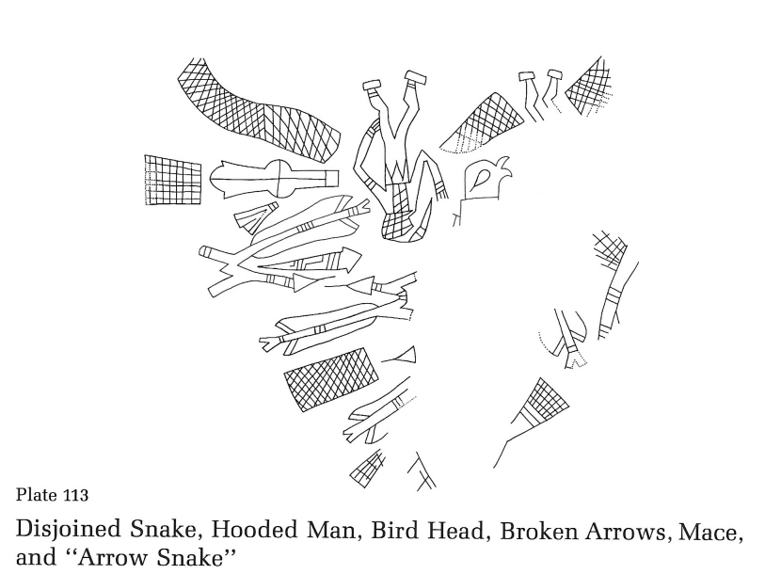

Figure 4.7: Plate 113 with original title from Phillips and Brown (1978:Plate 113)

Plate 113
This is the first plate in Braden C that depicts a whole human figure. There is also a partial human figure known only through its surviving legs and feet. The fully visible figure appears to be in a pose similar to that of plate 19’s figure, the Bilbao 21 stance. There, and here, the figure can be seen with its legs facing one direction, its chest forward, and its head turned in the direction opposite of its feet. Instrumentation is not present, but given the abundance of ophidian motifs, perhaps the evocation of the rattle is being made. However, there is nothing resembling a rattle. There is no written confirmation of dance. Inferred motion can be determined through the atypical axial orientations of the two figures. Since only two of the criteria are filled, this plate must be placed in the potential dance category.

Plate 114
This plate contains no full human bodies. Instead, there are two legs being depicted, neither of which are attached to a body. Posture and inferred motion cannot be determined. Nor is there a presence of instrumentation or written confirmation. This plate cannot be said to depict dance.

Plate 115
This plate does contain a whole human body, as well as several disembodied hands, and a lone pair of disembodied legs. The whole human body is in the “hocker” pose, as noted by Phillips and Brown (1978:Plate 115). This pose will be discussed more when it appears its third, and last, time on plate 201. There is no presence of instrumentation or written confirmation of dance. Inferred motion cannot be determined due to the lack of multiple figures. The closest thing to a second figure on this plate would be the disembodied pair of legs. However, unlike the incomplete bodies used previously to determine axial orientation, this one is in good enough condition to see that the legs were engraved by themselves initially, rather than being part of a figure and then broken off. Since the criteria have not been fulfilled, this plate cannot be counted as depicting dance. However, the “hocker” pose is rather unique and may change the outcome of this plate’s placement yet.
Plate 116
This plate contains a single, whole human body without its head. Its in a bent-knee pose with both fists raised slightly, with its arms bent at the elbows. There is no presence of instrumentation or written confirmation of dance. Inferred motion through axial orientation cannot be determined due to the figure’s lone status. This plate cannot be considered as depicting dance.

Plate 117
Here is another whole human figure. The figure may be in the half-leap pose. One of the legs is covered by the winged snake, so the posture is difficult to know for sure. There is no clear presence of instrumentation. However, the figure is depicted alongside ophidian imagery and can be seen sporting either a protruding, snake-like tongue, or a speech bubble. This does not wholly confirm the presence of sound-making imagery, nor does it deny it. There is no written confirmation of dance for this plate. Lastly, inferred motion cannot be determined since only one human figure is visible. The pose and weak argument for sound-making imagery are not enough to confirm this plate as depicting dance.

Plate 118
Plate 118 does contain a whole human figure. However, it has been abstracted to the point that Phillips and Brown (1978:Plate 118) equate its features as “doll-like.” The posture is static, with arms not depicted and its legs straight and stiff. There is no indication of musical instruments or sound making in general. There is no written confirmation for dance. Inferred
motion cannot be determined since this figure is depicted by themselves. This will be excluded from the dance depictions category.

Plate 123
Plate 123 contains seven fragments from various shells. Only fragment E contains an anthropomorphic depiction. All that is visible on fragment E is a human eye. Posture and inferred motion cannot be determined. Instrumentation and written confirmation of dance are both absent. Since none of the criteria are being fulfilled, this plate cannot be counted as depicting dance.

Summary of Braden
Depiction of Dance | Potential Depiction of Dance | Not a Depiction of Dance
Plate 1 | Plate 3 | Plate 4 (Fragment C)
Plate 2 | Plate 4 (Fragment A) | Plate 7
Plate 6 | Plate 4 (Fragment B) | Plate 9
 | Plate 5 | Plate 10
 | Plate 113 | Plate 11
 |  | Plate 12
 |  | Plate 13
 |  | Plate 14
 |  | Plate 17
 |  | Plate 21
 |  | Plate 22
 |  | Plate 23
 |  | Plate 53
 |  | Plate 54
 |  | Plate 55
 |  | Plate 56
 |  | Plate 57
 |  | Plate 58
 |  | Plate 59
 |  | Plate 60
 |  | Plate 61
 |  | Plate 62
 |  | Plate 63
 |  | Plate 64
 |  | Plate 65
 |  | Plate 68
 |  | Plate 76
 |  | Plate 78
 |  | Plate 82
 |  | Plate 100
 |  | Plate 101
 |  | Plate 102
 |  | Plate 103
 |  | Plate 104
 |  | Plate 105
 |  | Plate 106
 |  | Plate 114
 |  | Plate 115
 |  | Plate 116
 |  | Plate 117
 |  | Plate 118
 |  | Plate 123
Total Number of Plates = 3 | Total Number of Plates = 5 | Total Number of Plates = 42
Table 4.1: Total number of plates in each dance identification category for Braden

Craig A (Plates 124-186)
In general, the Craig substyles will likely be far more fruitful to this project than the Branden ones. This is due primarily to their overall greater number of total plates, and more specifically, their overall greater number of plates that contain anthropomorphic forms. This analysis will not include plates 124, 126, 131, 133, 134, 137, 138, 184, and 185, as these were already discussed in the methods chapter. One of the most prominent features of Craig A is the abundance of the paired figure gorgets. These have already been featured extensively in the shortlist for dance. Special attention will be paid to plates in this format.

Plate 125
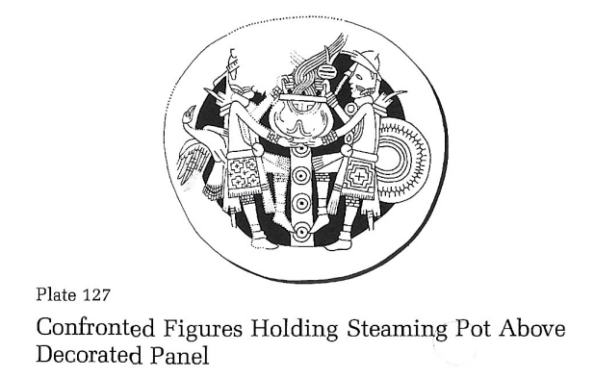
Plate 125 contains a single, statically posed figure. Here, the pose being static makes it negligible to the affirmation of dance. Furthermore, inferred motion cannot be determined since the figure is depicted as alone. Lastly, while there is no written confirmation, there is a presence of instrumentation. The visible wrist of the figure, as well as both knees, appear to bare worn-rattles. This alone is not enough for the inclusion of this plate into the dance category.

Figure 4.8: Plate 127 with original title from Phillips and Brown (1984:Plate 127)

Plate 127
Plate 127 holds many similarities with plate 126, which has been confirmed as depicting dance in this project. This plate depicts a pair of confronted figures with a central kettle drum. Both figures are holding rattles as identified by Rees (2012). This represents a rather ideal case for the inclusion of a plate into the dance depiction category. The pose of the figures is the second most common among the shortlist of confirmed dancers, the Raised Knee with Foot off the Ground. Instrumentation is present via the kettle drums and rattles. There is even written confirmation, both implicit and explicit, by Phillips and Brown (1984:Plate 133) and Rees (2012:39), respectively. Unfortunately, inferred motion cannot be determined on this plate, as both figures are axially oriented in the typical spire-to-tip fashion. That said, this plate will still be included in the dance category since it has fulfilled the other three criteria in such a robust manner.

Plate 128
Plate 128 is a peculiar case. There are two written confirmations of dance, both implicit. The first comes from Phillips and Brown (1984:Plate 133) and the other one comes from Rees (2012:26,36). Rees applies his reinterpretation of the entwined band motif argument to this plate, stating that the entwined band seen in the middle of the two figures visually represents the sounds being made by the drum. However, there is no apparent drum on this plate. He compares this to the previous two, plate 127 and 126, which have apparent kettle drums. Given this plate’s fractured integrity, it is a bit of a stretch to assume the presence of drum. Therefore, instrumentation will be considered absent here. Furthermore, inferred motion cannot be determined, as both figures are axially oriented in the typical fashion. Lastly, pose, which largely focuses on the positioning of the legs, cannot be convincingly determined. The gorget is missing the piece where the legs would be. Since so few of the categories have been fulfilled, this plate will not be considered as depicting dance. However, a disclaimer is necessary. This plate likely represents one that could easily be included as depicting dance if it were more complete. Unfortunately, it is not.
Plate 129
Plate 129 is a paired figure gorget that is missing its central motif, and significant portions of the two figures. The figures are complete enough to determine the pose, which is the second most common among the shortlist of confirmed dancers, the raised knee with foot off the ground. There is no apparent instrumentation present. Additionally, inferred motion cannot be determined as both figures are axially oriented in the typical fashion. Lastly, implicit written confirmation does exist in the same form as it does for all the paired gorgets, via Phillips and Brown (1984:Plate 133). Since only two of the criteria are fulfilled, and neither of them are done so exceptionally, this plate will not be considered as depicting dance.

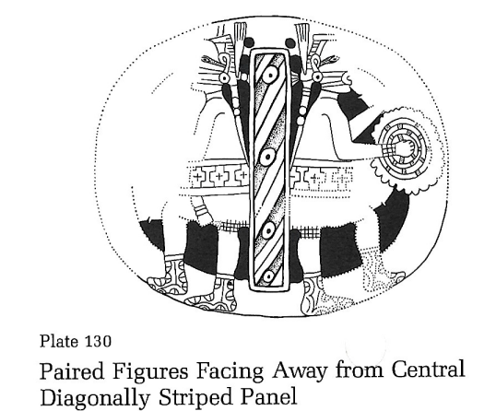

Figure 4.9: Plate 130 with original title from Phillips and Brown (1984:Plate 130)

Plate 130
Plate 130 is another paired figure gorget. Unlike the previous plate, the central motif is present, a stiped panel. However, again, significant portions of the figures are missing due to damage. Since the legs of the figures are intact, the pose can be determined as the bent knee with foot on the ground pose. This pose is tied for second most common among the shortlist of confirmed dancers. Instrumentation is present in the form of frame drums. Furthermore, there is both implicit and explicit written confirmation via Phillips and Brown (1984:Plate 133) and Rees (2012:43), respectively. Lastly, inferred motion cannot be determined since both figures are axially oriented in the typical fashion. However, given the fulfillment of all the other categories, this plate can be firmly placed in the category of dance depictions.

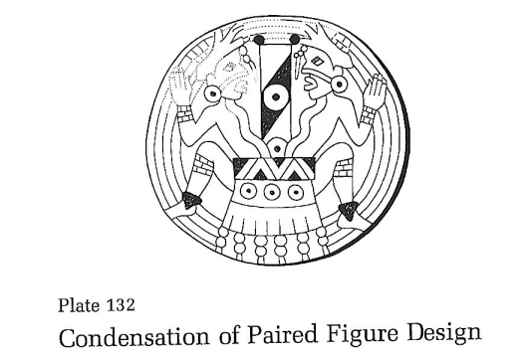
Figure 4.10: Plate 132 with original title from Phillips and Brown (1984:Plate 132)

Plate 132
Plate 132 is an essential part to Rees’ (2012) instrumentation argument. Here, two figures are depicted emerging from, or being sucked into a drum. Their pose is difficult to discern. If the figures are meant to be two parts of the same whole, then perhaps the pose could be interpreted as the “hocker” pose introduced in Braden C. If the figures are intended to be viewed separately, then not much can be said about the pose other than the knee and elbows are bent. This plate does have both implicit and explicit written confirmation via Phillips and Brown (1984:Plate 133) and Rees (2012:41), respectively. Inferred motion cannot be determined, since both figures are axially oriented in the typical fashion. Since two of the three categories were definitively fulfilled, this plate will go into the potential dance category.

Plate 135
This plate contains two large fragments of separate gorgets. Each will be analyzed on its own, and will follow the distinctions A and B, as made by Phillips and Brown (1984:Plate 135). Gorget A is a paired figure gorget that is missing one of its figures entirely. The other figure is largely intact. Its pose is static, with straight legs. One of the thighs appears to be swollen. It holds in its hands a staff with vaguely human-shaped heads impaled on it. Rees (2012:33) argues that these human head shapes are actually gourd rattles, or head effigy rattles. However, he draws upon the comparisons to Mesoamerican artifacts, which is something this project remains cautious about. Inferred motion cannot be determined, since only one figure is present. Since the pose is not particularly dance affiliated, and motion cannot be inferred, nor is the presence of instrumentation and the slightly implicit written confirmation via Rees (2012:33) very convincing, this plate will be placed in the category of not depicting dance.
Plate 135 B is far more intact than 135 A. Both figures on this paired figure gorget are visible. They are posed with both knees bent and their feet on the ground. They are divided by the central motif, an unadorned post. Inferred motion cannot be made, since both figures are axially oriented in the typical fashion. Also, there is lack in written confirmation of dance and the presence of instrumentation. Since none of the criteria are convincingly fulfilled, this too shall be considered as not depicting dance.

Plate 136
Plate 136 is a paired figure gorget with both figures and the central motif intact. They are posed somewhat statically, with their feet on the ground, knees slightly bent, and outreaching arms. There is an instrument present, as noted by Rees (2012:31-33,36). He argues that the figure on the right is holding a staff with rattles, bound to it by racoon pelts. These spoked, web-design rattles would have been played by either shaking the staff or pounding it against the earth. There is no written confirmation or dance. While Rees (2012) does implicitly tie most of the plates to dance, this one would be a stretch to count. Lastly, motion cannot be inferred, as both figures are oriented in the typical fashion. Since only one criteria is fulfilled, noting that the pose is inconsequential here, this plate will be placed in the category of not depicting dance.

Plate 139
This plate, entitled “Apotheosis of ‘Racoon-Man’: Invention or Transformation?” by Phillips and Brown (1984:Plate 139) contains two anthropomorphic forms. However, as implied by the title, these figures could be a single entity in various stages of a transformation. This would potentially classify it as an iconographic narrative since there is a passage of time condensed into a single composition without character repetition (Knight 2013:108-110). However, narratives generally deal with broader superthemes that connect across multiple compositions. Since this plate is unique in that regard, it would be difficult to argue the presence of a narrative. Furthermore, since the topic is present, orientation dependent passage of time is also likely a dead end. This is based primarily on the placement of the suspension holes being in the typical location. The pose of the figure whose full body can be seen is similar to the “hocker” pose, but Phillips and Brown (1984:Plate 139) equate it more closely to a birthing pose. There are no apparent instruments that can be seen on this plate. While the petaloid border, associated with the celestial realm, and according to Rees (2012), drums, is present. However, given the fantastical design of this composition, the former is more likely here. Additionally, there is no written confirmation, explicit or implicit, to this plate’s association with dance. Lastly, it is difficult to infer motion based on the figures’ axial orientations, since there is some debate on if these two figures are actually one. Regardless, there are not enough definitively filled criteria to count this plate as being dance associated.

Plate 140
This plate contains multiple fragments of various gorgets. Only fragments B, C, and G have clear anthropomorphic elements. However, none of them are complete enough to determine pose or the inference of motion. Furthermore, there is no presence of instrumentation or written confirmation. This plate will not be considered as depicting dance.

Plates 141-142
These two paired gorgets are similar enough in theme to review together. Both sets of figures are posed statically, with perhaps the most important difference being that the figures on plate 142 have their knees slightly bent. Either way, these poses are not pertinent to what has been identified as dance affiliated. Both sets of figures are oriented in the typical fashion, thus motion cannot be inferred. Lastly, there is no presence of instrumentation or written confirmation. The lack of written confirmation does disregard the broadly spoken quote by Phillips and Brown (1984:Plate 133) that most Craig A paired figure gorgets could be classified as dancers, since that is primarily referencing the presence of the rattle and fan combo. Regardless, not enough of the criteria have been convincingly fulfilled to include either of these plates in the category of depicting dance.

Plates 143-144
These plates contain multiple fragments from various gorgets. Fragments Aa, Ab, and Ac of plate 143 appear to be connected. These partially depict two figures. However, given the damage, it is difficult to determine any of the criteria. It is safe to exclude these from being dance affiliated. Furthermore, the anthropomorphic representations on fragments B, C, Da, and Db of plate 143 are either incomplete enough to disregard, as is the case for fragment C, or only depict disembodied heads. This entire plate can be considered as not depicting dance.
Likewise, plate 144 contains only partial anthropomorphic representations. However, this plate does fulfill some of the dance affirming criteria. In fragment A a hand can be seen wearing the rattle style bracelet identified before. Furthermore, the figure on fragment B’s pose can almost be made out. There are at least three visibly bent knees. Although, since nothing else can be fulfilled, and there is very little context, this plate will also be considered as not depicting dance.

Plates 147-148
These two plates are similar enough in composition and theme to warrant grouping them for this analysis. Plate 147 contains one of the first, largely complete birdmen. As noted by Phillips and Brown (1984:Plate 147), the “Human features are practically confined to the head and breast.” Due to this, the pose is difficult to determine since the legs are far more bird-like than human-like. There is no presence or instrumentation, or written confirmation. Lastly, motion cannot be inferred through axial orientation, since only a single figure is being depicted. Therefore, this plate will be placed in the category of not depicting dance.
With plate 148, many of the criteria fulfilling shortfalls are the same. Unfortunately, the figure’s legs are mostly missing. Again, there is no way to judge pose or infer motion. Additionally, there is no written confirmation or presence of instrumentation. This plate will also be included as not depicting dance.

Plate 149
This plate contains two separate gorgets connected by the same theme. Both of these gorgets are representing chunkee players. As noted previously in the analysis of plate 7, in cases where the actions of the figures are clearly established as not depicting dance, the plate will be placed in the category of not depicting dance. All the visible figures are seen holding chunkee disks, and two of the three can be seen alongside a broken chunkee stick.

Plate 150-151
Both of these plates contain a mixed lot of unmatched gorget fragments. None of the fragments with anthropomorphic depictions are complete enough to fulfill any of the dance identifying criteria in a meaningful way. Therefore, both plates will be considered as not depicting dance. Again, it should be noted, in cases where dance affiliation cannot be determined due to the damage of the cups or gorgets, it likely should not be written off completely. This project will not attempt to find ways in which to include such fragmentary pieces. Though, it might make for an interesting project in the future.

Plates 151.1-152
Both of these plates represent a similar theme of multiple heads in a cruciform design. Plate 151.1 is in near perfect condition, and is far more intact than the multiple fragments shown on plate 152. Plate 151.1 cannot fulfill the pose criteria since there are no bodies being depicted. Furthermore, there is no written confirmation of dance or presence of instrumentation. Lastly, inferred motion cannot be determined since three of the five heads are axially oriented in the typical fashion. The placement of the suspension holes helps back this claim, as their location makes the heads that are oriented typically the primary ones. For these reasons, the plate will not be considered as depicting dance.
Plate 152 does have a single fragment that is of note, fragment G. This fragment depicts the majority of a whole human figure. Its pose appears to be with both knees bent and the feet on the ground. However, besides its completeness in anthropomorphic form and partial fulfillment of a dance affirming pose, it still fails to fulfill the other three criteria. Therefore, this entire plate will not be considered as depicting dance.

Plates 153-156
All of these plates are connected to one or more themes concerning sacrifice. All of the plates contain multiple figures, some holding severed human heads (plates 153 and 154), others are empty handed (plates 155 and 156). There is no presence of instrumentation or written confirmation of dance for any of these plates. Additionally, there are no particularly dance related poses being shown. In general, the figures have slightly bent knees. Given the lack of criteria fulfillment, none of these plates will be considered as depicting dance.

Plate 157
This plate contains a large portion of a central motif that is enshrouded by human heads. However, there are no bodies being depicted outside of the lone human foot seen near the bottom right. Additionally, there is no presence of instrumentation or written confirmation of dance. All of the human heads are axially oriented in the typical fashion, so motion cannot be inferred. This plate does not fulfill any of the criteria for identifying dance, and therefore will be placed in the respective category.
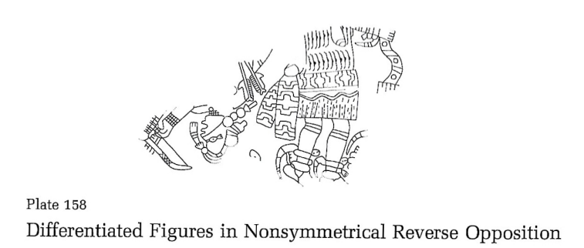
Figure 4.11: Plate 158 with original title from Phillips and Brown (1984:Plate 158)

Plate 158
Plate 158 contains two figures in nonsymmetrical reverse opposition. The upper chest, arms, and head of one figure is visible, while the other is visible from the mid-chest down. The legs of the figure on the right are in the lifted heal pose, which does occur twice in the shortlist of confirmed dancers but is only the fourth most common pose. Inferred motion can be determined through axial orientation, as the one on the right is oriented typically, while the one on the left is oriented atypically. There is, however, no indication of instruments in the composition, nor is there any written confirmation of dance. Since two of the criteria are fulfilled, this plate will be placed in the category of potentially depicting dance.

Plate 159
This plate contains a large number of profile heads in low relief. There are no bodies being depicted, nor is there any presence of instrumentation or confirmation of dance. Motion could possibly be inferred from the heads near the spire. However, it would not change the distinction of the cups placement into the category of not depicting dance.

Plate 160
Plate 160 is a similar case to plate 7 and 149, in that the actions being depicted by the anthropomorphic figures are clearly established. Here, the four figures are rowing a canoe. As tempting as it is to make the anachronistic joke of “rowing the boat” being the perfect dance move, it would be inappropriate. Therefore, this will not be included in the category of dance depictions.

Plate 161
This plate contains three figures from the waist up, each separated by a rectangular petaloid frame. They are all holding a club-like object, which lacks the described details of the idiophones discussed in Rees (2012). Furthermore, since the legs are not visible, and they are most crucial in determining dance posturing, posture cannot be determined. Furthermore, there is no written confirmation of dance, nor can motion be inferred through axial orientation. This plate will not be considered as depicting dance.

Plate 162
Plate 162 contains three figures surrounding a rectangular enclosure. Two of the three can be clearly seen wielding a bow. All of them are in a similar pose, in which one foot is off the ground, and the other is in mid-step. This is fairly similar to the half-leap pose, and may usefully serve as the beginning of the trilogy that is this pose, the half-leap, and the leap apex. Sequentially, this pose would be first, as it represents the beginning of the leap, or perhaps, gallop/skip. Due to the similarities, this plate will be counted as filling the posturing criteria of dance identification. There are no instruments present or written confirmation of dance. However, motion can be inferred through the axial orientation of the figures. Here, two of the three are oriented atypically. Since two of the four criteria have been fulfilled, this plate will be placed in the category of potential dance depiction.

Plate 163
This plate contains an assortment of unmatched cup fragments, many of which are unrelated. Most of the fragments have some representation of anthropomorphic form. Though, of these, only one is complete enough to be evaluated with the dance criteria. Fragment A contains a single, mostly intact figure. The pose appears to be the raised knee foot off the ground pose. Unfortunately, that is where the fulfillment of the criteria ends. There is no confirmation of dance through writing, nor is there any presence of instrumentation. Lastly, axial orientation as a means to infer motion cannot be used since only one figure is visible. For these reasons, plate 163 will be considered as not depicting dance.

Plate 164
Plate 164 does contain a single, whole human figure. The pose is static, besides the ever so slightly bent knees. Motion cannot be inferred since there is only a single figure and there is no written confirmation of dance. While the staff does somewhat invoke the sound-making staffs with attached idiophones mentioned previously, there is no indication of rattles or other sound makers on this plate. Since none of the criteria have been fulfilled, this plate will be considered as not depicting dance.

Plate 165
This plate contains two, partially visible figures. One appears to be bound to a rectangular frame while the other aims an arrow at them. Phillips and Brown’s title for this plate is “Possible Depiction of Arrow Sacrifice: Same Artist as Preceding Plate.” Since their argument for this action is so compelling, this plate will be placed alongside plates 7, 149, and 160. This plate, along with those just mentioned, have clear enough actions being depicted that dance can be ruled out. Therefore, it will not be considered as depicting dance.

Plates 165.1-166
Both of these plates are connected by the rather abstracted inclusion of birdmen. Plate 165.1’s figures are far more bird than man. The figures on this plate do not have human legs, and therefore their posture is difficult to determine. Additionally, the other three criteria are not fulfilled.
Plate 166 also contains an abstracted birdman. However, this figure is incomplete enough to not fulfill any of the criteria. Therefore, neither of these plates will be considered as depicting dance.

Plate 168
Plate 168 contains a rare horizontally oriented figure. The figure is alone in the depiction, thus motion cannot be inferred. Furthermore, pose cannot be determined since the figure is either oriented in such a way that the legs are blocked from view by the head, or were lost through damage of the shell. Lastly, instrumentation and written confirmation of dance are both absent. This plate will be placed in the category of not depicting dance.

Plate 168.1
This plate contains only a small portion of the overall engraving. Only a single leg and foot can be seen. Since what survives of the engraving is so incomplete, it cannot fulfill any of the dance identifying criteria. Therefore, it will be placed in the category of not depicting dance.

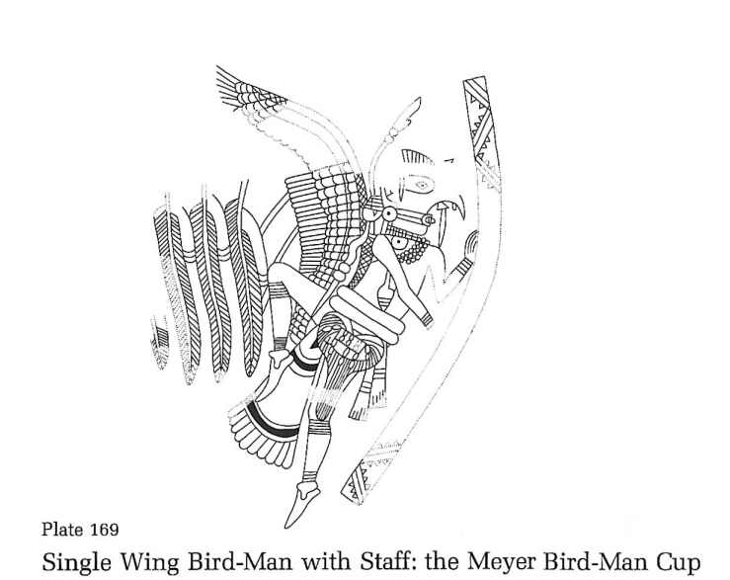
Figure 4.12: Plate 169 with original title from Phillips and Brown (1984:Plate 169)

Plate 169
Plate 169 contains a single birdman holding a staff. The pose is nearly in the half-leap. Though, one foot is clearly on the ground, regardless of the intensity of the heal lift. That said, it is close enough to the raised knee foot off the ground pose, the half-leap, and the raised heel pose that it can be argued as being a dance posture. Furthermore, the necklace worn by the birdman is of a similar design to what had previously been identified as worn-rattles. However, this argument is less compelling based on the placement of this adornment. When these are worn on the wrist, knees, or ankles there is a higher propensity of movement, and thus sound creation. Not that one of these worn-rattles hanging around the neck would be devoid of sound making, just that different placements would have a greater effect. For the sake of sticking with the criteria, this will be confirmed as containing instrumentation. Lastly, written confirmation and inferred motion are not present. Since two of the four criteria were fulfilled, this plate will be placed in the category of potential dance.

Plate 170
This plate contains multiple fragments of cups related to birdman themes. Unfortunately, none of the anthropomorphic representations on these fragments are complete enough to fulfill any meaningful quota of the dance identifying criteria. Therefore, this plate will be placed in the category of not depicting dance.

Plate 171
This is the last plate in Craig A with an anthropomorphic representation. However, Phillips and Brown’s title of it, “Slightly Anthropomorphized Bird: Putative Reconstruction Based on Three Nonmatching Fragments” suggest that the human elements are scarce. This figure seems so much more birdlike than humanlike that the application of the dance criteria cannot be fulfilled. Therefore, this plate will not be considered as depicting dance.

Craig B (Plates 187-277)
Within Craig B there are 69 plates containing anthropomorphic forms (Plates 187-201, 203-224, 232-234, 235, 240-241, 244, 247, 249-252, 254-258, 262, 265-266, 268-269, 273, and 275-277). This does not include Plates 189, 192, 193, and 197.1 which were already listed as dancers and discussed in the Methods chapter.

Plate 187-188
Both of these plates contain a pair of armed figures. In plate 187 the figures face the same direction, while those in 188 face opposite directions. Their poses are generally static, with knees so locked they almost appear to bend inwards. Motion cannot be inferred from either plate since all four figures are axially oriented in the typical fashion. There is also no written confirmation of dance or the presence of instrumentation. Since none of the criteria were fulfilled, these plates will not be considered as depicting dance.

Plate 190
The only surviving portion of the engraving on this plate is of a figure’s torso. Unfortunately, since the figure is so incomplete and alone none of the criteria involving visual examination can be complete. Furthermore, there is no presence of instrumentation or written confirmation. Therefore, this plate will not be considered as depicting dance.

Plate 191
Plate 191 contains the upper portion of an intertwined snake-men cup and some miscellaneous, unrelated fragments. Several of the unrelated fragments have anthropomorphic forms. However, none of them are complete enough to warrant an argument that they might be depicting dance. The upper portion of the intertwined snake-men cup (fragments Aa-Ac) do contain the clear depiction of rattle snake rattles. Rees (2012:33-36) had previously argued that these rattlesnake rattles might have acted as idiophonic instruments. Unfortunately, given the overall fragmentary nature of Plate 191, it would be unfair to classify this plate as depicting dance.

Plate 191.1
This plate contains two, asymmetrically paired figures holding serpent staffs. Both of them are fairly intact. The figure on the left is in the half-leap pose, while the figure on the right is statically positioned. Furthermore, inferred motion can be determined, as the figure on the left is diagonally oriented at a rough 45-degree angle. Previously, it was determined that this would be the cut off for considering diagonally oriented figures as being oriented atypically. There is no written confirmation of dance for this plate, nor is there any clear representation of instruments. However, Rees (2012:33) does note that some of the serpent staffs may be sound makers. Since the portions of the plate that would show most of the staff are missing, it is difficult to argue that this plate fulfills the presence of instrumentation criteria. Although, since two of the three criteria were fulfilled this plate will be placed in the potential dance depiction category.

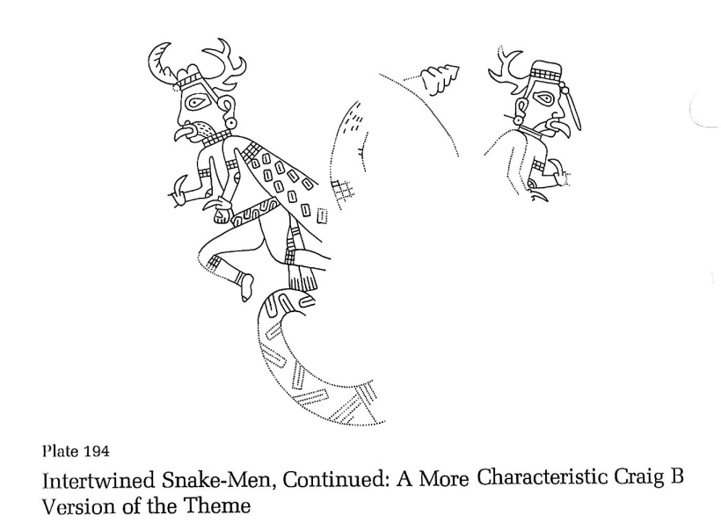
Figure 4.13: Plate 194 with original title from Phillips and Brown (1984:Plate 194)

Plate 194
Plate 194 is part of the intertwined snake-men theme. It is very reminiscent of plates 192 and 193, which were included in the shortlist of dancers. In fact, plate 193’s similarities to 192 and 197.1, as stated by Phillips and Brown (1984:Plate 193), are the reason for its inclusion in the shortlist of dancers. Plate 194 fulfills all of the dance criteria. One of the figures can be seen posed in the half-leap, which was most common among the confirmed dancers. Also, the presence of instrumentation, here to be understood as a noise-maker, is present in the rattlesnake rattle. Motion can be inferred by the axial orientation of the figures as well. Lastly, there is some implicit written confirmation that this plate pertains to dance in that Phillips and Brown (1984) note the similarities of this one to two other plates that they explicitly identify as dancers (plates 192 and 197.1). Therefore, this plate will be placed in the category of dance depictions.
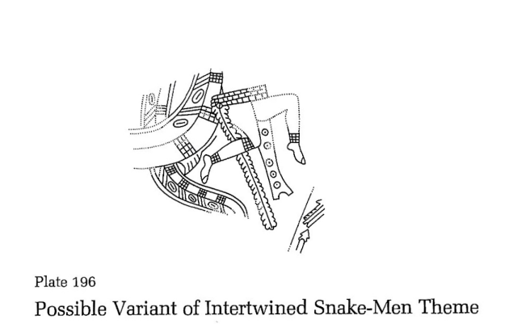

Figure 4.14: Plate 195 with original title from Phillips and Brown (1984:Plate 195)

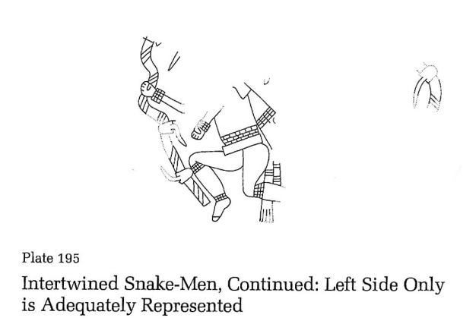

Figure 4.15: Plate 196 with original title from Phillips and Brown (1984:Plate 196)

Plates 195-196
This plate is fairly similar to plate 194’s design, only it is far less intact. It is certainly well within the theme of intertwined snake-men still. However, only a single figure can be clearly made out. Since only one figure can be seen, motion cannot be inferred. Furthermore, instrumentation is not present, as the portion of the cup that would contain the rattles is missing. The visible figure is in the half-leap pose, which is most common among the previously identified dancers. One could possibly argue that since this is in the same theme as the other previously identified plates that do depict dance, that there is some implicit written confirmation of dance. It will be said to be fulfilled here, but cautiously so. In general, this plate’s shortcomings in terms of fulfilling the dance identifying criteria are related to its incompleteness. If it were more intact, it would likely be placed in the category of depicting dance. That said, only two of the four criteria for fulfilling dance were met, but given this plate’s theme which has shown a pattern of being dance affiliated, this plate will be placed in the category of potential dance depiction.
The same arguments can be made about plate 196, in that the figure is in the half-leap pose and has the same roundabout implicit confirmation of dance that plate 195 does. This plate is also missing inferred motion and the presence of instrumentation. Like plate 195, this one is missing the portion that would show the rattlesnake rattles. This plate will also be placed in the category of potential dance depiction.

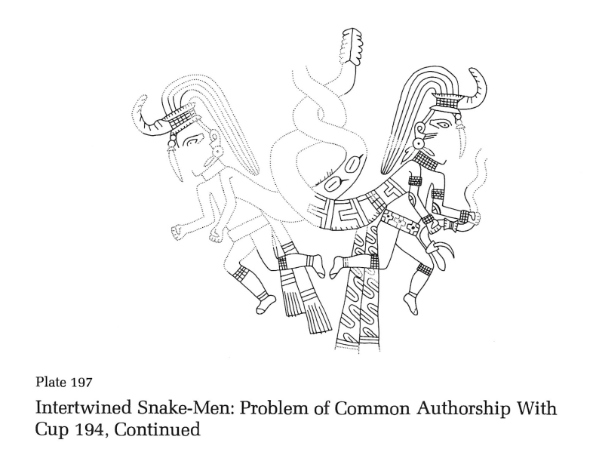
Figure 4.16: Plate 197 with original title from Phillips and Brown (1984:Plate 197)

Plate 197
This plate is also in the theme of intertwined snake-men. It nearly represents a perfect candidate for inclusion in the dance depictions category. The presence of instrumentation can be fulfilled by the rattlesnake rattle and the entwined band motif reinterpretation made by Rees (2012:34-36). Both figures exhibit the half-leap pose. There is some implicit written confirmation, given that the theme of intertwined snake-men as a whole has been associated with dance. However, inferred motion would be a bit of a stretch to confirm on this plate. Both figures are oriented diagonally at such an acute angle, it is difficult to distinguish it as atypical. Since three of the four criteria have been fulfilled this plate will be placed in the category of dance depictions.
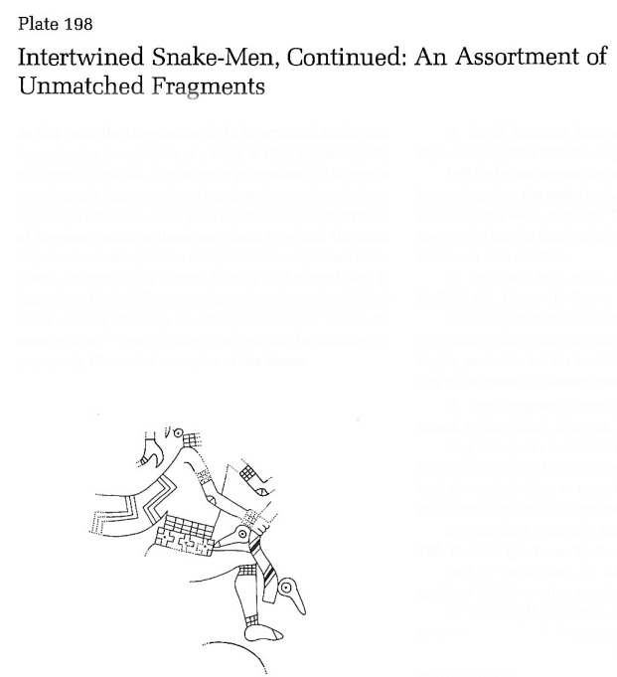

Figure 4.17: Plate 198 with original title from Phillips and Brown (1984:Plate 198)

Plate 198
Plate 198 contains an assortment of fragments associated with the intertwined snake-men theme. However, outside of this previously discussed implicit written confirmation of dance, none of the fragments are complete enough to fulfill more than two of the criteria at a time. For instance, fragments Aa-Ad show a figure in the half leap pose. Since only the dance associated pose and the implicit written confirmation are filled, this fragment would be placed in the potential dance depiction category. This bodes true for some of the other fragments as well, such as fragment C’s presence of instrumentation via a rattle. Overall, the incompleteness of this plate prevents it from being an ideal candidate. Therefore, it will be placed in the category of potential dance depiction.

Plate 199
This plate, like 198, contains an assortment of fragments related to the intertwined snake-men theme. However, the fragments on plate 199 are far more incomplete. Whereas in plate 198 several of the fragments could fulfill two of the dance identifying criteria, this plate’s fragments can only fulfill the implicit written confirmation criteria. Therefore, this will be placed in the category of not depicting dance.

Plate 200
Plate 200 depicts a single a bird-man. The pose is similar to the half-leap but is rotated 90-degrees. Additionally, motion cannot be inferred and there is no written confirmation of dance. There is a possible argument for instrumentation, as there appears to be a visual representation of sound being emitted from the bird-man’s beak. Rees (2012:36) has argued that these could be used to represent speech or singing when being emitted from the mouth. However, given the therianthropic figure, whose bird characteristics far outweigh its human ones, it would be troubling to associate this with anything other than a bird’s call. Regardless, even if this criteria were fulfilled, it would be the only one. Therefore, this plate will be considered as not depicting dance.

Plate 201
This plate depicts a single anthropomorphic form. There is a small, mostly completely figure in the hocker pose. axially oriented 90-degrees from the typical spire-to-tip orientation. The figure appears to be blowing into an aerophone, which would confirm the presence of instrumentation. This plate is one of the few argued to be depicting aerophones by Rees (2012:45-46) to do so. The presence of these sound waves does add to their interpretation as being just that, visual representations of sound. This will come up again when speech bubbles are examined in the later plates. Unfortunately, this is where the criteria fulfillment ends. Inferred motion cannot be attained since there is only a single figure being depicted. Furthermore, there is no written confirmation of dance. Since the hocker pose has not been necessarily dance affiliated so far, this plate can only be said to fulfill a single criteria. Therefore, it will not be considered as depicting dance.

Plate 203
Plate 203 represents a single bird-man and is in great condition. Condition aside, there is no presence of instrumentation or written confirmation of dance. Furthermore, inferred motion cannot be determined since the figure is depicted alone. The figure’s posture is similar to that of the hocker pose, but with less of a deep squat. Here, the knees are only bent partially, as opposed to the hocker pose’s full 90-degree bend. Since this pose is not dance affirming, nor were any of the other criteria fulfilled, this plate cannot be considered as depicting dance.

Plates 204-204.1
Both of these plates contain various cup fragments related to the theme of bird-men. Plate 204 contains three sets of fragments, two of which contain multiple parts. Plate 204.1 consists of three matching fragments from a small cup. These were grouped not only by their commonality in theme, but also for their similarities in how they fail to fulfill the dance identifying criteria. Plate 204’s figures are generally not intact enough to determine characteristics like pose. Additionally, all of the anthropomorphic representations seen on plate 204 are depicted alone, so inferred motion cannot be determined. Two of plate 204’s matching fragments, Aa and Ab, depict a bird-man’s head with a speech/singing bubble being emitted from the mouth. However, given the lack of context from the poor condition of the piece, this alone is not a compelling case for dance. Furthermore, neither plate has any written confirmation of dance.
Plate 204.1 has a similar pitfall to the previous one, in that the surviving portions of the cup do not convey enough information outside of the general theme to determine dance. The only surviving portions of the anthropomorphic bird-man are the winged arms. Pose cannot be determined. Nor is there any presence of instrumentation or characteristics that would imply motion. Therefore, neither of these plates will be considered as depicting dance.

Plate 205
This plate depicts a lone bird-man and is fairly similar to plate 203. Like the figure on 203, this bird-man is depicted in the partial hocker pose mentioned previously. Both of the figure’s knees are bent, but not the extent seen in the plates used to identify the hocker pose. There is no written confirmation of dance and motion cannot be inferred. The same issue regarding the speech/singing bubble is present on this plate. However, even if it were to be argued that this counts as the presence of instrumentation, only a single criteria would be fulfilled. Plate 205 will not be considered as depicting dance.

Plates 206-209.1
These plates have been grouped by their inclusion in the broad, bird-man theme, and for their similarities in their failures to fulfill the dance criteria. These plates represent both single, matching cup fragments, such as plate 206, as well as miscellaneous cup fragments, such as plate 208. What they all have in common is that they fail to fulfill more than a single dance identifying category at a time. Some fragments, like Aa and Ab on plate 208 could possibly be said to fulfill the presence of instrumentation identifier through the inclusion of speech/singing bubbles. However, they are not intact enough to determine anything else. Because of this, all of these plates will be considered as not depicting dance.

Plate 210
This plate contains an assortment of engravings grouped seemingly by their unusualness. Fragment grouping Aa, Ab, and Ac, as well as grouping Ba and Bb both have depictions of rattles. However, they are fairly incomplete beyond this. Both of those groupings also have an individual foot visible, but there is not enough of the figure’s body to determine anything regarding the identification of dance. Fragments D and E also contain anthropomorphic forms, a head and an elbow, respectively. Again, there is not enough of the body being depicted to determine dance. Lastly, the most complete figure seen on this plate comes from fragment grouping Ca, Cb, and Cc. This unusual figure was engraved with a total head to body ratio that is roughly one to thirteen. Phillips and Brown aptly argue away this unusual proportioning by providing a contemporary (to them) example of a New York Times drawing for a dress advertisement. Like the Spiroan engraving, the illustrated dress model has a head to body ratio of roughly one to thirteen. Moving forward beyond that digression, the figure is shown in the previously identified half-hocker pose, where the knees are not fully bent to 90-degree angles. There is a lack of instrumentation and written confirmation of dance for this fragment grouping, and since the figure is alone, inferred motion cannot be determined. This plate will be considered as not depicting dance.
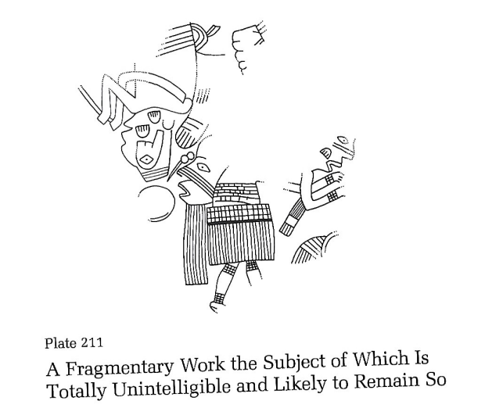

Figure 4.18: Plate 211 with original title from Phillips and Brown (1984:Plate 211)

Plate 211
Plate 211 represents and interesting case. For one, Phillips and Brown chose to entitle it “A Fragmentary Work the Subject of Which Is Totally Unintelligible and Likely to Remain So.” A fair challenge for sure. Though, this jumbled mess of figures easily fulfills the dance identifying categories. First, the figure whose legs are visible can be seen bending one knee slightly. This could be the raised knee foot on the ground posed, which is tied for second most common among the identified dancers. Additionally, the figures’ axial orientations are generally atypical, sans the severed head. Thus, inferred motion can be determined here. Furthermore, the figure on the far left appears to be holding an aerophone, as identified by Rees (2012:44-46). Lastly, there is no written confirmation of dance. However, since three of the four categories were fulfilled exceptionally, this plate will be placed in the category of dance depictions.

Plate 212
This plate depicts three very similar anthropomorphic figures all facing the same direction, one behind the other. At first glance it intuitively looks like they are dancing. However, it must be put through the criteria for this to be determined. There is no written confirmation of dance or presence of instrumentation. Additionally, it would be difficult to infer motion based on axial orientation, as the two most visible figures on the right are only diagonally oriented at an acute angle. The pose is interesting. All three figures have bent knees, raised heels, and their feet on the ground. Portions of this pose have been identified as being dance related, though this alone does not confirm this plate as depicting dance. Since only one of the criteria was partially filled, this plate will not be considered as depicting dance.

Plates 213-216
These plates have been grouped because they all depict heads without bodies. Plate 216 does give the anthropomorphic heads bodies, although they are given the bodies of turtles. Due to the lack of bodies, pose cannot be determined. Inferred motion can possibly be determined on plate 215, but without the presence of bodies this seems futile. Additionally, there is no written confirmation of dance for any of these plates. There is an argument to be made for the presence of instrumentation on each one of these. Plates 213-215 all depict the heads with either extended tongues, or speech/singing bubbles. However, as will be shown later on, the length of these protrusions from the mouth differ substantially from others, such as those seen in Craig C. This will be the rule moving forward. If a mouth protrusion is anatomically believable as a human tongue, it will be considered as such. Contrarily, if the protrusion is far longer, multipronged, or in general, anatomically unbelievable, it will be considered as a speech/singing bubble. Lastly, pate 216 does contain the presence of rattles, which have been engraved on the tail ends of the turtle bodies. These plates will not be considered as depicting dance.

Plate 217
Plate 217 depicts a single figure, whose human-animal form is composited uniquely. Very little of the human body is recognizable on this figure. The main portion that is, is the torso and arms, which is exactly conducive to identifying dance. Furthermore, there is no written confirmation of dance or presence of instrumentation. This plate will not be considered as depicting dance.

Plates 218-219
These plates have been grouped because they both contain miscellaneous fragments. The only anthropomorphic representation on plate 218 is the upper neck and lower jaw of a figure whose body is clearly snake-like. There is not enough of the engraving that is visible in the surviving fragment to determine the fulfillment of any of the criteria. Plate 219 fails to fulfil the criteria in a different way. Here, the only representation of an anthropomorphic figure is rowing a canoe. Therefore, neither of these plates will be considered as depicting dance.

Plates 220-222
These have been grouped by their relation in theme to human-headed snakes. Since there are no human bodies being depicted on these plates, there is little in the way of fulfilling the criteria that can be done. Before moving on, it is important to note that fragment B of plate 222 does fulfill the presence of instrumentation via a rattlesnake rattle. However, this alone is not enough to consider any of these plates as depicting dance.

Plates 223-224
These plates have been grouped based on their relation to the Piasa theme. Like the previous plates, the only human parts of these figures are their heads. The bodies are fully animal, fantastic or not. There is a rattlesnake rattle on plate 224. Although, this is not enough to confirm dance on either of these plates.

Plate 232
This plate was only included in the initial sorting for anthropomorphic forms based on its title in Phillips and Brown (1984:Plate 232), “Dived and Redivided Rattlesnake with a Unique Combination of Spider, Deer, and Possibly Human Elements about the Head.” Even Phillips and Brown express their caution in distinguishing this figure as “human,” and understandably so. There are no identifiable human characteristics of this figure in terms of identifying dance. Therefore, it will not be considered as depicting it.

Plate 233
Plate 233 contains at least four human heads, adorned with antlers. There are no bodies being depicted, so pose cannot be determined. Furthermore, motion cannot be inferred since all of the figures are oriented in the typical fashion. Lastly, there are instruments present or written confirmation of dance. This plate will not be considered as depicting dance.

Plates 234 & 235
Both of these plates contain depictions of animals with only the slightest human features. The first, plate 234, depicts five antlered fish, each with a slightly anthropomorphized face. The bodies are completely fish, therefore pose cannot be determined. Additionally, plate 235 depicts six racoons with slightly anthropomorphized shoulders. Otherwise, these depictions are fully racoon. Since there is not enough human representation on these plates to depict dance, neither will be included in the category.

Plates 240-241
These, like the previous plates, contain animal depictions with only the slightest anthropomorphizing. In the case of these two plates, rattlesnakes are depicted with fairly abstracted human face features. There are no human bodies present. However, there are rattles being depicted on both. This alone is not enough to consider either of these plates as depicting dance.
Plate 244
Again, this plate depicts an animal with very slight human elements. Here, spider heads are given the shoulders and arms of humans. There is not enough here to determine dance, and it will be categorized as such.

Plates 247, 249-252, 254-258, 262, 265-266, 268-269, and 273
For the sake of conciseness, as it is apparent that these arguments are getting repetitive, these plates have been grouped by their general lack of fulfilling the criteria for identifying dance. Most often, the issues with these plates come down to the incompleteness of the representation of the human form. For instance, a major portion of this grouping consists only of disembodied hands with eyes in the palms, and another portion was included based solely on the presence of independent eyes. None of these plates will be considered as depicting dance.

Plate 275
This plate contains two gorgets, one of which, fragment grouping Aa and Ab, depicts a lone bird-man. The pose is fairly static, with the figure having straight legs and outstretched arms. Additionally, motion cannot be inferred since the figure is by itself. Lastly, there is no presence of instrumentation or written confirmation of dance. Therefore, this plate will not be considered as depicting dance.

Plates 276-277
These last two Craig B plates are bundled for the same reasons as the previous section with bundled plates, in that neither depict enough of the human form to determine dance. In the case of these plates, both of their only anthropomorphic representation is human hands. Since there are no bodies, dance cannot be identified. Neither of these plates will be considered as depicting dance.

Craig C (Plates 278-338)
Craig C contains an abundance of anthropomorphic representation. There were only ten plates in this entire style group that did not have anthropomorphic elements, the rest do. Also, this style did not contain any plates from the shortlist of dancers. Therefore, all of the plates with anthropomorphic figures will be reviewed here.

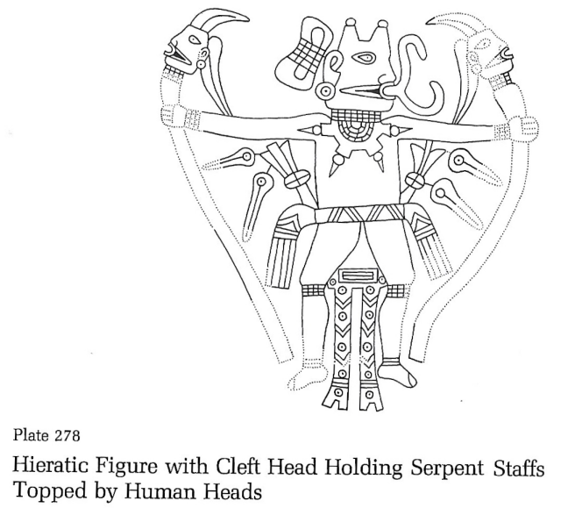

Figure 4.19: Plate 278 with original title from Phillips and Brown (1984:Plate 278)

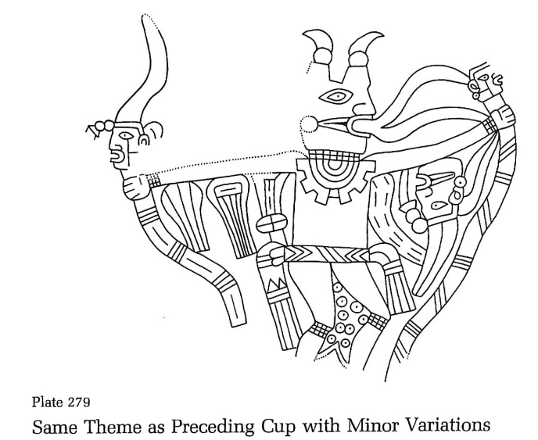

Figure 4.20: Plate 279 with original title from Phillips and Brown (1984:Plate 279)
Plates 278-279
These plates are grouped by their similarities in theme and design. Plate 278 contains a single, cleft-headed figure holding two serpent staffs that are topped with human heads. The pose is one that will come up frequently in Craig C. The figure’s legs are posed outwards, almost as if in a slight bowlegged squat. The chest faces forward, and the arms are outstretched to either side, each holding one of the serpent staffs. Additionally, the head is turned to one side. For lack of a better word, this pose will be dubbed the bent legged T-pose. The figure is alone, so inferred motion cannot be determined. There is some written confirmation of dance inside the generalized discussion by Rees (2012:30-31) in which he argues that rattles and other sound-making implements are associated with shamanic dancing. Instrumentation is present in two ways on this plate. The first is through the speech/singing bubble that is being emitted from the figure’s mouth. Here is a prime example of one that differs from a depiction of a tongue based on its anatomical believability. This bubble is much larger than even a conceivably large tongue and is multi-pronged. Furthermore, Rees (2012:30-31) argues that some of the headed staffs are actually human headed effigy rattles, like the one seen here. The T-pose will be discussed more later in the Craig C section, but for now will remain inconclusive in its relationship with dance. Even without this criterion being fulfilled, this plate does fulfill two of the others. Therefore, for now, it will be placed in the category of potential dance depiction.
Likewise for plate 279, there is a single, cleft-headed figure holding two serpent staffs that are topped with human heads. The same argument for the preceding plate can be made for this one. It will also be included in the category of potential dance depiction.

Plate 280
This plate is of a similar design to the previous two. A single figure is depicted in the T-pose holding a serpent staff in one hand, and a clublike object in the other. This figure does not have a speech/singing bubble emerging from the mouth, nor is there any indication of another type of instrument present. Lastly, motion cannot be inferred since the figure is alone. Since none of the criteria were totally fulfilled (more on the T-pose later), this plate will not be considered as depicting dance.
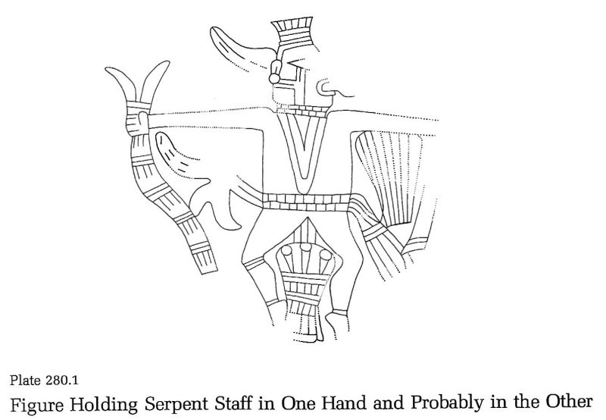

Figure 4.21: Plate 280.1 with original title from Phillips and Brown (1984:Plate 280.1)

Plate 280.1
Plate 281 holds some similarities with plates 278 and 279, in that a single figure is in the T-pose holding a serpent staff in each hand. Motion cannot be inferred. There is a speech/singing bubble emerging from the figure’s mouth, so the criterion of instrumentation can be counted as fulfilled. Unfortunately, there is no written confirmation of dance for this plate outside of Rees’ (2012:26) generalized association of singing and dancing. However, since this plate fulfils two of the criteria, it will be placed in the potential dance depiction category.

Plates 281-283
These plates were grouped by their compositional similarity. More specifically, all three of these plates contain a single figure in a modified T-pose. The pose modifications for plates 281 and 282 fall onto the positioning of the legs and the head. On these two plates the legs both face to the right, rather than being opposed in a squat position like the normal T-pose. Additionally, both of the figures’ heads are facing forward, towards the viewer, rather than in profile. Plate 283’s pose-modifications just concern the heads positioning as forward. The legs of plate 283 are in the normal, opposed squat position. None of these plates exhibit instrumentation or written confirmation of dance. Furthermore, motion cannot be inferred for any of them. Therefore, all of these plates will be considered as not depicting dance.

Plates 283.1-284
Both of these plates show partial, singular figures holding serpent staffs. However, given the damage of the artifacts, there is little that can be discerned. Both of the poses can be inferred, with plate 283.1’s figure in the same modified T-pose as plate 282, and plate 284’s figure in the standard T-pose. Instrumentation and written confirmation are absent for both of these plates. Lastly, motion cannot be inferred since both figures are single. These plates will be considered as not depicting dance.

Plate 285
This plate is unique in that it represents a large figurine carved from a previously decorated cup. The figure is static in pose, with legs and arms mostly straight. Additionally, instrumentation and written confirmation are absent. Lastly, the figure is alone, so inferred motion cannot be determined. This plate will be placed in the category of not depicting dance.

Plate 286
Plate 286 contains a single figure armed with a bow confronted by three disembodied heads. Motion cannot be inferred, for even if the heads are considered as making this composition multi-figured, they are all axially oriented in the typical fashion. Presence of instrumentation can be fulfilled by the protruding speech/singing bubbles being emitted from each figures’ mouth. The pose of the figure will come up frequently throughout the upcoming forked pole theme. Here, the figure is seen with bent knees, raised heels, outstretched arms, and an overall leaned back posture. For the sake of having to retype all of that every time this pose occurs, it will be known as the leaned back pose moving forward. There is no written confirmation of dance for this plate. This plate will not be considered as depicting dance.

Plate 286.1
This plate is very similar to the preceding plate. Again, a single figure is depicted, though this time holding a forked pole and only confronting two disembodied heads. Likewise, instrumentation is present in the form of speech/singing bubbles. Also, there is a lack of inferred motion and written confirmation. This plate too will be considered as not depicting dance.

Plates 287-288
Both of these plates contain miscellaneous fragments of Craig C themes. There is some anthropomorphic representation throughout both plates. However, even those that are able to fulfill the dance identifying criteria, they are too incomplete to fulfill more than one. For instance, presence of instrumentation could be argued for in fragment Gb of plate 287 via the speech/singing bubble being emitted from a figure’s head. However, since this depiction does lacks a body, this is the only criterion that can be fulfilled. Neither of these plates will be considered as depicting dance.

Plates 289-290
These plates are grouped by their relation in theme and design. Both plates show a dual-faced, single bodied, Janus-headed figure holding serpent staffs in each hand. One of the main differences between the two regards their poses. Plate 289’s figure is in the standard T-pose, while plate 290’s figure is in a modified T-pose, where its legs are facing the same direction, rather than bent away from each other in a forward squat. Presence of instrumentation is fulfilled on both plates through the speech/singing bubbles emerging from their mouths. Unfortunately, motion cannot be inferred and there is no written confirmation of dance for these plates. Both of these will be considered as not depicting dance.

Plate 291
Plate 291 contains a single figure holding a serpent staff in a modified leaned back pose, in which the lean is not as intense. There is no written confirmation of dance, nor any presence of instrumentation. Lastly, motion cannot be inferred, as this figure is depicted alone. This plate will not be considered as depicting dance.

Plate 292
This plate contains a single, cleft-headed figure holding a serpent staff. Presence of instrumentation is fulfilled by the speech/singing bubble coming from the figure’s mouth. However, there is no written confirmation of dance, nor any inferred motion. Lastly, the pose must be hypothesized, as much of the figure’s legs are not surviving. However, it does appear to be in the leaned back pose. This plate will not be considered as depicting dance.

Plate 293-294
Like many of the recently preceding plates, both of these are within the theme of single figures holding serpent staffs. They are grouped here based on this commonality in theme and their lack of instrumentation, which has been the primary dance fulfilling criteria among this theme. Both figures appear to be in the leaned back pose. Though, plate 293’s figure is leaned only slightly away from the serpent staff, and plate 294’s figure’s body is not in good condition. There is no written confirmation of dance for either of these plates, nor can motion be inferred. Both 293 and 294 will not be considered as depicting dance.

Plate 295
To mitigate any vague misunderstandings that a drawn-out description of this plate could provide, the title chosen by Phillips and Brown (1984:Plate 295) will be given, “Composite Human-Abstract Figure Displaying Trophy Heads.” Here, the legs and head of the figure are missing. The only visible anthropomorphic elements are the torso and arms. Both of the figure’s arms hold a head with emerging speech/singing bubbles. Pose cannot be identified given the missing lower-half of the figure, though it appears to be in a T-pose. Instrumentation is fulfilled by the speech/singing bubbles. However, there is no written confirmation of dance or any way to convincingly infer motion. This plate will not be considered as depicting dance.

Plate 296-297
Both of these plates contain horizontally banded heads. There are no bodies being depicted, so pose cannot be determined, and all of them are axially oriented in the typical fashion. Additionally, there is no written confirmation of dance. There is presence of instrumentation for both of these plates, as every single visible head is emitting a speech/singing bubble from its mouth. Unfortunately, this is not enough to confirm these plates as depicting dance.

Plate 298
This plate depicts a lone bird-man and begins the theme of bird-men in Craig C. The figure appears to be in the standard T-pose, though its legs are missing. The figure is alone, so motion cannot be inferred. Additionally, there is no written confirmation of dance. Instrumentation is present through two elements. First, the figure has a speech/singing bubble coming from its mouth. Second, the snake-spider-racoon composite seen above the figure has a rattlesnake rattle. Unfortunately, fulfilling only this category is not enough to consider this plate as depicting dance.

Plate 299
Plate 299 is also in the theme of bird-men. Here, another single bird-man is represented. Given the lack of legs, it is difficult to call this a T-pose, though that’s a close comparison. There is no written confirmation of dance, or way of inferring motion. Additionally, there are no instruments present. This plate will not be considered as depicting dance.

Plate 300
This plate differs from the last two in that the anthropomorphic features of this bird-man are far more prominent. For instance, this figure still has human legs. The pose appears to be the modified T-pose, with the figure’s legs both facing the same side, rather than being opposed in a squat. Motion cannot be inferred since the figure is alone. Instrumentation is present through the multi-pronged speech/singing bubble coming from the figure’s mouth. Lastly, there is no written confirmation of dance. Unfortunately, without the connection of the T-pose, or its variants, to dance many of these plates, like this one, will not be considered as dance depictions.

Plates 301-302
Both of these plates have been grouped by their commonality in the bird-man theme. Additionally, they suffer from the same lack of criteria fulfilling issues as many of the previous bird-men plates. Both figures are in the T-pose, though it is much more definitive on plate 301 than on 302, since the figure on 302 is depicted with bird legs rather than human ones. Additionally, both figures are alone, so motion cannot be inferred for either of them. Furthermore, there is not written confirmation for either of these plates. Lastly, instrumentation is present on plate 302 by way of the speech/singing bubble. However, it is not present on plate 301. Neither of these plates will be considered as depicting dance.

Plate 302.1
This plate’s anthropomorphic representation is even doubted by Phillips and Brown’s description, and understandably so. It was included in the sorting of anthropomorphic representation even with their misgivings. That said, there are not enough human elements or instrumentation to fulfill any of the criteria for identifying dance in a meaningful way. Therefore, this plate will be considered as not depicting dance.

Plate 303
Plate 303’s bird-man is far more bird than man. Arguably, its only anthropomorphic element is its general form. The bird-man is in a modified T-pose. There is no written confirmation of dance, presence of instruments, or an ability to infer motion. This plate will not be included in the dance depiction category.

Plates 304-304.1
These two plates represent the conclusion of the bird-man theme. Both contain various fragments related to the theme. Many of the fragments contain anthropomorphic representation, although none are complete enough to identify dance in a convincing manner. Therefore, neither of these plates will be included in the dance depictions category.

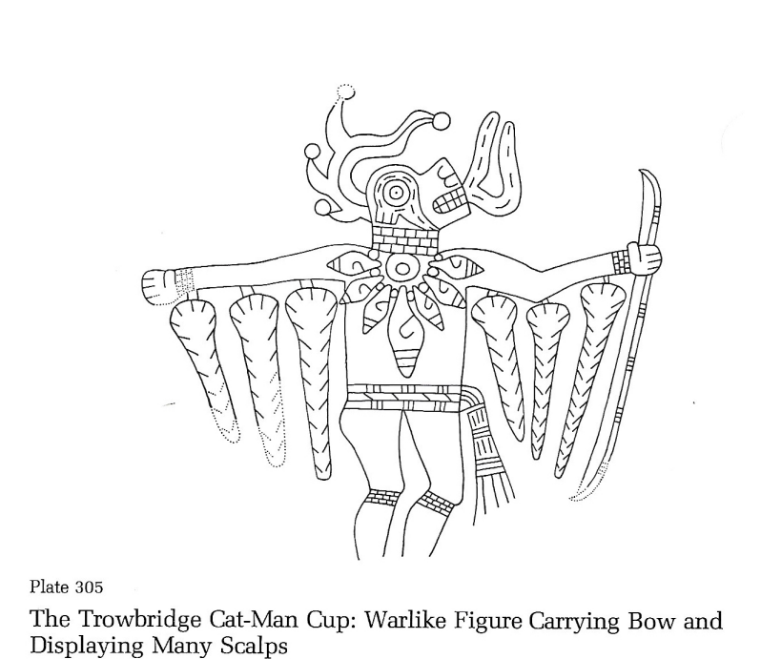

Figure 4.22: Plate 305 with original title from Phillips and Brown (1984:Plate 305)

Plate 305
This plate marks the beginning of the two-plate series involving cat-men. Plate 306 would have been grouped if not for the clear definition of its legs, which will ultimately change the categorical placement of it. Here, the figure’s legs are broken off at the feet. Unfortunately, the feet placement is crucial for identifying posture. We can infer this figure is in a modified T-pose, with both legs facing the same direction. Unfortunately, there is no indication if the feet have their heels raised. There could be a loose argument regarding the implicit written confirmation of dance for this plate. However, Phillips and Brown (1984:Plate 305) discuss their apprehension of regarding the assignment of roles, especially to therianthropic figures, as “dancers.” Given their wording in the description, it seems as though dancer was used as an off-handed example of a role. They also include the reference to “warriors.” This will be counted as a fulfillment of the criteria, though cautiously so. Motion cannot be inferred since the figure is alone. There is an instrument present in the form of a speech/singing bubble being emitted from the mouth. Since two of the four criteria were met this plate will be considered as a potential depiction of dance. Furthermore, given the context of the next plate, it is likely that this would fulfill a third criterion, dance posturing, if it were more complete.
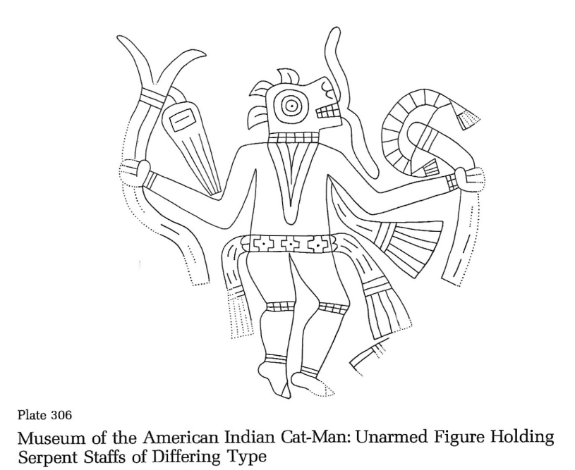

Figure 4.23: Plate 306 with original title from Phillips and Brown (1984:Plate 306)

Plate 306
This plate bares many similar characteristics to the preceding plate. Here, a cat-man is depicted holding two different serpent staffs in each hand. Where this figure’s pose differs from plate 305’s pose, or many of the identified T-poses in the single figure holding a serpent staff theme, such as plate 293, is that the heels are raised. Given the bent knees and the raised heels, which are both common characteristics identified in the confirmed dance posturing, this figure’s pose will be counted as fulfilling the criteria. Furthermore, there is the presence of instrumentation through the speech/singing bubble. Unlike the previous plate, this one has no written confirmation of dance. Lastly, motion cannot be inferred since the figure is depicted alone. This plate will be placed in the category of potential dance depiction.

Plates 307-308
Both of these plates contain snakes with anthropomorphized heads. While the presence of instrumentation is two-fold on plate 307, through both the speech/singing bubble and the rattlesnake rattle, it is absent on plate 308. Furthermore, there is no indication of a human body for either plate. Neither of these will be counted as depicting dance.

Plate 308.1
This plate contains two anthropomorphic figures facing back-to-back with macelike clubs between them. Unfortunately, this plate is not in great condition. One of the figures is nearly completely missing due to damage, and the other one is not complete enough to fulfill any of the dance identifying criteria in a meaningful way. This plate will not be considered as depicting dance.

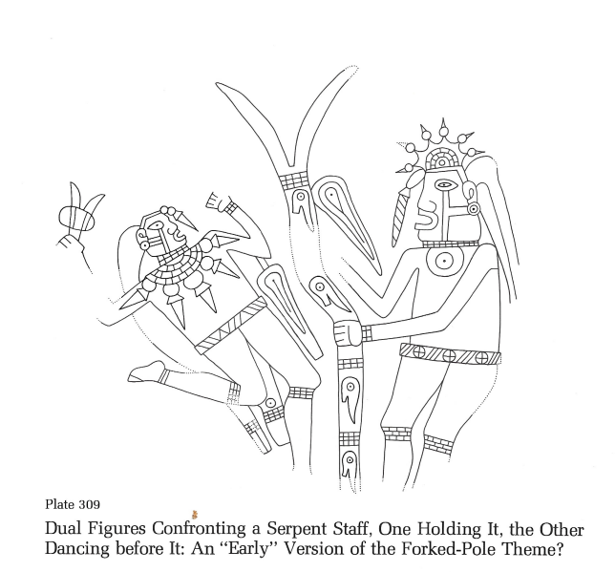

Figure 4.24: Plate 309 with original title from Phillips and Brown (1984:Plate 309)

Plate 309
Here is a near perfect candidate for inclusion in the dance depiction category. This plate contains two confronting figures with a serpent staff between them. The figure on the left will be the primary focus of this inquiry. Its pose is either a modified half-leap, or a raised knee foot on the ground pose. These poses represent the two most common poses among the previously identified dancers. Furthermore, there is an instrument being depicted in the left figure’s hand, a rattle. Additionally, this rattle identification comes with an implicit written confirmation of dance via Rees (2012:27-31). Lastly, motion can be inferred, as the axial orientation of the figure on the left is at a close enough angle to consider it atypical. All four of the categories have been fulfilled, and this plate will go into the category of dance depictions.

Plates 310-312
All five of these plates represent various levels of incomplete dual figures confronting serpent staff/s. Pose can rarely be identified in a meaningful way for any of the figures, and when it can, they do not fulfill the dance identifying criteria. Likewise, there is no presence of instrumentation, except for plate 312’s right figure’s speech/singing bubble, or written confirmation of dance. Lastly, axial orientation can be considered on several of these plates, but never to the effect of inferring motion. None of these plates will be considered as depicting dance.

Plate 313
This marks the beginning of the standardized version of the theme of paired figures confronting a forked pole. One of the elements of this standardization is the presence of two figural characters, Wedgemouth and T-Bar. These characters have been identified as representing spirit beings and human beings, respectively (Brown, Barker, and Sabo 2020:106-107). This plate was intentionally kept out of the grouping that will be analyzed next for its lack of the characteristic speech/singing bubbles. Here, like most of the other plates in this theme, the figures are in the leaned back pose. There is no written confirmation of dance. Lastly, both figures are axially oriented at an acute enough angle as to not infer motion. This plate will not be considered as depicting dance.

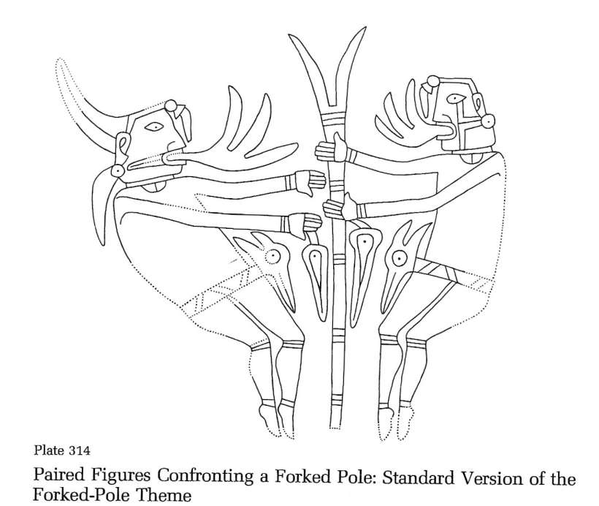

Figure 4.25: Plate 314 with original title from Phillips and Brown (1984:Plate 314)
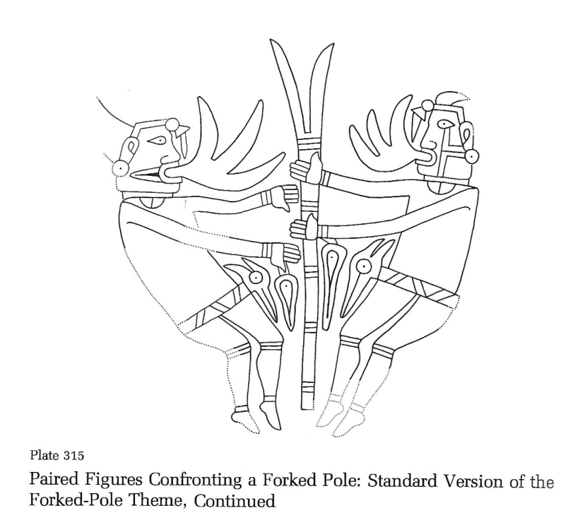

Figure 4.26: Plate 315 with original title from Phillips and Brown (1984:Plate 315)
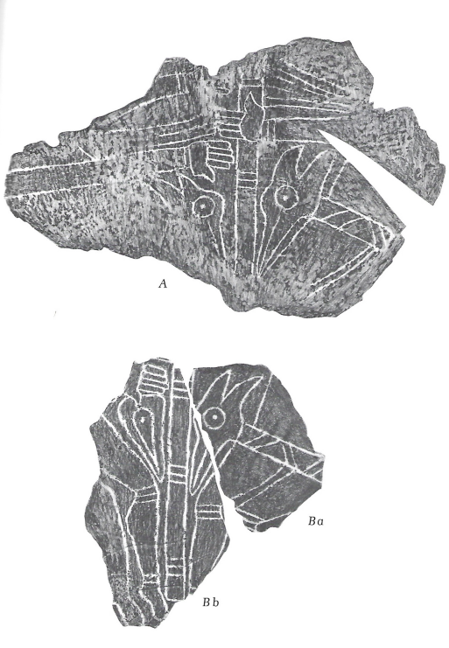

Figure 4.27: Plate 316, entitled “Paired Figures Confronting a Forked Pole: Standard Version of the Forked-Pole Theme, Continued: Two Large Cup Fragments” in Phillips and Brown (1984:Plate 316)
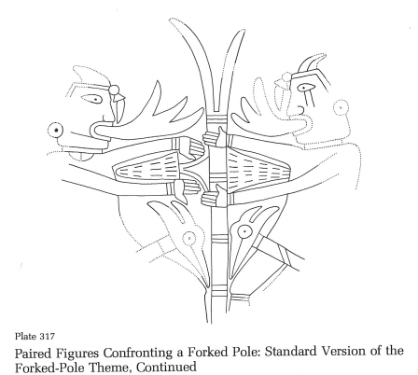

Figure 4.28: Plate 317 with original title from Phillips and Brown (1984:Plate 317)
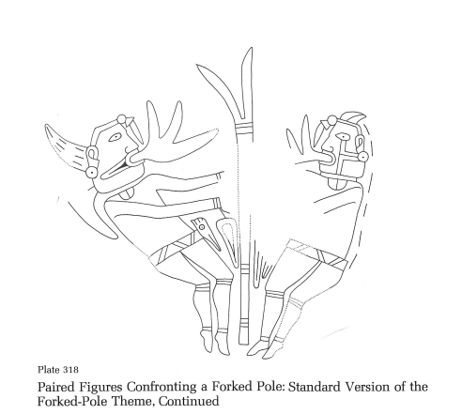

Figure 4.29: Plate 318 with original title from Phillips and Brown (1984:Plate 318)

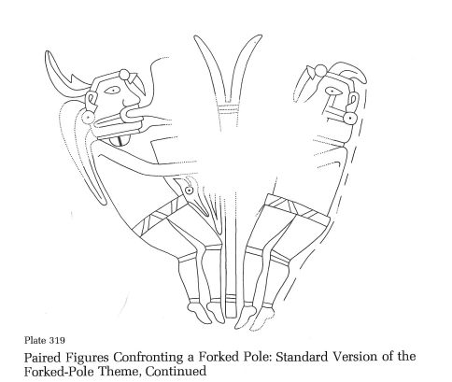

Figure 4.30: Plate 319 with original title from Phillips and Brown (1984:Plate 319)

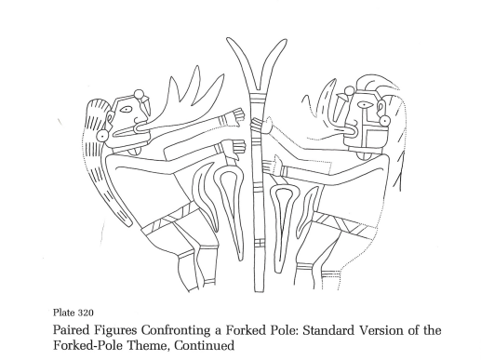

Figure 4.31: Plate 320 with original title from Phillips and Brown (1984:Plate 320)
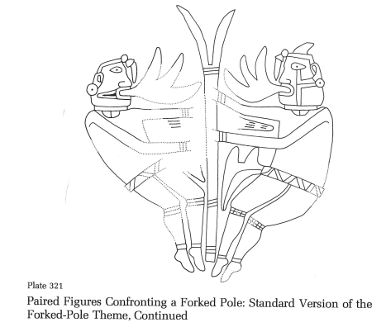

Figure 4.32: Plate 321 with original title from Phillips and Brown (1984:Plate 321)
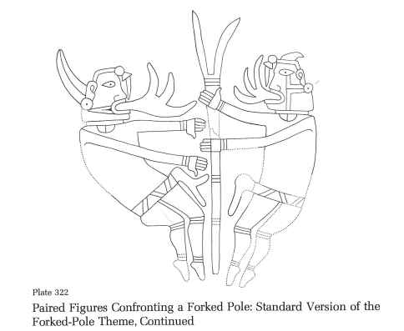

Figure 4.33: Plate 322 with original title from Phillips and Brown (1984:Plate 322)

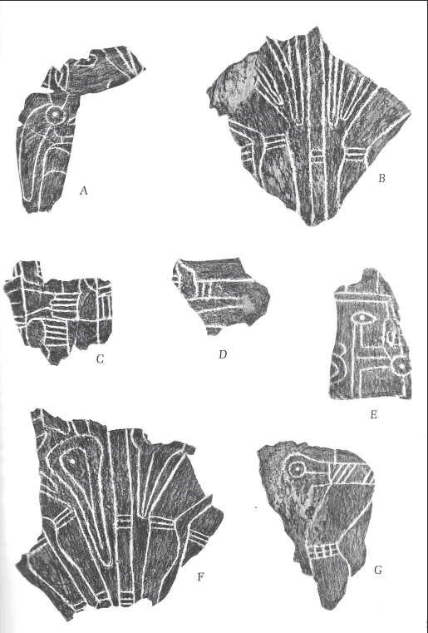

Figure 4.34: Plate 323, entitled “Paired Figures Confronting a Forked Pole: Standard Version of the Forked-Pole Theme, Concluded” in Phillips and Brown (1984:Plate 323)
Plates 314-323
This grouping represents the bulk of the standardized theme of paired figures confronting a forked pole. They are all strikingly similar in composition to one another and are therefore grouped here. All the figures whose poses are identifiable (314-315, 316 fragment Bb, 318-319, and 321-322) are shown in the leaned back pose with their knees bent and their heels lifted. The same argument regarding the posture of plate 306’s figure can be applied here. Also, as a side note, given the intense similarities between these plate’s, and the large number of examples of them, these will be placed categorically as a unit. Moving on, presence of instrumentation is fulfilled by all the plates through their speech/singing bubbles except for 316 and 323. Inferred motion is difficult to argue for here. Most of the figures are leaned away from the typical axial orientation, but generally at an acute enough angle for it to still be considered typical. Plate 314 and 318’s left figures arguably represent the most angled of all the figures, and even they cannot be said to fulfill this criteria. Lastly, there is no written confirmation of dance for any of these plates. Since two of the four dance identifying criteria are fulfilled, all of these plates will be placed in the category of potential dance depictions.

Plate 324
This plate depicts several rows of human hands with eyes in the palms. There are no bodies being depicted. This plate will not be considered as depicting dance.

Plate 325
This plate depicts a fish being pierced by arrows with only the slightest of anthropomorphic features on its face. It will not be considered as depicting dance.
Plate 335
Plate 335 is a series of miscellaneous fragments. Only fragment A has a meaningful amount of anthropomorphic representation. Unfortunately for this project, that representation is through bodyless heads. This plate will not be considered as depicting dance.
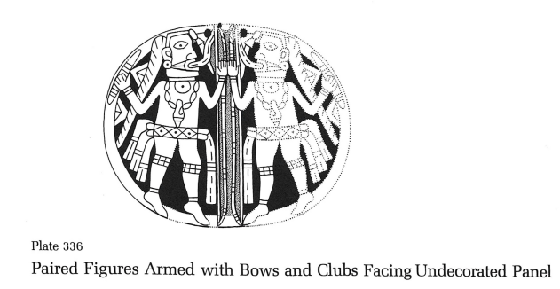
Figure 4.35: Plate 336 with original title from Phillips and Brown (1984:Plate 336)

Plate 336
This plate depicts two paired figures with a central bow motif. Both figures are in the bent knee lifted heel pose, which at this point has been associated with dance. Additionally, instrumentation is present via the speech/singing bubbles coming from both figures’ mouths. There is no written confirmation of dance or inferred motion. Since two of the four criteria have been fulfilled this plate will be considered a potential depiction of dance.

Plate 337
Plate 337 is of a gorget that is very similar to the preceding plate. The main difference between these two plates is that this one does not contain the speech/singing bubbles. Additionally, both figures’ feet on 337 are not as convincingly in the lifted heel pose. Otherwise, the previous argument is the same. This plate will not be considered as depicting dance.

Plate 338
Plate 338 is the last plate in Craig C. It contains various fragments of cups and gorgets. The only anthropomorphic representations are on fragments B and G. Both of these fragments depict human hands, but in vastly different ways. There are no visible bodies connected to them though. Therefore, this plate will not be considered as depicting dance.

Summary of Craig
Depiction of Dance | Potential Depiction of Dance | Not a Depiction of Dance
Plate 127 | Plate 132 | Plate 125
Plate 130 | Plate 158 | Plate 128
Plate 194 | Plate 169 | Plate 129
Plate 197 | Plate 195 | Plate 135 A
Plate 211 | Plate 196 | Plate 135 B
Plate 309 | Plate 198 | Plate 136
 | Plate 278 | Plate 139
 | Plate 279 | Plate 141
Depiction of Dance | Potential Depiction of Dance | Not a Depiction of Dance
 | Plate 280.1 | Plate 142
 | Plate 305 | Plate 143
 | Plate 306 | Plate 144
 | Plate 314 | Plate 147
 | Plate 315 | Plate 148
 | Plate 316 | Plate 149
 | Plate 317 | Plate 150
 | Plate 318 | Plate 151
 | Plate 319 | Plate 151.1
 | Plate 320 | Plate 152
 | Plate 321 | Plate 153
 | Plate 322 | Plate 154
 | Plate 323 | Plate155
 | Plate 336 | Plate 156
 |  | Plate 157
 |  | Plate 159
 |  | Plate 160
 |  | Plate 161
 |  | Plate 162
 |  | Plate 163
 |  | Plate 164
Depiction of Dance | Potential Depiction of Dance | Not a Depiction of Dance
 |  | Plate 165
 |  | Plate 165.1
 |  | Plate 166
 |  | Plate 168
 |  | Plate 168.1
 |  | Plate 170
 |  | Plate 171
 |  | Plate 187
 |  | Plate 188
 |  | Plate 190
 |  | Plate 191
 |  | Plate 199
 |  | Plate 200
 |  | Plate 201
 |  | Plate 203
 |  | Plate 204
 |  | Plate 204.1
 |  | Plate 205
 |  | Plate 206
 |  | Plate 207
 |  | Plate 208
Depiction of Dance | Potential Depiction of Dance | Not a Depiction of Dance
 |  | Plate 208.1
 |  | Plate 209
 |  | Plate 209.1
 |  | Plate 210
 |  | Plate 212
 |  | Plate 213
 |  | Plate 214
 |  | Plate 215
 |  | Plate 216
 |  | Plate 217
 |  | Plate 218
 |  | Plate 219
 |  | Plate 220
 |  | Plate 221
 |  | Plate 222
 |  | Plate 223
 |  | Plate 224
 |  | Plate 232
 |  | Plate 233
 |  | Plate 234
 |  | Plate 235
Depiction of Dance | Potential Depiction of Dance | Not a Depiction of Dance
 |  | Plate 240
 |  | Plate 241
 |  | Plate 244
 |  | Plate 247
 |  | Plate 249
 |  | Plate 250
 |  | Plate 251
 |  | Plate 252
 |  | Plate 254
 |  | Plate 255
 |  | Plate 256
 |  | Plate 257
 |  | Plate 257.1
 |  | Plate 258
 |  | Plate 262
 |  | Plate 265
 |  | Plate 266
 |  | Plate 268
 |  | Plate 269
 |  | Plate 273
 |  | Plate 276
Depiction of Dance | Potential Depiction of Dance | Not a Depiction of Dance
 |  | Plate 277
 |  | Plate 280
 |  | Plate 281
 |  | Plate 282
 |  | Plate 283
 |  | Plate 283.1
 |  | Plate 284
 |  | Plate 285
 |  | Plate 286
 |  | Plate 286.1
 |  | Plate 287
 |  | Plate 288
 |  | Plate 289
 |  | Plate 290
 |  | Plate 291
 |  | Plate 292
 |  | Plate 293
 |  | Plate 294
 |  | Plate 295
 |  | Plate 296
 |  | Plate 297
Depiction of Dance | Potential Depiction of Dance | Not a Depiction of Dance
 |  | Plate 298
 |  | Plate 299
 |  | Plate 300
 |  | Plate 301
 |  | Plate 302
 |  | Plate 302.1
 |  | Plate 303
 |  | Plate 304
 |  | Plate 304.1
 |  | Plate 307
 |  | Plate 308
 |  | Plate 308.1
 |  | Plate 310
 |  | Plate 310.1
 |  | Plate 311
 |  | Plate 311.1
 |  | Plate 312
 |  | Plate 313
 |  | Plate 325
 |  | Plate 335
 |  | Plate 337
 |  | Plate 338
Total Number of Plates = 6 | Total Number of Plates = 22 | Total Number of Plates = 135
Table 4.2: Total number of plates in each dance identification category for Craig

Chapter 5: Interpretations
The Plates in Context
This project significantly increased the total amount of plates with confirmed dance depictions, taking it from 14 to 23. Additionally, the total number of plates pertaining to dance, those that are confirmed as depicting dance and those that are potentially depicting dance combined, has more than tripled, from 14 to 50. Furthermore, with this identification complete, new patterns have emerged, and existing patterns have deepened. These patterns are where the interpretations will be made. Specifically, there will be a focus on thematic groupings and their combined relationship to dance, as well as stylistic groupings and their differences in relation to dance.

Confirmed Dance Depiction | Potential Dance Depiction
Plate 1 | Plate 3
Plate 2 | Plate 4a
Plate 6 | Plate 4b
Plate 18 | Plate 5
Plate 19 | Plate 113
Plate 20 | Plate 132
Plate 124 | Plate 158
Plate 126 | Plate 169
Plate 127 | Plate 195
Plate 130 | Plate 196
Plate 131 | Plate 198
Plate 133 | Plate 278
Plate 134 | Plate 279
Plate 137 | Plate 280.1
Plate 138 | Plate 305
Plate 189 | Plate 306
Plate 192 | Plate 314
Plate 193 | Plate 315
Plate 194 | Plate 316
Plate 197 | Plate 317
Plate 197.1 | Plate 318
Plate 211 | Plate 319
Plate 309 | Plate 320
Confirmed Dance Depiction | Potential Dance Depiction
 | Plate 321
 | Plate 322
 | Plate 323
 | Plate 336
Total = 23 | Total = 27
Combined Total = 50
Table 5.1 Total number of plates pertaining to the depiction of dance separated by confirmed and potential dance depictions. The red plate numbers indicate ones that were identified in the shortlist of confirmed dance depictions.

Thematic Groupings
In Phillips and Brown (1978; 1984) the plates are generally divided thematically. These thematic groupings are then laid out in sequence. Take for example the thematic grouping of “Multiple Figures in Motion,” which spans from plate 1 to plate 6. This example in particular is especially relevant to the case at hand, as all six of the “Multiple Figures in Motion” plates were identified as confirmed dance depictions, or potential dance depictions. Given the entirety of this theme’s inclusion in categories pertinent to dance, it is likely safe to say that the overall theme is related to dance. This is even backed by Phillips and Brown (1978:106-108).
Additionally, other thematic groupings are present in the combined list of identified dance depictions above. The paired figure gorget theme, spanning roughly from plate 126 to plate 142, with some mild variation, is another theme that is associated with dance. This series of plates holds an abundance of inclusions within the table above and is broadly defined as being dance related by Phillips and Brown (1984:Plate 133). Though, their comment refers specifically to the Craig A paired figure gorgets that exhibit the previously defined idiophonic rattles. Regardless, this theme too can be considered as being broadly relevant to the depiction of dance.
The “Snake-Men” theme is also likely related to dance depictions. Like before, there are a number of plates within its sequence, 189-199, that were included in the table above, and there is some broad confirmation as to this theme’s relevancy to dance in Phillips and Brown (1978:131-133; 1984:Plate 189). Before moving on, a quick note on Phillips and Brown’s thoughts on this theme’s relevance to dance is necessary. Throughout their discussion of this theme, which had previously been identified as “serpent dancers,” they often make a point to remain cautious when using the phrase “dancers.” However, this has more to do with their uneasiness in the debate surrounding the figure’s themselves and their identification as costumed humans or spirit beings rather than the figure’s actions. This debate was discussed before in the methods chapter.
Lastly, perhaps the most unsure of the dance related themes, there is the dual or paired figures confronting a serpent or forked staff theme, spanning from plate 309 to plate 323. Whereas in the previously discussed themes the classification of confirmed dance depictions and potential dance depictions were generally mixed, or even leaned more towards the confirmed dance depiction side. However, among this sequence of plates the overwhelming majority of them were placed in the potential dance depiction category. In fact, only one plate from these combined themes, plate 309, was placed in the confirmed dance depiction category. The main thing that held the other plates back from being classified as a confirmed dance depiction was the lack of written confirmation. However, the written confirmation of plate 309 (Phillips and Brown 1978:116) and its plate description (Phillips and Brown 1984:Plate 309) reveal its identification as an earlier version of the theme. It is likely a stretch, but given that the earlier version of the theme is related to dance, could the latter not be as well? This theme too will be considered as relevant to dance.
These thematic groupings were already largely identified as being related to dance by Phillips and Brown (1978; 1984). However, this adds weight to their interpretation and helps spell out this relationship in a more explicit manner. Furthermore, it aides in the link between ritualized song and dance and the contemporary interpretation of the Spirit Lodge as a means for renewal.

Planar Orientation and Dance Circles
Arguments have been made in regard to the border of the shell gorgets themselves playing into the iconography. This is most notable in the paired figure gorget theme. For example, notice the double-lined circular frames on plates 130 and 137 (Rees 2012; Reilly 2007). In both cases the dancers are facing away from a central motif, and their actions are contained within the circular frames. Reilly (2007:39-43) argued that these may represent dance circles. In these cases, the circles represent ground line locatives, and help associate the dancers on the same plane. This planar orientation is especially visible when considering the multiple-horizons technique. This allows for viewing the image in three dimensions, with the circle representing an X, Y plane and the pole representing a Z plane. Reilly (2007:41) went on to argue that using this technique could help identify ritual-specific ceremonial actions, and in turn help identify dance and medicine societies. Additionally, Reilly (2007:42) argued that being in possession of one of these gorgets that depict ritual-specific ceremonial actions could mark the wearer as a member of a specific dance or medicine society.
This information can be applied to the data set created in this project to identify additional examples of dance circles. To start, a criteria should be established. First, the actions of the dancers should be largely contained within the dance circle. Second, an attempt should be made to determine whether the potential dance circle is decorated or plain, as this may help identify a different locative. Third, if an explicit border is not carved, such as the double lines, does it appear to be implied with the border of the gorget itself. Fourth, this analysis will be limited to the plates within the paired figure gorget theme with confirmed depictions of dance or potential depictions of dance, which for this project is noted as plates 126, 127, 130, 131, 132, 133, 134, 137, and 138. Lastly, plates 130 and 137 will be considered as confirmed depictions of dance circles as they were previously identified in Rees (2012) and Reilly (2007). Therefore, they will not be analyzed here.
Plate 126 is fairly damaged. Though, it does appear that the actions of the dancers are contained within the confines of the border of the gorget. The border appears to be plain and would therefore be considered a locative of the ground regarding Reilly’s (2007) interpretation. However, there is little to be identified in terms of a central motif. Most central are the steaming pots, or kettle drums. This might represent a dance circle, but it is perhaps not the most fruitful example for applying the multiple-horizons technique.
Plate 127 has additional issues. The actions of the dancers do appear to be contained within the confines of the undecorated border, and there is a central decorated motif. However, both dancers appear to be holding or playing the same steaming pot or kettle drum, respectively. Additionally, given their postures it would be incredibly difficult to engage in circular movements while maintaining a grip on the object they are holding. Given the position of both of the figures’ legs that are placed on the ground, it appears that they are both leaning their weight backwards. Additionally, the leg movements of the figures are mirrored, in that the figure on the right’s right leg is lifted, while the figure on the left’s left leg is lifted. After a brief trial on my own to perform the logistics of this particular pose, it seems unlikely that this plate is depicting a dance circle, at least not in the same sense as those depicted on plates 130 and 137.
Plate 131 is a collection of various fragments from paired figure gorgets. Unfortunately, they are all too incomplete to do any kind of compelling analysis. Although, before moving on it should be noted that fragments B and F contain a decorated border. The borders on these two fragments consist of multiple concentric circles, which may be representing a different locative.
Plate 132 is unique, in that there are discrepancies about whether it is two halves of the same figure being depicted, or two individual figures being depicted. Additionally, it looks as though the feet are extending beyond the confines of the border. Furthermore, the border is similar in type to those seen on fragments B and F on plate 131. This does not appear to represent a dance circle, at least in the way they are represented on plates 130 and 137.
Plate 133 is an excellent example of a dance circle. The actions of the dancers are contained within the border of the gorget. The undecorated border of the gorget is carved in the same double-lined fashion as plates 130 and 137. Additionally, there is a decorated central motif. This likely represents a depiction of a dance circle.
Plate 134, like plate 131, is a collection of various fragments from paired figure gorgets. None of the fragments are complete enough to apply these dance circle identifying criteria to. Also like plate 131, there are depictions of concentric circle borders on fragments A, I, and possibly fragment B. In fragment A there is a petaloid border frame drum or fan that can be seen in association with the concentric circle border. This may suggest that the concentric circle border could be related to the spirit realm.
Plate 138 is also a collection of various fragments from paired figure gorgets. Most of the fragments contain depictions of bird-men. Though, the only fragment with a visible border is Ba and Bb. These combined fragment’s border contains densely packed concentric circles. This differs from the other concentric circle borders mentioned elsewhere in this analysis.
The most promising plates for depicting dance circles are the two that were previously identified, plates 130 and 137, and the newly identified plate 133. It is likely that more identifications could be made if the fragments of paired figure gorgets were more complete. Also, the plates containing paired figures that were facing toward each other appeared to be less likely as depicting a dance circle than paired figures that were facing away from each other. Furthermore, all of the plates analyzed are within Craig A. Additional conclusion could possibly be made if this were to be applied to gorgets outside of Craig A.

Differences by Style
Expanding beyond thematic groupings and into the realm of stylistic groupings reveals some additional patterns. On the surface, Braden as a whole seems far less relevant to dance than Craig. This is likely due to the general scarcity of anthropomorphic representation in Braden. However, if the proportionality of the dance related plates is considered in relation to the total of anthropomorphic representations, Braden is actually ahead of Craig in its pertinence to dance. In total, all of Braden has 51 anthropomorphic representations, and of these 51 there are 10 (here, the two fragments of Plate 4 are being counted as 1) instances that are dance related. Roughly 20% of all anthropomorphic depictions in the Braden style are of people engaging in dance. On the other hand, within Craig there are a total of 163 anthropomorphic representations, and of those there are 28 that are dance related. That means roughly 17% of all anthropomorphic depictions in the Craig style are of people engaging in dance. It would be interesting to see how these numbers stack up against other identified activities being performed on the engraved shells. Though, outside of only a few definitive instances, such as the depictions of figures rowing canoes, these activities may be difficult to identify. That said, given the frequency of dance depictions among both styles it may well be the most represented activity on the engraved shells. Unfortunately, that inquiry is beyond the scope of this project.
Similar proportional reasoning can be applied to the relevancy of theme to dance depictions between the two styles. Of the four themes identified as being related to dance, three of them are in Craig and only one is in Braden. Braden’s dance related theme, “Multiple Figures in Motion,” contains highly decorated dancers that are not particularly imbued with phantasmagorical elements. Additionally, there is a strong trend of disorderliness within the structures of these compositions. This makes planar orientation and dance circles difficult to discern. In general, the dance depictions in Braden are chaotic in their motion. Although, many of the poses within this style do carry over to the Craig depictions of dance. The most notable of these dance postures is the half-leap, which is most common among the shortlist of identified dancers. The only instruments seen in the Braden style depictions of dance are worn-rattles. Lastly, dance depictions in Braden appear to deal more closely with the human realm. This contrasts with two of Craig’s dance related themes, “Snake-Men” and “Forked Pole/Serpent Staff,” which both either contain the zoomorphization of the anthropomorphic form, or the presence of the figural character Wedgemouth, who is associated explicitly with the spirit realm, respectively. Most of the characteristics of Braden’s depictions of dance contrast with Craig’s depictions. For instance, on the whole, Craig has a greater emphasis on symmetry and order in its compositions of dance. Additionally, there is a greater array of instrumentation type within Craig.
The Forked Pole/Serpent Staff theme’s connections to dance are notable. For one, they are housed within the broad Craig style, which is believed to have originated at Spiro. Additionally, the narrative being conveyed by the compositions within this style are linked closely with the large-scale renewal ceremony held there. This ceremony was meant to ameliorate the social and climatic strife being experienced. It is depicted on the shell engravings as an attempt to connect with the spirit realm to ask for help. Two figural characters, T-bar and Wedgemouth, associated with the physical and spiritual worlds respectively, are wholly present in this theme. The Pawnee story regarding the forked pole as an object of immense power illustrates the direness of the Spiroan situation. Likewise, the Caddoan speaking Pawnee’s connections between the racoon motif and storm clouds (Reilly 2020:231), and this motif’s strong presence among the identified depictions of dance, adds some iconographic weight to the climatic interpretations of the ceremony. The iconography of these shells reveals some of the processes behind this ritual. Most notably are its relations to song and dance as indicated by the speech/singing bubbles and dance related posturing. This suggests that ritualized song and dance were a crucial part of Spiro’s renewal, and that their practice was worthy of inclusion within the Spirit Lodge.

The Significance of Dance
Lastly, the question of dance’s significance remains. With respect to Sabo (2005) focusing primarily on 15th century to contemporary Caddo traditions, and some assumptions to principles of cultural continuity, Caddo dance, and to a further extent, Spiroan dance, is a means of enacting history. It must be stressed that this understanding of history differs from the linear conceptions of time for which western epistemologies frame chronology. Instead, non-static historical processes are experienced directly by the Caddo through song, dance, and other ceremonies which serve as a way to transfer cultural identities through generations, ensuring their persistence. This understanding of history is achieved through the combination of two knowledge sources, that of tradition, which is based in primordial and eternal frameworks, and that of convention, which are based on the actors and events existing within chronological time shared with western written accounts. The culmination of these two understandings allows for the simultaneous connection to the past, present, and future. Here, at Spiro, the prevalence of the forked pole theme emphasizes these very same connections. A series of dire circumstances in the present led to uncertainties in the near future, for which a call to the primordial past was made as a means to overcome them.
The conclusions reached by this project are supported by these interpretations of the function of dance and the contemporary interpretations of the Spiro site as a whole. Sabo (2005) latched on to the surviving example of the Turkey Dance, whose meaning is imbued with themes of persistence and triumph in the face of adversity. Dance was turned to for similar reasons by the Spiroans. In some ways this theme of persistence allows for the success of the renewal ceremony. Though Spiroan lifeways transformed shortly after it, the continuity of dance’s primordial truths live on in the descendent communities of Spiro through their enactment of these dances in the present, and their non-static understanding of history which allows for trajectorial changes in the face of ongoing circumstances. Dance transcended more than climatic and social strife, rather it has transcended time itself.

Chapter 6: Conclusion and Future Work
The questions posed by this project were: 1) Can a set of reproducible criteria be developed and employed to identify depictions of dance on Spiroan engraved shell art? 2) Can certain thematic groupings be identified as being more pertinent to dance than others? 3) Can the use of the multiple-horizons technique be used to identify additional depictions of dance circles? 4) What are some of the main differences in how Braden and Craig style depict dance? 5) What is the significance of dance in the descendant Caddo community? The answers to these questions gleaned from this project will be addressed below and will be followed by a short discussion on potential future work.

Conclusions
Can a set of reproducible criteria be developed and employed to identify depictions of dance on Spiroan engraved shell art?
Yes. Though, for the purpose of adding nuance the answer to this question begins with the development of the Mississippian Ideological Interaction Sphere (MIIS). Waring and Holder’s (1945) discovery of common motifs among Muskhogean speaking peoples’ artifacts led to the coining of the Southern Cult, whose later development into the Southeastern Ceremonial Complex was challenged by Knight before its final realization as the MIIS. Generally, they are all referring to an artistic tradition from the Mississippi River Valley Region during the Mississippian Period (AD 900-1600). Throughout this debate a slew of archaeological and iconographic discoveries alike were being made. For instance, Emerson and Hughes’ (2000) archaeometric and iconographic work on the Resting Warrior effigy pipe helped reveal its clay sourcing area as Cahokia (Emerson et al. 2003). Additional iconographic work helped deepen the understanding of Ramey Incised vessels at Cahokia. Azar’s (2019) study identified motifs on these vessels that are common with Braden style engravings at Spiro. Furthermore, Azar helped reframe the dichotomous interpretation of the vessels as either representing a legitimization vehicle for the Cahokian elite, or a monolith of Mississippian religious identity. Instead, they appear to serve the purpose of religious expression instruments and act as other-than-human agents that continue to symbolically interact with people beyond their initial manufacturing as a way for Mississippians to physically practice their personalized religious beliefs (Azar 2019:223-225). Lastly, Dye (2020) was able to use iconographic and archaeological methods to help tie the export of religious sacra from Cahokia to Spiro.
At Spiro, the synthesis of iconography and archaeology continued. The publication of Phillips and Brown’s Pre-Columbian Shell Engravings From the Craig Mound at Spiro, Oklahoma Part 1 & 2 (1978, 1984), has continued to serve as the basis for iconographic work at the site. Throughout the decades of excavation and study these seminal iconographic works have been used as a framework for interpretation and have ultimately culminated into the contemporary interpretation of Spiro as a ceremonial center, and the site of a major renewal event. In summary, iconography has been a crucial tool for studying the Mississippian period and region broadly, and Spiro specifically.
The configurational analysis method holds its roots in Panofsky’s iconographic analysis and begins with the assembling of a corpus. In this case, much of the corpus had already been assembled since the main body of work used in this project were the shell engraving plates found in the two volumes by Phillips and Brown (1978; 1984). Next, explicit mentions of dance were identified in these two volumes. These dance depictions were broken down into their constituent parts and analyzed for motifs and other elements that were essential to dance. From this a list of criteria was created that included pose, instrumentation, inferred motion through axial orientation, and both implicit and explicit written confirmation.
The four criteria obtained from the short list of identified dance depictions were applied to the remaining plates with anthropomorphic representation. These plates were placed in one of three categories, Depiction of Dance, Potential Depiction of Dance, and Not a Depiction of Dance. This was based on the extent of the criteria that these plates fulfilled. This process yielded a substantial increase in the number of identified dance depictions within the corpus.
Can certain thematic groupings be identified as being more pertinent to dance than others? Yes. There were four themes that were identified as being associated with dance. These included Multiple Figures in Motion, Paired Figure Gorgets, Snake-Men, and the Forked Pole themes. Of these four themes, three are housed within the Spiro originated Craig style. Perhaps most importantly, the Forked Pole theme plays directly into the contemporary interpretation of Spiro as the site of a major life renewal ceremony. The theme depicts human actors receiving a power object from spiritual beings. These power objects could be used to overcome ongoing strife. This likely coincides with the 14th-15th century drought in the region that acted as the motivation for the life renewal ceremony.
Can the use of the multiple-horizons technique be used to identify additional depictions of dance circles?
Yes. This technique has revealed depictions of dance circles before on plate 130 and 137. Applying the multiple-horizons technique and the criteria created by Reilly (2007) to the entirety of the Craig A paired figure gorgets revealed several potential candidates for the depiction of dance circles, and one especially promising candidate, plate 133. Generally, the gorgets that were considered as only potentially depicting dance circles were given this distinction due to damage. Had these gorgets been better preserved, they too would likely be identified as depictions of dance circles.
What are some of the main differences in how Braden and Craig style depict dance?
Proportionally, Braden has a higher percentage of dance depictions than Craig if only the plates with anthropomorphic representation are used. However, in terms of dance related themes, Craig contains 75% of the total. In general, depictions of dance in the Braden style are more disorderly in their composition and more chaotic in their motion. Additionally, with the Braden style there is an overall lack of instrument variety in the depictions of dance. Lastly, Braden appears to be much more closely related to the human realm than Craig, which is generally more associated with the spirit realm. Furthermore, Craig is much more ordered and symmetrical in its compositions. Craig also has a far greater variety of instrument types than Braden.
What is the significance of dance in the descendant Caddo community?
This project largely affirmed some of the conclusions reached by Sabo’s (2005) study on Caddo dance. Here, Sabo argued that Caddo dance was a means for enacting a non-static history that allowed for the transfer of culture and overall persistence. This non-static view of history takes inspiration from two knowledge sources, one of tradition and one of convention. Tradition represents primordial and eternal knowledge, while convention represents the events and people who appear throughout chronological, or western conceptions of time. The combination of these knowledge sources allows for the simultaneous connection between past, present, and future. This view of history, in conjunction with certain Caddo dance’s goals of persistence especially come through in the Forked Pole theme at Spiro. Here, a series of dire circumstances in the present led to uncertainties in the near future, for which a call to the primordial past was made as a means to overcome them.
Potential Future Work
The model created for identifying dance attributes could gain additional strength by its application to other artwork assemblages, which was unfortunately beyond the scope of this thesis. Furthermore, the glossing over of plates that were highly fragmentary could be improved. Some of these fragments had diagnostic iconography and could probably be inferred as depicting dance in the future. As previously mentioned, it may be interesting to narrow the anthropomorphic representation subcategory to only include anthropomorphic figures that are engaged in an identifiable action. However, this runs into the major issue of defining and identifying specific actions. Lastly, drawing more parallels to contemporary Caddoan dance through research, interviews, and observations would have added great insight to this project.

References
Albert, Lois E.
1981 Ferndale Bog and Natural Lake: Five Thousand Years of Environmental Change in Southeastern Oklahoma. Oklahoma Archaeological Survey Studies in Oklahoma’s Past (7): 1-100

Alt, Susan
2007 Unwilling Immigrants: Culture, Change and the “Other” in Mississippian Societies. In Invisible Citizens: Captives and Their Consequences, edited by Catherine M. Cameron, pp. 2-43. University of Utah Press.
2018 Cahokia’s Complexities: Ceremonies and Politics of the First Mississippian Farmers. Archaeology of the American South: New Directions and Perspectives. Tuscaloosa, University of Alabama Press.

Anderson, David
1994 The Savanah River Chiefdoms: Political Change in the Late Prehistoric Southeast. The University of Alabama Press, Tuscaloosa.

Azar, Madeline C.
2019 Varied Visions: An Iconographic Reevaluation of Ramey Incised Production and Distribution in the American Bottom, Illinois. Southeastern Archaeology 38: 208-229.

Barker, Alex W.
2020 Craig-Style Iconography. In Recovering Ancient Spiro: Native American Art, Ritual, and Cosmic Renewal, edited by Singleton, Eric D., and F. Kent Reilly, pp. 237-251. Oklahoma City: National Cowboy & Western Heritage Museum.

Beck, Robin A. Jr.
2003 Consolidation and Hierarchy: Chiefdom Variability in the Mississippi Southeast. American Antiquity 68(4):641-661.

Blitz, J. H., and Lorenz, K. G.
2006 The Chattahoochee Chiefdoms, University of Alabama Press, Tuscaloosa.

Boles, Steve L.
2011 Thunder on the Ohio: Introducing Storms-as-he Walks, Red Horn’s Companion. Central States Archaeological Journal 58 (4): 237-249.

Brown, James A.
1996 The Spiro Ceremonial Center: The Archaeology of Arkansas Valley Caddoan Culture in Eastern Oklahoma. 2 vols. Memoir No. 29. Museum of Anthropology, University of Michigan, Ann Arbor.

Brown, James, Alex Barker, and George Sabo III.
2020 The Spirit Lodge, Spiro Ritual, and Cosmic Renewal. In Recovering Ancient Spiro: Native American Art, Ritual, and Cosmic Renewal, edited by Singleton, Eric D., and F. Kent Reilly, pp. 92-113. Oklahoma City: National Cowboy & Western Heritage Museum.

Burnette, Dorian, David Dye, and Arleen Hill.
2020 Climate Change, Ritual Practice, and Weather Deities at Spiro. In Recovering Ancient Spiro: Native American Art, Ritual, and Cosmic Renewal, edited by Singleton, Eric D., and F. Kent Reilly, pp. 76-89. Oklahoma City: National Cowboy & Western Heritage Museum.

Burnett, E. K.
1945 The Spiro Mound Collection in the Museum. Contributions of the Museum of the American Indian, Heye Foundation. 14: 1-47. New York.

Duncan, James R., and Carol Diaz-Granados
2000 Of Masks and Myths. Midcontinental Journal of Archaeology 25 (1): 1-26.

Dye, David H.
2020 Cahokian Exports to Spiro. In Cahokia in Context: Hegemony and Diaspora, edited by McNutt, Charles H. and Ryan Parish, pp. 216-242. University Press of Florida, Gainesville.

Emerson, Thomas E., and Randall E. Hughes.
2000 Figures, Flit Clay Sourcing, the Ozark Highlands, and Cahokian Acquisition. American Antiquity 65 (1): 79-101

Emerson, Thomas E., Randall E. Hughes, Mary R. Hynes, and Sarah U. Wisseman.
2003 The Sourcing and Interpretation of Cahokia-Style Figurines in the Trans-Mississippi South and Southeast. American Antiquity 68 (2): 287-313

Feinman, Gary M., and Jill E. Neitzel.
1984 Too Many Types: An Overview of Sedentary Prestate Societies in the Americas. In Advances in Archaeological Method and Theory 7, edited by M. B. Schiffer, pp. 39-102. Academic Press, New York.

Fowler, Melvin L.
1997 The Cahokia Atlas: A Historical Atlas of Cahokia Archaeology. Illinois Transportation Archaeological Research Program, University of Illinois.

Fritz, Gayle J.
1989 Evidence of Plant Use from Copple Mound at the Spiro Site. In Contributions to Spiro Archeology: Mound Excavations and Regional Perspectives, edited by J. Daniel Rogers, Don G. Wyckoff, and Dennis A. Peterson, pp. 65-87. Studies in Oklahoma's Past 16. Oklahoma Archeological Survey, Norman.
2019 Feeding Cahokia: Early Agriculture in the North American Heartland. University of Alabama Press, Tuscaloosa.

Griffin, James B.
1967 Eastern North American Archaeology: A Summary. American Association for the Advancement of Science 156 (3772):175-191.

Hamilton, Henry W.
1952 The Spiro Mound. Missouri Archaeologist. 14 (whole volume). Columbia, Missouri.

Hammerstedt, Scott W., Jami J. Lockhart, Patrick C. Livingood, Tim Mulvihill, Amanda L. Regnier, George Sabo III, and John R. Samuelson
2017 Multisensor Remote Sensing at Spiro: Discovering Intrasite Organization. In Archaeological Remote Sensing in North America: Innovative Techniques for Anthropological Applications, edited by Duncan P. McKinnon and Bryan S. Haley, pp. 11-27. The University of Alabama Press, Tuscaloosa.

Hammerstedt, Scott W., Patrick C. Livingood, Amanda L. Regnier, Jami Lockhart, Tim Mulvihill, George Sabo III, and John R. Samuelsen
2019 Archaeological Mitigation of Four Precontact Buildings at Spiro Mounds, 2013-2014, Oklahoma Archeological Survey Research Series 4.

Harrington, M. R.
1920 Certain Caddo Sites in Arkansas. Museum of the American Indian, New York City.

Kay, Marvin and George Sabo III
2006 Mortuary Ritual and Winter Solstice Imagery of the Harlan-Style Charnel House. Southeastern Archaeology 25 (1):29-47.

Kelly, John E.
1990 Range Site Community Patterns and the Mississippian Emergence. In The Mississippian Emergence, edited by B. Smith, pp. 67-112. Smithsonian Institute, Washington DC.

King, Adam
2020 Craig Mound Connection to the South Appalachian Region. In Recovering Ancient Spiro: Native American Art, Ritual, and Cosmic Renewal, edited by Singleton, Eric D., and F. Kent Reilly, 56-73. Oklahoma City, OK: National Cowboy & Western Heritage Museum.
Knight, Vernon J.
1990 Social Organization and the Evolution of Hierarchy in Southeastern Chiefdoms. Journal of Anthropological Research 46 (1): 1-23.
2006 Farewell to the Southeastern Ceremonial Complex. Southeastern Archaeology 25 (1): 1-5
2013 Iconographic Method in New World Prehistory. Cambridge University Press, Cambridge, Massachusetts.

Knight, Vernon James, George E. Lankford, Erin Phillips, David H. Dye, Vincas P. Steponaitis, and Mitchell R. Childress
2017 The Holly Bluff Style. Southeastern Archaeology 36 (3): 195-213.

Kozuch, Laura, Karen J. Walker, and William H. Marquardt
2017 Lightning Whelk Natural History and a New Sourcing Method. Southeastern Archaeology 36 (3): 226-240.

Kubler, George.
1967 The Iconography of the Art of Teotihuacán. Studies in Pre-Columbian Art and Archaeology 4: 1-40.

Lambert, Shawn
2017 Alternate Pathways to Ritual Power: Evidence for Centralized Production and Long-Distance Exchange Between Northern and Southern Caddo Communities. Unpublished Doctoral dissertation, Department of Anthropology, University of Oklahoma, Norman, Oklahoma.

Lankford, George E.
2007 Reachable Stars: Patterns in the Ethnoastronomy of Eastern North America. University of Alabama Press, Tuscaloosa, Alabama.

Lankford, George E., F. Kent Reilly, and James F. Garber
2011 Visualizing the Sacred: Cosmic Visions, Regionalism, and the Art of the Mississippian World. University of Texas Press, Austin, Texas.

La Vere, David.
2007 Looting Spiro Mounds: An American King Tut’s Tomb. University of Oklahoma Press, Norman, Oklahoma.

Livingood, Patrick.
2008 Recent Discussions in Late Prehistoric Southern Archaeology. Native South 1: 1-26.

Looper, Matthew George.
2009 To Be Like Gods: Dance in Ancient Maya Civilization. University of Texas Press, Austin, Texas.

Moore, Clarence B.
1905 Certain Aboriginal Remains of the Black Warrior River. Journal of the Academy of Natural Sciences of Philadelphia. 13: 123-244. Philadelphia, Pennsylvania.

Muller, Jon D.
1997 Mississippian Political Economy. Plenum Press, New York.

Nelson, Ben A.
1995 Complexity, Hierarchy and Scale: A Controlled Comparison between Chaco Canyon, New Mexico, and La Quemada, Zacatecas. American Antiquity 60: 597-618.

Orr, Kenneth G.
1946 The Archaeological Situation at Spiro. American Antiquity 11 (2): 228-255.

Panofsky, Erwin
1939 Studies in Iconology: Humanistic Themes in the Art of the Renaissance. New York.

Pauketat, Timothy R.
1993 Temples for Cahokia Lords: Preston Holder’s 1955-1956 Excavations of Kunnemann Mound. Memoir No. 26. Museum of Anthropology, University of Michigan, Ann Arbor.
1994 The Ascent of Chiefs: Cahokia and Mississippian Politics in Native North America. University of Alabama Press, Tuscaloosa.
2007 Chiefdoms and Other Archaeological Delusions. AltaMira Press, Lanham, Maryland.

Pauketat, Timothy R., and Thomas E. Emerson
1991 The Ideology of Authority and the Power of the Pot. American Anthropologist 93 (4): 919-941

Peebles, Christopher S., and Susan M. Kus
1977 Some Archaeological Correlates of Ranked Societies. American Antiquities 42 (3): 421-448.

Perttula, Timothy
2009 Extended Entranceway Structures in the Caddo Archaeological Area. Southeastern Archaeology 80 (1): 27-42.
2011 Archaeological and Archaeogeophysical Investigations at an Early Caddo Mound Center in the Sabine River Basin in East Texas. CRHR: Archaeology 81.

Phillips, Philip, and James A. Brown
1978 Pre-Columbian Shell Engravings from the Craig Mound at Spiro, Oklahoma, Vol. 1. Peabody Museum of Archaeology and Ethnology, Harvard University, Cambridge
1984 Pre-Columbian Shell Engravings from the Craig Mound at Spiro, Oklahoma, Vol. 2. Peabody Museum of Archaeology and Ethnology, Harvard University, Cambridge

Radin, Paul
1948 Winnebago Hero Cycles: A Study in Aboriginal Literature. Waverly Press, Maryland.

Regnier, Amanda, Scott Hammerstedt, and Sheila Savage
2019 The Ritual Landscape of Late Precontact Eastern Oklahoma: Archaeology from the WPA Era Until Now. The University of Alabama Press, Tuscaloosa.

Regnier, Amanda L., Patrick Livingood, and Scott Hammerstedt
2020 The History of Spiro. In Recovering Ancient Spiro: Native American Art, Ritual, and Cosmic Renewal, edited by Singleton, Eric D., and F. Kent Reilly, pp. 18-33. Oklahoma City: National Cowboy & Western Heritage Museum.

Reilly, F. Kent
2020 Foundational and Cosmological Themes in Braden-Style Art. In Recovering Ancient Spiro: Native American Art, Ritual, and Cosmic Renewal, edited by Singleton, Eric D., and F. Kent Reilly, pp. 220-233. Oklahoma City: National Cowboy & Western Heritage Museum.

Reilly, F. Kent, and James F. Garber, eds.
2007 Ancient Objects and Sacred Realms: Interpretations of Mississippian Iconography. University of Texas Press, Austin, Texas.

Rogers, J. Daniel
1980 Spiro Archaeology: 1979 Excavations. Oklahoma Archeological Survey Studies in Oklahoma's Past 6, Norman.
1982 Spiro Archaeology: 1980 Research. Oklahoma Archeological Survey Studies in Oklahoma's Past 6, Norman.
1983 Social Ranking and Change in the Harlan and Spiro Phases of Eastern Oklahoma. In Southeastern Natives and Their Pasts: Papers Honoring Dr. Robert E. Bell, edited by Wyckoff, Don G. and Jack L. Hofman. pp. 17-128. Oklahoma Archeological Survey Studies in Oklahoma's Past 11, Norman.
2006 Chronology and the Demise of Chiefdoms: Eastern Oklahoma in the Sixteenth and Seventeenth Centuries. Southeastern Archaeology 25 (1): 20-28

Rohrbaugh, Charles Lawrence
1982 Spiro and Fort Coffee Phases: Changing Cultural Complexes of the Caddoan Area. Doctoral dissertation, Department of Anthropology, University of Wisconsin, Madison.

Rowe, Simone, Lesley Rankin-Hill, Don Wyckoff, Diane Warren, Diane Livingood, and Barbara Safiejko-Mroczka
2014 Wister Area Fourche Maline: A Contested Landscape.

Rutecki, Dawn M.
2018 Religious Foodways: Intertwined Subsistence and Religious Practices at Spiro Mounds, OK. Unpublished Doctoral dissertation, Department of Anthropology, University of Oklahoma, Norman, Oklahoma.

Sabo, George III
1998 The Structure of Caddo Leadership in the Colonial Era. In The Native History of the Caddo: Their Place in Southeastern Archaeology and Ethnohistory, pp. 159-174. Texas Archaeological Research Laboratory, University of Texas, Austin.
2012 The Teran Map and Caddo Cosmology. In Archaeology of the Caddo, edited by Timothy Perttula, pp. 431-447. University of Nebraska Press, Lincoln and London.
2020 “Resting Warrior Figurine.” Arkansas Archaeological Survey. https://archeology.uark.edu/restingwarrior3d/.
2021 Caddo Regalia in Context: Historic and Ethnographic Examples. In Mississippian Culture Heroes, Ritual Regalia, and Sacred Bundles, edited by David H. Dye., pp. 315-330. Lanham, Maryland.

Schambach, Frank F.
2002 Fourche Maline: A Woodland Period Culture of the Trans-Mississippian South. In The Woodland Southeast, edited by Anderson, David G. and Robert C. Mainfort Jr., pp. 91-112. University of Alabama Press, Tuscaloosa.

Sievert, April K., and Joshua D. Rogers
2011 Artifacts from the Craig Mound at Spiro, Oklahoma. Institution Scholarly Press, Washington D.C.

Stuart, George E., and Gene B. Stuart
1969 Discovering Man’s Past in the Americas. National Geographic Society, Washington D.C.

Waring, A. and Preston Holder
1945 A Prehistoric Ceremonial Complex in the Southeastern United States. American Anthropologist 47: 1-34.

Wyckoff, Don G., and Timothy G. Baugh
1980 Early Historic Hasinai Elites: A Model for the Material Culture of Governing Elites. Midcontinental Journal of Archaeology 5 (2): 225-288

