UNIVERSITY OF OKLAHOMA

GRADUATE COLLEGE

FACTORS INFLUENCING DECISION MAKING IN NETWORKED ORGANIZATIONS: A CASE STUDY ON LEADERSHIP AND THE FORMATION OF THE NON-DEPARTMENT OF DEFENSE SCHOOLS PROGRAM (NDSP) TASK FORCE

A DISSERTATION
SUBMITTED TO THE GRADUATE FACULTY
in partial fulfillment of the requirements for the
Degree of
DOCTOR OF PHILOSOPHY

By

Michelle K. Langenderfer
Norman, Oklahoma
2016
FACTORS INFLUENCING DECISION MAKING IN NETWORKED ORGANIZATIONS: A CASE STUDY ON LEADERSHIP AND THE FORMATION OF THE NON-DEPARTMENT OF DEFENSE SCHOOLS PROGRAM (NDSP) TASK FORCE

A DISSERTATION APPROVED FOR THE
GRADUATE COLLEGE

BY

________________________________
Dr. Courtney A. Vaughn, Chair

________________________________
Dr. Nicole Campbell

________________________________
Dr. Gary Copeland

________________________________
Dr. Susan Sharp

________________________________
Dr. Joan Smith

© Copyright by MICHELLE K LANGENDERFER 2016
All Rights Reserved
Dedication

I dedicate the following dissertation to my parents, and to the military, civilians, and family members of the past, present, and future bonded together by service to our Nation.

Acknowledgements

I am indebted to my dissertation chair, Dr. Courtney Vaughn, and to my committee members Dr. Nicole Campbell, Dr. Gary Copeland, Dr. Susan Sharp, and Dr. Joan Smith who provided the guidance and positive encouragement to pursue my topic, and whose support did not waiver despite the ebb and flow of my nomadic lifestyle the past three years. Courtney, thank you for providing the freedom to translate and balance my comfort of theoretical structure with my enjoyment of the eclectic qualitative world. A special thank you to Dr. Copeland and Dr. Sharp who, as professors for the Advanced Programs Cohort 6, sparked my theoretical and methodological curiosities.
I am fortunate to come from a family with a rich military history. My father, Lieutenant Colonel (Retired) John Richard McNealy, United States Army, and my mother Kathaleen Dell Galland McNealy, who supported two Vietnam deployments and multiple moves in 23 years, instilled the values of a good education, hard work, and persistence. To my mother who taught me to be creative and independent and to my father who never failed to listen, advise, and convince me that I could do whatever I wanted (as long as I had a plan!).
The motivation behind this dissertation was to pay homage to them and to the countless number of people who influenced me. To Herman Hurd, Marvin Dickerson, and Gregory Holzinger from the United States Army Garrison in Stuttgart, Germany for the friendship, guidance and support during my first military civilian job in 2007. To Wayne Boswell, Paul Jerome, Mike Lynch, and Harvey Gerry who later contributed to my success in the frenetic life at a combatant command. I could not have asked for a better mix of mentors. To Patrick Rothbauer, United States Installation Management Command, who found a place for me with the Plans, Analysis and Integration Office so that I would not have to resign in order to pursue this degree. To my older brother, Colonel J. Michael McNealy, United States Army, whose professional and educational accomplishments continue to motivate me. To special friends Mike and Jennie Wilson for the home away from home and endless encouragement over the years.
To those who graciously participated in the interview process, I am truly grateful. The depth of your experience and weight of your positions provided a distinctive level of legitimacy to my research. While certain restrictions prevent me from naming everyone, I can highlight the generosity of Vice Admiral Dick Gallagher, United States Navy (Retired); Major General Michael Snodgrass, United States Air Force (Retired); Colonel Lester Niblock, United States Marine Corps (Retired); and Mike Lynch, Colonel, United States Air Force (Retired) and former Chief of Policy and Legislation at DoDEA.
To the members and professors of Cohort 6 for the opportunity to learn, teach, discuss and debate (sometimes vehemently!). Thanks especially to my roommates Lieutenant Colonel Ivan Udell, Bill Brabazon, and Kim Chamblin. To Aiden, Caleb, and Barrett Chamblin, thank you for sharing your mom Kim so that we had the time to challenge, motivate, frustrate, and inspire each other.
Finally, to my husband Colonel Mark “Doc” Langenderfer, United States Air Force, who, in 2010, brought home a brochure about a PhD program with an emphasis in organizational leadership. Thank you for believing I could do this, and for your enduring counsel and support.
Table of Contents
ACKNOWLEDGEMENTS iv
LIST OF FIGURES x
PROLOGUE 1
CHAPTER ONE 31
Introduction 31
Problem Statement and Research Questions 31
Literature Review 33
Research on Family and Quality of Life 33
Institute for Defense Analyses Report (2000) 33
USAFE School Board Program (2002) 37
Conclusion 38
CHAPTER TWO 40
Introduction 40
Review of Related Literature 40
Organizational Change in the Military 40
Network Theory 42
Leadership Theory 42
Theoretical Framework (Logic Linking Data to Propositions) 46
Kingdon’s Multiple Streams Model 47
Policy Entrepreneur 50
Policy Windows 50
Punctuated Equilibrium Theory (PET) 51
Conclusion 52
CHAPTER THREE 54
Introduction 54
Qualitative Research 54
Case Study 55
Process Tracing and Timelines 56
Unit of Analysis 57
Obtaining Institutional Review Board (IRB) Approval 57
Sources of Data 60
Researcher Reflexivity and Memos 60
Publically Available Documents 62
Data Collection and Analysis for Documents 63
Participants 68
Data Collection and Analysis for Interviews 69
Criteria for Interpreting Findings 79
Validity and Reliability 80
Conclusion 80
CHAPTER FOUR 82
Introduction 82
Organizational Agendas and Quality of Life Priorities 84
Explanation Building 86
Budgets and Military Construction 87
Exceptional Family Member (EFMP) Policy Issues 88
Transformation of the Non-DoD School Program (NDSP) and Database 89
Organizational and Programmatic Transformations 90
United States Africa Command 93
Papa, Hungary 94
Renewed Focus on the Pacific Region and Changes in the
Intelligence Community 95
Closing of the Dormitory in London 98
Leadership 104
Decision to Create the Task Force 106
Conclusion 108
CHAPTER FIVE 110
Introduction 110
Answers to the Research Questions 111
Timing and Window of Opportunity 112
Timing 113
Multiple Avenues 115
Quality of Life Conference and European Schools Council 116
Relationships and Communication in Pushing Agendas 120
Conclusion 131
CHAPTER SIX 133
Introduction 133
Evaluation of Theoretical Framework 133
Timing 134
Relationships and Networks 135
Leadership Qualities and Actions of Policy Entrepreneurs 136
Communication and Defining Problems 137
Motivation 139
Summary of Findings 141
Implications and Recommendations for Future Research 142
Conclusion 144
EPILOGUE 146
References 149
APPENDICES 167
Appendix A: Department of Defense Organizational Chart 168
Appendix B: United Campaign Plan (UCP) COCOM Areas of Responsibility 2011 169
Appendix C: Acronyms 170
Appendix D: Case Study Protocol Questions and Relationship to Theory 173
Appendix E: Charts and Diagrams 176
Diagram 1. Educational Advisory Committees 176
Diagram 2. Joint Strategic Planning System (JSPS) 177
Diagram 3. Four Year Integrated Defense Planning Cycle 178
Diagram 4. DoDEA MILCON Budget Fiscal Years 2003-2014 179
Diagram 5. Non-DoD Schools Program (NDSP) Budget Fiscal Year 2003-2014 180
Diagram 6. Non-DoD Schools Program (NDSP) Budget Comparisons 181
Diagram 7. Preliminary Positional Leadership Changes 2007-2010 182
Diagram 8. Timeline of Events 2000-2011 183
Appendix F: Case Study Documents Database Table of Contents 184
A. Publically Available Documents (TAB 1- TAB 11) 184
B. Interview Transcriptions and Notes (TAB 12) 191
C. Personal Memos and Memoed Reading Notes (TAB 13) 192
D. Process Pieces: Original Drawings with Handwritten Notes (TAB 14) 192
Appendix G: Sample Freedom of Information Act Request Letter 194
Appendix H: Approved Institutional Review Board Documents 196

List of Figures
Figure 1. EUCOM Chain of Command for Educational Issues 7
Figure 2. EUCOM Chain of Command School Council Engagement with DoDEA 14
Figure 3. Component Commands and DoDEA Council Engagement 15
Figure 4. EUCOM's European Schools Council 17
Figure 5. Council Committee Relationship with Administrators and Commanders 34
Figure 6. Wright's Proposed Council, Committee, School Board, and Schools Officer Relationships 35
Figure 7. Kingdon's Streams 50
Figure 8. Relation of Punctuated Equilibrium to Window of Opportunity 51
Figure 9. Sample Timeline Applied to Kingdon’s Streams and PET 52
Figure 10. Leadership Changes Chart 2007-2010 74
Figure 11. Timeline 2000-2010 75
Figure 12. Timeline 2007-2010 with Theoretical Framework 76
Figure 13. Explanation of Events Leading to Decision to Create a Task Force 103
Figure 14. Way Around a Negative Response Scenario One 121
Figure 15. Way Around a Negative Response Scenario Two 122
Figure 16. Way Around a Negative Response Scenario Three 122
Figure 17. Way Around a Negative Response Scenario Four 123

Abstract
The Department of Defense Education Activity (DoDEA) and the United States military fall under the purview of the Secretary of Defense. However, leaders at multiple levels within this organization do not systematically consider the requirements for the education of school-age children when developing new strategic military missions in overseas and remote locations worldwide where there are no DoDEA schools or adequate educational opportunities. During 2007 to 2010, the debate on who should fund the Non-DoD Schools Program (NDSP), a roughly $50 million ancillary program of DoDEA, shifted into a larger conversation on the importance of supporting the warfighter and the evolving military quality of life agenda to keep families together. Reoccurring concerns, such as quality of education, policy limitations, and increased budget requirements, from multiple organizations networked through a robust school council system resulted in a decision by the Director of DoDEA in spring 2010 to create a task force. Considering the challenges of advancing agendas in bureaucratic, hierarchical organizations, I used qualitative case study methods based on Yin’s (2009) five-component design to illuminate this decision-making process and to show how the topic of the NDSP elevated to the highest level of the school council system. Kingdon’s (1984) policy streams, policy entrepreneur and policy window model, underpinned with leadership and network theories, formed the theoretical framework. Punctuated Equilibrium Theory provided a rival explanation to add to discussion on incremental change, status quo, and abrupt change. A triangulation of three data sources (researcher memos, semi-structured interviews of former military and civilian members of the educational council system, and publically available documents) revealed a unique confluence of leadership at positional and Action Officer (AO) levels, changes in military missions, ongoing program transformations and the second and third order effects of previous decision-making that contributed to the outcome to create the task force. Leadership, communication, and relationships were prominent themes. This study has theoretical implications for organizational leaders at decision-making levels, and provides practical guidance for civilian and military AOs who endeavor to advance agendas effectively.
Keywords: organizational leadership, Kingdon, policy, network theory, DOD, decision-making, Punctuated Equilibrium

PROLOGUE
How do agendas advance, both personal and organizational, in multilayer organizations that connect to, or network with, multiple other organizations? Imagine an organizational agenda item as if it were a locally grown plant like cacao in Indonesia, beans in Guatemala or a special type of flower in rural Afghanistan. Then think of the steps and requirements needed to elevate and to transform the rudimentary product into a marketable item such as chocolate, coffee, or opium. Consider the challenges and barriers to overcome to include environmental conditions, geography, financial constraints, laws, legislation, and governing bodies that police and/or regulate the production and consumption. Depending on the legality of the product and the process, envision the network of activities and exchanges needed to navigate the system between and among individuals and groups to transform and distribute the merchandise from street corners to global markets. Inherent in the story are individuals with skills, abilities, limitations, and connections at various levels to facilitate the production and distribution as well as to circumnavigate impediments. There is also a clear fiscal motivation at the multiple levels ranging from ability to barter for needed sustenance, shelter, and basic needs to establishing power and territorial supremacy. I use this example to encourage a systems approach view regarding the interactive nature and interdependence of internal and external factors in an organization, that can affect, both positively and negatively, the ability to advance agendas in the decision making process of organizational life. Now consider a public organization not predicated on making a profit such as the military.
The diagram in Appendix A shows an example of a formal organizational network of a public organization. In this case, it is the Department of Defense (DoD) organized with the Secretary of Defense at the head. The organizational chart shows the relationships between and among the military services, the military Combatant Commands such as U.S. European Command (EUCOM) and the defense agencies and activities, such as the civilian run Department of Defense Education Activity (DoDEA) that oversees the educational support of military and civilian children in certain locations. The depiction also represents the formal chain of command from each of the individual organizational parts of the Department of Defense up to the Secretary of Defense who is the top-level authority and decision maker ultimately responsible for the allocation of resources and setting the tone and priorities of the overall organization. However, the Secretary of Defense “ serves at the pleasure of the President” so the responsibility and authority of the Secretary of Defense is tempered by the upward reporting chain to the President of the United States and the engagements with Congress to provision resources. While this is the formal chain of command structure for each organization, a rank order also exists between the civilian and military that establishes other authorities and protocols for interactions. For example, the document, “Order of Precedence for the Department of Defense,” OSD 22346-05, established that the civilian head of a defense activity such as DoDEA, is equivalent to a three-star general, which approximates the rank of the three-star Deputy Commander of a Combatant Command such as EUCOM. In addition to rank structure and chain of command reporting, regulations and directives establish where and when to delegate a responsibility. For example, Department of Defense Directive 1342.20 established DoDEA as a DoD field activity operating under the authority, direction, and control of the Principle Deputy Under Secretary of Defense for Personnel and Readiness (PDUSD (P&R) (DoD Directive 1342.20 Department of Defense Education Acitvity (DoDEA), 1992, 2007, p. 2). The Deputy Undersecretary reports to the Under Secretary of Defense who reports to the Secretary of Defense (SECDEF). Meanwhile, the head of a Combatant Command reports directly to the Secretary of Defense. The crux of this research situates at the juncture of the civilian education side represented by the Department of Defense Education Activity (DoDEA) and the operational war fighting military side represented by the Combatant Command (Appendix A, focus on sections labelled DoD Field Activities and Combatant Commands). Engagement on the issues of supporting the education of civilian and military affiliated children in locations where there are no adequate educational opportunities within various Combatant Command Areas of Responsibility (AOR) is the common thread. While my ideal audience is the military and civilian decision makers and action officers who carry the “burden” of navigating a system often constrained by competing priorities to organize support to facilitate moving agendas and to resolve conflict, the theoretical concepts and lessons discussed are just as relevant to any public organization.
Describing the functions of an organizational system, such as the Department of Defense Education Activity (DoDEA), its processes, responsibilities, its leadership structure and interactions with military organizations, such as the United States European Command (EUCOM), to someone who does not have or who has limited background into that world is a challenge. My own perspectives confine me, by virtue of having worked in just a small subsection of its intricate network (for a list of organizations, see Appendix C). Yet, it is that same perspective that provides the basis of my own understanding of the world in which I functioned to accomplish professional and personal objectives, to provide leadership and to advance the goals, objectives, and agendas of my organization. Before I outline my research, the reader must first understand how the military warfighting operational side connects with the educational support side within the Department of Defense structure through the educational advisory committees established in the Department of Defense Instruction (DoDI) 1342.15, “Educational Advisory Committees and Councils.” This document connects DoDEA with military commanders to resolve education issues (see Appendix E, Diagram 1). In addition, it is essential for the reader to appreciate the activities of the network of military organizations that occur outside the parameters of the DoDI that impact DoDEA and the military relationship. This sets the stage for moving on to a discussion of the process of decision-making within this bounded system, that I refer to as the school council network, that shapes the unit of analysis for my case study.
In this Prologue, I devote a considerable amount of time describing the function and actions of several organizations in the school council network, as well as illustrating the expected leadership activities at each level. I begin with background on my role in the school council network. I provide an overview of the structure, purpose, and responsibilities of the educational advisory committees. Next, I discuss the network of organizations by evaluating the relationship of EUCOM and DoDEA. I outline the three primary ways that the military resolves education issues in an overseas environment and provide examples at each level of types of issues and avenues to resolution. Then, I summarize the structure of EUCOM’s support, through the European Schools Council (ESC), of its Component Commands: United States Air Forces in Europe (USAFE), Naval Forces in Europe (NAVEUR), United States Army in Europe (USAREUR), Marine Forces in Europe (MARFOREUR) and Special Forces Operations Command in Europe (SOCEUR). I provide several examples to illustrate how DoDEA, EUCOM, and its Components work together on issues that are outside the purview of the educational advisory committees. In addition, I imbed in this prologue a cursory historical overview of the legislation that shaped DoDEA, a review of the educational advisory committees and council system created to address educational concerns. I include an overview of DoDEA’s Non-DoD Schools Program (NDSP) established to provide support to students in locations where there are no established DoDEA schools or reasonable access to a quality education. Finally, I provide background on the specific request generated from the educational advisory committee system process to create a special task force to review the Non-DoD Schools Program worldwide. I discuss my interest in this topic, as a former member of EUCOM and later as an organizational leadership scholar. My overview culminates with my research questions.
In February 2008, as an Army Civilian, I joined the staff of the Quality of Life (QOL) Branch in the Directorate for Personnel and Readiness (J-1) Division at the Headquarters of the United States European Command (EUCOM) in Stuttgart, Germany. EUCOM is a joint force combatant command (COCOM) led by a four-star Admiral or General who is also the North Atlantic Treaty Organization (NATO) Supreme Allied Commander (SACEUR) (See Appendix B for global map of all Combatant Commands). The Quality of Life Branch dealt with the policies and programs for all things that are quality of life related or support the force and family to include all department of defense schools, morale, welfare and recreation programs, health care, and behavioral health. Although my employment form stated I was a Management and Program Analyst, my office job title was Dependent Education Policy Proponent. Most people simply acknowledged me as the education liaison to the Command. My primary responsibility was to serve as the liaison between EUCOM and DoDEA.
Title XIV of Public Law (P.L.) 95-561, the Defense Dependents Education Act of 1978, established the Defense Dependents’ Education System and required the SECDEF to establish and operate a free public education system for eligible overseas dependents. Prior to World War II, there was no precedent to establish and operate schools for military dependents in foreign countries. The Director of DoDEA oversees all agency functions from the headquarters in Virginia. DoDEA’s regional areas include DoDDS-Pacific (also known as DoDEA-Pacific), DoDDS-Europe (also known as DoDEA-Europe), DDESS, the Domestic Dependent Elementary and Secondary Schools, also known as DoDEA-America. In the findings section, I will address the name changes but for the sake of clarity, throughout the paper I will use DoDDS-Europe and DoDDS-Pacific for schools in those regions and DDESS for schools in the Americas. Subsequently, DoDEA created the Non-DoD Schools Program (NDSP) to support students financially in remote locations where there are no DoDEA brick and mortar schools or where there are no adequate educational opportunities or reasonable access to education. Later in the paper, I provide discussion on the perception of the word reasonable. In 2010, DoDEA supported over 84,000 students worldwide in traditional brick and mortar schools and provided more than an additional $50 million to support approximately 3,400 students where there was no DoD or Department of Education (DoE) schools. Specifically, DoDDS-Europe’s NDSP financially supported 2,071 students who attended local private schools, public foreign nation schools, boarding schools, or received home based education overseas.
As a civilian GS-12, when working education issues, I reported to the civilian Branch Chief (GS-14) who reported to the military Division Chief (a Colonel) who reported to the military Director of Personnel and Readiness (J-1) (a Colonel) or Deputy Director, also a Colonel. The chain of command continued from the J-1 to the military Chief of Staff (a two-star) to the military and civilian Deputy Commanders (DCOM) (three-star) to the military Commander (four-star). Beyond our organization, as previously stated, the Commander reported to the Secretary of Defense.
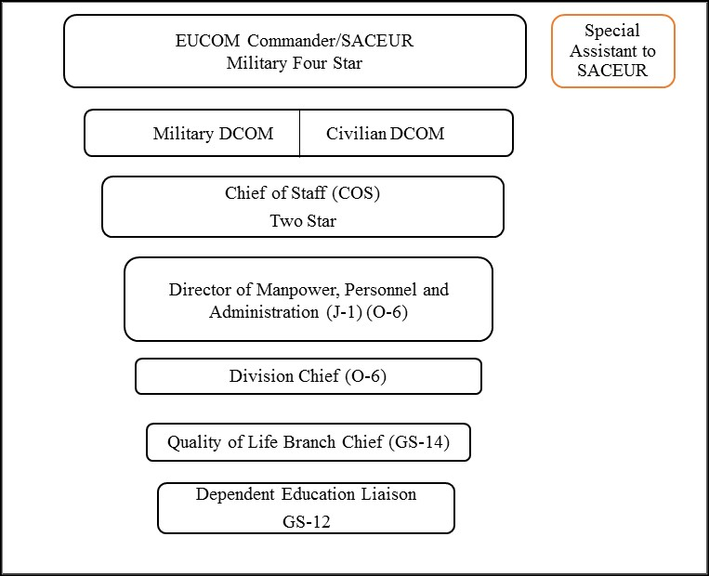
Figure 1. EUCOM Chain of Command for Educational Issues
The EUCOM Commander did not live in Stuttgart, Germany, where I worked; therefore, the DCOMs, both military and civilian, were the highest level of my direct engagements. As one of my primary responsibilities, I prepared senior leadership in my chain of command for attendance at meetings with the Director of DoDEA in Alexandria, Virginia and with the Director of DoDDS-Europe in Wiesbaden, Germany. In addition to engagements with the DoDEA Director and the DoDDS-Europe Area Director, I coordinated the twice-yearly European Schools Council (ESC) co-chaired by the DoDDS-Europe Director and EUCOM’s Chief of Staff. I represented EUCOM at the DoDDS-Europe Director’s Area Advisory Council (AAC) and the European Athletic Council (EAC) meetings. As the EUCOM liaison, the Command delegated certain responsibilities to me. For example, I represented EUCOM at the working group to develop the agenda for the Dependents Education Council in lieu of the J-1, the Division Chief, and the Branch Chief. Initially, I attended the meetings with my Branch Chief who then passed the responsibility to me. In this capacity, I served as the Action Officer (AO) or subject matter expert (SME) for any activity related to the education of military dependents in EUCOM’s area of responsibility (AOR) to include involvement in military construction (MILCON) of schools, drafting statements for congressional testimony, and writing white papers on the status of DoDEA’s Non-DoD Schools Program. I was a primary link from EUCOM to our Component Commands, DoDDS-Europe, and DoDEA.
In addition to the committees and councils, I analyzed issues brought to our attention by the Component Command school liaison officers who received issues through their council process or via emails and phone calls from other school liaison officers in their area of responsibility (AOR). Throughout Europe, different regional areas and/or functions fall under the command of a specific Service: Air Force bases fall under USAFE headquartered in Ramstein, Germany; Navy bases are under NAVEUR in Naples, Italy, and Army posts are under USAREUR in Heidelberg, Germany (at the time of this event). In addition, Installation Management Command (IMCOM) provides School Liaison Officers (SLOs) support to Army locations. Each component has a Headquarters School Liaison Officer (SLO) who works directly with DoDEA, DoDDS-Europe, or EUCOM to resolve its issues. At each level, the military, where funding is available, provides civilian SLOs to facilitate communication between and among the schools and the military commanders. In some locations the SLO is a military member assigned as an additional duty or as part of his or her role as a base or a garrison commander.
As the AO or SME, if I thought there were issues that leadership needed to understand immediately I would brief my direct supervisor who would pick up the phone and make a call then get back to me or he would ask me to write a tear line, which is a special type of email. Otherwise, I would monitor to see how the Component worked to resolve the issue with DoDDS-Europe or DoDEA. In order to write a tear line I would coordinate with the affected organizations. The purpose of the tear line was to consolidate vetted information in the fewest words to the highest-level decision maker. The initial section of the tear line would provide all of the pertinent information on the current issue, the history of issue, who was aware of it and at what levels and finally, what actions occurred to try to resolve it. Most importantly, it would contain several recommendations for action. The next section was a summary of the first part. At each point on the tear line the decision maker would delete the first part and make any adjustments to the recommendations then send it to the next higher level decision maker who would review, delete the lower level piece and send it forward. Each person continued on the CC line of the email to follow the flow of information. The benefit of the tear line was to inform each level of the chain of command. At any level, the decision maker had the option of engaging on the issue or passing it along. Most often than not, the tear lines stopped at the Chief of Staff level as the member of the European Schools Council. The leaders trusted the process of coordination with the affected organizations required for that the short summary so that there were no surprises when the high-level leader spoke as an expert on the subject. While the initial process of writing a tear line was time consuming and cumbersome, the product was a quick and effective way to communicate a large amount of coordinated information in a short message. Moreover, we did not have to construct a formal staff package coordination that required paperwork and signatures, which was a process that could take weeks by which time the problem was resolved or had escalated. As someone new to the organization, I had to rapidly figure out who knew what information in which organization and who would the decision or lack of decision affect? Thick binders of issue papers and executive summaries as well as copies of council agendas and after action reports provided historical background that phone calls sometimes substantiated. A repository of information on line did not exist so tracking down the origin of the issue was often time consuming. I relied on the collective memory of a small number of people from multiple organizations who had worked in the system for a long time. I soon learned which people and in which organizations were willing to share information. Sometimes if I could not locate any history, I would summarize the current situation as described to me and put in my own recommendations. Unfortunately, there was no systematic way to capture the information for future use as a decision-making or information providing process.
EUCOM’s avenues to address issues were multiple depending on the type of issue. The first was to speak directly to DoDDS-Europe, usually through the Chief of Staff. The second was to by-pass DoDDS-Europe to speak directly to HQ DoDEA’s Chief of Policy and Legislation. The third was to assess the dispute through our European Schools Council (ESC). Most of the concerns where we by-passed DoDDS-Europe revolved around EUCOM’s relationship with foreign countries. As part of the Department of Defense and EUCOM’s priority of “building partnership capacity,” several mechanisms were in place to allow foreign nationals to attend DoDEA schools. If there were issues with the countries, then the Special Assistant to SACEUR, who was a former EUCOM Division Chief, or the U.S. Staff Delegation to the North American Treaty Organization (NATO) education liaison, who was a military member assigned this duty, brought them to our attention. Usually the conversation would start with a phone call and a message that “some folks are talking about...” whatever the topic may be and since we are the school people we need to take care of it.
An example of this was the topic mentioned by the NATO liaison concerning several Partnership for Peace nations who recently joined NATO or who were about to join. By joining NATO, they lost their Partnership for Peace (PfP) status thus losing tuition free access to attend DoDEA schools. I recall that tuition to DoDEA cost more than the annual salary of the military personnel from one of the nations. I also remember that the issue was not EUCOM’s responsibility. No one seemed particularly clear on whose responsibility it was so I spoke directly with DoDEA’s Chief of Policy and Legislation.
While the sequence of events is fuzzy, the phone conversation ended with me going into the paper archive files in the basement of the building, a former 1950’s German barracks, just four doors down from our Quality of Life Branch offices, to find a mimeographed document of the previous time this issue appeared. I started to recreate the essence of the waiver and tracked down the relevant policies. I was still relatively new to EUCOM so this seemed to be an exercise in learning the system and developing relationships to coordinate issues. None of the involved organizations seemed to convey a sense of urgency on addressing the problem.
My understanding at the time was that since we were the liaisons for NATO we had to write a package for the Office of the Secretary of Defense addressed to one of his Undersecretaries. The package should contain a letter for him to sign to allow these nations to continue to receive tuition-free education at DoDEA schools. Eventually, our office formally staffed the package in which we explained in writing that Section 1404(c) of Public Law 95-561, “Defense Dependent Education Act of 1978," as amended, 20 USC 923(c), authorized the SECDEF to identify classes of dependents who may enroll in DoDDS on a space-available basis and to waive tuition for any such classes. The DoD had a class enrollment eligibility waiver in place for attendance at Department of Defense Dependent Schools for PfP dependents. DoD Directive 1342.13, "Eligibility Requirements for Education of Elementary and Secondary School-Age Dependents in Overseas Areas" included this waiver in February 2008. We based our argument on a continuity of message that reverberated throughout the command of supporting and building the relationships with partner nations. While this was an important engagement, I was never quite clear why our office had a hand in this interaction. I also wondered about the outcome if the Chief of Policy at DoDEA had not been the former J-1 at EUCOM and knew where to find the archived document. I questioned why the Office of the Secretary of Defense level, NATO level, or even DoDEA who had the information to resolve the problem did not take the actions to find a resolution. I refer to this episode as the Malta Waiver because I was on vacation in Malta when my Division Chief contacted me via my military spouse’s email. He also worked for EUCOM. Apparently, a new member of the Office of the Secretary of Defense planned to visit the EUCOM Commander or Deputy Commander and someone in my chain of command, who knew that I was working the issue in the background, decided that it was an opportunity to by-pass the months of paperwork and staffing requirements traditionally needed to communicate the needed solution. This sudden sense of urgency by senior leaders led to a day in Malta recreating the memo and sending it via my spouse’s work phone. This was a significant event for me personally and professionally, which is why I remember it as a formative experience.
Another part of EUCOM’s mission included assignments where DoD and Department of State (DoS) personnel worked together under the DoS. We addressed the main concern regarding the perceived disparate education between DoD personnel and DoS personnel who worked in the same office but whose children attended different schools due to the DoDEA regulation. We worked with both EUCOM and DoDEA legal departments to change the language in military orders to reflect DoD eligibility to obtain DoS benefits. These activities occurred outside of the educational advisory committee and council system.
As stated earlier, DoDEA, to support the military, connects directly through a robust system of school councils. DoD Instruction 1342.15, “Educational Advisory Committees and Councils,” outlines the responsibilities of each level of the council system designed to address issues at the lowest possible level. Previously I mentioned that we would hear issues consolidated from our Component Commands. If it appeared that there were issue affecting our components as a whole and not resolved through individual organizational channels and engagements then EUCOM would engage formally at a regional level with DoDDS-Europe through our European Schools Council.
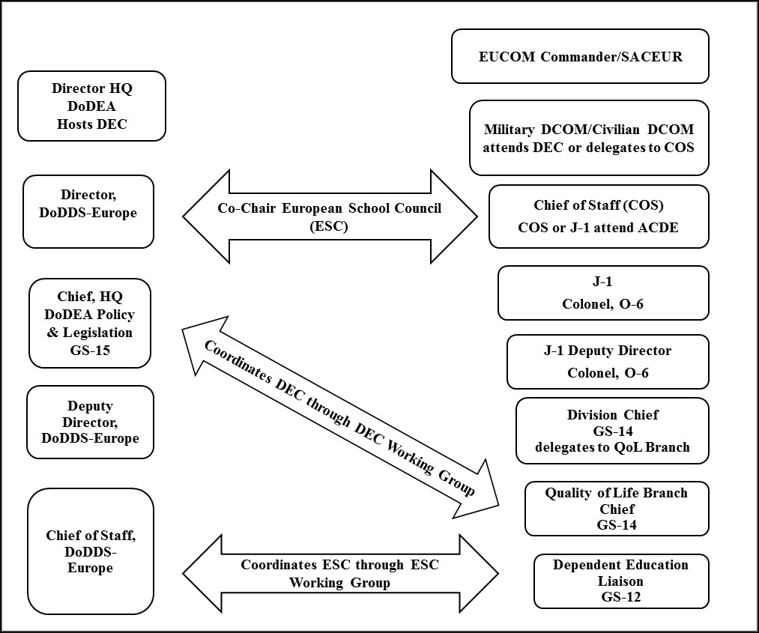
Figure 2. EUCOM Chain of Command School Council Engagement with DoDEA
However, to progress their consolidated issues, the Components had a similar structure and relationship with DoDDS-Europe and DoDEA when a problem arose. In addition to access by phone and email with the same DoDDS-Europe Chief of Staff and DoDEA Chief of Policy and Legislation plus attendance at lower level advisory meetings as well as high-level working groups, the Components had the biannual Component Commanders Advisory Council (CCAC).
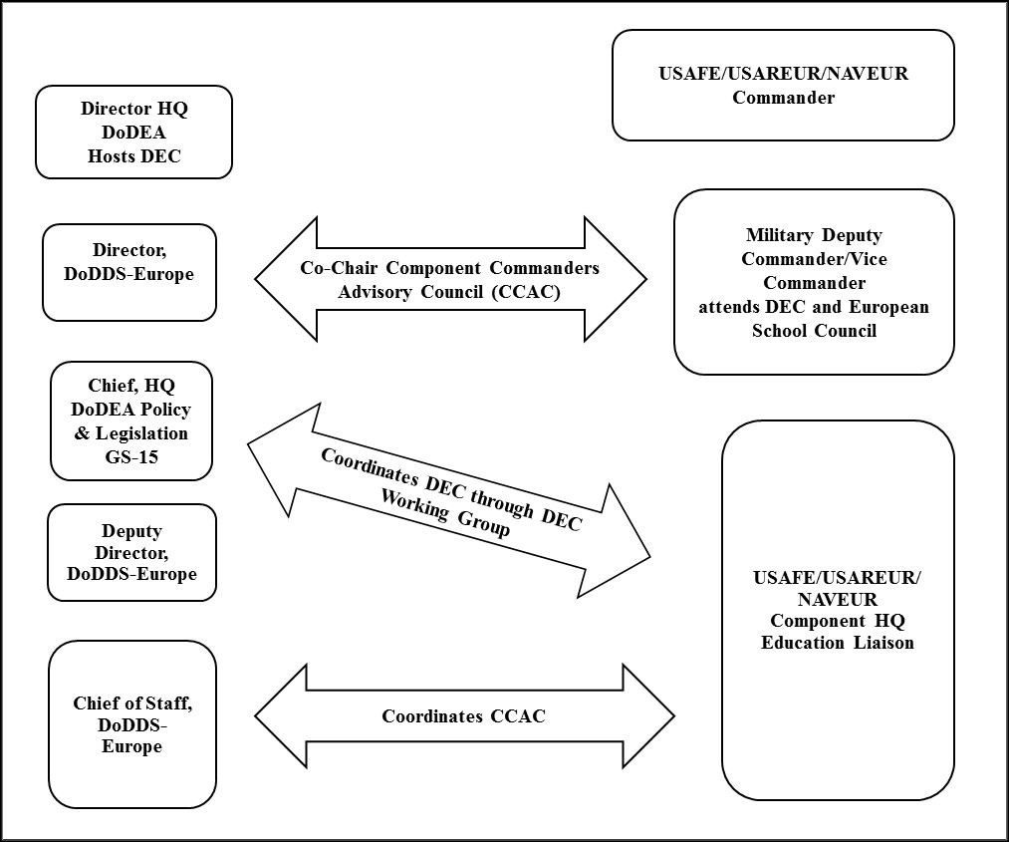
Figure 3. Component Commands and DoDEA Council Engagement
The CCAC is the main event to address component-wide issues. The DoDDS-Europe Director attends this meeting that the Component Commander, or designee, chairs. The Commander or designee then attends the European Schools Council and, subsequently, the Dependents Education Council (DEC). For an issue to reach the CCAC agenda, the School Advisory Council (SAC) addresses the concern at the individual school level (refer back to Figure 3). If the school principal cannot resolve the issue using military or DoDEA resources, the SAC elevates the issue to the Installation Advisory Council (IAC) that consolidates every school on the base or post for review (USAFE uses the term School Advisory Board or SAB). An example of a local issue could be as simple as needing a new scoreboard or additional fields for sports. If the base or post commander cannot resolve the issue with the corresponding DoDDS-Europe principal then the issue elevates to either DoDDS-Europe’s District Advisory Council (DAC) where it is resolved by a DoDEA Superintendent or to the CCAC where the Component Commander or designee and the DoDDS-Europe Director review it. The types of issues elevated to the DAC are primarily curriculum related or policies within the schools over which the base or post commander does not have purview. CCAC issues tend towards need for additional funding or schools due to excess population or quality of life issues for a given location. However, if the CCAC could not resolve the issue, the EUCOM Branch Chief or I as the educational liaison in the Quality of Life (QOL) Branch formally received the issue. If we could not resolve the issue and determined the issue affected a significant population in the EUCOM AOR, then the ESC reviewed the issue. During my tenure, NAVEUR did not conduct CCACs and brought issues directly to the ESC Working Group.

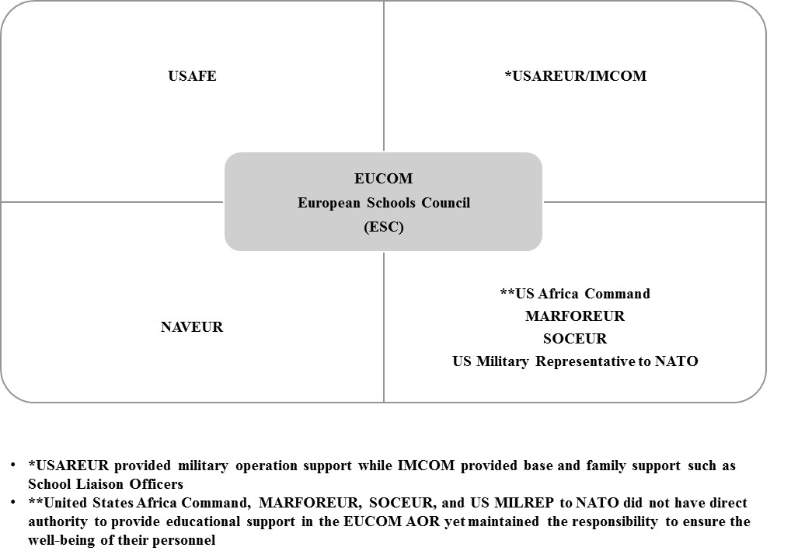
Figure 4. EUCOM's European Schools Council
Prior to the ESC meeting, the ESC Working Group (ESCWG) convened to set the agenda. In addition to the QOL Branch Chief and EUCOM Dependent Education Liaison, this group consisted of the DoDDS-Europe Deputy Director (this position disappeared with the creation on the Curriculum, Instruction, and Assessment (CIA) position in 2009) and DoDDS-Europe Chief of Staff, and the Component SLOs for U.S. Africa Command, USAREUR, IMCOM, NAVEUR, SOCEUR, and MARFOREUR. While SOCEUR and MARFOREUR, as components of EUCOM, did not have direct responsibility for providing educational support they did have personnel living throughout the AOR. The education liaison for the newly created U.S. Africa Command (sometimes called AFRICOM during this time) was also included since it was a Combatant Command co-located in Stuttgart, Germany with personnel in the EUCOM AOR. The military officer for the U.S. delegation to NATO in Belgium assigned as the education liaison also attended. He and I had few interactions but one issue on which we coordinated pertained to the attendance of Partnership for Peace (PfP) and NATO member children in DoDEA schools previously mentioned.
The European School Council Working Group’s (ESCWG) role was to review Component issues and decide if there was enough of a EUCOM-wide impact for it to become an agenda item for the ESC. During this working group, each component briefed the genesis of the issue and the process to try to reach a resolution. Since the CCACs occurred before this working group, the DoDDS-Europe Chief of Staff spoke to those issues as well. The issues that elevated tend to be policy related. For example, USAFE had a locale where students travelled on bus to school for over an hour, yet DoDEA’s policy stated that students could not eat or drink on busses. When approached by USAFE to change the policy, DoDEA responded that it was its policy and only affected a small portion of students so DoDEA would not change. USAFE brought this response to EUCOM through the ESCWG. We wrote a request to change the policy based on the best interests of all of the students worldwide who rode busses for over an hour. DoDEA agreed to change the policy with certain parameters placed on types of food and beverages.
Once an agenda was set at the ESCWG, I consolidated the Component issue papers on each issue as well as DoDDS-Europe’s information on academic, budget, personnel, military construction, NDSP budget numbers and new initiatives into a slide briefing and an executive summary. Using this executive summary and proposed agenda, I briefed the Division Chief (sometimes he would just review and sign off in approval) then the J-1 in preparation to brief the COS in preparation to obtain final approval from the DCOM. Initially my direct supervisor did the briefings, but eventually he delegated the responsibility to me. The purpose of this process of briefs through the chain of command served to inform leadership and to prepare the ESC and DEC attendee so there were no surprises. We advanced any unresolved issues to the DEC Working Group (DECWG). I consolidated the results of the ESC and submitted the items to DoDEA headquarters for addition to its agenda for the DECWG. Finally, I represented EUCOM at the DECWG held at DoDEA Headquarters in Virginia where we set the agenda for the worldwide meeting.
Usually, the day before the DECWG I met with the education liaisons from the Pacific Command (PACOM) to compare topics since we represented the preponderance of oversea schools. During this time, I remember a focus on expansion in Korea though I did not invest any real time in understanding what it meant. I also understood that the military families in Hawaii were upset about the quality of education and so a review by DoDEA was occurring to conclude if DoDEA should take over certain schools. The Pacific version of our ESC was the Pacific Theater Education Council (PTEC) comprised of United States Forces Korea (USFK), United States Forces Japan (USFJ), Pacific Forces Air Force (PACAF), and Marine Forces Pacific Command (MARFORPAC). DDESS, the stateside school system, did not have a comparable council though there was discussion during this time on creating one. In addition, representatives for the intelligence agencies and the specific military services attended the DECWG.
The expected level of engagement at the DEC was the commander at the highest level (such as the four star EUCOM Commander). However, most times Commanders delegated the responsibility. Twice I supported the EUCOM COS. During a time of transition, the three star USAREUR DCOM general attended as the representative for EUCOM as well as for USAREUR since he was a staunch advocate for education and actively participated in the EUCOM ESC process. At my final ESC in 2010, I escorted the new EUCOM Civilian Deputy Commander.
Even though EUCOM consolidated the issues and co-chaired the ESC with DoDDS-Europe, each Component and its SLO still attended the DEC as prescribed in DoD Instruction 1342.5. The component school liaisons and Component Commander or designees were also responsible for communicating the issues to the offices of their Service Chief. The agenda items that reached this level tended towards advocating for additional funding from Congress or communicating certain military installation changes.
One variation on the process of pushing agenda items through the school council system as outlined above occurred during the Component Commander’s Conference (CCC). This is the biannual conference attended by the Component Commanders and hosted by the EUCOM Commander. If there were any education topics brought to the Commander’s attention at this conference he directed the Quality of Life Branch to provide updates, explanations, or take on the role of resolving the issue. The Quality of Life Branch conducted a formal senior spouse program during this time that usually highlighted areas such as education, medical and family support issues so if the topic was education then DoDEA or DoDDS-Europe leadership attended and the senior leader spouses had direct access to them. I never attended the CCC since there was a specific member of the EUCOM J-1 team who organized the spouse program and agenda. Wright (2002) outlined an example of the relationship between DoDEA and the CCC in his research, “An Assessment of the USAFE School Board Test Program,” which I will specifically address in Chapter One.
Another variation, or more specifically an anomaly, to the relationships and interactions established through policy and regulations was the creation of education support in Papa, Hungary for the Heavy Airlift Wing (HAW). This was an example of the rare occasion where an issue was not initially in DoDEA or EUCOM’s purview or a CCAC issue. The creation of the HAW in 2008-2009 was a significant event that illustrates one of the anomalies of the COCOM structure with NATO and its service components. This was the first joint multinational force with a major US presence in Europe that does not report to the NATO SACEUR or answer to the EUCOM Commander and in fact established through the work processes of the United States Air Force and its component United States Air Forces in Europe (USAFE).
A student at the Army War College, who was involved in the development of the HAW described in his recent research paper, the creation of this strategic partnership as essential to advancing United States military capabilities and a priority of building partnership capacity. He concluded that
Constructing multinational institutions that reconcile differing national legal practices and definitions, financial instruments, military personnel and command systems, technical standards, and a host of other standards, is difficult and tedious work. However, precedent agreements such as the SAC MOU (Strategic Airlift Consortium Memorandum of Understanding) have been successfully agreed and executed now, and can be used as templates. (Berkompas, 2010, p. 16)
This conclusion, while appropriate to the military strategy and DoD goal of building partnership capacity is slightly premature since the issue of dependent education was unresolved at this time.
The HAW is a prime example of how a Component Command within EUCOM can negotiate the creation of a new base without any initial coordination with DoDEA on the educational requirement. The USAFE Commander worked directly with the Air Force Service Chief and collaborating nations. Once the coalition formed and families moved to the area, the main dispute concerned the lack of education comparable to one provided by DoDEA. The USAFE SLO, DoDEA Chief of Policy and DoDDS-Europe Chief of Staff worked with the local government to find a solution. They agreed to provide a bilingual education. At some point, I travelled with the DoDEA Chief of Policy and DoDDS-Europe Chief of Staff in Papa so that EUCOM could better understand the situation. When I arrived, we attended a meeting with the local education chief, toured the schools, and met the English-speaking teachers hired to teach the students from the HAW. We discussed the feasibility of hiring DoDEA teachers for this location to ensure a quality education. The main issue was that there was a viable school with a plan in place in a developed community. There were multiple age ranges so a teacher may only have a few students in a grade. Considering the support offered by the Hungarian education minister, this new requirement for additional funding was not reasonable.
We also attended an education meeting with the wing commander’s spouse who was the self-appointed SLO working with DoDEA. Representatives from the other consortium countries attended the meeting. Many pulled their students out of the Hungarian school because, in their view, the agreement for bilingual education failed. For each, bilingual meant Hungarian and their native language, not English. Another issue presented concerned the American contractors who by DoDEA regulation could not receive financial reimbursement for NDSP. As this was a very small community, a community solution was needed that transcended DoDEA's authority. This is also an example of an issue that pulls on the resources of several organizations. The actual cost of fixing problems reactively and the amount of time and personnel needed, diminished the financial and personnel resources that provided teacher salaries and quality programs for students in established traditional DoDEA schools.
During my tenure at EUCOM, this set of issues, related to the support of education for military children living in remote locations, reoccurred. Each time, we elevated the issue from the ESC to the DEC by way of the Working Groups or tried to work a solution directly with DoDEA Chief of Policy and Legislation or DoDDS-Europe Chief of Staff. While I will not specifically address values, I would be remiss not to note that those military members who spoke often of the need for high quality schools and education continuously connected it to the awareness that the children are our “future fighting force.” Those most vocal at the table continued the mantra of quality of life for our service members and families to enhance recruitment and retention. To support our service members defending our nation was simply the right thing to do. Upon reflection, I do not recall anyone who did not agree. The conflict in decision-making primarily revolved around who was responsible for administering and/or funding the Non-DoD School Program (NDSP). The military side concluded it was DoDEA’s responsibility while DoDEA concluded that the military service, who kept placing families in remote locations without consideration of the educational costs and requirements, was responsible.
Eventually, based on a specific request by EUCOM, vetted through the European Schools Council, and multiple inputs from staff internal to DoDEA as well as military leadership throughout Europe and the Pacific, DoDEA announced the first meeting of a task force in spring 2010 to review increased quality of life issues and funding concerns worldwide. For example, the military’s “strategic decision” to allow families to accompany military members in remote locations where there were no DoDEA run brick and mortar schools, such as Papa, Hungary, could land DoDEA an education bill for its Non-DoD Schools Program that was not accounted for in its budgeting process. In addition, negative quality of life issues for military families such as disparate quality of education and increased out of pocket expenses existed. DoDEA’s Chief of Policy and Legislation and DoDEA’s General Counsel co-chaired the task force. Other members included representatives from EUCOM, PACOM, NATO, the Defense Intelligence Agency (DIA), and Headquarters Army, Navy, and Air Force personnel. The USAFE Component SLO attended as the Headquarters Air Force representative.
From my limited practitioner’s point of view, this was a very dynamic time for several organizations for a variety of reasons to include new leadership, transformational minded leaders who had worked in the system for some time, and changes in military mission requirements that added new requirements for DoDEA. Lack of change in funding to support new educational requirements in remote locations complicated by lack of coordination between the military and DoDEA prior to establishing new locations complicated the process of providing reasonable educational opportunities. This small program and the issues that surrounded it fascinated me simply because the problems that existed involved a small number of people and organizations trying to work solutions at high levels with international implications.
Several months after DoDEA formed the NDSP Task Force, I had the opportunity to apply for the University of Oklahoma’s PhD program in Organizational Leadership. My EUCOM supervisor and the Chief of Policy and Legislation at DoDEA, who I considered mentors at that point, wrote letters of recommendation. My application included a statement of research that summarized the problem as:
More accompanied military tours to remote locations bring families, which increases the requirement for funding and educational support. While funding to support this program has increased from $27M to $51.8M in the last five years, it has not kept pace with actual need as military missions move into remote locations. Reimbursement for NDSP is governed by the Department of State Standardized Regulations (DSSR) education allowance that creates conflict in the management of the program in locations where there are DoD and DoS personnel together. There is currently a debate between DoDEA and the military services on who should pay for education in remote locations. Most of the solutions in place are temporary fixes to larger problems and each organization involved is limited by regulations, mission requirements, and budgetary constraints.

Throughout my two years of coursework in the Organizational Leadership program, I memoed alongside theories that seemed to explain the variety of phenomena I observed. Using this “theory of the day” mindset, I continued to ask what compelled DoDEA to agree to the request for a task force and how did “we” get everyone united in that decision. I waivered often on who was the “we.” During one class on Organizational Behavior, a professor introduced Punctuated Equilibrium Theory (PET) that, in its basic form, I remembered simply as there is a period of little change then something major happens and big change occurs in reaction. From this event one can work backwards to look at the circumstances leading up to the major event. Because I believed at the time that the decision to create the NDSP Task Force was a unique event, I fixated on that point in time from which to look backwards.
Later, in my Small Groups Communication class, I came across an application of Punctuated Equilibrium Theory (PET) to organizational theory by Tushman and Romanelli (1985) and then applied to small groups by Gersick (1988). The research, which uniquely addressed the role of a group, concluded
The common feature is in the observed pattern of change or periods of stasis (or in some versions, incremental change) punctuated by short periods of radical change in which a group attempts to improve its fit with the demands of its embedding context. (Arrow, Henry, Poole, Wheelan, & Moreland, 2005, p. 329)
This distinction of the role of groups sparked a consideration of the role of our council working groups (lower level workers, or action officers (AOs), in the chain of command yet with high level chain of command interactions) in pushing agendas across our own and collective organizations. I considered the role of leadership from high-level leaders in positon of power and influence to lower level positions such as mine that needed to network ways to find or create solutions.
When I wrote the first draft of my research prospectus in my final class, I, again like theory of the day, pulled from leadership, communication, psychology, network, leadership, organizational change, and social exchange theories. This was understandable considering the multidisciplinary nature of our program in Organizational Leadership. However, I had nothing to unify all of the theories other than each was related theoretically to the issue in some form. I wanted to understand what was going on at this particular point of time and felt that everything was relevant and theoretically appropriate and I did not want to choose just one theoretical direction or discipline.
After I drew a diagram on the board to organize my thoughts (Document Database, TAB 14, 4a) while I presented my paper, my professor, from a political science perspective, simply stated that it sounded like Kingdon. I discovered later the underlying components of the research. Kingdon (1984) focused on the governmental agenda setting process and concluded that there are three kinds of processes: problems, policies, and politics, and that “while governmental agendas are set in the problems or political streams, the chances of items rising on a decision agenda-a list of items up for actual action-are enhanced if all three streams are coupled together” (p. 21) during a window of opportunity. Kingdon (1984) explained that a “policy entrepreneur” who advocates for and pushes agendas facilitates this coupling. So, was the decision to form the NDSP task force an example of the right people, at the right place, at the right time consciously pushing an agenda? Moreover, if so, how did it actually happen?
Research that developed from Kingdon looked at multiple parts of an organization, such as leadership and networking, and moved away from a linear process of decision-making. Hayes (2008) reviewed Advocacy Coalition Frameworks (ACF) and Punctuated Equilibrium Theory (PET) and acknowledged Lindblom’s (1959) conclusion that most public policy change is incremental. Kingdon recognized this conclusion as well in his work. A dynamic view of multiple parts from multiple theories is Network Theory, which focused on the relationships between nodes and drew conclusions on the effects of external organizations on an open system. Contrary to this open system idea is Complexity Theory, developed with Twist and Schaap’s (1991) premise that “systems are thus self-generating enclosed structures whose mechanisms are interconnected and mutually dependent” (as cited in Klijn, 2008, p.8). Complexity Theory also supports an incrementalist approach contrary to PET. The understanding that a gap existed in research between disciplines predicated the move to complexity theory that sought to create a cross-discipline view of organizations from multiple levels. MacIntosh (2006) added that Complexity Theory combines multiple angles to understand change and dynamic systems because of complex interaction of parts of systems (as cited in Klijn, 2005, p.2). I reviewed additional research related to Kingdon (1984) to include Sabatier (1991) who cited Jones (1970), Anderson (1975), and Peters (1986) to summarize political science literature. Sabatier (1991) traced the expansion or move away from Kingdon’s Policy Streams and addressed the political science literature that focused on institution or on behavior. He acknowledged the importance of policy communities and networks that involve “actors” from multiple levels of government.
Despite the volume of research developed from Kingdon, with contrary conclusions, once again I felt that there were too many theoretical directions from which to choose. I returned to Kingdon after reading John’s (2003) article, “Is There Life After Policy Streams, Advocacy Coalitions, and Punctuations: Using Evolutionary Theory to Explain Policy Change?” He concluded that,
Although much is uncovered by institutional processes, long-term social and economic ideas, networks, strategic interaction, and the conscious adoption of ideas, the claim is that random processes, competition, and selection exert a background influence, which can drive policy making and implementation processes. (p. 495)

There are just simply too many influencers or “variables” in organizational life. This research focusses on the process of decision-making, the environment in which it occurs and the leadership that exists to facilitate or to hinder.
I responded positively to Kingdon’s quote, “Conditions become defined as problems when we come to believe that we should do something about them” (Kingdon, 1984, p. 115). From my perspective, the impetus for action was this belief that there was a “true” quality of life issue as seen in the actual formation of the Task Force. However, what were the conditions that shaped the decision? While I was part of the original EUCOM organization advocating for the task force, I do not know what conclusions or changes occurred since I had to leave my position a few months into the actual meetings due to the reassignment of my military spouse. At the time, I was aware of several issues that influenced some decision makers but any conclusions were purely conjecture and only represented my limited view as a former DoDDS-Europe teacher and member of the Quality of Life Branch at Headquarters EUCOM. Although I am no longer with EUCOM, I utilized professional resources and relationships to take this discussion to the next level by bringing a more systematic approach based in sound research methodology.
My combined questioning and experiences led to the following: Given the expansive network of military and civilian personnel and leadership connected through the DoDEA school council network, often with competing priorities and multiple options for issue resolution, how did the topic of the Non-DoD Schools Program (NDSP) become an actionable item on the highest level of the educational advisory committee and council system? More specifically, how were personal and organizational agendas advanced that culminated in the decision to create a Task Force to review NDSP issues worldwide? To answer these questions, I developed a case study design to investigate the process of decision-making and the role of leadership within the school council network specific to the creation of the NDSP Task Force in the spring of 2010. My background, as an organizational leadership scholar, a former educator for DoDDS-Europe, and as the former military civilian education liaison for EUCOM, supported my ability to conduct this research on a seemingly unique organizational event that has both practical and theoretical applications for organizational leaders at decision-making and policy changing levels.
CHAPTER ONE
Literature Review

Introduction
In this chapter, I outline the problem that led to the development of this case study and reiterate my research questions. Next, I acknowledge research related to the effects of the military lifestyle and the importance of addressing quality of life issues as connected to the impact on the military mission. Then, I review research specific to the Department of Defense Education Activity’s formal education council and committee process designed to examine educational issues in support of the military. Throughout, I enumerate ways that my research supports and advances this collective knowledge.

Problem Statement and Research Questions
Although DoDEA and the military fall under the same parent organization, the Department of Defense, and thus connect to and compete for the same source of money for budgets, military commanders at multiple levels do not systematically consider educational requirements or legislative constraints when developing new strategic military mission requirements. In the case where DoDEA and the military are intertwined, where one exists to support the other, DoDEA is dependent on the input of the military to inform operations while the military is dependent on DoDEA to support education so service members can focus on war fighting and global security.
While there is an educational advisory committee and council system in place where DoDEA briefs its budget, military construction (MILCON), and base support requirements, the military does not systematically consult DoDEA prior to making the decision to stand up new commands or new requirements that include families. Similarly, military decision makers can simply disregard DoDEA’s recommendations not to authorize children to accompany the service member due to lack of an adequate educational option. These additional accompanied military tours to remote locations where there are no DoDEA schools or adequate educational opportunities increase the requirement for funding and educational support that requires DoDEA to reallocate its budget away from traditional schools. In addition, a disconnect exists between DoDEA and the military services on who should pay for education in remote locations since DoDEA has the mandate to provide education while the military is the decision maker to send families to remote locations where education access is limited or non-existent. Ultimately, due to the lack of a streamlined decision making process by which these educational issues are addressed, this conflict led to depleted resources and unintended quality of life issues for service members and accompanying families.
As earlier suggested, addressing this problem led to a case study of the decision to create a task force to review issues associated with the Non-DoD Schools Program (NDSP). As mentioned in the Prologue, NDSP is the special program that financially supports education opportunities in remote locations or where there are no adequate educational opportunities for certain civilian and military dependent children. The questions to be answered are as follows: Given the expansive network of military and civilian personnel and leadership connected through the DoDEA school council network, often with competing priorities and multiple options for issue resolution, how did the topic of the Non-DoD Schools Program become an actionable item on the highest level of the educational advisory committee and council system? More specifically, how were personal and organizational agendas advanced that culminated in the decision to create a Task Force to review NDSP issues worldwide? In general, I seek to understand the circumstances that surrounded this decision.

Literature Review

Research on Family and Quality of Life
Research on the Non-DoD Schools Program (NDSP) does not exist. However, the emergence of research on education related quality of life initiatives and the effects of deployment on service members, families, and children all speak to the challenges facing service members in the 2007 to 2010 timeframe. Examples, which include the Blue Star Military Family Lifestyle Survey (2010), Chandra (2010) The Effects of Deployment on Children and Clark (2013) The Effects of Frequent Relocations and Deployments on Children’s Educational Experience, conclude that service member quality of life affects performance and performance affects unit morale and cohesion. My research adds to this body of work by providing another source of insight into the importance of addressing quality of life issues for the military as connected to the impact on the military mission.
Institute for Defense Analyses Report (2000)
There exists a small body of research that includes published research specific to the history, legislation, academics, and educational advisory committee and council process for DoDEA. In 2000, the Undersecretary of Defense for Personnel and Readiness (USD P&R) requested a review of DoDEA schools due to increased military command concerns over quality of education in the Department of Defense Dependent Schools in Europe. There was a concern that “these education issues were having an adverse impact on Quality of Life” (Wright, 2000, p. 29). The Institute for Defense Analyses (IDA) conducted both quantitative and qualitative research on DoDEA. Specific to my topic, researchers reviewed the educational advisory committees and provided a diagram of how external organizations connect to DoDEA through regulated council meetings:
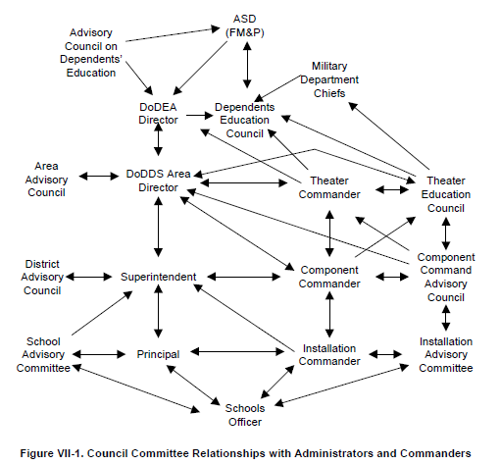
(Wright R., 2000, pp. VII-16)
Figure 5. Council Committee Relationship with Administrators and Commanders
During the qualitative phase, the researchers concluded that, “some of those interviewed thought there may be too much layering of committees and councils that deal with both educational and non-educational issues and that the process should be streamlined” (Wright, 2000, pp. VII-14). One of the recommendations from the report was to reorganize the communication flow and that, “DoDEA should submit changes to legislation and DoD Directives and Instructions to simplify and streamline the procedures and relationships that govern the functioning of the educational advising councils and committees and involve DDESS in the DEC and ACDE process.” Wright recommended a new diagram:
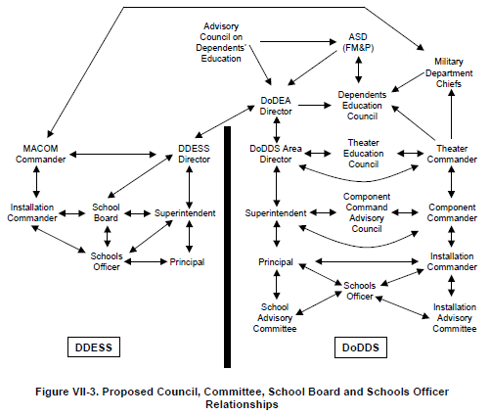
(Wright R., 2000, pp. VII-22)
Figure 6. Wright's Proposed Council, Committee, School Board, and Schools Officer Relationships
Wright (2000) also concluded that a draw-down in Europe, increased deployments, reorganizations, the new Math Land curriculum and perception that DoDEA was not responsive to concerns of senior military, contributed to the issues. He specifically stated, “The DEC was dysfunctional because generals stopped attending and began sending civilians without decision making ability” (p.29). I borrow this conclusion to provide a starting point for a ten-year period of activity that led to the decision to create the NDSP Task Force.
In addition, my research provides an updated view into the activities of the council system with a specific focus on the decision-making processes related to the Non-DoD School Program as well as the acknowledgement of the multiple decision-making activities that occur outside this formal educational council system. The findings provide a springboard to evaluating possible combinations that, taken in context, may help leaders to anticipate, create, and evaluate circumstances for advancing organizational agendas within this system.
During this same period, the military acted on its own behalf to create civilian school liaison positions to increase communication flow between command and school levels while USAFE specifically decided to create a school board structure (SAB) to replace the Installation Advisory Council (IAC) on each base. While Wright’s (2000) report concluded an ongoing process of deterioration in the relationship between DoDEA and the military there is no specific mention of a timeline. Was it possible that a specific incident or leader expedited the need for review in 1999 or was it the result of a long run of status quo? This line of questioning connects to my earlier discussion on Punctuated Equilibrium Theory and Network Theory. If it was a period of stasis with the ongoing drawdown in Europe, increased deployments and reorganizations then what was the catalyst for requesting the study on DoDEA?
Missing in both diagrams, and in the conclusion, is the breakout of the military side and its interaction at the European School Council (ESC) or Dependent Education Council (DEC) level to address the high-level legislative issues. Similarly, neither diagram address the issue of the cross representation in the council system. For example, United States Army in Europe (USAREUR) was at the decision making table while Installation Management Command (IMCOM) provided the personnel (SLO) and funding though each represented the Army. The scope of the council and committee structure due to the lack of review of military connections outside of the councils and committees concerning the alternate avenues to address issues limits Wright’s research.

USAFE School Board Program (2002)
In 2002, DoDEA asked for a review of the USAFE School Board Test Program. This research, conducted again by Wright of IDA from November 2001 to July 2002, underscored the high-level influence of the Component Commanders and the Office of the Secretary of Defense to bypass DoDEA. In this case, the USAFE Commander at the Combatant Commander Conference (CCC) brought up the issue of creating a school board model that changed DoDEA’s school council. The attending decision makers denied the request. Several months later, there was a new EUCOM Commander and USAFE again raised the issue. This time the CCC attendees approved the pilot study.
Wright’s report concluded that DoDEA’s council system was adequate in light of the new civilian school liaison positions so USAFE should end its SAB and return to the SAC/IAC model. This engagement with USAFE hinted of future behavior when setting up new programs in remote locations such as bypassing DoDEA straight to Air Force headquarters for support and funding. Later research conducted by Leonhart (2009) supported Wright’s conclusion that the system is effective and in fact outlined several ways for a school principal to be effective within the system. Leonhart (2009) summarized and concluded,
The authority of the military as a political influence is a major factor in leadership. To be successful and effective within this schools system, the principals must take the readily provided military structure and work within it. They cannot ignore the leadership-both that of the system headquarters and that of the military leadership...There are so many facets that make up a school’s culture, among these are personalities and qualifications of staff members, influence of the teacher’s union, socio-economic composition and age range of the student body, principal’s vision and leadership style, physical condition/appearance of the school building, funding, parental support, community partnerships and student achievement data. (p.162)

Leonhart’s conclusions provide insight into the influencing elements at the school and community level during my targeted timeframe. There is no specific research on the council system since 2002 so I begin with Wright’s research based conclusion as well as Leonhart’s (2009) perspective that the council system was adequate.
Conclusion
In this chapter, I discussed the problem that led to this research and the development of the research questions. I provided a review of research applicable to my topic and addressed the ways my research supports and advances their findings. Overall, Wright’s research on DoDEA and its education council system came from a quality of academic education perspective. My research approaches from the perspective of the military quality of life with a focus on remote locations governed by the Non-DoD School Program where there are no DoDEA schools or adequate educational opportunities. In addition, as stated before, there was limited consideration in the research for the extended network in which each organization exists. The research did not acknowledge the process of the multitude of pre-council meetings conducted by lower ranked members whose job it was to set the meeting agendas, the timing of decision-making or issue resolution, and where specific issue resolution occurred. My research provides insight into this process of decision-making. In addition, it expands the understanding of the political influence found within the council structure from the base level up through the highest Department of Defense level and provides a practical application for how to operate effectively to influence decision-making and advance agendas.

CHAPTER TWO
Review of Related Literature and Theoretical Framework

Introduction
In this chapter, I review related literature and discuss the theoretical framework that shaped my research. First, I discuss research on the ability to affect change in military organizations specific to the role of the intermediary or mid-level actors. Next, I summarize network theories that span the topics of motivation, the concept of strategic pursuit of relationships, peer attachments, and theories of social exchange. Then, I review leadership theories that provide an overview of qualities and actions. Finally, I outline the components of Kingdon’s (1984) research to include discussion on his concepts of politics, policies, problems, windows of opportunity, and policy entrepreneurs in relation to advancing agendas in organizations. I conclude the discussion with a contrast of Punctuated Equilibrium Theory (PET) as a rival explanation to Kingdon’s incremental approach to advancing agendas.

Review of Related Literature

Organizational Change in the Military
Research varies on the assertion that affecting change to organizational policies and processes can be difficult to accomplish in hierarchical, military organizations due to leadership, legislation, historical precedence, and stakeholder accountability. Specific to my study, several recent dissertations are relevant. Both Majewska-Button (2010) and Joyce (2013) on organizational change in military organizations concluded that middlemen (Majewska-Button 2010) or mid-level agents or actors (Joyce 2013) do have an effect on organizational change. Majewska-Button (2010) conducted a meta-analysis of existing research from a centralized database in the Centers for Army Lessons Learned using organizational change and leadership development literature as the primary sources of how to examine change efforts within the past thirty years. Using grounded theory methods on 75 case studies, she identified factors that influence the change process and concluded that the Department of Defense is not unique in its change efforts so an application of a generic theory of organizational change efforts can apply and that the role of leadership is quite important. I add that pushing agendas is an implied need for change. Similarly, Joyce (2012), who developed a micro-political perspective on change developed from American and comparative politics literature to analyze four decades of U.S. Army development, concluded that “transformations tend to be driven from the middle rather than from the top or outside; and that the porous nature of institutional boundaries allow internal reformers to forge networks and build consensus for change” (p.6).
Due to the conflicting findings within the larger body of research on organizational change, my research advances their work by connecting their results with network and leadership theories, and to support the conclusion that middlemen or mid-level actors can affect change. While I did not look at change, per se, I sought to understand the conditions necessary to facilitate the decision-making process in advancing agendas with the goal to create change or to evaluate the need for change. Furthermore, I broaden the scope on the location of the middlemen or mid-level actors by identifying the person generically by using the military term Action Officer (AO). To this end, my findings show that even the highest-level decision maker of the Department of Defense, the Secretary of Defense, is an AO.

Network Theory
Research on network theory spans the topics of motivation, the concept of strategic pursuit of relationships, peer attachments, and theories of social exchange. Specific to my focus, the following research conclusions are relevant: “In professional arenas, peers’ attachments to each other across organizations may be more important for them than their attachment to their employers” (Gersick, Bartunek, & Dutton, 2000, p. 1027). Likewise, network researchers found that “interconnectedness between organizational elites serves to produce a core of individuals that are more likely to act in the interests of their class than in the interests of their individual firms or overall network” (Adkins, 2011, p. 59). Another possibility emerged from structural holes theory within network theory that “posits that people accumulate social capital (positive relationships with other people) and invest it in structural holes (those places in networks where nodes are not linked together” (Adkins, 2011, p. 59). This theory could explain how low ranking members within the organization and/or networks were able to influence higher-level authorities to agree to the creation of the Task Force and further influence change.

Leadership Theory
At the individual level, I researched organizational change agents, power brokers, and leadership. The role of power (positional, social, political, expert, and reverent) is relevant. However to limit the scope of leadership theories I address transformational and transactional leadership styles specifically. I assume motivation and power theories within a basic contrast of transformational and transactional leadership. For example, for motivation, “Followers interpret the legitimacy of leader requests based largely on the type of tactics the leader uses” or for “political” reasons (Rusaw A., 1998, p.41). Porter, Allen, and Anglo (1990) observed that the perception of political is based on areas of organizational uncertainty and resource scarcity as well as the need to act because of high personal stake or importance of the issue to an individual (as cited in Rusaw, 1998, p. 41).
Qualities of transactional and transformational leadership reverberate in network theory. Barnard (1938, 1996) concluded that managers could offer material and nonmaterial rewards, “particularly important were opportunities to grow on the job, making the workplace physically attractive, developing warm interpersonal relationships, opportunities for more participation in decision making, and fostering communion, or a sense of belonging to a group having similar interests and goals” (as cited in Rusaw, 2001, p. 15). Ultimately, transactional leadership motivates followers by appealing to their self-interest and exchanging benefits. This may involve values related to exchange processes, for example, honesty, fairness, responsibility, and reciprocity (Yukl, 2010, p.261).
Transformational leadership, in contrast, appeals to the moral values of followers in an attempt to raise their consciousness about ethical issues and to mobilize their energy and resources to reform institutions (Yukl, 2010, p. 261). Burns (1978) was the first to develop the concept of transformational leadership in the sense of moral elevation or social reform. Bass (1985) developed the four I’s: Idealized influence, Individualized Consideration, Inspirational Motivation, and Intellectual Stimulation (Yukl, 2010, p. 276). Meanwhile, Bennis and Nanus highlighted the role of vision, becoming social architects, creating trust, and positive self-regard. According to Bass, “transformational leaders possess good visioning, rhetorical, and impression management skills, and they use these skills to develop strong emotional bonds with followers” (Hughes, Ginnett, & Curphy, 1993, p. 443). An illustration of this is from a paper during my Interpersonal Dynamics of Leadership class in 2011 that included comment on my interactions with the EUCOM Branch Chief:
A dynamic leader, who consistently challenged me to be independent and confident, to take risks, and to find my voice to stand up for issues affecting the educational quality of life for the families of our military personnel in our area of responsibility...a visionary who has the respect of the organization and who created a safe environment for me to express ideas and to take leads on actions. He provided the guidance and vision but gave me the leeway to develop and direct the process, while at the same time, he provided top cover when the senior leaders demanded quick changes and updates when their priority changes affected ours. (For full text see Document Database, TAB 13a)

The discussion on qualities of leadership continued with Kouzes and Posner (1987) who provided a prescriptive view of developing transformational leadership. The five fundamental practices include challenging the process, inspiring a shared vision, enabling others to act, modeling the way, and encouraging the heart (Natemeyer & Hersey, 2011, p. 354). Additionally, Bass and Avolio (1994) identified the roles of transformational leaders as mentors, coaches, and role models. All of these descriptions provide parameters for qualities that I expected to read or hear about during my research to understand better the leadership during my chosen event.
Another key concept in transformational leadership includes charisma. Much debate exists on the role of charisma in transformational leadership relative to the need to have charisma, or that one must be charismatic, in order to be transformational. In addition, some studies treated transformational leadership as a personality trait or personal predisposition rather than a behavior that people can learn (Bryman, 1992, p. 100). While transformational leadership “lacks conceptual clarity” (Northouse, 2010, p. 189), empirical studies showed it to be an effective form of leadership that has intuitive appeal.
A weakness of transformational leadership is that, “Transformational leaders can be disruptive to organizations particularly if the leader’s vision is in conflict with the goals of the organization or if the leader is only developing strong emotional bonds with followers for their own (i.e. the leader’s) selfish ends” (Hughes, Ginnett, & Curphy, 1993, p. 454). This statement hints at the ethics underlying a transformational leader. In essence, a transformational leader is trying to move others to a higher or better place. This implies the leader’s belief that the current status quo is not fine and that his or her vision is better. One may not know if it is a positive or negative change until circumstances present themselves. Having said that, there is the pseudo-transformational point of view defined by Bass (1998) that relates to a leader who is self-consumed, exploitive, and power oriented, with warped moral values (as cited in Northouse, 2010, p.173). Again, an immediate value judgment is implied and ethical debates that are not usually included in the discussion of transformational leadership.
The concept of power also underlies each leadership concept. In 1978, Burns, in The Power of Leadership, used the term power wielder (which I interpret as a leader) and stated, “Power wielders draw from their power base’s resources relevant to their own motives and the motives and resources of others upon whom they exercise power” (Natemeyer & Hersey, 2011). He continued that
Dominated by personal motives, P draws on supporters, on funds, on
ideology, on institutions, on old friendships, on political credits, on status, and on his own skills of calculation, judgment, communication, and timing to mobilize those elements that relate to the motives of person P wishes to control – even if in the end P overrides their values and goals. (Natemeyer & Hersey, 2011, pp. 438-9)

Overall, leadership theory is pertinent to any organizational study and underpins previously mentioned theories. My research uncovered qualities of leadership to add to the current body of knowledge on this subject and to serve as a means to assess Kingdon’s concept of a policy entrepreneur. My case study development and interviews established more of the story to address many theoretical debates on types of leadership found in military networks and provided insights into specific qualities and actions. I discuss the findings in subsequent chapters.

Theoretical Framework (Logic Linking Data to Propositions)
According to Yin (2009), the role of developing theory during the design phase is critical. In this section, I provide a summary of the theoretical framework that guides this study predominantly drawn from political science, leadership, and network theories. I offer a justification for existing in a policy world. I review Kingdon’s Policy Streams and address Punctuated Equilibrium Theory (PET) as a relevant rival theory. Specifically, I discuss Kingdon’s work that addressed three types of processes (or streams) of problems, policies, and politics, the concept of a policy entrepreneur, and the concept of a policy window or window of opportunity related to agenda setting.
It is appropriate to exist in a policy world since specific legislation determined the council structure and the high-ranking members of DoDEA and the military are political appointees. The DoDEA school council system is the policy community with the focus on providing education to military families in overseas environments and certain stateside locations. “Policy communities are composed of specialists in a given policy arena and have a common interaction” (Kingdon, 1984, p. 123). Issues raised to the committees are breakdowns in policies or in communication of policies or emergence of new issues, for example, the military moving toward a less centralized force. Policy is inherent in the structure of the council. The authority to address policy derives from laws, legislation, and directives. Each level has authority to a certain degree to address issues. I address this policy community as the unit of analysis in the methodology section.
While there are multiple theoretical extensions from Kingdon’s Policy Streams (as discussed in the Prologue) such as coalition building and agenda setting, I stick with Kingdon’s Policy Streams for its simplified, practical applicability and empirical value. Kingdon’s framework stems from Cohen, March and Olsen’s (1972) research that developed the “garbage can” model of organizational choice related to describing decision making within organized anarchies. They used the term to define an organization with problematic preferences, unclear technology, and fluid participation.

Kingdon’s Multiple Streams Model
Kingdon outlined three types of processes in agenda setting. The problems stream, seen as a crisis or some prominent event, is the first process. The second stream is policies whereby there is a gradual change in policies due to individual organizational changes, a preponderance of actions taken as exceptions to policy and/or a disconnect between priorities of the policy community affecting others. The relevant example here is the migration of military missions to remote locations that affected the established policies for administering the NDSP regulations. The final stream is politics that incorporates such things as change in leadership and public mood.
For this research, I defined the mood as the push for military quality of life, which I based from my experience of the key buzzwords used both in conversations and in official writings. I found an example of an official writing in the Congressional Testimony of the USEUCOM Commander. This is the annual event where the Commander lays out his priorities to Congress. For the March 2010 testimony, we wrote a draft that included mention of schools in remote locations. We wanted to get on record that there was a funding issue with educational support to remote areas due to new mission requirements. We also wanted to continue the message of quality of life initiatives that support the attracting and retaining of a high quality force. The draft went up the chain of command to the office of the EUCOM Commander in Belgium where the staff inserted it into his Congressional testimony. Small adjustments in the writing occurred along the way specific to EUCOM’s support of DoDEA as follows:
The quality of the President’s school system, managed by the Department of Defense Education Activity, is a major contributor to the Quality of Life of European Command members. European Command’s system is a benchmark for other school systems and we need your continued support and funding to ensure we maintain high educational standards. We continue to work collaboratively with the Department of Defense Education Activity to ensure funding for programs such as the Virtual School for our approximately 2,000 students in the European Command region located in areas with no school. Because funding for educational support in remote areas has not kept pace with new mission requirements, we need your support for this leading edge educational system for our youth. We are now just beginning to see the effect of nearly $100M to replace our schools, many of which are 1950’s barracks. We must continue funding this endeavor in future years. We look forward to sustaining the recent accomplishments in Quality of Life and base infrastructure. Taking care of people enhances readiness. In the short term, it enables the military services to attract and retain the high quality force our mission demands. (Hearing on national defense authorization act for fiscal year 2011 and oversight of previously authorized programs before the committee on armed services house of representatives one hundred eleven congress second session, 2010, p. 90)
The actual transcript was surprisingly difficult to find although I easily found the preceding and subsequent testimonies. If I did not have a hand in writing the draft section on dependent education, I would not have known of its existence. While looking for the testimony it occurred to me to read the documents found to see if there were any prior or subsequent mentions of NDSP or quality of life wording. Those posture statements provided a summary account of the command priorities, outlined the activities, accomplishments, and challenges for each of EUCOM’s service components (United States Air Forces in Europe, United States Army in Europe, Naval Forces Europe, Marine Forces Europe and Special Forces Europe) and highlighted international and interagency partnerships. This document specifically mentioned USAFE’s role in the activation of the Strategic Airlift Consortium (SAC) in Papa, Hungary (also called the Heavy Airlift Wing (HAW) and concluded that it was “a watershed event in international military cooperation” (2010, p. 70). The testimony noted the creation of a new Civilian Deputy Commander position at EUCOM. These are all examples that make up the politics stream.
Kingdon’s research continued that to move agendas along there must be some type of “policy entrepreneur” who is a person “willing to invest their resources in pushing their pet proposals or problems, are responsible not only for prompting important people to pay attention, but also for coupling solutions to problems and for coupling both problems and solutions to politics” (Kingdon, 1984, p. 21). As previously mentioned in the literature review, due to the structure of the council system where the components are attended by the highest level of seniority (for example, EUCOM is a four star member) meetings are often attended by lower ranking officials who receive their information from an even lower ranking member.

Policy Entrepreneur
Kingdon (1984) outlined three qualities of policy entrepreneurs as someone who has some claim to a hearing (expertise, ability to speak for others, authoritative decision making position); is known for political connections or negotiating skills; is persistent, give talks, write papers, send letters, and is willing to invest resources (p. 189). Kingdon’s policy entrepreneur concept specifically pairs well with leadership theory concerning types of people. Motivation theories provide insight into individual actions within groups and organizations ranging from doing things because a superior delegated or tasked the responsibility, to more altruistic behavior or, because it is the right thing to do. Other reasons include the lack of choice, social ingratiation, repaying a debt, or hoping for future favors. In small group theory literature, groups rarely consider alternatives that are not advocated by at least one member (Poole & Hollingshead, 2005, p. 29). The distinction with policy entrepreneurs is the deliberate action to push issues and to connect people and resources.
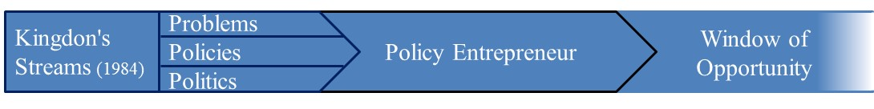
Figure 7. Kingdon's Streams

Policy Windows
Finally, the policy window is an opportunity for policy entrepreneurs to push solutions for their issues. This window is predictable based on budget cycles or changes in leadership, or it can be very unpredictable. For my research, theoretically, a Punctuated Equilibrium Theory (PET) event (something major happened suddenly that prompted quick reactions) and Kingdon’s window of opportunity exist at the same time, which equates to the decision point of the creation of the task force and serves as the point from which I organized organizational memory on the formation of the task force:
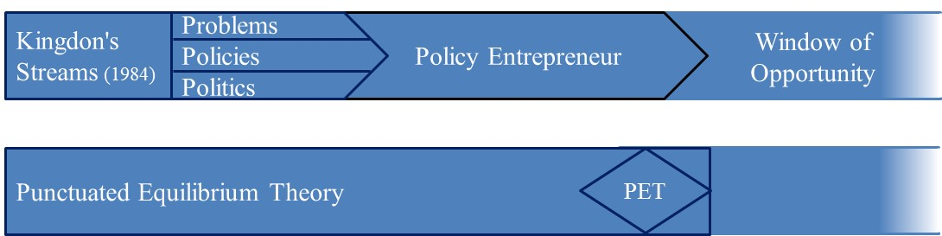
Figure 8. Relation of Punctuated Equilibrium to Window of Opportunity

Punctuated Equilibrium Theory (PET)
Jones and Baumgartner (2005) stated that studies are rare that use interviews and process tracing of government documents to understand causes of Punctuated Equilibrium Theory (PET) (p.14). Hayes (2008) summarized another benefit as “Punctuated equilibrium theory broadens the scope of the policy making community to include, both the political institutions in the form of policy monopolies as well as public mobilization…Stakeholders mobilization is a major influence for dynamic policy change” (p. 26). For my current case, I proposed that certain nodes and ties within the school council network mobilized other nodes to elevate the issues of NDSP in a short time period. Additionally, there was a window of opportunity to push agendas. This opportunity included changes in military leadership and pending changes in DoDEA leadership that contributed to the agreement to review the NDSP program. My interviews and review of extant texts add to this small group of studies on PET. In addition, returning to previous research, Wright’s (2000) report outlined reasons for the deterioration of the relationship between DoDEA and the military command. Wright concluded that there was a change in leadership, reorganization, and changes in military missions. While ten years earlier, this matches the conditions surrounding the decision to create the Non-DoD Schools Program.
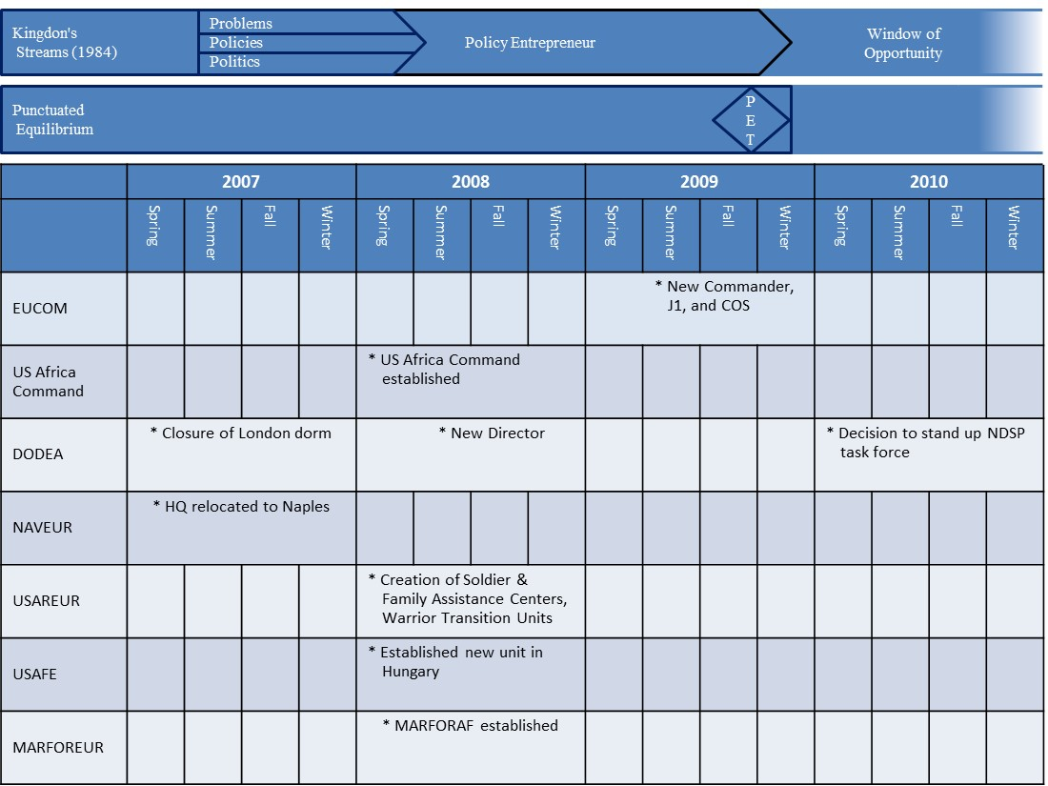Figure 9. Sample Timeline Applied to Kingdon’s Streams and PET

Conclusion
In this section, I summarized research related to organizational change, network, and leadership theories. I defined my theoretical framework and the role of Punctuated Equilibrium Theory in the discussion. Finally, I presented a graphic representation of the theoretical framework as applied to the timeframe that led up to the decision to create the Non-DoD Schools Program Task Force. Although a variety of research exists related to organizational change in military organizations, my research focused on the decision-making process leading up to the expected change. I took into account the external and environmental factors that affect decision-making such as leadership and the connected network of organizations and relationships. The role of theory is important in the design phase of a case study. To this end, I used Kingdon’s (1984) research on pushing agendas in political environments to form the theoretical framework for my proposal. The key elements of a policy entrepreneur connect to leadership qualities while the policy window allows for a discussion of timing of events and a treatment of Punctuated Equilibrium Theory (PET). Since I identified a possible comparable timeframe in 2000 where developing issues came to a head, caused conflict, and produced an actionable result, Kingdon’s policy entrepreneur or multiple entrepreneurs could be the catalyst to change at a given time rather than a specific event.

CHAPTER THREE
Methodology and Methods
“Empirical research advances only when it is accompanied by theory and logical inquiry, and not when treated as a mechanistic data collection endeavor” (Yin, 2009, p. xiii)

Introduction
In order to investigate the circumstances that surrounded the decision to create the Non-DoD Schools Program Task in the spring of 2010, my overall research design took into account the five components of a case study design as outlined by Yin (2009). Previously, I addressed the study’s questions, propositions, and logic linking data to the propositions. In this section, I focus on the remaining two components: unit of analysis and criteria for interpreting findings identified prior to data collection. First, I address the use of qualitative methods and the choice of a case study design. Next, I identify my unit of analysis as the decision-making process within the school council network. Then, I include a summary of my three sources of data and data collection procedures that contains a discussion on researcher reflexivity and memoing. Prior to the section on data sets, I address the process of receiving Institutional Review Board (IRB) approval. Finally, I discuss the validity and reliability of the research.

Qualitative Research
Qualitative methods are most appropriate for understanding the relationships and complex decision making situations that occurred within the school council network; “Using qualitative methods can document participant and stakeholder perspectives, engage them in process, and represent different interests and values in the programmes” (Simons, 2009, p. 18). Qualitative methods are also most suitable for capturing individual’s perceptions of actions taken and his or hers interpretation of meaning. In addition, the quality and meaning of networks are illuminated using qualitative methods. An example, found in Gersick, Bartunek, and Dutton’s (2000) article on the importance of professional relationships, concluded that “existing research has tended to focus on the structure of relationships and not on the meaning of the ties that compose networks” (p. 1029). Through my research I sought to understand the meaning of those ties with respect to how they influenced (facilitated or denigrated) the process of decision-making and advancement of personal and organizational agendas.

Case Study
Due to the nature of my study that included an interaction among and between leadership, a variety of social and professional networks, and the historical conditions considered, case study methods were a good fit. In A Case for the Case Study, Snow and Anderson (1991) concluded that
Case study embodies the following characteristics: they are relatively holistic analyses of systems of action that are bounded socially, spatially, and temporally; they are multi-perspectival and polyphonic; they tend toward triangulation; they allow for the observation of behavior over time and thus facilitate the processual analysis of social life; and they have an open-ended, emergent quality. (p. 152)

Case study methods allow the flexibility of combining data from multiple sources.
Several researchers defined case study: by Stake (1995) as the unit of study holistically, by Yin (2009) as a process, and by Merriam (1998) as a product. Since my focus was primarily the process of agenda setting and decision-making within the school council network it was appropriate to use Yin (2002, 2009) to design the case study. Yin (2002, 2009) stated that case study is preferred when one seeks answers to why/how questions; inquirer has little control over events being studied; contemporary phenomenon in a real-life context; and there are multiple sources of evidence. This is a single case design (Yin, 2009, p. 46) to establish meaning of events and circumstances related to the leadership and decision making within the school council network. The choice of the decision to form the Non-DoD Schools Program Task Force in 2010 stems from a specific type of case study: “Intrinsic case studies are undertaken when a researcher wants to better understand a particular case. It is not undertaken primarily because it represents other cases or because it illustrates some particular trait, characteristic, or problem. Rather, it is because of its uniqueness or ordinariness that a case becomes interesting (Berg, 2009; Creswell, 1998, 2007; Stake, 1994, 2000). My case was a unique opportunity to look at the symbiotic relationship between the military and a civilian run organization that share a common leader and financial source yet serve different purposes.

Process Tracing and Timelines
Timing was an important concept in the reviewed literature. Using case study methods, I was able to address process tracing, analysis of contributing factors, backwards mapping, key event analysis, and actor’s transactions, decisions, and involvement over time. Again, the specific incident of decision making to form the NDSP Task Force was the event. Kingdon’s Policy Window was the opportunity for advocates of proposals to push solutions. I used Rusaw’s (2001) definition of event as a unit of time and reference point from which memories are organized and structured. I borrowed from development of Grounded Theory to establish further the grounds for choosing to follow issues through the school council network: “A process consists of unfolding temporal sequences that may have identifiable markers with clear beginning, end, and benchmarks in between. The temporal sequences are linked in a process and lead to change. Thus, single events become linked in a process and lead to change” (Charmaz, 2006, p. 10). In this case, the decision to create a task force is an implied need for change and thus serves as an intermediary step in the process rather than as an indicator of change.

Unit of Analysis
The unit of analysis is the decision-making process within the school council network. Included in the parameters of this system are the specific education advisory committees as outlined in DoD Instruction 1342.15, “Educational Advisory Committees and Councils,” dated March 27, 1987, as well as the network of avenues, enumerated in the Prologue, by which an organization communicated and resolved any education related issue. To limit the scope of this system I focused on the primary interactions among the United States European Command (EUCOM) with its Component Commands and the Department of Defense Education Activity (DoDEA) and its Department of Defense Dependents Schools- Europe (DoDDS-Europe).

Obtaining Institutional Review Board (IRB) Approval
In May 2015, prior to formal data collection, I sought Institutional Review Board (IRB) approval from the University of Oklahoma (OU). Concurrently, I submitted a formal research study request packet, per DoDEA Administrative Instruction 2071.3, through DoDEA’s research division. My intent for the interviews was to talk with personnel to include the current DoDEA Deputy Director who was the former DoDDS-Europe Deputy Director, the new DoDEA Chief of Legislation who was one of my superiors as the J-1 at EUCOM, and the Chief of Staff of DoDDS-Europe who I worked with daily. Another potential interview was the new Non-DoD Schools Program (NDSP) director who was in charge of the partnership program leading up to the 2010 timeframe. In addition, I designed my original data collection plan with a focus on institutional documents such as the council and working group agendas, educational council meeting minutes and after action reports. “A great deal of attention must be given to why particular documents are to be constructed and why other materials are never recorded” (Sjoberg, Williams, Vaughan, & Sjoberg, 1991, p. 72). I defined agenda as the literal topics as seen on the actual meeting agenda, and anticipated that personal agendas would come out through interviews.
I planned to conduct a narrative analysis of the agendas for the Dependents Education Council (DEC) and the working group and pre-councils, such as EUCOM’s European Schools Council (ESC), that fed into the agenda setting process to discover where, when and how the topic of NDSP came to the forefront of discussion. For example, per DoD Instruction 1342.15, the DEC and Theater Education Councils (TEC) such as the ESC should meet two times a year and produce specific agendas and reports. In addition, as mentioned in the prologue, the Component Commander Advisory Councils (CCACs) also produced consolidated reports that they submitted to DoDEA. I believed the educational council agendas, meeting minutes and after action reports would show the level of engagement and starting points for issues related to NDSP and provide better insight into the process of advancing the agenda that led to the decision to create the task force. For example, if I am new to an organization I may assume that the issues I am pushing is my own organization’s issue while in essence it came from a completely different place and for different reasons.
Neither the OU IRB nor DoDEA would approve the research without approval first from the other. OU finally agreed to approve contingent on DoDEA approval. After two months, I received emails that the decision makers for the task force were no longer with DoDEA (despite the ones that are still there as mentioned above). Furthermore, the documents I requested were not available or classified (regardless of the fact that all meetings were public and the agendas and minutes were always transmitted over unclassified email (in other words, not classified)). Therefore, there would be little benefit to DoDEA to support the research. I had the opportunity to reengage through several emails but after receiving the response that all the documents were no longer available or classified (but I was told that the program was just fine), I decided to proceed using only publically available documents and participants. I considered contacting the people who I knew personally within DoDEA, however as a researcher, I followed the formal process and so deemed the response final. I also suspected that a work around would only contribute to biasing any potential participants. (Reference Document Database, Consolidated Memos, Tab 11a)
Due to my experience working in this system, I planned for the answer “no” by building in the parallel use of publically available documents and people (those who were no longer working for the elements associated directly with the school council system). At the end of July when I received DoDEA’s response, I rewrote my IRB submission that included an IRB request to highlight that no military or civilians currently affiliated with the organizations would participate. Furthermore, I could not use any documents previously acquired prior to IRB approval that were not publically available. Upon receiving OU IRB approval, recruitment for interviews began in August 2015.

Sources of Data
In this section, I focus on my three sources of data. Prior to collecting publically available documents and conducting semi-structured interviews, I constructed a narrative from personal academic writings and reading notes, memories, and memos. After I received IRB approval, I enhanced the discussion with an analysis of publically available documents after which I conducted the interviews. Finally, I triangulated the data to identify primary themes and comparable narratives.

Researcher Reflexivity and Memos
Prior to data collection, I acknowledged that my own involvement in the chosen case both limited and enhanced my role as researcher. However, “as qualitative researchers engaged in contemporary practice, we accept that the researcher is a central figure who influences, if not actively constructs, the collection, selection and interpretation of data” (Finlay, 2002, p. 212). From my initial draw toward qualitative research methods that involve the uncovering of meaning from multiple points of view and to my belief that one must include some structure and process when dealing with people in order to understand the conditions in which actions and feelings occurred, I already influenced my choices for design and theoretical framework.
Finlay (2002) described five variants of reflexivity: introspection; intersubjective reflection; mutual collaboration; social critique; and discursive deconstruction. Reflexivity as intersubjective reflection and social critique are pertinent due to the different rank and title positions of the participants in relation to me as their former employee or colleague and now in the role of the researcher. With regard to my prior involvement in the chosen case, introspection is also appropriate. However, “the challenge for researchers using introspection is to use personal revelation not as an end in itself but as a springboard for interpretations and more general insight” (Finlay, 2002, p. 215). This is why I organized my own written accounts prior to IRB approval and before I conducted any interviews or further data collection. My Prologue serves as an initial recollection of events and timing from my perspective.
For my Prologue, I sought to capture my memories and understandings from my perspective though I incorporated a few publically available documents such as directives and regulations to provide a clearer understanding of the structured, networked context in which I worked. The findings and conclusions section of this research address any discrepancies between my memories and articles or data from interviews. As data collection progressed, both in the development of my theoretical framework before document collection and interviews, then later through the actual data collection and analyses, I compiled examples of notes, diagrams, drawings, and memos to self that showed the progression of my thoughts (Document Database, TAB 13 and 14). For example, during my coursework and literature review phase I systematically took notes while reading (Document Database, TAB 13 b-j). Usually I wrote quotes and key points on the right side of a notebook then if I had a thought or reflection I would jot it down on the left side. I usually wrote “me:” to show it was an original thought or personal reflection. To illustrate this point, when I read Kingdon’s Agendas, Alternatives, and Public Policy in January 2014, next to the memo: Pg.123 Policy Communities: composed of specialists in a given policy arena…have in common one area…common interaction, I wrote, me: DoDEA council system is policy community…use this as framework. Next to a note about policy entrepreneurs I wrote, “me: this is key, believe people like ___, but I want to understand if they were aware or “just doing job” (Document Database, TAB 11, 3i). These types of memos provide insight into my thoughts that shaped the direction for this research. I engaged in the process of reflexivity and memoing throughout the duration of my research (Document Database, TAB 13 and 14).

Publically Available Documents
There were multiple avenues to acquire publically available documents to include the Department of Defense Education Activity website that contains all policies and legislation guidance, public affair releases for the years 2003-2015, budget books for 2003-2015, and is the home site for information for parents on the administration of the Non-DoD Schools Program. Other repositories of public documents and research included the websites for RAND Corporation, Education Resources Information Center (ERIC), Defense Technical Information Center (DTIC), and the Congressional Research Service. I reviewed documents that included policies and legislation, organizational budgets, military construction budgets, congressional testimony, Inspector General reports, newspaper articles, DoDEA Public Releases, documents on the Non-DoD Schools Program website, Teacher Union Newsletters, education council products such as presentation slides, and research conducted by organizations such as RAND and the Congressional Research Institute.
I identified approximately 125 publically available documents deemed germane to this research due to specific reference to at least one facet of the theoretical framework or relevance to illuminating some circumstance surrounding the decision to create the task force and organized them according to the following categories: After Action Reports/Minutes/Meeting Presentation/Briefings (TAB 1), Agendas (TAB 2), Budget Books (TAB 3), Congressional Hearings/Testimony (TAB 4), Policies, Directives, Instructions, Regulations, Memorandums and Guidance (TAB 5), Executive Summaries (TAB 6), Newspaper Articles (TAB 7), Press Releases (TAB 8), Legislation (TAB 9), Miscellaneous (TAB 10), and Reports/Research (TAB 11). The TAB designates their location in the physical document database (see Appendix F for Case Study Document Database Table of Contents for full list of documents).

Data Collection and Analysis for Documents
Yin’s (2009) inclusion of Miles and Huberman (1994) provided the suggestion to “play” with the data by arranging information into arrays, making matrixes of categories, and creating data display such as graphics (p. 129). To this end, I recorded ideas in a variety of ways to include drawings and memos (Document Database, TAB 14, c-f). To organize information chronologically, I added points to my initial timeline (based from the memo “Awareness of Events” dated January 2015) (see Appendix E, Diagram 8 for timeline). The bulk of the documents were located and organized with a preliminary analysis of themes prior to the interviews.
During document collection, I kept in mind the general theoretical propositions and related theories as previously outlined. I read for specific mention of a significant event, a leadership reference, quality of life reference, politics, policies, problems, and status quo. Early searches on the actual Non-DoD Schools Program Task Force and education council agendas such as the DEC and ESC produced zero results. I did however find a few council briefings from 2004 posted by Installation Management Agency (IMA) before the transition to Installation Management Command (IMCOM). The presentations showed the issue of overcrowded schools elevated from the community level Army Family Action Plan (AFAP) process as well as an example of DoDEA adapting to support the military based on new operational requirements. For example, during the Army in Europe Component Commander Advisory Council (CCAC), DoDDS briefed the following modified eligibility: “Modifications to DoDDS Eligibility Operation Iraqi Freedom: DoDDS-E will authorize space available tuition-free enrollment of a student placed in the care of a temporary guardian by a single or dual-military parent deployed in support of OIF” (Installation Management Agency, 2004). These modifications or exceptions to policy occur frequently in the documents and show a willingness to find a solution to emerging problems.
I read all of the public releases on DoDEA’s website for the years 2002 to 2015 and used my preliminary timeline to capture leadership changes and references to new programs or activities such as the development of the Virtual School and Partnership Branch Grant Program (See Appendix E, Diagram 8, Timeline of Events 2000-2011). While I read, I noted broad categories of topics of leadership changes, budgets, military construction projects, new programs, and events, which led to using those as labels on the timeline. Eventually I used the larger themes of Events, Decisions, New Organizations, New Programs, New Commanders or Directors, Process Changes, New Local Programs, Name Changes, and Ongoing Products.
The DoDEA website also contained the budget books from 2003-2015 which I strictly read looking for figures on the Non-DoD Schools Program (NDSP) and Military Construction (MILCON) (See Appendix E, Diagrams 4 and 5 for consolidated numbers). I located other documents and presentations with NDSP numbers from various websites not affiliated with DoDEA and noted an inconsistency with the numbers (see Appendix E, Diagram 6 for comparisons). Other documents provided data points for the timeline. From the documents and timeline, I then created a focused Preliminary Leadership Changes Chart for the years 2007-2010 (see Appendix E, Diagram 7). After the interviews, I created the final Positional Leadership Changes Chart (see Figure 10). In addition to the budget and leadership charts, several public releases provided data points for the timeline.
Other documents found on the DoDEA NDSP specific part of the website included highlighted changes in policy in 2008 regarding reimbursement for costs associated with school uniforms. This and the 2005 guidance on student placement for NDSP correspond with the timing of the decision to close the DoDEA run boarding school England. In some instances, I found that exceptions to policy outlined on the website, in 2015, were not included in the policy document.
During the publically available document collection, I gathered articles and research that provided insight and new layers into the activities of the multiple organizations connected to DoDEA’s school council network. For example, several documents developed by Sullivan (2008), were helpful in illustrating and reiterating some of the seemingly convoluted processes that occurred during this time such as the Joint Strategic Planning System (see Appendix E, Diagram 2) and the Four Year Integrated Defense Planning Cycle (see Appendix E, Diagram 3). I chose these to add another dimension to the understanding of the processes that converged on the 2010 timeframe. One document of specific interest was “The Unified Command Plan and Combatant Commands: Background and Issues for Congress” (Feickert 2013). This is a digestible compilation of information geared toward the decision-makers in Congress. On the surface, it is a quick summary aimed at providing a geographical review and overview of each Combatant Command such as EUCOM and US Africa Command. The broad worldwide scope is a good start for the uninitiated and one graphic in particular provided a solid visual to understand the reach of the combatant commands which I addressed in this research (See Appendix B). A senior army service member, who was not part of this research, validated my choice to use the Joint Strategic Planning System diagram when he commented, “Hate to tell you that these are the simple charts” (Document Database, TAB 13a, Consolidated Memos dated January 25, 2016).
I perused Congressional Testimony and posture statements from 2007-2010 looking for comments on quality of life and education initiatives. In addition to finding a consistent message on the need for quality of life initiatives and increased funding for school military construction projects, I found discussion on activities such as the development of the Heavy Airlift Wing in Papa, Hungary, the creation of US Africa Command as a combatant command, and incident specific topics such as the significance of the Russian invasion of Georgia in 2008 as an indicator of changing relations and dynamics in NATO relationships.
The documents tell the partial story of several organizations connected to the school council system to include their priorities, challenges, and transformations. At times, the organizations connected to create success in obtaining increased funding for MILCON and established joint programs like the high school baseball program for DoDDS- Europe. Other documents, which I will address later, portrayed a negative light on certain organizations and specific positional leaders.
Documents found “are useful even though they are not always accurate and may not be lacking in bias” (Yin, 2009, p. 103). In my work with the military, we had a saying of “Trust but verify”. To this end, I did not use uncorroborated documents. Alternatively, to offset this concern, I used multiple data sources and asked interviewees to confirm information or data points. For example, the discrepancy in the NDSP budgets created an opportunity for discussion with one respondent who had in depth knowledge on the reasons for discrepancies. This led to the revelation that during this time DoDEA was centralizing NDSP under the headquarters. I inquired about another document that appeared to reflect a possible outcome of the NDSP task force. The Dear Parent letter dated 2013 stated “after review of the program” and listed several changes (NDSP Letter to Parents SY2013-2014, 2013). When I looked to verify that DoDEA made the changes to the DoD Instruction as stated in the letter, I found there were no changes. During a follow up discussion, I learned that this was not a product of the task force but from a review when a new manager took over. The following year a new legal counsel reviewed all policies and changes and subsequently invalidated the changes in policy.
Similarly if a topic mentioned was not identified in the initial document review, I went back to look for a reference. This occurred in the initial London Dorm closure conversations. I had a cursory idea that it was an event that occurred during the time of interest but the fact that four interviews independently named it as a possible source of the beginning of the major problems facing NDSP I determined it warranted additional consideration (which I do in chapter 5).
Another area where the documents were confusing was the use of names. For example, the review of budget books shows NDSP as the Non-DoD Tuition Program (NDTP) prior to 2006. The DoDEA Annual report of 2010 refers to DoDDS-Europe, DoDDS-Pacific, and DDESS as DoDEA-Europe, DoDEA-Pacific, and DoDEA Americas. I remember that DoDEA asked us to start using DoDEA-Europe rather than DoDDS-E and that the reason was the headquarters was attempting to create a unified “Team DoDEA” that was not fractured by regions.
Despite the plethora of research, documents, websites, policy papers, and newspaper articles, there was no mention of the NDSP task force (though several sources referenced the other academic task forces conducted during that time) and no publically available agendas, minutes, or presentations relevant. Due to the lack of information, I extended my search to the Pacific region and found a Dependent Education Council list of attendees and an agenda from 2010 that did not reference NDSP. Once I set my interview dates, I reviewed the documents again and finalized the leadership change chart and timeline so that the respondents could review the information. I also prepared some additional questions to seek clarification specific to the individuals in light of the information.

Participants
Prior to obtaining OU IRB approval, I identified 33 potential participants for this research based on their connection to DoDEA and EUCOM during the target dates of 2007-2010. Each participant had an active role as a representative of an organization networked through the school council system. The choice of the council system naturally led to a mix of different perspectives, different pay grades, military services, former military service members, educators, non-educators, positional leaders, action officers, garrison, or base level through combatant command levels well as a variation of roles as stakeholders and decision-makers.
Following IRB approval and the agreement to use publically available documents and individuals only, I eliminated 18 potential participants due to lack of a public address or since they still worked as a DoD civilian with an involved organization. I recruited potential participants via email and LinkedIn. I emailed 15 requests to participate based on the University of Oklahoma’s templates (see Appendix H). All potential participants had at least one encounter with me in my role as education liaison. The email also contained the consent to participate form (see Appendix H). Of the 15 requests, eight did not respond and one gave a negative response. I received six positive responses (one was originally a “no” but reconsidered after clarification on the context of the interview). Each signed and returned the consent to participate form prior to arranging the interview.

Data Collection and Analysis for Interviews
I conducted the interviews, five in-person, and one via Skype, from October 9, 2015 to November 18, 2015. Prior to each interview, I reviewed the informed consent form and highlighted the section stating not to share any classified or restricted information by the Department of Defense or any affiliated unit or agency. As requested by the University of Oklahoma Institutional Review Board, I specifically instructed the respondents to refrain from using names. Due to the small number of respondents and the possibility of deductive re-identification, I chose to refer each by number. For all interviews, I used an outline of the OU IRB approved research questions (see Appendix H) as a template to capture notes during the interview. After each interview, the respondents (except the one conducted via Skype) had the opportunity to review the timeline and leadership charts. For certain interviews, as previously mentioned, I asked for clarification on specific publically acquired documents.
Five of the six respondents permitted audio recording. For the interviews with recordings, I transcribed the interview within 24 hours then memoed to connect points to previously identified themes and topics and noted any anomalies (Document Database, TAB 10 a-f). I deleted each audio recording after completing the transcription. After each interview, I matched findings similar to the documents and previous interviews while noting any contrasting or new information. I added new data points or noted similar mentions of an event on the timeline (Document Database, TAB 12, Diagram g).
After I removed all identifying information such as name, position, or rank, I sent the interview transcripts to each respondent to review for concurrence. For the one interview without audio recording, which happened to be the first interview, I chose to provide a synopsis of themes and my condensed notes for concurrence. The relevant events and themes identified during the interviews included discussion on the Korean Transformation, closing of the London Dorm, the role of the military spouse, perspectives regarding DoDEA’s ability to affect change, relationships, and certain leadership qualities and actions. Specifically I shared the following memo:
Use of word relentless – I do not plan to use this as a direct quote but will absorb it into section on leadership/policy entrepreneur that is consistent throughout each interview, not from a positional use of rank but more as the quality of persistence. The relevance relates to how one is perceived yet interestingly enough it is not in a negative vein (relevant I suppose to which side of the outcome one is on) but as in more of an awareness that this particular person will continue to persist and explore any means necessary to achieve a given objective. Reputation as results oriented and ability to navigate relationships, processes, and systems. (Document Database, TAB 10, Document a)

My first interview recommended a book by Robert Gates, the Secretary of Defense during the time leading up to the decision to create the Non-DoD Schools Program task force. The following memo provides insight into my reaction:
When speaking about this time he referenced Robert Gates book Duty and encouraged a reading of it to see if and how he mentioned DoDEA. I debated with myself for several hours after learning about the six hundred plus page book. I was curious to know the historical content and the personal insights of the Secretary of Defense. Yet, I wondered if my focus would pull from the almost completed document review and theme development and conclusion writing. There was the fear that I had not considered certain aspects of the higher political echelon. (Did I need to go that high?) I chose to read the introduction and first chapter and surprisingly found a story that was similar to my own and later to those I interviewed. After the first 50 pages or so, I realized that I could read the book as if it were conducting an interview using my questions. (Document Database, from Consolidated Memos, TAB 11a)

With the exceptions of the specific decision to create the task force and no mention of DoDEA, the memoirs that I found were similar stories of leadership, qualities, bureaucracy, the weight of position, personal connection to decision-making and the ultimate motivation of taking care of our troops. As evidenced in my memo dated October 15, 2015, Gates verified multiple aspects of my recollection of events leading up to the 2010 decision to create the task force:
To say that I took a trip down memory lane with Gates is appropriate. The decision to extend deployments was made while my brother was sitting in Iraq (deployed) and we all wondered if he would be home for the birth of his daughter. The review of JIEDDO (Joint IED (Improvised Explosive Device) Defeat Organization)) tapped my knowledge of a longtime family friend (a student cadet of my father’s when he taught at West Point) who chose to deploy twice as a Civilian even after serving a complete career as an Army officer. And the effects of BRAC (Base Realignment and Closure) and the debate on the surge and drawdown of BCTs (Brigade Combat Teams) in locations like Baumholder, Germany (a location) that I saw when I was asked to go to support their WTU (Warrior Transition Unit) only to find that the shiny new renovations and quality of life “stuff” for wounded warriors did not make it there because the Garrison was on the BRAC list. This was the largest group at almost 100 soldiers in a WTU in Europe and yet decisions made years in advance precluded the unit from actually getting the support triggered by the entire Walter Reed event. The years on which Gates reflected align with the focal years leading up to May 2010. I lived the times of Walter Reed, working to unravel the complicated dynamics of a dysfunctional system in order to explain how it might be fixed or worked around. (Document Database, Consolidated Memos, TAB 11a)

Furthermore, I plotted new events from the book on the timeline that subsequent interviews reiterated such as the development of the missile defense program, the repeal of Don’t Ask, Don’t Tell (DADT), the creation of Cyber Command, and references to the ongoing Quadrennial Defense Review (QDR) process. Then considering in summer 2009, I attended the change of command ceremony for the new EUCOM Commander in Stuttgart, Germany, over which Gates officiated, it seemed appropriate to include his memoir.
Following the completion of the interviews and after sending the transcripts for review and verification, I did not “play” with the data as I had the documents. Since I designed the interview questions to elicit an understanding of events based on my theoretical framework (for example, to understand the rival theories I asked, “Was the creation of the task force an anomaly or expected action?”) (See Appendix D for categorized list of questions), I chose instead to analyze the transcripts using the categories related to my theoretical propositions and to reflect a general understanding of circumstances. The use of the previously identified Questions to Ask of This Case (see Appendix D) produced the categories based on my theoretical framework of Politics, Problems, Policies, Window of Opportunity, Punctuated Equilibrium Theory, Leadership, Policy Entrepreneur, Circumstances and Miscellaneous (Document Database, TAB 12). The category of miscellaneous related to answers given when asked if there was anything else relevant. I found that miscellaneous and circumstances were vague enough that I could have combined both. Given that I used Gate’s memoir to add information to the compiled timeline I organized my 27 pages of reading notes for his book (Document Database, Tab 11j) as if they were from an interview (Document Database, TAB 10g). The result produced a more comprehensive view of the range of political and personal interactions from my level on up to the Secretary of Defense. This compilation served as the base for my narrative analysis in Chapters Four and Five.
I used interview data to cross check document data and vice versa. In the event of new information or a recommendation, for example “add DDESS leadership,” or “add P&R leadership,” I returned to documents or conducted a new search. This led to further focus on the levels of leadership positions where I found more references to name changes. For example, the Deputy Under Secretary of Defense (Personnel & Readiness) in FY2002, (based on (P.L. 107-107) post took over duties of Assistant Secretary of Defense for Force Management Policy (then abolished), and the DUSD (P&R) redesignated Principal Deputy Under Secretary of Defense (Personnel & Readiness) in 2003 by DoD Directive 5124.8. yet as of 2012 is called the Principal Deputy. This led to a memo where I questioned if name changes indicate the start of a reorganization and why would one want to disconnect from previous name? While inserting the personnel and readiness position I included the Military Community and Family Policy (MC&FP), another political positional level of DoDEA oversight that seemed a revolving door. Later, one interview commented that I should note that the DoDEA Director did not leave in 2010 willingly. I combined the additional information from the interviews and subsequent document review to produce the final leadership changes chart:
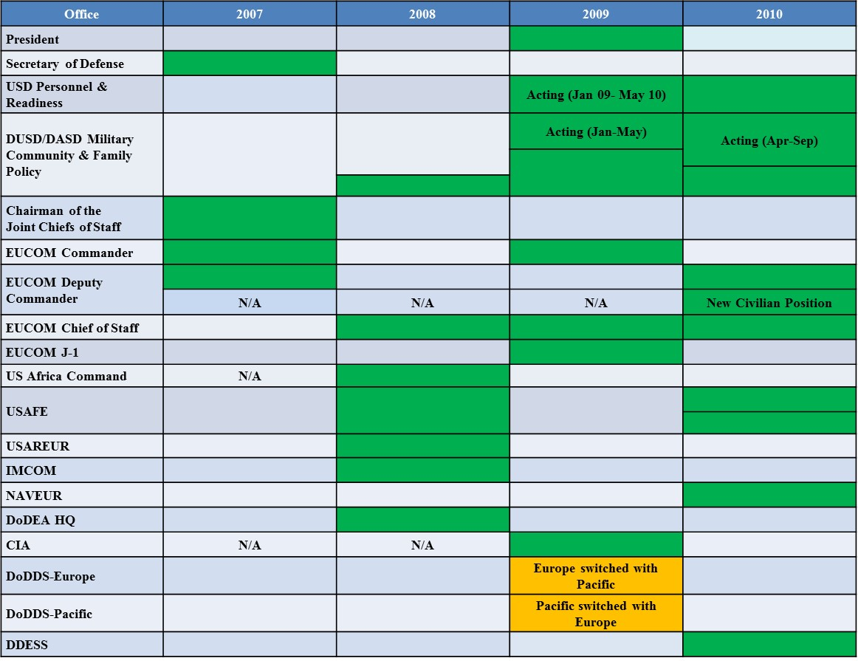
Figure 10. Leadership Changes Chart 2007-2010
I chose to remove the names of the individuals in order to highlight the number of vacant or new leaders during the time. There are a remarkable number of positional leadership changes in the 2007-2010 timeframe in contrast to the preceding years of relative leadership stability. For the timeline, I added the points for 2000 to 2011:
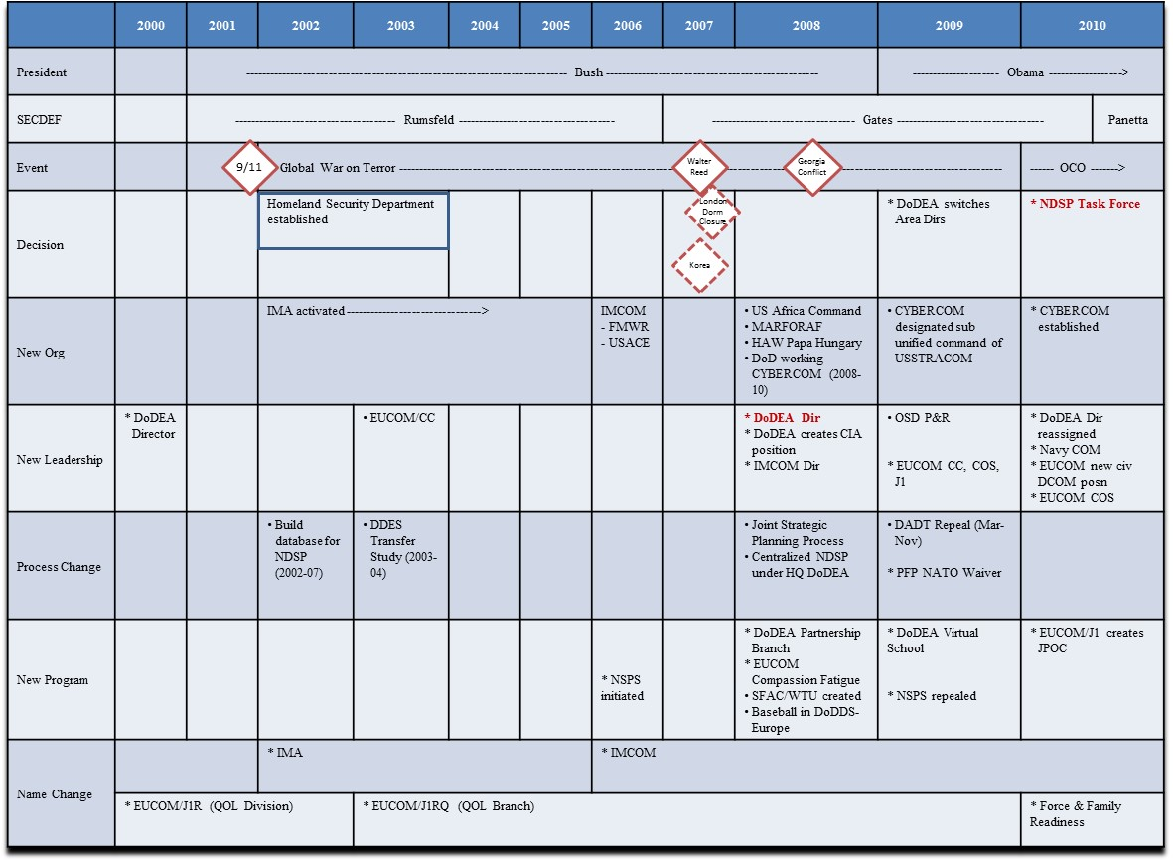
Figure 11. Timeline 2000-2010
Finally, I focused in on the timeframe of 2007-2010 in relation to my theoretical framework:
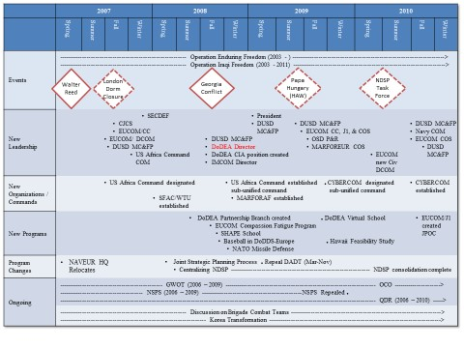
Figure 12. Timeline 2007-2010 with Theoretical Framework
The interviews provided insight into personal and organizational motivations and agendas, thought processes during decision-making, and reflections on the efficacy of the council system and external organizations. Recurring messages highlighted the symbiotic relationships of the organizations, the need for multiple avenues for problem resolution to facilitate the connection between the proper fiscal and human resources and the effects of external geopolitical (such as the draw down in Europe) and fiscal influences (such as budget cuts). New themes emerged to include the role of the military spouse and spouse programs, the importance of mentoring, the military as an external forcing function to impel DoDEA to action, personal and job related motivations, and the importance of “boots on the ground” (you have to see it in person to decide or bring the decision-maker to the location to decide). After the interviews I added the themes of “boots on the ground”, trust, and authority to the themes gleaned from the document collection. I highlighted the themes of leadership, communication, and relationships as major factors in the time leading up to the decision to create the Non-DoD Schools Program task force.
The use of the word leadership in the interviews was intentionally vague to allow answers to occur more organically. Answers revealed actions, positions, dispositions, and qualities. Collectively the top-level commander or director set the tone and message that education was a priority and, as a quality of life issue, it could have a detrimental impact on retention and readiness if not addressed. This consistency of message was evident throughout the interviews, in congressional hearings, and policy and position papers. The other leadership type responses conveyed that during this period the changes in certain leadership positions enabled a new review of old issues. Most salient is the alignment of certain characteristics during positional leadership changeovers. For example, an internal focused minded leader of an organization (education and curriculum centric) changed to one focused on an external view of the organization predicated on personal connection and military awareness. Similarly, a military leadership position transitioned from someone focused on local issues like fixing the individual’s location of residence to one focused strategically on the combined issues of the entire European area of responsibility. In other areas, the absence of senior leadership and multiple transitions enabled conversation and presentation of history and issues by lower level action officers (AOs) or subject matter experts (SMEs).
I noticed a trend of speaking in “we” which could reflect on my earlier musing in the Prologue, of not ever really knowing who is the “we”. My general impressions after the interviews included that interviewees had a predilection for the level of conversation and usually spoke in “we”. One focused on the political-military level and national dynamics, one focused on reorganizations and planning in direct support of the warfighting effort while another spoke in terms of working the system and developing leaders. Yet another took a more mentoring, historical approach while another spoke on how to get things done by finding the money or writing the legislation and that there was no real (or good) reason to not do something to fix a problem. I noted other observations to include some used examples from work while others shared insights that are more personal to make a point. The respondents came with a variety of backgrounds related to the military and/or schools. While some had children in the schools or were former DoDDS students as military children, other simply had an assignment where schools were a priority.
Due to the small number of respondents and the request by some for privacy, I chose to combine accounts for certain parts of the narrative using common information in the interviews and/or information substantiated by documental support. This technique enabled a more cohesive narrative while preserving anonymity. I document the compilations as (Combined Accounts).

Criteria for Interpreting Findings
To establish criteria for interpreting the findings, Yin (2009) outlined four general strategies: 1) relying on theoretical propositions, 2) developing a case description 3) using both qualitative and quantitative data and 4) examining rival explanations. He then offered five analytic techniques: 1) pattern matching, 2) explanation building; 3) time-series analysis, 4) logic models and 5) cross case synthesis. This is the last step in the case study design. I used time-series analysis, specifically compiling chronological events, as an analytic technique to look at timing of events and actions. The documents collected provided the structure and sequence. I used explanation building, which is a special type of pattern matching and is conducive to using narrative analysis. The results of which are discussed in Chapters 4 and 5.
As expected, I found references to Kingdon’s three streams, some predictable windows of opportunity during leadership changeovers, and some type of policy entrepreneur and leadership as previously outlined so relying on theoretical propositions was appropriate to this research. In addition, I examined a rival explanation as relevant with the addition of Punctuated Equilibrium Theory as well as the idea of simple status quo. As Yin (2009) stated, “real life rivals are the ones that you should carefully identify prior to your data collection” (p.134). As such, the two specific rivals relevant to this study are Rival Theory (a theory different from the original theory that explains it better) and Societal Rival (social trends, not any particular force or intervention account for the results) (Yin, 2009, p. 135). In other words, was the push of the NDSP agenda item that resulted in the formation of the task force an anomaly and signal of unique circumstances or just status quo and natural progression of an organized school council process? I discuss the actual findings in subsequent chapters through narrative analysis. According to Riessman (2003), what makes texts “narrative” is sequence and consequence. The researcher selects, organizes, connects, and evaluates events as meaningful for a particular audience. In addition, Gee (1991) asserts that this perspective is telling as it “refers to the fact that a narrative contains a point of view toward what happened, telling us what is significant” (Gee, 1991). My narrative tells the story, not just of how the agendas advanced but what many perceived to be the genesis of the problem.

Validity and Reliability
A case study design is subject to scrutiny concerning construct, internal, and external validity as well as reliability. During the research design phase I addressed construct validity with the proposal to use multiple sources of evidence, external validity with the identification of relevant theory, while pattern matching, explanation building and addressing rival theoretical explanations increased internal validity. The use of pattern matching, time-series analysis, and addressing rival explanations during the data analysis phase increased the internal validity of the study. Furthermore, I triangulated the three data sets. The creation of a case study database of publically available documents, raw data transcripts and chronological memos increased reliability (see Appendix F for Case Study Document Database for Table of Contents).
Conclusion
In this chapter, I considered the merits of qualitative methods and specifically the use of case study methods, reflexivity, and memoing. My unit of analysis was the decision making process of the school council network which includes the formal educational advisory committees process established by policy, as well as, the network of military organizations. I described my three data sets and summarized data collection and procedures. I collected and examined publically available documents to establish the circumstances that led to the timeframe conducive for the creation of the NDSP Task Force. I conducted semi-structured interviews to add to the discussion and to provide multiple perspectives on the genesis of and need for the task force as well as to establish the influencers such as leadership and organizational dynamics on decision-making. After transcribing the interviews (Document Database, TAB 10 a-f), I reviewed the transcripts specifically to look for Kingdon’s processes, policy entrepreneur, some window of opportunity and Punctuated Equilibrium Theory. Throughout I used researcher reflexivity and memoing. Overall, I used my theoretical framework to organize and evaluate data relevant to Kingdon’s three streams, a window of opportunity, and some type of policy entrepreneur and leadership, as previously outlined. In addition, I examined a rival explanation that this event was simply status quo and not indicative of anything unique. I discuss the findings in the following two chapters. Ultimately, this case study design provided the plan to conduct a systematic inquiry into the circumstances surrounding the decision to form the NDSP Task Force in spring of 2010 and to answer my established research questions.

CHAPTER FOUR
Theoretical Framework and Explanation Building
Conditions become defined as problems when we come to believe that we should do something about them. (Kingdon, 1984, p. 115)

Introduction
In this Chapter, I return to the theoretical framework provided by Kingdon (1984) and employ the technique of explanation building (Yin 2009) to encapsulate why the topic of the Non-DoD School Program (NDSP) rose to the highest level of the educational council network. First, I summarize the relevant organizational agendas and their relation to a common thread of Quality of Life priorities. Next, I address the circumstances, identified in the interviews, which influenced the decision-making process in the 2007-2010 timeframe. These include leadership changes, the budget, policy limitations, and organizational transformations, both short and long-term. Then, I offer a graphic depiction of the summary of events that influenced the decision to create the NDSP task force. Finally, I provide background on the internal decision-making process that led to the agreement to form a task force. The discussion culminates in Chapter Five with the answers to the questions: Given the expansive network of military and civilian personnel and leadership connected through the Department of Defense Education Activity (DoDEA) school council network, often with competing priorities and multiple options for issue resolution, how did the topic of the Non-DoD Schools Program (NDSP) become an actionable item on the highest level of the educational advisory committee and council system? More specifically, how were personal and organizational agendas advanced that culminated in the decision to create a Task Force to review Non-DoD Schools Program (NDSP) issues worldwide?
Publically available documents situated the event to create the task force, and provided confirmation of the timeline of memories while interviews elevated the discussion to the political-military, geopolitical realities of multiple organizations while providing day-to-day and organizational specific insights. In his memoirs, Secretary of Defense Gates (2014) reflected on his impressions of the bureaucratic climate that shaped the Department of Defense:
As of January 2007, even though the nation was waging two wars, neither of which we were winning, life at the Pentagon was largely business as usual when I arrived. I found little sense of urgency, concern, or passion about a very grim situation. No senior military officers, no senior civilians came to me breathing fire about the downward slide of our military and civilian war efforts in the wars, the need for more or different equipment or for more troops, or the need for new strategies or tactics. (p. 115)

Later he provided a perspective on the office that had oversight of DoDEA that adds to the understanding of the larger political level influences during this time:
Many of these matters came under the purview of the undersecretary of defense for personnel and readiness (P&R). For that office, it seemed the status quo was satisfactory. Virtually every issue I wanted to tackle with regard to health affairs (including deficiencies in Tricare, the military health insurance program, which I heard about continuously from those in uniform at every rank), wounded warriors, and disability evaluations encountered active opposition, passive resistance, or just plain bureaucratic obduracy from P&R. (Gates, 2014, p. 140)

Contrary to this sense of stagnation were the seemingly frenetic activities of the Combatant Commands, their Component Commands, and DoDEA as they worked to implement the top down Presidential, Congressional, and previous Secretary of Defense mandates while executing day-to-day operations that directly affected the warfighters and their families.

Organizational Agendas and Quality of Life Priorities
DoDEA was responsible for providing a quality education to certain civilian and military dependents even where there were no adequate educational opportunities. The NDSP financially supported this obligation. For several years leading up to the 2007-2010 time frame, DoDEA pushed to create a reimbursement program where the money would come from the military commands rather than DoDEA’s budget. “The money for the DoD school system comes straight out of the Armed Forces Service Committee it never went through Department of Education. So the schools compete with planes, bombs, boats, ships, special ops for schooling in the Department of Defense” (Interview dated October 26, 2015). This was a topic at the Dependents Education Council (DEC). At the heart of the issue was the military had the authority to ignore DoDEA’s recommendation to send a family into a country. The core of DoDEA’s argument for a reimbursable program centered on removing DoDEA from the fiscal equation so then DoDEA would serve as the unbiased advisor, delivery mechanism, and the education input to inform the military commands of the educational options. Then if the military service decided to send families to the location then the service would incur the cost over and above the normal cost, as allocated by the Department of State reimbursement regulation, rather than DoDEA (Interview dated October 26, 2015).
The military agenda, depending on the service, attempted to keep families together. Collectively, the military focused on service member quality of life, and keeping the family unit intact as a condition of force readiness for the nation’s all-volunteer force. Overall, DoDEA and the NDSP are the support elements for education, but there is a strategic advantage for the operational military to work cooperatively with DoDEA to ensure proper support.
The overarching reason for the discussion on the Non-DoD Schools Program (NDSP) connects to the idea of quality of life. An excerpt from a Naval Instruction sums up the variety of documents from the different military services on the topic:
Commanders are responsible for providing the opportunity for a reasonable Quality of Life (QOL) for Navy personnel and their families. It is both ethical and pragmatic for Navy leaders to care for their families – ethical because it is the right thing to do and pragmatic because caring for Sailors and their families directly impacts upon personal and job performance, retention, and readiness. (OPNAV Instruction 1754.1B, 2007)

Even the First Lady of the United States embraced military family support as one of her advocacy platforms in 2009. In her speech to the spouses of the joint staff in January 2010, the First Lady highlighted the accomplishments and commitments to the military such as the increase in funding to build new schools from “Georgia to Germany” (House T. W., 2010). Interviews confirmed that leaders at the top decision-making positions such as the Secretary of Defense and the Combatant Commanders prioritized quality of life initiatives as a high priority. The impact of quality of life on the military mission speaks to the importance of the NDSP.
The following sections connect the events that those interviewed linked directly to a cause of the growing NDSP conversation. After a broad discussion on the budget and military construction, I move to the specific organizational transformation of the administration of the Non-DoD Schools Program that centralized the program under DoDEA headquarters from 2002-2010. This review compelled a new oversight that initially magnified the discrepancies in the program. Next, I discuss larger organizational transformations that include the increase to NATO missions in remote locations, the creation of a new Combatant Command co-located with European Command (EUCOM) in Stuttgart, Germany, and the development of the Heavy Airlift Wing (HAW) in Papa, Hungary. I incorporate the emerging focus on the Pacific region specific to the growth in the military mission in Korea as well as the concerns with the quality of education provided in Hawaii. Then, I provide a synopsis of the unanticipated long-term effects of the decision by DoDEA, in coordination with a task force and EUCOM’s European School Council (ESC), to close the dormitory in London. Finally, I address the role of leadership. The choice of illustrative quotes and combined narratives provide insights into the decision-making thought process of these actions as well as a larger view of the actual military missions and activities that occurred outside of the educational conversation.

Explanation Building
When I initiated this research, I came in with the perception that the source of the conflict was the contentious discussion between DoDEA on one side saying that the military should pay when they overrule DoDEA’s recommendation to not send families to certain locations, and the military on the other side saying that DoDEA should pay since they are the element designed to support the military. What I found was a level of nuance to the discussion and certain policy issues that prevented DoDEA from simply providing financial reimbursement to families. Furthermore, I found a pattern of proactive engagement in the 2007-2010 period between military and civilian staffs to find solutions to an emerging problem set. The military provided opportunities to address education issues through the Combatant Commanders Conferences, spouse programs, Quality of Life conferences in addition to the formal education council system. Similarly, DoDEA facilitated a menu of exceptions to policy and provided access to personnel available to assist commanders that demonstrated an understanding of circumstances faced by the military and families living overseas. While the appeal was mostly to the budget, there was also the discussion on what one considers reasonable with regard to accessibility to a quality of education.

Budgets and Military Construction
I admit that when I sit in a briefing, I tune out when someone briefs the budgets. I listen for the “so what?” of the conversation such as what I heard regarding NDSP, “Our program doubled in the past two years without additional funds allocated.” I jumped on the train of indignation without considering that, in this case, 'they" went to a zero based budget so they had to look closely at requirements. In addition, due to the consolidation of the NDSP from the regions, the numbers for several years did not add up or even match from briefing to briefing, as documents show. Reporting numbers out of context provides an incomplete process but is a strategy used to stir up discussion. (Document Database, TAB 13a, from consolidated memos). However, the reality is that the budget is usually the starting point of most conversations.
Kingdon (1984) articulated, “Inserting funding proposal in an appropriations bill, for instance, may depend on the fortuitous absence of an articulate opponent” (p.199). Fortunately, this was a time that there was consistent support for improving the facilities and school construction projects despite some political pushback to reduce the military presence overseas. The additional influx of money from the 2010 National Defense Authorization Act (NDAA)
Enabled the Department of Defense Education Activity (DoDEA) to begin School Year 2010-2011 with a major facilities renovation and construction initiative eventually resulted in the modernization of 134 schools worldwide according to an August 2010 news source. The initiative started in October with the beginning of Fiscal Year 2011 and is scheduled to span the next several fiscal years through Fiscal Year 2016. Close collaboration and cooperation between DoDEA, The Under Secretary of Defense for Personnel and Readiness, the Military Services, the Department of Defense Comptroller, and the Deputy Under Secretary of Defense for Installations and Environment resulted in a plan to address $3.7 billion in Military Construction (MILCON) needs for DoDEA facilities. (Service, 2010)

These injections were the exception, not the rule. Overall:
The budget was declining, how can we do this better, how can we be more relevant? There was a big push inside the politics of America. Why do we need all these bases overseas? They are expensive...What’s the point? And so, that brought up the theater security cooperation plans, the engagement plans and the detail to why should we remain engaged and I think the proof is in the pudding. Russia gave us more proof than we could ever hope to imagine...But politicians were looking at how can I save money? It was in their best interest to build more barracks in... name a place wherever. Some Congressional personnel questioned why do we have all these facilities overseas when they should be in America and we are spending too much overseas and that money should be in America. So, that was a continuous fight because everyone was focused on Iraq at the time. Then focused on Iraq and then as we draw down everyone is focused on Afghanistan, and how do we make the budget dynamics work? What’s the geopolitical reason for maintaining a presence in Europe? Europe is stable. You know, Europe is stable because frankly from my perspective because we’re there and we enforce a level of presence...we enforce a level of leadership through our presence. (Interview dated November 17, 2015)
Everything’s about money, it’s always about money and follow the money is still very much you know the right lens. Then once you follow the money it’s...are there certain authorities associated with the whole DoDEA enterprise. Well, what schools are you going to have where and can you build an additional school? Can you get not only authorization but can you get the money to do this? (Interview dated November 7, 2015)

Despite the positive influx of MILCON money for education, there was not a push to increase funding for NDSP. Rather the discussion was on what DoDEA or service members had to pay for due to policy issues. For example, there were challenges with the Exceptional Family Member Program (EFMP).

Exceptional Family Member (EFMP) Policy Issues
In the assignment policy system, within the Office of the Secretary of Defense, the DoD system had two requirements to go overseas. You had a medical clearance that the military cannot get around it. If you did not get a medical clearance, you could not go to the next assignment. The second clearance that was required was an educational clearance that was not mandatory. If you received a recommendation that a family should not be there the military could still go ahead and send the family. Even though these were small numbers, many times you had a situation that got economically unbelievable. The military could trump DoDEA’s recommendation not to send families to certain locations. Additionally, during this time the Navy had part of their military assignment process broken down which provided orders to the military personnel before screening families. For the civilian employees, because of the American Disabilities Act, the format for an assignment was different. Prior to selection, you could not ask for any information concerning the family member’s physical or mental issues. After the civilian received notification of selection then you could ask. The information came to DoDEA who made a recommendation back. However, any reassignment of somebody, when you can tie it back to their promotion ability or job ability impacting their job, you could not deny them a placement. There were many failures in special needs identified during this time (Interview dated October 26, 2015). OSD, EUCOM and the military services initiated discussions to develop common screening processes and to communicate with families the limitations of special education support in oversea locations, especially where there were no DoDEA schools.

Transformation of the Non-DoD School Program (NDSP) and Database
The cost of NDSP was always part of the budget briefs at the Component Commander Advisory Councils (CCAC), the European Schools Council (ESC), and the Dependents Education Council (DEC). Internally to DoDEA, there was a consolidation of the Non-DoD Schools Program (NDSP). In 2002, there was no centralized database. Each area director maintained her own system and there were different interpretations of the same regulation. There were different operating procedures from the same guidance. Therefore, from 2002 to 2007, DoDEA Headquarters in Virginia created a database system, standardizing procedures, and ultimately in 2008 under the new DoDEA director, the program centralization completed. It took to 2010 to get it all under the headquarters. DoDEA eliminated all processing overseas. Nobody from the programmatic standpoint or the budget program was overseas except the education coordinators (Interview dated October 26, 2015). Products of this realignment were several policy changes. For example, one region wrote an exception to policy that now was no longer applicable because of the standardized policies and services. Families then initially incurred the financial burden of the change and the regional school liaison officers or headquarters’ liaisons heard about it. The issues then filtered to EUCOM or sometimes the education coordinators contacted me directly as they now served as liaisons.

Organizational and Programmatic Transformations
Transformation was an ongoing theme in the interviews and documents. In his e-book, Good to Great, on the transformation of organizations, Collins (2011) concluded
We’ve allowed the way transitions look from the outside to drive our perception of what they must feel like to those going through them on the inside. From the outside, they look like dramatic, almost revolutionary breakthroughs. But from the inside, they feel completely different, more like an organic development process. (loc. 2805)

However, with the military, there were so many transformations occurring during this time and with the exception of a comment on the speed by which United States Africa Command emerged, the transformations even from the outside seemed to be slow processes. At times DoDEA was unaware of planned base closures because of lack of access to the often times classified information.
An analysis on the data points on the timeline prior to the interviews revealed patterns in the data of change that included mission, programmatic (starting or ending programs such as the Compassion Fatigue Program at EUCOM), leadership changes (positional leadership: President, Commanders, Directors), name changes, and reorganizations. I noted a difference between unplanned and planned transformation. An example of unplanned transformation occurred after the events of September 11, 2001 that led to the creation of a new organization, the Department of Homeland Security. One example of a planned transformation was the transitional split, beginning in 2002, of the Installation Management Agency (IMA) from the United States Army to a formal command, Installation Management Command (IMCOM). The new organization focused on the support element to combat operations such as providing garrison and base level facilities, morale, welfare and recreation activities, and school liaison officers and school transition specialists (Burbach & Van Pool, 2010). Eventually when the events occurred at Walter Reed that put a spotlight on the negative treatment of combat wounded service members and led to the creation of the Soldier and Family Assistance Centers (SFAC) and Warrior Transition Units (WTU) in 2006-2007, the system absorbed the change. Other examples of planned transformation include EUCOM’s expanded support to the North Atlantic Treaty Organization (NATO), and the transition of certain requirements for the creation of a new Combatant Command (COCOM) in 2008.
This was a transformative time with NATO where we were now changing the dynamic from 2005 and 2006 where we were retrenching back into some of our military installations and now we were getting folks back out across NATO and working hand in hand with our NATO partners in these locations. They started developing asset locations where we as the United States could have assets at locations and partnerships with our NATO partners and obviously, we had to have US military personnel at those locations. The vast majority of what EUCOM did fed the US activity in NATO. Very little United States activity in NATO occurred without EUCOM either owning it, touching it, or enabling it. So even when forces would flow from the states to Afghanistan or Iraq, EUCOM would have a piece of that action. Pretty much all of the combat forces in the EUCOM area of responsibility (AOR) rotated in and out of Afghanistan and Iraq (Combined Accounts).
The following is an example of the magnitude of responsibility and activity for EUCOM as a Global Combatant Command:
Prior to splitting part of EUCOM to create United States Africa Command in 2007-2008, EUCOM was all of Europe, most all of Africa and a piece of Asia, with Turkey. It was 93 nations and since the Global Combatant Commands (GCCs) are responsible for any, and all, military operations within their geographic area. By virtue of that, there are many coordinating functions with State Department activities within those nations. A big difference between Department of Defense and Department of State is an ambassador is only worried about his or her nation. There’s very little coordination, ambassador to ambassador, from nation to nation. The State Department regional bureaus actually do that coordination. Ambassadors don’t do much of that themselves. Conversely, the global combatant commands are responsible for all of that coordination within all their nations. In EUCOM’s case, that includes 53 nations today. Combatant Commands coordinate all that military activity and all the activities that then need to be discussed with State Department, USAID, with other partners, with all those militaries and all those governments. We don’t do much in a vacuum. There’s very little done in a vacuum, in fact those are the hardest operations to plan because you risk burning bridges if you do them in an uncoordinated fashion. So the global combatant commands are worried about operations but they’re worried about maintaining US interests forward into those areas. EUCOM is very concerned with building partner capacity as all of our GCCs are. Working with partner nations, and it is not just their militaries, though it is principally their militaries, to build that capacity so we have capable partners when it come times for combat operations. You really like to have partners you can talk to, fight alongside, and trust. So it’s building their leadership, it’s helping them; it isn’t just “stuff”. The huge component of that is training (Interview dated November 7, 2015). For example, one of EUCOM’s Component Commands, Marine Forces in Europe (MARFOREUR) trained and equipped four Georgia battalions that could integrate into the Operation Enduring Freedom (OEF) cycle (previously the Operation Iraqi Freedom (OIF)) (Interview November 17, 2015).

United States Africa Command
In 2007-2008 EUCOM separated their plans and requirements for the African Continent and facilitated the creation of a new Combatant Command, United States Africa Command. The dynamics were shifting. A little bit of the leadership changed as the Deputy Commander for EUCOM moved over as the Commander of US Africa Command. The speed by which this occurred was “a big deal” (Interview dated October 9, 2015). The primary purpose was to build partnership capacity with African governments and liaise with entities in Washington D.C. and the Department of State. While the new US Africa Command had the same COCOM structure and the headquarters remained centrally located in the same community as EUCOM, the new mission focus required additional resources. For example, Marine Forces in Europe (MARFOREUR), one of the Component Commands co-located with EUCOM and United States Africa Command, transitioned as well during this time.
By the end of 2009, Africa Command stood up and parallel to that, MARFOREUR segregated and separated itself to form Marine Forces Africa (MARFORAF). MARFOREUR had the personnel but then there was a new MARFORAF Chief of Staff and G3/5, created in stride in 2008-9 timeframe to focus on being able to support US Africa Command. To facilitate this the MARFOREUR and MARFORAF Chiefs of Staff met daily. They shared the G-6 communication section, so it became a competition for resources. The MARFOREUR Chief of Staff responsibilities revolved around ensuring the G1, the G2, the G4, and the G3/5, the fiscal section and contract section, and the G-6 all worked together in concert and everybody understood the command priorities (Interview dated November 17, 2015).
During this time, another one of EUCOM’s Components, United States Air Forces in Europe (USAFE) supported the continuing war efforts through the development of the Heavy Airlift Wing (HAW) in Papa, Hungary in 2008.

Papa, Hungary
There were significant challenges in establishing educational support when the Air Force element stood up in Papa Hungary as a combined national program. The United States was not directly involved in the selection of the site. The group that selected it used criteria for the educational program that required a bilingual program. When they did the nomination package for the selection process, the city of Papa, Hungary answered that they had a bilingual program. In fact, their bilingual program was for English class, Music and PE. Teachers taught Math and Science in Hungarian so the school did not truly meet the criteria of a bilingual school. It took EUCOM and DoDEA some time to figure out how to address the issues in the location since families and students were already on location because the Air Force tried to do it on their own for a while. It was not until senior leaders went to the location and talked to service members or where senior leaders from DoDEA and DoDDS talked to EUCOM’s senior leaders that EUCOM really understood what the issues were and what the challenges were and that it had to be a priority issue to take on. DoDEA went to Papa to have conversations and to look around. They made it very clear that they could not do a report and analysis. They could not do any of that on the record because legislation prohibited them from certifying an education program not delivered by someone other than DoDEA. EUCOM and USAFE sent representation to Papa as well and in the final discussion determined it was not EUCOM’s responsibility. Ultimately, EUCOM and DoDEA did not have the authority, and the families were already on location. What was the solution? Maybe to get new authorizations, change policies, find someone to create an international school? This discussion was on going when the NDSP task force stood up (Combined Accounts).

Renewed Focus on the Pacific Region and Changes in the Intelligence Community
Historically 60 to 70% of issues at the Dependents Education Council (DEC) were Europe-centric. Yet, issues such as Papa, Hungary, the growing US mission to support NATO locations, and the possibility of additional families moving to the continent of Africa were not large enough for individual conversation considering that the financial need was minimal. At the same time, several interviews acknowledged a subtle shift in the topics and representation at the DEC. During this time, the attendance changed with the increase in intelligence assignments, and DoD imbedding with other organizations. While the existence of the intelligence community overseas was not new, the appearance of representation at the DEC shifted the balance of power with uncoordinated efforts. Unlike the European School Council, that consolidated issues before advancing to the DEC working group, the intelligence community did not have an avenue to vet issues so they brought the issues directly to the DEC working group or DEC. However, as schools picked up steam it became clearer that there were agencies that worked overseas impacted by quality of life issues. One of the challenges with the DEC was that anyone could bring any topic to the working group or even bring it to the table at the actual DEC meeting. Unfortunately, you waste time trying to address an issue if no one is prepared to talk on it. EUCOM and USAFE AOs took note of the emerging issues from the intelligence representatives and established relationships to compare notes (Combined Accounts).
In addition to the growing involvement with the intelligence community, there was a lot of discussion on the Pacific theater. Korea and Hawaii were commanding a lot more attention and focus on broader school issues so there was more dialogue with the commands. In other words, when things are going great, DoDEA does not often hear from commands. However, when there are problems, the two and the four stars are calling the DoDEA director (Interview dated October 26, 2015).
The Army initiative began in 2008 to increase families and extend tours because the Korean four star (US military) decided he wanted to increase the number of families assigned there. In doing so, it put a strain on the DoDEA system. However, part of the plan was the Government of South Korea wanted US military in certain locations so it paid for much of the move and construction under a bilateral cost-sharing agreement. The topic reached the Dependent’s Education Council (DEC) where from the European perspective there was now a new requirement for MILCON dollars that would take away from the already budgeted MILCON process to fix the schools in Europe. Collectively there was agreement that it was a valid requirement and everyone understood the need. However, the fiscal requirement was not budgeted and would take away from the actual students and facilities already in existence (Combined Accounts).
Meanwhile, in the fall of 2008, the state of Hawaii had some severe budget reductions. When they tried to find a way to reduce the budget in the education system they came to an agreement with the teacher’s union that what they would do is furlough teachers every Friday. They went from a normal 181 instructional year to 162. They began implementing it somewhere in the mid fall and by around January it was becoming a very big issue with the commands in the Pacific region. There was a perceived issue that Hawaii was a second-class education system. The Pacific theater commanders made a large issue of it at the DEC and the Office of the Secretary of Defense directed DoDEA to develop a study (Combined Accounts).
While at first glance, any DoDEA involvement in state business such as creating a DDESS school in Hawaii or giving grants to local education activities or even run schools in the states may seem out of their jurisdiction, their mandate was to support the military dependent student. For DoDEA to stay relevant and to address concerns from the military, certain organizational transformation of mission had to occur. In 2007, the John Warner National Defense Authorization Act authorized DoDEA to work collaboratively with the Department of Education through the developing of the Educational Partnership Program (DoDEA educational partnership grant program 2009-2010 annual evaluation report-Draft, 2011).
Since DoDEA’s primary function was to support the dependents of certain civilian and military personnel assigned in selected locations in the United States and overseas all of these changes affected the organization and put a spotlight on the requirement for and importance of NDSP. Yet, the catalyst for a renewed discussion on the increase in complaints started with the decision to close the dormitory in London in 2006. Interviews attributed this one major event as the origin of the problem.

Closing of the Dormitory in London
The closing of dormitory in London was the beginning of a series of new quality of life issues and need for developing exceptions to policy. I was unaware of the recent closure of London Dorm in 2006-2007 when I joined EUCOM in February 2009. I started to hear complaints about uniform payments costing up to $1500 per student from the USAFE Headquarters Component School Liaison Officer. I received phone calls from locations in England where DoD service members worked alongside Department of State personnel yet had to send their children to local schools while their colleagues sent their children to private or boarding schools. There was also a lottery to attend higher quality public schools which usually occurred before the military move cycle so incoming families were sent to lees than acceptable schools.
Four interviews attributed the closing of the dorm as the beginning of the crux of NDSP issues. One thought it was a unilateral decision made by DoDDS-Europe and the time for input never occurred while three others interviewed were aware of the task force convened to look at the possibility of closing the dorm. The following narrative combines the perspectives on the closure of the dormitory:
This school supported not just US students but foreign countries and attachés. The closure had a lot to do with the decision to relocate the headquarters of Navy Europe from London to Naples. In general, the re-stationing of forces drove this whole idea. Some of the base closures were mandates put out during the Rumsfeld years (2001-2006) to drawdown as much as possible. If you are keeping a school for 20 kids or send them somewhere else, the NDSP becomes a very important enabler to your ability to do what the Secretary of Defense wants done which is to get the overseas footprint down to a smaller size. That created obviously a big downsizing of London Central High School in terms of how many students it would take. This occurred also during the 2005-2006 conversation where we were looking to outsource the school in Belgium (now the SHAPE International School) as a solution set so that would have been 300-600 kids going to international schools in Waterloo or Brussels. There was a subset of Action Officers, AOs, that came together really to work this from a DoDEA educational quality standpoint. At the time, we looked at this from a financial standpoint and from a quality of education. The military tried to keep our families together as best they could. That was a priority. We send our service members in harm’s way but sometime they are in very bad locations. Not places that are conducive to having families present and we send them to other locations where the quality of life is a little questionable. Therefore, it made sense many years ago to have this dormitory school in London to support students from these outlying locations where the families made the decision that it was not right to take the children to the locations because there was no US education system.
DoDEA came to EUCOM first and said that they were not sure this was a quality education system. Military, if you really want to keep families together, then we want to take a strong look at this. It paralleled the military priorities in terms of trying to keep families together and ensuring a quality education. The changing force structure in EUCOM at the time compelled DoDEA to look at the dormitory situation. We had less people at these locations, these distant locations within the NATO system, within the embassies in these countries, 92 countries at the time in EUCOM’s AOR. It was cost intensive for these children and there were concerns about the quality of education.
So there were fewer kids in the dorm that cost two or three times what they used to cost because you have this huge facility with this staff and the security and everything else in London and then there really was a question about the overall quality of education in terms of the family support piece of this with the students in the school. We made the recommendation through the European Schools Council (ESC) to the Dependents Education Council (DEC). The DEC approved with a timeline for the closure and plans for the communication with students and parents. There was a plan to hand the property back over to the British. The school was part of a Navy base that was there and the Navy was interested in getting out of the base relationship with the school because there were no longer navy assets there.
To make the decision to close the dormitory, the group of AOs looked at the issues, looked at what the impact would be, at the policies that would be affected in terms of what would we do if we got rid of the dorm, what were the options for schooling and when we determined that it would really be on a case by case basis then DoDEA would work with these families to make the choice not to take their students with them to these locations or look at other options. Therefore, the Non-DoDs program gained importance when the military started increasingly placing people at non-DoDs locations more and more. All the stakeholders came together to work this truly important issue to assess potential impacts to NATO missions. There were policy and force support implications. This was much bigger than just educating kids.
The whole reason we have DoDDS schools overseas in Germany, in France, in Belgium, was for children to get the same quality of education as they do in the United States. Otherwise, you are going to impact the all-volunteer force, service members staying mission ready because they want to get out to take care of the family. There was a whole host of issues that came about because of the confluence of events with the closing of the dorm. For example, there was a lot of finger pointing in the early days. “It’s not that big of an issue,” “Don’t worry about it,” “It’s onesy-twoseys”, “The families will find their way,” “We’ve sent other families to locations with like issues.” There was this initial push back. Then when we started seeing early return of dependents, the challenge of getting qualified people in these positions because they could not take their family, we got more and more information. For example, there were new financial requirements for service members. With the closure of the dorm, the issue of uniforms became a very sensitive issue with USAFE in Europe with some of their families. Since we did not operate a high school anymore in that area students were in private day schools and in one of those schools, uniforms were required and were about $1500 per student. There was an enlisted family with three high schoolers.
Once the dorm closed, there was a swirl of all these activities. Papa, Hungary was probably one of the bigger topics. We had the issue in Albacete, Spain with the movement of the Warrior Prep Center to a multinational program and under the rules of assignment policy, you assign the commander there but the family was two and a half hours away in Barcelona at the local Spanish speaking school where their priority was to take Spanish national students and European Union nations first. Only if there was space could the Spanish speaking school admit a US student. In the United Kingdom and the English speaking countries there was one set of rules that applied to all DoD unless you were in a position that worked for the Department of State or you were in a special position filling a British UK position and someone was filling a US position.
There was another location in Spain where there was an elementary and a middle school but no high school. The kids were bussed an hour and a half away. Were there enough students to make that fiscal and reasonable? Basically, the closing of the dorm became a lightning rod for issues. In hindsight, it probably was a bad decision but at the time with the facts presented, it was a very good decision (Combined Accounts).
The closing of the dorm in London, a process triggered by transformation and draw down of troops, sparked a series of second and third order effects. Now there was no DoDEA boarding school option to support families such as those with the Heavy Airlift Wing (HAW) or for the children of the small number of children arriving as part of an increase in intelligence locations and those imbedding at NATO locations. Multiple distinctive changes in military missions shaped this 2007-2010 timeframe. Rather than a solution where DoDEA “simply” requested more financial support and legislative authority, the discussion continued to focus on service reimbursement with the intent that then the services would be more discerning in sending families. The military, however, preferred to start with getting the best-qualified service member in position. EUCOM and the Components continued to address individual location challenges as each emerged. DoDEA was the constant, support element but there was a disconnect between the expectation of support and the ability to sustain new demands from a budgetary or policy stance.
While I based my research questions on how the topic of NDSP advanced, the following figure summarizes the previously discussed circumstances of why:
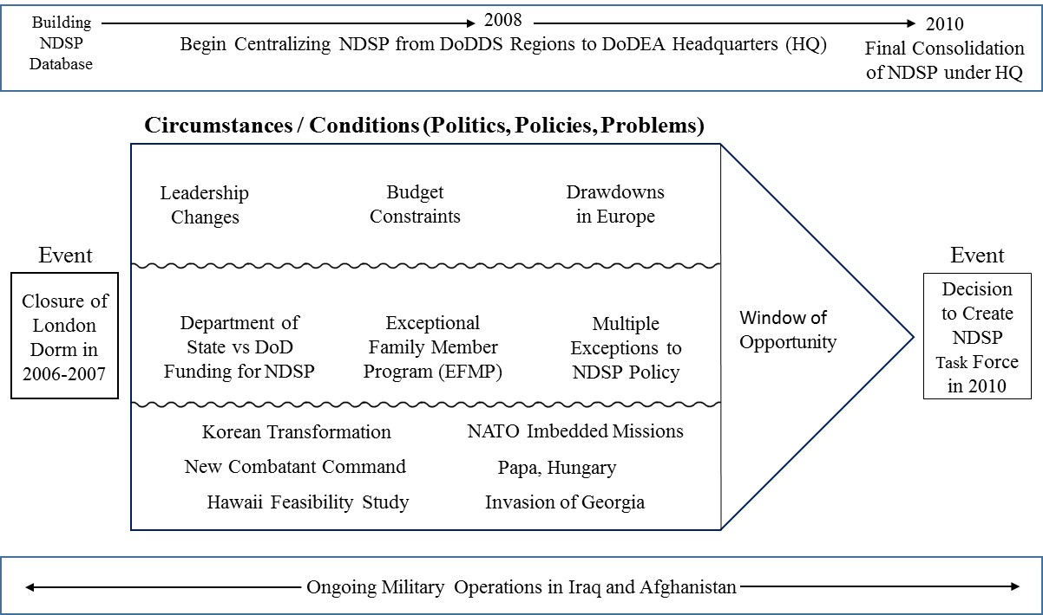
Figure 13. Explanation of Events Leading to Decision to Create a Task Force
These were the conditions with lack of a cohesive resolution. As an AO during this time, I understood the challenges. However, as a researcher, during several interviews I kept asking, what is the overarching problem really? There was a program in DoDEA to support the non-traditional school option. Even with the closing of the dorm, I did not hear anything that new policies, a change in policy, request for authority, or for an increased budget could not solve. I revisit Kingdon’s (1984) quote about conditions becoming problems when one decides to do something about them. Why this time? Why the spring of 2010? The answers exist in the fortuitous combination of leadership that transpired. Ultimately, it was the DoDEA Director’s decision to create the task force that enabled the collective to identify the swirl of conditions as a real problem set though there was no clear or easy solution.

Leadership
As summarized in Chapter Three, respondents’ answers regarding leadership led to a breakout of specific subcategories: positional (the person has the authority to make a decision such as the Director of DoDEA or the Commander of EUCOM); qualities (actionable descriptive characteristics such as persistence and audacity); values (the motivation behind the choice to pursue specific actions); and dispositions (how those interviewed evaluated the character, personality, and temperaments of others). Leadership changes enabled a new review of old issues. In addition to the multiple turnovers in positional leadership primarily in 2008 and 2009 (refer back to Figure 10), the DoDEA Chief of Staff from 2002-2008 transitioned into the new Chief of Policy and Legislation position with a focus on NDSP. Subsequently, EUCOM and each of its Components (with the exception of USAFE) hired new headquarters’ education liaisons. The Chief of Staff of DoDDS-Europe also changed and the DoDDS-Europe Deputy Director position disappeared with the creation of the new Curriculum, Assessment, and Instruction (CIA) position.
By nature of a rank position, or an authoritative position such as Commander or Director, leaders pushed an agenda by making it a priority. Similarly, the lack of an authoritative position empowered the Action Officer (AO), the person who had the director or commander’s blessing to get things done as he or she represented the organization’s priorities and interests. I borrowed this term from the military and applied it to each person interviewed or identified and determined in this network to some end each person is an AO, so even at the Secretary of Defense (SECDEF) level, he is the President’s AO as he “serves at the pleasure of the president” (Gates, 2014). He also is a positional leader by virtue of being responsible for the entire Department of Defense. While each AO was a decision-maker in his or her own right, there were certain limitations to the authority to act. Somehow, in the mix of change, the combination of several long-time, proactive advocates for the importance of NDSP, from both the DoDEA and military sides, converged with newer advocates, from both sides, who seized the opportunity to promote the topic as a priority.
Parallel to the positive, proactive engagement of DoDEA leadership with the military, there was a pattern of negative comments specific to DoDEA found in publically available documents to include Inspector General (IG) Reports and Congressional oversight committee reports aimed at reducing programs within DoDEA. Similarly, several documents by a teachers’ union conveyed a strong anti-DoDEA Director message. My discomfort in reviewing the documents came from the position that I did not share the same experience. The new DoDEA director engaged positively with the military and was accessible at many levels. However, what I read in the reports confirmed several rumors that I had heard of strife internal to the organization. While it would have been easy not to include the reports, I believe it would have limited the goal for understanding the circumstances and leadership at the time. Furthermore, my question of motivation for the agreement to assemble the task force (I wondered if it was to build a strong relationship with the military in order to insulate DoDEA from the Unions) would not benefit from the potential answers found in the documents. I handled the IG reports differently since each occurred after the target date of 2010, yet findings represented issues that affected the 2007-2010 timeframe as it usually takes a year or two to investigate and report findings. I used three reports (with the exception of the one on the DoDEA Director, I was surprised to find one on the EUCOM and US Africa Command Commanders) to verify interview data, organizational priorities, and purpose. While several documents, IG reports, and union newsletters shed a negative light on the Director of DoDEA during this time, the negative tone is contrary to the overall positive recollection of those interviewed.

Decision to Create the Task Force
The push for the Non-DoD Schools Program (NDSP) task force came from the Action Officer (AO) level. Specific to dealing with NDSP daily, those at positional leadership positions in certain organizations connected to the school council system did not have the connection to the decision to create the task force. In essence, this topic was simply one of many items that the education AOs back-briefed to the higher position leadership. The significance of this was that the topic elevated through the formal system unimpeded. Both the military and the educational sides of the discussion understood the benefit of opening up a broader dialogue. The following are recollections regarding the decision making related to the actual creation of the task force from the military side:
There was always talk about the Non-DoD Schools Program as far back as 2000 and how it works and who gets what and how you determine where the person goes. For the military, the Air Force, was probably the biggest voice at the table for the EUCOM area of responsibility in terms of what are we going to do about the variety of issues such as the cost of uniforms, bus rides over an hour, funding transportation where no bus route existed, providing education in Papa, and allowing students to choose private schools in the UK instead of having to attend local public schools. The Army came on board after that. The Navy was not a big player although there were a few areas where naval personnel had concerns. For example, we had an issue in Greece where the government planned to shut down the school where Air Force and Navy personnel’s children attended. At the same time, we were also communicating with Pacific Command (PACOM), an agency similar to EUCOM. They have some similar issues but not the same challenges because there is no NATO in PACOM. PACOM was much more about not taking families to these locations, yet they were developing new requirements in Korea. EUCOM was supportive of taking families to these locations. It was a little different dynamic. We were communicating with PACOM and they agreed that we should probably have this conversation with DoDEA. Eventually EUCOM compelled DoDEA to take this on lead to bring folks together to have these discussions. They were the ones who started the whole discussion on the closure of the dorm in London so from the EUCOM point of view; they were responsible for providing education to our military families in overseas environments. DoDEA had a responsibility for providing in class or virtual education options for students so they had to be a lead in this. Homeschooling was an option for military families except in certain locations where it was illegal so that was another problem. USAFE requested a task force and the European School Council also forwarded a recommendation for a task force to the DEC working group. This would enable a bigger picture view for DoDEA of the military concerns, and similarly the military representatives would develop a better understanding of the challenges of administering the program and the strain of uncoordinated actions (Combined Accounts).
The following represents a perspective from the DoDEA side:
From the DoDEA perspective, there was a perception that the Director had the nucleus of a group within the headquarters that understood the problem and that with a little bit more information that a larger group could come up with even better solutions. And we could share in the identifications of the problems but most importantly, share in how the solutions were going to take shape. Part of it was predicated on she viewed that as a means to assist and to get the reimbursement program approved. It wasn’t a groundwork idea that I’m doing this so I can do that. It was more of a we’ve got a group of people primarily some of the component commands who understand the issues. We don’t have everyone on the same sheet of music. If we do a task force, one we’re gonna collect more information because we’re going to ask people candidly to bring their problems and issues forward. Two, we’re going to get everybody in agreement on how to solve the problems. She was very much somebody who believed that you don’t come up with solutions in a stovepipe. She had a lot of confidence that we could get to the heart of the issues and her intent was to then come up with solutions and take it back to the DEC and get the DEC to agree and then move forward from there. This was not a topic saved just for the DEC. Phone calls during the week perpetually. As she travelled, she would do office calls with leadership, general officers, and senior commanders. I guarantee you every time she went to USAFE NDSP was a discussion, and every time she went to EUCOM it was a discussion. (Interview dated October 26, 2015)

Ultimately, the director made the decision. While the Action Officers for multiple organizations, to include DoDEA, had the authority to push the NDSP agenda, none had the actual authority to make the decision to create the task force. That authority rested solely with the DoDEA Director.

Conclusion
In this Chapter, I summarized the relevant organizational agendas that advanced in relation to the importance of service member quality of life and the potential impact on the military mission. I utilized the technique of explanation building to capture the reasons why the topic of the Non-DoD School Program (NDSP) rose to the highest level of the educational council network during 2007-2010. The discussion reflected components of Kingdon’s three streams, politics, problems, and policies, as illustrated in Figure 13. I included background on the leadership that represents his concept of a policy entrepreneur. Specifically, I discussed several unique circumstances, such as the closing of the dormitory in London, the consolidation of the Non-DoD Schools Program under the headquarters, the emerging military missions, and the timing of the combination of action officers at multiple levels mixing with a new DoDEA director who had the background to grasp the depth of issues, and who had the decision-making authority to create the task force. In the next chapter, I specifically answer my research questions. I conclude the discussion on the timing, or window of opportunity, with a comparison of the rival explanation shaped by Punctuated Equilibrium Theory (PET). Finally, I provide a deeper understanding of the actual actions taken to advance the agenda based on the themes of leadership, relationships, and communication.

CHAPTER FIVE
Themes and Findings
The US military embraces the family, the service member and family. Just produces a better culture for all of us in terms of enduring support for our military and connection with the community, so the community understands better what our service is doing and what our partners are doing and then you have a child that grows up in that environment with a supportive family in a military environment and then that helps the all-volunteer force recruiting effort. (Interview dated November 17, 2015)
When you take that leadership leap and present those opportunities, two things will happen. They will either say no or they’re going to do it. Possibly give you some feedback but those are the only two options. So, they say no. What do you lose from a no? Nothing. (Interview dated November 18, 2015)

Introduction
In the previous chapters I established why and how various organizations joined together to look at an emerging problem set for the Non-DoD Schools Program (NDSP) created by a blend of previous decision-making and new military mission requirements beyond the authority of the Department of Defense Education Activity (DoDEA) during the 2007-2010 timeframe. I identified why the topic rose in importance on the larger organizational level from the perspective of those interviewed. Now, I specifically address how individuals and small groups of Action Officers (AOs) collaborated to advance the agenda through a combination of understanding the structure (both formal and informal) of the network of organizations as well as the role of leadership, relationships, and communication. First, I provide the answers to the research questions: Given the expansive network of military and civilian personnel and leadership connected through the Department of Defense Education Activity (DoDEA) school council network, often with competing priorities and multiple options for issue resolution, how did the topic of the Non-DoD Schools Program (NDSP) become an actionable item on the highest level of the educational advisory committee and council system? More specifically, how were personal and organizational agendas advanced that culminated in the decision to create a Task Force to review Non-DoD Schools Program (NDSP) issues worldwide? Next, I evaluate how this was a unique event using Punctuated Equilibrium Theory (PET) applied overtime and to small group theory. Then, I expound upon the findings from the triangulation of my three data sets that identified the need for decision-makers who have the proper authority to hear issues from multiple sources and through multiple avenues. Finally, I present literal depictions of how agendas advanced within the formal and informal organizational structure, and offer a synthesis of advice and actions that exemplify the practical application of how to push or advance personal or organizational agendas. Throughout this chapter, I include discussion on the overarching themes of leadership, relationships, and communication.

Answers to the Research Questions
While the networked system to advance agendas was dynamic and complex, the answer to how the topic of the Non-DoD School’s Program (NDSP) reached the highest level of the council system is rather straightforward. The various avenues for issue resolution, both formal and informal, as outlined in the Prologue and subsequent chapters came into play. Formally, the CCAC and European School Council level addressed the topic and requested a task force, while in-person office calls with new senior leaders in multiple organizations added to the dialogue as AOs ensured the topic of NDSP was on the agenda. Informally, the AOs, who worked to resolve the constant stream of NDSP related issues specific to each organization united to advocate for a review. Not only did they consolidate and identify problem areas, they produced recommendations for solutions. More importantly, there was a consistency of message for AOs and decision-makers. The fact that quality of life initiatives were a priority communicated from the top down leadership enabled the lower level action officers to consolidate and evaluate the need for a task force and push the topic back to those leaders at the DEC. Finally, the DoDEA Director made the decision to establish the task force. The decision advanced the organizational agendas of both DoDEA and the military, as the task force would enable dialogue to consider both sides of the challenges faced by each.
Although I discussed several motivations for pushing the NDSP agenda, the answer for how personal agendas advanced was less clear. I attribute this to my earlier observation that those interviewed tended to speak in the “we”. Future studies should include interview questions specific to asking about personal motivation and agendas for action and interactions. However, there was a common message in the interviews that those who acted believed that this small program was important and had larger implications if left unresolved.

Timing and Window of Opportunity
To gain an understanding of the elements of status quo versus a unique event I asked if the formation of the task force was an anomaly. I then countered with asking if it was an expected outcome of the educational council system. The answers shed light on how it was both:
We asked for a task force during a time when DoDEA was conducting multiple curriculum and school-based task forces so our request fit right into the activity of the moment. (From consolidated memos)

The decision of a task force itself was not unique however, “That DoD would take this on during time of war, drawdowns, recession, budget cuts, when the US usually tends to become more isolationist...To step out and take this on reflects well on the organization.” (Interview dated October 9, 2015)

I think DoDEA basically uses (a task force) whenever it has a problem that it doesn’t know how to solve organically. Getting new schools built in Europe is another example of sort of processes that require these external injects to get DoDEA what it needs to be able to justify what it needs to do to right size. It doesn’t shock me that there’s always sort of ad hoc ways in which DoDEA needs to operate in order to get things done. Because it doesn’t seem to have an ability, I don’t know why, to get enough moxy within its structure. In its structure in its relationship with the rest of the department, I mean the Secretary of Defense, to get things right. It requires this external input to force the issue because people start complaining. (Interview dated October 23, 2015)

It was unique. Well it was not unique in the sense of DoDEA routinely does a lot of task forces. That was not unheard of. It was unheard of; in essence, we never approached doing anything like this task force for NDSP. NDSP had stayed in the shadows...with not bringing much attention at a larger element. (Unique) because the Director was signing up to ask everyone to participate, send information, be involved in it and then we’re going to make these policy and programmatic discussions as part of the DEC. (Interview dated October 26, 2015)

Overall, this was an anomaly because NDSP had become a larger strategic program in DoDEA's repertoire of providing support to military and as an enabler to the military agenda.

Timing
Earlier I referenced the research on Punctuated Equilibrium Theory (PET) and small groups that concluded, “The common feature is in the observed pattern of change- periods of stasis (or in some versions, incremental change) punctuated by short periods of radical change in which a group attempts to improve its fit with the demands of its embedding context” (Arrow, Henry, Poole, Wheelan, & Moreland, 2005, p. 329). I would not call this a radical change to conduct the task force, but it was unique in its mobilization of facets of the school council network. Every organization had representation at the working group level. The dynamics changed within the groups looking at the issues and new external forcing functions (discussed in Chapter Four) emerged that highlighted the need and importance of NDSP. DoDEA’s answer to the increased costs to have the services pay simply was not a solution to all of the problems as the demands on the program increased in response to the need for additional DoD personnel in locations without adequate educational opportunities.
In light of the reality that the number of students and expense involved is so minimal that it does not warrant discussion when compared to the larger organization, the fact that a group successfully advocated for a worldwide review of the program is remarkable. Moreover, there was the fact that the new DoDEA leader in 2008 had a proactive agenda in working with the military. The combination of leadership, relationships, communication, and the qualities of persistence provides insight into advancing agendas. Ultimately, a leader with decision-making authority is necessary.
A pattern of recent collaborative victories in supporting quality of life initiatives ranged from regional DoDDS-Europe baseball to the worldwide MILCON money insert paved the way for bringing everyone to the table to explore the emerging issues related to NDSP. Moreover, DoDEA and the military adapted to work together in mutual understanding of each other’s position based on purpose. With respect to the decision, Punctuated Equilibrium Theory (PET) existed with people during this time, not events. There was no specific event immediately preceding the decision to create the task force. Yet the right people connected from numerous avenues at the same time and collectively worked together to keep the topic of NDSP on the agenda until a leader with authority to act agreed to establish a task force

Multiple Avenues
When you join an organization, it is like walking into the middle of multiple stories. The cast of characters are in various chapters in their lives with "various" plot lines and settings. Sometimes the stories intersect and for that brief period of time, a shared experience occurs that becomes the baseline for future interaction (Document Database, Consolidated Memos dated December 12, 2015).
Another one of Kingdon’s (1984) concepts is “softening up” or the idea that to advance agendas one must first get discussion and awareness raised in multiple forums. This was our pre-briefs to senior leaders, working groups with the different councils, pre-meetings, and office calls with new leadership that all connect to this idea. The goal was to educate the policy community, the other action officers and leadership. Kingdon (1984) noted that, “Even specialists might not be sensitive to a problem or aware of a given proposal, so entrepreneurs try to educate their fellow specialists” (p.135). Interviews stressed the importance of collaboration and communication as related to a pattern of action. Several interviews stated that one must never go into a meeting without knowing how it will turn out. One must be aware of everyone’s pre-coordinated conversations and conclusions. However, despite all of the pre-coordination and information finding, the decisions made may not reflect the previous lower level agreement. Furthermore, one must be cognizant that although agreement occurred in the meeting, the written findings may reflect a different result depending on who writes the final report.

Quality of Life Conference and European Schools Council
Leading up to the 2010 time frame, EUCOM had the policy requirement and programmatic coordination for all quality of life aspects to include all Department of Defense schools, morale, welfare and recreation, health care, behavioral health, all things that are quality of life related or support the force and family. One cannot separate quality of life for children from service members. When making a decision to move to a remote location there are many factors involved such as career progression, family support, and education opportunities. In 2006-2007 as the force structure started to change in EUCOM it was more important for services to work closer together, because DoD started to look at closing installations, closing facilities, doing more joint basing overseas, cross collaboration amongst the services was important. It was also more important to talk about sharing in force support and installation issues, quality of life issues. We did this in a number of ways.
EUCOM had an annual quality of life conference that would bring in all the stakeholders in one venue to evaluate all aspects of quality of life, boys, and girls scouts, welfare and recreation, behavioral health, family support center structures, personnel and education. Both voluntary adult education and dependent education so we really had that cross collaboration and so we would talk across the command. What were the issues and then how could the team in EUCOM take on these issues and then work with its stateside counterparts and Office of Secretary of Defense and military services to change legislation, to change funding to support and have impact on those topics identified at the conference?
EUCOM Quality of Life brought in students as part of the conference to represent issues in the military communities. This process, especially having representative from the Office of the Secretary of Defense (OSD) enabled the EUCOM staff to basically take a year’s worth of effort through the ESC or the Component Commanders conferences or the spouse conferences or the break out groups from the quality of life conferences to say here are the top five issues that need to be fixed at the DoD level. The Director of DoDEA never missed one, the Deputy Assistant Secretary attended one or two and on the service side there was always somebody from the civilian side of leadership on the Manpower Reserve Affairs side. This was a proactive process to get the Command’s message communicated through to the Pentagon (Condensed Accounts).
In addition to the Quality of Life conference, a specialized focus on education occurred during the biannual European Schools Council. This was part of the conversation about the capacity to handle the needs of the families and schooling for kids. Living in a foreign environment those needs become even more important. For the European School Council (ESC), the working group was the one that really talked about the issues and were the action officers that looked at the issues, identified them and put them together and then they were also the ones that went back out and informed their leadership on what the issues were for the meeting to get them prepped so that we had a real 360 degree approach from buy-in to development. The hardest part of this process was to have issues on the agenda that would drive interest. So it’s not only important to have issues on the agenda that are important issues but it’s also important to have issues on the agenda that drive the interest of the senior leaders so now you can get them in the room to talk about other things (Interview dated November 18, 2015).
Part of the process was getting the senior leaders together and ready for the ESC and then many of those ESC members would come back and participate or be at the Dependent Education Council. We wanted Europe to identify and be able to say this is ours, we own it, we are responsible for it. Thus when we present items we want to represent them on behalf of Europe. From 2005 to 2009, we had topics regarding the reduced number of physical education activity in schools. There were perceptions that art and music were being downplayed. Questions came up about the quality of school leadership. The lack of sports was an issue. There was a perception from those external to DoDEA that the big issues that affected positive movements on schools in Europe whether it was school boards, whether was reduced PTR (pupil teacher ratio), full day kindergarten, or construction those were not internally driven by DoDEA but from the external customer which is the military (Combined Accounts).
Another way EUCOM would get information and connect resources was during the senior leader spouse program. We would bring up topics and the spouses would say either what can we do to help, or that they heard last month some things for us to look at, so forth, and so on. It was a good dialogue and informal. It was not as formal dealing with commanders, but ended up being as effective. One facet of overseas life that is important to understand is that we live and work in the same community. The base or the post is the community. Those interviewed felt that EUCOM did a commendable job of representing issues upwards to the external customers in a way that no other organization has replicated. Whether it was Non-DoDs, whether it was construction of schools whether it was bussing or whatever the issues were. People need to hear it in multiple forums (Combined Accounts).
Another avenue to hear issues involved the push from local military spouses. In one specific location in March 2009, senior spouses produced a paper analyzing DoDEA accountability and labeled it “the missing standard”. The paper served as a springboard for discussion, not only at the local level, but also up to the DoDEA Director. The group of spouses created a community group with the defined purpose of bringing parents together to identify issues relating to the DoDDS community and to provide a channel through which to affect change. The main concern was the attitude of the school system that appeared to “wait us out.” Due to the frequent transition of the community, the spouses believed that the school system stalled changes. To accelerate affecting change to the system, the spouses encouraged the use of the military chain of command and the structures in place, but if that did not work then they recommended communication with Senators and Congressmen (Document Database, Tab 13a, from consolidated memos).
Local community changes provided opportunities to create new relationships. For example, while there were growing pains associated with US Africa Command and EUCOM co-located in Stuttgart, Germany, the split from EUCOM did not have a negative effect on the relationships between the Chiefs of Staff of the Combatant Commands in relation to the European Schools Council and school support in the Stuttgart community. During the first year as a sub-unified command, the EUCOM Chief of Staff invited the AFRICOM chief of staff to attend the European Schools Council. Both shared similar views and agreed that one or the other, if not both, would attend the school council meetings with DoDDS-Europe and DoDEA (Interview dated October 9, 2015). From that time up to 2010, both commands (despite the three changes in EUCOM Chief of Staff and two Deputy Commanders) formed a united front to pursue additional MILCON dollars that resulted in a $50M congressional insert to build a new school in Stuttgart. The previous allocation of money for the Boeblingen Elementary and High School was about $50M under budget by the time the design phase occurred. Furthermore, they worked together with DoDDS-Europe to fund module trailers to curb the overcrowding in the schools. This concerted effort rolled into a larger worldwide push to inject the DoDEA MILCON portfolio with adequate funds to renovate or build schools.

Relationships and Communication in Pushing Agendas
It’s difficult to get, with the myriad of issues going on, from force structures to base closures to commissary challenges the whole host of issues that you have in the OCONUS environment and luckily most go unseen and it’s hard to bring issues to the forefront that don’t impact the families of senior leaders that are making those decisions. That’s difficult. How to get them to realize, you got to do this now for somebody living, or interested in this for somebody living 1200 miles away from where your front door is. So you have to make that real for them. And you have to be, I think, within a team that’s trying to push this issue together you have to be really clear about communication, communicating, communicating, communicating what the issues are, what the challenges are so that so that you get people to then reiterate or continue that dialogue, using the same terms I think is important. (Interview dated November 18, 2015)

Another way of looking at the concept of advancing or pushing a personal or organizational agenda is in the vein of how to work around a “no” or negative response. The stories told in the Prologue and during the interview phase led to the following thoughts and graphic depictions. These interpretations represent four ways that organizations raised awareness of issues during this time. The bottom level position represents the person elevating the issue regardless of rank or formal position. While I illustrated several avenues to problem solve within this network (both structurally and socially) Figures 13-16 graphically represent four specific scenarios.
Scenario 1. How to move an issue when you do not have access to the decision maker in your own organization:
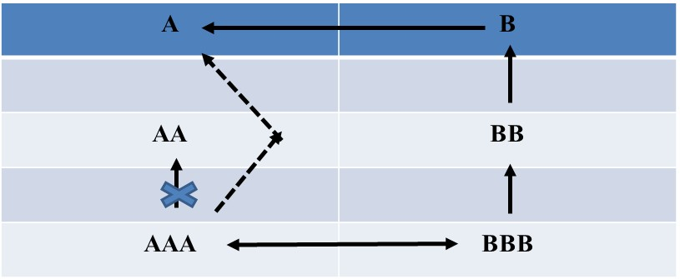
Figure 14. Way Around a Negative Response Scenario One
Pass the issue to another organization’s AO and work with them to move it up the chain of command then present it back. For example, when the senior leader of B comes for a visit, AAA works with BBB to get the item on the discussion agenda so when B presents to A it has more weight.
Scenario 2. How to get an issue addressed when the top of the chain of command decision maker is not accessible or does not have the authority
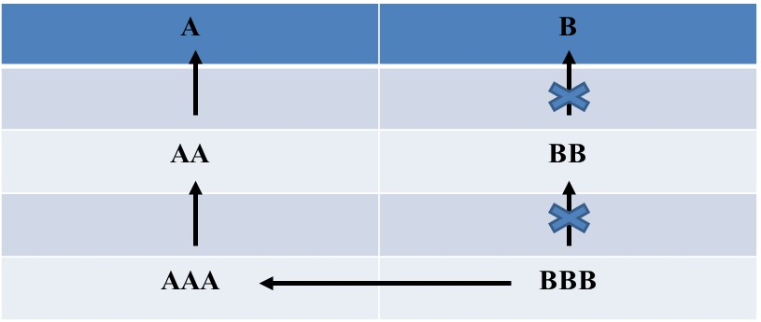
Figure 15. Way Around a Negative Response Scenario Two
Communicate the issue to another organization that has the authority. The caveat is that BBB is a representative of B so BBB needs to be diligent in pushing the issue. Even though one’s own organization is not involved, one must still inform the boss.
Scenario 3: When the top decision maker is hostile or laissez-faire (or no one is in that position) 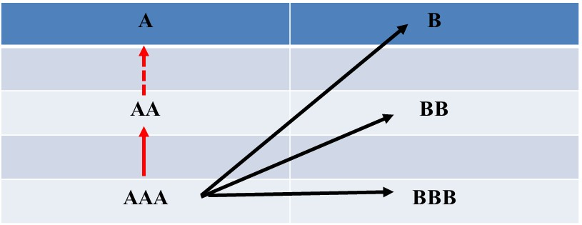
Figure 16. Way Around a Negative Response Scenario Three
When AAA is rep for A or AA, take charge and brief afterwards to AA who then may or may not pass on the information. Need to convey the importance of message using every available connection.
Scenario 4. When your own network cannot give you the answer
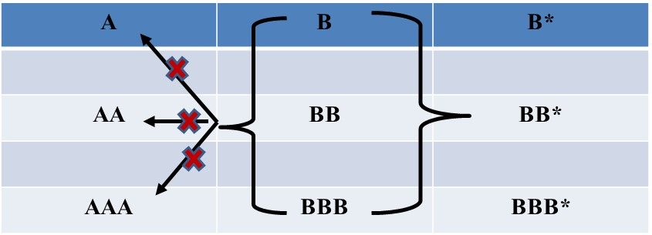
Figure 17. Way Around a Negative Response Scenario Four
Go to a decision maker in one’s network that is external to the core network. Go there because you can then access the higher network authority. The example relevant to the NDSP task force occurred when an action officer (AO) from USAFE asked to be one of the EUCOM representatives for the task force. When EUCOM denied the request, the AO went to Headquarters Air Force and asked to be their representative.
Each interview referenced previous relationships. Even the understanding of a love-hate relationship can help to define how to advance an issue. Do you continue to work with the person or do you find a way around? Everyone interviewed worked for at least two of the organizations connected to DoDEA’s school council network. This contributed to the depth of personal and organizational experiences that worked in the positive when pushing agenda items.
The following section is a synthesis of interview findings that form a practical application of how to push or advance personal or organizational agendas. I delineate between push and advance because push is an action while advance is the result. Each, predicated on themes of leadership, relationship building, trust, and communication, entails some type of conscious action:
- Find action officers (AOs) willing to work around a “no” but more importantly, find AOs who understand why the “no” happened. The AOs are the middlemen, the working group attendees, the ones who answer to a higher authority. The effective ones are those who can move in and out of the politics both among and between organizations.
- Take time to understand why you cannot do something. Do you have the expertise, resources (personnel and/or fiscal), or authority? Do you have the information?
- If you cannot do something, find someone who can (look for those not bound by politics. Ask, who has the authority? Who has the information? Who has the resources? “You gotta have someone who knows the dynamic, knows the people, knows the environment, has the connections, and is well connected and is driven by partnership collaboration to have the effect” (Interview dated November 18, 2015). Sometimes it is looking for someone with technical ability like knowledge and experience with writing legislation.
- Take time to understand why the answer is “no”. Maybe the timing is wrong, the action does not align with organizational priorities, and/or the actual decision maker is no longer there (there is a gap in position). “Do you have the right people in place, with the right skill sets and the right numbers with the right training and background, with the right mission statement, the right commander’s intent, the right authorizations, and the right direction to do what the commander thinks he has tasked you to do?” (Interview dated November 7, 2015)
- Another reason not to accept a “no” is that maybe the people who say “no” at the higher positions held the lower position at one time and got “no” so they believe that since they were not able to do it no one can. Categorize this person as a barrier to change on this issue.
- Consider that maybe it is not an issue of the wrong process, but the wrong authority.
Symbolically, there was no one of high rank in Defense whose specific job it was to ensure that the commanders and troops in the field had what they needed. The Chairman of the Joint Chiefs of Staff spoke for the armed services and was the senior military advisor to the president, but he had no command authority over the military services or civilian components, and no money. The senior civilians who were my top deputies in the Office of the Secretary of Defense, the undersecretaries, had a policy advisory role and direct authority only within their own areas of responsibility. The very size and structure of the department assured ponderousness, if not paralysis, because so many different organizations had to be involved in even the smallest decisions. (pg. 116)

- Re-engage by providing “nay sayer” with new information or necessary resources. “What I tried to do was usher topics through the group and try to get the group to look at the topics from a broader spectrum. Who else is involved? You know, who does this really impact? What are the second and third order consequences of doing this or not doing it?” (Interview dated October 26, 2015)
- Re-engage if you think that you were not clear in your argument or if you gain new facts or insights.
- Highlight issue to new leadership even if previous leadership said “no”. (From consolidated memos: Attach this to new/incoming leaders who pick up with whatever information they are handed, that’s the starting point. So, new leadership is opportunity to reengage if you do not agree with current affairs or previous agenda not addressed. Opportunity to provide background. I remember when a new (deleted) came in and made the comment of drinking the Kool-Aid, “You put it down, I just picked it up and started drinking.” (Document Database, Tab 13a, consolidated memos)
- Take chances to present a new idea first. “Just find another way to work it, but you had the opportunity to sell yourself, sell your case, sell the issue. Not through some other action officer that works for somebody else. So that was an important opportunity for us and we, we took a lot of those risks. We did. Which some panned out really well...some didn’t.” (from interview dated November 18, 2015)
- Build trust before (or is this how trust is built?) by demonstrating commitment and loyalty to the organization. You cannot delegate this.
- Conduct business in person when possible. “Our visit was critically important because you have to see and hear some things in person to understand them fully. No number of briefings in Washington could take the place of sitting in the same room with the Iraqis, or some of our own people on the scene, for that matter.” (Gates, 2014, p. 35)
- Pair agenda with something that brings people to the table. For example, to appeal to the military side, bring in the discussion of theater security then pair education with a strategic message.
Make sure senior leaders understand that if we don’t have the structure in place to support their strategy of service members and families together in remote locations. That you’re not going to support that strategy. So, if the students aren’t going and because the students aren’t going the spouses are staying home and guess what you have a family there and it’s a remote assignment all over again so you’re not producing the effect that you want to produce at the senior leader level...We were able to get senior leaders to come on board to support not only our service members but our families to be together...So we really pushed that so they were part of this process, not only to showcase the importance of being involved in the schools issues but from a leadership standpoint, these individuals own the assets across the command, the facilities, the installations, not the schools but all the support pieces for education so they (senior military leaders) had to be part of this process. (Interview dated November 18, 2015)

- Understand previous relationships. “This was one of those rare instances where a unique set of personal relationships stretching back decades allowed us significantly to mitigate otherwise intractable bureaucratic hostility. And it is still another reminder that when it comes to government, whether it works or not often depends on personal relationships.” (Gates, 2014, p. 92)
- Find who has the answer or resources and/or who is willing to do the work
- Qualities of persistence, humbleness, “relentless,” element of “willing to do battle,” “won’t toe the line” appear effective but are construed positively if on the same side of issue while negative if on the other side.
- It is not just important to have access to senior leaders but to be seen as a senior leader. Know what you bring to the table. Go in with information. Others may have the checkbook and political connections. What do you bring to the conversation?
- Understand that collaboration is hard work and entails paying attention, learning the system, and not accepting “no”.
I really believe in collaboration, so through collaboration you then influence buy-in, you have people as part of the process and then good, bad, ugly, whatever, they are part of the victory or also part of the failure. They own the process. For some it’s a very cumbersome process but I’ve always found it to be a, a way to get buy-in and create enduring relationships and create enduring buy-in and partnerships. (Interview dated November 18, 2015)

- Admit that you may not have the resources or information but are willing to work collaboratively. There was a trend in all of the interviews where each simply stated that they did not know something. I made a note about the quality of candor and honesty
- Do not limit yourself to pushing only good news.
- Appreciate honest conversation. “There were a handful of people I could count on to criticize me to my face, to tell me when I had given a poor answer to a question, to question my patience or impatience with others in the Pentagon, and to question a decision.” (Gates, 2014, p. 275)
- It is ok to “create chaos” (Interview dated October 23, 2015). Stirring up an issue even when there is no immediate solution gets people to start paying attention.
- Identify the level of solution you are willing to accept and level of effort you are willing to provide.
- Understand that not having authority does not have to be a barrier. Just because you do not have authority does not mean you cannot provide input and/or convince people to act. In the case of the Malta waiver:
There are strategic opportunities that present themselves and that could be out of the normal program management, strategy, or capability. In other words, somebody else owns it but I don’t care because it’s an important issue to me and the timing is right for me to hit a senior leader with it. It was a strategic opportunity to have an impact that should have been somebody else’s job but our leadership said if we go this other route it could take us months. So let’s make this happen right now. (Interview dated November 18, 2015)

- Regarding the issue of fairness and consistency, it is ok to focus on individual, unique relationships. However, you just need to communicate with all those at the table or in the group to build awareness, not necessarily consensus. (From consolidated memos: Data show pattern of DoDEA willingness to listen and engage on unique military requirements such as the Hawaii study, Korea, and Papa, Hungary)
- Inherent in the discussion of pushing agendas are the tactics used and responded to. “Have to be out and about” and “accessible” to gain information first hand (Interview dated October 9, 2015).
You go out in the field and you see what’s going on. You ask questions, you look at what you find, you come back with a little more analysis and then figure out, do I have a problem? And your job really is how do I make things better for the field? How do we achieve what we’re tasked to do? How do I help them? (Interview dated October 26, 2015)

- If you are local, go in person, Tandberg (video chat), anything that gives you face time. Follow up with emails and phone calls to address any questions and provide reminders of meetings.
- As an AO, you have to have access to senior leaders across organizations. “Take the filters off and connect the people directly with the people who can have the impact” (Interview dated November 18, 2015). One of the first things my boss did for me was call the Chief of Legislation and Policy at DoDEA and told him I was his new school’s person and that I was coming to the States and would he find the time to meet with me. During the one hour lunch I was “brought up to speed” on multiple issues (Document Database, Tab 13a, from consolidated memos).
- Learn to be a trusted agent.
This same process that I talked about that applies during acts of combat can apply and in fact worked well because the senior commander had someone to turn to that wasn’t in his chain of command, was not a threat, was not a competitor and literally the comment is, hey boss let’s go have a cup of coffee and go talk about this. So we go have a cup of coffee and go talk about it. In many cases it is just a conversation, what do you think about this, Socratic Method, well what do you think about this? Here’s what we’ve observed, and then you plant a few seeds and then if a comment is necessary, make a direct comment and then let them decide how they are going to handle it. In other words, let the staffs fix themselves is the best way for this to happen. (Interview dated November 7, 2015)

- Understand that there is a certain way, an appropriate way to engage with military leadership.
I was a voice in the middle. I had spent a considerable amount of time with (Director) talking about how to work with commands. The unwritten code within the military is you have to be accessible to the generals. You don’t have to do what they want you to do and this is really simplistic, but if a general asks you to do something and you decide not to do it you don’t send him a letter telling him no. You send him a letter but you pick up the phone before you sign that letter and you tell him that you’re going to tell him no. You build a rapport with these people, you do what you need to do, but you make sure they believe you heard them, you understood their message, but you just couldn’t come to the same conclusion that they did. (Interview dated October 26, 2015)

- Understand your personal limitations. What are you willing to do and what can you reasonably do alone?
- Value your organizational assets.
I know the SLO position, school liaison officer position, within EUCOM was a challenge to keep on the books, has been a challenge to keep on the books. What senior leaders didn’t understand is that you’ve got to have that active voice within the command that is knowledgeable and is passionate and is connected to be able to work these issues. You can’t just arrive on a Monday with little to no information and have this solved by Wednesday. You gotta have someone who knows the dynamic, knows the people, knows the environment, has the connections and is well connected and is driven by partnership collaboration to have the effect. (Interview dated November 18, 2015)

- Follow the issue and persist until resolution. Persistence relates to both quality of continued action but also awareness of time, accelerating the decision, keeping the facts and players notified. Following through to all levels, even when the issue is out of your hands or else it may stall elsewhere. Monitor issues and continue to evaluate the merit of the request. Advancing agendas takes time and persistence.
This makes relationships, communication, and leadership important enablers to action. Inherent are the characteristics and abilities of Directors, Commanders, and non-positional Action Officers to navigate through the bureaucracy. Most of those interviewed emphasized the role of mentoring and training which then facilitated the success of others.
Whether you’re in the civilian sector or the military sector it doesn’t really matter. Building relationships, building trust you know, proving that you are a worthy partner, that you have something to bring, that you aren’t just taking, but you’re bringing capability to the discussion. That in time of crisis, all the partners have the ability, and again whether US or not, have the ability to come together and solve problems. (Interview dated November 7, 2015)

Conclusion
In this chapter, I answered my research questions. I evaluated the timing of the decision to create the task force in relation to the combination of leadership and circumstances in the 2007-2010 time frame. I discussed findings from the data that identified the importance of conveying messages through multiple avenues and the value of leadership, relationships, and communication. Specifically, I addressed how an AO can work around a negative response, and how to evaluate opportunities during times of positional leadership changes to push agendas. I concluded with a combination of advice and actions from the interviews that exemplify the practical application of how to push or advance agendas.

CHAPTER SIX
Conclusions, Implications, and Recommendations

Introduction
This qualitative case study investigated the circumstances surrounding the decision to create the Non-DoD Schools Program (NDSP) task force in the spring of 2010. In this chapter, I evaluate the usefulness of my chosen theoretical framework and review previously identified theory and emerging literature in light of prominent themes identified in the research. Next, I provide a summary of findings. Finally, I relate the implications of the study and make recommendations for future research.

Evaluation of Theoretical Framework
From a theoretical framework perspective, the choice of Kingdon (1984) as an incremental approach to advancing agendas with a contrast of Punctuated Equilibrium Theory (PET) as an indicator that something specific happened which sparked immediate attention to the issue proved to be an appropriate framework. One can see the flow of streams, timing of events, the implied sense of urgency due to multinational involvement versus ongoing, slow moving changes, the public mood, the politics, leadership changes, and new opportunities to advance agendas. Throughout the data, the actions and qualities of a policy entrepreneur are evident along with the themes of leadership, relationships, and communication. However, the concept of time is still rather elusive as literature and findings on policy entrepreneurs describe action over an indeterminate amount of time while in this case the connection of multiple policy entrepreneurs occurred in a very short amount of time.

Timing
Timing was an important concept in the literature and in the interviews. Using case study methods, I traced and analyzed contributing factors and key events to gain a better understanding of actor’s transactions, decisions, and involvement over time in the actionable process of pushing an agenda. Again, the specific incident of decision making to form the NDSP Task Force was the event from which I worked backwards. An unexpected find was the number of interviews that attributed the flux of problems on a previous decision and thus established a start point for analysis. This provided an additional layer of storytelling that, in additional to answering how the topic of Non-DoD Schools Program advanced, answered why the Non-DoD Schools Program task force formed.
Earlier I acknowledged the examples of weaknesses of process tracing outlined by Kingdon (1984), Lichtenstein (1995), and Jones and Baumgartner (2012) as an adequate means to establish specific beginning of events. However, Yin (2009) stated that the “ability to trace changes over time is a major strength of case study” (p. 145). For this particular study, I was able to trace changes over time and establish the specific beginning of events from the perspective of those interviewed.
In Chapter One, I posited that the timeframe of 1998-2000 sounded similar to the 2010 task force decision (drawdowns in Europe and mission changes for example) and so warranted a discussion. Doing a specific time-series analysis (chronology) a quick comparison showed a relevant pattern of leadership change, military operations change, and mobilization of stakeholders that supports the ongoing need for collaboration and strong working relationship between the civilian and military communities and organizations. Both also speak to the viability of the council system over time. While this was not a study on the effectiveness of the council system, the data demonstrate that once again the structure of the council system was conducive to elevating issues. I add the qualification that it takes a concerted, multi-pronged approach, and that elevating issues does not imply resolution.
The decision to pull in the research from Wright (2000, 2002) provided a broader historical perspective and proved valuable for several reasons. First, one interview actually mentioned the Wright report and provided a firsthand account of that period. Second, now researchers have a ten-year look for future studies that provides substance for evaluating Punctuated Equilibrium Theory (PET). Furthermore, another benefit of linking to the 2000 period relates to the Hayes’s (2008) dissertation proposition that research on the policy change process requires a policy subsystem studied over a decade or more. In order to make the connection to the policy subsystem that I identify as the school council network, I return to the theories, such as Advocacy Coalition Framework, that I shelved when I chose Kingdon for the theoretical framework.

Relationships and Networks
Earlier in my paper, I justified the choice of existing in a policy world due to the political level of the senior leaders of each organization, and the legislative foundations of DoDEA and its formal educational council structure. A return to the Advocacy Coalition Framework (ACF), “Policy making occurs in policy subsets, which is a policy area that is geographically bounded and encompasses policy participants from all levels of government, multiple interest groups, research institutions, and the media” (Weible & Sabatier, p. 125) provides an enhanced definition appropriate to my findings. The variety of publically available documents representing the multiple entities focused specifically on the activities of DoDEA, from the teacher’s unions to newspaper outlets to Congressional Research organizations firmly add to my conclusion that this is a policy subset. This connection provides the base for using the educational council network as a unit of study for future research.
Weible and Sabatier (2006) highlight Sabatier and Jenkins-Smith (1993) to explain, “Policy participants both specialize in a policy subsystem to effectively achieve their objectives and maintain their participation over long periods of time to ensure objectives are achieved” (p.126). Again, in relation to my work, the element of time is still undefined. How long does it take to achieve an objective? While Kingdon is the better fit for the process of pushing agendas and understanding the conditions inherent in the political system, the ACF is better suited to the themes identified of relationships and communication in relation to the coalition building that occurred to enable the push of the NDSP agenda.

Leadership Qualities and Actions of Policy Entrepreneurs
My study shows the importance of the Action Officer, or the “middle man,” as a policy entrepreneur when working with other policy entrepreneurs across and within networks. This conclusion supports the work of Majewska-Button (2010) and Joyce (2013) who contended that the “middle man” or mid-level agents or actors could affect change in military organizations despite the bureaucracy. I add a layer to the discussion by providing additional real-world stories on the activities of these action officers to push agendas. The development of relationships is important. Their effectiveness optimized by awareness of circumstances that includes positional leadership changes and possession of certain qualities such as passion, perseverance, ability to develop relationships, and aptitude to work around a negative response.
In Chapter Two, I examined transformational and transactional leadership theories that addressed characteristics of leaders. While I expected to hear qualities, which I did, I did not expect to note that, in general, no one spoke about how their position enabled them to act. The exceptions were noted when certain respondents mentioned that they went to meetings specifically because the weight of his rank ensured that the command’s voice was heard at the table. Considering that no one interviewed talked about the power of positional leadership directly related to this event I resumed focus on the mid-level actors who do not have the top-level decision making authority.
The reoccurring themes of relationships and interactions within this system compel me to return to a closer look at the policy entrepreneur literature, outside of Kingdon (1984), as a base for future research. While his concept of the policy entrepreneur was an appropriate starting point to identify certain qualities and actions of a policy entrepreneur, the definition did not adequately apply when I associated the concepts in network theory to bring in the dynamics of multiple policy entrepreneur engagement within multiple organizations. I discovered additional research that conceptualized policy entrepreneurs beyond the work of Kingdon and matched my findings.

Communication and Defining Problems
Mintrom and Norman (2009) conducted a comprehensive literature review on the varying conceptualizations of policy entrepreneurs. They propose four key elements: displaying social acuity (effectively operate in networks), defining problems, building teams (promoting and maintaining advocacy coalitions), and leading by example. The element of defining problems is relevant as there were many inconsistent definitions of what the actual problem was in conversations leading up to the decision to create the task force. At the beginning of the study, I had a preconceived conclusion, based on a mix of observations and conversations, of the overarching problems related to the administration of the Non-DoD School Program as evidenced in my original stated research problem statement. While I still concur that military leaders do not systematically include education, the problem during my event stemmed from a difference in how to address the perceived problem. Fundamentally, the question was who should pay for the Non-DoD School Program and why? This leads to an interesting connection on the policy entrepreneur level, Mintrom and Norman (2009) included Crowley (2003) whose study
Highlights competition among policy entrepreneurs themselves. Often, discussions of policy entrepreneurship have characterized the policymaking context as consisting of a group of like-minded change advocates doing battle with myriad forces seeking to maintain the status quo. Crowley alerts us to the more complicated possibilities. Indeed, the politics of policy change can get extremely interesting when the contest does not involve simply shifting the status quo but also involves debate over the direction that such a shift should take. (p. 660)

This is where it is important for policy entrepreneurs to understand the network and history of issues as well as to have a clear understanding of what others perceive to be the problem. As I stated earlier, a clearly identified problem or solution did not exist, just a swirl of circumstances and conditions. I would also add that it might not always be about significantly changing current ways of doing things but rather realigning the conversation back to the original intent of the organization and understanding that one does have the authority to address the problem. What are the organization’s agendas? In addition, I will add that in this case, it was also an opportunity to evaluate the need for change. Although changes occurred externally, the internal system or process may not need to change.
While one cannot take an individual policy entrepreneur out of the organizational context, the individual’s qualities and abilities to identify a window of opportunity, and subsequently to act, are just as important, “Instances occur when new challenges appear so significant that established systems of managing them are judged inadequate. A key part of policy entrepreneurship involves seizing such moments to promote major change. Such action requires creativity, energy, and political skills” (Mintrom & Norman, 2009). I contribute that the political skill or savvy as gleaned from my interviews is the ability to transcend position: the policy entrepreneur functioning within bureaucratic limitations and the ability to move in and out of the politics. I recommend future research on identifying the quality of relationships and communication that is conducive to policy entrepreneurs moving in and out of politics.

Motivation
Mintrom and Norman (2009) cited the need for studies on the motivations and strategies used by policy entrepreneurs. My study provided some insight into motivations and strategies for action. Their findings, unrelated to military organizations, indicate, “Bureaucratic actors who develop track records for innovative action and who are prepared to move across organizations are rewarded in terms of faster than usual career progression” (p.661). Evidence from interviews and personal knowledge lend to conclusions that personal motivators in my case study include direct connection to schools because of living in the community, having a child in the school system, or as a job responsibility.
Another angle on motivation is internal motivators. Earlier I presented examples of multiple ways issues were resolved that show how an individual or group moved around the answer of “no”. What is relevant to the “no” is the understanding of the reason for it. Mainstream literature based on research conducted on organizations, such as Collins (2011) Good to Great, concluded that the right people are self-motivated. Dweck’s (2007) research on growth mindset and the “transformative power of effort” referenced Collins’s five-year study on organizations that concluded leaders “look at failures in the face and maintain faith that they would succeed in the end” (p. 109). She adds the work of Warren Bennis who asserted that some people do not set out to be leaders and have no interest in proving themselves. Dweck concluded that growth minded people did not even plan to go to the top. They got there because of doing what they love, the love of challenge, the belief in effort and resilience in the face of setback (p.12). One of my interviews included a summation of this exact sentiment next to which I wrote, “This is gold.”
Passion comes from within. Passion is indicated by somebody who won’t give up. When they see something, they will continue to follow that and push it because it’s bigger than themselves. It’s bigger than the organization. That’s was passion is. Passion leads to enduring impact, let’s say. Sometimes the numbers don’t line up but you have a sense that this is an important mission and it’s impacting a lot of people and there’s nobody else there to get behind them and support them. When I see passion in someone, somebody you know, I can kind of step away because I know they have their own fuel system. That passion will fuel them, propel them to take on the fight to engage at all levels and to make sure people hear them. And I think it’s a very positive thing to have, an action officer, a project officer somebody in that position that can be passionate, and they can be outside the political bounds. As you get up in to the more senior leadership positions, you’re fenced by the politics. (Interview dated November 18, 2015)

Summary of Findings
The topic of the Non-DoD School Program (NDSP) became an actionable item on the highest level of the DoDEA educational advisory committee and council system due to the multiple avenues for problem solving inherent in the structure (both formal and informal) and the activities of a small group of individuals committed to keeping the topic on the forefront of discussion. Furthermore, personal and organizational agendas advanced due to the alignment of personnel with specific qualities and abilities dedicated to alleviating the barriers associated with providing a quality education to children of certain civilian and military members assigned to locations where there are no adequate educational opportunities.
What makes this study remarkable is the combination of dynamics identified that occurred in the relatively short period of time that influenced the decision to create the Non-DoD Schools Program (NDSP) task force in spring 2010. The end process of the internal programmatic transition of the actual Non-DoD School’s Program from the regional areas to the headquarters impelled the review of how to administer the program while the unanticipated second and third order effects from previous decision making regarding the closure of the DoDEA run boarding school converged during this time. The creation of new military mission support structures such as the Heavy Airlift Wing (HAW) in Papa, Hungary, the establishment United States Africa Command, a new Combatant Command, an increase of Department of Defense (DoD) personnel embedded with the North Atlantic Treaty Organization (NATO) missions, and the transformation of the US military on the Korean peninsula are just a few events that stretched the resources of a network of organizations already depleted from budget cuts and mandates to downsize. Meanwhile, the ongoing military engagements in Iraq and Afghanistan and emerging global terrorist threats added to the tension.
The public debate on who should fund the Non-DoD Schools Program (NDSP), a $50 million ancillary program, suddenly shifted into a larger conversation on the importance of supporting the warfighter and the military agenda of trying to keep families together in remote locations where there are no adequate educational opportunities for school-age dependents. The final part to the mixture was the amalgamation of experienced and new individuals at positional leadership and action officer levels across several organizations who rapidly developed a shared understanding of the ramifications of not finding a solution despite the absence of a clearly defined problem. Ultimately, a leader with the authority to make the decision to create the task force emerged.

Implications and Recommendations for Future Research
While this research was not on the need or efficacy of the NDSP program, the data show that it is a necessary program with important implications to our military service members and families, both from a quality of life perspective and from a strategic military perspective. Thus, I conclude that continued support and discussion on the areas of concern, such as the decision-making processes to send families to remote areas, is necessary. Future studies could capture this decision-making process. Future studies within the military hierarchy and civilian military organizations are a good place to continue the discussion on the qualities and actions of policy entrepreneurs within bureaucratic and networked organizations to ascertain motivations and positive action skill sets.
Organizational leaders many times do not look beyond his or her own organization to evaluate if a decision was the right thing to do. My research provides insight into several influencers on the decision making process. One can evaluate possible combinations that, taken in context, will help leaders to learn to anticipate, create, and evaluate the circumstances for advancing organizational agendas. One could design a case study on the development of the education plan in Papa, Hungary, which will add value to the military literature on the Heavy Airlift Wing (HAW) to complete the template on how to create a new mission capability with one that includes a systematic plan for educational requirements from the beginning.
The lack of access to the historical documents internal to the organizations related to this event such as executive summaries, educational council agendas, after action reports and meeting minutes limited the findings on the literal movement of agenda items related to the Non-DoD Schools Program as well as the activities of the task force. In addition, the lack of access to the Department of Defense personnel who still work for the specific organizations and who had firsthand knowledge of this time produced a disproportionate weight of responses favoring a military perspective. To offset this limitation and to add additional perspective to this study, for future research, I recommend pursuing the Freedom of Information Act (FOIA) option to gain access to institutional documents. Appendix G contains a sample letter and instructions.
This case study represents a small subset of organizations and activities within a larger network and is Europe-centric by design. In light of the fact that I established a baseline of activity, an opportunity for a comparative case study is to approach from the Pacific point of view to gain another perspective on the activities during the 2007-2010 timeframe leading up to the decision to create the Non-DoD School Program (NDSP) task force. Another perspective to consider is the role of the military spouse and community mobilization to affect change or to facilitate identification of problems in advocating for a quality education. Everyone interviewed benefitted from having a highly educated and involved spouse who was able to provide an honest perspective derived from the ability to cut through layers of politics and rhetoric at multiple levels.

Conclusion
This study adds to the body of literature on leadership theory, network theory, and Punctuated Equilibrium Theory. It advances Kingdon’s (1984) work by connecting leadership and network theories as well as adding a discussion on the ambiguity of time. My research shows the confluence of leadership changes at multiple levels in multiple organizations, budgetary constraints and influxes, global conflicts, the transformation of new military missions in overseas communities paired with the drawdown of the military on established military installations. My research design which included Yin’s (2009) five components - a study’s questions, its propositions, unit of analysis, logic linking data to the propositions and criteria for interpreting the findings - allowed for a consideration of multiple theories related to leadership, network, and time framed by Kingdon’s (1984) work on advancing agendas in organizations.
Finally, the rival hypothesis of Punctuated Equilibrium Theory provided a contrast that, while not evidenced directly preceding the event, allowed for a more robust analysis of potential events whose affects slowly rolled to create a larger unexpected multi-organizational impact. A product of the research includes a physical database of documents to include congressional testimonies, legislation, newspaper articles, and research. This compilation incorporates proactive practical lessons gleaned from personal experiences of those interviewed, and from memos, to promote awareness of actions, organizational and functional processes, and external environmental circumstances one needs to consider as factors that influence decision making in networked organizations.
Overall, this study provided insight into the various activities of multiple organizations linked together. To achieve this I traced the topic of the Non-DoD School Program that had compound effects on both the program management of a non-educational instruction program element of DoDEA and the operational mission of the military. In speaking to those uninitiated with the military (less than 2% of the United States population is military affiliated), I extrapolate to a global issue but that can similarly represent the theoretical and practical applications that I combined in my study specific to network theory and leadership. As I suggested in the opening of the Prologue, substitute the word commodity or contraband for agenda. Developing and pushing a product and the concept of the policy entrepreneur go hand in hand, as one must find linkages and develop relationships to move information, money, contraband, or agendas. At the end of the day, the result rests on the ability and the actions of groups of individuals to navigate within the formal and informal network of organizations.

Epilogue
While the event at the heart of this dissertation is over, the reason for the discussion persists. Often, people ask me about the actual results of the Non-DoD Schools Program (NDSP) task force. The simple answer is I do not know because I left a few months into the meeting after my military spouse received an assignment and, by regulation, I could not stay in my job. There is no publically available information and those who I interviewed did not have an internalized answer other than to recommend a review of the Dependent Education Council (DEC) agendas and minutes. Several products from the Department of Defense Education Activity (DoDEA) website that appeared to reflect an outcome were actually the result of a review process when a new program manager assumed responsibility when the Partnership Branch of DoDEA absorbed the Non-DoD Schools Program. However, I can add a special note related to several topics and events presented throughout the research:
- The Heavy Airlift Wing (HAW) at Papa, Hungary achieved full operational capability in 2012 and continues to consist of ten NATO nations, to include the United States and two Partnership for Peace nations. A review in 2015 of the NDSP schools listing on the DoDEA website indicates that Quality Schools International (QSI) now provides educational support. According to their website, QSI is a private, non-profit institution responsible for 37 schools in 28 countries. The school in Papa, Hungary, opened in 2012, currently supports 80 students.
- The Hawaii Study (2013) concluded that DoDEA should not run schools in Hawaii (Blum, Blum, Hughes, Mmari, & Parekh, 2013).
- The elementary school that opened in South Korea at Camp Casey in 2010 as part of the transformation of US Forces Korea will close in the summer of 2016 due to the decline in enrollment once the Army stopped sponsoring families in that location in 2014 (Rowland, 2015). Transformation continues with the on-going development of Camp Humphreys south of Seoul described as the largest ever for the military (Rowland & Chang, 2013).
- As part of the Army transformation in Europe, United States Army Garrison (USAG) Baumholder (once slated for closure in 2005) now aligns with the new USAG Rheinland-Pfaltz while the garrisons of Heidelberg and Mannheim closed in 2013.
- The CONUS Education Options Assessment (CEOA) started in 2014 to review the possibility of closing DoDEA’s schools in the United States. The study conducted by the National Defense Research Institute through a contract with RAND Corporation costs $905,000 (Bushatz, 2014).
- Boeblingen Elementary and High School groundbreaking in Stuttgart, Germany occurred November 2013 with the grand opening on September 2015. Originally funded for $47M, the total cost of the project was $98M (Little, 2015).
- The new buildings for the international school at Supreme Headquarters Allied Powers Europe (SHAPE) in Belgium opened 2015 (Purtiman, 2014).
- DoDEA implemented a new Math program for school year 2015-2016 and currently is adopting Common Core standards. They use the terminology College and Career-Ready Standards (Richmond E., 2015).
- EUCOM no longer orchestrates the annual Quality of Life Conference.
- United States Air Forces in Europe (USAFE) still uses the School Advisory Board (SAB) model.
- The 2015-2016 back to school DoDEA message highlighted:
Beginning in School Year 2010-2011 DoDEA initiated an aggressive and comprehensive program to completely renovate or replace 134 of its schools worldwide. In support of DoDEA’s school construction program Congress has appropriated $2.8 billion from FY 2011-2015; Through the Educational Partnership Branch, which now has oversight into NDSP, Non-DoD School Program (NDSP) serves 2,794 students on 132 foreign locations at about $60 million. DoDEA, since 2009 awarded 331 grants to military connected Local Education Activities (LEA) totaling nearly $400 million, for projects supporting 480,000 military connected students in over 2,200 schools. (O'Gara & Kanellis, 2015)

With respect to timing, this year, 2016, is a presidential election year that will inevitably produce multiple windows of opportunity for advancing agendas, while shutting down opportunities for others. The importance for leadership, policy entrepreneurs, and decision makers (not mutually exclusive) at multiple political to grass roots levels to understand the new dynamics, organizational networks, and factors that influence decision-making cannot be overstated. The current agenda to focus on our armed forces and their families who remain vigilant as the military missions endure must continue to advance.

References

(2010). $200 billion in illustrative savings (Draft). National Commission on Fiscal Responsibility and Reform, Washington. Retrieved September 5, 2015, from https://www.fiscalcommission.gov/sites/fiscalcommission.gov/files/documents/Illustrative_List_11.10.2010.pdf
1, R. (2015, November 18). (M. Langenderfer, Interviewer)
10, R. (2015). (M. Langenderfer, Interviewer)
12, R. (2015, October 9). (M. Langenderfer, Interviewer)
15, R. (2015, November 17). (M. Langenderfer, Interviewer)
17, R. (2015, November 7). (M. Langenderfer, Interviewer)
(2010, March 10). Hearing on national defense authorization act for fiscal year 2011 and oversight of previously authorized programs before the committee on armed services house of representatives one hundred eleven congress second session(H.A.S.C. No. 111-132). Washington: U.S Government Printing Office.
3, R. (2015). (M. Langenderfer, Interviewer)
Adkins, G. (2011). An exploratory analysis: The role of network structures and boundary spanner behaviors as related to collaborationin interorganizational networks.
Affairs, U. A. (Ed.). (2010, June 16). Transcript: Air force times interview with major general michael snodgrass, u.s. africa command chief of staff. Retrieved December 14, 2015, from http://www/africom.mil/Newsroom/Transcript/7631/transcript-air-force-times-interview-with-major-ge
Agency, I. M. (2004, March). Component Command Council (CCAC). Retrieved from http://www.powershow.com/view/5600a-ODNmY/Component_Command_Advisory_Council_CACC_powerpoint_ppt_presentation
Anderson, L. B., Bracken, J., & Bracken, M. (2000). Review of department of defense education activity (DoDEA) volume II: Quantitative analyses of educational quality. Alexandria: Institute for Defense Analyses.
(2010). Annual report 2010. Department of Defense Education Activity, Alexandria. Retrieved from http://www.dodea.edu/newsroom/publications/loader.cfm?csModule=security/getfile&pageid=105415
Army School Support Services Strategic Plan 2009-2013. (2010, February). FMWR.
Arrow, H., Henry, K. B., Poole, M. P., Wheelan, S., & Moreland, R. (2005). Traces, Trajectories, and Timing: The temporal persective on groups. In M. S. Poole, & A. B. Hollingshead, Theories of small groups interdisciplinary perspectives (pp. 313-367). Thousand Oaks: Sage Publications, Inc.
Augustine, C. H., Levy, D. G., Benjamin, R. W., Bikson, T. K., Daley, G. A., Gates, S. M., . . . Moini, J. s. (2003). Strategic assessment and development of interorganizational influence in the absence of hierarchical authority. National Defense Research Institute. Santa Monica: RAND. Retrieved September 15, 2015, from http://www.rand.org/content/dam/rand/pubs/monograph_reports/2005/MR1561.pdf
Ballinger, G. A., & Rockmann, K. W. (2010). Chutes versus ladders: Anchoring events and a punctuated equilibrium perspective on social exchange relationships. Academy of Management Review, 35(3), 373-391. Retrieved November 4, 2014
Bannon, L. J., & Kuutti, K. (1996). Shifting perspectives on organizational memory: From storage to active remembering. Proceedings of the 29th Annual Hawaii International Conference on System Sciences, (pp. 156-166).
Bass, B. (1990). From transactional to transformational leadership: Learning to share the vision. Organizational Dynamics, 19-31.
Bass, B., & Avolio, B. (1994). Improving organizational effectiveness through transformational leadership. Thousand Oaks: Sage Publications.
Bass, B., & Avolio, M. (1994). Transformational leadership and organizational culture. International Journal of Public Administration, 541-54.
Battilana, J., & Casciaro, T. (2012). Change agents, networks, and institutions: A contingency theory of organizational change. Academy of Management Journal, 55(2), pp. 381-398. Retrieved November 30, 2012, from http://dx.doi.org/10.5465/amj.2009.0891
Beach, B. (2008, January 22). Stuttgart opens warrior transition unit. Retrieved August 28, 2015, from The Official Website of the United States Army: http://www.army.mil/article/7060/
Beebe, S. A., & Masterson, J. T. (2012). Communicating in small groups: Principles and practices. Boston: Allyn & Bacon.
Berg, B. L. (2009). Qualitative Research Methods for the Social Sciences (7th ed.). Boston: Allyn and Bacon.
Berkompas, C. K. (2010). Toward strategy for building partner capacity: Combined ownership and operations (Masters Research Project). Carlisle Barracks, PA: U.S. War College.
Blue star family 2010 military family lifestyle survey. (2010, September 10). Blue Shield of California Foundation. Retrieved Decemeber 15, 2015, from http://www.slideshare.net/BlueStarFamilies/2010-military-family-lifestyle-survey
Blum, R. W., Blum, L. M., Hughes, M., Mmari, K., & Parekh, J. (2013). The military child education in hawaii study.
Boyatzis, R., & McKee, A. (2005). Resonant leadership. Boston: Harvard Business School Press.
Bryman, A. (1992). Charisma and leadership in organizations. London: Sage.
(2004). Budget book fiscal year 2003. Department of Defense Education Activity, Alexandria. Retrieved from http://www.dodea.edu/newsroom/publications/loader.cfm?csModule=security/getfile&pageid=92601
(2005). Budget book fiscal year 2004. Department of Defense Education Activity, Alexandria. Retrieved from http://www.dodea.edu/newsroom/publications/loader.cfm?csModule=security/getfile&pageid=92603
(2006). Budget book fiscal year 2005. Department of Defense Education Activity, Alexandria. Retrieved from http://www.dodea.edu/newsroom/publications/loader.cfm?csModule=security/getfile&pageid=92580
(2007). Budget book fiscal year 2006. Department of Defense Education Activity, Alexandria. Retrieved from http://www.dodea.edu/newsroom/publications/loader.cfm?csModule=security/getfile&pageid=92586
(2008). Budget book fiscal year 2007. Department of Defense Education Activity, Alexandria. Retrieved from http://www.dodea.edu/newsroom/publications/loader.cfm?csModule=security/getfile&pageid=92571
(2009). Budget book fiscal year 2008. Department of Defense Education Activity, Alexandria. Retrieved from http://www.dodea.edu/newsroom/publications/loader.cfm?csModule=security/getfile&pageid=145859
(2010). Budget book fiscal year 2009. Department of Defense Education Activity, Alexandria. Retrieved from http://www.dodea.edu/newsroom/publications/loader.cfm?csModule=security/getfile&pageid=145860
(2011). Budget book fiscal year 2010. Department of Defense Education Activity, Alexandria. Retrieved from http://www.dodea.edu/newsroom/publications/loader.cfm?csModule=security/getfile&pageid=145863
(2012). Budget book fiscal year 2011. Department of Defense Education Activity, Alexandria. Retrieved from http://www.dodea.edu/newsroom/publications/loader.cfm?csModule=security/getfile&pageid=181442
(2013). Budget book fiscal year 2012. Department of Defense Education Activity, Alexandria. Retrieved from http://www.dodea.edu/newsroom/publications/loader.cfm?csModule=security/getfile&pageid=223005
(2014). Budget book fiscal year 2013. Department of Defense Education Activity, Alexandria. Retrieved from http://www.dodea.edu/newsroom/publications/loader.cfm?csModule=security/getfile&pageid=363239
(2015). Budget book fiscal year 2014. Department of Defense Education Activity, Alexandria. Retrieved from http://www.dodea.edu/newsroom/publications/upload/DoDEA-FY-2014-Budget-Book-ppt-Read-Only.pdf
Burbach, J. B., & Van Pool, J. E. (Eds.). (2010, October). Installation management command: A short history 2001-2010. Retrieved August 25, 2015, from The Official Website of Installation Management Command: http://www.imcom.army.mil/Portals/0/hq/about/history/IMCOM-History.pdf
Burke, W. W. (2008). Organization change: Theory and practice. Thousand Oaks: Sage Publications.
Bushatz, A. (2014, November 14). Study could recommend closing some dodea schools. Retrieved September 15, 2015, from http://www.military.com/daily-news/2013/11/14/study-could-recommend-closing-some-dodea-schools.html
Butts, C. T. (2008). Social network analysis: A methodological introduction. Asian Journal of Social Psychology, 13-41.
Caine, V., Estefan, A., & Clandinin, D. J. (2013). A return to methodological commitment: Reflections on a narrative inquiry. Scandinavian Journal of Educational Research, 57(6), 574-586. doi:10.1080/00313831.2013.798833
Carter, P., Dempsey, D. J., Kidder, K., & Schafer, A. (2015). Passing the baton: A bipartisan 2016 agenda for the veteran and military community. Washington: Center for a New American Security.
Chandra, A. (2010, March). Children on the homefront: The experiences of children from military families, testimony presented before the house armed services committee, subcommittee on military personnel on march 9, 2010. Retrieved from RAND Corporation: www.rand.org
Chandra, A., Martin, L. T., Hawkins, S. A., & Richardson, A. (2010). The impact of parental deployment on child social and emotional functioning: Perspectives of school staff. Journal of Adolescent Health, 1-6.
Charmaz, K. (2006). Constructing grounded theory: A practical guide through qualitative analysis. London: Sage Publications.
Church, A. T., & Warner, T. (2009). DOD planning, programming, budgeting, and execution system: A path toward improvement. JFQ Joint Forces Quarterly(53), pp. 80-84.
Ciulla, J. B. (2003). The ethics of leadership. Toronto: Wadsworth.
Clark, A. M. (2013). The effects of frequent relocations and deployments on the educational experience of military children: An autoethnography of a soldier (Doctoral dissertation). Ann Arbor: ProQuest LLC.
CNN. (2008, August 15). Poland, U.S. sign missile shield deal. Retrieved from CNN.com: http://edition.cnn.com/2008/WORLD/europe/08/15/poland.us.shield/index.html
Coburn, S. T. (2012). Department of Everything: Department of defense spending that has little to do with national security. United States Senate, Washington. Retrieved September 6, 2015, from http://www.dtic.mil/dtic/tr/fulltext/u2/a570614.pdf
Cohen, M. D., March, J. G., & Olsen, J. P. (1972, March). A garbage can model of organizational choice. Administrative Science Quarterly, 17(1), 1-25.
Cole, W. (2012, January 8). Ire over hawaii schools not enough to justify military-only education. McClatchy-Tribune Business News. Retrieved January 16, 2016, from http://search.proquest.com/docview/914534087?accountid=12964
Collins, J. (2001). Good to great: Why some companies take the leap...And others don't. New York: HarperCollins Publishers Inc.
Creswell, J. W. (2007). Qualitative inquiry & research design: Choosing among five approaches. Thousand Oaks: Sage Publications.
Davis, D. M., & Hayes, J. A. (2011). What Are the Benefits of Mindfulness? A Practice Review of Psychotherapy-Related Research. Psychotherapy, 198-208.
Defense, D. o. (2010, December 21). Functions of the department of defense and its major components. Retrieved September 6, 2015, from Defense Technical Information Center: http://www.dtic.mil/dtic/tr/fulltext/u2/a535601.pdf
Defense, D. o. (2010, February). Quadrennial Review Defense Report. Retrieved September 9, 2015, from Defense Technical Information Center: http://www.dtic.mil/dtic/tr/fulltext/u2/a513713.pdf
Defense, D. o. (2011, October 24). Joint Personnel Support. Retrieved September 6, 2015, from Defense Technical Information Center: http://www.dtic.mil/doctrine/new_pubs/jp1_0.pdf
DeLeo, R. A. (2012). Anticipatory policymaking: When government acts to prevent problems and why it is so hard (Doctoral dissertation). Ann Arbor: ProQuest LLC.
Department of defense authorization for appropriations for fiscal year 2008 part 1. (2007, May 17). Hearings before the committee on armed services united states senate one hundred tenth congress first session, S. HRG 110-201, PT.1. Washington: U.S Government Printing Office.
Department of defense education activity policy memorandum: Non-department of defense schools program minimum age requirement for kindergarten and first grade dependents. (2010, October 1). Retrieved from Department of Defense Education Activity.
Department of Defense Education Activity Regulation 1035.1 Use of Non-DoD School. (2003, 2009, August, May). Retrieved from Department of Defense Education Activity.
Department of Defense Guidance Students in Locations Not Served By DoDEA. (2005, November). Retrieved from Department of Defense Education Activity.
(2009). Department of defense military construction program fy2010 budget. Department of Defense. Retrieved July 9, 2015, from http://comptroller.defense.gov/Portals/45/Documents/defbudget/fy2010/budget_justification/pdfs/11_NATO_Security_Investment_Program/FY10_NSIP_JBook.pdf
DoD Directive 1342.16 Provisions for Free Public Education for Eligible Dependent Children. (1987, 1994, October, August 16, 5). Retrieved from Department of Defense Eudcation Activity.
DoD Directive 1342.20 Department of Defense Education Acitvity (DoDEA). (1992, 2007, October 13, 19). Retrieved from Department of Defense Education Activity.
DoD Directive 1342.6 Department of Defense Dependent Schools (DoDDS). (1992, October 13). Retrieved from Department of Defense Eudcation Activity.
DoD DIrective 5128.8 Principle Deputy Under Secretary of Defense for Personnel and Readiness. (2003, July 13). Retrieved from Department of Defense Education Activity.
DoD Instruction 1315.12 Provisions of Early Intervention and Special Education Services to Eligible DoD Dependents. (2015, June 17). Retrieved from Department of Defense Education Activity.
DoD Instruction 1315.19 Authorizing Special Needs Family Members Travel Overseas at Government Expense. (2005, 2011, December, February 20, 16). Retrieved from Department of Defense Eudcation Activity.
DoD Instruction 1342.15 Educational Advisory Committees and Councils. (1987, 2012, March, December 27, 7). Retrieved from Department of Defense.
DoD Instruction 1342.25 Schools Boards for Department of Defense Dependent Elementary and Secondary Schools (DDESS). (1996, October 30). Retrieved from Department of Defense Education Activity.
(2011). DoDEA educational partnership grant program 2009-2010 annual evaluation report- Draft. Synergy Enterprises, Inc., Silver Spring. Retrieved August 27, 2015, from http://download.militaryonesource.mil/12038/Project%20Documents/MilitaryHOMEFRONT/Service%20Providers/DoD%20Conferences/MFPP/Metrics%20and%20Evaluation/DoDEA_ETAC_Annual_Report_2009-2010.pdf
DoDEA Regulation 1342.13 Eligibility Requirements for Education of Elementary and Secondary School Age Dependents in Overseas Areas. (2008, February 29). Retrieved from Department of Defense Eudcation Activity.
DoDEA. (n.d.). Sample Freedom of Information Act Letter. Retrieved from http://www.dodea.edu/foia.cfm
Dweck, C. (2007). Mindset: The new psychology of success how we can learn to fulfill our potential. New York: Random House.
Else, D. H. (2011, July 13). Military construction: An analysis of the fy2012 appropriation and authorization. Retrieved September 6, 2015, from Defense Technical Information Center: http://www.dtic.mil/dtic/tr/fulltext/u2/a591751.pdf
EUCOM Directive 30-13 Overseas Dependents Education in USEUCOM . (2005, February 16).
(2009). EUCOM FY10 milcon & ha programs. Retrieved July 9, 2015, from http://mvs013-020.directrouter.com/~sameorg/images/stories/EUCOM_Brief_6-10-09.pdf
Fairhurst, G. T., & Uhl-Bien, M. (2012). Organizational discourse analysis (ODA): Examining leadership as a relational process. The Leadership Quarterly. Retrieved November 16, 2012, from http://dx.doi.org/10.1016/j.leaqua.2012.10.005
FEA meeting on dodea staffing changes put on hold. (2009, June 12). Stars and Stripes. Retrieved July 9, 2015, from http://www.stripes.com/news/fea-meeting-on-dodea-staffing-changes-put-on-hold-1.92425
Feagin, J. R., Orum, A. M., & Sjoberg, G. (1991). A case for the case study. Chapel Hill: University of North Carolina Press.
Feickert, A. (2013). The unified command plan and combatant commands: Background and issues for congress. Washington, D.C.: Congressional Research Service.
Feldman, M. S., Skoldberg, K., Brown, R. N., & Horner, D. (2004). Making sense of stories: A rhetorical approach to narrative analysis. Journal of Public Administration Research and Theory, 14(2), 147-170. doi:10.1093/jopart/muh010
Finlay, L. (2002). Negotiating the swamp: the opportunity and challenge of reflexivity in research practice. Qualitative Research, 2(2), 209-230.
Ford, J. D., Ford, L. W., & D'Amelio, A. (2008). Resistance to change: The rest of the story. Academy of Management Review, 33, 362-377. Retrieved July 12, 2015, from http://www.communicationcache.com/uploads/1/0/8/8/10887248/resistance_to_change-_the_rest_of_the_story.pdf
French, J., & Raven, B. (1959). The bases of social power. In D. Cartwright, Studies in social power (pp. 150-167). Ann Arbor: University of Michigan.
G9- Morale, Welfare, and Recreation. (n.d.). Retrieved August 15, 2015, from The Official Website of Installation Management Command: http://www.imcom.army.mil/Organization/G9FamilyMWRPrograms.aspx
Gates, R. M. (2014). Duty: Memoirs of a secretary at war. New York: Alfred A. Knopf.
Gersick, C. J., Bartunek, J. M., & Dutton, J. (2000). Learning from academia: The importance of relationships in professional life. Academy of Management Journal, 1026-1044.
Gibson, C. (2007, July 27). Jeter New Deputy Director DDESS. Retrieved from Department of Defense Education Activity.
Glaser, B. (2012, December). No preconception: The dictum. Retrieved February 5, 2013, from Grounded Theory Review: An International Journal: http://groundedtheoryreview.com/
Gray, J. H., & Densten, I. L. (2007). How Leaders Woo Followers in the Romance of Leadership. Applied Psychology: An International Review, 558–581.
Greenwald, H. P. (2008). Organizations: Management without control. Thousand Oaks: Sage Publications, Inc.
Haines, S. (2004, August 30). Component command advisory council ccac. Retrieved August 20, 2015, from http://www.powershow.com/view/23f5b-OTg2Z/Component_Command_Advisory_Council_CCAC_powerpoint_ppt_presentation
Hall, H., Griffiths, D., & McKenna, L. (2013). From Darwin to constructivism: The evolution of grounded theory. Nurse Researcher, 17-21.
Hambley, L., O'Neill, T., & Kline, T. (2007). Virtual team leadership: The effects of leadership style and communication medium on team interaction styles and outcomes. Organizational Behavior and Human Decision Processes, 1-20.
Harding, W. (1923, February 16). Reorganization plan given to committee: Action by next congress believed certainty. Retrieved November 20, 2014, from ProQuest Historical Newspapers: The Washington Post (1877-1997): http://media.proquest.com.ezproxy.lib.ou.edu/media/pq/hnp/doc/193211972/fmt/ai/rep/NONE?hl=&cit%3Aauth=%22WARREN+G.+HARDING%22.&cit%3Atitle=REORGANIZATION+PLAN+GIVEN+TO+COMMITTEE%3A+Action+by+Next+Congress+...&cit%3Apub=The+Washington+Post+%281923-1954%29
Hayes, E. J. (2008). An examination of the advocacy coalition framework and punctuated equilibrium theory: A case study of MI Public Act 61 of 2004 (Doctoral dissertation). Ann Arbor: ProQuest LLC. Retrieved November 1, 2012
Heffron, F. (1989). Organization theory & public organizations: The political connection. Englewood Cliffs: Prentice Hall.
Helland, M. R., & Winston, B. E. (2005). Towards a deeper understanding of hope and leadership. Journal of Leadership and Organizational Studies, 42-54.
House, T. W. (2010, January 26). Remarks by the first lady at the joint armed forces officers' wives' luncheon. Washington, D.C.: The White House. Retrieved from https://www.whitehouse.gov/the-press-office/remarks-first-lady-joint-armed-forces-officers-wives-luncheon
Hughes, R. L., Ginnett, R. C., & Curphy, G. J. (1993). Leadership: Enhancing the lessons of experience. Burr Ridge: Richard D. Irwin, Inc.
Hunter, A., Murphy, K., Grealish, A., Casey, D., & Keady, J. (2011). Navigating the grounded theory terrain. Part 1. Nurse Researcher, 6-10.
Inspector General (IG) Report 09L112622206. (2011, June 30). Retrieved from Department of Defense Office of Inspector General: http://www.dodig.mil/FOIA/ERR/MilesROIforreleaseRedacted.pdf
Inspector General (IG) Report 11-119226-153. (2012, June 26). Retrieved from Department of Defense Office of Inspector General: http://www.dodig.mil/fo/Foia/PDFs/WardROI_Redacted.pdf
Inspector General (IG) Report 11H118481105. (2012, May 3). Retrieved from Department of Defense Office of Inspector General: http://www.dodig.mil/FOIA/ERR/AdmStavridisROI(FINAL)_Redacted.pdf
Inspector General Report DoDIG-2012-136 DoD education activity needed better planning for military construction projects. (2012, September 24). Retrieved August 27, 2015, from Department of Defense Office of Inspector General: http://www.dodig.mil/audit/reports/fy12/DODIG-2012-136.pdf
Installation Management Agency, E. R. (2004, March 23). Component command advisory council. Retrieved August 20, 2015, from http://www.powershow.com/view/5600a-ODNmY/Component_Command_Advisory_Council_CACC_powerpoint_ppt_presentation
John, P. (2003). Is there life after policy streams, advocacy coalitions, and punctuations: Using evolutionary theory to explain policy change? The Policy Studies Journal, 481-498.
Jones, B. D., & Baumgartner, F. R. (2012). From there to here: Punctuated equilibrium to the general punctuation thesis to a theory of government information processing. Policy Studies Journal, 40, 1-20.
Joyce, A. (2013). The politics of 'the army you have' Change and continuity in the u.s. military, 1972-2008 (Doctoral dissertation). Ann Arbor: ProQuest LLC. Retrieved January 13, 2015
Kaiser, K. (2009). Protecting respondent confidentiality in qualitative research. Qualitative Health Research, 1632-1641. doi:10.1177/1049732309350879
Kaiser, R. B. (2012). The how and the what of leadership. Consulting Psychology Journal: Practice and Research, 119-135.
Katz, N., Lazer, D., Arrow, H., & Contractor, N. (2005). The Network Perspective on Small Groups. In Theories of Small Groups: Interdisciplinary Perspectives (pp. 277-305). Thousand Oaks: Sage Publications.
Kingdon, J. W. (1984). Agenda, alternatives, and public policies. Harper Collins Publishers.
Klein, L., & Eason, K. (1991). Putting social science to work: The ground between theory and use explored through case studies in organisations. Cambridge: Cambridge University Press.
Klijn, E. (2005). Complexity theory and public administration: What's new, key concepts in complexity theory compared to their counterparts in public administration research. Public Management Review, 10(3), 299-317.
Klocke, U. (n.d.). ‘I Am the Best’: Effects of Influence Tactics and Power Bases on Powerholders’ Self-Evaluation and Target Evaluation. Retrieved August 2011, from EBSCOhost Discocery Service: http://ehis.ebscohost.com.ezproxy.lib.ou.edu/eds/detail?sid=c4369d93-505c-42b1-9b49-3ba2fcc891aa%40sessionmgr114&vid=3&hid=121
Kouzes, J., & Posner, B. (1987). The leadership challenge: How to get extraordinary things done in organizations. San Francisco: Jossey-Bass.
Leonhart, M. K. (2009). Successful principals leading school improvement in overseas schools educating a large number of children with military parents: A qualitative study (Doctoral dissertation). Ann Arbor: ProQuest LLC.
Lester, P., & Flake, E. (2013). How wartime military service affects children and families. The Future of Children, 23(Fall), 121-141. Retrieved from www.futureofchildren.org
Lewin, K. (1947). Frontiers in group dynamics; Concept, method, and reality in social science: Social equilibria and social change. Human Relations, 5-41.
Lichtenstein, B. M. (1995). Evolution or transformation: A critique and alternative to punctuated equilibrium. Academy of Management Journal, 291-295.
Licqurish, S., & Sebold, C. (2011). Applying a contemporary grounded theory methodology. Nurse Researcher, 11-16.
Little, V. (2015, September 28). IT upgrades, sustainability are hallmarks of stuttgart campus project. Retrieved January 27, 2016, from www.army.mil The Official Homepage of the United States Army.
Lofland, J., Snow, D., Anderson, L., & Lofland, L. H. (2006). Analyzing social settings: A guide to qualitative observation and analysis. Belmont: Wadsworth.
Lombardi, K. (2011, June 26). The military children left behind: Decrepit schools, broken promises. Retrieved August 27, 2015, from The Center for Public Integrity: http://publicintegrity.org/2011/06/26/5012/military-children-left-behind-decrepit-schools-broken-promises
Lostumbo, M. J., McNerney, M. J., Peltz, E., Eaton, D., Frelinger, D. R., Greenfield, V., . . . Worman, S. M. (2013). Overseas basing of u.s. military forces: An assessment of relative costs and strategic benefits. National Defense Research Institute. RAND Corporation. Retrieved September 6, 2015, from http://www.dtic.mil/dtic/tr/fulltext/u2/a590553.pdf
Majewska-Button, M. (2010). Factors influencing organizational change in the department of defense (Doctoral dissertation). Ann Arbor: ProQuest LLC. Retrieved January 13, 2015
Matheson, C. (2009). Understanding the policy process: The work of henry mintzberg. Public Administration Review, 1148-1161.
Maxwell, S. E., & Delaney, H. D. (2004). Designing experiments and analyzing data: A model comparison perspective. New York: Psychology Press.
McKee, A., & Massimilian, D. (2006). Resonant leadership: A new kind of leadership for the digital age. Journal of Business Strategy, 45-49.
Merriam, S. B. (1998). Case studies as qualitative research. In S. B. Merriam, Qualitative research and case study applications in education (pp. 26-43). San Francisco: Jossey-Bass Inc.
Miles selected as director of the department of defense education activity. (2008, July 2). Retrieved August 28, 2015, from Department of Defense Education Activity: http://www.dodea.edu/newsroom/pressreleases/20080702.cfm
Miles, M., & Huberman, A. (1994). Qualitative data analysis: An expanded sourcebook. Thousand Oaks: Sage.
Mills, J., Bonner, A., & Francis, K. (2006). The development of constructivist grounded theory. International Journal of Qualitative Methods, 5(1), Article 3.
Miners, Z. (2009, November 5). Military to debut virtual school. U.S News and World Report. Retrieved August 27, 2015, from http://www.usnews.com/education/articles/2009/11/05/military-to-debut-virtual-school?page=2
Mintrom, M., & Norman, P. (2009). Policy entrepreneurship and policy change. The Policy Studies Journal, 37(4), pp. 649-667.
Moran, R. T., Harris, P. R., & Moran, S. V. (2011). Managing cultural differences: Leadership skills and strategies for working in a global world. Oxford: Butterworth-Heinemann.
Murray, B. (2006, September 6). London central school to be shut down at end of academic year. Stars and Stripes. Retrieved 7 July, 2015, from http://www.stripes.com/news/london-central-school-to-be-shut-down-at-end-of-academic-year-1.53783
Murray, B. (2007, June 5). DODEA ends probe of london central's closure. Stars And Stripes. Retrieved July 7, 2015, from http://www.stripes.com/news/dodea-ends-probe-of-london-central-s-closure-1.64965
Nanus, B. (1992). Visionary leadership. San Francisco: Jossey-Bass, Inc.
Natemeyer, W. E., & Hersey, P. (2011). Classics of organizational behavior. Long Grove: Waveland Press, Inc.
(2009). National defense authorization act for fiscal year 2010 report of the committee on armed services house of representatives. Washington: U.S. Government Printing Office. Retrieved September 6, 2015 , from http://www.dtic.mil/congressional_budget/pdfs/FY2010_pdfs/HASC_111-166.pdf
Navy School Liaison Officer. (n.d.). Navy Child and Youth Programs (CYP). Retrieved from www.cnic.navy.mil/cyp
NDSP Letter to Parents SY2013-2014. (2013, March 21). Retrieved July 9 2015, from Department of Defense Education Activity: http://www.dodea.edu/nonDoD/upload/NDSP_Letter_SY2013-2014_Guidance.pdf
Non-DoD Schools Listing. (2014, October). Retrieved from Department of Defense Education Activity: http://www.dodea.edu/nonDoD/resources.cfm
Northouse, P. G. (2010). Leadership: Theory and practice. Thousand Oaks: Sage Publications, Inc.
Oetzel, J. G., & Ting-Toomey, S. (2006). The sage handbook of conflict communication: Integrating theory, research, and practice. Thousand Oaks: Sage Publications, Inc.
Office, U. G. (1978, November 1). Public law 95-561: An act to extend and amend expiring elementary and secondary education programs, and for other purpose. Retrieved August 27, 2015, from ERIC: http://files.eric.ed.gov/fulltext/ED168250.pdf
O'Gara, F. X. (2008, June 13). Facon named dodea chief of educational partnerships branch. Retrieved August 28, 2015, from http://www.dodea.edu/newsroom/pressreleases/20080613.cfm
O'Gara, F. X., & Gillette, C. (2009, June 9). DoDEA selects area superintendents for curriculum, instruction, and assessment. Retrieved August 28, 2015, from http://www.dodea.edu/newsroom/pressreleases/20090609.cfm
O'Gara, F. X., & Kanelis, E. (2008, June 25). DoDEA director reflects on his service. Retrieved August 28, 2015, from http://www.dodea.edu/newsroom/pressreleases/20080624.cfm
O'Gara, F. X., & Kanelis, E. (2009, May 13). DoDEA area director aligned to new posts. Retrieved August 28, 2015, from http://www.dodea.edu/newsroom/pressreleases/20090513.cfm
O'Gara, F. X., & Kanellis, E. (2013, August 20). Dr. linda curtis selected as dodea pacific director. Retrieved August 28, 2015, from http://www.dodea.edu/newsroom/pressreleases/20130820.cfm
O'Gara, F. X., & Kanellis, E. (2015, August 5). DoDEA announces changes in educational leadership. Retrieved 28 August, 2015, from http://www.dodea.edu/newsroom/pressreleases/Educational-Leadership-Changes.cfm
O'Gara, F. X., & Kanellis, E. (2015, July 9). New director selected for dodea schools in europe. Retrieved August 28, 2015, from http://www.dodea.edu/newsroom/pressreleases/0709152015.cfm
O'Gara, F., & Kanellis, E. (2015, August 15). DoDEA Begins School Year 2015-2016. Retrieved January 2016, from Department of Defense Education Activity: www.dodea.edu
OPNAV Instruction 1754.1B. (2007, November 5). Retrieved from http://doni.dapa.dla.mil/instructions
Organization of the Department of Defense (DoD). (2012, March). (P. b. Defense, Compiler) Retrieved from http://odam.defense.gov/Portals/43/Documents/Functions/Organizational%20Portfolios/Organizations%20and%20Functions%20Guidebook/DoD_Organization_March_2012.pdf
OSD 22346-05 Order of Precedence Department of Defense. (2005, November 14). Washington D.C.: Office of the Secretary of Defense.
Overseas Dependents Education in USEUCOM. (2005, February 16). Directive Number 30-13.
Poole, M. S., & Hollingshead, A. B. (2005). Theories of small groups interdisciplinary perspectives. Thousand Oaks: Sage Publications, Inc.
President obama establishes bipartisan national commission on fiscal responsibility and reform. (2010, February 18). Washington: Office of the Press Secretary. Retrieved September 15, 2015, from https://www.whitehouse.gov/the-press-office/president-obama-establishes-bipartisan-national-commission-fiscal-responsibility-an
Priser, M. (2009, October 7). Retrieved July 9, 2015, from www.feaonline.org: http://feaonline.org/media/sos/FEA_Letter_to_DOD_IG_10-7-09.pdf
Priser, M. (2009, August). Educators have indeed provided decades of excellence! (Debunking the Myths of Dr. Shirley Miles). Retrieved July 9, 2015, from http://feaonline.org/media/journal/Vol53No1.pdf
Purtiman, B. (2014, August 15). SHAPE community schools to experience a transformative new school year. Retrieved August 28, 2015, from http://www.dodea.edu/newsroom/pressreleases/ShapeNewSchools.cfm
Purtiman, B. (2015, January 2). Dr. nancy bresell retires after 37 years of service to DoDEA. Retrieved from http://www.dodea/Europe/Area-News.cfm?id=A46714F1-----------
Quigley, S. (2009, June 18). Defense schools'director pleased with year's accomplishment. Retrieved August 28, 2015, from http://www.dodea.edu/newsroom/pressreleases/20090618.cfm
Rep. chet edwards holds a hearing on the u.s. european command. (2009, March 25). Retrieved January 16, 2016, from ProQuest: http://search.proquest.com/docview/467146518?accountid=12964
Restructuring for student achievement. (2015, May 21). Retrieved August 25, 2015, from Department of Defense Education Activity: http://www.dodea.edu/Restructuring/upload/Restructuring_slides_May_announcement-v11.pdf
Richmond, E. (2015, March 6). On military bases, Common core by another name. The Hechinger Report. Retrieved February 1, 2016, from U.S. News and World Report www.usnews.com
Richmond, H. (2002, September). Learner's lives: A narrative analysis. The Qualitative Report, 7(3). Retrieved January 2015, from http://www.nova.edu/ssss/QR/QR7-3/richmond.html
Riessman, C. K. (2003). Narrative Analysis. In M. Lewis-Beck, A. Brynum, & T. Fating Liao, The Sage Encyclopedia of Social Science Research Methods. Sage.
Rowland, A. (2014, August 19). Camp casey school closing after 5 years as part of relocation. Stars and Stripes.
Rowland, A. (2015, August 28). Camp casey school to welcome its final students monday. Stars and Stripes.
Rowland, A., & Chang, Y. K. (2013, June 15). Camp humphreys construction-largest ever for military-slogs on. Stars and Stripes.
Rowley, J. (2002). Using case studies in research. Management Research News, 25(1).
Rusaw, A. (1998). Transforming the character of public organizations: Techniques for change agents. Westport: Quorum Books.
Rusaw, A. C. (2001). Leading public organizations: An interactive approach. Fort Worth: Harcourt College Publishers.
Sabatier, P. A. (1991). Toward better theories of the policy process. PS: Political Science and Politics, 147-156. Retrieved from http://www.jstor.org/stable/419923
Sanchez, E. (2011, November 16). Official name new education activity director. Retrieved August 28, 2015, from http://www.dodea.edu/newsroom/pressreleases/16112011.cfm
Sandelowski, M. (1991). Telling stories: Narrative approaches in qualitative research. Journal of Nursing Scholarship, 23(Fall), 161-166.
Schein, E. (1987). Organizational Culture & Leadership . Retrieved November 2012, from Organizational Culture & Leadership : http://www.tnellen.com/ted/tc/schein.html
Schein, E. (1993). On dialogue, culture, and organizational learning. Organizational Dynamics, 40-51.
Schwandt, T. A. (2007). The Sage Dictionary of Qualitative Inquiry (3rd ed.). Los Angeles: Sage Publications.
Service, S. N. (2010, August 10). DoDEA begins school year with facilities renovation and construction initiative. Arlington, VA.
Siegel, A. B. (2002). "Mission creep": An examination of an overused and misunderstood term. Alexandria: Center for Naval Analyses.
Simons, H. (2009). Evolution and concept of case study research. In H. Simons, Case study research in practice (pp. 13-26). Thousand Oaks: Sage Publications.
Sjoberg, G., Williams, N., Vaughan, T. R., & Sjoberg, A. F. (1991). The case study approach in social research. In J. R. Feagin, A. M. Orum, & G. Sjoberg, A case for the case study (pp. 55-56). Chapel Hill: The University of North Carolina Press.
Smith, C. P. (2000). Content Analysis and Narrative Analysis. In T. Reis, & C. Judd, Handbook of Research Methods in Social and Personality Psychology (pp. 313-335). Cambridge: University Press.
Snow, D. A., & Anderson, L. (1991). Researching the homeless. In J. R. Feagin, A. M. Orum, & G. Sjoberg, A case for the case study (pp. 148-173). Chapel Hill: University of North Carolina Press.
Statement of mr. ray tolleson interim director of the department of defense education activity before the senate appropriations committee on the department of defense education activity (military construction subcommittee). (2000, February 29). Retrieved August 27, 2015, from http://www.dod.gov/dodgc/olc/docs/test00-02-29Tolleson.htm
Strauss, A., & Corbin, J. (1990). Basics of qualitative research: Grounded theory procedures and techniques. Newbury Park: Sage Publications.
Sullivan, S. C. (2008, September 10). Joint strategic planning system (JSPS). Newport: The United States Naval War College National Decision Making Department. Retrieved September 12, 2015, from http://www.dau.mil/search.aspx?q=sean+sullivan
Sullivan, S. C. (2009). Defense resource allocation: The formal processes in u.s. defense planning. The United States Naval War College, National Security Decision Making Department. Newport: The United States Naval War College. Retrieved September 12, 2015, from http://www.dau.mil/search.aspx?q=sean+sullivan
Tate, B. (2008). A longitudinal study of the relationships among self-monitoring, authentic leadership, and perceptions of leadership. Journal of Leadership & Organizational Studies, 16-29.
Timmermans, J. (2008, September 12). Punctuated equilibrium in a non-linear system of action. doi:10.1007/s10588-008-9031-5
United Air Forces in Europe Directive. (2013).
United States Air Forces in Europe Instruction 36-401. (2014, October 8).
Urquhart, C., Lehmann, H., & Myers, M. D. (2009). Putting the 'theory' back into grounded theory: Guidelines for grounded theory studies in information systems. Information Systems Journal, 357-381.
USEUCOM Infrastructure Update. (2010, July 19). EUCOM EC-J4.
Van Eynde, D. F., Hoy, J. C., & Van Eynde, D. C. (1997). Organization development classics: The practice and theory of change- the best of the od practitioner. San Francisco: Jossey-Bass Publishers.
Van Vugt, M. (2006). Evolutionary origins of leadership and followership. Personality and Social Psychology Review, 354-371.
Vandiver, J. (2009, April 12). Integrating multinational schools in papa,hungary, poses a challenge. Stars and Stripes.
Vandiver, J. (2013, November 12). Work starts on new school in stuttgart. Stars and Stripes.
Voelker, T. A., Wooten, K. C., & Mayfield, C. O. (2012). Towards a network perspective on change readiness. Journal of Applied Business and Economics, 13(4), 96-113. Retrieved July 12, 2015, from http://www.na-businesspress.com/JABE/VoelkerTA_Web13_4_.pdf
Walter, R. S. (2013, November 27). Groundbreaking celebrates future stuttgart schools. The Citizen. Retrieved August 27, 2015, from http://www.stuttgartcitizen.com/news/groundbreaking-celebrates-future-stuttgart-schools/
Weber, R. P. (1990). Basic content analysis: Quantitative applications in the social sciences. Newbury Park: Sage Publications, Inc.
Weible, C. M., & Sabatier, P. A. (n.d.). A guide to the advocacy framework. In Handbook of Public Policy Analysis.
Wright, R. (2000). Review of department of defense education activity (dodea) schools volume I: Main report and appendixes. Alexandria: Institute for Defense Analyses. Retrieved August 8, 2012
Wright, R. K. (2002). An assessment of the usafe school board test program. Alexandria: Institute for Defense Analyses.
Yin, R. (2009). Case study research: Design and methods. Thousand Oaks: Sage Publications, Inc.
Yukl, G. (2010). Leadership in organizations. Upper Saddle River: Prentice Hall.
Yukl, G. A. (1999). An evaluation of conceptual weaknesses in transformational and charismatic leadership theories. Leadership Quarterly, 285-305.
Yukl, G., Gordon, A., & Taber, T. (2002). A hierarchical taxonomy of leadership behavior: Integrating a half century of behavior research. Journal of Leadership and Organizational Studies, 15-32.

APPENDICES

Appendix A: Department of Defense Organizational Chart
(Retrieved from: http://odam.defense.gov/Portals/43/Documents/Functions/Organizational%20Portfolios/Organizations %20and%20 Functions%20Guidebook/DoD_Organization_March_2012.pdf)

Appendix B: United Campaign Plan (UCP) COCOM Areas of Responsibility 2011

(From Feickert (2013) Congressional Research Service Report)

Appendix C: Acronyms

AAC Area Advisory Council
AAR After Action Report
ACDE Advisory Council on Dependents Education
AFB Air Force Base
AO Action Officer
ASD (R&FM) Assistant Secretary of Defense for Readiness and Force Management
CCAC Component Commander’s Advisory Council
CCC Component Commander’s Conference
CJCS Chairman of the Joint Chiefs of Staff
DAC District Advisory Council
DASD (MC&FP) Deputy Assistant Secretary of Defense (Military Community and Family Policy) or DUSD Deputy Undersecretary
DDESS Domestic Dependent Elementary and Secondary Schools (also DoDEA-Americas)
DEC Dependents Education Council
DIA Defense Intelligence Agency
DoD Department of Defense
DoDD Department of Defense Directive
DoDDS Department of Defense Dependent Schools
DoDDS-E Department of Defense Dependent Schools Europe (also DoDEA-Europe)
DoDDS-P Department of Defense Dependent Schools Pacific (also DoDEA-Pacific)
DoDEA Department of Defense Education Activity
DoDI Department of Defense Instruction
DoE Department of Education
DoS Department of State
EAC European Athletics Council
ESC European Schools Council
EUCOM United States European Command
FYDP Future Years Defense Program
GWOT Global War on Terror
HAW Heavy Airlift Wing
IAC Installation Advisory Committee
IDA Institute for Defense Analyses
IMA Installation Management Agency
IMCOM Installation Management Command
JCS Joint Chiefs of Staff
JIEDDO Joint IED (Improvised Explosive Device) Defeat Organization
JPOC Joint Personnel Operations Center
JSPS Joint Strategic Planning System
LEA Local Educational Agency
LNO Liaison Officer
MARFOREUR United States Marine Forces Europe
MILCON Military Construction
MOU Memorandum of Understanding
NATO North Atlantic Treaty Organization
NAVEUR United States Naval Forces Europe
NDS National Defense Strategy
NDSP Non-DoD Schools Program
NDSP TF Non-DoD Schools Program Task Force
NDTP Non-DoDDS Tuition Reimbursement Program
NMS National Military Strategy
NSPS National Security Personnel System
OSD Office of the Secretary of Defense
PACOM United States Pacific Command
PET Punctuated Equilibrium Theory
PfP Partnership for Peace
PL Pubic Law
QOL Quality of Life
QDR Quadrennial Defense Review
SAB School Advisory Board
SAC School Advisory Council
SAC Strategic Air Capability
SAC Strategic Air Consortium
SACEUR Supreme Allied Commander Europe
SECDEF Secretary of Defense
SEL Senior Enlisted Leader
SLO School Liaison Officer (Civilian or Military)
SME Subject Matter Expert
SO School Officer (Military)
SOCOM United States Special Operations Command
TEC Theater Education Council
U.S.C. United States Code
USAFE United States Air Force Europe
USAFRICOM United States Africa Command
USAREUR United States Army Europe
USD (P&R) Under Secretary of Defense (Personnel and Readiness)

Appendix D: Case Study Protocol Questions and Relationship to Theory

- Case Study Questions
  - Level One: Questions Asked of Specific Interviewees
    - What is your name?
    - What is your current job title and responsibilities?
    - What is/was the name of your organization during 2005-2010?
    - What were your organization’s priorities during 2005-2010?
    - What was your job and what were your responsibilities during 2005-2010?
    - How did your organization connect to DoDEA’s council system?
    - What was your role in the council system?
    - What is your recollection of the events leading up to the decision to create the NDSP Task Force in May 2010?
      - How was the decision made?
      - Who made the decision? Key personnel/organizations?
      - What were the issues? Where did the issues originate?
      - What was the role of the School Council System?
      - Describe your role in the decision?
      - How was the agenda set that led to the decision?
    - What was the role of leadership internal to your organization during this time?
    - What was the role of leadership external to your organization during this time?
    - How was the decision to create the task force an anomaly and signal of unique circumstances?
    - How was the decision to create the task force an expected action of the council system?
    - Is there anything else that you feel/think/believe is relevant to the circumstances leading up to the decision to creates the task force?
    - Is there anything about your organization that you believe/feel/think is relevant?
  - Level Two: Questions Asked of the Individual Case (Questions answered by the Investigator)
    - Given the expansive network of military and civilian personnel and leadership connected through the DoDEA school council network, often with competing priorities and multiple options for issue resolution, how did the topic of the Non-DoD Schools Program become an actionable item on the highest level of the educational advisory committee and council system?
    - How were personal and organizational agendas advanced that culminated in the decision to create a task force to review NDSP issues worldwide?
    - In general, what were the circumstances that led to the decision to create the NDSP task force in May 2010?
    - Decision Making in the Council Structure
      - How did each organization set the agenda for the NDSP task force?
      - How did each organization communicate issues to DoDEA?
      - How did each organization record, capture meetings, agendas, and outcomes?
        - What happened to the information?
      - How did the alignment and activities of the school council members, in support or in opposition, influence the creation of the task force?
      - How do external networks connect to DoDEA to influence internal decision-making and policy changes?
    - Kingdon’s (1984) Model
      - Problems Stream
        - What were the issues for NDSP that necessitated the task force?
        - When did the topic of NDSP come to the forefront of conversation and who inserted topics as agenda items?
      - Policies Stream
        - Did the task force occur because the current school council system was not equipped to address issues or did it occur because DoD designed a system to support this progression and/or variation on the council purpose?
        - What was the role of policy?
      - Political Stream
        - What were the leadership changes, historical factors, and key issue?
    - How do the organizations networked through the DoDEA school council system advocate for or work together to change policies regarding support for education in remote locations when there are competing organizational priorities?
      - Policy Entrepreneur
        - Who was/were the primary instigators of the decision to create the NDSP task force and how was he or she/they able to direct/persuade/convince/negotiate the terms?
        - How did leadership within the school council system influence the creation of the task force?
      - Policy Window
        - What compelled DoDEA to agree to the request for the task force?
        - What critical event or factors occurred immediately preceding the decision to create the task force?
        - What events or factors occurred over an extended period of time that preceded the decision?

Appendix E: Charts and Diagrams

Diagram 1. Educational Advisory Committees

(Retrieved from United States Air Forces in Europe Instruction 36-401, dated 8 October 2014)

Diagram 2. Joint Strategic Planning System (JSPS)

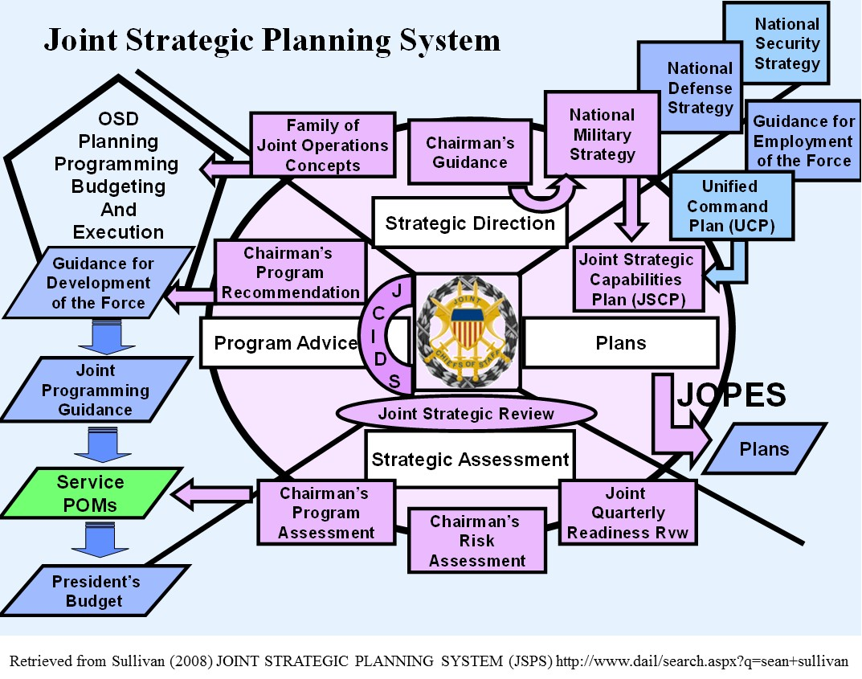

(Retrieved from Sullivan (2008) http://www.dau.mil/search.aspx?q=sean+sullivan)

Diagram 3. Four Year Integrated Defense Planning Cycle
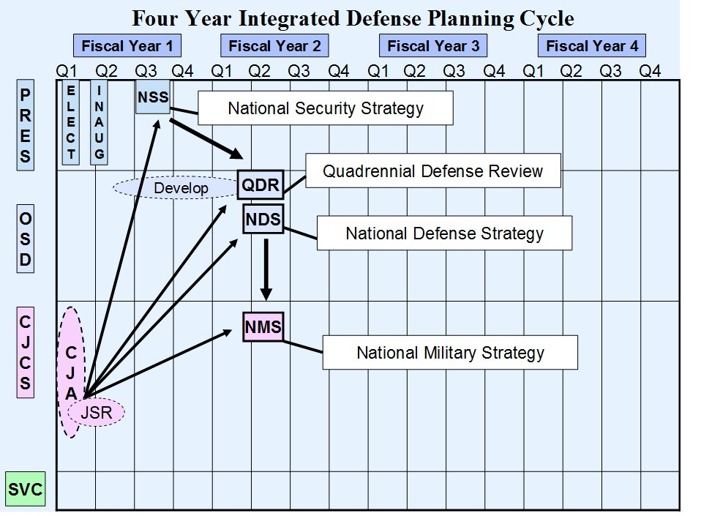
(Retrieved from Sullivan (2008) http://www.dau.mil/search.aspx?q=sean+sullivan)

Diagram 4. DoDEA Military Construction (MILCON) Budget Fiscal Years 2003-2014

(Data obtained from Budget Books FY2003-2014 on Department of Defense Education Activity website)

Diagram 5. Non-DoD Schools Program (NDSP) Budget Fiscal Year 2003-2014

(Data obtained from Budget Books FY2003-2014 on Department of Defense Education Activity website)

Diagram 6. Non-DoD Schools Program (NDSP) Budget Comparisons

DoDEA Budget Books FY 2009-2012
FY | # of Students | NDSP TCBR/TCA
2009 | 3,145 | 43487/47,404,755#
2010 | 3,321 | 63468/64,467,991#
2011 | 3,638 | 59,721
2012 | 3,540 | 67,556

Budget Update for Dependents Education Council (DEC) FY 2009
FY | # of Students | NDSP Costs (M) | CPP (K)
2005 | 2,562 | 26.7 | 10.4
2006 | 2,824 | 31.4 | 11.1
2007 | 2,951 | 40.1 | 13.6
2008 | 3117 | 45.3 | 14.5
2009 | 3,298 | 46.9 | 14.2
2010 | 3,287 | 49.3 | 15
2011 | 3,361 | 51.8 | 15.4

Americans Working Around the Globe (AWAG) Brief 2013
FY | # of Students | NDSP Costs | AVG CPP
2009 | 3,298 | $41,187,175 | $12,489
2010 | 3,321 | $51,731,679 | $15,577
2011 | 3,638 | $54,604,968 | $15,010
2012 | 3,540 | $63,323,002 | $17,888

DoDEA 2009 Annual Report: The Non-DoD Schools Program supported 3,145 students throughout the world at an annual cost of $53.2 million

Diagram 7. Preliminary Positional Leadership Changes 2007-2010
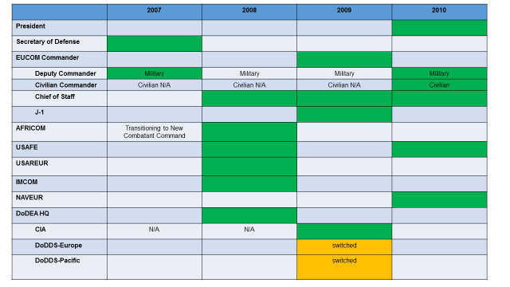

Diagram 8. Timeline of Events 2000-2011

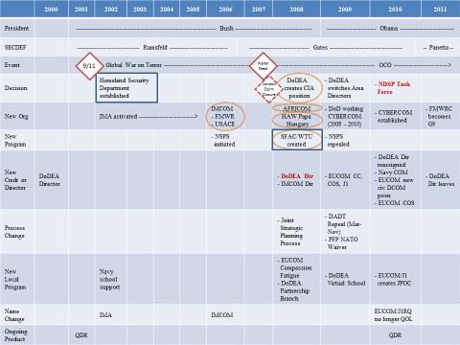

Appendix F: Case Study Documents Database Table of Contents
(Chronological order for each category)
- Publically Available Documents (TAB 1- TAB 11)
- After Action Reports/Minutes/Meeting Presentation/Briefings (TAB 1)
  - Component Command Advisory Council (CCAC), Installation Management Agency, Power Point Presentation (August 30, 2004)
  - Component Command Advisory Council (CCAC), Installation Management Agency, Power Point Presentation, March 23, 2004
  - Dependent Education Council (DEC) Budget Update (June 8, 2008)
  - Dependent Education Council (DEC) Attendees List (June 24, 2008)
  - Dependent Education Council (DEC) Military Construction (MILCON) Brief (June 24, 2009)
  - EUCOM FY10 MILCON & HA Programs (2009)
  - USEUCOM Infrastructure Update SAME University shows FY10 schools $50 insert by SASC for Boeblingen, NDAA, number two on Top 10 Infrastructure focus area in enhanced DoDEA MILCON Program for DoDDS-E, includes SHAPE school US portion (July 19, 2010)
  - Brief to Presidential Commission for Military Compensation and Retirement Modernization version 4 (October 7, 2013)
- Agendas (none publically available) (TAB 2)
- Budget Books (TAB 3)
- Department of Defense Education Activity Budget Book Fiscal Year 2003
- Department of Defense Education Activity Budget Book Fiscal Year 2004
- Department of Defense Education Activity Budget Book Fiscal Year 2005
- Department of Defense Education Activity Budget Book Fiscal Year 2006
- Department of Defense Education Activity Budget Book Fiscal Year 2007
- Department of Defense Education Activity Budget Book Fiscal Year 2008
- Department of Defense Education Activity Budget Book Fiscal Year 2009
- Department of Defense Education Activity Budget Book Fiscal Year 2010
- Department of Defense Military Construction Program FY2010 Budget
- Department of Defense Education Activity Budget Book Fiscal Year 2011
- Department of Defense Education Activity Budget Book Fiscal Year 2012
- Department of Defense Education Activity Budget Book Fiscal Year 2013
- Department of Defense Education Activity Budget Book Fiscal Year 2014
- Congressional Hearings/Testimony (TAB 4)
- Statement of Mr. Ray Tolleson Interim Director of the Department of Defense Education Activity Before the Senate Appropriations Committee on the Department of Defense Education Activity (Military Construction Subcommittee) (February 29, 2000)
- Department of Defense Authorization for Appropriations for Fiscal Year 2008 Part 1 Hearings Before the Committee on Armed Services United States Senate One Hundred Tenth Congress First Session on S. 1547 (S. HRG 110-201, PT. 1) U.S. Government Printing Office Washington 2008 Gates Testimony February 2007 – first in office and announcement of Africa Command (AFRICOM) Craddock Testimony (May 17, 2007)
- National Defense Authorization Act for Fiscal Year 2010 Report of the Committee on Armed Services House of Representatives (2009)
- Rep. Chet Edwards Holds a Hearing on the U.S. European Command (2009)
- Children on the Homefront: The Experience of Children from Military Families, Testimony presented before the House Armed Services Committee, Subcommittee on Military Personnel on March 9, 2010 (March 2010)
- Hearing on National Defense Authorization Act for Fiscal Year 2011 and Oversight of Previously Authorized Programs Before the Committee on Armed Services House of Representatives, One Hundred Eleven Congress, Second Session (March 10, 2010)
- Policies, Directives, Instructions, Regulations, Memorandums and Guidance (TAB 5)
- DoD Instruction 1342.15, Educational Advisory Committees and Councils, dated March 27, 1987
- DoD Directive 1342.20 Department of Defense Education Activity (DoDEA), dated October 13, 1992 and October 19, 2007
- DoD Directive 1342.21, Department of Defense Section 6 Schools, dated October 13, 1992
- DoD Directive 1342.6, Department of Defense Dependent Schools (DoDDS), dated October 13, 1992
- DoD Directive 1342.16, Provisions for Free Public Education for Eligible Dependent Children Pursuant to Section 6, Public Law 81-874, as amended, dated October 16, 1987 and change 1, dated August 5, 1994
- DoD Instruction 1342.25, School Boards for Department of Defense Dependent Elementary and Secondary Schools (DDESS), dated October 30, 1996
- DoD Directive 5128.8, Principle Deputy Under Secretary of Defense for Personnel and Readiness, dated July 13, 2003, paragraph 4.1.2.2
- DoDEA Regulation 1035.1 Department of Defense Education Activity Use of Non-DoD Schools, August 2003, Change 3, May 2009
- EUCOM Directive 30-13 Overseas Dependents Education in USEUCOM (February 16, 2005)
- DoD Instruction 1342.12 Provision of Early Intervention and Special Education Services to Eligible DoD Dependents (April 11, 2005) and (June 17, 2015)
- DoDEA Guidance Students in Locations Not Served By DoDEA (November 2005)
- OSD 22346-05 Office of Secretary of Defense Memorandum Order of Precedence (November 14, 2005)
- DoD Instruction 1315.19 Authorizing Special Needs Family Members Travel Overseas at Government Expense (December 20, 2005 with change 1 in 2011)
- DoD Directive 1342.20 Department of Defense Education Activity (DoDEA), dated October 19, 2007
- USD Memorandum dated November 14, 2007, Tuition Waiver for a Class of Space-Available Students Enrolled in the Department of Defense Dependent Schools (DoDDS)
- OPNAV Instruction 1754.1B Fleet and Family Support Center (FFSC) Program, dated November 5, 2007 from Chief of Naval Operations
- DoDEA Regulation 1342.13, Eligibility Requirements for Education of Elementary and Secondary School Age Dependents in Overseas Areas, Change 2, (February 29, 2008)
- Department of Defense Education Activity Policy Memorandum: Non-Department of Defense Schools Program Minimum Age Requirement for Kindergarten and First Grade Dependents (October 1, 2010)
- DoD Instruction 1342.15, Educational Advisory Committees and Councils, dated December 7, 2012
- United States Air Forces in Europe Directive, dated 2013
- NDSP Letter to Parents SY 2013-2014
- United States Air Forces in Europe Instruction 36-401, dated October 8, 2014
- Executive Summaries (TAB 6)
- Newspaper Articles (TAB 7)
- London Central School to be Shut Down at End of Academic Year (September 6, 2006)
- DoDEA Ends Probe of London Central’s Closure (June 5, 2007)
- Stuttgart Opens Warrior Transition Unit (January 22, 2008)
- Poland, U.S. Sign Missile Shield Deal (August 15, 2008)
- Integrating Multinational Schools in Papa, Hungary Poses a Challenge (April 12, 2009)
- FEA Meeting on DoDEA Staffing Changes Put on Hold (June 12, 2009)
- Military to Debut Virtual School (November 5, 2009)
- DOD Planning, Programming, Budgeting, and Execution System: A Path Toward Improvement (2009)
- The Military Children Left Behind: Decrepit Schools, Broken Promises (June 26, 2011)
- Ire Over Hawaii Schools Not Enough To Justify Military-Only Education (2012)
- Work Starts on New School in Stuttgart (November 12, 2013)
- Groundbreaking Celebrates Future Stuttgart Schools (November 27, 2013)
- Camp Casey School Closing After 5 Years as Part of Relocation (August 19, 2014)
- Study Could Recommend Closing Some DoDEA Schools (November 14, 2014)
- On Military Bases, Common Core by Another Name (March 6, 2015)
- Camp Casey School to Welcome Its Final Students Monday (August 28, 2015)
- IT Upgrades, Sustainability Are Hallmarks of Stuttgart Campus Project (September 28, 2015)
- Press Releases (TAB 8)
- Facon Named DoDEA Chief of Educational Partnerships Branch. (June 13, 2008)
- DoDEA Director Reflects on His Service (June 25, 2008)
- Miles Selected As Director of the Department of Defense Education Activity (July 2, 2008)
- DoDEA Area Director Aligned to New Posts (May 13, 2009)
- DoDEA Selects Area Superintendents for Curriculum, Instruction, and Assessment. (June 9, 2009)
- Defense Schools' Director Pleased with Year's Accomplishment (June 18, 2009)
- White House Press Release: President Obama Establishes Bipartisan National Commission on Fiscal Responsibility and Reform (February 18, 2010)
- DoDEA Begins School Year With Facilities Renovation and Construction Initiative (August 10, 2010)
- Officials Name New Education Activity Director (November 16, 2011)
- Dr. Linda Curtis Selected as DoDEA Pacific Director (August 20, 2013)
- SHAPE Community Schools to Experience a Transformative New School Year (August 15, 2014)
- Dr. Nancy Bresell Retires After 37 Years of Service to DoDEA (January 2, 2015)
- Restructuring for Student Achievement (May 21, 2015)
- New Director Selected for DoDEA Schools in Europe (July 9, 2015)
- DoDEA Announces Changes in Educational Leadership (August 5, 2015)
- DoDEA Begins School Year 2015-2016 (August 25, 2015)
- Legislation (TAB 9)
- Public Law 95-561, Defense Dependent Education Act of 1978: An Act to Extend and Amend Expiring Elementary and Secondary Education Programs, and for Other Purpose dated November 1, 1978
- U.S.C. Title 20, Education, Chapter 25A, Overseas Defense Dependents’ Education, (929) Advisory Council on Dependents’ Education
- U.S.C. Title 10, Armed Forces, Chapter 108, Department of Defense Schools, Section 2164, DoD Domestic Dependent Elementary and Secondary Schools
- Miscellaneous (TAB 10)
- Teacher Union FEA Newsletter (October 7, 2009)
- Teacher Union FEA Newsletter Educators Have Indeed Provided Decades of Excellence! (Debunking the Myths of Dr. Shirley Miles) (August 2009)
- Remarks by the First Lady at the Joint Armed Forces Officers’ Wives’ Luncheon (January 26, 2010)
- Transcript: Air Force Times Interview with Major General Michael Snodgrass, U.S. Africa Command Chief of Staff (June 16, 2010)
- Navy School Liaison Officer Brochure (no date, retrieved 2015)
- Non-DoD Schools Program Schools Listing (current as of January 2016)
- Reports/Research (TAB 11)
- Review of Department of Defense Education Activity (DoDEA) Schools, IDA Paper P-3544, Institute for Defense Analyses (October 2000)
- Review of Department of Defense Education Activity (DoDEA) Volume II: Quantitative Analyses of Educational Quality (2000)
- An Assessment of USAFE School Board Test Program, IDA Paper P-3711, Institute for Defense Analyses (July 2002)
- The Unified Command Plan and Combatant Commands: Background and Issues for Congress (2003)
- Strategic Assessment and Development of Interorganizational Influences in the Absence of Hierarchical Authority (2003)
- Joint Strategic Planning System (JSPS) The United States Naval War College National Decision Making Department (September 10, 2008)
- Defense Resource Allocation: The Formal Processes in U.S. Defense Planning (2009)
- Successful Principals Leading School Improvement in Overseas Schools Educating a Large Number of Children with Military Parents: A Qualitative Study (Doctoral Dissertation) (2009)
- The Impact of Parental Deployment on Child Social and Emotional Functioning: Perspectives of School Staff (2009)
- Department of Defense Education Activity Annual Report (2010)
- Functions of the Department of Defense and Its Major Components (December 21, 2010)
- Army School Support Services Strategic Plan (2010)
- Toward Strategy for Building Partner Capacity: Combined Ownership and Operations (Masters Research Project) (2010)
- Factors Influencing Organizational Change in the Department of Defense (Doctoral Dissertation) (2010)
- $200 Billion in Illustrative Savings (Draft). National Commission on Fiscal Responsibility and Reform (2010)
- Quadrennial Review Defense Report (February 2010)
- Children on the Homefront: The Experiences of Children from Military Families (March 9, 2010)
- Blue Star Family 2010 Military Family Lifestyle Survey (September 10, 2010)
- Joint Personnel Support (October 24, 2011)
- DoDEA Educational Partnership Grant Program 2009-2010 Annual Evaluation Report- Draft. Synergy Enterprises, Inc. (2011)
- The Distortion of Upward Communication in Military Organizations (Doctoral Dissertation) (2011)
- Inspector General Report: DoDEA, Dr. Shirley Miles (June 20, 2011)
- Military Construction: An Analysis of the FY2012 Appropriation and Authorization (July 13, 2011)
- Inspector General Report: EUCOM, Admiral Stavridis (May 3, 2012)
- Inspector General Report: US Africa Command General Ward (June 26, 2012)
- Department of Everything: Department of Defense Spending That Has Little To Do With National Security (2012)
- Inspector General Report DoD Education Activity Needed Better Planning for Military Construction Projects (2012)
- RAND Corporation, Overseas Basing of U.S. Military Forces: An Assessment of Relative Costs and Strategic Benefits (2013)
- How Wartime Military Service Affects Children and Families (2013)
- The Politics of 'The Army You Have': Change and Continuity in the U.S. Military, 1972-2008 (Doctoral Dissertation) (2013)
- The Unified Command Plan and Combatant Commands: Background and Issues for Congress (2013)
- The Military Child Education in Hawaii Study (January 14, 2013)
- Study Could Recommend Closing Some DoDEA Schools (November 14, 2014)
- Passing the Baton: A Bipartisan 2016 Agenda for the Veteran and Military Community (2015)
- Interview Transcriptions and Notes (TAB 12)
- Respondent #12 Conducted October 9, 2015 in person (notes only, no audio)
- Respondent #3 Conducted October 23, 2015 via Skype
- Respondent #10 Conducted October 26, 2015 in person
- Respondent #17 Conducted November 7, 2015 in person
- Respondent #15 Conducted November 17, 2015 in person
- Respondent #1 Conducted November 18, 2015 in person
- Interview Comparison: Theoretical Framework
- Personal Memos and Memoed Reading Notes (TAB 13)
  - Consolidated Memos and Diagrams Document (dated 2012-2016, 42 pages typed)
  - Notes on Complexity Theory (November 28, 2014, three pages, handwritten)
  - Notes Related to Grounded Theory Compilation (November 25, 2013, four pages, handwritten)
  - Thoughts on Case Study (2013, seven pages, handwritten)
  - Merriam (1998), Qualitative Research and Case Study Applications in Education, (n.d., three pages, handwritten)
  - A Case for the Case Study (1991), (November 28, 2013, 12 pages, handwritten)
  - Yin (2009) Case Study Research: Design and Methods, (November-December 2013, 20 pages, handwritten)
  - Kingdon (1984) Agendas, Alternatives, and Public Policies, (13 Jan 2014, 19 pages, handwritten)
  - Dweck (2006) Mindset: The New Psychology of Success How We Can Learn to Fulfill Our Potential, (12 September 2015, three pages, handwritten)
  - Gates (2014) Duty: Memoirs of a Secretary at War, (October 14, 2015, 27 pages, handwritten)
- Process Pieces: Original Drawings with Handwritten Notes (TAB 14)
  - Drawing of Network of Organizations Related to School Council System (November 2012)
  - My Awareness of Events (January 2015)
  - Ways Around a “No” (September 6, 2015)
  - Conceptualization of Big Rock, Little Rock (September 14-15, 2015)
  - People and Event Graphic of Big Rock, Little Rock (September 27, 2015)
  - Draft Timeline from Documents (September 27, 2015)
  - Respondent Interview Timeline (October-November 2015)
  - Focus 2007-2010 Timeline Draft (December 20, 2015)
  - Working Version Timeline 2000-2010 (January 16, 2016)
  - Explanation Building Drawing (February 2016)

Appendix G: Sample Freedom of Information Act Request Letter
(Retrieved from http://www.dodea.edu/foia.cfm)

Department of Defense Education Activity
FOIA Requester Service Center/PA Officer
4800 Mark Center Drive Suite 06F09-02
Alexandria, VA 22350-1400

Dear FOIA Requester Service Center/PA Officer:
This is a request under the Freedom of Information Act (5 U.S.C. 552). (Or; This is a request under the Privacy Act (5 U.S.C. 552a). I request that a copy of the following document(s) be provided to me: [Identify the documents as specifically as possible].

In order to help you determine my status for the purpose of assessing fees, you should know that I am [insert one of the descriptions below]
a representative of the news media affiliated with the _______newspaper (magazine, television station, etc.) and this request is made a part of news gathering and not for a commercial use.

affiliated with an educational or noncommercial scientific institution, and this request is made for a scholarly or scientific purpose and not for a commercial use.

affiliated with a private business and am seeking information for use in the company's business.

an individual seeking information for personal use and not for a commercial use.

I am willing to pay fees for this request up to a maximum of $_____. If you estimate that the fees will exceed this limit, please inform me first.
[optional] I request a waiver of fees for this request because disclosure of the requested information to me is in the public interest because it is likely to contribute significantly to public understanding of the operations or activities of the DoD and is not primarily in my commercial interest. [Include details about how the requested information will be disseminated by you to the general public.]

I also include a telephone number at which I can be contacted if necessary to discuss any aspect of my request.

Sincerely,

(Your Signature)
Name
Address
City, State, Zip Code
Telephone number
(Add SSN if requesting under Privacy Act)

Or:
FOIA Request information for US European Command:
http://www.eucom.mil/policies-and-compliance/freedom-of-information-act-foia-requestor-service-center/how-to-make-a-foia-request

Appendix H: Approved Institutional Review Board Documents

Recruitment Text
Subject: Request to Participate in Research Project
Dear Potential Research Participant,
I am Michelle (Mimi) Langenderfer, a doctoral candidate in the University of Oklahoma’s PhD program in Organizational Leadership and the former education liaison with Headquarters, United States European Command (EUCOM) from 2008-2010. I invite you to participate in a research project studying the circumstances that led to the formation of the Non-DoD Schools Program (NDSP) Task Force in May 2010. The title of the study is, “Factors Influencing Decision Making in Networked Organizations: A Case Study on Leadership and the Formation of the Non-Department of Defense Schools Program (NDSP) Task Force.”
You were identified as a potential participant due to your direct or indirect involvement with an organization associated with the decision to create the task force.
The interview, which will be conducted in person, via phone, or via Skype, should take up to one hour. Additional time, if necessary, will be added as agreed upon, after the initial interview. All information is confidential and not tied to your identity unless permission is granted in the attached consent form.
Please review the attached consent to participate document then contact me directly at
719-722-4444 or Michelle.K.Langenderfer-1@ou.edu.
Thank you so much for your help with this research project.
The University of Oklahoma is an equal opportunity institution

Informed Consent

