University of Oklahoma

Graduate College

“The Burro evil”: The eradication of feral burros in Grand Canyon national park

A thesis

submitted to the Graduate Faculty

in partial fulfillment of the requirements for the

Degree of

Master of Arts

By

Abbie Harlow
Norman, Oklahoma
2017

“The Burro Evil”: The eradication of feral burros in grand canyon national park

A thesis approved for the
Department of History

By

______________________________
Dr. Kathleen Brosnan, Chair

______________________________
Dr. Sterling Evans

______________________________
Dr. David Wrobel

© Copyright by ABBIE HARLOW 2017
All Rights Reserved.

To my parents for their unwavering support and confidence.

Acknowledgements

I wish to express my gratitude to my advisor, Dr. Kathleen Brosnan. Without her guidance and attention to detail this thesis would not be what it is. I am thankful for my committee members Dr. David Wrobel and Dr. Sterling Evans for their vital feedback. I am eternally indebted to my family and friends who have supported me and have constantly sent me everything burro-related they could find.

I never would have considered this topic without my volunteer experience at the Wild Burro Rescue in Olancha, California. I will be forever grateful for my opportunity to work with and learn about burros firsthand.

Table of Contents

Acknowledgements iv
List of Figures vi
Abstract vii
Introduction 1
1. Adapted to Canyon Life 12
2. The Authentic Arizona Burro 36
3. A Canyon without Burros 55
Epilogue 81
Bibliography 91

List of Figures
Figure 1. “Burro with target” 2

Figure 2. “Map of burro distribution” 6

Figure 3. “Burros on Grand Canyon cliff” 16

Figure 4. “Denton family on pack donkeys, 1910” 26

Figure 5. “Burro trails” 48

Figure 6. “News articles” 51

Figure 7. “Hand-drawn burro” 53

Figure 8. “Parade advertisement” 70

Figure 9. “Helicopter with sling” 71

Figure 10. “Bill of sale” 74

Figure 11. “Map of burro fence” 77

Figure 12. “Oatman burros” 85

Figure 13. “Moran Point” 89

Abstract
A population of feral burros has lived in the Grand Canyon since Spanish conquistadors brought the animals to North America in the sixteenth century. More burros entered the canyon in the late nineteenth century with prospectors who left the animals behind upon leaving the canyon. The National Park Service (NPS) planned to remove burros from the Grand Canyon as early as 1919 when the canyon joined the national park system. Burros are an exotic species in North America and the NPS considered exotic species detrimental to park environments. In 1924, park service administrators created a policy to remove burros from the canyon by shooting them. Nonetheless, fifty-six years later, burros remained in the park. In the 1960s and 1970s, the NPS’s removal attempts outraged the public and greatly complicated its efforts to protect and restore the canyon’s ecosystem. The NPS failed to recognize or acknowledge burros’ cultural importance in the canyon. Despite a strong ecological record to support its policy, the NPS could not sway the public to accept burro eradication. The controversy led to an infuriated public, a negative image of the NPS, and a complicated and lengthy removal process.

Introduction
The memo the Grand Canyon resource management chief distributed to rangers on March 20, 1980 included an attachment of a simple, line drawing of a horse with penned-in long ears. Drawn halfway between the animal’s shoulder and face is a bullseye. The note above the image reads, “Target area for swift killing of feral burros.” Preparations for burro culls throughout Grand Canyon National Park were in full swing in the spring of 1980. Park administrators planned to shoot approximately three hundred burros scattered throughout the canyon and along its rim. The target on Grand Canyon burros, however, existed well before the 1980 memo. The National Park Service (NPS) planned to remove burros from the Grand Canyon as early as 1919 when the canyon joined the national park system. Burros are an exotic species in North America and the NPS considered exotic species detrimental to park ecosystems. In 1924, park service administrators created a policy to remove burros from the canyon by shooting, herding, or by any means possible. Nonetheless, fifty-six years later, the hardy burros persisted in the park. The NPS’s removal attempts outraged the public and greatly complicated its efforts to protect and restore the canyon’s ecosystem in the 1960s and 1970s. The NPS failed to recognize or acknowledge burros’ cultural importance in the canyon. Despite a strong ecological record to support its policy, the NPS could not sway the public to accept burro eradication; the controversy forced the service to reconsider the burros' cultural importance.
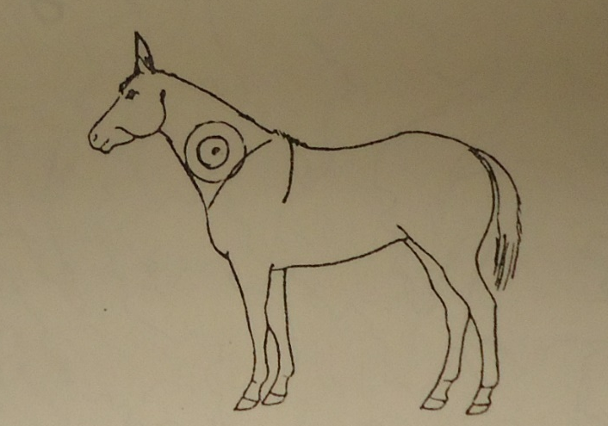
Figure 1
Image of burro with a target on its neck to show rangers where to shoot the exotic animals if a large-scale culling effort was necessary.
Image used with permission from the Grand Canyon Archives, Letters regarding removal 1980-9, GRCA 56988

Feral burros, as defined by the zoo-archeologist Juliet Clutton-Brock, are “those that live in a self-sustained population after a history of domestication.” The term feral applies to the burros in the Grand Canyon; they were decedents of European and African domesticated donkeys introduced to the region before the twentieth century. The Wild Free-Roaming Horse and Burro Act of 1971, however, uses the term wild interchangeably with feral. Humans describe burros by several names, such as donkey, ass, jack, jenny, and jennet. In the American West, however, the feral ass is nearly exclusively called “burro,” the Spanish word for donkey, because most of the animals are related to Spanish asses.
The burro’s history in the Grand Canyon has led people to associate the animal with the park. The burro traversed the canyon for centuries with explorers, miners, and tourists and the burros set free by early canyon visitors and residents formed substantially sized herds. The feral animals acclimated to the canyon environment and spread out along the river, cliff sides, and rims. The NPS assumed management of the canyon in 1919 and labelled the burros as exotic and detrimental to the canyon’s environment. Burros disrupted soils, eroded trails, and competed with wildlife for forage. The agency conducted culling campaigns from 1924 to 1969. These annual burro hunts reduced the animal’s population without completely eradicating burros. By 1969, however, the public responded negatively to the NPS’s burro culls. Through letter writing, newspaper articles, and signed petitions people and animal advocacy organizations dramatically slowed the removal process in the 1970s. The NPS conducted an arduous environmental impact statement to prove burros negatively affected the canyon and to justify removal through shooting. However, public opposition to the NPS’s plan remained. The nonprofit organization the Fund for Animals offered to conduct a live removal and airlifted the majority of the burros out of the canyon. Today, more than three decades later, the negative impact burros may have had on the Grand Canyon ecosystem has still not been definitively demonstrated.
The Grand Canyon has played a variety of roles in human history and imagination. For the Hopi and Havasupai Native American, the canyon was their home for over 800 years. Many locations along the canyon served them as farming, hunting, and sacred sites. When Spanish explorers reached the canyon in 1540, they viewed the great plateaus and cliffs as an obstacle. The explorers could neither cross the canyon in search of gold and silver nor drink from the river a mile below them. Geologist and explorer John Wesley Powell and his crew travelled along the Colorado River through the Grand Canyon in 1869. Following his successful survey of the canyon and his published account of the voyage, geologists came to study the canyon’s massive structure, rock walls, and eroded cliffs. The Smithsonian, Bureau of American Ethnology, and U.S. Geological Survey commissioned studies and accounts of the canyon’s size, history, people, and possible secrets. Word spread about the massive structure cut by a river over millennia. Prospectors soon made their way to the canyon in search of precious metals. Painters such as Thomas Moran lined the rim in an attempt to capture the wonder of the canyon. With books, paintings, and legends surrounding the canyon, tourists soon joined explorers, scientists, prospectors, and painters, all searching for something wonderful in the Grand Canyon and augmenting its status as a cultural icon.
In all the roles the canyon served, humans have viewed it as a location laden with the history of different meanings and purposes people have assigned to it throughout the centuries. “At the heart of every Canyon overlook,” the historian Stephen Pyne states, “there lies the paradox that while indescribable, the scene is not incomprehensible. It has meaning, and that meaning depends less on the scene’s physical geography than on the ideas through which it can be viewed and imagined.” While Pyne’s inclusion of the cultural Canyon’s importance to Grand Canyon history is significant, his examples omit an important actor. As “fur trappers and freebooters and agricultural colonizers […] peered and probed,” when explorers, scientists, and military commanders looked over the canyon rim, and when “Uncle Jim Owens escorted Teddy Roosevelt to hunt mountain lions,” they were not alone. Beside them, in front of them, and beneath their legs were surefooted burros carrying the travelers and their packs. The historian John Wills explains how many people were able to comprehend the otherwise inaccessible wonders of the indescribable canyon. “Burros,” Wills states, “enabled vacationers to interpret the monumental landscape, allowing them to see the Canyon as both a geological wonder and a place of pioneer history.” Burros allowed visitors to see the canyon as more than a great hole in the ground. They made it an accessible location steeped in history.
The canyon’s burro history ranged back to the Spanish conquistadors. The Spanish brought burros to North America in the sixteenth century and the animals first crossed into the present-day United States with Juan de Oñate in April 1598. Although some Spanish burros did escape, the feral population of burros remained low until the nineteenth century. Given the burro’s great value as a pack animal, the Spanish assiduously protected their herds. The burros that bolted from the Spanish found an environment in which they were well suited. Due to their evolution in northern Africa, burros thrived in the arid, rocky terrain of the American Southwest. The region’s feral burro populations grew slowly from the seventeenth to nineteenth century. However, following John Wesley Powell’s expedition through the Grand Canyon in 1869, hopeful prospectors, with the help of burros, made their way to search for valuable minerals in the canyon. Over time, miners lost faith in the rough terrain and headed back east, leaving behind their equine companions who were much better suited to the area than the miners. Left in the Grand Canyon, feral burros lived and reproduced freely for a few decades. The burros that remained in the area formed herds consisting of mostly former pack animals and formed three distinct herds along the Colorado River. The Tonto Plateau herd ranged along the South Rim and Red Canyon area. The second herd remained below the rim on the north side of the river on the Shinumo Creek, fittingly named the Shinumo herd. The final group, the Lower Canyon herd, stayed near the river in the western area of the canyon. Ecologists have not agreed on an exact number of burros in the canyon at the turn of the twentieth century, although, many estimate the burro population reached more than 2,000.
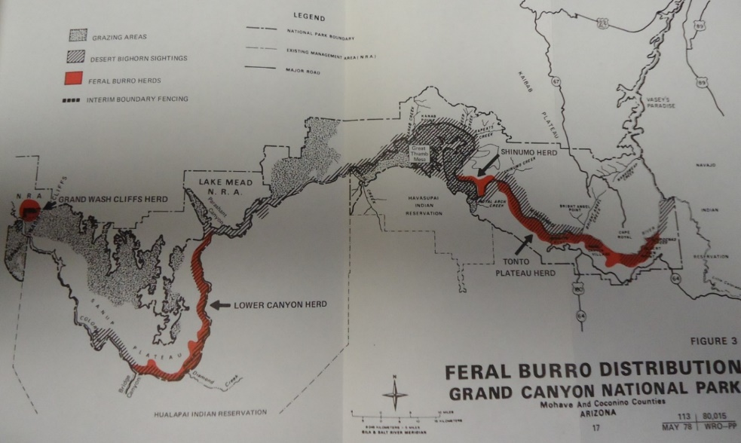

Figure 2.
Feral burros in the Grand Canyon formed three distinctive herds: the Tonto Plateau Herd on the far east, the Shinumo Herd in the northwest, and the Lower Canyon Herd on the far west of the canyon.
Map used with permission from the Grand Canyon Archives - GRCA 57685, Removal plan 1979, p. 17.

In 1924, Grand Canyon National Park began a fifty-six-year attempt at feral burro eradication. Four years earlier, Stephen Mather, the Director of the National Park Service, labelled the animal as “the burro evil.” Mather and other park service employees blamed burros for destroying the environment of the canyon. Burros created erosive trails on canyon sides, compacted soils, and ate similar vegetation as desert bighorn sheep creating competition in a limited environment. In an early attempt to rid the canyon of burros, NPS rangers conducted annual hunts. Rangers killed around 100 burros each hunt, never a large enough number to eradicate the population or attract much attention from the public. Removal efforts continued until the mid-twentieth century. In 1953, Marguerite Henry’s book Brighty of the Grand Canyon created an image of a canyon burro that quickly entered popular culture as “the spirit of the Grand Canyon.” Henry’s book raised interest in the feral burros and her impression of burros directly contradicted the NPS’s image of burros as destructive exotics. The NPS halted removal attempts in 1969 as public interest in burros increased alongside advocacy for wild horses in the western United States. In the 1970s, the NPS did not conduct any physical removal efforts, but the agency began the paperwork and planning for total removal. Public outcry against burro removal, especially killing burros, forced delays and negative publicity for the NPS. The agency listened to the public’s concerns in open meetings and released press statements to inform dissenters. The Grand Canyon Park Service released a final environmental impact statement (EIS) in 1980 that explained that the agency had investigated the option of leaving some burros in the canyon, as well as live removal, sterilization, and fencing, but concluded that the cheapest and most effective alternative, was to shoot all the Grand Canyon burros. In an attempt to minimize negative publicity for the NPS, the final EIS included a provision to allow individuals and organizations time to remove as many burros as possible before rangers started shooting. Cleveland Amory, the author and animal rights activist, and his organization the Fund for Animals proposed this amendment and volunteered to remove all the burros. Once removed, the Fund adopted out the burros to homes across the United States.
Recently, the focus on animals has gained attention in a variety of historical research. Studies varying in location, historical disciplines, and periods are increasingly considering animals as crucial to historical understanding. By focusing on animals, recent scholarship has altered the understanding of nonhuman animals from peripheral, static objects to vitally important historical actors. As the environmental historian Brett Walker describes, “[Animals are] mobile, thinking, feeling – nature with a profoundly important form of agency.” Considering animals as agents of change, however, is still a complicated and contested scholarly approach. Animals act and react in relation to their environment, but animal instinct is not comparable to human cognition. While attributing agency to animals is a much more widely accepted practice, animal histories must still walk a fine line between writing animals as actors and humanizing them. “Animals," the historian Susan Nance describes, "live in parallel realities shaped by their own priorities, instincts, and experiences, which people have always struggled to understand and control.” Many historians have begun to consider animals, not in opposition to, but in tandem with human actors and human history. Environmental, cultural, and intellectual histories have all worked to include animal actors in their narratives.
Humans use animals physically as meat and muscle, but, of greater historical interest, humans use animals to make meaning. “Animal history,” Nance states, “is really about what it has meant to be human through our interaction with other species.” Animals are important in defining what it means to be human, in relating to nature, or as a symbol of a time, place, or concept. Walker states, animals "can signify many different scientific, political, social, and cultural forces in human societies." Animal symbolism is important to cultures across the globe ranging from cats in Ancient Egypt to bald eagles in the United States. Similarly, humans used burros as a cultural symbol in the Grand Canyon. In the nineteenth and early twentieth century, burros symbolized a past era of pack trains, prospectors, and an unexplored, indescribable Grand Canyon. The symbolism associated with burros did not diminish with increased access to the canyon. Conversely, in time, tourists found burros' symbolism more important to the Grand Canyon’s history and culture.
This thesis explores burros in and their removal from the Grand Canyon. Chapter one explains the history of burros and equid ancestors in the canyon from before the Pleistocene era to 1919 when the canyon joined the NPS. Miners used a large number of burros in the canyon in the late nineteenth and early twentieth century. Upon leaving the canyon, prospectors released many their burros and the animals became feral. The tourism industry in the canyon used burros to carry visitors along trails not traversable by horses or on foot. Burros' early history in the canyon led many people to associate the animal with the Grand Canyon and the American Southwest. Chapter two details feral burros in Grand Canyon National Park and early NPS attempts to remove the animals. As the public learned about annual burro culls and plans for total eradication of burros in the canyon, an outcry to save the burros produced a clash between the NPS and the public. This disagreement led the NPS to a stop burro culls and attempt to find a way to appease the public while still removing the exotic animal from the Grand Canyon. Chapter three describes the environmental studies and impact statements created to justify the removal of feral burros and the reaction to the removal plans by those who supported burros remaining in the canyon. The ongoing public debates regarding burros on public lands took place as the federal government passed the Wild Free-Roaming Horse and Burro Act of 1971 designed to protect the feral animals from “capture, branding, harassment, or death.”Finally, in 1980, a compromise came in the form of action by the Fund for Animals, a nonprofit animal advocacy group. The organization offered to extract the burros through a live removal process using the Fund’s own money. The final removal proved arduous and expensive; however, it was successful in expelling the majority of feral burros from Grand Canyon National Park.
The saga of the Grand Canyon burro covers more than 400 years from the first conquistador’s pack animal to the last feral jenny airlifted out of the park. Many visitors wedded the animal to the image of the park’s monumental landscape. By failing to recognize or acknowledge the animals’ cultural importance, the NPS earned the ire of an outraged public and greatly complicated its efforts to protect and restore the canyon’s ecosystem in the 1960s and 1970s. Despite a strong ecological record to support its policy, the NPS could not sway the public to accept burro eradication; the controversy forced the service to reconsider the burros' cultural importance. Few burros remain in the Grand Canyon since the 1980s. At the same time, nearly 12,000 burros are on public lands throughout the United States. In national parks, burros are an exotic species and the NPS possesses the authority to remove or kill the animals. On other public lands, however, the Wild Horse and Burro Act of 1971 protects burros as “an integral part of the natural system of the public lands.” These conflicting views create confusion and tension when defining feral burros in the United States. Often, the public does not understand the nuances in the policies that affect burros. Recognizing the public's influence and educating as many people as possible about the environment of public lands will be vital to protecting those lands. Compromise, like that seen in the Grand Canyon burro removal, between government agencies, the public, and nonprofit organizations is vital to that success.

Chapter 1: Adapted to Canyon Life

In 1923, the famous western author Zane Grey shared the tale of a prospector and his “pack animal” companion as they search for mineral wealth across the American Southwest in Tappan’s Burro. Throughout the story, Tappan speaks to his burro, Jenet, who proves to be an invaluable worker and friend. “Here we are… a hundred miles from any camp,” Tappan exclaims to Jenet, “An’ what but you could have fetched me here? No horse! No mule! No man…But for you and your kind, Jenet, there’d be no prospectors, and few gold mines. Reckon the desert would still be an unknown waste. . . . You’re a great beast of burden, Jenet, an’ there’s no one to sing your praise.” For Grey, the burro was an integral part of a romantic western landscape, and, similarly, for many residents and visitors to the Grand Canyon, the burro became a symbol of the American West in the late nineteenth and early twentieth century. The National Park Service, however, increasingly viewed the burro as a destructive exotic and attempted to remove the animals from the canyon. Nonetheless, the burro’s ancestors once called the Grand Canyon home and arguably enjoyed an ecological connection to the canyon.
The Grand Canyon has a history millions of years long. Cut slowly into rock by the water of the Colorado River, the canyon contains two rims: the North and South, several plateaus at lower elevations, creeks, caves, side canyons, and, at the lowest elevation, the river. Geologist Jim Mead writes, “The Grand Canyon is more than just a mere river-cut canyon; it is a labyrinth of side canyons off side canyons of seemingly endless habitats.” Differing elevations create diverse environments throughout the canyon ranging from forests on the rims to desert flora and fauna along plateaus. Geologists have studied the Grand Canyon in an attempt to understand the geological processes that formed the massive landscape. The canyon’s slow formation has led to a better understanding of geologic time in relation to the Earth. “The Colorado River has taken ~20 million years to incise its course downward through the 1-mile depth of the Grand Canyon,” the Geologists Tim Atkinson and Mike Leeder explain. While 20 million years is an incredibly long time in human history, in the history of the Earth, it is relatively short. The canyon and its biotic communities have grown and shifted for millions of years and continue to change.
People resided in the canyon for only a fraction of its history. The first recorded humans in the Grand Canyon are the Native American tribes Havasupai, Hualapai, Zuñi, and Navajo. The Havasupai tribe, however, lived along and within the canyon for the longest time, perhaps as long as 800 years, before any non-Indian knew the Grand Canyon existed. The Havasupais migrated annually to spend their summers on the rim of the canyon where they hunted and planted crops to harvest before descending into the canyon for the winter months. The Havasupai people of the Grand Canyon were skillful agriculturalists and hunters; they changed the landscape of the Grand Canyon to support their lives for centuries. “At least two – and perhaps as many as seven – centuries ago the Havasupai began constructing the irrigation ditches that now run along the base of the cliffs on each side of the creek.” The tribe created several engineering works inside the canyon including irrigation ditches, dams, and aqueducts. When European livestock reached the canyon, the Havasupai put the animals to use immediately. Spanish missionary Francisco Garcés stated that the tribe had horses and cattle by 1776 and burros not long after. The Havasupai people made an ideal home in the Grand Canyon by changing the environment for centuries to grow better crops, or by capturing hawks and eagles in the canyon for their feathers and using European draft animals. Before Euro-Americans knew the Grand Canyon existed humans were changing the environment of the canyon, the addition of burros was just another alteration in a long period of change.
With help from Hopi Indians, members of Francisco Vàsquez de Coronado’s 1540 Spanish expedition became the first Europeans to reach the Grand Canyon. At the vast sight, the explorers did little more than curse the cliff walls that prevented them from reaching the river, which was nearly a mile down. The explorers did not believe the canyon held any possibilities; instead, they viewed the massive monument as a barrier to northern land. “With the failure of [Coronado’s] expedition,” the historian Donald Hughes states, “the Grand Canyon and its neighboring plateaus were left to the Indians for more than two centuries.” After gaining independence from Spain in 1821, Mexico claimed most of the present-day southwestern United States as its territory. “For the quarter-century of Mexican rule,” Hughes explains, “no record exists of any visits to the Grand Canyon by Mexicans.” In 1848, the canyon belonged to the United States after the end of the Mexican-American War and the Treaty of Guadalupe Hidalgo. As the Grand Canyon and the environment within it changed, so too did the burro.
The burro’s closest genetic relatives are the horse and zebra. The three equids evolved from one similar ancestor and “dispersed over nearly all the grassland areas of the world until, in the Pleistocene period, they inhabited South and well as North America, Asia, Europe, and Africa.” While the burro looks similar to both of its relatives, it differs dramatically in several aspects. Compared to the most popular horse breeds in the United States (American Quarter Horse, Thoroughbred, and Morgan), burros are shorter in stature with an average height of 10 hands or 40 inches from the ground to shoulders. Burros’ hooves are similar than those of horses. Both animal’s hooves will become overgrown and painful unless humans trim them or the animals walk on rough terrain. The smaller burro hooves match their smaller size and fit along more narrow paths. In captivity, a burro can live up to thirty years old. In the wild, it can range from an average of ten to twenty years. Burros’ most distinguishable characteristics are their ears and their bray. Their ears are much longer than those of any other Equid providing burros with better hearing. The burro’s bray is a loud trumpet-like noise distinguishable by creating sound both when exhaling and inhaling. No one who has heard the noise once will ever forget it. Burros’ small stature, large head, and long ears endear many people to the animals and their calm demeanor further appeals to humans. When not frightened or excited, burros tend to expend little energy, standing in place with a bowed head and drooping eyes.
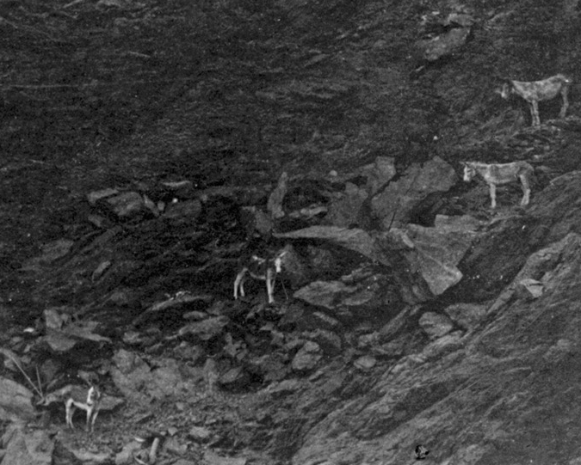

Figure 3.
Burros are uniquely suited to the steep cliffs of the Grand Canyon. The burro’s sure-footed nature and strong, small hooves allow them to walk on narrow, rocky trails in areas other ungulates are not able to reach.
“Wild burros on Grand Canyon cliff, September 1906”
Used with permission from the Grand Canyon Archives
GRCA 22337

As members of the Equidae family with relatives throughout the world, burros like Tappan’s Jenet, served human needs for thousands of years and remain an essential draft and pack animal in many African, Middle Eastern, and European cultures. While smaller than horses and weaker than oxen, burros found their niche as strong workers who require relatively little feed, making them cheap and capable laborers. The burro is well adapted to the harsh setting of the canyon and is, in turn, able to evade removal. Burros evolved to survive in areas similar to the Grand Canyon; they subsist on little water and eat most plants that grow in the desert including the coarse, dry vegetation of the arid U.S. Southwest. Burros are uniquely suited to difficult cliff trails as they move slowly to prevent falls or missteps and their legs, which are shorter than horses’, are stronger and less likely to twist and break. Burros’ hooves are small and able to fit around areas of loose rock. The animals also naturally trim their hooves on the rough terrain. Burros created trails by repeatedly following the same routes along the canyon rims and down to the river on routes not traversable by other animals. The trails burros create are often used by other ungulates, smaller wildlife, and, even, people; however, trails also accelerate the erosion of cliff sides. Burros dirtied many water sources due to their habit of digging into water seeps to bring up more water and to soak their dry hooves to prevent cracking. In their search for limited forage, burros eat a variety of vegetation including grasses, shrubs, forbs, ferns, and cacti, which are staple foods in the diets of most canyon wildlife.
Equid family ancestors of the burro lived in the Grand Canyon for thousands of years before humans hunted the animals to extinction at the end of the Pleistocene era. The wildlife ecologist Craig Downer states that wild burros, and their relative the wild horse, have an ecological right to exist in the American West. Studying fossil records, petroglyphs, and the present-day ecological niches of wild horses and burros in the United States, Downer argues that the Equidae family is not a destructive exotic but a “returned native.” Looking back millions of years, Downer describes the Equidae family’s spread across all continents, except Australia, and the fossil evidence that places relatives of the horse and burro in North America as early as 58 million years ago. Native Americans drew images of equids on rock walls and desert floors. The anthropologist David Whitley describes some of the petroglyphs of horses found in the Great Plains and Southwest, “Motifs include geometrics, supernatural beings, war exploits, and a wide range of animals, including especially horse, deer, and elk.” The evidence of equid images carved in caves and on rock walls demonstrated the importance of burros and their relatives as food and mythological representations to early Native American cultures before European equids stepped foot on the continent. The importance of early equids as a food source, however, also led to their ultimate extinction on the North American continent.
The Equidae family’s population dropped at the close of the Pleistocene era, around 10,000 years ago, when temperatures on the continent rose. During this period of depressed population, a growing human population continued to hunt and kill horses and donkeys, affecting their population much more than previously. The archaeologist Gary Haynes describes this road to extinction, “The climate-driven changing of late Pleistocene habitats [created] isolated refugium patches for mega faunal populations. Early human foragers who hunted medium to large animals such as camels or horses found them easier to locate and kill.” Haynes argues that as temperatures warmed and plant growth changed, larger mammals, including the horse and donkey, migrated less in order to remain near areas of plentiful vegetation. While remaining stationary assured that herbivores had access to food, it allowed human hunters to kill them with greater frequency. The zoo-archaeologist Juliet Clutton-Brock notes that, “In North America all the species of equids were exterminated.” Ultimately, the end of the Pleistocene also led to the end of the North American horse and donkey due, largely, to human overhunting.
Wild burros in North Africa, the Middle East, and Europe survived as North American humans hunted burros to extinction and humans domesticated the animals for meat and as beasts of burden. The exact date when burros entered Spain is unclear; however, the earliest European image of a donkey is a prehistoric cave drawing in El Castillo, Spain of a burro wounded by arrows. While donkeys were in Europe for thousands of years, their spread across the continent was slow and uneven. Burros originally evolved to live in the conditions of North Africa and thrive in warm, dry climates, although, European and African pastoralists altered the animals’ size, appearance, and traits through breeding practices. The burro survived best in warm, rocky, semi-arid climates, which kept donkey populations largest in southern Europe. Burros spread across the Iberian Peninsula, Italy, and the greater Mediterranean and humans hunted the animals in all these locations prior to domestication.
Early humans domesticated burros in numerous global locations. Libyans herded burros for use “as dairy animals and then as work stock and as meat for food.” Egyptians used burros as their primary draft animals by 3400 B.C. “There is little doubt,” the historian Frank Brookshier states, “that the burro was the first domesticated animal in Egypt.” In the east, nomadic peoples packed their belongings on donkeys. Burros were so ingrained in North African and Middle Eastern societies that they features in many Egyptian tomb paintings and in numerous stories in the Bible. “Donkeys carried the Ark of the Covenant” and an ox and ass are the only livestock mentioned in the Ten Commandments. Despite working across continents, burros became intimately associated with Spain; people go so far as to state that burros were indigenous to northeastern Spain because the area contained so many of the animals. “Spain and Portugal have long been the home and breeding ground of the burro.” Brookshier explains, “The animal was laboring on the Iberian Peninsula during Roman times.” European, African, and Middle Eastern cultures all utilized burros as a preferred domestic animal when Spanish explorers loaded them on ships bound for the New World.
By the age of exploration in the fifteenth century, burros had made their name as valuable work animals leading Iberian Peninsula explorers to carry donkeys along with horses, cattle, and pigs, across the ocean. Following their introduction in southern North America and Hispaniola, burros spread across the continent accompanying Spanish conquistadors north through New Spain. Spanish burros first crossed into the present-day United States with the conquistador Juan de Oñate in April 1598. Donkeys, however, had been on the western hemisphere since Columbus’ second voyage to the New World in 1495. Ferdinand II, the husband of Isabella, Queen of Spain, specifically instructed that six donkeys should accompany the journey to New Spain. “After laboring for mankind more than five thousand years in the Middle East and for at least two thousand years in Europe,” Brookshier describes, “the burro sailed westward to labor in faraway lands. He, along with his kin, the horse and the mule, accompanied the conquistadors to explore, settle, and develop the New World.”
When horses and burros returned to North America with Spanish explorers in the fifteenth century, the animals already had historical and ecological roots within the continent. Crosby describes the end of the Pleistocene, “If the hunters did kill off the giant land animals then it goes a long way to explain the success of feral Old World livestock in the Neo-Europes in the past few hundred years. It offers an explanation for the mysterious vacant or perhaps we might say vacated econiches …into which the invaders quickly moved.” Due to their relatives’ long history in North America, European donkeys adapted to the environment of the North American West. “The rapid reoccupation of vacant niches in North American by horses (Equus caballus) and burros (Equus asinus) may be viewed as corroborating their return to ancestral grounds.” Downer states, “In the words of the Plains Indians ‘The grass remembers the horses.’” Despite their relatively easy acclimation to the environment, burros remained an exotic species.
The distinction between indigenous species and exotic species is not always clear; it depends on various factors such as species and location. Ecologists generally define native species in North America by its pre-Columbian location, that is, whether it was in North America before Columbus and other Europeans invaded the continent. This definition, however, is still unclear in many respects and begs the question of how far back into pre-Columbian times is an animal considered native. The reproductive physiologist Jay Kirkpatrick and the environmental historian Patricia Fazio clearly define native species by “where it originated and whether or not it coevolved with its habitat.” This definition does not consider cultural association to landscape when defining an animal’s exotic status. The term exotic can be misleading because it describes something that is not native but is also a term for the unusual or intriguing. The label of burros as an exotic species tends to catch people off guard, the lowly donkey is often last from someone’s mind when considering exotic animals. The burro, however, is as exotic to the American West as horses, tumbleweed, and smallpox. Regardless of the labels placed upon them by humans, animals adapted to survive within any environment and the burro did just that. “When returned to North America,” Downer explains, “the burro readily adapts to an ecological niche that its not-so-distant ancestors filled for millions of years.”
Either the burros that reached the Havasupai Indians in the 1770s had escaped from the Spanish or explorers traded the animals to Native Americans. The burros that humans could not recapture returned to the environment in which they were best suited: the arid, rocky terrain of the Southwest. While burros were more abundant in the Grand Canyon each year, the burro’s feral numbers remained low until the 1900s. Clutton-Brock describes, “Because until the coming of the railways, the donkey was too valuable to both Europeans and native Americans to allow it to escape into the wild.” Domestic burros worked for Native Americans in and near the canyon for centuries after the Spanish first visited the canyon and the feral population, although still small, grew and established itself with little disruption by humans.
The author Anthony Dent states, “The general trend in the United States had been the penetration of the country from south to north by asses from the Spanish sphere of influence …at the same time there was a steady progression westward, both of donkeys and mules.” This westward movement of burros was often in the company of hopeful miners who entered the canyon in the mid-to-late-nineteenth century after the United States gained possession of the territory. For prospectors, the canyon became a destination instead of the barrier it had been to the Spanish. Burro populations in the Grand Canyon grew at a quick rate as the animals followed American prospectors to the Southwest in the mid-nineteenth century. The burros accompanying miners descended from Spanish burros just as those already in the canyon. Burros on the Atlantic coast of the United States traced their ancestry back to King Charles III of Spain who, in 1785, “made an exception to a strict law prohibiting the exportation of registered breeding jacks and sent [George] Washington two of the fine animals.” These burros bred a number of Spanish donkeys along the East Coast and inland. When miners bought animals to travel to the U.S. Southwest, Spanish-descended burros were readily available.
Mining in the Grand Canyon was a difficult and dangerous endeavor with often little or no return. Historians Billingsley, Spamer, and Menkes describe in their work on early mining in the canyon, “The Grand Canyon mines were virtually unknown or considered to be inconsequential to the mining community prior to the discovery of uranium” in the 1950s. Despite the canyon’s scant resource pay-off, many miners’ “lives were touched by Grand Canyon’s meager mineral riches.” As early as 1860, prospectors entered the canyon in search of gold, silver, asbestos, and any other resource they could find. Miners that entered the canyon were most often young-to-middle-aged single men who brought with them some fresh water, a gun to shoot game, a pick and pan to mine, and a burro. Burros were the most common companion for prospectors because they could carry the prospector’s supplies and did not need more water or food than what the animals could find in the canyon. Burros spent decades carrying riders, hauling packs, pulling carts, and serving as companion animals to wane loneliness, just as Jenet in Tappan’s Burro, throughout the Grand Canyon’s steep trails and cliff walls. Dent describes the burro’s work with prospectors, “What the donkey had done long ago on the caravan routes across the Sahara he performed again in American deserts and semi-deserts.”
Burros made sense as mining animals, especially in the Grand Canyon, because they were cheap to buy and feed, they could travel across mountainous terrain, and could carry heavy supplies, and, hopefully, heavy minerals. “Burros were commonly used as pack animals because horses, and sometimes mules, could not take the continuous strain of travel inside the rugged canyon.” Burros made rational and economic sense to miners, but they also served as companions to people isolated from other humans for months at a time. “In search for precious metals,” Brookshier describes, “the prospector penetrated isolated and inhospitable regions, with only his burro as a companion.” Burros were important workers and companions for prospectors in areas ranging from Mexico, the Rocky Mountains, California, and Alaska. In all these locations, burros eased the strain of isolation and loneliness. Many stories tell of the strong bonds developed between miners and their burros. Even with a loyal burro and some luck, Grand Canyon prospectors often left empty handed, if they left the canyon at all. Billingsley describes the difficulty faced in the Grand Canyon, “the life expectancy of a prospector in that beautiful but hostile country was minimal, and sometimes the tough little burro was the one who survived.” Over time, miners lost faith in the rough terrain and headed back east, leaving behind their burro companions who were much better suited to the area than the miners. Once established, few burros left the canyon. A feral population of burros formed along the canyon rim and at the base of the river, a population that grew yearly as more burros escaped or that disheartened prospectors set free.
By the turn of the twentieth century, as mining operations slowed and a tourist economy took root, many burros carried visitors on trail rides. Burro trail rides became an important aspect of the Grand Canyon experience because, for most tourists, riding a burro was the only way to descend the canyon. The burros contributed to peoples’ visit to the Grand Canyon as a mode of transportation and as a reminder of the canyon’s human history. When prospectors realized the canyon held little opportunity for mineral wealth, many left the Southwest but others turned to a new economic prospect. “Some miners who stayed on at the Canyon,” Hughes describes, “discovered that their trails and their land had value as tourist facilities which equaled or exceeded its mineral value.” Railroad lines reached Arizona territory in the 1870s bringing with them tourists who wanted to see the Grand Canyon of the Colorado now that it was more accessible, although still far from an easy trip. Many former prospectors happily took up new roles as canyon tour guides. Their burro companions, then, shed packs of mining paraphernalia to pick up tourists. Prospectors first utilized burros to carry canyon visitors, but, as more tourism companies and organizations established themselves at the canyon, most used the animals for their businesses.
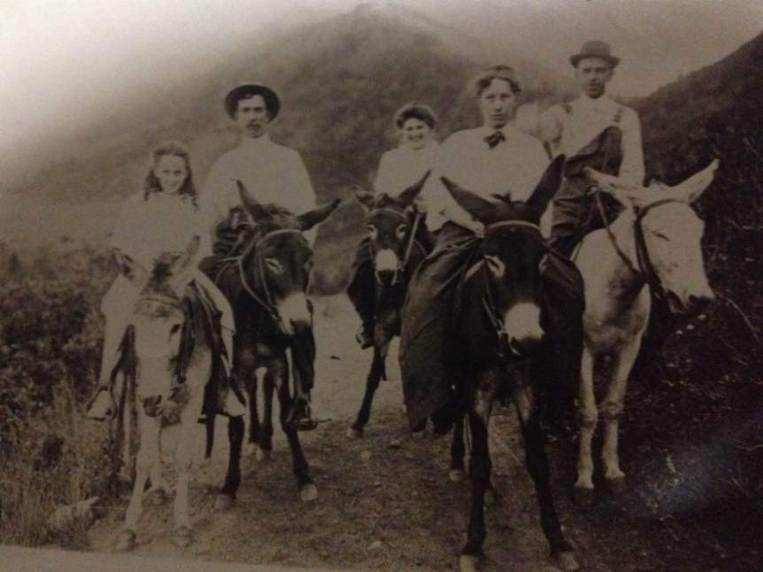
Figure 4.
Burros were the most common mode of transportation for visitors to the Grand Canyon. The animals allowed visitors access to areas in the canyon they would otherwise not be able to see.
“Denton Family on Pack Donkeys 1910”
Used with permission from the Wilson Family Collection

Public interest in the Grand Canyon increased as more people could visit the natural wonder by way of railroad and stagecoach. Travelling into the canyon, however, remained a perilous journey with only the option to walk or ride a burro, horse, or mule. “By mounting a burro,” one newspaper reporter announced in 1911, “the tourist can find himself in two hours in a scene of utter desolation which has never been penetrated by the automobile.” Riding a burro down narrow cliff trails was often the most memorable experience of one’s visit to the Grand Canyon. Burros offered an accessibility to the vast caverns and steep, treacherous paths that were otherwise unreachable to the average tourist. “Our burros had the most tantalizing habit of keeping just as close to the edge of the cliff as they possibly could.” One woman described her trip through the canyon on burro-back, “In the beginning, our guide gave directions not to attempt to guide the beasts. There were reins, of course, but the proper place for them was round the pommel of the saddle instead of in our hands.” Burros could be trusted, Grand Canyon trail guides suggested, to walk safely and assuredly through the canyon. Giving up the reins, so to speak, was a difficult task for many canyon travelers, as it forced them to have faith in their burro. In the end, when the trip was over and visitors were back safely at the canyon rim and on their own feet, they often praised the animals that led them through their most memorable experience. One visitor recounted her trip down and back up the canyon with great detail given to the burros they rode and the animals’ individual personalities. “El Tovar, my beastie,” she described the burro she rode in a loving fashion, “[is] a sure-footed creature, with whom it would be impossible to find fault – he did his best.” Burros made the expansive and dangerous Grand Canyon accessible to visitors physically through trail rides, but, also, by relating the canyon to a human history of Spanish explorers and early prospectors who also entered the canyon on burro-back.
The image of the burro in the American West, and specifically the Grand Canyon, has persisted whether as a worker and companion to prospectors or Spanish explorers, as a tourist guide, as a wild animal, or an exotic species. Brighty, arguably the most famous nonhuman resident of the Grand Canyon, cemented the symbolism of canyon burros. Brighty lived in the Grand Canyon from around 1892 to 1922, a friendly, feral burro that wandered between animal wilderness and human settlements. When with humans, the burro allowed children to climb on his back or he would carry water across short distances. However, he avoided ropes at all cost, running from anyone over the age of twelve with intentions of making him work. “Brighty was…respected and loved by all tourists who have visited the north rim of the Grand Canyon,” a 1923 sporting magazine article attests. One of the longest lasting stories of the Grand Canyon burro centers on Brighty’s help in building the first suspension bridge across the canyon. “He was first an interested spectator and later a cooperative worker when engineers were constructing the suspension bridge across the Colorado River,” Brookshier explains. The burro allowed the bridge crew to pack it with equipment and supplies. “When the structure was completed the question arose as to who should be permitted to make the first official crossing.” Author Thomas Heron McKee wrote in 1922, “By acclamation and by the consent of the authorities the honor was bestowed upon Brighty as the oldest and most distinguished inhabitant of the place.” Brighty lived out the rest of his life as a beloved mascot of the Grand Canyon until he met the unfortunate fate of serving as dinner for a pair of lost fugitives in a 1922 winter storm. The famous burro’s impact on the public, however, was far from over, Brighty would return to the mainstream in 1953.
“By the end of the nineteenth century,” ecologist Steven Carothers states, “the feral ass had become established in many isolated areas of the Southwest.” Burros remained established in the Grand Canyon both physically and in popular culture. “Literature of the West,” Historian Otis Young, Jr. describes, “strongly implies that the sole professional duty of the frontier prospector was chasing his burro.” While Young admits that much more went into the search for minerals, the image of the prospector and his burro remains widespread. Tales similar to Grey’s Tappan’s Burro flooded American literature in the form of dramatized works or in nonfiction accounts. In 1914, Arizona prospector George W. Harvey described the role of the burro in the Southwest. “Burros, I suppose, are to prospectors something like ships to sailors. They carry his food and lodging on their backs, sometimes the prospector himself. They bear his loads over incredibly rough country.” By the time increasing numbers of tourists flocked to the Grand Canyon in the 1910s, the burro was inextricably connected to its history. The Atchison, Topeka and Santa Fe Railroad, in an effort to sell tickets for its rail line to the national monument, replicated the Grand Canyon experience at the Panama-Pacific International Exposition in San Francisco in 1915. The exhibit took visitors through a simulated view of the El Tovar hotel, showed images of the sunrise and sunset over the canyon, and, a newspaper advertised, “a real Arizona burro will be part of the picture.” In any incarnation, as a prospector’s companion, a trail guide, a memory of Brighty, a figure in literature, or a feral animal on canyon cliffs, burros were deeply imbedded in the cultural landscape of the American West.
Few laws or regulations affected the use of land or the wildlife in or near the Grand Canyon before 1908. While the land changed hands several times from the fifteenth century until the twentieth, who owned the canyon on paper had little effect on the ground. Native Americans, Spanish explorers, American miners, and land speculators all made claims to areas of the canyon where they hunted, planted crops, and grazed cattle, but, in such a remote area, legal claims meant little. In 1908, however, the Grand Canyon gained national monument status, which placed it under the protection of the federal government and the U.S. Forest Service. The canyon’s new management prohibited many activities, such as taking claims to land, hunting indiscriminately, mining, and logging. Instead, as the 1906 message to congress from President Theodore Roosevelt proclaimed: the Grand Canyon would “be set apart forever for the use and benefit of our people as a whole and not sacrificed to the shortsighted greed of a few.” With the Grand Canyon under organized, federal control, the Forest Service could begin to enact canyon-wide environmental control.
Increased predator control was one of the aspects of environmental control the Forest Service started in the canyon. Predator control has affected wildlife populations in North America for centuries as Europeans killed large numbers of wolves, mountain lions, bears, and other animals considered dangerous. Generally, predator control procedures focused on large carnivorous animals that were able to hunt and kill livestock or large animals that national park visitors wanted to see such as elk, mule deer, bighorn sheep, and other ungulates. While the Havasupai and Hopi Indians in and near the Grand Canyon killed predators, they never hunted the animals in large numbers. The Havasupai had many taboos about mountain lion and grey wolf meat and skin. “Mountain lion flesh could not be eaten, “or even touched” (Spier 1928) by young married men or women when there are little babies in the family.” These taboos limited hunting large predators. The larger scale killing of predators by Euro-Americans, however, led to overpopulation in herbivores. Mountain lions hunted mule deer, bighorn sheep, and burros in the Southwest, including the Grand Canyon. Hunters who believed they were making the canyon safe, not severely damaging its ecosystem, systematically decimated mountain lion populations in the late 1800s and early 1900s. Most famous of these hunters was former president Theodore Roosevelt who wrote about his experience hunting cougars (mountain lions) in the Grand Canyon in 1913. “One important feature of [Uncle Jim Owens’] work,” Roosevelt states, “is to keep down the larger beasts and birds of prey, the arch-enemies of the deer, mountain sheep, and grouse and the most formidable among these foes of the harmless wild life are the cougars.” Roosevelt viewed the mountain lion hunt as necessary to protect and grow populations of big game animals. The ecologist John Merkle further explains predator control on the Grand Canyon rim: “For several years after 1906 government hunters were employed to kill predatory animals. By 1923, 674 mountain lions (the principal deer predator), 11 timber wolves, 3,000 coyotes, and 120 bobcats had been destroyed. Later the wolves were exterminated and the other predators further reduced.” With few predators in the canyon, deer, sheep, and burro populations grew unchecked.
Predator control creates a number of problems within an ecosystem. Predators serve at an important role in controlling other animal populations within an environment. Animal overpopulation can lead to plant overgrazing, the spread of disease, and large-scale animal die-offs. With more herbivores eating plants and grasses, many areas of plant coverage could not sustain the large numbers. Areas overgrazed in the summer and fall did not grow back in the same density of plant coverage in the spring. When fewer plants are available, smaller herbivores like rabbits, squirrels, and mice starve. The effects of predator control at the Grand Canyon peaked in the winter of 1925. Mule deer populations in the canyon and the adjacent Kaibab National Forest grew steadily larger following increased management of wildlife with the establishment of Grand Canyon National Forest. In conjunction with killing predators, forest service and park rangers halted deer migrations by building fences and setting out hay in the winter months. The growing mule deer population overgrazed the canyon and forest and disease spread rapidly through the crowded herds. “With no check on reproduction, the deer population exploded.” The historian Thomas Dunlap describes, “The animals stripped the forest, then died of starvation and disease.” Thousands of mule deer died in the winter of 1924 and 1925. Ecologists used the Kaibab deer die-off to understand the vital role of predators in an ecosystem and influenced park policies of predator control. Predator control efforts did not halt immediately and large carnivorous animal populations remain minimal in many national parks.
The environmentalist Aldo Leopold expressed the shift in environmental understanding in his essay "Thinking like a Mountain," published in his 1949 book A Sand County Almanac. In this work, Leopold addressed several environmental issues such as predator control and nonnative species. In “Thinking like a Mountain,” Leopold addressed the shifting understanding of wildlife populations, particularly predators, which occurred within his lifetime. Leopold expressed the common belief, originally shared by him, that hunters should exterminate predators. “In those days,” he stated, “we had never heard of passing up a chance to kill a wolf.” The realization that predators served as an integral part of an ecosystem came to Leopold, he states, while watching “a fierce green fire dying” in the eyes of a wolf he had shot. As hunters and ranchers killed a majority of the wolf population in the early-to-late twentieth century, deer and elk numbers exploded. Leopold described the consequences of overgrazing, “For while a buck pulled down by wolves can be replaced in two or three years, a range pulled down by too many deer may fail of replacement in as many decades.”
Leopold's compelling narrative in "Thinking like a Mountain" parallels the conservation movement's development towards a more complex and scientific management of wildlife. Leopold worked as an early endorser of studying the ecological connections between flora and fauna, however, increased professionalization and science-driven decisions inundated NPS policy by the mid-twentieth century.
______________________________________________________________________
With few predators, the Grand Canyon National Monument housed a growing burro population. The area still served as an ideal location for feral burros to live and reproduce. The burros that remained in the Grand Canyon formed the Tonto Plateau, Shinumo, and Lower Canyon herds. At the turn of the twentieth century, the burro population in the Grand Canyon reached above 2,000, or, as a National Forest ranger had once described it, “in such numbers as to constitute a nuisance.”

Chapter 2: The Authentic Arizona Burro
As tourism in the Grand Canyon increased in the early decades of the twentieth century, visitors saw the burros that transported them throughout the park as a symbol of the American West. “Burros,” the historian John Wills explains, “enabled vacationers to interpret the monumental landscape, allowing them to see the Canyon as both a geological wonder and a place of pioneer history.” Nonetheless, National Park Service (NPS) employees planned to remove the exotic equine, believing that it did not belong in Grand Canyon National Park because it competed for resources with the desert bighorn sheep, a native animal equally popular with tourists. The NPS began annual burro culls in 1924, but was unable to remove all of the animals from the sprawling canyon. By the 1960s, when the NPS adopted plans to eradicate all Grand Canyon burros, it encountered public hostility to its initiative. Viewing the burro as a cultural icon, an image reinforced in children’s literature, many people supported keeping the animals in the canyon, or, at the very least, opposed shooting them. Unprepared for the backlash, NPS efforts to educate the public about the ecological problems associated with the burro fell short. Compared to eye-catching newspaper articles about slaughtered burros, the NPS’s scientific studies seemed cold and alienating. The result of the NPS’s poorly implemented plan included an outraged public, a negative image for the National Park Service, and a removal process that proved longer and more complicated than officials had anticipated.
The national park idea developed over much of American history, long before the federal government launched the NPS in 1916. Its early proponents advocated the idea either as a means to convince the world of the nation’s unique landscapes or to preserve its natural areas. In Wilderness and the American Mind, the historian Roderick Frazier Nash considers the importance of nature in shaping a uniquely American identity, specifically in the early twentieth century, but stretching as far back as the seventeenth century. In contrast with Europe’s deep history and well-established culture, the United States seemed to have little to offer. Nash describes what many Americans discovered in the early nineteenth century, “In at least one respect Americans sensed that their country was different: wilderness had no counterpart in the Old World.” While the protection of nature was often part of the American embrace of scenic preserves, the ultimate goal was a search for a national identity. Rather than satisfying environmental obligations, the national park idea served American cultural needs. Henry David Thoreau and many of his contemporaries sought out nature in the mid-nineteenth century. In an increasingly industrialized nation, Thoreau wrote about the need for wilderness in daily life, whether accessing that wilderness meant walking through a park or living in the woods. Writers, such as Thoreau and Ralph Waldo Emerson, praised American wilderness, expressing the need for the nation to embrace nature. At the same time, American art presented nature in the United States as grand and imposing. Landscape artists such as Albert Bierstadt painted scenes of Yosemite, the Rocky Mountains, and the valleys of the Sierra Nevada Mountains on large canvases with vibrant colors, and, other than the rare inclusion of Native Americans, without humans but with the inclusion of selective animals emblematic of North America. By displaying a United States with vistas unlike anything else in the world, these landscape paintings assisted in creating a national interest in the country’s natural scenes. The grand scenery offered the United States a replacement for castles and cathedrals rooted in European history; instead, many Americans convinced themselves, the United States had taller mountains, stronger rivers, and more wilderness than all of Europe.
As more Americans began to embrace nature as essential to national identity, many people worked to save the wilderness from industrialization by promoting federal interventions. President Ulysses S. Grant established Yellowstone as the first national park in 1872. Twelve other parks, each managed by the U.S. Army, joined Yellowstone between 1890 and 1916. In 1916, Congress passed the National Park Service Organic Act, establishing the NPS within the Department of the Interior and setting forth the desired plan for the use of park land. The Organic Act states:
The service thus established shall promote and regulate the use of the Federal areas known as national parks, monuments, and reservations hereinafter specified by such means and measures as conform to the fundamental purpose of the said parks, monuments, and reservations, which purpose is to conserve the scenery and the natural and historic objects and the wild life therein and to provide for the enjoyment of the same manner and by such means as will leave them unimpaired for the enjoyment of future generations.

The act still serves as the foundation and mission of the NPS, although the interpretations of the mandate have changed over time. A contradiction between park preservation and an emphasis on parks meant for “enjoyment” has allowed a wide range of disturbances in parks, such as infrastructure construction, livestock grazing, the removal of certain animals deemed destructive, and the introduction of other flora and fauna with aesthetic or recreational value. The ambiguous mandate opened the parks up to development in the name of “enjoyment.”
While the NPS formed on August 25, 1916, the NPS historian Russ Olsen states, “It was not until May 16, 1917, with the appointment of Stephen T. Mather as Director, that a formal structure was established.” Mather, the first, and arguably, most influential park service director, emphasized park tourism and recreation over nature preservation in interpreting the Organic Act. “As one of his principal goals,” the historian Richard West Sellars describes, “the aggressive new director sought public acceptance and support for the parks by opening them to greater tourism to increase their popularity.” The cofounder of a borax mining company, Mather amassed enough money early in his life to pursue his true passion: nature. Mather retired in 1914 and joined the Sierra Club to spend his time hiking in Yosemite and Sequoia national parks. Interested in becoming more involved in the national parks, Mather moved east to work with Secretary of the Interior Franklin Lane to establish the NPS, and, in 1917, to head the agency. Mather immediately worked to create the park service he imagined, teeming with visitors, picturesque nature scenes, and desired animals always within view. The “fervently idealistic” director perceived tourism as the most important goal of the NPS and promoted developments such as hotels, roads, fences, and railroads. The emphasis placed on tourism often overshadowed many other aspects of the early national parks and the implications for park ecology rarely received attention.
Mather, along with the Assistant Director Horace Albright and a handful of employees, faced unprecedented decisions with respect to the size of the land the NPS managed and its mission to maintain that land “unimpaired.” The NPS represented something new in the world. Without its own precedent, the NPS’s environmental policies initially mimicked those created by the Army, the U.S. Forest Service, and civilian park superintendents. However, this meant that the NPS used information from organizations with vastly different missions. For example, the NPS used the Forest Service’s scientific studies that focused on management for “productivity” and “sustained yield” and neglected to conduct its own studies of park flora and fauna. With Mather’s focus on tourism, the NPS soon practiced “façade management,” the system of altering park ecology based on appearance instead of scientific fact. This management system also included predator control, fire and insect suppression, feeding hay to game animals, and encouraging visitors to feed bears or other wildlife. As Sellars describes, “The park service practiced a selective kind of preservation, promoting some elements of nature, opposing others – altering natural conditions largely in an attempt to serve the other part of its mandate, the public’s enjoyment of the parks.” In those early years, under the direction of Mather, the NPS set standards that lasted many decades after his retirement in 1929. One such standard was the NPS’s involvement with plant and animal populations in parks. National parks across the country altered wildlife populations, promoting and feeding popular animals and culling less desirable animals.
As the NPS grew as an agency, the Grand Canyon was developing its own tourist industry. Since its establishment as a forest reserve in 1893, the U.S. Forest service controlled the Grand Canyon. While still under Forest Service management, President Theodore Roosevelt declared the canyon a game reserve in 1906 and a national monument two years later. Nonetheless, the canyon’s natural resources were of little interest to Forest Service officials. The landscape did not possess enough timber for large-scale logging, and, by 1900, miners had found few precious metals within its boundaries. The rocks of the canyon, however, prompted several geological expeditions, including several visits from the U.S. Geological Survey and American Geographical Society between 1900 and 1912.
While geologists explored the canyon’s rock layers, tourists gaped at the canyon from the back of a burro. Private businesses established hotels, rail lines, trails, and numerous other tourist amenities around the canyon. By 1910, the El Tovar Hotel, Bright Angel Camp and Lodge, the Red Horse Hotel, the station grounds of the Santa Fe Railroad, and several smaller buildings lined the canyon’s south rim. Ralph Cameron, the owner of the Red Horse Hotel, privatized the canyon further by taking control of the Bright Angel Trail in 1903. Cameron placed a gate at the trailhead and charged $1.00 to everyone who hiked or rode into the monument. As elaborate hotels filled the canyon rim, other investors built small cabins, tent towns, and rest houses inside the canyon, just off the trails and nestled in crevices. Hermit’s Rest, one of the most well known canyon rest houses, consisted of a large log building adjacent to Hermit Trail for visitors to rest overnight. The Forest Service first attempted to establish a town, Grand Canyon Village, on the south rim in 1910, and while it could not afford to build the entire village, it constructed many roads, buildings, and fences that helped shape the community. The Grand Canyon already had a profitable, albeit unorganized, tourist industry by the time President Woodrow Wilson signed the bill granting the Grand Canyon national park status on February 26, 1919.
The presence of more buildings, trails, and tourists led to new demands for additional animals to carry people into the canyon. Burros were still the most common pack animal and helped carry building materials down the canyon paths and people back out. By 1910, however, mules were more common in Grand Canyon Village. Mules are the offspring of a male burro and a female horse. Their lineage makes them taller and stronger than burros enabling them to carry more weight. The animals are also sturdier and less skittish than horses making them safer for trail rides. Mules, however, are unable to breed. The sterile animals were an impractical investment for a tour company isolated in the canyon. With the formation of Grand Canyon Village, tour guides and companies were able to breed mules in the newly developed pastures and barns. Increased infrastructure also allowed mule owners to feed the larger animals that cannot subsist off desert brush like burros. While mules surpassed burros as trail animals, burros were still necessary to navigate incomplete or hazardous trails because they could walk on loose rocks and fit on smaller paths. Despite greater use of mules on the trail, many park visitors still saw domesticated and feral burros throughout the canyon. Whether working for a canyon resident or watching over tourists from a cliff, burros served as a reminder of the human history of the Grand Canyon.
While burros increasingly symbolized the Grand Canyon’s past, the NPS began to plan their eradication under Director Mather. Mather wanted to remove burros from the canyon because they competed with desert bighorn sheep. The native sheep, Mather believed, were of more interest to park tourists because most people had never before seen the wild animals compared to burros who have worked as livestock animals in the United States for centuries. In his 1920 report, Mather offered a negative view of the animal, blaming burros for eating forage meant for bighorn sheep and for destroying tourist trails. He stated, “The time is not far distant when radical steps will have to be taken to eliminate the burro evil.” These radical steps began in 1924 when the NPS established annual burro hunts by park rangers and nearby ranchers, authorizing rangers to shoot burros on site. The NPS hired private citizens who joined rangers in shooting and poisoning the burros in the 1920s and 1930s; they often left the bodies to decompose deep in the canyon out of the view of park visitors. Hired hunters sometimes drove burros off concealed cliffs in herds or sold the animals to butchers for pet food. In his 1930 Report, Horace Albright, Mather’s successor as NPS director, stated that annual burro hunting parties had killed 1,337 burros in six years. These culls inspired little interest from the public and the NPS conducted their reductions of the animal population discreetly in the backcountry, away from tourists’ eyes. Undisclosed burro culls continued through the 1950s focusing almost exclusively on the larger Tonto Plateau herd on the southern rim, of which park rangers and hunters killed 1,837 members between 1924 and 1956. The Shinumo and Lower Canyon herds remained relatively untouched on the north side of the river.
Mid-century animal culls in national parks were not limited the Grand Canyon. While canyon rangers shot feral burros, staff at Rocky Mountain National Park (RMNP) in Colorado grappled with an overpopulation of elk. “In 1944,” the historian Jerry Frank states, “the staff at RMNP began an intensive culling campaign.” In the 1910s and 1920s, the NPS had encouraged the growth of the elk population by removing predators and banning hunting in the area. By the 1940s, the elk had overrun the park, overgrazing meadows, compacting soil, and competing with other animals. Shooting the overpopulated elk, however, created controversy for the NPS. Between 1944 and 1959, the number of elk culled diminished each year in fear of public outrage. In 1961, the NPS released the Elk and Deer Management Plan that organized the culling of elk and deer each winter to a level “conducive to regrowth of forests, shrubs, and grasslands.” The plan faced harsh criticism. The Denver Post commented, “Seldom has the National Park Service taken a worse public beating than it’s now suffering.” The backlash led to the decision to live capture and transplant the elk off NPS land where the animals would disperse and hunters could shoot them. Along with this alternative, the NPS studied the animals’ migratory patterns to create a better management plan. Culling elk in RMNP remains a controversial subject. The opposition RMNP faced in shooting animals beloved by tourists served as an example for the NPS during burro removal.
Routine burro culls continued in the mid-twentieth century, even as Brighty the burro brought public interest back to Grand Canyon burros. The author Marguerite Henry discovered the story of the Grand Canyon’s most famous burro in a 1922 Sunset magazine article written by a long-time canyon resident Thomas McKee. Henry recognized the value of the old story and set out to write her own Brighty tale. In an attempt to make Brighty’s story as interesting and realistic as possible, Henry and her husband visited the canyon. She rode down the canyon on a mule, noting plants and wildlife that Brighty would have seen. The Grand Canyon historian Don Lago writes, “She did her best to see the canyon through Brighty’s eyes.” After extensive research, interviews with canyon residents, and, even, the purchase of her own burro, Henry published her children’s book Brighty of the Grand Canyon, in 1953. While grounded in the true tale of Brighty’s life in the Grand Canyon, Henry created an imaginative story of a wild but friendly burro who belonged in the Grand Canyon as much as the “dust and the ageless limestone that rose in great towering battlements behind him.” With Henry’s book in mind, many people viewed Brighty, and all burros, as an image of “the spirit of the Grand Canyon – forever wild, forever free.” Henry’s book raised public interest in what they viewed as a native, wild Grand Canyon burro that directly contradicted the NPS’s image of destructive exotics. To many park visitors, Brighty became a symbol of the Grand Canyon. They saw the burros as a wild, yet accessible part of nature, “a hybrid existence of domesticity and wildness.”
Henry described the feral burro as a natural feature of the Grand Canyon, “forever a part of the rocks and streams and the wind and sky.” Faced with the endearing tale of Brighty, NPS ecologists conducted several studies to prove to the public that burros were damaging the canyon and should not remain in the park. Under Director Conrad Wirth (1951-1964) and his successor George Hartzog Jr. (1964-1972), the NPS hired more environmental scientists to research the effects of past and current animal management practices across all of its parks. The increased number of scientific studies assisted in a professionalization of NPS employees and the park service itself, emphasizing ecology over recreation in parks. Several ecological studies focused on burros in the Grand Canyon in the 1960s. The studies cited burros as responsible for causing topsoil erosion on canyon plateaus, rockslides and cliff side erosion, fouling water sources, wallowing in water seeps, and, above all else, creating direct grazing competition for bighorn sheep, an indigenous species. Burro diets include a variety of grasses and shrubs depending on the time of the year and plant availability. While the majority of burro subsistence in desert landscapes focuses on grass, the animal will eat cacti and ferns. The burro’s diet consists of similar forage as desert bighorn sheep, and, as much larger animals, individual burros require more forage than bighorns. With similar diets, burros and bighorns often overlap territory and grazing areas. Exacerbating this grazing competition, burros are much more aggressive than bighorn sheep. Sheep are described as “shy, flighty, and nervous” while burros are known for their proclivity to fight rather than flight. Burros will chase intruding bighorn sheep away from forage and water. Burro competition threatened to diminish the canyon’s sheep population and the culling of canyon burros continued. Rangers took meticulous notes on burro sightings, shootings, and locations; between 1956 and 1968, rangers killed 771 burros. Since 1924, they had culled 2,608, a large number but never enough to eradicate the animals completely. The shootings carried on throughout the 1960s in much the same way they had begun in 1924 under the “Burro Control Program.”

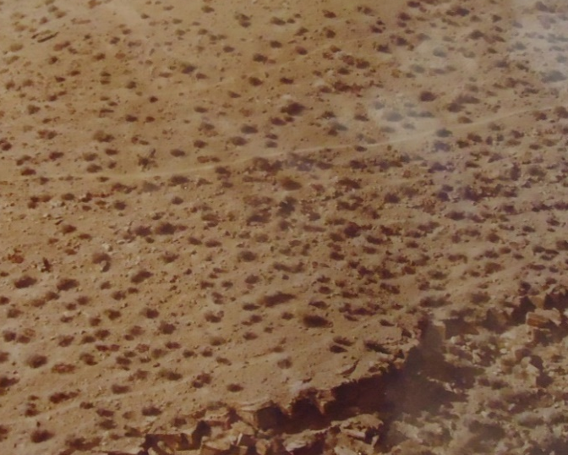
Figure 5.
This aerial photograph captures burro trails along a canyon plateau. Burros often travel several miles a day between water and forage. After crossing the same route many times, burro trails can line a plateau. The main centered trail is a hiking path.
Used with permission from the Grand Canyon Archives
Resource Management Burro Damage Monitoring, 1978
Burro Trailing Photo - GRCA 102834
Despite numerous scientific studies, the public and animal advocacy groups remained steadfast in their protest of burro culls. Once news of the NPS’s plan to remove burros from the Grand Canyon spread across the nation, protests ignited. The passing of the Wild Free-Roaming Horses and Burros Act of 1971 left equines fresh on the minds of the American public. The Wild Horse and Burro Act protects free-roaming burros and horses on public land from “capture, branding, harassment, or death.” The act, however, does not apply to national park land. Nevertheless, many of the organizations that promoted the Wild Horse and Burro Act, worked against the burro removal plan, including the animal advocacy groups: American Wild Horse Preservation Campaign, American Horse Protection Association, and the Humane Society, which created the Committee to Save the Grand Canyon Burros. Private citizens reacted to the removal plan by inundating the canyon offices with as many as 12,000 letters in the 1970s asking the NPS to reconsider removing the burros. One letter mailed to Park Ranger Jim Walters asked, “How would you like to be shot?” Across the country, newspapers printed articles about the removal plan and editorial pages filled with calls to “save the burros.” A letter to the editor of the New York Times threatened, “The canyon may soon become a slaughterhouse.” While most protesters asked that the burros remain untouched in the canyon, in some letters, people offered other solutions to the problem such as “importing mountain lions to eat them [or] growing grass in the canyon to feed them.” Protests against the burro removal plan kept the public engaged in the fate of the Grand Canyon burros to the early 1980s.
The park’s scientific burro management plan quickly split the argument. Those in favor of burro removal presented their findings as objective science and labelled the public protests as sentimental and overly emotional. Park officials feared that “emotional laymen” would undermine their expertise. Most of the public’s concern stemmed from the lack of ecological information shared in sympathetic and lay terms. Many people understood the basic damage done by burros, such as erosive trails and overeating limited forage, however, the NPS released information about burro damage in complicated scientific studies. To many, plans to eradicate the canyon burros sounded cold, economic, or, even, bloodthirsty. Scientists conducting studies of burro damage further alienated the many burro supporters by criticizing the latter’s stance as uneducated and hysterical. In one study, the ecologist Steven Carothers and Grand Canyon Park Superintendent Merle Stitt derogatorily labelled those who disagreed with burro removal as “assinophiles” and stated their disagreements as “public hysteria.” Dismissive and emotionally charged language filtered into many writings that supported burro removal. Studies often referred to burros as “pests,” “vermin,” or, as Mather stated back in 1920, “evil.” Most people and organizations that supported burro removal publically dismissed those that disagreed. “A degree of elitism could also be detected.” Wills states, “Many felt that only wildlife biologists and wilderness veterans could comprehend the burro issue, and that those members of the public who opposed killing knew little about ecology, parks or science.” This dismissal and alienation only furthered the fervor of burro supporters. While the Grand Canyon burro removal plan changed minimally from 1924 to 1969, public support to save canyon burros grew. The small amount of educational materials explaining the ecological damage caused by burros was unduly complex, and in its tone, patronizing and offensive. The ensuing public outcry in support of burros created a negative image of the NPS and a much longer removal process than anticipated.
While the NPS released scientific studies, media outlets exacerbated the public’s outrage about the burro removal plan. Newspapers across the country covered the NPS’s decision to shoot the canyon burros with dramatic headlines and images of burro foals. Many articles included a brief statement about the ecological damage burros inflicted on the canyon but mainly emphasized the plan to shoot the animals. Even the National Geographic, showed sentiment for canyon burros in its July 1978 issue. The article emphasizes burros’ environmental destruction describing the animals’ “erosion-inducing trails” and territory competition, but, on the next page, the article shows an image of a dying burro after Park Manager Jim Walters and his team shot it with an “immobilizing dart.” Most of the article explains environmental damage to the canyon in cold, economic terms considering the cost of live removal, the number of rangers needed, and the low price of burros at auction. Adversely, the image of the dying burro and the caption that two out of three burros sedated died, appeals to human emotion, and, often, turned the public against the NPS’s burro removal plan.
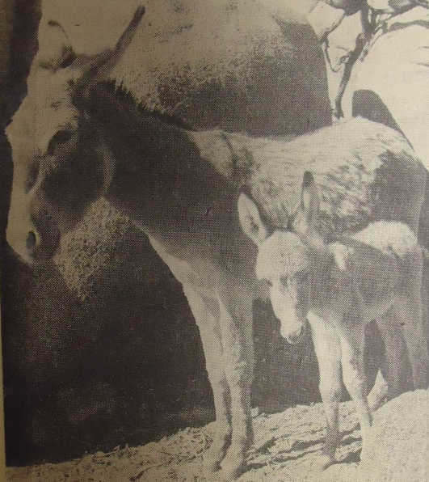
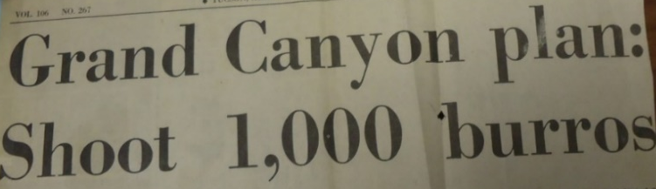
Figure 6.
The media played a large role in informing, and often upsetting, the public about the NPS’s plan to remove burros from the Grand Canyon. Headlines and pictures like these filled papers from Arizona, the Southwest, and as far away as Boston and New York City.
Used with permission from the Grand Canyon Archives
Burro Scrapbook Materials, 1976 -1981
Tucson Daily Citizen and Miami Herald - GRCA 102124

The Grand Canyon offices and Superintendent Stitt received piles of letters from concerned citizens ranging from members of national wildlife groups to small children who drew images of “Brighty.” Editorial sections of newspapers across the country contained passionate comments for, and, far more often, against burro removal. One writer in Chicago listed Stitt’s address asking others to write to him to stop the burro “extermination.” Elementary school teachers taught their students about the burro removal by reading Brighty to the class and explaining the NPS’s plan to remove all the Brightys from the Grand Canyon. Hundreds of children from as far away as New York and Boston wrote to Stitt asking him to “Please save the burros.”
Grand Canyon administrators ceased the original burro control program in 1969 due to growing public pressure against burro culling. The NPS addressed the lack of public knowledge about the program by releasing statements and conducting environmental impact studies. These efforts, however, did little to quell public anger concerning the burro removal program. While the control program halted in 1969, the NPS planned large-scale culls for the 1970s. In a public meeting concerning the removal, Park Superintendent Merle Stitt stated, “There was some public concern about the fact that we were shooting burros in the Canyon and that the public hadn’t been adequately informed.” In order to keep the public informed, Stitt and other NPS workers released public announcements in the mid-1970s, and, in 1979, held meetings in Flagstaff, Phoenix, Tucson, Salt Lake City, Las Vegas, and Los Angeles where the public could voice their concerns about the burro removal plan. The vast majority of people who spoke at these meetings were representatives of the Audubon Society, the Sierra Club, and other conservation groups already aware of the burro situation in the canyon. Often, instead of informing the public, these meetings contained groups that were already educated in the burro control effort. The NPS’s attempt to educate the public about burros in Grand Canyon National Park became an echo chamber of wildlife organizations while the public remained upset about the situation and uninformed about the burro control plan. The NPS did try to inform the public. Supervisor Stitt made the decision to replace the canyon’s life-size statue of Brighty with a chart describing the burro problem with images of burro trails, droppings, and muddied water holes. Visitors rarely commented on these meetings, the burro displays and information in Grand Canyon Lodge, or educational material at other tourism points at the canyon. Without a true overarching educational program, the public rallied against the burro removal plan.
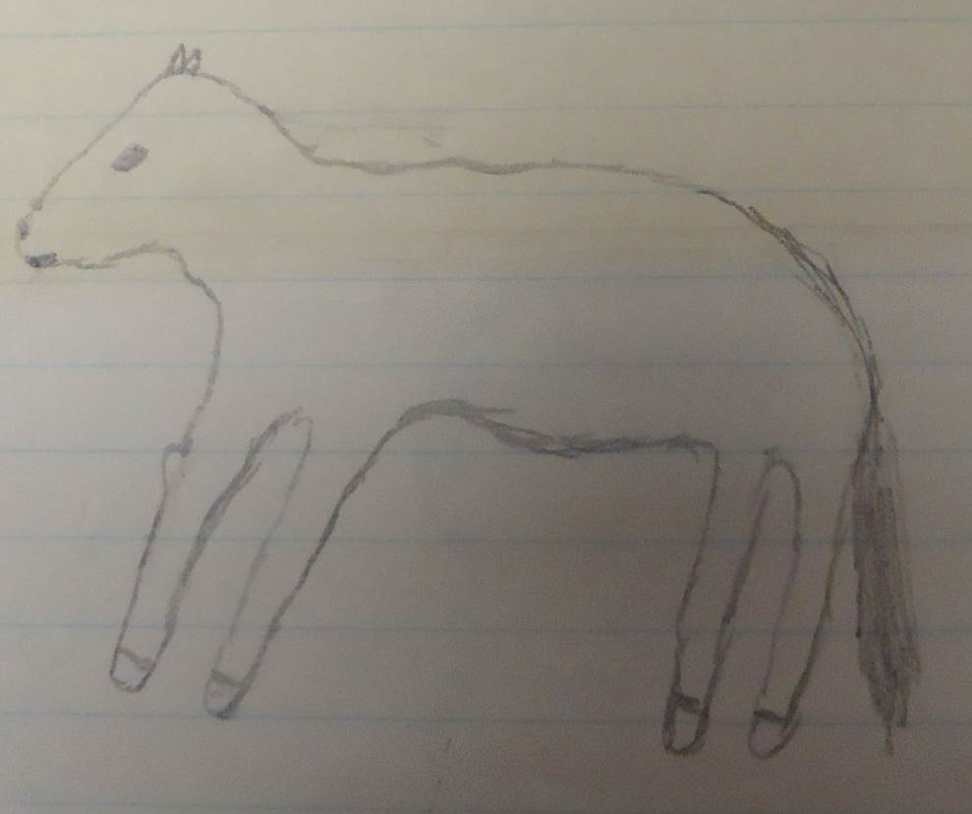
Figure 7.
Hand drawn picture of “Brighty” the burro included in a letter from a nine-year-old sent to Grand Canyon Park Superintendent Merle Stitt in 1977.
Stitt received numerous letters from people all over the country asking the NPS to find another way to handle the Grand Canyon burros.
Used with permission from the Grand Canyon Archives
Letters in Reference to Burro Management Plan, (1977), GRCA 57817

______________________________________________________________________
The NPS administration stood steadfast in its plan to remove the exotic animal and no lawsuit, claim of “burro-cide,” or hand-drawn picture of Brighty would change that decision. In the Grand Canyon, burros were an exotic species and slated for removal by the park service in 1924. Sporadic burro shootings by rangers transpired throughout the 1920s and 1930s. The mid-century decades saw increased removal efforts including shooting, poisoning, tranquilizing, and live removal. By the 1970s, as public advocacy for wild horses and burros grew, few burros left the canyon, but park administration began the paperwork and planning for total removal. Public interest forced delays and negative publicity upon the NPS. Increased public pressure to save the canyon burros without enough public education concerning the ecological damage caused by burros, led to an outraged public, a negative image of the National Park Service, and a complicated and long removal process. By 1976, the NPS was nearly ready to release its Burro Management Plan and Environmental Assessment and finally eradicate all burros from the Grand Canyon.

Chapter 3: A Canyon without Burros

After the NPS halted burro removal in 1969, the agency worked to inform the public about the burro issue by releasing public statements and authorizing scientific studies. These actions did little to quell the growing concern over the possible burro slaughter. In an attempt to explain the negative effects of the burro in the canyon, the NPS released the Burro Management Plan and Environmental Assessment in November 1976. The plan included several studies of burro impacts on canyon soils, vegetation, and wildlife, concluding that Grand Canyon policy would require rangers to shoot all the burros in the park. After six years of no reduction measures, the NPS estimated that the burro population had soared to 2,000 or 3,000. The conclusion outraged burro supporters who found the assessment lacked proof of negative burro impacts. Further, the plan stated that direct reduction through shooting was the only viable means of eradicating the animals from the park. While many wished to keep the burros in the canyon, killing the animals upset far more people than the idea of removal. In response to the environmental assessment, the American Horse Protection Association (AHPA) sued the NPS, preventing the agency from conducting any removal efforts until it conducted a full environmental impact statement (EIS). Russell Gaspar wrote to the NPS on behalf of the AHPA, “Because AHPA believed that the claimed problems were non-existent and that careful study of the situation would confirm that fact, a lawsuit was brought to compel the Park Service to prepare an environmental statement.” The National Environmental Policy Act of 1969 required federal agencies to conduct environmental assessments and impact statements explaining the possible environmental effects of proposed plans. The act required the use of “the natural and social sciences” to decide if a proposed action may affect the environment. The increased pressure of the AHPA lawsuit forced the NPS to create an extensive EIS between 1976 and 1980.
Grand Canyon park staff and hired researchers conducted environmental studies of the effects of burros on the park for the EIS. The NPS combined several studies about burro grazing habits, competition with desert bighorn sheep, trailing and erosion, and reproductive rates into a draft EIS. The draft EIS cited the exotic status of burros in North America as the main cause for the removal, but also included findings from the studies conducted in the 1970s. Relying primarily on reports prepared by the Museum of Northern Arizona, the draft concluded, “Feral burros change the natural condition of park soils through compaction and soil erosion.” The museum also stated that burros negatively affected plant communities in canyon areas overgrazed by burros and sheep. The draft EIS acknowledged, however, that some ecologists disagreed with these findings. Herbivores overgrazed areas throughout the canyon, including areas without a burro population. The museum’s study identified burros as damaging to small mammal populations, blaming the animals for overgrazing brush where small rodents hide. Other NPS studies concluded that areas of moderate burro grazing had a positive effect on small mammal populations by opening up the underbrush to allow easier movement and access to loose soil. While not certain, the draft EIS offered enough correlation between burros and canyon damage to convince the NPS of the animals’ negative effects. “Although most managers and scientists feel burros have a definite impact on native plant and animal communities,” the draft states, “there are a few scientists who feel this impact is slight or insignificant.” The draft’s inconclusive findings and use of vague terms led many commenters to question the scientific reasons for burro removal.
Further, the draft EIS failed to offer conclusive evidence on the impact of burros on bighorn sheep. In 1920, Stephen Mather had cited competition with the native bighorn sheep as the worst offense of burros in the Grand Canyon and a principal reason for justifying their culling. By 1979, none of the scientific studies found proof that feral burros in the canyon led to a declining sheep population. Instead, the draft EIS referenced habitat loss due to “a number of factors, mainly man’s activities such as mining, ranching, and recreation” as the greatest negative influence on sheep populations. Burros did compete for similar forage and water sources in areas of the canyon, but the draft EIS could not conclude undeniably that burros negatively affected sheep populations. Instead, the draft EIS stated, “While measurable direct competition between burro and bighorn had not as yet been demonstrated by research in Grand Canyon, the overlap in range and diets […] indicates that competition probably does exist.” With no proof of competition between burros and bighorn sheep, the NPS could not substantiate the oldest argument for burro removal.
The draft EIS did not convince everyone that burro removal by shooting was the best or only option. The draft EIS covered burro impacts on the canyon and agreed that the exotic animal affected the environment. The exact effects, however, were not clear enough to change the minds of burro supporters. Instead, the draft EIS, and the final document, had no impact on the people and organizations that had been vocal for and against burro removal.
Ultimately, the NPS concluded to remove all burros from the canyon by shooting the animals. The aerial and foot counts made for the EIS found that, instead of the earlier estimated 3,000, the burro population in the canyon was closer to 300. While the draft EIS did not offer the irrefutable evidence the NPS hoped for, it did conclude that the exotic burros harmed the canyon. In the draft EIS, the NPS includes other burro removal options considered by the agency and why these options were not viable. The draft EIS explained the alternative actions the NPS had considered. “No action” was not an option as it would allow “the continuation, intensification and expansion” of impacts by burros. During feasibility studies of burro live capture, the NPS estimated live removal would cost $360,000 and if no one adopted the removed animals in thirty days, the NPS would shoot them anyway. The NPS considered “partial retention of burros” in sectioned off areas of the canyon, however, the NPS would need to build several fences and conduct periodic reductions to maintain herd size. The NPS also considered establishing a “small burro viewing area” near a heavily trafficked location in the park. The NPS decided against this option because the small pens would create a “zoo-like atmosphere.” The NPS considered three final methods only briefly as their likelihood for success was severely limited. “Euthanasia with drugs” would end in the same result as shooting, however, the burros would experience increased trauma because rangers would have to be in closer proximity to inject the drugs. Sterilization would take far longer than any other process and each sterilization technique had undesirable side effects such as hormone imbalance. A restoration of mountain lions would decrease burro numbers but more predators would also reduce sheep and deer populations. The agency extensively investigated these other options, but concluded that the cheapest and most effective way to eradicate burros from the Grand Canyon was to shoot the animals.
The draft EIS included the proposed plan to complete the eradication of the burros. Rangers at close range would shoot the three main canyon herds during an initial twenty-day reduction period. Helicopters would fly rangers to the general vicinity of the herds, but the shooters would proceed on foot. Rangers would leave all the burros they killed within the canyon to decompose. If, however, hikers could view the carcasses from trails or the bodies were close enough to foul water sources, rangers would move them to a more remote location. Once rangers had reduced the three main herds to under a dozen animals, they would remove the fourth herd of approximately twelve burros. The final herd remained on the border of Grand Canyon National Park and Lake Mead National Recreation Area (LMNRA) in the Grand Wash Cliffs region. The park staff wanted to push this herd off the national park land into LMNRA where the Wild Horse and Burro Act protected the animals. The NPS then planned to build a two and a half mile fence to keep burros out of the park.
The NPS mailed out the draft EIS for comments from organizations and individuals ranging from the Bureau of Land Management to the American Horse Protection Association. Based on comments received in the spring of 1979, the opinions of the public and the scientific community remained divided. Animal protection organizations wrote at length of the inhumane and unnecessary killing of burros. Wildlife organizations generally supported the plan, although some noted minimal concerns regarding the time it would take to kill all the burros due to the park’s inability to complete this task previously. Many organizations also criticized the fence, concerned that it would hinder bighorn sheep migration or that burros would easily push through it. The NPS designed the fence to stop burro intrusions without affecting bighorn sheep. A three-stranded barbed wire fence with a smooth bottom wire would allow the smaller sheep to pass under the barbs but would block the larger burros. The Director of the Bureau of Land Management voiced concerns regarding the proposal of the burro fence. “The use of a three-strand wire fence,” the director wrote, “will probably prove to be no deterrent to keeping burros off of national park lands.” The NPS responded to the comment in its final Burro Management Plan. “This boundary fence needs to be constructed regardless of the burro problem in order to separate special-use practices, such as livestock grazing allowed on recreation area lands from those lands administered by Grand Canyon National Park. […] Whether or not it effectively will keep burros out of the park remains to be seen.” The purpose of the burro fence, despite its name, was ultimately to designate the line between Grand Canyon National Park and LMNRA. Marking this boundary kept grazing livestock off the national park land, where the NPS no longer allowed private grazing. In LMNRA ranchers could purchase annual grazing permits. Perhaps, however, the most important comment on the draft came from the animal advocacy organization the Fund for Animals. With no chance of keeping feral burros in the Grand Canyon, the Fund for Animals offered to remove the animals alive.
Released to the public in January 1980, the final environmental impact statement reinforced the burro’s non-native status and called for a complete elimination of the animal within Grand Canyon National Park. The final plan looked into the options of live removal, sterilization, and fencing, but concluded that the cheapest option was the total slaughter of the Grand Canyon burros. “The service,” a 1980 New York Times article stated, “estimated that it would take $360,000 to catch and ship out the burros but only $30,000 to shoot them.” In an attempt to reduce negative publicity for the NPS, the final Grand Canyon Feral Burro Management and Ecosystem Restoration Plan and EIS included a provision proposed by the Fund for Animals to allow individuals and organizations approximately two months to remove as many burros as they could before the shooting began. This important provision changed the first step from shooting to live removal. The section outlined the plan to allow “qualified persons” to remove burros from the canyon for a sixty-day period. Grand Canyon staff would supervise the live removal attempts, but the removal and the cost would be the responsibility of those participating in the process. The plan to allow individuals to take feral burros from the canyon, the NPS stated in its 1976 Burro Management Plan, “is not considered to have any resource management benefits beyond public relations.” Despite delaying burro removal even more, the NPS agreed to the provision of live removal in an attempt to salvage the organization’s image. The negative public response and media coverage of burro culling plans in the 1970s created a backlash against the NPS, painting the agency as inhumane. Accepting the Fund’s offer to remove the burros and take responsibility for their housing at the group’s own expense provided a perfect opportunity for the NPS to appease different audiences while still achieving its long-term objective. The NPS would remove the exotic species from the park at minimal tax-dollar expense, but could avoid the negative publicity associated with killing the animals.
When the Fund for Animals offered to remove an estimated 350 feral burros from the Grand Canyon, the organization had little experience and almost no money. The founder of the Fund, Cleveland Amory did not become involved in animal rights until he was forty-six years old in 1963. While he admired and cared for animals since childhood, he spent most of his younger years writing. Born in 1917 into an upper-class Boston family, Amory’s opportunities for success seemed unlimited. Amory possessed the necessary contacts and skills to enjoy a long and lucrative career as a writer. He had been the editor of the Harvard Crimson, and following graduation, he found writing and commentary positions mainly chronicling the lives of New England’s elite families. His first book, The Proper Bostonians, a bestseller with biting commentary about Boston high society, led Amory into a life of cocktail parties and sailing trips. Since the debut of Today on the National Broadcasting Channel in 1952, Amory worked for the show, periodically offering a five-minute commentary on a range of subjects in his trademark acerbic fashion. In the 1960s, Amory had amassed enough reputation and money to delve into animal advocacy, a concern that had interested him since childhood but that he had not focused on before. His commentary on Today often veered to less pleasant conversations about animal testing, “barbaric” bullfights, and rabbits beaten to death. In 1963, Amory’s comments on animal abuse became more pointed and aggressive. His lighthearted discussions of the social elite turned to condemnations of hunters and scientists who “tortured” house pets. On one show, Amory proposed the formation of a club to track down and kill hunters in order to “thin their ranks.” The proposal, while in the same sarcastic tone Amory had always adopted, resulted in a flood of calls and letters to NBC complaining about his distasteful comments. After several instances of complaints following Amory’s commentaries, the Today show fired him in the fall of 1963.
While Amory lost the platform of the Today show, his dismissal allowed him to delve deeper into the cause of animal advocacy without fear of repercussions. Amory joined a growing trend in the United States and many other countries in the mid-twentieth century. Animal advocacy and anti-cruelty groups formed across the country including the Humane Society of the United States founded in 1954. Amory joined the group a few years after its founding. These newer groups sought larger nation-wide changes. Instead of focusing on changing individual’s actions, these organizations sought to alter institutional animal treatment. The Humane Society and other animal advocacy groups of the mid-twentieth century sought to widen the definition of “animal cruelty” from only cruelty to house pets to include all animals. They sought to alter the treatment of animals raised for human consumption by lobbying for humane living conditions for cattle and chickens. These organizations also considered the treatment of wild animals. Unlike previous wildlife protection organization that worked with animals as whole populations, animal advocacy groups sought improved treatment for each animal. Wildlife protection organizations, for example, tracked how many animals hunters killed each year to maintain a species population. Anti-cruelty organizations, conversely, cared about how hunters killed animals. These groups opposed hunting from aircrafts and “blood sports,” chasing down foxes or rabbits as a leisure activity.
This shift of animal advocacy rose in tandem with an increased awareness of environmentalism in the 1960s and 1970s. Congress passed numerous laws creating stricter control of the environment to limit pollution, protect drinking water, and limit industrial waste. Individuals became engaged in environmental concerns and voiced their opinions. Grassroots environmental movements in the 1970s created a “sustained public interest in solving environmental problems.” Animal protection and environmental protection organizations rose to prominence in the United States at the same time, developing as people focused more on the non-human world around them. As environmentalism and animal advocacy raised awareness for their causes, the public’s voice and opinions mattered when the NPS and other land management agencies made decisions.
Amory backed this new vision for animal advocacy with his well-recognized voice. He often wrote columns for newspapers and magazines and was a regular guest on radio and daytime TV shows. Amory continued to write columns as TV Guide’s chief critic, and, while most of his columns focused on evaluating the television shows of the week, Amory found ways to discuss animal cruelty. Most notable, he criticized the hunting show The American Sportsman for depicting staged trophy hunts as a noble fight of man versus beast, all while backup shooters stood just off camera. Amory continued to write for TV Guide from 1963 to 1976 and used his growing readership and professional connections to further animal advocacy.
In 1967, after Amory called out other organizations for what he perceived to be a lack of action, he founded the Fund for Animals with $900, one employee, and a cramped Manhattan apartment. It took time before the Fund could make any changes in animal treatment, although its founding and the growing animal rights movement fueled Amory’s activism. By 1970, the Fund saw growth in its membership and, to a lesser extent, its donations. Still working with a relatively limited budget, the organization also took advantage of assistance from a number of Amory’s acquaintances including free advertising and pro bono legal work. Fund employees received minimal wages and few remained for longer than a few years. Amory took no salary from the Fund, subsisting off book royalties and the occasional writing job. The early years of the Fund consisted mostly of Amory discussing the organization’s mission on TV and radio shows with little action beyond advocating against animal cruelty.
Amory had specific plans in mind when creating the Fund for Animals. “The Fund is not merely one more humane society,” he wrote in one of the organization’s brochures, “Rather it is an organization which is specifically designed to help specific projects of existing societies.” Part of the Fund’s mission was to forge a realistic approach to animal welfare. Amory sought a balance between radical animal advocacy, which demanded the safety of every animal, and softer approaches, which avoided political and confrontational stances. For example, despite opposing hunting and animal testing in widespread and inhumane forms, Amory never expected either practice to halt completely. With Amory’s unrelenting voice, the Fund grew quickly from its meager roots. In the 1970s, the Fund’s membership, donations, and budget grew rapidly and the organization could do more for animals than advocating on television and in newspapers. The Fund’s Washington, D.C. employees started lobbying to Congress for more animal protection policies. Amory himself testified in Congress in 1971 for the passage of the Airborne Hunting Act that prohibited shooting wildlife from helicopters. Congress passed the bill in 1972, albeit with several loopholes. That same year the Fund helped pass the Marine Mammal Protection Act, which limited American whaling and prevented the poaching of other marine mammals. By 1972, the Fund had offices in New York, D.C., and San Francisco. As the organization grew, so did Amory’s ambitions; he was ready to get his hands dirty.
In 1978, the Fund received a call about cruelty to rabbits in South Carolina that propelled the organization to become a “hands-on animal sanctuary.” Rural South Carolina resident Caroline Gilbert saw in her neighbor’s yard a cage of seven neglected rabbits for sale as Easter presents. The animals had no access to food and water and the owner had never cleaned the cage. Gilbert took the rabbits to her farm, and, when the man threatened to sue her for stealing them, she called the Fund. Amory sent her the funds to pay the man for the rabbits and recruited her to start and run the Fund’s Rabbit Sanctuary on her thirty-acres. The Fund’s first animal sanctuary sheltered 200 rabbits at its peak capacity, but, more importantly, got the organization involved more hands-on work.
Amory’s next endeavor sent him to the Canadian ice fields. Greenpeace cofounder and sea captain Paul Watson contacted Amory about the slaughter of baby seals along the St. Lawrence River. After a brief meeting in California, Amory agreed to buy Watson a ship, supply him with a volunteer crew, and support his mission to save the seal pups. In February 1979, the ship left Boston Harbor for the Gulf of St. Lawrence with Watson, a crew, several news reporters, and Amory. Once in sight of the seal nurseries, the crew left their ship in the cover of night and painted the pups bright red with organic vegetable dye. The dye did not harm the animals and they shed the painted fur in a few weeks. However, it made their soft, coveted coats worthless to hunters. While the dye did not offer a long-term solution to stop hunting, the journalists that accompanied the Fund wrote articles and took images that brought widespread attention to the slaughter of seals and to the Fund. Watson continued to speak out against the use of seal fur in clothing and lobbied the Canadian government to restrict seal hunting. He founded the Sea Shepherd Conservation Society in 1978 to protect seals, whales, and other marine animals.
The Fund received increased attention and money after the harp seal campaign. Once the Fund had more publicity and money, the highly publicized plan to shoot the Grand Canyon burros could not escape the radar of the organization. In May 1979, it searched for a way to stop the slaughter. The Fund’s burro removal project needed all of Amory’s experience: assembling a network of contacts, negotiating with government agencies, rallying people behind a cause, working with wild animals, and convincing people to break out their checkbooks. By the time the NPS finalized its plan to remove burros from the Grand Canyon in 1980, Amory’s involvement in animal welfare projects spanned more than twenty years and the Fund for Animals was thirteen years old. No previous project, however, matched the scale of the proposed burro removal plan, neither in scope nor in price. The Fund for Animals had a limited budget, few employees, and little time. According to the service’s final EIS, released in January 1980, the NPS only allowed the Fund a sixty-day period, beginning in August, to capture and remove the animals.
Amory immediately began a fundraising campaign to pay for “two helicopters, eight cowboys, […] two humane officers, 40 horses and a two-mule team.” Money for the removal came from the Fund’s regular contributors and Amory’s celebrity contacts. Other donations followed a shocking full-page ad in the magazine Parade that ran several times between May 1980 and January 1981. It featured an image of Cleveland Amory holding a burro foal with the words, “If you turn the page, this burro will be killed.” The ad asked the reader to help pay for, what it called, “probably the toughest animal rescue operation in history.” The Fund raised a few hundred thousand dollars by August but the donations did not stop there. Some celebrities, who had previously supported Amory’s cause, publicly donated the burro removal effort. Princess Grace of Monaco, TV personality Steve Allen, and the actress Mary Tyler Moore backed the Fund’s plan. While Amory raised money for the burro removal, NPS officials and members of the Sierra Club and National Audubon Society questioned the Fund’s ability to remove the animals. Even Arizona Governor Bruce Babbitt, a strong conservationist, believed the idea of live removal was absurd. Most deemed the project impossible because of its scope, moreover, they criticized the effort as a lot of work and money for a few lowly donkeys.
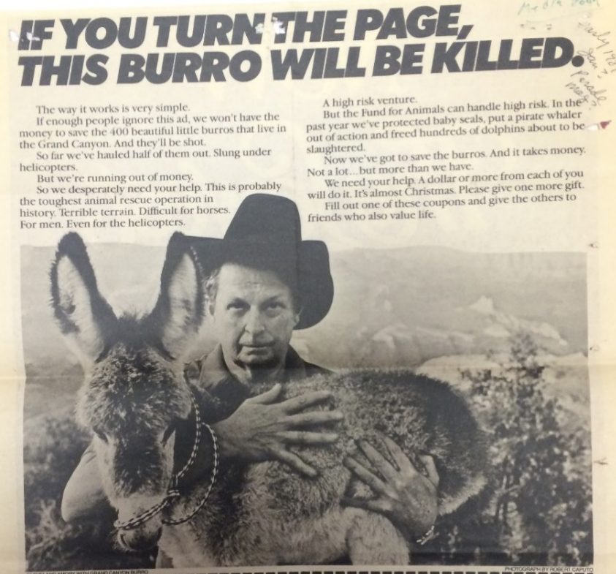
Figure 8.
Ad from Parade Magazine used to raise money for the Fund for Animal’s burro removal.
Used with permission from the Grand Canyon Archives
Correspondence on Burros, (1981 -1986),
Parade Magazine, 1981
GRCA 56983
The removal of more than three hundred burros from the million-acre park presented logistical challenges, but the Fund benefited from the NPS’s example of failed removal attempts in the past. Tranquilizing the burros rarely worked, either the immobilizing darts were too strong for the burro’s weight and the animal overdosed, or burros hit by darts ran up cliffs and fell to their death. Rangers had tried to herd burros from the canyon but the narrow trails were dangerous for horses and frightened burros. When wranglers on horseback pushed burros up trails, the animals complied for short distances before reversing direction and running past the wranglers, surprising the horses and risking falls off the cliff for ranger, horse, and burro. Large-scale roping, Amory’s hired wranglers discovered, was also out the question. If surprised at close range, burros could be roped and immobilized. However, if the animal ran from the wrangler, it would cover more ground than a horse and dip its head to avoid capture. The only viable option to remove canyon burros in large numbers would be cornering numbers along trails, corralling them, and, one-by-one, carrying them out in a sling below a helicopter.
Figure 9.
Burro carried in a sling below a helicopter. Wranglers corralled burros along the canyon floor and a helicopter carried each animal out of the canyon in a sling. Once at the rim, the pilot set the burro down inside another corral where volunteers untied it.
Used with permission from the Grand Canyon Archives
Burro Scrapbook Materials, (1976 -1979), GRCA 102124
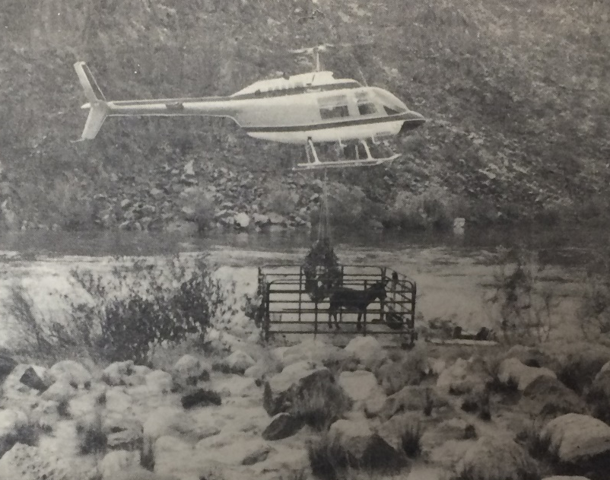
After six months of planning, the live removal effort began. Starting on August 9, the date set by the NPS, the Fund worked in the canyon at the hottest time of the year in what turned out to be an exceedingly hot summer. To avoid the 120-degree heat at the height of the day, the removal crews only worked in the early morning and late evening. The Fund for Animals team, with Park Resource Management Specialist Jim Walters monitoring, began to round up the burros at three in the morning. As one crew on horseback, headed by champion roper Dave Ericsson, herded the burros inside the canyon, another crew set up a corral on the plateau, and a helicopter crew hovered above. Once the burros were corralled, workers “threw a rope around their neck, then tied their legs together, then put them in a sling, and finally, under a frighteningly noisy machine, took them higher up in the sky than a self-respecting animal and perhaps any reasonably wise bird had ever been before.” The Fund removed twenty-seven burros from the canyon on the first day. The Fund kept the removed animals in corrals along the rim. The rim crew set up their retrieval area of several corrals, trucks, trailers, a veterinarian, and additional volunteers on the south rim in full view of bystanders and news reporters. The crew repeated this procedure hundreds of times in August and September 1980 with between thirty and fifty animals removed each week. “This is costing us some money to monitor the program,” Walters told a reporter in 1980, “but not nearly as much as it would to shoot them, so it's a beautiful compromise for us.”
As the crews lifted more burros out of the canyon, those remaining became harder to find and catch. The noise from the helicopters and commotion from the ground crew had frightened the remaining burros deep into the canyon. The team searched extensively for those that remained. One band of burros had moved to the west side of the canyon, away from a helicopter-landing zone. Unable to herd the animals back east, the crew added plywood and steel panels to a pontoon boat and floated the burros down the river to an area the helicopter could reach. Still, more burros remained. Ericsson and his crew searched for frightened burros along canyon trails, sometimes using his ranch dogs to herd stray burros down from cliffs. With the success of the Fund’s removal, the NPS granted the organization an extension to the original two-month timeline. The Fund for Animals achieved what many believed impossible, and, due to its success, the park arranged a standing invitation for the organization to return to pick up any additional burros The Fund’s crew returned intermittently in December 1980 and July and September 1981 to retrieve groups of burros reported by the NPS.
The Fund removed 577 burros from the Grand Canyon in the two-year operation, although, a few animals remained in the park. In total, the live removal cost $500,000, all donated to the Fund between 1980 and 1982. Other than a temporary, albeit strong fright, no burros removed by the Fund were harmed. One of the crew’s horses, however, died in the effort. The horse spooked and stepped off the edge of a cliff; the rider jumped off his saddle before the horse fell down a steep canyon side. Despite the Fund removing the vast majority of burros, some remained in the canyon. In the late 1980s, rangers discovered and shot a band of approximately thirty burros deep in the canyon after the Fund’s removal. “The success of the round-up in the extremely rugged canyon,” a 1981 newspaper stated, “has surprised skeptical federal officials.” Amory and the Fund were exceedingly proud of their rescue; however, getting the animals out of the canyon was only the first step.
Part of the NPS’s Burro Management Plan included an arrangement for burros after they left the canyon. The plan states, “The National Park Service will relinquish any claim to ownership of these animals once they have been removed from park boundaries.” The NPS issued a free bill of sale and the Fund paid $2 for an Arizona Equine Ownership Permit for each burro removed from the canyon.
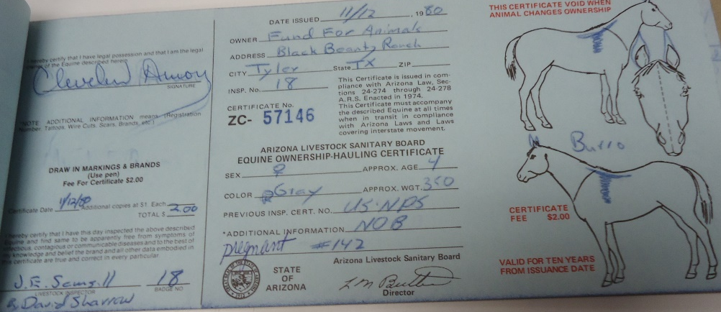
Figure 10.
Bill of sale issued to the Fund for Animals by the National Park Service. Each burro required a bill of sale to transfer ownership of the animal. This bill lists a pregnant jenny, later named Friendly by Amory.
Used with permission from the Grand Canyon Archives
Bill-of-Sale GRCA 28770

The Fund adopted out the burros removed from the canyon. Its extensive advertising campaign before and during the removal convinced hundreds of people to adopt canyon burros. During the removal process, however, the organization worried that the feral burros might not be adoptable and wondered if anyone would want one. “Wild burros make wonderful pets,” Amory wrote in his autobiographical book Ranch of Dreams, “That’s what we had said before we had the slightest idea whether they would make pets at all, let alone wonderful ones.” The burro that convinced Amory that the Fund could adopt out the burros came in the first batch of animals airlifted out of the canyon. Amory named the burro Friendly because she did not immediately run from the removal crew. This small action was enough to convince the Fund that the adoption program would succeed. One couple in rural Connecticut, Vicki and Allyn Claman, volunteered to lead the adoption program. Nearly 400 burros passed through their farm on their way to adoptive homes. The adoption program was exceptionally successful on the East Coast as the Fund advertised adoption as a way to own a part of the Grand Canyon. Although the Fund had a strict adoption policy, the majority of the canyon burros ended up in homes across the country. The Fund charged $400 per burro to insure that those adopting the animals were firmly committed. Most of the money went to the feed and care of the animals at the Claman farm. And no burro went alone. Burros are herd animals, and, Amory argued, needed a companion. The adopter had to already own another large herd animal or adopt two burros. Further, the Fund employees and volunteers checked in on the animals a few months after their adoption to confirm that the new owners treated the burros humanely. Many adopters mailed letters to Amory with pictures of their burros, which hung in his office until his death.
Not enough people expressed interest in adoption to account for all the burros, nor did Amory want to lose all of them. Instead, in 1980, he founded the Black Beauty Ranch on eighty-three acres in Murchison, Texas to house the burros that had not found a new home. When naming the ranch, he had one fictional horse in mind, but Amory ended up filling the ranch with hundreds of very real donkeys. Burros not adopted by locals in the Southwest or hauled to the Claman farm moved to Texas where they remained for the rest of their lives. The Black Beauty Ranch expanded beyond its original mission and quickly filled with other animals rescued by the Fund, including three former diving horses from Atlantic City, a chimpanzee that communicated through sign language from the University of Oklahoma, and two former circus elephants.
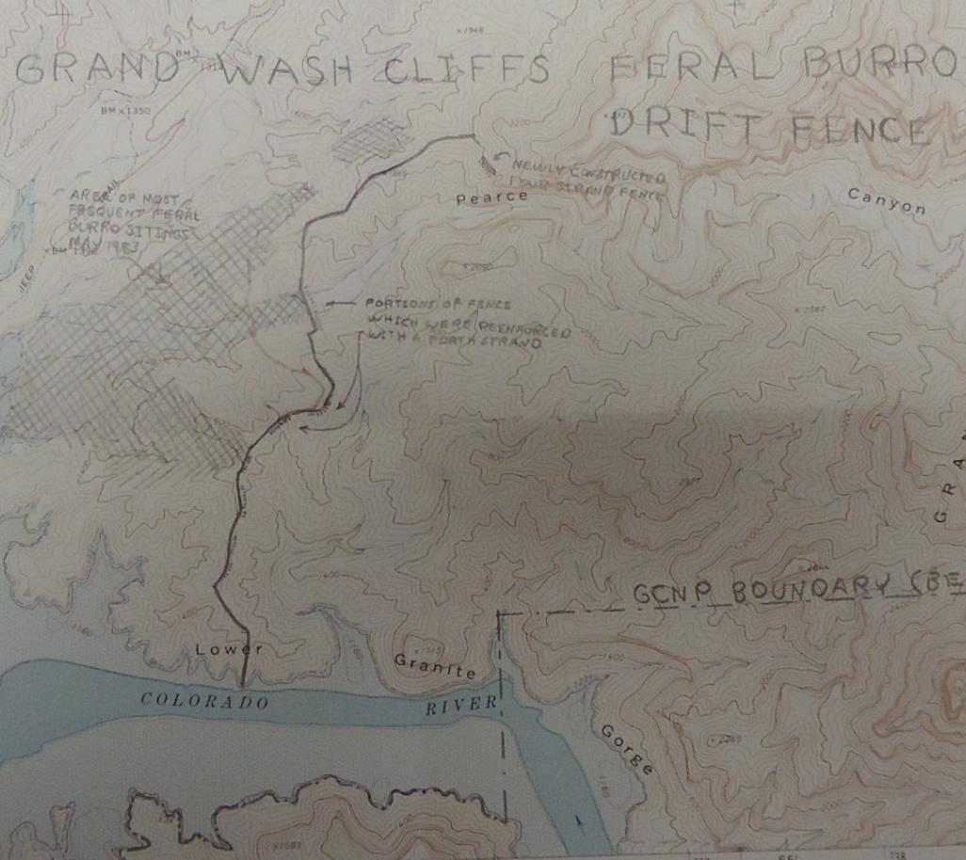
With the majority of the Grand Canyon burros now in Texas and on the East Coast, the NPS began the second phase of the burro removal plan. For an estimated $26,250, the NPS built a two-and-a-half mile fence along the boundary between the Grand Canyon and Lake Mead National Recreation Area to stop any burros from wandering back into the canyon. The fence needed to meet specific guidelines to stop burro intrusions without hindering the movements of bighorn sheep. A three-stranded barbed wire fence with a smooth bottom wire would allow the smaller sheep to pass under the barbs but would block the larger burros. Several problems arose after fence construction. The wires required constant repair as burros and other wildlife pushed into posts, knocking over sections of the fence. Despite the smooth bottom wire, the fence interrupted the movement of bighorn sheep between the canyon and LMNRA. Low water levels in the lake created gaps in the fence that allowed canyon access to burros. Despite admitted shortcomings in the design of the burro fence, the barrier prevented many feral burros from re-entering the canyon, it kept domesticated livestock out of the park, and it served as a boundary line between the Grand Canyon and LMNRA. For years after the removal, rangers tracked burro sightings, which grew increasingly rarer. “Feral burros are now absent from the river corridor,” states the ecologist Steven Carothers in a 1991 book. The feral burro “evil” was officially a low priority problem for the park by early 1983.

Figure 11.
Map of NPS burro fence between Grand Canyon and Lake Mead National Recreation Area meant to keep burros out of the canyon.
Used with permission from the Grand Canyon Archives
Wild Burros/Burro Fence Information - GRCA 97879

Burros have been, for the most part, absent from Grand Canyon National Park for thirty-five years. No one has conducted a follow-up study, however, to substantiate burros’ impact on the canyon’s soils, small mammals, or bighorn sheep. Beginning in the early 2000s, several ecologists working with the NPS launched studies of the bighorn sheep population. These decade-long studies have yet to reveal much information regarding Grand Canyon bighorn populations or whether those populations have increased without competition with burros. “Surprisingly,” the Grand Canyon’s wildlife research website states, “there has never been a follow-up survey to determine if the sheep population recovered and stabilized following the removal of the burro population.” Currently, there is no conclusive evidence that burros negatively affected bighorn sheep populations in the Grand Canyon. Similarly, there are few follow-up studies on feral burro impacts on soils and vegetation. Burro trails do still exist in remote canyon locations and plant growth has increased in areas previously grazed by burros.
Although burros physically left the canyon, the animals remained a cultural force. Brighty the burro, a symbol for all burros and the canyon itself, reappeared after being absent from the Grand Canyon for a decade. In the 1970s, NPS employees tried to distance Brighty from the destructive burros living in the canyon and removed his statue from public viewing. By 1983, with most burros removed from the park, Brighty no longer posed a threat to the NPS and its plans. Grand Canyon staff returned the bronze statue of Brighty and copies of Brighty of the Grand Canyon are available at Grand Canyon Lodge beside the statue. Mules still carried visitors down canyon trails but the NPS no longer bred the animals in Grand Canyon Village. Instead, the NPS buys twenty mules each year from a mule breeder in Tennessee. Consequently, there is no need for the NPS to keep burros in the park. Despite not being in the canyon, burros remain an important part of the area’s history and the burro removal process set an important precedent for public involvement in NPS decisions.
The Grand Canyon was the center of several environmental debates during the 1960s. As the population of the arid Southwest grew in the mid-twentieth century, an every-growing need for water led politicians to propose dam projects. In 1928, Congress approved the creation of the Boulder Dam (later named Hoover Dam) in southern Nevada along the Colorado River. In ensuing decades, politicians proposed multiple dam projects in the American Southwest; however, by the 1950s, the environmental movement opposed the flooding of irreplaceable canyons. In the mid-twentieth century, the Bureau of Reclamation planned to build a dam in Echo Park, within the boundaries of Dinosaur National Monument in Utah. Before plans for the dam could move forward, controversy surrounded the proposal to flood an NPS monument. Environmentalists, headed by David Brower of the Sierra Club, opposed the Echo Park Dam. Those attempting to save Dinosaur National Monument utilized tools to engage the public in later environmental movements including brochures, books, and direct mail. Enough protest surrounded the Echo Park Dam that the Bureau of Reclamation agreed to leave the NPS land in Dinosaur Monument untouched in exchange for the building of Glen Canyon Dam in northern Arizona. Construction of the Glen Canyon dam ended in 1963 and plans for a new dam in the Grand Canyon formed immediately. “The battle over the Grand Canyon dams,” the historian Marc Reisner states, “was the conservation movement’s coming of age.” While the flooding of Glen Canyon had been a compromise to save a national monument, Brower and other conservationists used the loss of the canyon as fuel to save the Grand Canyon from a similar fate. By mobilizing conservation organizations and the public, Brower swayed politicians to “save the Grand Canyon from being flooded.” In the proposed Echo Park Dam, Grand Canyon dams, and burro removal, the involvement of the public became a vital tool to sway policy decisions.
______________________________________________________________________
Similar to previous movements against environmental agencies, public outcry against burro removal forced the NPS to pause its eradication efforts for a decade, stop a project that had existed for forty-five years, and conduct expensive, time-consuming ecological studies. In the end, it prompted a compromise between the NPS, the public, and a non-profit organization. The compromise revealed that the NPS and other public land management agencies no longer could make large-scale decisions without listening to public opinion. The failure to listen could be debilitating. The burro removal project further proved that media coverage and public interest in public lands, their management, and wildlife influenced NPS decisions.

Epilogue

The outrage that followed the NPS’s burro removal plan in the 1960s forced the agency to halt all burro culls and address the public’s concerns. Thousands of letters flooded Grand Canyon offices, newspapers displayed headlines of “burro slaughter,” and animal advocacy groups labelled the NPS as cruel. NPS employees were well aware of the obstacles burro removal faced. Each day Park Superintendent Merle Stitt and Park Resource Management Specialist Jim Walters received newspaper clippings from friends and fellow park employees. These articles from across the country informed Stitt and Walters that a newspaper in another state had written about the burro removal plans and anger had followed it. The dissenting view expressed by the public forced the NPS to stop burro control efforts for more than a decade and to justify removal through a detailed environmental impact statement. The public outcry in support of the canyon burros set a precedent, for better or worse, the public continued to have a voice in decisions made about public lands and the wildlife on them.
The trouble with burros in the Grand Canyon may be resolved for the most part, however, the presence of feral burros on other public lands in the American West remain a contentious subject. NPS managed lands in the Southwest including Death Valley National Park and Mojave National Preserve still have populations of feral burros. On these lands, burros are an exotic species and the NPS attempts to control the population by herding, fencing, and shooting the animals. The Wild Horse and Burro Act, however, allows burros to live on nearby land managed by the Bureau of Land Management (BLM). The BLM manages land bordering or near NPS land as the agency is charged to administer “non-forested and desert lands, primarily in the arid West.” These burros often cross onto NPS lands making complete eradication in most parks impossible.
“The feral burro,” the historian Frank Brookshier laments, “is often a tragic figure, and one whose plight is no credit to the indifferent descendants of those he once helped settle the land.” The burro’s role as a “tragic figure” led to a rally behind the seemingly forgotten animals. A number of burro advocacy organizations developed since the 1980s. They used the media and their following to influence decisions about feral burros. Organizations similar to the Fund for Animals have stepped in to remove burros from other public lands. One such organization, the Wild Burro Rescue, founded by Diana Chontos in Olancha, California, has taken in hundreds of feral burros from public lands in California, Nevada, and Arizona. In 1992, her rescue efforts retrieved a corral of a hundred burros in Death Valley that BLM workers had rounded up. The workers planned to shoot the animals until Chontos and her husband arrived, making several trips to trailer the burros to their nearby rescue. Several other organizations, such as the Donkey Sanctuary and Peaceful Valley Donkey Rescue, housed and adopted out feral burros removed from public lands. Groups also lobbied congress for additional regulations on BLM management of wild horses and burros. The rise in animal advocacy and grassroots environmentalism coincided with the Grand Canyon burro removal. The opinions of the public could now affect policy on public lands.
While most of the burros from the Grand Canyon removal have died, the Fund for Animals still supports a herd of burros at the Black Beauty Ranch. The Fund continued to adopt unwanted and abused animals after the burro removal well after Amory’s death in 1998. The Fund focused on individual cases of cruelty to animals in order to create overall awareness. One such case, the removal of fifty-four large cats from a private home in California, led the Fund to campaign for stricter laws against the exotic pet trade. The Fund rallied behind a number of causes, stopping annual caged pigeon shoots in Pennsylvania, rescuing 4,000 goats from San Clemente Island off San Diego, and removing dozens of wild horses from BLM holding facilities. In 2005, The Fund joined the Humane Society of the United States. Both organizations have a separate board of directors but they share funds and projects, including running the now 1,400-acre ranch that was renamed the Cleveland Amory Black Beauty Ranch that same year. The Fund remained an important voice in animal advocacy and supported protecting wild horses and burros on public lands. Since 2003, the ranch has taken in dozens of horses from BLM holding facilities and lobbied Congress to allow more horses and burros to remain on public lands. Other organization have worked alongside the Fund to keep feral burros on public lands.
Burros were still visible on public lands alongside the more popular wild mustangs in the twenty-first century. In many places in the Southwest, burros even attracted tourists. Each year, half a million tourists visited Oatman, Arizona, a former mining town of around 120 people. While the town offered the iconic wood frame buildings, a tourist-oriented main street, and a staged gunfight, the vast majority of people travelled to Oatman to see burros. Each day about a dozen burros entered the town from the surrounding land. Maintained by the BLM, the burros are technically wild, but they have interacted with humans since birth. The burros approached visitors in search of alfalfa cubes, which most of the local businesses sold, and tolerated posing for pictures and petting. The herd has maintained a consistent number of ten to twelve burros. Late in the summer, BLM herd managers rounded up excess younger burros to take them to nearby holding facilities in Arizona and Nevada. Enough burros remained each year to entice tourists to visit the town. In 2009, Oatman resident Jerry Love told a reporter, “If it weren’t for the burros, the rest of us wouldn’t be here.” The burros of Oatman sustained the small town, and, while it is the only of its kind, many tourists visit areas in Arizona and Nevada with the hopes of seeing a wild burro. Red Rock Canyon National Conservation Area, just west of Las Vegas, and LMNRA similarly attract visitors hoping to see a wild burro. Many visitors expected to see a wild burro just as they envision elk in Rocky Mountain National Park or grizzlies in Yellowstone.
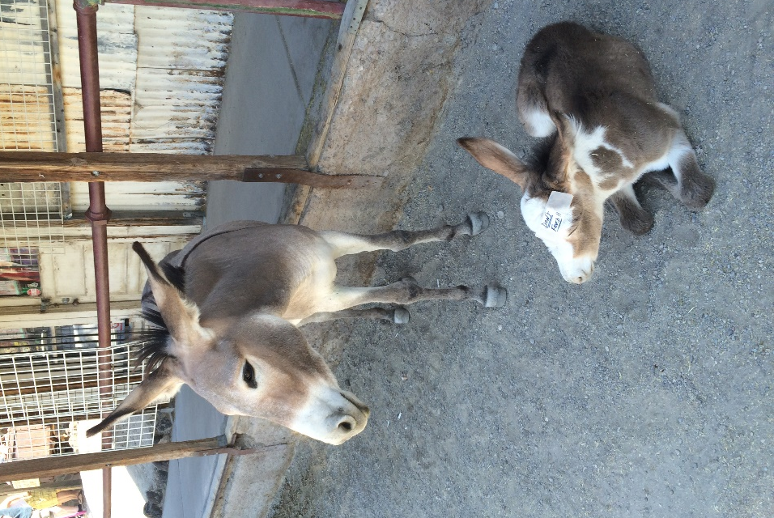
Figure 12.
Female burro and two-week-old foal on the main street of Oatman. Tourists visit the small Arizona town to see the wild burros that enter the town each day.
Photo by author.
In all locations, the BLM disapproved of the attention tourists paid to burros. Often, burros near locations of heavy tourist traffic were overweight. Tourists fed the animals an unhealthy diet of Cheetos and sandwiches and the burros remained near roads instead of foraging to burn calories. The attention has also led to car accidents as the animals grew accustomed to humans and approached cars in search of food. Under the Wild Free-Roaming Horse and Burro Act of 1971, the BLM must maintain burros on public lands. The agency, however, has faced fierce criticism of its attempts to manage the animals. Part of the BLM’s duty in protecting horses and burros includes preventing illegal branding or harassment to the animals. Its most time-consuming and expensive project is maintaining viable herd sizes. The BLM conducted studies to determine an area’s Appropriate Management Level (AML), or how many horses and burros can subsist off each rangeland called a Herd Management Area (HMA). If the BLM determines that an HMA exceeds capacity, the organization hires private contractors to remove as many excess animals as it can.
Each year, private contractors, hired by the BLM, herded hundreds of burros and took the animals by trailers to holding facilities. Several horse and burro advocacy groups denounced the BLM’s removal of the animals. The roundup by helicopter, where a pilot flew just above a group of burros and chased them into a holding pen, was traumatic for the animals. A majority of roundups ended in some form of injury, wounds from fences, trampling, or exhaustion. Most of the horses and burros removed from public lands, however, faced no long-term consequences and moved to a BLM holding facility to await adoption. “Since 1973,” a 2007 BLM brochure states, “the BLM has placed more than 217,000 horses and burros into private care.” By 2017, however, most holding facilities neared capacity. The BLM removed more animals from the range than could be adopted, and, as a result, most remained in long-term facilities their entire lives. Currently, more horses and burros live in captivity, almost 50,000, than on public lands, 32,000. Increased urbanization and an economic downturn have turned away possible adopters. In addition, the BLM imposed strict guidelines for adopting a horse or burro. Adopters could purchase no more than four animals a year and must prove they have the facilities and financial means to care for the animal(s), while the BLM withheld the title to the animal for one year, at which point a veterinarian inspected the animal. Even with these strict guidelines, some people sold burros to slaughter. In 2004, an amendment to the adoption program made it easier for prospective buyers to sell the animals to a slaughterhouse. The amendment allowed the BLM to sell, without restrictions, excess horses and burros that were more than ten years old, granting the animal’s title immediately and permitting buyers to adopt as many horses and burros as they wanted. Over a five-year period, the BLM sold more than 4,000 horses and burros under this provision and the agency cannot account for many of the animals. Often the BLM lacked the employees and money to check on an adopted animal, making it that much easier for new owners to sell the animals for profit to slaughterhouses.
Feral burro advocates also blamed livestock interests for limited forage on public lands. Privately owned cattle and sheep grazed the same land as wild horses and burros and the BLM’s AMLs included livestock grazing. The BLM allocated grazing permits annually to livestock owners that allowed them “to graze contractually specified numbers of cattle on designated BLM acreage.” Those in support of wild burros feared that too many livestock producers were overgrazing the range, forcing more BLM roundups each year. A 2013 NBC news report stated, “[The] BLM acknowledges that in virtually all its wild horse management areas, livestock is allocated more forage than horses [and burros].” Livestock producers had a vested interest in wild horse and burro management and lobbied the BLM to remove more animals from rangelands. One study found that the BLM allocated as much as 82 percent of HMAs to livestock permits with the rest available for wild horses, burros, and other wildlife. All of the BLM’s activities – conducting studies to determine AMLs, rounding up excess animals, adopting out wild horses and burros, and housing those not adopted – constituted an effort to protect animals that the U.S. Congress declared “living symbols of the historic and pioneer spirit of the West.” The BLM’s management of wild horses and burros faces criticism from the similar factions that split the Grand Canyon burro removal. Animal advocacy groups supported horses and burros on public lands because the animals are culturally significant to the American West and they do not want the animals killed. Conversely, environmental organizations feared horses and burros damaged lands and vegetation. The BLM worked to appease both sides while also meeting its Congressional mandate, just as the NPS did during burro removal.
National parks that border public lands constantly faced the encroachment of feral burros, just as at the border between LMNRA and the Grand Canyon. On one side of an invented line, burros were a destructive exotic; on the other side, a federal law protects the animal. Just as some burros still enter Grand Canyon National Park, the animals are in Death Valley and Mojave where the NPS attempts to curtail their populations through fences, roundups, and shooting. Due, in part, to the arbitrariness of the boundaries between national parks and other public lands, keeping burros out of parks is no easy task, and as long as the Wild Horse and Burro Act protects the animals, no park in the Southwest can guarantee burro-free status. In 2017, nearly 12,000 burros roam public lands, mostly in Arizona, California, and Nevada. While federal regulations protect burros from complete eradication, there is still a target on the necks of feral burros.

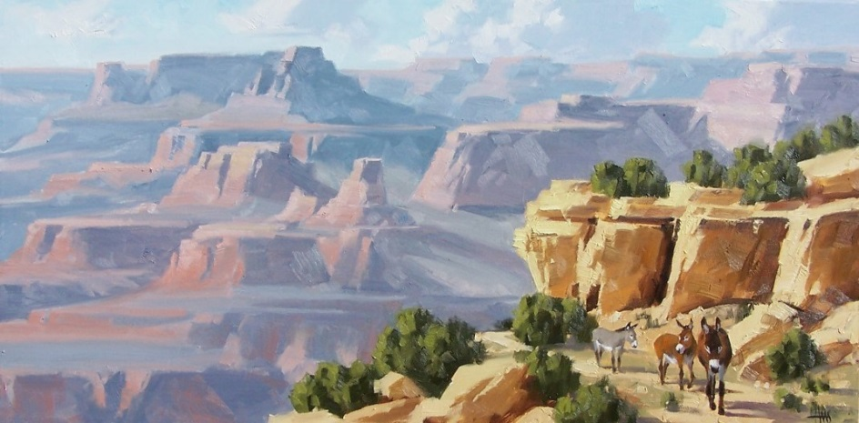
Figure 13.
“Moran Point” painted by Tom Haas in 2015. Haas paints landscape scenes of the American Southwest and chose to include burros in several of his works depicting the Grand Canyon.
Used with permission from Tom Haas.

Public advocacy has affected public lands for decades. Increased media access informed people of policies and actions with which many disagree. Letter-writing campaigns, newspaper articles, and, more recently, social media all allowed the public to influence policy decisions. Recognizing the public's influence and educating as many people as possible about the environment of public lands will be vital to protecting the lands and the animals on them. Compromise, like that seen in the Grand Canyon burro removal, between government agencies, the public, and nonprofit organizations is vital to that success.

Bibliography
Primary
Grand Canyon Archives (GRCA):
Bill-of-Sale, (1981), GRCA 28770
Burro Scrapbook Materials, (1976 -1981), GRCA 102124
Burro Surveys, Management Plans, Population Control, and Studies of Impacts, (1934 – 1982), GRCA 103533
Correspondence on Burros, (1981-1986), GRCA 56983
Correspondence on Wildlife Projects, (1960-63), GRCA 56966
Letters in Reference to Burro Management Plan, (1977), GRCA 57817
Removal Plan 1979. - GRCA 57685
Transcript of Public Meeting, (1979), GRCA 52802
Wild Burros/Burro Fence Information, (1980-1992), GRCA 97879

Albright, Horace M. Report of Director of National Park Service. Washington, D.C.:
U.S. Department of the Interior, National Park Service, 1930.

Amory, Cleveland. Ranch of Dreams: The Heartwarming Story of America’s Most
Unusual Animal Sanctuary. New York: Viking, 1997.

Associated Press. “Carrot-Toting Tourists Making Arizona Burros Fat.” NBC News.
August 31, 2009. http://www.nbcnews.com/id/32626306/ns/travel-
destination_travel/t/carrot-toting-tourists-making-ariz-burros-
fat/#.WNp9HfnyvIU

Becker, J.R. “Voice of the People.” The Chicago Tribune, February 13, 1977.

Brown, Jacki. “Bighorn Sheep Subject of Park Service Study.” Grand Canyon News,
May 10, 2007.

Bureau of Land Management. Adopt a Wild Horse or Burro. Washington, D.C.:
U.S. Department of the Interior, 2007.

Bureau of Land Management. Adopting a Wild Horse or Burro. Washington, D.C.:
U.S. Department of the Interior, 2003.

Bureau of Land Management. So You’d Like to Adopt a Wild Horse or Burro.
Washington, D.C.: U.S. Department of the Interior, 1991.

“Col. Dyer Describes His Trip With "Buffalo Bill" And The Army In Texas
Distinguished Augustan.” Augusta Chronicle, March 3, 1911.
http://infoweb.newsbank.com.

Compilation of the Administrative Policies for the National Parks and National
Monuments of Scientific Significance (Natural Area Category). Washington,
D.C.: U.S. Department of the Interior, National Park Service, 1970.

Compilation of the Administrative Policies for the National Recreation Areas, National
Seashores, National Lakeshores, National Parkways, National Scenic Riverways
(Recreational Area Category) of the National Park System. Washington, D.C.:
U.S. Department of the Interior, National Park Service, 1968

Demaray, A.E. “The Passing of Brighty,” Outing: Sport, Adventure, Travel, Fiction,
February 1923. https://books.google.com/books?id=sj0TAAAAIAAJ

“Father Collins' Letter. An Interesting Pen Picture of Impressions Gained While
Visiting Arizona.” Prescott Evening Courier, February 21, 1905.
http://infoweb.newsbank.com.

“In The Grand Canyon Of The Colorado Descent From Summit to Base in Most
Impressive.” The Sunday Oregonian, October 6, 1907.
http://infoweb.newsbank.com.

Ivins, Molly. “Wild Burros Plucked out of Grand Canyon.” New York Times. July 30,
1980.

Ivins, Molly. “Roundup of Wild Burros goes Well in Grand Canyon.” Sarasota Herald-
Tribune (Sarasota, FL). July 31, 1980.

Garrett, W.E. "The Grand Canyon: Are we loving it to death?" National
Geographic 154, no. 1 (July 1978): 27-31.

“Grand Canyon Will Appear at Exposition.” Tucson Daily Citizen, December 28, 1912.
http://infoweb.newsbank.com.

Grey, Zane. Tappan’s Burro. New York: Harper & Brothers, 1923.

Grand Canyon National Park, National Park Service. Feral Burro Management Plan
and Environmental Assessment. Washington, D.C.: U.S. Department of the
Interior, November 1976.

Henry, Marguerite. Brighty of the Grand Canyon. Chicago: Rand McNally & Company,
1953.

Hornblower, Margot. “Burro Battle: Like Comedy of the Absurd.” The Washington
Post. November 11, 1979.

Krebs, Albin and Robert McG. Thomas. “For the ‘Woman who has Everything’:
Burros.” The New York Times. December 6, 1980.

Lane, Franklin. "Secretary Lane's Letter on National Park Management." National Parks
Service. October 2000.
https://www.nps.gov/parkhistory/online_books/anps/anps_1j.htm.

Larimer, Sarah. “The Gray Wolf Spotted Near the Grand Canyon This Fall Has Already
Been Killed by a Hunter.” The Washington Post. February 12, 2015.
https://www.washingtonpost.com/news/speaking-of-science/wp/2015/02/12/the-
gray-wolf-spotted-near-the-grand-canyon-this-fall-has-already-been-killed-by-a-
hunter/

Leopold, Aldo. A Sand County Almanac: And Sketches Here and There. 1949. Reprint,
Oxford: Oxford University Press, 1968.

Leslie, Elaine. “Bighorn Sheep Studies,” Grand Canyon Wildlife Research Expedition.
2002. https://www.nature.nps.gov/Views/Sites/GRCA/HTML/
Bighorn/Bighorn_ET.htm.

Lindsay, Leon. “A Happy Ending to the Saga of Grand Canyon Burros.” Christian
Science Monitor (Boston, Massachusetts). July 10, 1981.

Management Policies. Washington, D.C.: U.S. Department of the Interior, National
Park Service, 1975.

Mather, Stephen. Report of Director of National Park Service. Washington, D.C.: U.S.
Department of the Interior, National Park Service, 1920.

“Merle Stitt, Former Head of Grand Canyon, Dies.” Arizona Republican. June 10, 1980.

“Motes and Beams.” Tucson Daily Citizen (Tucson, Arizona). April 26, 1921.

Myers, Lisa and Michael Austin. “Cruel or Necessary? The True Cost of Wild Horse
Roundups.” NBC News. May 14, 2013. http://investigations.nbcnews.com/_news/2013/05/14/17588942-cruel-or-necessary-the-true-cost-of-wild-horse-roundups

National Park Service Grand Canyon National Park. Feral Burro Management and
Ecosystem Restoration Plan and Final Environmental Impact Statement. Washington, D.C.: Department of the Interior, January 30, 1980.

Nemy, Enid. “Cleveland Amory Dies at 81; Writer and Animal Advocate.” The New
York Times.October 16, 1998.

Olsen, Russ. Administrative History: Organizational Structures of the National Park
Service 1917 to 1985. Washington, D.C.: U.S. Department of the Interior,
National Park Service, 1985.

Reed, Roy. “Doomed Wild Burros Find Haven at Texas Ranch.” The New York Times.
December 25, 1984.

Roosevelt, Theodore. "A cougar hunt on the rim of the Grand Canyon." Outlook 105
(1913): 259-266. https://search.proquest.com/docview/
136639524?accountid=12964.

“Salt Lake Line to the Chasm a Sure Thing Company Capitalized at Million Dollars
First Rival of the Santa Fe in Exploiting.” Albuquerque Journal, December 13, 1909. http://infoweb.newsbank.com.

Smith, Hubble Ray. “Moss: ‘Hunting Burros’ Idea Only Meant to Get Attention.”
Kingman Daily Miner. January 20, 2016. https://kdminer.com/news/2016/jan/20/moss-hunting-
burros-idea-only-meant-to-get-attent/

Sweet, Phoebe. “Leave the Wild Burro Be.” Las Vegas Sun. May 21, 2008.
https://lasvegassun.com/news/2008/may/21/leave-wild-burro-be/

“Vest Pocket Essays.” Patriot (Harrisburg, Pennsylvania), September 20, 1911.
http://infoweb.newsbank.com.

“Wild Burros Range in the Grand Canyon.” Boston Journal (Boston, Massachusetts).
May 9, 1916.

Wild Horse and Burro Act of 1971, Public Law 92-195,
https://www.blm.gov/or/regulations/files/whbact_1971.pdf

“U.S. Dooms Burros as Pest: Animals Charged with Destroying the Beauty of Grand
Canyon of the Colorado.” Bellville News Democrat (Belleville, Illinois). January
24, 1921.

United States Department of the Interior National Park Service. Management Policies.
Washington, D.C.: Department of the Interior, 1988.

United States National Park System. “Backcountry Management Plan for Grand
Canyon National Park.” Washington, D.C.: Department of the Interior, 1988.

United States National Park System. “The Sustainable Grand Canyon Workshop.”
Washington, D.C.: Department of the Interior, 1995.

U.S. Congress. House. Grand Canyon Forest Reserve (to accompany S. 2732), June 20,
1906, 59th Cong., 1st sess., 1906. H. Rep. 4973.

U.S. Congress. House. National Park Service (to accompany H.R. 15522), May 17,
1916, 64th Cong., 1st sess., 1916. H. Rep. 700.

Yerian, Loretta. “Newbies to the Barn: Training Grand Canyon’s Famous Mules,”
Havasunews. January, 31, 2016. http://www.havasunews.com/news/arizona/newbies-to-the-barn-
training-grand-canyon-s-famous-mules/article_614c7662-c81f-11e5-94d1-
8390b7425fdc.html

Secondary

Abella, Scott R. “A Systematic Review of Wild Burro Grazing Effects on Mojave
Desert Vegetation, USA.” Environmental Management. 41. (2008): 809-819. http://dx.doi.org/10.1007/s00267-008-9105-7

Atkinson, Tim and Mike Leeder. "Canyon Cutting on a Grand Time
Scale." Science 319, no. 5868 (2008): 1343-344. http://www.jstor.org/stable/20053520.

Berger, Joel. “Sympatric and Allopatric Relationshps among Desert Bighorn Sheep and
Feral Equids in Grand Canyon,” The Southwester Naturalist. 22, no. 4 (1977): 540-543.

Billingsley, George H. "Prospector's Proving Ground: Mining in the Grand
Canyon." The Journal of Arizona History 17, no. 1 (1976): 69-88.
http://www.jstor.org/stable/41859431.

Billingsley, George H., Earle E. Spamer, and Dove Menkes. Quest for the Pillar of
Gold: The mines and Miners of the Grand Canyon. Grand Canyon: Grand
Canyon Association, 1997.

Brookshier, Frank. The Burro. Norman: University of Oklahoma Press, 1974.

Brulliard, Nicholas. “The Burro Quandary.” National Parks Conservation Association
(2017). https://www.npca.org/articles/1409-the-burro-quandary.

Carothers, Steven W. and Bryan T. Brown. The Colorado River through Grand
Canyon. Tucson: University of Arizona Press, 1991.

Carothers, S. W., M. E. Stitt, and R. R. Johnson. “Feral Asses on Public Lands: An
Analysis of Biotic Impact, Legal Considerations and Management Alternatives,” Transactions of the North American Wildlife and Natural Resources Conference 41 (1976): 396-406.

Clutton-Brock, Juliet. Horse Power: A History of the Horse and the Donkey in Human
Societies. Cambridge, MA: Harvard University Press, 1992.

Cox, George W. Alien Species in North America and Hawaii: Impacts on Natural
Ecosystems. Washington, D.C.: Island Press, 1999.

Crosby, Alfred W. Ecological Imperialism: The Biological Expansion of Europe, 900-
1900. Cambridge: Cambridge University Press, 1986.

Dent, Anthony. Donkey: The Story of the Ass from East to West. London: George G.
Harrap & Co. LTD, 1972.

Downer, Craig C. “The Horse and Burro as Positively Contributing Returned Natives in
North America.” American Journal of Life Sciences. 2 (1). (2014): 5-23.
http://article.sciencepublishinggroup.com/pdf/10.11648.j.ajls.20140201.12.pdf

Dunlap, Thomas R. "That Kaibab Myth." Journal of Forest History 32, no. 2 (1988):
60-68. http://www.jstor.org/stable/4005066.

Elizondo, Vanessa, Timothy Fitzgerald, and Randal R. Rucker. “You Can’t Drag Them
Away: An Economic Analysis of the Wild Horse and Burro Program.” Journal
of Agricultural and Resource Economics. 41, no. 1 (2016): 1-24. https://search.proquest.com/docview/1812898850?accountid=12964.

Farmer, Jared. Glen Canyon Dammed: Inventing Lake Powell and the Canyon Country.
Tucson: University of Arizona Press, 1999.

Flader, Susan L. "A Biographical Study of Aldo Leopold: Thinking like a
Mountain." Forest History Newsletter 17, no. 1 (1973): 14-28.
http://www.jstor.org/stable/4004191

Fortwangler, Crystal. “A Place for the Donkey: Natives and Aliens in the US Virgin
Islands.” Landscape Research. 34, no. 2. (2009): 205-222.

Foster, Jonathan. Lake Mead National Recreational Area: A History of America’s First
National Playground. Reno: University of Nevada Press, 2016.

Frank, Jerry J. Making Rocky Mountain National Park: The Environmental History of
an American Treasure. Lawrence: University Press of Kansas, 2013.

Garner, Robert. Animals, Politics, and Morality. Manchester: Manchester University
Press, 1993.

Greenwald, Marilyn. Cleveland Amory: Media Curmudgeon & Animal Rights
Crusader. Hanover: University Press of New England, 2009.

Hanley, Thomas A., and Ward W. Brady. "Feral Burro Impact on a Sonoran Desert
Range." Journal of Range Management 30, no. 5 (1977): 374-77.
http://www.jstor.org/stable/3897726

Hansen, R. M., and P. S. Martin. "Ungulate Diets in the Lower Grand Canyon." Journal
of Range Management 26, no. 5 (1973): 380-81.
http://www.jstor.org/stable/3896863

Harvey, George W., Charles Fletcher Lummis, Heather Hatch, and Donald B. Sayner.
"Brother Burro." The Journal of Arizona History 17, no. 4 (1976): 397-414. http://www.jstor.org/stable/41695598.

Haynes, Gary. "The Catastrophic Extinction of North American Mammoths and
Mastodonts." World Archaeology 33, no. 3 (2002): 391-416. http://www.jstor.org/stable/827876.

Hendricks, Gordon. "Bierstadt's "The Domes of the Yosemite"" American Art
Journal 3, no. 2 (1971): 23-31. doi:10.2307/1593906.

Hirst, Stephen. I am the Grand Canyon: The Story of the Havasupai People. Grand
Canyon, Arizona: Grand Canyon Association, 2006.

Hotten, Alison L. “Cultural Landscape Development and Tourism in Historic Mining
Towns of the Western United States.” Master’s thesis, University of Nevada, Reno, 2011.

Hughes, J. Donald. In the House of Stone and Light: A Human History of the Grand
Canyon. Grand Canyon: Grand Canyon Natural History Association, 1978.

Jasper, James and Dorothy Nelkin. The Animal Rights Crusade: The Growth of a Moral
Protest. New York: The Free Press, 1992.

Keiter, Robert B. To Conserve Unimpaired: The Evolution of the National Park Idea.
Washington D.C.: Island Press, 2013.

Kirkpatrick, Jay F. and Patricia M. Fazio. "ECCE EQUUS." Natural History 117, no. 4
(2008): 30. http://search.proquest.com/docview/210639703?accountid=12964.

Lago, Don. “The Life, Death, and Afterlife of Brighty.” The Ol’ Pioneer: The Magazine
of the Grand Canyon Historical Society 23, no. 3 (2012): 4-45.
http://www.grandcanyonhistory.org/Publications/TheOlPioneer/
TOP_2012_3.pdf

Marshall, Julie Hoffman. Making Burros Fly: Cleveland Amory, Animal Rescue
Pioneer. Boulder: Johnson Books, 2006.

McKee, Thomas Heron. “Brighty, Free Citizen: How the Sagacious Hermit Donkey of
the Grand Canyon Maintained his Liberty for Thirty Years.” Sunset Magazine
49 (1922): 42-72. https://books.google.com/books?id=ycxBAQAAMAAJ

McKnight, Tom L. "The Feral Burro in the United States: Distribution and
Problems." The Journal of Wildlife Management 22, no. 2 (1958): 163-79.
http://www.jstor.org/stable/3797325

Mead, Jim I. “The Last 30,000 Years of Faunal History Within the Grand Canyon,
Arizona.” Quaternary Research 15, no. 3 (1981): 311-326. doi:10.1016/0033-5894(81)90033-8

Merchant, Carolyn. The Columbia Guide to American Environmental History. New
York: Columbia University Press, 2002.

Merkle, John. "Plant Communities of the Grand Canyon Area, Arizona." Ecology 43,
no. 4 (1962): 698-711. http://www.jstor.org/stable/1933459.

Minard, Anne. “Unwelcome Bison May Face a DNA Test.” Science 299 (5614).
American Association for the Advancement of Science (2003): 1835.
http://www.jstor.org/stable/3833847

Nash, Roderick Frazier. Wilderness and the American Mind. New Haven: Yale
University Press, 1967.

Pritchard, James A. Preserving Yellowstone’s Conditions: Science and the Perception
of Nature. Lincoln: University of Nebraska Press, 1999.

Pyne, Stephen J. How the Canyon became Grand: A Short History. New York: Viking,
1998.

Reisner, Marc. Cadillac Desert: The American West and its Disappearing Water, 3rd ed.
New York: Penguin Books, 1993.

Robbins, Jim. Last Refuge: The Environmental Showdown in Yellowstone and the
American West. New York: William Morrow and Company, Inc., 1993.

Rothman, Hal. America’s National Monuments: The Politics of Preservation.
Lawrence: University Press of Kansas, 1989.

Rudman, Rebecca. "The Behavior and Ecology of Feral Burros on St. John, U.S. Virgin
Islands." PhD dissertation, Cornell University, 1990.
http://search.proquest.com/docview/303849165?accountid=12964.

Ruffner, George A., and Steven W. Carothers. "Age Structure, Condition and
Reproduction of Two Equus Asinus (Equidae) Populations from Grand Canyon
National Park, Arizona." The Southwestern Naturalist 27, no. 4 (1982): 403-11. http://www.jstor.org/stable/3670715

Runte, Alfred. National Parks: The American Experience. Lincoln: University of
Nebraska Press, 1987.

Schullery, Paul. Searching for Yellowstone: Ecology and Wonder in the Last
Wilderness. Helena: Montana Historical Society Press, 2004.

Seegmiller, Rick F., and Robert D. Ohmart. "Ecological Relationships of Feral Burros
and Desert Bighorn Sheep." Wildlife Monographs, no. 78 (1981): 3-58.
http://www.jstor.org/stable/3830689.

Sellars, Richard West. "Manipulating Nature's Paradise: National Park Management
under Stephen T. Mather, 1916-1929." Montana: The Magazine of Western
History 43, no. 2 (1993): 2-13. http://www.jstor.org/stable/4519570.

Sellars, Richard West. Preserving Nature in the National Parks. New Haven: Yale
University Press, 1997.

Simberloff, Daniel. “Integrity, Stability, and Beauty: Aldo Leopold's Evolving View of
Nonnative Species.” Environmental History 17, no. 3 (2012): 487-511. doi:
10.1093/envhis/ems044

Sutton, Ann and Myron. The Wilderness World of the Grand Canyon: “Leave it as it
is.” Philadelphia: J.B. Lippincott Company, 1970.

Webb, Robert H. Grand Canyon a Century of Change: Rephotography of the 1889-
1890 Stanton Expedition. Tucson: University of Arizona Press, 1996.

Weber, Steven A. and P. David Seaman, editors. Havasupai Habitat: A. F. Whiting’s
Ethnography of a Traditional Indian Culture. Tucson: University of Arizona Press, 1985.

Wills, John. “Brighty, Donkeys and Conservation in the Grand Canyon.” Endaevour 30
(3). Elsevier (2006): 113-117.http://dx.doi.org/10.1016/j.endeavour.2006.07.002

Wills, John. “On Burro'd Time: Feral Burros, the Brighty Legend, and the Pursuit of
Wilderness in the Grand Canyon”. The Journal of Arizona History 44 (1).
Arizona Historical Society (2003): 1–24. http://www.jstor.org/stable/41696750.

Wilson, Mary F. and Steven W. Carothers. “Avifauna of Habitat Islands in the Grand
Canyon.” The Southwestern Naturalist 24 (4). Southwestern Association of
Naturalists (1979): 563-575. http://www.jstor.org/stable/3670516

Whitley, David S. “North American Rock Art,” in Encyclopedia of Global
Archaeology. New York, NY: Springer, 2014 p. 5415-5426.

Wright, R. Gerald. “A Review of the Relationships between Visitors and Ungulates in
National Parks.” Wildlife Society Bulletin 26 (3). Wildlife Society (1998): 471-
476. http://www.jstor.org/stable/3783759.

Young, Otis E., Jr. "The Craft of the Prospector." Montana: The Magazine of Western
History 20, no. 1 (1970): 28-39. http://www.jstor.org/stable/4517431.

Letters regarding removal 1980-9, GRCA 56988.
Juliet Clutton-Brock, Horse Power: A History of the Horse and the Donkey in Human Societies (Cambridge, MA: Harvard University Press, 1992), 19; Anthony Dent, Donkey: The Story of the Ass from East to West (London: George G. Harrap &Co. LTD, 1972.), 119.
Jackie Brown, “Bighorn Sheep Subject of Park Service Study.” Grand Canyon News, May 10, 2007.
Stephen J. Pyne, How the Canyon became Grand: A Short History (New York: Viking, 1998), xii-xiii; John Wills, ““On Burro'd Time”: Feral Burros, the Brighty Legend, and the Pursuit of Wilderness in the Grand Canyon,” The Journal of Arizona History 44 (1). Arizona Historical Society (2003): 1–24. http://www.jstor.org/stable/41696750. 17.
Frank Brookshier, The Burro (Norman: University of Oklahoma Press, 1974), 270, 239; Clutton-Brock, Horse Power, 40.
Ann and Myron Sutton, The Wilderness World of the Grand Canyon: “Leave it as it is” (Philadelphia: J.B. Lippincott Company, 1970), 156; Robert H. Webb, Grand Canyon a Century of Change: Rephotography of the 1889-1890 Stanton Expedition (Tucson: University of Arizona Press, 1996), 71.
“Wild Burros Range in the Grand Canyon,” Boston Journal (Boston, Massachusetts) May 9, 1916.
Stephen Mather, Report of Director of National Park Service (Washington, D.C.: U.S. Department of the Interior, National Park Service, 1920), 66; Horace M. Albright, Report of Director of National Park Service (Washington, D.C.: U.S. Department of the Interior, National Park Service, 1930), 103.
Marguerite Henry, Brighty of the Grand Canyon (Chicago: Rand McNally & Company, 1953), 222.
National Park Service Grand Canyon National Park, Feral Burro Management and Ecosystem Restoration Plan and Final Environmental Impact Statement (Washington, D.C.: Department of the Interior, January 30, 1980), 8; Wills, “On Burro'd Time," 18.
Brett L. Walker, “Animals and the Intimacy of History,” In The Oxford Handbook of Environmental History, edited by Andrew C. Isenberg, 52-75 (Oxford: Oxford University Press, 2014), 71.
Susan Nance, “Animal History: The Final Frontier?” The American Historian, November 2015. 30.
Nance, “Animal History,” 29.
Walker, “Animals and the Intimacy of History,” 62-63.
Wild Free-Roaming Horses and Burros Act of 1971, Public Law 92-195, https://www.blm.gov/or/regulations/files/whbact_1971.pdf. 1.
A vast amount of literature covers the tension over wild horses on public land, however, there is little focus on burros in similar situations.
Nicholas Brulliard, “The Burro Quandary,” National Parks Conservation Association (2017). https://www.npca.org/articles/1409-the-burro-quandary.
Wild Free-Roaming Horses and Burros Act of 1971, 1; Julie Hoffman Marshall, Making Burros Fly: Cleveland Amory, Animal Rescue Pioneer (Boulder: Johnson Books, 2006), 66.
Zane Grey, Tappan’s Burro (New York: Harper & Brothers, 1923), 6.
Jim I. Mead, “The Last 30,000 Years of Faunal History within the Grand Canyon, Arizona,” Quaternary Research 15, no. 3 (1981): 311-326. doi:10.1016/0033-5894(81)90033-8. 311.
Tim Atkinson and Mike Leeder, "Canyon Cutting on a Grand Time Scale," Science 319, no. 5868 (2008): 1343-344, http://www.jstor.org/stable/20053520. 1343.
J. Donald Hughes, In the House of Stone and Light: A Human History of the Grand Canyon (Grand Canyon: Grand Canyon Natural History Association, 1978), 14; Stephen Hirst, I am the Grand Canyon: The Story of the Havasupai People (Grand Canyon, Arizona: Grand Canyon Association, 2006), 50, 7.
Steven A. Weber and P. David Seaman, editors, Havasupai Habitat: A. F. Whiting’s Ethnography of a Traditional Indian Culture (Tucson: University of Arizona Press, 1985), 195.
Hirst, I am the Grand Canyon, 51.
Pyne, How the Canyon became Grand, 4, 25; Hughes, In the House of Stone and Light, 19, 20, 23.
Clutton-Brock, Horse Power, 17-18.
Brookshier, The Burro, 14.
Brookshier, The Burro, 9-11; Clutton-Brock, Horse Power, 18.
Brookshier, The Burro, 21-22; Craig C. Downer, “The Horse and Burro as Positively Contributing Returned Natives in North America,” American Journal of Life Sciences 2 (1) (2014): 5-23. http://article.sciencepublishinggroup.com/pdf/10.11648.j.ajls.20140201.12.pdf. 11.
Brookshier, The Burro, 11.
Downer, “The Horse and Burro,” 12.
Webb, Grand Canyon a Century of Change,72.
Ibid., 5-6.
David S. Whitley, “North American Rock Art,” in Encyclopedia of Global Archaeology (New York, NY: Springer, 2014), 5420.
Gary Haynes, "The Catastrophic Extinction of North American Mammoths and Mastodonts," World Archaeology 33, no. 3 (2002): 391-416. http://www.jstor.org/stable/827876. 407; Clutton-Brock, Horse Power, 25.
Dent, Donkey, 37; Brookshier, The Burro, 57; S. W. Carothers, M. E. Stitt, and R. R. Johnson, “Feral Asses on Public Lands: An Analysis of Biotic Impact, Legal Considerations and Management Alternatives,” Transactions of the North American Wildlife and Natural Resources Conference 41 (1976): 396-406. 396
Dent, Donkey, 38; Brookshier, The Burro, 179, 216.
Ibid., 239, 220, 219.
Alfred W. Crosby, Ecological Imperialism: The Biological Expansion of Europe, 900-1900 (Cambridge: Cambridge University Press, 1986), 278; Downer, “The Horse and Burro,” 6; Jay F. Kirkpatrick and Patricia M. Fazio, "ECCE EQUUS," Natural History 117, no. 4 (2008): 30. http://search.proquest.com/docview/210639703?accountid=12964. 30.
Downer, “The Horse and Burro,” 10.
Clutton-Brock, Horse Power, 40. Capitalization as in original; Hirst, I am the Grand Canyon. 50.
Dent, Donkey, 113; Brookshier, The Burro, 12.
George H. Billingsley, Earle E. Spamer, and Dove Menkes, Quest for the Pillar of Gold: The mines and Miners of the Grand Canyon (Grand Canyon: Grand Canyon Association, 1997), 21.
Dent, Donkey, 113.
Billingsley, Spamer, and Menkes, Quest for the Pillar of Gold, 22; Brookshier, The Burro, 243, 252.
George H. Billingsley, "Prospector's Proving Ground: Mining in the Grand Canyon," The Journal of Arizona History 17, no. 1 (1976): 69-88. http://www.jstor.org/stable/41859431. 87.
Wills, “On Burro'd Time,” 1; Hughes, In the House of Stone and Light, 47.
“Vest Pocket Essays,” Patriot (Harrisburg, Pennsylvania), September 20, 1911. http://infoweb.newsbank.com.
“In The Grand Canyon Of The Colorado Descent From Summit to Base in Most Impressive,” The Sunday Oregonian, October 6, 1907. http://infoweb.newsbank.com.
Ibid.
A.E. Demaray, “The Passing of Brighty,” Outing: Sport, Adventure, Travel, Fiction, February 1923. https://books.google.com/books?id=sj0TAAAAIAAJ. 225.
Brookshier, The Burro, 271; Thomas Heron McKee, “Brighty, Free Citizen: How the Sagacious Hermit Donkey of the Grand Canyon Maintained his Liberty for Thirty Years,” Sunset Magazine 49 (1922): 42-72. https://books.google.com/books?id=ycxBAQAAMAAJ. 71.
Carothers, Stitt, and Johnson, “Feral Asses on Public Lands,” 396; Otis E. Young Jr., "The Craft of the Prospector," Montana: The Magazine of Western History 20, no. 1 (1970): 28-39. http://www.jstor.org/stable/4517431. 28.
George W. Harvey, Charles Fletcher Lummis, Heather Hatch, and Donald B. Sayner, "Brother Burro," The Journal of Arizona History 17, no. 4 (1976): 397-414. http://www.jstor.org/stable/41695598. 398-9.
“Grand Canyon Will Appear at Exposition,” Tucson Daily Citizen, December 28, 1912. http://infoweb.newsbank.com.
U.S. Congress, House, Grand Canyon Forest Reserve (to accompany S. 2732), 59th Cong., 1st sess., 1906, H. Rep. 4973, 2.
Steven A. Weber and P. David Seaman, editors, Havasupai Habitat: A. F. Whiting’s Ethnography of a Traditional Indian Culture (Tucson: University of Arizona Press, 1985), 190.
The majority of information on predator control in the Grand Canyon is from after the area became a national monument in 1908. Before that, predators were hunted at high rates, however, documentation of these numbers are rare.
Theodore Roosevelt, “A cougar hunt on the rim of the Grand Canyon," Outlook 105 (1913): 259-266. https://search.proquest.com/docview/136639524?accountid=12964. 260; John Merkle, "Plant Communities of the Grand Canyon Area, Arizona," Ecology 43, no. 4 (1962): 698-711. http://www.jstor.org/stable/1933459. 699.
Thomas R. Dunlap, "That Kaibab Myth," Journal of Forest History 32, no. 2 (1988): 60-68. http://www.jstor.org/stable/4005066. 61.
Richard West Sellars, Preserving Nature in the National Parks (New Haven: Yale University Press, 1997), 77-78.
Dunlap, "That Kaibab Myth," 61; Sellars, Preserving Nature in the National Parks, 78; Dunlap, "That Kaibab Myth," 68.
Daniel Simberloff, “Integrity, Stability, and Beauty: Aldo Leopold's Evolving View of Nonnative Species,” Environmental History 17, no. 3 (2012): 487-511. doi: 10.1093/envhis/ems044. 489.
Aldo Leopold, A Sand County Almanac: And Sketches Here and There, 1949. Reprint (Oxford: Oxford University Press, 1968), 130.
Ibid., 130, 132.
Susan L. Flader, "A Biographical Study of Aldo Leopold: Thinking like a Mountain," Forest History Newsletter 17, no. 1 (1973): 14-28. http://www.jstor.org/stable/4004191. 16.
Webb, Grand Canyon a Century of Change, 71; “Wild Burros Range in the Grand Canyon,” Boston Journal, May 9, 1916.
Wills, “On Burro'd Time,” 17.
Roderick Frazier Nash, Wilderness and the American Mind Fifth ed. (New Haven: Yale University Press, 1967), 25, 67.
Alfred Runte, National Parks: The American Experience (Lincoln: University of Nebraska Press, 1987), xx; Nash, Wilderness and the American Mind, 86, 90.
Gordon Hendricks, "Bierstadt's "The Domes of the Yosemite,”” American Art Journal 3, no. 2 (1971): 23-31. doi:10.2307/1593906. 23.
Carolyn Merchant, The Columbia Guide to American Environmental History (New York: Columbia University Press, 2002), 136.
U.S. Congress. House. National Park Service (to accompany H.R. 15522), May 17, 1916, 64th Cong., 1st sess., 1916. H. Rep. 700.
Robert B. Keiter, To Conserve Unimpaired: The Evolution of the National Park Idea (Washington D.C.: Island Press, 2013), 15.
Russ Olsen, Administrative History: Organizational Structures of the National Park Service1917 to 1985 (Washington, D.C.: U.S. Department of the Interior, National Park Service, 1985), 7.
S Richard West Sellars, "Manipulating Nature's Paradise: National Park Management under Stephen T. Mather, 1916-1929," Montana: The Magazine of Western History 43, no. 2 (1993): 2-13. http://www.jstor.org/stable/4519570. 5; Sellars, Preserving Nature in the National Parks, 31; Runte, National Parks, 101-102.
Sellars, "Manipulating Nature's Paradise," 5.
Runte, National Park, 11.
Sellars, "Manipulating Nature's Paradise," 7.
Merchant, The Columbia Guide to American Environmental History, 138; Sellars, "Manipulating Nature's Paradise,” 4-6, 13.
Wills, “On Burro'd Time,” 5.
Pyne, How the Canyon became Grand, 115-116, 105-190.
Hughes, In the House of Stone and Light, 67-68.
Ibid., 66-72.
Mather, Report of Director of National Park Service, 66.
Albright, Report of Director of National Park Service, 103; Brookshier, The Burro, 264.
R. Gerald Wright, “A Review of the Relationships between Visitors and Ungulates in National Parks,” Wildlife Society Bulletin 26 (3) Wildlife Society (1998): 471-476. http://www.jstor.org/stable/3783759. 472.
Webb, Grand Canyon a Century of Change, 72.
Removal Plan, (1979) - GRCA 57685
Jerry J. Frank, Making Rocky Mountain National Park: The Environmental History of an American Treasure (Lawrence: University Press of Kansas, 2013), 128.
Ibid., 131-135.
McKee, “Brighty, Free Citizen”; Don Lago, “The Life, Death, and Afterlife of Bright,” The Ol’ Pioneer: The Magazine of the Grand Canyon Historical Society 23, no. 3 (2012): 4-45. http://www.grandcanyonhistory.org/Publications/TheOlPioneer/TOP_2012_3.pdf. 10.
Henry, Brighty of the Grand Canyon, 13, 222; Wills, “On Burro'd Time," 7.
Henry, Brighty of the Grand Canyon, 222; Olsen, Administrative History, 75, 85, 95; Sellars, Preserving Nature in the National Parks, 204; Keiter, To Conserve Unimpaired, 3.
Carothers, Stitt, and Johnson, “Feral Asses on Public Lands,” 397, 403-405; Sellars, Preserving Nature in the National Parks, 259; Scott R. Abella, “A Systematic Review of Wild Burro Grazing Effects on Mojave Desert Vegetation, USA,” Environmental Management 41 (2008): 809-819. http://dx.doi.org/10.1007/s00267-008-9105-7. 813; Rick F. Seegmiller and Robert D. Ohmart, "Ecological Relationships of Feral Burros and Desert Bighorn Sheep," Wildlife Monographs 78 (1981): 3-58. http://www.jstor.org/stable/3830689. 30.
Tom L. McKnight, "The Feral Burro in the United States: Distribution and Problems," The Journal of Wildlife Management 22, no. 2 (1958): 163-79. http://www.jstor.org/stable/3797325. 171; Correspondence on Wildlife Projects, (1960-63), GRCA 56966; Webb, Grand Canyon a Century of Change, 72.
Wild Free-Roaming Horses and Burros Act of 1971, 1.
Wills, “On Burro'd Time," 10.
Margot Hornblower, “Burro Battle: Like Comedy of the Absurd,” The Washington Post. November 11, 1979.
Burro Scrapbook Materials, The Daily Californian (1979), GRCA 102124; Burro Scrapbook Materials, The New York Times (1978), GRCA 102124; Hornblower, “Burro Battle.”
Wills, “On Burro’s Time," 14; John Wills, “Brighty, Donkeys and Conservation in the Grand Canyon,” Endaevour 30 (3) Elsevier (2006): 113-117. http://dx.doi.org/10.1016/j.endeavour.2006.07.002. 116.
Carothers, Stitt, and Johnson, “Feral Asses on Public Lands,” 397.
Wills, “Brighty," 116; Stephen Mather, Report of Director of National Park Service, 6.
Burro Scrapbook Materials, (1976 -1871), GRCA 102124
W.E. Garrett, "The Grand Canyon: Are we loving it to death?" National Geographic 154, no. 1 (July 1978), 30-31.
Correspondence on Burros, (1981-1986), GRCA 56983.
Burro Scrapbook Materials, (1976 -1979), GRCA 102124; Letters in Reference to Burro Management Plan, (1977), GRCA 57817
Transcript of Public Meeting, Flagstaff, Arizona (1979), GRCA 52802. 8; Correspondence on Wildlife Projects, (1960-63), GRCA 56966
Wills, “On Burro'd Time," 13; Wills, “Brighty," 116.
National Park Service Grand Canyon National Park, Feral Burro Management Plan and Environmental Assessment (Washington, D.C.: U.S. Department of the Interior, November 1976).
National Park Service, Feral Burro Management Plan, IX-59.
Wills, “On Burro'd Time,"10.
National Park Service Grand Canyon National Park, Feral Burro Management and Ecosystem Restoration Plan and Final Environmental Impact Statement (Washington, D.C.: Department of the Interior, January 30, 1980), IX-60.
Sellars, Preserving Nature in the National Parks, 234; Merchant, The Columbia Guide to American Environmental History, 181.
The EIS process included the creation of a draft that the NPS made available for comments by agencies, organizations, and private citizens. The draft EIS sparked further public debate regarding burro removal.
National Park Service, Feral Burro Management, 45-49, IX-76.
Ibid., 53.
Ibid., 60.
Ibid., IX-37-81.
Ibid., VIII-1-19.
Ibid., 8.
Ibid., 8.
Ibid., IX-36, IX-82.
Ibid., IX-22 – IX-48.
Wild Burros/Burro Fence Information, (1980-1992), GRCA 97879; 8, IX-22-81
National Park Service, Feral Burro Management, 1-5; Molly Ivins, “Wild Burros Plucked out of Grand Canyon,” New York Times, July 30, 1980; Wills, “On Burro'd Time," 18.
National Park Service, Feral Burro Management, 5-6; National Park Service, Feral Burro Management Plan, 16.
Wills, “Brighty,” 116; Burro Scrapbook Materials, (1976 -1981), GRCA 102124.
Marilyn Greenwald, Cleveland Amory: Media Curmudgeon & Animal Rights Crusader (Hanover: University Press of New England, 2009), 6-7.
Ibid., 9-10.
James Jasper and Dorothy Nelkin, The Animal Rights Crusade: The Growth of a Moral Protest (New York: The Free Press, 1992), 61; Robert Garner, Animals, Politics, and Morality (Manchester: Manchester University Press, 1993), 170.
These environmental laws included the Environmental Pesticide Control Act of 1972, the Clean Water Act of 1977, and the Toxic Substances Control Act of 1976.
Merchant, The Columbia Guide to American Environmental History, 182.
Greenwald, Cleveland Amory, 109; Marshall, Making Burros Fly, ix.
Marshall, Making Burros Fly, 20; Greenwald, Cleveland Amory, 116-8.
Greenwald, Cleveland Amory, 118.
Ibid., 122.
Marshall, Making Burros Fly, 24, 28, 34.
Ibid., 34.
Ibid., 35.
Ibid., 43-51, 140.
National Park Service, Feral Burro Management, IX-64; Ivins, “Wild Burros Plucked out of Grand Canyon.”
Albin Krebs and Robert McG. Thomas, “For the ‘Woman who has Everything’: Burros,” The New York Times, December 6, 1980; Correspondence on Burros, (1981 -1986), Parade Magazine, 1981 - GRCA 56983; Greenwald, Cleveland Amory. 166-7; Marshall, Making Burros Fly. 59.
National Park Service, Feral Burro Management. VIII-6-7.
Marshall, Making Burros Fly, 60.
Park Superintendent Merle Stitt died on June 10, 1980, two months before the removal start date, however, Richard Marks took his place to oversee the process. “Merle Stitt, Former Head of Grand Canyon, Dies,” Arizona Republican, June 10, 1980.
Cleveland Amory, Ranch of Dreams: The Heartwarming Story of America’s Most Unusual Animal Sanctuary (New York: Viking, 1997), 66-8, 79; Marshall, Making Burros Fly. 63.
Molly Ivins, “Wild Burros Plucked out of Grand Canyon,” New York Times, July 30, 1980.
Marshall, Making Burros Fly, 63; Leon Lindsay, “A Happy Ending to the Saga of Grand Canyon Burros,” Christian Science Monitor (Boston, Massachusetts), July 10, 1981; Krebs and Thomas, “For the ‘Woman who has Everything.’”
Wills, “On Burro'd Time," 19; Marshall, Making Burros Fly, 63-65.
Marshall, Making Burros Fly, 160; Burro Scrapbook Materials, (1976 -1981), GRCA 102124; Greenwald, Cleveland Amory, 167.
National Park Service, Feral Burro Management, 7.
Bill-of-Sale, 1981, GRCA 28770.
Amory, Ranch of Dreams, 78.
Greenwald, Cleveland Amory, 167; Amory, Ranch of Dreams, 79-80.
Amory, Ranch of Dreams, 139, 168, 245; Marshall, Making Burros Fly, 69.
Burro Surveys, Management Plans, Population Control, and Studies of Impacts, (1934 –1982), Population Control Folder, GRCA 103533
Steven W. Carothers and Bryan T. Brown, The Colorado River through Grand Canyon (Tucson: University of Arizona Press, 1991), 163; Wills, “On Burro'd Time," 19.
Jackie Brown, “Bighorn Sheep Subject of Park Service Study,” Grand Canyon News, May 10, 2007.
Elaine Leslie, “Bighorn Sheep Studies,” Grand Canyon Wildlife Research Expedition. 2002. https://www.nature.nps.gov/Views/Sites/GRCA/HTML /Bighorn/Bighorn_ET.htm; Webb, Grand Canyon a Century of Change, 248.
Wills, “On Burro'd Time," 20; Amory, Ranch of Dreams, 65; Loretta Yerian, “Newbies to the Barn: Training Grand Canyon’s Famous Mules,” Havasunews, January, 31, 2016. http://www.havasunews.com/news/arizona/newbies-to-the-barn- training-grand-canyon-s-famous-mules/article_614c7662-c81f-11e5-94d1-8390b7425fdc.html
Marc Reisner, Cadillac Desert: The American West and its Disappearing Water, 3rd ed. (New York: Penguin Books, 1993), 125.
Jared Farmer, Glen Canyon Dammed: Inventing Lake Powell and the Canyon Country, (Tucson: University of Arizona Press, 1999), 142
Farmer, Glen Canyon Dammed, 143-4.
Ibid., 146.
Reisner, Cadillac Desert, 285.
Farmer, Glen Canyon Dammed, 152.
Marshall, Making Burros Fly, 66.
Amory, Ranch of Dreams, 126; Burro Scrapbook Materials, (1976 -1981), GRCA 102124.
Merchant, The Columbia Guide to American Environmental History, 180; Brulliard, “The Burro Quandary.”
Brookshier, The Burro, 287.
Brulliard, “The Burro Quandary”; Amory, Ranch of Dreams, 86.
Marshall, Making Burros Fly, 96-98, 131.
Ibid., 105, 80, 89-90.
Ibid, 80, 133.
Associated Press, “Carrot-Toting Tourists Making Arizona Burros Fat,” NBC News, August 31, 2009. http://www.nbcnews.com/id/32626306/ns/travel-destination_travel/t/carrot-toting-tourists-making-ariz-burros-fat/#.WNp9HfnyvIU
Alison L. Hotten, “Cultural Landscape Development and Tourism in Historic Mining Towns of the Western United States” (Master’s thesis, University of Nevada, Reno, 2011), 78-79.
Bureau of Land Management, So You’d Like to Adopt a Wild Horse or Burro (Washington, D.C.: U.S. Department of the Interior, 1991), 20-21; Associated Press, “Carrot-Toting Tourists.”
Brulliard, “The Burro Quandary.”
Phoebe Sweet, “Leave the Wild Burro Be,” Las Vegas Sun, May 21, 2008. https://lasvegassun.com/news/2008/may/21/leave-wild-burro-be/; Brulliard, “The Burro Quandary.”
Wild Free-Roaming Horses and Burros Act of 1971, 1.
Vanessa Elizondo, Timothy Fitzgerald, and Randal R. Rucker, “You Can’t Drag Them Away: An Economic Analysis of the Wild Horse and Burro Program,” Journal of Agricultural and Resource Economics 41, no. 1 (2016): 1-24. https://search.proquest.com/docview/1812898850?accountid=12964. 3.
Bureau of Land Management, So You’d Like to Adopt a Wild Horse or Burro, 2; Elizondo, Fitzgerald, and Rucker, “You Can’t Drag Them Away,” 3.
Brulliard, “The Burro Quandary”; Lisa Myers and Michael Austin, “Cruel or Necessary? The True Cost of Wild Horse Roundups,” NBC News, May 14, 2013. http://investigations.nbcnews.com/_news/2013/05/14/17588942-cruel-or-necessary-the-true-cost-of-wild-horse-roundups; Bureau of Land Management, Adopt a Wild Horse or Burro (Washington, D.C.:U.S. Department of the Interior, 2007), 2.
Hubble Ray Smith, “Moss: ‘Hunting Burros’ Idea Only Meant to Get Attention,” Kingman Daily Miner, January 20, 2016. https://kdminer.com/news/2016/jan/20/moss-hunting-burros-idea-only-meant-to-get-attent/; Elizondo, Fitzgerald, and Rucker, “You Can’t Drag Them Away,” 1; Myers and Austin, “Cruel or Necessary?”
Bureau of Land Management, So You’d Like to Adopt a Wild Horse or Burro, 6-7; Elizondo, Fitzgerald, and Rucker, “You Can’t Drag Them Away,” 4; Marshall, Making Burros Fly, 77; Myers and Austin, “Cruel or Necessary?”
Bureau of Land Management, So You’d Like to Adopt a Wild Horse or Burro, 2.
Elizondo, Fitzgerald, and Rucker, “You Can’t Drag Them Away,” 4; Myers and Austin, “Cruel or Necessary?”
Wild Free-Roaming Horses and Burros Act of 1971, 1.
Brulliard, “The Burro Quandary”; Elizondo, Fitzgerald, and Rucker, “You Can’t Drag Them Away,” 4.
Brulliard, “The Burro Quandary.”
Ibid.

