UNIVERSITY OF OKLAHOMA
GRADUATE COLLEGE

IDENTIFYING PREFERRED NEIGHBORHOOD ATTRIBUTES AMONG INDIVIDUALS 50 YEARS AND OLDER, AND ANALYZING THEIR ACCESS TO THE PHYSICAL ENVIRONMENT: A CASE STUDY ON AGE FRIENDLINESS OF NORMAN, OKLAHOMA

A DISSERTATION
SUBMITTED TO THE GRADUATE FACULTY
in partial fulfillment of the requirements for the
Degree of
DOCTOR OF PHILOSOPHY

By
SARA FAST
Norman, Oklahoma
2023

IDENTIFYING PREFERRED NEIGHBORHOOD ATTRIBUTES AMONG INDIVIDULAS 50 YEARS AND OLDER, AND ANALYZING THEIR ACCESS TO THE PHYSICAL ENVIRONMENT: A CASE STUDY ON AGE FRIENDLINESS OF NORMAN, OKLAHOMA

A DISSERTATION APPROVED FOR THE
CHRISTOPHER C. GIBBS COLLEGE OF ARCHITECTURE

BY THE COMMITTEE CONSISTING OF

Dr. Bryce Lowery, Chair
Dr. Darren Purcell
Dr. Charles Warnken
Dr. Stephanie Pilat
Professor David Boeck

© Copyright by SARA FAST 2023
All Rights Reserved.

This Dissertation is dedicated to my husband, sons, parents, and brothers.

ACKNOWLEDGEMENT
I would like to express my gratitude to those who have stood by my side and have provided me with their support and encouragement throughout my doctoral journey at The University of Oklahoma. My sincere thanks go to my supervisor Dr. Lowery Bryce for his valuable and insightful advice without whom I could have not finished this dissertation. I would also like to express my appreciation to my committee members, Dr. Stephanie Pilat, Dr. Charles Warnken, Dr. Darren Purcell, and Professor Dave Boeck for their help and guidance.

TABLE OF CONTENTS
ACKNOWLEDGEMENT v
TABLE OF CONTENTS vi
LIST OF TABLES ix
LIST OF FIGURES x
ABSTRACT xii
Chapter 1: Introduction 1
Background and Significance of the Study 1
Research Purpose and Questions 5
Chapter 2: Literature Review 6
US Demographic Change 6
Aging in Place 7
Aging in Place: the International Perspective 9
Aging in Place: the U.S. Perspective 12
Benefits of Aging in Place 13
Residential Location Choice Models 14
Residential Location Choice Across the Life Span 23
Chapter 3: Method 32
Research Design 32
Data Collection 33
Survey Data Collection 33
Modifying the Survey Instrument 36
GIS Data Collection 36
Data Analysis 42
Survey Data Analysis 42
GIS Data Analysis 42
Chapter 4: Results 45
Survey Results 45
Description of Sample 45
Aging in place 48
Neighborhood Attribute Preferences 48
Comparing the preferences of two groups 52
Physical Environment 52
Transportation 53
Access to Amenities 54
Well-being, Safety, and Security 56
Community Values 57
Spatial Analysis Results 58
Kernel Density 58
Available Neighborhood Services Within Walking Distance 62
Summary of Results 67
Chapter 5: Discussion, Limitations and Contributions 71
Discussion 71
Limitations 76
Contributions 76
Bibliography 78
Appendix A. Tables 95
Appendix B. Survey 107
Appendix C. Recruitment Material 118

LIST OF TABLES
Table 1: Summary of residential location choice models 22
Table 2: An overview of studied literature 30
Table 3: Summary of neighborhood attributes based on the literature. 35
Table 4: Characteristics of participants, n = 285 46
Table 5: Pearson Correlation Coefficient test results 47
Table 6: Results for analyzing the Likert scale questions 52
Table 7: Mann-Whitney U test results for the physical environment category 53
Table 8: Mann-Whitney U test results for the transportation category 54
Table 9: Mann-Whitney U test results for the access to amenities category 55
Table 10: Mann-Whitney U test results for the well-being, safety, and security category 56
Table 11: Mann-Whitney U test results for the community values category 58
Table 12: Number of services within the 0.25- and 0.5-miles radius of studied intersections 62
Table 13: Differences between the neighborhood attribute preferences based on other independent variables 69
Table 14: Cronbach’s Alpha Reliability test 98
Table 15: Number of services within the .25-mile and .5-mile distances, across the sample of intersections. 106

LIST OF FIGURES
Figure 1: Population 65 years and over, 1920- 2020. Source 2020 U.S. Census Bureau 1
Figure 2: Number of persons aged 65 and older. Source: US Census Bureau, 2020 6
Figure 3: Schematic diagram of Von Thünen model. Source: Han, Yuan, and Zou (2022) 16
Figure 4: Rent function in the Monocentric model. Source: Alonso 1964 17
Figure 5: Research flow 32
Figure 6: Map of pinned intersections on Google Earth 36
Figure 7: Location of participants 37
Figure 8: Location of bus stops and bus routes 38
Figure 9: Location of medical centers (hospitals and urgent cares) 38
Figure 10: Location of pharmacies 39
Figure 11: Location of grocery stores 39
Figure 12: Location of parks 40
Figure 13: Location of recreation centers 40
Figure 14: Distribution of services in the city (Top), and magnified map of these services (Bottom). 41
Figure 15: 0.25- and 0.5-miles buffer distances around intersections 44
Figure 16: Kernel density map of bus stops 59
Figure 17: Kernel density map of medical centers 59
Figure 18: Kernel density map of pharmacies 60
Figure 19: Kernel density map of grocery stores 60
Figure 20: Kernel density map of parks 61
Figure 21: Kernel density map of recreation centers 61
Figure 22: Location of selected intersections 63
Figure 23: Lindsey Street and Highway9 intersection 64
Figure 24: 24th and E Lindsay Street intersection 64
Figure 25: Porter Street and Rock Creek intersection 65
Figure 26: 12th Street and Alameda intersection 65
Figure 27: 36th Street and Main Street intersection 66
Figure 28: 36th St and East Robinson Street intersection 66

ABSTRACT
The number of people aged 65-and-older has been growing worldwide and in the United States. The needs of these aging individuals will affect the communities in which they live. Faced with this drastic shift in the older adults population, the idea of aging in place was proposed by the World Health Organization (WHO) to focus on making the older adults’ homes and communities safe by tailoring them to their well-being and needs. By aging in place, older individuals can remain in communities for as long as possible while keeping their autonomy and social connections.
The concept of aging-in-place has been studied thoroughly in different fields like gerontology, social policy, and public health. By integrating a planning perspective on this interdisciplinary research topic, this dissertation focuses on the neighborhood preferences of individuals aged 50 or older in Norman, Oklahoma as well as their access to age friendly amenities through conducting a survey and spatial analysis. Successful aging in communities is not possible without access to reliable transportation, health services, recreational opportunities, physical and social support systems, and a wide variety of amenities. However, this study’s findings demonstrate that currently there is a gap between what individuals 50 years and above need to age in their neighborhoods and the current built environment attributes. Understanding this gap and the challenges these individuals face to age in their communities could help planners and designers develop policy and design recommendations to improve age friendliness of neighborhoods.
Keywords: Age friendliness, Aging in Place, Residential Location Choice, Built Environment Attributes, Spatial Analysis, Older Adults, Middle Aged Adults

Chapter 1: Introduction

Background and Significance of the Study
The rapid growth in the number of seniors in the United States is unprecedented in the nation’s history. In 2020 census data revealed that the older population increased from 4.9 million in 1920 to 55.8 million in 2020. This indicates a growth rate of almost five times that of the total population. In 1920 less than 1 in 20 people in the United States were age 65 and over. This proportion increased to 1 in 6 in 2020 or 16.8 Percent of the American population. This rapid growth was mainly due to aging baby boomers born between 1946 and 1964. Beginning 2030, all baby boomers will be 65 years or older which increases the size of the older population to one in every five Americans (Vespa, Medina, and Armstrong 2020).
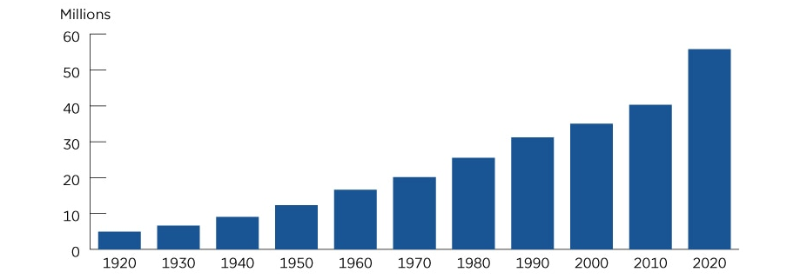
Figure 1: Population 65 years and over, 1920- 2020. Source 2020 U.S. Census Bureau
This issue is not limited to the United States. It has been identified that the world’s senior population is increasing quickly. In general health has improved, life expectancy has increased, and people are living longer worldwide. Many individuals are expected to live into their sixties and beyond. By 2030 1 out of 6 individuals in the world will be aged 60 or older and their population will double by 2050 (Erbas 2006; Miller and Annesley 2011; Cutler, Ghosh, and Landrum 2013; Verma 2014; World Health Organization 2023b). The increase in life expectancy, resulting growth of the elderly population, and needs of the great number of aging people will affect the communities in which they live. Thereby, researchers have focused on various biological, psychological, sociological, and economic aspects of aging (Erbas 2006; Ancora et al. 2022). In the realms of design and planning, experts have been trying to find new ways to ensure that older people are celebrated, welcomed, and have their practical ongoing needs met in their communities (Bayer and Harper 2000; Demirkan 2007; Judd et al. 2010; Dijk et al. 2015; Meeks 2022).
A key and guiding strategy in addressing and meeting the needs of the older population is the concept of Aging-in-place (Bayer and Harper 2000; Judd et al. 2010; Demirkan 2007; Iecovich 2014). The term aging in place has been defined as: ‘... remaining living at home in the community, with some level of independence, rather than in residential care’ (Davey et al. 2004: 133). Aging in a familiar and safe environment leads to various emotional and psychological advantages for older individuals. Providing them with control over their lives, enabling them to keep their identity, and improving their well-being are the reasons for which older individuals prefer to age in a familiar place surrounded by family and friends (Cutchin 2004; Rantz et al. 2005; Farber et al. 2011; Baker et al. 2014).
A study done by Herzog and House (1991) showed that living independently increases life satisfaction, health, and self-esteem which are three keys to aging successfully. On the contrary, relocation causes loss of independence and social relationships, loneliness, adjustment difficulties, emotional stress, changes in daily routines and lifestyles, and overall decline in physical and psychological functioning in older adults (Staveley 1998; Dobbs-Kepper et al. 2001; Iecovich 2014).
Aging in place is not only beneficial from the perspective of older individuals. Policy makers argue that the provision of care in the community and at the older individual’s home is much less expensive than institutional care (Chappell et al. 2004; Kaye, LaPlante, and Harrington 2009). Due to high costs of nursing home care for the public sector, many policy makers and professionals in aging societies have endorsed policies that prioritize aging in place (Iecovich 2014). Sociologists and environmental gerontologists have argued that as people become older their attachment to the environment where they live increases (M. Powell Lawton 1985).
Rowles (1983) argues that physical environments have a significant effect on all age groups, but the effect is greater on older people, and they are more sensitive to changes in their environment. In terms of environmental effect, Gilleard, Hyde, and Higgs (2007) argue that as people age their residential mobility decreases and they feel more attachment and belonging to their community. These effects are not limited to the design of dwellings. Neighborhood design has a significant impact on elderly safety, independence and social participation as well (Judd et al. 2010). Thereby, as people age, their neighborhood environment plays a crucial role in a successful aging in place and fulfilling their physical and emotional needs (König et al. 2019).
There is a long history of research on residential preference based on the importance of land cost and accessibility in people’s decision (Harvey 1996; Levine 1998; Weisbrod, Lerman, and Ben-Akiva 1980; Cao 2008; Ettema 2010; Luckey et al. 2018; Yan 2020). However, in the last decades ways to represent residential models have changed. Many recent studies have argued that a variety of factors including building and location-specific attributes play a role in residential decisions other than land costs and commuting costs (Talarchek 1982; Wenning 1995; M. J. Kim and Morrow-Jones 2005; Bayoh, Irwin, and Haab 2006; Hur and Morrow-Jones 2008; Schirmer, Van Eggermond, and Axhausen 2014b; Ardeshiri and Vij 2019).
In addition, researchers suggest that households’ characteristics and values play a significant role in their residential decisions. Since values change with time and over the life span, these changes are presumably reflected in their residential preferences as well (Lindberg et al. 1992; Sommers and Rowell 1992, 1; Masnick 2002; Duncombe, Robbins, and Wolf 2003; J. H. Kim, Pagliara, and Preston 2005; Wu, Zhang, and Dong 2013; Schirmer, Van Eggermond, and Axhausen 2014b; Yi and Lee 2014; Jin and Lee 2018). Thereby even if one demographic group currently focuses on something, their preferences might change over their life span and other groups might not have the same concerns. Despite the fact that residential attribute preference change across the life span, research on preferred attributes of middle-aged group --age 50 to 65-- has not received much consideration (S. Kim 2004; Demirkan 2007; Morrow-Jones and Kim 2009; Judd et al. 2010; Tokunaga and Murota 2023). Since baby boomers are a large portion of the current middle-aged group and will become a major portion of the senior population in the near future, studying and comparing their neighborhood and residential location preferences will help planners better aid these individuals to stay in their own neighborhoods as they age.

Research Purpose and Questions
Research studies suggest that currently older adults in the United States have various financial, political, social, and human resources obstacles and difficulties for aging in place (Russell, Skinner, and Fowler 2022). It is worth mentioning that we will all age and become older adults ourselves therefore, to achieve a successful aging in place it is important to make sure that our built environment supports aging in place and older adults’ preferences and needs are met not only when they are above 65 years old but also when they are still active and planning for retirement. Thereby, this dissertation aims to first study the neighborhood preferences of middle-aged groups and compare them with older individuals and then investigate their access to the amenities that make their communities more age friendly. In order to achieve this goal, the study will answer the following questions:
- What are the neighborhood attribute preferences of middle aged and older adults and how do they differ between these groups?
- What is the spatial distribution of amenities in these individuals’ neighborhoods and their access?
- What are the mismatches between preferred and current neighborhood attributes of the targeted groups?

Chapter 2: Literature Review

US Demographic Change
In 2000 data from US Census Bureau revealed that 12.4 percent of the American population was over 65 years old. By 2011 this group’s population was 40.3 million, and since January 1, 2011, for the next 20 years every day roughly 10,000 baby boomers -- born between 1946 and 1964 -- will turn 65 (DeNavas-Walt, Proctor, and Smith 2007; Pynoos et al. 2008; Howden and Meyer 2010; Gill and Moore 2013; Vespa, Medina, and Armstrong 2020). In the past decade the number of people in the United States who are 65-and-older grew by 34.2% or 13,787,044 people and by 3.2% or 1,688,924 people from 2018 to 2019. Due to the growth of this population the national median age rose from 37.2 years in 2010 to 38.4 years in 2019. In 2030 nearly one of every five Americans -- about 72 million -- will be an older adult. It is also anticipated that by 2060, over 90 million of the population will be aged 65 or older (US Census Bureau 2020).
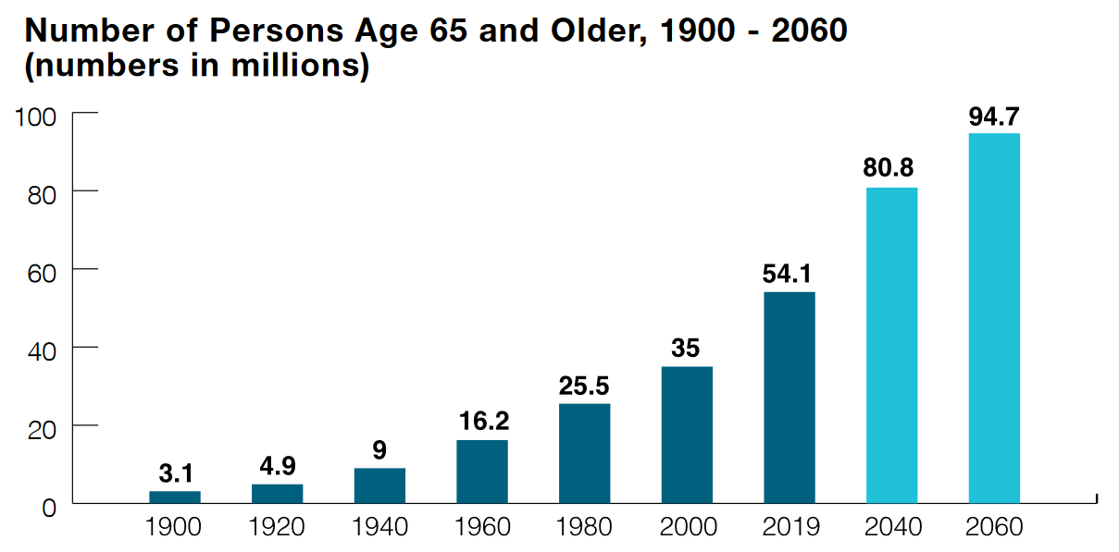
Figure 2: Number of persons aged 65 and older. Source: US Census Bureau, 2020

This dramatic change also stems from an increase in the life expectancy of the elderly. In 1900, the life expectancy was 47 years in the U.S., and it reached 76.64 in 2000. Due to improved health care life expectancy has been continuously increasing among seniors and the life expectancy for U.S. in 2020 was 77.0 years. By 2060 life expectancy is expected to increase to 85.6 (Erbas 2006; Miller and Annesley 2011; Cutler, Ghosh, and Landrum 2013; Verma 2014; West et al. 2014; Arias et al. 2022). According to Vespa, Medina, and Armstrong (2020) all racial and ethnic groups are expected to have gains in life expectancy, but the biggest ones are projected to be for black men, American Indian men and Alaska native men.

Aging in Place
Under current demographic projections the proportion of the elderly population is expected to increase, and the rate of growth will be even higher for the segment of the very old (aged 80 and over). Due to the rapid growth in the population aging, the significance of offering products and services that cater to the needs of older individuals is becoming more recognized by service providers and policy makers. Strategies and practices for ensuring a robust quality of life for older individuals have become an area of increasing interest for those who design the built environment (Scharf et al. 2002; Erbas 2006; Greenfield et al. 2015; World Health Organization 2023b).
Traditionally programs and public policies have focused on the delivery of assistance to targeted individuals. For example, the federal programs on the provision of healthcare and social services to older people, including the Social Security Act, the Medicaid Act, and the Older Americans Act were put in place during the 1960s by President Lyndon B Johnson's Great Society Act to provide essential support and care for older individuals (Gelfand 2006). However, in North America and Europe, the idea of “active aging” and aging in place has developed as a paradigm shift in addressing the challenge of population aging (World Health Organization 2002; Greenfield et al. 2015). The concept of aging in place suggests that elderly individuals, can continue remaining in their own homes as long as they receive the necessary services and support (Cutchin 2004).
In 1973, Lawton and Nahemow proposed The Ecology Theory of Aging (ETA) and conceptualized aging well as involving person-environment interchange dynamic. The ETA offers a comprehensive framework encompassing diverse forms and levels of personal competence, such as sensory impairment, reduced physical mobility, and cognitive decline, along with objective environmental features like housing standards, neighborhood conditions, and public transportation. A fundamental premise of ETA is that unique combinations of personal competence and environmental attributes determine an individual's optimal level of functioning. Furthermore, the person-environment interaction term implies that due to variations in how person-related abilities and needs express themselves in various environments, they can result in distinct outcomes. (M. Powell Lawton and Nahemow 1973).
Literature on aging-in-place is often about making the home more functional and less risky for the older adults by providing various home aids (Bayer and Harper 2000; Judd et al. 2010). While most conversations about aging in place revolve around people’s homes, many environmental gerontologists and researchers suggest that neighborhoods and communities play a vital role in enabling individuals to continue living in their current location (M. P. Lawton 1977).
Research studies performed in various countries prove that aging in place is becoming increasingly attractive for many older persons (Carr et al. 2013; Erbas 2006; Hall 2015; O’Hehir 2014; Scharf et al. 2002). As people age, they become more attached to the place where they live and more vulnerable to their social and physical environment (M. P. Lawton 1977; M. Powell Lawton and Nahemow 1973). Iecovich (2014) argues the term “place” not only relates to the seniors’ homes but also their community which highlights the importance of neighborhood environment. As individuals grow older, they experience greater physical fragility or chronic health issues, and their physical or cognitive abilities may diminish. In this case, older individuals need extra assistance to maintain their independence (Alley et al. 2007). Successful and independent aging in communities is not possible without accessible and safe neighborhood environments, including built environment characteristics, physical and social support systems, and a wide variety of amenities (Alley et al. 2007; Wiles et al. 2012; Fitzgerald and Caro 2014).
The built environment plays a crucial role in older adults’ participation in their communities. For instance, research studies have found that heavy traffic, inadequate security signs in the neighborhood, and poor access to public buildings can negatively impact social interaction and participation among individuals, especially those not using any mobility aid to get around (P. J. Clarke et al. 2011; P. Clarke et al. 2019). Additionally, built environment attributes like walkability, access to a public transportation system, access to parks, housing density, street connectivity, land use mix, safety and neighborhood appearance can increase physical activity among older adults and improve their well-being (Durand et al. 2011; Barnett et al. 2017; Van Cauwenberg et al. 2018; Song et al. 2020).

Aging in Place: the International Perspective
During the 1990s and early 2000s, the World Health Organization (WHO) started launching a number of policy initiatives that help experts develop age friendly communities. In 1999 during the United Nations’ Year of Older people, the idea of “active aging” was developed by the European Union. Later in 2002, the WHO elaborated this notion as the idea that older individuals should be able to continue participating in their social and physical environment. The WHO (2002) defines the term “active” as “continuing participation in social, economic, cultural, spiritual, and civic affairs, not just the ability to be physically active or to participate in the labor force. Older people who retire from work and those who are ill or live with disabilities can remain active contributors to their families, peers, communities, and countries. Active ageing aims to extend healthy life expectancy and quality of life for all people as they age, including those who are frail, disabled and in need of care”.
In 2006, the WHO directed a project in 33 cities from all continents which led to a guide of “Global Age-Friendly Cities”. This guide insists on making cities more aging-friendly to promote the wellbeing and participation of senior residents. Based on this report, active aging depends on a variety of material situations along with social factors that play an important role in people’s behavior and feelings. All of these influential determinants define an age-friendly city and affect how well individuals age in place. The WHO categorized these factors in eight different groups as “Communication and Information”, “Community Support and Health Services”, “Outdoor Spaces and Buildings”, “Transportation”, “Housing”, “Social Participation”, “Respect and Social Inclusion”, and “Civic Participation and Employment” (WHO, 2007b; Gonzales and Morrow-Howell 2009; Plouffe and Kalache 2010; Buffel, Phillipson, and Scharf 2012). The WHO project concluded that these features should be implemented as references for other communities to evaluate their strengths and gaps. Communities can also assess their progress in order to make their cities “friendly for all ages” and not just “elder-friendly” (WHO, 2007a: 72). In 2010 in an attempt to encourage implementation of policy recommendations from the 2006 project, the WHO launched the ‘Global Network of Age-friendly Cities’ including 47 individual cities (Buffel, Phillipson, and scharf 2012).
In 2023, the WHO released a new guide on developing national programs for age-friendly cities and communities. The new guide specifies both the rationale behind and a step by step, systematic method for creating age-friendly city and community initiatives on a national level. It also includes case studies from current, successful national programs for age-friendly cities and communities, as well as specific explanations of what may be done and how (World Health Organization 2023a). This guide provides a framework for governments to change their cities and communities to improve the well-being and ensure healthy aging for its population in more robust ways. The core elements of the framework are related to the following areas:
- partnerships, networking, and stakeholders
- leadership and strategic thinking
- human, financial, institutional, and cultural resources
- capacity-building
- knowledge, research, and innovation
- monitoring and evaluation

In the newly released document, the WHO presents a list of agencies developed all around the world that focus on age-friendly movement. AARP Network of Age-friendly States and Communities in the U.S., Age Friendly Ireland, Age Platform Europe, Centre for Ageing Better – United Kingdom Network of Age-friendly Communities, Office for Seniors- Government of New Zealand, Department of Seniors- Government of Queensland, Ministry of Health- Government of Singapore, International Federation on Ageing, Kanagawa Prefectural Government (Japan), Age-friendly Communities- Government of Canada, Instituto Nacional de Servicios Sociales para Jubilados y Pensionados (Argentina), and Servicio Nacional del Adulto Mayor (Chile) are some of agencies included in the list (World Health Organization 2023a).

Aging in Place: the U.S. Perspective
In the United States, the American Association of Retired Persons (AARP) Network of Age-Friendly Communities, joined the World Health Organization’s Age-Friendly Cities and Communities Program in 2012. Since adopting the WHO framework, the AARP has conducted community surveys to enable older adults to rate the current state of their communities for “aging in place” and facilitate support systems to help people live easily and comfortably in their homes and communities as they age (AARP 2023). In 2014, AARP conducted the “What Is Livable? Community Preferences of Older Adults” survey on individuals aged 50 and older.
Based on the survey results, fewer senior residents choose to live in traditional retirement communities or age-segregated housing. A great number of these individuals desire to age in their community and remain in their own homes and communities where they have the feeling of belonging. Also, for individuals 50-plus, access to public transportation, groceries and green spaces were very important community features. When they were asked what these individuals want implemented to improve their communities, attributes and services like an increased police presence; improved schools; pedestrian-friendlier streets; better transportation for older adults and people with disabilities; new or improved parks gained the highest rankings (Harrell et al. 2014).
In 2022, the AARP published the report of their “2021 Home and Community Preferences” survey. Based on the results, nearly 80 percent of adults aged 50 and older want to age in place by remaining in their homes and communities where they have “spent years making connections and commitments”. Findings indicate that the number of individuals that prefer to age in place has remained relatively consistent for more than a decade and was not impacted by the Covid-19 pandemic. The AARP states in order to facilitate aging in place, “people need homes and communities that are affordable, safe and can support their needs”. Also, it is crucial that individuals have access to high-quality health care providers, safe and accessible recreation spaces, conveniently located grocery stores, and infrastructure that reinforces community connectedness (AARP 2022).

Benefits of Aging in Place
Aging in a familiar and safe environment leads to various emotional and psychological advantages for older individuals. Providing them with control over their lives, enabling them to keep their identity, and improving their well-being are the reasons for which older individuals prefer to age in a familiar place surrounded by family and friends (Cutchin 2004; Farber et al. 2011; Fernald 2014; Rantz et al. 2005). In a recent study on 1,600 people aged 45 and older, AARP found that 73 percent prefer to stay in their current residences, and 67 percent like to remain in their communities as long as possible (Keenan 2010a).
In 2007, Clarity conducted research on attitudes of seniors and baby boomers on aging in place. Among a total of 804 random telephone interviews, 402 interviews were completed. The results demonstrated that the fear of losing independence causes many seniors not to choose nursing homes for living. A study done by Herzog and House (1991) showed that living independently increases life satisfaction, health, and self-esteem which are three keys to aging successfully. On the contrary, relocation causes loss of independence and social relationships, loneliness, adjustment difficulties, emotional stress, changes in daily routines and lifestyles, and overall decline in physical and psychological functioning in older adults (Chapin, Dobbs-Kepper 2001; Iecovich 2014; Staveley 1998).
The aforementioned discussions highlight the importance of managing, planning and designing communities that support aging in place. Many sociologists and environmental gerontologists have argued that as people become older their attachment to the environment where they live increases (Lawton 1985). Rowles (1983) argues that physical environments have a significant effect on all age groups, but the effect is greater on older people. These individuals are more sensitive to changes in their environment. In terms of environment’s effect, in 2007 Gilleard et al. found that as people age their residential mobility decreases and they feel more attachment and belonging to their community.
Aging in place is not only beneficial from the perspective of older individuals. Enabling older adults to stay in their homes and communities for an extended period also prevents the expensive alternative of institutional care, making it a preferred choice among policymakers and healthcare providers (Chappell et al. 2004; World Health Organization 2007; Kaye, LaPlante, and Harrington 2009; Iecovich 2014). In 2023, Curioni et al. conducted a systematic literature review on the cost-effectiveness of homecare services compared to in-hospital care for adults and older adults. The study results revealed homecare was generally more cost effective when compared to hospital care. Homecare can also influence the health and wellbeing of older adults. A review of the literature that examines home care compared to other care locations by Boland et al. (2017) indicated that homecare can positively impact the well-being of individuals aged 65 years and over. Given the importance of neighborhood design in successful aging and fulfilling individuals physical and emotional needs, research on residential choice of these individuals needs deep consideration.

Residential Location Choice Models
Cities’ lands are mostly made up of housing, and residential household location is one of the important factors in urban dynamics (Schirmer, Van Eggermond, and Axhausen 2014). The choices individuals make about where to live and age affect the investments in urban infrastructure and transportation, employment patterns, approaches to economic development, and neighborhood social structure (Huu Phe and Wakely 2000). Various determinants factors affect housing and neighborhood choices of people (Wiseman 1980; S. Kim 2004). Researchers have introduced three major approaches to model residential location including the monocentric model, the Lowery model, and the discrete choice model (Waddell 1997; Huu Phe and Wakely 2000; S. Kim 2004; Schirmer, Van Eggermond, and Axhausen 2014). These models are explained in detail as follows.
The roots of residential location modeling go back to Von Thunen’s hypothesis about concentric city-region (1828). His theory of location is based on transport costs from a central market. Thunen’s isolated state model consists of cospecializes of rural land use around a central market community in which each zone is specialized in a particular type of agricultural produce. Agricultural land uses with the highest transport costs and profits were found in the rings closest to the center. The first ring around the market community is dedicated to market gardening and fresh milk production, the second ring, dedicated to the production and harvest of forest products, the third ring, to crop rotation systems, and finally the fourth ring would be dedicated to livestock ranching (Harvey 1996; Arribas-Bel and Sanz-Gracia 2014).

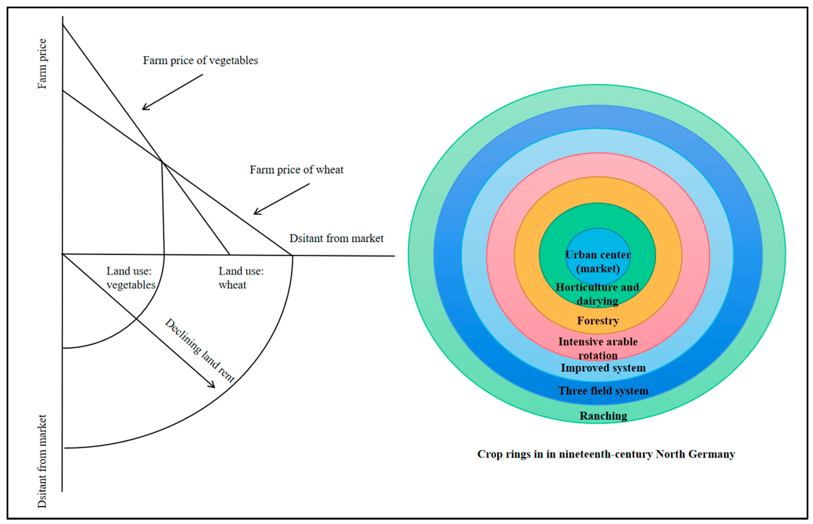
Figure 3: Schematic diagram of Von Thünen model. Source: Han, Yuan, and Zou (2022)
Von Thunen’s concept was updated and built upon by Alonso (1964), Muth (1969), and Mills (1972). They propose a mono-centric city with employment opportunities that is isolated and functions independently from other cities. The number of residents is fixed in this model, and they live around a central business district (CBD). The CBD locates all the city’s employment, services and goods. As one of the key features of the model it is assumed that each worker travels into the city center for work. Thereby employment as well as population density and land price increase in the central core since it is the most attractive location in the city.
Based on the monocentric model land is more expensive close to the center, which prompts homebuilders to economize on the use of land. Buildings closer to the CBD are higher and have smaller dwellings than those farther from the center. Since households living close to the city center have to travel less to get to work or entertainment center thereby rents are bid upwards and transportation costs are lower close to the city center. Households then choose to either live in well-located, but smaller and more expensive housing units or in more distant, but larger and less expensive towards the city fringe (S. Kim 2004; Lai and Tsai 2008).
In general, there is a negative correlation between the rent price and distance from the city center (Figure 4) and a positive correlation between transportation costs and distance from the city center. Since households have a combined rent and transportation budget constraint if transportation costs are higher, then the amount a household is willing to pay for rent is lower. Overall the monocentric model focuses on predicting residential location as a function of transportation and housing costs (Ahlfeldt 2008; Arribas-Bel and Sanz-Gracia 2014; Takahashi 2014)
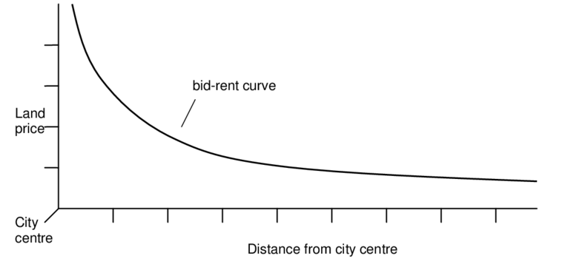
Figure 4: Rent function in the Monocentric model. Source: Alonso 1964
Even though the monocentric model provides the theoretical foundation for many residential location choice models, the validity of the model has been questioned. Researchers argue that the monocentric model oversimplifies the choices individuals and families make about where to live. For instance, it does not consider municipal policies (e.g. property taxes, zoning), neighborhood characteristics (e.g. crime, amenities), household characteristics (e.g. size, composition), socio-economic factors (e.g. race, income), cultural factors (e.g. ethnicity, group affiliation) and preferences (e.g. single family home, condominium) of residents (S. Kim 2004).
Furthermore, cities have become polycentric hence the suburbanization of population and employment opportunities have occurred (Griffith 1981; Rudzitis 1982; Berry and Kim 1993). The presence of multiple centers means population density at any location results from the layering of influences generated by different centers. The suburbanization of employment location means there will be more than one center for commercial and business activities in a metropolitan area which results in increased land price in these areas (Griffith 1981; Rudzitis 1982; Berry and Kim 1993; S. Kim 2004).
Parallel to Alonso, Lowry (1964) proposed the gravity model based on residents’ access to jobs, which was one of the first proposed transportation and land use models. The impetus for creating the model was to simulate the residential and services location patterns in the Pittsburgh region. In this model residential location is determined by employment and more specifically by the costs involved in accessing to a place of work. Lowery assumed a set of basic and non-basic employment regions and proposed an iterative procedure that generates the spatial distribution of employment and population within a region. Basic industries can support nonbasic services with additional income that they generate by exporting much of their product outside the region. Nonbasic industries supported by basic industries then can serve households within the region (Iacono, Levinson, and El-Geneidy 2008; Schirmer, Van Eggermond, and Axhausen 2014b).
In Lowry’s model the location of basic industries is fixed. Thereby population distribution is determined by employment location and households are allocated to zones based on the number of workers in that zone. Lowry’s formulation shows that residents’ willingness to commute from one zone to another one decreases as travel distance and cost increases.

f(tij) = exp (-βt ij)
f(tij): a deterrence function value representing the inverse of the probability of workers working in zone i and living in zone j.
tij is a measure of the disutility of travel between zones, typically defined as travel time.
- -β represents the marginal disutility per unit of time.
This functional form assumes that only one household member is employed outside the home and workers choose to live near their workplace. Also, the higher the cost of commuting, the closer places of employment and residential areas are. Finally, residential attractiveness is measured by the amount of land available for development in a particular zone (Myung-Jin 2004; S. Kim 2004; Iacono, Levinson, and El-Geneidy 2008; Schirmer, Van Eggermond, and Axhausen 2014b).
Implementing Lowry’s model needs modest data and a few parameter adjustments to analyze the impacts of major urban changes. However Berechman and Small (1988) argue the model lacks underlying economic or behavioral theory. Other criticisms of the model include the limitation of its applicability due to high sectoral aggregation between basic and nonbasic employment and ignoring the supply side of urban development like the housing industry (Jun and Moore 2002).
As Waddell (1997) discusses simultaneously a separate stream of research activity by McFadden (1973,1984), Quigley (1973, 1976) and others focused on household residential choice instead of rent price. These researchers worked on random utility theory to develop multinomial logit models of residential locations. This model assumes that residents make decisions about their residential location in a way to maximize their utility. Maximizing utility means minimizing travel time and residents maximize their utility by weighting the characteristics of each available alternative such as work, shopping, and school accessibilities, neighborhood quality, level of public services, housing cost, taxes, travel costs, and housing characteristics (year built, number of rooms, etc.). The strength of multinomial logit model comes from the fact that one can avoid describing a residential location solely based on its distance to the city center or job locations. Also, this framework has the ability to quantify the impact of various residential location attributes and household characteristics on residential location choices (D. McFadden 1973; Waddell 1997; Schirmer, Van Eggermond, and Axhausen 2014b).
However, in the last three decades thinking about the mechanisms and behaviors associated with housing choice has changed. Recent studies have argued that a variety of factors including building and location-specific attributes play a role in residential decisions other than land costs and commuting costs (Talarchek 1982; Wenning 1995; M. J. Kim and Morrow-Jones 2005; Bayoh, Irwin, and Haab 2006; Hur and Morrow-Jones 2008; Schirmer, Van Eggermond, and Axhausen 2014b). For example some studies have found that school quality is one of the household's priorities in locational choice and affect house prices (Haurin and Brasington 1996a; 1996b; Guo and Bhat 2002; M. J. Kim and Morrow-Jones 2005; Bayoh, Irwin, and Haab 2006). In 2005 Kim and Morrow-Jones used a survey of new home buyers and found that distance to work was relatively unimportant. This study concluded that various factors affect residential location decisions including housing characteristics (floor plan, quality of construction, and cost), community characteristics (safety of the neighborhood and good investment or resale value), and school quality (school reputation and quality of schools’ academic programs).
Many studies have discovered that households’ characteristics including size, income, social class or ethnic background, and household lifestyle play a significant role on their residential decisions (Duncombe, Robbins, and Wolf 2003; J. H. Kim, Pagliara, and Preston 2005; Wu, Zhang, and Dong 2013; Schirmer, Van Eggermond, and Axhausen 2014b; Yi and Lee 2014; Jin and Lee 2018). For example studies on residential choices have demonstrated that whites prefer predominantly white neighborhoods, while blacks tend to favor integrated neighborhoods (Clark 1991; Farley et al. 1994; Bobo and Hutchings 1996; Krysan and Farley 2002; Adelman 2005; Ibraimovic and Hess 2018).
According to Walker and Li (2007) lifestyle preferences are key determinants of residential location behavior and can be identified from observed choices of residential location. They believe that “there are three lifestyle segments: households that are suburban, auto, and school oriented; households that are transit oriented but want a suburban setting, and households that are urban and auto oriented”. In addition, in their study, Krizek and Waddell (2002) found correlations between lifestyle-related explanatory variables and transportation choices. They addressed nine lifestyles that affect households’ mobility behavior and residential location choices. These lifestyles are “retirees; single, busy urbanists; elderly homebodies; urbanists with higher income; transit users; suburban errand runners; activity-oriented families; suburbanites with double income; and exurban, family commuters. Based on this study, non-family households tend to locate in the central business district area while child-rearing family households locate in more suburbanized areas. A summary of discussed models is presented in Table 1.

Model | Explanation
Concentric Model by Von Thunen (1828). | Thunen’s theory of location is based on transport costs from a central market. This model aims to explain the spatial organization of agriculture and how it is influenced by transportation costs.
Monocentric Model by Alonso (1968), Muth (1969), and Mills (1972). | The monocentric model is based on the bid-rent function. It assumes that there’s a negative relationship between land price and the distance of land from the city center
Gravity Model by Lowery (1964). | This is one of the first transportation and land use models based on access of population to jobs. According to this model, employment location determines residential location, and the propensity of travel decreases with increasing distance.
Random Utility Model by McFadden (1973), Quigley (1973), And others. | This model assumes that residents make decisions about their residential location in a way to maximize their utility. Maximizing utility means minimizing travel time to access utilities.
The Life Course Model in the past two decades. | A variety of factors including building, location-specific attributes, and households’ characteristics and lifestyle influences residential decisions other than land costs and commuting costs.
Table 1: Summary of residential location choice models

Residential Location Choice Across the Life Span
Studies on residential location choices have revealed that desires and preferences of different age groups change with time and across the life span (Lindberg et al. 1992; Sommers and Rowell 1992; Masnick 2002; Morrow-Jones and Kim 2009; Schirmer, Van Eggermond, and Axhausen 2014b). Morrow-Jones and Wenning (2005) suggest that at different stages of life, household characteristics and their roles in the family might affect people’s residential location preferences. Change in residential preferences are also a reflection of change in households’ values that occur over the course of life (Michelson 1977; Rossi and Shlay 1982). Furthermore as people age their mobility decreases as middle aged and older households are less likely to move than younger households (Lu 1998). To understand the complexities of different household residential location decisions their preferences should be scrutinized based on disaggregated datasets. To identify these preferences, a range of peer-reviewed journal papers, working papers, theses, and dissertations that address residential choice were examined. When deciding these studies’ results, only results relating to neighborhood attributes were included. Table 2 shows a summary of these reviewed studies.
Author (Year) | Attributes
Wiseman (1980) | Climatic, scenic, and recreational amenities  Local availability of activities and social contact  Be near kin, especially children
Lindberg et al. (1992) | Housing attributes/Neighborhood attributes  Suitable for children, Low noise level, Clean air, Pleasant outdoor environment, Little crime, Low traffic intensity, Low population density, Nice neighbors, Good public transport, Good local services, High status  Location attributes  Close to school, Close to recreation facilities, Close to stores, businesses, and shopping centers, Close to cultural offerings and entertainment, Close to your workplace, Close to nature, Close to homes of friends and relatives
Filion, Bunting, and Warriner (1999) | Accessibility variables  Living close to stores, living close to work or school, living close to friends and family, Living close to major roads, Living close to expressways, Living close to bus route  Place variables  The appearance of your home, your home’ s privacy, Living in an attractive area, Living in a safe place, Living in a quiet place, Living in an area with parks and green space  Setting  Houses are not close together, houses mixed with shops, same-size houses in neighborhood, Newer neighborhood, houses mixed with low-rise apartments, townhouses, etc.  Availability  Types of housing available match consumer demand
Huu Phe and Wakely (2000) | Housing status  Distance to city center, the presence of good access to the street, Unit Location
Humpel et al. (2004) | Accessibility  Safety
Echeverria, Diez-Roux, and Link (2004) | Aesthetic environment  Attractive neighborhood, No trash and litter on the street, Interesting activities in the neighborhood, Enjoyable scenery in the neighborhood, No noise in the neighborhood, well maintained buildings and homes, interesting buildings and houses  Walking/exercise environment  Neighborhood offers many opportunities to be physically active, Local sports clubs and other providers, pleasant to walk, enough trees in the neighborhood to provide shade, Not a heavy traffic in the neighborhood, Not busy roads to cross when out for walks, Easy to walk to places, stores within walking distance of home, streets and sidewalks are in good condition, other people walking in the neighborhood, other people exercise (for example, jog, bicycle, play sports) in the neighborhood  Safety from crime  feel safe walking in the neighborhood during the evening, neighborhood is safe from crime, Violence in the neighborhood  Access to healthy foods  Availability of high quality products in the neighborhood, large selection of fresh fruits and vegetables available  Social cohesion (Sampson scale)  A close-knit or unified neighborhood, People around here are willing to help their neighbors, People in the neighborhood generally get along with each other, People in the neighborhood can be trusted, People in this neighborhood share the same values  Violence in past 6 months  Fight with gun, Gang fights, Sexual assault or rape, Robbery or mugging
J. H. Kim, Pagliara, and Preston (2005) | Travel time to work  Travel cost to work  Travel cost to supermarket  Population density  CITY Location of residence (city or suburban)  Quality of school
World Health Organization (2007b)  And AARP (2022) | Outdoor spaces and buildings  Transportation  Social Participation  Respect and social inclusion  Civic participation and employment  Communication and information  Community and health services
(Cao, Mokhtarian, and Handy 2007) | Accessibility  Physical activity options  Safety  Socializing  Attractiveness  Outdoor spaciousness
Morrow-Jones and Kim (2009) | Reasons for choosing the current neighborhood  Reputation of schools, Traffic in the neighborhood, Economic characteristics of the neighborhood, Racial composition of the neighborhood, Safety of the neighborhood, Quality of local garbage collection, Quality of local police services, Quality of local road maintenance, The number of parks and open space, General appearance of neighborhood  Accessibility-related reasons  Distance to work, Distance to family and/or friends, Wanted to be closer to more desirable shopping areas, Community recreational opportunities, Decreased my commuting cost, Less traffic congestion on my new commute, Availability of public transit, Ability to walk to stores and services
Troped et al. (2010) | Street Connectivity  Intersection density (intersections per kilometer  Land use mix  Density  Residential population density  Greenness  Vegetation index
Van Dyck et al. (2012) | Walking and cycling facilities  Aesthetic  Traffic safety  Crime safety  Parking near local shopping areas  Residential density  Land use mix-diversity
De Meester et al. (2014) | Residential Density  Presence of different types of residences (e.g. detached single-family residences, row houses, apartments  Land use mix diversity  Distance to local facilities (e.g. supermarket, post office, library)  Land use mix access  Access to neighborhood services (e.g. ease to walk to public transport, ease to walk to school)  Connectivity  Connectedness of street network  Availability of walking and cycling infrastructure  Quality and maintenance of walking and cycling infrastructure.  Aesthetics  Presence of aesthetic features (e.g. green spaces, attractive buildings, streets free from litter and graffiti  Safety for traffic  speed of traffic in neighborhood, availability of pedestrian crossings and traffic signals  Safety for crime  crime prevalence in the neighborhood, perceived safety from strangers  Convenience of recreation facilities  Distance to PA facilities
Schirmer, Van Eggermond, and Axhausen (2014) | Built environment  Built density, Open space, Land use, Network/noise  Socio-economic environment  Population density, Household type, Employment, Crime  Points of interest  Education, Urban character, Service and retail, Sport and recreation, Transport  Access & Accessibility  Commuting time, Sociodemographic  Previous location & Social networks  Individual distances
Dijk et al. (2015) | Outdoor spaces and buildings  A clean and green neighborhood, A neighborhood with wide sidewalks and safe crosswalks, Public buildings with elevators that are easily accessible for wheelchairs and walkers, A safe neighborhood, A calm neighborhood  Transportation  Good public transport, Enough parking spots  Social participation  A neighborhood where many social activities are organized, Affordable activities for older people.  Respect and social approval  A neighborhood where people have respect for older people, A neighborhood where people are willing to help each other whenever necessary, no majority of immigrants in the neighborhood, A neighborhood where people know each other and dare to approach each other.  Civic participation  Possibilities for voluntary work, A neighborhood where older people are involved, for example concerning changes in the neighborhood  Community support and health services  A neighborhood where home care is easily accessible, A neighborhood where caregivers collaborate and keep each other informed, A neighborhood with general practitioner (GP) and pharmacy at walking distance, Places where older people can go for advice and support, Volunteers who provide help when necessary, Shops and other facilities within walking distance
Child et al. (2016) | Accessibility  High dwelling density, Destinations within walking distance, Access to amenities, Access to transit stops  Structural support  Presence of sidewalks, Sidewalks are maintained, Presence of bicycle facilities, Facilities for bicycling are maintained, Presence of low-cost recreation facilities, High street connectivity  Safety
Novianto et al. (2016) | Amenity  Nature, Park and green space, City/town beauty  Safety  Streetlight, Bicycle path, Blind spot, Traffic situation, Road maintenance, Shelter, Pedestrian, Security post, Disaster  Health  Sewage, Noise, Vibration, Garbage  Convenience  Supermarket, Elementary school, Post office, Middle/high school, Bank, Train station, Library, Bus stop, Medical facility, Leisure place
Binette and Vasold (2018) | Transportation  Community Service and Features (a. Sidewalks and Streets safety, b. Outdoor Spaces & Buildings)  Social Participation
(Andersson, Abramsson, and Malmberg 2019) | Close to the family  Close to forests and land  Close to city life  Close to grocery shops  Services and culture  Close to public transport
Lee (2019) | Neighborhood Safety  Commute/Job Considerations  Neighborhood Public School Quality  Investment Value  Proximity of Family/Friends  Co-ethnic Businesses  Neighborhood Racial/Ethnic Composition  Entertainment Options
(Jamal, Newbold, and Scott 2022) | Living within walking distance of shopping areas  Living within walking distance of entertainment (restaurants, movies, clubs, etc.)  Having easy access to the highway  Having good public transit service  Living in a quiet neighborhood  Having lots of people out and about in the neighborhood  Having a high level of upkeep in the neighborhood  Having big trees on neighborhood streets  Having lots of off‐street parking (garages or driveways) in the neighborhood
Table 2: An overview of studied literature

There have been many studies on residential location choices of families with school aged kids. Also, since the WHO launched the Global Age Friendly initiatives there has been more focus on different approaches to make communities and neighborhoods more age friendly. However, studying and comparing neighborhood preferences across different stages of life has not gained enough consideration. Among the included studies in table 2, a few focused on comparing neighborhood preferences of older adults versus the younger groups.
For example in their paper, Jamal, Newbold, and Scott (2022) compared young and older adults’ attitudes and preferences towards different travel modes and residential characteristics. Although their study contributes to the field by adding more insight on residential preferences, it compares the preferences of 18–34-year-old individuals versus age 65 plus and their study was done in Ontario Canada. Furthermore, while the AARP study is one of the most comprehensive studies focused on age friendly initiatives it investigates home and community preferences of adults aged 18 plus nationally and analyses the 18–49-year olds’ preferences versus individuals aged 50 and over descriptively. There are still some unanswered questions about differences in the residential location preferences of individuals aged 50-64 versus older adults, and their needs and challenges related to aging in their neighborhoods that I’m trying to answer in this study.

Chapter 3: Method

Research Design
In this dissertation I examine the preferences for attributes that promote aging in place among a sample of individuals aged 50 and older, living in Norman, OK. I identify existing amenities that promote aging in place in the neighborhoods and compare these to the participants’ preferences. To do this, I employed a quantitative design, beginning with a survey to identify the neighborhood attribute preferences of middle age and seniors of Norman and answer the first research question. After analyzing the survey data, I inventoried a set of community amenities identified through the literature review as part of building age friendly neighborhoods. I map participants and existing amenities to examine the distribution of these individuals and their access to the built environment attributes and answer the second question. At the end, results from the two databases are combined and compared to have a better understanding of the phenomena (Creswell and Clark 2017) and answer the third research question.
GIS Data Collection
GIS Data Analysis
Results (Second Question)
Survey Data Collection
Survey Data Analysis
Results (First Question)
Data Interpretation (Third Question)

Figure 5: Research flow

Data Collection
In order to answer the research questions, this project focuses on individuals aged 50 or older in Norman, Oklahoma (Cluster sampling). The method of collecting primary data had two components: a questionnaire on neighborhood attributes preferences and using GIS mapping tools. Once the University of Oklahoma Institutional Review Board’s permission was granted, I posted the research flyer with a link to the survey on different Facebook groups related to Norman communities. At this stage information about participation’s location was collected. One of the questions was about naming the nearest intersection to their homes.

Survey Data Collection
To design the survey questions, scholarly research articles and studies that have worked on household’s residential location decisions were examined. When deciding these studies’ results, only those related to neighborhood attribute preferences were included (Table 2). Attributes mentioned in these studies were compared and combined to develop a survey instrument that was employed in collecting the data (Table 3). The questionnaire had 25 questions categorized in 6 major themes as respondent characteristics; physical environment; transportation; accessibility; well-being, safety, and security; and community values.

Attributes | Measurements
Respondent Characteristics | Age  Gender  Race  Education  Marital status  Employment  Living with someone under the age of 18  Disability  Home ownership  Income  Traveling mode  Length of living in the neighborhood
Physical Environment | Well maintained streets  Low density  Enough benches for resting in public areas, along sidewalks, and around public buildings  The general appearance of buildings in the neighborhood and clean neighborhood  Parks and green spaces  Public buildings and spaces that are accessible to people of different physical activities
Transportation | Bus routes  Bicycle facilities  Public transportation  Close to major roads  Special transportation options for the elderly and people with disability  Conveniently located public parking lots including parking for people with disabilities
Accessibility | Homes of friends and relatives within walking distance  Recreation facilities within walking distance  Grocery stores within walking distance  Cultural offerings and activities within walking distance  Religious centers (Church, mosque, synagogue, …)  Access to downtown/city center within 20-minute driving distance  Access to the workplace within 10-minute driving distance  Doctor, pharmacy, and emergency care centers within walking distance  Access to places where older people can go for advice and support (e.g. senior center)  Access to social clubs such as book, gardening, craft or hobby within walking distance  Affordable delivery system
Well-being, Safety, and Security | Low noise level and Calm  Clean air  Little crime  Reduced (15-25 mph) speed limits for cars  Low traffic intensity  Safe public transportation stops or areas that are accessible to people of varying physical abilities  Sidewalks that are in good condition and accessible for wheelchairs or other assistive mobility devices  Safe crossings that have both audio and visual signals  Separate pathways for bicyclists and pedestrians  Having an emergency shelter within walking distance (For tornado, flood, …)
Community Values | High Social status  Having the opportunity to participate in decision making bodies such as community councils or committees  Nice neighbors  Racial/Ethnic diversity of the neighborhood  No majority of immigrants in the neighborhood  Majority of people from the same race/ethnicity as you in the neighborhood  A neighborhood where people know each other  A feeling of belonging to the neighborhood  A neighborhood where people have respect for older people  A neighborhood where people are willing to help each other whenever necessary.  Shared religious beliefs
Table 3: Summary of neighborhood attributes based on the literature.

Modifying the Survey Instrument
Certain survey questions were sourced from the AARP Livable Communities questionnaire (2018), while the rest were derived from research findings outlined in Table 2. Once the survey was compiled, two experts in the field reviewed the questions for their suitability (content validity) and comprehensibility (wording). Additionally, the survey was presented during a meeting attended by a group of senior residents, and their feedback guided the final structuring of the questionnaire. Subsequently, internal consistency (reliability) was assessed using Cronbach's Alpha (Appendix A). The alpha coefficient for the 45 Likert Scale questions in the survey is 0.903 with a range of 0.898-0.906, suggesting that the items have relatively high internal consistency.

GIS Data Collection
After analyzing the survey results and finding the nearest intersections to the participants, these locations were pinpointed on Google Earth (Figure 6). Data regarding age-friendly features within the urban infrastructure was gathered using resources such as The City of Norman's website and Google search engine. The features within the built environment were categorized into four groups: transportation (T), nutrition (N), medical Care (MC), and recreation (R). These services were extracted from both Table 3 and the survey responses.
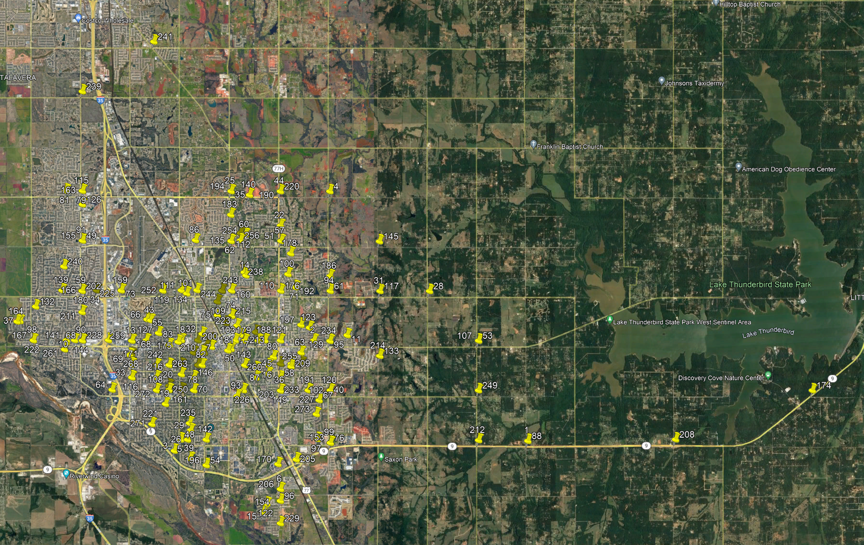
Figure 6: Map of pinned intersections on Google Earth
In the nutrition category, a list of existing grocery stores and their addresses were collected. Under medical care, all medical centers and pharmacies were identified. For the recreation category, parks and recreation centers within the city’s boundary were located through Google search. Lastly for the transportation category, the lists of existing bus stops and routes were compiled through the City of Norman Transportation Website, Embark. Once the addresses of these facilities were discovered, their coordinates were pinpointed on Google Earth. Afterwards, the data from Google Earth was stored as a KML layer, which was then imported into ArcMap for analysis. Data on bike routes, sidewalks, and the city’s boundary was downloaded from the GIS Services Division on the City of Norman’s website. Figures 7-13 show the nearest intersections to participants and age friendly built environment features in Norman, Oklahoma.
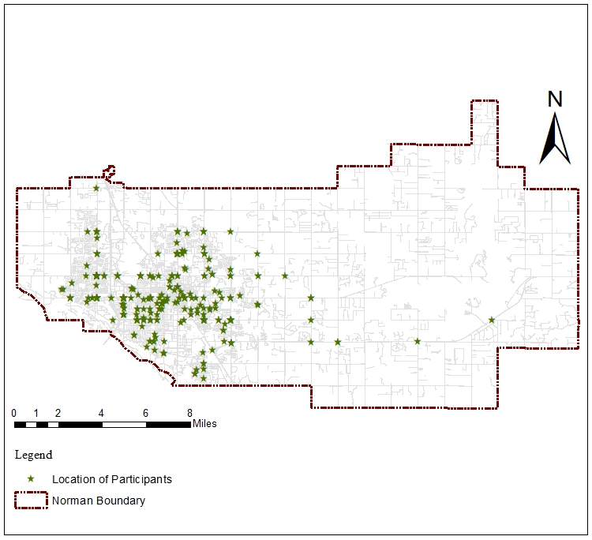
Figure 7: Location of participants

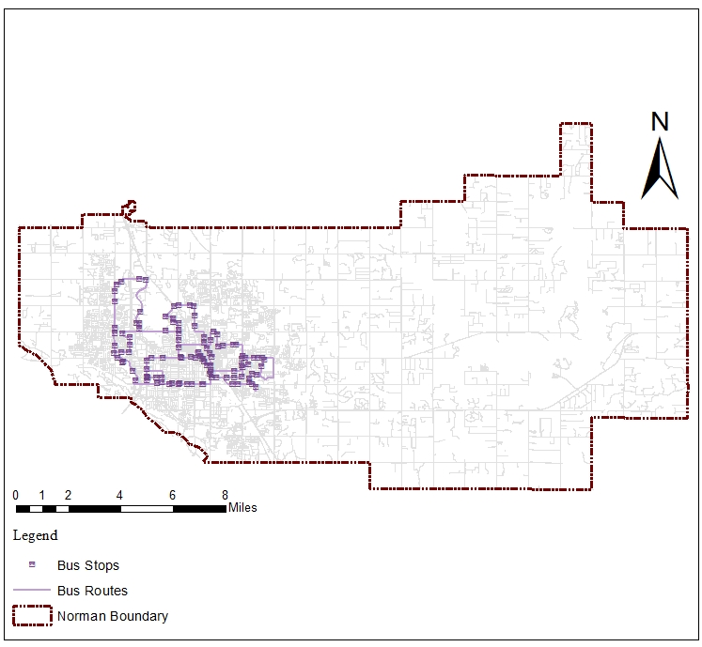
Figure 8: Location of bus stops and bus routes
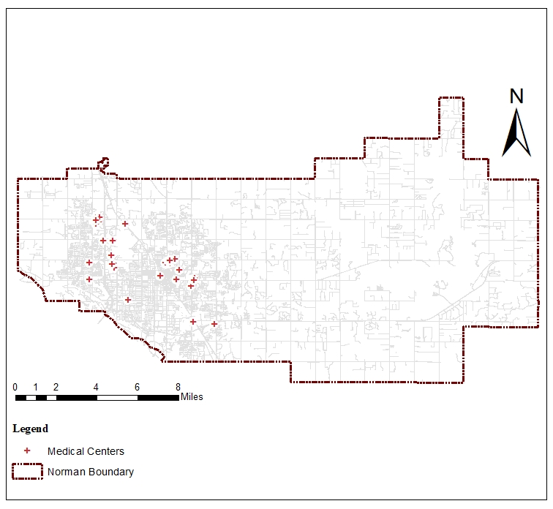
Figure 9: Location of medical centers (hospitals and urgent cares)
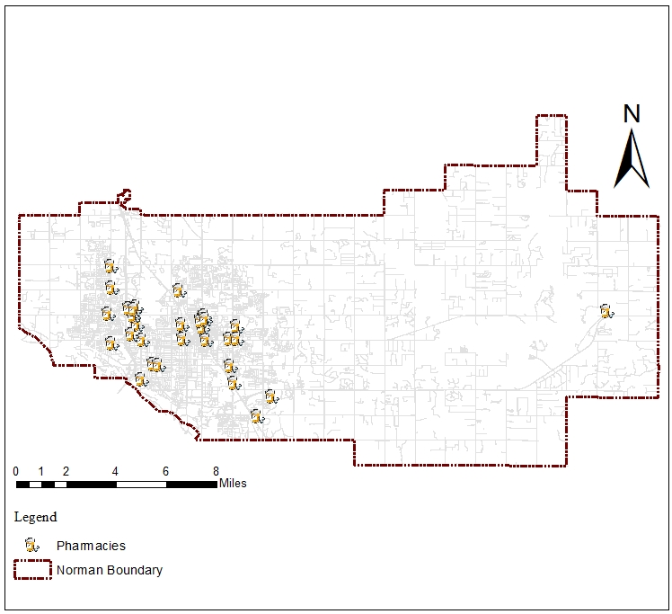
Figure 10: Location of pharmacies
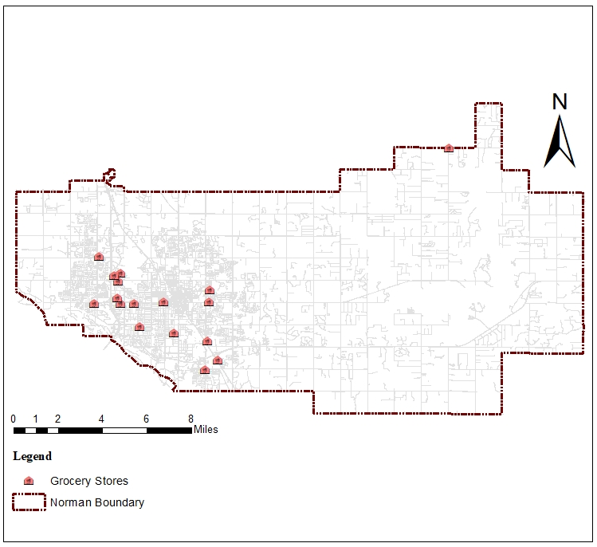
Figure 11: Location of grocery stores
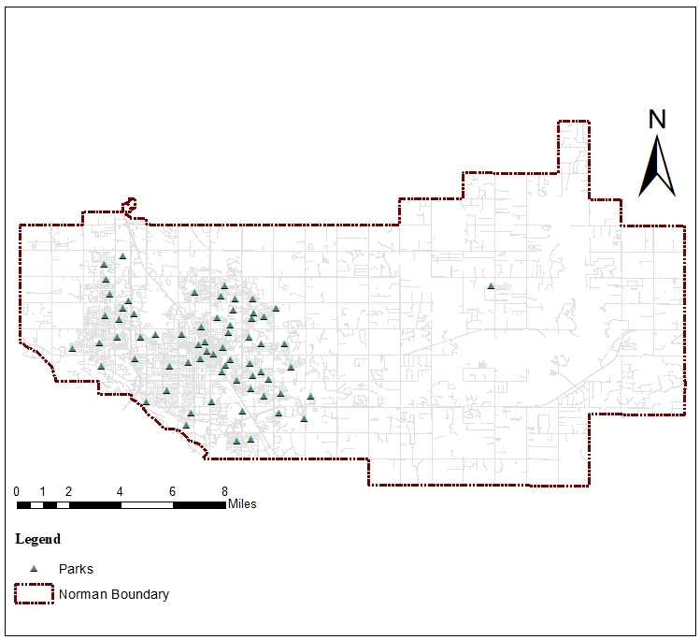
Figure 12: Location of parks
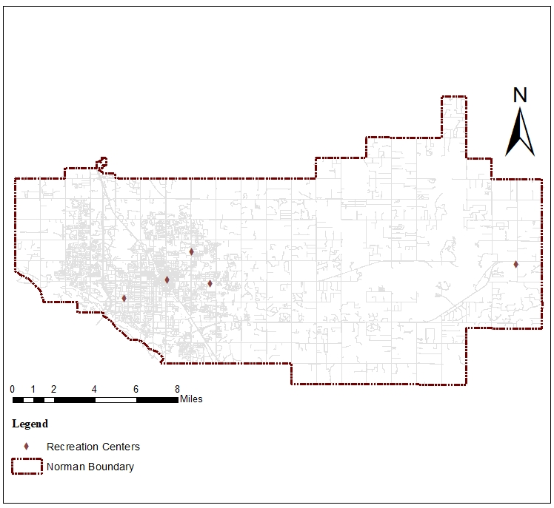
Figure 13: Location of recreation centers
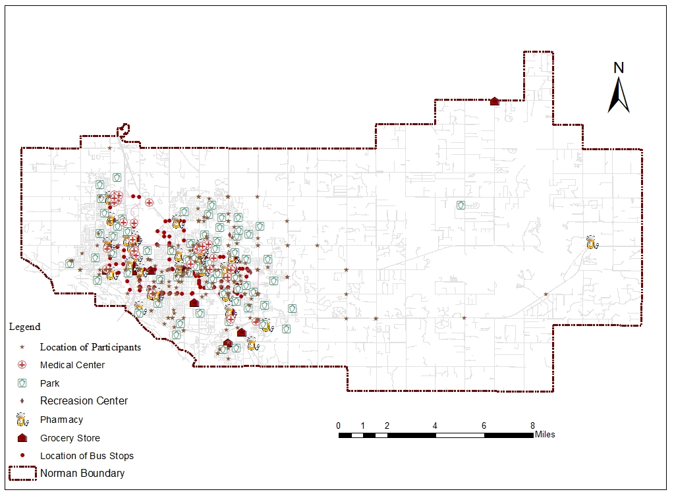
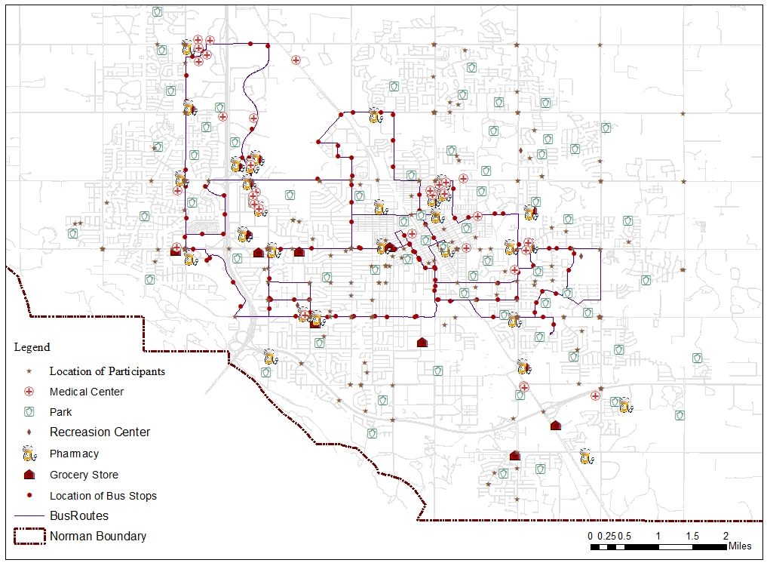
Figure 14: Distribution of services in Norman (Top), and magnified view of them (Bottom).

Data Analysis

Survey Data Analysis
Out of 319 responses two were deleted since the location of respondents were not within the city boundary and thirty-two participants’ responses were eliminated due to not answering sixty percent or more of the questions in the survey, leaving a final sample size of 285. The Little’s missing completely at random (MCAR) test was conducted using R programming for the remaining responses. Once confirming the randomness of missing data, mean imputation was used to address the missing data. Statistical Package for the Social Sciences (SPSS) version 28 and R packages were used for statistical computing.
First the frequency and percentage of the Likert scale questions were calculated (Appendix A). The Mann-Whitney U test was performed afterwards. The MWU test is a non-parametric test that is used to compare two sample means that come from the same population, and used to test whether two sample means are equal or not (Mann and Whitney 1947). The demographic questions in the survey were analyzed descriptively and the Pearson Correlation Coefficient test was conducted to test the relationship between variables. The Mann-Whitney U test was also conducted for other independent variables to verify if they make any differences in the neighborhood attribute preferences. Two questions in the survey were open ended and asked participants about the things they like or dislike in their neighborhood. Their answers were compared/combined with the Mann-Whitney U test outcome.

GIS Data Analysis
Transportation system and land use pattern define user’s accessibility to services. Transportation may be measured as “travel time” or “distance”. The land use dimension of accessibility can also be described as its "attractiveness," "opportunity," or "activity." Based on the relationship between these dimensions, 5 accessibility measures are used in the literature. The measures of accessibility are spatial separation, cumulative opportunities, gravity, utility, and time-space (Bhat et al. 2001). Due to the ease of computing and interpretation, the cumulative opportunities measure is adopted by many planning agencies and used in this study as well. This model assumes that only opportunities reachable within a specific travel time limit using a particular mode of transportation are considered accessible, whereas those beyond this limit should not be counted as accessible (El-Geneidy and Levinson 2022).
Determining the optimal travel time threshold to use in this model is a topic of ongoing discussion in the planning and transportation field (Páez, Scott, and Morency 2012). To analyze the participants’ access to the built environment features in their neighborhood, this dissertation focuses on walking as the mode of transportation. Walking can be linked to attributes of the built environment such as how close destinations are or nonphysical aspects like safety. Based on different studies for the last two decades, in the United States approximately 0.25 miles (a distance of approximately 400 meters, equivalent to a 5-minute walk) has been considered the distance that Americans would prefer to walk rather than using a vehicle (Atash 1994; Aultman-Hall, Roorda, and Baetz 1997; Pikora et al. 2002; Krizek 2003; Hoehner et al. 2005; McCormack, Giles-Corti, and Bulsara 2008). However, walking trips like 0.5 miles (1—minute walk) may not be uncommon in some cases (McCormack, Giles-Corti, and Bulsara 2008). Thereby, the 0.25- and 0.50-miles thresholds are used in this dissertation to assess the accessibility of services for individuals aged 50 and older.
After finding the nearest intersection to the participant’s home address two geodesic buffers within the 0.25 miles and 0.5 miles distances from each intersection were created (Fig 15). To assess service accessibility for each intersection the number of bus stops, grocery stores, medical centers, pharmacies, parks, and recreation centers were counted within each buffer zone (Appendix A). Mean, median, range, and standard deviation were calculated for these services, and the Kernel Density tool in ArcMap was used to visualize the density of these services in the city.
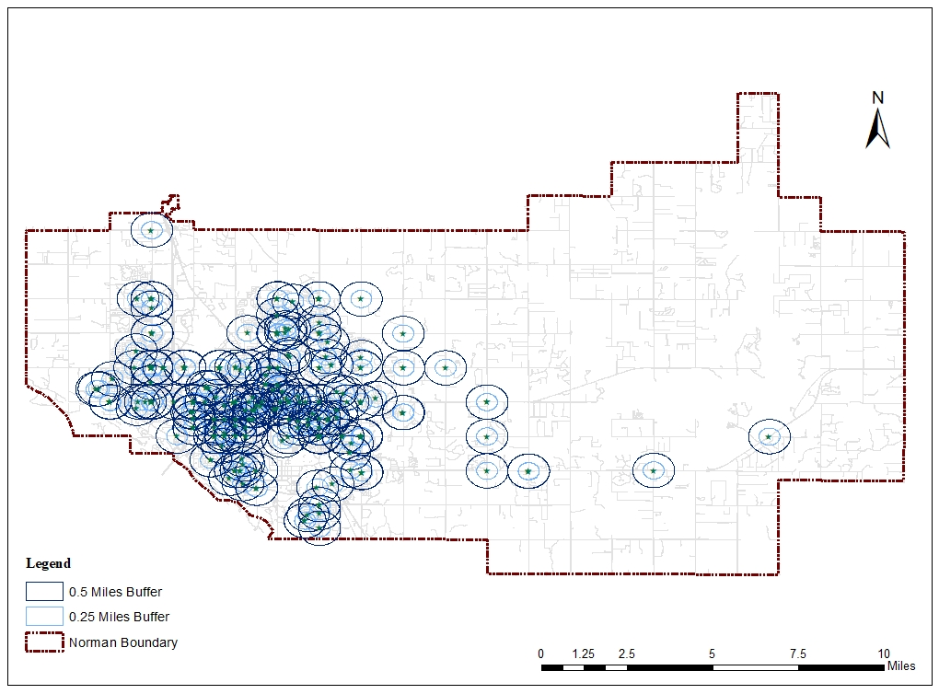
Figure 15: 0.25- and 0.5-miles buffer distances around intersections

Chapter 4: Results
This dissertation aimed to compare the neighborhood attributes of middle-aged with older adults and investigate their access to the built environment features that make their neighborhoods more age friendly. The following section describes the collected data, followed by the results of descriptive statistics, Mann–Whitney U test, and spatial analysis.

Survey Results

Description of Sample
A total sample of 319 individuals aged 50 or older were recruited between March and October 2020. The research flyer was posted in different groups on social media, and the participants were recruited on a voluntary basis. By removing two participants that were located outside the study area and 32 incomplete surveys, the total sample was reduced to 285. Out of 285 participants, 143 individuals were aged 50-64 (50.2%), and 142 of them were 65 or older (49.8%). These individuals consisted of 229 (80.4%) women and 56 men (19.6%). The majority of respondents were white or Caucasian (90.9%). The survey also collected information about these individuals’ disabilities, and 132 (45.6%) of them declared themselves or someone in their home as having a disability. The demographic characteristics of participants are summarized in Table 4.

Variable | Groups | Frequency | Percentage
Age | 50-64  65 and Older | 143  142 | 50.2  49.8
Gender | Male  Female | 56  229 | 19.6  80.4
Race | White or Caucasian  Non-White | 259  26 | 90.9  9.1
Education | No College Degree  College Degree or Higher | 46  239 | 16.1  83.9
Marital Status | Married or Living with Somebody  Single | 172  113 | 60.4  39.6
Employment | Still Working  Not Working | 120  165 | 42.1  57.9
Someone Under the Age of 18 | Living with Children or Relatives Under 18  Living without anyone Under 18 | 27  257 | 9.5  90.5
Disability | Someone with Disability in the House  No Disability | 132  152 | 45.6  53.6
Home Ownership | Own  Rent  Live with Somebody Else | 252  30  3 | 88.4  10.5  1.1
Income | Less than $40,000  $40,000 to $60,000  $60,000 to $80,000  $80,000 to $100,000  $100,000 and more | 58  51  51  49  72 | 20.4  17.9  17.9  17.2  25.3
Traveling Mode | Driving or Being Driven by Someone  Other Modes | 274  11 | 96.1  3.9
Length of Living in the Neighborhood | Less than 15 years  16 years and more | 124  161 | 43.5  56.5
Table 4: Characteristics of participants, n = 285
After analyzing the variables descriptively, the Pearson Correlation Coefficient test was conducted to examine the relationship between variables. Results showed that variables such as age and race, age and employment; race and length of living in the neighborhood; employment and disability; and disability and race were correlated. The Result of the Pearson Correlation Coefficient test is presented in table 5.
Variables | Correlation Results | Age | Race | Marital Status | Employment | Length of Living in the Neighborhood | Disability | Income
Age | R value | 1 | -.121* | -.062 | .480** | .025 | -.091 | .034
Age | Sig. |  | .042 | .299 | <.001 | .671 | .125 | .574
Age | N | 285 | 285 | 285 | 285 | 285 | 285 | 281
Race | R value | -.121* | 1 | -.008 | -.051 | .155** | .149* | .027
Race | Sig. | .042 |  | .897 | .394 | .009 | .012 | .648
Race | N | 285 | 285 | 285 | 285 | 285 | 285 | 281
Marital Status | R value | -.062 | -.008 | 1 | -.006 | -.099 | -.036 | -.530**
Marital Status | Sig. | .299 | .897 |  | .918 | .096 | .548 | <.001
Marital Status | N | 285 | 285 | 285 | 285 | 285 | 285 | 281
Employment | r value | .480** | -.051 | -.006 | 1 | .054 | -.133* | -.095
Employment | Sig. | <.001 | .394 | .918 |  | .361 | .025 | .114
Employment | N | 285 | 285 | 285 | 285 | 285 | 285 | 281
Length of Living in the Neighborhood | r value | .025 | .155** | -.099 | .054 | 1 | .005 | .119*
Length of Living in the Neighborhood | Sig. | .671 | .009 | .096 | .361 |  | .930 | .046
Length of Living in the Neighborhood | N | 285 | 285 | 285 | 285 | 285 | 285 | 281
Disability | r value | -.091 | .149* | -.036 | -.133* | .005 | 1 | .156**
Disability | Sig. | .125 | .012 | .548 | .025 | .930 |  | .009
Disability | N | 285 | 285 | 285 | 285 | 285 | 285 | 280
Income | r value | .034 | .027 | -.530** | -.095 | .119* | .156** | 1
Income | Sig. | .574 | .648 | <.001 | .114 | .046 | .009
Income | N | 281 | 281 | 281 | 281 | 281 | 280 | 281
*. Correlation is significant at the 0.05 level (2-tailed).
**. Correlation is significant at the 0.01 level (2-tailed).
Table 5: Pearson Correlation Coefficient test results

Aging in place
In 2021, the Home and Community Preferences survey conducted by AARP found that 77% of adults ages 50 and older want to stay in their homes, and 79% want to stay in their communities. This dissertation’s findings were consistent with previous data on aging in place, and most participants responded they prefer to stay in their homes and communities as they age. Findings showed that for 278 individuals (97.5%), it is important to be able to stay in their homes, and for 238 of them (83.5%), it is important to stay in their neighborhoods. More than 80% of the participants rate their neighborhood a good place for people as they age, and it is very likely or likely for 80.4% of them to recommend living in their neighborhood to older adults. Furthermore, the findings suggest that 252 participants own their home (88.4%), and 161 (56.5%) have lived in their neighborhoods for more than 16 years.

Neighborhood Attribute Preferences
To identify the most preferred and important neighborhood attributes among the middle aged and older individuals, frequency, mean, and standard deviation for the Likert questions in the survey were calculated, and their results are presented in Table 6. In the physical environment category, having a clean neighborhood with well-maintained streets and the general appearance of buildings in the neighborhood ranked highest. The most important features for participants in the transportation category were special transportation options and conveniently located public parking lots that include parking for people with disabilities. In terms of accessibility, having access to affordable delivery systems and access to downtown within 20-minute driving distance were the most favorable attributes. Finally, having clean air and a low rate of crime; having nice neighbors and a neighborhood where people are willing to help each other whenever necessary had the highest scores in the wellbeing and community values group.
Question | When you think about a place to live how important is it to you to have the following features in the neighborhood?
Groups | Variable | Scale | N | % | Mean | SD
Physical Environment | Well maintained streets | Not important  Important  Missing | 4  281  0 | 1.4  98.6  0 | 1.99 | .117
Physical Environment | Low density | Not important  Important  Missing | 66  218  0 | 23.2  76.5  0 | 1.77 | .423
Physical Environment | Enough benches for resting in public areas, along sidewalks, and around public buildings | Not important  Important  Missing | 53  232  0 | 18.6  81.4  0 | 1.81 | .389
Physical Environment | The general appearance of buildings in the neighborhood and clean neighborhood | Not important  Important  Missing | 7  278  0 | 2.5  97.5  0 | 1.97 | .155
Physical Environment | Parks and green spaces | Not important  Important  Missing | 11  273  1 | 3.9  95.8  0.4 | 1.96 | .193
Physical Environment | Public buildings and spaces that are accessible to people of different physical abilities | Not important  Important  Missing | 30  255  0 | 10.5  89.5  0 | 1.89 | .307
Transportation | Bus routes | Not important  Important  Missing | 120  164  1 | 42.1  57.5  0.4 | 1.57 | .494
Transportation | Bicycle facilities | Not important  Important  Missing | 140  145  0 | 49.1  50.9  0 | 1.50 | .500
Transportation | Public transportation | Not important  Important  Missing | 93  191  1 | 32.6  67  0.4 | 1.67 | .470
Transportation | Close to major roads | Not important  Important  Missing | 86  199  0 | 30.2  96.8  0 | 1.69 | .459
Transportation | Special transportation options for the elderly and people with disability | Not important  Important  Missing | 45  239  1 | 15.8  83.9  0.4 | 1.84 | .365
Transportation | Conveniently located public parking lots including parking for people with disabilities | Not important  Important  Missing | 56  229  0 | 19.6  80.4  0 | 1.80 | .398
Access to Amenities | Homes of friends and relatives within walking distance | Not important  Important  Missing | 108  177  0 | 37.9  62.1  0 | 1.62 | .485
Access to Amenities | Recreation facilities within walking distance | Not important  Important  Missing | 80  205  0 | 28.1  71.9  0 | 1.71 | .450
Access to Amenities | Grocery stores within walking distance | Not important  Important  Missing | 81  203  1 | 28.4  71.2  0.4 | 1.71 | .452
Access to Amenities | Cultural offerings and activities within walking distance | Not important  Important  Missing | 103  182  0 | 36.1  63.9  0 | 1.64 | .481
Access to Amenities | Religious centers (Church, mosque, synagogue, …) | Not important  Important  Missing | 148  137  0 | 51.9  48.1  0 | 1.48 | .500
Access to Amenities | Access to downtown/city center within 20-minute driving distance | Not important  Important  Missing | 44  241  0 | 15.4  84.6  0 | 1.84 | .361
Access to Amenities | Access to the workplace within 10-minute driving distance | Not important  Important  Missing | 139  146  0 | 48.8  51.2  0 | 1.51 | .500
Access to Amenities | Doctor, pharmacy, and emergency care centers within walking distance | Not important  Important  Missing | 123  162  0 | 43.2  56.8  0 | 1.56 | .496
Access to Amenities | Access to places where older people can go for advice and support (e.g. senior center) | Not important  Important  Missing | 72  212  1 | 25.3  74.4  0.4 | 1.74 | .435
Access to Amenities | Access to social clubs such as book, gardening, craft or hobby within walking distance | Not important  Important  Missing | 108  176  1 | 37.9  61.8  0.4 | 1.62 | .486
Access to Amenities | Affordable delivery system | Not important  Important  Missing | 47  238  0 | 16.5  83.5  0 | 1.83 | .371
Well-being, Safety, and Security | Low noise level and Calm | Not important  Important  Missing | 14  271  0 | 4.9  95.1  0 | 1.95 | .216
Well-being, Safety, and Security | Clean air | Not important  Important  Missing | 2  283  0 | 0.7  99.3  0 | 1.99 | .083
Well-being, Safety, and Security | Little crime | Not important  Important  Missing | 1  284  0 | 4  99.6  0 | 1.99 | .060
Well-being, Safety, and Security | Reduced (15-25 mph) speed limits for cars | Not important  Important  Missing | 27  256  2 | 9.5  89.8  0.7 | 1.90 | .294
Well-being, Safety, and Security | Low traffic intensity | Not important  Important  Missing | 14  268  3 | 4.9  94  1.1 | 1.95 | .217
Well-being, Safety, and Security | Safe public transportation stops or areas that are accessible to people of varying physical abilities | Not important  Important  Missing | 56  229  0 | 19.6  80.4  0 | 1.80 | .398
Well-being, Safety, and Security | Sidewalks that are in good condition and accessible for wheelchairs or other assistive mobility devices | Not important  Important  Missing | 17  268  0 | 6  94  0 | 1.94 | .237
Well-being, Safety, and Security | Safe crossings that have both audio and visual signals | Not important  Important  Missing | 34  251  0 | 11.9  88.1  0 | 1.88 | .324
Well-being, Safety, and Security | Separate pathways for bicyclists and pedestrians | Not important  Important  Missing | 49  235  1 | 17.2  82.5  0.4 | 1.82 | .378
Well-being, Safety, and Security | Having an emergency shelter within walking distance (For tornado, flood, …) | Not important  Important  Missing | 71  214  0 | 24.9  75.1  0 | 1.75 | .433
Community Values | High Social status | Not important  Important  Missing | 212  72  1 | 74.4  25.3  0.4 | 1.25 | .435
Community Values | Having the opportunity to participate in decision making bodies such as community councils or committees | Not important  Important  Missing | 71  214  0 | 24.9  75.1  0 | 1.75 | .433
Community Values | Nice neighbors | Not important  Important  Missing | 11  274  0 | 3.9  96.1  0 | 1.96 | .192
Community Values | Racial/Ethnic diversity of the neighborhood | Not important  Important  Missing | 61  224  0 | 21.4  78.6  0 | 1.78 | .410
Community Values | No majority of immigrants in the neighborhood | Not important  Important  Missing | 236  47  2 | 82.8  16.5  0.7 | 1.16 | .372
Community Values | Majority of people from the same race/ethnicity as you in the neighborhood | Not important  Important  Missing | 245  40  0 | 86  14  0 | 1.14 | .347
Community Values | A neighborhood where people know each other | Not important  Important  Missing | 30  255  0 | 10.5  89.5  0 | 1.89 | .307
Community Values | A feeling of belonging to the neighborhood | Not important  Important  Missing | 34  251  0 | 11.9  88.1  0 | 1.88 | .324
Community Values | A neighborhood where people have respect for older people | Not important  Important  Missing | 14  271  0 | 4.9  95.1  0 | 1.95 | .216
Community Values | A neighborhood where people are willing to help each other whenever necessary | Not important  Important  Missing | 12  273  0 | 4.2  95.8  0 | 1.95 | .201
Community Values | Shared religious beliefs. | Not important  Important  Missing | 257  28  0 | 90.2  9.8  0 | 1.98 | .298
Table 6: Results for analyzing the Likert scale questions

Comparing the preferences of two groups

Physical Environment
The results of the Mann-Whitney test did not show many differences between the preferences of middle-aged and older adults regarding 5 physical environment attributes (Table 7). However, at the 0.05 level, the results suggested that the general appearance of buildings in the neighborhood and having a clean neighborhood ranked higher for individuals 65 and older compared to the middle-aged group (p = .015). These neighborhood attributes were mentioned by several respondents in the survey as well. In one of the questions, participants were asked “What do you like the most about your current neighborhood?” and individuals used the following terms to describe their neighborhood: “nice and clean”, “clean”, “architecture and trees”, “older homes with large trees”, “nice yards with big trees”, “old houses”, “properties look nice”, “houses are well kept”, “pretty”, “well maintained homes”, “wonderful older homes”, “physically attractive”, and “cleanliness and beauty”.
Attributes | Mann-Whitney U | Std. Error | Z Score | Sig.^{a,b} | Mean Rank for  Age 50-64 | Mean Rank for  Age 65 and above
P1. Well maintained streets. | 10152 | 141.74 | -.007 | .994 | 143 | 142
P2. Low density. | 10653 | 511.23 | .979 | .328 | 139 | 146
P3. Enough benches for resting in public areas, along sidewalks, and public buildings. | 10781 | 468.82 | 1.340 | .180 | 138 | 147
P4. The general appearance of buildings in the neighborhood and clean neighborhood. | 11583 | 589.74 | 2.425 | .015 | 133 | 153
P5. Parks and green spaces. | 10433 | 242.00 | 1.157 | .247 | 141 | 145
P6. Public buildings and spaces that are accessible to people of different physical abilities. | 10715 | 369.79 | 1.521 | .128 | 139 | 147
a. The significance level is .050.
b. Asymptotic significance is displayed.
Table 7: Mann-Whitney U test results for the physical environment category

Transportation
In the transportation category, the Mann-Whitney test showed that the distribution of T1 to T6 was the same across both age groups. This means that there was no significant difference between their preferences. The results of the Mann-Whitney test including the standard error, Z score, and P-value for the test are presented in Table 8. The presence of special transportation options and parking lots for people with disabilities and older individuals in the neighborhood were the most important attributes for both age groups. Participants declared the importance of these attributes by using terms like: “easy access to highway”, “Close to I-35”, “close to major roads”, “easy access to highway”, and “access to highway”.
Attributes | Mann-Whitney U | Std. Error | Z Score | Sig.^{a,b} | Mean Rank for  Age 50-64 | Mean Rank for  Age 65 and above
T1. Bus routes | 10367 | 596.34 | .360 | .719 | 142 | 144
T2. Bicycle facilities | 9405 | 602.38 | -1.241 | .215 | 148 | 138
T3. Public transportation | 9820 | 566.99 | -.587 | .557 | 145 | 141
T4. Close to major roads | 9846 | 553.09 | -.554 | .579 | 145 | 141
T5. Special transportation options for the elderly and people with disability | 10296 | 443.45 | .322 | .747 | 142 | 144
T6. Conveniently located public parking lots including parking for people with disabilities | 10139 | 478.78 | -.029 | .977 | 143 | 143
a. The significance level is .050.
b. Asymptotic significance is displayed.

Table 8: Mann-Whitney U test results for the transportation category

Access to Amenities
Access to the workplace within 10-minute driving distance; and access to doctor, pharmacy, and emergency care centers within walking distance were the attributes that scored differently across the age categories. The result of the Mann-Whitney U test showed that access to workplace was more important for individuals aged 65 and older with the p value of .045 while the 50–64-year-old group values access to pharmacies and medical centers more than the other group (p = <.001) (Table 9). Related terms to this category used by survey participants when they were asked about their favorite neighborhood features were “close to many businesses”, “location”, “close to Walmart”, “close to shopping”, “walking distance to everything except a grocery”, “access to parks”, “Close proximity to everything”, “proximity to services”, stores and restaurants”, “Near to park, library, store & restaurants”, “ restaurants, shops, library, post office, doctors, pharmacy and hospital within walking distance”, “close to shopping and services”, “proximity to gas station, grocery stores, fast food, and essentials shopping”, “close to bank, groceries, shopping, entertainment, restaurants”, “close to my son”, “easy access to essentials”, “I'm a block from a grocery store and a pharmacy”, “Convenience to shopping and library”, and “Proximity (walking or bicycling distance) to grocery/pharmacy, public and university libraries/events, public parks”.
Attributes | Mann-Whitney U | Std. Error | Z Score | Sig.^{a,b} | Mean Rank for  Age 50-64 | Mean Rank for  Age 65 and above
A1. Homes of friends and relatives within walking distance. | 9500 | 439.37 | -1.485 | .138 | 147 | 139
A2. Recreation facilities within walking distance. | 10268 | 584.55 | .198 | .843 | 143 | 143
A3. Grocery stores within walking distance. | 10845 | 541.43 | 1.279 | .201 | 138 | 148
A4. Cultural offerings and activities within walking distance. | 10112 | 545.86 | -.075 | .940 | 143 | 143
A5. Religious centers. | 10768 | 578.86 | 1.063 | .288 | 139 | 147
A6. Access to downtown/city center within 20-minute driving distance. | 10971 | 602.02 | 1.359 | .174 | 137 | 149
A7. Access to the workplace within 10-minute driving distance. | 11436 | 638.77 | 2.009 | .045 | 134 | 152
A8. Doctor, pharmacy, and emergency care centers within walking distance. | 7930 | 666.85 | -3.334 | <.001 | 158 | 127
A9. Access to places where older people can go for advice and support (e.g. senior center). | 9481 | 596.81 | -1.126 | .260 | 147 | 138
A10. Access to social clubs such as book, gardening, craft or hobby within walking distance. | 10939 | 526.27 | 1.494 | .135 | 137 | 148
A11. Affordable delivery system. | 10653 | 586.22 | .854 | .393 | 140 | 146
a. The significance level is .050.
b. Asymptotic significance is displayed.
Table 9: Mann-Whitney U test results for the access to amenities category

Well-being, Safety, and Security
In the well-being and safety category, one attribute scored differently across the age groups after conducting the Mann-Whitney U test. Safe crossings that have both audio and visual signals with the P-value= .030 were more appreciated for individuals aged 65 or older than the younger group. When participants were asked what features they would like to change about their neighborhood many of them mentioned the lack of sidewalks, high crime rate, and high traffic intensity.
Attributes | Mann-Whitney U | Std. Error | Z Score | Sig.^{a,b} | Mean Rank for  Age 50-64 | Mean Rank for  Age 65 and above
W1. Low noise level and Calm. | 10149 | 260.42 | -.013 | .989 | 143 | 143
W2. Clean air. | 10152 | 100.58 | -.005 | .996 | 143 | 143
W3. Little crime. | 10224 | 71.25 | .996 | .319 | 143 | 143
W4. Reduced (15-25 mph) speed limits for cars. | 10059 | 364.42 | -.257 | .798 | 143 | 143
W5. Low traffic intensity. | 10504 | 285.45 | 1.231 | .218 | 140 | 146
W6. Safe public transportation stops or areas that are accessible to people of varying physical abilities. | 10566 | 478.78 | 2.337 | .388 | 140 | 146
W7. Sidewalks that are in good condition and accessible for wheelchairs or other assistive mobility devices. | 10505 | 285.37 | 1.233 | .217 | 140 | 146
W8. Safe crossings that have both audio and visual signals. | 10999 | 390.57 | 2.167 | .030 | 137 | 149
W9. Separate pathways for bicyclists and pedestrians. | 10439 | 458.46 | .624 | .533 | 141 | 145
W10. Having an emergency shelter within walking distance (For tornado, flood, …). | 10491 | 521.15 | .650 | .516 | 141 | 145
a. The significance level is .050.
b. Asymptotic significance is displayed.
Table 10: Mann-Whitney U test results for the well-being, safety, and security category

Community Values
This category had the highest number of attributes that were prioritized differently across the age groups. Living in a neighborhood with high social status, having the opportunity to participate in decision-making bodies such as community councils or committees, no majority of immigrants in the neighborhood, most people from the same race/ethnicity in the neighborhood, and shared religious beliefs were the attributes that were preferred more among participants aged 65 or older. When participants were asked what they don’t like about their neighborhood, 7 of them mentioned they prefer fewer rental units in their neighborhood so they could know their neighbors better.
Attributes | Mann-Whitney U | Std. Error | Z Score | Sig.^{a,b} | Mean Rank for  Age 50-64 | Mean Rank for  Age 65 and above
C1. High social status. | 11368 | 526.27 | 2.310 | .021 | 134 | 152
C2. Having the opportunity to participate in decision-making bodies such as community councils or committees. | 11346 | 521.15 | 2.290 | .022 | 134 | 152
C3. Nice neighbors. | 9936 | 232.11 | -.933 | .351 | 145 | 141
C4. Racial/Ethnic diversity of the neighborhood. | 10351 | 494.21 | .402 | .688 | 141 | 145
C5. No majority of immigrants in the neighborhood. | 11360 | 454.97 | 2.654 | .008 | 134 | 152
C6. The majority of people from the same race/ethnicity as you in the neighborhood. | 11018 | 418.54 | 2.067 | .039 | 136 | 150
C7. A neighborhood where people know each other. | 9860 | 369.79 | -.791 | .429 | 145 | 141
C8. A feeling of belonging to the neighborhood. | 10002 | 390.57 | -.387 | .699 | 145 | 141
C9. A neighborhood where people have respect for older people. | 10577 | 260.42 | 1.628 | .103 | 141 | 145
C10. A neighborhood where people are willing to help each other whenever necessary. | 10435 | 241.99 | 1.165 | .244 | 141 | 145
C11. Shared religious beliefs. | 10872 | 358.65 | 2.006 | .045 | 138 | 148
a. The significance level is .050.
b. Asymptotic significance is displayed.
Table 11: Mann-Whitney U test results for the community values category

Spatial Analysis Results

Kernel Density
After mapping the location of participants and services, the kernel density tool in ArcMap was used to create heat maps. Kernel Density Estimation (KDE) is essentially a method for estimating density, primarily relying on a distance-based approach to analyze a dataset consisting of points. It results in the generation of a density surface for each individual point within the dataset. For each specific point, a kernel density surface is constructed with its peak value located at the center of that point's position. As you move away from this center, the density value gradually diminishes until it eventually reaches zero once it extends beyond a predetermined radius. Conceptually, all of these individual density surfaces are combined to form a continuous and smoothly curved surface that spans across the entire study area (Silverman 1986).
The following kernel density maps visualize the concentration of the services in the neighborhoods. These maps show that the amenities are not distributed equally in the city, and the majority of them are located in small areas in the west side of the city, leaving the rest of the city’s residents with no access within walking distance to these services. As shown in Figure 15, the current public transportation system does not cover the whole city either and is insufficient to support the city’s residents. Therefore, these services are mainly catering to the individuals that can drive or are being driven by somebody else to access them.
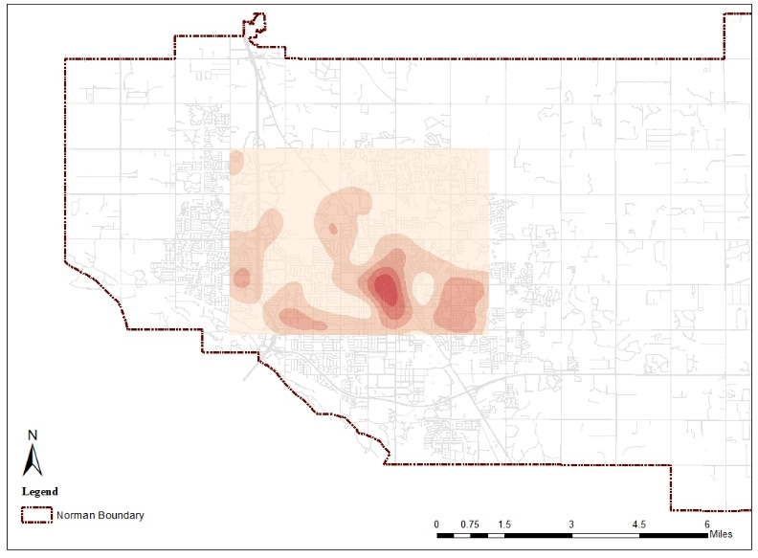

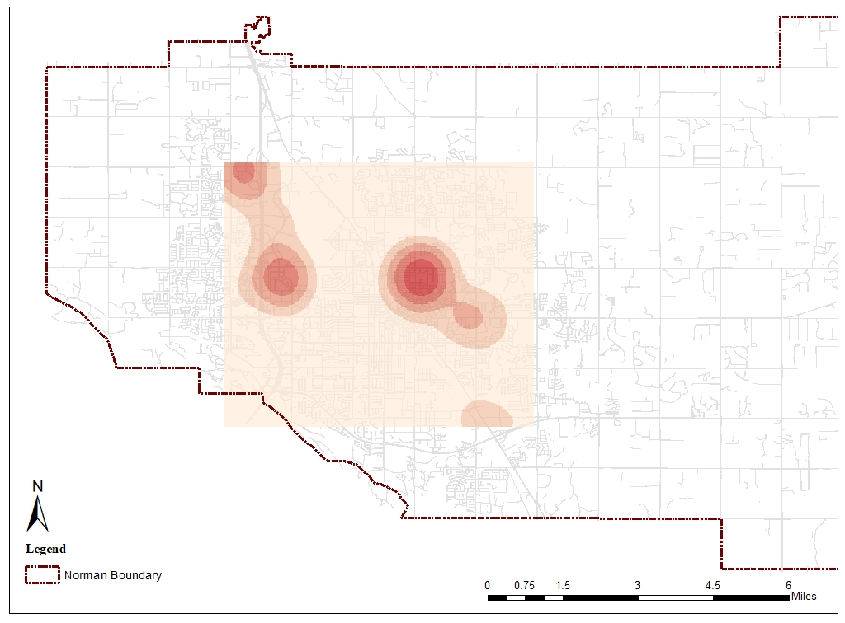
Figure 16: Kernel density map of bus stops

Figure 17: Kernel density map of medical centers

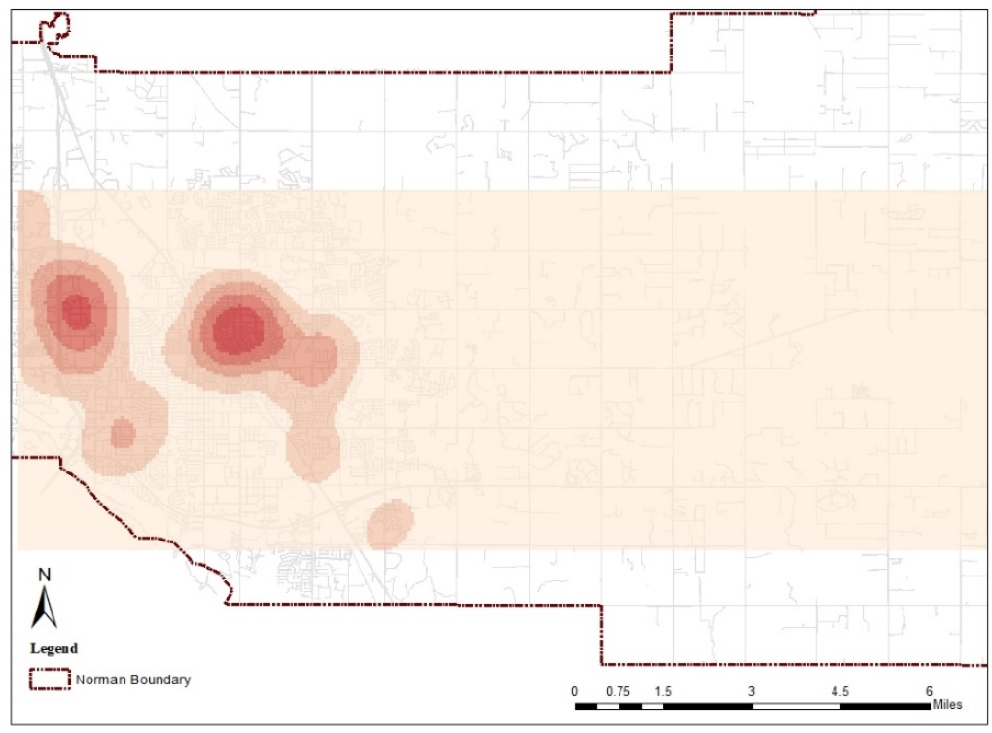
Figure 18: Kernel density map of pharmacies
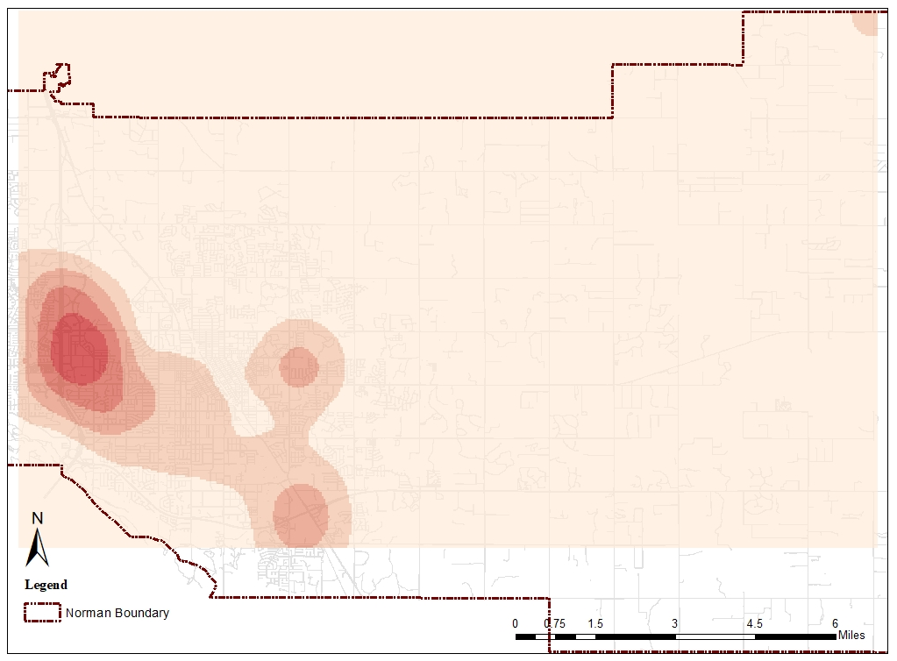
Figure 19: Kernel density map of grocery stores
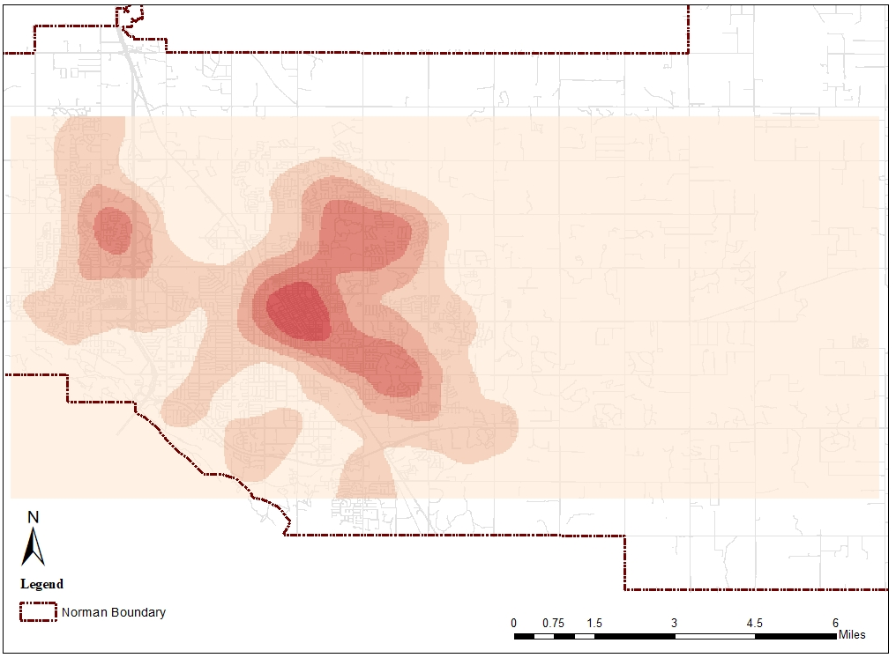
Figure 20: Kernel density map of parks
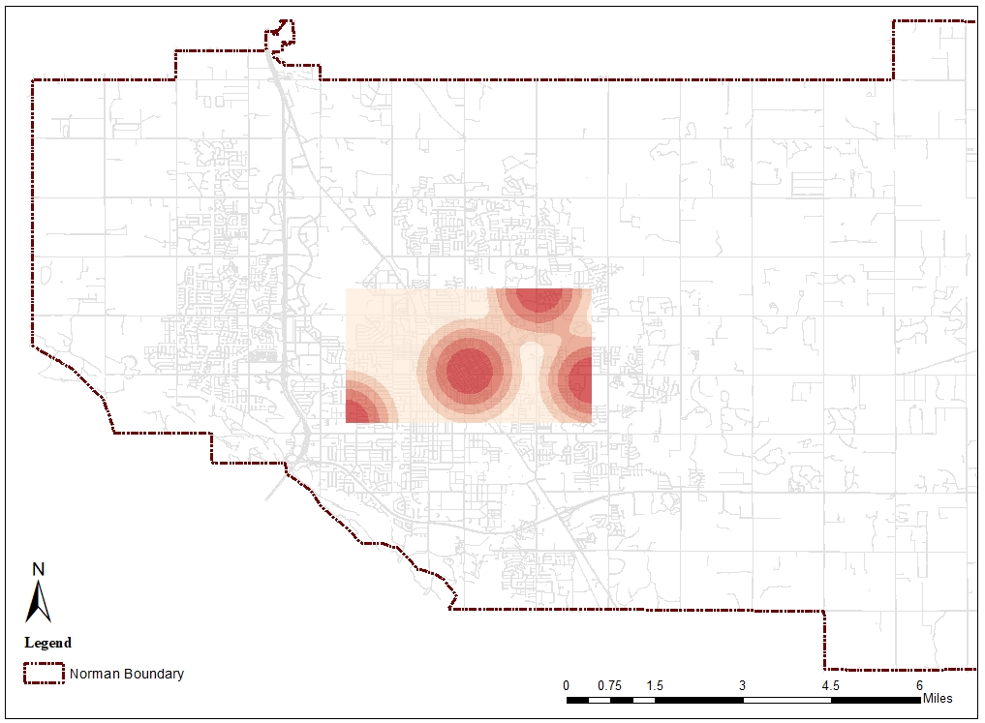
Figure 21: Kernel density map of recreation centers

Available Neighborhood Services Within Walking Distance
After counting the number of bus stops, Grocery stores, medical centers, pharmacies, parks, and recreation centers within the 0.25-mile and 0.5-mile radius around each intersection, mean, median, range, and standard deviation were calculated for these services. As the results show in Table 12 the number of recreation centers and grocery stores are the lowest in both buffer distances.
Total |  | Bus Stops | Grocery Stores | Medical Centers | Pharmacies | Parks | Recreation Centers
Within 0.25 M | Mean | 1.05 | .14 | .21 | .22 | .37 | .05
Within 0.25 M | Median | 0 | 0 | 0 | 0 | 0 | 0
Within 0.25 M | Range | 9 | 1 | 5 | 3 | 2 | 1
Within 0.25 M | SD | 1.581 | .343 | .620 | .516 | .551 | .227
Within 0.5 M | Mean | 4.03 | .34 | .81 | .75 | 1.63 | .17
Within 0.5 M | Median | 3 | 0 | 0 | 0 | 1 | 0
Within 0.5 M | Range | 16 | 3 | 6 | 6 | 5 | 1
Within 0.5 M | SD | 4.354 | .582 | 1.41 | 1.14 | 1.295 | .373
Table 12: Number of services within the 0.25- and 0.5-miles radius of studied intersections
Out of all the intersections, six were selected to visualize participants’ access to amenities (Figure 21). These intersections were chosen because they had the highest/lowest number of participants and/or services around them. As shown in the following maps, the Lindsey and Highway 9 intersection has no services in either threshold. On the other hand, individuals living close to 12th and Alameda Street; as well as near the intersection of 36th and Main Street have access to many services. However, many of these intersections have no sidewalks or the sidewalks are poorly connected around them which make it difficult for anybody to be able to access these services without relying on a car.
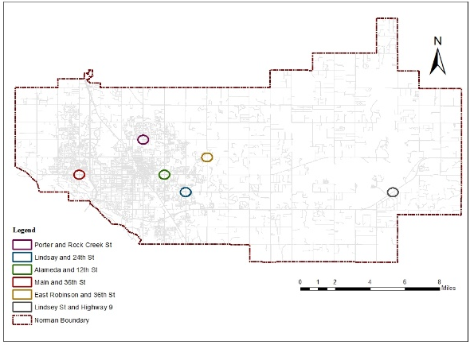
Figure 22: Location of selected intersections

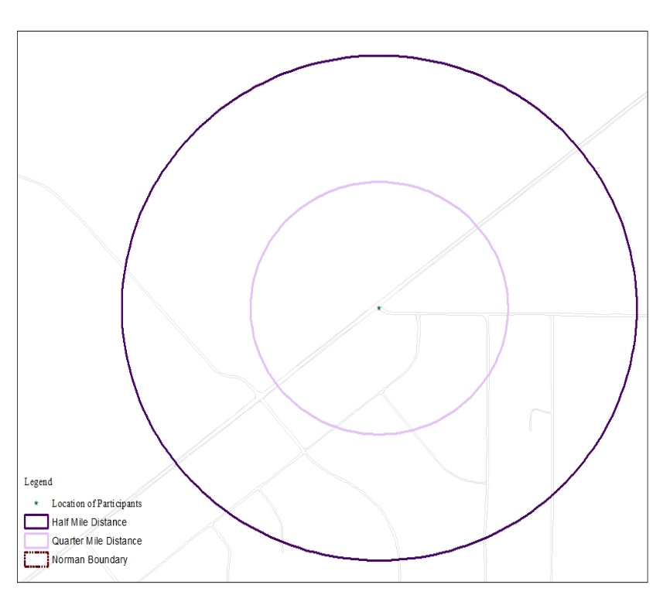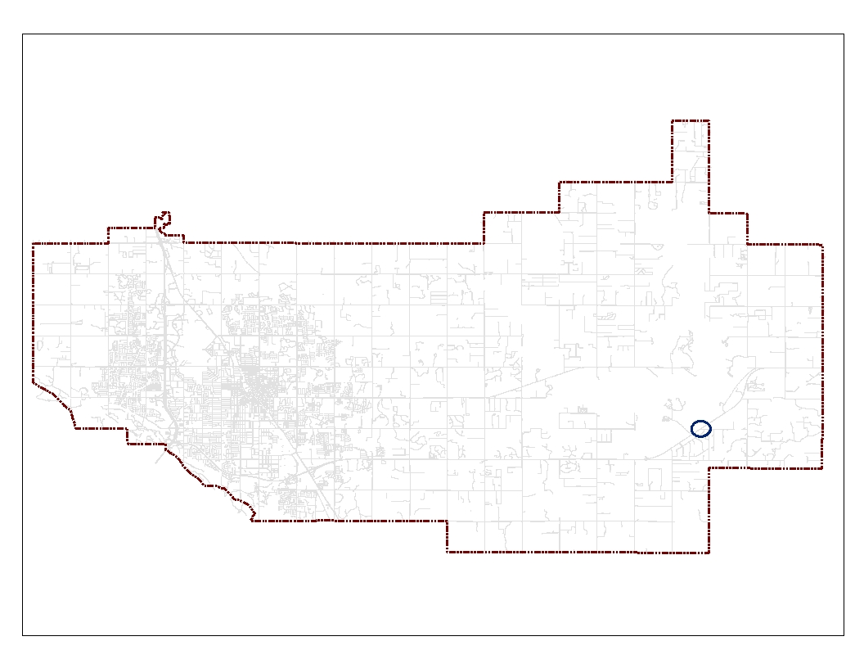
Figure 23: Lindsey Street and Highway9 intersection
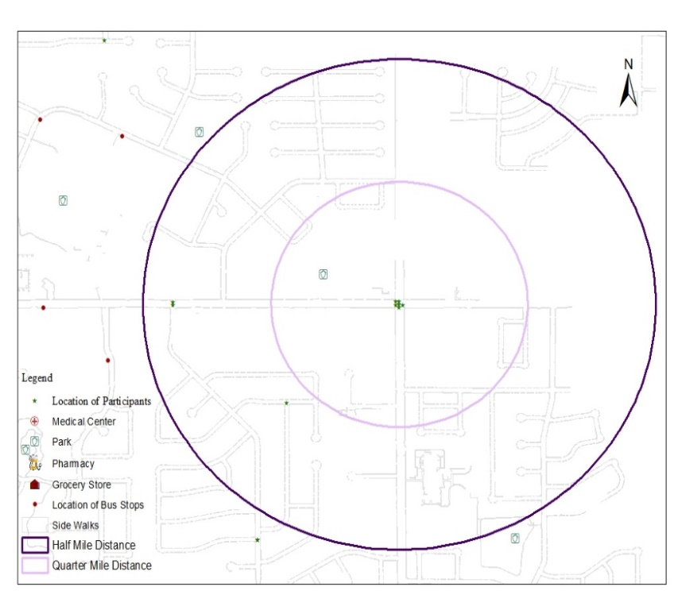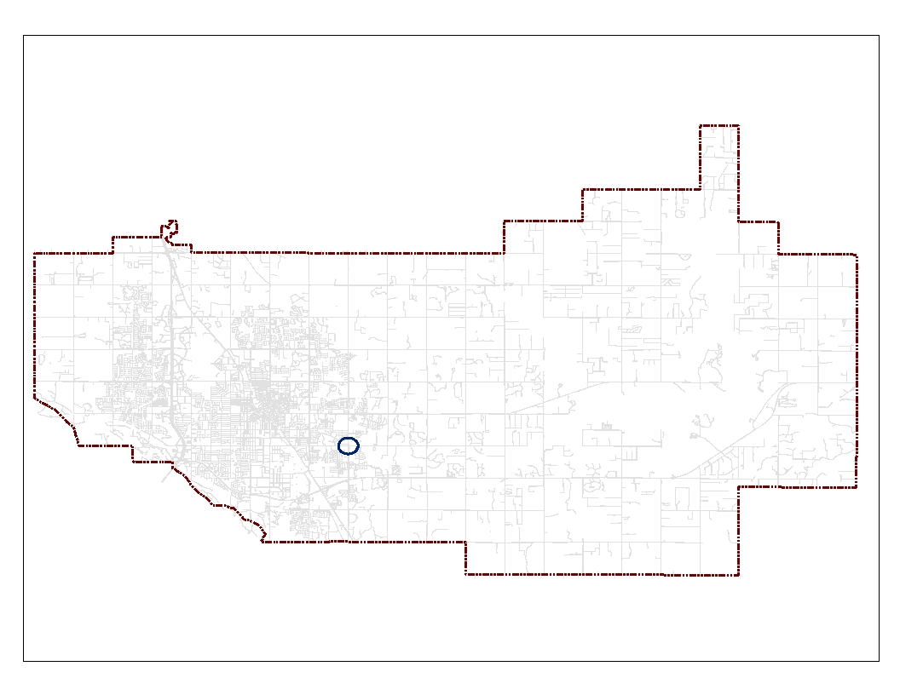
Figure 24: 24th and E Lindsay Street intersection

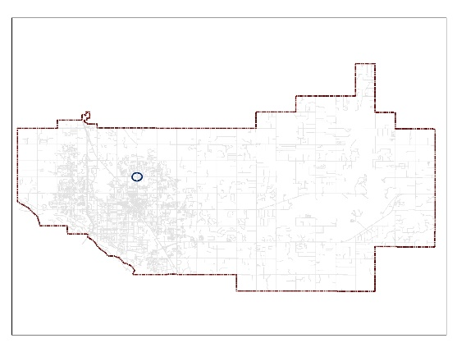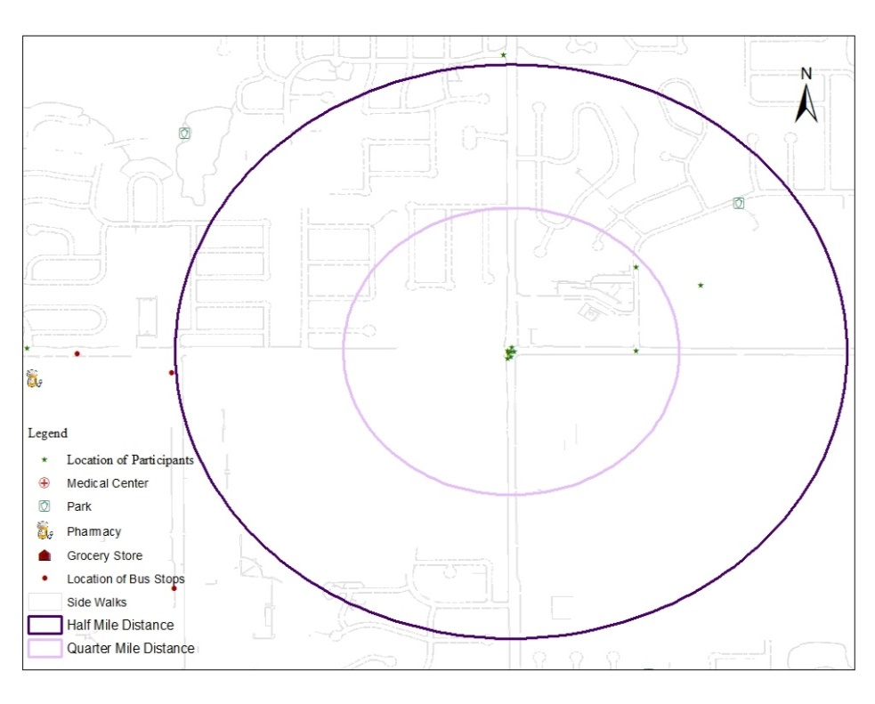
Figure 25: Porter Street and Rock Creek intersection
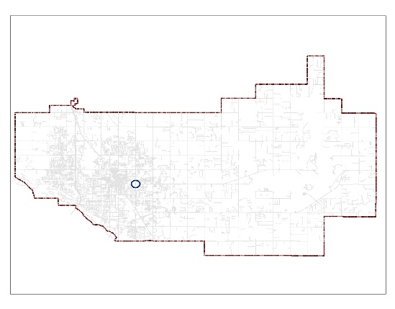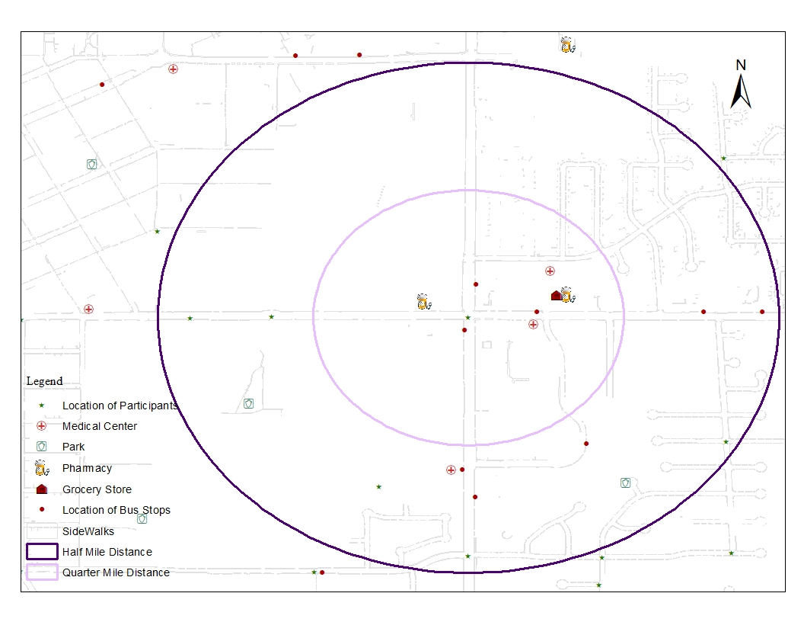
Figure 26: 12th Street and Alameda intersection

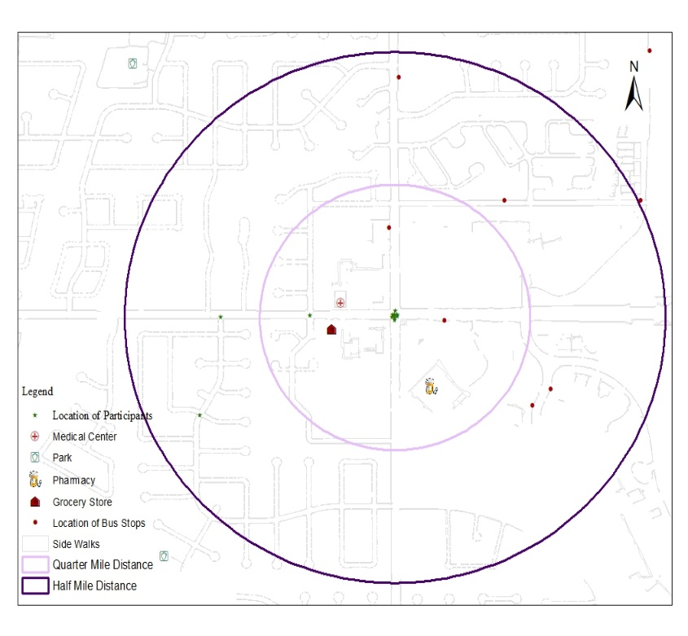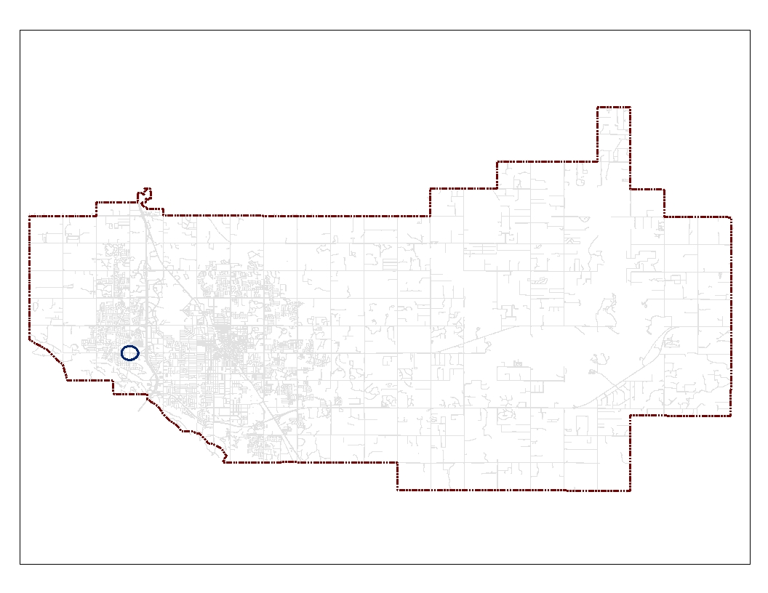
Figure 27: 36th Street and Main Street intersection
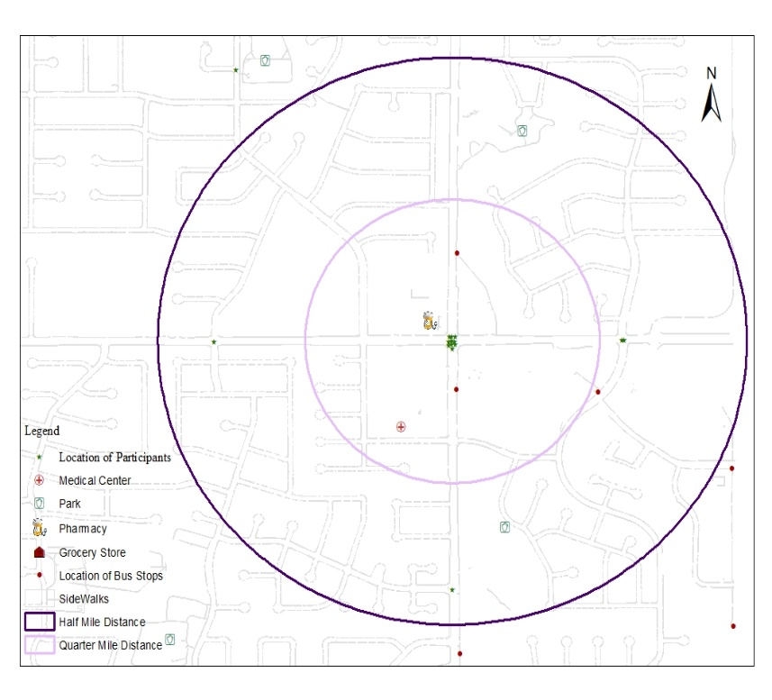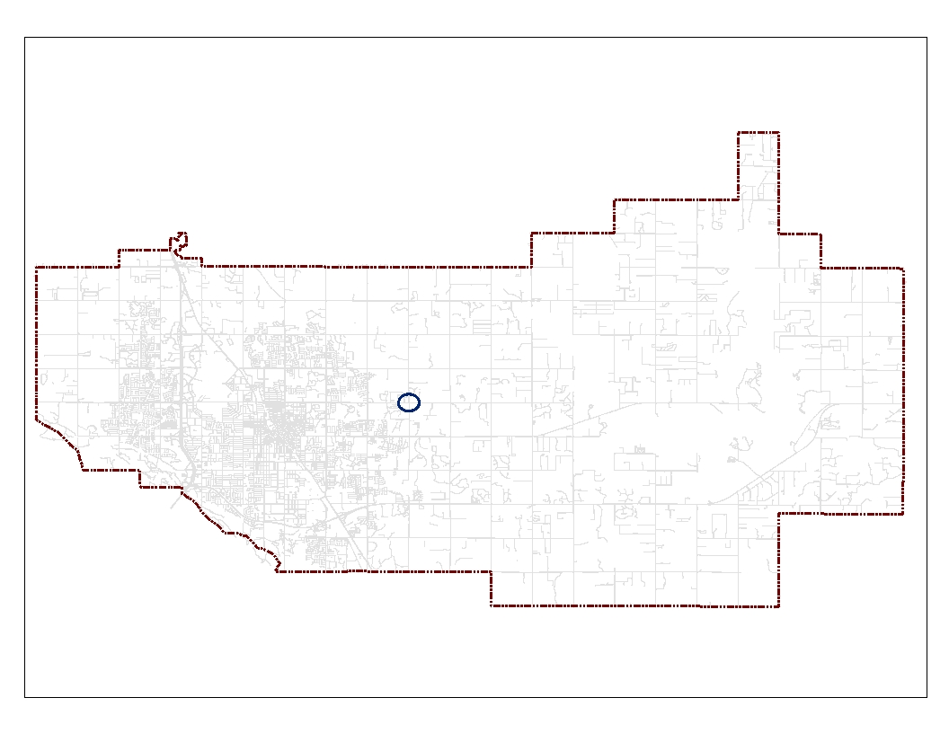
Figure 28: 36th St and East Robinson Street intersection

Summary of Results
To achieve the research objective, I answered the following questions through analyzing the survey data and spatial analysis:
- What are the neighborhood attribute preferences of middle aged and older adults and how do they differ between these groups?
Based on the findings, important neighborhood attributes for both the younger and older adults are the general appearance of buildings in the neighborhood, clean neighborhood, having access to parks and green spaces, access to special transportation options for the elderly and people with disability, conveniently located public parking lots including parking for people with disabilities, homes of friends and relatives within walking distance, access to affordable delivery system, having little crime in the neighborhood, reduced (15-25 mph) speed limits for cars, living in a neighborhood where people have respect for older people, and most people from the same race/ethnicity in the neighborhood. Both groups stated that they need more accessible built environment and sidewalks in their neighborhoods.
Although both groups prefer similar neighborhood attributes, the Mann-Whitney test results show that neighborhood attributes like the general appearance of buildings in the neighborhood, access to the workplace within 10-minute driving distance, safe crossings that have both audio and visual signals, living in a neighborhood with high social status, having the opportunity to participate in decision making bodies such as community councils or committees, no majority of immigrants in the neighborhood, most people from the same race/ethnicity in the neighborhood, and shared religious beliefs are more important to individuals aged 65 or older. However, the younger group value features like having access to doctors, pharmacy, and emergency care centers within walking distance. Conducting the MWU test for other variables indicated that variables like income and race impact the neighborhood attribute preferences of participants more than other variables. Results are presented in the following table.
Variables | Categories
Age | 50- 64 Years Old | 65 Years Old and Over
Age | - Access to doctor, pharmacy, and emergency care centers within walking distance | - The general appearance of buildings in the neighborhood  - Clean neighborhood  - Access to the workplace within 10-minute driving distance  - Safe crossings that have both audio and visual signals  - Living in a neighborhood with high social statues  - Having the opportunity to participate in decision making bodies such as community councils or committees  - No majority of immigrants in the neighborhood  - Most people from the same race/ethnicity in the neighborhood  - Shared religious beliefs
Disability | Someone with Disability in the Household | Nobody with Disability in the Household
Disability | - Enough benches for resting in public areas, along sidewalks, and around public buildings | - Having access to bicycle facilities
Income | Less than 60000 a Year | More than 60000 a Year
Income | - Enough benches for resting in public areas, along sidewalks, and around public buildings | - Public buildings and spaces that are accessible to people of different physical abilities  - Access to bus routes  - Access to public transportation  - Special transportation options for the elderly and people with disability  - Homes of friends and relatives within walking distance  - Doctor, pharmacy, and emergency care centers within walking distance  - Access to places where older people can go for advice and support (e.g. senior center)  - Access to social clubs such as book, gardening, craft or hobby within walking distance  - Affordable delivery system  - Safe public transportation stops or areas that are accessible to people of varying physical abilities  - Sidewalks that are in good condition and accessible for wheelchairs or other assistive mobility devices  - Safe crossings that have both audio and visual signals  - Having an emergency shelter within walking distance (For tornado, flood, …)
Race | White | Non-white
Race | - Access to bicycle facilities  - Close to major roads  - Recreation facilities within walking distance  - Having the opportunity to  participate in decision making bodies such as community councils or committees
Length of Living in the Neighborhood | Less than 15 Years | - Years and More
Length of Living in the Neighborhood | - A neighborhood where people have respect for older people  - A neighborhood where people are willing to help each other whenever necessary
Table 13: Differences between the neighborhood attribute preferences based on other independent variables
- What is the spatial distribution of amenities in these individuals’ neighborhoods and their access?
The spatial analysis indicated that currently individuals aged 50 and above do not have access to services like public transportation, food stores, medical centers, pharmacies, parks, and recreational centers within walking distance. These services and amenities are not distributed equally in the city either. The majority of them are located in a small area on the west side of the city and mainly catering to those living close to them.
- What are the mismatches between preferred and current neighborhood attributes of the targeted groups?
Although most of the study participants prefer to age in their own neighborhoods and have access to age friendly services, spatial analysis of amenities near participants’ residencies indicated that currently these individuals don’t have ideal access to services like public transportation, food stores, medical centers, pharmacies, parks, and recreational centers that support aging in place. Most of these amenities are located on the west side of the city in a small area. Also, the built environment form in Norman, like many other cities in the U.S. is very car oriented and physically disconnected from services. Therefore, these amenities are neither accessible for pedestrians due to the lack or poor condition of sidewalks, nor for those using public transportation with its limited coverage.

Chapter 5: Discussion, Limitations and Contributions

Discussion
Over the past two decades there has been more collaboration between designers, public health providers, and policy makers to make communities more age-friendly (Fitzgerald and Caro 2014; Greenfield et al. 2015). A variety of factors including global urbanization and the aging population across the globe and the impact of these changes on cities have sparked discussion around this subject. As the World Health Organization (2007) stated the world’s population is rapidly aging, and the proportion of individuals aged 60 and over will double from 11% in 2006 to 22% by 2050. At the same time, the number and proportion of urban dwellers is rising and 3 out of 5 people in the world will live in the cities by 2030. Faced with this dramatic change in the world’s population, the idea of aging in place and the age friendly community initiatives were proposed by the WHO to focus on making the older adults’ home and communities safe and tailored to their well-being and needs.
By aging in place, older individuals can remain in their homes and communities for as long as possible while maintaining their autonomy and connection to their social network like friends and family (Fitzgerald and Caro 2014; Wiles et al. 2012; World Health Organization 2007; Lawler 2001). Aging in place is also economically beneficial since individuals avoid the costly option of institutional care (Curioni et al. 2023; World Health Organization 2023b). Today, much of the older population in the US is dealing with health issues which makes aging in place more challenging for communities (Lakdawalla, Goldman, and Shang 2005; Association 2013; Mildred E. Warner, Xu, and Morken 2017).
To understand aging in place and challenges that older adults face to remain in their neighborhoods as they age, in this dissertation by conducting a survey I explored the neighborhood preferences of middle-aged groups and compare them with older adults in Norman, Oklahoma. Out of 285 individuals that participated in the survey, 143 individuals were aged 50-64 (50.2%), and 142 of them were 65 or older (49.8%). These individuals consisted of 229 (80.4%) women and 56 men (19.6%). Most respondents were white or Caucasian (90.9%). The survey also collected information about these individuals’ disabilities, and 132 (45.6%) of them declared themselves or someone in their home has disability. Furthermore, I collected information about participation’s location by asking about the nearest intersection to the participants homes in the survey.
After analyzing the survey results and finding the nearest intersections to the participants, I pinpointed these intersections on Google Earth. I gathered data regarding age-friendly neighborhood services through sources such as The City of Norman's website and Google search engine. These amenities were categorized into four groups: transportation (T), nutrition (N), medical care (MC), and recreation (R). These attributes were extracted from both Table 3 and the survey responses.
In the nutrition category, I found a list of existing grocery stores and their addresses. Under medical care, all medical centers and pharmacies were identified. For the recreation category, parks and recreation centers within the city’s boundary were located through Google search. Lastly for the transportation category, I compiled the lists of existing bus stops and routes through the City of Norman Transportation Website, Embark. Once the addresses of these facilities were discovered, I pinpointed their coordinates on Google Earth. Afterwards, the data from Google Earth was stored as a KML layer, which was then imported into ArcMap for analysis. Lastly, I downloaded data on sidewalks, and the city’s boundary from the GIS Services Division on the City of Norman’s website.
The survey results proved that 83.5% of participants (N=238) prefer to remain in their neighborhoods as they age. Based on the findings important neighborhood attributes for both the younger and older adults are the general appearance of buildings in the neighborhood, clean neighborhood, having access to parks and green spaces, access to special transportation options for the elderly and people with disability, conveniently located public parking lots including parking for people with disabilities, homes of friends and relatives within walking distance, access to affordable delivery system, having little crime in the neighborhood, reduced (15-25 mph) speed limits for cars, and living in a neighborhood where people have respect for older people.
Although both groups prefer similar neighborhood attributes, results indicate that the older group are more car oriented and they value access to amenities and services within driving distance. On the other hand, the younger group (aged 50-64) prefer having access to neighborhood services withing walking distance. Research studies have proven that walkable built environments and accessible sidewalks affect the level of physical activity in older adults and their well-being (Balfour and Kaplan 2002; Berke et al. 2007; McCormack, Giles-Corti, and Bulsara 2008; Van Dyck et al. 2012; Mildred E. Warner, Xu, and Morken 2017; Bozovic, Hinckson, and Smith 2020; Gan et al. 2021; Jardim and de Castro Neto 2022). Sidewalks also impact the participation of people with disabilities in their community (Ferleger 2012).
Based on the findings, there are more individuals with disability among the 50 to 64 age group than the older groups in Norman. In one of the survey questions participants were asked what they don’t like about their current neighborhood and the number one issue for many of them is the lack or low quality of sidewalks. It is not surprising that out of 285 participants in this study only 3 participants walk to travel to appointments, errands, events, or other locations. The current quality of sidewalks in Norman and the fact that even younger adults are dealing with disabilities highlight the importance of planning and designing well maintained and safe sidewalks in the current and future neighborhoods of the city.
Based on analysis of the survey findings and spatial analysis of services in Norman there are mismatches between what individuals aged 50 and above prefer to have in their neighborhoods and the current situation. Although most of the study participants prefer to age in their own neighborhoods and have access to age friendly services, spatial analysis of amenities near participants’ residencies indicated that currently these individuals don’t have ideal access to services like public transportation, food stores, medical centers, pharmacies, parks, and recreational centers that support aging in place. Most of these amenities are located on the west side of the city in a small area. Also, the built environment form in Norman, like many other cities in the US, is very car oriented and physically disconnected from services. Therefore, these amenities are neither accessible for pedestrians due to the lack or poor condition of sidewalks nor for those using public transportation with its limited coverage.
Successful aging in communities is not possible without access to reliable transportation, health services, recreational opportunities, physical and social support systems, and a wide variety of amenities (Alley et al. 2007; Wiles et al. 2012; Fitzgerald and Caro 2014). As individuals grow older, their physical or cognitive abilities may diminish, requiring them to seek extra assistance to maintain their independence. For those aging while coping with a disability, their capacity to perform everyday tasks and engage in community activities frequently relies on the availability of accessible infrastructure and social support systems (Alley et al. 2007).
The urban sprawl of Norman has led its built environment in many neighborhoods to be automobile dependent and physically disconnected from retail, health services, and social engagement opportunities for citizens as they age. In 2014, Ewing et al. found that compact planning design is negatively related to obesity, diabetes, and other chronic diseases at the county scale. However, as Warner, Xu, and Morken (2017) argue, achieving compact and walkable neighborhoods in many communities with low density “is not realistic or achievable”. Therefore, when the built environment does not fully support individuals to age in place, effective planning can improve service provisions to bridge this gap. This is especially critical in the realm of transportation, where public transit and paratransit services work in conjunction with street design to enhance walkability, and mobility for senior citizens (Lynott, Fox-Grage, and Guzman 2013; Mildred E. Warner, Xu, and Morken 2017).
In order to make Norman more age friendly, it is crucial to supplement the physical design with services and amenities, such as accessible transportation, health care services, recreation and grocery stores with healthy and affordable food options. However, extending these services requires significant funds from private and public sources. (M. E. Warner and Homsy 2015). As we move toward making changes in these neighborhoods and distributing the resource equitably, nontraditional forms of planning practices like participatory planning can reduce citizens resistance to change and their willingness to pay from their private income (Smith 1973; Mouter 2021).

Limitations
Limitations existed in the recruiting method. In order to recruit participants, the survey link and recruiting flyer were posted on Facebook groups. However, not all individuals aged 50 or older are active on social media or have access to the internet. Distributing the hard copy version of the survey in places like churches, libraries, doctors’ offices that these individuals are more likely to visit would have been beneficial.
Limitations also existed in the collected sample. Most participants in this study are white women. Research studies have proved that different groups like African Americans, Hispanics, Asians, and other minority groups live in communities and neighborhoods that are less age friendly compared to the white seniors. Future cross racial studies help to include these individuals’ needs and preferences in planning age friendly neighborhoods. Also, this dissertation conducted a quantitative research study and adding a qualitative component like interview or photovoice will help the researcher to best understand the research problem (Creswell and Clark 2017). Finally, this study focusses on Norman, Oklahoma which is a small college town. Its size and location make the results more relevant to similar towns and cities and results cannot be generalized to larger cities since each city has its own unique built environment features.

Contributions
Aging in a familiar and safe environment leads to various physical, emotional, and psychological benefits for older individuals. By providing age friendly neighborhoods, these people can stay in their community, participate in social activities, and be physically active as they age. This study is the first project conducted on age friendliness of Norman, Oklahoma that examines and compares the preferences of older and younger adults in this city. It is also one of the few studies in the planning field that combines quantitative analysis with spatial analysis to evaluate older adults’ preferences and access to age friendly built environment attributes.
My findings contribute to the growing body of literature on efficient planning for the aging population by identifying the gap between what individuals aged 50 and above prefer and their current access to the built environment attributes and services that support aging in place. By comparing the younger and older adults’ preferences and their demographic characteristics my findings indicate that the current middle-aged group are dealing more with disability and are less car oriented than the older generations. Although there are many projects and studies focused on the needs and preference of individuals age 65 or older as we look ahead the younger adults (age 50-64) are also important to think about since this group is planning for retirement and will become a major portion of the senior population in the near future. I believe my results will not only help younger and older citizens in their daily lives but will also guide planners and designers to recognize these individuals’ daily challenges, needs, and preferences to consider in the design process. Thereby, this project could be a connection between researchers, designers, city planners, policy makers, and users to achieve built environments that support aging in place.

Bibliography
AARP. 2022. “2021 Home and Community Preferences Survey: A National Survey of Adults Age 18-Plus.” AARP Research.
———. 2023. “An Introduction to the AARP Network of Age-Friendly States and Communities.” AARP. 2023. https://www.aarp.org/livable-communities/network-age-friendly-communities/info-2014/an-introduction.html.
Adelman, Robert M. 2005. “The Roles of Race, Class, and Residential Preferences in the Neighborhood Racial Composition of Middle-Class Blacks and Whites.” Social Science Quarterly 86 (1): 209–28.
Ahlfeldt, Gabriel M. 2008. “If Alonso Was Right: Residual Land Price, Accessibility and Urban Attraction.” Accessibility and Urban Attraction (November 2008).
Alonso, William. 1964. “Location and Land Use. Toward a General Theory of Land Rent.” Location and Land Use. Toward a General Theory of Land Rent.
Ancora, Leonardo A., Diego Andrés Blanco-Mora, Inês Alves, Ana Bonifácio, Paulo Morgado, and Bruno Miranda. 2022. “Cities and Neuroscience Research: A Systematic Literature Review.” Frontiers in Psychiatry 13. https://www.frontiersin.org/articles/10.3389/fpsyt.2022.983352.
Andersson, Eva K., Marianne Abramsson, and Bo Malmberg. 2019. “Patterns of Changing Residential Preferences during Late Adulthood.” Ageing & Society 39 (8): 1752–81. https://doi.org/10.1017/S0144686X18000259.
Ardeshiri, Ali, and Akshay Vij. 2019. “Lifestyles, Residential Location, and Transport Mode Use: A Hierarchical Latent Class Choice Model.” Transportation Research Part A: Policy and Practice 126 (August): 342–59. https://doi.org/10.1016/j.tra.2019.06.016.
Arias, Elizabeth, Jiaquan Xu, Betzaida Tejada-Vera, Sherry L. Murphy, and Brigham Bastian. 2022. “National Vital Statistics Reports Volume 71, Number 2 August 23, 2022” 71 (2).
Arribas-Bel, Daniel, and Fernando Sanz-Gracia. 2014. “The Validity of the Monocentric City Model in a Polycentric Age: US Metropolitan Areas in 1990, 2000 and 2010.” Urban Geography 35 (7): 980–97.
Baker, K., P. Baldwin, K. Donahue, A. Flynn, C. Herbert, E. La Jeunesse, and A. Will. 2014. “Housing America’s Older Adults-Meeting the Needs of an Aging Population.” Cambridge: Joint Center for Housing Studies of Harvard University.
Barnett, David W., Anthony Barnett, Andrea Nathan, Jelle Van Cauwenberg, Ester Cerin, and on behalf of the Council on Environment and Physical Activity (CEPA) – Older Adults working group. 2017. “Built Environmental Correlates of Older Adults’ Total Physical Activity and Walking: A Systematic Review and Meta-Analysis.” International Journal of Behavioral Nutrition and Physical Activity 14 (1): 103. https://doi.org/10.1186/s12966-017-0558-z.
Bayer, Ada-Helen, and Leon Harper. 2000. Fixing to Stay: A National Survey of Housing and Home Modification Issues. AARP.
Bayoh, Isaac, Elena G. Irwin, and Timothy Haab. 2006. “Determinants of Residential Location Choice: How Important Are Local Public Goods in Attracting Homeowners to Central City Locations?” Journal of Regional Science 46 (1): 97–120.
Berechman, J, and K A Small. 1988. “Research Policy and Review 25. Modeling Land Use and Transportation: An Interpretive Review for Growth Areas.” Environment and Planning A: Economy and Space 20 (10): 1285–1309. https://doi.org/10.1068/a201285.
Berry, Brian JL, and Hak-Min Kim. 1993. “Challenges to the Monocentric Model.” Geographical Analysis 25 (1): 1–4.
Bhat, Chandra, Susan Handy, Kara Kockelman, Hani Mahmassani, Qinglin Chen, Issam Srour, and Lisa Weston. 2001. “Assessment of Accessibility Measures.” Work 7: 4938–3.
Binette, Joanne, and Kerri Vasold. 2018. “2018 Home and Community Preferences: A National Survey of Adults Age 18-Plus.” AARP. 2018. https://doi.org/10.26419/res.00231.001.
Bobo, Lawrence, and Vincent L. Hutchings. 1996. “Perceptions of Racial Group Competition: Extending Blumer’s Theory of Group Position to a Multiracial Social Context.” American Sociological Review, 951–72.
Boland, Laura, France Légaré, Maria Margarita Becerra Perez, Matthew Menear, Mirjam Marjolein Garvelink, Daniel I. McIsaac, Geneviève Painchaud Guérard, Julie Emond, Nathalie Brière, and Dawn Stacey. 2017. “Impact of Home Care versus Alternative Locations of Care on Elder Health Outcomes: An Overview of Systematic Reviews.” BMC Geriatrics 17 (1): 20. https://doi.org/10.1186/s12877-016-0395-y.
Buffel, Tine, Chris Phillipson, and Thomas scharf. 2012. “Ageing in Urban Environments: Developing ‘Age-Friendly’ Cities.” Critical Social Policy 32 (4): 597–617. https://doi.org/10.1177/0261018311430457.
Cao, Xinyu. 2008. “Is Alternative Development Undersupplied? Examination of Residential Preferences and Choices of Northern California Movers.” Transportation Research Record 2077 (1): 97–105.
Cao, Xinyu, Patricia L. Mokhtarian, and Susan Handy. 2007. “Neighborhood Design and Aging: An Empirical Analysis in Northern California.” Upper Great Plains Transportation Institute, North Dakota State University.
Chappell, Neena L., Betty Havens Dlitt, Marcus J. Hollander, Jo Ann Miller, and Carol McWilliam. 2004. “Comparative Costs of Home Care and Residential Care.” The Gerontologist 44 (3): 389–400.
Child, Stephanie T., Danielle E. Schoffman, Andrew T. Kaczynski, Melinda Forthofer, Sara Wilcox, and Meghan Baruth. 2016. “Neighborhood Attributes Associated with the Social Environment.” American Journal of Health Promotion 30 (8): 634–37.
Clark, William AV. 1991. “Residential Preferences and Neighborhood Racial Segregation: A Test of the Schelling Segregation Model.” Demography 28 (1): 1–19.
Clarke, Philippa J., Jennifer A. Ailshire, Els R. Nieuwenhuijsen, and Marijke W. de Kleijn–de Vrankrijker. 2011. “Participation among Adults with Disability: The Role of the Urban Environment.” Social Science & Medicine 72 (10): 1674–84.
Clarke, Philippa, Erica Twardzik, Michelle A. Meade, Mark D. Peterson, and Denise Tate. 2019. “Social Participation Among Adults Aging With Long-Term Physical Disability: The Role of Socioenvironmental Factors.” Journal of Aging and Health 31 (10_suppl): 145S-168S. https://doi.org/10.1177/0898264318822238.
Creswell, John W., and Vicki L. Plano Clark. 2017. Designing and Conducting Mixed Methods Research. Sage publications.
Curioni, Cintia, Ana Carolina Silva, Jorginete Damião, Andrea Castro, Miguel Huang, Taianah Barroso, Daniel Araujo, and Renata Guerra. 2023. “The Cost-Effectiveness of Homecare Services for Adults and Older Adults: A Systematic Review.” International Journal of Environmental Research and Public Health 20 (4): 3373.
Cutchin, Malcolm P. 2004. “Using Deweyan Philosophy to Rename and Reframe Adaptation-to-Environment.” American Journal of Occupational Therapy 58 (3): 303–12.
Cutler, David M., Kaushik Ghosh, and Mary Beth Landrum. 2013. “Evidence for Significant Compression of Morbidity in the Elderly US Population.” In Discoveries in the Economics of Aging, 21–51. University of Chicago Press.
Davey, J. A., V. De Joux, G. Nana, and M. Arcus. 2004. “Accommodation Options for Older People in Aotearoa.” New Zealand.
De Meester, Femke, Delfien Van Dyck, Ilse De Bourdeaudhuij, and Greet Cardon. 2014. “Parental Perceived Neighborhood Attributes: Associations with Active Transport and Physical Activity among 10–12 Year Old Children and the Mediating Role of Independent Mobility.” BMC Public Health 14 (1): 631.
Demirkan, Halime. 2007. “Housing for the Aging Population.” European Review of Aging and Physical Activity 4 (1): 33–38. https://doi.org/10.1007/s11556-007-0016-z.
DeNavas-Walt, Carmen, Bernadette D Proctor, and Jessica C Smith. 2007. “Income, Poverty, and Health Insurance Coverage in the United States: 2012,” 88.
Dijk, Hanna M. Van, Jane M. Cramm, Job Van Exel, and Anna P. Nieboer. 2015. “The Ideal Neighbourhood for Ageing in Place as Perceived by Frail and Non-Frail Community-Dwelling Older People.” Ageing & Society 35 (8): 1771–95. https://doi.org/10.1017/S0144686X14000622.
Dobbs-Kepper, Debra, Rosemary Chapin, Pat Oslund, Roxanne Rachlin, and J. Stover. 2001. “Resident and Facility Factors Related to Residents’ Length of Stay in Assisted Living and Residential Health Care Facilities: A Longitudinal Analysis.” Lawrence, KS: University of Kansas School of Social Welfare.
Duncombe, William, Mark Robbins, and Douglas A. Wolf. 2003. “Place Characteristics and Residential Location Choice among the Retirement-Age Population.” The Journals of Gerontology Series B: Psychological Sciences and Social Sciences 58 (4): S244–52.
Durand, C. P., M. Andalib, G. F. Dunton, J. Wolch, and M. A. Pentz. 2011. “A Systematic Review of Built Environment Factors Related to Physical Activity and Obesity Risk: Implications for Smart Growth Urban Planning: Smart Growth Urban Planning and Obesity Risk.” Obesity Reviews 12 (5): e173–82. https://doi.org/10.1111/j.1467-789X.2010.00826.x.
Echeverria, Sandra E., Ana V. Diez-Roux, and Bruce G. Link. 2004. “Reliability of Self-Reported Neighborhood Characteristics.” Journal of Urban Health 81 (4): 682–701.
El-Geneidy, Ahmed, and David Levinson. 2022. “Making Accessibility Work in Practice.” Transport Reviews 42 (2): 129–33.
Erbas, Rem. 2006. “A THESIS SUBMITTED TO THE GRADUATE SCHOOL OF NATURAL AND APPLIED SCIENCES OF MIDDLE EAST TECHNICAL UNIVERSITY,” 160.
Ettema, Dick. 2010. “The Impact of Telecommuting on Residential Relocation and Residential Preferences: A Latent Class Modeling Approach.” Journal of Transport and Land Use 3 (1): 7–24.
Farber, Nicholas, Douglas Shinkle, Jana Lynott, Wendy Fox-Grage, and Rodney Harrell. 2011. “Aging in Place: A State Survey of Livability Policies and Practices.”
Farley, Reynolds, Charlotte Steeh, Maria Krysan, Tara Jackson, and Keith Reeves. 1994. “Stereotypes and Segregation: Neighborhoods in the Detroit Area.” American Journal of Sociology 100 (3): 750–80.
Ferleger, David. 2012. “Planning for Access: Sidewalks and the Americans with Disabilities Act.” Planning & Environmental Law 64 (8): 3–8. https://doi.org/10.1080/15480755.2012.710037.
Filion, Pierre, Trudi Bunting, and Keith Warriner. 1999. “The Entrenchment of Urban Dispersion: Residential Preferences and Location Patterns in the Dispersed City.” Urban Studies 36 (8): 1317–47.
Gelfand, Donald E. 2006. The Aging Network: Program and Services. Springer Publishing Company.
Gill, Jessica, and Margaret Jane Moore. 2013. “The State of Aging & Health in America 2013.”
Gilleard, Chris, Martin Hyde, and Paul Higgs. 2007. “The Impact of Age, Place, Aging in Place, and Attachment to Place on the Well-Being of the over 50s in England.” Research on Aging 29 (6): 590–605.
Greenfield, Emily A., Mia Oberlink, Andrew E. Scharlach, Margaret B. Neal, and Philip B. Stafford. 2015. “Age-Friendly Community Initiatives: Conceptual Issues and Key Questions.” The Gerontologist 55 (2): 191–98. https://doi.org/10.1093/geront/gnv005.
Griffith, Daniel A. 1981. “Modelling Urban Population Density in a Multi-Centered City.” Journal of Urban Economics 9 (3): 298–310.
Guo, Jessica, and Chandra Bhat. 2002. “Residential Location Choice Modeling: Accommodating Sociodemographic, School Quality and Accessibility Effects.” Austin: Department of Civil Engineering, Universidade Do Texas.
Harrell, Rodney, Jana Lynott, Shannon Guzman, and Cheryl Lampkin. 2014. “What Is Livable? Community Preferences of Older Adults.” American Association of Retired Persons (AARP) Public Policy Institute. https://www.giaging.org/documents/what-is-livable-report-AARP-ppi-liv-com.pdf.
Harvey, Jack. 1996. “The Pattern of Urban Land Use.” In Urban Land Economics, edited by Jack Harvey, 215–28. London: Macmillan Education UK. https://doi.org/10.1007/978-1-349-24441-6_14.
Haurin, Donald R., and David Brasington. 1996a. “School Quality and Real House Prices: Inter-and Intrametropolitan Effects.” Journal of Housing Economics 5 (4): 351–68.
Haurin, Donald R., and David M. Brasington. 1996b. “The Impact of School Quality on Real House Prices: Interjurisdictional Effects.” Journal of Housing Economics 5 (4): 351–68.
Herzog, A., and James S. House. 1991. “Productive Activities and Aging Well.” Generations: Journal of the American Society on Aging.
Howden, Lindsay M., and Julie A. Meyer. 2010. “Age and Sex Composition: 2010. 2010 Census Briefs, US Department of Commerce, Economics and Statistics Administration.” US Census Bureau.
Humpel, Nancy, Neville Owen, Don Iverson, Eva Leslie, and Adrian Bauman. 2004. “Perceived Environment Attributes, Residential Location, and Walking for Particular Purposes.” American Journal of Preventive Medicine 26 (2): 119–25.
Hur, Misun, and Hazel Morrow-Jones. 2008. “Factors That Influence Residents’ Satisfaction With Neighborhoods.” Environment and Behavior 40 (5): 619–35. https://doi.org/10.1177/0013916507307483.
Huu Phe, Hoang, and Patrick Wakely. 2000. “Status, Quality and the Other Trade-off: Towards a New Theory of Urban Residential Location.” Urban Studies 37 (1): 7–35. https://doi.org/10.1080/0042098002276.
Iacono, Michael, David Levinson, and Ahmed El-Geneidy. 2008. “Models of Transportation and Land Use Change: A Guide to the Territory.” Journal of Planning Literature 22 (4): 323–40. https://doi.org/10.1177/0885412207314010.
Ibraimovic, Tatjana, and Stephane Hess. 2018. “A Latent Class Model of Residential Choice Behaviour and Ethnic Segregation Preferences.” Housing Studies 33 (4): 544–64.
Iecovich, Esther. 2014. “Aging in Place: From Theory to Practice.” Anthropological Notebooks 20 (1): 21–33.
Jamal, Shaila, K. Bruce Newbold, and Darren M. Scott. 2022. “A Comparison of Young and Older Adults’ Attitudes and Preferences towards Different Travel Modes and Residential Characteristics: A Study in Hamilton, Ontario.” Canadian Geographies / Géographies Canadiennes 66 (1): 76–93. https://doi.org/10.1111/cag.12744.
Jin, Jangik, and Hee-Yeon Lee. 2018. “Understanding Residential Location Choices: An Application of the UrbanSim Residential Location Model on Suwon, Korea.” International Journal of Urban Sciences 22 (2): 216–35.
Judd, Bruce, Diana Olsberg, Joanne Quinn, Lucy Groenhart, and Oya Demirbilek. 2010. “Dwelling, Land and Neighbourhood Use by Older Home Owners.” Final Report. Melbourne: Australian Housing and Urban Research Institute.
Jun, Myung-jin, and James E. Moore. 2002. “The Lowry Model Revisited: Incorporating a Multizonal Input-Output Model into an Urban Land Use Allocation Model.” Review of Urban & Regional Development Studies 14 (1): 2–17. https://doi.org/10.1111/1467-940X.00045.
Kaye, H. Stephen, Mitchell P. LaPlante, and Charlene Harrington. 2009. “Do Noninstitutional Long-Term Care Services Reduce Medicaid Spending?” Health Affairs 28 (1): 262–72.
Kim, Jae Hong, Francesca Pagliara, and John Preston. 2005. “The Intention to Move and Residential Location Choice Behaviour.” Urban Studies 42 (9): 1621–36.
Kim, Moon Jeong, and Hazel Morrow-Jones. 2005. “Current Determinants of Residential Location Choices: An Empirical Study in the Greater Columbus Metropolitan Region.” Book-part. December 6, 2005. https://doi.org/10.1108/9780080460550-008.
Kim, Sungyop. 2004. “NEIGHBORHOOD RESIDENTIAL LOCATION CHOICE OF THE ELDERLY: A STUDY OF THE ELDERLY IN THE PUGET SOUND REGION OF WASHINGTON,” 160.
König, Katharina, Martina Raue, Lisa A. D’Ambrosio, and Joseph F. Coughlin. 2019. “Physical and Emotional Support of the Neighborhood for Older Adults: A Comparison of the United States and Germany.” Journal of Environmental Psychology 62: 84–94.
Krizek, Kevin J., and Paul Waddell. 2002. “Analysis of Lifestyle Choices: Neighborhood Type, Travel Patterns, and Activity Participation.” Transportation Research Record 1807 (1): 119–28.
Krysan, Maria, and Reynolds Farley. 2002. “The Residential Preferences of Blacks: Do They Explain Persistent Segregation?” Social Forces 80 (3): 937–80.
Lai, Fu-Chuan, and Jyh-Fa Tsai. 2008. “Simplified Alonso–Mills–Muth Model with a Monopoly Vendor.” Journal of Urban Economics 63 (2): 536–43.
Lawton, M. P. 1977. “The Impact of the Environment on Aging and Behavior. Edited by: Birren JE, Schaie WK.” New York: Van Nostrand Reinhold.
Lawton, M. Powell. 1985. “The Elderly in Context: Perspectives from Environmental Psychology and Gerontology.” Environment and Behavior 17 (4): 501–19.
Lawton, M. Powell, and Lucille Nahemow. 1973. “Ecology and the Aging Process.” https://psycnet.apa.org/record/2004-15428-020.
Lee, C. Aujean. 2019. “‘Working towards a Better Future for Ourselves’: Neighborhood Choice of Middle-Class Latino and Asian Homeowners in Los Angeles.” Journal of Urban Affairs, 1–19.
Levine, Jonathan. 1998. “Rethinking Accessibility and Jobs-Housing Balance.” Journal of the American Planning Association 64 (2): 133–49.
Lindberg, Erik, Terry Hartig, Jörgen Garvill, and Tommy Garling. 1992. “Residential-Location Preferences across the Life Span.” Journal of Environmental Psychology 12 (2): 187–98. https://doi.org/10.1016/S0272-4944(05)80070-2.
Lowry, I. S. 1964. “A Model Of Metropolis, Rand Corporation, Santa Monica, California.” 1979), Urban Residential Location Models, Studies in Applied Regional Science 13.
Lu, Max. 1998. “Analyzing Migration Decisionmaking: Relationships between Residential Satisfaction, Mobility Intentions, and Moving Behavior.” Environment and Planning A 30 (8): 1473–95.
Luckey, Kara S., Wesley E. Marshall, Catherine Durso, and Carol Atkinson-Palombo. 2018. “Residential Preferences, Transit Accessibility and Social Equity: Insights from the Denver Region.” Journal of Urbanism: International Research on Placemaking and Urban Sustainability 11 (2): 149–74.
Masnick, George S. 2002. “The New Demographics of Housing.” Housing Policy Debate 13 (2): 275–321. https://doi.org/10.1080/10511482.2002.9521444.
McFadden, Daniel. 1973. “Modelling the Choice of Residential Location.” Cowles Foundation Discussion Paper 477. Cowles Foundation for Research in Economics, Yale University. https://econpapers.repec.org/paper/cwlcwldpp/477.htm.
McFadden, Daniel L. 1984. “Chapter 24 Econometric Analysis of Qualitative Response Models.” In Handbook of Econometrics, 2:1395–1457. Elsevier. https://doi.org/10.1016/S1573-4412(84)02016-X.
Meeks, Suzanne. 2022. “Age-Friendly Communities: Introduction to the Special Issue.” The Gerontologist 62 (1): 1–5. https://doi.org/10.1093/geront/gnab163.
Michelson, William M. 1977. “Environmental Choice, Human Behavior, and Residential Satisfaction.” (No Title).
Miller, Glenn R., and Allison Annesley. 2011. Re-Positioning Age Friendly Communities: Opportunities to Take AFC Mainstream. Canadian Urban Institute.
Mills, Edwin S. 1972. “Studies in the Structure of the Urban Economy.”
Morrow-Jones, Hazel A., and Moon Jeong Kim. 2009. “Determinants of Residential Location Decisions among the Pre-Elderly in Central Ohio.” Journal of Transport and Land Use 2 (1). https://doi.org/10.5198/jtlu.v2i1.84.
Morrow-Jones, Hazel A., and Mary V. Wenning. 2005. “The Housing Ladder, the Housing Life-Cycle and the Housing Life-Course: Upward and Downward Movement among Repeat Home-Buyers in a US Metropolitan Housing Market.” Urban Studies 42 (10): 1739–54. https://doi.org/10.1080/00420980500231647.
Mouter, Niek. 2021. “Chapter Four - Willingness to Allocate Public Budget and Participatory Value Evaluation.” In Advances in Transport Policy and Planning, edited by Niek Mouter, 7:83–102. New Methods, Reflections and Application Domains in Transport Appraisal. Academic Press. https://doi.org/10.1016/bs.atpp.2021.01.001.
Muth, Richard F. 1969. “CITIES AND HOUSING; THE SPATIAL PATTERN OF URBAN RESIDENTIAL LAND USE.”
Myung-Jin, Jun. 2004. “A Metropolitan Input-Output Model: Multisectoral and Multispatial Relations of Production, Income Formation, and Consumption.” The Annals of Regional Science; Heidelberg 38 (1): 131. http://dx.doi.org.ezproxy.lib.ou.edu/10.1007/s00168-003-0138-9.
Novianto, Didit, Weijun Gao, Soichiro Kuroki, and Hidetoshi Fukahori. 2016. “Statistical Evaluation on Neighborhood Facilities in Relation with Residential Satisfaction and Preference.” American Journal of Environmental Sciences 12 (3): 169–81.
Pynoos, Jon, Christy Nishita, Caroline Cicero, and Rachel Caraviello. 2008. “Aging in Place, Housing, and the Law.” Elder LJ 16: 77.
Rantz, Marilyn J., Karen Dorman Marek, Myra A. Aud, Rebecca A. Johnson, Donna Otto, and Rose Porter. 2005. “TigerPlace: A New Future for Older Adults.” Journal of Nursing Care Quality 20 (1): 1–4.
Rossi, Peter H., and Anne B. Shlay. 1982. “Residential Mobility and Public Policy Issues: ‘Why Families Move’ Revisited.” Journal of Social Issues 38 (3): 21–34. https://doi.org/10.1111/j.1540-4560.1982.tb01768.x.
Rowles, Graham D. 1983. “Place and Personal Identity in Old Age: Observations from Appalachia.” Journal of Environmental Psychology 3 (4): 299–313.
Rudzitis, G. 1982. Residential Location Determinants of the Older Population (Department of Geography Research Paper No. 202). Chicago: University of Chicago Press.
Russell, Elizabeth, Mark W. Skinner, and Ken Fowler. 2022. “Emergent Challenges and Opportunities to Sustaining Age-Friendly Initiatives: Qualitative Findings from a Canadian Age-Friendly Funding Program.” Journal of Aging & Social Policy 34 (2): 198–217. https://doi.org/10.1080/08959420.2019.1636595.
Scharf, Thomas, Chris Phillipson, Allison E. Smith, and Paul Kingston. 2002. “Growing Older in Socially Deprived Areas: Social Exclusion in Later Life.”
Schirmer, Patrick M., Michael AB Van Eggermond, and Kay W. Axhausen. 2014a. “The Role of Location in Residential Location Choice Models: A Review of Literature.” Journal of Transport and Land Use 7 (2): 3–21.
Schirmer, Patrick M., Michael A.B. Van Eggermond, and Kay W. Axhausen. 2014b. “The Role of Location in Residential Location Choice Models: A Review of Literature.” Journal of Transport and Land Use 7 (2): 3. https://doi.org/10.5198/jtlu.v7i2.740.
Smith, Richard Warren. 1973. “A Theoretical Basis for Participatory Planning.” Policy Sciences 4 (3): 275–95. https://doi.org/10.1007/BF01435125.
Sommers, David G., and Katherine R. Rowell. 1992. “Factors Differentiating Elderly Residential Movers and Nonmovers.” Population Research and Policy Review 11 (3): 249–62.
Song, Siqi, Winston Yap, Yuting Hou, and Belinda Yuen. 2020. “Neighbourhood Built Environment, Physical Activity, and Physical Health among Older Adults in Singapore: A Simultaneous Equations Approach.” Journal of Transport & Health 18: 100881.
Staveley, J. J. 1998. “The Transition to Nursing Home Living: Relocation and Adaptation Conceptualized in a Person-Environment Congruence Model.”
Takahashi, Takaaki. 2014. “Location Competition in an Alonso–Mills–Muth City.” Regional Science and Urban Economics 48: 82–93.
Talarchek, Gary M. 1982. “Sequential Aspects of Residential Search and Selection.” Urban Geography 3 (1): 34–57.
Tokunaga, Ryoji, and Masako Murota. 2023. “Residential Preferences Based on Life Stage Groups of Residents and Factors Related to Types of Intentions to Continue Living in or Relocating from Super-High-Rise Condominiums.” Journal of Asian Architecture and Building Engineering 22 (2): 765–82. https://doi.org/10.1080/13467581.2022.2052299.
Troped, Philip J., Jeffrey S. Wilson, Charles E. Matthews, Ellen K. Cromley, and Steven J. Melly. 2010. “The Built Environment and Location-Based Physical Activity.” American Journal of Preventive Medicine 38 (4): 429–38.
US Census Bureau. 2001. “Census 2000 Brief: The 65 Years and Over Population: 2000.” Census.Gov. 2001. https://www.census.gov/library/publications/2001/dec/c2kbr01-10.html.
———. 2020. “65 and Older Population Grows Rapidly as Baby Boomers Age.” Census.Gov. 2020. https://www.census.gov/newsroom/press-releases/2020/65-older-population-grows.html.
Van Cauwenberg, Jelle, Andrea Nathan, Anthony Barnett, David W. Barnett, Ester Cerin, and the Council on Environment and Physical Activity (CEPA)-Older Adults Working Group. 2018. “Relationships Between Neighbourhood Physical Environmental Attributes and Older Adults’ Leisure-Time Physical Activity: A Systematic Review and Meta-Analysis.” Sports Medicine 48 (7): 1635–60. https://doi.org/10.1007/s40279-018-0917-1.
Van Dyck, Delfien, Ester Cerin, Terry L. Conway, Ilse De Bourdeaudhuij, Neville Owen, Jacqueline Kerr, Greet Cardon, Lawrence D. Frank, Brian E. Saelens, and James F. Sallis. 2012. “Associations between Perceived Neighborhood Environmental Attributes and Adults’ Sedentary Behavior: Findings from the USA, Australia and Belgium.” Social Science & Medicine 74 (9): 1375–84.
Verma, Ira. 2014. “Planning for Aging Neighborhoods Case Lauttasaari.” In Proceedings of the Annual Architectural Research Symposium in Finland, 148–54.
Vespa, Jonathan, Lauren Medina, and David M Armstrong. 2020. “Population Estimates and Projections.” U.S. Census Bureau.
Waddell, Paul A. 1997. Household Choice and Urban Structure: A Re-Assessment of the Behavioural Foundations of Urban Models of Housing, Labor and Transportation Markets. Routledge.
Walker, Joan L., and Jieping Li. 2007. “Latent Lifestyle Preferences and Household Location Decisions.” Journal of Geographical Systems 9 (1): 77–101.
Weisbrod, Glen, Steven R. Lerman, and Moshe Ben-Akiva. 1980. “Tradeoffs in Residential Location Decisions: Transportation versus Other Factors.” Transport Policy and Decision Making 1 (1): 13–26.
Wenning, Mary Vella. 1995. “Rethinking the Link: Residential Mobility, Housing and the Life Cycle.” The Ohio State University. https://etd.ohiolink.edu/!etd.send_file?accession=osu1261581047&disposition=inline.
West, Loraine A., Samantha Cole, Daniel Goodkind, and Wan He. 2014. “65+ in the United States: 2010.” US Census Bureau, 23–212.
Wiseman, Robert F. 1980. “Why Older People Move: Theoretical Issues.” Research on Aging 2 (2): 141–54.
World Health Organization. 2002. “Active Ageing: A Policy Framework.” 2002. https://scholar.google.com/scholar_lookup?title=Active+Aging:+A+Policy+Framework&publication_year=2002&.
———. 2007. Global Age-Friendly Cities: A Guide. World Health Organization.
———. 2023a. “National Programmes for Age-Friendly Cities and Communities: A Guide.” https://apps.who.int/iris/bitstream/handle/10665/366634/9789240068698-eng.pdf?sequence=1.
———. 2023b. “World Health Statistics 2023: Monitoring Health for the SDGs, Sustainable Development Goals.” 2023. https://www.who.int/publications-detail-redirect/9789240074323.
———. 2007b. “Checklist of Essential Features of Age-Friendly Cities.” Geneva. https://www.fpnetwork.org/resources/checklist-essential-features-age-friendly-cities.
Wu, Wenjie, Wenzhong Zhang, and Guanpeng Dong. 2013. “Determinant of Residential Location Choice in a Transitional Housing Market: Evidence Based on Micro Survey from Beijing.” Habitat International 39: 16–24.
Yan, Xiang. 2020. “Evaluating Household Residential Preferences for Walkability and Accessibility across Three US Regions.” Transportation Research Part D: Transport and Environment 80: 102255.
Yi, Changhyo, and Seungil Lee. 2014. “An Empirical Analysis of the Characteristics of Residential Location Choice in the Rapidly Changing Korean Housing Market.” Cities 39: 156–63.

Appendix A. Tables
Items | Scale Mean if Item Deleted | Scale Variance if Item Deleted | Corrected Item-Total Correlation | Cronbach's Alpha if Item Deleted
Well maintained streets | 133.22 | 218.649 | .190 | .903
Low density | 133.81 | 219.483 | .088 | .905
Enough benches for resting in public areas, along sidewalks, and around public buildings | 133.62 | 211.857 | .445 | .900
The general appearance of buildings in the neighborhood and clean neighborhood | 133.17 | 218.391 | .194 | .903
Parks and green spaces | 133.14 | 216.415 | .315 | .902
Public buildings and spaces that are accessible to people of different physical abilities | 133.39 | 211.434 | .486 | .900
Bus routes | 134.14 | 204.694 | .598 | .898
Bicycle facilities | 134.28 | 211.618 | .369 | .901
Public transportation | 133.91 | 204.167 | .627 | .898
Close to major roads | 133.93 | 213.047 | .397 | .901
Special transportation options for the elderly and people with disability | 133.55 | 206.771 | .614 | .898
Conveniently located public parking lots including parking for people with disabilities | 133.59 | 207.139 | .577 | .898
Homes of friends and relatives within walking distance. | 133.40 | 218.270 | .117 | .905
Recreation facilities within walking distance. | 134.04 | 209.364 | .511 | .899
Grocery stores within walking distance. | 133.81 | 210.045 | .501 | .900
Cultural offerings and activities within walking distance. | 133.81 | 207.724 | .557 | .899
Religious centers. | 133.98 | 208.141 | .555 | .899
Access to downtown/city center within 20-minute driving distance. | 134.35 | 209.974 | .382 | .901
Access to the workplace within 10-minute driving distance. | 133.58 | 212.222 | .399 | .901
Doctor, pharmacy, and emergency care centers within walking distance. | 134.33 | 212.476 | .289 | .903
Access to places where older people can go for advice and support (e.g. senior center). | 134.13 | 209.057 | .506 | .899
Access to social clubs such as book, gardening, craft or hobby within walking distance. | 133.79 | 206.571 | .578 | .898
Affordable delivery system. | 134.08 | 206.386 | .598 | .898
Low noise level and Calm. | 133.55 | 208.547 | .536 | .899
Clean air. | 133.16 | 218.033 | .193 | .903
Little crime. | 132.90 | 219.277 | .231 | .903
Reduced (15-25 mph) speed limits for cars. | 132.84 | 221.035 | .098 | .903
Low traffic intensity. | 133.36 | 215.171 | .321 | .902
Safe public transportation stops or areas that are accessible to people of varying physical abilities. | 133.33 | 216.991 | .260 | .902
Sidewalks that are in good condition and accessible for wheelchairs or other assistive mobility devices. | 133.57 | 205.351 | .658 | .897
Safe crossings that have both audio and visual signals. | 133.10 | 212.879 | .486 | .900
Separate pathways for bicyclists and pedestrians. | 133.46 | 207.719 | .611 | .898
Having an emergency shelter within walking distance (For tornado, flood, …). | 133.52 | 208.982 | .521 | .899
Low noise level and Calm. | 133.67 | 207.252 | .525 | .899
High Social status. | 134.68 | 218.553 | .130 | .904
Having the opportunity to participate in decision making bodies such as community councils or committees. | 133.82 | 216.023 | .240 | .903
Nice neighbors. | 133.15 | 217.873 | .216 | .903
Racial/Ethnic diversity of the neighborhood. | 133.73 | 212.363 | .358 | .902
No majority of immigrants in the neighborhood. | 135.01 | 218.813 | .092 | .905
Majority of people from the same race/ethnicity as you in the neighborhood. | 135.10 | 220.349 | .039 | .906
A neighborhood where people know each other. | 133.55 | 214.666 | .341 | .902
A feeling of belonging to the neighborhood. | 133.51 | 212.139 | .447 | .900
A neighborhood where people have respect for older people. | 133.17 | 211.662 | .520 | .900
A neighborhood where people are willing to help each other whenever necessary. | 133.22 | 212.991 | .477 | .900
Shared religious beliefs. | 135.27 | 216.639 | .238 | .903
Table 14: Cronbach’s Alpha Reliability test

Location | Distance (Miles) | T | N | M |  | R
Location | Distance (Miles) | Bus Stops | Grocery Stores | Medical Centers | Pharmacies | Parks | Recreation Centers
12th Ave/Alameda | 0.25 M | 3 | 1 | 2 | 2 | 0 | 0
12th Ave/Alameda | 0.5 M | 8 | 1 | 3 | 2 | 2 | 0
12th Ave/Cedar Lane | 0.25 M | 0 | 1 | 0 | 0 | 0 | 0
12th Ave/Cedar Lane | 0.5 M | 0 | 1 | 0 | 0 | 2 | 0
12th Ave/Golden Eagle | 0.25 M | 0 | 1 | 0 | 0 | 1 | 0
12th Ave/Golden Eagle | 0.5 M | 0 | 1 | 0 | 0 | 2 | 0
12th Ave/Lindsey | 0.25 M | 2 | 0 | 0 | 1 | 1 | 0
12th Ave/Lindsey | 0.5 M | 9 | 0 | 0 | 1 | 3 | 0
12th Ave NE/Robinson | 0.25 M | 0 | 0 | 0 | 0 | 0 | 0
12th Ave NE/Robinson | 0.5 M | 0 | 1 | 0 | 1 | 4 | 1
12th Ave SE/Cedar Lane | 0.25 M | 0 | 1 | 0 | 0 | 0 | 0
12th Ave SE/Cedar Lane | 0.5 M | 0 | 1 | 0 | 0 | 2 | 0
12th SE St/East Boyd | 0.25 M | 3 | 0 | 1 | 0 | 0 | 0
12th SE St/East Boyd | 0.5 M | 11 | 0 | 2 | 0 | 3 | 0
12th SE St/Cobblestone | 0.25 M | 0 | 0 | 0 | 0 | 0 | 0
12th SE St/Cobblestone | 0.5 M | 0 | 0 | 0 | 0 | 1 | 0
24th Ace NE/Robinson | 0.25 M | 0 | 0 | 0 | 0 | 0 | 0
24th Ace NE/Robinson | 0.5 M | 0 | 0 | 0 | 0 | 0 | 0
24th st/E Lindsay | 0.25 M | 0 | 0 | 0 | 0 | 1 | 0
24th st/E Lindsay | 0.5 M | 0 | 0 | 0 | 0 | 1 | 0
24th W/Terrace | 0.25 M | 2 | 0 | 0 | 0 | 0 | 0
24th W/Terrace | 0.5 M | 6 | 2 | 0 | 1 | 1 | 0
36th St/East Robinson | 0.25 M | 0 | 0 | 0 | 0 | 0 | 0
36th St/East Robinson | 0.5 M | 0 | 0 | 0 | 0 | 0 | 0
36th St/Summit Crossing Parkway | 0.25 M | 0 | 0 | 0 | 0 | 0 | 0
36th St/Summit Crossing Parkway | 0.5 M | 0 | 0 | 0 | 0 | 1 | 0
36th St/Brookhollow | 0.25 M | 1 | 0 | 0 | 0 | 1 | 0
36th St/Brookhollow | 0.5 M | 6 | 0 | 1 | 1 | 2 | 0
36th St/Cascade | 0.25 M | 2 | 0 | 1 | 1 | 0 | 0
36th St/Cascade | 0.5 M | 3 | 0 | 5 | 1 | 2 | 0
36th St/Main | 0.25 M | 2 | 1 | 1 | 1 | 0 | 0
36th St/Main | 0.5 M | 6 | 1 | 1 | 1 | 0 | 0
36th NE/Rock Creek | 0.25 M | 0 | 0 | 0 | 0 | 0 | 0
36th NE/Rock Creek | 0.5 M | 0 | 0 | 0 | 0 | 0 | 0
36th NW/Rock Creek | 0.25 M | 1 | 0 | 0 | 0 | 0 | 0
36th NW/Rock Creek | 0.5 M | 1 | 0 | 1 | 1 | 3 | 0
48th St/main | 0.25 M | 0 | 0 | 0 | 0 | 0 | 0
48th St/main | 0.5 M | 0 | 0 | 0 | 0 | 1 | 0
48th St/Robinson | 0.25 M | 0 | 0 | 0 | 0 | 0 | 0
48th St/Robinson | 0.5 M | 0 | 0 | 0 | 0 | 0 | 0
60th St/Alameda | 0.25 M | 0 | 0 | 0 | 0 | 0 | 0
60th St/Alameda | 0.5 M | 0 | 0 | 0 | 0 | 0 | 0
60th St/Lindsey | 0.25 M | 0 | 0 | 0 | 0 | 0 | 0
60th St/Lindsey | 0.5 M | 0 | 0 | 0 | 0 | 0 | 0
72nd SE/highway 9 | 0.25 M | 0 | 0 | 0 | 0 | 0 | 0
72nd SE/highway 9 | 0.5 M | 0 | 0 | 0 | 0 | 0 | 0
Acres/Jones | 0.25 M | 2 | 0 | 0 | 0 | 2 | 0
Acres/Jones | 0.5 M | 8 | 0 | 4 | 4 | 3 | 0
Alameda/Sherwood | 0.25 M | 0 | 0 | 0 | 1 | 1 | 0
Alameda/Sherwood | 0.5 M | 5 | 1 | 4 | 2 | 3 | 0
Alameda/Shiloh | 0.25 M | 2 | 0 | 0 | 0 | 1 | 0
Alameda/Shiloh | 0.5 M | 12 | 1 | 3 | 1 | 2 | 1
Alameda/Morningside | 0.25 M | 0 | 0 | 1 | 0 | 1 | 0
Alameda/Morningside | 0.5 M | 3 | 0 | 2 | 2 | 4 | 1
Alameda/24th NE | 0.25 M | 0 | 0 | 0 | 0 | 0 | 1
Alameda/24th NE | 0.5 M | 3 | 0 | 0 | 0 | 0 | 1
Apache/Carter | 0.25 M | 0 | 0 | 1 | 0 | 1 | 0
Apache/Carter | 0.5 M | 5 | 0 | 2 | 2 | 3 | 1
Barkley St/Harley | 0.25 M | 3 | 0 | 0 | 0 | 0 | 0
Barkley St/Harley | 0.5 M | 9 | 0 | 1 | 1 | 3 | 0
Berry/Boyd | 0.25 M | 0 | 0 | 0 | 0 | 0 | 0
Berry/Boyd | 0.5 M | 1 | 0 | 0 | 0 | 2 | 0
Berry/Lindsey | 0.25 M | 3 | 0 | 0 | 0 | 0 | 0
Berry/Lindsey | 0.5 M | 6 | 1 | 0 | 1 | 0 | 0
Berry Rd/Inhoff | 0.25 M | 0 | 0 | 0 | 0 | 0 | 0
Berry Rd/Inhoff | 0.5 M | 0 | 0 | 0 | 0 | 1 | 0
Boyd/McGee | 0.25 M | 0 | 0 | 0 | 0 | 1 | 0
Boyd/McGee | 0.5 M | 5 | 1 | 1 | 1 | 1 | 1
Boyd/24th Ave SW | 0.25 M | 2 | 0 | 0 | 0 | 0 | 0
Boyd/24th Ave SW | 0.5 M | 8 | 1 | 0 | 1 | 0 | 1
Boyd/Barkley St | 0.25 M | 2 | 0 | 0 | 0 | 0 | 0
Boyd/Barkley St | 0.5 M | 6 | 0 | 1 | 0 | 4 | 0
Boyd/Flood | 0.25 M | 0 | 0 | 0 | 0 | 1 | 0
Boyd/Flood | 0.5 M | 0 | 0 | 0 | 0 | 2 | 0
Boyd/Lahoma | 0.25 M | 0 | 0 | 0 | 0 | 1 | 0
Boyd/Lahoma | 0.5 M | 0 | 0 | 0 | 0 | 2 | 0
Boyd/Shiloh | 0.25 M | 3 | 0 | 0 | 0 | 1 | 0
Boyd/Shiloh | 0.5 M | 10 | 0 | 1 | 0 | 3 | 1
Boyd/Sunrise | 0.25 M | 3 | 0 | 0 | 0 | 1 | 0
Boyd/Sunrise | 0.5 M | 12 | 0 | 2 | 0 | 3 | 0
Boyd/Wylie | 0.25 M | 0 | 0 | 0 | 0 | 1 | 0
Boyd/Wylie | 0.5 M | 2 | 0 | 0 | 0 | 1 | 0
Brookhaven Blvd./Charing Cross Court | 0.25 M | 0 | 0 | 0 | 0 | 1 | 0
Brookhaven Blvd./Charing Cross Court | 0.5 M | 1 | 0 | 0 | 0 | 2 | 0
Brooks/McGee | 0.25 M | 3 | 0 | 1 | 1 | 0 | 1
Brooks/McGee | 0.5 M | 8 | 1 | 1 | 2 | 1 | 1
Brooks/24th W | 0.25 M | 3 | 0 | 0 | 0 | 0 | 0
Brooks/24th W | 0.5 M | 9 | 0 | 0 | 1 | 0 | 0
Brooks/12th St | 0.25 M | 3 | 0 | 0 | 0 | 0 | 0
Brooks/12th St | 0.5 M | 13 | 0 | 1 | 1 | 3 | 0
Caddell/Berry | 0.25 M | 0 | 0 | 0 | 0 | 0 | 0
Caddell/Berry | 0.5 M | 5 | 0 | 0 | 0 | 2 | 0
Castlerock Road/Tecumseh | 0.25 M | 0 | 0 | 0 | 0 | 1 | 0
Castlerock Road/Tecumseh | 0.5 M | 1 | 0 | 1 | 1 | 2 | 0
Central parkway/Pelham Dr. | 0.25 M | 0 | 0 | 0 | 0 | 1 | 0
Central parkway/Pelham Dr. | 0.5 M | 0 | 0 | 0 | 0 | 4 | 1
Charlotte Ct/Sunrise | 0.25 M | 1 | 0 | 0 | 0 | 1 | 0
Charlotte Ct/Sunrise | 0.5 M | 11 | 0 | 1 | 0 | 3 | 0
Classen/Alameda | 0.25 M | 1 | 0 | 1 | 1 | 1 | 1
Classen/Alameda | 0.5 M | 9 | 0 | 1 | 1 | 5 | 1
Classen/highway9 | 0.25 M | 0 | 1 | 0 | 0 | 0 | 0
Classen/highway9 | 0.5 M | 0 | 1 | 2 | 0 | 1 | 0
Classen/Boyd | 0.25 M | 0 | 0 | 0 | 0 | 2 | 0
Classen/Boyd | 0.5 M | 11 | 0 | 0 | 0 | 3 | 0
Collier/Main | 0.25 M | 2 | 1 | 0 | 1 | 0 | 0
Collier/Main | 0.5 M | 3 | 2 | 0 | 1 | 0 | 0
Comanche/Chautauqua | 0.25 M | 2 | 1 | 0 | 1 | 1 | 0
Comanche/Chautauqua | 0.5 M | 12 | 1 | 1 | 1 | 3 | 0
Crestland Dr./Morren Dr. | 0.25 M | 0 | 0 | 0 | 0 | 1 | 0
Crestland Dr./Morren Dr. | 0.5 M | 4 | 1 | 1 | 1 | 1 | 1
Daws/Porter | 0.25 M | 4 | 0 | 0 | 2 | 1 | 0
Daws/Porter | 0.5 M | 10 | 0 | 6 | 5 | 5 | 1
Devonshire Dr./Lochwood Dr. | 0.25 M | 0 | 0 | 0 | 0 | 0 | 0
Devonshire Dr./Lochwood Dr. | 0.5 M | 0 | 0 | 0 | 0 | 1 | 0
Highland Pkwy/Dorchester Dr. | 0.25 M | 2 | 0 | 0 | 0 | 1 | 0
Highland Pkwy/Dorchester Dr. | 0.5 M | 6 | 0 | 0 | 1 | 1 | 0
E 36th St/Lindsey | 0.25 M | 1 | 0 | 0 | 0 | 0 | 0
E 36th St/Lindsey | 0.5 M | 4 | 0 | 0 | 0 | 0 | 0
E Highway 9/108th St | 0.25 M | 0 | 0 | 0 | 0 | 0 | 0
E Highway 9/108th St | 0.5 M | 0 | 0 | 0 | 0 | 0 | 0
E. Brooks St./Oklahoma Ave. | 0.25 M | 1 | 0 | 0 | 0 | 1 | 0
E. Brooks St./Oklahoma Ave. | 0.5 M | 9 | 0 | 0 | 0 | 3 | 0
Eagle Cliff/Goshawk | 0.25 M | 0 | 0 | 0 | 0 | 1 | 0
Eagle Cliff/Goshawk | 0.5 M | 0 | 1 | 0 | 0 | 1 | 0
Elmhurst Ave/Oakcrest Ave | 0.25 M | 0 | 0 | 0 | 0 | 0 | 0
Elmhurst Ave/Oakcrest Ave | 0.5 M | 1 | 0 | 0 | 0 | 2 | 0
Finch/heron | 0.25 M | 0 | 0 | 0 | 1 | 1 | 0
Finch/heron | 0.5 M | 2 | 0 | 3 | 0 | 2 | 0
Flood/Robinson | 0.25 M | 0 | 0 | 0 | 0 | 0 | 0
Flood/Robinson | 0.5 M | 5 | 0 | 0 | 1 | 2 | 0
Flood/main | 0.25 M | 4 | 1 | 0 | 1 | 0 | 0
Flood/main | 0.5 M | 10 | 1 | 1 | 1 | 3 | 0
Harrogate/Hawkesbury Park | 0.25 M | 0 | 0 | 0 | 0 | 0 | 0
Harrogate/Hawkesbury Park | 0.5 M | 0 | 0 | 0 | 0 | 1 | 0
Hey 9/60th SE | 0.25 M | 0 | 0 | 0 | 0 | 0 | 0
Hey 9/60th SE | 0.5 M | 0 | 0 | 0 | 0 | 0 | 0
Hey 9/Berry | 0.25 M | 0 | 0 | 0 | 0 | 0 | 0
Hey 9/Berry | 0.5 M | 0 | 0 | 0 | 0 | 0 | 0
High Meadows/Wind Hill Rd. | 0.25 M | 0 | 0 | 0 | 0 | 1 | 1
High Meadows/Wind Hill Rd. | 0.5 M | 0 | 0 | 0 | 0 | 2 | 1
Hollywood/Vine | 0.25 M | 0 | 1 | 0 | 0 | 1 | 0
Hollywood/Vine | 0.5 M | 6 | 1 | 1 | 2 | 1 | 0
Huron St/Erie Ave | 0.25 M | 0 | 0 | 0 | 0 | 0 | 0
Huron St/Erie Ave | 0.5 M | 0 | 0 | 0 | 0 | 2 | 1
Hwy 9/Chautauqua | 0.25 M | 0 | 0 | 0 | 0 | 0 | 0
Hwy 9/Chautauqua | 0.5 M | 0 | 0 | 0 | 0 | 2 | 0
I35/Main St | 0.25 M | 1 | 0 | 0 | 0 | 1 | 0
I35/Main St | 0.5 M | 8 | 2 | 0 | 2 | 1 | 0
Imhoff/Chautauqua | 0.25 M | 0 | 0 | 0 | 0 | 0 | 0
Imhoff/Chautauqua | 0.5 M | 0 | 0 | 0 | 0 | 1 | 0
Imhoff/Oakhurst | 0.25 M | 0 | 0 | 0 | 0 | 0 | 0
Imhoff/Oakhurst | 0.5 M | 0 | 0 | 1 | 0 | 1 | 0
Indian Hills Rd/36th Ave | 0.25 M | 0 | 0 | 0 | 0 | 0 | 0
Indian Hills Rd/36th Ave | 0.5 M | 0 | 0 | 0 | 0 | 0 | 0
Iowa/Merkle | 0.25 M | 0 | 0 | 0 | 0 | 0 | 0
Iowa/Merkle | 0.5 M | 1 | 1 | 1 | 1 | 1 | 0
Iowa/Thorton | 0.25 M | 0 | 0 | 0 | 0 | 0 | 0
Iowa/Thorton | 0.5 M | 2 | 1 | 0 | 0 | 1 | 0
Jackson/Crest Place | 0.25 M | 0 | 0 | 0 | 0 | 1 | 0
Jackson/Crest Place | 0.5 M | 6 | 2 | 2 | 2 | 2 | 0
Jenkins/Linn | 0.25 M | 6 | 0 | 0 | 1 | 1 | 1
Jenkins/Linn | 0.5 M | 14 | 0 | 2 | 1 | 3 | 1
Jones/Johnson | 0.25 M | 2 | 0 | 1 | 0 | 0 | 0
Jones/Johnson | 0.5 M | 6 | 0 | 6 | 6 | 3 | 0
Lakewood/Meadowbrook | 0.25 M | 0 | 0 | 0 | 0 | 1 | 0
Lakewood/Meadowbrook | 0.5 M | 0 | 0 | 0 | 0 | 1 | 0
Lindsay/sooner | 0.25 M | 1 | 0 | 0 | 0 | 0 | 0
Lindsay/sooner | 0.5 M | 8 | 0 | 0 | 0 | 1 | 0
Lindsey/highway9 | 0.25 M | 0 | 0 | 0 | 0 | 0 | 0
Lindsey/highway9 | 0.5 M | 0 | 0 | 0 | 0 | 0 | 0
Lindsey/Oakhurst | 0.25 M | 1 | 0 | 0 | 0 | 0 | 0
Lindsey/Oakhurst | 0.5 M | 6 | 0 | 0 | 0 | 4 | 0
Linn/Santa Fe | 0.25 M | 6 | 0 | 0 | 0 | 0 | 0
Linn/Santa Fe | 0.5 M | 16 | 0 | 1 | 1 | 3 | 0
Main/Berry | 0.25 M | 2 | 0 | 0 | 0 | 0 | 0
Main/Berry | 0.5 M | 4 | 1 | 0 | 1 | 1 | 0
Main/NW 24th St | 0.25 M | 2 | 1 | 0 | 1 | 0 | 0
Main/NW 24th St | 0.5 M | 3 | 3 | 0 | 2 | 1 | 0
Main/Porter | 0.25 M | 3 | 0 | 0 | 1 | 0 | 0
Main/Porter | 0.5 M | 10 | 0 | 3 | 3 | 5 | 1
Main St/Cherry Creek Dr. | 0.25 M | 0 | 1 | 1 | 0 | 0 | 0
Main St/Cherry Creek Dr. | 0.5 M | 2 | 1 | 1 | 1 | 1 | 0
McGee/Lindsey | 0.25 M | 4 | 1 | 1 | 2 | 0 | 1
McGee/Lindsey | 0.5 M | 6 | 1 | 1 | 2 | 1 | 1
McGee/Highway9 | 0.25 M | 0 | 0 | 0 | 0 | 0 | 0
McGee/Highway9 | 0.5 M | 0 | 0 | 0 | 1 | 2 | 0
Mockingbird/Morningside | 0.25 M | 3 | 0 | 1 | 0 | 0 | 0
Mockingbird/Morningside | 0.5 M | 9 | 1 | 2 | 2 | 3 | 0
N. W. 12th/Tecumseh Rd. | 0.25 M | 0 | 0 | 0 | 0 | 0 | 0
N. W. 12th/Tecumseh Rd. | 0.5 M | 0 | 0 | 0 | 0 | 0 | 0
NE 24th/Cottonwood | 0.25 M | 0 | 0 | 0 | 0 | 0 | 0
NE 24th/Cottonwood | 0.5 M | 0 | 0 | 0 | 0 | 2 | 0
Night Hawk Dr./Eagle Cliff | 0.25 M | 0 | 0 | 0 | 0 | 0 | 0
Night Hawk Dr./Eagle Cliff | 0.5 M | 0 | 0 | 0 | 0 | 1 | 0
Oak Tree Ave/12th Ave SE | 0.25 M | 0 | 0 | 0 | 0 | 0 | 0
Oak Tree Ave/12th Ave SE | 0.5 M | 0 | 0 | 2 | 0 | 1 | 0
Oakhurst/Lakehurst | 0.25 M | 0 | 0 | 0 | 0 | 1 | 0
Oakhurst/Lakehurst | 0.5 M | 1 | 0 | 0 | 0 | 2 | 0
Oklahoma/Tulsa | 0.25 M | 1 | 0 | 0 | 0 | 2 | 0
Oklahoma/Tulsa | 0.5 M | 8 | 0 | 0 | 0 | 3 | 0
Peters/Tonhawa | 0.25 M | 3 | 0 | 1 | 1 | 2 | 0
Peters/Tonhawa | 0.5 M | 13 | 0 | 3 | 4 | 5 | 1
Peters/Alameda | 0.25 M | 2 | 0 | 0 | 1 | 2 | 1
Peters/Alameda | 0.5 M | 15 | 0 | 2 | 2 | 4 | 1
Peters/Robinson | 0.25 M | 1 | 0 | 2 | 0 | 1 | 0
Peters/Robinson | 0.5 M | 6 | 0 | 5 | 4 | 0 | 0
Pichard/Lindsey | 0.25 M | 4 | 0 | 0 | 0 | 0 | 0
Pichard/Lindsey | 0.5 M | 5 | 0 | 0 | 0 | 0 | 0
Pickard Ave/Symmes | 0.25 M | 0 | 0 | 0 | 0 | 1 | 0
Pickard Ave/Symmes | 0.5 M | 4 | 1 | 0 | 1 | 2 | 0
Pickard/Brooks | 0.25 M | 1 | 0 | 0 | 0 | 0 | 0
Pickard/Brooks | 0.5 M | 4 | 0 | 0 | 0 | 1 | 0
Pine tree/cherry creek | 0.25 M | 0 | 0 | 0 | 0 | 0 | 0
Pine tree/cherry creek | 0.5 M | 2 | 1 | 1 | 1 | 1 | 0
Porter/Highland Village Dr. | 0.25 M | 0 | 0 | 0 | 0 | 0 | 0
Porter/Highland Village Dr. | 0.5 M | 0 | 0 | 0 | 0 | 3 | 0
Porter/Robinson | 0.25 M | 2 | 0 | 5 | 3 | 0 | 0
Porter/Robinson | 0.5 M | 5 | 0 | 6 | 4 | 2 | 0
Porter/Rock Creek (7) | 0.25 M | 0 | 0 | 0 | 0 | 0 | 0
Porter/Rock Creek (7) | 0.5 M | 0 | 0 | 0 | 0 | 1 | 0
Porter/Tecumseh | 0.25 M | 0 | 0 | 0 | 0 | 0 | 0
Porter/Tecumseh | 0.5 M | 0 | 0 | 0 | 0 | 0 | 0
Rhoades Drive/Rhoades Court | 0.25 M | 0 | 0 | 0 | 0 | 1 | 0
Rhoades Drive/Rhoades Court | 0.5 M | 0 | 0 | 0 | 0 | 1 | 0
Rhodes/Baker | 0.25 M | 0 | 0 | 0 | 0 | 1 | 0
Rhodes/Baker | 0.5 M | 0 | 0 | 0 | 0 | 1 | 0
River Oaks Drive/Main | 0.25 M | 2 | 1 | 1 | 0 | 0 | 0
River Oaks Drive/Main | 0.5 M | 6 | 1 | 1 | 1 | 0 | 0
Robinson/Woods | 0.25 M | 1 | 0 | 0 | 0 | 0 | 0
Robinson/Woods | 0.5 M | 5 | 0 | 0 | 0 | 1 | 0
Robinson/24th Ave | 0.25 M | 1 | 0 | 3 | 2 | 0 | 0
Robinson/24th Ave | 0.5 M | 4 | 1 | 6 | 5 | 1 | 0
Robinson/36th Ave NW | 0.25 M | 2 | 0 | 1 | 1 | 0 | 0
Robinson/36th Ave NW | 0.5 M | 3 | 0 | 1 | 1 | 2 | 0
Robinson/Brookdale | 0.25 M | 0 | 0 | 0 | 0 | 0 | 0
Robinson/Brookdale | 0.5 M | 2 | 0 | 1 | 1 | 0 | 0
Robinson/Rambling Oaks Dr | 0.25 M | 1 | 0 | 0 | 0 | 0 | 0
Robinson/Rambling Oaks Dr | 0.5 M | 4 | 1 | 1 | 3 | 2 | 0
Robinson/Berry | 0.25 M | 2 | 0 | 0 | 0 | 0 | 0
Robinson/Berry | 0.5 M | 6 | 0 | 0 | 0 | 1 | 0
Rock creek/Sequoia trail | 0.25 M | 0 | 0 | 0 | 0 | 0 | 0
Rock creek/Sequoia trail | 0.5 M | 0 | 0 | 0 | 0 | 1 | 0
Rock Creek/Trailwood Dr. | 0.25 M | 2 | 0 | 0 | 1 | 0 | 0
Rock Creek/Trailwood Dr. | 0.5 M | 5 | 0 | 0 | 1 | 1 | 0
Rock Creek Rd/12th Ave | 0.25 M | 0 | 0 | 0 | 0 | 0 | 0
Rock Creek Rd/12th Ave | 0.5 M | 0 | 0 | 0 | 0 | 3 | 0
SE 24th Ave/Rte. 9 | 0.25 M | 0 | 0 | 1 | 0 | 0 | 0
SE 24th Ave/Rte. 9 | 0.5 M | 0 | 0 | 1 | 1 | 1 | 0
SE 72nd/Hwy 9 | 0.25 M | 0 | 0 | 0 | 0 | 0 | 0
SE 72nd/Hwy 9 | 0.5 M | 0 | 0 | 0 | 0 | 0 | 0
Sherry/Westchester | 0.25 M | 1 | 1 | 0 | 0 | 0 | 0
Sherry/Westchester | 0.5 M | 2 | 1 | 0 | 0 | 0 | 0
Shrill/Goldfinch Ct | 0.25 M | 0 | 0 | 0 | 0 | 1 | 0
Shrill/Goldfinch Ct | 0.5 M | 2 | 0 | 3 | 1 | 2 | 0
Sooner Dr/Garfield | 0.25 M | 0 | 0 | 0 | 0 | 0 | 0
Sooner Dr/Garfield | 0.5 M | 5 | 1 | 0 | 0 | 0 | 0
Sunset/Gatewood | 0.25 M | 2 | 0 | 0 | 0 | 0 | 0
Sunset/Gatewood | 0.5 M | 5 | 0 | 0 | 1 | 2 | 0
Symmes/Lahoma | 0.25 M | 0 | 0 | 0 | 0 | 1 | 0
Symmes/Lahoma | 0.5 M | 12 | 1 | 0 | 1 | 2 | 0
Symmes/Porter | 0.25 M | 2 | 0 | 1 | 1 | 1 | 1
Symmes/Porter | 0.5 M | 11 | 0 | 3 | 2 | 3 | 1
Tecumseh/36th NW | 0.25 M | 2 | 0 | 2 | 1 | 0 | 0
Tecumseh/36th NW | 0.5 M | 3 | 0 | 5 | 1 | 1 | 0
Tecumseh Rd/24th Ave NE | 0.25 M | 0 | 0 | 0 | 0 | 0 | 0
Tecumseh Rd/24th Ave NE | 0.5 M | 0 | 0 | 0 | 0 | 0 | 0
Terrace pl/Brentwood | 0.25 M | 2 | 0 | 0 | 0 | 0 | 0
Terrace pl/Brentwood | 0.5 M | 6 | 2 | 0 | 1 | 1 | 0
Tonhawa/Lahoma | 0.25 M | 3 | 1 | 0 | 1 | 0 | 0
Tonhawa/Lahoma | 0.5 M | 12 | 1 | 1 | 2 | 4 | 0
University/Comanche | 0.25 M | 9 | 1 | 1 | 0 | 1 | 0
University/Comanche | 0.5 M | 15 | 1 | 1 | 1 | 5 | 1
Vicksburg/Alameda | 0.25 M | 3 | 0 | 0 | 0 | 0 | 0
Vicksburg/Alameda | 0.5 M | 5 | 0 | 0 | 0 | 1 | 1
Walnut/Robinhood Ln | 0.25 M | 0 | 0 | 0 | 0 | 0 | 0
Walnut/Robinhood Ln | 0.5 M | 0 | 0 | 0 | 0 | 2 | 0
Walnut/Imhoff | 0.25 M | 0 | 0 | 0 | 0 | 0 | 0
Walnut/Imhoff | 0.5 M | 0 | 0 | 0 | 0 | 1 | 0
Walnut/Meadowbrook | 0.25 M | 0 | 0 | 0 | 0 | 0 | 0
Walnut/Meadowbrook | 0.5 M | 0 | 0 | 0 | 0 | 0 | 0
Wauwinet/Quidnet Rd. | 0.25 M | 0 | 0 | 0 | 0 | 0 | 0
Wauwinet/Quidnet Rd. | 0.5 M | 0 | 0 | 0 | 0 | 1 | 0
West Eufaula St/Park Dr. | 0.25 M | 8 | 1 | 0 | 0 | 1 | 0
West Eufaula St/Park Dr. | 0.5 M | 14 | 1 | 1 | 1 | 3 | 0
Wichita Dr/Sequoyah Trail | 0.25 M | 0 | 0 | 0 | 0 | 1 | 0
Wichita Dr/Sequoyah Trail | 0.5 M | 0 | 0 | 0 | 0 | 1 | 0
Woodcrest Dr/Woodcrest Cr. | 0.25 M | 0 | 0 | 0 | 0 | 1 | 0
Woodcrest Dr/Woodcrest Cr. | 0.5 M | 0 | 0 | 0 | 0 | 2 | 0
Wylie/Lindsey | 0.25 M | 2 | 1 | 0 | 1 | 0 | 0
Wylie/Lindsey | 0.5 M | 7 | 1 | 1 | 2 | 1 | 1
Wylie Rd./Ann Arbor Dr. | 0.25 M | 0 | 0 | 0 | 0 | 0 | 0
Wylie Rd./Ann Arbor Dr. | 0.5 M | 3 | 1 | 0 | 0 | 1 | 0
Table 15: Number of services within the .25-mile and .5-mile distances, across the sample of intersections.

Appendix B. Survey
Online Consent to Participate in Research
This research has been approved by the University of Oklahoma, Norman Campus IRB.
IRB Number: 11876 Approval date: Jan 13, 2023
Would you like to be involved in research at the University of Oklahoma?
I am Sara Fast from the College of Architecture and I invite you to participate in my research project entitled Aging in Place: A Study of Preferred Neighborhood Attributes Among Middle-Aged and Senior citizens. This research is being conducted in Oklahoma. You were selected as a possible participant because you are age 50 or over. You must be at least 18 years of age to participate in this study.
Please read this document and contact me to ask any questions that you may have BEFORE agreeing to take part in my research.
What is the purpose of this research? The purpose of this research is to enable urban designers and planners identify attributes and features that middle age and older individuals prefer in their neighborhoods. The result of this study will help professionals to be able to address these desires and preferences in the design process of built environment.
How many participants will be in this research? About 10000 participants- 5000 individuals age 50-65 and 5000 individuals age 65 or over will take part in this research.
What will I be asked to do? If you agree to be in this research, you will fill out a survey with 25 questions.
How long will this take? Your participation will take 10- 15 minutes.
What are the risks and/or benefits if I participate? There are no risks and no benefits from being in this research. There are no risks and no benefits from being in this research.
Will I be compensated for participating? You will not be reimbursed for your time and participation in this research.
Who will see my information? In research reports, there will be no information that will make it possible to identify you. Research records will be stored securely, and only approved researchers and the OU Institutional Review Board will have access to the records.
Data are collected via an online survey system that has its own privacy and security policies for keeping your information confidential. Please note no assurance can be made as to the use of the data you provide for purposes other than this research.
What will happen to my data in the future?
After removing all identifiers, we might share your data with other researchers or use it in future research without obtaining additional consent from you.
Do I have to participate? No. If you do not participate, you will not be penalized or lose benefits or services unrelated to the research. If you decide to participate, you don’t have to answer any question and can stop participating at any time.
Who do I contact with questions, concerns or complaints? If you have questions, concerns or complaints about the research or have experienced a research-related injury, contact me at 405-339-****, or email Sara.Fast-1@ou.edu or Dr. Charles Warnken at 405-325-**** or email cwarnken@ou.edu.
You can also contact the University of Oklahoma – Norman Campus Institutional Review Board (OU-NC IRB) at 405-325-8110 or irb@ou.edu if you have questions about your rights as a research participant, concerns, or complaints about the research and wish to talk to someone other than the researcher(s) or if you cannot reach the researcher(s).
Please print this document for your records. By providing information to the researcher(s), I agree to participate in this research.
- I agree
- I disagree

Respondent Characteristics
- How old are you?
50-65
68-80
Over 80 years old

The next sets of questions (number 2 to 6) relate to different preferred neighborhood features and services. As you think about life in an “ideal neighborhood”, consider how important it is to you to have each of them.

Physical Environment
- When you think about a place to live how important is it to you to have the following features in the neighborhood?
 | Extremely important | Somewhat important | Not very important | Not at all important
a) Well maintained streets
b) Low Density
c) Enough benches for resting in public areas like parks, along sidewalks, and around public buildings
d) The general appearance of buildings in the neighborhood and clean neighborhood
e) Parks and green spaces
f) Public buildings and spaces including restrooms that are accessible to people of different physical abilities

Transportation
- When you think about a place to live how important is it to you to have the following features in the neighborhood?
 | Extremely important | Somewhat important | Not very important | Not at all important
a) Bus routes
b) Bicycle facilities
c) Public transportation
d) Close to major roads
e) Special transportation options for the elderly and people with disability
f) Conveniently located public parking lots including parking for people with disabilities

Access to Amenities
- When you think about a place to live how important is it to you to have the following features in the neighborhood?
 | Extremely important | Somewhat important | Not very important | Not at all important
a. High-quality public schools
b. Homes of friends and relatives within walking distance
c. Recreation facilities within walking distance
d. Grocery stores within walking distance
e. Cultural offerings and activities within walking distance
f. Religious centers (e.g. Church, mosque, synagogue, …)
g. Access to downtown/city center within 20-minute driving distance
h. Access to the workplace within 10-minute driving distance
i. Doctor, pharmacy, and emergency care centers within walking distance
j. Access to places where older people can go for advice and support (e.g. senior center)
k. Access to social clubs such as book, gardening, craft or hobby within walking distance
l. Affordable delivery system

Well-being, Safety, and Security
- When you think about a place to live how important is it to you to have the following features in the neighborhood?
 | Extremely important | Somewhat important | Not very important | Not at all important
a) Low noise level and Calm
b) Clean air
c) Little crime
d) Reduced (e.g. 15-25 mph) speed limits for cars
e) Low traffic intensity
f) Safe public transportation stops or areas that are accessible to people of varying physical abilities
g) Sidewalks that are in good condition and accessible for wheelchairs or other assistive mobility devices
h) Safe crossings that have both audio and visual signals
i) Separate pathways for bicyclists and pedestrians
j) Having an emergency shelter within walking distance (For tornado, flood, …)

Community Values
- When you think about a place to live how important are the following factors to you?
 | Extremely important | Somewhat important | Not very important | Not at all important
a. High Social status (1)
b. Having the opportunity to participate in decision making bodies such as community councils or committees (2)
c. Nice neighbors (3)
d. Racial/Ethnic diversity of the neighborhood (4)
e. No majority of immigrants in the neighborhood (5)
f. Majority of people from the same race/ethnicity as you in the neighborhood (6)
g. A neighborhood where people know each other (7)
h. A feeling of belonging to the neighborhood (8)
i. A neighborhood where people have respect for older people (9)
j. A neighborhood where people are willing to help each other whenever necessary (10)
k. Shared religious beliefs (11)

The next set of short questions is designed to help us analyze the survey results. All your answers in this survey are anonymous, which means there is no information that will make it possible to identify you.

- You identify your gender as?
Man
Women
Other
Prefer not to disclose

- What do you identify your race/ethnicity as?
Black or African American
Hispanic or Latino
Asian
White or Caucasian
American Indian or Alaska Native
Other

- What is the highest level of education you have completed?
K-12th grade (no diploma)
High school graduate, GED or equivalent
College degree
Graduate or professional degree(s)
- What is your current marital status?
Married, living with partner or family
Separated or Divorced
Widowed
Never married

- Do you have any of the following people living in your household?
Child/children under 18
Child/children 18 or older
Parents
Other relative or friend under 18
- Which of the following best describes your current employment status?
Self-employed
Employed
Unemployed, but looking for work
Retired, not working at all
Not in labor force for other reasons

- What was your annual household income before taxes in the most recent tax year?
Less than $40,000
$40,000 to $60,000
$60,000 to $80,000
$80,000 to $100,000
$100,000 and more
- Do you and/or your spouse have any disability, handicap, or chronic disease?
Yes, myself
Yes, my spouse or partner
Yes, both me and my spouse or partner
No
- How long have you lived in this neighborhood?
Less than 5 years
5-15 years
16-25 years
26-35 years
36-45 years
More than 45 years

- What is the nearest intersection to your home?
- How would you rate your neighborhood as a place for people to live as they age?
Excellent
Very good
Good
Fair
Poor

- How likely or unlikely are you to recommend living in your neighborhood to older adults?
Very likely
Likely
Unlikely
Very unlikely
- How important is it to you to be able to remain in your home as you age?
Very important
Somewhat important
Not important

- How important is it to you to be able to remain in your neighborhood as you age?
Very important
Somewhat important
Not important

- Do you currently own or rent your home?
Rent
Own (with a mortgage payment)
Own (free and clear; no mortgage)
Live with somebody else

- About how much is your monthly housing cost for the place you live (including rent, mortgage payment, property tax, property insurance and homeowners’ association (HOA) fees)?
Less than $300 per month
$300 to $599 per month
$600 to $999 per month
$1,000 to $1,499 per month
$1,500 or more
- What is your usual way of travelling to appointments, errands, events or other locations? If more than one, select the one which takes the most time.
I drive myself
I am driven by friends or family
I use a taxi or car service company (Foe example: Uber, Lyft, …)
I take a public bus
I walk
I use senior transportation service or a service for individuals with disability
Other
We have just two more questions that will help us evaluate your current neighborhood. The survey is almost complete. Thank you for your continued participation.
- what you like the most about your current neighborhood?
- What would you like to change about your current neighborhood?

Appendix C. Recruitment Material

