UNIVERSITY OF OKLAHOMA
GRADUATE COLLEGE

COPPER-CARBENE MEDIATED 1,2-CIS FURANOSYLATION REACTIONS

A DISSERTATION

SUBMITTED TO THE GRADUATE FACULTY
in partial fulfillment of the requirements for the

Degree of
DOCTOR OF PHILOSOPHY

By
Adam M. Alber
Norman, Oklahoma
2024

COPPER-CARBENE MEDIATED 1,2-CIS FURANOSYLATION REACTIONS

A DISSERTATION APPROVED FOR THE
DEPARTMENT OF CHEMISTRY AND BIOCHEMISTRY

BY THE COMMITTEE CONSISTING OF

Dr. Indrajeet Sharma, Chair
Dr. Luca Fornelli
Dr. Yihan Shao
Dr. John P. Masly

© Copyright by ADAM ALBER 2024
All Rights Reserved.

DEDICATION

I dedicate this dissertation to my parents, Michael Joseph Alber and Elizabeth Katherine Alber. You have been my superheroes my whole life and I would not be where I am now without you.

ABSTRACT
Carbohydrates are essential biomolecules and are found in a majority of newly discovered natural products. When the fact that around 50% of novel drug molecules are either natural products or molecules based on natural products is taken into account, one would think that a large percentage of novel drug molecules contain carbohydrates. However, carbohydrates remain one of the most underrepresented moieties in drug molecules today. This underrepresentation comes from several factors. Firstly, carbohydrates are compounds that are notoriously difficult to work with, requiring numerous fine manipulations and the hands of a skilled chemist to produce the desired results. Secondly, glycosylation methods often require stoichiometric amounts of harsh reagents or the use of expensive rare-earth promoter.
These problems are often further exacerbated as there exist three main forms of glycoside: pyranosides, furanosides, and sialic acids. Pyranosides are the easiest to work with as their propensity to undergo S_{N}2-type reactions means that stereocontrol of the anomeric position is relatively facile. This means that a majority of protocols that are developed for glycosylations are developed for pyranosides. However, due to their difference in reactivity, pyranosylation strategies are often unable to induce effective glycosylation in either furanosides or sialic acids, meaning that these methods translate poorly to furanosylation or sialylation. As a result, efficient methods of furanosylation are few and far between.
Taking these factors into account, we notice that while glycosides in general are widely underrepresented in drug molecules approved by the FDA, furanosides are even less represented. On top of that, due to a plethora of reasons, the formation of 1,2-cis furanosides is of a particular challenge and while these species are essential for many organisms and they can be potent therapeutics, are far and beyond the most underrepresented moiety in drug molecules.
We sought to tackle this challenge head on by developing novel furanosylation strategies aimed at making furanosylation reactions more approachable to industrial entities. For this, we set out with a particular set of goals in mind. Firstly, we wished to develop furanoside donors that could be readily synthesized in a facile manner at a low cost. Secondly, our strategies must be selective for the challenging 1,2-cis linkages that remain largely underrepresented for pharmaceutical applications. And thirdly, we wanted our donors to be activatable by inexpensive, mild, earth-abundant conditions, namely copper catalysis.
These goals have converged in the development of novel approaches to 1,2-cis furanosylation, each of which promoted by mild copper catalysis, featuring benchtop stable donors bearing a carbene precursor moiety. The reactions are high yielding and diastereoselective and represent an excellent potential strategy for the generation of novel therapeutics containing 1,2-cis furanosides which should increase the accessibility of these molecules in the pharmaceutical industry.

ACKNOWLEDGEMENTS
I would like to start by thanking my family for encouraging me and always helping to motivate me when I need it. My mother Liz Alber, my father Mick Alber, and my brother Keegan Alber, I love you all so much and appreciate everything you do for me. You are the shining beacon from the lighthouse that keeps me steady at sea.
Secondly, I would like to thank my Ph.D. advisor, Dr. Indrajeet “Inder” Sharma. I came to you as a young, inexperienced student from New York and you helped educate me and shape me into the chemist and scientist I am today. You taught me how to be critical of the world around me, how to never give up, and most importantly how to be confident in myself both as a researcher and as a person.
I wish to thank my friends from back home, Benjamin Seefeldt, Christian Laude, Dr. Jonathan Pelc, and Dr. Samuel Capadano. You have always been there for me, to help support me when I’m feeling blue, from playing games and watching movies to helping me move halfway across the country to become a doctor, I will always appreciate the light you all bring to my life. I would also like to thank the friends that I made here in Oklahoma, Dr. Theo Rusmore, thank you for making me feel safe and welcomed even on a bad day. Dustin Dimas, we have been friends since day one and knowing there is a likeminded organic chemist around I can bounce ideas off of has helped me immensely. I would also like to thank Sara Brown, without whom I am unsure if I would have been able to stay sane in my early days here.
I would also like to thank my Sharma Lab groupmates both past and present for their help in molding me into the chemist I am today. Dr. Arianne Hunter, Dr. Nicholas Massaro, and Joe Stevens in my early days in the Sharma lab, you all helped me so much to gain my footing and develop the skills I needed to learn. Our junior students, Randy Welles, Prakash Kafle, Surya Pratap-Singh, Rishav Mukherjee, Deacon Herndon, Upasana Chatterjee, and Umesh Chaudhary, thank you all for listening and learning and working together to help build a cohesive lab environment. I appreciate you all and, in the process, I have learned from you all incredibly. I would like to thank our post-doc Dr. Bidhan Ghosh without whom I would have never been able to finish the work needed for this dissertation and our publications. Thank you to my graduate mentor, Dr. Steven Schlitzer, I learned so much from you so quickly and cannot accurately put into words just how accepted and welcomed into the lab you made me feel. I must also thank Dr. Anae Bain, I don’t know what I would do without you, whenever I’m feeling anxious or upset you always know exactly what to say to make me feel better. And finally, I would like to thank our undergraduate student Jiyoon Kim, who started off as a student but has become a good friend. I am glad I had the opportunity to watch you grow and develop into the bright young researcher you have now become.
Finally, I would like to thank the educators in my life who have helped me to become the educator I am today. Dr. Thomas Douglas, thank you for teaching me the fundamentals of organic chemistry. Thank you to Dr. Kevin Callahan, as my academic advisor, you helped me guide my undergraduate experience which I greatly appreciate. Anthony Kerr, thank you for helping inspire me to become an educator and to never give up. I would like to thank Thomas Krueger for helping inspire my interest in chemistry and giving me the opportunity to learn through teaching. Finally, I would like to thank Shana Stewart for helping mold me into the wacky person I am today, much of my teaching style comes directly from you and I will never forget to keep faking it ‘till I make it.
Table of Figures
Chapter 1: Background and Historical Perspectives
Figure 1.1: Classifications of Glycosides……………………………………………………………..2 Figure 1.2: Comparison of Glycosides to Oxocarbenium Ion………………………………………4 Figure 1.3: Comparison of Cis and Trans Anomeric Linkages……………………………………..5 Figure 1.4: Singlet vs Triplet Carbenes………………………………………………...…………….20 Figure 1.5: Various Carbene Precursors……………………………………………………………..21
Chapter 2: Enynal-Derived Copper-Carbene Mediated Furanosylations
Figure 2.1: Cis-Furanosides…………………………………………………………………………26 Figure 2.2: Donors Activated with Rare-Earth Catalysts Vs. Our Earth-Abundant Strategy….28 Figure 2.3: Aldehyde Necessary for Activation…………………………………………………….32 Figure 2.4: Substrate Scope of Ribose Donor……………………………………………………..41 Figure 2.5: Substrate Scope of Arabinose Donor………………………………………………….43 Figure 2.6: Substrate Scope of L-Arabinose and Benzoyl Ribose Donors……………………….45

Chapter 3: Inspiration for and Progress Towards Second Generation Thioglycoside Donors
Figure 3.1: Overview of Diazo-Derived Research Produced in the Sharma Lab………………108

Chapter 4: Diazo-Derived Copper-Carbene Mediated Thioglycoside Furanosylations
Figure 4.1: Substrate Scope of Ribose Donor……………………………………………………..155 Figure 4.2: Substrate Scope of Arabinose Donor………………………………………………….158 Figure 4.3: Substrate Scope of L-Arabinose Donor……………………………………………….159 Figure 4.4: C- and N-Furanosides…………………………………………………………………..160 Figure 4.5: Rate Study………………………………………………………………………………..161 Figure 4.6: Influence of Donor C2 Protecting Group……………………………...………………162 Figure 4.7: Dependence of Donor Anomeric Selectivity and Epimerization Study…………….163
Table of Schemes
Chapter 1: Background and Historical Perspectives
Scheme 1.1: General Glycosylation Strategy…………………………………………………………4 Scheme 1.2: Outline and Mechanism of Fischer Glycosylation…………………………………….6 Scheme 1.3: Outline and Mechanism of Koenigs-Knorr Glycosylation…………………………….7 Scheme 1.4: Outline and Mechanism of Thioglycosides Activated by Mercury Salts…………….9 Scheme 1.5: Outline and Mechanism of Thioglycosides Activated by Bismuth Salts…………..10 Scheme 1.6: Outline and Mechanism of Thioglycosides Activated by Iodonium Salts………….11 Scheme 1.7: Outline and Mechanism of Thioglycosides Activated by Sulfonium Species……..12 Scheme 1.8: Outline and Mechanism of Thioglycosides Activated
By Diazo-Derived Carbenes Decomposed with Rhodium……………………...…………………..13
Scheme 1.9: Outline and Mechanism of Trichloroacetimidate
Donors Activated with Weak Acids…………………………………………………………………….14 Scheme 1.10: Outline and Mechanism of the Temporary
Connection Method for Cis Furanosylation……………...…………………………………………...15
Scheme 1.11: Outline and Mechanism of Boron Activated Fluoro Donors……………………….16 Scheme 1.12: Outline and Mechanism for Gold Catalyzed 1,2-Cis Furanosylation…………….17 Scheme 1.13: Outline and Mechanism of Phosphonate
Donor Activation by Bis-Thiourea Organocatalyst…………………………………………………...18 Scheme 1.14: Outline and Mechanism of Bromo Donor
Activated by a Phenanthroline Organocatalyst……………………………………………………..19
Chapter 2: Enynal-Derived Copper-Carbene Mediated Furanosylations
Scheme 2.1: Enynal Activation for Carbene Formation…………………………………………….29 Scheme 2.2: Decomposition of O-Glycosides via Triflic Acid……………………………………...30 Scheme 2.3: General Synthesis of Enynal Donor…………………………………………………..31 Scheme 2.4: Synthesis of the Enynal Portion of the Donor………………………………………..32 Scheme 2.5: Mechanism of Enynal Activation………………………………………………………33 Scheme 2.6: Rate Study……………………………………………………………………………….46 Scheme 2.7: Influence of C2 Protecting Group……………………………………………………..47
Chapter 3: Inspiration for and Progress Towards Second Generation Thioglycoside Donors
Scheme 3.1: First Retrosynthetic Approach………………………………………………………..111 Scheme 3.2: First Synthetic Attempt………………………………………………………………..112 Scheme 3.3: Second Retrosynthetic Approach……………………………………………………113 Scheme 3.4: Second Synthetic Attempt…………………………………………………………….114 Scheme 3.5: Third Retrosynthetic Approach……………………………………………………….115 Scheme 3.6: Third Synthetic Attempt……………………………………………………………….116 Scheme 3.7: Fourth Retrosynthetic Approach……………………………………………………..117 Scheme 3.8: Fourth Synthetic Attempt……………………………………………………………..119
Chapter 4: Diazo-Derived Copper-Carbene Mediated Thioglycoside Furanosylations
Scheme 4.1: Retrosynthetic Approach for Diazo Thioglycoside…………………………………149 Scheme 4.2: Synthesis of Diazo Thioglycoside Donor……………………………………………150 Scheme 4.3: Proposed Mechanism…………………………………………………………………165
Table of Tables
Table 2.1: Initial Optimization of Enynal Reaction Conditions……………………………………..36 Table 2.2: Final Optimization of Enynal Reaction Conditions……...………………………………39 Table 4.1: Optimization of Diazo Thioglycoside Reaction Conditions…………………………...153
List of Abbreviations
°C degree centigrade
α alpha anomer
Å angstrom
Ac acetyl
ACN acetonitrile
AIBN azobisisobutyronitrile
Aq aqueous
β beta anomer
BArF bis(trifluoromethyl)phenyl borate
Bn benzyl
Bphen bathophenanthroline
Bz benzoyl
calc. calculated
Cbz benzyloxy carbonyl
CIP contact ion pair
cm centimeter
cm⁻¹ wavenumber
CSA camphorsulfonic acid
d doublet
DBU 1,8-diazabicyclo[5.4.0]undec-7-ene
DCC dicyclohexylcarbodiimide
DCM dichloromethane
dd doublet of doublets
DIPA diisopropyl amine
DIPEA diisopropylethyl amine
DMAP 4-dimethylamino pyridine
DMF dimethylformamide
DPSO diphenylsulfoxide
DR diastereomeric ratio
DTBMP 2,4,6-di-tert-butyl methyl pyrimidine
EDCI 1-ethyl-3-(3-dimethylaminopropyl)carbodiimide
EDG electron donating group
equiv. equivalent
ESI electrospray ionization
esp α,α,α’,α’-tetramethyl-1,3-benzenedipropionoate
Et ethyl
EtOAc ethyl acetate
EWG electron withdrawing group
FDA food and drug administration
FT Fourier transform
g gram
h hour
hr hour
HRMS high resolution mass spectrometry
Hz Hertz
IR infrared
IUPAC international union of pure and applied chemists
J coupling constant
L liter
LAH lithium aluminum hydride
LED light emitting diode
M molar or mega
m multiplet, mass, mili, meter, or mol
m/z mass to charge ratio
M+Na mass plus sodium
Me methyl
mm milimeter
mol mole(s)
MS molecular sieves
MTBE methyl-tert-butyl ether
n.d. not determined
n.r. no reaction
NBS N-bromosuccinamide
^{n}BuLi n-butyl lithium
NIS N-iodosuccinamide
nm nanometer
NMR nuclear magnetic resonance
Nu nucleophile
Oct octanoate
OTf triflate/trifluoromethansulfonate
p para
pABSA para acetamidobenesulfonyl azide
PCC pyridinium chlorochromate
PG protecting group
Ph phenyl
pH -log([H⁺]) in an aqueous solution
ppm parts per million
Pr propyl
PRPP phosphoribosyl diphosphate
PTB para-tert-butyl benzyl
pyr pyridine
q quartet
R alkyl
Rf retention factor
rt room temperature
s singlet
S_{N}1 substitution nucleophilic unimolecular
S_{N}2 substitution nucleophilic bimolecular
SSIP solvent separated ion pair
t triplet
TBAF tetra-N-butyl ammonium fluoride
TBAI tetra-N-butyl ammonium iodide
TEA triethyl amine
THF tetrahydrofuran
TIPS triisopropyl silyl
TLC thin-layer chromatography
TMS trimethyl silyl
Tol toluene or para-tolyl
Ts tosyl/toluene sulfonyl
TTBP 2,4,6-tri-tert-butyl pyridine
UV ultraviolet
UV-vis ultraviolet-visible spectroscopy
v volume
x anionic ligand or halide

Table of Contents
Abstract…………………………………………………………………………………………..v
Acknowledgements…………………………………………………………………………...vii
Table of Figures………………………………………………………………………………...ix
Table of Schemes……………………………………………………………………………….x
Table of Tables…………………………………………………………………………………xii
List of Abbreviations…………………………………………………………………………xiii
1. Chapter 1………………………………………………………………………………………………1
Background and Historical Perspectives………………………………………………………………1
1.1 Difficulties in Translating Glycosylation Strategies………………………………………….2
1.2 Lack of Non-Pyranosylation Strategies………………………………………………………...2
1.3 Oxocarbenium Ion Stability Directing Stereocontrol………………………………………...3
1.4.1 Dehydrative Fischer Glycosylation……………………………………….………….6
1.4.2 Silver Promoted Koenigs-Knorr Trans Glycosylation………………………….…6
1.4.3 Thioglycoside-Based Donors………………………………………………………....7
1.4.3.1 Activation of Thioglycosides by Mercury (II) Salts...…………………...8
1.4.3.2 Bismuth as an Activator of Thioglycoside………………………..……..9
1.4.3.3 In Situ Generation of Iodonium Ionsfor the Activation of Thioglycosides…………………………………....................................................10
1.4.3.4 Sulfonium Species for the Activation of Thioglycosides…………..11
1.4.3.5 Activation of Thioglycosides by Diazo-Derived Carbenes………..…12
1.4.4 Trichloroacetimidate Donors with Weak Acid Activation………………14
1.4.5 Temporary Connection Method…………………………………………………….14
1.4.6 Boron-Activated Fluoro-Donors……………………………………………………15
1.4.7 Modern Furanosylation Strategies…………………………………………………16
1.5 References for Chapter 1………………………………………………………………………...22
2. Chapter 2……………………………………………………………………………………………..25
Enynal-Derived Copper-Carbene Mediated Furanosylations………………………………………25
2.1 Historical Perspective of Biorelevant Furanosides…………………………………………25
2.1.1 Objective of Chapter………………………………………………………………….27
2.2 Enynal Reactivity………………………………………………………………………………….28
2.3 Lithium as an Additive……………………………………………………………………………29
2.4 Role of Base………………………………………………………………………………………..30
2.5 Synthesis of Donor………………………………………………………………………………..30
2.5.1 Synthesis of Enynal……...…………………………………………………………..31
2.6 Order of Reactivity for Carbonyl Insertion……………………………………………………32
2.7 Reaction Mechanism……………………………………………………………………………..32
2.8 Results and Discussion………………………………………………………………………….34
2.8.1 Initial Optimization of Reaction Conditions……………………………………34
2.8.2 Final Optimization of Reaction Conditions…………………………………….37
2.9 Scope of Ribose-Based Substrate……………………………………………………………..39
2.10 Scope of Arabinose-Based Substrate………………………………………………………..41
2.11 Additional Examples…………………………………………………………………………….44
2.12 Manipulation of the Electronics of the Donor………………………………………………45
2.13 Analysis of the C2 Protecting Group of the Donor………………………………………..46
2.14 References for Chapter 2………………………………………………………………………48
2.15 Experimental Section for Chapter 2………………………………………………………….54
2.15.1 Synthesis of Enynal Donor………………………………………………………..56
2.15.2 Furanosylation Reaction…………………………………………………………..73
2.15.3 Appendix 1……………………………………………………………………………86
Spectra Relevant to Chapter 2………………………………………………………………86
2.15.4 References for Chapter 2 Experimentals………………………………………105
3. Chapter 3……………………………………………………………………………………………107
Inspiration for and Progress Towards Second Generation Thioglycoside Donors……………..107
3.1 Historical Perspectives of Carbene Reactions in the Sharma Lab……………………..107
3.2 Photoactivation of Carbene Precursors……………………………………………………..109
3.3 Objective of Chapter…………………………………………………………………………….110
3.4 Initial Design of Thioglycoside-Based Donors…………………..…………………………111
3.4.1 Second Design of Thioglycoside-Based Donors………………………………112
3.4.2 Third Design of Thioglycoside-Based Donors…………………………………114
3.4.3 Fourth Design of Thioglycoside-Based Donors………………………………116
3.5 Progress Made Towards Photocatalytic Promotion by Blue LED………………………119
3.5.1 Rhodium-Catalyzed Conditions as a Model Reaction………………………….121
3.6 References for Chapter 3………………………………………………………………………124
3.7 Experimental Section for Chapter 3………………………………………………………….131
3.7.1 Synthesis of Diazo Donor First Attempt…………………………………………133
3.7.2 Synthesis of Diazo Donor Second Attempt……………………………………..134
3.7.3 Synthesis of Diazo Donor Third Attempt………………………………………..136
3.7.4 Synthesis of Diazo Donor Fourth Attempt….…………………………………..136
3.7.5 Appendix……………………………………………………………………………...140
Spectra Relevant to Chapter 3…………………………………………………………….140
3.7.6 References for Chapter 3 Experimentals……………………………………….145
4. Chapter 4…………………………………………………………………………………………...146
Diazo-Derived Copper-Carbene Mediated Thioglycoside Furanosylations…………………….146
4.1 Historical Perspectives of Thioglycosides…………………………………………………146
4.1.1 Objective of Chapter………………………………………………………………..148
4.2 Synthesis of Donor……………………………………………………………………………...149
4.3 Results and Discussion………………………………………………………………………...150
4.3.1 Reaction Conditions……………………………………………………………..151
4.3.2 Substrate Scope of Ribose Donors……………………………………………153
4.3.3 Substrate Scope of Arabinose Donors………………………………………..156
4.3.4 C- and N-Nucleophiles for Ribosylation………………………………………160
4.3.5 Control Reactions…………………………………………………………………160
4.3.5.1 Rate Study…………………………………………………………………161
4.3.5.2 Manipulation of the C2 Protecting Group……………………………162
4.3.5.3 Epimerization Studies and Importance
of the Anomeric Configuration of the Donor……………………...163
4.3.6 Proposed Reaction Mechanism………………………………………………...164
4.4 References for Chapter 4…………………………………………………………….166
4.5 Experimental Section for Chapter 4……………………………………………….172
4.5.1 Synthesis of Diazo Thioglycoside Donors…………….………………………..174
4.5.2 Furanosylation Reaction…………………………………..………………………..190
4.5.3 Appendix 1………………………………………………….…………………………204
Spectra Relevant to Chapter 4…………………………………………………….……….204
4.5.4 References for Chapter 4 Experimentals…………………………..……….226
5. Chapter 5…………………………………………………………………………………………..229 Summaries, Conclusions, and Future Directions………………………………………………….229 5.1 Synthesis of First-Generation Donors………………………………………………………229 5.2 Synthesis of Second-Generation Donors…………………………………………………..230 5.3 Future Directions and Scope of Work……………………………………………………….231
Autobiographical Statement……………………………………………………………………….233

CHAPTER 1
Background and Historical Perspective

Carbohydrates are just that, hydrates of carbon. In their most simplistic form, a carbohydrate is a molecule that contains a water molecule for every carbon atom present in that compound. Carbohydrates and sugars are synonymous and yet, when people think of sugars, they typically think of refined table sugar, sucrose. However, these compounds are found in over 90% of natural products and serve as an essential class of molecule as they are responsible for a variety of biological functions as well as disease processes. In fact, there are three main classifications of glycoside, pyranoside, furanoside, and sialic acids. These classifications are diverse in many different ways, structurally, they differ from one another in a few key fashions. The pyranoside is the quintessential six-membered sugar that most people think of when they envision a sugar. These molecules like to adopt a chair conformation which allows it to sit in the lowest energy state possible. From here, there are sialic acids which are, like pyranosides, six-membered sugars however, unlike pyranosides, possess a carboxylic acid group at the C2 position, a C3 deoxy group, and a three-carbon sugar tail at the C6 position. Finally, furanosides are five-membered sugars that adopt the lowest energy envelop conformation for that sugar.
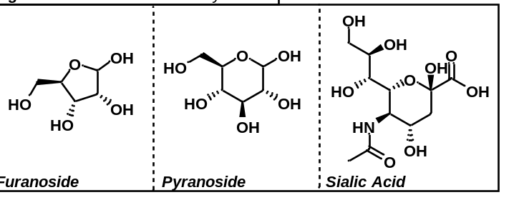
1.1 Difficulties in Translating Glycosylation Strategies
Due to the structural differences between the three classifications of glycoside, there are inherent difficulties in translating glycosylation approaches from one glycoside to another. Glycosylation, or the functionalization of a glycoside at the anomeric position, generally can go through a common intermediate for all classifications. This common intermediate is called the oxocarbenium ion and the propensity for a glycoside to undergo oxocarbenium ion formation dictates much of the difficulty in translating glycosylation strategies between these classes.

1.2 Lack of Non-Pyranosylation Strategies
Beyond the difficulty of translating glycosylation strategies from one class of glycoside to another, is the relative simplicity of developing approaches for pyranosylation. Compared to furanosides or sialic acids, pyranosides are often favored in the design of novel glycosylation strategies as, relatively speaking, they are easier to control the diastereoselectivity and activate than furanosides and sialic acids. This ease of control has resulted in a preference for developing glycosylation strategies for pyranosides over furanosides and sialosides. Because of this, furanosylation and sialylation.

1.3 Oxocarbenium Ion Stability Directing Stereocontrol
Upon release of the leaving group from the parent donor, an oxocarbenium ion is generated during these glycosylation reactions. As outlined by Crich in 2010,¹ glycosides can undergo a range of reactivity from purely S_{N}2 to purely S_{N}1 and everything in between. Typically, for pyranosides, α-donors can be activated and the leaving group can be displaced directly to result in an S_{N}2 product. Given additional time and/or solvent, the leaving group can leave to form the oxocarbenium ion. However, due to the newly formed dipole, the anion will arrange itself relatively close to the side of the oxocarbenium that it left from, forming what is known as a contact ion-pair. This anion largely blocks one face of the oxocarbenium ion resulting in the formation of predominately S_{N}2-type products with a small amount of the α-product being formed. If even further time or solvation is allowed, the contact ion-pair will separate further to produce a solvent-separated ion pair. Here, the produced anion has moved as far from the oxocarbenium as it can while still being influenced by the positive charge. At this stage, the anion largely plays no role in determining stereochemistry, thus producing a primarily S_{N}1 product (although there will still be a slight preference for the inversion of the stereocenter). Finally, time and/or additional solvation can result in the oxocarbenium acting as a completely free ion, producing a purely S_{N}1 glycoside upon reactivity. This mechanism applies to both pyranosides and furanosides, however, due to the additional stability of the oxocarbenium ion of furanosides when compared to pyranosides, we find that pyranosides prefer to undergo reactivity at the S_{N}2 end of the spectrum while furanosides prefer the S_{N}1 end. This means that stereocontrol of furanosides is more difficult to achieve as reactions typically go through the oxocarbenium and are thus unaffected by the anomeric configuration of the donor.
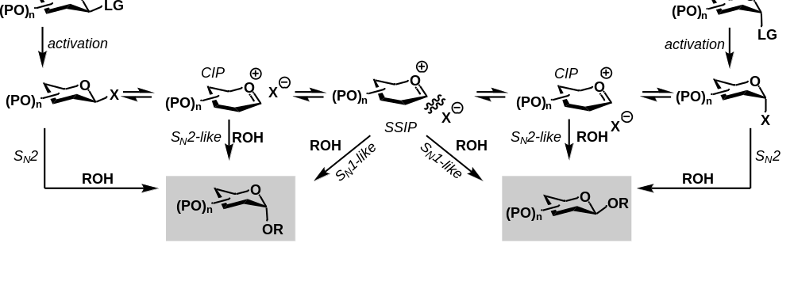
The glycosidic linkage (or the bond that connects two carbohydrate monomers to one another) is crucial for the observed activity of the product sugar. While the orientation of these glycosidic linkages is essential, the development of stereoselective methods for their synthesis has remained a key hurdle to overcome. Six-membered cyclic carbohydrates (pyranosides) are functionally very different from their five-membered counterparts (furanosides). The common intermediate for these reactions, the oxocarbenium ion, is known to be far more stable in a five-membered system than it is in the six-membered system.
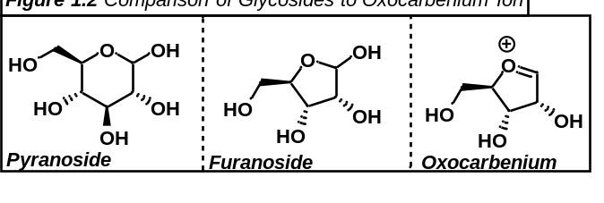
Because of this, functionalization attempts at the anomeric position for five-membered sugars tend to go through an S_{N}1-like reactivity whereas six-membered sugars tend to go through an S_{N}2-like reactivity. This preference towards S_{N}2-like reactivity somewhat trivializes stereoselective functionalization of the anomeric position of six-membered saccharides and yet the susceptibility of five-membered saccharides to undergo S_{N}1-like reactivity tends to complicate their further functionalization. Furthermore, stereocontrol to yield the trans isomer for furanosides can be rather facilely implemented merely by addition of a carbonyl containing protecting group (such as an acetyl or benzoyl group) being placed at the C2 position. This undergoes neighboring group participation with the formed oxocarbenium ion to stabilize the ion and block the cis face of the furanoside to facilitate production of the trans isomer exclusively. Altogether, this leaves a specific challenge to overcome, cis selective functionalization of furanosides. Furanosides prefer to undergo S_{N}1-like reactivity, the C2 position cannot be employed to aid in functionalization, and, due to steric interactions, serves as a barrier to achieving a high degree of stereocontrol.

The stereochemistry of these sugars and how they are bound dictates much of their function. For example, both amylose (starch) and cellulose are polysaccharides of the D-glucose monomer. Each of these polysaccharides bind their glucose monomers at the 1 and 4 position respectively. The only difference between the two is that amylose is comprised solely of α-linkages whereas cellulose is made of exclusively β-linkages.
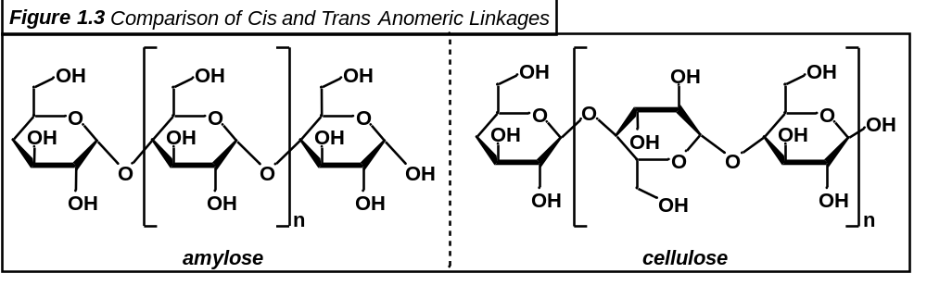
The sole difference between digestible amylose and nondigestible cellulose is whether there are trans linkages. Due to the presence of trans linkages in cellulose, enzymes in the human body are unable to digest these molecules whereas the cis only linkages of amylose are digestible by human enzymes.

1.4.1 Dehydrative Fischer Glycosylation
In 1893, Emil Fischer outlined one of the first methods of organic glycosylation ever documented in the literature.¹ The methods proposed by Fischer were rudimentary but laid the groundwork for far more elegant protocols. As documented by Fischer, carbohydrates like glucose and arabinose were dissolved in hot water along with an alcohol and to this solution was added either concentrated hydrochloric acid, or gaseous hydrochloric acid. The solution was cooled and evaporated to yield the corresponding methyl or ethyl carbohydrate. This dehydrative strategy was monumental in showing that chemical control can actually be exerted over carbohydrates.²
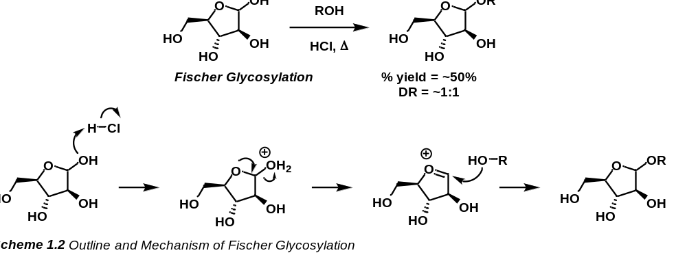

1.4.2 Silver-Promoted Koenigs-Knorr Trans Glycosylation
Eight years later, contemporary of Emil Fischer, Wilhelm Koenigs, and his student Edward Knorr, published a protocol wherein an acyl protected bromodonor was reacted with silver(I)carbonate to yield a diastereospecific β-pyranoside. This was a massive leap forward in many ways. Primarily however, this introduced a method of total stereocontrol for glycosylation reactions. This reaction functioned in a rather elegant manner, as silver(I)carbonate is soluble in many organic solvents, but silver(I)bromide is generally insoluble, the reaction can be driven by the formation of an insoluble salt. This would, of course, produce an oxocarbenium ion that would undergo anchimeric assistance to block the cis face of the ion from nucleophilic attack thus constraining the formed glycoside to be in the 1,2-trans conformation.³
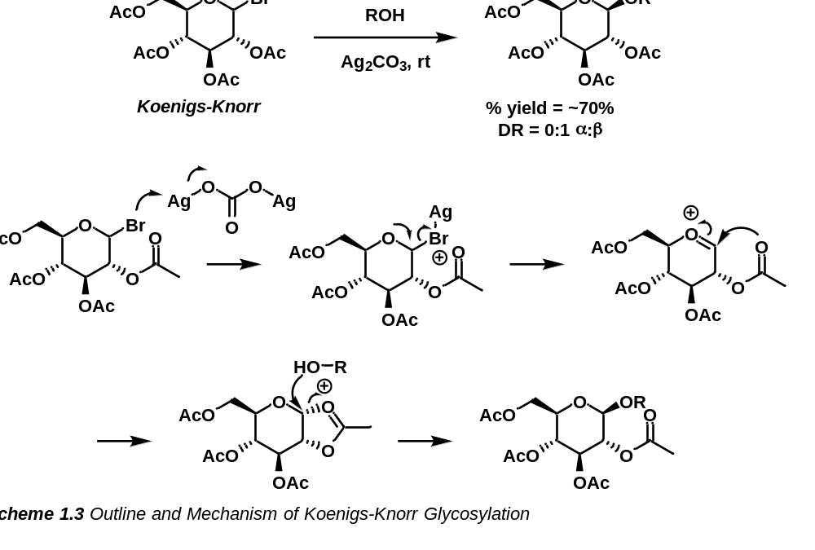

1.4.3 Thioglycoside-Based Donors
Anomeric thioglycosides have been long known for their stability and ease of activation. While 1,2-trans selective reactions have been addressed by the Koenigs-Knorr reaction, there is still a need for further stereocontrol be it for 1,2-cis selectivity or 1,2-trans selectivity that is independent of anchimeric assistance from the C2 protecting group. Thioglycoside-based donors seek to fill this niche. These donors are generally benchtop stable which is advantageous especially when compared to halo-donors like those in the Koenigs-Knorr reaction which are typically highly susceptible to hydrolysis. Anomeric thioglycosides can be activated under a variety of conditions, making them approachable for orthogonal purposes. These donors are so beneficial that, despite their induction for glycosylations in 1973, novel donors are still being developed featuring this moiety.

1.4.3.1 Activation of Thioglycosides by Mercury (II) Salts
In 1973,⁴ the activation of thioglycosides for glycosylation reactions was first reported by the Ferrier group. These thioglycoside donors were in a unique position as there are several thiophilic activators that could be employed to initiate glycosylation. This is due to the fact that the sulfur atom is a rather soft base according to hard-soft acid-base theory. This means that an adequately soft acid could bind to and activate these sulfur atoms quite effectively. One such acid that comes to mind is mercury. Mercury is an incredibly thiophilic soft acid that was shown to activate thioglycoside based donors. Generally, the binding of sulfur atoms to mercury is a thermodynamic sink and is typically irreversible. It was also shown that, in the pyranoside series, stereoinversion was witnessed (ie, β-glucopyranoside donors led to the formation of α-glucopyranoside products and vice-versa) which meant that stereoselectivity can be controlled by control of the anomeric configuration of the donor.
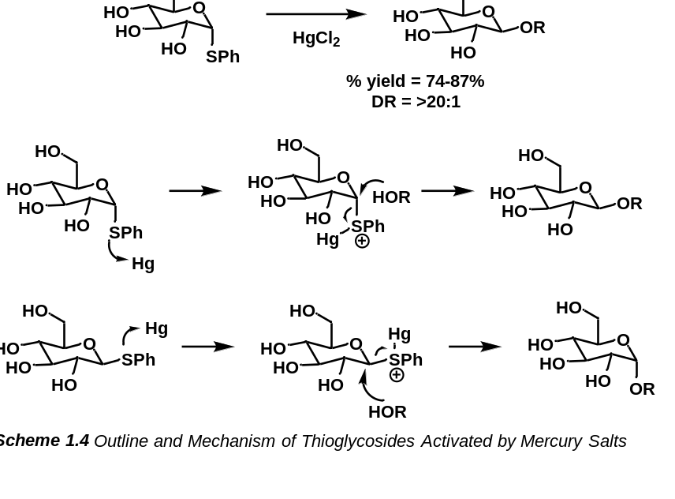

1.4.3.2 Bismuth as an Activator of Thioglycosides
Beyond mercury, other soft promoters are frequently sought for facile activation of thioglycosides. Along these lines, non-toxic bismuth was also shown to be an efficient promoter of thioglycosides. Generally, bismuth (III)⁵ or (V)^{6,7} triflates offer facile reactivity with thioglycosides to provide glycosyl linkages. While bismuth (III) can be employed catalytically, it must often be employed alongside a stoichiometric co-promoter. In the absence of a co-promoter, bismuth (III) is typically utilized hyperstoichiometrically (3 equivalents). Bismuth (V), usually in the form of Ph₃Bi(OTf)₂, is commonly used catalytically without requiring an external promoter. Coordination of bismuth to the sulfide and the subsequent release of a triflate anion leads to the formation of a more reactive triflate intermediate which reacts readily to form the glycosyl product.
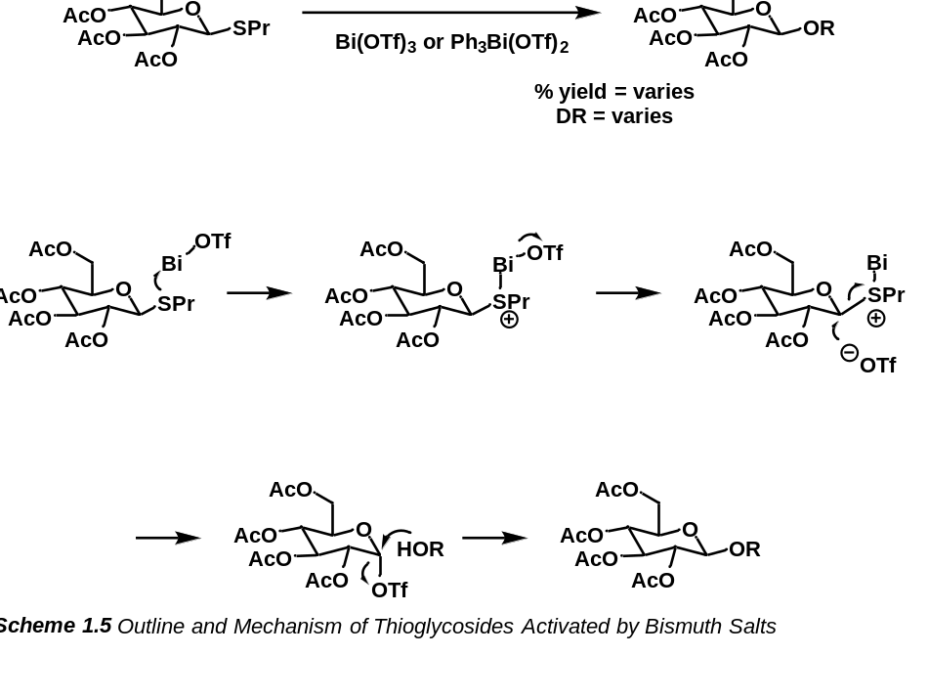

1.4.3.3 In Situ Generation of Iodonium Ions for the Activation of Thioglycosides
While effective, activation of thioglycosides under transition metal catalysts can certainly be improved. Primarily, due to the toxicity of transition metals, their use in synthetic scenarios is often discouraged which led to a desire in the synthetic community to move away from such toxic reagents and more towards non-metal promoters. A major advancement in this field came in 1990 when, independently of one another, the groups of van Boom⁸ and Fraser-Reid⁹ published their protocols which featured the activation of thioglycosides via N-iodosuccinimide with trifluoromethanesulfonic acid. This cocktail of NIS/TfOH generates, in situ, an iodonium ion which serves as a soft acid allowing it to bind strongly with the thioglycosides sulfur atom. Release of this species via an S_{N}2 attack by the triflate anion results in the formation of elemental iodine (I₂) and the relative disulfide as well as the anomeric triflate. This reactive intermediate reacts quickly with an alcohol acceptor via another S_{N}2 reaction to produce the desired glycoside.
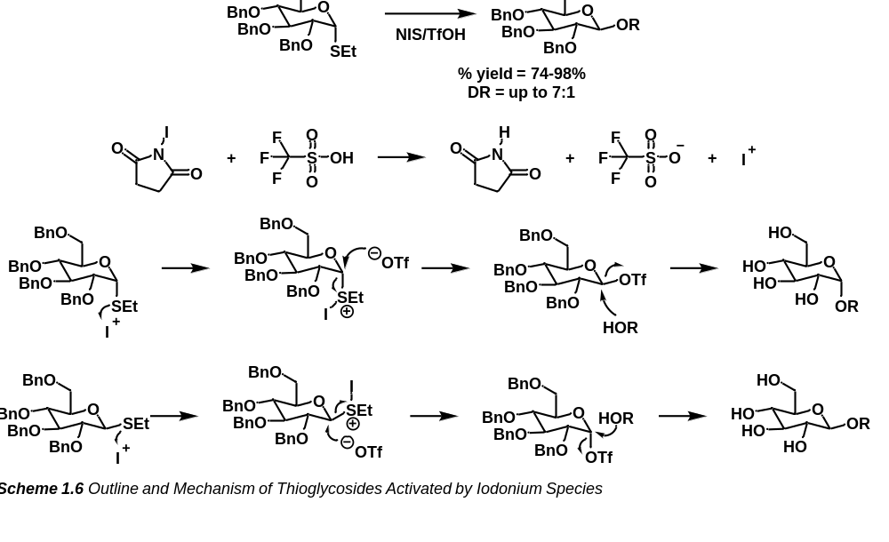

1.4.3.4 Sulfonium Species for the Activation of Thioglycosides
In 1997,¹⁰ the Crich lab published a protocol for activating sulfoxide donors based on work demonstrated by the Oae group in 1981.¹¹ This methodology, involving reacting triflic anhydride with a sulfoxide to generate a reactive sulfonium, was further developed in Crich’s 2001¹² protocol which led to the creation of what is now known as the Crich β-mannosylation. In this simple yet elegant strategy, diphenyl sulfoxide is subjected to triflic anhydride which generates the corresponding diphenyl sulfonium and a triflate anion. This sulfonium is a perfectly soft Lewis acid and thiophilic reagent that reacts readily with the sulfur atom of a thioglycoside to form a disulfide bond and initiate oxocarbenium formation. The newly formed oxocarbenium can then react with a triflate anion to form the corresponding intermediate glycosyl triflate, of which the α-triflate predominates. Following the formation of the α-triflate, an alcohol acceptor can be introduced which will react in an S_{N}2 fashion to produce the relative β-glycoside which, in the case of mannopyranosides as shown below is the challenging 1,2-cis linkage.
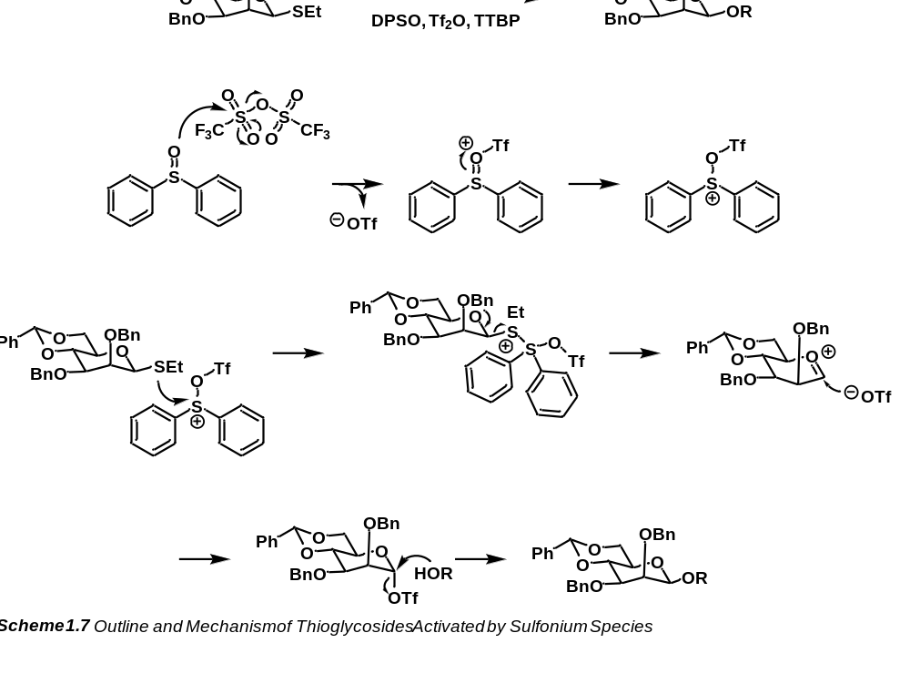

1.4.3.5 Activation of Thioglycosides by Diazo-Derived Carbenes
While elegant, many of these protocols for the activation of thioglycosides lack catalytic potential. Often, activators for thioglycosides are stoichiometric reagents and hazardous materials. Due to this, there is an inherent need for catalytic methods and mild reagents. Rhodium has long been known to activate a variety of species (namely diazo compounds) with extremely low catalyst loading. Sulfur compounds have also been shown to insert into rhodium carbenoids which led the Qian group to suspect that the rhodium catalyzed decomposition of simple diazo compounds could activate thioglycoside-based donors in 2019.¹³ This means that in the presence of a rhodium catalyst, a mixture of a diazo and a thioglycoside will decompose the diazo compound and the thioglycoside sulfur can insert into the newly formed carbene. From here, to generate a sulfonium species, a Brønsted acid catalyzed cycle can occur to protonate the ylide to form the desired sulfonium. This sulfonium can then be eliminated by the sugar to form the oxocarbenium ion. Subsequent attack by an alcohol nucleophile results in the formation of the glycosyl product.
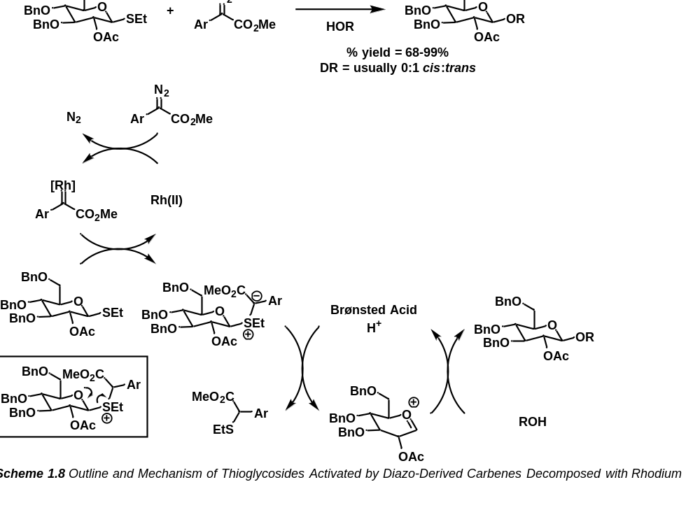

1.4.4 Trichloroacetimidate Donors with Weak Acid Activation
In the Fall of 1980,¹⁴ Richard R. Schmidt, along with his student Josef Michel, published a protocol for glycosylation that featured the formation of a trichloroacetimidate donor under basic conditions that could be reacted with a weak Brønsted acid or even a non-metal Lewis acid. This was an important development as previous conditions like the Fischer glycosylation (1.4.1) required the use of strong acids like HCl or would often rely on transition metal salts such as silver carbonate (Koenigs-Knorr, 1.4.2). These harsh conditions caused numerous issues with sensitive substrates and thus, more mild conditions for glycosylation reactions were highly sought after. As proposed by Schmidt, these trichloroacetimidates could be readily activated with pTsOH or BF₃*Et₂O. Later protocols would suggest that trimethylsilyl trifluoromethanesulfonate was an even superior activator¹⁵ for these donors, although that has been contested in the literature.¹⁶
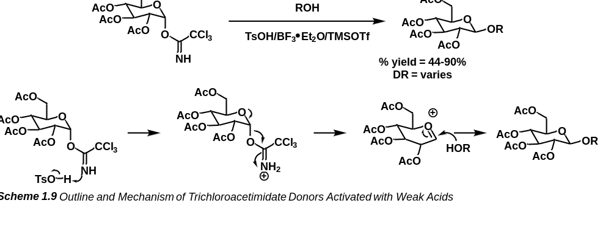

1.4.5 Temporary Connection Method
More modern methods have been developed as a general strategy for 1,2-cis glycosylations. In 1991, the Kim group outlined the temporary silicon connection method for control of regio- and stereochemistry.¹⁷ In this method, a silyl linker is attached to the C2 oxygen of the donor sugar along with the desired acceptor. In this work, the desired acceptor was an alkynyl species which would form a vinyl C-glycoside following the reaction. The donor proposed here would be activated under AIBN which would induce radical formation at the anomeric position and lead to homolytic cleavage of the alkynyl π-bond. This would force the newly formed C-glycoside to have its anomeric group on the same side as the C2 group. Once this bond is formed, the silyl linker can be cleaved to yield the desired C-glycoside and a deprotected C2 hydroxy group (which can then be used as an acceptor).
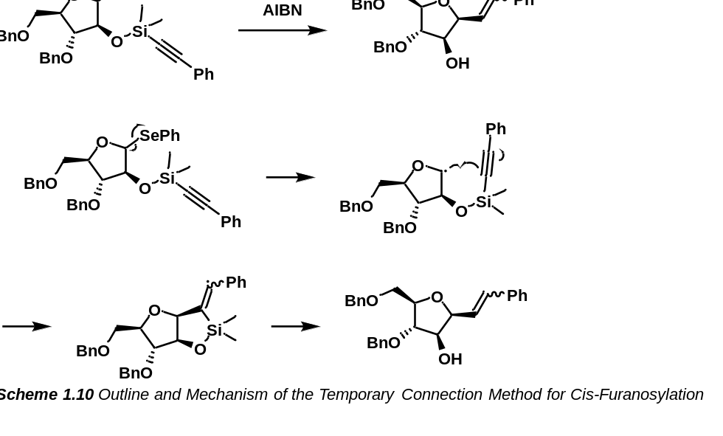

1.4.6 Boron-Activated Fluoro-donors
Recently, in 2020, the Montgomery group proposed a fluoride donor that can be activated under mild boron conditions. This elegant method features an anomeric fluoride which, upon activation produces a fluoride anion which can react with a silyl protected acceptor to release the acceptor and form the glycoside. As documented, this method can be performed intermolecularly with a C2 acyl protecting group to form the diastereospecific 1,2-trans glycoside. Additionally, as shown with rhamnosyl, glucosyl, and mannosyl donors, this methodology is amenable to the temporary silicon connection method (as described in 1.4.5) for the synthesis of 1,2-cis glycosides. Similarly to the intermolecular case, the intramolecular protocol releases a fluoride anion which can react with the C2 silyl linker to release the acceptor on the same face as the C2 group thus forming the desired 1,2-cis glycoside.¹⁸
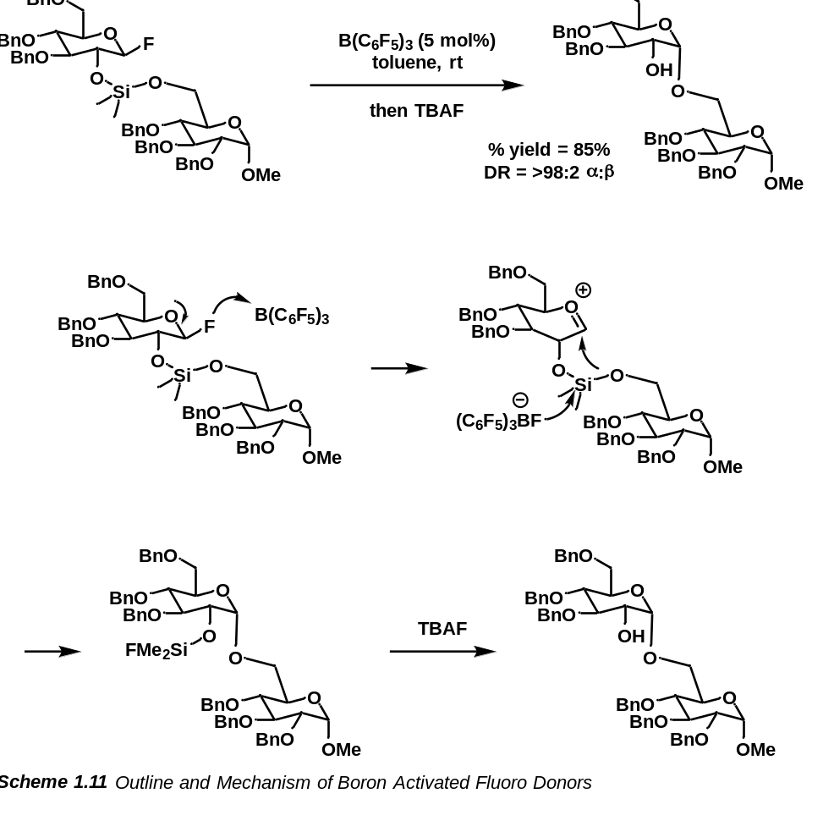

1.4.7 Modern Furanosylation Strategies
In contrast, some more recent furanosylation strategies such as those proposed by Qian or Zhang have been developed featuring catalytic methods. In 2019 Qian developed a set of thioglycosides, diazo-based, rhodium catalyzed reaction conditions.¹³ As well, the Zhang group developed a gold/silver mediated, alkyne activated method of site selective furanosylation.¹⁹ While catalytic, these conditions both suffer from the use of rare earth catalysts that are more expensive. While they exist, it is apparent that we are in need of a carbene-based, earth-abundant approach to stereoselective 1,2-cis furanosylation.
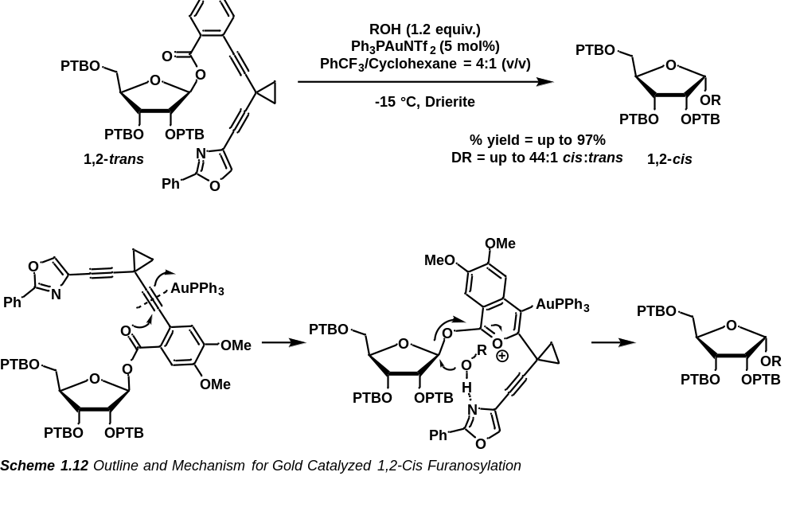

Most recently however, in 2022, procedures by the groups of Jacobsen and Nguyen have developed eloquent and catalytic methods of generating 1,2-cis furanosides diastereoselectively. Jacobsen proposed a phosphorus-based donor which, in the presence of a bis-thiourea catalyst and alcohol acceptor, reacts to form the corresponding disaccharide. As disclosed by the group, diastereoselectivity was achieved in a greater than 30:1 (α:β) ratio as well as with yields up to 93%. In terms of acceptors, this reaction was shown to tolerate pyranosides, furanosides, and even amino acids. However, this reaction suffers from a distinct set of disadvantages. A major drawback is the specificity of the bis-thiourea catalyst. The employed catalyst is rather large and must be synthesized fresh for the specific reaction.²⁰
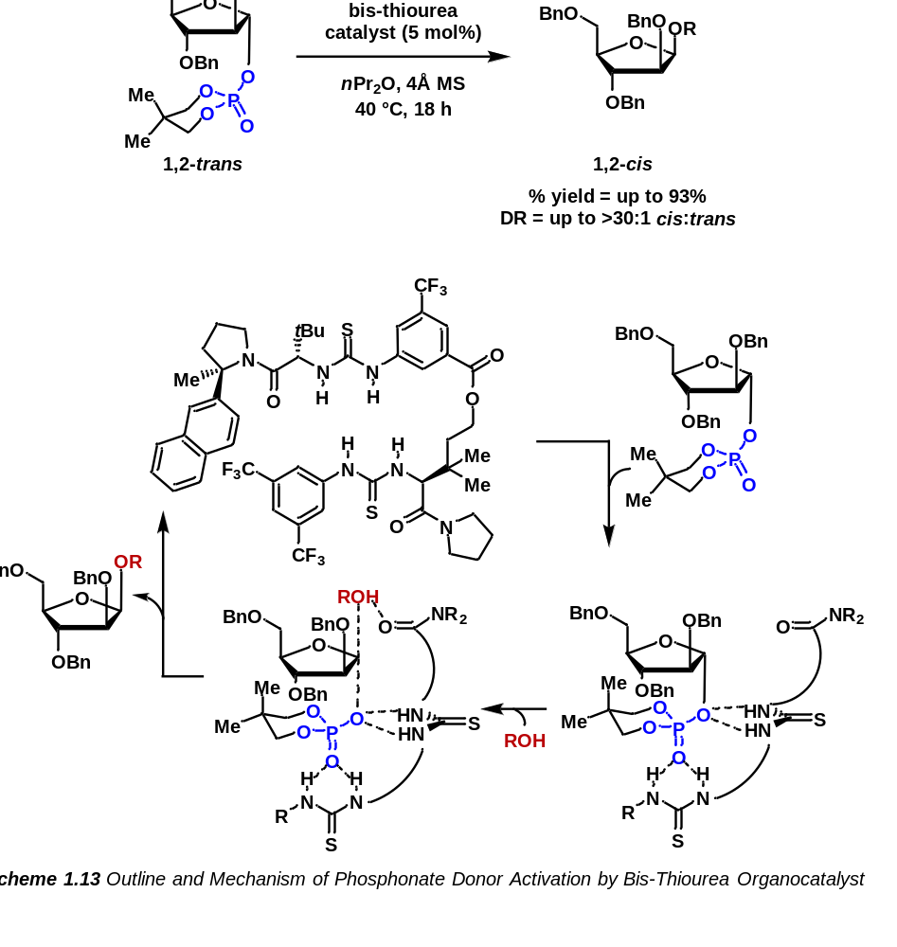

To contrast, the Nguyen protocol employes a bromo donor coupled with a phenanthroline organocatalyst to afford a stereoselective disaccharide product. The proposed donors are readily reactive and the phenanthroline catalyst ensures that the stereochemical outcome of the product is not dependent on the stereochemistry of the starting material. Under these conditions, Nguyen was able to induce diastereoselectivity up to 20:1 cis:trans and with yields of up to 90%. These reaction conditions were able to handle arabinose and xylose-based donors as well as a range of acceptors from ether protected sugars to ester-based sugar protecting groups.²¹

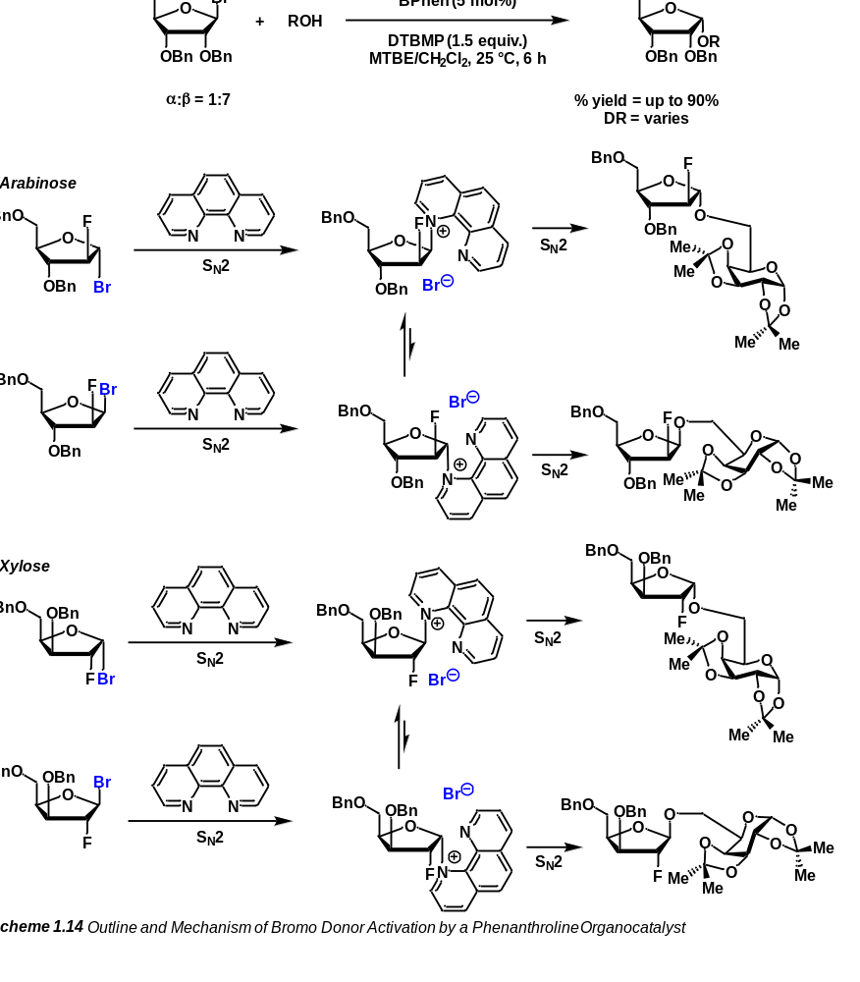

We then thought to approach this challenge ourselves starting from a realm our lab has much experience in, carbenes. Carbenes are an incredibly useful moiety within the synthetic community. A carbene is a carbon atom that possesses both a positive and negative charge at the same time. This can also present itself as a carbon atom with two orbitals occupied by a single electron each. These two carbenes are classified as either Fischer carbenes or Schrock carbenes respectively. Carbenes can rapidly build out both structural complexity and stereochemistry. With these moieties, large degrees of synthetic diversity can be established from the generation of natural products to the synthesis of small molecule inhibitors. Carbenes, however, are formed from what are known as carbene precursors. The most common and by far most well-known carbene precursor is the diazo. Diazo compounds are characterized as having a carbon atom double bonded to a nitrogen atom which is itself double bonded to another nitrogen atom. In the presence of a metal catalyst or in certain cases light, the diazo will release the nitrogen as elemental, diatomic, nitrogen gas. Upon this release, the full carbene is formed, capable of reacting like a nucleophile as well as an electrophile. Diazos, while both efficient and elegant carbene precursors do maintain a reputation as an unstable (and therefore explosive) functional group.
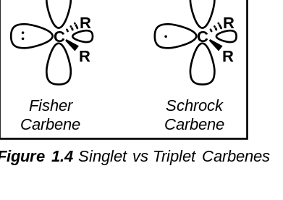
However, the diazo is not the only form of carbene precursor that exists. In recent years, novel carbene precursors have been developed such as the enynal/enynone. These compounds are characterized as possessing a conjugated series of an alkene, an alkyne and either an aldehyde, ketone, or similar carbonyl containing moiety. These alkynes, as have been shown, can be activated under mild, earth-abundant conditions to generate carbenes akin to diazo compounds albeit without the reputation for instability. This not only ensures that they have a higher degree of benchtop stability than the traditional diazo but that they are far safer to work with.
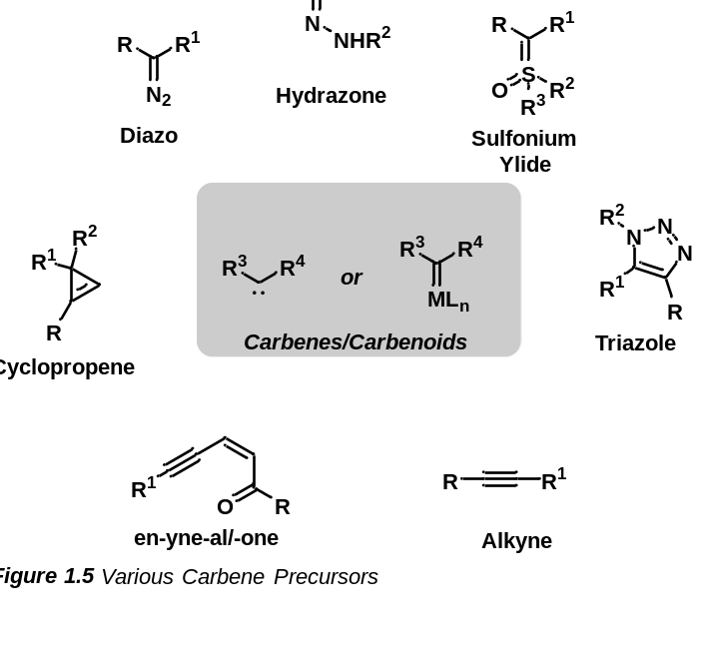
In efforts to develop better methods of furanosylation, we sought to develop a first generation furanoside donor comprised of an enynal that, upon activation and release, could form an oxocarbenium for further functionalization. This can lead to a general, earth-abundant catalytic approach to furanosylation.
1.5 References for Chapter 1
[1] Bohé, L.; Crich, D. A Propos of Glycosyl Cations and the Mechanism of Chemical Glycosylation. Comptes Rendus. Chimie 2010, 14 (1), 3–16. DOI: 10.1016/j.crci.2010.03.016.
[2] Fischer, E. Ueber Die Glucoside Der Alkohole. Berichte der deutschen chemischen Gesellschaft 1893, 26 (3), 2400–2412. DOI: 10.1002/cber.18930260327.
[3] Koenigs, W.; Knorr, E. Ueber Einige Derivate Des Traubenzuckers Und Der Galactose. Berichte der deutschen chemischen Gesellschaft 1901, 34 (1), 957–981. DOI: 10.1002/cber.190103401162.
[4] Ferrier, R. J.; Hay, R. W.; Vethaviyasar, N. A Potentially Versatile Synthesis of Glycosides. Carbohydrate Research 1973, 27 (1), 55–61. DOI: 10.1016/s0008-6215(00)82424-6.
[5] Valerio, S.; Iadonisi, A.; Adinolfi, M.; Ravidà, A. Novel Approaches for the Synthesis and Activation of Thio- and Selenoglycoside Donors. The Journal of Organic Chemistry 2007, 72 (16), 6097–6106. DOI:10.1021/jo070670o.
[6] Goswami, M.; Ellern, A.; Pohl, N. L. Bismuth(V)‐mediated Thioglycoside Activation. Angewandte Chemie International Edition 2013, 52 (32), 8441–8445. DOI:10.1002/anie.201304099.
[7] Goswami, M.; Ashley, D. C.; Baik, M.-H.; Pohl, N. L. Mechanistic Studies of Bismuth(v)-Mediated Thioglycoside Activation Reveal Differential Reactivity of Anomers. The Journal of Organic Chemistry 2016, 81 (14), 5949–5962. DOI: 10.1021/acs.joc.6b00860.
[8] Veeneman, G. H.; van Leeuwen, S. H.; van Boom, J. H. Iodonium Ion Promoted Reactions at the Anomeric Centre. II an Efficient Thioglycoside Mediated Approach toward the Formation of 1,2-Trans Linked Glycosides and Glycosidic Esters. Tetrahedron Letters 1990, 31 (9), 1331–1334. DOI: 10.1016/s0040-4039(00)88799-7.
[9] Konradsson, P.; Udodong, U. E.; Fraser-Reid, B. Iodonium Promoted Reactions of Disarmed Thioglycosides. Tetrahedron Letters 1990, 31 (30), 4313–4316. DOI: 10.1016/s0040-4039(00)97609-3.
[10] Crich, D.; Sun, S. Direct Synthesis of β-Mannopyranosides by the Sulfoxide Method. The Journal of Organic Chemistry 1997, 62 (5), 1198–1199. DOI: 10.1021/jo962345z.
[11] Morishita, T.; Furukawa, N.; Oae, S. Reaction of Thiolsulfinates with Trihaloacetic Anhydrides—I. Tetrahedron 1981, 37 (18), 3115–3120. DOI: 10.1016/s0040-4020(01)98843-x.
[12] Crich, D.; Smith, M. 1-Benzenesulfinyl Piperidine/Trifluoromethanesulfonic Anhydride: A Potent Combination of Shelf-Stable Reagents for the Low-Temperature Conversion of Thioglycosides to Glycosyl Triflates and for the Formation of Diverse Glycosidic Linkages. Journal of the American Chemical Society 2001, 123 (37), 9015–9020. DOI: 10.1021/ja0111481.
[13] Meng, L.; Wu, P.; Fang, J.; Xiao, Y.; Xiao, X.; Tu, G.; Ma, X.; Teng, S.; Zeng, J.; Wan, Q. Glycosylation Enabled by Successive Rhodium(II) and Brønsted Acid Catalysis. Journal of the American Chemical Society 2019, 141 (30), 11775–11780. DOI: 10.1021/jacs.9b04619.
[14] Schmidt, R. R.; Michel, J. Facile Synthesis of α‐ and β‐O‐glycosyl Imidates; Preparation of Glycosides and Disaccharides. Angewandte Chemie International Edition in English 1980, 19 (9), 731–732. DOI: 10.1002/anie.198007311.
[15] Mahling, J.; Schmidt, R. R. Glycosyl Imidates, 70. Synthesis of a Coumarin C‐glucoside. Liebigs Annalen 1995, 1995 (3), 467–469. DOI: 10.1002/jlac.199519950363.
[16] Li, Y.; Mo, H.; Lian, G.; Yu, B. Revisit of the Phenol O-Glycosylation with Glycosyl Imidates, BF₃·OET₂ Is a Better Catalyst than TMSOTf. Carbohydrate Research 2012, 363, 14–22. DOI: 10.1016/j.carres.2012.09.025.
[17] Stork, G.; Suh, H. S.; Kim, G. The Temporary Silicon Connection Method in the Control of Regio- and Stereochemistry. Applications to Radical-Mediated Reactions. the Stereospecific Synthesis of C-Glycosides. Journal of the American Chemical Society 1991, 113 (18), 7054–7056. DOI: 10.1021/ja00018a063.
[18] Sati, G. C.; Martin, J. L.; Xu, Y.; Malakar, T.; Zimmerman, P. M.; Montgomery, J. Fluoride Migration Catalysis Enables Simple, Stereoselective, and Iterative Glycosylation. Journal of the American Chemical Society 2020, 142 (15), 7235–7242. DOI: 10.1021/jacs.0c03165.
[19] Ma, X.; Zhang, Y.; Zhu, X.; Zhang, L. An S_{N}2-Type Strategy toward 1,2-Cis-Furanosides. CCS Chemistry 2022, 4 (12), 3677–3685. DOI: 10.31635/ccschem.022.202202175.
[20] Mayfield, A. B.; Metternich, J. B.; Trotta, A. H.; Jacobsen, E. N. Stereospecific Furanosylations Catalyzed by Bis-Thiourea Hydrogen-Bond Donors. Journal of the American Chemical Society 2020, 142 (8), 4061–4069. DOI: 10.1021/jacs.0c00335.
[21] Xu, H.; Schaugaard, R. N.; Li, J.; Schlegel, H. B.; Nguyen, H. M. Stereoselective 1,2-Cis Furanosylations Catalyzed by Phenanthroline. Journal of the American Chemical Society 2022, 144 (16), 7441–7456. DOI: 10.1021/jacs.2c02063.

CHAPTER 2
Enynal-Derived Copper-Carbene Mediated Furanosylations

2.1 Historical Perspective of Biorelevant Furanosides
In 1891, Emil Fischer discovered the structure of sugar.¹ A discovery for which he was awarded the Nobel Prize in 1902. Since this time, numerous advancements have been made in the field of carbohydrate research. While carbohydrates are the most abundant natural product,² development of novel carbohydrate-containing drugs has slowed significantly in recent years, with only about 4%³ of new drugs approved by the FDA between 2015 and 2020 containing this powerful moiety. These contrasting data are confounded further as roughly 50% of newly approved drugs each year are either natural products, or derivatives of natural products.⁴ This underrepresentation is due to several factors. The chief among which is the perceived difficulty associated with working with and manipulating these sugar compounds. Sugars require careful manipulation, lengthy cycles of protection/deprotection, and highly specific donors/reagents. As the cost of a drug is directly proportional to the number of synthetic steps required for its synthesis, the more complex (and thus more expensive) the synthesis, the higher the price of the final drug. These costs and the synthetic skill required to perform these reactions dissuade the pursuit of carbohydrates in pharmaceutical drugs.
Although uncommon, carbohydrate containing drugs, specifically furanosides, have seen use in pharmaceutical applications. Of these, the majority feature 1,2-trans linkages and it is exceedingly rare to find drugs that feature 1,2-cis linkages. Drugs like Tribenoside are furanosides that are administered as a racemate whereas compounds like Vidarabine and Nikkomycin Z are the pure 1,2-cis furanoside. These are therapeutics with potent activity against viral and fungal species. Further, compounds like phosphoribosyl phosphate (PRPP) are natural biomarkers for diseases like gout and are dependent on the observed stereochemistry.
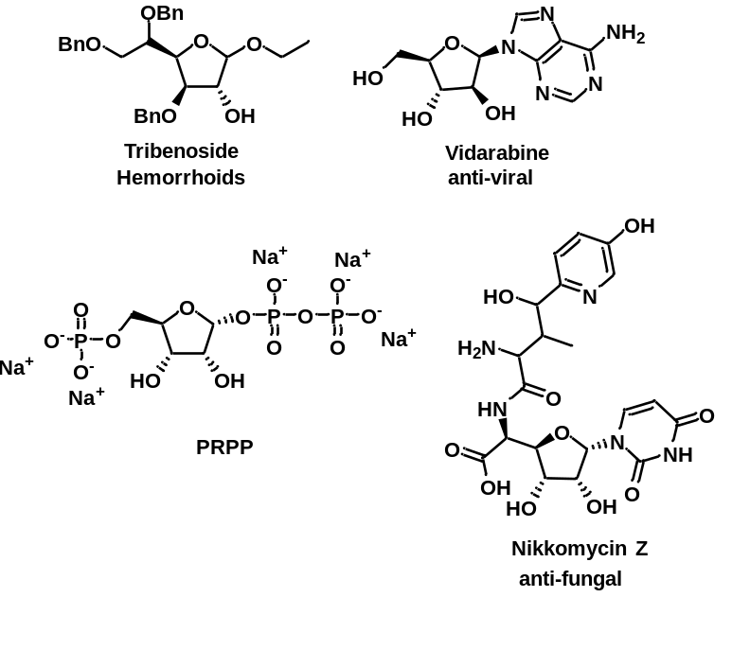

As stated, carbohydrates are the most common natural product, and, beyond biologically active compounds, furanosides are found widely among animals, plants, bacteria, fungi, and protozoa as both oligo- and poly-furanosides.⁵⁻¹⁰ While found naturally both as 1,2-cis furanosides and 1,2-trans furanosides, as discussed in 1.3, 1,2-cis furanosides are much more difficult to achieve synthetically in the lab.¹¹⁻¹⁴ 1,2-trans furanosides are easily furnished through anchimeric assistance via a C2 O-acyl protecting group.^{15,16} As these linkages determine much of the biological activity of these compounds, it is absolutely necessary to attain these species with the correct stereochemistry. To address these challenges, numerous approaches have been developed. Intramolecular aglycone transport,¹⁷⁻²³ hydrogen-bond-mediated aglycone transport,^{24,25} and even the implementation of donors featuring constrained conformations²⁶⁻³³ are a few of these such approaches. However, these methods are dependent on stoichiometric amounts of various promoters.

2.1.1 Objective of Chapter
The goal of this chapter is to highlight the usefulness of the novel enynal-based furanosyl donor which can be activated under mild, earth-abundant catalysis for the formation of difficult 1,2-cis linkages. Traditional methods of 1,2-cis selective furanosylations, while elegant, suffer from numerous issues. Many of the early methods required stoichiometric amounts of harsh reagents such as triflic acid or triflic anhydride. Later methods introduced catalytic procedures but themselves had noteworthy drawbacks. Phosphonate donors like those proposed by Jacobsen are moisture sensitive and require anomerically pure donors to induce stereocontrol. Similarly, halodonors like those employed by Schlegel and Nguyen³⁴ are often incredibly prone to hydrolysis and therefore are not benchtop stable. Finally, alkyne donors like those proposed by Zhang³⁵ or thioglycosides with activation methods like those proposed by Qian³⁶ rely on rare-earth metals like gold or rhodium for activation.
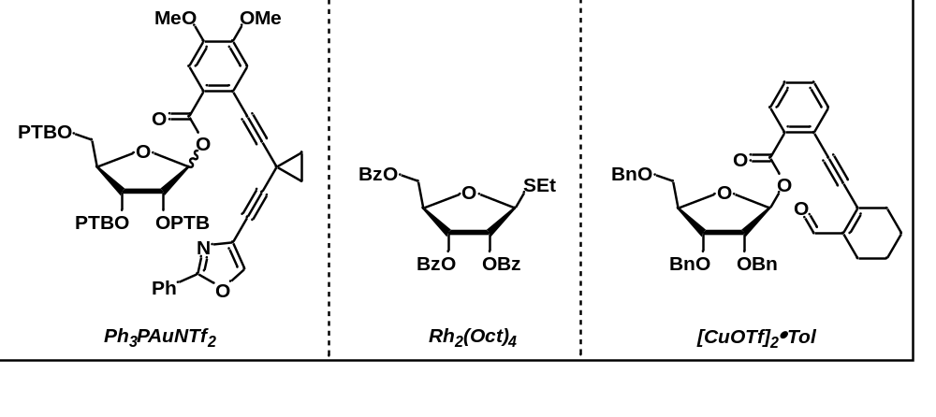

2.2 Enynal Reactivity
Enynals are compounds that feature an alkene, alkyne, and aldehyde in conjugation. These moieties allow for insertion of the aldehyde into the alkyne given appropriate polarization of the alkyne. This leads to the formation of a metal carbenoid through furan aromatization. These compounds were first documented in 1978³⁷ by Hoffman and Shechter albeit via the reverse reaction. As documented, enynal compounds can be generated via the decomposition of diazo furans. At the time, these structures were documented, but reactivity was not pursued. While work in the next two decades following this focused primarily on α-diazo ketones which could generate en-yne ketenes in situ.^{38,39} These structures rapidly undergo cyclization to produce phenols and benzoquinones. However, in 1997,⁴⁰ the Saito group outlined a light-mediated activation of an enynone for the synthesis of functionalized furan species. This represents a novel carbene source and, when compared to traditional diazo compounds, a significant advantage. While carbene formation in diazos is driven by the release of elemental nitrogen in the form of N₂, the formation of a carbene through an enynal is driven by furan aromatization. As enynal decomposition does not result in an increase in the moles of gas in the system, they represent a non-explosive carbene precursor and a distinct advantage over diazos which are frequently banned from use in industry for their dangerous reputation.
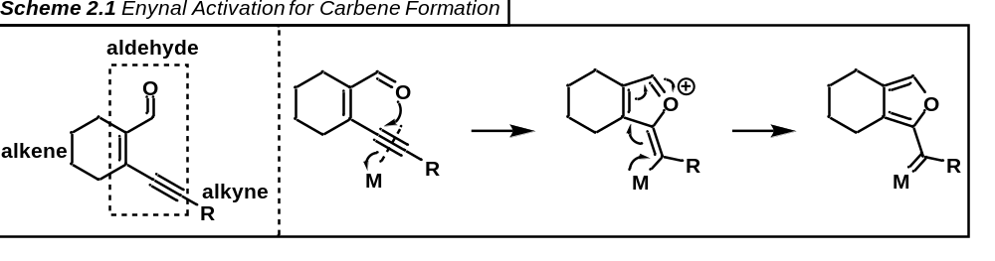

2.3 Lithium as an Additive
Initially upon synthesis of our enynal donor, we subjected the parent reaction to similar conditions that had been employed in the pyranoside case by other members of the lab. These conditions consisted of NaBArF to improve diastereoselectivity and copper(I)triflate to catalyze the decomposition of the enynal. We quickly discovered that the newly generated furanoside donors were not conducive to such a strategy. Reaction yields and diastereoselectivity were low and the reaction overall was rather messy creating numerous biproducts and resulting largely in unproductive decomposition. Primarily tasked with increasing the yield of the reaction and then with the diastereoselectivity, we were inspired by a publication from the Mukaiyama group in 1996 which outlined increased yields and diastereoselectivity for a similar furanosylation protocol through the use of lithium-based salts.⁴¹ Accordingly, the implementation of lithium carbonate as an additive saw not only an increase in yield and diastereoselectivity of the reaction, but importantly also an increase in the cleanliness of the reaction.
2.4 Role of Base
As metal triflates have been shown to be a mild source of triflic acid,⁴² it could not be discounted that the true catalyst of this reaction could be triflic acid or that triflic acid could be affecting the reaction negatively. To probe this, a reaction was set up with triflic acid in the absence of copper(I) triflate and lithium carbonate. Under these conditions, yield decreased significantly, diastereoselectivity reversed, and the reaction became much messier. This seemed to indicate that not only was triflic acid not catalyzing the reaction, but that it was also actually acting detrimentally to the formation of the desired products. This is likely due to decomposition of the desired product by triflic acid. This revelation was integral in selecting an additive to increase yield and selectivity. By selecting a non-nucleophilic base to act as a proton sponge, we suspected we could remove any generated triflic acid to ensure high yields and selectivity. Coupling this with information from section 2.3, led us to the selection of lithium carbonate as an additive. This simple change increased yield and diastereoselectivity significantly and, most importantly, increased the cleanliness of the reaction.
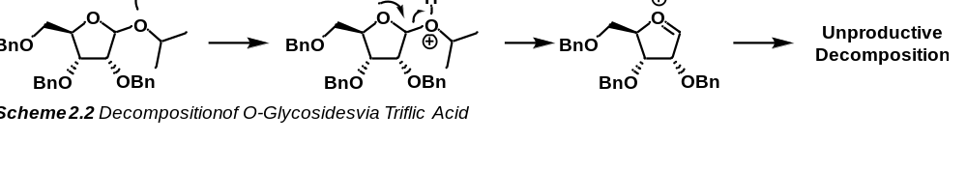

2.5 Synthesis of Donor
Synthesis of the donor proceeds facilely in two steps from the readily available sugar alcohol via an EDCI coupling with 2-iodobenzoic acid. This ester-linked furanoside can then be transformed into the desired donor in a single step via a Sonogashira coupling with the enynal component (which can be generated in three steps from inexpensive and readily available cyclohexanol). This simple strategy results in the formation of the desired enynal donor and was demonstrated to be conducive to gram-scale synthesis of this benchtop stable donor. This methodology was employed to synthesize the D-ribose, D-arabinose and L-arabinose donors used for experimentation.
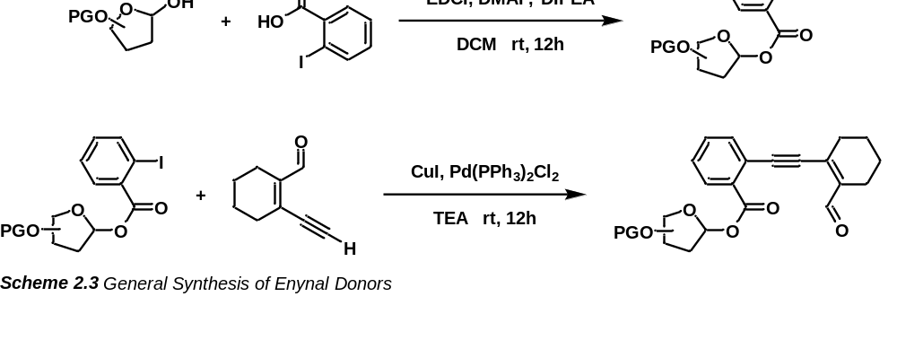

2.5.1 Synthesis of Enynal
The enynal portion of the donor can be readily synthesized in just three steps from inexpensive and widely available cyclohexanone via a robust Villsmeier-Haack reaction. This bromo aldehyde can then be converted into the TMS-protected enynal through a Sonogashira coupling reaction. Deprotection of the aforementioned compound by potassium carbonate dissolved in methanol will facilitate the formation of the desired enynal which can be easily connected to a sugar via the method described in 2.5. This generic enynal can be stored for several months and employed to synthesize a wide variety of furanosyl donors.
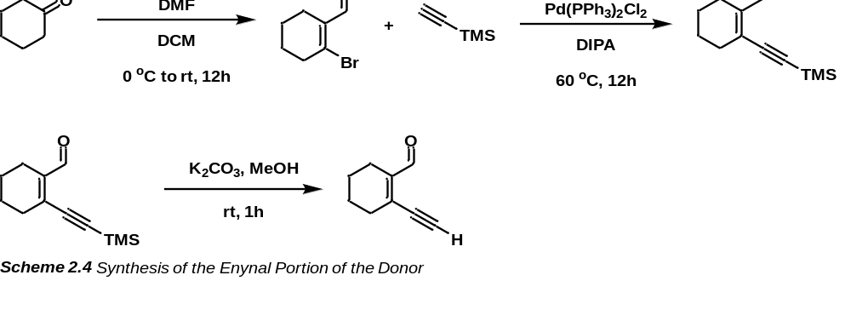

2.6 Order of Reactivity for Carbonyl Insertion
To probe the order of reactivity for carbonyl insertion into the enynal carbene, a donor was prepared lacking the aldehyde moiety such that the only carbonyl present was that of the ester. In the absence of the aldehyde, we found the starting materials unreactive under the optimized conditions. This indicates that insertion of the aldehyde into the alkyne moiety is a necessary initiation step for the formation of an enynal-derived carbene. This simple experiment was essential to understanding the order of reactivity and the electron demand of our system.
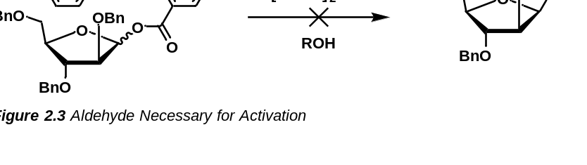

2.7 Reaction Mechanism
Following computational analysis and a series of control reactions, a plausible reaction mechanism was built out. The mechanism initiates by coordination of the copper (I) catalyst to the electron rich alkyne, polarizing the bond and encouraging insertion of the aldehyde into the alkyne. This insertion induces a positive charge on the oxygen atom which is quenched via the collapse of electrons from the copper catalyst, thus forming the aromatic furan ring and the copper carbene simultaneously. This copper carbene is then primed for insertion of the ester carbonyl which acts as a trigger mechanism locking the entire group to be released from the oxocarbenium. Upon release, the copper containing species can perform a ligand exchange with the alcohol acceptor to form the copper alkoxide species. The newly formed copper alkoxide can now coordinate to the C2 oxygen of the oxocarbenium ion. By then donating two electrons, the copper species can form a copper (III) intermediate which, upon reductive elimination, produces a contrathermodynamic furanosyl product that favors a 1,2-cis linkage.
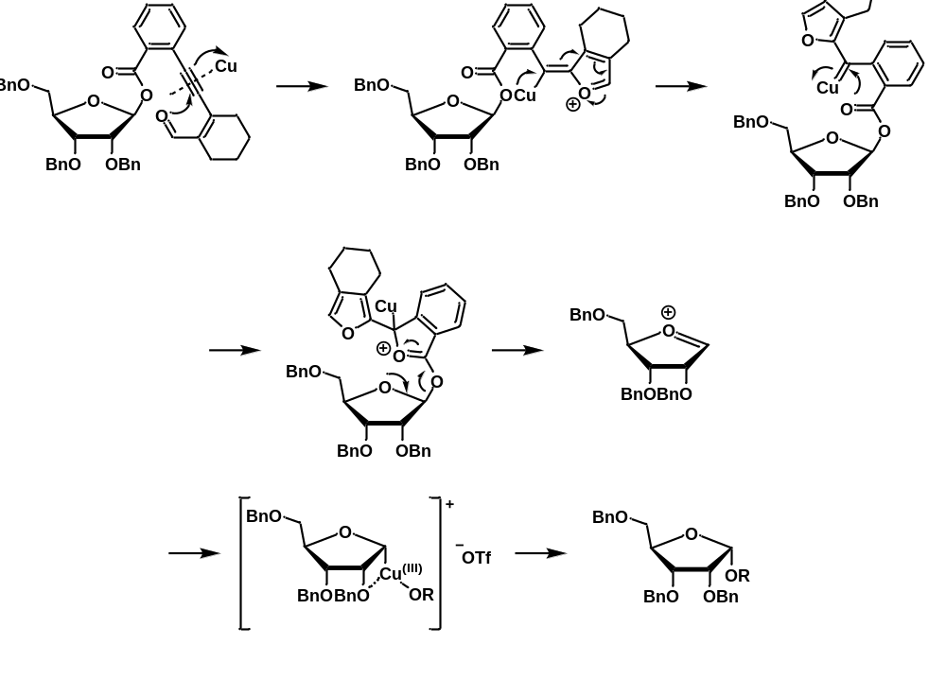

2.8 Results and Discussion
The overall reaction was optimized including the catalyst, solvent, and additive to produce a product with the highest percent yield and DR. With the optimized conditions, a substrate scope was built out to establish the range of acceptors that were amenable to our reaction conditions in the L-arabinose, D-arabinose, and D-ribose cases. This work was published in the journal ACS Catalysis in January of 2024 and represents the first example of a catalytic, 1,2-cis selective furanosylation strategy promoted by an earth-abundant copper catalyst.

2.8.1 Initial Optimization of Reaction Conditions
Initially, the catalyst was selected from a range of earth-abundant catalysts that had been shown to activate similar systems. We commenced our optimization with 2,3,4-tri-O-benzyl methylallopyranoside as the acceptor, however, we would later select a different acceptor and rerun the optimizations. To start, we examined a variety of copper, zinc, and iron catalysts. Under the parent conditions (30 mol% [CuOTf]₂·tol, 1.2 equivalents of lithium carbonate, dichloromethane as the solvent, powdered 4 Å MS, and running the reaction at room temperature), the reaction produced a yield of 96% with a diastereoselectivity of 8:1 (cis:trans). When employed, zinc triflate led to product formation, albeit in incredibly low (10%) yields and with a lower (5:1) diastereoselectivity when compared to the parent conditions. Zinc chloride produced similar results, lowering the yield to 55% and the diastereoselectivity to 5.6:1. Likewise, iron (III) chloride saw another decrease in yields (28%) and a further decrease in diastereoselectivity to 3:1. We also attempted to analyze a non-coordinating copper catalyst, CuPF₆, to determine its effects. In this trial, we found a decrease in yield to 48% however, interestingly, we observed a marked decrease in diastereoselectivity to 2:1. We also found that this system is unreactive under rhodium acetate conditions. This is excellent as it means we can expect orthogonality between our donor and that of donors which can be activated under rhodium catalysis. Additionally, we determined that the copper catalyst was necessary for the reaction to proceed as in its absence the reaction fails to initiate. Finally, as metal triflates have been shown to be a mild source of triflic acid, it could not be discounted that the true catalyst for our reaction could be triflic acid. To test this hypothesis, we set up a reaction without lithium carbonate or the copper triflate catalyst, adding only triflic acid to our donor/acceptor combination. In this case, we observed the yield of the reaction decrease significantly (25%), a complete reversal of diastereoselectivity (1:2.5), and a far messier reaction as a result.
Following optimization of the catalyst, we next sought to optimize the additive for the reaction. To examine the role of the lithium carbonate, we first performed a furanosylation in its absence. Under these conditions, we found that the yield of the reaction decreased to 40%, along with a decrease in the diastereoselectivity of the reaction, down to (6:1). The reaction also appeared to become messier, producing many more byproducts and off-target decomposition. We then sought to employ NaBArF as we believed it would help coordinate the C2 protecting group and the incoming acceptor to the same face of the oxocarbenium ion. This resulted in a small drop-off in yield (76%) and curiously a strong reversal of diastereoselectivity (1:7) ostensibly due to coordination of the C2 protecting group to the NaBArF blocking the α-face of the oxocarbenium ion producing a bias for the formation of the 1,2-trans product. Following this, we attempted to substitute the lithium carbonate in our reaction with an alternate acid sponge. To this end, we selected DTBMP which is a bulky non-nucleophilic base. Curiously, we saw a decrease in yield (73%) and another reversal of diastereoselectivity to 1:6. This is likely due to the need for increased reaction temperature up to 40 °C which could cause some decomposition of the desired product along with epimerization of the product.
Finally, we sought to determine the remaining parameters of the methodology (solvent and temperature). When Lewis basic solvents such as THF and MeCN were implemented, we observed either no reaction (in the case of THF) or marked decreases in yield (18% for MeCN). Along with the decrease in yield, we observed a complete reversal of diastereoselectivity (1:6). Next, we attempted a non-coordinating solvent, toluene, to observe the effects. In this case, we found an extreme decrease in yield (10%) and an altogether loss of diastereoselectivity. Finally, when the reaction was run at 0 °C, the reaction failed to proceed.
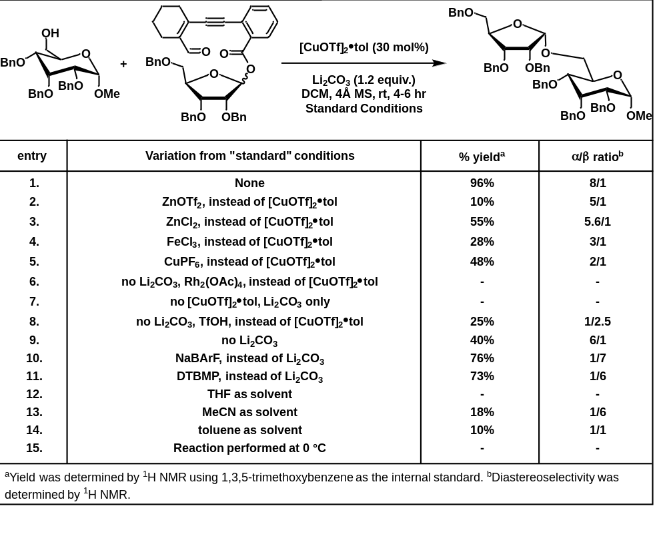
2.8.2 Final Optimization of Reaction Conditions
While the reaction was optimized with 2,3,4-tri-O-benzyl methylallopyranoside as the acceptor, it was found that a more activated acceptor like 1,2:3,4-di-O-isopropylidene-α-D-galactopyranoside would react with far lower (10 mol%) catalyst loading and therefore was more appealing for optimization. With this, the reaction was reoptimized for the new system. Under the parent conditions (10 mol% [CuOTf]₂•tol, 1.2 equivalents of lithium carbonate, dichloromethane as the solvent, powdered 4Å MS, and running the reaction at room temperature), the reaction was complete in 4 hours and the yield was 78% while the diastereoselectivity was found to be 7:1 (cis:trans). Earth-abundant catalysts, zinc(II) chloride and iron(III) chloride, saw marked decreases in yield to 20% and 15% respectively after 36 hours. While the iron catalyst lowered the diastereoselectivity of the reaction to 3:1, we observed a further decrease in selectivity with the zinc catalyst down to 1.5:1. Further metal triflates, such as zinc(II) triflate and triphenylphosphine gold(I) triflate were examined. Zinc(II) triflate unfortunately did not initiate the reaction and therefore resulted in no product formation. Triphenylphosphine gold(I) triflate, however, reacted in 3 hours to yield the product in a diastereomeric ratio of 7:1 albeit at a decreased (56%) yield. Fortunately, Rh₂(esp)₂ (which has been shown to activate enynal compounds), was unreactive in our system which might indicate good orthogonality between our donor and those reliant on rhodium-based catalysis strategies. To probe the role of the counterion in our system, we pursued trials with copper(I) catalysts featuring bulky, non-coordinating anions. Firstly, tetrakis(acetonitrile)copper(I) hexafluorophosphate was selected and after 4 hours, produced a 55% yield with a nearly racemic (2:1) diastereoselectivity. Tetrakis(acetonitrile)copper(I) tetrafluoroborate, however, reacted far more sluggishly, yielding less than 10% after 24 hours in an indeterminate diastereomeric ratio. Then, as metal triflates are known to be a mild source of triflic acid, it could not be discounted that the true catalyst for this reaction could be triflic acid. To examine this, triflic acid was employed in the absence of the copper(I) triflate toluene solvate catalyst and lithium carbonate. In this case, complete decomposition of the donor was observed within 2 hours, only producing a 25% yield with, interestingly, a reversal of diastereoselectivity to 1:2.5. Finally, we endeavored to probe the role of the catalyst altogether. To do this, we set up a reaction with lithium carbonate, but in the absence of the copper(I) catalyst. We found no reaction after 36 hours indicating the need for the catalyst.
Following the optimization of the catalyst, we next sought to optimize the additive of the reaction. To ensure that the lithium carbonate additive was necessary, we attempted to run the reaction without it. In this case, we observed that the reaction became much messier, producing a much lower yield (50%) of the product, and lessening the diastereoselectivity to 5:1. We then selected 2,6-di-tert-butyl-4-methylpyridine (DTBMP) in place of lithium carbonate and, when employed, we observed a decrease in yield (46%), an increase in reaction time (10 hours), and a decrease in diastereoselectivity (5:1) ostensibly due to the increased temperature (40 °C) required for successful progression of the reaction.
Finally, we set out to optimize the solvent of the reaction. As polar protic solvents would potentially induce insertion of the solvent into the oxocarbenium ion, they were avoided. Instead, we began with the Lewis basic (polar aprotic) solvents, THF and MeCN which each yielded no reaction after 24 hours. Finally, we sought to examine a nonpolar solvent. However, due to poor solubility of carbohydrate compounds in nonpolar solvents, our range was rather limited. For this trial, we selected toluene which possesses an aromatic ring while maintaining a nonpolar structure. In this case though, the reaction yield decreased significantly to less than 10% after 24 hours in an indeterminate diastereomeric ratio.
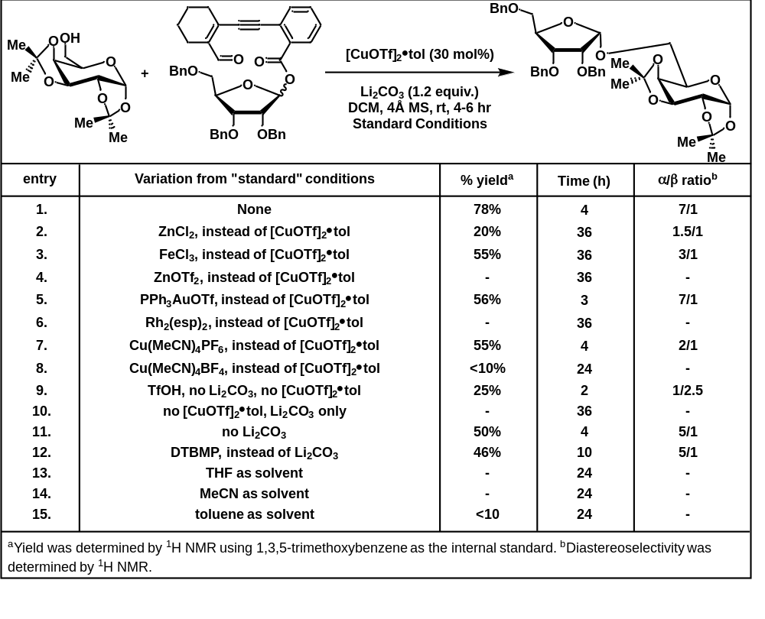

2.9 Scope of Ribose-Based Substrate
To examine the range of acceptors that would be appropriate for our system, we built out a substrate scope, starting with our 2,3,5-tri-O-benzylribofuranosyl donor. To commence, we began with a primary alcohol acceptor, pent-4-en-1-ol, which reacted to produce the desired product in an 84% yield and nearly diastereospecifically (>20:1 cis:trans). Following this, we screen achiral secondary alcohols, isopropanol and cyclohexanol. With regards to the isopropanol acceptor, the reaction yielded the desired compound in a 95% yield with a diastereoselectivity of 6:1. Results were comparable with the cyclohexanol acceptor as we observed a yield of 96% and a diastereoselectivity of 9:1. On the heels of these results, we decided to investigate chiral secondary alcohol acceptors such as menthol and cholesterol. Results were interesting as the reactions yielded 97% and 96% respectively. For diastereoselectivity, results with menthol showed a selectivity of 9:1 whereas cholesterol produced another nearly diastereospecific product at >20:1.
As many carbohydrates are found in natural products as disaccharides, there is a great interest in the synthetic community for novel methods of diastereoselective disaccharide synthesis protocols. With this in mind, we sought to highlight the utility of our method by diastereoselectively synthesizing a range of disaccharides from various sugar-alcohol acceptors. Interestingly, we found that yield and selectivity appeared to be independent of protecting group influence as these values were comparable for both the benzyl and benzoyl protected forms of glucose acceptor. These acceptors led to yields of 96% and 87% and selectivities of 9:1 and 8:1 respectively. We also found that a benzyl protected mannose acceptor, which was shown to be unreactive under the Jacobsen protocol, proceeded surprisingly effortlessly under our conditions to produce a yield of 84% and a selectivity of 5:1. To cap our investigation of sugar acceptors, we explored the use of benzyl protected arabinofuranoside acceptor which reacted cleanly to produce a 78% yield and in a diastereoselectivity of 4:1.
Finally for our ribose donor, we sought to examine amino acid-derived alcohol acceptors as amino acid linked glycosides are also found frequently in natural products. To start, we examined tosyl-protected alaninol which reacted in our system to yield the desired product in an 84% yield albeit with a selectivity of 3:1. A protected serine alcohol acceptor was also employed, and the results were similar to the alaninol trial, a yield of 82% and a selectivity of 3:1.
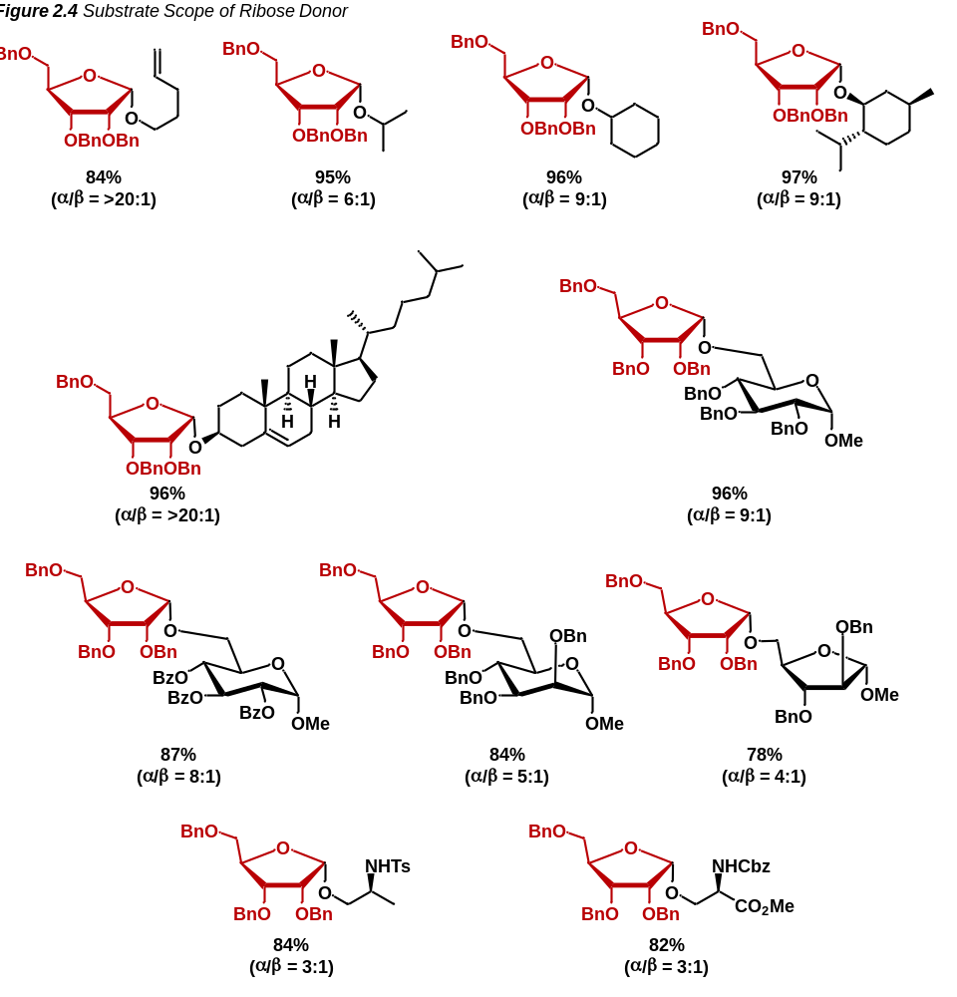

2.10 Scope of Arabinose-Based Substrate
Arabinofuranoside is often used as a counterpart to ribofuranoside for comparing diastereoselectivity as they only differ from each other in the orientation of the C2 protecting group. Therefore, to maintain 1,2-cis selectivity, anomeric selectivity must reverse (from α to β). This can be particularly challenging as numerous factors (see 1.1 and 1.3) would favor the formation of a singular anomeric product between ribose and arabinose. The ultimate test of a synthetic glycosylation strategy therefore is 1,2-cis selectivity between arabinofuranoside donors and ribofuranoside donors.
To this end, we pursued a range of acceptors with an arabinofuranoside donor comparable to the ribofuranoside donor described in (2.9). We started with the pent-4-en-1-ol acceptor which in the ribose case reacted to produce a nearly diastereospecific product. While the yield was maintained (at 82%), the magnitude of the selectivity declined to 1:8 (α:β). Following our example with a primary alcohol, we pursued results with a secondary acceptor, isopropanol. With this, the yield remained high (96%) while diastereoselectivity continued to favor the 1,2-cis product (1:4). We also found that yields and diastereoselectivity maintained similar results with chiral secondary alcohols like menthol which had a yield of 96% and a selectivity of 1:5. After obtaining these results, we were emboldened to attempt a tertiary alcohol and so selected adamantanol as an acceptor. To our surprise, the reaction was not only high yielding (92%), but diastereospecific in nature. Encouraged by these results, we screened cholesterol in our arabinose system. In the ribose system, the product glycoside was yielded nearly diastereospecifically. Here, however, the yield remained high (88%), but the selectivity decreased to 1:5. We then pursued the acetonide protected galactopyranoside acceptor that was employed in our second round of optimizations. In this case, we observed an 80% yield with a diastereoselectivity of 1:4. Like with the ribose series, we endeavored to evaluate the applicability of armed and disarmed glycosyl acceptors. Selecting glucopyranose as our model substrate, we prepared benzyl and benzoyl versions. Similarly to the ribose examples, we found that the results with both the armed benzyl glucose and the disarmed benzoyl glucose were comparable; featuring yields of 86% and 91% and diastereoselectivities of 1:5 and 1:4 respectively. As outlined in 2.9, benzyl-protected methyl mannopyranoside was unreactive under the Jacobsen method, so we were pleasantly surprised to find that this acceptor reacted under our conditions to produce the desired product in a high (90%) yield and in moderate diastereoselectivity (1:3). Finally, we sought to analyze reactivity with furanosyl acceptors. To this end, we set out to create a di-arabinose disaccharide which we found to produce a product of 80% yield in a diastereospecific manner.
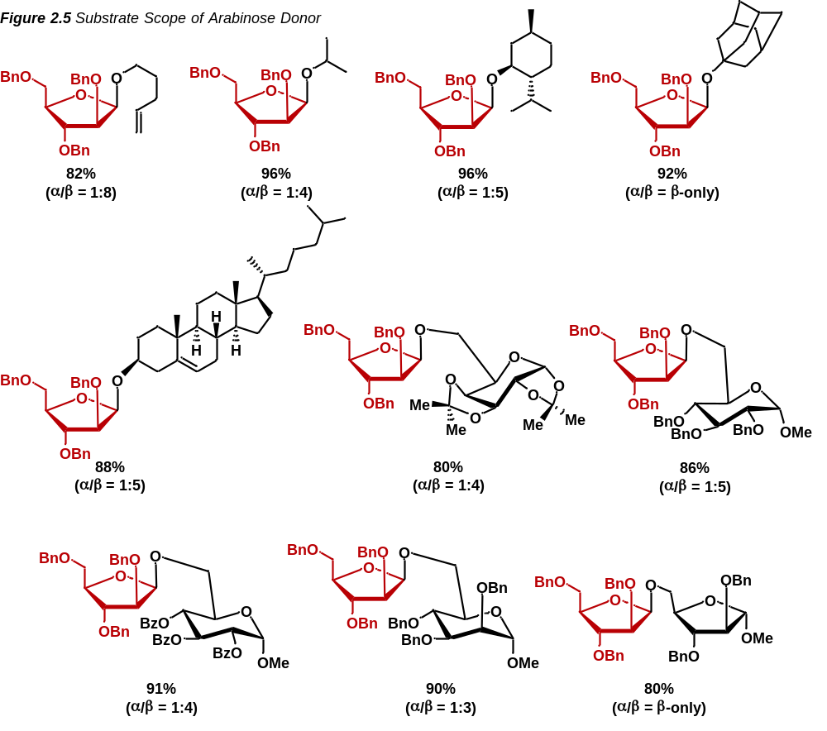
2.11 Additional Examples
To verify that the observed selectivity was tied to the C2 group on our donor, we synthesized an L-arabinose donor and subjected it to a range of alcohol acceptors. To our delight, the reaction maintained the β-1,2-cis selectivity throughout that was observed in the D-arabinose donors. We commenced with the 1,2:3,4-di-O-isopropylidene-α-D-galactopyranoside acceptor which in the D-arabinose donor furnished the desired product in an 80% yield with a diastereoselectivity of 1:4 (α:β). In the L-arabinose case, we saw similar yields (78%) and diastereoselectivity (1:3, α:β). Delighted by this result, we moved to the disarmed methyl 2,3,4-tri-O-benzoyl glucopyranoside acceptor. In this case, catalyst loading needed to be increased (to 30 mol% vs the typical 10 mol%), however, yields were moderate at 72% and diastereoselectivity was maintained with 1:4 (α:β). Finally, disarmed methyl 2,3,4-tri-O-benzoyl mannopyranoside acceptor reacted cleanly (again, with a loading of 30 mol%) to produce the desired product in an 84% yield with a diastereoselectivity of 1:4 (α:β).
We also sought to determine if 1,2-trans furanosides could be synthesized selectively under our conditions. For this, we synthesized a benzoyl-protected ribose donor to analyze whether anchimeric assistance from the C2 position could help promote a 1,2-trans selectivity. We took this donor and employed methyl 2,3,4-tri-O-benzyl glucopyranoside as the acceptor with 30 mol% of our copper(I) catalyst. Under these conditions, the reaction produced the desired product in a 61% yield in an exclusively β-1,2-trans configuration.
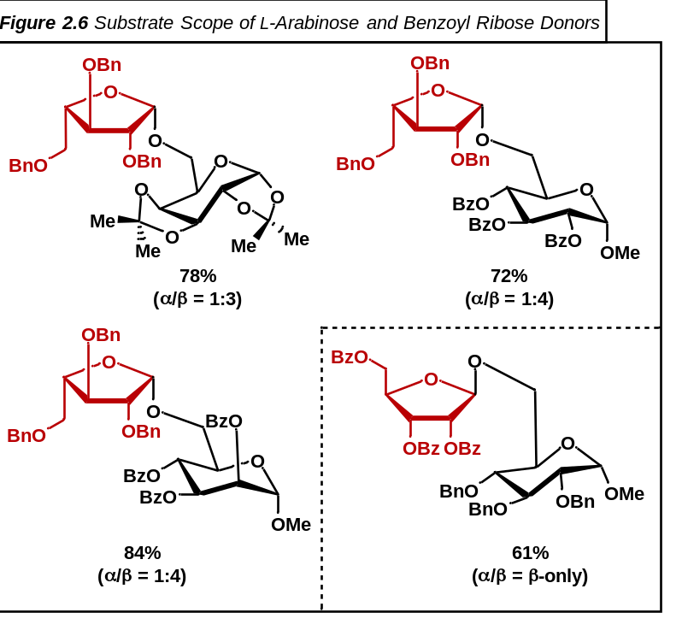

2.12 Manipulation of the Electronics of the Donor
We also endeavored to discover if the electronics of the aromatic ring could affect the rate of the reaction and so synthesized a range of donors with varied electronic configurations at the aromatic ring, para to the ester. We began with the electron-donating, para-methoxy, donor. While yield remained high (90% when compared to the 96% of the parent donor), we observed no change in either rate or diastereoselectivity. This was again reflected in our electron-withdrawing, para-nitro, donor which again maintained a high yield of the reaction (94%) with no change in diastereoselectivity or reaction rate. This indicates that the insertion of the ester carbonyl into the carbene is likely not the rate limiting step of the reaction.
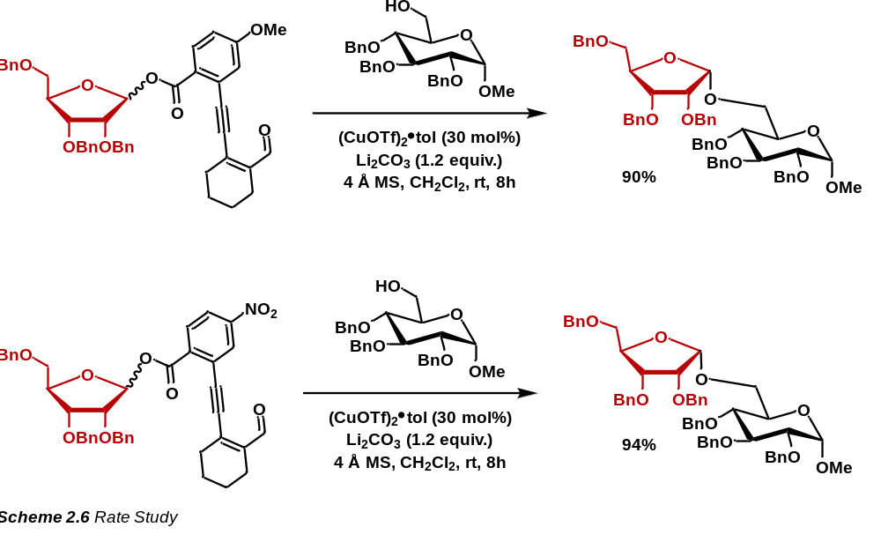

2.13 Analysis of the C2 Protecting Group of the Donor
To probe our mechanism of diastereoselectivity, we sought to manipulate the C2 protecting group. We suspected that coordination between the copper species and the π-aryl component of the benzyl rings may be contributing to the observed diastereoselectivity and so, to analyze this, we synthesized a C2 methoxy protected donor. To our surprise, in this case, the reaction proceeded cleanly with only a slight decrease in yield (92% when compared to the 96% of the parent conditions), however, maintaining the observed diastereoselectivity (α:β = 9:1). This seemed to indicate that the copper may not be coordinating to the π-aryl system, rather, to the oxygen atom of the C2 group. To examine this, a strongly electron-donating, C2 triisopropylsilyloxy protected donor was synthesized. As these silyl groups place a larger δ- on the adjoining oxygen atom, we should expect higher coordination between the oxygen atom and the copper catalyst leading to larger diastereoselectivity. We were then excited to find that the diastereoselectivity increased dramatically to a nearly diastereospecific result (α:β = >20:1). This was even more encouraging as the yield of the reaction was found to be 88%. These results help lend credibility to our hypothesis that coordination of the copper catalyst to the C2 oxygen atom is responsible for the observed diastereoselectivity. This would later be confirmed by computational studies into the manner.
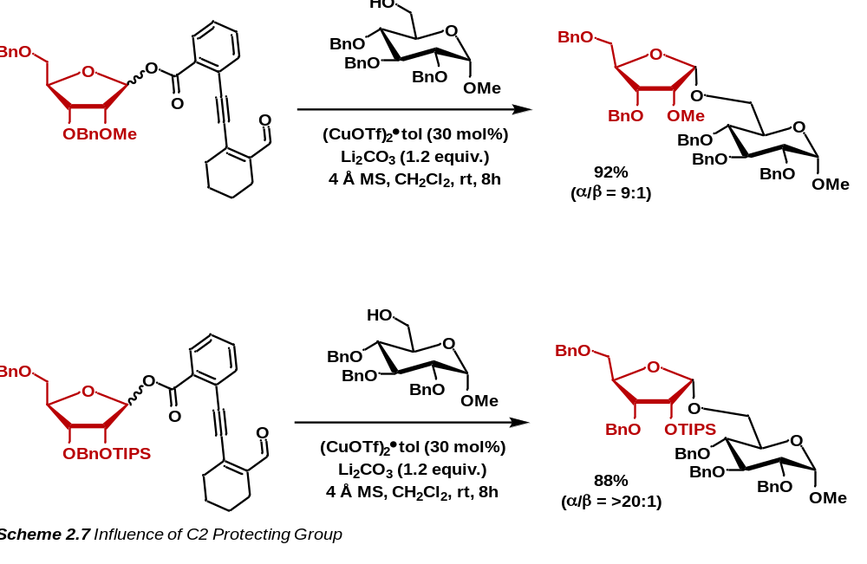
2.14 References for Chapter 2
[1] Fischer, E. Ueber Die Configuration Des Traubenzuckers Und Seiner Isomeren. Berichte der deutschen chemischen Gesellschaft 1891, 24 (1), 1836–1845. DOI: 10.1002/cber.189102401311.
[2] Tiwari, V. K.; Mishra, B. B. Opportunity, Challenge and Scope of Natural Products in Medicinal Chemistry; Research Signpost, 2011.
[3] Wang, J.; Zhang, Y.; Lu, Q.; Xing, D.; Zhang, R. Exploring Carbohydrates for Therapeutics: A Review on Future Directions. Frontiers in Pharmacology 2021, 12. DOI: 10.3389/fphar.2021.756724.
[4] Stratton, C. F.; Newman, D. J.; Tan, D. S. Cheminformatic Comparison of Approved Drugs from Natural Product versus Synthetic Origins. Bioorg. Med. Chem. Lett. 2015, 25 (21), 4802–4807. DOI: 10.1016/j.bmcl.2015.07.014.
[5] Lindberg, B. Components of Bacterial Polysaccharides. Advances in Carbohydrate Chemistry and Biochemistry 1990, 279–318. DOI: 10.1016/s0065-2318(08)60033-5.
[6] Brennan, P. J.; Nikaido, H. The Envelope of Mycobacteria. Annual Review of Biochemistry 1995, 64 (1), 29–63. DOI: 10.1146/annurev.bi.64.070195.000333.
[7] Crick, D. C.; Mahapatra, S.; Brennan, P. J. Biosynthesis of the Arabinogalactan-Peptidoglycan Complex of Mycobacterium Tuberculosis. Glycobiology 2001, 11 (9). DOI: 10.1093/glycob/11.9.107r.
[8] Peltier, P.; Euzen, R.; Daniellou, R.; Nugier-Chauvin, C.; Ferrières, V. Recent Knowledge and Innovations Related to Hexofuranosides: Structure, Synthesis and Applications. Carbohydrate Research 2008, 343 (12), 1897–1923. DOI: 10.1016/j.carres.2008.02.010.
[9] Tefsen, B.; Ram, A. F.; van Die, I.; Routier, F. H. Galactofuranose in Eukaryotes: Aspects of Biosynthesis and Functional Impact. Glycobiology 2011, 22 (4), 456–469. DOI: 10.1093/glycob/cwr144.
[10] Lowary, T. L. Twenty Years of Mycobacterial Glycans: Furanosides and Beyond. Accounts of Chemical Research 2016, 49 (7), 1379–1388. DOI: 10.1021/acs.accounts.6b00164.
[11] Christina, A. E.; van den Bos, L. J.; Overkleeft, H. S.; van der Marel, G. A.; Codée, J. D. Galacturonic Acid Lactones in the Synthesis of All Trisaccharide Repeating Units of the Zwitterionic Polysaccharide SP1. The Journal of Organic Chemistry 2011, 76 (6), 1692–1706. DOI: 10.1021/jo102363d.
[12] Imamura, A.; Lowary, T. Chemical Synthesis of Furanose Glycosides. Trends in Glycoscience and Glycotechnology 2011, 23 (131), 134–152. DOI: 10.4052/tigg.23.134.
[13] Nigudkar, S. S.; Demchenko, A. V. Stereocontrolled 1,2-Cis Glycosylation as the Driving Force of Progress in Synthetic Carbohydrate Chemistry. Chemical Science 2015, 6 (5), 2687–2704. DOI: 10.1039/c5sc00280j.
[14] Mensink, R. A.; Boltje, T. J. Advances in Stereoselective 1,2‐Cis Glycosylation Using C‐2 Auxiliaries. Chemistry – A European Journal 2017, 23 (70), 17637–17653. DOI: 10.1002/chem.201700908.
[15] Houseknecht, J. B.; Lowary, T. L. Chemistry and Biology of Arabinofuranosyl- and Galactofuranosyl-Containing Polysaccharides. Current Opinion in Chemical Biology 2001, 5 (6), 677–682. DOI: 10.1016/s1367-5931(01)00265-4.
[16] Zhu, S.-Y.; Yang, J.-S. Synthesis of Tetra- and Hexasaccharide Fragments Corresponding to the O-Antigenic Polysaccharide of Klebsiella Pneumoniae. Tetrahedron 2012, 68 (20), 3795–3802. DOI: 10.1016/j.tet.2012.03.074.
[17] Bols, M.; Hansen, H. C. Long Range Intramolecular Glycosidation. Chemistry Letters 1994, 23 (6), 1049–1052. DOI: 10.1246/cl.1994.1049.
[18] Krog-Jensen, C.; Oscarson, S. Stereospecific Synthesis of β-D-Fructofuranosides Using the Internal Aglycon Delivery Approach. The Journal of Organic Chemistry 1996, 61 (14), 4512–4513. DOI: 10.1021/jo960776b.
[19] Désiré, J.; Prandi, J. Synthesis of Methyl β-D-Arabinofuranoside 5-[1D (and l)-Myo-Inositol 1-Phosphate], the Capping Motif of the Lipoarabinomannan of Mycobacteriumsmegmatis. Carbohydrate Research 1999, 317 (1–4), 110–118. DOI: 10.1016/s0008-6215(99)00078-6.
[20] Bamhaoud, T.; Sanchez, S.; Prandi, J. 1,2,5-Ortho Esters of D-Arabinose as Versatile Arabinofuranosidic Building Blocks. Concise Synthesis of the TETRASACCHARIDIC Cap of the Lipoarabinomannan of Mycobacterium Tuberculosis. Chemical Communications 2000, No. 8, 659–660. DOI: 10.1039/b000873g.
[21] Fairbanks, A. J. Intramolecular Aglycon Delivery (IAD): The Solution to 1,2-Cis Stereocontrol for Oligosaccharide Synthesis? Synlett 2003, No. 13, 1945–1958. DOI: 10.1055/s-2003-42056.
[22] Cumpstey, I. Intramolecular Aglycon Delivery. Carbohydrate Research 2008, 343 (10–11), 1553–1573. DOI: 10.1016/j.carres.2008.04.031.
[23] Ishiwata, A.; Munemura, Y.; Ito, Y. Nap Ether Mediated Intramolecular Aglycon Delivery: A Unified Strategy for 1,2‐Cis‐glycosylation. European Journal of Organic Chemistry 2008, 2008 (25), 4250–4263. DOI: 10.1002/ejoc.200800249.
[24] Yasomanee, J. P.; Demchenko, A. V. Effect of Remote Picolinyl and PICOLOYL Substituents on the Stereoselectivity of Chemical Glycosylation. Journal of the American Chemical Society 2012, 134 (49), 20097–20102. DOI: 10.1021/ja307355n.
[25] Liu, Q.-W.; Bin, H.-C.; Yang, J.-S. β-Arabinofuranosylation Using 5-O-(2-Quinolinecarbonyl) Substituted Ethyl Thioglycoside Donors. Organic Letters 2013, 15 (15), 3974–3977. DOI: 10.1021/ol401755e.
[26] Imamura, A.; Lowary, T. Chemical Synthesis of Furanose Glycosides. Trends in Glycoscience and Glycotechnology 2011, 23 (131), 134–152. DOI: 10.4052/tigg.23.134.
[27] Zhu, X.; Kawatkar, S.; Rao, Y.; Boons, G.-J. Practical Approach for the Stereoselective Introduction of β-Arabinofuranosides. Journal of the American Chemical Society 2006, 128 (36), 11948–11957. DOI: 10.1021/ja0629817.
[28] Crich, D.; Pedersen, C. M.; Bowers, A. A.; Wink, D. J. On the Use of 3,5-O-Benzylidene and 3,5-O-(Di-Tert-Butylsilylene)-2-O-Benzylarabinothiofuranosides and Their Sulfoxides as Glycosyl Donors for the Synthesis of β-Arabinofuranosides: Importance of the Activation Method. The Journal of Organic Chemistry 2007, 72 (5), 1553–1565. DOI: 10.1021/jo061440x.
[29] Wang, Y.; Maguire-Boyle, S.; Dere, R. T.; Zhu, X. Synthesis of β-D-Arabinofuranosides: Stereochemical Differentiation between D- and L-Enantiomers. Carbohydrate Research 2008, 343 (18), 3100–3106. DOI: 10.1016/j.carres.2008.09.006.
[30] Imamura, A.; Lowary, T. L. β-Selective Arabinofuranosylation Using a 2,3-O-Xylylene-Protected Donor. Organic Letters 2010, 12 (16), 3686–3689. DOI: 10.1021/ol101520q.
[31] Tilve, M. J.; Gallo-Rodriguez, C. Glycosylation Studies on Conformationally Restricted 3,5-O-(Di-Tert-Butylsilylene)-D-Galactofuranosyl Trichloroacetimidate Donors for 1,2-Cis α-D-Galactofuranosylation. Carbohydrate Research 2011. DOI: 10.1016/j.carres.2011.10.004.
[32] Lavinda, O.; Tran, V. T.; Woerpel, K. A. Effect of Conformational Rigidity on the Stereoselectivity of Nucleophilic Additions to Five-Membered Ring Bicyclic Oxocarbenium Ion Intermediates. Org. Biomol. Chem. 2014, 12 (36), 7083–7091. DOI: 10.1039/c4ob01251h.
[33] Zhang, L.; Shen, K.; Taha, H. A.; Lowary, T. L. Stereocontrolled Synthesis of α-Xylofuranosides Using a Conformationally Restricted Donor. The Journal of Organic Chemistry 2018, 83 (15), 7659–7671. DOI: 10.1021/acs.joc.8b00410.
[34] Xu, H.; Schaugaard, R. N.; Li, J.; Schlegel, H. B.; Nguyen, H. M. Stereoselective 1,2-Cis Furanosylations Catalyzed by Phenanthroline. Journal of the American Chemical Society 2022, 144 (16), 7441–7456. DOI: 10.1021/jacs.2c02063.
[35] Ma, X.; Zhang, Y.; Zhu, X.; Zhang, L. An S_{N}2-Type Strategy toward 1,2-Cis-Furanosides. CCS Chemistry 2022, 4 (12), 3677–3685. DOI: 10.31635/ccschem.022.202202175.
[36] Meng, L.; Wu, P.; Fang, J.; Xiao, Y.; Xiao, X.; Tu, G.; Ma, X.; Teng, S.; Zeng, J.; Wan, Q. Glycosylation Enabled by Successive Rhodium(II) and Brønsted Acid Catalysis. Journal of the American Chemical Society 2019, 141 (30), 11775–11780. DOI: 10.1021/jacs.9b04619.
[37] Hoffman, R. V.; Shechter, H. Carbenic, Cationic, Metal Ion Catalyzed, and Photolytic Decompositions of Ethyl (2-Furyl)Diazoacetate. Journal of the American Chemical Society 1978, 100 (25), 7934–7940. DOI: 10.1021/ja00493a024.
[38] Nakatani, K.; Maekawa, S.; Tanabe, K.; Saito, I. Alpha-Diazo Ketones as Photochemical DNA Cleavers: A Mimic for the Radical Generating System of Neocarzinostatin Chromophore. Journal of the American Chemical Society 1995, 117 (43), 10635–10644. DOI: 10.1021/ja00148a005.
[39] Karlsson, J. O.; Nghi V. Nguyen; Foland, L. D.; Moore, H. W. (2-Alkynylethenyl)Ketenes. A New Quinone Synthesis. Journal of the American Chemical Society 1985, 107 (11), 3392–3393. DOI: 10.1021/ja00297a081.
[40] Nakatani, K.; Tanabe, K.; Saito, I. Novel Synthesis of Bifurans via Furan-Forming Photocyclization of α-Diketones Conjugated with ENE-Yne. Tetrahedron Letters 1997, 38 (7), 1207–1210. DOI: 10.1016/s0040-4039(97)00018-x.
[41] Uchiro, H.; Mukaiyama, T. A Significant Effect of a Lithium Salt in the Stereocontrolled Synthesis of α-D-Ribofuranosides. Chemistry Letters 1996, 25 (4), 271–272. DOI: 10.1246/cl.1996.271.
[42] Tschan, M. J. ‐L.; Thomas, C. M.; Strub, H.; Carpentier, J. Copper(II) Triflate as a Source of Triflic Acid: Effective, Green Catalysis of Hydroalkoxylation Reactions. Advanced Synthesis Catalysis 2009, 351 (14–15), 2496–2504. DOI: 10.1002/adsc.200800750.
2.15 EXPERIMENTAL SECTION FOR CHAPTER 2

MATERIALS AND METHODS

Reagents
Reagents and solvents were obtained from Sigma-Aldrich, Chem-Impex, VWR International, and Acros Organics and used without further purification unless otherwise indicated. Dichloromethane and Acetonitrile were distilled over CaH under N₂ unless stated otherwise. Tetrahydrofuran was distilled over Na under N₂ with benzophenone indicator.

Reagents
All reactions were performed in oven-dried glassware under positive N₂ Pressure with magnetic stirring unless otherwise noted.

Chromatography

Thin layer chromatography (TLC) was performed on 0.25 mm E. Merck silica gel 60 F254 plates and visualized under UV light (254 nm) or by staining with potassium permanganate (KMnO₄), cerium ammonium molybdate (CAM), phosphomolybdic acid (PMA), and ninhydrin. Silica flash chromatography was performed on Sorbtech 230-400 mesh silica gel 60.

Analytical Instrumentation

NMR spectra were recorded on a Varian VNMRS 300, 400, 500, and 600 MHz NMR spectrometer at 20 ºC in CDCl₃ unless otherwise indicated. Chemical shifts are expressed in ppm relative to solvent signals: CDCl₃ (¹H, 7.26 ppm, ¹³C, 77.0 ppm); coupling constants are expressed in Hz. IR spectra were recorded on a Cary 760 FTIR spectrometer with peaks reported in cm⁻¹. Mass spectra were obtained on an Advion Expression CMS TLC Mass Spectrometer.

Nomenclature

Chemical structure named in accordance with IUPAC guidelines, automatically generated using ChemDraw 20.1

Additional Information and Considerations

Syringe pump addition reactions were conducted using a Harvard Apparatus (Model: 55- 1111) or a New Era Pump Systems, Inc. (Model: NE-300) syringe pump. Sonication was performed using a Bransonic Ultrasonic Cleaner (Model: M5800H).

Publication and Contributions Statement
The research presented in this chapter was published in ACS Catalysis 2024 14 (2), 1037-1049.
DOI: 10.1021/acscatal.3c05237 as the second author. All materials and procedures are contributions by A. Alber and Bidhan Ghosh.

2.15.1 Synthesis of Enynal Donor
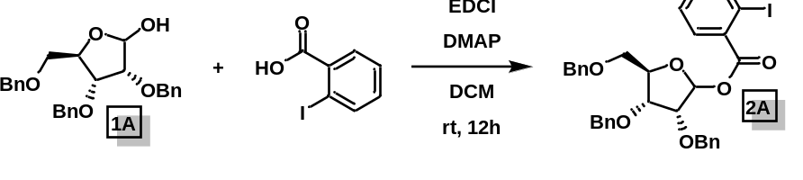
(3R,4R,5R)-3,4-bis(benzyloxy)-5-((benzyloxy)methyl)tetrahydrofuran-2-yl 2-iodobenzoate (2A): To an oven-dried round-bottom flask containing a magnetic stirring bar, were added furanosyl anomeric alcohol (1 equiv.), commercially available 2-iodobenzoic acid (1.2 equiv.), EDCI (2 equiv.), DMAP (0.2 equiv.) and DCM (10 mL/mmol). The reaction mixture was stirred at room temperature for 6 h. After completion, it was diluted with dichloromethane; washed with water and brine. The organic layer was dried over sodium sulfate, concentrated in vacuo, and purified by silica gel flash chromatography (ethyl acetate/hexane: 10% → 15%) to give the desired product.
¹H NMR (500 MHz, CDCl₃) δ 8.04 – 7.99 (m, 0.7H), 7.96 (dd, J = 7.9, 1.1 Hz, 1H), 7.67 (dd, J = 7.8, 1.6 Hz, 1H), 7.49 – 7.45 (m, 2H), 7.41 – 7.28 (m, 11H), 7.28 – 7.24 (m, 5H), 7.23 – 7.19 (m, 1H), 7.16 – 7.11 (m, 1.4H), 6.63 (d, J = 4.1 Hz, 0.25H), 6.49 (s, 1H), 4.88 (d, J = 12.0 Hz, 1H), 4.81 (d, J = 11.6 Hz, 0.4H), 4.73 (d, J = 12.2 Hz, 1.4H), 4.67 – 4.61 (m, 0.7H), 4.59 – 4.47 (m, 5H), 4.43 (d, J = 11.9 Hz, 1H), 4.32 (dd, J = 8.2, 4.5 S5 Hz, 1H), 4.17 – 4.15 (m, 0.4H), 4.13 (d, J = 4.6 Hz, 1H), 4.07 – 4.05 (m, 0.3H), 3.79 (dd, J = 11.1, 3.0 Hz, 1H), 3.67 (dd, J = 11.1, 4.4 Hz, 1H), 3.55 (d, J = 3.7 Hz, 0.5H).
¹³C NMR (125 MHz, CDCl₃) δ 165.18, 141.44, 141.35, 138.25, 137.62, 137.35, 134.54, 132.95, 132.64, 131.55, 128.62, 128.56, 128.52, 128.47, 128.41, 128.38, 128.18, 128.07, 128.01, 127.91, 127.88, 127.74, 127.69, 127.61, 127.57, 100.32, 96.05, 94.13, 84.81, 81.91, 78.87, 78.49, 77.36, 76.45, 76.22, 73.67, 73.36, 73.19, 72.93, 72.49, 72.28, 70.00, 69.67.
HRMS (ESI): calc. for C₃₃H₃₁IO₆Na (M+Na): 673.1063; found: 673.1038.

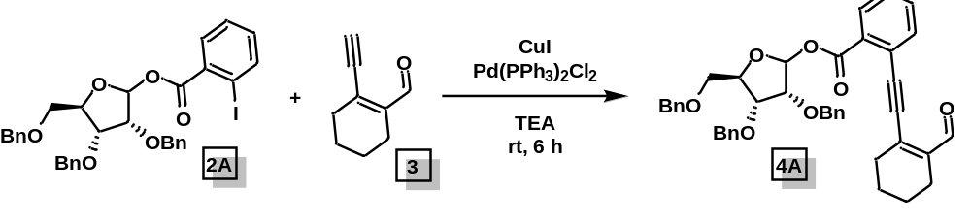
(3R,4R,5R)-3,4-bis(benzyloxy)-5-((benzyloxy)methyl)tetrahydrofuran-2-yl-2-((2-formylcyclohex-1-en-1-yl)ethynyl)benzoate (4A): To a flame-dried Schlenk flask containing a magnetic stirring bar, were added the iodobenzoate (2A) (1.0 equiv.), enynal 3 (1.2 equiv.), Pd(PPh₃)₂Cl₂ (15 mol %) and CuI (10 mol %). The flask was vacuumed and filled with argon three times before adding degassed Et₃N (~0.05 M). The mixture was stirred at room temperature for 6 h. After completion, it was diluted with EtOAc, filtered through celite, washed with saturated Na₂CO₃ aqueous solution, H₂O, and brine. The organic layer was dried over sodium sulfate, concentrated in vacuo, and the crude was purified by flash column chromatography (ethyl acetate/hexane: 5 → 10%) to yield the pure donor 4A (Rf = 0.3 in 85:15 hexane: ethyl acetate; α:β = 1:4, 290 mg, 88%).
¹H NMR (400 MHz, CDCl₃) δ 10.40 (s, 1H), 8.11 (dd, J = 8.0, 1.3 Hz, 0.3H), 7.76 (dd, J = 8.0, 1.2 Hz, 1H), 7.56 (dd, J = 7.9, 1.3 Hz, 1H), 7.50 – 7.41 (m, 3.3H), 7.38 – 7.25 (m, 10H), 7.24 – 7.19 (m, 5H), 7.18 – 7.11 (m, 1.4H), 6.61 (d, J = 4.1 Hz, 0.24H), 6.47 (s, 1H), 4.86 (d, J = 12.2 Hz, 1H), 4.78 (s, 0.3H), 4.71 (d, J = 12.2 Hz, 1H), 4.64 – 4.41 (m, 6.5H), 4.30 (dd, J = 8.0, 4.5 Hz, 1H), 4.16 – 4.11 (m, 0.4H), 4.08 (d, J = 4.5 Hz, 1H), 4.04 (dd, J = 6.1, 2.2 Hz, 0.3H), 3.77 (dd, J = 11.1, 2.9 Hz, 1H), 3.65 (dd, J = 11.2, 4.0 Hz, 1H), 3.52 (d, J = 3.7 Hz, 0.4H), 2.57 – 2.54 (m, 2.4H), 2.36 – 2.27 (m, 2.4H), 1.77 – 1.63 (m, 4.8H).
¹³C NMR (100 MHz, CDCl₃) δ 193.62, 163.90, 143.59, 139.93, 138.29, 137.67, 137.55, 134.30, 132.28, 130.93, 130.90, 128.68, 128.58, 128.53, 128.52, 128.40, 128.32, 128.09, 128.02, 127.91, 127.60, 127.58, 123.53, 99.91, 96.88, 91.70, 81.80, 78.83, 76.77, 73.40, 72.59, 72.25, 69.52, 32.17, 22.29, 22.03, 21.17.
HRMS (ESI): calc. for C₄₂H₄₀O₇Na (M+Na): 679.2672; found: 679.2650.

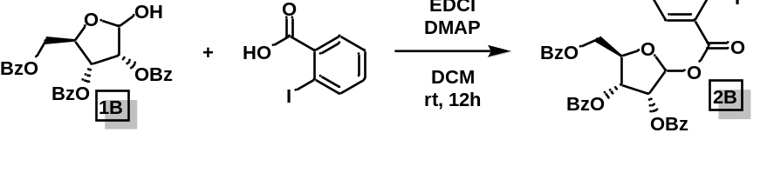
(2R,3R,4R)-2-((benzoyloxy)methyl)-5-((2-iodobenzoyl)oxy)tetrahydrofuran-3,4-diyl dibenzoate (2B): The titular compound was synthesized in accordance to the procedure outlined for 2A. The crude was purified by flash chromatography (ethyl acetate/hexane: 10 → 20%) to give pure 2B (Rf = 0.3 in 80:20 hexane: ethyl acetate; 86%).
¹H NMR (500 MHz, CDCl₃) δ 8.13 (dd, J = 8.1, 1.4 Hz, 0.6H), 8.07 – 8.03 (m, 2.6H), 8.01 – 7.93 (m, 4H), 7.93 – 7.88 (m, 2H), 7.81 (dd, J = 7.8, 1.8 Hz, 1H), 7.65 – 7.59 (m, 2H), 7.58 – 7.50 (m, 2H), 7.46 (t, J = 7.8 Hz, 4H), 7.40 (t, J = 7.8 Hz, 1H), 7.38 – 7.29 (m, 5H), 7.25 – 7.15 (m, 5H), 6.69 (s, 1H), 6.08 – 6.03 (m, 2.6H), 4.89 (q, J = 4.3 Hz, 2H), 4.79 (dt, J = 12.2, 4.1 Hz, 2H), 4.58 (dd, J = 12.2, 4.4 Hz, 1.6H).
¹³C NMR (125 MHz, CDCl₃) δ 166.19, 165.49, 165.16, 164.64, 141.97, 141.74, 133.87, 133.79, 133.73, 133.69, 133.65, 133.57, 133.54, 133.41, 133.36, 133.31, 133.20, 131.76, 131.70, 131.62, 130.10, 130.07, S6 130.03, 129.99, 129.97, 129.90, 129.88, 129.83, 129.80, 129.47, 128.91, 128.79, 128.75, 128.72, 128.65, 128.57, 128.54, 128.42, 128.39, 128.37, 128.13, 128.11, 127.84, 99.64, 94.52, 80.26, 75.03, 71.41, 63.78.
HRMS (ESI): calc. for C₃₃H₂₅IO₉Na (M+Na): 715.0441; found: 715.0446.
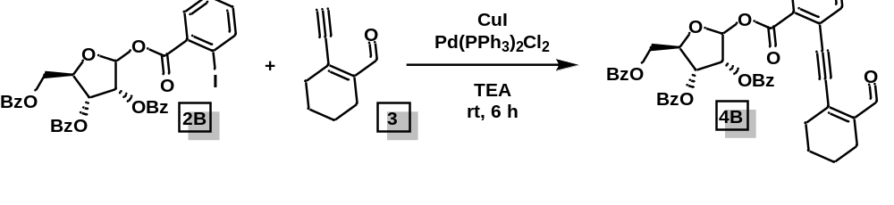
(2R,3R,4R)-2-((benzoyloxy)methyl)-5-((2-((2-formylcyclohex-1-en-1-yl)ethynyl)benzoyl)oxy)tetrahydrofuran-3,4-diyl dibenzoate (4B): The titular compound was synthesized in accordance to the procedure outlined for 4A. The crude was purified by flash chromatography (ethyl acetate/hexane: 10 → 20%) to give pure donor 4B (Rf = 0.2 in 80:20 hexane: ethyl acetate; α:β = 1:3, 85%).
¹H NMR (400 MHz, CDCl₃) δ 10.42 (s, 1H), 10.39 (s, 0.25H), 8.01 (dd, J = 8.0, 1.3 Hz, 1H), 7.90 (dd, J = 8.0, 1.3 Hz, 0.3H), 7.60 (dd, J = 7.8, 1.3 Hz, 1.5H), 7.52 (td, J = 7.6, 1.5 Hz, 1.5H), 7.38 – 7.23 (m, 22H), 6.60 (d, J = 3.5 Hz, 0.3H), 6.54 (s, 1H), 4.76 (d, J = 12.0 Hz, 1H), 4.72 – 4.69 (m, 0.6H), 4.60 (d, J = 9.1 Hz, 4H), 4.56 – 4.46 (m, 3H), 4.33 (t, J = 4.3 Hz, 1H), 4.25 (d, J = 2.0 Hz, 1H), 4.06 (dd, J = 5.1, 1.8 Hz, 1H), 3.66 (dt, J = 10.0, 5.0 Hz, 2.7H), 2.56 (td, J = 5.9, 2.5 Hz, 2.7H), 2.32 (td, J = 6.1, 2.6 Hz, 2.8H), 1.74 – 1.63 (m, 6H).
¹³C NMR (100 MHz, CDCl₃) δ 193.54, 166.15, 165.46, 165.15, 163.64, 143.68, 139.79, 134.41, 133.85, 133.73, 133.23, 132.62, 130.86, 130.34, 130.06, 130.03, 129.93, 129.90, 129.78, 129.48, 128.90, 128.80, 128.74, 128.70, 128.57, 128.51, 128.40, 128.38, 123.76, 99.33, 96.54, 92.02, 80.15, 75.18, 71.43, 63.72, 32.14, 22.28, 21.99, 21.11.
HRMS (ESI): calc. for C₄₂H₃₄O₁₀Na (M+Na): 721.2050; found: 721.2057.

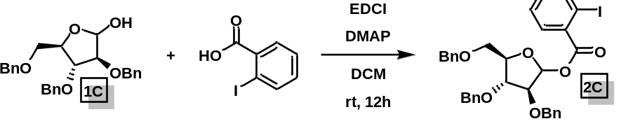
(3R,4R,5R)-3,4-bis(benzyloxy)-5-((benzyloxy)methyl)tetrahydrofuran-2-yl-2-iodobenzoate (2C): The titular compound was synthesized in accordance to the procedure outlined for 2A. The crude was purified by flash chromatography (ethyl acetate/hexane: 5 → 10%) to give pure 2C (Rf = 0.4 in 80:20 hexane: ethyl acetate; α:β = 2:1, 560 mg, 86%).
¹H NMR (400 MHz, CDCl₃) δ 8.04 – 7.98 (m, 1.4H), 7.86 (dd, J = 7.8, 1.7 Hz, 1H), 7.77 (dd, J = 7.8, 1.7 Hz, 0.5H), 7.40 – 7.27 (m, 20H), 7.23 (dd, J = 7.6, 1.2 Hz, 0.4H), 7.19 – 7.12 (m, 1.6H), 6.60 (d, J = 3.7 Hz, 0.5H), 6.56 (s, 1H), 4.80 – 4.72 (m, 2H), 4.67 – 4.60 (m, 4H), 4.56 – 4.51 (m, 4H), 4.39 – 4.23 (m, 2.5H), 4.08 (dd, J = 5.2, 1.8 Hz, 1H), 3.72 – 3.64 (m, 3H).
¹³C NMR (100 MHz, CDCl₃) δ 165.13, 165.04, 141.54, 138.01, 137.99, 137.95, 137.57, 137.32, 137.24, 134.10, 133.09, 132.95, 131.81, 131.62, 128.59, 128.56, 128.49, 128.46, 128.44, 128.17, 128.14, 128.10, 128.09, 128.00, 127.96, 127.94, 127.90, 127.88, 127.86, 127.84, 127.76, 127.73, 127.71, 101.64, 95.68, 94.56, 94.42, 86.52, 84.17, 84.02, 83.84, 81.49, 81.31, 73.53, 73.41, 73.32, 72.64, 72.19, 72.17, 70.94, 69.71.
HRMS (ESI): calc. for C₃₃H₃₁IO₆Na (M+Na): 673.1063; found: 673.1042.

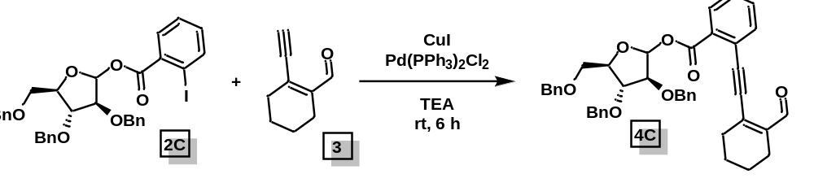
(3S,4R,5R)-3,4-bis(benzyloxy)-5-((benzyloxy)methyl)tetrahydrofuran-2-yl-2-((2-formylcyclohex-1-en-1-yl)ethynyl)benzoate (4C): The titular compound was synthesized in accordance to the procedure outlined for 1C. The crude was purified by flash chromatography (ethyl acetate/hexane: 5 → 10%) to give pure donor 4C (Rf = 0.3 in 85:15 hexane: ethyl acetate; α:β = 1:3, 280 mg, 85%).
¹H NMR (400 MHz, CDCl₃) δ 10.42 (s, 1H), 10.39 (s, 0.3H), 8.01 (dd, J = 8.0, 1.3 Hz, 1H), 7.90 (dd, J = 8.0, 1.3 Hz, 0.3H), 7.60 (dd, J = 7.8, 1.3 Hz, 1.5H), 7.52 (td, J = 7.6, 1.5 Hz, 1.6H), 7.37 – 7.23 (m, 22H), 7.24 (s, 1H), 6.60 (d, J = 3.5 Hz, 0.3H), 6.54 (s, 1H), 4.76 (d, J = 12.0 Hz, 1H), 4.73 – 4.46 (m, 10H), 4.33 (t, J = 4.3 Hz, 0.7H), 4.25 (d, J = 2.0 Hz, 1.3H), 4.06 (dd, J = 5.1, 1.8 Hz, 1H), 3.71 – 3.63 (m, 2.7H), 2.60 – 2.51 (m, 2.7H), 2.35 – 2.28 (m, 2.7H), 1.74 – 1.63 (m, 6H).
¹³C NMR (100 MHz, CDCl₃) δ 193.75, 193.63, 164.10, 164.04, 143.48, 143.44, 139.94, 138.02, 137.96, 137.63, 137.36, 134.30, 134.23, 132.35, 132.15, 131.21, 130.98, 130.92, 128.70, 128.56, 128.50, 128.48, 128.46, 128.43, 128.17, 128.06, 128.03, 128.00, 127.92, 127.86, 127.85, 127.78, 127.75, 127.71, 127.69, 123.50, 101.19, 96.93, 91.65, 91.58, 86.74, 84.09, 84.01, 83.81, 81.56, 81.38, 73.55, 72.17, 72.15, 69.79, 32.10, 32.08, 22.23, 22.20, 21.96, 21.11.
HRMS (ESI): calc. for C₄₂H₄₀O₇Na (M+Na): 679.2672; found: 679.2654.

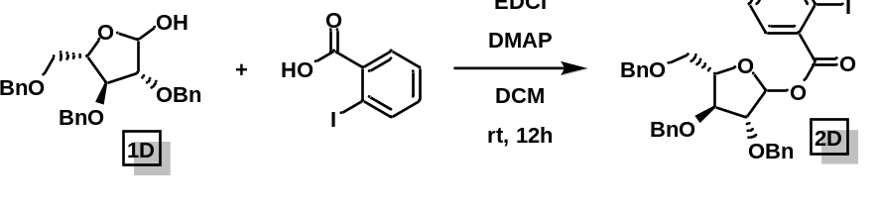
(3R,4S,5S)-3,4-bis(benzyloxy)-5-((benzyloxy)methyl)tetrahydrofuran-2-yl-2-iodobenzoate (2D): The titular compound was synthesized in accordance to the procedure outlined for 2A. The crude was purified by flash chromatography (ethyl acetate/hexane: 5 → 10%) to give pure 2D (Rf = 0.3 in 80:20 hexane: ethyl acetate; α:β = 2:1, 550 mg, 85%).
¹H NMR (400 MHz, CDCl₃) δ 8.00 (dd, J = 8.0, 1.2 Hz, 1H), 7.84 (dd, J = 7.8, 1.7 Hz, 1H), 7.40 – 7.27 (m, 16H), 7.15 (td, J = 7.7, 1.8 Hz, 1H), 6.54 (s, 1H), 4.75 (d, J = 11.9 Hz, 1H), 4.61 (d, J = 10.5 Hz, 3H), 4.51 (d, J = 6.2 Hz, 3H), 4.28 (d, J = 1.9 Hz, 1H), 4.06 (dd, J = 5.2, 1.8 Hz, 1H), 3.68 (dd, J = 5.3, 3.3 Hz, 2H).
¹³C NMR (100 MHz, CDCl₃) δ 165.17, 141.57, 138.04, 137.60, 137.27, 134.15, 133.12, 131.84, 128.62, 128.60, 128.52, 128.49, 128.17, 128.13, 128.03, 127.96, 127.93, 127.89, 127.79, 101.67, 94.44, 86.56, 84.19, 83.88, 73.57, 72.22, 72.21, 69.74.
HRMS (ESI): calc. for C₃₃H₃₁IO₆Na (M+Na): 673.1063; found: 673.1043.

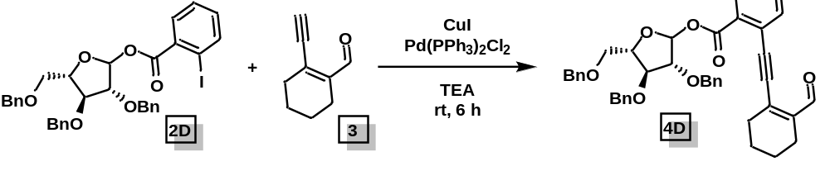
(3R,4S,5S)-3,4-bis(benzyloxy)-5-((benzyloxy)methyl)tetrahydrofuran-2-yl-2-((2-formylcyclohex-1-en-1-yl)ethynyl)benzoate (4D): The titular compound was synthesized in accordance to the procedure outlined for 4A. The donor was purified by flash chromatography (ethyl acetate/hexane: 5% → 10%) to give pure 4D (Rf = 0.4 in 80:20 hexane: ethyl acetate; 290 mg, 90%).
¹H NMR (400 MHz, CDCl₃) δ 10.42 (s, 1H), 10.40 (s, 1H), 8.03 – 7.99 (m, 1H), 7.90 (d, J = 8.0 Hz, 1H), 7.62 – 7.57 (m, 2H), 7.55 – 7.47 (m, 2H), 7.39 – 7.26 (m, 32H), 6.61 (d, J = 3.4 Hz, 1H), 6.54 (s, 1H), 4.80 – 4.47 (m, S8 16H), 4.36 – 4.30 (m, 2H), 4.26 – 4.23 (m, 2H), 4.06 (dd, J = 5.1, 1.9 Hz, 1H), 3.69 – 3.63 (m, 4H), 2.58 – 2.53 (m, 4H), 2.35 – 2.27 (m, 4H), 1.72 – 1.64 (m, 8H).
¹³C NMR (100 MHz, CDCl₃) δ 193.73, 193.62, 164.10, 164.03, 143.47, 143.44, 139.95, 139.92, 138.03, 138.02, 137.96, 137.63, 137.36, 134.29, 134.22, 132.34, 132.15, 131.24, 131.20, 130.97, 130.91, 128.71, 128.69, 128.56, 128.53, 128.50, 128.48, 128.46, 128.42, 128.05, 128.03, 128.01, 127.99, 127.96, 127.94, 127.91, 127.86, 127.84, 127.77, 127.75, 127.71, 127.69, 123.50, 101.19, 96.92, 96.90, 95.24, 91.65, 91.58, 86.74, 84.09, 84.01, 83.81, 81.56, 81.38, 73.55, 73.40, 73.24, 72.67, 72.17, 72.15, 70.92, 69.79, 32.10, 32.08, 22.23, 22.20, 21.96, 21.11.
HRMS (ESI): calc. for C₄₂H₄₀O₇Na (M+Na): 679.2672; found: 679.2654.

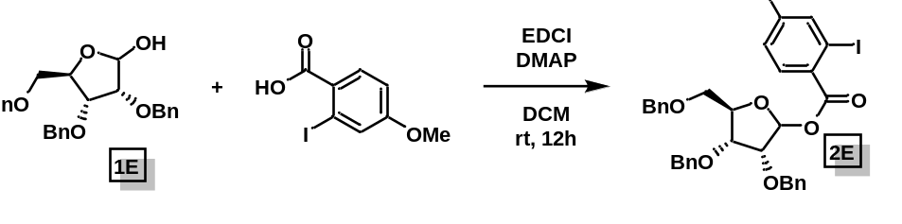
(3R,4R,5R)-3,4-bis(benzyloxy)-5-((benzyloxy)methyl)tetrahydrofuran-2-yl-2-iodo-4-methoxybenzoate (2E): The titular compound was synthesized in accordance to the procedure outlined for 2A. The crude was purified by flash chromatography (ethyl acetate/hexane: 5 → 10%) to give 2E (Rf = 0.3 in 80:20 hexane: ethyl acetate; 313 mg, 92%).
¹H NMR (500 MHz, CDCl₃) δ 8.06 (d, J = 8.8 Hz, 0.6H), 7.70 (d, J = 8.8 Hz, 1H), 7.51 (d, J = 2.6 Hz, 0.5H), 7.49 – 7.44 (m, 2.6H), 7.40 – 7.23 (m, 19H), 6.64 – 6.57 (m, 2.3H), 6.47 (s, 1H), 4.87 (d, J = 12.1 Hz, 1H), 4.80 (d, J = 11.5 Hz, 1H), 4.73 – 4.69 (m, 2H), 4.66 – 4.41 (m, 10.5H), 4.34 (dd, J = 8.1, 4.5 Hz, 1.5H), 4.15 – 4.04 (m, 3H), 3.83 – 3.79 (m, 6H), 3.78 (d, J = 2.9 Hz, 1H), 3.70 – 3.65 (m, 1.5H), 3.54 (d, J = 3.7 Hz, 1.5H).
¹³C NMR (125 MHz, CDCl₃) δ 164.13, 162.27, 162.25, 138.41, 138.35, 137.93, 137.72, 137.68, 137.44, 134.24, 133.40, 128.61, 128.57, 128.56, 128.54, 128.47, 128.43, 128.40, 128.17, 128.14, 128.07, 128.02, 127.99, 127.92, 127.88, 127.70, 127.65, 127.52, 127.20, 127.02, 113.67, 113.58, 99.83, 96.28, 95.83, 95.58, 84.68, 81.77, 78.87, 78.59, 76.47, 76.34, 73.68, 73.39, 73.12, 72.93, 72.50, 72.23, 70.04, 69.64.
HRMS (ESI): calc. for C₃₄H₃₃IO₇Na (M+Na): 703.1169; found: 703.1164.

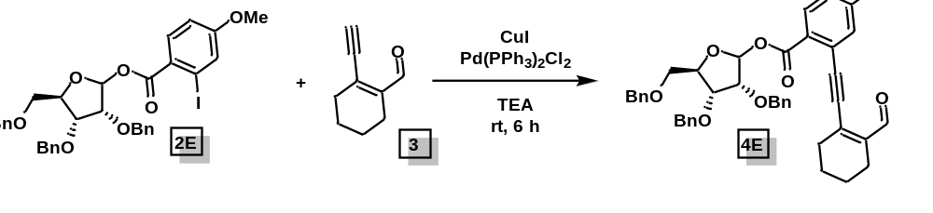
(3R,4R,5R)-3,4-bis(benzyloxy)-5-((benzyloxy)methyl)tetrahydrofuran-2-yl-2-((2-formylcyclohex-1-en-1-yl)ethynyl)-4-methoxybenzoate (4E): The titular compound was synthesized in accordance to the procedure outlined for 4A. The crude was purified by flash chromatography (ethyl acetate/hexane: 5 → 10%) to give pure donor 4E (Rf = 0.2 in 75:25 hexane: ethyl acetate; α:β = 1:4, 290 mg, 88%).
¹H NMR (500 MHz, CDCl₃) δ 10.42 (s, 1H), 7.72 (d, J = 8.8 Hz, 1.3H), 7.46 – 7.43 (m, 2H), 7.38 – 7.22 (m, 13H), 7.02 (d, J = 2.7 Hz, 1H), 6.59 (dd, J = 8.8, 2.7 Hz, 1.3H), 6.47 (s, 1H), 4.87 (d, J = 12.2 Hz, 1.5H), 4.71 (d, J = 12.2 Hz, 2H), 4.60 – 4.41 (m, 7H), 4.32 (dd, J = 7.9, 4.5 Hz, 1.6H), 4.08 (d, J = 4.5 Hz, 1.4H), 3.87 – 3.85 (m, 4H), 3.79 (dd, J = 11.2, 2.9 Hz, 1.3H), 3.66 (dd, J = 11.1, 3.9 Hz, 1.6H), 2.58 (tt, J = 4.1, 1.9 Hz, 3H), 2.40 – 2.24 (m, 3H), 1.77 – 1.66 (m, 7H).
¹³C NMR (125 MHz, CDCl₃) δ 193.71, 163.45, 162.40, 143.71, 139.94, 138.39, 137.73, 137.62, 133.11, 128.58, 128.54, 128.41, 128.33, 128.16, 128.06, 128.01, 127.91, 127.71, 127.64, 127.54, 125.54, 123.15, S9 118.83, 114.84, 99.60, 96.95, 91.51, 81.71, 78.82, 73.42, 72.56, 72.20, 69.59, 55.78, 32.16, 22.30, 22.04, 21.17.
HRMS (ESI): calc. for C₄₃H₄₂O₈Na (M+Na): 709.2777; found: 709.2772.

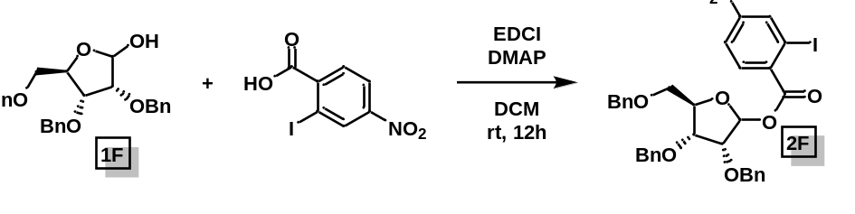
(3R,4R,5R)-3,4-bis(benzyloxy)-5-((benzyloxy)methyl)tetrahydrofuran-2-yl-2-iodo-4-nitrobenzoate (2F): The titular compound was synthesized in accordance to the procedure outlined for 2A. The crude was purified by flash chromatography (ethyl acetate/hexane: 5 → 10%) to give 2F (Rf = 0.3 in 80:20 hexane: ethyl acetate; α:β = 1:1.4, 89%).
¹H NMR (400 MHz, CDCl₃) δ 8.74 (d, J = 2.2 Hz, 0.6H), 8.66 (d, J = 2.2 Hz, 1H), 8.02 (d, J = 8.6 Hz, 1H), 7.76 (dt, J = 8.7, 2.2 Hz, 1.7H), 7.61 (d, J = 8.6 Hz, 1H), 7.48 – 7.44 (m, 2H), 7.41 – 7.20 (m, 22H), 7.17 (dd, J = 6.7, 2.7 Hz, 2H), 6.62 (d, J = 4.0 Hz, 0.7H), 6.45 (s, 1H), 4.86 (d, J = 12.1 Hz, 1H), 4.78 – 4.35 (m, 14H), 4.19 (dd, J = 6.0, 4.1 Hz, 1H), 4.13 – 4.04 (m, 2H), 3.82 (dd, J = 11.1, 2.6 Hz, 1H), 3.66 (dd, J = 11.1, 3.6 Hz, 1H), 3.56 (d, J = 3.6 Hz, 1.4H).
¹³C NMR (100 MHz, CDCl₃) δ 164.03, 163.96, 148.91, 148.80, 140.12, 139.72, 138.05, 137.98, 137.75, 137.52, 137.43, 137.16, 135.70, 135.64, 133.02, 131.75, 128.67, 128.62, 128.59, 128.58, 128.55, 128.49, 128.41, 128.29, 128.20, 128.01, 127.89, 127.72, 127.67, 127.63, 122.70, 100.53, 97.13, 93.88, 93.36, 85.33, 82.06, 79.12, 78.30, 76.13, 75.59, 73.68, 73.45, 73.30, 73.14, 72.50, 72.41, 69.94, 69.08.
HRMS (ESI): calc. for C₃₃H₃₀INO₈Na (M+Na): 718.0914; found: 718.0910.

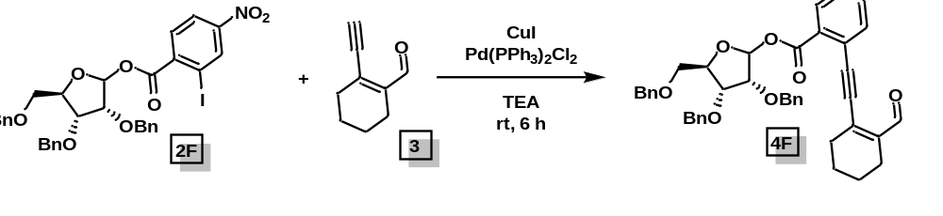
(3R,4R,5R)-3,4-bis(benzyloxy)-5-((benzyloxy)methyl)tetrahydrofuran-2-yl-2-((2-formylcyclohex-1-en-1-yl)ethynyl)-4-nitrobenzoate (4F): The titular compound was synthesized in accordance to the procedure outlined for 4A. The crude was purified by flash chromatography (ethyl acetate/hexane: 5 → 10%) to give pure donor 4F (Rf = 0.3 in 75:25 hexane: ethyl acetate; α:β = 1:2, 88%).
¹H NMR (400 MHz, CDCl₃) δ 10.38 (s, 1.2H), 8.31 (dd, J = 16.1, 2.3 Hz, 1.3H), 8.17 (d, J = 8.7 Hz, 0.6H), 7.77 (dd, J = 8.7, 2.3 Hz, 0.6H), 7.73 (d, J = 8.7 Hz, 1H), 7.62 (dd, J = 8.7, 2.3 Hz, 1H), 7.47 – 7.42 (m, 2H), 7.40 – 7.20 (m, 18H), 7.16 (dd, J = 7.4, 2.1 Hz, 2H), 6.62 (d, J = 4.0 Hz, 0.5H), 6.45 (s, 1H), 4.86 (d, J = 12.2 Hz, 1H), 4.79 – 4.36 (m, 12H), 4.19 (dd, J = 5.9, 4.2 Hz, 0.7H), 4.11 – 4.05 (m, 1.6H), 3.83 (dd, J = 11.2, 2.4 Hz, 1.2H), 3.67 (dd, J = 11.2, 2.9 Hz, 1.2H), 3.55 (dd, J = 3.6, 1.6 Hz, 1H), 2.60 – 2.52 (m, 3H), 2.59 – 2.53 (m, 3H), 1.78 – 1.66 (m, 7H).
¹³C NMR (100 MHz, CDCl₃) δ 193.49, 193.14, 162.94, 162.40, 149.39, 149.37, 144.96, 144.78, 138.74, 138.59, 138.10, 138.07, 137.78, 137.56, 137.48, 137.35, 136.75, 135.81, 133.07, 132.10, 128.60, 128.57, 128.52, 128.48, 128.45, 128.42, 128.38, 128.28, 128.25, 128.22, 128.16, 128.12, 128.06, 128.03, 128.00, 127.91, 127.85, 127.80, 127.76, 127.68, 127.58, 124.97, 124.90, 122.93, 122.82, 100.05, 96.51, 94.35, 94.22, 94.03, 93.78, 85.20, 81.93, 79.05, 78.61, 76.23, 75.89, 73.69, 73.50, 73.21, 73.06, 72.59, 72.35, 70.00, 68.95, 31.91, 31.89, 22.33, 22.30, 21.91, 21.01, 20.99.
HRMS (ESI): calc. for C₄₂H₃₉NO₉Na (M+Na): 724.2523; found: 724.2520.

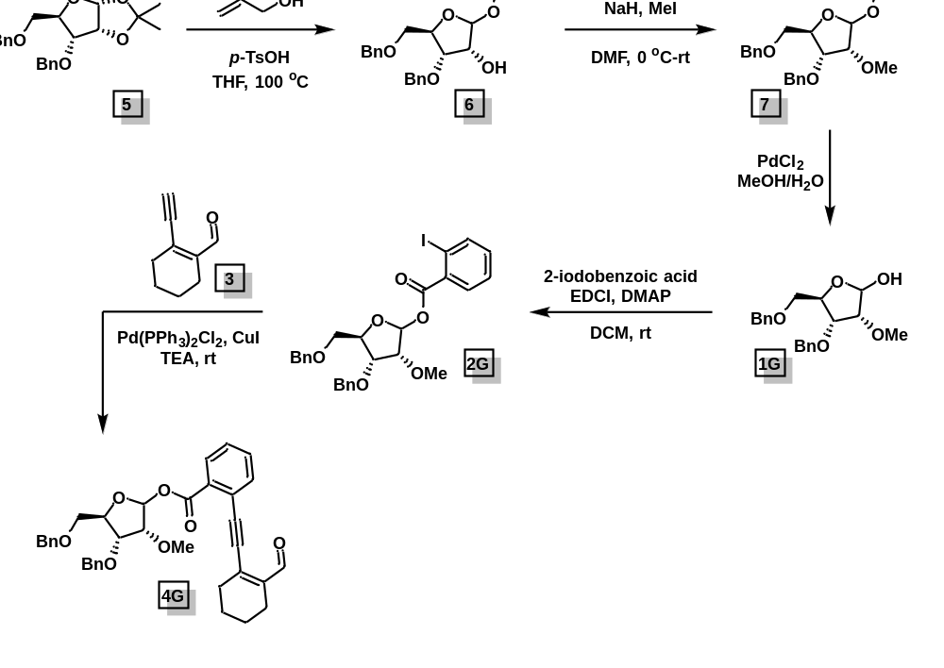
(3R,4S,5R)-2-(allyloxy)-4-(benzyloxy)-5-((benzyloxy)methyl)tetrahydrofuran-3-ol (6): 3,5-di-O-benzyl-1,2-O-isopropylidene-α-D-ribofuranose 5 was prepared according to the reported procedure. To a flame-dried Schlenk flask were added 5 (2.5g, 6.76 mmol), p-TsOH (0.20g, 1.08 mmol), dry allyl alcohol (25 mL) and dry THF (25 mL). The mixture was heated at 100 ºC for 20 h. After completion, it was neutralized with saturated NaHCO₃ solution (30 mL), extracted with EtOAc (3 × 40 mL). The organic layer was washed with H₂O, brine. It was then dried over sodium sulfate, concentrated in vacuo, and purified by silica gel flash chromatography (ethyl acetate/hexane: 10% → 20%) to give pure 6 (Rf = 0.2 in 70:30 hexane: ethyl acetate; 2 g, 80 %).
¹H NMR (400 MHz, CDCl₃) δ 7.40 – 7.25 (m, 10H), 5.84 (dddd, J = 16.9, 10.3, 6.2, 5.2 Hz, 1H), 5.24 (dd, J = 17.2, 1.6 Hz, 1H), 5.16 (dt, J = 10.4, 1.4 Hz, 1H), 5.03 (s, 1H), 4.58 (d, J = 5.1 Hz, 4H), 4.26 (q, J = 5.6 Hz, 1H), 4.19 – 4.08 (m, 3H), 3.95 (ddt, J = 12.8, 6.2, 1.4 Hz, 1H), 3.56 (dd, J = 5.5, 1.7 Hz, 2H), 2.77 (s, 1H).
¹³C NMR (100 MHz, CDCl₃) δ 138.19, 137.20, 134.04, 128.68, 128.46, 128.30, 128.03, 127.77, 127.72, 117.51, 106.69, 80.68, 79.78, 73.49, 73.34, 72.85, 71.75, 68.30.
HRMS (ESI): calc. for C₂₂H₂₆O₅Na (M+Na): 393.1678; found: 393.1684.

(3R,4R,5R)-2-(allyloxy)-4-(benzyloxy)-5-((benzyloxy)methyl)-3-methoxytetrahydrofuran (7): To an ice-cold solution of 6 (6.8 mmol) in dry DMF (5 mL) were successively added NaH (20 mmol, 60% dispersion in mineral oil), MeI (17 mmol) and TBAI (0.2 mmol). After stirring at 0 ºC for 10 min and another 50 min at room temperature, the excess hydride was decomposed by addition of MeOH, and the resulting mixture was partitioned between Et₂O (200 mL) and cold water (100 mL). The separated aqueous layer was then washed with another portion of Et₂O (100 mL). The combined organic extracts were dried over Na₂SO₄, concentrated, and the residue was purified by silica gel column chromatography (hexane/ethyl acetate, 5%) to give compound 7 as a colorless oil (98%; Rf = 0.3 in 90:10 hexane: ethyl acetate).
¹H NMR (400 MHz, CDCl₃) δ 7.38 – 7.26 (m, 10H), 5.84 (dddd, J = 16.9, 10.3, 6.2, 5.2 Hz, 1H), 5.23 (dq, J = 17.2, 1.6 Hz, 1H), 5.15 (dq, J = 10.4, 1.4 Hz, 1H), 5.07 (d, J = 1.0 Hz, 1H), 4.66 – 4.52 (m, 4H), 4.29 (ddd, J = 7.2, 5.9, 3.8 Hz, 1H), 4.19 (ddt, J = 12.8, 5.2, 1.5 Hz, 1H), 4.07 (dd, J = 7.1, 4.7 Hz, 1H), 3.95 (ddt, J = 12.7, 6.3, 1.4 Hz, 1H), 3.68 – 3.59 (m, 2H), 3.51 (dd, J = 10.6, 5.9 Hz, 1H), 3.45 (s, 3H).
¹³C NMR (100 MHz, CDCl₃) δ 138.35, 137.88, 134.14, 128.48, 128.42, 128.04, 127.93, 127.74, 127.63, 117.51, 103.85, 82.31, 80.46, 78.55, 73.23, 72.67, 71.46, 68.40, 58.44.
HRMS (ESI): calc. for C₂₃H₂₈O₅Na (M+Na): 407.1834; found: 407.1838.

(3R,4R,5R)-4-(benzyloxy)-5-((benzyloxy)methyl)-3-methoxytetrahydrofuran-2-yl 2-iodobenzoate (2G): A mixture of compound 7 (1.4 mmol) and PdCl₂ (0.2 mmol) in MeOH/H₂O (20 mL, 10:1, v/v) was stirred at room temperature for 2 h. The reaction mixture was filtered through Celite and concentrated in vacuo. The crude was carried forward without further purification.
The pre-donor 2G was prepared in accordance with the procedure outlined for 2A. The crude was purified by flash chromatography (ethyl acetate/hexane: 10 → 20%) to give pure 2G (85%; Rf = 0.3 in 80:20 hexane: ethyl acetate; α:β = 1:5).
¹H NMR (400 MHz, CDCl₃) δ 7.94 (dd, J = 7.8, 1.2 Hz, 1H), 7.68 (dd, J = 7.7, 1.8 Hz, 1H), 7.39 – 7.27 (m, 7.2H), 7.25 – 7.08 (m, 7.6H), 6.65 (d, J = 4.1 Hz, 0.2H), 6.42 (s, 1H), 4.79 (d, J = 11.8 Hz, 0.4H), 4.68 (d, J = 12.1 Hz, 1H), 4.63 – 4.46 (m, 4.5H), 4.40 – 4.31 (m, 2.2H), 4.12 (dd, J = 6.4, 2.2 Hz, 0.3H), 3.98 (dd, J = 6.1, 4.2 Hz, 0.3H), 3.86 (d, J = 4.0 Hz, 1H), 3.75 (dd, J = 11.1, 2.7 Hz, 1H), 3.66 – 3.45 (m, 6H).
¹³C NMR (100 MHz, CDCl₃) δ 165.09, 141.49, 141.45, 138.24, 137.66, 134.39, 133.02, 131.70, 128.63, 128.61, 128.47, 128.41, 128.28, 128.22, 128.20, 128.07, 128.03, 127.76, 127.65, 127.60, 99.49, 94.19, 81.69, 81.58, 76.60, 73.37, 72.91, 69.59, 58.65.
HRMS (ESI): calc. for C₂₇H₂₇IO₆Na (M+Na): 597.0750; found: 597.0751.

(3R,4R,5R)-4-(benzyloxy)-5-((benzyloxy)methyl)-3-methoxytetrahydrofuran-2-yl-2-((2-formylcyclohex-1-en-1-yl)ethynyl)benzoate (4G): The titular compound was synthesized in accordance to the procedure outlined for 4A. The crude was purified by flash chromatography (ethyl acetate/hexane: 10 → 20%) to give pure 4G (85%; Rf = 0.2 in 80:20 hexane: ethyl acetate; α:β = 1:5).
¹H NMR (400 MHz, CDCl₃) δ 10.39 (s, 0.2H), 10.37 (s, 1H), 7.77 (dd, J = 7.9, 1.3 Hz, 1H), 7.56 (dd, J = 7.8, 1.3 Hz, 1H), 7.46 (qd, J = 7.2, 3.2 Hz, 2H), 7.38 – 7.27 (m, 6H), 7.23 (d, J = 1.9 Hz, 4H), 7.16 (td, J = 7.7, 1.3 Hz, 1H), 6.65 (d, J = 4.1 Hz, 0.2H), 6.42 (s, 1H), 4.67 (d, J = 11.9 Hz, 1H), 4.61 – 4.45 (m, 4H), 4.40 – 4.29 (m, 2H), 3.83 (d, J = 4.3 Hz, 1H), 3.76 (dd, J = 11.2, 2.8 Hz, 1H), 3.62 (dd, J = 11.2, 3.8 Hz, 1H), 3.56 (s, 3H, OMeβ), 3.53 (d, J = 3.8 Hz, 1H), 3.48 (s, 1H, OMeα), 2.55 (dq, J = 6.0, 2.7 Hz, 2H), 2.35 – 2.27 (m, 2H), 1.69 (ddtd, J = 11.4, 8.1, 5.8, 2.7 Hz, 5H).
¹³C NMR (100 MHz, CDCl₃) δ 193.70, 163.94, 143.59, 139.93, 138.28, 137.68, 134.27, 132.27, 130.98, 130.85, 128.69, 128.58, 128.40, 128.13, 128.07, 127.61, 127.60, 123.50, 99.18, 96.82, 91.68, 81.77, 81.63, 73.39, 72.90, 69.47, 58.63, 32.16, 22.27, 22.01, 21.16.
HRMS (ESI): calc. for C₃₆H₃₆O₇Na (M+Na): 603.2359; found: 603.2354.

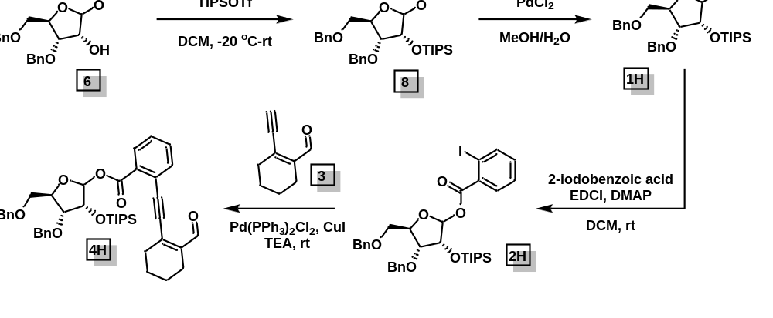
(((3R,4R,5R)-2-(allyloxy)-4-(benzyloxy)-5-((benzyloxy)methyl)tetrahydrofuran-3-yl)oxy)triisopropylsilane (8): Compound 6 (200 mg, 0.54 mmol, 1.0 equiv) was dissolved in CH₂Cl₂ (0.1 M) and cooled down to –20 ºC. 2,6-Lutidine (3.0 equiv.) was added to the reaction mixture followed by the addition of triisopropylsilyl triflate (1.5 equiv) and then the reaction was warmed to rt and monitored by TLC. After completion, it was quenched with saturated aq. NaHCO₃; the aq. layer was separated and extracted with CH₂Cl₂. The organic layer was collected, dried over Na₂SO₄, filtered, and concentrated by rotary evaporation to afford the crude product. Purification by silica flash chromatography (ethyl acetate/hexane: 5 → 10%). afforded the TIPS-protected compound 8 (210 mg, 74%).
¹H NMR (400 MHz, CDCl₃) δ 7.35 – 7.26 (m, 7H), 7.25 – 7.22 (m, 3H), 5.95 (dddd, J = 17.1, 10.3, 6.7, 4.9 Hz, 1H), 5.36 – 5.28 (m, 1H), 5.16 (dd, J = 10.4, 1.7 Hz, 1H), 4.99 (d, J = 4.4 Hz, 1H), 4.85 (d, J = 12.7 Hz, 1H), 4.58 – 4.37 (m, 4H), 4.30 (ddt, J = 13.2, 5.0, 1.5 Hz, 1H), 4.23 – 4.07 (m, 4H), 3.78 (dd, J = 6.6, 2.7 Hz, 1H), 3.45 (dd, J = 10.5, 3.3 Hz, 1H), 3.30 (dd, J = 10.4, 4.0 Hz, 1H), 1.10 – 1.05 (m, 21H).
¹³C NMR (100 MHz, CDCl₃) δ 138.88, 138.14, 134.92, 128.44, 128.32, 128.22, 127.78, 127.75, 127.57, 117.43, 101.27, 82.36, 73.70, 73.53, 72.77, 70.40, 68.83, 18.16, 18.10, 12.35.
HRMS (ESI): calc. for C₃₁H₄₆O₅SiNa (M+Na): 549.3007; found: 549.3005.

(3R,4R,5R)-4-(benzyloxy)-5-((benzyloxy)methyl)-3-((triisopropylsilyl)oxy)tetrahydrofuran-2-yl 2-iodobenzoate (2H): Compound 1H was synthesized according to the procedure for 1G. The crude was carried forward without further purification.
The pre-donor 2H was prepared in accordance with the procedure outlined for 2A. The crude was purified by flash chromatography (ethyl acetate/hexane: 5 → 10%) to give pure 2H (α:β 1:4, 110 mg, 75%).
¹H NMR (400 MHz, CDCl₃) δ 7.94 (dd, J = 7.9, 1.2 Hz, 1H), 7.66 (dd, J = 7.7, 1.7 Hz, 1H), 7.35 – 7.27 (m, 6H), 7.25 – 7.17 (m, 6H), 7.15 – 7.04 (m, 2H), 6.51 (d, J = 4.2 Hz, 0.25H), 6.30 (s, 1H), 4.74 (d, J = 11.8 Hz, 1H), 4.59 – 4.48 (m, 5H), 4.42 (ddd, J = 7.5, 4.3, 2.7 Hz, 1H), 4.29 (dd, J = 8.1, 3.9 Hz, 1H), 3.75 (dd, J = 11.0, 2.7 Hz, 1H), 3.60 (dd, J = 11.2, 4.5 Hz, 1.5H), 1.12 – 1.10 (m, 17H), 1.03 – 0.99 (m, 4H).
¹³C NMR (100 MHz, CDCl₃) δ 165.13, 141.27, 138.26, 137.92, 134.92, 132.92, 132.82, 131.49, 128.51, 128.47, 128.35, 128.34, 127.96, 127.94, 127.78, 127.77, 127.63, 127.52, 102.15, 94.04, 81.21, 77.59, 74.27, 73.38, 72.66, 69.79, 18.16, 12.64.
HRMS (ESI): calc. for C₃₅H₄₅IO₆SiNa (M+Na): 739.1922; found: 739.1926.

(3R,4R,5R)-4-(benzyloxy)-5-((benzyloxy)methyl)-3-((triisopropylsilyl)oxy)tetrahydrofuran-2-yl 2-((2-formylcyclohex-1-en-1-yl)ethynyl)benzoate (4H): The titular compound was synthesized in accordance to the procedure outlined for 4A. The crude was purified by flash chromatography (ethyl acetate/hexane: 5 → 10%) to give pure donor 4H (α:β 1:3, 90 mg, 83%).
¹H NMR (400 MHz, CDCl₃) δ 10.38 (s, 0.3H), 10.34 (s, 1H), 8.00 (dd, J = 7.8, 1.4 Hz, 0.4H), 7.78 (dd, J = 8.0, 1.3 Hz, 1H), 7.73 – 7.66 (m, 0.6H), 7.60 – 7.37 (m, 4H), 7.34 – 7.27 (m, 5H), 7.23 (s, 4H), 7.15 (td, J = 7.7, 1.3 Hz, 1H), 6.27 (s, 1H), 4.72 (d, J = 11.6 Hz, 1H), 4.56 – 4.36 (m, 5.5H), 4.25 (dd, J = 7.8, 3.9 Hz, 1H), 3.93 (s, 1H), 3.76 (dd, J = 11.1, 2.7 Hz, 1H), 3.59 (dd, J = 11.1, 3.9 Hz, 1H), 2.58 – 2.53 (m, 2.6H), 2.34 – 2.29 (m, 2.6H), 1.75 – 1.64 (m, 5H), 1.23 – 0.99 (m, 21H).
¹³C NMR (100 MHz, CDCl₃) δ 193.66, 193.43, 163.79, 143.52, 143.42, 140.02, 138.34, 137.99, 134.29, 134.23, 132.16, 132.02, 131.20, 130.89, 130.83, 128.85, 128.64, 128.44, 128.38, 127.89, 127.86, 127.63, S13 127.56, 123.51, 101.93, 96.96, 91.62, 81.19, 78.02, 74.61, 73.43, 72.81, 69.72, 32.26, 32.20, 22.28, 22.05, 21.19, 18.14, 12.63.
HRMS (ESI): calc. for C₄₄H₅₄O₇SiNa (M+Na): 745.3531; found: 745.3537.

2.15.2 Furanosylation Reaction

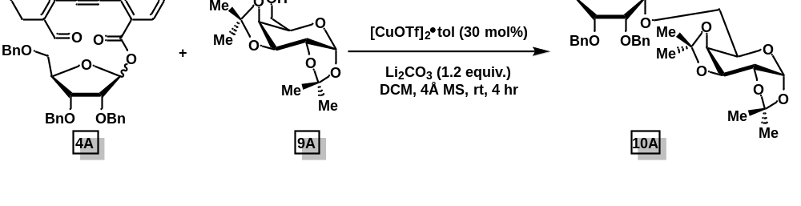
(2,3,5-tri-O-benzyl-α-D-ribofuranosyl)-(1→6)1,2:3,4-di-O-isopropylidene-α-D-galactopyranoside (10A): A 4 mL vial was charged with alcohol acceptor 9A (0.05 mmol, 1.0 equiv.), furanosyl donor 4A (0.1 mmol, 2.0 equiv.), [CuOTf]₂•tol (10 mol% with respect to the alcohol), Li₂CO₃ (0.06 mmol, 1.2 equiv.), 4Å molecular sieves and CH₂Cl₂ (0.04 M). The resulting solution was stirred at room temperature and the progress was monitored by TLC (4 h). After completion, saturated NaHCO₃ solution was added, and the aqueous phase was extracted with DCM (3x). An internal standard, 1,3,5-trimethoxybenzene (0.05 mmol, 1.0 equiv.) was added to the organic extract. It was then concentrated in vacuo. The product yield and anomeric ratio were determined by ¹H NMR of the crude. (78%, α:β = 7:1). The ¹H NMR of compound 10A matches the literature report.¹

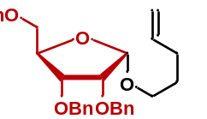
4-Penten-1-yl 2,3,5-tri-O-benzyl-α-D-ribofuranoside (10B): Prepared in accordance with the procedure for 10A in 3 h, (84%, α-only). The ¹H NMR of compound 10B matches the literature report.²⁻⁴

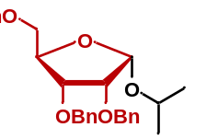
Isopropyl 2,3,5-tri-O-benzyl-D-ribofuranoside (10C): Prepared in accordance with the procedure for 10A in 2 h, (95%, α:β = 6:1). The ¹H NMR of compound 10C matches the literature report.^{2,5}

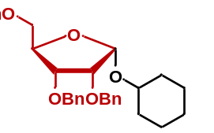
Cyclohexyl 2,3,5-tri-O-benzyl-D-ribofuranoside (10D): Prepared in accordance with the procedure for 10A in 3 h (96%, α:β = 9:1). The ¹H NMR of compound 10D matches the literature report.⁶

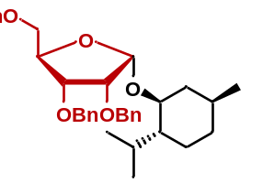
l-Menthyl 2,3,5-tri-O-benzyl-D-ribofuranoside (10E): Prepared in accordance with the procedure for 10A in 3 h (97%, α:β = 9:1). The ¹H NMR of compound 10E matches with the literature report.²⁻⁴

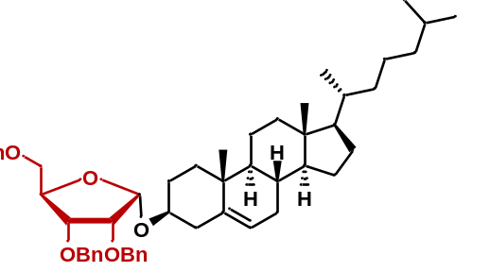
Cholesteryl 2,3,5-tri-O-benzyl-D-ribofuranoside (10F): Prepared in accordance with the procedure for 10A in 5 h, yielding the product as a white semisolid (96%, α-only). The ¹H NMR of compound 10F matches the literature report.⁴

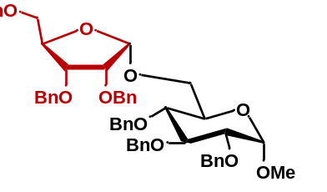
Methyl (2,3,5-tri-O-benzyl-α-D-ribofuranosyl)-(1→6)-2,3,4-tri-O-benzyl-α-D-glucopyranoside (10G): Prepared in accordance with the procedure for 10A using 30 mol% [Cu(I)OTf]₂•tol at rt in 6 h, yielding the product as a colorless oil (96%, α:β = 9:1). The ¹H NMR of compound 10G matches the literature report.^{2,7-9}

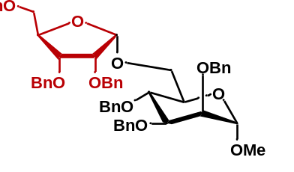
Methyl (2,3,5-tri-O-benzyl-α-D-ribofuranosyl)-(1→6)-2,3,4-tri-O-benzyl-α-D-mannopyranoside (10H): Prepared in accordance with the procedure for 10A using 30 mol% [Cu(I)OTf]₂•tol at rt in 8 h, yielding the product as a colorless oil (Rf = 0.3 in 70:30 hexane: ethyl acetate; 84%, α:β = 5:1).
¹H NMR (600 MHz, CDCl₃) δ 7.39 – 7.17 (m, 30H), 5.31 (d, J = 3.6 Hz, 1H), 4.77 (dd, J = 20.0, 11.4 Hz, 2H), 4.73 – 4.50 (m, 11H), 4.42 (dd, J = 25.3, 12.0 Hz, 2H), 4.26 (q, J = 4.0 Hz, 1H), 4.19 – 4.12 (m, 2H), 3.89 – 3.80 (m, 4H), 3.77 (dd, J = 3.2, 1.8 Hz, 1H), 3.74 – 3.68 (m, 1H), 3.53 (dd, J = 10.7, 3.3 Hz, 1H), 3.44 (dd, J = 10.7, 4.0 Hz, 1H), 3.25 (s, 3H).
¹³C NMR (100 MHz, CDCl₃) δ 138.99, 138.52, 138.23, 128.47, 128.42, 128.39, 128.37, 128.32, 128.30, 128.26, 128.16, 128.03, 127.98, 127.77, 127.72, 127.66, 127.59, 102.22, 99.29, 80.74, 80.30, 77.48, 76.23, 75.24, 75.12, 74.99, 73.51, 72.94, 72.70, 72.32, 72.06, 69.73, 66.57, 54.82.
HRMS (ESI): calc. for C₅₄H₅₈O₁₀Na (M+Na): 889.3928; found:889.3934.

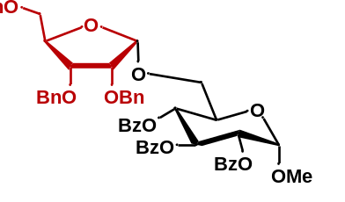
Methyl (2,3,5-tri-O-benzyl-α-D-ribofuranosyl)-(1→6)-2,3,4-tri-O-benzoyl-α-D-glucopyranoside (10I): Prepared in accordance with the procedure for 10A using 30 mol% [Cu(I)OTf]₂•tol at rt in 6 h (87%, α:β = 8:1). The ¹H NMR of compound 10I matches with the literature report.¹⁰

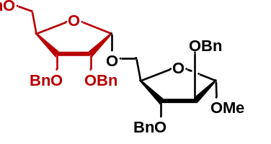
Methyl (2,3,5-tri-O-benzyl- α-D-arabinofuranosyl)-(1→5)-2,3-di-O-benzyl-α-D-arabinofuranoside (10J): Prepared in accordance with the procedure for 10A using 30 mol% [Cu(I)OTf]₂•tol at rt in 6 h (78%, α:β = 4:1). The ¹H NMR of compound 10J matches the literature report.¹¹

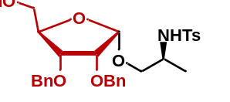
N-tosyl-O-(2,3,5-tri-O-benzyl-α-D-ribofuranosyl)-L-alaninol (10K): Prepared in accordance with the procedure for 10A using 30 mol% [Cu(I)OTf]₂•tol at rt in 8 h, yielding the product as a colorless oil (Rf = 0.2 in 60:40 hexane: ethyl acetate; 84%, α:β = 3:1).
¹H NMR (500 MHz, CDCl₃) δ 7.79 (d, J = 8.0 Hz, 2H), 7.37 – 7.28 (m, 13H), 7.24 – 7.20 (m, 2H), 7.09 (d, J = 7.9 Hz, 2H), 5.94 (s, 1H), 4.95 (d, J = 4.0 Hz, 1H), 4.66 (s, 2H), 4.60 (d, J = 11.9 Hz, 1H), 4.52 – 4.46 (m, 2H), 4.42 (d, J = 12.1 Hz, 1H), 4.23 – 4.20 (m, 1H), 3.90 (dd, J = 6.3, 2.0 Hz, 1H), 3.83 (dd, J = 6.3, 4.0 Hz, 1H), 3.59 – 3.54 (m, 1H), 3.40 – 3.27 (m, 4H), 2.32 (s, 3H), 1.14 (d, J = 6.4 Hz, 3H).
¹³C NMR (150 MHz, CDCl₃) δ 142.96, 137.96, 137.91, 137.65, 137.43, 129.89, 129.75, 129.71, 129.66, 129.63, 128.88, 128.73, 128.65, 128.58, 128.52, 128.33, 128.17, 128.02, 127.92, 127.79, 127.50, 100.23, 83.28, 78.67, 75.01, 73.62, 72.66, 72.60, 70.12, 69.20, 49.26, 29.86, 21.62, 17.85.
HRMS (ESI): calc. for C₃₆H₄₁NO₇SNa (M+Na): 654.2501; found:654.2507.

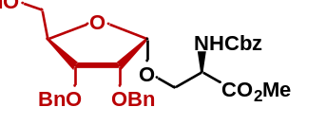
N-(Benzyloxycarbonyl)-O-(2,3,5-tri-O-benzyl-α-D-ribofuranosyl)-L-serine methyl ester (10L): Prepared in accordance with the procedure for 10A at rt using 30 mol% [Cu(I)OTf]₂•tol in 8 h (84%, α:β = 3:1). The ¹H NMR of compound 10L matches the literature report.⁵

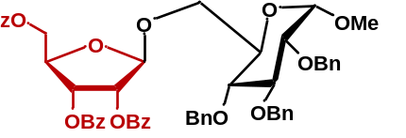
Methyl (2,3,5-tri-O-benzoyl-β-D-ribofuranosyl)-(1→6)-2,3,4-tri-O-benzyl-α-D-glucopyranoside (11): Prepared in accordance with the procedure for 10A at rt in 8 h (61%, β-only). The ¹H NMR of compound 11 matches the literature report.⁵

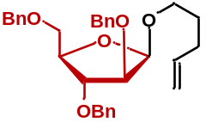
4-Penten-1-yl 2,3,5-tri-O-benzyl-β-D-arabinofuranoside (12A): Prepared in accordance with the procedure for 10A at rt using 10 mol% [Cu(I)OTf]₂•tol in 6 h (82%, α:β = 1:8). The ¹H NMR of compound 12A matches the literature report.⁴

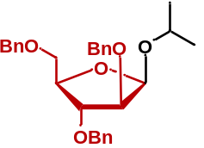
Isopropyl 2,3,5-tri-O-benzyl-β-D-arabinofuranoside (12B): Prepared in accordance with the procedure for 10A at rt using 10 mol% [Cu(I)OTf]₂•tol in 2 h (96%, α:β = 1:4). The ¹H NMR of compound 12B matches the literature report.¹

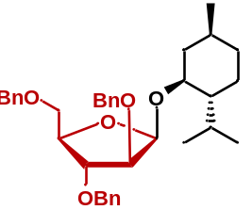
l-Menthyl 2,3,5-tri-O-benzyl-β-D-arabinofuranoside (12C): Prepared in accordance with the procedure for 10A using 10 mol% [Cu(I)OTf]₂•tol at rt in 3 h (96%, α:β = 1:5). The ¹H NMR of compound 12C matches the literature report.^{3,4}

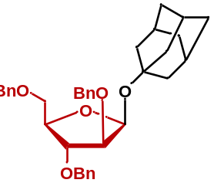
Adamantanyl 2,3,5-tri-O-benzyl-β-D-arabinofuranoside (12D): Prepared in accordance with the procedure for 10A using 10 mol% [Cu(I)OTf]₂•tol at rt in 5 h (92%, β-only). The ¹H NMR of compound 12D matches the literature report.^{4,12}

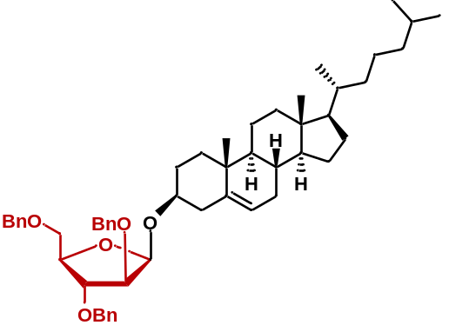
Cholesteryl 2,3,5-tri-O-benzyl-β-D-arabinofuranoside (12E): Prepared in accordance with the procedure for 10A using 10 mol% [Cu(I)OTf]₂•tol at rt in 5 h (88%, α:β = 1:5). The ¹H NMR of compound 12E matches with the literature report.^{4,12}

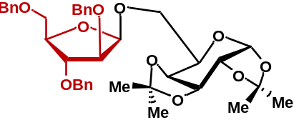
Methyl (2,3,5-tri-O-benzyl-β-D-arabinofuranosyl)-(1→6)1,2:3,4-di-O-isopropylidene-α-D-galactopyranoside (12F): Prepared in accordance with the procedure for 10A using 10 mol% [Cu(I)OTf]₂•tol at rt in 4 h (80%, α:β = 1:4). The ¹H NMR of compound 12F matches with the literature report.^{1,11}

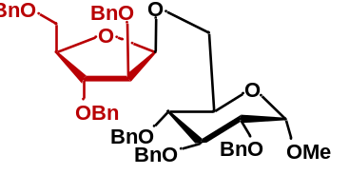
Methyl (2,3,5-tri-O-benzyl-β-D-arabinofuranosyl)-(1→6)-2,3,4-tri-O-benzyl-α-D-glucopyranoside (12G): Prepared in accordance with the procedure for 10A using 30 mol% [Cu(I)OTf]₂•tol at rt in 6 h (86%, α:β = 1:5). The ¹H NMR of compound 12G matches with the literature report.^{11,12}

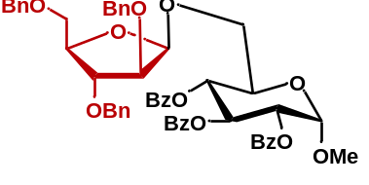
Methyl (2,3,5-tri-O-benzyl-β-D-arabinofuranosyl)-(1→6)-2,3,4-tri-O-benzoyl-α-D-glucopyranoside (12H): Prepared in accordance with the procedure for 10A using 30 mol% [Cu(I)OTf]₂•tol at rt in 6 h (91%, α:β = 1:4). The ¹H NMR of compound 12H matches the literature report.^{11,12}

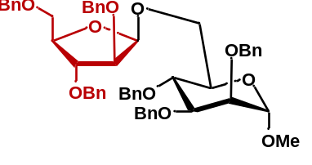
Methyl (2,3,5-tri-O-benzyl-β-D-arabinofuranosyl)-(1→6)-2,3,4-tri-O-benzyl-α-D-mannopyranoside (12I): Prepared in accordance with the procedure for 10A using 30 mol% [Cu(I)OTf]₂•tol at rt in 6 h (90%, α:β = 1:3). The ¹H NMR of compound 12I matches the literature report.¹²

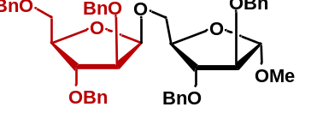
Methyl (2,3,5-tri-O-benzyl-D-arabinofuranosyl)-(1→5)-2,3-di-O-benzyl-α-D-arabinofuranoside (12J): Prepared in accordance with the procedure for 10A using 30 mol% [Cu(I)OTf]₂•tol at rt in 6 h (80%, β-only). The ¹H NMR of compound 12J matches the literature report.¹¹

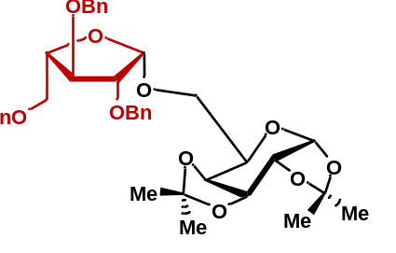
Methyl (2, 3, 5-tri-O-benzyl-β-L-arabinofuranosyl)- (1→6)1,2:3,4-di-O-isopropylidene-α-D-galactopyranoside (13A): Prepared in accordance with the procedure for 10A using 10 mol% [Cu(I)OTf]₂•tol at rt in 4 h (78%, α:β = 1:3. The ¹H NMR of compound 13A matches the literature report.¹

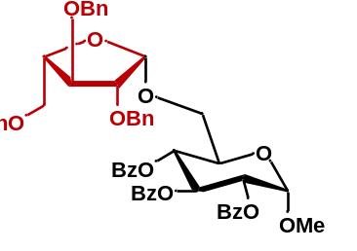
Methyl (2, 3, 5-tri-O-benzyl-β-L-arabinofuranosyl)-(1→6) 2,3,4-tri-O-benzoyl-α-D-glucopyranoside (13B): Prepared in accordance with the procedure for 10A using 30 mol% [Cu(I)OTf]₂•tol at rt in 6 h (72%, α:β = 1:4). The ¹H NMR of compound 13B matches the literature report.^{11,13}

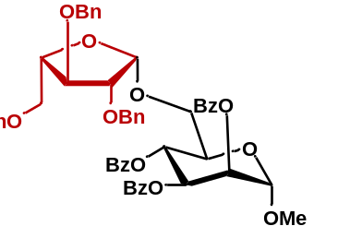
Methyl (2, 3, 5-tri-O-benzyl-β-L-arabinofuranosyl)-(1→6) 2,3,4-tri-O-benzoyl-α-D-mannopyranoside (13C): Prepared in accordance with the procedure for 10A using 30 mol% [Cu(I)OTf]₂•tol at rt in 6 h, yielding the product as a colorless oil (84%, α:β = 1:4). The ¹H NMR of compound 13C matches the literature report.^{12,13}

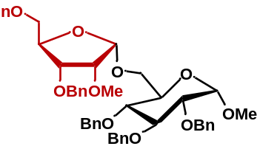
(2-Methoxy-3,5-di-O-benzyl-α-D-ribofuranosyl)-(1→6)-2,3,4-tri-O-benzyl-α-D-glucopyranoside (14): Prepared in accordance with the procedure for 10A using 30 mol% [Cu(I)OTf]₂•tol at rt in 8 h, yielding the product as a colorless syrup (Rf = 0.2 in 70:30 hexane: ethyl acetate; 92%, α:β = 9:1).
¹H NMR (400 MHz, CDCl₃) δ 7.46 – 7.09 (m, 25H), 5.16 (d, J = 4.2 Hz, 1H), 4.95 (d, J = 11.0 Hz, 1H), 4.85 – 4.72 (m, 4H), 4.68 – 4.59 (m, 2H), 4.57 (d, J = 3.5 Hz, 1H), 4.53 – 4.39 (m, 4H), 4.22 – 4.09 (m, 2H), 3.96 (t, J = 9.2 Hz, 1H), 3.90 (dd, J = 6.4, 4.0 Hz, 1H), 3.77 (d, J = 10.3 Hz, 1H), 3.73 – 3.65 (m, 3H), 3.53 (dd, J = 9.6, 3.6 Hz, 1H), 3.44 (d, J = 0.7 Hz, 3H), 3.42 (d, J = 3.6 Hz, 1H), 3.36 (d, J = 3.9 Hz, 1H), 3.34 (s, 3H).
¹³C NMR (100 MHz, CDCl₃) δ 139.14, 138.76, 138.42, 138.27, 138.12, 128.54, 128.51, 128.47, 128.38, 128.26, 128.16, 128.05, 128.00, 127.96, 127.80, 127.77, 127.73, 127.67, 127.60, 101.99, 98.26, 82.27, 81.63, 80.65, 79.95, 77.95, 75.79, 75.78, 75.15, 73.56, 73.52, 72.58, 70.16, 69.91, 66.78, 59.09, 55.26.
HRMS (ESI): calc. for C₄₈H₅₄O₄Na (M+Na): 813.3615; found: 813.3621.

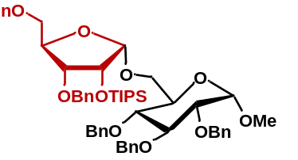
(2-Triisopropylsilyl-3,5-di-O-benzyl-α-D-ribofuranosyl)-(1→6)-2,3,4-tri-O-benzyl-α-D-glucopyranoside (15): Prepared in accordance with the procedure for 10A using 30 mol% [Cu(I)OTf]₂•tol at rt in 8 h, yielding the product as a colorless syrup (Rf = 0.3 in 70:30 hexane: ethyl acetate; 88%, α–only).
¹H NMR (400 MHz, CDCl₃) δ 7.37 – 7.27 (m, 13H), 7.25 – 7.09 (m, 12H), 4.98 (d, J = 4.4 Hz, 1H), 4.93 (d, J = 11.1 Hz, 1H), 4.86 – 4.59 (m, 7H), 4.55 – 4.48 (m, 2H), 4.43 (dd, J = 11.8, 3.2 Hz, 2H), 4.24 (dd, J = 6.1, 4.4 Hz, 1H), 4.16 (q, J = 3.3 Hz, 1H), 4.10 (dd, J = 11.1, 3.0 Hz, 1H), 3.94 (t, J = 8.8 Hz, 1H), 3.81 (dd, J = 6.1, 2.4 Hz, 1H), 3.77 – 3.70 (m, 2H), 3.55 (d, J = 11.0 Hz, 1H), 3.51 – 3.40 (m, 3H), 3.31 (s, 3H), 1.14 – 0.99 (m, 21H).
¹³C NMR (100 MHz, CDCl₃) δ 139.38, 139.03, 138.99, 138.46, 138.16, 128.52, 128.44, 128.36, 128.23, 128.03, 127.92, 127.90, 127.75, 127.71, 127.48, 127.43, 127.32, 102.90, 98.21, 82.48, 82.17, 79.72, 78.05, 78.00, 75.57, 75.10, 74.49, 73.53, 73.44, 72.95, 70.69, 70.34, 66.47, 55.08, 18.19, 18.08, 12.38. S25
HRMS (ESI): calc. for C₅₆H₇₂O₁₀SiNa (M+Na): 955.4787; found: 955.4785.

2.15.3 Appendix 1
Spectra Relevant to Chapter 2

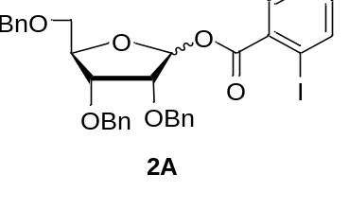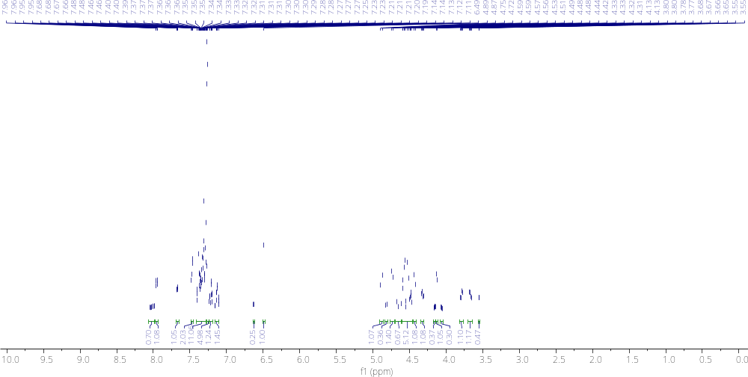

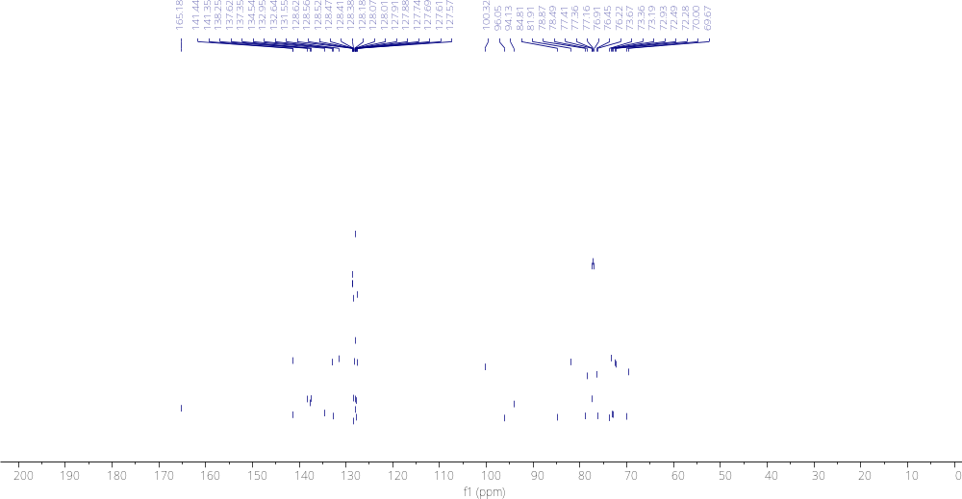
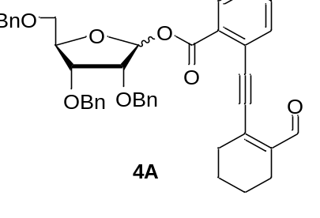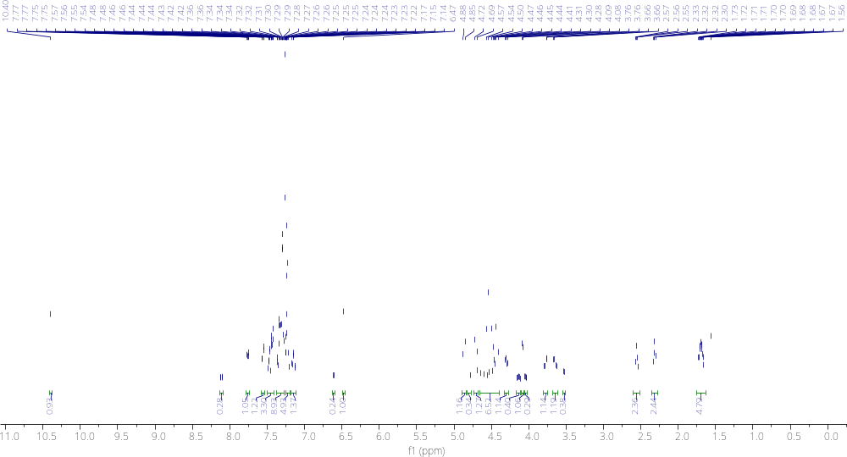

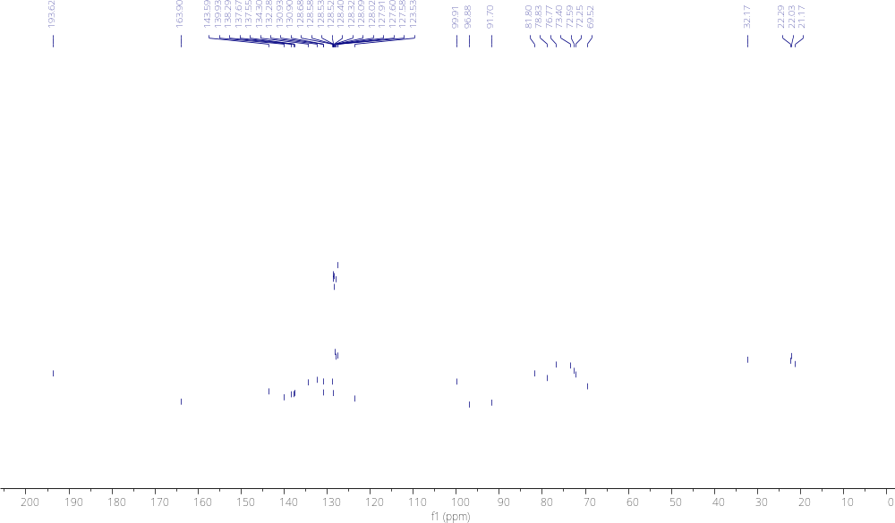
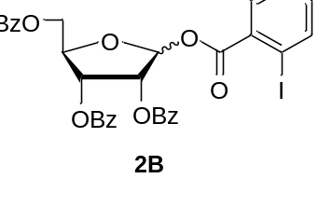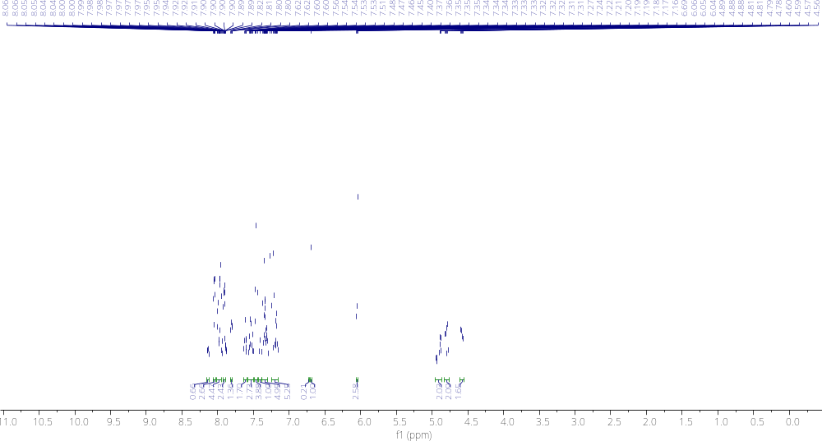

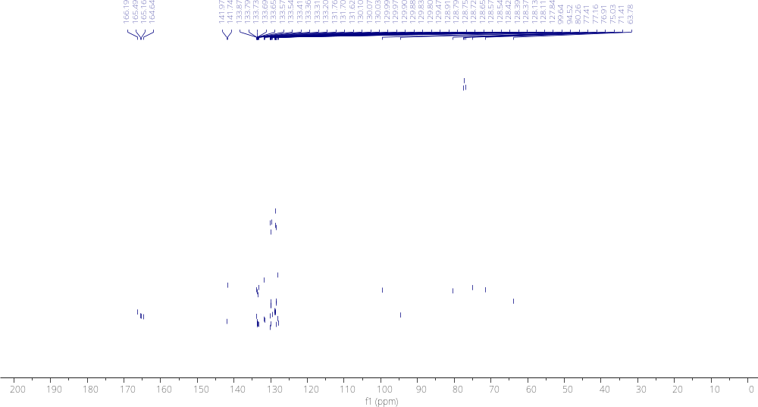
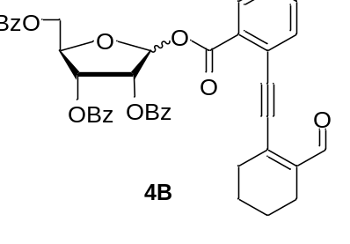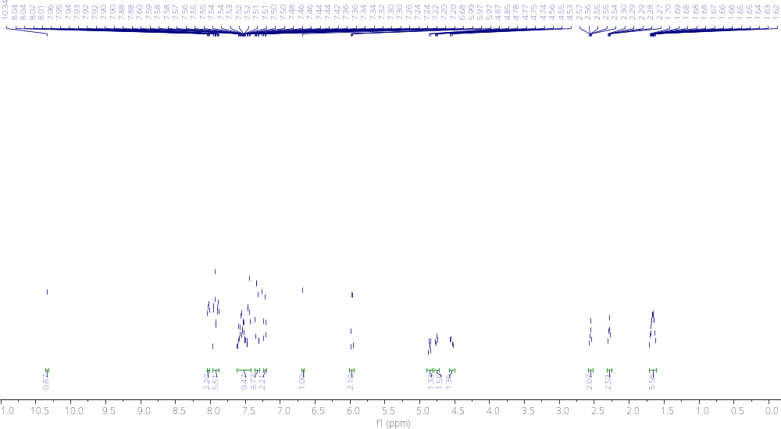

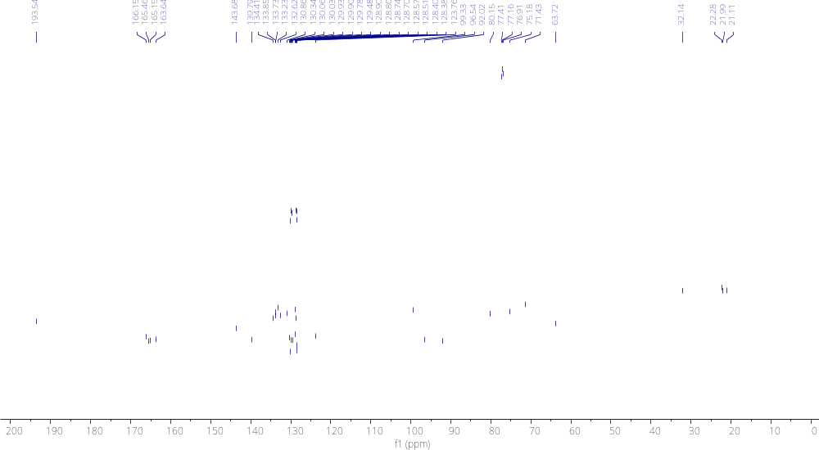
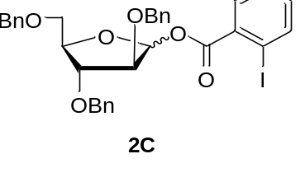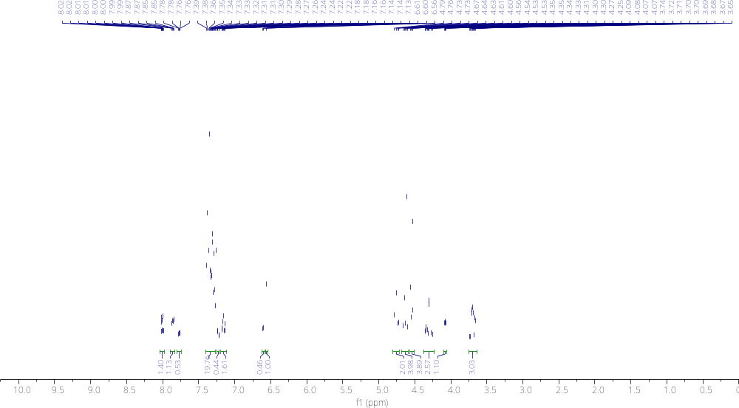

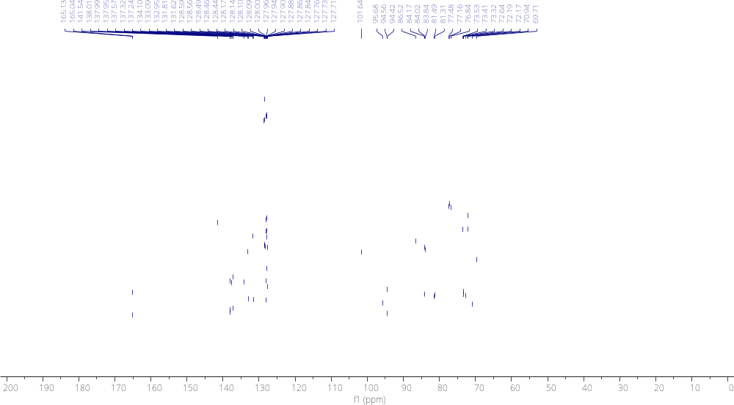
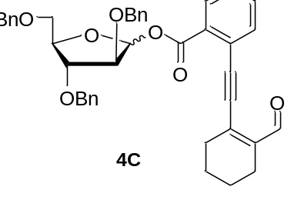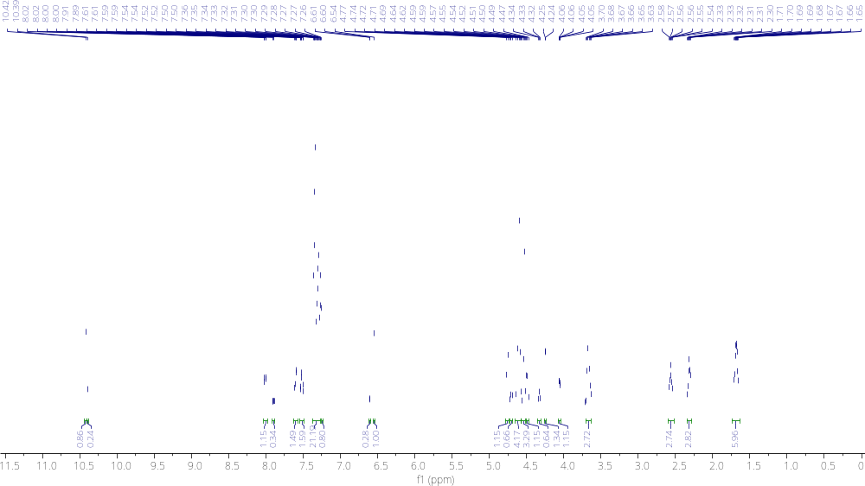
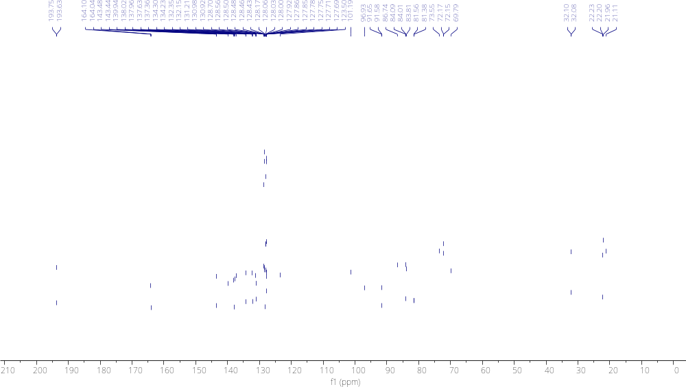
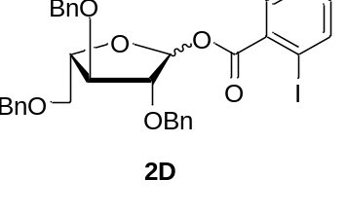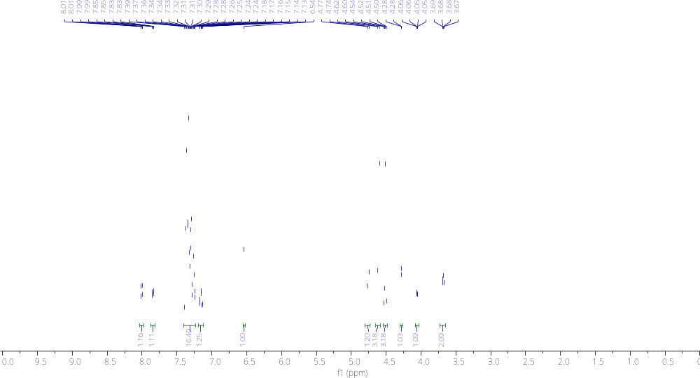
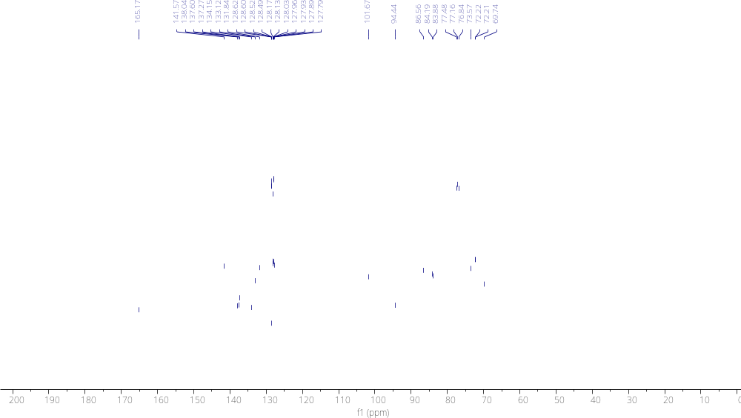
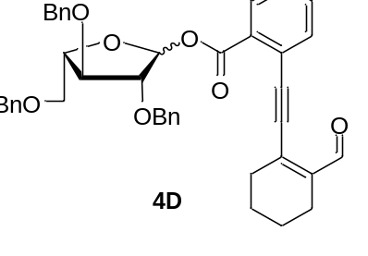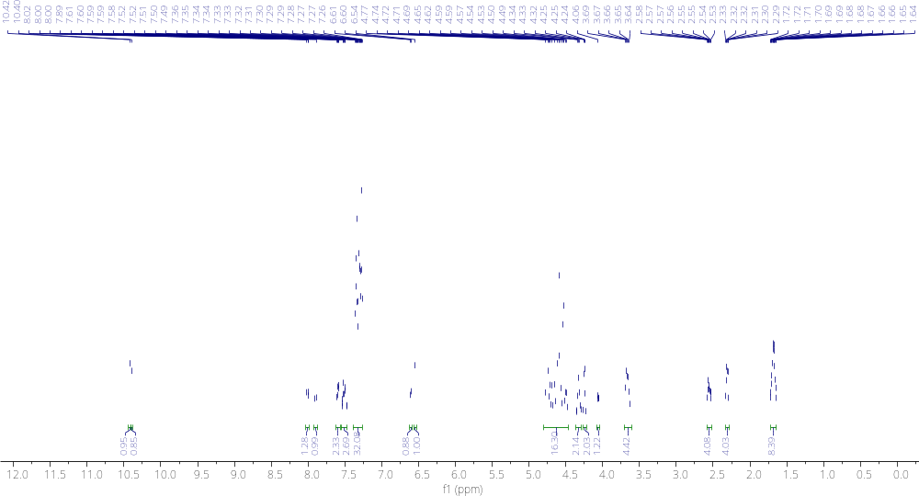

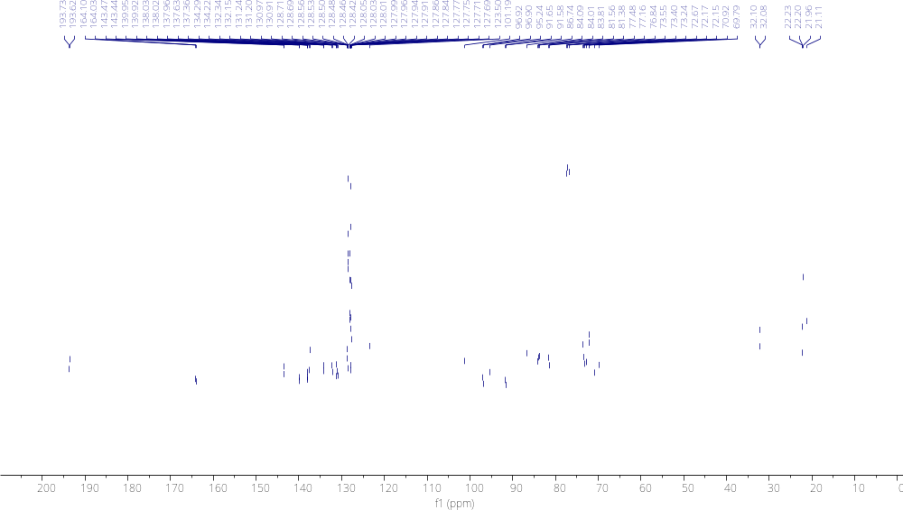
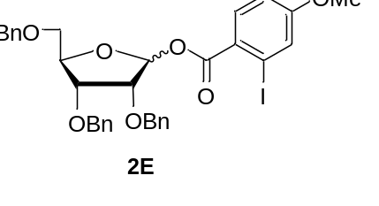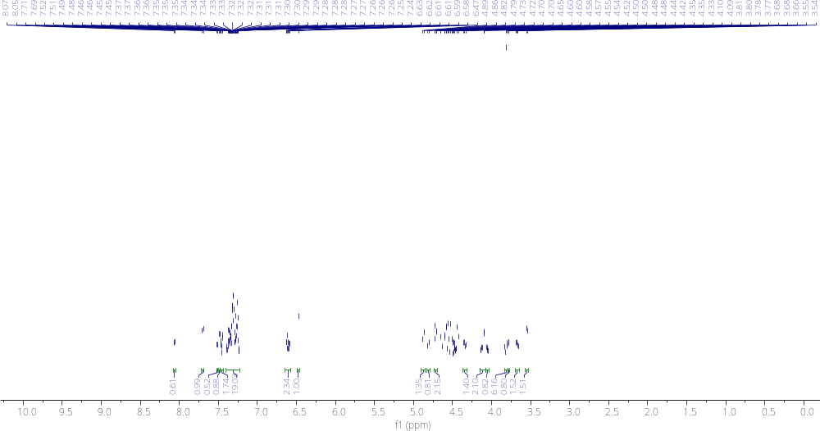

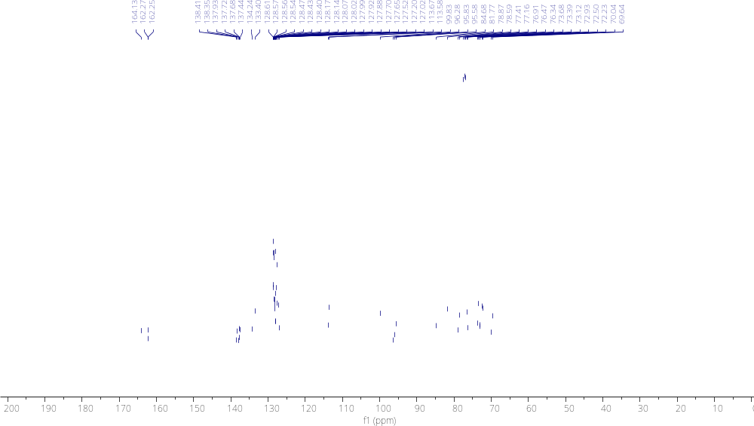
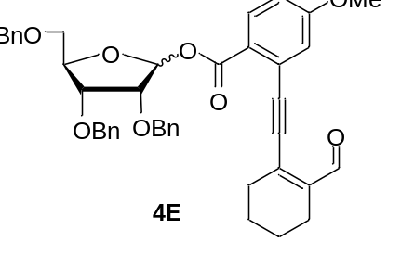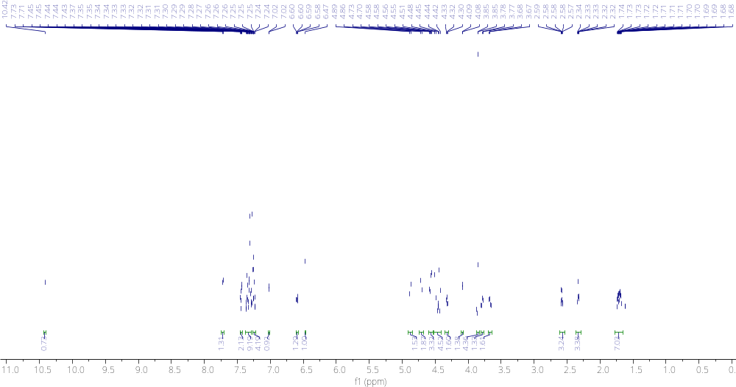

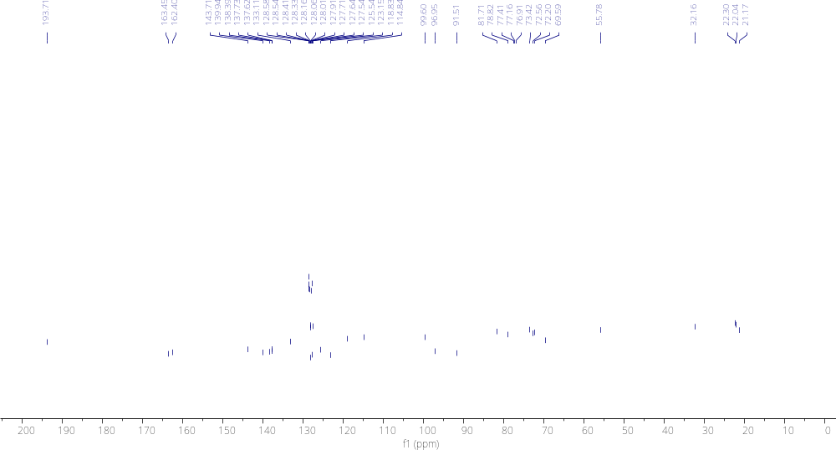
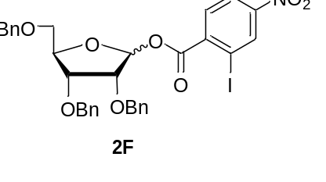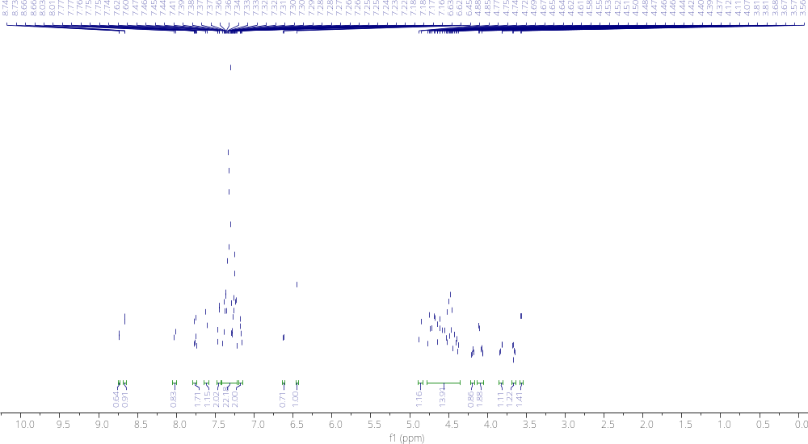

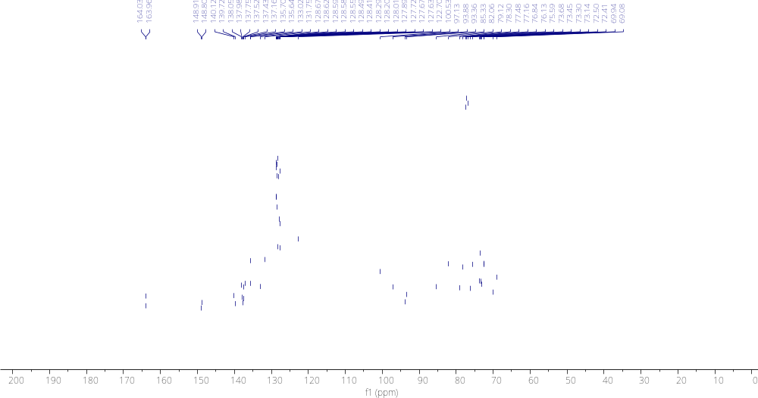
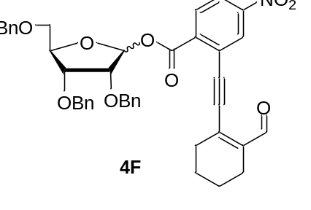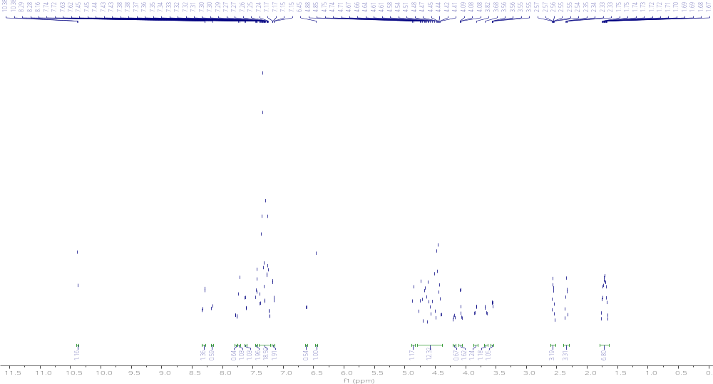

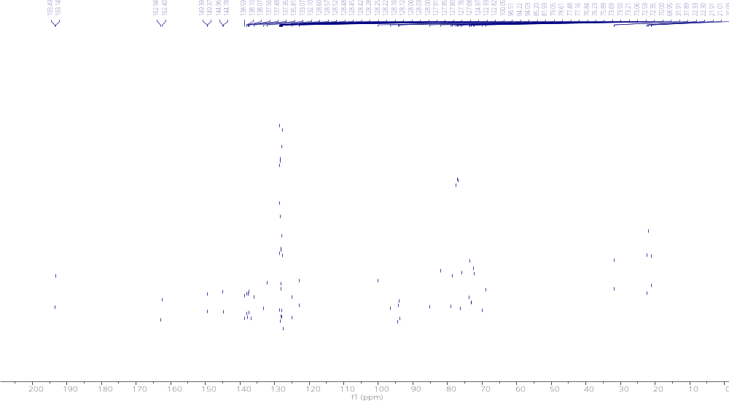
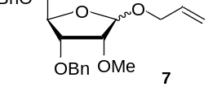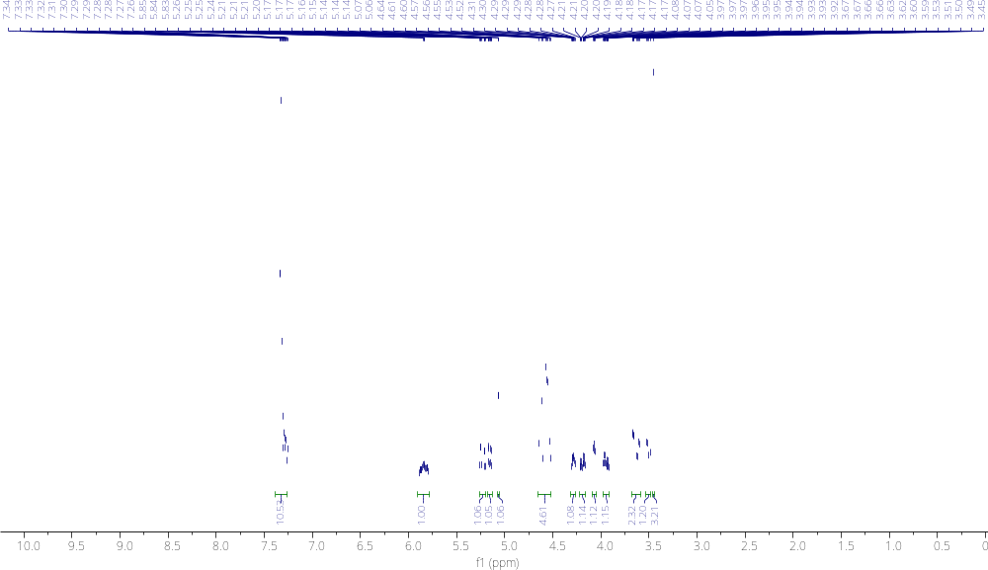

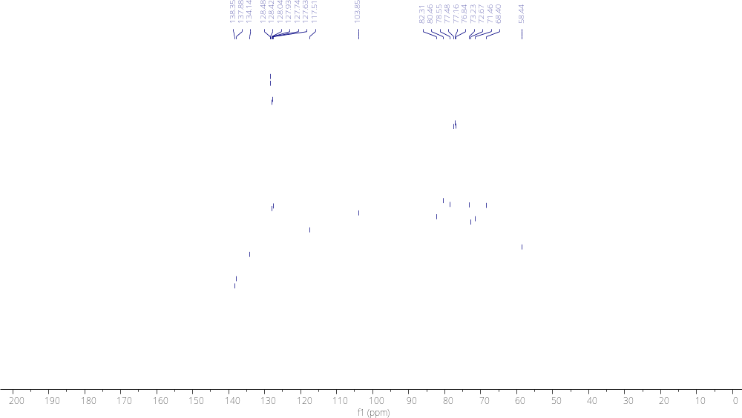
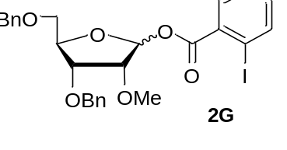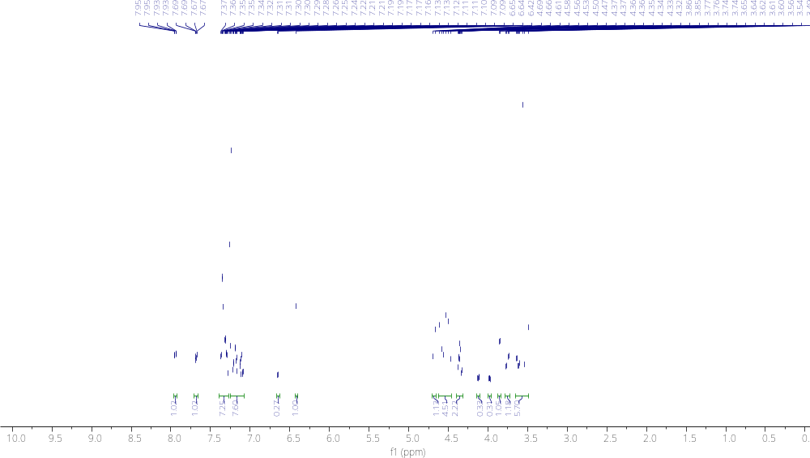

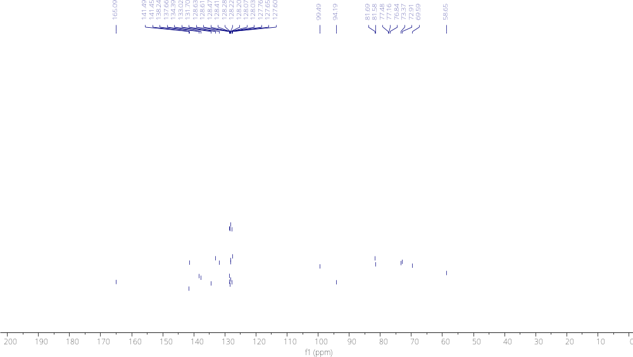

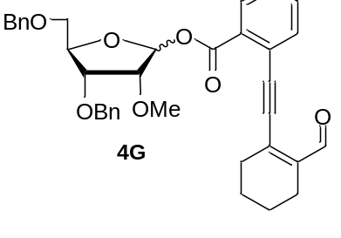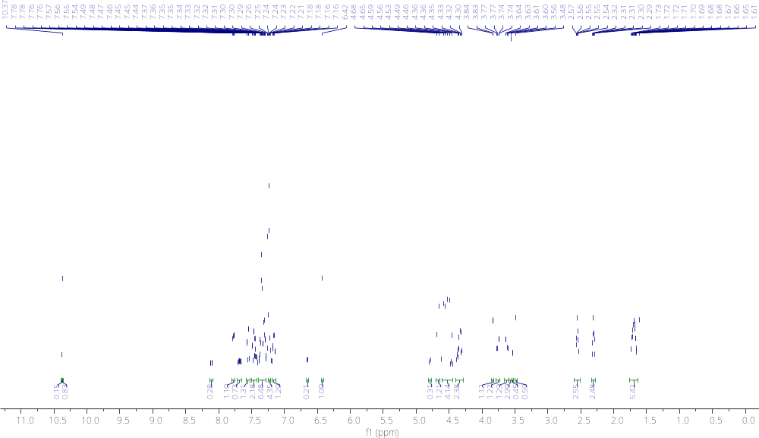

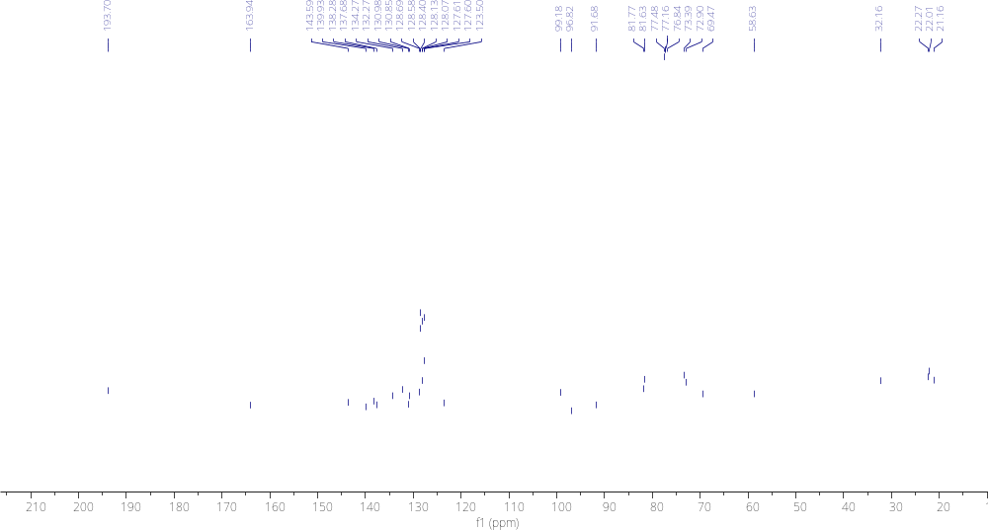
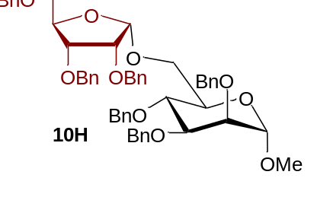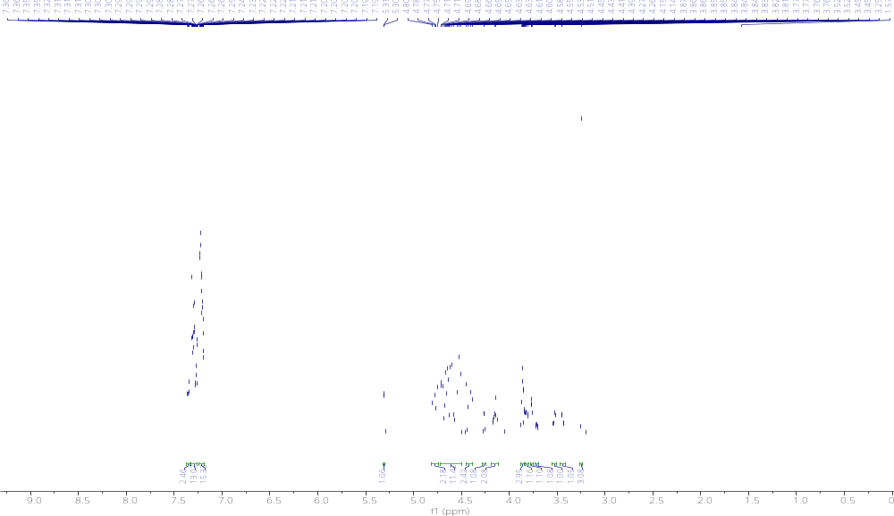

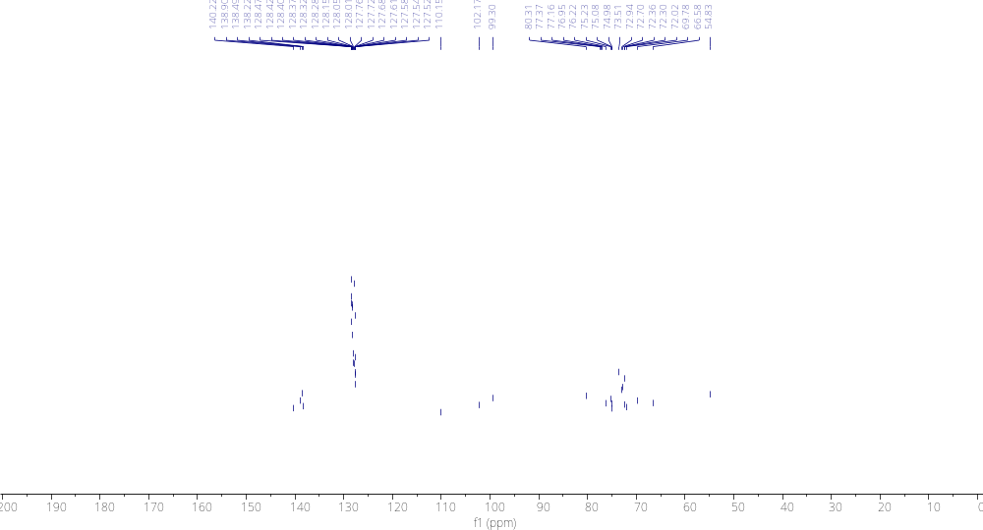

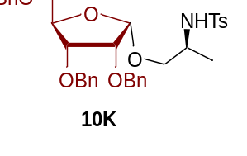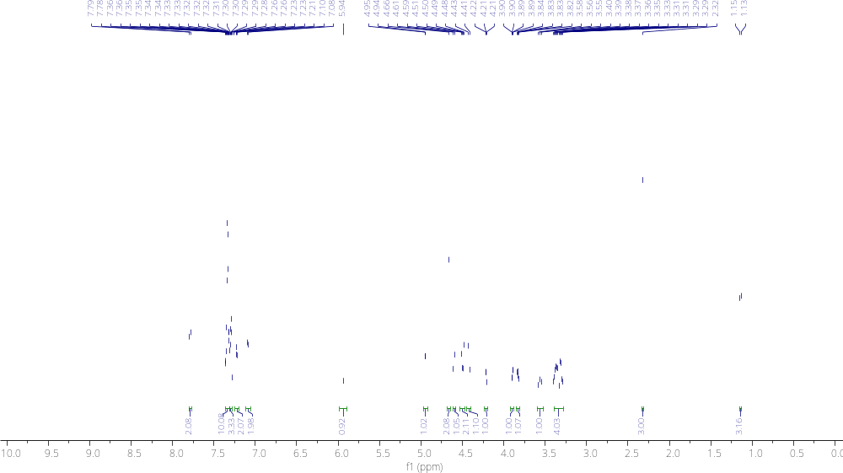

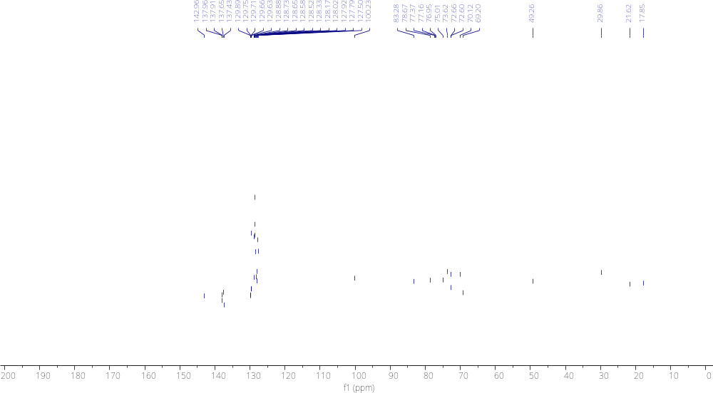

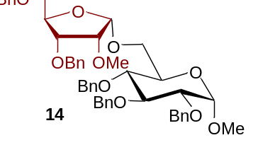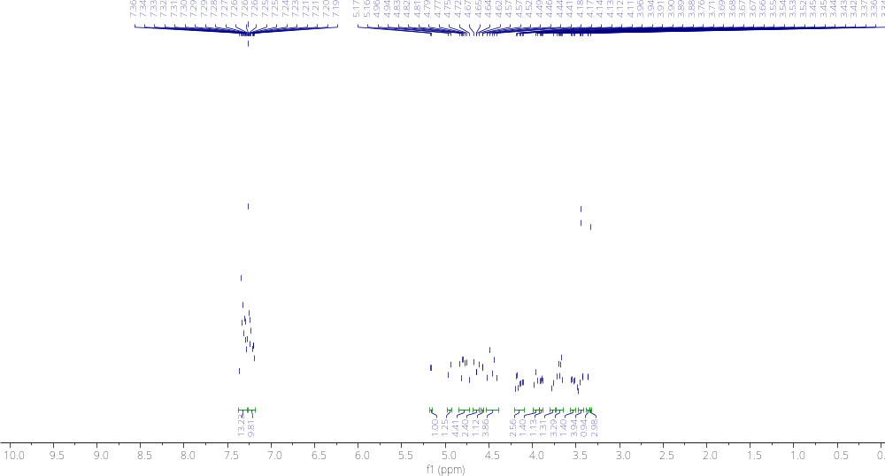

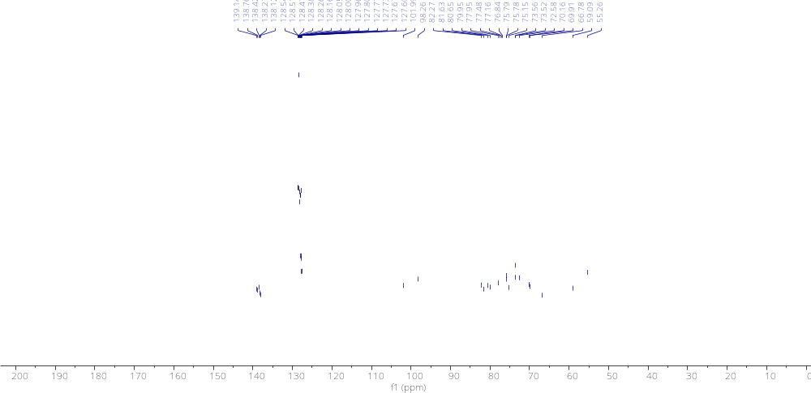
2.15.4 References for Chapter 2 Experimentals
[1] Mayfield, A. B.; Metternich, J. B.; Trotta, A. H.; Jacobsen, E. N. Stereospecific Furanosylations Catalyzed by Bis-Thiourea Hydrogen-Bond Donors. Journal of the American Chemical Society 2020, 142 (8), 4061–4069. DOI: 10.1021/jacs.0c00335.
[2] Oka, N.; Kajino, R.; Takeuchi, K.; Nagakawa, H.; Ando, K. α-Selective Ribofuranosylation of Alcohols with Ribofuranosyl Iodides and Triphenylphosphine Oxide. The Journal of Organic Chemistry 2014, 79 (16), 7656–7664. DOI: 10.1021/jo500632h.
[3] Vidadala, S. R.; Gayatri, G.; Sastry, G. N.; Hotha, S. Propargyl/Methyl Furanosides as Potential Glycosyl Donors. Chemical Communications 2011, 47 (35), 9906. DOI: 10.1039/c1cc13134f.
[4] Mallick, A.; Mallikharjunarao, Y.; Rajasekaran, P.; Roy, R.; Vankar, Y. D. Auiii‐halide/Phenylacetylene‐catalysed Glycosylations Using 1‐o‐acetylfuranoses and Pyranose 1,2‐orthoesters as Glycosyl Donors. European Journal of Organic Chemistry 2015, 2016 (3), 579–588. DOI: 10.1002/ejoc.201501245.
[5] Shimomura, N.; Mukaiyama, T. Stereoselective Syntheses of α-d- and β-d-Ribofuranosides Catalyzed by the Combined Use of Silver Salts and Their Partners. Bulletin of the Chemical Society of Japan 1994, 67 (9), 2532–2541. DOI: 10.1246/bcsj.67.2532.
[6] Hirooka, M.; Mori, Y.; Sasaki, A.; Koto, S.; Shinoda, Y.; Morinaga, A. Synthesis of β-d-Ribofuranosyl-(1→3)-α-l-Rhamnopyranosyl-(1→3)-l-Rhamnopyranose by in Situ Activating Glycosylation Using 1-OH Sugar Derivative and Me₃SiBr–CoBr₂–Bu₄NBr–Molecular Sieves 4A System. Bulletin of the Chemical Society of Japan 2001, 74 (9), 1679–1694. DOI: 10.1246/bcsj.74.1679.
[7] Hashizume, N.; Kobayashi, S. Lanthanide Triflates as Reusable Catalysts in Stereoselective -and- Glycosylation Reactions of 1-O-Acetyl-2, 3, 5-Tri-O-Benzylribofuranose. Carbohydr. Lett. 1996, 2, 157-164.
[8] Suzuki, T.; Watanabe, S.; Yamada, T.; Hiroi, K. Dehydrative Glycosylation of Tri-O-Benzylated 1-Hydroxyribofuranose Catalyzed by a Copper(II) Complex. Tetrahedron Letters 2003, 44 (12), 2561–2563. DOI: 10.1016/s0040-4039(03)00270-3.
[9] Schmidt, R. R.; Reichrath, M. Facile, Highly Selective Synthesis of α‐ and β‐disaccharides from 1‐O‐metalated D‐ribofuranoses. Angewandte Chemie International Edition in English 1979, 18 (6), 466–467. DOI: 10.1002/anie.197904661.
[10] Uchiro, H.; Kurusu, N.; Mukaiyama, T. A Convenient Method for the Preparation of Disaccharides by Transglycosylation of Methyl Glycosides. Israel Journal of Chemistry 1997, 37 (1), 87–96. DOI: 10.1002/ijch.199700011.
[11] Xu, H.; Schaugaard, R. N.; Li, J.; Schlegel, H. B.; Nguyen, H. M. Stereoselective 1,2-Cis Furanosylations Catalyzed by Phenanthroline. Journal of the American Chemical Society 2022, 144 (16), 7441–7456. DOI: 10.1021/jacs.2c02063.
[12] Lee, Y. J.; Lee, K.; Jung, E. H.; Jeon, H. B.; Kim, K. S. Acceptor-Dependent Stereoselective Glycosylation: 2‘-CB Glycoside-Mediated Direct β-d-Arabinofuranosylation and Efficient Synthesis of the Octaarabinofuranoside in Mycobacterial Cell Wall. Organic Letters 2005, 7 (15), 3263–3266. DOI: 10.1021/ol0510668.
[13] Zhu, X.; Kawatkar, S.; Rao, Y.; Boons, G.-J. Practical Approach for the Stereoselective Introduction of β-Arabinofuranosides. Journal of the American Chemical Society 2006, 128 (36), 11948–11957. DOI: 10.1021/ja0629817.

CHAPTER 3
Inspiration for and Progress Towards Second Generation Thioglycoside Donors
3.1 Historical Perspectives of Carbene Reactions in the Sharma Lab
Carbenes have been an essential part of the Sharma lab since its inception. Carbenes, namely diazo-derived carbenes, are incredibly versatile tools that can be used for a wide range of applications. Early experimentation out of our lab demonstrated OH insertion into acceptor/acceptor diazos.¹ We built upon this work by developing conditions for an insertion/Conia-ene cascade for the formation of γ-butyrolactones and tetrahydrofurans.² We also showed that diazo compounds can be used to synthesize medium-sized oxacycles³ and azacycles^{4,5} from oxygen and nitrogen containing reagents. It was also discovered that while secondary amines would yield medium-sized azacycles, implementation of primary amines would lead to quinoline formation. Our lab would continue to publish work highlighting the utility of these reactive intermediates for CH functionalization, spirocyclization with oxygen,⁶ carbon,⁷ or nitrogen⁸ nucleophiles, oxy-Cope cyclization,⁹ and total synthesis.¹⁰ This would be expanded on in 2023 as we published our first article on non-diazo-derived carbenes. In this disclosure, we outlined a method of enynal-derived zinc carbenoid cascade reaction for the production of (2-furyl)-2-pyrrolidines.¹¹
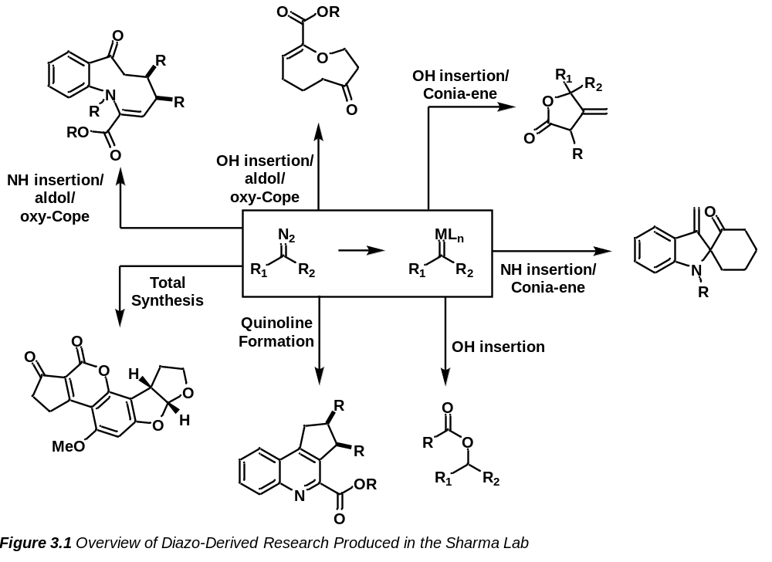

While work from this lab has focused heavily on diazo chemistry coupled with insertion of alcohols or amines, a notable nucleophile was distinctly missing from these disclosures. Sulfur-based insertion/cascade reactions involving diazo-derived carbenes were sparse in the literature and methods were of particular interest in the synthetic community. This led to significant attention being given to the insertion of sulfur nucleophiles into diazo compounds for cascade reactions. From this, we decided to pursue a range of thiol nucleophiles bearing an alkyne primed for S-H insertion/Conia-ene cyclization. There were, however, several problems with this project. Firstly, preparation of the starting material was difficult as they were often unstable and would decompose quickly. Secondly, our catalytic triad (Rh/Ag/Au) was found to be incompatible with our thioalkyne as the thiol would react too quickly with the alkyne via the Ag/Au to cyclize and become unreactive towards the diazo. This meant that Conia-ene cyclization would have to occur following insertion of the sulfur nucleophile into the carbene. However, thirdly, the insertion products of these thiols and the diazo compounds were themselves rather unstable and would frequently decompose before they could be subjected to Conia-ene conditions. These conditions together meant that the desired reactivity was likely out of reach, but our progress along this project did help to inspire the reactivity and design of our thioglycoside-based, second-generation donors.
Following this work, we became interested in diastereoselective glycosylation reactions, inspired by the work of Dr. Indrajeet Sharma during his PhD. The goals and outcomes of this work can be found in Chapter 2 of this dissertation. While impressive, we believed that the enynal donor could be expanded upon, coupled with a disclosure in 2019 by the Qian group on rhodium catalyzed diazo-derived activation of thioglycosides¹² (see Chapter 1.4.3.5), we became emboldened to revisit our furanosylation strategy. Given our previous experience of the reactivity of diazo compounds and sulfur-containing species, coupled with the notoriety of thioglycosides for their relative stability, we envisioned a strategy for diastereoselective glycosylation with a thioglycoside donor that could be activated intramolecularly via an earth-abundant copper catalyzed diazo-derived carbene.

3.2 Photoactivation of Carbene Precursors
Photolytic decomposition of diazo compounds has been documented in the literature for well over a century as first described by Wolff in the now eponymous Wolff rearrangement.¹³ While there was some research that would build upon this over subsequent decades, often, reaction would be low yielding¹⁴ or still rely on ketene products.¹⁵⁻¹⁷ More recently, protocols have shown a wide range of reactivities such as C-H insertions,¹⁸⁻²⁷ O-H insertions,²⁸⁻³² N-H insertions,³³⁻³⁶ Si-H insertions,³⁷ S-H insertions,^{38,39} cyclopropanations,^{40,41} cyclopropenations,⁴² and cycloadditions.⁴³⁻⁴⁵ These developments have lent credibility and much interest into the utilization of blue LED and photolytic conditions to cause transformations.⁴⁶ As these reactions are usually far less expensive than those that implement expensive transition metal catalysts and have as lesser environmental impact than such reactions, blue LED conditions are typically preferable when compared to transition metal catalyzed reactions. We were then made aware of a recent disclosure by the Qian group wherein a thioglycoside-based donor was activated via an external diazo which was decomposed by a transition metal catalyst.¹² We suspected that by developing a donor capable of intramolecular interactions, we could lower the barrier for reaction such that blue LED or photocatalytic conditions could be implemented. In fact, light-catalyzed glycosylation of furanosides has been documented since 1989 when anomeric N-tosylhydrazones were decomposed photolytically to yield the desired O-glycoside.⁴⁷⁻⁵⁰ Although documented, these protocols rely on extreme excesses of oxygen nucleophiles, display low yields, and lack diastereoselectivity. We believed that we could develop a donor conducive to blue LED conditions that could remain not only high yielding, but highly diastereoselective as well.

3.3 Objective of Chapter
In this chapter, we will outline the process we followed behind the generation of our second-generation donor. We will cover the retrosynthetic approaches and design schemes we utilized over the course of development. Learning outcomes will be highlighted following each unsuccessful attempt that led to specific design choices and alterations that we employed in subsequent designs. Progress towards a donor capable of activation under more inexpensive earth-abundant catalysts or even blue LED for the formation of diastereoselective furanoside products will be investigated as well. Progress made in developing conditions for blue LED experiments will also be discussed and potential outlets for a third-generation of furanoside donor will too be outlined herein.

3.4 Initial Design of Thioglycoside-Based Donors
As we began, we thought to model our second-generation donor after our first-generation donor which led to a design that was rather different from our final design. Initially, we believed that a thioglycoside bearing a diazo (A) could be prepared from thioglycoside B which in turn could be synthesized from thioglycoside ester C. We had believed that this compound could be readily obtained from a coupling reaction of the ribofuranosyl anomeric acetate (E) and methyl protected 2-mercaptobenzoic acid (D).
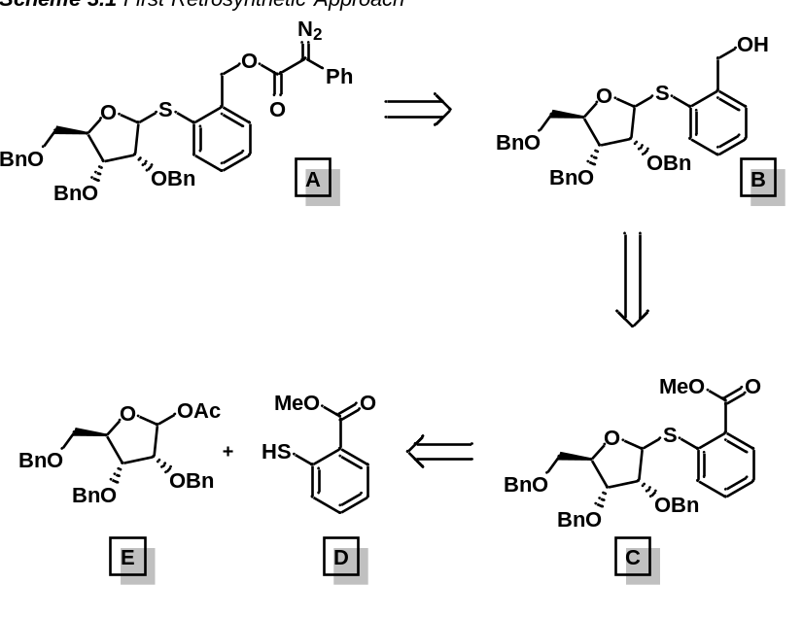

To initiate our synthesis, we acetylated tri-O-benzyl ribofuranoside which we were able to obtain in a quantitative manner. Alongside this, we prepared the methyl ester of 2-mercaptobenzoic acid via a Fischer esterification reaction. We then attempted to couple these fragments together through a boron-trifluoride diethyl etherate coupling reaction. To our dismay, no reaction was observed, ostensibly, as the coupling reagent appeared to coordinate to the thiol compound. This was an important discovery for us as it indicated that electron-rich esters could not be present on our thiol reagent as they would prevent the intended coupling reaction from occurring.
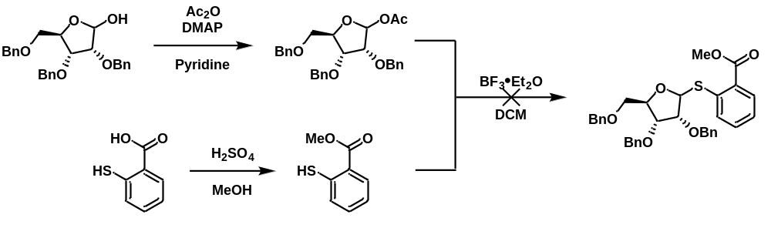

3.4.1 Second Design of Thioglycoside-Based Donors
Seeking milder, neutral, conditions for reactivity, we established another new design for our donor along with the necessary retro synthesis. We first sought to mimic the design of 3.4 wherein our product donor would possess an ester moiety. We envisioned another donor/acceptor-based diazo but notably, one that could be synthesized with the absence of an ester on the thiophenol starting material. This donor, we believed, could be achieved by performing a diazo transfer following a simple DCC coupling of phenyl acetic acid to a phenolic thioglycoside. This pre-donor could be synthesized through a boron-trifluoride diethyl etherate coupling of 2-mercaptophenol with methyl tri-O-benzylribofuranoside.
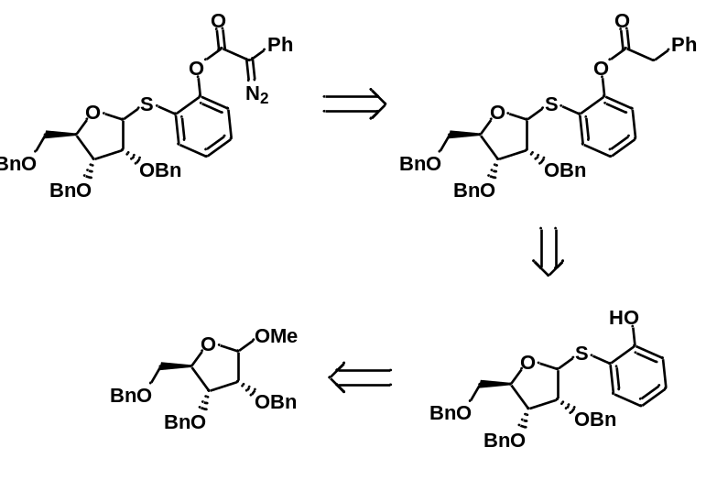

We commenced our synthesis with methyl tri-O-benzylribofuranoside coupling this reagent with 2-mercaptophenol via a boron-trifluoride diethyletherate coupling reacted cleanly to yield the desired thioglycoside in an 88% yield. We were pleasantly surprised by these results as our original design was incompatible under these conditions. Following the boron trifluoride diethyletherate coupling, we performed a DCC coupling of the previous compound with phenyl acetic acid. This, again, reacted cleanly to produce the desired ester thioglycoside in a 74% yield. We next sought to subject this pre-donor to a Regitz diazo transfer, and so, set up a reaction consisting of the pre-donor with pABSA. We, however, found the pre-donor unreactive under these conditions. Curious, we reattempted this reaction separately with both pABSA and TsN₃ and to our dismay we found that the diazo did not appear present either by NMR, TLC, or IR. Our suspicion with this was that the presence of the ester moiety in the pre-donor was causing conflicts with our diazo transfer conditions, and so, we surmised that the donor would need to be redesigned such that it was lacking the ester moiety.
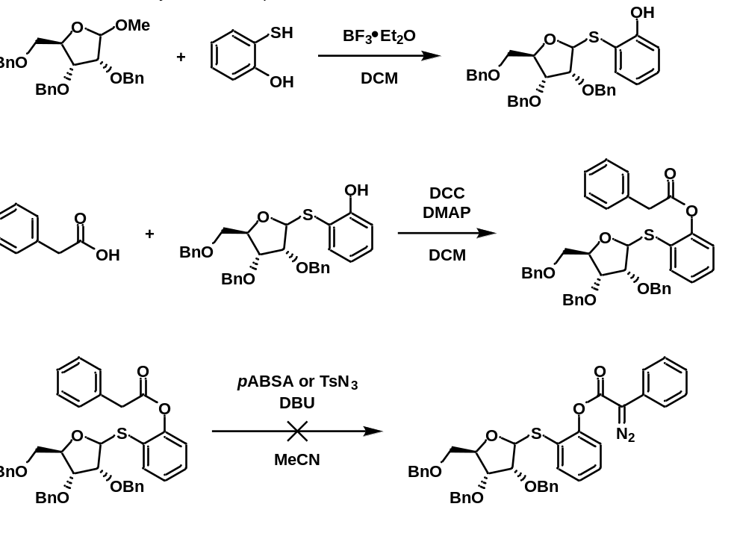

3.4.2 Third Design of Thioglycoside-Based Donors
Learning from the results of our previous drafts, we went back to the chalkboard to redesign our donor. Under this new design, we targeted a ketone-based donor/acceptor diazo thioglycoside. This donor, we believed, could be obtained from a diazo transfer following oxidation of the respective alkyne species. We reasoned that this alkyne-based species could be synthesized through a Sonogashira reaction of the halo-thioglycoside with phenyl acetylene. The thioglycoside in this process could come from a boron-trifluoride diethyl etherate coupling of methyl tri-O-benzylribofuranoside with 2-halomercaptophenol.
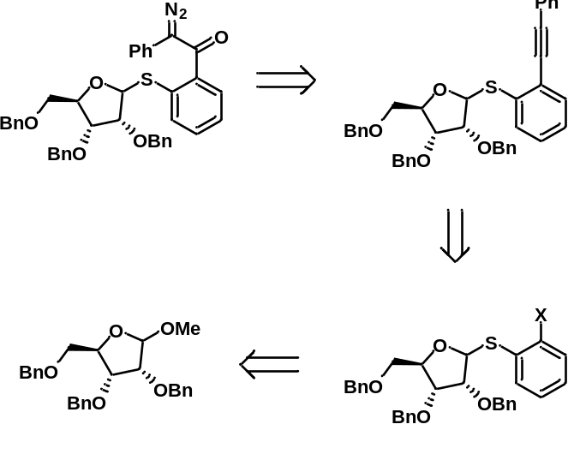

With the retrosynthetic scheme established, we set out on our synthesis. To begin, we targeted the synthesis of 2-iodothiophenol for coupling with our methylfuranoside. For this, we selected 2-aminothiophenol, believing we could prepare the desired iodo-compound via diazotization in the presence of potassium iodide. This method would quickly prove incapable of yielding the desired compound as trials produced a 0% yield of the compound. Not deterred by this result, we shifted gears and attempted to synthesize the desired compound from 2-iodoaniline again via diazotization to displace the amine with a thiol. However, like before, we observed no product formation by NMR. This would be rectified as we were later able to order 2-bromothiophenol to circumvent the difficult synthesis of 2-iodothiophenol. With this bromide in hand, we were able to perform the coupling reaction with 2-methyl-tri-O-benzylribofuranoside via boron-trifluoride diethyl etherate coupling. To our delight, this reaction proceeded cleanly to yield the desired product quantitatively. With this, we then attempted to perform a Sonogashira reaction with the generated bromo-thioglycoside and phenyl acetylene. We, however, encountered another fatal flaw in this step as the reaction failed to produce any product at all. This was likely due to coordination of the thioglycoside sulfur to the thiophilic copper(I) catalyst required in these reactions. This meant that to pursue the second-generation thioglycoside donor, we would again need to redesign our route.
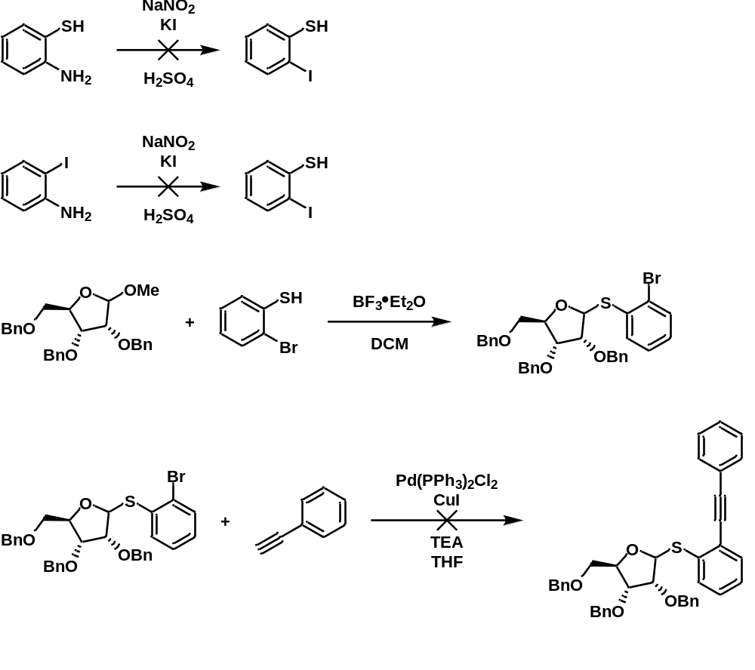

3.4.3 Fourth Design of Thioglycoside-Based Donors
Emboldened by the success of the boron-trifluoride diethyl etherate coupling in 3.4.1, which was not possible in our original design, we set out to develop a fourth retro synthesis. We believed that the synthesis could commence similarly to the pathway described in 3.4.2 with a few key late-stage modifications. Our fourth design was structurally identical to the second design but would be prepared through a different route. We envisioned performing a diazo transfer following oxidation of the requisite alcohol species to obtain the desired donor. This alcohol, we believed, could be generated from an attack by an organolithiate generated via a metal-halogen exchange from the relative bromo-thioglycoside. This bromo-thioglycoside we knew could be prepared from a boron-trifluoride diethyl etherate coupling of 2-bromothiophenol and methyl-2,3,5-tri-O-benzylribofuranoside.
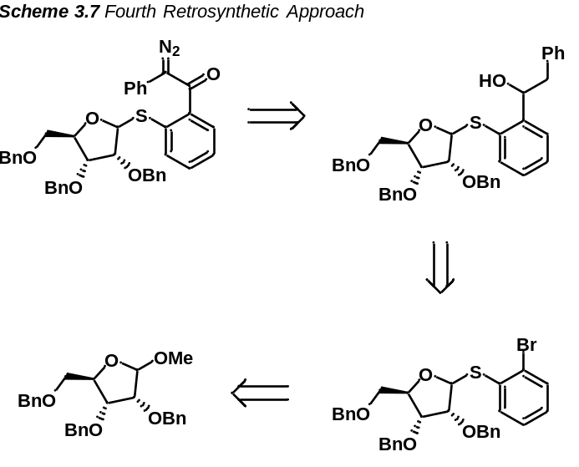

To begin, we prepared the bromothioglycoside in accordance with 3.4.2. We then prepared a Weinreb-amide in hopes that reactivity would directly produce the desired ketone pre-donor. This Weinreb-amide was prepared through an EDCI-coupling of phenylacetic acid with the Weinreb-amine hydrochloride salt. This reacted cleanly to produce the desired Weinreb-amide in a 94% yield. We then performed a metal-halogen exchange through ^{n}Butyl lithium with the bromo-thioglycoside to attack onto the Weinreb-amide and furnish the desired ketone pre-donor. However, this reaction led to a complex mixture, and little to no product yield. We had suspected this may be due to the poorly electrophilic nature of the Weinreb-amide and so decided to adjust our design to react with a more electrophilic aldehyde. This nucleophilic attack would yield an alcohol product that we could then oxidize to the requisite ketone pre-donor. For this route, we first started by reducing phenylacetic acid to 2-phenylethanol via an LAH reduction. This alcohol was then oxidized to the desired aldehyde through a PCC oxidation. Concerned that the five-membered ring may be negatively influencing the reaction, we prepared a benzyl protected bromo-thiomannopyranoside compound for reaction with this aldehyde to serve as a model for reactivity. Performing the metal-halogen exchange of the bromo-thiomannopyrannoside with ^{n}Butyl lithium and subjecting the prepared aldehyde to this organolithiate, we believed would generate the desired alcohol. However, to our dismay, we found that the above conditions led exclusively to unproductive decomposition. We took this as an opportunity to reflect on our experiences as we would need to redesign our donor again. It was at this point that we realized that the aromatic ring of our thiophenol was allowing for a high degree of delocalization in our system, causing reactivity to become unpredictable. This delocalization could cause rearrangement of the compound to furnish the C-glycoside through a Stevens rearrangement, or a release of benzyne which could then react externally in a detrimental manner. Due to this instability and the uncertainty regarding the reactivity of this compound, we determined that the aromatic ring was largely problematic in our system and thus would need to remove it moving forward.
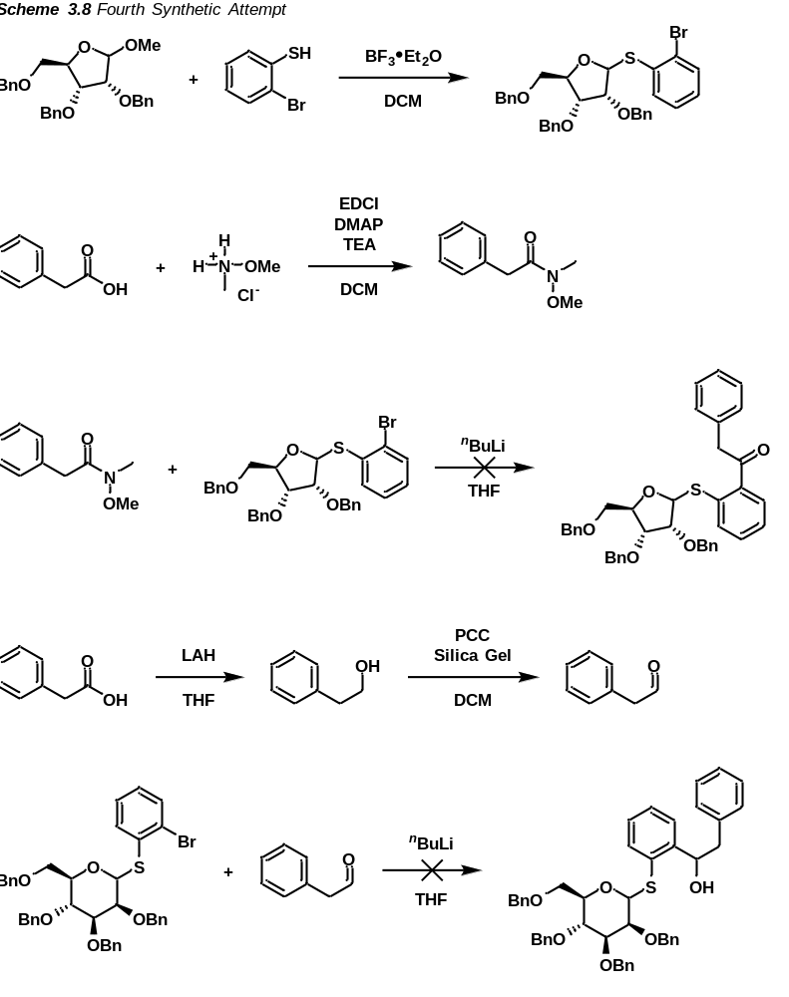

3.5 Progress Made Towards Photocatalytic Promotion by Blue LED
Given the broad interest in blue LED promoted diazo-derived carbene reactions and the design of our donor which we believed to be conducive to such conditions, we endeavored to develop a set of conditions for the blue LED activation of our donor. Our final donor (which will be discussed more in depth in Chapter 4) was prepared and a UV-vis spectra was collected to determine the λ-max of the diazo compound. The discovered λ-max was closest to 440 nm, and so, this was the wavelength of light used for decomposition of the diazo.
To encourage diastereoselectivity, we employed a range of additives with the goal of inducing coordination between the C2 oxygen of the donor with the oxygen acceptor or otherwise promoting β-cis selectivity. We initiated our study in the absence of any additive, we suspected that if a reaction did occur, the diastereoselectivity would be low if not non-existent. However, in this case, we found extensive decomposition to have occurred with no diastereoselectivity. Following this, we employed NaBArF as an additive of the reaction which we believed could coordinate with the C2 oxygen atom of the donor and the acceptor. Unfortunately, under these conditions, we observed largely unproductive decomposition, rearrangement of the starting material, and insertion of the alcohol acceptor into the diazo moiety directly. We next attempted lithium triflate as a triflate source to prepare a reactive anomeric triflate in hopes that would encourage desired reactivity and help stabilize the oxocarbenium ion. However, like before, the reaction proceeded rather poorly with respect to both yield and diastereoselectivity.
Fearing that the rearrangement product was too facile, we sought to quench the carbanion to prevent rearrangement of the donor. For this, we intended to ensure a proton source remained present in solution to protonate the carbanion formed following insertion of the sulfur atom into the free carbene. For this, we implemented a range of acid sources. To start, we selected a mild acid source that features a bulky counterion, camphorsulfonic acid. Upon subjection to these conditions, the donor instantly began decomposing, effervescing as elemental nitrogen was released. Decomposition occurred so rapidly that no product formation was observed by NMR. We next sought to implement a triflate source alongside a proton source so as to protonate the intermediate species while stabilizing the oxocarbenium. For this, we selected triflic acid. However, given our results with camphorsulfonic acid, we expected decomposition to be rapid in the absence of a proton sponge. In this case, we set up our reaction with di-tert-butyl methylpyridine and added the triflic acid after homogeneity had been achieved. However, we again witnessed largely unproductive decomposition. Suspicious that the triflic acid could have still caused decomposition, we prepared a salt of di-tert-butyl methylpyridine and triflic acid ahead of time to ensure the triflic acid source had been sufficiently quenched. We then ran another reaction in the presence of this di-tert-butyl methylpyridinium triflate salt, but to our dismay, we found this reaction still led to unproductive decomposition.
Until now, our best results had occurred with NaBArF, our attempts to limit the Stevens rearrangement product through addition of a proton source were largely unsuccessful, so we turned addition methods to increase desired reactivity. To slow the rate of decomposition of the donor, we first attempted portionwise addition of the donor (0.3 equivalents at a time, to 3.0 equivalents total) while monitoring for total diazo decomposition by TLC. We had also attempted a reaction setup through syringe pump addition of the donor over 8-10 hours. Unfortunately, we again observed largely unproductive decomposition in both cases. We took this as a sign to step back and redevelop conditions under a metal catalyzed system to identify a set of conditions that would minimize unproductive pathways.

3.5.1 Rhodium-Catalyzed Conditions as a Model Reaction
Dismayed but undefeated by our results with blue LED, we sought to develop conditions in a model rhodium environment. We had observed that decomposition of the diazo was possible with Rh₂(esp)₂ and did produce the desired product but resulted mainly in the formation of the Stevens rearrangement product. To suppress this rearrangement, we first attempted to run the reaction at a decreased temperature. To our delight, at 0 ºC, we observed an almost complete suppression of the Stevens rearrangement product. Yields and selectivity, however, seemed to remain low. Optimistic of these results, we then intended to increase yield and selectivity through selection of an appropriate additive. To start, we thought of stabilizing the oxocarbenium ion to ensure it lives long enough to react properly. For this, we first implemented lithium triflate in hopes of forming the stabilized anomeric triflate. This, however, failed to increase yield or selectivity. We then sought to implement NaBArF to bring the acceptor and the oxocarbenium ion of the donor in close proximity to ensure effective furanosylation. Again, yields remained low and diastereoselectivity was minimal. Given these results, we then suspected that the carbanion species generated following insertion of the sulfur into the rhodium carbenoid was causing issues in our system. Based on this assessment, we endeavored to establish a reaction protocol in the presence of a mild acid as we had in the blue LED case.
To begin, we investigated the di-tert-butyl methylpyridinium triflate salt we had previously generated for the blue LED experiments. This again resulted in poor yields and no observable selectivity. We then tried weakly Lewis acidic organic compounds like 2,4-dinitrophenol and pentafluorophenol. These reagents are weakly acidic and, importantly, extremely poor nucleophiles. As both of these reagents are unlikely to insert into the oxocarbenium, but should be able to donate a proton to quench the formed carbanion, we believed they would be excellent options for additives in our setup. However, again to our dismay, we observed poor yields and selectivity.
Finally, we endeavored to modify addition methods like we did in the blue LED setup. Unfortunately, we did not observe an increase in either yield or diastereoselectivity whether our addition was performed via syringe pump, or portionwise in either 0.3 equivalent portions or 0.5 equivalent portions. We found frequently that the alcohol acceptor would insert into the rhodium carbenoid far faster than the sulfur of the thioglycoside could insert, preventing effective activation of the furanosyl species. This would be ameliorated by a simple change of catalyst but would however indicate that our donor was merely unconducive to blue LED conditions.
3.6 References for Chapter 3
[1] Hunter, A. C.; Chinthapally, K.; Sharma, I. Rh₂(Esp)₂: An Efficient Catalyst for O–H Insertion Reactions of Carboxylic Acids into Acceptor/Acceptor Diazo Compounds. European Journal of Organic Chemistry 2016, 2016 (13), 2260–2263. DOI: 10.1002/ejoc.201600064.
[2] Hunter, A. C.; Schlitzer, S. C.; Sharma, I. Synergistic Diazo‐OH Insertion/Conia‐ene Cascade Catalysis for the Stereoselective Synthesis of γ‐butyrolactones and Tetrahydrofurans. Chemistry – A European Journal 2016, 22 (45), 16062–16065. DOI: 10.1002/chem.201603934.
[3] Chinthapally, K.; Massaro, N. P.; Sharma, I. Rhodium Carbenoid Initiated O–H Insertion/Aldol/Oxy-Cope Cascade for the Stereoselective Synthesis of Functionalized Oxacycles. Organic Letters 2016, 18 (24), 6340–6343. DOI: 10.1021/acs.orglett.6b03229.
[4] Chinthapally, K.; Massaro, N. P.; Padgett, H. L.; Sharma, I. A Serendipitous Cascade of Rhodium Vinylcarbenoids with Aminochalcones for the Synthesis of Functionalized Quinolines. Chemical Communications 2017, 53 (90), 12205–12208. DOI: 10.1039/c7cc07181g.
[5] Chinthapally, K.; Massaro, N. P.; Ton, S.; Gardner, E. D.; Sharma, I. Trapping Rhodium Vinylcarbenoids with Aminochalcones for the Synthesis of Medium-Sized Azacycles. Tetrahedron Letters 2019, 60 (46), 151253. DOI: 10.1016/j.tetlet.2019.151253.
[6] Hunter, A. C.; Chinthapally, K.; Bain, A. I.; Stevens, J. C.; Sharma, I. Rhodium/Gold Dual Catalysis in Carbene Sp₂ C−H Functionalization/Conia‐ene Cascade for the Stereoselective Synthesis of Diverse Spirocarbocycles. Advanced Synthesis & Catalysis 2019, 361 (12), 2951–2958. DOI: 10.1002/adsc.201900079.
[7] Hunter, A. C.; Schlitzer, S. C.; Stevens, J. C.; Almutwalli, B.; Sharma, I. A Convergent Approach to Diverse Spiroethers through Stereoselective Trapping of Rhodium Carbenoids with Gold-Activated Alkynols. The Journal of Organic Chemistry 2018, 83 (5), 2744–2752. DOI: 10.1021/acs.joc.7b03196.
[8] Hunter, A. C.; Almutwalli, B.; Bain, A. I.; Sharma, I. Trapping Rhodium Carbenoids with Aminoalkynes for the Synthesis of Diverse N-Heterocycles. Tetrahedron 2018, 74 (38), 5451–5457. DOI: 10.1016/j.tet.2018.06.042.
[9] Massaro, N. P.; Stevens, J. C.; Chatterji, A.; Sharma, I. Stereoselective Synthesis of Diverse Lactones through a Cascade Reaction of Rhodium Carbenoids with Ketoacids. Organic Letters 2018, 20 (23), 7585–7589. DOI: 10.1021/acs.orglett.8b03327.
[10] Paymode, D. J.; Sharma, I. Rhodium‐catalyzed [3+2]‐annulation of Ortho‐Diazoquinones with Enol Ethers: Diversity‐oriented Total Synthesis of Aflatoxin B2. European Journal of Organic Chemistry 2021, 2021 (13), 2034–2040. DOI: 10.1002/ejoc.202100186.
[11] Ou, C.; Ghosh, B.; Sharma, I. A Non-Diazo Approach to Functionalized (2-Furyl)-2-Pyrrolidines through a Cascade Reaction of Enynal-Derived Zinc Carbenoids with β-Arylaminoketones. Organic Chemistry Frontiers 2023, 10 (23), 5933–5939. DOI: 10.1039/d3qo01354e.
[12] Meng, L.; Wu, P.; Fang, J.; Xiao, Y.; Xiao, X.; Tu, G.; Ma, X.; Teng, S.; Zeng, J.; Wan, Q. Glycosylation Enabled by Successive Rhodium(II) and Brønsted Acid Catalysis. Journal of the American Chemical Society 2019, 141 (30), 11775–11780. DOI: 10.1021/jacs.9b04619.
[13] Wolff, L. Ueber Diazoanhydride. Justus Liebigs Annalen der Chemie 1902, 325 (2), 129–195. DOI: 10.1002/jlac.19023250202.
[14] Still, I. W.; Wang, D. T. Thermal and Photolytic Decomposition Reactions of Diazo Compounds in the Bicyclo[4 •1•0]Heptane Series. Canadian Journal of Chemistry 1968, 46 (9), 1583–1586. DOI: 10.1139/v68-262.
[15] Kirmse, W. Carbene Chemistry Wolfgang Kirmse. with Contributions by H. M. Frey ; Peter P. Gaspar ; George S. Hammond; Acad. Press, 1964.
[16] Kan, R. O. Organic Photochemistry by Robert O. Kan; McGraw-Hill, 1966.
[17] Neckers, D. C. Mechanistic Organic Photochemistry by Douglas C. Neckers; Reinhold Pub. Corp, 1967.
[18] Trommer, M.; Sander, W. (Trimethoxysilyl)Carbene: Photochemistry, Oxidation, and Carbonylation of a Silylcarbene. Organometallics 1996, 15 (2), 736–740. DOI: 10.1021/om950782i.
[19] Maas, G.; Krebs, F.; Werle, T.; Gettwert, V.; Striegler, R. Silicon-Oxygen Heterocycles from Thermal, Photochemical, and Transition-Metal-Catalyzed Decomposition of α-(Alkoxysilyl and Alkenyloxysilyl)-α-Diazoacetates. European Journal of Organic Chemistry 1999, 1999 (8), 1939–1946. DOI: 10.1002/(sici)1099-0690(199908)1999:8&lt;1939::aid-ejoc1939&gt;3.3.co;2-1.
[20] Maas, G.; Bender, S. Synthesis and Ring Enlargement of 2-Ethoxycarbonyl-1-Silacyclobutanes. Chemical Communications 2000, No. 6, 437–438. DOI: 10.1039/a909306k.
[21] Giedyk, M.; Goliszewska, K.; ó Proinsias, K.; Gryko, D. Cobalt(I)-Catalysed CH-Alkylation of Terminal Olefins, and Beyond. Chemical Communications 2016, 52 (7), 1389–1392. DOI: 10.1039/c5cc07363d.
[22] Jana, S.; Li, F.; Empel, C.; Verspeek, D.; Aseeva, P.; Koenigs, R. M. Stoichiometric Photochemical Carbene Transfer by Bamford–Stevens Reaction. Chemistry – A European Journal 2020, 26 (12), 2586–2591. DOI: 10.1002/chem.201904994.
[23] Daucher, B.; Gettwert, V.; Striegler, R.; Maas, G. Intramolecular Carbene and Carbenoid Reactions of α-(Vinyloxy)Silyl-α-Diazoacetates. Zeitschrift für Naturforschung B 2004, 59 (11–12), 1444–1450. DOI: 10.1515/znb-2004-11-1212.
[24] Maas, G.; Daucher, B.; Maier, A.; Gettwert, V. Synthesis and Ring Opening Reactions of a 2-Silabicyclo[2.1.0]Pentane. Chem. Commun. 2004, No. 2, 238–239. DOI: 10.1039/b312110k.
[25] Candeias, N. R.; Gois, P. M.; Veiros, L. F.; Afonso, C. A. C−H Carbene Insertion of α-Diazo Acetamides by Photolysis in Non-Conventional Media. The Journal of Organic Chemistry 2008, 73 (15), 5926–5932. DOI: 10.1021/jo800980c.
[26] Yang, J.; Zhang, Q.; Zhang, W.; Yu, W. Synthesis of Benzo[a]Carbazoles and Indolo[2,3-a]Carbazoles via Photoinduced Carbene-Mediated C–H Insertion Reaction. RSC Adv. 2014, 4 (26), 13704–13707. DOI: 10.1039/c4ra00442f.
[27] Smith, M. R.; Blake, A. J.; Hayes, C. J.; Stevens, M. F.; Moody, C. J. Carbene Reactivity of 4-Diazo-4h-Imidazoles toward Nucleophiles and Aromatic Compounds. The Journal of Organic Chemistry 2009, 74 (24), 9372–9380. DOI: 10.1021/jo902165w.
[28] Jurberg, I. D.; Davies, H. M. Blue Light-Promoted Photolysis of Aryldiazoacetates. Chemical Science 2018, 9 (22), 5112–5118. DOI: 10.1039/c8sc01165f.
[29] Zhang, Z.; Yadagiri, D.; Gevorgyan, V. Light-Induced Metal-Free Transformations of Unactivated Pyridotriazoles. Chemical Science 2019, 10 (36), 8399–8404. DOI: 10.1039/c9sc02448d.
[30] Smith, M. R.; Blake, A. J.; Hayes, C. J.; Stevens, M. F.; Moody, C. J. Carbene Reactivity of 4-Diazo-4h-Imidazoles toward Nucleophiles and Aromatic Compounds. The Journal of Organic Chemistry 2009, 74 (24), 9372–9380. DOI: 10.1021/jo902165w.
[31] Yang, J.; Wang, G.; Zhou, H.; Li, Z.; Ma, B.; Song, M.; Sun, R.; Huo, C. Visible-Light-Promoted Selective o-Alkylation of 2-Pyridones with α-Aryldiazoacetates. Organic & Biomolecular Chemistry 2021, 19 (2), 394–398. DOI: 10.1039/d0ob02350g.
[32] Jana, S.; Yang, Z.; Li, F.; Empel, C.; Ho, J.; Koenigs, R. M. Photoinduced Proton‐transfer Reactions for Mild O‐H Functionalization of Unreactive Alcohols. Angewandte Chemie International Edition 2020, 59 (14), 5562–5566. DOI: 10.1002/anie.201915161.
[33] Hansen, S. R.; Spangler, J. E.; Hansen, J. H.; Davies, H. M. Metal-Free N–H Insertions of Donor/Acceptor Carbenes. Organic Letters 2012, 14 (17), 4626–4629. DOI: 10.1021/ol3020754.
[34] Okada, C. Y.; dos Santos, C. Y.; Jurberg, I. D. Blue Light-Promoted N–H Insertion of Amides, Isatins, Sulfonamides and Imides into Aryldiazoacetates: Synthesis of Unnatural α-Aryl Amino Acid Derivatives. Tetrahedron 2020, 76 (51), 131316. DOI: 10.1016/j.tet.2020.131316.
[35] Stivanin, M. L.; Fernandes, A. A.; da Silva, A. F.; Okada, C. Y.; Jurberg, I. D. Blue Light‐promoted N−H Insertion of Carbazoles, Pyrazoles and 1,2,3‐triazoles into Aryldiazoacetates. Advanced Synthesis & Catalysis 2020, 362 (5), 1106–1111. DOI: 10.1002/adsc.201901343.
[36] Maiti, D.; Das, R.; Sen, S. Blue Led-Mediated N–H Insertion of Indoles into Aryldiazoesters at Room Temperature in Batch and Flow: Reaction Kinetics, Density Functional Theory, and Mechanistic Study. The Journal of Organic Chemistry 2021, 86 (3), 2522–2533. DOI: 10.1021/acs.joc.0c02649.
[37] He, F.; Li, F.; Koenigs, R. M. Metal-Free Insertion Reactions of Silanes with Aryldiazoacetates. The Journal of Organic Chemistry 2019, 85 (2), 1240–1246. DOI: 10.1021/acs.joc.9b02605.
[38] Yang, J.; Wang, G.; Chen, S.; Ma, B.; Zhou, H.; Song, M.; Liu, C.; Huo, C. Catalyst-Free, Visible-Light-Promoted S–H Insertion Reaction between Thiols and α-Diazoesters. Organic & Biomolecular Chemistry 2020, 18 (46), 9494–9498. DOI: 10.1039/d0ob02006k.
[39] Hua, T.-B.; Yang, Q.-Q.; Zou, Y.-Q. Recent Advances in Enantioselective Photochemical Reactions of Stabilized Diazo Compounds. Molecules 2019, 24 (17), 3191. DOI: 10.3390/molecules24173191.
[40] Chen, Z.; Xie, Y.; Xuan, J. Visible Light‐mediated Cyclopropanation: Recent Progress. European Journal of Organic Chemistry 2022, 2022 (44). DOI: 10.1002/ejoc.202201066.
[41] Langletz, T.; Empel, C.; Jana, S.; Koenigs, R. M. Stereoconvergent, Photocatalytic Cyclopropanation Reactions of β-Substituted Styrenes with Ethyl Diazoacetate. Tetrahedron Chem 2022, 3, 100024. DOI: 10.1016/j.tchem.2022.100024.
[42] Jana, S.; Pei, C.; Empel, C.; Koenigs, R. M. Photochemical Carbene Transfer Reactions of Aryl/Aryl Diazoalkanes—Experiment and Theory**. Angewandte Chemie International Edition 2021, 60 (24), 13271–13279. DOI: 10.1002/anie.202100299.
[43] Bao, M.; Łuczak, K.; Chaładaj, W.; Baird, M.; Gryko, D.; Doyle, M. P. Photo-Cycloaddition Reactions of Vinyldiazo Compounds. Nature Communications 2024, 15 (1). DOI: 10.1038/s41467-024-48274-5.
[44] Saha, A.; Sen, C.; Guin, S.; Das, C.; Maiti, D.; Sen, S.; Maiti, D. Photoinduced [3+2] Cycloaddition of Carbenes and Nitriles: A Versatile Approach to Oxazole Synthesis. Angewandte Chemie International Edition 2023, 62 (48). DOI: 10.1002/anie.202308916.
[45] Zhang, Y.; Li, Y.; Ni, S.-F.; Li, J.-P.; Xia, D.; Han, X.; Lin, J.; Wang, J.; Das, S.; Zhang, W.-D. Visible-Light-Induced [3+2] Cycloadditions of Donor/Donor Diazo Intermediates with Alkenes to Achieve (Spiro)-Pyrazolines and Pyrazoles. Chemical Science 2023, 14 (38), 10411–10419. DOI: 10.1039/d3sc04188c.
[46] Ciszewski, Ł. W.; Rybicka-Jasińska, K.; Gryko, D. Recent Developments in Photochemical Reactions of Diazo Compounds. Organic & Biomolecular Chemistry 2019, 17 (3), 432–448. DOI: 10.1039/c8ob02703j.
[47] Edgar, L. J.; Dasgupta, S.; Nitz, M. Protecting-Group-Free Synthesis of Glycosyl 1–Phosphates. Organic Letters 2012, 14 (16), 4226–4229. DOI: 10.1021/ol3019083.
[48] Briner, K.; Vasella, A. Glycosylidene Carbenes a New Approach to Glycoside Synthesis. Part 1. Preparation of Glycosylidene‐derived Diaziridines and Diazirines. Helvetica Chimica Acta 1989, 72 (6), 1371–1382. DOI: 10.1002/hlca.19890720626.
[49] Mangholz, S. E.; Vasella, A. Glycosylidene Carbenes. Part 21. Synthesis of N‐tosylglycono‐1,4‐lactone Hydrazones as Precursors of Glycofuranosylidene Carbenes. Helvetica Chimica Acta 1995, 78 (4), 1020–1035. DOI: 10.1002/hlca.19950780424.
[50] Mangholz, S. E.; Vaseha, A. Glycosylidene Carbenes. Part 5. Synthesis of Glycono‐1,5‐lactone Tosylhydrazones as Precursors of Glycosylidene Carbenes. Helvetica Chimica Acta 1991, 74 (8), 2100–2111. DOI: 10.1002/hlca.19910740845.
3.7 EXPERIMENTAL SECTION FOR CHAPTER 3

MATERIALS AND METHODS

Reagents
Reagents and solvents were obtained from Sigma-Aldrich, Chem-Impex, VWR International, and Acros Organics and used without further purification unless otherwise indicated. Dichloromethane and Acetonitrile were distilled over CaH under N₂ unless stated otherwise. Tetrahydrofuran was distilled over Na under N₂ with benzophenone indicator.

Reagents
All reactions were performed in oven-dried glassware under positive N₂ Pressure with magnetic stirring unless otherwise noted.

Chromatography

Thin layer chromatography (TLC) was performed on 0.25 mm E. Merck silica gel 60 F254 plates and visualized under UV light (254 nm) or by staining with potassium permanganate (KMnO₄), cerium ammonium molybdate (CAM), phosphomolybdic acid (PMA), and ninhydrin. Silica flash chromatography was performed on Sorbtech 230-400 mesh silica gel 60.

Analytical Instrumentation

NMR spectra were recorded on a Varian VNMRS 300, 400, 500, and 600 MHz NMR spectrometer at 20 ºC in CDCl₃ unless otherwise indicated. Chemical shifts are expressed in ppm relative to solvent signals: CDCl₃ (¹H, 7.26 ppm, ¹³C, 77.0 ppm); coupling constants are expressed in Hz. IR spectra were recorded on a Cary 760 FTIR spectrometer with peaks reported in cm⁻¹. Mass spectra were obtained on an Advion Expression CMS TLC Mass Spectrometer.

Nomenclature

Chemical structure named in accordance with IUPAC guidelines, automatically generated using ChemDraw 20.1

Additional Information and Considerations

Syringe pump addition reactions were conducted using a Harvard Apparatus (Model: 55- 1111) or a New Era Pump Systems, Inc. (Model: NE-300) syringe pump. Sonication was performed using a Bransonic Ultrasonic Cleaner (Model: M5800H).

Publication and Contributions Statement
The research presented in this chapter is unpublished. All materials and procedures are contributions by A. Alber solely.

3.7.1 Synthesis of Diazo Donor First Attempt
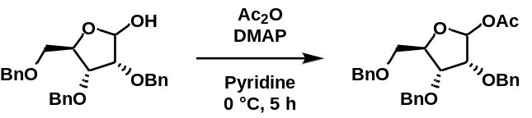
(3R,4R,5R)-3,4-bis(benzyloxy)-5-((benzyloxy)methyl)tetrahydrofuran-2-yl acetate: To an oven-dried 20 mL vial was added tri-O-benzyl-D-ribofuranoside (1 equivalent) and dry pyridine (0.1 mol/L). The reaction was cooled to 0 °C and to it was added acetic anhydride (1.2 equivalents) and a catalytic amount of DMAP. The reaction was stirred at 0 °C for 5 hours and, upon completion by TLC, the reaction was diluted with DCM, washed with diluted acetic acid, then water, then brine. The organic layers were dried over anhydrous sodium sulfate and concentrated under reduced pressure. Product isolated in a quantitative (220 mg) yield.
¹H NMR (500 MHz, CDCl₃) δ 7.40 (d, J = 6.7 Hz, 2H), 7.38 – 7.28 (m, 12H), 7.28 (s, 3H), 6.21 (s, 1H), 4.78 (d, J = 12.2 Hz, 1H), 4.68 – 4.49 (m, 5H), 4.47 – 4.35 (m, 2H), 4.15 (dd, J = 7.8, 4.7 Hz, 1H), 3.93 (d, J = 4.6 Hz, 1H), 3.72 (dd, J = 11.0, 3.1 Hz, 1H), 3.61 (td, J = 11.0, 4.8 Hz, 1H), 1.94 (d, J = 1.4 Hz, 3H).

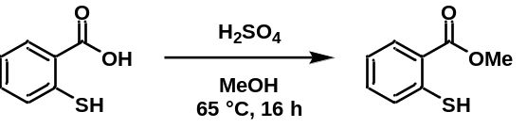
methyl 2-mercaptobenzoate: To an oven-dried 100 mL round-bottom flask was added 2-mercaptobenzoic acid (1 equivalent), anhydrous methanol (0.65 mol/L), and concentrated sulfuric acid (0.15 equivalents). The reaction was refluxed at 65 °C for 16 hours. The reaction was cooled to room temperature, diluted with dichloromethane, and with water, then sodium bicarbonate, then brine. Organic layer dried over anhydrous sodium sulfate and concentrated under reduced pressure to furnish the desired product in an 80% yield. The ¹H NMR of the titular compound matches that of the literature report.¹

3.7.2 Synthesis of Diazo Donor Second Attempt
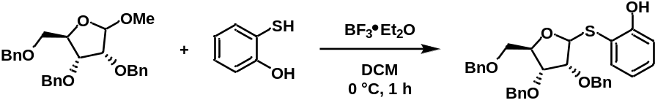
2-(((3R,4R,5R)-3,4-bis(benzyloxy)-5-((benzyloxy)methyl)tetrahydrofuran-2-yl)thio)phenol: To an oven-dried 100 mL round-bottom flask was added methyl-2,3,5-tri-O-benzyl ribofuranoside (1 equivalent), freshly distilled DCM (0.08 mol/L), and 2-mercaptoethanol (1.5 equivalents). The mixture was cooled to 0 °C and to it was added boron trifluoride diethyl etherate (2.0 equivalents) dropwise. The reaction was stirred at 0 °C for 1 hour and, upon completion by TLC, quenched with a saturated solution of sodium bicarbonate. The product was extracted with DCM, dried over anhydrous sodium sulfate, and concentrated under reduced pressure. The product was purified by silica gel column chromatography (5% ethyl acetate/hexanes) to furnish the desired product in an 88% yield (535 mg).
¹H NMR (400 MHz, CDCl₃) δ 7.57 (s, 1H), 7.44 – 7.16 (m, 14H), 7.04 – 6.91 (m, 1H), 6.88 – 6.75 (m, 1H), 5.23 (d, J = 4.0 Hz, 1H), 4.61 – 4.54 (m, 2H), 4.48 – 4.42 (m, 2H), 4.26 – 4.21 (m, 1H), 4.00 (t, J = 5.3 Hz, 1H), 3.86 (t, J = 4.5 Hz, 1H), 3.47 (dd, J = 6.5, 3.7 Hz, 1H).

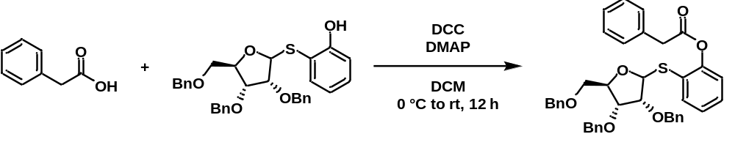
2-(((3R,4R,5R)-3,4-bis(benzyloxy)-5-((benzyloxy)methyl)tetrahydrofuran-2-yl)thio)phenyl 2-phenylacetate: To an oven-dried 100 mL round-bottom flask was added the thioglycoside (1.1 equivalents), phenylacetic acid (1.0 equivalents), and freshly distilled DCM (0.04 mol/L). The solution was cooled to 0 °C and to it was added N,N’-dicyclohexylcarbodiimide (1.1 equivalents), then DMAP (0.1 equivalents). The reaction was warmed to room temperature and stirred at room temperature for 12 hours. Upon completion by TLC, the reaction was quenched via the addition of 1M HCl. The product was extracted with DCM, washed with 1M HCl, and brine. The organic layers were combined, dried over anhydrous sodium sulfate, and concentrated under reduced pressure. The product was purified by silica gel column chromatography (5% → 7.5% → 10% ethyl acetate/hexanes) to furnish the desired product in a 66% yield (88 mg).
¹H NMR (500 MHz, CDCl₃) δ 7.80 (dd, J = 8.2, 3.7 Hz, 1H), 7.62 (dd, J = 7.8, 1.5 Hz, 1H), 7.41 – 7.29 (m, 15H), 7.29 – 7.23 (m, 7H), 7.23 – 7.12 (m, 1H), 7.05 (d, J = 8.0 Hz, 1H), 5.46 (d, J = 3.3 Hz, 1H), 4.60 (s, 1H), 4.58 (s, 1H), 4.56 – 4.51 (m, 2H), 4.45 (dd, J = 11.9, 2.6 Hz, 2H), 4.32 (q, J = 4.8 Hz, 1H), 3.98 (t, J = 5.6 Hz, 1H), 3.93 (t, J = 4.1 Hz, 1H), 3.87 (d, J = 2.0 Hz, 2H), 3.59 (qd, J = 10.8, 4.4 Hz, 2H), 2.45 (d, J = 2.4 Hz, 1H).
3.7.3 Synthesis of Diazo Donor Third Attempt
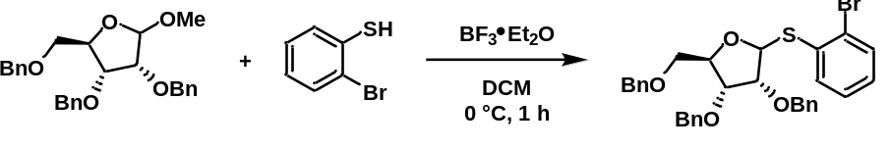
(2R,3R,4R)-3,4-bis(benzyloxy)-2-((benzyloxy)methyl)-5-((2-bromophenyl)thio)tetrahydrofuran: To an oven-dried 100 mL round-bottom flask was added methyl-2,3,5-tri-O-benzyl ribofuranoside (1.0 equivalents), freshly distilled DCM (0.06 mol/L), and 2-bromothiophenol (1.5 equivalents). The solution was cooled to 0 °C and to it was added boron trifluoride diethyl etherate (2.0 equivalents) dropwise. The reaction was stirred at 0 °C for 1 hour and, upon completion by TLC, was quenched via the addition of a saturated solution of sodium bicarbonate. The product was extracted with DCM, dried over anhydrous sodium sulfate, and concentrated under reduced pressure. The product was purified by silica gel column chromatography (5% → 10% ethyl acetate/hexanes) to furnish the desired product in a 94% yield (955 mg).
¹H NMR (400 MHz, CDCl₃) δ 7.69 (dd, J = 7.9, 1.6 Hz, 1H), 7.56 (ddd, J = 8.1, 4.2, 1.4 Hz, 1H), 7.49 – 7.43 (m, 2H), 7.40 – 7.17 (m, 17H), 7.10 – 7.03 (m, 1H), 5.81 (d, J = 5.4 Hz, 1H), 4.89 (d, J = 11.7 Hz, 1H), 4.80 – 4.61 (m, 3H), 4.61 – 4.50 (m, 4H), 4.50 – 4.30 (m, 3H), 4.26 (t, J = 5.6 Hz, 1H), 4.10 – 3.98 (m, 2H), 3.69 – 3.57 (m, 2H), 3.57 – 3.46 (m, 2H).

3.7.4 Synthesis of Diazo Donor Fourth Attempt
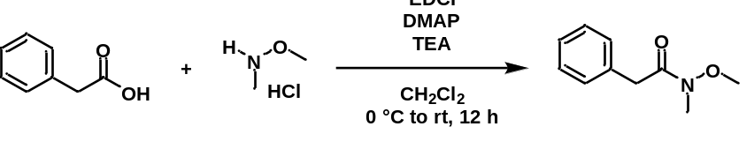
N-methoxy-N-methyl-2-phenylacetamide: To an oven-dried 100 mL round-bottom flask was added phenylacetic acid (1.0 equivalents), the Weinreb amine hydrochloride salt (1.3 equivalents), DMAP (0.1 equivalents), and freshly distilled DCM (0.2 mol/L). The mixture was cooled to 0 °C and to it was added triethylamine (1.33 equivalents) and EDCI (1.30 equivalents). The reaction was stirred at 0 °C for 1 hour, then warmed to room temperature and stirred at room temperature for 12 hours. Upon completion by TLC, the reaction was concentrated under reduced pressure until a precipitate formed. The reaction was redissolved in ethyl acetate, washed with 1M HCl, then sodium bicarbonate, then brine. The organic layers were combined, dried over anhydrous sodium sulfate, and concentrated under reduced pressure. The product was purified by silica gel column chromatography (10% ethyl acetate/hexanes) to furnish the desired product in a 94% yield (1.242 g).
¹H NMR (500 MHz, CDCl₃) δ 7.36 – 7.22 (m, 5H), 3.79 (s, 2H), 3.62 (s, 3H), 3.21 (s, 3H).

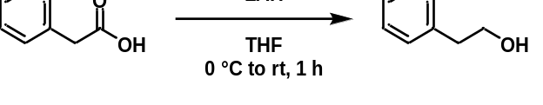
2-phenylethan-1-ol: To an oven-dried 100 mL round-bottom flask was added lithium aluminum hydride (1.2 equivalents) and freshly distilled THF (0.75 mol/L). The solution was cooled to 0 °C and to it was added a solution of phenylacetic acid (1.0 equivalents) in freshly distilled THF (10 mL) dropwise over 10 minutes. The reaction was warmed to room temperature and stirred at room temperature for 1 hour. Upon completion by TLC, the reaction was cooled to 0 °C and to it was added 1M HCl. The product was extracted with 1M HCl and brine. The organic layers were combined, dried over anhydrous sodium sulfate, and concentrated under reduced pressure. The product was purified by silica gel plug (20% ethyl acetate/hexanes) to furnish the desired product as a colorless liquid.
¹H NMR (500 MHz, CDCl₃) δ 7.38 – 7.30 (m, 2H), 7.28 – 7.22 (m, 3H), 3.88 (t, J = 6.6 Hz, 2H), 2.89 (t, J = 6.6 Hz, 2H).

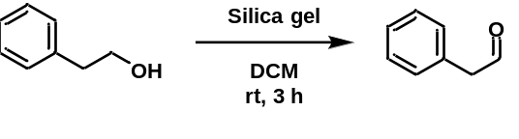
2-phenylacetaldehyde: To an oven-dried 20 mL vial was added silica gel (1.4 g), pyridinium chlorochromate (1.5 equivalents), and freshly distilled DCM (0.25 mol/L). To this was added a solution of 2-phenylethan-1-ol (1.0 equivalents) in freshly distilled DCM (3 mL). The reaction was stirred at room temperature for 3 hours and, upon completion by TLC, was loaded directly onto a silica gel column and washed with DCM. The product was concentrated under reduced pressure to yield the desired product as a pale-yellow oil with a floral scent.
¹H NMR (500 MHz, CDCl₃) δ 9.77 (t, J = 2.4 Hz, 1H), 7.41 – 7.37 (m, 2H), 7.35 – 7.32 (m, 1H), 7.25 – 7.22 (m, 2H), 3.71 (d, J = 2.4 Hz, 2H).

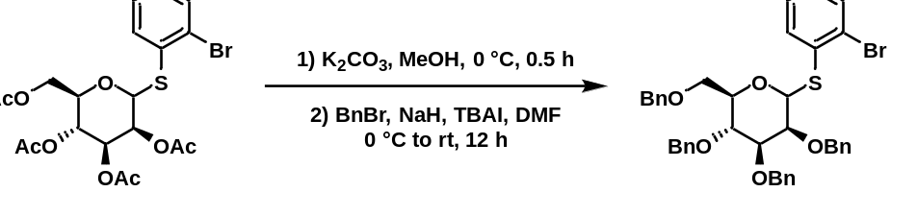
(2R,3R,4S,5S)-3,4,5-tris(benzyloxy)-2-((benzyloxy)methyl)-6-((2-bromophenyl)thio)tetrahydro-2H-pyran: To an oven-dried 20 mL vial was added the mannothioglycoside (1.0 equivalents) and dry methanol (0.1 mol/L). The solution was cooled to 0 °C and to it was added potassium carbonate (1.0 equivalents). The reaction was stirred at 0 °C for 30 minutes and, upon completion by TLC, the reaction was filtered through a silica plug which was then washed with acetone. The product was concentrated under reduced pressure and carried forward without further analysis or purification.
To an oven-dried 250 mL round-bottom flask was added the mannothioglycoside (1.0 equivalents), anhydrous DMF (0.07 mol/L), TBAI (0.01 equivalents), and benzyl bromide (5.2 equivalents). The mixture was cooled to 0 °C and to it was added sodium hydride (5.2 equivalents) portionwise. The reaction was warmed to room temperature and stirred at room temperature for 12 hours. Upon completion by TLC, the reaction was quenched with 1M HCl and extracted with ethyl acetate. The organic layers were combined and washed with brine, then dried over anhydrous sodium sulfate. The product was concentrated under reduced pressure and purified by silica gel column chromatography (5% → 10% ethyl acetate/hexanes) to furnish the desired product in a 24% yield over 2 steps (121 mg).

3.7.5 Appendix 1
Spectra Relevant to Chapter 3

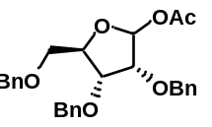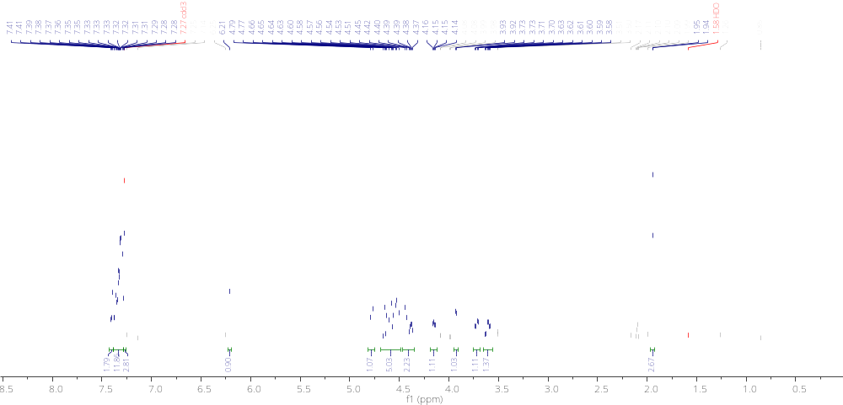

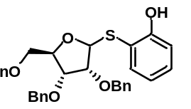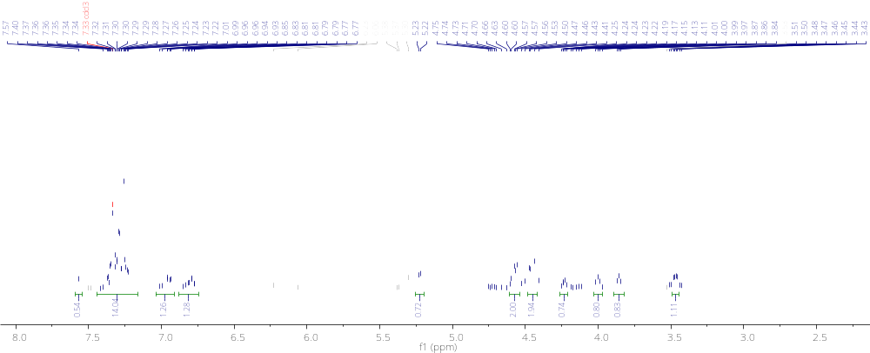

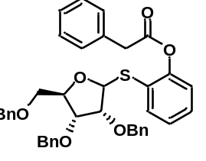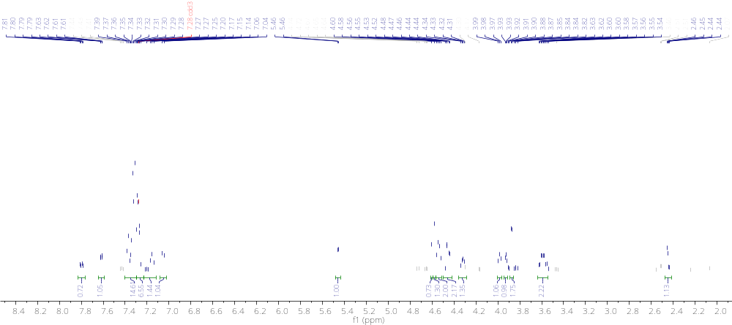

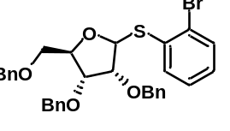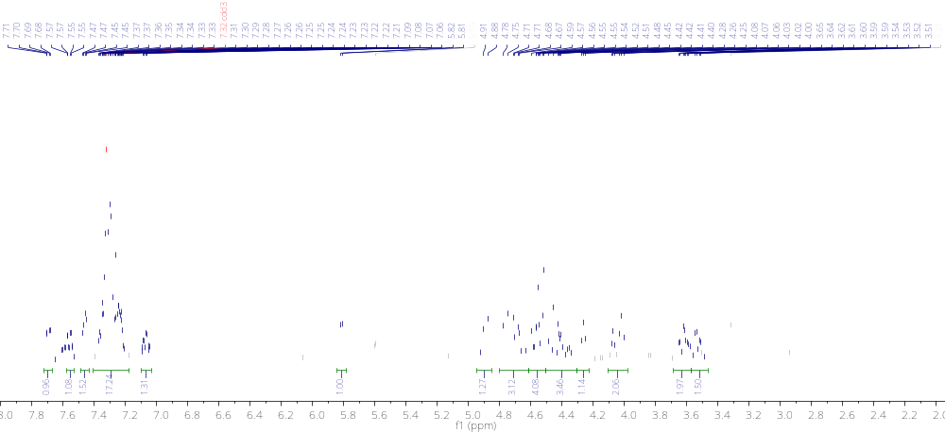

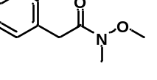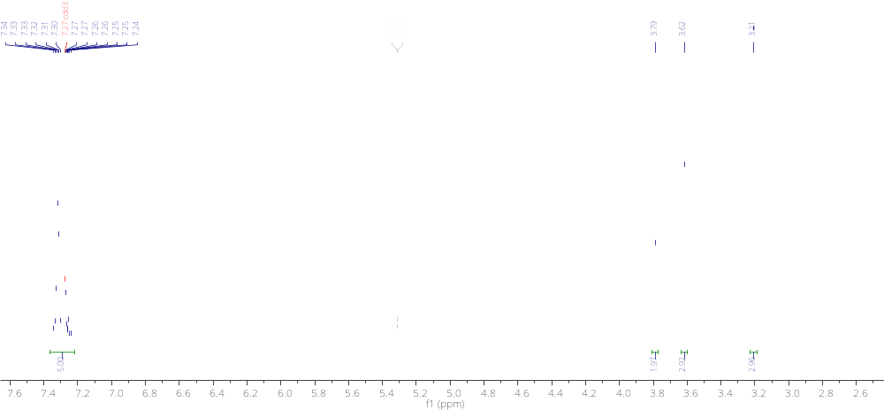

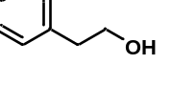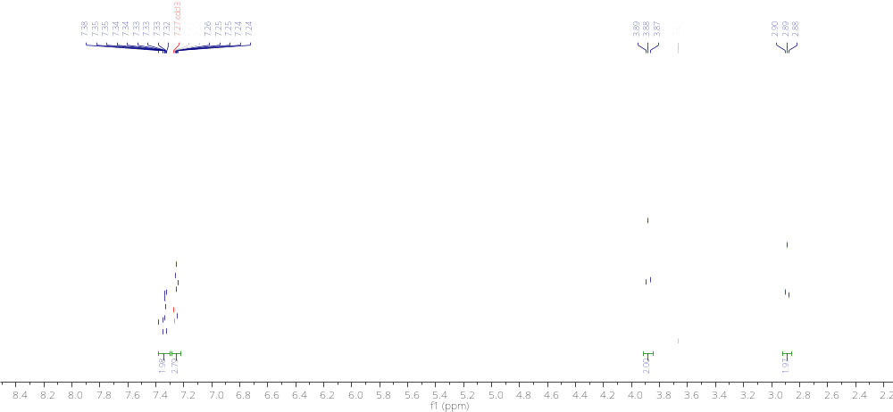

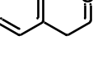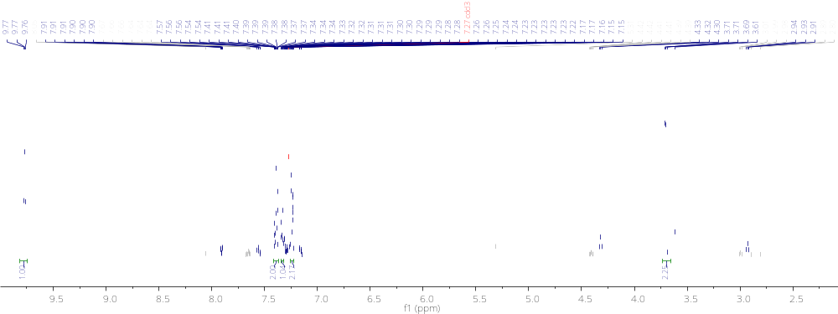

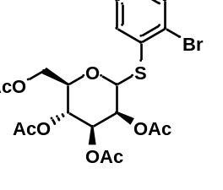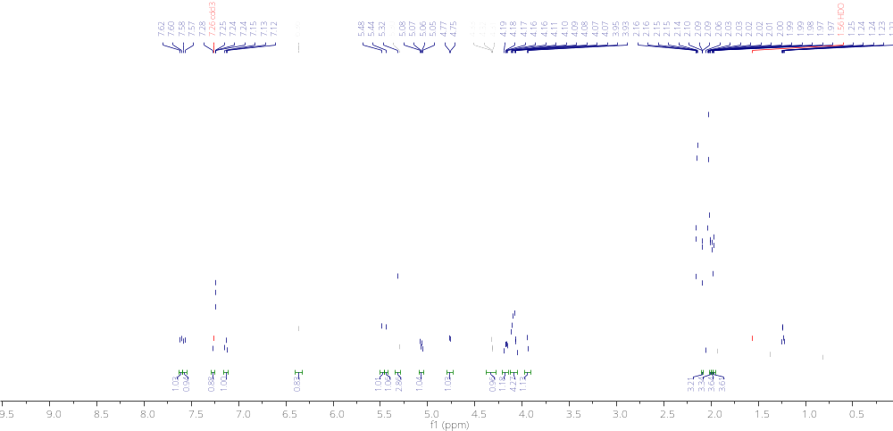
3.7.6 References for Chapter 3 Experimentals
[1] Gamer, C.; Sundaresan, S.; Carrella, L. M.; Rentschler, E. Single‐ vs Double‐decker Copper 12‐MC‐4 Metallacrown Using the Coordination Flexibility of a Soft Donor Ligand. European Journal of Inorganic Chemistry 2022, 2022 (22). DOI: 10.1002/ejic.202200261.

CHAPTER 4
Diazo-Derived Copper-Carbene Mediated Thioglycoside Furanosylations
4.1 Historical Perspectives of Thioglycosides
Thioglycosides were first synthesized in the 50’s and 60’s from dialkyl dithioacetals.¹⁻³ In fact, thioglycosides have been documented and identified in natural products for hundreds of years.⁴ These compounds have been well documented for their stability which often lend themselves to acting as both glycosyl acceptors and donors.^{5,6} This stability is highly sought after in the synthetic community as many donors, including phosphonate and halo donors, are often moisture sensitive and need to be prepared fresh whenever synthetic transformations are desired. Stability, however, comes at a cost. As starting materials become more stable, they also become less reactive. This means that whereas halodonors are typically exceedingly unstable, activation methods for these donors are typically very mild.^{7,8} Thioglycosides, on the other hand, often require more extreme methods of activation. Mercury salts,³ Triflic anhydride,^{9,10} and triflic acid¹¹ are all examples of stoichiometric promoters of thioglycosides. These harsh reagents are generally avoided by more junior academics and even in industrial settings. This has led to the development of numerous catalytic methods of activation for thioglycosides in an attempt to reduce the dependence on harsh stoichiometric conditions. This led to a recent disclosure by the Qian group wherein it was outlined that thioglycoside donors could be activated with an external diazo in a rhodium/Brønsted acid catalytic relay system.¹² Other methods of furanosylation have been reported recently in a catalytic manner, albeit deficient of a thioglycoside moiety, such as by Zhang wherein an alkyne-based donor was activated under gold catalysis for the synthesis of 1,2-cis furanosides.¹³ These donors, however, require expensive rare-earth catalysts to prepare the desired product.
While progress has been made with regards to developing a set of mild, inexpensive conditions for activation of a benchtop stable donor, no singular method has quite crossed that threshold thus far. In truth, activation of thiopyranosides under mild earth-abundant conditions have been well documented for several decades now. In fact, copper(II) triflate, which we propose as a novel activator for our donor, was first used to diastereoselectively activate a thioglycoside donor in 1979.¹⁴ Copper salts in general have been shown to be effective activators for a variety of thioglycosides.^{15,16} The problem with these strategies is often that they lack applicability in the furanoside case. Due to the relative ease of working with pyranosides over furanosides, the majority of novel transformation methods focus on their design. This unfortunately means that synthetic strategies for the diastereoselective synthesis of furanosides are often underrepresented and designs in the pyranoside case poorly reflect utility in their furanoside counterparts.
Pyranosylation strategies involving the activation of thioglycosides are robust and well documented. Early disclosures in the 70’s and 80’s relied heavily on mercury salts as thiophilic promoters.^{3,17-20} These methods, while effective, are still disfavored amongst synthetic chemists due to the toxicity associated with mercury salts. This led to a desire among the community for milder conditions. Rare-earth transition metals became popular promoters of thioglycosides following this with numerous palladium,^{21,22} silver,^{15,23-26} iridium,²⁷ and rhodium¹² centered strategies being developed. While these methods are elegant, they are also expensive which has led to further interest in the community to develop inexpensive strategies to promote thioglycosides. As sulfur is typically considered a soft Lewis base, soft Lewis acids are often employed as promoting agents and this revelation resulted in a great expansion of activating conditions. Iodonium²⁸⁻³⁰ or bromonium^{31,32} promoters can be readily generated from an in situ reaction of their respective N-succinamides and triflic acid. These soft halonium species bond strongly with the sulfur atom of the thioglycoside thus inducing glycosylation. Further still, iodonium species can be generated cleanly from silver salts, decreasing the required loading of silver to effectively initiate glycosylation.^{33,34} Sulfonium species have also been prized for their reactivity and their ability to cleanly activate thioglycosides. These sulfonium species can be readily generated from diphenylsulfoxide and triflic anhydride³⁵ or commercially available sulfonium triflates.^{36,37} These strategies, while ineffective at inducing pyranosylation have all helped to inspire the novel thioglycoside-based furanosylation strategy we outline herein.

4.1.1 Objective of Chapter
In this chapter, we hope to highlight the strength and utility of our intramolecular diazo-derived carbene-based thiofuranosylation strategy. Our method features a benchtop stable thioglycoside with a built-in diazo which can be activated under mild earth-abundant conditions. We will demonstrate the power and capacity of our donor for a range of conditions that make it clearly advantageous over current methods. The design, synthesis, and applications of this novel donor will be explored and discussed herein. We will also highlight the proposed mechanism of this reaction and the believed route of reactivity for the observed diastereoselectivity.

4.2 Synthesis of Donor
Learning from the development process outlined in chapters 3.4, 3.4.1, 3.4.2, and 3.4.3 we sought to develop another retrosynthetic route to the desired donor. Here, we envisioned a donor/acceptor diazo connected to the saccharide through a sulfur atom attached through a non-aromatic linker. We believed that this structure could be obtained following a Regitz diazo transfer which itself would follow a simple EDCI coupling of phenylacetic acid to a free alcohol. This alcohol could be synthesized through a boron trifluoride diethyl etherate coupling of 2-mercaptoethanol with methyl tri-O-benzylribofuranoside.
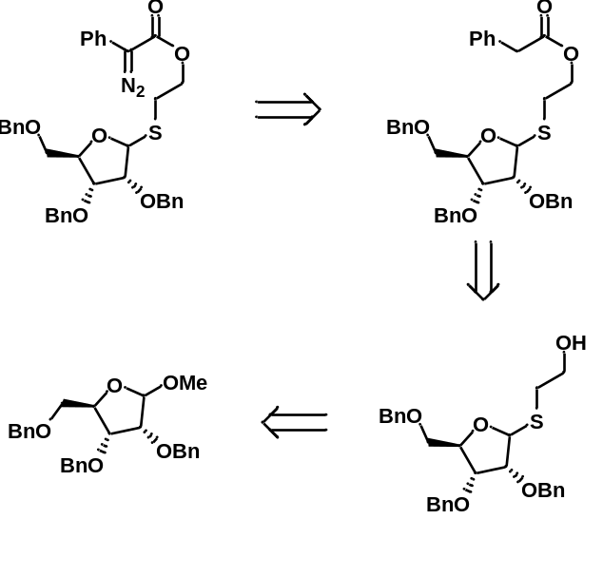

To initiate our synthesis, we began by performing a boron trifluoride diethyl etherate coupling of methyl-2,3,5-tri-O-benzyl ribofuranoside with 2-mercaptoethanol. To our delight, after 5 hours, the reaction furnished the desired product in an 89% yield. We then attempted an EDCI coupling of this species with phenylacetic acid. Again, monitoring by TLC, we found that the reaction was complete after 12 hours and had produced the desired ester in an 81% yield. Hopeful this time, we set up a Regitz diazo transfer with pABSA which, after 12 hours, appeared complete by TLC. To our pleasure, we observed an 84% yield of the desired diazo.
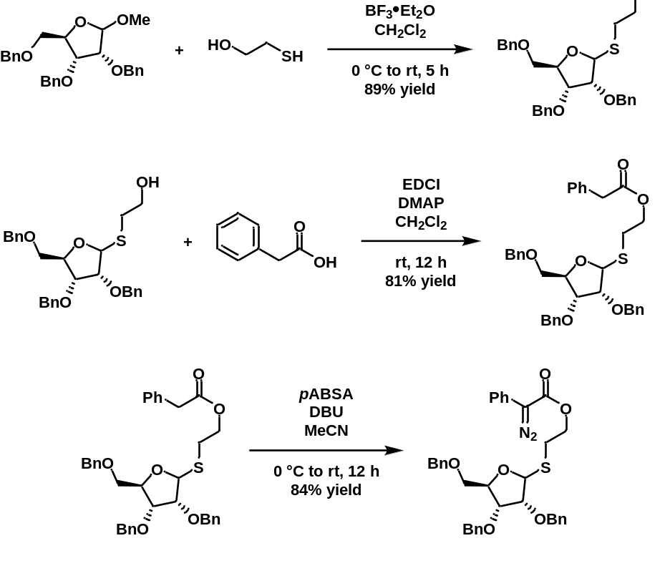

4.3 Results and Discussion
A synthetic route to a benchtop stable thioglycoside bearing an internal diazo capable of activation under mild, earth-abundant catalysis was established. Activation of this species leads to 1,2-cis furanosides in a highly diastereoselective and high yielding manner. Furanosylation occurred between O-, N-, and C-nucleophiles which highlights the broad applicability of our donor. The reaction was optimized, and a substrate scope was built out consisting of D-ribose, D-arabinose, and L-arabinose sugars. A rate study was performed to determine the effect of electron-donating and electron-withdrawing constituents on the aromatic ring of the donor. This methodology was implemented to produce a trisaccharide through iterative synthesis.

4.3.1 Reaction Conditions
We initiated our optimization of the reaction with our 2,3,5-tri-O-benzyl-D-ribose donor and had selected methyl-2,3,4-tri-O-benzyl-glucopyranose acceptor. We observed a small degree of unproductive decomposition associated with our reaction and so employed a slight excess of the donor (1.4 equivalents). Our parent conditions of copper(II) triflate at 10 mol% at room temperature for 20 hours furnishes the desired product in an 88% yield at a diastereoselectivity of 9:1 (α:β) with a 20% yield of the Stevens rearrangement product. To begin our optimization, we examined a combination of Rh(II) with di-tert-butyl methylpyridinium triflate which had been shown by Qian¹² to be effective at activating thioglycosides for pyranosylation. Unfortunately, in this case, we observed the formation of the Stevens rearrangement product (80%) primarily with only 10% of the desired product being formed after 16 hours. We then thought to turn to copper(I) triflate toluene solvate as we had utilized effectively in our enynal donor system. With 30 mol% (as we had used in our enynal system for sugar acceptors), the yield of the reaction decreased (80%) when compared to the parent conditions and the yield of the Stevens rearrangement product increased to 30% though the diastereoselectivity remained high at 9:1 (α:β). To mirror the parent conditions, we employed 10 mol% of copper(I) triflate toluene solvate which led to further decreases (37%) in yield of the desired product and increases in yield (45%) of the rearrangement product although the diastereoselectivity maintained a 9:1 ratio (α:β). We next sought to explore the effect of the anion of our copper species on our system. For this, we implemented tetrakis(acetonitrile)copper(I) tetrafluoroborate which failed to furnish the desired product after 24 hours, exclusively producing the rearrangement product in a 65% yield. We also examined tetrakis(acetonitrile)copper(I) hexafluorophosphate which fared slightly better with a desired product yield of 30% in a diastereoselectivity of 4:1 (α:β). This indicates that the choice of counterion for the catalytic pathway is important in ensuring the yield and selectivity of this reaction. From here, we attempted to decrease the yield of the Stevens rearrangement product and so, ran the reaction at various diminished temperatures. Running the reaction with 10 mol% of copper(II) triflate and maintaining the reaction at 0 °C did demonstrate a decrease in yield of the rearrangement product (to >10%), however, the reaction time increased to 36 hours and the yield of desired product decreased to 65%, though the selectivity remained 9:1 (α:β). At 10 °C however, the results were identical to the parent conditions, though not achieving completion until 36 hours had elapsed. To examine the tolerance for low catalyst loading, we employed the copper(II) triflate catalyst at a loading of 5 mol%. In this case, the reaction was again sluggish, completing only after 36 hours and with a decrease in the yield of the desired product (45%), maintaining a diastereoselectivity of 9:1 (α:β) and increasing the yield of rearrangement product to 30%. Finally, we sought to investigate various non-copper earth-abundant metal triflates. We found that with zinc(II) triflate in a loading of 30 mol%, the reaction led exclusively to unproductive decomposition and rearrangement after 36 hours. With iron triflates (namely iron(II) and iron(III) triflate) in 30 mol% we did observe formation of the desired product in appreciable yields. For iron(II) triflate, the reaction was complete after 16 hours while running at 50 °C with a yield of 72% for the desired product albeit in a racemic mixture. The yield of the Stevens rearrangement product in this case was found to be 40% which, interestingly, was the same in the iron(III) triflate case. The reaction in this iron(III) case was decreased when compared to the iron(II) case at 62% in again, a racemic mixture. It is worth noting that while the iron(II) triflate reaction needed to be run at 50 °C for 16 hours, the iron(III) case was reactive at room temperature after 18 hours.
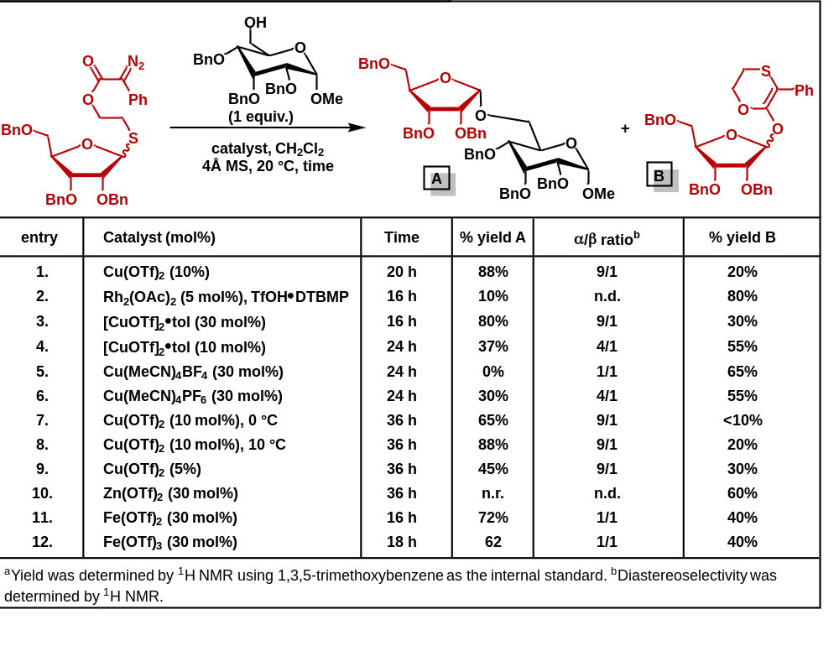

4.3.2 Substrate Scope of Ribose Donors
We commenced our substrate scope with primary alcohol acceptors such as pent-4-en-1-ol and propargyl alcohol. The yield of these reactions was excellent (84% and 90% respectively) whereas the diastereoselectivities ranged quite a bit. For the propargyl alcohol acceptor, the selectivity was moderate (5:1 α:β) however, for the pent-4-en-1-ol acceptor, the selectivity was high (15:1 α:β). Impressed by these results, we moved on to the secondary alcohol acceptors, isopropanol and cyclohexanol. Again, yields were high at 86% and 96% respectively while selectivity remained varied (4:1 for isopropanol and 9:1 α:β for cyclohexanol). With a range of achiral secondary alcohols explored, we decided to explore a range of chiral secondary alcohols. We began with menthol which, when subjected to our parent conditions, reacted cleanly to yield the desired product in an 85% yield with a diastereoselectivity of 5:1 α:β. Following this, we attempted cholesterol as an acceptor. In this case, yields were comparable to menthol (80%) although selectivity was improved (10:1 α:β). We then decided to pursue a bulky tertiary alcohol acceptor to analyze our reactions tolerance of such moieties. For this, we selected adamantanol as our acceptor. We observed a yield of 82% and a selectivity of 6:1 α:β. Pleased with these results, we turned our attention to various sugar alcohol acceptors. We began with an isopropylidene-protected galactopyranoside acceptor which displayed high yields (88%) and, again, excellent diastereoselectivity (9:1 α:β). We then expanded to a benzoyl-protected glucopyranoside acceptor. With this, we observed a yield of 86% and a diastereoselectivity of 8:1 (α:β). Following these results, we sought to examine how our system behaved with both armed and disarmed acceptors. For this, we decided to select mannopyranoside as our model substrate. We started with the armed, benzyl-protected, substrate and found a yield of 90% and a diastereoselectivity of 5:1 (α:β). To our delight, the disarmed benzoyl-protected acceptor maintained a high yield at 88% as well as maintaining the observed diastereoselectivity (5:1 α:β). Finally, we wanted to ensure that furanoside-based acceptors were also conducive to our strategy. We selected isopropylidene-protected glucofuranoside and allofuranoside acceptors for study. In these cases, the reaction furnished the desired products in an 88% and 84% yield respectively and, to our delight, the diastereoselectivity of both were >20:1 (α:β).
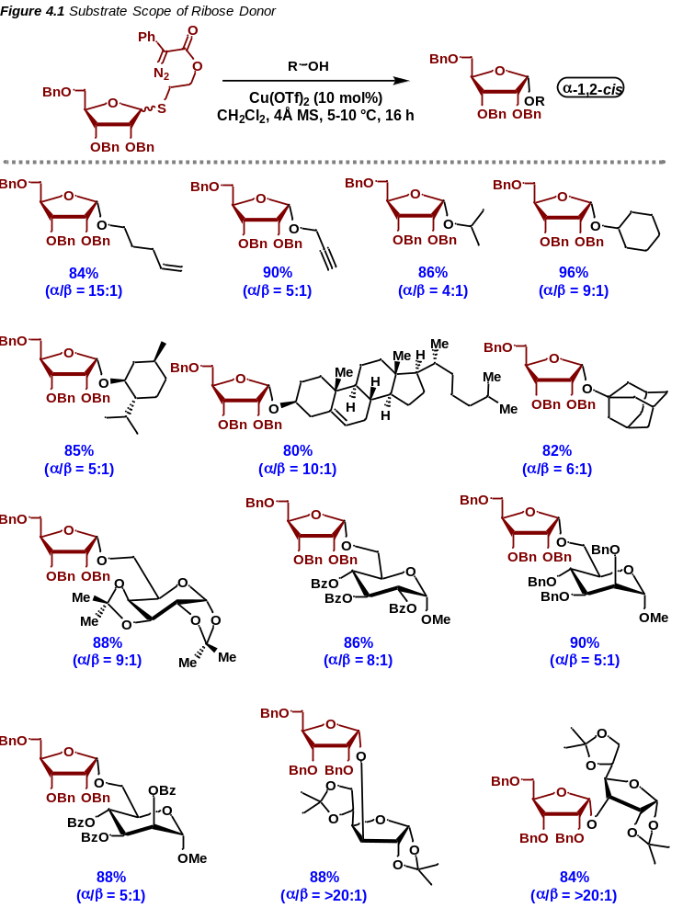
4.3.3 Substrate Scope of Arabinose Donors
With the scope of D-ribose donors established, we then turned our attention to arabinose donors. Arabinofuranose differs from ribofuranose in a singular key way. The stereochemistry of the C2 position of arabinose is the opposite of the stereochemistry of the C2 position of ribose. Because of this, the stereochemistry of the incoming nucleophile would have to reverse entirely to ensure 1,2-cis selectivity. No other position changes, so 1,2-cis selectivity would be dependent on that C2 groups orientation, indicating that cis selectivity can be maintained for each selected saccharide. With this in mind, we began our journey of developing a substrate scope for our arabinose donors.
Like with the ribose series, we began with primary alcohol acceptor pent-4-en-1-ol. The yield for this reaction remained moderate (82%) and the diastereoselectivity remained high albeit reversing the selectivity (1:10 α:β). We then investigated an achiral secondary alcohol, isopropanol, for its reactivity. With this acceptor, we observed a yield of 84% with a diastereoselectivity of 1:4 (α:β). Following these results, we endeavored to examine chiral secondary alcohols like menthol and cholesterol. With menthol, we observed a yield of 88% with a 1:6 α:β ratio. The cholesterol acceptor, similarly to the menthol acceptor, furnished the desired product in an 88% yield with an α:β ratio of 1:5. We then sought to apply our reaction to bulky tertiary systems. For this, we implemented adamantanol as an acceptor and, in this case, our conditions produced the desired product in a 92% yield in an exclusively diastereospecific manner. We were pleased to find that, regardless of whether the acceptors had low or high steric bulk, the yields and selectivity remained high indicating that yield and selectivity are independent of bulk of the acceptor.
While it is important to show that the formation of simple O-glycosides is facile under our conditions, the synthetic community is also invariably interested in the formation of disaccharides. To this end, we pursued a range of sugar alcohol acceptors to examine their applicability in our system. As many acceptors are conformationally constrained, we decided to begin our study there. We employed an isopropylidene-protected galactopyranoside acceptor which reacted cleanly under our conditions to furnish the desired product in a 94% yield with a diastereoselectivity of 1:5 (α:β). We are also aware that synthetic chemists often seek to implement both armed and disarmed acceptors in their synthetic routes and so we wanted to show that our reaction is conducive to both types of acceptors. To initiate, we selected an armed benzyl-protected glucopyranoside acceptor and found that the yield of the reaction was 86% with a diastereoselectivity of 1:5 (α:β). To our delight, disarmed benzoyl-protected and acetate-protected glucopyranoside acceptors maintained high yields and selectivity. Our benzoyl-protected substrate reacted cleanly to produce the desired product in a 90% yield with a diastereoselectivity of 1:5.5 (α:β). Similarly, the acetate-protected acceptor was synthesized in an 86% yield with a selectivity of 1:4 (α:β). This seemed to indicate that both armed and disarmed systems are reactive under our conditions. Finally, we examined mannopyranoside acceptors which were found to be unreactive under the Jacobsen protocol.³⁸ To our pleasure, both benzyl- and benzoyl-protected mannose acceptors reacted cleanly through our protocol to furnish the desired products in a 90% and 88% respectively. Even more interesting, we found that the benzyl-protected species was nearly diastereospecific (1:>20 α:β). The benzoyl-protected species was less selective with a selectivity of 1:4 (α:β).
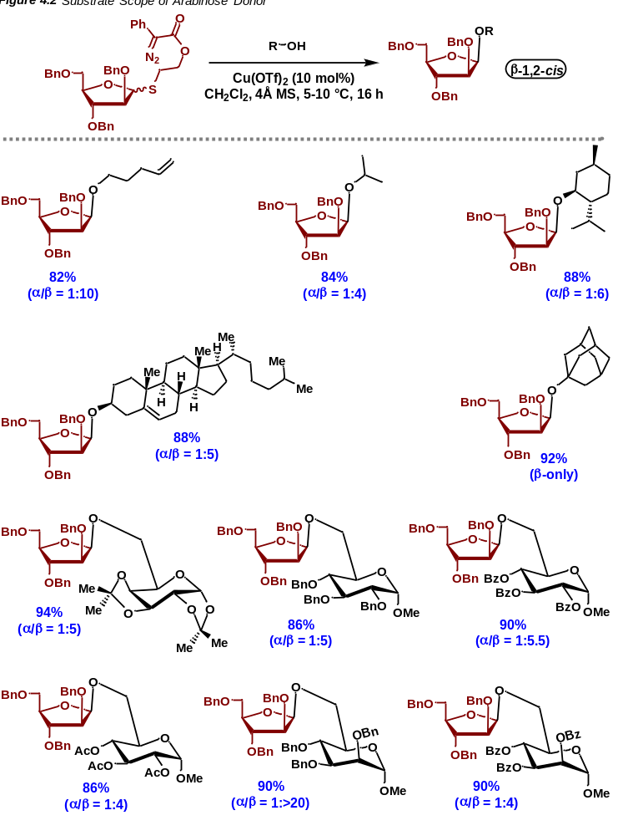

To probe our mechanism further, we decided to pursue a small substrate scope with an L-arabinose donor. As L- and D-arabinose differ by completely reversing the stereochemistry of every position on the furanose ring, cis selectivity would need to be dependent on the C2 position, reducing the likelihood of confounding factors. We began with a conformationally constrained isopropylidene-protected galactopyranoside acceptor. When subjected to our parent conditions, we observed product formation in a 78% yield with a diastereoselectivity of 1:3 (α:β). Following these results, we explored benzoyl-protected glucopyranoside and mannopyranoside acceptors. With glucose, the substrate reacted cleanly to furnish the desired product in an 82% yield in a diastereoselectivity of 1:4 (α:β). Finally, our mannose disaccharide was synthesized in an 80% yield with a selectivity of 1:4 (α:β). We were pleased with these results as they indicated that our reaction was conducive to L-arabinose conditions and thus lent credence to our hypothesis that coordination of the copper catalyst to the C2 position led to the desired 1,2-cis stereoselectivity.
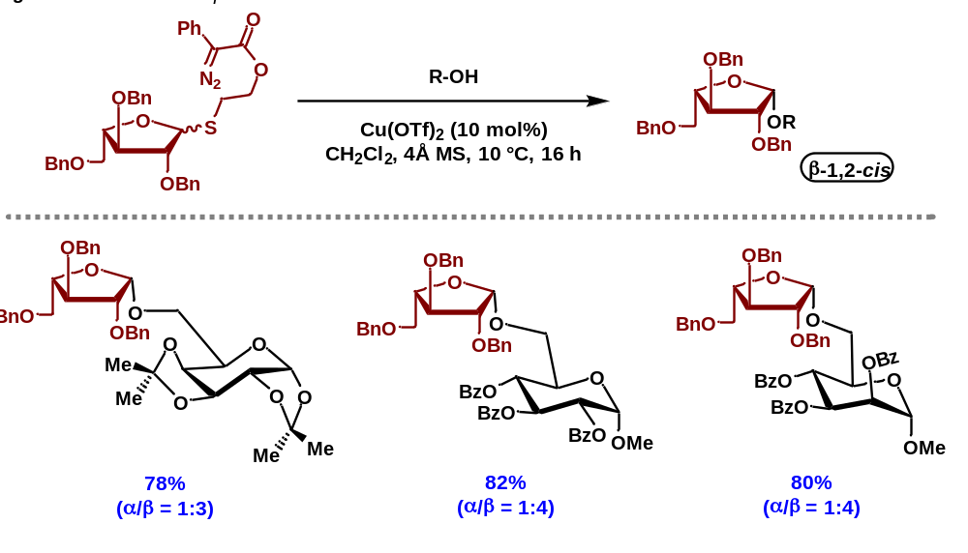
4.3.4 C- and N-Nucleophiles for Ribosylation
To highlight the applicability of our system for furanosylation, we set out to synthesize C- and N-furanosides. We began with C-ribosides and so selected allyl trimethylsilane as an acceptor. To our delight, when subjected to our optimized conditions, the reaction proceeded cleanly to furnish the desired C-glycoside in an 82% yield in a diastereospecific (α-only) manner. We then sought to analyze nitrogen nucleophiles for the formation of N-ribosides. For this, we selected benzyl tosyl amine as our acceptor which, when subjected to the parent conditions, yielded the desired product in a 70% yield with a diastereoselectivity of 3:1 (α:β).
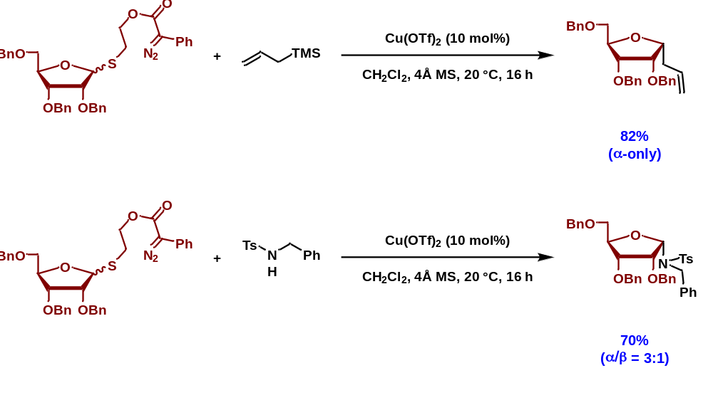

4.3.5 Control Reactions
To probe the mechanism of our reaction, we decided to run a variety of control reactions. To analyze the electronic effects of the aromatic ring, on the rate of reaction, we established a series of reactions varying the electronic configuration of that ring. We also sought to analyze the effect of the C2 protecting group to analyze the effect this would have on diastereoselectivity. Finaly, we monitored the rate of epimerization for this reaction to determine if that could lead to reasonable product formation.

4.3.5.1 Rate Study
We first decided to investigate the effect of the electronics of the aromatic ring attached to the diazo. For this, we synthesized para-methoxy and para-nitro versions of the parent donor. Three reactions were set up in parallel consisting of the para-methoxy donor, the parent donor, and the para-nitro donor. When subjected to the optimized conditions, we observed that the para-methoxy donor reacted rapidly, however, leading to byproduct formation primarily with only 34% of the desired product being formed. We believe that this was due to the lower stability of the para-methoxy diazo causing the diazo to decompose faster, but not necessarily productively. Our parent donor reacted cleanly over 20 hours to furnish the desired product in an 88% yield. Conversely, the para-nitro donor did not react after 36 hours, likely due to the stability of the diazo being unreactive in the presence of the copper catalyst.
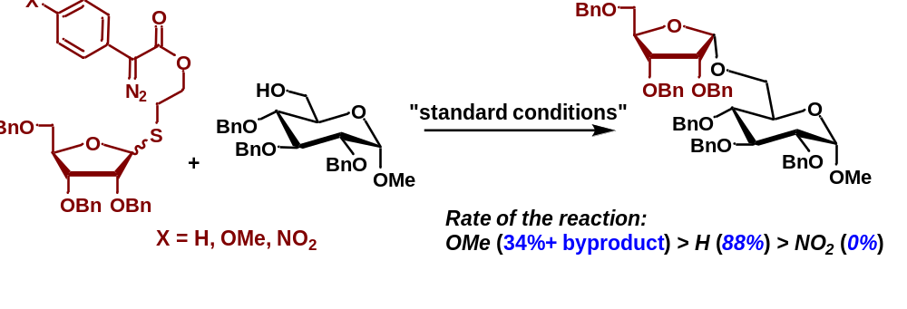
4.3.5.2 Manipulation of the C2 Protecting Group
We then sought to investigate the influence of the C2 protecting group on the observed diastereoselectivity of the reaction. To this end, we synthesized a variety of donors possessing various C2 protecting groups. We were first curious as to whether chelation of the copper atom to the benzyl aromatic ring^{39,40} was driving selectivity and so synthesized a C2 methoxy donor which lacks potential for π-aryl coordination. We found that when subjected to the parent conditions, the reaction proceeded cleanly to furnish the desired product in a 92% yield in a diastereospecific (α-only) manner indicating that coordination of the copper catalyst to the aromatic ring of the C2 position does not drive the observed selectivity. Following these results, we sought to evaluate whether a silyl-protected donor would be conducive to our conditions as silyl-protected compounds are suitable for solid-phase automated synthesis.⁴¹⁻⁴³ To this end, we synthesized a C2 OTIPS donor which, when subjected to our optimized conditions, we observed the formation of the desired product in a 90% yield in a diastereospecific (α-only) manner. To probe the tolerance for copper coordination, we synthesized a weakly coordinating, C2 fluoro donor and, to our surprise, we observed again a diastereospecific (α-only) product formation in an 86% yield. Finally, to evaluate the necessity of a C2 group for selectivity, we synthesized a C2 deoxy donor. As anticipated, upon subject to our parent conditions, we observed exclusively extensive decomposition with no product formation. This indicates that coordination between the C2 protecting group and the copper catalyst is mandatory for effective furanosylation diastereoselectivity.
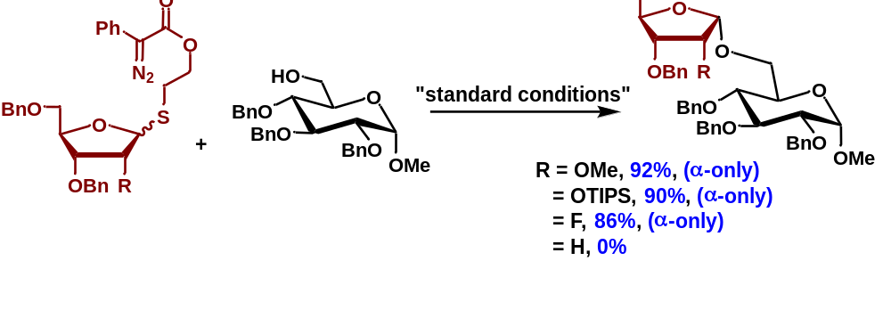

4.3.5.3 Epimerization Studies and Importance of the Anomeric Configuration of the Donor
Pyranosylation strategies often rely on anomerically pure donors to result in the desired diastereoselectivity. This is due to the preference of pyranosides to undergo S_{N}2-type reactivity, allowing for facile control of anomeric configurations. This has led to attention being placed on a similar form of anomeric stereocontrol for novel furanosylation strategies. Recent protocols, like those published by Jacobsen³⁸ and Zhang,¹³ have highlighted the necessity of anomerically pure substrates to aid in achieving diastereoselectivity. We then decided to investigate whether our donor system had a similar dependence. For this, we set up parallel reactions consisting of a racemic mixture of the donor and a diastereotopically pure donor. When subjected to the optimized conditions, we observed no distinguishable variance in either yield or diastereoselectivity indicating that the desired diastereoselectivity and yield are independent of the anomeric configuration of the donor. We also sought to determine whether diastereoselectivity was being established upon initial reaction, or if it was trending towards one isomer due to epimerization. To this end, we isolated a single diastereomer (α) and subjected it to our parent conditions once again. However, we did not observe the formation of the β-isomer, indicating that the product does not epimerize as a result of the conditions of the reaction.
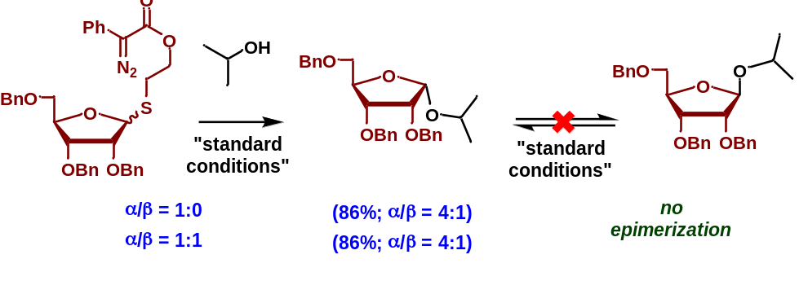

4.3.6 Proposed Reaction Mechanism
Following the control reactions and computational studies that were performed regarding this reaction, we established a plausible reaction mechanism to explain the observed diastereoselectivity. We envision the reaction beginning by decomposition of the diazo by our copper(II) triflate catalyst forming the copper carbenoid. Following this, coordination of the copper catalyst to the sulfur atom of the thioglycoside places the sulfur atom in close proximity to the carbon center of the carbene allowing for facile insertion into the carbene. This can be followed by a migration of the copper species from the carbon center onto the adjacent oxygen. This then promotes the release of the leaving group to form an oxocarbenium ion and the O-linked copper species. Recombination of these two species leads to the formation of the observed Stevens rearrangement product and serves as a dead-end for the reaction. Ligand exchange of the alcohol acceptor with the triflate anion on the copper catalyst results in the formation of a copper alkoxide necessary for desired reactivity. Coordination of the copper alkoxide to the C2 oxygen of the oxocarbenium ion facilitates facile delivery of the acceptor to the cis face of the oxocarbenium ion and regenerating the copper catalyst. Interestingly, this mechanism indicates that the copper catalyst maintains a +2 oxidation state for the duration of the reaction.
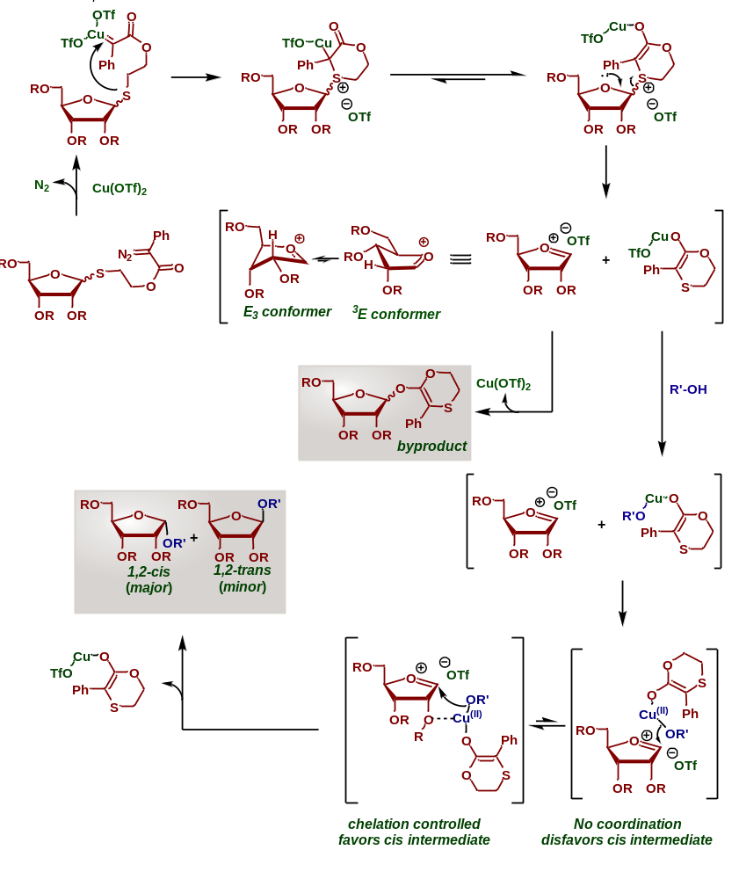
4.4 References for Chapter 4
[1] El Hewehi, Z. Über Zucker‐mercaptale. Chemische Berichte 1958, 91 (10), 2039–2044. DOI: 10.1002/cber.19580911006.
[2] Zissis, E.; Clingman, A. L.; Richtmyer, N. K. D-Glucose Diphenyl Dithioacetal, Phenyl 1-Thio-α-D-Glucopyranoside, Phenyl 1-Thio-α-D-Glucofuranoside, and Some Related Compounds. Carbohydrate Research 1966, 2 (6), 461–469. DOI: 10.1016/s0008-6215(00)81750-4.
[3] Ferrier, R. J.; Hay, R. W.; Vethaviyasar, N. A Potentially Versatile Synthesis of Glycosides. Carbohydrate Research 1973, 27 (1), 55–61. DOI: 10.1016/s0008-6215(00)82424-6.
[4] Fahey, J. W.; Zalcmann, A. T.; Talalay, P. The Chemical Diversity and Distribution of Glucosinolates and Isothiocyanates among Plants. Phytochemistry 2001, 56 (1), 5–51. DOI: 10.1016/s0031-9422(00)00316-2.
[5] Fried, Josef.; Walz, D. E. Ethyl Thioglycosides of D-Mannose and D-Galactose and a New Synthesis of Styracitol. Journal of the American Chemical Society 1949, 71 (1), 140–143. DOI: 10.1021/ja01169a038.
[6] Toshima, K.; Sasaki, K. O-Glycosidation Methods. Comprehensive Glycoscience 2007, 261–311. DOI: 10.1016/b978-044451967-2/00008-8.
[7] Li, J.; Nguyen, H. M. Phenanthroline Catalysis in Stereoselective 1,2-Cis Glycosylations. Accounts of Chemical Research 2022, 55 (24), 3738–3751. DOI: 10.1021/acs.accounts.2c00636.
[8] Koenigs, W.; Knorr, E. Ueber Einige Derivate Des Traubenzuckers Und Der Galactose. Berichte der deutschen chemischen Gesellschaft 1901, 34 (1), 957–981. DOI: 10.1002/cber.190103401162.
[9] Crich, D.; Pedersen, C. M.; Bowers, A. A.; Wink, D. J. On the Use of 3,5-O-Benzylidene and 3,5-O-(Di-Tert-Butylsilylene)-2-O-Benzylarabinothiofuranosides and Their Sulfoxides as Glycosyl Donors for the Synthesis of β-Arabinofuranosides: Importance of the Activation Method. The Journal of Organic Chemistry 2007, 72 (5), 1553–1565. DOI: 10.1021/jo061440x.
[10] Crich, D. Methodology Development and Physical Organic Chemistry: A Powerful Combination for the Advancement of Glycochemistry. The Journal of Organic Chemistry 2011, 76 (22), 9193–9209. DOI: 10.1021/jo2017026.
[11] Heuckendorff, M.; Jensen, H. H. DIDMH in Combination with Triflic Acid - a New Promoter System for Thioglycoside Glycosyl Donors. Carbohydrate Research 2018, 455, 86–91. DOI: 10.1016/j.carres.2017.11.012.
[12] Meng, L.; Wu, P.; Fang, J.; Xiao, Y.; Xiao, X.; Tu, G.; Ma, X.; Teng, S.; Zeng, J.; Wan, Q. Glycosylation Enabled by Successive Rhodium(II) and Brønsted Acid Catalysis. Journal of the American Chemical Society 2019, 141 (30), 11775–11780. DOI: 10.1021/jacs.9b04619.
[13] Ma, X.; Zhang, Y.; Zhu, X.; Zhang, L. An S_{N}2-Type Strategy toward 1,2-Cis-Furanosides. CCS Chemistry 2022, 4 (12), 3677–3685. DOI: 10.31635/ccschem.022.202202175.
[14] Mukaiyama, T.; Nakatsuka, T.; Shoda, S. An Efficient Glucosylation of Alcohol Using 1-Thioglucoside Derivative. Chemistry Letters 1979, 8 (5), 487–490. DOI: 10.1246/cl.1979.487.
[15] Sato, S.; Mori, M.; Ito, Y.; Ogawa, tomoya. An Efficient Approach to O-Glycosides through CuBr₂-Bu₄NBr Mediated Activation of Glycosides. Carbohydrate Research 1986, 155. DOI: 10.1016/s0008-6215(00)90163-0.
[16] Nakano, T.; Ito, Y.; Ogawa, T. Total Synthesis of a Sulfated Glucuronyl Glycosphingolipid, Iv3glca(3-So3)Nlcose4cer, a Carbohydrate Epitope of Neural Cell Adhesion Molecules. Tetrahedron Letters 1990, 31 (11), 1597–1600. DOI: 10.1016/0040-4039(90)80026-i.
[17] Tsai, T. Y.; Jin, H.; Wiesner, K. A Stereoselective Synthesis of Digitoxin. on Cardioactive Steroids. XIII. Canadian Journal of Chemistry 1984, 62 (7), 1403–1405. DOI: 10.1139/v84-238.
[18] Garegg, P. J. Thioglycosides as Glycosyl Donors in Oligosaccharide Synthesis. Advances in Carbohydrate Chemistry and Biochemistry 1997, 179–205. DOI: 10.1016/s0065-2318(08)60091-8.
[19] Van Cleve, J. W. Reinvestigation of the Preparation of Cholesteryl 2,3,4,6-Tetra-O-Benzyl-α-D-Glucopyranoside. Carbohydrate Research 1979, 70 (1), 161–164. DOI: 10.1016/s0008-6215(00)83281-4.
[20] Hanessian, S.; Bacquet, C.; Lehong, N. Chemistry of the Glycosidic Linkage. Exceptionally Fast and Efficient Formation of Glycosides by Remote Activation. Carbohydrate Research 1980, 80 (2). DOI: 10.1016/s0008-6215(00)84882-x.
[21] Woodward, R. B.; Logusch, E.; Nambiar, K. P.; Sakan, K.; Ward, D. E.; Au-Yeung, B. W.; Balaram, P.; Browne, L. J.; Card, P. J.; Chen, C. H. Asymmetric Total Synthesis of Erythromycin. 3. Total Synthesis of Erythromycin. Journal of the American Chemical Society 1981, 103 (11), 3215–3217. DOI: 10.1021/ja00401a051.
[22] Wuts, P. G.; Bigelow, S. S. Total Synthesis of Oleandrose and the Avermectin Disaccharide, Benzyl α-L-Oleandrosyl-α-L-4-Acetoxyoleandroside. The Journal of Organic Chemistry 1983, 48 (20), 3489–3493. DOI: 10.1021/jo00168a022.
[23] Lear, M. J.; Yoshimura, F.; Hirama, M. A Direct and Efficient -Selective Glycosylation Protocol for the Kedarcidin Sugar, L-Mycarose: AGPF6 as a Remarkable Activator of 2-Deoxythioglycosides. Angewandte Chemie International Edition 2001, 40 (5), 946–949. DOI: 10.1002/1521-3773(20010302)40:5&lt;946::aid-anie946&gt;3.3.co;2-7.
[24] Ohashi, I.; Lear, M. J.; Yoshimura, F.; Hirama, M. Use of Polystyrene-Supported DBU in the Synthesis and α-Selective Glycosylation Study of the Unstable Schmidt Donor of l-Kedarosamine. Organic Letters 2004, 6 (5), 719–722. DOI: 10.1021/ol036353v.
[25] Kihlberg, J. O.; Leigh, D. A.; Bundle, D. R. The in Situ Activation of Thioglycosides with Bromine: An Improved Glycosylation Method. The Journal of Organic Chemistry 1990, 55 (9), 2860–2863. DOI: 10.1021/jo00296a055.
[26] TSUBOYAMA, K.; TAKEDA, K.; TORII, K.; EBIHARA, M.; SHIMIZU, J.; SUZUKI, A.; SATO, N.; FURUHATA, K.; OGURA, H. A Convenient Synthesis of S-Glycosyl Donors of D-Glucose and O-Glycosylations Involving the New Reagent. Chemical and Pharmaceutical Bulletin 1990, 38 (3), 636–638. DOI: 10.1248/cpb.38.636.
[27] Wever, W. J.; Cinelli, M. A.; Bowers, A. A. Visible Light Mediated Activation and O-Glycosylation of Thioglycosides. Organic Letters 2012, 15 (1), 30–33. DOI: 10.1021/ol302941q.
[28] Konradsson, P.; Udodong, U. E.; Fraser-Reid, B. Iodonium Promoted Reactions of Disarmed Thioglycosides. Tetrahedron Letters 1990, 31 (30), 4313–4316. DOI: 10.1016/s0040-4039(00)97609-3.
[29] Konradsson, P.; Mootoo, D. R.; McDevitt, R. E.; Fraser-Reid, B. Iodonium Ion Generated in Situ from N-Iodosuccinimide and Trifluoromethanesulphonic Acid Promotes Direct Linkage of ‘Disarmed’ Pent-4-Enyl Glycosides. J. Chem. Soc., Chem. Commun. 1990, No. 3, 270–272. DOI: 10.1039/c39900000270.
[30] Veeneman, G. H.; van Leeuwen, S. H.; van Boom, J. H. Iodonium Ion Promoted Reactions at the Anomeric Centre. II an Efficient Thioglycoside Mediated Approach toward the Formation of 1,2-Trans Linked Glycosides and Glycosidic Esters. Tetrahedron Letters 1990, 31 (9), 1331–1334. DOI: 10.1016/s0040-4039(00)88799-7.
[31] Sasaki, M.; Tachibana, K.; Nakanishi, H. An Efficient and Stereocontrolled Synthesis of the Nephritogenoside Core Structure. Tetrahedron Letters 1991, 32 (47), 6873–6876. DOI: 10.1016/0040-4039(91)80430-e.
[32] Koichi, F.; Atsushi, H.; Shoichi, K. A Novel Method for Activation of Thioglycosides, Combination of N-Bromosuccinimide and Triflic Acid Salts. Tetrahedron Letters 1993, 34 (13), 2187–2190. DOI: 10.1016/s0040-4039(00)60378-7.
[33] Ercegovic, T.; Meijer, A.; Magnusson, G.; Ellervik, U. Iodine Monochloride/Silver Trifluoromethanesulfonate (ICL/AgOTf) as a Convenient Promoter System for O-Glycoside Synthesis. Organic Letters 2001, 3 (6), 913–915. DOI: 10.1021/ol015547c.
[34] Meijer, A.; Ellervik, U. Interhalogens (ICl/IBr) and AgOTf in Thioglycoside Activation; Synthesis of Bislactam Analogues of Ganglioside GD3. The Journal of Organic Chemistry 2004, 69 (19), 6249–6256. DOI: 10.1021/jo049184g.
[35] Crich, D.; Smith, M. 1-Benzenesulfinyl Piperidine/Trifluoromethanesulfonic Anhydride: A Potent Combination of Shelf-Stable Reagents for the Low-Temperature Conversion of Thioglycosides to Glycosyl Triflates and for the Formation of Diverse Glycosidic Linkages. Journal of the American Chemical Society 2001, 123 (37), 9015–9020. DOI: 10.1021/ja0111481.
[36] Dasgupta, F.; Garegg, P. J. Alkyl Sulfenyl Triflate as Activator in the Thioglycoside-Mediated Formation of β-Glycosidic Linkages during Oligosaccharide Synthesis. Carbohydrate Research 1988, 177, c13–c17. DOI: 10.1016/0008-6215(88)85071-7.
[37] Dasgupta, F.; Garegg, P. J. Use of the Methylsulfenyl Cation as an Activator for Glycosylation Reactions with Alkyl (Aryl) L-Thioglycopyranosides: Synthesis of Methyl O-(2-Acetamido-2-Deoxy-β-D-Glucopyranosyl)-(1→ 2)-α-D-Glucopyranoside, a Derivative of the Core Trisaccharide of E. Coli K12. Carbohydrate Research 1990, 202, 225–238. DOI: 10.1016/0008-6215(90)84082-6.
[38] Mayfield, A. B.; Metternich, J. B.; Trotta, A. H.; Jacobsen, E. N. Stereospecific Furanosylations Catalyzed by Bis-Thiourea Hydrogen-Bond Donors. Journal of the American Chemical Society 2020, 142 (8), 4061–4069. DOI: 10.1021/jacs.0c00335.
[39] Kundu, S.; Greene, C.; Williams, K. D.; Salvador, T. K.; Bertke, J. A.; Cundari, T. R.; Warren, T. H. Three-Coordinate Copper(II) Aryls: Key Intermediates in C–O Bond Formation. Journal of the American Chemical Society 2017, 139 (27), 9112–9115. DOI: 10.1021/jacs.7b04046.
[40] Nishimura, K.; Wang, Y.; Ogura, Y.; Kumagai, J.; Ishihara, K. A π–Cu(II)−π Complex as an Extremely Active Catalyst for Enantioselective α-Halogenation of N-Acyl-3,5-Dimethylpyrazoles. ACS Catalysis 2022, 12 (2), 1012–1017. DOI: 10.1021/acscatal.1c05500.
[41] Hsu, Y.; Lu, X.-A.; Zulueta, M. M.; Tsai, C.-M.; Lin, K.-I.; Hung, S.-C.; Wong, C.-H. Acyl and Silyl Group Effects in Reactivity-Based One-Pot Glycosylation: Synthesis of Embryonic Stem Cell Surface Carbohydrates LC4 and IV2Fuc-LC4. Journal of the American Chemical Society 2012, 134 (10), 4549–4552. DOI: 10.1021/ja300284x.
[42] Sati, G. C.; Martin, J. L.; Xu, Y.; Malakar, T.; Zimmerman, P. M.; Montgomery, J. Fluoride Migration Catalysis Enables Simple, Stereoselective, and Iterative Glycosylation. Journal of the American Chemical Society 2020, 142 (15), 7235–7242. DOI: 10.1021/jacs.0c03165.
[43] McDonald, F. E.; Wu, M. Stereoselective Synthesis of L-Oliose Trisaccharide via Iterative Alkynol Cycloisomerization and Acid-Catalyzed Glycosylation. Organic Letters 2002, 4 (22), 3979–3981. DOI: 10.1021/ol026886o.
4.5 Experimental Section for Chapter 4

MATERIALS AND METHODS

Reagents
Reagents and solvents were obtained from Sigma-Aldrich, Chem-Impex, VWR International, and Acros Organics and used without further purification unless otherwise indicated. Dichloromethane and Acetonitrile were distilled over CaH under N₂ unless stated otherwise. Tetrahydrofuran was distilled over Na under N₂ with benzophenone indicator.

Reagents
All reactions were performed in oven-dried glassware under positive N₂ Pressure with magnetic stirring unless otherwise noted.

Chromatography

Thin layer chromatography (TLC) was performed on 0.25 mm E. Merck silica gel 60 F254 plates and visualized under UV light (254 nm) or by staining with potassium permanganate (KMnO₄), cerium ammonium molybdate (CAM), phosphomolybdic acid (PMA), and ninhydrin. Silica flash chromatography was performed on Sorbtech 230-400 mesh silica gel 60.

Analytical Instrumentation

NMR spectra were recorded on a Varian VNMRS 300, 400, 500, and 600 MHz NMR spectrometer at 20 ºC in CDCl₃ unless otherwise indicated. Chemical shifts are expressed in ppm relative to solvent signals: CDCl₃ (¹H, 7.26 ppm, ¹³C, 77.0 ppm); coupling constants are expressed in Hz. IR spectra were recorded on a Cary 760 FTIR spectrometer with peaks reported in cm⁻¹. Mass spectra were obtained on an Advion Expression CMS TLC Mass Spectrometer.

Nomenclature

Chemical structure named in accordance with IUPAC guidelines, automatically generated using ChemDraw 20.1

Additional Information and Considerations

Syringe pump addition reactions were conducted using a Harvard Apparatus (Model: 55- 1111) or a New Era Pump Systems, Inc. (Model: NE-300) syringe pump. Sonication was performed using a Bransonic Ultrasonic Cleaner (Model: M5800H).

Publication and Contributions Statement
The research presented in this chapter is unpublished. All materials and procedures are contributions by A. Alber and Bidhan Ghosh.

4.5.1 Synthesis of Diazo Thioglycoside Donor
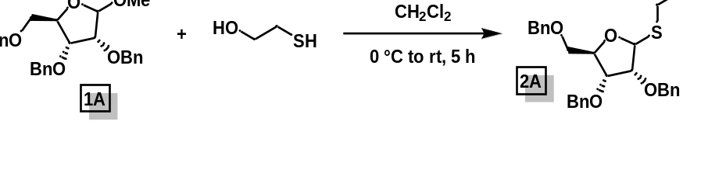
2-(((3R,4R,5R)-3,4-bis(benzyloxy)-5-((benzyloxy)methyl)tetrahydrofuran-2-yl)thio)ethan-1-ol (2A): To an oven-dried round-bottom flask containing a magnetic stirring bar, were added furanosyl anomeric methoxide (1 equiv.), commercially available 2-mercaptoethanol (1.5 equiv.), and freshly distilled DCM (20 mL/mmol). The reaction mixture was cooled to 0 °C and to it was added boron trifluoride diethyl etherate (2.0 equiv.) dropwise. The reaction was warmed to room temperature and stirred at room temperature for 5 h. After completion, it was quenched with a saturated solution of sodium bicarbonate; extracted with DCM and washed with a saturated solution of sodium bicarbonate, then water, then bine. The organic layer was dried over anhydrous sodium sulfate, concentrated in vacuo, and purified by silica gel flash chromatography (ethyl acetate/hexane: 20% → 30%) to give the desired product 2A in an 89% yield.
¹H NMR (500 MHz, CDCl₃) δ 7.40 (d, J = 7.2 Hz, 2H), 7.37 – 7.28 (m, 14H), 7.27 – 7.22 (m, 4H), 5.45 – 5.40 (m, 1H), 4.78 – 4.33 (m, 10H), 3.98 (td, J = 5.6, 1.1 Hz, 1H), 3.88 – 3.67 (m, 4H), 3.63 – 3.56 (m, 1H), 3.54 – 3.47 (m, 1H), 2.99 – 2.85 (m, 2H), 2.84 – 2.72 (m, 2H).
¹³C NMR (101 MHz, CDCl₃) δ 138.29, 137.98, 137.86, 128.42, 128.40, 128.39, 128.35, 128.32, 128.29, 128.24, 128.18, 128.11, 128.08, 128.06, 128.04, 128.01, 127.98, 127.97, 127.93, 127.90, 127.88, 127.86, 127.84, 127.81, 127.78, 127.71, 127.69, 127.68, 127.62, 127.61, 102.52, 82.14, 77.87, 77.55, 77.23, 76.91, 75.05, 73.47, 73.46, 73.34, 72.48, 72.36, 72.30, 70.18, 55.58, 53.55.

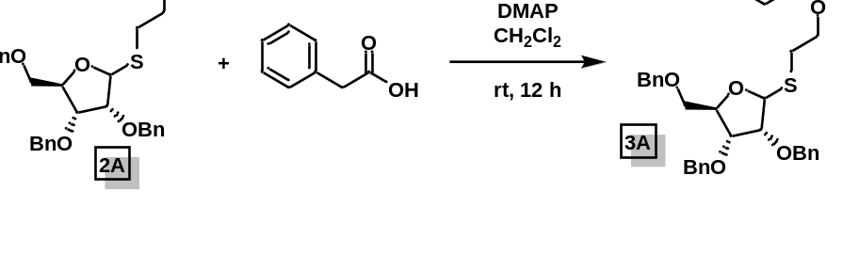
2-(((3R,4R,5R)-3,4-bis(benzyloxy)-5-((benzyloxy)methyl)tetrahydrofuran-2-yl)thio)ethyl 2-phenylacetate (3A): To an oven-dried round-bottom flask containing a magnetic stirring bar, were added the thioglycoside alcohol (2A,1.0 equiv.), freshly distilled DCM (25 mL/mmol), phenylacetic acid (1.2 equiv.), EDCI (2.0 equiv.), and DMAP (1.0 equiv.). The reaction was stirred at room temperature for 12 hours and, upon completion by TLC, was quenched via addition of a saturated solution of sodium bicarbonate. The product was extracted with DCM. The organic layers were combined, washed with a saturated solution of sodium bicarbonate, then water, then brine. The organic layer was dried over anhydrous sodium sulfate and concentrated under reduced pressure. The product was purified by silica gel column chromatography (15% ethyl acetate/hexanes). The product ester 3A was isolated as a light-yellow syrup in an 81% yield (2.16 g).
¹H NMR (400 MHz, CDCl₃) δ 7.39 – 7.22 (m, 16H), 5.25 (d, J = 4.1 Hz, 1H), 4.66 (d, J = 12.1 Hz, 1H), 4.63 – 4.53 (m, 3H), 4.51 (s, 1H), 4.48 (d, J = 1.3 Hz, 1H), 4.35 – 4.26 (m, 2H), 4.20 (ddd, J = 11.2, 7.6, 6.3 Hz, 1H), 4.02 (t, J = 5.4 Hz, 1H), 3.86 (t, J = 4.6 Hz, 1H), 3.62 (s, 2H), 3.55 (td, J = 11.3, 10.7, 4.4 Hz, 2H), 2.92 (dt, J = 13.9, 7.0 Hz, 1H), 2.78 (dt, J = 13.9, 7.0 Hz, 1H).

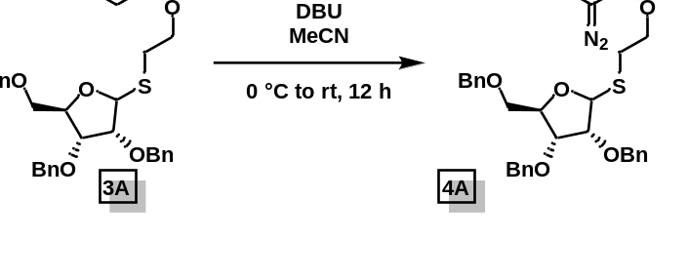
2-(((3R,4R,5R)-3,4-bis(benzyloxy)-5-((benzyloxy)methyl)tetrahydrofuran-2-yl)thio)ethyl 2-diazo-2-phenylacetate (4A): To an oven-dried round-bottom flask was added the thioglycoside ester (3A, 1.0 equiv.), freshly distilled acetonitrile (10 mL/mmol), and pABSA (1.4 equiv.). The reaction was cooled to 0 °C and to it was added DBU (1.6 equiv.) dropwise. The reaction was warmed to room temperature and stirred at room temperature for 12 hours. Upon completion by TLC, the reaction was quenched via addition of water. The product was extracted with ethyl acetate, the organic layers were combined, washed with a saturated solution of ammonium chloride, and then brine. The organic layer was dried over anhydrous sodium sulfate and concentrated under reduced pressure. The product was purified by silica gel column chromatography (15% ethyl acetate/hexanes). The product was obtained as an orange syrup in an 84% yield of the desired diazo 4A.
¹H NMR (400 MHz, CDCl₃) δ 7.56 – 7.49 (m, 2H), 7.45 – 7.30 (m, 16H), 7.25 – 7.20 (m, 1H), 5.34 (d, J = 4.1 Hz, 1H), 4.76 – 4.49 (m, 7H), 4.47 – 4.33 (m, 2H), 4.11 (t, J = 5.3 Hz, 1H), 3.95 (t, J = 4.6 Hz, 1H), 3.70 – 3.58 (m, 2H), 3.04 (ddd, J = 13.8, 7.5, 6.2 Hz, 1H), 2.93 – 2.84 (m, 1H).
¹³C NMR (101 MHz, CDCl₃) δ 164.74, 138.10, 137.64, 137.47, 128.94, 128.43, 128.39, 128.33, 128.09, 128.00, 127.93, 127.86, 127.61, 127.58, 125.84, 125.39, 123.94, 86.09, 81.92, 80.57, 77.95, 77.48, 77.36, 77.16, 76.84, 73.30, 72.24, 70.61, 63.94, 29.42.
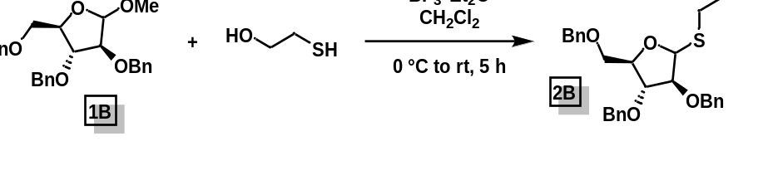
2-(((3S,4R,5R)-3,4-bis(benzyloxy)-5-((benzyloxy)methyl)tetrahydrofuran-2-yl)thio)ethan-1-ol (2B): The titular compound was synthesized in accordance to the procedure outlined for 2A. The crude was purified by flash chromatography (20% → 30% ethyl acetate/hexanes) to give pure 2B (75% yield).

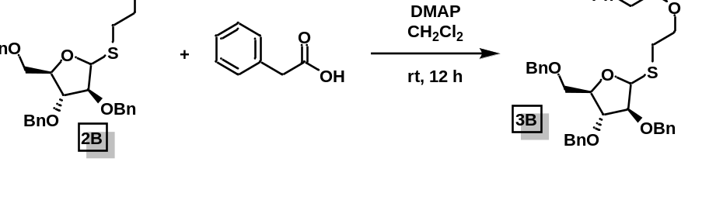
2-(((3S,4R,5R)-3,4-bis(benzyloxy)-5-((benzyloxy)methyl)tetrahydrofuran-2-yl)thio)ethyl 2-phenylacetate (3B): The titular compound was synthesized in accordance to the procedure outlined for 3A. The crude was purified by flash chromatography (15% ethyl acetate/hexanes) to give pure 3B (93% yield).
¹H NMR (500 MHz, CDCl₃) δ 7.41 – 7.25 (m, 23H), 5.42 (d, J = 2.5 Hz, 1H), 5.01 (s, 0H), 4.62 (dd, J = 12.1, 1.3 Hz, 2H), 4.57 (t, J = 6.0 Hz, 2H), 4.55 – 4.46 (m, 2H), 4.45 – 4.22 (m, 5H), 4.03 (dd, J = 6.8, 3.2 Hz, 1H), 3.99 (t, J = 2.8 Hz, 1H), 3.73 – 3.62 (m, 5H), 3.00 (ddd, J = 13.7, 7.2, 6.3 Hz, 1H), 2.91 (t, J = 6.5 Hz, 1H), 2.88 – 2.80 (m, 1H), 2.80 – 2.68 (m, 1H).
¹³C NMR (126 MHz, CDCl₃) δ 171.33, 138.05, 137.71, 137.32, 133.89, 129.31, 128.63, 128.59, 128.48, 128.41, 128.37, 128.01, 127.98, 127.85, 127.83, 127.77, 127.76, 127.65, 127.21, 127.18, 127.12, 88.73, 87.65, 83.59, 80.15, 77.35, 77.09, 76.84, 73.41, 72.29, 72.06, 69.02, 63.77, 63.38, 53.27, 41.27, 41.25, 37.18, 30.87, 29.75.

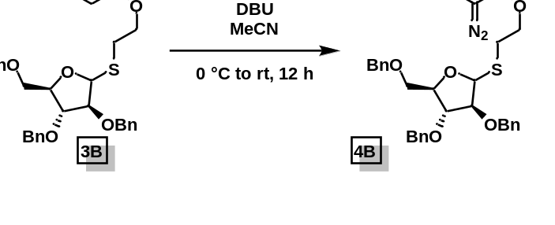
2-(((3S,4R,5R)-3,4-bis(benzyloxy)-5-((benzyloxy)methyl)tetrahydrofuran-2-yl)thio)ethyl 2-diazo-2-phenylacetate (4B): The titular compound was synthesized in accordance to the procedure outlined for 4A. The crude was purified by flash chromatography (15% ethyl acetate/hexanes) to give pure 4B (87% yield).
¹H NMR (400 MHz, CDCl₃) δ 7.55 – 7.44 (m, 2H), 7.42 – 7.22 (m, 15H), 7.18 (ddt, J = 8.7, 7.1, 1.2 Hz, 1H), 5.41 (d, J = 2.4 Hz, 1H), 4.67 – 4.36 (m, 8H), 4.32 (ddd, J = 6.7, 4.8, 3.7 Hz, 1H), 4.04 – 3.94 (m, 2H), 3.73 – 3.58 (m, 2H), 3.06 (ddd, J = 13.7, 7.3, 6.2 Hz, 1H), 2.90 (ddd, J = 14.0, 7.4, 6.5 Hz, 1H).
¹³C NMR (101 MHz, CDCl₃) δ 164.85, 138.03, 137.66, 137.27, 128.94, 128.44, 128.37, 128.33, 127.99, 127.94, 127.81, 127.79, 127.73, 127.60, 125.85, 125.39, 124.00, 88.68, 87.60, 83.60, 80.16, 77.34, 77.22, 77.02, 76.70, 73.39, 72.27, 72.06, 69.00, 63.58, 30.00, 29.70.
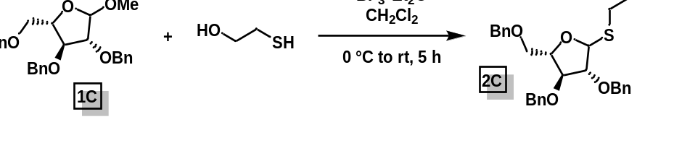
2-(((3R,4S,5S)-3,4-bis(benzyloxy)-5-((benzyloxy)methyl)tetrahydrofuran-2-yl)thio)ethan-1-ol (2C): The titular compound was synthesized in accordance to the procedure outlined for 2A. The crude was purified by flash chromatography (20% → 30% ethyl acetate/hexanes) to give pure 2C (XX% yield).
¹H NMR (400 MHz, CDCl₃) δ 7.38 (dt, J = 10.5, 3.3 Hz, 8H), 7.36 – 7.27 (m, 5H), 5.42 (dd, J = 9.5, 3.7 Hz, 1H), 4.70 – 4.48 (m, 6H), 4.28 – 4.01 (m, 3H), 3.93 – 3.78 (m, 2H), 3.78 – 3.62 (m, 2H), 3.01 – 2.75 (m, 3H).
¹³C NMR (101 MHz, CDCl₃) δ 137.34, 128.55, 128.54, 128.53, 128.48, 128.46, 128.08, 128.04, 127.99, 127.92, 127.90, 127.84, 127.81, 127.78, 127.74, 88.64, 88.25, 88.16, 83.90, 83.49, 83.00, 82.24, 80.27, 77.63, 77.31, 76.99, 73.43, 73.36, 72.40, 72.31, 72.20, 71.92, 70.50, 69.08, 62.50, 62.24, 35.60, 35.59.

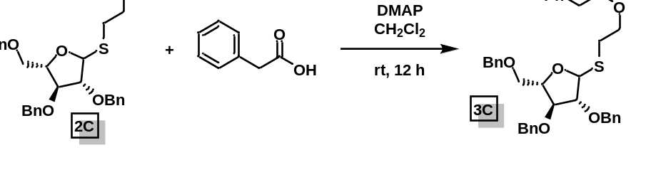
2-(((3R,4S,5S)-3,4-bis(benzyloxy)-5-((benzyloxy)methyl)tetrahydrofuran-2-yl)thio)ethyl 2-phenylacetate (3C): The titular compound was synthesized in accordance to the procedure outlined for 3A. The crude was purified by flash chromatography (15% ethyl acetate/hexanes) to give pure 3C (XX% yield).
¹H NMR (400 MHz, CDCl₃) δ 7.36 (pdd, J = 6.1, 4.1, 2.7 Hz, 13H), 7.31 – 7.26 (m, 3H), 5.49 – 5.40 (m, 1H), 4.67 – 4.56 (m, 3H), 4.56 – 4.42 (m, 3H), 4.42 – 4.17 (m, 3H), 4.12 – 3.95 (m, 2H), 3.77 – 3.60 (m, 4H), 3.01 (ddd, J = 17.2, 8.7, 4.9 Hz, 1H), 2.84 (dtd, J = 13.9, 6.9, 3.7 Hz, 1H).
¹³C NMR (101 MHz, CDCl₃) δ 171.36, 138.03, 137.68, 137.29, 133.88, 129.33, 128.61, 128.50, 128.47, 128.43, 128.39, 128.04, 128.00, 127.96, 127.93, 127.87, 127.85, 127.83, 127.79, 127.67, 127.14, 88.68, 87.62, 87.14, 84.23, 83.53, 82.09, 80.11, 77.44, 77.33, 77.13, 76.81, 73.40, 72.29, 72.05, 71.97, 71.22, 68.95, 64.15, 63.76, 41.27, 29.74, 29.00.

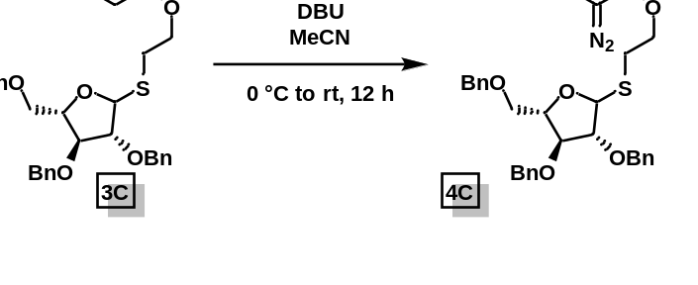
2-(((3R,4S,5S)-3,4-bis(benzyloxy)-5-((benzyloxy)methyl)tetrahydrofuran-2-yl)thio)ethyl 2-diazo-2-phenylacetate (4C): The titular compound was synthesized in accordance to the procedure outlined for 4A. The crude was purified by flash chromatography (15% ethyl acetate/hexanes) to give pure 4C (XX% yield).

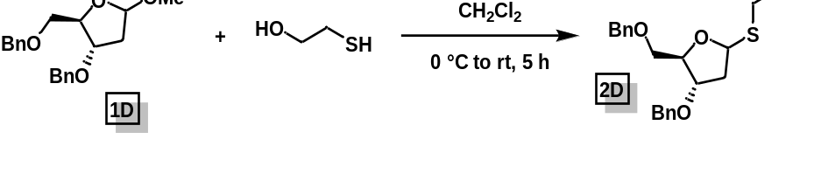
2-(((4S,5R)-4-(benzyloxy)-5-((benzyloxy)methyl)tetrahydrofuran-2-yl)thio)ethan-1-ol (2D): The titular compound was synthesized in accordance to the procedure outlined for 2A. The crude was purified by flash chromatography (20% → 30% ethyl acetate/hexanes) to give pure 2D (55% yield).
¹H NMR (400 MHz, CDCl₃) δ 7.40 – 7.24 (m, 9H), 5.36 (dd, J = 8.6, 6.1 Hz, 1H), 4.56 (s, 2H), 4.50 (s, 2H), 4.28 (td, J = 5.5, 2.4 Hz, 1H), 4.14 (dt, J = 6.1, 2.4 Hz, 1H), 3.86 (dddd, J = 12.1, 9.0, 5.6, 3.9 Hz, 1H), 3.73 (ddt, J = 11.8, 8.1, 4.3 Hz, 1H), 3.60 (dd, J = 10.2, 5.1 Hz, 1H), 3.50 (dd, J = 10.2, 5.8 Hz, 1H), 3.39 (dd, J = 8.5, 4.8 Hz, 1H), 2.85 (qdt, J = 11.5, 7.6, 3.8 Hz, 2H), 2.39 (ddd, J = 13.7, 6.1, 2.4 Hz, 1H), 2.07 (ddd, J = 14.1, 8.6, 6.0 Hz, 1H).
¹³C NMR (101 MHz, CDCl₃) δ 137.89, 137.65, 128.46, 128.40, 127.81, 127.72, 127.70, 84.54, 84.33, 80.36, 77.34, 77.22, 77.02, 76.70, 73.43, 71.25, 70.52, 62.49, 38.59, 36.20.

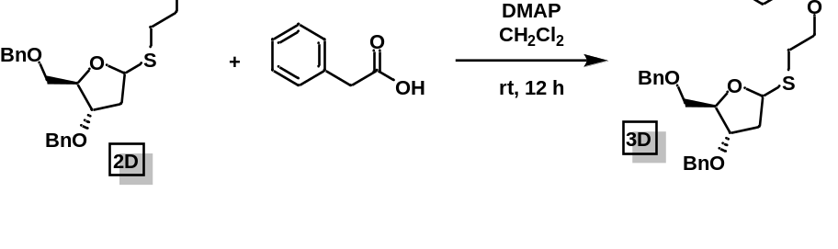
2-(((4S,5R)-4-(benzyloxy)-5-((benzyloxy)methyl)tetrahydrofuran-2-yl)thio)ethyl 2-phenylacetate (3D): The titular compound was synthesized in accordance to the procedure outlined for 3A. The crude was purified by flash chromatography (15% ethyl acetate/hexanes) to give pure 3D (92% yield).
¹H NMR (400 MHz, CDCl₃) δ 7.31 (dtd, J = 14.8, 7.2, 3.3 Hz, 10H), 5.36 (dd, J = 7.9, 6.1 Hz, 1H), 4.60 – 4.45 (m, 4H), 4.33 (ddd, J = 11.2, 7.7, 6.3 Hz, 1H), 4.24 (ddd, J = 11.0, 7.6, 5.9 Hz, 2H), 4.12 (dt, J = 5.7, 2.7 Hz, 1H), 3.62 (s, 2H), 3.59 (dd, J = 10.1, 5.1 Hz, 1H), 3.50 (dd, J = 10.1, 6.1 Hz, 1H), 2.95 (ddd, J = 14.1, 7.6, 6.5 Hz, 1H), 2.83 (ddd, J = 13.9, 7.7, 6.2 Hz, 1H), 2.35 (ddd, J = 13.6, 6.1, 2.8 Hz, 1H), 2.05 (ddd, J = 13.9, 8.0, 6.2 Hz, 1H).
¹³C NMR (101 MHz, CDCl₃) δ 171.33, 138.04, 137.76, 133.85, 129.29, 128.57, 128.45, 128.38, 127.77, 127.72, 127.67, 127.11, 109.99, 84.19, 83.86, 80.47, 77.36, 77.04, 76.72, 73.39, 71.28, 71.01, 64.27, 41.24, 38.78, 29.57.

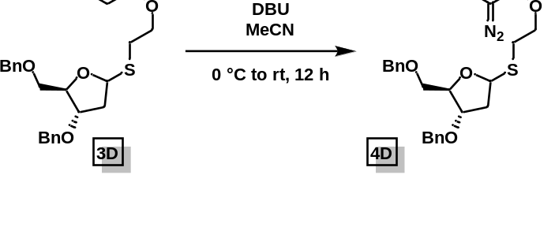
2-(((4S,5R)-4-(benzyloxy)-5-((benzyloxy)methyl)tetrahydrofuran-2-yl)thio)ethyl 2-diazo-2-phenylacetate (4D): The titular compound was synthesized in accordance to the procedure outlined for 4A. The crude was purified by flash chromatography (15% ethyl acetate/hexanes) to give pure 4D.
¹H NMR (500 MHz, CDCl₃) δ 7.52 – 7.46 (m, 2H), 7.40 (dd, J = 8.5, 7.3 Hz, 2H), 7.38 – 7.29 (m, 8H), 7.20 (tt, J = 7.4, 1.3 Hz, 1H), 5.43 (dd, J = 8.0, 6.1 Hz, 1H), 4.57 (d, J = 3.1 Hz, 2H), 4.53 (d, J = 1.2 Hz, 2H), 4.43 (ddd, J = 11.1, 7.8, 6.4 Hz, 1H), 4.28 (td, J = 5.6, 2.5 Hz, 1H), 4.15 (dt, J = 5.7, 2.7 Hz, 1H), 3.63 (dd, J = 10.1, 5.1 Hz, 1H), 3.54 (dd, J = 10.1, 6.1 Hz, 1H), 3.05 (ddd, J = 14.0, 7.7, 6.3 Hz, 1H), 2.93 (ddd, J = 13.9, 7.8, 6.2 Hz, 1H), 2.39 (ddd, J = 13.6, 6.1, 2.8 Hz, 1H), 2.10 (ddd, J = 13.9, 8.0, 6.2 Hz, 1H).
¹³C NMR (126 MHz, CDCl₃) δ 164.87, 138.06, 137.80, 128.96, 128.46, 128.44, 128.39, 127.81, 127.77, 127.73, 127.68, 125.87, 125.41, 123.99, 84.32, 84.26, 83.97, 80.50, 77.30, 77.25, 77.04, 76.79, 73.43, 71.29, 71.04, 64.20, 38.82, 29.90.

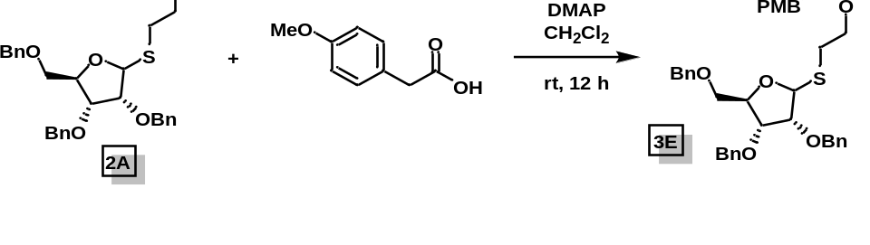
2-(((3R,4R,5R)-3,4-bis(benzyloxy)-5-((benzyloxy)methyl)tetrahydrofuran-2-yl)thio)ethyl 2-(4-methoxyphenyl)acetate (3E): The titular compound was synthesized in accordance to the procedure outlined for 3A. The crude was purified by flash chromatography (15% ethyl acetate/hexanes) to give pure 3E (79% yield).
¹H NMR (600 MHz, CDCl₃) δ 7.38 – 7.27 (m, 7H), 7.27 – 7.20 (m, 6H), 7.17 (d, J = 8.6 Hz, 1H), 6.86 – 6.79 (m, 1H), 5.29 (s, 1H), 4.73 – 4.59 (m, 1H), 4.59 – 4.40 (m, 4H), 4.32 – 4.14 (m, 2H), 4.00 (t, J = 5.3 Hz, 1H), 3.84 (dd, J = 5.0, 4.3 Hz, 1H), 3.79 – 3.71 (m, 2H), 3.60 – 3.43 (m, 3H), 2.96 – 2.85 (m, 1H), 2.85 – 2.68 (m, 1H).

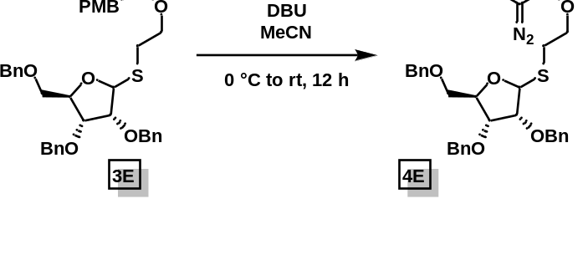
2-(((3R,4R,5R)-3,4-bis(benzyloxy)-5-((benzyloxy)methyl)tetrahydrofuran-2-yl)thio)ethyl 2-diazo-2-(4-methoxyphenyl)acetate (4E): The titular compound was synthesized in accordance to the procedure outlined for 4A. The crude was purified by flash chromatography (15% ethyl acetate/hexanes) to give pure 4E.
¹H NMR (600 MHz, CDCl₃) δ 7.40 – 7.30 (m, 7H), 7.30 – 7.25 (m, 9H), 7.24 (d, J = 3.1 Hz, 2H), 6.94 – 6.90 (m, 2H), 5.28 (s, 1H), 5.24 (d, J = 4.2 Hz, 1H), 4.62 (d, J = 20.3 Hz, 1H), 4.59 – 4.56 (m, 1H), 4.55 (d, J = 4.7 Hz, 1H), 4.49 (s, 1H), 4.47 (s, 1H), 4.45 – 4.41 (m, 1H), 4.34 (ddd, J = 11.1, 7.7, 6.2 Hz, 1H), 4.27 (td, J = 5.1, 3.9 Hz, 1H), 4.02 (t, J = 5.4 Hz, 1H), 3.86 (dd, J = 5.0, 4.2 Hz, 1H), 3.79 (s, 3H), 3.59 (dd, J = 10.7, 3.8 Hz, 1H), 3.53 (dd, J = 10.6, 4.9 Hz, 1H), 2.96 (ddd, J = 13.8, 7.6, 6.2 Hz, 1H), 2.83 (ddd, J = 14.0, 7.7, 6.4 Hz, 1H).
¹³C NMR (151 MHz, CDCl₃) δ 158.07, 138.08, 137.46, 128.39, 128.35, 128.29, 128.05, 127.95, 127.88, 127.80, 127.59, 127.54, 125.96, 116.79, 114.60, 86.07, 81.90, 80.62, 77.99, 77.18, 76.97, 76.76, 73.30, 72.24, 70.60, 63.89, 53.38, 29.43, 11.77.

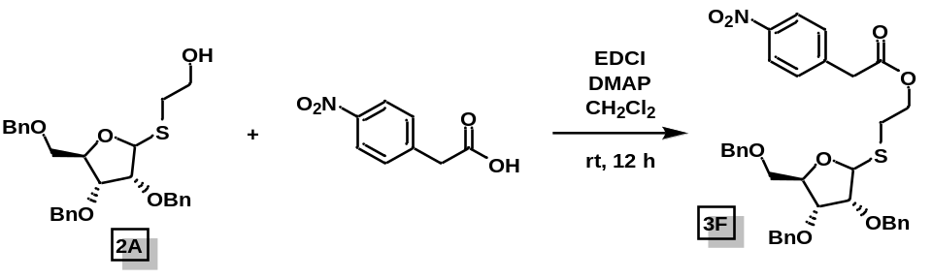
2-(((3R,4R,5R)-3,4-bis(benzyloxy)-5-((benzyloxy)methyl)tetrahydrofuran-2-yl)thio)ethyl 4-nitrobenzoate (3F): The titular compound was synthesized in accordance to the procedure outlined for 3A. The crude was purified by flash chromatography (15% ethyl acetate/hexanes) to give pure 3F (69% yield).

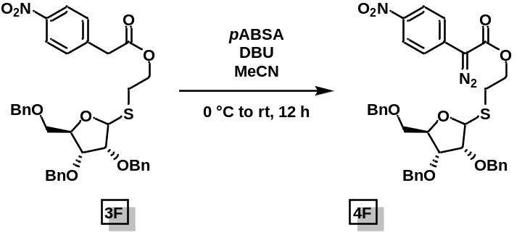
2-(((3R,4R,5R)-3,4-bis(benzyloxy)-5-((benzyloxy)methyl)tetrahydrofuran-2-yl)thio)ethyl 2-diazo-2-(4-nitrophenyl)acetate (4F): The titular compound was synthesized in accordance to the procedure outlined for 4A. The crude was purified by flash chromatography (15% ethyl acetate/hexanes) to give pure 4F (28% yield).
¹H NMR (400 MHz, CDCl₃) δ 8.27 – 8.15 (m, 4H), 7.70 – 7.56 (m, 4H), 7.40 – 7.24 (m, 30H), 5.30 (s, 1H), 5.25 (d, J = 4.5 Hz, 1H), 4.77 – 4.34 (m, 20H), 4.17 – 3.95 (m, 5H), 3.91 – 3.80 (m, 3H), 3.74 – 3.47 (m, 7H).

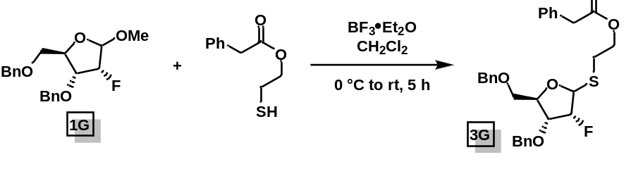
2-(((3R,4R,5R)-4-(benzyloxy)-5-((benzyloxy)methyl)-3-fluorotetrahydrofuran-2-yl)thio)ethyl 2-phenylacetate (3G): The titular compound was synthesized in accordance to the procedure outlined for 2A. The crude was purified by flash chromatography (15% ethyl acetate/hexanes) to give pure 3G (XX% yield).
¹H NMR (600 MHz, CDCl₃) δ 7.37 – 7.28 (m, 13H), 7.28 – 7.22 (m, 2H), 5.35 (dd, J = 19.6, 1.9 Hz, 1H), 4.70 (d, J = 11.6 Hz, 1H), 4.61 – 4.57 (m, 2H), 4.57 – 4.48 (m, 2H), 4.32 (dt, J = 11.3, 6.6 Hz, 1H), 4.28 – 4.20 (m, 2H), 4.20 – 4.12 (m, 1H), 3.68 (dd, J = 10.9, 2.9 Hz, 1H), 3.62 (s, 2H), 3.58 (dd, J = 10.9, 4.8 Hz, 1H), 2.94 (dt, J = 13.8, 6.8 Hz, 1H), 2.80 (dt, J = 13.8, 6.7 Hz, 1H).
¹³C NMR (151 MHz, CDCl₃) δ 171.21, 138.01, 137.24, 133.76, 129.26, 128.57, 128.49, 128.34, 128.07, 127.89, 127.62, 127.13, 93.64, 92.35, 85.94, 85.78, 81.09, 77.69, 77.59, 77.23, 77.02, 76.81, 73.36, 72.81, 69.92, 64.01, 41.19, 29.13.

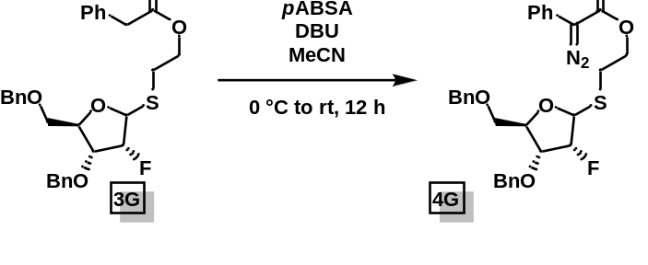
2-(((3R,4R,5R)-4-(benzyloxy)-5-((benzyloxy)methyl)-3-fluorotetrahydrofuran-2-yl)thio)ethyl 2-diazo-2-phenylacetate (4G): The titular compound was synthesized in accordance to the procedure outlined for 4A. The crude was purified by flash chromatography (15% ethyl acetate/hexanes) to give pure 4G (XX% yield).
¹H NMR (600 MHz, CDCl₃) δ 7.50 – 7.45 (m, 2H), 7.39 (t, J = 7.9 Hz, 2H), 7.37 – 7.26 (m, 10H), 7.20 (td, J = 7.3, 1.3 Hz, 1H), 5.39 (dd, J = 19.8, 1.9 Hz, 1H), 4.71 (d, J = 11.7 Hz, 1H), 4.63 – 4.45 (m, 4H), 4.39 (dt, J = 11.5, 6.8 Hz, 1H), 4.28 (dt, J = 7.7, 3.8 Hz, 1H), 4.19 (ddd, J = 19.0, 7.5, 4.1 Hz, 1H), 3.71 (dd, J = 10.9, 3.0 Hz, 1H), 3.61 (dd, J = 11.0, 4.9 Hz, 1H), 3.03 (dt, J = 13.9, 6.9 Hz, 1H), 2.90 (dt, J = 13.8, 6.8 Hz, 1H).
¹³C NMR (151 MHz, CDCl₃) δ 164.74, 138.00, 137.26, 128.95, 128.50, 128.35, 128.08, 127.90, 127.64, 125.92, 125.32, 124.02, 93.63, 92.34, 85.90, 85.74, 81.17, 77.71, 77.61, 77.27, 77.06, 76.84, 73.39, 72.82, 69.93, 63.84, 29.37.

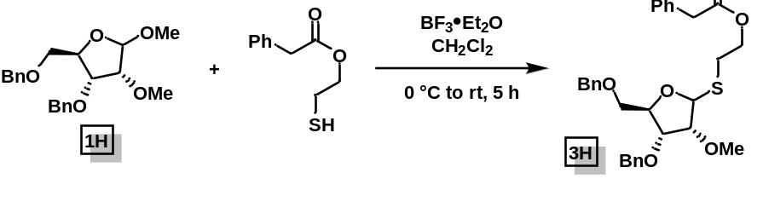
2-(((3R,4R,5R)-4-(benzyloxy)-5-((benzyloxy)methyl)-3-methoxytetrahydrofuran-2-yl)thio)ethyl 2-phenylacetate (3H): The titular compound was synthesized in accordance to the procedure outlined for 2A. The crude was purified by flash chromatography (15% ethyl acetate/hexanes) to give pure 3H (XX% yield).
¹H NMR (400 MHz, CDCl₃) δ 7.42 – 7.22 (m, 15H), 5.23 (d, J = 4.0 Hz, 1H), 4.63 (d, J = 12.0 Hz, 1H), 4.59 (d, J = 13.2 Hz, 2H), 4.52 (d, J = 12.1 Hz, 1H), 4.34 (ddd, J = 11.2, 7.5, 6.3 Hz, 1H), 4.28 – 4.20 (m, 2H), 4.08 (t, J = 5.3 Hz, 1H), 3.64 (d, J = 4.9 Hz, 3H), 3.56 (td, J = 10.6, 4.5 Hz, 2H), 3.43 (s, 3H), 2.96 (ddd, J = 13.9, 7.5, 6.4 Hz, 1H), 2.87 – 2.79 (m, 1H).
¹³C NMR (101 MHz, CDCl₃) δ 171.37, 138.14, 137.60, 133.90, 129.35, 128.63, 128.49, 128.42, 128.16, 128.01, 127.72, 127.69, 127.17, 85.68, 83.39, 81.72, 77.86, 77.48, 77.16, 76.84, 73.36, 72.45, 70.63, 64.15, 58.29, 41.27, 29.30.

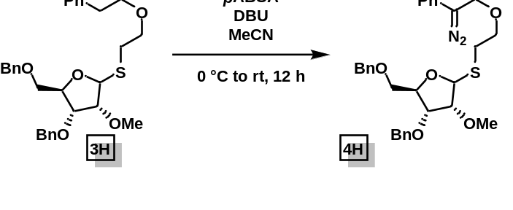
2-(((3R,4R,5R)-4-(benzyloxy)-5-((benzyloxy)methyl)-3-methoxytetrahydrofuran-2-yl)thio)ethyl 2-diazo-2-phenylacetate (4H): The titular compound was synthesized in accordance to the procedure outlined for 4A. The crude was purified by flash chromatography (15% ethyl acetate/hexanes) to give pure 4H (XX% yield).
¹H NMR (600 MHz, CDCl₃) δ 7.49 – 7.44 (m, 2H), 7.39 – 7.36 (m, 2H), 7.34 – 7.24 (m, 10H), 7.18 (tt, J = 7.3, 1.2 Hz, 1H), 5.23 (d, J = 4.0 Hz, 1H), 4.62 (d, J = 11.9 Hz, 1H), 4.58 (d, J = 12.1 Hz, 2H), 4.53 – 4.46 (m, 2H), 4.40 (ddd, J = 11.1, 7.7, 6.3 Hz, 1H), 4.25 (td, J = 5.3, 4.0 Hz, 1H), 4.09 (t, J = 5.4 Hz, 1H), 3.65 (dd, J = 5.0, 4.0 Hz, 1H), 3.61 (dd, J = 10.7, 3.9 Hz, 1H), 3.56 (dd, J = 10.6, 5.0 Hz, 1H), 3.43 (s, 3H), 3.02 (ddd, J = 13.9, 7.6, 6.2 Hz, 1H), 2.89 (ddd, J = 13.9, 7.7, 6.3 Hz, 1H).
¹³C NMR (151 MHz, CDCl₃) δ 164.90, 138.22, 137.72, 129.05, 128.52, 128.44, 128.17, 128.02, 127.75, 127.72, 125.97, 125.51, 124.11, 83.55, 81.87, 78.01, 77.37, 77.16, 76.95, 73.45, 72.53, 70.71, 64.14, 58.36, 29.65.

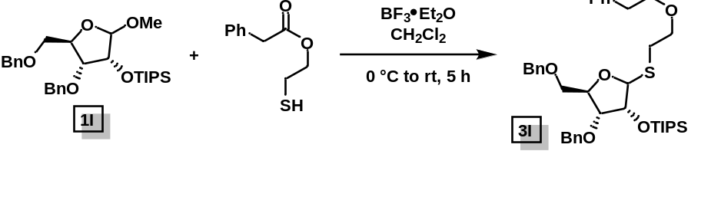
2-(((3R,4R,5R)-4-(benzyloxy)-5-((benzyloxy)methyl)-3-((triisopropylsilyl)oxy)tetrahydrofuran-2-yl)thio)ethyl 2-phenylacetate (3I): The titular compound was synthesized in accordance to the procedure outlined for 2A. The crude was purified by flash chromatography (15% ethyl acetate/hexanes) to give pure 3H (XX% yield).
¹H NMR (400 MHz, CDCl₃) δ 7.32 (dq, J = 13.5, 4.9 Hz, 12H), 5.17 (d, J = 3.3 Hz, 1H), 4.70 (d, J = 11.6 Hz, 1H), 4.63 – 4.47 (m, 3H), 4.28 (dddd, J = 35.2, 11.1, 7.9, 5.2 Hz, 4H), 4.04 (dd, J = 6.1, 4.4 Hz, 1H), 3.64 (s, 2H), 3.62 (d, J = 3.3 Hz, 1H), 3.54 (dd, J = 10.6, 5.1 Hz, 1H), 2.99 (ddd, J = 13.9, 7.6, 6.3 Hz, 1H), 2.82 (ddd, J = 13.9, 7.7, 6.3 Hz, 1H), 1.10 (p, J = 2.4, 2.0 Hz, 18H).
¹³C NMR (101 MHz, CDCl₃) δ 171.29, 138.14, 137.86, 133.90, 129.32, 128.58, 128.33, 128.31, 127.84, 127.75, 127.73, 127.60, 127.11, 88.88, 81.19, 79.82, 77.43, 77.11, 76.79, 75.76, 73.38, 72.39, 71.02, 64.18, 41.21, 29.22, 18.08, 18.06, 12.57.

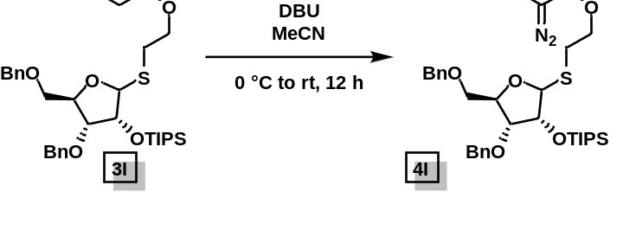
2-(((3R,4R,5R)-4-(benzyloxy)-5-((benzyloxy)methyl)-3-((triisopropylsilyl)oxy)tetrahydrofuran-2-yl)thio)ethyl 2-diazo-2-phenylacetate (4I): The titular compound was synthesized in accordance to the procedure outlined for 4A. The crude was purified by flash chromatography (15% ethyl acetate/hexanes) to give pure 4H (XX% yield).
¹H NMR (400 MHz, CDCl₃) δ 7.49 (d, J = 8.0 Hz, 2H), 7.39 (t, J = 7.8 Hz, 2H), 7.32 (q, J = 5.8, 5.1 Hz, 9H), 7.19 (t, J = 7.4 Hz, 1H), 5.16 (d, J = 3.3 Hz, 1H), 4.68 (d, J = 11.6 Hz, 1H), 4.59 (d, J = 12.0 Hz, 1H), 4.55 – 4.47 (m, 3H), 4.47 – 4.27 (m, 3H), 4.04 (dd, J = 6.1, 4.4 Hz, 1H), 3.63 (dd, J = 10.6, 3.3 Hz, 1H), 3.54 (dd, J = 10.6, 5.1 Hz, 1H), 3.05 (ddd, J = 13.8, 7.5, 6.2 Hz, 1H), 2.88 (dt, J = 13.9, 7.1 Hz, 1H), 1.08 (dd, J = 5.4, 2.5 Hz, 19H).
¹³C NMR (101 MHz, CDCl₃) δ 164.79, 138.10, 137.84, 128.94, 128.31, 128.30, 127.84, 127.74, 127.71, 127.58, 125.82, 125.43, 123.93, 88.83, 81.20, 79.80, 77.38, 77.06, 76.74, 75.74, 73.39, 72.38, 71.00, 63.95, 29.50, 18.05, 18.03, 12.55.

4.5.2 Furanosylation Reaction

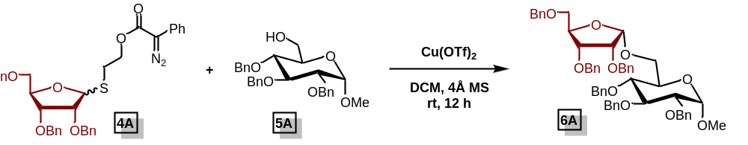
(2R,3R,4S,5R,6S)-3,4,5-tris(benzyloxy)-2-((((2S,3R,4R,5R)-3,4-bis(benzyloxy)-5-((benzyloxy)methyl)tetrahydrofuran-2-yl)oxy)methyl)-6-methoxytetrahydro-2H-pyran (6A): An oven-dried 4 mL vial was charged with the diazo thioglycoside donor (1.4 equiv.), methyl 2,3,5-tri-O-benzyl glucopyranoside (1.0 equiv.), copper (II) triflate (10 mol%), some powdered 4Å molecular sieves, and freshly distilled DCM (50 mL/mmol). The reaction was stirred at room temperature for 12 hours and, upon completion by TLC, was quenched via addition of a saturated solution of sodium bicarbonate. The product was extracted with DCM (3x), the organic layers were combined, dried over anhydrous sodium sulfate, and concentrated under reduced pressure. The product yield and anomeric ratio were determined by ¹H NMR of the crude. (86%, α:β = 8:1). The ¹H NMR of compound 6A matches the literature report.¹⁻⁴

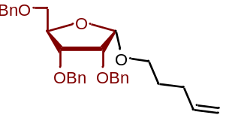
(2R,3R,4R,5S)-3,4-bis(benzyloxy)-2-((benzyloxy)methyl)-5-(pent-4-en-1-yloxy)tetrahydrofuran (6B): Prepared in accordance with the procedure for 6A, (84%, α/β = 15:1). The ¹H NMR of compound 6B matches the literature report.^{2,7}

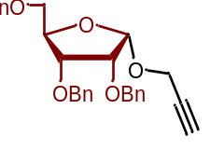
(2R,3R,4R,5S)-3,4-bis(benzyloxy)-2-((benzyloxy)methyl)-5-(prop-2-yn-1-yloxy)tetrahydrofuran (6C): Prepared in accordance with the procedure for 6A, (90%, α/β = 5:1). The ¹H NMR of compound 6C matches the literature report.⁵

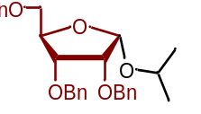
(2R,3R,4R,5S)-3,4-bis(benzyloxy)-2-((benzyloxy)methyl)-5-isopropoxytetrahydrofuran (6D): Prepared in accordance with the procedure for 6A, (86%, α/β = 4:1). The ¹H NMR of compound 6D matches the literature report.¹

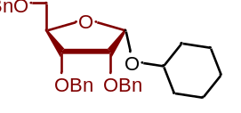
(2R,3R,4R,5S)-3,4-bis(benzyloxy)-2-((benzyloxy)methyl)-5-(cyclohexyloxy)tetrahydrofuran (6E): Prepared in accordance with the procedure for 6A, (96%, α/β = 9:1). The ¹H NMR of compound 6E matches the literature report.⁶

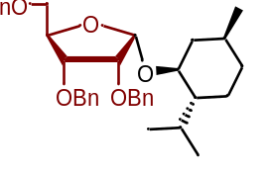
(2R,3R,4R,5S)-3,4-bis(benzyloxy)-2-((benzyloxy)methyl)-5-(((1S,2R,5S)-2-isopropyl-5-methylcyclohexyl)oxy)tetrahydrofuran (6F): Prepared in accordance with the procedure for 6A, (85%, α/β = 5:1). The ¹H NMR of compound 6F matches the literature report.^{2,7}

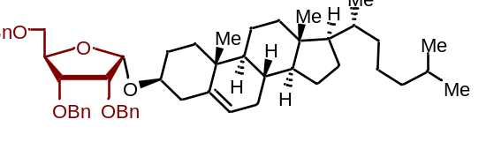
(2R,3R,4R,5S)-3,4-bis(benzyloxy)-2-((benzyloxy)methyl)-5-(((3S,8S,9S,10R,13R,14S,17R)-10,13-dimethyl-17-((R)-6-methylheptan-2-yl)-2,3,4,7,8,9,10,11,12,13,14,15,16,17-tetradecahydro-1H-cyclopenta[a]phenanthren-3-yl)oxy)tetrahydrofuran (6G): Prepared in accordance with the procedure for 6A, (80%, α/β = 10:1). The ¹H NMR of compound 6G matches the literature report.⁷

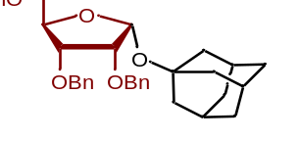
(2R,3R,4R,5R)-2-(((3S,5S,7S)-adamantan-1-yl)oxy)-3,4-bis(benzyloxy)-5-((benzyloxy)methyl)tetrahydrofuran (6H): Prepared in accordance with the procedure for 6A, (82%, α/β = 6:1). The ¹H NMR of compound 6H matches the literature report.⁷

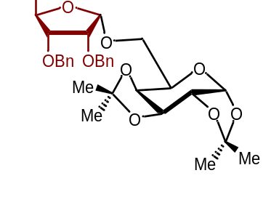
(3aR,5R,5aS,8aS,8bR)-5-((((2S,3R,4R,5R)-3,4-bis(benzyloxy)-5-((benzyloxy)methyl)tetrahydrofuran-2-yl)oxy)methyl)-2,2,7,7-tetramethyltetrahydro-5H-bis([1,3]dioxolo)[4,5-b:4',5'-d]pyran (6I): Prepared in accordance with the procedure for 6A, (88%, α/β = 9:1). The ¹H NMR of compound 6I matches the literature report.⁸

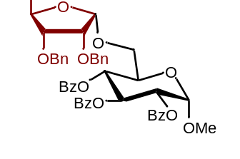
(2R,3R,4S,5R,6S)-2-((((2S,3R,4R,5R)-3,4-bis(benzyloxy)-5-((benzyloxy)methyl)tetrahydrofuran-2-yl)oxy)methyl)-6-methoxytetrahydro-2H-pyran-3,4,5-triyl tribenzoate (6J): Prepared in accordance with the procedure for 6A, (86%, α/β = 8:1). The ¹H NMR of compound 6J matches the literature report.⁹

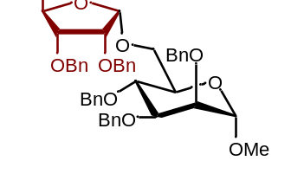
(2R,3R,4S,5S,6S)-3,4,5-tris(benzyloxy)-2-((((2S,3R,4R,5R)-3,4-bis(benzyloxy)-5-((benzyloxy)methyl)tetrahydrofuran-2-yl)oxy)methyl)-6-methoxytetrahydro-2H-pyran (6K): Prepared in accordance with the procedure for 6A, (90%, α/β = 5:1). The ¹H NMR of compound 6K matches the literature report.¹⁰

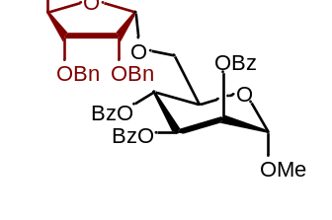
(2R,3R,4S,5S,6S)-2-((((2S,3R,4R,5R)-3,4-bis(benzyloxy)-5-((benzyloxy)methyl)tetrahydrofuran-2-yl)oxy)methyl)-6-methoxytetrahydro-2H-pyran-3,4,5-triyl tribenzoate (6L): Prepared in accordance with the procedure for 6A, (88%, α/β = 5:1). The ¹H NMR of compound 6L matches the literature report.

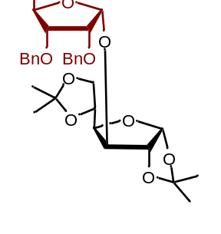
(3aR,5R,6S,6aR)-6-(((2R,3R,4R,5R)-3,4-bis(benzyloxy)-5-((benzyloxy)methyl)tetrahydrofuran-2-yl)oxy)-5-(2,2-dimethyl-1,3-dioxolan-4-yl)-2,2-dimethyltetrahydrofuro[2,3-d][1,3]dioxole (6M): Prepared in accordance with the procedure for 6A, (88%, α/β = >20:1). The ¹H NMR of compound 6M matches the literature report.¹¹

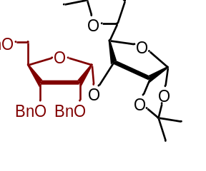
(3aR,5R,6R,6aR)-6-(((2R,3R,4R,5R)-3,4-bis(benzyloxy)-5-((benzyloxy)methyl)tetrahydrofuran-2-yl)oxy)-5-(2,2-dimethyl-1,3-dioxolan-4-yl)-2,2-dimethyltetrahydrofuro[2,3-d][1,3]dioxole (6N): Prepared in accordance with the procedure for 6A, (84%, α/β = >20:1). The ¹H NMR of compound 6N matches the literature report.¹¹

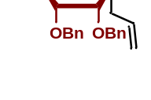
(2S,3S,4R,5R)-2-allyl-3,4-bis(benzyloxy)-5-((benzyloxy)methyl)tetrahydrofuran (6O): Prepared in accordance with the procedure for 6A, (82%, α/β = α-exclusively). The ¹H NMR of compound 6O matches the literature report.¹²

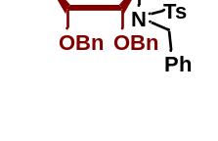
N-benzyl-N-((2S,3R,4R,5R)-3,4-bis(benzyloxy)-5-((benzyloxy)methyl)tetrahydrofuran-2-yl)-4-methylbenzenesulfonamide (6P): Prepared in accordance with the procedure for 6A, (70%, α/β = 3:1). The ¹H NMR of compound 6P matches the literature report.

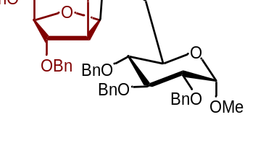
(2R,3R,4S,5R,6S)-3,4,5-tris(benzyloxy)-2-((((2R,3S,4R,5R)-3,4-bis(benzyloxy)-5-((benzyloxy)methyl)tetrahydrofuran-2-yl)oxy)methyl)-6-methoxytetrahydro-2H-pyran (7A): Prepared in accordance with the procedure for 6A, (86%, α/β = 1:5). The ¹H NMR of compound 7A matches the literature report.^{13,14}

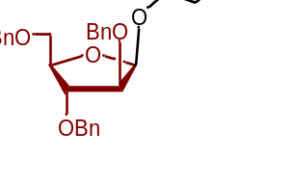
(2R,3R,4S,5R)-3,4-bis(benzyloxy)-2-((benzyloxy)methyl)-5-(pent-4-en-1-yloxy)tetrahydrofuran (7B): Prepared in accordance with the procedure for 6A, (82%, α/β = 1:10). The ¹H NMR of compound 7B matches the literature report.⁷

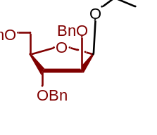
(2R,3R,4S,5R)-3,4-bis(benzyloxy)-2-((benzyloxy)methyl)-5-isopropoxytetrahydrofuran (7C): Prepared in accordance with the procedure for 6A, (84%, α/β = 1:4). The ¹H NMR of compound 7C matches the literature report.⁸

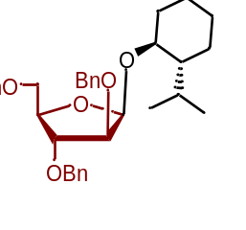
(2R,3R,4S,5R)-3,4-bis(benzyloxy)-2-((benzyloxy)methyl)-5-(((1S,2R,5S)-2-isopropyl-5-methylcyclohexyl)oxy)tetrahydrofuran (7D): Prepared in accordance with the procedure for 6A, (88%, α/β = 1:6). The ¹H NMR of compound 7D matches the literature report.⁷

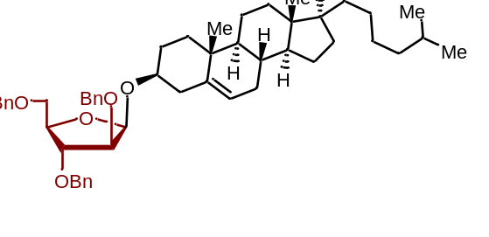
(2R,3R,4S,5R)-3,4-bis(benzyloxy)-2-((benzyloxy)methyl)-5-(((3S,8S,9S,10R,13R,14S,17R)-10,13-dimethyl-17-((R)-6-methylheptan-2-yl)-2,3,4,7,8,9,10,11,12,13,14,15,16,17-tetradecahydro-1H-cyclopenta[a]phenanthren-3-yl)oxy)tetrahydrofuran (7E): Prepared in accordance with the procedure for 6A, (88%, α/β = 1:5). The ¹H NMR of compound 7E matches the literature report.^{7,14}

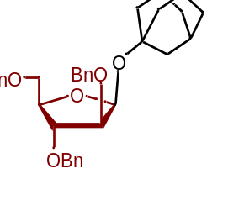
(2S,3S,4R,5R)-2-(((1R,3R)-adamantan-1-yl)oxy)-3,4-bis(benzyloxy)-5-((benzyloxy)methyl)tetrahydrofuran (7F): Prepared in accordance with the procedure for 6A, (92%, α/β = β-exclusive). The ¹H NMR of compound 7F matches the literature report.^{7,14}

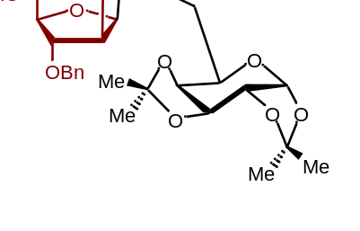
(3aR,5R,5aS,8aS,8bR)-5-((((2R,3S,4R,5R)-3,4-bis(benzyloxy)-5-((benzyloxy)methyl)tetrahydrofuran-2-yl)oxy)methyl)-2,2,7,7-tetramethyltetrahydro-5H-bis([1,3]dioxolo)[4,5-b:4',5'-d]pyran (7G): Prepared in accordance with the procedure for 6A, (94%, α/β = 1:5). The ¹H NMR of compound 7G matches the literature report.^{8,13}

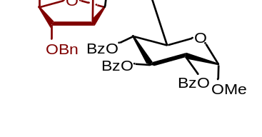
(2R,3R,4S,5R,6S)-2-((((2R,3S,4R,5R)-3,4-bis(benzyloxy)-5-((benzyloxy)methyl)tetrahydrofuran-2-yl)oxy)methyl)-6-methoxytetrahydro-2H-pyran-3,4,5-triyl tribenzoate (7H): Prepared in accordance with the procedure for 6A, (90%, α/β = 1:5.5). The ¹H NMR of compound 7H matches the literature report.^{13,14}

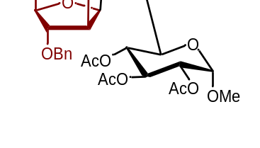
(2R,3R,4S,5R,6S)-2-((((2R,3S,4R,5R)-3,4-bis(benzyloxy)-5-((benzyloxy)methyl)tetrahydrofuran-2-yl)oxy)methyl)-6-methoxytetrahydro-2H-pyran-3,4,5-triyl triacetate (7I): Prepared in accordance with the procedure for 6A, (86%, α/β = 1:4). The ¹H NMR of compound 7I matches the literature report.⁸

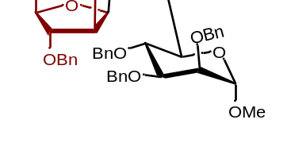
(2R,3R,4S,5S,6S)-3,4,5-tris(benzyloxy)-2-((((2R,3S,4R,5R)-3,4-bis(benzyloxy)-5-((benzyloxy)methyl)tetrahydrofuran-2-yl)oxy)methyl)-6-methoxytetrahydro-2H-pyran (7J): Prepared in accordance with the procedure for 6A, (90%, α/β = 1:>20). The ¹H NMR of compound 7J matches the literature report.¹⁴

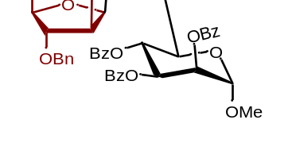
(2R,3R,4S,5S,6S)-2-((((2R,3S,4R,5R)-3,4-bis(benzyloxy)-5-((benzyloxy)methyl)tetrahydrofuran-2-yl)oxy)methyl)-6-methoxytetrahydro-2H-pyran-3,4,5-triyl tribenzoate (7K): Prepared in accordance with the procedure for 6A, (90%, α/β = 1:>20).
¹H NMR (500 MHz, CDCl₃) δ 8.12 – 8.07 (m, 2H), 7.97 – 7.93 (m, 2H), 7.86 – 7.81 (m, 2H), 7.54 – 7.48 (m, 2H), 7.45 – 7.33 (m, 8H), 7.31 – 7.27 (m, 7H), 7.25 – 7.20 (m, 7H), 5.92 (t, J = 10.0 Hz, 1H), 5.85 (dd, J = 10.0, 3.3 Hz, 1H), 5.65 (dd, J = 3.3, 1.8 Hz, 1H), 5.11 (d, J = 4.1 Hz, 1H), 4.90 (d, J = 1.9 Hz, 1H), 4.82 (d, J = 11.7 Hz, 1H), 4.62 – 4.50 (m, 4H), 4.43 (s, 1H), 4.37 (d, J = 12.0 Hz, 1H), 4.23 (ddd, J = 9.8, 6.1, 2.0 Hz, 1H), 4.13 – 4.05 (m, 3H), 3.93 (dd, J = 11.4, 2.1 Hz, 1H), 3.68 (dd, J = 11.4, 6.1 Hz, 1H), 3.53 – 3.48 (m, 2H), 3.41 (s, 3H).
¹³C NMR (151 MHz, CDCl₃) δ 165.75, 165.61, 138.38, 138.24, 138.13, 133.54, 133.50, 133.24, 130.15, 129.96, 129.88, 129.46, 129.39, 129.32, 128.71, 128.58, 128.46, 128.44, 128.41, 128.23, 127.86, 127.81, 127.75, 127.73, 127.71, 101.31, 98.49, 84.37, 83.64, 80.69, 77.37, 77.16, 76.95, 73.37, 72.60, 72.38, 72.27, 70.54, 70.38, 70.34, 67.45, 66.30, 55.53.

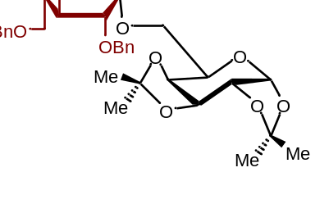
(3aR,5R,5aS,8aS,8bR)-5-((((2S,3R,4S,5S)-3,4-bis(benzyloxy)-5-((benzyloxy)methyl)tetrahydrofuran-2-yl)oxy)methyl)-2,2,7,7-tetramethyltetrahydro-5H-bis([1,3]dioxolo)[4,5-b:4',5'-d]pyran (8A): Prepared in accordance with the procedure for 6A, (78%, α/β = 1:3). The ¹H NMR of compound 8A matches the literature report.⁸

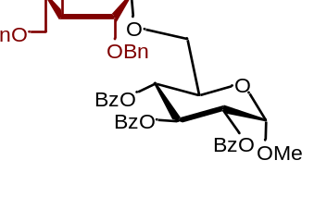
(2R,3R,4S,5R,6S)-2-((((2S,3R,4S,5S)-3,4-bis(benzyloxy)-5-((benzyloxy)methyl)tetrahydrofuran-2-yl)oxy)methyl)-6-methoxytetrahydro-2H-pyran-3,4,5-triyl tribenzoate (8B): Prepared in accordance with the procedure for 6A, (82%, α/β = 1:4). The ¹H NMR of compound 8B matches the literature report.^{13,15}

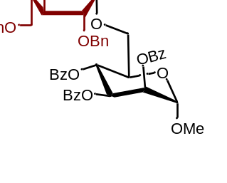
(2R,3R,4S,5S,6S)-2-((((2S,3R,4S,5S)-3,4-bis(benzyloxy)-5-((benzyloxy)methyl)tetrahydrofuran-2-yl)oxy)methyl)-6-methoxytetrahydro-2H-pyran-3,4,5-triyl tribenzoate (8C): Prepared in accordance with the procedure for 6A, (80%, α/β = 1:4). The ¹H NMR of compound 8C matches the literature report.^{14,15}

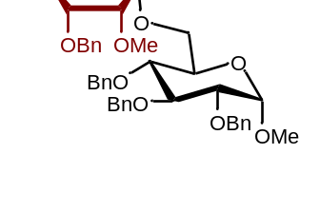
(2R,3R,4S,5R,6S)-3,4,5-tris(benzyloxy)-2-((((2S,3R,4R,5R)-4-(benzyloxy)-5-((benzyloxy)methyl)-3-methoxytetrahydrofuran-2-yl)oxy)methyl)-6-methoxytetrahydro-2H-pyran (9): Prepared in accordance with the procedure for 6A, (92%, α/β = α-exclusively). The ¹H NMR of compound 9 matches the literature report.¹⁰

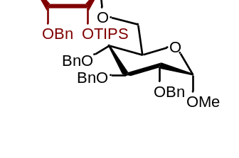
(((2S,3R,4R,5R)-4-(benzyloxy)-5-((benzyloxy)methyl)-2-(((2R,3R,4S,5R,6S)-3,4,5-tris(benzyloxy)-6-methoxytetrahydro-2H-pyran-2-yl)methoxy)tetrahydrofuran-3-yl)oxy)triisopropylsilane (10): Prepared in accordance with the procedure for 6A, (90%, α/β = α-exclusively). The ¹H NMR of compound 10 matches the literature report.¹⁰

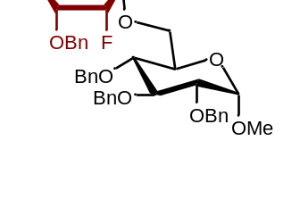
(2R,3R,4S,5R,6S)-3,4,5-tris(benzyloxy)-2-((((2S,3R,4R,5R)-4-(benzyloxy)-5-((benzyloxy)methyl)-3-fluorotetrahydrofuran-2-yl)oxy)methyl)-6-methoxytetrahydro-2H-pyran (11): Prepared in accordance with the procedure for 6A, (86%, α/β = α-exclusively).
¹H NMR (600 MHz, CDCl₃) δ 7.37 – 7.19 (m, 28H), 5.22 (dd, J = 5.8, 3.9 Hz, 1H), 4.95 (d, J = 10.9 Hz, 1H), 4.84 – 4.76 (m, 3H), 4.73 – 4.68 (m, 2H), 4.65 (d, J = 12.1 Hz, 1H), 4.60 (d, J = 3.5 Hz, 1H), 4.50 (dd, J = 22.5, 11.9 Hz, 2H), 4.43 (d, J = 12.1 Hz, 1H), 4.21 – 4.15 (m, 2H), 4.00 – 3.92 (m, 2H), 3.78 – 3.66 (m, 3H), 3.54 (ddd, J = 9.6, 7.1, 3.2 Hz, 2H), 3.45 (dd, J = 10.9, 3.4 Hz, 1H), 3.34 (s, 3H).
¹³C NMR (151 MHz, CDCl₃) δ 138.92, 138.62, 138.26, 137.86, 137.68, 128.39, 128.35, 128.30, 128.28, 128.05, 127.88, 127.87, 127.83, 127.80, 127.68, 127.61, 127.49, 127.45, 101.00, 100.90, 98.21, 88.72, 87.38, 82.08, 80.39, 79.96, 77.57, 75.66, 75.50, 75.40, 75.00, 73.45, 73.42, 72.78, 70.03, 68.76, 66.54, 55.10.

4.5.3 Appendix 1
Spectra Relevant to Chapter 4

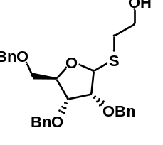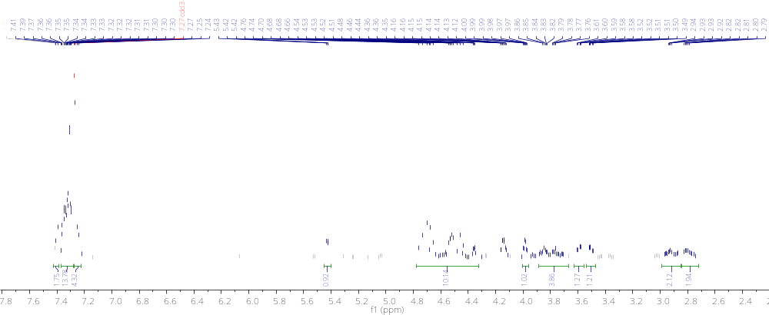

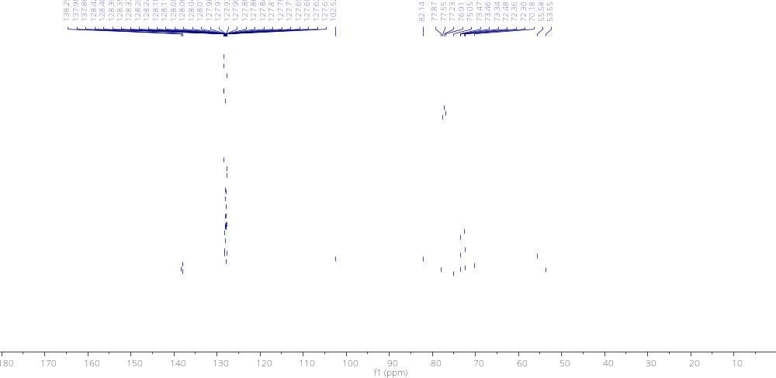

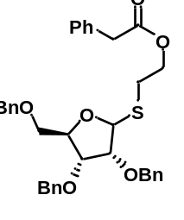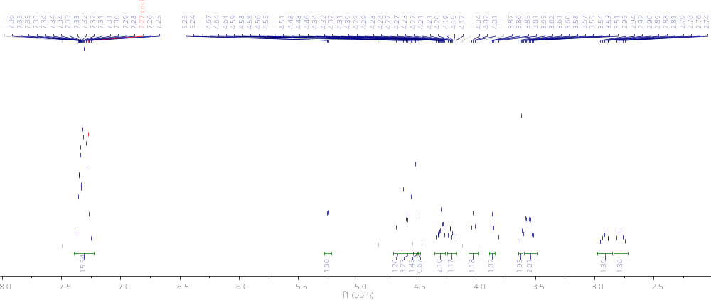
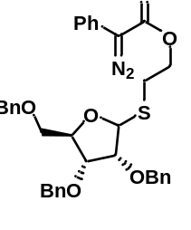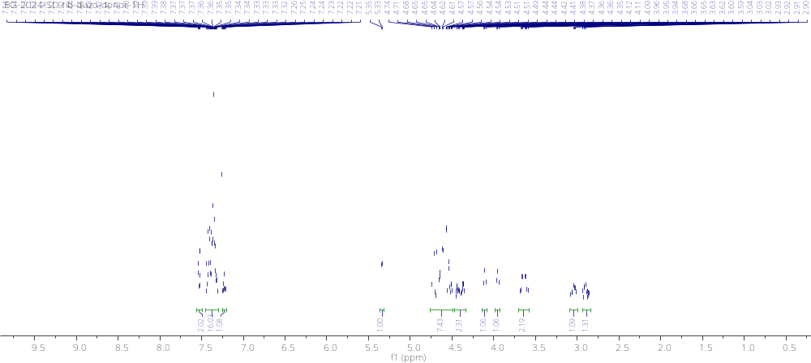

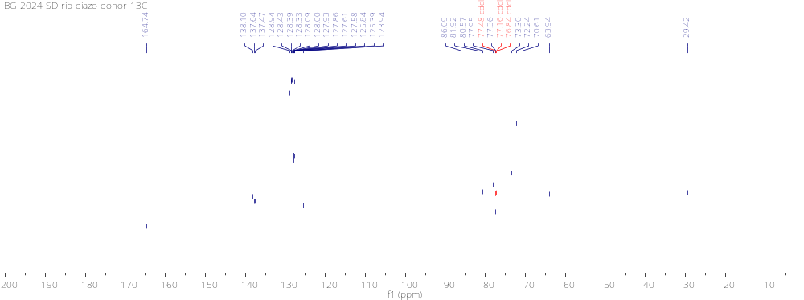

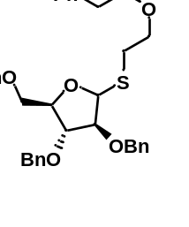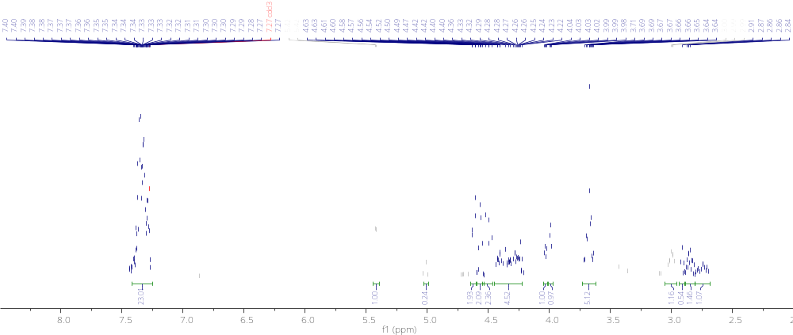

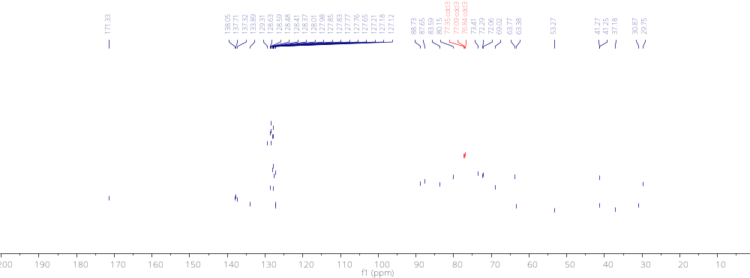

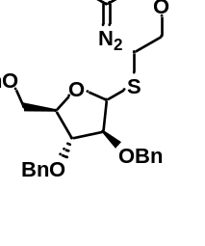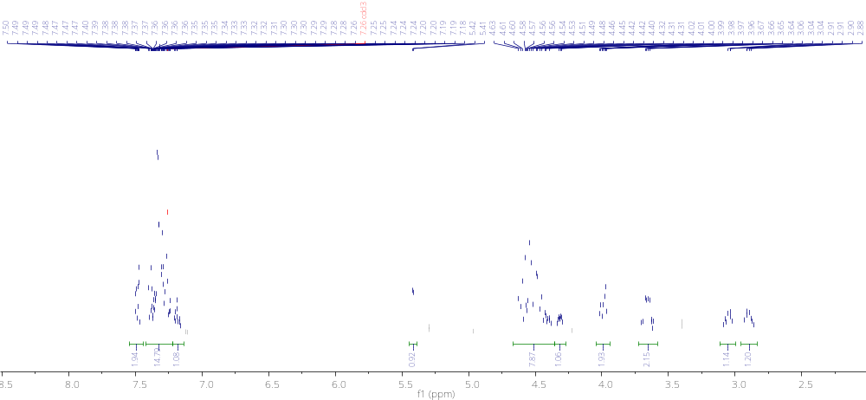

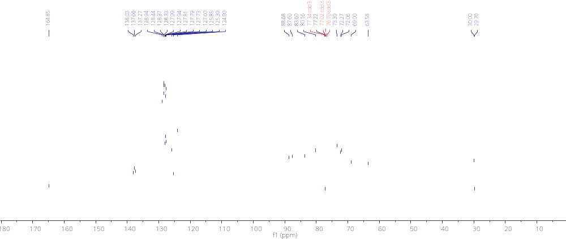

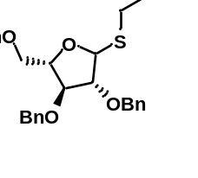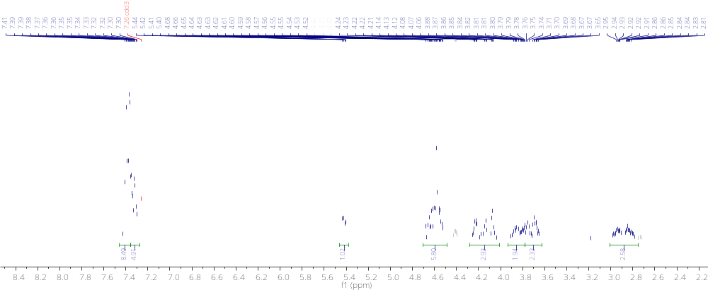

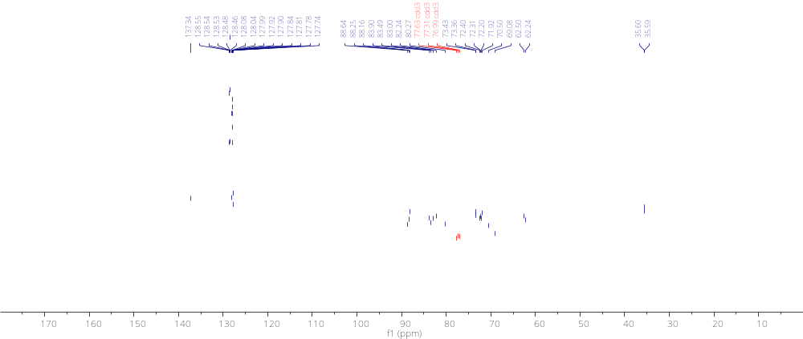

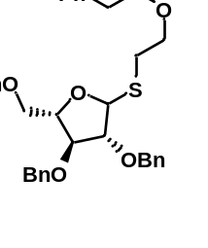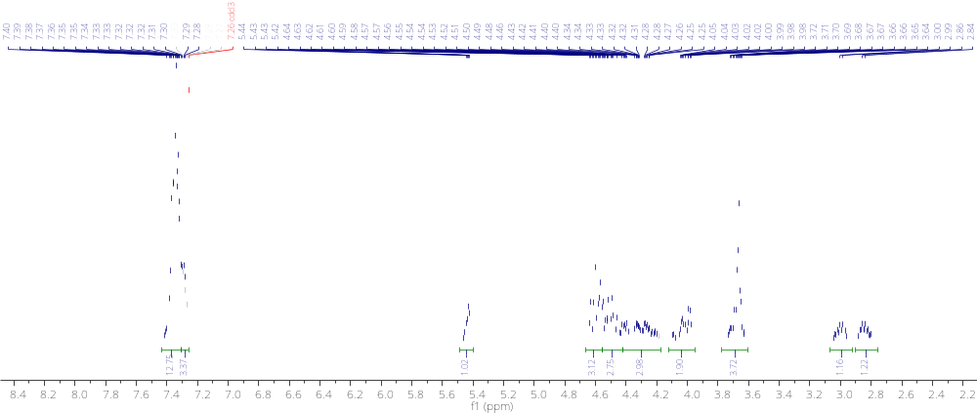

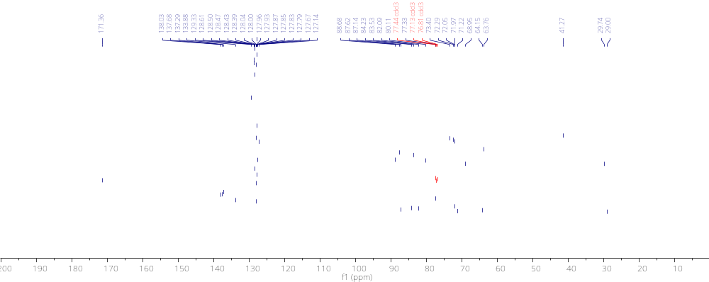

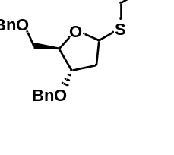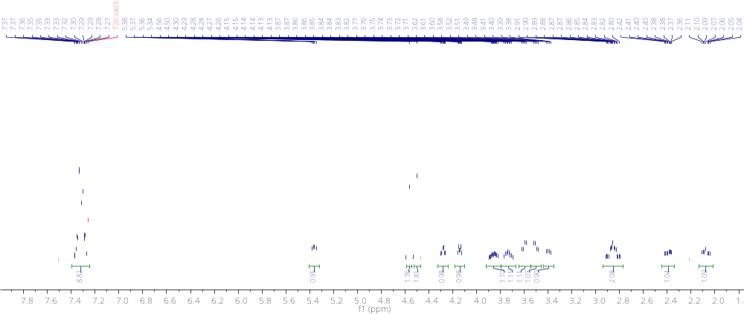

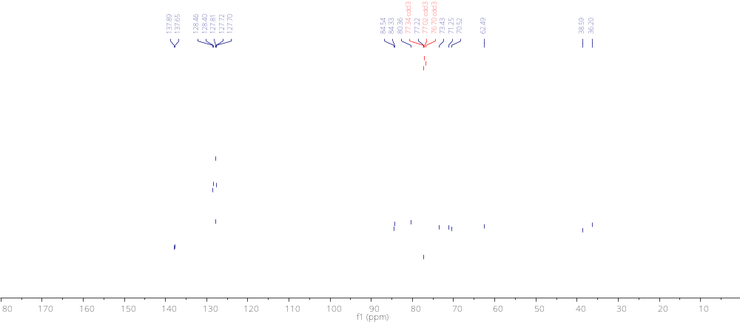

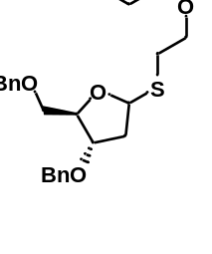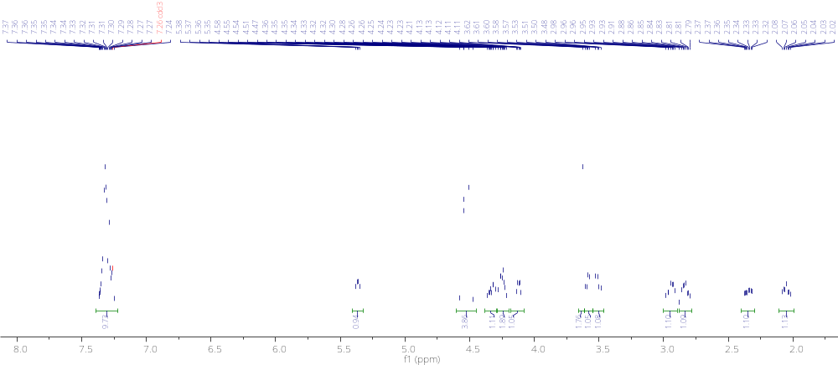

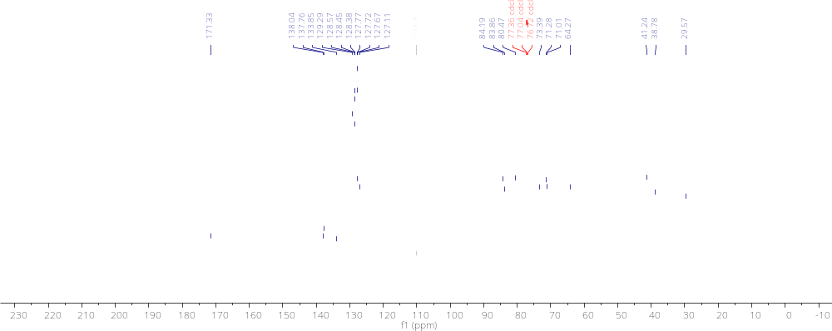

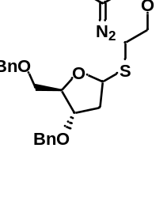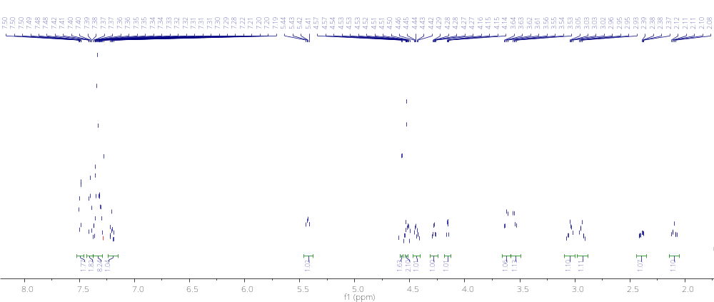

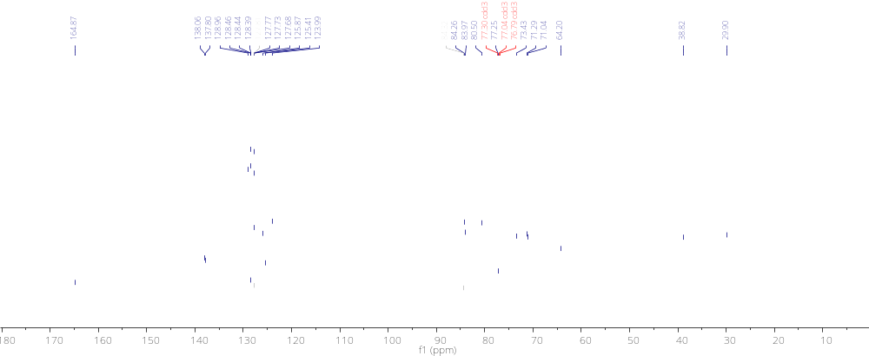
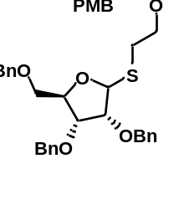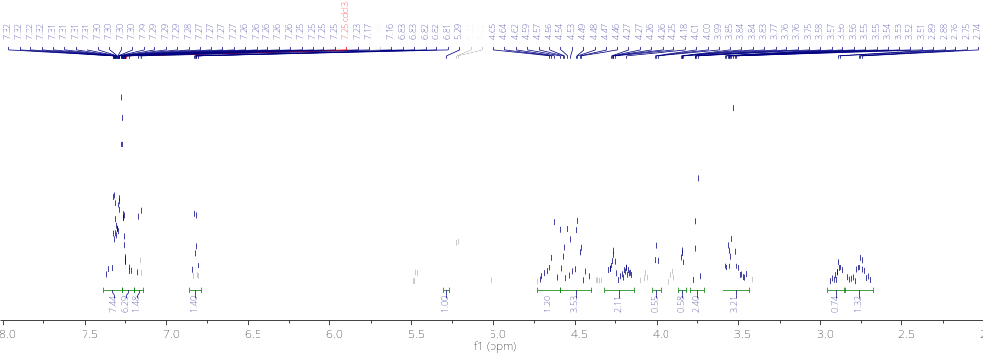
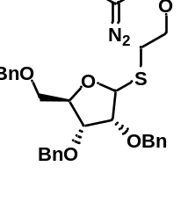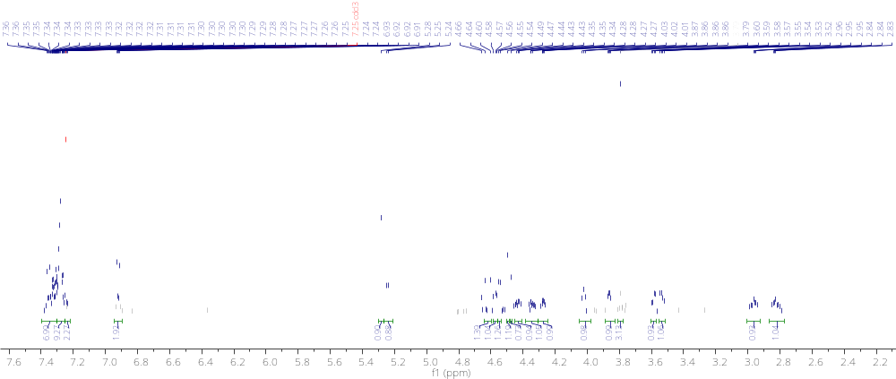

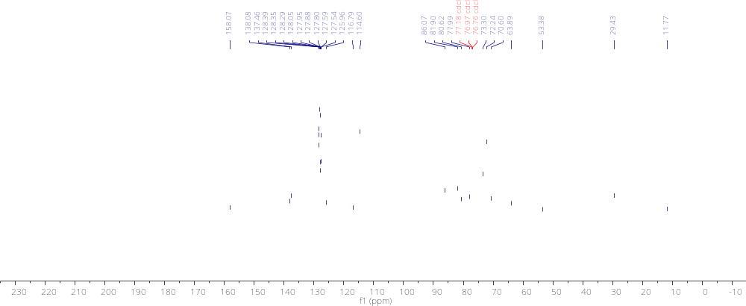

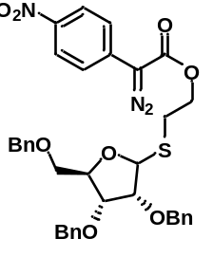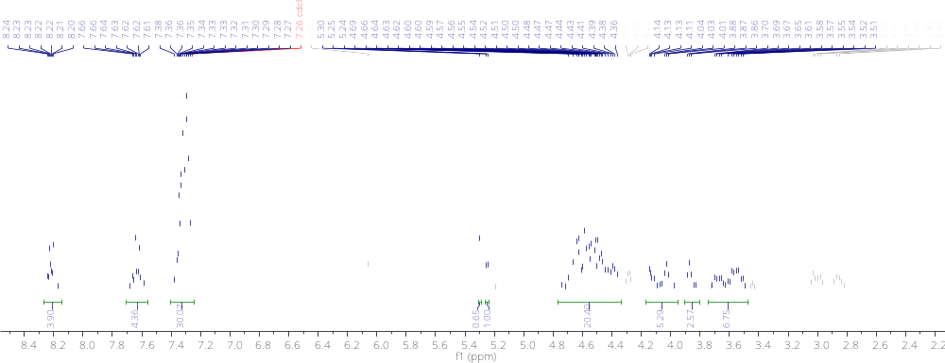
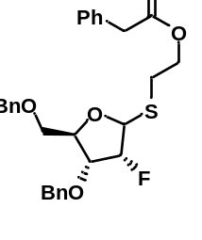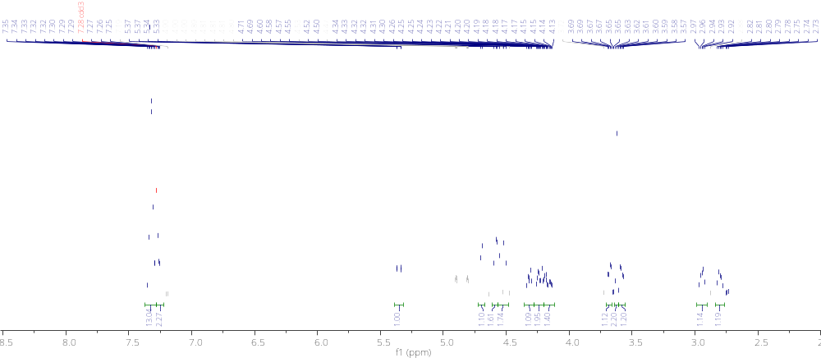

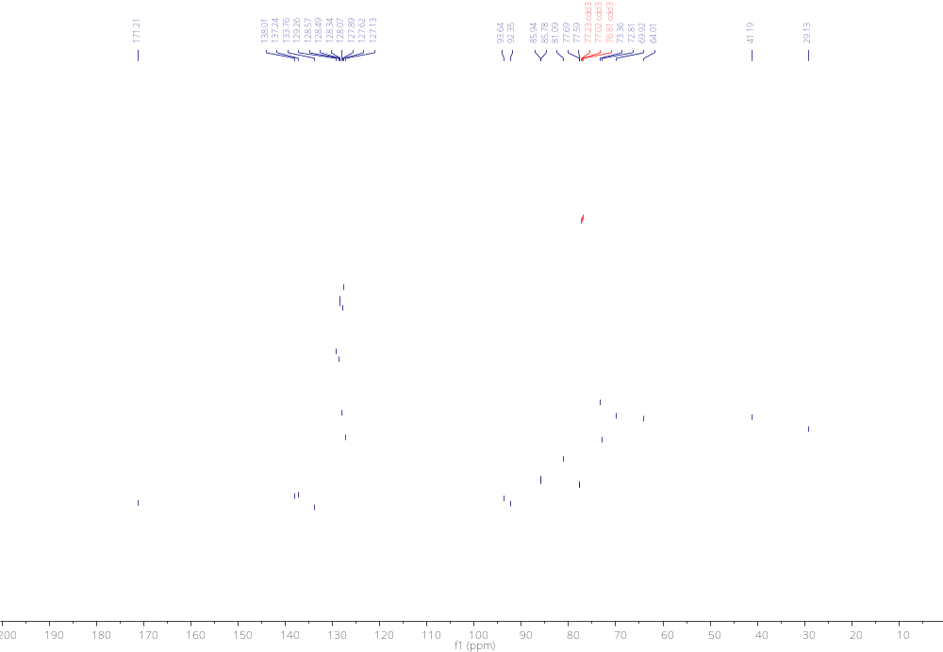

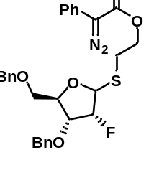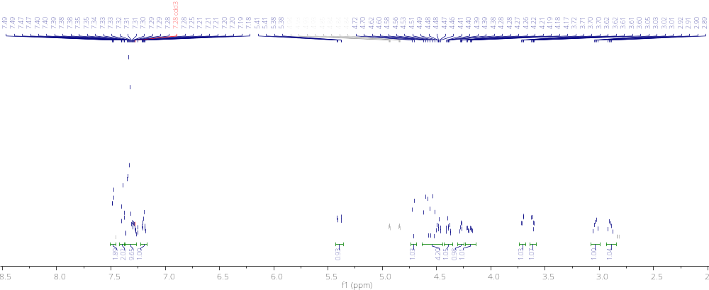

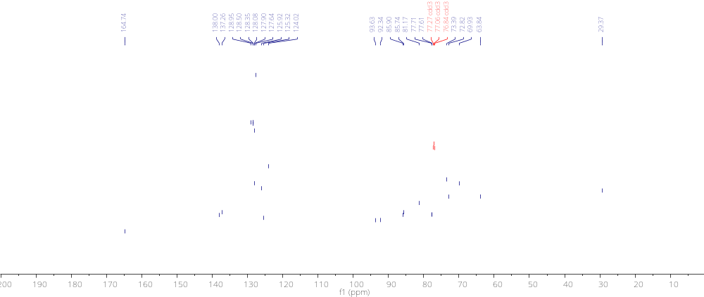

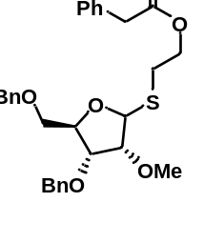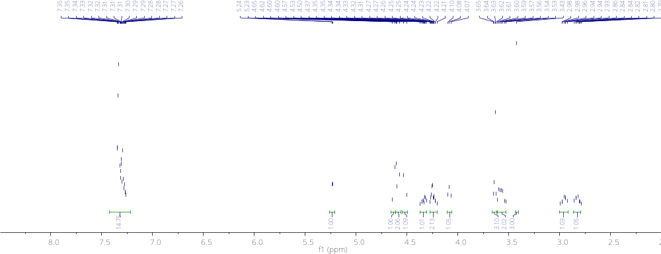

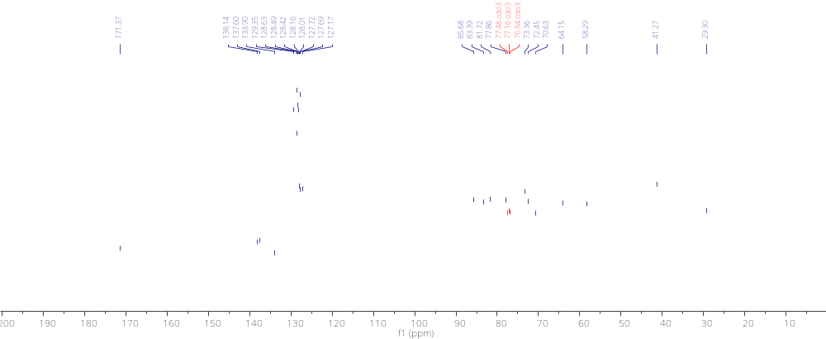

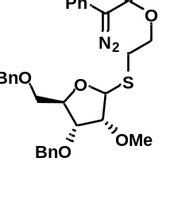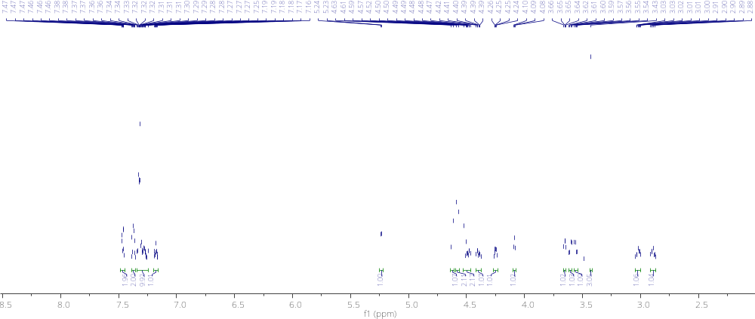

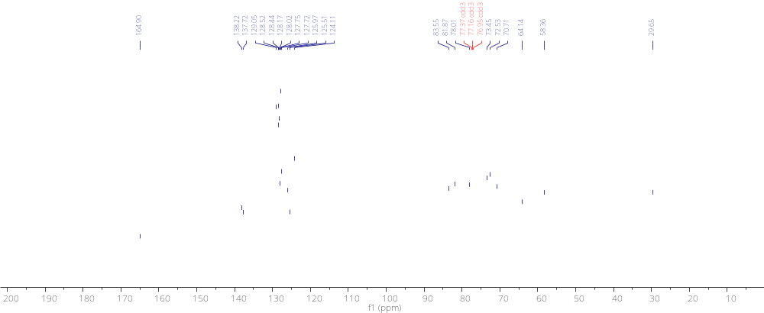

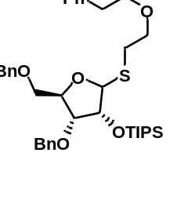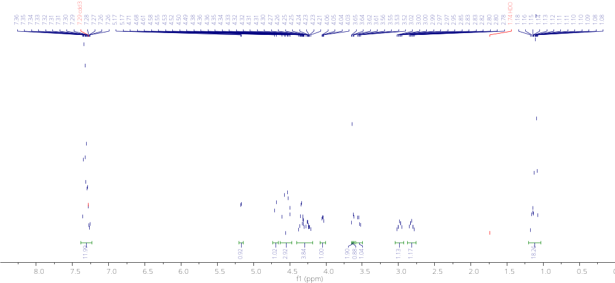

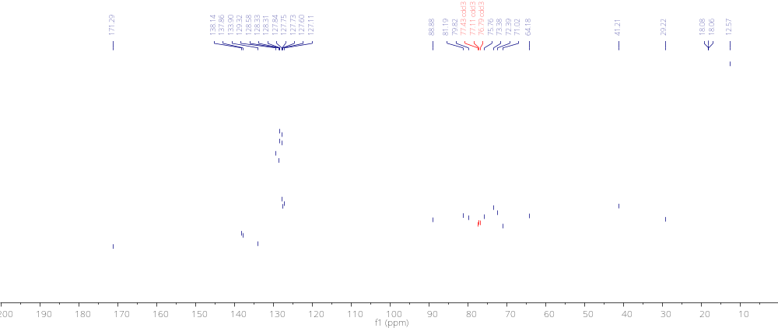

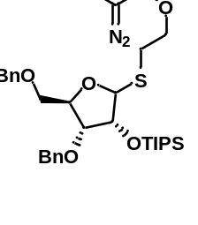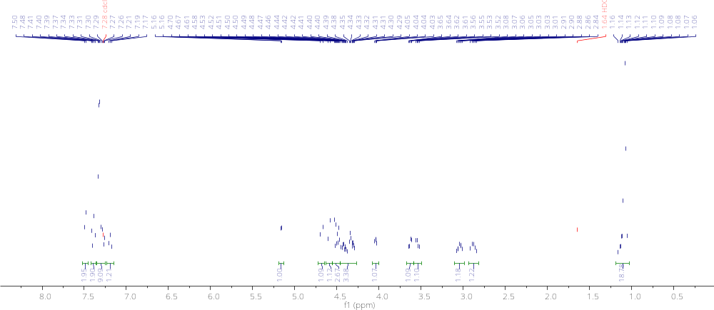

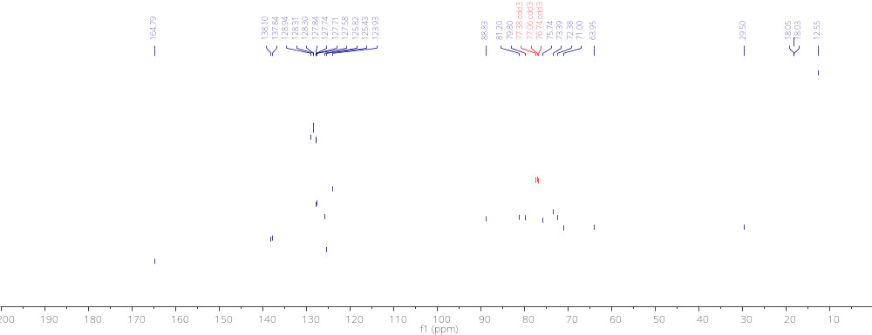

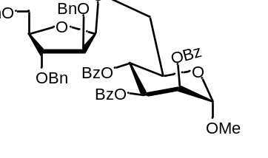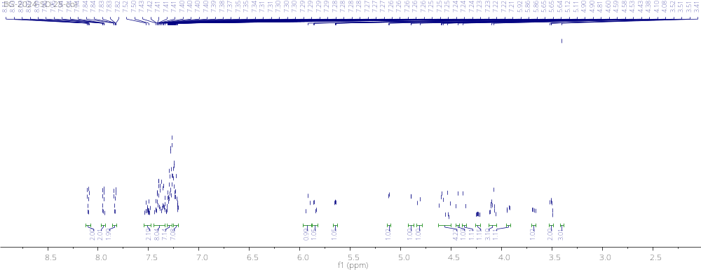

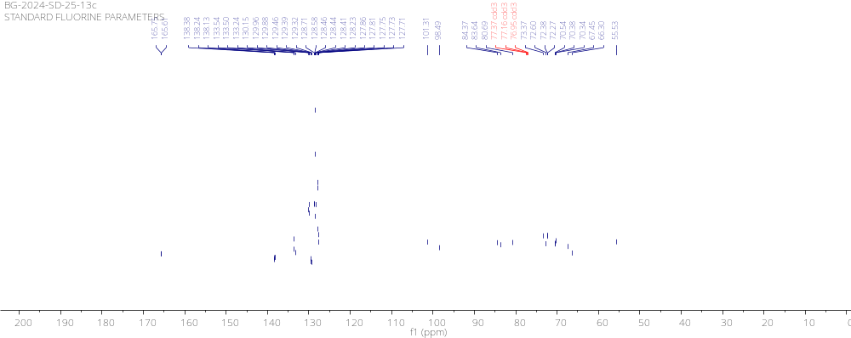

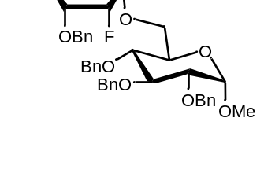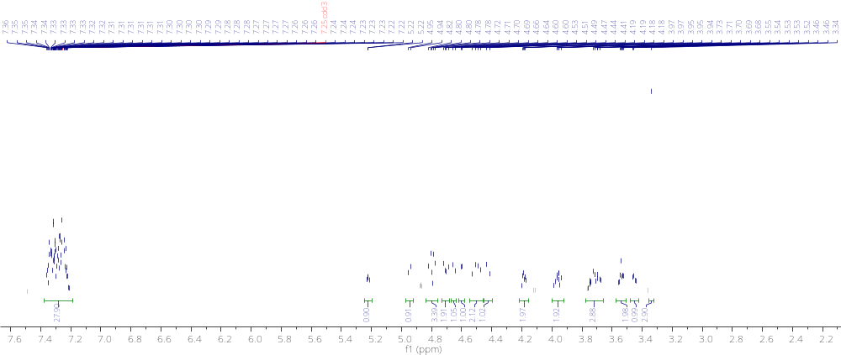

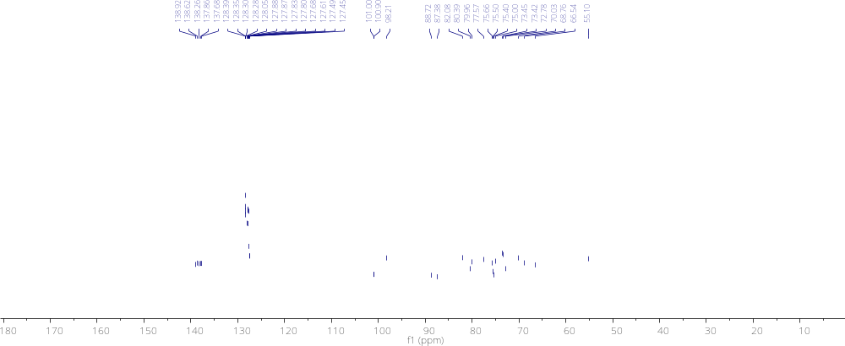

4.5.4 References for Chapter 4 Experimentals
[1] Oka, N.; Kajino, R.; Takeuchi, K.; Nagakawa, H.; Ando, K. α-Selective Ribofuranosylation of Alcohols with Ribofuranosyl Iodides and Triphenylphosphine Oxide. The Journal of Organic Chemistry 2014, 79 (16), 7656–7664. DOI: 10.1021/jo500632h.
[2] Hashizume, N.; Kobayashi, S. Lanthanide Triflates as Reusable Catalysts in Stereoselective -and- Glycosylation Reactions of 1-O-Acetyl-2, 3, 5-Tri-O-Benzylribofuranose. Carbohydr. Lett. 1996, 2, 157-164.
[3] Suzuki, T.; Watanabe, S.; Yamada, T.; Hiroi, K. Dehydrative Glycosylation of Tri-O-Benzylated 1-Hydroxyribofuranose Catalyzed by a Copper(II) Complex. Tetrahedron Letters 2003, 44 (12), 2561–2563. DOI: 10.1016/s0040-4039(03)00270-3.
[4] Schmidt, R. R.; Reichrath, M. Facile, Highly Selective Synthesis of α‐ and β‐disaccharides from 1‐O‐metalated D‐ribofuranoses. Angewandte Chemie International Edition in English 1979, 18 (6), 466–467. DOI: 10.1002/anie.197904661.
[5] Vidadala, S. R.; Gayatri, G.; Sastry, G. N.; Hotha, S. Propargyl/Methyl Furanosides as Potential Glycosyl Donors. Chemical Communications 2011, 47 (35), 9906. DOI: 10.1039/c1cc13134f.
[6] Hirooka, M.; Mori, Y.; Sasaki, A.; Koto, S.; Shinoda, Y.; Morinaga, A. Synthesis of β-d-Ribofuranosyl-(1→3)-α-l-Rhamnopyranosyl-(1→3)-l-Rhamnopyranose by in Situ Activating Glycosylation Using 1-OH Sugar Derivative and Me₃SiBr–CoBr₂–Bu₄NBr–Molecular Sieves 4Å System. Bulletin of the Chemical Society of Japan 2001, 74 (9), 1679–1694. DOI: 10.1246/bcsj.74.1679.
[7] Mallick, A.; Mallikharjunarao, Y.; Rajasekaran, P.; Roy, R.; Vankar, Y. D. Auiii‐halide/Phenylacetylene‐catalysed Glycosylations Using 1‐o‐acetylfuranoses and Pyranose 1,2‐orthoesters as Glycosyl Donors. European Journal of Organic Chemistry 2015, 2016 (3), 579–588. DOI: 10.1002/ejoc.201501245.
[8] Mayfield, A. B.; Metternich, J. B.; Trotta, A. H.; Jacobsen, E. N. Stereospecific Furanosylations Catalyzed by Bis-Thiourea Hydrogen-Bond Donors. Journal of the American Chemical Society 2020, 142 (8), 4061–4069. DOI: 10.1021/jacs.0c00335.
[9] Uchiro, H.; Kurusu, N.; Mukaiyama, T. A Convenient Method for the Preparation of Disaccharides by Transglycosylation of Methyl Glycosides. Israel Journal of Chemistry 1997, 37 (1), 87–96. DOI: 10.1002/ijch.199700011.
[10] Ghosh, B.; Alber, A.; Lander, C. W.; Shao, Y.; Nicholas, K. M.; Sharma, I. Catalytic Stereoselective 1,2-Cis-Furanosylations Enabled by Enynal-Derived Copper Carbenes. ACS Catalysis 2024, 14 (2), 1037–1049. DOI: 10.1021/acscatal.3c05237.
[11] Mereyala, H. B.; Kulkarni, V. R.; Ravi, D.; Sharma, G.; Venkateswara Rao, B.; Bapu Reddy, G. Stereoselective Synthesis of α-Linked 2-Deoxysaccharides and Furanosaccharides by Use of 2-Deoxy 2-Pyridyl-1-Thio Pyrano- and Furanosides as Donors and Methyl Iodide as an Activator. Tetrahedron 1992, 48 (3), 545–562. DOI: 10.1016/s0040-4020(01)89016-5.
[12] Mukaiyama, T.; Kobayashi, S. A Convenient Synthesis of C-α-D-Ribofuranosyl Compounds from 1-O-Acetyl-2,3,5-Tri-O-Benzyl-β-D-Ribose by the Promotion of Triphenylmethyl Perchlorate. Carbohydrate Research 1987, 171 (1), 81–87. DOI: 10.1016/s0008-6215(00)90880-2.
[13] Xu, H.; Schaugaard, R. N.; Li, J.; Schlegel, H. B.; Nguyen, H. M. Stereoselective 1,2-Cis Furanosylations Catalyzed by Phenanthroline. Journal of the American Chemical Society 2022, 144 (16), 7441–7456. DOI: 10.1021/jacs.2c02063.
[14] Lee, Y. J.; Lee, K.; Jung, E. H.; Jeon, H. B.; Kim, K. S. Acceptor-Dependent Stereoselective Glycosylation: 2‘-CB Glycoside-Mediated Direct β-d-Arabinofuranosylation and Efficient Synthesis of the Octaarabinofuranoside in Mycobacterial Cell Wall. Organic Letters 2005, 7 (15), 3263–3266. DOI: 10.1021/ol0510668.
[15] Zhu, X.; Kawatkar, S.; Rao, Y.; Boons, G.-J. Practical Approach for the Stereoselective Introduction of β-Arabinofuranosides. Journal of the American Chemical Society 2006, 128 (36), 11948–11957. DOI: 10.1021/ja0629817.

CHAPTER 5
Summaries, Conclusions, and Future Directions
Herein, we have highlighted the importance of furanosides in natural products and of diastereoselective transformations relating to these furanosides. Through the synthesis of two generations of furanosyl donor, we have introduced into the ethos the concept of earth-abundant, diastereoselective, furanosylation. Significant improvements have been made in the development of second-generation donors over first-generation donors and have led to the possibility of the development of third-generation donors and beyond.

5.1 Synthesis of First-Generation Donors
While carbohydrates and, indeed, furanosides specifically are one of the most common motifs found in natural products, they remain woefully underrepresented in pharmaceutical formulations. As of 2018 there were nearly 20,000 FDA approved drugs available on the market, of which only a few dozen contain furanosides. This is in stark contrast to the facts that roughly 50% of all newly approved drugs are natural products or compounds based on them and that carbohydrates are so common in natural products that this motif is found in 90% of all discovered natural products.
We first sought to develop a system by which a donor could be activated under mild earth-abundant catalysis for difficult 1,2-cis furanosylations (Chapter 2). To this end, we turned our attention to the underexplored world of enynal carbenes. These carbene precursors can be activated under mild conditions and, importantly, lack a reputation for instability. The decomposition of enynal compounds leads to the formation of stable, unreactive furans as opposed to the release of gaseous elemental nitrogen in common diazo compounds.
For this, we synthesized a series of first-generation donors featuring an enynal moiety that can be activated under copper (I) triflate at room temperature. This allowed for the facile synthesis of O-furanosides with moderate yields and diastereoselectivity. This was the first example of diastereoselective earth-abundant catalytic 1,2-cis furanosylation documented in the literature.

5.2 Synthesis of Second-Generation Donors
Based on the development of our first-generation donors, we modified our donor and refined our structure to produce the second-generation of furanosyl donor (Chapter 4). For this, we wanted to improve several aspects of our first-generation donor. While generally more inexpensive than rare earth catalysts, copper (I) catalysts are usually more expensive than their copper (II) counterparts as well as being more moisture sensitive. We also found that catalyst loading for some of our first-generation substrates was higher (30 mol%) and believed we could decrease loading with our modified donor. The present literature suffered from numerous other deficiencies that we sought to address such as the lack of a general strategy that can be applied to the formation of N-, O-, and C-furanosides. Finally, we wanted to develop additive-free conditions that would be amenable to solid-phase synthesis as there are currently no known methods of 1,2-cis selective solid-phase synthesis for furanosylation.
For this, we turned our attention to a diazo-based approach. Our lab has an extensive background in diazo-derived carbenes and we decided to leverage this knowledge to the creation of our second-generation of furanosyl donor. Our solution to the aforementioned problems was an elegant one. We sought to take the relative stability of the benchtop stable thioglycoside and combine it with easily accessible diazo compounds. This strategy will allow us to bridge the gap between thioglycosides that require harsh conditions for activation and diazo compounds which have a propensity for instability.
Our second-generation furanosyl donor solved many of the problems associated with our first-generation donor. We were able to demonstrate a general glycosylation strategy that resulted in selective 1,2-cis furanosylation for O-, N-, and C-nucleophiles. This methodology reacted in a facile manner with copper (II) triflate with loading no higher than 10 mol%. Of note, as opposed to our first-generation donor, we were able to activate our second-generation donor under additive-free conditions which makes the method conducive to automated solid-phase synthesis.

5.3 Future Directions and Scope of Work
The process behind developing our second-generation donors led to much insight for potential future directions. We easily foresee the development of third-generation donors that can be activated under earth-abundant iron catalysis or blue LED. Results from our second-generation donor showed minor reactivity under blue LED conditions, but they led to mostly unproductive decomposition. We believe that by restricting the orientation of the diazo to be in close proximity to the sulfur atom in the thioglycoside, we can lower the energy of activation for the reaction to initiate such that activation with iron or blue LED can be facile.
Adam M. Alber
Norman, OK 73072
(585) 485 – 3821 | adam.m.alber-1@ou.edu
Languages: English (Native), French (Fluent), Russian (Proficient)

Education
THE UNIVERSITY OF OKLAHOMA, Norman, OK
Doctor of Philosophy in Chemistry August 2018-
ST. JOHN FISHER COLLEGE, Rochester, NY
Bachelor of Science in Chemistry, French Minor May 2018
Awards
Outstanding Organic TA of the Year Award
University of Oklahoma 2020-2021
Roland E. Lehr Scholarship for Teaching Excellence
University of Oklahoma 2022-2023

Experience
University of Oklahoma, Norman, Oklahoma 2023-present
Graduate Lecturer
- Developed lectures for >200 students.
- Wrote exams, laboratory manuals, and worksheets for students.
- Organized and trained graduate teacher’s assistants to run labs for undergraduate students.
- Scheduled teacher’s assistants for lab sections and proctoring.

University of Oklahoma, Norman, Oklahoma 2018-2023
Graduate Teacher’s Assistant
- Organized and led structured recitations.
- Taught laboratory skills to students and led labs.
- Proctored exams and graded exams/lab reports.

Shana Stewart, Rochester, New York 2011-2014
Teacher’s Assistant
- Organizational and communication skills.
- Analysis and assessment of student skills.

Courses Taught and Enrollments
Number of Unique Courses/Teaching Experiences: 6; Total Number of Sections Taught: 21; Total Number of Students Taught (Through June 2024): 765
CHEM1315 – General Chemistry (I): 84 students, 5 sections, Recitation and Lab
CHEM3152 – Organic Chemistry Lab: 155 students, 7 sections, Lab
CHEM3152-010 – Organic Chemistry Lab Lecture: 502 students, 5 sections, Lecture
CHEM3164 – Organic Chemistry I: 1 section, Lecture Aide
CHEM4444 – Advanced Synthesis/Spectral Characterization: 24 students, 3 sections, Lab
Invited Talks
Saint John Fisher University, Rochester, NY Jan 2023

Publications
[1] Bidhan Ghosh, Adam Alber, Chance W. Lander, Yihan Shao, Kenneth M. Nicholas, and Indrajeet Sharma, ACS Catalysis 2024 14 (2), 1037-1049 DOI: 10.1021/acscatal.3c05237
[2] Adam Alber, Bidhan Ghosh, Chance W. Lander, Yihan Shao, and Indrajeet Sharma Manuscript in preparation

Research Experience
- Experienced in running reaction from low milligram to multigram scale.
- Experienced in mentoring undergraduate researchers, first-year graduate students, and high school researchers.
- Experienced in structural analysis and characterization.
  - ¹H NMR
  - ¹³C NMR
  - 2D NMR
    - COSY
    - HSQC
    - HMBC
    - DEPT 45, 90, 135
  - Mass Spectrometry
    - Gas Chromatography
    - Thin Layer Chromatography
  - Infrared Spectroscopy
  - UV-Vis
- Experienced in workups and purifications from low milligram quantities up to several gram quantities.
- Maintained and operated IR and MS instruments.

Activities
and
Volunteering
Head of Marketing,
St. John Fisher College Gaming Club Fall 2015 - Spring 2016
- Coordinated Super Smash Bros. Charity Tournament
- Manage and Maintain club social media accounts
Vice President
St. John Fisher College Gaming Club Fall 2016 - Spring 2018
- Organized annual 25-hour Extra Life charity livestream
- Led weekly club meetings

