University of Oklahoma

Graduate College

EMERGENCY CRITICAL SKILLS TRAINING FOR PRE-CLINICAL PHYSICIAN ASSISTANT STUDENTS: MIXED METHODS COMPARISON OF TRAINING METHODS

A Dissertation

submitted to the Graduate Faculty

in partial fulfillment of the requirements for the

Degree of

Doctor of Philosophy

By

Mary brennan moon
Norman, Oklahoma
2020

EMERGENCY CRITICAL SKILLS TRAINING FOR PRE-CLINICAL PHYSICIAN ASSISTANT STUDENTS: MIXED METHODS COMPARISON OF TRAINING METHODS

A Dissertation approved for the
Department of Instructional Leadership and Academic Curriculum

By the committee consisting of

Dr. Lawrence Baines, Chair

Dr. Frederick Miller, Co-Chair

Dr. Alix Darden

Dr. Maeghan Hennessey

Dr. Stacy Reeder

© Copyright by MARY BRENNAN MOON 2020

All Rights Reserved.
Acknowledgements
I cannot possibly express in words the deep appreciation I feel for my mentors, committee members and colleagues, and friends and family who have given—generously and unreservedly—their guidance, wisdom, and support. I look forward to cultivating the relationships that have formed during this process. Because words feel inadequate in expressing my appreciation, I am left with hope for the opportunity to express it through action, working diligently for and alongside those who have given so much of themselves to my personal and professional development throughout my doctoral program and final dissertation process.
I would like to first thank Dr. Frederick Miller and Dr. Alix Darden for serving as mentors and often going above and beyond that role. I will forever be thankful for the time they have given me, in the weekly meetings, and in everyday life, teaching me to be a scholar and educator of integrity.
I would also like to thank Dr. Lawrence Baines, alongside Dr. Frederick Miller, for serving as my committee chair and co-chair, and Dr. Alix Darden, alongside Dr. Maeghan Hennessey and Dr. Stacy Reeder, for serving on my committee as well. A special thanks to Drs. Miller, Darden, and Baines for also serving as primary readers and editors throughout the writing process of this dissertation.
A number of people also deserve recognition, without whom this research would not have been completed. Bruna Valarri-Claypool and Scott Tatum, as well as multiple other clinicians, who donated their time and expertise to this research project in training and assessing student performance. Drs. Molly Hill and Megan Peters for aiding in an onerous qualitative coding process. Also, with regard to the completion of this research, I’d like to thank the Academy of Teaching Scholars for generously grant-funding the purchase of equipment.
Expanding my anatomical knowledge and working toward becoming a content expert has been one of the most fulfilling experiences of my lifetime. I must thank a close-knit team of anatomists that have been my teachers and friends throughout this pursuit. Drs. Daniel O’Donoghue, Nancy Halliday, Frederick Miller, and Katherine Klump have been the best team I could ask for. Every day they make learning and teaching anatomy a fascinating and fun experience.
Finally, I would like to thank my family and friends for all their support and understanding throughout my academic pursuit, especially my partner Connor. Having such an unwavering support system has been instrumental in moving me forward, through even the toughest times. And to my husband’s and my first child, due in October, who has shown me that, when I thought it couldn’t be more difficult, the writing process can always be worse if you add a little, or a lot of, nausea.

Table of Contents

Acknowledgements iv
List of Tables viii
List of Figures ix
Abstract x
Chapter 1: Introduction 1
Background 2
Origins of the Physician Assistant Profession 2
Modern Physician Assistant Student and Training in the 21st Century 4
Clinical Skills Training 5
Statement of Problem 7
Goals of Research 7
Chapter 2: Literature Review 8
Graduating PAs going into Rural Practice and Emergency Medicine 8
Medical Education and the use of Soft Fixed Cadavers 10
Theoretical Framework 13
Chapter 3: Methods 15
Overall Design 15
Sampling 16
Prior medical experience grouping 17
Emergency skills evaluation rubric selection and modification 18
Rater Selection and Preparation 19
Video Selection and Distribution 19
Questionnaire Development 20
Training 20
Data Collection 20
Student perspectives of preparedness pre/post surveys 21
Data Preparation and Analysis 21
Quantitative Data Analysis 22
Chapter 4: Results 24
Overview 24
Phase I: Grouping of students by previous medical experience prior to training intervention 24
Phase II: Mixed Methods Data Analysis Results 27
Graded Skill Performance 27
Student Perspectives on Preparedness 29
Description of Codes 29
Pre survey 34
Post survey 39
Chapter 5: Discussion 44
Overview of the study 44
Student Performance on the Assessment 44
Student Perception of Training 47
Pre survey 47
Post survey 48
Theoretical Understanding of the Student Perspectives 49
Programmatic challenges: justifying a budget 51
Limitations 52
Conclusions 52
References 53

List of Tables

Table 1: Definition of the three training groups 8
Table 2: Definitions of the three experience levels 18
Table 3: Skills training day schedule 21
Table 4: Students’ previous medical experience 25
Table 5: Students’ previous observation of four training session skills 26
Table 6: Student previous performance of training session skills 27
Table 7: Definition of codes with representative quotes 33
Table 8: Qualitative codes in learning domains 51

List of Figures

Figure 1: Stages of Research 16
Figure 2: Comparing means scores and standard deviation of chest tube and intubation across intervention groups 29
Figure 3: Comparing median scores and quartiles of intraosseous insertion and needle decompression across intervention groups 30
Figure 4: Student perspectives on preparedness to perform four training skills prior to training 36
Figure 5: Student perspectives on improving feelings of preparedness 39
Figure 6: Student perspectives on preparedness to perform four training skills post training 40
Figure 7: Student perspectives on training session 43

Abstract
Importance: PAs enter the medical field, on average, 27 months after beginning their program. Due to the fast-paced nature of PA programs, an emphasis on high-fidelity, critical care skill training is warranted. PA programs’ procedural skills training is variable, and faculty commonly use inanimate objects, such as manikins or task-trainers, to assess student performance. Lightly fixed cadavers provide a high-fidelity training model to teach high-acuity, low-opportunity procedures. Currently, the effectiveness of lightly fixed cadavers compared to task trainers to teach invasive, emergent clinical skills to PA students has not been thoroughly evaluated.
Objectives: 1) Compare performance of video, task trainer, and soft-fixed cadaver trained PA students in completing chest tube insertion, intubation, intraosseous insertion, and needle chest decompression, to establish evidenced-based training methods for emergency procedural skill acquisition among PA students. 2) Explore student perspectives regarding training methods and perceptions of preparedness.
Methods: Forty-eight pre-clinical PAs participated in clinical skills training on chest tube insertion, endotracheal intubation, intraosseous insertion, and needle decompression in one of the following training groups: video, cadaver, or task trainer. Randomized, stratified sampling was utilized to ensure students with differing medical experience had equal representation across training groups. Following training, student performance was assessed using skill specific rubrics. Students perceptions of preparedness to perform each skill in a clinical setting was examined pre and post intervention.
Results: All three training groups had significantly different scores in comparing chest tube insertion, intubation, intraosseous insertion, and needle decompression (p=0.046, p=0.0009, p=0.0019, and p<0.0001 respectively). Cadaver-trained students scored significantly higher than task trainer-trained students in intubation (p=0.0003) and intraosseous insertion (p=0.0012).
Conclusion: Lightly fixed cadaver training can provide signiﬁcantly higher pre-clinical PA student performance of endotracheal intubation and intraosseous insertion in comparison to task trainers or video training. Video-trained students performed significantly worse than their hands-on trained counterparts. Student perspectives on preparedness can provide valuable insight into procedural skill training; however, perspectives were not indicative of assessment performance.

Chapter 1: Introduction
Physician Assistants (PA) have played an integral role in the US healthcare system since the inception of the field in 1967 (Cawley & Hooker, 2013). PAs and other Advance Care Providers (ACP) are especially important in rural areas where physician shortages are common (Rosenblatt & Hart, 2000). To fill physician deficits, ACPs often serve as primary providers in rural emergency departments. Supervising Family Medicine or Emergency Medicine doctors are often located at a different facility or only available remotely via radio or telecommunication (House et al., 2009; Nelson & Hooker, 2016). One of the primary objectives when creating the PA position was to provide formal education to individuals with considerable pre-existing medical experience in emergency and critical care skills and place them into communities of need (Coombs & Pedersen, 2017; Now, 2016). Thus, PAs graduating from accredited programs have been effectively positioned, through previous experience and subsequent education, to mitigate the shortage of physicians.
The demographics and experience level of PA school applicants have trended towards younger individuals with less direct patient care experience (Physician Assistant Education Association, 2001; Physician Assistant Education Association et al., 2017). PA graduates with little to no prior medical training, background, or experience enter the medical field at a different level than PA graduates with prior medical experience and training. For these reasons, this study focused on emergency critical care skills and student perceptions of preparedness of performance in a clinical setting. A mixed methods research design was used to assess training methods in four emergency critical care skills and to gain an understanding of participants’ perceptions of preparedness prior to and following training. This study addressed the following two aims.
1) Evaluate performance of students trained on either video, task trainer, or soft-fixed cadaver to establish evidenced-based training methods for emergency procedural skill acquisition. All participating students completed a graded skills examination on a soft-fixed cadaver to provide quantitative data on procedural performance of the following skills: endotracheal intubation, intraosseous infusion, tube thoracostomy, and needle thoracostomy (commonly referred to as “needle decompression,” which is the language used for this dissertation)
2) Explore student perspectives regarding training methods and perceptions of preparedness. Students took a pre-post, open-ended survey to provide dense descriptions of their feelings of preparedness.

Background
Origins of the Physician Assistant Profession. In 1965, Dr. Eugene Stead, then chairman of the Department of Medicine at Duke University, established a two-year medical program designed to formally educate “physician assistants” (Hooker et al., 2004). Duke’s program addressed two main issues: 1) a national shortage of medical professionals and 2) a lack of career opportunities for skilled corpsmen and medics returning home from the war in Viet Nam (Appropriations, 1956). In 1957, the US Surgeon General, Leroy E. Burney, declared a national shortage of US medical professionals (General, 1957). The Bayne-Jones Report of 1958, the Bane Report of 1959, and the Millis Commission Report of 1963 confirmed the physician shortage and recommended the establishment of new medical schools (Stevens, 1998). However, the arduous process of creating new medical schools—with their intensive, seven-year training program—meant impacts would not be felt until years down the road.
The shortage of medical personnel coincided with thousands of highly skilled medics and corpsmen returning home from war in Viet Nam (Holt, 1998). The practical training and medical experiences of these veterans provided the perfect opportunity for a reappropriation of pre-existing skills into the profession. Duke’s program, the first of its kind, was based on an accelerated 3-year MD program, developed by US medical colleges during World War II, in response to the physician shortage both abroad and at home (Hooker et al., 2004). The inaugural class at Duke consisted of former US NAVY corpsmen with extensive medical practice from their prior military experience. In 1978, 42% of the 4,500 practicing PAs were former military medical corps members (Cawley et al., 2012; Perry & Breitner, 1982), and 51% of all PAs had previously worked as medical technicians or technologists (Cawley et al., 2012).
Thus, the population of practicing PAs in the 1970’s was primarily comprised of individuals with existing experience in medical settings who were ready and willing to fill gaps in rural and underserved America where physician deficits were most acute (Rosenblatt & Hart, 2000). The PA program at Duke provided new career pathways for military medics and corpsmen. (Cawley et al., 2012). Fifty years have passed since Duke’s inaugural class and the demographics and experience level of matriculating PA students in North America are changing (Physician Assistant Education Association et al., 2016, 2017).
PA training is significantly shorter than undergraduate medical education (Medical Doctor, MD training). PA graduates enter the medical field immediately after passing the Physician Assistant National Certification Exam. (Miles, Kellett, & Leinster, 2017). PA training is typically two or three calendar years in length (M = 26.8 months) set over seven continuous semesters (Physician Assistant Education Association et al., 2019) and is divided into two phases. First, students undergo, on average, 58 weeks of didactic training, followed by approximately 54.3 weeks of clinical education (Physician Assistant Education Association et al., 2019). Clinical education must consist of at least 6 core rotations—including family medicine, internal medicine, general surgery, pediatrics, obstetrics/gynecology, and behavioral and mental health care—and 5-8 elective rotations (Accreditation Review Commission on Education for the Physician Assistant, Inc., 2018). PA education demands an accumulation of significant medical knowledge and clinical skill within a condensed time period. By comparison, the American Association of Medical Colleges (AAMC) reports the average pre-clinical clerkship and clinical clerkships for MD training to be 70.3 weeks and 64.4 weeks, respectively (American Association of Medical Colleges, 2019). Unlike PA training, where graduates are certified to practice once they have graduated from an accredited PA program and passed the Physician Assistant National Certification Exam (PANCE), medical school graduates must undergo additional training in residency before they practice medicine (National Commission on Certification of Physician Assistants, Inc., 2020).

Modern Physician Assistant Students and Training in the 21st Century
The number of accredited PA programs in the US has grown tremendously over the past two decades. The number of accredited PA programs in the US grew from 52 in 1991 to 250 in 2019 (Accreditation Review Commission on Education for the Physician Assistant, 2019). According to the annual report released by the National Commission on Certification of Physician Assistants (NCCPA) (2018), “the PA profession grew 53.8% over seven years, reaching 123,089 Certified PAs at the end of 2017” (p. 5). The expansion of PA programs and growth of Certified PAs continues (Brown et al., 2012; Hooker & Berlin, 2002; IHS Markit Ltd., 2019); though a modern PA from 2020 looks very different from a PA from 1968, or even 1990 (Simon & Link, 2006).
The percentage of PA matriculants above the age of 29 was over 50% in 1990, however, by 2005 the percentage of students 29 years or older had fallen to 25.1% (Simon & Link, 2006). At the same time, the proportion of PA matriculants 24 years and younger grew from less than 20% in 1990 to 34.8% of total enrolled students by 2005 (Simon & Link, 2006). By 2017, the mean age of first-year PA students was 25 (Huang et al., 2015; Physician Assistant Education Association, 2009, 2010, 2011, 2012, 2013; Physician Assistant Education Association et al., 2016, 2017, 2018; Albert Simon & Link, 2005, 2006, 2007a, 2007b).
Clinical Skills Training. The Accreditation Review Commission on Education for Physician Assistant (ARC-PA) standards indicate that a program’s didactic curriculum “must include instruction in technical skills and procedures based on current professional practice” (Accreditation Review Commission on Education for the Physician Assistant, Inc., 2018, p. 18). Standard B2.07 highlights the importance of preparing PA students in procedural aspects of clinical medicine during pre-clinical training, providing exposure to skills prior to entry into the clinical phase (Accreditation Review Commission on Education for the Physician Assistant, Inc., 2018). However, only approximately one third of programs include clinical training experiences during the first year (Physician Assistant Education Association et al., 2019).
ARC-PA standards state that an accredited PA program curriculum must be of sufficient breadth and depth to prepare students for clinical practice (ARC-PA, 2018). While robust, these standards fail to provide a measurable baseline for student competency prior to clinical rotations. During clinical rotations, students interact with patients and are expected to perform in a supervised setting the skills and procedures required to practice medicine, which would include emergency procedural skill knowledge (Accreditation Review Commission on Education for the Physician Assistant, Inc., 2018). PA programs’ pre-clinical emergency procedural training is variable, and faculty commonly use manikins or task trainers in assessment of student performance (Mabee, Tramel, & Lie, 2014). A 2012 cross-sectional, national initiative aimed at gathering information regarding PA program procedural skill training sent surveys to all 154 ARC accredited PA programs (Mabee, et al., 2014). Self-reporting, where students log procedures performed during the clinical phase, was the most frequent method of assessment, according to the survey (Mabee et al., 2014). The same survey indicated 24% percent of programs that responded did not formally evaluate students’ skill proficiency. Indeed, performance competency of clinical skills was not part of the summative evaluation (Mabee, et al., 2014).
MD training has seen a rise in the number of unprepared interns, even though these graduates undergo more training than their PA counterparts. In response to this unpreparedness, some programs have responded with “boot camp” training to bring MDs up to speed during their intern year (Burns et al., 2016; Lerner et al., 2018; Teo et al., 2011). Given the preparedness issues with MDs, the fast-paced nature of PA programs especially warrants an emphasis on high-fidelity, critical care skills training, as students are expected to practice medicine immediately upon receiving certification. Currently, the national certification examination does not adequately measure students’ critical care skills before they enter clinical practice (National Commission on Certification of Physician Assistants, Inc., 2020). Following graduation from an accredited PA program, students must pass the PANCE to apply for licensure to practice in the US (Accreditation Review Commission on Education for the Physician Assistant, 2019). PANCE, administered by the National Commission on Certification of Physician Assistants (NCCPA) and developed by the National Board of Medical Examiners (NBME), is a certification program that holds PAs to a standard of clinical knowledge, reasoning, and skill prior to entry into practice (Hooker et al., 2004). Initially, PANCE was comprised of three components: 1) multiple choice questions, 2) patient management problems, and 3) performance assessment skills (subsequently renamed the Clinical Skills Portion (CPS)) (Hooker et al., 2004). In 1997, however, citing difficulties administering the CPS and variability around testing conditions, the NCCPA eliminated the clinical skills portion of PANCE (Hooker et al., 2004).

Statement of Problem
In-depth evaluation of training methods for emergency procedures in pre-clinical PA training may not be assessed in PA programs (Mabee et al., 2014). Following a literature review, it appears there is a lack of data regarding education and training on evidence-based practices for the pre-clinical teaching of emergent procedural skills. There is limited literature regarding PA pre-clinical procedural skill training and students’ perspectives on their preparedness.
Goals of Research
The purpose of this research was to investigate the teaching of invasive emergency critical care procedures to pre-clinical PA students in order to determine evidence-based practice. The goal was to compare student performance using three different training methods to determine levels of emergency procedural skill acquisition and student perceptions of preparedness.

Table 1. Definition of three training groups
Task trainer training group (TTG) | Students watch video demonstrations of each of the four skills and then attend a clinician led training session using task trainers
Cadaver training group (CTG) | Students watch video demonstrations of each of the four skills and then attend a clinician led training session using soft-fixed or lightly fixed cadavers
Video trainer group (VTG) | Students watch video demonstrations of each of the four skills
The following research question guided this project: What is the effect of emergency procedure clinical training on skill acquisition and perceptions of preparedness in pre-clinical PA students who are trained using either a) soft-fixed cadavers, b) task trainers, or c) videos?

CHAPTER 2: LITERATURE REVIEW
Graduating PAs going into Rural Practice and Emergency Medicine
patient-to-primary care physician ratios in rural areas average 39.8 physicians per 100,000 people compared to 53.3 physicians per 100,000 people in urban areas (Hing & Hsiao, 2014). Some states, including Oklahoma, have been acutely affected by this issue. Physician to patient population ratios in 30 the 73 listed counties for Oklahoma have been trending in a negative direction since 2010, according to 2020 County Health Rankings data (University of Wisconsin Population Health Institute, 2020). Recent rural hospital closures creates the possibility of further exacerbation of the rural deficit with 79 rural hospital closures since 2015, and 19 of those in 2019 alone (NC Rural Health Research Program, 2020). PAs are situated to provide support to these suffering rural communities.
Currently, only two percent of PAs work in a rural setting and twenty percent of PAs work in an emergency setting (National Commission on Certification of Physician Assistants, 2019). Often, PAs and other advanced care providers are recruited to rural areas and medically underserved areas with scholarships and loan forgiveness programs offered at the state level and by the federal National Health Service Corps (NHSC). Grants and loan forgiveness are offered to attract new students to placement in rural clinic for a designated amount of time, based on loan forgiveness requirements.
Only 78% of PA students that responded to a Physician Assistant Education Association (PAEA) survey indicated that clinical and technical skills training in the didactic phase prepared them well for rotations (Physician Assistant Education Association et al., 2018). More extensive investigation into medical school trainees and residents has shown variation in preparedness to practice medicine and perform clinical skills. Consistently, relatively high percentages of fourth year medical students report to strongly agree or agree with the statement, “I am confident that I have acquired the clinical skills required to begin a residency program.” (AAMC, 2011).
On the other hand, a study that surveyed first year residents, commonly referred to as interns, reported feelings of unpreparedness to perform common clinical and professional responsibilities (Minter et al., 2015). A 2015 survey asked residents whether their medical school training prepared them for residency and residents reponded that they needed more focus on skill and psychosocial experiences (Chen, Kotliar, & Drolet, 2015). When considering student performance versus perception, a 2015 study described Step 2 CS performance on the physical exam portion as significantly worse than on the history-taking portion, potentially highlighting deficiencies in skills as basic as a physical (Peitzman & Cuddy, 2015). Another study aimed at gauging feelings of unpreparedness indicated that early consideration of postgraduate career preparation had a strong association with self-reported preparedness of medical graduates (Kassim, McGowan, McGee, & Whitford, 2016). Several medical schools have introduced boot camps to ensure medical students are prepared for the challenges of residency (Burns et al., 2016; Lerner et al., 2018). These boot camps aim to bridge gaps between medical knowledge and clinical skill preparedness in graduating medical students (Burns et al., 2016; Lerner et al., 2018).
Detailed information on PA programs’ procedural skills training is not described in the literature to the same extent as it is with medical students and residents. Mabee, Tramel, and Lie (2014) sought to describe procedural skills training in U.S. PA programs using an online cross-sectional survey. The survey found that the most frequent methods of assessment during the preclinical phase were faculty-supervised performance of procedural skills on inanimate models (pigs’ feet, mannequins) or live models (other students, standardized patients), with just one school reporting the use of an unfixed cadaver (Mabee et al., 2014). However, the Mabee et al. (2104) survey failed to specifically ask about the use of cadavers in skill proficiency and performance competency in PA curricula. The Mabee et al. (2014) study was also not specific to emergency medicine skills, but instead addressed clinical skills. In 2015, Beer and Stoehr (2015) sought to examine the extent of simulation used during PA education. Beer and Stoehr (2015) surveyed 63 of the 153 accredited PA programs and found that 88.3% used task trainers and 85% used low-fidelity mannequins. In addition, 73.3% of programs used high-fidelity mannequins, 71.7% used heart/lung sound machines, and 26.7% used virtual reality simulators, during clinical simulation activities. Thus according to this study, clinical skill training in PA education primarily utilized low fidelity manikins or task trainers (Beer & Stoehr, 2015; Mabee et al., 2014). However, neither of the surveys specifically highlighted the use of soft-preserved cadavers in PA clinical skills training. The use of soft-preserved cadavers in PA clinical skills training is not well documented in the literature.

Medical Education and the use of Soft-fixed Cadavers
Formalin-preserved cadavers have been an essential tool in basic anatomical sciences education for over a century (Brenner, 2014). Formalin is an excellent tissue fixative (Richins et al., 1963) and useful in preservation for human dissection. However, formalin preserved cadavers lack the pliability and softness representative of tissues seen in a living patient. Thus, soft-fixed cadavers may provide a more realistic experience during medical training. Recently, preservation techniques using saturated salt solutions or Thiel solution (Thiel, 1992) have been shown to present a soft preserved cadaver with a texture, flexibility, and coloration acceptable for surgical and procedural skills training (Balta et al., 2015; Hayashi et al., 2014; Okada et al., 2012).
Utilization of soft-fixed cadavers as a training model has increased over the last decade, expanding to a range of fields beyond surgery (Smith, 2017). Soft-fixed or Thiel embalmed cadavers have been found to be effective tools for providing procedural expertise in graduate medical education programs (Yiasemidou et al., 2017). Soft-fixed cadavers provide a high-fidelity training model to teach high-acuity, low opportunity procedures. Soft-fixed cadavers enable students to gain competency in clinical skill procedures without harm to patients, especially when performing invasive procedures. Soft-fixed cadavers provide a more realistic experience for learners than task trainers and simulators (Takayesu et al., 2017).
Much of the literature regarding soft-fixed cadaver use tends to focus on training in graduate medical education (residents), in particular, surgical specialties (Hayashi et al., 2014, 2016; Yiasemidou et al., 2017) rather than undergraduate medical or PA students. Szucs et al. (2016) found Thiel embalmed cadavers are suitable for intubation training and provide a more realistic environment for training laryngoscopy and tracheal intubation than task trainers or manikins. Twenty experienced anesthesiologists participated in the Szucs study and were clustered and assigned to cadaver or control groups (Szűcs et al., 2016). Yang et al. (2016) found similar results when comparing fresh frozen cadavers to manikin or task trainers for direct laryngoscopic or tracheal intubation training (Yang et al., 2010). However, that study’s participants were primarily doctors with prior procedural experience (Yang et al., 2010).
A recent study indicated no significant difference in confidence levels or performance when comparing task trainers with soft-fixed cadavers for teaching tube thoracostomy to first and second year emergency medicine and surgery residents (Tan et al., 2018). However, the final assessment took place seven months following the training session, during which time 13 out of 14 participants had the opportunity to perform a tube thoracostomy on a patient in a clinical setting. Additionally, participants were tested on the mechanism on which they were trained during the study.
Educational experience and training fidelity have been shown to be of institutional interest in some studies. Twenty-two senior level emergency medicine residents participated in a study that assessed the difference in fidelity and educational experience of a formalin-fixed cadaver-based training compared to simulation training (Takayesu et al., 2017). Participants were asked to estimate the fidelity of the cadaver versus task trainers and animal models using a 100-point visual analog scale where 100 was defined as equal to performing the procedure on a real patient (Takayesu et al., 2017). For tube thoracostomy the average fidelity of the cadaver was 86 ± 8.6 vs. 38.4 ± 19.3 for the task trainer (p=0.0001) (Takayesu et al., 2017). The realistic nature of cadaver training has been evaluated in other emergency procedures as well.
A 2012 two-part study investigated if chest wall thickness of task trainers used in needle decompression is an anatomically accurate representation of a human chest (Boyle et al., 2012). Following a scoping review of the literature, the study found adult chest wall thickness varied between 1.3 cm and 9.3 cm in the area of the second intercostal space mid clavicular line (Boyle et al., 2012). The task trainers used in this study were found to be an inaccurate representation of the human thorax that may provide unrealistic experiences when performing a chest needle decompression (Boyle et al., 2012). The use of cadaver tissue in needle decompression training has significantly improved student confidence when compared to task trainers during training of pre-deployment soldiers without previous training (Studer et al., 2013). When participants in this study were evaluated on preparedness, no significant difference was found between cadaver and task trainer groups (Studer et al., 2013) Investigation into traditional slide-based lectures compared to cadaver training was investigated in a military setting with US Navy corpsmen, with the study finding that those with cadaver-based training were better trained to place a needle decompression than their slide-based lecture trained counterparts (Grabo et al., 2014).
Theoretical Framework.
An objectivist, positivist epistemological position informed my general belief system for the majority of my undergraduate education. My background in basic science research, grounded in the positivist scientific method, lends itself towards knowledge firmly grounded, not speculated (Crotty, 1998). However, as I ventured into graduate school, I began to explore the complexities of other ontological and epistemological perspectives. My epistemological beliefs transformed to shape and guide the framework and details of my current research processes. I began to search less for a singular universal paradigm and more for a practice that marries unique but complementary perspectives, working together to address limitations of a single methodological approach.
My beliefs on the nature of reality and the nature of knowledge center around the recognition of an assumed reality, independent of individual perception. However, I also identify with a constructionist epistemological viewpoint described by Crotty as “knowledge, and therefore meaningful reality as such is contingent upon human practices being constructed in and out of interaction between human beings and their world” (p. 42). I understand that consciousness does not solely define all knowledge and thus also believe there are “meaningful entities independent of conscious and experience” (Crotty, p. 5). I assume that individuals experience phenomenon differently and there is no absolute interpretation of experience. Features of an individual’s experiences, social and political circumstances, economic status, race, gender-identity, and associated values may give rise to divergent perceptions of reality (Guba & Lincoln, 1994). I acknowledge that knowledge is dynamic rather than absolute and only relatively accumulates through a continued dialectical metamorphosis (Schutz, Chambless & DeCuir-Gunby, 2004). However, I am not a purist in my view of reality and knowledge and recognize that there are external factors shaping and influencing perception. Thus, I align closest with a critical realist stance (Maxwell & Mittapalli, 2010), as it bridges a realist ontological perspective with a constructivist epistemology (Creswell & Clark, 2018).
In terms of the research process and the nature of inquiry, critical realism encourages cooperation between quantitative and qualitative investigation to counterpose each other’s weaknesses (Maxwell & Mittapalli, 2010). I align with the notion that the purpose of science is to understand and reconstruct concepts, ultimately aiming to develop more informed and sophisticated constructs. The purpose of this mixed-methods research is to develop understanding and to determine best practice through multifaceted inquiry. I believe inquiry should be problem-centered, with the inquirer well-informed on current, relevant literature, yet simultaneously capable of critique. In preliminary inquiry development, methods may be secondarily considered so that at least some effort is made to describe the context of transactions and the environment in which they occur (Schutz, Chambless & DeCuir-Gunby, 2004). Considerations of risk-benefit are of the upmost importance when addressing topics of inquiry. According to Maxwell and Mittapalli (2010), researchers have inherent biases and values that cannot be shed; rather, they must be minimized, recognized, and stated to the best of their ability.

CHAPTER 3: METHODS

Overall Design. The aims guiding this study were as follows:
Aim 1) Compare student performance on video, task trainer, and soft-fixed cadaver trained individuals to establish evidenced-based training methods for emergency procedural skill acquisition. All participating students completed a graded skills examination to provide quantitative data on procedural performance of the following skills: endotracheal intubation, intraosseous infusion, tube thoracostomy, and needle decompression.
Aim 2) Explore student perspectives regarding training methods and perceptions of preparedness. Students took a pre-post, open-ended survey to provide dense descriptions of their feelings of preparedness.
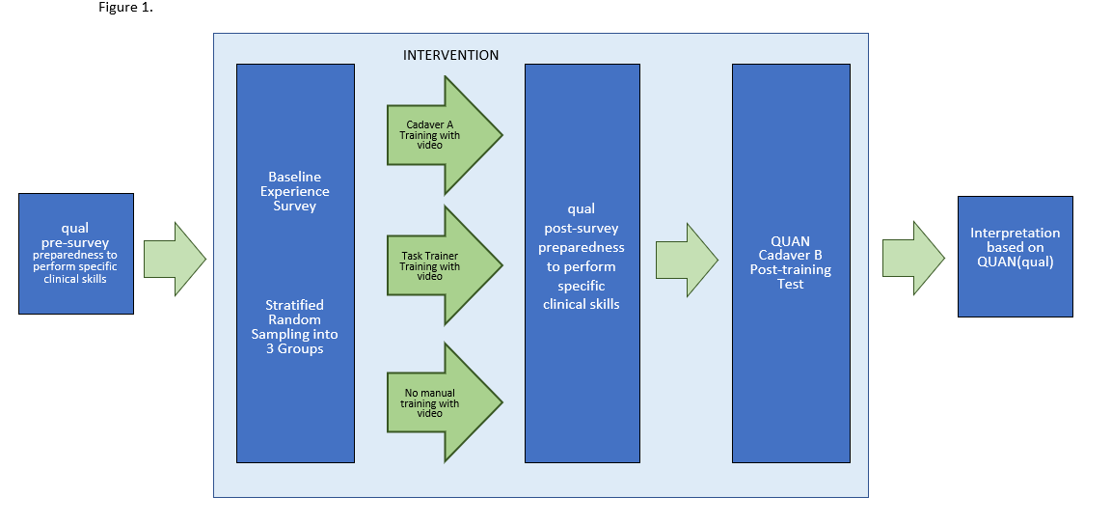
For this study, an experimental design using a core embedded-experiment model was utilized (Creswell, 2007). Inquiry was guided by Johnson, Onwuegbuzie, & Turner’s (2007) definition of mixed methods as “a researcher or team of researchers that combines elements of qualitative and quantitative research approaches (e.g. use of qualitative and quantitative viewpoints, data collection, analysis, inference techniques) for the purposes of breadth and depth of understanding and corroboration” (p.123). Data on student performance on four clinical skills and perceptions of preparedness for each of the skills in a clinical setting were collected. Interpretation of the quantitative data and qualitative data was accomplished using a convergent method (Creswell, 2017). The qualitative data on student perspectives acted as a secondary component to the primary quantitative, student performance data.
Figure 1. Stages of Research
The study was bound by two identifiable qualities: time (the intervention was integrated into a course) and participants (one cohort of second year PA students from a single institution). The University of Oklahoma Health Science Center Institutional Review Board awarded this research exempt status and approved all data collection procedures and documents used in this study. (Appendix C)
Sampling. The target population for this study was all first-year PA students (n=48) from a single PA program in a mid-western city. The class size of the PA program (n=48) was a limiting factor in the number of participants for this study. The study was integrated into the Patient Management Skills (PMS) course, which covered training didactic and procedural skills training in emergency medicine. All students were required to complete an online training module that included a PowerPoint lecture and four videos concerning performance of critical care skills, including the four covered in this study. Convenience sampling was utilized to send study information and consent forms to each student enrolled in the PMS course at the program. Students consented to participate two weeks prior to the beginning of the study. Once consented, a randomized, stratified sampling approach was utilized to ensure students with differing levels of experience had equal representation across groups. Prior medical experience stratification was to mediate potentially varying degrees of medical experience (Physician Assistant Education Association et al., 2018).
Prior medical experience grouping. Medical experience and exposure were measured using a background survey, PA Prior Medical Experience Survey (PA-PME) (Appendix A), designed by faculty and investigators where students self-report the following: type of position held, number of years, and average hours worked in a week. The PA-PME contained a deidentification code (Appendix B) used to deidentify the data. Exposure to specific skills involved in the training was also documented through students self-reporting the number of times they performed and/or observed a specific skill. Data from the PA-PME survey was used to stratify students into three levels (high, medium, low) based on medical experience and exposure. High, medium, and low categories were established by clinician faculty and experts in the field following data collection and based on the information collected in the medical experience and exposure survey.
Table 2. Definitions of the three experience levels
High Experience Level | Previous work in the medical field (ex: Nurse, EMT, Medical Scribe)  AND  Observation experience with any of the skills  OR  Performance experience with any of the skills
Medium Experience Level | Previous work in the medical field (ex: Nurse, EMT, Medical Scribe)  AND  No observation experience with any of the skills  AND  No Performance experience with any of the skills
Low Experience Level | No previous work in the medical field (ex: Nurse, EMT, Medical Scribe)  AND  No observation experience with any of the skills  AND  No Performance experience with any of the skills

High, medium, and low experience levels were established criteria outlined in Table 1 Definitions of the Three Experience Levels. Variations in the High Experience Level led to additional stratification into three groups, established by frequency counts of skill observation and performance, as well as numbers of years worked in the medical field. Additional stratification of the high experience level was performed to ensure equability across training groups and resulted in three additional groups: High-A, High-B, and High-C. The survey was administered to the participants two weeks prior to training to generate data on previous medical exposure and experience. Student participants included all first year PA students at a single institution. Following stratification, students were randomly placed into one of the following training groups: soft-fixed cadaver, task-trainer, or video (no manual training).
Emergency skills evaluation rubric selection and modification. Rubrics to evaluate the four emergency skills were selected from two sources: National Registry of Emergency Medical Technicians (NREMT) Practical Exam Skill Sheets and peer reviewed literature. The NREMT resources page contained open-source skills sheets on tube thoracostomy, needle decompression, and intraosseous insertion. The NREMT indicated that “all skills have been developed in accordance with the U.S. Department of Transportation National EMS Education Standards, the American Heart Association Guidelines for CPR and ECC, and the U.S. Department of Health and Human Services Centers for Disease Control and Prevention National Trauma Triage Protocol(National Registry of Emergency Medical Technicians, 2020). Tube thoracostomy is a skill not performed by Emergency Medical Technicians (EMT), thus there was not a skill sheet for this particular skill. Therefore, for tube thoracostomy, a previously validated rubric for pediatric emergency medicine physician—the Tool for Assessing Chest Tube Insertion Competency (TACTIC)—was used, the (Shefrin et al., 2015). Prior to selection, clinician faculty reviewed rubrics for appropriateness for student learners. Clinician faculty suggested modifications in the area of sterile field. Sterile field modifications were made due to monetary considerations as well as time associated with the testing session. Rubrics were provided to students and raters one week prior to the clinical skills training session. Skill rubrics contained a deidentification code (Appendix D) used to deidentify the data prior to grading. Quantitative data collection occurred 24 hours following training.
Rater Selection and Preparation. Clinician faculty were recruited six months prior to the training session to give ample time for scheduling. A recruitment letter was drafted by investigators (Appendix E) and clinician faculty to PAs and physicians currently practicing in an emergency medicine or trauma setting or clinicians with extensive background and experience with the skills. A total of six clinicians or clinician faculty volunteered for the testing and/or training day. Trainers and graders were blinded to the purpose of the study as well as students’ training group. However, due to the small number of volunteer clinicians, some clinicians served double roles as both trainers and graders. Where possible, clinician trainers and testers worked with different sets of students, to reduce bias and group recognition. Clinician and faculty instructors attended a 1-hour training session on the use of skill-specific rubrics (Appendix D) and the testing session. The rater training session was utilized to ensure evaluators were comfortable with the rubrics and that there was equitable grading across groups.
Video Selection and Distribution. Videos used in this training were selected by a clinician faculty member and then circulated among four clinicians in the field. The clinicians were asked to evaluate the videos for clarity and correctness. All clinicians found the videos to contain correct information and have appropriate clarity for student learners. Skill specific videos were uploaded to the course webpage two weeks prior to the training session and students were instructed to watch each of the videos prior to their PMS final, which took place 4 days before the training. The video training group (VTG) was contacted an additional time, 24 hours prior to testing, to advise re-watching the videos and reviewing the rubrics.
Questionnaire Development. The qualitative aspect of this study was in the form of pre and post open-ended questionnaires that addressed students’ perspectives of their own preparedness. The pre-questionnaire provided a baseline for student perspectives on preparedness to perform the procedures covered in the training. Questions were developed in line with study aims and research questions and then reviewed by faculty to ensure neutral and consistent language.
Training. Training for the task trainer group (TTG) and cadaver training group (CTG) groups took place from 7:00am to 5:45pm on August 27, 2019. The day was divided into four training sessions (Table 2), two morning blocks and two afternoon blocks, with each block lasting 2 hours and 15 minutes. Students in both the TTG and the CTG rotated through all four skill stations. The tube thoracostomy and endotracheal intubation stations each lasted 30 minutes, while the intraosseous insertion and needle decompression stations each lasted 15 minutes. Each of the skills in the TTG and CTG groups were taught by the same clinician. To address ethical concerns, at the end of the study, all students were provided the opportunity to be trained on a soft-fixed cadaver or task trainer.
Table 3. Skills training day schedule
8:00am-10:15am | Block I: Task Trained Group (8 Students)
10:15am-12:30pm | Block II: Task Trained Group (9 Students)
12:30pm-1:00pm | Lunch Break
1:00pm-3:15pm | Block III: Cadaver Trained Group (8 Students)
3:30pm- 5:45 pm | Block IV: Cadaver Trained Group (9 Students)

Data Collection. Student performance was measured using skill-specific, point-based rubrics by the same faculty members and expert clinicians that were involved in the training. Pre-surveys, containing the deidentification code (Appendix B), were administered in person prior to training, post PowerPoint lecture and skill-specific videos. To ensure all students had watched the skill specific videos, the PMS course webpage was checked to ensure students had accessed each of the videos. In order to be eligible for the post-training open-ended survey on student perspectives of preparedness, students were required to have participated in one of the training methods in the quantitative portion of the design.
Student perspectives of preparedness pre/post surveys. All participants (n=48) were administered the pre-survey on perspectives of preparedness (Appendix C) one week prior to training and the results were immediately collected. The post-survey on perspectives of preparedness (Appendix C) was administered immediately following participants’ training. Students in the video group were emailed the post-survey, completed the post survey prior to testing, and then e-mailed the survey back to investigators.
Data Preparation and Analysis. All data was de-identified using an IRB approved, multi-question algorithm which accompanied all data collected throughout the study. Electronic data was kept in a password protected laptop and any non-electronic data was kept in a secure room, in a locked office. Any identifying information was removed prior to data preparation and analysis. De-identified data was transcribed verbatim, into Excel spreadsheets, allowing a first pass at reviewing the data.
Thematic analysis of open-ended questions was conducted by a four-person team, including three members with prior experience in qualitative research methods. Initially, each member performed independent thematic analysis of the data using an iterative process of inductive, open coding and deductive, conceptual coding. The analysis process involved reading all pre and post survey responses to open-ended questions and highlighting and identifying the main ideas in each phrase. The team then reviewed the highlighted words to develop primary codes. The analysis team met eight times over five months to compare and reach consensus over code development. Initial meetings involved comparison of open coding to ensure consistency and to help combine similar codes. For example, “insufficient preparation” and “not prepared” were considered similar enough to combine. Twelve initial codes were identified. In subsequent meetings, the initial codes were narrowed to seven final codes by eliminating codes not strongly represented across the data and merging any primary codes that conveyed similar concepts. To ensure passages coded the same way were consistent, the analysis team cycled back through the data using constant comparison. Inconsistencies were identified and discussed to ensure team consensus. Significant statements that conveyed the overall sense of each code were selected for presentation in Table 6.

Quantitative Data Analysis. Descriptive frequencies and proportions were calculated for each question in the pre intervention survey investigating experience level. Continuous variables were converted into categorical variables for ease of reporting more interpretable frequencies and proportions. The distribution of these frequencies across intervention groups was then investigated for significant difference using Fisher’s Exact tests (significance level p<0.05) to ensure that the intended equal distribution of experience level when assigning individuals to intervention groups was achieved.
To investigate whether performance of skills differed by intervention group, each participant’s scores on individual components were summed to create a sum score achieved for each skill. The sum scores for chest tube, intubation, intraosseous insertion, and needle decompression were each assessed for normality of distribution using Shapiro-Wilk tests. Chest tube and intubation scores showed evidence of normal distributions (significance level p<0.05), while intraosseous insertion and needle decompression scores demonstrated significant evidence of non-normal distributions. Means and standard deviations were calculated for the normally distributed chest tube and intubation scores. Medians, 25th percentile, and 75th percentiles were calculated for non-normally distributed intraosseous insertion and needle decompression. To investigate significant difference of scores between intervention groups, ANOVA models were created for chest tube and intubation scores, while non-parametric Wilcoxon signed rank tests (for two-group comparisons) and Kruskal-Wallis tests (for three-group comparisons) were used for intraosseous insertion and needle decompression scores.

CHAPTER 4: RESULTS

Overview

This chapter discusses data analysis findings for two aims: 1) Compare student performance on video, task trainer, and soft-fixed cadaver trained individuals to establish evidenced-based training for emergency procedural skill acquisition. 2) Describe student perspectives regarding training methods and perceptions of preparedness. Initial data processing for both qualitative and quantitative data will be discussed in detail along with study results. This allows readers to examine the thought process behind research decisions and minimizes the chance of researcher bias being embedded in the research method without transparency.
Phase I: Grouping of students by previous medical experience prior to training intervention
Forty-eight second year PA students from a single institution took the Prior Medical Experience Level Survey (Appendix A). Questions directed at obtaining student data on previous professional medical experience indicated 34 individuals or 70.8% of students previously held a position in the medical field.
Table 4. Students’ previous medical experience
Variable |  |  |  | All  N=48 | Video  N=16 | Task Trainer  N=15 | Cadaver  N=17 | P  Value
 |  |  |  | n (%) | n (%) | n (%) | n (%)
Previous professional experience
 | Held medical position |  |  | 34 (70.8) | 12 (75.0) | 10 (66.7) | 12 (70.6) | 0.92
 |  | Years held |  |  |  |  |  | 0.80
 |  |  | 0-<1 | 9(26.5) | 2 (16.7) | 3 (30.0) | 4 (33.3)
 |  |  | 1-<3 | 13 (38.2) | 6 (50.0) | 4 (40.0) | 3 (25.0)
 |  |  | ≥3 | 12 (35.3) | 4 (33.3) | 3 (30.0) | 5 (41.7)
 |  | Weekly hours |  |  |  |  |  | 0.70
 |  |  | ≤ 24 | 8 (23.5) | 2 (16.7) | 4 (40.0) | 2 (16.7)
 |  |  | > 24-40 | 22 (64.7) | 9 (75.0) | 5 (50.0) | 8 (66.7)
 |  |  | > 40 | 4 (11.8) | 1 (8.3) | 1 (10.0) | 2 (16.7)

These positions included nurse, EMT, physical therapy tech, and medical scribe. The number of years individuals held these positions ranged from zero to 10 years with nine students (26.5%) holding the position less than one year, 13 students (38.2%) holding the position one to three years, and 12 students (35.3%) holding the position greater than or equal to three years. The average hours worked in the position was distributed into three main categories: less than or equal to 24 hours per week (8 students, 23.5%), between 24 and 40 hours per week (22 students, 11.5%), and over 40 hours per week (4 students, 11.8%). Of the 48 students, 4 (8.3%) had observed insertion of a chest tube, 10 (20.8%) had observed an endotracheal intubation, and 6 (12.5%) had observed a needle decompression. Three students had previously observed chest tube insertion (75%); 1 student (25%) had observed the procedure more than once. Two students had previously observed endotracheal intubation (20%) once and 8 students (80%) had observed the procedure more than once.
Table 5. Students’ previous observation of four training session skills
Variable |  |  | All  N=48 | Video  N=16 | Task Trainer  N=15 | Cadaver  N=17 | P  Value
 |  |  | n (%) | n (%) | n (%) | n (%)
Has previously observed
 | Chest tube |  | 4 (8.3) | 2 (12.5) | 0 | 2 (11.8) | 0.53
 | Endotracheal intubation |  | 10 (20.8) | 3 (18.8) | 2 (13.3) | 5 (29.4) | 0.61
 | Intraosseous insertion |  | 6 (12.5) | 2 (12.5) | 1 (6.7) | 3 (17.7) | 0.86
 | Needle decompression |  | 2 (4.2) | 1 (6.3) | 0 | 1 (5.9) | 1.0
Frequency observed (among those that previously observed)
 | Chest tube |  |  |  |  |  | 1.0
 |  | Once | 3 (75.0) | 2 (100) | 0 | 1 (50)
 |  | More than once | 1 (25.0) | 0 | 0 | 1 (50)
 | Endotracheal intubation |  |  |  |  |  | 0.67
 |  | Once | 2 (20.0) | 0 | 1 (50) | 1 (20)
 |  | More than once | 8 (80.0) | 3 (100) | 1 (50) | 4 (80)
 | Intraosseous insertion |  |  |  |  |  | 0.40
 |  | Once | 3 (50.0) | 0 | 1 (100) | 2 (66.7)
 |  | More than once | 3 (50.0) | 2 (100) | 0 | 1 (33.3)
 | Needle decompression |  |  |  |  |  | 1.0
 |  | Once | 1 (50.0) | 1 (100) | 0 | 0
 |  | More than once | 1 (50.0) | 0 | 0 | 1 (100)

One student had previously observed needle decompression (50%) and 1 student (50%) had observed the procedure more than once. Three students had previously observed intraosseous insertion (50%) and 3 students (50%) had observed the procedure more than once. Data on performance of procedures indicated one student had previously performed endotracheal intubation one time and one student had performed intraosseous insertion one time.
Table 6. Student previous performance of training session skills
Variable |  |  | All  N=48 | Video  N=16 | Task Trainer  N=15 | Cadaver  N=17 | P  Value
 |  |  | n (%) | n (%) | n (%) | n (%)
Has previously performed
 | Chest tube |  | 0 | 0 | 0 | 0 | 1.0
 | Endotracheal intubation |  | 1 (2.1) | 1 (6.3) | 0 | 0 | 0.65
 | Intraosseous insertion |  | 0 | 0 | 0 | 0 | 1.0
 | Needle decompression |  | 1 (2.1) | 1 (6.3) | 0 | 0 | 0.65
Frequency performed (among those that previously performed)
 | Endotracheal intubation
 |  | Once | 1 (100) | 1 (100) | 0 | 0
 | Needle decompression
 |  | Once | 1 (100) | 1 (100) | 0 | 0

Initial stratification into three primary categories of experience yielded the following in each group: high experience level (29.2%, n=14), medium experience level (22.9% n=11), and low experience level (47.9%, n=23). Due to diversity in the level of experience in the high experience level (HEL), this group was re-stratified and resulted in the following number of students in each of the categories: HEL-1(n=4), HEL-2(n=3), HEL-3(n=7). Randomization into three training groups initially resulted in a video group with 16 students, a task trainer group with 16 students, and a cadaver group with 17 students. However, one student dropped from the program during the course of this project and thus the task trainer group ended up with 15 students.
Following stratification and randomization, distribution of variable frequencies across intervention groups was investigated for significant differences using Fisher’s Exact tests. This resulted in no significant difference across for all variables. These variables included: Previous professional experience (p=.92), years position was held (p=.80), average weekly hours worked (p=.70), previous observation (p ranged from .40-1.0), and frequency of observation of any of the four skills (p ranged from .53-1.0), previous performance (p ranged from .65-1.0), and frequency of performance of any of the four skills. Thus, groups were found to be equitable.

Phase II: Mixed Methods Data Analysis Results

Graded Skill Performance. Experience level did not differ significantly between groups (p>0.05) across experience-related variables (Table 5). Tests for normality concluded that sum scores for chest tube and intubation were normally distributed (p=13, p=15, respectively), while sum scores for IO and needle decompression had non-normal distributions (p<0.0001, p<0.0001, respectively). Means with standard deviations were reported for chest tube and intubation, and medians with 25th and 75th quartiles were reported for IO and needle decompression. Sum scores differed across all three intervention groups, video, task trainer, and cadaver for chest tube (Mean = 16.4, 18.9, and 19.1 respectively, p=0.04), intubation (Mean= 17.6, 17.1, 23.0, p=0.0009), IO (Median= 44, 45, 48, p=0.0019), and needle decompression (Median=18, 23, 22, p=<0.0001). Comparing scores with regard to cadaver and task trainer groups, students trained on cadavers scored significantly higher than students trained on task trainers for intubation (p=0.0003), and for IO (p=0.0012). However, differences observed for chest tube and needle decompression were not statistically significant (p=0.85, p=0.11, respectively).

Figure 2. Comparing mean scores and standard deviations of chest tube and intubation across intervention groups

Figure 3. Comparing median scores and quartiles of intraosseous insertion and needle decompression across intervention groups

Student Perspectives on Preparedness. This section presents the findings from the pre and post qualitative survey taken by all 48 second-year PA students. The open-ended survey was meant to address the following aims: 1) to understand student perspectives regarding training methods and perceptions of preparedness, and 2) to understand how students trained on soft-fixed cadaver, task trainer, and video differed with regards to perceptions of preparedness. Qualitative analysis of the pre and post open ended survey resulted in a total of 6 codes identified across the data. Codes across training groups are discussed for each of the questions in the pre and post test.
Description of Codes. COACHING. This code describes the process of a knowledgeable, experienced individual expertly facilitating the learning process through supporting, guiding, and assessing students during their endeavor to develop knowledge and skills. This code was identified through statements discussing having a “strong teacher” to “guide” an individual through the process, “correcting” them when they make a mistake and providing an opportunity to “ask questions.” Many of the participants describe the benefit of having an “expert” or “clinician” as being a beneficial aspect of their training and learning process.
Confidence. This code was identified when participants described feelings of self-assurance in knowledge and ability or lack thereof, encompassing having or not having confidence. Identification of this code was relatively straightforward in that participants stated feeling “confident” or “not confident.” Students also described “not feeling comfortable” and others commented they felt that they could perform the skill “perfectly.”
DEMONSTRATION. This code was defined as the act of an individual (novice or expert) actively exhibiting the steps of a procedure while providing an explanation. This code was identified when students described, “seeing the procedures performed by preceptors and all the other students” and “seeing it done before trying it myself.”
HANDS-ON TRAINING/PRACTICE. For this code, two concepts were consistently associated with one another. This combined code was defined as the act of teaching and developing an individual’s skill and knowledge through direct practical experience and repeated or regular actual application or use of a process or procedure in order to gain proficiency. Students spoke negatively and positively about the lack or importance of hands-on training/practice. One student described important characteristic as, “I think the most important characteristic of training for clinical rotations is the time to practice hands-on. Watching someone via online tutorial is helpful to get an idea of how to approach a procedure, but doing it first-hand allows you to think of questions you may not know that you have and it makes it easier to remember long-term.”
KNOWLEDGE. The knowledge code was defined as awareness of facts, information, and skills acquired by an individual through experience or education resulting in a theoretical or practical understanding of a process or skill. In discussing their preparedness, they made statements that expressed their individual content knowledge. “I currently feel like I have knowledge on the necessary steps for intubation providing a feeling of preparation.”
PREPARED. Preparedness as a code was defined as having the knowledge, mentality, and physical ability to complete a task or perform a procedure. Identification of this code was relatively straightforward in that participants detailed “I feel much more prepared” or simply stated “not prepared” in response to the open-ended questions.
REALISTIC SIMULATION. This code was defined as a constructivist learning model that provides learners with the experience of working on a realistic (the degree to which something represents thing in a way that is accurate or true to life in physical form and texture) representation of a real-world system while omitting the distracting or dangerous elements. Representative student quotes ranged from detailed descriptions of realistic nature to re-counting the absence of realism. One student wrote, “I feel more prepared on many levels due to this training. Not only do I know how hard to push for Io placement in real bone, but I know what it feels like to run a chest tube over my finger into the chest of a patient. I know how heavy the lower jaw/neck tissue can be while trying to intubate. I did not know those things until today.” Another student described, “….I would feel better with a simulation more closely resembling an actual clinical.”

Table 7. Definition of Codes with Representative Quotes
Code and Definition | Representative Quotes to Illustrate Code
(1) Coaching  A knowledgeable, experienced individual who expertly facilitates the learning process through supporting, guiding, and assessing students during their endeavor to develop knowledge and skills.  OR  A knowledgeable, experienced individual who expertly facilitates the learning process through effective and appropriate pedagogy. | B1.12 “Having a strong teacher that is knowledgeable and can answer any questions”  G6.05 “Yes, having a clinician there to answer questions and guide me in the procedures. I also like how they let me practice the procedure and were there to correct me when I made mistakes.”  B6.02 “It cannot be stressed enough how helpful it is to be able to ask questions while it is being taught to you face to face…”  P1.16 Secondly, I think it’s helpful to have knowledgeable instructors present to guide and answer questions.
(2) Confidence  Feelings of self-assurance in one’s knowledge and ability.  Feelings of lacking self-assurance in one’s knowledge and ability. | G3.04 “I am much more confident now.”  B2.09 “I feel much more confident in my ability. Not only to perform the procedure but to keep my wits about me. I have in the past had bouts of lightheadedness and Clinic / OR/ ED settings. Getting to watch several times and perform the procedure myself help me build my self-confidence.”  P2.03 “...I do not feel confident enough to complete them in real life as compared to practicing first.”  P2.05 “I still do not feel comfortable inserting a chest tube in a clinical setting.”
(3) DEMONSTRATION  The act of an individual (novice or expert) actively going through the steps of a procedure while providing an explanation of the process. | P3.07 “… I definitely feel like an in-person explanation and demonstration would be beneficial…”  B5.15 “hands-on experience. Lots of practice. Seeing it done by a provider in real life”  G1.09 “In person demonstration of the skill. I learn best this way before performing blindly.”  P1.02 “Seeing demonstration in person. Too hard to understand after watching a video.”
(4) HANDS-ON TRAINING/PRACTICE  The act of teaching and developing an individual’s skill and knowledge through direct practical experience.  Practice  The repeated or regular actual application or use of a process or procedure in order to gain proficiency. | P1.16 “I think the most important characteristic of training for clinical rotations is the time to practice hands-on. Watching someone via online tutorial is helpful to get an idea of how to approach a procedure, but doing it first-hand allows you to think of questions you may not know that you have and it makes it easier to remember long-term.”  G1.15 “hands-on training in the most realistic way with repetition is the most important part of training for me. Because repetition helps me get better.”  B1.13 “Actually practicing the skill over and over again. Head knowledge doesn’t always translate to physically doing something.”
(5) KNOWLEDGE  The awareness of facts, information and skills acquired by an individual through experience or education resulting in a theoretical or practical understanding of a process or skill (Oxford Dictionary of English, 2010). | B6.16 “It increased my knowledge and allowed me to feel more prepared for clinicals”  G3.03 “I currently feel like I have knowledge on the necessary steps for intubation providing a feeling of preparation.”
(6) PREPARED  Having the knowledge, mentality, and physical ability to complete a task or perform a procedure. | G3.15 “I feel much more prepared”  B5.02 “This training was extremely helpful for landmarks and to get a real feel for how much fore it takes to get the needle in. I feel very prepared.”  P3.07 “It was a good initial introduction to the process, but I do not feel fully prepared to do it on my own. I definitely feel like an in-person explanation and demonstration would be beneficial as well as the opportunity to practice multiple times.”
(7) REALISTIC SIMULATION  A constructivist learning model that provides learners with the experience of working on a realistic (The degree to which something represents thing in a way that is accurate or true to life in physical form and texture) representation of a real-world system while omitting the distracting or dangerous elements. | B6.11 “Practice! Practice in realistic settings and on realistic trainers”  B6.09 “I feel more prepared on many levels due to this training. Not only do I know how hard to push for Io placement in real bone, but I know what it feels like to run a chest tube over my finger into the chest of a patient. I know how heavy the lower jaw/neck tissue can be while trying to intubate. I did not know those things until today.”  G6.01 “These were somewhat helpful in my preparedness, but I would feel better with a simulation more closely resembling an actual clinical”

PRESURVEY. Thematic analyses of data from the pre-test survey on procedural preparedness resulted in the identification of ten total codes at varying degrees across all groups. Analysis of data from the open-ended question, “What do you think are the most important characteristics of training for procedural skill preparedness in clinical rotations? a. Why?” resulted in six codes across training groups. For all three groups, the importance of “hands-on” training/ practice was a prominent theme with 93.8% of the students describing it in the cadaver training group (CTG), 66.7% in the task trainer group (TTG), and 50% in the video groups (VTG). Other frequently mentioned factors for individuals in the cadaver groups were realistic simulation (25%) and confidence (25%). However, the task trainer group individuals emphasized the importance of knowledge (33.3%) and realistic simulation (26.7%) and the video group, knowledge (31.3%) and realistic simulation (12.5%).
Analysis of the data from open-ended question, “Describe your current feelings of preparedness to perform chest tube insertion in a clinical setting” resulted in the identification of four codes across training groups. When answering this question, students in the cadaver training group described feelings of being ill prepared (50%) and lacking confidence (56.3%). Students in the task trainer group also expressed feelings of not being prepared (53.3%) and not being confident (40%); however, these feelings were often interlaced with student’s knowledge (40%) of the procedure. For the video group, 62.5% of students described feelings of not being confident. Other prominent codes for this group were needing hands-on training/practice (43.8%) and not being prepared (37.5%).
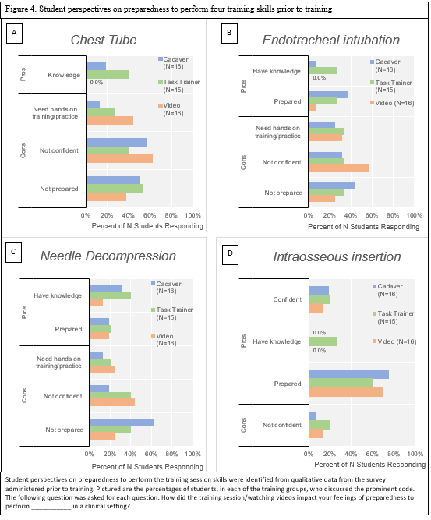
Analysis of the data from open-ended question, “Describe your current feelings of preparedness to perform endotracheal intubation in a clinical setting” resulted in the identification of five codes across training groups. Students in the cadaver training group described feeling not prepared (43.8%), prepared (37.5%), not confident (31.3%), and needing hands-on training (25%). TTG students describe a wider range of feelings with 33.3% needing hands-on training/practice, (33.3%) being not confident, and (33.3%) being not prepared. Some students in this group also described feelings of preparedness and knowledge regarding aspects of the procedure. The VG students discussed feeling not confident (56.3%) and feeling not prepared (25%). VG students also discussed the desire for hands-on training/practice (31.3%).

Analysis of the data from open-ended question, “Describe your current feelings of preparedness to needle decompression in a clinical setting” resulted in the identification of five codes across training groups. CG students described feelings of being not prepared (62.5%); however, 31.3% still indicated having knowledge about the procedure. There were also students who described being not confident (18.8%) while others indicated feelings of preparedness (18.8%). TTG students described the feelings of not being prepared (40%), not confident (40%), and having knowledge surrounding the procedure (40%). Some students also indicated the need for hands-on training/practice (20%), while others describe feelings of preparedness (20%). VG students mostly described feelings of not confident (43.8%) with the procedure with lower levels of students indicating not prepared (25%) and needing hands-on training/practice (25%). As with the other two groups, there were still a small percentage of students that felt prepared (18%).

Analysis of the data from open-ended question, “Describe your current feelings of preparedness to intraosseous insertion in a clinical setting” resulted in the identification of four codes across training groups. Students in the CG described feelings of being prepared (75%), confident (18.8%), and not confident (6.3%). In the TTG, students described feelings of preparedness at a percentage of 60%, with 20% describing being confident, 20% not confident, and 26.7% mentioning knowledge around the procedure. VG students had similar outcomes in that 68.8% described feelings of preparedness, 12.5% wrote about being not confident, and 12.5% wrote about being confident.
Analysis of the data from open-ended question, “Ways to improve feelings of preparedness of skill training?” resulted in the identification of five codes across training groups. The majority of all training groups found hands-on training/practice was the most relevant factor in improving feelings of preparedness with 75% of CG, 66.7% of TTG, and 68.8% of VG students reporting it. CG students also found demonstration (37.5%), coaching (12.5%), and realistic simulation (6.3%) to be frequently mentioned in improving feelings of preparedness. TTG students also described demonstration (40%), realistic simulation (13.3%), and coaching (6.7%) as predominant factors in preparedness, but knowledge (26.7%) was also a frequently mentioned factor for this group. VG students, like TTG and CG students, also described hands-on training, demonstration (25%), realistic simulation (18.8%), coaching (31.3%), and knowledge (6.3%) as frequently mentioned factors in preparedness.

Figure 5. Student perspectives improving feelings of preparedness

POST SURVEY
Thematic analyses of the post-test survey data on procedural preparedness resulted in the identification of nine total codes at varying degrees across all training groups. Analysis of data from the open-ended question, “How did the training session impact your feelings of preparedness to perform chest tube insertion in a clinical setting?” resulted in eight codes across training groups. Students in the CTG described feelings of being prepared (56.3%), being confident (37.5%), and realistic simulation (31.3%). Some students in the CTG also described as though they still needed practice (12.5%) and they were not confident (18.8%). Students in the TTG group described feelings of preparedness at a higher rate (66.7%) than the CTG students. Students in the TTG also described being confident (33.3%) and hands-on training/practice (33.3%). A small percent of TTG students did feel not confident (13.3%). Students in the VG felt not prepared (68.8%), not confident (31.3%), and felt they needed practice (37.5%). Students in the VG group also described having the knowledge (43.8%) surrounding the procedure.
Student perspectives on preparedness to perform the training session skills were gleaned from qualitative data from the survey administered post training. Pictured are the percentages of students, in each of the training groups, that discussed the prominent code. The following question was asked for each question: How did the training session/watching videos impact your feelings of preparedness to perform ___________ in a clinical setting?

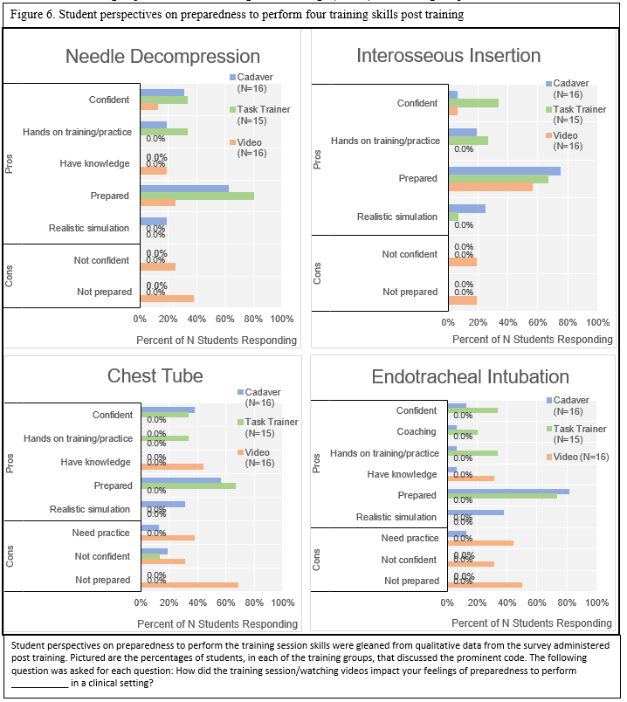
Analysis of data from the open-ended question, “How did the training session/watching videos impact your feelings of preparedness to perform endotracheal intubation in a clinical setting?” resulted in nine codes across training groups. Student in the CTG felt prepared (81.3%), realistic simulation (37.5%), and confident (12.5%). There were some students in the CTG that felt they still needed practice (12.5%). Students in the TTG also felt prepared (73.3%) and confident (33.3%) regarding performing endotracheal intubation. Students in the TTG also described positive feelings of hands-on training/practice (33.3%) and coaching (20%). Students in the VTG described feelings of having knowledge surrounding the procedure; however, 50% of students described feeling of not being prepared, 31.3% described feeling not prepared, 43.8% need practice and 31.3% being not confident.
Analysis of data from the open-ended question, “How did the training session/watching videos impact your feelings of preparedness to perform needle decompression in a clinical setting?” resulted in seven codes across training groups. CTG students overall described feelings of preparedness (62.5%) and being confident (31.3%). They also described positive feelings towards hands-on training/practice (18.8%) and realistic training (18.8%). Students in the VTG group felt a wider range of feelings towards performing needle decompression in a clinical setting. The most prominent feeling was being not prepared (37.5%) with 25% describing feelings of not confident. Some students in the VTG did indicate feeling prepared (25%) and confident (12.5%) with positive descriptions about hands-on training/practice.
Analysis of data from the open-ended question, “How did the training session/watching videos impact your feelings of preparedness to perform interosseous insertion in a clinical setting?” resulted in six codes across training groups. The CTG described feelings of being prepared (75%) while also describing positive feelings surrounding hands-on training/practice (18.8%) and realistic simulation (25%). Students in the TTG described feelings of being prepared (66.7%), confident (33.3%), and positive aspects of hands-on training/practice (26.7%). Students in VTG also felt prepared (56.3%); however, 18.8% of these students also felt not confident and 18.8% of students felt not prepared.
Analysis of data from the open-ended question, “Were there any aspects of the training session that positively affected your feelings of preparedness? Why?” resulted in six codes across the CTG and TTG students. CTG students (56.3%) and TTG students (66.7%) found hands-on training/practice to be a frequently mentioned factor in affecting their preparedness. Students in the CTG group also described realistic simulation (50%), confidence (37.5%), coaching (37.5%), and demonstration (18.8%) as frequently mentioned aspects of the training that affected their preparedness. Students in the TTG found coaching (66.7%) to be a noteworthy aspect of training that affected their feelings of preparedness.
Analysis of data from the open-ended question, “Were there any aspects of watching the video that positively or negatively affected your feelings of preparedness? Why and to what extent?” resulted in two codes in the VTG. At a proportion of 43.8%, VTG students found the videos to positively affect their knowledge level. Students in this group also reported a majority sentiment that they were not prepared (87.5%).

Figure 7. Student perspectives on training session

Chapter 5: Discussion

Overview of the study

To establish evidenced-based training for procedural skill acquisition, student performance of four emergency skills (endotracheal intubation, intraosseous insertion, tube thoracostomy, and needle decompression) was examined following three training methods. Student perspectives on preparedness to perform procedures in a clinical setting was also examined. Qualitative and quantitative data was collected in an attempt to develop a deeper, well-rounded understanding of student procedural learning.
Student performance was measured using the National Registry of Emergency Medical Technicians Skill assessment sheets for endotracheal intubation, intraosseous insertion, and needle decompression, modified by faculty clinicians to meet the needs of the training. Tube thoracostomy was assessed using the TACTIC Tool for Chest Tube Insertion. Student perspectives were gathered through a qualitative pre and post survey administered prior to and following the training.
Student Performance on the Assessment
Significant differences in student skill performance were seen when comparing the three intervention groups. Research demonstrating the effectiveness of hands-on training in learning technical skills (Grabo et al., 2014) served as rationale for further investigation of performance between cadaver and task trainer intervention groups specifically. However, it is worth mentioning that students in this study still described the video as valuable, noting it provided content knowledge. This study demonstrates that both task trainer and cadaver models are effective teaching modalities, although a cadaver model may be more suitable for some skills.
A research aim was to compare student performance on video, task trainer, or soft-fixed cadaver trained individuals to establish evidenced-based training methods for emergency procedural skill acquisition. CTG students scored significantly higher than TTG students at performing endotracheal intubation. Patient simulators have been reported to be inadequate representations of real patient airways (Schebesta et al., 2012), while cadaver airways and anatomy have been found to represent a high level of realism during training (Yang et al., 2010). A more realistic training specimen may have had a positive influence on CTG students allowing for better performance. Pedigio et al (2020) found no significant difference in first-pass intubation success when comparing students trained on task trainers to students trained on unembalmed cadaver specimens; however, the study involved fourth year medical students enrolled in the EM sub-internship or emergency procedures elective students who may have had higher levels of intubation exposure and experience. Pedigio et al (2020) used new Laerdal airway management trainers as their task trainers, as previous studies suggested that this was rated as the most realistic and highest performance manikin. Therefore, the type of task trainer used may play a role in performance outcomes.
CTG student performance on intraosseous insertion significantly differed from student performance in VTG and TTG training groups. Discrepancies between training groups may stem from the realistic nature of training mechanism and difficulties with equipment. Perceptions of the realism of task trainers can vary based on what type of trainer or model is used (Shefrin et al., 2015), which may in turn influence student performance. The task trainers used for this research included a proximal tibia training bone with a flesh-like covering adhered to the approximate point of entry. Students may have encountered difficulty assessing correct anatomical locations for insertion on a human specimen. Another important factor may have been difficulties with equipment. Equipment used for an intraosseous insertion involves a utilizes a reusable battery-powered driver and a disposable intraosseous needle to establish access and then attaching spiking and attaching a solution fluid bag with tubing.

Student in the non-CTG experienced equipment related issues that may have stemmed from not having hands-on training for the VTG students. It is not clear why the TTG had equipment related issues since the same drill, solution bag, and tubing was used for both the task trainers and the cadaver.
Student performance on tube thoracostomy did not significantly differ between cadaver and task trainer groups; however, student average in the cadaver group was slightly higher than the other two training groups. While cadaver assessment has its benefits in realism and fidelity, there still exists some limitations in the reusable nature of the specimen. For example, the initial steps in inserting a chest tube involve identifying insertion site, blunt dissection, and puncturing into the pleural cavity (Stone & Humphries, 2017). In designing the assessment for chest tube insertion, it was important to make each student’s assessment experience as similar as possible. When testing each trainee, the incision, blunt dissection, and puncture had already been performed by a faculty member to ensure equitable testing throughout groups. Students were still expected to perform all other aspects of the procedure; however, taking out the initial steps of the insertion, which are technically challenging, may have removed any advantages a more realistic training would have provided.
Student performance on needle decompression did not significantly differ between the CTG and TTG groups. VTG significantly differed from the other two groups with an overall lower performance. This is consistent with findings in Grabo (2014), where corpsmen with hands-on training more accurately performed needle decompressions compared to their no-hands-on-training counterparts. The results from this study indicated either task trainer or cadavers would be preferable to video for training PA students to perform needle thoracostomy.

Student perception of training

Pre-survey. Data extracted from the pre-survey, as expected, indicated student perspectives on preparedness across VTG, CG, and TTG varied very little and centered around students’ preparedness, confidence, needing hands-on training/practice, and knowledge. Some students refrained from elaborating on their preparedness and described their perceptions in one word or short phrases such as “I do not feel prepared.” Throughout the pretest, the students often hands-on training practice affecting their feelings of preparedness. Based on this commonsense notion, it seems apparent that students would find hands-on training/practice to be an important factor for clinical skill preparedness. Differences varied little between the pretest survey responses among groups. As expected, most students reported feeling that they were not prepared and not confident; they expressed a need for hands-on training. However, interesting data arose for student preparedness in three of the skills.
One unexpected response in the pre-survey qualitative data was that many students felt prepared to perform endotracheal intubation, needle decompression, and intraosseous insertion prior to training. One commonly referred to reason for preparedness for intraosseous insertion and endotracheal intubation was “previous training in ACLS/BLS.” All second year PA students at this institution are required to complete the Advanced Cardiovascular Life Support (ACLS) and Basic Life Skills (BLS) training session as a part of their PMS course.
“The goal of the ACLS Provider Course is to improve outcomes for adult patients of cardiac arrest and other cardiopulmonary emergencies through early recognition and interventions by high-performance teams” (2015 ACLS guidelines, p. 1). Participation in ACLS training has been shown to significantly increase confidence and knowledge assessment scores in ACLS in similar student populations (Maxwell et al., 2016). Student perceptions on chest tube and needle thoracostomy were as expected prior to training and varied little among groups.

Post survey. Student perception of preparedness following training consistently varied between groups with the VTG demonstrating the greatest variation from CTG and TTG students. Students expressed similar feelings of confidence and preparedness in the CTG and TTG groups. However, students in the VTG group were influenced by an additional factor—the realistic nature of their training. Realistic nature was a common difference between the CTG and TTG training groups. While performance did not significantly vary between CTG and TTG for needle decompression, student descriptions of anatomical locations, tissue consistency, and resistance highlighted a factor they felt was important to the educational experience and their overall success.
Realistic simulation was described by the CTG group in each of the four skills assessed, which supports the notion that students found this to be a relevant factor. Student perceptions of their preparedness did not always align with the actual student performance. For intraosseous insertion, a majority of students in each of the training groups felt prepared to perform the skill in a clinical setting; however, performance significantly differed between training groups. Similar findings can be seen when examining student perspectives in the CTG and TTG groups for endotracheal intubation. TTG students were confident and prepared at equal and greater rates compared to their CTG counterparts, however performed significantly worse on the assessment. TTG and CTG often demonstrated similar levels of confidence and preparedness, yet when assessed, performed at different levels. This may be attributed to tasks seeming easier to perform on a task trainer, thus biasing students’ sense of preparedness or confidence. The psychological and affective difficulties with performing low frequency, invasive procedures may be influenced by the realistic nature of a training and in turn may impact perceptions of preparedness.

Theoretical Understanding of the Student Perspectives

When revisiting codes identified in the data, the qualitative team observed a continuity and natural fit into a pre-existing theoretical model, Bloom’s three learning domains: the cognitive, psychomotor, and affective domains (Anderson & Krathwohl, 2001). Each of the learning domains is complex and involves learning processes of varied complexity, organized into a hierarchy of dimensions (Anderson & Krathwohl, 2001). Student multidimensional responses highlighted how teaching complex procedural skills involves more than demonstration and content knowledge. Student perspectives on the pretest indicated each group found a multidimensional training—which contained cognitive, affective and psychomotor aspects—to be important. When describing their preparedness following training, only certain aspects of each of the three domains were identified in students’ responses. These student responses allowed insight into the specific positive and negative qualities of each training method and how it affected their preparedness. As medical educators, it is important to ensure students gain professional competence by engaging them in rich formative and summative experiences that encompass all learning domains. Future emergency skills training would benefit by ensuring training incorporates elements from each of Bloom’s three domains of learning: the cognitive, psychomotor, and affective.

Table 8. Qualitative Codes in Learning Domains
Three Domains of Learning: Cognitive, Affective and Psychomotor
Cognitive | Affective | Psychomotor
Knowledge | Preparedness  Confidence  Coaching  Realistic Nature | hands-on training/practice

While there were aspects of the training that influenced students’ perspectives of preparedness, investigation into which aspects are most influential may improve future training experiences. Expansion of this study could include student perspectives following assessment and a longitudinal aspect investigating student retention of skill. Student experiences performing these emergency procedures during rotations could also be investigated.

Programmatic challenges: justifying a budget

Cost can often be a concern when designing medical educational training sessions, especially when they involve cadavers—due to their limited warranty and relatively high price tag. (Anteby, 2009; Simpson, 2014). Cadaver costs for this project were $4,392.30, which included two cadavers and their associated fees. However, task trainers can also pose a significant financial investment ranging from $607.15 for a Simulaids Tension Pneumothorax Simulator as used in this study, $6,991.00 for a TruMan Trauma X System - Airway Management & Resuscitation Skills, or over $100,000 for more complex cardiac and birth simulators.
The cost of the training in this study was offset through obtaining funding through a small local grant as well as using existing departmental task trainers. It is hopeful that the data described here will convince program leadership that the expense of cadavers is justified by the potential gains in performance. Program leadership may be hesitant to devote resources required to provide students with cadavers given budget concerns. Task trainers are often deemed a cost-effective alternative in that they are usable year after year. Some programs may have issues beyond the cost of the cadaver. Additional issues may arise with regard to access to cadavers, as well as safety and legal requirements that accompany handling a human body.
Limitations
This research is subject to a number of limitations. First, it is based upon results from a single institution, which may influence the reproducibility and generalizability of the study. Another limitation affecting generalizability is the small sample size. The small sample size also contributes to the difficulties in establishing statistical differences among training groups. The currently limited literature could not provide guidance with regard to effect sizes, so power analyses were not used to inform necessary sample size. An a priori power calculation was not performed.
A post hoc calculation demonstrated that sample size produced a power of greater than 90 percent to detect the observed differences in means. Some testing bias may be present given that students in the CTG were trained and tested on the same mechanism. However, steps to reduce this bias were taken through use of a different cadaver than what was used during CTG training.

Conclusions
Lightly fixed cadaver training demonstrated signiﬁcantly higher pre-clinical PA student performance on endotracheal intubation and intraosseous insertion in comparison to task trainers or video training. Video trained students performed significantly worse than their hands-on trained counterparts. While task trainers and videos may be adequate resources for some procedural skills, they are inadequate for others. Inadequate may seem a strong term, however, when training future health care professionals in emergent procedures, the potential cost of failure involves a life. Therefore, during training, it is vital to give our students every advantage.
Student perspectives on preparedness provided valuable insight into procedural skill training, however their perspectives were not always indicative of their eventual performance. Cognitive, psychomotor, and affective aspects of each training method contributed to students’ feelings of preparedness.
Lightly fixed cadaver training contributed to students’ level of preparedness in performing medical procedures by providing a component of realism lost in video and task trainers. Based on the results of the study, it is recommended that PA programs invest in the soft-fixed cadavers for training emergency procedures like intubation and intraosseous insertion, prior to sending students on rotation, to provide a rich learning environment. Based on student perspectives, programs training sessions should allow for hands on training on realistic training modalities such as soft-fixed cadavers. Students should be accompanied by experienced individuals in these sessions where they are coaching the students through the implications and steps of the procedure.

References
Accreditation Review Commission on Education for the Physician Assistant, Inc. (2018). Accreditation Standards for Physician Assistant Education Fourth Edition.
Accreditation Review Commission on Education for the Physician Assistant. (2019, September). ARC-PA Program Data. ARC-PA.
American Association of Medical Colleges. (2019). Weeks of Instruction and Contact Hours Required at US Medical Schools. AAMC. https://www.aamc.org/data-reports/curriculum-reports/interactive-data/weeks-instruction-and-contact-hours-required-us-medical-schools
Anderson, L. W., & Krathwohl, D. R. (Eds.). (2001). A taxonomy for learning, teaching, and assessing: A revision of Bloom’s taxonomy of educational objectives (Complete ed). Longman.
Anteby, M. (2009). A Market for Human Cadavers in All but Name? Economic Sociology: The European Electronic Newsletter, 11(1), 3–7.
http://www.arcpa.org/accreditation/resources/program-data/
Appropriations, U. S. C. H. C. on. (1956). Departments of Labor and Health, Education, and Welfare Appropriations for 1957: Hearings Before the Subcommittee of the Committee on Appropriations, House of Representatives, Eighty-fourth Congress, Second Session. Department of Health, Education and Welfare. U.S. Government Printing Office.

Balta, J., Lamb, C., & Soames, R. (2015). A Pilot Study Comparing the Use of Thiel- and Formalin-Embalmed Cadavers in the Teaching of Human Anatomy. Anatomical Sciences Education, 8. https://doi.org/10.1002/ase.1470
Beer, K., & Stoehr, J. (2015). Utilization of Clinical Simulation in Physician Assistant Education. American Association of Physician Assistants, San Francisco.
Boyle, M. J., Williams, B., & Dousek, S. (2012). Do mannequin chests provide an accurate representation of a human chest for simulated decompression of tension pneumothoraxes? World Journal of Emergency Medicine, 3(4), 265–269. https://doi.org/10.5847/wjem.j.issn.1920-8642.2012.04.005
Brenner, E. (2014). Human body preservation—Old and new techniques. Journal of Anatomy, 224(3), 316–344. https://doi.org/10.1111/joa.12160
Brown, D. F. M., Sullivan, A. F., Espinola, J. A., & Camargo, C. A. (2012). Continued rise in the use of mid-level providers in US emergency departments, 1993-2009. International Journal of Emergency Medicine, 5(1), undefined-undefined. https://doi.org/10.1186/1865-1380-5-21
https://www.cureus.com/articles/4036-a-brief-boot-camp-for-4th-year-medical-students-entering-into-pediatric-and-family-medicine-residencies
Burns, R., Adler, M., Mangold, K., & Trainor, J. (2016). A Brief Boot Camp for 4th-Year Medical Students Entering into Pediatric and Family Medicine Residencies. Cureus, 8(2). https://www.cureus.com/articles/4036-a-brief-boot-camp-for-4th-year-medical-students-entering-into-pediatric-and-family-medicine-residencies
Cawley, J. F., Cawthon, E. A., & Hooker, R. S. (2012). Origins of the physician assistant movement in the United States. JAAPA : Official Journal of the American Academy of Physician Assistants, 25(12), 36–40, 42. https://doi.org/10.1097/01720610-201212000-00008
Cawley, J. F., & Hooker, R. S. (2013). Physician assistants in American medicine: The half-century mark. The American Journal of Managed Care, 19(10), e333-41.
Coombs, J. M., & Pedersen, D. M. (2017). Crafting a Profession: Moving From Innovative Model Programs to a Successful National Profession. The Journal of Physician Assistant Education: The Official Journal of the Physician Assistant Education Association, 28 Suppl 1, S7–S13. https://doi.org/10.1097/JPA.0000000000000134

Grabo, D., Inaba, K., Hammer, P., Karamanos, E., Skiada, D., Martin, M., Sullivan, M., & Demetriades, D. (2014). Optimal training for emergency needle thoracostomy placement by prehospital personnel: Didactic teaching versus a cadaver-based training program. Journal of Trauma and Acute Care Surgery, 77(3). https://doi.org/10.1097/TA.0000000000000349
Hayashi, S., Homma, H., Naito, M., Oda, J., Nishiyama, T., Kawamoto, A., Kawata, S., Sato, N., Fukuhara, T., Taguchi, H., Mashiko, K., Azuhata, T., Ito, M., Kawai, K., Suzuki, T., Nishizawa, Y., Araki, J., Matsuno, N., Shirai, T., … Itoh, M. (2014). Saturated salt solution method: A useful cadaver embalming for surgical skills training. Medicine, 93(27), e196. https://doi.org/10.1097/MD.0000000000000196
Hayashi, S., Naito, M., Kawata, S., Qu, N., Hatayama, N., Hirai, S., & Itoh, M. (2016). History and future of human cadaver preservation for surgical training: From formalin to saturated salt solution method. Anatomical Science International, 91(1), 1–7. https://doi.org/10.1007/s12565-015-0299-5
Hing, E., & Hsiao, C.-J. (2014). State variability in supply of office-based primary care providers: United States, 2012. NCHS Data Brief, 151, 1–8.
Hooker, R. S., Carter, R., & Cawley, J. F. (2004). The National Commission on Certification of Physician Assistants: History and Role. https://doi.org/10.1097/01367895-200415010-00001
Holt, N. (1998). Confusion’s masterpiece": The development of the physician assistant profession. Bulletin of the History of Medicine, 72(2), 246–278. https://doi.org/10.1353/bhm.1998.0106
Hooker, R. S., & Berlin, L. E. (2002). Trends In The Supply Of Physician Assistants And Nurse Practitioners In The United States. Health Affairs, 21(5), 174–181. https://doi.org/10.1377/hlthaff.21.5.174
Hooker, R. S., Carter, R., & Cawley, J. F. (2004). The National Commission on Certification of Physician Assistants: History and Role. https://doi.org/10.1097/01367895-200415010-00001
House, H., Young, R., & DeRoo, E. (2009). 207: Penetration of Board Certified Emergency Physicians Into Rural Emergency Departments in Iowa. Annals of Emergency Medicine, 54(3), S64. https://doi.org/10.1016/j.annemergmed.2009.06.236
Huang, L., Miller, A., & Hamann, R. (2015). By the Numbers: 30th Report on Physician Assistant Educational Programs in the United States. Physician Assistant Education Association. https://doi.org/10.17538/btn2015.001
IHS Markit Ltd. (2019). 2019 Update The Complexities of Physician Supply and Demand: Projections from 2017 to 2032, for Association of American Medical Colleges (pp. 1–86).

Lerner, V., Higgins, E. E., & Winkel, A. (2018). Re-boot: Simulation Elective for Medical Students as Preparation Bootcamp for Obstetrics and Gynecology Residency. Cureus, 10(6), e2811–e2811. https://doi.org/10.7759/cureus.2811
Mabee, J., Tramel, J., & Lie, D. (2014). Current status of procedural skills training in physician assistant programs in the United States. The Journal of Physician Assistant Education: The Official Journal of the Physician Assistant Education Association, 25(4), 4–11. https://doi.org/10.1097/01367895-201425040-00001
Maxwell, W. D., Mohorn, P. L., Haney, J. S., Phillips, C. M., Lu, Z. K., Clark, K., Corboy, A., & Ragucci, K. R. (2016). Impact of an Advanced Cardiac Life Support Simulation Laboratory Experience on Pharmacy Student Confidence and Knowledge. American Journal of Pharmaceutical Education, 80(8). https://doi.org/10.5688/ajpe808140

National commission on Certification of Physician Assistants. (2019). 2018 Statistical Profile of Certified Physician Assistants [Annual Report]. https://www.nccpa.net/research
National Commission on Certification of Physician Assistants, Inc. (2020). Physician Assistant National Certifying Exam (PANCE) Eligibility—NCCPA. https://www.nccpa.net/pance-eligibility
National Registry of Emergency Medical Technicians. (2020). National Registry of Emergency Medical Technicians—Psychomotor Exams.

Nelson, S., & Hooker, R. (2016). Physician Assistants and Nurse Practitioners in Rural Washington Emergency Departments. The Journal of Physician Assistant Education, 27, 56–62. https://doi.org/10.1097/JPA.0000000000000074
Now, C. (2016, November 15). The Birth of the Physician Assistant. Circulating Now from NLM. https://circulatingnow.nlm.nih.gov/2016/11/15/the-birth-of-the-physician-assistant/
NC Rural Health Research Program. (2020). 168 Rural Hospital Closures: January 2005 - Present (126 since 2010). Sheps Center. https://www.shepscenter.unc.edu/programs-projects/rural-health/rural-hospital-closures/
Okada, R., Tsunoda, A., Momiyama, N., Kishine, N., Kitamura, K., Kishimoto, S., & Akita, K. (2012). Thiel’s method of embalming and its usefulness in surgical assessments. Nihon Jibiinkoka Gakkai Kaiho, 115(8), 791–794. https://doi.org/10.3950/jibiinkoka.115.791
Oxford Dictionary of English. (2010). Oxford Dictionary of English (3rd ed.). Oxford University Press. https://doi.org/10.1093/acref/9780199571123.001.0001
Education Association. https://doi.org/10.17538/PR33.2018

National commission on Certification of Physician Assistants. (2019). 2018 Statistical Profile of Certified Physician Assistants [Annual Report]. https://www.nccpa.net/research
National Commission on Certification of Physician Assistants, Inc. (2020). Physician Assistant National Certifying Exam (PANCE) Eligibility—NCCPA. https://www.nccpa.net/pance-eligibility
National Registry of Emergency Medical Technicians. (2020). National Registry of Emergency Medical Technicians—Psychomotor Exams.
NC Rural Health Research Program. (2020). 168 Rural Hospital Closures: January 2005 - Present (126 since 2010). Sheps Center. https://www.shepscenter.unc.edu/programs-projects/rural-health/rural-hospital-closures/
Okada, R., Tsunoda, A., Momiyama, N., Kishine, N., Kitamura, K., Kishimoto, S., & Akita, K. (2012). Thiel’s method of embalming and its usefulness in surgical assessments. Nihon Jibiinkoka Gakkai Kaiho, 115(8), 791–794. https://doi.org/10.3950/jibiinkoka.115.791
Oxford Dictionary of English. (2010). Oxford Dictionary of English (3rd ed.). Oxford University Press. https://doi.org/10.1093/acref/9780199571123.001.0001

Perry, H. B., & Breitner, B. (1982). Physician assistants: Their contribution to health care. Human Sciences Press.
Physician Assistant Education Association. (2001). Seventeenth Annual Report on Physician Assistant Educational Programs in the United States, 2000-2001. PAEA. https://paeaonline.org/wp-content/uploads/2016/10/17th-Annual-Report-on-Physician-Assistant-Educational-Programs-in-the-United-States-2000-2001.pdf
Physician Assistant Education Association, Chitwood, R., & Yuen, C. (2019). By the Numbers: Program Report 34:Data from the 2018 Program Survey. Physician Assistant Education Association. https://doi.org/10.17538/PR34.2019
Physician Assistant Education Association, Yuen, C., Lessard, D., & Keahey, D. (2017). By the Numbers: Program Report 32: Data from the 2016 Program Survey. Physician Assistant Education Association. https://doi.org/10.17538/PR32.2017
Physician Assistant Education Association. (2009). 25th Annual Report on Physician Assistant Educational Programs in the United States, (2008-2009). https://paeaonline.org/research/program-report/
Physician Assistant Education Association. (2010). 26th Annual Report on Physician Assistant Educational Programs in the United States, (2009-2010). https://paeaonline.org/research/program-report/
Physician Assistant Education Association. (2011). 27th Annual Report on Physician Assistant Educational Programs in the United States, (2010-2011). https://paeaonline.org/research/program-report/
Physician Assistant Education Association. (2012). 28th Annual Report on Physician Assistant Educational Programs in the United States, (2011-2012). https://paeaonline.org/research/program-report/
Physician Assistant Education Association. (2013). 29th Annual Reporton Physician Assistant Educational Programs in the United States, (2012-2013). https://paeaonline.org/research/program-report/
Physician Assistant Education Association, Chitwood, R., & Yuen, C. (2019). By the Numbers: Program Report 34:Data from the 2018 Program Survey. Physician Assistant Education Association. https://doi.org/10.17538/PR34.2019
Physician Assistant Education Association, Yuen, C., Lessard, D., & Keahey, D. (2016). By the Numbers: Program Report 31: Data from the 2015 Program Survey. Physician Assistant Education Association. https://doi.org/10.17538/PR32.2017
Physician Assistant Education Association, Yuen, C., Lessard, D., & Keahey, D. (2017). By the Numbers: Program Report 32: Data from the 2016 Program Survey. Physician Assistant Education Association. https://doi.org/10.17538/PR32.2017
Physician Assistant Education Association, Yuen, C., Lessard, D., & Keahey, D. (2018). By the Numbers: Program Report 33: Data from the 2017 Program Survey. Physician Assistant Education Association. https://doi.org/10.17538/PR33.2018
of Physician Assistants. Inc. (2018). 2017 Statistical Profile of Certified Physician Assistants: An Annual Report of the National Commission on Certification of Physician Assistants. https://prodcmsstoragesa.blob.core.windows.net/uploads/files/2017StatisticalProfileofCertifiedPhysicianAssistants%206.27.pdf
Physician Assistant Education Association, Yuen, C., Lessard, D., & Keahey, D. (2018). By the Numbers: Program Report 33: Data from the 2017 Program Survey. Physician Assistant

Richins, C. A., Roberts, E. C., & Zeilmann, J. A. (1963). Improved Fluids for Anatomical Embalming and Storage. The Anatomical Record, 146, 241–243. https://doi.org/10.1002/ar.1091460309

Rosenblatt, R. A., & Hart, L. G. (2000). Physicians and rural America. The Western Journal of Medicine, 173(5), 348–351. https://doi.org/10.1136/ewjm.173.5.348

Schebesta, K., Hüpfl, M., Rössler, B., Ringl, H., Müller, M. P., & Kimberger, O. (2012). Degrees of reality: Airway anatomy of high-fidelity human patient simulators and airway trainers. Anesthesiology, 116(6), 1204–1209. https://doi.org/10.1097/ALN.0b013e318254cf41
Shefrin, A. E., Khazei, A., Hung, G. R., Odendal, L. T., & Cheng, A. (2015). The TACTIC: Development and validation of the Tool for Assessing Chest Tube Insertion Competency. CJEM, 17(2), 140–147. https://doi.org/10.2310/8000.2014.141406
Shefrin, A., Khazei, A., & Cheng, A. (2015). Realism of procedural task trainers in a pediatric emergency medicine procedures course. Canadian Medical Education Journal, 6(1), e68–e73.
Simon, A., & Link, M. (2006). Twenty-Second Annual Report on Physician Assistant Educational Programs in the United States, 2005-2006 (No. 22). Physician Assistant Education Association.

Simon, A, & Link, M. (2006). Twenty-Second Annual Report on Physician Assistant Educational Programs in the United States, 2005-2006 (No. 22). Physician Assistant Education Association.
Simon, Albert, & Link, M. (2001). 17th Annual Report on Physician Assistant Educational Programs in the United States, 2000-2001. Physician Assistant Education Association. https://paeaonline.org/wp-content/uploads/2016/10/17th-Annual-Report-on-Physician-Assistant-Educational-Programs-in-the-United-States-2000-2001.pdf
Simon, Albert, & Link, M. (2005). 21st Annual Reporton Physician Assistant Educational Programs in the United States, (2004-2005). Physician Assistant Education Association. https://paeaonline.org/wp-content/uploads/2016/10/21st-Annual-Report-on-Physician-Assistant-Educational-Programs-in-the-United-States-2004%e2%80%932005.pdf
Simon, Albert, & Link, M. (2006). 22st Annual Report on Physician Assistant Educational Programs in the United States, (2005-2006). Physician Assistant Education Association. https://paeaonline.org/research/program-report/
Simon, Albert, & Link, M. (2007a). 23st Annual Report on Physician Assistant Educational Programs in the United States, (2006-2007). Physician Assistant Education Association. https://paeaonline.org/research/program-report/
Simon, Albert, & Link, M. (2007b). 24st Annual Report on Physician Assistant Educational Programs in the United States, (2006-2007). Physician Assistant Education Association. https://paeaonline.org/research/program-report/

Simpson, J. (2014). An Economical Approach to Teaching Cadaver Anatomy: A 10-Year Retrospective. The American Biology Teacher, 76, 42–46. https://doi.org/10.1525/abt.2014.76.1.9
Smith, G. (2017). Educational Advantages to the Use of Soft Fixed Cadavers. The FASEB Journal, 31(1_supplement), 738.3-738.3. https://doi.org/10.1096/fasebj.31.1_supplement.738.3
Stevens, R. (1998). American Medicine and the Public Interest (First Edition, Updated Edition with a New Introduction edition). University of California Press.
Stone, C. K., & Humphries, R. L. (Eds.). (2017). Current diagnosis & treatment emergency medicine (Eighth edition). McGraw Hill Education.
Studer, N. M., Horn, G. T., & Armstrong, J. H. (2013). Self-rated readiness for performance of needle decompression in combat lifesaver training. Military Medicine, 178(11), 1218–1221. https://doi.org/10.7205/MILMED-D-13-00141
Szűcs, Z., László, C. J., Baksa, G., László, I., Varga, M., Szuák, A., Nemeskéri, Á., & Tassonyi, E. (2016). Suitability of a preserved human cadaver model for the simulation of facemask ventilation, direct laryngoscopy and tracheal intubation: A laboratory investigation. British Journal of Anaesthesia, 116(3), 417–422. https://doi.org/10.1093/bja/aev546
Shefrin, A. E., Khazei, A., Hung, G. R., Odendal, L. T., & Cheng, A. (2015). The TACTIC: Development and validation of the Tool for Assessing Chest Tube Insertion Competency. CJEM, 17(2), 140–147. https://doi.org/10.2310/8000.2014.141406

Takayesu, J. K., Peak, D., & Stearns, D. (2017). Cadaver-based training is superior to simulation training for cricothyrotomy and tube thoracostomy. Internal and Emergency Medicine, 12(1), 99–102. https://doi.org/10.1007/s11739-016-1439-1
Tan, T. X., Buchanan, P., & Quattromani, E. (2018). Teaching Residents Chest Tubes: Simulation Task Trainer or Cadaver Model? [Research Article]. Emergency Medicine International; Hindawi. https://doi.org/10.1155/2018/9179042
Teo, A. R., Harleman, E., O’Sullivan P, S., & Maa, J. (2011). The key role of a transition course in preparing medical students for internship. Academic Medicine, 86(7), 860–865. https://dx.doi.org/10.1097/ACM.0b013e31821d6ae2
Thiel, W. (1992). [The preservation of the whole corpse with natural color]. Annals of Anatomy = Anatomischer Anzeiger: Official Organ of the Anatomische Gesellschaft, 174(3), 185–195.
University of Wisconsin Population Health Institute. (2020). Primary care physicians in Oklahoma. County Health Rankings & Roadmaps. https://www.countyhealthrankings.org/app/oklahoma/2020/measure/factors/4/data
Yang, J. H., Kim, Y.-M., Chung, H. S., Cho, J., Lee, H.-M., Kang, G.-H., Kim, E.-C., Lim, T., & Cho, Y. S. (2010). Comparison of four manikins and fresh frozen cadaver models for direct laryngoscopic orotracheal intubation training. Emergency Medicine Journal: EMJ, 27(1), 13–16. https://doi.org/10.1136/emj.2008.066456
Yiasemidou, M., Roberts, D., Glassman, D., Tomlinson, J., Biyani, S., & Miskovic, D. (2017). A Multispecialty Evaluation of Thiel Cadavers for Surgical Training. World Journal of Surgery, 41(5), 1201–1207. https://doi.org/10.1007/s00268-016-3868-4

Appendices

Appendix A - Prior Medical Experience Survey

Prior it entering PA school, did you hold a position in the medical field?
If yes, please explain:

If yes, how long did you hold this position?

If yes, how many hours did you work in an average week?

During your medical experience did you observe any of the following procedures.
Endotracheal Intubation
Interosseous Insertion
Needle Thoracostomy (Chest Decompression)
Tube Thoracostomy (Chest tube)

If yes, indicate the number of times you observed the procedure.
Endotracheal Intubation
- 1
- 2
- 3
- 4
- >5
Interosseous Insertion
- 1
- 2
- 3
- 4
- >5

Needle Thoracostomy (Chest Decompression)
- 1
- 2
- 3
- 4
- >5

Tube Thoracostomy (Chest tube)
- 1
- 2
- 3
- 4
- >5
During your experience did perform any of the following procedures?
Endotracheal Intubation
Interosseous Insertion
Needle Thoracostomy (Needle Decompression)
Tube Thoracostomy (Chest tube)

If yes, indicate the number of times you performed the procedure.
Endotracheal Intubation
- 1
- 2
- 3
- 4
- >5
Interosseous Insertion
- 1
- 2
- 3
- 4
- >5

Needle Thoracostomy (Needle Decompression)
- 1
- 2
- 3
- 4
- >5

Tube Thoracostomy (Chest tube)
- 1
- 2
- 3
- 4
- >5

Appendix B – IRB Approved Coding Algorithm

ANONYMOUS SURVEY CODING ALGORITHM
You may use the following coding system to match participant’s surveys without knowing the identity of the participant.
- What shoe size do you wear? (ex: size 9 = 09; size 12 = 12)
- First two letters of your favorite color? (ex: Blue = bl)
- How many brother do you have? (ex: 2 brothers = 02)
- How many sisters do you have? (ex: 1 sister = 01)
- First letter of the city where you were born? (ex: Boston = B)

Appendix C – IRB Approval Letter

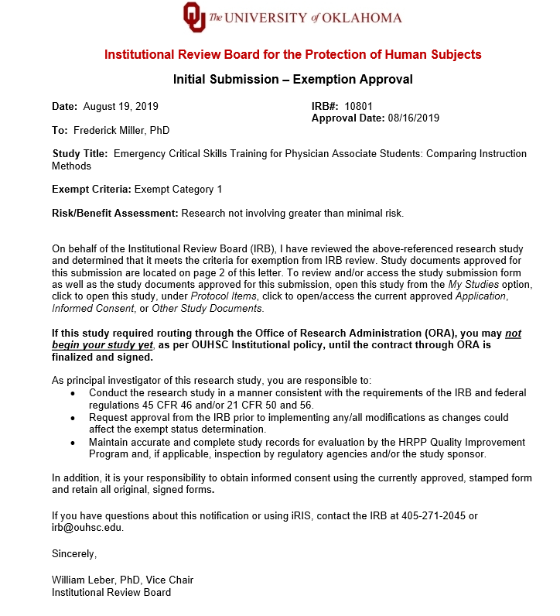

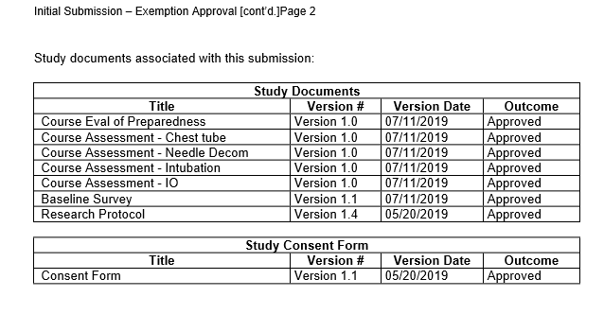

Appendix D -Qualitative Perspectives on Preparedness Survey

Survey Following Video Questions
- What do you think are the most important characteristics of training for procedural skill preparedness in clinical rotations?
  - Why?
- Describe your current feelings of preparedness to perform chest tube insertion in a clinical setting?
- Describe your current feelings of preparedness to perform endotracheal intubation in a clinical setting?
- Describe your current feelings of preparedness to perform needle decompression insertion in a clinical setting?
- Describe your current feelings of preparedness to perform interosseous insertion in a clinical setting?
- Ways to improve?

Post Assessment Survey Questions
- What do you think are the most important characteristics of training for procedural skill preparedness in clinical rotations?
  - Why?
- How did the training session impact your feelings of preparedness to perform chest tube Insertion in a clinical setting?
- How did the training session impact your feelings of preparedness to perform Endotracheal Intubation in a clinical setting?
- How did the training session impact your feelings of preparedness to perform Chest Needle Decompression in a clinical setting?
- How did the training session impact your feelings of preparedness to perform interosseous insertion in a clinical setting?
- Were there any aspects of training session that positively affected your feeling of preparedness? Why and to what extent?
- Were there any aspects of training session that negatively affected your feeling of preparedness? Why and to what extent?
- Please provide any additional comments that may enhance your feelings of preparedness.

Appendix D – Modified Assessments for Skills Training 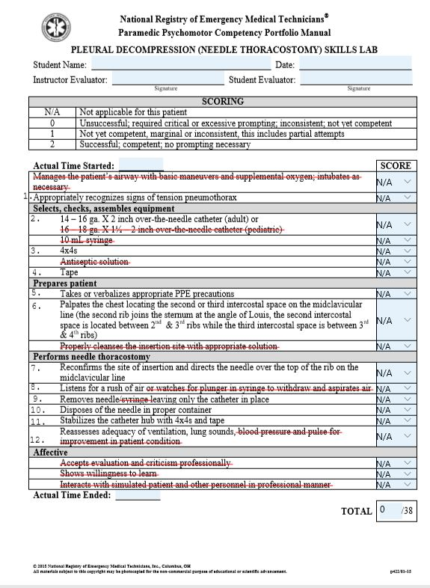 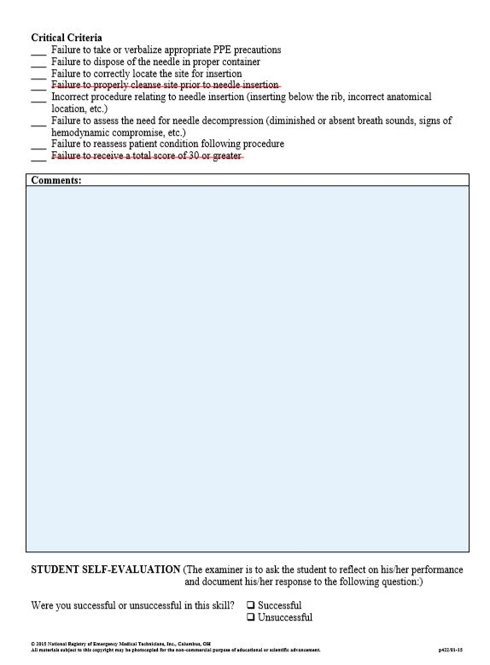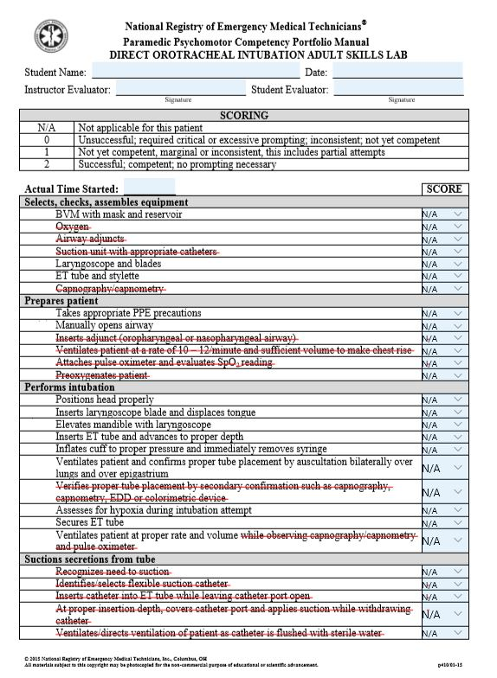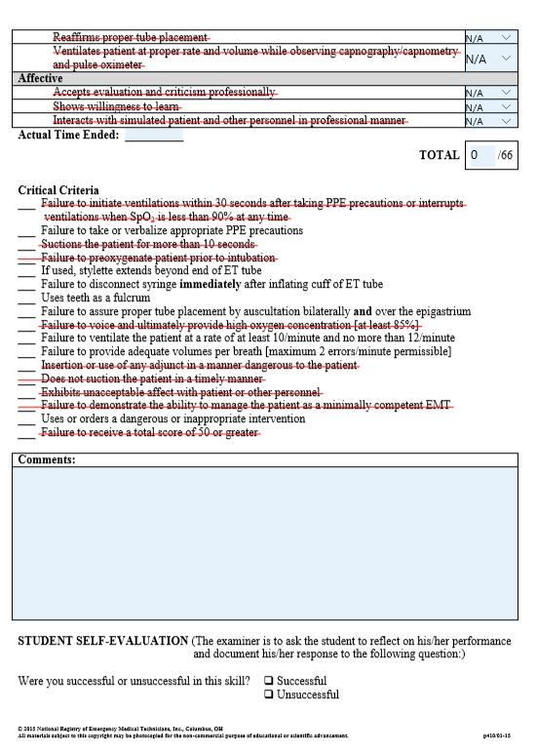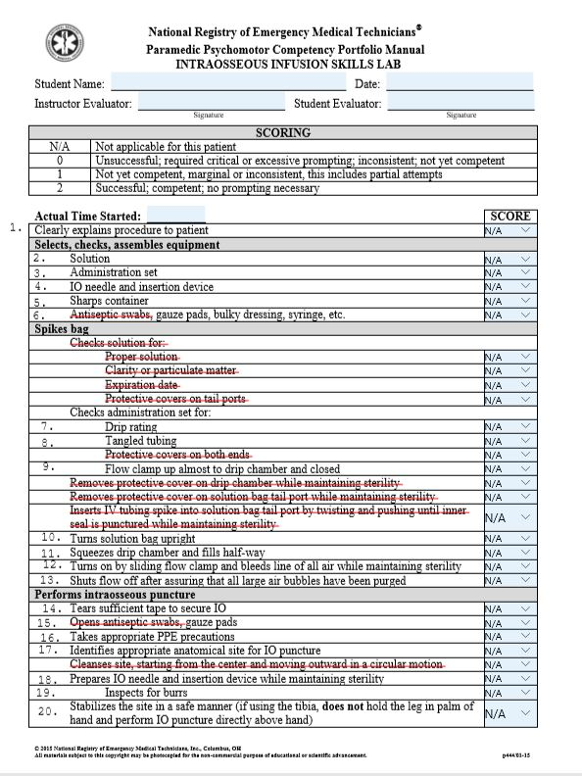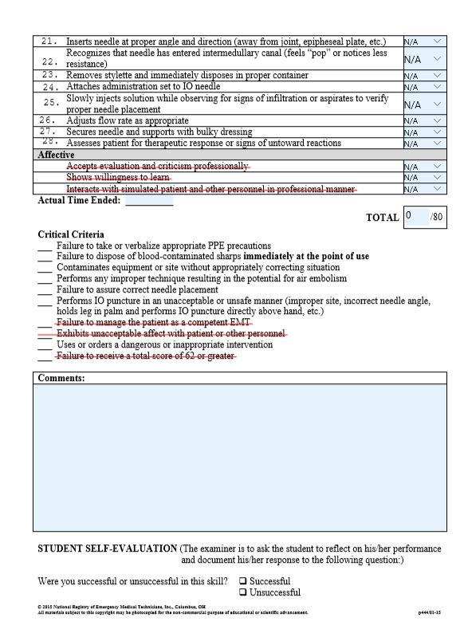

Appendix E – Recruitment Letter

DATE

Dear _______________,

In order to ensure every University of Oklahoma Physician Associate program student receives high-fidelity training in emergency skill procedures, we regularly assess and adapt our curriculum to the current standards of care. To that end, we invite our alumni and collaborating physicians to participate in the education of didactic Physician Associate students.

There are two opportunities available to participate.
- Tuesday, August 27, 7:00 – 19:00, including a 30 minute lunch break (lunch provided). Training on task trainers in the morning and cadavers in the afternoon.
- Wednesday, August 28, 7:30 – noon. Testing on cadavers.
- Optional, Wednesday, August 28, 13:00 – 17:00. Open lab for students to practice on both task trainers and cadavers.

Four procedures, endotracheal intubation, chest tube insertion, intraosseous insertion (anterior tibia & humeral head) and needle chest decompression, will be taught, and tested. We have 50 PA students this year to train and test. You will be assigned only one skill to either train or test, depending on what day you volunteer.

In 1999, we began using lightly fixed cadavers to train our students on emergency clinical skill procedures including: endotracheal intubation, chest tube insertion, intraosseous insertion, pericardiocentesis, needle cricothyrotomy, and needle chest decompression. Lightly-fixed cadavers provide a high-fidelity training model to teach critical, low opportunity procedures and provide a more realistic experience for learners than task trainers and simulators. Additionally, we will be conducting a research study to determine the most effective way to teach these skills. Therefore it is critical that we have trained professionals involved in both the training and assessment.

To sign up for this opportunity or if you would like more information, please contact Bruna Varalli-Claypool at bvaralli@ouhsc.edu or 405-361-1277 or Mary Moon at mary.b.moon-1@ou.edu or 405-448-1744.

Respectfully,

Mary Moon, MS Bruna Varalli-Claypool, MHS, PA-C
PhD Candidate Associate Professor

