UNIVERSITY OF OKLAHOMA
GRADUATE COLLEGE

Accountability, Ownership, and Satisfaction: An Innovative Approach to Teamwork in Engineering Education
A THESIS

SUBMITTED TO THE GRADUATE FACULTY
in partial fulfillment of the requirements for the
Degree of
MASTER OF SCIENCE

By
Sydney Kropp
Norman, Oklahoma
2024

Accountability, Ownership, and Satisfaction: An Innovative Approach to Teamwork in Engineering Education

A THESIS APPROVED FOR THE
SCHOOL OF INDUSTRIAL AND SYSTEMS ENGINEERING

BY THE COMMITTEE CONSISTING OF

Dr. Doyle Dodd
Dr. Tarren Shaw
Dr. Kimberly Wolfinbarger

© Copyright by Sydney Kropp 2024 All Rights Reserved.

Table of Contents

Abstract..…………………………………………………………………………………………...v
Introduction………………………………………………………………………………………...1
Methodology……………………………………………………………………………………….3
Results……………………………………………………………………………………………...7
Analysis…………………………………………………………………………………………...16
Discussion………………………………………………………………………………………..25
Conclusion………………………………………………………………………………………..28
Works Cited………………………………………………………………………………………30
Appendix A……………………………………………………………………………………….33
Appendix B……………………………………………………………………………………….35
Appendix C……………………………………………………………………………………….37

Abstract
Teamwork skills are essential for engineers to be successful in their careers. Engineers often work in teams to solve complex problems. Unfortunately, learning power skills, such as teamwork, can pose a significant challenge for engineering-minded students. This often results in frustration for students and instructors alike. To address this issue, we implemented an innovative approach toward group lab writing in a lab class for 35 junior-level Chemical Engineering students. In this study, individual contributions were worth 30% toward the group-written lab report. Students were required to complete their individual contribution submission as a completion grade 24 hours before the group-written report was due. The group lab report was graded on quality and was worth the other 70%. The purpose of this initiative was twofold: 1) to enhance accountability among team members, as students’ individual grades now reflect their individual contributions; and 2) to foster better time management skills, reducing last-minute group efforts.
Our findings suggest that including an individual portion in lab group assignments positively impacts students. The average scores for the individual contribution portion of the lab reports were 92%. The approach was shown to increase accountability among individual members of the lab groups, as students who self-identified as “waiting to the last minute” were shown to submit individual portions on time (75%). Furthermore, the early submission requirement encouraged effective time management across all students, exemplified by the on-time submission rate of 94% on individual portions, thereby diminishing the likelihood of last-minute, hurried teamwork. Additionally, the entire class exhibited a perfect 100% on-time submission rate for group-written assignments. Finally, students found teamwork more enjoyable with this method of submission. When surveyed, students' opinions of teamwork improved by an average of 1 point (on a 5-point scale). This mixed methods, IRB approved study, highlights the potential benefits of incorporating individual portions in team assignments, paving the way for improved opinions on teamwork, promotion of accountability, and time management skills among students.

Introduction
This study explores a fresh approach to promote accountability and encourage individual participation in the context of group lab reports, named the I-in-Team method. This approach introduces a dual grading system, where students are not only evaluated as part of the collective effort but also receive an individual grade for their specific contributions. By examining this approach's impact, we aim to discover how it affected students’ opinions of teamwork. The central question driving this research is, "How can teamwork become a more enjoyable and productive experience for students?"
Teamwork is the cornerstone of success in engineering [1, 2], a field where complex problems demand collaborative solutions. However, the path to effective teamwork can be challenging. The complexities of engineering projects present a distinct set of challenges often requiring interdisciplinary teamwork. Students need to negotiate a range of viewpoints, including a variety of specialties, and balance their unique contributions to form a coherent whole. Teamwork is a necessary skill for engineers with its significance recognized by ABET (Accreditation Board for Engineering and Technology): Criterion 3, Student Outcome 5 - “Students should be able to function effectively as members of a technical team, and as leaders on technical teams”. Teamwork is often the key to solving the complex problems engineers face.
One goal of higher education is to prepare students for their professional lives. Teamwork is imperative to solve “real-world” problems [3]. Teamwork is a highly important skill for engineers to have, irrespective of the field or industry they enter after graduation. [4,5]. It is expected by employers for engineers to be proficient in teamwork. They must be able to solve problems as part of a team practicing good communication, collaboration, and conflict resolution. The collaboration method proposed in this study is similar to what is expected in the workplace. Engineers will likely be working in teams during their professional careers. They will be expected to do their individual work ahead of time to collaborate effectively during team meetings. The I-in-Team method is designed to reflect these industry expectations to prepare engineering students for success in their professions after graduation [6]. In today's organizations, effective collaboration is one of the most sought-after qualities that an employer hopes to find [4]. Teamwork skills are also highly related to leadership skills [2,5] which are important for engineers in industry [4,5,6]. Students are given an opportunity to practice leadership skills through teamwork in engineering coursework [7,8]. Teamwork itself is a practical skill for engineers, and it teaches many other tangible skills such as leadership, conflict resolution, and communication through its implementation [2,5,9,10]. Lab reports are commonly used in engineering education to teach a variety of skills, including but not limited to, technical writing, communication, time and project management, and teamwork. These various skills are developed when engineers write ab report assignments [9].
Teamwork can be challenging. Successful teamwork requires fairness, responsibility, and leadership to be present [11]. Another reason some students struggle with teamwork is that they often know the end goal of the project but have difficulty mapping out the path to get there. Despite the evident importance of teamwork, difficulties persist in fostering students' appreciation and proficiency in this area [12]. One survey of chemistry students' attitudes toward teamwork shed light on prevalent concerns, including the issue of 'hitchhikers' [13] —students who contribute minimally team efforts [14]. This underscores the need for structured approaches to teamwork that promote individual accountability while fostering cooperative dynamics.
By introducing an individual component to the evaluation process, we aim to motivate students, as their individual grades now hinge on both their personal contributions and the collective group-written paper. This approach has the potential to transform group dynamics, through promoting a sense of ownership over one's work. By including an individual submission due 24 hours before the group-written assignment, the researchers hoped to increase individual accountability, a sense of ownership of the project, and time management skills. Many have discussed the importance of individuality in teamwork [15,16]. It is important to maintain a balance of individuality and teamwork. The main components needed for collaboration in STEM are engagement, student ownership, and negotiation of the shared activity [15]. Ownership and accountability are important for successful teamwork. Individual accountability, combined with collaborative work, leads to the best results in learning [16]. Working on a skill alone, practicing, and refining it are important for learning. Being social and comparing work in a group setting also enriches the learning experience. It is important to balance the benefits of teamwork and the downsides of social loafing [17]. Social loafing may cause students to give less effort towards a group project, since other students may pick up their slack [17]. This is why a balance of interdependence is necessary. Students need motivation and accountability for both their individual grades and for group outcomes.
Other studies have likewise highlighted the importance of individual grades within group work [18]. The present study is designed to apply these concepts to group-written lab reports. There are a few similar studies that discuss using an individual portion and a group portion on an assignment. One approach utilizes the "GIG" model (group-individual-group), where students are given both individual and group portions on reports for a chemistry class [19]. It was reported that students with an individual portion performed significantly better in the course than students who worked entirely in teams. It's important to promote both individualism and collectivism in the classroom so students can benefit from both [19]. Another approach combines the two for exams by giving the students two portions of an exam. The first is an individual assignment and the second is done in groups. Better performance was observed from the students using a combination of individual and group components for exams [20]. Another approach requires students to achieve a minimum individual assessment score before they are allowed to continue on to the participate in a team-based assessment [21]. This was to ensure that individuals prepare themselves ahead of group work. The present study will require students to complete both group and individual assignments.
Another concept important to this study is structuring teamwork and assigning roles. Previous works have highlighted the importance of assigning clear roles to students in a group project [22 ,23]. Another tool, the Jigsaw Class method [24, 25], emphasizes students “owning” a piece of the group project. Each member has a piece they oversee, with the group needing all components to function well. When roles are established or work is divided within a team, each person on the team has responsibility or a stake in the project that will be accounted for. Setting up clear roles and defining the work for each group member assists the students in achieving their goals. Another best practice is to assign roles to the students so that they have individual responsibility while simultaneously functioning within the team as a whole [23]. In contrast, unstructured group work can result in negative pressures that add to the normal apprehension experienced by students [26, 27, 28]. The best practice is to carefully structure teamwork to promote interdependence.
Interdependence occurs when students must partially rely on their group for outcomes and experiences [29]. In collaborative learning, individual and group achievement are mutually dependent, requiring both individual preparation and teamwork. [30]. Accountability is key to successful teamwork. Teamwork is difficult, especially when groups have “hitchhikers". When accountability is emphasized, teams will function better. Students are more prepared to interact and collaborate with their group when individual preparation is done beforehand [21]. Interdependence blends “independence” of an individual and “dependence” of a group; it is a key element for productive teamwork [31]. Interdependence allows students to express their thoughts and opinions, share individual knowledge, debate, and use argument techniques to change misconceptions [26]. It enables students to piece together individual ideas to build new, more comprehensive ideas. Interdependence acts as the glue that binds teams together, building success by aligning the needs and motives of individuals. This alignment ensures that actions taken by one individual can positively impact the outcomes of others, encouraging a collaborative environment. Studies have shown that interdependency increases idea generation and collaborative engagement with learning tasks [26 ,32 33, 34]. For instance, students in interdependent conditions spent more time engaging in group work, explaining concepts, responding to partners, asking questions, and making positive comments [26]. It is important for students to have a stake in both their own portions and the overall assignment of the groups. Individuals are more likely to invest time and resources into those around them when doing so is likely to encourage the attainment of their own goals [26].
The I-in-Team method is designed to emphasize the individual or “I” within a team. Teamwork is a critically important engineering concept, but often challenging for students to learn and for instructors to teach. Ownership and accountability are both needed for positive teamwork experience. The method of group lab report writing proposed in this study blends individual accountability with group ownership and collaboration. The I-in-Team submission method seeks to create a balance of individual work and teamwork.
Methodology
The test group for this study included 35 students enrolled in the ABET-accredited junior-level Unit Operations Laboratory chemical engineering class at a public state university] These students were divided into 11 lab groups. The class was held in-person three sessions a week with a mix of both online submissions using Canvas and in-class physical submissions for assignments.
The summarized grade distributions for assignments from the course applicable to this study are provided below in Table 1. The final lab reports are worth a total of 36% of the final grade. There is 1 individual executive summary lab report worth 12%. Finally, other group assignments make up 16% of the final grade and additional individual assignments are worth 36%.
Assignment | Individual / Group | Weight
Group Lab Report (3)
-Individual Component Submission | I | 10.8%
-Group Report Submission | G | 25.2%
Executive Summary Lab Report (1) | I | 12%
Additional Group Assignments | G | 16%
Additional Individual Assignments | I | 36%
Table 1. Summarized grade distributions for the course.
There are 3 group lab reports in this course based on 3 of the following 4 experiments. The 1 remaining experiment is an individual executive summary style lab report.
I: Steam Condensation on a Single Tube
II: Shell and Tube Heat Exchangers
III: Membrane Gas Separation
IV: Fluid Flow Characteristics/Tray Hydraulics
The instructor assigned the lab groups of 3-4 students loosely based on student grade point averages (GPA) at the beginning of the course. Each lab group had a range of student GPAs so that no team featured several high or low GPA students. Students were assigned rotating roles for each group lab report (Table 2).
Sections of Group Report:
1. Letter of Transmittal
2. Title Page
3. Table of Contents
4. Abstract
5. Introductions and Theory
6. Apparatus and Operating Procedures (App & Op Proc)
7. Results and Discussion
8. Conclusions and Recommendations
9. References
10. Appendix

4-Person | Experiment 1 | Experiment 2 | Experiment 3 | Experiment 4
Member 1 | Introduction | Appendix | Exec Sum | Results
Member 2 | App & Op Proc | Introduction | Exec Sum | Appendix
Member 3 | Results | App & Op Proc | Exec Sum | Introduction
Member 4 | Appendix | Results | Exec Sum | App & Op Proc
3-Person | Experiment 1 | Experiment 2 | Experiment 3 | Experiment 4
Member 1 | Introduction | Results | Exec Sum | App & Op Proc
Member 2 | App & Op Proc | Introduction | Exec Sum | Results
Member 3 | Results | App & Op Proc | Exec Sum | Introduction
Table 2. 4 and 3-person lab report section assignments for the 3 labs that were written in groups.
Peer Evaluations
Students were given a peer evaluation which asked:
“Compared to the other members of your group, with yourself excluded, what percentage did this person contribute? The percentages of all the other members of your group must add up to 100%. (Example: for a four-person group, if each of the members besides you contributed equally, each would receive 33.3%.)”.
Students were given a grade after each group lab report based on the evaluation from their teammates. Only the final, cumulative score was reported to the student; no additional feedback was given.
Individual Component Submission / Group Lab Report Guidelines – the I-in-Team method
For every group lab report, each individual team member was expected to submit a digital copy of their assigned individual portion to the Canvas LMS 24 hours before the Group Report submission date. The page length requirements for each individual component submission were as follows:
Introduction – 3 pages
App & Op Proc – 3 pages
Results – 5 pages
Appendix – 3 pages
The submissions are graded based on completeness – page length in this study- by the grader. “Quality” of the individual component submissions was not factored in unless a notable lack of effort was apparent. This is to encourage students to get their portion completed before the group comes together to write the rest of the report. Completeness/length was measured by the grader. A score of 0 was given for no submission or any submission submitted less than 24 hours before the group submission date. This individual component submission portion is worth 30% of each group lab report grade, with the cumulative Group Report submission being worth 70% of each lab report grade. The 24-hour period was intended to give the students enough time to prepare their portion after participating in lab while managing other assignments, and far enough in advance to the group portion to give them time to work together on the final report.
The group report was graded based on quality by the grader (as they are traditionally in this course). This group report submission was worth the remaining 70% of the group report grade.
- Individual Component Submission: assigned role for the experiment, graded on length/completeness, due 24 prior to Group Report due date, worth 30%.
- Group Report Submission: final group report for the experiment, graded on quality, worth 70%.

An IRB (Institutional Review Board) approved study was conducted in this course. The course instructor was not involved with creating the I-in-Team method and is not an author of this study. They volunteered their classroom for this study and implemented the I-in-Team method in their course. The study involved collecting survey data from students and their grade data in the course. There were 35 students divided into 11 lab groups across 3 sections of the course. The same instructor taught each section of the course. The lab groups were set by the course instructor who arranged groups by spreading GPAs so that there was a mix of A, B and C students in each group. This study had no control group. It would have been preferable to have a section that did not participate in the I-in-Team method; however, the course instructor did not want to have different procedures in different sections of the course. We would also like to note that this is common practice in engineering education.

The students enrolled in the course were given a pre-survey on the first day of class before the rubric and I-in-Team method were presented and explained. The purpose of this first pre-survey was to get students’ opinions of groupwork before they learned about the method that would be used in the course. The pre-survey contained 9 questions: 6 asking their feelings on groupwork, 3 asking them to identify their typical groupwork roles. See the attached Appendix A for the pre-survey questions. No demographic information was collected.

A second, post-survey was given to the students on the last day of class, after all Group Reports had been submitted, but before final grades were posted. The purpose of this post-survey was to gauge their opinions and feelings on the I-in-Team method after utilizing it. Students were asked specifically about their experience in this course and their thoughts on the method. See Appendix B for the post-survey questions.

Several responses are open-ended questions about feelings. Some of the responses were subjectively categorized as positive, negative, or neutral. These were based on the tone of the response, which is called sentiment coding. The sentiment coding was performed by three people. The data was assigned as positive, neutral, or negative.
Positive: Responses that express approval, agreement, or satisfaction.
Negative: Responses that express disapproval, disagreement, or dissatisfaction.
Neutral: Responses that do not clearly express a positive or negative sentiment.

Percent Agreement (PA) is widely accepted and used as a metric of validity/reliability [2]. The use of 3 people to analyze the data provides inter-coder reliability. The majority-voted result is in Appendix C, as well as the Percent Agreement (PA) metric. This shows how agreed upon the result was. The average PA was 94%, which shows validity of the results as three different people agreed most of the time. Additionally, 83% of the results were unanimous, the remaining 17% only had 1 person with a different answer.

An example of positive is “I enjoyed my group” or “I liked it,” an example of neutral is “it was fine” or “it was okay,” negative examples include “I did not learn anything” or “I did not like my group.” See Appendix C for the raw data and their categorization. Likert scale questions were objectively categorized as positive, negative, and neutral based on the scale provided in the question: 1-2 being negative, 3 neutral, and 4-5 being positive.

The de-identified survey data were compiled into an Excel spreadsheet for analysis. Grade data from participating students was gathered after the conclusion of the course. All data was stored on a secure cloud server.

Analysis
This mixed-methods study includes the following analysis. The numeric responses from Likert-scale questions were averaged. Some responses were counted and categorized (ex: positive, negative, and neutral experiences). The free response questions were categorized via sentiment coding into positive, negative, and neutral responses. See Appendix C for the raw data and the label assigned. Responses to comparable Likert-scale questions from the pre/post-surveys were analyzed with a Wilcoxon Rank Test with a confidence level of 95%. The non-parametric test was chosen after a Shapiro-Wilks test was performed, indicating non-normal data. Similarly, Mann-Whitney tests were used on grade data. This was decided as the sample sizes are under 30 for the groups in the comparisons. The use of non-parametric tests to compare a difference in means is an appropriate choice for the small sample size in this study.
Results
Pre-Survey
Students were given a pre-survey at the beginning of the first class period. Students were asked” How do you feel about group work”, with responses ranging on a Likert scale with 1 being “I hate it” to 5 indicating “I love it.” We saw an average response of 2.97, which is equivalent to indifferent on our scale.

Feelings on Group Work
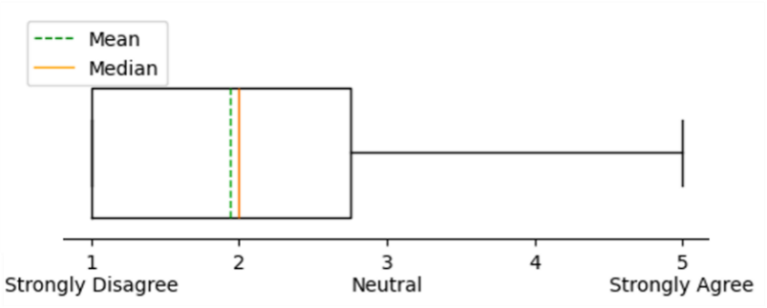
Figure 1: Likert scale boxplot showing students (n = 35) responses to their feelings on “group work”.
Students were asked, “How many positive, negative, and neutral group work experiences have you had in college?”. Figure 2 demonstrates the per-person average by creating a ratio for each student and averaging those ratios. Figure 2 shows that on average, each person reported 42% positive group experiences and 30% negative group experiences. The average number of experiences was 4.8. One student reported 12 total group experiences (most), with the lowest reported number of group experiences being 2. Four students (11%) reported having NO positive group experiences in college yet. Ten students (29%) reported having no negative group experiences in college yet.
Group Work Experiences
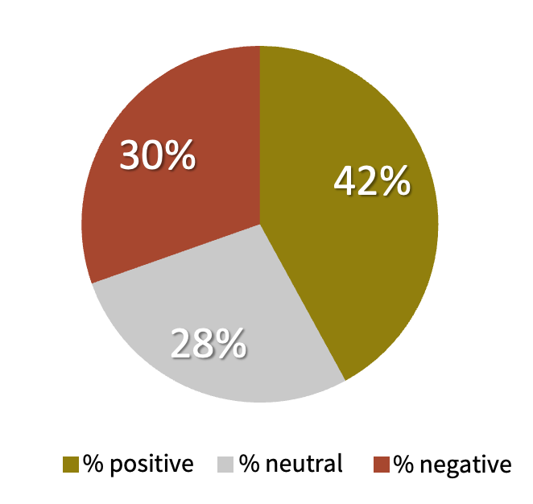
Figure 2: Average results of each student's response to “How many positive, neutral, and negative group work experiences have you had in college?”
Students were asked to rank their most positive group work experience, and most negative group work experience, the results are seen in Figure 3. The most negative experience has a mean of 2.3 which is between ‘neutral’ and ‘it was the WORST’. Additionally, 25% of students responded between 3 and 4. There is an outlier of “it was great actually”, 5. This could be explained by the 29% who have not had a negative experience so far. The most positive experience has a mean of 4.31 which is between ‘neutral’ and ‘it was the BEST’, with no datapoints below 3, neutral.
How negative was your most negative groupwork experience? | How positive was your most positive groupwork experience?
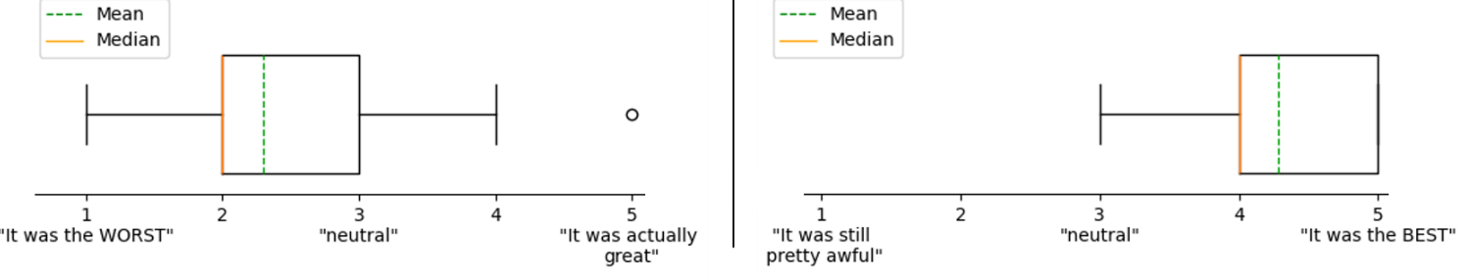Figure 3: Boxplots showing student’s most negative (a) and most positive(b) group work experiences
Next, the students were asked for the reasons for their ranking. The students were asked a free-response question “What made the most negative experience negative?”. The most common word reported here was “effort” (45%). Most students responded with concerns about their group members, while a few simply did not like the assignment.
Cause of Negative Experiences

Figure 4: Most common words found in students’ responses to “What caused negative experiences?”
Similarly, the next question was “What made the most positive experience go well?”. “Effort” was again the most common response here (31%). In these free responses, students commented about equal effort from their group members most often. Additionally, students mentioned having good relationships and building friendships with their peers.
Causes for Positive Experiences
Figure 5: Most common words found in students’ responses to “What caused positive experiences?”
Students were asked a series of questions intended to self-identify their view of working on a team. They were also asked about their own work habits and contributions when on a team. Students were asked, “What grades do you typically receive on group projects?.” 80% reported typically receiving A’s and 20% reported receiving B’s. No one reported typically receiving a C or lower. (Fig 6a)
When asked “How does your work generally compare to your peers?” students reported A. I’m the leader (51% of students), B. I'm an average group member (46%), C. Revisions and additions are made to my work (3%). (Fig 6b)
Finally, when asked, “How early do you usually have your portion of a group assignment done?”, 48% reported having it done a few days prior to the deadline, 40% said they had it done 1 day before, and 11% said they finished their portion the day the assignment was due. (Fig 6c)

Students Self-Identify Group Work Habits
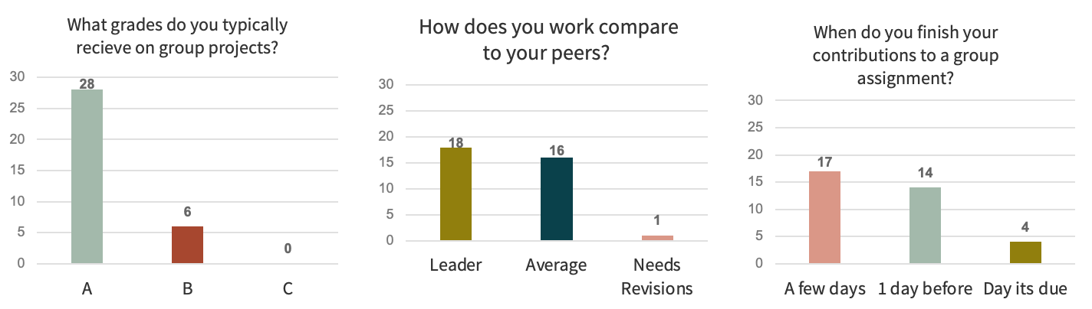Figure 6: Student responses to pre-survey questions. (a) Students self-reported average grades on previous group assignments. (b) Students self-identified their contributions toward group work compared to their peers.’ (c) Students reported how many days before a group assignment they finish their contribution.
Post-Survey
Students were given a post-survey on the final day of the course to assess their experience using the I-in-Team method. The first question in the post-survey asked students to report their feelings on writing a group report, specifically in this Chem-E course after implementing the I-in-Team method. Students reported an average of 3.96, falling between “indifferent” and “I loved it. Only two students reported a score below 3, ‘neutral’.
Feelings on “Writing a Group Report” in this Course
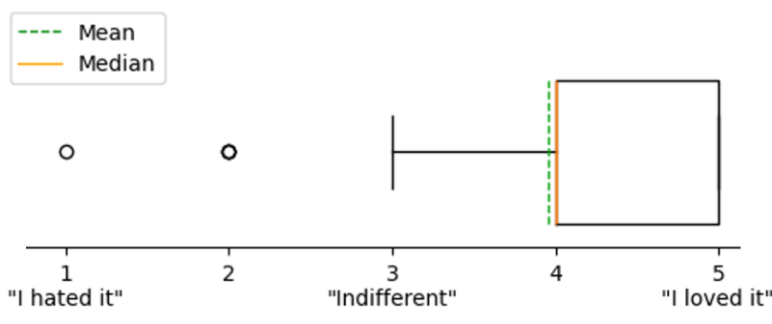
Figure 7: Box-plot showing Likert scale results based on students’ (n = 35) feelings about “writing a group report” toward the conclusion of the course.
Next, students were asked to report their experience working on a team in this Chem-E course, reporting an average of 4.11 which falls between “neutral” and “it was great”. Similarly, the same 2 outliers below 3, ‘neutral’ are seen here.

Feelings About “Working on a Team” in this Course
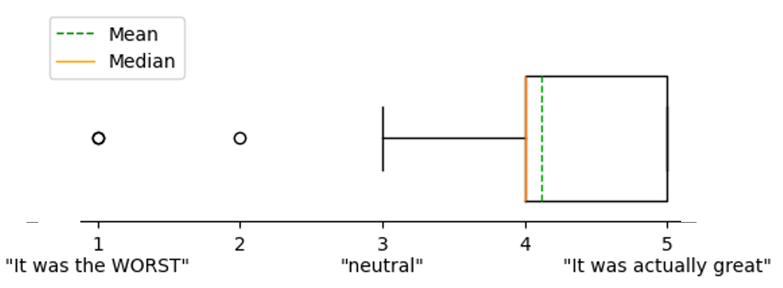
Figure 8: Box-plot showing Likert scale results to the post-survey question “Think about your experiences working on a team in this course. How was it?”
Questions 3 was a free-response question, subjectively categorized as positive, negative, or neutral. Question 3 asked students why they responded to Question 2 (“Feelings about working on a team in this course”) with the response they reported. 66% responded with a generally positive comment (while on the Likert scale 85% were a 4 or above), 23% responded with a negative comment (only 9% were negative on the Likert scale), and 11% responded neutrally.
 | Feelings on working in a team in this course
 | Free response  (coded with sentiment analysis) | Likert
Positive | 60% (21 students) | 85% (30 students)
Neutral | 26% (9 students) | 6% (2 students)
Negative | 14% (5 students) | 9% (3 students)
Table 3: Responses to questions 2 and 3 (feelings on working in a team in this course) summarized in table to see difference between Likert scale responses and free responses for all students (n=35).
Question 4 of the post-survey was a free-response and asked if there were any teamwork issues during the semester. 34% said there were no issues, while 66% reported encountering a problem. Out of these 23 students who reported issues, 39% reported time conflicts/scheduling issues for team meetings, 39% of team conflicts were due to effort, 17% were related to the class itself, and 4% were communication related.
Team Problems Reported During This Course
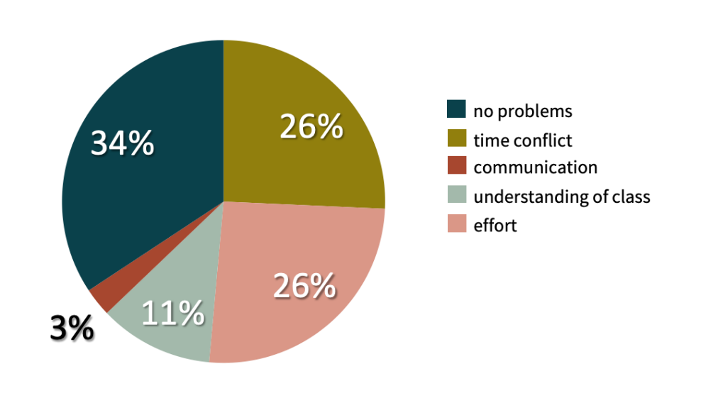
Figure 9: Students responses on problems during the semester in this course
Question 5 asked students if every group member contributed equally towards the group-written reports. Figure 10 shows an average of 3.46, which is between neutral and agree. An investigation into the level of agreement or dissent within each lab group was performed concerning opinions on “equal contribution.” The average standard deviation per group was 0.95. The lowest was 0 (all group members agreed unanimously on effort levels) and the highest was 2.08 (there was a range of feelings on effort from within the team).
Each Group Member Contributed Equally Toward Completion of the Reports
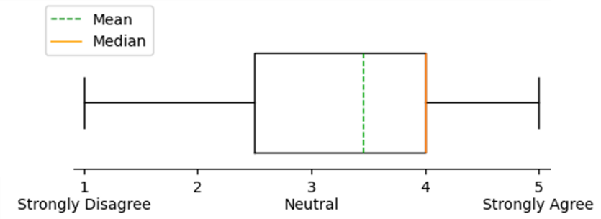
Figure 10: Boxplot showing Likert scale results to the post-survey question on whether students felt their teammates provided equal contributions in the course.
Question 6 asked students to report their feelings about the use of the individual submission component in this course. 69% reported positive feedback, with such quotes as “it felt good to get credit for my work and increased my understanding of the material” and “I appreciated [the individual submission], it kept people ahead and on track for group lab”. 29% of responses reported neutral feelings on the individual submission component, and only 3% (1 student) had negative feedback. The negative comment was simply “redundant.”
Feelings on the Individual Submission
Positive | 69% (24 students)
Neutral | 28% (10 students)
Negative | 3% (1 student)
Table 4: Responses to Q6: Feelings on the individual submission component for all students (n = 35), coded with sentiment analysis.
When asked how they felt about the group-written portion of the lab report 71% of students surveyed had positive comments, 11% were negative, and 17% were neutral about the groupwork portion.

Feelings on the Group Submission
Positive | 71% (25 students)
Neutral | 18% (6 students)
Negative | 11% (4 students)
Table 5: Responses to Q7: Feelings on the group submission component for all students (n = 35), coded with sentiment analysis.
Students were asked whether the individual submission component detracted from their group work. Responses averaged 1.94 which is equivalent to “disagree” on our scale, closer to the strongly disagree side.

Did the Individual Submission Component Detract from Group Work?
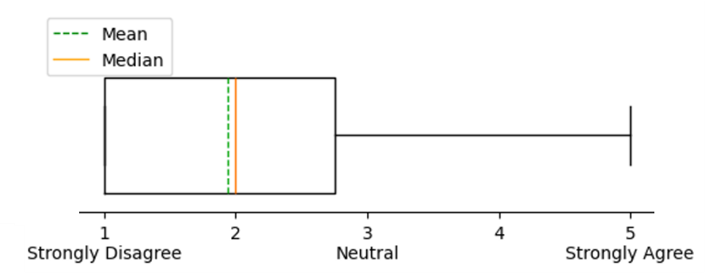
Figure 11: Boxplot showing Likert scale results to the post-survey question on whether students felt the individual submission component detracted from the group-written lab report.
The final 2 survey questions on the post-survey concern making modifications to the existing individual submission component. The first regards how long the period between the individual component submission and the group assignment due dates should be. Students requested an average of 1.29 days. Most students were happy with the 24-hour period between individual submission components and group-written lab reports that was used in this study, with a few suggesting 2 days would be better. The course instructor was also asked “Do you believe the 24-hour gap between individual and group submissions was sufficient, or would you recommend any adjustments?” They responded “[The 24-hour period] was sufficient for the group review and would also allow enough time for the completion of individual work.” Both students and the instructor agree that individual component submission due date 24-hours prior to the group-written lab report is a suitable timeline.
Students were asked what score breakdown they would prefer. The breakdown used in this study was 30% individual component submission: 70% group-written lab report. Most students wanted to increase the individual contribution weight to 40% of the total report grade, while some students suggested that the individual report should be worth as much as 80% of the report grade as shown in Figure 12.
Preferred Weight of Individual Component Submission
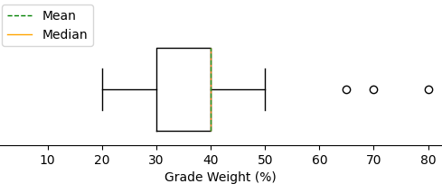
Figure 12: Boxplot showing Likert scale results to the post-survey question preferred weights for the individual component submission
Most students (30) were able to submit all 3 individual contributions on time. Three students submitted only 2 individual reports on time, and 2 students only submitted 1 individual report contribution.
Finally, students were asked, “What grade do you expect to receive in this course?” Only 4 students expected an A, 26 expected a B, and 3 expected a C. 2 students declined to answer this question. The actual grade distribution was 8 A’s, 20 B’s, and 7 C’s.
Analysis
Students generally enjoyed and appreciated using the I-in-Team method of group lab report writing in this course. Students reported an average score of 2.97 indicating “indifferent” feelings about group work coming into the course but averaged 3.96 “I like it” when asked the same question at the conclusion of the course. A Wilcoxon test showed a significant difference in opinion between the pre- and post-survey results (p = 0.000126). The students’ general opinions of group work improved after utilizing the I-in-Team method for group lab report writing.
Students Opinions on Teamwork from Pre and Post Surveys
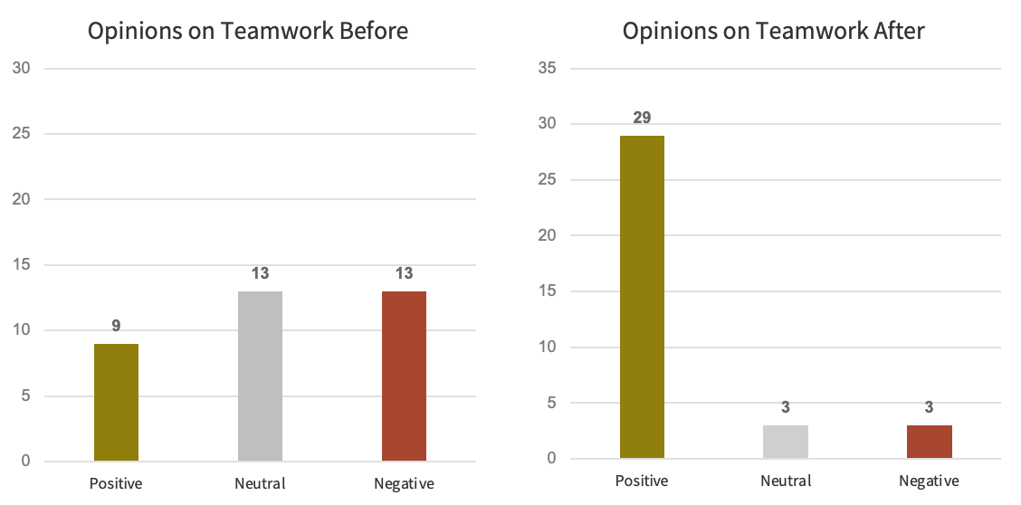
Figure 13: Bar charts showing students’ opinions on teamwork from the pre- and post-survey (before and after using the I-in-Team method).
Only 2 students lowered their opinion of group work as a result of this course, 7 students' opinions were unchanged, and the remaining 26 students’ opinions improved by at least 1 point. This improved opinion of group work could be due to the I-in-Team submission method.

Students’ Opinion Change on Teamwork after I-in-Team Method
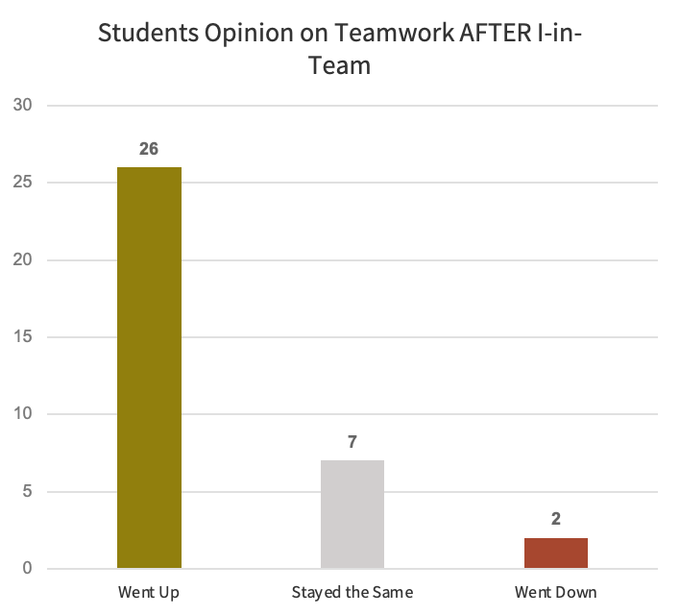
Figure 14: Bar chart showing change in students’ opinions on teamwork before and after using the I-in-Team method.
When asked their opinions of the individual submission component of the lab reports students reported very positive feedback. They responded with only positive and neutral feedback; there were no negative comments concerning the individual submission component. Students often used words like “appreciated” and “enjoyed.” 26 students replied with positive remarks, with 10 reporting some version of “I liked that I received credit for my own contribution”. Students appreciated having ownership and getting a direct grade for their efforts. See Figure (15) for a word cloud from the students’ free responses.
Feelings on the Individual Submission Component
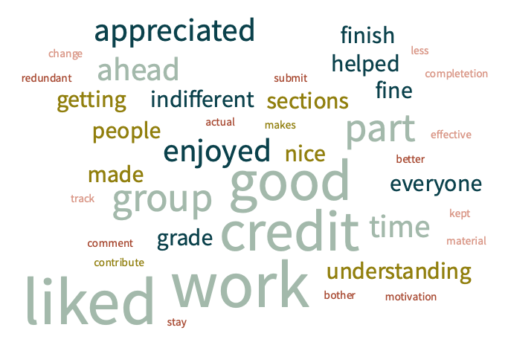
Figure 15: Word cloud showing which words students used when asked about their feelings on the individual submission component.
The responses to this question: “What are your thoughts on the individual submission?” were coded with sentiment analysis. The results can be seen in Figure 16. Only 1 student had a negative comment.
Feelings on the Individual Submission Component
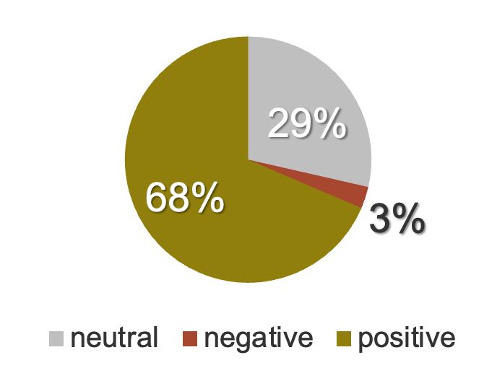
Figure 16: Pie chart with 68% positive,3% negative and 29% neutral responses to feelings on the individual submission component
Both the quantitative (data from Likert scales, before and after) and qualitative (free responses) data show that students generally enjoyed teamwork when framed with the I-in-Team method.
An examination into students’ previous teamwork experiences was conducted. This analysis is derived from Q2 on the Pre-Survey which asks the number of positive, neutral, and negative experiences students have had so far. Students with >70% positive experiences are labeled Majority Positive Experiences, n = 4. Students with <30% positive experiences are labeled Majority Negative Experiences, n = 11. The design of this study seeks to ensure everyone has a positive experience when participating in the I-in-Team method. The students with Majority Negative Experiences report enjoying teamwork with this method. This is measured by their change in response from the pre and post survey, regarding their feelings on teamwork. The data can be seen in Table 6. Ten of the 11 Majority Negative Experiences students’ opinions improved. The only Majority Negative Experiences student opinion that did not improve after utilizing the I-in-Team method was an AS on a team with 1 NS. The Majority Negative Experiences students’ opinions improved by an average of 1.5 points. The student group of Mostly Positive Experiences (n = 4) responded 100% positively to Likert-scale question on both the pre and post survey.

Majority Negative Students’ Opinion on Teamwork: Before and After
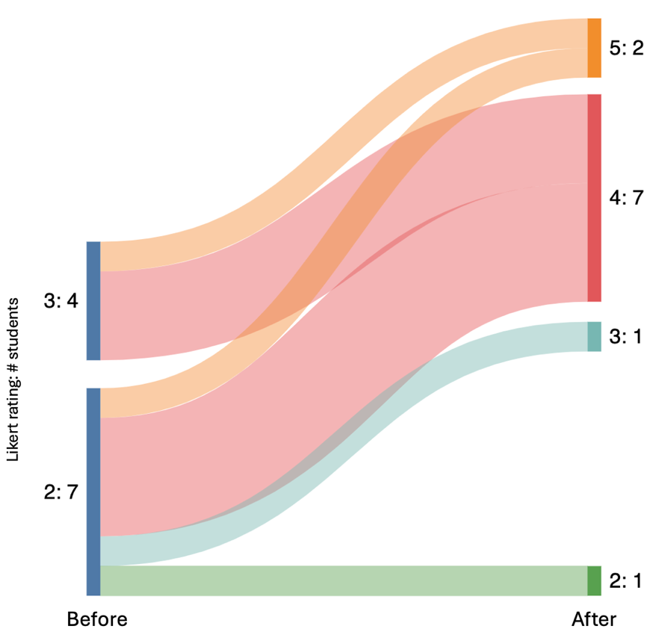
Figure 17: Responses from Majority Negative Experience students on feelings on teamwork before and after experiencing the I-in-Team method seen in a Sankey diagram. Diagram generated using SankeyMATIC; https://sankeymatic.com/
In addition to qualitative analysis supporting positive feelings toward teamwork, sentiment analysis on the qualitative free responses toward “Feelings about Group Submission” (Q7) from the Majority Negative Experiences (n = 11) students further supported positive feedback using the I-in-Team method, with 67% positive responses. The Majority Positive Experiences (n = 4) students likewise responded 100% positively to this question in the post-survey. The support shown from both quantitative and qualitative data further strengthens the finding that students generally enjoyed using the I-in-Team method.
In addition to student feedback, the course instructor was asked for feedback on utilizing the I-in-Team method in their class. Their responses are presented in Table 6.

Instructor Feedback (n = 1)
Do you feel that the I-in-Team method improved your student’s scores? | 3, Neutral
Do you feel that: the I-in-Team method improved teamwork? | 4, Agree
Do you feel that the I-in-Team method lowered complaints from students? | 5, Strongly Agree
Do you feel that the I-in-Team method took less time to grade than standard grading methods? | 2, Slightly more time spent grading
Table 6: Course instructor/grader (n = 1) feedback showing opinions on utilizing the I-in-Team method.
These responses show that from the instructor’s perspective, the I-in-Team method is effective and worthwhile to improve teamwork. The instructor felt that it improved teamwork and strongly decreased student complaints. Although the I-in-Team method takes slightly longer to grade, the benefits are worth the extra time spent, as stated by the course instructor. The instructor was not able to directly compare the actual score from this study to previous years’ data due to IRB restrictions.
When asked "How does the I-in-Team method compare to traditional approaches in terms of fostering collaboration, accountability, and overall learning outcomes?” the course instructor responded:
“The I-in-Team method helped encourage early preparation for individual work and prevented procrastination in the group delivery, essentially promoting teamwork.”
Students were categorized into 3 groups based on their responses to pre-survey questions and/or their grades they received as part of the course (Fig. 18). “Potential hitchhiker” (PH) students were identified from response provided on the pre-semester survey. This group of 5 students answered that their work needs significant revision, and/or tend to wait until the due date to finish their work for a group assignment. Hitchhiker behavior in engineering education refers to students who rely on the contributions of their teammates to complete their work, without making significant contributions themselves. This behavior can manifest in several ways, such as not participating in discussions, not contributing to group projects, or not completing their assigned tasks [13,11].
The PH students, who reported typically needing revision and struggling with time management, reported a positive experience in this course using the I-in-Team method. 3 of the 5 wanted the individual submission to be worth more than 30%, while 1 agreed that 30% was adequate. The 5th wanted the individual component submission to be worth only 20% of each lab report (Fig. 19). This shows that most of these students think the individual component submission is fair, if not too lenient. Of the 5 PH students, 3 submitted all their individual contributions on time to receive full points. The other 2 potential hitchhikers submitted 3 out of 6 total individual component submission on time. These results suggest that the individual contribution component of the I-in-Team method may have motivated “potential hitchhikers” into contributing their share of a group-written report on a timeline that was useful to their teammates.
A second, partially overlapping group of 6 students failed to submit one or more individual component submission on time (NS for “non-submitters”). Of this group, 2 were identified as potential hitchhikers (PH), while 4 had given no indication in their pre-survey responses that they might heavily rely on their teammates to do the work. These NS students were likewise satisfied with the I-in-Team method, indicating an average “I like it” when asked their feelings about i) working on a team and ii) writing a group report in this course. Of these 6 NS students, 4 of them wanted the individual submission component to be worth more than 30%, indicating that even students who were penalized by this submission method felt it could have been more motivating had it been weighted heavier (Fig. 19).
It is interesting to note that even after being penalized 5 of the 6 NS students still reported positive responses to survey questions concerning teamwork and group report writing using the I-in-Team method, with the sixth NS student responding with neutral comments. This would seem to suggest that those NS students understood the consequences of their (in)actions and accepted responsibility. 4 out of 6 NS students reported that they would prefer the individual contribution to be worth a larger percentage of the total grade than what was presented in the course (30%). This could indicate that they felt a lack of motivation from only 30% weight.
The PH students were satisfied with the I-in-Team method, as seen by their responses in the post-survey. With responses (of these 5 students) averaging above a 4, these students both indicated that they liked working in a group for this course and had a positive experience working in their team. 4 out of 5 of these students said they felt like an equal amount of work was done by all team members. These 5 PH students were each assigned to 5 different teams. 3 of their teams agreed that all team members contributed equally. The remaining 2 teams had an average Likert scale response of 2.6 and 3.3. There was a range in opinions seen in groups 1 and 10 in the table below. These scores might indicate the PH is happy with their own effort levels, but their group was not. (Two of the PH students ended up being NS students.)
Q5: Each member contributed equally towards the group report
Group # | 1 | 2 | 3 | 4 | 5 | 6 | 7 | 8 | 9 | 10 | 11
Average | 3.33 | 4.25 | 3.75 | 4.00 | 2.00 | 2.33 | 4.67 | 4.67 | 4.67 | 2.67 | 2.67
Responses | 5,4,1 | 3,5,4,5 | 4,3,4,4 | 4,4,4 | 2,1,3 | 5,3,2 | 2,4,1 | 4,5,5 | 5,5,4 | 2,4,2 | 3,2,3
Table 7: Students average and raw responses from post survey Q5: equal contributions
A third group of 29 students consisted of the students who turned in all individual component submissions on time. These 29 students have been categorized as “Accountable Students” (AS). Of the 29 student AS group, 3 students also belonged to the PH group, indicating that these 3 students recognized their own tendency to burden their teams but were able to contribute fairly when using the I-in-Team method. Of the 26 students exclusive to the AS group, 9 thought the individual submission component weight was fair at 30%, and 17 of the group wanted the individual submission component to be worth more than 30%. None of the AS group felt that the individual submission component should be worth less than 30%. This suggests that the students who contribute towards the success of the team also believe the current settings of the I-in-Team method to be fair, if not too lenient.
Only 3 of the 35 students in the course reported negative feelings about teamwork and negative experiences writing a group report in the course. All 3 of these students (categorized in the exclusive AS group) with negative responses toward working in a team were in lab groups with one or more NS student. These same 3 also represent the outliers in Figures 7 & 8.
Student A: 2 AS + 1 NS (1 individual submission missing)
Student B: 1 AS + 3 NS (1-2 individual submissions missing each)
Student C: 2 AS + 1 NS (2 individual submissions missing)
All 3 of the students who reported negative feelings thought the individual portion should be worth more than 30% of the report grade, suggesting at least 50% (if not more). These results suggest that these 3 AS’s, who likely had to take up slack left by their teammates, felt that 30% was not enough incentive and that a higher grade-related motivation was necessary. By focusing on the factors that motivate learning among engineering students, educators can develop targeted interventions to encourage more active participation and engagement from all students, including those who might otherwise be less motivated or more inclined to "hitchhike" on the efforts of their peers [35]. Providing motivation, particularly for students who fall behind, is incredibly important [35].
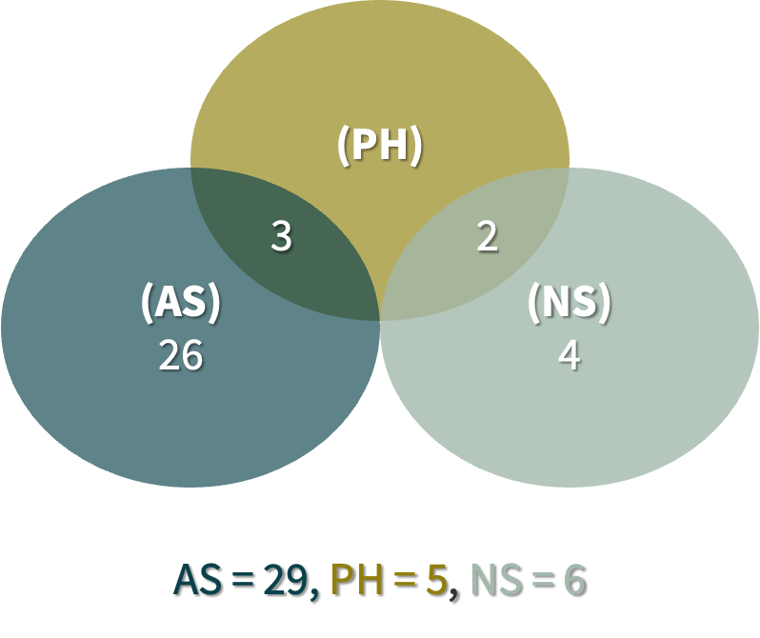
Figure 18: A Venn diagram displaying the relationship of 3 identified categories of student. (i) PH = “potential hitchhiker”, n = 5. A student who responded on the pre-survey indicated that their work needs significant revision and/or that they submit their group work at the last minute. (ii) NS = “not submitted”, n = 6. A student who received a score of 0 on one or more individual component submission assignments. (iii) AS = “accountable student”, n = 26. A student who submitted all individual component submissions on time but did self-identify as a potential hitchhiker in the pre-survey.
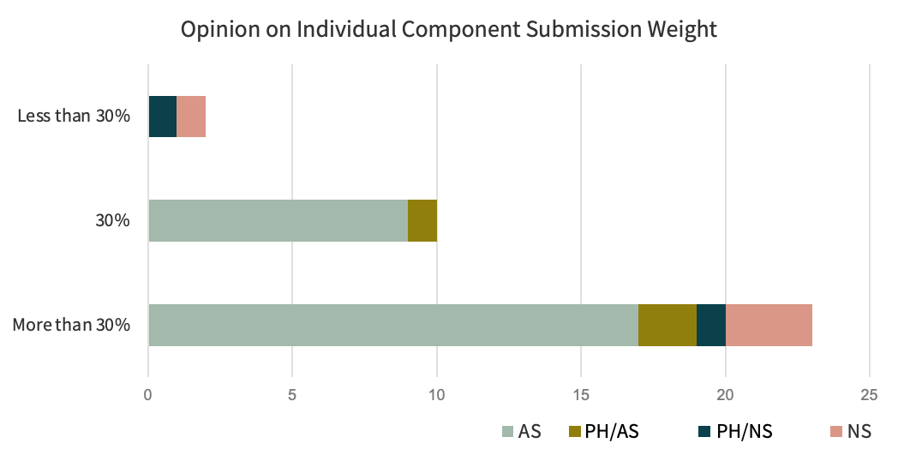
Figure 19: A stacked bar chart showing the responses to post-survey question “How much should the individual submission component be weighted?” Responses are categorized for the exclusive accountable student (AS), potential hitchhiker & accountable student (PH & AS), non-submitter & potential hitchhiker (NS & PH), and exclusive non-submitter (NS) categories.
An investigation into how NS students performed compared to the AS group was performed. This study found that final lab report grades of NS students are significantly different than AS (Mann-Whitney: p = .0007). This is expected, as the NS students did not submit assignments worth 30% towards these reports.
Lab Report Grades
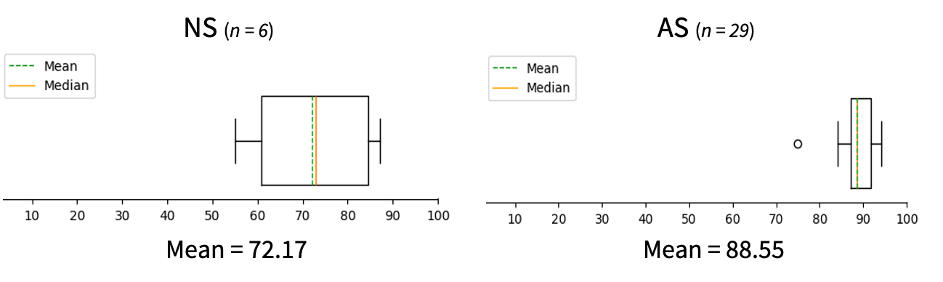
Figure 20: Two boxplots showing the significantly different (p=0.0007) grade distributions for NS students (n=6) and AS group (n=29) for final lab report grades
Next, overall final course grades were analyzed with a Mann-Whitney Test to see if there is a difference in scores between NS and AS students. NS students’ final scores are significantly different than the AS group (Mann-Whitney: p = .0011). This was an interesting discovery as the individual submission components are worth 11% of the overall course grade. All NS students submitted at least 1 individual submission component, meaning they received at least some credit towards this portion of the final course grade.
Final Course Grades
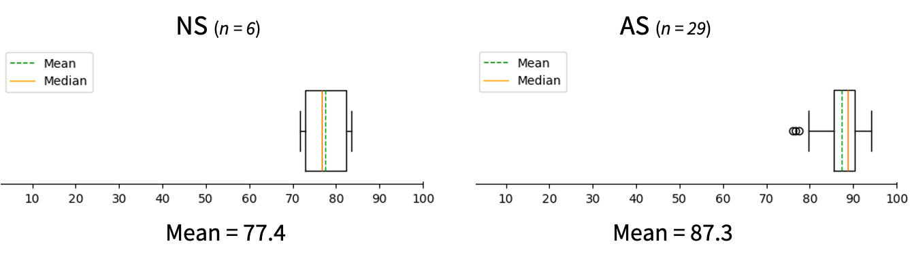
Figure 21: Two boxplots showing the significantly different (p=0.0011) grade distributions for NS students (n=6) and AS group (n=29) for final course grades
Finally, this study compared all individual grades, but excluding the individual submission components of group-written lab reports. The objective of this analysis is to investigate whether NS students performed at the same level individually when there was not a team to rely on. NS students are significantly different than the AS group in this case as well (Mann-Whitney: p= .0326). This provides strong evidence that NS students are performing worse than the AS group in general, not just in the context of team-based assignments.
Individual Assignment Grades
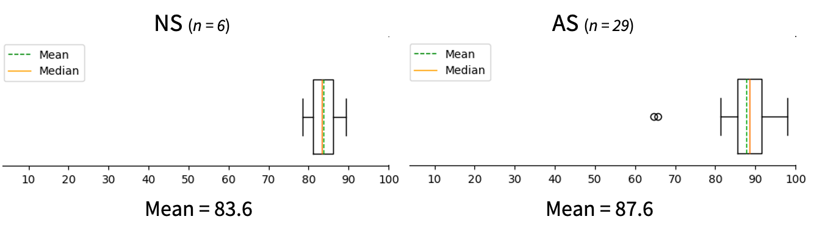
Figure 22: Two boxplots showing the significantly different (p=0.0326) grade distributions for NS students (n=6) and AS group (n=29) for individual assignment grades (excluding individual submission component)
An analysis was performed on peer evaluation grade data as well. This study investigated whether there was a difference between AS and NS students’ peer evaluation scores. There was no significant difference found (Mann-Whitney p= .028), despite the fact that there were several documented instances of hitchhiking in various lab groups.
Discussion
Accountability is an imperative component for effective teamwork in engineering education [36]. This study highlights the role of individual accountability in shaping team dynamics. By assigning specific responsibilities to each student and evaluating their individual contributions, the I-in-Team method promotes equitable participation within teams. This approach not only encourages students to take their roles seriously but also mitigates issues related to free-riding or unequal workload distribution within groups. Students need to be assessed on and recognized for their individual contribution; a method to determine the participation level of individual team members is essential. Students need to be recognized not only for the outcome of the entire team, but also for their individual contributions within a team [37]. A previous study discusses an initiative that emphasizes the importance of accountability in engineering education [38]. This approach was designed to hold students accountable for their contributions and the quality of their work, fostering a culture of responsibility. By holding students accountable for their individual contributions and the overall team performance, engineering educators can address the challenges posed by slacker/hitchhiker students and promote a culture of active participation and engagement among all students. Regular accountability checks have been shown to decrease team conflicts [39]. Similarly, the instructor for this class reported fewer inter-team conflicts when using the I-in-Team method.
An alternate way to assess individual contributions in a team project is with peer evaluations. Studies have shown, however, that peer evaluations are an unreliable source of evaluating teamwork and measuring workload balance within a team [11, 39]. Peer evaluations are commonly used in engineering education to measure accountability and individual effort [2]. Peer evaluations, while useful, have many shortcomings. These include social pressure to provide positive scores for teammates [11], the students’ possible inability to appropriately evaluate team behaviors [40] and failing to recall events accurately [2]. When students are ranked by their peers, it introduces ego-involving, threatening, and comparative problems [41]. These issues lead to a lack of cooperation. In this study, it was seen that NS students received the same peer evaluation grades as AS on peer evaluations. Students likely dealt with social pressure to rank their peers positively. For example, Student B’s group (1 AS + 3 NS) gave each other perfect scores on all 3 peer evaluations. This is surprising as student B likely did extra work due to the 3 NS students, but still gave them full credit on peer evaluations. This student was outnumbered and likely did not want to deal with the social repercussions. Additionally, there was a discrepancy between the Likert scale data on Q5: “feelings on equal contribution” and the grades given in the peer evaluations. This could indicate that students did not want to score their peers poorly, despite their feelings on equal contribution [11, 39]. The I-in-Team method provides a way to measure individual contributions without relying on potentially biased or inaccurate peer evaluations. It measures at the moment, based on tangible work done by the student instead of retroactive peer-reports. This aligns with best-practice recommendations to encourage teams to use nonpunitive accountability mechanisms throughout the project to foster motivation [8, 42, 43].

Most students, including a majority of the NS students, indicated they think the individual portion should be more heavily weighted. This suggests that perhaps 30% of the final lab report grade did not provide enough incentive to complete the individual portion on time. However, the results from the individual grade analysis (Figure 22) show that even when assignments are 100% individual, these NS students are still performing differently than the AS group. This could mean that while NS students recognize their need for extrinsic motivation, they additionally lack some other skills required to achieve the higher scores seen by the AS group.
Some students indicated very positive ranking towards feelings on teamwork in post-survey Q2, then suddenly turned negative when asked to elaborate in free response Q3. Only 6% were negative in Q2, while 14% were classified as negative on the free response. There are a few possible explanations for this change in attitude. Likert scales, while effective for quantifying opinions and attitudes, are prone to response bias. Respondents may avoid selecting extreme items or disagreeing with statements to appear more "normal" or favorable [44, 45]. In contrast, free-response questions allow for more detailed and nuanced responses, potentially revealing deeper insights into the respondent's feelings and experiences. However, this format also introduces the risk of fatigue or inattention [46]. The current study included both types of questions to gain a comprehensive understanding of student’s feelings on teamwork.
This study has limitations related to the size and composition of the sample. The sample size of the study, including the number of students and instructors involved, could impact the generalizability of the findings. Additionally, this study's focus on a specific course or institution may limit its applicability to broader contexts within engineering education. This study relies heavily on self-reported data from students and instructors, which may introduce biases or inaccuracies [45]. An examination of historic course data (previous final scores or lab report grades) could not be performed due to IRB restrictions. Students' perceptions of teamwork and the effectiveness of the I-in-Team method could be influenced by several factors, such as their prior experiences with teamwork or their individual attitudes towards collaboration. This study was performed with a group of chemical engineering juniors who may have taken classes together and worked on projects with the same group previously. Additionally, the study's evaluation of the I-in-Team method was limited to a single-semester timeframe, providing insights into immediate outcomes but potentially overlooking long-term effects. Future research could explore the method's impact over multiple semesters or academic years to assess its durability and effectiveness over time.

The pre- and post-surveys used in this study have room for improvement. Regrettably, no demographic information was collected. Question 8 on the pre-survey raises a point of contention regarding the alignment between the inquiry and its response options. The use of 'quality' alongside descriptions of team roles creates confusion and uncertainty. 'Quality' typically indicates the standard or excellence of work produced, while the response options pertain more to the individual's perceived role within the team dynamics (Best member/leader, average, work needs revisions). This inconsistency highlights a limitation in the survey design, respondents may struggle to accurately convey their perception of work quality within the team context. Addressing this limitation in future revisions could involve clarifying the terminology used or restructuring the question. Finally, there were 4 NS students who gave no indication they might not submit their work on time. Further development of the survey could be done to better identify potential hitchhikers and non-submitters.

This study used a GPA spread for the group design such that every team included a high GPA member, and no team had multiple low GPA students. This team-construction method was decided by the course instructor. Previous research indicates instructors, not students, should form groups, and that instructors should post clear guidelines on how to handle hitchhiking team members [11]. For this study, students were not allowed to change groups as it would affect the students’ assignments (ex: their first lab report they write the introduction, the second they do results, they need to be reassigned and now other groups roles must be considered as well as this student’s). Additionally, it is important to consider the possibility of group-swapping before the course begins. That is, if students may be allowed to change groups and if so, how that affects the group they are leaving and joining.

The I-in-Team method could potentially be applied to courses with team projects that would benefit from individual team members preparing their contributions in advance of a team deliverable. The method requires a structure where each student has a clear role or portion of the group assignment. From there, a measure of “completeness” needs to be established for all individual contributions. This study used page count, however for future iterations, word count is recommended. Feedback from the course instructor mentioned that some student’s individual submissions would make graphs and figures unnecessarily large to reach a required page count with less words. Similarly, results from the exit-survey suggest trying a weight of 40% (or more) for the individual portion based on the average preference of students in this study. The course in this study included graded peer evaluations, however, the grades from the individual component could replace the peer evaluation grades. Peer evaluations are a common measure of an individual’s contributions to a group project, but peer evaluations have many disadvantages [2, 11,40, 41]. The I-in-Team method grades tangible work done. Peer evaluations are a helpful tool to gain insight on how a group is doing in general, but students should not give grades to (or receive grades from) each other.

Conclusion
The findings of this study reaffirm the role of accountability as a key driver of successful teamwork. By instilling a sense of ownership and responsibility among students, a foundation is set for a culture of collaboration and mutual respect. This echoes arguments presented in previous a study, that emphasize the importance of teams in the learning process and highlight the importance of teamwork in STEM education [47]. The current study found positive effects when utilizing the I-in-Team method of accountability framework for group-written lab reports. Similar means of accountability could be applied to any collaborative group effort such as student competition teams or Capstone project teams. Future studies might investigate the most effective balance of weights between individual component submissions and team deliverables, while also factoring in time spent grading and instructional effort.
The implementation of the I-in-Team submission method in a chemical engineering lab course has shown promising results in improving student’s attitudes about teamwork. This approach aligns with the principles outlined by previous work [48], who emphasize the central role of shared vision in fostering productive innovation teams, suggesting that the I-in-Team method's emphasis on shared accountability can significantly enhance team dynamics. The unanimous agreement from all identified groups (potential hitchhikers, non-submitters, and accountable students) on the fairness of the method provides further evidence toward its efficacy in promoting an environment for teamwork.
Utilizing the I-in-Team method created a significant positive change in student’s opinions towards working in a team. It is likely that the student’s previous team experiences featured biased grading systems, more lenient on hitchhikers and non-submitters. Finally, the study's exploration of the impact of equitable grading systems on students' attitudes towards teamwork aligns with the broader literature on diversity, conflict, and performance in workgroup [49], suggesting that fairness in evaluation methods can significantly influence team dynamics and performance. When working in an equitable grading system, all students, even those penalized by the system, reported enjoying team-based activities and an improved attitude towards teamwork. This approach gives clear structure to the teams through the weekly assigned role. This highlights the importance of strategic leadership in achieving shared goals through team development skills, such as rotating roles, and working together on lab results. [50]. The approach was shown to increase accountability among individual members of the lab groups, as students who self-identified as “waiting to the last minute” were shown to submit individual portions on time (75%). Furthermore, the early submission requirement encourages effective time management across all students, exemplified by the on-time submission rate of 94% on individual portions, thereby diminishing the likelihood of last-minute, hurried teamwork. Additionally, the entire class exhibited a perfect 100% on-time submission rate for group assignments.
Overall, students, instructors, and graders benefited and enjoyed the implementation of the I-in-Team method for team-based lab writing. Students reported appreciation for receiving credit for individual contributions. The course instructor reported having fewer internal problems within lab groups than in previous semesters. While the instructor reported that the I-in-Team method required a bit more time to grade, they stated this was a worthwhile trade off to promote teamwork in their chemistry lab course.

Works Cited
- Trevelyan, J. The Making of an Expert Engineer. New York: CRC Press, 2014.
- Wolfinbarger, K. G. Team Leadership in Engineering Education. pp 53–61. New Directions for Student Leadership, 2022.
- Gantasala, V. P. Teamwork in Higher Education: an exploratory study in an UAE University, pp 16-40. Strategic Management Quarterly, 2016.
- Brackin, P., & Williams, J., Teaching And Assessing Teaming Skills In a Senior Level Design Course. Albuquerque, New Mexico: ASEE, 2001.
- Burke, C. S., Diazgranados, D., & Salas, E. . Team leadership: A Review and Look Ahead. pp. 338–351. The SAGE handbook of leadership, 2011.
- Dunne & Rawlins, Bridging the Gap Between Industry and Higher Education: Training Academics to Promote Student Teamwork. pp 361-371. Innovations in Education and Training International, 2000.
- Knight, D. B., & Novoselich, B. J. Curricular and co-curricular influences on undergraduate engineering student leadership. pp 44–70. Journal of Engineering Education, 2017.
- Wolfinbarger, K. G., Shehab, R. L., Trytten, D. A., & Walden, S. E. The influence of engineering competition team participation on students’ leadership identity development. pp 925-948. Journal of Engineering Education, 2021.
- Mahmoud Ibrahim, and Ala'a H Al Muhtaseb. Improving Engineering Students’ Writing/presentation Skills Using Laboratory/mini-project Report. pp 701-14. International Journal of Electrical Engineering & Education, 2021.
- Novick, David, et al. “Teaching engineers the leadership skill of Conflict Resolution.” 2022 ASEE Annual Conference &amp; Exposition Proceedings, 2022.
- Oakley, Barbara & Brent, Rebecca & Felder, Richard & Elhajj, Imad. Turning Student Groups into Effective Teams. Journal of Student Centered Learning, 2004.
- Landaverde-Alvarado, C. Work in progress: A teamwork training model to promote the development of teaming skills in chemical engineering students. ASEE Annual Conference &amp; Exposition Proceedings, 2023.
- Hamnett, McKie, and Morrison. Postgraduate Students' Attitudes towards Group Work: Experiences within a Forensic Chemistry Programme. pp. 1240-252, Chemistry Education Research and Practice, 2018.
- Felder, Brent, and Elhajj, Coping with couch potatoes and hitchhikers on teams. pp. 9-34. Student Centered Learning, 2004.
- Gomoll, Hmelo-Silver, Tolar, Šabanović, and Francisco. Moving Apart and Coming Together. pp. 219-32. Educational Technology & Society, 2017.
- Puji, and Lammers. Individual Accountability in Cooperative Learning: More Opportunities to Produce Spoken English. pp 215-28. Indonesian Journal of Applied Linguistics, 2017
- Ying, Xiangyu et al. Group Laziness: The Effect of Social Loafing on Group Performance. p. 465–471. Social Behavior & Personality: an international journal, 2014.
- Chan, S., & Chan, M. A Study of Deriving Individual Marks from a Group. 2005 Annual Conference Proceedings, 2005.
- Cox. "Incorporating More Individual Accountability in Group Activities in General Chemistry. pp. 30-36. Journal of College Science Teaching, 2015.
- Prete, Vincenzo, Macrì, Diego, and Rania. Team Production in a Field Experiment: Study of Aggregative vs. Individual Cultural Activities. Higher Education, 2021.
- Carrasco, Gonzalo A., et al. “A novel grading strategy for team‐based learning exercises in a hands‐on course in Molecular Biology for senior undergraduate underrepresented students in medicine resulted in stronger student performance. pp 115–123. Biochemistry and Molecular Biology Education, 2018.
- Alireza Nili, Mary Tate, Alistair Barros, David Johnstone, An approach for selecting and using a method of inter-coder reliability in information management research. International Journal of Information Management, 2020.
- Mirek and Agnieszka. Introducing "captaining": How to Best Combine Group Work with Individual Achievement within Higher Education Examination. pp. 57-70. Journal of Pedagogical Research, 2020.
- Aronson, E., Blaney, N., Stephin, C., Sikes, J., & Snapp, M. The Jigsaw Classroom. Sage Publishing Company, 1978.
- Aronson, E., & Patnoe, S. Cooperation in the Classroom: The Jigsaw Method (3rd ed.). Pinter & Martin, Ltd, 2011.
- Premo J, Cavagnetto A, Davis WB, Brickman P. Promoting Collaborative Classrooms: The Impacts of Interdependent Cooperative Learning on Undergraduate Interactions and Achievement. CBE Life Sci Educ, 2018.
- Howard J. R., Baird R. The consolidation of responsibility and students’ definitions of situation in the mixed-age college classroom. pp 700–721. Journal of Higher Education, 2000.
- Frisby B. N., Berger E., Burchett M., Herovic E., Strawser M. G. Participation apprehensive students: The influence of face support and instructor–student rapport on classroom participation. pp 105–123. Communication Education, 2014.
- Forsyth, Donelson R. Group Dynamics 5th edition. Wadsworth Cengage Learning, 2010.
- Falcione, S., Campbell, E., McCollum, B., Chamberlain, J., Macias, M., Morsch, L., & Pinder, C. Emergence of different perspectives of success in collaborative learning. The Canadian Journal for the Scholarship of Teaching and Learning, 2019.
- Reeves S, Xyrichis A, Zwarenstein M. Teamwork, collaboration, coordination, and networking: Why we need to distinguish between different types of interprofessional practice. J Interprof Care, 2018.
- Roseth C. J., Johnson D. W., Johnson R. T. Promoting early adolescents’ achievement and peer relationships: The effects of cooperative, competitive, and individualistic goal structures. Psychological Bulletin, 2008.
- Kyndt E., Raes E., Lismont B., Timmers F., Cascallar E., Dochy F. A meta-analysis of the effects of face-to-face cooperative learning. Do recent studies falsify or verify earlier findings?. pp 133–149. Educational Research Review, 2013.
- Buchs C., Pulfrey C., Gabarrot F., Butera F. Competitive conflict regulation and informational dependence in peer learning. pp 418–435. European Journal of Social Psychology, 2010.
- Brown, P. R., McCord, R. E., Matusovich, H. M., & Kajfez, R. L. The Use of Motivation Theory in Engineering Education Research: a Systematic Review of Literature. pp 186-205, European Journal of Engineering Education, 2015.
- Chowdhury, Tahsin & Murzi, Homero. Literature Review: Exploring Teamwork in Engineering Education, 2019.
- Ziegler, W. Teaching and assessing teamwork: Including a method (that works) to determine individual contributions to a team. Annual Conference Proceedings, 2003.
- Rooney, S.I., Scott, R.A. Promoting Effective Student Teamwork Through Deliberate Instruction, Documentation, Accountability, and Assessment. pp 221–227. Biomed Eng Education, 2021.
- Nilson, Linda B. Improving Student Peer Feedback. pp. 34–38. College Teaching, 2003.
- Imbrie, P. K., Agarwal, J., & Raju, G. Team effectiveness in predicting student learning: An analysis of firstyear engineering students. ASEE Virtual Annual Conference, 2020.
- Hayek, Toma, Guidotti, Oberlé, and Butera. Grades Degrade Group Coordination: Deteriorated Interactions and Performance in a Cooperative Motor Task. vol. 32, no. 1, pp. 97-112. European Journal of Psychology of Education, 2017.
- Davis, C. E., & Wolfinbarger, K. G. Assessing Team Development in an Engineering Project-Based Course. Frontiers in Education Conference, 2018.
- Wageman, R., Hackman, J. R., & Lehman, E. Team diagnostic survey: Development of an instrument. pp 378–398. Journal of Applied Behavioral Science, 2005.
- Westland, J. C. Information loss and bias in likert survey responses. PLoS One, 2022.
- Oddgeir Friborg, Monica Martinussen, Jan H. Rosenvinge, Likert-based vs. semantic differential-based scorings of positive psychological constructs: A psychometric comparison of two versions of a scale measuring resilience. pp 873-884. Personality and Individual Differences, 2006.
- Smith, P.B. Response Bias(es). Encyclopedia of Quality of Life and Well-Being Research, 2014.
- Wuchty, S., Jones, B.F., Uzzi, B. The increasing dominance of teams in production of knowledge. pp 1036–1039. Science 2016.
- Pearce, C.L., & Ensley, M.D. A reciprocal and longitudinal investigation of the innovation process: The central role of shared vision in product and process innovation teams (PPITs). pp 259–278. Journal of Organizational Behavior, 2004.
- Jehn, K.A., Northcraft, G.B., Neale, M.A. Why differences make a difference: A field study of diversity, conflict, and performance in workgroups. pp 741–763. Administrative Science Quarterly, 1999.
- Wolfinbarger, Kim Graves. A New Approach to Laboratory-Based Learning in an Introductory Ergonomics Course. Proceedings of the Human Factors and Ergonomics, 2010.

Appendix A
Pre Survey

For the purposes of this survey, we are only interested in your group work experiences in college. Specifically, assignments that are done in collaboration with a group/team where all members receive the same grade.
- What are your feelings about working with a group to write a report? (Circle one number corresponding to your feelings.)
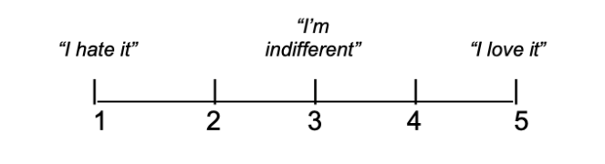
- Recall the group assignment experiences from college. Approximately how many positive, negative, and neutral group experiences have you had?
# positive =
# neutral =
# negative =
- Think about your most frustrating group assignment experience in college. How negative was it? (Circle one number corresponding to your feelings.)
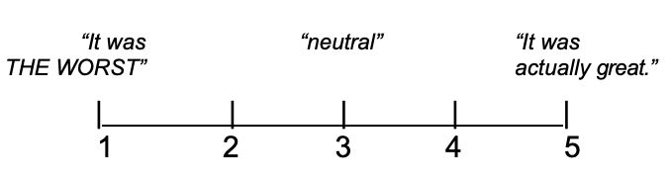
- What made this group experience frustrating?
- Think about your most positive group assignment experience in college. How positive was it? (Circle one number corresponding to your feelings.)
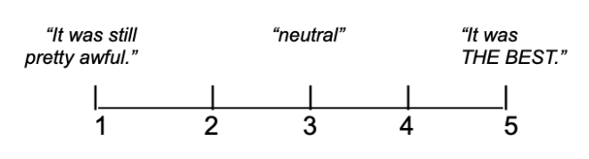
- What made this group experience a positive experience?
- What grades do you typically receive on group projects?
A B C D F
- In general, how do you feel the quality of your contributions compares to that of your teammates? (Circle one answer.)
- I am usually the best group member/team lead
- I am an average group member
- Other team members usually make significant changes/additions to my work
- How early before the due date do you usually finish your contribution to a group assignment? (Circle one answer.)
- A few days prior
- The day before
- The day of
- At the very last possible moment

Appendix B
Post Survey
For the purposes of this survey, we are only interested in your group work experiences in this course.
- What are your feelings about working with your group to write reports for this course? (Circle one number corresponding to your feelings.)
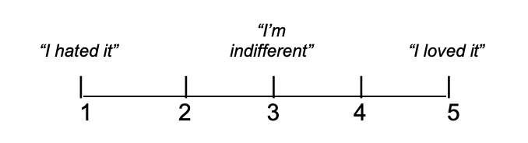
- Think about your experiences working on a team in this course. How was it? (Circle one number corresponding to your feelings.)
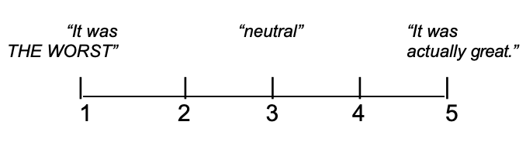
- Why did you rate your experiences working on a team in this course this way?
- Did your team encounter any problems this semester? If so, please describe:
- Do you agree or disagree with the following statement:
“Each member of my group contributed roughly equally toward completion of the reports.”
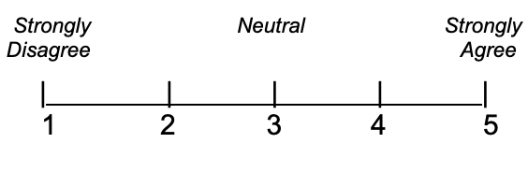
- How did you feel about the individual submission portion of the group report?
- How did you feel about the group collaboration aspect of the group report?
- Do you agree or disagree with the following statement:
“The individual submission portion of the report detracted from the group collaboration.”
- The individual lab contributions were worth 30% of a student’s total lab grade for each report, with 70% of the grade coming from the group’s completed group lab reports. If you could change this distribution of points for the class, what distribution would you use? | ____% individual  ____% group
- The individual lab contributions were due 24 hours before the completed group lab reports. Was this enough time to compile and edit the group report? How much time should be required in future semesters? | ____ days
- Each lab group submitted 3 lab reports as part of this course. How many of the individual lab contributions were you able to submit on time? | 1 2 3
- Each lab group submitted 3 lab reports as part of this course. How many of the completed group lab reports was your group able to submit on time? | 1 2 3
- What average letter grade did your lab group receive on the 3 completed group lab reports? | A B C D F

Appendix C
Question 3 Post-Survey: Why did you rate your experiences working on a team in this course this way?
PA | code | response
100% | pos | groupwork enhanced understandability
67% | pos | collaborations builds relationships
67% | neg | I did the math, my group did not
100% | neg | "I did not learn anything"
100% | neu | easy to bounce ideas, but room for miscommunication
100% | pos | worked with a great group
100% | neu | fine
100% | neu | it wasn’t bad, but there was a lot of communication
67% | neg | different expectations and understanding
67% | pos | I prefer working in a group
67% | neu | different work style, some communication issues
67% | pos | nice having opinions, had to compromise
100% | pos | I didn’t hate it, we worked well
67% | neu | enjoyable in general, not always my standard of quality
67% | neu | when everyone did their part it was good
100% | pos | I enjoyed it, I enjoyed my teammate
100% | pos | good group
100% | pos | enjoyed my group
100% | pos | made workload easier
67% | neu | nice, but hard to schedule
67% | neu | different skills benefit, some slacking
100% | pos | work equally divided
100% | pos | worked well together
100% | neg | my group held me back
100% | pos | worked well, good quality work
100% | pos | same expectations
100% | pos | I had great partners, consistently met deadlines
100% | pos | group worked well together
100% | pos | everyone worked cohesively
100% | neg | not organized, made it tedious
100% | pos | I would have suffered if it was alone
67% | neu | different levels of effort
100% | pos | it was helpful having a team
100% | pos | made workload easier
100% | pos | we work well together

Post Survey Question 6: How did you feel about the individual submission aspect of the group report?
PA | code | response
100% | pos | makes everyone contribute
100% | neu | it was fine
100% | pos | I liked it, I enjoyed getting credit for my work
100% | neu | "I submit them on time"
67% | neu | "didn't bother with it, no comment"
100% | neg | redundant
100% | pos | liked it, wouldn’t change
100% | pos | it was good to get credit for my own work
100% | pos | motivation to stay ahead and finish work. Liked part of actual grade
100% | neu | indifferent
100% | pos | it was good, it helped me get a better understanding of the material
67% | neu | completion grade made it less effective
100% | neu | didn’t mind it, it didn't help me
100% | pos | good. I'm glad I can be graded for my own effort
100% | pos | I appreciated this part, kept people ahead and on track for group lab
100% | pos | great
100% | pos | this is needed, I like that everyone got credit for their own work
100% | pos | liked it, wished there was more collaboration on group writing
100% | pos | I liked it, helped me with time management
100% | pos | it was nice having something im soley responsible for
100% | pos | I liked it, I enjoyed getting credit for my work
100% | pos | felt good to get credit for my work, increased my understanding
100% | pos | I was lacking but this is useful
100% | pos | good way to hold people accountable
100% | neu | I enjoyed working on specific parts, but I didn’t learn the other sections as well
100% | pos | pushed me to do my work ahead of time
100% | pos | nice to receive credit for my portion
100% | pos | I appreciated this, encouraged responsibility, liked rotating role
67% | neu | it was fine
100% | pos | good job providing structure, made group part feel stitched together
100% | pos | positive, very manageable
100% | pos | I appreciated this part
100% | pos | I think we need more of these
100% | neu | it was okay
100% | neu | indifferent, it provided the group with a deadline to finish sections

Question 7 Post-Survey: How did you feel about the group collaboration aspect of the group report?
PA | code | response
100% | pos | better understanding of material
100% | pos | it was good
67% | neu | wish there was more collaboration
100% | neg | "I truly did not like the class"
100% | neu | easy to bounce ideas, but room for miscommunication
100% | neg | tedious
100% | pos | liked it, wouldn’t change
67% | pos | it was fine, hard to delegate some parts
67% | pos | good! Professor should meet with struggling groups
100% | pos | I liked it
100% | neu | it was ok, group members were late
100% | pos | prevented overwhelming amount of work
100% | pos | I liked it, easy to delegate work
100% | pos | I liked it, easier than doing it myself
100% | pos | it was good
100% | pos | not bad, hard to contribute equally
100% | neu | I liked not doing it by myself
100% | pos | liked it, wished there was more, labs too sectioned
100% | pos | limited due to divide and conquer attitude
100% | neu | frustrating when it didn’t work, nice when it did
100% | neu | I liked not doing it by myself
100% | pos | good, easy to set up
100% | pos | worked well
67% | pos | group put in effort
100% | pos | enjoyed it, engaging learning experience
100% | pos | a lot of content to handle, went well
100% | pos | went well, individual portion enhanced groupwork
100% | pos | I liked it, beneficial to collaborate
100% | pos | it was good
100% | pos | useful, combines skills, more time to complete assignments
100% | pos | work was split evenly
100% | neg | I would've liked better collaboration
100% | neg | there was too much collaboration, my grades should reflect me
100% | pos | it was helpful
100% | pos | it was good to split the workload

