UNIVERSITY OF OKLAHOMA

GRADUATE COLLEGE

ABIOTIC AND BIOTIC DRIVERS OF GRASSLAND STRUCTURE: FROM INDIVIDUAL TO COMMUNITY RESPONSES

DISSERTATION

SUBMITTED TO THE GRADUATE FACULTY

in partial fulfillment of the requirements for the

Degree of

DOCTOR OF PHILOSOPHY

By

KAREN P. CASTILLIONI
Norman, Oklahoma
2021

ABIOTIC AND BIOTIC DRIVERS OF GRASSLAND STRUCTURE: FROM INDIVIDUAL TO COMMUNITY RESPONSES

A DISSERTATION APPROVED FOR THE
DEPARTMENT OF MICROBIOLOGY AND PLANT BIOLOGY

BY THE COMMITTEE CONSISTING OF

Dr. Lara Souza, Chair
Dr. Elinor Martin
Dr. Heather R. McCarthy
Dr. Michael A. Patten
Dr. Michael E. Kaspari

© Copyright by KAREN P. CASTILLIONI 2021
All Rights Reserved.

ACKNOWLEDGMENTS

I would like to thank my advisor, Dr. Lara Souza for her mentorship, support, advice, kind words of encouragement and patience during my doctoral degree. I will certainly carry with me many things that I learned with Lara’s guidance and will always be grateful for the opportunity to join her lab. I also would like to thank the other members of my advisory committee – Dr. Heather McCarthy, Dr. Michael Patten, Dr. Michael Kaspari and Dr. Elinor Martin – for their mentorship, feedback, support and guidance to navigate my dissertation and accomplishments.
Thank you, Dr. Amy Iler, for collaborating in the phenology project, for thoroughly and helpful comments on my work. Thanks to another awesome woman in STEM, who is also an inspiration in many ways, Dr. Sara Kuebbing, for supporting me with words and in research proposals.
I would like to thank my parents - Ailce and Antonio - and sister — Ingrid - for their support from far in Brazil. They went above and beyond to support my dreams and to encourage me in difficult times. I would like to thank Joe Muse —my husband, best friend and graduate school sweetheart — for his constant words of encouragement, for listening, cheering me up and supporting me with love.
Huge thanks to the past and current Souza lab members, Tess Hartog, Megan Means, Josh Kuori, Mason Moran, Eric Allen, Greg Newman and Juliana Teixeira many others who I enjoyed working with and that became really good friends inside and outside the lab. We have so many great memories together from trips, camping and game nights. To Tess specifically, thank you for being my great friend and for taking the courage to go with me on many adventurous.
Thanks to all other graduate students and friends who have supported me on this Ph.D.: Alva Strand, Lidiane Torres, Rebecca Prather, Amy Adams and Shuang Ma.
Big thanks to Ranell Madding and Trina Looman Steil at the Oklahoma Biological Survey (OBS) for their help any time that I needed and for receiving me with open arms. Thanks, OBS for the valuable logistic support in field and lab experiments. Thanks to all professors and students that were somehow involved in my dissertation, in shared office and biomass sorting at OBS. I also thank Amy Buthod and Dr. Abigail Moore in the herbarium to their help identifying plants and tips about plant care. Thank you, Ben, – former field manager at Kessler and Atmospheric Field Station (KAEFS) – for making field work possible. Thanks to the Department of Microbiology and Plant Biology at OU for scholarships that supported me financially. Finally, many thanks to the awesome library staff- Brent Tweedy, Magen Bednar, and Claire Curry for helping me with feedback on presentations, layouts, or research questions.

Table of Contents
ACKNOWLEDGMENTS iv
Abstract xiv
Chapter One 1
DROUGHT MILDLY REDUCES PLANT DOMINANCE IN A TEMPERATE PRAIRIE ECOSYSTEM ACROSS YEARS 1
Abstract 2
Introduction 3
Methods 6
Results 10
Discussion 14
Acknowledgments 19
References 21
Tables and figures 29
Appendix S1 34
Chapter Two 49
PRECIPITATION EFFECTS ON GRASSLAND PLANT PERFORMANCE ARE LESSENED BY HAY HARVEST 49
Abstract 50
Introduction 51
Methods 54
Results 58
Discussion 62
Acknowledgments 67
References 68
Tables and figures 74
Appendix S1 81
Chapter Three 95
EFFECTS OF PRECIPITATION ON PHENOLOGY DEPEND ON FUNCTIONAL AND LIFE-HISTORY TRAITS IN A GRASSLAND COMMUNITY 95
Abstract 96
Introduction 97
Methods 101
Results 107
Discussion 109
Acknowledgements 115
References 116
Tables and figures 126
Appendix S1 128

List of Tables

CHAPTER 1
Table 1. Model summary and ANCOVA results for generalized linear models of main and interactive effects of precipitation and clipping on community-level and species-specific responses. 29

Table S1. Species composition, family, functional group, growth form, life history, average cover prior treatments application in May 2016 at the Kessler Atmospheric Ecological Field Station, Washington, Oklahoma. F = family, FG = functional group, GF = growth form, LH = life history and AC = average absolute cover (%). 34

Table S2. Volumetric soil water content (mean ± se, m3.m-3) and soil temperature (mean ± se, ˚C) during growing season of 2017 and 2018 across precipitation levels and clipping treatments. 36

Table S3. PERMANOVA and test for homogeneity of multivariate dispersions (PERMDISP) based on a Bray–Curtis similarity matrix of log(x+1) transformed plant species abundance. Permutations = 999. Significant results (P (perm) < 0.05) are shown bold; d.f. shown in parentheses. 37

Table S4. Pairwise comparisons following PERMDISP test results on precipitation effects based on table 1. Significant results (P (perm) < 0.05) are shown bold. 37

Table S5. Average (%± s.e.) plant richness, evenness, relative cover of forbs (%), graminoids (%) and species-specific foliar cover (%) for clipping vs. unclipping under the precipitation gradient. Data are shown for 2017. 38

Table S6. Average (%± s.e.) plant richness, evenness, relative cover of forbs (%), graminoids (%) and species-specific foliar cover (%) for clipping vs. unclipping under the precipitation gradient. Data are shown for 2018. 39

Table S7. Measures of plant community changes (species gains, losses and turnover) from 2017 to 2018 in each treatment. Shown are means ± s.e. 40

CHAPTER 2
Table 1. GLMM of main effects of plant richness, leaf area index and ANPP on focal species-specific height, under hay harvest vs. no hay harvest. Significant P (≤0.05) shown in bold. 74

Table S1. Mean and standard error (SE) for soil moisture (%) in each precipitation level with and without hay harvest during the growing season May-September 2017. 81

Table S2. Model estimates, standard errors (SE), and p-values (P) from hay harvest under altered precipitation piecewise Structural Equation Model (Fig. 2a) depicting the direct and indirect effects of precipitation treatments and clipping on Focal species height and foliar cover. Significant P (≤0.05) values are shown in bold. 82

Table S3. Model estimates, standard errors (SE), and p-values (P) from without hay harvest under altered precipitation piecewise Structural Equation Model (Fig. 2a) depicting the direct and indirect effects of precipitation treatments and clipping on Focal species height and foliar cover. Significant P (≤0.05) values are shown in bold. 83

Table S4. GLMMs of main effects of the precipitation gradient and hay harvest on biotic variables (community richness, LAI, ANPP) and abiotic variables (soil moisture, soil temperature and bare-ground cover). Significant P (≤0.05) shown in bold. 84

Table S5. GLMMs of main effects of bare-ground cover, soil moisture and soil temperature on focal species-specific height, under hay harvest vs. no hay harvest. Significant P (≤0.05) shown in bold. 84

Table S6. GLMMs of main effects of bare-ground cover, soil moisture and soil temperature on focal species-specific abundance, under hay harvest vs. no hay harvest. Significant P (≤0.05) shown in bold. 85

Table S7. Model estimates, standard errors (SE), and p-values (P) from hay harvest under altered precipitation piecewise Structural Equation Model depicting the direct and indirect effects of precipitation treatments and clipping on Focal species height and foliar cover in C₃ forbs. Significant P (≤0.05) values are shown in bold. SEM AIC = 155.52, F=25.52 and P-value = 0.27. 86

Table S8. Model estimates, standard errors (SE), and p-values (P) from without hay harvest under altered precipitation piecewise Structural Equation Model depicting the direct and indirect effects of precipitation treatments and clipping on Focal species height and foliar cover C₃ forbs. Significant P (≤0.05) values are shown in bold. SEM AIC = 160.76, F= 30.76 and P-value = 0.10. 87

Table S9. Model estimates, standard errors (SE), and p-values (P) from hay harvest under altered precipitation piecewise Structural Equation Model depicting the direct and indirect effects of precipitation treatments and clipping on Focal species height and foliar cover in C₃ graminoid. Significant P (≤0.05) values are shown in bold. SEM AIC = 153.50, F=7.50 and P-value = 0.27. 88

Table S10. Model estimates, standard errors (SE), and p-values (P) from without hay harvest under altered precipitation piecewise Structural Equation Model depicting the direct and indirect effects of precipitation treatments and clipping on Focal species height and foliar cover C₃ graminoid. Significant P (≤0.05) values are shown in bold. SEM AIC = 150.55 F= 0.55 and P-value = 0.76. 89

Table S11. Model estimates, standard errors (SE), and p-values (P) from hay harvest under altered precipitation piecewise Structural Equation Model depicting the direct and indirect effects of precipitation treatments and clipping on Focal species height and foliar cover in C₄ graminoids. Significant P (≤0.05) values are shown in bold. SEM AIC = 148.86, F= 0.86 and P-value = 0.93. 90

Table S12. Model estimates, standard errors (SE), and p-values (P) from without hay harvest under altered precipitation piecewise Structural Equation Model depicting the direct and indirect effects of precipitation treatments and clipping on Focal species height and foliar cover C₄ graminoids. Significant P (≤0.05) values are shown in bold. SEM AIC = 151.88, F= 5.88 and P-value = 0.44. 91

CHAPTER 3
Table S1. Summary tables from GLMMs for studied species grouped as a whole community analysis of the effect of the precipitation gradient on the timing of reproductive phases (peak dates), the duration of reproductive phases, maximum flower and fruit count, and seed viability. Species was a random intercept term in this analysis. 128

Table S2. Summary tables from GLMMs for studied species grouped by average bloom time analysis of the effect of the precipitation gradient on the timing of reproductive phases (peak dates), the duration of reproductive phases, maximum flower and fruit count, and seed viability. 129

Table S3. Summary tables from GLMMs for studied species grouped into functional groups (C₃ vs. C₄) analysis of the effect of the precipitation gradient on the timing of reproductive phases (peak dates), the duration of reproductive phases, maximum flower and fruit count, and seed viability. 130

Table S4. Summary tables from GLMMs for studied species grouped by life span (annual vs. perennial) analysis of the effect of the precipitation gradient on the timing of reproductive phases (peak dates), the duration of reproductive phases, maximum flower and fruit count, and seed viability. 131

Table S5. Summary tables from GLMMs from the species-level analysis of the effect of the precipitation gradient on the timing of reproductive phases (peak dates), the duration of reproductive phases, maximum flower and fruit count, and seed viability. 132

List of Figures

CHAPTER 1
Figure 1. Average effect sizes (Cohen’s D) and 95% confidence interval (bars) of relative abundance (foliar cover %) for community-level within precipitation treatments. Note that evenness is based on Jaccard index and richness is based on the number of species. Year 2018 (after treatment application) was compared to year 2016 (before treatment application), including the control treatment (i.e. 0% change in precipitation). Red circles + bars denote significant effect sizes; red circles + bars to the right indicate positive effect sizes, and red circles + bars to the left indicate negative effect sizes. 31

Figure 2. Average effect sizes (Cohen’s D) and 95% confidence interval (bars) of relative abundance (foliar cover %) for community-level in clipped vs. unclipped condition. Note that evenness is based on Jaccard index and richness is based on the number of species. Year 2018 (after treatment application) was compared to year 2016 (before treatment application), including the control treatment (i.e. unclipped plots). Red circles + bars denote significant effect sizes; red circles + bars to the right indicate positive effect sizes, and red circles + bars to the left indicate negative effect sizes. 32

Figure 3. Average effect sizes (Cohen’s D) and 95% confidence interval (bars) of relative abundance (foliar cover %) for community-level within precipitation treatments in clipped vs. unclipped condition. Note that evenness is based on Jaccard index and richness is based on number of species. Year 2018 (after treatment application) was compared to year 2016 (before treatment application), including the controls treatments (i.e. 0% change in precipitation and unclipped plots). Red circles + bars denote significant effect sizes; red circles + bars to the right indicate positive effect sizes, and red circles + bars to the left indicate negative effect sizes. 33

Figure S1. Top panel: Daily soil moisture and precipitation measurements during 2017 and 2018 growing season for all treatments. Bottom panel: Soil moisture content (%, mean±se) regression across the precipitation gradient for each year. 41

Figure S2. Experimental design showing (top panel) arrangement of drought shelters that produced the precipitation gradient distributed in three blocks (n=3, N=21): -100%, -80%, -60%, -40%, -20% precipitation reduction, 0% change (no rainfall change), and 50% precipitation addition; and arrows pointing clipped and unclipped subplots. Top right panel individually illustrates a +50 precipitation addition plot. Bottom panel shows left: illustration of a plot and its subplots, and right: phot of plot at Kessler Atmospheric Ecological Field Station, in Washington, Oklahoma. Subplots were clipped once a year during the growing season (clipping treatment) or left unclipped (unclipping treatment or control). 42

Figure S3. Average effect sizes (Cohen’s D) and 95% confidence interval (bars) of relative abundance (foliar cover %) for most common species within precipitation treatments. Year 2018 (after treatment application) was compared to year 2016 (before treatment application), including the control treatment (i.e. 0% precipitation). Red circles + bars denote significant effect sizes; red circles + bars to the right indicate positive effect sizes, and red circles + bars to the left indicate negative effect sizes. 43

Figure S4. Average effect sizes (Cohen’s D) and 95% confidence interval (bars) of relative abundance (foliar cover %) for most common species in clipping treatment and unclipping conditions. Year 2018 (after treatment application) was compared to year 2016 (before treatment application), including the control treatment (i.e. unclipped plots). Red circles + bars denote significant effect sizes; red circles + bars to the right indicate positive effect sizes, and red circles + bars to the left indicate negative effect sizes. 44

Figure S5. Average effect sizes (Cohen’s D) and 95% confidence interval (bars) of relative abundance (foliar cover %) for most common species within precipitation treatments in clipped and unclipped conditions. Year 2018 (after treatment application) was compared to year 2016 (before treatment application), including the controls treatments (i.e. 0% precipitation and unclipped plots). Red circles + bars denote significant effect sizes; red circles + bars to the right indicate positive effect sizes, and red circles + bars to the left indicate negative effect sizes. 46

Figure S6. Rank abundance curves for each replicate (different symbols) in each precipitation treatment (-100%, -80%, -60%, -40%, -20%, 0% change[control], +50% precipitation) demonstrate how the community changed in 2017 and 2018. The tail of the rank abundance curve shows rare species. Illustrated are species that were significantly affected by precipitation (P < 0.5, Table 1), but also important species in the system, such as the dominant species, Schizachyrium scoparium and sub-dominant Sorghastrum nutans shown, respectively, in shades of blue and orange. Erigeron strigosus (purple shades) increased in relative abundance with more precipitation, while Croton monanthogynus (yellow shades) decreased. 48

CHAPTER 2
Figure 1. Piecewise Structural Equation Models (SEMs) describing the relationships among plant performance (focal plant cover, focal plant height), biotic variables (LAI – leaf area index, ANPP – aboveground net primary productivity, community richness), abiotic variables (soil moisture, soil temperature, bare-ground cover) in plots with hay harvest (a) no hay harvest (b) across precipitation treatments. Conditional R² values (i.e., including fixed and random effects) are under each predicted variable and standardized path estimates are provided next to each path with line thickness scaled based on the strength of the relationship (see Methods for variable descriptions): *P ≤ 0.05, **P ≤ 0.01, ***P ≤ 0.001. Only significant relationships (P ≤ 0.05) are shown. Blue and black arrows indicate positive and negative relationships, respectively. Arrow widths are proportional to the strength of the relationship. The proportion of variance explained (R²) appears alongside the response variable in the model. Model estimates, standard errors, and P-values for significant and non-significant relationships are provided in Tables S2-3. 76

Figure 2. Focal species (a) height-abiotic and (b) cover-abiotic variables relationships in plots with hay harvest. Relationships were estimated by fitting GLMMs with log link to both species-specific height and abiotic variables (soil temperature, soil moisture, bare-ground cover). Continuous lines mean significant relationships, while dashed lines mean non-significant. P-values are shown in Table S4. 77

Figure 3. Focal species (a) height-biotic and (b) cover-abiotic variables relationships in plots with hay harvest. Relationships were estimated by fitting GLMMs with log link to both species-specific height and biotic variables (community richness, leaf area index, ANPP). Continuous lines mean significant relationships, while dashed lines mean non-significant. P-values are shown in Table 1. 78

Figure 4. Focal species (a) height-abiotic and (b) cover-abiotic variables relationships in plots with no hay harvest (b). Relationships were estimated by fitting GLMMs with log link to both species-specific height and abiotic variables (soil temperature, soil moisture, bare-ground cover). Continuous lines mean significant relationships, while dashed lines mean non-significant. P-values are shown in Table S5. 79

Figure 5. Focal species (a) height-biotic and (b) cover-biotic variables relationships in plots with no hay harvest. Relationships were estimated by fitting GLMMs with log link to both species-specific cover and biotic variables (community richness, leaf area index, ANPP). Continuous lines mean significant relationships, while dashed lines mean non-significant. P-values are shown in Table 2. 80

Figure S1. Average rainfall (cm) each month for the duration of the experiment (2017). Rainfall data downloaded from https://www.mesonet.org/ and is from Washington county, OK which is closely located at Kessler Atmospheric and Ecological Field Station. 92

Figure S2. Top left panel: experimental design showing (top panel) arrangement of precipitation shelters that created the precipitation gradient replicated in three blocks (n=3, N=21): -100%, -80%, -60%, -40%, -20% precipitation reduction, 0% change (no precipitation change), and 50% precipitation addition; and arrows pointing clipped (mimicked hay harvest) and unclipped (no hay harvest) subplots. Bottom panel shows left: illustration of a plot and its nested subplots, and right: photo of experimental plot. Clipped subplot was clipped once a year during the growing season (clipping treatment), while unclipped subplot was our control. 93

Figure S3. Conceptual a priori model for the precipitation gradient with hay harvest and no hay harvest. In blue are all effects emerging from the precipitation treatment on focal plant performance (abundance and height), in brown from abiotic variables and green from biotic variables. 94

CHAPTER 3
Figure 1. Traits factors and its species inside circles grouped by early and late-blooming species, C₃ and C₄ species, annual and perennial species. Ambrosia psilostachya (AP), Schizachyrium scoparium (Ss), Bothriochloa ischaemum (Bi), Croton monanthogynus (Cm), Chamaecrista fasciculata (Cf), Calylophus serrulatus (Cs), Dichanthelium oligosanthes (Do), Erigeron strigosus (Es), Symphyotrichum ericoides (Se), Sorghastrum nutans (Sn), Sporobolus compositus (Sc). 126

Figure 2. Regression line on the timing and duration of flowering and fruiting, count of flower and fruit, and seed viability shown in day of year (DOY) across the precipitation gradient of seven levels: -100% precipitation, -80% precipitation, -60% precipitation, -40% precipitation, -20% precipitation, 0% precipitation and +50% precipitation, for trait factors and species. Filled circles represent the mean response for each precipitation level with error bars. No regression line means no significance (P <0.05). 128

Figure S1. Average rainfall (cm) each month for the duration of the experiment (2019). Rainfall data downloaded from https://www.mesonet.org/ and is from Washington county, OK which is closely located at Kessler Atmospheric and Ecological Field Station. 133

Figure S2. Top left panel: experimental design showing (top panel) arrangement of precipitation shelters that created the precipitation gradient replicated in three blocks (n=3, N=21): -100%, -80%, -60%, -40%, -20% precipitation reduction, 0% change (no precipitation change), and 50% precipitation addition; and arrows pointing clipped (mimicked hay harvest) and unclipped (no hay harvest) subplots. Bottom panel shows left: illustration of a plot and its nested subplots, and right: photo of experimental plot. Clipped subplot was clipped once a year during the growing season (clipping treatment), while unclipped subplot was our control. 134

Figure S3. Calculation of phenology shift in days. To allow comparisons with other studies and to provide a recognizable response metric, we calculate responses to experimental precipitation level based on slopes from linear regression equations. The slope was calculated as the change in days, counts, or proportion seeds (Y2-Y1) between -60% precipitation and the 0% control. Effect sizes throughout the results section reflect the change in response between -60% precipitation and the 0% control from linear models as described in the Methods. 135

Figure S4. Regression line on the timing and duration of flowering and fruiting, count of flower and fruit, and seed viability shown in day of year (DOY) across the precipitation gradient of seven levels: -100% precipitation, -80% precipitation, -60% precipitation, -40% precipitation, -20% precipitation, 0% precipitation and +50% precipitation, for community-level. Large circles represent the mean response for each precipitation level with error bars. No regression line means no significance (P <0.05). 136

Abstract
Climate has long been recognized as an important factor in determining the spatial-temporal distribution and abundance of species, consequently influencing global biological diversity. Model projections point to changes in precipitation regimes, with some geographic regions experiencing increases and others decline in rainfall; but it is also predicted increase in rainfall variability with lower frequency but higher intensity of precipitation events. Such changes in precipitation regimes will likely have large effects on plant responses. In addition to climate, disturbances can alter the structure and functioning of local systems through disruption in biota, consequently altering resources and conditions. In turn, local biota and their associated species interactions play an important role influencing the response of ecosystems to changes in precipitation and disturbance. Grasslands represent a large proportion of the terrestrial land surface, and provide valuable ecosystem services (e.g., forage production, soil C storage). Thus, it is especially important to understand the magnitude and direction of ecological responses since grasslands are strongly water-limited and experience disturbance by human management. In my dissertation I explore the effects of changing environments on plant communities and how these factors shape plant individual to community responses.
In chapter one, 1 explore how organization levels (species-level, functional group level and community level) of the temperate tallgrass prairie are influenced by changes in precipitation and hay harvest (a proxy for human management). I do so by addressing how seven precipitation levels, along with clipping, affect an existing mixed-grass prairie ecosystem. I demonstrated that initial shifts in abundance were detected by examining species- to community-level changes over time. Across years, in dry conditions there was an increase in evenness that was related to the decline of the dominant species and increase in subdominants; whereas mesic conditions mildly promoted plant richness. Hay harvest enhanced plant richness not only over time through species gains, but also in each year. When combining altered precipitation with hay harvest, specifically under mild drought, I observed a decline in evenness that was related to the reduced abundance of C₃ species and increase in C₄ species. However, in extreme dry levels, clipping muted the effects of precipitation on the dominant plant species, plant evenness, functional groups (C₃ and C₄ species) and subdominants. These findings could potentially indicate species reordering in abundance of species within a community with experimental climate change and human management.
In chapter two, I investigate precipitation and hay harvest effects by incorporating the relative contribution of biotic vs. abiotic factors and the role of species identity in influencing plant performance (measured by cover and height). I was able to provide new insights that acute hay harvest reduces the strength of the precipitation gradient on plant performance. I found that plant performance responds directly to abiotic change with hay harvest, but indirectly without hay harvest through increased precipitation. Hay harvest reduced the strength of precipitation effects on plant performance through changes in bare-ground cover. Conversely, altered precipitation without hay harvest promoted plant species performance through abiotic factors change first, followed by biotic. Most grassland species, including the dominant grass Schizachyrium scoparium, increased their performance with greater canopy structure. These findings provide evidence for hindering positive effects of biotic factors when hay harvest co-occurs with increasing precipitation.
In chapter three, I focus on the effects chronic altered precipitation levels to understand the impact of changes in precipitation on plant phenology and reproductive success. Most studies examining the effects of climate change on plant phenology have focused on climate warming, but in grasslands, precipitation is a dominant factor given their water-limited nature. Furthermore, species with different seasonality (especially late-season species) across species of varying origin, growth form, and life cycle have been underrepresented in phenological studies. I, therefore, report the results of precipitation gradient manipulation on plant phenology (flowering/fruiting dates, duration and flower/fruit count) and reproductive success (seed viability) by dividing responses into community-level and its trait factors (bloom time, functional group and life span), and species responses. I found that traits factors are critical for driving different responses of early and late-flowering species, C₃ and C₄ species, annuals and perennials to drought. Early-blooming plants minimally advanced their flowering date and produced a lower proportion of viable seeds, whereas late-blooming plants responded in the opposite direction by delaying flowering date at a larger magnitude and producing a higher proportion of viable seeds than annuals. Differential drought tolerance also seemed to play a role in the way plant phenology responded to decreasing precipitation, as indicated by functional group (C₃ vs. C₄ plants), suggesting that water-use strategies may be related to phenological variation among plants growing in grasslands. When grouping species by life span (annual vs. perennial), C₃ perennial plants exhibited stronger advances in flowering and fruiting dates than annuals in response to decreasing precipitation. Community-level analysis showed no response to the precipitation gradient, whereas species not only responded in different magnitudes, but also in different directions within the same community. Hence effects of precipitation on plant phenology might be overlooked if trait factors are not considered. This study adds to a growing body of literature showing that precipitation affects phenology, but the mechanism by which precipitation affects phenology is not understood.

Chapter One

Published in 2020 at Ecology and Evolution 10: 6702-6713

DROUGHT MILDLY REDUCES PLANT DOMINANCE IN A TEMPERATE PRAIRIE ECOSYSTEM ACROSS YEARS

Karen Castillioni¹, Kevin Wilcox², Lifen Jiang³, Yiqi Luo³, Chang Gyo Jung³, Lara Souza¹

¹ Oklahoma Biological Survey and Department of Microbiology and Plant Biology, University of Oklahoma, Norman, OK
² Ecosystem Science and Management, University of Wyoming, Laramie, WY
³ Center for Ecosystem Science and Society, Northern Arizona University, Flagstaff, AZ, USA

Abstract
- Shifts in dominance and species reordering can occur in response to global change. However, it is not clear how altered precipitation and disturbance regimes interact to affect species composition and dominance.
- We explored community-level diversity and compositional similarity responses, both across and within years, to a manipulated precipitation gradient and annual clipping in a mixed-grass prairie in Oklahoma, USA. We imposed seven precipitation treatments (five water exclusion levels [-20%, -40%, -60%, -80%, and -100%], water addition [+50%], and control [0% change in precipitation]) year-round from 2016-2018 using fixed interception shelters. These treatments were crossed with annual clipping to mimic hay harvest.
- We found that community-level responses were influenced by precipitation across time. For instance, plant evenness was enhanced by extreme drought treatments, while plant richness was marginally promoted under increased precipitation.
- Clipping promoted species gain resulting in greater richness within each experimental year. Across years, clipping effects further reduced the precipitation effects on community-level responses (richness and evenness) at both extreme drought and added precipitation treatments.
- Synthesis: Our results highlight the importance of studying interactive drivers of change both within vs. across time. For instance, clipping attenuated community-level responses to a gradient in precipitation, suggesting that management could buffer community-level responses to drought. However, precipitation effects were mild and likely to accentuate over time to produce further community change.
Keywords: species reordering, climate change, land management, clipping, mixed-grass prairie, Drought-Net.

Introduction
Climatic changes are altering Earth’s hydrological cycle, resulting in altered precipitation amounts, and increased frequency and magnitude of extreme wet and dry years (IPCC, 2013). These trends will likely continue into the future with plant communities expected to undergo significant changes in ecological structure (Smith, Knapp, & Collins, 2009). It is especially important to understand the magnitude of climatic impacts in grasslands due their unique sensitivity to changes in precipitation (Huxman et al., 2004; A. K. Knapp, Briggs, & Koelliker, 2001; Sala, Gherardi, Reichmann, Jobbágy, & Peters, 2012; Wilcox et al., 2017). Altered precipitation can lead towards shifts in the distribution and abundance of plant species, impacting species composition at local scales (Sala et al., 2012). The rate by which grasslands will respond to changes in precipitation will vary among grasslands types, xeric vs. mesic, and will depend on the life-history of organisms (Sala et al., 2012). Thus, assessing ecological responses to multiple drivers and how they interact will allow us to document and better predict responses in a highly responsive ecosystem (Jones, Ripplinger, & Collins, 2017).
Reordering of species dominance patterns or the changes in the relative abundances of species
within a community over time, and changes in species composition (e.g. colonization and local extinction) underpin important community dynamics under global change (Jones et al., 2017). Rates of response to global change may be dependent on how species are organized in a community (Smith et al., 2009). Species in a given community may be ranked by their dominance reflecting their success in competing for light, water and nutrients. The mass ratio hypothesis postulates that dominant species use the majority of resources and have disproportionally large community impact (Grime, 1998). At intermediate resources levels, subdominants can become more abundant having greater effects on the ecosystem, but they become more important as resource levels increase or decrease with climatic perturbations (Mariotte, 2014). As a result, the responses of these species to climate change can determine the rate at which other species can respond (Felton & Smith, 2017; Smith et al., 2009).
Grassland subdominants often thrive under unstable climate conditions, including across wet and dry years (Grime, 1998). Subdominants can enhance community resistance against drought by increasing their above-ground biomass production (Mariotte, Vandenberghe, Kardol, Hagedorn, & Buttler, 2013). Dominant species are expected to respond to changes in climate most directly (Felton & Smith, 2017; Smith et al., 2009), whereas subdominant species may respond to climate change directly and indirectly through their interactions with the dominant species (Barton, Beckerman, & Schmitz, 2009; Belote, Weltzin, Norby, & Weltzin, 2009; Kardol et al., 2010). For instance, Kardol et al. (2010) showed that the proportion of subdominant species increased under dry compared with wet conditions. Further, Kardol et al. (2010) found that dominant species responded most strongly to the direct impacts of drought, while subdominant species responded to the resulting decrease in the strength of competition interactions with the dominant species. Because responses to climate change differ among individual plant species and depend on community context (Parmesan & Yohe, 2003; Tylianakis, Didham, Bascompte, & Wardle, 2008; Zavaleta et al., 2003), the resultant community dynamics are difficult to predict. Thus, assessing climate change effects on the entire community and on dominant, subdominant and transient (i.e., not persistent in the vegetation) community members separately is necessary (Mariotte, 2014).
In the US Great Plains, both grazing by large ungulates and hay harvesting are strong drivers of plant community structure and ecosystem functioning (Collins, Knapp, Briggs, Blair, & Steinauer, 1998; Alan K. Knapp et al., 2008; Koerner & Collins, 2014; Shi et al., 2016). Both grazing and hay harvest are disturbances that remove aboveground vegetation, consequently altering species-level plant species abundances (Borer, Seabloom, Gruner, Harpole, & Hillebrand, 2014; Shi et al., 2016), community-level biodiversity (Collins et al., 1998) and productivity (Collins et al., 2011; Smith et al., 2009). Hay harvesting can also suppress the growth of competitive dominant species, promoting community-level biodiversity by promoting resource availability to subdominant species (Borer et al., 2014; Collins et al., 1998; Shi et al., 2015). An understanding of how hay harvest, and rainfall interact to structure plant communities is necessary not only to effectively manage these systems, but also to provide new insights into how multiple forms of disturbance interact to shape the dynamics of natural systems (Riginos, Porensky, Veblen, & Young, 2018).
Here, we assessed the effects of a manipulated precipitation gradient, and its effects concurrent with clipping (i.e., simulating vegetation disturbance) on community structure. First, we predicted that subdominant species would increase in abundance resulting from a decline in abundance of dominant species as the environment becomes drier and harsher. Similarly, transient species would increase in abundance and frequency under increased drought or increased water availability. This change in the community dynamics would be reflected in biodiversity metrics by increasing richness and evenness as subdominant and transient species thrive under altered resource availability. Second, clipping acting independently would increase subdominant and transient species by reducing the abundance of dominant species. Consequently, richness and evenness would increase promoting biodiversity. Third, clipping would enhance the effects of drought and increased water availability by reducing the abundance of dominant species and promoting transient and subdominant species.

Methods
Study site
We established this field experiment in an existing temperate mixed-grass prairie grassland at Kessler Atmospheric and Ecological Field Station (KAEFS, http://kaefs.ou.edu/), central Oklahoma, USA (34°59'N, 97°31'W). KAEFS was abandoned from field cropping in 1973 but has sustained light grazing in designated areas (Xu, Sherry, Niu, Li, & Luo, 2013). The grassland is dominated by C₄ and C₃ graminoids, and forbs (species list in Table 1S). The mean annual precipitation from 1994 to 2018 was 885 mm, and from 1997 to 2018, the mean annual air temperature was 16.2 ˚C (Oklahoma Climatological Survey, Norman, OK, USA). In 2017 and 2018, total rainfall was 992.1 mm and 1241.0 mm, respectively. Mean annual air temperature for both years was 17˚C and 16˚C (Appendix Fig. 1S). The soil is classified as the Nash-Lucien complex, characterized by a neutral pH, high water holding capacity (around 37%), a depth of about 70 cm, and a moderately penetrable root zone (Xu et al., 2013).

Experimental design
Treatments description
In Spring 2016, we installed rain interception shelters to impose a gradient of precipitation treatments, as part of a global coordinated experimental network (Drought-Net: http://wp.natsci.colostate.edu/droughtnet/). The experimental design consisted of seven levels of precipitation, establishing a precipitation gradient: -100%, -80%, -60%, -40%, -20% rainfall exclusion, 0% change in precipitation (i.e., control) and precipitation addition +50%, in a fully factorial randomized block design (n=3, N=21, Appendix Fig. 2S). Rain interception shelters were made of acrylic transparent plastic that blocked rain but not sunlight, and they were present in all treatments, including control, to exclude confounding effects of shelter presence (Beier et al., 2012; Yahdjian & Sala, 2002). Rain gauges were used to estimate rainfall collected by each treatment, which coincided closely with our target manipulation levels (G. Newman, ‘unpublished data'). We set up the +50% precipitation addition plots by adding panels on two sides of plots receiving ambient rainfall to divert additional precipitation onto the plot. The width of each additional panel sheet was 25% the width of the experimental plot, together equaling 50% of the plot (Appendix Fig. 2S). Precipitation collected from panels was drained by gutters to the inside of the plot. Thus, the frequency of precipitation addition and total precipitation amount coincided with the ambient precipitation events. Each 4 × 4 m experimental plot was subdivided into four 1 × 1 m subplots, with a 1 m buffer area on the edge of each plot. In addition to precipitation, one subplot was clipped at the end of the growing season in September 2016, 2017, and 2018 to remove aboveground biomass at a height of 10 cm from ground level once a year to mimic hay harvesting. Similar to hay production, clipped materials were removed from subplots (Xu et al., 2013). Diagonally from the clipping subplot was the unclipped control subplot (Appendix Fig. 2S).
Soil moisture content and temperature
We measured volumetric soil water content (VWC, m³.m⁻³) and soil temperature (˚C) every 30 minutes from September 2016 to September 2018 using Decagon 5TM soil probes with a depth of 1 – 10 cm in each clipped and unclipped subplot. During the growing season (May to September), the precipitation gradient significantly altered VWC (Appendix Table 2S) in 2017 (F = 156.8 and P < 0.001) and in 2018 (F = 52.76 and P < 0.001), while soil temperature (Appendix Table 2S) in 2017 (F = 88.4 and P < 0.001) and in 2018 (F = 72.74 and P < 0.001). However, we found significant effects of clipping on soil temperature only in 2018 (F = 16.92 and P < 0.001). We found no significant interaction between the precipitation gradient and clipping to affect VWC and soil temperature in both years (P > 0.05).
Plant species-specific and community-level responses
To examine the main and interactive effects of clipping and the gradient of precipitation on two levels of organization (i.e., species-specific and community wide), we tallied the number of species in each subplot (richness) and estimated species-specific foliar cover (%) twice a year in May and August. We estimated percent foliar cover (e.g., vegetative cover including stems and leaves) in the one clipped and the one unclipped subplot by using a modified Braun-Blanquet cover-abundance scale that included seven categories of percent foliar cover: 1%, 1–5%, 5–25%, 25–50%, 50–75%, 6: 75-95%, 7: 95-100% (Braun-Blanquet, 1932); we used the median of each assigned cover class as the abundance for each species in a subplot. Maximum percent foliar cover between May and August sampling periods for each species in each year. These maximum cover values were used as species abundance values in each year. Next, species-specific relative abundance was obtained by dividing species-specific abundance to the sum of all species abundance per plot. Relativized cover allows for comparison of species composition across years with different absolute abundance values coinciding with interannual variation in environmental characteristics (e.g., in a dry versus a wet year). Jaccard’s index (evenness) was calculated using foliar cover data. We also calculated the average abundance of C₃ and C₄ species, subdominants and transients from relative cover data. We defined plant species as ‘dominant,’ ‘subdominant,’ or ‘transients’ based on frequency of occurrence and relative species cover. Dominant plant species were considered species having relative cover of > 45%, subdominant species were those with relative cover values between 0.2% and 45 %, and transient species were determined as those having less than 0.2% relative abundance.
Data analysis
Species and community shifts through time
To assess for directional changes in species and community-level trajectory in reference to baseline measurements (i.e., prior treatment application in year 2016), we computed Cohen's d effect size (Cohen, 1988) i.e. the standardized mean difference using the pooled standard deviation of the treatment and control groups with a bias correction (Hedges and Olkin, 1985). Specifically, treatment and control plots in 2018 were compared with their 2016 pre-treatment data. This allows for comparison of species and community shifts occurring in the background community with shifts occurring due to treatments. Effect size was calculated using function cohen.d in the effect size package in R (Torchiano, 2019). Data visualization was created by using ggplot2 (Wickham, 2016).
Precipitation gradient and clipping effects
To determine species and community-level responses to treatments within each year, we used generalized linear models with mixed-effects models and ANCOVA. We assessed differences among clipping and precipitation treatments for individual species covers, total subdominant species cover, total transient species cover, total C₃ species cover, total C₄ species cover, species richness, and species evenness using the glmer function in the lmerTest package (Bates, Mächler, Bolker, & Walker, 2015) and Anova function in the car package in R (Fox & Weisberg, 2019). We ran a single model separately for 2017 and 2018 having precipitation, clipping, and precipitation*clipping (i.e., 2017 and 2018) as main fixed effects, while block and plot as random factors in the glmer model. We treated both block and plot as random factors in the model to account for uncontrolled variation among blocks and plots. The level of significance for all statistical tests was α = 0.05. Choice of error distribution was dictated by the scale of the response variable. A Poisson distribution and log link was chosen to model richness as a count variable. Evenness and total absolute cover were modelled with a gamma distribution log link and inverse link, respectively, as they have only nonnegative values. All relative cover variables were modeled with binomial distribution with logit link and weighted by total absolute cover. Tests of fixed effects were obtained with Type II Wald chi-square tests.
Species gains, losses and turnover: We applied RAC_change() function (Avolio et al., 2019) in codyn package to calculate species gain and loss within each plot from 2017 to 2018. Species gains and losses were then compared across precipitation and clipping treatments using
ANCOVA.
Species composition: we used non-parametric, permutational multivariate analysis of variance (PERMANOVA) to determine the difference among communities across precipitation and clipping treatments, which were treated as fixed factors in the model. We performed the PERMANOVA on a Bray-Curtis similarity matrix generated from the log transformed (log X+1) plant composition data (i.e., species-specific relative percent foliar cover). We followed up PERMANOVA analyses with permutational multivariate analysis of dispersion (PERMDISP) to assess heterogeneity of local communities within treatments (Anderson, 2001). Plant compositional analyses were conducted using package vegan (Oksanen et al., 2019).

Results
Precipitation gradient effects
Species and community shifts across time
Extreme drought had a positive effect on evenness (Cohen’s d of 0.71 standard deviations (SD)) while added precipitation had a positive effect on richness (0.31 SD, Fig. 1). Greater plant evenness in drier treatments was concurrent with reduced abundance of the dominant species and C₄ species in our system (S. scoparium, referred to as dominant species hereafter: -0.47SD) and increased subdominant species abundance (0.80SD, Fig. 1). Two C₃ forbs species (Ambrosia psilostachya: 1.00SD, and Dalea purpurea: 0.38SD) and a C₄ grass species (Sorghastrum nutans: 0.95SD) increased greatly in droughted plots. In contrast, increased richness in 50% precipitation addition occurred concurrently with increased abundance of transient species (0.43SD, Fig. 1). Total absolute cover was lower in -60% (-1.24SD), -40% (-1.70SD), and -20% (-1.25SD) precipitation reduction.
Within year precipitation effects
Neither relative abundances of groups (dominant, subdominant, transient, C₃, C₄) nor richness or evenness were influenced by precipitation treatments within any year (Table 1, Appendix Tables 5S and 6S). However, we found increased dissimilarity of species composition under +50% precipitation compared to 0% change in precipitation (Appendix Table 3S). Dispersion within ‘added precipitation’ treatments (e.g., increased dissimilarity) did not coincide with species gains (F = 1.19 and P = 0.28), losses (F = 1.39 and P = 0.25), or species turnover (F = 0.00 and P = 0.92) (Appendix Table 7S). To further explore increased dissimilarity patterns, we subsequently generated ranked abundance curves for each experimental replicate in each precipitation level (Appendix Fig. 6S). Rank abundance curves illustrate how shifts in plant dominance across replicates contribute towards variability in species composition in precipitation extremes.
Clipping effects
Species and community shifts across time
Clipping had a positive effect on richness from 2016 to 2018 (Cohen’s d of 0.68SD), while in unclipped plots we observed an increase in evenness (0.76SD), subdominant abundance (0.18SD), and overall C₃ species abundance (0.60SD, Fig. 2) over time. Unclipped plots, however, experienced reduced abundance of C₄ species (-0.60SD, Fig. 2) and dominant species over time (-0.49SD, Fig. 2). Total abundance cover was negatively influenced independently of the treatment (Figure 4S). Across time, clipped plots gained 87% more species compared to unclipped (F = 32.7 and P < 0.001), while unclipped plots lost 28% species (F = 13.24 and P < 0.001) (Appendix Table 7S).
Within year clipping effects
Clipping effects generally promoted richness while minimally altering plant dominance. In 2018, richness was on average 24 species in clipped and 15 species in unclipped conditions, while evenness was on average 0.71 in clipped compared to 0.77 in unclipped plots. Evenness values were not significantly different between clipped and unclipped treatments in 2017 (Table 1, Appendix Tables 5S). Subdominants significantly decreased in clipped plots (2018: F = 27.03 and P < 0.001, 0.66% average relative abundance), compared to unclipped plots (0.72% average relative abundance). Alternately, transients increased in clipped plots (0.20% average relative abundance, P < 0.001) compared to unclipped plots (0.15% average relative abundance) in both years (Table 1). Total absolute cover remained unchanged (P > 0.05).
Species compositional similarity was significantly different between clipped and unclipped plots based on PERMANOVA in 2018 (Appendix Table 3S), meaning that species composition was more different in clipped versus unclipped treatments.

Clipping-precipitation interaction
Species and community shifts through time
Interactive effects between precipitation and clipping were minimal, despite a few differences. Clipping had a positive effect on richness not only when we added 50% precipitation (1.11SD), but also when we reduced precipitation by 80% (0.75SD, Fig. 3).
Within year precipitation x clipping effects
Interactive effects of precipitation x clipping were more consistent at the species- than community-level (Table 1). For example, the subdominant grass S. nutans was slightly more abundant in most of the precipitation reduction plots, in clipped conditions (average 0.05% relative abundance) compared to unclipped (average 0.04% relative abundance) (Table 1). In contrast, added precipitation had a negative effect on S. nutans, which declined in clipped plots (0.04% relative abundance) relative to unclipped plots (0.07% relative cover). Additionally, A. psilostachya and Croton monanthogynus, both herbaceous forbs, increased in foliar cover with drought in clipped relative to unclipped conditions, while E. strigosus showed the opposite pattern. On the other hand, Solidago rigida, another herbaceous forb, became more abundant from 0.002% relative abundance in unclipped plots to 0.10% relative abundance in clipped plots with water addition. Our analysis revealed no significant interaction of precipitation and clipping to have no influence on species composition (Appendix Table 3S), other plant community metrics (Appendix Table 4S), changes in species gains (F = 1.75 and P = 0.19), losses (F = 0.05 and P = 0.82) and plant species turnover (F = 0.71 and P = 0.40). However, changes occurred in species composition at the plot level (within replicates) in the first year only (Appendix Table 3S). Finally, we did find an interactive effect on transient species abundance in 2018 (F= 7.65 and P = 0.01). In that year clipping increased transients’ relative abundance from 0.23% relative abundance in clipped ambient plots to 0.27% relative abundance in +50% precipitation plots.

Discussion
Biodiversity change occurs across years
Our study demonstrated that initial shifts in abundance were detected by examining species- to community-level changes over time. Across years, in dry conditions we documented an increase in evenness that was related to the decline of the dominant species and increase in subdominants, while mesic conditions mildly promoted plant richness. Clipping enhanced plant richness not only over time through species gains, but also in each year. When combining altered precipitation with clipping, specifically under mild drought, we observed a decline in evenness that was related to the reduced abundance of C₃ species and increase in C₄ species. However, in extreme dry levels, clipping muted the effects on the dominant plant species, plant evenness, functional groups (C₃ and C₄ species) and subdominants.
As current climate change predictions for the Great Plains point to increased frequency and duration of severe droughts, these short-term results suggest the first signals of species shifting dominance patterns. Plant species seem to be tracking environmental conditions through reducing or increasing their abundance within the existing community. Detecting changes that occur in the short-term may predict abrupt reshuffling of plant communities which could ultimately lead to the formation of novel species assemblages (Walther, 2010).

Precipitation gradient
We predicted that subdominant species, including C₃ species, would become more abundant to the detriment of dominant species as the environment became drier. As predicted, we found that extreme drought conditions decreased the dominant species abundance, while we observed an increase of subdominants and C₃ species over time. These results refer to across time analysis since no within year effects of precipitation were detected. Similarly, Mariotte et al. (2013) found evidence for subordinate species increase enhancing their above-ground biomass production under drought, with decreased competitiveness of dominant species. Mariotte (2014) further suggests that subordinate plant species may have larger impacts on ecosystem functioning than expected and more experiments should study the role of subordinate species under present and projected climate.
Shifts in species-specific abundance escalated to changes in plant evenness in extreme drought by shifting plant dominance patterns. In contrast, added precipitation had a marginal positive impact on plant richness, particularly by promoting the abundance of transient, but not affecting subdominant species. Similarly, subdominant species were previously found not to be influenced by added precipitation in a mixed-grass prairie (Zelikova et al., 2014). Interestingly, these findings were only notable when taking into account initial variation in plant distribution and abundance (Langley et al., 2018).
Although at the community-level, we documented increased dissimilarity in precipitation extremes across replicates in 2017 and 2018, composition has not fully changed for all plots. This is likely because some plots might be changing at a faster pace than others. We speculate that as species try to adapt to extreme changes in resources, their abundance may shift and increase dissimilarity among plots of a treatment. Eventually, all the plots in a treatment may become different than the other if water availability conditions remain the same (Komatsu et al., 2019).
Various studies have reported well-adaptation of S. scoparium to drought conditions (Maricle & Adler, 2011; Maricle, Caudle, & Adler, 2015). Yet, in agreement with our study, the dominant species S. scoparium also responded negatively to other climatic changes (warming) in the same system, while the other C₄ grass Sorghastrum nutans was generally more abundant in the warmed plots (Shi et al., 2015). According to Gherardi & Sala (2015) grasses can reduce their abundance and their ability to absorb water under drought. Grasses have relatively shallow roots and use soil water located in upper layers of the soil (Nippert & Knapp, 2007). However, in our within year analysis drought positively influenced S. nutans growth, even though this species was found to be more sensitive to water stress in tallgrass prairie (Hoover, Knapp, & Smith, 2014; Swemmer, Knapp, & Smith, 2006). Thus, likely reduced competitive pressure with the dominant species was key to promote S. nutans that generally has lower dominance.
In fact, forbs that responded positively to drought over time, such as Ambrosia psilostachya, might have been alleviated from competitive pressure for water resources, and its deeply rooted system (Hake, Powell, McPherson, Claypool, & Dunn, 1984) likely gave this species growth advantage. Further, C₃ species show niche differentiation in water use strategies to avoid competition with C₄ grasses for water (Nippert & Knapp, 2007). Climatic changes such as altered precipitation and warming can drive rapid changes in plant communities, especially in herbaceous plants, many with short-term population cycles (Gottfried et al., 2012; Kelly & Goulden, 2008). Thus, our results highlight the need to understand the species-specific sensitivity to precipitation changes along with the influence of biotic interactions because predicted changes may vary across precipitation levels (Byrne, Adler, & Lauenroth, 2017; Tomiolo, Van Der Putten, Tielborger, & Allison, 2015).

Clipping alone effects
We predicted that clipping would promote the abundance of subdominant and transients by reducing the abundance of dominant species, and that as a consequence, richness and evenness would increase more in clipped than unclipped plots. Increase in richness was consistent for across and within time analyses. However, within year analysis contradicted our predictions by showing that clipping actually lowered the abundance of subdominant species allowing transients to become more abundant. This observation is likely due to higher ground surface light allowed by clipping allowing transient species to better colonize under such conditions. Evenness remained unchanged at the end of two years, showing more resistance to change as previously noted (White, Bork, & Cahill, 2014).
Within year analysis also showed changes in species composition. Early shifts in community composition due to clipping have been widely documented (Shi et al., 2015; Teyssonneyre, Picon-Cochard, Falcimagne, & Soussana, 2002; Yang et al., 2011). Further, our temporal analysis showed that lack of clipping was detrimental to the dominant species. Although the dominant species was not affected by clipping in our across years analysis, Shi et al. (2015) found that clipping favors this species abundance when studying sensitivity of community structure and composition in the same system. This finding indicates the importance of clipping alone for the dominant species maintenance, especially due to its grazing tolerance (proxy to clipping) and for evolving to be part of grazed systems. These responses include the maintenance of a large reserve population of buds or meristems for recovery, including maintenance of high tiller natality rates (N’Guessan & Hartnett, 2011). Annual hay harvesting is common in natural and managed ecosystems across the world, being a widely used practice in grasslands. Elucidating the effects of disturbances (Smith et al., 2009), such as biomass harvesting, will help conserve biodiversity, function and stability of ecosystems (Yang et al., 2012).

Interactive effects of precipitation gradient and clipping
Our results suggest that precipitation reduction acted differently when clipping was incorporated, especially under extreme drought. This finding contrasts with our predictions of overall plant decrease by combining two stressors. Less water availability and clipping allowed the dominant species to remain unchanged over time, and other groups remained constant in -100% precipitation. Multiple environmental drivers tested in grassland, such as reduced precipitation and clipping, suggest that intermediary environmental and biological variables can ultimately directly and indirectly influence unresponsive variables (White et al., 2014). These factors could be additional factors not considered in this study, such as plant traits (Díaz et al., 2007) or plant interactions (Filazzola, Liczner, Westphal, & Lortie, 2018). Similarly to White et al. (2014) study, we also found evenness to be unresponsive with precipitation reduction. Here, we suspect that this happens because the dominant species can better thrive when all species are clipped, including the ones with more drought tolerance.
In long-term experiments of other grassland communities, the effects of rainfall on plant composition varied in direction across herbivore treatments (Riginos et al., 2018). In Riginos et al. (2018) much of the community change in lightly grazed treatments (especially after droughts) was due to substantial increases in cover of the perennial grasses, which is comparable yet for our short-term treatments. Therefore, clipping under extreme drought should be considered with caution given our short-term results. Most shifts in community structure and species composition are not rapid (i.e., in 2-5 years) but can emerge over a longer term (i.e., ≥10 y) (Kroël-Dulay et al., 2015; Shi et al., 2018, 2015), and will depend on the experimental manipulation length and number of factors manipulated (Komatsu et al., 2019).

Conclusion
Our results revealed that precipitation altered species and community-level changes over time by affecting shifts in species dominance patterns (more specifically with drought reducing plant dominance). Clipping promoted richness, more than dominance patterns, leading to an increase in the number of species mostly due to greater colonization/recruitment of transient species. These short-term findings should be taken with caution given the duration of our experiment and minimal within year effects, but they could be the first sign of species reordering in abundance of species within a community.

Acknowledgments
We thank Kaitlin Bacon, Josh Kouri, Tess Hartog, Greg Newman, Sana Raza, Rebecca Prather, Alexia Walton, Grace Johnzon for help in the field and lab. Additionally, we thank Amy Buthod & Dr. Abigail Moore for plant identification. We thank many former lab members in Dr. Yiqi Luo’s lab for their help setting up the experiment and an anonymous reviewer for many helpful
comments on the manuscript. This study was financially supported by NSF Office of Experimental Program to Stimulate Competitive Research (OIA-1301789) and Office of the Vice President for Research, University of Oklahoma.

Author’s contributions
L.S., Y.L., K.W. L.J. C.J. conceived the experiment. K.C., K.W., L.J, Y.L., L.S., C.J. collected and contributed data. K.C. analyzed the data and K.C. wrote the manuscript with the contribution of L.S. and K.W. Y.L., C.J. and L.J. provided comments on the final manuscript.

Data availability statement
Data available in Dryad https://doi.org/10.5061/dryad.sj3tx9629

ORCID
Karen Castillioni https://orcid.org/0000-0002-9205-7631
Kevin Wilcox https://orcid.org/0000-0001-6829-1148
Lifen Jiang https://orcid.org/0000-0002-1546-8189
Yiqi Luo https://orcid.org/0000-0002-4903-3095
Chang Gyo Jung https://orcid.org/0000-0002-9845-7732
Lara Souza https://orcid.org/0000-0001-6005-8667

The authors declare that there is no conflict of interest.

References
Avolio, M. L., Carroll, I. T., Collins, S. L., Houseman, G. R., Hallett, L. M., Isbell, F., … Wilcox, K. R. (2019). A comprehensive approach to analyzing community dynamics using rank abundance curves. Ecosphere, 10(10), 1–18. doi: 10.1002/ecs2.2881
Barton, B. T., Beckerman, A. P., & Schmitz, O. J. (2009). Climate warming strengthens indirect interactions in an old-field food web. Ecology, 90(9), 2346–2351. doi: 10.1890/08-2254.1
Bates, D., Mächler, M., Bolker, B. M., & Walker, S. C. (2015). Fitting Linear Mixed-Effects Models Using lme4. Ecologia Austral, Vol. 67, pp. 1–48. doi: 10.18637/jss.v067.i01
Beier, C., Beierkuhnlein, C., Wohlgemuth, T., Penuelas, J., Emmett, B., Körner, C., … Hansen, K. (2012). Precipitation manipulation experiments - challenges and recommendations for the future. Ecology Letters, 15(8), 899–911. doi: 10.1111/j.1461-0248.2012.01793.x
Belote, R. T., Weltzin, J. F., Norby, R. J., & Weltzin, J. E. (2009). Plant Community Responses Depends Species of Availability. New Phytologist, 161(3), 827–835. doi: 10.1046/j.1469-8137.2003.00977.x
Borer, E. T., Seabloom, E. W., Gruner, D. S., Harpole, W. S., & Hillebrand, H. (2014). Herbivores and nutrients control grassland plant diversity via light limitation. Nature, 517–520. doi: 10.1038/nature13144.Rights
Braun-Blanquet, J. (1932). Plant sociology: the study of plant communities. Retrieved from http://www.undp.org/content/undp/es/home/sustainable-development-goals/goal-1-no-poverty.html
Byrne, K. M., Adler, P. B., & Lauenroth, W. K. (2017). Contrasting effects of precipitation manipulations in two Great Plains plant communities. Journal of Vegetation Science, 28(2), 238–249. doi: 10.1111/jvs.12486
Cohen, J. (1988). Statistical power analysis for the behavioral sciences. (2nd ed). Hillsdale, NJ: Lawrence Earlbaum Associates.
Collins, S. L., Carpenter, S. R., Swinton, S. M., Orenstein, D. E., Childers, D. L., Gragson, T. L., … Whitmer, A. C. (2011). An integrated conceptual framework for long-term social-ecological research. Frontiers in Ecology and the Environment, 9(6), 351–357. doi: 10.1890/100068
Collins, S. L., Knapp, A. K., Briggs, J. M., Blair, J. M., & Steinauer, E. M. (1998). Modulation of diversity by grazing and mowing in native tallgrass prairie. Science, 280(5364), 745–747. doi: 10.1126/science.280.5364.745
Díaz, S., Lavorel, S., McIntyre, S., Falczuk, V., Casanoves, F., Milchunas, D. G., … Campbell, B. D. (2007). Plant trait responses to grazing - A global synthesis. Global Change Biology, 13(2), 313–341. doi: 10.1111/j.1365-2486.2006.01288.x
Felton, A. J., & Smith, M. D. (2017). Integrating plant ecological responses to climate extremes from individual to ecosystem levels. Philosophical Transactions of the Royal Society B: Biological Sciences, 372(1723). doi: 10.1098/rstb.2016.0142
Filazzola, A., Liczner, A. R., Westphal, M., & Lortie, C. J. (2018). The effect of consumer pressure and abiotic stress on positive plant interactions are mediated by extreme climatic events. New Phytologist, 217(1), 140–150. doi: 10.1111/nph.14778
Fox, J., & Weisberg, S. (2019). An {R} Companion to Applied Regression. In Robust Regression in R (Third Edit). doi: 10.1177/0049124105277200
Gherardi, L. A., & Sala, O. E. (2015). Enhanced precipitation variability decreases grass- and increases shrub-productivity. Proceedings of the National Academy of Sciences of the United States of America, 112(41), 12735–12740. doi: 10.1073/pnas.1506433112
Gottfried, M., Pauli, H., Futschik, A., Akhalkatsi, M., Barančok, P., Benito Alonso, J. L., … Grabherr, G. (2012). Continent-wide response of mountain vegetation to climate change. Nature Climate Change, 2(2), 111–115. doi: 10.1038/nclimate1329
Grime, J. P. (1998). Benefits of plant diversity to ecosystems: immediate, filter and founder effects. Journal of Ecology, 86, 902–910. doi: doi.org/10.1046/j.1365-2745.1998.00306.x
Hake, D. R., Powell, J., McPherson, J. K., Claypool, P. L., & Dunn, G. L. (1984). Water stress of tallgrass prairie plants in Central Oklahoma. Journal of Range Management, 37, 147–151.
Hoover, D. L., Knapp, A. K., & Smith, M. D. (2014). Resistance and resilience of a grassland ecosystem to climate extremes. Ecology, 95(9), 2646–2656. doi: 10.1890/13-2186.1
Huxman, T. E., Smith, M. D., Fay, P. A., Knapp, A. K., Shaw, M. R., Lolk, M. E., … Williams, D. G. (2004). Convergence across biomes to a common rain-use efficiency. Nature, 429(6992), 651–654. doi: 10.1038/nature02561
IPCC. (2013). IPCC. In Cambridge University Press. doi: 10.1017/cbo9781107415324
Jones, S. K., Ripplinger, J., & Collins, S. L. (2017). Species reordering, not changes in richness, drives long-term dynamics in grassland communities. Ecology Letters, 20(12), 1556–1565. doi: 10.1111/ele.12864
Kardol, P., Campany, C. E., Souza, L., Norby, R. J., Weltzin, J. F., & Classen, A. T. (2010). Climate change effects on plant biomass alter dominance patterns and community evenness in an experimental old-field ecosystem. Global Change Biology, 16(10), 2676–2687. doi: 10.1111/j.1365-2486.2010.02162.x
Kelly, A. E., & Goulden, M. L. (2008). Rapid shifts in plant distribution with recent climate change. Proceedings of the National Academy of Sciences of the United States of America, 105(33), 11823–11826. doi: 10.1073/pnas.0802891105
Knapp, A. K., Briggs, J. M., & Koelliker, J. K. (2001). Frequency and extent of water limitation to primary production in a mesic temperate grassland. Ecosystems, 4(1), 19–28. doi: 10.1007/s100210000057
Knapp, Alan K., Beier, C., Briske, D. D., Classen, A. T., Luo, Y., Reichstein, M., … Weng, E. (2008). Consequences of More Extreme Precipitation Regimes for Terrestrial Ecosystems. BioScience, 58(9), 811–821. doi: 10.1641/b580908
Koerner, S. E., & Collins, S. L. (2014). Interactive effects of grazing, drought, and fire on grassland plant communities in North America and South Africa. Ecology, 95(1), 98–109. doi: 10.1890/13-0526.1
Komatsu, K. J., Avolio, M. L., Lemoine, N. P., Isbell, F., Grman, E., Houseman, G. R., … Zhang, Y. (2019). Global change effects on plant communities are magnified by time and the number of global change factors imposed. Proceedings of the National Academy of Sciences of the United States of America, 116(36), 17867–17873. doi: 10.1073/pnas.1819027116
Kroël-Dulay, G., Ransijn, J., Schmidt, I. K., Beier, C., De Angelis, P., De Dato, G., … Penuelas, J. (2015). Increased sensitivity to climate change in disturbed ecosystems. Nature Communications, 6, 1–7. doi: 10.1038/ncomms7682
Langley, J. A., Chapman, S. K., Pierre, K. J. La, Avolio, M., Bowman, W. D., Johnson, D. S., … Tilman, D. (2018). Ambient changes exceed treatment effects on plant species abundance in global change experiments. Global Change Biology, 24, 5668–5679. doi: doi.org/10.1111/gcb.14442
Maricle, B. R., & Adler, P. B. (2011). Effects of precipitation on photosynthesis and water potential in Andropogon gerardii and Schizachyrium scoparium in a southern mixed grass prairie. Environmental and Experimental Botany, 72(2), 223–231. doi: 10.1016/j.envexpbot.2011.03.011
Maricle, B. R., Caudle, K. L., & Adler, P. B. (2015). Influence of water Availability on Photosynthesis, Water Potential, Leaf δ 13 C, and Phenology in Dominant C 4 Grasses In Kansas, USA. Transactions of the Kansas Academy of Science, 118(3–4), 173–193. doi: 10.1660/062.118.0301
Mariotte, P. (2014). Do subordinate species punch above their weight? Evidence from above- and below-ground. New Phytologist, 203(1), 16–21. doi: 10.1111/nph.12789
Mariotte, P., Vandenberghe, C., Kardol, P., Hagedorn, F., & Buttler, A. (2013). Subordinate plant species enhance community resistance against drought in semi-natural grasslands. Journal of Ecology, 101(3), 763–773. doi: 10.1111/1365-2745.12064
N’Guessan, M., & Hartnett, D. C. (2011). Differential responses to defoliation frequency in little bluestem (Schizachyrium scoparium) in tallgrass prairie: Implications for herbivory tolerance and avoidance. Plant Ecology, 212(8), 1275–1285. doi: 10.1007/s11258-011-9904-4
Nippert, J. B., & Knapp, A. K. (2007). Soil water partitioning contributes to species coexistence in tallgrass prairie. Oikos, 116(6), 1017–1029. doi: 10.1111/j.2007.0030-1299.15630.x
Oksanen, A. J., Blanchet, F. G., Friendly, M., Kindt, R., Legendre, P., Mcglinn, D., … Szoecs, E. (2019). vegan: Community Ecology Package. Retrieved from https://cran.r-project.org/package=vegan
Parmesan, C., & Yohe, G. (2003). A globally coherent fingerprint of climate change impacts across natural systems. Nature, 421(6918), 37–42. doi: 10.1038/nature01286
Riginos, C., Porensky, L. M., Veblen, K. E., & Young, T. P. (2018). Herbivory and drought generate short-term stochasticity and long-term stability in a savanna understory community. Ecological Applications, 28(2), 323–335. doi: 10.1002/eap.1649
Sala, O. E., Gherardi, L. A., Reichmann, L., Jobbágy, E., & Peters, D. (2012). Legacies of precipitation fluctuations on primary production: Theory and data synthesis. Philosophical Transactions of the Royal Society B: Biological Sciences, 367(1606), 3135–3144. doi: 10.1098/rstb.2011.0347
Shi, Z., Lin, Y., Wilcox, K. R., Souza, L., Jiang, L., Jiang, J., … Luo, Y. (2018). Successional change in species composition alters climate sensitivity of grassland productivity. Global Change Biology, 24(10), 4993–5003. doi: 10.1111/gcb.14333
Shi, Z., Sherry, R., Xu, X., Hararuk, O., Souza, L., Jiang, L., … Luo, Y. (2015). Evidence for long-term shift in plant community composition under decadal experimental warming. Journal of Ecology, 103(5), 1131–1140. doi: 10.1111/1365-2745.12449
Shi, Z., Xu, X., Souza, L., Wilcox, K., Jiang, L., Liang, J., … Luo, Y. (2016). Dual mechanisms regulate ecosystem stability under decade-long warming and hay harvest. Nature Communications, 7(May), 1–6. doi: 10.1038/ncomms11973
Smith, M. D., Knapp, A. K., & Collins, S. L. (2009). A framework for assessing ecosystem dynamics in response to chronic resource alterations induced by global change. Ecology, 90(12), 3279–3289. doi: doi.org/10.1890/08-1815.1
Swemmer, A. M., Knapp, A. K., & Smith, M. D. (2006). Growth responses of two dominant C4 grass species to altered water availability. International Journal of Plant Sciences, 167(5), 1001–1010. doi: 10.1086/505611
Teyssonneyre, F., Picon-Cochard, C., Falcimagne, R., & Soussana, J. F. (2002). Effects of elevated CO2 and cutting frequency on plant community structure in a temperate grassland. Global Change Biology, 8(10), 1034–1046. doi: 10.1046/j.1365-2486.2002.00543.x
Tomiolo, S., Van Der Putten, W. H., Tielborger, K., & Allison, S. D. (2015). Separating the role of biotic interactions and climate in determining adaptive response of plants to climate change. Ecology, 96(5), 1298–1308. doi: 10.1890/14-1445.1
Torchiano, M. (2019). Package ‘ effsize ’ (pp. 1–10). pp. 1–10. Retrieved from http://github.com/mtorchiano/effsize/%0ABugReports
Tylianakis, J. M., Didham, R. K., Bascompte, J., & Wardle, D. A. (2008). Global change and species interactions in terrestrial ecosystems. Ecology Letters, 11(12), 1351–1363. doi: 10.1111/j.1461-0248.2008.01250.x
Walther, G. R. (2010). Community and ecosystem responses to recent climate change. Philosophical Transactions of the Royal Society B: Biological Sciences, 365(1549), 2019–2024. doi: 10.1098/rstb.2010.0021
White, S. R., Bork, E. W., & Cahill, J. F. (2014). Direct and indirect drivers of plant diversity responses to climate and clipping across northern temperate grassland. Ecology, 95(11), 3093–3103. doi: 10.1890/14-0144.1
Wickham, H. (2016). ggplot2 Elegant Graphics for Data Analysis. In Media (2nd editio, Vol. 35). doi: 10.1007/978-0-387-98141-3
Wilcox, K. R., Shi, Z., Gherardi, L. A., Lemoine, N. P., Koerner, S. E., Hoover, D. L., … Luo, Y. (2017). Asymmetric responses of primary productivity to precipitation extremes: A synthesis of grassland precipitation manipulation experiments. Global Change Biology, 23(10), 4376–4385. doi: 10.1111/gcb.13706
Xu, X., Sherry, R. A., Niu, S., Li, D., & Luo, Y. (2013). Net primary productivity and rain-use efficiency as affected by warming, altered precipitation, and clipping in a mixed-grass prairie. Global Change Biology, 19(9), 2753–2764. doi: 10.1111/gcb.12248
Yahdjian, L., & Sala, O. E. (2002). A rainout shelter design for intercepting different amounts of rainfall. Oecologia, 133(2), 95–101. doi: 10.1007/s00442-002-1024-3
Yang, H., Jiang, L., Li, L., Li, A., Wu, M., & Wan, S. (2012). Diversity-dependent stability under mowing and nutrient addition: Evidence from a 7-year grassland experiment. Ecology Letters, 15(6), 619–626. doi: 10.1111/j.1461-0248.2012.01778.x
Yang, H., Li, Y., Wu, M., Zhang, Z., Li, L., & Wan, S. (2011). Plant community responses to nitrogen addition and increased precipitation: The importance of water availability and species traits. Global Change Biology, 17(9), 2936–2944. doi: 10.1111/j.1365-2486.2011.02423.x
Zavaleta, E. S., Shaw, M. R., Chiariello, N. R., Thomas, B. D., Elsa, E., Field, C. B., & Mooney, H. A. (2003). Grassland Responses to Three Years of Elevated Temperature, CO2, Precipitation, and N Deposition. Ecological Monographs, 73(4), 585–604. doi: doi.org/10.1890/02-4053
Zelikova, T. J., Blumenthal, D. M., Williams, D. G., Souza, L., LeCain, D. R., Morgan, J., & Pendall, E. (2014). Long-term exposure to elevated CO2 enhances plant community stability by suppressing dominant plant species in a mixed-grass prairie. Proceedings of the National Academy of Sciences of the United States of America, 111(43), 15456–15461. doi: 10.1073/pnas.1414659111

Tables and figures
Table 1. Model summary and ANCOVA results for generalized linear models of main and interactive effects of precipitation and clipping on community-level and species-specific responses.
 | Precipitation |  | Clipping |  | Precip. x Clip.
Community-level | Chisq | P | Chisq | P | Chisq | P
Richness (S)
2017 | 2.06 | 0.15 | 4.12 | 0.04 | 0.19 | 0.67
2018 | 0.94 | 0.33 | 35.85 | 0.00 | 1.03 | 0.31
Evenness (J’)
2017 | 0.40 | 0.52 | 1.48 | 0.22 | 2.28 | 0.13
2018 | 0.15 | 0.70 | 17.45 | 0.00 | 0.09 | 0.76
Dominant
2017 | 0.46 | 0.50 | 1.87 | 0.17 | 20.98 | 0.00
2018 | 1.69 | 0.19 | 26.74 | 0.00 | 3.18 | 0.07
Subdominants
2017 | 0.55 | 0.46 | 0.44 | 0.51 | 19.10 | 0.00
2018 | 1.83 | 0.18 | 27.03 | 0.00 | 2.22 | 0.14
Transients
2017 | 0.00 | 0.95 | 9.57 | 0.00 | 3.30 | 0.07
2018 | 0.58 | 0.45 | 36.02 | 0.00 | 7.65 | 0.01
C3 species
2017 | 0.50 | 0.48 | 5.60 | 0.02 | 16.59 | 0.00
2018 | 0.27 | 0.60 | 2.97 | 0.08 | 0.49 | 0.48
C4 species
2017 | 0.59 | 0.44 | 2.12 | 0.15 | 17.15 | 0.00
2018 | 0.15 | 0.69 | 3.32 | 0.07 | 0.09 | 0.76
Total absolute cover
2017 | 0.07 | 0.78 | 0.06 | 0.80 | 0.25 | 0.61
2018 | 1.32 | 0.25 | 1.68 | 0.19 | 0.06 | 0.81
Species-specific: forbs
Ambrosia psilostachya
2017 | 0.13 | 0.72 | 0.02 | 0.87 | 14.79 | 0.00
2018 | 1.32 | 0.25 | 11.37 | 0.00 | 2.41 | 0.12
Calylophus serrulatus
2017 | 0.51 | 0.48 | 22.48 | 0.00 | 0.42 | 0.52
2018 | 0.90 | 0.34 | 16.28 | 0.00 | 0.09 | 0.76
Croton monanthogynus
2017 | 5.59 | 0.02 | 31.69 | 0.00 | 12.59 | 0.00
2018 | 3.07 | 0.08 | 3.74 | 0.05 | 0.27 | 0.61
Dalea purpurea
2017 | 0.13 | 0.72 | 6.41 | 0.01 | 0.29 | 0.59
2018 | 0.16 | 0.69 | 1.48 | 0.22 | 11.04 | 0.00
Erigeron strigosus
2017 | 7.25 | 0.01 | 47.05 | 0.00 | 2.85 | 0.09
2018 | 2.53 | 0.11 | 22.79 | 0.00 | 12.34 | 0.00
Lespedeza cuneata
2017 | 0.17 | 0.68 | 30.43 | 0.00 | 1.07 | 0.30
2018 | 0.15 | 0.70 | 3.17 | 0.07 | 16.62 | 0.00
Solidago rigida
2017 | 0.21 | 0.64 | 0.34 | 0.56 | 0.35 | 0.55
2018 | 1.36 | 0.24 | 6.28 | 0.01 | 38.26 | 0.00
Symphyotrichum ericoides
2017 | 0.33 | 0.56 | 0.01 | 0.92 | 0.64 | 0.42
2018 | 0.50 | 0.48 | 54.97 | 0.00 | 0.02 | 0.89
Species-specific: graminoids
Bothriochloa ischaemum
2017 | 2.37 | 0.12 | 0.78 | 0.38 | 3.45 | 0.06
2018 | 0.61 | 0.43 | 5.68 | 0.02 | 19.06 | 0.00
Dichanthelium oligosanthes
2017 | 0.49 | 0.48 | 13.72 | 0.00 | 5.12 | 0.02
2018 | 0.78 | 0.38 | 25.27 | 0.00 | 1.08 | 0.30
Sorghastrum nutans
2017 | 3.09 | 0.08 | 14.04 | 0.00 | 0.30 | 0.58
2018 | 0.06 | 0.80 | 8.85 | 0.00 | 25.62 | 0.00
Sporobolus compositus
2017 | 0.00 | 0.95 | 10.19 | 0.00 | 0.01 | 0.93
2018 | 0.28 | 0.60 | 80.65 | 0.00 | 0.01 | 0.92
Note: Precipitation (covariate), clipping, their interaction were treated as main fixed factors, with block and plot as random factors. Significant results (P < 0.05) are shown bold. Overall d.f.=1.

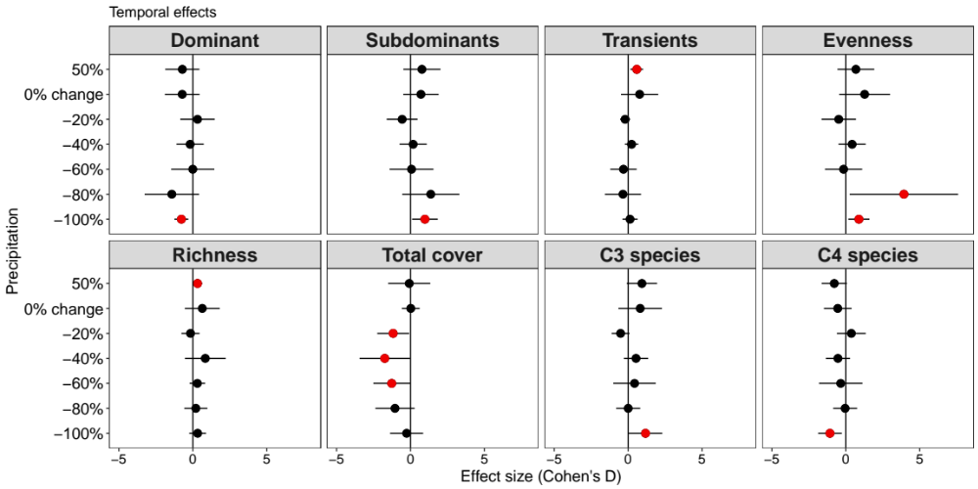
Figure 1. Average effect sizes (Cohen’s D) and 95% confidence interval (bars) of relative abundance (foliar cover %) for community-level within precipitation treatments. Note that evenness is based on Jaccard index and richness is based on the number of species. Year 2018 (after treatment application) was compared to year 2016 (before treatment application), including the control treatment (i.e. 0% change in precipitation). Red circles + bars denote significant effect sizes; red circles + bars to the right indicate positive effect sizes, and red circles + bars to the left indicate negative effect sizes.

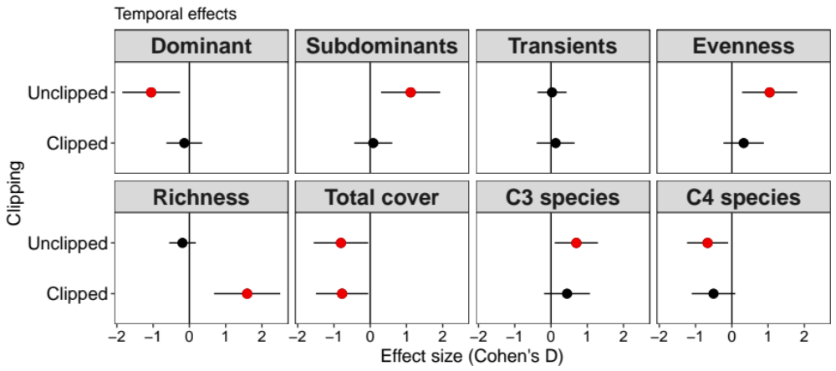
Figure 2. Average effect sizes (Cohen’s D) and 95% confidence interval (bars) of relative abundance (foliar cover %) for community-level in clipped vs. unclipped condition. Note that evenness is based on Jaccard index and richness is based on the number of species. Year 2018 (after treatment application) was compared to year 2016 (before treatment application), including the control treatment (i.e. unclipped plots). Red circles + bars denote significant effect sizes; red circles + bars to the right indicate positive effect sizes, and red circles + bars to the left indicate negative effect sizes.

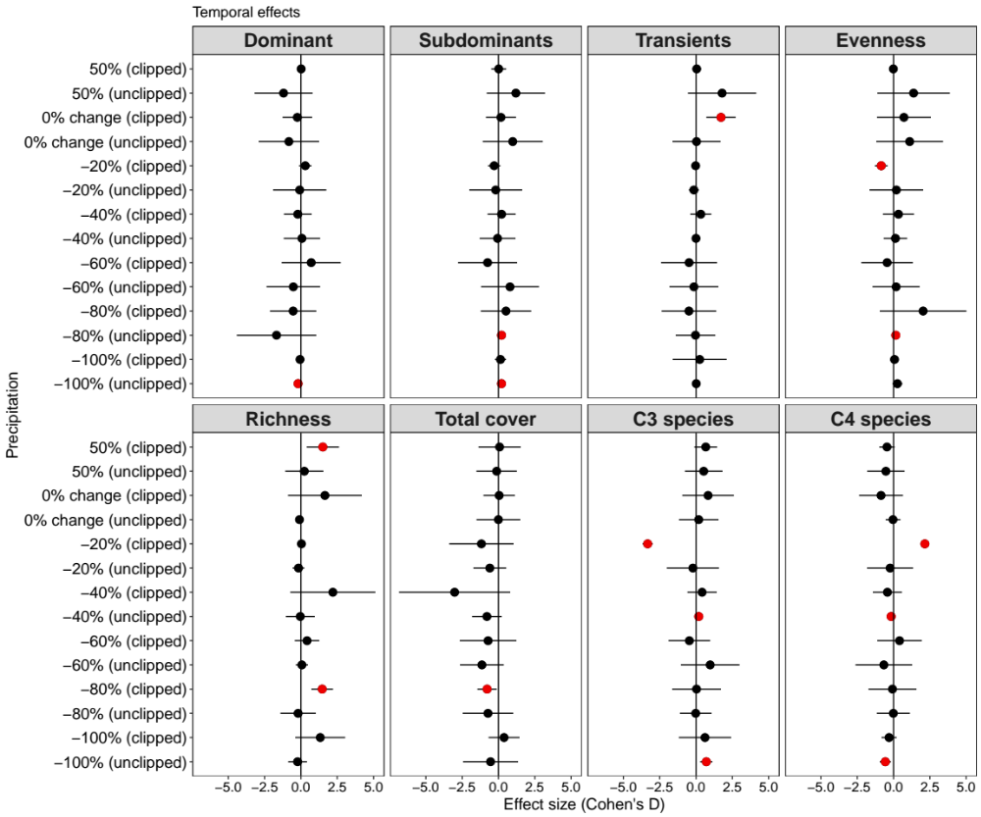
Figure 3. Average effect sizes (Cohen’s D) and 95% confidence interval (bars) of relative abundance (foliar cover %) for community-level within precipitation treatments in clipped vs. unclipped condition. Note that evenness is based on Jaccard index and richness is based on number of species. Year 2018 (after treatment application) was compared to year 2016 (before treatment application), including the controls treatments (i.e., 0% change in precipitation and unclipped plots). Red circles + bars denote significant effect sizes; red circles + bars to the right indicate positive effect sizes, and red circles + bars to the left indicate negative effect sizes.

Appendix S1
Table S1. Species composition, family, functional group, growth form, life history, average cover prior treatments application in May 2016 at the Kessler Atmospheric Ecological Field Station, Washington, Oklahoma. F = family, FG = functional group, GF = growth form, LH = life history and AC = average absolute cover (%).
Plant species | F | FG | GF | LH | AC (%)
Achillea millefolium | Asteraceae | C3 | forb | perennial | 0.39
Ambrosia psilostachya | Asteraceae | C3 | forb | annual/ perennial | 11.61
Anemone caroliniana | Ranunculaceae | C3 | forb | perennial | 0.02
Asclepias arenaria | Asclepiadaceae | C3 | forb | perennial | 0.36
Asclepias arenaria | Asclepiadaceae | C3 | forb | perennial | 0.36
Asclepias stenopyllum | Asclepiadaceae | C3 | forb | annual/ perennial | 0.37
Asclepias viridis | Asclepiadaceae | C3 | forb | perennial | 0.39
Bothriochloa ischaemum | Poaceae | C4 | graminoid | perennial | 3.96
Bouteloua sp. | Poaceae | C4 | graminoid | perennial | 2.20
Calylophus serrulatus | Onagraceae | C3 | forb | perennial | 8.08
Carex sp. | Cyperaceae | C3 | graminoid | perennial | 0.04
Castilleja sp. | Scrophulariaceae | C3 | forb | perennial | 0.01
Chamaecrista fasciculata | Fabaceae | C3 | forb | annual | 0.86
Cirsium undulatum | Asteraceae | C3 | forb | biennial/ perennial | 0.37
Coreopsis grandiflora | Asteraceae | C3 | forb | perennial | 1.54
Croton monanthogynus | Euphorbiaceae | C3 | forb | annual | 4.49
Dalea purpurea | Fabaceae | C3 | forb | perennial | 1.96
Desmanthus illinoensis | Fabaceae | C3 | forb | perennial | 0.42
Dichanthelium oligosanthes | Poaceae | C3 | graminoid | perennial | 7.85
Eleocharis spp. | Cyperaceae | C4 | graminoid | annual/ perennial | 0.90
Eragrostis sp. | Poaceae | C4 | graminoid | perennial | 1.80
Erigeron strigosus | Asteraceae | C3 | forb | annual/ biennial/ perennial | 4.5
Evax prolifera | Asteraceae | C3 | forb | annual | 1.29
Fimbristylis puberula | Cyperaceae | C3 | graminoid | perennial | 1.11
Galium virgatum | Rubiaceae | C3 | forb | annual | 0.96
Hedeoma hispida | Lamiaceae | C3 | forb | annual | 0.89
Juncus sp. | Juncaceae | C3 | graminoid | perennial | 0.36
Juniperus virginiana | Cupressaceae | C3 | woody | perennial | 0.02
Koeleria macrantha | Poaceae | C3 | graminoid | perennial | 0.38
Lespedeza cuneata | Fabaceae | C3 | forb | perennial | 2.88
Lespedeza hirta | Fabaceae | C3 | forb | perennial | 0.75
Lespedeza sp. | Fabaceae | C3 | forb | perennial | 0.36
Liatris squarrosa | Asteraceae | C3 | forb | perennial | 2.23
Oxalis stricta | Oxalidaceae | C3 | forb | perennial | 0.13
Panicum capillare | Poaceae | C4 | graminoid | annual | 0.37
Plantago patagonica | Plantaginaceae | C3 | forb | annual | 0.85
Plantago sp. | Plantaginaceae | C3 | forb | annual | 0.57
Plantago virginica | Plantaginaceae | C3 | forb | annual | 0.39
Prunus angustifolia | Rosaceae | C3 | woody | perennial | 0.36
Psoralidium tenuiflorum | Fabaceae | C3 | forb | perennial | 0.74
Pyrrhopappus sp. | Asteraceae | C3 | forb | perennial | 0.04
Ratibida columnifera | Asteraceae | C3 | forb | perennial | 0.07
Rhus copallinum | Anacardiaceae | C3 | woody | perennial | 0.36
Rhus glabra | Anacardiaceae | C3 | woody | perennial | 0.71
Schizachyrium scoparium | Poaceae | C4 | graminoid | perennial | 45.89
Sisyrinchium angustifolium | Iridaceae | C3 | forb | perennial | 0.43
Solidago ludoviciana | Asteraceae | C3 | forb | perennial | 0.02
Solidago sp. | Asteraceae | C3 | forb | perennial | 0.36
Sorghastrum nutans | Poaceae | C4 | graminoid | perennial | 7.50
Sporobolus compositus | Poaceae | C4 | graminoid | perennial | 6.62
Stenaria nigricans | Rubiaceae | C3 | forb | perennial | 0.74
Stenosiphon linifolius | Onagraceae | C3 | forb | perennial | 0.01
Symphyotrichum ericoides | Asteraceae | C3 | forb | perennial | 6.31
Tetraneuris scaposa | Asteraceae | C3 | forb | perennial | 0.77
Tragia sp. | Euphorbiaceae | C3 | forb | perennial | 0.01
Triodanis perfoliata | Campanulaceae | C3 | forb | annual | 0.01
Tridens flavus | Poaceae | C4 | graminoid | perennial | 0.37
Ulmus rubra | Ulmaceae | C3 | woody | perennial | 0.13
Verbena halei | Verbenaceae | C3 | forb | perennial | 0.37

Table S2. Volumetric soil water content (mean ± se, m3.m-3) and soil temperature (mean ± se, ˚C) during growing season of 2017 and 2018 across precipitation levels and clipping treatments.
 | 2017 | 2018
Treatment | Volumetric soil water content (m³.m⁻³)
Precipitation
-100% | 0.14 ± 0.00 | 0.13 ± 0.00
-20% | 0.16 ± 0.00 | 0.14 ± 0.00
-40% | 0.15 ± 0.00 | 0.14 ± 0.00
-60% | 0.16 ± 0.00 | 0.15 ± 0.00
-80% | 0.16 ± 0.00 | 0.16 ± 0.00
0% change (control) | 0.15 ± 0.00 | 0.15 ± 0.00
50% | 0.20 ± 0.00 | 0.17 ± 0.00
Clipping
clipped | 0.16 ± 0.00 | 0.15 ± 0.00
unclipped | 0.16 ± 0.00 | 0.15 ± 0.00
 | Soil temperature (˚C)
Precipitation
-100% | 27.93 ± 0.15 | 28.90 ± 0.13
-20% | 26.93 ± 0.15 | 28.10 ± 0.14
-40% | 27.48 ± 0.138 | 28.52 ± 0.12
-60% | 26.72 ± 0.128 | 27.97 ± 0.13
-80% | 27.23 ± 0.145 | 27.82 ± 0.11
0% change (control) | 25.46 ± 0.125 | 27.16 ± 0.11
50% | 26.54 ± 0.123 | 27.41 ± 0.09
Clipping
clipped | 26.90 ± 0.07 | 28.19 ± 0.07
unclipped | 26.90 ± 0.07 | 27.82 ± 0.06

Table S3. PERMANOVA and test for homogeneity of multivariate dispersions (PERMDISP) based on a Bray–Curtis similarity matrix of log(x+1) transformed plant species abundance. Permutations = 999. Significant results (P (perm) < 0.05) are shown bold; d.f. shown in parentheses.
 | Precipitation |  | Clipping |  | Precip. x Clip. |  | Soil moisture
 | F | P | F | P | F | P | F | P
Species composition
PERMANOVA
2017 | 1.25 (1) | 0.25 | 1.05 (1) | 0.39 | 0.67 (1) | 0.75 | 0.72(1) | 0.71
2018 | 1.66 (1) | 0.07 | 3.40 (1) | <0.01 | 0.77 (1) | 0.68 | 1.19(1) | 0.28
PERMDISP
2017 | 2.61 (6) | 0.03 | 0.08 (1) | 0.80 | 2.17 (13) | 0.04 | - | -
2018 | 3.56 (6) | 0.01 | 0.16 (1) | 0.70 | 1.56 (13) | 0.16 | - | -

Table S4. Pairwise comparisons following PERMDISP test results on precipitation effects based on table 1. Significant results (P (perm) < 0.05) are shown bold.
 | 2017 | 2018
Pairwise comparison | P | P
-100% precip. vs. -80% precip. | 0.31 | 0.31
-100% precip. vs. -60% precip. | 0.30 | 0.31
-100% precip. vs. -40% precip. | 0.04 | 0.01
-100% precip. vs. -20% precip. | 0.84 | 0.94
-100% precip. vs. 0% change in precip. | 0.29 | 0.06
-100% precip. vs. 50% precip. | 0.79 | 0.21
-80% precip. vs. -60% precip. | 0.89 | 0.87
-80% precip. vs. -40% precip. | 0.06 | 0.16
-80% precip. vs. -20% precip. | 0.06 | 0.33
-80% precip. vs. 0% change in precip. | 0.90 | 0.64
-80% precip. vs. 50% precip. | 0.16 | 0.04
-60% precip. vs. -40% precip. | 0.01 | 0.09
-60% precip. vs. -20% precip. | 0.05 | 0.38
-60% precip. vs. 0% change in precip.. | 0.82 | 0.43
-60% precip. vs. 50% precip. | 0.14 | 0.04
-40% precip. vs. -20% precip. | 0.00 | 0.03
-40% precip. vs. 0% change in precip. | 0.13 | 0.18
-40% precip .vs. 50% precip. | 0.00 | 0.00
-20% precip. vs. 0% change in precip. | 0.07 | 0.12
-20% precip. vs. 50% precip. | 0.47 | 0.30
0% change in precip. vs. 50% precip. | 0.16 | 0.01

Table S5. Average (%± s.e.) plant richness, evenness, relative cover of forbs (%), graminoids (%) and species-specific foliar cover (%) for clipping vs. unclipping under the precipitation gradient. Data are shown for 2017.
 |  | Precipitation
 |  | -100% |  |  | -80% |  |  | -60% |  |  | -40% |  |  | -20% |  |  | 0% change |  |  | 50%
Richness | clipped | 19.3 | ± | 1.9 | 19.0 | ± | 3.1 | 22.7 | ± | 2.7 | 22.0 | ± | 1.5 | 20.0 | ± | 1.5 | 19.3 | ± | 1.2 | 23.0 | ± | 2.0
Evenness | clipped | 0.6 | ± | 0.0 | 0.7 | ± | 0.0 | 0.7 | ± | 0.0 | 0.6 | ± | 0.1 | 0.6 | ± | 0.1 | 0.6 | ± | 0.0 | 0.7 | ± | 0.0
Forbs | clipped | 0.4 | ± | 0.1 | 0.3 | ± | 0.0 | 0.3 | ± | 0.1 | 0.2 | ± | 0.1 | 0.2 | ± | 0.0 | 0.3 | ± | 0.0 | 0.3 | ± | 0.0
Graminoids | clipped | 0.4 | ± | 0.2 | 0.5 | ± | 0.0 | 0.5 | ± | 0.1 | 0.6 | ± | 0.1 | 0.6 | ± | 0.1 | 0.6 | ± | 0.0 | 0.5 | ± | 0.0
Ambrosia psilostachya | clipped | 0.1 | ± | 0.1 | 0.2 | ± | 0.0 | 0.1 | ± | 0.1 | 0.0 | ± | 0.0 | 0.1 | ± | 0.0 | 0.1 | ± | 0.1 | 0.0 | ± | 0.0
Bothriochloa ischaemum | clipped | 0.0 | ± | 0.0 | 0.0 | ± | 0.0 | 0.0 | ± | 0.0 | 0.1 | ± | 0.1 | 0.2 | ± | 0.2 | 0.0 | ± | 0.0 | 0.1 | ± | 0.0
Calylophus serrulatus | clipped | 0.1 | ± | 0.0 | 0.0 | ± | 0.0 | 0.1 | ± | 0.0 | 0.1 | ± | 0.0 | 0.0 | ± | 0.0 | 0.0 | ± | 0.0 | 0.1 | ± | 0.1
Croton monanthogynus | clipped | 0.1 | ± | 0.1 | 0.0 | ± | 0.0 | 0.0 | ± | 0.0 | 0.0 | ± | 0.0 | 0.0 | ± | 0.0 | 0.0 | ± | 0.0 | 0.0 | ± | 0.0
Dalea purpurea | clipped | 0.0 | ± | 0.0 | 0.1 | ± | 0.0 | 0.0 | ± | 0.0 | 0.1 | ± | 0.0 | 0.1 | ± | 0.0 | 0.0 | ± | 0.0 | 0.1 | ± | 0.1
Dichanthelium oligosanthes | clipped | 0.0 | ± | 0.0 | 0.0 | ± | 0.0 | 0.0 | ± | 0.0 | 0.0 | ± | 0.0 | 0.0 | ± | 0.0 | 0.0 | ± | 0.0 | 0.0 | ± | 0.0
Erigeron strigosus | clipped | 0.0 | ± | 0.0 | 0.0 | ± | 0.0 | 0.1 | ± | 0.0 | 0.0 | ± | 0.0 | 0.0 | ± | 0.0 | 0.1 | ± | 0.0 | 0.1 | ± | 0.0
Lespedeza cuneata | clipped | 0.0 | ± | 0.0 | 0.0 | ± | 0.0 | 0.0 | ± | 0.0 | 0.0 | ± | 0.0 | 0.0 | ± | 0.0 | 0.1 | ± | 0.0 | 0.0 | ± | 0.0
Schizachyrium scoparium (Dominant) | clipped | 0.4 | ± | 0.1 | 0.3 | ± | 0.1 | 0.4 | ± | 0.1 | 0.5 | ± | 0.1 | 0.4 | ± | 0.1 | 0.4 | ± | 0.1 | 0.4 | ± | 0.1
Solidago rigida | clipped | 0.1 | ± | 0.0 | 0.0 | ± | 0.0 | 0.0 | ± | 0.0 | 0.0 | ± | 0.0 | 0.0 | ± | 0.0 | 0.0 | ± | 0.0 | 0.0 | ± | 0.0
Sorghastrum nutans | clipped | 0.1 | ± | 0.1 | 0.0 | ± | 0.0 | 0.1 | ± | 0.0 | 0.0 | ± | 0.0 | 0.0 | ± | 0.0 | 0.1 | ± | 0.0 | 0.1 | ± | 0.0
Sporobolus compositus | clipped | 0.0 | ± | 0.0 | 0.1 | ± | 0.0 | 0.0 | ± | 0.0 | 0.0 | ± | 0.0 | 0.0 | ± | 0.0 | 0.2 | ± | 0.1 | 0.1 | ± | 0.0
Symphyotrichum ericoides | clipped | 0.0 | ± | 0.0 | 0.1 | ± | 0.0 | 0.1 | ± | 0.0 | 0.0 | ± | 0.0 | 0.0 | ± | 0.0 | 0.0 | ± | 0.0 | 0.1 | ± | 0.0
Richness | unclipped | 14.0 | ± | 0.6 | 17.0 | ± | 0.6 | 16.7 | ± | 0.3 | 20.3 | ± | 2.3 | 19.0 | ± | 2.1 | 22.0 | ± | 1.5 | 17.0 | ± | 0.0
Evenness | unclipped | 0.6 | ± | 0.0 | 0.7 | ± | 0.0 | 0.7 | ± | 0.0 | 0.6 | ± | 0.0 | 0.7 | ± | 0.0 | 0.6 | ± | 0.0 | 0.7 | ± | 0.0
Forbs | unclipped | 0.3 | ± | 0.1 | 0.2 | ± | 0.1 | 0.3 | ± | 0.1 | 0.3 | ± | 0.1 | 0.2 | ± | 0.0 | 0.3 | ± | 0.0 | 0.3 | ± | 0.1
Graminoids | unclipped | 0.6 | ± | 0.1 | 0.6 | ± | 0.1 | 0.6 | ± | 0.1 | 0.5 | ± | 0.1 | 0.5 | ± | 0.1 | 0.6 | ± | 0.1 | 0.6 | ± | 0.1
Ambrosia psilostachya | unclipped | 0.1 | ± | 0.0 | 0.1 | ± | 0.0 | 0.1 | ± | 0.1 | 0.1 | ± | 0.0 | 0.1 | ± | 0.0 | 0.1 | ± | 0.1 | 0.1 | ± | 0.0
Bothriochloa ischaemum | unclipped | 0.1 | ± | 0.0 | 0.0 | ± | 0.0 | 0.0 | ± | 0.0 | 0.0 | ± | 0.0 | 0.1 | ± | 0.0 | 0.0 | ± | 0.0 | 0.1 | ± | 0.1
Calylophus serrulatus | unclipped | 0.1 | ± | 0.1 | 0.0 | ± | 0.0 | 0.1 | ± | 0.0 | 0.1 | ± | 0.0 | 0.0 | ± | 0.0 | 0.1 | ± | 0.0 | 0.1 | ± | 0.0
Croton monanthogynus | unclipped | 0.0 | ± | 0.0 | 0.0 | ± | 0.0 | 0.0 | ± | 0.0 | 0.0 | ± | 0.0 | 0.0 | ± | 0.0 | 0.0 | ± | 0.0 | 0.0 | ± | 0.0
Dalea purpurea | unclipped | 0.0 | ± | 0.0 | 0.0 | ± | 0.0 | 0.1 | ± | 0.0 | 0.1 | ± | 0.0 | 0.0 | ± | 0.0 | 0.0 | ± | 0.0 | 0.0 | ± | 0.0
Dichanthelium oligosanthes | unclipped | 0.1 | ± | 0.0 | 0.0 | ± | 0.0 | 0.1 | ± | 0.0 | 0.0 | ± | 0.0 | 0.0 | ± | 0.0 | 0.0 | ± | 0.0 | 0.0 | ± | 0.0
Erigeron strigosus | unclipped | 0.0 | ± | 0.0 | 0.0 | ± | 0.0 | 0.0 | ± | 0.0 | 0.0 | ± | 0.0 | 0.0 | ± | 0.0 | 0.0 | ± | 0.0 | 0.0 | ± | 0.0
Lespedeza cuneata | unclipped | 0.1 | ± | 0.0 | 0.1 | ± | 0.1 | 0.0 | ± | 0.0 | 0.0 | ± | 0.0 | 0.0 | ± | 0.0 | 0.1 | ± | 0.0 | 0.2 | ± | 0.0
Schizachyrium scoparium (Dominant) | unclipped | 0.5 | ± | 0.1 | 0.3 | ± | 0.0 | 0.4 | ± | 0.1 | 0.5 | ± | 0.1 | 0.3 | ± | 0.1 | 0.4 | ± | 0.1 | 0.3 | ± | 0.1
Solidago rigida | unclipped | 0.1 | ± | 0.0 | 0.0 | ± | 0.0 | 0.0 | ± | 0.0 | 0.1 | ± | 0.0 | 0.0 | ± | 0.0 | 0.0 | ± | 0.0 | 0.0 | ± | 0.0
Sorghastrum nutans | unclipped | 0.1 | ± | 0.0 | 0.0 | ± | 0.0 | 0.1 | ± | 0.0 | 0.0 | ± | 0.0 | 0.1 | ± | 0.1 | 0.1 | ± | 0.0 | 0.1 | ± | 0.0
Sporobolus compositus | unclipped | 0.0 | ± | 0.0 | 0.2 | ± | 0.1 | 0.1 | ± | 0.0 | 0.0 | ± | 0.0 | 0.1 | ± | 0.1 | 0.0 | ± | 0.0 | 0.2 | ± | 0.1
Symphyotrichum ericoides | unclipped | 0.1 | ± | 0.0 | 0.1 | ± | 0.0 | 0.1 | ± | 0.0 | 0.0 | ± | 0.0 | 0.0 | ± | 0.0 | 0.1 | ± | 0.0 | 0.0 | ± | 0.0

Table S6. Average (%± s.e.) plant richness, evenness, relative cover of forbs (%), graminoids (%) and species-specific foliar cover (%) for clipping vs. unclipping under the precipitation gradient. Data are shown for 2018.
 |  | Precipitation
 |  | -100% |  |  | -80% |  |  | -60% |  |  | -40% |  |  | -20% |  |  | 0% change |  |  | 50%
Richness | clipped | 24.3 | ± | 2.6 | 23.7 | ± | 3.0 | 21.7 | ± | 2.2 | 25.0 | ± | 1.7 | 22.0 | ± | 1.0 | 24.7 | ± | 1.3 | 24.0 | ± | 0.6
Evenness | clipped | 0.7 | ± | 0.0 | 0.8 | ± | 0.0 | 0.7 | ± | 0.0 | 0.7 | ± | 0.1 | 0.7 | ± | 0.0 | 0.7 | ± | 0.0 | 0.8 | ± | 0.0
Forbs | clipped | 0.3 | ± | 0.0 | 0.3 | ± | 0.1 | 0.3 | ± | 0.0 | 0.4 | ± | 0.1 | 36.5 | ± | 0.0 | 0.3 | ± | 0.0 | 0.4 | ± | 0.0
Graminoids | clipped | 0.4 | ± | 0.0 | 0.4 | ± | 0.1 | 0.5 | ± | 0.0 | 0.4 | ± | 0.1 | 54.0 | ± | 0.0 | 0.5 | ± | 0.0 | 0.4 | ± | 0.1
Ambrosia psilostachya | clipped | 0.1 | ± | 0.1 | 0.1 | ± | 0.0 | 0.0 | ± | 0.0 | 0.1 | ± | 0.0 | 11.0 | ± | 0.0 | 0.1 | ± | 0.0 | 0.1 | ± | 0.0
Bothriochloa ischaemum | clipped | 0.0 | ± | 0.0 | 0.0 | ± | 0.0 | 0.0 | ± | 0.0 | 0.0 | ± | 0.0 | 0.0 | ± | 0.1 | 0.0 | ± | 0.0 | 0.1 | ± | 0.0
Calylophus serrulatus | clipped | 0.0 | ± | 0.0 | 0.0 | ± | 0.0 | 0.0 | ± | 0.0 | 0.1 | ± | 0.0 | 7.0 | ± | 0.0 | 0.0 | ± | 0.0 | 0.1 | ± | 0.0
Croton monanthogynus | clipped | 0.0 | ± | 0.0 | 0.0 | ± | 0.0 | 0.0 | ± | 0.0 | 0.0 | ± | 0.0 | 2.2 | ± | 0.0 | 0.0 | ± | 0.0 | 0.0 | ± | 0.0
Dalea purpurea | clipped | 0.0 | ± | 0.0 | 0.0 | ± | 0.0 | 0.0 | ± | 0.0 | 0.1 | ± | 0.1 | 11.0 | ± | 0.0 | 0.0 | ± | 0.0 | 0.1 | ± | 0.0
Dichanthelium oligosanthes | clipped | 0.0 | ± | 0.0 | 0.0 | ± | 0.0 | 0.0 | ± | 0.0 | 0.0 | ± | 0.0 | 2.0 | ± | 0.0 | 0.0 | ± | 0.0 | 0.0 | ± | 0.0
Erigeron strigosus | clipped | 0.1 | ± | 0.0 | 0.0 | ± | 0.0 | 0.1 | ± | 0.0 | 0.0 | ± | 0.0 | 6.2 | ± | 0.0 | 0.0 | ± | 0.0 | 0.1 | ± | 0.0
Lespedeza cuneata | clipped | 0.0 | ± | 0.0 | 0.1 | ± | 0.0 | 0.0 | ± | 0.0 | 0.0 | ± | 0.0 | 0.0 | ± | 0.0 | 0.1 | ± | 0.0 | 0.0 | ± | 0.0
Schizachyrium scoparium (Dominant) | clipped | 0.3 | ± | 0.1 | 0.2 | ± | 0.0 | 0.4 | ± | 0.0 | 0.4 | ± | 0.1 | 45.8 | ± | 0.1 | 0.3 | ± | 0.0 | 0.3 | ± | 0.1
Solidago rigida | clipped | 0.1 | ± | 0.0 | 0.0 | ± | 0.0 | 0.0 | ± | 0.0 | 0.1 | ± | 0.1 | 1.0 | ± | 0.0 | 0.1 | ± | 0.0 | 0.1 | ± | 0.0
Sorghastrum nutans | clipped | 0.1 | ± | 0.0 | 0.1 | ± | 0.0 | 0.0 | ± | 0.0 | 0.0 | ± | 0.0 | 1.2 | ± | 0.0 | 0.0 | ± | 0.0 | 0.0 | ± | 0.0
Sporobolus compositus | clipped | 0.0 | ± | 0.0 | 0.1 | ± | 0.0 | 0.0 | ± | 0.0 | 0.0 | ± | 0.0 | 5.0 | ± | 0.0 | 0.0 | ± | 0.0 | 0.0 | ± | 0.0
Symphyotrichum ericoides | clipped | 0.1 | ± | 0.0 | 0.1 | ± | 0.1 | 0.0 | ± | 0.0 | 0.0 | ± | 0.0 | 0.3 | ± | 0.0 | 0.0 | ± | 0.0 | 0.0 | ± | 0.0
Richness | unclipped | 11.3 | ± | 0.7 | 15.0 | ± | 2.3 | 13.7 | ± | 0.3 | 19.7 | ± | 2.8 | 16.3 | ± | 0.3 | 15.3 | ± | 0.9 | 16.3 | ± | 0.3
Evenness | unclipped | 0.8 | ± | 0.0 | 0.8 | ± | 0.0 | 0.8 | ± | 0.0 | 0.7 | ± | 0.0 | 0.7 | ± | 0.1 | 0.8 | ± | 0.0 | 0.8 | ± | 0.0
Forbs | unclipped | 0.5 | ± | 0.1 | 0.3 | ± | 0.1 | 0.4 | ± | 0.0 | 0.3 | ± | 0.0 | 25.3 | ± | 0.1 | 0.3 | ± | 0.0 | 0.3 | ± | 0.1
Graminoids | unclipped | 0.4 | ± | 0.1 | 0.5 | ± | 0.1 | 0.5 | ± | 0.0 | 0.5 | ± | 0.1 | 53.3 | ± | 0.1 | 0.5 | ± | 0.1 | 0.4 | ± | 0.1
Ambrosia psilostachya | unclipped | 0.2 | ± | 0.0 | 0.1 | ± | 0.0 | 0.1 | ± | 0.0 | 0.1 | ± | 0.0 | 10.2 | ± | 0.0 | 0.1 | ± | 0.0 | 0.1 | ± | 0.0
Bothriochloa ischaemum | unclipped | 0.0 | ± | 0.0 | 0.0 | ± | 0.0 | 0.0 | ± | 0.0 | 0.0 | ± | 0.0 | 0.0 | ± | 0.1 | 0.0 | ± | 0.0 | 0.2 | ± | 0.0
Calylophus serrulatus | unclipped | 0.2 | ± | 0.0 | 0.0 | ± | 0.0 | 0.1 | ± | 0.0 | 0.1 | ± | 0.0 | 6.0 | ± | 0.0 | 0.1 | ± | 0.0 | 0.1 | ± | 0.0
Croton monanthogynus | unclipped | 0.0 | ± | 0.0 | 0.0 | ± | 0.0 | 0.0 | ± | 0.0 | 0.0 | ± | 0.0 | 1.2 | ± | 0.0 | 0.0 | ± | 0.0 | 0.0 | ± | 0.0
Dalea purpurea | unclipped | 0.0 | ± | 0.0 | 0.0 | ± | 0.0 | 0.1 | ± | 0.1 | 0.1 | ± | 0.0 | 2.0 | ± | 0.0 | 0.0 | ± | 0.0 | 0.0 | ± | 0.0
Dichanthelium oligosanthes | unclipped | 0.2 | ± | 0.0 | 0.0 | ± | 0.0 | 0.1 | ± | 0.0 | 0.0 | ± | 0.0 | 2.2 | ± | 0.0 | 0.1 | ± | 0.0 | 0.0 | ± | 0.0
Erigeron strigosus | unclipped | 0.0 | ± | 0.0 | 0.0 | ± | 0.0 | 0.0 | ± | 0.0 | 0.0 | ± | 0.0 | 1.2 | ± | 0.0 | 0.1 | ± | 0.0 | 0.1 | ± | 0.0
Lespedeza cuneata | unclipped | 0.0 | ± | 0.0 | 0.0 | ± | 0.0 | 0.0 | ± | 0.0 | 0.0 | ± | 0.0 | 0.0 | ± | 0.0 | 0.1 | ± | 0.1 | 0.2 | ± | 0.0
Schizachyrium scoparium (Dominant) | unclipped | 0.3 | ± | 0.1 | 0.2 | ± | 0.0 | 0.3 | ± | 0.1 | 0.4 | ± | 0.1 | 30.0 | ± | 0.1 | 0.3 | ± | 0.0 | 0.2 | ± | 0.0
Solidago rigida | unclipped | 0.1 | ± | 0.0 | 0.0 | ± | 0.0 | 0.1 | ± | 0.0 | 0.0 | ± | 0.0 | 1.0 | ± | 0.0 | 0.0 | ± | 0.0 | 0.0 | ± | 0.0
Sorghastrum nutans | unclipped | 0.0 | ± | 0.0 | 0.1 | ± | 0.1 | 0.1 | ± | 0.0 | 0.0 | ± | 0.0 | 11.0 | ± | 0.0 | 0.1 | ± | 0.0 | 0.1 | ± | 0.0
Sporobolus compositus | unclipped | 0.1 | ± | 0.0 | 0.2 | ± | 0.1 | 0.1 | ± | 0.0 | 0.0 | ± | 0.0 | 10.2 | ± | 0.0 | 0.1 | ± | 0.0 | 0.1 | ± | 0.0
Symphyotrichum ericoides | unclipped | 0.1 | ± | 0.0 | 0.2 | ± | 0.1 | 0.1 | ± | 0.0 | 0.1 | ± | 0.0 | 5.0 | ± | 0.0 | 0.1 | ± | 0.0 | 0.1 | ± | 0.0

Table S7. Measures of plant community changes (species gains, losses and turnover) from 2017 to 2018 in each treatment. Shown are means ± s.e.
Precipitation |  | Species gains |  |  | Species losses |  |  | Species turnover
-100% |  | 0.29 | ± | 0.05 | 0.18 | ± | 0.00 | 0.47 | ± | 0.05
-80% |  | 0.29 | ± | 0.07 | 0.23 | ± | 0.03 | 0.52 | ± | 0.10
-60% |  | 0.21 | ± | 0.02 | 0.26 | ± | 0.04 | 0.47 | ± | 0.02
-40% |  | 0.25 | ± | 0.01 | 0.16 | ± | 0.04 | 0.41 | ± | 0.04
-20% |  | 0.24 | ± | 0.05 | 0.24 | ± | 0.03 | 0.49 | ± | 0.08
0% change |  | 0.25 | ± | 0.03 | 0.26 | ± | 0.07 | 0.50 | ± | 0.04
50% |  | 0.24 | ± | 0.01 | 0.25 | ± | 0.03 | 0.48 | ± | 0.02
Clipping alone |  | Species gains |  |  | Species losses |  |  | Species turnover
clipped |  | 0.30 | ± | 0.02 | 0.20 | ± | 0.01 | 0.50 | ± | 0.02
unclipped |  | 0.17 | ± | 0.02 | 0.29 | ± | 0.02 | 0.45 | ± | 0.02
Precipitation |  | Species gains |  |  | Species losses |  |  | Species turnover
-100% | clipped | 0.36 | ± | 0.04 | 0.21 | ± | 0.02 | 0.57 | ± | 0.06
-80% | clipped | 0.36 | ± | 0.06 | 0.20 | ± | 0.02 | 0.56 | ± | 0.08
-60% | clipped | 0.23 | ± | 0.03 | 0.26 | ± | 0.03 | 0.49 | ± | 0.05
-40% | clipped | 0.26 | ± | 0.01 | 0.16 | ± | 0.03 | 0.41 | ± | 0.03
-20% | clipped | 0.27 | ± | 0.04 | 0.19 | ± | 0.03 | 0.47 | ± | 0.05
0% change | clipped | 0.36 | ± | 0.04 | 0.19 | ± | 0.03 | 0.55 | ± | 0.02
50% | clipped | 0.26 | ± | 0.02 | 0.21 | ± | 0.03 | 0.47 | ± | 0.01
-100% | unclipped | 0.11 | ± | 0.02 | 0.28 | ± | 0.05 | 0.38 | ± | 0.06
-80% | unclipped | 0.22 | ± | 0.06 | 0.32 | ± | 0.08 | 0.54 | ± | 0.09
-60% | unclipped | 0.15 | ± | 0.00 | 0.30 | ± | 0.03 | 0.46 | ± | 0.02
-40% | unclipped | 0.18 | ± | 0.04 | 0.21 | ± | 0.07 | 0.38 | ± | 0.05
-20% | unclipped | 0.19 | ± | 0.07 | 0.30 | ± | 0.03 | 0.48 | ± | 0.09
0% change | unclipped | 0.11 | ± | 0.02 | 0.37 | ± | 0.07 | 0.48 | ± | 0.06
50% | unclipped | 0.20 | ± | 0.01 | 0.23 | ± | 0.02 | 0.44 | ± | 0.03

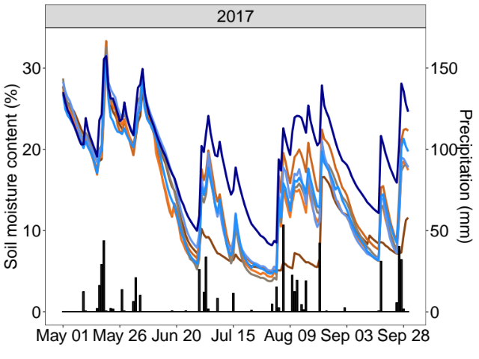
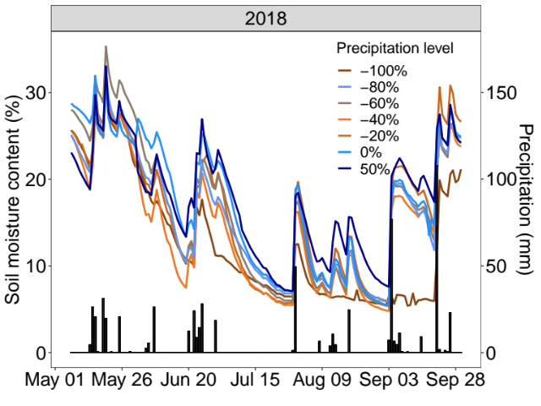
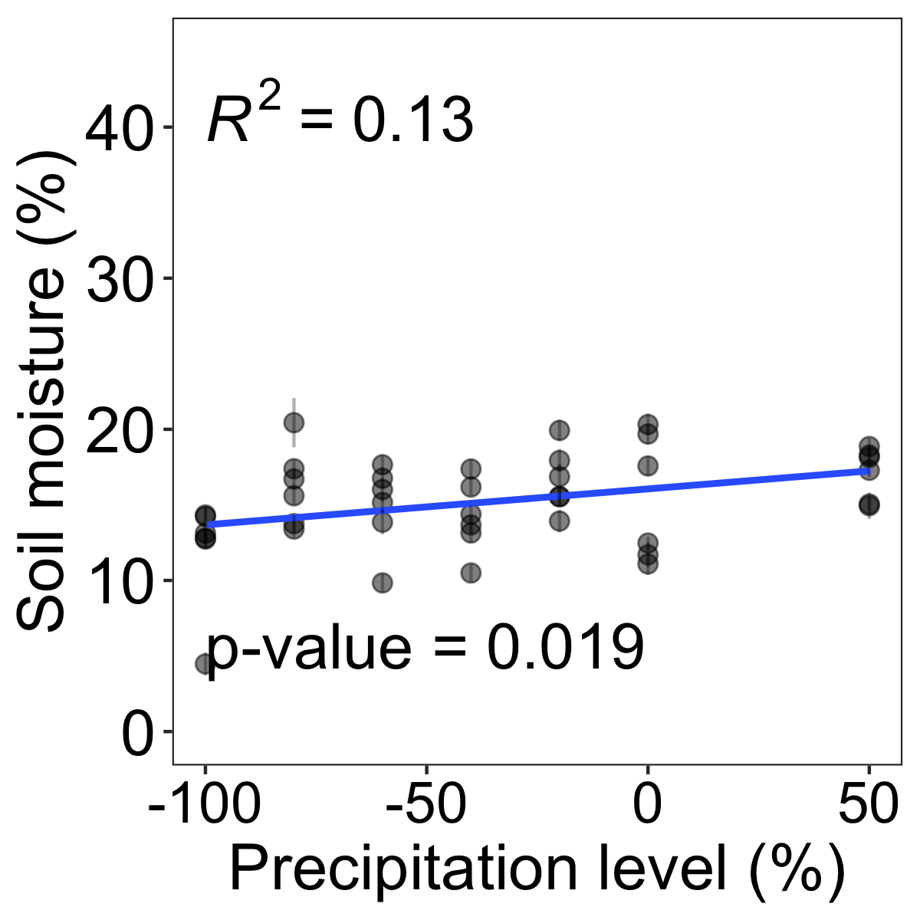
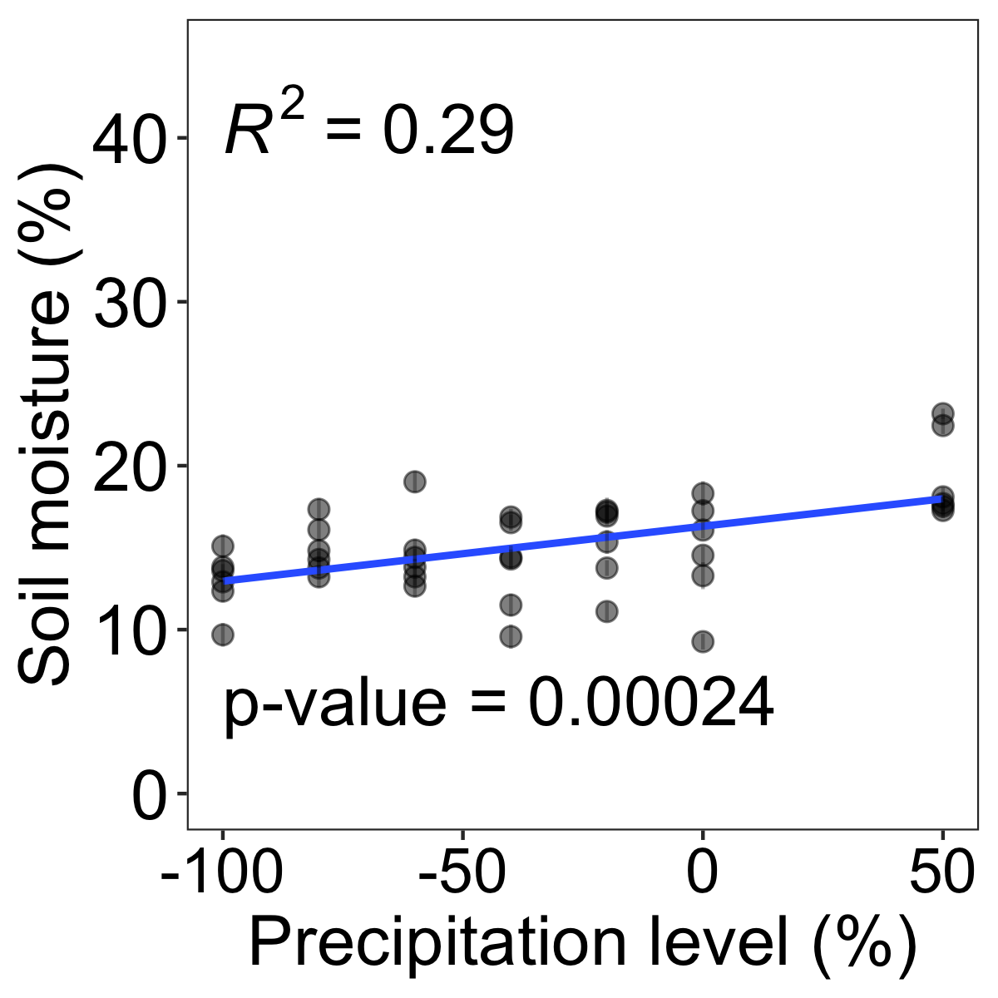
Figure S1. Top panel: Daily soil moisture and precipitation measurements during 2017 and 2018 growing season for all treatments. Bottom panel: Soil moisture content (%, mean±se) regression across the precipitation gradient for each year.

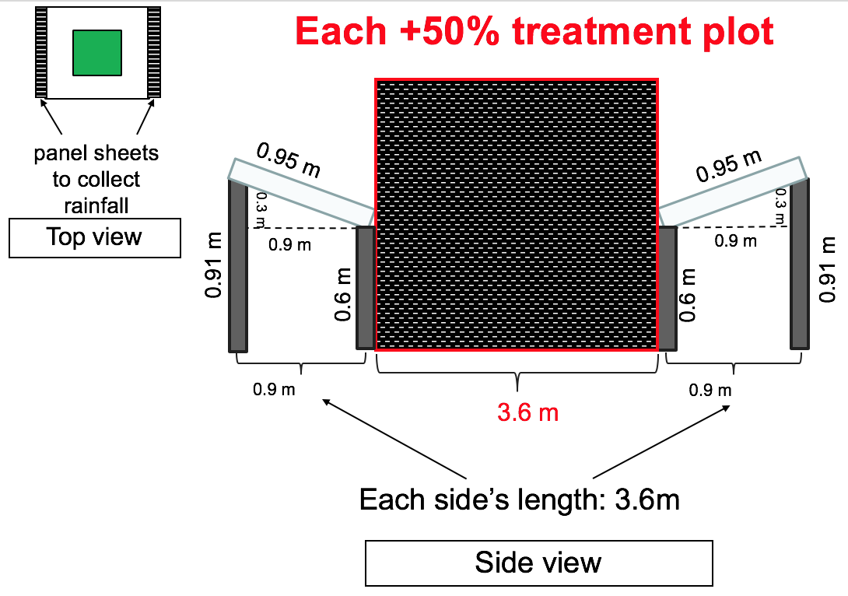
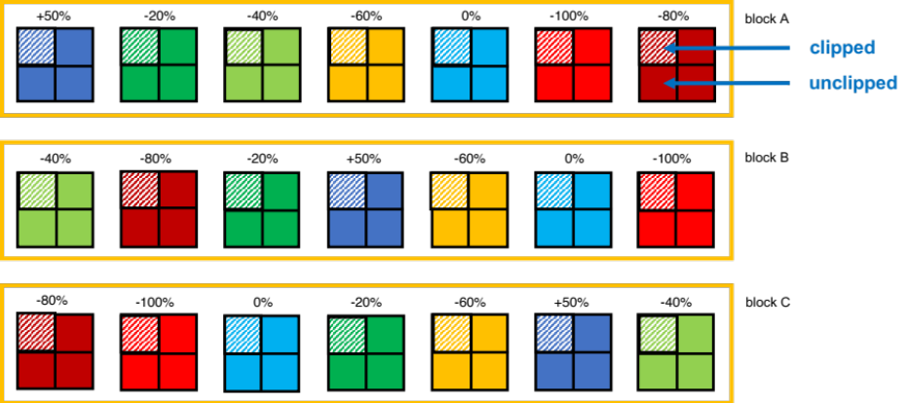

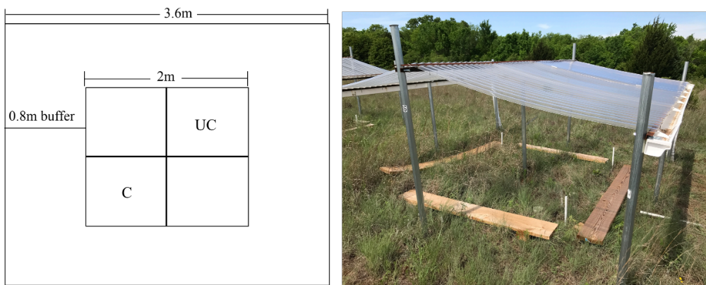
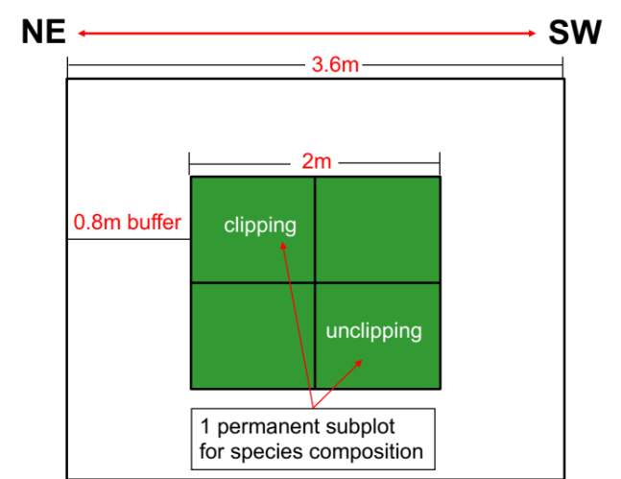
Figure S2. Experimental design showing (top panel) arrangement of drought shelters that produced the precipitation gradient distributed in three blocks (n=3, N=21): -100%, -80%, -60%, -40%, -20% precipitation reduction, 0% change (no rainfall change), and 50% precipitation addition; and arrows pointing clipped and unclipped subplots. Top right panel individually illustrates a +50 precipitation addition plot. Bottom panel shows left: illustration of a plot and its subplots, and right: phot of plot at Kessler Atmospheric Ecological Field Station, in Washington, Oklahoma. Subplots were clipped once a year during the growing season (clipping treatment) or left unclipped (unclipping treatment or control).

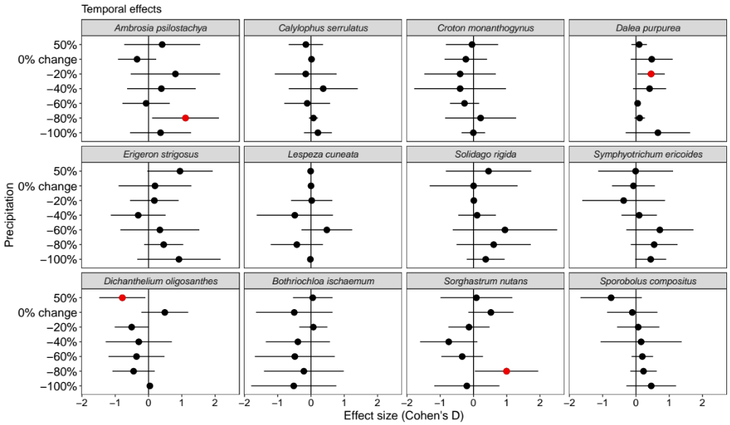
Figure S3. Average effect sizes (Cohen’s D) and 95% confidence interval (bars) of relative abundance (foliar cover %) for most common species within precipitation treatments. Year 2018 (after treatment application) was compared to year 2016 (before treatment application), including the control treatment (i.e. 0% precipitation). Red circles + bars denote significant effect sizes; red circles + bars to the right indicate positive effect sizes, and red circles + bars to the left indicate negative effect sizes.

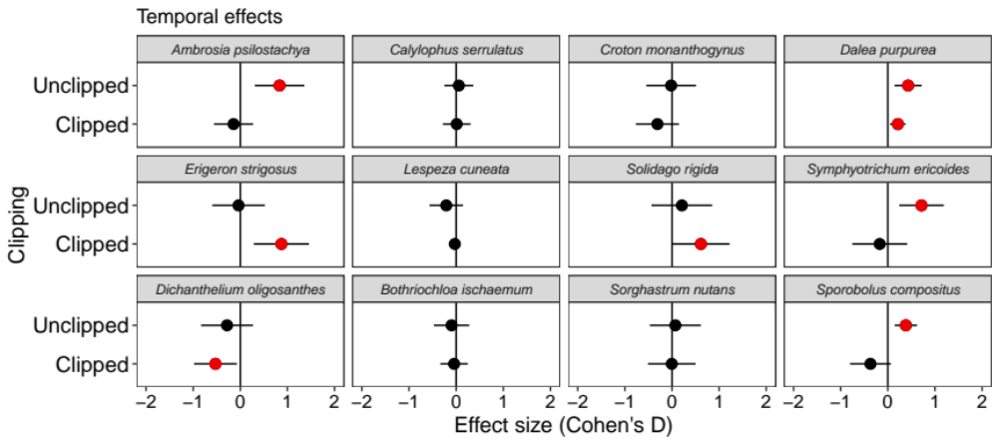
Figure S4. Average effect sizes (Cohen’s D) and 95% confidence interval (bars) of relative abundance (foliar cover %) for most common species in clipping treatment and unclipping conditions. Year 2018 (after treatment application) was compared to year 2016 (before treatment application), including the control treatment (i.e. unclipped plots). Red circles + bars denote significant effect sizes; red circles + bars to the right indicate positive effect sizes, and red circles + bars to the left indicate negative effect sizes.

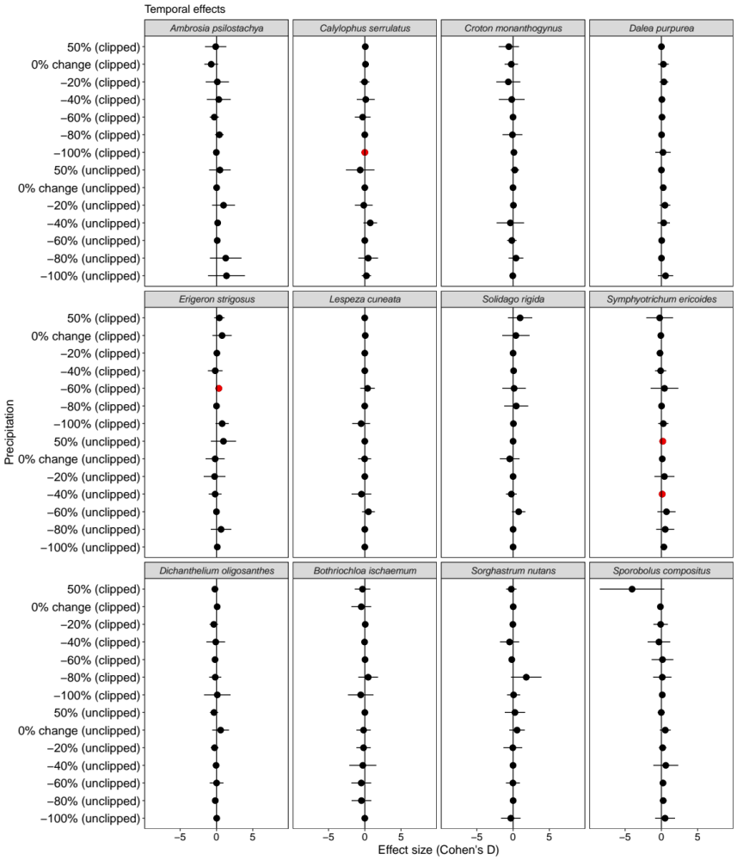

Figure S5. Average effect sizes (Cohen’s D) and 95% confidence interval (bars) of relative abundance (foliar cover %) for most common species within precipitation treatments in clipped and unclipped conditions. Year 2018 (after treatment application) was compared to year 2016 (before treatment application), including the controls treatments (i.e. 0% precipitation and unclipped plots). Red circles + bars denote significant effect sizes; red circles + bars to the right indicate positive effect sizes, and red circles + bars to the left indicate negative effect sizes.

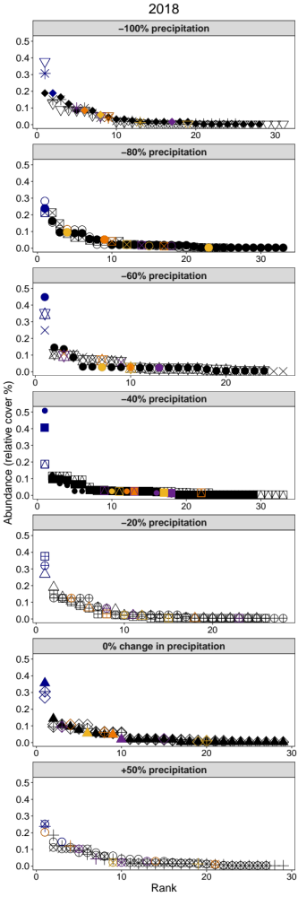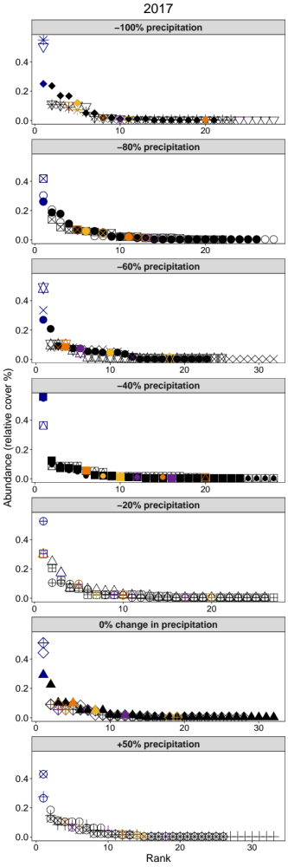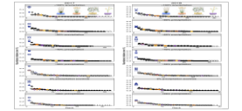
Figure S6. Rank abundance curves for each replicate (different symbols) in each precipitation treatment (-100%, -80%, -60%, -40%, -20%, 0% change[control], +50% precipitation) demonstrate how the community changed in 2017 and 2018. The tail of the rank abundance curve shows rare species. Illustrated are species that were significantly affected by precipitation (P < 0.5, Table 1), but also important species in the system, such as the dominant species, Schizachyrium scoparium and sub-dominant Sorghastrum nutans shown, respectively, in shades of blue and orange. Erigeron strigosus (purple shades) increased in relative abundance with more precipitation, while Croton monanthogynus (yellow shades) decreased.

Chapter Two
In revision in Scientific Reports

PRECIPITATION EFFECTS ON GRASSLAND PLANT PERFORMANCE ARE LESSENED BY HAY HARVEST
Karen Castillioni¹, Michael A. Patten ², Lara Souza¹

¹Oklahoma Biological Survey and Department of Microbiology and Plant Biology, University of Oklahoma, Norman, Oklahoma, 73019, USA
²Ecology Research Group, Faculty of Biosciences and Aquaculture, Nord University, N-7729 Steinkjer, Norway

Abstract
Climate and human management, such as hay harvest, shape grasslands. With both disturbances co-occurring, understanding how these ecosystems respond to these combined drivers may aid in projecting future changes in grasslands. We used an experimental precipitation gradient combined with mimicked acute hay harvest (clipping once a year) to examine 1) whether hay harvest influences precipitation effects on plant performance (cover and height) and 2) the role of inter-specific responses in influencing plant performance. We found that hay harvest reduced the strength of precipitation effects on plant performance through changes in bare-ground soil cover. Species performance mainly influenced change in abiotic factors, often responding negatively, as hay harvest increased bare-ground amount. Conversely, altered precipitation without hay harvest promoted plant species performance through abiotic factors change first, followed by biotic. Most species, including the dominant grass Schizachyrium scoparium, increased their performance with greater leaf area index (proxy for canopy structure). Our experiment demonstrates that plant performance responds directly to abiotic factors with hay harvest, but indirectly without hay harvest. Positive effects of increasing precipitation were likely due to microhabitat amelioration and resource acquisition, thus inclusion of hay harvest as a disturbance lessens positive impacts of biotic variables on species performance to climate change.
Keywords: vegetation, clipping, neighbors, climate change, disturbance, biotic, microclimate.

Introduction
Climate and human management are some of the important factors that shape vegetation dynamics in grasslands. Climate - in particular factors that influence temperature and soil moisture - is the primary determinant of plant productivity, with human management operating within constraints imposed by moisture availability^{1,2}. Climate models forecast increased precipitation variability in grasslands³, leading to more frequent dry periods in many regions^{4,5}. Altered precipitation already has created novel abiotic and biotic conditions across ecosystems, resulting in community shifts that alter ecosystem structure and function^{6,7}. Combining altered precipitation and hay harvest, studies suggest that their interactions could substantially affect plant community composition and total aboveground net primary productivity (ANPP) ^{8–10}. Because these drivers may influence community and ecosystem responses differently¹¹, they must be manipulated and studied in combination to draw realistic conclusions about overall plant performance under future environmental change scenarios¹².
Soil moisture availability limits net primary production in grasslands, with growing-season precipitation determining ANPP over time^{13,14}. Like ANPP, grassland species richness often increases with precipitation¹⁵, while species might undergo abundance change (species re‐ordering⁶). Increased drought incidence will therefore negatively impact ANPP in grasslands but have a variable impact on plant community composition. Abiotic stressors caused by altered precipitation drive community change, yet biotic structure (e.g., biomass production, canopy structure and community richness) influences community‐level responses by mediating effects of these stressors¹⁶. Species in a community might ameliorate the environmental stress for other species by facilitating their coexistence, establishment, or growth^{17–19}. For example, neighboring species ameliorate some or many stressful environmental conditions, causing positive impacts on focal species²⁰, and plants of different growth forms can alter the canopy structure of plant communities²¹, resulting in competitive hierarchies with effects on the plant performance due to the directional supply of light ^{22–24}. Plant communities thus exhibit a particular suite of varied species performance as a result of particular combinations of biotic structure ^{25,26}, yet under severe environmental change, biotic structure may become unimportant to determine plant performance, relative to the effect of the abiotic stress. Only the most stress-tolerant species can persist under harsh conditions ^{27–29}.
In the US Great Plains, hay harvest is a common human management practice that acts as a strong driver of plant community structure and ecosystem function ¹⁰. Hay harvest, whether acute or chronic³⁰, increases ground-level light penetration and surface temperature, which can have mixed impacts on plants¹². Above-ground biomass removal by hay harvest can be beneficial for growth of early emerging species due to reduced physical barrier for growth and light limitation³¹. Alternatively, hay harvest increases soil insolation, resulting in higher surface temperatures, ultimately filtering for heat tolerant species³². Plants surrounded by soil exposure experience greater rates of attack from herbivores because of greater plant apparency³³. Further, increased bare-ground may increase visibility to herbivores but may also expose them to greater drought stress³⁴. Increased bare-ground amount also reduces densities of plant neighbors, which can be facilitators in harsh conditions³⁴. Combined, drought and hay harvest may result in higher surface temperatures and reduced moisture - by less precipitation or more water loss via soil evaporation³⁵ - than found with altered precipitation or hay harvest alone, reducing both plant growth and cover.
Communities dominated by different functional types could differ in their response to abiotic or biotic factors that ultimately shape their performance (cover and height). Plant functional traits may drive the structure of biological communities^{36–38}. Functional traits that allow tolerance to drought may overlap with traits that provide tolerance to disturbance like vegetation clipping, thus traits can ultimately determine the response of functional types^{39,40}. For example, C₄ plants use water more efficiently⁴¹, and some are adapted to disturbances such as grazing, which should give them higher competitive ability to handle water stress and defoliation relative to C₃ counterparts^{42,43}. Research focusing on responses of C₃ and C₄ species must consider adaptations of these functional types to tease apart how performance of each is shaped by abiotic vs. biotic variables across an environmental gradient.
Understanding the role of interactive effects of disturbances is important for modelling and projecting future plant community dynamics and the stability of ecosystem functions as climate changes. Here, we report results from a novel field experiment in which we manipulated precipitation at multiple levels with rain-out shelters - a gradient of increasing precipitation (from extreme drought [-100% precipitation] to precipitation addition [+50% precipitation]) - and tested acute clipping once a year (hereafter hay harvest). We tested for hay harvest as an acute disturbance (i.e., occurring once a year) as we were not aiming to address the effects of its frequency, but occurrence. We define hay harvest as a disruption of biotic structure that leads to a pulse in available resources, such as light and space³⁰. We examined the effects of altered precipitation in two scenarios, with and without acute hay harvest, to address the following questions: (1) Can hay harvest influence the effect of a gradient from drought to increasing precipitation on abiotic and biotic conditions, and consequently alter overall plant performance?; (2) What is the influence of inter-specific responses in driving plant performance responses to hay harvest and a gradient from drought to increasing precipitation? We hypothesized that (1) hay harvest will lessen the effects of increasing precipitation by reducing plant cover and resulting in decreased plant performance (i.e., height and cover)⁴⁴; and that (2) differences in inter-specific responses (via inter-specific differences in functional traits) will play a key role in determining plant performance under hay harvest and increasing precipitation, as plant species have varied tolerance to soil moisture and clipping^{39,40}.

Methods
Study site
We studied the plant species and community responses in 2017 from June to August at Kessler Atmospheric and Ecological Field Station (KAEFS), a mesic and mixed grass prairie in central Oklahoma, USA (34°59'N, 97°31'W), last farmed >45 yr. ago. Permission to use this study site was obtained from KAEFS Steering Committee. The study site is dominated by C₄ and C₃ graminoids, and C₃ forbs⁴³. Annual precipitation in 2017 was 992.12 mm (historical average in 1998-2016: 872.76 mm) and mean air temperature was 16.66°C (historical average in 1998-2016: 16.15°C) (Figure S1, Oklahoma Climatological Survey).

Experimental design
To determine the response of focal plants to a precipitation gradient and clipping, we used replicated rain-out shelters established in January/February 2016 to create multiple levels of precipitation. This experimental study is part of Drought-Net, a coordinated global network examining terrestrial ecosystem sensitivity to drought. We used a randomized block split-plot design with seven precipitation treatments (five water exclusion levels [-20%, -40%, -60%, -80%, and -100% of the ambient precipitation], one water addition [+50% of the ambient precipitation], and a control [0% change in precipitation or no change]) replicated three times (replication number follows Drought-Net protocol) for a total of 21, 2 x 2 m plots (Figure S2). Subplots are 1x1 m plots within the 21 2x2m plots. One of the trade-offs to the low replication in our experimental design is the wider spectrum of treatment levels we used which allowed us to explore differing precipitation scenarios⁴⁵. Soil moisture reflected the proposed precipitation gradient¹². In addition, one subplot within each precipitation treatment plot was clipped once to mimic hay harvest at the end of the growing season in September 2016. All aboveground biomass was clipped at a height of 10 cm from ground level to mimic hay harvest⁴⁶. Diagonally from the clipping subplot was the unclipped control subplot.

Plant Performance
To determine the effects of the precipitation gradient and hay harvest on the species performance – quantified by plant height and plant cover - we selected the nine most common plant species (focal plants: six C₃ species – i.e., five forbs and one graminoid - and three C₄ grasses) at our study site. The selected species and their mean (±SE henceforth) relative plant cover were estimated in 2016 (baseline year): the C₃ forbs are Ambrosia psilostachya (7.3±1.1%), Erigeron strigosus (1.7±0.5%), Croton monanthogynus (2.7±0.5%), Solidago nemoralis (0.1±0.1%), and Symphyotrichum ericoides (3.7±0.8%); while the C₃ graminoid is Dichanthelium oligosanthes (4.6±0.8%), and C₄ graminoids are Sorghastrum nutans (5.1±0.8%), Sporobolus compositus (5.3±1.0%) and Schizachyrium scoparium (37.2±2.1%). These species were also selected because they occurred in 70% of the plots. We tagged one adult individual of each species in each experimental plot, i.e., clipped, and unclipped subplots across the precipitation treatments. For each individual tagged species, we estimated percentage foliar cover (i.e., vegetative cover including stems and leaves) as a measure of cover using a modified Braun-Blanquet cover-abundance scale that included seven categories of percentage foliar cover: 1%, 1–5%, 5–25%, 25–50%, 50–75%, 75-95%, 95-100%⁴⁷. We used the median of each assigned cover class as the cover for each individual tagged species in a plot, and maximum percentage foliar cover between June and July sampling periods for each species. We measured height by holding the tallest leaf upright from the base of the stem to the tip of the leaf once in early August 2017. Our study complies with the IUCN Policy Statement on Research Involving Species at Risk of Extinction and the Convention on the Trade in Endangered Species of Wild Fauna and Flora.

Biotic variables
To determine the effects of a precipitation gradient and hay harvest on biotic variables, we measured community richness as the total number of species in each plot once in the peak of the growing season in July 2017. We estimated ANPP at the end of the growing season (September 2017) by using clipping standing biomass in clipped subplots (cut at 10 cm from ground level in 1 x 1 m subplots). Standing biomass for ANPP from unclipped plots was clipped in 20 x 100 cm strips also in September, following Drought-Net protocol, and scaled up to g.m⁻² as a control for clipped subplots. Clipped materials were oven-dried and weighed. We measured leaf area index (LAI) – canopy structure based on the projected area of leaves – averaged across the months of June, July and August 2017 by using AccuPAR LP-80.

Abiotic variables
To determine the effects of a precipitation gradient and hay harvest on abiotic variables, we measured soil moisture, soil temperature and bare-ground cover¹². Soil probes (Decagon 5TM, ICT International) continuously measured percentage volumetric water content (VWC, i.e., soil moisture, Table S1) and soil temperature (°C) at a depth of 10 cm, every 10 minutes, from May 2017 to September 2017, in each clipped and unclipped subplot nested in precipitation treatment plots. We then averaged soil moisture and soil temperature within the same time frame, corresponding to the plant growing season. Additionally, we visually estimated bare-ground cover (%) using the same modified Braun-Blanquette cover-abundance scale.

Statistical Analysis
We used a piecewise structural equation model (SEM)^{48,49} that accounted for both direct and indirect effects to achieve a system-understanding of the major drivers of plant performance. A similar approach has been used to pinpoint the direct and indirect effects of our precipitation gradient experiment and clipping on arthropod abundance and diversity in our previous study¹². Structural equation modelling is particularly useful in large-scale correlative studies because it allows us to partition causal influences among multiple variables, and to separate the direct and indirect effects of the predictors included in the model⁵⁰. Our a priori model based on our current knowledge is available in Figure S3. We built two piecewise SEMs, one for altered precipitation effects with hay harvest and another for without hay harvest. All piecewise SEMs contained plant cover and height of all focal species of the community as the response variable, with soil moisture, soil temperature, and bare-ground cover as abiotic predictor variables, and community richness, ANPP, and LAI as biotic predictor variables. Separate SEMs for C₃ forbs, C₃ graminoid and C₄ graminoids were also performed. Before running SEMs, we used Z-scores to scale variables. We included species identity as a random factor in our models because individual responses can influence overall plant focal height and cover. In order to resolve pseudo-replication due to repeated sampling, we also included plot nested within block as a random variable in all mixed model regressions. We used tests of directed separation to include missing paths. We used a single piecewise SEM model based on our a priori model for altered precipitation effects under hay harvest and no hay harvest and did not remove non-significant links. In comparison with traditional SEM, piecewise SEMs are less restricted by the number of links per sample size, and Fisher’s C is used as the goodness-of-fit statistic ^{48,49}. As in traditional SEM, a non-significant P-value indicates a well-fit model. We conducted Piecewise SEMs by using piecewiseSEM⁴⁹ and nlme⁵¹ packages in R ⁵².
We used generalized linear mixed models (GLMM) to test the significance of individual relationships on variables (i.e., height and abundance) for each species. Plot was used as a random effect nested within block. The level of significance for all statistical tests was α = 0.05. A gamma error distribution (inverse link) was used to model continuous variables, such as species-specific height and cover, as well as abiotic and biotic variables; while Poisson error distribution (log link) was used to model discrete counting variables, such as community richness when we assessed precipitation and hay harvest effects. To test the independent effects of the precipitation gradient and hay harvest on biotic and biotic variables, we conducted a GLMM with the same approach described above. We log-transformed response variables to better meet normality assumptions. All models were checked for overdispersion and normal distribution. We performed models by using the glmer function in the lme4 package in R⁵².

Results
Precipitation gradient and hay harvest effects on overall plant performance
Effects of increased precipitation on plant performance were lessened with vs. without hay harvest. A precipitation gradient without hay harvest increased plant performance through changes in both abiotic and biotic conditions. In SEMs with and without hay harvest, changes in focal plant height were correlated positively with changes in focal plant cover.
Hay harvest had a strong negative effect on bare-ground cover (P=<0.001, Table S4): bare ground increased from 4.2±0.85% in no hay harvested plots to 21.0±1.70% in hay harvested plots. In the SEM, bare-ground cover increased with soil temperature, which decreased in response to increasing precipitation (Figure 1a). This change in bare-ground cover was the only significant link to focal plant performance (plant height, regression coefficient: -0.16) in the Hay Harvest SEM (Figure 1a, Table S2, Fisher’s C = 5.15, AICc = 151.15, P = 0.52). Under hay harvest, increasing precipitation directly promoted community richness (regression coefficient: 0.31) and soil moisture (regression coefficient: 0.19). In turn, decrease in soil temperature (through precipitation increase) was negatively correlated with LAI (regression coefficient: -0.11) and ANPP (regression coefficient: -0.80), although none of these changes affected plant performance.
In the No Hay Harvest SEM, increasing precipitation strongly influenced plant performance through two routes: 1) increased soil moisture that increased community richness but, subsequently, decreased overall focal plant height (regression coefficient: -0.09) (Figure 1b, Table S3, Fisher’s C = 12.03, AICc = 158.04, P = 0.06); 2) decreased soil temperature, which decreased LAI but increased plant performance (Figure 1b, Table S2). Further, increase in soil moisture had a positive effect on ANPP that, subsequently, promoted LAI (regression coefficient: 0.39).

Species identity influence on plant performance
We further examined direct relationships between key biotic and abiotic variables that promoted change in plant performance variables for each species using GLMMs. These analyses allowed us to explore how focal species identity could influence overall performance in our SEMs.

- Hay harvest across the precipitation gradient
In this scenario, below-ground had direct negative effects on species performance in the Hay Harvest SEM. Ambrosia psilostachya (C₃ forb) and Sporobolus compositus (C₄ graminoid) height decreased with increased bare-ground cover (Figure 2a, Table 5S). Other abiotic variables shared positive and negative relationships with plant performance variables (Figure 2a, Table 5S). For example, only C₄ graminoids responded to changes in soil moisture - Schizachyrium scoparium and Sorghastrum nutans height increased with increased soil moisture, while Sporobolus compositus height was negatively related to soil moisture. Only two species’ heights changed with increased temperature - Sorghastrum nutans was negatively affected, but Solidago nemoralis increased. Regarding focal species cover (Figure 2b, Table S6), the C₃ Symphyotrichum ericoides slightly increased with soil moisture; in contrast, the C₄ Sorghastrum nutans decreased with increased soil temperature.
Only Solidago nemoralis and Dichantelium oligosanthes height decreased with increased community richness, but height of Croton monanthogynus, Erigeron strigosus, Symphyotrichum ericoides increased (Figure 3). None of the C₄ species responded (Figure 3). High values of LAI corresponded to increased height of Symphyotrichum. ericoides, but the opposite was held for Croton monanthogynus, Solidago. nemoralis and Sporobolus compositus (Figure 3a). Increased ANPP was associated with increased height of the Schizachrium scoparium and Sorghastrum nutans, and with Erigeron strigosus but decreased height of Croton monanthogynus, Solidago nemoralis and Sporobolus compositus (Figure 3a). Regarding focal species cover (Figure 3b, Table 2), the cover of C₃ grass Dichantelium oligosanthes and the C₃ forb Symphyotrichum ericoides correlated positively with community richness. Increased LAI corresponded to decreased cover of Croton monanthogynus and Solidago nemoralis. The same pattern held for ANPP, except that Sorghastrum nutans cover increased with increased ANPP.

- No hay harvest across the precipitation gradient
Bare-ground cover predominantly correlated negatively to focal species height, whereas soil moisture and soil temperature shared a mix of positive and negative relationships across species (Figure 4a and Table S5). Height of the forbs Ambrosia psilostachya and Symphyotrichum ericoides and the grasses Dichantelium oligosanthes and Sporobolus compositus correlated negatively with bare-ground cover. Increased soil moisture corresponded to increased height of the forbs Croton monanthogynus and Solidago nemoralis and the C₄ grass Sorghastrum nutans but to decreased height of the forbs Ambrosia psilostachya and Erigeron. strigosus. Height correlated positively with soil temperature in the forbs Dichantelium oligosanthes, Solidago nemoralis, and Erigeron strigosus, and the C₄ grass Sporobolus compositus but negatively with Croton monanthogynus and Sorghastrum nutans. Among focal species (Figure 4b, Table S6), Ambrosia psilostachya cover correlated positively withes in bare-ground cover but negatively to Sporobolus compositus cover. Soil moisture correlated positively with cover of only one species, Solidago nemoralis. High values of soil temperature correlated positively with cover of Dichantelium oligosanthes and negatively with cover of Ambrosia psilostachya.
The precipitation gradient and abiotic conditions altered biotic variables, such as ANPP, community richness and LAI, subsequently influencing focal species performance (Figure 1). Height of Ambrosia psilostachya, a C₃ forb, correlated positively with community richness, while height of Erigeron strigosus and Sporobolus compositus decreased with increased community richness. Height of the C₃ forbs Ambrosia psilostachya, Croton monanthogynus, and Symphyotrichum ericoides) and all C₄ graminoid species increased with increased LAI (Figure 5a and Table 1) but was uncorrelated to ANPP. Among focal species (Figure 5b, Table 2), Erigeron strigosus cover was the only one positively associated to community richness. Higher values of LAI correlated positively with Symphyotrichum ericoides cover but negatively Dichantelium oligosanthes cover. Among forb, Ambrosia psilostachya and Erigeron strigosus cover increased with increased ANPP, while Solidago nemoralis cover decreased.

Precipitation gradient and hay harvest effects on functional groups’ plant performance

- C₃ forbs: Hay harvest influenced C₃ forbs’ plant performance mainly through biotic change (Tables S7-8), irrespective of treatment. . Increasing precipitation affected plant performance by increasing soil moisture, which increased LAI and, subsequently, plant height (regression coefficient: 0.67). We found the same pattern for increased precipitation without hay harvest (regression coefficient: 0.36). In both SEMs, focal plant height was positively correlated to plant abundance.
- C₃ graminoid: Neither the precipitation gradient nor hay harvest affected Dichanthelium oligosanthes performance (Tables S9-10).
- C₄ graminoids: Focal C₄ graminoid plant performance mirrored overall plant performance, with exceptions only when precipitation change occurred without hay harvest (Tables S11-12). In that SEM, LAI was the only biotic variable correlated with focal plant height but not with community richness. In both SEMs, focal plant height was positively correlated with plant cover.

Discussion
Precipitation gradient and hay harvest effects on overall plant performance
We provide new insights, from a novel experiment design, that acute hay harvest reduces the effect of a precipitation gradient on plant performance. A key abiotic variable, bare-ground soil cover, mediated precipitation effects on plant performance. Specifically, increases in bare-ground cover, due to vegetation removal by hay harvest, directly hindered plant height. Compared to precipitation change without hay harvest, the effect of hay harvest changes the drivers of plant performance from being abiotic alone to a combination of biotic plus abiotic. The piecewise structural equation modelling (SEM) allowed us to identify the most important ecological predictors as well as the associations between precipitation change, abiotic variables and biotic variables as drivers of plant performance (plant height and cover) in hay harvest vs. no hay harvest conditions. As current climate change predictions for temperate grasslands include increased precipitation variability under drought conditions, influenced by human management, our experimental results demonstrate how hay harvest influences the trajectory of altered precipitation on plant performance.
Bare-ground was an important abiotic driver of plant performance of the community. The amount of bare-ground surrounding individual plants can expose them to greater UV radiation, increase drought stress, and reduce densities of plant neighbors which can ameliorate harsh conditions^{34,44}. Moving forward, disentangling the relative importance of bare-ground cover and pathways leading to plant performance will require the expansion of experimental and descriptive approaches, for example, measurements incorporating other abiotic conditions or resource availability. Measurement of plant traits and abilities associated with resource uptake, competition, and drought tolerance may shed light on the reasons for bare-ground increase with altered precipitation with hay harvest ^{37,53,54}.
Biotic variables were the main drivers of plant performance with altered precipitation only (under no hay harvest). Increase in richness was related to the increase in soil moisture along the precipitation gradient, allowing more species to coexist. Higher number of plant species likely increased competitive interactions, hindering target plant performance⁵⁵. In contrast, increase in soil moisture also promoted LAI through increase in ANPP, having a positive effect on overall plant performance. Higher values of LAI likely was positively associated with greater overall plant performance^{7–19}. Thus, biotic variables directly influenced by abiotic conditions and resources, ultimately affected plant performance^{16,55–57}. Additionally, net biotic interactions around focal species, the relative frequency and intensity of facilitative (positive) and competitive (negative) interactions between plants, are assumed to change temporally, becoming more positive under increasing drought stress and more negative as drought stress decreases⁵⁶. Conversely, increased precipitation affects the rate of resource acquisition, specifically water, altering vegetation density and the intensity and importance of net biotic interactions, all of which will influence drought induced compositional and performance changes⁵⁶.
We also found that plant height predicted foliar cover; they covaried positively in our models. Plant stature is associated with the ability to intercept light from neighbors, thus shading competitors³⁷. In contrast, immediate changes in foliar cover are limited by a trade-off between tall plants with long leaves, and short plants with many leaves³⁸. This means that plant growth in height is an important variable influencing foliar lateral spread for light interception and interaction with neighboring plants.
Species identity influence on plant performance
We further explored responses of plant species in relation to biotic and abiotic variables to better understand the role of species identity in driving overall plant responses. We found that responses were species-specific as hypothesized. Our previous study⁴³ on species-specific responses to precipitation and clipping showed a small number of significant interactive effects between these treatments. Here we found that most species performance metrics, but especially plant height, mainly were influenced by change in abiotic variables; if altered precipitation co-occurs with hay harvest, it negatively impacts plant performance. In this context, only height of C₄ graminoids responded positively to greater soil moisture. As a result, he dominant grass Schizachyrium scoparium and subdominant grass Sorghastrum nutans, responded positively to increases in soil moisture, suggesting water limitation in this ecosystem⁵⁸. Cover of only two species (a forb and a grass) were associated with greater soil moisture and soil temperature change, highlighting the importance of changes in height to define plant performance when precipitation change is concurrent with hay harvest. Finally, although not statistically significant in the SEM models, we found a tendency for mixed positive and negative relationships between plant performance and biotic variables in the context of precipitation change and hay harvest.
In contrast, most species increased in performance with higher values of LAI when precipitation occurred alone. A total of six out of nine species were mainly influenced by increases in LAI, including all C₄ graminoids. These results show that these species are benefited by greater LAI and increased community richness when only precipitation increased; yet are not influenced by biotic variables if hay harvest co-occurs with changes in precipitation. Neighbors around focal plants ameliorate some or many environmental conditions, allowing species to grow despite harsh conditions ²⁰. Hence, we posit that microhabitat amelioration by neighbors’ presence was key for other species performance (Ambrosia psilostachya, Croton monanthogynus, Symphyotrichum ericoides, Schizachryium scoparium, Sorghastrum nutans and Sporobolus compositus), including species that are known to be less abundant in the community. Thus, vegetation removal by harvest disrupts the positive effects of biotic structure when grassland species undergo changes in precipitation.

Precipitation gradient and hay harvest effects on functional groups plant performance
Plant performance, both of individuals and specifically of focal C₄ graminoids, was influenced similarly, a finding that suggests C₄ graminoids determined overall plant performance. The SEM for C₃ grasses showed no significant change of plant performance, but C₃ grasses were only represented by a single species (Dichanthelium oligosanthes). These results are expected because C₄ graminoids are the dominant functional group in our study site. By contrast, C₃ forbs performance mainly increased through biotic change, independently of the precipitation manipulation. However, the positive effect of biotic variables (ANPP, LAI and community richness) was slightly stronger with hay harvest when considering C₃ species. This positive effect potentially allowed more plant growth, thus likely generating more light and space for growth conditions for C₃ species⁵⁹.

Conclusions
We demonstrate the role of interactive effects of disturbances in shaping plant performance. Hay harvest lessens precipitation effects on biotic and abiotic variables to influence plant performance. We further conclude that abiotic factors (i.e., soil temperature and soil moisture) and biotic factors (i.e., ANPP and LAI) are key drivers of plant performance along a precipitation gradient. Abiotic factors often drive response to climate drivers at the larger scale, whereas biotic factors at the local scale ⁶⁰. However, this effect will depend on the type of occurring disturbances. Our integrative disturbance approach can be extended to test the generality of adaptation to changes in abiotic and indirect biotic factors in other plant groups and in other regions with different precipitation conditions, like arid and moist environments. It is also important to study other metrics of plant performance to further understand the impacts of climate change and human management. Finally, more broadly, pathway analysis approaches applied to a variety of systems and questions in climate change ecology is an important means through which we can explain the changes of biodiversity.

Author’s contributions: KC and LS conceived the ideas and designed methodology; KC collected the data; KC analyzed the data; KC, LS and MAP contributed to the writing. All authors contributed critically to the drafts and gave final approval for publication.

Competing Interests: The authors declare no competing interests.

Data availability: Upon publication of this article, data will be made available on SHAREOK University of Oklahoma Libraries.

Acknowledgments

We thank Lifen Liang, Kevin Wilcox, Yiqi Luo and others in the EcoLab for setting up the experimental plots. We thank Josh Kouri for help with field and lab work. We thank Amy Buthod and Abigail Moore for help with plant identification. This study was supported by the University of Oklahoma Faculty Investment Program (FIP) and NSF EPSCoR Research Infrastructure Improvement Award No. OIA-1301789 to LS.

References

1. Knapp, A. K. & Smith, M. D. Variation among biomes in temporal dynamics of aboveground primary production. Science 291, 481–484 (2001).
2. Collins, S. L. et al. Stability of tallgrass prairie during a 19-year increase in growing season precipitation. Functional Ecology 26, 1450–1459 (2012).
3. Maurer, G. E., Hallmark, A. J., Brown, R. F., Sala, O. E. & Collins, S. L. Sensitivity of primary production to precipitation across the United States. Ecology Letters 23, 527–536 (2020).
4. IPCC. IPCC. Cambridge University Press (2013) doi:10.1017/cbo9781107415324.
5. Knapp, A. K. et al. Differential sensitivity to regional-scale drought in six central US grasslands. Oecologia 177, 949–957 (2015).
6. Smith, M. D. An ecological perspective on extreme climatic events: A synthetic definition and framework to guide future research. Journal of Ecology 99, 656–663 (2011).
7. Zeppel, M. J. B., Wilks, J. V. & Lewis, J. D. Impacts of extreme precipitation and seasonal changes in precipitation on plants. Biogeosciences 11, 3083–3093 (2014).
8. Frank, D. A. Drought effects on above- and belowground production of a grazed temperate grassland ecosystem. Oecologia 152, 131–139 (2007).
9. Skinner, R. H., Hanson, J. D., Hutchinson, G. L. & Schuman, G. E. Response of C3 and C4 grasses to supplemental summer precipitation. Journal of Range Management 55, 517–522 (2002).
10. Shi, Z. et al. Dual mechanisms regulate ecosystem stability under decade-long warming and hay harvest. Nature Communications 7, 1–6 (2016).
11. Zavaleta, E. S. et al. Grassland Responses to Three Years of Elevated Temperature, CO2, Precipitation, and N Deposition. Ecological Monographs 73, 585–604 (2003).
12. Prather, R. M., Castillioni, K., Welti, E. A. R., Kaspari, M. & Souza, L. Abiotic factors and plant biomass, not plant diversity, strongly shape grassland arthropods under drought conditions. Ecology 101, 1–7 (2020).
13. Nippert, J. B., Knapp, A. K. & Briggs, J. M. Intra-annual rainfall variability and grassland productivity: Can the past predict the future? Plant Ecology 184, 65–74 (2006).
14. La Pierre, K. J. et al. Explaining temporal variation in above-ground productivity in a mesic grassland: The role of climate and flowering. Journal of Ecology 99, 1250–1262 (2011).
15. Cleland, E. E. et al. Sensitivity of grassland plant community composition to spatial vs. temporal variation in precipitation. Ecology 94, 1687–1696 (2013).
16. Grant, K., Kreyling, J., Heilmeier, H., Beierkuhnlein, C. & Jentsch, A. Extreme weather events and plant–plant interactions: shifts between competition and facilitation among grassland species in the face of drought and heavy rainfall. Ecological Research 29, 991–1001 (2014).
17. Brooker, R. W. et al. Facilitation in plant communities: The past, the present, and the future. Journal of Ecology 96, 18–34 (2008).
18. Schöb, C., Armas, C. & Pugnaire, F. I. Direct and indirect interactions co-determine species composition in nurse plant systems. Oikos 122, 1371–1379 (2013).
19. Gross, N., Börger, L., Duncan, R. P. & Hulme, P. E. Functional differences between alien and native species: Do biotic interactions determine the functional structure of highly invaded grasslands? Functional Ecology 27, 1262–1272 (2013).
20. van der Merwe, S., Greve, M., Olivier, B. & le Roux, P. C. Testing the role of functional trait expression in plant–plant facilitation. Functional Ecology 1–11 (2020) doi:10.1111/1365-2435.13681.
21. Tremmel, D. C. & Bazzaz, F. A. How neighbor canopy architecture affects target plant performance. Ecology 74, 2114–2124 (1993).
22. Weiher, E. & Keddy, P. A. Ecological assembly rules: perspective, advances, retreats. in (eds. Weiher, E. & Keddy, P. A.) (Cambridge University Press, 2001).
23. Anten, N. P. R. & Hirose, T. Interspecific differences in above-ground growth patterns result in spatial and temporal partitioning of light among species in a tall-grass meadow. Journal of Ecology 87, 583–597 (1999).
24. Yann Hautier, Pascal A. Niklaus, A. H. Competition for Light Causes Plant. Science 324, 636–638 (2009).
25. Walker, B., Kinzig, A. & Langridge, J. Plant attribute diversity, resilience, and ecosystem function: The nature and significance of dominant and minor species. Ecosystems 2, 95–113 (1999).
26. Brooker, R. W. Plant–plant interactions and environmental change. New Phytologist 171, 271–284 (2006).
27. Michalet, R. & Pugnaire, F. I. Facilitation in communities: Underlying mechanisms, community and ecosystem implications. Functional Ecology 30, 3–9 (2016).
28. Maestre, F. T., Callaway, R. M., Valladares, F. & Lortie, C. J. Refining the stress-gradient hypothesis for competition and facilitation in plant communities. Journal of Ecology 97, 199–205 (2009).
29. Saccone, P., Delzon, S., Jean-Philippe, P., Brun, J. J. & Michalet, R. The role of biotic interactions in altering tree seedling responses to an extreme climatic event. Journal of Vegetation Science 20, 403–414 (2009).
30. Smith, M. D., Knapp, A. K. & Collins, S. L. A framework for assessing ecosystem dynamics in response to chronic resource alterations induced by global change. Ecology 90, 3279–3289 (2009).
31. Borer, E. T., Seabloom, E. W., Gruner, D. S., Harpole, W. S. & Hillebrand, H. Herbivores and nutrients control grassland plant diversity via light limitation. Nature 517–520, (2014).
32. de Sassi, C. & Tylianakis, J. M. Climate change disproportionately increases herbivore over plant or parasitoid biomass. PLoS ONE 7, (2012).
33. Strauss, S. Y. & Ivalú Cacho, N. Nowhere to run, nowhere to hide: The importance of enemies and apparency in adaptation to harsh soil environments. American Naturalist 182, (2013).
34. Brady, K. U., Kruckeberg, A. R. & Bradshaw, H. D. Evolutionary ecology of plant adaptation to serpentine soils. Annual Review of Ecology, Evolution, and Systematics 36, 243–266 (2005).
35. Moran, M. S. et al. Soil evaporation response to Lehmann lovegrass (Eragrostis lehmanniana) invasion in a semiarid watershed. Agricultural and Forest Meteorology 149, 2133–2142 (2009).
36. Pérez-Harguindeguy, N. et al. New handbook for standardised measurement of plant functional traits worldwide. Australian Journal of Botany 61, 167–234 (2013).
37. Díaz, S. et al. The global spectrum of plant form and function. Nature 529, 167–171 (2016).
38. Gross, N., Suding, K. N. & Lavorel, S. Leaf dry matter content and lateral spread predict response to land use change for six subalpine grassland species. Journal of Vegetation Science 18, 289–300 (2007).
39. Quiroga, R., Golluscio, R., Blanco, L. & Fernandez, R. Aridity and grazing as convergent selective forces: an experiment with an Arid Chaco bunchgrass. Ecological Applications 100319061507001 (2010) doi:10.1890/09-0641.
40. Blumenthal, D. M. et al. Traits link drought resistance with herbivore defence and plant economics in semi-arid grasslands: The central roles of phenology and leaf dry matter content. Journal of Ecology 108, 2336–2351 (2020).
41. Taylor, S. H. et al. Ecophysiological traits in C3 and C4 grasses: A phylogenetically controlled screening experiment. New Phytologist 185, 780–791 (2010).
42. N’Guessan, M. & Hartnett, D. C. Differential responses to defoliation frequency in little bluestem (Schizachyrium scoparium) in tallgrass prairie: Implications for herbivory tolerance and avoidance. Plant Ecology 212, 1275–1285 (2011).
43. Castillioni, K. et al. Drought mildly reduces plant dominance in a temperate prairie ecosystem across years. Ecology and Evolution 10, 6702–6713 (2020).
44. Ivalú Cacho, N. & Strauss, S. Y. Occupation of bare habitats, an evolutionary precursor to soil specialization in plants. Proceedings of the National Academy of Sciences of the United States of America 111, 15132–15137 (2014).
45. Cottingham, K. L., Lennon, J. T. & Brown, B. L. Knowing when to draw the line: Designing more informative ecological experiments. Frontiers in Ecology and the Environment 3, 145–152 (2005).
46. Xu, X., Sherry, R. A., Niu, S., Li, D. & Luo, Y. Net primary productivity and rain-use efficiency as affected by warming, altered precipitation, and clipping in a mixed-grass prairie. Global Change Biology 19, 2753–2764 (2013).
47. Braun-Blanquet, J. Plant sociology: the study of plant communities. (1932).
48. Shipley, B. The AIC model selection method applied to path analytic models compared using ad‐separation test. Ecology 94, 560–564 (2013).
49. Lefcheck, J. S. piecewiseSEM: Piecewise structural equation modelling in r for ecology, evolution, and systematics. Methods in Ecology and Evolution 7, 573–579 (2016).
50. Grace, J. B. Structural Equation Modeling and Natural Systems. in (Cambridge University Press, 2006). doi:10.1017/CBO9780511617799.
51. Pinheiro, J., Bates, D., DebRoy, S., Sarkar, D. & R.C., T. nlme: Linear and nonlinear mixed effects models. R package version 3.1 111 (2013).
52. Bates, D., Mächler, M., Bolker, B. M. & Walker, S. C. Fitting Linear Mixed-Effects Models Using lme4. Ecologia Austral vol. 67 1–48 (2015).
53. Pearson, D. E., Ortega, Y. K. & Maron, J. L. The tortoise and the hare: reducing resource availability shifts competitive balance between plant species. Journal of Ecology 105, 999–1009 (2017).
54. Maron, J. L. & Crone, E. Herbivory: Effects on plant abundance, distribution and population growth. Proceedings of the Royal Society B: Biological Sciences 273, 2575–2584 (2006).
55. Bertness, M. & Callaway, R. M. Positive interactions in communities. Trends in Ecology and Evolution 9, 191–193 (1994).
56. Ploughe, L. W. et al. Community Response to Extreme Drought (CRED): a framework for drought-induced shifts in plant–plant interactions. New Phytologist 222, 52–69 (2019).
57. Klanderud, K., Vandvik, V. & Goldberg, D. The importance of Biotic vs. Abiotic drivers of local plant community composition along regional bioclimatic gradients. PLoS ONE 10, 1–15 (2015).
58. Maricle, B. R., Caudle, K. L. & Adler, P. B. Influence of water Availability on Photosynthesis, Water Potential, Leaf δ 13 C, and Phenology in Dominant C 4 Grasses In Kansas, USA. Transactions of the Kansas Academy of Science 118, 173–193 (2015).
59. Collins, S. L., Knapp, A. K., Briggs, J. M., Blair, J. M. & Steinauer, E. M. Modulation of diversity by grazing and mowing in native tallgrass prairie. Science 280, 745–747 (1998).
60. Gornish, E. S. & Tylianakis, J. Community shifts under climate change : Mechanisms at multiple scales. American Journal of Botany 100, 1422–1434 (2013).

Tables and figures
Table 1. GLMM of main effects of plant richness, leaf area index and ANPP on focal species-specific height, under hay harvest vs. no hay harvest. Significant P (≤0.05) shown in bold.
 | Community richness |  | Leaf area index |  | ANPP (g.m⁻²)
Species | Chisq | P | Chisq | P | Chisq | P
Ambrosia psilostachya
hay harvest | 3.11 | 0.08 | 0.97 | 0.32 | 0.03 | 0.87
no hay harvest | 2566.5 | <0.001 | 21.33 | <0.001 | 0.91 | 0.34
Croton monanthogynus
hay harvest | 4.12 | 0.04 | 61680 | <0.001 | 0.64 | <0.01
no hay harvest | 0.34 | 0.56 | 5.13 | 0.02 | <0.01 | 0.96
Erigeron strigosus
hay harvest | 61202 | <0.001 | 2.87 | 0.09 | 9.08 | <0.01
no hay harvest | 5.43 | 0.02 | 318861 | <0.001 | 2.40 | 0.12
Solidago nemoralis
hay harvest | 347.7 | <0.001 | 34.12 | <0.001 | 8.11 | <0.01
no hay harvest | <0.01 | 0.97 | 0.96 | 0.33 | 0.11 | 0.74
Symphyotrichum ericoides
hay harvest | 4.66 | 0.03 | 309944 | <0.001 | 0.85 | 0.36
no hay harvest | 0.02 | 0.88 | 2262.2 | <0.001 | 0.11 | 0.74
Dichanthelium oligosanthes
hay harvest | 2582.7 | <0.001 | 0.09 | 0.76 | 0.06 | 0.80
no hay harvest | 0.54 | 0.46 | <0.01 | 0.93 | 2.14 | 0.14
Schizachyrium scoparium
hay harvest | 0.21 | 0.65 | 2.32 | 0.13 | 9.61 | <0.01
no hay harvest | 0.81 | 0.37 | 17077 | <0.001 | 1.53 | 0.22
Sorghastrum nutans
hay harvest | 0.01 | 0.91 | 2.85 | 0.09 | 56.87 | <0.001
no hay harvest | 0.60 | 0.44 | 5.31 | 0.02 | 1.25 | 0.26
Sporobolus compositus
hay harvest | 2.58 | 0.10 | 3.91 | 0.05 | 4.35 | 0.04
no hay harvest | 3.68 | 0.05 | 8.96 | <0.01 | 0.622 | 0.43

Table 2. GLMM of main effects of plant richness, leaf area index and ANPP on focal species-specific cover, under hay harvest vs. no hay harvest. Significant P (≤0.05) shown in bold.
 | Community richness |  | Leaf area index |  | ANPP (g.m⁻²)
Species | Chisq | P | Chisq | P | Chisq | P
Ambrosia psilostachya
hay harvest | 0.32 | 0.57 | 0.04 | 0.84 | 0.29 | 0.59
no hay harvest | 0.76 | 0.38 | 1.04 | 0.30 | 16.91 | <0.001
Croton monanthogynus
hay harvest | 0.07 | 0.78 | 5.17 | 0.02 | 46174087 | <0.001
no hay harvest | 0.11 | 0.74 | 5.54 | 0.11 | 0.69 | 0.40
Erigeron strigosus
hay harvest | 3.40 | 0.06 | 0.09 | 0.76 | 0.97 | 0.32
no hay harvest | 6.92 | <0.01 | 0.02 | 0.90 | 51.99 | <0.001
Solidago nemoralis
hay harvest | 1.57 | 0.21 | 13.69 | <0.001 | 52869 | <0.001
no hay harvest | 2.36 | 0.12 | 0 | 0.99 | 40.82 | <0.001
Symphyotrichum ericoides
hay harvest | 6436.9 | <0.001 | 0.09 | 0.75 | <0.01 | 0.93
no hay harvest | 0.01 | 0.93 | 64687 | <0.001 | 0.49 | 0.48
Dichanthelium oligosanthes
hay harvest | <0.01 | 0.98 | 436.51 | <0.001 | 0.16 | 0.69
no hay harvest | 0.49 | 0.49 | 4.70 | 0.3 | 3.19 | 0.07
Schizachyrium scoparium
hay harvest | <0.01 | 0.98 | 2.52 | 0.11 | 0.04 | 0.84
no hay harvest | 0.03 | 0.86 | <0.01 | 0.93 | 0.99 | 0.32
Sorghastrum nutans
hay harvest | 0.81 | 0.36 | 1.27 | 0.26 | 3.80 | 0.05
no hay harvest | <0.01 | 0.93 | 0.45 | 0.50 | 0.10 | 0.74
Sporobolus compositus
hay harvest | 0.02 | 0.89 | 0.11 | 0.74 | 0.49 | 0.48
no hay harvest | 0.04 | 0.85 | 0.70 | 0.40 | 0.92 | 0.34

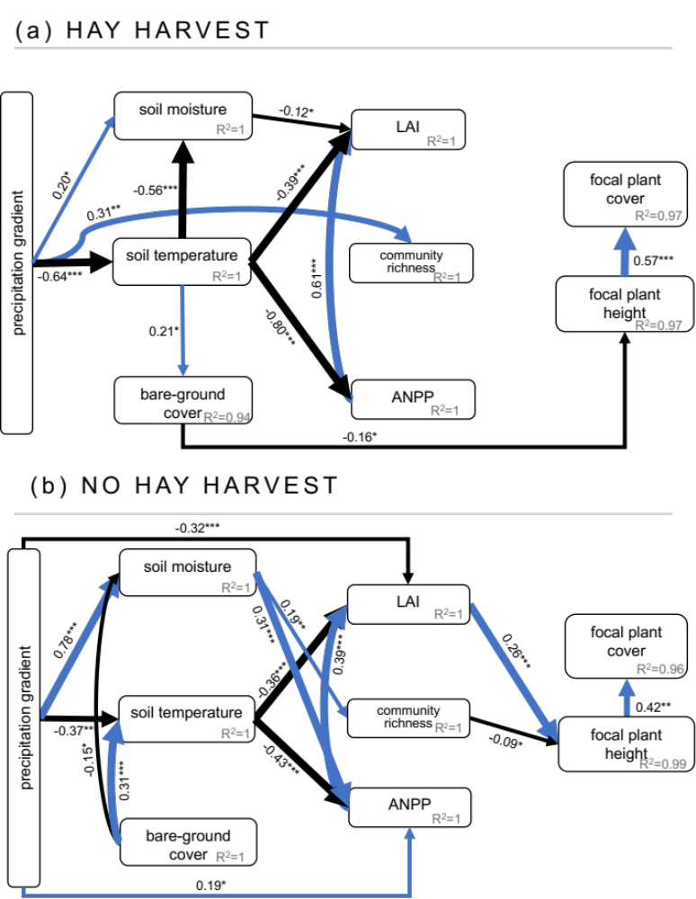
Figure 1. Piecewise Structural Equation Models (SEMs) describing the relationships among plant performance (focal plant cover, focal plant height), biotic variables (LAI – leaf area index, ANPP – aboveground net primary productivity, community richness), abiotic variables (soil moisture, soil temperature, bare-ground cover) in plots with hay harvest (a) no hay harvest (b) across precipitation treatments. Conditional R² values (i.e., including fixed and random effects) are under each predicted variable and standardized path estimates are provided next to each path with line thickness scaled based on the strength of the relationship (see Methods for variable descriptions): *P ≤ 0.05, **P ≤ 0.01, ***P ≤ 0.001. Only significant relationships (P ≤ 0.05) are shown. Blue and black arrows indicate positive and negative relationships, respectively. Arrow widths are proportional to the strength of the relationship. The proportion of variance explained (R²) appears alongside the response variable in the model. Model estimates, standard errors, and P-values for significant and non-significant relationships are provided in Tables S2-3.
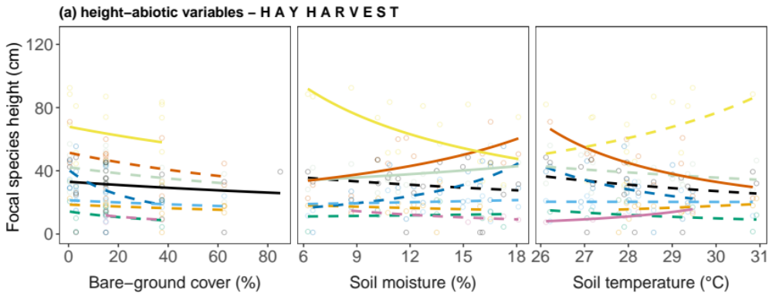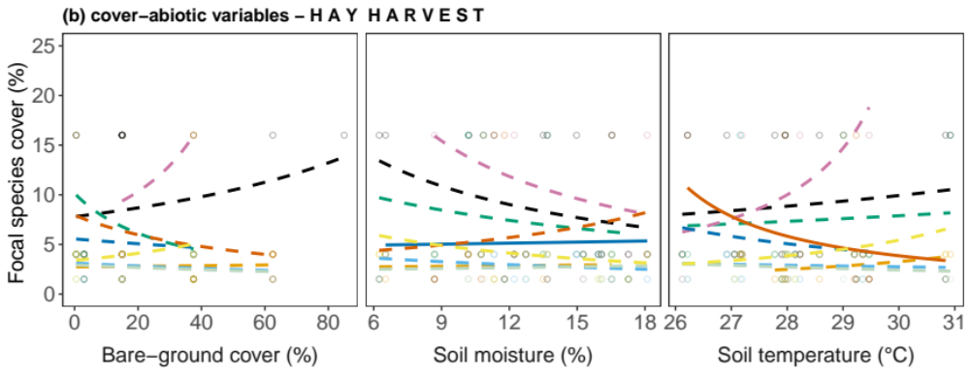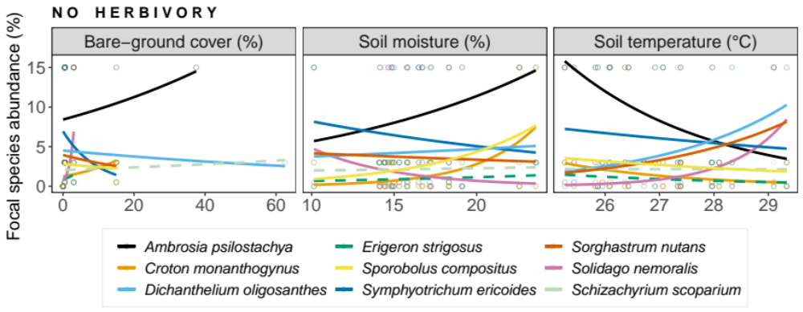
Figure 2. Focal species (a) height-abiotic and (b) cover-abiotic variables relationships in plots with hay harvest. Relationships were estimated by fitting GLMMs with log link to both species-specific height and abiotic variables (soil temperature, soil moisture, bare-ground cover). Continuous lines mean significant relationships, while dashed lines mean non-significant. P-values are shown in Table S4.

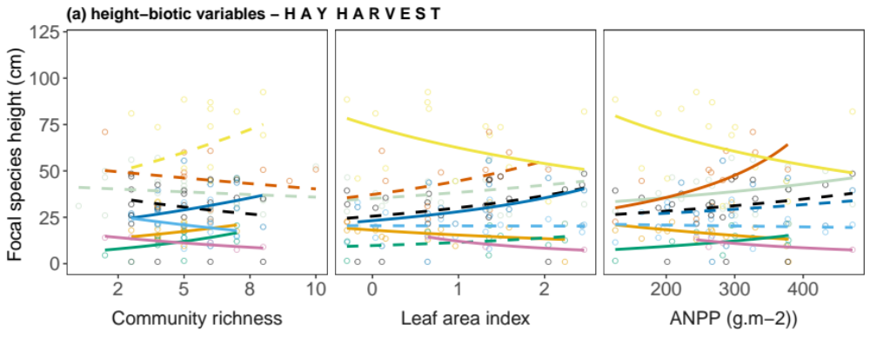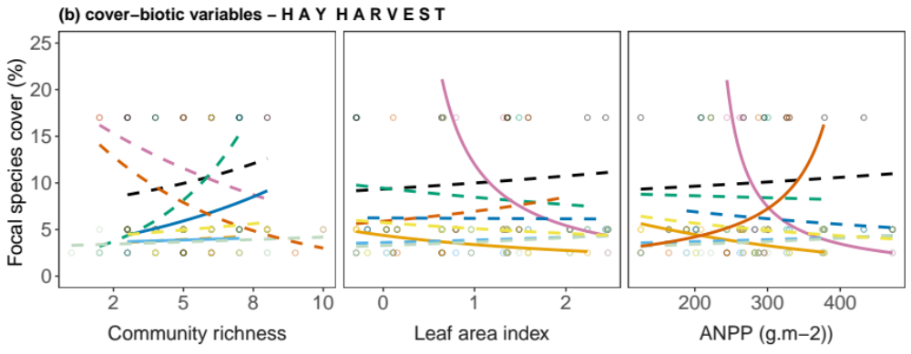

Figure 3. Focal species (a) height-biotic and (b) cover-abiotic variables relationships in plots with hay harvest. Relationships were estimated by fitting GLMMs with log link to both species-specific height and biotic variables (community richness, leaf area index, ANPP). Continuous lines mean significant relationships, while dashed lines mean non-significant. P-values are shown in Table 1.

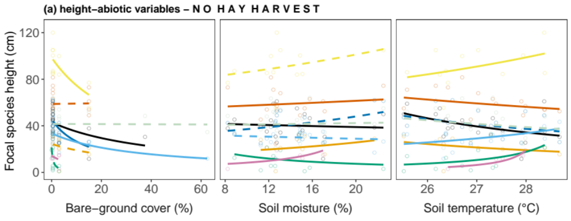
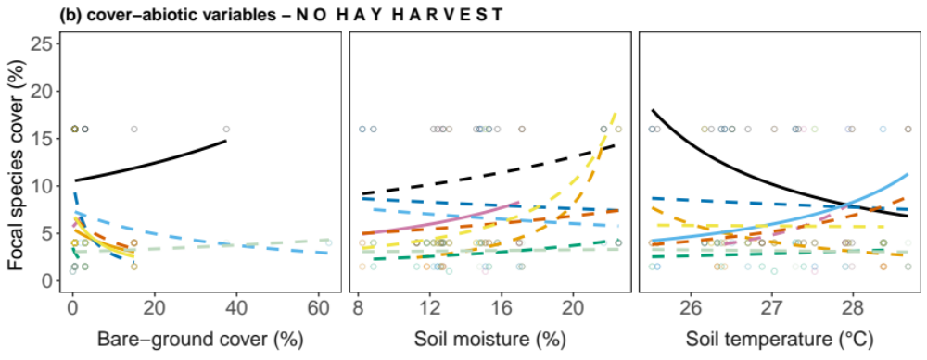
Figure 4. Focal species (a) height-abiotic and (b) cover-abiotic variables relationships in plots with no hay harvest (b). Relationships were estimated by fitting GLMMs with log link to both species-specific height and abiotic variables (soil temperature, soil moisture, bare-ground cover). Continuous lines mean significant relationships, while dashed lines mean non-significant. P-values are shown in Table S5.

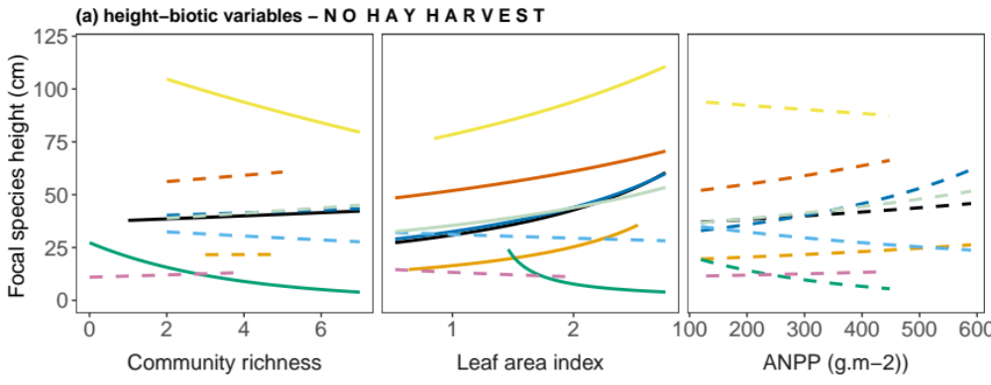
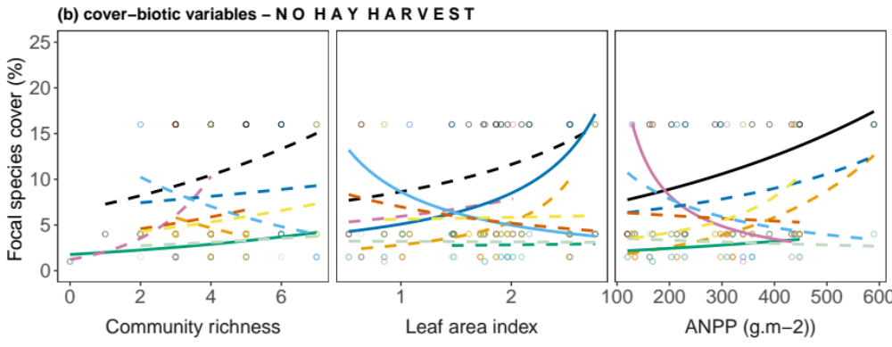
Figure 5. Focal species (a) height-biotic and (b) cover-biotic variables relationships in plots with no hay harvest. Relationships were estimated by fitting GLMMs with log link to both species-specific cover and biotic variables (community richness, leaf area index, ANPP). Continuous lines mean significant relationships, while dashed lines mean non-significant. P-values are shown in Table 2.

Appendix S1

Table S1. Mean and standard error (SE) for soil moisture (%) in each precipitation level with and without hay harvest during the growing season May-September 2017.
Precipitation level | Hay harvest | Mean | SE
-100 | yes | 12.88 | 0.44
-80 | yes | 15.07 | 0.41
-60 | yes | 16.93 | 0.48
-40 | yes | 13.92 | 0.45
-20 | yes | 15.18 | 0.44
0 | yes | 17.72 | 0.49
50 | yes | 17.97 | 0.35
-100 | no | 14.67 | 0.42
-80 | no | 16.96 | 0.41
-60 | no | 14.57 | 0.35
-40 | no | 16.07 | 0.42
-20 | no | 16.62 | 0.44
0 | no | 14.00 | 0.37
50 | no | 21.50 | 0.31

Table S2. Model estimates, standard errors (SE), and p-values (P) from hay harvest under altered precipitation piecewise Structural Equation Model (Fig. 2a) depicting the direct and indirect effects of precipitation treatments and clipping on Focal species height and foliar cover. Significant P (≤0.05) values are shown in bold.
Response | Predictor | Estimate | SE | P
Focal plant height | Richness | 0.03 | 0.06 | 0.60
Focal plant height | ANPP | -0.16 | 0.14 | 0.23
Focal plant height | LAI | 0.08 | 0.15 | 0.59
Focal plant height | Soil temperature | -0.22 | 0.13 | 0.10
Focal plant height | Soil moisture | -0.09 | 0.09 | 0.29
Focal plant height | Bare-ground cover | -0.16 | 0.06 | 0.01
Focal plant height | Precipitation treatment | -0.08 | 0.08 | 0.31
Focal plant abundance | Focal plant height | 0.57 | 0.11 | <0.001
Focal plant abundance | Richness | 0.06 | 0.08 | 0.46
Focal plant abundance | ANPP | 0.12 | 0.17 | 0.49
Focal plant abundance | LAI | -0.06 | 0.19 | 0.76
Focal plant abundance | Soil temperature | 0.01 | 0.17 | 0.97
Focal plant abundance | Soil moisture | -0.07 | 0.11 | 0.48
Focal plant abundance | Bare-ground cover | 0.11 | 0.08 | 0.17
Focal plant abundance | Precipitation treatment | -0.05 | 0.10 | 0.61
Richness | Soil temperature | 0.20 | 0.13 | 0.15
Richness | Soil moisture | 0.07 | 0.12 | 0.57
Richness | Bare-ground cover | 0.03 | 0.09 | 0.75
Richness | Precipitation treatment | 0.31 | 0.12 | <0.01
LAI | ANPP | 0.62 | 0.06 | <0.001
LAI | Soil temperature | -0.39 | 0.07 | <0.001
LAI | Soil moisture | -0.12 | 0.05 | 0.02
LAI | Bare-ground cover | -0.05 | 0.04 | 0.14
LAI | Precipitation treatment | 0.03 | 0.05 | 0.50
ANPP | Soil temperature | -0.80 | 0.08 | <0.001
ANPP | Soil moisture | -0.13 | 0.08 | 0.09
ANPP | Bare-ground cover | -0.10 | 0.06 | 0.09
ANPP | Precipitation treatment | 0.10 | 0.07 | 0.18
Bare-ground cover | Soil temperature | 0.21 | 0.11 | 0.01
Soil temperature | Precipitation treatment | -0.64 | 0.07 | <0.001
Soil moisture | Bare-ground cover | -0.05 | 0.06 | 0.42
Soil moisture | Soil temperature | -0.56 | 0.08 | <0.001
Soil moisture | Precipitation treatment | 0.20 | 0.08 | 0.02

Table S3. Model estimates, standard errors (SE), and p-values (P) from without hay harvest under altered precipitation piecewise Structural Equation Model (Fig. 2b) depicting the direct and indirect effects of precipitation treatments and clipping on Focal species height and foliar cover. Significant P (≤0.05) values are shown in bold.
Response | Predictor | Estimate | SE | P
Focal plant height | Richness | -0.09 | 0.04 | 0.04
Focal plant height | ANPP | -0.06 | 0.06 | 0.31
Focal plant height | LAI | 0.26 | 0.05 | <0.001
Focal plant height | Soil temperature | 0.07 | 0.06 | 0.20
Focal plant height | Soil moisture | 0.04 | 0.06 | 0.47
Focal plant height | Bare-ground cover | -0.07 | 0.04 | 0.10
Focal plant height | Precipitation treatment | 0.06 | 0.06 | 0.36
Focal plant abundance | Focal plant height | 0.41 | 0.14 | <0.01
Focal plant abundance | Richness | 0.08 | 0.09 | 0.35
Focal plant abundance | ANPP | 0.08 | 0.12 | 0.49
Focal plant abundance | LAI | -0.09 | 0.11 | 0.42
Focal plant abundance | Soil temperature | -0.04 | 0.11 | 0.70
Focal plant abundance | Soil moisture | 0.17 | 0.12 | 0.17
Focal plant abundance | Bare-ground cover | 0.00 | 0.09 | 0.97
Focal plant abundance | Precipitation treatment | -0.15 | 0.13 | 0.25
Richness | Soil temperature | -0.18 | 0.10 | 0.07
Richness | Soil moisture | 0.39 | 0.12 | <0.01
Richness | Bare-ground cover | 0.06 | 0.09 | 0.52
Richness | Precipitation treatment | -0.12 | 0.13 | 0.37
LAI | ANPP | 0.40 | 0.10 | <0.001
LAI | Soil temperature | -0.36 | 0.10 | <0.001
LAI | Soil moisture | 0.11 | 0.11 | 0.32
LAI | Bare-ground cover | -0.14 | 0.08 | 0.06
LAI | Precipitation treatment | -0.32 | 0.11 | <0.01
ANPP | Soil temperature | -0.43 | 0.07 | <0.001
ANPP | Soil moisture | 0.31 | 0.08 | <0.001
ANPP | Bare-ground cover | -0.09 | 0.06 | 0.14
ANPP | Precipitation treatment | 0.19 | 0.09 | 0.04
Bare-ground cover | Soil temperature | 0.12 | 0.09 | 0.18
Soil temperature | Precipitation treatment | -0.37 | 0.08 | <0.001
Soil moisture | Bare-ground cover | -0.15 | 0.06 | 0.03
Soil moisture | Soil temperature | 0.31 | 0.07 | <0.001
Soil moisture | Precipitation treatment | 0.78 | 0.07 | <0.001

Table S4. GLMMs of main effects of the precipitation gradient and hay harvest on biotic variables (community richness, LAI, ANPP) and abiotic variables (soil moisture, soil temperature and bare-ground cover). Significant P (≤0.05) shown in bold.
 | Precipitation gradient |  | Hay harvest
Species | Chisq | P | Chisq | P
Biotic variables
community richness | 6.60 | 0.01 | 16.78 | <0.001
LAI | 0.63 | 0.43 | 26.11 | <0.001
ANPP | 4.45 | 0.03 | <0.01 | 0.94
Abiotic variables
soil moisture | 6.59 | 0.01 | 3.80 | 0.05
soil temperature | 8.36 | <0.01 | 29.65 | <0.001
bare-ground cover | <0.01 | 0.99 | 149.35 | <0.001

Table S5. GLMMs of main effects of bare-ground cover, soil moisture and soil temperature on focal species-specific height, under hay harvest vs. no hay harvest. Significant P (≤0.05) shown in bold.
 | Bare-ground cover (%) |  | Soil moisture (%) |  | Soil temperature (°C)
Species | Chisq | P | Chisq | P | Chisq | P
Ambrosia psilostachya
hay harvest | 56.54 | <0.001 | 1.90 | 0.17 | 0.07 | 0.79
no hay harvest | 6.35 | 0.01 | 4574298 | <0.001 | 116057 | <0.001
Croton monanthogynus
hay harvest | 0.31 | 0.58 | 1.90 | 0.17 | 0.45 | 0.50
no hay harvest | <0.01 | 0.96 | 4574298 | <0.001 | 78480 | <0.001
Erigeron strigosus
hay harvest | 0.47 | 0.49 | 0.67 | 0.41 | 1.16 | 0.28
no hay harvest | 1.86 | 0.17 | 19784692 | < 0.001 | 1123909 | <0.001
Solidago nemoralis
hay harvest | 0.14 | 0.70 | 0.67 | 0.41 | 47659 | <0.001
no hay harvest | 1.76 | 0.18 | 49310885 | < 0.001 | 33.13 | <0.001
Symphyotrichum ericoides
hay harvest | 1.75 | 0.19 | 0.67 | 0.41 | 2.62 | 0.10
no hay harvest | 5.32 | 0.02 | 0.98 | 0.32 | 2.77 | 0.09
Dichanthelium oligosanthes
hay harvest | 0.07 | 0.79 | 0.14 | 0.71 | <0.01 | 0.93
no hay harvest | 1393.4 | < 0.001 | <0.001 | 0.98 | 4.98 | 0.02
Schizachyrium scoparium
hay harvest | 2.67 | 0.10 | 3752530 | < 0.001 | 0.13 | 0.72
no hay harvest | 0.16 | 0.69 | 0.02 | 0.89 | 0.74 | 0.39
Sorghastrum nutans
hay harvest | 1.18 | 0.28 | 7.39 | <0.01 | 10.37 | <0.01
no hay harvest | 0.16 | 0.69 | 1010023 | < 0.001 | 82.15 | <0.001
Sporobolus compositus
hay harvest | 8.83 | <0.01 | 5.38 | 0.02 | 2.62 | 0.10
no hay harvest | 16.07 | < 0.001 | 1.45 | 0.23 | 6175.6 | <0.001

Table S6. GLMMs of main effects of bare-ground cover, soil moisture and soil temperature on focal species-specific abundance, under hay harvest vs. no hay harvest. Significant P (≤0.05) shown in bold.
 | Bare-ground cover (%) |  | Soil moisture (%) |  | Soil temperature (°C)
Species | Chisq | P | Chisq | P | Chisq | P
Ambrosia psilostachya
hay harvest | 1.47 | 0.22 | 0.8 | 0.78 | 0.12 | 0.72
no hay harvest | 4844.4 | < 0.001 | 0.25 | 0.61 | 4.63 | 0.03
Croton monanthogynus
hay harvest | 0.002 | 0.96 | <0.001 | 0.97 | 1.26 | 0.26
no hay harvest | 433009 | <0.001 | 0.36 | 0.55 | 2.46 | 0.12
Erigeron strigosus
hay harvest | 0.34 | 0.55 | <0.01 | 0.93 | 0.35 | 0.55
no hay harvest | 0 | 0.99 | 0.36 | 0.55 | 0.27 | 0.60
Solidago nemoralis
hay harvest | 0.45 | 0.50 | 0.05 | 0.81 | 2.97 | 0.8
no hay harvest | 0.44 | 0.50 | 50414290 | <0.001 | 76876 | <0.001
Symphyotrichum ericoides
hay harvest | 2.37 | 0.12 | 12832559 | <0.001 | 0.42 | 0.51
no hay harvest | 3.57 | 0.06 | 0.27 | 0.60 | 0.28 | 0.60
Dichanthelium oligosanthes
hay harvest | 0.16 | 0.69 | 1.10 | 0.29 | 0.08 | 0.78
no hay harvest | 2.19 | 0.14 | 0.12 | 0.73 | <0.001 | <0.001
Schizachyrium scoparium
hay harvest | 0.69 | 0.41 | 0.04 | 0.84 | 0.39 | 0.53
no hay harvest | 3.24 | 0.07 | 0.16 | 0.69 | 0.06 | 0.80
Sorghastrum nutans
hay harvest | 0.53 | 0.46 | 0.78 | 0.38 | 4.72 | 0.03
no hay harvest | 0.16 | 0.68 | 0.14 | 0.70 | 0.18 | 0.67
Sporobolus compositus
hay harvest | 0.36 | 0.55 | 1.76 | 0.18 | 0.38 | 0.53
no hay harvest | 14.17 | <0.001 | 0.99 | 0.32 | 0.06 | 0.80

Table S7. Model estimates, standard errors (SE), and p-values (P) from hay harvest under altered precipitation piecewise Structural Equation Model depicting the direct and indirect effects of precipitation treatments and clipping on Focal species height and foliar cover in C₃ forbs. Significant P (≤0.05) values are shown in bold. SEM AIC = 155.52, F=25.52 and P-value = 0.27.
Response | Predictor | Estimate | SE | P
Focal plant height | Bare-ground cover | -0.14 | 0.12 | 0.23
Focal plant height | Community richness | 0.08 | 0.11 | 0.47
Focal plant height | ANPP | -0.46 | 0.23 | 0.05
Focal plant height | LAI | 0.67 | 0.24 | <0.01
Focal plant height | Soil moisture | 0.03 | 0.13 | 0.83
Focal plant height | Precipitation treatment | -0.18 | 0.14 | 0.19
Focal plant abundance | Precipitation treatment | -0.11 | 0.11 | 0.29
Focal plant abundance | Focal plant height | 0.46 | 0.13 | <0.001
Community richness | Soil temperature | 0.08 | 0.18 | 0.66
Community richness | Soil moisture | 0.26 | 0.18 | 0.16
Community richness | Bare-ground cover | 0.05 | 0.13 | 0.71
LAI | Community richness | -0.05 | 0.05 | 0.33
LAI | ANPP | 0.56 | 0.09 | <0.001
LAI | Soil temperature | -0.40 | 0.11 | <0.001
LAI | Soil moisture | -0.11 | 0.07 | 0.16
LAI | Bare-ground cover | -0.10 | 0.05 | 0.08
LAI | Precipitation treatment | 0.06 | 0.07 | 0.36
ANPP | Community richness | -0.13 | 0.08 | 0.11
ANPP | Soil temperature | -0.86 | 0.11 | <0.001
ANPP | Soil moisture | -0.09 | 0.11 | 0.43
Bare-ground cover | Soil temperature | 0.23 | 0.12 | 0.06
Soil temperature | Precipitation treatment | -0.67 | 0.10 | <0.001
Soil moisture | Bare-ground cover | -0.02 | 0.10 | 0.86
Soil moisture | Soil temperature | -0.62 | 0.13 | <0.001
Soil moisture | Precipitation treatment | 0.12 | 0.12 | 0.33

Table S8. Model estimates, standard errors (SE), and p-values (P) from without hay harvest under altered precipitation piecewise Structural Equation Model depicting the direct and indirect effects of precipitation treatments and clipping on Focal species height and foliar cover C₃ forbs. Significant P (≤0.05) values are shown in bold. SEM AIC = 160.76, F= 30.76 and P-value = 0.10.
Response | Predictor | Estimate | SE | P
Focal plant height | Bare-ground cover | -0.11 | 0.08 | 0.20
Focal plant height | Community richness | -0.13 | 0.09 | 0.14
Focal plant height | ANPP | -0.10 | 0.10 | 0.33
Focal plant height | LAI | 0.36 | 0.09 | <0.001
Focal plant height | Soil moisture | 0.23 | 0.10 | 0.02
Focal plant height | Precipitation treatment | -0.11 | 0.10 | 0.30
Focal plant abundance | Precipitation treatment | 0.13 | 0.10 | 0.21
Focal plant abundance | Focal plant height | 0.57 | 0.12 | <0.001
Community richness | Soil temperature | -0.22 | 0.12 | 0.08
Community richness | Soil moisture | 0.43 | 0.11 | <0.001
Community richness | Bare-ground cover | 0.20 | 0.12 | 0.11
LAI | Community richness | 0.22 | 0.12 | 0.07
LAI | ANPP | 0.43 | 0.14 | <0.01
LAI | Soil temperature | -0.31 | 0.14 | 0.03
LAI | Soil moisture | -0.04 | 0.17 | 0.82
LAI | Bare-ground cover | -0.17 | 0.12 | 0.15
LAI | Precipitation treatment | -0.27 | 0.16 | 0.09
ANPP | Community richness | -0.24 | 0.11 | 0.03
ANPP | Soil temperature | -0.52 | 0.09 | <0.001
ANPP | Soil moisture | 0.58 | 0.10 | <0.001
Bare-ground cover | Soil temperature | 0.36 | 0.12 | <0.01
Soil temperature | Precipitation treatment | -0.35 | 0.12 | <0.01
Soil moisture | Bare-ground cover | -0.13 | 0.11 | 0.21
Soil moisture | Soil temperature | 0.33 | 0.11 | <0.01
Soil moisture | Precipitation treatment | 0.78 | 0.10 | <0.001

Table S9. Model estimates, standard errors (SE), and p-values (P) from hay harvest under altered precipitation piecewise Structural Equation Model depicting the direct and indirect effects of precipitation treatments and clipping on Focal species height and foliar cover in C₃ graminoid. Significant P (≤0.05) values are shown in bold. SEM AIC = 153.50, F=7.50 and P-value = 0.27.
Response | Predictor | Estimate | SE | P
Focal plant height | Richness | -0.39 | 0.41 | 0.36
Focal plant height | ANPP | -0.15 | 0.92 | 0.87
Focal plant height | LAI | 0.67 | 0.90 | 0.48
Focal plant height | Soil temperature | 0.57 | 0.78 | 0.48
Focal plant height | Soil moisture | 0.48 | 0.52 | 0.39
Focal plant height | Bare-ground cover | -0.46 | 0.38 | 0.26
Focal plant height | Precipitation treatment | -0.41 | 0.46 | 0.40
Focal plant abundance | Focal plant height | 0.59 | 0.26 | 0.06
Focal plant abundance | Community richness | 0.12 | 0.32 | 0.71
Focal plant abundance | ANPP | 0.26 | 0.68 | 0.71
Focal plant abundance | LAI | 0.02 | 0.69 | 0.98
Focal plant abundance | Soil temperature | -0.45 | 0.60 | 0.48
Focal plant abundance | Soil moisture | -0.67 | 0.41 | 0.15
Focal plant abundance | Bare-ground cover | -0.14 | 0.31 | 0.66
Focal plant abundance | Precipitation treatment | -0.16 | 0.36 | 0.66
Community richness | Soil temperature | 0.15 | 0.39 | 0.71
Community richness | Soil moisture | -0.32 | 0.43 | 0.47
Community richness | Bare-ground cover | -0.30 | 0.27 | 0.30
Community richness | Precipitation treatment | 0.38 | 0.38 | 0.34
LAI | ANPP | 0.75 | 0.19 | <0.01
LAI | Soil temperature | -0.28 | 0.22 | 0.24
LAI | Soil moisture | -0.14 | 0.18 | 0.46
LAI | Bare-ground cover | 0.11 | 0.11 | 0.35
LAI | Precipitation treatment | 0.02 | 0.16 | 0.89
ANPP | Soil temperature | -0.83 | 0.24 | 0.01
ANPP | Soil moisture | -0.23 | 0.27 | 0.40
ANPP | Bare-ground cover | 0.13 | 0.17 | 0.46
ANPP | Precipitation treatment | 0.24 | 0.24 | 0.33
Bare-ground cover | Soil temperature | -0.02 | 0.27 | 093
Soil temperature | Precipitation treatment | -0.58 | 0.22 | 0.02
Soil moisture | Bare-ground cover | 0.03 | 0.18 | 0.86
Soil moisture | Soil temperature | -0.47 | 0.22 | 0.05
Soil moisture | Precipitation treatment | 0.42 | 0.23 | 0.09

Table S10. Model estimates, standard errors (SE), and p-values (P) from without hay harvest under altered precipitation piecewise Structural Equation Model depicting the direct and indirect effects of precipitation treatments and clipping on Focal species height and foliar cover C₃ graminoid. Significant P (≤0.05) values are shown in bold. SEM AIC = 150.55 F= 0.55 and P-value = 0.76.
Response | Predictor | Estimate | SE | P
Focal plant height | Community richness | -0.39 | 0.41 | 0.36
Focal plant height | ANPP | -0.15 | 0.92 | 0.87
Focal plant height | LAI | 0.67 | 0.90 | 0.48
Focal plant height | Soil temperature | 0.57 | 0.78 | 0.48
Focal plant height | Soil moisture | 0.48 | 0.52 | 0.39
Focal plant height | Bare-ground cover | -0.46 | 0.38 | 0.26
Focal plant height | Precipitation treatment | -0.41 | 0.46 | 0.40
Focal plant abundance | Focal plant height | 0.59 | 0.26 | 0.06
Focal plant abundance | Community richness | 0.12 | 0.32 | 0.71
Focal plant abundance | ANPP | 0.26 | 0.68 | 0.71
Focal plant abundance | LAI | 0.02 | 0.69 | 0.98
Focal plant abundance | Soil temperature | -0.45 | 0.60 | 0.48
Focal plant abundance | Soil moisture | -0.67 | 0.41 | 0.15
Focal plant abundance | Bare-ground cover | -0.14 | 0.31 | 0.66
Focal plant abundance | Precipitation treatment | -0.16 | 0.36 | 0.66
Community richness | Soil temperature | 0.15 | 0.39 | 0.71
Community richness | Soil moisture | -0.32 | 0.43 | 0.47
Community richness | Bare-ground cover | -0.30 | 0.27 | 0.30
Community richness | Precipitation treatment | 0.38 | 0.38 | 0.34
LAI | ANPP | 0.75 | 0.19 | <0.01
LAI | Soil temperature | -0.28 | 0.22 | 0.24
LAI | Soil moisture | -0.14 | 0.18 | 0.46
LAI | Bare-ground cover | 0.11 | 0.11 | 0.35
LAI | Precipitation treatment | 0.02 | 0.16 | 0.89
ANPP | Soil temperature | -0.83 | 0.24 | 0.01
ANPP | Soil moisture | -0.23 | 0.27 | 0.40
ANPP | Bare-ground cover | 0.13 | 0.17 | 0.46
ANPP | Precipitation treatment | 0.24 | 0.24 | 0.33
Bare-ground cover | Soil temperature | -0.27 | 0.26 | 0.30
Soil temperature | Precipitation treatment | -0.58 | 0.22 | 0.02
Soil moisture | Bare-ground cover | 0.03 | 0.18 | 0.86
Soil moisture | Soil temperature | -0.47 | 0.22 | 0.05
Soil moisture | Precipitation treatment | 0.42 | 0.23 | 0.09

Table S11. Model estimates, standard errors (SE), and p-values (P) from hay harvest under altered precipitation piecewise Structural Equation Model depicting the direct and indirect effects of precipitation treatments and clipping on Focal species height and foliar cover in C₄ graminoids. Significant P (≤0.05) values are shown in bold. SEM AIC = 148.86, F= 0.86 and P-value = 0.93.
Response | Predictor | Estimate | SE | P
Focal plant height | Community richness | 0.10 | 0.14 | 0.48
Focal plant height | ANPP | 0.09 | 0.28 | 0.76
Focal plant height | LAI | -0.39 | 0.33 | 0.24
Focal plant height | Soil temperature | -0.44 | 0.29 | 0.14
Focal plant height | Soil moisture | -0.26 | 0.18 | 0.16
Focal plant height | Bare-ground cover | -0.28 | 0.13 | 0.04
Focal plant height | Precipitation treatment | -0.03 | 0.18 | 0.86
Focal plant abundance | Focal plant height | 0.60 | 0.15 | <0.001
Focal plant abundance | Community richness | -0.14 | 0.14 | 0.34
Focal plant abundance | ANPP | 0.25 | 0.29 | 0.38
Focal plant abundance | LAI | -0.07 | 0.33 | 0.84
Focal plant abundance | Soil temperature | 0.12 | 0.30 | 0.69
Focal plant abundance | Soil moisture | 0.09 | 0.19 | 0.63
Focal plant abundance | Bare-ground cover | 0.13 | 0.14 | 0.37
Focal plant abundance | Precipitation treatment | 0.00 | 0.18 | 0.99
Community richness | Soil temperature | 0.24 | 0.21 | 0.26
Community richness | Soil moisture | 0.01 | 0.20 | 0.95
Community richness | Bare-ground cover | 0.10 | 0.14 | 0.50
Community richness | Precipitation treatment | 0.46 | 0.18 | 0.02
LAI | Community richness | 0.13 | 0.06 | 0.05
LAI | ANPP | 0.59 | 0.10 | <0.001
LAI | Soil temperature | -0.44 | 0.12 | <0.001
LAI | Soil moisture | -0.11 | 0.08 | 0.18
LAI | Bare-ground cover | -0.07 | 0.06 | 0.24
LAI | Precipitation treatment | -0.03 | 0.08 | 0.74
ANPP | Soil temperature | -0.80 | 0.13 | <0.001
ANPP | Soil moisture | -0.13 | 0.13 | 0.30
ANPP | Bare-ground cover | -0.11 | 0.09 | 0.24
ANPP | Precipitation treatment | 0.10 | 0.12 | 0.40
Bare-ground cover | Soil temperature | 0.21 | 0.14 | 0.13
Soil temperature | Precipitation treatment | -0.62 | 0.11 | <0.001
Soil moisture | Bare-ground cover | -0.12 | 0.11 | 0.27
Soil moisture | Soil temperature | -0.52 | 0.13 | <0.001
Soil moisture | Precipitation treatment | 0.22 | 0.13 | 0.10

Table S12. Model estimates, standard errors (SE), and p-values (P) from without hay harvest under altered precipitation piecewise Structural Equation Model depicting the direct and indirect effects of precipitation treatments and clipping on Focal species height and foliar cover C₄ graminoids. Significant P (≤0.05) values are shown in bold. SEM AIC = 151.88, F= 5.88 and P-value = 0.44.
Response | Predictor | Estimate | SE | P
Focal plant height | Community richness | -0.08 | 0.08 | 0.33
Focal plant height | ANPP | -0.02 | 0.11 | 0.88
Focal plant height | LAI | 0.34 | 0.09 | <0.001
Focal plant height | Soil temperature | 0.19 | 0.11 | 0.09
Focal plant height | Soil moisture | -0.06 | 0.11 | 0.58
Focal plant height | Bare-ground cover | -0.04 | 0.09 | 0.61
Focal plant height | Precipitation treatment | 0.23 | 0.12 | 0.07
Focal plant abundance | Focal plant height | 0.39 | 0.19 | 0.05
Focal plant abundance | Richness | 0.11 | 0.15 | 0.46
Focal plant abundance | ANPP | 0.12 | 0.20 | 0.56
Focal plant abundance | LAI | -0.28 | 0.18 | 0.13
Focal plant abundance | Soil temperature | 0.01 | 0.20 | 0.96
Focal plant abundance | Soil moisture | 0.34 | 0.20 | 0.09
Focal plant abundance | Bare-ground cover | -0.02 | 0.16 | 0.92
Focal plant abundance | Precipitation treatment | -0.24 | 0.23 | 0.29
Community richness | Soil temperature | -0.20 | 0.18 | 0.26
Community richness | Soil moisture | 0.22 | 0.20 | 0.26
Community richness | Bare-ground cover | -0.12 | 0.16 | 0.44
Community richness | Precipitation treatment | -0.05 | 0.22 | 0.84
LAI | ANPP | 0.41 | 0.17 | 0.02
LAI | Soil temperature | -0.25 | 0.17 | 0.16
LAI | Soil moisture | 0.07 | 0.18 | 0.71
LAI | Bare-ground cover | -0.14 | 0.14 | 0.32
LAI | Precipitation treatment | -0.26 | 0.20 | 0.20
ANPP | Soil temperature | -0.44 | 0.14 | <0.01
ANPP | Soil moisture | 0.23 | 0.16 | 0.16
ANPP | Bare-ground cover | -0.14 | 0.12 | 0.28
ANPP | Precipitation treatment | 0.21 | 0.18 | 0.23
Bare-ground cover | Soil temperature | 0.15 | 0.14 | 0.30
Soil temperature | Precipitation treatment | -0.41 | 0.13 | <0.01
Soil moisture | Bare-ground cover | -0.28 | 0.11 | 0.02
Soil moisture | Soil temperature | 0.37 | 0.12 | <0.01
Soil moisture | Precipitation treatment | 0.78 | 0.12 | <0.001

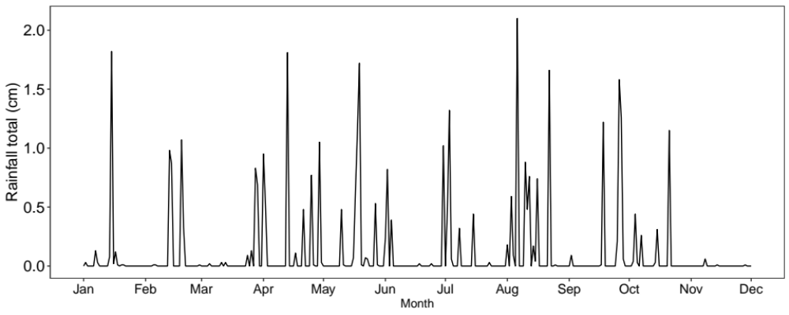
Figure S1. Average rainfall (cm) each month for the duration of the experiment (2017). Rainfall data downloaded from https://www.mesonet.org/ and is from Washington county, OK which is closely located at Kessler Atmospheric and Ecological Field Station.

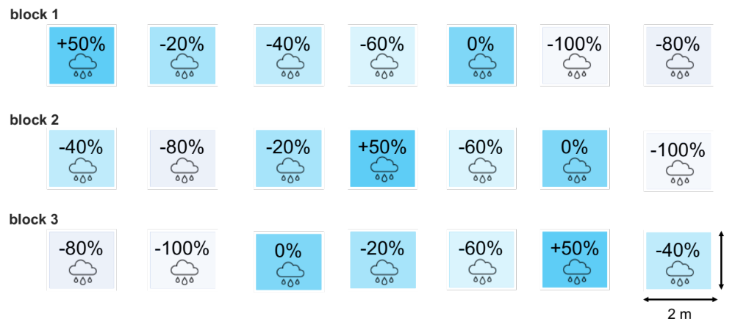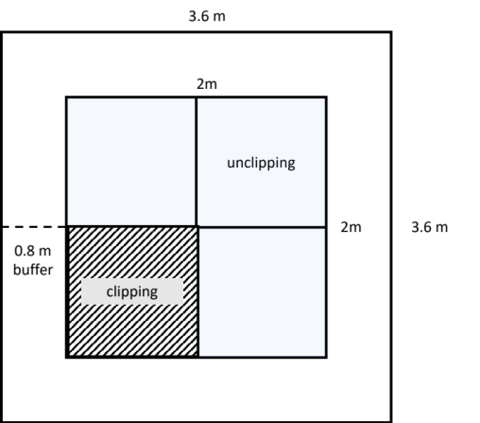
Figure S2. Top left panel: experimental design showing (top panel) arrangement of precipitation shelters that created the precipitation gradient replicated in three blocks (n=3, N=21): -100%, -80%, -60%, -40%, -20% precipitation reduction, 0% change (no precipitation change), and 50% precipitation addition; and arrows pointing clipped (mimicked hay harvest) and unclipped (no hay harvest) subplots. Bottom panel shows left: illustration of a plot and its nested subplots, and right: photo of experimental plot. Clipped subplot was clipped once a year during the growing season (clipping treatment), while unclipped subplot was our control.

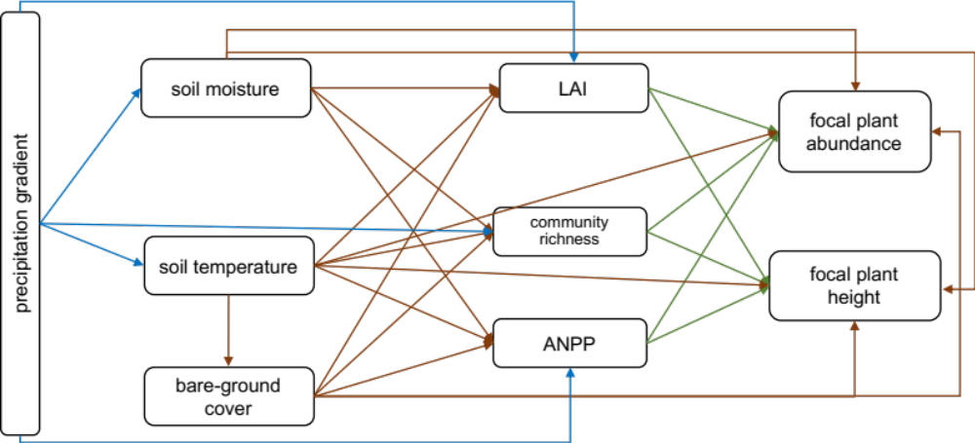
Figure S3. Conceptual a priori model for the precipitation gradient with hay harvest and no hay harvest. In blue are all effects emerging from the precipitation treatment on focal plant performance (abundance and height), in brown from abiotic variables and green from biotic variables.

Chapter Three
Formatted for publication in the Journal of Ecology

EFFECTS OF PRECIPITATION ON PHENOLOGY DEPEND ON FUNCTIONAL AND LIFE-HISTORY TRAITS IN A GRASSLAND COMMUNITY

Karen Castillioni^{1,2}, Gregory S. Newman^{1,3}, Lara Souza^{1,2}, Amy M. Iler⁴

¹Oklahoma Biological Survey, University of Oklahoma, Norman, OK, USA
²Department of Microbiology and Plant Biology, University of Oklahoma, Norman, OK, USA
³Department of Biology, University of Oklahoma, Norman, OK, USA
⁴Chicago Botanic Garden, the Negaunee Institute for Plant Science Conservation and Action, Glencoe, IL, USA

Abstract
- Flowering and fruiting phenology of plants is sensitive to environment cues such as temperature and moisture. In temperate grasslands, precipitation governs phenology due to the water-limited nature of this ecosystem. As climate change intensifies, variation in precipitation could be a dominant driver of future community structure through induced drought-shifts on plant phenology. However, the role of precipitation in driving phenology in grasslands is far less understood compared to other climate change drivers, such as temperature and photoperiod. Thus, variation in precipitation on plant phenology deserves greater consideration and unlike temperature, it is likely to affect species differently depending on their sensitivity to soil moisture.
- Here we report results from a multiyear precipitation gradient to test the direction and magnitude of reproductive phenology in a temperate grassland. We test the effects of precipitation by dividing responses into community-level and its trait factors (bloom time, functional group and life span) and species responses.
- Our results provide clear evidence of divergent shifts in plant phenology and reproductive success across a precipitation reduction gradient. We found that traits factors are critical for driving directional responses of early vs. late-blooms plants, C₃ vs. C₄ species, annuals vs. perennials to variation in precipitation. With decreasing precipitation, early-blooming plants and C₃ (annuals and perennials) advanced flowering date, whereas late-blooming plants and C₄ perennials delayed flowering date. Shift in early-blooming flowering date co-occurred with less seed viability, but higher seed viability for late-blooming species. In contrast, C₃ shift in phenology was concurrent with higher flower output and longer fruiting duration — an indication that shift in phenology resulted in increased performance for this group. Community-level analysis showed no response to the precipitation gradient, whereas species individually responded in opposing directions or minimally.
- Synthesis. We demonstrate the importance of understanding how plant traits with differential water availability tolerance drive response to decreasing precipitation when forecasting phenology over the coming decades. Without grouping species by traits, we would not have been able to detect relevant phenological shifts. This study adds to a growing body of literature showing that precipitation affects phenology in temperate grasslands.

Keywords: Climate change, drought, flower timing, flower duration, fruiting timing, seed, prairie

Introduction
Climate change is altering the timing and performance of plant reproduction (Bellard, Bertelsmeier, Leadley, Thuiller, & Courchamp, 2012; Hedhly, Hormaza, & Herrero, 2009) because these phenological events are highly sensitive to environmental cues, such as temperature and soil moisture (Rathcke & Lacey, 1985; Sherry et al., 2007). These direct responses to climate change drivers include early onset of sexual reproduction (CaraDonna, Iler, & Inouye, 2014; Fitter & Fitter, 2002; Miller-Rushing & Primack, 2008) and higher or lower reproductive output (Hedhly et al., 2009). Indirect effects may occur when altered reproductive phenology influence the duration of a phenological event, which can also affect the number of flowers or fruits produced, as a longer flowering period might provide more opportunities for plants to reproduce (Dieringer, 1991; Nagahama, Kubota, & Satake, 2018). Most studies examining the effects of climate change on plant phenology have focused on climate warming (Knapp, Briggs, & Koelliker, 2001; Knapp & Smith, 2001; Zelikova et al., 2015), but in many ecosystems, precipitation is also likely to be a dominant factor. For example, precipitation is the primary driver shaping vegetation dynamics in grasslands, and seasonal variation in the timing and amount of precipitation governs phenology due to the water-limited nature of this ecosystem (Knapp et al., 2020; Zelikova et al., 2015). Therefore, the effects of altered precipitation under climate change on plant phenology deserves greater consideration and unlike temperature, it is likely to affect species differently depending on their sensitivity to soil moisture (Cleland, Chiariello, Loarie, Mooney, & Field, 2006).
While some species may be able to plastically respond to altered timing of precipitation events to avoid drier future climates, increased frequency of drought events pose a risk of negative consequences for the reproductive performance of moisture-driven species (Zeiter, Schärrer, Zweifel, Newbery, & Stampfli, 2016). Variable responses to drought across species may result from differential soil moisture limitations on early- vs. late-season flowering species (Park et al., 2019; Sherry et al., 2007) or variation among species in the degree to which phenology is regulated by water stress (Crimmins, Crimmins, & Bertelsen, 2010). However, few direct comparisons of functional groups (grasses and shrubs) have been performed (Ryel, Leffler, Ivans, Peek, & Caldwell, 2010; Wilson et al., 2018).
Species or traits factors (i.e., flowering time, life span and functional group) may play a key role in determining the direction of the variation in responses within communities. Previous work suggests that important traits factors should covary with reproductive phenology, such as life span (Segrestin, Navas, & Garnier, 2020) and functional groups (C₃ forbs or shrubs and C₄ grasses) (Aspinwall et al., 2017; Fay et al., 2002). For example, flowering date of annuals was found to be more variable than for perennial herbs or shrubs (Miller-Rushing & Primack, 2008), and annuals exhibited a stronger phenological shift through time than did perennials (Fitter & Fitter, 2002). This is likely because perennial species use resources from previous years, unlike annuals that rely on current available resources (Wolkovich & Cleland, 2014). Perennial C₄ “warm season” grasses have relatively high water use efficiency (Taylor et al., 2010) and can lower water availability later in the growing season, whereas annual C₃ “cool season” grasses cause less soil drying than perennial grasses that maintain permanent root structures (Enloe, DiTomaso, Orloff, & Drake, 2004). Further, the divergent effects of precipitation levels on traits factors and individual species have the potential to affect plant reproduction through reduced seed abundance and seed mass (Zeiter et al., 2016). Finally, altered relative fitness among community members can affect community composition, as long as reproduction influences population growth (Kimball, Angert, Huxman, & Venable, 2010).
Much of our knowledge of the effects of precipitation on plant phenology comes from high-elevation and high-latitude ecosystems, where precipitation in the form of snow has been shown to affect phenology independently of temperature change (Bjorkman, Elmendorf, Beamish, Vellend, & Henry, 2015; Forrest & Miller-Rushing, 2010; Høye, Ellebjerg, & Philipp, 2007; Jerome, Petry, Mooney, & Iler, 2021). However, altered precipitation may affect plant phenology differently in other habitats (Schwartz, 2013). We know very little about the role of precipitation as a potential phenological cue for grasslands, but the limited evidence available for increased precipitation suggests no effect on flowering and fruiting phenology (Cleland, Chiariello, Loarie, Mooney, & Field, 2006; Sherry et al., 2007). Low representation of phenological studies in grasslands is concerning considering that grasslands are one of Earth’s dominant ecosystems (White, Murray, Rohweder, Prince, & Thompson., 2000).
As climate change intensifies, grasslands are forecast to experience higher variability and altered seasonality in annual precipitation through less frequent, but higher intensity storm events and increased summer drought (Bukovsky, McCrary, Seth, & Mearns, 2017; Harding & Snyder, 2014; Mullens & McPherson, 2019; Ryu, Hayhoe, & Kang, 2018). As a result, altered precipitation can aggravate water stress for plant communities in an already water-sensitive ecosystem. Even small shifts in phenology can disrupt phenological complementarity among species, with potentially large consequences for the future of grasslands (Cleland et al., 2006; Zelikova et al., 2015). We therefore focus on the effects of precipitation levels on grassland plant phenology in this study.
Here we report results from a novel multiyear factorial field experiment where we manipulated precipitation with rainfall shelter to test the direction and magnitude of reproductive phenology in a mixed-grass prairie in the US Southern Great Plains. We test the following hypotheses related to the effects of decreasing precipitation by dividing responses into community-level and its trait factors (bloom time, functional group and life span), and species responses:
(1) We hypothesize that divergent variation among species will counter-balance responses at the community-level.
(2) We hypothesize that early-blooming species will advance reproduction whereas late-blooming species will delay, which will also directly lead to changes in the duration of flowering and fruiting.
(3) We expect that if species have diverse phenological responses, functional groups and life span will explain some variation in phenological responses.
(4) Because plant reproductive potential is tightly linked to phenological plant strategies (timing and abundance of flowers), we hypothesize that plants unable to shift phenology might have lower reproductive success as measured by seed viability here.

Methods
Study site. This study was conducted in an open mixed-grass prairie at Kessler Atmospheric and Ecological Field Station (KAEFS) in central Oklahoma, USA (34°59'N, 97°31'W). KAEFS is a temperate mixed-grass prairie that also contains encroaching Juniper virginiana, Rhus copallinum and Rhus glabra, abandoned from field cropping since 1973, with sustained light grazing in designated areas. Mean annual precipitation at KAEFS was 1074 mm, and mean annual air temperature was 16˚C from 2016 to 2019 (Oklahoma Climatological Survey, Norman, OK, USA, Figure S1). The study site had a flat slope and the soil was classified as the Lucien series, weathered from sandstone with clay, siltstone, or sandy shale of Permian age, and characterized by a neutral pH, high water holding capacity (around 37%), a depth to approximately 70 cm, and a moderately penetrable root zone (Soil Survey Staff, Natural Resources Conservation Service, United States Department of Agriculture). The site is dominated by C₄ graminoids, C₃ annuals, and C₃ perennial forbs (Buthod & Hoagland, 2016; Castillioni et al., 2020).
Study species. This study included 11 focal species. Five were perennial graminoids: Schizachryrium scoparium (C₄), Sporobolus compositus (C₄), Sorghastrum nutans (C₄), Bothriochloa ischaemum (C₄, also non-native to the United States (Buthod and Holand 2016)), and Dichanthelium oligosanthes (C₃). Six species were mixed perennial and annual forbs, all C₃ species (J. R. Taylor, 1989): Ambrosia psilostachya (perennial), Calylophus serrulatus (perennial), Croton monanthogynus (annual), Chamaecrista fasciculata (annual), Erigeron strigosus (annual), and Symphyotrichum ericoides (perennial). See illustration in Figure 1 for species grouping by trait factors. Together, these species make up approximately 80% of the relative cover in the experimental plots.

Experimental design
Precipitation treatments. To determine the phenological response of focal species to variation in precipitation, we used rain-out shelters established in Fall 2015 to passively create a precipitation gradient with seven treatment levels: +50%, 0%, -20%, -40%, -60%, -80%, and -100% change from ambient precipitation, replicated three times for a total of 21 2 x 2 m plots. Block consisted of one replication of each precipitation treatment (total 3 blocks), and plot was our experimental unit (1–21). The acrylic transparent shelters intercept rain, but allow > 93% solar radiation, and were present in all treatments (including the 0% control treatment) to exclude the potentially confounding effects of shelter presence (Beier et al., 2012; Yahdjian & Sala, 2002). In the 0% control treatment, we arranged shelters panel facing downwards with space between them, allowing all precipitation to fall into the plots. The precipitation reduction treatments diverted rainwater away from the plots depending how the shelter panels were arranged (upwards and/or downwards) to meet the precipitation reduction percentage of each treatment. The +50% precipitation addition plots had additional panels on two sides of plots receiving ambient rainfall to divert additional precipitation onto the plot. The width of each additional panel sheet was 25% the width of the experimental plot, together equaling 50% of the plot (Figure S2). Precipitation collected from panels was drained by gutters to the inside of the plot. Thus, the frequency of precipitation addition and total precipitation amount coincided with the ambient precipitation events. Rain gauges were used to estimate precipitation intercepted by each treatment and validate the shelter design. Precipitation under each roof correlated closely with the target manipulation of ambient precipitation across the experimental gradient (expected vs. observed R²=0.953; G. Newman, unpublished data).
We also measured soil temperature in all plots to determine whether the precipitation gradient affected soil temperature. Daily temperatures were measured at 30-minute intervals with Decagon 5TM (Pullman WA, USA) soil probes to a depth of 10 cm in each plot. We used daily the 24 measurements to calculate mean daily soil temperature and growing degree days (i.e., heat accumulation over time) to test the effects of precipitation treatment on these two variables. Growing degree days was calculated from the month in which soil temperatures warm above the mean winter temperature (i.e., 7 ºC plus 1 ˚C added to this baseline) through the first day of flowering, as suggested by degree day requirements for flowering.
Tracking phenology. Five focal individuals of each species were tagged in each plot as species emerged across the growing season and monitored their reproductive phenology twice a week across the entire growing season (May to November). Phenological measurements on each day consisted of total counts for open flowers and fruits in each plot and on each species replicate. Flowers were considered open if stigmas or anthers were visible and appeared to be fresh (i.e., were not dried out and brown). Fruits from forbs were considered mature if fruit color was changed from green to either yellow, orange, or red. If fruits were always green, for example for D. oligosanthes, or if the species was a graminoid, fruits were considered mature if fruits were easily detachable from the reproductive inflorescence. Phenology was quantified as the date of peak flowering and fruiting (hereafter flowering date and fruiting date, respectively), which we calculated as the day of year when 50 per cent of the annual total flowers or fruits were counted for each individual (Høye et al., 2007; Iler, Høye, Inouye, & Schmidt, 2013). We first calculated the cumulative sum of flower or fruit counts for each individual and then used linear interpolation to determine the day on which 50% of flowers or fruits were counted. Duration was calculated as the number of days between the onset (first day on which flowers or fruits were present) and conclusion (last day on which flowers or fruits were present) of each phenological event (flowering and fruiting).
Measuring seed viability. For each species, a subset of fruits was collected from each focal individual when most fruits on individuals were mature. Between 2–112 fruits per individual forb, and 4–153 per individual graminoid were collected. The variation in fruits collected was due to natural variation in the number of mature fruits in each species, including species with inflorescences that had multiple mature fruits per inflorescence. Seed viability was estimated by using tetrazolium stain tests and/or X-ray imaging (Riebkes, Barak, & Kramer, 2015). Tetrazolium acts to stain respiring tissues in the seed, which are then dissected to visually identify seeds with viable living tissues under a microscope. X-Ray imaging (MultiFocus X-Ray Imaging System, Ohio State University) uses low levels of radiation to identify seeds that are filled by endosperm or contain a fully formed embryo. Although this does not guarantee that the seed is viable and will germinate, it is a more thorough assessment than visually identifying seeds that appear to be viable vs. nonviable. We initially tested seed viability of Dichanthelium oligosanthes and Erigeron strigosus using tetrazolium. We opted to continue seed viability tests using X-ray imaging because it is a non-destructive technique, and we could preserve the remaining seeds. Thus, we tested all the seeds of the remaining species with X-ray imaging. Reproductive success was assessed as the proportion of viable seeds, calculated as the number of viable seeds divided by the total number of seeds (viable + nonviable) for each species replicate in each plot. Because we were unable to collect all fruits on each plant and we were unable to know how may fruits each plant produced in total, we did not use the total number of viable seeds per individual.

Statistical Analysis
To determine how decreasing precipitation affects phenology of flowering and fruiting, maximum flower and fruit abundance, duration of flowering and fruiting, and proportion of viable seeds, we used generalized linear mixed effects models (GLMMs). In all mixed effect models, plot nested within block was a random intercept term. For each response variable, we conducted hypothesis testing for models with the precipitation gradient treatment as a continuous predictor. Phenology (number of days since Jan 1), duration (number of days in fruit or flower), and flower and fruit counts are based on count data and were therefore analyzed with a Poisson error distribution (log link), unless they were overdispersed, in which case a negative binomial error distribution (log link) was used. The proportion of viable seeds was modeled with a binomial error distribution (logit link) and was weighted by total seed number. The level of significance for all statistical tests was α = 0.05.
We ran a single model separately for different trait factors: bloom time (i.e., continuous gradient of mean flowering dates for each species in each plot - for illustration purposes ‘early-flowering’ indicate lower values of mean flowering dates (<205 day of year (DOY)), whereas ‘late-flowering’ indicate greater values of mean flowering dates (>205 DOY)), functional groups (C₃ or C₄), life span (annual vs. perennial), and species.
Community-level: The community-level analysis had precipitation gradient as a fixed continuous predictor, with species identity as a random intercept.
Trait factors: Models that included trait factors (early- vs. late-blooming, C₃ vs. C₄, and annual vs. perennial) had the same model structure as the aggregated community-level analysis but with group type (i.e., bloom time, functional group, or life span) as additional fixed predictors.
Species-level: The species-level analysis used precipitation gradient and species as fixed predictors. When other fixed effects were included in models in addition to the precipitation gradient, we included an interaction between precipitation and that fixed effect (bloom time, functional group, or life span). We included the interaction to test the hypothesis that the response to decreasing precipitation is dependent upon the identity within these community-level traits factors.
To determine whether growing degree days (GDDs; i.e., accumulated temperature) or mean soil temperature during the growing season (April to September) should be included as predictors, we ran linear mixed models (LMMs) using each of these two separate temperature metrics along with the precipitation gradient as a fixed continuous factor and block and plot as random intercept terms. We decided not to include GDD or mean soil temperature as fixed terms because of the weak effect of the precipitation gradient on these variables (GDD: R² = 0.18, P = 0.62; mean soil temperature: R² = 0.09, P = 0.27). Analyses were performed in R (R Core Development Team, 2021), using the lme4 package for LMMs (Bates, Mächler, Bolker, & Walker, 2015) and the glmmTMB package for GLMMs (Brooks et al., 2017).
Calculation of phenology shift in days. To allow comparisons with other studies and to provide a recognizable response metric (i.e., effect size), we calculate responses to experimental precipitation level based on slopes from linear regression equations. The slope was calculated as the change in days, counts, or proportion seeds (Y2-Y1) between -60% precipitation and the 0% control (Figure S3). Effect sizes throughout the results section reflect the change in response between -60% precipitation and the 0% control from linear models as described above. Negative differences in the calculation indicate delays in phenological responses, whereas positive differences indicate advance. This drought level is generally described and applied as an extreme drought event in this region (Knapp et al., 2017; Lagueux et al., 2021; Smith, 2011) and represents the 1% quartile precipitation event based on site-level records from KAEFS (Oklahoma Mesonet). These values are presented in the text along with the results of the GLMMs, as an effect size that is comparable to other studies.

Results
Community-level analyses
For all response variables in the community-level analysis without any of the trait factors, the precipitation gradient had no significant effect (Table S1, Figure S4).
Bloom time
The bloom time interacted with the precipitation gradient to influence flowering date and seed viability (Table S2, Figure 2). Flowering date delayed in late-blooming plants by 4 days and minimally advanced in early-blooming plants by 1 day when comparing precipitation levels. Precipitation and bloom time exhibited a cross-over interaction for viable seeds, with late-blooming plants producing 3% more viable seeds across precipitation levels and early-blooming species producing 5% fewer viable seeds across precipitation levels. We did not detect any significant interactions between bloom time and the precipitation gradient, or any significant main effects of the precipitation gradient in any other response variables.
Functional group
Functional group (C₃ vs. C₄) interacted with the precipitation gradient to influence flowering date, fruiting duration, and flower output (Table S3, Figure 2). Decreasing precipitation was associated with delayed flowering in C₄ species by 3 days and advanced flowering in C₃ species by 4 days. Decreasing precipitation was associated with shorter fruiting in C₄ species by 4 days and longer fruiting in C₃ species by 4 days. Precipitation and functional group exhibited a cross-over interaction for flower count, with C₃ species producing more flowers (+3) with decreasing precipitation and C₄ species producing fewer flowers (-2). We did not detect any significant interactions between functional group and the precipitation gradient, or any significant main effects of the precipitation gradient in any other response variables.
Life span
Life span (annual vs. perennial) interacted with the precipitation gradient to influence flowering and fruiting dates (Table S4, Figure 2). Flowering date advanced by 7 days in perennials and by 4 days in annuals; similarly, fruiting date advanced by 8 days in perennials and 3 days in annuals. We did not detect any significant interactions between life span and the precipitation gradient, or any significant main effects of the precipitation gradient in any other response variables.
Species-level analysis
Species interacted with the precipitation gradient to influence flowering date (Table S5, Figure 2). Some species exhibited delayed flowering date, others advanced, and some minimally respond (≤2 day change) to decreasing precipitation. The following species delayed in flowering date: Ambrosia psilostachya (7 days), Schizachyrium scoparium (5 days), Bothriochloa ischaemum (4 days), Sorghastrum nutans (2 days), Erigeron strigosus (1 day), Symphyotrichum ericoides (1 day), Calylophus serrulatus (1 day); whereas the following species advance: Croton monanthogynus (13 days), Chamaecrista fasciculata (2 days), Dichanthelium oligosanthes (2 days). Sporobolus compositus was found in +50% precipitation plots only, thus no pattern of phenology shift could be calculated. We did not detect any significant interactions between species and the precipitation gradient, or any significant main effects of the precipitation gradient in any other response variables.

Discussion
Here we show evidence that the effect of multiyear drought depends on functional and life-history traits in a grassland community. The role of precipitation in driving phenology is far less understood compared to other climate change drivers, such as temperature and photoperiod. Variation in precipitation in temperate grasslands could be a dominant driver of future community structure since drought-induced shifts on plant phenology may exacerbate summer soil water stress to the later active species. Our results provide clear evidence of divergent shifts in plant phenology and reproductive success across a precipitation reduction gradient in a temperate grassland. We further demonstrate that estimating phenological responses across multiple traits will improve our ability to make robust predictions about the consequences of climate change on system level function (Inouye, Ehrlén, & Underwood, 2019).
We found that life history traits factors are critical for driving directional responses of early vs. late-flowering plant species, C₃ vs. C₄ species, annuals vs. perennials to variation in precipitation. To account for species variation in our trait factor analyses, we accounted for species-level variation by including it as a random intercept term. As hypothesized, community-level analysis showed no response to the precipitation gradient, whereas species individually responded in opposing directions or minimally. This result agrees with what was found in previous precipitation manipulation that reported no phenological responses to climate change detected at the community-level, but significant changes were found when analyzing functional groups (grass and forbs) (Suonan, Classen, Sanders, & He, 2019). Thus, effects of precipitation on plant phenology might be overlooked if trait factors are not considered.
Of all our response variables, flowering date consistently responded to the precipitation gradient, and the direction and magnitude of the response was dependent on trait factors and plant species. Interestingly, the direction of the precipitation effect was also dependent on which grouping variable was tested (i.e., bloom time, functional group, life span and species). Early-blooming plants, C₃ plants (annuals and perennials) all advanced their flowering dates at different magnitudes with decreasing precipitation. This finding suggests that there should be a shift in phenology toward earlier in the growing season for these life history groups because this period is when most rainfall occurs in the US Southern Great Plains (i.e., late spring and early summer). Drought events, however, often occur during the summer rather than spring disproportionately affecting species. Similarly, numerous studies have reported earlier flowering dates with increases in temperature and decline in precipitation (CaraDonna et al., 2014; Chen et al., 2020; Frank, 2007; Ganjurjav et al., 2020; Sherry et al., 2007; Suonan et al., 2019). However, shifts in flowering date did not result in increased performance (e.g., more flowers -except for C₃- or a higher proportion of seeds) in our study, as has been observed for warming (Cleland et al., 2012). Instead, groups that delayed flowering time, such as late-blooming plants, produced more viable seeds. This finding may imply that late-blooming plants are less impacted by experimental drought.
Early-blooming plants minimally advanced their flowering date and produced a lower proportion of viable seeds, whereas late-blooming plants responded in the opposite direction by delaying flowering date at a larger magnitude and producing a higher proportion of viable seeds than annuals. The advance in the early-blooming plants and the delay in the late-blooming plants could result in resource scarcity for pollinators in the middle of the season (sensu Aldridge, Inouye, Forrest, Barr, & Miller-Rushing, 2011; Sherry et al., 2007). In addition, because early-blooming plants had a lower proportion of viable seeds, despite a minimal advance in flowering date, we cannot attribute lower reproductive success to phenological shift in this case. Further, because late-blooming plants had higher reproductive success with decreasing precipitation, it remains to be understood why plants would be able to mature a higher proportion of viable seeds under limited conditions of water availability. One possible reason is that decreasing precipitation may have affected optimal ranges for development of reproductive tissues and slowed development in late-blooming species (Sherry et al., 2007), but these species were still able to maintain higher proportion of viable seeds. Here, we had a caveat that we did not measure number of seeds, which would be a more accurate representation of reproductive fitness.
Differential drought tolerance also seemed to play a role in the way plant phenology responded to decreasing precipitation, as indicated by functional group (C₃ vs. C₄ plants), suggesting that water-use strategies may be related to phenological variation among plants growing in grasslands (Moore & Lauenroth, 2017; Moore, Lauenroth, Bell, & Schlaepfer, 2015). It is well-established that C₄ plants have inherently higher water use efficiency and lower photorespiration than C₃ plants, hence it is expected that C₄ plants can better deal with increased drought (Bauwe, Hagemann, & Fernie, 2010; Osborne & Sack, 2012; Pearcy & Ehleringer, 1984). C₃ plants advanced their flowering date but produced more flowers and exhibited longer days of fruiting in response to decreasing precipitation. In contrast, C₄ plants exhibited the opposite response by delaying flowering date, producing less flowers, and reducing fruiting duration with decreasing precipitation. Thus, for C₃ species, we have evidence that shifts in flowering date resulted in increased performance (at least in flower output) (Cleland et al., 2012). Another point worth mentioning is the divergence in the way that ecological variables respond to drought for these functional groups. Knapp et al. (2020) found that a 4-year experimental drought (equivalent durations of Dust Bowl drought and the most extreme drought years in the historical record) reduced total aboveground net primary production (ANPP) for C₄-dominated grasslands by 40%, but C₃ grassland was much less sensitive to reduced growing season precipitation. Because productivity exhibited a divergent response than what was found for reproductive phenology in our study, it remains to be explored whether changes in phenology of C₄ provide a compensatory mechanism to persist in the ecosystem under extreme drought conditions.
Interestingly, C₃ phenological timing overlapped with early-blooming species responses, and the same was true for C₄ and late-blooming species. All the early-blooming species in our study are C₃ - while some C₃ species are also classified as late-blooming plants -, and all the C₄ species are late-blooming perennials. However, it is still important to understand why later flowering for C₄ species and late-blooming species may be a better strategy in the context of decreasing precipitation. One potential reason is that phenological timing is likely to correlate with different drought resistance strategies. These strategies can include drought tolerance, such as through access to deep water or conservative water-use, or drought-tolerance, such as through low water potential withstanding in plant tissues during drought conditions (Griffin-Nolan et al., 2019; Ocheltree, Nippert, & Prasad, 2016). Consequently, plants with differential drought and heat tolerance may persist later in the growing season, reflecting the multi-dimensional nature of both phenology and drought tolerance ( Ocheltree et al., 2020). A potential implication of the divergence in flowering date between C₃ early-blooming plants and C₄ late-blooming plants is that phenological niches can become temporally vacant during the mid-summer drought, likely increasing vulnerability to plant invasions (Sherry et al., 2007; Wolkovich & Cleland, 2011).
Climate-induced changes to the duration of phenological stages are not as well-documented as timing of events. However, some studies have reported a diversity of changes to the duration of reproductive phases, such as shorter, longer or unresponsive, in response to climate change (Jerome et al., 2021). The expanded reproductive fruiting in C₃ species with decreasing precipitation may allow longer seed dispersal time, higher germination rates (Qi & Redmann, 1993); in contrast, it could result in more time exposure to predation (Sethi, Theobald, Breckheimer, & HilleRisLambers, 2020), or temporal overlap with other species (Sherry et al., 2007). Temporal overlap in seed dispersal resulting in phenological complementarity may have potential implications for species’ persistence and coexistence during reproduction in plant communities (Fargione & Tilman, 2005; Wolkovich & Cleland, 2011).
When grouping species by life span (annual vs. perennial), there were no delays in flowering phenology. Instead, perennial plants exhibited stronger advances in flowering and fruiting dates in response to drought than annuals. Furthermore, differently to what observed for warming near our experimental site (Sherry et al., 2007), perennials did not differ in reproductive duration compared to annuals. We believe that C₃ perennials drove patterns of flowering date shift because all the other species were C₄ plants, which delayed phenological events. Although both annuals and perennials shifted in the same direction, there was no overlap in flowering and fruiting dates between annuals and perennials.
Phenological species responses to climate are commonly documented in the literature (CaraDonna et al., 2014; Cleland et al., 2006; Sherry et al., 2007). In this experiment, we show that species are responding not only in different magnitudes, but also in different directions within the same community. Because we found such variation in species response, we could not compare species-level results to identify what species drove responses within each trait grouping. Instead, species-level variation was accounted as a random intercept term in trait factors analyses.
Yet, in species-specific responses, more species delayed flowering date, whereas few species advanced flowering date. Two species from our study, Ambrosia psilostachya and S. scoparium, also delayed their flowering in response to warming in a different experiment (Sherry et al., 2007). Although in Serry et al. study, warming did not significantly alter soil moisture, other studies have found warming to induce low soil moisture through increased evapotranspiration (Dorji et al., 2013; Ganjurjav et al., 2021). This type of stress through low soil moisture availability could potentially explain species delay in flowering. Another reason is that drought might not only affect phenology through changes in soil moisture, but also affect the capacity of plants to mobilize soil nutrients. This could be also why trait groups showed differential phenological responses to decreasing precipitation (Suonan et al., 2019). For example, decreasing precipitation can caused soil nitrogen mineralization to decrease, consequently nitrogen-fixing legumes may decline, whereas non-legume plants may increase (Suonan et al., 2019) — meaning benefit one group over another in our study. The availability of nutrients can be so constraining by drought that nitrogen addition can reverse the detrimental effects of altered precipitation patterns on plant reproductive phenology (Liu et al., 2017). The availability of nutrients offsets flowering phenology, but flowering could be shifted (advanced or delayed) towards times along the growing season when nutrients are not limited (Liu et al., 2017). Further, none of the species showed a demographic consequence in reproduction, regardless of shift in phenology or irresponsiveness to the precipitation. The potential implications of shifted flowering dates in different directions is likely a reshuffling of the patterns of temporal overlap among flowering plant species, with potential bottom-up effects on other trophic levels, such as pollinators (CaraDonna et al., 2014; Forrest & Miller-Rushing, 2010; Iler, CaraDonna, Forrest, & Post, 2021)

Conclusion
Our study results highlight the importance of understanding how plant traits drive response to decreasing precipitation when forecasting phenology over the coming decades. These results are especially relevant because species with different seasonality (especially late-season species) across species of varying origin, growth form, and life cycle have been underrepresented in phenological studies (Stuble, Bennion, & Kuebbing, 2021). Without grouping species by traits, we would not have been able to detect relevant phenological shifts. The new knowledge on the interspecific variation in phenological responses to climate change also adds to the understanding of differences in phenological responses (König et al., 2018). This study adds to a growing body of literature showing that precipitation affects phenology (Ganjurjav et al., 2020; Jerome et al., 2021; Suonan et al., 2019), but the mechanism by which precipitation affects phenology is not understood. We further suggest that future studies address intra-annual variation in drought to best predict trait factors to better predict ecological responses in summer droughts.

Acknowledgements
We thank Dr. Pablo Jourdan, Director of the Ornamental Plant Germplasm Center at The Ohio State University, for allowing KC to use X-ray machine. We also thank Eric Renze for help with X-ray machine. Further, we thank Chicago Botanical Garden for allowing use of facilities. We are grateful for all the help in the field from: Sara Valentine, Josh Kuori, Dorsa Hajimirsadeghi, Joe Muse. This study was supported by Robberson Research Grant (University of Oklahoma), Nancy L. Mergler Fellowship (University of Oklahoma).

References
Aldridge, G., Inouye, D. W., Forrest, J. R. K., Barr, W. A., & Miller-Rushing, A. J. (2011). Emergence of a mid-season period of low floral resources in a montane meadow ecosystem associated with climate change. Journal of Ecology, 99(4), 905–913. doi: 10.1111/j.1365-2745.2011.01826.x
Aspinwall, M. J., Fay, P. A., Hawkes, C. V., Lowry, D. B., Khasanova, A., Bonnette, J., … Juenger, T. E. (2017). Intraspecific variation in precipitation responses of a widespread C4 grass depends on site water limitation. Journal of Plant Ecology, 10(2), 310–321. doi: 10.1093/jpe/rtw040
Bates, D., Mächler, M., Bolker, B. M., & Walker, S. C. (2015). Fitting Linear Mixed-Effects Models Using lme4. Ecologia Austral, Vol. 67, pp. 1–48. doi: 10.18637/jss.v067.i01
Bauwe, H., Hagemann, M., & Fernie, A. R. (2010). Photorespiration: players, partners and origin. Trends in Plant Science, 15(6), 330–336. doi: 10.1016/j.tplants.2010.03.006
Beier, C., Beierkuhnlein, C., Wohlgemuth, T., Penuelas, J., Emmett, B., Körner, C., … Hansen, K. (2012). Precipitation manipulation experiments - challenges and recommendations for the future. Ecology Letters, 15(8), 899–911. doi: 10.1111/j.1461-0248.2012.01793.x
Bellard, C., Bertelsmeier, C., Leadley, P., Thuiller, W., & Courchamp, F. (2012). Impacts of climate change on the future of biodiversity. Ecology Letters, 15(4), 365–377. doi: 10.1111/j.1461-0248.2011.01736.x
Bjorkman, A. D., Elmendorf, S. C., Beamish, A. L., Vellend, M., & Henry, G. H. R. (2015). Contrasting effects of warming and increased snowfall on Arctic tundra plant phenology over the past two decades. Global Change Biology, 21(12), 4651–4661. doi: 10.1111/gcb.13051
Brooks, M. E. ;, Kristensen, K. ;, Van Benthem, K. J. ;, Magnusson, A. ;, Berg, C. W. ;, Nielsen, A. ;, … Mächler, M. (2017). glmmTMB balances speed and flexibility among packages for zero-inflated generalized linear mixed modeling ETH Library glmmTMB Balances Speed and Flexibility Among Packages for Zero-inflated Generalized Linear Mixed Modeling. doi: 10.3929/ethz-b-000240890
Bukovsky, M. S., McCrary, R. R., Seth, A., & Mearns, L. O. (2017). A mechanistically credible, poleward shift in warm-season precipitation projected for the U.S. Southern Great Plains? Journal of Climate, 30(20), 8275–8298. doi: 10.1175/JCLI-D-16-0316.1
Buthod, A., & Hoagland, B. (2016). A Floristic Inventory of the University of Oklahoma’s Kessler Atmospheric and Ecological Field Station, McClain County, Oklahoma. Oklahoma Native Plant Record, 16(1), 45–63. doi: 10.22488/okstate.17.100122
CaraDonna, P. J., Iler, A. M., & Inouye, D. W. (2014). Shifts in flowering phenology reshape a subalpine plant community. Proceedings of the National Academy of Sciences of the United States of America, 111(13), 4916–4921. doi: 10.1073/pnas.1323073111
Castillioni, K., Wilcox, K., Jiang, L., Luo, Y., Jung, C. G., & Souza, L. (2020). Drought mildly reduces plant dominance in a temperate prairie ecosystem across years. Ecology and Evolution, 10(13), 6702–6713.
Chen, J., Luo, Y., Chen, Y., Felton, A. J., Hopping, K. A., Wang, R. W., … Jørgensen, U. (2020). Plants with lengthened phenophases increase their dominance under warming in an alpine plant community. Science of the Total Environment, 728, 138891. doi: 10.1016/j.scitotenv.2020.138891
Cleland, E. E., Allen, J. M., Crimmins, T. M., Dunne, J. A., Pau, S., Travers, S. E., … Wolkovich, E. M. (2012). Phenological tracking enables positive species responses to climate change. Ecology, 93(8), 1765–1771.
Cleland, E. E., Chiariello, N. R., Loarie, S. R., Mooney, H. A., & Field, C. B. (2006). Diverse responses of phenology to global changes in a grassland ecosystem. Proceedings of the National Academy of Sciences of the United States of America, 103(37), 13740–13744. doi: 10.1073/pnas.0600815103
Crimmins, T. M., Crimmins, M. A., & David Bertelsen, C. (2010). Complex responses to climate drivers in onset of spring flowering across a semi-arid elevation gradient. Journal of Ecology, 98(5), 1042–1051. doi: 10.1111/j.1365-2745.2010.01696.x
Dieringer, G. (1991). Variation in Individual Flowering Time and Reoproductive Sucess of Agalinis strictifolia (Scrophulariaceae). American Journal of Botany, 78(4), 497–503.
Dorji, T., Totland, Ø., Moe, S. R., Hopping, K. A., Pan, J., & Klein, J. A. (2013). Plant functional traits mediate reproductive phenology and success in response to experimental warming and snow addition in Tibet. Global Change Biology, 19(2), 459–472. doi: 10.1111/gcb.12059
Enloe, S. F., DiTomaso, J. M., Orloff, S. B., & Drake, D. J. (2004). Soil water dynamics differ among rangeland plant communities dominated by yellow starthistle ( Centaurea solstitialis ), annual grasses, or perennial grasses . Weed Science, 52(6), 929–935. doi: 10.1614/ws-03-156r
Fargione, J. E., & Tilman, D. (2005). Diversity decreases invasion via both sampling and complementarity effects. Ecology Letters, 8(6), 604–611. doi: 10.1111/j.1461-0248.2005.00753.x
Fay, P. a, Carlisle, J. D., Danner, B. T., Lett, M. S., Mccarron, K., Stewart, C., … Mccarron, J. K. (2002). Altered Rainfall Patterns , Gas Exchange , and Growth in Grasses and Forbs. International Journal of Plant Sciences, 163(4), 549–557.
Fitter, A. H., & Fitter, R. S. R. (2002). Rapid changes in flowering time in British plants. Science, 296(5573), 1689–1691. doi: 10.1126/science.1071617
Forrest, J., & Miller-Rushing, A. J. (2010). Toward a synthetic understanding of the role of phenology in ecology and evolution. Philosophical Transactions of the Royal Society B: Biological Sciences, 365(1555), 3101–3112. doi: 10.1098/rstb.2010.0145
Frank, D. A. (2007). Drought effects on above- and belowground production of a grazed temperate grassland ecosystem. Oecologia, 152(1), 131–139. doi: 10.1007/s00442-006-0632-8
Ganjurjav, H., Gornish, E., Hu, G., Wu, J., Wan, Y., Li, Y., & Gao, Q. (2021). Phenological changes offset the warming effects on biomass production in an alpine meadow on the Qinghai–Tibetan Plateau. Journal of Ecology, 109(2), 1014–1025. doi: 10.1111/1365-2745.13531
Ganjurjav, H., Gornish, E. S., Hu, G., Schwartz, M. W., Wan, Y., Li, Y., & Gao, Q. (2020). Warming and precipitation addition interact to affect plant spring phenology in alpine meadows on the central Qinghai-Tibetan Plateau. Agricultural and Forest Meteorology, 287(August 2019). doi: 10.1016/j.agrformet.2020.107943
Griffin-Nolan, R. J., Blumenthal, D. M., Collins, S. L., Farkas, T. E., Hoffman, A. M., Mueller, K. E., … Knapp, A. K. (2019). Shifts in plant functional composition following long-term drought in grasslands. Journal of Ecology, 107(5), 2133–2148. doi: 10.1111/1365-2745.13252
Harding, K. J., & Snyder, P. K. (2014). Examining future changes in the character of central u.S. warm-season precipitation using dynamical downscaling. Journal of Geophysical Research, 119(23), 13,116-13,136. doi: 10.1002/2014JD022575
Hedhly, A., Hormaza, J. I., & Herrero, M. (2009). Global warming and sexual plant reproduction. Trends in Plant Science, 14(1), 30–36. doi: 10.1016/j.tplants.2008.11.001
Høye, T. T., Ellebjerg, S. M., & Philipp, M. (2007). The impact of climate on flowering in the high arctic-the case of dryas in a hybrid zone. Arctic, Antarctic, and Alpine Research, 39(3), 412–421. doi: 10.1657/1523-0430(06-018)[HOYE]2.0.CO;2
Iler, A. M., CaraDonna, P. J., Forrest, J. R. K., & Post, E. (2021). Demographic Consequences of Phenological Shifts in Response to Climate Change. Annual Review of Ecology, Evolution, and Systematics, 52(1), 221–245. doi: 10.1146/annurev-ecolsys-011921-032939
Iler, A. M., Høye, T. T., Inouye, D. W., & Schmidt, N. M. (2013). Nonlinear flowering responses to climate: Are species approaching their limits of phenological change? Philosophical Transactions of the Royal Society B: Biological Sciences, 368(1624), 13–16. doi: 10.1098/rstb.2012.0489
Inouye, B. D., Ehrlén, J., & Underwood, N. (2019). Phenology as a process rather than an event: from individual reaction norms to community metrics. Ecological Monographs, 89(2), 1–15. doi: 10.1002/ecm.1352
Jerome, D. K., Petry, W. K., Mooney, K. A., & Iler, A. M. (2021). Snow melt timing acts independently and in conjunction with temperature accumulation to drive subalpine plant phenology. Global Change Biology, (April), 1–16. doi: 10.1111/gcb.15803
Kimball, S., Angert, A. L., Huxman, T. E., & Venable, D. L. (2010). Contemporary climate change in the Sonoran Desert favors cold-adapted species. Global Change Biology, 16(5), 1555–1565. doi: 10.1111/j.1365-2486.2009.02106.x
Knapp, A. K., Briggs, J. M., & Koelliker, J. K. (2001). Frequency and extent of water limitation to primary production in a mesic temperate grassland. Ecosystems, 4(1), 19–28. doi: 10.1007/s100210000057
Knapp, A. K., & Smith, M. D. (2001). Variation among biomes in temporal dynamics of aboveground primary production. Science, 291(5503), 481–484. doi: 10.1126/science.291.5503.481
Knapp, Alan K., Avolio, M. L., Beier, C., Carroll, C. J. W., Collins, S. L., Dukes, J. S., … Smith, M. D. (2017). Pushing precipitation to the extremes in distributed experiments: recommendations for simulating wet and dry years. Global Change Biology, 23(5), 1774–1782. doi: 10.1111/gcb.13504
Knapp, Alan K., Chen, A., Griffin-Nolan, R. J., Baur, L. E., Carroll, C. J. W., Gray, J. E., … Smith, M. D. (2020). Resolving the dust bowl paradox of grassland responses to extreme drought. Proceedings of the National Academy of Sciences of the United States of America, 117(36), 22249–22255. doi: 10.1073/pnas.1922030117
König, P., Tautenhahn, S., Cornelissen, J. H. C., Kattge, J., Bönisch, G., & Römermann, C. (2018). Advances in flowering phenology across the Northern Hemisphere are explained by functional traits. Global Ecology and Biogeography, 27(3), 310–321. doi: 10.1111/geb.12696
Lagueux, D., Jumpponen, A., Porras-Alfaro, A., Herrera, J., Chung, Y. A., Baur, L. E., … Rudgers, J. A. (2021). Experimental drought re-ordered assemblages of root-associated fungi across North American grasslands. Journal of Ecology, 109(2), 776–792. doi: 10.1111/1365-2745.13505
Liu, L., Monaco, T. A., Sun, F., Liu, W., Gan, Y., & Sun, G. (2017). Altered precipitation patterns and simulated nitrogen deposition effects on phenology of common plant species in a Tibetan Plateau alpine meadow. Agricultural and Forest Meteorology, 236, 36–47. doi: 10.1016/j.agrformet.2017.01.010
Miller-Rushing, A. J., & Primack, R. B. (2008). Global warming and flowering times in Thoreau’s Concord: A community perspective. Ecology, 89(2), 332–341. doi: 10.1890/07-0068.1
Moore, L. M., & Lauenroth, W. K. (2017). Differential effects of temperature and precipitation on early- vs. Late-flowering species. Ecosphere, 8(5). doi: 10.1002/ecs2.1819
Moore, L. M., Lauenroth, W. K., Bell, D. M., & Schlaepfer, D. R. (2015). Soil water and temperature explain canopy phenology and onset of spring in a semiarid steppe. Great Plains Research, 25(2), 121–138. doi: 10.1353/gpr.2015.0027
Mullens, E. D., & McPherson, R. A. (2019). Quantitative scenarios for future hydrologic extremes in the U.S. Southern Great Plains. International Journal of Climatology, 39(5), 2659–2676. doi: 10.1002/joc.5979
Nagahama, A., Kubota, Y., & Satake, A. (2018). Climate warming shortens flowering duration: a comprehensive assessment of plant phenological responses based on gene expression analyses and mathematical modeling. Ecological Research, 33(5), 1059–1068. doi: 10.1007/s11284-018-1625-x
Ocheltree, T. W., Mueller, K. M., Chesus, K., LeCain, D. R., Kray, J. A., & Blumenthal, D. M. (2020). Identification of suites of traits that explains drought resistance and phenological patterns of plants in a semi-arid grassland community. Oecologia, 192(1), 55–66. doi: 10.1007/s00442-019-04567-x
Ocheltree, Troy W., Nippert, J. B., & Prasad, P. V. V. (2016). A safety vs efficiency trade-off identified in the hydraulic pathway of grass leaves is decoupled from photosynthesis, stomatal conductance and precipitation. New Phytologist, 210(1), 97–107. doi: 10.1111/nph.13781
Osborne, C. P., & Sack, L. (2012). Evolution of C4 plants: A new hypothesis for an interaction of CO2 and water relations mediated by plant hydraulics. Philosophical Transactions of the Royal Society B: Biological Sciences, 367(1588), 583–600. doi: 10.1098/rstb.2011.0261
Park, D. S., Breckheimer, I., Williams, A. C., Law, E., Ellison, A. M., & Davis, C. C. (2019). Herbarium specimens reveal substantial and unexpected variation in phenological sensitivity across the eastern United States. Philosophical Transactions of the Royal Society B: Biological Sciences, 374(1763). doi: 10.1098/rstb.2017.0394
Pearcy, R. W., & Ehleringer, J. (1984). Comparative ecophysiology of C3 and C4 plants. Plant, Cell & Environment, 7(1), 1–13. doi: 10.1111/j.1365-3040.1984.tb01194.x
Qi, M. Q., & Redmann, R. E. (1993). Seed germination and seedling survival of C3 and C4 grasses under water stress. Journal of Arid Environments, 24, 277–285.
Rathcke, B., & Lacey, E. P. (1985). Phenological patterns of terrestrial plants. Annual Review of Ecology and Systematics., 16, 179–214. doi: 10.1146/annurev.es.16.110185.001143
Riebkes, J. L., Barak, R. S., & Kramer, A. T. (2015). Evaluating seed viability in prairie forbs: a test of three methods. Native Plants Journal, 16(2), 96–106. doi: 10.3368/npj.16.2.96
Ryel, R. J., Leffler, A. J., Ivans, C., Peek, M. S., & Caldwell, M. M. (2010). Functional Differences in Water‐Use Patterns of Contrasting Life Forms in Great Basin Steppelands. Vadose Zone Journal, 9(3), 548–560. doi: 10.2136/vzj2010.0022
Ryu, J. H., Hayhoe, K., & Kang, S. L. (2018). Projected Changes in Summertime Circulation Patterns Imply Increased Drought Risk for the South-Central United States. Geophysical Research Letters, 45(20), 11,447-11,455. doi: 10.1029/2018GL080593
Schwartz, M. D. (2013). Phenology: An integrative environmental science. In Phenology: An Integrative Environmental Science. doi: 10.1007/978-94-007-6925-0
Segrestin, J., Navas, M. L., & Garnier, E. (2020). Reproductive phenology as a dimension of the phenotypic space in 139 plant species from the Mediterranean. New Phytologist, 225(2), 740–753. doi: 10.1111/nph.16165
Sethi, M. L., Theobald, E. J., Breckheimer, I., & HilleRisLambers, J. (2020). Early snowmelt and warmer, drier summers shrink postflowering transition times in subalpine wildflowers. Ecology, 101(12), 1–11. doi: 10.1002/ecy.3171
Sherry, R. A., Zhou, X., Gu, S., Arnone, J. A., Schimel, D. S., Verburg, P. S., … Luo, Y. (2007). Divergence of reproductive phenology under climate warming. Proceedings of the National Academy of Sciences of the United States of America, 104(1), 198–202. doi: 10.1073/pnas.0605642104
Smith, M. D. (2011). An ecological perspective on extreme climatic events: A synthetic definition and framework to guide future research. Journal of Ecology, 99(3), 656–663. doi: 10.1111/j.1365-2745.2011.01798.x
Stuble, K. L., Bennion, L. D., & Kuebbing, S. E. (2021). Plant phenological responses to experimental warming—A synthesis. Global Change Biology, 27(17), 4110–4124. doi: 10.1111/gcb.15685
Suonan, J., Classen, A. T., Sanders, N. J., & He, J. S. (2019). Plant phenological sensitivity to climate change on the Tibetan Plateau and relative to other areas of the world. Ecosphere, 10(1). doi: 10.1002/ecs2.2543
Taylor, J. R. (1989). An annotated list of the ferns, fern allies, gymnosperms and flowering plants of Oklahoma. Biology Dept. Herbarium, Southeastern Oklahoma State University.
Taylor, S. H., Hulme, S. P., Rees, M., Ripley, B. S., Ian Woodward, F., & Osborne, C. P. (2010). Ecophysiological traits in C3 and C4 grasses: A phylogenetically controlled screening experiment. New Phytologist, 185(3), 780–791. doi: 10.1111/j.1469-8137.2009.03102.x
White, R. P., Murray, S., Rohweder, M., Prince, S. D., & Thompson., K. M. (2000). Grassland ecosystems. Washington, DC.
Wilson, S. D., Schlaepfer, D. R., Bradford, J. B., Lauenroth, W. K., Duniway, M. C., Hall, S. A., … Tietjen, B. (2018). Functional Group, Biomass, and Climate Change Effects on Ecological Drought in Semiarid Grasslands. Journal of Geophysical Research: Biogeosciences, 123(3), 1072–1085. doi: 10.1002/2017JG004173
Wolkovich, E. M., & Cleland, E. E. (2011). The phenology of plant invasions: A community ecology perspective. Frontiers in Ecology and the Environment, 9(5), 287–294. doi: 10.1890/100033
Wolkovich, E. M., & Cleland, E. E. (2014). Phenological niches and the future of invaded ecosystems with climate change. AoB PLANTS, 6, 1–16. doi: 10.1093/aobpla/plu013
Yahdjian, L., & Sala, O. E. (2002). A rainout shelter design for intercepting different amounts of rainfall. Oecologia, 133(2), 95–101. doi: 10.1007/s00442-002-1024-3
Zeiter, M., Schärrer, S., Zweifel, R., Newbery, D. M., & Stampfli, A. (2016). Timing of extreme drought modifies reproductive output in semi-natural grassland. Journal of Vegetation Science, 27(2), 238–248. doi: 10.1111/jvs.12362
Zelikova, T. J., Williams, D. G., Hoenigman, R., Blumenthal, D. M., Morgan, J. A., & Pendall, E. (2015). Seasonality of soil moisture mediates responses of ecosystem phenology to elevated CO2 and warming in a semi-arid grassland. Journal of Ecology, 103(5), 1119–1130. doi: 10.1111/1365-2745.12440

Tables and figures

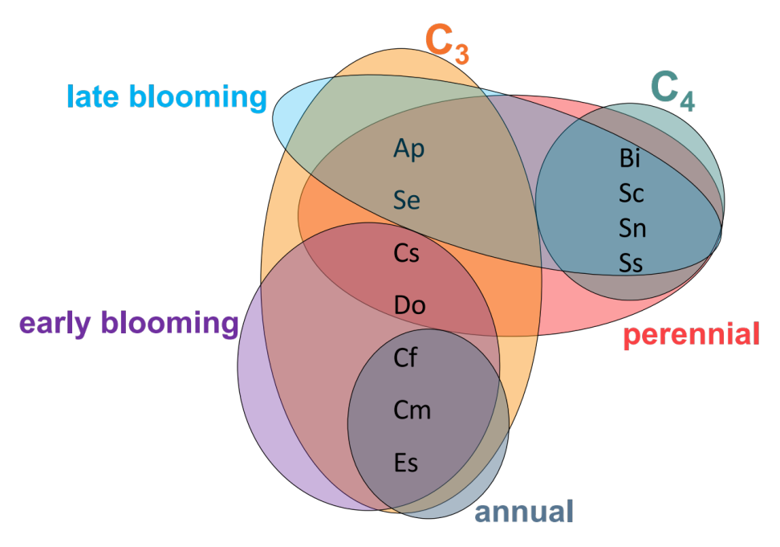
Figure 1. Traits factors and its species inside circles grouped by early and late-blooming species, C₃ and C₄ species, annual and perennial species. Ambrosia psilostachya (AP), Schizachyrium scoparium (Ss), Bothriochloa ischaemum (Bi), Croton monanthogynus (Cm), Chamaecrista fasciculata (Cf), Calylophus serrulatus (Cs), Dichanthelium oligosanthes (Do), Erigeron strigosus (Es), Symphyotrichum ericoides (Se), Sorghastrum nutans (Sn), Sporobolus compositus (Sc).
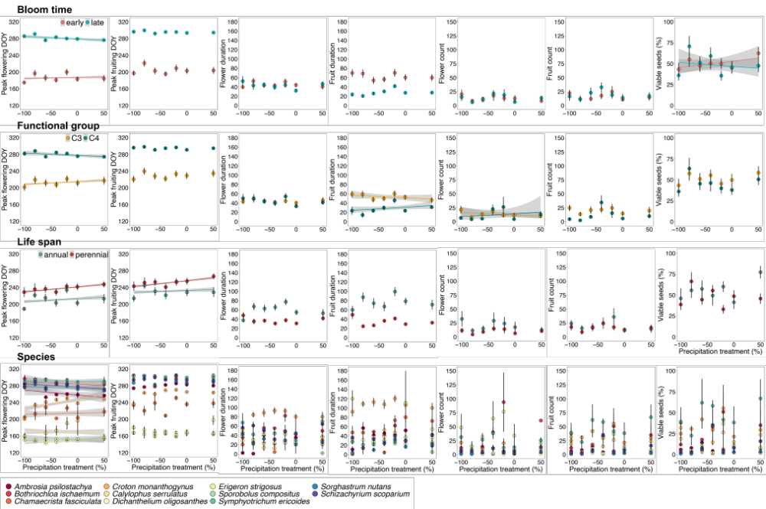
Figure 2. Regression line on the timing and duration of flowering and fruiting, count of flower and fruit, and seed viability shown in day of year (DOY) across the precipitation gradient of seven levels: -100% precipitation, -80% precipitation, -60% precipitation, -40% precipitation, -20% precipitation, 0% precipitation and +50% precipitation, for trait factors and species. Filled circles represent the mean response for each precipitation level with error bars. No regression line means no significance (P <0.05).

Appendix S1

Table S1. Summary tables from GLMMs for studied species grouped as a whole community analysis of the effect of the precipitation gradient on the timing of reproductive phases (peak dates), the duration of reproductive phases, maximum flower and fruit count, and seed viability. Species was a random intercept term in this analysis.
Response | Predictor | Chisq | df | Pr(>Chisq)
Peak Flowering | Intercept | 5150.21 | 1 | <0.001
 | Precipitation treatment | 0.23 | 1 | 0.63
Peak Fruiting | Intercept | 5758.25 | 1 | <0.001
 | Precipitation treatment | 1.63 | 1 | 0.20
Duration Flowering | Intercept | 332.84 | 1 | <0.001
 | Precipitation treatment | 0.02 | 1 | 0.89
Duration Fruiting | Intercept | 385.36 | 1 | <0.001
 | Precipitation treatment | 0.37 | 1 | 0.54
Flower count | Intercept | 41.02 | 1 | <0.001
 | Precipitation treatment | 0.03 | 1 | 0.86
Fruit count | Intercept | 50.90 | 1 | <0.001
 | Precipitation treatment | 0.07 | 1 | 0.80
Seed Viability | Intercept | 20.17 | 1 | <0.001
 | Precipitation treatment | 0.06 | 1 | 0.81

Table S2. Summary tables from GLMMs for studied species grouped by average bloom time analysis of the effect of the precipitation gradient on the timing of reproductive phases (peak dates), the duration of reproductive phases, maximum flower and fruit count, and seed viability.
Response | Predictor | Chisq | df | Pr(>Chisq)
Peak Flowering | Intercept | 7844.14 | 1 | <0.001
 | Precipitation | 0.78 | 1 | 0.38
 | Blooming Time | 20.22 | 1 | <0.001
 | Precipitation*Bloom Time | 3.77 | 1 | 0.05
Peak Fruiting | Intercept | 7270.84 | 1 | <0.001
 | Precipitation | 2.01 | 1 | 0.15
 | Blooming Time | 7.90 | 1 | 0.005
 | Precipitation*Bloom Time | 0.52 | 1 | 0.47
Duration Flowering | Intercept | 117.68 | 1 | <0.001
 | Precipitation | 0.03 | 1 | 0.85
 | Blooming Time | 61.50 | 1 | <0.001
 | Precipitation*Bloom Time | 0.15 | 1 | 0.70
Duration Fruiting | Intercept | 482.71 | 1 | <0.001
 | Precipitation | 1.15 | 1 | 0.28
 | Blooming Time | 10.99 | 1 | 0.001
 | Precipitation*Bloom Time | 2.04 | 1 | 0.15
Flower count | Intercept | 34.66 | 1 | 0.001
 | Precipitation | 0.11 | 1 | 0.74
 | Blooming Time | 10.54 | 1 | 0.001
 | Precipitation*Bloom Time | 2.51 | 1 | 0.11
Fruit count | Intercept | 47.64 | 1 | <0.001
 | Precipitation | 0.14 | 1 | 0.71
 | Blooming Time | 1.39 | 1 | 0.24
 | Precipitation*Bloom Time | 1.93 | 1 | 0.16
Seed Viability | Intercept | 21.53 | 1 | <0.001
 | Precipitation | 0.02 | 1 | 0.87
 | Blooming Time | 0.19 | 1 | 0.70
 | Precipitation*Bloom Time | 4.27 | 1 | 0.03

Table S3. Summary tables from GLMMs for studied species grouped into functional groups (C₃ vs. C₄) analysis of the effect of the precipitation gradient on the timing of reproductive phases (peak dates), the duration of reproductive phases, maximum flower and fruit count, and seed viability.
Response | Predictor | Chisq | df | Pr(>Chisq)
Peak Flowering | Intercept | 5005.03 | 1 | <0.001
 | Precipitation | 1.84 | 1 | 0.17
 | Functional Group | 6.74 | 1 | 0.009
 | Precipitation* Functional Group | 4.91 | 1 | 0.03
Peak Fruiting | Intercept | 5434.31 | 1 | <0.001
 | Precipitation | 2.47 | 1 | 0.11
 | Functional Group | 6.06 | 1 | 0.01
 | Precipitation* Functional Group | 0.91 | 1 | 0.34
Duration Flowering | Intercept | 252.58 | 1 | <0.001
 | Precipitation | 0.05 | 1 | 0.83
 | Functional Group | 0.24 | 1 | 0.62
 | Precipitation * Functional Group | 0.29 | 1 | 0.59
Duration Fruiting | Intercept | 348.41 | 1 | <0.001
 | Precipitation | 0.13 | 1 | 0.72
 | Functional Group | 3.84 | 1 | 0.05
 | Precipitation * Functional Group | 4.32 | 1 | 0.04
Flower count | Intercept | 25.12 | 1 | <0.001
 | Precipitation | 1.34 | 1 | 0.24
 | Functional Group | 0.004 | 1 | 0.98
 | Precipitation * Functional Group | 5.84 | 1 | 0.01
Fruit count | Intercept | 686.24 | 1 | <0.001
 | Precipitation | 0.06 | 1 | 0.81
 | Functional Group | 7.14 | 1 | 0.007
 | Precipitation * Functional Group | 0.29 | 1 | 0.59
Seed Viability | Intercept | 14.34 | 1 | <0.001
 | Precipitation | 0.09 | 1 | 0.76
 | Functional Group | 0.004 | 1 | 0.95
 | Precipitation * Functional Group | 2.16 | 1 | 0.14

Table S4. Summary tables from GLMMs for studied species grouped by life span (annual vs. perennial) analysis of the effect of the precipitation gradient on the timing of reproductive phases (peak dates), the duration of reproductive phases, maximum flower and fruit count, and seed viability.
Response | Predictor | Chisq | df | Pr(>Chisq)
Peak Flowering | Intercept | 1514.41 | 1 | <0.001
 | Precipitation | 9.66 | 1 | 0.002
 | Life Span | 1.25 | 1 | 0.26
 | Precipitation * Life Span | 14.33 | 1 | <0.001
Peak Fruiting | Intercept | 1643.97 | 1 | <0.001
 | Precipitation | 7.80 | 1 | 0.005
 | Life Span | 1.10 | 1 | 0.29
 | Precipitation * Life Span | 6.23 | 1 | 0.012
Duration Flowering | Intercept | 145.53 | 1 | <0.001
 | Precipitation | 0.88 | 1 | 0.35
 | Life Span | 1.25 | 1 | 0.26
 | Precipitation * Life Span | 1.39 | 1 | 0.24
Duration Fruiting | Intercept | 202.94 | 1 | <0.001
 | Precipitation | 1.14 | 1 | 0.28
 | Life Span | 3.38 | 1 | 0.06
 | Precipitation * Life Span | 0.76 | 1 | 0.38
Flower count | Intercept | 16.46 | 1 | <0.001
 | Precipitation | 0.75 | 1 | 0.39
 | Life Span | 0.44 | 1 | 0.50
 | Precipitation * Life Span | 1.40 | 1 | 0.24
Fruit count | Intercept | 21.07 | 1 | <0.001
 | Precipitation | 0.37 | 1 | 0.54
 | Life Span | 0.63 | 1 | 0.43
 | Precipitation * Life Span | 1.51 | 1 | 0.22
Seed Viability | Intercept | 6.52 | 1 | 0.01
 | Precipitation | 0.31 | 1 | 0.58
 | Life Span | 0.53 | 1 | 0.47
 | Precipitation * Life Span | 0.35 | 1 | 0.55

Table S5. Summary tables from GLMMs from the species-level analysis of the effect of the precipitation gradient on the timing of reproductive phases (peak dates), the duration of reproductive phases, maximum flower and fruit count, and seed viability.
Response | Predictor | Chisq | df | Pr(>Chisq)
Peak Flowering | Intercept | 126050 | 1 | <0.001
 | Precipitation | 2.33 | 1 | 0.13
 | Species | 3643.20 | 10 | <0.001
 | Precipitation * Species | 29.14 | 10 | 0.001
Peak Fruiting | Intercept | 222090 | 1 | <0.001
 | Precipitation | 0.23 | 1 | 0.63
 | Species | 5507.7 | 10 | <0.001
 | Precipitation * Species | 17.83 | 10 | 0.06
Duration Flowering | Intercept | 69.77 | 1 | <0.001
 | Precipitation | 0.78 | 1 | 0.37
 | Species | 40.98 | 10 | <0.001
 | Precipitation * Species | 3.15 | 10 | 0.97
Duration Fruiting | Intercept | 115.50 | 1 | <0.001
 | Precipitation | 0.27 | 1 | 0.60
 | Species | 60.36 | 10 | <0.001
 | Precipitation * Species | 9.22 | 10 | 0.51
Flower count | Intercept | 0.61 | 1 | 0.43
 | Precipitation | 0.22 | 1 | 0.64
 | Species | 74.39 | 10 | <0.001
 | Precipitation * Species | 4.06 | 10 | 0.94
Fruit count | Intercept | 4.14 | 1 | 0.04
 | Precipitation | 1.05 | 1 | 0.30
 | Species | 62.44 | 10 | <0.001
 | Precipitation * Species | 4.64 | 10 | 0.91
Seed Viability | Intercept | 9.86 | 1 | 0.002
 | Precipitation | 0.07 | 1 | 0.78
 | Species | 292.38 | 9 | <0.001
 | Precipitation * Species | 9.91 | 9 | 0.36

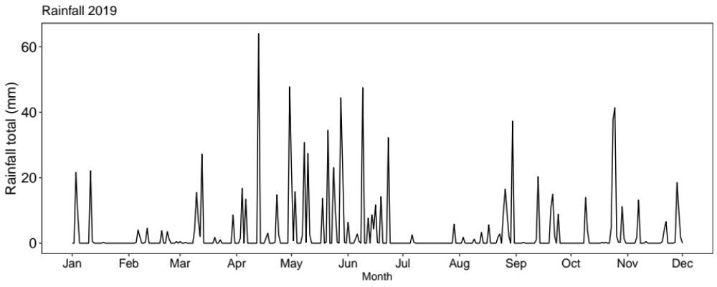
Figure S1. Average rainfall (cm) each month for the duration of the experiment (2019). Rainfall data downloaded from https://www.mesonet.org/ and is from Washington county, OK which is closely located at Kessler Atmospheric and Ecological Field Station.

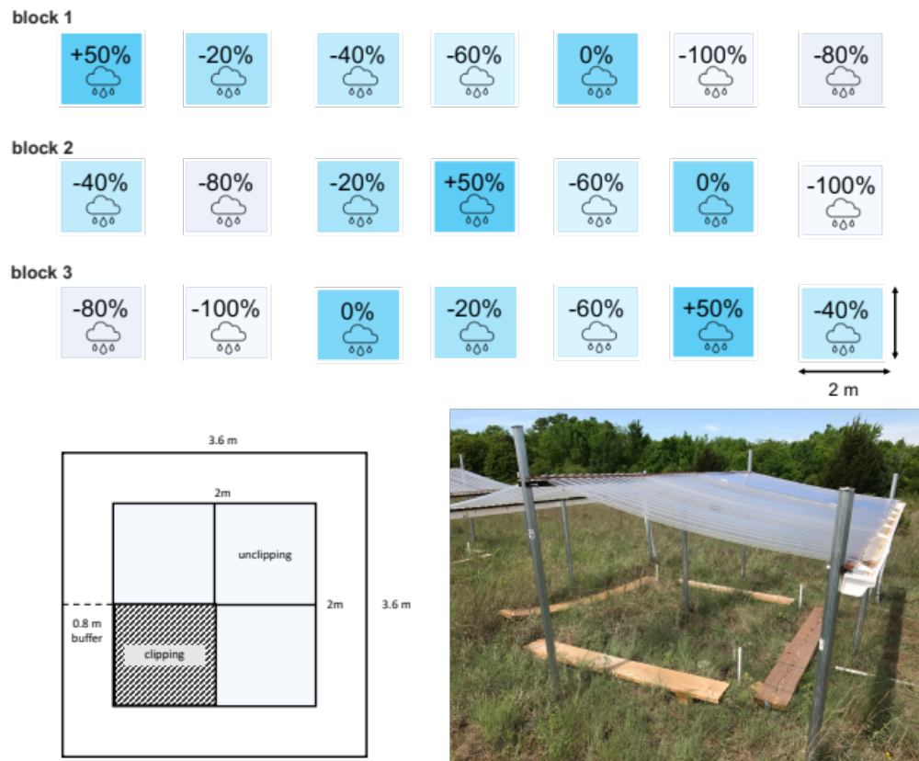
Figure S2. Top left panel: experimental design showing (top panel) arrangement of precipitation shelters that created the precipitation gradient replicated in three blocks (n=3, N=21): -100%, -80%, -60%, -40%, -20% precipitation reduction, 0% change (no precipitation change), and 50% precipitation addition; and arrows pointing clipped (mimicked hay harvest) and unclipped (no hay harvest) subplots. Bottom panel shows left: illustration of a plot and its nested subplots, and right: photo of experimental plot. Clipped subplot was clipped once a year during the growing season (clipping treatment), while unclipped subplot was our control.

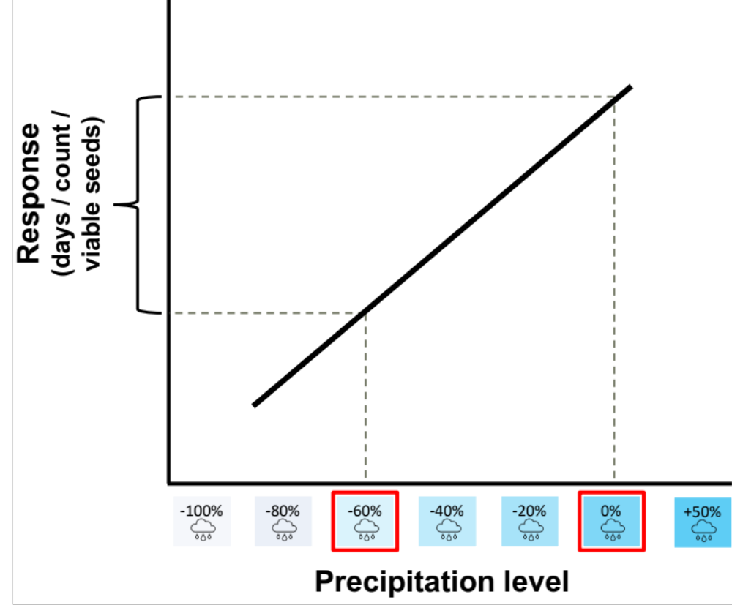
Figure S3. Calculation of phenology shift in days. To allow comparisons with other studies and to provide a recognizable response metric, we calculate responses to experimental precipitation level based on slopes from linear regression equations. The slope was calculated as the change in days, counts, or proportion seeds (Y2-Y1) between -60% precipitation and the 0% control. Effect sizes throughout the results section reflect the change in response between -60% precipitation and the 0% control from linear models as described in the Methods.

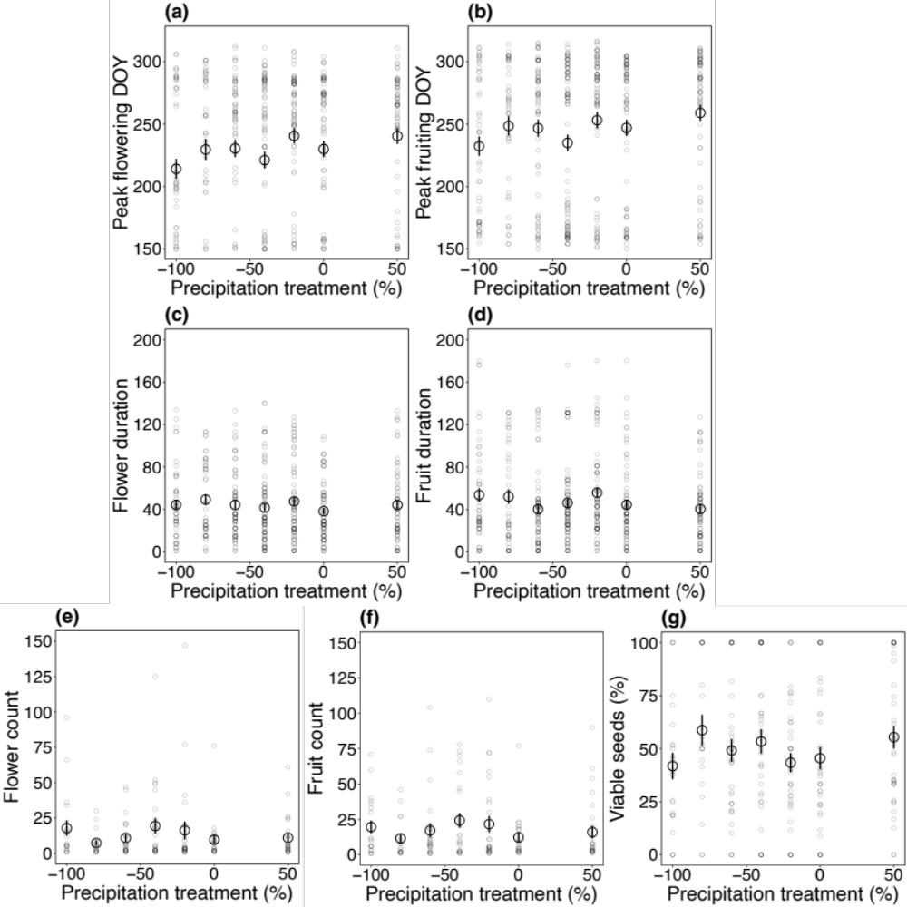
Figure S4. Regression line on the timing and duration of flowering and fruiting, count of flower and fruit, and seed viability shown in day of year (DOY) across the precipitation gradient of seven levels: -100% precipitation, -80% precipitation, -60% precipitation, -40% precipitation, -20% precipitation, 0% precipitation and +50% precipitation, for community-level. Large circles represent the mean response for each precipitation level with error bars. No regression line means no significance (P <0.05).

