University of Oklahoma

Graduate College

Population dynamics and long-term impacts of the invasive zebra mussel (Dreissena polymorpha) in a subtropical reservoir

A Dissertation

submitted to the graduate faculty

in partial fulfillment of the requirements for the

Degree of

Doctor of Philosophy

By

Thayer C. Hallidayschult
Norman, Oklahoma
2018

Population dynamics and long-term impacts of the invasive zebra mussel (Dreissena polymorpha) in a subtropical reservoir

A Dissertation approved for the
Department of Biology

By

______________________________
Dr. K. David Hambright, Chair

______________________________
Dr. Michael Kaspari

______________________________
Dr. Caryn Vaughn

______________________________
Dr. Edith Marsh-Matthews

______________________________
Dr. Robert Cichewicz II

© Copyright by Thayer c. hallidayschult 2018
All Rights Reserved.

Acknowledgements

I would first like to thank my advisor, Dr. K. David Hambright, without whom I would never have gotten through this dissertation. I can’t imagine that any other advisor would have pushed me so hard to do my best while also being so supportive. I would also like to thank my committee members, Dr. Mike Kaspari, Dr. Caryn Vaughn, Dr. Edith Marsh-Matthews, and Dr. Robert Cichewicz II for all their help and feedback in guiding the direction of this dissertation.

I would also like to thank the many wonderful staff members at both the Biological station and in the Biology department for their continuous assistance and support of graduate students.

I would like to thank all the members of the Plankton Ecology and Limnology Lab, both past and present, who gave support and feedback on this work, helped out with data collection, and helped guide me through the long process from start to finish.

I wouldn’t be anywhere without my wonderful parents, Carolyn Halliday and C.R. Schult. Their steadfast support and belief and love carried me to this point in my life, undoubtedly. And finally, Jessica, for keeping me on track, helping me with stats, giving me draft feedback, and frankly just being unbelievably supportive.

Funding was provided by the OU Biology department’s Adams Scholarship & L. G. Hill Excellence Fund award, the OU Biological Station Graduate Research Fellowship, and a Sigma Xi Grant-in-Aid of Research.

Table of Contents
Acknowledgements iv
List of Tables ix
List of Figures xi
Abstract xix
Chapter 1 - Predicting zebra mussel (Dreissena polymorpha) distributions within a subtropical reservoir using key water quality parameters 1
Abstract 1
Introduction 2
Methods 10
Results 12
Discussion 13
Acknowledgements 19
Works Cited 20
Figures 29
Tables 33
Chapter 2 - Highly variable colonization patterns in juvenile zebra mussels (Dreissena polymorpha) in a recently invaded subtropical lake 35
Abstract 35
Introduction 36
Methods 41
Results 44
Discussion 45
Works Cited 55
Figures 61
Tables 71
Chapter 3 - Variable zebra mussel (Dreissena polymorpha) population densities in a subtropical reservoir result in significant but localized effects on long term water clarity 73
Acknowledgements 73
Abstract 74
Introduction 75
Methods 80
Results 83
Discussion 85
Works Cited 90
Figures 96
Tables 106
Chapter 4 - Harris mud crabs (Rhithropanopeus harrisii) as a novel invasive predator of zebra mussels (Dreissena polymorpha) 110
Abstract 111
Introduction 112
Methods 119
Results 123
Discussion 124
Acknowledgements 134
Works Cited 134
Figures 142
Tables 155

List of Tables
Chapter 1
Table 1: Comparison of minimum, maximum, and median values of environmental variables between areas of Lake Texoma for temperature (Temp), specific conductivity (Sp. Cond.), chlorophyll (Chl.) , dissolved oxygen (DO), and Secchi depth. 33
Table 2: Results of logistic regression model testing for differences in environmental parameters between the Red River and Washita River arms of Lake Texoma, with the standard error (S.E.), z-value, and p-value for each of the independent environmental variables tested. Only specific conductivity and Secchi depth were significantly different between lake arms in the logistic regression model. 34
Chapter 2
Table 1: results of mixed effect model. As expected, zebra mussel distributions were extremely variable between sites, but were also variable within a site, with fewer zebra mussels being found on plate area C than A, and more being found on plate area D than A. More zebra mussels were also found at 3 meters than at 1 meter. 71
Table 2: Results of Wilcoxon rank-sum test pairs. After adjusting α to 0.008 to account for multiple corrections, area A and D are different from B and C but not each other, and areas B and C are different from A and D but not each other, meaning that sample masses were significantly higher on samples from the inside (areas B and C) of the sampler than areas from the outside (areas A and D) of the sampler. 72
Chapter 3
Table 1: Results of the linear model created to predict Secchi depth in the Red River and Washita River arms of the lake. The satellite reflectance model for the Red River arm had a residual standard error of 0.3732 on 49 degrees of freedom, with an R² of 0.2027, while the model for the Washita River arm had a residual standard error of 0.296 on 53 degrees of freedom, with an R² of 0.3105. 106
Table 2: Results of Wilcoxon test comparing pre-and post-zebra mussel invasion Secchi depths, grouped by month and lake arm. 109
Chapter 4
Table 1: Results of the generalized linear mixed effects model testing the relationship between size class and number of zebra mussels consumed. When all crabs were used, mussels from size class A were not consumed significantly more often than mussels from size class B, but were consumed more often than mussels from size classes C, D, and E. When only cooperative crabs were used, there were no significant differences between groups. 155
Table 2: Carapace and claw sizes for crabs used in the experiment, along with their consumption during the 4 days of the experiments. In the zebra mussels consumed columns, the first number is the number of zebra mussels consumed, and the second number is the total shell free dry mass of the zebra mussels consumed. The bolded and highlighted rows indicate the crabs identified as cooperative (i.e., crabs 2, 4, 7, 8, 9, 11, and 15), defined as those crabs that consumed mussels in at least three of the four days of the experiment. 157
Table 3: The overall number of mussels presented and consumed by crabs during the experiment, and Manly’s α (Chesson 1978) values for each category. Harris mud crabs showed a preference for the smaller two size classes of zebra mussels. (Alpha values above 0.2 indicate positive preference) 159

List of Figures

Chapter 1
Figure 1: Location of Lake Texoma in the United States (upper panel), and map of site locations on Lake Texoma (lower panel). The Red River feeds into Lake Texoma from the west, while the Washita River, originating from the west, feeds into Lake Texoma from the northeast. Sampling sites Texoma Marina, Buncombe Creek, and Cedar Mills were considered to be on the Red River arm, while Johnson creek, Catfish Bay, and Soldier Creek were considered to be on the Washita River arm of the lake. 29
Figure 2: PCA of differences in environmental variables between the Red and Washita River arms of Lake Texoma. Arrows represent the direction of samples with higher levels of a given parameter, and the colored circles represent the area which encompasses 67% of sampling events on a given arm of the lake. The variables fed into the PCA were the same as those used in the regression analysis: temperature, specific conductivity, chlorophyll, dissolved oxygen, and Secchi depth. Secchi depth, specific conductivity, and chlorophyll can be seen to act as the primary separators between the Red River and the Washita River arms of the lake. 30
Figure 3: Veliger incidence rates for each arm (Red River vs Washita River) of the lake, as the proportion of total samples which contained at least one veliger. Error bars represent bootstrapped 95% confidence intervals. Veligers were much more likely to be found in a given sample from the Washita River arm than the Red River arm of the lake. 31
Figure 4: Mean abundance of veligers per cubic meter across all samples with at least one veliger, with bootstrapped 95% confidence intervals. In any given sample with at least one veliger, abundances were much higher in the Washita River arm than the Red River arm of the lake. Even when veligers were present in a Red River arm sample, the abundances were low. 32
Chapter 2
Figure 1: Location of Lake Texoma in the United States and map of site locations on Lake Texoma. The Red River feeds into the lake from the west, while the Washita River feeds in from the North. Sampling sites Texoma Marina, Buncombe Creek, and Cedar Mills were considered to be on the Red River arm, while Johnson creek, Catfish Bay, and Soldier Creek were considered to be on the Washita River arm. 61
Figure 2: schematic of zebra mussel settling sampler design. Two horizontal PVC 20cm × 20cm squares are mounted on an eye bolt, with a 2.5 cm segment of PVC tubing used as a spacer between them. A PVC cap with a hole drilled through the middle holds the top plate in place below the eye of the eye bolt, while a wing nut below firmly keeps the plates in place. When sampling, the wing nut is loosened or removed to grant access to all four sampling areas (the top and underside of each plate), marked A, B, C, and D. 62
Figure 3: Seasonal variation in zebra mussel settling patterns in Lake Texoma, with each circle representing the average zebra mussel density at a given site and depth. Settlers were only detected during May, June, and July. Note the log scale 63
Figure 4: Seasonal variation in physiochemical factors, with month (Jan=1, etc.) on the X axis and the relevant physiochemical parameter on the Y axis. Each circle represents an observation from a site, at 1 and 3 meters (except in the case of Secchi depth, which is site-specific, but not depth-specific). 64
Figure 5: Zebra mussel settling patterns by sampling site, arranged from west to east. Whiskers are 1.5 times the upper or lower inter-quartile range, and open circles represent individual samples. 65
Figure 6: Zebra mussel settling patterns within a given sampler, when zebra mussel settlers were present. The four available areas of the samplers are marked A, B, C, and D, with A being the top of plate 1, B being the bottom of plate 1, C being the top of plate 2 and D being the bottom of plate 2. Lowercase letters denote which plate areas were significantly different from one another, with A and B being similar to each other but different from C and D, C being different from A, B, and D, and D being different from A, B, and C. Whiskers are 1.5 times the upper or lower IQR, and open circles represent individual samples. 66
Figure 7: Zebra mussel settling patterns across samplers at 1- and 3-meter depths. When present, zebra mussels occurred at a significantly higher density on samplers suspended at 3 meters than on samplers suspended at 1 meter. Whiskers are 1.5 times the upper or lower IQR, and open circles represent individual samples. 67
Figure 8: Water temperatures at 1 and 3 meters throughout the annual cycle. Closed circles represent values recorded at 1 meter, while open triangles represent values recorded at 3 meters. While temperatures are close together, summer water temperatures were slightly cooler at 3 meters within a given site. 68
Figure 9: Results of the sediment mass analysis by plate, showing the the dry mass for each of the 100 samples, grouped by plate area (A, B, C, and D). Lower case letters denote the plate areas which are significantly different from one another, with plates A and D being similar to one another but different from B and C, while B and C are similar to one another but different from A and D. Whiskers are 1.5 times the upper or lower inter-quartile range, and open circles indicate individual samples. 69
Figure 10: Results of the sediment mass analysis by sampling site, showing the the dry mass for each of the 100 samples, where TM is Texoma Marina (Red River arm), CM is Cedar Mills (Red River arm), BC is Buncombe Creek (Red River arm), SC is Soldier Creek (Washita River arm), and CB is Catfish Bay (Washita River arm). Lowercase letters denote the statistical differences between sites. Cedar Mills had significantly lower sample mass than the other sites. Whiskers are 1.5 times the upper or lower inter-quartile range, and open circles indicate individual samples. 70
Chapter 3
Figure 1: A map of Lake Texoma, showing the areas in which we focused our data collection efforts for the Red River arm (fed by the Red River coming in from the west) and Washita River arm (fed by the Washita River coming in from the north). 96
Figure 2: Plots of the recorded Secchi depths (light blue dots) as well as the Secchi depths inferred by our linear regression model based on satellite image reflectance (orange dots) for the Red River (top) and Washita River (bottom) arm of the lake. The dashed black line shows the linear trend in the combined in situ and inferred Secchi depth for both lake arms over time, with the average Secchi depth in the Red River arm decreasing over time and the average Secchi depth in the Washita River arm increasing over time. These trends were supported in both the in situ and inferred models, with the in situ (n = 172, t = 2.79, p = 0.006) and predicted (n = 86, t = 7.057, p-value < 0.0001) Secchi depths increasing in the Washita River arm, and both in situ (n = 174, t = -5.14, p < 0.001) and predicted (n = 91, t = -1.897, p-value = 0.0494) Secchi depths decreasing in the Red River arm. 97
Figure 3: Boxplot of combined in situ and inferred Secchi depths, in meters, pre- and post-invasion for each arm of the lake. In situ values are in gray, and values inferred via the satellite model are in yellow. The Red River arm Secchi depths are significantly lower post-invasion, while the Washita River arm Secchi depths are significantly higher post-invasion. Whiskers represent 1.5 times the inter-quartile range, with open circles indicating individual recorded Secchi depths. 99
Figure 4: Seasonal analysis of Secchi depth shifts pre-and post-zebra mussel invasion. 1-12 on X axis represent months of the year, beginning in January. In the Washita, Secchi depths changed significantly in Jan, Apr, Jun, Jul, & Oct. In the Red, Secchi depths changed significantly in Mar & Aug. 100
Figure 5: result of breakpoint analysis, which identified mid-2001 as the point which defined a different slope in the linear relationship between year and Secchi depth. The red line shows the linear fit pre-and post-2001. Black bars at the bottom represent density of data. 101
Figure 6: Boxplot of chlorophyll-a concentrations, in micrograms per liter, pre-and post-zebra mussel invasion. Chlorophyll concentrations were lower in both arms of the lake post-zebra mussel invasion. Whiskers represent 1.5 times the inter-quartile range, with open circles indicating individual recorded chlorophyll concentrations. 102
Figure 7: Boxplot of nitrogen and phosphorus concentrations, in milligrams per liter, pre- and post-invasion for the Washita River and Red River arms of the lake. Nitrogen concentrations significantly increased in the Red River arm, but no other concentrations significantly changed pre- and post-invasion. Whiskers represent 1.5 times the upper or lower inter-quartile range, with open circles indicating individual recorded nutrient concentrations. 103
Figure 8: Plot of overall zooplankton biomass, in micrograms per liter, from 2006 to 2012. There was no significant change in zooplankton biomass in the Washita River arm over time either pre- or post-invasion, but in the Red River arm, zooplankton biomass did not change during the pre-invasion period and significantly increased post-invasion. 104
Figure 9: Plot of the average monthly instantaneous discharge recorded at gauging stations directly above where the Red and Washita Rivers flow into Lake Texoma, representing the inflow rates for each arm of the lake (discounting inflows from other tributaries). Whiskers represent 1.5 times the upper or lower inter-quartile range with open circles representing each individual monthly average. Flow rates decreased for both rivers in the post-zebra mussel invasion time period. 105
Chapter 4
Figure 1: United States Geological Survey map of the current recorded Harris Mud Crab distribution. The gold filled area represents areas where it is native (or had spread before the native crab fauna had been catalogued), with the colored circles representing documented invasion locations. The map likely does not represent the full extent of their range expansion due to its status as an understudied and cryptic invader. 142
Figure 2: Photograph of a Styrofoam dock float from Lake Texoma, courtesy of Tom Wooten, owner of Buncombe Creek Marina. The holes are Harris mud crab burrows. 143
Figure 3: Example image of crab photo used for morphometric analysis, with the 7 landmark locations identified. 144
Figure 4: Relationship between crab size and claw height and length, demonstrating a relatively stable allometric relationship. Blue squares are chelae length, and orange circles are chelae height. 145
Figure 5: Total combined mass of zebra mussels consumed per size class for each crab across the 4 days of the experiment (top, all crabs; bottom, cooperative crabs only). For each boxplot, the thick dark line represents the median, the box the inter-quartile range, and the whiskers 1.5 times the inter-quartile range. Open circles represent values which lie outside of the whiskers. We found no significant differences in mass consumed between size classes of zebra mussels all crabs, but significantly more mass from size class E was consumed by cooperative crabs. 146
Figure 6: Consumption patterns in the cooperative crabs (i.e., those which consumed zebra mussels in at least three of the four daily feeding trials, orange triangles) and uncooperative crabs (blue circles). Numbers and mass of zebra mussels consumed increased with crab size (as carapace width) for cooperative crabs. 148
Figure 7: Total count of zebra mussels consumed per size class for each crab across the 4 days of the experiment (top), and total count of zebra mussels consumed by cooperative crabs (bottom). When all crabs were used, significantly more zebra mussels of size class A were consumed than for classes C, D, and E, but there was no significant difference between consumption of size class A and B. When only cooperative crabs were used, no differences between groups were found. 149
Figure 8: Average mass of zebra mussels consumed by crab carapace width, with cooperators in orange circles and non-cooperators in blue squares. Mass consumed during the experiment increases for both groups as crab size increased. 151
Figure 9: Figure showing an average strength and direction of the movement of the landmarks between crab individuals, with a superimposed photo for reference of what part of the claw each landmark was tracking. More movement can be seen in the position of the teeth, with relatively little change in the shape of the main portion of the chela. 152
Figure 10: Total zebra mussel mass consumed (left) and the amount of zebra mussel mass consumed relative to the crab’s own body weight (right) when plotted against variation in claw shape, as captured by the claw’s principal component 1 score for cooperative crabs (i.e., those which consumed zebra mussels in at least three of the four daily feeding trials, orange triangles) and uncooperative crabs (blue circles). 153

Abstract
As humans continue to advance through the Anthropocene, we find that among other impacts, the rate at which species expand their range and are transplanted into new environments continues to increase. As the frequency of biological invasions increases, so too do our opportunities to understand how the environment shapes and controls these invaders, and how these invaders may in turn shape the environment they have invaded. In chapter one, I examine how key environmental characteristic can be used to predict how zebra mussels (Dreissena polymorpha), an aquatic invasive species, are distributed within the large subtropical reservoir Lake Texoma, and in chapter two, I look at how fine scale differences within a location structure the local population densities of zebra mussels. In chapter three, I look at how zebra mussels, once established, may in turn be altering the characteristics of their environment by increasing water clarity, even when they do not reach high densities. Chapter four considers the interactions between zebra mussels and another invasive species, the Harris mud crab (Rhithropanopeus harrisii) and how this invasive crab may play an important role as a novel predator of zebra mussels in lakes where they co-occur.
In chapter one, I tested if environmental variation explains zebra mussel distribution within a lake by measuring zebra mussel larval (veliger) abundances and quantifying water quality at six sites across the two arms of subtropical Lake Texoma, OK-TX from 2011-2015. I found a gradient in salinity, water clarity, and algal abundances across the two arms of the lake which correlated with mussel densities. Zebra mussel veliger densities were lower in the arm of the river with lower water clarity, higher salinity, and higher productivity.
In chapter 2, I examined the colonization patterns of newly settled zebra mussels to determine what factors play a role in predicting fine-scale patterns in their densities at a given location. To test this, I deployed PVC samplers to attract settling zebra mussel juveniles, in a configuration that manipulated the availability of shelter, light levels and depth. Zebra mussels were collected from the samplers once a month from August 2011 to June 2012. We found that newly settled zebra mussels preferred unenclosed surfaces on the undersides of the samplers, and did not prefer areas sheltered from fish predation nor avoid surfaces which received more light. Settling patterns may have instead been strongly shaped by sedimentation, as sample collected from the inside areas of the sampler had higher sample mass. Settling was also likely influenced by the newly introduced Harris mud crab (Rhithropanopeus harrisii), a potentially important predator of zebra mussels, which also recruited to the PVC samplers. Taken as a whole, these results indicate that even at the local scale, small variations in the immediate environment can drastically alter the suitability of hard substrate for colonization by zebra mussels.
In chapter 3, I tested for effects of zebra mussels on water clarity of Lake Texoma by creating a long-term (1980-2017) dataset of Secchi depths, nutrient concentrations, chlorophyll concentrations and zooplankton biomass. I supplemented these data with inferred Secchi depths, created by using satellite imagery to estimate Secchi depth during periods of time where data were missing. Based on the uneven distribution of zebra mussels in the lake, I conducted the analysis separately for the Red River arm where zebra mussels were scarce and for the Washita River arm where zebra mussels were more abundant. I found that water clarities have increased in the Washita River arm but not the Red River arm. None of the other measured water quality parameters changed in association with the increase in clarity in the Washita River arm except for inflow volume, suggesting that the effect is likely due to zebra mussels interacting with changes in hydrology.
In chapter 4, I tested whether and to what extent Harris mud crabs act as predators of zebra mussels under laboratory conditions. I conducted feeding trials to test how mussel size and crab body size affected the size and total mass of mussels consumed. No relationship was found between crab size and overall mussel mass consumed, with a large amount of variance in mussel consumption. Overall, crabs preferred smaller mussels over larger mussels when analyzing the number consumed, but this effect disappeared when instead analyzing the total mass consumed for a given size class. Analysis of crab claw morphology did not better explain consumption patterns, but when the data were subset into crabs which did and did not cooperate (ate on at least 3 of the 4 days), the cooperative crab absolute and relative consumption scaled with body size. These results suggest that Harris mud crabs may play an important role as a predator of zebra mussels, but we require a better understanding of their highly variable consumption patterns as well as more research into their current and potential habitat overlap to make accurate predictions. Furthermore, the interactions between these two species should be considered in not just the context of a predator-prey relationship, but also in terms of the zebra mussel’s capacity to act as a powerful ecosystem engineer, altering the landscape of lakes they invade.
As the rate of species range expansion and transplantation continues to increase, there is a growing pressure to understand how we can work to predict the extent to which species will spread, as well as the potential impacts these species will have on the systems they invade. To understand these dynamics, we have to build an understanding of a species not only in optimal environments, but also in environments at the edge of their physiological tolerances. We also must consider that a spreading species does not exist in isolation, but will in fact have a complex web of interactions with not only native species, but also other invasive species with which it may not have ever interacted with before.

Chapter 1 - Predicting zebra mussel (Dreissena polymorpha) distributions within a subtropical reservoir using key water quality parameters

Thayer C. Hallidayschult (ORCID 0000-0001-7179-5320), Jessica E. Beyer (0000-0002-3388-3255) and K. David Hambright (0000-0002-5592-963X)
Program in Ecology and Evolutionary Biology and Plankton Ecology and Limnology Laboratory, Department of Biology, University of Oklahoma, Norman, OK, USA

Keywords: Dreissena polymorpha, zebra mussel, subtropical lakes, Lake Texoma, invasive species, aquatic nuisance species

Abstract
Zebra mussels (Dreissena polymorpha) are one of the most economically and ecologically disruptive aquatic invasive species in North America where they alter ecological processes and damage infrastructure. Thus, understanding and predicting where and when zebra mussels can colonize next is essential, and key water quality parameters such as temperature, water clarity, dissolved oxygen, and primary productivity have all been found to play major roles in zebra mussel establishment. In stressful habitats where zebra mussels are on the edge of their environmental tolerances, such as in subtropical lakes, environmental parameters should become even more important in determining zebra mussel distributions. Based on previous research, increases in water clarity and dissolved oxygen should be associated with higher zebra mussel abundances, while increases in water temperature, salinity, and primary productivity should be associated with lower abundances. To test if environmental variation explains zebra mussel distribution within a lake, we measured zebra mussel larval (veliger) abundances and quantified water quality at six sites across the two arms of subtropical Lake Texoma, OK-TX from 2011-2015. We found a gradient in salinity, water clarity, and algal abundances across the two arms of the lake which correlated with mussel densities. Zebra mussel veliger densities were lower in the arm of the river with lower water clarity, higher salinity, and higher productivity. In habitats which are particularly stressful for zebra mussels, water quality gradients may provide an easy way to predict and map zebra mussel population densities across heterogeneous lakes, thus enabling more proactive and directed mitigation efforts.

Introduction
Zebra mussels (Dreissena polymorpha) are a well-known aquatic invasive species with a reputation for invading and disrupting ecosystems. Originating in the Ponto-Caspian region, zebra mussels have spread across Europe (Karatayev et al. 1997) and into North America. They were first recorded in the Laurentian Great Lakes in 1986, and have since made their way into lakes and rivers across much of the eastern half of the United States (Roberts 1990). The impacts of zebra mussels are of both ecological and economic concern (Limburg et al. 2010, Strayer 2010, Sousa et al. 2014). Zebra mussels, as filter feeders which can form dense colonies, can clear large amounts of algae out of the water column and depositing wastes onto stream and lake bottoms (Gergs et al. 2009). This increase in benthic nutrients encourages the growth of both benthic flora and fauna, with increased densities of nuisance benthic algae such as Cladophora (Armenio et al. 2016), although the response of benthic fauna seems to vary by taxa, with organisms specializing in soft substrate tending to decline, e.g. the amphipod Diporeia (Nalepa et al. 1998), and large increases in abundance for species which take advantage of hard substrate (Ozersky et al. 2011, Stewart et al. 1998, Stewart et al. 1999, Ward and Ricciardi 2007). This transport of nutrients from the pelagic to the benthic system is often accompanied by reduced particle densities in the water column, resulting in increased water clarity (Effler et al. 1996, Budd et al. 2001, Barbiero and Tuchman 2004, Higgins and Vander Zanden 2010, Binding et al. 2015, Geisler et al. 2016). While the increased water clarity that often accompanies the dramatic declines in algal biomass in invaded systems may be welcomed by some lake users, such changes can be detrimental (Parparov et al. 2006, De Stasio et al. 2008), and the ecology of these invaded systems can be fundamentally altered as energy flow and nutrient cycling that would be normally occur in the water column are instead shunted into the benthic community (Higgins and Vander Zanden 2010).

Additionally, zebra mussels are notorious biofoulers, attaching to any submerged hard surfaces, including water intake pipes and boats. It has been estimated that since zebra mussels invaded the United States, they have directly caused hundreds of millions of dollars in damages to power and water treatment plants alone (Connelly et al. 2007). Globally, their impacts have been severe enough for the Invasive Species Specialist Group of the International Union for Conservation of Nature (IUCN) to list them as one of the top 100 world’s worst invasive species (Lowe et al. 2000).

In part due to the substantial negative ecological and economic impacts, there has been extensive research dedicated to understanding and predicting the spread of zebra mussels. Several key environmental factors can limit the habitat suitability of zebra mussels, including water temperature (Karatayev et al. 1998, Griebeler and Seitz 2007), salinity (Ellis and MacIsaac 2008) and calcium levels (McMahon 1996). Researchers have found that these environmental factors are an essential component for predicting which lakes are most vulnerable to invasion in temperate regions of Europe, e.g. (Karatayev et al. 2015), as well as in the United States, e.g., (Drake and Bossenbroek 2004, Johnson et al. 2008).

The United States represents an extremely heterogeneous set of potential water bodies to invade (Drake and Bossenbroek 2004). As the range of zebra mussels continues to expand, they inevitably invade water bodies on the edge of their environmental tolerances, such as subtropical lakes and rivers (Allen et al. 1999, Mihuc et al. 1999, Churchill 2013, Smith et al. 2016, Churchill et al. 2017). These systems, particularly subtropical reservoirs, offer extremely high habitat diversity relative to temperate systems. In this context, some portions of an invaded subtropical reservoir, such as areas near the deep main channel and dam, may be suitable for colonization, as environmental variation may consistently remain within the zebra mussel range of tolerance. By contrast, some portions of subtropical reservoirs, such as shallow backwaters and embayments, may experience extremely high fluctuations in water depths, temperatures, and other environmental conditions, such that some habitats may frequently range beyond zebra mussel tolerances. Thus, environmental characteristics generally used for predicting zebra mussels on a broad geographic scale (e.g., summer water temperatures, dissolved oxygen and chlorophyll concentrations, water clarity, salinity, calcium, and pH) may also be useful for predicting finer-scale, within lake habitat suitability.

When organisms expand to new areas from their natural range, one of the most surprising yet well-documented results is a shift in the niche of the organism in its newly invaded environment when compared to the niche breadth defined by looking at the organism in its native range, even when considering factors as fundamental as temperature tolerances (Broennimann et al. 2007). In the case of problematic invasive species such as zebra mussels, it is essential to continue collecting data describing the fundamental niche of an organism as it expands its range to better understand what limits may prove to be true physiological hurtles and what limits may simply be an artifact of the complex interplay between sets of biotic and abiotic stressors in its original range. The problem of quantifying physiological constraints is particularly interesting in the case of zebra mussels, as researchers have found that even between invasion fronts, which environmental factors limit zebra mussels seems to change. Constraints on European populations differ from the constraints on North American populations, with differences in temperature and salinity tolerances reported between North American and European populations (McMahon 1996, Karatayev et al. 1998). Similarly, zebra mussels defied predictions based on their temperature tolerances in temperate North American populations as they expanded into subtropical regions (Elderkin and Klerks 2005). Therefore, it remains essential to continue to apply scrutiny to zebra mussel populations along the invasion front, gathering information from potentially stressful environments to better understand their true physiological limits.

One such invaded water body that presents environmental challenges to zebra mussels is Lake Texoma, a subtropical reservoir located on the Texas-Oklahoma border (Fig. 1). Created in 1944 by damming the confluence of the Red River and the Washita River, the lake provides an excellent arena for testing the importance of key environmental parameters in predicting zebra mussel distributions in suboptimal habitats. Lake Texoma is a particularly useful lake for investigating this phenomenon because it receives water from two watersheds in which physiochemical properties, including water quality factors known to be important in determining zebra mussel habitat invasion success, can vary significantly depending on which river is the dominant source of water for a particular site. Previous research on zebra mussel veliger densities conducted by Churchill (2013), monitored at a site close to the dam, has shown that zebra mussels seasonally spawn in Lake Texoma, with veliger abundance related to the favorable water temperatures of May and June, peaking at densities of 42 veligers per liter (much lower than the densities observed in El Dorado Lake in Kansas (270/L) and Oologah Lake in Oklahoma (480/L). Veliger densities were also found to be heavily impacted by the hot conditions and low water levels of 2011, with veliger densities only a tenth (peak of 3.3/L) of what was reported in 2010 (peak of 42/L).

As a subtropical lake, many parts of the lake routinely reach temperatures approaching the known thermal maxima for zebra mussels of 32°C (Mackie and Claudi 2010, Churchill et al. 2017, Beyer et al. 2011). Not only are high summer water temperatures physiologically stressful to zebra mussels, they may act to amplify the importance of other stressors as well. Thermal stressors in particular have been shown to make aquatic organisms more vulnerable to additional stressors, such as salinity (Spidle et al. 1995) or toxins (Heugens et al. 2001), and as a result zebra mussels in subtropical lakes may well be more sensitive to variation in water quality. An important factor linked to these warm summer water temperatures, particularly in eutrophic lakes, is dissolved oxygen. Zebra mussels are intolerant of prolonged exposure to dissolved oxygen concentrations below 6 mg/l, and are unlikely to survive in waters that regularly drop below a dissolved oxygen concentration of 3 mg/l (Matthews and McMahon 1995). Previous work on zebra mussel populations in Lake Texoma has found that zebra mussels have high growth rates in the lake while conditions are favorable, but are also prone to temperature stress and experience high summer mortality (Churchill et al. 2017).

Like many filter-feeding organisms, zebra mussel growth rates typically display a unimodal response to food concentrations (Naddafi et al. 2011). Zebra mussels starve when food concentration is too low, but extremely high food concentrations can clog gills and can make sorting palatable particles from unpalatable particles much more difficult. The eutrophic conditions necessary for high chlorophyll concentration also promote blooms of cyanobacteria, which are a poor food source for zebra mussels (Vanderploeg et al. 1996) and are associated with decreased condition in zebra mussel populations (Vanderploeg et al. 2009). Thus, high chlorophyll concentrations are problematic for zebra mussel feeding, as they make feeding more difficult and are often associated with poor quality food.

Poor quality food is not the only problem facing zebra mussels in eutrophic systems. High levels of decomposing organic matter can deplete the oxygen in deeper waters, which has the potential to kill any zebra mussels which happen to deeper areas that frequently exhibit low oxygen concentrations (McMahon 1996). Eutrophic lakes also produce large amounts of particulate organic matter, which can settle out on hard substrate and prevent zebra mussels from using that habitat. If a large amount of the lake bottom is composed of a soft organic substrate, zebra mussel densities will be much lower due to a shortage of hard substrate (Mellina and Rasmussen 1994). As a result, poor water clarity is associated with lower zebra mussel densities. Thus, in a eutrophic lake with poor water clarity, increases in Secchi depth should be positively associated with zebra mussel densities.

Salinity is typically of little concern for inland lakes and has largely been useful in temperate regions for predicting zebra mussel invasion of coastal estuaries and rivers (Karatayev et al. 1998). Nevertheless, salinity is of greater concern in subtropical regions, where many lakes, such as those in Oklahoma and Texas, can reach salinities in excess of 1 part per thousand (ppt). Zebra mussel populations can be found in habitats with salinities above 4 ppt (Orlova et al. 1998), so salinity in inland waters is unlikely to act as a source of acute mortality, as short term salinity tolerance of zebra mussels is quite high (Ellis and MacIsaac 2008), and zebra mussel populations can persist in estuaries with salinities of 8-12 ppt (Karatayev et al. 1998). However, even if salinity is not high enough to cause acute mortality, it is still likely to act as a stressor, particularly when interacting with other stressors, as stressors commonly interact, amplifying an organism’s sensitivity to stress (Lemm and Feld 2017). Higher temperatures increase zebra mussel sensitivity to salinity stress (Spidle et al. 1995), and salinities as low as 1 ppt negatively affect the rate at which zebra mussels generate byssal threads (Grutters et al. 2012). These sublethal effects may be particularly important when considering the interactive effect between multiple stressors, resulting in a zebra mussel population which is more stressed by salinity.

As with any shelled mollusk, zebra mussels require calcium in the water to construct their shells, and cannot maintain shell integrity without a minimum calcium concentration of 15 mg/l. Similarly, low pH environments actively degrade their shells, and zebra mussels are uncommon in waters with a pH below 7.5 (Karatayev et al. 2015).

We hypothesized that local-scale variation in zebra mussel abundances in Lake Texoma could be predicted using the same factors used to predict zebra mussel invasion success on a larger scale. Our predictions were that zebra mussel densities should be negatively associated with increases in summer water temperatures, increased chlorophyll, decreased water clarity, and increased salinity. To test these predictions, we carried out monthly monitoring of zebra mussel veliger densities, Secchi depth, water temperature, chlorophyll concentration, salinity, and dissolved oxygen concentration at six sites over four years to assess how variation in environmental parameters affected zebra mussel abundances and assessed the degree to which the reproductive output of local zebra mussels corresponds to the predictions of habitat suitability. Veliger densities were assessed instead of adult densities, as veliger densities can be measured regularly without having to arrange for expensive and time-consuming SCUBA surveys. Moreover, veliger densities have been shown to accurately represent reproductive adult zebra mussel population sizes, and veliger counts provide one of the few alternatives to visual SCUBA surveys available for routine zebra mussel monitoring (Burla and Ribi 1998).

Methods
We selected six sites on Lake Texoma for monitoring, with three on the Red River arm and three on the Washita River arm (Fig. 1). Each site was located at a dock with access to water 2-5 m deep. From August 2011 to October 2015, we carried out a monthly sampling protocol, visiting each of the six sites. Due to fluctuating water levels rendering one site on the Washita River arm (Johnson Creek) inaccessible over 50% of the time, we removed it from further analysis. At each site, water temperature, conductivity, pH, oxidative-reductive potential, and chlorophyll and phycocyanin concentrations were measured using a Hydrolab DS5 multiprobe (Hach). We measured Secchi depth and collected zooplankton samples using a Wisconsin-type 63-µm mesh zooplankton net. Zooplankton were filtered down in the field and immediately preserved in 80% ethanol. Whole water was collected in a 1-liter bottle, and, per EPA method 445.0 (Arar & Collins 1997), filtered onto 25mm Whatman GF/F filters, ground and incubated in acetone before being read on a Turner fluorometer. Veligers were enumerated by examining the entire zooplankton sample in a gridded petri dish under a compound microscope at 70× magnification. We assessed overall zebra mussel populations using veliger abundances, as adult zebra mussels are extremely patchy in their distribution, creating large uncertainties in terms of overall population size. Additionally, surveying adult zebra mussels is logistically difficult in low visibility water, such as in many subtropical lakes like Lake Texoma.

All statistical analyses were carried out in R (version 3.2.3, R Development Core Team, 2016). To test for differences in environmental parameters between the two arms of the lake, we used logistic regression implemented in R, using the glm function with a logit-linked binomial family to examine the relationships between the two arms of the lake and the predictor variables of water temperature, specific conductivity, chlorophyll, dissolved oxygen and Secchi depth (N=148). Veliger presence was analyzed as above, using a glm function with a binomial family, with the response variable being presence or absence of zebra mussel veligers and the predictor variable was lake arm. Veliger abundances were analyzed using a general linear model with a zero inflated negative binomial family, with lake arm as the predictor variable and veliger density as the response variable implemented using the glmmADMB package (R package version 0.8.3.3, (Skaug et al. 2016)). Bootstrapped confidence intervals were created by resampling either occurrence or abundance 1000 times, with replacement. Differences between lake arms were visualized with a PCA, using the ‘prcomp’ function and the plot generated with the ggbiplot package (R package version 0.55, V Q. Vu, 2011).

Results
A comparison of the minimum, maximum, and median values for environmental parameters of both arms of the lake can be seen in table 1. When comparing the Washita arm and the Red River arm of Lake Texoma, Secchi depth was greater in the Washita arm, and salinity was greater in the Red River arm. The logistic model did not detect any significant differences in overall chlorophyll concentrations, temperature, or dissolved oxygen between the two arms of the lake (Table 2). Visualizing the two arms of the lake with a PCA (Fig. 2) shows that Secchi depth, salinity, and chlorophyll all drive separation of the two arms of the lake, while temperature and dissolved oxygen explained very little of the variation.

The two arms of the lake differed greatly both in the frequency of occurrence (Fig. 3) and abundance when present (Fig. 4) of veligers. For values which were significantly different between sites (Secchi depth and salinity), higher veliger densities occurred in the arm of the lake with a deeper Secchi depth and lower salinity. Additionally, the PCA shows that higher chlorophyll concentrations, which drive separation between the two lake arms, are also associated with lower veliger densities. Both the logistic regression and the PCA failed to find any evidence for temperatures or dissolved oxygen levels driving separation between lake arms, making any assessment about their predictive power inconclusive.

Discussion
Given that zebra mussels have major impacts on both the ecology and economy of the systems they invade (Higgins and Vander Zanden 2010), understanding where they are most likely to have an impact is of great importance, and accordingly, there has been extensive research on how best to predict their probable invasions on a large geographic scale. However, when zebra mussels colonize a lake, they do not necessarily do so evenly, and their impacts can vary locally, in part determined by the densities they reach. In Lake Texoma, easily measured water quality parameters (Secchi depth, chlorophyll, salinity) were found to vary across the two main arms of the lake with increased Secchi depths and decreased chlorophyll and salinity in the Washita arm of the lake, compared with the Red River arm. Zebra mussel veliger densities were correspondingly lower in the Red River arm than the Washita River arm, matching our predictions based on the environmental parameters. Where conditions were more favorable in the Washita arm of the lake, with increased Secchi depths, decreased chlorophyll, and increased salinity, zebra mussel veliger densities were much higher, suggesting that overall zebra mussel populations are much denser in the area of the lake with more favorable conditions. Even these higher abundances in the Washita are lower than what was recorded in Lake Texoma in 2010, with our peak veliger densities reaching 9.4/L compared to 42/L recorded by Churchill in 2010. Their sampling site was downstream of ours and positioned more on the main channel of the river, so it is possible that had we sampled in the same location, densities would be higher. It is also possible that the after-effects of the 2011 die-off are still being felt in the zebra mussel population, even three years after the fact. As our sampling efforts only partially overlapped in time and did not overlap in space, it is difficult to compare the two studies more closely without more data.

While environmental variability is known to be an important predictor of zebra mussel abundances on a large scale, within a watershed these factors are not typically considered. This may be due in part to the fact that research done in more temperate areas will be conducted on populations of zebra mussels not necessarily existing on the threshold of their environmental tolerances, and therefore may be less sensitive to minor fluctuations in basic water quality parameters across the lake. Additionally, reservoirs created by damming the confluence of two rivers can vary greatly in water quality parameters from one arm of the lake to the other, creating an environmentally heterogeneous habitat for colonizing zebra mussels. In considering the parameters which varied between arms of Lake Texoma, densities of zebra mussel veligers were higher in areas with more favorable environmental conditions, suggesting that even within a watershed, basic physiochemical parameters may be useful for predicting the spread and ultimately the impact of zebra mussels. These implications should also be considered in the context of global climate change, where inland waters temperatures are predicted to rise, meaning that, among other things, the frequency with which zebra mussels encounter habitats on the edge of their thermal tolerance is likely to increase in the coming years (Griebeler and Seitz 2007). Thus, these considerations may be applicable in the future even to areas which currently have healthy zebra mussel populations living in a relatively low-stress environment.

Several key factors which were not quantified in this study but may have played a role in determining zebra mussel distributions in the lake should also be considered. First, we did not quantify the relative levels of dispersal opportunities from habitats upstream of the sampling sites. Some of the sites with low abundances may be suitable for colonization but receive insufficient propagule pressure for reproducing populations of zebra mussels to establish. However, all sampling sites were located in or adjacent to marinas located in embayments of Lake Texoma, indicating significant boat traffic in all of the sampled areas of the lake. As boat traffic is known to be a good indicator of zebra mussel propagule pressure (Johnson et al. 2008), it is likely that all of the sites sampled are accessible to zebra mussels via accidental human dispersal, and thus differences in abundances are more likely to be the result of habitat filtering than as a result of inaccessibility. Furthermore, the Red River, while having significantly lower densities of zebra mussel veligers, nonetheless had zebra mussel veligers occurring at least occasionally throughout the four-year sampling period, suggesting that there were established populations which did not ever reach high densities during the four years of monitoring. Alternately, veliger mortality rates may be much higher in the Red River arm of the lake. The veliger life stage experiences high mortality and is much more sensitive to low quality food than the adult zebra mussel (Vanderploeg et al. 1996), so it may be the case that the more stressful conditions in the Red River arm impose proportionally higher mortality on the veliger stage, but adults which manage to survive and settle onto suitable substrate can survive and reproduce. This possibility is supported by previous work in Lake Texoma which found that artificially transplanted zebra mussels grew at similar rates in the two arms of the lake (Churchill et al. 2017).
While we were unable to explicitly test it with these data, there is likely to be significant variation in food quality between arms of the lake. Toxigenic golden algae (Prymnesium parvum) abundances are much higher in the Red River arm of the lake, with significant concentrations only being detected relatively far up the Red River arm (Hambright et al. 2010, 2015). In pilot studies conducted within our lab, we found no zebra mussel mortality due to exposure to golden algae. However, further experimentation revealed that zebra mussels consistently ceased feeding in response to exposure to golden algae, suggesting that perhaps the toxins produced by or the micropredatory behavior of these protists discourages feeding by zebra mussels. While golden algae tend to occur more routinely in the winter months, its presence in the Red River, even at the low abundances observed throughout the year (Hambright et al. 2015) could offer a challenge to high zebra mussel population establishment. Likewise, the Red River arm of Lake Texoma tends to experience large summer blooms of cyanobacteria, including members of the genera Microcystis, Cylindrospermopsis, Planktothrix, and others (Hambright unpublished data). Several studies have reported that Microcystis is a poor food source for both adults (Nadaffi et al. 2007, Vanderploeg et al. 2009) and veligers (Vanderploeg et al. 1996), due to their size and lack of essential fatty acids, as well as the presence of toxins (Juhel et al. 2006) (but see (Pires et al. 2004a, 2004b, 2005). More in-depth data analyzing the components of the phytoplankton community would be required to assess to what extent the cyanobacterial communities are significantly different between the two arms, but we do know that the chlorophyll concentration is higher in the Red River arm, and that cyanobacteria constitute the dominant summer taxa. These algal community differences also may play a role in structuring the variation in zebra mussel veligers in Lake Texoma, particularly as veligers are more sensitive to unpalatable foods (Vanderploeg et al. 1996).

Second, we did not quantify the availability of hard substrate, which is a key component required for zebra mussels to reach high population densities. Indeed, this is a critical component in determining the maximum densities that zebra mussels can reach, but it is also one of the most difficult to quantify, as it generally requires extensive SCUBA surveys. Substrate availability can explain the majority of variation in zebra mussel densities under otherwise suitable environmental conditions (Mellina and Rasmussen 1994), but as it is time consuming and expensive to estimate, it has less use as a predictive tool in situations where lakes do not have pre-existing estimates of substrate type distribution within the lake. Nonetheless, it is an important consideration and certainly plays a role in explaining the density differences between the two arms of Lake Texoma.

Additionally, the moderate difference in zebra mussel veliger density observed between the two arms of the lake appears to have persistent ecological consequences. Water clarity in the Washita River arm of the lake has significantly increased since the invasion of zebra mussels, while there has been no corresponding increase in the Red River arm of the lake (Chapter 3). This suggests that the difference in zebra mussel colonization patterns has led to zebra mussels having an uneven impact on the lake, with more heavily colonized areas being more greatly affected, and in turn amplifying the environmental differences between the two arms of the lake.

While calcium concentrations and pH are important in predicting zebra mussel success in many lakes, the ranges recorded for Lake Texoma exceed any documented threshold values measured for zebra mussels. Lake Texoma calcium levels range from 59-141 mg/l (An and Kampbell 2003), compared with the minimum level of 32 mg/l for optimal growth of zebra mussels (Hincks and Mackie 1997). The threshold pH value of 7.5 reported by (Karatayev et al. 2015) suggests that pH could offer some impediment to zebra mussels in Lake Texoma as values measured during 2006-2012 in both littoral and pelagic sites ranged between 6.3 and 9.58 (Hambright, unpublished), but given the high productivity generally recorded in the lake, pHs generally exceed 7.8 during the daytime, during algal blooms (Hambright et al. 2015), but also even during the spring clear water phase (Hambright unpublished). Therefore, we did not expect these two variables to play a role in governing zebra mussel distributions in Lake Texoma, although research by (Churchill 2013) did find that models including pH along with temperature and chlorophyll were the best predictors of zebra mussel veliger densities at the Lake Texoma pumping site for the North Texas Municipal Water District. However, this study focused more on seasonal rather than spatial patterns. Although average calcium concentrations ranged narrowly between 79 and 87 mg/l (well above the 32 mg/l threshold reported by (Hincks and Mackie 1997), Churchill et al. (2017) did detect a positive relationship between zebra mussel growth rates in Lake Texoma enclosures and calcium, so it is conceivable that, much like high salinity, borderline/low calcium concentrations could potentially act as a sublethal stressor interacting with the other factors in the lake to ultimately determine zebra mussel population densities and reproductive success.

Baseline environmental data collected from a variety of locations within a water body may represent a useful predictive tool for assessing the extent and severity of zebra mussel invasions in suboptimal habitats, and allow a finer-scale understanding of how zebra mussels may be affecting the lakes they invade. Even the moderate differences in environmental parameters seen between the two arms of Lake Texoma appear to produce a large difference in zebra mussel distribution patterns. As zebra mussels continue to invade and expand across the United States, it is essential that we collect information on their spread in conjunction with documenting key water quality parameters to better quantify the fundamental niche of this problematic invader, as well as better understand how and why their actualized niches maintain such a high level of plasticity across the various locations they have invaded worldwide.

Acknowledgements
I would like to thank everyone in the Plankton Ecology and Limnology Lab who contributed to this work and who gave me helpful feedback on the many drafts and revisions of this manuscript. I would also like to thank the University of Oklahoma Biology Department and the University of Oklahoma Biological Station who provided funding for this research. This work was submitted by TCH as partial fulfillment of the requirements for a Ph.D. degree from the University of Oklahoma.

Works Cited

Allen, Y. C., B. A. Thompson, and C. W. Ramcharan. 1999. Growth and mortality rates of the zebra mussel, Dreissena polymorpha, in the lower Mississippi river. Canadian Journal of Fisheries and Aquatic Sciences 56:748–759.
An, Y.-J., and D. H. Kampbell. 2003. Total, dissolved, and bioavailable metals at Lake Texoma marinas. Environmental Pollution:253–259.
Armenio, P. M., C. M. Mayer, S. A. Heckathorn, T. B. Bridgeman, and S. E. Panek. 2016. Resource contributions from dreissenid mussels to the benthic algae Lyngbya wollei (Cyanobacteria) and Cladophora glomerata (Chlorophyta). Hydrobiologia 763:35–51.
Arar, E. J. and G. B. Collins. 1997. Method 445.0 In Vitro Determination of Chlorophyll a and Pheophytin ain Marine and Freshwater Algae by Fluorescence. U.S. Environmental Protection Agency, Washington, DC,
Barbiero, R. P., and M. L. Tuchman. 2004. Long-term dreissenid impacts on water clarity in Lake Erie. Journal of Great Lakes Research 30:557–565.
Beyer, J. E., P. Moy, and B. De Stasio. 2011. Acute Upper Thermal Limits of Three Aquatic Invasive Invertebrates: Hot Water Treatment to Prevent Upstream Transport of Invasive Species. Environmental Management 47:67.
Binding, C. E., T. A. Greenberg, S. B. Watson, S. Rastin, and J. Gould. 2015. Long-term water clarity changes in North America's Great Lakes from multi-sensor satellite observations. Limnology and Oceanography 60:1976–1995.
Broennimann, O., U. A. Treier, H. Muller-Scharer, W. Thuiller, A. T. Peterson, and A. Guisan. 2007. Evidence of climatic niche shift during biological invasion. Ecology Letters 10:701–709.
Budd, J. W., T. D. Drummer, T. F. Nalepa, and G. L. Fahnenstiel. 2001. Remote sensing of biotic effects: Zebra mussels (Dreissena polymorpha) influence on water clarity in Saginaw Bay, Lake Huron. Limnology and Oceanography 46:213–223.
Burla, H., and G. Ribi. 1998. Density variation of the zebra mussel Dreissena polymorpha in Lake Zürich from 1976 to 1988. Aquatic Sciences 60:145–156.
Churchill, C. J. 2013. Spatio-temporal spawning and larval dynamics of a zebra mussel (Dreissena polymorpha) population in a north Texas reservoir: Implications for invasions in the southern United States. Aquatic Invasions 8:389–406.
Churchill, C. J., D. J. Hoeinghaus, and T. W. La Point. 2017. Environmental Conditions increase growth rates and mortality of zebra mussels (Dreissena polymorpha) along the southern invasion front in North America. Biological Invasions 19:2355–2373.
Connelly, N. A., C. R. O'Neill Jr, B. A. Knuth, and T. L. Brown. 2007. Economic Impacts of Zebra Mussels on Drinking Water Treatment and Electric Power Generation Facilities. Environmental Management 40:105–112.
De Stasio, B., M. B. Schrimpf, A. E. Beranek, and W. C. Daniels. 2008. Increased chlorophyll-a, phytoplankton abundance, and cyanobacteria occurrence following invasion of Green Bay, Lake Michigan by dreissenid mussels. Aquatic Invasions 3:21–27.
Drake, J. M., and J. M. Bossenbroek. 2004. The Potential Distribution of Zebra Mussels in the United States. BioScience 54:931–941.
Effler, S. W., C. M. Brooks, K. Whitehead, B. Wagner, S. M. Doerr, M. Perkins, C. A. Seigfreid, L. Walrath, and R. P. Canale. 1996. Impact of zebra mussel invasion on river water quality. Water Environmental Research 68:205–214.
Elderkin, C. L., and P. L. Klerks. 2005. Variation in thermal tolerance among three Mississippi River populations of the zebra mussel, Dreissena polymorpha. Journal of Shellfish research 24:221–226.
Ellis, S., and H. J. MacIsaac. 2008. Salinity tolerance of great lakes invaders. Freshwater Biology 54:77–89.
Geisler, M. E., M. D. Rennie, D. M. Gillis, and S. N. Higgins. 2016. A predictive model for water clarity following dreissenid invasion. Biological Invasions 18:1989–2006.
Gergs, R., K. Rinke, and K.-O. Rothhaupt. 2009. Zebra mussels mediate benthic-pelagic coupling by biodeposition and changing detrital stoichiometry. Freshwater Biology 54:1379–1391.
Griebeler, E. M., and A. Seitz. 2007. Effects of increasing temperatures on population dynamics of the zebra mussel Dreissena polymorpha: implications from an individual-based model. Oecologia 151:530–543.
B. Grutters, M. Verhofstad, G. van der Velde, S. Rajagopal, and R. Leuven. 2012. A comparative study of byssogenesis on zebra and quagga mussels: the effects of water temperature, salinity, and light-dark cycle. Biofouling 28:121–129.
Hambright, K. D., J. E. Beyer, J. D. Easton, R. M. Zamor, A. C. Easton, and T. C. Hallidayschult. 2015. The niche of an invasive marine microbe in a subtropical freshwater impoundment. International Society for Microbial Ecology 9:256–64.
Hambright, K. D., R. M. Zamor, J. D. Easton, K. L. Glenn, E. J. Remmel, and A. C. Easton. 2010. Temporal and spatial variability of an invasive toxigenic protist in a North American reservoir. Harmful Algae:568–577.
Heugens, E. H. W., A. J. Hendriks, T. Dekker, N. M. Van Straalen, and W. Admiraal. 2001. A Review of the Effects of Multiple Stressor on Aquatic Organisms and Analysis of Uncertainty Factors for Use in Risk Assessment. Critical Reviews in Toxicology 31:247–284.
Higgins, S. N., and M. J. Vander Zanden. 2010. What a difference a species makes: a meta-analysis of dreissenid mussel impacts on freshwater systems. Ecological Monographs 80:179–196.
Hincks, S. S., and G. L. Mackie. 1997. Effects of pH, calcium, alkalinity, hardness, and chlorophyll on the survival, growth, and reproductive success of the zebra mussel (Dreissena polymorpha) in Ontario lakes. Canadian Journal of Fisheries and Aquatic Sciences 54:2049–2057.
Johnson, P. T., J. D. Olden, and M. J. Vander Zanden. 2008. Dam invaders: impoundments facilitate biological invasions into freshwaters. Frontiers in Ecology and the Environment 6:357–363.
Juhel, G., J. Davenport, J. O'Halloran, S. C. Culloty, R. M. O'Riordan, K. F. James, A. Furey, and O. Allis. 2006. Impacts of microcystins on the feeding behavior and energy balance of zebra mussels, Dreissena polymorpha: a bioenergetics approach. Aquatic Toxicology 79:391–400.
Karatayev, A. Y., L. E. Burlakova, S. E. Mastitsky, and D. K. Padilla. 2015. Predicting the spread of aquatic invaders: insight from 200 years of invasion by zebra mussels. Ecological Applications.
Karatayev, A. Y., L. E. Burlakova, and D. K. Padilla. 1997. The effects of Dreissena polymorpha (Pallas) invasion on aquatic communities in eastern Europe. Journal of Shellfish research 16:187–203.
Karatayev, A. Y., L. E. Burlakova, and D. K. Padilla. 1998. Physical factors that limit the distribution and abundance of Dreissena polymorpha (Pall.). Journal of Shellfish research 17:1219–1235.
Lemm, J. U., and C. K. Feld. 2017. Identification and interaction of multiple stressors in central European lowland rivers. Science of the Total Environment 603:148–154.
Limburg, K. E., V. A. Luzadis, M. Ramsey, K. L. Schulz, and C. M. Mayer. 2010. The good, the bad, and the algae: Perceiving ecosystem services and disservices generated by zebra and quagga mussels. Journal of Great Lakes Research 36:49–55.
Lowe, S., M. Browne, S. Boudjelas, and M. De Poorter. 2000. 100 of the world's worst invasive species: A selection from the Global Invasive Species Database.
Mackie, G. L., and R. Claudi. 2010. Monitoring and Control of Macrofouling Mollusks in Fresh Water Systems. Second. CRC Press, Boca Raton.
Matthews, M. A., and R. F. McMahon. 1995. Survival of zebra mussels (Dreissena polymorpha) and Asian clams (Corbicula fluminea) under extreme hypoxia. United States Army Corps of Engineers.
McMahon, R. F. 1996. The physiological ecology of the zebra mussel, Dreissena polymorpha, in North America and Europe. American Zoology 36:339–363.
Mellina, E., and J. B. Rasmussen. 1994. Patterns in the distribution and abundance of the zebra mussel (Dreissena polymorpha) in rivers and lakes in relation to substrate and other physiochemical factors. Canadian Journal of Fisheries and Aquatic Sciences 51:1024–1036.
Mihuc, T. B., J. M. Battle, J. R. Mihuc, and F. Bryan. 1999. Zebra mussel (Dreissena polymorpha) seasonal colonization patterns in a sub-tropical floodplain river. Hydrobiologia 392:121–128.
Nadaffi, R., K. Pettersson, and P. Eklöv. 2007. The effect of seasonal variation in selective feeding by zebra mussels (Dreissena polymorpha) on phytoplankton community composition. Freshwater Biology 52:823–842.
Naddafi, R., T. Blenckner, P. Eklöv, and K. Pettersson. 2011. Physical and chemical properties determine zebra mussel invasion success in lakes. Hydrobiologia:227–236.
Nalepa, T. F., D. J. Hartson, D. L. Fanslow, G. A. Lang, and S. J. Lozano. 1998. Declines in benthic macroinvertebrate populations in southern Lake Michigan, 1980-1993. Canadian Journal of Fisheries and Aquatic Sciences 55:2402–2413.
Orlova, M. I., V. V. Khlebovich, and A. Y. Komendantov. 1998. Potential Euryhalinity of D. polymorpha (Pallas) and Dreissena bugensis (Andr.) 7:17–28.
Ozersky, T., D. R. Barton, and D. O. Evans. 2011. Fourteen yeras of dreissenid presence in the rocky littoral zone of a large lake: effects on macroinvertebrate abundance and diversity. Journal of the North American Benthological Society 30:913–922.
Parparov, A., K. D. Hambright, L. Håkanson, and A. Ostapenya. 2006. Water quality quantification: basics and implementation. Hydrobiologia 560:227–237.
Pires, L. D., B. M. Bontes, E. Van Donk, and B. W. Ibelings. 2005. Grazing on colonial and filamentous, toxic and non-toxic cyanobacteria by the zebra mussel Dreissena polymorpha. Journal of Plankton Research 27:331–339.
Pires, L. D., R. R. Jonker, E. Van Donk, and H. J. Laanbroek. 2004a. Selective grazing by adults and larvae of the zebra mussel (Dreissena polymorpha): application of flow cytometry to natural seston. Freshwater Biology 48:116–126.
Pires, L. D., K. M. Karlsson, J. Meriluoto, E. Kardinaal, P. M. Visser, K. Siewertsen, E. Van Donk, and B. W. Ibelings. 2004b. Assimilation and depuration of microcystin-LR by the zebra mussel, Dreissena polymorpha. Aquatic Toxicology 69:385–396.
Roberts, L. 1990. Zebra Mussel Invasion threatens U.S. Waters. Science 249:1370–1372.
Skaug, H. J., D. A. Fournier, B. Bolker, A. Magnusson, and A. Nielsen. 2016. Generalized linear mixed models using “AD model builder.”
Smith, B. R., D. R. Edds, and J. M. Goeckler. 2016. Distribution and density of zebra mussels in four Kansas reservoirs. The Southwestern Naturalist 61:49.
Sousa, R., A. Novais, R. costa, and D. Strayer. 2014. Invasive bivalves in fresh waters: impacts from individuals to ecosystems and possible control strategies. Hydrobiologia 735:233–51.
Spidle, A. P., E. L. Mills, and B. May. 1995. Limits to tolerance of temperature and salinity in the quagga mussel (Dreissena bugensis) and the zebra mussel (Dreissena polymorpha) 52:2108–2119.
Stewart, T. W., J. C. Gafford, J. G. Miner, and R. L. Lowe. 1999. Dreissena-shell habitat and antipredator behavior: combined effects on survivorship of snails co-occurring with molluscivorous fish. Journal of the North American Benthological Society:274–283.
Stewart, T. W., J. G. Miner, and R. L. Lowe. 1998. Quantifying mechanisms for zebra mussel effects on benthic macroinvertebrates: organic matter production and shell-generated habitat. Journal of the North American Benthological Society 17:81–94.
Strayer, D. 2010. Alien species in fresh waters: ecological effects, interactions with other stressors, and prospects for the future. Freshwater Biology 55:152–174.
Vanderploeg, H. A., T. H. Johengen, and J. R. Liebig. 2009. Feedback between zebra mussel selective feeding and algal composition affects mussel condition: did the regime changer pay a price for its success? Freshwater Biology 54:47–63.
Vanderploeg, H. A., J. R. Liebig, and A. A. Gluck. 1996. Evaluation of different phytoplankton for supporting development of zebra mussel larvae (Dreissena polymorpha): the importance of size and polyunsaturated fatty acid content. Journal of Great Lakes Research 22:36–5.
Ward, J. M., and A. Ricciardi. 2007. Impacts of Dreissena invasions on benthic macroinvertebrate communities: a meta-analysis. Diversity and Distributions 13:155–165.

Figures
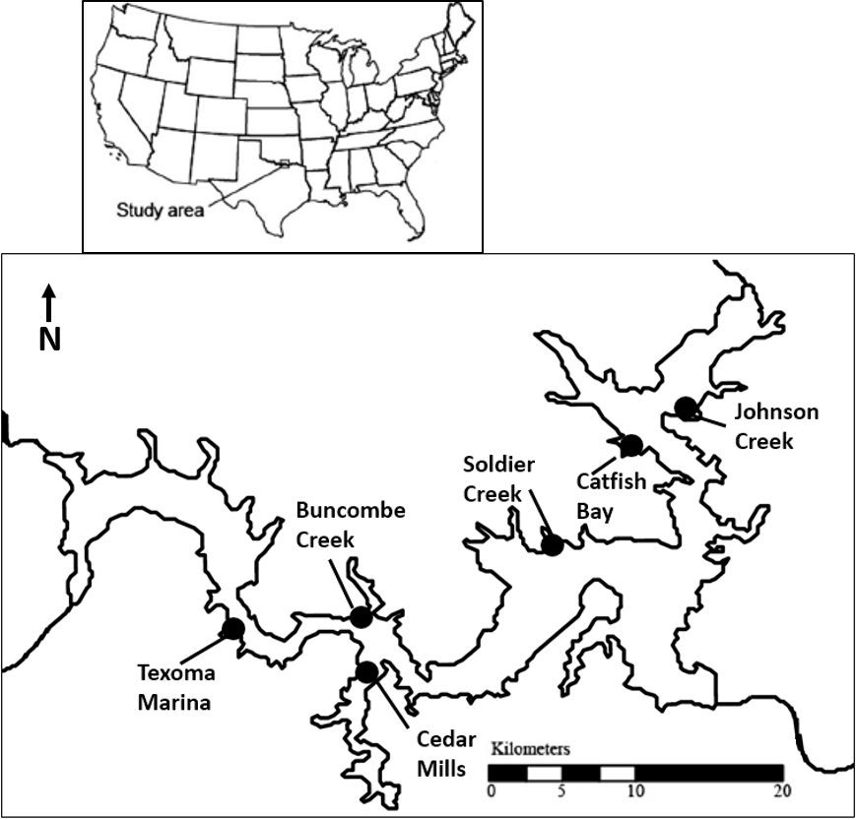
Figure 1: Location of Lake Texoma in the United States (upper panel), and map of site locations on Lake Texoma (lower panel). The Red River feeds into Lake Texoma from the west, while the Washita River, originating from the west, feeds into Lake Texoma from the northeast. Sampling sites Texoma Marina, Buncombe Creek, and Cedar Mills were considered to be on the Red River arm, while Johnson creek, Catfish Bay, and Soldier Creek were considered to be on the Washita River arm of the lake.
Figure 2: PCA of differences in environmental variables between the Red and Washita River arms of Lake Texoma. Arrows represent the direction of samples with higher levels of a given parameter, and the colored circles represent the area which encompasses 67% of sampling events on a given arm of the lake. The variables fed into the PCA were the same as those used in the regression analysis: temperature, specific conductivity, chlorophyll, dissolved oxygen, and Secchi depth. Secchi depth, specific conductivity, and chlorophyll can be seen to act as the primary separators between the Red River and the Washita River arms of the lake.

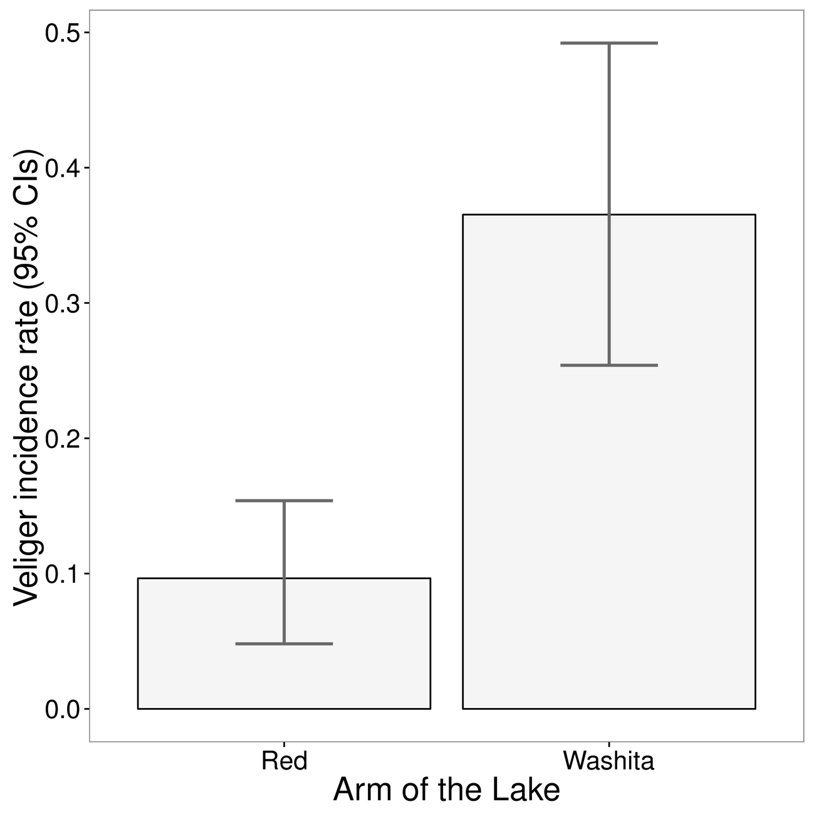
Figure 3: Veliger incidence rates for each arm (Red River vs Washita River) of the lake, as the proportion of total samples which contained at least one veliger. Error bars represent bootstrapped 95% confidence intervals. Veligers were much more likely to be found in a given sample from the Washita River arm than the Red River arm of the lake.

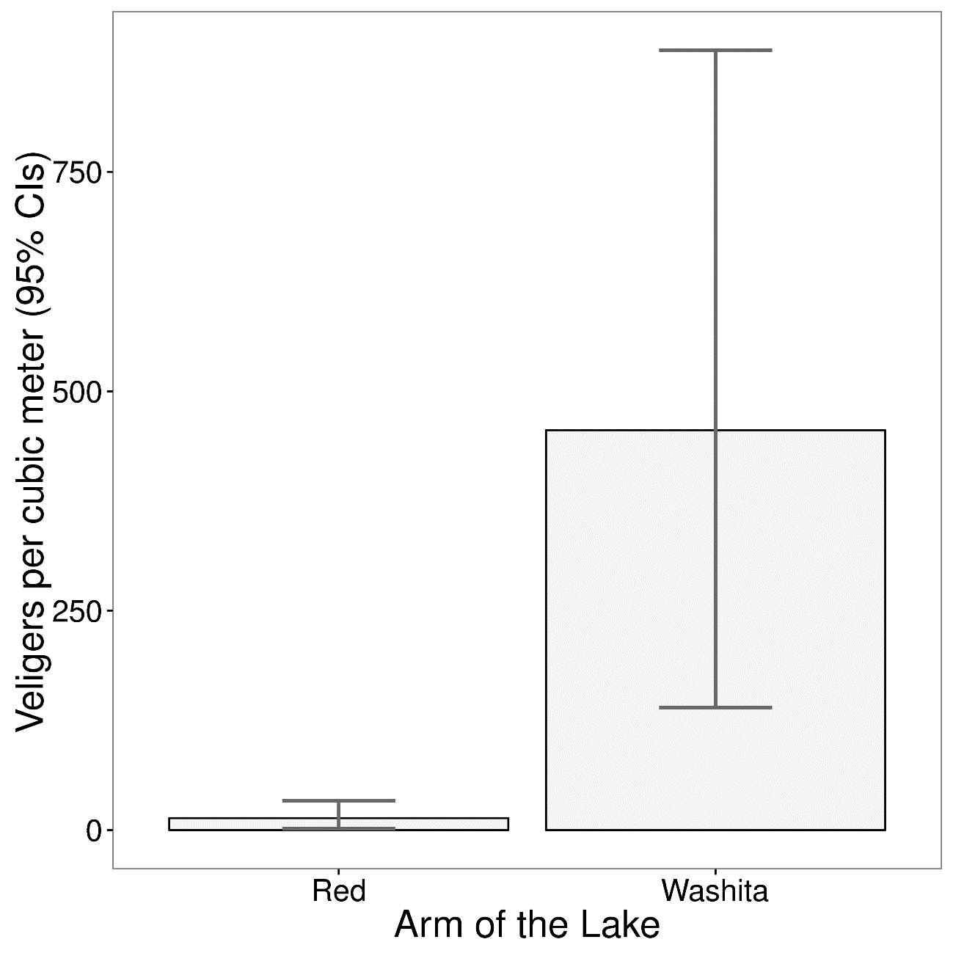
Figure 4: Mean abundance of veligers per cubic meter across all samples with at least one veliger, with bootstrapped 95% confidence intervals. In any given sample with at least one veliger, abundances were much higher in the Washita River arm than the Red River arm of the lake. Even when veligers were present in a Red River arm sample, the abundances were low.

Tables

Table 1: Comparison of minimum, maximum, and median values of environmental variables between areas of Lake Texoma for temperature (Temp), specific conductivity (Sp. Cond.), chlorophyll (Chl.) , dissolved oxygen (DO), and Secchi depth.
 | Temp (℃) |  |  | Sp. Cond (µs/cm) |  |  | Chl (µg/l) |  |  | DO (mg/l) |  |  | Secchi depth (m)
Lake arm | min | max | med | min | max | med | min | max | med | min | max | med | min | max | med
Washita | 4.8 | 31.7 | 18.9 | 1169 | 2088 | 1679 | 1.4 | 71.3 | 16.7 | 6.2 | 14 | 8.7 | 0.5 | 2.1 | 1.05
Red | 3.8 | 32.2 | 18.7 | 1169 | 2873 | 1927 | 4.2 | 266 | 35.9 | 5.4 | 15 | 8.9 | 0.3 | 1.3 | 0.75

Table 2: Results of logistic regression model testing for differences in environmental parameters between the Red River and Washita River arms of Lake Texoma, with the standard error (S.E.), z-value, and p-value for each of the independent environmental variables tested. Only specific conductivity and Secchi depth were significantly different between lake arms in the logistic regression model.

Independent variables | S.E. | Z-value | P-value (>|Z|)
Temperature | 0.0525 | 1.722 | 0.085
Specific conductivity | 0.0023 | -4.501 | <0.001
Chlorophyll | 0.0132 | -1.362 | 0.173
Dissolved oxygen | 0.2460 | 0.894 | 0.371
Secchi depth | 1.6338 | 3.864 | <0.001

Chapter 2 - Highly variable colonization patterns in juvenile zebra mussels (Dreissena polymorpha) in a recently invaded subtropical lake

Thayer C. Hallidayschult, Jessica E. Beyer and K. David Hambright
Program in Ecology and Evolutionary Biology and Plankton Ecology and Limnology Laboratory, Department of Biology, University of Oklahoma, Norman, OK, USA
*Corresponding author. e-mail address: Thayer@ou.edu

Abstract
Zebra mussels (Dreissena polymorpha) are a well-known aquatic invader with a high reproductive rate. They can quickly colonize hard surfaces in such densities that they form a layer several mussels thick. Working in a large subtropical lake recently invaded by zebra mussels, we deployed PVC settling samplers to examine the colonization patterns of newly settled zebra mussels. Zebra mussels were collected from the samplers once a month from July 2011 to June 2012. Settling rates varied seasonally, with settlers only detected during May, June and July, and were much more abundant in the Washita River arm of the lake. We found that newly settled zebra mussels preferred unenclosed surfaces on the undersides of the samplers, and did not prefer areas sheltered from fish predation nor did they avoid sampler areas which received more light. Abundances were higher on samplers at 3 meters than 1 meter, suggesting that deeper locations may provide refuge from high temperatures (or possibly light). Settling patterns may have instead been strongly shaped by particulate sedimentation patterns, as well as by the newly introduced Harris mud crab (Rhithropanopeus harrisii), a potentially important predator of zebra mussels, which also recruited to the PVC samplers. There was a greater total mass of material collected from the enclosed sampler areas, suggesting that it may have been more difficult for zebra mussels to settle in the enclosed areas, or there was post-settling mortality from sedimentation. Taken as a whole, these results indicate that even at the local scale, small variations in the immediate environment can drastically alter the suitability of hard substrate for colonization by zebra mussels.

Introduction
Understanding what factors define the presence or absence of a given organism from a given location has been one of the fundamental goals of autecology for over a hundred years (Browne 1983), and has given rise to the understanding that an organism’s distribution range is inextricably linked to the environmental attributes of the habitat where the organism is found (Elton 1927, 1958, Lockwood 2007). By defining the realized niche (sensu Hutchinson 1957) that a species occupies, ecologists have found that they can not only better understand a species current distribution, but model the species distribution in order to make predictions about potential future expansions and invasions (Hirzel and Le Lay 2008, Soberon and Nakamura 2009). This approach is particularly appealing for invasion ecology, where predicting areas at risk of invasion is a central management component (Kolar and Lodge 2001). This approach lets scientists prioritize detection and prevention efforts in areas most at risk.
However, even when a species is present in a given area, it is not uniformly distributed across the landscape, with both biotic and abiotic factors acting to create areas of high and low species density, often in association with microhabitat variation ( MacArthur 1972, Brown et al. 1995, With and Crist 1995, With et al. 1997). This effect is particularly pronounced when organisms cannot leave an undesirable area, as is the case with plants and sessile animals. If this sessile organism is an invasive species, understanding where the invasive species occurs in higher abundances within a given landscape or site may provide insight into how it is interacting with other species, or what abiotic variation in microhabitat drives its local densities. One such invasive species is the zebra mussel (Dreissena polymorpha), an infamous invasive species with a reputation for disrupting the local ecology as well as the human infrastructure of the lakes and rivers they invade (Higgins and Vander Zanden 2010). While they originated in the Ponto-Caspian region of Eastern Europe, they have spread around the world, travelling on ships attached to hulls, in bilge water, and ballast tanks (Mackie 1991). They reached North America most likely in 1986, where they were discovered in the Laurentian Great Lakes and have since spread across much of the central United States (Drake and Bossenbroek 2004). Once zebra mussels establish in a given lake or waterway, removal is extremely difficult, and mitigation is time consuming and expensive. For example, in power plants and drinking water treatment plants, the average annual cost of mitigation is around $30,000 per facility (Connelly et al. 2007). Zebra mussels can also be manually removed from problematic areas, although this is extremely time consuming, particularly if the removal must be done underwater by personnel in SCUBA gear (Mackie and Claudi 2010). Some chemicals are available for large-scale removal of zebra mussels, but these are often nonspecific to zebra mussels (Waller et al. 1993) and are typically too expensive to apply to an entire lake.
Management and mitigation is complicated by the extremely patchy distribution of zebra mussels within an invaded system (Burlakova et al. 2006). Zebra mussels are prolific spawners, with a single mature female capable of releasing a million eggs into the water during a single reproductive season (MacIsaac 1996). With this number of eggs released, zebra mussels have the potential to aggregate in the thousands, completely covering desirable substrate. However, zebra mussels are not evenly distributed across a lake. Depending on the specific location sampled, zebra mussel densities may vary by several orders of magnitude, even when the locations are mere meters apart, and these areas of high and low zebra mussel densities are not necessarily constant in a system, with the densities of zebra mussels within a given site sometimes shifting between years (Burlakova et al. 2006).
Numerous factors can affect the density of adult zebra mussels at a particular location, and these factors can be broadly divided up by whether they primarily limit the ability for larval zebra mussels to reach a potential settling site or if they instead limit the success of post-settling zebra mussels (Jones and Ricciardi 2014). Zebra mussels are broadcast spawners with a planktonic larval stage, so the patterns of water movement and flow play a large role in determining the number of larval zebra mussels which are available to potentially colonize a particular site (Mackie 1991). Sites which are hydrologically isolated from adult zebra mussel populations will receive considerably fewer potential colonizers than sites with a strong hydrologic connection to reproductively active zebra mussel beds (Griffiths et al. 1991). This particular dynamic is difficult to quantify a priori, particularly in lakes without a strong directional flow pattern, but at the very least it can be surmised that dendritic backwaters are unlikely to receive the same colonization pressures as the main flow channel of a lake or river.
Once planktonic zebra mussel larvae arrive in an area, they still must settle onto a particular substrate where they will spend the rest of their adult lives, anchored to the substrate via byssal threads (Ackerman et al. 1994). When settling out of the water column, planktonic zebra mussels do not necessarily begin attaching byssal threads to the first substrate they settle on to. Rather, the juveniles will use their extensible foot to move around their local environment, and only begin the attachment process once they reach a desirable location (Czarnoleski et al. 2004). Zebra mussels tend to settle in areas with moderate flow rates of water out of direct sunlight, and aggregate on the edges of surfaces (Kobak 2005). The type of substrate also influences settling preferences, with more textured substrates such as rocks, concrete, and wood preferred over smoother substrates (Marsden and Lansky 2000). This means that even within a given site, some areas can have extremely high densities of zebra mussels at desirable settling locations, while nearby but less desirable locations will have few to no individuals.
A final factor which plays a large role in determining zebra mussel densities is post-settling mortality. For example, Jones and Ricciardi (2014) found that in Lake Michigan, densities of larvae and juvenile zebra mussels did not predict the densities of adult zebra mussels, implying that the factors driving adult zebra mussel densities relate more to post-settling differences in juvenile mortality than to the overall larval settling rates. Furthermore, there is reason to believe that post settling mortality plays an even larger role in structuring adult zebra mussel densities in subtropical areas, as they experience greater levels of thermal stress (Spidle et al. 1995, Karatayev et al. 1998) and much higher predation pressures from molluscivorous fish including catfish and freshwater drum, both of which are common in Lake Texoma (Eggleton et al. 2004, Bartsch et al. 2005, Watzin et al. 2008).
Differences in flow patterns, substrate type and availability, thermal stress, and predation pressure may vary greatly across a lake, which may in turn explain why many lakes have extremely uneven distributions of zebra mussels across the lake area (Mellina and Rasmussen 1994). This is particularly likely for complex dendritic lakes common in the subtropical United States, where lake conditions can be highly variable from one area of the lake to the next (Thornton et al. 1990, Whittier et al. 2002). However, physiochemical variation is unlikely to completely explain why, even across very short distances (where factors such as larval densities, predator abundances, and physiochemical properties are unlikely to significantly vary), we see profound differences in zebra mussel densities. In warmer lakes, these differences are likely amplified, as the warm spring and fall weather encourages rapid zebra mussel growth. For example, Churchill (2017) found that in Lake Texoma, while mid-summer mortality was high, zebra mussels transplanted onto artificial substrate experienced growth rates higher (160 µm/day) than what has been documented in temperate areas (35-140 µm/day). To better understand what factors drive differences in zebra mussel densities within a particular location, we deployed artificial substrates in different configurations and at different depths to recruit larval zebra mussels. Based on previous studies of zebra mussel settling patterns and research on the increasing predation pressures on zebra mussels in subtropical systems, we expected higher settling success in areas which were more protected from molluscivorous fish, such as catfish and freshwater drum, areas which were in darkness, and areas which were in deeper and therefore cooler waters.

Methods
For this study, we collected samples from the large subtropical lake Lake Texoma, which is a reservoir on the Texas-Oklahoma border where zebra mussels were first detected in 2009. Lake Texoma is a large dendritic lake with gradients in water clarity, salinity, and primary productivity (Chapter 1), providing an excellent opportunity to study zebra mussel distributions across a variable aquatic environment. The sampling locations capture a wide range of the potential variation within Lake Texoma, with sites spread across the two main arms of the lake (Fig. 1).
The sampler design consisted of two horizontal PVC plates mounted on an eye bolt and hung from a rope into the water, inspired by a modified version of a Hester-Dendy sampler (Fig. 2). Each PVC plate was roughened by sanding to increase its suitability as a settling surface, and provided available area for attachment on both its top and its bottom. The sampler provided the options of attaching in light (Fig. 2; area A) or in darkness (areas B, C, D), settling in an area sheltered from molluscivorous fish (areas B & C), areas of higher flow (areas A & D), or areas free of sediment (areas B & D). At each sampling site, a total of six identical samplers were deployed, three at 1 meter and three at 3 meters below the water’s surface. All samplers were secured to a dock, to provide a fixed structure which would keep the samplers suspended at their given depth throughout fluctuation in water levels, which are typical of reservoirs.
From July 2011 until June 2012 sites were sampled monthly. Sampling consisted of scraping a 5-cm × 5-cm subsample collected from the same area each month, using a razor blade to clear the sampling area. After collecting the subsample, the area of the plate surrounding the sampling location was also scraped clean to ensure that each sample represented newly settled larvae rather than translocated zebra mussels from previous time periods. Collected samples were preserved in 80% ethanol in scintillation vials for later enumeration. Samples were counted on a dissecting scope under 26× magnification in a gridded petri dish.
Along with the settling samples, we also collected zooplankton samples to estimate larval zebra mussel water column density at each site using a Wisconsin-type 63-µm-mesh zooplankton net and measured water temperature, specific conductivity, pH, oxidative-reductive potential, and chlorophyll and phycocyanin concentrations were measured using a Hydrolab DS5X multiprobe. Water clarity was measured using a Secchi disk.
All statistical analyses were carried out in R (version 3.2.3, R Development Core Team, 2016). To test for differences in zebra mussel settler abundances between sampler areas within a site, settler abundances were analyzed using a general linear mixed effect model with a Poisson family distribution, with sites, plate areas, and sampler depths as the predictor variables and settler density as the response variable, and sampler replicate as a random effect, implemented using the glmmADMB package (R package version 0.8.3.3, Skaug et al. 2016). Bootstrapped confidence intervals were created by resampling either occurrence or abundance 1000 times, with replacement.
To evaluate differences in total sample mass between different plate locations, a subset of 100 previously enumerated samples (25 samples from each plate area, A, B, C, and D) were dried in aluminum weigh boats at 100℃ and weighed every 24 hours until there was less than a 4% change between mass for any of the samples (a total of 5 days). To test for a significant effect of sampler area on sample dry weight, sample mass was analyzed using a Kruskal-Wallace test (due to uneven variance between samples) for omnibus significance, followed by a Wilcoxon rank-sum test to evaluate differences between pairs of sampler areas, with a simple Bonferroni correction applied to the necessary α to adjust for multiple comparisons. To test for a significant effect of sampler location on sample dry weight, sample mass by location was analyzed using a Kruskal-Wallace test (due to uneven variance between samples) for omnibus significance, followed by a Wilcoxon rank-sum test to evaluate differences between pairs of sites, with a simple Bonferroni correction applied to the necessary α to adjust for multiple comparisons.
A t-test was used to test for a difference between water temperatures found at one meter compared to three meters for the months of June, July, and August, when water temperatures reach their peak. Only the months with the highest water temperatures were analyzed, because we hypothesized that this represents the time of year when temperature differences between depths would be most important in determining zebra mussel survival, in terms of acute thermal mortality. We also tested for differences in the other physiochemical parameters between depths, both in the summer months (as with temperature), and year-round. The Johnson Creek site was not included in any analyses due to frequent exposure of the sampler to the atmosphere at low water levels. Also, because during most times of the season zebra mussel larvae were not settling out, we limited our analysis of settling patterns to when zebra mussel settlers were present (May-July) (Fig. 3).

Results
Both settling rates and physochemical parameters varied across the year (Figs. 3, 4). Settler abundances varied between sites, with zebra mussels occurring more frequently at sites in the Washita River arm than at the Red River arm of the lake (Fig. 5). Within a site, zebra mussels were also unevenly distributed across samplers at different depths, as well as across areas on a given sampler (Table 1). Mussels were most abundant on area D, the underside of the second sampling plate, and least abundant on area C, the top of the second sampling plate. There were no differences in mussel abundances on areas A, the top of the first plate, or B, the underside of the first plate (Fig. 6). Zebra mussels were significantly less abundant on samplers in one meter of water than on samplers in three meters of water (Fig. 7). A t-test of the summer water temperatures revealed that water temperatures were significantly cooler at 3 meters than at 1 meter (df = 26, t = 2.35, p < 0.026), with a mean difference of 0.77℃ (Fig. 8). No other environmental parameters varied significantly with depth either in summer or during the entire year.
Our comparison of total sample mass by plate area found a significant effect of plate area on total dry mass (Kruskal-Wallace chi-squared = 19.246, df = 3, p-value < 0.001). A Wilcoxon test with Bonferroni correction (adjusted α = 0.05/6= 0.008) found significantly higher total sample masses in areas B and C when compared to samples from areas A and D (Fig. 9, Table 2).
Comparison of total sample mass by sampler location revealed a significant effect of location on total dry mass (Kruskal-Wallace chi-squared = 25.813, df = 4, p-value < 0.001). The site at Cedar Mills Marina in the Red River arm had significantly lower total sample mass than the other sites (Wilcoxon tests with independent contrasts; adjusted α = 0.05/7= 0.0071). The other sites did not differ significantly in sample mass from one another (Fig. 10, Table 2).

Discussion
Zebra mussels have a well-earned reputation as a notoriously disruptive invasive species which is linked to both ecological and economic damage in the systems they invade. This is in part due to their high reproduction rates and ability to densely colonize available hard substrate. However, the reality of the situation is that the distribution of zebra mussels in a lake is extremely variable even over short distances, with a variety of factors governing whether a rock is bare or completely covered in adult zebra mussels. In this survey, we were interested in investigating differential recruitment across identical settling plate samplers deployed in a variety of conditions across a large subtropical lake. In particular, we had hypothesized that settling areas which were dark and protected from molluscivorous fish would be preferred over those which were in light and exposed to molluscivorous fish, and that deeper samplers would be preferred to shallower samplers, with these differences being driven by a combination of juvenile settling choices and post-settling mortality.
First, it should be noted that recruitment to the samplers was lower on the Red River arm of the lake, and higher on the Washita River arm of the lake. This agrees with measures of zebra mussel larval densities across the lake, where much higher densities of zebra mussel larvae were found in the Washita arm of the lake than in the Red River arm of the lake (Chapter 1). This difference in zebra mussel densities between the two arms of the lake may be driven by several factors, including a lack of available substrate for upstream parent populations, or high mortality due to sedimentation. A lack of source populations may be a more likely explanation, as when growth rates of transplanted zebra mussels in Lake Texoma were measured on both arms of the lake, zebra mussels growing in the Red River arm of the lake did not grow more slowly or suffer from higher mortality than those growing in the Washita arm of the lake (Churchill 2017) This suggests that the low abundances of zebra mussels at our sampled Red River sites cannot be attributed to unsuitable conditions, but is instead much more likely to be due to a lack of suitable source populations. Similarly, our measures of total sample mass did not find that Red River sites had a greater total amount of accumulated material on samplers – in fact, the Cedar Mills sampler, considered to be in the Red River arm, had lower total sample mass than the other sites, so the Red River arm locations sampled in this study do not seem to necessarily be lower quality habitat than locations on the Washita River arm, at least by the metrics measured in either our study or Churchill (2017).
When we examined variation within a given sampling site, we found that variation within and across samplers at a given site was associated with significant changes in overall zebra mussel abundances. We found that samplers in deeper water were in fact colonized at greater densities (Fig. 7), and we found that samplers at 3 meters had an average summer temperature difference of 0.77℃ lower than at one meter. While less than a single degree Celsius difference may seem relatively unimportant, in subtropical systems where zebra mussels are living on the edge of their thermal tolerances, mortality rates begin climbing extremely rapidly as temperatures rise above 30° C (Beyer et al. 2011). In August, the average water temperature at 1 meter across the sampling sites was 30.01℃ (Fig. 8), suggesting that mussels might indeed be experiencing thermal stress at the peak of summer in Lake Texoma. Additionally, the greater volume of water above the 3-meter samplers may also have provided a buffer against short-term temperature fluctuations, where samplers at one meter were likely exposed to differences greater than one degree on particularly hot, still, and sunny afternoons. For example, on one particularly hot and sunny August day at the Catfish Bay sampling site, we recorded a water temperature of 31.73℃ at one meter and a temperature of 29.17℃ at three meters, a difference of 2.65 degrees. It is also possible that sublethal thermal stress is a larger factor, as could be measured by differences in degree-days between the two depths. While the other physiochemical parameters did not vary between one and three meters, it should also be considered that the deeper samplers would be exposed to less ambient light, and while we did not see evidence for within-sampler settling abundances being affected by light, it may be that zebra mussels settled more frequently at the deeper samplers because overall light levels were lower.
Our other two predictions were not supported. First, more enclosed (protected from vertebrate predators) areas of the samplers were not preferred. As to why molluscivorous fish predation did not seem to structure zebra mussel settling patterns, it may be that recently settled zebra mussels are too small to experience heavy fish predation. Bartsch et al. (2005) found that in Mississippi navigational pools, excluding fish from settling substrate significantly impacted zebra mussel densities, but their substrates were deployed directly on the bottom of the river and were retrieved after 145 days, significantly longer than our 30 days. Very small juvenile mussels may not be a preferred food source for these fish. As the primary fish predators of zebra mussels are benthivorous (e.g. freshwater drum, catfish), it may be also that the samplers suspended in the water column were much less likely to be encountered by potential predators.
Further complicating matters, at around the same time as the introduction of zebra mussels, the invasive Harris mud crab (Rhithropanopeus harrisii) was introduced to Lake Texoma, and it was later found to be an effective predator on zebra mussels (Chapter 4). These crabs were often observed on the samplers, particularly between the two plates (i.e., between areas B and C). It is possible that in our attempts to exclude one type of predator, we inadvertently encouraged another type. The inner space, originally intended to provide a refuge from fish predation, may have unexpectedly become the more dangerous space. If Harris mud crabs took advantage of the refuge space between the plates (areas B and C) while simultaneously consuming zebra mussels, we would expect that any benefit the internal space offered to zebra mussels would be reduced, or possibly eliminated. We would predict this effect to be most pronounced on the lower inner area (area C), which did indeed have the lowest settling densities. In systems where Harris mud crabs co-occur with zebra mussels, it may be that areas in protected crevices no longer provide shelter to zebra mussels, shifting settling patterns of adult zebra mussels in the presence of Harris mud crabs.
Given this unexpected presence of an invertebrate predator which is hypothesized to encounter zebra mussels most frequently in approximately opposite habitat types (open to the water vs. sheltered), we would expect the signal from a single predator to essentially disappear, as prey distributions are often based on the weight of multiple predator types, instead of simply being defined by a single threat (Pitt 1999, Thaker et al. 2011). This sampling protocol also does not give us insight whether the observed zebra mussel settling patterns are due to differential rates of attachment in a given area, due to differential mortality imposed on settled zebra mussels, or a combination of factors. To truly disentangle what is driving the avoidance of the enclosed sampler space would require additional information on the relative strengths of settling and post-settling factors in determining the final abundances. Ideally, we would be able to determine predator-specific mortality rates, and compare the relative dangers posed by the predators to settling patterns in zebra mussels protected from all predation, to see how settling and post-settling factors act together to determine the final pattern.
We also did not find that zebra mussels preferentially avoided the area of our plate most likely to receive direct sunlight (area A). This suggests that the sampled zebra mussels did not appear to be preferring to attach in darker areas, running contrary to previous findings (Kobak 2005). However, it may simply be that the light hitting the samplers was not bright enough to discourage colonization. At least some light was reaching the one-meter samplers, as the average Secchi depths across sites during the sampling period was 0.88 meters and the sampling plates were also often visible in the water, but it could simply be that the light was sufficiently attenuated so as to not discourage colonization. Similarly, as Lake Texoma is an extremely turbid environment, the light reaching the samplers would have been highly scattered by suspended particles, further reducing the contrast in light levels between the four settling areas. An important additional consideration is that area A is the area likely to receive the highest volume of settling larvae simply because it is the topmost settling area. Thus, the light would have to be strong enough to encourage larvae to translocate from area A to another area. We saw evidence that zebra mussels were indeed very mobile on the plates (Area D was the most colonized, but as it was the underside of a plate it was only accessible to zebra mussels which crawled from a different location), but perhaps the light levels themselves were insufficiently discouraging to induce most mussels to translocate to another plate. It is also possible that the increased abundances at the three-meter samplers is at least in part driven by light avoidance.
An additional factor which was not initially considered was the role that settling suspended solids would play in structuring where juvenile zebra mussel settling patterns. It quickly became clear after returning to the samplers that all the plates were accumulating sediment on area A and C, and particularly area C. While the total amount of sediment collected on the various areas of the sampler between visits was not quantified, we quantified the total dry mass of the collected samples and found that the two inside areas (B and C) had significantly more dry mass than the outside areas (A and D). Additionally, while there was a large amount of variance between samples, the samples from plate area C had a higher median mass, and also contained the samples with the largest mass (Fig. 9). This suggests that at the very least, the two inside areas were likely more difficult for zebra mussels to colonize, as there was a greater amount of material collected in the sample area. The bulk of the sample mass was composed of a mixture of sediments and periphyton. Soft substrates discourage zebra mussel attachment, so the combination of periphyton with sediment may have discouraged colonization (Coakley et al. 2010).
We suspect that the sampler design’s tendency to trap and collect sediment between the two plates led to the creation of a highly undesirable habitat, in spite of any potential shelter it may have offered (perhaps no shelter at all, when Harris mud crabs are taken into consideration). It may also have been more desirable to other colonists besides zebra mussels, with periphyton competing with zebra mussels for any available hard substrate, and just as the inside of the sampler would shelter zebra mussels from molluscivorous fish, it would similarly shelter any periphyton from algivorous fish.
These results emphasize that while there are clear and concrete individual factors which contribute to the distribution of zebra mussels within a given body of water, there is in fact a complex interplay between these factors, and local conditions will strongly influence which traits and factors will play the largest role in determining whether zebra mussel reefs form in a given location. Even small differences between locations only a meter away may vary greatly in the number of mussels they support, and the interplay between these small differences may in part help explain what drives such high levels of variation. The combination of abiotic and biotic factors which can potentially structure zebra mussel densities across a landscape means that there is a huge potential for variation in the distributions and densities of zebra mussels within a lake, and even more potential for variation between lakes.
Given that subtropical lakes pose a variety of challenges to zebra mussels such as lethal summer water temperatures, higher predation pressure, and increased sediment load, deploying similar samplers across a variety of subtropical lakes and comparing the differences in zebra mussel settling patterns between lakes may prove to be very useful in isolating the ecological factors which are most powerful in determining zebra mussel colonization success in subtropical systems, particularly if they are paired with careful experimental analysis of the relative costs imposed by the various factors. Data from habitats on the edge of an organism’s invasion front are an essential component for detecting and defining changes in the actualized niche occupied by the invader across the habitats it occupies, and comparison between invasion areas helps inform our understanding of what the fundamental niche of a particularly plastic invasive species truly is.
Furthermore, zebra mussels in subtropical systems experience periods of optimal growth conditions in the spring and fall periods, with juveniles growing rapidly and maturing quickly. Zebra mussels in Marion Reservoir in Kansas reached sexual maturity in as little as one month of growing time, suggesting that it is likely that subtropical reservoirs experience multiple generations of zebra mussels each year (Delmott and Edds 2014). Other research in Lake Texoma has found similar patterns, with highly variable distributions of zebra mussel veligers (Churchill 2013) and both high growth rates and mortality in adults (Churchill et al. 2017). In Kansas, four different reservoirs were found to have extremely variable densities of zebra mussels both within and between reservoirs, despite them all being hydrologically connected to one another, with a complex interplay between time of invasion and variation in local physiochemical factors the most likely explanation for the differences in zebra mussel densities between the sampling locations (Smith et al. 2016).
Variation in habitat suitability combined with high growth rates and mortality means that in subtropical systems, zebra mussel distributions are likely to be even more patchily distributed than in temperate systems with the added complication of increased variation in time. This emphasizes the importance of untangling the mechanics underpinning habitat selection in subtropical systems. Collecting fine scale colonization and distribution data will help future researchers discern the most important factors in structuring zebra mussel densities in subtropical lakes, and in turn provide the necessary information to enable more mechanistic and laboratory-based approaches to isolating the driving mechanisms and giving us a better understanding of these versatile invaders. This information is especially important given that zebra mussels continue to expand into sub-optimal habitats, in both the United States and in Europe (Karatayev et al. 2015), and grows in power when paired with information about source populations of zebra mussels, and future research into documenting the distribution and densities of available hard substrate as well as locations of actively reproducing zebra mussel reefs in Lake Texoma would serve to further put habitat selection dynamics into a greater context.
Similar information for quagga mussels (Dreissena bugensis) occupying sub-optimal habitats is also becoming increasingly important, as they are rapidly spreading, and, in many cases, displacing zebra mussels (Zhulidov et al. 2010, Jones and Ricciardi 2014, Karatayev et al. 2015), in part due to their increased tolerances of sedimentation and softer substrates, as well as of cooler, deeper waters (Quinn et al. 2014). While their lower temperature tolerances may at first glance mean that they are unlikely to invade very far south, it would be worth remembering that at one point, most people considered it very unlikely that zebra mussels would survive in warmer southern waters. Capturing the true niche breadth of these versatile invaders has proven difficult so far, and requires continuous data from the forefront of the invasion.
When assessing the costs of invasive species on a system, it is important to consider not only the broad physiochemical landscape that defines the overall species range, but the microhabitat variation that plays a role in structuring species density within the invaded range, particularly when costs are often high localized to where the species occurs (as is the case for biofouling species like zebra mussels, where they damage infrastructure only where they directly settle). This density variation across a habitat may mean that much more targeted approaches can be used for management, increasing efficacy while decreasing costs.

Works Cited
Ackerman, J. D., B. Sim, S. J. Nichols, and R. Claudi. 1994. Review of the early-life history of zebra mussels (Dreissena polymorpha) - comparisons with marine bivalves. Canadian Journal of Zoology 72:1169–1179.
Bartsch, M. R., L. A. Bartsch, and S. Gutreuter. 2005. Strong effects of predation by fishes on an invasive macroinvertebrate in a large floodplain river 24:168–177.
Beyer, J. E., P. Moy, and B. De Stasio. 2011. Acute Upper Thermal Limits of Three Aquatic Invasive Invertebrates: Hot Water Treatment to Prevent Upstream Transport of Invasive Species. Environmental Management 47:67.
Brown, J. H., D. W. Mehlman, and G. C. Stevens. 1995. Spatial variation in abundance. Ecology 76:2028–2043.
Browne J. 1983. The Secular Ark: Studies in the History of Biogeography. Yale University Press
Burlakova, L. E., A. Y. Karatayev, and D. K. Padilla. 2006. Changes in the distribution and abundance of Dreissena polymorpha within lakes through time. Hydrobiologia 571:133–146.
Churchill, C. J. 2013. Spatio-temporal spawning and larval dynamics of a zebra mussel (Dreissena polymorpha) population in a north Texas reservoir: Implications for invasions in the southern United States. Aquatic Invasions 8:389–406.
Churchill, C. J., D. J. Hoeinghaus, and T. W. La Point. 2017. Environmental Conditions increase growth rates and mortality of zebra mussels (Dreissena polymorpha) along the southern invasion front in North America. Biological Invasions 19:2355–2373.
Coakley, J. P., N. Rasul, S.E. Loannou, and G. R. Brown. 2010. Soft sediment as a constraint on the spread of the zebra mussel in western Lake Erie: Processes and impacts. Aquatic Ecosystem Health & Management 5:329-343
Cohen, A. N. 2005. A Review of Zebra Mussels' Environmental Requirements. San Francisco Estuary Institute.
Connelly, N. A., C. R. O'Neill Jr, B. A. Knuth, and T. L. Brown. 2007. Economic Impacts of Zebra Mussels on Drinking Water Treatment and Electric Power Generation Facilities. Environmental Management 40:105–112.
Czarnoleski, M., L. Michalczyk, and A. Pajdak-Stos. 2004. Substrate preference in settling zebra mussels Dreissena polymorpha. Archiv Fur Hydrobiologie 159:263–270.
Delmott, S. E., and D. R. Edds. 2014. Zebra mussel maturation and seasonal gametogenesis in Marion Reservoir, Kansas, USA. Bioinvasions Records 3:247–260.
Drake, J. M., and J. M. Bossenbroek. 2004. The Potential Distribution of Zebra Mussels in the United States. BioScience 54:931–941.
Eggleton, M. A., L. E. Miranda, and J. P. Kirk. 2004. Assessing the potential for fish predation to impact zebra mussels (Dreissena polymorpha): insight from bioenergetics models 13:85–95.
Elton, C. 1927. Animal ecology. Sidgwick and Jackson, London.
Elton, C. 1958. The Ecology of Invasions by Animals and Plants. University of Chicago Press.
Griffiths, R., D. Schloesser, J. H. Leach, and W. P. Kovalak. 1991. Distribution and dispersal of the zebra mussel (Dreissena polymorpha) in the Great Lakes region. Canadian Journal of Fisheries and Aquatic Sciences 48:1381–1388.
Higgins, S. N., and M. J. Vander Zanden. 2010. What a difference a species makes: a meta-analysis of dreissenid mussel impacts on freshwater systems. Ecological Monographs 80:179–196.
Hirzel, A. H., and G. Le Lay. 2008. Habitat suitability modelling and niche theory. Journal of Applied Ecology 45:1372–1381.
Hutchinson, G. E. 1957. Concluding remarks. Cold Spring Harbor Symposia on Quantitative Biology 22:415–427
Jones, L. A., and A. Ricciardi. 2014. The influence of pre-settlement and early post-settlement processes on the adult distribution and relative dominance of two invasive mussel species. Freshwater Biology 59:1086–1100.
Karatayev, A. Y., L. E. Burlakova, and D. K. Padilla. 1998. Physical factors that limit the distribution and abundance of Dreissena polymorpha (Pall.). Journal of Shellfish research 17:1219–1235.
Karatayev, A. Y., L. E. Burlakova, and D. K. Padilla. 2015. Zebra versus quagga mussels: a review of their spread, population dynamics, and ecosystem impacts. Hydrobiologia 746:97–112.
Kobak, J. 2005. Recruitment and distribution of Dreissena polymorpha (Bivalvia) on substrates of different shape and orientation 90:159–170.
Kolar, C. S., and D. M. Lodge. 2001. Progress in invasion biology: predicting invaders. Trends in Ecology & Evolution 16:199–204.
Lockwood, J. L., M. F. Hoopes, and M. P. Marchetti. 2007. Invasion Ecology. Blackwell Publishing, Malden, MA. 304.
MacArthur, R. H. 1972. Geographical Ecology: Patterns in the Distribution of Species. Harper and Row, New York.
MacIsaac, H. J. 1996. Potential abiotic and biotic impacts of zebra mussels on the inland waters of North America. American Zoology 36:287–299.
Mackie, G. L. 1991. Biology of the exotic zebra mussel, Dreissena polymorpha, in relation to native bivalves and its potential impact in Lake St. Clair. Hydrobiologia 219:251–268.
Mackie, G. L., and R. Claudi. 2010. Monitoring and Control of Macrofouling Mollusks in Fresh Water Systems. Second. CRC Press, Boca Raton.
Marsden, J. E., and D. M. Lansky. 2000. Substrate selection by settling zebra mussels, Dreissena polymorpha, relative to material, texture, orientation, and sunlight. Canadian Journal of Zoology 78:787–93.
Mellina, E., and J. B. Rasmussen. 1994. Patterns in the distribution and abundance of the zebra mussel (Dreissena polymorpha) in rivers and lakes in relation to substrate and other physiochemical factors. Canadian Journal of Fisheries and Aquatic Sciences 51:1024–1036.
Pitt, W. C. 1999. Effects of multiple vertebrate predators on grasshopper habitat selection: trade-offs due to predation risk, foraging, and thermoregulation. Evolutionary Ecology 13:499–515.
Quinn, A., B. Gallardo, and D. Aldridge. 2014. Quantifying the ecological nice overlap between two interacting invasive species: the zebra mussel (Dreissena polymorpha) and the quagga mussel (Dreissena bugensis). Aquatic Conservation 24:324–337.
Smith, B. R., D. R. Edds, and J. M. Goeckler. 2016. Distribution and density of zebra mussels in four Kansas reservoirs. The Southwestern Naturalist 61:49.
Soberon, J., and M. Nakamura. 2009. Niches and distributional areas: concepts, methods, and assumptions. Proceedings of the National Academy of Sciences of the United States of America 106:19644–19650.
Spidle, A. P., E. L. Mills, and B. May. 1995. Limits to tolerance of temperature and salinity in the quagga mussel (Dreissena bugensis) and the zebra mussel (Dreissena polymorpha) 52:2108–2119.
Thaker, M., A. Vanak, C. Owen, M. B. Ogden, S. Niemann, and R. Slotow. 2011. Minimizing predation risk in a landscape of multiple predators: effects on the spatial distribution of African ungulates. Ecology 92:398–407.
Thornton, K. W., B. L. Kimmel, and F. E. Payne. 1990. Reservoir limnology: ecological perspectives. John Wiley, New York.
Waller, D., J. Rach, G. Cope, and L. L. Marking. 1993. Toxicity of candidate molluscicides to zebra mussels (Dreissena polymorpha) and selected nontarget organisms. Journal of Great Lakes Research 19:695–702.
Watzin, M. C., K. Joppe-Mercure, J. Rowder, B. Lancaster, and L. Bronson. 2008. Significant fish predation on zebra mussels Dreissena polymorpha in Lake Champlain, U.S.A. Journal of Fish Biology 73:1585–1599.
Whittier, T. R., D. P. Larsen, S. A. Peterson, and T. Kincaid. 2002. A comparison of impoundments and natural drainage lakes in the Northeast USA. Hydrobiologia 470:157–171.
With, K. A., R. H. Gardner, and M. G. Turner. 1997. Landscape connectivity and population distributions in heterogenous environments. Oikos 78:151–169.
With, K. A., and T. O. Crist. 1995. Critical thresholds in species responses to structure. Ecology 76:2446–2459.
Zhulidov, A. V., A. V. Kozhara, G. H. Scherbina, T. F. Nalepa, A. Protasov, S. A. Afanasiev, E. G. Pryanichnikova, D. A. Zhulidov, T. Y. Gurtovaya, and D. F. Pavlov. 2010. Invasion history, distribution, and relative abundances of Dreissena bugensis in the old world: a synthesis of data. Biological Invasions 12:1923–1940.

Figures
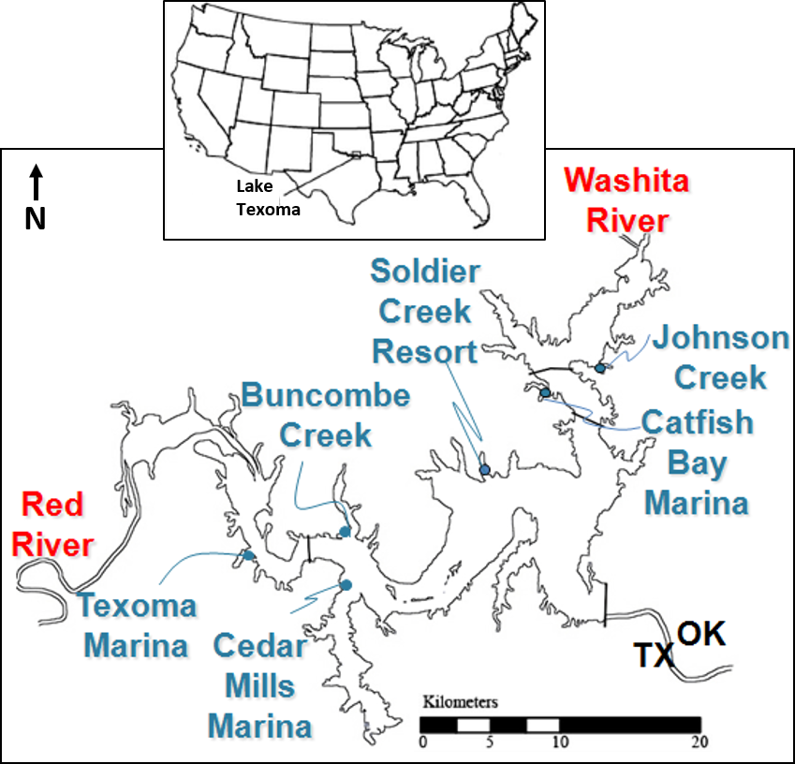
Figure 1: Location of Lake Texoma in the United States and map of site locations on Lake Texoma. The Red River feeds into the lake from the west, while the Washita River feeds in from the North. Sampling sites Texoma Marina, Buncombe Creek, and Cedar Mills were considered to be on the Red River arm, while Johnson creek, Catfish Bay, and Soldier Creek were considered to be on the Washita River arm.

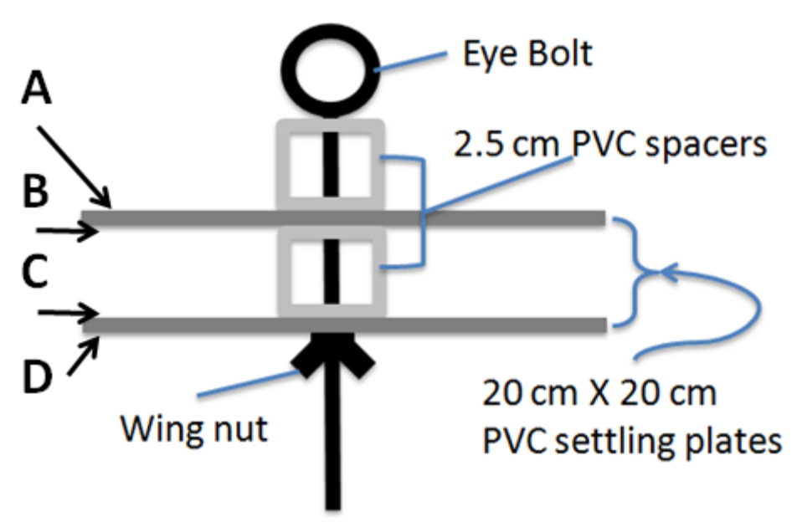
Figure 2: Schematic of zebra mussel settling sampler design. Two horizontal PVC 20cm × 20cm squares are mounted on an eye bolt, with a 2.5 cm segment of PVC tubing used as a spacer between them. A PVC cap with a hole drilled through the middle holds the top plate in place below the eye of the eye bolt, while a wing nut below firmly keeps the plates in place. When sampling, the wing nut is loosened or removed to grant access to all four sampling areas (the top and underside of each plate), marked A, B, C, and D.

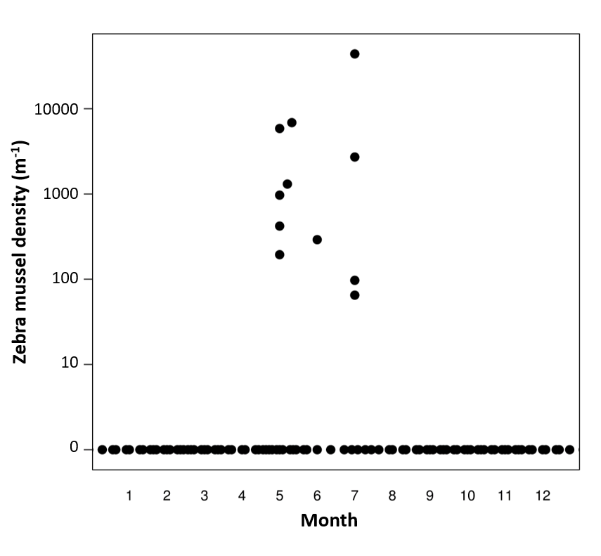
Figure 3: Seasonal variation in zebra mussel settling patterns in Lake Texoma, with each circle representing the average zebra mussel density at a given site and depth. Settlers were only detected during May, June, and July. Note the log scale

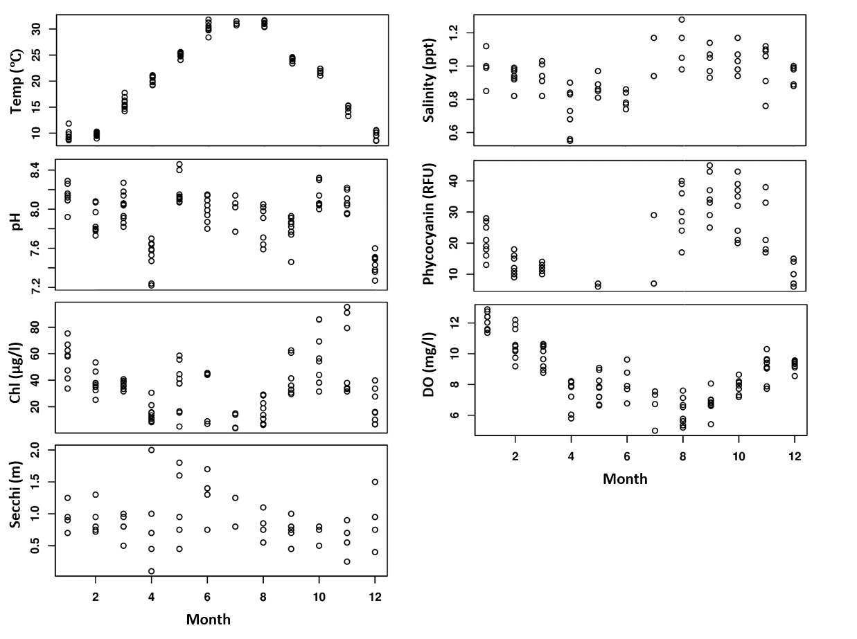
Figure 4: Seasonal variation in physiochemical factors, with month (Jan=1, etc.) on the X axis and the relevant physiochemical parameter on the Y axis. Each circle represents an observation from a site, at 1 and 3 meters (except in the case of Secchi depth, which is site-specific, but not depth-specific).

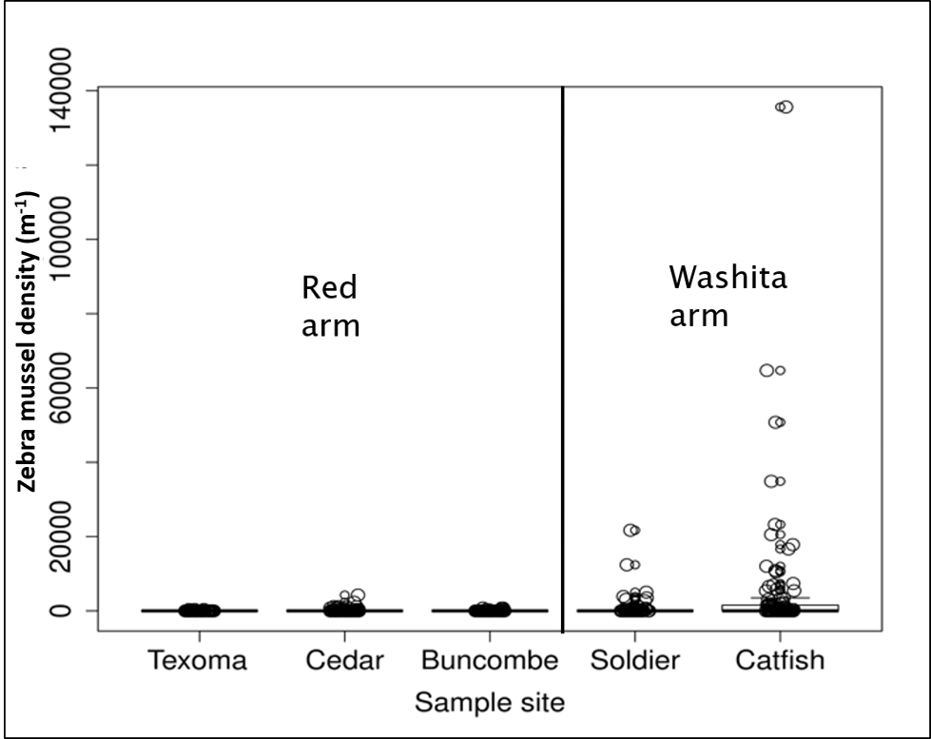
Figure 5: Zebra mussel settling patterns by sampling site, arranged from west to east. Whiskers are 1.5 times the upper or lower inter-quartile range, and open circles represent individual samples.
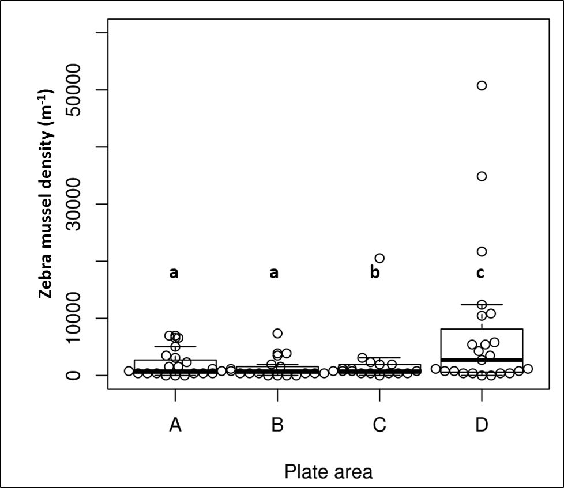
Figure 6: Zebra mussel settling patterns within a given sampler, when zebra mussel settlers were present. The four available areas of the samplers are marked A, B, C, and D, with A being the top of plate 1, B being the bottom of plate 1, C being the top of plate 2 and D being the bottom of plate 2. Lowercase letters denote which plate areas were significantly different from one another, with A and B being similar to each other but different from C and D, C being different from A, B, and D, and D being different from A, B, and C. Whiskers are 1.5 times the upper or lower IQR, and open circles represent individual samples.

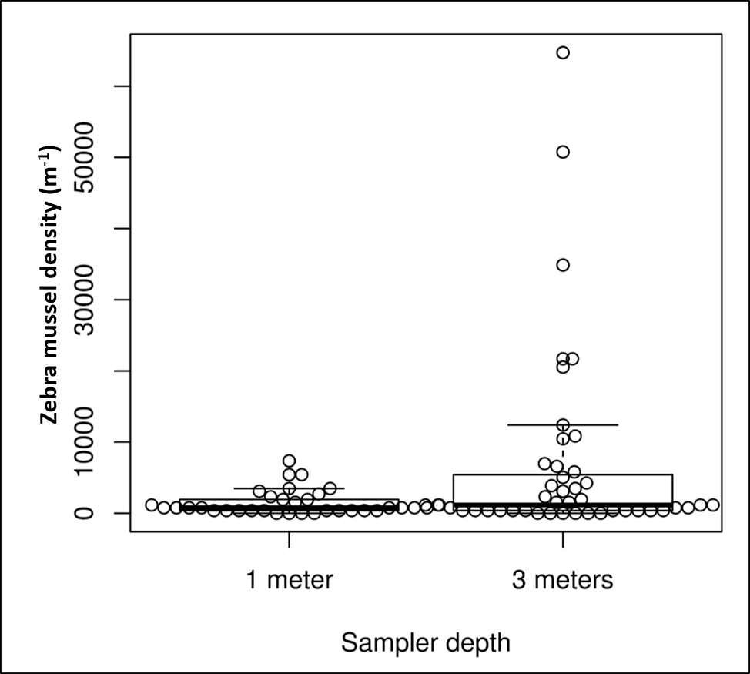
Figure 7: Zebra mussel settling patterns across samplers at 1- and 3-meter depths. When present, zebra mussels occurred at a significantly higher density on samplers suspended at 3 meters than on samplers suspended at 1 meter. Whiskers are 1.5 times the upper or lower IQR, and open circles represent individual samples.

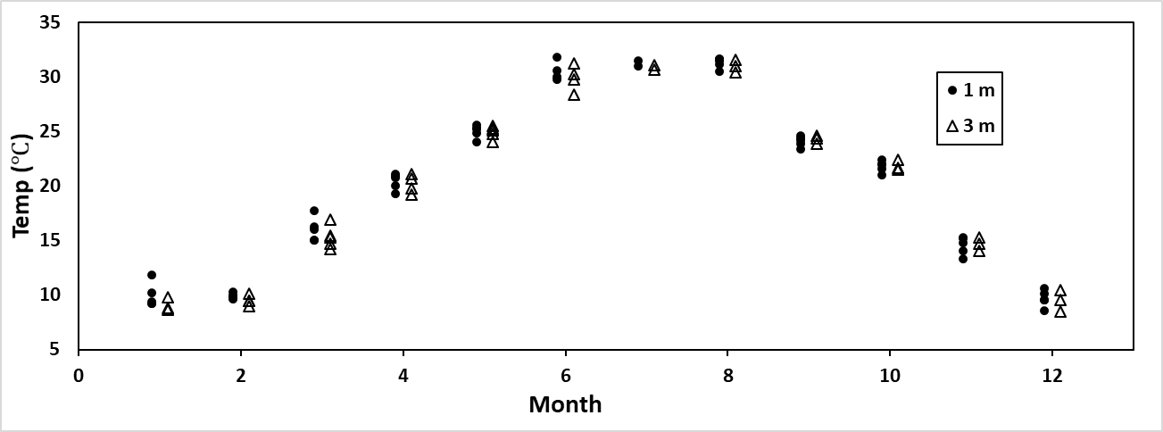
Figure 8: Water temperatures at 1 and 3 meters throughout the annual cycle. Closed circles represent values recorded at 1 meter, while open triangles represent values recorded at 3 meters. While temperatures are close together, summer water temperatures were slightly cooler at 3 meters within a given site.
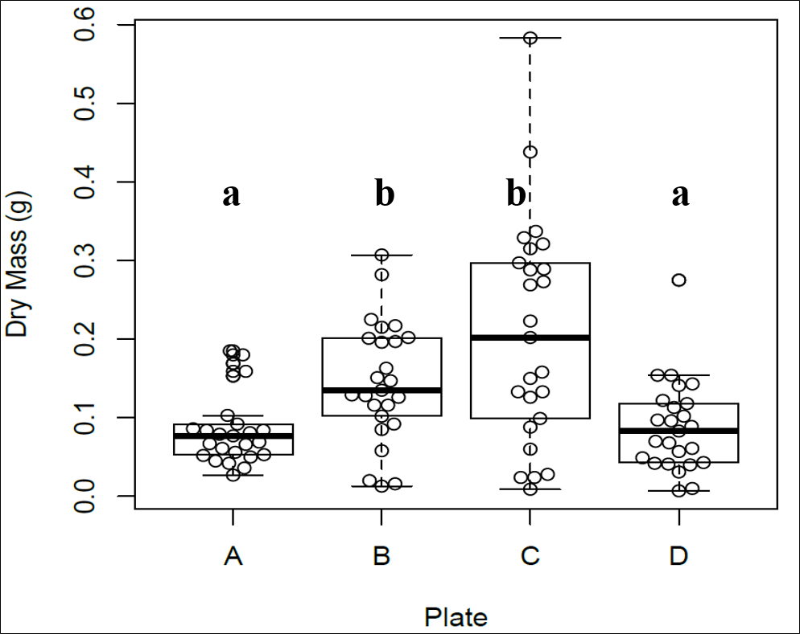
Figure 9: Results of the sediment mass analysis by plate, showing the the dry mass for each of the 100 samples, grouped by plate area (A, B, C, and D). Lower case letters denote the plate areas which are significantly different from one another, with plates A and D being similar to one another but different from B and C, while B and C are similar to one another but different from A and D. Whiskers are 1.5 times the upper or lower inter-quartile range, and open circles indicate individual samples.
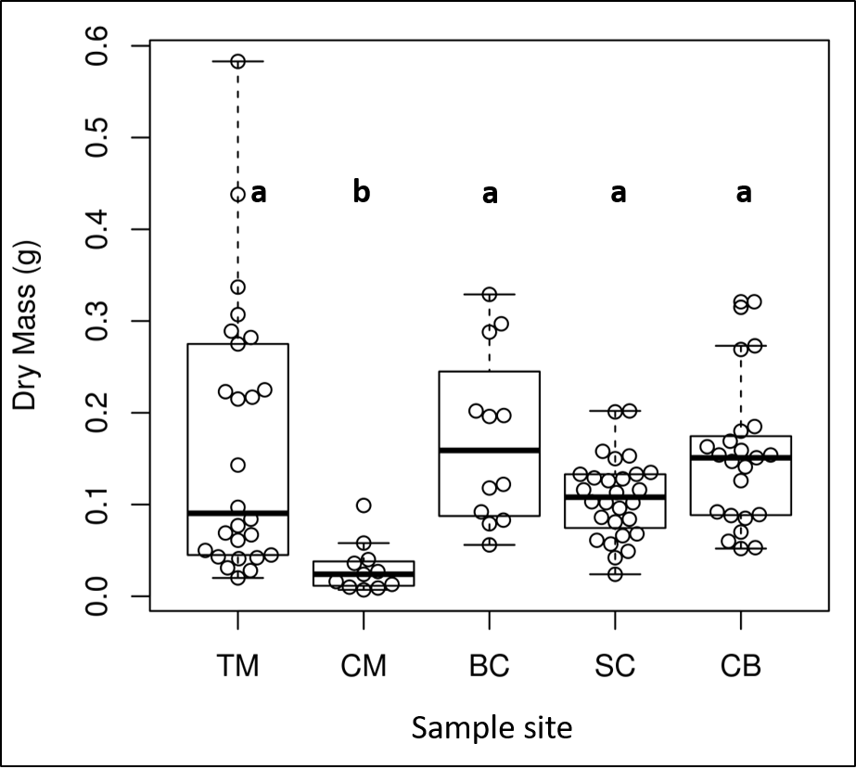
Figure 10: Results of the sediment mass analysis by sampling site, showing the the dry mass for each of the 100 samples, where TM is Texoma Marina (Red River arm), CM is Cedar Mills (Red River arm), BC is Buncombe Creek (Red River arm), SC is Soldier Creek (Washita River arm), and CB is Catfish Bay (Washita River arm). Lowercase letters denote the statistical differences between sites. Cedar Mills had significantly lower sample mass than the other sites. Whiskers are 1.5 times the upper or lower inter-quartile range, and open circles indicate individual samples.

Tables

Table 1: results of mixed effect model. As expected, zebra mussel distributions were extremely variable between sites, but were also variable within a site, with fewer zebra mussels being found on plate area C than A, and more being found on plate area D than A. More zebra mussels were also found at 3 meters than at 1 meter.

 | Estimate | Std. error | Z value | Pr(>|z|)
(Intercept) | -0.3933 | 0.4852 | -0.81 | 0.41768
Catfish_Bay | 1.7777 | 0.4631 | 3.84 | 0.00012
Cedar_Mills_Marina | 0.411 | 0.5078 | 0.81 | 0.41838
Soldier_Creek | 1.6445 | 0.4787 | 3.44 | 0.00059
Texoma_Marina | -0.0231 | 0.6349 | -0.04 | 0.97093
Plate_B | -0.2078 | 0.2684 | -0.77 | 0.43886
Plate_C | -0.6131 | 0.311 | -1.97 | 0.04869
Plate_D | 0.9115 | 0.2461 | 3.7 | 0.00021
Sampler_depth3 | 0.7541 | 0.2011 | 3.75 | 0.00018

Table 2: Results of Wilcoxon rank-sum test pairs. After adjusting α to 0.008 to account for multiple corrections, area A and D are different from B and C but not each other, and areas B and C are different from A and D but not each other, meaning that sample masses were significantly higher on samples from the inside (areas B and C) of the sampler than areas from the outside (areas A and D) of the sampler.

Pair | W | p-value
A & B | 155.5 | 0.002392
A & C | 153 | 0.002035
A & D | 315 | 0.9693
B & C | 315 | 0.9693
B & D | 460.5 | 0.00421
C & D | 472 | 0.002035

Chapter 3 - Variable zebra mussel (Dreissena polymorpha) population densities in a subtropical reservoir result in significant but localized effects on long term water clarity

Thayer C. Hallidayschult (ORCID 0000-0001-7179-5320), Jessica E. Beyer (0000-0002-3388-3255), Katherine V. Hooker, and K. David Hambright (0000-0002-5592-963X)
Program in Ecology and Evolutionary Biology and Plankton Ecology and Limnology Laboratory, Department of Biology, University of Oklahoma, Norman, OK, USA
*Corresponding author contact information: email: Thayer@ou.edu phone #:(405) 595 6520

Keywords: Dreissena polymorpha, zebra mussel, subtropical lakes, Lake Texoma, invasive species, aquatic nuisance species

Acknowledgements
I would like to thank everyone in the Plankton Ecology and Limnology Lab who contributed to this work and who gave me helpful feedback on the many drafts and revisions of this manuscript. I would also like to thank the University of Oklahoma biology department and the University of Oklahoma Biological Station who provided funding for this research. I would also like to thank my data sources, the Texas EPA, USGS, and especially William J. Matthews for their contributions to the long-term dataset from Lake Texoma. This work was submitted by TCH as partial fulfillment of the requirements for a Ph.D. degree from the University of Oklahoma.

Abstract
While zebra mussels have well documented ecosystem impacts in temperate lakes where they reach high densities and can rapidly colonize all available substrate, less is known about zebra mussel impacts in subtropical systems where they typically reach much lower densities and experience higher mortality rates. The most well-documented effect of zebra mussels is an increase in water clarity after they invade a system, but zebra mussel invasions do not happen in a vacuum and care must be taken to isolate the introduction of zebra mussels from other important factors which also may influence water clarity, such as changes in zooplankton densities, chlorophyll concentrations, and nutrient concentrations. In this study, we examined the large subtropical Lake Texoma, where zebra mussels invaded in 2009. To test for effects of zebra mussels on water clarity, we created a long-term (1980-2014) dataset of Secchi depths, nutrient concentrations, major tributary inflows, chlorophyll concentrations and zooplankton biomass within that time window, as data were available. We also used satellite imagery to estimate Secchi depth during periods of time where data were missing, and breakpoint analysis to detect a change in the relationship between water clarity and date. Based on the uneven distribution of zebra mussels in the lake, we conducted the analysis separately for the Red River arm where zebra mussels were scarce and for the Washita River arm where zebra mussels were more abundant. Zebra mussel populations in the lake have not reached high densities and they experience frequent dieoffs, but water clarities have nonetheless increased in the Washita River arm but not the Red River arm. Seasonal analysis of changes in Secchi depth showed that the changes in the Washita occurred throughout the year. None of the other measured water quality parameters changed in association with the increase in clarity, suggesting that the effect is due to zebra mussels. Inflow rates decreased for both arms of the river during this time, suggesting that hydrology may be interacting with zebra mussels to increase water clarity, and breakpoint analysis detected 2001 as the shifting point in water clarity, suggesting that the system was changing before zebra mussels invaded. This demonstrates that zebra mussels need not reach high densities or be abundant throughout an entire system to have a large-scale effect, but in large dendritic systems like many subtropical lakes, it is important to ensure that efforts to quantify zebra mussel ecosystem effects incorporate a sampling design that captures the complexity of the system being sampled, as well as consider other factors which may also affect water clarity such as hydrology.

Introduction
Invasive species are a global concern, estimated to impose a total global cost exceeding one trillion dollars (Pimentel et al. 2001), including global costs of over seventy billion dollars to agriculture and human health caused by invasive insects alone (Bradshaw et al. 2016) and billions of dollars in damages to agriculture in just the US (Paini et al. 2016). Invasive species also bring with them problematic ecological shifts which disrupt essential ecosystem services, which are more difficult to quantify monetarily but no less important (Cook et al. 2007, Oreska and Aldridge 2011).
However, understanding these costs and ecological shifts relies on scientists having data and being able to compare and contrast conditions before and after a given species invades in order to delineate ecosystem change (Strayer et al. 2006, Willis et al. 2007, Crowl et al. 2008, Strayer 2012). These datasets are particularly important for assessing the impact of ecosystem engineers, species which indirectly modify the habitat itself (Jones et al. 1994). When an invasive species is an ecosystem engineer, it is more likely to have deleterious impacts on systems it invades, and these impacts are likely wide-ranging and may take significant time to fully manifest (Crooks 2002). In aquatic systems, invasive bivalves often act as powerful ecosystem engineers, changing nutrient dynamics, water clarity, flow patterns, and benthic habitat (Sousa et al. 2009). One species of particularly disruptive bivalve is the zebra mussel (Dreissena polymorpha).
Zebra mussels are well recognized as a problematic aquatic invasive species in North America, where they cause both economic and ecological disruptions (Connelly et al. 2007, Higgins and Vander Zanden 2010). Zebra mussels have the potential to drastically alter systems they invade, including increasing the nutrient supply to the lake bottom, out-competing grazing zooplankton, and extirpating native mussels (Higgins and Vander Zanden 2010, Stewart et al. 2010, Vanderploeg et al. 2010). However, zebra mussels are perhaps most infamous for increasing water clarity in systems they invade. The combination of their high rates of filtration and reproduction means that zebra mussels can quickly achieve a large population size which is capable of filtering substantial volumes of water. As a result, much of the palatable algae in the water column is consumed, and unpalatable algae and other suspended particles are rejected in matrices of mucous which prevents their immediate resuspension in the water column (Vanderploeg et al. 2009). This results in a water body which has much lower concentrations of suspended particles in the water column, meaning light can penetrate much deeper into the lake, shifting a lake from one which is driven by a pelagic food web to one which is driven by a benthic food web dominated by macrophytes and benthic invertebrates (Stewart et al. 1998).
However, the strength of these effects will necessarily depend on the zebra mussel population size in a given body of water, and the majority of the research on the ecological impacts of zebra mussels has been conducted in temperate lakes where zebra mussels can reach high densities. In environments at the edge of zebra mussel tolerances, these ecological effects may not be as pronounced, given that zebra mussels will likely not reach high population densities, or may be much more prone to periodic die-offs and population crashes. In particular, subtropical lakes in the southern United States pose a colonization challenge for zebra mussels, with high summer water temperatures, high levels of turbidity, and many with relatively high levels of salinity (Ground and Groeger 2009). While zebra mussels have proved highly resilient, spreading to lakes and rivers throughout the southern United States, they tend to have a more pronounced boom-and-bust lifecycle and experience frequent die-offs in these systems (Mihuc et al. 1999, Delmott and Edds 2014, Smith et al. 2016, Churchill et al. 2017).
If zebra mussels are unable to maintain the same population sizes and densities as is frequently seen in more suitable temperate habitat, it follows that their ecological impacts may be equally diminished as well, or they may vary seasonally or inter-annually. Effects may appear during good conditions, only to vanish as zebra mussel populations crash. If zebra mussels do not occur at a sufficient density to filter an appreciable fraction of the water column, or only achieve the necessary density a portion of the time, water clarity impacts may be diminished or become highly variable. If populations always remain low, their effect on water clarity may similarly be lower. Conversely, if zebra mussels achieve high densities, but frequently experience die-offs, they may have only transient effects on water clarity, with light penetration increasing when zebra mussel densities are high, and light penetration returning to pre-zebra mussel levels when densities return to normal. Both alternative scenarios would suggest that the ecological effects of zebra mussel invasions in subtropical lakes are markedly different than the effects in temperate lakes, and our expectations and assumptions should necessarily be adjusted.
Unfortunately, assessing the extent to which zebra mussels may be impacting the water clarity of the lake requires a record of water clarity both before and after zebra mussels invaded the system, as well as information about other factors which may also be influencing water clarity, such as nutrient inputs, land use changes, and water inflows and outflows. This limits our ability to assess zebra mussel impacts in subtropical lakes to bodies of water which have been routinely monitored both before and after the date of zebra mussel invasion. Alternatively, long-term satellite imagery can provide a proxy for lake water quality data, especially that concerning water clarity (Budd et al. 2001, Binding et al. 2015, Rowe et al. 2015). Fortunately, one such lake with both long-term in situ and satellite data available is Lake Texoma, a large subtropical reservoir on the border of Texas and Oklahoma, which was invaded by zebra mussels in 2009. To assess whether zebra mussels have or may be impacting water clarity in this lake, we set out to assemble a long-term monitoring dataset of water clarity and important factors contributing to water clarity for as far back before zebra mussels invaded as possible, as well as post-zebra mussel invasion. Our goal is to not only to evaluate whether water clarity has changed in the lake after being invaded by zebra mussels, but to also test for any changes in other potentially confounding important water quality parameters which may also affect water clarity, such as the rate of inflow for the two main rivers, nitrogen and phosphorus concentrations, chlorophyll-a concentrations, and zooplankton biomass. By examining the trends in these factors alongside trends in water clarity, we can better understand the factors most likely to be driving any detected changes in water clarity.
We hypothesized that, given the relatively low population densities of zebra mussels in Lake Texoma and their cyclical patterns of die-offs in summer heat and drought, that zebra mussel impacts on water clarity would be limited. Further, given previous knowledge of the uneven distribution of zebra mussels within the lake (Chapter 1), we predicted that water clarity impacts would be more pronounced or appear only in the Washita River arm, which has higher zebra mussel densities, while the Red River arm, with lower zebra mussel densities, would have lower or no changes in water clarity associated with the zebra mussel invasion.

Methods
Lake Texoma is a large subtropical reservoir, formed in 1946 and is the twelfth largest reservoir in the United States by surface area. It was created by damming the confluence of the Red River and the Washita River (Fig. 1). Due to its large size and the difference in water contributions between the two major tributaries, we collected data from points within both the Red River arm and the Washita River arm of the lake (Fig.1). Data were collected from the United States Geological Survey, the Texas Department of Environmental Quality, William J. Matthews (University of Oklahoma), and the Plankton Ecology and Limnology lab at the University of Oklahoma. We collected information on inflow rates collected from the USGS gauging stations nearest to where the two rivers flow into the lake, total nitrogen concentrations, total phosphorus concentrations, Secchi depth, zooplankton abundances, and zebra mussel larvae abundances in a window from 1980 to 2015, where data were available.
Due to significant gaps in our water clarity data, we also supplemented the in situ Secchi depth data using light reflectance data from satellite images paired with in situ data to create a model for predicting Secchi depth, then inferred the Secchi depths for time periods where in situ data were missing using satellite images to predict the Secchi depth. To collect the data used to create the model, Landsat 7 & Landsat 5 ETM+ Level 2 Surface Reflectance data were obtained from EROS Data Center, Sioux Falls, SD (USGS) for path 27, row 36. Images were collected from 1989 through 2017, and were divided into two pools. Images within 8 days of an in situ measurement of Secchi depth were used to create the predictive model, while the images further than 8 days from an in situ Secchi depth recording were used to predict an inferred Secchi depth for that point in time. The choice of pairing satellite images with in situ data no more than 8 days separated in time was a compromise between collecting a sufficient number of paired Secchi data and Landsat images (with a 16-day return time) to create a functional model and ensuring that conditions present when the image was collected would correspond to conditions present when the Secchi depth was recorded. Analysis of temporal autocorrelation in a similar subtropical reservoir showed that water quality data taken up to 11 days apart were still strongly autocorrelated (Beyer and Hambright 2017). Images with more than 10% cloud cover, or cloud cover obscuring the sampling area were discarded, along with images with artifacts obscuring a sampling location. To minimize loss of data from visual artifacts and compensate for the possibility of unusual coloration in an individual pixel (e.g. an unfortunately positioned boat), and to account for the combination of in situ samples from an area of the lake instead of a fixed sampling coordinate, all reflectance data were composed of the average of nine pixels (the target point pixel and the eight surrounding pixels) for each site. This approach both increased the number of useable images and created more representative reflectance data for analysis (Baban 1993).
The predictive model was built using the linear regression function implemented in R (version 3.2.3, R development core team 2016), using the green, red, near-infrared, and short-wave infrared bands, as well as the red/green, blue/green, blue/near-infrared, green/near-infrared, and red/near-infrared band ratios as predictors and Secchi depth as our response variable. To increase the accuracy of our interpolative model, we used a separate model for the Red River and the Washita River arm, to account for the colorimetric differences between the two regions. When estimating water clarity where the primary source of turbidity (e.g. phytoplankton vs suspended sediment) is different, separate models are often used (Gholizadeh et al. 2016). To maximize model fit and the model’s interpolative utility, and because the model is not designed to be a universal model applied to other lakes, the full model containing all predictors was used (Burnham and Anderson 2002).
All statistical analysis was performed in R (version 3.2.3, R development core team 2016). We used linear regression to test for any significant trends in Secchi depth over time, and zooplankton biomass over time, for each arm of the lake, with time as the predictor and Secchi depth, or zooplankton biomass as the response variable. Additionally, as a second method for testing our hypothesis to ensure our results were robust as well as evaluate potentially important water quality parameters which were not as widely or evenly collected Secchi depth, we divided the water quality data into two categories, pre-zebra mussel invasion and post-zebra mussel invasion, and used Mann-Whitney U tests to test for a significant difference in a given parameter before and after zebra mussels invaded. Mann-Whitney U tests were used instead of t-tests as most of the data were non-normally distributed. This approach was particularly useful for parameters which were more irregularly collected, where the reduced numbers of samples or gaps in time made linear regression undesirable.
We performed a breakpoint analysis on the combined in situ and predicted Secchi depth dataset using the package “segmented” (Muggeo 2003). Breakpoint analysis can be used to estimate the location of a shift in the formula describing the relationship between two variables. In this case, we used breakpoint analysis to detect whether the relationship between Secchi depth and date had any noteworthy shifts, and if so, if these shifts were located near 2009, the proposed introduction time of zebra mussels.
Using the increased resolution provided by the addition of Secchi depths predicted by satellite to the in situ Secchi depth database, we also examined whether there were seasonal patterns in the changes to Secchi depth in the two arms of the lake. After a Mann-Whitney U test for omnibus significance, pairwise Wilcoxon rank-sum tests were used to compare Secchi depths pre- and post-zebra mussel invasion, grouped by month as the subsetting factor.

Results
In assembling our long-term database we collected a total of 174 Secchi depth readings for the Red River arm and 172 Secchi depth readings for the Washita River arm between 1980-2015. The data collected between 2006 and 2012 represented the only period of time with Secchi depths spaced evenly throughout the year, with years outside this range lacking complete annual records of Secchi depth. We found a significant increase in Secchi depths in the Washita River arm post-zebra mussel invasion (2009-2012; Mann-Whiney U test; df = 171, W = 705, p-value < 0.0001), and a significant decrease in Red River arm Secchi depths post-zebra mussel invasion (df = 173, W = 1940, p-value = 0.004) (Figs 2, 3).
Satellite imagery allowed us to infer a more complete record of Secchi transparency prior to 2006, as well as post 2012 (Fig. 2, full results of model in table 1). Inclusion of the satellite-inferred Secchi data increased our number of observations to 265 for the Red River arm and 257 for the Washita river arm. Using the combined actual and inferred Secchi record, we found similar changes in Secchi depth in both arms of the lake over time, following the same pattern as in the in situ data, with Secchi depth increasing over time in the Washita River arm and decreasing over time in the Red River arm (Figs. 2 and 3) and a significant difference between Secchi depths pre-and post-invasion (Mann-Whitney U test, df=257, W = 10617, p-value < 0.0001). The inferred Secchi data also allowed us to evaluate the hypothesis that zebra mussel impact in the Washita River arm continued from 2012 to present, and the data suggest that this trend is indeed continuing (Fig 2). Our analysis of seasonal variation in the differences between pre-and post-zebra mussel invasion Secchi depths found that the months which differed significantly post-invasion were January, April, June, July, and October in the Washita River arm, and March and August for the Red River arm (Fig. 4, Table 2). Breakpoint analysis of the combined Secchi data from 1980-2017 on the Washita River identified one breakpoint, occurring in 2001 (1 estimated break point, breakpoint = 2001.54, std. error = 2.295) as the point in time where the linear relationship between Secchi depth and year shifts (Fig. 5).
Chlorophyll declined in both the Red River (n = 80, W = 1027, p-value = 0.03) and the Washita River arms (n = 76, W = 1029, p-value = 0.001) of the lake (Fig. 6). Nitrogen concentrations increased in the Red River arm (n = 111, W = 541, p-value = 0.01), but not in the Washita River arm (n = 106, W = 593, p-value = 0.13) (Fig. 7). Phosphorus concentrations did not change in either the Red River (n = 111, W = 1296, p-value = 0.11) or the Washita River arms (n = 106, W = 751, p-value = 0.94) (Fig. 7). Zooplankton biomass did not change in either the Red River arm (n = 35, t = 0.36, p-value = 0.71) or the Washita River arm (n = 27, t = -1.8, p-value = 0.08) between 2006-2009. However, zooplankton biomass increased in the Red River arm (n = 23, t = 4.69, p-value < 0.0001) after 2009, but did not change in the Washita River arm (n = 23, t = -0.63, p-value = 0.53) (Fig 8). Average monthly instantaneous discharge rates, representing inflows from the two main rivers, decreased post-zebra mussel invasion in both the Red River (n = 428, W = 21256, p-value = 1.039e-12) and the Washita River arms (n = 428, W = 20690, p-value = 5.307e-11) (Fig. 9).

Discussion
When evaluating how zebra mussels may be affecting water clarity in Lake Texoma, we considered the two arms of the lake separately, as zebra mussels are relatively uncommon in the Red River arm and relatively more abundant in the Washita River arm (Chapters 1 and 2). Given the dendritic nature of the lake and separation between the two arms (Fig. 1), it is unlikely that the effects of zebra mussels in the Washita River arm would carry over to the Red River arm, and vice-versa. Indeed, when we evaluated the patterns in other water clarity factors such as nutrients and zooplankton concentrations, we can see that the two arms are travelling on different trajectories from one another, and appear to be becoming more different from one another over time, with water clarity increasing in one arm while decreasing in the other. We saw water clarities increase in the Washita River arm, these increases in water clarity occurred around the same time as zebra mussels become abundant in the lake, and these increases in water clarity occurred despite there being no detectable changes in nitrogen or phosphorus concentrations or in zooplankton biomass, although there was a significant decrease in the average volume of inflow for both arms of the lake during this period of time. Shifts in the hydrology of a system can have large impacts on water clarity in a system. For example, river flow rates interact with zebra mussel grazing in the Hudson River to increase the overall system’s sensitivity to flow regime change, with increased flow associated with decreased water clarity, and decreased flow associated with increased water clarity. The driving factor behind this is thought to be that during low flow periods there is less input of sediment and zebra mussel grazing removes the majority of the phytoplankton biomass (Strayer et al. 2008). Similarly, in systems where turbidity is primarily caused by suspended sediment in runoff, lower inflows should also result in increased water clarity (Vogt et al. 2015). However, if the inflow primarily consists of water with low suspended sediment, high flow can have the opposite effect, washing away phytoplankton and replacing it with relatively clear water (e.g. (Loverde-Oliveira et al. 2009)), increased flow may have the opposite effect of increasing water clarity. We also do not see a strong seasonal pattern in the water clarity changes, suggesting that rainfall and inflow are unlikely to be the only driving factor.
While we do not have information on the densities of adult zebra mussel densities in Lake Texoma or veliger densities in the main channel of the Washita River, we do know that zebra mussels experienced a population crash in 2011 and post-crash veliger densities were lower than pre-crash densities (chapter 1). Despite the assumedly large change in the adult zebra mussel population in Lake Texoma, the changes in water clarity in the Washita persist after the 2011 crash (fig. 3), with the highest recorded Secchi depth for the Washita occurring in 2014. A more detailed and/or specialized dataset would be required to test whether inter-annual variation in water quality can be linked to fluctuations in the zebra mussel population in the lake.
Interestingly, while both arms of the lake experienced decreased inflows, the water clarity has changed in opposite directions in the two arms of the lake, suggesting that, while hydrology may be playing a significant role in determining water clarity in Lake Texoma, it is unlikely to be the sole factor driving these changes. We propose that these changes in water clarity, at least in the Washita River arm, are at least in part due to the impact of zebra mussels. If zebra mussel filter feeding is in part responsible for clearing the water in the Washita arm of the river, then the decreased inflow rates may be amplifying the effect of zebra mussels by slowing water retention time and increasing the proportion of the water column which is able to be filtered by zebra mussels, while simultaneously reducing the rate at which new nutrients are supplied to the phytoplankton community in the lake. Our breakpoint analysis suggests that zebra mussels are not the only factor responsible for the water clarity shifts in the Washita river, as the point of relationship change the analysis identified was in or around the year 2001, before zebra mussels invaded the lake. Thus, it is entirely possible that decreasing flow rates had already begun to increase Secchi depth in the Washita River (but not the Red River) arm, and the zebra mussel invasion has acted to amplify this effect.
Meanwhile, the Red River arm of the lake has taken a very different path, with the water clarity decreasing over time, despite an increase in zooplankton biomass and a decrease in chlorophyll concentration and inflow volume. This suggests that the changing water clarity in the Red River arm may be due to an increasing load of total suspended solids (perhaps with decreased inflow there is a reduction in hydraulic flushing by large rain events), or other non-algal source of turbidity, although we do not have more detailed data on what the source of the decrease in water clarity may be.
That zebra mussels could be having such a pronounced effect on the water clarity in Lake Texoma is somewhat surprising, given their overall low population densities, and high seasonal mortality rates from stressors such as water level fluctuations, high summer water temps, seasonal anoxia, and high predation pressure. However, these stresses may be offset by near-optimal growing conditions during the spring and fall, when Churchill (2017) found rapid growth rates in young zebra mussels deployed on artificial substrates. The periods of accelerated growth may allow zebra mussels to have major ecosystem impacts, even when these optimal growing periods are interspersed with periods of high stress and mortality. The analysis of seasonal impacts found that water clarity had significantly increased in the Washita River arm for five months out of the year, in no particular pattern, suggesting that the increase in water clarity is not tightly linked to when conditions are optimal for zebra mussels.
In the Washita river arm, the overall water clarity increased from an average Secchi depth of 1.22 meters to 1.63 meters, a 34% increase in water clarity. This is actually comparable to the 38% average increase in water clarity attributed to zebra mussels in temperate lakes found by Higgins and VanderZanden in their 2010 meta-study. This water clarity increase also appears to be persistent, with Secchi depths having migrated upwards since 2009 (Fig. 2), and changes in monthly Secchi depths detected for five months, distributed throughout the year (Fig. 4). The inferred Secchi depths created using our predictive model suggests that this trend is in fact continuing, underscoring the need for dedicated routine monitoring in subtropical lakes, particularly soon after zebra mussel invasions. This need is especially pressing when one considers that the zebra mussel population in Lake Texoma is unevenly distributed throughout the lake and not particularly dense, but nonetheless appears to have had a major impact on the water clarity in a large subtropical lake.
It should be noted that while the model used to generate the satellite-inferred Secchi depths was not particularly strong (Table 1), the overall patterns and changes in the inferred data were also observed in the in situ data, with the predicted values being used to get a better look at seasonal variation and potentially detect any historical shifts or swings in Secchi depth not captured by the in situ observations.
The potential interaction between zebra mussels and reduced flow rates also raises the possibility that the impacts of zebra mussels will worsen with climate change, as already arid regions such as the American Southwest are predicted to become increasingly drought-prone (Seager et al. 2007, Dai 2011). It also emphasizes the importance of distributed sampling efforts, as in the case of Lake Texoma, sampling efforts focused solely in the Red River arm would have run the risk of entirely missing the impact that zebra mussels were having in another area of the lake. Zebra mussels need not reach high densities or achieve stable population numbers to have ecosystem level effects, but these effects may be masked in many systems, particularly in large dendritic subtropical lakes. Careful consideration must be put into monitoring efforts before drawing any conclusions about the potential impact of zebra mussels on a given lake ecosystem, and these efforts must be paired with collection of supplemental data examining potential changes in other important driving factors, such as changes to primary productivity or hydrology
Invasive species are well appreciated as a global problem, and many of them have had such costly and disruptive impacts that the consequences cannot help but be obvious. However, many invasive species impacts are indirect, and may only become evident through careful comparison of the ecosystems before and after invasion. This is not possible unless routine monitoring takes place before the invasion occurs, because if data collection only begins after the invasion, it may already be too late to assess the damage being done. However, for visually active ecosystem properties such as water clarity, an existing but incomplete record of in situ data may represent an opportunity to use pre-existing remotely sensed images to supplement the existing in situ dataset, and thereby better capture the effects of invasive species, both forwards and backwards in time. As the rates of species invasions and range expansions continue to increase, this relatively low effort technique is likely to become increasingly popular for invasive species monitoring.

Works Cited
Baban, S. M. J. 1993. Detecting water quality parameters in the Norfolk Broads, U.K. using Landsat imagery. International Journal of Remote Sensing 14:1247–1267.
Beyer, J. E., and K. D. Hambright. 2017. Maternal Effects are no match for stressful conditions: a test of the maternal match hypothesis in a common zooplankter 31:1933–1940.
Binding, C. E., T. A. Greenberg, S. B. Watson, S. Rastin, and J. Gould. 2015. Long-term water clarity changes in North America's Great Lakes from multi-sensor satellite observations. Limnology and Oceanography 60:1976–1995.
Bradshaw, C. J. A., B. Leroy, C. Bellard, D. Roiz, C. Albert, A. Fournier, M. Barbet-Massin, J.-M. Salles, F. Simard, and F. Courchamp. 2016. Massive yet grossly underestimated global costs of invasive insects. Nature Communications.
Budd, J. W., T. D. Drummer, T. F. Nalepa, and G. L. Fahnenstiel. 2001. Remote sensing of biotic effects: Zebra mussels (Dreissena polymorpha) influence on water clarity in Saginaw Bay, Lake Huron. Limnology and Oceanography 46:213–223.
Burnham, K., and D. Anderson. 2002. Model selection and multimodal inference. Springer, New York.
Churchill, C. J., D. J. Hoeinghaus, and T. W. La Point. 2017. Environmental Conditions increase growth rates and mortality of zebra mussels (Dreissena polymorpha) along the southern invasion front in North America. Biological Invasions 19:2355–2373.
Connelly, N. A., C. R. O'Neill Jr, B. A. Knuth, and T. L. Brown. 2007. Economic Impacts of Zebra Mussels on Drinking Water Treatment and Electric Power Generation Facilities. Environmental Management.
Cook, D. C., M. B. Thomas, S. A. Cunningham, D. L. Anderson, and P. J. De Barro. 2007. Predicting the economic impact of an invasive species on an ecosystem service. Ecological Applications 17:1832–1840.
Crooks, J. A. 2002. Characterizing ecosystem-level consequences of biological invasions: the role of ecosystem engineers. Oikos 97:153–166.
Crowl, T. A., T. O. Crist, R. R. Parmenter, G. Belovsky, and A. E. Lugo. 2008. The spread of invasive species and infectious disease as drivers of ecosystem change. Frontiers in Ecology and the Environment 6:238–246.
Dai, A. G. 2011. Drought under global warming: a review. Wiley Interdisciplinary Reviews - Climate Change 2:45–65.
Delmott, S. E., and D. R. Edds. 2014. Zebra mussel maturation and seasonal gametogenesis in Marion Reservoir, Kansas, USA. Bioinvasions Records 3:247–260.
Gholizadeh, M. H., A. M. Melesse, and L. Reddi. 2016. A comprehensive review on water quality parameters estimation using remote sensing techniques. Sensors 16.
Ground, T. A., and A. W. Groeger. 2009. Chemical Classification and Trophic Characteristics of Texas Reservoirs. Lake and Reservoir Management 10:189–201.
Higgins, S. N., and M. J. Vander Zanden. 2010. What a difference a species makes: a meta-analysis of dreissenid mussel impacts on freshwater systems. Ecological Monographs 80:179–196.
Jones, C. G., J. H. Lawton, and M. Shachak. 1994. Organisms as ecosystem engineers. Oikos 69:373–386.
Loverde-Oliveira, S. M., V. L. Moraes Huszar, N. Mazzeo, and M. Scheffer. 2009. Hydrology-driven regime shifts in a shallow tropical lake. Ecosystems 12:807–819.
Mihuc, T. B., J. M. Battle, J. R. Mihuc, and F. Bryan. 1999. Zebra mussel (Dreissena polymorpha) seasonal colonization patterns in a sub-tropical floodplain river. Hydrobiologia 392:121–128.
Muggeo, V. M. R. 2003. Estimating regression models with unknown break-points. Statistics in Medicine 22:3055–3071.
Oreska, M., and D. C. Aldridge. 2011. Estimating the financial costs of freshwater invasive species in Great Britain: a standardized approach to invasive species costing. Biological Invasions 13:305–319.
Paini, D. R., D. C. Cook, P. J. De Barro, S. P. Worner, and M. B. Thomas. 2016. Global threat to agriculture from invasive species. Proceedings of the National Academy of Sciences of the United States of America 113:7575–7579.
Pimentel, D., S. McNair, J. Janecka, J. Wightman, C. Simmonds, C. O'Connell, E. Wong, L. Russel, J. Zern, T. Aquino, and T. Tsomondo. 2001. Economic and environmental threats of alien plant, animal, and microbe invasions. Agriculture Ecosytems & Environment 84:1–20.
Rowe, M. D., D. R. Obenour, T. F. Nalepa, H. A. Vanderploeg, F. Yousef, and W. C. Kerfoot. 2015. Mapping the spatial distribution of the biomass and filter-feeding effect of invasive dreissenid mussels on the winter-spring phytoplankton bloom in Lake Michigan. Freshwater Biology 60:2270–2285.
Seager, R., M. Ting, I. Held, Y. Kushnir, J. Lu, G. Vecchi, H.-P. Huang, N. Harnik, A. Leetmaa, N.-C. Lau, C. Li, J. Velez, and N. Naik. 2007. Model projections of an imminent transition to a more arid climate in southwestern North America. Science 316:1181–1184.
Smith, B. R., D. R. Edds, and J. M. Goeckler. 2016. Distribution and density of zebra mussels in four Kansas reservoirs. The Southwestern Naturalist 61:49.
Sousa, R., J. L. Gutierrez, and D. C. Aldridge. 2009. Non-indigenous invasive bivalves as ecosystem engineers. Biological Invasions 11:2367–2385.
Stewart, T. J., O. E. Johannsson, K. Holeck, W. G. Sprules, and R. O'Gorman. 2010. The Lake Ontario zooplankton community before (1987-1991) and after (2001-2005) invasion-induced ecosystem change. Journal of Great Lakes Research 36:596–605.
Stewart, T. W., J. G. Miner, and R. L. Lowe. 1998. Quantifying mechanisms for zebra mussel effects on benthic macroinvertebrates: organic matter production and shell-generated habitat. Journal of the North American Benthological Society 17:81–94.
Strayer, D. 2012. Eight questions about invasions and ecosystem functioning. Ecology Letters 15:1199–1210.
Strayer, D., T. V. Eviner, J. M. Jeschke, and M. L. Pace. 2006. Understanding the long-term effects of species invasions. Trends in Ecology & Evolution 21:645–651.
Strayer, D., M. L. Pace, N. F. Caraco, J. Cole, and S. Findlay. 2008. Hydrology and grazing jointly control a large-river food web. Ecology 89:12–18.
Vanderploeg, H. A., T. H. Johengen, and J. R. Liebig. 2009. Feedback between zebra mussel selective feeding and algal composition affects mussel condition: did the regime changer pay a price for its success? Freshwater Biology 54:47–63.
Vanderploeg, H. A., J. R. Liebig, T. F. Nalepa, G. L. Fahnenstiel, and S. A. Pothoven. 2010. Dreissena and the disappearance of the spring phytoplankton bloom in Lake Michigan. Journal of Great Lakes Research 36:50–59.
Vogt, R. J., S. Sharma, and P. R. Leavitt. 2015. Decadal regulation of phytoplankton abundance and water clarity in a large continental reservoir by climatic, hydrologic, and trophic processes. Journal of Great Lakes Research 41:81–90.
Willis, K. J., M. B. Arujo, K. D. Bennett, B. Figueroa-Rangel, C. A. Froyd, and N. Meyers. 2007. How can a knowledge of the past help to conserve the future? Biodiversity conservation and the relevance of long-term ecological studies. Philosophical Transactions of the Royal Society B - Biological Sciences 362:175–186.

Figures
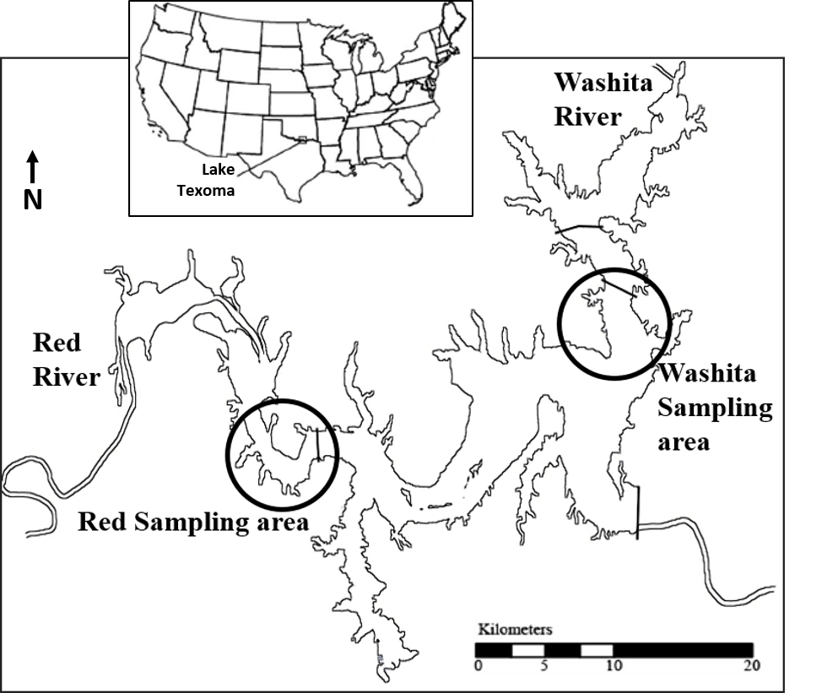
Figure 1: A map of Lake Texoma, showing the areas in which we focused our data collection efforts for the Red River arm (fed by the Red River coming in from the west) and Washita River arm (fed by the Washita River coming in from the north).

Figure 2: Plots of the recorded Secchi depths (light blue dots) as well as the Secchi depths inferred by our linear regression model based on satellite image reflectance (orange dots) for the Red River (top) and Washita River (bottom) arm of the lake. The dashed black line shows the linear trend in the combined in situ and inferred Secchi depth for both lake arms over time, with the average Secchi depth in the Red River arm decreasing over time and the average Secchi depth in the Washita River arm increasing over time. These trends were supported in both the in situ and inferred models, with the in situ (n = 172, t = 2.79, p = 0.006) and predicted (n = 86, t = 7.057, p-value < 0.0001) Secchi depths increasing in the Washita River arm, and both in situ (n = 174, t = -5.14, p < 0.001) and predicted (n = 91, t = -1.897, p-value = 0.0494) Secchi depths decreasing in the Red River arm.

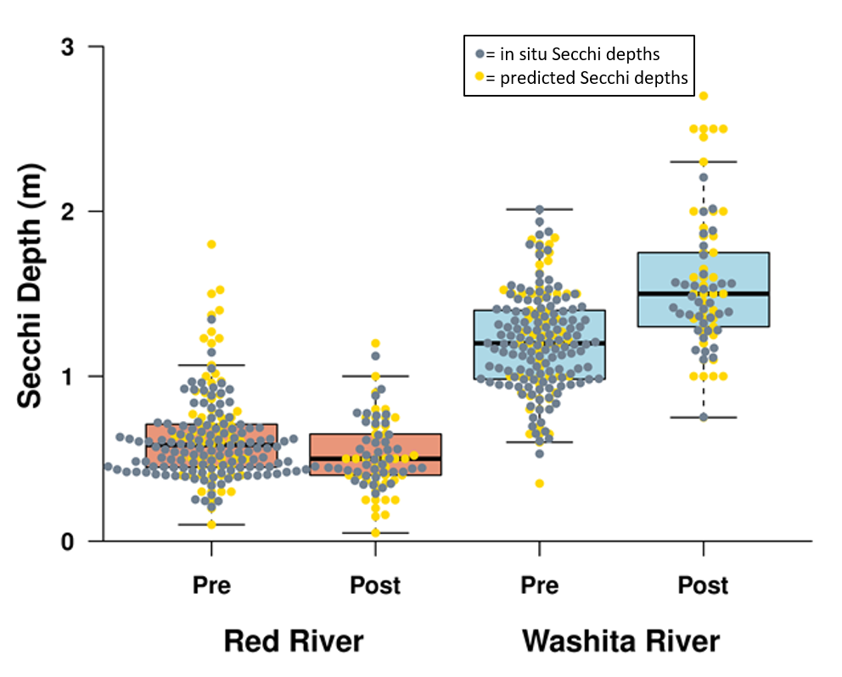
Figure 3: Boxplot of combined in situ and inferred Secchi depths, in meters, pre- and post-invasion for each arm of the lake. In situ values are in gray, and values inferred via the satellite model are in yellow. The Red River arm Secchi depths are significantly lower post-invasion, while the Washita River arm Secchi depths are significantly higher post-invasion. Whiskers represent 1.5 times the inter-quartile range, with open circles indicating individual recorded Secchi depths.

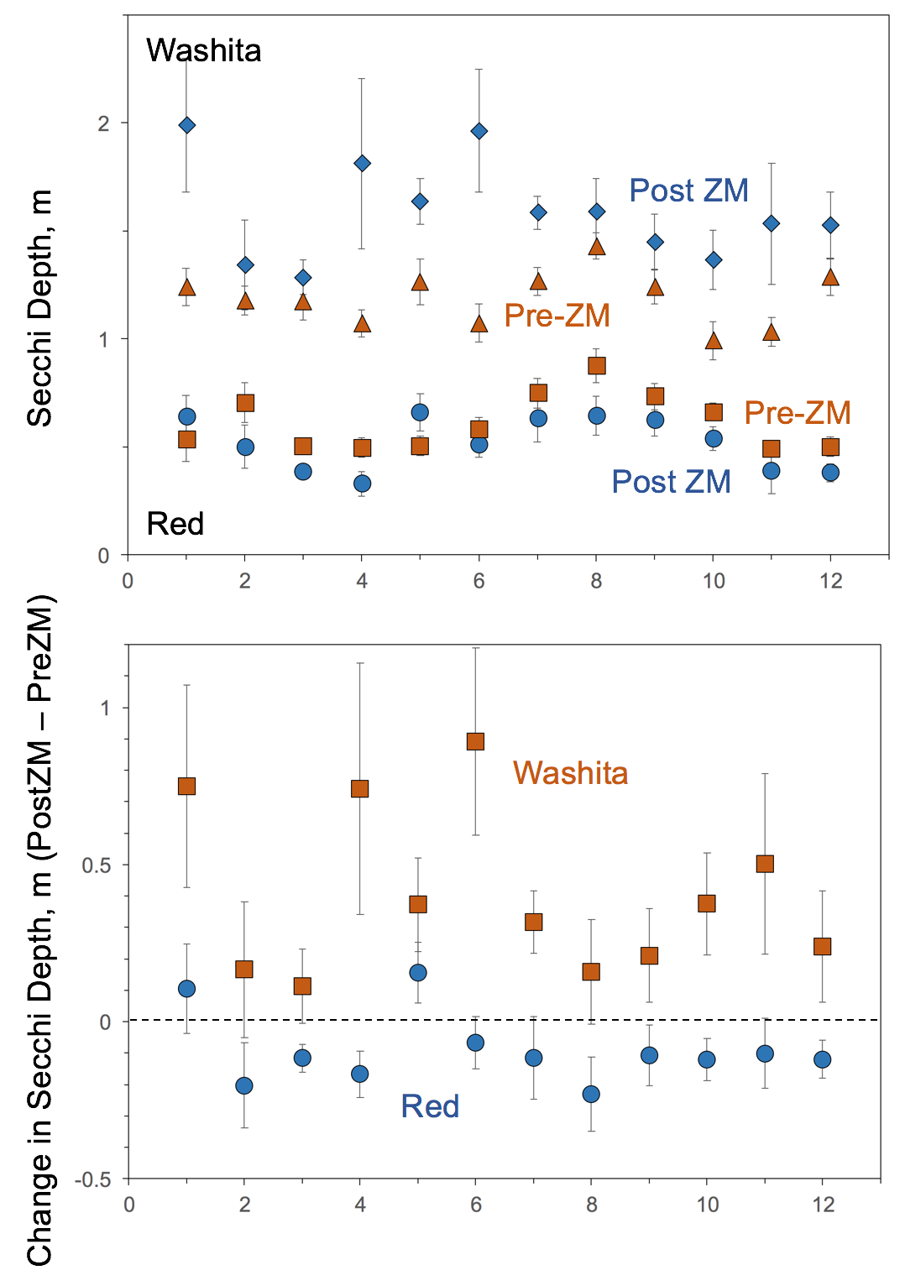
Figure 4: Seasonal analysis of Secchi depth shifts pre-and post-zebra mussel invasion. 1-12 on X axis represent months of the year, beginning in January. In the Washita, Secchi depths changed significantly in Jan, Apr, Jun, Jul, & Oct. In the Red, Secchi depths changed significantly in Mar & Aug.

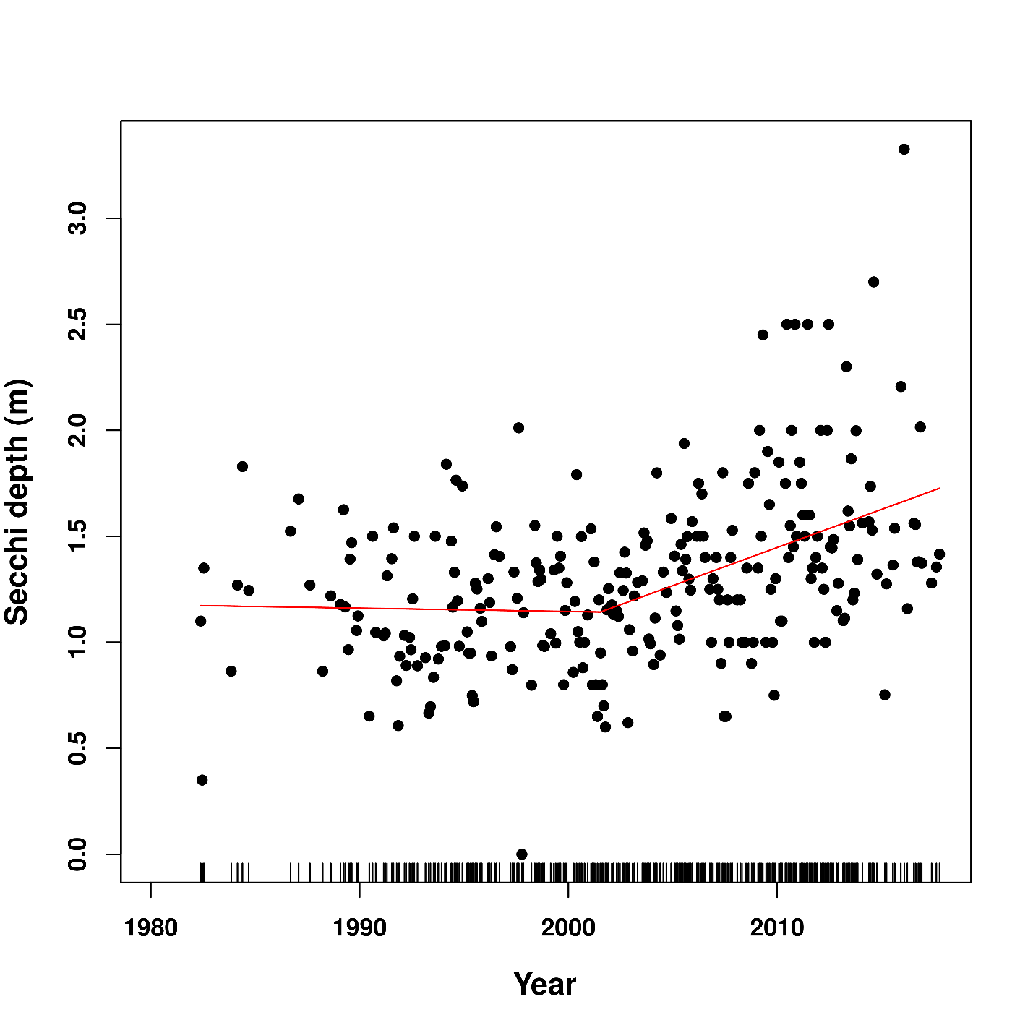
Figure 5: Result of breakpoint analysis, which identified mid-2001 as the point which defined a different slope in the linear relationship between year and Secchi depth. The red line shows the linear fit pre-and post-2001. Black bars at the bottom represent density of data.

Figure 6: Boxplot of chlorophyll-a concentrations, in micrograms per liter, pre-and post-zebra mussel invasion. Chlorophyll concentrations were lower in both arms of the lake post-zebra mussel invasion. Whiskers represent 1.5 times the inter-quartile range, with open circles indicating individual recorded chlorophyll concentrations.

Figure 6:

Figure 7: Boxplot of nitrogen and phosphorus concentrations, in milligrams per liter, pre- and post-invasion for the Washita River and Red River arms of the lake. Nitrogen concentrations significantly increased in the Red River arm, but no other concentrations significantly changed pre- and post-invasion. Whiskers represent 1.5 times the upper or lower inter-quartile range, with open circles indicating individual recorded nutrient concentrations.

Figure 7:

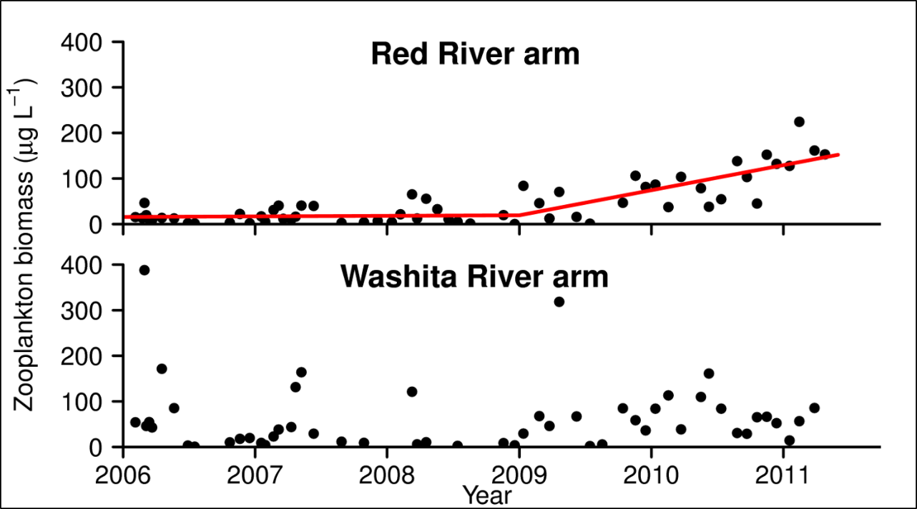
Figure 8: Plot of overall zooplankton biomass, in micrograms per liter, from 2006 to 2012. There was no significant change in zooplankton biomass in the Washita River arm over time either pre- or post-invasion, but in the Red River arm, zooplankton biomass did not change during the pre-invasion period and significantly increased post-invasion.

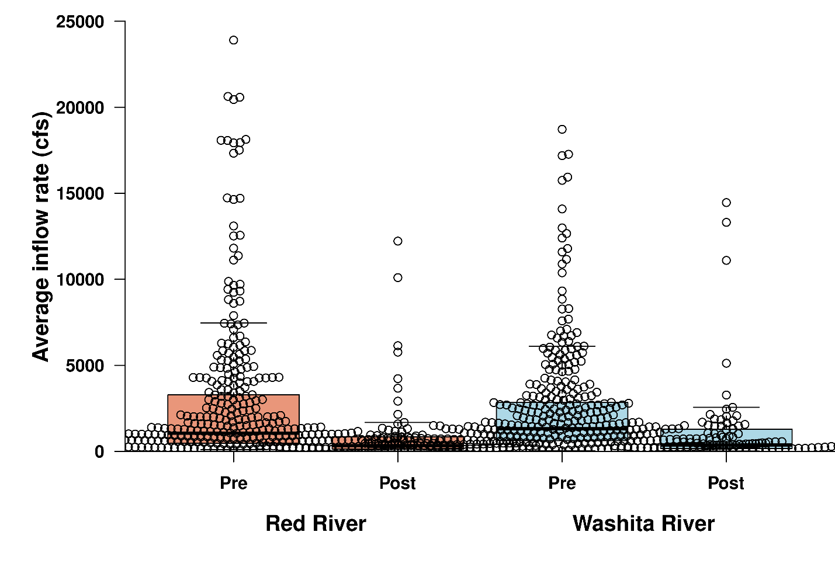
Figure 9: Plot of the average monthly instantaneous discharge recorded at gauging stations directly above where the Red and Washita Rivers flow into Lake Texoma, representing the inflow rates for each arm of the lake (discounting inflows from other tributaries). Whiskers represent 1.5 times the upper or lower inter-quartile range with open circles representing each individual monthly average. Flow rates decreased for both rivers in the post-zebra mussel invasion time period.

Tables
Table 1: Results of the linear model created to predict Secchi depth in the Red River and Washita River arms of the lake. The satellite reflectance model for the Red River arm had a residual standard error of 0.3732 on 49 degrees of freedom, with an R² of 0.2027, while the model for the Washita River arm had a residual standard error of 0.296 on 53 degrees of freedom, with an R² of 0.3105.

Red River
Predictor | Estimate | Std. error | t-value | Pr(>|t|)
(Intercept) | -7.74339 | 5.91835 | -1.308 | 0.196
BlueBand | -52.2598 | 43.1557 | -1.211 | 0.231
GreenBand | 31.70002 | 32.29892 | 0.981 | 0.331
RedBand | -0.67014 | 8.64279 | -0.078 | 0.938
NIRBand | 0.52112 | 10.46381 | 0.05 | 0.96
SWIRBand | -4.6209 | 21.67096 | -0.213 | 0.832
SWIR2Band | -2.13367 | 25.10573 | -0.085 | 0.933
BGRatio | 12.86781 | 8.4936 | 1.515 | 0.136
BRRatio | -5.99239 | 4.53069 | -1.323 | 0.192
GRRatio | 4.49798 | 3.30421 | 1.361 | 0.179
BNIRRatio | -0.58259 | 0.85997 | -0.677 | 0.501
GNIRRatio | -0.08221 | 0.7932 | -0.104 | 0.918
RNIRRatio | 0.29862 | 0.53894 | 0.554 | 0.582

Washita River
Predictor | Estimate | Std. Error | t-value | Pr(>|t|)
(Intercept) | -6.5472 | 9.179 | -0.713 | 0.4791
BlueBand | 2.3254 | 69.9497 | 0.033 | 0.9736
GreenBand | -13.9601 | 61.9082 | -0.225 | 0.8225
RedBand | -20.7203 | 32.4012 | -0.639 | 0.5255
NIRBand | 25.9177 | 19.9835 | 1.297 | 0.2007
SWIRBand | -12.6553 | 42.0346 | -0.301 | 0.7646
SWIR2Band | 38.4187 | 40.7655 | 0.942 | 0.3506
BGRatio | 4.3219 | 9.903 | 0.436 | 0.6645
BRRatio | -1.8455 | 5.998 | -0.308 | 0.7596
GRRatio | 4.3765 | 5.4228 | 0.807 | 0.4235
BNIRRatio | -0.3552 | 1.4918 | -0.238 | 0.8128
GNIRRatio | -1.7217 | 1.4018 | -1.228 | 0.2252
RNIRRatio | 3.3889 | 1.7889 | 1.894 | 0.0641

Table 2: Results of Wilcoxon test comparing pre-and post-zebra mussel invasion Secchi depths, grouped by month and lake arm.
 | Washita |  | Red
Month | W | p-value | W | p-value
Jan | 5 | 0.007829 | 16 | 0.1471
Feb | 36 | 0.5187 | 78 | 0.1542
Mar | 35 | 0.2307 | 97 | 0.01687
Apr | 9 | 0.04019 | 68 | 0.05002
May | 23 | 0.0701 | 25 | 0.07406
Jun | 9.5 | 0.005014 | 54 | 0.5255
Jul | 15.5 | 0.001431 | 100 | 0.3213
Aug | 65.5 | 0.3371 | 127 | 0.04368
Sep | 26 | 0.3845 | 46.5 | 0.5391
Oct | 22 | 0.02506 | 88 | 0.138
Nov | 18 | 0.0525 | 48 | 0.2908
Dec | 22.5 | 0.1602 | 66 | 0.05067

Chapter 4 - Harris mud crabs (Rhithropanopeus harrisii) as a novel invasive predator of zebra mussels (Dreissena polymorpha)

Thayer C. Hallidayschult and K. David Hambright
Program in Ecology and Evolutionary Biology and Plankton Ecology and Limnology Laboratory, Department of Biology, University of Oklahoma, Norman, OK, USA
*Corresponding author. e-mail address: Thayer@ou.edu

Abstract
The trophic ecology of invasive species is integral to predicting their impacts, as release from natural predators can lead to explosive population growth outside their native range. Novel predators may act as a biological control, but quantifying their impact on invasive prey is often difficult in invaded systems. In Oklahoma and Texas, two invasive species, zebra mussels (Dreissena polymorpha), which are expanding their range southward, and Harris mud crabs (Rhithropanopeus harrisii), which are expanding their range northward, now coexist in a novel predator-prey relationship. To identify factors key in regulating consumption of zebra mussels by Harris mud crabs, we conducted feeding trials to determine whether Harris mud crabs would consume zebra mussels and if so, to determine whether consumption rates varied with mussel or crab size. Overall, in experimental settings, crabs consumed more smaller mussels than larger mussels, but this apparent selection for smaller sizes disappeared when analyzing mass-specific consumption rates. Using Manly’s α, a measure of feeding preferences, we also found a preference for smaller sizes. Given a ‘necessary but not sufficient’ relationship between crab size and total mussel mass consumed and mass specific mussel mass consumed, we also analyzed cooperators separately. Cooperator crabs consumed more zebra mussels, both absolutely and relative to their body size. We did not detect a difference in the sizes of mussels selected (likely due to smaller sample size), but Manly’s α showed that the preference for smaller sizes remained in the cooperators. Our results suggest that Harris mud crabs may play an important role as a predator of zebra mussels, but we require a better understanding of their highly variable consumption patterns, as well as more research into their current and potential habitat overlap to make accurate predictions of how ecosystems may be affected when these two species co-occur. As zebra mussels and Harris mud crabs continue to spread throughout Oklahoma, the interactions between these two species may prove important in how these two invaders impact each other, as well as the systems they invade. These types of novel interactions between non-native species likely will become more common as species introduction and range expansion rates continue to increase. Thus, understanding how an organism’s evolutionary history and native niche affects its interaction with new species will become increasingly important.

Introduction
As we continue into the global Anthropocene, the rate of human-mediated species introductions and range expansions continues to increase, creating novel ecological networks of species interactions with no common evolutionary history (Williams et al. 2015). This means that as traditional biogeographical barriers become less important for defining species ranges, the importance of environmental tolerances, structured by both abiotic and biotic interactions, in defining species ranges and abundances will increase (Capinha et al. 2015). Understanding these dynamics is particularly important for problematic invasive species, most of which have well documented negative effects on both the ecology and economy of systems they invade.
One of the most striking phenomena in the study of invasive species is when a species, relatively innocuous in its native range, suddenly explodes in population size when introduced to a new habitat. This rapid population growth may be caused by a variety of factors, but one of the most hypothesized explanations is a reduction in predation pressures as a species leaves its native range. Often referred to as the enemy release hypothesis (ERH), the conceptual framework is exceedingly straightforward – when a species invades a new area, it leaves behind its native predators and thereby benefits from reduced mortality relative both to its native habitat and to native species in the invaded habitat (Keane and Crawley 2002, Colautti et al. 2004). Existing predators in the introduced range may impose lower mortality on the invasive species relative to native species for a variety of reasons, such as an inability to recognize the invasive species as a food source if it is dissimilar from native organisms, or the invasive species may have defensive mechanisms for which the native predators are not adapted to overcome (Sih et al. 2010).
One such invasive species which seems to have benefitted from enemy release is the zebra mussel (Dreissena polymorpha) (Carlsson et al. 2009, 2011). Zebra mussels are a well-known aquatic invasive filter-feeding bivalve, originally from the Ponto-Caspian region. Introduced to the United States in 1986 (Roberts 1990), zebra mussels have since spread across the United States, often causing significant changes to the water bodies they invade, where they act as powerful ecosystem engineers that can directly increase water clarity by changing water column algal species composition and biomass, and indirectly alter the benthic communities (Effler et al. 1996, Connelly et al. 2007, Ward and Ricciardi 2007, Higgins and Vander Zanden 2010, Ozersky et al. 2011, Sousa et al. 2014).
While the ERH does not necessarily provide a complete explanation for why a particular species such as the zebra mussel becomes a successful invader (e.g., Keane and Crawley 2002, Colautti et al. 2004), it has nonetheless been shown to play an important role in invaded aquatic systems, and particularly when potential predators in the invaded range are scarce (Prior et al. 2014). In the case of zebra mussels, specialized mussel predators are often scarce in temperate regions as there are no native freshwater encrusting bivalves in North America. However, molluscivorous predators, particularly those that normally consume snails, have been found in some cases to have significant impacts on zebra mussel populations (e.g. (Eggleton et al. 2004, Bartsch et al. 2005). This is particularly true for estuarine environments, where zebra mussels do not occupy an ecologically unique niche as an encrusting bivalve (Boles and Lipcius 1997, Carlsson et al. 2011). In these estuarine environments, zebra mussels are much more likely to encounter predators which make encrusting bivalves a regular part of their diet, including crabs, which are effective predators of zebra mussels but typically only encounter them in limited circumstances. Where crabs, such as blue crabs in the Hudson river estuary, co-occur with zebra mussels, they are very effective at reducing zebra mussel population densities (Boles and Lipcius 1997, Carlsson et al. 2011). A variety of species of fish have been found to consume zebra mussels in North America, typically molluscivores such as freshwater drum (Eggleton et al. 2004). However, complex three-dimensional habitats, such as rocky substrate, provide extensive refuge space from predatory fish, reducing the impacts molluscivorous fish may have on zebra mussel or other shelled mollusk populations (Stewart et al. 1999). This could, in part, explain why crabs can be such effective predators of zebra mussels – they are benthic foragers, adept at moving through rocky substrate and feeding on the biota attached to hard substrates such as mussels (Seitz et al. 2001). Thus, with a greater overlap in habitat use and little crab-free refuge space in estuaries, crabs have the potential to significantly regulate zebra mussel populations. However, the majority of zebra mussel populations in the United States are in inland bodies of water lacking crabs, rather than in estuaries. As such, predation on zebra mussels and mussel population regulation by crabs is not considered a plausible mechanism for keeping invasive zebra mussel populations in check.
In a rare chance occurrence, an invasive crab, the Harris mud crab (Rhithropanopeus harrisii), has spread northward from coastal Texas to Lake Texoma on the Oklahoma-Texas border. Harris mud crabs are originally from the Atlantic coast of North America and have invaded estuaries around the world (Turoboyski 1973b). More recently, they have moved inland to lakes in Texas, first discovered in Possum Kingdom Reservoir in 1998, and subsequently found in eight other reservoirs across the state, with reproducing populations occurring in systems with salinities as low as 0.5 parts per thousand (ppt) (Fig. 1) (Boyle et al. 2010). In 2009, the same year zebra mussels are thought to have invaded, Harris mud crabs were discovered in Lake Texoma (Boyle et al. 2010). This overlap in geographic distributions between zebra mussels and Harris mud crabs provides a rather unique opportunity to study interactions between two invasive species whose post-invasion range expansion has created a novel predator-prey co-existence.
The invasion range of Harris mud crabs is likely larger than currently documented, as they are extremely cryptic, public awareness of them is low, and they are not a species under active study. Adult Harris mud crabs are small, with a carapace width of approximately 11 millimeters, and inhabit rock reefs where available, but can survive in a wide variety of habitats as they dig burrows into the substrate (Turoboyski 1973a), including artificial substrates, such as Styrofoam floats (Fig. 2). The crabs are opportunistic omnivores, with bivalves often composing a significant portion of their diet. Harris mud crabs have been documented to consume zebra mussels in Poland, where both species have invaded several Polish estuaries (Czerniejewski and Rybczyk 2008), suggesting that they may prove to be an important predator of zebra mussels in Lake Texoma.
Lake Texoma is the first reservoir where these two species are documented to co-occur, but their range overlap is likely to increase as zebra mussels expand their range southward into the Harris mud crab’s introduced range while Harris mud crabs expand their range northward into the zebra mussel’s introduced range. Additionally, if populations of Harris mud crabs with lowered salinity tolerances spread outside of the Southwestern United States, they have the potential to interact with zebra mussels around the world wherever rivers have sufficient estuarine input to meet the 0.5 ppt hypothesized salinity requirement for Harris mud crab reproduction – although it may prove to be lower as its range continues to expand.
While the Harris mud crab’s nocturnal feeding and propensity for burrowing makes estimations of their population sizes difficult, we have found them present at every site on Lake Texoma where we have searched for them. Additionally, fishermen and dock owners on the lake often encounter them, so their population size is large enough to be noticed frequently by recreational lake-users. The Lake Texoma population is reproductively active, as larval crab zoeae have been found in zooplankton tows from Lake Texoma (unpublished data). Given the mud crab’s ubiquity throughout the lake, there is great potential for zebra mussels to encounter Harris mud crabs at a high frequency, increasing the potential for significant interaction between the two species. Harris mud crabs have been documented reproducing at salinities as low as 0.5 ppt, suggesting that any inland body of water with a salinity of at least 0.5 ppt could conceivably be invaded by Harris mud crabs (Boyle et al. 2010). Zebra mussels are documented to grow and reproduce optimally when salinity is below 2.5 ppt, but populations in Europe have been known to tolerate salinities as high as 14 ppt (Karatayev et al. 1998), meaning there is significant potential for overlap between these two organisms, particularly where salinities are between 0.5 and 2.5 ppt. Interactions are likely at salinities above that, particularly in Europe if the low-salinity tolerant ecomorph of the Harris mud crab is transported across the Atlantic (or independently arises, as it did in Texas (Boyle et al. 2010)). If Harris mud crabs are found to consume large numbers of zebra mussels, it could mean that in areas where the two species overlap, the interactions between the two may result in substantially altered population dynamics for both species when compared to where they do not co-occur. However, it is important to determine whether Harris mud crabs have the potential for being a major predator of zebra mussels.
One reason why the enemy release hypothesis is thought to play an important role in the success of zebra mussels in North America is that zebra mussels represent a relatively exotic food, as they are ecologically and morphologically dissimilar from other freshwater mollusks (Carlsson et al. 2009). While native molluscivores may not immediately recognize zebra mussels as a potential food source, an organism which is already adapted to feeding on encrusting bivalves like zebra mussels may have much less difficulty adjusting to zebra mussels as a food source when they first encounter them (Carlsson et al. 2009). Both organisms also occupy rock reefs, increasing the overlap in their habitat use and therefore making Harris mud crabs likely to frequently encounter zebra mussels while foraging.
However, Harris mud crabs are relatively small, so zebra mussels may be able to quickly outgrow the threat of Harris mud crab predation. Harris mud crabs, as shown for other crab species (Juanes 1992, Smallegange and Van der Meer 2003), may also prefer to consume zebra mussels that are smaller than the maximal size predicted to be the most profitable by optimal foraging theory. There are a variety of explanations for a preference for smaller sizes. Crabs may select small, easy-to-open mussels to minimize wear and damage to the chelae (Juanes 1992), or large amounts of force which can put dangerous levels of stress on their chelae (Aronhime and Brown 2009). However, crabs still display an impressive amount of variation in their feeding patterns, even within a single species, varying their approach based on the relative interplay between crab strength and mussel strength (Elner and Hughes 1978, Elner 1980, 2012). Without knowing more about zebra mussel consumption by Harris mud crabs in particular, it is difficult to predict how this interaction is likely to play out.
Considering the importance that prey size plays in crab predation on bivalves, we may see strong size selection in Harris mud crab consumption of zebra mussels, which is an important consideration when understanding how Harris mud crabs may affect zebra mussel populations. For example, size selective predation can significantly alter the population dynamics of prey species (e.g. (Brooks and Dodson 1967), (Abrams and Rowe 1996)) and we know the relationship between crab size (and claw strength) and bivalve size plays an important role in understanding the role of crabs as predators of bivalve mollusks (e.g., Peterson 1982, Juanes 1992, Aronhime and Brown 2009). It may be the case that adult Harris mud crabs are unable to consume larger mussels, or prefer smaller, juvenile zebra mussels, and therefore may not exert significant pressure on overall zebra mussel population densities.
This may be especially important for encrusting bivalves like zebra mussels as the growth and reproduction of large, highly fecund zebra mussels are actively inhibited by juvenile mussels affixing to their shells, in a process known as conspecific biofouling. In fact, as this phenomenon has been invoked as one potential explanation for the reduced lifespan and highly cyclical reproductive success of zebra mussels in ideal habitats (Czarnoleski et al. 2003), it could also be possible that regular grazing on the shell epibiota by Harris mud crabs would actually benefit mature zebra mussels.
To better understand how Harris mud crabs may act as a predator of zebra mussels, we set out to test whether, under controlled laboratory conditions, Harris mud crabs consume zebra mussels and, if so, what role body size and claw morphology may play, as well as determining the preferred size of zebra mussel for consumption when presented with an array of zebra mussel sizes.

Methods
Harris mud crabs were collected from populations in Lake Texoma, while zebra mussels were collected from populations in either Lake Texoma or nearby Lake Murray, and acclimated to lab conditions in aquaria kept at 20°C and on a 12hr-12rh light-dark cycle. Zebra mussels were housed communally, but Harris mud crabs were kept isolated within the aquarium using glass jars, to regulate feeding, prevent cannibalism, and keep track of individual identity. Harris mud crabs were fed every other day, with all feeding trials taking place after a 48-hour starvation period. At the start of each experiment, each crab was sexed and measured for carapace width, claw height and length.
Five zebra mussels from each of five size classes, for a total of 25 zebra mussels, were haphazardly selected, measured, and tagged, then scattered across the sand bottom of a 11-liter aquarium. Zebra mussel size classes were assigned based on the total length of the zebra mussel relative to the crab’s carapace width, with size class A composed of mussels with a total length of 61-70% of the crab’s carapace width, size class B 71-80%, size class C 81-90%, size class D 91-100%, and size class E 100-110%. Thus, all crabs had a wide variety of mussel sizes to which they were exposed, with class E mussels being quite large relative to the crab, and class A mussels quite small.
Each crab participated in a total of 4 trials, each lasting 24 hours. Every 24 hours, any consumed zebra mussels were recorded and the trial reset, with any consumed mussels being replaced by a mussel from the same size class. A total of 15 male crabs were used. Male crabs were chosen as the chelae are generally larger in male crabs and if zebra mussels are consumed by Harris mud crabs, well developed claw muscles are likely necessary. All crabs were kept under observation after the experiment concluded, to ensure they were still actively feeding and not preparing to molt. All crabs used resumed feeding after the experiment concluded, and did not molt within the next week. During the feeding trials, not all crabs became accustomed to the daily routine of feeding, collection, measuring, etc., with only a small portion of crabs spending any of their time actively foraging in the lab. Of the 15 crabs used in feeding trials, only seven individuals consumed zebra mussels in at least three of the four trials (hereafter “cooperative” crabs), while nine individuals consumed zebra mussels in two or fewer trials (hereafter “uncooperative crabs”). Subsequent data analysis specifies cooperative and uncooperative crabs.
Harris mud crab mass was estimated using the formula where total crab weight in mg = 3.1*(crab carapace width in mm)^{2.29}, from Czarniejewski & Rybczyk (2008). Zebra mussel mass was estimated using the formula where shell free dry weight in mg = 0.0121*(shell length in mm)^{2.54}, from Conroy et al. (2005).
The relationship between an individual crab and the amount of zebra mussel consumed during each 4-day experiment was tested with a linear regression implemented in R (Bates et al. 2015), with crab carapace width as the predictor variable and total mass of zebra mussel tissue consumed as the response variable. Similar analyses were also performed with claw height and length as predictor variables. The relationship between crab mass and zebra mussel tissue consumed during each 4-day experiment was also analyzed using data only from the top 60% of the crabs, the crabs who enthusiastically fed during the experiment (henceforth referred to as the cooperative crabs), to examine the data for evidence of a ‘necessary but not sufficient’ relationship between the variables (Yu et al. 2003).
Feeding preferences for different sizes of zebra mussels was analyzed using a generalized linear mixed effects model, with size class as the predictor variable, number consumed or total mass consumed from each size class as the response variable, and crab identity as a random effect. The count model was implemented with a Poisson distribution, while the total mass consumed was implemented with a normal distribution. The model was implemented in R (version 3.2.3, R development core team 2016) using lme4 (version 1.1-12 2016) as outlined in (Bates et al. 2015).
Feeding preference was also analyzed using Manly’s α (Chesson 1978), an index for measuring preference in consumption patterns of an organism, given a known starting distribution and known consumption from each category (Chesson 1978). The analysis was implemented in R (version 3.42, R development core team 2017) using the package ‘selectapref’ (Richardson 2017) and calculating Manly’s α index for the total number of zebra mussels consumed for each size class across all days of all crabs, with replacement. Significant preference is indicated by α > 0.2.
Morphometric analyses were performed by first photographing the major chela of each crab participating in the experiment. The photographs were loaded into the software tpsDIG2 (Rohlf 2004.), and seven landmarks were assigned based on features which could reliably be placed in the same relative location for each crab claw (Fig. 3). Once assigned, the landmarks were analyzed using the MorphoJ software to perform a generalized procrustes analysis to determine relative differences in landmark position between individual crab claws and convert them to principal component space for analysis with other variables (Klingenberg 2011).

Results
Crab claw height and length were found to be highly collinear with carapace width, demonstrating a stable allometric relationship between body size and claw size for these crabs, and thus crab carapace width and crab mass were used in the analysis (Fig. 4, Table 2). All but one Harris mud crab consumed at least one zebra mussel during the four-day experimental period, demonstrating that these crabs have the ability to consume zebra mussels in a laboratory setting. However, only seven individuals consistently consumed zebra mussels during the four-day experiment. Overall, estimated crab mass was not related to the total amount of zebra mussel mass consumed with some relatively large crabs consuming few or no zebra mussels. When looking at total mass consumed in a size class, there was no significant effect of size class on the amount of zebra mussel mass consumed by the crabs, as determined by an omnibus significance test of the fitted model using an ANOVA (df = 4, sum sq. = 2138, mean = 534.6, f-value = 1.306, p-value = 0.486), but significantly more zebra mussel mass was consumed from size class E when only cooperative crabs were analyzed (df = 4, sum sq. = 9140.3, mean sq = 2285.1, f-value = 2.335, p-value = 0.029) (Fig. 5). Nevertheless, for cooperative crabs, zebra mussel mass consumed increased linearly with crab size (Fig. 6). Using all crabs, zebra mussels from the smaller size classes were significantly more frequently consumed, with mussels from size classes A and B consumed more frequently than mussels from C, D, or E (Fig. 7). This pattern remained apparent with the smaller data set of cooperative crabs, but with the reduction in sample number, the effect is no longer significant (Fig. 7, Table 1). Factors other than size were also important, as the mean size of zebra mussel consumed by Harris mud crabs increased with increasing crab size (Fig. 8), partly reflecting the experimental design, but also demonstrating that zebra mussel size did not appear to provide a refuge from predation. The Manly α preference index (Chesson 1978) supported the conclusions found in the general linear model analyzing consumption frequency, with positive selection for smaller two size classes of zebra mussels when tested using all the crabs, a pattern found in both cooperators and non-cooperators (Table 3). Larger crabs were capable of eating larger amounts of tissue and capable of eating more of their body weight in zebra mussel tissue than smaller crabs, but many did not, demonstrating that increased crab size is necessary for increased mussel consumption, but not in of itself sufficient to explain overall consumption patterns.
The landmark analysis of differences between individual crab claws found differences in the relative position of the landmarks between the analyzed crab claws (Fig 9). Principal component analysis found that principal component 1 explained 11% of the variation in shape, and did not significantly explain consumption patterns (Fig. 10). Claw size was also estimated using the landmark centroid size (a measure of the space between the landmarks which captures an estimate of an object’s overall size) as an alternative to measuring claw height or crab carapace width, and revealed that, for the cooperative crabs, mass-specific consumption of zebra mussels increased with claw size (Fig. 11).

Discussion
As we had originally hypothesized, Harris mud crabs were found to consume zebra mussels in a laboratory setting, but because Harris mud crabs were extremely variable in either their ability or willingness to consume zebra mussels throughout the course of the four-day experiment, at least under laboratory conditions, there was little overall relationship between crab size and the total amount of zebra mussels consumed. However, it is clear that at least some Harris mud crabs recognize zebra mussels as a potential food source and are quite capable of consuming them, with one individual (crab number 7) consuming 36 zebra mussels over the 4 days of the experiment (Table 2). We also found that as the crabs get larger, some but not all of the crabs increase their relative and absolute consumption of zebra mussels, indicating that size plays a role in determining zebra mussel consumption by Harris mud crabs but that there are more complex factors, such as behavior, at play here besides simply the size of the crab. The morphological analysis of claw shape detected some differences in the position and angle of teeth on the fixed blade of the claw between individual crabs, suggesting that there was at least some variation in claw morphology between the individuals tested in this experiment. However, this variation was not associated with any particular pattern in consumption. It is possible a larger sample size or a more precise method of morphological analysis which better captures changes in claw shape may explain consumption patterns, or it may be that while claw morphology plays an important role in explaining inter-species variation in mussel consumption patterns, the intra-specific variation in claw morphology is much less important relative to overall crab size and behavior.
Harris mud crabs, on average, consumed many more small zebra mussels than large zebra mussels, both when measuring the proportions in the glm model and when using Manly’s α index of food preference, which suggests a preference for feeding on smaller, possibly easier to open zebra mussels, which is the typically observed pattern in molluscivorous crabs. However, when we looked only at the cooperative crabs, this effect disappeared statistically, although this could be an artifact of the reduced sample size, as the general pattern reflects increasing consumption of smaller size classes.
When analyzing the total mass of the zebra mussels from a particular size class, there is no difference in the mass consumed from each size class for the crabs overall, and more mass from the largest size class was consumed by cooperative crabs, suggesting that in fact, Harris mud crabs may simply consume fewer large zebra mussels because they reach a satiation point and stop feeding soon after only one or two large mussels have been eaten, while individuals consuming smaller mussels need to consume more before becoming satiated. This pattern would fit with Harris mud crabs consuming zebra mussels as they are encountered regardless of size, and ceasing foraging once they reach a satiation point. It may also be that individual Harris mud crabs vary in their feeding preferences and foraging patterns, which is supported by the large amount of individual variation in overall mussel consumption. Depending on crab claw strength and crab experience, there may be different modes of feeding, with some crabs only able to open smaller mussels, while some can open all sizes. Perhaps the non-cooperative crabs were relatively unfamiliar with zebra mussels or had claws ill-suited to opening the mussels, and only consumed a few of the smaller mussels, while cooperative crabs were able to consume any mussels encountered, regardless of size. The cooperative crabs may have been less naïve about zebra mussels as a food source, or more comfortable feeding in the lab setting (although all crabs actively fed on crab pellets both before and after the experiment), or possessed claws better suited to opening zebra mussels. While all of the crabs used in the experiment came from Lake Texoma, the zebra mussel densities vary greatly across the lake (Chapters 1 & 2). Thus, it may be that some, but not all, Harris mud crabs had previously encountered zebra mussels during their life in Lake Texoma. If some of the crabs were familiar with zebra mussels as a food source but others were not, this may have contributed to the variation in individual crab responses to zebra mussels during the feeding experiment.
These experiments demonstrate that Harris mud crabs have the potential to act as an introduced novel predator of zebra mussels in areas where the two species distributions overlap, and it is quite possible that Harris mud crabs could play an important role in dictating the overall success of zebra mussels as an invasive species where the two species co-habit, or diminishing the impact that zebra mussels have in the systems they invade. However, it is important to note that this study is merely the first step in understanding how these two species interact in the natural environment, and more research is needed to follow up on these results, for example, to test the effects of Harris mud crabs on zebra mussel populations in a natural or near-natural setting. Of particular importance is understanding Harris mud crab feeding preferences for zebra mussels given a variety of food choices available, as well as investigating how Harris mud crab feeding on zebra mussels affixed to a natural substrate compares to these laboratory results in which the zebra mussels were placed upon sand. The strength and method of attachment is known to be an important factor in determining the success of crab feeding on mussels, as they typically must manipulate the mussel to position it for opening with the cheliped (Harper 1991). However, many crabs also display flexible feeding patterns, and can adapt their feeding strategy to compensate for the size of the prey, toughness of the shell, or difficulty in manipulation. For example, the crab Zilchiopsis collastinensis was documented to use seven different techniques to open the invasive mussel Limnoperna fortunei, depending on the particular crab and the size of mussel offered (Torres et al. 2012). Thus, while feeding preferences may be somewhat altered by whether the zebra mussels are attached, it is likely that Harris mud crabs will still consume them.
It is also worth noting that zebra mussels, like many prey organisms, respond to predator cues, and so the vulnerability of zebra mussels to Harris mud crab predation may decrease over time. While sessile organisms like zebra mussels are unlikely to adopt behavioral responses to predators, they can, like many organisms, alter their morphology to reduce their vulnerability to predators (Cooley et al. 1985, Weisser et al. 1999), an ability which is particularly common in aquatic organisms (Bronmark and Pettersson 1994, Tollrian 1995, Kats and Dill 1998, Relyea 2001, Lass and Spaak 2003). In response to predator cues, zebra mussels increase the strength of their shells (Naddafi and Rudstam 2013) and predator cues, along with available calcium and pH, are thought to play a significant role in explaining variation in the shell strength of zebra mussels in lakes and rivers (Czarnoleski et al. 2006, Natesan and Strayer 2016). This response is typical of anchoring bivalves, which typically respond to predator cues by strengthening their shells to reduce predation risk (Smith and Jennings 2000, Seitz et al. 2001). If zebra mussels increase their shell strength in response to predation from Harris mud crabs, Harris mud crabs may reduce their consumption of zebra mussels in response (although they may still reduce zebra mussel population growth rates by inducing zebra mussels to spend more energy on shell strength and less energy on growth and reproduction).
Taken as a whole, our results suggest that Harris mud crabs may play an important role as a predator of zebra mussels, particularly in inland systems where there are no other predators similar to crabs. To understand their potential impacts, we require a greater understanding of Harris mud crab consumption patterns and feeding preferences before we will be able to make accurate predictions as to whether Harris mud crabs negatively impact zebra mussels, or whether zebra mussels may positively impact Harris mud crabs.
Given that we now know that Harris mud crabs are at the very least capable of and willing to consume zebra mussels under laboratory conditions, the next step in research would be to assess to what extent zebra mussels are actually consumed by Harris mud crabs under natural conditions. Gut content analysis of crabs is somewhat difficult as they shred their food prior to consumption with both their chelipeds and their maxillae, as well as after consumption within their cardiac stomach, so identifying what crabs have eaten by microscopy is difficult and only allows a relatively coarse taxonomic resolution, particularly if the crabs do not ingest any distinctive shell fragments of zebra mussels as part of their feeding. Stable isotope analysis could be a viable approach (sensu Parnell et al. 2010), but it may be difficult to distinguish the signature of non-dreissenid benthic invertebrates from zebra mussels when examining isotope signatures. Additionally, the role of Harris mud crabs as important predators of zebra mussels could, in part, be evaluated using exclusion experiments, where suitable zebra mussel substrate is deployed within enclosures preventing access by molluscivorous fish but allowing Harris mud crabs, as well as enclosures which prevent access by both Harris mud crabs and molluscivorous fish. The results from such an experiment would give some indication as to whether Harris mud crabs by themselves exert any significant predation pressure on zebra mussels.
However, even if Harris mud crabs do not prove to be a sufficiently voracious predator to significantly suppress zebra mussel densities, they may still alter the ecosystem impacts of zebra mussels. One of the many ways in which zebra mussels alter the ecosystems they invade is by increasing the energy flow from the pelagic system into the benthic system, often referred to as benthic-pelagic coupling (Higgins and Vander Zanden 2010). One of the factors which governs the strength of this coupling is the relative inaccessibility of energy and nutrients bound up in zebra mussel tissue, as relatively few vertebrate predators can effectively consume hard-shelled mollusks such as zebra mussels. However, there is the possibility that Harris mud crabs may weaken benthic-pelagic coupling by consuming zebra mussel tissue and incorporating it into their own tissue, which may be a more accessible energy source to many fish. Indeed, as gathered from anecdotal conversations with local fishermen on Lake Texoma, Harris mud crabs are commonly found in the guts of fish such as largemouth bass and crappie, fish which do not consume zebra mussels. Thus, Harris mud crabs feeding on zebra mussels may potentially be providing a benthic subsidy back to the pelagic system, where previously this was energy largely locked away and inaccessible except to a select few specialized benthivorous feeders. Energy flow dynamics are significantly altered by zebra mussel invasions, with energy shunted semi-permanently into the benthos, but there is the intriguing possibility that this invasive crab may in some ways mitigate the effect. More research is needed to test whether this is indeed the case, including more research into whether Harris mud crabs constitute a significant portion of fish diet. It may be the case that the addition of this invasive crab to inland aquatic systems significantly alters the energy flow dynamics in the lakes it invades, and it would be particularly interesting to compare how the energy flow pathways differ between lakes with and without zebra mussels. As zebra mussels and Harris mud crabs continue to spread throughout Texas and Oklahoma and beyond, the interactions between these two species may prove important in understanding the impacts of both zebra mussels, and Harris mud crabs. Additionally, while zebra mussels have been extensively studied as they have invaded freshwater systems around the world, the Harris mud crab has been relatively understudied. As an invader of estuarine systems, it may not play a particularly unique role in an environment already occupied by many similarly sized species of decapods, but as an invader of inland freshwater systems, it has the potential to be extremely ecologically disruptive. More research is needed to explore the ecology of Harris mud crabs, both in the context of their interactions with zebra mussels and more generally their impacts on the systems they invade. Increased monitoring and awareness of this invasive crab as its range expands is an essential first step to furthering our understanding of these unusual invaders.
The range expansion of these two invaders also presents many opportunities to use the lens of invasion ecology in the evaluation of classical ecological theory, both individually and in the context of their interactions with each other. Harris mud crabs in particular have the potential to significantly disrupt the benthic community. Lakes invaded by zebra mussels often experience marked shifts in the benthic species assemblage, with zebra mussels supplying both an influx of energy to the benthos as well as providing a more complex and three-dimensional habitat with their shells. In the context of zebra mussels acting as ecosystem engineers, Harris mud crabs may actually benefit more from the indirect effects of zebra mussels than through direct consumption.
Zebra mussels, in providing energy subsidies to the benthos that in turn increases the abundance of benthic invertebrates, may actually create much more valuable food resources for Harris mud crabs than the zebra mussels themselves would provide. Additionally, the increased three-dimensional habitat of zebra mussel shells may increase the reproductive success of Harris mud crabs. Juvenile survivorship is often a life history bottleneck for organisms which face high predation pressures, and this is even more problematic when the organism faces high rates of conspecific cannibalism. Smaller size classes of crab are extremely vulnerable to predation from adult crabs, and juvenile survivorship is highly dependent on the availability of complex habitat to provide shelter from larger crabs (Moksnes et al. 1998). Thus, zebra mussels may be indirectly subsidizing Harris mud crab’s food resources as well as reducing a life history bottleneck. If true, it would be an interesting case where a potential prey item is actually much more valuable to the predator as an ecosystem engineer than as a food source. Thus, interactions between zebra mussels and Harris mud crabs may not be a straightforward predator-prey relationship. Predicting the potential effects of these two species on one another depends entirely on gathering more information on the strengths of their various ecological interactions. If Harris mud crabs act as an effective predator of zebra mussels, we would predict that Harris mud crabs would be relatively more abundant in lakes with zebra mussels, and zebra mussels less abundant. If the ecosystem engineering of zebra mussels is the strongest driver in the relationship, we might expect Harris mud crabs to be more abundant in lakes with zebra mussels, but zebra mussel abundances to be unaffected. It would even be possible that through the feeding actions of Harris mud crabs and the removal of epibionts from large fecund zebra mussels, the abundances of both Harris mud crabs and zebra mussels increase in the presence of one another. Currently, we simply do not have enough information to fully characterize the nature of their relationship as antagonistic, facultative, or possibly even synergistic.
One consequence of increasing globalization of the human population and human-induced climate change is an increased rate of species introductions and range expansions, where organisms with no shared evolutionary history may be interacting for the first time. This provides unique opportunities for better understanding how these novel interactions will play out based on an organism’s natural history and autecology, as well as how an organism’s realized niches shift with their transplantations and range expansions. In addition to changing abiotic variables such as climate and physiochemistry, it is essential to consider the types of interspecies interactions which are occurring, particularly when these interactions are with an ecological guild with which the organism has no evolutionary history.

Acknowledgements
Thank you to the University of Oklahoma Biology department for helping fund this research through the Adams summer scholarship. A huge thank you to the PELL lab for all of their support in reading drafts and giving essential feedback on this project throughout its growth, with particular thanks to Jessica Beyer for her invaluable statistical and R coding advice and assistance.

Works Cited
Abrams, P. A., and L. Rowe. 1996. The effect of predation on the age and size of maturity of prey. Evolution 50:1052–1061.
Aronhime, B. R., and K. M. Brown. 2009. The roles of profit and claw strength in determining mussel size selection by crabs 379:28–33.
Bartsch, M. R., L. A. Bartsch, and S. Gutreuter. 2005. Strong effects of predation by fishes on an invasive macroinvertebrate in a large floodplain river 24:168–177.
Bates, D., B. Bolker, M. Maechler, and S. Walker. 2015. Fitting linear mixed-effects models using lme4. Journal of Statistical Software 67:1–48.
Boles, L. C., and R. N. Lipcius. 1997. Potential for population regulation of the zebra mussel by finfish and the blue crab in North American estuaries. Journal of Shellfish research 16:179–186.
Boyle, T., Jr, D. Keith, and R. Pfau. 2010. Occurrence, reproduction, and population genetics of the estuarine mud crab, Rhithropanopeus harrisii (Gould) (Decapoda, Panopidae) in Texas freshwater reservoirs. Crustaceana 83:493–505.
Bronmark, C., and L. B. Pettersson. 1994. Chemical cues from piscivores induce a change in morphology in crucian carp. Oikos 70:396–402.
Brooks, J. L., and S. I. Dodson. 1967. Predation body size and composition of plankton. Science 150:28–35.
Capinha, C., F. Essl, H. Seebens, D. Moser, and H. M. Pereira. 2015. The dispersal of alien species redefines biogeography in the Anthropocene. Science 348:1248–1251.
Carlsson, N. O. L., H. Bustamente, D. Strayer, and M. L. Pace. 2011. Biotic resistance on the increase: native predators structure invasive zebra mussel populations. Freshwater Biology 56:1630–1637.
Carlsson, N. O. L., O. Sarnelle, and D. Strayer. 2009. Native predators and exotic prey - an aquired taste. Frontiers in Ecology and the Environment 7:525–532.
Chesson, J. 1978. Measuring preference in selective predation. Ecology 59:211-215
Colautti, R. I., A. Ricciardi, I. A. Grigorovich, and H. J. MacIsaac. 2004. Is invasion success explained by the enemy release hypothesis? Ecology Letters 7:721–733.
Connelly, N. A., C. R. O'Neill Jr, B. A. Knuth, and T. L. Brown. 2007. Economic Impacts of Zebra Mussels on Drinking Water Treatment and Electric Power Generation Facilities. Environmental Management 40:105–112.
Cooley, P. D., J. P. Bryant, and F. S. Chapin. 1985. Resource availability and plant antiherbivore defense. Science 230:895–899.
Czarnoleski, M., J. Kozlowski, P. Kubajak, K. Lewandowski, T. Muller, A. Stanczykowska, and K. Surowka. 2006. Cross-habitat differences in crush resistance and growth pattern of zebra mussels (Dreissena polymorpha): effects of calcium availability and predator pressure. Archiv Fur Hydrobiologie 165:191–208.
Czarnoleski, M., J. Kozlowski, A. Stanczykowska, and K. Lewandowski. 2003. Optimal resource allocation explains growth curve diversity in zebra mussels 5:571–587.
Czerniejewski, P., and A. Rybczyk. 2008. Body weight, morphometry, and diet of the mud crab, Rhithropanopeus harrisii tridentatus (Maitland 1874) in the Odra estuary, Poland. Crustaceana 81:1289–1299.
Effler, S. W., C. M. Brooks, K. Whitehead, B. Wagner, S. M. Doerr, M. Perkins, C. A. Seigfreid, L. Walrath, and R. P. Canale. 1996. Impact of zebra mussel invasion on river water quality. Water Environmental Research 68:205–214.
Eggleton, M. A., L. E. Miranda, and J. P. Kirk. 2004. Assessing the potential for fish predation to impact zebra mussels (Dreissena polymorpha): insight from bioenergetics models 13:85–95.
R. W. Elner. 1980. The influence of temperature, sex, and chela size in the foraging strategy of the shore crab, Carcinus maenas (L.). Marine and Freshwater Behavior and Physiology 7:15.
Elner, R. W., and R. Hughes. 1978. Energy maximization in the diet of the shore crab, Carcinus maenas. Journal of Animal Ecology 47:103–116.
Harper, E. M. 1991. The role of predation in the evolution of cementation in bivalves. Paleontology 34:455–460.
Higgins, S. N., and M. J. Vander Zanden. 2010. What a difference a species makes: a meta-analysis of dreissenid mussel impacts on freshwater systems. Ecological Monographs 80:179–196.
Juanes, F. 1992. Why do decapod crustaceans prefer small-sized molluscan prey? Marine Ecology Progress Series 87:239–249.
Karatayev, A. Y., L. E. Burlakova, and D. K. Padilla. 1998. Physical factors that limit the distribution and abundance of Dreissena polymorpha (Pall.). Journal of Shellfish research 17:1219–1235.
Kats, L. B., and L. M. Dill. 1998. The scent of death: chemosensory assessment of predation risk by prey animals. Ecoscience 5:361–394.
Keane, R. M., and M. J. Crawley. 2002. Exotic plant invasions and the enemy release hypothesis. TRENDS in Ecology & Evolution 17:164–170.
Klingenberg, C. P. 2011. MorphoJ: an integrated software package for geometric morphometrics. Molecular Ecology Resources 11:353–357.
Lass, S., and P. Spaak. 2003. Chemically induced anti-predator defenses in plankton: a review. Hydrobiologia 491:221–239.
Moksnes, P.-O., L. Pihl, and J. Van Montfrans. 1998. Predation on postlarvae and juveniles of the shore crab Carcinus maenas: importance of shelter, size, and cannibalism. Marine Ecology Progress Series 166:211.
Naddafi, R., and L. G. Rudstam. 2013. Predator-induced morphological defenses in two invasive dreissenid mussels: implications for species replacement. Freshwater Biology 59:703–713.
Natesan, S., and D. Strayer. 2016. Long-term increases in shell thickness of zebra mussels (Dreissena polymorpha) in the Hudson River. Fundamental and Applied Limnology 188:245–248.
Ozersky, T., D. R. Barton, and D. O. Evans. 2011. Fourteen yeras of dreissenid presence in the rocky littoral zone of a large lake: effects on macroinvertebrate abundance and diversity. Journal of the North American Benthological Society 30:913–922.
Parnell, A. C., R. Inger, S. Bearhop, and A. L. Jackson. 2010. Source partitioning using stable isotopes: coping with too much variation. PLOS ONE 5:article e9672
Peterson, C. H. 1982. The importance of predation and intra- and interspecific competition in the population biology of two infaunal suspension-feeding bivalves, Protothaca staminea and Chione undatella. Ecological Monographs 52:437–475.
Prior, K. M., T. H. Q. Powell, A. L. Joseph, and J. J. Hellmann. 2014. Insights from community ecology into the role of enemy release in causing invasion success: the importance of native enemy effects. Biological Invasions 17:1283–1297.
Relyea, R. A. 2001. Morphological and behavioral plasticity of larval anurans in response to different predators. Ecology 82:523–540.
Richardson, J. (2017). selectapref: Analysis of Field and Laboratory Foraging. R package version 0.1.0. https://CRAN.R-project.org/package=selectapref
Roberts, L. 1990. Zebra Mussel Invasion threatens U.S. Waters. Science 249:1370–1372.
Rohlf, F. J. (n.d.). TpsDIG, version 2.16. FJ Rohlf.
Seitz, R. D., R. N. Lipcius, A. H. Hines, and D. B. Eggleston. 2001. Density-dependent predation, habitat variation, and the persistence of marine bivalve prey. Ecology 82:2435–2451.
Sih, A., D. Bolnick, B. Luttbeg, J. L. Orrock, S. D. Peacor, L. M. Pintor, E. Preisser, J. S. Rehage, and J. R. Vonesh. 2010. Predator-prey naivete, antipredator behavior, and the ecology of predator invasions. Oikos 119:610–621.
Torres, M. V, F Giri, and V Williner. Size selective predation on an invasive bivalve, Limnoperna fortunei (Mytilidae) by a freshwater crab, Zilchiopsis collastinensis (Trichodactylidae). 2012. Size selective predation on an invasive bivalve, Limnoperna fortunei (Mytilidae) by a freshwater crab, Zilchiopsis collastinensis (Trichodactylidae) 32:698.
Smallegange, I. M., and J. Van der Meer. 2003. Why do shore crabs not prefer the most profitable mussels? Journal of Animal Ecology 72:599–607.
Smith, L. D., and J. A. Jennings. 2000. Induced defensive responses by the bivalve Mytilus edulis to predators with different attack modes. Marine Biology 136:461–469.
Sousa, R., A. Novais, R. costa, and D. Strayer. 2014. Invasive bivalves in fresh waters: impacts from individuals to ecosystems and possible control strategies. Hydrobiologia 735:233–51.
Stewart, T. W., J. C. Gafford, J. G. Miner, and R. L. Lowe. 1999. Dreissena-shell habitat and antipredator behavior: combined effects on survivorship of snails co-occurring with molluscivorous fish. Journal of the North American Benthological Society:274–283.
Tollrian, R. 1995. Predator-induced morphological defenses - costs, life-history shifts, and maternal effects in Daphnia pulex. Ecology 76:1691–1705.
Turoboyski, K. 1973a. Biology and ecology of the crab Rhithropanopeus harrisii ssp. tridentatus. Marine Biology 23:303–313.
K. Turoboyski. 1973b. Biology and Ecology of the Crab Rhithropanopeus harrisii ssp. tridentatus 23:303–313.
Ward, J. M., and A. Ricciardi. 2007. Impacts of Dreissena invasions on benthic macroinvertebrate communities: a meta-analysis. Diversity and Distributions 13:155–165.
Weisser, W. W., C. Braendle, and N. Minoretti. 1999. Predator-induced morphological shift in the pea aphid. Proceedings of the Royal Society B - Biological Sciences 266:1175–1181.
Williams, M., J. Zalasiewicz, P. K. Haff, C. Schwageri, A. D. Barnosky, and E. C. Ellis. 2015. The Anthropocene biosphere. The Anthropocene Review 2:196–219.
Yu, K., Z. Lu, and J. Stander. 2003. Quantile regression: applications and current research areas. The Statistician 52:331–350.

Figures
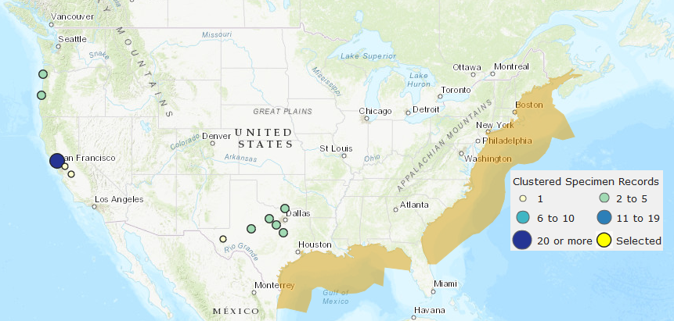
Figure 1: United States Geological Survey map of the current recorded Harris Mud Crab distribution. The gold filled area represents areas where it is native (or had spread before the native crab fauna had been catalogued), with the colored circles representing documented invasion locations. The map likely does not represent the full extent of their range expansion due to its status as an understudied and cryptic invader.
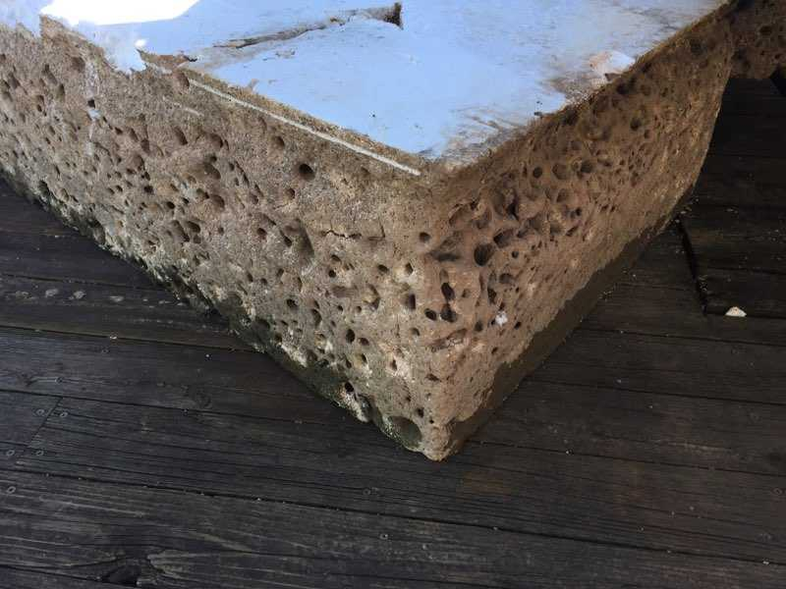
Figure 2: Photograph of a Styrofoam dock float from Lake Texoma, courtesy of Tom Wooten, owner of Buncombe Creek Marina. The holes are Harris mud crab burrows.

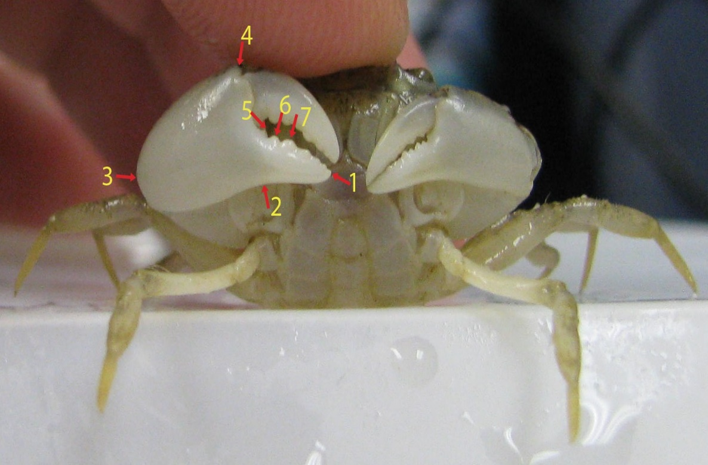
Figure 3: Example image of crab photo used for morphometric analysis, with the 7 landmark locations identified.

Figure 4: Relationship between crab size and claw height and length, demonstrating a relatively stable allometric relationship. Blue squares are chelae length, and orange circles are chelae height.

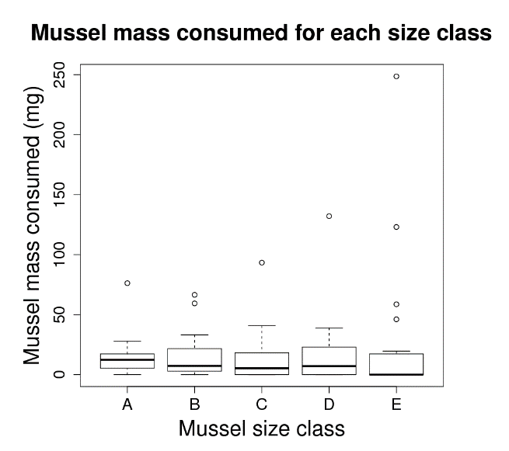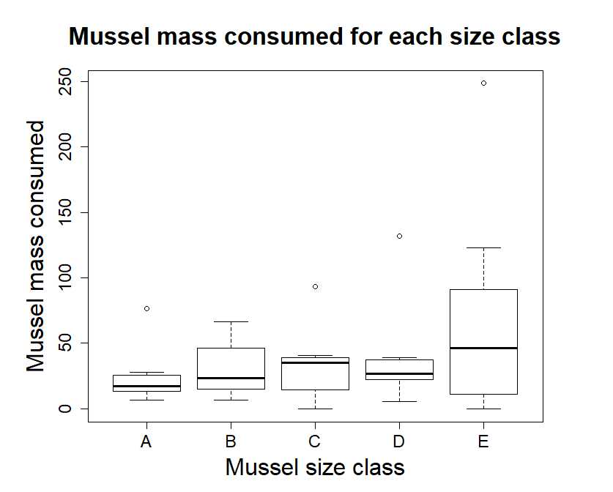
Figure 5: Total combined mass of zebra mussels consumed per size class for each crab across the 4 days of the experiment (top, all crabs; bottom, cooperative crabs only). For each boxplot, the thick dark line represents the median, the box the inter-quartile range, and the whiskers 1.5 times the inter-quartile range. Open circles represent values which lie outside of the whiskers. We found no significant differences in mass consumed between size classes of zebra mussels all crabs, but significantly more mass from size class E was consumed by cooperative crabs.

Figure 6: Consumption patterns in the cooperative crabs (i.e., those which consumed zebra mussels in at least three of the four daily feeding trials, orange triangles) and uncooperative crabs (blue circles). Numbers and mass of zebra mussels consumed increased with crab size (as carapace width) for cooperative crabs.

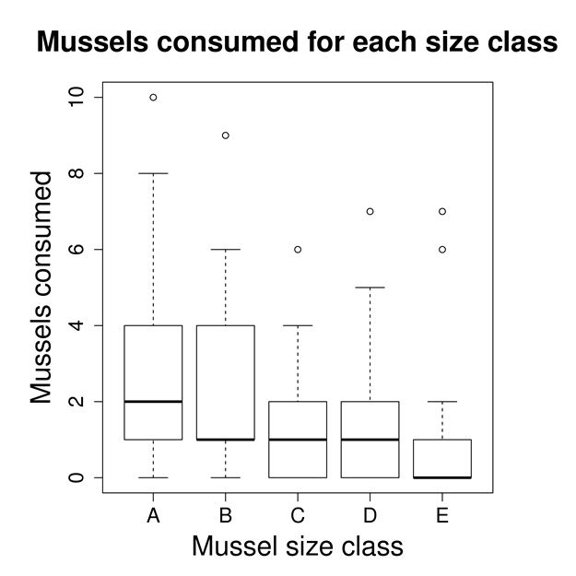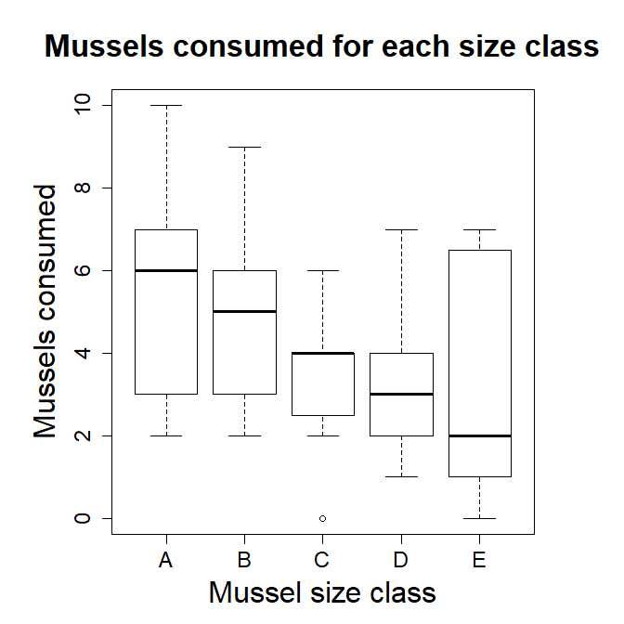
Figure 7: Total count of zebra mussels consumed per size class for each crab across the 4 days of the experiment (top), and total count of zebra mussels consumed by cooperative crabs (bottom). When all crabs were used, significantly more zebra mussels of size class A were consumed than for classes C, D, and E, but there was no significant difference between consumption of size class A and B. When only cooperative crabs were used, no differences between groups were found.

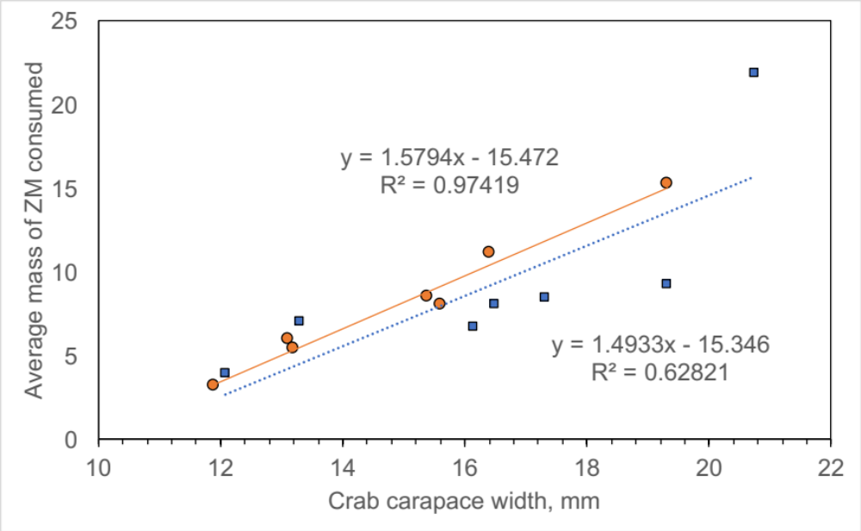
Figure 8: Average mass of zebra mussels consumed by crab carapace width, with cooperators in orange circles and non-cooperators in blue squares. Mass consumed during the experiment increases for both groups as crab size increased.

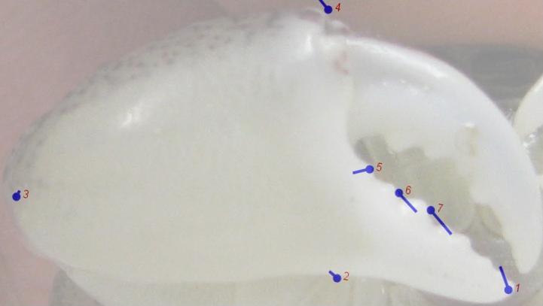
Figure 9: Figure showing an average strength and direction of the movement of the landmarks between crab individuals, with a superimposed photo for reference of what part of the claw each landmark was tracking. More movement can be seen in the position of the teeth, with relatively little change in the shape of the main portion of the chela.

Figure 10: Total zebra mussel mass consumed (left) and the amount of zebra mussel mass consumed relative to the crab’s own body weight (right) when plotted against variation in claw shape, as captured by the claw’s principal component 1 score for cooperative crabs (i.e., those which consumed zebra mussels in at least three of the four daily feeding trials, orange triangles) and uncooperative crabs (blue circles).

Figure 11: Total zebra mussel mass consumed (left) and the amount of zebra mussel mass consumed relative to the crab’s own body weight (right), plotted against claw size, as measured by the size of the centroid calculated during landmark analysis, for cooperative crabs (i.e., those which consumed zebra mussels in at least three of the four daily feeding trials, orange triangles) and uncooperative crabs (blue circles).

Tables
Table 1: Results of the generalized linear mixed effects model testing the relationship between size class and number of zebra mussels consumed. When all crabs were used, mussels from size class A were not consumed significantly more often than mussels from size class B, but were consumed more often than mussels from size classes C, D, and E. When only cooperative crabs were used, there were no significant differences between groups.
All crabs
Predictor | Estimate | Std. Error | Z value | Pr(>|z|)
intercept | 0.5416 | 0.281 | 1.928 | 0.0538
Size class B | -0.2025 | 0.189 | -1.072 | 0.2837
Size class C | -0.693 | 0.219 | -3.159 | 0.00158
Size class D | -0.6604 | 0.217 | -3.042 | 0.00234
Size class E | -0.7985 | 0.2274 | -3.511 | 0.00046

Cooperative crabs only
Predictor | Estimate | Std. Error | Z value | Pr(>|z|)
intercept | 1.61 | 0.2231 | 7.243 | 4.37e-13
Size class B | -0.1112 | 0.2345 | -0.474 | 0.6352
Size class C | -0.5021 | 0.2624 | -1.914 | 0.0557
Size class D | -0.5021 | 0.2624 | -1.914 | 0.0557
Size class E | -0.4595 | 0.2590 | -1.775 | 0.0760

Table 2: Carapace and claw sizes for crabs used in the experiment, along with their consumption during the 4 days of the experiments. In the zebra mussels consumed columns, the first number is the number of zebra mussels consumed, and the second number is the total shell free dry mass of the zebra mussels consumed. The bolded and highlighted rows indicate the crabs identified as cooperative (i.e., crabs 2, 4, 7, 8, 9, 11, and 15), defined as those crabs that consumed mussels in at least three of the four days of the experiment.

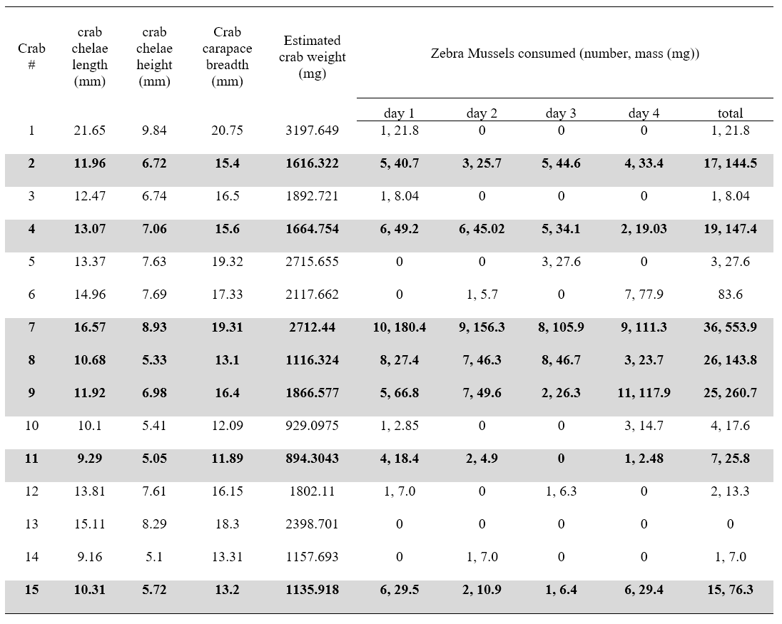
Table 3: The overall number of mussels presented and consumed by crabs during the experiment, and Manly’s α (Chesson 1978) values for each category. Harris mud crabs showed a preference for the smaller two size classes of zebra mussels. (Alpha values above 0.2 indicate positive preference)
All crabs

 | A | B | C | D | E
total in environment | 300 | 300 | 300 | 300 | 300
total consumed | 44 | 40 | 25 | 27 | 26
Manly's α | 0.276 | 0.249 | 0.152 | 0.164 | 0.158

Cooperative crabs only
 | A | B | C | D | E
total in environment | 140 | 140 | 140 | 140 | 140
total consumed | 38 | 34 | 23 | 23 | 24
Manly's α | 0.277 | 0.244 | 0.157 | 0.157 | 0.165

