UNIVERSITY OF OKLAHOMA
GRADUATE COLLEGE

CARICATURES OF CARTOGRAPHY: GEOGRAPHIC IMAGINARIES IN THE POLITICAL CARTOONS OF EMAD HAJJAJ

A THESIS
SUBMITTED TO THE GRADUATE FACULTY
in partial fulfillment of the requirements for the
Degree of
MASTER OF ARTS

By
CAYTON MOORE
Norman, Oklahoma
2021

CARICATURES OF CARTOGRAPHY: GEOGRAPHIC IMAGINARIES IN THE POLITICAL CARTOONS OF EMAD HAJJAJ

A THESIS APPROVED FOR THE
DEPARTMENT OF GEOGRAPHY AND ENVIRONMENTAL SUSTAINABILITY

BY THE COMMITTEE CONSISTING OF

Dr. Darren Purcell, Chair
Dr. Laurel Smith
Dr. Waleed Mahdi

© Copyright by Cayton Moore 2021
All Rights Reserved.

Contents and Front Matter
Contents
Contents and Front Matter iv
Chapter 1: Introduction 1
From Critical Geopolitics to Popular Geopolitics: A textual refocusing 3
Theories of Humor 15
The role of humor and political cartooning in the Arab World 20
Chapter 2 26
Emad Hajjaj and Political Cartoons in the Arab World 31
Political cartoons as popular geopolitics: A visual cartographic text 33
The Arab World According to Emad Hajjaj: Sites of Replication and Resistance 37
Bringing it together: Prerequisite knowledge and Geographic Imaginaries 57
Chapter 3: Discussion 59
Future Research and Applications 62
Works Cited 65

Abstract
This thesis examines the political cartoons of Palestinian-Jordanian cartoonist Emad Hajjaj as a site for new Arab imaginative geographies. With the mapping of the Arab world an artifact of imperialism, the ability to provide cartographic counter-narratives is a powerful exercise of agency for the subaltern. I build the case for Hajjaj’s political cartoons as such a site for discursive agency in three chapters: The first positions the research in the larger field of the critical geopolitics in addition to the sub-field of popular geopolitics. Specifically, I outline the concept of intertextuality as it is used in critical geopolitics and its application to pieces of popular media and culture, such as political cartoons, creating popular geopolitics. In the second, I leverage theories of satire and humor hinging on requisite (or presupposed) knowledge in the form of “common sense” geopolitical imaginaries. By examining these contexts necessary for the understanding of the satire in the cartoon, we are able to capture the ways in which Hajjaj’s imaginative geographies capture popular tropes to subvert them, a process referred to as enunciation. The corpus analyzed comprises cartoons from 2011-2014 wherein Hajjaj uses maps or other cartographic elements to make his point. Hajjaj’s use of maps clustered around several themes, most notably his acts of “playing with space” wherein he rearranged Arab world states into creative new configurations beyond strict physical borders. The final chapter expands upon the findings and positions the research in terms of my contribution to scholarship in popular geopolitics, concluding that the imaginative geographies presented are hybrids, drawing from established imaginaries that are filtered through Hajjaj’s flair for satire to enunciate distinctly Arab counter-geographies, exercising the agency to map that has historically been denied to Arabs.

Chapter 1: Introduction
With the advent of the twenty-four-hour news cycle, editorial cartoonists and other satirists have never had the plethora of source material about world events that they do now. Political cartoons are a venerable form of humor tasked with satirizing the world around us in hopes of illuminating some absurdity in our times. Political cartoons, like any form of humor or satire requires of its audience some degree of foundational knowledge to be funny, as everyone knows that a joke explained is seldom funny. This requisite knowledge can consist of national stereotypes, generalizations about countries, or just cultural touchstones that make humor relevant and comprehensible. This knowledge forms the basis of our mental map of the world and its inhabitants, referred to as the geographic imagination. Edward Said first described geographic imaginations in the context of Orientalism, where years of cultural othering and domination creates broadly understood notions of what the other is, exotic and mutually exclusive to what we consider ourselves (1978). Geographic imaginations are a way of thinking about place through our perceptions as sculpted by discourse, images, media, and experience. Historically, geographic imaginaries emphasize the distinction between the self and other, as the former is usually informed by more nuanced experience, while the imagination of othered spaces may consist of an amalgamation of stereotypes, generalizations, and even propaganda. Since Said’s work, the concept of geographic imaginations has evolved and been refined into imaginative geographies and geographic imaginaries. Imaginative geographies are the representations and depictions of a place and its peoples that carries discursive weight by introducing or reinforcing particular geographic narratives (Gregory, 1995, 2004). When imaginative geographies gain a foothold in cultural zeitgeist, they are termed geographic imaginaries, which are the “taken for granted” mental ordering of space that many reference subconsciously (Gregory, 2009; Watts, 1999). Together, these more discretely account for the multiple components of Said’s geographic imagination from creation and representation to embedding and replication. In discussing the geographic imaginary, Said drew primarily from examples in the Middle East and Arab world, a common target of wide-ranging stereotypes and imaginaries. I take up the same regional focus in exploring geopolitical imaginations, as more than forty years later the region is still scrutinized and lampooned in American media.
I leverage political cartoons by Palestinian-Jordanian cartoonist Emad Hajjaj in order to explore how imaginative counter-geographies of the Arab world (as opposed to those Euro-American produced geographies and imaginaries) are produced and reproduced in political cartoons. This leads to the question “Does political cartoons’ reliance on requisite knowledge allow us to catch glimpses of the cartoonist’s imaginative geography through the way a cartoonist represents the world cartographically?” I choose to explore this via Hajjaj’s editorial cartoons in several Arabic-language newspapers in Jordan and beyond. In analyzing how Hajjaj maps the world for his predominantly Arab audience, we are afforded an opportunity to see how orientalist geographies are subverted, or even replicated in humor, as well as what counter-imaginaries might look like. Like any discourse, the image of Hajjaj’s imaginative geographies is an incomplete one, but it relies upon a mix of normalized tropes (some of which resemble common Orientalist imaginaries) with embedded common cultural knowledge to allow Hajjaj the agency to provide new (and often subversive) mental maps that his audience may be familiar with. The effect that this requisite knowledge has on the discursive capacities of his cartoons is profound, and these mixed imaginative geographies differ greatly based on the embedded knowledge of the audience.
I have chosen to tackle this topic in three chapters. The first chapter positions the research in the larger field of the critical geopolitics in addition to the sub-field of popular geopolitics. Specifically, I outline the concept of intertextuality as it is used in critical geopolitics and its application to pieces of popular media and culture, such as political cartoons, creating popular geopolitics. The second chapter presents the analysis of Emad Hajjaj’s cartoon cartography and the geographic imaginaries it replicates and subverts. The selected cartoons leverage a wide variety of common imagery and tropes, including some Orientalist visions of the Arab world that Hajjaj undermines to disrupt some of those embedded discourses. The final chapter expands upon the findings and positions the research in terms of the contribution to scholarship in popular geopolitics.

From Critical Geopolitics to Popular Geopolitics: A textual refocusing
Geopolitics is defined as the “linkage between linkage of space, power, and political practice” (Purcell, 2006). The leveraging of geography in explaining political organization is not a new occurrence. Friedrich Ratzel conceived of the nation state as a living, breathing being in the latter years of the 19th century, making the case for conflict over resources and territory rights as the natural evolution of the state if it was to survive (Purcell, 2006). This begins the process of geopolitical ordering of states based on their ability to acquire lebensraum (living space) from weaker neighbors. These ideas were borrowed and reworked by Kjellen, who coined the term “geopolitics” to describe a supposedly objective, scientific means of describing the impacts of space on the organism of the state (Reuber, 2009). Geopolitics was further cemented as a means to formalize the relationship between geography and political action on the international stage by Halford Mackinder in 1904 with the construction of a geopolitical “heartland” controlled by Russia, thought to be the geographic key to empire (Reuber, 2009). In this classical geopolitics, geography is causative and static, acting as a set of conditions that constrain or support particular states and their political dealings at home and abroad with a focus on empire.
This gave geopolitics a crucial role to play in securing political power in the wake of the first World War, a war of imperial ambition where prominent scholars of geopolitics like Mackinder served in crucial advisory roles. Though some vestiges of empire had weakened after the armistice, geopolitics was still on the table with a resurgence in Germany. Karl Haushofer picked up the banner of Ratzel in the interwar period, writing on a new nationalist geopolitics that influenced the Nazi movement through Haushofer’s connections in the leadership to figures such as Rudolf Hess (Dodds & Atkinson, 2000) Haushofer and his contemporaries aided in devising a racial organization of the German nation state that is believed to have underpinned the Nazi annexation of Austria and the invasion of Poland in early World War II. This positioned geopolitics as a strategic bogeyman during the war, with a mythologized Institute of Geopolitics in Munich at its center that Allied forces were tasked with locating during the liberation in 1945 (Reuber, 2009). Following the Holocaust and other atrocities perpetrated by the Axis powers, there existed an assumption that a desire to wield geopolitical power in accordance with the tenets of Ratzel and Haushofer was at the heart of the war. Geopolitics stopped being studied as a subdiscipline of geography shortly after World War II due to a sense of complicity in supporting colonialism or invasion such as the Anschluss, leading to its description as an “intellectual poison” within the field (Hartshorne, 1954). However while it was not studied in geography departments, states and their apparatuses were still playing geopolitical games supported by the likes of international relations, positioning for a role in defining what the world is and ought to be.
Geopolitics was revived in such a manner by scholars and advisors like Henry Kissinger with the Cold War. The construction of US and Soviet spheres echoed Mackinder’s own clash between land and sea empires. Meanwhile, strategies of containment were built on the notion that controlling the geographies of communism constituted best practice to avoid a new era of empire building in this new bipolar world (Toal, 1996). This type of new Cold War “balance of power” politics found a foothold in international relations, constituting much of the realist school, which emphasized game theory and other “objective” ways of describing international order, epitomized by scholars such as Robert Jervis through the early 1990s (Jervis, 1978). In this era of distancing from geopolitics and the separation of geographers from the state apparatus, geography underwent a turn to the critical and radical, driven by Marxist and feminist scholars pioneering critical approaches to human geography. With the influx of critical theoretical frameworks, poststructuralist approaches to geography arrived, with a focus on destabilizing theoretical regimes such as positivism and other privileged approaches deemed “objective” (Cresswell, 2013). Poststructuralist thought was based on the works of Foucault and Derrida, with an emphasis on texts and discourse as tools of power in defining truth and morality (Cresswell, 2013; Sharp, 2009a). With new critical lenses emerging, there was an opportunity to reassert geopolitics as a valid subdiscipline within geography, capable of reckoning with its problematic history in a constructive manner.
This resurrection at the hands of poststructuralism and critical theory, resulted in critical geopolitics. This new field applied geography’s vast repertoire of spatial thinking once more to international politics with an emphasis on critical theory and a separation from the state apparatus (Sharp, 2006; Toal, 1996). Critical geopolitics emphasized geopolitics less as a discipline of facts and laws and one closer resembling constructed truths (Foucault, 1972; Tuathail & Agnew, 1992). The new ontology of the discipline was a predominantly poststructuralist one, where the writing of the world is a series of discourses that are subject to studies of truth regimes and gaze (Toal, 1996). This poststructuralist drive further separated critical geopolitics from its maligned ancestor by necessarily focusing on “the micro-level capillaries of power” impact the linkages between geography and global politics (Kuus, 2010). This change in scope further delineates the separation between classical and critical geopolitics in that critical geopolitics is problem-based. Much of the work done in critical geopolitics concerns itself with ongoing power relations relevant to the shaping of geopolitical thought right now, as will be demonstrated with much of the literature cited here, especially that concerning the War on Terror. Dissecting contemporary power dynamics that perpetuate imperial or colonial definitions of space goes hand and hand with Foucauldian approaches to knowledge and truth. This is critical to critical geopolitics’ capacity to examine and resist imperialism as opposed to tacitly uphold it. In this new critical vein the history of geopolitics itself is a case study in the coercive power of discourse that scholars can apply to any of the myriad areas they see geopolitical discourse at work.
Toal brought this form of analysis to the attention of political geography in examining the United States’ relationship with El Salvador during the Cold War (1986), a study that began to initiate studies of geopolitical discourse and lead to the publication of Critical Geopolitics (1996). This text made the case for the new subdiscipline and outlined the critical traditions such as Foucauldian discourse analysis that would serve as the basis for much of the scholarship to follow. The Foucauldian influences critical geopolitics to study geographic imaginations because discourse frequently serves to frame particular concepts and spaces. This framing is one part of what constitutes Foucauldian regimes of truth by dictating what can and cannot be discussed about a topic (Foucault, 1979).
The study of the geographic imagination within the field of geography brought about two crucial refinements of Said’s thesis. The geographic imagination with which Said engaged was enormous in the scale of discourses it contained and areas of thought it infiltrated. At such a scale, the Orientalist geographic imagination lacked granularity, consisting of very generalized notions about a place, resulting in a less than nuanced understanding of a space (Gregory, 1995) . As an alternative, Gregory offers the notion of imaginative geographies, which are discursive tools consisting of representations and depictions of a place that like any discourse, can be replicated and embedded with time (Gregory, 1995, 2004). Notably, imaginative geographies are interpretations of space that reflect the biases of their creator, and do not imply the same pervasive “taken for granted” state that the term geographic imagination had taken on. The connotation of “geographic imagination” was always a reference back to The geographic imagination, which is the Orientalist one, requiring new terms to talk about the phenomenon of geographic imaginations. Imaginative geographies described the idea that was propagated in media, a mental map of associations about a place. The term geographic imaginary came to describe the other aspect, the embedded matter-of-factness that the discourse takes on over time. Geographic imaginaries are the mental arrangements of space that we take for granted subconsciously, often a product of myriad imaginative geographies that we have internalized (Gregory, 2009; Watts, 1999). With this distinction, it becomes easier to talk about a single thread of discourse (such as the portrayal of the Arab world in a series of political cartoons) as an imaginative geography without overstating its impact on greater discursive flows and the way people subconsciously arrange the world. Meanwhile, we can talk about the embedded geographic knowledge that an audience may use to engage with imaginative geographies in the form of geographic imaginaries, the plurality of which implies greater nuance and variety than a unitary geographic imagination would. Both imaginative geographies and geographic imaginaries can extend to the geopolitical, wherein the mental map of associations with a place includes conceptions of political ordering in that space. Such imaginaries are crucial to region-making, a process that needs consistent discursive affirmation to solidify them (Albert & Reuber, 2007; Sidaway, 2003).
Geographic Imagination | Imaginative Geographies | Geographic Imaginaries
- Said (1978) Framework concerned primarily with establishing “us” and “them”  - Term has been subject to a significant amount of debate and redefinition.  - Pluralization moves us away from “The Geographical Imagination” (i.e. the Orientalist imagination). | - Said (1978) & Gregory (1995, 2004)  - Representations and depictions of places and their inhabitants  - Reflective of their creator’s dispositions  - Discourses require performative maintenance. | - Watts (1999) & Gregory (2009)  - Refers to specific “taken for granted” orderings and framings of space  - Often subconscious  - Tied to collective Imaginative Geographies as a process of realizing and embedding those geographies.
Table 1: Geographic Imagination, Imaginative Geographies, and Geographic Imaginaries
Engagement with these geographic imaginaries in turn influenced the study of geopolitical “codes”, where designations like enemy and ally are assigned to geographic entities through repeated rhetorical association (Dijkink, 1998; Gregory, 1995). These codes are discursive tools, a type of shorthand that can shape opinion about particular actors and regions through carefully crafted language. One such example of these codes in practice could be the association of phrases such as “democratic transition” by top level officials in regarding the Iraq War, which can attempt to justify the invasion to American audiences and the world stage, while also cementing notions that Iraq is inherently unstable by being contrasted with the actions of the United States. The rhetoric of these top officials, such as the president and secretary of state constitute what Toal describes as formal geopolitics, consisting of geopolitical practice by academics, think tanks, and politicians, which focus on “big ideas” of geopolitical order. These tend to be enacted and reinforced by the second form of geopolitics: practical geopolitics, which is the day to day formation and maintenance of geopolitical discourses by diplomats and other public servants. Finally, popular geopolitics the focus of this research, consists of the myriad ways geopolitical ideas are communicated, replicated and subverted in popular culture and media. Geopolitical codes are often the product of state-associated actors, i.e. the formal and practical geopolitical actors, and are reproduced or referenced for consumption as popular media, sometimes faithfully, other times critically. A great many geopolitical codes were themselves products of geopolitical meddling, such as Mackinder’s heartland-rimland theory helping to define the threats to the British Empire Pre-World War I or even Kissinger’s rhetoric permeating the Cold War in nearly its entirety. After distancing itself from these advisory positions, the study of these discourses perpetuated by geopolitical experts became foundational to understanding how geographic imaginaries are formed.
This emphasis on the formal and practical positioned the state apparatus as the primary discursive actor in early critical geopolitics. Critical geopolitics proves capable analyzing state-centered discourses and issues with a similar capacity to international relations, which is bound to interactions between sovereign states as both a subject and unit of analysis. Critical geopolitics is free to diverge from state-centrism to analyze any number of actors or discourses beyond the state (Sharp, 2006). This open questions of where geopolitical discourse is created and who has a role to play in it. The ability to engage with how geopolitics can be consumed, replicated, and resisted beyond the actions of states, diplomats, and academics is what enriches geopolitics’ relevance in comparison to international relations beyond the leveraging of critical theories. (Hyndman, 2001; Sidaway, 2000). The third category of geopolitics, popular geopolitics epitomizes this concept by analyzing processes through which geopolitical thought can be created, disseminated, and replicated in popular culture and media, as opposed to formal speeches and works by politicians and academics or the day to day maintenance activities of diplomats (Dittmer & Bos, 2019). Much of the early literature in popular geopolitics focuses primarily on how geopolitical texts were constructed in popular media, emphasizing films, political cartoons, and magazines (Dodds, 1996, 2006, 2007; Sharp, 1993). By the publication of The Geopolitics Reader in 1998, political cartoons were at in the sights of the field at large, as the editors punctuated many of the chapters with political cartoons relevant to the era of geopolitical thought they were discussing (Tuathail et al., 1998). Though the cartoons are not leveraged in any significant way in the book, it legitimizes political cartoons as a text worth mentioning in critical geopolitics. With time and further development, the media that have been used as texts in popular geopolitics has similarly broadened to include comics, comedians, and video games (Bos, 2018; Dittmer, 2005; Purcell et al., 2010, 2017). The ability to analyze popular culture and media as texts capable of revealing discursive flows with geopolitical implications is powerful, especially given how embedded individuals are in media landscapes today.
The textual focus brings with it contemporary critiques of critical geopolitics that call into question the discipline’s capacity for meaningful praxis or its ability to avoid similar euro-centric trajectories as geopolitics had in the previous century. One important intervention in the short history of critical geopolitics is engagement of more feminist and postcolonial thought into the political geography and further into critical geopolitics (Dalby, 1994; Hyndman, 2001; Kofman & Peake, 1990; Staeheli, 1999). Importantly, these additions disrupted the status quo by decentering of the state as actor and scale of research by emphasizing the ways that focus on the state (such as body counts in Iraq) can further marginalize vulnerable groups, such as women and children (Hyndman, 2007). Similarly destabilizing the emphasis on the state as a unit of analysis, explorations of informal political spaces as inscribed with prevailing discourses that are often gendered, othering, and embodied by all manner of individuals (Secor, 2001). Many of these criticisms are inextricably woven into the predominantly Euro-American fabric of the discipline, something shared with classic Geopolitics. The need for subaltern academic voices, new areas of study, and a broadening of theoretical horizons beyond the Euro-American context are necessary for critical geopolitics’ continued relevance (Kuus, 2010). The tools favored by critical geopolitics scholars are more than capable of moving into these spaces, as the delineation of methodologies and theory that define critical geopolitics are not held sacrosanct. With some crossover in topics and methodologies, the challenges to critical geopolitics that feminist geopolitics raises has shaped the trajectory of contemporary work while maintaining a mutually beneficial relationship between the disciplines. One critique in this vein posits that an overreliance on texts as the site of meaning fails to sufficiently account for the way that geopolitical knowledge is actually consumed, making many of the linkages between discourse and action weaker (Woon, 2014). This can lead to issues with positionality and interpretation that resemble the selection of “elite” texts and media over other forms of popular media like popular comedy or video games (Bos, 2018; Purcell et al., 2010).
The treatment of intertextuality, the relationship between texts and other texts/contexts, as the primary means of understanding how geopolitical norms are expressed, duplicated and subverted can be limiting. This can be a product of media selection biases toward “elite texts” as seen above, but can also leave out important elements of interpretation, such as social context and audience. The result is a limiting of permissible geopolitical research that is seen as impactful. This exacerbates the praxis issue, as researchers may emphasize topics with influential audiences (academic or otherwise) to see broader impacts. This is not to say that studying geopolitical discourses with an emphasis on intertextuality cannot link discourse to geopolitical outcomes (see Beauguitte, Richard, & Guérin-Pace, 2015; Dittmer, 2017; Flint & Falah, 2004), but rather these studies lack insights about how audiences may reinforce or alter the geopolitical message being supplied from the formal and practical arenas. The present response to this critique has been an emphasis on incorporating audience studies in a way that doesn’t merely project the interpretations of the author onto them as a strawman (Anaz & Purcell, 2010; Dittmer & Bos, 2019; Dodds, 2006). Audiences contribute to the interpretation and sensemaking of many geopolitical codes in ways that may not be straightforward in a textual analysis. Audience sentiments and experience can even subvert or rearrange the intended function of a text, something that could only be observed when qualitative tools like interviews are brought to the forefront in popular geopolitics. This would require the incorporation of some frameworks not often found in critical geopolitics, such as an emphasis on embodied knowledge or the deployment of tools such as interviews or oral histories that are often leveraged in disciplines like feminist geopolitics. Audiences constitute a human context that cannot be talked about beyond conjecture and generalization without interacting with those people in some way regarding the text. Scholars such as Fluri and Clark have centered popular geopolitical work on personal scales that incorporate interviews with audiences as a means to understand the roles of jokes as a form of geopolitical sensemaking (Clark, 2019; Fluri, 2019).
The second critique is less easily solved and concerns the broadly utilized genealogy of the discipline. The early emphasis on global hegemons in spatializing international order was subversive and critical of those tools of power utilized largely by European and United States interests. What this lens lacked, however, was a significant space for studying the subaltern, which is a step beyond speaking truth to power and allowing the disempowered to speak for themselves in narratives of geopolitical importance. Sharp introduces a need for a “subaltern geopolitics” by examining the securitization of Tanzania in the global war on terror, taking a moment to illuminate non-European geographic imaginaries of those impacted by the shift in global order that the war or terror brought about (2011). Subaltern here refers to marginalized bodies, especially those that have been subject to imperial or colonial rule (Sharp, 2009b). Where the subaltern often lack agency to speak their own truths, they must rely on adopting the language of their oppressors, effectively hiding their own thoughts and ways of knowing in order to be seen as legitimate. This negotiation process fuels the process of enunciation, wherein the subaltern must borrow tools and speech from the colonizer before altering, exercising some degree of agency over the discourse used to oppress them. Among the epistemologies silenced within the subaltern are new geopolitical arrangements where ordering and reason do not flow from seats of empire (S. D. Khoury & Khoury, 2013). Imperial geographies in the Arab world cemented a set of geographic imaginaries, necessitating new imaginative geographies and counter cartographies to reconstruct the nation, as done by leaders like Gamal Abdel Nasser (L. Khoury & Da’Na, 2012a). Mapping is a means of taking geopolitical agency, of allowing the subaltern some avenue of resistance. Khoury and Da’Na argue that the counter-mapping process is an interplay between imperialist and indigenous geographies, which still hints at the process of enunciation over true epistemological liberation, but nonetheless acts as a site for subaltern agency, even if it is not the speaking of the subaltern in Spivak’s terms (L. Khoury & Da’Na, 2012a; Spivak, 2003). Culcasi discusses the counter-mapping performed in the Arab world against the regionalization of “The Middle East” as a combination of refusing to map the place (and therefore a refusal to engage with the imperialist imagination) and reclamation under an internal term like Al-Watan Al-Arabi (The Arab homeland) (Culcasi, 2012). Subaltern geographies are intimately tied to processes that allow for agency, such as mapping, allowing for imaginative geographies to be created counter to prevailing imperialist imaginaries.

More broadly, attempts at allowing the subaltern to speak and introduce new imaginaries and genealogies to exist have found footholds in political geography (see Hammett, 2011; Sidaway, 2000; Slater, 2008). However, critical geopolitics had foundations in international relations theory that still focused on the discursive abilities of “great powers”. To challenge this ontological genealogy, Sharp recounts geopolitical knowledge creation in post-independence Tanzania as a source for alternative geopolitical imaginaries in post-colonial and critical geopolitics (2013). Introduction of new methodologies is insufficient to solving for this without also being open to new subaltern ontologies and epistemologies in critical geopolitics work. Methods like interviews, oral histories, and participatory research can be amenable to such changes in their inclusion of research partners that may not share the same biases as the researcher. Additionally, authors can leverage one of the basic issues of poststructuralism and discourse analysis, the notion that knowledge is constructed, can be embodied, and truths are highly contextual, to recognize that positionality impacts the authority of conclusions drawn in critical geopolitics research. This is not to say that researchers steeped in Eurocentric traditions cannot contribute to knowledge in this field, but the overreliance on those ontologies as sacrosanct or fundamental ought to be challenged by those same researchers in the interest of reflexivity.
Critical geopolitics comprises a potentially broad toolbox of analytical lenses through which to view geopolitical activity at multiple scales. The distance that practitioners in the discipline attempt to keep from geopolitics’ historical role as a tool of empire has allowed research at multiple scales and different disciplinary approaches to flourish. The framework set forth by Toal and other earlier pioneers of the discipline has primarily been a textual one, rooted in the study of discourse, however encounters with other critical approaches have loosened the stays some by encouraging new actors, mediums, and frameworks to be explored while still answering fundamental questions about the manner in which people and states organize the world politically. This thesis is only possible as a result of the multidisciplinary outlets that popular geopolitics allows for as a specialization of critical geopolitics. The act of examining political cartoons as an expression of imaginative geographies is one that is true to the discipline’s origins in poststructuralist theory while being able to freely reach into humor studies, cultural studies, and other critical geographies to attempt a robust analysis of the ways that “big idea” geopolitics can impact individuals through media.

Theories of Humor and Satire
I conceived this study originally based on leveraging humor theory in examining imaginative geographies and geographic imaginaries across two different mediums. To that end, I identified two relevant theories of humor relating to how geopolitical humor may be constructed. The first is succinctly summarized by Billig in Laughter and Ridicule: incongruity theory. Incongruity is perhaps the most widely studied today with roots in cognitive psychology. It posits that perceived incongruity between expectations for a situation and reality are likely to cause laughter (Berger, 2014). The second theory, disposition theory, posits that the more negatively the audience feels about the subject of a joke, the more likely they are to laugh, and that this negative disposition may precede any moral judgement about the content of the joke (Raney, 2004). Disposition can has been leveraged in the study of geopolitical jokes, especially critical or derisive humor (Purcell et al., 2017). This means that negative stereotypes may elicit laughter without a need for incongruity and without reflexivity that would render audiences aware of their own dispositions.
Disposition theory enhances incongruity theory frameworks as both require prior knowledge or assumptions about the subject of the joke on the part of the audience. This creates cultural underpinnings of humor that can dictate how things can be seen as incongruous or dispositions can create laughter (Webber, 2013). Audience dispositions can complicate incongruity by bypassing moral sensemaking. In such a case, a disposition may be so strong that an audience may not need to have prior knowledge of one of more components of the joke to laugh at it. In other cases, stereotypes and dispositions may be intertwined so that either stereotypes (setting up an incongruity) or dispositions can elicit laughter at the same joke. Together, these theories allow for a study of presupposed knowledge and dispositions that provide a toolbox for gleaning authorial attitudes and intent as well as audiences. In analyzing political cartoons here, disposition theory informs some ways a cartoonist may interact with the subject they are lampooning and offers an alternative to incongruity when dealing with presupposed knowledge and humor. However, without deeper methodological engagement with the audience, such as surveys or interviews, disposition theory cannot be relied on beyond generalizations found embedded in some geographic imaginaries.
Humor’s reliance on requisite knowledge or assumptions, either as an expectation leveraged for incongruity or in playing on assumed dispositions of the audience means that humor can be an outlet for discourse, or in the case of some humor, geographic imaginaries. Jokes that rely on understandings of regional differences (such as accents) are only funny if the recipient has some concept of what goes on there, which could range from actual experiential knowledge to media-reinforced stereotypes. This requisite knowledge or set of imaginaries is required of both the creator/teller of the joke as well as the audience, making for a discursive encounter worth exploring. Sometimes, creators can take on a didactic role with their creations and a joke can become a tool for relaying or subverting a particular imaginary or disposition that can then be received and processed to produce laughter. The discursive underpinnings of some humor, as well as its ubiquity makes humor relatively unique compared to other texts in that they are necessarily embodied texts between requisite knowledge/dispositions and their ability to elicit an bodily response on a personal level.
As analysis of the Emad Hajjaj’s political cartoons began with the goal of tracking requisite knowledge for each cartoon’s humor element, there were some struggles with applying theories like incongruity to the cartoons. Cartoons are not simply visual jokes, and much of the linguistically-oriented literature surrounding incongruity theory especially does not always translate well to cartoons (Hempelmann & Samson, 2008). With a solely linguistic framework, much of the iconographic value of the image is lost, or the analysis only focuses on how the image serves the textual elements, which can leave some elements of the image unexplored. The decision to focus on explicit leveraging of cartography and landscape in the study can play on subversion of expectations similar to incongruity theory, but its effectiveness may be diminished outside a linguistic context.
The difficulties of applying humor theory to some political cartoons becomes more apparent when you consider the purpose of editorial cartoons, which is often to satirize or lampoon current events to make a point. There is a distinction between humor broadly writ and satire, which editorial cartoons tend to favor (Lewis et al., 2008). Satire often does not elicit laughter, or even seek to do so. Victor Raskin, in the final response letter of the collection “The Muhammad cartoons and humor research: A collection of essays” draws a stark line between humor and satire at its very worst, a tool to denigrate an entire group of people (Lewis et al., 2008, pp.41-3). To Raskin, much satire elicits very little laughter and is both aggressive and derogatory by nature. He also indicates that for satire, it is never self-explanatory, requiring a familiarity with news or the subject of the satirical media. It is in part this reliance for “common sense” that allows for cartoons to play a role in geopolitical sensemaking as cartoons can convey information, persuade, and interpret events (Dodds, 2007, p. 158). This point does not separate satire from humor using the frameworks laid out in in my research, such as incongruity or disposition theories. While Raskin’s observations certainly pertain to the derogatory Jyllands-Posten cartoons depicting Muhammad as distinct from humor, these lines fail to explain the convergence of satire and humor that occurs too often, both in editorial cartoons as well as media dedicated to this convergence such as The Daily Show. The interface between humor, satire, and the editorial cartoon is better viewed using Charles A. Knight’s framework for the satiric frame of mind (Knight, 2004). Satire is a mode of communication and perspective as opposed to strictly being a genre of media and literature. It attempts to force shifts in perception regarding its subject, as opposed to necessarily conveying judgement or attempting to change behaviors (Knight, 2004, p.5). This supports the notion of satire as a discursive tool which can present imaginative geographies or perceptions of the subject, such as one’s mental map of the world. On its relationship with humor, Knight describes satire as “an exploiter of genres”, even going on to describe satire’s relationship with humor as one that is not entirely capable of being unraveled by delineations and categories (Knight, 2004, p.4). Rather, satire, in its bending of forms and expectations, often is extremely compatible with humor. Both humor and satire require requisite knowledge in its audience, but more so than general humor, satire often depends on specialist knowledge or a following of current events. For example, satirizing a city commissioner’s new infrastructure plan may not be able to elicit laughter like some jokes may be able to by playing on the public’s disposition toward the commissioner or commissioners in general. In this case, requisite knowledge is necessary to understanding the message, but the purpose of the cartoon may be critical or didactic as opposed to humorous.
With cartographic representations, the imaginative geographies conveyed by the cartoonist may not even be integral to the joke, preventing them from comprising a humorous incongruity in most cases, but it does still contribute to the iconography and semiotics of the image that can enhance a point or attempt to reinforce a particular world view. This means that even outside of humor, these maps may be serving a satirical purpose in shifting perceptions by portraying an altered or novel representation of a world that the reader expects to be familiar with. Maps have long been used satirically, and can be found in many a compiled book of historical maps such as The Curious Map Book and A History of the 20th Century in 100 Maps (Baynton-Williams, 2015; Bryars & Harper, 2016). Satirical maps have also been discussed or leveraged in academic circles as a mode of mapping with an extensive history that offers glimpses into the era in which they were produced and distributed (Barron, 2008; Edney, 2020). Like maps, political cartoons are a predominantly visual medium, providing information and interpretation through “visual referencing and symbolism” (Dodds, 2007, pp. 158–159). The aforementioned referencing describes the exact process that this thesis seeks to explore as a site for imaginative geographies by honing in on cartography as an element of the cartoon’s visual tableau.

The role of humor and political cartooning in the Arab World
Most earlier literature posits that political humor in the Arab world was an effective means to criticize politics in oppressive regimes while evading censorship (Kishtainy, 1985; Shehata, 1992). The censoring of such humor is itself recognition of humor’s subversive power, as regimes recognize it as a vehicle for criticism. This lends legitimacy to humor’s relevance particularly in regard to the Arab Uprisings, where political order was at least challenged. To ascribe any sort of causal link between humor and the uprisings would not be well supported, as there is “no record of a regime falling because of a joke” (Kishtainy, 2009). Research between the 1980s and the turn of the century emphasized the political function of humor domestically or regionally as sites for critique and dialogue in oppressive regimes (Kishtainy, 1985; Shehata, 1992). This research forms an important foundation for the social function of humor and satire in these societies, but often does not engage with the discursive elements and practices of the jokes themselves. Badarneh fills this gap by examining the “life cycle” of political jokes, concluding that they create a discursive imaginary that mirrors political developments in reality as opposed to actually disrupting or interacting with that reality (2011).
Analysis of requisite knowledge in political cartoons varies based on whether or not the cartoon in question most closely resembles a visual joke or satire, as described by Lewis et al. (2008). The Arab uprisings brought satirical humor to the forefront of humor studies in the Arab world, though such satire had been a player in political humor for some time. This is reflected in the surge of satirical literature in the Egyptian market after the uprisings (Jacquemond, 2016). Satirical comedy on television followed the expansion of satellite service in the 1990s when satirical comedy shows became more commonplace in the region, especially on private channels. Sketch shows such as Maraya came to epitomize the theory of tanfis (trans. “venting” or “airing”), wherein government censors would overlook low-level criticism in media and art as a means to redirect frustrations and resistance against the government (Joubin, 2014). Joubin counters this, explaining that this co-opting of satire and criticism strips the satirists of agency when discussing the programs as sites for resistance (Joubin, 2014). Satire as a means of seizing discursive agency in the Arab world only becomes more apparent with the Arab uprisings. After 2011, satirical shows engaged with the aftermath of the uprisings, such as Bassem Youssef’s Al-Bernameg in Egypt and the similar Buq ‘at Daw’ in Syria, but Kishtainy’s statement remained true, despite the widespread popularity Bassem Youssef enjoyed (Damir-Geilsdorf & Milich, 2020). Al-Bernameg has been the subject of multiple studies emphasizing the show’s role in countering both state media and private news discourse during back-to-back regime changes in Egypt and a sudden re-centering of political life in the public sphere (Gordon & Arafa, 2014; A. Ibrahim & Eltantawy, 2017). This expansion of satirical media and criticism also brought forth a new surge of censorship, ranging from failed internet blackouts to jail time for journalists (Lynch, 2014). Cartoonists were not exempted from these measures, with Sisi’s Egyptian government imprisoning several cartoonists and even the Jordanian government putting cartoonist Osama Hajjaj (brother of Emad Hajjaj) and his editor-in-chief in jail overnight for a cartoon (Maktabi, 2011; Walsh & Ismail, 2016). Bassem Youssef similarly ended al-Bernameg in 2014 after becoming the plaintiff in a lawsuit for criticizing the Egyptian military (Damir-Geilsdorf & Milich, 2020). During the Arab Uprisings and their aftermath, the presence of satirical criticism increased, and with it its discursive weight as governments moved quickly to monitor and regulate the influx of political participation through humor and media attention increased the reach of many artists and content creators. Such a strong response by governments during this time of upheaval suggests some of the subversive power these cartoons possess or at the very least, their perceived subversive power. As a result, I have used the timeframe 2011-2014, the peak of the Arab Uprisings in defining the corpus of study.
Political cartoons have been the subject of limited study in this body of literature, ranging from studies of social context and identity construction (see Najjar, 2007) to some engagements with humor theory in the form of linguistic pragmatics (see Al Kayed, Kitishat, & Farajallah, 2015; Ibrahim, 2014). The latter group is of particular interest in that they emphasize that the effectiveness of satirical humor is dependent on their ability to subvert linguistic norms, in this case Grice’s maxims of communication (Ahmed, 2006). Grice’s maxims are guidelines for effective communication between two or more parties in a framework called cooperation theory. The pragmatic arguments for these political cartoon studies attempt to link political satire to breaking the maxim of relevance, where all information presented must be relevant to the conversation. Satire can break this by presenting the audience with a puzzle of sorts (constituting a shift in perspective that the reader must reconcile), where seemingly irrelevant information is inserted into a message about the subject, such as a political figure. In order to solve the puzzle, the audience must accept the absurdity in the juxtaposition of the relevant and irrelevant information (2006). This framework still employs linguistic models that fall short in terms of the visual elements of cartoons, but nonetheless contribute to future studies that focus on social contexts in audiencing (i.e. How does a cartoon break linguistic maxims for effect in the audience?). Two of the most recent studies of political cartoons in the Arab World both use the cartoons of Emad Hajjaj as their corpus, though they emphasize the cartoonist’s series Abu Mahjoub and how it portrays Jordanian politics. The first of these is a semiotic analysis, which still adopts a linguistic approach to humor, but draws from visual semiotics and iconography to discuss the image-text interface in each cartoon as a means to alter or amplify the connoted political message (Al-Momani et al., 2017). The second article engages with multi-modal contexts in Abu Mahjoub using Dijk’s context model (Al-Masri, 2016; Dijk, 2008). This study of geopolitical imaginations in Hajjaj’s work draws strongly on this model used by Al-Masri, altered for a geographic context as geographic imaginaries constitute a social context according to Dijk- relevant discursive information that is recalled and subjectively arranged by the consumer of a text in order to understand it. This operates as the replacement for incongruity theory in the visual analysis where there are no strong empirics for audiencing or linguistic components of humor, which in turn drives the following research.
Political cartoons provide a wellspring of opportunities for discourse analysis through their timely subject matter, wide consumption, and their reliance on social contexts and requisite knowledge in the audience. These qualities comprise the bread and butter of a great deal of popular geopolitics literature, and both political cartoons and humor more broadly have been studied, though there does not yet exist a robust body of work on humor and geopolitical practice. Scholars like Dodds situate political cartoons very specifically in the context of the event they’re lampooning, treating them as tools or artifacts of discursive struggles (Dodds, 1996). Similarly, studies in the subdiscipline that evoke humor theory tend to examine verbal humor as embodiment of geopolitical discourses or even just as a means of relief (Clark, 2019; Fluri, 2019). Geopolitical imaginaries have been linked to the production and replication of geopolitical codes, a more formalized discourse that guides formal and practical geopolitical practice. To understand how these imaginaries are received then replicated or subverted is an opportunity to observe how a region that has been subjected to the violence of these mental maps defines itself in response to a discursive deluge from beyond their borders. While the study of political cartoons, geopolitical imaginations, and humor are not wholly unique in critical geopolitics, an emphasis on imaginative geographies in political cartoons, especially political cartoons in the Arab world widens the scope of new humor research in critical geopolitics by putting into conversation insights from humor theory with work on imaginative geographies such as Gregory’s The Colonial Present (2004) and applying them to political cartoons as a geopolitical text .
Study of the geopolitical contexts of Hajjaj’s cartoons contributes to a scarce but growing body of literature on political cartoons in the Arab World while situating them in a non-domestic context as counter-discourses to prevailing Eurocentric arrangements of power. An emphasis on visual discourse analysis as opposed to examining linguistic and semiotics similarly positions this research as contributing to a larger multidisciplinary survey of humor in the region. The intersection of popular geopolitics and humor theory borrows from incongruity and disposition theories of humor, which both require that the audience has some awareness of or disposition toward the subject of the joke in order to understand it. This reliance on requisite knowledge or preconceptions allows us to link humor and satire to the study of the geographic imaginaries, a prevalent understanding that many have of the world outside of their experience that is often rife with generalizations and stereotypes that are leveraged in jokes. In this case, a taken for granted geopolitical arrangement of space constitutes a relevant context that a cartoonist can satirize or leverage to further their own conceptions of space.
Humor theory and popular geopolitics have fairly recently converged with the study of “jocular geopolitics”. Humor as a near ubiquitous text in human life makes for a rich subfield for researchers wishing to see how larger geopolitical discourses are packaged, consumed, and replicated at levels beyond the formal and practical geopolitical functions of states and the academy. In the following article, I seek to contribute to jocular geopolitics as I examine a selection of Palestinian-Jordanian cartoonist Emad Hajjaj’s political cartoons as a site of enunciation for geopolitical imaginations. The aim of this framework is to parse out qualities of Hajjaj’s imaginative geographies and how they are enunciated to an audience through his use of maps and landscapes. Hajjaj’s cartoons exist in a much wider geopolitical discursive flow about the Arab world, especially as it relates to the United States. Such discourse can serve as a baseline for the creation of satire in political cartoons by using the language of the powerful and using the discursive weight of those images to enunciate a new counter discourse.

Chapter 2: Beyond a Background: cartography in Emad Hajjaj’s political cartoons as discursive site
In the increasingly media-saturated environment much of the world inhabits, mental maps have never been easier to fill. This is a product of the ease with which information can cross boundaries and an increased reliance on global economic and information flows. However, less and less of the information we encounter is experiential, and rarely does information flow equitably. One result of this information landscape is what Said dubbed the geographic imagination, which is the perception of a place as seen in texts, images, and other discursive outlets, a form of mental map that organizes those spaces we perceive as belonging to us and those that do not (Said, 1978). Examples of geographic imaginations in action include the portrayal of the Arab world in American film as a homogenous desert inhabited by little more than camels and thaub-wearing tribesmen. These images are powerful, creating and reinforcing stereotypes that work their way into everyday media to be replicated once more. Education and popular culture creates many of these imaginaries about places beyond our domestic sphere by altering the way we arrange places and their characteristics into a sort of mental map. The Orientalist geographic imagination is often preoccupied with the distinction between places of the self and the other and is sprawling, consisting of hundreds of variants on the east-west dichotomy that have been reinforced for centuries. As a result the geographic imagination (That is, the Orientalist geographic imagination laid out by Said) can be cumbersome to study today when myriad discursive regimes exist, often paradoxically alongside one another. Instead, it is more helpful to speak in terms of imaginative geographies and geographic imaginaries, terms that break down the discursive components of the geographic imagination. Imaginative geographies comprise the representations of a place as produced in speech, text, and media, offering generalizations and depictions of a place and its inhabitants (Gregory, 1995). If, by the process of replication and reinforcement, aspects of an imaginative geography become embedded as common knowledge, they are then referred to as geographic imaginaries, which implies the plurality of discursive imaginings that are present and subconsciously active for anyone at a given time (Gregory, 2009; Watts, 1999). When examining the intersection of media and geographic sensemaking, we are most often talking about how the media proposes an imaginative geography created by the author and how it interacts with or becomes one or more geographic imaginaries.
Imaginative geographies and geographic imaginaries, like any discourse construction, require maintenance and upkeep through repetition and embedding of the discourse in everyday life. This process is called enunciation by Homi Bhabha, and is how many of the Orientalist tropes that Said wrote about in the 1970s have persisted through to today (2004). In the geopolitical context, this reproduction process is the same one that creates notions of friend or foe on the global stage. It becomes necessary to reiterate (in this case, to clarify) differences between the self and other if the other is to be perceived as a threat (Gregory, 1995). This continued process of reaffirming discourses that enforce power inequalities produces “The Colonial Present”, wherein thought processes and power relations of imperialism are perpetuated despite the fact that the formal bonds of colonialism have been shed (Gregory, 2004). Geographic imaginaries are a powerful tool in producing the Colonial Present, and like any discourse, its maintenance produces artifacts of the constant negotiation of ideas and identities in discursive flows. These comprise the texts and contexts that discourse analysis concerns itself with to understand and reconstruct discourse.
One such artifact of popular culture contributing to a geographic imaginary is the political cartoon. Political cartoons are nearly ubiquitous in newspapers, magazines and digital news publications, making them a worthwhile subject to investigate concerning the popular reproduction of discourse. Political cartoons are deeply embedded in the worldview of their artists, even when they seek to subvert common understandings of the news and the world at large. This allows for insights as to how the cartoonists arrange the contemporary world geopolitically for their audience. Political cartoons are often satirical, and some can be understood as drawn jokes in a limited sense, but some of the linguistic analytical tools utilized for verbal jokes are not as applicable when applied to cartoons (Hempelmann & Samson, 2008). Rather, the tools employed by political cartoonists require examination of the semiotic and iconic and are both dependent on social contexts, utilized here to parse out how cartoons relay a cartoonist’s particular imaginative geographies. As with any verbal joke, the audience’s background knowledge informs understanding. In order to understand how wordplay or a twist in the scenario is funny, the audience must be familiar enough with the subject of the joke to have expectations or dispositions about that subject. Not all cartoons seek to generate laughter but can be effective in communicating a point regardless. Scholars such as Lewis (2008) suggest that often, cartoons follow the rules of satire more so than humor, due to the fact that they can elicit little humorous response while effectively conveying the idea, and are rarely self-contained as they mine extant social discourse (like geographic imaginaries) to make their points. (Lewis et al., 2008). Satire can be seen as a means of shifting perspective on a subject by altering its form in media, such as through a caricature or through metaphor and allegory (Knight, 2004). To present an alternative perspective, however satirical cartoons require requisite knowledge and perspectives, such as an awareness of prevailing geographic imaginaries, making them a ripe ground for examining the construction of an imaginative geography by the cartoonist in a way that resonates with the audience. Furthermore, satire is media agnostic alone, and is best seen as a mode of information conveyance as opposed to a subgenre of humor.
Satire in political cartoons can often be cutting and subversive, but the question as to whether these cartoons speak truth to old implicit Orientalist imaginaries is worth investigating. To this end, we can observe how cartographic imagery contributes to or runs counter to discursive regimes that govern geopolitical thought. The process of a reader interpreting political cartoons provides a glimpse of the artist’s imaginative geography through what the cartoonist chooses to comment on, and how they do so with visual cues. This involves the examination of implicit and explicit visual and textual cues in relation to discourses (such as Orientalist tropes, stereotypes and other discursive resources) as well as current events, especially when the satirist creates a gap between the preconceived expectations and their representation of the issue. In order to both create and understand satire, context about the subject matter is required. The information presented by the cartoonist is never an exhaustive account of the issue they are lampooning, but rather a curated perspective that the audience must then interpret using their own knowledge and emotions about the topic. All of this presupposed knowledge leveraged by the cartoonist and provided by the reader in interpreting the cartoon constitutes context. This framing of satire as dependent on requisite knowledge informs the core methodological question of this study: whether it is possible to parse imaginative geographies from political cartoons and more broadly, visual satire, by studying requisite knowledge and contexts.
Dijk provides a similar framework for social context in language, where language users actively create subjective understandings of conversations and texts based on information they deem relevant to the situation (Dijk, 2008). A geographic imaginary is precisely what van Dijk would posit as a form of context, as a collection of relevant information or understandings about a situation, in this case a region of the world that is then used to understand the meaning of a text. Geographic imaginaries are derived from formal education, media, and experience, and prevailing discourses about a region, such as Orientalism can then influence these imaginaries with the inclusions of stereotypes and myths (Gregory, 1995). I focus here on Hajjaj’s ability to convey a particular imaginative geography, especially when it intersects with geographic imaginaries, those common, often problematic, conceptions of the region held by many in Europe and the United States. By lampooning these imaginaries that Hajjaj chooses to hint at, he can create space for his readers to challenge their comprehension of the cartoon’s subject and reinscribe their mental map.
The most explicit outlet for the Hajjaj’s imaginative geographies in his cartoons is the use of maps and other cartographic elements. Cartography and its impacts on the geographic imaginaries have long been seen as both historical tools of empire as well as contemporary tools of hegemony (Culcasi, 2010, 2012; Gregory, 2004; L. Khoury & Da’Na, 2012b). Maps of the Arab world are still haunted by the borders drawn in the Sykes-Picot agreement, and the subsequent discursive palimpsest creates a power dynamic that is unequal at best, with both imagined and expressed geographies dominated by Euro-American interests. Cartography as an explication of hegemonic geographic imaginaries then make for a necessary site of agency for the subaltern (those marginalized groups who lack agency as a result of imperialism) to form new geographic imaginaries and identities (L. Khoury & Da’Na, 2012b). I investigate cartographic elements in Hajjaj’s editorial cartoons as they interact with the geographic tropes and imaginaries surrounding the Arab World, especially those perpetuated in American and European media for the reason that the mapping of the Arab world has long been a geopolitical tool of which Arabs found themselves dispossessed. This drives my core argument that the resulting editorial cartoons can be read as a discursive site wherein Hajjaj exercises geopolitical agency often denied to Arabs against dominating geographic imaginaries by adopting elements of the visual language of the colonizer through the discursive process of enunciation. Political cartoons are a relevant form of popular media that can carry geopolitical messaging like most other forms of media. This broad appeal and production outside the normal apparatuses of geopolitical power, such as governments and academia are what makes the study of these cartoons worthwhile as a site of interest for popular geopolitics.
To build the case for Hajjaj’s cartography as imaginative counter-geographies to existing Orientalist imaginations, I will begin by outlining extant scholarly work on Hajjaj, as well as the work on Arab political cartoons and humor more broadly. Then I will introduce the popular geopolitical framework that I believe enhances the current body of work on both Hajjaj and the geopolitics of humor and satire. This will be accompanied by a discussion of Orientalist and post-colonial geographic imaginaries of the Arab world through scholars like Said, Bhabha, and Gregory. This sets up the analytical framework for the analysis promised in this paper examining the interface between Hajjaj’s representations of the Arab world and implicit geographic imaginaries that he references contextually. Entering the analysis section, I will describe my corpus construction before exploring a selection of themes that the analysis of the cartoons brought to light. Finally, I will discuss the implications and impacts of the aforementioned analysis and its relevance to the bodies of work that study contributes to.

Emad Hajjaj and Political Cartoons in the Arab World
Emad Hajjaj is a Palestinian-Jordanian cartoonist that has been active since acquiring his bachelor’s degree from the University of Yarmouk in 1993. He is best known for his slice-of-life commentary on Jordanian life and politics rendered through the character Abu Mahjoub and his eponymous series. Abu Mahjoub is a caricature of the average Jordanian man in middle age, with a head literally shaped like the boundaries of his beloved country. Despite the focus of Abu Mahjoub and his editorial cartoons focused on life in Jordan, his frequent or syndicated publication outlets vary widely from Jordanian papers and news magazines Alrai, Al-Ghad, and Al-Arab Al-Youm to broader Arabic language outlets like Al-Quds Al-Arabi and Al-Dostour (Egypt). This reach is part of what makes Hajjaj’s cartoons particularly relevant in capturing a snapshot of the Arab world in terms of political cartoons and their geographic imaginaries. By publishing in some Pan-Arab newspapers like Al-Quds Al-Arabi, Hajjaj can further reinforce boundaries of Al-Watan Al-Arabi (The Arab world/homeland) as a geographic unit of some distinction.
Extant literature on political humor in the Arab World is broad, especially those studies that examine humor as a form of subversive politics (Anagondahalli & Khamis, 2014; Damir-Geilsdorf & Milich, 2020; Shehata, 1992). Similarly, a more focused literature about political cartoons in the Arab World has arisen, ranging from studies of cartoons as artifacts of conflict and some limited analysis of the humor itself (Al Kayed et al., 2015; Najjar, 2007). More recently, Emad Hajjaj has been the subject of two analyses emphasizing his Abu Mahjoub series as it pertains to Jordanian politics. The first of these is a semiotic analysis with an emphasis on linguistic messaging and interplay between text and image to parse out connoted messages (Al-Momani et al., 2017). The second is a multimodal contextual analysis of Hajjaj’s cartoons concluding that his work combines multiple modes of understanding (visual, verbal, and socio-cultural) to produce a message (Al-Masri, 2016). Both studies engage Hajjaj’s work as it exists in a social context either in terms of the message conveyed or those specific contexts leveraged. What I contribute is a focus on the vast body of Hajjaj’s non-Abu Mahjoub work, but also putting work on Arabic-language political cartoons into conversation with geography as a discipline, specifically geographic imaginaries and their contribution to popular understandings of geopolitics.

Political cartoons as popular geopolitics: A visual cartographic text
Contextual underpinnings of humor can be brought into conversation with contemporary work dealing with geopolitical codes in popular geopolitics. These codes are a way for various apparatuses of geopolitical power (heads of state, diplomats, think tanks, etc.) to organize geographic imaginaries into a system of allies and enemies, selves and others, that can be observed in the language of policy documents and agreements through the formal and practical realms of geopolitics (Dijkink, 1998; Saunders, 2019; Toal, 1996). These codes permeate the popular imagination through interfaces such as the US State of the Union address, used to inform not just citizens, but the world of geopolitical priorities (Flint et al., 2009). This interface and communication of codes are both reflective and productive of geopolitical imaginaries. One such example is the construction of a “just war” against a distant other in Iraq and Afghanistan, described by the Bush administration as a “clash of civilizations”, reflecting the ideas of Samuel Huntington, who had constructed a world of mutually exclusive “civilizations” destined for conflict (Flint & Falah, 2004; Huntington, 1996). Those same wars were productive of new imaginaries, as popular support for the war produced a domestically justified extraterritoriality to American security concerns, where one of the primary forms of resistance were newspaper reports and political cartoons (Falah et al., 2006). The policy actions that these codes are associated with disseminate themselves through both and formal and popular geopolitical channels.
The way Arabs are portrayed in film indicates just how popular media is often in tune with dominant tropes as the stereotypical Arab developed new layers of coding from backward nomad, to senselessly wealthy oil sheikh, to terrorist, each contributing new connotations relevant to the US-Arab relationship (Shaheen, 2001). All of these are based in Orientalist stereotypes as articulated by Said, but the imaginaries reflect very different forms of othering that in turn can shape popular response to the people impacted (1978). This othering is inscribed on the landscape as the borders within the Arab world, still coinciding roughly with the Sykes-Picot agreement more than a century out. Engaging with geographic imaginaries through popular geopolitics is not simply a recitation or translation of the formal and practical realms to the general population, but has the ability to grant agency to the marginalized to try and produce imaginative geographies, such as Black Panther’s creation of a liberating, though decidedly neoliberal, afro-futurist society in the heart of Africa (Saunders, 2019).
Examination of humor in popular geopolitics is a relatively recent development in the subdiscipline. Humor’s ubiquity in cultures makes it a valuable lens for analyzing the everyday embodiment of geopolitics. Political cartoons have been examined in critical geopolitics, with an emphasis on how visual media plays a part in fostering geopolitical imaginations (Dodds, 1996, 2007; Dodds & Kirby, 2013; Hammett, 2011; Ridanpää, 2012). This expanding body of work in the popular geopolitics of humor emphasizes affective embodiment of humor often as a coping mechanism or a means of social negotiation (Eriksen, 2019; Fluri, 2019). Closer to the work of examining the geographic imaginaries of Emad Hajjaj’s cartoons are those that study “jocular geopolitics” as a means of reframing narratives so as to not normalize prevailing national or political narratives, as seen in Clark’s case study of Kurdish families in Turkey joking as a means to avoid normalizing the violence around them (2019). That several Arab countries censor the work of comedians and political cartoonists is a tacit recognition of the subversive potential of humor and satire to challenge governments, social norms, and geopolitical imaginings supported by the state (Shehata, 1992).
I lean heavily in this study on Strukov’s assessment of discourse in popular geopolitics as distinct from traditional relationships between the gaze and power (2018). Said and Foucault both consider the gaze as productive of power either in itself or as a tool of the dominating party (Foucault, 1979; Said, 1978). Strukov addresses Foucault’s approach to the gaze specifically by offering an alternative framework inspired by Bhabha wherein imaginaries of difference are spatialized as opposed to internalized, so that while power relations have an” orientation”, they are better understood as being between locations of culture, and that these locations are observed, and differences defined and maintained through the gaze (Bhabha, 2004; Strukov, 2018, pp.65-6). This process of defining difference between locations of culture is termed enunciation, and is an iterative practice performed as subversion or domination (Bhabha, 2004). Enunciation is linked to Bhabha’s notion of ambivalence, wherein the relationship between colonizer and colonized is not defined strictly by domination by the former and compliance in the latter. Instead, there is ambivalence, or fluctuations in the relationship. The colonized is not always in strict opposition to the colonizer, while the colonizer in trying to enforce mimicry of their own standards and behaviors invites encounters such as mockery and disturbance in the relationship (Bhabha, 2004). Ambivalence breaks down the either/or paradigms for postcolonial discourse, such that the borrowing of tropes used by the colonizer does not mean that colonizing discourse is being reinforced whole cloth. Enunciation is a product of ambivalence in that ambivalence disrupts discourse in the colonizer-colonized relationship, necessitating reiteration to maintain discursive power. In this framework, stereotypes constitute a form of knowledge that attempts to solidify the enunciation of difference, though it paradoxically requires consistent utterance to continue existing. Cartoons reliant on these stereotypes can require enunciation in order to create incongruity, which can reproduce and subvert previously held stereotypes by defining new categorizations of difference or similarity (Which replaces the self vs. other dichotomy).
In the vein of Bhabha’s work, other postcolonial literature has made it clear that Orientalist geographic imaginaries exist and hold substantial power, with America situated as a cultural and geopolitical hegemon (Gregory, 2004). This colonial present, as Gregory calls it, is maintained through dominating discourses, such as traditional Orientalist dichotomies, (e.g. the feminine orient/masculine occident). This monopolization of discourse by a dominant party seeks to limit the space for subversive discourse because of the sheer volume of enunciation events emanating from one location which advances a dominant narrative until it becomes common sense. I base this paper on the assumption that a power relationship between the United States and the Arab World exists and is asymmetrical in defining the geographic region that Arabs inhabit through domination of these discursive channels and the ability to define difference on their own terms (Makdisi, 2010). The corpus that I curated reflects efforts by a cartoonist to resist the dominant imaginary supported through U. S. discursive practices (Culcasi, 2010; Davison, 1960).
In discussing the role of discourse in popular geopolitics, it is important to deal with the gap between text and praxis. Critical geopolitics has been described as a field of discursive struggles, where “analysis of texts and images with a geopolitical content may easily eclipse the political action” (Mamadouh & Dijkink, 2006). Humor, however, is much more than a textual discourse. It is embodied, practiced, shared and its social modality is context dependent on social, geographic, and temporal axes. As such, the context presented in an analysis such as this will always be incomplete, but an emphasis on prevailing geographic imaginaries is able to pare down the necessary facets of context I must examine in a way that still produces partial, but notable glimpses into geopolitical discourse.

The Arab World According to Emad Hajjaj: Sites of Enunciation and Agency
I have chosen to emphasize Hajjaj’s non-Abu Mahjoub work with focus on his editorial cartoons, as they are more likely to contain cartographic representations and have not been a primary focus of other studies of Hajjaj’s work (from http://www.hajjajcartoons.com/).The corpus consists of a selection of 56 Arabic-language political cartoons archived on Emad Hajjaj’s personal website and blog. The timeframe encompasses the years 2011 through 2014, the peak of the Arab Uprisings. As expressions of imaginative geographies, each cartoon was selected because it contains elements conveying the regions of the Arab World or Middle East, via cartographic depictions of states, regions, or cities.
The discourse analysis methods leveraged for this study draw on Gillian Rose’s “Discourse Analysis I”, which emphasizes images and texts as sites of articulating discourses (such as imaginative geographies and geographic imaginaries) as opposed to studying institutional practices and assemblages (Rose, 2012). An emphasis on the social modality of the text and image, as opposed to the manner in which the audience uses the text for discourse, supports tracing the presupposed audience knowledge that cartoonists and comedians both rely on to produce laughter. These tropes can be observed across the corpus of cartoons, supporting conclusions about the geopolitical frame that Hajjaj is working within either to support or subvert particular ways of thinking.
Each cartoon was coded for the location portrayed and tagged for tropes and themes that are evoked or otherwise leveraged, such as portrayal of a desert, anthropomorphized maps or objects, social media or war. This allowed for constructive grouping of cartoons based on these categories that revealed themes leveraged in our analysis. Once coded, the visual analysis involved individually examining cartoons within each group, focusing on the prerequisite knowledge or imaginaries required for a political cartoon to work. This method allows us to parse out Hajjaj’s imaginative geography as it interacts with, subverts, or replicates popular imaginaries in these cartoons, with particular attention paid to often problematic Orientalist imaginaries that even a Palestinian-Jordanian cartoonist might employ. Coding these discursive currents at the site of the image allows a glimpse of geographic imaginaries as they are translated and constructed in the space between the creator and audience.
The Subject Matter: Who gets cartographic representation?
It is no surprise that the first piece of requisite knowledge for interpreting Hajjaj’s cartographic representations is recognizing the outline of state boundaries displayed on their own and in composite with other states. The corpus contains a variety of visual techniques leveraging the shape of Arab World states, ranging from anthropomorphizing map features to composites of people and objects within a cartographic silhouette. Some representations can consist of a map that comprises most of the frame, with particular states highlighted, enlarged or otherwise brought to the reader’s attention against the backdrop. They may also be disembodied from other cartographic elements entirely or arranged in new and creative ways that recontextualize these states for the purpose of the joke or another message.
The filtering of states as they are portrayed is the most explicit means by which Hajjaj reinforces and enunciates a particular cartography of his subject matter. Ten cartoons (nearly 20% of the corpus) portray “The Arab World/The Arab Homeland” (al-waṭan al-ʿarabī). Its borders coincide with Arab League membership, including Somalia. In the wake of the Arab uprisings, this grouping of states as the subject of the cartoonist’s vision is notable. A timely revitalization of pan-Arabism accompanies the understanding that the Arab World is well connected internally and that revolutions had the potential to diffuse across borders (Gelvin, 2015). The inclusion of states that may be seen as peripheral members of the league, such as Mauritania and Somalia, constitutes an implicit choice for representation, but one that is likely based on an assumed level of requisite knowledge about the Arab League. This can be embodied knowledge for Hajjaj’s broader audience, who may see Arab League membership as roughly coinciding with the Arab World. This bordering then can become salient when one considers how broad Hajjaj’s audience is through newspapers and magazines alone, not counting his presence on social media (Al-Masri, 2016). This understanding of the Arab homeland as congruent with the boundaries of a transnational political organization is distinct from other competing regionalizations offered by observers reflecting proclivities toward Orientalist geographies, such as “The Greater Middle East”, “MENA”, or even smaller divisions such as The Levant, Mashriq, or Near East. While not necessarily a subversion of presupposed geographies for Arab and non-Arab audiences, the included states constitute a baseline for commentary on the region, even when some actors (e.g. Mauritania and Somalia) are rarely the subjects of cartoons themselves. This redefining of the Arab World and consistency with which Hajjaj utilizes it across the corpus comprise a form of counter-enunciation that draws regional boundaries on the grounds of transnational cooperation as opposed to American strategic interests.
Furthermore, the default representation of the Arab World is borderless in Hajjaj’s cartoons, which further cements the idea of the Arab World as a unified subject of criticism or commentary. It only makes sense that regional issues worth creating cartoons about might be transnational. Leveraging the entire Arab World in a cartoon reinforces the real space that Arabs occupy as a site of connected political interests, transcending state boundaries. This sweeping involvement of the Arab world cartographically may resemble some generalizations of popular Orientalist imaginations, making Arab culture a unitary, cohesive unit, but Hajjaj uses these cartoons to enunciate as an Arab, a regional solidarity as opposed to an external grouping of convenience. The most explicit inscription of an event as such a transnational concern for the Arab World comes from a 2011 cartoon titled “ميدان التحرير” (trans. “Tahrir Square”) depicting the aforementioned Arab World as a figure shouting with upraised fists constructed from a map meant to resemble Cairo’s Tahrir Square, the roundabout at the heart of the figure in Egypt, overlaid into the Arab League outline (figure 1). The rest of the cartographic silhouette is filled with gray roads on muted green, reminiscent of many an electronic map of a city. The message is loud and clear, that the entire Arab World at that time could become a site for popular resistance like Tahrir Square. However, Hajjaj’s imaginative geography maintains Tahrir Square within the relative location of Egypt in the larger Arab League outline. The loss of discrete detail as roads emanate from Egypt may be an artistic device to avoid cluttering, but the figure’s fists still are positioned where the major players in the Arab Uprisings- Egypt, Tunisia, and Syria, would be relative to the map. This ordering still cements a notion of a periphery, where uprisings have not been exported yet. In this world, Tahrir Square is literally embodied as a site of resistance in the Arab World, as constituting a hub for a network of transnational resistance. For the cartoon to work, requisite knowledge about the site of Arab uprisings in February 2011 contextualizes the focal points of the cartoon.
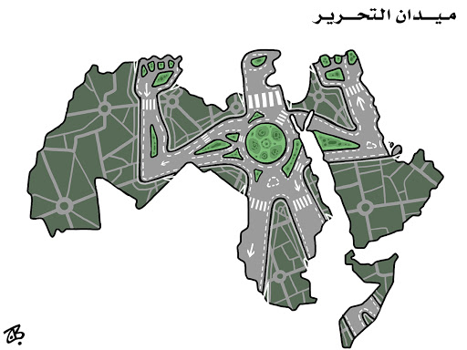
Figure 1
The network metaphor for Hajjaj’s ordering of space occurs again three years later with his character Abu Mahjoob (A Jordanian everyman whose head is a cartographic representation of Jordan) praising a simulacrum of the Arab World made up of a hodgepodge of social media logos, declaring: “My beloved homeland, the greatest homeland” with phone in hand, a torch (Hajjaj’s calling card for revolution in cartoons) emanating from it (figure 2). The line is from a song by Egyptian composer Mohammed Abdel Wahab to celebrate the United Arab Republic, the coalescence of Syria and Egypt into a single state built on Pan-Arabism. As such, the song became an anthem for Pan-Arabists (Mehrez, 2010, p.128). Notable here is the silhouette of the Arab World in gray, negative space. It is present either to signal that the logos Abu Mahjoob is looking at represent the Arab World, something that may be lost to some readers due to the abstraction of the shape created by the logos. Alternatively, Abu Mahjoob’s turning away from the gray map may indicate a shift in focus from perceived cartographic reality. The unity in the social media logo map may be seen as parallel to an Arab homeland, connected via social media. During the uprisings, it would seem that the swell in pan-Arab pride online might have transcended borders, and the action occurring on social media seemed to replace realities on the ground. This cartoon subverts cartographic representations as Hajjaj begins to explore cartographic agency by playing with space, creating new cartographies within the corpus by emphasizing electronic connectivity over political boundaries in the construction of Arab identity. The resulting image then comprises a visual reference of the Arab world for the reader juxtaposed with a caricature of that same space being highlighted as somehow more real than the political borders of the Arab League. There exists no one-to-one correlation between logos and states, only al-waṭan, a suggestion of a network of individuals who share a language and a sentiment expressed by Abu Mahjoob (figure 2).
This combination of themes is also seen in “Update!” (figure 3) for the Arab World (Hajjaj 2013). Where network lines are overlapped with red nodes resembling the notification bubbles of Facebook. The cartoon asks the reader to please wait for new updates. The portrayal of the Arab World as an app in the midst of updates is a metaphor for the challenges to regimes in the Arab League space. This reinforces the compression of time and space as a result of communication technologies (Harvey, 1990). It becomes easier to possess a pan-Arab geographic imaginary when borders were transgressed by coverage of the uprisings through outlets like al-Jazeera and through social media, despite attempts by regimes to impose media blackouts.
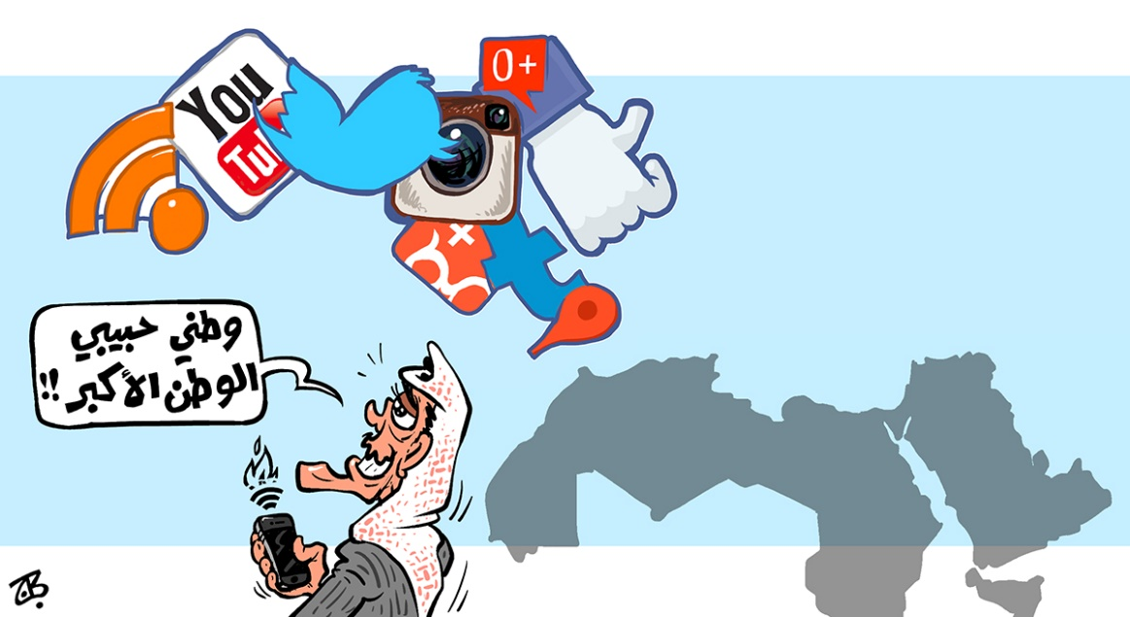
Figure 2
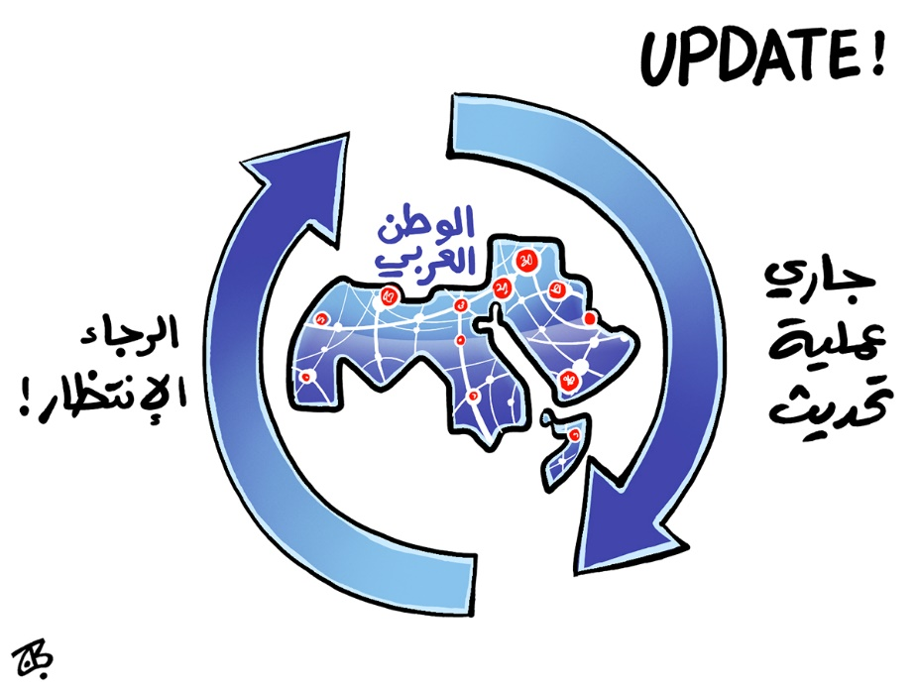
Figure 3
The homogenization of the Arab World in these imaginaries does pose risks of reinforcing broad-stroke portrayals of the region to non-Arab audiences. With regionalizations, there is a loss of specific, discrete narratives and geographies in favor of analytical simplicity, which is unavoidable in cartography lest we attempt to recreate Borges’ imperial map where only one-to-one scales will do (1998). What is done to combat this is to leverage the regionalization in juxtaposition to the other as is done in September 2013 (figure 4). Hajjaj provides a map of his established Arab World, with a sign saying “This region has existed 123 days without wars”, while a caricature of President Barack Obama arrives on a warship to press the button on the side of the sign, resetting the number to zero.
If one assumes that the region is frequently war torn, then the existence of the sign declaring four months as conflict-free is jarring. Alternatively, if the reader finds that characterizations of the Arab World as war torn are overblown or inaccurate, the sign can be seen as supporting the notion that peace is uncommon, necessitating a count of peaceful days. This view also sets up an agent to blame for such a characterization (the United States), as Obama, an external agent, is about to reset the count. On both ends, however, the parties at play are clear in Hajjaj’s geography. An Arab World locked together as a show of solidarity against US intervention that threatens a ground-reality or hopeful imaginary for the region. This is the most explicit play on the discursive relationship between the modern Orientalist geographic imagination and new enunciations of a different imaginary by Hajjaj in the corpus. The arrangement of the Arab World as a unitary actor is crucial to the joke’s function, which would lose some of its subversive power if it portrayed only a solitary Arab state experiencing conflict, such as Syria, Libya or Yemen. This highlights the crucial function of enunciation, which is the disambiguation of the colonial imagination and its subversive repurposing by the colonized.
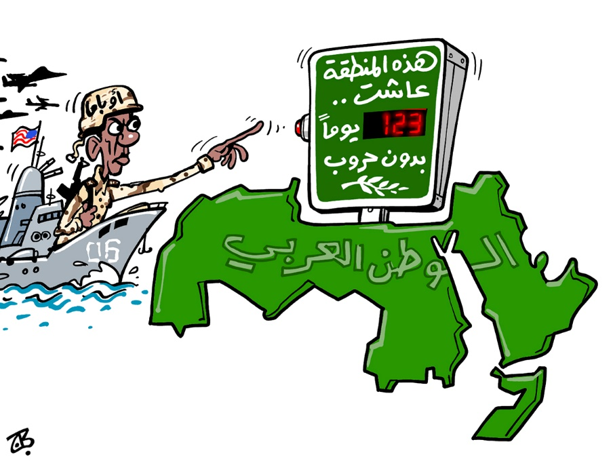
Figure 4
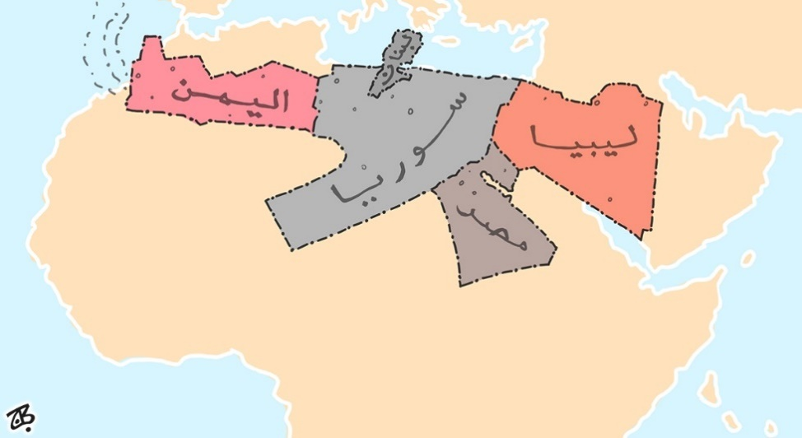
Figure 5
Hajjaj expands his act of playing with cartographic space by taking creative license to arrange states and reorder space to meet artistic needs in ways that many a reader may not initially recognize, as shown in Figure 5. These arrangements require similar requisite knowledge in recognizing the shape of the constituent parts (though the text labels make this trivial), with the additional requirement to parse out the reason for the grouping. For example, figure 5 sees Hajjaj arrange Egypt, Yemen, Libya, Syria, and Lebanon into the shape of an AK-47 situated over north Africa. In this instance, the impetus for the grouping is incumbent on the reader without any guiding text or title beyond the labeling of the states. All these states saw conflict in the uprisings, but the scale and nature varied widely between all-out war in Syria and police violence against protestors in Egypt. The arrangement makes a visual point about conflict in the Arab World by rearranging geographies in a way that reinforces geographic imaginaries about allegedly endemic conflict. In such a case, rather than discursive tropes being assigned to existing geographies, a new arrangement of states created to resemble the tropes, producing an incongruous map to challenge our own mental maps for effect. Such an arrangement would mean nothing without a mental basemap of these states or regions. Furthermore, Hajjaj filters out his subjects and imposes a new arrangement of states over a basemap of the region, overtaking the “real” map.
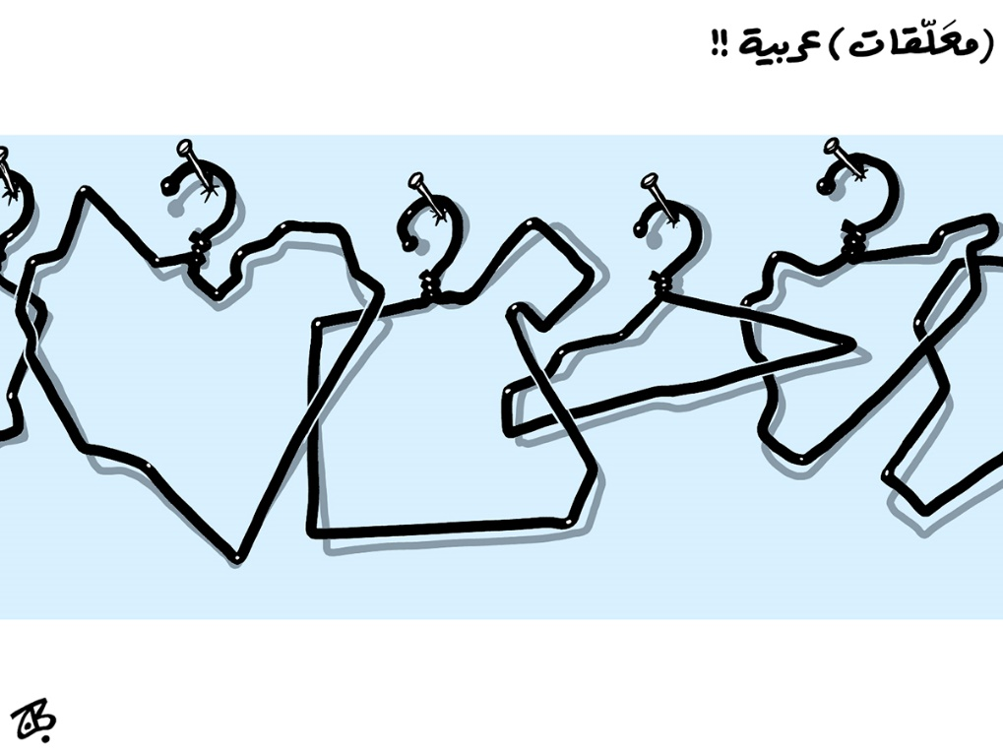
Figure 6
Other creative arrangements reinforce a notion of a unitary Arab World. In a piece titled (m’allaqat) ‘arabiyyah, (figure 6) wire coat hangers in the shape of Libya, Egypt, Palestine. Syria, and Iraq are nailed into a wall. Displaying outlines of countries with significant stakes in the Arab uprisings, the title references the m’allaqat, seven hanging poems hanging on the Kaaba in Mecca, considered the epitome of pre-Islamic Arabic-language literature. These new m’allaqat (things that are hanging), in this case wire coat hangers, are cheap ubiquitous items but the pun nonetheless hints at shared pan-Arab heritage. The requisite knowledge contributes to a pan-Arab imaginary in that the visual pun relies on common knowledge regarding language as a shared history. The humor exists between the esteemed position that the poems hold in the cultural imagination hanging from the Kaaba in Mecca and the “new” coat hanger art sure to capture the imagination. This reinforces the pan-Arab imaginary through turning presupposed knowledge on its head. In this case, this centering of revolutionary states as lynchpins to Arab identity the likes of the m’allaqat is only salient because of the visual pun, where the states form a new map of reverence and disorder. This act of filtering and privileging particular states in these maps alter one of the fundamental units of analysis in examining geographic imaginaries- the mental map. By choosing what states and geographic areas are represented in these critiques, Hajjaj agency over popular geopolitical imaginaries and the power to map by offering a world that is (in)congruous to major discursive regimes in order to create a backdrop for this reordering of states.
Whose cultural imaginaries are being leveraged?
In examining these cartoons, it was often difficult to parse out which discursive flows could include particular tropes and markers. Instead, it is more helpful to highlight recurring or interesting uses of these tropes and examine how they fit into contemporary imaginings of represented places, which are dynamic and individualized. The cartographic features of Hajjaj’s cartoons are less a direct borrowing of, or answer to, Orientalist tropes, but rather exist in a social environment where they leverage satire’s capacity to make readers reevaluate their geographic imaginations. Chief among these features is Hajjaj’s choice in how to portray the generalized landscape of states. There is a tension between physical reality of arid climates in the Arab World and the overgeneralization of the desert as a site for many of the Orientalist tropes about Arabs as nomadic Bedouins in an exotified desert. Even within the Arab World, exotification occurs in reference to Egypt, where Hajjaj visually invokes the country’s pharaonic past (figures 7 and 8). In the first of these, Egypt is anthropomorphized with a head in the style of pharaonic period murals, in this case representing “revolutionary Egypt” opening the Rafah crossing to the Gaza Strip permanently. Figure 8 also uses pharaonic symbolism as a symbol for revolutionary Egypt as “The Egyptian People” lift a sun disk labeled “Freedom”. These visual cues are complicated, as the pharaonic eras constitute a great deal of the Orientalist imagination surrounding Egypt since the 19th century, but was also leveraged for Egyptian nationalism side by side with pan-Arabism under Nasser (Lorenz, 1990). The leveraging of pre-Arab and pre-Islamic Egyptian society as a marker for identity in Egypt, especially for use as a secular national mythology for Pan-Arabism means makes for contextual ambiguity. The historical contexts for this imagery can just as easily recall Egyptomania from the 19th and early 20th century as it can Egyptian nationalism, making disambiguation and assessment of the geographic imaginaries evoked here difficult.
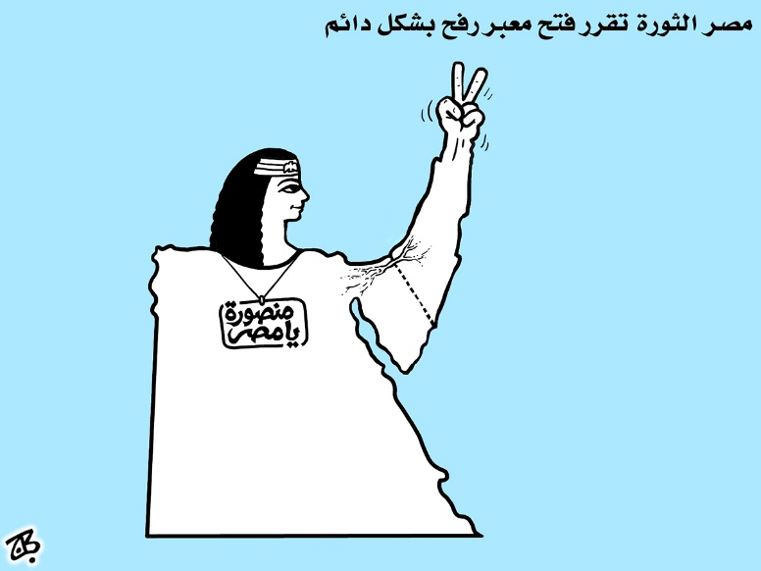
Figure 7
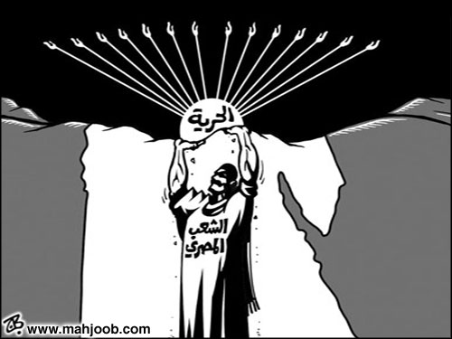
Figure 8
The complexities of categorizing Orientalism in the corpus ultimately break down stricter dichotomies concerning the origin of a discursive device. It cannot be assumed that there are discrete internal (Hajjaj/Arab Culture) and external (American/European/Colonial) categories for trope identification, only their possible interpretations with these discursive frameworks. These generalized landscapes assigned to cartographic elements of these cartoons comprise a wide variety of visual map shading that contextualize the space they portray from cues to the physical geography of a place to groundcover that extends affective metaphors about the issue Hajjaj is highlighting.
The most common visual groundcover is perhaps the hardest to attribute to any discursive trend in production. Many maps, especially those produced digitally use a beige or tan color as a color fill for lands in frame. This is no exception with some of Hajjaj’s cartoons, where country and region outlines may be filled with beige as a backdrop to other elements. This is standard color for many basemaps that is not unknown to users of ESRI products or other cartography and GIS tool suites. However, beige and tan can also denote or visually reinforce to external readers a desert landscape in context. This background tends to accompany what are likely template-drawn background maps as opposed to hand drawn figures by the artist, though they can still reinforce perceptions of uniform topography and environment, especially when the prevailing imaginary about the biome of the Arab World is a homogenous desert (Shaheen, 2001). When taken into consideration with less ambiguous references to desert landscapes in Hajjaj’s cartoons (See figures 10 and 11), the result is the mired portrayal of something between a simple cartographic generalization of reality on the ground and a reproduction of a common assumption in Orientalist discourse. At times, these portrayals can be lodged in commentary on external meddling, as is the case of a cartoon portraying a desert Syria between the United States and Russia (figure 9), but it can also be normalized as a backdrop for caricatures of leaders like Bashar al-Assad (figure 10) or exaggerated, as is the case of a 2012 piece regarding regional droughts where even the Mediterranean and Red Seas are shown as parched, cracked earth (figure 11).
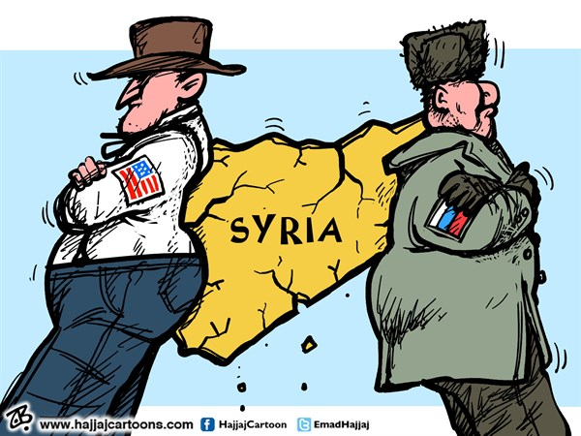
Figure 9
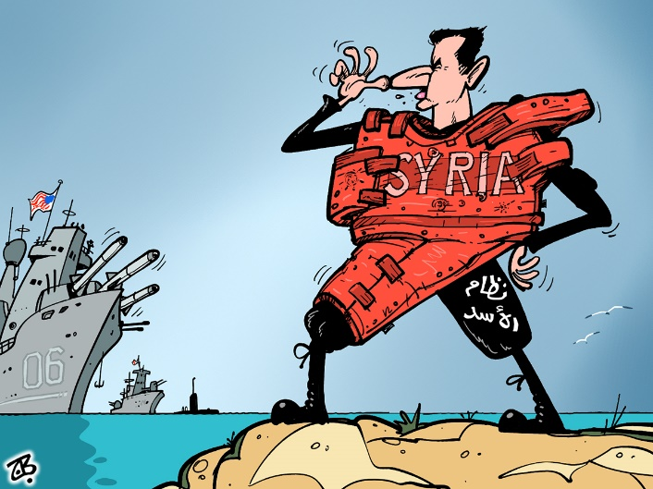
Figure 10
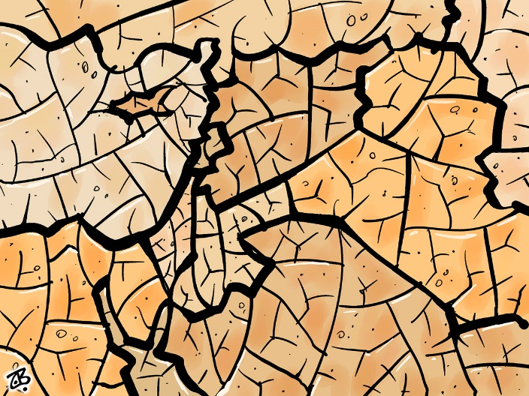
Figure 11
On the other end of the spectrum, Hajjaj renders the map fill of the Arab World as green twice in the corpus, first in opposition to the United States (figure 4), and again in a piece showing Syria as the port for “Charging Sectarianism” (figure 12). The latter cartoon lacks a contextual indicator for an occidental/Oriental dichotomy but provides an interpretive context clue for the map fill. Green is a color symbolically associated with Islam, reinforced by the color’s incorporation in the flags of several Muslim-majority states. The text says, “charging sectarianism”, so it may follow to use this fill as a cue for framing Syria as a battleground for sectarian feuds within Islam. However, the choice to render the entire Arab World in this map fill still reinforces a common geographic imaginary about the homogeneity of belief in the region. Hajjaj’s use of color here suggests a religious landscape for the region as the basis for his commentary. Representations of a green Arab world are few and far between but could serve to provide incongruity to prevailing discourse, where Hajjaj can exercise his agency while responding to popular contemporary news images of American troops in the desert.
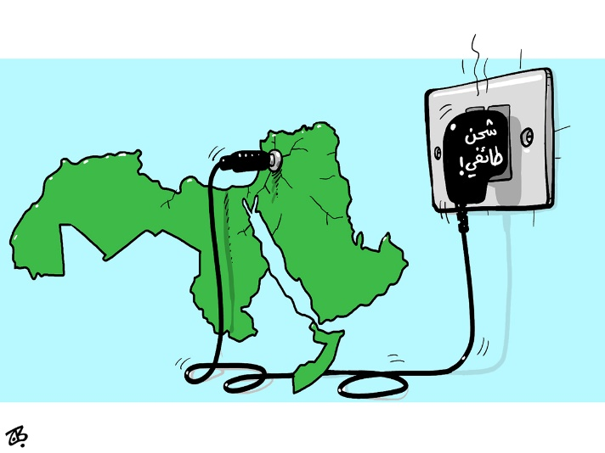
Figure 12
Occasionally there is a lack of map fill altogether in the form of negative space, as found in the aforementioned M’allaqat cartoon (figure 6) and world of social media logos (Figure 2). In these cases, there is a process of cartographic othering at work, where the standard map is eschewed for these newly produced spaces of social media or a new geography is built on replacing even the amalgamated shape of the Arab world, as with the hangers. Negative space can similarly contribute to orderings that can reinforce alterity. When a grayscale Arab World is being bled upon by Syria on a television screen, reaching out for help, the visual arrangement of colored and monochrome elements creates a sharp distinction between parties that is isolating, even when the countries at play are all constituent pieces of the Arab World (fig. 13). These all destabilize the mental map of readers by removing or decentering cartographic sense, so that instead of the grayscale map in figure 2, we look at a collection of logos or disembodied hanger shapes on a wall that we do not immediately associate with the Arab World.
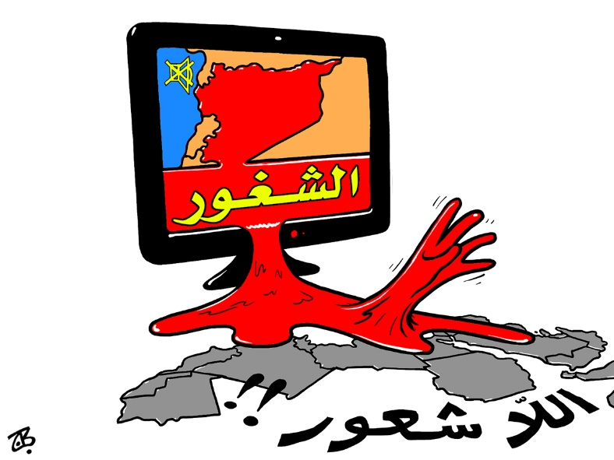
Figure 13
Similarly, darkness can function much like negative space when used as map fill. In juxtaposition with a light source, darkness as seen in the corpus can signal Tunisia as a bearer of light for the Arab World, by bringing the country to the visual forefront by turning the country’s outline into a torch bearing woman, referencing popular artistic representations of liberty or freedom such such as Delacroix’s Liberty Leading the People (fig 14.). This tactic is used to elevate Tunisia twice almost three years apart, but in the latter, the darkness is not just effective negative space, but is anthropomorphized, with shifty eyes that harken back to some less than flattering caricatures of Arab men, especially in animation (fig. 15). They are juxtaposed with a woman carrying a ballot box, clad in a shapely, revealing dress (as opposed to more conservative religious wear) as a harbinger of progress against perceived backwardness in the region. Images of western style dress worn by women in the region have been leveraged by Americans to demonstrate how Iran or Lebanon has somehow culturally backslid by become “less” western and more fundamentalist in recent decades. The requisite knowledge here is simply the stereotypes or associated tropes evoked by these images, rather than requiring a particular image on the part of the reader. The evocation of these tropes creates an ambiguity by requiring Hajjaj to leverage Orientalist discourses to subverting them, which means that interpretation of the cartoon could be dependent on the context (in this case colonial or postcolonial) that the audience brings with them. This ambiguity might enhance the subversive turn of the cartoon, as using these stereotypes explicitly might exist as a means to bring them to the forefront and force readers to reconcile the discourse through humor. This western-dominant requisite knowledge is evoked again with darkness as the Arab World frames a drowning person with the caption “Surrounded by the ocean of constructive chaos”. “Constructive Chaos”, a term apocryphally attributed to Condoleezza Rice in 2006 describes the proposed solution to the Arab World’s problem with stable authoritarian regimes (Fig. 16) (al-ʿAfīfī, 2012). In this case creative/constructive chaos described the US strategy of encouraging positive societal change by disrupting (often violently) entrenched regimes in the region in hopes that one or more revolutions would cascade across the region. The cartoon portrays a helplessness that is expected as a result of this chaos, one that does not account for the hardship of people in the areas subject to it. Hajjaj makes clear he sees the process of intervention and supporting civil unrest as causing collateral damage. The intention of constructive chaos was to overwhelm dictators, but we cannot determine the social status of the person drowning. They may even be evocative of refugees from conflict drowning in the Mediterranean, which would place them as among the most vulnerable populations the region has to offer as opposed to the fall of dictators and oligarchs as promised. The cartoon is a site of enunciation to highlight and reinforce the embodied impact of constructive chaos rather than the American usage of the term, scrubbed of the explicit violence against innocents required. The leveraging of this term in Arabic has garnered enough traction to be recognizable and is intended to counter discourse streams from the United States during the Arab Spring, when “constructive chaos” was once again a talking point with the overthrow of two regimes in a year. Rather than creating a new discourse around constructive chaos for his Arab readers, Hajjaj relays and reinforces the violence of the term through his enunciation and puts it in conversation with his imaginative geography of a united Arab world.
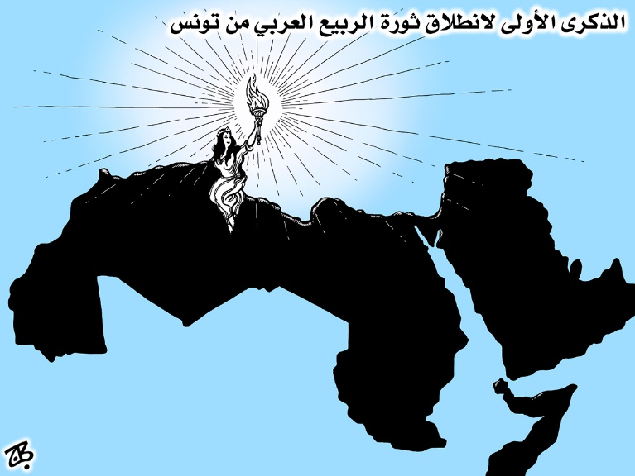
Figure 14
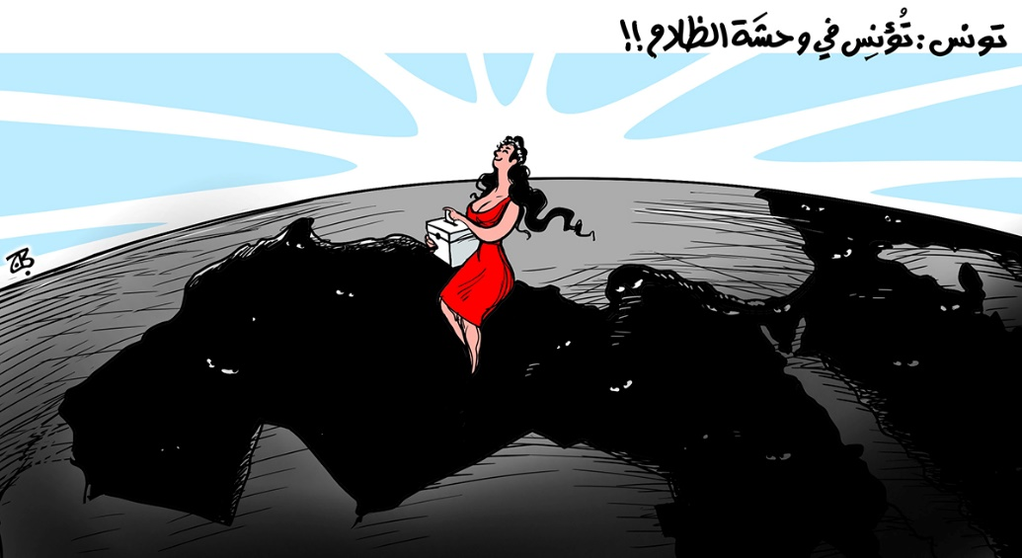
Figure 15
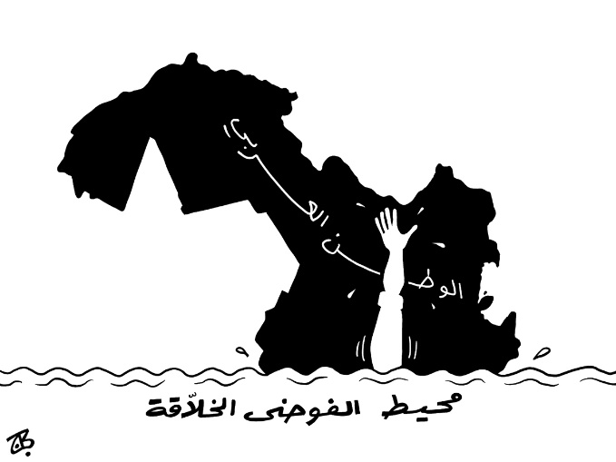
Figure 16

Bringing it together: Prerequisite Knowledge and Geographic Imaginaries
As seen in this analysis, it would seem possible to distill out some characteristics pointing to Hajjaj’s imaginative geographies in much the same way that discourse analysis cannot define and give shape to a discourse as a unitary object of analysis, but can analyze the rhetoric and effects that perpetuate a discourse stream. It is similarly difficult to judge these evoked imaginaries as explicitly Orientalist or not, but it is clear these cartoons exist as encounters between competing discursive regimes. This is evidenced by the effect Hajjaj is able to achieve with rearrangement of states in ways that destabilize common regionalizations and mental maps. This act of “playing with space” fulfills satire’s key function of presenting new perspectives on a topic and affords the cartoonist profound agency over the ordering of space, something historically denied to Arabs, even after liberation from formal imperialism. Hajjaj operates on some requisite knowledge and established imaginaries that are a synthesis of Orientalist tropes that have become normalized as well as specific cultural touchstones with subversive themes.
One example of this is the map fill of Hajjaj’s cartoons that can conjure a variety of stereotypes and inconsistencies solely based on the embodied knowledge of the reader. This synthesis constitutes a case of what Bhabha refers to as hybridity, where the insertion of subaltern voices into discursive spaces once dominated by colonial or imperial powers, it opens space to critique or dissemble the oppressive discourse (Bhabha, 2004). Hybridity is a form of mimicry, where the prevailing discourse is adapted to the needs of the subaltern, which parallels satire’s process of adapting news and political discourses, altered to expose absurdity and criticize the subject. Hybridity places many of these cartoons at a discursive crossroads where requisite knowledge may entirely change the interpretation of the cartoon when it leaves Arabic language outlets. The result is the (re)production of mixed geopolitical imaginaries with which to operate, which Hajjaj leverages as an enunciation event for his imaginative geographies, forcing a reconciliation or reconsideration of the imaginaries being satirized. Engagement with geopolitical imaginaries further have effects in enunciating positions that justify policy actions of governments by leveraging the map as a strategic asset, a notorious tool in the imperial toolbox. Hajjaj’s agency to map and reorder space in popular media is a potent discursive power, which while difficult to measure against the barrage of Eurocentric discourse but regardless offers a decolonization of geopolitical imaginaries by enunciating new cartographies of the Arab World.

Chapter 3: Discussion
In the midst of regional upheaval, it is unsurprising that a prominent political cartoonist would use cartographic imagery in his commentary on unprecedented political activism in which control of states was at stake. In most of the cartoons selected for this corpus, maps don’t simply comprise a backdrop, but are large elements, if not the primary focus of the cartoon. This emphasis puts imaginative geographies front and center as Hajjaj creates new maps and arrangement of states to critique political order and even preexisting geopolitical imaginaries (such as his portrayal of Arab States as an AK-47). In a region where Sykes-Picot took the power to map away from most Arab states by way of drawing borders and giving colonial powers the ability to enforce those borders with transitional governments, the ability to create new popular maps is a powerful reclamation of geopolitical agency. What is notable about Hajjaj’s use of this agency is that it subject to a blending of prevailing geopolitical discourses. The map fill chosen by Hajjaj to portray the Arab world may reinforce classic Orientalist imaginaries that generalize the Arab world as a single desert, while portrayal of the entire Arab League as Tahrir Square may reinforce a pan-Arab imaginative geography. Imaginative geographies, like many contexts, according to Dijk, are subject to reinterpretation and alteration based on relevant or convenient information to the consumer (Dijk, 2008). This supports the panoply of geographies used by Hajjaj, especially when one considers that satire requires an audience be familiar with the target of the criticism to be effective, meaning that satire and caricatures (from which the Arabic word for cartoons derives) are a common method of lampooning something. To know and leverage discourses that could be Orientalist, for example, allows for a more poignant critique or frame of reference, which would explain inclusion in some cartoons.
Attempting to read the discursive hints that Hajjaj’s cartography incorporates posed some methodological challenges in early iterations of the analysis. Early coding involved tagging cartoons for a series of Orientalist tropes and dichotomies to see correlations between those tropes and particular subjects or punchlines. This was an attempt to incorporate techniques from the digital humanities in analyzing relationships between cartoons that may have been missed by simply holistically analyzing each cartoon. The resulting coding and visualizations produced from it revealed two major flaws: first, the broad subject matter of the cartoons and the extensive list of tropes did not produce meaningful groupings, as even in a corpus of more than 56 cartoons, there were rarely more than three cartoons with any single tag that was not simply a country portrayed. This meant that in trying to talk about the relationship between desert landscapes and countries portrayed, there were only 5 cartoons that fit the bill, with only three of those definitively portraying a desert as opposed to a featureless tan map fill. Second, coding for punchlines and requisite knowledge in discrete categories made for a similarly cumbersome dataset as the trope tags saw very little relationship between most cartoons. This was further complicated by the fact that some cartoons (such as memorial cartoons for casualties in the Syrian Civil War) have no punchline, as they were not intended to be humorous. Cartoons such as these still evokes a war torn geographic imaginary wherein Syria is a black void in a crumbling wall, requiring some requisite knowledge for impact, but these did not fit into the paradigms set forth by incongruity and disposition theory that were originally to be used in the interpretation of the cartoons. These difficulties encouraged the shift toward a framework of analyzing the cartoons as satire, as opposed to analyzing them in a humor framework alone.
These challenges with the network analysis tool as primary method of analysis demanded a significant change in thinking about how these cartoons ought to be handled. With the above techniques, it became nearly impossible to determine if a discourse marker was Orientalist or not, reinforcing or subverting tropes. To answer this required first an ontological shift, then a methodological one. Assuming the exclusivity of discursive techniques and trope to be either Orientalist or not itself created a dichotomy reminiscent of the Orientalist binaries that this research was trying to locate and deconstruct. Many of these tropes are variable, depending on the audience and their relevant knowledge in comprehending the cartoon, which constituted a positionality bias with myself as speaking for the cartoon’s audience. This meant eschewing this binary in favor of analyzing strictly the cartographic elements of the cartoons and how they may connote different geopolitical imaginaries to audiences based on the requisite knowledge they demand. This led to the methodological shift away from using humor theory and treating these cartoons as visual jokes and instead emphasizing their role as satire, leading to a more descriptive account of the corpus’ geopolitical imaginaries and their hybridity.
The fact that audience contexts can create such vastly different interpretations of geographic imaginaries hinted at by Hajjaj is a key conclusion reached from the analysis. A lack of audience study is a significant weakness of the study when this conclusion is taken into account, but was omitted because these conclusions would not have been possible until the methodological shift of the research had occurred, leaving insufficient time to design and enact an audiencing portion to support the visual analysis. Though audience analysis would have complemented the visual discourse analysis performed here, the post-structuralist tradition of discourse analysis would preclude some common methodologies. Surveys for example can lean into some positivist analysis with might be at odds with notions of social constructivism. Furthermore, the construction of survey questions is likely to unnecessarily direct conversation and underlying discourse in a particular direction. Interviews or oral histories may also suffer from this fault if the researcher is not cognizant of power relations or particular leading lines of questioning but could ultimately serve as better methods for understanding how audiences activate geopolitical imaginaries to make sense of satirical humor. Another site for audience data could draw from digital humanities and scrape social media comments for cartoons or clips of a television show, constituting an audience-generated text that could open up applications for disposition theory or even discourse analysis in itself as commenters react affectively, debate, or highlight favorite elements of a joke in the comments section similar to work done by Klaus Dodds with IMDB (Dodds, 2006).
Geographic imaginaries are a powerful source of context in navigating the world, as demonstrated by Said’s argument on their role in supporting Orientalism (1978). As a form of discourse, these imaginaries are never observed as whole, cohesive ideologies but rather in fragmented parts that are observable in most texts and assemblages. Requisite knowledge in humor and satire is tangentially leveraged in incongruity theory and explorations of these cartoon’s social contexts, but has not seen wider application in popular geopolitics, where humor’s ubiquity and deeply personal affective response could provide valuable insights into the ways that media influences geopolitical sensemaking and reinforces popular discourses in the banal.

Future Research and Applications
This thesis was originally conceived as a set of two complementary articles leveraging analysis of requisite knowledge in humor as it pertains to geopolitical imaginaries. In addition to the article presented in chapter 2, there was to be an analysis of Jon Stewart’s The Daily Show between 2011 and Stewart’s departure in 2014. With a timeline concurrent with the cartoons in this thesis’ corpus, the objective was to compare and contrast geopolitical imaginaries about the Arab world as produced in The Daily Show with Emad Hajjaj’s political cartoons. This was meant to act as a multimedia testbed for this thesis’ methodological approach to humor in critical geopolitics. In both chapter two and this unrealized research, the site of discursive comprehension and replication are the same- in the contextual geographic imaginative geographies of the content creator as they are presented to the audience. However, as demonstrated in the turn away from humor theory in the study of Hajjaj’s political cartoons, there still exists some key theoretical differences in how to approach different media when investigating the imaginative geographies of humor. These can be leveraged for future research to similar ends of examining how comedy reinforces or subverts geopolitical imaginaries.
Referencing a multidisciplinary body of literature (drawing from humor studies, communications, Middle East studies, political geography and international relations) for theory and methodology, then utilizing it to questions distinct to critical geopolitics about how we arrange the world contextually should provide ample foundations for expansion and refinement. The utilized framework for tracing discursive tropes and imaginaries in political cartoons from requisite knowledge can be adapted with the incorporation of several analytical frameworks ranging from semiology/iconographic visual analyses to linguistically rooted humor theories such as incongruity. This makes for a flexible framework that can analyze a wide variety of humor media, being predicated solely on satire’s reliance on context. These studies could be corpus/issue focused while maintaining a broad toolbox of discourse analysis methods and theories or could emphasize a specific theory such as incongruity theory or a focus on social semiotics. Possible corpora to explore are vast, especially humor that might constitute a cultural encounter, such as an analysis of Jon Stewart’s The Daily Show and Bassem Youssef’s al-Bernameg. These shows used the same structure and with the appearance of both hosts on the other’s shows, Bassem Youssef was widely referred to as “The Jon Stewart of the Middle East” (A. Ibrahim & Eltantawy, 2017). Such a study could more precisely draw parallels between the cutting satire of Stewart that at least on a surface level is critical and subversive and Bassem Youssef’s own treatment of Egypt and the Arab world more broadly when talking about the Arab Uprisings.
The enunciation of geopolitical imaginaries is ubiquitous in our lives, as the existence of popular geopolitics as a field would suggest. If this is the case, then as with most discourse, there are infinite permutations of those ideologies that can constitute identity (as Orientalism has long after the end of formal colonization) or impact geopolitical order. As demonstrated by this research, geopolitical contexts can be conveyed through satire, but the imaginaries that they evoke are variable based on the relevant knowledge of the reader. This constitutes hybridity as described by Bhabha, wherein power discourses can be altered or disassembled by the creation of new syncretic discourses by the formerly disempowered. This is derivative of mimicry and explains the process of satirization quite well when considering the replication of widely understood images and tropes that may be problematic in Orientalist contexts in order to reproduce a new counter-imaginary or critique existing knowledge. Thus, the creation of hybrid discourses is an act of asserting agency for the subaltern. An emphasis on requisite knowledge in the production and consumption of popular culture allows for a new lens through which to examine how geopolitical sensemaking occurs and the extent to which this knowledge is hybridized in today’s media landscape. Satire simply constitutes one of the best testing sites for this sort of discourse analysis due to its ubiquity and its nature as a site for discursive play (i.e. changing the perspective on a commonly established belief).

Works Cited
Ahmed, M. F. (2006). On The Relationship Between Grice’s Maxims And Humorous Discourse. Adab AL Rafidayn, 45, 472–489.
Al-Masri, H. (2016). Jordanian editorial cartoons: A multimodal approach to the cartoons of Emad Hajjaj. Language and Communication, 50, 45–58. https://doi.org/10.1016/j.langcom.2016.09.005
Al-Momani, K., Badarneh, M. A., & Migdadi, F. (2017). A semiotic analysis of political cartoons in Jordan in light of the Arab Spring. Humor: International Journal of Humor Research, 30(1), 63–95.
al-ʿAfīfī, F. (2012). War of Creative Destruction: the central tendency in the globalized Arab revolutions (a study in the formation of the future). Contemporary Arab Affairs, 5(3), 427–447. https://doi.org/10.1080/17550912.2012.676320
Al Kayed, M., Kitishat, A., & Farajallah, H. (2015). Violation of the Grice’s maxims in Jordanian newspapers’ cartoons: A pragmatic study. International Journal of Linguistics and Literature, 4(4), 41–50.
Albert, M., & Reuber, P. (2007). Introduction: The Production of Regions in the Emerging Global Order – Perspectives on ‘Strategic Regionalisation.’ Geopolitics, 12(4), 549–554. https://doi.org/10.1080/14650040701546038
Anagondahalli, D., & Khamis, S. (2014). Mubarak framed! Humor and political activism before and during the Egyptian Revolution. Arab Media & Society, 19(Fall 2014).
Anaz, N., & Purcell, D. (2010). Geopolitics of Film: Valley of the Wolves—Iraq and Its Reception in Turkey and Beyond. The Arab World Geographer, 13(1), 34–49. https://doi.org/10.5555/arwg.13.1.lh6435231vuu2114
Badarneh, M. A. (2011). Carnivalesque politics: A Bakhtinian case study of contemporary Arab political humor. Walter de Gruyter GmbH & Co. KG.
Barron, R. M. (2008). Bringing the map to life: European satirical maps 1845-1945. Belgeo, 3(4), 445–464.
Baynton-Williams, A. (2015). The Curious Map Book. University of Chicago Press.
Beauguitte, L., Richard, Y., & Guérin-Pace, F. (2015). The EU and Its Neighbourhoods: A Textual Analysis on Key Documents of the European Neighbourhood Policy. Geopolitics, 20(4), 853–879. https://doi.org/10.1080/14650045.2015.1075512
Berger, P. L. (2014). Redeeming laughter : the comic dimension of human experience / Peter L. Berger. (2nd editio). Berlin .
Bhabha, H. K. (2004). The location of culture / Homi K. Bhabha . London .
Borges, J. L. (1998). On the exactitude of science. Collected Fictions. Translated by Andrew Hurley. New York: Penguin, 325.
Bos, D. (2018). Answering the Call of Duty: Everyday encounters with the popular geopolitics of military-themed videogames. Political Geography, 63, 54–64. https://doi.org/https://doi.org/10.1016/j.polgeo.2018.01.001
Bryars, T., & Harper, T. (2016). A history of the 20th century in 100 maps.
Clark, J. H. (2019). “The state kills, we kill, everyone kills”: Cracking and framing the field with humor. Political Geography, 68, 131–138. https://doi.org/https://doi.org/10.1016/j.polgeo.2018.08.002
Cresswell, T. (2013). Geographic thought : a critical introduction. Wiley-Blackwell.
Culcasi, K. (2010). Constructing and naturalizing the Middle East. Geographical Review, 100(4), 583–597.
Culcasi, K. (2012). Mapping the Middle East from Within: (Counter-)Cartographies of an Imperialist Construction. Antipode, 44(4), 1099–1118. https://doi.org/https://doi.org/10.1111/j.1467-8330.2011.00941.x
Dalby, S. (1994). Gender and Critical Geopolitics; Reading Security Discourse in the New World Disorder. Environment and Planning D: Society and Space, 12(5), 595–612. https://doi.org/10.1068/d120595
Damir-Geilsdorf, S., & Milich, S. (2020). Forms and Functions of Political Humor in Arab Societies : Historical and Contemporary Perspectives. In S. Damir-Geilsdorf & S. Milich (Eds.), Creative Resistance: Political Humor in the Arab Uprisings (pp. 9–52). Transcript.
Davison, R. (1960). Where Is the Middle East?. Foreign Affairs (Pre-1986), 38(000004), 665.
Dijk, T. A. van. (2008). Discourse and Context: A Sociocognitive Approach. https://doi.org/10.1017/CBO9780511481499
Dijkink, G. (1998). Geopolitical codes and popular representations*. GeoJournal, 46(4), 293–299. https://doi.org/10.1023/A:1006999221884
Dittmer, J. (2005). Captain America’s Empire: Reflections on Identity, Popular Culture, and Post‐9/11 Geopolitics. Annals of the Association of American Geographers, 95(3), 626–643. https://doi.org/10.1111/j.1467-8306.2005.00478.x
Dittmer, J. (2017). Diplomatic material: Affect, assemblage, and foreign policy. Duke University Press.
Dittmer, J., & Bos, D. (2019). Popular culture, geopolitics, and identity. Rowman & Littlefield.
Dodds, K. (1996). The 1982 Falklands War and a critical geopolitical eye: Steve Bell and the if… cartoons. Political Geography, 15(6–7), 571–592. https://doi.org/10.1016/0962-6298(96)00002-9
Dodds, K. (2006). Popular geopolitics and audience dispositions: James Bond and the internet movie database (IMDb). Transactions of the Institute of British Geographers, 31(2), 116–130.
Dodds, K. (2007). Steve Bell’s Eye: Cartoons, Geopolitics and the Visualization of the `War on Terror’. Security Dialogue, 38(2), 157–177. https://doi.org/10.1177/0967010607078536
Dodds, K., & Atkinson, D. (2000). Introduction: Geopolitical Traditions: A Century of Geopolitical Thought. In K. Dodds & D. Atkinson (Eds.), Geopolitical Traditions: A Century of Geopolitical Thought (pp. 1–24). Routledge.
Dodds, K., & Kirby, P. (2013). It’s Not a Laughing Matter: Critical Geopolitics, Humour and Unlaughter. Geopolitics, 18(1), 45–59. https://doi.org/10.1080/14650045.2012.668723
Edney, M. H. (2020). Cartography : The Ideal and Its History. University of Chicago Press. https://www.degruyter.com/isbn/9780226605715
Eriksen, C. (2019). Negotiating adversity with humour: A case study of wildland firefighter women. Political Geography, 68, 139–145. https://doi.org/https://doi.org/10.1016/j.polgeo.2018.08.001
Falah, G., Flint, C., & Mamadouh, V. (2006). Just War and Extraterritoriality: The Popular Geopolitics of the United States’ War on Iraq as Reflected in Newspapers of the Arab World. Annals of the Association of American Geographers, 96(1), 142–164. https://doi.org/10.1111/j.1467-8306.2006.00503.x
Flint, C., Adduci, M., Chen, M., & Chi, S.-H. (2009). Mapping the Dynamism of the United States’ Geopolitical Code: The Geography of the State of the Union Speeches, 1988–2008. Geopolitics, 14(4), 604–629. https://doi.org/10.1080/14650040802693929
Flint, C., & Falah, G.-W. (2004). How the United States Justified Its War on Terrorism: Prime Morality and the Construction of a “Just War.” Third World Quarterly, 25(8), 1379–1399.
Fluri, J. L. (2019). What’s so funny in Afghanistan?: Jocular geopolitics and the everyday use of humor in spaces of protracted precarity. Political Geography, 68, 125–130. https://doi.org/https://doi.org/10.1016/j.polgeo.2018.08.011
Foucault, M. (1972). Archaeology of knowledge. Pantheon Books.
Foucault, M. (1979). Discipline and punish : the birth of the prison / Michel Foucault . In Discipline & Punish. New York : Vintage Books.
Gelvin, J. L. (2015). The Arab uprisings : what everyone needs to know / James L. Gelvin. (2nd ed.). New York : Oxford University Press.
Gordon, J., & Arafa, H. (2014). “Stuck with Him”: Bassem Youssef and the Egyptian Revolution’s Last Laugh. Review of Middle East Studies, 48(1–2), 34–43. https://doi.org/10.1017/S2151348100056809
Gregory, D. (1995). Imaginative geographies. Progress in Human Geography, 19(4), 447–485. https://doi.org/10.1177/030913259501900402
Gregory, D. (2004). The colonial present : Afghanistan, Palestine, Iraq / Derek Gregory. Malden, MA : Blackwell Pub.
Gregory, D. (2009). Geographic Imaginary. In The Dictionary of Human Geography (p. 283). Blackwell.
Hammett, D. (2011). Resistance, power and geopolitics in Zimbabwe. Area, 43(2), 202–210. http://libraries.ou.edu/access.aspx?url=http://search.ebscohost.com/login.aspx?direct=true&db=s3h&AN=60676132&site=ehost-live
Hartshorne, R. (1954). Political Geography. In P. James & C. Jones (Eds.), American Geography (pp. 211–214). Syracuse University Press.
Harvey, D. (1990). Time-space compression and the postmodern condition. In The Condition of Postmodernity: An Enquiry into the Origins of Cultural Change (pp. 284–307). Blackwell.
Hempelmann, C. F., & Samson, A. C. (2008). Cartoons: Drawn Jokes? In V. Raskin (Ed.), Primer of Humour Research. Mouton de Gruyter.
Huntington, S. P. (1996). The clash of civilizations and the remaking of world order / Samuel P. Huntington. In Clash of civilizations & the remaking of world order. New York : Simon & Schuster.
Hyndman, J. (2001). Towards a feminist geopolitics. Canadian Geographer / Le Géographe Canadien, 45(2), 210–222. https://doi.org/10.1111/j.1541-0064.2001.tb01484.x
Hyndman, J. (2007). Feminist geopolitics revisited: Body counts in Iraq. The Professional Geographer, 59(1), 35–46.
Ibrahim, A., & Eltantawy, N. (2017). Egypt’s Jon Stewart: Humorous Political Satire and Serious Culture Jamming. International Journal of Communication; Vol 11 (2017). https://ijoc.org/index.php/ijoc/article/view/6359
Ibrahim, R. (2014). A socio-pragmatic study of some caricatures in Iraqi TV Media. Research on Humanities and Social Sciences, 4, 165–175.
Jacquemond, R. (2016). Satiric Literature and Other “Popular” Literary Genres in Egypt Today. Journal of Arabic and Islamic Studies, 16, 349–367.
Jervis, R. (1978). Cooperation Under the Security Dilemma. World Politics, 30(2), 167–214.
Joubin, R. (2014). Resistance amid Regime Co-optation on the Syrian Television Series Buq’at Daw’, 2001-2012. Middle East Journal, 68(1), 9–32.
Khoury, L., & Da’Na, S. (2012a). Decolonizing the Geographies of Resistance: Imperialist Cartography of the Arab World. The Arab World Geographer, 15(3), 189–225. https://doi.org/10.5555/arwg.15.3.c1l6837m3110826x
Khoury, L., & Da’Na, S. (2012b). Decolonizing the Geographies of Resistance: Imperialist Cartography of the Arab World. The Arab World Geographer, 15(3), 189–225. https://doi.org/10.5555/arwg.15.3.c1l6837m3110826x
Khoury, S. D., & Khoury, L. (2013). “GEOPOLITICS OF KNOWLEDGE”: CONSTRUCTING AN INDIGENOUS SOCIOLOGY FROM THE SOUTH. International Review of Modern Sociology, 39(1), 1–28.
Kishtainy, K. (1985). Arab political humour. Quartet Books Limited.
Kishtainy, K. (2009). Humor and resistance in the Arab world and greater Middle East. In M. J. Stephan (Ed.), Civilian Jihad: Nonviolent Struggle, Democratization, and Governance in the Middle East (pp. 53–63). Palgrave Macmillian.
Knight, C. A. (2004). Introduction: the satiric frame of mind. In The Literature of Satire (pp. 1–10). Cambridge University Press. https://doi.org/DOI: 10.1017/CBO9780511485428.001
Kofman, E., & Peake, L. (1990). Into the 1990s: a gendered agenda for political geography. Political Geography Quarterly, 9(4), 313–336.
Kuus, M. (2010). Critical Geopolitics. In Critical Geopolitics. Oxford Research Encyclopedia of International Studies. Oxford University Press. https://doi.org/10.1093/acrefore/9780190846626.013.137
Lewis, P., Davies, C., Kuipers, G., Lewis, P., Martin, R. A., Oring, E., & Raskin, V. (2008). The Muhammad cartoons and humor research: A collection of essays. HUMOR, 21(1), 1–46. https://doi.org/https://doi.org/10.1515/HUMOR.2008.001
Lorenz, J. P. (1990). Egypt and the Arabs : foreign policy and the search for national identity / Joseph P. Lorenz. Boulder : Westview Press.
Lynch, M. (2014). Media, Old and New. In M. Lynch (Ed.), The Arab Uprisings Explained: new contentious politics in the Middle East. Columbia University Press.
Makdisi, U. S. (2010). Faith misplaced : the broken promise of U.S.-Arab relations: 1820-2001 / Ussama Makdisi. (1st ed..). New York : PublicAffairs.
Maktabi, R. (2011). Brothers’ political cartoons break taboos. CNN.
Mamadouh, V. D., & Dijkink, G. J. W. (2006). Geopolitics, international relations and political geography: The politics of geopolitical discourse. Geopolitics, 11(3), 349–366. https://doi.org/10.1080/14650040600767859
Mehrez, S. (2010). Egypt’s culture wars. American University in Cairo Press.
Najjar, O. (2007). Cartoons as a site for the construction of Palestinian refugee identity. Journal of Communication Inquiry, 31(3), 255–285.
Purcell, D. (2006). Geopolitics. In Encyclopedia of Human Geography (pp. 184–186). SAGE Publications Ltd.
Purcell, D., Brown, M. S., & Gokmen, M. (2010). Achmed the dead terrorist and humor in popular geopolitics. GeoJournal, 75(4), 373–385. https://doi.org/10.1007/s10708-009-9258-9
Purcell, D., Heitmeier, B., & van Wyhe, C. (2017). Critical Geopolitics and the Framing of the Arab Spring Through Late-Night Humor. Social Science Quarterly, 98(2), 513–531. https://doi.org/10.1111/ssqu.12296
Raney, A. A. (2004). Expanding Disposition Theory: Reconsidering Character Liking, Moral Evaluations, and Enjoyment. Communication Theory, 14(4), 348–369. https://doi.org/10.1111/j.1468-2885.2004.tb00319.x
Reuber, P. (2009). Geopolitics (R. Kitchin & N. B. T.-I. E. of H. G. Thrift (Eds.); pp. 441–452). Elsevier. https://doi.org/https://doi.org/10.1016/B978-008044910-4.00777-X
Ridanpää, J. (2012). The media and the irony of politically serious situations: consequences of the Muhammed cartoons in Finland. Media, Culture & Society, 34(2), 131–145. https://doi.org/10.1177/0163443711430754
Rose, G. (2012). Discourse Analysis I: Text, Intertextuality, and Context. In Visual Methodologies: An Introduction to Researching with Visual Materials (pp. 188–226). SAGE Publications Ltd.
Said, E. W. (1978). Orientalism (1st ed..). New York : Pantheon Books.
Saunders, R. A. (2019). (Profitable) imaginaries of Black Power: The popular and political geographies of Black Panther. In Political Geography (Vol. 69, pp. 139–149). https://doi.org/10.1016/j.polgeo.2018.12.010
Secor, A. J. (2001). Toward a Feminist Counter-geopolitics: Gender, Space and Islamist Politics in Istanbul. Space and Polity, 5(3), 191–211. https://doi.org/10.1080/13562570120104409
Shaheen, J. G. (2001). Reel bad Arabs : how Hollywood vilifies a people / Jack G. Shaheen . New York : Olive Branch Press.
Sharp, J. P. (1993). Publishing American identity: popular geopolitics, myth and The Reader’s Digest. Political Geography, 12(6), 491–503.
Sharp, J. P. (2006). Critical Geopolitics. In Encyclopedia of Human Geography (pp. 65–66). SAGE Publications Ltd.
Sharp, J. P. (2009a). Critical Geopolitics (R. Kitchin & N. B. T.-I. E. of H. G. Thrift (Eds.); pp. 358–362). Elsevier. https://doi.org/https://doi.org/10.1016/B978-008044910-4.00766-5
Sharp, J. P. (2009b). Geographies of Postcolonialism: Spaces of Power and Representation. https://doi.org/10.4135/9781446212233
Sharp, J. P. (2011). A subaltern critical geopolitics of the war on terror: Postcolonial security in Tanzania. Geoforum, 42(3), 297–305.
Sharp, J. P. (2013). Geopolitics at the margins? Reconsidering genealogies of critical geopolitics. Political Geography, 37, 20–29. https://doi.org/https://doi.org/10.1016/j.polgeo.2013.04.006
Shehata, S. S. (1992). Politics of Laughter: Nasser, Sadat, and Mubarak in Egyptian political jokes. Folklore, 103, 75–91.
Sidaway, J. (2000). Postcolonial geographies: an exploratory essay. Progress in Human Geography, 24(4), 591–612. https://doi.org/10.1191/030913200100189120
Sidaway, J. (2003). Imagined Regional Communities : Integration and Sovereignty in the Global South. http://ebookcentral.proquest.com/lib/qut/detail.action?docID=170194
Slater, D. (2008). Geopolitics and the post-colonial: rethinking North-South relations. John Wiley & Sons.
Spivak, G. C. (2003). Can the subaltern speak? Die Philosophin, 14(27), 42–58.
Staeheli, L. (1999). Tyrannies of Indifference: Feminist and political geographies. Presentation to the American Association of Geographers Annual Conference, Honolulu, HI, March.
Strukov, V. (2018). Towards a new paradigm of resistance: Theorizing popular geopolitics as an interdiscipline. In R. A. Saunders & V. Strukov (Eds.), Popular Geopolitics: plotting an evolving interdiscipline (pp. 63–82). Routledge.
Toal, G. (1986). Political geography of contemporary events VIII the language and nature of the ‘new geopolitics’—the case of US-El Salvador relations. Political Geography Quarterly, 5(1), 73–85. https://doi.org/https://doi.org/10.1016/0260-9827(86)90014-5
Toal, G. (1996). Critical geopolitics : the politics of writing global space / Gearóid Ó Tuathail. Minneapolis : University of Minnesota Press.
Tuathail, G. Ó., & Agnew, J. (1992). Geopolitics and discourse: Practical geopolitical reasoning in American foreign policy. Political Geography, 11(2), 190–204. https://doi.org/10.1016/0962-6298(92)90048-X
Tuathail, G. Ó., Dalby, S., & Routledge, P. (Eds.). (1998). The Geopolitics Reader (First). Routledge.
Walsh, D., & Ismail, A. (2016). Cartoonist is Arrested as Egypt Cracks Down on Critics. New York Times.
Watts, M. (1999). Collective Wish Images: Geographical Imaginaries and the Crisis of Development. In J. Allen & D. Massey (Eds.), Human Geography Today (pp. 85–107). Polity Press.
Webber, J. A. (2013). The Cultural Set Up of Comedy: Affective Politics in the United States Post 9/11. United Kingdom: Intellect Books.
Woon, C. Y. (2014). Popular geopolitics, audiences and identities: Reading the ‘War on Terror’in the Philippines. Geopolitics, 19(3), 656–683.

