UNIVERSITY OF OKLAHOMA
GRADUATE COLLEGE

Ꮵ ᏣᎳᎩ (TSI TSALAGI), I AM CHEROKEE:
UNDERSTANDING CONTEMPORARY ART
OF THE CHEROKEE DIASPORA

A DISSERTATION
SUBMITTED TO THE GRADUATE FACULTY
in partial fulfillment of the requirements for the
Degree of

DOCTOR OF PHILOSOPHY

By

Ashley Holland (Cherokee Nation)
Norman, OK
2021

Ꮵ ᏣᎳᎩ (TSI TSALAGI), I AM CHEROKEE:
UNDERSTANDING CONTEMPORARY ART
OF THE CHEROKEE DIASPORA

A DISSERTATION APPROVED FOR THE SCHOOL OF VISUAL ARTS

BY THE COMMITTEE CONSISTING OF

DR. ALISON FIELDS

DR. AMANDA COBB-GREETHAM

DR. ROBERT BAILEY

MR. B. BYRAN PRICE

DR. DANIEL SWAN

© Copyright by Ashley R. Holland
2021
All Rights Reserved.

TABLE OF CONTENT

Abstract vii

List of Figures viii

1. Introduction 1
Dissertation Methodology 2
The Problem 4
The ᏣᎳᎩ 7
Literature Review 13
Dissertation Framework 27
Conclusion 33
Figures 35

2. (Native) American Artist: Kay WalkingStick 36
A ᏣᎳᎩ Family 39
The Feminist ᏣᎳᎩ Artist 41
An Artist in Limbo 46
ᏣᎳᎩ Woman 48
Painting the Landscape and Beyond 55
Conclusion 57
Figures 59

3. Art as a Tool of Survival: Luzene Hill 75
The ᏣᎳᎩ that Stayed Behind 76
A Personal Journey 80
A Wound on the Mind 83
A Return Home 91
Conclusion 93
Figures 94

4. Creating Balance: Brenda Mallory 115
ᏚᏳᎦᏛ through the Four Directions 119
Knowing 121
Doing 124
Having 127
Being 128
Conclusion 132
Figures 133

5. Going Home: Kade L. Twist 149
In the West 152
Yearning for Home 155
Contemporaneity 158
Marginal Equity 161
Conclusion 166
Figures 167

6. Conclusion 176
Figures 179

7. Bibliography 180

ACKNOWLEDGEMENTS
Thank you to my dissertation chairs, Dr. W. Jackson Rushing III and Dr. Alison Fields. Dr. Rushing, you are the reason I came to OU and I will forever be grateful for your support. Dr. Fields, your guidance was beyond measure and I honestly could not have finished on time (despite a pandemic and full-time job) without you. To my committee – Dr. Robert Bailey, Dr. Amanda Cobb-Greetham, Mr. B. Byron Price, and Dr. Daniel Swan – your knowledge and encouragement are a gift. Everyone should be so lucky to have a committee like mine. Wado to Kay WalkingStick for being an inspiration and as well as Luzene Hill, Brenda Mallory, and Kade L. Twist for sharing your thoughts and hearts in such a meaningful way. I especially could not have done this without the support of my dear friends and fellow students Mary Deleary, Mark Esquivel, Dr. Alicia Harris, and Dr. Chelsea Herr. The same goes for Dr. heather ahtone and Marwin Begaye. Thank you for giving me a feeling of family away from my own. Holly Wilson, thank you for being my friend and sometimes boss. To the teams at Art Bridges Foundation and Crystal Bridges Museum of American Art, especially Dr. Margi Conrads, thank you for the support that allowed me to work and write at the same time. To my parents, Lisa and Tim Holland, thank you for always allowing me to follow my dreams, even if you didn’t understand them. It turns out you can get a job with an art history degree! To Katie and Patrick Keeven, thank you for being the best sister and brother-in-law a girl could ask for as well as the creator of Finn. He is definitely the greatest part of 2020. To the Fields family (in all your versions), thank you for your love and support. And the biggest thanks goes to Ryan Fields, my husband. You are my favorite person and I am so happy you are on this journey with me.
I dedicate this dissertation to John A. Morris, my grandfather. I love and miss you every day. Thank you for being the best Papaw in the world.
ABSTRACT

Questions of diaspora and cultural identity drive my analysis of the work and lives of four contemporary ᏣᎳᎩ (Tsalagi), Cherokee, artists: Kay WalkingStick (Cherokee Nation), Luzene Hill (Eastern Band of Cherokee Indians), Brenda Mallory (Cherokee Nation), and Kade L. Twist (Cherokee Nation). I propose the shaping of an art historical understanding of these artists through the ᏣᎳᎩ worldview, ᏚᏳᎦᏛ (duyuktv), the right way. For ᏣᎳᎩ people, ᏚᏳᎦᏛ is connected to who we are in both a physical and spiritual sense.
This dissertation consists of four case studies, each comprising of a unique chapter. Chapter two examines Kay WalkingStick, whose work has been discussed more through homogenized concepts of indigeneity. I argue through the use of ᏚᏳᎦᏛ for a reading of her work as that of a ᏣᎳᎩ artist. Chapter three analyzes Luzene Hill, a multi-media artist, best known for conceptual installations addressing the issue of violence against women. Hill creates works from her personal experience of a violent sexual assault. Hill became and remains a survivor fully in control, and her art displays this reality and can be understood as a representation of ᏚᏳᎦᏛ. Chapter four discusses Brenda Mallory. I argue that her work is an expression of ᏚᏳᎦᏛ through the foundational principles of the four directions. I conclude in chapter five with interdisciplinary artist Kade L. Twist. Twist looks to storytelling and language as a way to examine Indigenous issues of displacement.
My overall argument for this dissertation is that when ᏣᎳᎩ experience displacement and cultural estrangement, which is counter to a ᏣᎳᎩ life in balance within the concept of ᏚᏳᎦᏛ, art is a way to reestablish ᏚᏳᎦᏛ and therefore re-engage one’s connection to community and metaphorically return home.
LIST OF FIGURES

1.1 Kay WalkingStick, Ourselves / Our Land, 1991 35

2.1 Kay WalkingStick, Me and My Neon Box, 1970 58

2.2 Kay WalkingStick, Chief Joseph Series, 1975-1977 59

2.3 Kay WalkingStick , For John Ridge, 1975 60

2.4 Kay WalkingStick , The Abyss, 1989 61

2.5 Kay WalkingStick, Tears/ᏧᎦᏌᏬᏛ, 1990 62

2.6 Kay WalkingStick , Where Are the Generations?, 1991 63

2.7 Kay WalkingStick , Talking Leaves (cover), 1993 64

2.8 Kay WalkingStick , Talking Leaves (page 2-3), 1993 65

2.9 Kay WalkingStick , Talking Leaves (5-6), 1993 66

2.10 Kay WalkingStick, Talking Leaves (8-9), 1993 67

2.11 Kay WalkingStick, Talking Leaves (11-12), 1993 68

2.12 Kay WalkingStick, Talking Leaves (14-15), 1993 69

2.13 Kay WalkingStick, Talking Leaves (17-18), 1993 70

2.14 Kay WalkingStick, Blame the Mountains III, 1998 71

2.15 Kay WalkingStick, Gioioso, Variation II, 2001 72

2.16 Kay WalkingStick, New Mexico Desert, 2011 73

2.17 Kay WalkingStick, Cherokee Dancers, 2016 74

3.1 Luzene Hill, Enate (performance), 2017 95

3.2 Luzene Hill, Enate (performance), 2017 96

3.3 Luzene Hill, Enate (performance), 2017 97

3.4 Luzene Hill, Enate (performance), 2017 98

3.5 Luzene Hill, Enate (detail), 2017 99

3.6 Luzene Hill, Enate (detail), 2017 100

3.7 Luzene Hill, Untitled, date unknown 101

3.8 Luzene Hill, Untitled, date unknown 102

3.9 Luzene Hill, Untitled, date unknown 103

3.10 Luzene Hill, Now the Gates of Hell are closed…III, 2019 104

3.11 Luzene Hill, GoH0012, 2019 105

3.12 Luzene Hill, GoH0014, 2019 106

3.13 Luzene Hill, The Pilgrimage Ribbon, 2006 107

3.14 Luzene Hill, The Pilgrimage Ribbon (detail), 2006 108

3.15 Luzene Hill, …the body and blood , 2010 109

3.16 Luzene Hill, …the body and blood (detail), 2010 110

3.17 Luzene Hill, Retracing the Trace (performance), 2012 111

3.18 Luzene Hill, Retracing the Trace (performance), 2012 112

3.19 Luzene Hill, Retracing the Trace (performance), 2012 113

3.20 Luzene Hill, Retracing the Trace (performance), 2012 114

3.21 Luzene Hill, Spearfinger, 2007 115

4.1 Brenda Mallory, Biophilia: Emergent Properties (detail), 2005 135

4.2 Brenda Mallory, Biophilia: Goods and Services, 2005 136

4.3 Brenda Mallory, Biophilia: Interaction, 2005 137

4.4 Brenda Mallory, Biophilia: Cradle, 2005 138

4.5 Brenda Mallory, Biophilia: Structured Levels (detail), 2005 139

4.6 Brenda Mallory, Slipping Into Order: A Glitch in the Phylum, 2007 140

4.7 Brenda Mallory, Slipping Into Order: A Glitch in the Phylum (detail), 2007 141

4.8 Brenda Mallory, Reformed Order, 2013 142

4.9 Brenda Mallory, Low Tide (Dark), 2007 143

4.10 Brenda Mallory, Rifts, 2014 144

4.11 Brenda Mallory, Rifts (detail), 2014 145

4.12 Brenda Mallory, Reformed Spools #2, 2015 146

4.13 Brenda Mallory, Firehose Experiment #5, 2015 147

4.14 Brenda Mallory, Zen Scrubber #1, 2015 148

4.15 Brenda Mallory, Colonnizer, 2003 149

4.16 Brenda Mallory, Recurring Chapters in the Book of Inevitable Outcomes,
2015-2018 150

5.1 Kade L. Twist, It’s Easy to Live With Promises If You Believe They Are
Only Ideas, 2012 169

5.2 Kade L. Twist, It’s Easy to Live With Promises If You Believe They Are
Only Ideas (video detail), 2012 170

5.3 Kade L. Twist, Repellent Eye Over Phoenix, 2008 171

5.4 Kade L. Twist, Repellent Eye (Winnipeg), 2011 172

5.5 Postcommodity, Repellent Fence / Valla Repelente, 2015 173

5.6 Kade L. Twist, ᎠᎳᏏᏅᏙᏗ ᎤᏛᏏᏗᎡ (Economic Growth), 2016 174

5.7 Kade l. Twist, ᎠᏎᏊᎢ ᎤᏂᎾᏗᏅᏗ (Free Market), 2016 175

5.8 Kade L. Twist, ᎠᏓᏜᏅᏓᏚᎲ (Oppurtunity), 2016 176

5.9 Cover of Marginal Equity, 2018 177

6.1 Four Generations of ᏣᎳᎩ, ca. 1990 181

1. INTRODUCTION
In 1991, artist Kay WalkingStick (Cherokee Nation) created a powerful diptych work titled Ourselves / Our Land. (fig. 1.1) On the left canvas, rendered in acrylic, wax, and copper are symbols displayed on an oval. The resulting phrases, formed from the ᏣᎳᎩ (Tsalagi), Cherokee, syllabary invented by ᏍᏏᏉᏯ (Sequoyah) in the early 1800s, seemingly translates to the title of WalkingStick’s work: ᎢᎬᏌ (igvsa), ourselves [you all and I], ᎢᎦᏤᎵᎢ (igatsali), our; and ᎦᏓ (gada), land. The right canvas is a rendering of a mountainous landscape, symbolic of the ancestral homelands of the Cherokee people which were carved out from the mud during the ᏣᎳᎩ creation story. Prominent colors of browns, yellows, blues, and black dominate the diptych, creating a moody contemplation of abstraction and figuration which, free of the ᏣᎳᎩ syllabary, lends itself more to a Euro-American idea of modernism than a culturally identifiable Native art form. It is from this work that my consideration of Indigenous identity and diaspora takes inspiration. At the moment Ourselves / Our Land was created, WalkingStick was at a pivotal point of her career. The Columbus Quincentennial was looming heavy and many Native artists were examining the role of ongoing settler colonialism in their lives, while many non-Native institutions began taking note of these artists and their contemporary art. The result for WalkingStick was a work that used depictions of landscape and language as stand-ins for ᏣᎳᎩ identity, an important and often overlooked interpretation for an artist living outside of the Cherokee ancestral and political homelands who still maintains a strong sense of belonging.
Ourselves / Our Land also serves as a starting point for larger questions posed in this dissertation: How does the reality of living in diaspora shape the art of ᏣᎳᎩ artists? What role does that art play in maintaining those artists’ cultural identity? Is there a way to discuss these artists and their art that does not default to dominant culture art historical methodologies but instead prioritizes a ᏣᎳᎩ worldview? In the following chapters of this dissertation, these questions drive my analysis of the work and lives of four contemporary ᏣᎳᎩ artists. I begin with an examination the WalkingStick, followed by Luzene Hill (Eastern Band of Cherokee Indians), Brenda Mallory (Cherokee Nation), and Kade L. Twist (Cherokee Nation). In my consideration of these artists, I privilege Indigenous methodology – something that has been historically lacking in the discipline of art history, especially for art that straddles the reality of a settler and Native context. Through these chapters, I argue that each of these artists recognize themselves as diasporic but use the medium of art as a way to accomplish ᏚᏳᎦᏛ (duyuktv), the right path, to metaphorically return home. Utilizing this ᏣᎳᎩ worldview, I propose a new method with which to view the work of these contemporary artists that emphasizes a sense of balance within their own identity and allows for a larger reality of cultural continuation within their art.
Dissertation Methodology
Again, in the following chapters, I propose the shaping of an art historical understanding of four contemporary ᏣᎳᎩ artists through an Indigenous methodology based on a ᏣᎳᎩ worldview of balance, which can be expressed through the term ᏚᏳᎦᏛ. ᏚᏳᎦᏛ prescribes that ᏣᎳᎩ people attempt to obtain harmony and balance in every aspect of our lives. This need to practice ᏚᏳᎦᏛ can be accomplished in our connection with all things: the environment, family relationships, or even our responsibility to community and culture. In essence, ᏚᏳᎦᏛ is a counter response to moments of imbalance and a reminder of the way all ᏣᎳᎩ should live. For ᏣᎳᎩ people, ᏚᏳᎦᏛ is connected to who we are in both a physical and spiritual sense. It is at the very core of what makes us ᏣᎳᎩ. My overall argument in this dissertation is that when ᏣᎳᎩ experience displacement and cultural estrangement, which is counter to a ᏣᎳᎩ life in balance within the concept of ᏚᏳᎦᏛ, art is a way to reestablish ᏚᏳᎦᏛ and therefore re-engage one’s connection to community and metaphorically return home.
ᏚᏳᎦᏛ appears as a methodology in other disciplines, though its use in art history is unique to this dissertation. Qwo-Li Driskill, a gender studies scholar, notably made use of the concept of ᏚᏳᎦᏛ in their work. Driskill specifically looks at ᏚᏳᎦᏛ through the lens of gender within ᏣᎳᎩ cultural practices, and how the two ᏣᎳᎩ genders of male and female, which are not defined by biology but instead culturally specified and reciprocally dependent roles and responsibilities, are an example of balance in practice. This overarching focus on ᏚᏳᎦᏛ and ensuring balance through practice – such as through the ᏣᎳᎩ stomp dance in the work of Driskill – remains a strong lens to view artists’ reality as living in diaspora, which is an inherently imbalanced reality for a community that places emphasis on place as the location of cultural knowledge.
In applying more recognizable art historical theories and practices, even while keeping the concept of ᏚᏳᎦᏛ in the forefront of my methodology and analysis, it allows for the prioritizing of a ᏣᎳᎩ world view with which to study and understand art by artists living in diaspora. My definition of diaspora for the sake of this dissertation includes any citizen of the three federally recognized Cherokee tribes who are living outside of their ancestral or political homelands. This allows for the recognition of sovereign tribal nations directly tied to the land. While Native people have become increasingly urban and removed from their communities, the heart of Indigenous cultures still live in those sovereign spaces.
The Problem
In the following sections, I outline the influences and context that I explore the work of WalkingStick, Hill, Mallory, and Twist. Through the four case studies of these artists, my goal is to demonstrate that previous scholarship has not fully found a way to join a settler art historical approach to Native art with an Indigenous worldview, something that is important when discussing work that transcends both the Native and non-Native art worlds. These works often seem to straddle the line between dominant and marginalized culture(s). As a further complication, the artists may have grown up outside their Indigenous community or been trained in a formal setting of education that promotes settler methodologies over community knowledge and kinship practices. They also may have come to their identification of themselves as a Native artist later in life. ᏣᎳᎩ artists who live in diaspora and produce non-ethnographically or culturally specific art often are placed in an in-between categorization of both American and Native art. But rather than arguing that the artists are “living in two worlds,” which necessarily implies an abandonment of some type, it is important to acknowledge that there are Indigenous ways to examine this work that allow for cultural nuances and changing ideas of identity. What is appropriate for settler art, or even works from other marginalized communities, may not be appropriate for Native art. And what is appropriate for one Native community may not be appropriate for another. I am arguing for a nuanced art historical framework that takes into account the ubiquitous similarities of Indigenous communities but addresses the unique qualities of ᏣᎳᎩ culture. Thus my desire for anti-homogenization leads me to my overarching framework of a ᏣᎳᎩ methodology that uses the concept of ᏚᏳᎦᏛ.
I have chosen to use the term “settler art” instead of a more commonplace “Western art” as I want to de-center the idea of Euro-American art history and instead emphasize the otherness of non-Native art in what is now known as the United States. Native art was present first in what is now known as the United States, and from that foundation, all American art should be sourced. Art history scholarship should no longer rely on the hierarchical structure of artist as genius, curator/scholar/critic as expert, elite as owner, and public as consumer, all based within a Euro-centric mindset. Museums and the academy have historically prioritized white males, settler education, and individuality. The result has been a field that historically ignored artists that did not meet the requirements of a country born of manifest destiny and even more so when these artists are opposed to a unified American identity. It devalued marginalized peoples’ ability to create art that speaks only to their own communities, even if the work may not look community derived, or to have ownership over their own creations and not fall into the trappings of arguments for authenticity. This re-centering directly counters the practice that Indigenous art or works by people of color only become relevant when the dominant culture gives them attention or can understand their meaning.
WalkingStick, Hill, Mallory, and Twist were specifically chosen because they each live in diaspora and have so for all or the majority of their lives. It is a consideration I take into account partially because it is such a large aspect of many ᏣᎳᎩ citizens reality. It is also personal because I have always lived away from our communities. Their story is one that I understand and relate to in many ways. While I am not an artist, my career in the arts has led me to locating my own return home, enacting ᏚᏳᎦᏛ, through art writing and curation, especially when I am able to work with other ᏣᎳᎩ. I served as the Assistant Curator of Native American Art at the Eiteljorg Museum of American Indians and Western Art, Indianapolis IN, from 2007-2016 and am currently an Associate Curator at the Art Bridges Foundation which is dedicated to expanding the definition of American art and places an emphasis on collecting works by Native artists. It is in my practice with Native art and especially ᏣᎳᎩ artists that I locate my own balance of cultural understanding and fully embrace and realize my reality as a ᏣᎳᎩ woman. It is because of this that I am continually led to find a methodology that can embrace ᏣᎳᎩ artist living in diaspora and how they use art for their own creation of ᏚᏳᎦᏛ.

The ᏣᎳᎩ
Historian Theda Perdue, in her book The Cherokee, discusses how migration and the resulting diaspora are facts of ᏣᎳᎩ history and culture in both ancestral and contemporary understandings of self. The ancestral lands of the original, united ᏣᎳᎩ are – and I use present tense intentionally because they remain our ancestral lands even if we (contemporary ᏣᎳᎩ citizens and descendants) no longer have access or possession of them – located in the southeast on what is now referred to as Tennessee, North Carolina, South Carolina, and Georgia. This land is considered the center of the ᏣᎳᎩ world and our creation story is tied directly to that landscape of the earth. ᏣᎳᎩ existence began in the mountainous area now known as the southern Appalachians. The world was created when the water beetle went down from the crowded sky and brought mud up from below the water and made the land. The mountains were created when the buzzard went down to see if the mud was dry enough for the animals to come down and when he became tired , his wings hit the still soft ground and created the mountains and valleys.
Initial contact between the ᏣᎳᎩ and Europeans took place in 1540 when the Spanish conquistador, Hernando de Soto, passed through ᏣᎳᎩ territory during his exploration. Rather than finding riches and empires as expected, he found prospering farms and towns. Other explorers, such as the Spaniard Juan Pardo, arrived in ᏣᎳᎩ territory during the sixteenth century, though never staying for long. Despite these relatively short encounters, European contact and exploration resulted in mass death and destruction, either by physical force or disease. It is important to note that the ᏣᎳᎩ likely did not associate all of this loss with Europeans at that time, but rather as an indications that the world was out of balance, a disruption to ᏚᏳᎦᏛ. This important emphasis on maintaining a life in balance, on staying on the right path, continues to be an important distinction into the contemporary and the larger discussion of diaspora.
It was not until the eighteenth century that European contact began to transition to European settlement and permanently disrupted the ancestral and traditional ᏣᎳᎩ communities. These continued encounters with European settlers resulted in violent altercations and changes to daily life, one of the largest changes occurring in the ᏣᎳᎩ political structure. Instead of relying on individual councils, often overseen by women, the Europeans enforced their patriarchal preferences and instead chose to deal with male warriors. These disruptions kept occurring and each time the ᏣᎳᎩ were forced to redefine their communities and culture in order to try and reclaim ᏚᏳᎦᏛ.
In the late eighteenth and early nineteenth century, the ᏣᎳᎩ tried to maintain control of territory and autonomy as the power of the newly formed United States increased. The establishment of the new settler state included the “civilizing” of ᏣᎳᎩ through the introduction of missionaries and schools that preached abandoning the ancient practices and Cherokee language and adopting Christianity and settler ways. The ᏣᎳᎩ nation, now unified in an effort to consolidate power, believed that assimilation was a way preserve community and maintain ᏚᏳᎦᏛ. By making themselves culturally similar to the white settlers, there was the possibility to remain in peace on ancestral lands. Around the same time, ᏍᏏᏉᏯ developed his syllabary in an effort to make the ᏣᎳᎩ literate and therefore better equipped to deal with the United States as a sovereign nation. By 1827, the ᏣᎳᎩ had adopted a constitution modeled after that of the United States. With this constitution, the ᏣᎳᎩ government defined the geographical boundaries of the ᏣᎳᎩ nation, affirming that the land was communally held by the nation and not individuals, and that only the nation could sell the land. These would all soon prove to be important points of contention within the ᏣᎳᎩ nation.
The majority of ᏣᎳᎩ were eventually removed from their ancestral land. As the United States grew around them, it became a focus of the outsider government to create space for new white settlers and for the ᏣᎳᎩ to be removed to less desirable land in the West. Groups of ᏣᎳᎩ had already moved West to present day Texas and Arkansas in an effort to avoid “civilization” policies being imposed in the ᏣᎳᎩ nation at that time. The ᏣᎳᎩ that remained on ancestral lands included a variety of factions. There were the ᏣᎳᎩ traditionalists that began to actively oppose assimilation practices during the 1820s. This group was led by Principal Chief John Ross. There was also a group of ᏣᎳᎩ, often children of intermarriage with European settlers, who saw value in working with the United States government in order to secure a new homeland. This is referred to as the Treaty party. It was this latter group that negotiated the Treaty of New Echota in 1835, which resulted in the trade of all ᏣᎳᎩ territory in the southeast for a tract of land in present day northeastern Oklahoma. While the Treaty party had consisted of around 100 members, almost 15,000 Cherokees signed a petition protesting the trade. The Treaty party fled for the new territory in the West, fearing retribution for their betrayal of the ᏣᎳᎩ people, their land, and their constitution. Three years later, the majority of the remaining ᏣᎳᎩ were forcibly marched out of their ancestral lands on what has now become known the Trail of Tears.
When the ᏣᎳᎩ arrived in Indian Territory, they slowly began to rebuild in a new homeland. The fact that three different groups of ᏣᎳᎩ had arrived in Indian Territory at varying times and for different reasons led to conflict. Continuing anger against the Treaty party led to civil war and death. Eventually peace was reached amongst the three groups and a new ᏣᎳᎩ nation began to emerge. However, this newly found peace was once again disrupted at the outbreak of the Civil War, splintering slave and non-slave owning ᏣᎳᎩ. The designated ᏣᎳᎩ territory was again threatened with the introduction of railroads and the Homesteading Act of 1862, which awarded 160 acres to anyone willing to settle and cultivate land for at least five years. The end result of this desire and need for land by Americans, wealthy industrialists, and the government was the General Allotment Act of 1887, or Dawes Act, named for its sponsor, a republican senator from Massachusetts, Henry L. Dawes. The ᏣᎳᎩ were exempted from this first round of allotments, but not the Curtis Act of 1898, introduced by a republican senator from Kansas, Charles Curtis. This act extended the authority to determine tribal membership of the “Five Civilized Tribes” to the Dawes commission. The ᏣᎳᎩ eventually agreed to allotments out of necessity and the ᏣᎳᎩ territory, as a communally owned entity, no longer existed. Its dissolution allowed for the emergence of the state of Oklahoma. As Perdue states, “Their own nations, laws, and customs abolished, Indians found themselves dominated and exploited. Contrary to the hopes of capitalists and philanthropists, however, the Cherokees and other native peoples in Oklahoma did not disappear nor, in fact, did their traditions and values.”
While most ᏣᎳᎩ were removed to Indian Territory by the 1830s, a small group were able to stay behind on the ancestral lands in opposition to the removal. These ᏣᎳᎩ struggled to maintain their identity while being forced to become citizens of the state of North Carolina, a requirement imposed by the United States in order to remain. This newly formed eastern band of ᏣᎳᎩ (a distinction to the federally recognized western band) slowly rebuilt their land holdings through the help of a white man named William Holland Thomas. Despite being able to stay connected to a small part of the ancestral lands, the eastern Cherokee faced great poverty and difficulty in this new existence which had limited their land and their power as a nation.
Today, contemporary ᏣᎳᎩ citizens belong to one of three federally recognized tribes. The Eastern Band of Cherokee Indians is headquartered in Cherokee, North Carolina, while the Cherokee Nation and the United Keetoowah Band of Cherokee Indians are headquartered in Tahlequah, Oklahoma. Each of the three federally recognized ᏣᎳᎩ tribes exist as sovereign nations with their own enrollment requirements, tribal governments, and programs. And while many ᏣᎳᎩ citizens still live within these communities, many others form a vast diaspora. To put into perspective the sheer size of the ᏣᎳᎩ diaspora, it should be noted that there are over 320,000 Cherokee Nation citizens and of those, almost 200,000 live outside of the fourteen-county jurisdictional boundary in Oklahoma.
Similar to other Indigenous groups in what is now known as the United States of America, ᏣᎳᎩ understanding of self and culture have changed over time. These changes are partially due to the impact of outside forces through colonialism, destruction, land loss, invader settlement, and assimilation. But change also happens as a way to guarantee survival and continuation. Assimilation was instigated to destroy knowledge of language, art, and community as a policy that would lead to the disappearance of Native cultures. Allotment policies broke up the communal holding of lands that had continued to Indian Territory and created a new concept of community that was no longer directly tied to a shared land but instead a central government. So much of indigeneity across numerous Native communities is an inherent perception of an internal connection to the land from which one emerged or where they communally reside. Many Indigenous creation stories, including that of the ᏣᎳᎩ, literally have the land as creator of the people. But what happens when the Indigenous peoples are removed from their original lands or their lands cease to be communal? Do these people cease being Indigenous? That was the goal of the settler government, and while it failed in erasure, it does still continue to impact contemporary Indigenous peoples. These concepts speak to a larger quandary of how have understandings of self-identity and migration impacted the work of ᏣᎳᎩ contemporary artists in the twenty-first century? This consideration of the location of an artist, within or outside of community, speaks to issues of the continuing impact of diaspora on identity and how that translates into artistic production. Displacement causes a disruption, whether historically or today, in ᏚᏳᎦᏛ and art is a way to right this fracture.
Literature Review
While I am approaching this dissertation through the voice of a Native art historian who is centering a ᏣᎳᎩ world view in a way that may seem to dismiss previous scholarship, I believe that one perspective can inform the other. Many sources from a variety of disciplines advise my hybrid ᏣᎳᎩ art historical approach, either directly or indirectly. For the following literature review, I examine important texts from scholars of history, ethnic studies, culture, Indigenous womanism (feminism), art history, philosophy, and memory studies.
Diaspora
The technical definition of diaspora is a “people settled far from their ancestral homelands” or “the place where these people live” and involves movement and migration. While the term was primarily associated with Jewish communities, it has since been expanded to include African and Native communities, though the latter has been slower to adopt conversations of diaspora into art history. In Exiles, Diasporas & Strangers, art historian of African diaspora Kobena Mercer notes, “[The] language of migration has an intimate connection with the lived experience of modernity because uprooting is intrinsically perspectival: the immigrant who arrives as a stranger or newcomer from the point of view of the receiving society is at the same time an emigrant from the point of view of those who are left behind or who chose not to leave.” The following books take the considerations of diaspora proposed by Mercer and applies them to Indigenous communities as well as the history of ᏣᎳᎩ people.
Returns by historian James Clifford asks: How is culture maintained? How does migration and globalization change Indigenous people? He works within three narratives—decolonization, globalization, and [I]ndigenous becoming and explores contemporary Indigeneity by arguing for an understanding of the contemporary through a rethinking of the past. Clifford also examines processes of cultural renewal through the production of art. Clifford seeks to remove the perceived inherent contradictions of an Indigenous and diasporic life. So much of indigeneity is an inherent perception of an internal connection to the land from which one emerged. Clifford states: “Diasporic ruptures and connections—lost homelands, partial returns, relational identities, and world-spanning networks—are fundamental components of [I]ndigenous experience today.
Moving from Clifford’s exploration of diaspora on a larger scale, Gregory D. Smithers’ The Cherokee Diaspora: An Indigenous History of Migration, Resettlement, and Identity explores the impact of migration and creation of diaspora on ᏣᎳᎩ culture. Smithers argues for an understanding of the ᏣᎳᎩ as a migratory people with a deep history in movement, adaptation, and diaspora. Smithers recounts the story of Selu (first woman) and Kena’ti, (first man), their son, and I’nage-utasun’hi (He-who-grew-up-wild) in terms of both gendered logic and migration within the tribe. With the appearance of I’nage-utasun’hi, the balance of life was disrupted. The boys set free the wild game that had before once been simply available to Kena’ti. They also killed their mother, thinking her a witch for her ability to produce the corn and beans from her body. Kana’ti learns that the boys killed Selu and attempts to have them killed, though ultimately fails. Believing that he succeeded, though, Kana’ti leaves home. I’nage-utasun’hi uses a “gaming wheel” and begins sending it into the different directions to try and find their father. First he sends it to the “Darkening Land” to the West but it returns. Next they send it North and South, but both times the wheel returns. When the wheel is rolled to the “Sun Land” in the East, the wheel does not return and there they go to find their father. Eventually they encounter him, but each time an obstacle presents itself in the form of a panther and cannibals. The boys are able to remain on their path and travel to the “end of the world, where the sun comes out.” Here, the boys find Kana’ti and Selu, reunited. The boys are allowed to stay for seven days, but then must return to the Darkening Land. It is within this story the role of men and women are determined and confirmed as well as a warning that disrupting this balance results in danger and uncertainty.
For Smithers, the ᏣᎳᎩ are not just tragic figures who persevered through adversity set in play by the appearance and settlement of Europeans, but they are also a culture that has always understood migration and had deeper cultural tools that enable them to navigate and adapt. He notes that travel was not uncommon for ᏣᎳᎩ up through the early nineteenth century, it was just always understood that they would return home. The ᏣᎳᎩ diaspora was born out of desire to preserve community and cultural identity.
By the twentieth century, a new ᏣᎳᎩ diaspora began to take shape. Unlike the ᏣᎳᎩ diaspora of the eighteenth and nineteenth century, this diaspora was leaving one of two homelands. After World War II, ᏣᎳᎩ began to move about the US at greater rates. A new type of “Trail of Tears” occurred when many experienced the impact of the termination and relocation era of the 1940s-1960s. ᏣᎳᎩ today are still existing as diaspora all around the US and even globally.
ᏣᎳᎩ Art
In depth explorations of ᏣᎳᎩ art currently exist but their usefulness for art history is minimal because they do not turn a critical eye to production. These texts often default to ethnographic and anthropological coding and strict cultural guidelines. Their aim is the documentation of artists and art forms but with the goal of promoting cultural understanding and continuation through the preservation of culturally-derived art forms. The goal of this dissertation is to expand the definition of ᏣᎳᎩ art through the use of the ᏣᎳᎩ worldview of ᏚᏳᎦᏛ. But in order to offer my interpretations,, I feel an understanding of other literature about ᏣᎳᎩ art is important.
ᎥᎪᏢᏍᎬ ᏌᏇ ᎠᏥᎸ Building One Fire: Art + World View in Cherokee Life, was co-written by Chadwick Corntassel Smith (Cherokee Nation) and Rennard Strickland with Benny Smith (Cherokee Nation). What Building One Fire hopes to achieve is described by Chad Smith in his introduction: “It is believed that the designed purpose for the Cherokee Nation is to be a people who are happy and healthy, who are in touch with the essence of their culture and its values and attributes.” The book is structured around the teachings of Redbird Smith and divided into the four directions. Building on knowledge documented by Smithers, the West is shown to be no longer just an unknown land of danger, referred to the Darkening Land. It is now a place of possibility and adaption. However, ᎥᎪᏢᏍᎬ ᏌᏇ ᎠᏥᎸ Building One Fire does not provide art historical context, outside of offering various descriptions or qualities related to the directions.
Culturally specific art production is celebrated in Cherokee National Treasures: In Their Own Words, edited by Cherokee Nation citizens Shawna Morton Cain and Pamela Jumper Thurman. While this text emphasizes cultural practice rather than art historical interpretations, it, and other similar texts, serves an important purpose of honoring and documenting ᏣᎳᎩ artists in a lasting way. The title Cherokee National Treasures refers to a distinction that has been awarded to ᏣᎳᎩ citizens since 1988. Chosen by a group of their peers, the program began as a way to honor “those Cherokee who have been distinguished by the Cherokee Nation and the Cherokee National Historical Society as Master Artisans and Craftspeople in producing and preserving Cherokee art forms that might otherwise be lost through the passage of time.” The book is structured by birth order, from the eldest to the youngest. Interspersed throughout the book are the categories of art that the Cherokee National Treasures honors, from historical art forms such as gig making and pottery which were introduced in 1988 to painting in 2011 and digital design in 2015. This text is an interesting addition to the body of literature about ᏣᎳᎩ art when considering the similarities and differences of the art of those artists that are a part of the ᏣᎳᎩ diaspora. While not all of the artists live in the Tahlequah area, they do all reside in Oklahoma. And even though the art forms have evolved over time to include more contemporary mediums, the subject matters are still very obviously ᏣᎳᎩ art in their prescribed mediums and content.
Gender
Issues of gender are an important aspect to consider when discussing ᏣᎳᎩ worldviews and issues of balance. For ᏣᎳᎩ, the story of first man and first woman helps to shape our concepts of gender, which are binary but fluid and complimentary.
In thinking about the role of gender it relates to ᏣᎳᎩ, I consider M. A. Jaimes*Guerrero’s essay, “‘Patriarchal Colonialism’ and Indigenism: Implications for Native Feminist Spirituality and Native Womanism.” Jaimes*Guerrero essay discusses the problematic nature of the Eurocentric feminist movement and ideologies, which do not take into account differing gender issues of Native peoples. The colonizers misconception of Native communalism overlooked gender egalitarianism and social kinship. The imposed Eurocentric “patriarchal colonialism” removed the place of power Native women held historically within their communities. Indigenous women are now actively seeking to undo the harm that these Eurocentric concepts have placed on colonized communities through the principle of “Native Feminist Spirituality.” Jaimes*Guerrero calls for the adoption of the term “Native Womanist” as a counter to Eurocentric feminism to address Native women’s issues and the impact of colonialism.
Jaimes*Guerrero makes a convincing argument that the term “feminism” is not universal to all women and fails to acknowledge the differences of Native and Euro-American women and their communities. Her exploration of the role Eurocentric policies of patriarchal colonialism had in changing the world Native people were forced to participate and live in shows the continued importance of engaging in an indigenous focused view of feminism. Native communities were forced to move away from a centralized way of thinking about themselves as “the People” with gender egalitarianism as the norm and to adopt the hierarchical and patriarchal policies of their colonizers. Colonial terms such as “tribe” were used to belittle Native peoples and women lost their important roles within their communities. Native Womanism, as opposed to Eurocentric feminism, is an Indigenous-centric ideology that returns the voices and positions of power that were lost to Native women during colonization.
Memory
Within my discussion of the impact of dislocation on cultural production and contemporary art, the lens of memory studies becomes very useful. So much of ᏣᎳᎩ art is entrenched with concepts of identity. And this identity, along with the resilience of ᏣᎳᎩ communities despite centuries of efforts by outside forces to destroy and dismantle them, is deeply tied to and formed by memory.
French philosopher and sociologist, Maurice Halbwachs’ On Collective Memory is an appropriate starting point for the discussion of memory as a socially constructed notion. For Halbwachs, collective memory is shaped by the memories of those members of a group or society. He argued that the creation of memory, which we are in control of, is shaped by the groups of people we are remembering with and is always subjective and selective. Halbwach’s concept of collective memory can be applied to Native peoples if you consider the way memory of the founding of “America” differs for the Indigenous peoples of this land as opposed to the settler population. Collective memory argues that a person’s social class can determine how they may remember a historical event, and the same is true for the colonized memory versus that of the colonizer.
German Egyptologist Jan Assman builds upon the work of Halbwachs with the concept of cultural memory. In his essay, “Collective Memory and Cultural Identity,” Assman shifts the concept of collective memory from a biological context into a cultural framework. He defines cultural memory against what it is not. First, it is not “communicative” or “everyday memory.” Cultural memory is also not “from science, which does not have the characteristics of memory as it relates to a collective self-image.” As Assman explains, “The concept of cultural memory comprises that body of reusable texts, images, and rituals specific to each society in each epoch, whose ‘cultivation’ servers to stabilize and convey that society’s self-image. Upon such collective knowledge, for the most part (but not exclusively) of the past, each group bases its awareness of unity and particularity.” For Assman, cultural memory is durable and responsive in its ability to shape identity. Cultural memory is created for Native peoples through interactions with ancestral lands and creation stories. It is formed by clan systems and family recognition within the community. It is through culturally based symbols, songs, and ceremonies. Cultural memory is reinforced by Indigenous languages, both in their continuation and in their revival. In many ways, cultural memory became the enemy of Euro-Americans as the United States was being colonized once the settlers realized that the Indigenous bodies would not disappear. Policies of assimilation and acculturation are in effect anti-cultural memory. But what these policies failed to realize was, as Assman argues, the reflexive nature of cultural memory. It is adaptive and responsive to the needs of a culture.
Marita Sturken further explores the concept of cultural memory in Tangled Memories: The Vietnam War, the AIDS Epidemic, and the Politics of Remembering. Sturken defines cultural memory as, “memory that is shared outside the avenues of formal historical discourse yet is entangled with cultural products and imbued with cultural meaning.” She distinguishes between cultural memory, personal memory, and historical discourse. Sturken references Freud and his influence on the understanding of personal memory. She notes that contemporary understandings of personal memory are influenced by Freud and his assertion that memories of all experiences are stored in the unconscious. Sturken counters with Halbwachs notions that all individual memory is incomplete and therefore dependent on collective memory for its formation. She further references the French historian Pierre Nora and the opposition he saw in history and memory. For Nora, history exists to destroy memory. Sturken is not so nihilistic in her opinion and instead views them as entangled. Sturken’s work builds on French philosopher and social theorist Michel Foucault’s ideas of the political nature of memory. Foucault theorized on the concept of popular memory as a form of collective knowledge of a marginalized people. Popular memory is formed as an act of resistance. Unlike Foucault, Sturken distinguishes between cultural memory and popular memory. She believes that cultural memory is produced through its representations, objects, and images. These “technologies of memory” are the vehicles through which memories are “shared, produced, and given meaning.” The importance of cultural memory is also discussed by Sturken, though she uses the lens of the United States and nation building. The same can be applied to contemporary Native communities that exist as sovereign nations. Nation building is an important practice within Native communities as it strengthens both the cultural continuation and the citizens as culture bearers. The individual memory of Native citizens is dependent on the collective memory of their nation. This is especially true as more and more Native peoples move outside of their communities but wish to retain ties to their Native identity.
In her book, The Generation of Postmemory: Writing and Visual Culture after the Holocaust, Marianne Hirsch makes the important assertion that we can remember other’s memories. She is arguing for a postmemory: the recalling of a memory that is not yours but may shape you more than your own memories. Hirsh describes “postmemory” as “the relationship that the ‘generation after’ bears to the personal, collective, and cultural trauma of those who came before—to experiences they ‘remember’ only by means of the stories, images, and behaviors among which they grew up.” Like, Halbwachs, Hirsch is examining the creation of memory as it relates to familial and group relations. Postmemory, as opposed to memory, for Hirsch, is created through a projection of our own desires rather than those who experienced the memory.
Addressing historical trauma can also tie to Hirsch’s definition of postmemory. Much like cultural memory is used to maintain and strengthen Native communities, postmemory is often the source of cultural identity. I have never lived in Tahlequah, Oklahoma, the capitol of the Cherokee Nation. But my grandfather did, and his mother before him, and our relatives before her, all the way back to our shared ancestors that arrived in what was then known as Indian Territory. But my connection to that place, my feelings of familiarity and homecoming when I visit, they are all a result of postmemory. These “memories” are strengthened by photographs and stories that I have grown up with in my interactions with family members. And I would argue that the ᏣᎳᎩ artists living in diaspora are also participating in postmemory.
Building on the concepts of historical trauma proposed in Hirsch, personal trauma also plays a role in the lives and work of artists. Professor of English and comparative literature, Dr. Cathy Caruth, aims to understand history and trauma through the twentieth anniversary addition of her 1996 text, Unclaimed Experience. Caruth recalls Freud and his fascination with traumatic experiences. She defines as a wound inflicted upon the mind. “[Trauma] is always the story of a wound that cries out, that addresses us in the attempt to tell us of a reality or truth that is not otherwise available. This truth, in its delayed appearance and its belated address, cannot be linked only to what is known, but also to what remains unknown in our very actions and in our language.”
In discussing trauma studies, which took shape after Caruth first published this book, is now found in a large number of disciplines in both the humanities and social sciences. “The idea of trauma as a deferred experience – not grasped as it occurs, returning later to haunt the survivor repeatedly – has struck a chord, likewise in artists, survivors, activists, and others who work in the public sphere, and who have responded creatively to the powerful call of this enigmatic notion.” She acknowledges that the field of trauma studies is now being forced to respond to the Eurocentric perspectives of “classical” trauma theory. Caruth acknowledges there have been arguments for the dismissal of her and Freud’s scholarship on trauma, but she believes that their work still holds merit.

Art History
Despite my interdisciplinary approach, this is still an art history dissertation and the use of non-Indigenous based scholarship is necessary. I look to the work of Terry Smith specifically because his exploration of the defining of contemporary art aligns comfortably with the use of the ᏣᎳᎩ worldview of ᏚᏳᎦᏛ. Smith’s What is Contemporary Art? grapples with the concept of defining contemporary art alongside the confines of a time-based definition. He proposes the term “contemporaneity” to explain the fundamental qualities of contemporary art. Smith argues, “Contemporaneity is the most evident attribute of the current world picture, encompassing its most distinctive qualities, from the interactions between humans and geosphere, through the multeity of cultures and ideascape of global politics to the interiority of individual being.” He believes that three sets of forces contend within contemporaneity: globalization (a result of decolonization), inequality (of people, classes, and races), and immersion in an image economy (one that is instant and all encompassing). For Smith, contemporary art has the capacity to grasp the relationships between time and being.
Indigenous Methodology
For her methodological approach, I look to the work of Amy Lonetree (Ho-Chunk). In Decolonizing Museums: Representing Native America in National and Tribal Museums, Lonetree serves as the forefront voice on the promotion of decolonized practices within the museum field. The term “decolonizing” has in some ways became overused, little understood, and misappropriated. One argument against the term is that spaces such as museums are inherently colonial and therefore unable to be de-colonized. But the concepts, if not the actual term, that Lonetree introduces are very relevant to my own practice. She is arguing for reclaiming of representation and a re-centering of Indigenous needs. Lonetree states, “It is time for us as communities to acknowledge the painful aspects of our history along with our stories of survivance, so that we can move toward healing, well-being, and true self-determination.” This applies heavily to my argument for an Indigenous methodology based in a Cherokee cultural viewpoint.
Another important work by an Indigenous scholar that is informing my methodology is Indigenous Methodologies: Characteristics, Conversations, and Contexts by Margaret Kovach (Plains Cree/Saulteaux). Unlike much of the other works in this literature review that are primarily created with a dominant or non-Native audience in mind, Kovach writes specifically for Indigenous graduate students. Not only is the text meant as a guideline for various types of Indigenous methodologies but also as a support for these methodologies within fields, such as art history, that may not be designed to naturally embrace them. What is important in the work of Kovach is she creates a framework that directly corresponds with the problem of this dissertation of integrating settler (Western) methodologies with cultural or tribal knowledge. As she states, “no matter how sympathetic the Western methodology, the question I was considering ruled out a research process based solely on Western thought and tradition.” Kovach argues for a centering of tribal knowledge and acknowledges that one must recognize the relatedness of Indigenous language structures and worldviews and how colonialism has interfered with that dynamic. Because of this, language must be considered when working from an Indigenous framework.
Kovach also explores the importance of recognizing the historical Indigenous-settler relationship and how this continues to impact contemporary issues of representation. It is because of this continuing impact that the importance of decolonizing practices, such as decentering dominant culture methodologies, matters and is also inherently a part of an Indigenous researcher. By employing cultural knowledge, an Indigenous scholar is actively responding to continuing settler colonial trauma.
Other aspects of an Indigenous approach to methodology is through avenues such as story and self-locating. As Kovach relates, “Stories remind us of who we are and of our belonging. Stories hold within them knowledge while simultaneously signifying relationships.” She believes that stories, or narrative, are inherently bound with knowing, or research. Along with that, the researchers own practice of self-locating plays an important role. Who the researcher is becomes just as relevant as who the focuses are of the research. But in that reality, a certain amount of trust must be given to the researcher, especially by the non-Native community to which they may be presenting their work. She states, “Tribal epistemologies cannot be disassociated from the subjective. Tribal epistemologies are a way of knowing that does not debate the subjectivity factor in knowledge production – subjectivity is a given. To embrace Indigenous methodologies is to accept subjective knowledge.” This trust is in many ways the most important aspect of an Indigenous methodology that will be carried forth into my own work.

Dissertation Framework
In developing a theoretical framework for my dissertation, I have chosen to prioritize Indigenous voices in a way that goes beyond simply including quotes by artists. This begins with the language that I am using. As I have done in this introduction and will continue in the following chapters, I present ᏣᎳᎩ words in the following way, when possible: the word is first written in the ᏣᎳᎩ syllabary followed by with the phonetic spelling of that ᏣᎳᎩ word. Rather than italicizing, a standard practice when introducing “foreign” words, I place the phonetic version in parentheses. After the syllabic and phonetic versions, I conclude with an English translation. After the initial introduction, I simply use the syllabic version. This prioritizing serves the purpose of re-Indigenizing the conversation around Indigenous art and restoring cultural sovereignty that was stolen away by practices of assimilation. It is my personal attempt at removing the colonial overtones that are often placed on the art through language. For example, an American museum is more likely to translate the label for a work by a Native artist from English into Spanish rather than the language of the artist’s community. I am obviously not opposed to making art accessible to the various languages that are spoken in the United States, but the few times museums have also included Native language, it is both refreshing and affirming. One exhibition that has pushed against this practice by prioritizing Native languages of the artists was Hearts of Our People: Native Women Artists, curated by associate curator of Native American Art at the Minneapolis Institute of Art and independent curator Teri Greeves (Kiowa Nation). The show was supported by an advisory panel of Native women artists and Native and non-Native scholars. The result of this inclusive way of curating Native art was incredible to witness as a Native person.
Just as I am re-Indigenizing the discussion of ᏣᎳᎩ art, I am also re-Indigenizing my internal dialogue as well as the one I imagine my fellow diasporic ᏣᎳᎩ practice at times. The title of this dissertation speaks directly to that. In the ᏣᎳᎩ language, Ꮵ ᏣᎳᎩ (Tsi Tsalagi) identifies the speaker as a ᏣᎳᎩ person. It is most often translated to mean, “I am Cherokee.” Much like the larger issues of identity and indigeneity, Ꮵ ᏣᎳᎩ has a slightly more nuanced meaning when examined further. In actuality, ᏣᎳᎩ (Tsalagi) refers to the name for our language, which has become the stand in for the original identification of our people: ᎠᏂᏴᏫᏯ (Aniyunwiya), or Principal People. I am not a primary—or even secondary—speaker of ᏣᎳᎩ, unfortunately, though I have made an effort to learn whenever possible and try to speak the basics—ᎣᏏᏲ (Osiyo), hello; ᏩᏙ (Wado), thank you; and Ashley ᏓᏆᏙ (Ashley dagwado), My name is Ashley—especially when around other Indigenous peoples. While this may seem a minor practice, it is important to me as a way of not only reclaiming my own ᏣᎳᎩ identity but in continuing it. This variation in identifying oneself from the ways my ancestors may have to the contemporary words I use, specifically when stating my citizenship in the Cherokee Nation, acts as a metaphor for the larger issues of ᏣᎳᎩ identity.
In selecting WalkingStick, Hill, Mallory, and Twist for close study, I considered a specific set of requirements. First, they all live outside of ᏣᎳᎩ ancestral or political homelands. Some of the artists, such as Hill and Mallory, have had periods of their life within or near the communities but ultimately all of the artist consider themselves diasporic. Second, they are each of Native and European decent, though they primarily self-identify as ᏣᎳᎩ. The emphasis for this was more on identifying with only a singular Indigenous community rather than being settler-Native. The reality is that, due to assimilation and intermarriage, very few ᏣᎳᎩ would be able to identify their heritage as only ᏣᎳᎩ, especially if they live away from the community. I am not making any reference to blood quantum or ideas of mixed blood within this statement or in the overall argument of this dissertation. I believe Native people have the right to self-determination within the boundaries set by their tribal governments and community kinship practices. I do not refer to any of my artists by a degree of ᏣᎳᎩ blood nor do I view them as anything but fully ᏣᎳᎩ, though they may have European ancestors as well. Third, each artist produces work that may address indigeneity directly or indirectly. It is important that the artists are thinking about their own ᏣᎳᎩ identity but also that their work does not fall within the strict definition of historically-based ᏣᎳᎩ art. The art becomes a representation for their own lived experiences. Lastly, each artist is actively thinking about what it means to be a ᏣᎳᎩ person and artist producing work outside of the community. These artists are grappling with concepts of being and belonging through their art, as well as displacement. I argue that they are all restoring balance within their identity through the production and reception of their work as being created by a ᏣᎳᎩ person.
Chapter two, the first of my case studies, focuses on Kay WalkingStick. She was born to a ᏣᎳᎩ father and a Euro-American mother and has spent her entire life outside of ᏣᎳᎩ ancestral or political homelands. While WalkingStick’s paintings, drawings, and prints are impacted by her ᏣᎳᎩ identity, her work has been discussed more through non-specific concepts of indigeneity, duality, and multi-ethnicity. Even her use of diptychs are often viewed as a type of stand-off between two identities. WalkingStick has found success within the canon of American art and in the reading of her thoughts on her work and her influences, it is not a stretch to make the argument of her place within American art, but I also argue for a reading of her work as that of a ᏣᎳᎩ artist. While I layer the interpretation of the following artists through the ᏣᎳᎩ worldview of ᏚᏳᎦᏛ, I look at the work of WalkingStick through existing scholarship and reinterpret with this new lens.
The subject of chapter three is Luzene Hill, an Eastern Band of Cherokee Indians citizen who currently lives in Atlanta, Georgia. She is a multi-media artist, best known for conceptual installations addressing the issue of violence against women. Her work is informed by pre-contact culture through which Hill advocates for Indigenous sovereignty—linguistic, cultural and personal. These concepts form the basis for her installations, performance, drawings and artist’s books.
Hill's installations examine the staggering reality sexual assault, rape, and violence as a constant threat for many Native women. Hill creates works from her personal experience of a violent sexual assault that occurred in 1994 while she was jogging in an Atlanta park. Her journey from that moment was one of trauma, therapy, introspection, creation, and survival. Rape is about more than a physical assault on the body. It is a violent act that strips away power from the victim. As Caruth describes, trauma creates a wound on the mind. In refusing to remain powerless, Hill became and remains a survivor fully in control, and her art displays this reality and can be understood as a representation of ᏚᏳᎦᏛ.
Chapter four addresses Portland-based Cherokee Nation citizen, Brenda Mallory, the final ᏣᎳᎩ female artist included in this dissertation,. Unlike the other artists highlighted, Mallory did grow up in Oklahoma but has also lived in Los Angeles. Her art ranges from individual wall hangings and sculptures to large-scale installations. Mallory works with mixed media, using natural and found materials to create multiple forms that are joined with crude hardware or mechanical devices to imply tenuous connections and aberration. She is interested in ideas of interference and disruptions in systems of nature and human cultures. Mallory’s tactile and geometric work is both installation and sculpture. It is an extension of herself, unspoken but strongly present, and the world around her. Often made up of multiple pieces able to exist on their own, the resulting work is multi-surfaced and immersive. Biological forms resembling spores, pods, and plant-like stalks are rendered through the marriage of harsh industrial metal objects and silky soft looking skins or fibers.
The work Mallory creates is much like the environment that we live in, both beautiful and dangerous. It is also like life and history, full of pain and joy. Her work is a representation of her self-realizations and personal history bared to the world. It reflects a diversity of identity by grappling with the hard parts and forging them together with the soft. I argue that her work is an expression of ᏚᏳᎦᏛ through the foundational principles proposed by Redbird Smith concerning the four directions and discussed in ᎥᎪᏢᏍᎬ ᏌᏇ ᎠᏥᎸ Building One Fire. I divide Mallory’s work into four focuses: knowing, doing, having, and being.
I conclude my case studies in chapter five, which focuses on interdisciplinary artist Kade L. Twist, who grew up in Bakersfield, California and currently resides in Los Angeles. Twist is an artist that “investigates the unresolved tensions between market-driven systems, consumerism and Indigenous self-determination. He utilizes his art practice (which includes video, sound, text, sculpture, installation, land and public policy) to promote generative discourses that challenge the social, political and economic processes that are destabilizing indigenous communities and geographies.”
Twist looks to storytelling and has used the ᏣᎳᎩ language and his own poetry as a way to talk about Indigenous issues of displacement, both from a personal and global standpoint. Through the use of multi-media installations, Twist creates work that exemplify Smith’s definition of contemporary art while actively investigates the history and impact of dislocation on ᏣᎳᎩ communities and the resulting diaspora through a central theme of longing for home. Twist serves as an example of how the use of settler art history and the ᏣᎳᎩ worldview of ᏚᏳᎦᏛ can exist simultaneously in the understanding of an artist.
I am fortunate that all of the artists I discuss in this dissertation are still living and I have established relationships with each of them to some degree. For my case studies, I rely heavily on new and existing artist interviews in order to expound upon the validity of the role of art as a vehicle of balance and homecoming through the worldview of ᏚᏳᎦᏛ. This is especially important considering that, other than WalkingStick, little scholarship exists on these artists. Twist is best known for his inclusion in the Indigenous collective, Postcommodity, which he cofounded in the early 2000s. His solo practice has received less scholarly attention. Both Hill and Mallory became artists later in life and are still finding their place within the art field, though they have had a few major exhibitions and related publications recently.
In preparation for my artist interviews, I created a series of questions to help steer the conversation in a way that allowed for genuine responses from the artists without affecting their impartiality in regards to my overarching argument. These questions were designed to be asked in a semi-structured to informal capacity. What I found with each artist is that the conversation typically deviated from the formal structure at a certain point and that many of my questions became redundant or unnecessary while new, unplanned questions or conversations naturally emerged. The central focus of the questions included asking them to speak to their reality as ᏣᎳᎩ artist living in diaspora and how that impacts their art. In addition to the artist interviews, I also focused on visual analyses of the larger body of each of these artists’ work in order to find a equilibrium between what the artists is attempting to convey and how it is received and experienced by another ᏣᎳᎩ person who is viewing it through the lens of ᏚᏳᎦᏛ. In doing so, my interpretation often veers away from previously stated analyses but it is important to note that I am not discrediting them, simply centering through my own ᏣᎳᎩ lens.
Conclusion
The relationship between settler art history and Native art has not always been an easy one and it continues to be problematic. Creating and applying a culturally specific methodology might seem to have little chance of contributing to the larger field of art history, but I would argue that the opposite is true. The concepts I am exploring have a broad application when considering migration, diaspora, identity, and self-representation. The desire for balance and harmony created through art is not uniquely ᏣᎳᎩ. Instead, this methodology could serve as a guiding principal for all art where issues of displacement, longing, and cultural continuation are present. I see value in giving culturally-based art culturally-based methodologies and believe this nuanced approach will lead to a broader appreciation for work by artists previously marginalized within the art world. Native art is not simply another type of American art and it deserves a place in the larger canon without having to fully embrace a dominant cultural understanding.

FIGURES

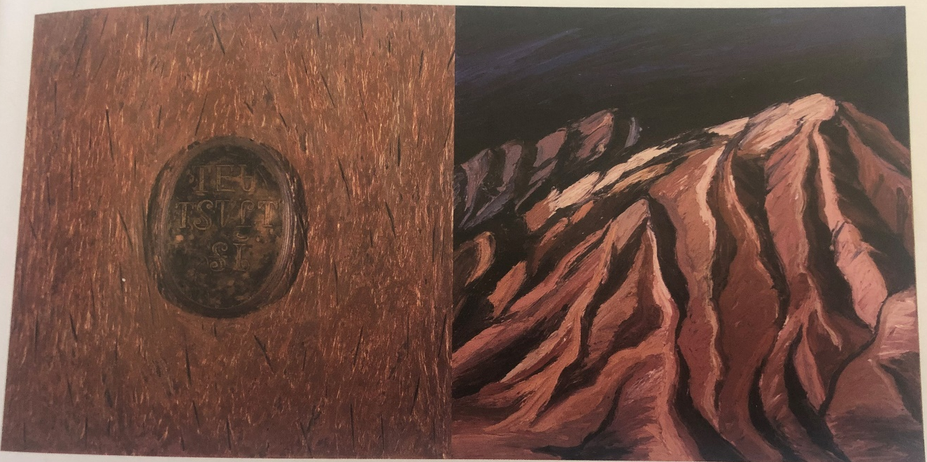
Figure 1.1
Kay WalkingStick, Ourselves / Our Land, 1991.
Copper, wax, wood, acrylic, and oil on canvas, 22 x 44 inches.
Collection of the Eiteljorg Museum of American Indians and Western Art, Indianapolis IN.

2. (NATIVE) AMERICAN ARTIST: KAY WALKINGSTICK

Kay WalkingStick is arguably the most well-known ᏣᎳᎩ artist today. In November 2015, The National Museum of the American Indian in Washington DC premiered the retrospective Kay WalkingStick: An American Artist. In the afterword of the catalogue of the exhibition, co-curator David W. Penney discusses the telling title of the exhibition. He states,
Pointing to her ancestry descending on one side from a white upstate New York family of artists and on the other from Cherokee WalkingStick’s deeply rooted in American soil, as WalkingStick has always thought of herself as an American artist. Put this way, the thought hardly seems contestable. But the reconciliation of these two fundamental strands of American historical reality – an immigrant nation born of European colonialism and the dispossession -yet-persistence of the nation’s Native inhabitants – remains elusive among historians of America and, more specifically for the purpose of this discussion, art historians of American art.

Penney and fellow co-curator Kathleen Ash-Milby place WalkingStick within the canon of American art though they acknowledge that it is problematic. But I read this also as a dismissal of WalkingStick’s ᏣᎳᎩ identity. It is not surprising, however, because WalkingStick’s relationship with her ᏣᎳᎩ identity is complicated due to her separation from community as well as developing as an artist within a Euro-American education during a time when Native and American art was decidedly separate and ideas of indigeneity often fell within a homogenized ideal. WalkingStick’s biography, which is based almost entirely in the Northeast and specifically her time in the New York City area during the peak of the post-modernism movement, led to an art practice that is formed by her experiences as a ᏣᎳᎩ woman – in the general sense, not specific to any community – living in diaspora physically disconnected from her culture as well as an artist exploring settler artistic concepts and theories. She is strongly influenced by Euro-American aesthetics, a side effect of her location and schooling. This creates an art practice that is easily recognized by Euro-Americans and arguably leads to why WalkingStick has been so widely and continuously embraced while other Native artists have struggled to stay in the forefront of the mainstream art world’s mind. This, however, does not discredit her work both as a Native woman and a ᏣᎳᎩ artist. It simply reveals that much like other ᏣᎳᎩ artists living in diaspora, the ways with which we view her indigeneity, as it relates to her work, is nuanced. Given the place that WalkingStick is at as an artist, no longer working towards recognition or working through her own self-realizations as an artist, but a celebrated example of modern and contemporary Native art, it is time to reexamine her art through a specifically ᏣᎳᎩ worldview of ᏚᏳᎦᏛ. By centering WalkingStick’s art as a way of reconnecting to her community and therefore returning to the right path, I show that while it is not incorrect to consider her as existing in the American art cannon, she should also be recognized as deeply rooted within ᏣᎳᎩ art.
Given WalkingStick’s nearly fifty year career as an artist, there is no shortage of art or literature to examine. WalkingStick has been written about extensively and her voice is often included in this scholarship. Much of WalkingStick’s life is wrapped into concepts of movement, displacement, and return. As historian Gregory Smithers has argued in his examination of ᏣᎳᎩ migration, resettlement, and identity, this is a very ᏣᎳᎩ way of understanding WalkingStick. But rather than centering her work within diaspora concepts and ᏚᏳᎦᏛ, WalkingStick is discussed by art scholars through concepts of homogenized indigeneity, aesthetic duality and multi-ethnicity.
Her earliest works from the 1960s and 70s were heavy with feminist influence and abstracted sexuality, shaped by the male post-modernist she studied while in school at New York. These sensuous forms carried over into works that removed the physical body and instead used depictions of cloth to convey an unseen form. By the mid-1970s, WalkingStick abandoned the body all together and created abstracted canvases that rely on shapes and color to convey the people being referenced in the title but also concepts of cultural disruption and survival. Those forms were further broken down during the 1980s when texture and dimension, often conveyed through the literal slicing of the canvas, becomes a major component. These textural works eventually split by the late 1980s and abstraction begins to share a stage with abstracted landscapes. This pivotal moment is when WalkingStick fully embraces the diptychs that she is so well known for to this day. Over time, the abstracted landscapes begin to take more obvious forms and the textural canvas begin to feature silhouettes reminiscent of WalkingStick’s early portraits. It was in the 1990s that WalkingStick created a series of painting and drawings (presented in the form of an artist’s book) that she transparently examined her identity as a ᏣᎳᎩ woman. She relied heavily on the ᏣᎳᎩ syllabary and self-portraiture to convey this aspect of herself. Throughout the 2000s, she moved farther from abstraction and her scenes begin to bleed together, despite the continued use of diptychs. The landscapes take on a dream-like quality and are softened by a use of brighter colors. In the 2010s, she did a short series of works that borrow imagery from Mississippian cultures that have been appropriated by many southeastern tribes, including the ᏣᎳᎩ. WalkingStick’s most recent work has been almost entirely landscape driven, calling out specific locations and embedding Native signifiers through the overlay of Indigenous patterns.
This reviewing of WalkingStick’s work through ᏚᏳᎦᏛ as a way to rectify her life outside of the ᏣᎳᎩ homeland is necessary, because she is someone whose biography embodies the ᏣᎳᎩ diasporic experience. While this case study revisits existing scholarship about WalkingStick, it emphasizes the application of understanding her work through ᏚᏳᎦᏛ. The following sections look to WalkingStick’s biography while examining a selection of works from her extensive catalogue raisonné as a way further interpret her as a ᏣᎳᎩ artist.
A ᏣᎳᎩ Family
The story of the Walkingstick family is familiar to many ᏣᎳᎩ people. It is one of movement, survival, adaption, and loss. She was born in 1935 to a ᏣᎳᎩ father and a white mother. Her father, who went by Ralph, came from a well-known ᏣᎳᎩ family that included Old Settlers such as James Walkingstick, who opposed the signing of the Treaty of New Echota. Another ancestor, Archibald Scraper walked the Trail of Tears. Many of her ancestors were actively involved in ᏣᎳᎩ politics. WalkingStick’s grandfather, Simon R. Walkingstick, participated in the implementation of the Dawes Act, serving as both an interpreter and clerk. Through these ancestors, WalkingStick has links to a variety of ᏣᎳᎩ experiences with some actively opposing a forced migration, others choosing to migrate before it became inevitable, and then a ᏣᎳᎩ who aided the US government in the solidifying of migration and assimilation through the allotment period. Like many other Native peoples, WalkingStick’s ancestors were as complicated and nuanced as contemporary Native people.
The Walkingstick family remained in Oklahoma until Ralph left in 1914 to attend Dartmouth College, though he didn’t graduate. WalkingStick’s mother, Emma, married Ralph in 1917. Their wedding announcement was actually celebrated in the Syracuse paper with the headline, “Cherokee Indian and Syracuse Bride.” After this, Ralph was employed by the Young Men’s Christian Association (YMCA) International Committee and traveled extensively to a variety of places – Indian, England, and Mesopotaia – until 1919. Upon Ralph’s return, he and Emma transferred to Musckogee, Oklahoma and started their family. Ralph became employed as a geologist with an oil company and once again spent a great deal of time traveling around the state, away from home. Ralph’s trips home were often unhappy and accompanied by his drinking and rage. Emma was also faced with weathering the Depression virtually alone. By 1934, Emma was pregnant with Kay and made the decision to leave Ralph and return to Syracuse with her four children and expected fifth. While Oklahoma was a source for community for ᏣᎳᎩ, as a white woman from New York, Emma would find her own security back home and not with her children’s culture. The return to Syracuse brought stability and family support that had been lacking for Emma and her children in Oklahoma, creating Emma’s own example of ᏚᏳᎦᏛ even though she was not ᏣᎳᎩ.
But the removal from Oklahoma did not result in the loss of the children’s ᏣᎳᎩ identity. Even as a child, WalkingStick searched out connections to her culture. When she was nine years old, while looking through the Saturday Evening Post, WalkingStick came across an image of “Chief Moses WalkingStick” of North Carolina. WalkingStick was struck by the different spelling of his name and figuring they must be related, decided that she would change the spelling of her own name to reflect this familial connection. In a way, this was the first time WalkingStick practiced ᏚᏳᎦᏛ. She was unable to return home, but she could create a connection to her ancestors through her name.
WalkingStick’s adult life was marked by continuous movement. She and her mother moved to Bethayres, Pennsylvania where WalkingStick graduated high school in 1952. After meeting her husband Robert Michael Echols, a white man who went by Michael, in 1955, WalkingStick began attending Beaver College (now Arcadia University in Glenside, Pennsylvania, studying painting. Within a month of her graduation in 1959, Michael and WalkingStick were married. After this, they moved to New York City and eventually settled in Eaglewood, New Jersey where they raised their family.
The Feminist Cherokee Artist
By the mid-1970s, WalkingStick was able to return to school and studied at the Pratt Institute in Brooklyn, commuting from her home in northern New Jersey. This was a turning point for her work as the 1970s were an important time in WalkingStick’s development as an artist. At the time, in New York, the emphasis was on minimalism and that is what she focused on while at Pratt.
WalkingStick’s earliest work is entrenched in female sensuality and feminist ideals. Me and My Neon Box, 1970, depicts three figures, though none in full detail. (fig. 2.1) The figures are silhouette in shades of green and placed in the foreground, middle ground, and background of the canvas, both consuming the space and framing an implied horizon line within a flattened landscape of shapes and color. The title calls out the neon box that one figure seems to be sitting upon, but can also exist as a coy double entendre for female genitalia. About works from this time period, WalkingStick states, “There is a joyousness in their nakedness, rather than nudity. They are enjoying their bodies. A lot of that early work was really about feminism and my own recognition of my own sexuality.”
These expressions of feminism and embracement of sensuality can also be tied to the reality that the ᏣᎳᎩ are a historically matrilineal society and our concepts of gender are tied to ᏚᏳᎦᏛ, though this is not how WalkingStick has described the work and these ideas would not have been part of her formal education. While WalkingStick was likely being influenced by the feminism of the day, it is important to also acknowledge that the strength of the feminine is inherently ᏣᎳᎩ. As scholar M. A. Jaimes*Guerrero has noted, Native womanism, as opposed to Eurocentric feminism, is an Indigenous-centric ideology that returns the voices and positions of power that were lost to Native women during colonization. Prior to European influence, which believed that men should be in charge and viewed women as property, ᏣᎳᎩ women were the leaders of their family. Women chose who to marry and the man was expected to leave his family to live with his wife. If a woman chose, she could divorce and the home and children remained hers. Clans, the heart of the ᏣᎳᎩ community, were passed down through the mother. A man’s clan was his mother’s while his children’s clan was his wife’s. ᏣᎳᎩ women owned their sexuality and were free to make decisions for themselves. It was only with the encroachment of European settlers, missionaries, and Christian patriarchy that this community structure faltered. So in a way, WalkingStick is not just embracing her sexuality through a feminist aesthetic, but she is also reclaiming the very foundation of ᏣᎳᎩ gender worldviews and reestablishing ᏚᏳᎦᏛ.
Despite growing up with a firm understanding of herself as Native, there was still a feeling of disconnect that came from being away from the ᏣᎳᎩ community and even the lack of her father throughout her childhood. Her work from this time reflects that exploration of womanhood while also revealing a yearning for a home that was seemingly never hers. While WalkingStick’s work is shaped through her own memories, she is also heavily influenced by the memories of her ancestors. For WalkingStick, her foundational understanding of her indigeneity came from her parents through her father’s lived experiences and her mother’s secondary education through stories to allow WalkingStick to be connected to her ᏣᎳᎩ community despite not living there. And it is through her artwork that she is able to metaphorically return home, despite never living in Oklahoma, and establish ᏚᏳᎦᏛ within herself as a ᏣᎳᎩ woman and artist.
This idea of longing for home can be found one of WalkingStick’s most prolific and recognized works, the Chief Joseph series, 1975-1977. (fig. 2.2) This work contains 36 individual canvases and pays homage to Hin-mah-too-yah-lat-kekt (Chief Joseph) of the Wallam-wat-kain (Wallowa) band of the Niimíipuu (Nez Perce). Chief Joseph led a group of at least 700 men, women, and children in the hopes of joining other Native exiles in what is now known as Canada after they were forced by the United States government to move onto a reservation from their ancestral lands in the Wallowa Valley. His legacy is one of resistance, survival, and sacrifice despite the violent influence of the settler colonial state and policies of cultural genocide.
WalkingStick’s tribute to Chief Joseph is abstracted and repetitive. Each 20 x 15 inch canvas features four domed shapes of various sizes. The curved portion of the domes, oriented vertically, face either left or right, though the directions are seemingly random. The palate of the paintings are rendered each in two colors, all done in various shades of red, orange, black, white, and blue. The domes sometimes move together in a singular direction, other times diverge as if to separate, and even seem to be colliding, though they never overlap or leave the plane of the canvas. While the individual canvases create a division between the shapes and the lack of a pattern leads to some feeling of chaos, the end result of the panels read together is one of journey and community. The individual works come together to tell a larger story of survival. Chief Joseph was willing to do whatever was necessary to ensure the survival of his people. The government viewed the Nez Perce as a collective problem to be dealt with by confinement on a small reservation away from their ancestral lands. This work is a celebration of community, one made up of many individuals all committed to a similar way of life and worldviews. Their strength is in their commitment to each other, in their collective similarities. While the story of the Nez Perce and Chief Joseph is their own, it is not hard to see similarities to the ᏣᎳᎩ and our own fight to maintain community while being divided and separated. If one of the canvases is to be taken away, the cohesion of the presentation becomes imcomplete. This speaks directly to the imbalance that occurs when a ᏣᎳᎩ citizen lives outside of our ancestral and political homelands. We are incomplete, yearning to return home. We are more powerful together, which is why so much of settler colonialism is dependent on keeping us apart. But through the return to a life lived on the right path, ᏚᏳᎦᏛ, whether by figuratively going home or metaphorically creating a return through practices such as art, ᏣᎳᎩ survive and thrive.
WalkingStick brings this reality back to her own ᏣᎳᎩ identity with For John Ridge, 1975. (fig. 2.3) In scholar Kate Morris’s interpretation of the work, she relies heavily on the physical aspects of the painting and only briefly touches on the ᏣᎳᎩ undertones that automatically resonate to me as a ᏣᎳᎩ woman. Morris states,
For John Ridge is an elegy for the prominent Cherokee statesman who was killed in 1839. In many respects, For John Ridge represents the synthesis of the various themes, techniques, and ideas that WalkingStick methodically explored in her graduate career: isolation of the arc; use of the grid; continued flattening of space; attention to surface; development of a unique saponified wax process; attunement to the expressive qualities of color, including black; and even the turn toward subject matters drawn from Native American experience, especially those of loss and tragedy.

What Morris seemingly misses, and WalkingStick may not have consciously intended, is that despite the abstracted depiction, this work tells a story of displacement and migration. There is an embedded aspect of loss and tragedy, but also implied hope. John Ridge was a signer of the Treaty of New Echota which ceded ᏣᎳᎩ ancestral lands to the US Government in exchange for land in Indian Territory, in what is now known as Oklahoma. In doing so, Ridge guaranteed a new homeland for the ᏣᎳᎩ peoples but also betrayed the communally held belief, confirmed by the ᏣᎳᎩ constitution, that no one had the right to give away ᏣᎳᎩ land. These opposing views, depicted through the tension of the four domes facing towards each other while pushing up against the boundaries created on the canvas, resulted in a very real fracturing of the Cherokee Nation and eventually bloodshed, through the assassination of Ridge and other signers of the Treaty of New Echota. WalkingStick views Ridge as a tragic figure, one she feels especially connected to because his portrait hung in her mother’s home. However, many ᏣᎳᎩ peoples view Ridge and the other signers of the Treaty as villains who betrayed their own people, men not practicing ᏚᏳᎦᏛ and instead serving their own interest. When I look at For John Ridge, that tension reads more prominently to me than anything. It is a tension that I think with which many ᏣᎳᎩ people relate. For Cherokee Nation citizens, we mourn the loss of our ancestral home while we celebrate our political homeland. We source our identity in two places, one taken and one given. This constant tension is only heightened by then living in diaspora away from both places. Art becomes a way to relieve some of that tension, giving it form and life outside of the body and creating ᏚᏳᎦᏛ through artistic expression.
An Artist in Limbo
The following decades of WalkingStick’s life had additional moments of migration and personal rupture. In the late 1980s, WalkingStick was offered a teaching position at Cornell University in Ithaca, New York. After the unexpected death of her husband in 1989, she left Cornell for SUNY-Stony Brook and an apartment in Queens. During this time, her art once again reflected aspects of WalkingStick’s reality but moved deeply internal as she dealt with the death of her husband. This tension of internal and external forces, while embracing a desire to acknowledge imbalance and create ᏚᏳᎦᏛ becomes even more prominent as WalkingStick moved into her signature diptych paintings.
The Abyss, 1989, shares qualities that can be found in earlier works such as Chief Joseph Series – the domed shape and the emphasis on colors such as red, black, and white – but with works like this, WalkingStick begins embracing landscape and abstracted depictions of the subconscious. (fig. 2.4) The work created during this time period is highly personal in a way that goes beyond WalkingStick as a Native woman. These paintings are about grief and loss. They are filled with uncertainty and fear. The Abyss features two canvases, displayed together as a single work (the way all of WalkingStick’s diptychs are rendered). On the left side, a highly stylized depiction of water over rocks is rendered in harsh reds, blacks, and bright white. The right panel features a central fan shape of red with black highlights. Simultaneously radiating out and condensing inward from the central images; ripples of black and then red frame the canvas. Where the left panel is chaos, the right panel is concentrated control. In a review of the work, art critic Holland Cotter states,
These were chromatically raw images: in The Abyss (1989) black, white, and red predominated so that the waterfall was like a surge of blood . . . Most significant was the fact that all these works were diptychs with a balancing image: a fanlike pyramidal shape of the kind she had begun using a decade of more before. Here looking like a cross between a tribal insignia and a space ship radiating its own lambent glow, it is as mysterious in its emplamatic serenity as the waterfall if physically and emotionally specific. Like WalkingStick’s color and her surfaces the images in the diptychs reveal themselves slowly and derive their power from their ambiguities. At once materially dense and conceptually lucid, despairing and resurrectional, they are grounded both in the artists’s inner life and that of a life beyond her – her father’s, her people’s, our own.
What Cotter gets wrong in his assertion is that works like The Abyss are also tied to the same type of arguments I make about works such as For John Ross. As a ᏣᎳᎩ person, I do not read this as a moment of attempting to balance her identity and reality as a diasporic Native person. The work is wholly personal in a way that does not need the additional layer of indigeneity. While my primary argument is that WalkingStick’s work is not often read through a Cherokee lens but rather a homogenized Native American view, I also think it is appropriate to state that some works may have little if anything to do with being ᏣᎳᎩ. As ᏣᎳᎩ who also have European ancestors and who identify in both an Indigenous and settler work are allowed to have moments that are uniquely personal and not informed by identity. This is true for any Native artist or even any artist from a marginalized community. And just as art is a vehicle to establish ᏚᏳᎦᏛ for a ᏣᎳᎩ artist living outside of our political and ancestral homelands, so is it a way to reconcile the opposed qualities of our ancestry. It is just not always acknowledged or allowed by the dominant society, of which Cotter is a member.
ᏣᎳᎩ Woman
In 1992, WalkingStick made the following statement in response to a questionnaire sent to Native artists participating in the Land, Spirit, Power exhibition which was presented by the National Gallery of Canada in the same year: “What does my heritage have to do with my art? It is who I am. Art is a portrait of the artist, at least of the artist’s thought processes, sense of self, sense of place in the world. If you see art as that, then my identity as an Indian is crucial.” There is no question about how her ᏣᎳᎩ identity is included in the works produced during the early 1990s. The early 1990s were a time of important art production by Native people in light of the Columbus Quincentenary. While countries around the world, including the United States, were preparing to celebrate the Italian explorer’s “discovery” of the New World on behalf of Spain, many people were reevaluating his contributions or openly protesting the celebration. For Native people, Columbus had never been a positive historical figure. Instead, he was a catalyst that brought forth the doctrine of discovery, manifest destiny, colonization, genocide, assimilation policies, loss of land, and disease. This led to an influx of art work by Native artists that openly discussed these issues with Columbus as well as explored Native identity, especially from a contemporary context. WalkingStick was no different. While a lot of her work during the late 1980s and early 1990s were emotional and filled with grief and loss, there was also a series of works that dealt directly with her ᏣᎳᎩ identity and the complexity of it in the contemporary world. WalkingStick created a group of paintings that directly incorporated ᏣᎳᎩ text either into the work or the title in 1990-1991, and followed in 1993 with an Artist’s book titled Talking Leaves. These works, unsurprisingly due to their content and context, are the easiest to view ᏚᏳᎦᏛ as the artist contends with her reality as a ᏣᎳᎩ woman living in diaspora.
In an interview with WalkingStick, Lawrence Abbot posed a question to the artist concerning the evolution of her work. Her response pivoted to an exploration of how she worked through her sense of indigeneity through her artwork. She stated,
My view of myself as an Indian was based on idea alone; I was not raised in a Native culture. And consequently, I had some questions about myself as a Native person, and so I decided to investigate that part of myself. . . . I started reading Native American history and trying to, through painting, find out about myself. . . . Creativity is an investigation for me. So this was a way to investigate my Indianness.

When asking WalkingStick if she was influenced by the homelands of North Carolina or Oklahoma, she notes how her father was born in Indian Territory and that she was not, something that she regrets. But like all of us, we cannot control where we are born any more than we can control who we are born to or when, we can only find ways to rectify this imbalance. Instead, WalkingStick remarks how she wished she knew how to speak ᏣᎳᎩ because she feels that it would be a good way for her to feel more connected to ᏣᎳᎩ communities. She reflects, “I would really love to learn Cherokee because I think it would help me. You know, people are very much defined by their own language, by the way they speak their language, by the sounds it makes. A language describes people – we are, in a sense, our tongue.” WalkingStick sees understanding of indigeneity as being located within language. It is, therefore, no surprise, that when she is exploring her reality as a ᏣᎳᎩ woman and creating her own ᏚᏳᎦᏛ she uses language to act as her signifier.
Tears/ᏧᎦᏌᏬᏛ, 1990, was a departure from WalkingStick’s emblematic paintings. (fig.2.5) The small sculpture instead features mixed media to create a maquette-like work created primarily from natural materials – deer and cow hide, copper, feathers, bone beads, corn, stones, turquoise, wood, and Ancestral Pueblo (also called Anasazi) pot shards – save for the black acrylic paint. The painted platform resembles a funerary scaffold often associated with Plains communities, though it is not a traditional burial method for ᏣᎳᎩ. The corn, stones, turquoise, and pot shards are wrapped into the hide, creating a bundle that appears human-like. In the artist statement attached to this work when it was shown in 1992 in a show curated by Jaune Quick-to-See Smith titled The Submuloc Show/Columbus Wobs: A Visual Commentary on the Columbus Quincentennial from the Perspective of America’s First People, WalkingStick described the inspiration as coming from a story her father told her about a young Indian boy being murdered by white Oklahoma cowboys. Below the structure is an encased copper plate, embossed with an English poem and signed in ᏣᎳᎩ. It states:
In 1492
We were 20 million
Now
We are 2 million
Where are the generations
Where are the Children?
Never born.
ᎤᏤᎳᏅᏍᏗ

While many of the materials that WalkingStick uses are not typically associated with ᏣᎳᎩ culture, the embossed copper recall decorated copper gorgets, which have historical and contemporary importance to the ᏣᎳᎩ.
Where Are the Generations?, 1991, borrowed from WalkingStick’s earlier styles of abstracted landscapes and geometric shapes while also incorporating the words from her 1990 poem and the copper on which it was featured. (fig. 2.6) The cool palette of blues, pinks, and gray-scale invoke a night scene. But unlike the bundled body representation in Tears/ᏧᎦᏌᏬᏛ, this work features no humans, dead or alive. The empty landscape, mourning poem, and somber columns all combine to create a depiction of loss and despair. But it should also be read as a moment of hope. The very inclusion of the ᏣᎳᎩ syllabary, the continuation of the ᏣᎳᎩ language, speaks of survival even into the contemporary moment.
This contemporary survival is further depicted in Talking Leaves, 1993. This artist’s book was created after the popularity seen by Native artists during the Columbus Quincentennial. While WalkingStick’s work prior to 1990-1992 had been quietly or invisibly ᏣᎳᎩ to a mainstream audience, many now recognized her as a Native artists. But as many Native people know, especially light-skinned ᏣᎳᎩ, with recognition comes stereotyping and (not so) subtle racism. The title references Sequoyah, who created the ᏣᎳᎩ syllabary in the first quarter of the nineteenth century. “Talking leaves” was the term he gave to books. The book acts as a type of autobiography of WalkingStick from a young age to the present. The cover features a subtly framed cross, backed in black and colored with shades of brown and gold. (fig. 2.7) This cross serves as a signifier for both her ᏣᎳᎩ and white identities: the four directions are an important aspect of many Native communities, including ᏣᎳᎩ, while the cross also symbolizes Christianity, which was how WalkingStick was raised. Each biographical section is separated by a similar cross, though they vary in color. The implication is that while WalkingStick has been questioned about her identity throughout her life, she always returns to her own self-identification as a Native woman with European ancestry. While the moments of identity questioning are presented as diptychs, the words at odds with the way WalkingStick depicts herself, the cross is always depicted whole. While others may not be able to rectify what they imagine of WalkingStick and stereotypes of Native people, and while WalkingStick was raised and remains an artist outside of her home community, she is unapologetically herself – ᏣᎳᎩ and white.
Talking Leaves contains six diptych images. Each have a phrase written on the left page and a self-portrait on the right page. The first features the words, “You’re an Indian? Well, I should have known with those cheekbones!” On the left, a young WalkingStick stares passively with her hair down. She wears a simple maroon shirt, turquoise necklace, and large hoop earrings. Three bands are laid in the background and foreground, reminiscent of a Cherokee ribbon dress. A border of yellow-green corn are seen behind her head while the bottom feature images from southern Indigenous tribes such as the Aztec and Toltec. (fig. 2.8)
Her school years are depicted with the text, “You’re an Indian? I thought you were a Jewish girl from Queens who changed her name.” The self-portrait presents WalkingStick in a Western-style shirt and cowboy hat. A yellow and red rainbow frames her hat, and is reminiscent of the modern Pueblo painting style made popular at the Santa Fe Indian School in the 1930s. The right page is bordered on the right side but a tall stalk of corn, indicating that time has passed since the earlier self-portrait. Where before WalkingStick seemed to look past the viewer, now she stairs straight ahead with direct eye contact. (fig. 2.9)
The next diptych states, “We were told to hire minority artists but there are no good minority artists.” WalkingStick wears a black apron over a red shirt with a colorfully banded cowboy hat and turquoise earrings. Behind her are representations of her various works from the 1970s and 1980s, similar to the Chief Joseph series and Abyss. Where before WalkingStick’s mouth was closed, now she appears to be in the process of speaking up, perhaps to correct the speaker or to remind the viewer that while her work may not be obviously done by a minority, it is still the work of a minority artist. (fig. 2.10)
Following this moment of active response, the next phrase reads, “You’re not an Indian. You weren’t born on a Reservation!” WalkingStick is once again featured in a smock but with a teal shirt two strands of turquoise. She looks straight at the viewer but with narrowed eyes, as if in defiance. In the upper background of the page, multiple homes are shown: a pre-contact stucco building with a curtain for the door, the ancestral WalkingStick cabin located in Tahlequah, WalkingStick’s home in Englewood, NJ, and her home at the time in Ithaca, New York. Below these homes are a band of teepees, the dwelling stereotypically assumed to be all Native peoples’ homes. At the bottom of the page, harvested corn is depicted. (fig. 2.11)
The final diptych in this style states on the left page, “You’re an Indian? So what can you say in Indian --‘Where’s the nearest bar?’” The self-portrait is of a mature WalkingStick, with her head proudly tilted up, small stud turquoise earrings, and an impressive turquoise nugget necklace. On both sides of her head are simple yellow four-sided crosses. Bordering the left side of the right page is a dry corn stalk, at the end of its cycle. On the bottom of the right page are depictions of the seven Cherokee clans – Bird, Wolf, Paint, Wild Potato, Deer, Blue, and Twister (Long Hair). Also included are two Zuni bears, which is in reference to the fact that when WalkingStick asked her white mother what clan she was, her mother replied that she (Kay) was Bear clan. While there is no Bear clan, WalkingStick wanted to honor her mother who was trying to raise her daughter as ᏣᎳᎩ while not being so herself. (fig. 2.12)
The final self-portrait of WalkingStick maintains the diptych style of the previous pages, but now it is the artist speaking directly to the reader. On the left page, on a background of rich
green and black, are “Enough!” with “ᎡᎵᏊ,” the ᏣᎳᎩ translation of the same word. On the right page is a sepia-toned rendering of WalkingStick as she was in 1993. (fig. 2.13) She wears a cowboy hat and turtleneck and displays her upper body at an angle with her head turned toward the viewer. She stares straight ahead with a proud and defiant gaze. Overlaid on her self-portrait are the ᏣᎳᎩ words:

ᎠᏴ ᎤᎵᏏ
ᎠᏴ Ꮶ
ᎤᏙᏔᏅᏍᏗ
Ꮵ ᏴᏂ ᏫᏯ
ᏣᎳᎩ

Translation:

I am a Grandmother.
I am Kay WalkingStick.
Of the Principle People,
Cherokee!
The journey WalkingStick takes through her artist book is highly personal but one many Native people, especially ᏣᎳᎩ living in diaspora who also have European ancestry, will recognize. And in binding her book, which relies on the diptych to express the imbalance in her identity both from and external and internal view, with the combined cross, WalkingStick is able to practice a visual and personal ᏚᏳᎦᏛ.
Painting the Landscape and Beyond
What follows after Talking Leaves is a return to the landscape and the body. The trauma of the sudden loss of her husband and the self-reflection that came after during the Columbus Quincentennial resulted in a new style of work that again recalls styles of the past but added new dimensions and influence. There is also a stability in WalkingStick’s life that results in one of the largest bodies of her work. By 1992, she had returned to Cornell to teach, where she would stay until 2005. Works like Blame the Mountains, III, 1998, feature rich tones and a bright landscape. (fig. 2.14) The left panel depicts a mountain scene with a sky rendered in Braff leaf. The right panel once again features a silhouette of a female body, reminiscent of the early works such as Me and My Neon Box. There is a softness to works like this that was often left out of the earlier abstracted landscape diptychs. This softness carries over into other works such as Gioioso, Variation II, 2001. (fig. 2.15) Here, the mountains still take prominence on the left panel but now the silhouette has been joined by another. These two figures are depicted by their legs, which appear to dance upon a flattened plane, entangled in a moment.
WalkingStick retired from Cornell in 2005 and moved back to New York City. After a battle with cancer, she eventually met her second husband Dirk Bach. By the 2010s, WalkingStick returned to employing Native signifiers in her work. No longer are her landscapes rendered in abstraction that makes identifying the location difficult. In New Mexico Desert, 2011, WalkingStick depicts a realistic though softly painted desert scene. (fig. 2.16) Unlike many previous diptychs, this landscapes spans both panels, though the line splitting the two panels is obvious. Overlaid on only the right panel, however, is a band of Pueblo-inspired symbols. WalkingStick is claiming the landscape for the original inhabitants. Like in Where Are the Generations?, no people appear in the scene but their presence is felt through the inclusion of their cultural symbols.
WalkingStick returned once again to her own ᏣᎳᎩ culture in the Cherokee Dancers series. Cherokee Dancers II, 2016, is not a true or implied diptych. (fig. 2.17) But there is a type of symmetry that carries over from WalkingStick’s usual work. The center features two dancing figures, bottom silhouettes of a male and female. On the left and right sides of the work are two individual figures, seemingly ancestral ᏣᎳᎩ dancers. They each carry staffs and masks, and are shown in profile. Stamped on top of the image are three images, depicting Mississippian culture imagery that has been adopted by many Southeastern tribes, including the ᏣᎳᎩ. Unlike most of WalkingStick’s work in the past few decades, there is no landscape depicted. Much like WalkingStick, both the past and present ᏣᎳᎩ are removed from their home. They float on a plane stamped with culture but removed from any place. This feels like a fitting metaphor for all ᏣᎳᎩ living in diaspora and a striking way to represent WalkingStick’s own understanding of her indigeneity.
Conclusion
The influence of Kay WalkingStick on other Native artists, especially ᏣᎳᎩ, should never be understated. Other ᏣᎳᎩ artists such as Luzene Hill, Brenda Mallory, and Kade L. Twist, have all expressed how they admire her work and look to her for inspiration. WalkingStick has accomplished recognition and praise that many settler or even Native male artists could only aspire to achieve. WalkingStick’s artistic practice has seamlessly moved between Euro-American aesthetics to explorations of contemporary Native indigeneity with moments of deep internal introspections. Her work has been centered in examining concepts of duality, often seen in her use of the diptych, though she cautions they should never be read as separate and always two parts of a whole. What I have argued throughout this chapter, though, what is often left out of scholarship about WalkingStick’s work is that of Native womanism and the ᏣᎳᎩ worldview of ᏚᏳᎦᏛ and the use of art as a way to counter the imbalance she feels as a ᏣᎳᎩ woman living in diaspora. By centering WalkingStick’s work within these concepts, new dimensions of understanding is added to her extensive body of work. This reality makes her deserving of not just recognition as a Native artist but as the very embodiment as a ᏣᎳᎩ woman living in diaspora using art to create a sense of belonging to a community to which she still belongs.

FIGURES

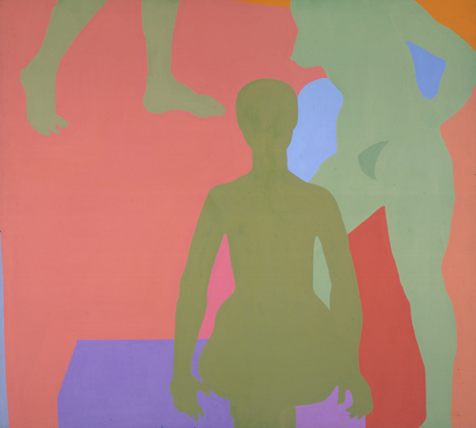
Figure 2.1
Kay WalkingStick, Me and My Neon Box, 1970.
Acrylic on canvas, 56 x 60 in.

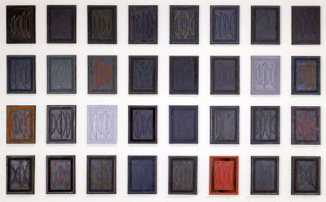
Figure 2.2
Kay WalkingStick, Chief Joseph Series, 1975-1977.
Acrylic and wax on canvas, 20 x 15 in. each.
Collection of the National Museum of the American Indian, Washington DC.

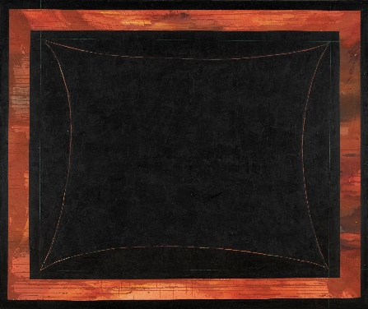
Figure 2.3
Kay WalkingStick, For John Ridge, 1975.
Acrylic, ink, and saponified wax on canvas, 60 x 72 in.
Collection of the Gilcrease Museum, Tulsa, OK.

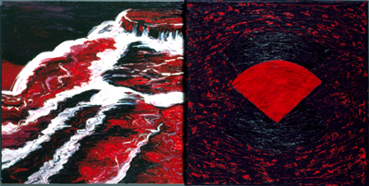
Figure 2.4
Kay WalkingStick, The Abyss, 1989.
Acrylic and wax, oil on canvas, 36 x 72 x 3 ½ in.

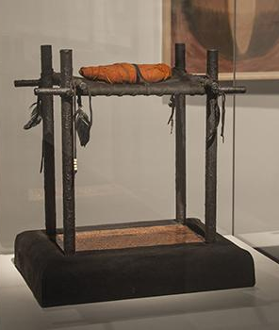
Figure 2.5
Kay WalkingStick, Tears/ᏧᎦᏌᏬᏛ, 1990.
Mixed media, 18 ¼ x 16 ½ x 12 in.

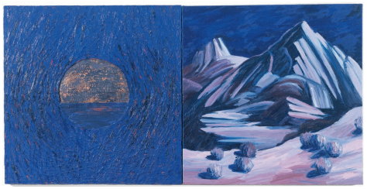
Figure 2.6
Kay WalkingStick, Where Are the Generations?, 1991.
Copper, acrylic, and saponified wax on canvas (left), oil on canvas (right), 28 x 56 in.
Collection of Jim and Keith Straw.

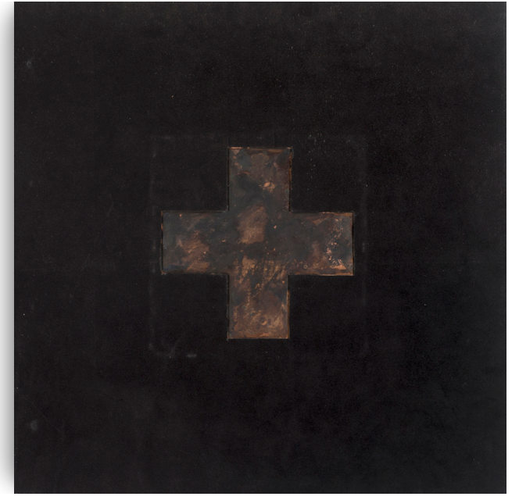
Figure 2.7
Kay WalkingStick, Talking Leaves (cover), 1993.
Oil stick, gouache, collage on paper, 22 x 14 ¾ in.

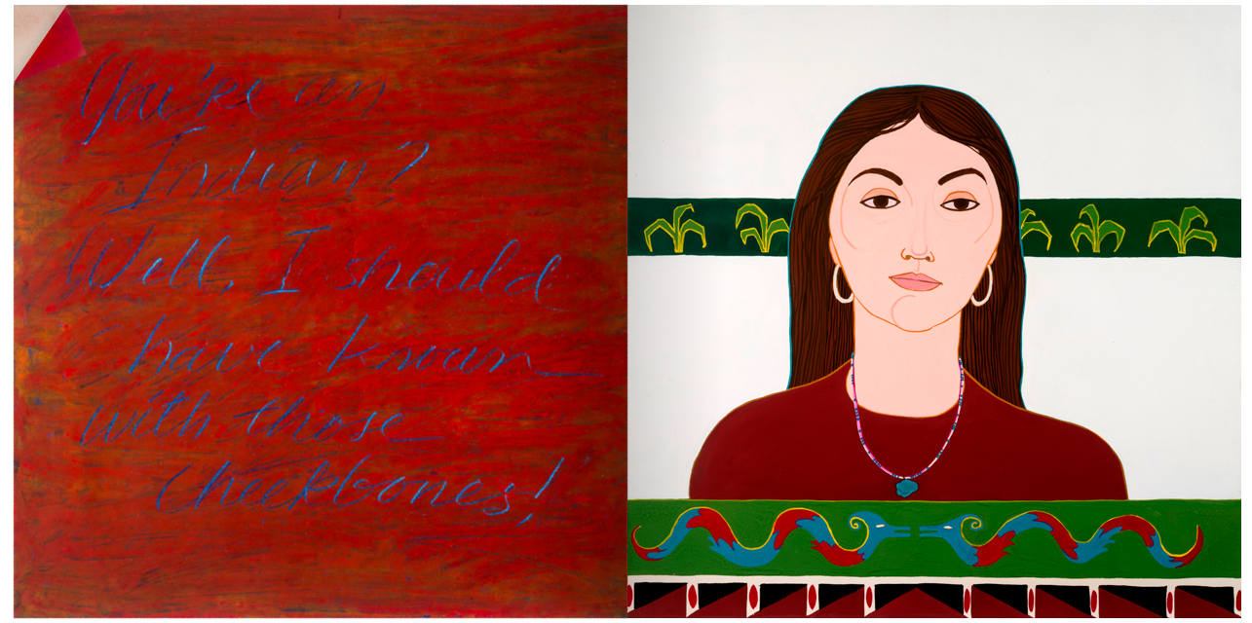
Figure 2.8
Kay WalkingStick, Talking Leaves (page 2-3), 1993.

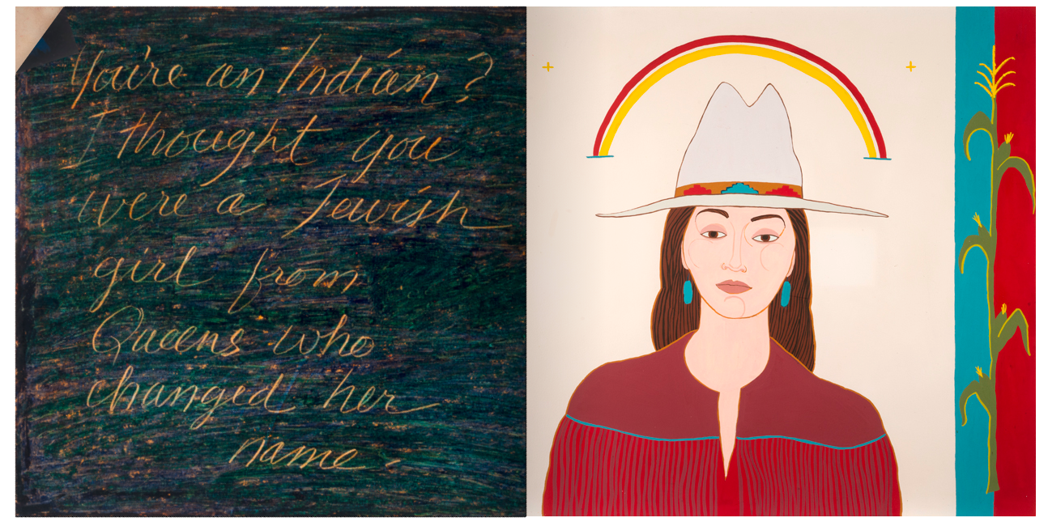
Figure 2.9
Kay WalkingStick, Talking Leaves (page 5-6), 1993.

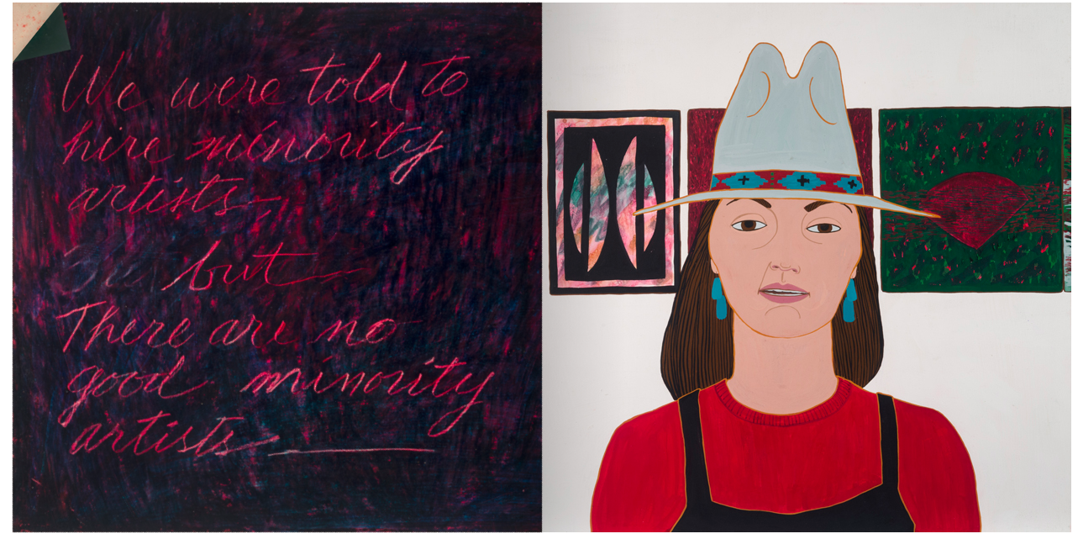
Figure 2.10
Kay WalkingStick, Talking Leaves (pages 8-9), 1993.

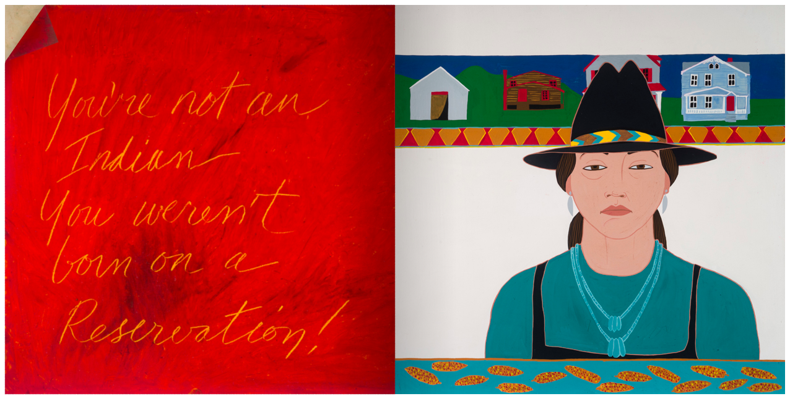
Figure 2.11
Kay WalkingStick, Talking Leaves (pages 11-12), 1993.

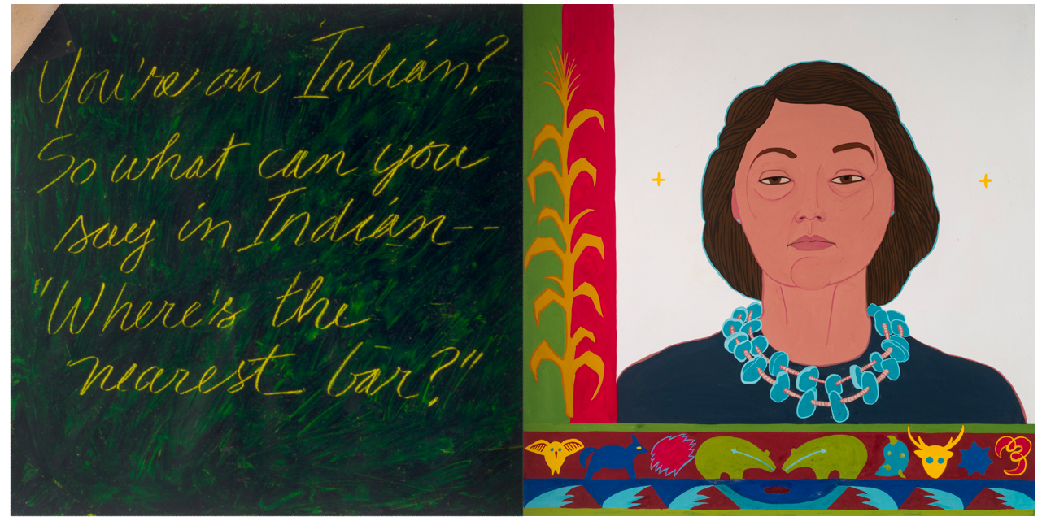
Figure 2.12
Kay WalkingStick, Talking Leaves (pages 14-15), 1993.

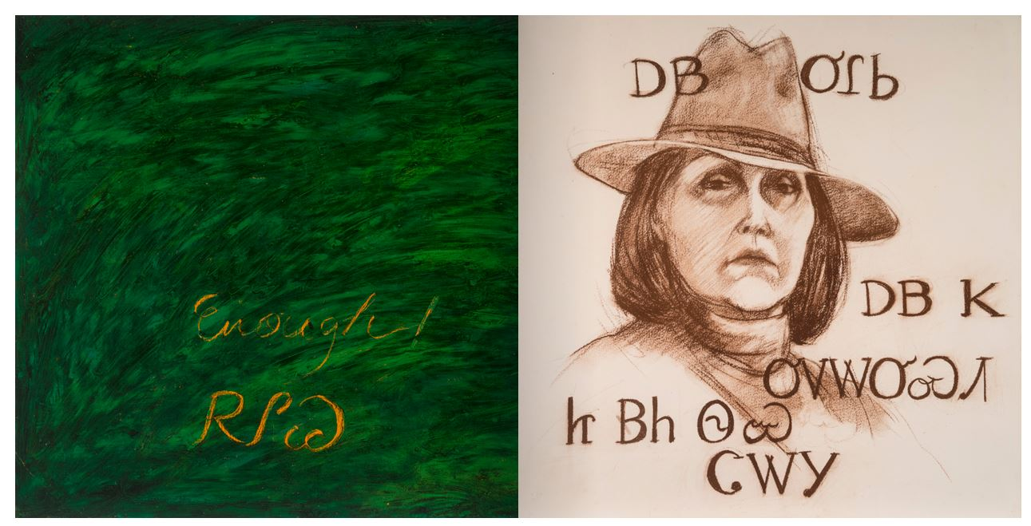
Figure 2.13
Kay WalkingStick, Talking Leaves (pages 17-18), 1993.

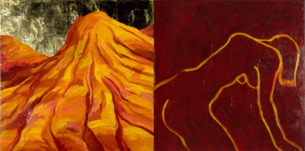
Figure 2.14
Kay WalkingStick, Blame the Mountains, III, 1998.
Oil and brass leaf on canvas (left), oil on canvas stretched over wood panel (right), 32 x 64 in.

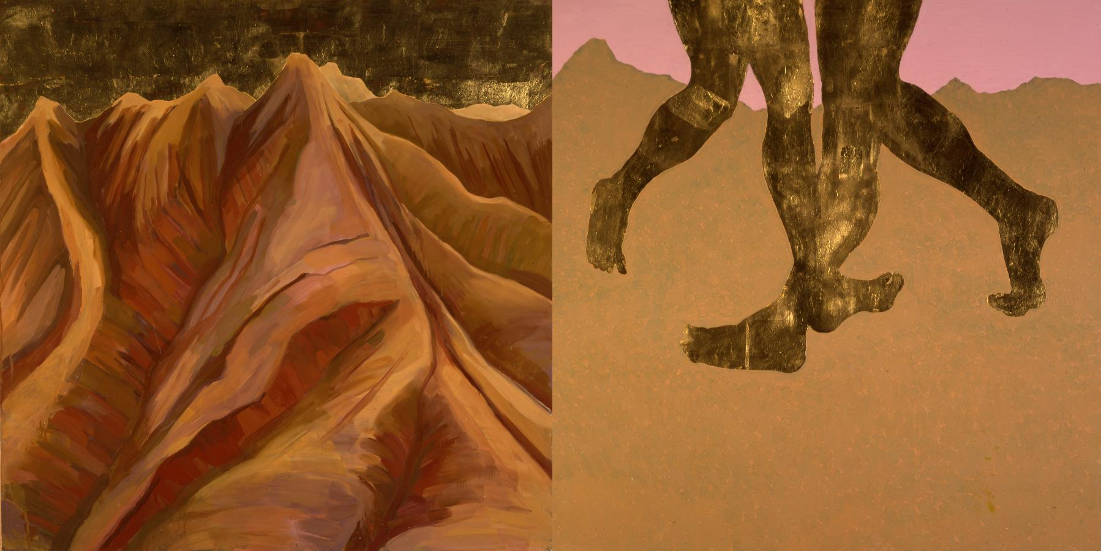
Figure 2.15
Kay WalkingStick, Gioioso, Variation II, 2001.
Oil and gold leaf on wood panel, 32 x 64 in.
Collection of the Eiteljorg Museum of American Indians and Western Art, Indianapolis IN.

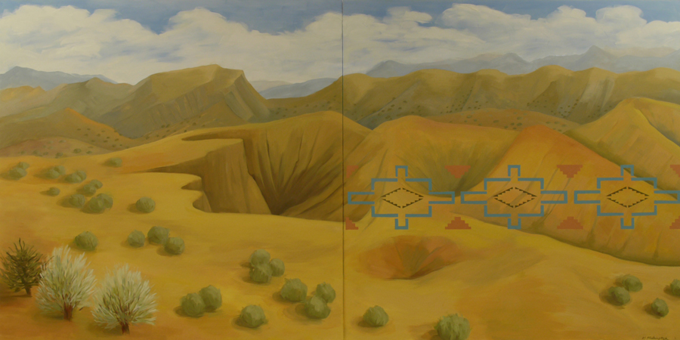
Figure 2.16
Kay WalkingStick, New Mexico Desert, 2011.
Oil on wood panel, 40 x 80 in.
Collection of the National Museum of the American Indians, Washington DC.

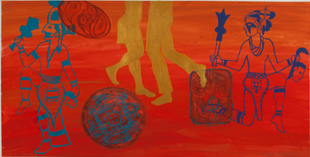
Figure 2.17
Kay WalkingStick, Cherokee Dancers II, 2016.
Gouache and acrylic on paper, 20 x 38 in.

3. ART AS A TOOL OF SURVIVAL: LUZENE HILL

A pile of vibrant red feather-like fabric sits in a corner. (fig. 3.1) Slowly, a figure stands, draped in a long mantle of textured taffeta. (fig. 3.2) The figure moves around the room, interacting with the space in a quiet dance of contemplation. Eventually, the mantle is removed, ascending to the ceiling on invisible wires. (fig. 3.3) The artist remains, still clothed in a red sheer cape. (fig. 3.4) This too leaves the artist’s body and takes a permanent position on the wall, spread like the wings of a bird, softly descending down to the ground on one end. (fig. 3.5) All that is left is the memory of the artist’s body in the two garments. But the artist is not gone. She remains, strong and reborn – a survivor, creating ᏚᏳᎦᏛ through her art.
Luzene Hill, the subject and performer of the above described installation titled Enate, 2017, is a multi-media artist best known for conceptual works addressing issues of violence against women as well as Indigenous knowledge. In the following chapter, I explore the work of Hill by arguing that through the creation of art around her personal journey of trauma and renewal, she generate ᏚᏳᎦᏛ as a way to reconnect to her ᏣᎳᎩ culture and create balance in her life. She is deeply committed to using art as a way to continue cultural knowledge as well as creating installation of resilience and strength as counter narratives to displacement and sexual violence. Through work informed by pre-contact Indigenous culture, personal experience, and her family history, Hill advocates for Indigenous sovereignty – linguistic, cultural, and personal – as well as a reclamation of female power and sexuality. These concepts form the basis for her beautiful while also challenging art production, in which ᏚᏳᎦᏛ is made present. Through her work, Hill responds to the reality of being a contemporary ᏣᎳᎩ woman removed from her ancestral lands, while still finding and actively practicing her indigeneity through her art. Hill is a warrior against the trauma that has been placed upon her ancestors and herself, as symbolized by the red mantle of the installation Enate. (fig. 3.6) She responds to moments of imbalance both in her existence and the larger world by bringing awareness through her practice and creating ᏚᏳᎦᏛ that directly counters a destructive narrative, a necessity for existing on the right path as ᏣᎳᎩ.
The ᏣᎳᎩ That Stayed Behind
Hill is a citizen of the Eastern Band of Cherokee Indians, which is now centered in Cherokee, North Carolina. Of the three federally recognized tribes of the ᏣᎳᎩ (Cherokee Nation, Eastern Band of Cherokee Indians, and United Keetoowah Band of Cherokee Indians), the Eastern Band maintains the closest physical relationship to the land of which encompasses the origin of ᎠᏂᏴᏫᏯ (Aniyunwiya), Principal People, now referred to as ᏣᎳᎩ. This land is considered the center of the ᏣᎳᎩ world and our creation story is directly tied to that landscape of the literal earth. The world was created when the water beetle went down from the crowded sky and brought mud up from below the water and made the land. The mountains were created when the buzzard went down to see if the mud was dry enough for the animals to come down and when he became tired , his wings hit the still soft ground and created the mountains and valleys. And it is in these mountains that the ancestral ᎠᏂᏴᏫᏯ lived, where the eventual United Keetoowah Band of Cherokee Indians and Cherokee Nation originated before migration and removal to what is now known as Oklahoma. It is also where the Eastern Band of Cherokee Indians remain.
These ancestral lands of the original, united ᏣᎳᎩ are located in the southeast of what is now known as Tennessee, North Carolina, South Carolina, and Georgia, geographically referred to as southern Appalachia. While the Cherokee Nation, United Keetoowah Band of Cherokee Indians, and Eastern Band of Cherokee Indians share an ancestral homeland and origin, the history of each tribe took a point of departure during the 1800s and this resulted in instances of unique cultural memory. In his essay, “Collective Memory and Cultural Identity,” German Egyptologist Jan Assman states, “The concept of cultural memory comprises that body of reusable texts, images, and rituals specific to each society in each epoch, whose ‘cultivation’ serves to stabilize and convey that society’s self-image. Upon such collective knowledge, for the most part (but not exclusively) of the past, each group bases its awareness of unity and particularity.” For Assman, cultural memory is not biological in nature and instead durable and responsive in its ability to shape identity. Cultural memory is created for Native peoples through interactions with ancestral lands and creation stories. It is formed by clan systems and family recognition within the community. It is through culturally based symbols, songs, and ceremonies. Cultural memory is reinforced by Indigenous languages, both in their continuation and in their revival. In many ways, cultural memory became the enemy of Euro-Americans as the United States was being colonized once the settlers realized that the Indigenous bodies would not disappear. Policies of assimilation and acculturation are in effect anti-cultural memory, counter to the worldview of ᏚᏳᎦᏛ. But what these policies failed to realize was, as Assman argues, the reflexive nature of cultural memory. It is adaptive and responsive to the needs of a culture. And because the three bands of the ᏣᎳᎩ had ruptures of location and experiences which effected all aspects of their communities, each formed a unique cultural memory while still sharing an ancestral reality.
Initial migration away from the ancestral lands began in the 1800s, as white settlers illegally moved onto ᏣᎳᎩ land. The discovery of gold on ᏣᎳᎩ lands in 1829 and increased pressure from white settlers and the United States government resulted in the forceful military removal of the majority of remaining ᏣᎳᎩ people from the lands, which had been greatly reduced over time. Despite the mass relocation of thousands of Native peoples from the southeast to Indian Territory, a small group of ᏣᎳᎩ stayed behind in what is now known as North Carolina. These ᏣᎳᎩ, who would eventually become formally known as the Eastern Band of Cherokee Indians, were able to remain for a variety of reasons including hiding during removal or renouncing their land and tribal citizenship to assimilate as United States citizens. It is important to note, though, that despite many stories that are passed around in the United States concerning fictional ᏣᎳᎩ ancestors that were ashamed of their ᏣᎳᎩ identity and therefore hid their culture, these ᏣᎳᎩ viewed staying with the land as the most important way to survive and maintain their community. But governmentally forced renunciation of tribal citizenship did not render the remaining ᏣᎳᎩ as culturally non-existence. Nearly 1,000 ᏣᎳᎩ remained and began the process of rebuilding their culture and of re-establishment as a sovereign nation. The ability to remain on ancestral land and maintain a physical relationship with that environment led to the help of an adopted white man named William Holland Thomas who purchased land on behalf of the remaining ᏣᎳᎩ and they were eventually were able to move toward recognition by the US government.
It was through their resilience and help from Thomas that the North Carolina ᏣᎳᎩ remained on land that eventually became the Qualla Boundary in Cherokee, North Carolina, also sometimes called the Cherokee Indian Reservation. The Qualla Boundary, however, is unlike other reservations in the United States because it was not technically “reserved’ by the US government on behalf of the ᏣᎳᎩ but instead owned by the ᏣᎳᎩ with the assistance of Thomas. In 1872, the land was formally returned to the North Carolina ᏣᎳᎩ and placed under federal protection as a land trust. Today the Eastern Band of Cherokee Indians are still located on the Qualla Boundary and the majority of over 12,000 member live within the Qualla Boundary, though like the other ᏣᎳᎩ communities, there are those that choose to live in diaspora.
Each of the three federally-recognized ᏣᎳᎩ tribes exist as individual sovereign nations. They all have their own enrollment requirements, tribal governments, and programs. And as is referred to in the work of Assman, they also have unique cultural memory that help to form the identity of each band. But the experience of ᏣᎳᎩ living in diaspora are often similar despite whether they are from the contemporary Oklahoma-based or North Carolina-based ᏣᎳᎩ. And just how our ancestors used art as one way to maintain culture, so do contemporary ᏣᎳᎩ, no matter what band they are a citizen of or what the art resembles or from which takes inspiration. It is within this reality that we find the work of Hill, a contemporary ᏣᎳᎩ woman living in diaspora, creating her own ᏚᏳᎦᏛ through her art.
A Personal Journey
It is through art that artist Hill connects to her community and ideas of indigeneity. Unlike other ᏣᎳᎩ living away from their ancestral or political homelands, Hill has been able to maintain a consistent connection to ancestral land, though she still views herself as a diasporic citizen. Her story is one of displacement and return. She was born in 1946 and grew up in what is now known as Georgia with her Eastern Band of Cherokee Indian father and white mother. She was named after her paternal grandmother, Luzene Sequoyah Hill, who was a ᏣᎳᎩ woman. Through her shared named and the reality of being an only child, Hill felt a great responsibility in the continuation of her ᏣᎳᎩ culture.
Hill’s ancestors may have avoided removal during the forced migration of the 1830s but her family’s reality was not without continuing trauma tied to their Native identity. Both of Hill’s paternal grandparents were sent to Carlisle Indian Industrial School, founded by Richard Henry Pratt. Pratt is well-known for his statement, “kill the Indian...and save the man.” He believed in the Americanization of Native children through cultural assimilation, which would be more accurately described as cultural genocide. While Pratt was not arguing for the extermination of Native peoples, he believed that the only way Native peoples could fully survive was to renounce traditional ways and integrate into American society through the adoption of Christianity, wearing of Western clothing, and rejection of Native languages and practices. In theory, Pratt was a revolutionary to some because he viewed Natives as equals to Euro-Americans and worthy of the same opportunities. However, this was only possible through the student’s loss of traditional practices and culture, which were strictly forbidden. The children who attended the school were not there by choice and corporal punishment was regularly used as a means of enforcing the school’s doctrine. What is important, though, it that while the assimilation policies of schools like Carlisle were detrimental, they did not fully succeed and Native cultures have been able to survive. While the trauma of this experience led to Hill’s grandparents not speaking or passing on their language but it did not lead to the loss of their identity.
The experience of her paternal grandparents extended to her father, who was also sent to boarding school, though one much closer to home. Another aspect of the boarding school experience was the belief that Native parents were unfit to raise and educate their own children. Hill recalls a story of her grandmother still taking care of her father, despite the separation. “[My] father was sent to a weekly boarding school in Cherokee when he was growing up. So he [was] like a mile away from the house but they kept the children away. And my grandmother would walk down the mountain and. put food through the fence to him.” Even with the forced separation, there was still the inherent need to parent and provide, contrary to the policies and beliefs of the settler government and religious institutions that oversaw the boarding schools.
In spite of the negative interventions of the settler government in his parents and his own childhood and education, Hill’s father became a paratrooper in the United States Army and would remain a career military man. Her parents met after World War II and Hill recounts that because of his position in the army, her father was often away from home and stationed in various places around the world; sometimes Hill and her mother would join him, other times they would live with her mother’s family. Hill recounts that when they joined her father in Germany, how the experience of living in a new, international community impacted her way of thinking and influenced her appreciation for art: “I lived in Europe when I was seven [to] nine, and I do think that had a really strong influence on me. I went from a blue collar neighborhood in Atlanta – white people, southern, and conservative – and then, when we lived in Germany it was so expanding [for my knowledge of art]: the European art and the museums and architecture. That broadened my vision.” This cosmopolitan environment was in stark contrast to the reality of life for Hill in Georgia.
While Hill primarily grew up in Atlanta with time spent in Germany, she also made regular summer visits to the home of her father’s parents in Cherokee, North Carolina. In recalling these summer trips, which involved a drive up the mountain from Georgia, a type of pilgrimage occurred that involved a return to the land of her ancestors and the current home of her ᏣᎳᎩ relatives. Hill experienced the difference in life at her paternal grandparents’ home and her life in Atlanta, but these visits gave her additional insight into her ᏣᎳᎩ culture, even if it was subtle. She states, “[I have] childhood memories of going to Cherokee to visit my grandparents and they lived in a little house, a little a-frame house nestled up on into the mountain side, with a wood stove for heat and no running water. And they had farm animals and my grandmother made honeysuckle baskets and quilts.” Honeysuckle baskets would eventually becoming a cultural signifies that Hill embeds into some of her installations as a way to reference her ᏣᎳᎩ culture and to reconnect with a community that she has felt removed from at various points of her life. And in using art, Hill is able to find a way to counteract the moments of disruption in her life and cultural identity, to restore balance that was taken away through violence and cultural genocide.
A Wound on the Mind
Like many other contemporary ᏣᎳᎩ artists living in diaspora, the art of Hill is informed by both her reality as a Native person and her personal experiences, which are part of a settler colonial and globalized world. She uses her work as a way to reestablish her connection to her ᏣᎳᎩ community, while also recognizing that her experience is not unique. While her art production deals with cultural continuation and knowledge, it also highlights aspects of the contemporary world that are steeped in trauma and survivance. Artistic influences for Hill include performance aritst Marina Abromović (Serbian, b. 1946), contemporary ᏣᎳᎩ basket maker Shan Goshorn (Eastern Band of Cherokee Indians, 1957-2018), and conceptual artist Ana Mendieta (1948-1985). The comparisons to the work of Mendieta is entirely fitting in both Hill and Mendieta are thinking about displacement, pilgrimage, and violence. Mendieta’s own personal story is one of being removed from her home country of Cuba and then using art as a way to metaphorically and literally return home, while also calling out violence against women and the earth. Though Mendieta uses the physical earth as her medium, Hill creates a proxy environment within her installations in order to return home and institute ᏚᏳᎦᏛ.
Hill creates installations that are deeply personal and heartbreakingly relatable for many viewers. Sexual assault, rape, and violence are a constant threat in the United States. According to the Rape, Abuse & Incest National Network (RAINN), every 73 seconds an American is sexually assaulted and 1 out of every 6 American women has been the victim of rape in her lifetime. In addition to these staggering facts, Native Americans are at the greatest risk for sexual violence in the United States, being twice as likely to experience rape/sexual assault compared to all other races. For Hill, this is not just a statistic. In 1994, while jogging in an Atlanta park, she was violently attacked and sexually assaulted. Her journey from that moment is one of trauma, therapy, introspection, creation, and survival. Rape is about more than a physical assault on the body. It is a violent act that strips away power from the victim. In refusing to remain powerless, Hill became and remains a survivor fully in control, and her art displays this reality. And as should be argued for every victim of sexual assault, Hill is more than that experience. She creates work that talks about resilience and continuation, both of herself and her community. Through her various art forms, that vary between intimate drawings to large scale, immersive installations, she navigates the world as a strong ᏣᎳᎩ woman who is considering her place within a larger community. And while Hill’s ancestors were not removed to Indian Territory, her story has still been one of diaspora. And through her art making, she has found ᏚᏳᎦᏛ in order to reaffirm her place within the ᏣᎳᎩ community.
Again, Cathy Caruth, defines trauma as being a wound inflicted upon the mind. She states, “[Trauma] is always the story of a wound that cries out, that addresses us in the attempt to tell us of a reality or truth that is not otherwise available.” Caruth believes that trauma occurs in a delayed capacity, and that this reality resonates with artists who respond creatively to the continued impact. For Hill, her trauma comes from dual sources: that of a ᏣᎳᎩ woman disconnected from her community both figuratively and literally, and as a sexual assault survivor.
Hill’s drawings incorporates delicate materials that feel temporary: paper, ink, charcoal, and beeswax. With them, she creates automatic drawings that are both abstract and hint at the human body. (figs. 3.7-3.9) There is a physicality of the work that pulls the viewer in to examine closer. The subject feels vulnerable and exposed. Hill states, “Vulnerability is a recurring theme in my work. Transformations, both physical and psychological, interest me. The process of change – voluntary or imposed, subtle or wrenching – is, paradoxically, a constant in life. I explore this fluid experience through media that are tentative, fleeting, easily altered or destroyed.” These drawings emerged without consciousness, and speak directly to Hill’s process of addressing with the trauma of being raped; the smeared red ink and muddy splotches, the distorted body parts, the violence of the chaos. Hill has recounted how she did not realize at first that she was working through her own recovery as she created the images. Rape is not about sex, but about loss of power. In creating these images, Hill was slowly able to reclaim her body, to recreate the destruction she saw after her attack, and make it hers. Hill subsequently sees herself as a survivor, not a victim of sexual assault. And as is stated by Caruth, continually dealing with trauma is a side effect of the experience, not a result of being a victim.
This power over her personal history is also seen in her more recent drawings, which have begun to be more sexually reclaiming and powerful. (figs. 3.10-3.12) These drawings are sometimes a celebration, and sometimes a condemnation of the patriarchy that all women must exist in, where sexuality is something women should be ashamed of, a decidedly un-ᏣᎳᎩ way of thinking. Hill recounted how a male professor started the first day of class by asking all of the “young ladies in the front row” to “please cross your legs.” Once they did, the professor stated, “now the gates of hell are closed . . . we can begin.” For Hill, expressing female sexuality and power is a way to directly challenge Eurocentric patriarchy, which is in direct contradiction to ᏣᎳᎩ beliefs of women, which was historically a matrilineal society and held women as equally powerful and capable as men. For Hill, female sexuality is something to be celebrated. She states,
Now I've gotten very keen on expressing matrilineal culture. . . . I'm trying to have this parallel path of still continuing to address the numbers and the violence against women, but also expressing female sexual energy and power. It is about our sexuality and sexualization of us. . . . I want to talk about strong sexual, powerful Indigenous women, and [the] sexual freedom that we had and had control over which was part of our status and power. . . . Until we start expressing our strength – which is sexual, female, and matrilineal strength, then people are still going to think they can dominate us.
Hill’s drawings take the viewer through a journey of trauma, healing, self-realization, and reclaiming of sexuality and the result is quiet but powerful. However, the intimacy of the drawings, the small scale and contained medium, begin to fall away as Hill’s practice moves into the installation realm.
Hill’s first fully realized immersive installation, The Pilgrimage Ribbon, 2005, speaks to this expanded journey. She created the installation as a way to explore journeys like those she had experienced through her life as well as that of other Indigenous people. She also saw it as a statement on the loss of Native cultures. The physical structure of the books reference the Codex Boturini (Tira de la Peregrinación de los Mexica), Tale of the Mexica Migration, which retells the story of the Aztec’s journey to find a new home. Hill’s recreation of the codices are each eleven feet long, representing the artist’s eleven year journey from the time of her sexual assault to the creation of this installation. While the work is based in Hill’s own history and finds inspiration from Aztec culture, it is also tied to a ᏣᎳᎩ experience. She views the work as an expression of vulnerability that is represented through the negative space that is present in both her work and the Codex Boturini. She states, “Our paths dip and wind through encounters, exploration, danger, disappointment; eventually straying into unchartered areas of ourselves.” This work begins a journey of vulnerability that was present in Hill’s drawings and continues to be seen in her installation.
The Pilgrimage Ribbon is placed within a narrow room, with the two artist books displayed in an accordion form along the left and right hand walls. (fig. 3.13) In the center of the space are stacked piles of twenty-two bundles of twenty-two manuscripts, 484 in total. To create the two codices involved a process of working (tearing, staining, dying, and folding) 484 strips of paper. Like with Hill’s other installations, the artist actively engages with the work after it is installed. Over time, she returned to the installation and steals a bundle until only one remains. These final twenty-two pages are a representation of the loss of Native American cultures over time.
Hill thinks of the ᏣᎳᎩ translation of the title as being “as I look for the important things.” In considering this translation, it could also have connections to the idea of maintaining the right path, ᏚᏳᎦᏛ. This understanding can be seen in the two accordion books, which feature figure-like beings moving along the pages and stopped periodically by red splotches. (fig. 14) For Hill, the figures are for important moments in her life and decisions she made. The red are stopping points of confrontation. The journey of the figures, of the bound manuscripts, and of Hill herself, are all imbedded in the installation and on top of that is a concept of migration, be it forced or for survival. She explores her own family history and that of other Cherokee and Native peoples while giving the viewer a larger world view of time and change.
Hill considers her own ᏣᎳᎩ identity and larger issues of violence against women in her beautiful but haunting 2010 installation …the body and blood. (fig. 3.15) Placed in the middle of a room sits a wooden table. On top of the table is an old basket, overfilled with dry rose petals that spill out onto the table top and then create a dense carpet surrounding the table’s legs and underside. (fig. 16) Where The Pilgrimage Ribbon was about removal and continuation, …the body and blood is focused on revealing truth over time. The installation starts as a simple basket on a table while a bell rings every two minutes. Each day, 720 dried rose petals are added. This symbolic gesture reflects a statistic that the vast majority of rapes go unreported while reported attacks (Hill states only about sixteen percent) occur every two minutes. The implications are staggering. What many viewers may miss is that the basket Hill uses in the center of the installation is a ᏣᎳᎩ honeysuckle basket, similar to what Hill would have seen in her grandparents’ home in Cherokee, North Carolina during her summer visits. While the work speaks to a global issue of violence against women, the inclusion of the ᏣᎳᎩ basket pulls it back to a personal statement. ᏣᎳᎩ baskets are historically linked with women and the shape is a feminine vessel with a gentle swell. The basket acts as not only a signifier for the artist, herself a survivor of sexual assault, but also for other Native women who are unfortunately not immune to this type of violence.
Violence against Native women is further explored in Hill’s installations Retracing the Trace, 2012, and the previously mentioned Enate, 2017. The dominant color in both these works – a deep red created through the use of cochineal – represents both pre-contact Indigenous life and feminine power. Cochineal dye, which was prevalent in Central America before European contact, is a natural, vibrant red developed from the carminic acid that is produced by a specific type of adult female insect in order to protect itself from predators. The resulting color denoted sacred life and death and was used for ceremonies. When Spanish invaders arrived, they appropriated the dye and began using it for their purposes, such as the coloring of Catholic Cardinal's robes.
Retracing the Trace again borrows from Hill’s own sexual assault to reveal larger issues of sexual violence, especially against Native women. (fig. 3.17-3.20) This performative installation begins with an empty gallery. Stenciled around the walls, at the height of Hill’s neck, are 24 hours from 01:00 to 24:00. To begin the installation, Hill lays on the floor face down. All around her are a pile of cochineal dyed silk cords with varying knots, totaling 3,780 or the number of unreported rapes in the United States each day. Upon closer inspection, the knotted cords are actually khipu, an Indigenous Andean South America device of communication. Each khipu is tied in a way to indicate a unique number between 1-3,780. Hill stands up from the pile of khipu, leaving behind a silhouette of her body. Over time, the khipu are transferred from the floor and onto the wall, framed by the stenciled times. While the silhouette of the body diminishes, a red band grows in intensity until no khipu remain and the wall is cut by a band of vibrant red.
Retracing the Trace once again deals with the horrifying statistics of rape in the United States. It also acts as a biographical retelling of Hill’s own story. When Hill was assaulted, the cords on her sweatshirt were used to strangle her, thus silencing her voice. The violent action left her with red marks circling her neck for months, symbolized by the final red band of khipu in the gallery. But where Hill and the 3,780 sexual assault survivors were either figuratively or literally silenced, the khipu also gives back their voice. It speaks to existence and continuation. Hill states,
Silence shrouds the experience of sexual assault. A woman is often strangled to silence and control her and the aftermath is characterized by a different kind of enveloping disquiet. Rape is about power and rage. A woman is made powerless and she is silenced.

In previous installations I addressed the issue of violence against women in an abstract and personally detached way. "Retracing the Trace" marks a shift in my approach to this subject. Each aspect of this work reflects my identity and involvement, from making the body imprint to removing the last cord from the floor and attaching it to the wall. The gallery is a metaphor for my body, as I draw attention to the number of sexual assaults that go unreported, and renounce the traces of my own trauma.
The incidence of violence against Native American women is almost three times greater than the national average and 90 percent of the sexual assaults are by non-Native men. Historical precedents of conquest and colonialism continue to play out.
Building off the ideas set forth in Retracing the Trace, Enate is another complex installation with a critical performance component that embeds the artist, Hill, within her work. The symbolism behind Hill’s use of cochineal dye speaks visually to that reclaiming of power once lost. With the cochineal, Hill has dyed 6956 silk taffeta silhouettes that resemble ancient depictions of women, 6956 being the number of reported rapes of Native American women each year. Native women are three times more likely to be raped than other women in the United States (the majority by non-Native men), and Hill conveys this through the triple layering of silhouettes. The result is a mantle which drapes around the artist like a cloak of protection as she walks through the gallery. Eventually the mantle is removed from the artist and ascends to a point of permanence in the gallery. The mantle resembles the feather capes historically worn by ᏣᎳᎩ leaders: white feathers designated a peace chief while red was for a war chief. Hill has reclaimed her feminine power and sexuality and is active in countering violence against her and all other Native women through her art as an expression of ᏚᏳᎦᏛ. The shadows cast between the cochineal-dyed silhouettes, at the same time, stand in for those women who do not report their sexual assaults. These women are not forgotten, though they remain unseen, and instead move forward with their sisters towards reclaiming power.
A Return Home
Hill became a professional artist later in life, focusing on family responsibilities and obligations before turning to art creation. For her formal education, which she completed from 2006-2012, she chose to attend Western Carolina University (WCU) in order to receive her bachelor of fine arts and master of fine arts. This is important because the location of WCU is located just outside the Qualla Boundary. It has a dedicated ᏣᎳᎩ studies program which offers both undergraduate and graduate degrees. WCU, through a series of grants from the Cherokee Preservation Foundation, also works towards ᏣᎳᎩ language preservation. In remembering the time leading up to her return to North Carolina for school, she states, “When I was planning to move . . . every time I would say, ‘I'm going to Cherokee,’ I would say, unconsciously, ‘I'm going back.’” While Hill’s emphasis was on art while at WCU, she was able to participate in the WCU Cherokee Studies Cherokee Language Program. She created cut paper illustrations and ink drawings for two stories, The Grouchy Old Lady and Spearfinger, which were part of a series of children’s book titled, ᎠᎴᏂᏐᏗ To Rise and Begin Again. The books are entirely written in the ᏣᎳᎩ syllabary, and created in order to address a lack of accessible language learning material. Hill is not a fluent writer or speaker of ᏣᎳᎩ so she worked with other citizens of the Eastern Band of Cherokee Indians to provide the text. The story of Spearfinger has interesting parallels for an artist who is considering the survival of her community as well as the cultural knowledge of language and the following recounting of the story is taken from the announcement of the book’s publication. Spearfinger tells the story of a shapeshifting witch with skin as hard as a rock and a dagger for an index finger. (fig. 3.21) Through her shapeshifting abilities, Spearfinger is able to take on the identity of loved ones and through this deceit, devours the livers of young ᏣᎳᎩ. In an effort to protect the young, the community holds a council to determine the best way to get rid of the witch. The council decides to capture her in a pit, where they try to kill her with arrows but because of her stone skin, she is not killed. It is through the help of a chickadee that reveals the location of her heart in the soft palm of her hand. Once she is defeated, they burn her body, which releases healing songs that are still remembered today. What this story reveals is that those things that appeal to us may actually be harmful and it is through community action that we can protect ourselves.
This proximity to her ancestral home created an opportunity for Hill to fully embrace her understanding of herself as a ᏣᎳᎩ artist and to use her art to her personal ᏚᏳᎦᏛ and to counter issues of displacement, cultural loss, and trauma. What has resulted is an artist with a strong sense of her cultural identity and a firm grasp on depicting personal survival.
Conclusion
When asked to reflect on what she thinks of ᏣᎳᎩ art, Hill responded, “I do think if you define Cherokee art with that tribal name that it does bring up historical Cherokee artist. But thinking of the art that I am aware of in Cherokee that is historical, I see so much . . . sensuality and sexuality, and I'm thinking of the baskets, so much sensuousness and also connection to nature.” For Hill, while her art may not automatically look ᏣᎳᎩ, her work has always put into practice a ᏣᎳᎩ worldview of ᏚᏳᎦᏛ, a consistent drive towards living a life in balance and harmony as a ᏣᎳᎩ woman. For her, it is a necessary practice as an artist living in both a settler and Indigenous reality. She uses her work as a counter to the continuing trauma that has occurred in her family’s history as well as her own life, all bi-products of a colonial system that runs counter to ᏚᏳᎦᏛ. Where the different policies of cultural genocide failed to rid Hill and her
ancestors of their indigeneity, so too did the moments of trauma in Hill’s life fail to diminish her inherent power as a ᏣᎳᎩ woman.
FIGURES

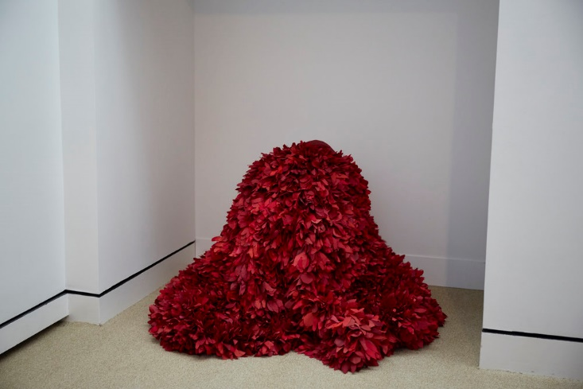
Figure 3.1
Luzene Hill, Enate (performance), 2017.
Mixed media, dimensions variable.

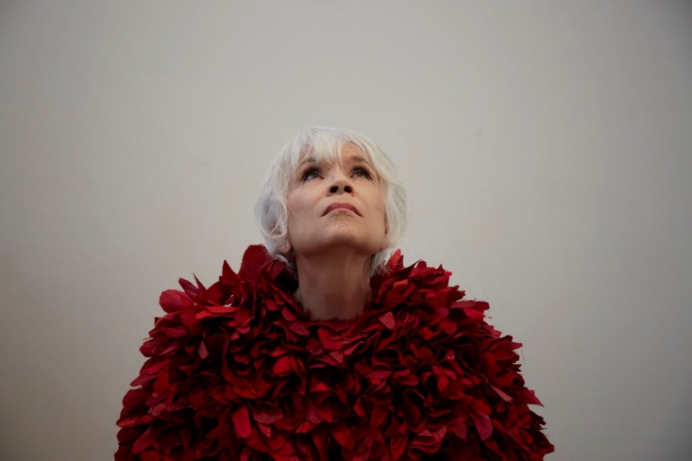
Figure 3.2
Luzene Hill, Enate (performance), 2017.
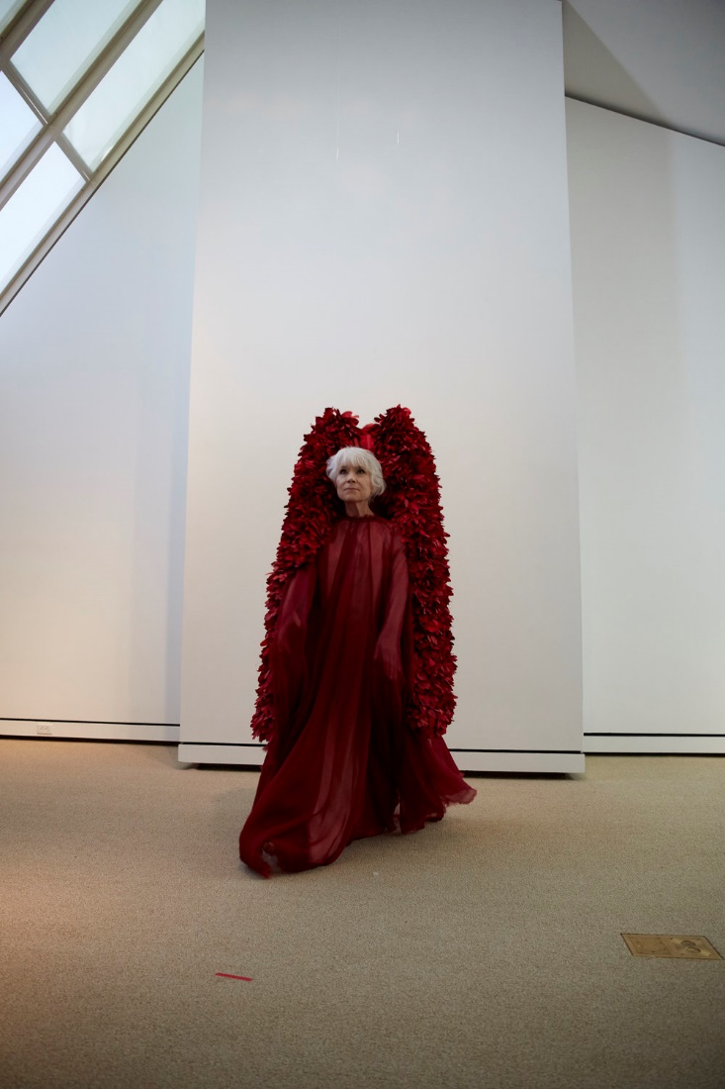
Figure 3.3
Luzene Hill, Enate (performance), 2017

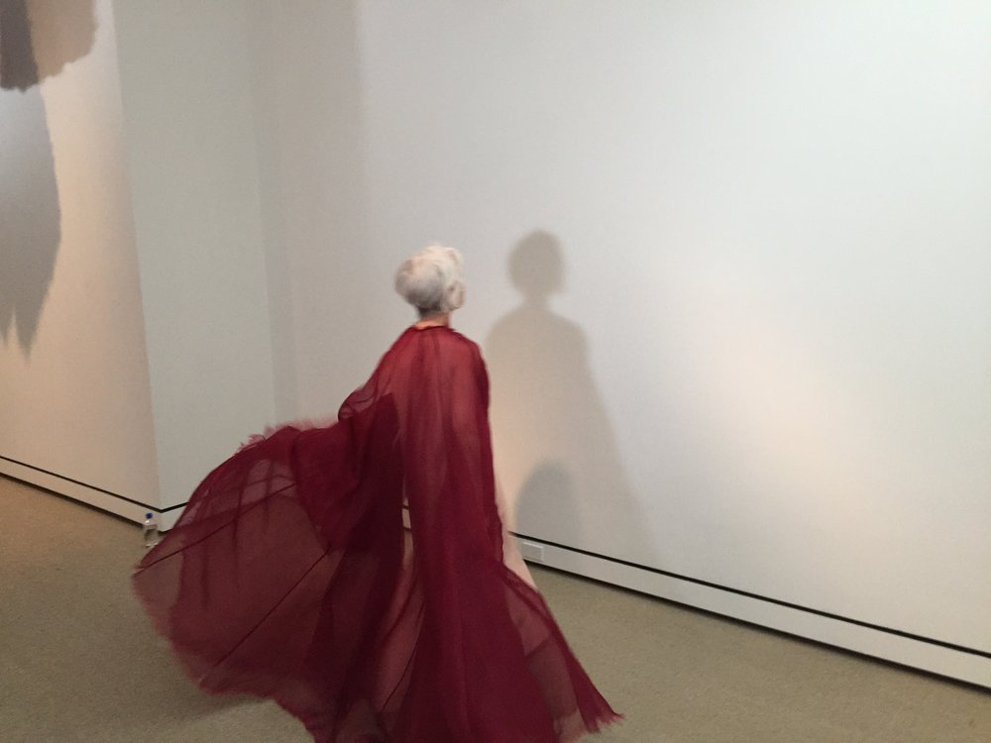
Figure 3.4
Luzene Hill, Enate (performance), 2017.

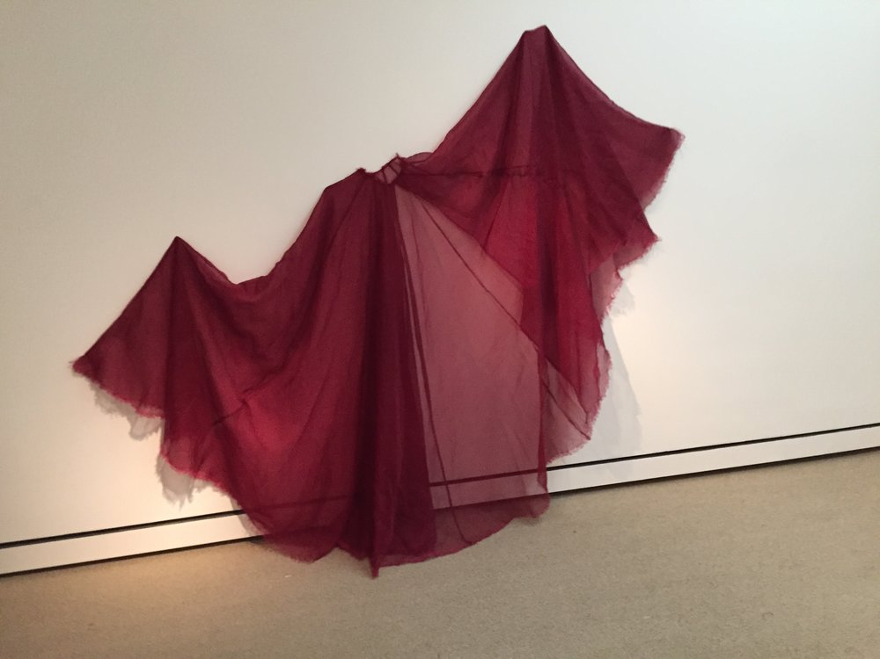
Figure 3.5
Luzene Hill, Enate (detail), 2017.

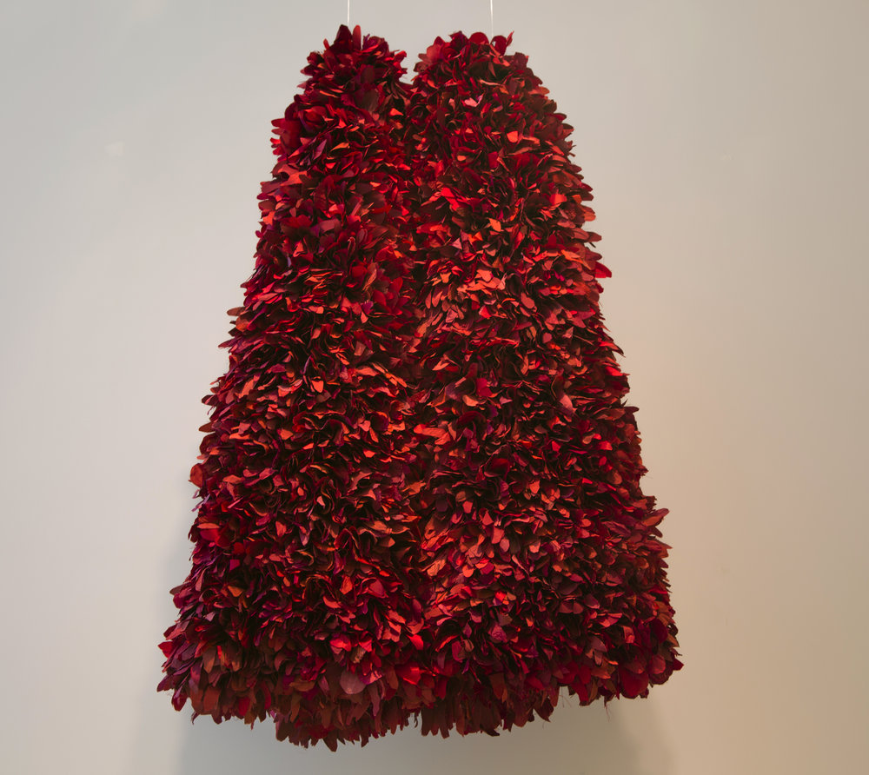
Figure 3.6
Luzene Hill, Enate (detail), 2017.

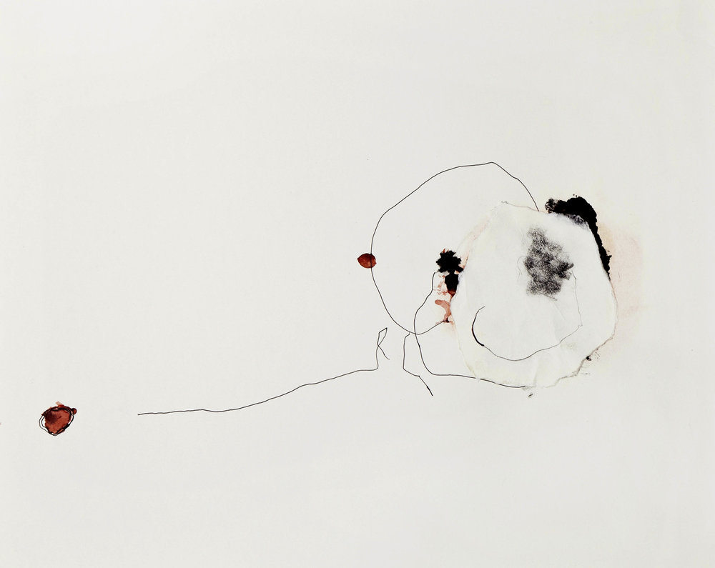
Figure 3.7
Luzene Hill, Untitled, date unknown.
Mixed media on paper.

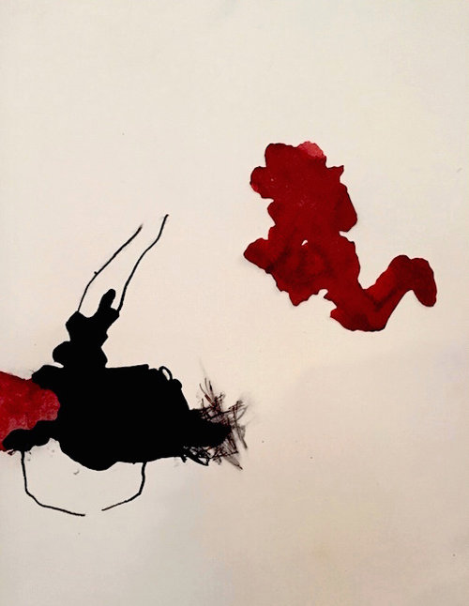
Figure 3.8
Luzene Hill, Untitled, date unknown.
Mixed media on paper.
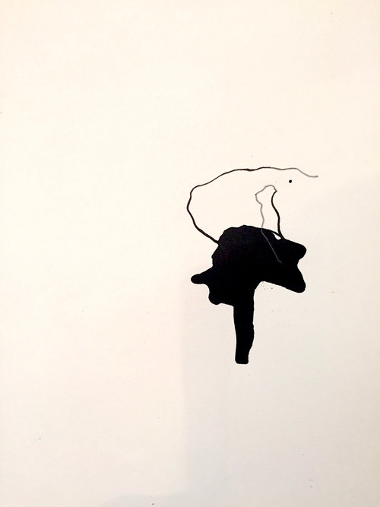
Figure 3.9
Luzene Hill, Untitled, date unknown.
Mixed media on paper.

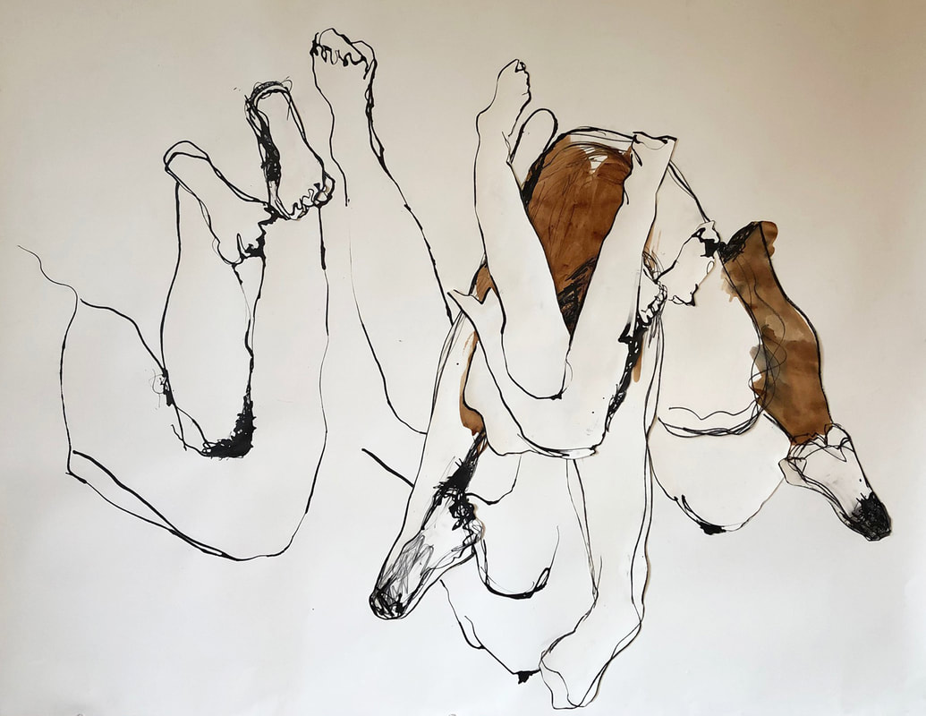
Figure 3.10
Luzene Hill, Now the Gates of Hell are closed…III, 2019.
Ink, charcoal, and collage on paper, 42 ½ x 53 ½ in.

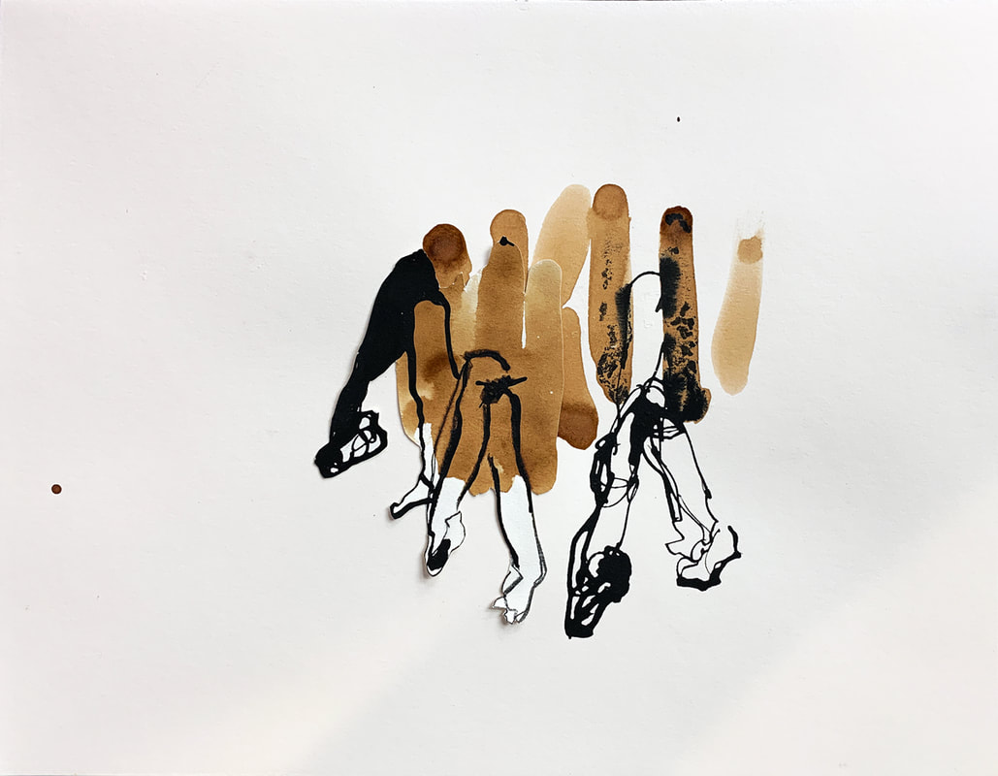
Figure 3.11
Luzene Hill, GoH0012, 2019.
Tea stain, charcoal, and ink on paper, 16 x 19 in.

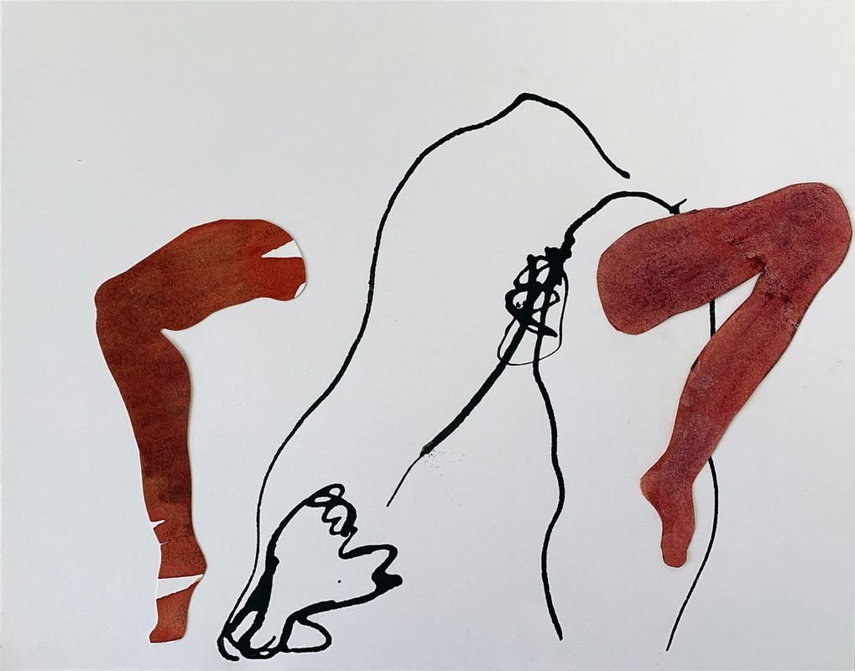
Figure 3.12
Luzene Hill, GoH0014, 2019.
Collage and ink on paper, 16 x 19 in.

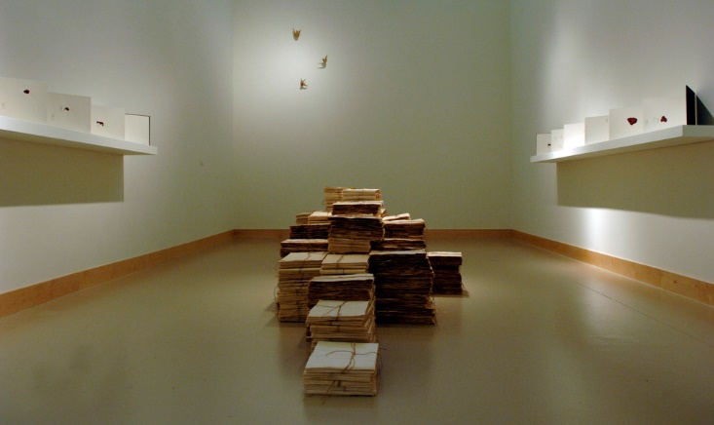
Figure 3.13
Luzene Hill, The Pilgrimage Ribbon (installation), 2006.
Mixed media, dimensions variable.

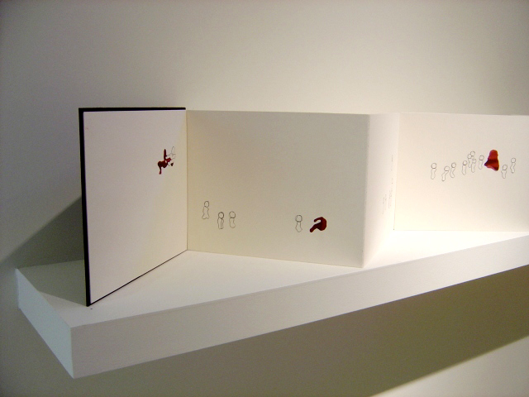
Figure 3.14
Luzene Hill, The Pilgrimage Ribbon (detail), 2006.
Paper, charcoal, ink, museum board, book, cloth, 132 x 11 in.

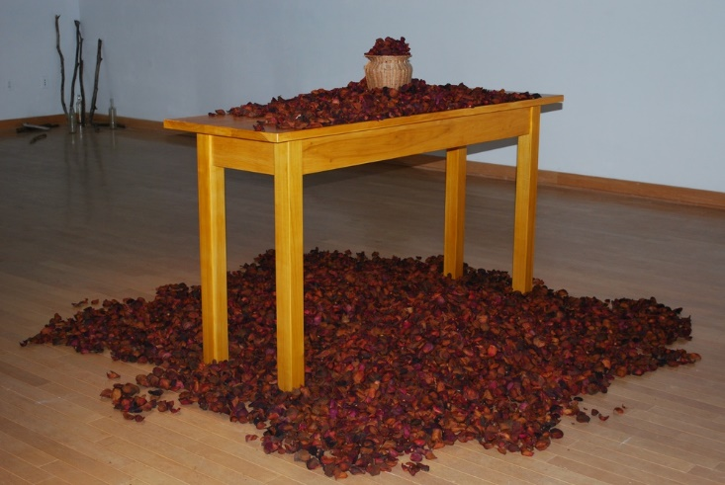
Figure 3.15
Luzene Hill, …the body and blood, 2010.
Mixed media, dimensions variable.

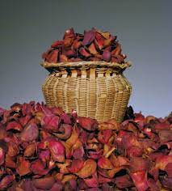
Figure 3.16
Luzene Hill, …the body and blood (detail), 2010.

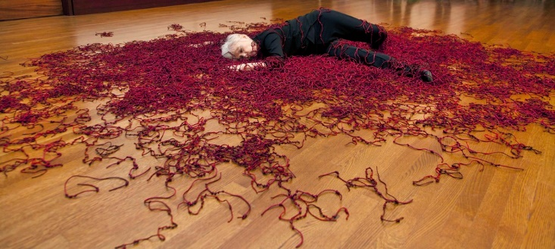
Figure 3.17
Luzene Hill, Retracing the Trace (performance), 2012.
Mixed media, dimensions variable.
Collection of the Eiteljorg Museum of American Indians and Western Art.

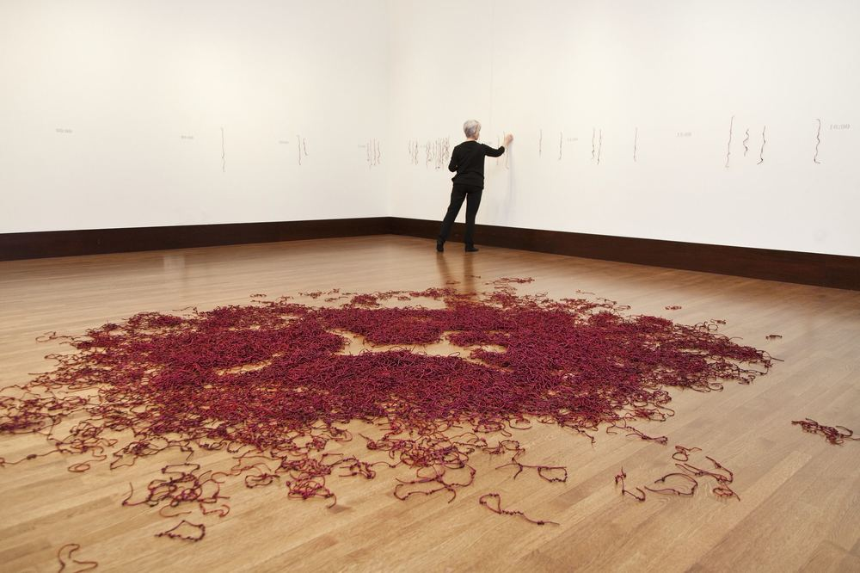
Figure 3.18
Luzene Hill, Retracing the Trace (performance), 2012.
Mixed media, dimensions variable.
Collection of the Eiteljorg Museum of American Indians and Western Art.

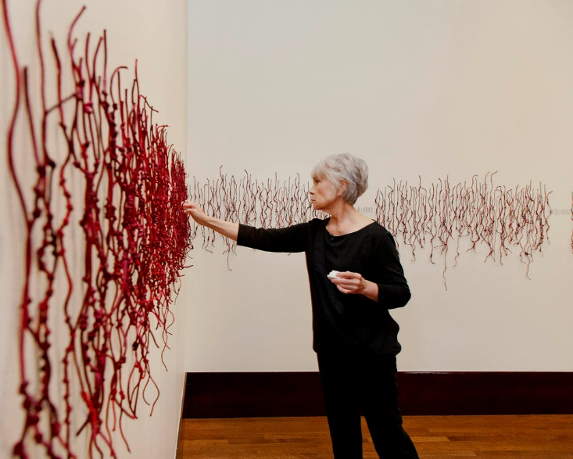
Figure 3.19
Luzene Hill, Retracing the Trace (performance detail), 2012.
Mixed media, dimensions variable.
Collection of the Eiteljorg Museum of American Indians and Western Art.

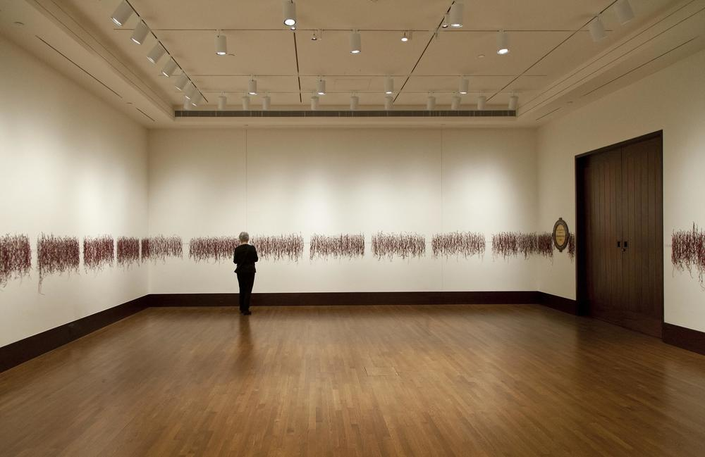
Figure 3.20
Luzene Hill, Retracing the Trace (performance detail), 2012.
Mixed media, dimensions variable.
Collection of the Eiteljorg Museum of American Indians and Western Art.

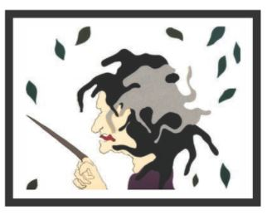
Figure 3.21
Luzene Hill, Spearfinger, 2007.
Cut paper illustration with ink, dimensions unknown.

4. CREATING BALANCE: BRENDA MALLORY

In this chapter, I return to the core questions of my dissertation: How does the reality of living in diaspora shape the art of ᏣᎳᎩ artists? What role does that art play in maintaining those artists’ cultural identity? Is there a way to discuss these artists and their art that does not default to dominant culture art historical methodologies but instead prioritizes a ᏣᎳᎩ worldview? While these questions are specific to ᏣᎳᎩ artist, they are also at the heart of the issues of authenticity that revolve around all Native art. But ideas of strict adherence to media or form are not inherently Native concepts. For as long as art has been made, embracing new materials, expanding aesthetics, and building off prior forms have been a part of the process of creating. Cherokee Nation citizen Brenda Mallory’s art does not embed the ᏣᎳᎩ syllabary within her canvases or include cultural identifiers, ᏣᎳᎩ or otherwise. Instead, her works are methodical, often scientific in nature. Mallory relies on repetition, natural and found material, as well as paradox in her work. The process of creation becomes an integral part of the finished art work, though unseen by the viewer. And the result are easily identifiable as the artist’s work. Her visual voice is strong in the same way a piece of ᏣᎳᎩ pottery or basketry is recognizable to the informed viewer. But while a pot or basket may be easily identifiable as created by a ᏣᎳᎩ person even without knowing the maker, this is not typically true for artists like Mallory. Whether or not a work is familiar as culturally connected does not make the artist any less so, however that connection may occur. This contradiction to what might be expected from a ᏣᎳᎩ artist is common for ᏣᎳᎩ artists living in diaspora and it is from that fact that I argue that artists like Mallory use their art as a way to create their own ᏚᏳᎦᏛ and reconnect to community. She embraces this ᏣᎳᎩ worldview, sometimes unconsciously, and expresses it in ways that are at the very essence of what many diasporic Cherokees are trying to grasp, a metaphorical return home and a declaration of their cultural identity. Her art is her source for ᏚᏳᎦᏛ from which she is able to connect with her Cherokee community despite the distance. For Mallory, who lives thousands of miles from both ᏣᎳᎩ ancestral and political homelands where cultural knowledge is based, there is a desire to expand that understanding of ᏣᎳᎩ art. This expansion of including artists like Mallory in discussions of ᏣᎳᎩ art is important because through that acceptance, a counter is created that directly responds to a history of erasure through displacement and assimilation. Viewing the art of Mallory through a ᏚᏳᎦᏛ centers her work in a way that allows for her to rightfully claim her reality as a ᏣᎳᎩ artist.
Mallory was born in 1955 in northeastern Oklahoma. Unlike many other ᏣᎳᎩ citizens that fall within the definition of diaspora, Mallory spent her formative years in Rogers County, about an hour from the Cherokee Nation headquarters in Tahlequah and within the Nation’s district boundaries. She grew up in a family that was openly ᏣᎳᎩ but, like many others, emotionally separated from their identity. While her paternal family participated in tribal enrollment, they did not practice ᏣᎳᎩ culture. Mallory acknowledges that her family fully embraced and found safety in assimilation and despite acknowledging ᏣᎳᎩ citizenship, the general feeling was that the cultural connection was historic. As Chickasaw Nation and Choctaw scholar and curator heather ahtone notes in an overview of Mallory’s biography, “[Federal] assimilationist policies have created a cultural infertility in her family that Mallory internally struggles to reconcile.” Mallory’s story of disconnect is not uncommon and even reflects my maternal family’s biography. Mallory reflects, “There was a part of me that just felt I couldn't make that claim, [even growing up in Claremore, Oklahoma] . . . , I felt almost like I couldn't claim it . . . now I see how foolish that was and also how, again, what deliberate set of procedures went in to make me feel that way.” While it may seem obvious to outsiders that being born and raised in Oklahoma allowed Mallory and others immediate access to ᏣᎳᎩ culture, many of our ancestors simply wanted to survive and that often meant embracing a life outside of community obligations and expectations. In doing so, a rupture counter to ᏚᏳᎦᏛ occurs between being and recognizing oneself as Native.
Eventually, Mallory left Oklahoma and built a life in the West, first living in Los Angeles for twelve years. Here, she obtained her bachelor of arts in linguistics and English from the
University of California, Los Angeles. In reflecting on her choice to study the foundational and creative properties of language, Mallory states,
I was interested in how structures work and what our systems are and [what is] in place that make [them] function. And that's why I think linguistics is this wonderful thing to figure out; that something is a system, there are rules that work. Maybe you don't know the rules, you don't understand the rules, you have to discover them, but there are [systems] in place that make things go the way they go and I love that.

While studies in linguistics and art may appear to be at odds with each other especially for an artist who produces work devoid of visual representations of words, Mallory’s fascination with the study of language – its structures, nuances, rules, and systems – plays an integral role in her art production.
After Los Angeles, Mallory moved to Portland, Oregon. While she had always been creative and found outlets in art making – mainly sewing– she realized that her “interest in how structures work” extended to art and led her to pursue a formal art education. Mallory obtained a bachelor of fine arts in general studies from the Pacific Northwest College of Art, where she was able to study both practical art skills as well as art history. As is true with many Native artists who attend mainstream educational institutions that rely on Euro-centric art history, she states, “I do regret that I really did not get any Native studies in my education of art history.” But being the lifelong learner that she is, Mallory chose to do her own research and, combined with the art history she learned in the classroom, she created the foundation from which her work continues to gain inspiration.
Even with all of the generational baggage that comes from assimilation and displacement, Mallory is a proud Cherokee Nation citizen and is active in her Cherokee at-large community, which is offered by the Cherokee Nation in areas with large groups of diasporic Cherokee citizens. She states, “We are [called] the Mount Hood Cherokees and I'm the treasurer. I feel really good [about my involvement with them] because I've motivated my family . . . my sister and my niece and especially my daughter, to understand more about our Cherokee history.” But her embracement of herself as a ᏣᎳᎩ artist has come over time; and with that, a re-centering of her identity as central to her art creation. Mallory finds a way to balance this contradiction and her identity outside of the ᏣᎳᎩ homeland through art and in doing so, she also expands the very meaning of ᏣᎳᎩ art.
In considering the work of Mallory and how it relates to her lived experience as a ᏣᎳᎩ woman in diaspora, the work of historian James Clifford in his book, Returns, seems to have a place in this discussion. In Clifford’s text, he explores the reality of contemporary Indigenous peoples in the twenty-first century and how disruptions in culture through various forms – migration, assimilation, etc.— creates new instances of cultural resilience. His concept of “Indigenous articulations” is directly tied to issues of diaspora. In Clifford’s defining of articulation, he notes how cultural forms are continuously made, unmade, and remade. Clifford also discusses how Native peoples are devising new ways to be Indigenous and that this is done as a way to counter the inherent contradictions of an Indigenous and diasporic life. He states that, “Diasporic ruptures and connections – lost homelands, partial returns, relational identities, and world-spanning networks – are fundamental components of [Indigneous] experience today.” It is through this concept of survival and renewal, as well as the desire for ᏚᏳᎦᏛ, that I will examine the work of Mallory.
ᏚᏳᎦᏛ through the Four Directions
In the Cherokee Nation produced book, ᎥᎪᏢᏍᎬ ᏌᏇ ᎠᏥᎸ Building One Fire: Art + World View in Cherokee Life, Cherokee citizen Benny Smith discusses how the concept of the Four Directions of the Keetowah Society informs the ᏣᎳᎩ understanding of humankind, and in doing so, helps us understand ourselves. He states, “Native people in today’s modern age have been forced by the dominant society to accept practices that are foreign to their [I]ndigenous culture. All people living in the modern age seem to be disconnected. We feel alone, isolated and separated.” Smith is arguing for an understanding of self in order to counter that disconnect through the four point circle. He believes that every human can be understood this way and that we experience balance through this worldview. These four points, or directions, can expand to hold many truths:
North, South, East, West
Air, Water, Fire, Earth
Wholeness, Growth, Nourishment, Protection
Mental, Physical, Emotional, Spiritual
Blue, Yellow, Black, Brown
Human, Plant, Animal, Mineral
Humility, Gentleness, Courtesy, Caring
Knowing, Doing, Having, Being
Belief, Trust, Hope, Courage
Intellect, Wisdom, Compassion, Guardianship
Responsibility, Harmonious, Curious, Spontaneous
Spring, Winter, Summer, Fall
Inception, Gestation, Emergence, Existence

It is within these truths or principles – particularly Knowing, Doing, Having, Being – that I place the work of Mallory and her creation of ᏚᏳᎦᏛ through art. Her practice ranges from individual wall hangings and sculptures to large-scale, immersive installations. She works with mixed media, using natural and found materials to create multiple forms that are joined with crude hardware or mechanical devices to imply tenuous connections and aberration. In more recent years, she has incorporated materials such as paper and glass to expand on her art production, embracing artist residencies that give her access to new methods to address her overall artistic thesis of materiality and a continued fascination with the world around her. She is interested in ideas of interference and disruptions in systems of nature and human cultures. Mallory’s tactile and geometric work is an extension of herself, unspoken but strongly present, and the world around her. Often made up of multiple pieces able to exist on their own, much of her work is multi-surfaced and immersive. Biological forms resembling spores, pods, and plant-like stalks are rendered through the marriage of harsh industrial metal objects and silky soft looking skins or fibers. The work Mallory creates is much like the environment that we live in, both beautiful and dangerous. It is also like life and history, full of pain and joy. Her work is a representation of her self-realizations and personal history bared to the world. It reflects a diversity of identity by grappling with the hard parts and forging them together with the soft. As Chadwick Corntassel Smith, then Principal Chief of the Cherokee Nation stated in the opening message of ᎥᎪᏢᏍᎬ ᏌᏇ ᎠᏥᎸ Building One Fire: Art + World View in Cherokee Life, “It is believed that the designed purpose for the Cherokee Nation is to be a people who are happy and healthy, who are in touch with the essence of their culture and its values and attributes. Art is an effective way to pass on and enjoy culture[.]” Through the principals of knowing, doing, having, and being, I argue Mallory creates ᏚᏳᎦᏛ in her art and is able to accomplish that prescribed goal of happiness and health as stated by Principal Chief Smith.
Knowing
Concepts of knowing are the first of the four principles that set the foundation for Mallory’s search for ᏚᏳᎦᏛ through her art. In thinking about the idea of knowing, it is easy to make a connection to the study of science. This interest in knowing, of scientific exploration, is woven through many aspects of Mallory’s work. She states, “Biology is this whole wonderful system that I completely love.” The titles and content of some of her works reveal a fascination in scientific discovery and examinations. Two examples of this are in the installation works Biophilia, 2005, and Slipping in to Order: A Glitch in the Philum, 2007.
Biophilia is a large-scale installation that contains individual elements to form a multilayered experience. The title references a term coined by American biologist Edward Osborne (E. O.) Wilson (born 1929) in his book¸ Biophilia, 1984. The biophilia hypothesis proposes that as humans, we are naturally inclined to seek out connection with other forms of life and nature. While the installation takes its name from Wilson’s book, the work itself is inspired by a biology textbook chapter, “Themes in the Study of Life.” Mallory notes in her artist statement for the work that while the text was largely educational and scientific, there was also a more philosophical tone to some of the writings. These included “diversity and unity are the dual faces of life on earth” and “organisms are open systems that interact continuously with their environment.” It is from these philosophical statements that Biophilia takes the names for each of the individual components: Emergent Properties, Goods and Services, Interaction, Cradle, and Structural Levels. The components come in a variety of forms.
Emergent Properties is a wall hanging sculpture that literally emerges from its plane. A honeycomb base made of steel contains cylinder like shapes, wire covered with waxed cloth that push away and towards the wall in varying lengths and colors. (fig. 4.1) Goods and Services moves away from the wall and is comprised of four rectangular carts with a gridded top of steel rods. (fig. 4.2) Stacked and stuffed in between the rods are cone like structures, a separate color for each. The colors are red, white, black, and yellow. These colors, which will continue to be present in other works by Mallory, correspond to the concept of the four directions or medicine wheel which is found in many Indigenous communities in North America, including the ᏣᎳᎩ, though our colors slightly vary.
The smaller components in Biophilia are Interactions and Cradle. Interactions is made of shaped waxed cloth which are dyed a pinkish red and hinged together to create a shell-like structure. The small objects are then displayed scattered on a shelf which is attach to the wall. (fig. 4.3) Cradle also hangs from the wall, though the structure of steel is shaped to resemble a cradleboard, with gingko leaf shaped waxed cloth adhered to the front. (fig. 4.4) While both works make use of unyielding steel, the delicate nature of the waxed cloth shapes add a certain delicateness to the works.
The final part of the installation is another large wall hanging titled, Structural Levels. (fig. 4.5) Where the structure of Emergent Properties seemed to be on a horizontal, Structural Levels climbs up the wall. Welded branches appear to have short barbs and are overlaid with groups of circular waxed cloth, connected by bolts. The entire form speaks to a vegetation like vine, growing up the wall. Once again, a variety of colors are employed by Mallory to create a striking organic installation that is created out of both the softness of wax and the harsh properties of steel.
Created two years following Biophilia, Slipping in to Order: A Glitch in the Philum is another work by Mallory that takes inspiration from science to create an immersive installation experience. While Biophilia had a feeling of rigid structure, Slipping in to Order moves more into chaos. The individual components are no longer separately named but instead all a part of the larger presentation. Mallory notes that the work is an homage to Swedish biologist Carolus Linnaeus (1707-1778) who is credited with creating the modern system of biological organization and nomenclature. With this work, Mallory’s fascination with language mold with science in the form of a staged scene of a biology classifiers workshop. (fig. 4.6) Organic looking forms are created out of waxed cloth and intermixed with found objects that are both manmade and natural. (fig. 4.7) Furniture in the forms of tables, a chair, a ladder, and a lamp create the workshop like feel while a microscope and scientific drawings add to the scientific nature of the space. The overall effect is an installation that speaks to the biological world that may appear seemingly chaotic but finds organization through the methods of scientist like Linnaeus’s system of naming.
While Biophilia and Slipping Into Order: A Glitch in the Phylum are some of Mallory’s earliest formal works and speak primarily to her interest in science, they also begin the reveal other components that are prevalent in later creations. Structure, binary, and identity are present but it is through her continued art practice that they move to the forefront and it is through these focuses that her understanding of self as a Native artist and a ᏣᎳᎩ woman wanting to create ᏚᏳᎦᏛ grow.
Doing
The act of doing is an important, though unseen to the viewer, factor of the work of Mallory. And in examining her process, her desire for order and structure emerge in the final product. Mallory’s emphasis on progression and appreciation for structure are found in her focus on process and organized aesthetics. This is especially prevalent in her wall hanging sculptures and works on paper. In this desire for order, a connection to ᏚᏳᎦᏛ can be made as it is also dependent on harmony and balance.
The materials that Mallory use in the process of creating her structured forms are not accidental and have a very practical origin. Before Mallory was an artist, she was a business woman. In 1993, she conceived the idea to create a reusable menstrual pad for women after being inspired by her daughter’s washable cloths diapers. The inspiration formed the company, GladRags, which Mallory ran until she sold it in 2011. Mallory created her product using a soft cotton flannel. When Mallory began her artistic practice, the material that formed her GladRags followed and became the foundation for her sculptures. There was a practicality to it, she had a large amount of leftover fabric laying around her home. She reflects, “I have worked with materials that have either been found or reclaimed and I feel really proud that that's a part of my practice. I don't force myself to use only everything that's recycled, but it does feel important to me to salvage and make do with things that are around.” She also found a flexibility in the material, which could be dipped in beeswax and shaped similar to clay. She states, “These found items I work with sometimes I let their material properties, the baggage that comes along with materials inform the work.” Waxed cotton flannel is an integral component of many of her Mallory’s works and the manipulation the material under goes in order to create its final forms is an important aspect of Mallory’s creation.
Reformed Orders is made of waxed cloth, felt, nuts, and bolts. (fig. 8) The natural color of the wax paints the cloth in a soft yellowish hue while the stark blackness of the bolts create an obvious contrast. There is an order to the work: the rectangular strips of waxed cloth are arranged in a short, long, short, etc. pattern. The result is a large-scale wall sculpture that reads left to right and then back again. The process for creating the work involves dipping strips of cloth into wax which then harden to create a stronger form that can withstand the brutality of being bound by metal.
In Low Tide (Dark), 2007, Mallory further manipulates her material by coaxing the flat waxed cloth into boat-like shapes. (fig. 4.8) These shapes mimic leaves or the female form but are then forged together through bolts and suspended onto the wall on a welded steel structure. The organic nature of the materials – cotton and wax – are countered by the harsh metals. Mallory must shape each form by hand and then create the ordered structure individually. The fastening of bolts to the waxed cloth adds a dimension of weight that is then countered by the supporting structure. The changing properties of the work influence Mallory just as much as the materials she uses and the end result is bound in its final presentation as well as its creation.
Over time, Mallory has expanded her practice beyond waxed cotton flannel but she uses new materials in a way that invokes the same properties of the original. Rifts takes the patterns of Reformed Orders and transfers them to paper. (fig. 4.9) The paper is printed with undulating lines of black, sometimes broken up by larger planes of ink. These rows are then separated by sewn lines that are further sealed with encaustic paint to create a stable border. (fig. 4.10) The delicate paper is reinforced by the hand of the artist, seemingly made stronger through the remaking.
The previously mentioned Indigenous articulation theory of Clifford seems to speak especially to Mallory and her art practice. In thinking of the process of making, unmaking, and remaking, Mallory does that when she deconstructs materials and remakes them into new forms. Her work is a study in not just the end result but the process of creation. Her use of found materials and reuse of manmade objects can be a physical manifestation of Clifford’s theory. Her reality as a Cherokee Nation citizen living in Portland creating work that demonstrates considerations beyond cultural aesthetics invokes the fundamental aspects of a contemporary Indigenous experience.
Having
When considering the concept of having in relation to the work of Mallory, I argue that the process of taking oppositional objects and creating harmony between them is an expression of ᏚᏳᎦᏛ. The idea of materiality within Mallory’s art includes the experience of those materials, especially the ways they are used and interact as well as their inherent and manipulated properties. She notes, “I work with wax cloth and a lot of hardware [such as] nuts and bolts and hog rings and things that are very rudimentary type connections, crude. . . I think of them, the way I put these forms, and I make together [something] like a form of sewing.” For Mallory, there is an interest in the properties of materials and a combining into singular objects that merge the soft and hard or the natural and manufactured. Reformed Spools #2, 2015, Firehose Experiment #5, 2015, and Zen Scrubber #1, 2015, demonstrate Mallory’s preference to combine and reform materials that are seemingly at odds and to emphasize the properties of the material. All of these works are part of a series titled, Reclaimed and Reformed.
Reformed Spools takes a normal object, a spool of thread, and deconstructs it to reveal the inherent contradiction of soft and hard. (fig.4.11) Mallory cuts through the thread to reveal the hard paper spools on which the soft material is wound. The result is a work that reads like soft wool, stapled together with harsh black rings. The natural color variations of the thread allows for the individual spools to be obvious, creating a dynamic grid. Like many of Mallory’s work, this piece elicits a strong need to touch, though the work may not be as soft as it initially appears.
As opposed to the enigma of Reformed Spools, Firehose Experiment #5 is more obvious in its material’s origins. Mallory has cut strips of linen firehose and then connected them with hog rings at the end to create a crescent shaped work that is displayed bending away from the wall. (fig. 4.12) The frayed ends of the firehose reveal red and blue within, breaking up the monotone off white color of the linen. The strength of the woven hose bound by metal hog rings are countered by the soft ends of exposed thread. While the firehose has been made worthless by its deconstruction, the use of hog rings, a common tool for repairing objects like fencing and barbed wire, speaks to a resurrection in use. Mallory both allows the work to exist as it is and manipulates it into her chosen form.
Out of the body of work by Mallory explored in this chapter, Zen Scrubber #1 would appear to be the most Native-inspired of them all. At a quick glance, one could mistakenly identify it as a contemporaneous recreation of a shield with long leather fringe, or even more nefariously, a scalped lock of hair. (fig. 4.13) But while Mallory has noted that her interest in deep abstraction may sometimes result in works appearing like certain objects, that is typically not her goal. She is instead interested in creating from the materials around her, manipulating properties in a way that elevates the ordinary to a work of art and also creates ᏚᏳᎦᏛ for the artist.
Being
The final focus of Mallory’s art production is squarely situated in identity, both her own and the larger concept of Native identity within a settler state such as the contemporary United States. This idea of identity can be attributed to the final ᏣᎳᎩ foundational concept of being. I believe that identity as it relates to indigeneity is inherent. One’s understanding of themselves as Native is a part of who they are as a person, despite their location in relationship to their community. This aspect of Mallory’s work is at the forefront of works such as one of her earliest works, Colonization, 2003, and the more recent large-scale and ever evolving Recurring Chapters in the Book of Inevitable Outcomes, 2015-2018.
Colonization features many other aspects of Mallory’s work. The wall hanging sculpture features off-white pods made of waxed cloth that are naturally dyed by the beeswax and fastened together with nuts and bolts. (fig. 4.14) The work looks to science in the artist’s explanation of one aspect of the title. As stated earlier, assimilation policies have resulted in a “cultural infertility” that Mallory continually tries to reconcile within herself and her work. In thinking more broadly on other ways this occurs in contemporary life, she relates it to the process of agrochemical companies that create genetic use restriction technology (GURT), otherwise known as terminator technology or suicide seeds. What this technology is meant to do is essentially strip a seed of its genetic makeup, thus removing its identity and ability to reproduce. This annihilation of adaptive survival through manipulation of the natural life cycle has obvious connections to the assimilation policies practiced by the United States government, which also sought to eradicate the Indigenous population by outlawing the very cultural knowledge that forms the basis of our understanding as Native. By preventing one generation from obtaining that knowledge, it made it impossible for the next generation to acquire it and learn and a total disruption of ᏚᏳᎦᏛ.
Despite the efforts of the government and companies like Monsanto, assimilation policies were ultimately a failure and nature always finds a way. Colonization can be viewed as a representation of these facts. The waxed cloth shaped into open vessels, when taken as separate pieces, have been weakened by the holes punched through their surfaces. But this weakness is countered by the addition of bolts, which fill the holes and combine the individual pieces into a new structure. This new structure is a symbol of a culture of survival, reformed and made stronger through our continued existence, of which Mallory is an important representation.
Another work of Mallory’s that deals with the realities of historical oppression and contemporary survival is Recurring Chapters in the Book of Inevitable Outcomes. While Colonization came early in Mallory’s career and was more nuanced in its context, Recurring Chapters in the Book of Inevitable Outcomes demonstrates the Mallory’s growth and evolution, both as an artist and as a ᏣᎳᎩ woman. The work came at an important moment in her career. It was not until 2015 that Mallory had her work presented as part of an exhibition dedicated to Native artists, Conversations: Eiteljorg Contemporary Art Fellowship 2015. Prior to this, she had largely shown in the Pacific Northwest in contemporary galleries with no ties to Native art. She has stated, “I often feel like I’m not put in many Native shows, and I think it’s because my work is so far outside any iconography or imagery that anybody can quickly identify [as Native] so it’s just too hard to put it in a way that’s easily quickly accessible by an audience.”
Exhibitions like Conversations, which was a part of the Eiteljorg Museum Contemporary Art Fellowship program, are designed to recognize Native artists regardless of their medium or influence. The work presented are not meant to be a reflection of the concepts of authenticity but instead of the contemporary Native experience, whatever that might be for the artist. What Mallory’s inclusion in this show – and recognition as a Fellow joining the ranks of artists such as Jaune Quick-to-See Smith, Kay WalkingStick, and Jeffrey Gibson – accomplished was a point of acceptance by the Native art community. And this acceptance is of huge importance to a Native artist living away from her community. Through her art she was able to feel more secure her reality as a ᏣᎳᎩ woman.
Within Recurring Chapters in the Book of Inevitable Outcomes are the materials Mallory consistently uses: waxed cloth, wire, and steel. But in this works installation, there is a life that seems to emerge from the structures. (fig. 4.15) Rather than being confined to a wall, the installation literally leaps off and floats around in a dizzy display of color and texture. Mallory has created a landscape for the viewer that is foreign but inviting. The urge to touch is tempered by the harsh edges of the metal holding everything together. The burst of colors and spore-like forms refer to future life while the dark, ruin like towering stalks invoke loss, history, and the past. Mallory’s installation reflects her own grappling with identity, by taking the hard aspects and forging them together with the soft. The mysteriousness of the installation, itself with an enigmatic title, allows for viewers to manifest their own interpretation simultaneously with Mallory’s intent. The final product is a beautiful symphony of life, self, and the world; a physical manifestation of ᏚᏳᎦᏛ.
In discussing her practice and materials, Mallory recognizes that what may appear at first glance to be devoid of cultural signifiers is actually heavily influenced by her reality of being born into a ᏣᎳᎩ family in Oklahoma. In talking about her work she notes,
I would say a lot of my visual textures and materials and methods truly are Oklahoma-based. Like the span of a textured piece I might make that's nothing but one shape put together with one kind of nuts and bolt that's like looking at a blowing wheat field. . . My my grandfather had those boxes of rattlesnake rattles that he used to keep in his fiddle to for little extra percussive sound and I used to draw that and I never realized, for a long time that's what I was drawing, but it was this same little shape evolving, getting smaller and smaller or larger and larger, so all that really influenced my visual language.

Despite living in the Pacific Northwest for three decades, Mallory still considers Oklahoma to be the strongest environment that influences her work.
There are also inherently Indigenous aspects that become obvious when you view her entire body of work as a whole. I have already discussed the most obvious aspect that is found in the colors that are prevalent throughout and red, white, black, and yellow consistently occur in Mallory’s work. Those four colors directly correspond with the medicine wheel or association with the four directions. When asked if she intentionally means to use these colors, Mallory notes, “For the longest time, the color I worked with was this natural beeswax color which basically resulted from the materials I was using . . . . .And the other colors that I have worked with . . . just emerged from what the materials are. . . I’m not a colorist, I never studied art theory in school.” For Mallory, the colors and their association with Indigenous directions is accidental, a result of the natural properties of her materials. But in this happenstance, an unconscious link to indigeneity occurs.
Conclusion
At the heart of Mallory’s practice is a desire to obtain ᏚᏳᎦᏛ and reclaim her connections to her ᏣᎳᎩ community. She notes, “We Oklahoma Cherokee have learned to love this thing that was forced upon us and that's weird . . . though it's just a natural survival technique, both mentally and physically . . . [even] when it's forced on us.” It is through her art that Mallory has found her voice as a ᏣᎳᎩ woman. While her work may not always read as culturally derived, her continued desire to be recognized as a ᏣᎳᎩ artist is always present. And the fact that so much of her work is based in balance –soft and hard, dark and light, natural and manufactured – reinforces her creation of ᏚᏳᎦᏛ. Through that reality, Mallory is able to rightfully claim her work as Native. Much in the way her work has been made, unmade, and remade, so has Mallory’s understanding of herself as a ᏣᎳᎩ woman.
FIGURES

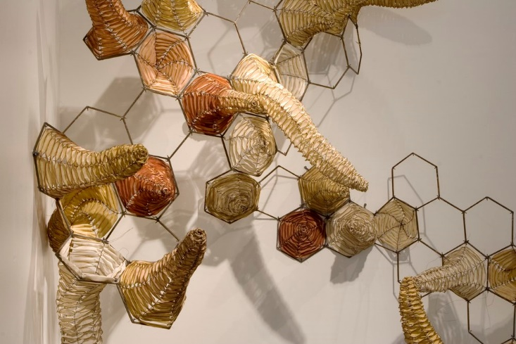
Figure 4.1
Brenda Mallory, Biophilia: Emergent Properties (detail), 2005.
Waxed cloth, steel, wire. 120 x 144 x 36 inches.

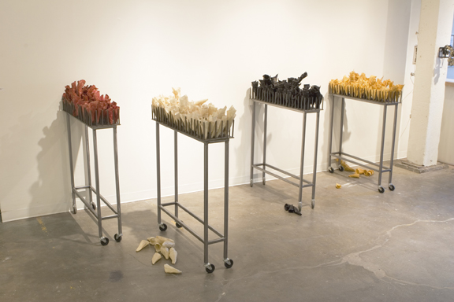
Figure 4.2
Brenda Mallory, Biophilia: Goods and Services, 2005.
Waxed cloth, welded steel. 40 x 10 x 38 inches (each).

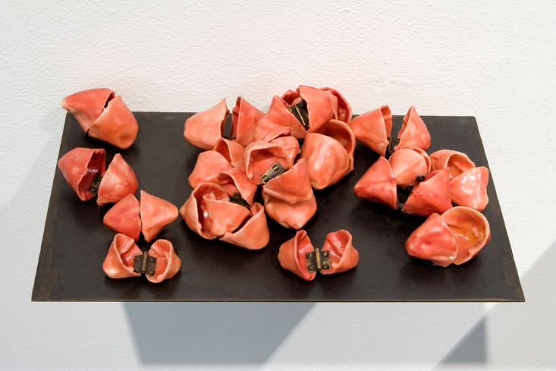
Figure 4.3
Brenda Mallory, Biophilia: Interaction, 2005.
Waxed cloth, hinges, steel shelf, 12 x 16 x 4 inches.

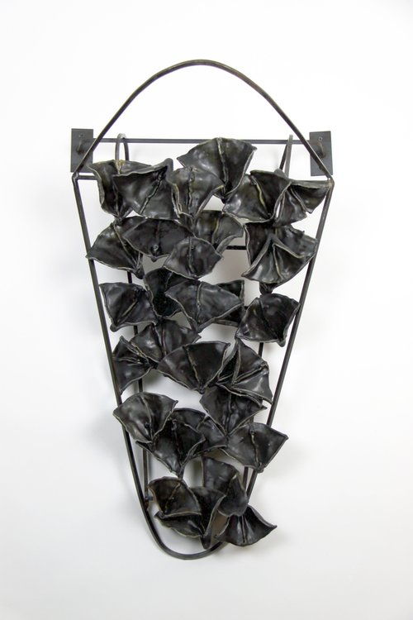
Figure 4.4
Brenda Mallory, Biophilia: Cradle, 2005.
Waxed cloth and welded steel, 32 x 18 x 12 inches.

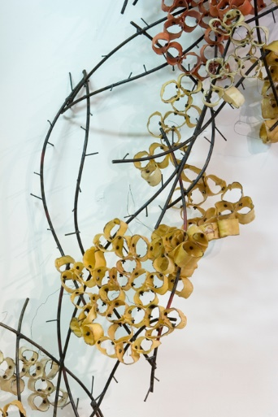
Figure 4.5
Brenda Mallory, Biophilia: Structural Levels (detail), 2005.
Waxed cloth, welded steel, bolts, unknown dimensions.

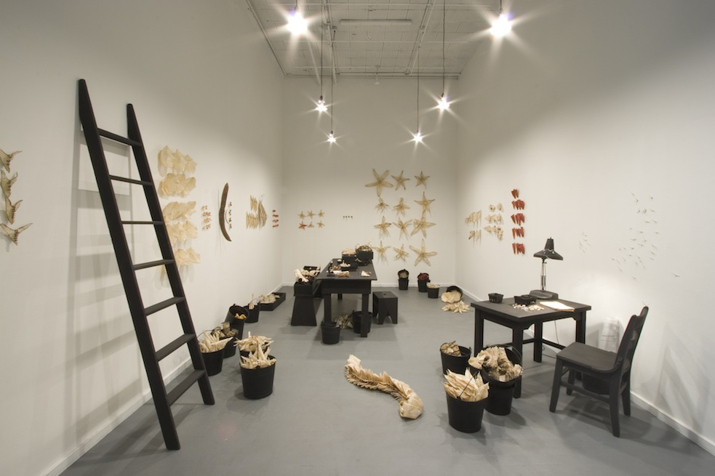
Figure 4.6
Brenda Mallory, Slipping Into Order: A Glitch in the Phylum, 2007.
Mixed media, dimension variable.

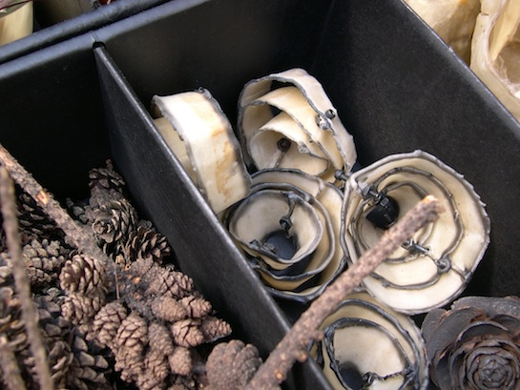
Figure 4.7
Brenda Mallory, Slipping Into Order: A Glitch in the Phylum (detail), 2007.
Mixed media, dimensions variable.

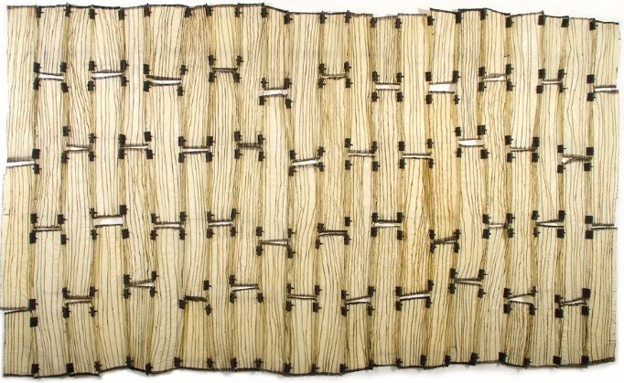
Figure 4.8
Brenda Mallory, Reformed Order, 2013.
Waxed cloth, felt, nuts, bolts, 72 x 120 x 3 inches.

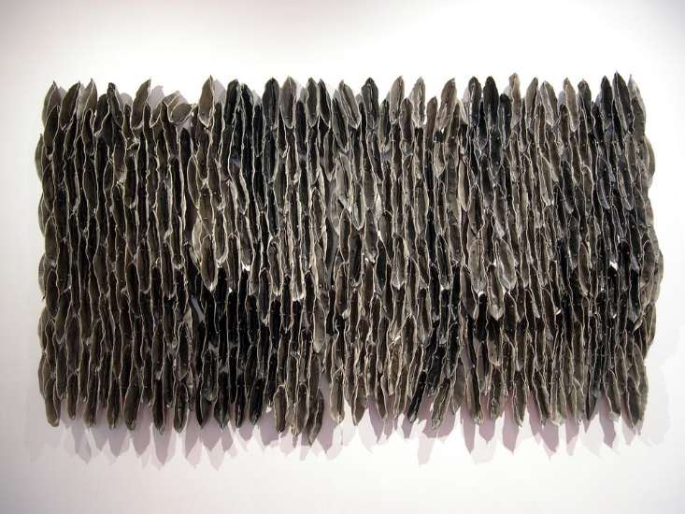
Figure 4.9
Brenda Mallory, Low Tide (Dark), 2007.
Waxed cloth, nuts, bolts, welded steel, 51 x 90 x 7 inches.

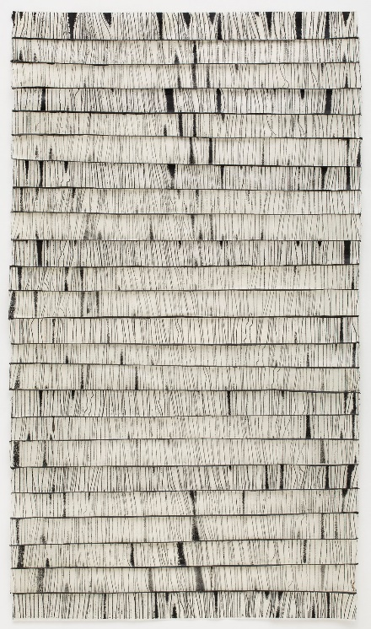
Figure 4.10
Brenda Mallory, Rifts, 2014.
Collagraph print on rice paper, thread, encaustic paint, 45 ½ x 26 x 1 inches.

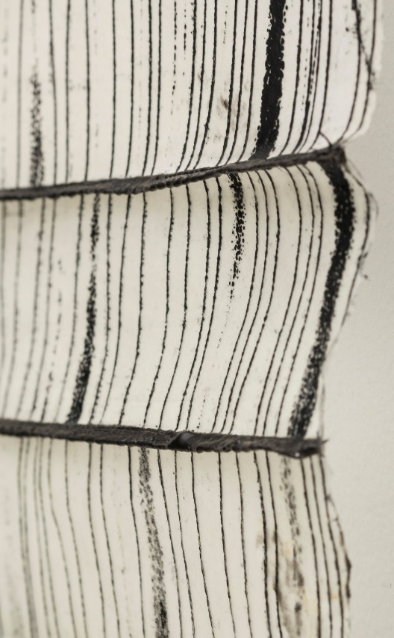
Figure 4.11
Brenda Mallory, Rifts (detail), 2014.
Collagraph print on rice paper, thread, encaustic paint, 45 ½ x 26 x 1 inches.

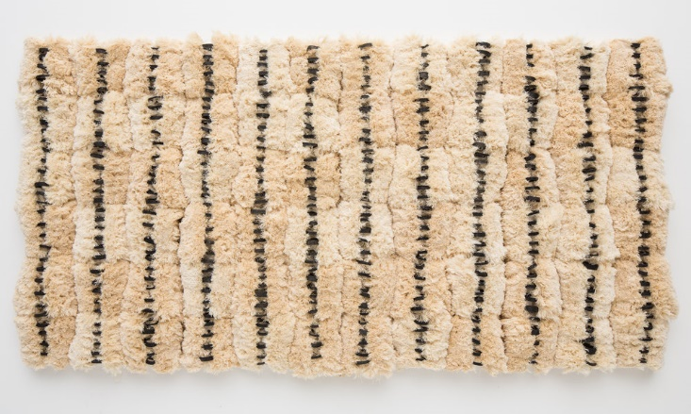
Figure 4.12
Brenda Mallory, Reformed Spools #2, 2015.
Deconstructed thread spools on panel, 42 x 80 x 4 inches.

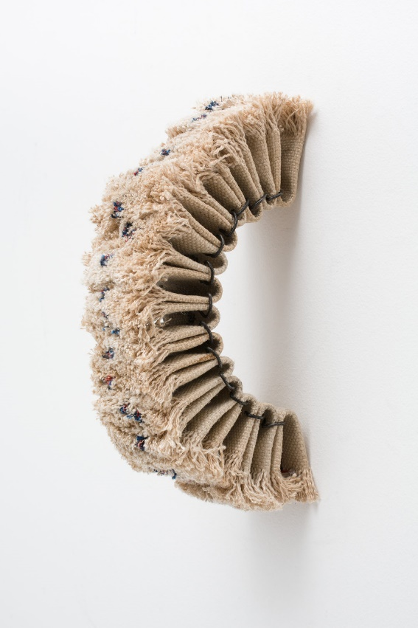
Figure 4.13
Brenda Mallory, Firehose Experiment #5, 2015.
Deconstructed linen firehose, hog rings, 10 x 3 x 6 ½ inches.
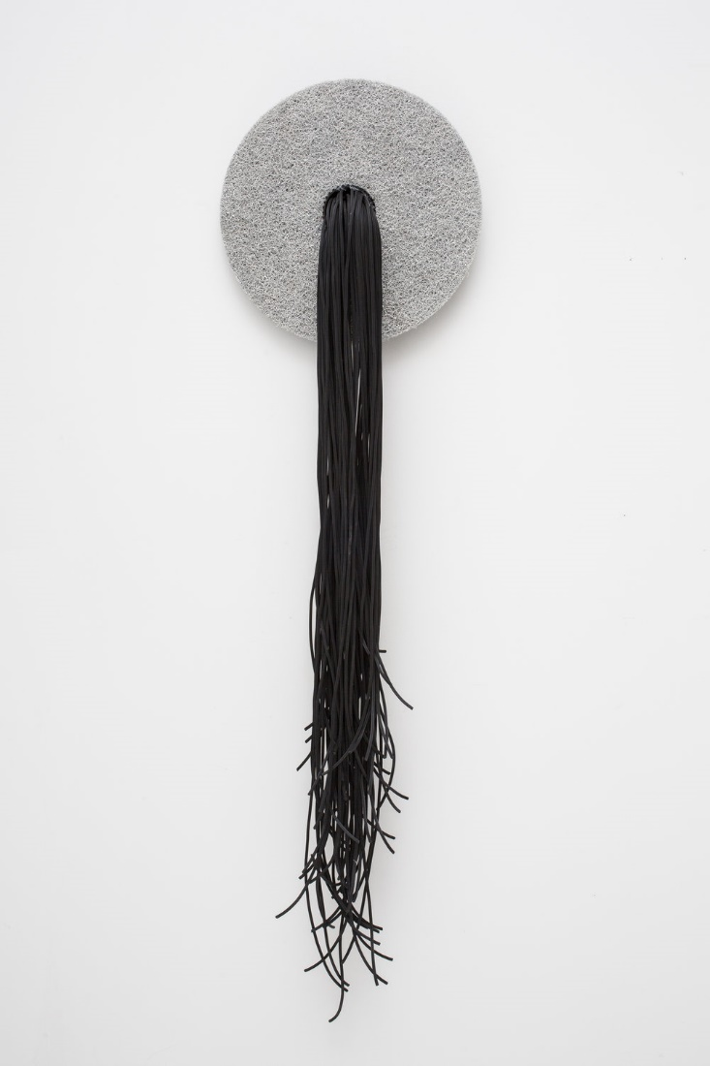
Figure 4.14
Brenda Mallory, Zen Scrubber #1, 2015.
Nylon industrial scrubber pad, rubber drive belt, plastic cable, 60 x 18 x 6 inches.

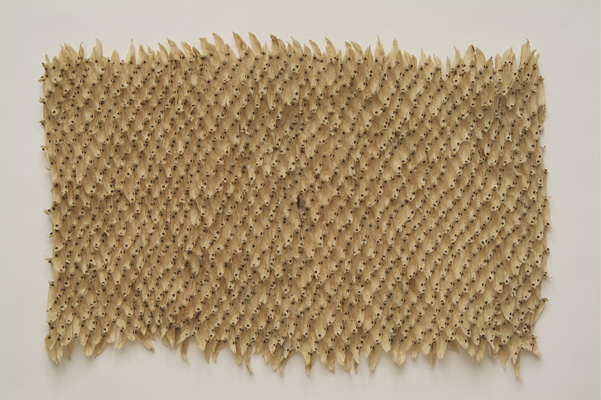
Figure 4.15
Brenda Mallory, Colonization, 2003.
Waxed cloth, nuts, bolts, 43 x 67 x 2 ½ inches.

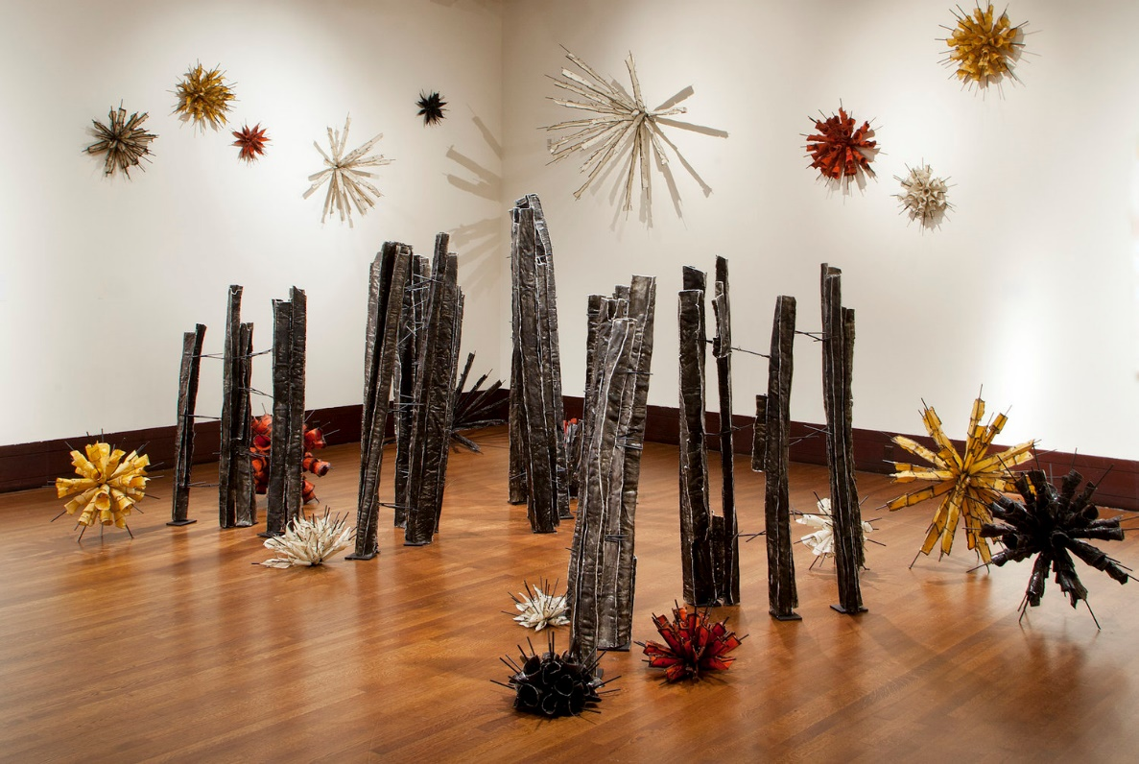
Figure 4.16
Brenda Mallory, Recurring Chapters in the Book of Inevitable Outcomes, 2015-2018.
Waxed cloth and steel, dimensions variable.

5. FAR FROM HOME: KADE TWIST

For the ᏣᎳᎩ, art is more than a physical production of beauty and goes beyond aesthetics and concepts of artistic genius. ᏣᎳᎩ art tells a story of where we have been, where we are, and where we are going; often times simultaneously. Just like time can be viewed as cyclical rather than linear, so too can art production exist in a continuous harmony. While art history and other disciplines, such as ethnography and anthropology, have supported strict parameters when discussing art that is culturally specific, I argue that ᏣᎳᎩ art is much more flexible and responsive to the environment within which it is made. ᏣᎳᎩ art is a vessel in which ᏣᎳᎩ people find our ever changing cultural knowledge and epitomize our location in this world. Art is a source for ensuring ᏚᏳᎦᏛ, a life on the right path, lived in balance with both the communities of our ancestors as well as our own contemporary realities. Our art has always been a tangible response to the environment where it is made and a way to make sense of the world around us. Due to this designation, understanding the impact that migration, whether forced or voluntary, manifests and impacts the art of a contemporary ᏣᎳᎩ artist is an important discussion.
In this chapter, I examine the work of Kade L. Twist (Cherokee Nation, born 1971), an interdisciplinary ᏣᎳᎩ artist that has lived in diaspora his whole life. The work of Twist spans multiple media – video, sound, interactive, text, and installation – and sources inspiration from the place and community in which it is created. A consistent theme within his art production revolves around migration, displacement, and the experience of a contemporary ᏣᎳᎩ in search of ways to create ᏚᏳᎦᏛ through art in order to address the imbalance that separation from homeland creates. While the art of Twist does not share the ethnographic qualities of ᏣᎳᎩ art that may be expected in our ancestral or political homeland or by those in the art market, he is producing work that talks to the experience of a contemporary ᏣᎳᎩ man, living in diaspora, yearning for a home that was never technically experienced but exists in his very understanding of self.
In considering the work of Twist and its role as both an expression of culture and a lived global experience, art historian Terry Smith creates an effective analytical lens in addition to the world view of ᏚᏳᎦᏛ which requires balance in our existence in order to live on the right path as ᏣᎳᎩ. In Smith’s text, What is Contemporary Art?, the author grapples with the concept of defining contemporary art alongside the confines of a time-based definition. This distinction has an important relationship to Native art as conversations of historical or traditional vs modern or contemporary are often embedded in interpretation. These Euro-centric derived terms do not allow for the entanglements that happen within the various distinctions. A work of art can be both historically-based and contemporary, for example. Smith proposes the term “contemporaneity” to explain the fundamental qualities of contemporary art. Smith describes three core meanings of the term “contemporary”: the immediate, the contemporaneous, and the contemporal. He argues, “Contemporaneity is the most evident attribute of the current world picture, encompassing its most distinctive qualities, from the interactions between humans and geosphere, through the multeity of cultures and ideascape of global politics to the interiority of individual being.” He believes that three sets of forces contend within contemporaneity: globalization (a result of decolonization), inequality (of people, classes, and races), and immersion in an image economy (one that is instant and all encompassing). In contemporary art, Smith sees three currents: The first is an embrace by artists of neoliberal economics, globalizing capital, and neoconservative politics. The second current is a postcolonial turn, which is art shaped by local, national, anticolonial, independent, anti-globalization values. The third current is a smaller scale, modest response to the immediate and the changing.
Smith is interested in the postcolonial turn of contemporary art, which he describes as “a different kind of contemporary art [that] has appeared from under the horizon.” It should be noted that when discussing Native artists in what is now known as the United States, concepts like postcolonial do not apply since the US is a settler colonial state and incapable of being postcolonial. I do not think this discredits the contribution of Smith and the validity of his argument concerning contemporary ᏣᎳᎩ art, however. For Smith, the deepest impulses of contemporary art are locally specific yet worldly in implications, inclusive yet oppositional and anti-institutional, concrete but also various, mobile, and open-minded.” Smith explores issues of time and place within contemporary art and ties it to ethical action. When considering ethical action, this has direct ties to ᏚᏳᎦᏛ which is inherently focused on the ethics of our existence. Smith also proposes a practical application, a sort of theory for approaching contemporary art, which he describes as having multiple histories. Smith states,
Contemporary Art is a culture that matters—to itself, as its own subculture, to the local culture formation in which it is embedded, to the complex exchanges between proximate cultures, and as a trendsetting force within international high culture. Its globalizing character is essential to it, but it also mobilizes nationalities, and even localisms, in quite specific and complex ways.

Smith believes contemporary art has the capacity to grasp the relationships between time and being. All of these considerations of contemporary art have direct considerations in the art of Twist. Twist is creating work that directly investigates his experience as a ᏣᎳᎩ man living in diaspora while also responding to “our shared experiences within this increasingly challenging contemporary environment” in order to “promote a constructive discourse that challenges the social, political, and economic processes that are destabilizing communities and geographies; and connect Indigenous narratives of cultural self-determination with the broader public sphere.” Within Smith’s definition of contemporary art, the work of Twist is comfortably understood while also allowing room for viewing it through the lens of ᏚᏳᎦᏛ.
To understand the impact that migration has had on Twist, it is necessary to look at his family history. A separation from homeland has deeply affected him and led to a career examining the reality of diaspora and longing for home, as well as a larger focus on the global impact of (settler) colonialism and the economy of art as it relates to Indigenous peoples. The following sections explores the Twist family biography as well as how Twist’s art practice came into being. I argue that Twist’s art is the embodiment of contemporary art as described by Smith while also being an example of ᏚᏳᎦᏛ as a means to reconnect with community.
In the West
Twist was born in Bakersfield, California to a ᏣᎳᎩ father and white mother. The history of migration to what is now known as California is one that incorporates many Native communities, especially those who were relocated to what is now known as Oklahoma. During the 1930s, there was a large exodus by Okies to California as a result of the economic hardships that were being experienced in Oklahoma at that time due to the Dust Bowl and the Great Depression. Many ᏣᎳᎩ also left Oklahoma during the time before and during World War II as an effort to find work and to escape the overt racism in Oklahoma being inflicted by the influx of white settlers. Twist recalls, during a series of interviews he conducted with his grandfather, that the elder Twist recollected the broken state of the Cherokee Nation during the mid-twentieth century and how the nation was unable to protect its own citizens as they were fighting for sovereignty within the settler state. Twist’s grandfather left Oklahoma because it was no longer the homeland he believed it should be, created as a result of forced migration to protect and care for the removed ᏣᎳᎩ.
The elder Twist’s initial experience in California was not without difficulty and he had a hard time finding work as a welder due to racist policies of the day that prevented Native people from joining trade unions. Even once the laws changed due to the Civil Rights Act, Twist’s grandfather still had trouble finding jobs that would accept him until he built up a reputation as a talented worker. It was because he was Native that he had to prove himself above and beyond his white counterparts. But despite the racist reality of California that the ᏣᎳᎩ migrants faced, a sense of community began to form and the Twist family found success in their new home. Twist recalls, “We came from a family that really worked hard and couldn't sit still [but we] felt lost, and the only way to not feel lost was working.” In their own way, the Twist family established ᏚᏳᎦᏛ through professional success and building a life in California and it was through this example that set the stage for Twist’s future art practice.
The Twist family was not the only ones to find ᏚᏳᎦᏛ in Bakersfield, and a small ᏣᎳᎩ community was formed and still remains. The Cherokee Community of Central California is an official At-large ᏣᎳᎩ community based in Bakersfield. This diaspora community was formed around the ᏣᎳᎩ practice of ᎦᏚᎩ (gadugi), working together. Their website states, “We have come together to solve problems of the people living away from our homeland. Many of us were brought by our parents, grandparents, and others to find work and make a new life for their families. With the Nations help, our goal is to educate our people of our heritage, language, and to help our brothers and sisters.” But with all of the hard work the Twist family and other ᏣᎳᎩ have put into creating a new community in California, and ensuring the continuation of culture and establishing ᏚᏳᎦᏛ through ᎦᏚᎩ, the sentiment is still that Bakersfield is not Oklahoma. Even at the end of his life, Twist’s grandfather stated that if he could do it all over again, he would not have left Oklahoma. And it is through this reality that even Twist, who was not born in Oklahoma, still feels a longing to return to that home.
As historian Gregory D. Smithers has noted, historically, movement was not uncommon for ᏣᎳᎩ but it was always understood that [we] would return home. Being away from homeland, whether it be our political or ancestral home, creates imbalance in ᏣᎳᎩ cultural identity. And while many diasporic ᏣᎳᎩ have found ways to counter the effects of displacement, such as through the creation of proxy communities when they are unable to physically return home, it is still not the same. And for artists like Twist, using art as a vehicle to metaphorically return home, or to at least acknowledge a longing for a home lost, allows for a way to re-establish ᏚᏳᎦᏛ.
Yearning for Home
The road to art for Twist took a few turns through tribal policy with an important detour in Oklahoma. Before becoming a professional artist, Twist attended the University of Oklahoma (OU) in Norman, where he received a bachelor of art degree in Native American studies with an emphasis in tribal policy. Prior to his arrival at OU, Twist had spent time in San Francisco and notes how being there “took my brain into a non-Indian direction.” Though Twist had never lived in Oklahoma and had only visited for periods of time in the summer, to him it felt like a return. He was able to spend time with family in the Cherokee Nation and to return to the stomp grounds to dance. Twist was greatly impacted by his time at OU and being in Oklahoma, especially his interactions with other Native students and communities, as well as professors. Twist eventually graduated from OU and for a time lived in Washington DC but he turned to art after a time, as a way to address many of the issues of imbalance he felt as a ᏣᎳᎩ man born and raised in Bakersfield who felt split between California and Oklahoma.
When discussing his earliest work, Twist recounts how his first focus was directly on this imbalance that is created through diaspora. He began working with the idea of disruption and substitutions through the use of prosthetics (fake fires and prosthetic legs). The representation of fire was a statement on Twist’s ideas that our medicine lacks power outside of our community fires and that causes us to not be whole as ᏣᎳᎩ people when we are away from them. He stated that he would use fake fire inserts in his installations as a way to represent this idea.
Expanding on this, in one installation, Twist used a painted prosthetic leg overlaid with sampled ᏣᎳᎩ language tapes to represent his diasporic experience of having one leg in California and one in Oklahoma, something he equates to phantom leg syndrome. He states, “You never get your life back, it’ll never be the same. . . . [it] doesn’t make anyone a hero. I felt shame around [my own family’s migration] and there was a shame towards being Cherokee in California, not back in [in Oklahoma], back home. So I think a lot of that work was sadness and shame and frustration and loss and phantom leg syndrome seemed to be the best metaphor.” Twist used his art as a way to deal with his own feelings of displacement and a yearning for ᏚᏳᎦᏛ, which for him could only happen by returning home.
Ultimately, Twist states, “[I started] going to myth . . . thinking about some of our stories like the hunter and the buzzard which speaks most directly to the diasporic [Cherokee] experience and that idea of leaving home out of scarcities and trying to find new hunting grounds.” The story of the hunter and the buzzard can be found in Myth of the Cherokee by James Mooney. As Mooney retells it,
A hunter had been all day looking for deer in the mountains without success until he was completely tired out and sat down on a log to rest and wonder what he should do, when a buzzard—a bird which always has magic powers—came flying overhead and spoke to him, asking him what was his trouble. When the hunter had told his story the buzzard said there were plenty of deer on the ridges byond if only the hunter were high up in the air where he could see them, and proposed that they exchange forms for a while, when the buzzard would go home to the hunter’s wife while the hunter would go look for deer. The hunter agreed, and the buzzard became a man and went home to the hunter’s wife, who received him as her husband, while the hunter became a buzzard and flew off over the mountain to locate the deer. After staying some time with the woman, who thought always it was her real husband, the buzzard excused himself, saying he must go again to look for game or they would have nothing to eat. He came to the place where he had first met the hunter, and found him already there, still in buzzard form, awaiting him. He asked the hunter what success he had had, and the hunter replied that he had found several deer over the ridge, as the buzzard had said. Then the buzzard restored the hunter to human shape, and became himself a buzzard again and flew away. The hunter went where he had seen the deer and killed several, and from that time he never returned empty-handed from the woods.

In interpreting the story of the hunter and the buzzard, it is clear that it is referencing the sacrifices that are made for survival. The hunter was willing to give up his human form and give his wife to the buzzard in order to find food. While the buzzard became human and lived as such for a time, he eventually wanted to return to his original form. Through their mutual exchange and cooperation, and through movement from their original being and away from the human’s original hunting grounds, both the hunter and buzzard received what they needed though in the end they both returned to themselves. Where Twist equates this story to diaspora and being willing to do what is necessary to survive, I also see it as an example of ᏚᏳᎦᏛ in practice as there was an imbalance that the buzzard witnessed and was able to correct through his actions. As Twist was looking for ways to understand diasporic reality, art became a solution. It should be noted as well, that while possibly the artist’s intent, embedded in this story is also the cultural roles of ᏣᎳᎩ men and women, which are an expression of ᏚᏳᎦᏛ and tied to the responsibilities we have in the home: women take care of the household while men must provide through hunting.
At Arizona State University as part of his 2012 MFA thesis, Twist created a seven-channel installation with sound titled, It’s Easy to Live with Promises if You Believe They Are Only Ideas, 2012. (fig. 5.1) This immersive work uses California condors as a metaphorical representation of diasporic life. The California condor is the largest North American land bird and it became extinct in the wild, through the actions of humans, during the 1980s. Since the 1990s, California condors have been reintroduced to northern Arizona and southern Utah through a captive breeding program. The condor chicks are created and raised in captivity, nurtured by life-like condor puppets. When the condors are old enough, they are released into the wild but tagged in order to keep track of them.
Twist’s installation includes a central projected image surrounded by six screens, creating the seven-channels. Seven is a sacred number for ᏣᎳᎩ as it relates directly to the seven directions – north, sound, east, west, above, below, and center – as well as our seven clans. Center, where we live and find our homeland, is also around which we place our sacred fire to dance and live. Twist’s video replaces the fire with another source of life, the condor chick in an incubator. (fig. 5.2) Other scenes surrounding the image include matured condors with their tracking tags displayed on their wings, close up footage of the condors before they are released as well as shots of them in the wild, flying and eating, sometimes alone but often as a group. There is something both sad and celebratory about the reality of California condors that resonates with the ᏣᎳᎩ story of migration, especially as a means of survival. There is an artifice to the bred condors’ new reality but eventually they are able to return home, to live as they were always meant to in the environment of their ancestors.
Contemporaneity
After living in Phoenix and getting his MFA, Twist moved to Santa Fe, New Mexico, the heart of the Native art market. This had a huge impact on his art focus, which began to include issues of diaspora as well as globalization and the market system He states,
There's always been this conceptual feedback loop a Western scientific world view, creating scarcity and . . . creating a market driven industry to address a scarcity. And that kind of feedback loop . . . got more interesting allowed me to get away from the literal aspects of [diaspora] and to think of it as something bigger than the Cherokee Nation. . . . I started thinking about things in ways that are much bigger than American Indian issues or Cherokee issues, that globalism exploded out of the Renaissance movement . . . which legitimized individualism that was later even more legitimized by the Enlightenment project. There's this gradual build of the growth of the market in relationship to the concept of the individual. That has a direct impact on people coming to our hemisphere and remaking it in their image. And so I've since really focused on market systems because [white settlers] entered the Cherokee communities purely for economic purposes.

Before moving to Santa Fe, Twist co-founded the interdisciplinary arts collective, Postcommodity. Postcommodity describes their art as “a shared Indigenous lens and voice to engage the assaultive manifestations of the global market and its supporting institutions, public perceptions, beliefs, and individual actions that comprise the ever-expanding, multinational, multiracial, and multiethnic colonizing force that is defining the 21st Century through ever increasing velocities and complex forms of violence.” One of the most impactful works created by Postcommodity is titled Repellent Fence, 2015 which builds off earlier works of the collective: Repellent Eye Over Phoenix, 2008, and Repellent Eye (Winnepeg), 2011 (fig. 5.3-5.4). The first two iterations feature a “scare eye balloon,” which are hung in yards and barns to repel birds. Each replica measures 10 feet in diameter and is created out of vinyl and acrylic paint in the colors of red, yellow, and black – colors that hold power in many Indigenous communities. The works are aesthetically captivating but as the colors signify, a very important message. In regard to Repellent Eye Over Phoenix, the collective states,
Postcommodity has appropriated the scare eye balloon as a semiotic vessel that signifies a complex nexus of simultaneously conflicting cultural, economic and political issues. Postcommodity then uses this vessel as an embodiment and sign of defiance against colonialism and globalism. In this context, the Repellent Eye Over Phoenix functions as an intervention repelling the manifestations of the Western worldview and imagination.

The iteration in Winnipeg the same concepts but in the context of the Canadian settler state. It is an intervention on the (im)balance of competing interests between settler and Indigenous populations. The works memorialize history while also keeping the present accountable. It is both a warning for the viewer and a physical representation of hope for a peaceful shared existence.
The 2015 land-based installation, Repellent Fence, is the culmination of the ideas proposed in the early versions of the work incorporating the “scare eye balloons.” (fig. 5.4) The work spanned two miles between Douglas, Arizona and Aqua, Sonora and served as a metaphorical stitch to reunite the peoples of the United States and Mexico together in order to emphasize the interconnectedness of this land and its peoples, which has been divided by an imagined border. As the description for the work states,
[The] intention of Repellent Fence is to organize a network of dialogues between indigenous, United States, and Mexican publics and their government agencies. The intentions for these generative dialogues are to form local and external capacities for the recovery of transborder knowledges that have been arrested through binary discourses. The benefit of these narratives are to identify and support indigenous and border community interests, desires, concerns, and goals for creating a more safe, healthy, and culturally appropriate borderlands environment for its citizens.

While the Repellent Fence series are not inherently ᏣᎳᎩ due to their association with a non-culturally specific Native collective, placement in numerous locations, and variety of stakeholders, the goal of each is one that can be understood through ᏚᏳᎦᏛ. It demonstrates “the complexity of movement.” The current settler states of Mexico, the United States, and Canada are broken because there is disconnect between the needs and reality of Indigenous peoples as well as their land. Through acknowledging this imbalance, steps can be made to return to the right path.
Marginal Equity
Twist’s personal art practice has since tapered off in favor of large scale projects created as part of Postcommodity, but in 2016 he participated in an exhibition curated by David Richard Gallery titled, The Santa Fe Art Project – Part 1. The work Twist presented was decidedly contemporary but also very ᏣᎳᎩ. As Terry Smith has noted, contemporary art has the potential to “grasp the multiplicity of relationships between being and time that were occurring now and that had occurred in the past.” As one aspect of the exhibition, Twist created a series of panels incorporating the ᏣᎳᎩ syllabary. The works include phrases such as ᎠᎳᏏᏅᏙᏗ ᎤᏛᏏᏗᎡ, ᎠᏎᏊᎢ ᎤᏂᎾᏗᏅᏗ, and ᎠᏓᏜᏅᏓᏚᎲ. (fig. 5.5-5.7) The words are polished aluminum embedded onto aluminum panels, painted with automobile paint. Each phrase translates to an economic term (respectively): economic growth, free market, and opportunity. Within the setting of Santa Fe, the works could be interpreted to comment about the financial repercussions of producing Native art in an environment that has certain standards for what Native art should look like, all tied within ideas of the art market. For Twist to create Native art that would satisfy the market it would have to read as Native and nothing is more recognizably ᏣᎳᎩ than our syllabary. But Twist is also talking about the impact of the economy on ᏣᎳᎩ communities and culture. It is because of greed for resources that the ᏣᎳᎩ lost their land in the east to white settlers. It is also due to economic hardship, a side effect of racism, that Twist’s family left Oklahoma and moved to California for better opportunities and because of those economic gains that the Twist family remained in Bakersfield.
In considering the impact of coming from a ᏣᎳᎩ family shaped my migration and the ongoing influence of diaspora on his work, Twist notes that recently he has found the written word to be the most effective means to share his thoughts. While his earlier work used the ᏣᎳᎩ syllabary, he also embraces poetry as a means of expression. Marginal Equity, 2018, is “a book-length poem that parodies the form of a corporate/governmental prospectus – complete with opportunity statement, deliverables, and budget – all while exposing their smooth rhetoric, exploitative intentions, and empty promises.” (fig. 5.9) The text is beautiful but admittedly sad – especially reading as another ᏣᎳᎩ person living in diaspora. The following text is from the section titled, (leveraging synergies):
i understand
why the streets
of bakersfield
are affordable

and i say this
not because
i hold grudges
against my history

it’s merely
an observation
about the concrete
beneath my feet
and the people
who sacrificed
their lives
to transform
natural beauty
into artificial
desert

sometimes
when i close
my eyes
i can’t tell
if i’m in oklahoma
or bakersfield

because
either way
it feels
the same

a whisper
of science
and industry
mixed with sweat
and memories
of something
that was
supposed to be
liberating

think
of how
many songs
we sing
about liber
ation

and none
of them
are in my
native language

when i drive
from one end
of this valley
to the other

i see
what the loss
of language
really means
once upon
a time

i wore
a turban

and smoked
a long

thin
pipe

i used
to hang out
in cafes
and listen
to white people
talk about
the way
language
configures
reality
and think
about all the
metaphors
and signifiers
and consensual
hallucinations
that have been
dismembered
and replaced
by a system
of prosthesis
and faith

i love

the way

rain falls

onto silent dirt

through

i will never

know if there

will ever

be a way

to say this

anymore

Through the written English language, one that Twist acknowledges is not inherently his own as a ᏣᎳᎩ, he speaks to the many factors of diaspora: loss, displacement, and memory. In doing so, he is mediating between his reality and his longing for home.
This overall tone of Kade’s poems are set from the book’s acknowledgement, which is, “For all the Cherokees who have died away from home.” This statement struck a particular nerve for me as it is something I have thought about with my own grandfather. At the end of his life, all he wanted was to return home to Stilwell, OK one more time to participate in a celebration day at our family cemetery. The Ketcher Cemetery is where all of my ᏣᎳᎩ family have been buried since the first ancestors arrived in Indian Territory. My grandfather had not grown up openly proud of being ᏣᎳᎩ because that was not the world he lived in, especially after he left the Cherokee Nation. But he instilled in my family a pride of culture that still remains. And in his last years, when his memory was being taken away by Alzheimer’s, his greatest hope was to return home, even if just for a visit. Home, as we think of our land and community in Oklahoma, is integral to our understanding of ourselves as ᏣᎳᎩ. Through Twist’s poem, he captures that longing to return and it is truly heartbreaking but also recognizable. And while the overall focus of this chapter has been on art in terms of physical aesthetics, there is a beauty to the way Twist lays out the pages of his book of poetry and tells a story of displacement and a search for ᏚᏳᎦᏛ.
Conclusion
Kade Twist may have been born and raised in California but he calls Oklahoma, the Cherokee Nation, home. In the conversations that I had with him in discussing his art, he continuely talked about “going home” and “being home.” For ᏣᎳᎩ people living in diaspora, we understand and recognize this sentiment. Our sense of culture, our indigeneity, is directly tied to the land of our ancestors. When we are removed from these lands, for the numerous reasons that people are unable to live within their community whether by choice or force, a sense of imbalance is created. Imbalance can also be understood as not practicing ᏚᏳᎦᏛ. When ᏣᎳᎩ are unable to return home, art becomes a way to create a metaphorical reconnection. For Twist, his art has taken various forms and he finds inspiration in the contemporary world around him. And while there is a longing for return, Twist is accomplishes ᏚᏳᎦᏛ through his artistic expression.
As he said in his poem, (community embeddedness):
but I’ve got
to take care of some indian
shit first

its about time
i got back
on the turtle
for a while

you know what I mean

FIGURES

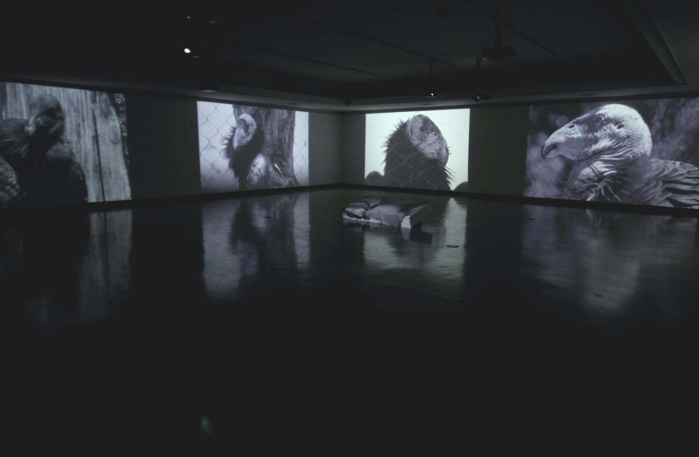
Figure 5.1
Kade L. Twist, It’s Easy to Live With Promises If You Believe They Are Only Ideas, 2012.
Seven-channel video installation with sound.

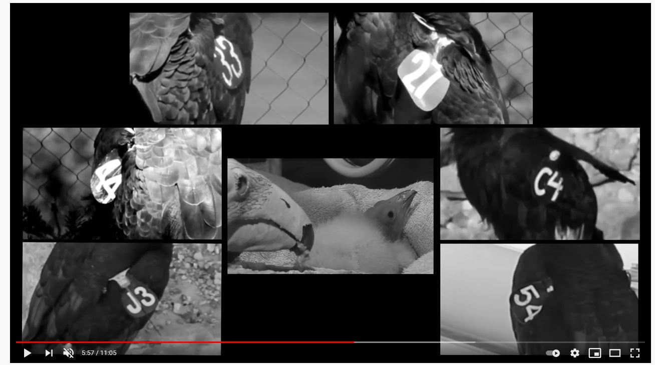
Figure 5.2
Kade L. Twist, It’s Easy to Live With Promises If You Believe They Are Only Ideas (detail), 2012.

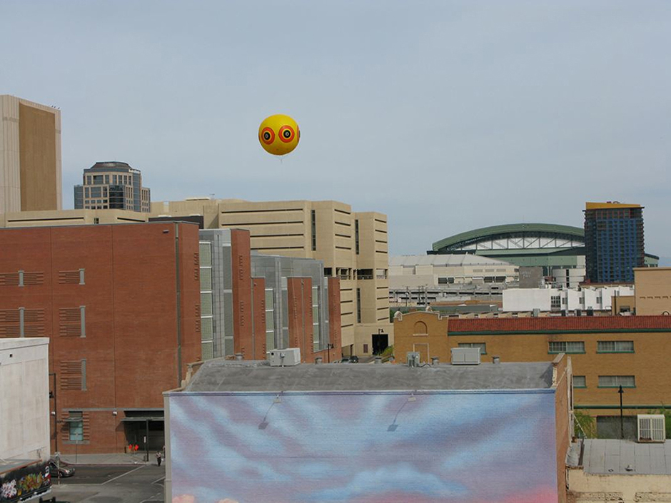
Figure 5.3
Kade L. Twist, Repellent Eye Over Phoenix, 2008.
Site-specific intervention and installation, 120 in. diameter

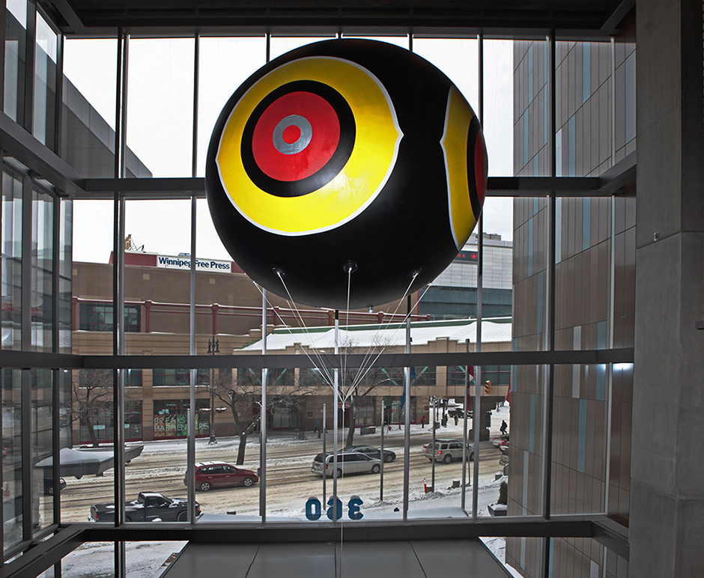
Figure 5.4
Kade L. Twist, Repellent Eye (Winnipeg), 2011.
Intervention and installation, 120 in. diameter

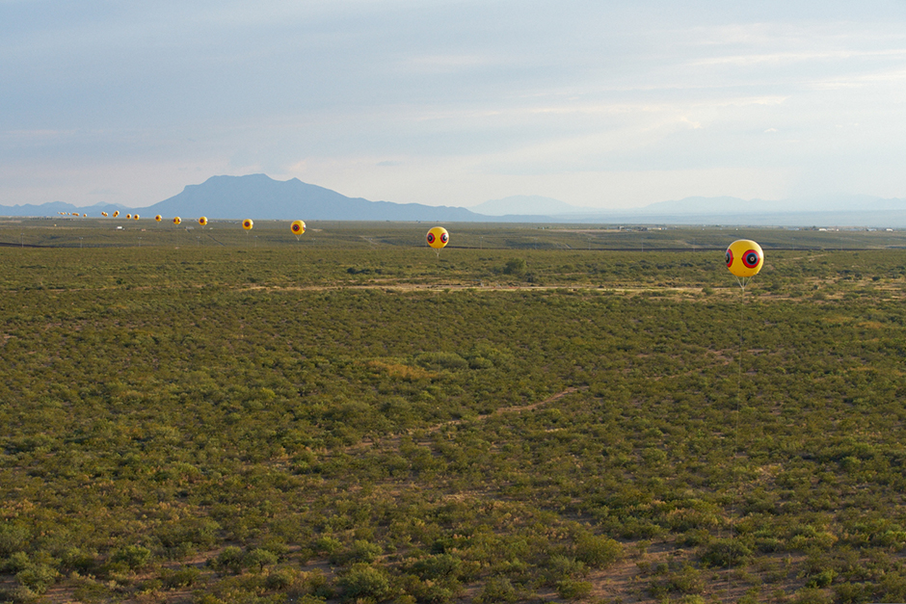
Figure 5.5
Postcommodity, Repellent Fence / Valla Repelente, 2015.
Site-specific installation and intervention.

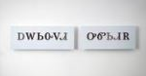
Figure 5.6
Kade L. Twist, ᎠᎳᏏᏅᏙᏗ ᎤᏛᏏᏗᎡ (Economic Growth), 2016.
Aluminum panel, automobile paint, acrylic and polished aluminum text, 17 ½ x 70 inches.


Figure 5.7
Kade L. Twist, ᎠᏎᏊᎢ ᎤᏂᎾᏗᏅᏗ (Free Market), 2016.
Aluminum panel, automobile paint, acrylic and polished aluminum text, 17 ½ x 70 inches.


Figure 5.8
Kade L. Twist, ᎠᏓᏜᏅᏓᏚᎲ (Oppurtunity), 2016.
Aluminum panel, automobile paint, acrylic and polished aluminum text, 17 ½ x 40 inches.

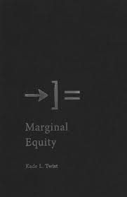
Figure 5.9
Cover of Marginal Equity, 2018.

6. CONCLUSION

When Kay WalkingStick created her mixed media diptych Ourselves / Our Land in 1991, she had no way of knowing over fifteen years later, a young ᏣᎳᎩ woman would stand before it in the museum vault at her first curatorial job. That painting, as well as the other works by WalkingStick that are in the collection of Eiteljorg Museum of American Indians and Western Art, had the type of impact on that curator, me, that led me to this dissertation. When I looked at the works of WalkingStick, I felt a sense of home. It was an odd feeling because Oklahoma had never been my home, much less North Carolina. I grew up the epitome of a ᏣᎳᎩ living in diaspora. I was born in California and grew up in Illinois. I spent my formative college years through my early 30s in Indiana. At best, Oklahoma was a place steeped in nostalgia and understood through memory.
When I came to the University of Oklahoma (OU) for my doctorate, I knew I wanted to focus on ᏣᎳᎩ art in some way. What is fascinating to me, even now, is that the commitment to exploring ᏣᎳᎩ art and artists never wavered but the context changed as I grew as a student. Attending OU felt like my own homecoming, a place where I found ᏚᏳᎦᏛ in my personal journey of reconnecting with my ᏣᎳᎩ identity and inherent indigeneity. Unlike other members in my family, I had been entrenched in a pseudo-Native world for the past decade because of my work at the museum. But my Native community was small, fractured, and inconsistent. Some of the highlights of my time in that position was when I met Kay WalkingStick during my first artist convening. Another was the year that Luzene Hill, Brenda Mallory, and Holly Wilson (Delaware Nation/Cherokee) were part of an exhibition. Much like when I would view WalkingStick’s work, I felt a rightness in my ᏣᎳᎩ identity. All of this led to me to desire my own journey home, back to Oklahoma, a place I had never lived but had visited as a child. (fig. 6.1) OU is not situated on ᏣᎳᎩ homelands, but its closer than I had ever been and the community I found there was like none I had ever experienced. For the first time in my life, I felt fully and wholly ᏣᎳᎩ. This realization led me to consider to understand why I felt such a sense of peace when looking at WalkingStick’s work or being around other ᏣᎳᎩ artists. I realized through my own curatorial and scholarly practice, I was creating ᏚᏳᎦᏛ in my own desire to find to return home, through art.
In this dissertation, I questioned what it means to be a ᏣᎳᎩ artist living in diaspora, which creates a disruption in one’s indigeneity, and how art can serve as way to return home even metaphorically. I argue for the use of the term ᏚᏳᎦᏛ which prescribes that ᏣᎳᎩ people attempt to obtain harmony and balance in every aspect of our lives. This need to practice ᏚᏳᎦᏛ can be accomplished in our connection with all things: the environment, family relationships, or even our responsibility to community and culture. In essence, ᏚᏳᎦᏛ is a counter response to moments of imbalance and a reminder of the way all ᏣᎳᎩ should live. For ᏣᎳᎩ people, ᏚᏳᎦᏛ is connected to who we are in both a physical and spiritual sense. It is at the very core of what makes us ᏣᎳᎩ. My overall argument for this dissertation is that when ᏣᎳᎩ experience displacement and cultural estrangement, which is counter to a ᏣᎳᎩ life in balance within the concept of ᏚᏳᎦᏛ, art is a way to reestablish ᏚᏳᎦᏛ and therefore re-engage one’s connection to community and metaphorically return home.
Through the lens of ᏚᏳᎦᏛ I examined the work of WalkingStick, Hill, Mallory, and Kade L. Twist. Each artist, whether knowing or not, creates ᏚᏳᎦᏛ through their work. Previous scholarship is useful in fleshing out the nuances of the works of these artists but it not capable to fully explain the reality of ᏣᎳᎩ artist in diaspora and the integral role art plays in their understanding of self and home.
This dissertation is a product of my own ᏚᏳᎦᏛ. I chose these artists because their stories are similar to mine. I recognized the longing I heard in their voices for homeland and return. And I create my own sense of balance when I look at their work. There are many reasons for a ᏣᎳᎩ not to go home but my aim is to show, through the previous chapters, how return is possible through art. And in that return, we once again become a united culture: ᎠᏂᏴᏫᏯ (Aniyunwiya), or Principal People.

FIGURES

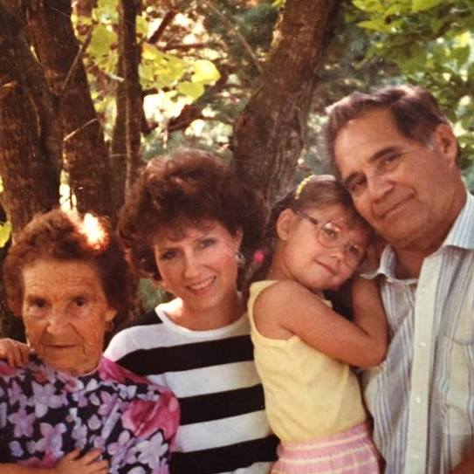
Figure 6.1
Four Generations of ᏣᎳᎩ, ca. 1990
The author as a child (center-right) with her great-grandmother (left), mother (center-left), and grandfather (right) in Stilwell, OK.

BIBLIOGRAPHY

Abbot, Lawrence, ed. I Stand in the Center of the Good: Interviews with Contemporary Native
American Artists. Lincoln and London: University of Nebraska Press, 1994.

Archuleta, Margaret et al. Shared Visions: Native American Painters and Sculptors in the
Twentieth Century. Phoenix, AZ: The Heard Museum, 1991.

Ash-Milby, Kathleen and David W. Penney, eds. Kay WalkingStick: An American Artist.
Washington DC: Smithsonian Books, 2015.

Assmann, Jan, and John Czaplicka. "Collective Memory and Cultural Identity." New German
Critique, no. 65 (1995): 125-33.

Bal, Mieke, Jonathan Crewe, and Leo Spitzer, eds. Acts of Memory: Cultural Recall in the
Present. Hanover: University Press of New England, 1999.

Ben-Amos, Dan and Liliane Weissberg, eds. Cultural Memory and the Construction of Identity.
Detroit: Wayne State University Press, 1999.

Berlo, Janet C. and Ruth B. Phillips. Native North American Art. Oxford and New York: Oxford
University Press, 1998.

Blomberg, Nancy J., ed. [Re]inventing the Wheel: Advancing the Dialogue on Contemporary
American Indian Art. Denver Art Museum, 2008.

Bond, Lucy and Jessica Rapson, eds. The Transcultural Turn: Interrogating Memory between
and beyond Borders. Berlin: De Gruyter, 2014.

Boyarin, Jonathan, ed. Remapping Memory: The Politics of TimeSpace. Minneapolis:
University of Minnesota Press, 1994.

Boyer, Pascal and James V. Wertsch. Memory in Mind and Culture. New York: Cambridge
University Press, 2009.

Brose, David S. et al. Ancient Art of the American Woodland Indians. New York: H.N. Abrams,
in Association with the Detroit Institute of Arts, 1985.

Butler, Thomas. Memory: History, Culture and the Mind. Oxford; New York: B. Blackwell,
1989.

Cain, Shawna Morton, Pamela Jumper Thurman, eds. Cherokee National Treasures: In Their
Own Words. Tahlequah, OK: Cherokee Nation, 2017.

Cantrell, Roy H. Cherokee Stories of the Past. Winston-Salem, N.C.: Bandit Books, 2010.

Caruth, Cathy. Unclaimed Experience: Trauma, Narrative, and History. Baltimore: Johns
Hopkins University Press, 1996.

Clifford, James. Returns: Becoming Indigenous in the Twenty-First Century. Cambridge, MA:
Harvard University Press, 2013.

D'Alleva, Anne. Methods & Theories of Art History. London: Laurence King, 2012.

Denzin, Norman K., Yvonna S. Lincoln, and Linda Tuhiwai Smith. Handbook of Critical and
Indigenous Methodologies. Thousand Oaks: SAGE Publications, 2008.

Diversi, Marcelo, and Cláudio Moreira. Betweener Talk: Decolonizing Knowledge Production,
Pedagogy, and Praxis. Walnut Creek: Left Coast Press, 2009.

Enwezor, Okwui and Chika Okeke-Agulu. Contemporary African Art since 1980. Bologna:
Damiani, 2009.

Erll, Astrid and Ansgar Nünning, eds. in collaboration with Sara B. Young. Cultural Memory
Studies: An International and Interdisciplinary Handbook. Berlin and New York: Walter
de Gruyter, 2008.

Fernie, Eric. Art History and Its Methods: A Critical Anthology. London: Phaidon, 1995.

Halbwachs, Maurice with Lewis A. Coser, trans. On Collective Memory. Chicago: University of
Chicago Press, 1992.

Hirsch, Marianne. The Generation of Postmemory: Writing and Visual Culture after the
Holocaust. New York: Columbia University Press, 2012.

Iversen, Margaret, and Melville, Stephen W. Writing Art History: Disciplinary Departures.
Chicago: University of Chicago Press, 2010.

Kammen, Michael G. Meadows of Memory : Images of Time and Tradition in American Art and
Culture. Austin: University of Texas Press, 1992.

Koselleck, Reinhart, Todd Samuel Presner, and Hayden V. White. The Practice of Conceptual
History: Timing History, Spacing Concepts. Stanford: Stanford University Press, 2002.

Kovach, Margaret. Indigenous Methodologies: Characteristics, Conversations, and Contexts.
Toronto, Ontario: University of Toronto Press, 2009.

Kramer, Karen, Janet Catherine Berlo, and Kathleen E Ash-Milby, eds. Shapeshifting:
Transformations in Native American Art. Salem; New Haven: Peabody Essex Museum; Yale University Press, 2012.

Leuthold, Steven. Indigenous Aesthetics: Native Art, Media, and Identity. Austin: University of
Texas Press, 1998.

Linenthal, Edward Tabor. Preserving Memory: The Struggle to Create America's Holocaust
Museum. New York: Viking, 1995.

Lippard, Lucy et al. Pathbreakers: The Eiteljorg Fellowship for Native American Fine Art, 2003.
Indianapolis, IN and Seattle, WA: Eiteljorg Museum of American Indians and Western Art in association with University of Washington Press, 2003.

Lipsitz, George. Time Passages: Collective Memory and American Popular Culture.
Minneapolis: University of Minnesota Press, 1990.

Lonetree, Amy. Decolonizing Museums: Representing Native America in National and Tribal
Museums. Chapel Hill: University of North Carolina Press, 2012.

Mathur, Saloni. The Migrant's Time: Rethinking Art History and Diaspora. Williamstown; New
Haven: Sterling and Francine Clark Art Institute; Yale University Press, 2011.

McNutt, Jennifer Complo and Ashley Holland, eds. Conversations: Eiteljorg Contemporary Art
Fellowship 2015. Indianapolis, IN: Eiteljorg Museum of American Indians and Western Art, 2015.

Mercer, Kobena. Exiles, Diasporas, & Strangers. Cambridge, MA and London: The MIT Press,
2008.

Miller, Susan A., and Riding In, James. Native Historians Write Back: Decolonizing American
Indian History. Lubbock: Texas Tech University Press, 2011.

Mirzoeff, Nicholas. Diaspora and Visual Culture: Representing Africans and Jews. London and
New York: Routledge, 2000.

Mithlo, Nancy et al. New Native Art Criticism: Manifestations. Santa Fe: Museum of
Contemporary Native Arts, 2011.

Mooney, James. Myths of the Cherokee. Washington: Government Printing Office, 1902.

Moreton-Robinson, Aileen. The White Possessive: Property, Power, and Indigenous
Sovereignty. Minneapolis, MN and London: University of Minnesota Press, 2015.

Moxey, Keith P. F. The Practice of Persuasion: Paradox and Power in Art History. Ithaca:
Cornell University Press, 2001.

Niemeyer, Katharina. Media and Nostalgia: Yearning for the Past, Present and Future.
Houndmills, Basingstoke, Hampshire and New York: Palgrave Macmillan, 2014.

Okeke-Agulu, Chika. Postconlonial Modernism: Art and Decolonization in Twentieth-Century
Nigeria. Durham, NC: Duke University Press, 2015.

Oland, Maxine, Siobhan M. Hart, and Liam Frink. Decolonizing Indigenous Histories: Exploring
Prehistoric/colnial Transitions in Archaeology. Tucson: University of Arizona Press, 2012.

Ostrowitz, Judith. Interventions: Native American Art for Far-flung Territories. Seattle:
University of Washington Press, 2009.

Passalacqua, Veronica, Kate Morris, and James H. Nottage, eds. Native Art Now!: Developments
in Contemporary Native American Art since 1992. 2017.

Perdue, Theda with Frank Porter, ed. The Cherokee. New York: Chelsea House, 1989.

Power, Susan C. Art of the Cherokee: Prehistory to the Present. Athens: University of
Georgia Press, 2007.

Radstone, Susannah, ed. Memory and Methodology. Oxford; New York: Berg, 2000.

Shohat, Ella. Taboo Memories, Diasporic Voices. Durham: Duke University Press, 2006.

Smith, Chadwick Corntassel, Rennard Strickland, Benny Smith, and Cherokee Nation,
Oklahoma. Building One Fire: Art World View in Cherokee Life. Norman: University of Oklahoma Press, 2010.

Smith, Linda Tuhiwai. Decolonizing Methodologies: Research and Indigenous Peoples. London:
Zed Books; Dunedin: University of Otago Press; New York: Distributed in the USA Exclusively by St Martin's Press, 1999.

Smith, Richard Cándida, ed. Text & Image: Art and the Performance of Memory. London and
New York: Routledge, 2002.

Smith, Terry. What is Contemporary Art. Chicago: The University of Chicago Press, 2009.

Smithers, Gregory D. The Cherokee Diaspora: An Indigenous History of Migration,
Resettlement, and Identity. New Haven, NJ and London: Yale University Press, 2015.

Sturken, Marita. Tangled Memories: The Vietnam War, the AIDS Epidemic, and the Politics of
Remembering. Berkeley: University of California Press, 1997.

Taubman, Ellen and David Revere McFadden, eds. Changing Hands: Art Without Reservations
3. Contemporary Native North American Art from the Northeast and Southeast. New York City: Museum of Arts and Design, 2012.

Tiger, Tony A. et al. Return From Exile: Contemporary Southeastern Indian Art. Tahlequah,
OK: Southeastern Indian Artists Association, 2015.

Tlostanova, M. V. Postcolonialism and Postsocialism in Fiction and Art: Resistance and
Re-existence. Cham, Switzerland: Palgrave Macmillan, 2017.

Tumblety, Joan. Memory and History: Understanding Memory as Source and Subject. London:
Routledge, 2013.

When possible, all Cherokee words, whether phonetic or syllabic, were confirmed through the use of the Cherokee Nation online word list: https://language.cherokee.org/word-list/. Variations in translations and spellings may be a result of different dialects or source material.
See, Angela M. Hass “Wampum as Hypertext: An American Indian Intellectual Tradition of Multimedia Theory and Practice,” Studies in American Indian Literatures, Vol. 19 (4), 2007, 77-100.
Driskill self-identifies as a non-citizen Cherokee Two-Spirit and Queer writer, activist, and performer also of African, Irish, Lenape, Lumbee, and Osage ascent. In public discussions with Cherokee citizens David Cornsilk and Dr. Candessa Teehee, both emphasized that unfortunately Driskill is a practicing ethnic fraud and has no right to the self-identification of Cherokee. There was consensus that the while the general idea of balance as Driskill argues for it in his own defining of ᏚᏳᎦᏛ is based in Cherokee worldviews, the source becomes problematic. So in essence, the framework of ᏚᏳᎦᏛ is legitimately Cherokee but Driskill is not. Despite this act of ethnic fraud, there is still value in the scholarship produced.
See, Driskill, Qwo-Li, Asegi Stories: Cherokee Queer and Two-Spirit Memory, Tucson: University of Arizona Press, 2016.
I use this distinction as opposed to historical or traditional vs modern or contemporary. These Euro-centric derived terms do not allow for the entanglements that happen within the various distinctions. A work of art can be both traditional and contemporary, for example. For a broader discussion of this topic, see First American Art Magazine’s Style Guide: https://firstamericanartmagazine.com/submissions/faam-style-guide/.
This type of statement, as well as “I’m an artist first and an Indian second,” have been associated and espoused by other Native artists such as Fritz Scholder (Luiseño, 1937-2005) and George Morrison (Grand Portage Band of the Minnesota Chippewa Tribe, 1919-2000) who may have felt it was necessary to make this distinction in order to gain larger appeal beyond the restrictive Native art field at the time.
For an in depth exploration of the development of art history, see Wood, S. Christopher, A History of Art History. Princeton, NJ: Princeton University Press, 2019.
Theda Perdue with Frank Porter, eds., The Cherokee, (New York: Chelsea House, 1989), 17.
Ibid, 27.
Ibid, 28.
For a deeper historical look at post-contact ᏣᎳᎩ life, see James Mooney, Myths of the Cherokee (Washington: Government Printing Office, 1902), 14-228.
Ibid, 36-37.
Cherokee is classified as a southern Iroquoian language and prior to 1820 was only spoken until ᏍᏏᏉᏯ (Sequoyah) (c. 1770–1843) created a system of writing, the Cherokee syllabary. While historically there were three dialects of Cherokee, only two are still maintained by modern speakers: Kituwah (Eastern Band of Cherokee Indians) and Otali (Oklahoma Cherokee).
Perdue, 47.
Ibid, 50.
Ibid, 58.
Ibid, 77-78.
Ibid, 81.
There are numerous State-recognized and non-federally recognized Cherokee groups that have dubious claims to Cherokee heritage. The Cherokee Nation and Eastern Band of Cherokee Indians have both formally renounced all Cherokee groups that are not one of the three federally recognized Cherokee tribes.
Cherokee Nation. “Frequently Asked Questions.” https://cherokee.org/About-The-Nation/Frequently-Asked-Questions (accessed April 10, 2019).
“Diaspora,” Merriam-Webster. Accessed April 20, 2021, https://www.merriam-webster.com/dictionary/diaspora.
For an example on discussions of Art of the African Diaspora, see Kobena Mercer, Travel and See. Durham, NC: Duke University Press, 2016.
Kobena Mercer, ed., Exiles, Diasporas & Strangers (Cambridge, MA and London: The MIT Press, 2008), 19.
James Clifford, Returns: Becoming Indigenous in the Twenty-First Century (Cambridge, MA: Harvard University Press, 2013), 88.
Smithers, 14.
Ibid, 15.
The boys eventually become known as “Ansga’ya Tsunsdi’ (Little Men). They present themselves as thunder, the sound being made when they talk to each other. They are allowed in some stories to journey back East but must always return West.
Gregory Smithers, The Cherokee Diaspora: An Indigenous History of Migration, Resettlement, and Identity (New Haven, NJ: Yale University Press, 2015), 16.
Chadwick Corntassel Smith, Rennard Strickland, and Benny Smith, Building One Fire: Art World View in Cherokee Life (Norman, OK: University of Oklahoma Press), 8.
The East: World Guardian, brown, harmony, openness, caring, and innocence. The North: Knowledgeable One, blue, ability to seek new knowledge, curiosity, and intellect. The West: Wise one and Disappearing way, yellow, learn from experiences, insight, mediate, collaborate, and put in focus. The South: black, compassion, loyalty, committedness, dedication, and display of emotion.
Cain, Shawna Morton, Pamela Juniper Thurman, and Christie Fogg, eds., Cherokee National Treasures: In Their Own Words (Tahlequah, OK: Cherokee Nation with The University of Oklahoma Press, Norman, 2017), 20.
La Mémoire collective was published posthumously in 1950. On Collective Memory is the 1992 translated and edited version by sociologist Lewis A. Coser.
Jan Assman and John Czaplicka, “Collective Memory and Cultural Identity,” New German Critique, no. 65 (1995), 126.
Ibid.
Ibid, 132.
Sturken, 3.
Ibid, 3.
Ibid, 5.
Ibid.
Ibid, 9.
Hirsch, 5.
Cathy Caruth, Unclaimed Experience: Trauma, Narrative, and History, Twentieth Anniversary Edition. (Baltimore: Johns Hopkins University Press, 1996), 4.
Ibid, 116.
Ibid, 117.
Ibid, 5.
Ibid, 6.
Ibid, 254.
Margaret Kovach, Indigenous Methodologies: Characteristics, Conversations, and Contexts (Toronto: University of Toronto Press, 2010), 20.
Ibid, 39.
Ibid.
Ibid, 59.
Ibid, 78.
Ibid, 94.
Ibid, 94.
Ibid, 111.
Hearts of Our People was presented at the Minneapolis Institute of Art from June 2-August 18, 2019 followed by the Frist Museum in Nashville (September 27, 2019–January 12, 2020), the Renwick Gallery of the Smithsonian American Art Museum, Washington, D.C. (February 21–August 2, 2020), and the Philbrook Museum of Art, Tulsa (October 7, 2020–January 3, 2021).
These views are my own and may not reflect the views of other Cherokee citizens. For a more in depth conversation on Indigenous identity, see Scott Richard Lyons, X-marks: Native Signatures of Assent. Minneapolis: University of Minnesota Press, 2010.
“Congratulations to Kade Twist and Postcommodity for Their Inclusion in the 2017 Whitney Biennial,” David Richard Gallery Accessed April 2, 2019, .https://www.blogdavidrichardgallery.com/single-post/2017/03/15/Congratulations-to-Kade-Twist-and-Postcommodity-For-Their-Inclusion-In-the-2017-Whitney-Biennial.
I have worked in varying capacities with all four artists during my time as an assistant curator at the Eiteljorg Museum of American Indians and Western Art, Indianapolis IN.
It is possible that Jeffrey Gibson is starting to gain on WalkingStick in terms of popularity with his multiple solo exhibitions at numerous museums across the country. Gibson is also a great example of an artist that exemplifies the Cherokee diasporic experience and I am interested with how that plays out in his work though he did not fit the parameters for this research.
The exhibition debuted at NMAI from November 7, 2015-September 18, 2016 and was toured by the American Federation of Arts. It appeared at the Heard Museum, Phoenix AZ (October 15, 2016–January 8, 2017); the Dayton Art Institute, Dayton OH (February 11–May 7, 2017); the Kalamazoo Institute of Arts, Kalamazoo MI (June 17–September 10, 2017); the Gilcrease Art Museum, Tulsa OK (October 5, 2017–January 7, 2018); and the Montclair Art Museum, Montclair NJ (February 3–June 17, 2018).
Kathleen Ash-Milby and David W. Penney, eds. Kay WalkingStick: An American Artist, (Washington DC: Smithsonian Books, 2015), 165.
In a 1991 interview with Lawrence Abbot, WalkingStick references primarily male American artists such as Frederic Church, Thomas Cole, Frank Stella, Mark Rothko, and Jasper Johns.
These modern and contemporary moments of Euro-American art patrons and institutions embracing Native art production occur in silos throughout the last hundred years and impact the work of many Native artists and their artistic output. In the time between the World Wars, exhibitions were staged both in New York City and internationally for Native artists as examples of an American modernist aesthetic, unique from the European ideal. While the work by Native artists featured Native subject matters, the goal of the patrons was a form of American nation building. Eventually the desire for this work receded and many Native artists struggled against the legacy created by white patron demand. See David W. Penney and Lisa A. Roberts, “Pueblo Painters in the Border Zone,” in Native American Art in the Twentieth Century, edited by W. Jackson Rushing (New York: Routledge, 1999), 21-38.
When I was a Masters student in Indianapolis and feeling profoundly homesick for my family, I remember going to the Eiteljorg Museum for an assignment and coming across the work of WalkingStick. I will readily admit that up until that point, my knowledge of most Native art was limited and stereotypical. But seeing a painting by WalkingStick, a fellow Cherokee woman, brought about a feeling of home that I can still remember to this day.
Unfortunately, Kay WalkingStick declined to be interviewed for this case study so I will only be able to rely on existing scholarship and interviews.
Old Settlers refer to those ᏣᎳᎩ that migrated to what is now known as Arkansas, Oklahoma, and Texas prior to forced removal as a way to maintain ᏣᎳᎩ culture and religious practices and avoid white influence.
Kathleen Ash-Milby and David W. Penney, eds., Kay WalkingStick: An American Artist (Washington DC: Smithsonian Books, 2015), 26.
Ibid, 27.
Ibid, 28.
Lawrence Abbot, I Stand in the Center of the Good: Interviews with Contemporary Native American Artist (Lincoln and London: University of Nebraska Press, 1994), 270.
Ash-Milby and Penney, 53.
Ibid, 32.
These concepts build off the ideas proposed by Maurice Halbwachs concerning collective memory, where our memories are built through those around us, and Marianne Hirsch examination of the creation of memory as it relates to familial and group relations. Postmemory, as opposed to memory, for Hirsch, is created through a projection of our own desires rather than those who experienced the memory. See Maurice Halbwachs with Lewis A. Coser, trans. On Collective Memory. Chicago: University of Chicago Press, 1992. and Marianne Hirsch, The Generation of Postmemory: Writing and Visual Culture after the Holocaust. New York: Columbia University Press, 2012.
Ash-Milby, 63.
Ibid, 172.
Cotter, 7.
Holland Cotter was born in 1947 in Connecticut and grew up in Boston, Massachusetts. He earned his undergrad from Harvard College in English literature and a masters in American modernism from the City of New York. He is a prominent art critic and writes for the New York Times and well as Art In America and Art News. In 2009, he won the Pulitzer Prize for Criticism.
Ash-Milby and Penney, 105.
Abbot, 271.
Abbot, 276.
Ash-Milby and Penney, 106.
Kay WalkingStick, artist statement in Jaune Quick-to-See Smith, The Submuloc Show/Columbus Wobs (Phoenix, AZ: ATLATL, 1992), 66.
Ibid, 114.
Ibid, 114.
Ibid, 115.
It should be noted that I find inconsistencies with the Cherokee translations that WalkingStick often uses. Since I do not know the source of her translations and am not a speaker or writer of the language, I cannot verify the validity of them and instead must rely on the artist. I am also having to base my recreations of the words on WalkingStick’s handwritten syllabary so I apologize if I misidentify any of the symbols.
Ibid, 115.
Margaret Archuleta and Rennard Strickland, eds., Shared Visions: Native American Painters and Sculptures in the Twentieth Century (Phoenix, AZ: The Heard Museum, 1991), 95.
Jan Assman and John Czaplicka, “Collective Memory and Cultural Identity,” New German Critique, no. 65 (1995), 132.
For these early migrating ᏣᎳᎩ, called the Old Settlers, moving to a new location where white influence in the form of religion and government policies could potentially be avoided, proved more important than maintaining a physical connection to ancestral lands. The Old Settlers relocated to modern day Arkansas and Indian Territory, now Oklahoma, and eventually became the United Keetoowah Band of Cherokee Indians.
These ᏣᎳᎩ where removed to Indian Territory from 1836-1839 and eventual became the Cherokee Nation. This relocation, also known as the Trail of Tears, was a result of the Indian Removal Act of 1830 and the eventual signing of the Treaty of Echota in 1835.
Rose Stremlau, Sustaining the Cherokee Family: Kinship and the Allotment of an Indigenous Nation, (Chapel Hill: The University of North Carolina Press, 2011), 33.
Gregory D. Smithers, The Cherokee Diaspora: An Indigenous History of Migration, Resettlement, and Identity, (New Haven: Yale University Press, 2015), 128.
Ibid, 129.
“History & Culture.” Eastern Band of Cherokee. (Archived from http://nc-cherokee.com/historyculture/, on April 15, 2015).
Luzene Hill in conversation with the author, January 2021.
Born the same year as Hill was the Qualla Arts and Crafts Mutual, which was founded as a response to the opening of the Great Smoky Mountains National Park in 1940 and postwar highway growth and family travel. The Blue Ridge Parkway was met by many Eastern Band of Cherokee Indians members with suspicion due to the potential loss of land and over influence by the government. The resulting artist cooperative is the oldest known in the United States. Qualla Arts and Crafts Mutual became not only a source for economic growth but also a place where culture could be practiced through the creation of arts.
Luzene Hill in conversation with the author, January 2021.
Richard Henry Pratt, Battlefield and Classroom: Four Decades with the American Indian, 1867-1904. (University of Oklahoma Press: Norman, 2003), 215.
Luzene Hill in conversation with the author, January 2021.
Ibid.
Ibid.
Martin DeWitt, “Free Falling Up,” in Conversations: Eiteljorg Contemporary Art Fellowship 2015, ed. Jennifer Complo McNutt and Ashley Holland (Indianapolis IN: Eiteljorg Museum of Western Art and American Indians, 2015), 40.
“Victims of Sexual Violence: Statistics,” RAINN, accessed April 2, 2021, https://www.rainn.org/statistics/victims-sexual-violence.
“Victims of Sexual Violence: Statistics,” RAINN, accessed April 2, 2021, https://www.rainn.org/statistics/victims-sexual-violence.
Cathy Caruth, Unclaimed Experience: Trauma, Narrative, and History, Twentieth Anniversary Edition. (Baltimore: Johns Hopkins University Press, 1996), 4.
Ibid, 5.
“Luzene Hill,” First Peoples Fund, accessed February 3, 2021, https://www.firstpeoplesfund.org/luzene-hill.
Luzene Hill in conversation with the author, January 2021.
“Luzene Hill: Now the Gates of Hell are closed…,” Different Train Gallery, accessed February 20, 2021, https://www.differenttrainsgallery.com/artist-luzene-hill.html.
Ibid.
As stated in the chapter on Kay WalkingStick, prior to European influence, which believed that men should be in charge and viewed women as property, ᏣᎳᎩ women were the leaders of their family. Women chose who to marry and the man was expected to leave his family to live with his wife. If a woman chose, she could divorce and the home and children remained hers. Clans, the heart of the ᏣᎳᎩ community, were passed down through the mother. A man’s clan was his mother’s while his children’s clan was his wife’s. ᏣᎳᎩ women owned their sexuality and were free to make decisions for themselves. It was only with the encroachment of European settlers, missionaries, and Christian patriarchy that this community structure faltered.
Luzene Hill in conversation with the author, January 2021.
“Installations,” Luzene Hill artist website, accessed February 1, 2021, http://www.luzenehill.com/installations.
DeWitt, 49.
“Installations,” Luzene Hill artist website, accessed February 1, 2021, http://www.luzenehill.com/installations.
DeWitt, 49.
“Installations,” Luzene Hill artist website, accessed February 1, 2021, http://www.luzenehill.com/installations.
DeWitt, 49.
“Installations,” Luzene Hill artist website, accessed January 28, 2021, http://www.luzenehill.com/installations.
Ibid.
“Violence Against American Indian and Alaska Native Women and the Criminal Justice Response: What is Known,” The National Crime Victimization Survey (1992-2005).
Ibid.
Hill has been actively making art since the 1990s and her first professional experience was attending the Southwestern Association for Indiana Arts’ (SWAIA) Santa Fe Indian Market in 1997. She had been encouraged by a friend to submit her paintings and drawings and was put on a wait list for admission. She ended up being allowed to participate and shared a booth with another artist. It was the only time Hill has participated in Indian Market, which is a type of rite of passage for many Native artists, but it would prove a turning point in her embracing art as a full-time professional artist.
The WCU Cherokee Center was founded in 1975 and acts as a headquarters for all outreach and involvement in the Eastern Band of Cherokee Indians community. To learn more, see https://www.wcu.edu/engage/cherokee-center/index.aspx.
To learn more about the Cherokee Preservation Foundation, see, http://cherokeepreservation.org/.
Luzene Hill in conversation with the author, January 29, 2021.
“WCU Produces Second Book in Cherokee Language Series,” Asheville, accessed April 3, 2021, https://www.asheville.com/news/wcu0409.html.
Ibid.
Ibid.
Luzene Hill in conversation with the author, January 2021.
Ideas of authenticity are tied to Native arts relationship with ethnography and anthropology of the early to mid-twentieth century. It is also strongly promoted by the Native art market (such as the Santa Fe Indian Market) where standards are set and strictly enforced.
ahtone, heather “Ontology of Ripples,” in Conversations: Eiteljorg Contemporary Art Fellowship 2015, ed. Jennifer Complo McNutt and Ashley Holland (Indianapolis IN: Eiteljorg Museum of Western Art and American Indians, 2015), 68.
Ibid.
Ibid.
My grandfather was born to a ᏣᎳᎩ mother and white father in Stilwell, OK in 1928. He grew up within the Cherokee Nation boundaries and my mother remembers vising my great grandmother’s church, which was conducted in ᏣᎳᎩ. However, like many Native people during the twentieth century, the language was not spoken in my grandfather’s home. When my grandfather was a teenager, he moved to the panhandle of Oklahoma in order to work on a farm. He never moved back to Stilwell, though his mother remained for many decades.
Brenda Mallory in discussion with the author, January 2021.
Ibid.
Ibid.
Ibid.
For more information about Cherokee at-large communities, see https://cherokeesatlarge.org/.
Brenda Mallory in conversation with the author, January 2021.
James Clifford, Returns: Becoming Indigenous in the Twenty-First Century (Cambridge MA and London: Harvard University Press, 2013), 62.
Ibid, 88.
Chadwick Corntassel Smith, Rennard Strickland, and Benny Smith, Building One Fire: Art World View in Cherokee Life (Norman, OK: University of Oklahoma Press), 10.
Ibid, 12.
Ibid, 16.
Ibid, 14.
Ibid, 8.
Brenda Mallory in conversation with the author, January 2021.
“Installations: Biophilia,” Brenda Mallory, accessed March 15, 2021, https://www.brendamallory.com/biophilia.
Ibid.
Ibid.
“Installation: Slipping into Order: A Glitch in the Phylum,” Brenda Mallory, accessed March 16, 2021. https://www.brendamallory.com/a-glitch-in-the-phylum.
Ibid.
Brenda Mallory in conversation with the author, January 2021.
Ibid.
Ibid.
Karen Wright and John Clark, “Terminator Genes: Here’s another fine mess biotechnology has gotten us into,” Discover, August 21, 2003, https://www.discovermagazine.com/the-sciences/terminator-genes.
Brenda Mallory in conversation with the author, January 2021.
Ibid.
Ibid.
Ibid.
An example can be seen in the way that ᏣᎳᎩ baskets have changed, or stayed the same, over time due to location of the weaver. To learn more about the progression of ᏣᎳᎩ over time, see Powers, Susan C., Art of the Cherokee: Prehistory to the Present. Athens, GA: University of Georgia, 2007.
For a broader discussion of this topic, see First American Art Magazine’s Style Guide: https://firstamericanartmagazine.com/submissions/faam-style-guide/.
Terry Smith, What is Contemporary Art (Chicago: The University of Chicago Press, 2009), 4.
Ibid, 5.
Ibid, 6.
Smith, 151.
Ibid.
Ibid, 242.
Ibid, 254.
“About,” Postcommodity, accessed April 19, 2021, http://www.postcommodity.com/About.html.
To learn more about the mass Oklahoma migration to California, see “Dust Bowl Legacies: The Okie Impact on California, 1939-1989,” by James N. Gregory, http://faculty.washington.edu/gregoryj/legacies.pdf. Accessed April 20, 2021.
Kade Twist in conversation with the author, January 2021.
Ibid.
“Community*Culture*Connections*Continuity,” Cherokee Community of Central California, accessed April 22, 2021, http://cherokeecommunityofcentralcalifornia.yolasite.com/.
Kade L. Twist in conversation with the author, January 2021.
Gregory Smithers, The Cherokee Diaspora: An Indigenous History of Migration, Resettlement, and Identity (New Haven, NJ: Yale University Press, 2015), 16.
Kade L. Twist in conversation with the author, January 2021.
Twist notes the important influence of professors such as Dr. Jerry Bread, Edgar Heap of Birds, and Dr. Mary Jo Watson.
Kade L. Twist in conversation with author, January 2021.
Ibid.
Ibid.
Ibid.
Ibid.
James Mooney, Myths of the Cherokee (Washington: Government Printing Office, 1902), 294.
Kade L. Twist in conversation with author, January 2021.
As of 2021, Postcommodity is comprised of Twist and Cristóbal Martínez. Previous collaborators were Raven Chacon, Steven Yazzie, Adam Ingram-Goble, Andrew McCord, Annabel Wong, and Existence AD.
“About,” Postcommodity, accessed April 20, 2021, http://www.postcommodity.com/About.html.
“Repellent Eye Over Phoenix,” Postcommodity, accessed April 20, 2021, http://postcommodity.com/RepellentEyeOverPhoenix.html.
Ibid.
“Repellent Eye (Winnipeg),” Postcommodity, Accessed April 15, 2021. http://postcommodity.com/RepellentEye.html.
Ibid.
“Repellent Fence,” Postcommodity. Accessed April 22, 2021, http://postcommodity.com/Repellent_Fence_English.html.
Ibid.
Ibid.
Smith, 255.
“Marginal Equity,” Publication Studio Guelph. Accessed April 2, 2021, https://publicationstudio.biz/books/marginal-equity/.
Kade L. Twist, “(leveraging synergies),” in Marginal Equity (Guelph, Ontario: Musagetes and PS Guelph, 2018), 42-47.
Kade L. Twist in conversation with the author, January 2021.
Kade L. Twist, “(community embeddedness),” in Marginal Equity (Guelph, Ontario: Musagetes and PS Guelph, 2018), 62.

