UNIVERSITY OF OKLAHOMA
GRADUATE COLLEGE

CHEROKEE COMPOSITIONS: THE (RE)DISCOVERY, RESTORATION, AND REVIVAL OF THE MUSIC OF JACK FREDERICK KILPATRICK

A DISSERTATION
SUBMITTED TO THE GRADUATE FACULTY
In partial fulfillment of the requirements for the
Degree of
DOCTOR OF PHILOSOPHY

By
CHRISTINA GIACONA
Norman, Oklahoma
2023

CHEROKEE COMPOSITIONS: THE (RE)DISCOVERY, RESTORATION, AND REVIVAL OF THE MUSIC OF JACK FREDERICK KILPATRICK

A DISSERTATION APPROVED FOR THE
DEPARTMENT OF ANTHROPOLOGY

BY THE COMMITTEE CONSISTING OF

Dr. Sean O’Neill, Chair
Dr. Betty Harris
Dr. Amanda Minks
Dr. Joshua Nelson
Dr. Daniel C. Swan

© Copyright by CHRISTINA GIACONA 2023
All Rights Reserved.

This dissertation is dedicated to Becca Field Jessop,
the best champion and friend I could have asked for.

Acknowledgements
There is no way for me to properly express how fortunate I am for the support and dedication given to me by my graduate committee, friends, family, and colleagues. My anthropology graduate work started in the fall of 2013 when I decided to take one class to help further my understanding in the field. Having already completed a D.M.A in music performance in 2009, I had no intention on earning another degree, but little did I know that this one class titled “Foundations of Social Thought” would lead to a second master’s degree and eventually this Ph.D. in sociocultural anthropology. The last 10 years would not have been possible without everyone’s relentless dedication, encouragement, and commitment to my research and wellbeing, which is only overshadowed by their friendship, generosity, and guidance.
First, I want to thank my advisor Sean O’Neill, who saw something in me that was worth investing in. I could not ask for a more dedicated dissertation advisor! I cannot even start to count the hours I spent in Sean’s office rambling off new research ideas. Sean only encouraged me to continue to explore the unknown while never allowing me to stop and take an easier path. Amanda Minks, I want to thank you for not letting me accept mediocrity and putting hours into taming my wild thoughts into rigorous academic arguments. I appreciate every effort you took to make sure I was always submitting my best work and forging a pathway to help me be successful. Amanda read everything, and I mean EVERYTHING I sent her way, in every possible state of completion. I honestly do not know where she found the time, but I am eternally grateful.
To Daniel C. Swan, it was because of you that I finally understood the importance of fieldwork and the act of gaining knowledge through active participation. Until this document my professional work as a music producer, composer, and musician had always been separate from my role as a professor, researcher, and writer. You showed me a path which joined these two disparate parts of my life. Betty Harris served both on my M.A. and Ph.D. committees and she opened my eyes to reading the works of those who are often underrepresented. She taught me that behind every successful person, there are supporters who often do not get the credit they deserve and with that in mind, I try and expand every narrative to include those who might get overlooked. Joshua Nelson, the first person who suggested I write about the music of Jack Kilpatrick, continually guided me in how to forge a path in this field that held true to my ethics and cultural beliefs. You have opened my eyes to the world of Indigenous film, and I must say Joshua really can cut a rug on the dance floor!
Lina Ortega, I sincerely appreciate your continual support and interest in my research. You gave the Kilpatrick materials a beautiful home at the Western History Collections, and I cannot think of anyone more suited to taking care of these precious materials. Paula Conlon, thank you for your constant support and for modeling how to be part of this community of incredible musicians here in Oklahoma. To Alexander Mickelthwate, conductor of the Oklahoma City Philharmonic and the first conductor to take a chance on programming Kilpatrick’s music, thank you for being my constant artistic collaborator and friend. To Jennifer Loren, senior director of Cherokee Film, for featuring this research on “Osiyo, Voices of the Cherokee People.” To John Jeter and Christopher Baumgartner, thank you for continuing to revive Kilpatrick’s music for a new generation of concertgoers. And lastly, Matt Stock, while not on my committee was such an important part of this work. He helped me through thick and thin! Every week I was in his office asking for help with my research. As another expert on Jack Kilpatrick, he always shared his own research and took the time to help me uncover every article I needed. This would not have been possible without you.
I need to underline that I have the best, most generous, and supportive friends. Thank you to my Gatewood support team Neila Crank-Clements, Kevin Jessop, David H. Clements, and the late Becca Field Jessop for helping me with everything! Every plate of food you brought me and every word of encouragement will never be forgotten! I also need to say the same about my officemate and bestie Jennifer Slater who let me bounce my ridiculous ideas off her. My parents Carole and the late Greg Giacona have always been my champions and have never questioned my desire to become a professional musician. I am telling you, all those clarinet lessons have paid off!
Writing these acknowledgements is in a way bittersweet, as it marks the end of my anthropologic graduate work, but I can say with confidence that it is with everyone’s support that I feel ready to conquer the next phase of my academic career. The last person I need to thank is my ride or die Patrick Conlon, who has taken the words in sickness and health to be forever true. While at this moment I am promising to never take another graduate class, we’ll see how long that lasts!
Finally, I need to thank the Kilpatrick family, who have trusted me to handle this incredible music and story. Kilpatrick’s three sons: Jack Jr., Clifford, and Alan, who are all incredibly kind, intelligent, and thoughtful; Clifford’s lovely daughter Mary Anna Kilpatrick-Honea; and Mary Anna’s husband Chris Honea, who served as the lawyer for the family and spent many hours on the phone helping me to make sure the Kilpatrick family gets the recognition they deserve for their family’s legacy.
I wholeheartedly thank you all for your inspiration and willingness to take a chance on me, and I promise to continue to work on projects that will make you proud!

ABSTRACT

CHEROKEE COMPOSITIONS: THE (RE)DISCOVERY,
RESTORATION, AND REVIVAL OF THE MUSIC OF
JACK FREDERICK KILPATRICK

Christina Giacona

This dissertation documents and analyzes the (re)discovery, restoration, and revival of the music of Jack Frederick Kilpatrick (1915-1967), a composer and intellectual who identified as Cherokee and who spent his career in Oklahoma, California, Washington DC, and Texas. Jack Frederick Kilpatrick was one of the first professional classical composers whose work was based on his intimate knowledge of Native American culture. His compositional output is made up of over 250 pieces, including 188 officially completed opus numbers. Jack Kilpatrick’s compositional style was influenced by his experience growing up in Stilwell, Oklahoma, and his immersion in Cherokee culture. Jack’s musical output mediates between Cherokee and Euro-American culture through songs that include both English and Cherokee text, librettos that describe Cherokee cultural practices, and compositions that translate traditional Cherokee performance practices including intonation, scales, and rhythms into the Western European tradition of song structures, orchestration, and musical notation. These pieces connect listeners to Cherokee life as told through Cherokee histories, performance traditions, language, and medicine.

When we found 31 boxes of Jack Kilpatrick’s personal manuscript collection and hand-written notes in the attic of Catlett Music Center at the University of Oklahoma in 2018, our discovery opened a window into the mediating intercultural and musical experiences of Jack and the Oklahoma Cherokee during the mid-20th century. In addition to providing the most comprehensive biography of Jack Frederick Kilpatrick available to date, my research is focused on four additional main areas: first, the archiving and collection building of the Jack Kilpatrick Collection at the University of Oklahoma’s Western History Collections; second, the transcription and repertoire construction of Kilpatrick’s musical works; third, my work creating critical editions and performance materials of selected Kilpatrick compositions; and finally, an ethnography of my first five years of efforts to ignite a revival of Kilpatrick’s music with Alexander Mickelthwate and the Oklahoma City Philharmonic. Throughout this document, I also self-examine my role as an ethnographer and researcher attempting to apply decolonizing methodologies at the intersectional crossroads of music, language, heritage, and anthropology, while also attempting to act as a translator, caretaker, and animateur for a music that is not mine to own. The core analytic concepts explored in this dissertation are focused on identity; archive building; the relationship of language and music in discourse; the entextualization and recontextualization process revealed by the relationship between manuscript scores, performance materials, and musical performance; the role of context in shaping performance and reception; and the structure and cultural role of music revivals.

TABLE OF CONTENTS
Chapter 1: Introduction 1
The Beginning 4
Initial Correspondence and the Origins of the Collection 8
Use of Names 12
Full Name: Jack Frederick Kilpatrick 12
Full Name: Anna Gritts Kilpatrick and later Anna Gritts Kilpatrick Smith 13
The Kilpatricks 13
Differing Kilpatrick Collections and Archives 14
Dissertation Overview and Significance of the Kilpatricks’ Work to Cherokee Literature 15
Chapter Outlines 21
SECTION I: (RE)DISCOVERY 34
Chapter 2: The Life and Work of Jack Kilpatrick: Oklahoma 38
Jack’s Early Years, Family, and Ethnicity 38
Bacone College (1933–1935) 44
The University of Redlands (1935–1938) 53
The WPA Oklahoma Symphony Orchestra (1938–1941) 56
Edward MacDowell Memorial Colony of Artists (1941) 61
Kilpatrick’s Transitional Period (1941–1948) 62
Chapter 3: The Life and Work of Jack Kilpatrick: Texas 66
Washington D.C. (1943–1945) 66
National Gallery Sinfonietta and Richard Bales 67
The Catholic University of America and Jack’s Master’s Thesis 70
Dallas, Texas (1947–1967) 72
Kilpatrick’s Symphonic Period (1947–1957) 82
The Curse of the Ninth Symphony 89
Symphonic Dramas in collaboration with Kermit Hunter (Historical Dramatist) 90
Kilpatrick’s Legacy 101
Chapter Conclusion 105
Section II: RESTORATION 108
Decolonizing Methodologies 109
Sovereignty and Indigenous Decolonizing Perspectives 111
Digitization and Access 113
Chapter 4: Archival Research, Discoveries, and Indexing the Jack Kilpatrick Collection 115
The Discovery Phase 116
The Selection and Acquisition Process 118
A Survey of Other Archival Holdings 119
Indexing the Collection 121
The Deselection Process 124
Opus Numbers and Organizational Systems 127
The Cataloging of Kilpatrick Works 130
Ownership, Copyright, and Permissions 132
Rumors and Curses 133
Chapter Conclusion 135
Chapter 5: Technology, Critical Editions, and Preparing Manuscripts for Performance 137
Arranging and Orchestrating 142
Types of Publication Editions 144
Publishing and Technology 146
Publishing the Kilpatrick Manuscripts 147
Determining Other Publication Details for Concert Programming 150
Instrumentation 151
Duration and Tempo 152
How It Sounds 157
Score Reading 158
MIDI Mockups 159
Copyrights 162
SECTION III: REVIVAL 165
Legitimization and Value 167
Embodied Performance and Archival Memory 167
Chapter 6: Revival, Performance, and Reception 173
Revival 175
The Revival of Florence Price 175
Pre-requisites and Motivations for a Music Revival 176
Stages of a Music Revival 178
Diversifying the Canon and Statistically Analyzing Diversity in Orchestral Programming 182
Barriers to Diverse Orchestral Programming 183
My Other Contributions to Indigenous Music Programming, Collaborations, and Revival 184
Performance 185
Live-Streamed Performances vs. “Live” Concert Recordings 187
Audio and Audio-Visual Recordings 189
Reception 191
Identity 192
Chapter Conclusion 194
Chapter 7: A Case Study: The Oklahoma City Philharmonic’s (re)Premieres of Jack Frederick Kilpatrick’s Symphonic Works, 2019–2022 196
Setting the Stage: Meeting Alexander Mickelthwate 202
Concert 1: Oklahoma Stories 2019–2020: Situating An American Indian Serenade 204
The Program 206
Authenticating Kilpatrick and Situating His Music 210
The First (re)Premiere of Jack Frederick Kilpatrick’s Symphonic Works 223
Concert 2: COVID-19, A Soloist’s Interpretation, The American Sound, 228
and the 2020–2021 Season Reimagined 228
Changes in Orchestral Performance Practice due to COVID-19 229
A Season “Reimagined” 232
A Soloist’s Interpretation 234
Situating Kilpatrick as part of the American Classical Sound 236
Concert 3: Oklahoma Stories: Meeting the Kilpatrick Family, Cultural Preservation and Knowledge Transfer Through Orchestral Performance, and the 2021-2022 Season 243
Analyzing the Scores 244
Situating Kilpatrick as an Indigenous Composer 248
Three Cherokee Cosmogenic Legends 251
Four Ozark Dances 254
Meeting the Kilpatrick Family 255
Chapter Conclusion 260
Chapter 8: Concluding Thoughts 261
Next Steps 263
Re-Awakenings 268
Works Cited 270
Appendix A: News Release by the National Gallery of Art, February 21, 1945 283
Appendix B: News Release by the National Gallery of Art, February 20, 1947 285
Appendix C: Index for Jack Kilpatrick Collection 287

LIST OF FIGURES

Figure 1.1 2
An Image of Program Notes from An American Indian Serenade

Figure 1.2 11
An Image of a Program of the special recital “A Bicentennial Tribute to Jack Frederick Kilpatrick (1915-1967)” presented by the University of Oklahoma, School of Music on February 21, 1976

Figure 2.1 48
An Image of The Singing Redmen, 1935 featuring Jack Kilpatrick bottom row, 4th from the right

Figure 2.2 51
An Image of the Handwritten Score “Hymn to Bacone College” by Jack Kilpatrick

Figure 2.3 64
An Image of Jack Kilpatrick from May 19, 1941

Figure 3.1 68
An Image of the Program of the National Gallery Sinfonietta from Sunday, May 21, 1944 featuring Jack Kilpatrick’s composition Invocation and Ritual

Figure 3.2 78
An Image of a Hand-Written List of Commissioning Organizations, Conductors, and Concert Artists Who Have Worked With Jack Kilpatrick in His Own Hand

Figure 3.3 81
An Image of a Newspaper Report of Jack and Anna Kilpatrick’s Appointments as Editors of the New Cherokee Advocate by the Cherokee National History Society at Tahlequah, Oklahoma

Figure 3.4 88
An Image of Anna, Jack Jr., Clifford, and Alan Kilpatrick at the Premiere of Jack Kilpatrick’s Symphony No. 8 “Oklahoma”

Figure 3.5 91
An Image of Jack Kilpatrick’s Biography in the Program for Unto These Hills: A Drama of the Cherokee Indian’s 1951 Season which ran from June 23 to September 3

Figure 3.6 98
An Image of an Advertisement for Chucky Jack Featuring Biographies of Kermit Hunter and Jack F. Kilpatrick

Figure 3.7 103
An Image of a Proclamation of Dr. Jack Kilpatrick Day in the Strawberry Festival Program, 1959
Figure 4.1 123
An Image of the Indexing Process of the Jack Kilpatrick Collection During the Summer of
2019 Dale Society Fellowship at the Western History Collections at the University of Oklahoma

Figure 4.2 126
An Image of Indexed Kilpatrick Materials in Opus Number Order After the Deselection Process was Completed During the Summer of 2019 Dale Society Fellowship at the Western History Collections at the University of Oklahoma

Figure 4.3 128
An Image of the Manuscript for Cherokee Life with Penciled-In Opus Number

Figure 4.4 134
An Image of Jack Kilpatrick Smoking a Cigarette While Composing at the Piano

Figure 4.5 136
An Image of a Display Case Assembled by Christina Giacona in 2019 After Her Work as a Dale Society Fellow at the Western History Collections at the University of Oklahoma

Figure 7.1 198
An Image of “From Storage Room to Stage,” the University of Oklahoma University Libraries 2018-2019 Progress Report Path to Excellence

Figure 7.2 208
An Image of the Program for Oklahoma City Philharmonic’s Classics 1: Oklahoma Stories Concert from the 2019-2020 Season

Figure 7.3 212
An Image of John Hamilton, Timothy Nevaquaya, the Oklahoma Fancy Dancers, and the Native Praise Choir Backstage at the Oklahoma City Civic Center Music Hall on September 14, 2019

Figure 7.4 218
An Image of John Hamilton Performing Grand Entry Medley with Alexander Mickelthwate and the Oklahoma City Philharmonic on September 14, 2019

Figure 7.5 221
An Image of John Hamilton, Timothy Nevaquaya, the Oklahoma Fancy Dancers, and the Native Praise Choir Performing Grand Entry Medley with the Oklahoma City Philharmonic on September 14, 2019

Figure 7.6 226
An Image of, From Left to Right, Matt Stock, Alexander Mickelthwate, and Christina Giacona Posing with the Critical Edition Conductor Score of Jack Kilpatrick’s An American Indian Serenade on September 12, 2019

Figure 7.7 230
An Image of the Oklahoma City Philharmonic’s Reduced Orchestra Size, Increased Spacing, and Use of Personal Protective Equipment in 2021 During the COVID-19 Pandemic

Figure 7.8 238
An Image of the Program of the Oklahoma City Philharmonic’s ‘Tis a Gift Concert from
May 8, 2021

Figure 7.9 247
An Image of Jack Kilpatrick’s Appearance on NBC’s “The Wishing Well—Where Dreams Do Come True” on December 15, 1940

Figure 7.10 250
An Image of the Program of the Oklahoma City Philharmonic’s “Oklahoma Stories: Kilpatrick” Concert from April 30, 2022

Figure 7.11 256
An Image of an Advertising Banner for the Oklahoma City Philharmonic’s “Oklahoma Stories: Kilpatrick” Concert

Figure 7.12 257
An Image of a Facebook Post by the Oklahoma City Philharmonic on April 21, 2022

Chapter 1: Introduction
The program notes to An American Indian Serenade were the first words I read by composer Jack Frederick Kilpatrick in 2018, when University of Oklahoma librarian Dr. Matt Stock asked me to look at the contents of thirty-one boxes of disorganized materials that were slated to be discarded after being discovered in the storage attic of a classroom that was being cleaned over the break. The first thing I took out of the boxes were program notes typewritten and taped to the back of the front cover of a handwritten manuscript score labeled An American Indian Serenade. In Figure 1.1, the program notes to An American Indian Serenade read:
“An American Indian Serenade, op. 21,” is the last of a series of orchestral compositions depicting various phases of Oklahoma Indian life, written by the composer for the Oklahoma Symphony Society during the years 1938-1942. Less objective than the others of the group, it is not so much concerned with presenting the Indian point of view as it is with interpreting it; the derivation of its materials from actual folk tunes is more remote; the spirit of Indian life is celebrated, rather than a particular phase exposed. It is the record of an Indian composer’s awareness of the “strangeness of familiar things.” – Jack Frederick Kilpatrick.” (Kilpatrick, An American Indian Serenade, op. 21).

Figure 1.1
An Image of Program Notes from An American Indian Serenade
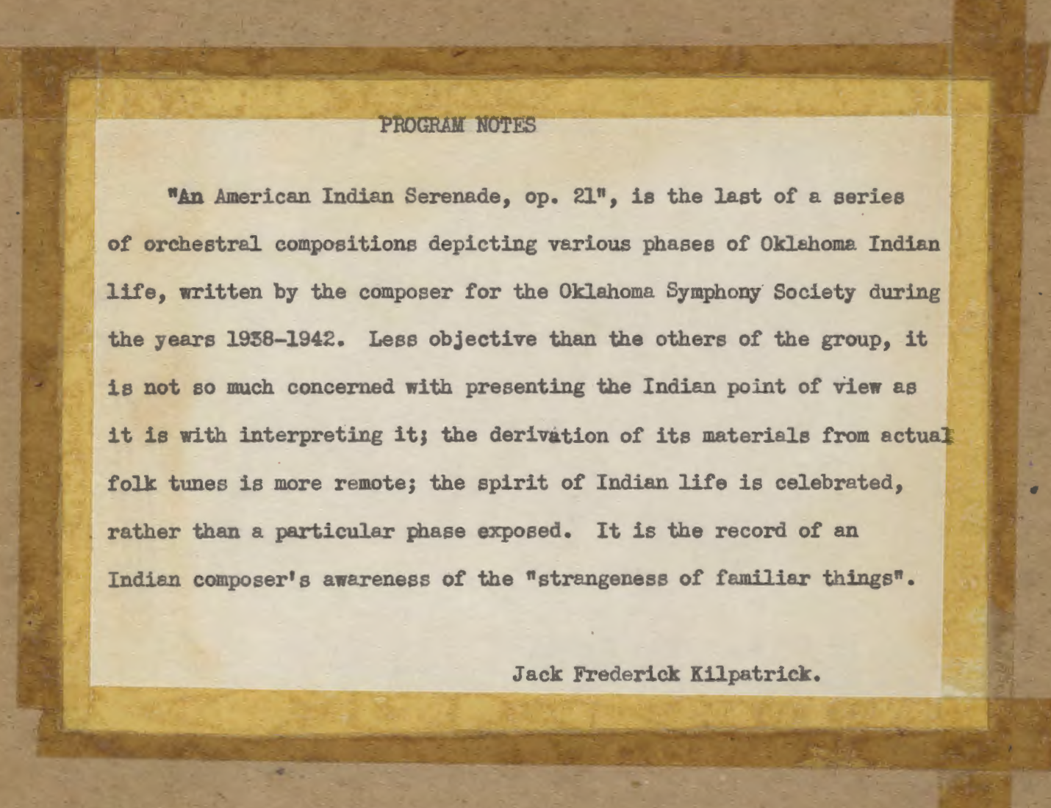
Note. A photograph of program notes typewritten by Jack Kilpatrick and taped to the second page of the manuscript holograph of An American Indian Serenade (own photo). Reprinted with permission from the Jack Kilpatrick Collection at the University of Oklahoma Western History Collections.

Kilpatrick’s words about this “less objective,” “more remote,” and un-“exposed” music speak loudly about his fears of its reception and his attempts to contextualize his music for future listeners and concert audiences by including this inscription within the score. Within these words are artistic anxieties and questions that affect almost all Indigenous artists working within the western classical music industry: Will his music be rationalized as people try and “interpret” the “hybridity” as they are looking for melodic material that they believe is “Indian?” Will an audience of non-Indigenous listeners try to determine his “Indianness” based on their understanding of what they define as being or sounding Indigenous? Or will the listener be able to recognize their own positionality and challenge themselves to listen past the cultural imagination and romanticizing that is so heavily embedded in western classical art music? What exactly is inclusion? Is it something that grants an open and equal space to diverse voices, or is it a place where “the other” is consumed and only their financially lucrative and culturally non-offensive parts are extracted and held up as evidence of their identity and difference from the norm?
American Indian Serenade was the first manuscript I pulled out of the boxes, the first score I studied, and the first piece the Oklahoma City Philharmonic (re)premiered on September 14, 2019, as part of their “Oklahoma Stories” concert series. The questions embedded within these program notes are the same questions which have been a focal point of my own research for the past twenty years into the racialization, appropriation, contextualization, and re-contextualization of Indigeneity by both indigenous and non-indigenous artists within American music and are the same questions I ask myself as I work to re-introduce the world to the music of Jack Frederick Kilpatrick.
After reading Jack Kilpatrick’s liner notes, I must admit I was intrigued but at the same time confused. Who was Jack Frederick Kilpatrick—and how could I have not known about a person who was so prolific a composer, receiving multiple commissions from major orchestras across the United States starting at the age of 23? How could classical music publishers, so hungry for diverse historical classical composers to add to their catalogs, have not already consumed these works? And what exactly did Kilpatrick mean by, “it is the record of an Indian composer’s awareness of the ‘strangeness of familiar things’”?

The Beginning
Little did I know that on May 2, 2018, my world would soon become consumed with a composer I had only heard mentioned in passing. As I was walking to my office, which happens to be located inside the Fine Arts Library at the University of Oklahoma (OU), I was approached by University of Oklahoma Fine Arts Librarian Dr. Matt Stock, who asked me if I could look at several boxes that he found in the attic of Catlett Music Center on campus. Matt mentioned that the boxes were filled with original manuscripts by a composer by the name of Jack Frederick Kilpatrick, and that several boxes also contained items that he thought were Cherokee cultural items, as well as texts written in Cherokee syllabary. Matt mentioned the boxes appeared to also contain items often found in a music professor’s office such as programs, textbooks, handwritten notes, diplomas, and yearbooks. Matt thought that, as a specialist in Native American in the School of Music, I might want to look at the materials before they were taken to the dumpster. The next week Matt and I met to look over his finding. What he had discovered were thirty-one boxes labeled K1-K31 that contained composer Jack Frederick Kilpatrick’s personal manuscript collection (holographs) and hand-written notes, in addition to teaching materials, concert programs (including programs featuring his music), cultural items, and reel-to-reel recordings. This discovery opened a window into the mediated intercultural and musical experiences of Jack Frederick Kilpatrick and the Oklahoma Cherokee during the mid-20th century.
In June 2017, about a year before Matt’s discovery, Chickasaw composer Jerod Impichchaachaaha' Tate had reached out to the OU Fine Arts Library’s then-librarian Robin Noad, inquiring about the Jack Frederick Kilpatrick manuscripts, but at the time, the University of Oklahoma was not aware of the collection in its possession. Jerod Tate, who had been in contact with Alan Kilpatrick (one of Kilpatrick’s sons, who believed that an archive had already been created), was hoping to create and expand upon a repository that housed Oklahoma Native American classical music items and was aware that the University of Oklahoma had received the manuscripts. After extensive research, our understanding of the timeline of the manuscript collection’s arrival at the University of Oklahoma is that soon after Kilpatrick’s death in 1967, the contents of his office were boxed and then given to the University of Oklahoma School of Music; however, no formal arrangement was ever agreed upon. Over the years, as department chairs and faculty shifted, the boxes remained in storage; by the time Jerod Tate inquired as to the whereabouts of the manuscript collection, no one remaining on campus knew that these boxes existed.
When he called Robin Noad, Jerod Tate and I already knew each other well as colleagues and friends. Throughout the past decade and a half, Jerod and I have worked together on dozens of musical collaborations. We have recorded albums together and shared the stage; he has been a featured guest artist on the Ruggles Native American Concert Series that I produced; and I have performed his classical compositions numerous times. Through the process of working with Jerod and during our many conversations over the years, we have become close friends and he has been an incredible colleague and confidante. I do recall Jerod (who also is a historian) mentioning to me that there were three Native American classical composers that are foundational to the understanding of the importance of Native American contributions to classical music. Those composers are Jack Frederick Kilpatrick, Louis W. Ballard, and himself. Since I had yet to hear a Kilpatrick recording or see a score, his significance never truly registered with me until I saw the Kilpatrick collection firsthand.
On October 7, 2018, while having lunch with Jerod Tate, Dr. Joshua B. Nelson (filmmaker and one of my committee members), and Jennifer Loren (Executive Producer and host of OsiyoTV and director of the Cherokee Nation Film office) at Jane’s Delicatessen in Tulsa, I mentioned the Kilpatrick manuscript find. Knowing that I had not settled on a dissertation subject yet, Joshua stated that this needed to become my topic. Jennifer also mentioned that she was currently researching the literary work of the Kilpatricks for an upcoming episode on OsiyoTV–Voices of the Cherokee People. At this time, I had already had several conversations with Alexander Micklethwate, the conductor of the Oklahoma City Philharmonic (OKC Phil) about the possibility of programming Kilpatrick’s works. I mentioned to Jennifer that the OKC Phil planned to perform a piece composed by Jack Kilpatrick on their 2019-2020 season opener. She asked if it would be possible to see the Kilpatrick scores that we had found and if the OKC Phil would be willing to be part of the Jack and Anna Kilpatrick segment that they were working on. I said I thought Alexander, the OKC Phil staff, and the musicians would all be very willing to contributors.
A few days later I introduced Jennifer and Alexander, and the OsiyoTV production team came down to OU to explore the Kilpatrick materials we found in the attic. This lunch with Jerod, Joshua, and Jennifer ended up being the start on this entire Kilpatrick revival project. The conversation we had led to numerous collaborations between me and Jerod Tate, me giving an interview to Jennifer Loren for OsiyoTV, and the beginning of my journey with Alexander Micklethwait to re-introduce his music to audiences worldwide. Joshua has continued to be an invaluable resource as one of my committee members and mentor. From here I started the (re)discovery of learning who Jack Frederick Kilpatrick was and how his music fits within an American western art music cannon.
After this lunch meeting, I applied for and was awarded The Dale Society Fellowship at the Western History Collections at the University of Oklahoma for the summer of 2019. The focus of my research at the Western History Collection was twofold: first, to research and contextualize the writings of Jack Frederick Kilpatrick and his wife and collaborator Anna Gritts Kilpatrick (Cherokee linguist and folklorist) about the Cherokee; and second, to index, categorize, restore, and analyze the musical compositions of Jack Kilpatrick that were found in the attic of the Catlett Music Center at the University of Oklahoma. This Dale Society Fellowship at the Western History Collections enabled me to index and be a part in creating the Jack Kilpatrick Collection, a central part of this dissertation. After years of work, the now completed collection titled the “Jack Kilpatrick Collection” is now housed at the Western History Collections at the University of Oklahoma, catalogued after more than forty years in storage.
Unlike other research projects I have worked on, the finding of the Kilpatrick manuscript collection was completely serendipitous, and it took me on a journey I will never forget. In the process of crafting this document, archive, and music revival, I have met so many incredible people and collaborators who have been just as interested as I from the beginning. It was through the programming and the (re)premiers of Three Cherokee Cosmogenic Legends op. 9 and Four Ozark Dances op. 10 on April 30, 2022, with the Oklahoma City Philharmonic that I met Mary Anna Kilpatrick (Jack and Anna’s granddaughter and the last and youngest Kilpatrick family member), Clifford Kilpatrick, Alan Kilpatrick (Jack and Anna’s sons), and Christopher Honea (Mary Anna’s partner and family lawyer). Christopher has been such a champion for Jack’s music and a major resource connecting me with the Kilpatrick family. It is integral to the ethical foundations of my research that this work is not only approved of by the Kilpatrick family, but that it also benefits them, as Jack Kilpatrick’s music is their family legacy and inheritance.

Initial Correspondence and the Origins of the Collection
From the onset of this project, it has always seemed unusual to me that these boxes just sat in an attic in Catlett unknown to anyone. The L-shaped room where the boxes were stored were mixed along with other items such as out-of-date textbooks, broken instruments, and old programs that didn’t seem to have a home. What we now refer to as the Catlett Music Center went through two construction phases: the initial phase in 1986 which included the completion of the Fine Arts Library, rehearsal, and classroom spaces and the second phase in 1998 with the construction of the Paul F. Sharp Concert Hall. Prior to the construction of Catlett Music Center, the music department was housed in Holmberg Hall which was constructed in 1918. It was determined that the Kilpatrick boxes have been at OU since 1977. In 2005 Holmberg Hall went through a multimillion-dollar renovation. Between 1977 and 2005 I believe the boxes were being stored in Holmberg but were relocated to the Catlett attic not to be touched until their discovery in 2018. As any researcher wants to determine, how did the boxes end up at OU in the first place?
In 1977 Jack Kilpatrick, Jr. contacted the University of Oklahoma about purchasing the manuscript collection. On February 10, 1977, Ralph Verrastro (a then OU professor of music and coordinator of graduate studies) stated in a letter to Jack Jr. that on February 19, 1977, a university van would collect the material for temporary possession until a formal agreement could be established. In the letter it was mentioned that during a telephone conversation between Jack Jr. and Ralph Verrastro a decision on whether a long-term loan or full donation would be given to the University of Oklahoma. The letter ended with “Thank you, again, for your consideration. We Look forward to holding the collection until such time as its proper disposition can be achieved.” A follow-up letter from Jerry Neil Smith, the former Director of the School of Music was sent to Jack Jr. on September 21, 1977, stating the estimated value of the collection to be between $300 and $500. Importantly the letter stated that Rick Benson was “making good strides in organizing [the manuscripts] properly.” The research done by Harry D. “Rick” Benson, who was a graduate student of Ralph Verrastro has helped me formulate a timeline of Kilpatrick’s compositions and how his works relate to the manuscripts stored in the archive. From this point the last written communication was an internal inquiry on September 14, 1981, indicating that no paperwork and no trusting memory can be found to establish a clear title of ownership. At this point I believe the boxes that contained the manuscripts were then placed in the attic of Catlett music center, not to be found again until 2018. The September 14, 1981 letter, written by Jan E. Seifert, a former music librarian, to Kerry Grant, Associate Professor of Music and Assistant Director of the School of Music, believed it would be imprudent to move or process any of the collection since a clear and established title had not been finalized. This was the last documented correspondence making any reference to the materials.
In the first letter written by Ralph Verrastro to Jack Jr. in 1977 he wrote that his intentions after the donation of the collection, was in “cataloging and repairing the collection, locating missing components, assessing and insuring its value, and in general making it available, at large, as a living memorial.” The letter continues that he wants to “look into the possibility of publishing or re-publishing works of general interest and will encourage the systematic recording of the complete collection.” After 46 years the collection is still in process of negotiating the donation. In 2019 Lina Ortega mailed a letter to Jack Jr. who is now living in Dallas Texas, requesting a follow-up from the original correspondence in 1977. She requested that the materials be formally donated to the University of Oklahoma. Jack Jr. responded by email stating that he believed a formal donation had already occurred. From here a formal donation was started between Jack Jr. and the University of Oklahoma. But in 2022 I was contacted by John Allen, the General Manager of the Oklahoma City Philharmonic stating an heir to the Kilpatrick collection had contacted them saying they had no idea about the whereabouts of the collection, nor had they agreed upon a donation to OU. It appeared that Clifford Kilpatrick, the middle son of Jack and Anna who lives in Midwest City, Oklahoma, saw a Facebook ad that mentioned an upcoming concert featuring Jack’s composition “Four Ozark Dances.” I said I would be happy to talk with Clifford about our discovery. I told the family about finding the pieces in the attic of Catlett and that the Oklahoma City Philharmonic has taken a particular interest in programming these works. It was from this point on that I have had the pleasure of working with Clifford and Alan Kilpatrick to build the collection and the biography for their father. A continuation of this journey is told in Chapter 6, “The Oklahoma City Philharmonic, The Fort Smith Symphony, CODA Honor Band, and the (Re)premiers of Jack Kilpatrick’s Compositions.”
Harry D. “Rick” Benson went on to write the first biography on Jack Kilpatrick titled, “A Biographical Sketch of Jack Frederick Kilpatrick and a Partial Single Source Compilation of Published and Unpublished Compositions” and on February 21, 1976, he curated a concert titled “A Bicentennial Tribute to Jack Frederick Kilpatrick (1915-1967)” in Holmberg Hall Auditorium featuring selections of Kilpatrick’s compositions as seen in Figure 1.2. The program included Clarinet Quintet op. 115, Autumn Love op. 95, incidental music for Samuel Beckett’s play Waiting for Godot op. 161, Four Songs with poetry by Libby Stopple op. 168, ballet excerpts from Ravenmocker op. 148, and opera selections from Blessed Wilderness op. 167.
Figure 1.2
An Image of Program of the special recital “A Bicentennial Tribute to Jack Frederick Kilpatrick (1915-1967)” presented by the University of Oklahoma, School of Music on February 21, 1976
Note. A scan of a program featuring the music of Jack Kilpatrick sent to me by the Western History Collections at the University of Oklahoma. Reprinted from The University of Oklahoma Archives, College of Fine Arts Collection Publications, 1902-1992 (inclusive). Reprinted with permission.

Several years after the Bicentennial Tribute, Jerry Neil Smith, the music director of the Norman Chamber Orchestra and the then director of the OU School of Music programmed a few works of Kilpatrick’s in 1991 and 1992. After this time, I could not find any concert programing of Kilpatrick works until 2019 when the Oklahoma City Philharmonic (re)premiered An American Indian Serenade.

Use of Names
Throughout this document there will be variations of important people’s names. Below is a description of possible variations and an explanation for when different variations will be used. As a general note I try to my best to refer to people using their first names or by the convention that is common for that discipline. For example, when discussing Jack Frederick Kilpatrick in relationship with this family I opt to refer to him as Jack. When I am specially referring to him as a composer of classical music, I will often refer to him by his last name, Kilpatrick, since it has been commonly accepted to refer to classical composers by only their last name.

Full Name: Jack Frederick Kilpatrick
Variations: Jack, Jack Kilpatrick, Jack F. Kilpatrick, Jack Frederick Kilpatrick, J. Kilpatrick, J. F. Kilpatrick, Kilpatrick, Dr. Kilpatrick, and Tsegi Kanûnö
For clarity’s sake I change the naming conventions of Jack Frederick Kilpatrick to best suit the situation in which he is discussed. I will often just use the name Jack in a more colloquial sense and to help clearly identify him from other family members with the same last name. Most importantly it is also an easy way to refer to him in association to work he has in collaboration with Anna Kilpatrick. While alive, Jack referred to as Jack Kilpatrick, Jack Frederick Kilpatrick, and Kilpatrick, but after establishing himself as a professional he personally adorned many of his compositions, academic writings, and concert program listing interchangeably by the named of Jack F. Kilpatrick and Jack Frederick Kilpatrick. Other times he used the variations listed above and on occasion he used the Cherokee spelling of him name, Tsegi Kanûnö. When referring to him only in the context of being a classical composer I will use, Kilpatrick. Later in his career Jack received an honorary doctorate from the University of Redlands. After that point he used Dr. Kilpatrick in academic settings.

Full Name: Anna Gritts Kilpatrick and later Anna Gritts Kilpatrick Smith
Variations: Anna Gritts, Anna Gritts Kilpatrick, Anna Gritts Kilpatrick Smith, and Anna G. Kilpatrick
While I will try to use the name Anna as much as possible, the variations of her late name show different time periods of her life. Anna Gritts will refer to her life before marrying Jack, Anna Gritts Kilpatrick discussing her life and work with Jack, and Anna Gritts Kilpatrick Smith after remarrying after Jack’s death.

The Kilpatricks
Much of Jack’s historical work was done in collaboration with his wife Anna Gritts Kilpatrick. When referring to them as a cohesive unit I often call them “the Kilpatricks” or Jack and Anna. For the sake of clarity, “the Kilpatricks” will only refer to Jack and Anna as a unit. All other family members will be referred to by their first and last name.
In regards to the “(re)” prefix that is placed in parenthesis throughout this dissertation, I am continuing the usage of the prefix as Mark Slobin introduces it in Chapter 30: Re-Flections of The Oxford Handbook of Music Revival. Where in Slobin’s case he chooses to hyphenize the “re” prefix when it is used to create a new word or to provide additional emphasis to how he is using an already existing term in a new fashion, I have chosen to place the “re” prefix in parenthesis when using it under the same two conditions. As Slobin states, “It seems re- has re-placed post-, the favored prefix of the late 20th century […] It’s a cosmopolitan prefix that suits our interpretive moment.” (pg 666-667)

Differing Kilpatrick Collections and Archives
Currently there are five important collections that contain a considerable about of material associated with the Kilpatricks. The first is the Jack Kilpatrick Collection housed at the Western History Collections at the University of Oklahoma. The second is the Kilpatrick Collection of Cherokee Manuscripts housed at the Beinecke Rare Book and Manuscript Library at Yale University. The third is the Kilpatrick collection of scores and sheet music and as part of the Jerry Bywaters Special Collections under Jack Kilpatrick Collection at Southern Methodist University (SMU) And the fourth is the Jack Frederick Kilpatrick and Anna Gritts Kilpatrick Papers at Western Carolina University. There is a considerable collection of material housed at East Carolina University though these holdings are not part of a formal Kilpatrick focused collection, but instead part of their holdings on historical dramas title East Carolina Manuscript Collection.
For clarity I will often refer to the collection by its intuitional holding as well as by what their collection includes. For example, Jack Kilpatrick Collection housed at the Western History Collections is often referred to as the musical manuscripts or manuscripts collection since that is its focus. In comparison, the Yale collection’s holding is entirely written in the Cherokee syllabary collected by the Kilpatrick’s as part of their research. They currently do not have any musical manuscripts but have various materials relating to Oklahoma Cherokee history and medical practices. While the other collections listed above have been important to my research, the OU and Yale collections have held the most significance.

Dissertation Overview and Significance of the Kilpatricks’ Work to Cherokee Literature
My dissertation documents and analyzes the (re)discovery, collection, restoration, and revival of the music of Jack Frederick Kilpatrick, a composer and intellectual who identified as and was recognized as Cherokee during his life, and who spent his career in Oklahoma, California, Washington DC, and Texas. Kilpatrick composed over two hundred and fifty pieces, personally labeling his “completed works” to include a collection of 188 opus numbers. While he died at the age of fifty-two, he had experienced a prolific career, including service in the Navy, a position as professor of composition and theory at Southern Methodist University in Dallas, program writer for the Dallas Symphony, and music critic for the Dallas Herald.
In addition to his teaching and professional career, he worked as the composer and arranger for the WPA Oklahoma Symphony Orchestra and had several premieres from the Indianapolis Symphony Orchestra, the San Antonio Symphony, the Dallas Symphony, the Honolulu Symphony Orchestra (now the Hawaii Symphony Orchestra), the Oklahoma Symphony Orchestra (now the Oklahoma City Philharmonic), and others. His works were performed by an illustrious list of conductors, including Leopold Stokowski, Hans Kindler, Thor Johnson, José Iturbi, Efrem Kurtz, Vladimir Golschmann, Walter Hendl, Victor Kolar, and Fabien Sevitzky. He worked closely with Victor Alessandro, the Oklahoma City Philharmonic’s music director from 1938–1951, and Guy Fraser Harrison, the Oklahoma City Philharmonic’s music director from 1951–1973. He also had much success writing music for historical dramas such as “Unto These Hills: A Drama of the Cherokee Indian,” which is still performed yearly in Cherokee, North Carolina.
The more I understand Kilpatrick’s works, the more I realize that these mostly forgotten compositions, written between the years of 1940 to 1961, are not just pieces of American classical music, but that they connect listeners to Cherokee life as told through Cherokee histories, performance traditions, language, and medicine. Kilpatrick’s works are not pieces constructed as part of a system of preservation, but act instead as a personal, artistic expression that culminated from his experiences living a life of cultural hybridity in Oklahoma, Washington DC, and Texas.
Jack Kilpatrick’s musical output was heavily influenced by Anna Kilpatrick’s Cherokee heritage and work as a cultural historian and translator. Anna Gritts Kilpatrick was born in Echota, Oklahoma, and is said to be a direct descendant of Sequoyah (who is best known for creating the Cherokee syllabary that was officially adopted in 1825). Her father Levi Gritts was a prominent leader in the “Nighthawk Keetoowahs of Full-blood Cherokee Indians” society and was appointed Chief of the Cherokees during the period of organizing the Cherokee Executive Council in 1918. Jack Frederick Kilpatrick co-authored numerous books and articles about Cherokee culture in collaboration with Anna Gritts Kilpatrick. Their work has been foundational to Indigenous studies, and they are often compared to James Mooney, an American ethnographer whose research was focused on Cherokee folklore. In addition to the books that Anna and Jack Kilpatrick wrote together, the majority of Anna Kilpatrick’s work is centered on the writing and teaching of the Cherokee syllabary. Her book, An Introduction to Cherokee, is still used by the Cherokee Nation, including in its Cherokee language classes taught through the Cherokee Nation language program, which uses sections of the book to teach Cherokee folklore in their original language. On their writing projects, Anna and Jack worked closely with Anna’s relative, Uwedasat Sawali, who was a Cherokee shaman and Christian minister. While researching their writings, I came across numerous Indigenous scholars mentioning the importance of their work to the field and how only a person from within the culture could have such a connection.
The reason why this is important to understand is that Jack’s Cherokee identity, during his lifetime and even through to today, has been constantly in question. Those who have accused him of lying about his heritage often do so in a way to disqualify his contributions to the field. Identity is not always clearly defined and often differs depending on various cultural, political, and personal acceptances. Joshua Nelson’s book Progressive Traditions: Identity in Cherokee Literature and Culture provides insight into the cultural history of questioning the Indigeneity of Cherokee artists and authors, which he refers to as a “historical pattern of dismissal that reduces Indian identity to a dichotomy in which Indians are either ‘traditional’ or ‘assimilated,’ the latter being code for ‘not really Indian.’ (Nelson, 2014, p. xiii). A further investigation of Cherokee identity politics can be found in Circe Sturm’s seminal books on the subject, Becoming Indian: The Struggle over Cherokee Identity in the Twenty-First Century and Blood Politics, both of which greatly influenced my research into the subject. What is important to note is that regardless of Jack’s identity, his work has been valued by many Indigenous scholars and below are just a handful of examples.
In the book Studies in American Indian Literature, edited by Chadwick Allen and written by Rose Gubele, Gubele discusses the expertise of “beloved Cherokee authors Jack Frederick and Anna Gritts Kilpatrick” in “Utalotsa Woni–‘Talking Leaves.’” In her dissertation, “The 'Cherokee Phoenix’ and the Syllabary: Cherokee Rhetorics of Balance,” Rose Gubele also writes:
Of the above authors, the Kilpatricks are the only authors I consider reliable. The late Jack Kilpatrick and Anna Gritts Kilpatrick were both Cherokee, and their son, Alan, carried on the family tradition of writing about spiritual matters. Jack Kilpatrick was honored with the presentation of the second citation given by the Cherokee Nation. The only other citation was given to Sequoyah in 1824, for inventing the syllabary (Gubele, 2008).
Kilpatrick's award was given for his contribution to the “cultural welfare of the Cherokee Nation.” Studies in American Indian Literature by Paula Allen Gunn lists the Kilpatricks as Cherokee (Gunn, 1983), and Craig Womack wrote in “Theorizing American Indian Experience” about Jack and Anna Kilpatrick, both as being Cherokee and as Cherokee speakers (Womack, 2008). Kirby Brown, Director of Native American and Indigenous Studies, listed the Kilpatricks as “Cherokee Ethnologists” (Brown, 2019), professor Mary C. Churchhill includes them as “Cherokee scholars,” (Churchhill, 2005), and The University of Washington School of Law’s Annual Western Regional Indian Law Symposium notes “the distinguished Cherokee linguists and ethnographers Anna and Jack Kilpatrick” ([symposium program], 1997). Jack has entries in Encyclopedia of Native American Healing (Lyon, 1998), The Cambridge History of American Music (Nicholls, 1998), Baker’s Biographical Dictionary of Musicians, Encyclopedia of Native American Music of North America (Keilor, Kelly, and Archambault 2013), A Cherokee Encyclopedia (Conley, 2007), and Encyclopedia Britannica, all crediting him with being Cherokee. According to Ancestry.com Jack Kilpatrick’s maternal Helton line is mixed-Cherokee that traces back to Cherokee ancestors in Georgia and North Carolina.
Despite these honors and affirmations from academics and the Cherokee community, questions about Jack Kilpatrick’s ethnicity haunted him while he was alive and continued to follow him after death. However, this is not a phenomenon which is unique to Jack Kilpatrick. In the book chapter “Keeping Oklahoma Indian Territory: Alice Callahan and John Oskison (Indian Enough)” in The Oxford Handbook of Indigenous American Literature, Joshua Nelson examines how Native American Oklahoman writers from the late nineteenth and early twentieth centuries have “frequently been ignored as only tangentially Indian.” He argues that the twentieth century politics of race in America, attacks on Indian land and governmental sovereignty by the Dawes and Curtis Acts, and the “binaristic idea of Indian identity that pits traditionalism against assimilation, dismissing the latter as “not really Indian,” all combined to create an expectation in audiences that “Indian” artistic output should be “ethnically identifiable and politically insular.” In addition, limiting citizenship to blood quantum denies a sovereign nation such as the Cherokee Nation the power to bestow citizenship through naturalization or intermarriage. Similar to Kilpatrick, the two authors examined by Nelson, Sophia Alice Callahan and John Oskison, “share a sentimental style of writing now severely devalued by modern tastes but, at the time, calculated to draw empathy from white, progressivist audiences” (Nelson, 2014, pp. 638-639).
Kilpatrick’s music employs Cherokee language, stories, instruments, melodies, and rhythms, but the intended listener for his music is a predominantly white, classical music audience. Kilpatrick’s intended audience is clear in the text he chose for his piece Cherokee Life, which reads “here’s a picture of my people at their play, their dreaming. We are like you, when springtime comes with dogwood blossoms, our hearts rejoice that winter’s gone” (Kilpatrick, circa 1942). In this text, “we” refers to Kilpatrick and the Cherokee people, and “you” refers to the non-Cherokee classical audience listening to the concert during a performance. Kilpatrick is attempting to solicit empathy from his audience, later setting a Cherokee children’s song that he describes as being sung to a child by their mother, and introducing the Green Corn religion to his audience in simplified, non-confrontational terms. Kilpatrick’s role as a musical ambassador of Cherokee culture to non-indigenous American concert audiences began before he wrote his first symphonic work, when Kilpatrick was a member of the Singing Redmen, the Bacone College Men’s Glee Club which was known for their satirical advertisements (“The Red Men Are Coming!”) and polished musical performances (Neuman, 2013).
While we have been unable to find an official listing of Jack Frederick Kilpatrick on the Cherokee Roles, this dissertation focuses on Jack Kilpatrick’s output as a musician under the assumption that he is culturally Cherokee. I believe that the fact that dozens of Cherokee academics and the Cherokee Nation itself have recognized Jack Kilpatrick as Cherokee is more important than any outside opinion I could offer on the subject. Rather than question his Indigenous identity or assess who is allowed to make these distinctions, this dissertation explores the cultural significance of debates about his identity with regard to his musical production. As Circe Sturm states, “We can learn far more about the social and political construction of Native American identity by asking not whether or not these claims of kinship are true or false but under what conditions others accept them” (Sturm, 2011). John Troutman further explores how concepts of hybridity and authenticity are constantly negotiated between Indigenous musicians and non-Indigenous audiences. In his work, he investigates
“the juxtaposition of pressures and opportunities felt by Native performers of popular music in the early twentieth century. Trained musically in federal Indian boarding schools designed to destroy their cultural values and traditions, they were nevertheless consistently treated, and marketed, as “Indians” rather than simply as musicians in the mass entertainment industry” (Troutman, 2016, p.29).
These approaches have played a very important role in my analytical process as I study Kilpatrick’s output as a musician and the relation of his work to Cherokee culture.

Chapter Outlines
This document is divided into three overarching sections with chapters providing more detailed exploration. Those sections are “(Re)discovery,” “Restoration,” and “Revival.” The structure of this dissertation is based on the different phases of research I undertook, starting on May 2, 2018, when Matt Stock first approached me about the Kilpatrick boxes in the attic of Catlett Music Center at OU, through to the final edit I made in the Fall of 2023 when I deposited my completed dissertation.
As an ethnomusicologist, music producer, and linguistic anthropology my work and contributions to the field up to this point overlap with critical race studies, performative studies, sound studies, discourse analysis, and stereotyping. My theoretical contributions to the field stem from notions of racializing sound and my concept of “Singing Redface,” the act of a non-Native person that takes on the racial archetype of a Native American character through song. In order to “become Native,” artists literally and figuratively dress up as “Indians” in live performance, music videos, album covers, and song lyrics, often using racial slurs, mock Indian languages, and inauthentic Native American music. Using Philip Deloria’s theory of “Playing Indian,” I further explore the collective ideology of “playing Indian through musical performance.” I analyze the discourses of songs like Tim McGraw’s “Indian Outlaw” and the sport chant the “Tomahawk Chop.” Based on Jane Hill’s work in The Everyday Language of White Racism, I have created a generative model that highlights four differing discourses. They are: Racial Antipathy (the disdain that stems from archetypal racialized stereotyping), Idealized Sympathy (voice appropriation and the sympathy for an imaginary race), Cultural Misappropriation (the profiting from Indigenous culture and ideology), and Cultural Confusion (the perpetuation of misinformation based on homogenized presentations of Indigenous content).
This document is built on the research of scholars including Dylan Robinson, Linda Tuhiwai Smith, Philip J. Deloria, Tara Browner, Caroline Bithell, Juniper Hill, Mark Slobin, Paula Conlon, Amy Lonetree, Dustin Tahmahkera, Christina Taylor Beard-Moose, Charles L. Briggs, Richard Bauman, Tamara E. Livingston, Georgina Born, David Hesmondhalgh, Katrina Phillips, Christopher Small, Circe Sturm, Diana Taylor, Joshua Nelson, Jace Weaver, Daniel Heath Justice, Craig Womack, and Charlotte Heth. While during my thesis and previous scholarship I have analyzed popular and classical music through the lens of contemporary decolonizing methodologies and cultural analyses of music’s power and place in our society, the discovery of Kilpatrick’s music offered a chance to attempt a music revival that was informed by these methodologies in the hope of resulting in a less “hungry listening” of Kilpatrick’s music. In particular, I attempted to interface with and implement Dylan Robinson’s concepts of guided positionality, sovereignty of sounds, and sqwálewel (thinking-feeling) in my research approach and to guide my work as an animateur in promoting the revival and Kilpatrick’s music. This dissertation acts as both an ethnography of my attempts to enact these methodological frameworks as a real-world experiment, and as, assuming the reader finds my attempt at least partially successful, a document for future similar music revivals to reference.
I would like to note that while I discuss these phases of research in a linear manner, with each chapter leading into the next as if it was a smooth and planned path, it was anything but. My research process was more circular—or, as I always imagine it, an infinity sign that interweaves forwards and backwards. The words “forwards” and “backwards” in this case do not mean progress and lack of progress, but rather that the future informs the past, and the newly understood past will change the trajectory and open up new pathways for the future. With each new interview and piece of information, my own research followed the same patterns of discovery, contextualization, and recontextualization that music revivals themselves follow. For those of you who are working on music revivals, I hope my processes help as you find your way, but also know that once the time is ready, doors will open up for you. The one thing every researcher learns is that the investigative process is never clear or easily planned, but is instead a reaction to what information is bestowed upon you through primary sources, research, and people close to the subject at hand. This collection and the people that I have met along the path were not part of a pre-conceived plan, but have nevertheless been a part of some of the most meaningful work I have done so far in my career. Unraveling the different layers of who Jack was may have been the first stage of research, but it continued to develop throughout the entire process and I will continue to recontextualize my understanding of this fascinating composer long after this dissertation is complete.

SECTION I: (Re)discovery: Chapters 2 (The Life and Work of Jack Kilpatrick: Oklahoma) and 3 (The Life and Work of Jack Kilpatrick: Texas)
While I now call this my first phase of research, at the time, it felt less like investigation and more like just figuring out what had happened to the boxes. After we opened the very first box, the first few questions that came to mind were:
- Who is Jack Frederick Kilpatrick?
- How did these boxes end up in the school of music’s attic?
- What does his music sound like?
After doing some preliminary research and learning that Jack was born in Oklahoma and was a prolific composer, author, and professor, other questions quickly surfaced. With such a monumental number of primary resources now at my fingertips, how could I start to investigate how his music fit within the landscape of Oklahoma, and more broadly, American Classical Music History? This first phase of inquiry I refer to as the historical research phase, which then transitioned into the “(Re)discoveries” section of my dissertation. There were two major components to this phase: first, learning about who Jack Kilpatrick was, and second, understanding how his music contextually fits within his predecessors and contemporaries and is reflected in the work of his successors. This is ultimately where I started my research and how I became so interested in better understanding his music. “(Re)discoveries,” as a section, focuses on my extensive findings of already existing historical information about the life and work of Jack Kilpatrick and better understanding how his music is situated within the American classical cannon. The story of Jack Kilpatrick cannot be told without the inclusion of his wife and collaborator Anna, who is just as fascinating and historically important. A short biography on Anna Gritts Kilpatrick is also included in Chapter 2.
Chapter 2 of this dissertation, “The Life and Work of Jack Kilpatrick: Oklahoma,” followed by Chapter 3, “The Life and Work of Jack Kilpatrick: Texas,” serves as the most comprehensive biography currently available. In these chapters, I explore Jack’s life chronologically in association to his space, place, compositional thematic material, and genre. Within the element of space (abstract), I explore Jack’s compositional output through his physical location while exploring the concept of place (awareness) to better understand his identity and cultural connectivity. While these chapters are biographical, I also delve into analyzing Jack’s space and place in relationship to his musical compositions. Music has the ability to narrate a space sonically, creating a window into a past person’s everyday life and surroundings through the soundscape of the performed music and librettos chosen. In a way, the music that Jack composed was a soundtrack both to and created from his everyday existence as a music minister, professor, author, and composer. In turn, his music plays a significant role in the way that Jack authored his space. The authoring of space manifests in how compositions are creatively intertwined with a person’s local knowledges and understandings in a way that exudes the local (Bennett, 2004).

SECTION II: Restoration: Chapter 4 (The Creation of the Jack Kilpatrick Collection: Indigenous Research Methodologies and Archival Discovery) and Chapter 5 (Technology, Critical Editions, and Preparing Manuscripts for Performance)
As a professional orchestra musician and music producer working in the area of score reconstruction, music programming, and music recording, I bring together theory and practice to understand musical revivalism and the increasingly prominent discourses on diversity that shape most contemporary symphonic revivals. My research in the “Restoration” section is focused on three main areas: first, the archiving and the collection building of the Jack Frederick Kilpatrick Musical Manuscript Collection at the University of Oklahoma’s Western History Collections; second, the transcription and repertoire construction of Kilpatrick’s musical works; and third, my work creating critical editions and performance materials of selected Kilpatrick compositions, which is discussed in depth in Chapter 5.
Chapter 4, “The Creation of the Jack Kilpatrick Collection: Indigenous Research Methodologies and Archival Discovery,” has two central focuses. Chapter 4 first focuses on the processes of archiving that I followed in the creation of the collection, and later investigates and explains how I chose and implemented Indigenous research methodologies throughout the archival process. Intertwined throughout the chapter is the exploration of archival knowledge and how it is transmitted through informational and embodied memory, entextualized information, and performance. The archive consists mostly of holographs, which are manuscripts handwritten by the person whose name is listed as the creator (Bauden & Franssen 2020). This chapter discusses the processes of discovery, selection, acquisition, procurement, deselection, reconstruction, cataloguing, repository, digitization, engraving, creating performance preparation materials, restoration, re-mastering, and repatriation in the creation of the Kilpatrick archive. In addition, this chapter analyzes the discourse between the score, performance materials, musicians, and conductor, and examines how the linguistic and sociolinguistic context entextualized into the holographs can be translated into performance materials and transmitted to performers without information being lost or its meaning being changed in the process. Later, in Chapter 7, this discourse analysis is expanded to include the discourse between Kilpatrick, the Oklahoma City Philharmonic, and the classical music audience in Oklahoma.
As references, I used the Arnold Schönberg Center in Vienna, Austria, and the “Kilpatrick Collection of Cherokee Manuscripts” housed at the Beinecke Library at Yale University in building the collection. The Schönberg Center acted as a reference because of its single composer structure, and the Yale archive due to its focus on Kilpatrick. The Yale archive is not a collection of holographs but is instead a collection of items associated with the Kilpatricks’ research, most of which are materials written in the Cherokee syllabary. The Schönberg Center served as an ideal model for the Kilpatrick collection because of how they catalogued differing materials, such as music manuscripts, calendars, diaries, correspondence, discography, historical recordings, videos, voice recordings, writings, press archives, image archives, and writings. The Beinecke Library, and specifically, advice from Lisa Conathan, Head of Special Collections for Sawyer Library at Williams College and former Head of Processing at The Beinecke Rare Book and Manuscript Library at Yale University, provided invaluable guidance on proper archival procedures and considerations when handling Indigenous materials.
Decolonizing methodologies in regard to researching institutional archives, in either a library or a museum, must be discussed. The work of Linda Tuhiwai Smith in Decolonizing Methodologies: Research and Indigenous Peoples, as well as the collected work of several Indigenous scholars and non-Indigenous researchers associated with the field of Indigenous studies in Afterlives of Indigenous Archives, were vital to my research. It is also important to mention the work of Amy Lonetree, specifically her book, Decolonizing Museums: Representing Native America in National and Tribal Museums. While the Kilpatrick collection held at the Beinecke and the construction of the Arnold Schönberg Center served as examples of construction, these scholars reoriented my process to allow for other knowledge systems, specifically those rooted in Indigenous epistemologies, to be heard.
I also used Diana Taylor’s book, The Archive and the Repertoire: Performing Cultural Memory in the Americas, as a methodology. Through this lens, the Kilpatrick archive is more than just a collection of handwritten music: it is an epicenter of Indigenous knowledge. While a more in-depth discussion of performance continues in Chapter 6, including Taylor’s exploration of the power of performance, Chapter 4 theorizes how the Kilpatrick archive could potentially be used by Indigenous communities, musicologists, and performers alike. These materials are not just scores written in a westernized fashion, but Indigenous materials—and the means of handling these objects should reflect that. This in turn opens a short discussion on defining literacy in regard to Indigenous preservation and learning methods. Taylor encourages academics to break away from the western perception of literacy that acts as the hierarchical form of informational memory and transmission, and instead inspires us to consider that orality is a form of transmitting knowledge through the process of embodied memory, which often can stand the test of time more than something that has been placed in the archive. According to Taylor, embodied memory is the performance acts that embody culture. Through the acts of performing, the embodied knowledge is transmitted through the performance and creates a discourse with the other performers, audience members, and space and time. Taylor also makes a distinction that embodied memory is directly tied to the repertoire or the collection of known works, songs, dances, stories, processes, rites, etc. The idea of embodied memory is such an important concept to understanding Indigenous processes that it often takes students time to understand and reconfigure their thinking. In academia we often do not trust ourselves to remember, and we continue to rely on written materials for simple tasks. Knowledge is a collective ideal, and it does not come just from the memory, but from all situational concepts that allow for knowledge embodiment, such as performance. Though this document focuses on the music of Jack Kilpatrick, many of these same concepts apply to Indigenous language renewal, and future linguists and scholars interested Cherokee language renewal will find much of worth in the Jack Kilpatrick Collection and in Kilpatrick’s work.
In Chapter 5, “Technology, Critical Editions, and Preparing Manuscripts for Performance,” I recount the process of creating performable scores and parts in accordance with MOLA (Association of Music Performance Librarians) standards and midi reference recordings. The restoration and reconstruction of a score, which has been a central part of my work, opens a glimpse into a composer’s ideologies. Processes of professionally engraving the score from the hand-written manuscripts, producing orchestral parts, interpreting the manuscript and recordings, reconstructing performance practices, and pursuing a theoretical and ethnomusicological analysis of a piece are central to recovering the cultural memory embedded within that piece, which is then transmitted to a new generation of listeners and musicians and thereby (re)discovered. The complexity of the linguistic discourse entextualized in Kilpatrick’s manuscripts acts as an example of heteroglossia, where western musical notation; Italian, French, and German musical instructions; Cherokee and English lyrics; English program notes; and Cherokee syllabary all exist simultaneously. This kind of cultural, historical, and semiotic investigation is conducted in dialogue with community ethnography in this chapter.
Organizational analysis of the Kilpatrick collection and its metadata was also a key component of the restoration. For example, on every numbered manuscript, Kilpatrick listed the date and location where it was completed. Including this information on the score is not common practice, and thus reveals that this information was important to Kilpatrick. From my preliminary findings, the locations where the majority of his works were written include Stilwell, Oklahoma; Oklahoma City; Washington DC; and Dallas, Texas. The inscription of time and place reveals one of Kilpatrick’s modes of contextualizing his work.

SECTION III: REVIVAL: Chapter 6 (Revival, Performance, and Reception) and Chapter 7 (A Case Study: The Oklahoma City Philharmonic’s (re)Premieres of Jack Frederick Kilpatrick’s Symphonic Works, 2019–2022)
Performance and reception are integral to my analysis of the revival process. This process is informed by analyses of live performances, the concert series the performances were part of, the ensembles who performed the pieces, and the reception of the performances by both the performers and their audiences. The audience is also as important as the performance because their reaction informs the conductor and thus informs the musicians. Performers will often describe having a “feeling” or “feeling it” when the energy is conducive to a great performance. In one of the main conversations I have had with conductor Alexander Mickelthwate, he said the sounds and feel that happen first transform into the sounds that follow in a reciprocal manner. He described his approach to live conducting as an improvisatory, horizontal process, where “the energy and tempo of a previous phrase or musical moment informs the next phrase, which in turn informs the next, and the next, until the piece is done, meaning that no two performances can be alike in nature.” (A. Mickelthwate, Personal Communication, May 22, 2022). The audience is part of the reciprocal process: as the receivers of the transmitted musical information, they act as the only conduit through which non-participants can gain knowledge and information about the experience of the live performance.
In analyzing Kilpatrick’s works in the context of revival, my focus is the Oklahoma City Philharmonic’s four performances between 2018 and 2022 of Kilpatrick’s pieces: An American Indian Serenade, op. 21, Concerto for Flute and Strings, op. 137, Three Cherokee Cosmogenic Legends, op. 9 and Four Ozark Dances, op. 10. Here I study the journey, revival process, performance, and musical discourse of the (re)premieres of four of his compositions; why they were programmed; and the intended and perceived aurality of their performance. Through this, I analyze how the performance of each of Kilpatrick’s entextualized musical materials serves to frame and continuously recontextualize his identity, his musical genre, and his reception by audiences and musicians. In addition, I also explore how Kilpatrick and the classical music revivals of diverse classical composers are part of a contemporary cultural movement to diversify the stage, and the procedures, roadblocks, obstacles, and outcomes involved in the use of classical music revivals to achieve the goals of this revolutionary movement.
My analysis of Kilpatrick’s work and practices of revival in classical music discourses will create new theoretical perspectives on the processes of (re)contextualization in building collections and canons. My project will also have a broad public impact in reshaping understandings of “American music” and contributing to new frameworks for programming a broader range of culturally and racially diverse classical composers. The revival work I am doing with Kilpatrick’s work is part of a larger movement that aims to rewrite the history of the American classical music canon to include more non-White, non-male composers. Mark Slobin states that the impetus for a music revival usually comes from a realm of dissatisfaction as a result of cultural change and that, therefore, music revivalists usually have a specific, contemporary agenda that they are attempting to promote (Slobin, 2014). My own agenda is, first, to reinterpret the history of American classical music and highlight the fact that it is not nearly as bereft of diversity as we portray it; second, to draw attention to the way that Native Americans and other Indigenous and minority artists have consistently been an important and ever-changing part of American art history; and third, to give agency and distinction to a unique Cherokee artistic voice through performances and recordings of Kilpatrick’s work.

Concluding Thoughts
The final chapter of this dissertation is a conclusion and reflection of my research as a whole. This is where I digest and analyze what I learned throughout the creation of this dissertation and its related projects, and how I will reorient my process in the future based on those findings. In this concluding chapter, I bring the discussion full circle by reintroducing the quote from Kilpatrick’s An American Indian Serenade, op. 21, to ponder Kilpatrick’s reasoning for being aware of the “strangeness of familiar things.” The program notes written by Kilpatrick that contain this quote by English poet and playwright Gordon Bottomley from The End of the World was the impetus for this dissertation, and strangely enough was the first thing I ever read by Jack Kilpatrick.
Through this process, I have grown to feel like I know Jack Kilpatrick better than I know most of the people I have met in person. His music spoke to me, not just as an inspiration, but as a pleading compositional and artistic voice that was trying to be accepted for who he believed he was. His work, and specifically his composition An American Indian Serenade, is as it says, a serenade. Delivered as a musical greeting, as a message from a human from the American past speaking to an imagined and now realized American future, Kilpatrick’s music does what music does best: it offers to us a kind of truth that is inexpressible through words alone. I believe Kilpatrick’s truths are similar to those of many artists struggling to express their own artistry and identity in a music industry that is not so dissimilar to the one Kilpatrick knew, and I believe those truths are a sound worth amplifying and sharing with the world.
There are multiple audiences who I hope will find worth in this document. First, classical musicians and conductors who are interested in programming Jack Kilpatrick’s works, who I hope use this document to understand the complex heteroglossia of interwoven meaning and identity entextualized in Kilpatrick’s musical manuscripts and use that to create informed and sensitive interpretations of his music in performance. Second, I hope future scholars find value in this document in how to apply decolonizing methodologies to archive building, the preparation of performance materials, and music performance, and how in the field of classical music all three of these steps are interrelated and inform and recontextualize each other constantly. Third, for music revivalists whose composers or genres fall within the context of diversity programming, I hope they will find within this document a framework and instructions for how to run a successful music revival. Fourth, for non-Indigenous people, who I hope will stop trying to find Indigeneity in Kilpatrick’s music after reading this document and start to understand that the entire idea of a non-Indigenous person claiming the ability to “hear” Indigeneity is itself a problematic racial construct based on post-colonialist thinking.

SECTION I: (RE)DISCOVERY
The (Re)discovery section serves three purposes: one, to establish an understanding about the life and work of Jack Frederick Kilpatrick; two, to explore how his music fits within the historical, critical, and socio-economic contexts of his predecessors and contemporaries; and three, how Kilpatrick’s music has been (re)contextualized for a modern classical audience. While Jack Kilpatrick was a successful classical composer during his lifetime, after his death performances of his pieces quickly dwindled, scores and parts became unavailable for purchase or rental, and today he is basically unknown to contemporary classical audiences. Before the completion of this document, very little was written about Jack after his death, and piecing together his biography was a challenge. As part of this (re)contextualization of Jack Kilpatrick’s music, I posit that the story of Jack Kilpatrick cannot be told without including the influence and contributions of his wife and collaborator Anna, who is just as fascinating and historically important a figure as Kilpatrick himself. To this day, Jack Frederick Kilpatrick and Anna Gritts Kilpatrick are most well known for their co-authored works preserving Cherokee performance traditions, histories, religion, and medicine. It only seems fitting that a short biography on Anna Gritts Kilpatrick also be included in this document.
In the case of Jack Kilpatrick’s (re)insertion into the classical canon, there are four reasons that Jack’s music is ripe to become programmed on classical concerts today. First, Jack’s music works as part of an international movement to (re)examine and (re)acknowledge the contributions of Indigenous peoples to art, history, technology, and culture in post-colonial countries. Second, on a local level, Jack Kilpatrick’s music represents a direct connection to classical music for Oklahomans, Arkansans, and Cherokees that showcases the maturing history of classical music in the region. The (re)discovery of Jack Kilpatrick by these communities is also the (re)discovery of the nationally renowned Oklahoma Symphony Orchestra in the mid-20th century, the excellence of the Indigenous arts programs at Bacone College, and the influence that Oklahoma and the Cherokee Nation had on art and music history. Third, Jack’s music is representative of a current artistic practice that emphasizes and promotes the self-expression of personal identity and culture. Finally, on the practical side, orchestras need easily readable scores and parts to program classical music. Each critical edition that is assembled from Jack’s handwritten manuscripts makes his music more easily and likely to be programmed by contemporary orchestras.
This section is divided into two chapters; Chapter 2 focuses on Jack’s life in Oklahoma and Chapter 3 focuses on Jack’s later life in Texas. Chapter 2 documents Jack’s life, education, and artistic output from his birth in 1915 through his residency at the Edward MacDowell Colony in 1941. During this time, Jack lived for a brief time in Redlands, California, and later in Washington D.C.; however, I believe that Jack viewed these times away as temporary relocations and of lesser importance than his home in Oklahoma and, later, the second home he eventually made in Texas. Indeed, even during his time in Dallas, Texas, there was something special in Jack’s Oklahoma and Cherokee homeland that always drew him back. His music without question favored Cherokee subjects, stories, and ideology, and often portrayed these subjects through the lens of their relationship to Oklahoma. It was not until Jack moved to Texas that he began to use Texan subject matters, and even then, these pieces were often commissioned by Texan organizations. Most importantly, even while living in Texas, Jack and Anna would regularly come to Oklahoma while working on academic research projects. During a Zoom meeting when I spoke with Alan and Clifford Kilpatrick (two of Jack and Anna’s three sons), both sons mentioned that their home in Texas was lively and filled with three energetic boys, and that Jack often sought refuge at his mother’s home in Stilwell, Oklahoma, when working on his compositions. The importance of place in the compositional process to Jack is made clear through his score markings; location of composition remains one of the few things that he consistently marked on almost every single completed manuscript. Thus, Chapter 2 focuses on the Oklahoma period of Jack’s life and works.
Chapter 3 continues from the year 1943, when Jack enlisted in the Navy and resigned from his post as composer and arranger with the Oklahoma Symphony Orchestra, until his death in 1967. After relocating to Washington D.C., Jack started to receive real attention from several prominent professional conductors, and his works started to become regularly programmed by leading orchestras. His career continued to flourish after taking a teaching position at Southern Methodist University (SMU) in Dallas, Texas, a post which he held from 1946 until the time of his death. While Jack’s musical output in his Oklahoma years mostly included tone poems, which depict elements of Cherokee life, his later life in Texas was marked by his arrival as a professional American classical composer. Chapter 3 explores Jack Kilpatrick’s larger symphonies and the conductors who programmed him, as well as the popularity of the historical dramas he worked on with collaborator and playwright Kermit Hunter.
While these biography chapters provide a timeline of important details about Jack’s life, they also investigate his experiences with music and how he composed in various and differing genres. Exploring the different genres in which Jack composed illuminates how his music was consumed by classical audiences. In particular, Jack’s works that were more obviously tied to his cultural identity became by far his most popular compositions, which in turn led him to be commissioned by conductors and ensembles who wanted more works in that vein. In North American ethnomusicology, we often analyze the musicalization of everyday life in association with popular musical genres and the construction of national identity, but the same holds true for classical music. Just as popular music articulates the notions of community and collective identity in relationship to space, often discussed in terms of urban and rural spaces, classical music articulates symbolic notions of community through the same methods of cultural musicalization. Subject matters that Jack transcended through sound are not experienced by the audience as singular stories created by the composer, but instead act as representatives and aspects of collective community knowledge. Even the harmonic and melodic structures he crafted through his pieces reflect both his intentional and embedded understandings of his own space and place. It is the intersection of Jack’s compositional processes of music-making, collaborations, place, and space that are explored in these biography chapters.

Chapter 2: The Life and Work of Jack Kilpatrick: Oklahoma
This chapter focuses on the biographical aspects of Jack’s life and how his upbringing, culture, and family affected his compositions and academic writing while living in Oklahoma. A small section is dedicated to the few years he lived in California after transferring to the University of Redlands to complete his undergraduate degree in composition. Jack was a renaissance man with diverse interests and a multi-faceted career that left a prolific legacy of Cherokee translations, Cherokee histories, and rich compositional contributions to the American classical music canon. Jack Kilpatrick’s career blossomed as a product of his upbringing, place, family, military service, education, and academic employment. In order to understand his music, we must understand how his music was directly influenced by the diverse aspects of his life.

Jack’s Early Years, Family, and Ethnicity
Jack Frederick Kilpatrick was born to parents Ferol and Oscar Henry Kilpatrick on September 23, 1915, in the small town of Stilwell, Oklahoma, which lies just eight miles from the Arkansas state line. Stilwell sits within Adair County, which was established in 1907 as part of the formation of Oklahoma statehood, when the Going Snake and Flint districts of the Cherokee Nation combined. In 1915, when Jack was born, Stilwell had a population of roughly 1,200 people, the majority of whom were of Native American descent. Twenty-three miles away from Stilwell lies Tahlequah, the tribal headquarters of two Cherokee tribes: the Cherokee Nation and the United Keetoowah Band of Cherokee Indians. Jack Kilpatrick’s upbringing in Cherokee country and his immersion in Cherokee culture would influence his academic pursuits, research, interests, and musical style for his entire life.
Jack was born and raised in Stilwell, and it became the place he always returned home to. Oscar, Jack’s father, who was originally from Texas, worked as a geologist and surveyor throughout Texas and Oklahoma; while the majority of Jack’s youth was in Oklahoma, his family briefly relocated to San Antonio, Texas while Jack was in elementary school before returning to Stilwell. Even after moving to Dallas to teach at Southern Methodist University in 1948, Jack would often work on compositions at his mother’s house, with many of his later compositions listing Stilwell as the location where he completed the piece. His childhood home was a place of inspiration and seclusion, which allowed for his creativity to flow.
While Jack did not come from a wealthy family, he did grow up in a household rich in musical experiences. His mother, who was herself a fine pianist, taught Jack how to play piano as a child. Jack composed at the piano, and throughout his life the piano continued to be his most important musical tool. As a child, Jack would replay melodies he heard growing up and orchestrate them in his head while plunking the notes in his left hand (Benson, 1975). He would then imagine interweaving parts to tie the melodies together and placed those contrapuntal lines and harmonies on musical manuscript. Jack’s ability to play piano enabled him to begin playing for church services and later aided his compositional process. Later, when Jack became a music professor, he would teach counterpoint, theory, and composition while seated at the piano and continued to perform piano and organ professionally on Sundays in church services.
In addition to his mother’s piano teaching, Jack Kilpatrick grew up in a supportive family that fostered his musical curiosity. The Kilpatricks’ musical household dedicated Sunday evenings to making music together as a family, with Jack’s mother Ferol playing the piano and his paternal grandfather Pete playing the violin. Peter “Pete” Helton (1861–1944) was a lawyer by trade, but his passion for playing fiddle tunes on his violin was an early influence on Jack Kilpatrick. Pete was born on August 29, 1861 in Maries County, Missouri. Pete’s wife, Jack’s paternal grandmother Hattie “Nettie” Antoinette Wishard Helton, was born on November 15, 1870 in Greenwood Falls, Indiana. Hattie and Pete Helton had three children: Fred Chrisman Helton (1884–1915), Ferol Cloud Helton Kilpatrick (1891–1965), and Edward O. Helton (1895–1928). In 1911, the Helton family moved from Missouri to Stilwell, Oklahoma. Jack’s mother, Ferol Cloud Helton, married Oscar Henry Kilpatrick (1880–1954) in December 1908 in Haskell, Texas, and together they had two children: Melodese Kilpatrick Whitaker (1910–1997) and Jack Frederick Kilpatrick.
Grandfather Pete Helton’s love of the fiddle acted as one of Jack’s first musical inspirations and opened the door to Jack’s fascination with music, inspired Jack’s early compositions, and fueled his desire to learn piano. Pete became especially influential for Jack after the divorce of Jack’s parents, Ferol and Oscar, and his influence can be seen throughout Jack Kilpatrick’s career. The first composition Jack personally listed as opus 1 is a piece for solo violin and piano called “Forked Deep River,” likely inspired by Pete’s fiddle tunes. In addition, Jack wrote a piece circa 1944 called Pete Helton’s Reel (“Missouri Country Dance”) for solo piano, in honor of his grandfather. This piece is a charming dance song that could easily be performed with the addition of other instruments such as the fiddle or guitar. Other popular songs he composed at the time were “Ike Miller’s Reel,” “Rustlers, Beware,” “Ozark Dance,” “The Bar-Z Barn Dance,” “Cherokee Autumn Dance,” “Log Cabin Nocturne,” and “Log Dry Spell: A Country Store Yarn.” These Kilpatrick compositions serve as both a fitting tribute to his grandfather, and also evidence of the popularity of Cherokee fiddling and “mountain music” in the Oklahoma Ozarks during the 20th century.
Jack continued his music training outside of the home at Stilwell middle and high schools. However, Jack did not have any formal individual musical lessons until he was twenty-one years old (Pittenger, n.d.). His classmates stated that Jack never accepted his musical talent and was always highly critical of his own work. For example, while Jack played the horn in both middle and high school band, in his personal journal, Jack claims that although he held the horn in rehearsal, he never truly played a note. This kind of self-effacing lack of confidence is a constant throughout Jack’s autobiographical writings and gives insight into his own struggles with how to create and understand his own identity. Jack’s creativity manifested not just in music, but also in writing. While still in high school, Jack worked in the office at the local newspaper, the Stilwell Democrat-Journal, for extra money. Here, his love for documentation and writing first developed as a professional calling. He was also extremely interested in creative writing.
Despite claiming that he was not a musician, Jack often composed music for the groups he performed in and was also known to be a strong pianist and accompanist. In high school, Jack arranged many pieces for choir and marching band, and even composed a musical score for the entire biblical book of Job, drawing inspiration from his religious upbringing in the Methodist church. At this time, many Cherokee citizens were also Christians (Nelson, 2014), and growing up culturally Cherokee and religiously Methodist was not outside the norm. Later in his career, he often served professionally as a church music director, playing organ and piano at several prominent Methodist churches. Jack went on to arrange and compose many pieces for various Methodist churches. The earliest piece included in the Jack Frederick Kilpatrick Musical Manuscript Collection housed at the University of Oklahoma’s Western History Collection is a composition titled Three Hymns for four-part chorus, completed in Stilwell in the year 1934, when Jack was only 19 years old.
In addition to the influence of his family, religion, and schooling, Jack Kilpatrick’s upbringing in the heart of the Cherokee Nation was an enormous influence on his life, work, and musical style. The Cherokee Nation is the largest federally recognized Native nation in the United States. Northeastern Oklahoma, where Jack’s hometown of Stillwell is located, is in the heart of Cherokee country. It is to this region that Cherokee citizens were forcibly relocated from the southeastern part of the United States after the Trail of Tears moved to rebuild their new national homelands (1838–1839). One of the first actions of the newly relocated Cherokee Nation was to establish governmental systems and a public educational system, including publicly funded primary, secondary, and collegiate educational institutions, in 1841 (Ellis, n.d.).
The Cherokee Nation has tribal jurisdiction over an area that includes 14 counties, including Adair County, where both Jack and his future wife Anna grew up. During high school, Jack met Anna through local Cherokee community events in Stilwell and Echota, Oklahoma. Jack and Anna dated throughout high school and college. While Stilwell and Echota were home for Jack and Anna, respectively, the Cherokee Nation and United Keetoowah Band of Cherokee Indians’ capital city of Tahlequah was just as strong a cultural influence on both their lives. Tahlequah, a city within Cherokee County, is located at the foothills of the Ozark Mountains. This culturally rich area is also the home of Northeastern State University, which was first established in 1846 as the Cherokee National Female Seminary. Anna chose to attend Northeastern State University and later became a member of their faculty.
While his home in Stilwell and his connection to Cherokee culture were central elements in Jack Kilpatrick’s upbringing, his ethnic identity remains somewhat ambiguous. Jack Kilpatrick identified with Cherokee culture, self-identified as Cherokee by ancestry, and was at multiple times throughout his life recognized by the Cherokee Nation as Cherokee. Jack believed he was Cherokee, his family talk about a Cherokee relative that fought in the Civil War, he attended Cherokee ceremonial events throughout his lifetime, and even newspaper articles that discuss the Kilpatrick family label his as being Cherokee (Stilwell Democrat-Journal, 1963). He did not think about this identity in any other fashion. While Jack Kilpatrick did not know a life without connecting to and identifying as Cherokee, according to contemporary genealogical research, Kilpatrick was not Cherokee by blood ancestry. However, Kilpatrick’s ethnicity on his October 16, 1940 World War II draft card is listed as Native American, and Jack was recognized as Cherokee by the Cherokee Nation during multiple awards ceremonies during his life (Pittenger, n.d.). Jack regularly participated in Cherokee cultural ceremonial events, became a fluent speaker of the Cherokee language, and was heavily invested in Cherokee culture due to his upbringing in Cherokee country and close relationships with Cherokee people. Jack often used Cherokee folklore as the basis for his early compositions. In their writings, Jack Kilpatrick and Anna Gritts Kilpatrick often referred to their shared Cherokee identity in the first person. Anna Gritts Kilpatrick’s grandfather Levi Gritts and mother Mary May Mankiller Nofire Gritts are listed on the 1898–1914 Dawes Rolls as “Cherokee by Blood.” Jack Kilpatrick attended Cherokee religious ceremonies from childhood on, and his Cherokee name is listed as Tsegi Kanûnö in a profile piece on the May 21st, 1944 edition of the Washington Evening Star (Washington Evening Star, 1944).
Jack’s involvement in Cherokee culture combined with his natural skill for writing propelled Jack into the work of Cherokee language and cultural preservation, which remains what he is most well-known for. He co-authored historical writings with Anna on Cherokee culture, language, music, and medicine. Later in life, Anna and Jack translated many Cherokee texts, publishing four books: Friends of Thunder: Folktales of the Oklahoma Cherokees (1964), Walk in Your Soul (1965), Run Toward the Nightland (1967), and Notebook of a Cherokee Shaman (1970). These books were focused on the importance of storytelling as a means of cultural transmission and preservation. Harry D. “Rick” Benson, a graduate student who did research on the Kilpatrick collection when the manuscript collection first arrived at the University of Oklahoma, writes that in high school Jack was interested in three things—“creative writing, Indians, and music”—and these areas of study encompassed Jack’s every waking moment (Benson, 1975, p. 4). After high school, Jack Frederick Kilpatrick’s work would build upon these three passions for the rest of his career.

Bacone College (1933–1935)
After graduating from Stilwell High School in 1933, Jack Kilpatrick attended Bacone College, a two-year college at the time, to continue his education in creative writing. During Jack Kilpatrick’s time there, Bacone College was known as one of the most culturally influential Native American colleges in the United States. Bacone was an Indigenous center that cultivated artistic and intellectual talent and was also highly competitive in collegiate sports.
Originally named Indian University but later changed to Bacone College to honor founder and educator Almon Clementus Bacone (1830–1896), Bacone College was rooted in local religious and cultural history. In 1878, founder A. C. Bacone became the director of the Cherokee Male Seminary in Tahlequah, which at the time was located in Indian Territory (Williams, n.d.). While working at the seminary, Bacone saw the need for an institution that would train individuals for religious work after high school and created Indian University in 1880. Soon after formation, the school relocated from Tahlequah to Muskogee, Oklahoma, where it developed roots as a small American Baptist college with the mission to educate American Indian students (Hanneman, n.d.). The land was donated by the Muscogee (Creek) Nation to the American Baptist Church (at the time formally referred to as the American Baptist Home Mission Societies) with the intent that the American Baptist Church would build and run the university. B. D. Weeks, who was president of Bacone from 1918 to 1941, attracted students to attend by advertising the college as “the only college exclusively for American Indians” (Williams, n.d.). Weeks also recruited and hired Native faculty and staff and supported their efforts to create classes that focused on Indian culture (Williams, n.d.).
When Jack Kilpatrick began his studies at Bacone College in 1933, he arrived at a campus where artistic experimentation and exploration were fostered and the label of being an “Indian” artist was being redefined by Indigenous scholars and artists. Mary “Ataloa” Stone McLendon (1896–1967) was a Native American musician and storyteller, a member of the Chickasaw Nation, and the influential creator and first director of the art department at Bacone College. McLendon began teaching at Bacone College in 1927, and by 1932 had raised the money to build a new art building and museum on campus (now known as the Ataloa Lodge Museum, which currently houses more than 20,000 pieces of traditional and contemporary Native American art). Traditional Native American music was also part of the curriculum, and performances of traditional Native arts aided in the fundraising initiatives to create a music and art center at Bacone (Reyhner & Eder, 2017). The Bacone Indian Art Program became nationally recognized for its association with famous Native American artists, including Woody Crumbo, Acee Blue Eagle, and W. “Dick” West.
While there was no music major, music was at the core of student life at Bacone College. While Jack was a student, Bacone College had a concert band, and a marching band that consisted of a Drum, Fife, and Bugle Corps. The concert choir was limited to 50 members, with students also participating in either the Girls’ Glee Club or the Red Men’s Glee Club. For students who wanted formal training, private lessons were also available for those interested in studying piano or an orchestral instrument (Wright, 1968). Baconians supported the arts and admired the musical talent of their fellow classmates, and many graduating students continued their arts education by transferring to the University of Redlands in California.
Despite its beginnings as a missionary-based school, by 1933, Bacone College was a university that “fostered an environment where Native American identities could be expressed within innovative curricular programs and creative student peer cultures” (Neuman, 2013). Unlike the American Indian boarding and residential schools run by the United States government and Christian missionaries with the intent to assimilate their Indigenous students, Bacone College enhanced and stimulated an Indigenous intellectual renaissance led by Indigenous professors. A Bacone education instilled the idea of “being Indian” and “being educated” in tandem (Neuman, 2013).
To discuss Jack’s education at Bacone College is, in part, to understand how he viewed himself. Jack embraced Bacone—an art school by and for Native Americans—as a Native American student who was crafting his musical skills in order to allow for his Indigeneity to be part of his self-aware expression of compositional identity. At the time, mixed Indian identities were common at Bacone, and students often conceptualized themselves not as singular tribal members, but instead as embodiments of a larger pan-Indian identity (Neuman, 2013). One of the most convoluted questions that is often raised whenever Indigenous musicians and artists interact with Western art is this: How “authentically Indian” is the art that is produced, and how “authentically Indian” is the artist who is producing it? (Sturm, 2011; Nelson, 2014) These questions of authenticity, Indian-ness, and cultural appropriation all lie at the heart of how Jack Kilpatrick’s own artistic and cultural identity formed during his life, and how his works are interpreted today.
Jack’s first year at Bacone was filled with creating art, experiencing life as a college student, and participating in several clubs on campus. One of his major accomplishments was the completion of his play Cherokee Nights, which was debuted by Bacone’s drama club at the University of Oklahoma while they were on campus to participate at a forensic meet (Benson, 1975). Jack was also the piano accompanist of the glee club, referred to at the time as The Red Men’s Glee Club and later known as the Singing Redmen. As a member of this ensemble, Jack performed with them on tour and wrote many arrangements for the ensemble. The group’s touring ensembles were started in 1927 by Bacone College to ignite their fundraising efforts by having their “boys’ and girls’” ensembles perform throughout the United States, thus allowing for Jack to participate in several touring performance opportunities nationwide. A photo of the 1935 members of the Singing Redmen can be seen in Figure 2.1.

Figure 2.1
An Image of The Singing Redmen, 1935 featuring Jack Kilpatrick bottom row, 4th from the right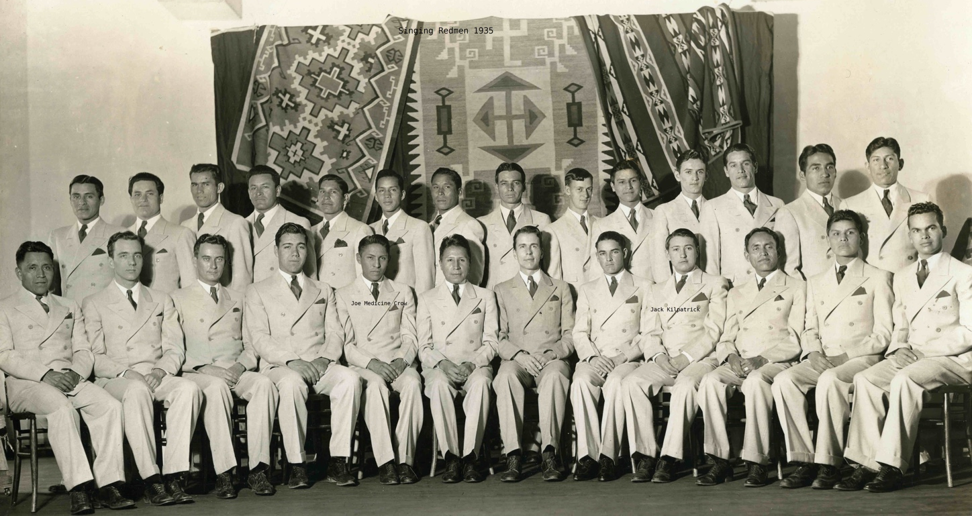
Note. A scan of an image of the Singing Redmen from 1935 uploaded to Pinterest by Frances Donelson, a researcher who was working on the Native American Collection at Bacone College. Frances Donelson passed away in 2022. Image retrieved October 1, 2023, from https://www.pinterest.com/pin/194921490105792112/. Reprinted with permission from Merritt D. Betts & Bacone College American Indian Research Library Native American Collection.

The Red Men’s Glee Club playfully referenced pop culture stereotypes of Native identity with concert headlines like “The Red Men Are Coming!” (referencing the 1930 Universal Pictures feature film The Indians Are Coming) and by posing in traditional attire before arriving and performing high-brow and well-rehearsed concerts of European standards and traditional Native American choral works. As Lisa Neuman states, the act of Indigenous students knowingly “playing Indian” with a wink and nod “playfully commented on European American images of Indian-ness while also engaging ideas about what it meant to be educated and Indian in mid-twentieth century America” (Neuman, 2013).
This culture of self-awareness, Indian identity, and academic and artistic rigor set the stage for the nascent art of then-freshman college student Jack Frederick Kilpatrick. The art that came out of Bacone from the 1930s through the 1950s navigated the challenge of developing an authentic Native American artistic style while still retaining marketability to a mostly white audience. As a composer and musician, Kilpatrick would have been well aware of the Indianist movement, which was most popular from the 1880s through the 1920s and included non-Indigenous composers like Charles Sanford Skilton, Arthur Nevin, and Arthur Farwell. These Indianist composers were influenced by Native American melodies and musical attributes, and marketed their music as such through publishing houses such as Wa-Wan Press, which ran from 1901 to 1912. The Indianist music movement was ignited by Czech composer Antonin Dvorak’s 1892 arrival in New York and famous plea for American composers to stop imitating European models and turn to Indigenous and African-American sources instead. By the time Kilpatrick was in college, this movement had dwindled in importance, and by the 1930s, the romantic, folk-inspired orchestral music of the Indianist composers was replaced in popularity by big bands and swing. It follows that in the same artistic culture that produced the Bacone style, Jack Kilpatrick knowingly embraced classical concert music as a place where he could produce what he believed were authentic representations of a new form of Native American cultural and artistic expression.

In 1934, while he was enrolled at Bacone, Jack wrote a hymn to Bacone College. The four-part hymn seen in Figure 2.2 reads as follows:
Hymn To Bacone College (1934)
March on, Bacone, into Futurity!
Lead on, Bacone, in bright nobility!
March on, Bacone, forever, as of old!
Bacone, Bacone, Christ's banner to uphold!
Bacone, our pride, our joy and guiding light!
Our vows to you we joyfully come to plight!
Though far from you, your mem’ry’ll ne’er grow old,
But work through us Christ’s banner to uphold!

Figure 2.2
An Image of the Handwritten Score “Hymn to Bacone College” by Jack Kilpatrick

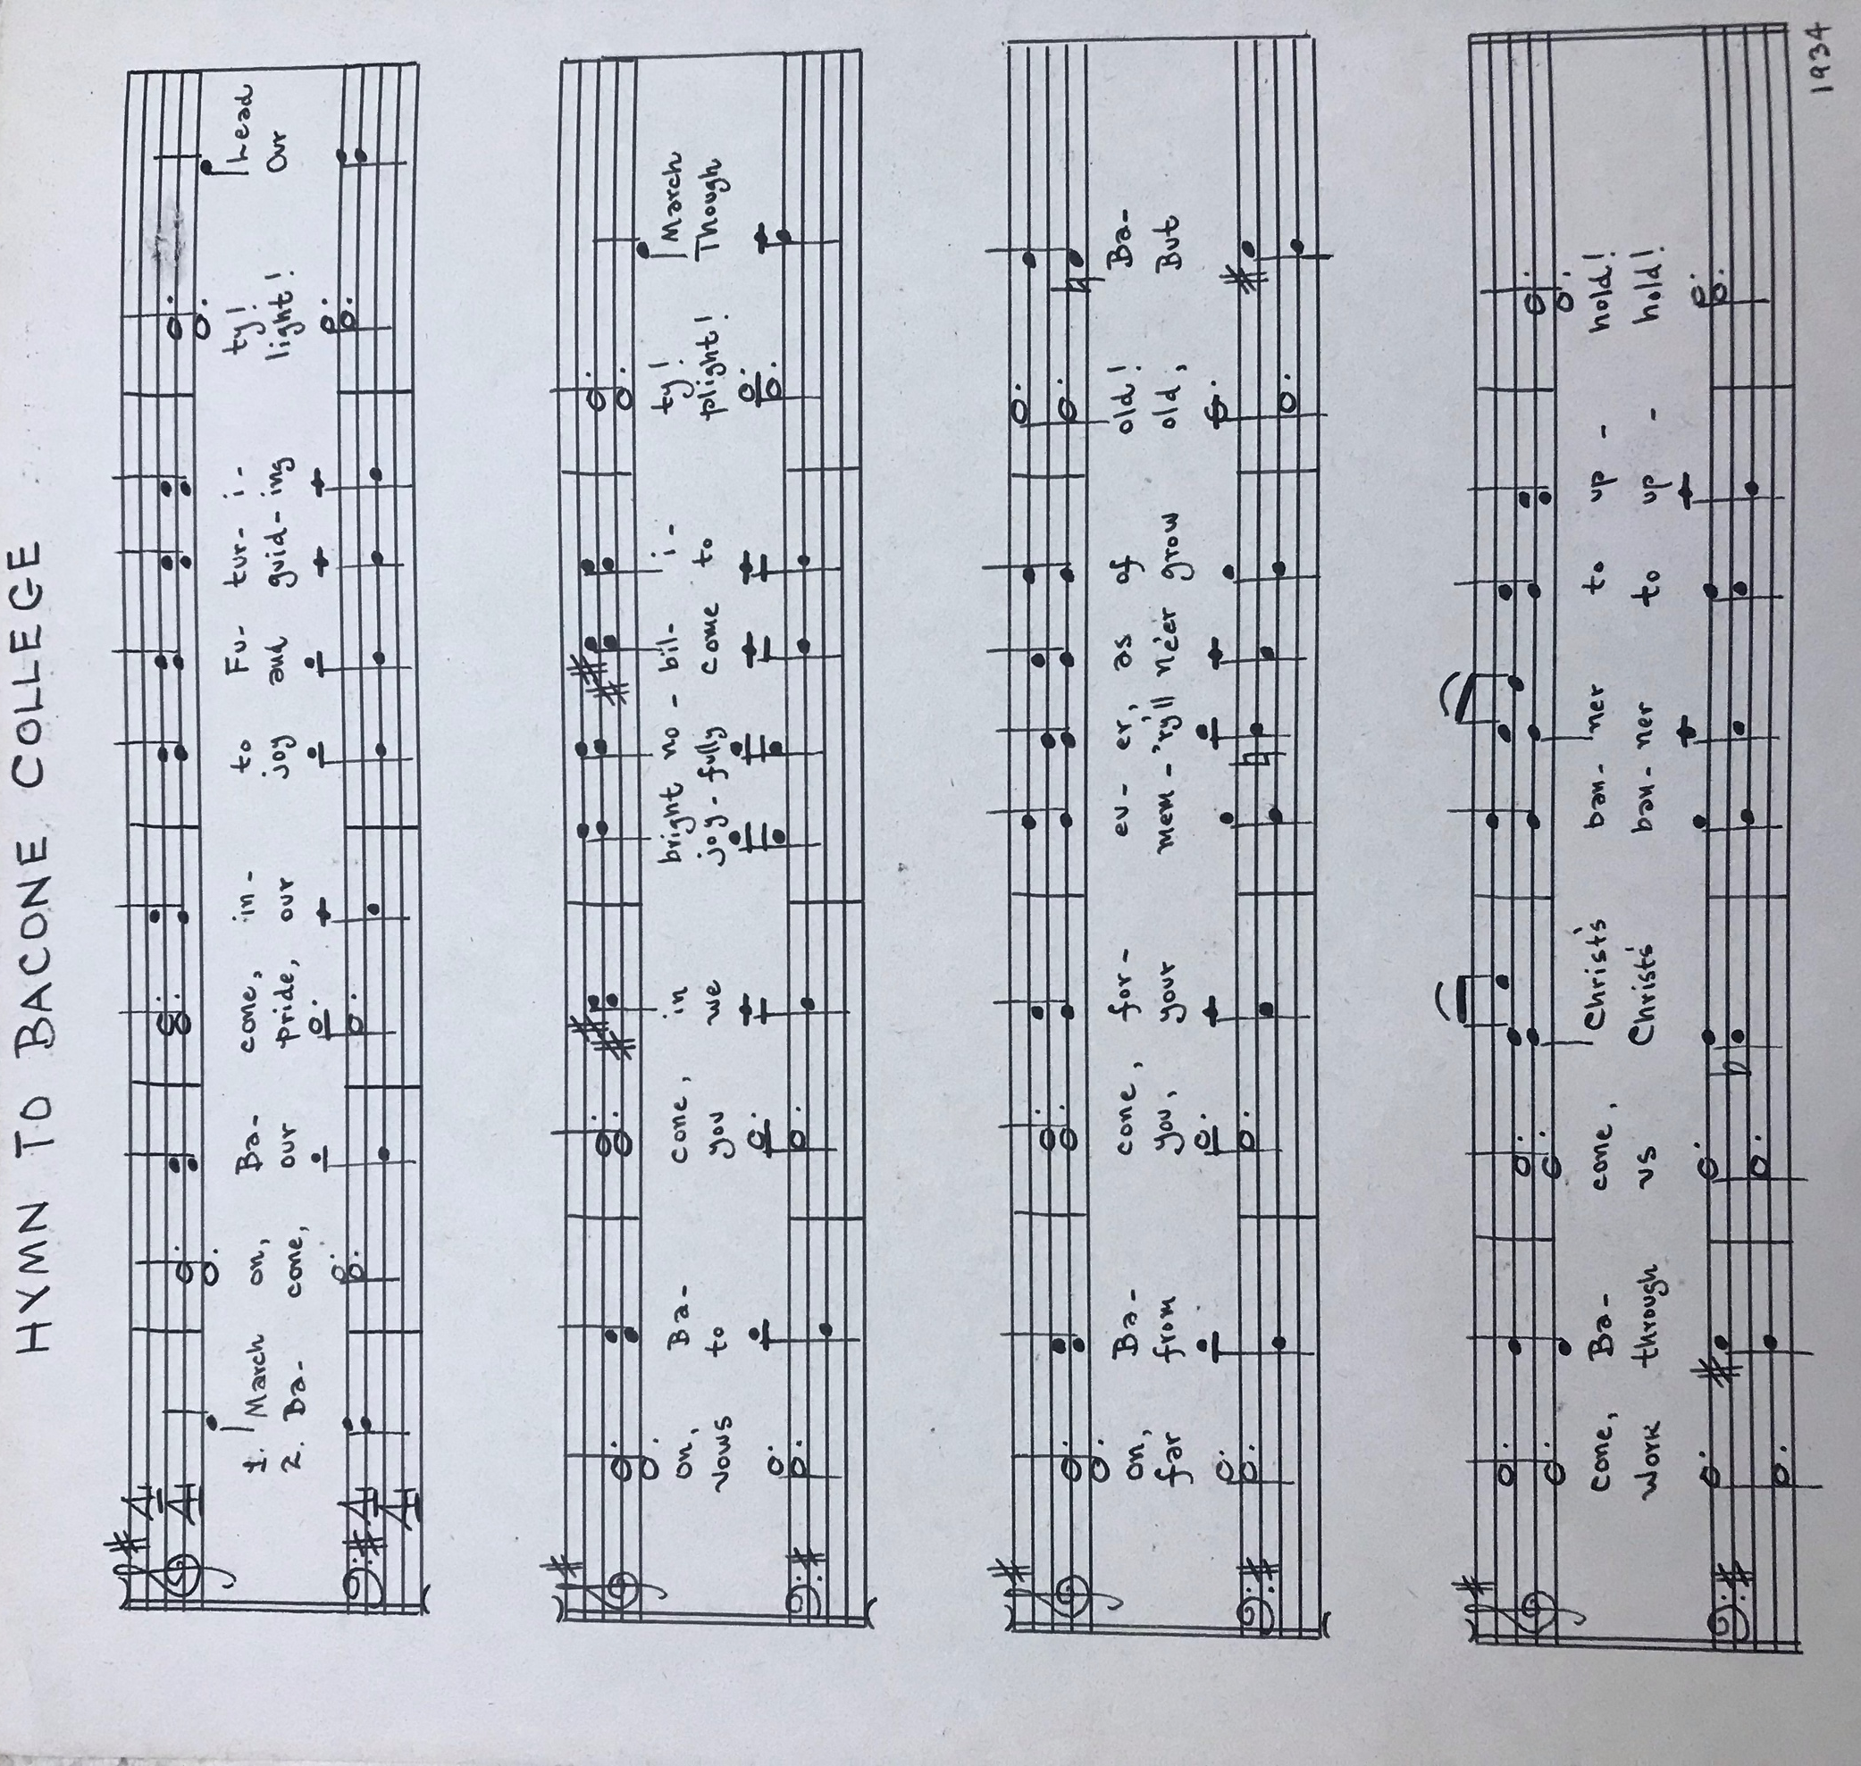
Note. A photograph of the holograph of Hymn to Bacone College by Jack Kilpatrick (own photo). Reprinted with permission from the Jack Kilpatrick Collection at the University of Oklahoma Western History Collections.

This hymn acts as a window into Jack Frederick Kilpatrick’s earliest compositional style. It is not uncommon for new texts to be written for already existing melodies, but “Hymn to Bacone College” appears to be his own composition, and the melody is more modern in style than what would typically be heard in Baptist hymnody. In it we can already see elements of his style that lasted throughout his career: a focus on religion and spirituality; a focus on and nostalgia for the place where he was while he was writing the piece; and a loyalty to the institutions and people that shaped his artistic voice. Though Kilpatrick only spent two years studying at Bacone before transferring to the University of Redlands in 1935 to pursue his dream of becoming a classical composer, the cultural and philosophical impact of his time at Bacone are evident throughout his long career. Linda Jordan, Chair of the Division of Liberal Studies at Bacone college said it was her understanding that Jack had either taught at Bacone or had a very strong association with the college, so much so they he was able to hire, fire, and assess curriculum (Linda Jordan, personal communication, December 1, 2022). A year after Jack transferred from Bacone, Anna started her own college education at Bacone, later completing her degree at Southern Methodist University in Dallas.
From their conception, the University of Redlands and Bacone College have been connected through the American Baptist Missionary Society as well as through many academics who are members of the American Baptist denomination in higher education (Michele Nielsen, personal communication, October 3 , 2022). Former Bacone President B. D. Weeks (from 1918 to 1941), former University of Redlands President Dr. Armacost, and their families at this time worked together in helping students transfer between the two universities. Due to this intentional partnership and because at the time Bacone was a two-year program, there were many Bacone graduates who completed their four-year degrees at the University of Redlands.
Many famous and influential Indigenous scholars and artists followed the same initial educational path as Jack Kilpatrick. For example, educator and policymaker Emmett Sampson Oliver (1913–2016), who was the former director of the Indian Student Center at the University of Los Angeles, the former director of the Indian Student Program at the University of Washington, and the past supervisor of Indian Education for the State of Washington, was a classmate of Kilpatrick, also starting his academic journey at Bacone and transferring to the University of Redlands on scholarship (Northwest Treaty Tribes, 2016). After graduating with degrees in biology and education, Oliver returned to Bacone to become a science professor and coach the football team and track and field (Walker, 2016). Another influential scholar and artist who graduated from the University of Redlands is Richard West Jr.—the son of “Dick” West, the chair of the art department at Bacone—who is currently serving as the president and CEO of the Autry Museum of the American West and was the founding director of the Smithsonian National Museum of the American Indian. Other people who graduated from Bacone and transferred to the University of Redlands around the same time include Walter Johnson (Northern Paiute, 1908–70?), who was inducted into the American Indian Athletic Hall of Fame, and painter Thomas Claymore, who majored in history at Bacone from 1936 to 1938 and later majored in biology at Redlands from 1949 to 1951. To this day, Bacone awards one faculty member a year with the Jack Kilpatrick Award for Excellence in Professional Creativity.

The University of Redlands (1935–1938)
Jack Kilpatrick graduated from Bacone College in 1935 and transferred to Redlands College, now the University of Redlands, to continue his training in music composition. His preparation for a career as an Indigenous artist by the artistically minded community at Bacone had enabled Jack Kilpatrick to put together a strong application and portfolio to apply for music composition programs. The University of Redlands’s composition professor Rowland Leach saw promise in Kilpatrick’s compositions and worked with him to gain scholarships in order to further his education at The University of Redlands (Pittenger, 19--). Based on the materials Kilpatrick had written and composed at Bacone and the experience he had gained in various performing groups, Kilpatrick was accepted by and given a scholarship to attend the University of Redlands in California.
The city of Redlands is located in San Bernardino County, which is approximately 65 miles from Los Angeles. A small, private college, Redlands was founded in 1909 by the American Baptist Churches USA (ABCUSA) after the 1906 San Francisco earthquake destroyed their Northern California campus institution, the California College in Oakland. One unique aspect of the University of Redlands is that it is close enough to the big city life of Southern California to feel cosmopolitan while still being secluded and offering a “small town” feel on its campus. The academic rigor at Redlands was esteemed; in Two Paths: Emmett Oliver’s Revolution in Indian Education, author Ben Smith writes, “Humanities, music, and spiritual life at Redlands were natural extensions of Bacone, but academic competition was far more intense” (Smith, 1995).
The music department at the University of Redlands, now known as the conservatory of music, has attracted significant talent throughout its history. Emmett Oliver, a classmate of Jack’s at Bacone College and then later at the University of Redlands, discussed the world-class musicians who were often found performing recitals at the University of Redlands campus (Smith, 1995). Many of the music faculty during Kilpatrick’s time at Redlands went on to teach at highly prestigious music departments throughout the United States, and the size of the faculty at the time allowed Jack the opportunity to train under several different music specialties. While at the University of Redlands, Jack Kilpatrick was able to study with a roster of accomplished music pedagogues, composers, and performers, including Arthur Poister, who is considered one of the master teachers of the organ during the 20th century. Arthur Poister had a burgeoning career as an organ recitalist that began to take off during Jack Frederick Kilpatrick’s time at the University of Redlands. Jack Kilpatrick’s own skills as an organist and accompanist indicate that Poister’s position as faculty was an important part of Jack’s education and decision to study at the University of Redlands. Kilpatrick also worked extensively with Rowland Leach, the Chicago-born violin professor and part-time composer who had recruited Jack to the University of Redlands and also directed some of the ensembles at the university.
In addition to his studies with Poister and Leach, Kilpatrick studied with composition professor William Benjamin Olds, who specialized in song and choral works, which would be highly influential and come into great use throughout Jack Frederick Kilpatrick’s own compositional career. W. B. Olds began teaching at the University of Redlands in 1923 and had a particular focus on the study of and transcription of bird songs. Kilpatrick also worked with composition and music theory professor Paul Amadeus Pisk. Pisk was an Austrian-born musician who studied under Guido Adler, Franz Schreker, and Arnold Schoenberg. Pisk began teaching at the University of Redlands in 1937, and later taught at the University of Texas at Austin (1951–1963) and Washington University in St. Louis (1963–1972). His experience in large-scale orchestral works, ballets, chamber music, and song would have greatly influenced Jack Kilpatrick’s training during Jack’s two years of study at the University of Redlands.
While a student, Jack composed several chamber pieces that he labeled and included within his compositional collection, such as “Quintette for Woodwinds in B-flat,” “Two Inventions” for solo piano, and a handful of a cappella four-part chorus works. Similar to his “Hymn for Bacone College,” Jack also wrote a hymn for the University of Redlands, which he later combined with the former to publish “Two School Hymns,” opus 44b.
During Jack’s final year of undergraduate studies, he started to compose larger works for orchestra. In his final semester, he completed Wovoka, which formed the foundation of his early compositional aesthetic. Wovoka, a tone poem which he composed between 1937 and 1938, was Jack’s first large ensemble composition. It shows the work of a young budding composer mediating his musical world of Cherokee traditional music within the context of a classical musical composition. The piece is named after the spiritual leader and creator of the Ghost Dance religion, Wovoka, also known by the name of Jack Wilson, who was one of the most influential leaders during the turn of the century in the American west. According to Wovoka’s prophecy, he died and came back to life. During the period of time that Wovoka believed he had died, he met God, and received a dance from him and a message to spread the word of peace rather than violence. His teachings quickly gained momentum, as many of his followers had despaired about the changing cultural landscape due to colonization (Hittman, 1998). The title of this composition is written in both English and the Cherokee syllabary, along with Italian tempo, expression, and dynamic markings, which is a common practice in American classical music. This aesthetic approach to Indigenous symphonic tone poems was further explored after graduation and in the works, he later composed for the WPA Oklahoma Symphony Orchestra.

The WPA Oklahoma Symphony Orchestra (1938–1941)
After graduating with his B.M. in composition from the University of Redlands in 1938, Jack’s life was focused on his desire to create art, compose, and express his Cherokee identity through music. He did not publish any academic writings until after he graduated with his master’s degree, instead focusing on his musical compositions, which were heavily influenced by Indigenous histories and culture. After graduation, at the age of 23, Jack moved back to Oklahoma, where he was appointed to the position of arranger and composer for the Oklahoma Symphony Orchestra (today known as the Oklahoma City Philharmonic) through a Works Progress Administration government program. Jack and Anna moved to Oklahoma City, and on October 8, 1938, they were married after Jack received his first paycheck from the Symphony. Soon after, Anna and Jack purchased a small portable pedal organ on which Jack composed most of his early compositions (Benson, 1975). During the next four years, Jack spent most of his waking hours composing.
Kilpatrick’s job was funded by President Franklin D. Roosevelt’s New Deal, which established several governmental programs that provided financial support and created safeguards for American employment after the Great Depression. The Works Progress Administration (WPA) administered five billion dollars for public works meant to employ and have long-term benefits for local communities, with states taking over initiatives best suited for their locations. As part of the New Deal, several music-specific programs were created. Nearly 16,000 American musicians during the Great Depression benefited from employment and artistic opportunities from the WPA’s Federal Music Program. By 1941, WPA musicians had performed 7,300 compositions of 2,558 American composers (Gough, 2015). The first was the WPA Federal Music Project, which began in 1935 and was subsequently renamed the WPA Music Program in 1939 (Debo, 2014).
The Oklahoma Music Project made considerable contributions to folksong collection and recordings and the employment of professional musicians registered on the relief rolls in their field of practice. In Oklahoma, the impact of the Dust Bowl greatly damaged the economy in rural areas, and the New Deal governmental programs supported the resurgence of farming, cultural documentation, and artistic development to encourage a resurgence for the state economy. A few important developments occurred in Oklahoma during this time that impacted Kilpatrick’s career: first, the creation of the Oklahoma City Philharmonic under the direction of Ralph Rose, which at its formation in 1937 was known as the Oklahoma Federal Symphony Orchestra (later becoming the Oklahoma Symphony Orchestra); and second, the establishment of funding for the recording of Oklahoma folk music and the collection, transcription, and classification of Oklahoma Indigenous music. Jack being a Cherokee classical composer seemed fitting for the WPA Oklahoma programs. He was able to compose new works for the organization, and utilize his knowledge of Cherokee music to fit the needs of the WPA missions.
During the New Deal period, ideologies on Indian education shifted from having assimilationist goals to more of a focus on civil service, particularly in positions that aided Native American federally driven services (Reyhner & Eder, 2017). At this time, more day schools housed within Native American reservations were built that allowed students to live at home and remain a part of their cultural areas, as opposed to the boarding schools, which were built to purposefully remove previous generations from their cultural communities. One of the primary objectives of these schools was “to give students an understanding and appreciation of their tribal lore, art, music, and community originations” (Reyhner & Eder, 2017). For Jack, working as a WPA composer in Oklahoma provided an opportunity to compose music that interfaced with his cultural knowledge and the personal aesthetic expression of his Cherokee identity.
The Oklahoma Music Project was an extremely important early career opportunity for Jack. During his time with the Oklahoma Symphony Orchestra, he was able to compose music that aligned with his personal aesthetic interests. Jack viewed himself as a Cherokee composer who used his musical landscape within the structure of classical music. During this period, Jack composed some of his best-known orchestral works, which were then performed by a major symphony orchestra with the help of the symphony’s conductor, Victor Alessandro. Between 1938 and 1941, Kilpatrick composed works for orchestra including Two Cherokee Folk Tunes, Three Cosmogonic Legends, Four Ozark Dances, A Souvenir Sonatina, Two Orchestral Sketches, and An Overture to the Shoemaker’s Holiday. He also composed Romanza for Oboe and Strings, Four Pieces for String Orchestra, Six Pieces for String Quartet, and Long Remembrance for Piano and Solo Voice.
The first work that Jack arranged was a chamber orchestra piece based on melodies Arthur Farwell had harmonized in American Indian Melodies, a 1901 publication by The Wa Wan Press and Newton Center in Massachusetts. Kilpatrick’s arrangement of these melodies, which Jack titled Five American Indian Melodies (1938), is written for flute, oboe, clarinet, bassoon, two horns, trumpet, trombone, strings, timpani, and percussion. On the manuscript is inscribed in Jack’s writing, “Arranged for the Oklahoma Federal Symphony.” It is unknown whether Five American Indian Melodies was arranged for the ensemble as an assigned job duty or whether this was something that Jack selected himself. My best assumption is that the work was selected by either conductor Victor Alessandro or a selection committee. The Indianist movement and Wa Wan Press had capitalized on using American Indian melodies as their source material, and while the composers who arranged classical works using Indigenous melodies were not Native themselves, the people consuming the music (listening and performers) viewed the material as such. It makes sense for the time that the first work that Kilpatrick was asked to undertake as an Indigenous composer would be to re-legitimize and re-introduce the work of the Indianist composers to a modern audience through an Indigenous compositional lens.
However, it is important to note that Jack personally gave the arrangement an opus number—particularly, opus “1.” An opus number indicates the chronological order of a composer’s published compositions and the sequence of their professional output. Throughout Jack’s life, he personally included his own opus numbers on each manuscript. Jack wrote several important pieces before 1938, and his later opus numbering also supports this—he later indicated that Forked Deer River for violin and piano was his opus 1—but when Jack first wrote Five American Indian Melodies, he evidently viewed it as important enough to label it as the first piece that marked the beginning of his professional career. It is quite normal for opus numbering to be revised several times early on in a composer’s compositional career until their body of work has been established through publication. At the same time, Five American Indian Melodies is one of only a few arrangements from Kilpatrick’s career that was not an original composition. In the entire manuscript collection housed within the Jack Kilpatrick Archive at the University of Oklahoma, which includes 188 different opus numbers, only six pieces are arranged but not composed by Jack Kilpatrick. These five arrangements are Five American Indian Melodies by Arthur Farwell, Sonata by Ludwig Van Beethoven, A Stephen Foster Medley by Stephen Foster, Now Thank We All Our God by Johann Crüger, Dearest Lord Jesus by J.S. Bach, and Buttered Bread by W.A. Mozart.
By 1940, Jack Kilpatrick was composing new symphonic works on a regular basis that often utilized Cherokee thematic material as inspiration. He would later continue his post-baccalaureate education at Northeastern University in Tahlequah, Oklahoma, but did not earn a degree from those studies. After moving to Washington D.C. to serve and teach at the Naval School of Music, he also attended the Catholic University of America in Washington D.C., earning an M.M. in composition. In April 1952, the University of Redlands conferred that Jack be honored with the degree of Doctor of Music based on his professional contributions to the field.

Edward MacDowell Memorial Colony of Artists (1941)
In the summer of 1941, Jack attended the Edward MacDowell Memorial Colony of Artists in Peterboro, New Hampshire, after receiving the National Academy of Arts and Letters MacDowell Fellowship in composition. Edward MacDowell (1860–1908) was a prominent American composer and pianist known for his romantic works and was one of the first seven members appointed to the American Academy of Arts and Letters in 1904. Edward MacDowell’s wide breadth of compositional output was similar to what Jack achieved throughout his career. MacDowell attended the Paris Conservatory studying piano, theory, and composition, and was fellow classmates with Claude Debussy. During MacDowell’s lifetime, he was viewed as one of the leading American composers, and because of this status, he became the first appointed music professor at Columbia University (1896–1904) (MacDowell, 1912). MacDowell’s Indian Suite for orchestra became one of his most popular compositions and was premiered by the Boston Symphony 1896.
The MacDowell Artists’ Residency and Workshop is better known as the MacDowell Colony, or simply “the Colony.” The Colony which was started in 1908 by Marian MacDowell, was (and continues to be) a retreat for artists to create a seminal work of art, a serene place where artists are inspired by their surroundings and removed from the day-to-day activities that can limit creativity. MacDowell wanted there to be a space for artists where they were free to allow for the creative process to be fostered, just as Marian and Edward MacDowell had in their New Hampshire home.
Jack Frederick Kilpatrick’s acceptance to the Colony was a seminal turning point in his career, as more than 60 artists who have attended the Colony have won Pulitzer Prizes. This was the first time Kilpatrick was viewed as a professional composer alongside other well-known artists of the time. Other famous works composed at the Colony include Aaron Copland’s Appalachian Spring, Leonard Berstein’s Mass, DuBose and Dorothy Heyward’s Porgy, which was the basis for George Gershwin’s Porgy and Bess, and Virgil Thomson’s Mother of Us All. While at the Colony, Jack Kilpatrick composed In Berry Time for orchestra, which Jack dedicated to the MacDowell Club of Oklahoma City, Oklahoma. In Berry Time is one of the few pieces that is currently available for rental through the publisher Carl Fisher Music. The title of the piece is likely a nod to the yearly celebration of the spring harvest of strawberries, a time-honored tradition in Jack’s hometown of Stilwell.

Kilpatrick’s Transitional Period (1941–1948)
By 1941, the WPA had seen much success, and throughout the country its musicians had performed 7,300 original compositions by 2,558 American composers (Gouch, 2015). One of the results of the state-run program was the categorization of regional musical styles. In each location, regionalists started working within New Deal projects, bringing their specialties to the forefront. In the American West, regionalism took on increased importance, and the symphonic music varied from the east coast, as the performing organizations did not subscribe to the same notion of European musical hierarchy. Instead of just performing the European classical canon, the music of the American West blended the music of diverse groups of people (Gough, 2015). Jack Kilpatrick is representative of the ethnographically informed focus of the New Deal in the American West. Western regional symphonies often performed music by American composers who synthesized or derived from Indigenous, Hispanic, African, Anglo, or Asian American folksong and folklore. Musicologist and composer Sigmund Spaeth applauded these efforts of using American musical sources as a new dawn of music culture, identifiably America’s own (Gough, 2015). Peter Gough writes:
By the 1930s, the West remained the most ethnically diverse, transient, and least culturally and politically entrenched region of the United States. It is the musical expression of these varied groups—people of Native American, European, African, and Asian ancestry—that most distinguished the FMP [Federal Music Project] in the West. (Gough, 2015)
During the early 1940s, the U.S.’s involvement in World War II heightened, and federal funding shifted from economic recovery programs to national defense. By December 1941, all remaining WPA programs were transformed to aid in the war effort. These were pivotal years for Jack Kilpatrick. He could see that with reduced funding, his position with the WPA and the Oklahoma Symphony Orchestra would eventually go away, so he began to try to figure out how to move on from his WPA position with the Oklahoma Symphony Orchestra after completing his work Four Ozark Dances. Near the end of his employment with the WPA, he composed one of his seminal works, In Berry Time, which he completed during his summer at the prestigious MacDowell Colony. However, soon after, in the fall of 1941, Jack found himself once again teaching public school in rural Oklahoma, as a band teacher at Cave Springs Public Schools in Bunch, Oklahoma (Adair County). An image of Jack from this time can be seen in Figure 2.3.

Figure 2.3
An Image of Jack Kilpatrick from May 19, 1941
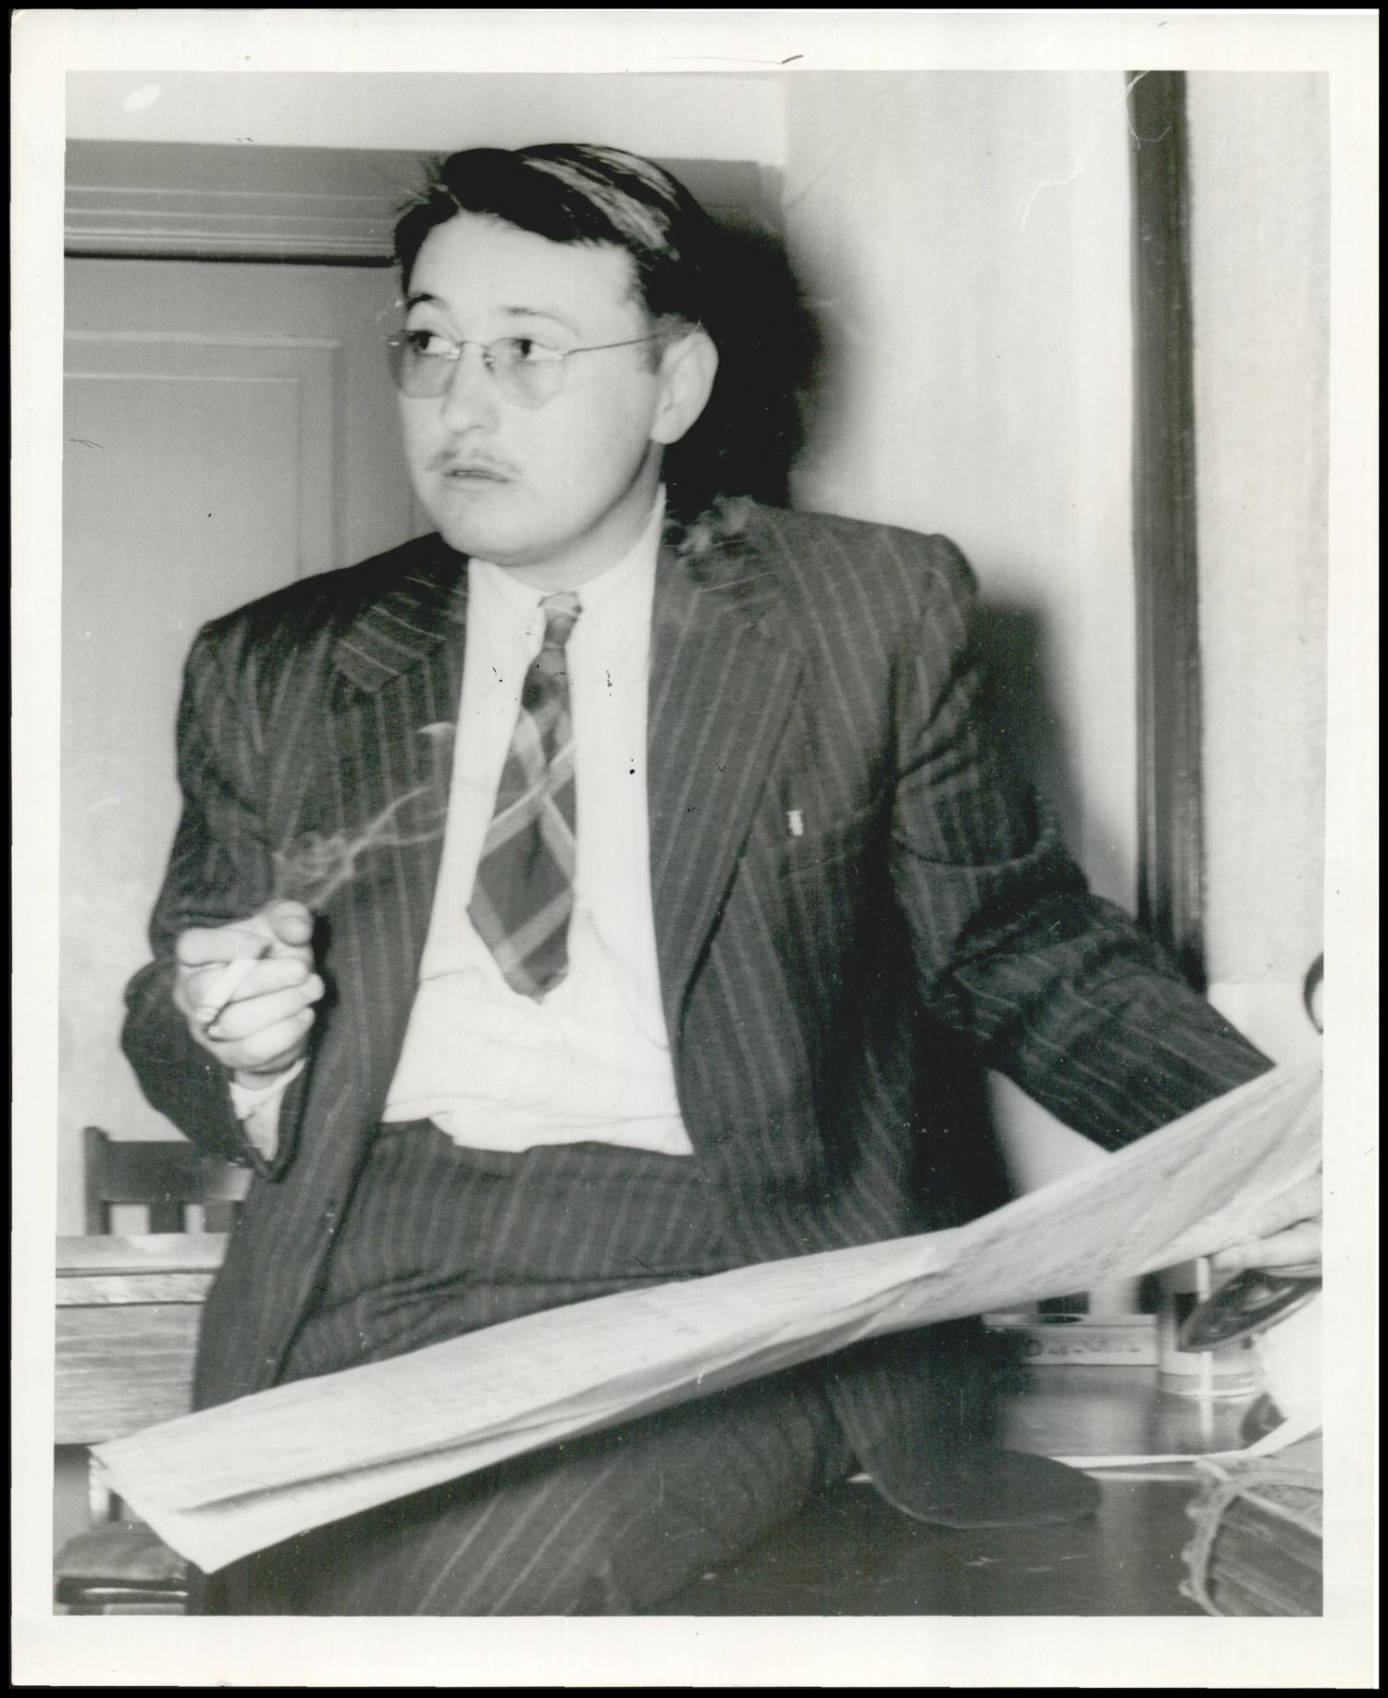
Note. Photograph used for a newspaper owned by the Oklahoma Publishing Company. Caption: "Kilpatrick, Jack. Composer.” Photo by Hart, Alphia O, May 19, 1941. Reprinted with permission from the Oklahoma Historical Society.

While Jack did not write a large amount of band compositions as compared to other genres of music during his career, he wrote a handful of pieces for his public school bands while he taught music in the public school system. His most notable band composition is his 1943 march titled Tahlequah, where he specifically wrote on the score manuscript “For High School Band.” With the increased efforts of World War II, Jack Kilpatrick enlisted in the Navy in 1943, moved to Washington D.C., and began a transitional period of his career, during which he put together the skills, experiences, and educational credentials that led to his eventual appointment as a professor at Southern Nazarene University in Dallas, Texas.

Chapter 3: The Life and Work of Jack Kilpatrick: Texas
In 1943, Jack Frederick Kilpatrick enlisted in the Navy and left his job with the Oklahoma Symphony Orchestra. He completed basic training in San Diego, California, and earned the rank of a musician third class. Jack then moved to Washington D.C., where he became a music instructor at the Naval School of Music and enrolled at the Catholic University of America, earning a Master of Music in music composition. This chapter starts with Jack Kilpatrick’s achievements while residing in Washington D.C., which includes his thesis work, teaching at the Naval School of Music, and several performances of his works programmed by Richard Bales and the National Gallery Sinfonietta. In 1945 after the completion of his military service and time at the Naval School of Music, he moved back to Oklahoma.
The next home Jack created with his family was in Dallas, Texas, after taking a teaching position at Southern Methodist University (SMU) starting in 1947. Jack Kilpatrick taught at SMU until the time of his death in 1967. The remainder of this chapter is centered around Jack’s compositional output while he resided in Dallas, including his symphonies and music composed for symphonic dramas in collaboration with Kermit Hunter.

Washington D.C. (1943–1945)
From its opening in 1935 until 1942, the Naval School of Music was an independent entity that operated in conjunction with the United States Navy Band. This was a formative time for Jack. After the end of the WPA program’s focus on new American compositions, his new position at the Naval School in Washington D.C. allowed Jack to gain experience teaching collegiately as a music counterpoint instructor. During this time, he also received mentorship in music composition and anthropology while enrolled at the Catholic University of America, where he earned an M.M. degree in music composition in 1946, and was able to start getting his compositions in front of prominent conductors and organizations. I believe it was his time in Washington D.C. that established Jack as an American composer to take notice of. The connections Jack Kilpatrick made in Washington D.C. grew his brand from a regional, Oklahoma-based composer who focused on smaller orchestral tone poems to a nationally known composer of large concert works and symphonic dramas.

National Gallery Sinfonietta and Richard Bales
Starting in 1942 and continuing to this day, the National Gallery of Art in Washington D.C. offers weekly concerts that often feature ensembles from the armed forces and military schools. The complexity of the performing groups ranges from small chamber ensembles to full symphony orchestras and choirs, and the National Gallery also has a resident ensemble, the National Gallery Sinfonietta. Jack Kilpatrick’s work Invocation and Ritual, which he wrote specifically for the National Gallery Sinfonietta, was commissioned and premiered there by director Richard Bales (1915–1998) in 1944 (National Gallery Sinfonietta, 1944). Bales served as assistant director of music for the National Gallery for 42 years (1943–1985). The copy of the program from the premiere of Invocation and Ritual can be seen in Figure 3.1.

Figure 3.1
An Image of the Program of the National Gallery Sinfonietta from Sunday, May 21, 1944 featuring Jack Kilpatrick’s composition Invocation and Ritual
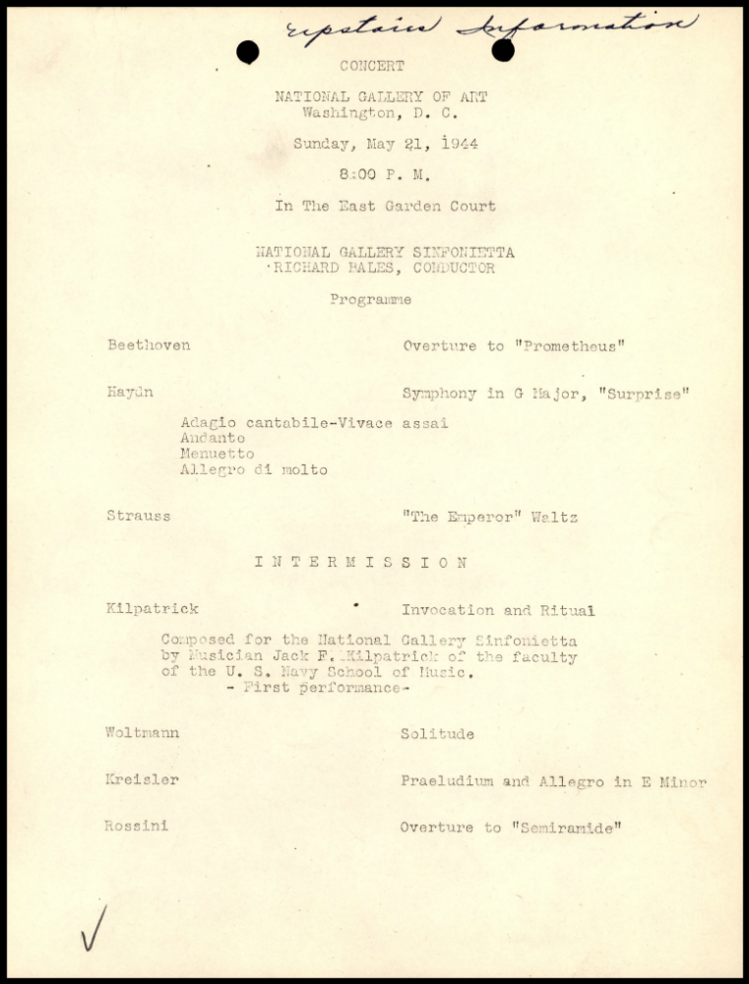
Note. Reprinted with permission from the National Gallery of Art Concert Programs Archive.
Bales, who was an authority on early American music, took an interest in Kilpatrick’s work, and programmed several of Kilpatrick’s compositions alongside other leading American composers of the time. As an alumnus of Eastman School of Music, Bales was inspired by the American music concerts that then-composer and Eastman faculty member Howard Hanson (1896–-1981) curated. Before his appointment as the assistant director of music for the National Gallery, Bales stated that if he were ever given the opportunity to run a concert series, he would use that opportunity to create a space to present the music of American composers to a modern audience (Hume, 1979). In the summer of 1943, much to Bales’s surprise, the then-director of the National Gallery of Art, David E. Finley, asked Bales to take over curating the National Gallery of Art chamber series and conducting the National Gallery Orchestra in Finley’s place. Starting in the spring of 1944 and continuing until 1985, Bales presented the annual American Music Festival, dedicating multiple concerts to programming the music of American composers. Throughout his tenure, Bales produced 1,786 concerts in the museum’s Garden Court and elevated the status of the National Gallery Orchestra to a nationally recognized ensemble renowned for its musical excellence (Barnes, 1998). These concerts were instrumental in shaping our modern conception of the American sound, through premiere performances of living composers and astute programming that placed those contemporary works within a contextual history of American classical music programming. As a music historian, Bales was also always in search of recently rediscovered music by prominent composers, giving them a place to heard on his concert series. In 1945, the year following Jack’s premiere of Invocation and Ritual, Bales programmed another Kilpatrick composition, An Oklahoma Sinfonietta, which was featured as part of his annual American Music Festival (Hume, 1979). After the continued support of Richard Bales, Kilpatrick received several commissions from leading U.S. orchestras which helped solidify him as a prominent composer of his time (see Appendix A and B).

The Catholic University of America and Jack’s Master’s Thesis
Jack Kilpatrick attended the Catholic University of America (CUA) in Washington D.C. from 1943 to 1946, during the middle of the United States’ involvement in World War II and the university’s reconstructions of departmental offerings. It was not until 1950, four years after Jack graduated, that an official division of music was created at the Catholic University of America. John Paul, who had previously worked as chair of Jack’s thesis committee, was chosen as the first leader of the newly formed music division (Kilpatrick, 1946). However, prior to the official start of the music department in 1950, the Catholic University of America still had a long tradition of educating musicians, scholars, and composers (Department of Music: History, n.d.). While at CUA, Jack Kilpatrick’s research interests were not only focused in composition and theory; his growing fascination with musicology and ethnomusicology was also starting to become apparent. After WWII ended in 1945, Jack returned home to Stilwell, Oklahoma, where he took a position as the band director at Stilwell High School, with one year remaining in his university program. During this time, he frequently traveled back to D.C. in order to complete his graduate classwork and finish the research and the writing of his graduate thesis, “The Possible Relationship of Content to Form in Certain Gros Ventre Songs,” which he completed in July of 1946. Jack’s success after graduation continued to spotlight the need for continuing to foster the growing talent of modern composers, and his studies at the Catholic University of America were part of John Paul’s arguments in favor of forming an official music division at the University.
While Jack authored and co-authored many writings, a close reading of Jack’s master’s thesis reveals a great deal about his artistic process and how he understood and approached syncretizing Native American music with the Westernized medium of classical concert music. Jack’s research was based on a partnership with John M. Cooper, an anthropologist at Catholic University, who had recorded 116 songs performed by members of the Gros Ventre Nation. Jack used the recordings captured by Cooper as the basis of his master’s thesis research, listening to the recordings, transcribing them into Western musical notation, and analyzing the transcriptions he made of the recordings. In his thesis, Jack searched for structural similarities between the compositional styles of the Gros Ventre collection and Euro-American classical music. However, Jack lamented that many of the musical transcriptions he had notated were not able to convey the intricacies of the performance deliveries that he heard in the recordings—an observation that was almost more important for Jack’s own development than for the content of his thesis. He wrote that one of the most difficult tasks of the thesis was to accurately transcribe the recordings into Western notation, because he believed that important performance qualities in the original recordings were lost by taking non-Western music and simplifying it into Western notation. Most importantly to Jack, Western transcription does not account for expression and performance sensibility. Jack modeled his transcriptional style after George Herzog’s, which he considered most adequate for notes, unvoiced notes, grace notes, slides, and scoops within the Western notation system. However, Jack heavily stressed that Native American music does not fit into two- and four-beat groupings and that, while he used measures and common Western meters, each measure usually had a different time signature. For some of the meters, the time signatures included an extra eighth or sixteenth note to best attempt to accurately transcribe the vocal performance. His cross-cultural knowledge of both musical cultures allowed him to notice the discrepancies of earlier transcriptions and the failings of the tools at his disposal (Kilpatrick, 1946, p. 1–7).

Dallas, Texas (1947–1967)
After graduation from the Catholic University of America in 1946, Jack took a job at Southern Methodist University in 1967, and his whole family (now including two children, Jack Jr., and Clifford) relocated to Dallas, Texas. Jack and Anna’s third and youngest son, Alan Kilpatrick, was born in 1949, and he would eventually follow in their footsteps as an academic and anthropologist with a focus on Cherokee culture. In addition to Southern Methodist University, Jack was also offered teaching positions at Southeastern State College (now Southeastern Oklahoma State University) in Durant, Oklahoma, and North Texas State College (now University of North Texas) in Denton, Texas, but he ultimately took the position at Southern Methodist University because of his Methodist beliefs and his desire to build professional connections with conductors and classical organizations in the Dallas area and beyond (Benson, 1975, p. 7). After receiving his faculty appointment at SMU, Jack started composing more chamber music than he had previously, due to the opportunity to collaborate with faculty colleagues and gifted music students on university recitals. At this same time, Anna completed her undergraduate degree from SMU, started teaching in the public school system in Dallas, and together Jack and Anna did some of their most important research, with the first printings of several of their most popular books being published by the Southern Methodist University Press.
For Jack Kilpatrick, Dallas became a mecca of opportunity. While Jack was always a small-town boy at heart, Dallas provided him with opportunities to work alongside other like-minded academics and music professionals. After becoming a faculty member at Southern Methodist University, Jack started to explore historical writing in collaboration with Anna and alongside his composing career. In addition, faculty members were interested in commissioning and performing his works regularly, as well as playing pieces that were still in the development phase (Benson, 1975, p. 8–9). This allowed him the freedom to workshop his compositions and receive feedback before the premiere performance. Southern Methodist University was then and remains to this day the central hub of the North Texas classical music scene, and because of this, the university has always been able to attract phenomenal talent to join their faculty. For Jack, this was an opportunity to work with world class talent, and the connections he made led to lifelong friendships with people and organizations who were constant champions of his work. Two important advocates who both played a significant role in Kilpatrick’s success were conductor Paul van Katwijk of the Dallas Symphony Orchestra and historical outdoor dramatist Kermit Hunter, the dean of the Meadows School of the Arts at Southern Methodist University.
To have success as a classical composer, it is imperative that the composer has support by people who wish to program their works. The support of artistic directors and conductors can often be the deciding force on a composer’s career. Backing from Richard Bales and Paul van Katwijk affected Kilpatrick’s career advancement as a composer more than almost any other influences. Kilpatrick’s collaborations with these two friends led one of the leading and most influential conductors of the 20th century, Leopold Stokowski (1882–1977), to become a fan of Kilpatrick’s music. In 1955, Stokowski programmed two performances of Invocation and Ritual, opus 30, while in residence as a guest conductor with the Dallas Symphony Orchestra and Fort Worth Symphony. The original program for these concerts was Ludwig van Beethoven’s (1770–1827) Symphony no. 7 in A major, op. 92, and Lou Harrison’s (1917–2003) Symphony no. 1 “Symphony in G”, but due to the unavailability of the two harpists needed for Harrison’s piece, it was replaced on the program with Kilpatrick’s Invocation and Ritual. Harrison was not notified of the change beforehand, taking a bus from California to be present for the concerts but was soon left disappointed after finding out about the reprogramming (Huffman, n.d.).
It was during this time that Kilpatrick also composed his only opera, The Blessed Wilderness, which was completed in 1959. The work was previewed on March 19, 1959, during Southern Methodist University’s Fine Arts Festival, and had its world premiere on April 18, 1959, by the SMU Opera Theatre (Strawberry Festival Program, 1959). This 90-minute opera about Indian removal in northern Georgia was said by Anna Gritts Kilpatrick to be one of Jack’s favorite compositions because, unlike other pieces he composed, he “said everything musically he had wanted to say” (Benson, 1975, p. 11). This was one of Jack’s last major compositions before he shifted his focus to writing music for historical dramas and academic and historical writing in collaboration with Anna.
In 1948, Kilpatrick was offered the position of composer-in-residence and Professor of Theory and Composition, later becoming the chair of the music department at Southern Methodist University in Dallas, Texas. After moving to Dallas, Jack’s compositional style changed. In his role at Southern Methodist University in Dallas, his opportunities shifted from providing Indigenous, Oklahoman, or American content as part of a wider movement or program to individual commissions for fellow faculty members, recitals, ensembles, conductors, and companies. These changes in opportunity are reflected in his manuscript collection. While his early works have a substantial focus on programmatic works with evocative and culturally-based names (e.g. An American Indian Serenade, Invocation and Ritual, and An Oklahoma Sinfonietta), his works during his early years in Dallas are more focused on concertos, symphonies, chamber works, incidental music, and sonatas. This change, from the more populist and grant-friendly programmatic naming conventions of his early years to the more theoretical and genre-based naming conventions of his later years, is reflective of both the academic naming conventions of the time and the fact that as an established composer, Kilpatrick was now being asked to write pieces because of his own reputation and relationships, rather than because he was representative of a type of composer that ensembles and granting agencies wished to invest in.
Kilpatrick was a devoted teacher to his students, and this was recognized by the other members of the music faculty (Benson, 1975). As a professor, he taught some incredible talent, and Kilpatrick’s orchestration and composition classes were some of the most popular courses within the schools where he taught (Benson, 1975). Many of Kilpatrick’s students went on to become professionals themselves, such as Frank Lewin (1925–2008), who was a professor at Yale School of Music from 1971 to 1992 as well as at Columbia University School of the Arts, and who was also the John R. Akins Professor of Music Theory and composition at Evangel University (Floyd, 2011, p.5). Lacy McLarry (former concert master of the Oklahoma City Philharmonic) and Beverly McLarry (former Minister of Music at First Christian in Oklahoma City and adjunct professor of voice at Oklahoma City Community College), now retired music professionals based in Oklahoma City who were both students of Kilpatrick’s, talked fondly about taking classes from him at SMU (L & B McLarry, Personal Communication, September 14, 2019)
While at Southern Methodist University, Kilpatrick started to explore composing for more smaller, chamber ensembles. He had the ability to compose music for his colleagues and have his music regularly performed on faculty recitals and programmed by his music students. Because he also served as the music director at a local Methodist church, he often composed smaller works for SATB, TTBB, and other mixed vocal choirs. Kilpatrick composed a considerable amount of music for solo piano and collaborative piano works. He continued to explore melodic and thematic Indigenous content, but he was also drawn to composing music that explored the sounds of Texas. He composed a considerable amount for string quartet and for string quartet with a solo instrument.
Prior to moving to Dallas, most of his pieces were framed in some way as connected to Cherokee culture, either by title, lyrical content, or melodic material. His works were generally centered in Western tonality and favored traditional classical forms. However, after moving to Dallas, the other professors at Southern Methodist University were still very interested in playing his music, but each piece alluded much more subtly to his culture and his home. Rather than writing big form pieces like his earlier shorter tone poems and marching band works, he now opted for more dense, academic chamber music and symphonies. Through studying the collection, it has become clear that Kilpatrick’s music started to move away from tonality and played with the idea of unstructured song and atonality the longer he was at Southern Methodist University.
At this time, Kilpatrick gravitated towards composing music that was either through-composed or a three-movement work. The first movement often had a lively or driving feel and tempo, followed by a slow and lyrical second movement. Kilpatrick had a knack for finishing his compositions with a reel as the third movement, creating a fun and playful ending. The music he composed while at SMU continued his lifelong approach to writing music that is playable, melodic, and a good fit for the instruments the music was composed for.
As Kilpatrick continued his compositional career, his pieces began to be programmed by leading American orchestras and were receiving attention by world-famous conductors. While he taught at Southern Methodist University in Dallas, Jack also received several commissions. Some of the orchestras that played, premiered, and/or commissioned works by him include the Albany, Amarillo, Buffalo, Charlotte, Cincinnati, Dallas, Detroit, Honolulu, Houston, Indianapolis, Oklahoma City, National, Pittsburg, Rochester, Saint Louis, San Francisco, and San Antonio symphonies, as well as the NBC, the Scottish BBC, and the Radio Symphony of Sweden. A list of his commissioning ensembles, conductors, and concert artists who have performed his works written in Kilpatrick’s own hand can be seen in Figure 3.2.

Figure 3.2
An Image of a Hand-Written List of Commissioning Organizations, Conductors, and Concert Artists Who Have Worked With Jack Kilpatrick in His Own Hand
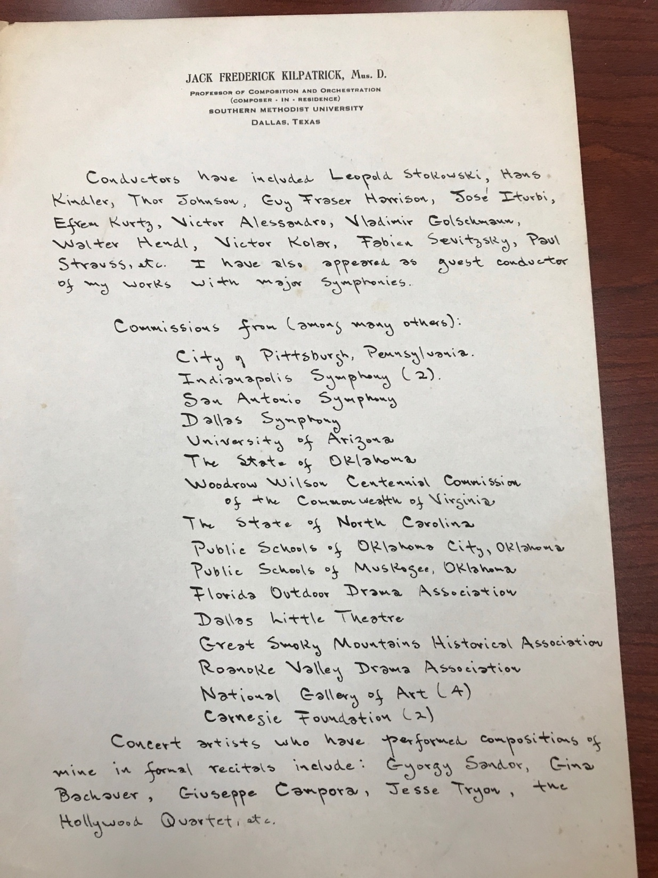
Note. A photograph of a handwritten list by Jack Kilpatrick (own photo). Reprinted with permission from the Jack Kilpatrick Collection at the University of Oklahoma Western History Collections.
While his music shifted away from Cherokee thematic material, Jack Kilpatrick had by no means abandoned Cherokee research during this period. Most of Jack and Anna’s books and articles were focused on Cherokee storytelling, medicine, incantations, and language. One of their most iconic books was, Walk In Your Soul: Love Incantations of the Oklahoma Cherokee published in 1965. Anna and Jack received several grants to pursue their research and they returned to Oklahoma frequently. The combination of the opportunity to write academically about Cherokee folklore along with the academic musical opportunities in Jack’s new position caused his music to expand into different sonic soundscapes outside of the realm of Indigenous inspiration.
During this time in Dallas, Anna and Jack began publishing academic papers and books together. Anna’s work as a Cherokee transcriber and translator was foundational to the work Jack and Anna did with Cherokee folklore. While Jack did read and write in Cherokee, all of the completed translation work was done by Anna Kilpatrick. Once they began working together, both Jack and Anna Kilpatrick were able to lend each other legitimacy against outside entities that questioned their authenticity. As co-authors, Jack Kilpatrick’s credentials as a professor at a university acted to authenticate the academic rigor of Anna Gritts Kilpatrick’s research and writings, while Anna Gritts Kilpatrick’s credentials as a full-blooded Cherokee with a significant and storied cultural lineage that led back to Sequoyah himself (which Jack Kilpatrick often mentioned) acted to authenticate Jack Kilpatrick’s cultural knowledge and voice as Cherokee.
Their book Friends of Thunder, Anna and Jack both mention that Cherokee history needs to be preserved by people who are in fact Cherokee and truly understand the culture. This gives us an important understanding into Jack Kilpatrick’s philosophical approach about how he might want the Cherokee elements of his music to be analyzed. One of the Kilpatricks’ missions in their work was to accurately preserve Cherokee culture. The Kilpatricks critiqued the extensive errors in James Mooney’s books Sacred Formulas of the Cherokee, The Myths of the Cherokee, and The Swimmer Manuscript: Cherokee sacred formulas and medicinal prescriptions, revised, completed by Frans M. Olbrechts. These errors limited the value of the works for cultural preservation. In particular, the Kilpatricks wanted to correct the information in Mooney’s book, Sacred Formulas of the Cherokee. While they never believed Mooney’s work was invalid, they did believe that his understanding of culture from an outsider’s perspective led to gross mistakes. For example, the Kilpatricks believed Mooney’s use of the term “sacred formulas” was problematic. The Kilpatricks stated that the spells were often not sacred (though some scholars might argue this now) and that they were anything but formulaic. Shamans and medicine people had core elements of shared knowledge, but healing was itself a personal formula. That is why in their book, Jack and Anna use the term “incantations” to replace “sacred formulas.” During the same time they wrote Friends of Thunder, Anna wrote a book on the Cherokee syllabary, and they both invested numerous hours in collecting Cherokee stories and folklore from Cherokee culture bearers.
In 1966, Jack Kilpatrick served as editor and Anna Kilpatrick served as translator for the single issue they published of The New Cherokee Advocate, a historical journal published by the Cherokee National Historical Society in Tahlequah, Oklahoma. The journal’s name derived from the 1844–1906 newspaper the Cherokee Advocate, which was a weekly newspaper published by the Cherokee Nation relating to Cherokee, local, and national news. It was also similar to the Cherokee Phoenix, which was the first newspaper to be written in both Cherokee and English languages (The New Cherokee Advocate, 1950). A newspaper report of their appointment as editors of The New Cherokee Advocate can be seen in Figure 3.3.
Figure 3.3
An Image of a Newspaper Report of Jack and Anna Kilpatrick’s Appointments as Editors of the New Cherokee Advocate by the Cherokee National History Society at Tahlequah, Oklahoma
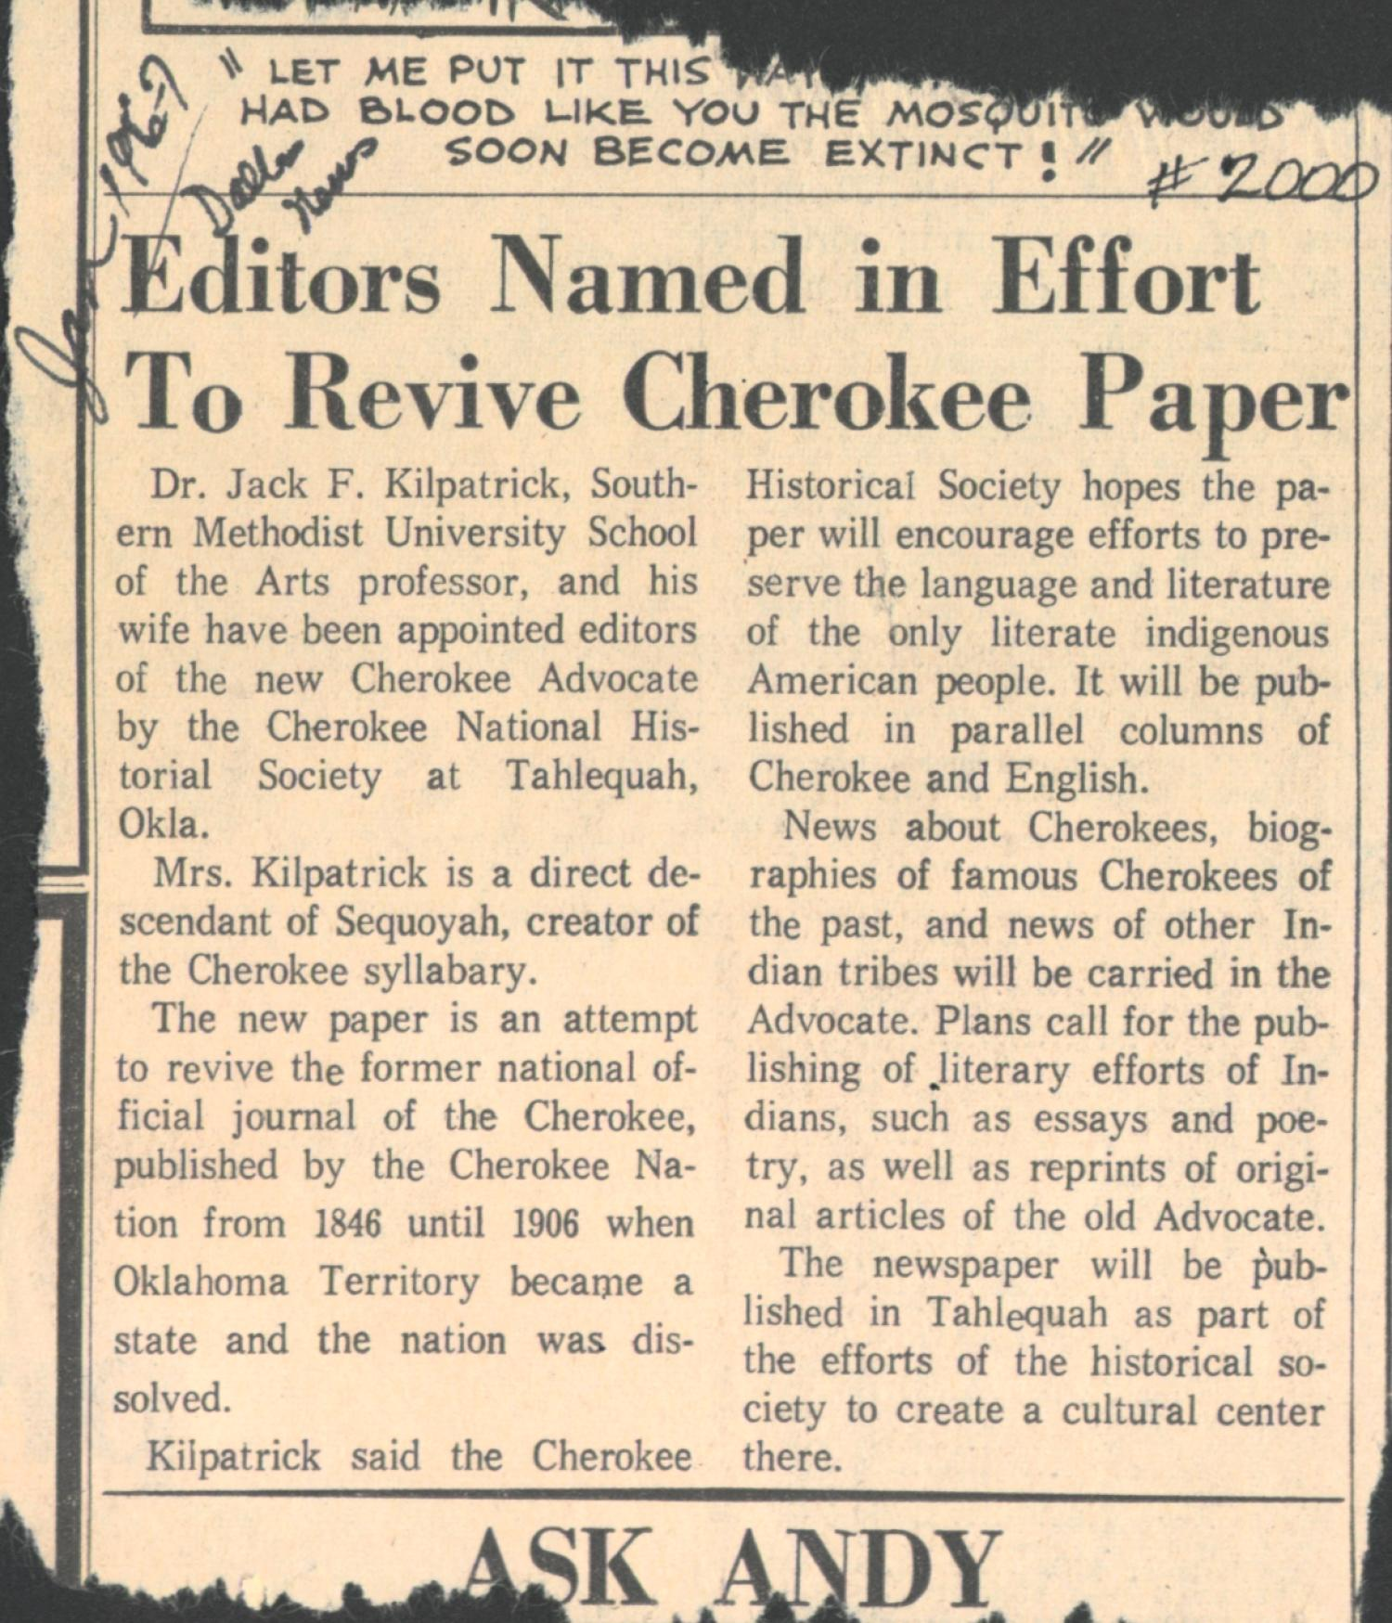
Note. Creator unknown. Reprinted with permission from the Oklahoma Historical Society.
Their work together earned them the “Citation of Merit” by the Cherokee Nation. In addition, Jack and Anna were awarded grants from the Smithsonian Institution, the Danforth Foundation, and the American Philosophical Society.
This later period of Kilpatrick’s compositional career can be best analyzed through an in-depth examination of two of the main mediums through which he composed: his eight symphonies, and his historical dramas. These were the two main avenues through which Kilpatrick established himself as a leading American composer in the 1950s and 1960s, and are some of the most important and most performed works from his catalog.

Kilpatrick’s Symphonic Period (1947–1957)
Ever since Ludwig van Beethoven elevated the status of the symphony to represent the apex of compositional importance in classical music, the act of a composer writing their first successful symphony has been seen as a seminal moment that separates aspiring composers from established ones. Following this model, one of the most effective ways of establishing a career as a professional American composer during the 20th century was to compose large-scale symphonic and operatic works for major orchestras and opera houses. It makes sense then that Jack Kilpatrick, now with a music professorship at Southern Methodist University and in a bid to establish himself as a composer in a growing and cosmopolitan metropolis in Dallas, began to interface more with the traditional pathways through which he could establish legitimacy in his career as an important American composer. This approach can be seen both in the larger-scale genres that Kilpatrick began to compose in, and in the early-modern American tonalities and harmonies that became much more prevalent in Kilpatrick’s compositional style at this time. Again, this draws attention to the importance that space and place had on Kilpatrick’s compositions, as his place at a cosmopolitan university and the space he operated in as an established academic American composer both became seminal influences on his output during this period.
Jack Kilpatrick wrote his first symphony, the Symphony No. 1 in F minor, “Indian Boyhood,” in 1947, the year before he moved to Dallas, Texas. Writing a symphony is considered a rite of passage for classical composers, an act which often separates what musicologists will consider a composer’s early works from their more serious, later works. Composers like Johannes Brahms and Gustav Mahler each famously took over a decade to premiere their first symphony. Johannes Brahms began work on a D minor symphony in 1854, before eventually abandoning its symphonic form and revising it into his first piano concerto. The weight of continuing Beethoven’s “inheritance,” so to speak, was so great that it took Brahms until 1876—twenty-two years from when he began in earnest—to premiere his first symphony. Gustav Mahler’s Symphony No. 1 took a similarly long journey to completion. In its earliest form in 1887, Mahler’s first symphony was referred to as a tone poem, incorporating music written earlier in his career. It was not until 1898 that the completed four-movement work was presented in its entirety and published as his first symphony.
Therefore, it makes sense that Jack Kilpatrick did not feel comfortable writing and publishing his Symphony No. 1 until he felt he was ready to undertake that task. All of Kilpatrick’s other symphonies were composed while he lived in Dallas and had the support of his colleagues, and later, his reputation, to support his more serious work. While Kilpatrick wrote many pieces for and including the orchestra, he only wrote eight symphonies, and his last symphony, Symphony no. 8, “Oklahoma,” only exists on a reel-to-reel recording, as the sheet music was lost in a plane crash. The eight symphonies were all written between a ten-year period, 1947 to 1957, with the last year of this period (1956 –1957) being his most prolific time completing symphonies 6, 7, and 8 all within the same year (Keillor et al., 2013). In addition, most of Kilpatrick’s symphonies were premiered by leading orchestras with repeat performances.
Kilpatrick’s first symphony, Symphony No. 1 in F Minor, “Indian Boyhood,” opus 89, was completed on August 12, 1947, and later revised in 1959. The piece was premiered by Albany Symphony in March of 1954 and published with Pioneer, a publishing company that is no longer active, but published many of Kilpatrick’s pieces. I believe this work represents an autobiographical musical bildungsroman, or coming of age story, of the composer through his journey to become a professional classical composer. His early symphony music featured melodic and thematic Cherokee motifs that would be easy for a conductor to associate with the composition being Indigenous. The piece, written in three movements, follows a common Kilpatrick model, utilizing a vigorous and angsty first movement driven by a relentless powwow style drum, followed by a slow, song-like movement, and finishing with a joyously fast third and final movement. His following two symphonies, Symphony No. 2 in D major, “Ozark,” opus 96, was completed in Dallas, Texas, on February 20, 1948, and Symphony No. 3 in C Minor, opus 131, was originally finished in 1950, but later revised in 1952 and dedicated to the memory of Lt. Kelly R. Moore. All three of these works were similar in style and structure. Around this time, Kilpatrick’s tempo and expression markings started to follow the trend of moving away from Italian markings and instead utilize American phrases and English terminology to better relate to American musicians. Kilpatrick attempted to connect to the musicians playing his music and to draw on modern expressions of Indigeneity; his early symphonies use markings such as “Savagely,” “In the Indian Style,” and “With Savage Fire” and also incorporate Indigenous drums into the percussion parts.
Starting with his fourth symphony, Kilpatrick started to expand on the orchestrations for his symphonic works. The following symphonies are grand in scale, feature soloists, and, in the case of his eighth symphony, include dancers and narrator. Symphony No. 4 in G Minor, opus 132, is titled “Jubilee” in celebration of the golden jubilee anniversary (fiftieth anniversary) of the Dallas Symphony orchestra. It was written for orchestra, baritone, soprano, and chorus and set the text from an essay written by Henry Thoreau. This work was completed on November 4, 1950, in Dallas, Texas, was premiered by the Dallas Symphony Orchestra under Walter Hendl in Dallas on January 17, 1951, and included the Southern Methodist University Choral (Slonimsky, 2001). This performance is one of the few recordings we were able to restore and digitize and is currently available at The University of Oklahoma’s Fine Arts Library.
Kilpatrick believed that his next symphony, Symphony No. 5 in F-Sharp Minor, opus 144, was the most successful piece he composed during his lifetime. The symphony was premiered in Honolulu on February 19, 1957, presumably by the Honolulu Symphony (now the Hawai’i Symphony Orchestra) (Kilpatrick, n.d.). In addition to the completed score and parts, Kilpatrick also created a piano reduction of the work for those who might be interested in programming it. The three-movement work, with movements “Deciso,” “Adagio,” and “Vivo,” fits closely with other composers’ works of this time. This work is reminiscent of that of Vincent Persichetti (1915–1987), Percy Grainger (1882–1961), and Florence Price (1899–1952), and the driving opening movement can easily be compared to the work of Antonín Dvořák (1841–1904) and Igor Stravinsky (1882–1971) with its memorable melodies and rhythmic intensity. As mentioned previously, after moving to Dallas, his symphonic works and his other smaller compositions started to move away from Cherokee melodic source material and became more focused on exploring and showcasing Texas culture.
His sixth symphony—which Kilpatrick did not personally assign an opus number to on the manuscript, but according to my research, should be labeled opus 153—was completed in 1957 and premiered by the San Antonio Symphony on March 2, 1957. While I have not recovered much additional information about his sixth symphony, his Symphony No. 7 in B-flat, “The Republic of Texas,” was one of Kilpatrick’s biggest commissions and was considered for a Guggenheim award in 1956. The multi-movement work focuses on events that historically “defined” Texas, such as The Battle of the Alamo and San Jacinto. The first movement is a setting of the 1836 Texas Declaration of Independence, followed by the Travis Alamo letter (Victory or Death) written for tenor soloist. “The Republic of Texas” was premiered by the San Antonio Symphony on March 2, 1957 with additional performances by The Amarillo Symphony, Southern Methodist University Orchestra, and the University of Redlands Orchestra.
Conductor and oboist Archibald Clyde Roller, who conducted the SMU orchestra from 1947 to 1948 (the first year Kilpatrick joined the faculty), programmed and recorded several of Kilpatrick’s works. Prior to working together at SMU, Roller had conducted Kilpatrick’s tone poem Saturday Night on Echota Hill with the Oklahoma City Symphony (now the Oklahoma City Philharmonic), when Kilpatrick worked at composer and arranger for the WPA orchestra. Roller had an illustrious career both as an oboist and conductor, having performed with the Oklahoma City Symphony, the Birmingham Symphony (now the Alabama Symphony Orchestra), and the Tulsa Philharmonic. As a conductor, he led the Amarillo Symphony, Houston Symphony, and Lansing Symphony Orchestra and guest conducted with the Boston Symphony Orchestra, Eastman Wind Symphony, and New Zealand Symphony Orchestra.
Kilpatrick’s Symphony No. 8, titled “Oklahoma,” was the last symphony he composed, but unfortunately the manuscript was lost in a plane crash after its premiere by the Oklahoma City Symphony on November 17, 1957. “Oklahoma” was commissioned in 1957 by Guy Fraser Harrison, the conductor of the Oklahoma City Symphony Orchestra, to commemorate the fiftieth year of Oklahoma statehood (“OU Concert to honor”, 1976) The symphony was composed for orchestra, soloist, chorus, narrator, and dancers. The premiere of the symphony featured Will Rogers Jr. as narrator, and college students from across Oklahoma were members of the chorus. Oklahoma Treasures and Osage prima ballerinas Maria Tallchief and her younger sister Marjorie Tallchief, who were members of the Five Moons (five Native American ballerinas from Oklahoma who achieved national recognition), were featured as principal dancers (Benson, 11). The only thing from the symphony that is left is a digitized reel-to-reel recording that is now housed at the University of Oklahoma. Alan Kilpatrick said his father would joke about the loss of the composition, saying “the only people who can hear the piece now are the fish in the bottom of the ocean.”(A. Kilpatrick, personal communication, 2022). An image of Anna, Jack Jr., Clifford, and Alan Kilpatrick at the premiere of Jack Kilpatrick’s Symphony No. 8 “Oklahoma” can be seen in Figure 3.4.

Figure 3.4
An Image of Anna, Jack Jr., Clifford, and Alan Kilpatrick at the Premiere of Jack Kilpatrick’s Symphony No. 8 “Oklahoma”
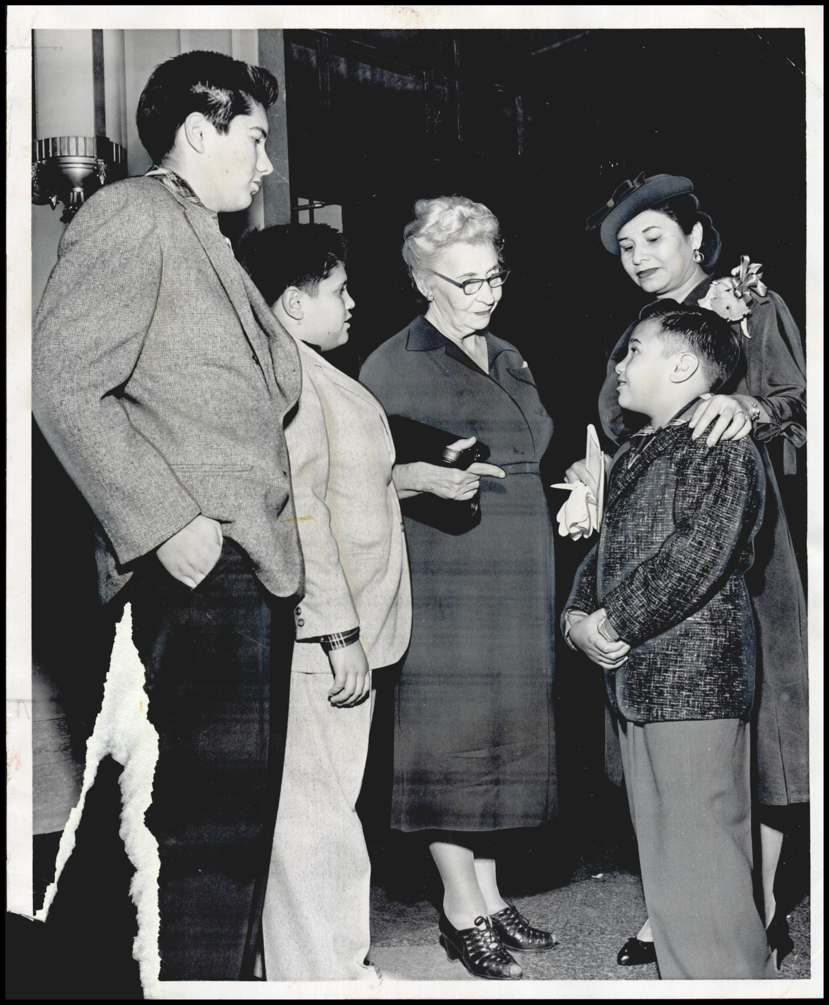
Note. Photograph used for story in the Daily Oklahoman. Caption: "Among the most interested listeners at Sunday's Semi Centennial concert here were composer Jack Kilpatrick's wife, mother and three sons." Photo by Gumm, John, November 17, 1957. Reprinted with permission from the Oklahoma Historical Society.

The Curse of the Ninth Symphony
It must be mentioned that Kilpatrick joins an illustrious group of composers who died before, during, or after completing their ninth symphony. Popularized by Arnold Schoenberg as a superstition started by Gustav Mahler, who was famously terrified of writing his ninth symphony and hid his symphonic work Das Lied von der Erde behind the moniker of a symphonic song-cycle, the curse was supposedly based on how Beethoven and Schubert had both died after writing their ninth symphony. In 2012, Philip Glass famously stated that “Everyone is afraid to do a ninth. It is a jinx that people think about” (Reed, 2012). While what exactly qualifies someone as an example of this curse varies from storyteller to storyteller, composers who are often considered a part of this legacy include Beethoven, Dvorak, Schubert, Vaughan Williams, Bruckner, and Spohr.
However, it is more likely that composers since Mahler have hesitated at writing their ninth symphony than if a supernatural force has spent the last two hundred years murdering classical composers at the apex of their symphonic journey. Jack Kilpatrick lived for ten more years after completing his eighth symphony and had plenty of time and opportunity to write his ninth. The ubiquity of the curse of the ninth and knowledge that Kilpatrick must have been well-aware of it, especially considering the space he occupied as a professional composer in the United States during the mid-20th century, combined with the dramatic way in which Kilpatrick’s eighth symphony was lost to the sea, indicate that this particular myth of the classical music must have had at least some influence on Jack’s decision to suddenly stop composing symphonies in 1957.

Symphonic Dramas in collaboration with Kermit Hunter (Historical Dramatist)
Kermit Hunter, an American playwright and former dean at Southern Methodist University, had a prolific career writing 42 historical dramas throughout his lifetime. Prior to working at Southern Methodist University, Hunter taught in the English department at the University of North Carolina at Chapel Hill, where he wrote some of his most successful dramas. Besides being a historical playwright, Hunter studied piano at the Julliard School and later received a master’s degree in Dramatic Art from Chapel Hill in 1949. While at Chapel Hill, Hunter studied under Paul Green. Paul Green is considered to be the founder of the American outdoor historical drama genre. During Hunter’s time as a graduate student at Chapel Hill, the Western North Carolina Associated Communities sought to commission Paul Green to write a politically-driven outdoor drama about the Eastern Band of Cherokee Indians to promote tourism and economic growth in western North Carolina. However, Green suggested to them that they hire Hunter to write Unto These Hills, which in turn launched Hunter’s career.
Unto These Hills is an outdoor historical drama written by playwright Kermit Hunter with incidental music composed by Jack Kilpatrick, which was the first of many collaborations between the two. It tells a story of the history, trials, and tribulations of the Eastern Cherokees up until their forced removal from their land. The play’s protagonist, Tsali (Charley), was a popular historical figure in the region and is credited with martyring himself along with his two sons in order for members of the Eastern Cherokees to stay on their ancestral lands. The premiere of Unto These Hills: A Drama of the Cherokee Indian took place on July 1, 1950, in Cherokee, North Carolina, right outside of the Qualla Boundary. Jack Kilpatrick’s biography from the 1951 season program can be seen in Figure 3.5.

Figure 3.5
An Image of Jack Kilpatrick’s Biography in the Program for Unto These Hills: A Drama of the Cherokee Indian’s 1951 Season which ran from June 23 to September 3
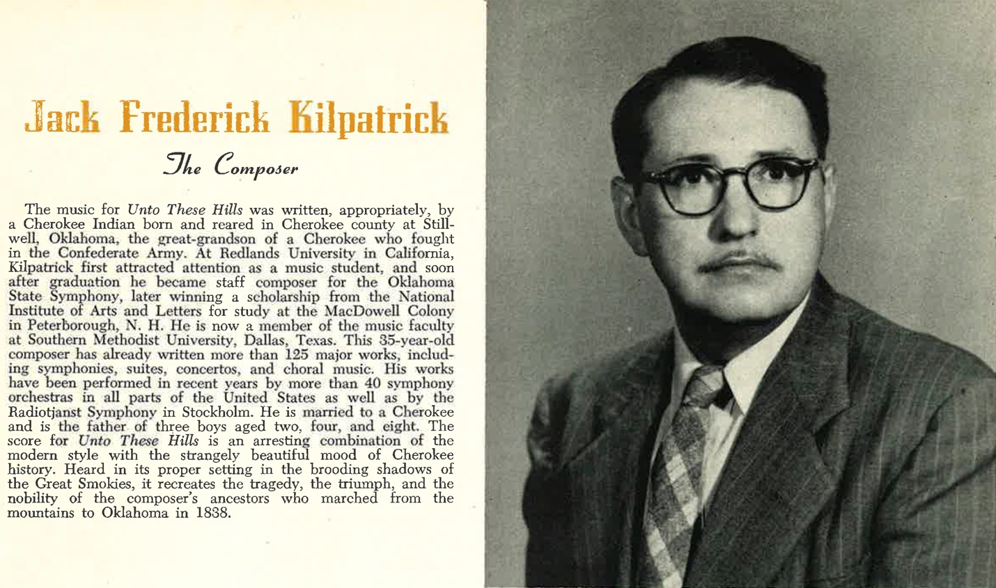
Note. A photograph of the playbill from Unto These Hills: A Drama of the Cherokee Indian’s 1951 Season (own photo). Reprinted with permission from the Jack Kilpatrick Collection at the University of Oklahoma Western History Collections.

Since the play’s premiere in 1950, the historical drama has been performed every summer in Cherokee, North Carolina. The only pause in performances was due to the COVID-19 pandemic in 2020 and 2021, but productions started again in the summer of 2022.The continued success of the show has created significant revenue for the Eastern Band of Cherokee Indians, which has been used for civic and educational projects as well as regular opportunities for employment. However, some criticisms of the genre and its execution must be noted. Professor Kristina Phillips (Red Cliff Ojibwe) has criticized how Native American themed pageants and theatrical shows run the risk of acting as propagators of “Salvage Tourism.” Based on the premise of salvage anthropology, salvage tourism centers “saving” and “showing off” Euro-American ideas of an imagined Indian culture for the purposes of enticing tourists for political and economic gain (Phillips, 2021, p. 11–12). These types of historical shows utilize the power of nostalgia and touristic desires to be rooted in learning about an imagined historical past in an entertaining fashion. Fellow critic of the genre Christina Taylor Beard-Moose similarly suggests that Unto These Hills allows tourism to give life to ideas of tribalism and colonialism presented through entertainment that focuses on an idealized past (Beard-Moose, 2009, p. 50). While salvage tourism was not overtly sought by the producers of these symphonic dramas, it is an important theory to consider in determining how these shows reflect on and affect the communities they are depicting. In fact, critics have questioned everything from the story content to the naming of Unto These Hills ever since its premiere performance.
Despite these critiques, the show remained a hit. Because of the continued success of Unto These Hills, the Cherokee Nation of Oklahoma commissioned Hunter and Kilpatrick in 1967 to write a sequel titled The Trail of Tears, depicting the life of the Cherokees after removal to Indian Territory. Although Kilpatrick passed away before finishing the music, the drama was finished posthumously and premiered in 1969 at the Cherokee Heritage Center (formally known as Tsa-La-Gi) near Tahlequah, Oklahoma. In 2006, the Eastern Band of Cherokee Indians asked producer and playwright Hanay Geiogamah (Kiowa) to revise the drama. Following the new revised production, additional changes were made, but the new renditions seemed unable to garner audience interest. In 2015, the original play (with a few revisions to depict historical events more accurately) was reinstated, and was met with much success.
After the success of the premiere of Unto These Hills, the majority of Jack Kilpatrick’s compositional output shifted from writing orchestral compositions to penning incidental music for these historical symphonic dramas. This collaboration between Jack Kilpatrick and Kermit Hunter lasted from 1950 and until Kilpatrick’s death in 1967. Historical dramas authored by this partnership include Unto these Hills: A Drama of the Cherokee Indian (1950), Voice in the Wind (1953), The Bell and the Plow (1954), Chucky Jack: The Story of Tennessee (1956), The Golden Crucible (1959), Bound for Kentucky! (1961), Thy Kingdom Come (1961), Honey in the Rock (1961), Next Day in the Morning (1962), and Trail of Tears (1969), which Jack was working on before his death but never completed. After Jack Kilpatrick’s death in 1967, Hunter continued to collaborate on historical dramas with other composers, including Frank Lewin, who was a former student of Jack’s.
Composing for a historical drama required a different skillset than writing for the concert stage. Up to this point, Kilpatrick had written a tremendous amount of music for chamber ensembles and symphony orchestras, but he also needed to draw upon his experience as a music minister and songwriter for the theatrical staging of these plays. Not only was Kilpatrick composing incidental music, but, depending on the needs of the story, he was also required to write music for large dance and ensemble features, as well as songs to represent traditional Native American ceremonies. Several of these dramas also included sung performances by the leading actors or ensemble cast, and budgets for different productions varied greatly, forcing Kilpatrick to adapt his compositions to varying ensemble sizes that might be performed live or pre-recorded in lieu of a live ensemble.
Despite these difficulties, the music was a vital part of these historical dramas. Hunter and Kilpatrick’s historical dramas followed the philosophy of Hunter’s mentor Paul Green, who found fault with excluding music from the critique and structure of historical dramas. In order to separate music-centered historical dramas from contemporary works that were bereft of music, Green started calling the outdoor historical dramas that he and Hunter popularized “symphonic dramas” rather than “historical dramas.” This new genre title drew attention to the importance of the symphonic underscoring or incidental music essential to the dramas created by Hunter and Kilpatrick, which is shown in Green’s famous symphonic drama The Lost Colony. According to Green, music is central to elevating the narrative and adds emotion that is otherwise unattainable in unscored dramatic works. In his writings, he states that it is the pairing of music with theatrical drama that makes historical dramas effective as an art form (Green, 1949). While the term “symphonic dramas” never became common nomenclature, it is the most accurate term for these unique works of art because of Kilpatrick and Hunter’s prolific output and their dedication to Green’s approach to historical dramas.
In a way, these historical dramas represent Cherokee history as understood by some of the viewers. These historical dramas provide a glimpse into what the governmentally-approved versions of these histories were at the times they were funded and premiered. While it is impossible to speak for an entire group of people, historical dramas become part of the subjects’ history through repeated performances for new generations of audiences. The stories told become internalized as part of their understood history. In the case of American dramas, these are usually telling a story about events that happened before and leading up to Indian removal from a particular location. While Kermit Hunter was not Native American, he was a specialist in writing historical dramas, often in collaboration with tribal governance. His connection with Kilpatrick, a Cherokee composer, added to the overall credibility of the production. The performances also include Indigenous actors to play Indigenous roles, and the production takes place on Eastern Cherokee space. Tourism dollars from outsiders bring in financial support to the local community and re-energize interests in learning about Indigenous histories (Phillips, 2021). The play Unto These Hills was selected for performance by The Cherokee Historical Association, whose mission is “to perpetuate the History and Traditions of the Cherokee Indians” and Kermit’s biography in the 1951 program of the play stated, “It is with pride that the Cherokee Historical Association honors the playwright, and is proud to offer his work as a large step in its program to perpetuate this history and tradition of the Cherokee Indians” ([Program for “Unto These Hills”], 1951, p. 2).
With any dramatized performance of a historical event, there are going to be romanticized liberties, and this is certainly the case with Unto These Hills, but as new generations seek more historical accuracy over dramatizations, adjustments made to the production are often a mirror for how contemporary generations of a group of people wish to be represented at that time in history. Dustin Tahmahkera’s theories relating to Indigenous media can also be applied here. His concept of decolonized viewing is a dualistic framework for coordinating, contextualizing, and critiquing visions of indigeneity and indigenous settler interculturality from the vantage point of both the non-Native and Native creators (Tahmahkera, 2014, p. 7). Unto These Hills specifically is a creation brought together by non-Native and Natives alike, with adaptations being mediated between the need for tourism dollars and historical accuracy. This is a common theme found in all of the dramas that Hunter and Kilpatrick worked on together.
The second drama Hunter and Kilpatrick collaborated on was The Bell and the Plow, which premiered at the University of Arizona Auditorium on April 28 through 30, 1954, presented by the Arizona Corral Theatre. The Bell and the Plow is the story about the founding of the San Xavier Mission and the life of Father Kino. As part of the Tucson Festival Society’s celebration (and fundraising plan to help with funding the restoration of the mission) in 1952, they started an annual fiesta, and in 1954, The Bell and the Plow was part of the events (Jane H Ivancovich Collection Finding Aid, 1998).
While The Bell and the Plow did not have nearly the same commercial success as Unto These Hills, the production was well received. At this time, Kilpatrick had been getting national attention as a composer, and his name continued to be listed as top billing after Kermit Hunter’s name on programs and advertising materials. As a composer, Kilpatrick was now being described as a trendsetter and trailblazer in American classical music. During The Bell and the Plow’s opening season and only season, Kilpatrick was praised for breaking away from standard Italian classical terminology language use. The following quote by Sam Fain, the orchestral director from the Tucson Symphony Orchestra, is from a newspaper article about the then-upcoming performance.
Kilpatrick followed a new method of identifying particular parts for the conductor. For instance, it is common to find Italian words on a score to denote speed, style and other such features of the music. However, often the Italian word is not clear in its use, and a more familiar English word would be better. This is what Kilpatrick has done when he has written into the score such words as “whimsically,” “airily,” “reverently,” and “solemnly.” ([scrap book], 1952-1958)
The projects that Hunter and Kilpatrick worked on together used Hunter’s ability to recreate American-based stories for the stage and Kilpatrick’s mastery of composing and arranging for different stage performances. Kilpatrick also became the leading authority for the Indigenous voice in classical music in the 1950s and 60s. Advertisements, programs, and playbills featured Hunter alongside Kilpatrick, and Jack’s biography commonly mentioned him being a Cherokee composer, as in the case of Chucky Jack (see Figure 3.6).

Figure 3.6
An Image of an Advertisement for Chucky Jack Featuring Biographies of Kermit Hunter and Jack F. Kilpatrick
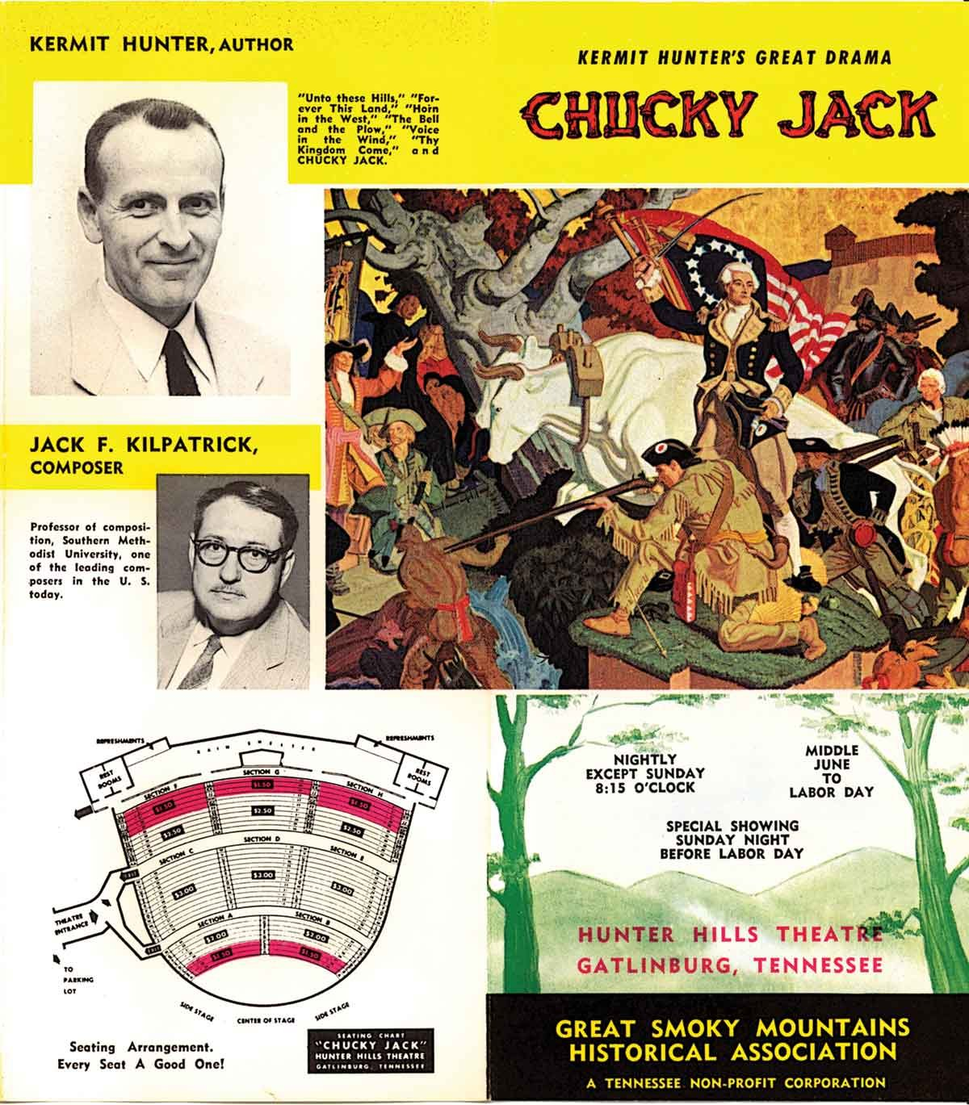
Note. A photograph of an advertisement for Chucky Jack Featuring Biographies of Kermit Hunter and Jack F. Kilpatrick. Reprinted with permission from the University of Tennessee Libraries, Knoxville, Betsey B. Creekmore Special Collections and University Archives.
Chucky Jack: The Story of Tennessee is a historical drama with music by Kilpatrick which premiered in 1956 and ran until 1959. The performances took place at the Hunter Hills Theatre Stage in Gatlinburg, Tennessee. The theater was named in honor of Kermit Hunter and was constructed specifically for the upcoming performances of Chucky Jack. This historical drama explored the story of the State of Franklin, an unrecognized proposed state that was offered by North Carolina as a cession to Congress to help pay off debts related to the American War for Independence. The State of Franklin existed as an extra-legal state for four and a half years before being absorbed back into North Carolina. It was located in what is today East Tennessee. The protagonist of the historical drama is John Sevier, who later became Tennessee's first governor. Prior to Tennessee statehood, Sevier was known as a leading commander who helped fight against the Cherokees in the later part of the 1700s.
For the premiere performance, the music for the drama was originally written for and to be recorded by the Knoxville Symphony Orchestra, but in the summer of 1956, due to limited musicians being available, the score was reorchestrated for organ. The music was recorded at the Sequoyah Hills Presbyterian Church in Knoxville, Tennessee, in 1956. The organ rendition was performed by Maurice Douglas Pederson playing a Moeller organ owned by the church. The Knoxville College Octet performed all vocal parts (Buttrey, 1979, p. 10). The following year, during the planning session for the second season of the performance, it was decided that changes to the musical elements were needed. Rather than playing the pre-recorded music, it was decided that it would be best if the organ accompaniment was performed live and if a better trained chorus also performed the music. Secondly, the show added more dance segments, including a “Creek Indian Dance” that was based on a traditional ceremonial dance, added for spectacle (Buttrey, 1979, p. 14), During the second season, New York choreographer Mark Ryder, a dancer in the Martha Graham Dance Company, was added to the production team as a choreographer.
Between the years of 1959 and 1961, Hunter and Kilpatrick worked on several successful collaborative productions. In 1959, The Golden Crucible premiered in Pittsburgh, Pennsylvania, and in 1961, three different historical dramas premiered: Honey in the Rock, Thy Kingdom Come, and Bound For Kentucky!. The general theme of American outdoor historical dramas is to create a live production around the stories of formational, American roots stories. Examples of these subjects include stories of statehood, biographies of people who helped forge policy, military leaders, and relations with Indigenous nations.
As cities were investing in building outdoor facilities to foster tourism and economic growth, the outdoor drama became the popular genre commissioned and performed after investing in these large civic projects. The Golden Crucible: The pageant of Pittsburgh’s 200 years of progress opened on June 27, 1959, at the Pittsburgh Bicentennial Gateway Amphitheater. More commonly known as the Golden Crucible, this historical drama was presented by the Pittsburgh Bicentennial Drama Committee. The amphitheater was built to celebrate Pittsburgh’s bicentennial, where Hunter’s drama highlighted the city’s contribution to the nation (The Pittsburgh Bicentennial, 1959). The Cliffside Amphitheatre in Grandview Park, West Virginia, which was built in 1961, opened with the premiere of the Hunter/Kilpatrick historical drama Honey in the Rock. Similar to Unto These Hills, Honey in the Rock has been performed annually since its 1961 premiere by Theatre West Virginia.
Kilpatrick and Hunter’s last project together was the historical drama titled “Trail of Tears,” which premiered on June 27, 1969, in the Tsa-La-Gi Theater near Tahlequah, Oklahoma. Unfortunately, the untimely death of Jack Kilpatrick resulted in him not completing the composition for this drama, but in the souvenir program it is said that portions of the music were based on Kilpatrick’s sketches and were completed posthumously (“The Trail of Tears Historic Drama,” 1973). Historical dramas, unlike similar theatre or musical theatre productions, utilize American histories in a commemorative fashion in order to entice visitors from near and far to come to learn about and be part of the experience. The audience’s travel to a remote location is meant to create a sense of pilgrimage, transporting them to a different time and place. They become rooted within the history or legend presented to them and learn by being entertained (Sumner, 1967). Throughout the mid-20th century, patrons of all ages attended these dramas, and they became a destination for family summer vacations. As a composer, the success of these dramas has led to an uncountable number of audience members hearing Kilpatrick’s music. Today, there are dozens of abandoned amphitheaters scattered in remote locations throughout the United States that stand as monuments to what was at the time considered a sure-fire civic investment in tourism.

Kilpatrick’s Legacy
While today, many people might not know the name Jack Frederick Kilpatrick, during his life, his music was heard throughout the United States and Europe. As a professional composer, he was receiving commissions from major orchestras and organizations regularly, and his music was receiving repeat performances. His music had a long-lasting impact on American audiences, both on the concert and on the outdoor stage. Jack Kilpatrick’s collaborations with Kermit Hunter on musical historical dramas means that for a fifteen-year period from approximately 1950 to 1965, Jack Kilpatrick was the most successful composer working in the most popular new medium of classical concert music in the United States at the time. In addition, Jack’s historical research with Anna was also earning attention and accolades, receiving grants from the Tobin Endowment (1956), Danforth Foundation (1960), Graduate Council of the Humanities at SMU (1961, 1964, and 1965), The Smithsonian Institution (1960), National Science Foundation (1962–1963 and 1963–1964), American Philosophical Society (1962), and Nation Federation of Music Clubs (1962) (Benson, 1975). By the last few years of Kilpatrick’s life, he was viewed as one of the authorities on Cherokee epistemology and folklore. In 1959, Jack and Anna Kilpatrick received the “Citation of Merit” from the Cherokee Nation for their outstanding work on preserving Cherokee cultural history, and the same year. the city of Stilwell, Oklahoma, proclaimed May 9, 1959, to be recognized as “Dr. Jack Kilpatrick Day,” appointing him as honorary mayor of the town. The program for the 1959 Stilwell Strawberry Festival (see Figure 3.7) states:
Proclamation
In consideration of the fame which Dr. Jack Kilpatrick has brought to the city of Stilwell
And, in appreciation for the offerings he has made to our country’s cultural interests through the field of symphonic music
And, in respect to the dignity he has given to those of Cherokee blood
The city council has, by unanimous vote, ordered me to proclaim the day of May 9, 1959 as “Dr. Jack Kilpatrick Day” in the City of Stilwell and to appoint Dr. Kilpatrick as Honorary Mayor of this Town.
Done this 6th day of April, 1959.
C.C. McCormack Mayor (Strawberry Festival Program, 1959)

Figure 3.7
An Image of a Proclamation of Dr. Jack Kilpatrick Day in the Strawberry Festival Program, 1959
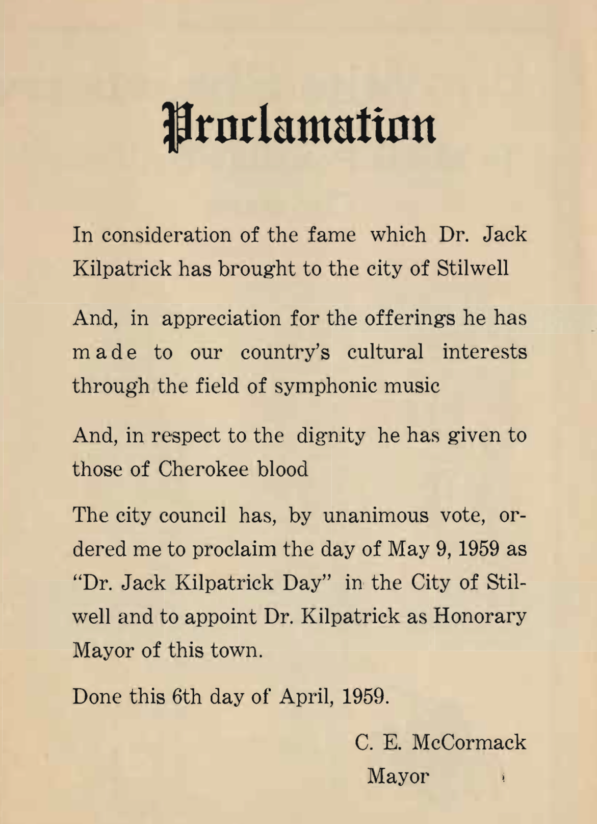
Note. Image retrieved October 1, 2023, from https://www.cityofstilwell.com/DocumentCenter/View/163/1959-Booklet-PDF. Reprinted with permission from the City of Stilwell.
On February 22, 1967, while at dinner with his oldest son, Jack Kilpatrick Jr., in Muskogee, Oklahoma, it is believed that Jack Kilpatrick had a heart attack and was rushed to the Muskogee General Hospital, where he died at the age of 52. In an interview, Kermit Hunter declared Jack to be “American’s finest American Indian composer” (cited in Benson, 1975). Jack Frederick Kilpatrick’s remains were laid to rest in a cemetery in Echota, Oklahoma. After the death of his father, Jack Jr. worked with Jerry Neil Smith, the director of the School of Music at the University of Oklahoma, to find a place to house the Kilpatrick manuscripts. While processing the gift, then-master’s student Harry D. “Rick” Benson worked on cataloguing the manuscripts as well as finding opportunities to program Kilpatrick’s works. One of the most important concerts after Jack’s death was a memorial concert honoring him, presented by the OU School of Music on February 21, 1976, in which students and faculty performed excerpts from Kilpatrick’s ballet The Ravenmocker, which was originally premiered by the San Antonio Symphony in 1956, and Kilpatrick’s opera Blessed Wilderness. In The Oklahoma Daily (the University of Oklahoma’s school newspaper), Benson discussed the importance of Kilpatrick’s music, writing that the official OU School of Music bicentennial presentation with Anna Gritts Kilpatrick and other members of Jack’s family in attendance was “honoring one of America’s foremost Native American composers” (“OU concert to honor Cherokee composer,” 1976).
Benson, who coordinated the event and taught one of the first courses at OU focused on Native American music, stated that Kilpatrick was “the most prolific American Indian composer in history” (“OU concert to honor Cherokee composer,” 1976). Prior to recent rediscovery of the Kilpatrick manuscripts in Catlett, which prompted the work I have done at the Western History Collection and the research and writing that went into this dissertation, Benson was most likely the most involved with the manuscript collection of anyone, and he is an expert witness to the breadth of Kilpatrick’s extraordinary musical output.
After the bicentennial presentation, the Norman Chamber Orchestra programmed a piece by Kilpatrick on February 5, 1991 (Music Notebook, 1991) at the First Presbyterian Church of Norman. On September 25, 1992, the same ensemble programmed “Cherokee Suite” and performed in OU’s Holmberg Hall Auditorium (“Norman Orchestra to Play Works By Three Oklahoma Composers,” 1992). The 1992 article in The Oklahoman stated that the concert would feature three nationally recognized composers who were all born in Oklahoma, including Roy Harris, Spencer Norton, who was then on the music faculty at the University of Oklahoma, and Jack Kilpatrick. It is interesting to note that Spencer Norton’s 1959 composition “Partita for Two Pianos and Orchestra" was commissioned by the Oklahoma Symphony Orchestra, the same organization Kilpatrick worked for when he was first starting out. At the time of the 1992 bicentennial, Jerry Neil Smith was the music director of the Norman Chamber Orchestra and director of the OU School of Music. Today, Jack Kilpatrick’s music is undergoing another musical revival after the rediscovery of his manuscript collection, and further discussions of this musical project continue in later chapters.

Chapter Conclusion
As stated in Chapter 2, Jack Kilpatrick believed that his music was intimately tied to the time and place where it was written. As I was indexing the archive, I noticed that at the end of each holograph (musical manuscripts hand-written by Kilpatrick himself) Kilpatrick lists the date of completion and the location that it was written, allowing us to map his compositional career both chronologically and physically. The two major locations where he composed most of his works were in Stilwell, Oklahoma, and Dallas, Texas, which was the reason I chose to highlight his move to Dallas as a major period shift in his music. For example, when he was living in Oklahoma his subject matter was focused on Cherokee melodies and stories, but after he moved to Texas he became interested in writing music based on popular works like Treasure Island by novelist Robert Louis Stevenson and Waiting for Godot by playwright Samuel Beckett. Throughout his career, Kilpatrick often found solitude and comfort composing at his mother’s home in Stilwell and when possible, would compose sections or finalize compositions he was working on even after he moved to Texas.
In addition to this belief that his music was a result of his physical location, Jack Kilpatrick’s musical output was also directly tied to the opportunities and artistic environments he found himself in throughout his career. As a young composer at Bacone College and Redlands University, Jack Kilpatrick had been surrounded by other Indigenous artists who were working towards creating a movement of intelligent, worldly, and cosmopolitan Native American art that could be viewed with respect from established Western institutions and traditional Native nations alike. In his role as a WPA composer with the Oklahoma Symphony Orchestra, Kilpatrick was tasked with creating distinctively Oklahoman and Cherokee music as part of the WPA Music Program’s goal to create and provide opportunities for American music and musicians. In Washington D.C., his greatest advocate, Richard Bales, was focused on creating a concert series and forum for distinctly American music to flourish. And finally, in Dallas, his position as a music professor allowed him to write sonatas, concertos, and chamber works for his colleagues while also receiving commissions from major orchestra for works that celebrated major occasions including Symphony No. 7 “The Republic of Texas” and Symphony No. 8 “Oklahoma.”
After the success of the 1950 historical drama Unto these Hills: A Drama of the Cherokee Indian, a large portion of Kilpatrick’s compositional output was dedicated to producing the ten historical dramas he co-authored with Kermit Hunter. By 1960, Kilpatrick was viewed as a well-respected music critic and popular composer throughout the United States (Bensen, 1975). In 1961, the Kilpatrick Music Society was established in Dallas with the mission to discuss and perform works by Kilpatrick or music composed by Kilpatrick’s students. The meetings were held monthly and attracted professionals, students, faculty, and people interested in classical music to join. By the end of his career, Kilpatrick was being performed regularly by major orchestras, receiving prestigious commissions, had been shortlisted for the Pulitzer Prize in Music, and was a central figure in the music department at Southern Methodist University. (Fischer, 2010). When Kilpatrick passed away at the age of fifty-one he was on the path to becoming one of the most respected American composers of his time.

Section II: RESTORATION
Music revivals are social movements that are fixated on the idea of restoration. Restoration is simultaneously a physical and metaphysical act: The physical act of restoring a faded and unusable hand-written score by preparing digitally notated and easy to read performance materials is an act which also restores that music’s place as a performable part of a performance practice. In this dissertation I will be referring to the physical act of preparing performance materials and creating the music archive as restoration, and the act of soliciting performances and restoring Kilpatrick’s place as a composer within the history and contemporary performance cannon of American classical music as revival. The impetus for a music revival is generally predicated on the basis that something that helps to portray a new narrative message is missing from a musical genre and through a process of restoration the missing piece is elevated into a position of prominence to help push this new cultural narrative message. The restoration of physical and digital materials is a prerequisite for a classical music revival to occur; and simultaneously the social and cultural demand for a missing kind of music that fits the narrative of a contemporary musical movement is a requirement for creating the conditions under which a large-scale restoration project can be funded and undertaken.
The missing kind of music can come in many forms, but for a music revival it is usually based on the restoration of a particular genre of music that has been unpopular or underperformed for a significant length of time – usually at least a generation or two. Different music genre’s revivals are initiated and spearheaded through different avenues depending on the way that performance materials are distributed to performers and performances are distributed to audiences. In classical music, a common music revival structure involves the discovery of a missing piece or forgotten composer; a revivalist community or fanbase energizing a resurgence in popularity for the piece or composer; and finally, a commercial group, either for or non-profit, creating opportunities for performances, recordings, festivals, and other revivalist activities. The trajectory of any music revival goes as follows; the missing pieces resurface (discovery phase), the missing pieces are restored (restoration phase), and the missing pieces are now restored and are put into practice (revival phase).

Decolonizing Methodologies
One of the most preeminent and overarching perspectives to building the Jack Frederick Kilpatrick collection is that research is biased and the ways in which we engage with the materials is constructed in embedded colonial constructs. No person or institution is free from these biases. The institutional structures of education such as the library and the conservatory as well as the institutionalized classical performance structures of the orchestra, the recording, and publishing industries have of late made significant changes to be more inclusive, but unless the methodologies surrounding how we interact with and learn about diverse music changes, the colonialist mindset will continue to propagate unless we find new ways to decolonize the archive. My understanding of decolonizing educational institutions comes from the work of Linda Tuhiwai Smith and Amy Lonetree who challenge the processes and methodologies of the archive, the museum, and the classroom. The process of decolonization results in the freedom of colonized peoples to reconstruct and gain sovereignty over physical, philosophical, cultural, political, theoretical, and future structures of thought. The work of decolonizing educational institutions has been progressing as more Indigenous and tribally-owned and operated museums, archives, academic programs, and performing organizations grow in power and influence.
Included in Smith’s 2021 edition of Decolonizing Methodologies: Research and Indigenous Peoples, she writes
“knowledge and the power to define what counts as real knowledge lie at the epistemic core of colonialism. The challenge for researchers of decolonizing methodologies as a set of knowledge-related critical practices is to simultaneously work with colonial and Indigenous concepts of knowledge, decentering one while centering the other” (Smith, 2021, p. 13).
The framework for the Kilpatrick collection is one that acknowledges the needs of classical institutions but is also situated within the understanding of Indigenous knowledge and methodologies. The ethics of research and the importance of building a collection that follows Indigenous protocol is what is most important to me in the process of restoring and reviving Kilpatrick’s works through the archival process.
Smith stated, “Another problem is that academic writing is a form of selecting, arranging, and presenting knowledge. It privileges sets of texts, views about the history of an idea, what issues count as significant; and, by engaging in the same process uncritically, we too can render Indigenous writers invisible or unimportant while reinforcing the validity of other writers” (Smith, 2021, p. 40). The ways in which Indigenous discourse is represented within the collection matters. I believe that the music of Kilpatrick is not one that should be used to retell or reimagine Cherokee culture, but should instead be used as way to show how influential and foundational Cherokee and other Indigenous cultures are in Oklahoma and American histories.
How decolonization can be applied to the Kilpatrick Archive can be understood through the examination of two ideas: first, the idea of authenticity and who gets to define it; and second, how Indigenous peoples view their past, present, and future based on the effects of colonialism. Smith defines the pre-colonial Indigenous epoch “a time before colonization in which we were intact as Indigenous peoples. We had absolute authority over our lives; we were born into and lived in a universe which was entirely of our making.” (Smith, 2021, p. 26) The idea of authenticity I am using here is one of authority, the authority of a person having a core to which they hold true despite outside pressures to change. It is when this definition of authenticity is combined with the understanding of how colonialism has interacted with the past, present, and future of Indigenous existence that post-colonial rhetoric can be understood by those who are not directly affected by it. The Jack Kilpatrick musical manuscripts exist in the intersection of colonialist and Indigenous logics. In my analysis of his works, I do not attempt to separate elements of Indigenous knowledge from Western influences, but instead see his works as artistic works and embodied knowledge from a person whose existence and experiences were intrinsically intertwined in two worlds and epistemologies.

Sovereignty and Indigenous Decolonizing Perspectives
An important element to consider in the collection are the documents containing Cherokee folklore. Since Jack and Anna were both very well known for their writing on Cherokee language, medicine, and folklore, there is a strong interest in knowing about how these topics relate to the compositions. What the search criteria came down to were two main overarching areas: the ability to investigate the epistemology of the compositions and the information needed to program them. Thinking about the compositions from an epistemological perspective changed the landscape of how these pieces would be theorized. Using Native American literary criticism models as a comparison became vital to establishing the collection. Regardless of how one views Jack Kilpatrick’s ethnicity, his works are rooted in Cherokee ideology and should be treated as such. People using the Jack Kilpatrick Collection will be using it in an Indigenous context and the pieces include Indigenous knowledge. It will benefit Indigenous and non-Indigenous researchers alike to make sure colonialist ideals are not placed within the collections process.
Why nationalist, indigenist, and cosmopolitanist literary criticism and the decolonizing methodologies of Linda Tuhiwai Smith are important to my research is that for the most part these theories have been developed by and through the Indigenous decolonizing perspective. According to Smith, how the western academy uses and claims theory is one that was constructed by the West and it is their rules that construct how Indigenous works should be theorized (Smith, 2021, p. 69). According to many Indigenous cultures, not all information should be public and easily accessible. This statement often goes against how western societies view research and knowledge. The “Doctrine of Discovery” is important to understand because research institutions often encase items or collections that were misappropriated from Indigenous cultures by claiming that their safeguarding of these artifacts is needed for the greater good of all. The “Doctrine of Discovery” is an international law which originated in the fifteenth and sixteenth centuries and was originally used as a legal way for English colonists to justify the exploitation of Indigenous land and knowledge. (Miller, Ruru, Behrendt, & Lindberg, 2010, p. 3) It was used to justify their sovereignty, religious ideologies, and claims to land. The doctrine gave settlers legal rights to acquire land and resources as they deemed fit without needing to obtain rights from the original inhabitants of the land. (Miller, Ruru, Behrendt, & Lindberg, 2010, p. 3)
One element to this collection that I am still grappling with is how accessible should the materials in the collection be? The theoretical framework of the Doctrine of Discovery has infiltrated the academy in the philosophy that cultural information should be accessible by everyone, regardless of concerns of privacy or cultural considerations. Part of creating an archive that includes cultural information must include considerable thought as to what should be accessible to the public and what should have restricted access. Also important to this process is the consideration of what should be digitized and what should be accessible through the internet. These considerations became important early on in the discovery process of the Jack Kilpatrick Musical Manuscript Archive when we discovered sacred Cherokee cultural artifacts within the collection of items and had to decide how to handle these important cultural items. As soon as I saw the first Cherokee medicine book in the boxes I informed my colleague Corey Still (who is a Cherokee language professor at the University of Oklahoma) and I was careful to follow what I understood as cultural protocol for a non-culture bearer and never touched or interacted with the items.

Digitization and Access
With the permanence of the internet the new model for archiving often includes digitization. At this moment the Jack Kilpatrick Collection is still forming as a physical, non-distributed collection, but it would be unrealistic to assume it will remain in this state forever. While many view the internet and the use of digital technology as breaking away from restriction and opening a new space where knowledge is transferred and learned freely without the stronghold of colonialist paradigms, Ivy Schweitzer wrote in the Introduction of The Afterlives of Indigenous Archives that holding institutions and tech companies are actually reproducing “Western, white, male, and individualist dominance” through the reconstruction of colonialist paradigms (Henry & Schweitzer, 2019, p. 4). Once again it is important to note that in Indigenous cultures not all information and materials should be available to everyone. The philosophy of the internet being an open exchange for information goes directly against some Indigenous ideologies involving controlling the dissemination of information. This process of open access and digitization could limit the ways in which Indigenous communities collaborate with the process.
Western ideologies that focus on the idea of exploration either of a physical or intellectual space without restriction in many ways goes against these Indigenous ideologies related to restricted information. While it is common place for an individual, a family, a group, or a Native Nation to have restricted rights over both tangible and intangible items, ideas, or performance rights, it is often hard for westerners to comply and understand the restriction. In Dylan Robinson’s “Hungry Listening,” at the end of the introduction he asks that non-Indigenous readers skip over chapter two and continue reading starting in chapter three since, “The next section of the book, however, is written exclusively for Indigenous readers” (Robinson, 2020, p. 25) For non-Indigenous readers, this is a moment to confront why they feel the right to invade what an Indigenous author has asked for them to respect as a sovereign space for Indigenous readers only.

Chapter 4: Archival Research, Discoveries, and Indexing the Jack Kilpatrick Collection
This chapter will discuss the work process I used in indexing the works of Jack Kilpatrick that later became the catalog for the Jack Kilpatrick Collection. The majority of this work occurred in the spring of 2019, when I was awarded the Dale Society Fellowship at the University of Oklahoma’s Western History Collections library. My residency at the Western History Collections was officially held during June and July of 2019, but I have been working in some capacity with the Jack Kilpatrick Collection since its (re)discovery in 2018 and have continued working with the collection through the fall of 2023. As a Dale Society Fellow, I was granted unlimited access to the Kilpatrick materials and time to invest in researching the written work of Jack and Anna Kilpatrick. The different phases of this project include the discovery, selection, acquisition, procurement, deselection, reconstruction, cataloging, repository, digitization, restoration, engraving, creation of performance preparation materials, and repatriation phases.
It should be reiterated at this time that I view and treat all of Kilpatrick’s materials as Indigenous with embedded Indigenous knowledge and as physical pieces of Indigenous history. While the collection mostly contains classical sheet music, the way everything was handled was held to the highest standards and followed the most recent methodological protocols. With every phase of this project, I used current best practices for handling Indigenous materials and knowledge. Important sources of these best practices included the American Library Association (ALA), the American Indian Library Association (AILA), and the Association of Tribal Archives, Libraries, and Museums (ATALM). In addition, special attention was always given to the management of, caring for, and following of Indigenous protocol, including Indigenous archiving and researching methodologies that focus on new research models with the intention of decolonizing archival practices. This collection process was aided by recent literature on archiving Indigenous culture, an evaluation of the Kilpatrick Collection of Cherokee Manuscripts held at Beinecke Library at Yale University, and considerations of how archival memory aids in embodied and entextualized memory.
This chapter is divided into the following sections: The Discovery Phase; The Selection and Acquisition Process; Indexing the Collection; The Deselection Process; Opus Numbers and Organizational Systems; The Cataloging of Kilpatrick Works; Ownership, Copyright, and Permissions; Rumors and Curses; and A Survey of Other Archival Holdings. My goal in creating the Jack Kilpatrick Collection was to develop an archive that would benefit scholarly research, aid in the revival of Kilpatrick’s music, and contribute to community-driven research on Cherokee history, culture, and language.

The Discovery Phase
The discovery phase involved researching the collection’s past and executing a plan to procure a new home for the collection. At the start of this project, the most important questions were: Who is Jack Frederick Kilpatrick, and why was his entire manuscript collection in the storage attic of Catlett Music Center at the University of Oklahoma? When we were first notified about the manuscripts, all the Kilpatrick materials were contained neatly within 31 cardboard boxes labeled K1–K31. Because of the numbering system used on the outside of the boxes and personalized folders for each manuscript, it appeared that either Jack Kilpatrick had categorized his own collection, or someone had started the process of archiving. The contents of the boxes did not just include his handwritten compositional manuscripts, but also included previously published copies of his compositions for defunct publishers, photocopies of popular pieces, printing negatives of his sheet music, hand-written notes, teaching materials, newspaper clippings, concert programs, memorabilia, and recordings of his compositions, as well as sacred Cherokee cultural items, including medicine books.
My initial interaction with the materials was initiated by Eric Walschap, the Coordinator of Facilities and Technology for the School of Music at the University of Oklahoma, who contacted Matt Stock, the University of Oklahoma’s Fine Arts Librarian, in requesting that the Kilpatrick boxes either be moved from the Catlett attic or be approved to be disposed of. Eric was tasked with cleaning out the attic and disposing of any materials that were unneeded when he discovered the boxes labeled K1-K31. At this time, May 2018, Matt had no previous knowledge that the boxes even existed nor an understanding of why they were placed in the attic in the first place. Soon after Matt’s encounter with Eric, Matt asked me if I happened to know of a composer by the name of Jack Frederick Kilpatrick. Matt speculated that Kilpatrick was a Cherokee classical composer. Because I am a classical producer who specializes in Indigenous music, I recognized Jack’s name, which is often listed in relation to other Indigenous composers, but at the time, I did not know who he was, just that he existed.
In 2018, my general search engine inquiries looking for information about Jack Kilpatrick did not lead to much. Because the name Jack Kilpatrick is somewhat common, I just thought it was a coincidence that an American folklorist—whom at the time I did not think had any relevance to the collection of boxes—dominated my search results. However, I quickly learned that the composer whose manuscript collection had emerged and the American folklorist who co-wrote and translated numerous books with Anna Gritts Kilpatrick about the Oklahoma Cherokee were one and the same. When starting this research, the Encyclopedia of Native American Music of North America, written by Elaine Keillor, John M. H. Kelly, and Timothy Archambault, was the only published book on Native American music that had tangible information about Jack Kilpatrick. While brief, their entry proved that the manuscripts we found were something of great merit.

The Selection and Acquisition Process
After the initial discovery of the collection, the found materials were moved from the attic of Catlett Music Center and held at the University of Oklahoma’s Fine Arts Library. While little information was initially available about Jack’s compositions, it became clear the boxes contained irreplaceable, primary source materials. To learn more about Jack Kilpatrick’s compositions, I began by searching for publishers that might still have his compositions as part of their catalog. However, I could not find a single publisher listing any of Kilpatrick’s works, and the handful of published scores that were found in the Kilpatrick boxes indicated defunct publishing houses. The only published materials that I could find for sale were used copies of early published piano pieces.
Next, Matt Stock and I created an audit of the boxes and began selecting what materials would remain in the Fine Arts Library and what pieces would be best housed at the Western History Collections. While the boxes contained other materials, the main contents included the musical manuscripts, reel-to-reel and disc recordings, and Cherokee cultural items. It was at this point that Matt contacted Lina Ortega, the Associate Curator of the Western History Collections, about the possibility of the Western History Collections acquiring the materials. After making arrangements for the collection to be officially held as part of a special collection at the Western History Collections, it took approximately a year for the materials to be transferred and an additional two years for the materials to be made as a repository.
At this point, we found out that the majority of the recorded media, while in decent shape, would be unusable without professional restoration. Still, we were not able to digitize every recording for fear of permanently damaging the original recordings. The reel-to-reel and tape recordings that could withstand digitization were selected early on and stayed at the Fine Arts Library until restoration could occur. After funding was later approved, the audio restoration took place at the University of North Texas by sound preservationist David Huff.
The remaining holographs, manuscripts, publisher printings, photocopies, textbooks, teaching materials, diplomas, concert programs, letters, other miscellaneous items, and cultural materials were then slated to be transferred to the Western History Collections. Once the materials were transferred to the Western History Collections in 2019, I applied for and received a Dale Society Fellowship to begin building the archive at the Western History Collections out of the newly acquired materials.

A Survey of Other Archival Holdings
In addition to the Jack Kilpatrick Collection at OU, there are four other university libraries throughout the United States that have robust holdings related to Jack and Anna Kilpatrick. They are Southern Methodist University in Dallas, Texas; Western Carolina University in Cullowhee, North Carolina; East Central University in Greenville, North Carolina; and Yale University in New Haven, Connecticut.
The Jerry Bywaters Special Collections at Southern Methodist University includes a Jack Kilpatrick Collection that is the most similar in content to the OU collection. Their collection includes mostly photocopied scores, parts of selected Jack Kilpatrick compositions, works that Jack had composed while a faculty member at SMU, classroom compositional teaching assignments, chamber works that were premiered by SMU faculty, and arrangements for liturgical Methodist church services.
Western Carolina University’s Hunter Library Special Collections currently has the Jack Frederick Kilpatrick and Anna Gritts Kilpatrick Papers. This collection contains research materials, translations, drafts, galleys, and publications relating to the Kilpatricks’ historical publications.
While not a named collection, the Joyner Library at East Central University in Greenville, North Carolina, holds the Institute of Outdoor Theatre Archives, which includes programs, recordings, and press clippings relating to many of the historical dramas Kilpatrick collaborated on with Kermit Hunter.
The most important collection of Jack Kilpatrick’s work outside of the University of Oklahoma is housed at the Beinecke Library at Yale University. The Kilpatrick Collection of Cherokee Manuscripts contains materials that were accumulated by Jack and Anna as part of their Cherokee-focused research and transcriptions. This collection consists of handwritten documents in the Cherokee syllabary that were created and accumulated by the Kilpatricks, ranging from the 1890s to the 1960s. The documents contain information about Oklahoma Cherokee history and culture, including Christianity and church organizations, hymnodies, letters, Cherokee organizational minutes, Cherokee folklore, funerary customs, medicine, and health ailments. The collection, as well as the Beinecke, has become a center for aiding in Indigenous language revitalization and Cherokee cultural preservation and revitalization. Similar to OU’s musical manuscript collection, The Kilpatrick Collection of Cherokee Manuscripts at the Beinecke went uncatalogued until 2013 and has no records of use between 1979, when the materials were purchased by Yale, and 2013, when the materials underwent cataloging (Conathan, 2021, p. 100). In the case of the University of Oklahoma’s collection, which has been on campus since 1977, the lack of attention was mainly due to an unclear understanding of a deed of gift. At Yale, lack of available resources and the inability to translate the materials written in Cherokee syllabary seem to be the main factors that delayed the cataloging of their collection. According to the Kilpatrick family, the OU and Yale collections were initiated by two of Jack and Anna’s sons, Alan and Jack Jr.. In speaking with Alan, I learned that he had arranged for the acquisition of the materials at the Beinecke, and according to written correspondence to Jack Jr., it seemed Jack Jr. had been hoping to do the same at OU. While the focus for the Beinecke collection is language revitalization, the Western History Collections Jack Kilpatrick Collection is focused on aiding musical performance revivals.
Other sources of materials related to Jack Kilpatrick have come from the Braun Research Library, the Oklahoma Historical Society, The Oklahoman’s archive, the Dallas Public Library, and the University of Redlands Armacost Library. In developing a methodology for creating the Kilpatrick musical manuscripts catalog, I surveyed all the collections listed. With each collection having a specialized focus, I was able to cross-list what they had in common with the OU materials.

Indexing the Collection
At this point, the materials had been relocated, acquired, and organized, and the next step of indexing all items began. One of my main duties as a Dale Society Fellow was to create an index that detailed all the manuscript materials included in the collection. This index was the main source used to formally catalog and organize the collection. The indexing phase took roughly six weeks working forty hours a week.
Currently, the Western History Collections only has one room that is available for staff members to handle collection materials. I quickly learned that not having a dedicated acquisitioning space was a major issue for my work in indexing the collection, and in interviewing other librarians, I discovered this was a very common problem in many libraries. Even though I had access to the room during most days of my fellowship, at the end of each day I had to clear the space so it could be used by other researchers. Not having a dedicated acquisitioning room in which I could leave the materials out overnight limited how fast I could index the holding. Each day I had to unpack the collection and then repack and store the materials. While I did everything I could to organize how the materials were stored, reorganization was inevitable and often happened daily. An image of the daily reorganization of the Kilpatrick materials can be seen in Figure 4.1.

Figure 4.1
An Image of the Indexing Process of the Jack Kilpatrick Collection During the Summer of 2019 Dale Society Fellowship at the Western History Collections at the University of Oklahoma
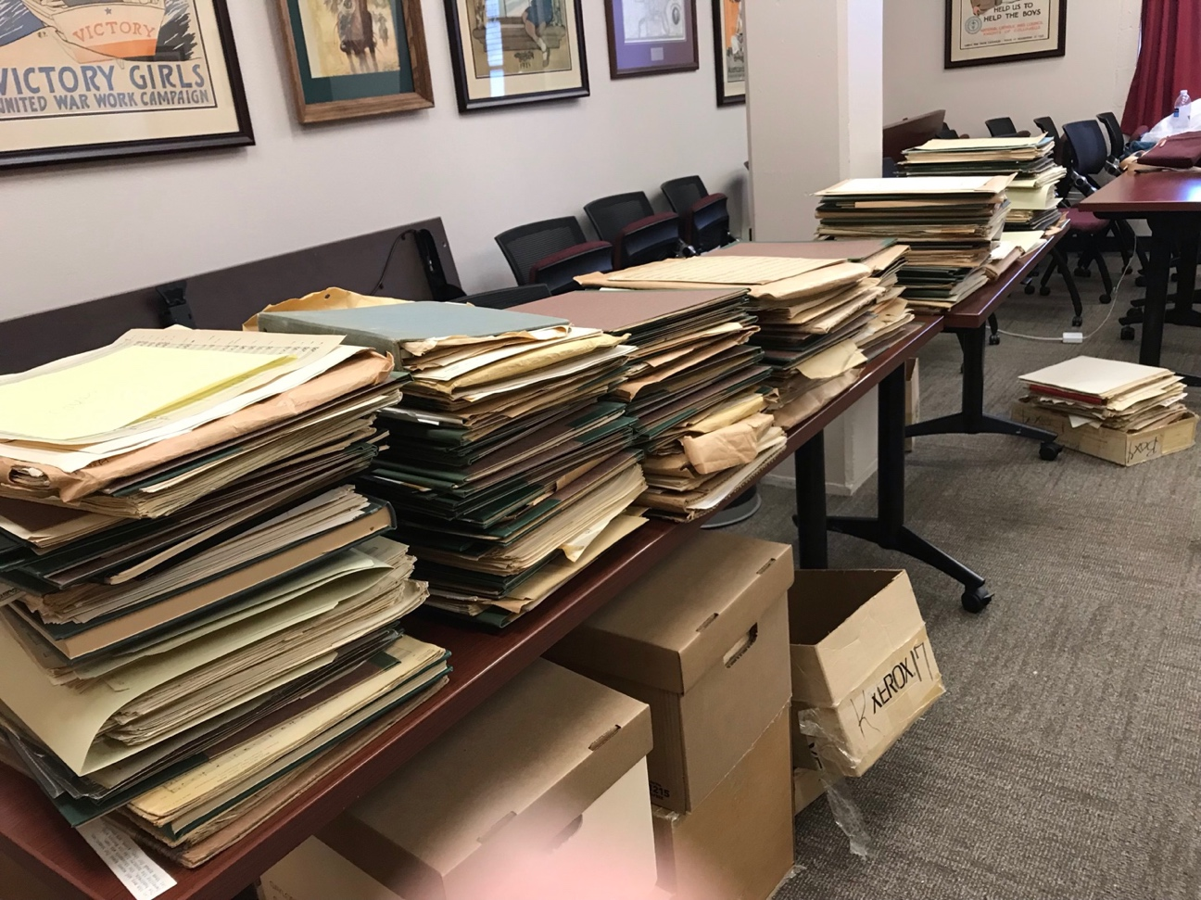
Note. A photograph of the archive process for the Jack Kilpatrick Collection (own photo). Reprinted with permission from the Jack Kilpatrick Collection at the University of Oklahoma Western History Collections.

During this phase, the Western History Collections was only looking to procure the physical manuscripts for the collection, not the digital recordings, previously published works, or literary and historical writings. Because of this, I was responsible for deciding exactly what would be included in the collection and which items would be deselected. The main job of this process was to find exactly what we had and to identify and index every item. In order to do this for the manuscript collection, I separated each piece by opus number, determined whether we had a holograph (handwritten score) or copy, how many copies we had, whether the copies and holograph were complete or missing pages, and whether these holographs and copies were complete orchestrations of each opus number or altered orchestrations or piano reductions. Using my music training, I was able to read the sheet music and correctly place the out-of-order manuscripts together based on pagination, instrumentation, measure numbers, rehearsal markings, keys, meter, and similar musical material. After each manuscript was identified, I determined whether we were missing any opus numbers, and searched other libraries to see if they had those documents available. Southern Methodist University’s collection contained a handful of copies of opus numbers that were missing from the Jack Kilpatrick Collection.

The Deselection Process
The process of deselecting the items that had been transferred to the Western History Collections included multiple steps. The first step was to identify materials that did not necessarily fit the Jack Kilpatrick Collection and label these as deselected items so that they could be added later or as part of a different collection. Items that fit the deselection criteria included classroom teaching materials, textbooks, programs that included performances of Kilpatrick’s music, Kilpatrick’s diplomas, newspaper clippings, and other items that gave insight into Kilpatrick’s life and career but were not manuscripts themselves.
The next part of the deselection process looked for redundancy and completeness. My main objective was to select only holograph and manuscript scores to be part of the special collection. One of the goals of this collection was to have an entry for every opus number, and since we did not have either a holograph or manuscript for every single piece, some of the scores that were included were photocopies. Therefore, I needed to determine whether the photocopies were worth including in the collection due to lack of access to the original holograph.
Precedence for inclusion in the collection was given to unique, primary source materials, but I found it extremely interesting that Kilpatrick personally kept several copies of select pieces. I assume these pieces had been photocopied because they were programmed fairly regularly during his lifetime. For example, I found more than 30 copies of Symphony No. 5 in F-sharp minor, which was one of Kilpatrick’s most popular symphonies. Not only were there several photocopies of the symphony score, but there were also numerous copies of a piano reduction version that Kilpatrick constructed. After finding no differences between the copies, I only included a few copies each of the score and the piano reduction version in the catalog. Currently, only Kilpatrick’s sheet music, which includes holographs, manuscripts, and photocopies, is included in the Jack Kilpatrick Collection at the Western History Collections. His teaching materials, medicine books, diplomas, various textbooks, and items that were not personally authored by Jack Kilpatrick were deselected. While the Western History Collections still has the remaining deselected materials in their holdings, they are not available for viewing. An image of the indexed manuscripts in opus number order after the deselection process was completed can be seen in Figure 4.2 (see Appendix C for the Index of the Jack Kilpatrick Collection).

Figure 4.2
An Image of Indexed Kilpatrick Materials in Opus Number Order After the Deselection Process was Completed During the Summer of 2019 Dale Society Fellowship at the Western History Collections at the University of Oklahoma
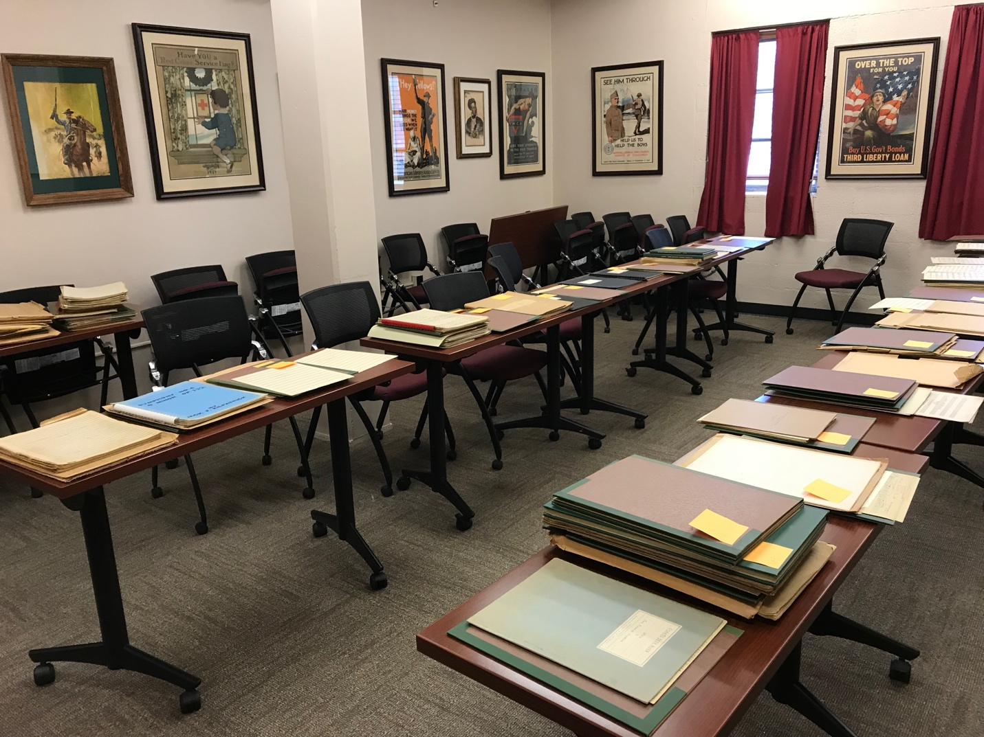
Note. A photograph of the archive process for the Jack Kilpatrick Collection (own photo). Reprinted with permission from the Jack Kilpatrick Collection at the University of Oklahoma Western History Collections.

Opus Numbers and Organizational Systems
After the deselection process, I reordered all the pieces in numeric order according to the opus numbering system created by Kilpatrick. It was apparent that Kilpatrick retroactively numbered his early compositions, and after establishing his initial numbering system, he continued in chronological order. I believe that Jack began numbering his compositions around the time he started teaching at SMU. Earlier pieces often contain penciled in opus numbers that did not match the ink or pencil markings consistent with the rest of the score. Theoretically, it also makes sense that a composer early in their career may not necessarily think of their compositions as worthy of an opus number marking. An opus number is the declaration of completing a foundational work—something that would be worthy of programming long after the composer has died. As Kilpatrick’s works became more popular and after receiving commissions from leading orchestras of his time, it makes sense that he would reflect on the order and validity of his earlier compositions. An example of Kilpatrick penciling in an opus number on a previously written composition can be seen in Figure 4.3.

Figure 4.3
An Image of the Manuscript for Cherokee Life with Penciled-In Opus Number
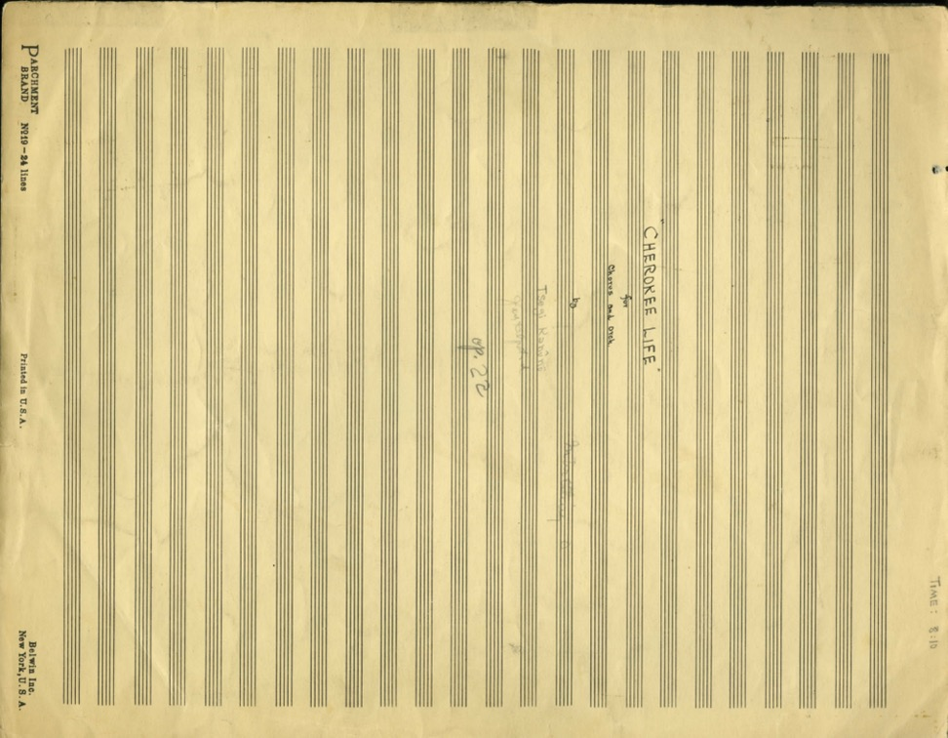
Note. This picture is also an example of Kilpatrick signing both his Cherokee and English names on his manuscripts (own photo). Reprinted with permission from the Jack Kilpatrick Collection at the University of Oklahoma Western History Collections.
Next, the cataloging process began. During this phase, determining cataloging order was a priority, as was detailing elements from the manuscripts to make into searchable fields for a future database, which was influenced by hypothesizing how the collection would be used in the future. To determine how this collection could aid in future research projects, thus determining which details I would include in the cataloging process, I interviewed Lisa Conathan, Head of Special Collections for Sawyer Library at Williams College and former Head of Processing at The Beinecke Rare Book and Manuscript Library, about her work at Yale with the Kilpatrick collection there. Since the Western History Collections is a non-circulating library, the first question she had me answer was why someone would travel to and request to look at this particular collection.
In order to select searchable fields, I took note of the questions I had been asked by musicians and researchers about the collection during the process of building the archive. These questions included: what does the music sound like, what composers does it sound similar to, what is the instrumentation, how long are the pieces, where can someone get a copy of the music, is the music published, how big is the collection, where did the collection come from, where is Kilpatrick from and where did he study composition, what are his composition dates, what are some of Kilpatrick’s musical influences, are any of his pieces recorded, and if so, where can they be accessed, and who has performed his compositions. Performers have also consistently asked me for lists of pieces written for their instruments, and conductors have asked for pieces that fit the instrumentation of their ensembles. After a tremendous amount of deliberation, I decided at this point that the archive would at minimum be searchable by title, opus number, and instrumentation. I later added more searchable fields as part of the cataloging stage.

The Cataloging of Kilpatrick Works
What the Western History Collections has is an almost complete collection of Jack Frederick Kilpatrick’s holograph music manuscripts. However, I was unable to find any other collection specializing on a single Indigenous composer as momentous as the Jack Kilpatrick Collection constructed at the Western History Collections. Because of this, the Arnold Schönberg Center located in Vienna, Austria served as the most comparable model for indexing and cataloging the complete works of a single composer in a single collection. While the Arnold Schönberg Center is not a special collection within a larger library, but instead a center that only focuses on the life and work of Schönberg, the construction of their archived manuscript materials served as a helpful model. The Schönberg archive is the most comprehensive collection of materials documenting his work as a composer, painter, teacher, theoretician, and innovator. Similar to what I hope the Kilpatrick collection will become, the Schönberg Center is available to the general public as well as dedicated scholars.
The holdings at the Arnold Schönberg Center include his music manuscripts, calendars, diaries, correspondence, discography, historical recordings, videos, voice recordings, writings, press archive, image archive, satellite collections, and library catalog. For the scope of this project, my interest was focused on the music manuscripts, discography, and historical recordings holdings. The music manuscript collection contains autographed music manuscripts, digital facsimiles, musical sketches and drafts, engraver’s copies, and corrected early editions. The structure of the catalog is based on the Arnold Schönberg Complete Edition (German: Arnold Schönberg Gesamtausgabe), a historical-critical edition of the complete works of Schönberg, created in 1965 by his pupil and later assistant Josef Rufer for publisher Schott Music. The Arnold Schönberg Complete Edition is divided by type of composition into the following volumes:
I. Songs and Canons, Volumes 1–3
II. Piano and Organ Music, Volumes 4–5
III. Stage Works, Volumes 6–8
IV. Orchestral Works, Volumes 9–15
V. Choral Works, Volumes 16–19
VI. Chamber Music, Volumes 20–24
VII. Arrangements, Volumes 25–28
VIII. Supplements, Volumes 29–33
All works at the Schönberg Center are named in accordance with the Arnold Schönberg Complete Edition as listed above, which is structured and searchable by title, opus number, date, work categories (genres), and kind of paper stock. Full text and category searches of this collection can include category, sub-category, instrumental/vocal setting, persons, opus number, dating, first performance, first printing, location, and call number (Arnold Schönberg Center, 2023). I used this catalog’s structure as a model for how to divide the works of the Jack Kilpatrick Collection.
Based on the Arnold Schönberg Complete Edition, the Jack Kilpatrick Collection’s finding aid is similarly divided into the following series:
1: Symphonies
2: Orchestral Music
3: Band Music
4: Chamber Music
5: Choral Music
6: Opera, Theater, and Film
7: Solo Keyboard
8: Solo Instrument (besides keyboard)
9: Solo Voice
All works in the Jack Kilpatrick Collection are labeled in accordance with the series name and number listed above and are searchable by series number, box number, folder number, item number, opus number, folder title or item description, date of completion, nicknames, and dedications.

Ownership, Copyright, and Permissions
The manuscripts of the Kilpatrick collection are considered by the Kilpatrick family to be equally owned by all three living sons of Jack and Anna. Together they agreed on how the collection would be handled. For the interest of the archive, the University of Oklahoma and the Western History Collections are only responsible for the physical materials, not the copyright or performance royalties of the compositions. Discussions on how the materials can be duplicated, shared, and used are still ongoing at the time of this writing, but the Kilpatrick family is part of the process. While the University does not handle copyright issues, I am working with the family to help them receive performance royalty payments and ensure that continued copyright is retained with the family as long as they wish to hold it.
The University of Oklahoma is still working with the Kilpatrick family to formalize the legal documents giving us permission to perform and record the music contained within these manuscripts. When we spoke with him originally, Jack Kilpatrick Jr., Kilpatrick’s oldest son, believed that this had already been taken care of in the 1970s when the boxes were gifted to OU, but we are currently finalizing the legal documents to tie all loose ends and make sure there are no uncertainties related to this.
Along this line, I am also determining which of Kilpatrick’s works have been published, who they were published with, and who, if anyone, currently holds the rights to those published works. Due to the nature of the publishing business, most of Kilpatrick’s works are still potentially under copyright, but every publishing house he worked with has since gone out of business. In fact, every company that we have contacted who we believe may have purchased the catalogs from one of those now-defunct companies has no knowledge or records of Kilpatrick’s work.

Rumors and Curses
There are various possible explanations for Jack’s early death. Throughout Jack’s life, he was a chronic smoker, and one of his most notable pictures is of him composing at the piano with a cigarette hanging from his lips (see Figure 4.4).

Figure 4.4
An Image of Jack Kilpatrick Smoking a Cigarette While Composing at the Piano
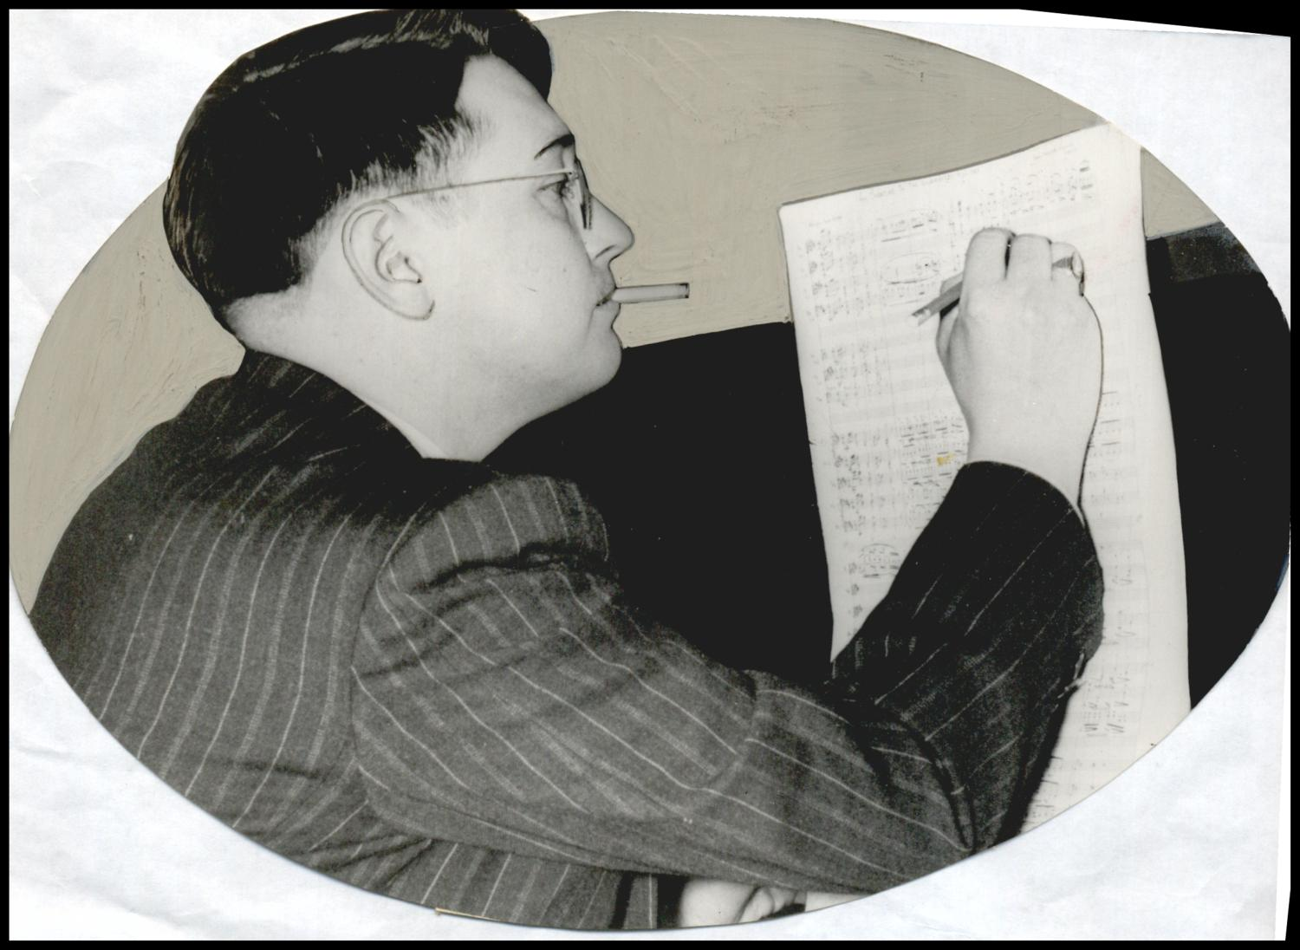
Note. Photograph used for a newspaper owned by the Oklahoma Publishing Company. Caption: "Kilpatrick, Jack. Composer." Photo by Hart, Alphia O, May 19, 1941. Reprinted with permission from the Oklahoma Historical Society.

Throughout his life, he was plagued with recurring health issues that often caused him to take leave from work. There has also been speculation from many members of the Cherokee community that Jack’s death was a result of him having possession of Cherokee medicine books. To respect the privacy of those I interviewed, I will not mention any specific sources, but I have heard from members of the Cherokee Nation that briefly before his death a curse had been placed on him by members of the community who thought that the Kilpatricks should not be sharing and documenting the sacred cultural information contained within the medicine books and that the only way for him to be cured was to return the materials to their rightful owner – though who exactly that rightful owner would be is unclear. Whatever eventually led to his death, there is a strong belief among some groups that his heart attack occurred due to owning, working with, and being in the presence of these medicine books. The few medicine books that we found with the other materials only made up a small percentage of the Cherokee books the Kilpatrick family had in their possession at the time of Jack’s death. In the discovery phase, a library staff member kept the medicine books in their office and reported feeling sick. It was not until the medicine books were removed that they started to feel better. In passing, I have also heard from multiple members of the Cherokee Nation that the collection as a whole may be cursed.

Chapter Conclusion
Our finding of such a comprehensive and robust collection of musical manuscripts by a singular composer was such a unique find that it seemed best that the materials stay together as part of a special collection rather than as individual entries within the OU Fine Arts Library catalog. The majority of the materials found were one-of-a-kind handwritten scores (holographs) created by the composer himself that represent an almost complete catalog of his musical compositions. This special collection is focused on serving scholars researching the music of Jack Frederick Kilpatrick, Indigenous classical music, historical music collections, music funded by the Work Progress Administration (WPA), music by Oklahomans, Cherokee folklore, the music of historical dramas, and American classical programming in the mid-1900s. After completing the Dale Society Fellowship at the Western History Collections, I was asked to assemble a display case highlighting some important elements of the Jack Kilpatrick Collection that was on display in 2019-2020 at the Western History Collections (see Figure 4.5).

Figure 4.5
An Image of a Display Case Assembled by Christina Giacona in 2019 After Her Work as a Dale Society Fellow at the Western History Collections at the University of Oklahoma
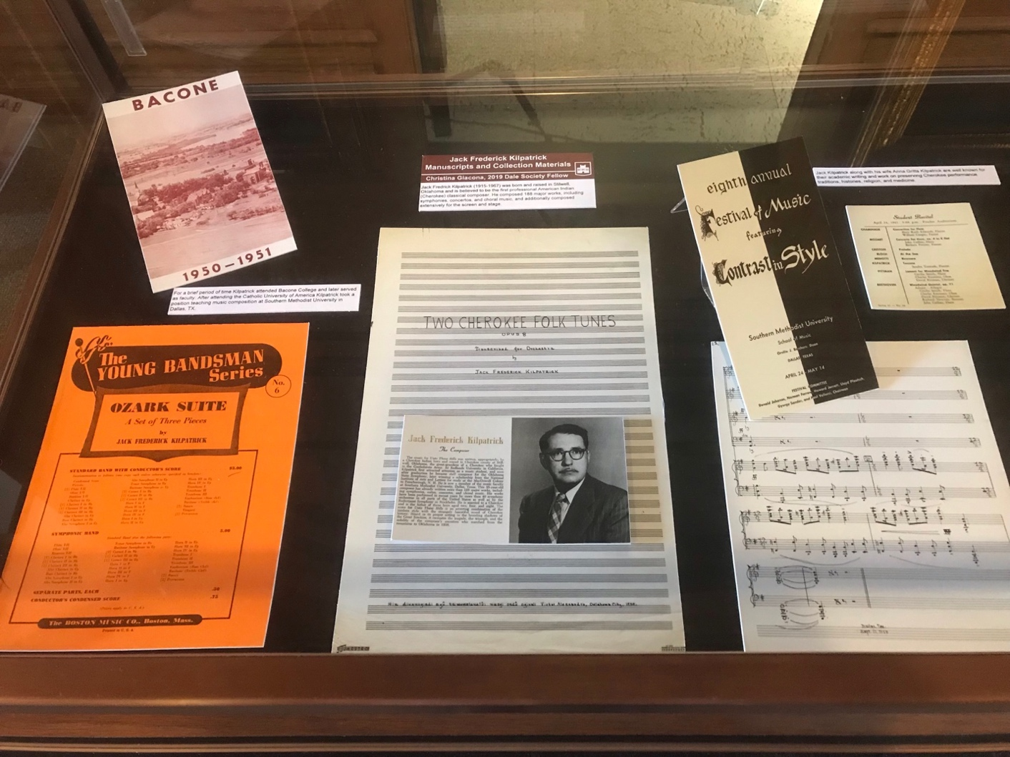
Note. A photograph of the display case in Bizzell Library for the Jack Kilpatrick Collection (own photo). Reprinted with permission from the Jack Kilpatrick Collection at the University of Oklahoma Western History Collections.

Chapter 5: Technology, Critical Editions, and Preparing Manuscripts for Performance
While the handwritten manuscript scores that make up the majority of the Jack Frederick Kilpatrick archive contain the information needed to put together the performance materials required for new live performances, they are not themselves usable “performance materials.” In order to take the next step in beginning a revival of Kilpatrick’s music, I needed to decide on a primary research methodology that would be used in order to make critical editorial decisions in the creation of performance materials that would enable conductors and musicians to start programming and performing his music. Many aspects of an original manuscript must be taken into consideration during the music preparation process, including freedom of interpretation and composer intent, historical and musicological context, and how to approach revisions, errata, reductions, part scoring, and performance instructions. The following section will detail the typical decisions involved in the creation of performance materials from a composer’s manuscripts. This chapter will detail the different options available, current professional standards, what methodologies were used, and why I chose those methodologies to build performance materials out of the Kilpatrick manuscripts.
These methodological decisions are important because, while handwritten manuscript scores contain most or even all of the musical information needed to create performance materials, manuscripts are not themselves usable as performance materials in most situations. In fact, manuscript scores, especially hand-written ones, usually occupy a similar position to book manuscripts, in that they are considered a primary source of a draft edition of a musical performance before it has been officially published. The act of making an exact duplication of a mechanical (non-digital) score and entering it into digital music notation software such as Finale, Dorico, or Sibelius in order to create performance materials is known as transcription. The act of taking that digital score and creating individual performance materials (known as parts) for each musician is known as engraving, and those that do it are known as copyists. However, it is not always so straightforward. Manuscript scores occupy a tenuous position of authority because of the secondary steps often necessary to make performance materials from a manuscript score. For example, it is often difficult to ascertain whether any discrepancies between the manuscript score and the published performance materials were due to revisions made with the composer’s input, revisions made without the composer’s agreement, or errata made by mistake in the process of making the performance materials. Hand-written manuscripts are most often consulted in the event that a published edition of the score is suspected of containing errata, or when an element of performance practice is unclear in the performance materials and is in question. The archive contains both original handwritten manuscripts and professionally published conductors scores and parts for some Jack Kilpatrick’s compositions. In a handful of these cases, there are small discrepancies between holograph manuscripts and the published performance materials.
To center my work to create new performance materials (and eventually new performances) of Kilpatrick’s compositions based on the information embedded in his manuscripts, I use the terms contextualization, entextualization, decontextualization, and recontextualization as defined by Richard Bauman and Charles L. Briggs (Bauman and Briggs, 1990). Bauman and Briggs explain that contextualization is the process by which context is created, that is the process of negotiation between participants as they interact through speech to identify, interpret, affect, and change the context of the communicative situation. The term contextualization emerged as an attempt to deal with the problems associated with the concept of context – in particular, complexity of describing the context of a situation as a singular whole, and false objectivity, where ignoring the active role that hearers play in performances also ignores how the presence of researcher cannot help but act as an active force on the contextualization of the event. This moves the ideas of illocutionary forces (intentions) and perlocutionary effects (the consequence of speech-acts) from a static equation to a constantly changing interpretation both affecting and affected by each participant in the performance. The result of this active negotiation of contextualization means that in the case of Kilpatrick’s music, I cannot analyze the context of his music without understanding that my very presence as a researcher and animateur in attempting to revive his music acts as an active participant in each moment of contextualization.
Entextualization is the process by which discourse is extracted from its interactional setting to become its own unit (or text). In the case of Kilpatrick’s music, the information embedded in his holograph manuscripts acts as entextualized representation of instructions for future sonic performances extracted from their interactional setting (a performance by an orchestra for an audience). Full performance is often associated with strong degrees of entextualization due to the fact that the very things associated with analyzing full performance (putting speech on display, lifting it from its more normative interactional setting, and opening it to scrutiny to an audience) also draw attention to an entextualized item. For example, if two orchestras perform the same composition by Kilpatrick, the entextualized performance materials are the portion of the performance (the text) that remains the same (or to say it differently, outside of the contextualization of the musical score that occurs during each individual performance).
If contextualization is the anchoring of performance into its context of use, then decontextualization is the extraction of verbal art (in this case music) from its context of use. Bauman and Briggs underline that decontextualization is always followed at some point by recontextualization in a new context. Recontextualization is the act of taking an entextualized object (a text) that was somehow decontextualized from its original context and contextualizing it in a different context. It is this process of recontextualization that so profoundly alters and actually allows music revival to function for cultures that are often drastically different than the original cultural context of the music in its original time.
To put these terms clearly into context for my own research, my work as a researcher, archivist, and revivalist is constantly attempting to contextualize Kilpatrick’s music as historically important, worthy of a music revival, and of interest to music directors. Kilpatrick’s music was decontextualized after his death due to the unavailability of performance materials (scores and parts), which led to a rapid decrease in performances of his music and his eventual decline into obscurity. The discovery of his manuscripts allowed us a chance to recontextualize his music for a new, contemporary audience by using the entextualized information embedded in the holographs and creating new performance materials from them for modern performing ensembles.
Manuscript scores also contain differing amounts of detail and authority depending upon the individual process that each composer followed for creating performance materials of their work. For example, some composers rely heavily on the embodied knowledge of performance practice and only include basic rhythm, pitch, and dynamic markings in their scores, while other composers will provide detailed performance instructions in their scores in an attempt to clarify any questions a performer might have for their interpretation of the score. This is because manuscript scores, like book manuscripts, usually include the required information needed to put together performance materials, but in most cases are not themselves used as performance materials. For example, some manuscript scores are written in short-hand or even as reduced scores, where instruments and notes that would occupy separate staves on a conductor’s performance score are combined onto a single staff line to expedite the composing process. In a situation like this, some editorial license must be taken in assuming voice leading when separating these notes into each instrument part in the engraving process. In situations where extensive editorial license is needed to extract information from a reduced score, this would be considered orchestrating. This lack of specificity in some manuscript scores is why so many unpublished works that are later published based on manuscript scores often contain asterisks in the music explaining that a particular section is printed in the performance materials a certain way, but that alternative interpretations of that section are possible. This is common in all eras of published sheet music, from the works of Johann Sebastian Bach to the recently re-published works of Florence Price.
Luckily, despite having very few recorded performances, the manuscript collection of Jack Kilpatrick contains mostly full-score, non-reduced hand-written manuscripts written with legible and clear engraving. While some of the scores are written in reduced score format, they are the minority, and for most of his opus numbers the manuscripts contain the information needed to create performance materials without re-arranging or re-orchestrating. However, there are a small number of manuscripts in this collection that will require some amount of arranging or orchestrating in order to create usable performance materials. As mentioned earlier, these Kilpatrick works that require arranging or orchestration in order to prepare performance materials will be left until the end of the restoration process so that his orchestrational style can be more deeply studied before any orchestrations of his works are attempted. Any re-orchestration of his work would be clearly labeled as such and the original manuscript would be included in the performance materials for conductors to reference.

Arranging and Orchestrating
Arrangers are most often credited by name on performance materials due to the fact that they have actually added musical material or altered musical material to be different from the manuscript score. This is usually reserved for large scale changes in the harmony, structure, or melodic content of the piece, and is not a term used for a music preparer who alters a note or two from the manuscript score to publish what they believe the composer meant to write rather than what is present in the score. For example, a music preparer who changes a note that is perceived to be a mistake in the manuscript score for the performance materials but marks it with an asterisk and explains their reasoning would not be considered to be creating a new arrangement of the work, but is instead creating what is known as an edited edition. In most cases with Kilpatrick’s scores, this is the extent of the orchestration necessary due to the clarity and completeness of the manuscript collection. Any changes to Kilpatrick’s scores that appear in the performance materials I have prepared use the asterisk to denote that a change has been made from the original manuscript score. So far these have only involved messy, hand-written noteheads where it is unclear which pitch they are meant to represent. Fortunately, in all the cases I have run into during the course of building Kilpatrick performance materials, it has been fairly easy to ascertain the intended pitch through a harmonic analysis of the section and an investigation into the pitch content of similar melodic materials in other sections and instruments present in the manuscript score.
Kilpatrick, as is common in classical concert music composition, was also the arranger and orchestrator of his compositions. There is no evidence of additional orchestrators or musical collaborators with the exception of collaborations with librettists, lyricists, and dramatists like Kermit Hunter. However, due to the lack of an editorial position in classical music analogous to an editor for prose authors or a producer for popular musicians, the editorial role is filled by a variety of different people, from conductors to mentors, friends, spouses, and students. Many conductors and musicians take on this editorial role, with notable examples of conductors who suggested (and/or demanded) re-arrangements or re-orchestrations from composers including Arturo Toscanini and Leopold Stokowski. Recordings and musical interpretation in previous performances make it difficult for a publisher to ascertain whether the authorial intent of the composer is best found in the manuscript score, performance materials, or recorded performances. For example, Arturo Toscanini’s performance of Claude Debussy’s seminal 1905 composition La Mer in Milan in 1909 included changes to the orchestration from the manuscript. Rob Cowan’ss 2018 article “Debussy’s La Mer: a complete guide to the best recordings” for Gramophone states: “He [Toscanini] actually corresponded with the composer, who interestingly granted his request to bolster the divided cello passage with violas. Also, in the finale he alters the ff pizzicato chord at one bar before fig 46 to arco (Guido Cantelli does the same)” (Cowan, 2018).
Conductors and musicologists have since argued over which version best represents the composer's intent: the re-orchestration by Toscanini made with primary source evidence of Debussy’s approval, or the original manuscript and published editions of the performance materials which contained Debussy’s original orchestration. This discrepancy can be seen in recordings, performances, and published editions of Debussy’s La Mer, as there is equal evidence that both orchestrations could have been what the composer preferred, despite the presence of a manuscript score that can be referenced. Using the restored reel-to-reel recordings included within the Kilpatrick archive, I have begun to compare the recorded performances against the manuscript scores to look for any discrepancies between the performed materials and the notated performance instructions. However, this line of inquiry cannot progress further until we restore a greater number of the recordings. I have also been looking for any correspondence between Kilpatrick and the performing conductors but have thus far not discovered anything of note.

Types of Publication Editions
In order to establish a general methodology for the creation of performance materials from the Jack Frederick Kilpatrick Music Manuscript Archive, I had to decide on what kind of editing philosophy I would use. In general, published materials for a classical acoustic composition fall into four edition types:
- Manuscript editions, which are photocopies of the hand-written manuscript scores.
- Urtext editions, which are digitally transcribed performance materials consisting of a score and parts that exactly match the original manuscript with any changes from the original manuscript marked and explained. These are usually delineated by a lack of any additional phrase markings, dynamics, articulations, or fingerings.
- Regular editions, which may choose to follow the original manuscript, their interpretation or authorial intent, or performance practice and may or may not list any changes from the original manuscript.
- Edited editions, where an expert who specializes in the field has been hired to make editorial changes to the performance materials to present their interpretation of how the composer’s manuscript should be interpreted by other musicians. This is especially popular for soloists to create for concerti and can include changes to dynamics, articulations, bowings, added performance fingerings, additional cadenzas, or more rarely actual changes to the orchestration or arrangement, though it is most common that these changes involve cutting material out of the music to make it shorter.
In addition to the named genres of edition, different publishers are known for specializing in different kinds of editions. For example, publisher G. Henle Verlag is well-known for providing urtext editions of classical performance materials that are as close to the composer’s manuscript as is possible. Bärenreiter, however, provides critically acclaimed editions of classical performance materials by hiring musicologists who are experts at the material in question in order to enable performances as close to the authorial intent of the composer as possible. Like any field, there are also publishers with various reputations for accuracy, with publishers like International Music Company and Kunzelmann being known for having periods when large numbers of errata could be expected in their performance materials.
Outside of publisher specializations, one of the main issues with putting together new performance materials from hand-written manuscripts by a deceased composer is a variety of standards in performance material creation, with large differences found in different genres, mediums, time periods, and countries of origin. With historical works such as the Kilpatrick manuscript archive, the question becomes whether to create performance materials in the historical style of performance materials at the time of publication, or to create performance materials in a modern fashion to more accurately and efficiently reproduce the intended sounds of the manuscript scores with a modern orchestra.
In creating the performance materials for Jack Kilpatrick’s pieces, I decided to create performance materials following modern engraving standards. The reason for this is that the time period when Kilpatrick composed his work, from the 1930s through the 1960s, is not a time period that is commonly performed by historically informed performance (HIP) ensembles. While medieval, renaissance, and baroque period performance materials are often republished as a facsimile of the historical engraving process, this is rarely applied to 20th century concert works. Instead, contemporary performance materials for 20th century compositions are expected to be easily read and performed using the latest technology.

Publishing and Technology
Professional music publishers do adhere to professional printing and engraving standards, but new compositions, the current music industry, and the popularity of self-publishing created through digital notation software have changed how sheet music is created. In today’s music industry, composers and arrangers can create, engrave, and publish their own performance material scores and parts which are just as professional as those from a music publisher. The ability to create PDFs and easily transfer these electronic files across the world for printing onsite or use through a tablet device rather than mailing physical materials has created the need for standardized performance material guidelines that not only cover the engraving process but also printing practices, paper sizes, and recently how to prepare PDFs for viewing on iPad and tablet devices. Most organizations will only have one librarian on staff with limited time and their job duties do not intrinsically include fixing errors in reproduced parts and scores. Thus, it is up to the publisher or the creator of performance materials to adhere to twenty-first-century standards in the creation of compatible performance materials. In creating the performance for Jack Frederick Kilpatrick’s works, I have been careful to stringently adhere to professional printing and engraving standards.

Publishing the Kilpatrick Manuscripts
In the interest of making it as easy as possible for orchestras to program, rehearse, and perform Jack Frederick Kilpatrick’s music, I have chosen to create critical editions from his manuscripts where all performance materials act as urtext performance materials with musicologically-informed program notes and contemporary engraving standards. Due to the lack of an established performance practice for Kilpatrick’s music existing within the embedded collective knowledge of contemporary orchestral performers, I believe that it is important to adhere stringently to the markings in the score while simultaneously providing context for musicians who will be attempting to interpret a music with which they are not familiar. This means that any changes from the original manuscript scores will be noted in the conductor’s performance score, but that ideas of tempo and how to interpret unwritten musical ideas be informed by the few remaining Kilpatrick recordings, program notes, and the idiomatic performance practices of American classical concert music at the time of music publication. The actual performance parts and score layout of these new editions of Kilpatrick’s pieces, however, follow current Major Orchestra Librarians’ Association (MOLA) standards, which are outlined in the following section.
MOLA: Major Orchestra Librarians’ Association
The Major Orchestra Librarians’ Association (MOLA) is a nonprofit collaborative organization that facilitates communication between performance librarians and provides education and support to ensembles and music publishers. As part of this mission, MOLA has published online guidelines for the approved preparation of music scores and parts and in doing so created a standard of American engraving practices utilized by professional, semi-professional, collegiate, and youth ensembles. Professional industry-standard engraving software such as Finale, Sibelius, and Dorico are programmed to follow many of these MOLA guidelines, and all MOLA guidelines can be achieved by any of these three professional standard programs through the use of approved score templates.
The MOLA guidelines have been prepared and revised by four different publication committees. The description below was created in 1993 from professional orchestra librarians from the United States and Canada. These guidelines were revised in 2001, 2006, and 2017. I am using the latest 2017 revision standards for the creation of performance materials from the Kilpatrick manuscript collection. The following MOLA guidelines have been adhered to for the transcription, engraving, and creation of performance materials for the four Jack Frederick Kilpatrick orchestral pieces performed by the Oklahoma City Philharmonic.
MOLA refers to the created scores and parts as “Performance Materials.” Performance materials refer to a full score with cover and individual instrument parts. There are standardized fonts, formatting, paper, paper sizes, and binding. The Kilpatrick performance materials are not handwritten, but are instead computer generated and printed or sent as PDFs. At the top of the page the score includes the title of the piece at the top and centered. Underneath the title any commissioning information or additional dedications is included. On the top right underneath the title the composer’s name is listed. In the staff and staves the clef then key signature followed by the time signature is included. These items are included on each line and page. Tempo markings are placed above the staff whereas dynamic markings are below.
The full score also includes the full name of all instruments at the left of the page next to the associated staff or staves. This element of the performance score can become contractually important in unionized orchestras. Many union orchestras have stipulations against performing classical pieces with what are referred to as “reduced” orchestrations. In orchestras with this stipulation in their bargaining agreement, the instrumentation listed in the performance materials of a piece of music must be provided in order to perform the work even if it means hiring additional personnel or finding experts for rare instruments. Some composers and publishers work around this by listing rare or difficult to procure instrument requirements that are preferred but not essential to a competent performance realization of the music as “optional.” Sometimes, for preferred but rare instruments like a contrabass clarinet or a cimbasso, optional substitutions can also be suggested with included parts for both options. An example of how this might look on a score would be “Contrabass Clarinet (optional bass clarinet part included)” or “Cimbasso (optional bass trombone part included).” Both of these situations would not be considered a “reduced” orchestration, but would instead be considered a regular performance of the listed orchestration without all of the optional instrumental lines realized. Kilpatrick’s manuscript scores and performance materials follow these guidelines.
A “reduced” orchestra, which is common in touring musicals to save money, refers to a version of a piece of music that is performed by fewer musicians than is listed in the performance materials. Sometimes these reductions are made in the moment and not reflected in the performance materials (e.g., in the case of an unexpected sickness or a lack of funds, it is common for the missing musician’s part to be covered by the keyboard player). Some reduced orchestrations can become standardized to the point that entirely new performance materials are created for the reduced edition of the orchestration. These reduced orchestrations will often combine multiple parts onto a single performance part. For example, music which may have originally been written for one clarinetist, one flutist, and one saxophonist, will be combined into a single “wind doubler” part where the most important lines of each instrument are played by a single performer who switches between instruments in the middle of the performance.
Full scores include measures and page numbers. For clarity a combination of measure numbers and rehearsal letters should be used. Measure numbers should start from 1 at the beginning of every movement and they should be placed below the staff system. For Kilpatrick’s performance materials, additional measure numbers are added to the parts automatically by the engraving software. This does not constitute a change from the manuscript and as such does not require an asterisk with explanation.
For printing purposes all parts and scores are double-sided with music on both sides of the page. The minimum legible staff size for scores is 4mm, and the staff size range for instrument parts in Kilpatrick’s performance materials are between 7.5 and 8.5 mm. Page turns are be considered in page layout, wind parts do not have multiple instruments on a single staff, and string parts are created with one part per section with complicated string divisions written on separate staves. Conductor scores are to be printed on paper at least 9 x 12 inches but no larger than 11 x 17, and parts are to be printed on paper at least 9 x 12 inches but no larger than 11 x 14 inches.

Determining Other Publication Details for Concert Programming
When a music director, conductor, chamber musician, or soloist selects a Kilpatrick piece for programming on a concert, recital, or recording project, the music programmer relies on access to a number of important selection criteria as they build the repertoire for the individual project or even the entire concert season.

Instrumentation
First and most important is the instrumentation of the music that is being considered for programming. Music publishers base their catalog categorization with instrumentation as the primary differentiator between different search options, and often specialize in specific instrumentations (for example, solo piano works or wind band music). However, for programming consideration music programmers require information that goes beyond just the type of ensemble required, as the personnel requirements for a piece labeled for “full orchestra” can vary by over twenty specialized musicians. To give an example, Wolfgang Amadeus Mozart’s Symphony No. 40 is scored for flute, 2 oboes, 2 clarinets, 2 bassoons, 2 horns, and strings. In comparison, Gustav Mahler’s Symphony No. 2 is scored for 4 flutes, 4 oboes, 4 clarinets (including Eb, A, C, and bass clarinet doubles), 4 bassoons (including contrabassoon doubles), 10 horns, 10 trumpets, 4 trombones, tuba, 3 timpanists, 2 bass drums, several snare drums, a pair of cymbals, 2 triangles, 2 tam-tams, rute, 3 untuned bells, glockenspiel, soprano solo, alto solo, full mixed chorus, 2 harp parts with the indication to have several harp players per part, and strings. While the general instrumentation is included in the catalog of the Jack Frederick Kilpatrick Musical Manuscript Archive, individual instrument listings are only assembled during programming discussions at the beginning stages of the creation of performance materials. As part of the critical editions, the second page of each conductor score (the page following the title page) contains a full list of all instruments required for performance of the piece.
This becomes both a logistical and financial issue for programming consideration, so it is important that this information is readily available. Both orchestras and chamber groups will often attempt to pair similar instrumentation requirements on the same concert to avoid hiring extra musicians for only a portion of the concert. As discussed in the case study chapter, instrumentation was always an important element of selection in all four performances of Jack Kilpatrick pieces by the Oklahoma City Philharmonic. In addition, while the manuscript scores of Kilpatrick show instrumentation, they do not indicate the size of the different instrument groups (for example, how many violins, violas, cellos, and basses should be on each part, or if any wind parts should be doubled). In order to ascertain this information, the best option is to cross-reference the manuscript instrumentation with the size of the commissioning or premiering ensemble (if available), and then with any subsequent ensembles who programmed the music.

Duration and Tempo
The second piece of information that is required for programming is the duration of each piece of music. Concerts have generally standardized durations, and it is a question that any artistic director or musician thinking of programming a piece as part of a concert will ask. If there is a recording already available of the music, this is the best way to find out the estimated duration of the piece to within an acceptable margin of error. However, without a recording, it becomes more difficult to estimate the approximate duration of a piece of music.
The reason that it can be difficult to estimate the duration of a piece of music from a manuscript score, and why MOLA suggests listing the approximate duration on the performance material conductor’s score, is three-fold. First, tempo (speed of playback) is marked in a piece of music by a word or phrase at the top of the score referred to as a tempo marking. In American concert music, this tempo marking can either be in the primary language of the composer and/or orchestra (in English, this would include markings like Slow, Fast, Dirge-like, or March) or in Italian (including common tempo markings like Largo, Andante, Allegro, Presto). However, the tempo marking itself is only one half of the information needed to describe the tempo. The other half of the required information comes from the time signature.
Because tempo markings are ranges rather than strict measurements, what is considered “fast” can change depending on the year of composition, the era of performance, the country, the composer, the conductor, or any number of other factors. In some scores, this problem is somewhat rectified by including what is known as a metronome marking. Usually placed immediately following and acting as part of the tempo marking in a score, a metronome marking consists of a note value followed by either a specific beats-per-minute indication or a range (ex. Fast, Quarter Note = 130 or Fast, Quarter Note = 124-142). Jack Frederick Kilpatrick’s manuscript scores are inconsistent in whether or not the tempo markings also contain a metronome marking, though in general the larger the piece (both in instrumentation and duration), the more likely it is that the tempo markings in his scores will contain a metronome marking.
A second problem in estimating duration from a manuscript score comes from the performance practice of classical concert music. Even if there is a metronome marking in the manuscript score, in practice conductors of classical concert music will choose their own tempi for each piece, using the tempo and metronome markings in the score as guidelines rather than requirements. A famous extreme example of this is Leonard Bernstein’s 1959 recording of Dimitri Shostakovich’s Symphony No. 5 where Bernstein doubled the speed of the end of the piece from what Shostakovich had written despite the presence of a metronome marking in the score. Due to the iconic nature of this performance, subsequent performances of this Shostakovich symphony (especially in the U.S.) all begin with the conductor having to make the choice of whether to follow Shostakovich’s original marking, Bernstein’s interpretation, or come up with their own. As stated earlier, this is proof that manuscript scores inform the performance practice of a piece, but do not dictate them. In actual practice, every performance of a concert work is a unique artistic artifact, and the actual performance tempi of a concert work is influenced by a myriad of factors including the score, performance materials, historical performance practice, contemporary performance practice, conductor interpretation, and even the mood of the conductor and orchestra during that particular moment in time.
The third problem with estimating the duration of a performance from a manuscript score comes from the push and pull or tempo fluctuations that are integral to most western classical music performance. With the exception of contemporary pieces performed with a pre-programmed metronome track (referred to as a “tempo track” or “click track” with an audible metronome beat piped through the headphones referred to as the “click”), the majority of western classical concert music involves tempo fluctuations as an accepted part of musical phrasing. Major tempo fluctuations are written into the score as tempo markings (ex. Ritardando [rit. for short] to indicate slowing down and Accelerando [accel. for short] to indicate speeding up). However, more subtle tempo fluctuations are expected and encouraged both pedagogically and in the performance practice of western classical concert music.
Therefore, even if a concert score includes all tempo markings and each tempo marking has an associated metronome marking, and that score is performed by a conductor who is determined to follow those tempo markings exactly, it is impossible to exactly determine the duration of a piece even in this hypothetical situation due to the subtle push and pull that occurs in each phrase during a concert performance. Such a hypothetical situation would also actually go against the established performance practice of how conductors interpret manuscript scores for performance. In practice, metronome markings serve more as clarifying tools to avoid large misunderstandings (i.e. what note value does the tempo marking refer to) rather than as sacrosanct indicators of composer intent. Due to these factors, estimated durations are only expected to be accurate within a few minutes of the actual performance tempo (with more flexibility given to longer pieces). Concert programmers need to know if the piece is somewhere in the range of a 10-minute piece or somewhere in the range of a 30-minute piece, and do not usually need exact durations except in the case of pre-programmed television or time-sensitive performances outside of the traditional concert hall concert series.
Once the tempos of each specific section of the music have been analyzed, there are three ways to estimate the duration of a piece of music from only the information present in the manuscript score, each of which require different amounts of work and are usually done at different stages of the performance materials creation and programming selection process: timed score reading by a pianist, mathematical calculations, and transcription and MIDI file generation.
The first, and most direct way to establish a general duration for a concert work is to have a trained pianist play through the score and use a stopwatch or app to measure the length it takes to perform the entire piece. Score reading at the piano is a specialized skill that many conductors are taught as part of their training. Score reading at a piano involves a pianist making decisions about what parts of the score are important to hear and what parts can be left out to give a general sonic sketch of what the concert work might sound like when realized by a full orchestra.
While this method requires a skilled pianist who has been trained in score reading, it is the most efficient (though least exact) method of estimating the duration of a concert work; many scores can be read through and many rough estimates of duration can be established in a single day.
The second way to establish a general duration for a concert work from the manuscript score is to mathematically figure out the number of beats in a particular piece of music and the per-minute value of each of those beats through the time signatures and tempo markings present in the score. In practice, this method is generally used when the music director or music programmer has narrowed the number of pieces that they are interested in programming to a handful of selections and wants a more accurate duration estimate. For the Kilpatrick scores, I used this method to estimate duration for the Oklahoma City Philharmonic for An American Indian Serenade and for both the flute and oboe concertos (the flute concerto was eventually chosen over the oboe concerto for performance). If there are metronome markings in the score, this method will give an exact mathematical duration of what is present in the manuscript score, but does not account for conductor interpretation or for tempo fluctuations due to phrasing, tempo markings like rit or accel, fermati, or any unmetered measures, cadenzi, or other out of tempo markings.
The third way to establish a general duration for a concert work from the manuscript score is to do a full transcription of the score from the handwritten manuscript to a digital notation software like Finale, Sibelius, or Dorico and then use the digital notation software’s built-in MIDI sequencer to create a MIDI (Music Instrument Digital Interface) mockup of the piece. This is generally only used once the score has been selected for programming due to the cost and time of hiring a copyist to do the transcription, and due to the fact that this process is also required to create the performance materials. This is by far the most accurate way to come up with an estimated duration for a concert work, due to the “human playback” features of modern digital notation software. Digital notation software such as Finale works in such a way that when notes, articulations, dynamics, and tempos are entered into the digital “score” it creates both an engraved notation that can be printed and simultaneously creates a MIDI file for audio playback of what has been entered. “Human playback” was developed by composer and software designer Robert Piéchaud, and is a comprehensive utility that “reads” the Finale score inputs that are in the music, including tempo markings, fermati, rits, accels, and creates an anticipated phrasing tempo map. The combination of human playback with the ability to adjust the metronome markings with conductor feedback make full transcription, engraving, and MIDI sequencing a time-intensive but accurate tool to determine approximate duration.

How It Sounds
In addition to the basic information of length (duration) and instrumentation, music programmers also want to know how a piece of music sounds before they program it on a concert. Is the piece slow and meditative, or loud and bombastic? And, more so than anything else, does the music director in charge of programming the piece believe that it is aesthetically a “good” piece of music? Every music programmer needs to know how a piece of music “sounds” in order to make a personal judgement on whether or not the piece is right for a particular concert.
For pieces of music with previous professional recordings which are accessible to the music programmer, this is an easy task. The music programmer will listen to the recording either with or without the score in hand and make an aesthetic decision based on what they hear. If no professional recording is available, but it is a widely performed piece, the next best option is for the music programmer to attend a live performance of the piece of music and experience it live. This is a common occurrence with new, popular works that have yet to receive a professional recording. In the case of the Jack Kilpatrick manuscript collection, both of these options are unavailable for the majority of the works. While there are some reel-to-reel tape recordings of his works in the collections, they are in varied states of quality and need to be digitized and cleaned up by professional audio engineers before they are available for playback.

Score Reading
Because recordings and live performances are not available, there are three remaining options of increasing cost available to help music programmers decide whether to program Jack Kilpatrick’s music. The first option is to engage in score study. Conductors and trained musicians are used to reading scores like a book, and can imagine what the piece of music would sound like through a process called audiation. Audiation is a term that music educator Edwin Gordon began using in 1975 to refer to the internal realization of music, where a musician “imagines” sound that is not physically present. (Gerhardstein, R. C. (2002). The historical roots and development of audiation: A process for musical understanding. In Hanley, B. & Goolsby, T.W. (Eds.) Musical understanding: Perspectives in theory and practice. [Canada] : Canadian Music Educators Association.) Other terms that refer to the same phenomenon are aural perception or aural imagery. The ability to sight-read a score with accurate audiation is a difficult and inexact skill, but it is one that most conductors can use to gain at least a rough understanding of what a piece of music will generally sound like. Despite the inaccuracy of this method, it is efficient, as a skilled practitioner can gain a large-scale understanding of the general sound qualities of a piece of music (loud vs. soft, complex and dense vs. sparse and delicate, etc.) with just a cursory look through a manuscript copy.
Score study of this nature was used to go through large quantities of music in the Kilpatrick collection quickly in order to make note of certain pieces that the music programmer would be interested in investigating further. For example, in the case of my work with conductor Alexander Mickelthwate, I would first send Alexander an excel document with a list of all the Kilpatrick manuscripts we had available with information on length, instrumentation, titles, and premiere dates. Alexander would then ask for suggestions of Kilpatrick pieces that fit certain length and instrumentation requirements and mention titles that caught his attention from the excel document, and I would put together a short list of Kilpatrick manuscripts that matched his criteria. We would then pull those manuscript scores from the collection and go look at the manuscript scores together, or I would work with librarian Matt Stock to create a PDF scan of the manuscript score and send it to Alexander.
At this point we would sit down with the Kilpatrick manuscript scores and study the scores. The scores that we found the most interesting would result in the second option to help investigate how a manuscript score with no previous recordings would sound like: a performance of the score on the piano. As mentioned earlier, score reading at the piano is a part of standard conductor pedagogy. In this situation the improvised reduced piano interpretation of the manuscript score is used to “double-check” our own audiation of the score. Interesting looking sections of the music could be analyzed by playing the harmonies and melodies at the piano. While this did not give an indication of the orchestration, having the physical and psychoacoustic manifestation of the harmonies, melodies, and rhythms contained within the manuscript score realized through the piano makes it much easier to gain a more accurate image of what a fully realized performance of the selected musical piece would sound like.

MIDI Mockups
Finally, Kilpatrick pieces that were identified as serious candidates for programming were chosen to begin the engraving process and to have a MIDI mock-up created. Before sequencer software was created conducting preparation was usually done through improvised or notated piano reductions or through published piano four-hand arrangements of orchestral works. Because of the numerous parts and unique musical lines that can occur in an orchestra piece many orchestral scores were reduced to these piano four-hands (two players performing on the same piano) arrangements. In these new arrangements rhythmic complexity might be simplified and harmonic content might be reduced to blocked chords. However, today the piano four-hands arrangement’s role has been replaced with MIDI mock-ups.
In the past, music notation and engraving changed when the processes of printing developed. The word engraving is derived from one of the original processes of plate engraving where a professional would etch or cut grooves into a metal or glass plate known as a printing plate to then create prints for re-creation. Today, music engraving refers to the process of using a music notation program such as Finale, Sibelius, or Dorico to create performance materials. These modern programs allow for flexibility in editing and design of a musical score so that parts can be extracted from the score and used digitally or printed physically. One of the other features that changes how people interpret a new work is that digital programs can record notes played through a MIDI instrument as well as play back the notes inputted to the score.
Modern music notation programs also allow musicians to interface with high quality MIDI programs to provide a realistic orchestra simulation. In the 1980s, Universal Synthesizer Interfaces generated sounds representing instruments. Today, symphonic MIDI orchestras such as East West’s “Symphonic Orchestra” created by award winning engineers and producers have recorded a multitude of classical instruments capturing the instrument’s entire range along with various articulations and techniques. The instruments are also recorded as a solo instrument, in a small section, and as a large orchestra section. The instruments have also been recorded with an array of different miking techniques. A close microphone is used to capture the non-musical sounds of the instrument such as key clicks, finger touches, bow scratches, and musician inhalation and exhalation and on-stage and room mics are used to capture the sound of the musicians in the concert hall. With the modern use of surround and immersive audio additional microphones are setup to allow for these modern ways to mixing audio. Today’s MIDI sounds extremely realistic because the sounds have been captured by real performers on real instruments. While there is never a replacement for a live ensemble, modern MIDI programs have come to replace music in many mediums because it can be hard to decipher the difference between some MIDI realizations and real orchestral recordings.
These MIDI realizations of the musical score take time and require hiring a specialized music engraver and “music programmer” (a separate term unrelated to the term music programmer that has been used elsewhere in this document: this kind of “music programmer” refers to someone who programs the musical manuscript information into the MIDI programming language and then creates a recording of that MIDI information realized by a music sequencer program using sounds from a music library). In order to do this, the music from the score is transcribed into a music notation program. These music notation programs tie the digital images that make up each musical symbol (quarter notes, rests, dynamics) to digital MIDI information that can be used to create an audio playback version of the score (for example: dynamics change the velocity of each midi note, note duration affects the position of the MIDI note on and note off commands, instrument selection affects which sound sample library the MIDI sequencer will load, etc.). Once the score is transcribed into the engraving program, most programs have an instant playback option that will create a decent realization of the music and which can be exported as a .wav or .mp3 file.
However, these MIDI realizations are usually of middling quality. If a music programmer or conductor wishes to have a more realistic realization of the score that would closer emulate what a live performance would sound like, the MIDI information needs to be exported from the engraving software and imported into a Digital Audio Workstation (DAW) like ProTools, Logic, Ableton Live, or Digital Performer. In the case of Kilpatrick’s audio realizations, I imported the MIDI data from the Finale engraving program into the DAW ProTools. I then loaded third-party orchestral sound libraries from the company East-West Quantum Leap and tied the midi data to those sound samples, hand selecting different articulations and digital instruments for each instrument listed in the score. This session was then mixed and mastered as if it were a professional recording, with reverb, compression, EQ, and mastering plugins applied.

Copyrights
Other areas of interest are that of copyright law and performing rights issues. Music performed by orchestras often is not clear cut when it comes to royalties. One issue with the Kilpatrick manuscripts is that many of his pieces have been published professionally, but in searching for the publishers listed for his pieces most of them no longer exist. Because of this it is extremely unclear who owns the rights to much of Kilpatrick’s music. Usually publishers have some kind of agreement that outlines who can perform, record, reprint, or recreate scores and parts. All of the recent performances discussed in this dissertation have engraved scores and parts from the manuscripts and no materials have been sold for profit.
When a concert work is performed live, the composer, person, or company that owns the copyright makes money primarily from two sources: first, from the selling or renting of performance materials including scores and parts, which is how publishers primarily benefit from acquiring composer catalogs; and second, from songwriter royalties. These songwriter royalties are attached to the intellectual copyright of the song or composition itself, not to any particular recording, performance, edition or publication. Performing rights organizations (PROs) such as ASCAP, BMI, and SESAC will collect information on performances (including recorded plays) of musical works and pay the copyright owners their songwriter royalties if they have registered their pieces through their service. These payments are funded by monthly and yearly payments by performance venues, restaurants, radio stations, streaming services, and other places where music is played, with those payments granting those institutions the right to perform or play those music catalogs.
We have been operating in good faith under the assumption that most if not all of Kilpatrick’s publishers no longer hold the rights to his works. The reasons we have come to this conclusion involve exhaustive research into trying to locate if any current publishers hold the rights to his published works. With the exception of one 1941 composition titled In Berry Time listed as published by G. Schimer (which I assume to be a misspelling of G. Schirmer), all of the companies that Kilpatrick published under—including Pioneer, Willis Music Co., Summy Co., Scribners, Boston Music Co., Belwin, Inc., and M. M. Cole—have gone out of business. In addition, I cannot locate any record of Kilpatrick’s catalog being transferred to any other publisher from any of these now-defunct publishing companies.
In addition, the main reason we believe that Kilpatrick’s compositions are likely no longer held in copyright by these publishers is that all his publications were created under the 1909 copyright law. Under this copyright law, federal copyright was secured on the date the work was published and lasted 28 years. During the last year of the copyright (the 28th year), the copyright holder could apply for renewal of copyright. Works originally copyrighted between January 1, 1950 and December 31, 1963 still had to be renewed to be protected for a second term, however, if a valid renewal registration was made at the proper time the second term would last for 67 years.
Kilpatrick’s compositions were all published between 1938 and 1961. Kilpatrick died in 1967, giving his publishers only two years (for those pieces published in 1938 and 1939) when he would have been alive during the renewal year for his compositions and able to apply for copyright renewal. Unless Kilpatrick or one of his publishers applied for copyright renewal for his compositions (of which there is no evidence that we could discover after four years of research), it is most likely that Kilpatrick’s entire catalog was no longer under contract with a publisher after 1989, when his final published works in 1961 reached their 28 year first-term limit. In the deed of gift that was obtained in 2021 by Lina Ortega from the University of Oklahoma’s Western History Collections Library, the physical materials found in the boxed were gifted to the University of Oklahoma, but the copyrights of the music continued as originally assigned. This extensive research has led us to believe we are working in good faith when new scores and parts following the MOLA standards are created and the pieces are publicly performed. However, while it is likely that these compositions are no longer under contract to a specific publisher, the pieces themselves do still remain under copyright to the estate of Jack Frederick Kilpatrick.

SECTION III: REVIVAL
The act of restoration and revival is always a complicated venture, and the music of Jack Frederick Kilpatrick has added layers of complexity with questions about his identity, the hybridization of Indigenous content within western art music, and historical and contemporary suspicions of his authenticity. In addition to these complexities, the structure of Jack Frederick Kilpatrick’s revival is further complicated by the structural difference in how ethnomusicology and classical musicology use different theoretical and philosophical approaches in analyzing music revivals. In Tamara E. Livingston’s Music Revivals: Towards a General Theory, she states that:
“Studies of musical revivals in Western art music have long been an area of interest for musicologists concerned with issues of performance practice or notational matters, and a lively debate has been generated concerning the issue of authenticity in music performance. The literature on popular and indigenous music revivals on the other hand is heavily influenced by a large body of writings produced outside of academia by revivalists for other revivalists or fans of the music, including performer/composer biographies and anecdotal essays, first-hand accounts of festivals, gatherings or concerts, and practical guides to performing, collecting or building instruments. Few of these works however attempt to treat revivals in a theoretical manner, or relate the revival to a social context.” (Livingston, 1999, 67-8)
In this dissertation I am attempting to forge a research path that interfaces with all three of these theoretical approaches: first, to examine Kilpatrick’s works in the musicological manner where score study and reconstruction is used to create an agreed-upon set of performance practices that are viewed as authentic to original composer intent; second, to examine Kilpatrick’s works in the ethnomusicological manner where the contextualization of how his music functioned as a part of society during his lifetime and the recontextualization of what his music means as a part of contemporary society are analyzed through information, memories, personal recollection, experiences, and materials outside of the entextualized manuscript scores and performance materials; and finally, to examine what the societal function and context of a classical music revival are in a theoretical manner that illuminates what role classical music revivals play in contemporary society. I believe Kilpatrick’s music must be examined using all three of these methods if this document is to be useful in respecting Kilpatrick’s belief in “the amazing ability of the Cherokees to maintain an equilibrium between two opposing worlds of thought” (Kilpatrick & Kilpatrick, 1995, p. xii).
I believe that the difference between the musicological and ethnomusicological approaches to music revival study is due to differences in how music functions within different cultures. In his book Hungry Listening: Resonant Theory for Indigenous Sound Studies, Dylan Robinson draws attention to the difference between a western art music logic where music serves as “an object of aesthetic contemplation” and an Indigenous logic where music can serve as “law, medicine, or primary historical documentation” (Robinson, 2020, p 8). However, in Kilpatrick’s case, his music functions in both of these modes of logic simultaneously. His music functions artistically as an object of aesthetic contemplation that reveals insight into his original intent as a composer, but his scores also contain entextualized information about Cherokee life, history, and culture that serve as a method of preserving cultural information that has value outside of any aesthetic or commercial considerations.

Legitimization and Value
While western art music’s focus is usually concerned with performance practice, music transcription, or notation, my work in the Kilpatrick revival has also involved understanding how the collection legitimatizes the resurrection of his music. As mentioned, Kilpatrick’s music straddles two sectors: that of Indigenous music and that of classical music. Kilpatrick’s music poses an interesting quandary due to its cross-cultural nature. One of the considerations when envisioning the feasibility, and success, of a music revival is the ability to restore a missing element that is in demand in a contemporary cultural context. In this case I am examining the sheet music and the possibility of creating a repository that gives agency to the documents as authentic Cherokee materials and as authentic Kilpatrick compositional performance materials. Once again following the word of ethnomusicologist and archivist Tamara Livingston, she states that music revivals occur “to serve a cultural opposition and as an alternative to mainstream culture, and [second] to improve existing culture through the values based in historical value and authenticity expressed by revivalists” (Livingston, 1999, p. 68). The reason for restoring Kilpatrick’s scores is based upon the understanding that his scores have value to our society. Studies in material culture allow us to explain how the scores relate to specific cultural and historical contexts. We are able to see the connection to a person or community and how they interact, use, and understand the object.

Embodied Performance and Archival Memory
Cultural memory lives strongly throughout the Kilpatrick collection, but what exactly is contained within that embedded memory and how it could be relevant to understanding Kilpatrick’s music and Cherokee cultural understanding, transmission, and knowledge became fundamental questions in my research. To understand and allow for cultural memory to emerge, I needed to break away from the western perception of literacy as a hierarchical form of informational memory and transmission, and instead consider understanding different aspects of orality as equally important and effective as means of information transfer.
Diana Taylor, a professor of performance studies at New York University, greatly informed the way I perceived handling and understanding the Kilpatrick material. In her book The Archive and the Repertoire: Performing Cultural Memory in the Americas she states that, “by taking performance seriously as a system of learning, storing and transmitting knowledge, performance studies allow us to expand what we understand by “knowledge”” (Taylor, 2003, p. 16). In the history of colonization, colonial governments have always taken seriously performance’s role in learning, storing, and transmitting cultural knowledge in Indigenous societies. Why else would governments so consistently ban performance practices including traditional songs, dances, art, and rituals if they were not aware that these were the primary ways in which culture is transmitted across generations? In the case of preserving and restoring the scores of Jack Frederick Kilpatrick, which contain entextualized Cherokee cultural information, the issue of how to restore and preserve the performance practice of his music becomes especially important.
The additional problem with academia viewing literacy as the only reliable source for cultural transmission is, as outlined later by Taylor, that “if performance did not transmit knowledge, only the literate and powerful could claim social memory and identity” (Taylor, 2003, p. xvii). The issues with the perceived “reliability” of performance do not only have intellectual and cultural ramifications but legal and economic ones as well. The entire system of international music copyright was built on a framework of proving intellectual ownership through written scores and later recordings. The idea of cultural or individual ownership (or sovereignty) of a story, performance, or music is not considered provable under copyright law through memory or performance. This has in large part been the structural system that has enabled the wide-spread misappropriation of non-Western music by Western composers.
In academia, and I say “we” as a way of including myself in this train of thought, we often do not trust our own memories and feelings as reliable sources and instead place higher importance on written and recorded materials. However, orality is more than just a form of transmitting knowledge through speech and listening but also the process of awakening embodied memory through performance. Embodied memory is intertwined throughout all musical repertoires, and enactments of embodied memory include performance, gestures, orality, movement, dance, and singing – in short, all those acts that are usually thought of as ephemeral, non-reliable methods of knowledge storage and transfer. This understanding of performance as a powerful and effective system of knowledge transmission is a starting place for challenging the western hierarchy of the written word or the musical score. In North America written knowledge has become a stand-in for embodied knowledge. However, with a more critical look at how embodied knowledge is transmitted, we can start to have a better understanding of not just the text and narratives we analyze, but begin to understand how performed experiences transmit knowledge that cannot be understood through the written word alone.
Classical music exists at this cross section of literacy-based information storage and performance-based information transfer. The sonic information that is entextualized into the manuscript score can only be realized through the creation of performance materials and subsequent live performances of the work. However, the entextualized information that is present within a musical manuscript is terribly incomplete: this is why a particular performance of a written musical composition is referred to as a musical interpretation. Classical musicians, outside of technical skill-based studies, spend the majority of their training and research learning non-literacy-based performance practices. These learned performance practices are the building blocks from which a musical interpretation is built.
A musical interpretation comes from a myriad of different sources. These include an in-depth study of the manuscript score; the methods in which the performance materials were created; a historical study of the performance practice of the time the pieces were premiered; a study of any previously recorded performances; the artistic license to decide how much to interact with the original performance practice of the pieces (often referred to in classical music as historically-informed-performance) or how much to focus on a new interpretation of the work; and the wide artistic license of the conductor or performers to make tempi, phrasing, dynamic, timbral, and articulation choices that are informed by the manuscript score and performance practices. The artistic license to interpret the works of composer revivals based on manuscript collections offers much more room for interpretation than traditional performances of well-known concert works, as conductors and performers cannot rely on previous recordings and established, piece-specific performance practices to inform their own interpretation.
These established performance practices become conspicuous in their absence in two specific classical performance situations: first, the premiering of a newly composed and never performed work; and second, the (re)premiering of a previously composed work whose established performance practices have not been transmitted to contemporary performers. Because the vast majority of performance practices are transmitted through aural and physical show and tell (to the point that certain classical pedagogical lineages can be identified by performance experts by just their musical interpretations), if a performer is asked to interpret a musical score which they have not been aurally taught the performance practices for they must look outside the entextualized information present in the score to find clues to help them create an “authentic” musical interpretation.
Diana Taylor states that “Embodied performances have always played a central role in conserving memory and consolidating identities in literate, semiliterate, and digital
societies,” and refers to the non-archival system of performance information transfer as the “repertoire” (Taylor, 2003, p. 124) When a piece is removed from the orchestral repertoire, as is the case for most of Jack Kilpatrick’s work, the performance information needed to perform that work is no longer embodied in the collective knowledge of the orchestral musicians. Case studies of the process by which musicians create newly embodied contemporary knowledge of performance practices for Kilpatrick’s music is outlined in Chapter 7.
My role here is to catalog Kilpatrick’s sheet music in a way to best represent the collection and secondly to transfer the embodied memory from the manuscript into a critical edition that is performable. However, the embodied memory which has been entextualized into Kilpatrick’s scores can only be transmitted through the performance act of playing his music. The sound and the act of performing creates a discourse with the other performers, audience members, and space and time. The discussion of this idea of “playing culture” will also be addressed in future chapters as will the act of performing. The collection, organization, and accessibility of these scores is not just about enabling the recreation of a historical performance aesthetic, it is about keeping their history alive. Holding or performing a piece of history triggers memory and the ability to transfer that cultural information and memory is one of the most important values of the Jack Frederick Kilpatrick Collection. As classical music, the embodied knowledge in Kilpatrick’s compositions can only be transmitted through the sound performance. Therefore, the restoration of Kilpatrick’s manuscript scores into an “archive” is only of value if it is used to create embodied performances of his works that are transmitted throughout the world through his reintegration into the orchestral repertoire.

Chapter 6: Revival, Performance, and Reception
This chapter discusses the performance and reception aspects of music revivals for framing the in-process revival of Jack Frederick Kilpatrick’s music after the discovery of his manuscripts in 2018. In this chapter, I will be exploring the concept of performance and reception as contextualized communicative situations. My definition of performance and reception encompasses performing, listening to, and experiencing a concert, including the transmitting of history, memory, and the composer’s self-identity. Through his own ideology of being Cherokee, Kilpatrick’s historical, cultural, and personal knowledge are entextualized into his holograph manuscripts and performance materials and then are recontextualized during each performance for the listening audience.
This chapter is divided into the following overarching sections: Revival, Performance, and Reception. In the Revival section, I discuss recent industry efforts to diversify the classical music canon, the importance of revivals in this movement toward programming diversity, and how my work in Indigenous music preservation has aided in these efforts. This section also outlines the steps all music revivals experience as a framework for contextualizing the ongoing Kilpatrick revival. As part of this explanation, I draw upon The Oxford Handbook of Music Revival edited by Bithell, Hill, and Slobin, which served as a foundational piece for my dissertation research. This groundwork created benchmarks from which I could measure the success (or lack thereof) of a Kilpatrick revival.
Because a music revival is centered on concepts of performance, the second section of this chapter defines “performance” beyond the traditional transmission of playing live, in-person, concert stage performances, and extends it to mean being heard and experienced through streaming, broadcasting, pedagogy, manuscripts, printing, publishing, oral/aural means, and recordings. Further, I discuss how these mediums of transmission change what a revival of Kilpatrick’s music means in the twenty-first century. To situate how performance plays a part in the revival of Jack Kilpatrick’s music, I utilize the theories presented in performance studies and music criticism through the works of Dylan Robinson, Caroline Bithell, Juniper Hill, Mark Slobin, Diana Taylor, Christopher Small, Georgina Born, and David Hesmondhalgh. In particular, the work of Christopher Small in Musicking: The Meanings of Performing and Listening and his concept of “musicking” is central to my approach to these varied listener experiences. Small argues that music is created for performance, and how we understand music comes from the act of performing music (as a verb), not investigating music as an object (noun). This concept is central to understanding how the cultural material entextualized in the music objects (the holograph manuscript scores) is only recontextualized as part of a music revival through the act of performance (musicking). These theoretical concepts informed my ethnographic research in the field, which is discussed in Chapter 7.
The final section of Chapter 6 introduces concepts of reception. In the case of this document, the reception of Kilpatrick’s music includes how the music is received by musicians, audiences, and organization staff, as well as how Kilpatrick’s Cherokee identity has been received by this same group of people. An audience often cannot separate liking and supporting someone’s music from how they personally view the musician. If an audience does not trust the artist, they will not trust their music, which translates most commonly into a negative reaction to the performance. Reception as a concept is something I considered throughout my field research and will be discussed more heavily in the following chapter.

Revival
My revival work with Kilpatrick’s music is a small part of a larger cultural movement to diversify and redefine classical music. The term most commonly used in classical music to reference this movement is diversifying the stage. Organizations such as Wise Music Classical, the Institute for Composer Diversity, Bachtrack, and the League of American Orchestras have begun keeping track of the demographic data of performed composers, and resources like Music by Women and Diverse Music Theory Examples are available for pedagogical purposes. As a composer who identified as Cherokee, much of the interest in Jack Kilpatrick’s music revival comes from what he can offer this cultural movement in classical music.
In finding a comparable model for how to go about successfully reviving Jack Kilpatrick’s music for the concert stage, I used the recent revival of African American composer Florence Price (1887–1953). Price’s entire manuscript collection was found in an attic of a Saint Anne, Illinois, home in 2009. Seeing the trajectory along with the positive and negative aspects of her revival has provided insight into what I could expect with Kilpatrick’s revival. Like Florence Price, the revival of Jack Kilpatrick’s music for the concert stage can further the agenda of classical music diversification efforts. Kilpatrick’s music serves as more proof that the historical lack of diversity on the classical concert stage was a cultural and social phenomenon, not one based on the quality of the work being created by diverse composers.

The Revival of Florence Price
The classical world has recently been taken by storm by the music of African American composer Florence Beatrice Price (1887–1953), who has become the figurehead of this movement toward diversity in the classical music industry partly due to the recent (re)discovery and successful revival of her work. In 2022, Michael Cooper, Professor of Music at Southwestern University in Georgetown, Texas, described Florence Price’s “sudden rise as the biggest sustained revival of public, artistic, and scholarly interest in a composer since the renewed attention to Gustav Mahler in the mid-20th century” (MacMillan, 2022). Not only is Price a representative example of a contemporary classical music revival, but several biographical similarities can also be drawn between her and Kilpatrick. Like Kilpatrick, Price grew up in a mixed-race family, later facing issues related to and having to qualify questions about her race (Ege & Shadle, 2023). She was educated at the New England Conservatory of Music, and after graduation, she worked as a professional composer, music teacher, pianist, and organist, writing over 300 pieces. Price is currently credited as being the first African American woman whose music was performed by leading orchestras during her lifetime. Similarly to Kilpatrick, while she was programmed frequently during her lifetime, her compositions became obsolete after her death until 2009, when her entire manuscript collection was found in the attic of her summer home in Saint Anne, Illinois, close to Chicago, Illinois. Since this (re)discovery, Price’s symphonic works have been highly sought after. Currently, the Naxos recording label is working towards a complete set of recordings cataloging her life’s work. In addition to these recordings, the publisher G. Schirmer, Inc. acquired the worldwide publishing rights to her catalog in 2018 and is currently working towards creating rentable performance materials for her entire catalog.

Pre-requisites and Motivations for a Music Revival
Hill and Bithell list six tenants for music revival and the describe them as, “activism and the desire for change, the valuation and reinterpretation of history, recontextualization and transformation, legitimacy and authenticity, transmission and dissemination, and post revival outgrowths and ramifications.” (Bithell and Hill, 2016, p. 4) It is important to underline that in the act of recontextualizing and transforming the music of our past, the result of a music revival will not necessarily mean that something has been lost and is now restored; it could just as easily mean an entirely new interaction based on historical influence or another brief moment in a series of brief moments of popularity for an item.
Hill and Bithell also list four different motivations for the purpose of revival in the form of activism. The four motivations are: one, dissatisfaction with the modern world; two, the bolstering of identity; three, political outrage; and four, responses to natural and war-torn disasters. Kilpatrick’s revival is driven by all four of these motivations. When a revival occurs due to modern dissatisfaction modern elements are usually viewed as distorting balance and harmony and the need for revival is linked to connecting to the past as a way to (re)create order. In the case of the current movement to diversify the classical canon, composers like Florence Price and Jack Kilpatrick are revitalized as a symbol for a future in which opportunities for diverse classical artists are as numerous as for those who have been historically over-represented in concert programming.
The second category that Hill and Bithell analyze bolsters the identity of a group (ethnic, minority, or nation) and is an important motivation for Kilpatrick’s music revival. Music revivals with this motivation are clear due to the messaging that accompanies concert performances, scholarship, and criticism. Marketing materials for music programming motivated by this category heavily feature the ethnicity or special class of the composer: for example, Kilpatrick is presented as a Cherokee composer, Louis Ballard as a Quapaw-Cherokee composer, and Florence Price as the first professional black female composer. In scholarship and criticism, these composers are often analyzed as representative of their group identity.
Revival efforts used for political means, the third general type of motive for revival efforts, have been used both by those who represent the government and those who are protesting them. In the introduction, Hill and Bithell mention that the most researched and documented revival periods are centered on grass-roots endeavors. Historically these kinds of revivals are seen during periods of struggle such as civil rights movements, the criticizing of or breaking away from oppressive governments, and aftermaths of changed events after periods of protest. The revival of Kilpatrick’s music represents part of the contemporary political reckoning that our society is facing due to the historical genocide of Indigenous peoples in the United States and Canada, which grew to its more institutionalized and partially government-sanctioned current state from centuries of grass-roots political protests.

Stages of a Music Revival
Based on the more universal music revival trajectories outlined by Bithell, Hill, and Slobin in The Oxford Handbook of Music Revival, I have constructed my own blueprint that is specific to the stages of a classical music revival, which goes as follows: In the first stage, an animateur has access to performance materials and attempts to reach out to collaborators to convince them to begin initial performances of the available music. In the second stage, a foundational ensemble agrees to invest in performing the works of a newly (re)discovered composer or composition. In the third stage, a handful of other early adopters are convinced by the initial investment in this new or (re)discovered composer to program other works by the composer themselves. In the fourth stage, enough of the catalog has been prepared for performance that a short list of easily accessible pieces begins to be programmed regularly by a wider network of performing ensembles. In the fifth stage, those well-known pieces are disseminated more widely throughout the music industry as a whole, while work on additional (re)premieres continues to grow. In the sixth stage, work towards a comprehensive and complete set of works in both performance materials and recordings begins, and this stage continues until it is complete (this can take decades). Ultimately, in the final stage, the music can be considered successfully revived; it is now regularly performed, high quality recordings are easily accessible, and the music is contextualized through music history pedagogy and academic writing.
The first stage of the Kilpatrick revival began following the initial discovery of the collection, before it was cataloged. At this point, I was still attempting to convince directors to program Kilpatrick’s works. The transition from the first stage to the second stage occurred prior to the first performance by the OKC Philharmonic in the fall of 2019, when Jennifer Loren, the host and producer of the Cherokee Nation’s television series “Osiyo, Voices of the Cherokee People,” took interest in my work. She was at the lunch where Joshua Nelson and I were discussing the finding of the Kilpatrick material and he encouraged me to pursue it further for my dissertation. Jennifer and I kept in touch after that, and in the summer of 2019, the Cherokee Nation filmed a segment which aired on November 3, 2019, about the collection, revival, and performances by the OKC Phil (Season 5, Episode 10). This moment legitimized the start of the revival and created momentum for the future.
From here, several performances by the Oklahoma City Philharmonic with conductor Alexander Mickelthwate were programmed. Other pieces that have been performed in the last few years are Clarinet Quintet in G Minor with the Fort Smith Symphony under the direction of John Jeter and Tahlequah with the Central Oklahoma Directors Association’s (CODA) honor band and the New Horizons Community Band under the direction of Dr. Christopher Baumgartner. These performances, which signaled the transition from the second phase of the music revival to the third stage, are discussed in length in the following chapter.
The transition from the third stage of the music revival to the fourth stage of the music revival occurred after the collection cataloging was complete, an example critical edition score and performance materials were created, and a handful of archival live performance recordings became available. The proof that we had transitioned to the fourth stage was evidenced by the ability of non-primary researchers to access the Kilpatrick Manuscript Collection and begin work towards new performances of Kilpatrick’s work. Examples of non-primary researchers accessing the archive included University of Oklahoma graduate student Christian Damir Martinez Vega, who completed his master’s thesis Sound of Native Oklahoma: The Significance of Fred Cardin, Jack F. Kilpatrick, and Tessie Mobley for the Musical Culture of America in 2021; and University of Oklahoma doctoral student Hayden Coie, who completed his dissertation Jack Frederick Kilpatrick, Oklahoma's Cherokee Composer: An Analysis of Six Intermediate Collections for Solo Piano in 2022 and has presented on his research at multiple conferences. Since 2022, several additional music students from the University of Oklahoma, Oklahoma City University, and the University of Central Oklahoma have also requested scores from the collection for various research and performance projects. We are currently transitioning between the fourth and fifth stage of Kilpatrick’s music revival and have reached the point where we are transitioning from a handful of early adopters to a more robust group of ensembles performing his music.
The next logical step to continue Kilpatrick’s music revival will involve the production and distribution of commercial recordings and easily accessible rental performance materials. The accessibility of performance materials is a prerequisite step. This step can be forecasted by examining the model of Florence Price’s music revival. In 2018 and 2019, during the fifth stage of Price’s music revival, two important recordings of Price’s music were released. The first, titled Florence Price: Violin Concertos, performed by violinist Er-Gene Kahng and the Janacek Philharmonic, was released on February 1, 2018, on the Albany label and was the first major release of an orchestral recording of Florence Price’s music since the 2011 Albany release Florence Price: Symphony in E minor by Karen Walwyn, Leslie Dunner, and the New Black Repertory Ensemble. The second recording, Florence Beatrice Price: Symphonies 1 & 4 by John Jeter and the Fort Smith Symphony, was released as part of the American Classics series on Naxos Records on December 1, 2018. In addition to these two important recordings, major publisher G. Schirmer purchased and acquired the worldwide publishing rights to Florence Price’s music catalog on November 15, 2018. These three key moments transitioned Florence Price’s music revival from the fifth stage to the sixth stage, and since Schirmer’s acquisition of Florence Price’s catalog, hundreds of performances of Florence Price’s music have occurred, and dozens of professional recordings have been done by major orchestras, including Chicago and Philadelphia. According to Wise Music Classical’s performance listing, there have been at least 1,094 performances of Florence Price’s music from 2019 to 2024, compared to four in 2018.
It is my hope that Jack Kilpatrick’s music revival follows a similar path: critical editions of his most important works are completed; a high quality recording, solo-composer record featuring Jack Kilpatrick’s symphonic work is released on a major label; his work becomes part of the zeitgeist in academic presentations and music criticism; his chamber music pieces become part of the pedagogical and professional classical music canon; his symphonic works are performed regularly throughout the world; the rights to publish his music catalog are purchased by a major publisher who fairly negotiates with the Kilpatrick family; ASCAP performance royalties go to the Kilpatrick family; and finally, Kilpatrick becomes part of the pantheon of incredible Indigenous classical composers who are charting a new future for classical music in America.

Diversifying the Canon and Statistically Analyzing Diversity in Orchestral Programming
As part of the current movement to diversify classical music programming, Kilpatrick’s music revival is also a part of an emerging movement to specifically highlight Indigenous music contributions to classical music programming. A successful Indigenous classical music revival would not only result in the (re)premieres of Kilpatrick’s compositions, but would also spark an international interest and a broader, long-lasting desire to create space in the classical music industry for other Indigenous composers. Clear signs that the classical music industry has begun to invest in Indigenous composers can be seen in Raven Chacon’s (Diné-American) 2022 Pulitzer Prize win for his composition Voiceless Mass and the significant increase in funding targets and investments for Indigenous art by funding agencies like the Canada Council for the Arts (from $6.3 million in 2015–2016 to $23.7 million in 2020–2021) (Canada Council for the Arts, n.d.).
In the Institute for Composer Diversity’s 2022 Orchestra Repertoire Report, which focused on repertoire programming by professional orchestras in the United States during the 2021–2022 season and put that programming into context through a longitudinal examination of orchestral repertoire programming since 2015, they found that programmed works by women composers and composers of color increased overall from 4.5% in 2015 to 22.5% in 2022. However, this report and many reports like it focus on numbers of works programmed, but not minutes of performance programmed. This is an important distinction, as the positive trend in recognition does not necessarily translate proportionately to rightful material and economic benefits to the composers themselves. This is because composers are paid by two sources: performance rental and purchase agreements, which are negotiated per work and measured by this report, and performance royalties, which are paid out per minute of performance based on the size of the venue. An orchestra can tilt their percentages of works performed by programming multiple short-length works by diverse composers, while still investing the majority of their rehearsal time and monetary investment into large-scale works by historical white male composers. Two additional respected data sources, Bachtrack’s annual classical music statistics report and the League of American Orchestra’s Orchestra Statistical Report, both report on performance numbers rather than on minutes of performance. The addition of statistical reports that focus on programming lengths would be a step forward in diversity data in the classical music industry, and would open the doors to increased intentional equity in programming in the future.

Barriers to Diverse Orchestral Programming
Creating diversity in classical programming is not as simple as just changing the pieces performed: it is about reshaping policies and structural inequities that reinforce cultural barriers to entry and growth for marginalized groups within classical music. One such barrier that affects most Indigenous classical composers is that performance-ready materials are not always available to artistic directors. This is because, historically, these composers have not been programmed frequently enough to make them financially viable to be a main feature of a publisher’s catalog. However, an equally pervasive barrier that I have discovered through my research is that many artistic directors and conductors I have spoken with cannot easily name even one Indigenous classical composer. The reasons why composers like Mozart, Beethoven, Wagner, and Brahms are programmed are that their compositions are known, they have been widely studied, new editions are continually fixing copyist or composer errors, and they have been performed repeatedly. Due to this history of performance, there are widely available reference recordings, multiple editions available, scholarly resources, and many orchestra libraries already have copies of these pieces so they can be performed without any rental fees. In addition, the performance practices for these compositions, specifically the performance practices of the classical and romantic periods, are generally agreed upon without extensive discussion needed. However, for unknown composers with differing backgrounds, a ubiquitous understanding of musical interpretative sensibilities outside the standard canon is not a part of taught performance practice.
This means that it is often more work for a conductor, orchestra, and audience to perform a “successful” performance of an Indigenous composer than a historically well-known European composer. Every aspect of the performance process, from programming, to negotiating rental and purchase agreements, to receiving performance materials, to the musicians practicing their music before rehearsal, to rehearsal, to the marketing, to ticket sales, to the pre-performance talks, to the performance itself, to reviews, criticism, polling, public relations, and donor activity, affects the reception of the music. An actual or perceived increase in difficulty or dissatisfaction from any of these actors (the organization, the conductor, the musicians, or the audience) at any of these stages makes it less likely for the piece of music to be programmed in the future. The risk that an Indigenous composer’s work will fall into this self-fulfilling prophecy means that an intentional approach must be taken in the performance and reception of such music.

My Other Contributions to Indigenous Music Programming, Collaborations, and Revival
In pursuit of these diversity goals, my work helping with the revival of Indigenous compositions has now expanded to include other Indigenous composers. I have served as a consultant on Indigenous music programming for the Fort Smith Symphony, which has undertaken the task of revitalizing the music of composer and educator Louis Ballard (Quapaw-Cherokee). Under the direction of John Jeter, the Fort Smith Symphony performed an all-Louis Ballard concert followed by a commercial record release in November 2023.
I have also had the pleasure of working with composer/pianist Jerod Impichchaachaaha’ Tate (Chickasaw) on numerous projects, including serving as a music contractor and score mixer for his music in the film Oyate. I have also served as a music producer and collaborated with Jerod in 2018 at the Native Crossroads Film Festival, where the 1931 silent film A Day in Santa Fe was performed with live experimental music by composer/pianist Jerod Tate and violinist Laura Ortman (White Mountain Apache); in 2021 on “DREAM WORLD: A marriage of choreography and composition” by Jerod Impichachaachaaha’ Tate and Maggie Boyett (Shawnee); in 2023 on a concert of Jerod’s music performed by Tracey Gregg-Boothby (Wichita) and the Rose State Concert Choir, featuring Christine Davis from the Buffalo Philharmonic; and on other orchestral performances, albums, film scores, and projects, the most recent being Tate’s Spring 2023 residency at the University of Oklahoma School of Music. It is through this body of work that I have established the methodologies and procedures outlined in this document.

Performance
While the first (re)premiere of Jack Kilpatrick’s work happened in the fall of 2019, substantial processes of this project were drastically changed in 2020 due to COVID-19 shutdowns and the inability for orchestras to perform for a live audience. How audiences experienced “live” performances and how ensembles performed changed drastically because of social distancing protocols mandated by state, federal, city, union, and professional requirements. One result was that orchestras had to find new ways to present concerts that included reduced orchestra sizes. Additionally, with the rise of live-streaming, new audience members from anywhere in the world could tune into a live-streamed concert. While this new way of performing and experiencing performances was not planned, these performances actually simulated the way audiences originally tuned into radio orchestra or broadcast orchestra performances popular in the 1930s, 1940s, and 1950s, when Kilpatrick was composing the majority of his music.
For the purposes of this dissertation, I am looking at three modes of performance. They are live in-person performance, broadcasting (including live audio and video recording, streaming, and radio), and audio recording. Live performance, in the case of classical music, usually refers to the music being performed by humans in real time (without any editing) with a live audience seated within the concert hall. One of the most important aspects to a live performance is that any one given performance can only be experienced at that moment and at that location. While the same concert program can be performed again, the same concert experience can never be exactly recreated. The performing arts (e.g., live music, theatre, dance, slam poetry readings, etc.) are unique in that the actual art, the artistic object itself, does not exist unless it is being performed, and ceases to exist the moment the performance is over. Therefore, without a performance, or, more accurately, many performances, there cannot be a music revival.
According to Christopher Small, this is because music and music performance is an action rather than an object, and the act of performing cannot be detached from the music or music reception itself. He writes, “Music is not a thing at all, but an activity, something that people do. The apparent thing, ‘music,’ is a figment, an abstraction of the action, whose reality vanishes as soon as we examine it at all closely” (Small, 1998, p. 2). Live performances can only be understood at the exact moment they happen and absorbed while in the concert space with the musicians and audience present. The moment the music has passed, the only remaining action available for the audience is that of remembering the past. Even (re)listening to live recordings cannot achieve the same sensibilities as to what was experienced at the exact moment that was felt live. Interpreting the “meaning” of the music in itself changes after the moment of performance has passed. Performers describe having a “feeling” or “feeling it” when the energy is conducive to a great performance, whereas audiences use their own experiences to gain a deeper meaning and connection to the music. When Kilpatrick’s music is performed, the act of performance transmits feelings and information related to history, identity, and cultural connectivity. How this music is interpreted and experienced by both the performers and the audience is worthy of being studied.

Live-Streamed Performances vs. “Live” Concert Recordings
Broadcast and live-streamed performances exist in the borderlands between the art of live performance and the art of creating audio recordings for stereo and immersive playback systems. Live performance broadcasting became a significant transformation of live performing as a result of COVID-19 shutdowns and limitations. The idea of a live broadcast is that the actual live performance, without edits, is experienced “live” outside of the concert setting. Live streams or simulcasts utilize recording technology and very quickly (though not instantaneously) send that audio or audio-visual information to playback systems where audience members who are located somewhere other than the live performance can “listen in” to the live performance, while audience members in the actual performance space are experiencing the performance in person. These live streams are mostly used so that audience members who cannot be at a live performance due to geographical location, price, or other reasons can still feel like they are experiencing and being a part of a live performance. The terminology and marketing around these live streams are often similar to live performances (tickets, attendees being counted as audience members) and frequently use egalitarian language (making the concert hall more accessible, reaching new audiences, lowering the barrier to entry, etc.).
There is also a long history of orchestral and classical music presenting “live” recorded concerts, which is distinct from live-streaming. Originally starting as AM radio broadcasts, these “live recordings” can exist in different forms. An archival recording, which is an artifact of a live-broadcasted performance, is a recording of a live concert without editing. Archival recordings are still an inexact recreation of a live performance and cannot be viewed as accurately representative of the live performance experience, due to recontextualization, movement between mediums, sound change, some parts of the live performance being excluded from an audience perspective, etc.
The elements that make a live concert stream sound “live” include applause, time between pieces, audience noise, and conductor interaction with the audience. In fact, certain live broadcasts lean into the spectacle aspect of it, with The Met: Live in HD broadcasting to music theatres and even including play-by-play and color commentary announcers similar to sports broadcast events. However, in the early days of radio broadcasts, it was quickly discovered that while certain elements of the overall experience of a live stream or live broadcast differentiate it from recorded music (a live stream can only happen at that time, it cannot be fast-forwarded or skipped ahead to times that have not happened before, and sometimes it is only accessible at that particular time), the actual audio of a live stream can be made indistinguishable from an edited recording. Radio symphonies began pre-recording their audio, using the medium's ability to edit, mix, and create a more polished product than is possible in real time, but including the sonic elements and ritual that live performance broadcast audiences expected. This is what was done by the Oklahoma City Philharmonic during their second performance of a Kilpatrick composition, which is discussed in the following chapter.

Audio and Audio-Visual Recordings
By contrast, audio and audio-visual recordings do not attempt to recreate a live performance, but instead attempt to correctly realize the compositional instructions outlined in a manuscript score. Often referred to as “studio recordings,” these audio recordings have a different purpose than a live recording: where a live recording attempts to emulate the imperfections of live performance, audio recordings strive for a closeness to perfection unreachable in live performance settings. These recordings are manipulated in a way that make it seem as if they were performed with perfection, but in a way the idea that an audio recording is in any way an “accurate” reproduction of a live performance is a complete illusion. Audio recordings take samples of sound waves through multiple microphones, translate the air pressure waves to electrical waves through the use of different microphones which each change and color the sound differently due to their construction, boost and change that signal through preamps, then translate those electrical waves into digital graphs through analog to digital converters which once again change and translate the sounds due to their unique construction. These sounds are then manipulated, sampled, spliced together, their background noises are eliminated, their dynamics are almost entirely at the control of the mixing engineer, and the overall sound and color of the track is changed by the mastering engineer. These files are then stored as digital files, cut and printed onto vinyl, written onto magnetic tape, stamped or laser-etched onto compact discs, and digitally distributed to different streaming services with different listening coder-decoders (codecs) to be delivered to consumers. From here, each consumer will choose to listen on different sets of headphones, speakers, and mediums, each with their own playback systems complete with converters, preamps, volume controls, often equalizers and mixing control, and in rooms and locations with no connection to the original way that music was performed. Each “performance” of an audio recording occurs in its own time and place, through a different medium of sound production, and for a different audience despite digital audio’s claim to accurately duplicate the same audio with no fidelity loss.
“Well-recorded” music has what we call high fidelity, which means that it sounds similar to the original sound source. However, the variables involved when consumers “play back” music means that there is very little control over the end product of “performance.” Essentially, everyone creates their own unique listening experience. This means that “well-recorded” music is a compromise to achieve what is known in the mastering industry as “translatability,” which refers to a sound recording’s ability to sound high-fidelity over a large variety of playback systems. Due to the actual difference between a live performance of a piece of music and the individual playback of a recorded music track of the same composition, the impression of high fidelity is actually a psychoacoustic phenomenon where mixing and mastering engineers learn how to create audio tracks that use the acoustic attributes of headphone and speaker sound output and listening habits to create the feeling of being in a live concert. It is in Christopher Small’s “act of performance”—when an audience member actually listens to an audio recording—that the impossibility of a perfect reproduction of a live performance through an audio recording becomes clear.
As mentioned earlier, if Kilpatrick’s music revival follows the model of Florence Price’s music revival, the next logical step to increase interest in his music is to create a studio recording of his orchestral works. Despite the differences in medium and performance experience, the ability for audio recordings to be easily accessed and distributed worldwide means that they are often the precursor to live performance programming. Conductors do not often program pieces that they have not heard before, therefore making high-quality recordings a necessary part of convincing a large number of performing arts organizations to program a composer they do not know well.

Reception
While examinations of performance and performance practice are at the forefront of my research, how Kilpatrick’s music was and is being received also needs to be discussed. There are three primary institutions who control what music gets programmed by orchestras in the United States. These include academic institutions, whose pedagogy defines what music musicians and orchestra staff are aware of and believe are important as they enter the workforce and whose research informs current leaders in the field; orchestras and performing musicians, who make programming decisions based on a complex negotiation between what they want to perform, what they believe they should perform, what they believe the audience will enjoy, and what they can (financially, logistically, and technically) perform at a professional level; and the audience, who influence programming decisions through ticket sales, donations, polling, and criticism.
The meaning of a positive or negative reception by each of these three institutions can be stated in an extremely reduced manner as follows. First, do professors at academic institutions want to teach or write about Kilpatrick’s music after experiencing a performance? Second, do performers and ensemble staff, after having programmed and performed Kilpatrick’s music, wish to program and perform his music again? Finally, does an audience, after experiencing a performance of Kilpatrick’s music, wish to hear his music again? In all three instances, these reactions can be used to ascertain whether Kilpatrick’s music was received positively or negatively by that group.
The issues associated with conflating popularity with positive cultural change are historically obvious, so suffice it to say that a positive reception, in this reduced sense, is an increase in interest in Kilpatrick’s music after a performance. However, a so-called positive reception (that is, a reception that grows the popularity of Kilpatrick’s music) does not address how that reception is recontextualizing what Kilpatrick’s music means to each participant.

Identity
A uniquely important issue that can determine whether a listener has a positive reception of Kilpatrick’s music is whether the listener believes that Kilpatrick is Indigenous or not. One of the most common conversations with organizations about programming Kilpatrick’s music that I have had is a surprisingly frank conversation about whether or not Kilpatrick is “Indigenous enough” to market him as an Indigenous composer to their audiences. Conductors consistently want me to definitively state whether I believe Kilpatrick is Indigenous or not according to their understanding of Indigeneity, and my refusal to do so in the terms they want has been a major hurdle in getting his music programmed and recorded. In different terms, organizations want me to prove Kilpatrick is Cherokee through blood quantum, and are initially uninterested in deeper conversations about Cherokee citizenship and Indigeneity. In fact, I have had multiple conductors who were ready to invest significant amounts of money and time in recording Kilpatrick’s music put recording plans on hold until they could receive proof of his Indigeneity. The issue becomes not whether Kilpatrick’s music is Cherokee music; the issue becomes whether Kilpatrick is “Native enough” to market him as a “Native American Composer.”
Because Kilpatrick’s Indigeneity is at the forefront of the promotion of his music, non-Indigenous listeners (including academics, performers, and audiences) are almost forced into defining whether they believe Kilpatrick is or is not Indigenous. This is hugely problematic, as there is a long and unhealthy history of non-Indigenous people deciding who is or is not Indigenous. The complexity of the situation means that Kilpatrick is no longer an easy sell to a classical music organization.
I have discovered that due to the complexity of Kilpatrick’s identity, the conversations that I have with conductors and performing organizations when I pitch Kilpatrick tends to follow a certain script. The first reaction is that of immense excitement because they believe that they could be credited with (re)discovering the first Native American classical composer in American music history. The second reaction is one of immense disappointment when I explain to them that defining Indigeneity is more than just about being on the rolls or through blood quantum, and that I cannot tell them definitively, using their definition, that Jack Frederick Kilpatrick was the first Native American classical composer. At this point, most organizations state that they need time to think about whether or not they wish to be a part of his music revival. In the end, the third reaction, after processing the information, has tended to be that the conductors and organizations come back to me and state that they do wish to be part of telling Jack Kilpatrick’s uniquely Oklahoman, American, and Indigenous story.
At this point, the conductor and the organization have gone through their reception of Kilpatrick’s story. As they have now contextualized and recontextualized their idea of who Kilpatrick was and how they will present his music, the next listeners of his music are the performing musicians. Musician reception can be based on many different factors: the performance materials, the sonic quality of the music, the difficulty in performing the music, the perceived orchestrational skill of the composer based on how “well” they wrote for the musician’s instrument, and the story of the conductor and the piece of music told to them by the conductor and other knowledge bearers with direct access to the musicians. Each rehearsal of a piece of music with an orchestra is a chance for dozens of musicians to wish to perform additional works (especially chamber works) by the musicians, and this is a huge influence on what gets programmed in the future.
Next comes the audience reception during the performance of the piece. Conductors may attempt to build interest in a piece they have programmed through pre-concert lectures, conversations with the musicians during and outside rehearsals, marketing, and promotion. However, the audience has more power than one might expect when it comes to programming. The audience’s reception is different than that of the performer, because audiences are encouraged to use their own experiences to gain a deeper understanding of and connection to the performed music, while performers are encouraged to use their training and knowledge of performance practices to perform a “successful” interpretation of the piece. Introspection becomes a key element for an audience as to how the piece is received, understood, and contextualized. The conductor and the performers are interpreters of the musical compositions and perform to express the sentiment of the composer. Since the goal for performing organizations is to perform for audiences, if the audience is disinterested in the music being performed, organizations will eventually stop programming those works.

Chapter Conclusion
My work has come to intertwine elements of cultural and artistic practice through the field of performance studies. In a way, writing this chapter (and the next) has allowed me to explore Kilpatrick’s music both as an art form and as a cultural practice. Music is not just heard, but experienced, and how the listener does so highlights their understanding and their reception of the work and composer.
The following chapter details my research findings with regard to the performance and reception of Jack Frederick Kilpatrick’s music: how it was performed and received during his lifetime, and how it is being received since its (re)discovery in 2018. In the case of Kilpatrick, this revival was instigated by the finding of his manuscripts, but it was continued with the support of the Oklahoma music community. In my efforts to create opportunities for Kilpatrick’s music to be performed and studied, I collaborated with several local organizations who expressed interest in programming his music. These organizations were the Oklahoma City Philharmonic (including Alexander Mickelthwate, the Oklahoma City Philharmonic organizational staff, the Oklahoma City Civic Center staff, and the Oklahoma City Philharmonic musicians), the Fort Smith Symphony (John Jeter, the Fort Smith Symphony organizational staff, and the Fort Smith Symphony musicians), and the CODA Honor Band/New Horizons Band (Chris Baumgartner).

Chapter 7: A Case Study: The Oklahoma City Philharmonic’s (re)Premieres of Jack Frederick Kilpatrick’s Symphonic Works, 2019–2022
This chapter covers my ethnographic work with the Oklahoma City Philharmonic musicians, staff, and audience. My fieldwork involved multiple (re)premieres done in collaboration with the Oklahoma City Philharmonic’s German-born conductor and artistic director Alexander Mickelthwate beginning in 2018. To date, the Oklahoma City Philharmonic has (re)premiered four of Kilpatrick’s works on three different concerts that occurred over three seasons between 2019 and 2022 and has future plans to continue to perform his works and make the first Jack Frederick Kilpatrick recording. The different stages of a classical composer revival that are outlined in the previous chapter are used here in order to gauge the success and progress of the revival of Jack Kilpatrick’s music. By studying the journey, revival process, performance, and musical discourse of these (re)premieres I am able to analyze how the recontextualization of Kilpatrick’s entextualized musical materials through performance frame and continuously recontextualizes his identity, his musical genre, and his reception by the Oklahoma City Philharmonic musicians and audience. I also explore how Kilpatrick’s music revival is progressing in a similar fashion to the classical music revival of Florence Price, and how comparing and contrasting the two can reveal insight into how classical music revivals are being used to further the goals of the current cultural movement to diversify classical music programming and performance.
I underlined the similarities between Jack Kilpatrick’s music revival and the classical music revivals of Florence Price and William Grant Still in an article titled “From Storage Room to Stage” included in the University of Oklahoma University Libraries 2018-2019 Progress Report Path to Excellence, seen in Figure 7.1.

Figure 7.1
An Image of “From Storage Room to Stage,” the University of Oklahoma University Libraries 2018-2019 Progress Report Path to Excellence
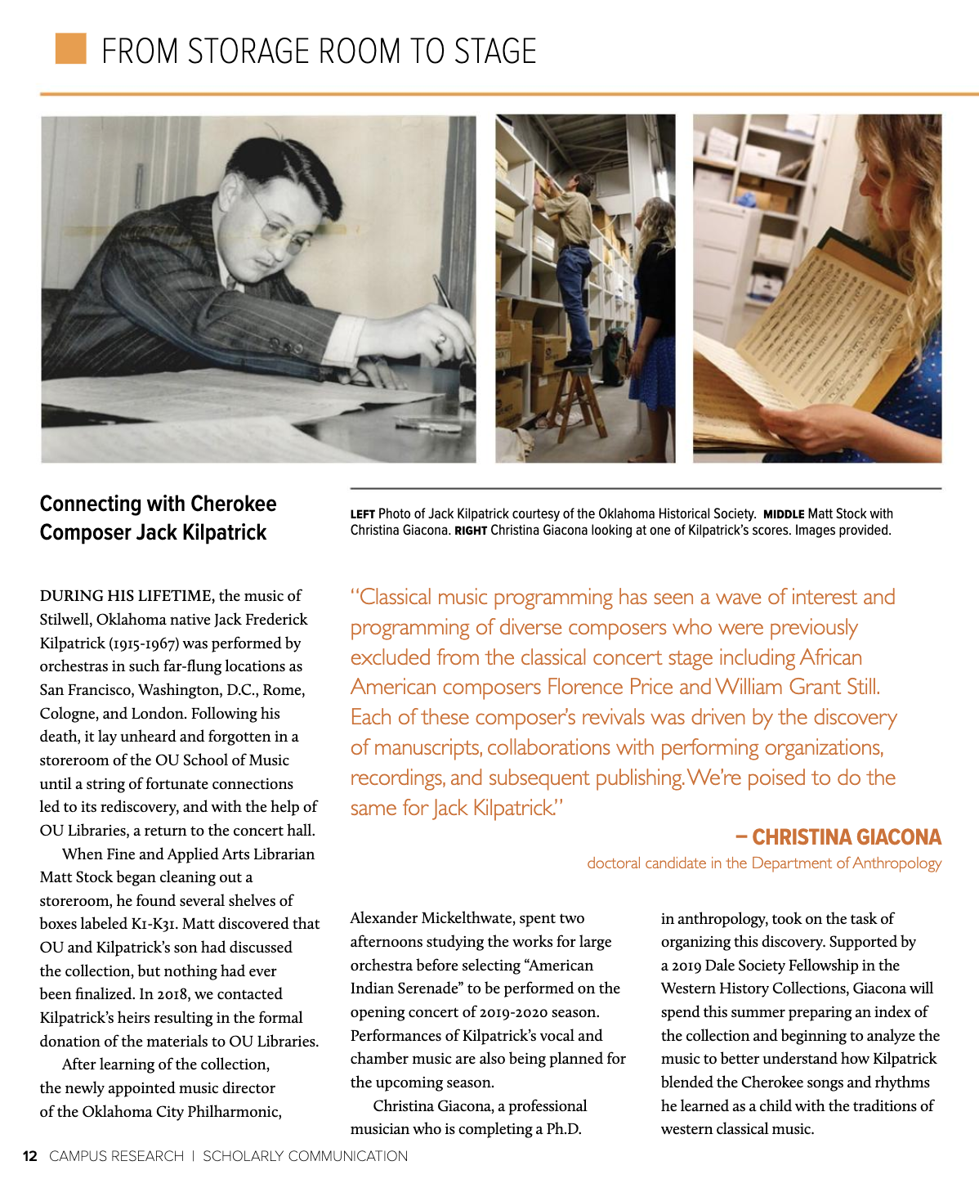
Note. (Left) Photo of jack Kilpatrick courtesy of the Oklahoma Historical Society. (Middle) Matt Stock with Christina Giacona. (Right) Christina Giacona looking at one of Kilpatrick’s scores. Reprinted with permission by the University of Oklahoma Libraries.
The first (re)premiere of a Jack Frederick Kilpatrick work based on the manuscripts discovered and assembled into the Jack Kilpatrick Collection occurred during the Oklahoma City Philharmonic’s 2019–2020 season opening concert. The concert was titled “Oklahoma Stories” and featured numerous Indigenous performers from Oklahoma. This was the first case study where I acted as an active participant in the revival of Jack Frederick Kilpatrick’s music through a live performance. Since then, the concert series “Oklahoma Stories” has become a yearly tradition with the Oklahoma City Philharmonic and Alexander Mickelthwate. Since the premiere of the new series starting in the 2019–2020 season, each following season has included a concert of the same name and features a connection to Oklahoma.
Like many musical communities, Oklahomans love celebrating, performing, and hearing music written by fellow Oklahomans. In a casual post-concert survey I conducted with audience members immediately following the performance, (personal communication, September 14, 2019) many participants stated that they feel connected to music by Oklahomans and especially Indigenous Oklahomans due to the ubiquity of Indigenous music and art in Oklahoma. Most Oklahomans that I have talked with, both Native and non-Native, feel appreciative and in a way protective of Indigenous contributions to the artistic canon. Non-Indigenous Oklahomans often speak about Indigenous histories as part of their own Oklahoma stories.
This chapter is divided into three sections, each focusing on one concert. The first section, “Concert 1: Oklahoma Stories 2019–2020: Situating An American Indian Serenade,” describes the opening concert of the 2019–2020 season. This particular concert featured Kilpatrick’s An American Indian Serenade, alongside Grand Entry Medley for Powwow Singer, Native American Flute, and Praise Choir, a piece I arranged for this celebration. The second section, “Concert 2: COVID-19, A Soloist’s Interpretation, The American Sound, and the 2020–2021 Season Reimagined,” discusses the (re)premiere of Kilpatrick’s Concerto for Flute and Strings. This concert season was unusual, as it was the first season affected by COVID-19 distancing protocol. Here I discuss the how the performance and reception changed due to live streaming and limited in-person audiences. The third and last section, “Concert 3: Oklahoma Stories: Meeting the Kilpatrick Family, Cultural Preservation and Knowledge Transfer Through Orchestral Performance, and the 2021–2022 Season,” not only discusses the performances of Kilpatrick’s Four Ozark Dances and Three Cherokee Cosmogenic Legends, but also investigates how this concert led to my meetings with Clifford and Alan Kilpatrick (two of Jack and Anna’s sons), Mary Anna Kilpatrick (Jack and Anna’s granddaughter), and the family lawyer and partner of Mary Anna, Christopher Honea.
These (re)premieres have resulted in increased interest in Jack Frederick Kilpatrick and his works. Since the first Oklahoma City Philharmonic (re)premiere in 2019, I have helped advise three other dissertation and thesis projects that have stemmed from the creation of the Kilpatrick archive. Two of these academic projects explored Kilpatrick’s piano works and their ability to contribute to the piano pedagogy canon. In 2021, graduate student Cristian Damir Martinez Vega (MM in Piano Pedagogy from the University of Oklahoma) defended his thesis “Sounds of Native Oklahoma: The Significance of Fred Cardin, Jack F. Kilpatrick, and Tessie Mobley for the Musical Culture of America.” Hayden Coie (Ph.D. in Piano Pedagogy from the University of Oklahoma), piano pedagogue and performer who has done extensive research on Kilpatrick, is frequently performing solo piano works and presenting workshops on his music. His dissertation Jack Frederick Kilpatrick, Oklahoma's Cherokee Composer: An Analysis of Six Intermediate Collections for Solo Piano (2022) has spearheaded an interest in Kilpatrick’s solo piano works outside of Oklahoma. There is also currently an interest in programming Kilpatrick’s band works that he composed while he was the music director at Cave Springs Public Schools in Adair County.
As Kilpatrick’s works begin to be programmed more often, an exploration of how music directors and performers situate Kilpatrick’s music is vital to understanding how his music is received. The decision of how to program a Kilpatrick orchestral work begins by questioning who will be the primary audience for his music. This assumed audience market is what decides which subscription series the music will be placed on (Classics, Pops, Discovery, or one-off concerts). After this initial placement into a subscription series, the next step involves deciding which concert the Kilpatrick work will be programmed on and which pieces it will share the concert with. This is because on some level all concerts are programmed based on a theme. Whether this theme is overt (for example, “Music of Scandinavia” or “Beethoven’s Late String Quartets”) or subtle, concert programming and piece pairing reveal and reinforce how we contextualize composers and their works.
Kilpatrick’s identity is complicated, and the story of a small-town boy from Stilwell, Oklahoma, with a complex Indigenous cultural identity limits programmability outside the Oklahoma and Texas markets. It makes sense for their audience demographics that the Oklahoma City Philharmonic situated Kilpatrick as an Oklahoman, a Cherokee, a Native American, a former resident of Oklahoma City, the former composer-in-residence of the Oklahoma Symphony Orchestra (now Oklahoma City Philharmonic), and an American. It also makes for a compelling story that Kilpatrick had to leave Oklahoma and take a job in Dallas, Texas, in order to further his career. The fact that he had to move to Texas in order to become successful is a story that resonates with many Texans, and the fact that even after he chose to move away from home Kilpatrick always viewed himself as an Oklahoman and a Cherokee is a story that resonates with many Oklahomans.

Setting the Stage: Meeting Alexander Mickelthwate
In the fall of 2018, I was invited to a coffee meeting to meet the then-new music director and conductor of the Oklahoma City Philharmonic, Alexander Mickelthwate, who replaced Maestro Joel Levine. Joel had been with the Philharmonic since 1989, and Alexander was the first new conductor for the orchestra in almost thirty years. Our first coffee meeting started with the normal pleasantries one would expect. Alexander told me about his experiences conducting the Winnipeg Symphony Orchestra in Manitoba, Canada, and their success programming contemporary Indigenous composers in addition to the organization’s long history of premiering new contemporary works. Alexander was interested in the topics I taught in my Native American and World Music courses as well as my experiences with the Los Angeles New Music Ensemble and my history as a clarinetist. As our conversation continued, he generally inquired about classical Native American composers and hoped I might know of some people or pieces he should explore. He had already met with contemporary Chickasaw composer Jerod Impichchaachaaha’ Tate, so I shared with Alexander the story behind finding the Kilpatrick manuscripts and he was extremely excited about the possibility of a new collection and the potential of programming the pieces. We also discussed other classical Indigenous composers including Louis Ballard, Raven Chacon, Tanya Tagaq, and Charles Shadle.
During this same conversation, Alexander shared that he wanted to commission a new work that involved traditional Native American musicians and the orchestra. Years prior to meeting Alexander, I had envisioned writing an orchestral work for powwow singers and orchestra. As I imagined the composition, I originally heard the beautiful clarity of Northern Plains singers interweaving with the first violin section, and this meeting was the perfect opportunity to present my idea. As we talked, Alexander asked if there were any other Indigenous genres that might work together to form a three-movement medley. This eventually became my three-movement arrangement titled Grand Entry Medley for Powwow Singer, Native American Flute, and Praise Choir, featuring compositions and performances by John Hamilton, Timothy Nevaquaya, and the Native Praise Choir. Grand Entry Medley has since been performed three additional times, including at the Opening Ceremonies of the First Americans Museum, where it was programmed alongside Jerod Impichchaachaaha’ Tate.
This meeting led to numerous collaborations and the (re)premiering of several Kilpatrick compositions. Through our five years working together, Alexander has become a true friend and confidant. I admire his determination and I am happy to be a part of his continued efforts to grow the role of the Oklahoma City Philharmonic in the Oklahoma City and national music scenes. As of 2023, we have collaborated on the (re)premieres of four of Jack Frederick Kilpatrick’s compositions, the premiere of my orchestral arrangement Grand Entry Medley for Powwow Singer, Native American Flute, and Praise Choir, an orchestral reconstruction of Jóhann Jóhannsson’s Fordlandia for live performance, two video collaborations with local hip-hop celebrity JaBee, and the recording and producing of two album recording projects.
While Alexander was named the new conductor and artistic director in 2018, much of the 2018–2019 season was performed as a year-long celebration of the “handing over of the baton,” with an already programmed season and many concerts still conducted by Joel Levine. The 2019–2020 season was Alexander’s first chance to establish what kind of music director he was going to be and fully control the music being programmed on each concert. This is why it was on the initial concert of the 2019-2020 season that we were able to program the first (re)premiere of a Jack Frederick Kilpatrick work in almost thirty years.

Concert 1: Oklahoma Stories 2019–2020: Situating An American Indian Serenade
On September 14, 2019, at 8:00 p.m., the Oklahoma City Philharmonic (re)premiered Kilpatrick’s symphonic composition An American Indian Serenade at the Oklahoma City Civic Center Music Hall. The discussions that led to this piece being programmed began during that coffee meeting in October 2018 and continued through to the (re)premiere. Situating Kilpatrick’s music within this program became one of the central discussions leading up to the performance. Alexander Micklethwate’s vision for the program, which was titled “Oklahoma Stories,” was to feature and present the musical sound of Oklahoma on the concert stage. Jack Frederick Kilpatrick’s music fit this narrative through his Oklahoma roots, his Native American heritage, his featuring of Native American sounds in symphonic literature, and his history as a composer for the original Oklahoma Symphony Orchestra which eventually became the current Oklahoma City Philharmonic in 1989. In speaking about Kilpatrick’s positionality as an Oklahoman and Indigenous composer, Mickelthwate said:
It's, first of all, that bizarre Oklahoma story that is not only an Oklahoma story, but a very American story of cultures organically growing together. It's absolutely the story of the melting pot, of his parents — white parents from Texas — moving to Cherokee country in the early 20th century.... He really grew up talking Cherokee, the Cherokee language, married a Cherokee wife, they lived the Cherokee lifestyle. He studied classical music, and then started to compose with all the elements of his surroundings. ... So, he is a reflection of a true American sense of being part of that melting pot — and in a very positive way. (McDonnell, 2021)
The process of selecting An American Indian Serenade started with Alexander coming to the Western History Collections to look over the scores and gain some general insight about the collection as a whole. Alexander is also a pianist, so he was personally interested in looking at some of the Kilpatrick piano pieces in addition to his symphonic works. For the opening concert, I knew Alexander needed a piece for symphony orchestra that was roughly ten minutes in length. From these criteria, a handful of scores were pulled for him to peruse. The pieces that were selected to be reviewed were Four Ozark Dances, Ghost Dance, Symphony No. 3, Symphony No. 4, Symphony No. 5, Three Cherokee Cosmogonic Legends, Wovoka, Two Cherokee Folk Tunes, Saturday Night on Echota Hill, and An American Indian Serenade. While it didn’t fit the criteria exactly, I also suggested Alexander look at Cherokee Life for choir and symphony orchestra, because the Oklahoma City Philharmonic does collaborate with Canterbury Voices each season.
In this meeting, we spent some time looking over the scores together, and I explained some of the significance of why I selected the different pieces and how they fit within the theme of “Oklahoma Stories.” Many of the scores I selected were pieces that the Oklahoma Symphony had premiered between 1938 and 1942. I particularly drew his attention to Two Cherokee Folk Tunes, which was dedicated to Victor Alessandro, the former conductor of the Oklahoma Symphony, who became a lifelong champion of Kilpatrick’s music. This two-movement work features orchestral reimaginings of the Cherokee songs “Cherokee Glory” and “Bear, Bear, Rabbit.” After looking at the scores in the library, we relocated to a practice room and Alexander played selections on the piano. At this time, the audio recordings had not been digitized and there were no known recordings of any of these pieces available to us, so the selection was based solely on score study, playing the piano reductions, examining their connection to Oklahoma, orchestration, length, and performability. Together we selected an An American Indian Serenade to perform. The next steps to prepare the work for performance were to engrave a digital score from the handwritten manuscript, create performance materials and parts, and assemble a midi mockup for score study and aural preparation.
Alexander really liked the idea that the first Kilpatrick piece to be (re)premiered would be a tone poem rather than a symphony due to the overtly narrative nature of the medium. While this was partially for technical reasons (length, difficulty, and instrumentation played a huge part in its selection), most importantly, Alexander was drawn to the narrative of this particular tone poem. For the first reintroduction of Kilpatrick’s music to the Oklahoma City Philharmonic’s audience, Alexander wanted something that could be described as sounding “Oklahoman,” in an easy-to-understand and obvious format. Alexander was looking for the sound of Oklahoma that his audience and orchestra would understand after only hearing the piece performed once. One of the challenges of programming music that people do not know is that their understanding of the music comes instantly while hearing the piece for the first time during the live performance. The challenge of a symphony is the large scale of the composition, which usually results in a three- or four-movement work that musically takes time to digest. This tone poem would be instantly understood. The next step was to finalize the rest of the program that would surround Kilpatrick’s An American Indian Serenade.

The Program
Kilpatrick’s symphonic tone poem, An American Indian Serenade, followed the opening piece on the concert titled Grand Entry Medley for Powwow Singer, Native American Flute, and Praise Choir that I arranged for powwow singer John Hamilton (Kiowa), Native American flutist Tim Nevaquaya (Kiowa-Comanche), and the Native Praise Choir. The other two pieces on the concert were Alexander Arutiunian’s Trumpet Concerto with Matilda Lloyd as the soloist, and Ludwig van Beethoven’s Symphony No. 5 in C Minor. (See Figure 7.2)

Figure 7.2
An Image of the Program for Oklahoma City Philharmonic’s Classics 1: Oklahoma Stories Concert from the 2019-2020 Season
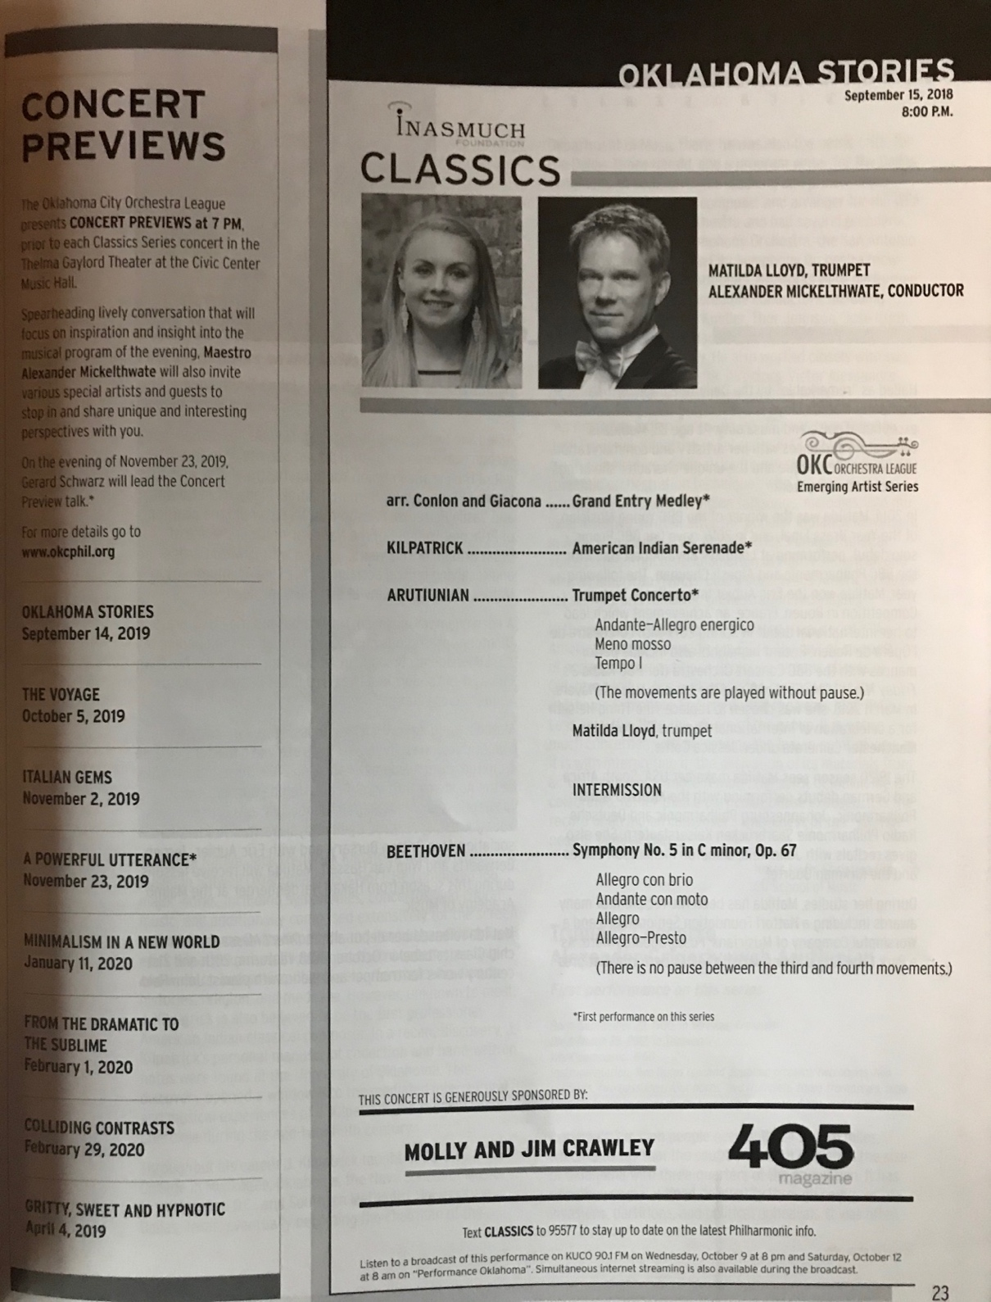
Note. A photo of the program notes for the Oklahoma City Philharmonic’s Classics 1 concert from 2019 (own photo). Reprinted with permission from the Oklahoma City Philharmonic.
Alexander told me that he wanted this first concert to serve as an outline of what kind of artistic director he would be for the orchestra. First, he wanted to focus on the rich traditional Native American culture and talent in Oklahoma; second, he wanted to feature Oklahoma-grown talent; third, he wanted to bring in new and exciting guest artists; and finally, he wanted to present his own experience and heritage as a German musician through his interpretation of German composer Ludwig van Beethoven’s fifth symphony. As mentioned earlier in this chapter, symphonic programs have two obvious levels of narrative that serve to situate the music for the audience (and many more subtle ones as well): first, the compositional narrative of each individual piece; and second, the meta-narrative formed by the pairing-together of these particular works, in this particular order, at this particular time, in this particular place, by this particular ensemble.
I had multiple duties on this concert: as the arranger of Grand Entry, the sub-contractor who had completed initial negotiations and scheduling with the Native American composers and performers who were part of the Grand Entry portion of the concert (including the previously mentioned composers and musicians and the Oklahoma Fancy Dancers), the archivist and engraver for Kilpatrick’s An American Indian Serenade, an acting producer to help make the live show happen through rehearsals and performance, and the author of the program notes for Grand Entry Medley and An American Indian Serenade. Because of this, I worked closely with then-executive director Eddie Walker, then-general manager Kris Woolly Markes, Alexander Mickelthwate, advising composer Jerod Impichchaachaaha’ Tate (Chickasaw), choral conductor Tracey Gregg-Boothby (Wichita), the Oklahoma City Philharmonic musicians, and the guest artists.
It had been quite some time since a performance of Kilpatrick’s music other than the annual performance of the historical drama Unto These Hills in Cherokee, North Carolina. After the Kilpatrick collection had been delivered to the University of Oklahoma, a concert titled “A Bicentennial Tribute to Jack Frederick Kilpatrick” occurred on February 21, 1976, and the Norman Chamber Orchestra had also programmed several of Kilpatrick’s works throughout the years, with the last known performance taking place in 1991 (The Oklahoman, 1991).
It took over a year to get from the initial coffee meeting with alexander to the performance of An American Indian Serenade, including selecting the score, creating performance ready materials, writing program notes, and having Alexander agree to program the piece on his first self-programmed concert as the music director and conductor of the Oklahoma City Philharmonic. When I was working on the program notes for this first performance, there was very little information available about Kilpatrick, and the majority of my research was pieced together from primary sources contained within the collected materials we discovered. The process of selection, score reading, midi mockup, engraving, and the creation of the critical edition of An American Indian Serenade that occurred in the months leading up to the (re)premiere performance by the Oklahoma City Philharmonic is outlined in Chapter 5.

Authenticating Kilpatrick and Situating His Music
I believe it is important to take a moment now to analyze the rehearsals and performance of Grand Entry Medley, which was performed during this same concert. In order to arrange, assemble, and perform the three Indigenous songs that make up “Grand Entry,” Alexander Mickelthwate, the orchestral musicians, the Indigenous performers, and I all had to engage in the same kind of intercultural mediation that is at the core of so much of Kilpatrick’s music. By analyzing both the difficulties and successes of these intercultural negotiations, I believe we are given insight into Kilpatrick’s own compositional process as well.
Alexander’s vision for the beginning of the concert was that the contemporary traditional Native American and Oklahoman artists featured in Grand Entry Medley would open the concert and then lead directly into Kilpatrick’s An American Indian Serenade, situating Kilpatrick’s music as both Oklahoman and Indigenous for the audience. Alexander was cognizant of the fact that his audience might have trouble accepting the authenticity of Kilpatrick’s sound as “Native” due to its similarities to contemporary 1930s and 1940s symphonic composers such as George Gershwin, Florence Price, Virgil Thompson, and Aaron Copeland. He felt that it was critical that Native American performers establish authenticity and act as a “centering” for the audience of an Indigenous musical sound world at the beginning of the concert through performances of traditional Native American music. In the end, Grand Entry Medley was a collaboration between the Oklahoma city Philharmonic, me, and Native American artists John Hamilton, Timothy Nevaquaya, and the Native Praise Choir. The medley features John Hamilton’s intertribal powwow song Gamma Delta Pi written for the Native American sorority at the University of Oklahoma, a Native American flute solo titled Walking in the Spirit composed by Timothy Nevaquaya from his upcoming album, an arrangement of Amazing Grace (My Chains Are Gone) written by Louie Giglio and Chris Tomlin and performed and translated by the Native Praise Choir into a variety of Native languages, and a performance by the Oklahoma Fancy Dancers. An image of the Indigenous guest artists backstage during the concert can be seen in Figure 7.3.

Figure 7.3
An Image of John Hamilton, Timothy Nevaquaya, the Oklahoma Fancy Dancers, and the Native Praise Choir Backstage at the Oklahoma City Civic Center Music Hall on September 14, 2019
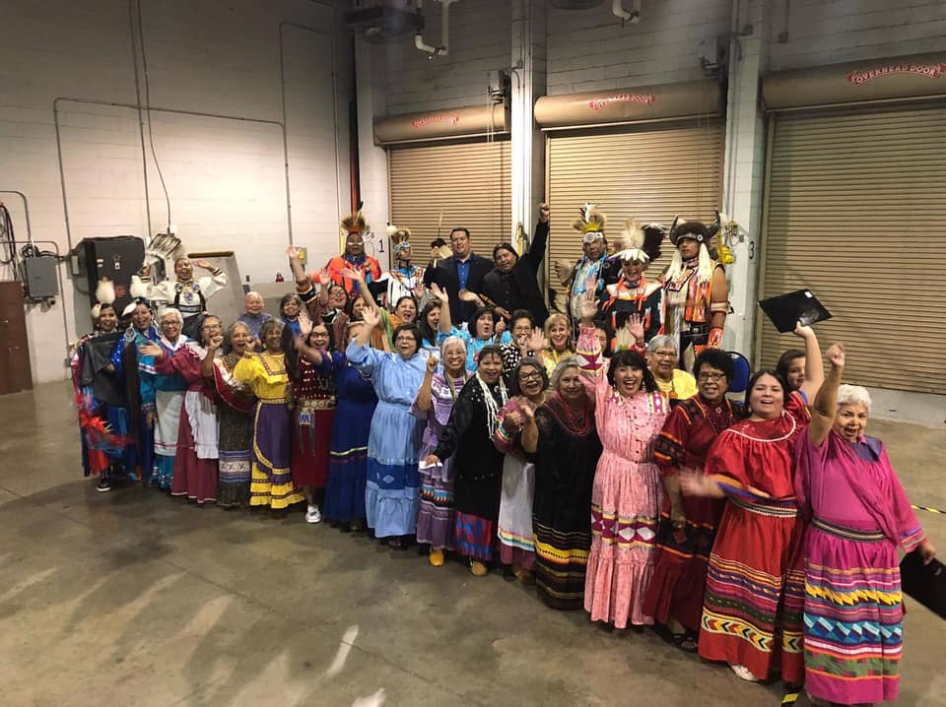
Note. Backstage photo from September 14, 2019 taken by Alicia Nevaquaya. Reprinted with permission from Alicia Nevaquaya.

With all the intercultural collaboration required to properly perform this piece, it became clear that classical institutional culture has a lot of unspoken rules and that insiders need to communicate these rules to those who have not worked within the system in order to properly collaborate. This is particularly evident when the orchestra works with musicians from different genres (like rock musicians, for example) who have different cultural rules pertaining to rehearsal, communication, and performance. In many cases, the rigid nature of classical music rehearsal and performance etiquette will cause conflict with guest artists from genres with more relaxed and improvisatory rehearsal cultures.
For example, one of these rules is the start and stop of rehearsals and concerts. During classical music rehearsals, everyone is expected to be in their seats and ready to play before the downbeat. The term “downbeat” refers to the start of the session, that being the rehearsal or concert. For the Oklahoma City Philharmonic, rehearsals start at exactly 7:30 p.m. and end at exactly 10:00 p.m.. Rehearsals that go even one minute over the 10:00 p.m. ending time will result in overtime pay for the musicians, and this is not something that is done frequently. Rehearsal breaks follow a similar structure: there is a designated range of start times for the mandatory break, and the length is timed to be exactly twenty minutes. Power dynamics are also integral to pathways of communication in classical ensembles. The conductor, concertmaster, and section leaders are each given symbolic capital and power and operate through usually unspoken but strongly reinforced command structures. These positions are given agency over specific elements of the music, allowing them to make personal choices on musical styles and expression, while the other members of the section are expected to follow the decisions of their direct leaders.
For Grand Entry Medley, John Hamilton’s performance presented an interesting dynamic because he was simultaneously acting as a traditional powwow singer and leader and as an orchestral soloist. The head singer’s role is very similar to that of the conductor, where they set the tempo and feel for the rest of the group to follow. As John had never performed with an orchestra, I initially sat on stage next to him and tapped him on the knee to help translate the non-verbal, gestural cues Alexander was giving. When rehearsing orchestral music, the score and individual parts are all aligned with numerical measure numbers or other kinds of rehearsal markings such as consecutive alphabetical lettering, Roman numerals, or circled Arabic numerals. This way the conductor can start at any section of the piece by referring to those numbers.
Powwow music is not constructed in the same way. Repeats are referred to as “pushups” or “starts,” and the number of pushups can change between performances depending on the purpose for the song. The same song can be situationally placed into different categories and those determine the length of performance. For example, an intertribal performance of a powwow song might have eight to ten pushups, whereas a competition performance of the same song might only have four. John was initially viewed by the orchestra as a concerto soloist with the orchestra accompanying him. When a classical ensemble hires a soloist, there is an unspoken rule that the soloist can just slot into place without needing any direction and will follow the conductor when there is a large musical section for the orchestra. However, this expectation was directly at odds with John’s usual position as head singer, where he was the one tasked with deciding the tempo and structure of the piece and the surrounding musicians were supposed to follow his lead.
Grand Entry Medley was a new venture for Alexander, the orchestra, and John Hamilton, and it took some extra time to learn a new form of intercultural musical dialogue. While I had faith that everything would work out, it was one of the most stressful situations to be in because I was acting as the translator between all three members of this collaboration. However, due to all of us entering into the performance open to cultural exchange, we were able to create an incredible musical collaboration. As is often the case, the successful performance of the work came about due to three distinct cultural sharing practices: first, the use of analogy to contextualize what seems like a foreign action within our own cultural understanding; second, the translation of terms and gestures across both languages for both parties; and finally, the negotiation of power as it applies to musical performance.
The use of analogy was helpful in negotiating initial misunderstandings into a newer context. The most helpful of these came about during the initial arrangements of the pieces into the three-movement orchestral work. While we were explaining how to credit each of the contributors to the work, the symphony staff was initially confused as to who the composer was for the work. We used the analogy that this was similar to a pops concert with a rock band who were performing their own songs with orchestral arrangements and that all attributions, credit, and payment should work similarly; the use of this analogy allowed the symphony staff to recontextualize the role of each participant in a way that made sense within their own systems of power, ownership, and attribution, and to do so in a way that aligned with the Indigenous performers’ and composers’ own understanding of their roles.
The use of translation was most important during the rehearsals. As mentioned previously, Alexander initially approached the rehearsal with the methodology of a classical music rehearsal—that is, he was expecting to be able to stop and start the performance at will by calling out measure numbers and rehearsal markings. Again, the analogy of the rock band concert was helpful in reorienting this towards a different style of rehearsal. To elaborate, in most rock band concert rehearsals where there is orchestral accompaniment, there are two distinct structural languages at play that are separate between the band and the orchestra, and the music director is expected to translate between the two. For example, what the band calls “verse 2” might be “measure 33” for the orchestra. So to start slightly before that, the band would need to be told “they’re starting two before verse 2” and the orchestra would be told to “start at measure 31.”
This exact type of translation occurred during the rehearsal of the first movement of Grand Entry Medley. Alexander and I put in the powwow song structure terms into his score so that he could tell both John and the orchestra where to start if he wished to start somewhere other than the beginning of the movement. The examples of powwow song structure terminology that allowed Alexander to communicate more efficiently with John were “push up,” which means the repeat of the musical material (for example, one would say “start at the second push up” to mean start the second time the melody plays); the “honor beats” which occurred at the end of the second push up; and the primary verse and secondary verse, which refer to the verse sung alone by the head singer and the verse sung by the entire drum (the rest of the singers), respectively. By tying these terms to the exact measure numbers in the score, Alexander was then able to jump around the piece during rehearsal in the manner of a classical ensemble rehearsal so that both the orchestra and John knew where he wanted to start. It took a few tries, but once John understood Alexander’s cues, they were able to work together without my help. The result was a negotiated hybridity of not only musical sounds, but also musical roles which each performer undertook in order to successfully perform together.
Finally, we had to come to a mutual understanding in regards to the negotiation of power over certain musical elements. At first, Alexander was attempting to control the tempo of the ensemble as he usually would in a classical concerto performance. However, in powwow music, that role goes to the head singer (in this case, John Hamilton). Initially Alexander was worried that John was “rushing” as the piece went on, which is a music term that means to speed up or accelerando when one is not supposed to. However, John and I explained that the increase in tempo at each push up (repeat) of the song is actually a part of traditional powwow song performance practice and this was an intentional action by John. In addition, the beginning of a powwow song is partially improvisatory—the number of drumbeats before the lead singer begins singing are not set in stone. Therefore, we started the movement with a full verse with John by himself before the orchestra began. However, this meant that Alexander needed to not systematically count measures at the beginning, but instead needed to listen to contextual cues from John to show the orchestra when to come in. An image of John Hamilton performing Grand Entry Medley with the Oklahoma City Philharmonic can be seen in Figure 7.4.

Figure 7.4
An Image of John Hamilton Performing Grand Entry Medley with Alexander Mickelthwate and the Oklahoma City Philharmonic on September 14, 2019
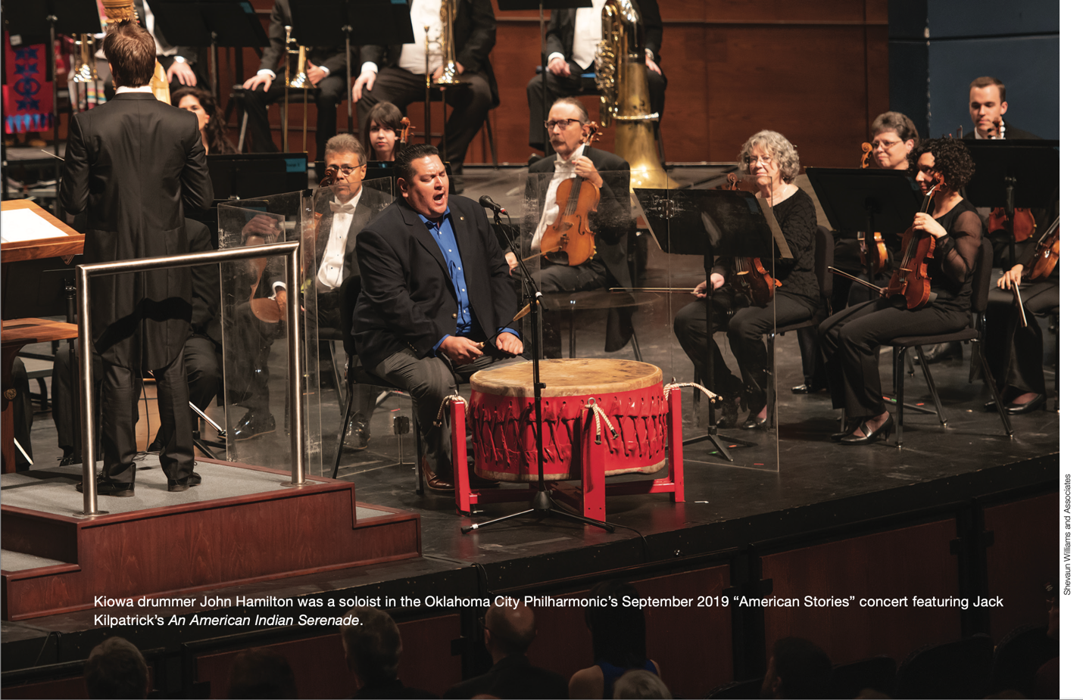
Note. Photo by Shevaun Williams and Associates. Reprinted with permission by the Oklahoma City Philharmonic.

Finally, the end of the piece is also somewhat improvisatory and is cued by five heavy beats from John. In order to put this together, we created an optional vamp (short repeat) at the end of the piece so that Alexander could cue the orchestra for when to play their last beat with John. As soon as Alexander understood that John was in control of tempo, that there were areas of slight improvisation, and that his role was to bring the orchestra along for the ride, the entire tenor of the collaboration instantly changed. What had initially sounded like a powwow drummer attempting to play with an orchestra and not quite connecting suddenly transformed into a powwow drummer amplified by an orchestra supporting his every move. In addition, this change of the narrative of power was important when it came to the overall approach to John’s song in the context of a classical performance. It changed the context of the situation from “a powwow singer playing with an orchestra” to “an orchestra playing with a powwow singer.” This was always my vision for how this collaboration would go, but I was incredibly fortunate to have collaborators in John and Alexander who were willing to go through the delicate negotiation process to find a way to perform a work that mediates between two musical worlds, just as Kilpatrick did in his compositions.
Due to all of these potential moments for failure or disconnection between the two main musical actors in this work (John Hamilton and the orchestra), I attempted to write multiple fail safes into the orchestral part. These included the vamps, doubling of vocal melodies, and places where if there was separation in the intended connection between the orchestra and the drum, it would still sound intentional. However, as is often the case, one of my greatest fears for failure was not even slightly an issue during rehearsals, but arose during the performance. The head singer of a powwow group not only sets the tempo and controls the structure of the performance, but his initial performance of the melody also sets the key center for the rest of the drum to follow. However, an orchestra cannot modulate the key of their music on the spot, so I needed John to come in on the exact same note of the piece every single time. In order to help with this, I wrote a cello line that doubled the vocal melody in order to give him his initial pitch. However, during the performance, the cellists missed their cue to come in with the line which would give John Hamilton his initial pitch center. Despite this, John came in by himself perfectly on key just as he had in all the rehearsals, which is a testament to his musical acumen.
Despite the success of the rehearsals, during the actual concert performance I was so nervous that I was clenching my fists until my fingernails started digging into the palms of my hands. However, the performance was flawless. Everyone seemed to be in sync, and it was one of the best feelings to see this all come together. The audience also agreed, offering one of the longest and loudest standing ovations I have ever heard in my entire orchestral career. Since this initial performance in 2019, John and the Oklahoma City Philharmonic have gone on to perform this exact piece numerous times, including two performances for the opening celebrations of the First Americans Museum (FAM) in 2021 and a recent performance in 2023. An image of the first movement of Grand Entry Medley can be seen in Figure 7.5.

Figure 7.5
An Image of John Hamilton, Timothy Nevaquaya, the Oklahoma Fancy Dancers, and the Native Praise Choir Performing Grand Entry Medley with the Oklahoma City Philharmonic on September 14, 2019
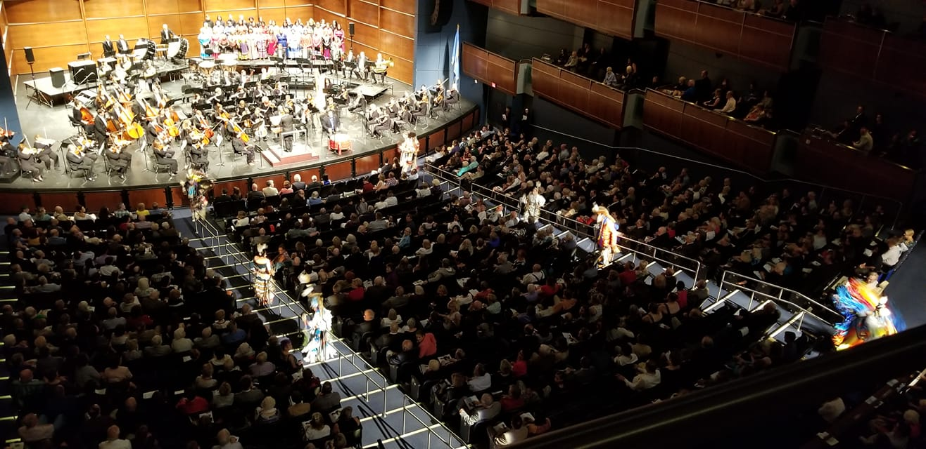
Note. Photo by Shevaun Williams and Associates. Reprinted with permission by the Oklahoma City Philharmonic.

After the concert, John Hamilton, Tim Nevaquaya, Alexander Mickelthwate, and I did a Q&A with the audience. It was at this time that I received some insight into the reception of the work outside of the standing ovation. Internationally renowned artist D.G. Smalling (Choctaw) was in the audience during the Q&A. He stated, “Thank you, thank you for this,” and proceeded to elaborate that he believed this was the kind of music that we needed to hear in our concert halls today, and that this was brave programming. Classical composer Sam Magrill then proceeded to ask how we were able to put this music together in a way that retained the authenticity and structure of the original Indigenous compositions while still being performable with a symphony orchestra. In response to Sam’s question, we explained that each Indigenous composer/performer sent us a recording of their song, and that we transcribed those songs exactly in order to build the orchestral accompaniment that went around them. He stated that he was struck by the complexity of the Indigenous musical structures, and how seamlessly the orchestra fit into these intricate and detailed musical soundscapes. I was filled with gratitude toward this reception to the music, as one of my main goals with this project was to amplify and honor the music that we were arranging to be performed with orchestra, not to simplify and commodify it for easy digestion by a symphonic audience. In fact, in Jack Kilpatrick’s master’s thesis, he underlined how Western notation often fails to capture the musical intricacies of Indigenous melodies and song structures.
The reason I believe it is important to analyze this performance is not just because of the similar intercultural mediation between classical ensembles and Native American traditional music that occurs in both Grand Entry Medley and Jack Kilpatrick’s compositions, but also because of how intensely aware I was of the reception of multiple audiences during the rehearsal and performance of this piece. From the audience at the performance, we received instant feedback at the end of the performance of the piece when we received the standing ovation. This was unique in that the piece of music was the opener for the concert; while standing ovations are fairly common at the end of the first half and at the end of the concert, they rarely occur in between first half pieces. In addition, the audience also burst into a long and spontaneous applause after the first movement (John’s intertribal), which is something that classical audiences are specifically trained not to do but that simultaneously indicates a particularly affective performance. I was also intensely aware of the reception of the work by the conductor (Alexander), the featured artists (John, Tim, and the Native Praise Choir), and the orchestral musicians. I was struck by how similarly important these audiences would have been for Jack Kilpatrick during the initial premieres of his music.
In the context of the entire program, Grand Entry Medley was meant to function as a tool to recontextualize the audience’s understanding of what a “symphonic and Indigenous sound” could be. For example, I had discovered that non-Native listeners often had trouble understanding that many Native Nations have a powerful and centuries-old cultural connection to and ownership of the hymn Amazing Grace. Performed by the Native Praise Choir in both English and a variety of Native American languages, Amazing Grace is a hymn that connects the diverse peoples of the world through their shared experiences. After the passage of the Indian Removal Act in 1830, the Cherokee were forcibly removed from their homeland and relocated to Oklahoma. During what became known as the Trail of Tears, Cherokee citizens were not allowed to give the thousands who died along the march a full burial. Those who survived would sing Amazing Grace to honor their fallen family members, resulting in Amazing Grace being considered a Cherokee national anthem (Heth, 2023, p. 71). By imprinting the audience with a recontextualized understanding of the connection of the hymn Amazing Grace to many Indigenous nations, more abstracted elements of Kilpatrick’s compositional style such as his use of four-part hymnody can be reinterpreted as an element of his Cherokee musical language rather than as an element of his western classical training.

The First (re)Premiere of Jack Frederick Kilpatrick’s Symphonic Works
It was immediately following the performance of Grand Entry Medley that Kilpatrick’s first (re)premiere occurred. An American Indian Serenade, op. 21, was completed by Jack Frederick Kilpatrick in February 1942 in Stilwell, Oklahoma. Written following the popular Indianist movement in American classical music, it is indicative of Kilpatrick’s early style, combining late romantic orchestration techniques with his own personal knowledge of American Indian folk songs, melodies, and musical histories. Kilpatrick’s unique musical voice comes from his combination of Native American and African American hymns, blues, jazz, 1940s American classical scoring, and romantic orchestration techniques.
Kilpatrick wrote An American Indian Serenade when he was 27 years old. It was part of a series of pieces he composed for the Oklahoma Symphony Society that depicted Oklahoma Indian life. The other compositions in this series are Wovoka, Saturday Night on Echota Hill, Two Cherokee Folk Tunes, Three Cherokee Cosmogenic Legends, and Four Ozark Dances. To put things in perspective, An American Indian Serenade was composed a year after Kilpatrick wrote Four Ozark Dances, which helped him receive the “National Academy of Arts and Letters MacDowell Fellowship,” and a year before he started his graduate studies at the American Catholic University in Washington D.C.
Kilpatrick’s early symphonic compositions which make up this series are also indicative of the conservative nature of symphonic musical commissioning and programming; his early compositions are scored for traditional small symphonic instrumentations, are recognizably tonal, and short in length. This conservatism is due to a variety of factors: one, a season needs to be approved not only by the music director but also by the board of the symphony; two, the music director needs to also choose programming that the musicians, often represented by an elected musician’s programming committee, will accept; and three, that the audience and especially donors of the symphony will feel that the programming is both exciting and appropriate for the series that it is placed on—this is especially evident when programming the “classics” series. While we are starting to see a loosening of the separation between what is considered to be the high-brow classics series and the low-brow pops series, music directors still need to be aware of these distinctions. Alexander’s decision to place both Grand Entry Medley and Kilpatrick’s An American Indian Serenade on his first classics series concert while sharing the program with Beethoven’s Symphony No. 5 was an intentional decision to situate Kilpatrick’s work and traditional Indigenous performers as equals on the stage with historically revered classical composer Ludwig van Beethoven. This did not go unnoticed by audience members and critics, many of whom commented on how they found Kilpatrick’s and Beethoven’s music to be of equal worth when listening to them on the same program.
Kilpatrick’s music revival is based on new presentations of his historical musical manuscripts, and because of this, the interpretive choices of the music performers during his (re)premieres are an important influence on how his music is received by the audience. Western notation is notoriously imprecise, and the same dynamic and articulation markings can imply different performance instructions depending on the composer of the work. In the case of Kilpatrick, the performers at this concert did not have a preconceived notion of what Kilpatrick meant with each of his instructions because this was their first performance of one of his compositions. An image of Matt Stock, Alexander Mickelthwate, and me posing with my critical edition of Jack Kilpatrick’s An American Indian Serenade can be seen in Figure 7.6.

Figure 7.6
An Image of, From Left to Right, Matt Stock, Alexander Mickelthwate, and Christina Giacona Posing with the Critical Edition Conductor Score of Jack Kilpatrick’s An American Indian Serenade on September 12, 2019
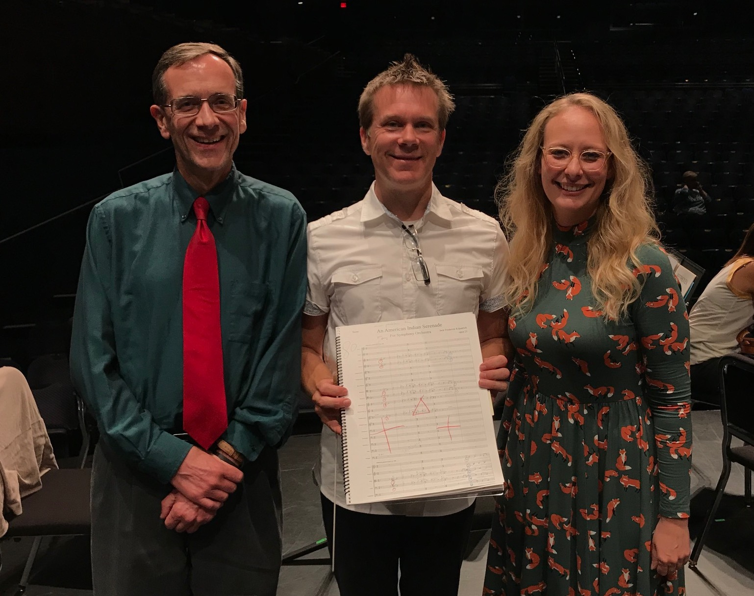
Note. Photo by Patrick Conlon. Reprinted with permission from Matt Stock.

How this affected their interpretation of Kilpatrick’s music could be seen during the Oklahoma City Philharmonic’s rehearsals for An American Indian Serenade. The orchestra was performing the piece from my reconstruction of the manuscript score. Some of the tempo markings in the score seemed to be dramatically slower than the musical style of the writing and the historical musical performance practice of the time and culture Kilpatrick was writing in. However, because we are in the middle of reviving this music for the concert hall, Alexander Mickelthwate was hesitant to follow his musical intuition and go against the score due to the anxiety of a non-culture bearer inauthentizing a performance of a revivalist work, and he specifically sent me an email asking if there were any historical audio recordings of the work that he could use to compare with the score markings.
To put this in context, one of the most consistent aspects of symphonic performance is that symphonic performances of the classical canon continually change and are reimagined to be more accessible and communicative to new audiences. The entire idea of “period practice,” or attempting to re-create and revive the performance practices of the time at which a composition was first premiered, is itself a late 20th-century phenomenon that only applies to specific periods of music. Therefore, we were faced with a conundrum. Would it be more authentic to allow the conductor to interact artistically with the score, as a conductor would have interacted at the time Kilpatrick wrote the piece, or would it be more authentic to follow the score markings exactly in an effort to avoid any accusation of inauthenticity? In this case, I advised Alexander to feel free to nudge the tempos in the direction he thought would be musically fulfilling and to insert his own interpretation into the performance the same way that he would with any other score.
The concert was a great success, and Kilpatrick’s An American Indian Serenade also received a standing ovation. The programming was successful in conveying Alexander’s narrative as well. By combining Grand Entry Medley and An American Indian Serenade with Beethoven’s Symphony No. 5 and Arutiunian’s Trumpet Concerto on his initial Classics concert, Alexander implied that Kilpatrick’s compositions and traditional Native American songs were just as important and valid a part of the orchestral repertoire in his eyes as one of the most famous Germanic symphonies in history. In 2019, Symphony magazine featured the Oklahoma City Philharmonic and the programming of Kilpatrick’s works. This major marketing success paved the way for additional Kilpatrick programming.
The reception of this message from the musicians and audience when asked directly was interesting. Some musicians had an extremely positive reaction to the programming, and multiple musicians including horn players Mirella Gable and James Rester specifically reached out and thanked us for putting together a concert that they felt represented where classical music needed to go to stay relevant in our society. The most prevalent negative reaction heard from concertgoers and musicians was that the music “did not sound Native.” This is an example of the phenomenon discussed earlier in this dissertation where non-Native listeners have confidence that they can identify and classify Indigenous sounds, but in practice are unable to do so.

Concert 2: COVID-19, A Soloist’s Interpretation, The American Sound,

and the 2020–2021 Season Reimagined
On May 8, 2021, the Oklahoma City Philharmonic presented the concert “American Stories – ’Tis a Gift” at the Oklahoma City Civic Center Music Hall. The concert featured Jack Kilpatrick’s Concerto for Flute and Strings, op. 137, performed by Oklahoma City Philharmonic principal flutist Valerie Watts. This concert was unusual because it occurred during the middle of the COVID-19 pandemic and restrictions limited live concert capacity in the venue. Because of limited capacity in both the orchestra and attending audience, as well as strict COVID-19 protocols, concert programming was extremely difficult that year. The musicians were all required to wear a mask at all times and sit at least six feet apart separated by plexiglass barriers, woodwind and brass musicians were required to cover their instruments to collect water and saliva, and every musician needed to receive a negative covid test 24 hours before rehearsals started and have their temperature checked upon arrival. Due to the reduced audience capacity, the concert was also live streamed and made available for audience members to watch up to a week after the event.

Changes in Orchestral Performance Practice due to COVID-19
The 2020–2021 season came with many challenges, as the COVID-19 pandemic forced many performing organizations to cancel their season or rethink how they could present concerts. Prior to the start of the 2020–2021 season and the COVID-19 shutdown in late March 2020, the Oklahoma City Philharmonic had already announced their upcoming season. With the pandemic shutting down normal concert operations for almost two years, the 2020–2021 season ended up being completely re-programmed to accommodate a smaller live audience and orchestra rather than eliminate performances altogether. Since the season was essentially re-organized and re-arranged from their original vision, the Oklahoma City Philharmonic referred to the season as “Reimagined.” Many of the concerts for which tickets had already been sold were rescheduled rather than canceled, and several smaller chamber music concerts were added in addition to the reduced capacity subscription series concerts. An image of the smaller ensemble, increased spacing between musicians, and personal protective equipment worn by the Oklahoma City Philharmonic in 2021 can be seen in Figure 7.7.

Figure 7.7
An Image of the Oklahoma City Philharmonic’s Reduced Orchestra Size, Increased Spacing, and Use of Personal Protective Equipment in 2021 During the COVID-19 Pandemic
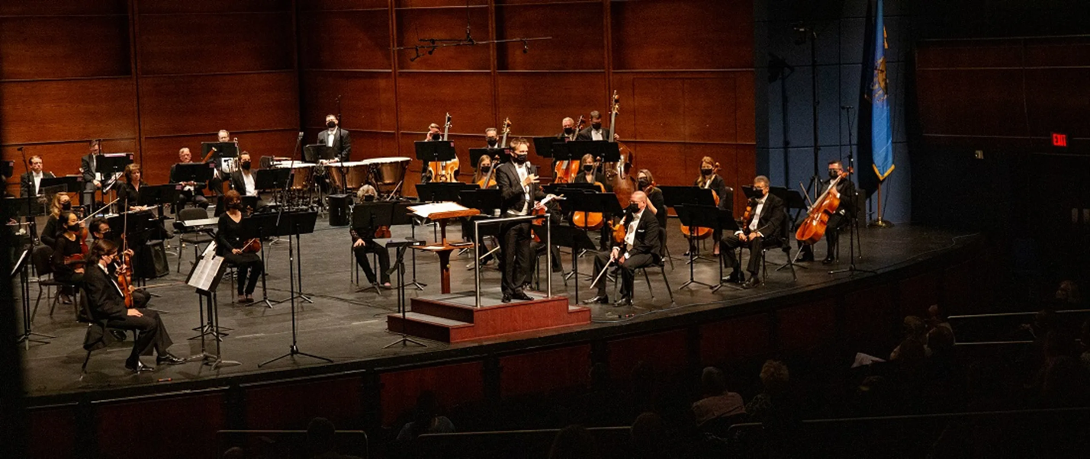
Note. Reprinted with permission by the Oklahoma City Philharmonic.

Orchestras across the world were now having to adapt to what became known as the “new normal.” This was uncharted territory for performing arts organizations, musicians, and audiences. Two major challenges quickly arose: how can orchestras keep the audience engaged and how can they keep everyone safe at a live concert? Before a vaccine was widely available, the options were: first, limiting the number of people within a given space; second, making sure everyone was distanced appropriately; third, making adjustments to the airflow of the concert hall so that fresh air was continuously flushed into the space; and fourth, using personal protective equipment (PPE). Music written for a symphony orchestra requires a substantial number of performers, and aesthetically it would do a disservice to the composition to reduce the number of required performers. The Oklahoma City Philharmonic is also a union orchestra, and it is against policy and contractually prohibited to eliminate parts from a score without requesting permission from the musicians’ committee first. Rather than trying to adapt larger scores to fit a chamber sized orchestra, the Oklahoma City Philharmonic decided to reprogram the season to include works by a smaller group of performers. Many of these reduced orchestration pieces come from wartimes when composers had to write for what performers were available at that time and place. The other issue organizations had to deal with was that travel was extremely limited and most soloists postponed scheduled appearances. With about 75% of all programming featuring some kind of touring guest artist (be it a performer, ensemble, or composer), this element now needed to be filled by local artists.
Prior to the 2020–2021 season, the Oklahoma City Philharmonic was made up of roughly seventy musicians, with larger orchestrated pieces like the late romantic symphonies of Gustav Mahler needing up to and sometimes over 100 musicians. For example, one of the last full orchestra concerts performed by the Oklahoma City Philharmonic prior to the 2020 lockdown had roughly 270 musicians on stage, including a 200-person choir and a 70-person orchestra. In addition to new size constraints, musicians were also accustomed to sitting directly next to other musicians in their section and had been trained to listen to the ensemble as a cohesive cluster in a specific formation. Not only did social distancing require each ensemble member to be at least six feet apart, but the musicians were also required to wear personal protective gear such as face masks and wind instrument coverings. Wind sections were often barricaded from each other using plexiglass and all sections were limited in size. All of these new requirements drastically changed how the ensemble sounded, and with such a limited capacity of performers allowed during this time, a normally sized symphony orchestra had to reduce their performers to that of a chamber orchestra with roughly 20 to 30 musicians at best. There were also limited civic center staff members available for each concert. Musicians had to undergo PCR tests within a specified timeline before the start of rehearsals for each weekly concert, receive temperature checks at the door, and report any exposure to COVID-19. During this time, most organizations had to be ready to hire last-minute substitutes for exposed or positive-testing musicians right up until the day of the concert, or be ready to perform with suddenly reduced numbers. As many compositions, especially smaller chamber music works, have specific parts for each instrument, this added tremendous anxiety to musicians and organizations attempting to perform pieces at a high level of performance.
To put this in perspective, I want to highlight a quote from the Oklahoma City Philharmonic’s executive director (then board president) Brent Hart about the reimagined season:
Without a doubt, the “Re-imagined” 2020–21 season will look and feel different as we navigate new logistical challenges and prioritize the safety of our musicians and attendees. Patrons are accustomed to a finely tuned concert experience for more than 30 years, and we ask for your continued support as we adapt in anticipation of the new season. With lessons learned in the first half of 2020, our team is working hard to return music to the stage and make the NEW user experience as smooth as possible (Oklahoma City Philharmonic, 2020).

A Season “Reimagined”
With the idea of a “reimagined” season, Alexander decided to keep doing concerto performances, but instead of hiring touring musicians from out of state, he featured members from the orchestra and the Oklahoma City community. This also required selecting new concertos to be performed that only needed a handful of players. Alexander asked me if there were any Kilpatrick concertos that would fit the new requirements. He still wanted to keep to the basic programming structure of a classical concert (overture, concerto, symphony), but it had to be limited in scope. He asked me about the possibilities of programming a Jack Kilpatrick concerto that must be able to be performed with an extremely small orchestra and be about fifteen minutes in length, and the soloist would be a member of the orchestra. This is a perfect example of the programming considerations I took when deciding on what data must be available for the Jack Kilpatrick Archive. At this point I had assembled a prototype of the archive database that I could use to identify orchestration, length, genre, opus number, title, location of composition, year of composition, and time and place of the first premiere if available.
After looking over the possibilities, I narrowed it down to two possible options that fit the performance criteria, the first being the Concerto in D minor for Oboe and Strings, op. 87, and the second being the Concerto for Flute and Strings, op. 137. Along with the manuscripts found in the attic of Catlett Music Center, there were a few boxes that contained reel-to-reel and disc recordings. This digitization is still ongoing, but we were able to listen to a flute and piano reduction of the concerto performed by flutist Joseph Tallal and pianist Lathon Jernigan, recorded on May 12, 1963, while they were both students at Southern Methodist University. This live performance recording was made for the Kilpatrick Society, a group of colleagues and students formed to promote performances of Kilpatrick’s music. Joseph was a founding member of the Texas Flute Society and Lathon later became the chair of Theory and Composition Division at the School of Music at the University of Northern Iowa.
Ultimately, the Concerto for Flute and Strings, featuring principal flutist and University of Oklahoma professor of flute Valerie Watts, was selected for the April 20, 2021, concert performance titled “American Stories – ’Tis a Gift.” This performance did have a limited and socially distanced audience, but the concert was also live streamed and accessible up to a week after the performance. The concert was also aired on WQRX-Classical Music Radio in Oklahoma City one week after the concert. Valerie Watts later performed the Concerto for Flute and Strings with piano reduction at the National Flute Association conference in 2022.

A Soloist’s Interpretation
Concerto for Flute and Strings, op. 137, was completed on January 5, 1952, in Dallas, Texas. This composition is an example of how Kilpatrick would use his knowledge of Cherokee folk songs, melodies, and musical histories and traditional symphonic song form, aesthetics, and instrumentation. The concerto begins with a lyrical opening movement filled with an effervescent and yearning beauty, where the influence of French impressionists like Debussy and Ravel combines with open harmonies reminiscent of the American Plains to create the unique sound of Kilpatrick’s compositions. The second movement draws more from Oklahoma and the American heartland, with a sophisticated and unabashedly pretty melody that effortlessly unfurls. The second movement then leads us into the innocent and playful dance-like third movement that showcases Kilpatrick’s penchant for featuring American Indian and American folk melodies through classical structures and orchestration.
Prior to the performance, Valerie Watts and I met to discuss the concerto and performance practice. We spent a large amount of the discussion on how the range of some of the flute parts did make it difficult to perform. The lower register of the flute can be hard to project over a large ensemble and we were worried that at times even the smaller ensemble could bury the solo line. However, in an email that Valerie sent me after the concert, she remarked, “When I heard the video recording, I felt the flute carried well in the hall (overall) and seemed to work because of the lighter string orchestra accompaniment.” She believed that this was possible due to the attentiveness of both the soloist and the orchestra to their dynamic level, and that a second or third performance could capture the translucent qualities of the concerto’s unique timbre even further. In speaking of her interpretation of the musical performance, Valerie mentioned that she was initially perplexed by the eclectic nature and simplicity and innocence of the work. She felt that there were influences from Native American flute melodies, harmonies and phrasing reminiscent of Dvorak, and a final movement that felt like a country fiddle tune. These disparate influences made her worried about how much she should alter what she would naturally do for the style and phrasing of each individual movement to create a cohesive presentation of the work as a whole.
Later, Valerie stated that she “felt so much more at home with the piece, more accepting and understanding, after we chatted about Kilpatrick’s musical career and interests. Originally, I wanted to produce a cohesive presentation of the entire work. I understood after our discussion that this work was a montage of his musical passions” (V. Watts, personal communication, March 18, 2023). In regards to the innocence and simplicity of the work, Valerie, being a dedicated soloist and interpreter of classical music, was also concerned that she take the work seriously and create a convincing and engaging performance of the work. She did not want to take something that was meant to be serious and complex and portray it as frivolous or simplistic. However, she stated that after she embraced the innocence, joy, and unpretentious nature of the work, she felt that performing the work became much more organic and clear to her. She stated, “Again, it took time for me to embrace this aspect and relish it without forcibly imposing an interpretation that doesn’t align with the spirit of this concerto” (V. Watts, personal communication, March 18, 2023).
Interpreting a piece that has seldom been performed is considered an incredibly difficult and important task for classical musicians. When performing popular concertos, musicians struggle to create an interpretation that can be viewed as providing a new and worthy interpretation of a well-known work. However, when performing a seldom or never before performed work, great musicians like Valerie understand that they may be creating the foundational performance or recording that will be used by all subsequent performances as a guide. I believe that what Valerie exposed through her impressive and introspective journey in interpreting a new performance of Kilpatrick’s seldom-heard flute concerto is what we tend to look for when examining works that we consider to be seminal examples of a specific genre or national “sound.”

Situating Kilpatrick as part of the American Classical Sound
Orchestral concert programming is usually centered around a central theme, such as the “Oklahoma Stories” from the 2019–2020 season. Concerts often feature a combination of a light, fun, easy listening short piece or overture, followed by a concerto, and then a large symphonic work. Unlike touring ensembles that bring the same concert to many locations, orchestras' programs differ by having the same ensemble performing different repertoire throughout a single season within one location. An orchestra needs to have enough variety to keep their audiences interested in returning to several concerts a season. In order to diversify as well as keep the regular subscription ticket holders interested, programming becomes a difficult task. Today, most orchestras have a combination of “classics” and “pops” programming. Pieces performed on a “classics” concert hold true to the classical music canon and feature works by dominant composers such as Mozart, Beethoven, Wagner, and so on. These pieces are those that are continually programmed and often are seen as the heart and soul of the symphony repertoire. “Pop” concerts feature classical music and collaborations with non-classical musicians on the concert stage rather than in a movie theater or concert stadium. These programs can include live music performances to film such as Harry Potter or a performance with a pop musician like Lady Gaga with symphony orchestra. How and where an orchestral organization places and programs pieces explains a lot about how they view the musical work and the composer.
Broadening the scope from “Oklahoma Stories” to “American Stories,” the “‘Tis a Gift” concert situated Kilpatrick’s music into a wider lens and solidified that Alexander viewed his work as part of the classical music canon. The focal point of this concert centered around Aaron Copland’s Appalachian Spring suite, which incorporates the Shaker song “Simple Gifts.” By recontextualizing his previous programming of Jack Kilpatrick as representative of an Oklahoman sound to his 2021 programming of Jack Kilpatrick as representative of an American sound, Alexander was attempting to insert the idea that Jack Kilpatrick is not only an important part of Oklahoma’s musical history, but of American music history as a whole. An image of the program for the Oklahoma City Philharmonic’s “‘Tis a Gift” concert can be seen in Figure 7.8.

Figure 7.8
An Image of the Program of the Oklahoma City Philharmonic’s ‘Tis a Gift Concert from May 8, 2021

Note. A photo of the program notes for the Oklahoma City Philharmonic’s ‘Tis a Gift Concert from May 8, 2021 (own photo). Reprinted with permission from the Oklahoma City Philharmonic.
This is because the initial 2019 performance contextualized Jack Kilpatrick as part of how Alexander wanted to approach programming with the Oklahoma City Philharmonic as its new director. As mentioned earlier, this was a sort of “prototype” or “example” of what he believed were important musical areas to invest in as an ensemble. The contextualization of the 2021 performance is different. In my opinion, the first concert could be reduced to Alexander and the orchestra presenting the message of “this music is important to me, and I believe these pieces are an important part of Oklahoma’s musical narrative.” In contrast, a simplified message of the 2021 concert would read as “I believe this music is important to America, and these pieces are an important part of what makes up the American musical narrative.” In ethnomusicological terms, this second concert’s message is a far more wide-ranging statement that affects and interacts with a larger, more diverse set of interested parties.
What Valerie struggled with in the initial stages of interpreting Kilpatrick’s flute concerto was that the innocence, eclecticism, and unserious nature of the composition were at odds with the style of classical music we commonly associate with as defining the “American sound.” Copland’s 1945 Pulitzer Prize-winning composition Appalachian Spring, which shared the stage with Kilpatrick’s flute concerto at this performance, is a perfect example of this traditionally conceived American sound. Appalachian Spring was a commission by Martha Graham and Elizabeth Sprague Coolidge for Copland to write a ballet with “an American theme.” The ballet tells a simple story about a wife, husband, man, pioneer woman, and preacher who set out to live life and conquer a new land in a pageantry of manifest destiny.

Copland uses the shaker song Simple Gifts as the melody for the composition, and later used the same song as the basis of his 1950 publication Old American Songs for voice and piano. The lyrics of Brackett’s original verse that were set by Copland for his composition read:
'Tis the gift to be simple, ’tis the gift to be free
'Tis the gift to come down where we ought to be,
And when we find ourselves in the place just right,
'Twill be in the valley of love and delight.
When true simplicity is gained,
To bow and to bend we shan’t be ashamed,
To turn, turn will be our delight,
Till by turning, turning we come ’round right. (Brackett, 1848)
However, despite the thematic romanticization of simplicity in the ballet’s narrative, Copland’s choice of melody, and the actual lyrics from Simple Gifts, Copland’s music is anything but simple. Appalachian Spring is a complex, difficult-to-perform, and intense musical composition. Copland’s formative piece is not an innocent and simple music, but is instead an incredibly complex and serious composition that was inspired by “simple” and “innocent” American folk traditions. It is here that Kilpatrick’s approach is at odds with Copland. Both are drawing on similar musical traditions that were an everyday part of life in the United States, but while Copland transforms these traditions into a complex, serious work of classical music that showcases his craft as an intellectual composer in the vein of the “great works” of famous European classical composers, Kilpatrick attempts to write in the original spirit of the works without transforming their original character. This aligns with Kilpatrick’s writings on his music, where he commonly uses verbs like “sharing” and attempting to “capture” the particular feeling of a place or time when a kind of music would occur. This is in contrast to the “composing, creating, crafting, inventing” terminology that modernist composers in the 20th century often used to describe their process.
This contrast was highlighted because the idea of national and genre-specific sounds was Alexander’s focus for the entire 2020–2021 reimagined season. In his announcement of the 2020–2021 season programming, he stated:
We will be embracing romanticism with an all-Tchaikovsky program, as well as the romantic German repertoire of Robert Schuman and Richard Strauss and include music of the Americas. We will be celebrating racial diversity with African American newcomers Carlos Simon and Jesse Montgomery and Oklahoma’s own Jack Kilpatrick. (McDonnell, 2020)
The idea of creating a national sound through classical composition has a long, storied, and complex history. In the case of Aaron Copland, Annegret Fauser writes in Aaron Copland, Nadia Boulanger, and the Making of an “American” Composer that “Aaron Copland identified himself early on as a composer “anxious to write a work that would immediately be recognized as American in character.” Indeed, Copland’s identity as an “American” composer has long been established as a common, unquestioned trope in both contemporary reception and scholarship.” It is interesting that both Copland and Virgil Thompson, a contemporary American composer of Copland’s, both engaged in a very European model of what it means to create a classically “American” sound after their time in Paris. Fauser attributes this experience as a combination of the influences of Nadia Boulanger, André Gide, Harold Clurman, Les Six, Gertrude Stein, and the transformative effects of the French gaze. Les Six, a group of avant-garde French composers including Darius Milhaud, Georges Auric, Louis Durey, Arthur Honegger, Francis Poulenc, and Germain Tailleferre, had named themselves after The Five (also known as The Mighty Handful), a group of mid-to-late-19th-century Russian classical composers including Mily Balakirev, César Cui, Modest Mussorgsky, Nikolai Rimsky-Korsakov, and Alexander Borodin who lived in Saint Petersburg and became known for their promotion of a music that they branded “authentically Russian.” Both of these groups were formed by up-and-coming composers on the outskirts of the classical music establishment as a way to gain notoriety and fame by attempting to recontextualize what the national music of their country “should” sound like.
What occurred during Valerie’s process of interpreting Kilpatrick’s flute concerto is a perfect example of Dylan Robinson’s discussion of the juxtaposition between a Western art music concert protocol and an Indigenous logic of musical listening: the former situates music as an object of aesthetic contemplation that prioritizes originality and complexity, and in the latter, the music serves as a sharing or documentation of a time, place, idea, history, or state of being. Valerie demonstrated Dylan Robinson’s statement that “listening is guided positionality as an intersection of perceptual habit, ability, and bias” (Robinson, 2020, p. 37) and that “critical listening emerges through an intersection of sqwálewel (thinking-feeling)” (Robinson, 2020, p. 51). Through Valerie’s experience as a soloist and as a musician who has performed with culture-bearers who approach music from a wide variety of perspectives, she recognized that her attempts to create a unified, singular message that could be identified as Kilpatrick’s signature musical style from the disparate elements of the different movements “felt” wrong to her. She even spoke of how her experience getting to know the piece involved embracing the naturalness and unsecretive nature of the concerto, and how she felt that her performance of the concerto suffered whenever she attempted to “forcibly impose an interpretation that doesn’t align with the spirit of this concerto” (V. Watts, personal communication, March 18, 2023). I thought her actual performance of the concerto felt organic, free, and natural, and that her eloquence in describing her journey to listen to the piece to discover this interpretation was surpassed only by the elegance of her playing.
This open musical language—where the greatest interpretation of the Kilpatrick’s concerto comes from taking the performance practice of the music directly from the clear inspirations behind each movement rather than delving for a deeper hidden truth—is much different from that of Copland’s Appalachian Spring, where a performer is much more involved in performing an interpretation of Copeland’s personal musical style and performance practice than in performing Simple Gifts in the spirit of the original Quaker song. It is here that I think the pairing of these two pieces is so illuminating. It is not just that both of these composers wrote pieces that feature “American” musical inspirations, but that these two pieces represent two different “American” ways of listening, thinking, and being.

Concert 3: Oklahoma Stories: Meeting the Kilpatrick Family, Cultural Preservation and Knowledge Transfer Through Orchestral Performance, and the 2021-2022 Season
On April 30, 2022, the Oklahoma City Philharmonic’s concert, “Oklahoma Stories: Kilpatrick,” performed Kilpatrick’s Three Cherokee Cosmogenic Legends for Symphony Orchestra and Narrator and Four Ozark Dances for Symphony Orchestra. With the continuation of the “Oklahoma Stories” concert series, audiences were once again presented with programming that connected them to their “Oklahoma roots.” However, this was the first time a concert by the Oklahoma City Philharmonic specifically included Kilpatrick’s name in the concert title. While the pervious concerts used the “Oklahoma Stories” moniker, this was the first time the concert programming was centrally focused on the music and identity of Jack Frederick Kilpatrick. This particular concert led to a very fortunate happenstance of meeting Jack and Anna’s sons Alan and Clifford Kilpatrick after years of trying to get in touch with them. It was also my pleasure to take Mary Anna and Chris Honea (Jack and Anna’s granddaughter and her husband) to the philharmonic concert to hear these pieces live.
The 2021–2022 season, while not as challenging as the prior season, continued to be hindered by the requirements of remaining COVID-19 protocols. It was once again my pleasure to work with the dedicated staff who expertly navigated the transition from COVID-19 requirements to safely starting to offer in-person concerts again. Like past seasons, I worked with conductor and artistic director Alexander Mickelthwate to best achieve his vision for the concert, including discussions on how to pair Kilpatrick’s works with other composers who would complement the “Oklahoma Stories” narrative. Behind the scenes, I once again worked with former executive director Agnieszka Rakhmatullaev, general manager John Allen, stage manager J. Leroy Newman, music librarian Jose Batty, and former associate director of digital strategies Ulises Serrano, who dedicated their time to create an experience for the audience that would not only showcase the importance of Jack’s works but also situate him as a true American modern composer.

Analyzing the Scores
As with the two previous concerts, I worked with Alexander to build a program that could include Jack Kilpatrick’s compositions. In this case, Alexander was eager to feature some of Kilpatrick’s works that were based on cultural sharing and knowledge transmission. We settled on Three Cherokee Cosmogenic Legends and Four Ozark Dances because we felt that the combination of these two pieces mirrored the two main facets of Jack Kilpatrick’s life: Three Cherokee Cosmogenic Legends is a seminal example of Kilpatrick’s use of orchestral performance to share Cherokee origin stories and culture with symphony audiences, while Four Ozark Dances is based on the popular folk songs from northeast Oklahoma and northwest Arkansas that Kilpatrick grew up listening to and performing.
Both Three Cherokee Cosmogenic Legends and Four Ozark Dances were completed in 1940 and are indicative of Jack Frederick Kilpatrick’s early compositional style. During his early “Oklahoma” period (1938–1946), which consists of his first 70 opus numbers (out of 188), Jack Kilpatrick’s music focused on the culture, land, and music of his native Stilwell, Oklahoma. In many of these early works, Kilpatrick uses the concert hall as a medium for transmitting cultural knowledge—of sharing and preserving the culture he was raised in through orchestral scores and performances. It was not unusual for Kilpatrick to compose works that include a narrator, as he was also drawn to writing historical dramas and pageants. For example, one of Kilpatrick’s seminal works, Symphony No. 8 “Oklahoma” (1957), was commissioned by Guy Fraser and the Oklahoma City Symphony Orchestra and was orchestrated for narrator, tenor soloist, chorus, orchestra, and ballet dancers. Notable performers of this work included Will Rogers Jr. as narrator and Marie and Marjorie Tallchief as principal dancers.
Both of the selected pieces for this concert, Four Ozark Dances and Three Cherokee Cosmogenic Legends, include a modern period-sized orchestra which consists of between 70 and 80 musicians. The orchestration of these works consists of four major sections. They are the string section (violin 1, violins 2, viola, cello, bass, and harp), the woodwind section (flute, oboe, clarinet, bassoon, and on occasion saxophone), the brass section (horn, trumpet, trombone, bass trombone, and tuba), and the percussion section (timpani, xylophone, cymbals, triangles, snare drum, bass drum, tambourine, gongs, chimes, celesta, and piano). The woodwind sections also include the possibility of using the expanded full range instruments that include contrabass, bass, baritone, alto, and piccolo variations of the standard instruments, though in the case of these two pieces, only the piccolo flute and standard variations of the woodwinds are required.
Much of Kilpatrick’s national success was found after Jack appeared on NBC’s “The Wishing Well—Where Dreams Do Come True” show sponsored by Quaker Oats Company on December 15, 1940 (The Oklahoman, 1941). (See Figure 7.9)

Figure 7.9
An Image of Jack Kilpatrick’s Appearance on NBC’s “The Wishing Well—Where Dreams Do Come True” on December 15, 1940
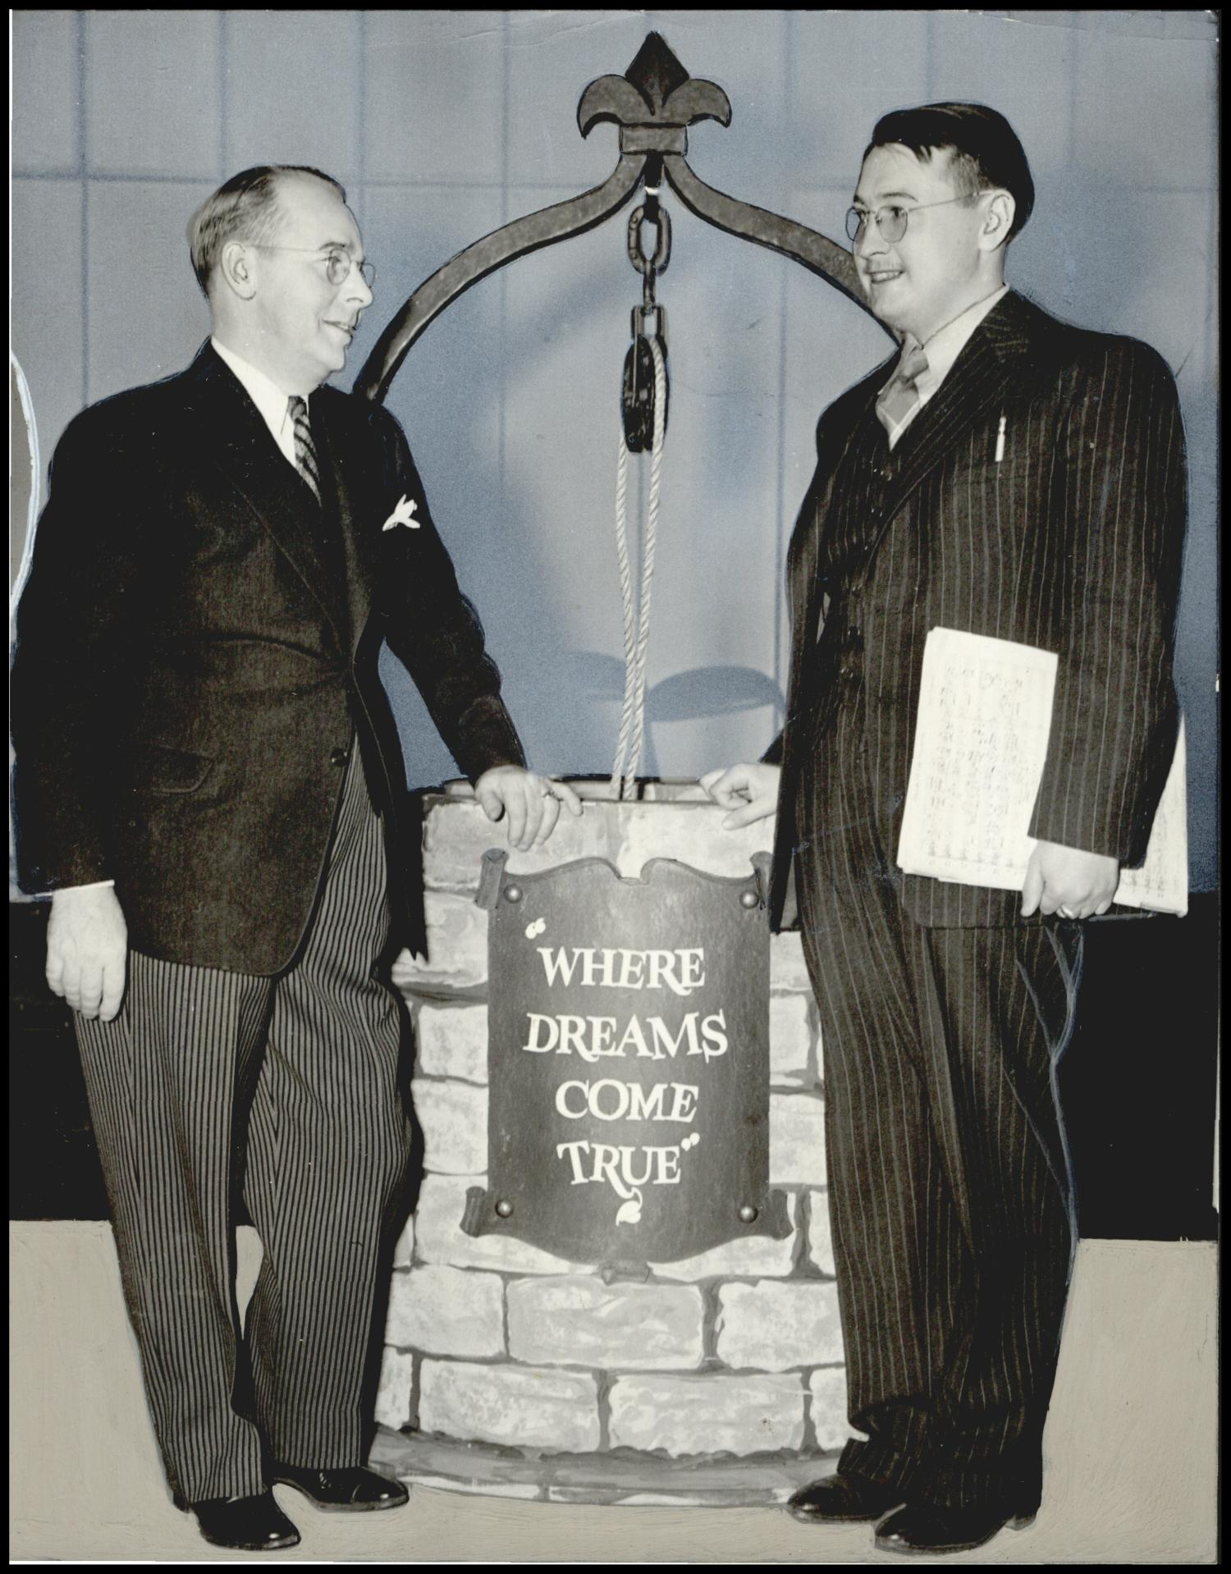
Note. Photograph used for story in the Daily Oklahoman. Caption: "Kilpatrick Jack. Composer" Author unknown, 1941. Reprinted with permission from the Oklahoma Historical Society.
During this time, orchestral compositions—especially those written for nationally broadcast radio orchestras like the Oklahoma City Symphony—were heavily influenced by radio dramas, with famous examples of narrated orchestral compositions including Sergei Prokofiev’s Peter and the Wolf (1936) and Benjamin Britton’s Young Person’s Guide to the Orchestra (1945). During the 1930s and 40s, radio dramas were one of the leading forms of entertainment in the United States until the advent of television ended the Golden Age of Radio in the 1950s. Radio dramas depended on dialogue, music, and sound effects to help the listener imagine characters and stories.
Drawing on these influences, and written for narrator and symphony orchestra, each movement of Three Cherokee Cosmogenic Legends shares a different Cherokee origin story with the audience. Preserving and sharing origin stories, charm songs, and translations of Cherokee manuscripts on medicine and magic would remain a lifelong calling for both Jack and Anna Kilpatrick. Three Cherokee Cosmogenic Legends is a prime example of how Jack Kilpatrick used the popular styles of classical composition during his time to further his and his wife’s work as Cherokee preservationists, translators, and historians.

Situating Kilpatrick as an Indigenous Composer
In examining the three concerts from 2019 to 2022 by the Oklahoma City Philharmonic that featured Jack Kilpatrick’s music, it becomes clear that if the first concert situated Kilpatrick as an Oklahoman composer, and the second concert situated Kilpatrick as an American composer, then this third concert acted to situate him as an Indigenous composer and storyteller. Once again, the choice of what other pieces to include on the program alongside Kilpatrick’s music is what reveals how Alexander Mickelthwate chose to present Kilpatrick to his audience. For this concert, Kilpatrick’s compositions Three Cherokee Cosmogenic Legends and Four Ozark Dances were paired with contemporary Chickasaw composer Jerod Impichchaachaaha’ Tate’s bassoon concerto Ghost of the White Deer and early 20th century Mexican composer Silvestre Revueltas’s symphonic suite from the movie La Noche de los Mayas. By pairing three pieces that feature Cherokee, Chickasaw, and Mayan legends told through symphonic performance, Mickelthwate situated Kilpatrick as an Indigenous storyteller who used the orchestra as a medium through which to share his culture. An image of the program from this concert can be seen in Figure 7.10.

Figure 7.10
An Image of the Program of the Oklahoma City Philharmonic’s “Oklahoma Stories: Kilpatrick” Concert from April 30, 2022
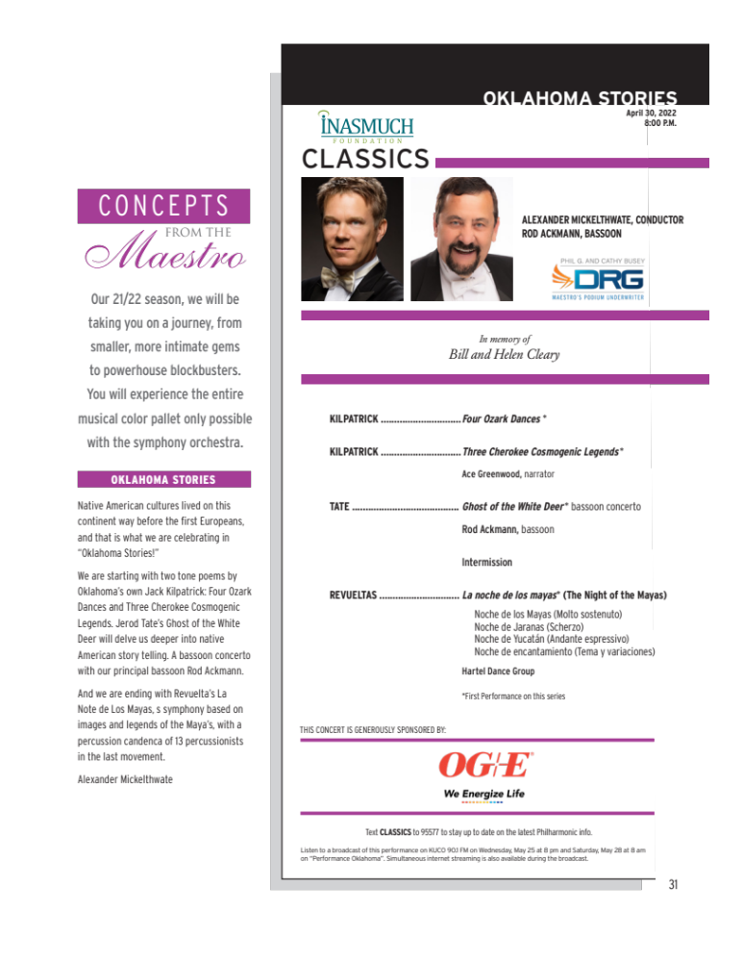
Note. A photo of the program notes for the Oklahoma City Philharmonic’s “Oklahoma Stories: Kilpatrick” Concert from April 30, 2022 (own photo). Reprinted with permission from the Oklahoma City Philharmonic.

Three Cherokee Cosmogenic Legends
Three Cherokee Cosmogenic Legends, “Movement I: Origin of the Pleiades,” tells the story of how the star constellation Pleiades, popularly known today as the Seven Sisters, came to be through the tragic choices of unruly children. Through whirling woodwind figures and a stern horn and oboe duet, the music paints the picture of children playing and crashing around the house, parents lecturing, and finally the children’s slow ascent into the heavens. The narration of the first movement is as follows:
Long ago, in the beginning there were some disobedient boys, playmates.
This is their story.
Rather than work in the cornfields or learn the art of hunting, they preferred to play ball all day long, around and around the council house.
Their parents pleaded with them to give up their idle ways.
But soon they were back at their games, around and around the council house.
Said their parents: “Since you must play, you shall not eat.”
“Ah-yo! ah-yo!” cried the boys. “Since our parents treat us this way, we shall pray to the spirits to take us away from them.”
“Do not leave us!” implored their parents.
But it was too late.
The whirling boys were by now leaving the ground, and soon were whirled up into heaven!
Movement II: Origin of Medicine tells the story of how animals, in response to being hunted and killed by humans, curse humans with disease and sickness. In response, plants, mistreated by the animals and used for food, decide to save humanity through their healing leaves and medicines. Listeners can hear the rage of the Great Animals and the heroism and kindness of the plant’s council through clear and affective text painting.
In solemn council met the Great Animals, to curse mankind with sickness and disease.
“Man has slain our brothers!” they said.
Hearing of this, the kind Plants held a council of their own.
“We shall help mankind with our healing leaves. The Great Animals devour us, they are our enemies.”
And that’s the way it happened, the cursing of all mankind by the Great Animals.
Finally, Movement III: Origin of Fire, tells the story of how lightning struck an island and how the smallest of the animals, a tiny water spider, was the only one brave and clever enough to go fetch a coal to grant fire to the animals. Through direct orchestration choices, Kilpatrick depicts the roll of thunder, the flickering of fire, the fear of the shivering animals, and the bravery of the tiny water spider in this adventurous tale.
Once the earth was cold and dark, and the heavens stormy.
In the middle of a great lake was an island, and in this island there was a hollow sycamore tree which was struck by a great bolt of lightning, setting it afire.
The fire from heaven began to glow, then to leap and curl and crackle and spit.
And to fill the darkness.
The shivering animals on shore looked longingly at the bright glow and made many futile efforts to obtain a coal of it.
At last, the brave and cunning little Water Spider, one of the smallest of animals, set himself to get a coal, while the other animals watched anxiously.
Snatching up a coal in his web, he brought it back in triumph.
What all three of these legends have in common with Jerod Impichchaachaaha’ Tate’s setting of the Ghost of the White Deer is that there is no clear resolution or ending to these stories. When I was speaking with Jerod following the concert, he stated that this lack of resolution is common in Native American stories and legends, and that it affects how he composes as well. Jerod said that he is often inspired by the non-linear structure of Indigenous stories in how he structures his own compositions. This lack of resolution can be clearly seen in all three of the Cherokee Cosmogenic Legends, which by Western standards each seem to end in the middle of what might be considered the climax of their stories—as the naughty children are whirled up into heaven, as mankind is cursed with sickness and disease, and as the cunning Water Spider brings back the burning coal in triumph. Ponca storyteller and author Dan SaSuYeh Jones explains this non-linear storytelling structure in his article for School Library Journal, “How American Indian Storytelling Differs From the Western Narrative Structure,” where he discusses how Indigenous stories may begin with the ending or start in the middle, characters change and grow with the audience, and stories continue for the lifetime of the listener. He explains that these Indigenous characters, like the cunning Cherokee Water Spider, are not only “immortal and indestructible—where they may be killed in one story and are right back at it in another—they also age with the listener. Coyote stories for children have childlike morals; for teens, Coyote is a much rougher character; and, for elders only, grandpa Coyote is smart, and his stories are deep and filled with complicated plots and plans” (Jones, 2021).
Once again, I was struck by how clearly Kilpatrick was operating in what Dylan Robinson called the Indigenous mode of thought in all of the pieces that had been presented by the Oklahoma City Philharmonic. In An American Indian Serenade, Kilpatrick stated that he was not attempting to present a particular Indigenous melody or sound, but that the piece acts as a “record of an Indian composer’s awareness of the ‘strangeness of familiar things.’” This is mirrored in the way soloist Valerie Watts struggled to interpret his Concerto for Flute and Strings through the western lens of compositional genius and individuality until she approached it as a “montage of his musical passions.”
In rehearsals for Three Cherokee Cosmogenic Legends and Four Ozark Dances, Alexander’s reaction after the orchestra’s first reading of the works was a somewhat bemused smile. Each of the legends were narrated by Chickasaw/Cherokee entertainer Ace Greenwood, and in speaking with Alexander afterwards, he stated that the pieces were charming but all seem to “just happen, there is no beginning or end.” Again, even in symphonic form, these legends are not told through the western storytelling structure of beginning, middle, and end, but are rather glimpses into a timeless story that seems to continue whether it is being told or not. The most intriguing aspect of these performances was how much the performers and audience were not only exposed to the cultural information entextualized into the scores, but were also gently pulled into an Indigenous way of thinking and encoding history.

Four Ozark Dances
While in Three Cherokee Cosmogenic Legends, Kilpatrick is preserving and sharing cultural knowledge through narration and musical text painting, in Four Ozark Dances Kilpatrick is preserving, sharing, and elevating the folk music he grew up listening to in eastern Oklahoma in the Ozark Mountain range. The dance suite has been an important part of classical instrumental music since the 1600s and was a particularly popular structure during the Baroque era, with famous examples by J.S. Bach, George Frederic Handel, and Francois Couperin with the familiar movement titles of Allemande, Sarabande, Gigue, Minuet, and Prelude. However, in the 20th century, American composers began to create their own dance suites out of the popular dance music of their own time, with examples including Florence Price’s Suite of Dances (1933), featuring the southern Black folk tunes Rabbit Foot, Hoe Cake, and Ticklin’ Toes, and Edward Kennedy “Duke” Ellington’s prolific dance suites featuring spirituals, blues songs, and work songs in large-scale compositions like Black, Brown, and Beige (1943).
The four movements of Jack Kilpatrick’s Four Ozark Dances consist of the folk music of his youth, featuring a joyous and playful reel, a graceful and bucolic waltz, a distinguished and grand dance song, and a final unpretentious, honest hornpipe. These songs take the listener back to the contradances and county fairs popular in the Ozarks during Kilpatrick’s youth and preserve and re-introduce audiences to the historical soundscapes of Oklahoma in the early 20th century.

Meeting the Kilpatrick Family
The preparation for this concert was similar to the other two seasons; I worked with Alexander on the musical aspects of preparation while simultaneously working with the Oklahoma City Philharmonic administration on how to market Kilpatrick and record the performance. As part of the Oklahoma City Philharmonic’s promotional campaign for their upcoming concerts, they place sponsored ads on Facebook and Instagram. It is important to note that unlike the first two concerts in previous years featuring Kilpatrick’s music, this particular marketing campaign featured Kilpatrick as the main theme of the concert, as seen in Figure 7.11.

Figure 7.11
An Image of an Advertising Banner for the Oklahoma City Philharmonic’s “Oklahoma Stories: Kilpatrick” Concert

Note. Reprinted with permission from the Oklahoma City Philharmonic.

It was one of these sponsored Facebook ads for the concert featuring Jack Kilpatrick’s name that first brought the upcoming performance to Clifford Kilpatrick’s attention. I had been trying to reach Clifford and Alan Kilpatrick, Jack’s surviving sons, since 2018, but had not received any responses to my efforts to initiate contact with them and share information about the discovery of their father’s manuscript collection. After Clifford saw the Facebook ad for the concert, he reached out to his son-in-law Chris Honea, who is a lawyer who focuses on trademark and copyright law. An image of the Facebook post that Clifford shared with Chris Honea can be seen in Figure 7.12.

Figure 7.12
An Image of a Facebook Post by the Oklahoma City Philharmonic on April 21, 2022
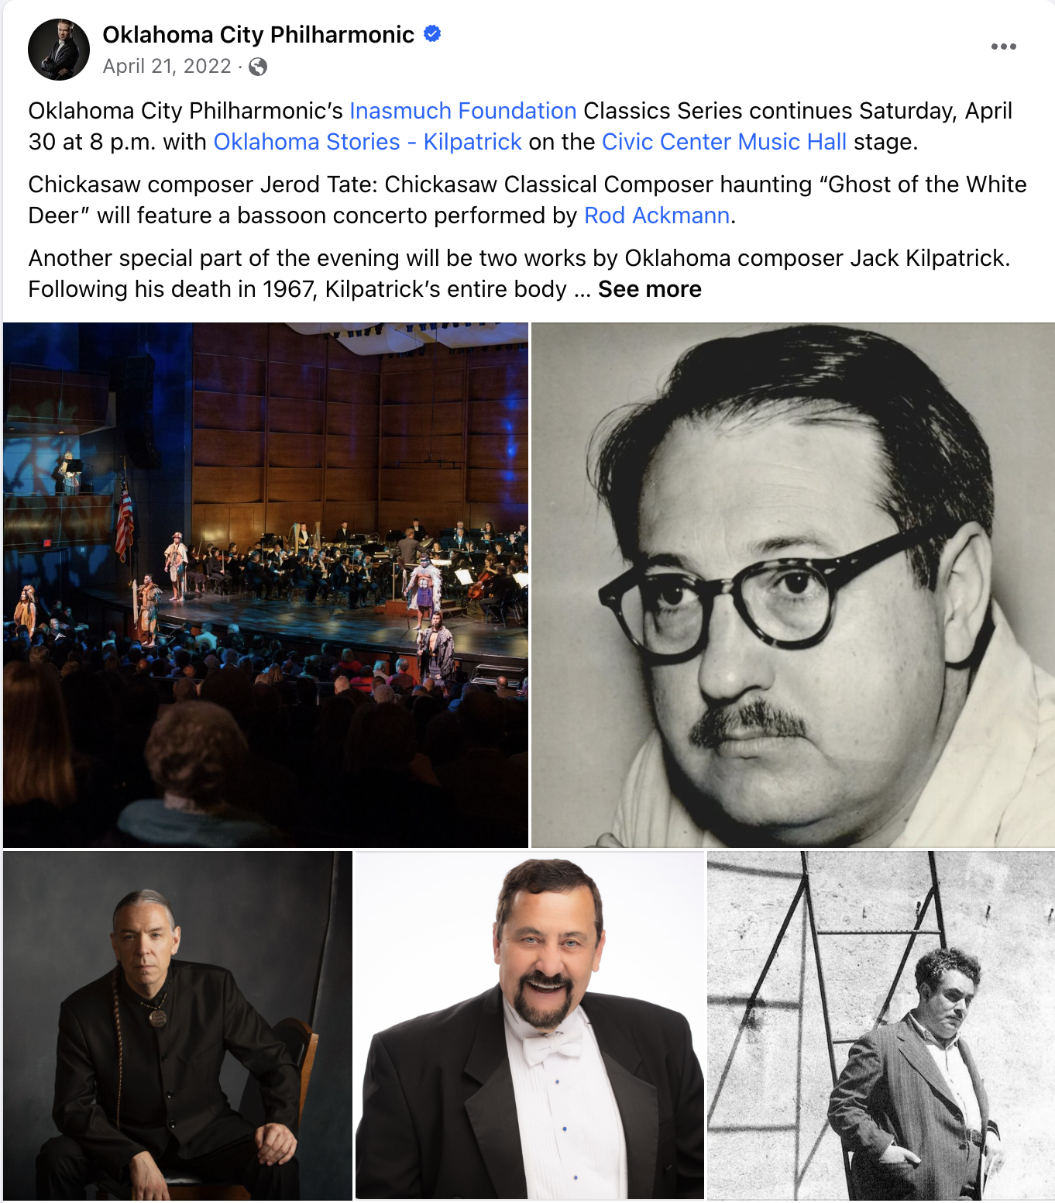
Note. Reprinted with permission from the Oklahoma City Philharmonic.
Chris Honea called the Oklahoma City Philharmonic offices and spoke with general manager John Allen. Chris and Clifford inquired about how the Philharmonic had received access to Jack Kilpatrick’s works, as they were unaware of their location. John Allen then called me and asked if I could reach out to the Kilpatrick family to discuss the situation with them. I called Chris Honea and had a long phone conversation with him discussing the initial finding of the collection, my work to catalog it, our current plans to share and attempt to build interest in performing Jack Kilpatrick’s music, and my wish to include the family in any further decisions regarding performances, publications, and recordings of Kilpatrick’s music. While Chris was initially concerned about making sure the family’s legacy was protected and not taken advantage of, after our phone conversation he stated that he had a good feeling about working with me and invited me to a dinner to meet the family. After getting off the phone with Chris, I called John Allen and Alexander back and we arranged for the Kilpatrick family to receive complimentary tickets to the concert and to come backstage and meet with the Oklahoma City Philharmonic staff and musicians.
On April 30, 2022, the day of the concert, I drove to Iron Star Barbeque in Oklahoma City to meet with the Kilpatrick family for dinner. The group consisted of Clifford Kilpatrick and his wife, their daughter Mary Anna Kilpatrick and her partner Chris Honea. The family was warm and welcoming to me, and asked lots of questions about what materials were included in the collection. The family was particularly interested in the historical dramas, and how the Oklahoma City Philharmonic became associated with performing Kilpatrick’s music. They were also curious about what our future goals were with the music, and also how the royalties, publishing, and performances worked in regards to both payment and ownership. After explaining my role in the process and offering to help them navigate registering the works with a performing rights organization so they could receive royalty payments, they began sharing stories of their memories of Jack and Anna Kilpatrick.
After dinner, we attended the concert together and I sat with the family and some of their friends. For the concert, we had come up with a plan to honor the family from the stage. From the stage, Alexander announced that the Oklahoma City Philharmonic was honored to have some of the Kilpatrick family in attendance and asked Mary Anna to stand and be recognized. She received a standing ovation from the audience and the musicians after being thanked and acknowledged for attending and allowing the organization to perform Kilpatrick’s works. This was her first time attending a live orchestra performance, and they said that they had a wonderful time. After the concert, Alexander met with the family and many of the audience members and musicians came up to introduce themselves and talk about how wonderful Jack Kilpatrick’s music was.
Since that concert, I was able to meet with Alan Kilpatrick (Jack Kilpatrick’s youngest son) over Zoom. Alan is a retired professor of anthropology living in Belgium, and we have communicated many times over email since that initial Zoom meeting as I worked on finishing this document. During that meeting, Alan was able to solve a particularly difficult mystery for me. Matt Stock, the Oklahoma City Philharmonic, and I had spent several years attempting to locate a manuscript score for Jack Kilpatrick’s Symphony No. 8, which was commissioned by the Oklahoma Symphony Orchestra. However, Alan shared with us that the only score and parts were “now at the bottom of the sea.” The music was being shipped across the Atlantic Ocean when the plane it was on crashed at sea. This had occurred while Jack Kilpatrick was alive, and according to Alan that was the only copy of the music that existed. Alan also shared that the oboe concerto was one of Jack Kilpatrick’s favorite works that he wrote, and that Jack had arranged a version of it for clarinet so that Alan, when he was a young musician playing clarinet, could perform it. Chris Honea and I also remain in regular correspondence, and all Kilpatrick performances and recordings are now put together in collaboration with the family.

Chapter Conclusion
In a way, this chapter represents the culmination of my research, from the (re)discovery of the collection, to the restoration of the collection into performance materials, to the revival of Jack Kilpatrick’s music that I now find myself helping to lead. I have learned through this process that a music revival cannot come from one person, but instead takes an entire community. The power dynamic between academic institutions, classical ensembles, and audiences collectively determines what music is programmed and over time how the canon is constructed, dismantled, and reconstructed continually. To understand a classical music revival is to understand how classical music is based on an ecosystem of interest, difficulty, accessibility, cultural importance, and performance. This complex web of music reception by multiple parties informs the success or failure of each (re)premiere to help or hurt this classical music revival’s chance to grow into a more important part of the classical music industry and culture as a whole. Each performance of classical music, in turn, recontextualizes what classical music is as a genre and what it means to our society as a cultural force in the 21st century. Over the past five years, Jack Kilpatrick’s music has become part of the collective consciousness of musicians in the Oklahoma and Arkansas regions through these (re)premieres. I am still in talks with multiple organizations about future performances and recordings of Jack Kilpatrick’s work, and look forward to observing and participating in the continued revival of his music and legacy.

Chapter 8: Concluding Thoughts
The revival of Jack Frederick Kilpatrick’s music is part of a journey that started long before I opened the first box of his holograph manuscripts and will continue long after I am gone. The archive will not only keep the memories and cultural knowledge entextualized in his music alive, but will pass down and share more knowledge than a dissertation can ever express. Every time I find myself needing to examine a score from the archive I unexpectedly learn something new from just being in the presence of the manuscripts. As a person who finds herself wanting to move quickly and decisively, this kind of absorption takes time, patience, openness, and a willingness to listen to the unspoken cultural information entextualized into the scores. There is no way for me to truly write with clarity about the archival knowledge embedded within these thin sheets of paper covered in pen and pencil markings. In order to understand this power you must be near it, part of it, within it, and accept that it will reveal itself in its own time. You must smell and feel the pages and see what indications were placed where on the page and ponder why those annotations were so important for Kilpatrick to express at that time. Most importantly you must be there because looking at a facsimile of these pages online will change their meaning completely. I have grown to think of Kilpatrick’s manuscripts as sacred cultural items, hope that I have been a worthy caretaker of them for this short time, and wish that others who are inspired by Jack Frederick Kilpatrick’s story will continue the journey of reviving his work and opening his music to other audiences. This dissertation is only a small piece of a much longer story, and just like the Cherokee legends that Kilpatrick shared in some of his symphonic works, it does not have a clear beginning, middle, or end.
One thing I learned from this entire process is that a revival cannot be forced. You cannot mold it to be something it is not and it will never be exactly what you expected it to be in the beginning. If you are unwilling to take each bump, turn, turn-about, and hurdle in stride then it might be better to take on a different project, but if you are willing to go on that ride there is nothing better feeling than hearing a piece you have helped foster be (re)introduced to a new audience. It is true magic. And while the meaning of the music might not be universal, everyone can understand the power of witnessing a musical voice reawaken after a long slumber through live performance. For future music revivalists, I hope that you have found some insight into how a music revival that interfaces with the idea of diversity programming can navigate these strange cultural waters, and can use my ethnography of my own experiences to help you avoid some of my mistakes and use some of my successes.
As an ethnomusicologist this dissertation was more than just a project, but also a time for reflection on my own work. As fields of study adapt and change based on the perceptions of reflection, I found myself questioning much of my own work, my own thought processes, and my own intentions. Was I following the same paths as some of my predecessors who are criticized by modern scholars or was I adapting to new theories presented in modern study? How would my work be interpreted by readers and listeners ten, twenty, a hundred, or a thousand years from now? And finally, how could I simultaneously engage in Dylan Robinson’s Indigenous mode of thought and listen critically through an “intersection of sqwálewel (thinking-feeling)” while also fulfilling the requirements of a Westernized anthropology dissertation that demands academic rigor, evidence-based research, and a clear beginning, middle, and end? (Robinson, 2020, p. 51)
In particular, I hope that I have successfully applied decolonizing theoretical frameworks to my biographical research, archive building, creation of performance materials, and attempt to revive Kilpatrick’s music for the concert stage, and that this application is made clear through this document. I hope that this document will serve to help me in communicating to people interested in programming Kilpatrick’s work that the complexity of Cherokee identity in 20th century America is not something that can be distilled into a singular Cherokee sound. I have despaired with my colleagues about the hundreds of times I have been asked to explain exactly how Kilpatrick’s music sounds Cherokee by non-Indigenous musicians and scholars who do not understand that the entire construct of this conversation is itself problematic and unhelpful in revealing anything of worth about Kilpatrick’s artistic output and complex identity. It is my hope that those who read this dissertation will leave with more poignant questions about Kilpatrick’s music, his identity, and the role of music and society in shaping and reflecting our identity, and that these questions will lead to future research on identity, revivals, the relationship of language and music in discourse, and the role of context in shaping performance in the interrelated fields of musicology, ethnomusicology, anthropology, linguistics, Native American studies, and performance studies.

Next Steps
Despite these unanswered questions, there are two clear goals I would like to achieve in the years to come. First is to have performance ready scores and parts, and second is to have reference recordings to accompany the manuscript collection. With the size of this collection, this represents a lifelong endeavor. It has taken roughly five years to get to this point in the revival process. As of the end of 2023, the collection has been indexed and cataloged, organizations have performed and others are interested in programming Kilpatrick’s works, a few of his compositions have been professionally engraved, audiences are interested in going to concerts they are programmed on, the Kilpatrick family has formed a limited liability company and is in the process of registering the compositions with performing rights organizations, and collectively a revival is beginning to gain momentum. What started as a project almost entirely driven by my own research and actions is now beginning to move out of my control and be dispersed among dozens of interested parties. But the question I still ask myself is am I ethically doing everything I could and am I using the theories presented in this dissertation in my own work?
Therefore, just like the legends of Coyote that Ponca storyteller Dan SaSuYeh Jones shared that grow and change with its listeners, I want to go back to the beginning here at this dissertation’s end. The first Kilpatrick piece I ever studied, the first Kilpatrick piece we performed, the first manuscript score I held from the first box of his collected works that I opened, and the first words written in Kilpatrick’s hand that I read have always been in the back of my mind throughout this project.
“An American Indian Serenade, op. 21,” is the last of a series of orchestral compositions depicting various phases of Oklahoma Indian life, written by the composer for the Oklahoma Symphony Society during the years 1938-1942. Less objective than the others of the group, it is not so much concerned with presenting the Indian point of view as it is with interpreting it; the derivation of its materials from actual folk tunes is more remote; the spirit of Indian life is celebrated, rather than a particular phase exposed. It is the record of an Indian composer’s awareness of the “strangeness of familiar things.” – Jack Frederick Kilpatrick.” (Kilpatrick, An American Indian Serenade, op. 21).

Over the past five years, I find myself continually coming back to Kilpatrick’s quote by Gordon Bottomley about the “strangeness of familiar things.” As an ethnomusicologist and music producer, I am constantly reminded of Western culture’s appetite for appropriating and consuming art against the artist’s will. I have since met with his descendants and family, had dozens of conversations with cultural leaders, artists, composers, and academics, and spent five years becoming, to my absolute surprise, the foremost scholar on a composer whom I had only heard mentioned in passing by a handful of local musicians. But despite all this, I still needed to be sure that reviving these works was what Jack Kilpatrick would have wanted himself. I wanted to honor being entrusted with these manuscripts, these stories, these cultural celebrations and interpretations, and this legacy.
So again and again I asked myself: Why did Jack Frederick Kilpatrick choose to include this quote in this piece, and what does that tell me about his own wishes when it comes to his music? As an artist and producer, when I choose to include a quote or philosophy from another artist in my professional materials (as Kilpatrick did at the beginning of American Indian Serenade’s manuscript) I am trying to use another artist’s words to speak towards something that I also feel – I usually choose not only a work that resonates with me, but an artistic philosophy. I later discovered that the “strangeness of familiar things” is a quote from “The End of the World,” a poem by contemporary English poet and playwright Gordon Bottomley (1874-1948) that was included in his poetry collection Chambers of imagery (Second series) released in 1912 by London-based publisher Elkin Matthews Ltd. Run by Charles Elkin Mathews, Elkin Matthews Ltd.’s other published authors included W.B. Yeats, James Joyce, Ezra Pound, and Robert Bridges.
I read and re-read the Bottomley’s poem “The End of the World,” and also researched the poet and playwright himself. In doing so, I came across a quote from Bottomley where he was discussing the other genre he was well known for outside of poetry, the “poetic drama.” In his essay “Poetry and the Contemporary Theatre,” published in Essays and Studies by Members of the English Association (1934), Bottomley states that “The Poetic drama is, indeed, not so much a representation of a theme as a meditation upon it or a distillation from it; its business is far less the simulation of life than the evocation and isolation for our delight of the elements of beauty and spiritual illumination in the perhaps terrible and always serious theme chosen.” I was struck by the consanguinity of this quote with Kilpatrick’s own words about An American Indian Serenade, op. 21 that preceded his quotation of Bottomley: “Less objective than others of the group; it is not so much concerned with presenting the Indian point of view as it is with interpreting it; the derivation of its materials from actual folk tunes is more remote; the spirit of Indian life is celebrated, rather than a particular phase exposed.” Below are two excepts from Bottomly’s poem “The End of the World” including the section that contains Kilpatrick’s quotation.

Two Excerpts from The End of the World by Gordon Bottomley
“All was so safe indoors where life went on
Glad of the close enfolding snow – O glad
To be so safe and secret at its heart,
Watching the strangeness of familiar things.
They knew not what dim hours went on, went by,
For while they slept the clock stopped newly wound
As the cold hardened. Once they watched the road
Thinking to be remembered. Once they doubted
If they had kept the sequence of the days,
Because they heard not any sound of bells.
A butterfly, that hid until the Spring
Under a ceiling’s shadow, dropt, was dead.
The coldness seemed more nigh, the coldness deepened
As a sound deepens into silences;”
[…]
She said “O, do not sleep,
Heart, heart of me, keep near me. No, no; sleep.
I will not lift his fallen, quiet eyelids,
Although I know he would awaken then–
He closed them thus but not of his own will.
He can stay with me while I do not lift them.”

Re-Awakenings
A serenade is a special type of composition. While concertos showcase virtuosity from the soloist and symphonies highlights the mastery of the composer as they command the musicians to transmit their presence, a serenade is delicate and asks someone to engage while listening. It was composed with someone in mind and when performed it freely takes the audience on a journey of exploration. An American Indian Serenade was written by Kilpatrick for Oklahoma, which was not only the place he was born and died in, but the place he was always drawn back to. He wrote about the landscape and was influenced by the people he grew up with. For Kilpatrick, Oklahoma itself was the source of inspiration. This is not a serenade about American Indians, it is itself an American Indian serenade about the strangeness of familiar things.
In 1942, at 27 years old, Kilpatrick was grappling with the same issues of the American music industry and audiences’ hunger to consume and identify the music of the other that current composers deal with in today’s marketed, monetized consumption of diversity programming by the classical music industry. He takes great pains to point out that there are no traditional melodies quoted in this particular piece, that its inherent “Indianness” is not quantifiable by forensic analysis of melodic or harmonic content but by the spirit of the culture that inspired it.
I knew that in attempting to revive Kilpatrick’s work for the concert stage I would also be reopening the possibility for his music to be misunderstood, misappropriated, and misused – which, while it can happen to any art, is especially likely to happen to art that our culture is currently hungry for. Like anything precious, the same conditions that pave the way for Kilpatrick to be revived for the concert stage also place his works in danger of being taken advantage of, and I am determined to do whatever I can to help ensure that his story and his art are presented in a way that honors his legacy and protects his family. This is why it is so important to me that Kilpatrick’s story, which is so representative of a real human’s experiences in Oklahoma during the early days of statehood, is told in its entirety and not distilled and packaged to sell to a hungry audience (Robinson, 2020).
With these fears and moral beliefs informing my every careful step towards the revival of Jack Frederick Kilpatrick’s music, two things happened that finally made me feel ready to move towards reviving his works in earnest. First, I was finally able to meet with Jack Frederick Kilpatrick’s family and ask them what they wanted to do with his works. I am now in constant communication with both the family and their family lawyer and both advising and asking for their advice on how to move forward with any additional programming, publishing, recording, and marketing strategies.
Second, in one of my many re-readings of Bottomley’s quoted poem “The End of the World” I was suddenly struck by the three-part relationship between Bottomley’s poem, which details the slow and quiet death of a community (be that a person, culture, world, or universe); Jack Kilpatrick’s work to preserve his Cherokee community through his writings and music, which are still fighting against a half-millennia of human massacre and cultural genocide; and finally, Jack Kilpatrick’s own music, which was as vibrant and popular during his life as any, but had since settled into the near-forgotten quietude of obscurity. As we continue to lift the fallen, quiet eyelids of Kilpatrick’s music and reawaken his music into this world, I hope we do it for the right reasons.

Works Cited
Advertising Banner for the Oklahoma City Philharmonic’s “Oklahoma Stories: Kilpatrick” Concert. (2022). Oklahoma City Philharmonic.
An Advertisement for Chucky Jack Featuring Biographies of Kermit Hunter and Jack F. Kilpatrick [Photograph]. (1956). University of Tennessee Libraries, Knoxville, Betsey B. Creekmore Special Collections and University Archives.
A Bicentennial Tribute to Jack Frederick Kilpatrick (1915-1967) [Photograph]. (1976). College of Fine Arts Collection Publications, 1902-1992 (inclusive). The University of Oklahoma Archives, Norman, OK.
Arnold Schönberg Center. (2023). (http://www.schoenberg.at/index.php/en/musik-2).
Bales, R. (Director). (1944, May 21). Program for the National Gallery Sinfonietta, Conducted by Richard Bales. National Gallery of Art. https://www.nga.gov/content/dam/ngaweb/research/gallery-archives/concertprograms/1942-1950/1943-1944/15A4_68777_19440521.pdf
Barnes, B. (1998, June 27). Conductor, Composer Richard Bales Dies at 83. The Washington Post.
Bauden, F., & Franssen, É. (Eds.). (2020). In the author’s hand: Holograph and authorial manuscripts in the Islamic handwritten tradition. Brill.
Bauman, R. (1984). Verbal Art As Performance. Waveland press.
Bauman, R., & Briggs, C. L. (1990). Poetics and Performance as Critical Perspectives on Language and Social Life. Annual Review of Anthropology, 19, 59–88. JSTOR.
Beard-Moose, C. T. (2009). Public Indians, Private Cherokees: Tourism and Tradition on Tribal Ground. University of Alabama Press.
Benson, H. D. (1975). A Biographical Sketch of Jack Frederick Kilpatrick and a Partial Single Source Compilation of Published and Unpublished Compositions. The University of Oklahoma.
Bithell, C., & Hill, J. (Eds.). (2016). The Oxford handbook of music revival (First issued as an Oxford University Press paperback). Oxford University Press.
Brackett, J. (1848). Simple Gifts.
Buttrey, G. (1979). A History of the Hunter Hills Theatre, 1956-1977 [University of Tennessee - Knoxville]. https://trace.tennessee.edu/cgi/viewcontent.cgi?article=4703&context=utk_gradthes
Clubs, N. F. of M. (1950). Music Clubs Magazine. National Federation of Music Clubs. https://books.google.com/books?id=3d7jAAAAMAAJ
Conathan, L., & Hartwell, F. (2015). Guide to the Kilpatrick Collection of Cherokee Manuscripts. Beinecke Library. https://docplayer.net/155047004-Guide-to-the-kilpatrick-collection-of-cherokee-manuscripts.html
Conley, R. J. (2007). A Cherokee encyclopedia. University of New Mexico Press.
Conlon, P. (2019). Matt Stock, Alexander Mickelthwate, and Christina Giacona Posing with the Critical Edition Conductor Score of Jack Kilpatrick’s An American Indian Serenade [Photograph].
Cowan, R. (2018, September 18). Debussy’s La Mer: A Complete Guide to the Best Recordings. Gramophone: The World’s Best Classical Music Reviews. https://www.gramophone.co.uk/features/article/debussy-s-la-mer-a-complete-guide-to-the-best-recordings)
Debo, A. (2014). The WPA guide to Oklahoma: The sooner state. Trinity University Press.
Deloria, P. J. (2022). Playing Indian. Yale University Press.
Department of Music: History. (n.d.). [University Website]. The Catholic University of America. Retrieved July 3, 2023, from https://music.catholic.edu/about-us/history/index.html
Editors Named In Effort To Revive Cherokee Paper, text, 2013; (https://gateway.okhistory.org/ark:/67531/metadc1630928/: Accessed October 27, 2023), The Gateway to Oklahoma History, https://gateway.okhistory.org; crediting Ardmore Public Library. (n.d.).
Ellis, C. (n.d.). American Indians and Education. In The Encyclopedia of Oklahoma History and Culture. https://www.okhistory.org/publications/enc/entry.php?entry=AM012.
Emmett Oliver Passes Away at Age 102. (2016, March 8). https://nwtreatytribes.org/emmett-oliver/
Facebook Post by the Oklahoma City Philharmonic. (2022). Oklahoma City Philharmonic.
Fischer, H. D. (Ed.). (2010). The Pulitzer Prize Winners for Music: Composer Biographies, Premiere Programs and Jury Reports. P. Lang.
Floyd, J. M. (2011). Composers in the Classroom: A Bio-Bibliography of Composers at Conservatories, Colleges, and Universities in the United States. Scarecrow Press.
From Storage Room to Stage. (2018, 2019). Path to Excellence, Progress Report, 32. University Libraries, The University of Oklahoma.
Frontz, K. (1998). [Finding Aid]. Jane H Ivancovitch Collection. https://www.arizonahistoricalsociety.org/wp-content/upLoads/library_Ivancovich-JaneH.pdf
Gough, P. (2015). Sounds of the New Deal: The Federal Music Project in the West. University of Illinois press.
Grant, T. (1976). American History in Drama: The Commemorative Tradition and Some Recent Revisions. Modern Drama, 19(4), 327–339. https://doi.org/10.3138/md.19.4.327
Green, P. (1949). Symphonic Drama. The English Journal, 38(4), 177. https://doi.org/10.2307/806687
Gubele, R. (2013). The Cherokee Phoenix and the syllabary: Cherokee Rhetorics of Balance [Dissertation]. Washington State University.
Gumm, J. (1957). Anna, Jack Jr., Clifford, and Alan Kilpatrick at the Premiere of Jack Kilpatrick’s Symphony No. 8 “Oklahoma” [Photograph]. The Gateway to Oklahoma History, https://gateway.okhistory.org; crediting Oklahoma Historical Society. https://gateway.okhistory.org/ark:/67531/metadc373248/
Hanneman, C. (n.d.). Bacone, Almon Clematus. In The Encyclopedia of Oklahoma History and Culture. https://www.okhistory.org/publications/enc/entry.php?entry=BA006
Hart, A. O. (1941). Jack Kilpatrick Smoking a Cigarette While Composing at the Piano [Photograph]. The Gateway to Oklahoma History, https://gateway.okhistory.org; crediting Oklahoma Historical Society. https://gateway.okhistory.org/ark:/67531/metadc375614/
Hart, A. O. (1941). Kilpatrick, Jack. Composer [Photograph]. The Gateway to Oklahoma History, Oklahoma Historical Society. https://gateway.okhistory.org/ark:/67531/metadc377097/
Heth, C. W. (2022). Going Forward With Vigilance: American Indian Music Is Always There. In B. M. Romero, S. M. Asai, D. A. McDonald, A. G. Snyder, & K. E. Best (Eds.), At the Crossroads of Music and Social Justice (pp. 68–75). Indiana University Press; JSTOR. https://doi.org/10.2307/j.ctv319wqgd.9
Hittman, M. (1998). Wovoka and the ghost dance (expanded ed). University of Nebraska Press.
Huffman, L. (n.d.). A Listing of the Concerts of Leopold Stokowski 1950 to 1974.
Hume, P. (1979, April 1). Maestro of The East Garden Court. The Washington Post. https://www.washingtonpost.com/archive/lifestyle/1979/04/01/maestro-of-the-east-garden-court/444e63f3-7712-49b2-bb5c-9f5da0263301/
Hunter, K. (1951). The Cherokee Historical Association to perpetuate the history and traditions of the Cherokee Indians presents unto these hills: A drama of the Cherokee Indian. Cherokee Historical Association, Inc.
Ivancovich, Jane Harrison, 1915-1991 Papers, 1935-1975 (bulk (1950-1965). (n.d.). Arizona Historical Society. https://www.arizonahistoricalsociety.org/wp-content/upLoads/library_Ivancovich-JaneH.pdf
Jack Kilpatrick’s Appearance on NBC’s “The Wishing Well—Where Dreams Do Come True.” (1940). [Photograph]. The Gateway to Oklahoma History, https://gateway.okhistory.org; crediting Oklahoma Historical Society. https://gateway.okhistory.org/ark:/67531/metadc399995/
Jack Kilpatrick’s Biography in the Program for Unto These Hills: A Drama of the Cherokee Indian’s 1951 Season. (1951). Jack Kilpatrick Collection. Western History Collections, Norman, OK.
Keillor, E., Archambault, T., & Kelly, J. M. H. (2013). Encyclopedia of Native American music of North America. Greenwood.
Keys, C., & Hillsamer, D. (1984, March 23). Couple Honored With Top Musician Award. The Hopkins County Echo. https://texashistory.unt.edu/ark:/67531/metapth779820/m1/2/
Kilpatrick, A. G., & Kilpatrick, J. F. (1965). The book of Haggai translated into Cherokee. Perkins School of Theology, Southern Methodist University.
Kilpatrick, J. F. (1942). An American Indian Serenade. Jack Kilpatrick Collection. Western History Collections, Norman, OK.
Kilpatrick, J. F. (1942). Cherokee Life. Jack Kilpatrick Collection. Western History Collections, Norman, OK.
Kilpatrick, J. F. (Unknown). Hand-Written List of Commissioning Organizations, Conductors, and Concert Artists Who Have Worked With Jack Kilpatrick in His Own Hand. Jack Kilpatrick Collection. Western History Collections, Norman, OK.
Kilpatrick, J. F. (1934). Hymn to Bacone College. Jack Kilpatrick Collection. Western History Collections, Norman, OK.
Kilpatrick, J. F. (1966). The Wahnenauhi Manuscript: Historical Sketches of the Cherokee. Smithsonian Institution: Bureau of American Ethnology. https://repository.si.edu/bitstream/handle/10088/22138/bae_bulletin_196_1966_77_175-214.pdf
Kilpatrick, J. F. (1946). The Possible Relationship of Content to Form in Certain Gros Ventre Songs. The Catholic University of America.
Kilpatrick, J. F. (1965). Sequoyah of Earth & Intellect. The Encino Press.
Kilpatrick, J. F., & Kilpatrick, A. G. (1964). Cherokee burn conjurations.
Kilpatrick, J. F., & Kilpatrick, A. G. (1973a). Muskogean charm songs among the Oklahoma Cherokees. Filmed by Microfilming Corp. of America.
Kilpatrick, J. F., & Kilpatrick, A. G. (1973b). Notebook of a Cherokee shaman. Filmed by Microfilming Corp. of America.
Kilpatrick, J. F., & Kilpatrick, A. G. (1973c). Walk in your soul: Love incantations of the Oklahoma Cherokees. Microfilming Corp. of America.
Kilpatrick, J. F., & Kilpatrick, A. G. (1977). Run toward the Nightland; Magic of the Oklahoma Cherokees. Southern Methodist University Press.
Kilpatrick, J. F., & Kilpatrick, A. G. (1995). Friends of Thunder: Folktales of the Oklahoma Cherokees (University of Oklahoma Press ed). University of Oklahoma Press.
Kilpatrick, J. F., & Kilpatrick, A. G. (2017). Plains Indian Motifs in Contemporary Cherokee Culture. Plains Anthropologist Plains Anthropologist, 7(16), 136–137.
Kilpatrick, J. F., Kilpatrick, A. G., & Conley, R. J. (1995). Friends of Thunder: Folktales of the Oklahoma Cherokees.
Kilpatrick, J. F., Kilpatrick, A. G., & University Microfilms International. (1993). The Shadow of Sequoyah: Social documents of the Cherokees, 1862-1964. Books on Demand, a Pub. Service of University Microfilms International.
Kilpatrick, J. F., Kilpatrick, A. G., Worcester, S. A., & Boudinot, E. (1968). New Echota letters. Southern Methodist University Press. http://books.google.com/books?id=OSB1AAAAMAAJ
“Kilpatrick, Jack (Frederick).” Baker’s Biographical Dictionary of Musicians. Encyclopedia.com. 23 Feb. 2023 <https://www.encyclopedia.com>. (n.d.).
King, R. (1954). Epic Drama of Father Kino’s Missionary Work Springs to Life on U of A Stage [dataset]. Institute of Outdoor Theatre Archives. https://digital.lib.ecu.edu/33096
Link, A., Shelton, A., Spero, P., Center for Native American and Indigenous Research, & American Philosophical Society (Eds.). (2021). Indigenous languages and the promise of archives. Co-published by the University of Nebraska Press and the American Philosophical Society.
Livingston, T. E. (1999). Music Revivals: Towards a General Theory. Ethnomusicology, 43(1), 66–85. JSTOR. https://doi.org/10.2307/852694
Lyon, W. S. (1998). Encyclopedia of native American healing (1. publ. as a Norton paperback). Norton.
MacDowell, E. (1912). Critical and Historical Essays: Lectures delivered at Columbia University (W. J. Baltzell, Ed.). Arthur P. Schmidt.
McCormack, C. E. (1959). Image of a Proclamation of Dr. Jack Kilpatrick Day in the Strawberry Festival Program. City of Stilwell. https://www.cityofstilwell.com/DocumentCenter/View/163/1959-Booklet-PDF
McDonnell, B. (2020, August 19). Coronavirus in Oklahoma: OKC Philharmonic announces “(re)IMAGINE(d)” 2020-2021 Classics and Pops concert seasons. The Oklahoman. https://www.oklahoman.com/story/entertainment/columns/brandy-mcdonnell/2020/08/19/coronavirus-oklahoma-philharmonic-announces-reimagined-2020-2021-classics-and-pops-concert-seasons/60385925007/
McLarry, L., & McLarry, B. (2019, September 14). [Personal communication].
Miller, R. J., Ruru, J., Behrendt, L., & Lindberg, T. (2010). Discovering Indigenous Lands: The Doctrine of Discovery in the English Colonies. OUP Oxford.
Mooney J. (1982). Myths of the Cherokee; and Sacred Formulas of the Cherokees. Charles and Randy Elder-Booksellers.
Music Notebook. (1991, February 1). The Oklahoman. https://www.oklahoman.com/story/news/1991/02/01/music-notebook/62538229007/
National Gallery Sinfonietta. (1944). National Gallery of Art Concert Programs Archive.
Nees, H. (2012). “Indian” Summers: Querying Representations of Native American Cultures in Outdoor Historical Drama [Bowling Green State University]. https://etd.ohiolink.edu/apexprod/rws_etd/send_file/send?accession=bgsu1352840321&disposition=inline
Nelson, J. B. (2014). Progressive traditions: Identity in Cherokee literature and culture. University of Oklahoma Press.
Nelson, J. B. (2014). Keeping Oklahoma Indian Territory (J. H. Cox & D. H. Justice, Eds.). Oxford University Press. https://doi.org/10.1093/oxfordhb/9780199914036.013.020
Neuman, L. K. (2013). Indian Play: Indigenous Identities at Bacone College. University of Nebraska Press.
Nevaquaya, A. (2019). John Hamilton, Timothy Nevaquaya, the Oklahoma Fancy Dancers, and the Native Praise Choir Backstage at the Oklahoma City Civic Center Music Hall [Photograph].
Nicholls, D. (Ed.). (1998). The Cambridge history of American music. Cambridge University Press.
Norman Orchestra to Play Works By Three Oklahoma Composers. (1992, September 25). The Oklahoman. https://www.oklahoman.com/story/news/1992/09/25/norman-orchestra-to-play-works-by-three-oklahoma-composers/62481140007/
Noyes [Editor}, T. W. (1944, May 21). Cherokee Composer. The Washington Evening Star, C–2. Chronicling America.
Oklahoma City Philharmonic. (2019). Classics: Oklahoma Stories.
Oklahoma City Philharmonic. (2021). Classics: American Stories—’Tis a Gift, Copland: Appalachian Spring.
Oklahoma City Philharmonic. (2022). Classics: Oklahoma Stories.
OU concert to honor Cherokee composer. (1976, February 12). The Oklahoma Daily. https://gateway.okhistory.org/ark:/67531/metadc1829548/m1/20/zoom/?q=Jack%20Kilpatrick&resolution=7.371275827523494&lat=3247.5924369199147&lon=1331.2661901803767
Phillips, K. M. (2021a). Staging Indigeneity: Salvage Tourism and the Performance of Native American History. University of North Carolina Press.
Pioneer Teacher and Official Dies at Home. (1963, June 6). Stilwell Democrat-Journal, 1.
Pittenger, T. L. (19--). The music of the Will Rogers memorial dedication; George Whitefield, Methodist preacher par excellence ; Jack Frederick Kilpatrick, Oklahoma Indian composer.
Pittsburgh Bicentennial Gateway Festival Magazine (1250-s1-b170-fk). (1959). Institute of Outdoor Theatre Archives. https://digital.lib.ecu.edu/34315
Reed, B. (2012, February 5). Pass notes No 3,119: Curse of the ninth symphony. The Guardian. https://www.theguardian.com/music/2012/feb/05/pass-notes-ninth-symphony
Reyhner, J. A., & Eder, J. M. O. (2017). American Indian education: A history (Second edition). University of Oklahoma Press.
Robinson, D. (2020). Hungry listening: Resonant theory for indigenous sound studies. University of Minnesota Press.
Schweitzer, I., & Henry, G. (Eds.). (2019). Afterlives of indigenous archives: Essays in honor of the Occom Circle. Dartmouth College Press.
Slonimsky, N., Kuhn, L., & McIntire, D. (2001). Kilpatrick, Jack (Frederick). In N. Slonimsky & L. Kuhn (Eds.), Baker’s Biographical Dictionary of Musicians (Vol. 3, p. 1873). Schirmer; Gale eBooks. https://link-gale-com.ezproxy.lib.ou.edu/apps/doc/CX3491806713/GVRL?u=norm94900&sid=bookmark-GVRL&xid=6e013669
Small, C. (1998). Musicking: The meanings of performing and listening. University Press of New England.
Smith, B. (1995). Two paths: Emmett Oliver’s revolution in Indian education. Salish Press.
Smith, L. T. (2021). Decolonizing methodologies: Research and Indigenous Peoples (First published in Great Britain 2021, Third edition). Zed.
Sturm, C. (2011). Becoming Indian: The struggle over Cherokee identity in the twenty-first century (1st ed). School for Advanced Research Press.
Sumner, M. R. (1967). An Investigation of Existing Outdoor Drama Techniques and a Determination of Methods to Improve Training (Institute of Outdoor Drama). University of North Carolina. https://files.eric.ed.gov/fulltext/ED016895.pdf
Symphony Orchestra’s Concert Is Set Friday. (1941, December 2). The Charlotte Observer, 17.
[Symposium program]. (1997). Annual Western Regional Indian Law Symposium, The University of Washington School of Law.
Tahmahkera, D. (2014). Tribal television: Viewing native people in sitcoms. The University of North Carolina Press.
Taylor, D. (2003). The archive and the repertoire: Performing cultural memory in the Americas. Duke University Press.
The Associated Press. (2001, April 26). Kermit Hunter—Historical Dramatist, 90. The New York Times. https://www.nytimes.com/2001/04/26/arts/kermit-hunter-historical-dramatist-90.html
The Bell and The Plow Scrapbook. Institute of Outdoor Theatre Archives. 1250-s1-b5-fd. East Carolina University Digital Collections. Https://digital.lib.ecu.edu/36522. Accessed 29 Oct. 2023. (n.d.). https://digital.lib.ecu.edu/36522
The New Cherokee Advocate. (1950, May 3). Cherokee Phoenix. https://digital-collections.demo.quartex.uk/Documents/Detail/the-new-cherokee-advocate/17046
The Oklahoma City Philharmonic’s Reduced Orchestra Size, Increased Spacing, and Use of Personal Protective Equipment in 2021 During the COVID-19 Pandemic. (n.d.). [Photograph]. Oklahoma City Philharmonic.
The Singing Redmen, 1935 featuring Jack Kilpatrick bottom row, 4th from the right. (1935). [Photograph]. Merritt D. Betts & Bacone College American Indian Research Library Native American Collection. https://www.pinterest.com/pin/194921490105792112/
Troutman, J. (2016). Indigenous Pop: Native American Music from Jazz to Hip Hop (Lee, K., Johnson, J., & Berglund, J.. Eds.) Tucson: University of Arizona Press.
Twelfth Annual Strawberry Festival Featuring an All-Indian Program. (1959). https://www.cityofstilwell.com/DocumentCenter/View/163/1959-Booklet-PDF
Wahnenauhi, & Kilpatrick, J. F. (1966). The Wahnenauhi manuscript: Historical sketches of the Cherokees; together with some of their customs, traditions, and superstitions. In Anthropological papers (1–no. 77, pp. 175-213 , plates). U.S. Government Printing Office. https://ehrafworldcultures.yale.edu/document?id=nn08-005
Walker, R. A. (2018, September 13). Emmett Oliver, Founder of Paddle to Seattle, Walks On at 102. Indian Country Today. https://indiancountrytoday.com/archive/emmett-oliver-founder-of-paddle-to-seattle-walks-on-at-102
Watts, V. (2023, March 18). Watts, Thoughts About Kilpatrick Concerto [Personal communication].
West Virigina Archives & History Channel (Director). (n.d.). Selected Scenes from Honey in the Rock by Kermit Hunter. https://www.youtube.com/watch?v=u9EeiZ5l6aI
Whiteley, S., Bennett, A., & Hawkins, S. (Eds.). (2016). Music, Space and Place: Popular music and cultural identity. Routledge.
Williams, J. L. (n.d.). Bacone College. In The Encyclopedia of Oklahoma History and Culture. https://www.okhistory.org/publications/enc/entry.php?entry=BA004
Williams, S., & Associates. (2019). John Hamilton Performing Grand Entry Medley with Alexander Mickelthwate and the Oklahoma City Philharmonic [Photograph]. Oklahoma City Philharmonic.
Williams, S., & Associates. (2019). John Hamilton, Timothy Nevaquaya, the Oklahoma Fancy Dancers, and the Native Praise Choir Performing Grand Entry Medley with the Oklahoma City Philharmonic [Photograph]. Oklahoma City Philharmonic.
Woodward, K. (2014, November 20). Rick on Theater [Commentary]. Beth Henley and “Ridiculous Fraud.” http://rickontheater.blogspot.com/2014/11/beth-henley-and-ridiculous-fraud.html
Wright, M. (1968). Bacone College A History. https://digitalcommons.butler.edu/cgi/viewcontent.cgi?article=1024&context=grtheses

Appendix A: News Release by the National Gallery of Art, February 21, 1945

Appendix B: News Release by the National Gallery of Art, February 20, 1947

Appendix C: Index for Jack Kilpatrick Collection











Engraving is the art of transcribing hand-written musical notation into high quality digital drawings for the purposes of legibility, part creation, and reproduction.
The first seven members of the Academy were William Dean Howells, Augustus Saint-Gaudens, Edmund Clarence Stedman, John La Farge, Mark Twain, John Hay, and Edward MacDowell.
Stokowski was one of the foremost conductors of American classical music development with his long-standing association we the music director for the Philadelphia Orchestra who appeared in Disney’s Fantasia. Throughout his career he held music directorships for several leading American orchestra’s including the Cincinnati Symphony Orchestra, the NBC Symphony Orchestra, New York Philharmonic Symphony Orchestra, the Houston Symphony Orchestra, among others and he was the founder of the Hollywood Bowl Symphony Orchestra and the American Symphony orchestra.
A recording of the fifth symphony by the Honolulu Symphony was found with the rest of collection. I believe this is a recording of the premiere performance, but it is unclear.
Incidental music is music that is used to accompany and enhance the mood, spirit, or action happening during a stage performance.
An animateur is a music professional who takes on the responsibility of engaging audiences with new or unfamiliar forms of music.
In this chapter I am using (re) to indicate that these performances were not the premiere performances of these pieces, but instead the first performances since finding the manuscripts. A more in-depth discussion on the use of (re) is included in Chapter 1.

