University of Oklahoma

Graduate College

WAS THAT RUDENESS OR RACISM?
EXPLORING THE MODERATING EFFECT OF ATTRIBUTION TO RACISM ON EXPERIENCES OF INCIVILITY

A thesis

submitted to the Graduate Faculty

in partial fulfillment of the requirements for the

Degree of

Master of Science

By

COOPER SEAN DELAFIELD
Norman, Oklahoma
2022

WAS THAT RUDENESS OR RACISM?
EXPLORING THE MODERATING EFFECT OF ATTRIBUTION TO RACISM ON EXPERIENCES OF INCIVILITY

A thesis approved for the
Department of Psychology

By THE COMMITTEE CONSISTING OF

Dr. Lori Anderson Snyder, Chair

Dr. Mary Shane Connelly

Dr. Hairong Song

© Copyright by COOPER SEAN DELAFIELD 2022
All Rights Reserved.

Acknowledgements
Thank you to the many students and alumni who chose to participate in our research study over the past several years. Thank you to my friends and family for supporting me in all that I do. Thank you to my committee for your mentorship, instruction, help, and guidance over the years. This research is financially supported by the National Institute of General Medical Science (R01GM107696-01 and R35GM127107-01) and by the University of Oklahoma’s Office of the Vice President for Research.

Table of Contents
Acknowledgements iv
List of Tables vii
List of Figures viii
Abstract ix
Introduction 1
Incivility and Strain 5
Ethnic Identity and Attribution to Racism 8
Attributions and Experiences of Incivility 10
Covariates 11
Alternative Models 12
Model 1 13
Model 2 14
Model 3 15
Model 4 15
Method 16
Procedure 16
Participants 17
Measures 18
Demographics 19
Ethnic Identity 19
Incivility 20
Attribution to Racism 20
Vigor 21
Burnout 21
Poor Sleep Quality 21
Stress 22
Analyses 22
Results 26
Ethnic Identity 27
Incivility 27
Attribution to Racism 27
Vigor (R) 27
Burnout 27
Poor Sleep Quality 28
Correlations 29
Hypothesis 1 29
Hypotheses 2 – 4 30
Hypothesis 5 30
Hypotheses 6 & 7 31
Hypotheses 8 32
Discussion 32
Selective Incivility as Subtle Discrimination 33
Ethnic identity and Attribution to Racism 34
Moderating Influence of Attribution to Racism on Strain 35
Ethnic Identity as a Protective Factor 38
Limitations 39
Conclusion 40
References 42
Appendix A: Screenshots of Survey Measures 61

List of Tables
Table 1. Sample Characteristics 47
Table 2. Fit Indices for Measurement Models 47
Table 3. Means, Standard Deviations, Response Scale, Reliabilities, and Correlations among Study Variables 48
Table 4. Partial Correlations among Study Variables After Controlling for Gender, Age, Year in School, and Stress 49
Table 5. Standardized Estimates for Model 1 49
Table 6. Standardized Estimates for Model 2 49
Table 7. Standardized Estimates for Model 3 50
Table 8. Standardized Estimates for Model 4 50

List of Figures
Figure 1. Model 1: Proposed Theoretical Framework 51
Figure 2. Model 2: Alternative Model with Direct Moderation of Ethnic 52
Figure 3. Model 3: Alternative Model with Ethnic Identity as a Covariate 53
Figure 4. Model 4: Alternative Model with Ethnic Identity Directly Predicting Strain 53
Figure 5. Model 1: Fitted Structural Model 54
Figure 6. Model 1: Graph of Significant Moderating Effect of Attribution to Racism on the Relationship between Incivility and Vigor (R) 54
Figure 7. Model 2: Fitted Structural Model 55
Figure 8. Model 2: Graph of Significant Moderating Effect of Attribution to Racism on the Relationship between Incivility and Poor Sleep Quality 56
Figure 9. Model 2: Graph of Significant Moderating Effect of Attribution to Racism on the Relationship between Incivility and Vigor (R) 57
Figure 10. Model 2: Graph of Significant Moderating Effect of Level of Ethnic Identity on the Relationship between Incivility and Vigor (R) 58
Figure 11. Model 3: Fitted Structural Model 59
Figure 12. Model 4: Fitted Structural Model 60

Abstract
Incivility is a typical way that subtle discrimination manifests in academic contexts and may be a key contributor to racial and ethnic disparities in student wellbeing and achievement. Because Native American students display the lowest college participation and persistence rates in the United States, promoting resilience and equality for Native American students requires an understanding of the protective factors shielding Native American students from the harmful effects of incivility. Research testing ethnic identity as a protective factor for victims of subtle discrimination has yielded mixed results, with one study finding ethnic identity to be associated with attributing mistreatment to prejudice. The present study uses structural equation modeling to investigate ethnic identity as a protective factor for Native American students experiencing incivility by exploring the moderating effect of attributions to racism on the relationship between incivility and strain. Understanding the role that attributions may have in buffering the effects of subtle discrimination would give insight into the processes underlying ethnic identity as a protective factor, which may inform the development of positive tools and resources for Native American students.
Keywords: incivility, discrimination, attributions, ethnic identity

Introduction
The presence of formal discrimination in academic settings in the United States (US) has decreased in recent decades, yet the stark disparities in mental health and academic achievement between racial and ethnic groups have not been eliminated (Cortina, 2008; Hebl, Cheng, & Ng, 2020). Scholars speculate that the legal and social efforts over the past 50 years aimed at eradicating discrimination have led to a reduction in formal forms of discrimination (e.g., employment discrimination), but also a corresponding increase in subtle discrimination (Brief et al., 1997; Rowe, 1990). Subtle discrimination can often take the form of interpersonal mistreatment arising out of bias and prejudice on the part of the perpetrator (Hebl, Foster, Mannix, & Dovidio, 2002). These behaviors happen frequently in academic settings and can be confusing and harmful to minoritized students’ well-being and academic performance (Caza & Cortina, 2007; Cortina, Magley, Williams, & Langhout, 2001). Considering the effect that strain caused by subtle discrimination has on psychosocial outcomes for minoritized individuals, subtle discrimination has been said to be “now the principal scaffolding for segregation in the United States” (Brief et al., 1997; Rowe, 1990, p. 1). Therefore, subtle discrimination may contribute to disparities in academic achievement among students who are members of underrepresented racial/ethnic groups in college (Stevens, Liu, & Chen, 2018). Despite the relevance of subtle discrimination to racial/ethnic group disparities, there is a dearth of research on Native American students’ experiences with subtle discrimination (Jones & Galliher, 2015). Native American communities and individuals have historically been targets of cultural annihilation efforts by European settlers and the United States government (Duran, Duran, & Braveheart, 1998). Today, Native American individuals have been called “the most economically disadvantaged racial/ethnic group tracked in the national data” and Native American students display some of the poorest health and academic outcomes in higher education with a college participation rate of 17% compared to the national average of 60% (Lomawaima, 1995; Mosholder & Goslin, 2013, p. 306; The Postsecondary National Policy Institute, 2020). Therefore, there is a great need for research into both Native American students’ experiences with subtle discrimination, as well as into identifying protective factors that can weaken the effects of subtle discrimination on Native American students (Garrett et al., 2014; Luthar & Cicchetti, 2000).
A topic of recent interest within the subtle discrimination research is that of selective incivility (Cortina, 2008; Cortina et al., 2013). Incivility encompasses low-intensity antisocial behaviors that can be difficult to detect, possibly unintentional on the part of the perpetrator, and ambiguous in terms of the perpetrator’s motives (Andersson & Pearson, 1999). Nevertheless, these acts of mistreatment can have negative consequences for the target’s psychological wellbeing and academic performance (Cortina et al., 2013; Wells, 1998). While incivility refers to general mistreatment, perpetrators of incivility may selectively target members of stigmatized groups with mistreatment, known as selective incivility—at which point incivility becomes discrimination (Cortina, 2008; Krings, Johnston, Binggeli, & Maggiori, 2014). The ambiguous nature of incivility behaviors also allows selective incivility to persist in social settings where perpetrators may evade criticism by consciously or unconsciously finding nonprejudicial justifications for their uncivil actions towards minoritized individuals (Hebl, Foster, Mannix, & Dovidio, 2002; Jones, Peddie, Gilrane, King, & Gray, 2016; King et al., 2011). Considering these qualities, incivility represents a harmful, pervasive manifestation of subtle discrimination that may help explain how subtle discrimination persists as an engine for inequality in academic settings.
The strain produced by selective incivility may be in part due to the complex attributional process experienced by targets of incivility following their mistreatment (Jones et al., 2016; Major, Quinton, & McCoy, 2002). Scholars have argued that experiencing selective incivility can require victims to expend significant amounts of time and energy interpreting the cause of their mistreatment and that this drain on cognitive resources can lead to severe strain for the victims (Major, Quinton, & McCoy, 2002). Some research posits that this taxing attributional process will result in greater strain produced by subtle than blatant forms of discrimination, however a recent meta-analysis suggests that subtle and overt discrimination have comparable effects on victims’ well-being (Jones et al., 2016).
In addition to the strain produced by the attributional process, the conclusions that targets of incivility make as to the cause of their mistreatment may also affect the level of strain caused by the experience (Major, Quinton, & McCoy, 2002). Research on attributions supports that an individual’s interpretation of an event can influence the effect that event has on the individual (Kelley & Michaela, 1980). Empirical studies suggest that individuals who belong to minoritized racial/ethnic groups vary in their likelihood to attribute ambiguous mistreatment to racism (Crocker et al., 1991; Operario & Fisk, 2001). It is unclear whether attributing ambiguous mistreatment to racism strengthens or weakens the harmful effects of incivility for the victim (Crocker et al., 1991; Crosby, 1982; Operario & Fisk, 2001; Ruggiero & Taylor, 1997). Two competing hypotheses speculate whether attributions of racism are beneficial or harmful for wellbeing. The minimization of personal discrimination hypothesis suggests that attributions of racism are damaging for well-being because perceiving oneself as a victim of discrimination removes feelings of control and harms the self-concept (Ruggiero & Taylor, 1997). The discounting hypothesis suggests that attributions of racism are beneficial for well-being because rather than victims internalizing mistreatment from others as due to qualities of themselves as a person, they can discount the mistreatment as solely due to the perpetrator’s bias (Crocker & Major, 1989; Crocker et al., 1991; Major & Crocker, 1993; Noh, Kaspar, & Wickrama, 2007). These competing hypotheses illuminate important gaps in our understanding of how minoritized individuals’ interpretations of incivility influence the effects incivility has on well-being.
Beyond the need for deeper understanding of how attributions to racism effect experiences of incivility, there is also a need for more research into how known protective factors for subtle discrimination may buffer the effects of incivility on college students (Galliher, Jones, & Dahl, 2011; Lee, 2003; Luthar & Cicchetti, 2000; Stiffman et al., 2007). Few empirical studies exist that investigate protective factors for the relationship between incivility and strain for college students, and no studies have investigated this relationship in Native American college student populations. Ethnic identity is one protective factor that has been suggested regarding minoritized students’ experiences of subtle discrimination, but the empirical findings supporting this assertion are mixed (Cross, 1991; Kenyon & Carter, 2011, Operario & Fiske, 2001; Pascoe, & Smart Richman, 2009). Additionally, while many studies incorporate ethnic identity into models of subtle discrimination, no study has investigated ethnic identity as a protective factor for minoritized individuals’ experiences of incivility (Forrest-Bank & Cuellar, 2018). Interestingly, stronger ethnic identification has been associated with attributing mistreatment to prejudice (Operario & Fiske, 2001). If subtle discrimination typically manifests in the form of incivility, it is vital that protective factors are identified for the relationship between minoritized individuals’ experiences of incivility and their subsequent well-being (Luthar & Cicchetti, 2000). To strengthen understanding of ethnic identity as a protective factor for incivility, as well as explore its relationship with attributions to racism, the present study investigates whether ethnic identity will buffer the effects of incivility on strain through its association with attributions to racism.
To gain in-depth knowledge of the effect of incivility on strain for college students, as well as the roles of ethnic identity and attribution of incivility to racism, several structural models will be proposed that explore the interactions of these variables. These models will be fit to data from participants in three racial and ethnic groups: Native American students, Asian American students, and White students. Attention will be given to racial and ethnic group differences in the model to explore differential experiences of college students with incivility, as well as the way ethnic identity may function as a protective factor for different racial/ethnic groups.

Incivility and Strain
Incivility is broadly defined as low-intensity antisocial behavior that is not clearly intended to harm the target and may even be unintentional on the part of the perpetrator (Andersson & Pearson, 1999; Cortina, 2008). Behaviors that fall within the domain of incivility are excluding others from social interaction, making rude or sarcastic comments to or about others, and being condescending when speaking to someone (Porath & Pearson, 2010). These behaviors and others can be directed consciously or non-consciously at members of stigmatized groups as a reflection of bias on the part of the perpetrator, but by definition it is never wholly apparent to the victim whether the perpetrator knows they have behaved uncivilly or why they might have done so (Andersson & Pearson, 1999).
Incivility is widespread in organizational settings (Cortina, Magley, Williams, & Langhout, 2001). Of the employees surveyed in one study, 96% report having experienced incivility at some point during their career, and research posits that members of certain stigmatized groups may experience more incivility than peers who do not identify with a stigmatized group (Cortina, 2008; Cortina, Kabat-Farr, Leskinen, Huerta, & Magley, 2013). The difficulty associated with identifying acts of incivility combined with the difficulty in determining malicious or prejudicial intent behind the behaviors likely contribute to prevalence and endurance of incivility throughout the decades (Jones et al., 2016). Scholars writing on the role of incivility in the workplace note that incivility may be a method for individuals with implicit or explicit biases to act on those prejudices and evade detection and criticism (Cortina, 2008; Jones et al., 2016). Whether the perpetrator has these biases, is aware of their biases, or intended to act out their biases, is irrelevant to the experience of the target who must always speculate these possibilities but will likely never know the accuracy of their conclusions.
Porath and Pearson (2010) posited that targets of incivility must spend significant cognitive resources questioning the cause of their mistreatment, which leads to less time spent working and reduced wellbeing. It follows that incivility may have important downstream consequences for its victims depending on the setting. For Native American students, known work outcomes of incivility may correspond to similar mental and physical strain and lower academic success (Porath, & Pearson, 2010). This would potentially exacerbate a pre-existing disparity in Native American achievement in higher education, making incivility a particularly insidious method of discrimination (Rowe, 1990).
Known outcomes of incivility include increased state negative affect (Pearson, Andersson, & Wegner, 2001; Porath & Pearson, 2012), worsened psychological wellbeing and physical wellbeing, reduced affective commitment to one’s job, and reduced job satisfaction (Hershcovis, 2011). Outcomes that are particularly relevant for college students are reduced sleep quality and quantity, decreased vigor, and increased burnout. Establishing a relationship between incivility and these outcomes in a university sample would give support for incivility as a detrimental experience for college students and bolster the assertion that identifying protective factors which mitigate this relationship is vital to promoting success and wellbeing of Native Americans and equality of minoritized racial/ethnic groups. Considering previous research on incivility as modern discrimination we hypothesize the following:
Hypothesis 1: Participants in the White racial/ethnic group will report significantly lower levels of incivility than those in the Native American and Asian American racial/ethnic groups.

Ethnic Identity and Attribution to Racism
Ethnic identity—or the extent to which an individual understands and recognizes what their ethnic identity means to them—has been supported as a positive predictor of psychological wellbeing for ethnically minoritized individuals (Kenyon & Carter, 2011; Phinney, 1989). Additionally, ethnic identity has been associated with resilience and hardiness, making it a potentially important construct in the advancement of anti-discriminatory social change (Rowe, 1990; Jones et al., 2016). While ethnic identity has been supported empirically as a protective factor—buffering the effects of discrimination on wellbeing—additional studies suggest that high ethnic identity is related to greater sensitivity to subtle prejudice in one’s environment (Branscombe et al., 1999; Operario & Fiske, 2001).
Overwhelming empirical evidence suggests that being a victim of racial discrimination is harmful to the self-concept and to one’s psychological wellbeing (see Jones et al., 2016 and Pascoe & Smart Richman, 2009 for review; Erikson, 1956). These findings would seem to run contrary to the notion that ethnic identity acts as a buffer of the incivility and strain relationship. If higher ethnic identity is associated with greater likelihood of making attributions of racism, one would expect ethnic identity to be instead a vulnerability factor that makes the effects of incivility worse. One possible explanation of these disparate findings is that the predictive relationship operates in the direction of attributions of racism leading to development of ethnic identity. Indeed, research has supported that a reciprocal relationship likely exists between ethnic identity and discrimination whereby experiencing discrimination causes the target to place greater focus on their ethnic identity and pursue a process of exploring the meaning of their ethnicity to them, culminating in a strengthening of their ethnic identity and a greater sensitivity to discrimination in their environment (Meca et al., 2020).
Major, Quinton, and McCoy (2002) present an alternative explanation for these seemingly contradictory findings of ethnic identity as a protective factor and attributions of racism as a vulnerability factor with likely correlation between the two. Guided by Lazarus and Folkman’s (1984) theory of stress and coping, Major and colleagues contend that attributions to racism constitute an element of the primary appraisal process whereby the target of incivility determines how stressful the incivility is to them (Major, Quinton, & McCoy 2002). Attributions of racism, the authors speculate, may indeed amplify the perceived stressfulness of the incivility by causing the target to appraise a threat, however this will only lead to stress for the target if they perceive their available coping resources as insufficient to deal with the stressor (Lazarus & Folkman, 1984; Major, Quinton, & McCoy 2002). Put simply, if ethnic identity provides resources for individuals in minoritized racial/ethnic groups to cope with racism during the secondary appraisal process, highly identified individuals may be able to perceive more racism during primary appraisal and not be negatively affected by it due to the coping resources at their disposal (Lazarus & Folkman, 1984; Major, Quinton, & McCoy 2002; Torres, Yznaga, & Moore, 2011).
The present study seeks to investigate this nuanced relationship using a multiple-timepoint design in order to better assess the relationship between ethnic identity and attributions of racism for incivility behaviors. Ethnic identity is measured at timepoint one, and attributions of racism are measured at timepoint two. In general, prior research suggests that racially and ethnically minoritized individuals that display stronger levels of ethnic identity will be more likely to attribute ambiguous mistreatment to racism. Considering this, the present study hypothesizes the following:
Hypothesis 2. Ethnic identity will positively predict attribution to racism.

Attributions and Experiences of Incivility
While attributions of racism may be related to ethnic identity, the role attributions may play in the processes underlying ethnic identity as a protective factor for incivility remains unclear. Attributions of racism have been purported in the literature as harmful to the self-concept and having deleterious effects on physical and psychological wellbeing (Erikson, 1956; Pascoe & Smart Richman, 2009). There are, however, competing perspectives on this topic with some researchers positing that attributions of racism are beneficial to the self-concept as they prevent internalization of criticism and mistreatment (Crocker & Major, 1989).
Crocker and Major’s (1989) discounting hypothesis suggests that stigmatized individuals are motivated to attribute negative experiences to discrimination if there are clear cues of potential discrimination because doing so permits the victim to discount the experience as not due to anything about them as a person, but rather due to inappropriate bias on the part of the perpetrator (Cortina, 2008). This hypothesis is contradicted, however, by Taylor and colleagues (1990) minimization-of-personal-discrimination hypothesis which argues that perceiving oneself as being discriminated against removes feelings of control and makes the target feel like a victim (Major, Quinton, & McCoy 2002). Therefore, in this perspective, individuals in stigmatized groups will be motivated to not make attributions of racism in response to ambiguous incivility behaviors because these attributions would lead to worse health outcomes.
The present study investigates the role of attribution to racism in the relationship between incivility and strain. We consider the role of ethnic identity as a salient protective factor for the aforementioned relationship, as well as prior research connecting stronger ethnic identity to greater likelihood of endorsing prejudice as a cause of ambiguous mistreatment. To tease apart the connections between these variables, several alternative models are proposed (described below) that each explore a different set of relationships among these variables, each in line with a perspective supported by empirical and theoretical literature.

Covariates
To control for irrelevant sources of variance, several covariates will be included in the models. The direct relationship between incivility and strain underlies each model therefore it is particularly important to identify and control for variables that may confound this relationship. Empirical and theoretical evidence suggest that age and year in school may affect individuals experience of negative emotions, therefore these factors are controlled for in the analyses (Lewis et al., 2010). Additionally, prior research suggests that gender can influences experiences of incivility with women reporting higher levels of incivility than men (Cortina et al., 2001; 2002; 2013). Because the present study focuses on incivility as a form of subtle racial/ethnic discrimination, gender is included as a covariate in the analyses. Finally, because the present study is interested in the variance in participants’ strain that is due to experiences of incivility, other potential sources of variance in strain must be accounted for. Stress is often investigated as a strain outcome in studies of undergraduate students, however in the present study stress may be an important confounding variable that would affect the outcome variables of burnout, vigor, and sleep quality (Gadzella et al., 2012). Therefore, stress will be included as a covariate in the analyses.

Alternative Models
The goal of the present study is to understand the relationship between ethnic identity, attributions to racism, and the consequences of incivility. To illuminate the way these variables are related, several models will be fit to the data. Each model will present a different potential relationship among these variables in line with the competing evidence found in the empirical and theoretical literature on this subject. Each model will be presented with theoretical justification and the unique hypotheses tested within the model.
Notably, none of the models test a relationship between level of ethnic identity and reported experiences of incivility. While it may seem that the potential for those with stronger ethnic identity to perceive more mistreatment from others in their environment (because of greater awareness of the possibility for racialized mistreatment) would require the relationship between ethnic identity and incivility to be modeled, the present study does not do so. The decision to not model this relationship is due to the conceptualization of incivility in the present study as that of general incivility which reflects experiences of mistreatment that can happen to anyone for any possible reason. The present study does incorporate the potential for increased experiences of incivility by those in minoritized racial and ethnic groups as a result of selective incivility, however modeling ethnic identity as predicting level of incivility would presuppose that the variable of incivility is not a quantitative assessment of one’s experiences which it is intended to be. Instead of using a direct path whereby ethnic identity predicting experiences of incivility, the role of ethnic identity is instead incorporated by modeling ethnic identity as predicting attribution to racism. So rather than theorizing that the amount of incivility one experiences is influenced by ethnic identity, it is instead speculated that one’s interpretation of the experiences are what is influenced by ethnic identity. Omitting this relationship is further bolstered by a lack of correlation between ethnic identity and incivility in the controlled dataset (see table 4).

Model 1
Considering results from empirical studies which suggest individuals with stronger ethnic identity are more likely to attribute ambiguous mistreatment to prejudice, it is likely that in the present sample, participants with higher levels of ethnic identity will report a greater likelihood that incivility they experienced was due to racism (Operario & Fiske, 2001). Moreover, while competing viewpoints exist for whether attribution of incivility to racism is beneficial or detrimental for wellbeing, there is evidence that ethnic identity is a protective factor for experiences of prejudice (Branscombe et al., 1999; Crocker & Major, 1989; Taylor et al., 1990). Model 1 therefore explores the possibility that ethnic identity serves as a protective factor for subtle discrimination by increasing attribution to racism, which leads to less severe strain outcomes from uncivil treatment.
In model 1, experiences of incivility will directly predict levels of strain and attribution to racism will moderate this relationship. Ethnic identity will directly predict attribution to racism. These hypothesized relationships are illustrated in Figure 1. This model presents the following hypotheses:
Hypothesis 3: Incivility will significantly predict levels of strain.
Hypothesis 4. Attribution to racism will buffer the direct relationship between incivility and strain.

Model 2
While model 1 presents attribution to racism as the sole moderator of the relationship between incivility and strain, model 2 explores ethnic identity and attribution to racism as joint moderators. While attribution to racism is still predicted by ethnic identity in this model, model 2 posits both variables as having unique buffering effects on the relationship between incivility and strain. Fitting the data to this model will inform an alternative perspective wherein ethnic identity is related to attribution to racism, but it is not solely this association that supports ethnic identity’s role as a protective factor for incivility.
In model 2, experiences of incivility will directly predict levels of strain. Ethnic identity will directly predict attribution to racism. Ethnic identity and attribution to racism will both moderate the relationship between incivility and strain. These hypothesized relationships are illustrated in Figure 2. This model presents the following hypothesis:
Hypothesis 5. Ethnic identity will buffer the direct relationship between incivility and strain when attribution to racism is modeled as both being predicted by ethnic identity and having a buffering effect on the direct relationship between incivility and strain.

Model 3
Model 3 addresses the potential for levels of ethnic identity to influence the relationships between incivility and strain, and the buffering effect of attribution to racism on these relationships. Since empirical and theoretical support for these two relationships is relatively sound, it may be possible to produce deeper insight into the role of attributions on the relationship between incivility and strain by controlling for ethnic identity and testing attribution to racism as a moderator and a mediator (see model 4).
In model 3, holding ethnic identity constant, experiences of incivility will likely directly predict levels of strain, and attribution to racism will moderate this relationship. These hypothesized relationships are illustrated in Figure 3. This model presents the following hypotheses:
Hypothesis 6. When controlling for ethnic identity, experiences of incivility will negatively predict levels of strain.
Hypothesis 7. When controlling for ethnic identity, attribution to racism will buffer the effects of incivility on strain.

Model 4
Prior research on the role of ethnic identity has not only yielded support for its role as a protective factor, but also has yielded substantial evidence suggesting that ethnic identity is directly related to better wellbeing outcomes for racially and ethnically minoritized individuals (Houkamau et al., 2021; Jones & Galliher, 2007; Karaś et al., 2014; Rivas-Drake et al., 2014a; Rivas-Drake et al., 2014b; Smith & Silva, 2011; Umaña-Taylor, 2011; Verkuyten, 2018; Williams et al., 2018). As with model 3, model 4 considers the evidence found in the literature for ethnic identity predicting attribution to racism and its association with stronger wellbeing outcomes. In contrast to other models, however, the association between ethnic identity and lower levels of strain is represented through a direct relationship between ethnic identity and strain.
In model 4, Experiences of incivility will directly predict levels of strain and attribution to racism will moderate this relationship. Ethnic identity will predict experiences of incivility, attribution to racism, and levels of strain. These hypothesized relationships are illustrated in Figure 4. This model presents the following hypothesis:
Hypothesis 8. Ethnic identity will negatively predict levels of strain when ethnic identity is modeled as predicting attribution to racism, and attribution to racism is modeled as having a buffering effect on the direct relationship between incivility and strain.

Method

Procedure
Participants were undergraduate students from a large, public university in the south-central United States. Data were collected through an online survey as part of a larger longitudinal study investigating the effects of individual and contextual variables on the achievement of Native American college students. Only individuals that completed the proposed measures in accordance with the proposed time points described below were included in the analyses. To ensure the validity of survey responses, only participants who correctly responded to a majority of attention check questions embedded within survey measures were included. These questions appeared as items of the survey measures, but instruct the participant to select, for example, “Strongly Disagree” to prove they are paying attention. Participants who completed the full survey were compensated with a $20 Amazon electronic gift card at each timepoint.
To avoid common-method bias, data were collected from three separate timepoints. As the larger survey from which these data were collected is administered to eligible undergraduates once per semester, participants who completed a measure of ethnic identity, followed by measures of incivility and attribution to racism in a subsequent survey, followed by the outcome measures of sleep quality, vigor, and burnout in a third survey were included. Put another way, participants’ measures of ethnic identity were collected at timepoint one, measures of incivility and attributions were collected at timepoint two, and measures of sleep quality, vigor, and burnout were collected at timepoint three.

Participants
The present sample consisted of 651 participants (34% male, 66% female). Out of the full dataset, 942 participants completed the requisite measures at separate time points in the desired order. Next, to ensure all participants fit within the variables included in the study, 39 participants were removed for identifying as an ethnicity besides Native American, Asian American, or White. With regards to gender, 12 participants were removed for identifying as a gender besides male or female or declining to report their gender. A single participant was removed for having no institutional records available to determine age. Finally, 239 participants were removed for reporting no experiences with incivility, reflected by either mean score of 1 on the incivility measure (selecting “0 times” for all items) or by indicating “Not Applicable” on the attribution to racism item (participants are instructed to choose this option if they did not experience any of the behaviors in the preceding incivility measure). Participants removed for this reason were 109 (46%) white, 58 (24%) Asian, 72 (30%) Native American, 146 (61%) female and 93 (39%) male participants. The characteristics of the sample can be seen in Table 1. To understand the nature of the data that were removed, t-tests and effect sizes comparing means of the three outcome measures between included and excluded participants were obtained. Results of these analyses suggest significantly lower levels of burnout (t(526.13) = 4.14, p < .001, d = -.30) reported by individuals excluded from the dataset (M = 4.21, SD = 1.49) than by participants included in the dataset (M = 4.63, S D = 1.39). Significant differences in sleep quality were also observed (t(563.34) = 3.41, p < .001, d = -.24) with excluded individuals reporting lower levels of poor quality sleep (M = 2.58, SD = 1.00) than participants included in the study (M = 2.82, SD = 1.01). The differences in burnout and poor sleep quality had meaningful effect sizes, although both effect sizes were small (d > .20). These findings may have been anticipated whereby most participants who were removed were those who did not experience any incivility. Participants in general had about a year of time elapse between each timepoint. The average age of participants at timepoint 1 was around 19 and a half years of age and the average age at the final timepoint was 21 and a half years of age.

Measures
To investigate the presence of selective incivility, the influence of ethnic identity in attributing incivility to racism, the effects that incivility may have on strain, and how attributions to racism may moderate that relationship, latent variables of ethnic identity, incivility, and three strain outcomes were constructed using data from several measures of the larger survey. Demographic information such as ethnicity and gender were obtained through self-report measures in the survey, and institutional records were used to obtain data for the covariates of age and year in school. The full content of the measures used in the study including participant instructions, items, and response options are included in Appendix A: Screenshots of Survey Measures.

Demographics
Because the structural models assessed ethnic identity at timepoint one, participant’s racial/ethnic group was determined by their response to the self-categorization item of the MEIM measure that asks, “In terms of ethnic group I consider myself to be.” Response options for this item included “Black or African-American”, “Asian”, “White”, “Native American or Alaska Native”, “Native Hawaiian or Other Pacific Islander”, and “Hispanic or Latino/a”. Participants were included in the study if they indicated that they considered themselves to be either Native American, Asian, or White. These inclusion criteria were decided upon in part due to the sampling methods of the larger survey from which these data are collected whereby Native American students are oversampled and an equal number of Asian and white students are recruited thereafter. Gender was assessed using a single item asking, “What is your gender?” Participants could select one of 3 options which were “Male”, “Female”, “Other.”

Ethnic Identity
Ethnic identity was assessed using the 12-item Multigroup Ethnic Identity Measure (MEIM) (Phinney, 1992; Roberts et al., 1999). Respondents rated each item on a 4-point scale (1= strongly disagree, 4=strongly agree). A sample item includes, “I have spent time trying to find out more about my ethnic group, such as its history, traditions, and customs.”

Incivility
The participants’ experiences with incivility were assessed using an 8-item measure developed by Snyder et el. (2010) based on Benokraitis and Feagin’s (1995) exploration of ways that interpersonal discrimination manifests in the workplace. Respondents rated how many times they felt specific incivility behaviors were committed towards them since becoming a student at the university. Items were scored on an 11-point scale (1=0 times, 11=10 or more times). Sample items include “that your contribution during a discussion was discounted” and “that other students in a group ignored you.”

Attribution to Racism
Following their rating of experiences with incivility behaviors, participants were asked, based on the behaviors they reported experiencing on the previous page, to indicate their agreement with the statement “The treatment I received was because of racism.” The scale was a 7-point Likert-type scale that included a “not applicable” option in addition to the 7 scale points (1=strongly disagree, 7=strongly agree). Participants who reported not experiencing any of the incivility behaviors may have marked not applicable, or obtained a mean score of 1 for incivility items (meaning all incivility items were indicated as being experienced 0 times), both of which excluded participants from further analyses.

Vigor
Vigor was assessed using a 7-item measure developed by Schaufeli and Bakker (2003) which asked participants to indicate their agreement with each item on a 7-point, Likert-type scale with regards to how they generally feel this semester (1=strongly disagree, 7=strongly agree). Sample items include “I feel bursting with energy” and “I feel recovered from everything that happens each day.” Items of this measure were reverse coded such that high scores indicate low vigor, to allow consistent representation of strain in the outcome variables.

Burnout
Burnout was assessed using a 10-item, measure developed by Taylor (2016) which was derived from the physical and cognitive sub-dimensions of the Shirom-Melamed Burnout Questionnaire (Melamed, Kushnir, & Shirom, 1992). Items asked participants to indicate their agreement with each item on a 7-point, Likert-type scale with regards to how they generally feel this semester (1=strongly disagree, 7=strongly agree). Sample items include “I feel tired” and “I have difficulty concentrating.”

Poor Sleep Quality
Participants’ sleep quality was assessed using the scale put forth by Jenkins, Stanton, Niemcryk, and Rose (1988). The measure consisted of 4 items and asked participants to indicate on a 5-point scale (1=to a very small extent, 5=to a very large extent) to what extent they experienced certain symptoms of poor sleep quality over the past year such that higher scores indicate worse sleep quality. Sample items include “Had trouble falling asleep” and “Woke up after your usual amount of sleep feeling tired and worn out.”

Stress
Participant stress was assessed using a revised version of the 21-item College Stress Inventory scale put forth by Solberg, Hale, Villarreal, and Kavanagh (1993). The original scale included three subscales, academic, social, and financial stress. The revised measure has 30 items and includes four subscales, adding a family stress subscale to the original three. The measure asked participants to indicate on a 5-point scale how often in the last year they experienced the following such as “Difficulty taking exams” and “Difficulty finding support groups sensitive to your needs” (1=Never, 5=Very Often).

Analyses
To control for the effects of gender, age, year in school, and stress on experiences of incivility, each item of the incivility, sleep quality, vigor and burnout measures was modeled in an ordinary least squares regression as being predicted by each of the covariates, and the residual of each regression equation was imputed as the new value of that item. In doing this, the variance of the data that is explained by age, gender, year in school, and overall stress was removed, and the resulting residualized dataset could be analyzed without the influence of covariates.
The controlled dataset was examined for missing and non-normal data before being used for further analyses. According to the suggestions of Weston & Gore Jr (2006), variables with skew larger than 3.0 and/or kurtosis indices higher than 10.0 can be problematic. None of the variables in the residualized dataset displayed problematic skew or kurtosis according to these suggestions. Additionally, efforts to determine whether missing data were missing completely at random (MCAR), missing at random (MAR), or missing not at random (MNAR) were undertaken. First, Little’s (1988) test was conducted on the controlled dataset using the RStudio package misty version 0.4.6 (R Core Team, 2021; Takuya Yanagida, 2022). This test identifies groups within the dataset that share patterns of missing data and compares the means of each variable for those groups with an expected population mean as estimated by the expectation-maximization (EM) algorithm. A significant result of Little’s test is evidence that the data are not missing completely at random. The result of Little’s test on the controlled dataset yielded a non-significant result (χ2 = 1615.40, p = .203), however non-significant values are not conclusive evidence that the data are MCAR.
The distribution of responses to the single-item attribution to racism measure displayed a near bi-modal distribution of responses. In order to preserve the meaningful variance of this item in the analyses, the variable was dichotomized such that participants who indicate they disagree/neither agree or disagree were coded as 0, and participants who responded with any of the agree response options were coded as 1.
To achieve valid measures of the latent variables that will be used to test hypotheses in the structural models, measurement models of each latent variable were tested using confirmatory factor analysis (CFA). The models were fit to the residualized data for each measure and full information maximum likelihood (FIML) estimation was used for missing data. FIML estimates missing values based on parameters that take into account information from partially complete observations (Jeličić et al., 2009). This approach allows for the ideal utilization of existing data in estimating missing values and has been supported as an effective method for reducing the likelihood of obtaining biased estimates in SEM analysis (Enders & Bandalos, 2001). The a priori structure of each measurement model was examined in RStudio using the package lavaan version 0.6-10 (R Core Team, 2021; Yves, 2022). We sought to construct measurement models that fit the data well according to the most common criteria for good model fit (CFI > 0.90, TLI > 0.90, and RMSEA < 0.06; Schreiber, 2017). A priori models that did not have good fit were “debugged” in an iterative process whereby items that were redundant and/or had poor latent variable loadings (< 0.3) were removed or allowed to covary with other items one at a time, checking model fit indices after each alteration until the fit criteria were met. The revised measurement models were used for all further analyses.
Next, evidence of reliability and validity of the measures used in the study was obtained. The a priori measurement models for each variable were examined and estimates of Cronbach’s alpha and McDonald’s hierarchical omega coefficients were obtained using the Package psych version 2.1.9 (R Core Team, 2021; Revelle, 2022).
The hypothesis that Native American and Asian American participants will experience more incivility than White participants (hypothesis 1) was tested using one-way analysis of variance (ANOVA). Hypotheses 2-8 were tested using structural equation modeling with maximum likelihood (ML) estimation as well as a bounded nonlinear optimization procedure (nlminb) in RStudio using the lavaan package. The hypothesized positive relationship between incivility and strain (hypothesis 2) was reflected in direct regression paths in model 1 connecting incivility with sleep quality, vigor, and burnout. Significant regression coefficients for all three paths was to be considered support for hypothesis 2. Hypothesis 3 states that ethnic identity will be associated with stronger attribution to racism. This hypothesis was also tested in model 1 and is reflected in a direct path connecting MEIM and attribution to racism. A significant, positive regression coefficient was to be considered supporting hypothesis 3. The buffering effect of attribution to racism (hypothesis 4) was the final hypothesis tested in model 1.
Because attribution to racism was modeled as both an outcome of ethnic identity and a moderator of the incivility/strain relationship, multi-group analysis (MGA) could not be used although it is recommended for testing moderation with discrete moderators (Sauer & Dick, 1993). Moreover, the small number of responses coded as affirmative in the attribution to racism variable prevents lavaan from inverting the information matrix and therefore calculating standard errors/significance when attempting to treat attribution as ordered/categorical. This most likely occurs due to a lack of variance recognized by the software due to the small number of observations in one category.
In order to test for moderation, an interaction term was created by creating a new variable in the dataset wherein the values were predicted factor loadings obtained using the “sem” command in lavaan. Then, the value of the dichotomous attribution variable for each participant was multiplied with each value of the new variable, and the products were input as values of a new variable labeled as the interaction term. A significant negative regression of the interaction term on each strain variable was to be considered support for hypothesis 4. A direct moderating effect of ethnic identity (hypothesis 5) was tested in model 2 through the creation of an interaction term in the same manner as with attribution to racism in hypothesis 4. A significant regression coefficient of the interaction term on each strain variable was taken as support for hypothesis 5. Hypotheses 6 and 7 posit a significant effect of incivility on strain and a significant buffering effect of attribution to racism while controlling for ethnic identity. This model (model 3) required that ethnic identity be controlled for which was done through the same residualization process as the covariates detailed earlier. Model 3 included direct predictive pathways connecting incivility and the three strain variables as well as a moderating effect of attribution to racism on each of these direct relationships, akin to model 1. Significant positive regression coefficients for the incivility/strain paths in this model was taken as support for hypothesis 6, and a significant negative regression coefficient for the interaction term was taken as support for hypothesis 7. Finally, a significant direct effect of ethnic identity on strain in the presence of all the same pathways as model 1 (hypothesis 8) was tested in model 4. A significant negative regression coefficient of ethnic identity and each strain variable in this model was taken as support for hypothesis 8.

Results
Results of the CFAs suggest that the a priori measurement models for MEIM, incivility, sleep quality, vigor, and burnout did not sufficiently explain the variance of the data. In examining the factor loadings and content of the items included in these models, several potentially problematic items were removed such as those with poor latent factor loadings and/or those with theoretical justification for removal (e.g., redundancy with other items). Fit indices for initial and revised measurement models are reported in Table 2.

Ethnic Identity
In debugging the measurement model for MEIM, items 6 and 7 were removed due to redundancy with items 11 and 3 respectively. Additionally, items 3 and 5 were modeled as covarying due to the likelihood of an unidentified latent trait being responsible for a significant portion of the variance in these two items.

Incivility
For incivility, item 5 was removed due to redundancy with 4 and 6, and item 7 was removed for redundancy with item 3.

Attribution to Racism
Of the sample of 651 undergraduate students who met the inclusion criteria for the study, only 88 (13.5%) indicated they felt their experiences of incivility were at all due to racism on the part of the perpetrator. The single item measure did not enable revision of the model.

Vigor (R)
The measurement model for vigor was modified to include covariation between items 1 and 3, 2 and 4, and 5 and 6. Each of these covariations was included due to the potential for different, unmeasured latent constructs affecting these pairs of items.

Burnout
Finally, five items of the burnout measure were removed due to redundancy with other items. Items 1, 2, 3, and 5 were redundant with item 4, and item 10 was redundant with item 6. The large number of problematic items in this model was likely due to the way the burnout measure used in this study was originally constructed, whereby only the physical and cognitive dimensions of the Shirom-Melamed Burnout Questionnaire were included (Melamed et al., 1992; Taylor, 2016). The revised model displayed good fit after accounting for the redundancy of items 1, 2, 3, and 5 with item 4, all of which reflect physical exhaustion, and the redundancy of item 10 with the remaining items which mostly concern cognitive exhaustion.

Poor Sleep Quality
The measurement model for sleep quality only includes four indicators, therefore the only modification to this model was the addition of a covariance path between items 2 and 3 due to conceptual overlap. Notably, this measure includes only 4 items, with the debugged model having only 1 degree of freedom. The addition of any other path, or removal of any item results in perfect fit of the data to the model. Therefore, the measurement model of sleep quality does not meet the RMSEA cutoff.
Since including a poor-fitting latent variable measurement model in a structural model can be detrimental to the fit of the structural model, poor sleep quality was not modeled as a latent variable in the structural models and was instead modeled as an indicator variable representing the mean score of each participant on the sleep quality measure items. Changing the way poor sleep quality is modeled is justified due to the objective nature of the items of this measure. The items ask for frequencies with which participants experienced concrete events relevant to sleep, rather than subjective judgments. Therefore, the average score across these items can be justifiably considered as an observed variable instead of as a latent variable, and poor sleep quality is modeled as such in all subsequent models.

Correlations
To provide initial insight into the relationships among variables included in the present models (including control variables), a correlation matrix of ethnic identity, incivility, attribution to racism, sleep quality, sleep quantity, vigor, burnout, as well as the covariates of gender, age, year in school, and stress was constructed using Pearson (or point-biserial in the case of gender and attribution to racism) correlations and reported in Table 3 along with means, standard deviations, alpha coefficients, and ranges for each measure using the uncontrolled dataset. Another matrix was constructed in a similar fashion using the dataset that was controlled for the effects of gender, age, year in school, and stress, and is reported in Table 4.

Hypothesis 1
To test hypothesis 1, that participants in the White racial/ethnic group will report significantly lower levels of incivility than those in the Native American and Asian American racial/ethnic groups, a one-way ANOVA was conducted using the controlled dataset comparing the frequency of White, Asian, and Native American participant groups’ experiences of mistreatment.
Results of the ANOVA suggest that there is no significant main effect for racial/ethnic identity group on experiences of incivility (F (2, 648) = .06, p = .94, η ²= .0002; M(SD) _{White} = -0.170 (11.3), M(SD) _{Asian} = 0.240 (13.2), M(SD) _{Native American} = -0.022 (13.7)). The small and/or negative mean values and large standard deviations reported here are the result of the procedure used to control for the covariates. To provide better context for interpreting these results, the uncontrolled data for experiences of incivility display a mean for all participants of 2.97, which corresponds to experiencing each incivility behavior about twice since becoming a student at the university. Considering these results, hypothesis 1 is not supported.

Hypotheses 2 – 4
The first proposed model, Model 1 (see Figure 1), included paths representing hypotheses 2-4. This model tested whether more experiences of incivility predict greater levels of strain, whether higher levels of ethnic identity predict more attribution to racism, and whether attribution to racism moderates the effect of incivility on strain (Hypotheses 2, 3, and 4 respectively). Model 1 had 409 degrees of freedom. As previously stated, the structural model used ML estimation and missing data were managed using FIML.
Indices of model fit for Model 1 suggest good fit for the data (CFI = .90, TLI = .89, RMSEA = .054, SRMR = .092). Results of the regressions in the model suggest that incivility significantly predicts poor sleep quality (β = 0.143, p < .01) and burnout (β = 0.206, p < .01), but not lower vigor (see Table 5 and Figure 5). Ethnic identity positively predicted attribution to racism. Finally, attribution to racism had a significant moderating effect on the effect of incivility on vigor, such that the relationship between increased incivility and lower vigor was strengthened in the case of attribution to racism (see Figure 6). There was no significant moderation effect on burnout or sleep quality. Thus, hypothesis 2 was partially supported, hypothesis 3 was supported, and hypothesis 4 was partially supported.

Hypothesis 5
Model 2 (see Figure 2), an alternative model that is identical to Model 1 except for the inclusion of a moderating effect of ethnic identity on the relationship between incivility and strain, had 433 degrees of freedom. Results from the analyses suggest this model had marginally good fit (CFI = .90, TLI = .89, RMSEA = .051, SRMR = .088). Significant relationships among variables in Model 2 (see Table 6 and Figure 7) suggest that incivility predicted poor sleep and burnout and ethnic identity predicted attribution to racism. In addition, attribution to racism strengthened the relationship between increased incivility and poor sleep quality (see Figure 8) and the relationship between increased incivility and decreased vigor (see Figure 9), but not the relationship between incivility and burnout. Finally, ethnic identity buffered the relationship between increased incivility and decreased vigor (see Figure 10) but had no effect on the relationships with poor quality sleep or burnout. Therefore hypothesis 5 was partially supported.

Hypotheses 6 & 7
To test hypotheses 6 and 7, ethnic identity was controlled in the same manner as other covariates and Model 3 (see Figure 3), which included a direct effect of incivility on strain and a moderating effect of attribution to racism on that relationship, was fit to the newly controlled data. This model had 241 degrees of freedom.
Initial results suggested the model did not have good fit to the data (CFI = .90, TLI = .89, RMSEA = .068, SRMR = .112). Most modifications to this model based on theoretical justification (i.e., covarying the strain outcome variables or modeling only one strain variable at a time as the outcome) did not yield a model with good fit to the data. However, the addition of cross-loadings of items 4 and 9 of the burnout measure onto the latent variable of vigor, and a covariance path between items 2 and 4 of the incivility measure did yield a model that satisfied the RMSEA cutoff (CFI = .93, TLI = .91, RMSEA = .059, SRMR = .097).
Results of this model (see Table 7 and Figure 11) suggest that increased incivility predicts worse quality of sleep (β = 0.164, p < .01) and higher burnout (β = 0.203, p < .01). Additionally, attribution to racism significantly strengthened the relationship between increased incivility and lower vigor. Therefore, the hypothesized direct effect of incivility on strain while controlling for ethnic identity (hypothesis 6) was partially supported and the hypothesized buffering effect of attribution to racism while controlling for ethnic identity (hypothesis 7) was not supported due to the direction of the moderating effect being opposite that which was hypothesized.

Hypotheses 8
Model 4 (see Figure 4) included a direct effect between ethnic identity and strain in order to test hypothesis 8 but is otherwise identical to model 1. Model 4 had 498 degrees of freedom.
Model fit indices suggest Model 4 had good fit for the data (CFI = .90, TLI = .89, RMSEA = .057, SRMR = .091). The results of the regressions reflect those of model 1, however the added direct effect of ethnic identity on strain was not significant for sleep, burnout, or vigor (see Table 8 and Figure 12). Therefore, hypothesis 8 was not supported.

Discussion
The present study sought to provide insight into how experiences of incivility may affect Native American college students as well as how ethnic identity and attribution to racism may play a role in those experiences. Using structural equation modeling, latent variables of ethnic identity, incivility, and strain such as sleep quality, burnout and vigor were validated and modeled alongside an attribution to racism indicator. We hypothesized that ethnic identity would predict attribution to racism, and because ethnic identity is often posited as a protective factor for subtle discrimination, we hypothesized that attribution to racism would buffer the effects of incivility on strain. Ethnic identity was found to predict attribution to racism, incivility was found to predict burnout and poor sleep, and attribution to racism had a significant moderating effect that strengthened the effects of incivility on vigor (and sleep quality when ethnic identity is modeled as a moderator simultaneously). Considering the multiple time-point design, advanced statistical analyses, and consideration of alternative models/hypotheses, the findings offer unique evidence that may add nuance to our understanding of ethnic identity as a protective factor as well as how attributions may influence the effects of incivility on wellbeing.

Selective Incivility as Subtle Discrimination
In seeking to understand the role of incivility in college settings and how this may affect Native American students, we first explored whether Asian and Native American participants reported significantly more experiences of incivility than White students. Results showed there was no significant difference, specifically students across groups indicated low levels of incivility overall.
While the lack of support for the selective incivility hypothesis may lead one to assume incivility may occur differently in universities than in other contexts in which other studies have observed the phenomenon, consideration should be given to the relevance of the currently available measures for students in academic settings. There may be behaviors that young adults in university settings today experience that are harmful and covert but are not captured in current measures of incivility. There may also be behaviors included in current measures of incivility that young adults today do not find to be as harmful or against the status quo.
Furthermore, cultural differences may exist within the context of the present study that influence not only what behaviors are considered incivility, but also the motivations individuals have to report experiences of incivility. Cultural influences on reporting incivility have been suggested by researchers in light of differences in elements such as power distance or workplace norms (Torkelson & Bäckström, 2016). Re-examining the content of current scales and devoting resources to developing new measures of incivility that address these potential confounds will provide a better foundation for similar research in the future.

Ethnic identity and Attribution to Racism
In order to explore the role of ethnic identity in attribution to racism, we investigated whether score on MEIM predicts stronger attribution to racism. We found that very few participants marked agree or strongly agree when asked if they felt their mistreatment was due to racism. To make the variance of the item informative despite the skewness and bimodality, the variable was dichotomized dependent on whether or not the participant agreed that their mistreatment was due to racism in any degree. We then tested whether MEIM significantly predicted attribution to racism using a structural model. Results suggest ethnic identity positively predicts attribution of incivility to racism, supporting hypothesis 3.
This finding is in line with previous empirical evidence that suggests individuals with higher levels of ethnic identity will more strongly endorse prejudice as a cause of ambiguous mistreatment than do individuals with lower ethnic identity. The construct of ethnic identity is related to the strength with which one identifies with the ethnic group of which they identify themselves as being a member. The multiple timepoint design of the present study provides a deeper insight into the relationship between ethnic identity and perceptions of subtle discrimination. Most of the previous empirical studies that have yielded evidence in support of the relationship do so with data collected at a single timepoint or over a short period of time. Therefore, the present finding may be interpreted as novel support for the influence of ethnic identity on perceptions of subtle discrimination. Notably, the majority of participants in each racial/ethnic group did not to any degree feel their mistreatment was due to racism. This could be taken as evidence of the minimization of personal discrimination hypothesis whereby individuals are motivated to not make attributions to racism when they are mistreated because it produces a more negative experience for them as the victim. This interpretation may in fact be supported by the results of the analysis of attribution to racism as a moderator.

Moderating Influence of Attribution to Racism on Strain
To explore how attributing experiences of incivility to racism may affect the victim’s experience, the present study built structural models to test the hypotheses that incivility will positively predict levels of strain (hypothesis 2) and that attribution to racism will buffer the relationship between incivility and strain (hypothesis 4). The results of the structural models indicated partial support for hypothesis 2 whereby incivility significantly predicted two of the three latent variables measuring strain. Specifically, while incivility positively predicted higher burnout and worse quality sleep, it did not predict lower levels of vigor. Vigor and burnout can be observed simultaneously and are generally considered to be independent constructs, however the evidence supporting this is mixed (Demerouti et al., 2010; Swords & Ellis, 2017 ; Yik et al., 2011 ). Because frequency of incivility shows significant association with greater severity of all other strain outcomes (including burnout), it may be that vigor functions independently from burnout in this context. Interpreting the unique relationship between incivility and vigor—as compared to the other two strain outcomes—may be further informed by considering the results of testing the moderating role of attribution to racism (hypothesis 4) in which only vigor was significantly moderated by attribution to racism.
Hypothesis 4 posited that attribution to racism would significantly buffer the effects of incivility on strain. Results of the regression analyses in model 1 suggest that there is a significant moderating effect of attribution to racism on the relationship between increased incivility and lower vigor, but not for poor sleep quality or burnout. Moreover, results suggest attribution to racism strengthens, rather than buffers the effects of incivility on vigor. Essentially, while experiencing more incivility may not significantly relate to lower vigor on its own, the relationship is significantly strengthened when one perceives mistreatment as due to racism. Hypothesis 4 is therefore not supported, as attribution to racism did not significantly weaken the relationship between incivility and strain.
The latent variable of vigor stands out from other strain outcomes in the results of the structural model, which raises questions about what may be unique to this latent variable and why it is not influenced by incivility or attributions in the same way that burnout and sleep quality are. A study by Demerouti and colleagues (2010) that explored the relationship between vigor and burnout using structural models concluded that while vigor and burnout are correlated, models that treat them as independent constructs fit the participant data significantly better than models that treat the variables as part of the same spectrum (fixing the latent variables’ covariance to be 1). Among the qualities that differentiate burnout and vigor is the aspect of behavioral inhibition/facilitation (Shirom, 2003). Burnout is considered to be part of the behavioral inhibition system that motivates individuals to stop engaging in behavior that may lead to adverse experiences, whereas vigor is a part of the behavioral facilitation system which motivates behaviors that may result in positive rewards. Shirom (2007) describes vigor as “the affective dimension of the energy reservoirs that [individual]s possess” (p. 86). Shirom states that physical, emotional, and cognitive energies relate to vigor, and that “these energies are socially embedded” meaning the amount of energy or resources an individual is able to possess is influenced by others in their social environment. For example, cognitive energies may be depleted by a friend asking for help solving a complex problem, or by being in a social setting where one must think constantly about how to best behave. Additionally, because positive and negative affective states have unique antecedents, then vigor will not always be influenced by the same events as is burnout. These distinctions and theoretical frameworks may help interpret the present findings. Considering the possibility for vigor to have distinct antecedents from those of burnout, and for vigor to be a product of one’s physical, emotional, and cognitive energies, it may be that vigor is unaffected by incivility directly, but when the victim’s attributional process results in feeling that they have been the target of racism, their emotional and cognitive energies are expended perhaps to contemplate the existence of racism and racist treatment in their social environment. This would therefore result in lower feelings of vigor.

Ethnic Identity as a Protective Factor
There is a substantial body of evidence supporting ethnic identity as a positive influence on the wellbeing of minoritized individuals (Brittian et al., 2015; Forrest-Bank & Cuellar, 2018). As detailed in Pascoe and Smart Richman (2009), ethnic identity is often modeled as a buffer for the strain that victims of discrimination can experience, however the findings of these studies are largely mixed. The present study modeled attribution to racism—a known correlate of ethnic identity—as a buffer for experiences of incivility. It was hypothesized that attribution to racism may serve as a mechanism of ethnic identity’s protective qualities. However, the results of the present study suggest attribution to racism may actually strengthen the negative consequences of incivility. It may be that studies that explore ethnic identity as a protective factor or buffer produce mixed results because ethnic identity has correlates (such as attribution to racism) that produce more vulnerability qualities in conjunction with or instead of ethnic identity’s protective qualities. Depending on the strength of ethnic identity’s protective qualities for wellbeing and depending on the strength of the effects of any correlates, it may be that a “net” positive or negative influence of ethnic identity emerges in different circumstances.

Limitations
The present study has several limitations to be considered. First, attribution to racism was measured using a single item measure which precludes any analysis of internal consistency of the measure (Nunnally, 1967). Additionally, the single item measure prevented attributions from being modeled as a latent variable in the structural models which would have allowed for uniqueness and measurement error to be statistically accounted for. Even further, the distribution of data from the single item measure were highly non-normal with very few participants indicating agreement on the scale. As a result of this, the variable was recoded to be dichotomous which allowed for meaningful analysis of the variance in the data. Unfortunately, the small proportion of “1” respondents in this variable meant that estimation methods that are ideal for dichotomous data could not be used, as the information matrix could not be inverted leading to an inability to calculate standard errors in the structural model. As a result, ML estimation was used which may result in biased estimates compared to a weighted least squares approach.
Another limitation that must be considered in the interpretation of the results is the fact that the sample consisted of students from a single university. While a diverse sample, multiple timepoints, and use of structural equation modeling can account for the potential influence of correlated errors in a sample from one university, the results may still be less generalizable to other populations as a result. The goals of the present study are to grow the understanding of Native American student experiences. Therefore, before the results presented here can be said to advance those goals in a meaningful way, replicating or building on the research using a sample of Native American college students from several different universities would be essential. Research that pursues these avenues would greatly benefit from the development of new incivility scales that are designed to capture more of the variance in the experience of college students—specifically Native American college students—with incivility.
While outside the scope of the present study, obtaining evidence supporting measurement invariance for all measures across the racial and ethnic groups included in the study is necessary for meaningful observation of group differences. Future research should endeavor to evaluate the invariance of the measures included in the present study for Native American, Asian, and White samples.

Conclusion
In sum, the present study provides unique contributions to the literature on ethnic identity and subtle discrimination by exploring how attribution to racism is both predicted by ethnic identity, and may strengthen the relationship between increased incivility and low vigor. While more robust measures assessing attribution to racism and incivility would greatly strengthen the interpretations of findings such as these, the results of the present study offer insight into how correlates of certain protective factors may bring deleterious consequences that could attenuate or erase the benefit of the protective factor. It must be said clearly that an individual’s attribution of their mistreatment to racism should never be interrogated or challenged on the basis of the potential consequences of that attribution. Individuals’ attributions reflect genuine sense-making processes based on a myriad of influences known only to the individual, and by virtue of the ambiguity inherent in incivility, these attributions should never be labeled as incorrect.
The experiences of Native American college students at their universities can be important factors in determining individual well-being, motivation, achievement, and persistence in higher education (Mosholder & Goslin, 2013). Prior research on subtle discrimination posits that incivility may be a pervasive form of discrimination, however the findings of the present study indicate that more research may be needed to better understand ways incivility manifests for college students as opposed to individuals in the workplace, and for Native American individuals overall (Jones et al., 2016). The present findings regarding the how attribution to racism can worsen the strain caused by incivility, and how ethnic identity is linked to more attribution to racism can also be considered informative for institutions such as universities seeking to promote resources and inclusivity for marginalized groups. Seeing as individuals form attributions based on daily lived experiences, universities would benefit from listening to students in minoritized racial and ethnic groups and seriously addressing reports of students experiencing subtle, racialized mistreatment. Educational institutions that take students’ perceptions of racism and mistreatment seriously can promote an environment that is beneficial for all students and help curb the effects of adversities that can so often exist beneath the surface.

References
Andersson, L. M., & Pearson, C. M. (1999). Tit for tat? The spiraling effect of incivility in the workplace. Academy of management review, 24(3), 452-471.
Branscombe, N. R., Schmitt, M. T., & Harvey, R. D. (1999). Perceiving pervasive discrimination among African Americans: Implications for group identification and well-being. Journal of personality and social psychology, 77(1), 135.
Brief, A. P., Buttram, R. T., Reizenstien, R. M., Pugh, S. D., Callahan, J. D., McCline, R. L., & Vaslow, J. B. (1997). Beyond good intentions: The next steps toward racial equality in the American workplace. Academy of Management Perspectives, 11(4), 59-72.
Brittian, A. S., Kim, S. Y., Armenta, B. E., Lee, R. M., Umaña-Taylor, A. J., Schwartz, S. J., ... & Hudson, M. L. (2015). Do dimensions of ethnic identity mediate the association between perceived ethnic group discrimination and depressive symptoms?. Cultural Diversity and Ethnic Minority Psychology, 21(1), 41.
Caza, B. B., & Cortina, L. M. (2007). From insult to injury: Explaining the impact of incivility. Basic and Applied Social Psychology, 29(4), 335-350.
Caza, Brianna Barker, and Lilia M. Cortina. "From insult to injury: Explaining the impact of incivility." Basic and applied social psychology 29, no. 4 (2007): 335-350.
Cortina, L. M. (2008). Unseen injustice: Incivility as modern discrimination in organizations. Academy of management review, 33(1), 55-75.
Cortina, L. M., Kabat-Farr, D., Leskinen, E. A., Huerta, M., & Magley, V. J. (2013). Selective incivility as modern discrimination in organizations: Evidence and impact. Journal of management, 39(6), 1579-1605.
Cortina, L. M., Magley, V. J., Williams, J. H., & Langhout, R. D. (2001). Incivility in the workplace: incidence and impact. Journal of occupational health psychology, 6(1), 64.
Crocker, J., & Major, B. (1989). Social stigma and self-esteem: The self-protective properties of stigma. Psychological review, 96(4), 608.
Crocker, J., Voelkl, K., Testa, M., & Major, B. (1991). Social stigma: The affective consequences of attributional ambiguity. Journal of Personality and Social Psychology, 60(2), 218.
Duran, B., Duran, E., & Brave Heart, M. Y. H. (1998). Native Americans and the trauma of history. Studying native America: Problems and prospects, 60-76.
Erikson, E. H. (1956). The problem of ego identity. Journal of the American Psychoanalytic Association, 4(1), 56-121.
Forrest-Bank, S. S., & Cuellar, M. J. (2018). The mediating effects of ethnic identity on the relationships between racial microaggression and psychological well-being. Social Work Research, 42(1), 44-56.
Galliher, R. V., Jones, M. D., & Dahl, A. (2011). Concurrent and longitudinal effects of ethnic identity and experiences of discrimination on psychosocial adjustment of Navajo adolescents. Developmental psychology, 47(2), 509.
Hebl, M. R., Foster, J. B., Mannix, L. M., & Dovidio, J. F. (2002). Formal and interpersonal discrimination: A field study of bias toward homosexual applicants. Personality and social psychology bulletin, 28(6), 815-825.
Hebl, M., Cheng, S. K., & Ng, L. C. (2020). Modern discrimination in organizations. Annual Review of Organizational Psychology and Organizational Behavior, 7, 257-282.
Jones, K. P., Peddie, C. I., Gilrane, V. L., King, E. B., & Gray, A. L. (2016). Not so subtle: A meta-analytic investigation of the correlates of subtle and overt discrimination. Journal of management, 42(6), 1588-1613.
Jones, M. L., & Galliher, R. V. (2015). Daily racial microaggressions and ethnic identification among Native American young adults. Cultural Diversity and Ethnic Minority Psychology, 21(1), 1.
Kelley, H. H., & Michela, J. L. (1980). Attribution theory and research. Annual review of psychology, 31(1), 457-501.
Kenyon, D. B., & Carter, J. S. (2011). Ethnic identity, sense of community, and psychological well‐being among northern plains American Indian youth. Journal of community psychology, 39(1), 1-9.
King, E. B., Dunleavy, D. G., Dunleavy, E. M., Jaffer, S., Morgan, W. B., Elder, K., & Graebner, R. (2011). Discrimination in the 21st century: Are science and the law aligned?. Psychology, Public Policy, and Law, 17(1), 54.
Krings, F., Johnston, C., Binggeli, S., & Maggiori, C. (2014). Selective incivility: Immigrant groups experience subtle workplace discrimination at different rates. Cultural Diversity and Ethnic Minority Psychology, 20(4), 491.

Lazarus, R. S., & Folkman, S. (1984). Stress, appraisal, and coping. Springer publishing company.
Lee, R. M. (2003). Do ethnic identity and other-group orientation protect against discrimination for Asian Americans?. Journal of Counseling Psychology, 50(2), 133.
Lin, L., Shi, D., Snyder, L. A., Lee, T., & Taylor, W. D. (2019). Structure and Measurement Invariance of Ethnic Identity for Native American College Students. Frontiers in psychology, 10, 1651.
Little, R. J. (1988). A test of missing completely at random for multivariate data with missing values. Journal of the American statistical Association, 83(404), 1198-1202.
Lomawaima, K. T. (1995). Educating Native Americans.
Luthar, S. S., & Cicchetti, D. (2000). The construct of resilience: Implications for interventions and social policies. Development and psychopathology, 12(4), 857-885.
Major, B., & Crocker, J. (1993). Social stigma: The affective consequences of attributional ambiguity. In D. M. Mackie & D. L. Hamilton (Eds.), Affect, cognition, and stereotyping: Interactive processes in intergroup perception (pp. 345–370). New York: Academic Press.
Major, B., Quinton, W. J., & McCoy, S. K. (2002). Antecedents and consequences of attributions to discrimination: Theoretical and empirical advances.
Meca, A., Gonzales-Backen, M., Davis, R., Rodil, J., Soto, D., & Unger, J. B. (2020). Discrimination and ethnic identity: Establishing directionality among Latino/a youth. Developmental psychology, 56(5), 982.
Melamed, S., Kushnir, T., & Shirom, A. (1992). Burnout and risk factors for cardiovascular diseases. Behavioral medicine, 18(2), 53-60.
Mosholder, R., & Goslin, C. (2013). Native American college student persistence. Journal of College Student Retention: Research, Theory & Practice, 15(3), 305-327.
Noh, S., Kaspar, V., & Wickrama, K. A. (2007). Overt and subtle racial discrimination and mental health: Preliminary findings for Korean immigrants. American journal of public health, 97(7), 1269-1274.
Nunnally, J. C. (1967). Psychometric theory.
Park, I. J., Schwartz, S. J., Lee, R. M., Kim, M., & Rodriguez, L. (2013). Perceived racial/ethnic discrimination and antisocial behaviors among Asian American college students: Testing the moderating roles of ethnic and American identity. Cultural Diversity and Ethnic Minority Psychology, 19(2), 166.
Pascoe, E. A., & Smart Richman, L. (2009). Perceived discrimination and health: a meta-analytic review. Psychological bulletin, 135(4), 531.
Pearson, C. M., Andersson, L. M., & Wegner, J. W. (2001). When workers flout convention: A study of workplace incivility. Human Relations, 54(11), 1387-1419.
Porath, C. L., & Pearson, C. M. (2010). The cost of bad behavior. Organizational dynamics.
Porath, C. L., & Pearson, C. M. (2012). Emotional and behavioral responses to workplace incivility and the impact of hierarchical status. Journal of Applied Social Psychology, 42, E326-E357.
Revelle, W. (2021) psych: Procedures for Personality and Psychological Research, Northwestern University, Evanston, Illinois, USA, https://CRAN.R-project.org/package=psych Version = 2.1.9.
Roberts, R. E., Phinney, J. S., Masse, L. C., Chen, Y. R., Roberts, C. R., & Romero, A. (1999). The structure of ethnic identity of young adolescents from diverse ethnocultural groups. The Journal of Early Adolescence, 19(3), 301-322.
Ruggiero, K. M., Taylor, D. M., & Lydon, J. E. (1997). How Disadvantaged Group Members Cope With Discrimination When They Perceive That Social Support Is Available 1. Journal of Applied Social Psychology, 27(18), 1581-1600.
Sauer, P. L., & Dick, A. (1993). Using moderator variables in structural equation models. ACR North American Advances.
Schaufeli, W. B., & Bakker, A. B. (2003). Test manual for the Utrecht Work Engagement Scale. Unpublished manuscript, Utrecht University, The Netherlands. Retrieved from http://www.schaufeli.com
Shirom, A. (2003). Feeling vigorous at work? The construct of vigor and the study of positive affect in organizations. In Emotional and physiological processes and positive intervention strategies. Emerald Group Publishing Limited.
Stein, G. L., Kiang, L., Supple, A. J., & Gonzalez, L. M. (2014). Ethnic identity as a protective factor in the lives of Asian American adolescents. Asian American Journal of Psychology, 5(3), 206.
Stevens, C., Liu, C. H., & Chen, J. A. (2018). Racial/ethnic disparities in US college students’ experience: Discrimination as an impediment to academic performance. Journal of American college health, 66(7), 665-673.
Stiffman, A. R., Brown, E., Freedenthal, S., House, L., Ostmann, E., & Yu, M. S. (2007). American Indian youth: Personal, familial, and environmental strengths. Journal of Child and Family Studies, 16(3), 331.
Takuya Yanagida (2022). misty: Miscellaneous Functions 'T. Yanagida'. R package
Taylor, W. D., (2016). "What free time?" A daily study of work recovery and regulatory focus among student-employees [Unpublished doctoral dissertation]. University of Oklahoma.
The Postsecondary National Policy Institute. (2020). Native American Students in Higher Education. Factsheets. pnpi.org/native-american-students/.
Torkelson, E., Holm, K., & Bäckström, M. (2016). Workplace incivility in a Swedish context. Nordic Journal of Working Life Studies, 6(2), 3-22.
version 0.4.6. https://CRAN.R-project.org/package=misty
Wells Jr, L. (1998). The effects of ethnicity on the quality of student life: An embedded intergroup analysis. The Journal of Applied Behavioral Science, 34(4), 403-417.
Weston, R., & Gore Jr, P. A. (2006). A brief guide to structural equation modeling. The counseling psychologist, 34(5), 719-751.
Yetter, G., & Foutch, V. (2013). Investigation of the structural invariance of the Ethnic Identity Scale with Native American youth. Cultural Diversity and Ethnic Minority Psychology, 19(4), 435.
Yves Rosseel (2012). lavaan: An R Package for Structural Equation Modeling. Journal of Statistical Software, 48(2), 1-36. https://doi.org/10.18637/jss.v048.i02

Table 1. Sample Characteristics
Factor | Total sample | Excluded from sample
Gender
n | 651 | 291
% Male | 33.6 | 35.4
% Female | 66.4 | 60.5
Racial/Ethnic Group
n | 651 | 291
% Asian American | 30.4 | 21.3
% Native American | 30.6 | 38.8
% White | 39.0 | 26.5
Mean Age (SD) | 20.54 (3.49) | 20.28 (8.19)

Table 2. Fit Indices for Measurement Models
Latent Variable | Model | X2 | df | CFI | TLI | RMSEA | SRMR
Ethnic Identity | A Priori | 210.039 | 44 | 0.952 | 0.927 | 0.077 | 0.038
Ethnic Identity | Revised | 99.089 | 32 | 0.978 | 0.963 | 0.058 | 0.032
Incivility | A Priori | 194.784 | 20 | 0.866 | 0.812 | 0.118 | 0.063
Incivility | Revised | 28.107 | 9 | 0.976 | 0.959 | 0.058 | 0.030
Vigor (R) | A Priori | 131.867 | 14 | 0.952 | 0.929 | 0.117 | 0.038
Vigor (R) | Revised | 34.158 | 11 | 0.991 | 0.982 | 0.058 | 0.021
Burnout | A Priori | 783.088 | 35 | 0.834 | 0.786 | 0.186 | 0.082
Burnout | Revised | 8.232 | 5 | 0.998 | 0.997 | 0.032 | 0.009
Poor Sleep | A Priori | 44.289 | 2 | 0.948 | 0.843 | 0.184 | 0.057
Poor Sleep | Revised | 8.999 | 1 | 0.99 | 0.941 | 0.113 | 0.018

Table 3. Means, Standard Deviations, Response Scale, Reliabilities, and Correlations among Study Variables
 |  | M (SD) | Range | 1 | 2 | 3 | 4 | 5 | 6 | 7 | 8 | 9 | 10
1 | Ethnic Identity | 2.80 (0.56) | 1-4 | (.89)
2 | Incivility | 2.97 (1.72) | 1-11 | .09* | (.82)
3 | Attribution to Racism† | 0.14 (0.34) | 0-1 | .19** | .27** | —
4 | Poor Sleep Quality | 2.82 (1.01) | 1-5 | .04 | .27** | .13** | (.81)
5 | Vigor (R) | 4.35 (1.27) | 1-7 | -.09* | .22** | .09* | .39** | (.92)
6  48 | Burnout | 4.63 (1.39) | 1-7 | .05 | .25** | .11** | .43** | .63** | (.94)
7 | Stress | 2.36 (0.65) | 1-5 | .10* | .35** | .16** | .32** | .30** | .34** | (.92)
8 | Gender† | 0.66 (0.47) | 0-1 | .04 | .09* | .05 | .25** | .23** | .23** | .10** | —
9 | Age | 20.54 (3.49) | 17.8-51.8 | -.00 | .12** | .08 | .16** | .09* | .10* | .15** | — | —
10 | Year in School | 2.40 (0.68) | 1-4 | -.02 | .15** | .06 | -.03 | .04 | .01 | .10* | — | — | —
Note. (R) indicates reverse coded items. † indicates point biserial correlations. Cronbach’s alpha reliability coefficients are listed in parentheses along the diagonal, where appropriate. M = Mean, SD = Standard Deviation. Gender: 1 = male, 2 = female. Year: 1 = first year, 2 = sophomore, 3 = junior, 4 = senior. Ns range from 650 to 651 due to pairwise deletion. *p < .05, **p < .01

Table 4. Partial Correlations among Study Variables After Controlling for Gender, Age, Year in School, and Stress
 |  | 1 | 2 | 3 | 4 | 5 | 6
1 | Ethnic Identity | (.90)
2 | Incivility | .07 | (.82)
3 | Attribution to Racism† | .18** | .22** | —
4 | Poor Sleep Quality | .00 | .18** | .07 | (.81)
5 | Vigor (R) | -.12** | .11** | .03 | .29** | (.90)
6 | Burnout | .01 | .15** | .05 | .33** | .58** | (.93)
Note. (R) indicates reverse coded items. † indicates point biserial correlations. Cronbach’s alpha reliability coefficients are listed in parentheses along the diagonal, where appropriate. **p < .01.

Table 5. Standardized Estimates for Model 1
Parameter |  | β/sig. | SE
Dependent Variable | Independent Variable
Attribution to Racism | Ethnic Identity | .029** | 0.01
Poor Sleep | Incivility | .143** | 0.05
 | Attribution to Racism | .017 | 0.102
 | Incivility * Attribution to Racism | .138 | 0.093
Vigor (R) | Incivility | .09 | 0.069
 | Attribution to Racism | -.047 | 0.133
 | Incivility * Attribution to Racism | .266* | 0.125
Burnout | Incivility | .206** | 0.073
 | Attribution to Racism | .151 | 0.145
 | Incivility * Attribution to Racism | -.076 | 0.134
Note. * p < .05. ** p < .01. *** p < .001

Table 6. Standardized Estimates for Model 2
Parameter |  | β/sig. | SE
Dependent Variable | Independent Variable
Attribution to Racism | Ethnic Identity | .029** | 0.01
Poor Sleep | Incivility | .122* | 0.05
 | Attribution to Racism | .038 | 0.104
 | Ethnic Identity | .001 | 0.027
 | Incivility * Attribution to Racism | .219* | 0.096
 | Incivility * Ethnic Identity | -.047 | 0.042
Vigor (R) | Incivility | .096 | 0.067
 | Attribution to Racism | -.007 | 0.136
 | Ethnic Identity | -.028 | 0.035
 | Incivility * Attribution to Racism | .376** | 0.132
 | Incivility * Ethnic Identity | -.191** | 0.060
Burnout | Incivility | .193** | 0.074
 | Attribution to Racism | .142 | 0.147
 | Ethnic Identity | .013 | 0.036
 | Incivility * Attribution to Racism | -.092 | 0.143
 | Incivility * Ethnic Identity | -.018 | 0.063
Note. * p < .05. ** p < .01. *** p < .001

Table 7. Standardized Estimates for Model 3
Parameter |  | β/sig. | SE
Dependent Variable | Independent Variable
Poor Sleep | Incivility | .164** | 0.051
 | Attribution to Racism | .031 | 0.101
 | Incivility * Attribution to Racism | .122 | 0.092
Vigor (R) | Incivility | .11 | 0.067
 | Attribution to Racism | .015 | 0.132
 | Incivility * Attribution to Racism | .268* | 0.12
Burnout | Incivility | .203** | 0.072
 | Attribution to Racism | .165 | 0.137
 | Incivility * Attribution to Racism | -.091 | 0.126
Note. * p < .05. ** p < .01. *** p < .001

Table 8. Standardized Estimates for Model 4
Parameter |  | β/sig. | SE
Dependent Variable | Independent Variable
Attribution to Racism | Ethnic Identity | .029** | 0.010
Poor Sleep | Incivility | .144** | 0.05
 | Attribution to Racism | .017 | 0.102
 | Incivility * Attribution to Racism | .138 | 0.093
 | Ethnic Identity | -.002 | 0.026
Vigor (R) | Incivility | .095 | 0.069
 | Attribution to Racism | -.04 | 0.133
 | Incivility * Attribution to Racism | .263* | 0.125
 | Ethnic Identity | -.036 | 0.035
Burnout | Incivility | .205** | 0.073
 | Attribution to Racism | .15 | 0.145
 | Incivility * Attribution to Racism | -.075 | 0.134
 | Ethnic Identity | .005 | 0.035
Note. * p < .05. ** p < .01. *** p < .001

Figure 1. Model 1: Proposed Theoretical Framework
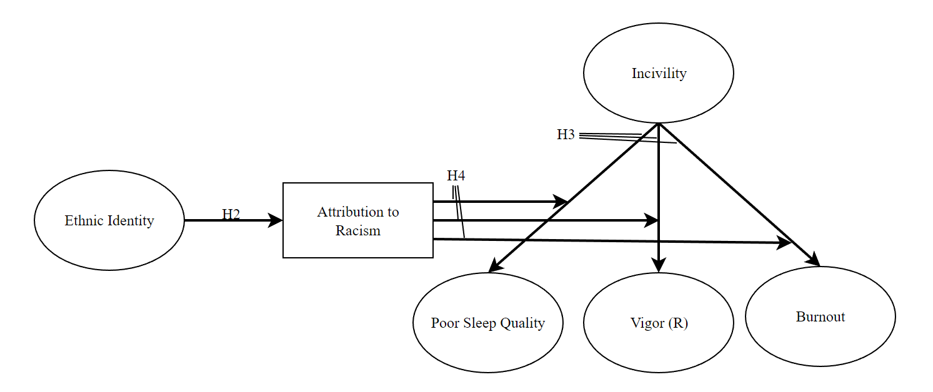

Figure 2. Model 2: Alternative Model with Direct Moderation of Ethnic
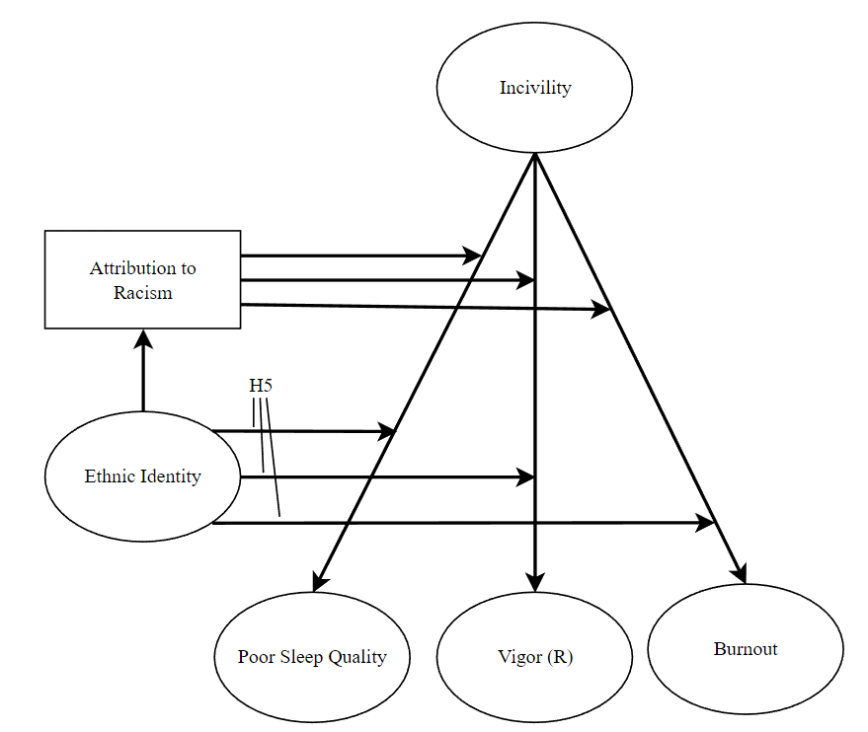
Figure 3. Model 3: Alternative Model with Ethnic Identity as a Covariate
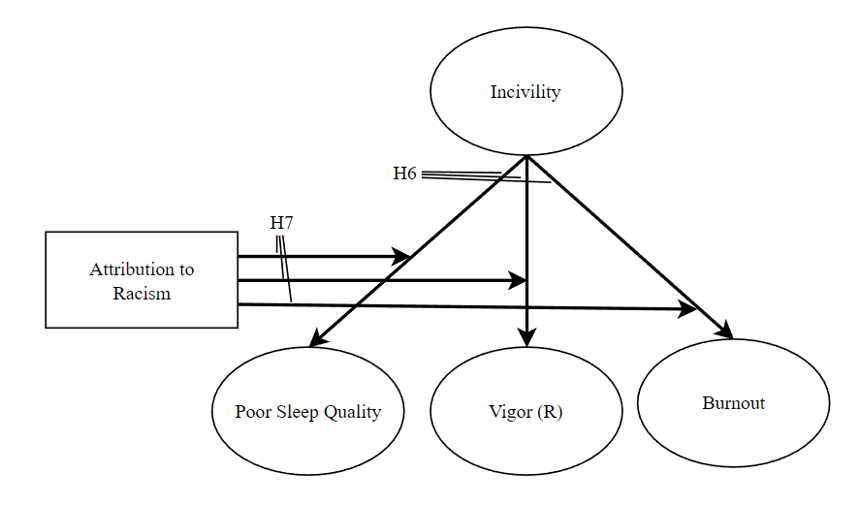
Figure 4. Model 4: Alternative Model with Ethnic Identity Directly Predicting Strain
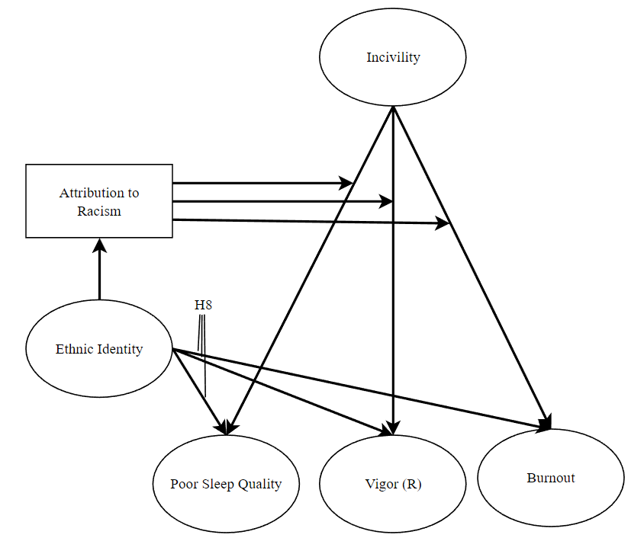
Figure 5. Model 1: Fitted Structural Model
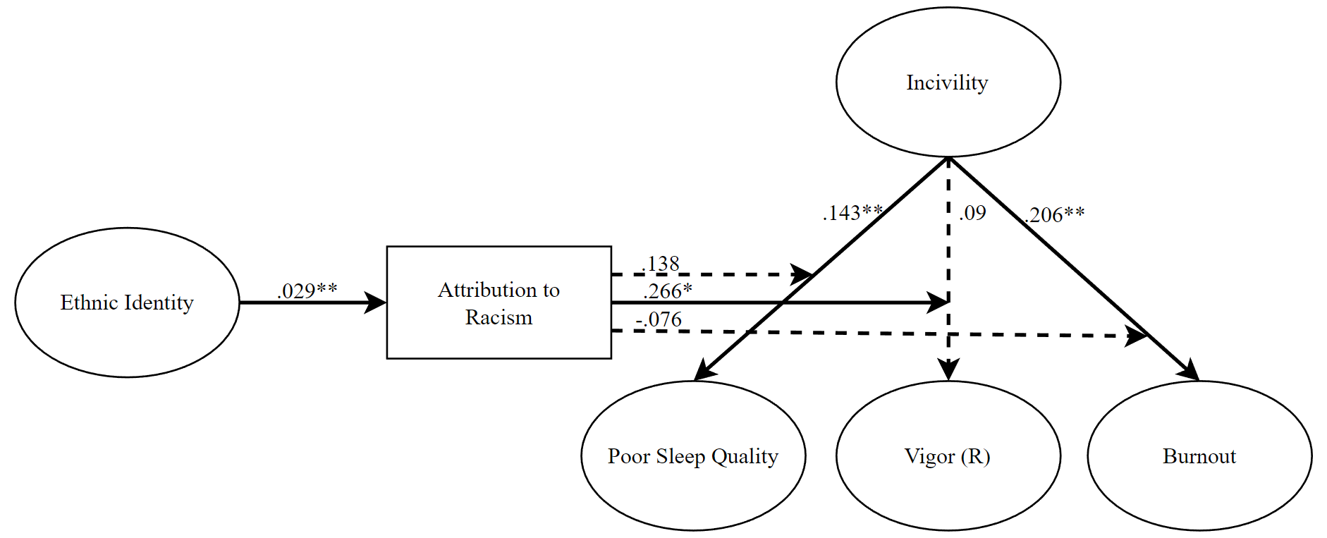
Note. * p < .05, ** p < .01; Standardized estimates reported; dashed lines represent non-significant paths.

Figure 6. Model 1: Graph of Significant Moderating Effect of Attribution to Racism on the Relationship between Incivility and Vigor (R)
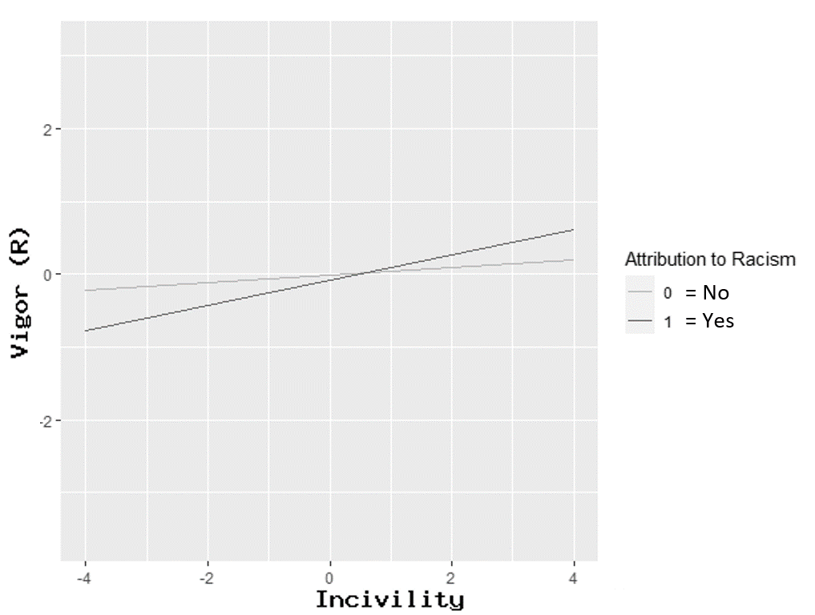
Note: (R) indicates reverse coded scale

Figure 7. Model 2: Fitted Structural Model
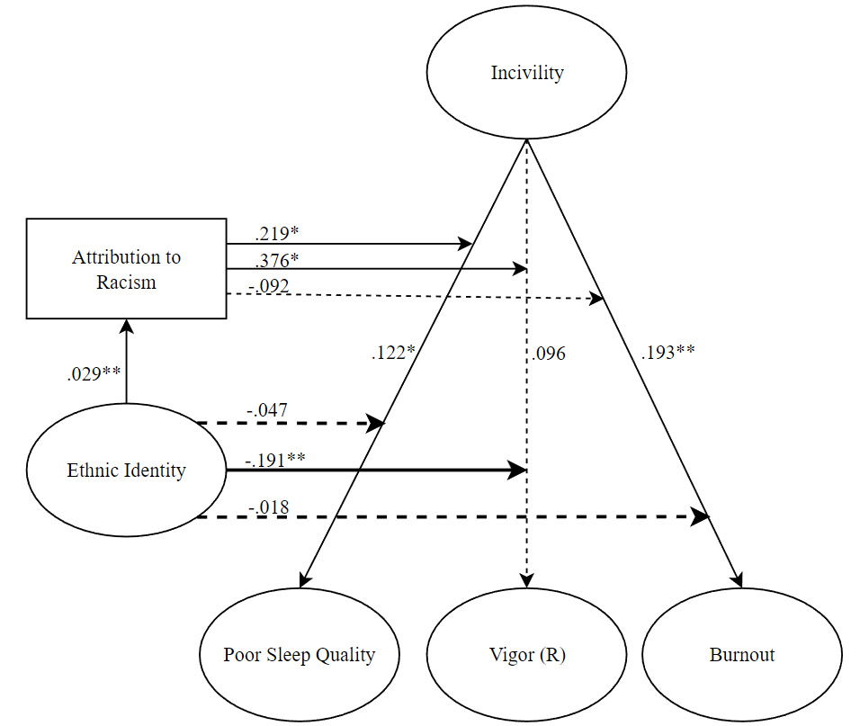
Note. * p < .05, ** p < .01; Standardized estimates reported; dashed lines represent non-significant paths.

Figure 8. Model 2: Graph of Significant Moderating Effect of Attribution to Racism on the Relationship between Incivility and Poor Sleep Quality
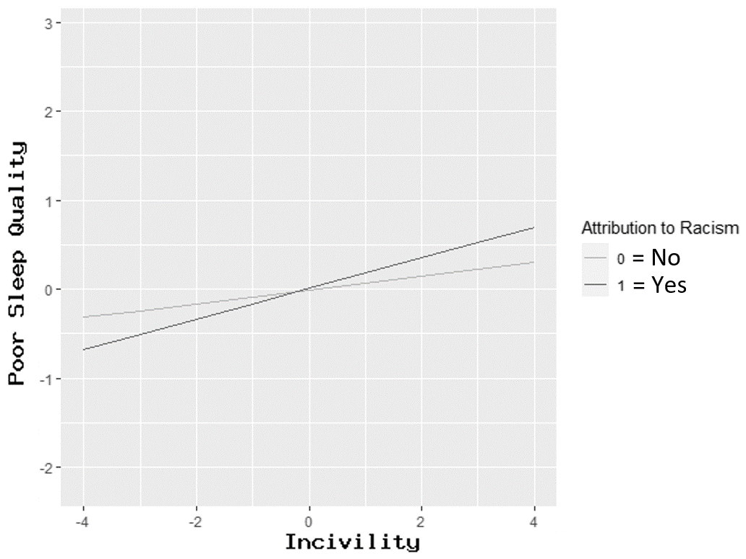 Note: (R) indicates reverse coded scale

Figure 9. Model 2: Graph of Significant Moderating Effect of Attribution to Racism on the Relationship between Incivility and Vigor (R)
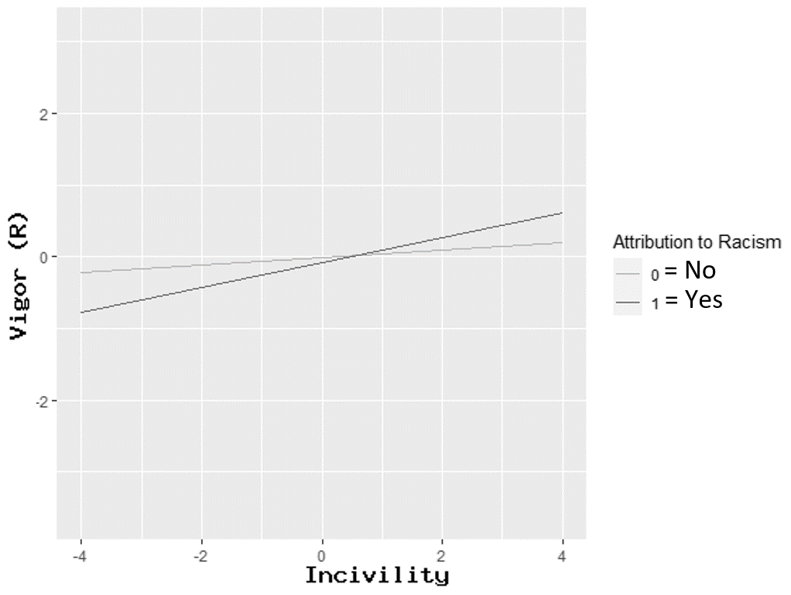 Note: (R) indicates reverse coded scale
Figure 10. Model 2: Graph of Significant Moderating Effect of Level of Ethnic Identity on the Relationship between Incivility and Vigor (R)
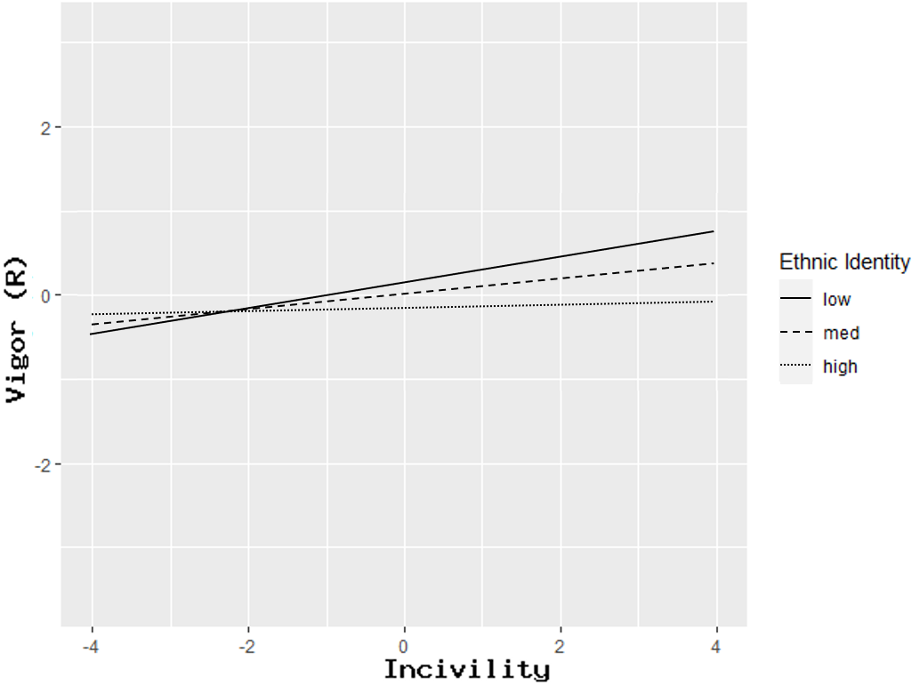 Note: (R) indicates reverse coded scale

Figure 11. Model 3: Fitted Structural Model
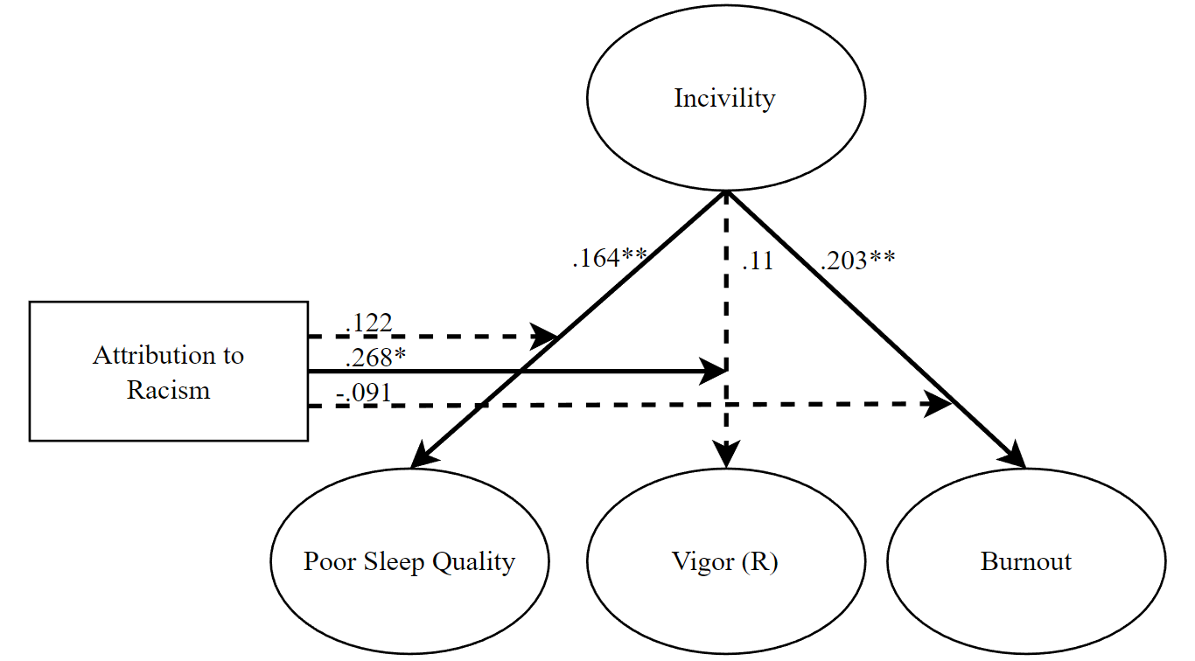 Note. * p < .05, ** p < .01; Standardized estimates reported; dashed lines represent non-significant paths.

Figure 12. Model 4: Fitted Structural Model
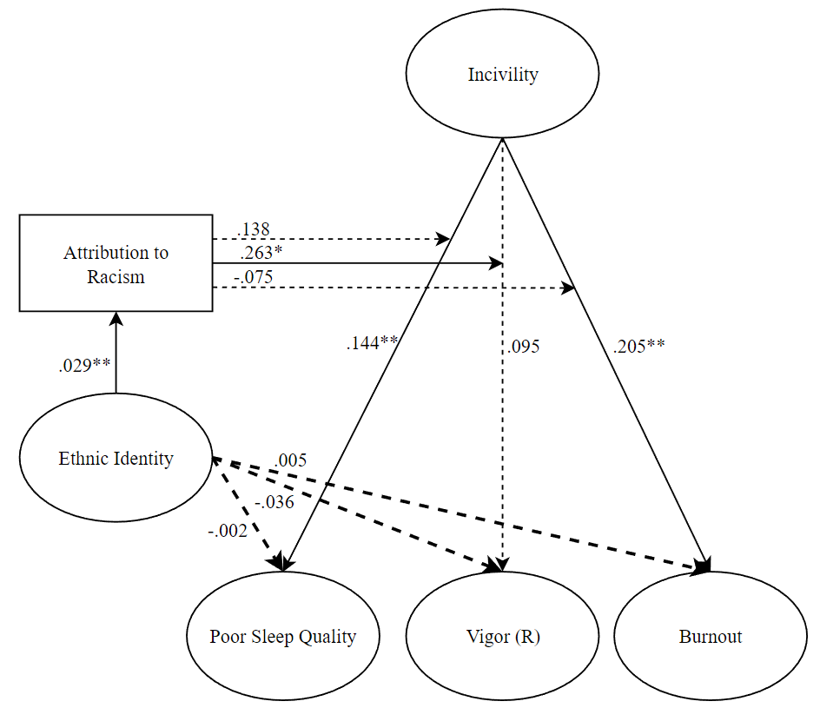 Note. * p < .05, ** p < .01; Standardized estimates reported; dashed lines represent non-significant paths.

Appendix A: Screenshots of Survey Measures
Note: Only screenshots of the measures used in the study are included. The screenshots are how the survey appears to participants.

