University of Oklahoma

Graduate College

Glycopeptide Detection, Selection, and Characerization through a Liquid Chromatography-Mass Spectrometry-Differential ion mobility Platform

A thesis

submitted to the Graduate Faculty

in partial fulfillment of the requirements for the

Degree of

Master of Science

By

dANIEL gRAHAM dELAFIELD
Norman, Oklahoma
2018

GLYCOPEPTIDE DETECTION, SELECTION, AND CHARACERIZATION THROUGH A LIQUID CHROMATOGRAPHY-MASS SPECTROMETRY-DIFFERENTIAL ION MOBILITY PLATFORM

A thesis approved for the
Department of Chemistry and Biochemistry

By

______________________________
Dr. Si Wu, Chair

______________________________
Dr. Christina Bourne

______________________________
Dr. Shaorong Liu

© Copyright by Daniel Graham Delafield 2018
All Rights Reserved.

Acknowledgements
It is my firm belief that no graduate student is successful solely because of his or her own doing. The construction of a thesis and graduation from a university serve as tribute to the men and women who provide unending support through the long and sometimes arduous years a student spends at study. First and foremost, I would never have been able to reach this point in a scientific career if it had not been for the educational mentors who fostered my desire to learn and achieve. I consider all the men and women who served as my educators to be foundational to my current successes, though there are a few to whom I must give special recognition. To Mrs. Jill Sullins, who first introduced me to the field of Chemistry, for noticing my aptitude and appreciation for science and cultivating within me a spirit of achievement and ingenuity. To Ms. Torie York who taught me that the most important lessons in life are not found in books and that every person, regardless of circumstance, is capable of the greatest accomplishments. To Mr. Mike Lowery who accepted nothing but excellence and repeatedly demonstrated the worth of a love for learning. And to Mrs. Cheri Blackwood, whose knowledge, teaching prowess, and passion for science serves as inspiration even today; without her instruction, my love of chemistry and any academic or professional accomplishments would not exist.
Furthermore, a different and more direct sense of gratitude should be given to my current mentor and primary investigator, Dr. Si Wu. Before participating in her research as an undergraduate student, never once did I believe that a career in chemistry could be as rewarding or endearing as I now profess. Through constant admonishment, she has shown me that lacking knowledge is an inevitability but the confidence to persevere and desire to learn are the mindsets to which we must always adhere. I will never forget the experiences I have shared as a member of her group and I can only hope that my future accomplishments serve to reflect on the quality of guidance she has provided.
Finally, there is no person or group of people who has inspired or provided me more than my immediate family, to whom I will forever be indebted. To my sister, Aubrey, for repeatedly achieving and displaying nothing but the highest qualities of an individual. She is the person to whom I constantly compared myself and inspired me to grow and accomplish more than I ever imagined possible. To my brother, Cooper, for displaying an outstanding mental fortitude and appreciation of the highest levels of intellect. Through maturing with him I have learned lessons far more valuable than those found in my education and have been shown the reward of personal investment. Finally, to my father, Fred, and mother, Mary, who are now – and will always be – the greatest contributors to my achievement. Their mutual love for science certainly makes my current life path seem almost predetermined, but I know they would love and support me no less regardless of my passions or desires in life. All that I have been, all that I am, and all that I will be should serve as a testament of their devotion to our family.

Table of Contents

Acknowledgements iv
Table of Contents vi
List of Tables x
List of Figures xi
Abstract xiii
Chapter 1: Glycobiology 1
1.1 Introduction 1
1.1.1 Structural Diversity in Glycosylation 2
1.1.2 Glycoform Distinction 4
1.2 Biological Significance of Glycosylation 5
1.2.1 Glycans as Receptor Ligands and Viability Moderators 6
1.2.2 Traditional Techniques for Glycan Analysis and Their Limitations 8
1.3 Further Analytical Challenges in Glycosylation Studies 10
1.3.1 Microheterogeneity 11
1.3.2 Specificity and Activity of Glycosyltransferases (GSTs) 13
1.4 N-Glycans 16
1.4.1 Process of N-Linked Glycosylation 16
1.4.2 Heterogeneity Found in N-Glycans 17
1.5 Conclusion 18
Chapter 2: Proteomics-Based Glycosylation Studies 25
2.1 Considerations for Glycoform Analysis 25
2.1.1 Top-Down Proteomics and Limitations in Glycoprotein Analysis 25
2.1.2 Drawbacks of Enzymatic Glycan Release 27
2.2 Bottom-Up Glycoprotein Analysis 28
2.3 Conclusion and Future Directions 30
Chapter 3: Gas Phase Separations Prior to Mass Spectrometry 34
3.1 Introduction and Mathematical Derivation of Mobility, K 34
3.2 General Features and Design of Drift Tube Ion Mobility 37
3.3 Consideration of Gas Composition and Pressure 39
3.3.1 Ideal Drift Gases and Electron Scavengers 39
3.4 Proven Applications of Ion Mobility Spectrometry 41
3.4.1 Relevance of IMS to Current Work 42
3.5 Expanded Ion Mobility Instrumentation 43
3.6 High-Field Asymmetric-Waveform Ion Mobility Spectrometry (FAIMS) 45
3.6.1 Effects of Asymmetric Electrical Field on Ion Behavior 45
3.7 Separation Based on Dipole Alignment 47
3.8 Applications of FAIMS and Relevance to Glycopeptide Analysis 49
3.9 Conclusion and Relevance to Current Work 51
Chapter 4: N-Linked Glycopeptide Feature Characterization Through FAIMS-Coupled Concurrent LC-MS Platform 61
4.1 Abstract 61
4.2 Introduction 61
4.3 Experimental 65
4.3.1 Materials 65
4.3.2 Trypsin Digestion 65
4.3.3 RPLC-MS 66
4.3.4 Oxonium Ion Monitoring 66
4.3.5 Concurrent Fractionation via Triversa Nanomate 67
4.3.6 FAIMS Instrumentation and Method 67
4.4 Results 68
4.4.1 Digestion and Glycopeptide Separation Analysis 68
4.4.2 FAIMS Separation of Base Peptide Glycoforms 68
4.4.3 Optimized Digestion for Increased Glycoform Presence 69
4.4.4 Feature Characterization Through FAIMS Behavior 70
4.4.5 Discrimination of Glycosylated and Non-Glycosylated Peptides 70
4.4.6 Altered Gas-Phase Confirmations for Higher Charge State Peptides 71
4.5 Conclusion 72
4.6 Acknowledgements 73
References 89

List of Tables
Table 2.1 Commonly Occurring Monosaccharides 33
Table 4.1 Compensation Voltage Scan Ranges 75
Table 4.2 Non-Glycosylated Peptides Examined Through FAIMS 86

List of Figures
Figure 1.1 Aldo- and Keto- Sugars 20
Figure 1.2 Glycosidic Bond Formation 21
Figure 1.3 Classes of Commonly Occurring Monosaccharides 22
Figure 1.4 N-Glycan Core Structure and Recognized Classes 23
Figure 1.5 N-Glycosylation Pathway 24
Figure 2.1 Top-down and Bottom-up Proteomics 32
Figure 3.1 Schematic of IMS Drift Region 52
Figure 3.2 Paschen Curves for Pure Gases 53
Figure 3.3 Gas Radius versus Ion Radius 54
Figure 3.4 Schematic of Trapped Ion Mobility Principle 55
Figure 3.5 Traveling Wave Ion Mobility 56
Figure 3.6 Schematic of Differential Mobility Analyzer 57
Figure 3.7 Asymmetric Waveform as Applied to FAIMS 58
Figure 3.8 Compensation Voltage for Ion Path Correction 59
Figure 3.9 Dipole Alignments with Respect to Rotational Energy 60
Figure 4.1 RPLC-MS-FAIMS Platform 74
Figure 4.2 Mass Spectra of Summed Oxonium Ion Detection 76
Figure 4.3 Preliminary RNaseB Chromatogram and MS² Oxonium Ion Abundance 77
Figure 4.4 RPLC Retention of RNaseB Glycopeptides 78
Figure 4.5 FAIMS Separation of RNaseB Base Glycopeptides 79
Figure 4.6 Compensation Field vs. m/z for RNaseB Base Peptides 80
Figure 4.7 TIC and MS² Oxonium Ion Abundance for Optimized Digestion 81
Figure 4.8 Summed Mass Spectra of Multiple Glycopeptide Elution 82
Figure 4.9 RPLC Retention Heat Map for Complex Glycopeptide Mixture 83
Figure 4.10 Ec vs. m/z for Shortest and Longest Peptide Backbone 84
Figure 4.11 Overall Trend in Ec vs. m/z for All Glycopeptides 85
Figure 4.12 Discrimination of Glycopeptides and Non-Glycosylated Peptides 87
Figure 4.13 FAIMS Separation for Charge State Variants 88

Abstract
The cellular functions necessary to sustain life are, in large part, mediated by the collection of translated proteins unique to each organism, referred to as the proteome. Due to the broad and ever-growing number of connections drawn between the proteome and biologically significant occurrences, proteomics has established itself as a critical field of research. Though the vastness of the proteome may be understood when assuming a single product for every translated gene, the complexity grows exponentially when considering the process of post-translational modification inherent for each protein and organism. As post-translational modifications are noted to be crucial in understanding the basic and altered functional states of all proteins, a large emphasis is placed on their identification and characterization. And though all post-translational modifications may be considered intricate, none is more so than glycosylation.
Glycosylation stands preeminent in diversity and functionality when compared to other post-translational modifications. Owing to the fact that such modifications can exist in multiple structures, may incorporate several unique monosaccharide units, and are highly dependent on the enzymatic processes by which they are constructed, glycosylation modifications require careful consideration when one attempts to perform analysis and characterization of any glycoprotein conjugate. Knowing this, the following work should serve to provide context as to the elaborate nature of glycobiology, discussion of possible proteomic workflows useful for glycoprotein analysis, and understanding of gas-phase separation techniques. Such comprehensions are necessary prior to detailing the culminating work where glycopeptide features were characterized through a novel, liquid chromatography-mass spectrometry-differential ion mobility platform.

Glycobiology

Introduction
At the time of conception, the central dogma of biology was an accepted model for understanding how genetic information correlated to the proteins necessary for cellular growth, communication, and function. Slowly, the central dogma evolved as comprehension of biology grew, considering reverse-transcription, gene-peptide relationships, and various other biological revelations. As scientific endeavors pushed forward, and the disciplines of genomics, transcriptomics, metabolomics and others gained recognition, the central dogma became an oversimplification of the reality occurring between the formation of DNA and its translation into functional proteins. Regardless of what genes are present, and the level to which they may be expressed within an organism, the critical intermediate between genetic information and cellular function is the proteome. Referring to the collection of all proteins expressed within an organism, the expansive nature of the proteome is only truly recognized when accounting for the number of proteins expressed, the varying number of protein replicates, and the uniquely identified proteins that differ only by the post-translational modifications contained therein. Post-translational modifications, much like the proteins on which they may be deposited, are diverse in type, abundance, and functionality, making the accurate discussion of such a broad substituent class far outside the scope of this thesis. However, one post-translational modification (PTM) that stands out among the rest due to its unrivaled diversity, complexity, and implications in biological function, is glycosylation – around which the proceeding discussion and research is modeled. The intricacies of this modification are quite extensive and accurate introduction must be given to foster understanding and appreciation of the later study.

Structural Diversity in Glycosylation
The glycosylation of a protein involves the enzymatically controlled transfer of oligosaccharide moieties to the peptide backbone of proteins. These oligosaccharide moieties – referred to throughout as “glycans” – are composed of repeating cyclic monosaccharide motifs, linked together by glycosidic bonds.¹ As ring formations of these carbohydrate entities are produced, a chiral anomeric center is formed; this chiral center, or anomeric carbon, resides in the C-1 position for aldo- sugars and C-2 for keto- sugars¹ (figure 1.1). The glycosidic bonds that join monosaccharides involve a water-loss step as the hydroxyl group of the anomeric carbon leaves to make way for a new bond between the anomeric carbon and a hydroxyl-group oxygen of another monosaccharide ring. As cyclic monosaccharides have hydroxyl groups available on most, if not all, carbon centers, glycosidic bonds are named according to the carbons on each ring that terminate the newly-formed connection (e.g. 1-3, 1-4, 1-6, etc.) (figure 1.2). And since glycosidic bond formation is not restricted by stereochemistry, glycosidic bonds are further distinguished according to the identical or opposite orientation (i.e. axial or equatorial position) of the hydroxyl groups attached to the anomeric carbon and the stereocenter furthest in distance from the chiral center – α linkage referring to identical stereochemistry and β referring to the opposite (figure 1.2). Glycans are made more complex by the fact that multiple types of sugar residues exist in biology, all of which maintain the same ability to form glycosidic bonds. Monosaccharides incorporated in glycan chains typically reside within one of six classes: pentoses, hexoses, hexosamines, 6-deoxyhexoses, uronic acids, and nonulosonic acids (figure 1.3) – hexoses and hexosamines being of immediate relevance to the following work.^{(4.1)} And within these six classes, there are shown to be more than seventy unique monosaccharides in total – though only twelve are considered commonly occurring¹ – representing the extreme diversity that can arise when examining possible residue combinations.
Complicating matters even more is the consideration of how these sugar chain moieties are attached to their conjugate substrate. Briefly, glycoconjugates exist in three distinct classes: glycosylphosphatidylinositol – which serves as the lipid anchor for many cell-surface proteins,² glycosphingolipids and glycosaminoglycans – important for signaling pathways and membrane structure,³ and glycoproteins. The latter class of proteins as a conjugate species is one of breadth and complexity that cannot be easily summarized but may be slightly simplified due to the overwhelming abundance of certain binding sites compared to others. When referring to glycoproteins, glycan moieties are divided between the classically referenced O- and N-linked glycans. These groups denote the element – oxygen or nitrogen – with which a glycan moiety forms a glycosidic bond and, therefore, also provide assignment with which amino acid residues glycosidic linkages may be formed – an important distinction that is discussed later in detail. ^{(1.3.2)} The variations in glycan structure discussed so far – glycosidic bond location, α/β orientation, and constituent residues – begin to reveal the truly complex nature of glycan moieties and attempting to simultaneously evaluate the staggering number of proteins to which these glycans may be attached drastically obscures glycan and glycoprotein comprehension. This inherent diversity of glycan-conjugate complexes brings with it terminology useful for referring to structural or compositional differences.

Glycoform Distinction
Glycosylation, like all post-translational modifications, is an enzymatically controlled process. The nature of enzymes responsible for glycan construction and deposition will be discussed, ^{(1.3.2)} but since variable enzymatic activity is a common biological occurrence, it is easy to imagine the variation of glycoprotein species due to slight inconsistencies in enzyme behavior. Since the enzymes involved in glycosylation – transferases and glycosidases – are highly specific in their function and will all constitutively attempt to perform their various processes, it may be reasonably understood that a collection of multiple localized enzymes could not only create multiple copies of the same glycan moiety and glycoprotein product but can also produce glycan moieties unique in structure and composition. These unique moieties – that can differ by as little as a single glycosidic bond or be completely void of all resemblance to one another except for attachment site on their conjugate – give rise to the term “glycoform.”¹ Commonly used throughout the subsequent discussion and across literature of multiple disciplines, “glycoform” is used to denote variation between otherwise identical glycan-conjugate pairs. For sake of clarification, two glycoproteins identical in sequence, structure and modification except for a missing glycan on the latter are classified as unique glycoforms. Another example of differing glycoforms can be seen when two copies of the same glycoprotein are modified at the same site but the glycan on one protein incorporates glucose residues, whereas the glycan on the adjacent protein incorporates galactose residues. This trend continues to be true, so long as any structural or compositional difference exists between otherwise identical glycoconjugates. However, while further understanding the differences between – and characterization of – glycoforms certainly aids in explaining the complex phenomenon found within glycoconjugates, such an explanation would be considered superficial without first discussing the impacts of glycosylation and comprehending the biological importance found therein.

Biological Significance of Glycosylation
Numerous significant investigators from over a century of dedicated research have led to this point where such deep knowledge of glycoconjugates is readily available for retrieval and expansion. However, it would be disingenuous and irresponsible to ignore the reason behind the enormous dedication of time and energy allotted to glycobiology. The biological implications of glycoconjugates continually grow in number due to the sheer number of ways a glycan may function within an organism. And, though glycans could later be proved to participate in a litany of biological and biochemical pathways, currently, the importance of glycans is realized through their role in three classically recognized areas: structural and modularity roles – especially those pertaining to nutrient sequestration and storage, recognition and signaling pathways – commonly attributed to extrinsic and intrinsic glycan binding proteins, and molecular mimicry – the process by which foreign species emulate the modifications expressed by a host to inspire increased tolerance.¹ Though a glycan may participate in one or all of these roles,¹ the importance of all individual glycan moieties is still not fully realized. This unfortunate reality stems from functions often being time-dependent within the lifespan of the host organism, the effects of active glycans being quite subtle and difficult to recognize, and modulation in glycan activity based on the cellular or molecular environment.¹ For these reasons and others, techniques commonly employed to elucidate glycan structure and function are often quite limited in success. ^{(1.2.2)}

Glycans as Receptor Ligands and Viability Moderators
Though much time could be spent attempting to fully detail the ways in which glycans are utilized within different organisms, one of the most important and heavily studied areas of glycan interaction and function is the large class of protein messengers that recognize them – glycan binding proteins. Glycan binding proteins (GBPs) come in one of two varieties: intrinsic or extrinsic. Intrinsic GBPs are noted as such because they specifically recognize the glycans from an organism or conjugate identical to the one on which the GBP resides, where extrinsic GBPs are those that recognize glycans expressed by foreign organisms and substrates. As GBPs are a major – if not the predominant – class of glycan receptors, they serve as initiators of the many biological processes described above, ^{(1.2)} such as nutrient storage and sequestration. However, due to the importance of GBPs to the survival of the host organism, they are often used as a means of exploitation by invading species and pathogens.
“Molecular mimicry” refers to the process by which microbial pathogens modify their exterior surface to incorporate the glycans exhibited by the host organism, usually to escape immune response or rejected recognition that would result in death of the invading species.¹ This process is not to be confused with “molecular gimmickry,” where the pathogen or invading species – through successful infiltration and imitation of host glycans – begins to slowly increase a host’s tolerance for the pathogen by acclimating it to lower levels of undesirable glycans. Both molecular mimicry and gimmickry serve to illustrate how integral glycan-protein interactions are to the overall viability of an individual organism.
Furthermore, if the biological relevance of these protein interactions is accepted, it would imply that any gene defects revealed to alter protein function would also impact the modifications expressed on proteins or functions of the proteins that recognize them. Genetic defects of this type have been successfully promoted and observed in cell cultures through the alteration of growth conditions or introduction of stressors.¹ When observing the result of genetic defects on an individual cell, there was very little effect, if any; however, when examining the same genetic defects within a complex organism, severe and catastrophic results were reported.¹ These studies serve to, again, reinforce the significance of glycan expression and recognition, and also that the major roles of glycans operate mainly within intact, multicellular organisms.¹
Another pivotal, readily studied task of glycan modifications is protection from or redirection towards degradation. A simple example of protection can be found when examining bacteria. The glycocalyx, or paricellular matrix, that surrounds the cell membrane is largely composed of glycan chains extending away from their transmembrane glycoprotein conjugates. This matrix offers a level of protection from species that seek to attack or consume the bacterium by serving as a repository of glycans that can be beneficially recognized and also by acting as a physical barrier.¹ However, where the glycans found in the glycocalyx act to prevent degradation, glycans deposited during protein maturation can conversely be used to redirect their conjugates towards degradation. Glycosylation is noted as a competing factor to protein folding,¹ meaning that glycans are transferred to the peptide backbone before or during the formation of secondary structures and that proper folding can only occur when the deposited modifications promote the preferred folded structure. Protein misfolding is a biochemical normality, and incorrectly folded proteins are typically marked for digestion and recycling, as has been noted time and time again. Therefore, since glycoproteins are successfully modified, secreted and allowed to function in all organisms, it must be reasonably concluded that proper protein folding takes place only when proper modification occurs. Conversely, improperly modified proteins may result in improper protein folding, preventing the conjugate from proceeding past the modification step in the endoplasmic reticulum (ER). The proteins residing in the ER long after release from the translocon will subsequently be redirected towards degradation.¹
In short, though glycans have been implicated in several pertinent biological interactions, of which those listed above are simply representative examples, the process of glycosylation is highly important to the full understanding of protein and organism function. Such a revelation would lead researchers to attempt to learn the exact function resulting from commonly occurring glycan chains, an endeavor pursued through countless techniques, each presenting limitation.

Traditional Techniques for Glycan Analysis and Their Limitations
Though there has been much knowledge obtained about the importance of glycans to the survival, growth, and responses within an organism, ^{(1.2.1)} there is a stark, immediately-noticed disparity between the recognized significance of glycans and the exact functions confirmed to take place. Simply put, the sheer number of unique glycans, variable expression, and time-dependent importance of modifications make the endeavor of function assignment difficult, to say the least. But since nothing in biochemical research is ever straightforward, a brief explanation of common methods and their failures becomes necessary.
One common technique researchers will use to determine how glycans are recognized within an organism is by introducing receptor probes. These receptor probes often come in the form of Galectin-Related Proteins (GRPs) – galectins being a conserved family of β-galactoside-binding proteins.⁴ GRPs will bind with the glycans expressed by the host organism, allowing all unbound species to be washed away, and the GRP-glycoprotein complex can then be extracted and purified for glycan analysis. In theory, this approach would be beneficial for determining the specific modifications found within a certain class of organism but is limited by the fact that GRPs exhibit weak affinity, are multivalent, and their cognate ligands are usually present in multiple copies.¹ These regretful properties of GRPs typically result in aggregation of receptor probes around certain cell types and could result in over-diagnosis of function.⁵ GRPs, therefore, require careful consideration and optimization before reaching reasonable success.
Another common method for glycan analysis is to compare organism function under normal conditions and in the absence of any glycosylation by performing knockout experiments. A popular choice of workflow is to inhibit N-glycosylation through the introduction of tunicamycin,⁶ a mixture of antibiotics that inhibit N-Acetylglucosamine transferases. Workflows utilizing this technique are often limited in conclusion when used in complex organisms because such knockouts often impact unrelated organism processes,¹ making exact assignment of glycan function a near-impossible conclusion.
One other, more specific, form of glycan recognition and detection is done through utilizing glycan binding proteins (GBPs). Because these proteins can recognize specific glycans, they are of great interest to researchers pursuing targeted analysis and seeking to detect the presence of certain glycan chains or glycoproteins. However, it has been noted that the monovalent affinity between a GBP and its ligand is often quite low, indicating a need for GBPs to be introduced in high density to facilitate detection.⁷ And as well, organisms are known to exhibit a variety of glycan structures in different tissue types at different times during development, meaning that GBP studies can result in interactions at a place or time that is of little biological relevance.¹
Though these are certainly not all the possible means of glycan and glycoprotein analysis, they are techniques that highlight both the efforts and limitations in analyzing present glycan moieties and further indicate that novel characterization studies are of immediate importance. However, before improved methods can be conceptualized and tested, it is necessary to understand the challenges presented when studying glycosylation so current analytical methods may be appreciated and potential limitations may be accounted for preemptively.

Further Analytical Challenges in Glycosylation Studies
When attempting to recognize and characterize glycosylation modifications through modern analytical techniques, hindrances abound due to the complexity of the species targeted for study. Glycosylation, as mentioned previously, ^{(1.1.2)} is an enzymatically controlled process that results in multiple glycan products unique in structure and monosaccharide composition, which can be deposited on multiple modification sites in varying abundances. This reality makes appropriate discussion of all observable glycans an ambitious endeavor, necessitating a balance of consideration between the inherent diversity of glycans, and the glycans of immediate relevance. Seen below, ^{(1.3.2, 1.4)} glycans deposited on protein conjugates can be classified as either O- or N-linked, and both should be addressed to fully comprehend the complexity of glycoproteins; however, only N-linked glycans will be discussed in detail due to their broader diversity and relevance to the later work. ^{(4.1)} And to fully appreciate N-glycan diversity, it is important to first discuss the natural and incomparable phenomenon found in glycosylation that leads to extreme the difficulty of targeted analysis: microheterogeneity.

Microheterogeneity
“Microheterogeneity” is the colloquialism used to describe the existence of multiple compositionally and structurally unique glycans that can be found at a single modification site of a protein conjugate. One aspect of microheterogeneity that is commonly discussed is that of glycan structure – referring to the location of α and β glycosidic bonds. Two glycans, each composed of the same number and type of monosaccharides, could demonstrate completely different structures due to the previously discussed ^{(1.1.1)} ability of glycosidic bonds to exist between multiple stereocenters and in multiple orientations. When comparing glycosidic bonds to those of common polymeric species found in biology (e.g. phosphodiester bonds of DNA or peptide bonds of polypeptide chains), it is obvious that glycosidic bonds are far and away greater in diversity, whereas phosphodiester and peptide bonds are highly conserved. However, though structure is a significant consideration in the overall phenomenon of microheterogeneity, the more easily recognized component of the phenomenon comes when examining composition, rather than monosaccharide orientation.
Comparing again to DNA and polypeptides, glycans share in the fact that there is a finite number of possible species that can be sequentially added during construction. DNA is composed of four unique nucleotides, polypeptides are composed of twenty common amino acids, and glycans are primarily composed of twelve commonly occurring monosaccharides, allowing one to extrapolate that glycans produce a diversity greater than DNA but less than polypeptides. This component of microheterogeneity is more readily noticed through analytical techniques because varying the number or type of monosaccharides incorporated into a glycan chain will exhibit changes in analyte character (e.g. greater mass, size, or hydrophilicity), whereas changes in glycosidic bonds typically do not.
The microheterogeneity exhibited by glycoproteins is still quite a mystery, even to those who study it in detail, leaving many questions about the phenomenon unanswered. Analytical researchers are typically concerned with illuminating the variety and abundance with which different glycoforms are expressed in vivo – a question not easily answered even with the most proficient techniques. Furthermore, such a quandary is dwarfed by those attempting to understand the reason microheterogeneity takes place. In an attempt to provide explanation, two leading hypotheses exist to answer why microheterogeneity naturally occurs: i) during maturation, glycoproteins are subject to modification by a series of competing enzymes that yield multiple unique glycans or ii) each cell type is responsible for – and specifically executes – the creation of a small number of glycosylated products and the microheterogeneity observed results from investigating multicellular sources. It could be that neither or both hypotheses are one day confirmed, but despite accepting or rejecting either, understanding the enzymes and processes by which glycoproteins are produced is necessary for full understanding of microheterogeneity and the following work. ^{(4.1)}

Specificity and Activity of Glycosyltransferases (GSTs)
Glycosylation begins with the transfer of activated sugar residues (UDP-N-Acetylglucosamine, GDP-Mannose, etc.) to the lipid substrate dolichol pyrophosphate (Dol-P-P) – the polar head of which is exposed to the cytosolic face of the endoplasmic reticulum (ER). The various enzymes that facilitate the transfer of sugar residues and formation of glycosidic linkages are referred to throughout as glycosyltransferases. Glycosyltransferases (GSTs) constitute a large family of proteins, the functions of which are often generalized as transferring an activated monosaccharide to an acceptor substrate. In general, it is thought that GSTs act linearly and sequentially so that the product of one transferase becomes the acceptor for another, but this is not to say that some GSTs cannot act simultaneously to give unique branched products.
A notable characteristic of GSTs is that of their extreme specificity. It would be logical to assume that, as a glycan is constructed, a GST recognizes only the terminal monosaccharide and either will or will not carry out its function based on that ending residue. Such a thought, however logical, is incorrect. The specificity of GSTs is so high that the activity of a transferase can preferentially select for a terminal sugar based on its connectivity to others, effectively indicating that GSTs recognize more than just a terminal residue. A practical example of this selectivity is seen in the human B blood group where α1-3 glycosyltransferase desires to transfer a galactose residue to the H antigen but will only do so if the substrate has been previously attached α1-2 to fucose.¹ Correspondingly, if one accepts the specificity of the GSTs constructing glycans, it is simple to imagine how the altered expression and activity of one GST would result in the production of extremely diverse glycan chains. Following the basic premise of sequentially acting enzymes, GSTs will elongate and mature glycan chains depending on cell type and modification class (i.e. different GSTs are used to produce O- and N-glycans) until the time when they are ready to be transferred to a protein substrate, at which point a distinct group of transferases takes over.
The GSTs most important for glycoprotein production and function are those that transfer the mono- and oligosaccharide moieties to the polypeptide backbone. Briefly and only superficially discussed herein, the transferases responsible for O-GalNAc (O-linked N-Acetylgalactosamine) modification do not recognize specific peptide motifs as modification “primers,” and instead deposit the mono- or oligosaccharide moieties on the hydroxyl group of any present Serine or Threonine residues, indicating these transferases may not demonstrate the same specificity discussed above. However, it should be further noted that though no peptide motif is required for O-glycan transferases, O-GalNAc modifications are typically found on less structured portions of folded proteins, suggesting a protein’s control over its modification or the preference of O-glycan transferases to select for these regions. Furthermore, since O-glycans are joined to hydroxyl-containing amino acid residues, it is possible for residues other than Serine or Threonine to be modified. These instances are rare, however, and may be considered exceptions to the central or relevant model of glycosylation.
All N-glycans found in eukaryotic organisms are transferred to their peptide substrate by similar processes, which are initiated by one of two oligosaccharyltransferases (OSTs): Oligosaccharyltransferase A (OSTA) or Oligosaccharyltransferase B (OSTB). The function of these two transferase enzymes is essentially the same but are distinguished due to OSTA favoring nascent peptide substrates that are still associated with the translocon, whereas OSTB favors proteins that have separated from the translocon and have entered the ER. These two OST enzymes are significant compared to those facilitating O-glycosylation in that they specifically recognize the polypeptide motif Asn-X-Ser/Thr, where “X” may be any amino acid except for proline,^{1, 8-9} and transfer the oligosaccharide to the amine-group nitrogen of Asparagine. A possible explanation for the exclusion of proline in this motif is that proteins are noted to perform a 180° folding “turn” following a glycosylated residue, which would not be possible with the presence of proline.¹ In either case, the ability of these transferase enzymes to recognize specific peptide sequences, again, points to the high level of specificity demonstrated by the transferases involved in the glycosylation process, reinforcing their impact on the overall phenomenon of microheterogeneity. Now topically understanding the underlying processes responsible for the construction and transfer of glycan species, N-glycans may be described further in detail due to their immediate relevance.

N-Glycans
Where O-glycans form an α1 glycosidic bond between the hydroxyl group of either Serine or Threonine and are commonly comprised of an initial N-Acetylgalactosamine (GalNAc), N-linked glycans form the initial β1 glycosidic linkage between the side chain nitrogen of Asparagine and a N-Acetylglucosamine (GlcNAc) residue. As stated previously, ^{(1.3.2)} N-glycans are transferred only after recognition of the peptide motif (N-X-S/T), a trend that only disappears when examining cytoplasmic or nuclear proteins, which do not definitively express N-glycans.¹ For the proteins that do express N-glycan modifications, there are three major classes into which the glycan moieties fall, all of which begin with the same core structure described below (figure 1.4): oligomannose – where mannose residues extend the core structure, complex – where GlcNAc residues form antennae that extend the core structure, and hybrid – where mannose extends the α1-6 arm of the core and GlcNAc extends the α1-3 arm (figure 1.4).

Process of N-Linked Glycosylation
Expanding on the earlier introduction to the process of glycosylation, ^{(1.3.2)} the glycan precursor, Dol-P, a polyisoprenyl moiety comprised of five-carbon units, receives the first activated sugar residue (GlcNAc-1-P) from UDP-GlcNAc with assistance from ALG7 – asparagine-linked glycosyltransferase 7. The oligosaccharide eventually reaches the classic core structure, GlcNAc₂Man₃, by sequentially adding to the primary monosaccharide one GlcNAc residue and three Mannose (Man) residues in branched fashion (figure 1.4). Upon the transfer of two additional Mannose residues, the glycan has reached the point where it must be “flipped” across the ER membrane for further exposure to the luminal region (figure 1.5). The maturing GlcNAc₂Man₅ glycan must be actively transported across the hydrophobic bilayer due to the extreme hydrophilic character now present from the extending sugar chain – a process similar to that of the classic ABC transporter, facilitated by the flippase² RFT1.¹ It should also be noted that the continued growth on the luminal side of the ER membrane is still dependent on the presence of activated sugar residues (GDP-Man and UDP-Glc) that must also be actively transported across the ER bilayer via flippase proteins. Once exposed to the luminal region of the ER, the glycan continues to grow in length by four mannose residues and three terminal glucose residues – the first two exhibiting α1-3 linkages and the third being bound α1-2, which act as a signal of finality. Upon recognition of these terminal glucose residues, the entire oligosaccharide (GlcNAc₂Man₉Glc₃) is transferred to the available peptide backbone by OSTA or OSTB (figure 1.5).

Heterogeneity Found in N-Glycans
Though the complete process of glycan construction and transfer can be characterized as above, leaving the discussion as is would be to ignore the later steps that contribute to microheterogeneity. Briefly, after the mature GlcNAc₂Man₉Glc₃ glycan becomes attached to the protein backbone, the terminal glucose residue is removed by α-glucosidase I, with the inner two following via α-glucosidase II. Before the newly modified glycoprotein exits the ER, ER α-mannosidase I removes a terminal mannose residue from the central arm to form the GlcNAc₂Man₈ glycan – a process that continues in the cis-golgi to produce GlcNAc₂Man₅ glycans. If the GlcNAc₂Man₅ proceeds without further processing, the secreted or membrane protein will typically exhibit GlcNAc₂Man₅₋₉ modifications. If the GlcNAc₂Man₅ continues in processing, the glycan will grow to form complex or hybrid moieties.¹
Further contributing to microheterogeneity, it is obvious not every protein in an organism’s proteome will contain the peptide motif necessary for N-glycosylation, and not every motif present will receive a modification. It is predicted that approximately 70% of proteins contain the motif and 70% of all motifs are modified¹ – bolstering the glycoform/microheterogeneity conundrum. When it comes to the peptide motif itself, there is very little information that exists to expand upon its selective nature, but some have noted uncommon exceptions where Cysteine occupies the third position rather than Serine or Threonine. The second position, in the same respect does not seem to affect glycosylation overall but may help reduce binding when occupied by an acidic residue (i.e. Aspartate or Glutamate) and may help promote binding when occupied by Phenylalanine. Such changes in motif are also contributors to the overall diversity found when examining N-glycosylation.

Conclusion
Resulting from the highly diverse nature of glycan structure, the large number of monosaccharides that may be incorporated, and the specificity and varying activity of enzymes participating in the complex modification process, glycosylation presents unparalleled complexity, compared to other PTMs. In accordance with this extreme diversity, glycans are implicated in many relevant molecular pathways and are of immediate biological and clinical concern. However, the study of glycans through traditional methods has yielded limited results and many considerations must take place before meaningful analysis may be performed. For this reason, proteomic analysis of glycoproteins typically employs a broad range of sophisticated techniques that do not rely on biochemical processes, making proteomics-based studies more beneficial for detection and analysis of glycoforms, but limited in their revelation of biological underpinnings. However, though many analytical methods are available for use, and more are validated as time goes on, it continues to be seen – and is described below – that analytical approaches lack the ability to cope with the overwhelming intricacies of glycosylation, usually resulting in the sacrifice of one piece of information to obtain another.

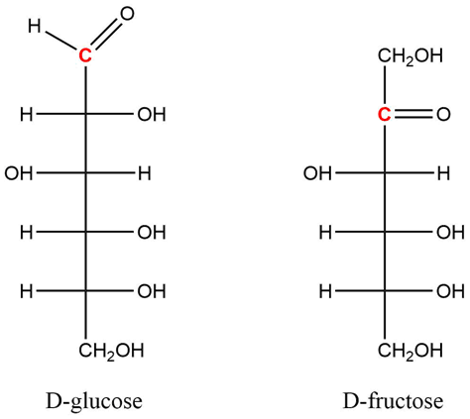

Figure ‎1.1 Aldo- and Keto- Sugars
All commonly occurring sugars exist as isomers or expansions of fundamental aldo- (left) or keto- (right) sugar molecules, such as these representative molecules. The anomeric carbon, highlighted in red, represents the reducing end and corresponds to the chiral center responsible for forming glycosidic bonds. Glycosidic bonds are formed between the anomeric carbon on one residue and a hydroxyl-containing carbon of another.¹ Original figure.

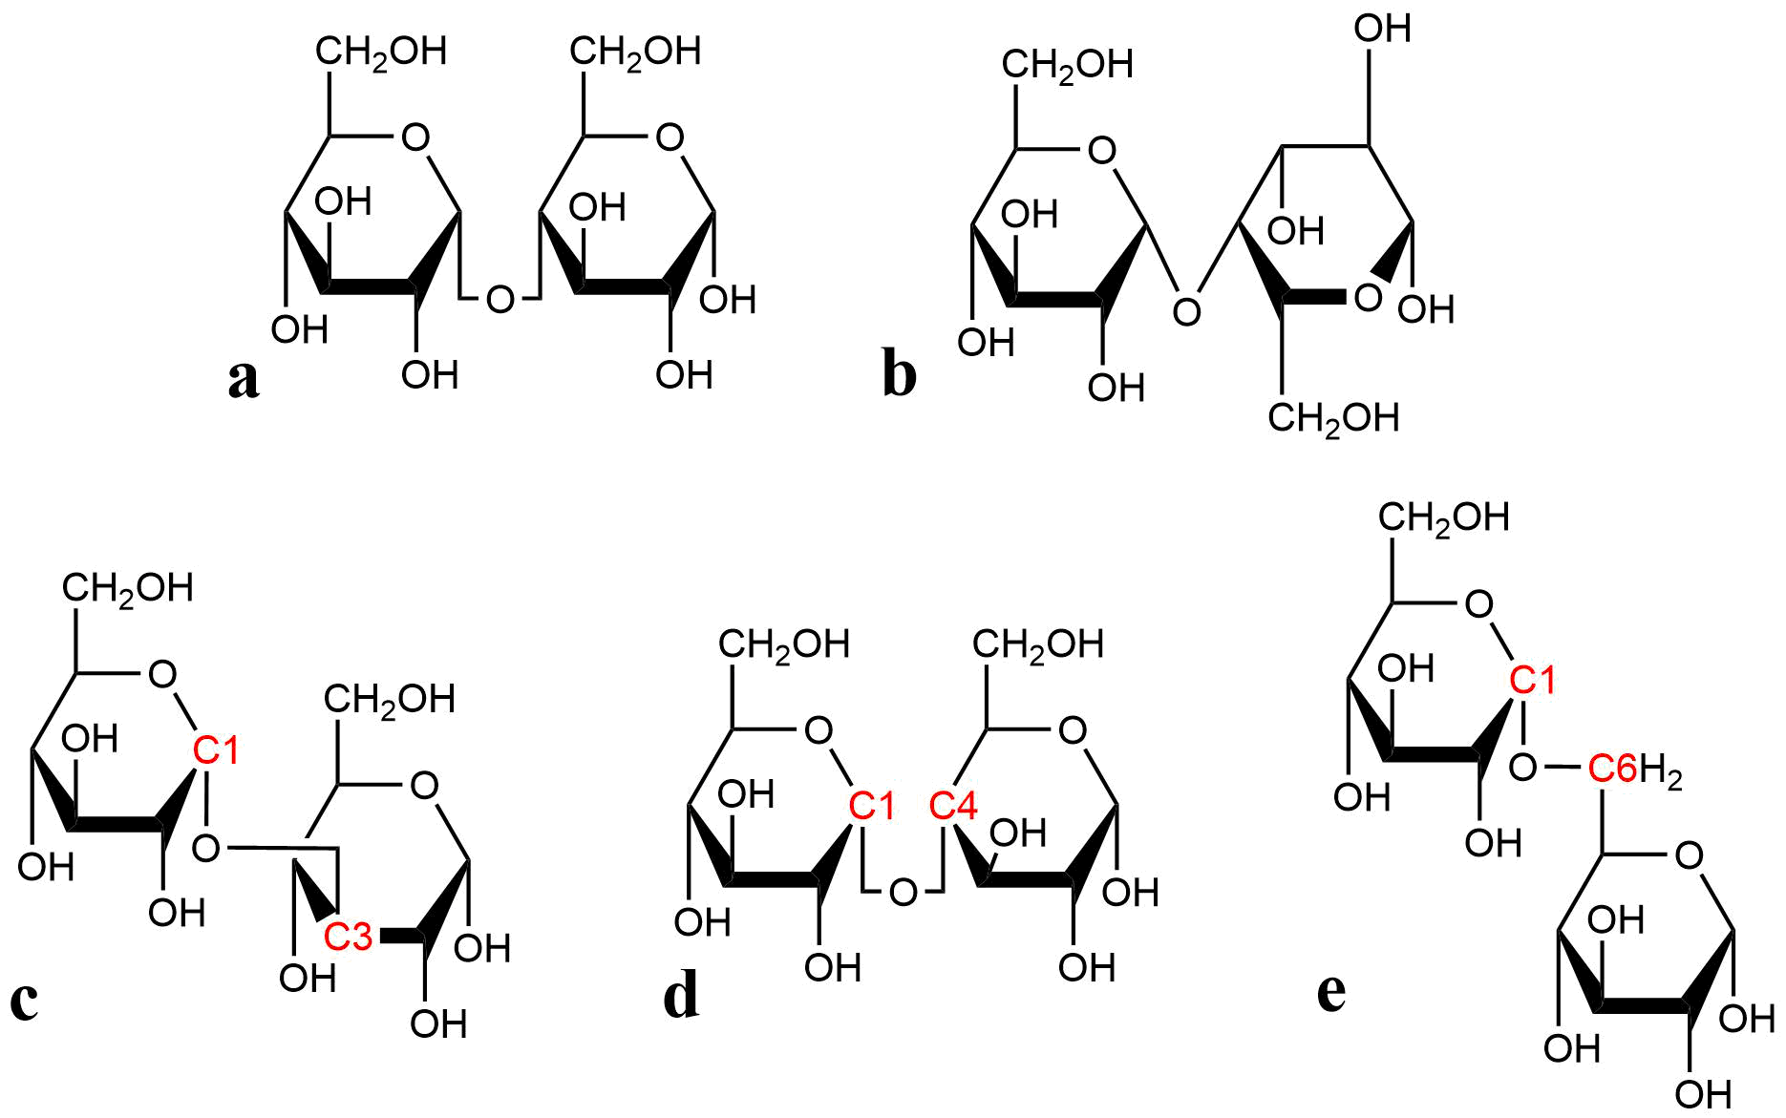

Figure ‎1.2 Glycosidic Bond Formation
Glycosidic bonds are delineated based on multiple characteristics. The first point of distinction is based on the respective stereochemistry of the anomeric carbon and carbon center furthest in distance – alpha (α) corresponding to identical orientation (a) and beta (β) corresponding to opposite orientation (b). Furthermore, glycosidic bonds can be formed between the reducing end of one monosaccharide and any hydroxyl-containing carbon on another and are labeled according to the carbon centers that terminate the glycosidic bond.¹ Carbons of monosaccharides are ordered such that the anomeric carbon is represented as C1. a) 1-3 b) 1-4 and c) 1-6 glycosidic bonds are depicted here. Original figure.

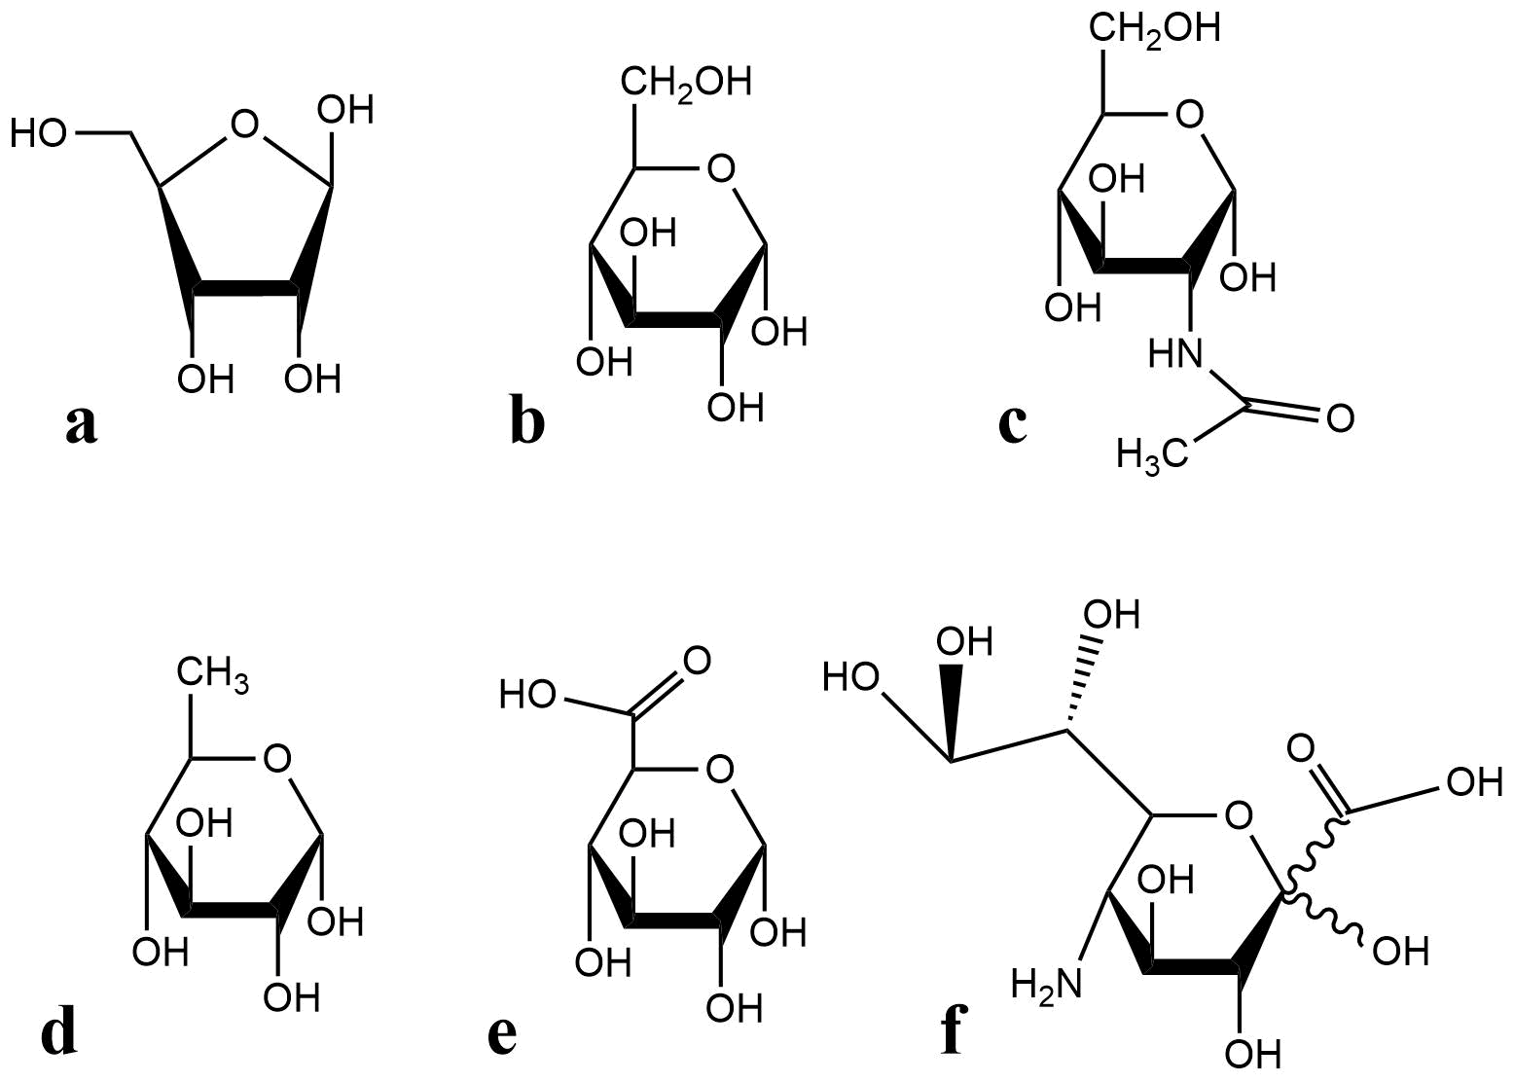

Figure ‎1.3 Classes of Commonly Occurring Monosaccharides
The six classes of monosaccharides, within which all commonly occurring sugar residues are grouped – pentose (a), hexose (b), hexosamine (c), 6-deoxyhexose (d) uronic acid (e) and nonulosonic acid (f) – represented by arbitrary residues. Original figure.

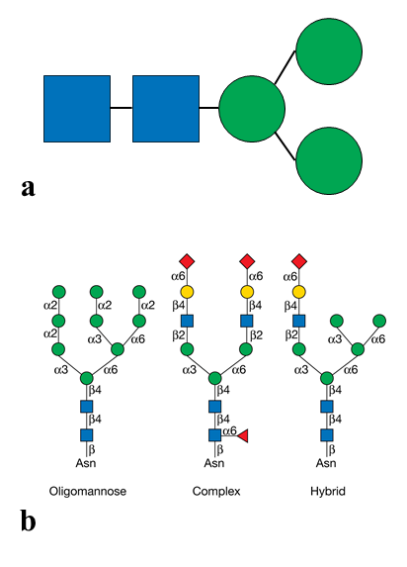
Figure ‎1.4 N-Glycan Core Structure and Recognized Classes
(a) The core structure of all N-glycans, composed of two primary N-Acetylglucosamine residues and three Mannose residues. Original figure. (b) Three recognized classes into which all N-glycan moieties are placed. N-glycans are categorized as either oligomannose – or high mannose (left), complex (center), or hybrid (right).¹ Reprinted with permission from Varki, A. (2009). Essentials of glycobiology. Cold Spring Harbor, N.Y., Cold Spring Harbor Laboratory Press. 2009. Cold Springs Harbor Laboratory Press.

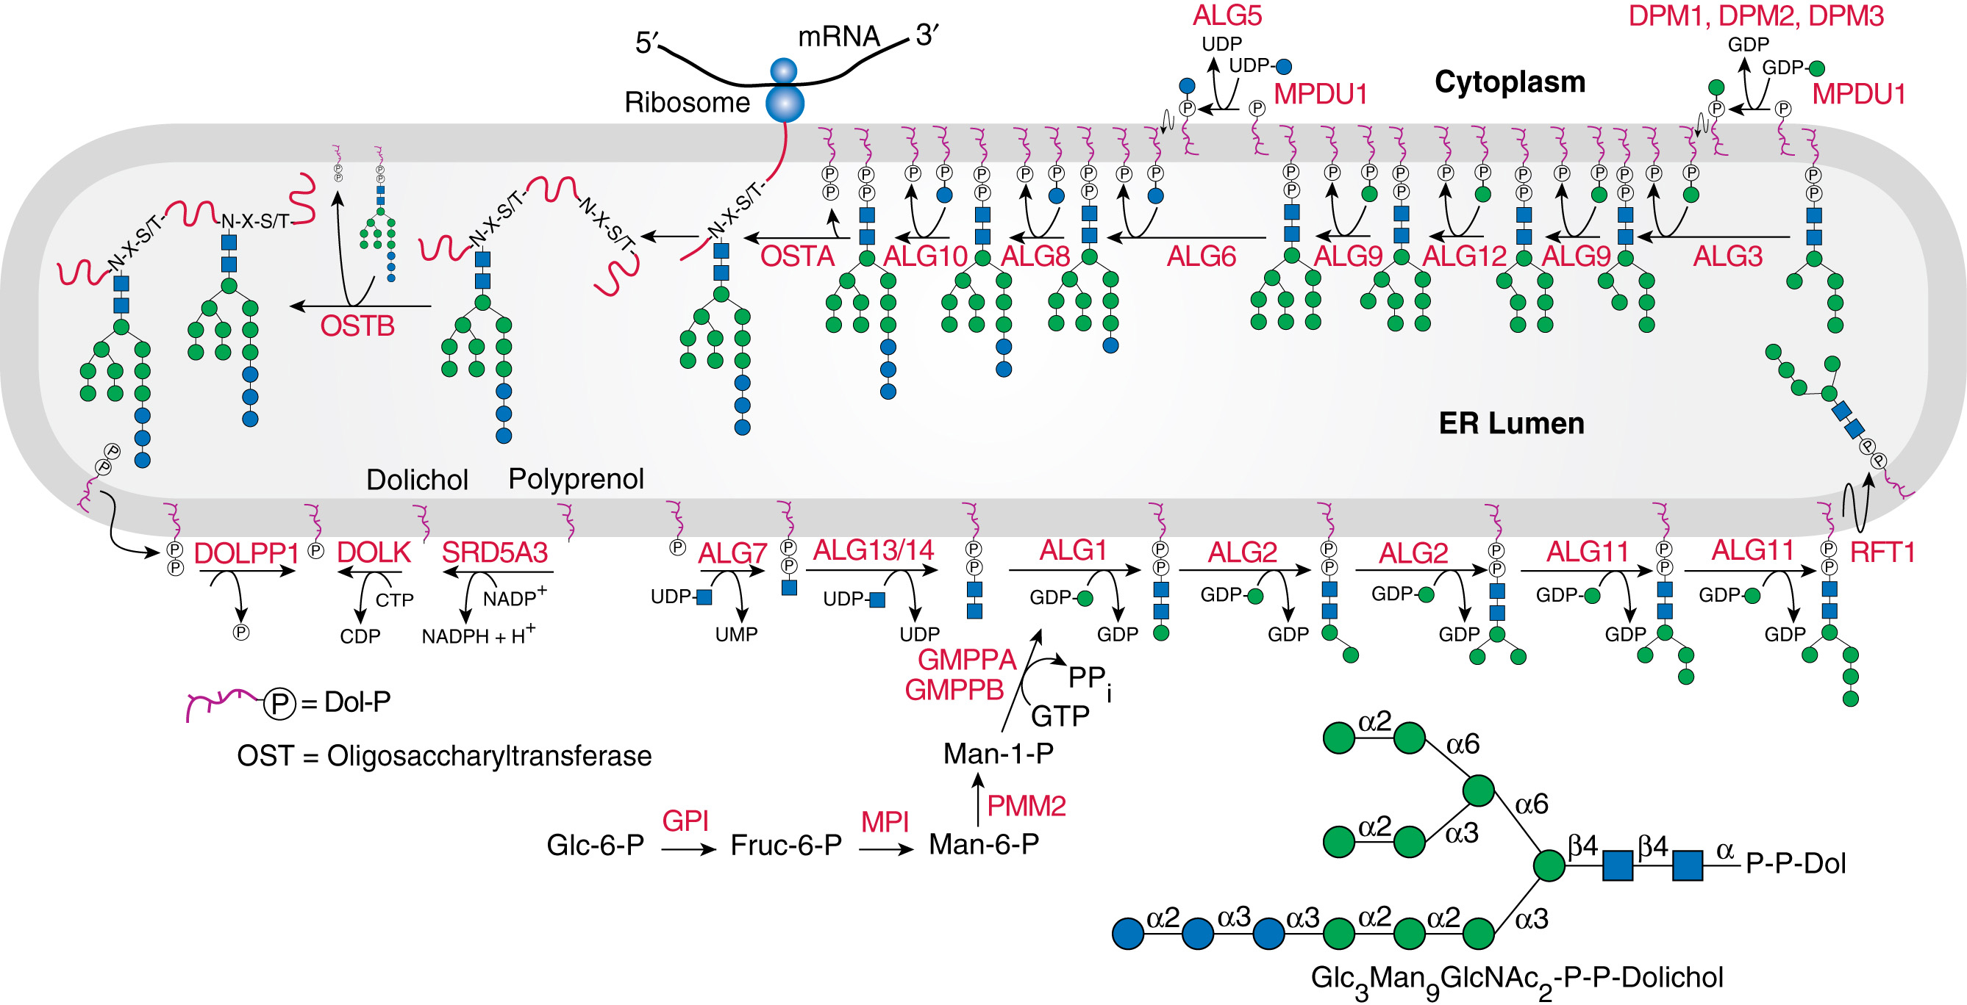
Figure ‎1.5 N-Glycosylation Pathway
Graphical depiction of the formation, elongation, and transfer of oligomannose N-glycans. The precursor, dolichol-phosphate (lower left) receives the initial and subsequent monosaccharides from various asparagine-linked glycosyltransferases (ALG) until reaching a terminal length of GlcNAc₂Man₉Glc₃, at which point the oligosaccharide is transferred to the nascent or maturing protein by OSTA or OSTB, respectively.¹ Reprinted with permission from Varki, A. (2009). Essentials of glycobiology. Cold Spring Harbor, N.Y., Cold Spring Harbor Laboratory Press. 2009. Cold Springs Harbor Laboratory Press.

Proteomics-Based Glycosylation Studies

Considerations for Glycoform Analysis
When arriving at the decision to study glycoproteins, whether through an established method or novel approach, several considerations must take place to ensure reasonable success. At the heart of most analytical glycoprotein studies – assuming one is studying a single or small set of glycoconjugates, the general interest lies in either obtaining information pertaining to the structure and composition of glycans or in determining the number of distinct glycoforms present, when only the more ambitious of studies aspire to do both. Attempting to assign structure to glycan modifications is arguably the more difficult of the two, because structural revelations of glycans relies on successful cross-ring fragmentation through mass spectrometry (MS) or in highly-specific liquid chromatography (LC) techniques.¹⁰⁻¹² Such methods have been proven successful with regular improvements in analytical techniques, but are hampered by the fact that diverse glycans require diverse identification methods, making the successful technique used for some sample types and their glycans unsuccessful for others. This fact would lead one to believe that the most useful techniques for glycan analysis are those that can be universally applied – a point reinforced in the later work. ^{(4.1)}

Top-Down Proteomics and Limitations in Glycoprotein Analysis
On the other hand, if one is seeking to profile all the different glycoforms that may be present in a given sample or set of conjugates, the prevailing strategy is to take the top-down approach, due to its usefulness for broad analysis. “Top-down” proteomics (figure 2.1) refers to the investigation of intact proteins and is usually done through mass-spectrometry (MS) analysis of purified proteins or analysis of protein mixtures separated by liquid chromatography (LC) prior to mass spectrometry. When applied to glycoprotein studies – or the study of virtually any protein – mass spectrometry analysis reveals the accurate mass measurements of all intact proteoforms present in the sample.¹³ Top-down proteomics is an area of relative infancy compared to the bottom-up approach discussed later, ^{(2.2)} and is not without its limitations.
Top-down is usually most successful when applied to a well-purified, single protein or a complex mixture of proteins that is comparably well-separated. This is because, as noted before, ^{(1.3.1)} the microheterogeneity present in glycoproteins would make a complex mixture of diversely modified proteins quite difficult to characterize without careful optimization due to the possibly overlapping signals present on the spectra.¹³ Another challenge to using the top-down approach is the fact that various glycoforms will inherently be more abundant than others, and will, therefore, suppress the MS signal for the low-abundant glycoproteins that are present,¹⁴ making detection of some potentially important glycoforms an endeavor of its own. And even if this top-down approach is taken, the beauty and accuracy of MS measurements can also be considered a drawback. Since glycans are so diverse in their composition – incorporating many different sugar residues that may have the same molecular weight¹⁵ (table 2.1) – achieving an accurate mass measurement of a given glycoprotein would not actually provide any reasonable distinction of glycoforms modifications without further analysis. Furthermore, as top-down methods are still quite limited in their ability to facilitate peptide sequence mapping, obtaining all relevant site-specific modification information may be considered outside the realm of immediate possibility. These limitations may indicate one would be better served by focusing all attention on the glycan chains themselves, which may be released from the protein and studied more efficiently.

Drawbacks of Enzymatic Glycan Release
Top-down analysis of glycoproteins, regardless of the above limitations that must be overcome, does provide great insight into the diversity and number of glycoforms presented in a given sample, but lacks significant capability to do meaningful characterization. Therefore, one may conclude it would be easier to release all the glycans present on protein and study them individually. Glycan release is typically accomplished by introducing PNGase F¹⁶⁻¹⁹ – an amidase capable of hydrolyzing the glycosylamine linkage of a broad range of substrates – or pronase²⁰⁻²² to a purified or a mixture of glycoproteins, allowing their intact glycan chains to be further analyzed. However, though these methods can be useful in determining all the different types of modifications present on a given protein, once a glycan is released, all ability to assign it to a specific modification site on the protein has been lost. The release of glycans from their conjugate protein is, therefore, detrimental to the endeavor of discovering modification function because knowledge of glycan structures is valuable but, to an extent, meaningless if the correlation to active or binding sites of the protein are impossible to determine.
Upon realizing both that site specificity is necessary to holistic protein characterization and that top-down protein analysis could be quite limited for various sample types or individual proteins, there is an emerging need to determine and pursue methods that incorporate the benefits found in both. To this end, studying glycoproteins in a bottom-up fashion seems ever more reasonable and preferential.

Bottom-Up Glycoprotein Analysis
Due to its breadth of application and decades of revision and improvement, bottom-up remains the most popular method for proteome analysis. The “bottom-up” approach is so named for its focus on taking native proteins, denaturing them, introducing a protease, and then studying the resulting peptides.²³⁻²⁵ Bottom-up techniques have been extensively utilized for a broad range of applications, because they can be greatly optimized to allow for high-throughput characterization and quantification of proteome content.²⁵ As bottom-up studies are generally applied to a workflow utilizing MS, the preceding separation and enrichment methods utilized are an area of great importance and interest to researchers.
Focusing on the analytes of immediate concern to the following work, ^{(4.1)} it is fortunate that, when all things are taken into consideration, glycopeptides usually exhibit enough unique characteristics to find a suitable chromatography method to differentiate them both from unmodified peptides and from one another – though no universal approach is accepted for all glycoprotein/glycopeptide studies. Some traditional methods of glycopeptide separation include lectin chromatography,²⁶⁻²⁷ boronate chromatography,²⁸⁻³¹ hydrophilic interaction chromatography (HILIC),³²⁻³⁶ and porous graphitized carbon chromatography (PGC)³⁷⁻³⁸ all of which offer complementary information to one another based on peptide character, and can be coupled together to provide greater separation. In general, each of these separation and enrichment techniques can be applied to more than one sample type, but each reaches limitations when the complexity of sample increases. Also, an unfortunate reality of glycoproteins is that the number of glycopeptides resulting from proteolytic activity will be low in abundance compared to the unmodified or non-glycosylated peptides from the same protein.¹⁹ Accordingly, to do meaningful analysis or quantification for a set of glycopeptides, sample enrichment is often necessary prior to LC separation – a step that may involve careful optimization and may only be beneficial for a small set of glycoproteins.
Enrichment set aside, regardless of how successful or popular a chromatography technique may be, the question of microheterogeneity still exists. If glycopeptides are to be separated according to hydrophilic character, for example, this implies that two identical glycopeptides that differ only in position of glycosidic linkages found within the glycan will not differ in terms of hydrophilicity while being recognized as unique glycoforms. The presence of these isomeric species in bottom-up glycopeptide studies has gained tremendous attention and should effectively be considered its own area of study. To date, there exists very few chromatographic separation techniques that facilitate the separation of glycopeptide isomers, with relative success being found in analyzing permethylated glycopeptides through PGC at high temperatures.³⁹⁻⁴¹ However, the separation and characterization of isomeric species is neither the goal nor the focus of the following work. In order for any isomeric studies to take place, accurate separation of glycoforms would be necessary, which is not readily achieved through commonly applied methods. This lack of adequate glycoform distinction is, therefore, the area requiring immediate attention and is the subject of the presented work.
The challenges to glycoform analysis are far more abundant than simply relegating it to a matter of isomeric separation. Knowing that a single protein may contain multiple glycosylation modification sites, and that each site may exhibit several unique glycan chains of different composition, one can imagine the complexity that would be seen when comparing all the present, unique glycopeptides resulting from one protein conjugate. Using the same logic, one may extrapolate that multiple protein copies or mixtures of several glycoproteins would exhibit an almost insurmountable level of diversity in glycopeptide composition. This being true, it would be insufficient to rely on a single separation component to accurately distinguish each glycoform because there would almost certainly be overlap in analyte character (hydrophobicity, hydrophilicity, lectin affinity, etc.), regardless of the separation dimension utilized. And even if a single separation technique was suitable for this endeavor, such methods would be dependent on accurate enrichment, derivation, and separation prior to MS analysis, decreasing their overall flexibility and universality. Recognizing the stated importance of glycoform separation and characterization^{8, 10, 42-43} and the limitations of accomplishing this through LC, it is noted that an additional separation component would be useful in glycoform analysis and that gas phase separations could provide information complementary to that readily achieved through traditional techniques.¹⁹

Conclusion and Future Directions
Glycoprotein analysis is a complicated endeavor. Utilizing mass spectrometry is undoubtedly the most preferential analytical technique and may, therefore, be assumed as a necessary component in any method conceived. However, with the diversity found in glycoproteins, there are many ways MS may be applied to glycoform analysis, each of which offers limitations. Top-down analysis of glycoproteins will provide revelation of the glycoforms present but cannot distinguish between glycoforms of identical mass, would struggle to identify any glycoforms that are in low abundance, and is limited in its capacity to offer site-specific information. The enzymatic release of glycans from a conjugate would allow for analysis through LC-MS and therefore provide detailed structural information but eliminates any site-specificity and, therefore, the possibility correlating modifications to active protein sites. Bottom-up analysis offers advantages compared to top-down and glycan release through the retention of site-specific information and the ability to provide structural and compositional details. But for bottom up studies to be successful, glycopeptide enrichment and separation is necessary and the chromatography techniques commonly employed lack the power to distinguish analytes of subtle difference and cannot be applied to all glycoprotein or glycopeptide samples.
These realizations indicate the need for further method development. Firstly, one must pursue a method that utilizes bottom-up analysis in order to retain site-specific information. Further, the method should include a means of glycopeptide separation and enrichment from a complex mixture that can be universally applied to all sample types and operate independently of glycopeptide complexity. And finally, there must be a means to distinguish glycoforms from one another, regardless of any subtle differences in composition. Such a method is certainly feasible, as demonstrated below, ^{(4.1)} but should not be confined to separations in the liquid phase. Due to the endearing breadth of gas-phase separations and the information they provide, such methods must be considered both in terms of theory and functionality.
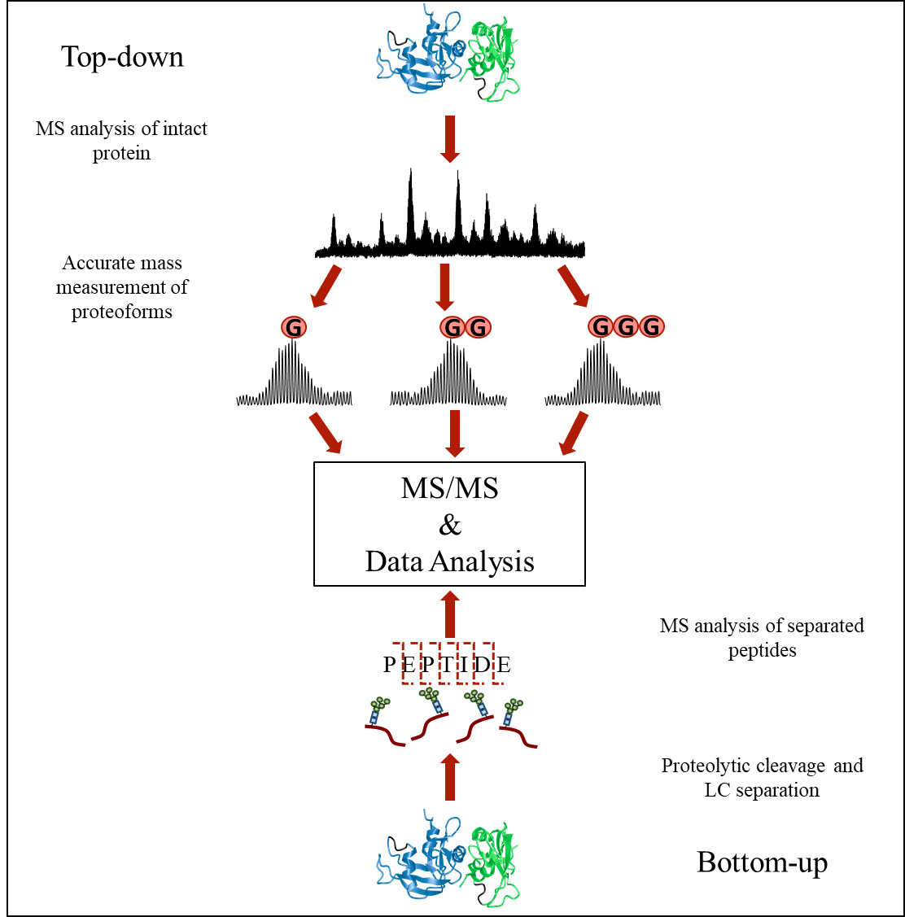
Figure ‎2.1 Top-down and Bottom-up Proteomics
Pictorial representation of top-down and bottom-up proteomics workflows. Top-down analysis relies on protein extraction and purification, at which point native proteins will be analyzed by mass spectrometry, revealing accurate mass measurements useful for revealing the number of glycoforms present. Bottom-up techniques rely on proteolytic cleavage of proteins and examination of peptide masses to determine the presence of modifications.⁴⁴ Original figure.

Monosaccharide | Class | Accurate Mass (Da)
Glucose | Hexose | 180.1559
Galactose | Hexose | 180.1559
Mannose | Hexose | 180.1559
Fucose | Pentose | 164.1565
Glucosamine | Hexosamine | 179.1711
Galactosamine | Hexosamine | 179.1711
N-Acetylglucosamine | Hexosamine | 221.208
N-Acetylgalactosamine | Hexosamine | 221.208
Glucuronic Acid | Uronic Acid | 194.1394
Ascorbic Acid | Uronic Acid | 176.124
Sialic Acid | Nonulosonic Acid | 309.27
N-Acetylmuramic Acid | Nonulosonic Acid | 293.2705

Table ‎2.1 Commonly Occurring Monosaccharides
Though a staggering number of unique monosaccharides have been identified in vivo,¹ a small set are considered commonly occurring. One notable feature of these common monosaccharides is that, often, residues within the same class exist as isomers of one another, exhibiting only structural differences, and, therefore, have identical molecular weights. This adds to the difficulty of glycan analysis in that obtaining accurate mass of the incorporated sugars does not result in instant identification.

Gas Phase Separations Prior to Mass Spectrometry
Gas phase separations as a means to further analyze chemical products stemmed from the initial discoveries pertaining to the formation and behavior of ions in ambient gases,⁴⁵ which are considered to be strongly linked to the studies of lightning that began in the 1700s⁴⁶ and the continued interests in electricity in the following century.^{45, 47} Now collectively referred to as Ion Mobility Spectrometry (IMS), such studies have undergone decades of increased interest, conception, and modified design in governmental, industrial, and academic settings being valued as technique useful for its speed, durability, and reliability.⁴⁵ Though only the most in-depth writings would provide a complete understanding of IMS, a brief explanation of IMS features and relevant applications should be provided to better comprehend the following work described in Chapter 4.

Introduction and Mathematical Derivation of Mobility, K
As the name suggests, ion mobility spectrometry techniques are built around the utilization and exploitation of the mathematically defined mobility (K) that is both inherent and unique for a given ion in the gaseous phase when introduced to an electric field. To obtain a superficial and working knowledge of such IMS techniques, it would be simple to say that every observable ion exhibits unique movement in response to an electric field and can, therefore, be separated from others due to that quantifiable difference. However, since ion mobility techniques continue to grow both in number and complexity, such a simple explanation of this ion characteristic would be insufficient. For this reason, we must briefly look at an expansion of traditionally accepted physics⁴⁸ to understand the mathematical definition of mobility, K.
Molecular diffusion is defined by Fick’s First law:
 | $$J_{m}=-D∇_{N}$$ | (2.1)
where
J_{M} is the molecular flux (number of molecules flowing through unit area per unit time)
∇_{N} is the concentration gradient
D is the diffusion coefficient, a molecular characteristic
More complicated however, is molecular diffusion in gases, D. In these instances, D is determined as
 | $$D=\frac{3}{16}{\left(\frac{2πk_{B}T}{μ}\right)}^{1/2}\frac{1}{NΩ}$$ | (2.2)
where
k_{B} is the Boltzmann constant
T is the gas temperature
µ is the reduced mass of the diffusing and gas molecules – m and M, respectively
N is the number density of gas molecules

 | $$μ=mM/(m+M)$$ | (2.3)
Ω, the value introduced above (equation 2.2), refers to the orientationally averaged collision integral of a species. Since the orientation of the diffusing and gas molecules are random, there exists an infinite number of orientations present. However, to give a more definite value, Ω is equivalent to only the first collisional integral defined in the transport theory⁴⁹ and Ω is, from here on, equated to the collisional cross section (CCS). Once the diffusion of molecules in gas and its relation to CCS are realized, one may dive deeper into the properties presented in gas-phase separations.
Defined by Newton’s second law, Ions of charge q that are subjected to a fixed electric field, E, experience a force constant and equal to qE. Further described by the same law, in the presence of a vacuum, ions fly with constant acceleration, $θ$.
 | $$θ=zeE/m$$ | (2.4)
where
z = q/e is the ion charge state
e is the elementary charge
Ion velocity, v, accordingly, increases linearly with time, t:
 | $$v=zeEt/m$$ | (2.5)
In the presence of an electric field, however, ion velocity cannot simply increase without end. Objects subjected to Coulomb force – or any force, for that matter – will eventually reach terminal velocity, referred to as drift velocity, v. In IMS, each species has a unique v and is separated by mobility, K.
 | $$K=v/E$$ | (2.6)
This mobility value can be linked to the gas-phase diffusion value through the Einstein relationship (or the Nernst-Townsend-Einstein relationship):
 | $$K=Dq/K_{B}T$$ | (2.7)
Therefore, the overall mobility of an ion also depends on CCS, Ω, according to the Mason-Schamp equation:
 | $$K=\frac{3}{16}{\left(\frac{2π}{μk_{B}T}\right)}^{1/2}\frac{ze}{NΩ}$$ | (2.8)
Such mathematical derivations serve only to demonstrate the nature of mobility, K, that is discussed in the following sections. The differences of this property between all observable analytes is what gives IMS its unique separation capabilities.

General Features and Design of Drift Tube Ion Mobility
As the name suggests, Ion Mobility Spectrometry (IMS) is based on the quantifiable difference in mobility between ions of unique characteristics. The overall design of such IMS instruments is discussed below, and while instrument design modulates as needed, the overall concept remains the same. Traditional measurement methods of IMS come through the determination of drift velocities for gaseous ions in the presence of a weak electric field.⁴⁵ Knowing this truth, much consideration has been given to the formation and behavior of gaseous ions from neutral samples. However, though ion behavior is dependent on origin and environmental conditions, the overall consideration of ion formation is of little consequence to understanding the following work.
Ions for IMS measurement were originally produced using chemical ionization⁵⁰ but are now created through common, modern ionization techniques such as electrospray ionization⁵¹⁻⁵³ (ESI) and matrix-assisted laser desorption ionization⁵⁴⁻⁵⁶ (MALDI). Regardless of ionization technique, all ion mobility instruments function around transfer and introduction of these ions to the separating region of the instrument referred to as the “drift region”⁴⁵ (Figure 3.1). However, though it is possible – and certainly simpler – to allow the continuous flow of ions between the ionization source and the drift region, such conditions would hamper the separation and analyzing power of IMS. As mentioned before, IMS analysis relies on the measurable difference of ion velocities through the drift region, and if there is no definite start time for a given group of ions, there is no way to determine how long an ion spends within the drift region, making velocity calculations impossible. For this reason, and to ensure adequate signal intensity, entrance to the drift region is regulated by an ion shutter.^{45, 57} The ion shutter (or ion gate) is an electric field only strong enough to cause ions to yield without repulsion. Prior to analysis, the ion shutter is “closed,” allowing ions to accumulate at the interface between the ionization and drift regions, then “opened” for a brief period (50-200 µs, depending on method conditions) dispensing ion swarms into the separating region.⁴⁵ While being pushed toward the detector with a constant electric field, there is simultaneous competition to forward mobility due to the presence of the drift gas. This drift gas, usually an inert species such as Nitrogen or Helium, collides with the ions in the drift region – more ion-gas interactions occurring for ions with larger cross-sectional diameter. These ion-gas collisions result in the decreased drift velocity of all analytes, forcing them to arrive at the detector in a manner proportional to their collisional cross section. The output values from IMS instruments are measurements of arrival time – how long it took an analyte with a given mass-to-charge ratio (m/z) to reach the detector – and may be used to determine CCS. The quantification of CCS values has many uses cases and is a technique that has increased in popularity as demand changes, especially when attempting differentiate species on subtle differences in composition or structure. However, careful deliberation of design features is necessary when relying on gas-phase interactions and variable electric fields to facilitate chemical separation.

Consideration of Gas Composition and Pressure
Since Ion mobility studies are also built around establishing an electric field across a region of gas, it is important to consider the nature of the gas that is present. Logically, if mobility is related to the strength of the applied electric field (equation 2.6), instrumental design will benefit from applying electric fields of varying magnitudes. However, the maximum limit of electric field strength is determined by the point at which the electric field overcomes the buffering capability of the gas between the electrodes – a process referred to as electrical breakdown. In the presence of a pure gas, the voltage needed to break through a gas field between electrodes of distance d depends on the pressure of gas present, P_{d}, as demonstrated by Paschen Curves^{48, 58} (figure 3.2). Therefore, as defined for an individual gas, there is a minimum pressure that must exist to avoid breakdown at a given voltage. And as different gases exhibit unique Paschen curves, gas selection becomes a balancing act of finding the gas that will allow for the maximum electric field, while still providing significant separating collisions with the diffusing molecules.

Ideal Drift Gases and Electron Scavengers
Gases that are defined as “electron scavengers” – or those with high electron affinity – may serve to decrease the pressure necessary to avoid electrical breakdown compared to poor insulators found in small, light, low electron affinity species such as H₂, He, and other noble gases.^{48, 58} For example, sulfur hexafluoride, SF₆, is a common insulator for exposed conductors at high voltages⁵⁸ and would therefore be an ideal candidate for suppressing electrical breakdown in IMS systems⁵⁹ for two reasons. SF₆ – and other halogenated compounds that are harder to breakdown – are excellent electron scavengers due to their high electron affinity, and their relatively large mass and size provide a lower mobility, K, than the diffusing molecules. This lower mobility will decrease the energy of collision with the diffusing molecules, reducing the likelihood of drift gas ionization.⁴⁸ And, as proven advantageous in industrial applications, the addition of a scavenging gas would raise the breakdown threshold disproportionately to the fraction of scavenger added when using pure scavenging gas is not desirable.⁴⁸
However, if we are to consider gas molecules as a separating component in some IMS systems, and we now know that IMS is dependent on collisional cross section, the size of gas molecules must be given equal consideration as that of their buffering capacity. Knowing that CCS is an average of all the infinite possible rotational collisions between a diffusing ion and gas molecule, one can crudely approximate the relationship between Ω, average ion radius, $r_{I}$, and average gas radius, $r_{g}$, as $Ω=π{(r_{I}+r_{g})}^{2}$. Given this approximation, it is easy to see that the dependence of Ω on $r_{g}$ weakens as $r_{I}$ increases, making the effect of gas radius more pronounced for ions with smaller dimensions⁴⁸ (figure 3.3). This same principle can be applied to isomeric species of different spatial geometry. For example, non-spherical (oblate or prolate) species would be greatly affected by gas molecule dimensions compared to its near-spherical isomer due to the sheer difference in surface area.⁴⁸ In summary, though gases with large mass, size, and electron affinity may provide the greatest buffering capacity to avoid electric breakdown, the sole use of such a gas in IMS is both impractical and mathematically disadvantageous. For this reason, smaller gas molecules such as N₂ and He are traditionally used for most IMS applications and electrical breakdown is avoided by sacrificing electric field intensity or increasing gas pressure.

Proven Applications of Ion Mobility Spectrometry
Ion mobility spectrometry is a unique and powerful method of analysis that is of great interest to researchers, stemming from its orthogonality to other readily-implemented separation and analytical techniques. “Orthogonality” refers to the measurement of one technique offering information complementary to – and independent of – another method and is a fitting description when comparing IMS to other common separation techniques. Traditional separation and analysis methods, such as those detailed earlier, ^{(2.1-2.3)} rely on LC-MS techniques that sort analytes according to attributes displayed in the aqueous phase, after which their accurate mass can be determined. IMS, on the other hand, can take the analytes sorted over time by LC and then distinguish them further according to CCS before detecting their mass, making the information obtained from the two separation methods orthogonal to one another. For this reason, as well as the obvious ability to analyze compounds that exist in the gas phase, IMS has been extensively applied across academic, government, and industry settings. However, though IMS can be used in a high-throughput manner – detecting everything abundant enough to be observed – commercial, governmental, and industrial ion mobility instruments are more often tuned to detect a given list of analytes.⁴⁵ Examples of these endeavors include instruments optimized for detecting explosives and volatile compounds,⁶⁰⁻⁶² drugs of abuse,⁶³⁻⁶⁵ and impurities found in air,⁴⁵ food,⁶⁶⁻⁶⁷ or other consumables.⁴⁵ And though such instrumental approaches are highly specific for individual use cases, a key benefit to using IMS for analyte detection is the ability to differentiate between isomeric species^{3, 68-69} or those exhibiting subtle structural and compositional differences not distinguished through LC.

Relevance of IMS to Current Work
Since ions present in the drift region of IMS are actively proceeding against a field of drift gas, it is easy to imagine that ions of nearly identical mass, but noticeably different CCS will be affected accordingly. This difference in response can accurately separate any analyte species, even on the isomeric level, which is a classic example of IMS usefulness and is briefly explained here. However, it should be noted, as stated previously, ^{(2.2)} isomeric separation is not the end goal of the resulting research and must therefore only be discussed to better appreciate the substantial separation capacity of ion mobility techniques.
Though constitutional isomers would certainly be separated in the drift region of IMS, such species would more than likely exhibit different attributes in the aqueous phase and could be sorted by LC alone. Conformational, geometric, and diastereomers, on the other hand, would be more prone to behave identically in LC and would, therefore, need further analysis to enable characterization. Since each of these isomer classes would have unique average collisional cross sections, they would interact with IMS drift gases accordingly and would reach the detector at different times. And though isomeric separation is not of immediate concern to the following work, the ability of IMS to discriminate analytes on very small changes in composition would make it extremely useful for glycan and glycopeptide studies due to the inherent heterogeneity and complexity of bottom-up glycoforms. Such methodologies have been validated and the discoveries resulting from numerous applications of IMS to glycopeptide and glycan studies are expansive^{17, 70-74} – some of which will be discussed briefly. And though it may be unfair to only superficially discuss these endeavors, the omission of an accurate retelling should serve only to reinforce the fact that countless endeavors have been successful. However, IMS is not the only separation technique that has been applied to chemical analysis, so focusing on traditional ion mobility spectrometry would prevent a well-formulated decision prior to experimental design.

Expanded Ion Mobility Instrumentation
Elaborating upon the now relatively understood concept of traditional, drift-tube IMS, there are other forms of ion mobility studies that have been developed over the last several decades that may be introduced. Techniques exploiting the inherent mobilities of gas phase ions are continually growing in number and rampant in application. Some of the more popular and widely used methods are traveling wave ion mobility spectrometry (TWIMS), trapped ion mobility spectrometry (TIMS), and differential mobility analyzers (DMA). Briefly, TWIMS and TIMS function similarly to traditional IMS in that these methods are all based on the inherent mobility for an analyte,⁷⁵ with the main differences coming in how mobility is exploited in these various applications. Where IMS uses an electric field to continuously push ions forward while a drift gas counteracts the motion, TIMS works similarly but pushes ions toward the detector using gas and employs electric fields to “trap” ions in the region where the force applied by the gas is equivalent to the counter force applied by the electric field⁷⁶ (figure 3.4). TWIMS, in contrast, supports ions through the present electric field but does not use gas as a propulsion component. Rather, as the name would suggest, a sequence of uniform, symmetric potential waves is continually sent through the drift region, propelling ions forward according to their mobility.⁷⁵ Therefore, since ions of different character naturally exhibit unique mobility, ions will exist in the separation segment of the instrument for unequal times⁷⁵ (figure 3.5).
DMA, the method most unlike the others stated above resembles that of a more “targeted” approach. In differential mobility analyzers, ions are introduced between electrodes set at a specified distance and a sheath gas that pushes ions at an angle 90° from the angle of entrance. Simultaneously, there is an established electrical field between the electrodes that acts upon the ions in the same vector they originally moved at introduction. At the end of the electrodes is a small opening that leads to the detector, allowing for the detection of only the ions that exhibit the proper response to both the sheath flow and the electric field⁷⁷ (figure 3.6). While this approach enables more specific detection, it is hindered by the fact that the applied electric field only operates at one voltage at a time – meaning the separation component of the device must be “scanned” or set to change over time. However, differential ion mobility does leave several factors to be considered. The separating component can be changed and, therefore, can be held constant to further analyze a species, the design of differential mobility instruments is often greatly simplified compared to that of IMS,^{45, 78} and such devices can sort analytes according to a character different than their CCS-defined mobility.^{75, 78} For these reasons, as well as to facilitate comprehension of the following work, discussion of another ion mobility technique is paramount.

High-Field Asymmetric-Waveform Ion Mobility Spectrometry (FAIMS)
High-Field Asymmetric-Waveform Ion Mobility Spectrometry, or FAIMS, contrasts quite severely to the ion mobility techniques discussed previously both in its recognition as the only true differential ion mobility separation method⁴⁸ and in its general design considerations. In FAIMS, ions do not travel against the flow of gas as in the drift region of some IMS instruments, but rather they are pushed toward the detector by a carrier gas⁷⁸ that is optimized for separation, resolution and detection⁴⁸ – a component that will be further discussed. Bearing some superficial similarities to DMA, Ions are introduced to FAIMS at an angle 90° to the flowing carrier gas in between two planar or circular electrodes.⁴⁸ However, instead of a constant electric field being applied with uniform direction – such as the field present in DMA devices – FAIMS utilizes an asymmetric radio frequency (RF) voltage to apply two fields of unique magnitude.

Effects of Asymmetric Electrical Field on Ion Behavior
Asymmetric voltage application, an imperative component to FAIMS, incurs oscillation between a high and low electric field such that the high field operates for one time unit (t), and the low field – at negative one-half the voltage of the high field – operates for two time units^{48, 78-79} (figure 3.7). In Layman’s terms, the asymmetric waveform must be characterized by having equal area under the curve for the high and low fields and can be further represented by the formula
 | $$E_{1}t_{1}=E_{2}t_{2}$$ | (2.9)
where
E₁ and E₂ are the high and low fields, respectively
t₁ and t₂ are the amounts of time for which each field is applied
This combination of high and low fields in the presence of a carrier gas makes it so field-dependent analytes between the electrodes exhibit two unique mobilities – one in the high field and one in the low, whereas other ion mobility techniques exploit a constant mobility coefficient. Thusly, ions will exhibit a greater – or at the very least, unequal – response to either the high or low field causing ions to alternatively migrate towards one electrode or the other, depending on which field imparts the greatest effect, eventually resulting in collisions and loss of ions.^{48, 78}
The unequal migration can also be mathematically defined for further explanation. If the mobility of an analyte were to be independent of field intensity, the following equation would be satisfied:
 | $$K_{{(E}_{1})}=K_{(E_{2})}$$ | (2.10)
Exclusively in this case, ion motion between the electrodes as high and low fields are applied would be both equal in magnitude and opposite in direction.
 | $$K_{{(E}_{1})}E_{1}t_{1}=-K_{(E_{2})}E_{2}t_{2}$$ | (2.11)
However, for ions with dependence on mobility, the difference in migration distance toward one electrode would be a non-zero value
 | $$K_{{(E}_{1})}E_{1}t_{1}+K_{(E_{2})}E_{2}t_{2}≠0$$ | (2.12)
and would therefore be displaced along the y-axis, the direction of which would be governed by the sign of mobility dependence.
 | $$K_{{(E}_{1})}E_{1}t_{1}+K_{(E_{2})}E_{2}t_{2}=∆KE_{1}t_{1}$$ | (2.13)
for ions with a positive dependence on mobility
 | $$K_{{(E}_{1})}E_{1}t_{1}+K_{(E_{2})}E_{2}t_{2}=∆KE_{2}t_{2}$$ | (2.14)
for ions with a negative dependence on mobility
The extent of such displacement between the electrodes is mathematically and practically determined by field amplitude (E_{x}), waveform ratio (t₁/t₂) and ion mobility dependence (ΔK).⁷⁸
Now understanding the natural tendency for analytes to have displaced motion between the electrodes, another voltage must be applied to “correct” ions toward the center of the electrode gap. This superimposed DC voltage – referred to throughout as the compensation voltage, C_{v} – enables only certain ions to advance to the detector (figure 3.8), similar to the process found in DMA. Since the compensation voltage that will prevent electrode collision is unique for each species – and because such a voltage is dependent on environmental factors such as temperature, moisture, and the present RF voltage – it must be scanned or set to change over time in order to do broad analysis.^{48, 75, 78} However, the uniqueness of correct compensation voltage for a given analyte is so specific that even subtly different or isomeric species respond to different C_{v} values. This ability of FAIMS to discriminate even the smallest compositional differences will be discussed further and it is the reason such a technique is viable for glycopeptide analysis.

Separation Based on Dipole Alignment
Though ion behavior through FAIMS is relatively understood at this point, it has not been established why analytes of similar composition respond differently in the presence of high and low electric fields and can thusly be separated from one another. As discussed before, ion behavior through FAIMS can be affected by temperature, moisture, pressure, and other environmental factors,^{48, 78} but these features are externally determined and have nothing to do with structure, composition, or innate character of an analyte. The relevant feature of ionic species that makes FAIMS separation possible is that of dipole alignment.
Fundamentally, all macroions have inherent dispersion of positive and negative charges resulting in permanent dipole moments with a given energy, p.⁸⁰ Crudely approximating this dipole as having a positive and negative terminus, one could imagine that, in the presence of an electric field, a given macroion with its dipole will become specifically oriented – much like a compass in the presence of a magnetic field. Specifically pertaining to FAIMS, when the asymmetric radio frequency induces the high positive field, the dipole of ions experiencing this columbic force become materially aligned and orientationally “locked.”^{48, 80} Once the dipole of a macroion has been aligned in the presence of an electric field, the ability for the dipole to rotate becomes dependent on the rotational energy contained by the analyte, $ε_{R}$, compared to the energy require to rotate the analyte in the presence of an electric field, A – quantities for which can be defined as follows:
 | $$A= \int_{0}^{π}{τdφ}=2pE$$ | (2.15)
where
$A$ is energy
$τ$ is torque in an electric field
$φ$ is angle with respect to field vector
$p$ is dipole energy
$E$ is electric field
 | $$ε_{R}=k_{B}T_{R}$$ | (2.16)
where
$ε_{R}$ is the rotational energy
$k_{B}$ is the Boltzmann constant
$T_{R}$ is the temperature of rotation
When the rotational energy available to an ion exceeds that of the energy required to rotate a dipole, rotation occurs freely and without consequence. However, as A increases – making the value of $ε_{R}/A$smaller – the dipole becomes progressively more fixed in its orientation. When pictured spatially (figure 3.9), one could equate the relative alignment of dipole vectors as moving from a relatively freely-rotating state to that of a more confined, tight pendulum.⁴⁸
With this concept in mind, it is now plainly seen that as field intensity, E, decreases, the possibility of an ion rotating freely in space becomes greater. Logically, the average cross section, Ω, of an aspherical ion that rotates freely in space will be greater than the Ω of the same ion that is locked into a defined orientation⁸⁰ and will therefore allow a greater number of collisions between the diffusing and carrier gas molecules. All in all, the difference in mobility between compositionally different analytes comes through the combination of having unique dipole alignment and steric connectivity that lead to unique Ω values in both the high and low fields, thusly affecting the mobility exhibited for each.

Applications of FAIMS and Relevance to Glycopeptide Analysis
Due to its unique filtering and separation functionalities, FAIMS has been proven viable for several use cases, establishing itself as a method useful for a wide array of biomolecule analyses. Like the accomplishments of IMS mentioned previously, any but the most in-depth retelling of FAIMS studies would be inappropriate and the absence of such discussion indicates the breadth with which differential ion mobility has been applied. Briefly, FAIMS has shown the ability to separate peptide sequence isomers,⁸¹ cis-trans isomers,⁸² lipids,⁸³ identical peptides that vary only in the site of modification^{51-52, 84-87} and many others. Though the changes in analytes may be quite small, it has been shown time and time again that FAIMS can provide more-than-adequate resolution for even isomeric species, indicating an obvious capability to separate compositionally different ions. Remembering the breadth of variation found when examining the biology of glycan moieties and understanding that the differences in the deposited modifications on protein conjugates could be obvious or extremely subtle indicates that FAIMS may be an excellent method for such PTM studies.
Though speculation alone indicates FAIMS would provide information useful for glycopeptide analysis, doing so without examining previous studies would be premature. This truth notwithstanding, there exist very few studies specifically dealing with bottom-up analysis of glycoproteins combined with FAIMS. Work done by Helen Cooper, a prominent figure in ion mobility research, has demonstrated site-variable glycopeptides can be resolved through FAIMS⁸ – work that led to comprehensive glycosylation mapping of the flagellin on a bacterial species.⁸⁸ This work demonstrates the principle of FAIMS is certainly suited to glycopeptide analysis, but modification mapping could potentially be accomplished through combining other chemistry techniques, making FAIMS unnecessary. However, these previous studies all but ignore the assessment of microheterogeneity and the separation of glycoforms, leaving a large benefit of gas-phase separations underutilized. For this reason, it becomes reasonable to investigate the ability of FAIMS to analyze unique glycoforms at the peptide level.

Conclusion and Relevance to Current Work
The introductory chapters of this thesis should serve to convey the difficulties and importance of glycoform analysis as well as the benefits of incorporating differential ion mobility into a proteomic workflow. In review, the diversity and biological significance of the present glycoforms for a given protein conjugate has been established, the desire to pursue bottom-up glycopeptide analysis has been determined, and the benefits of gas-phase differential ion mobility analysis orthogonal to LC have been declared. The aggregate of these considerations leads to the method conceived in the following chapter. The project described below is built around flexibility and universal application for all sample types, finding a tunable and unbiased source of glycopeptide identification, and accurate separation and deepened understanding of present glycoforms. Effective implementation of these endeavors has been accomplished through the successful conception, creation, optimization, and validation of a novel LC-MS-FAIMS glycopeptide analysis workflow.

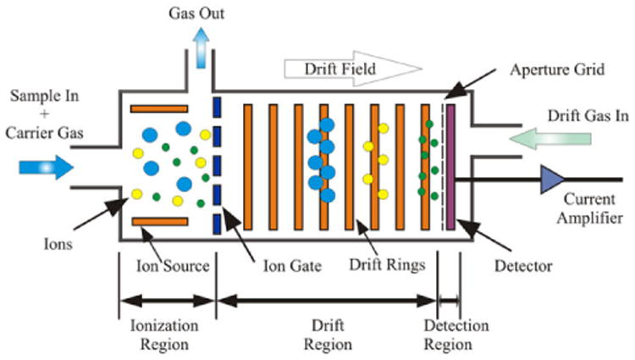
Figure ‎3.1 Schematic of IMS Drift Region
Depiction of the drift region for traditional, drift-tube ion mobility spectrometers displaying the introduction of ion swarms and the difference in mobility between smaller (green) and larger (blue) analytes as ion-gas collisions take place.⁵⁷ Figure reprinted with permission from Cumeras, R., et al. (2015). "Review on Ion Mobility Spectrometry. Part 1: Current Instrumentation." The Analyst 140(5): 1376-1390. 2015. Royal Society of Chemistry.

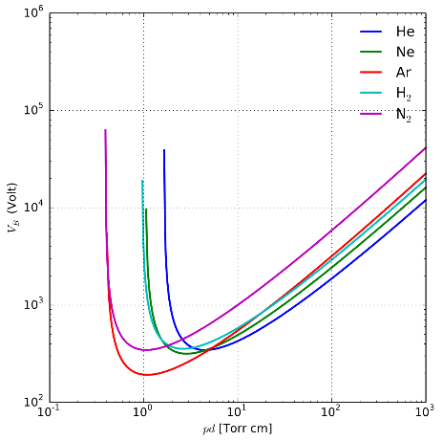
Figure ‎3.2 Paschen Curves for Pure Gases
Paschen curves of various pure gases that display the pressure of each that must be present in order to prevent breakdown of an electrical field at various strengths.⁵⁸ Figure reprinted with allowance under GNU Free Documentation License.

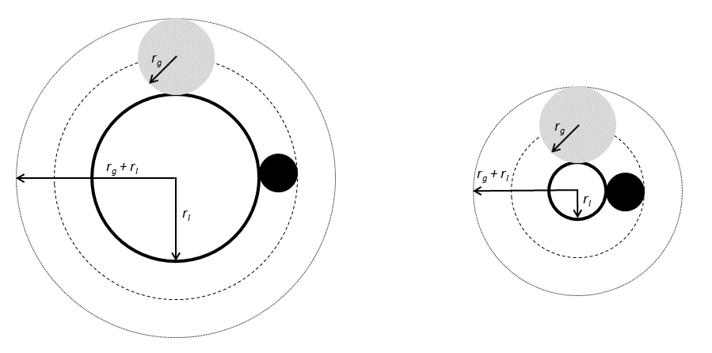
Figure ‎3.3 Gas Radius versus Ion Radius
Pictorial representation of the influence of gas radius on diffusing molecules where small (dark circles) and large (grey circles) gas molecules of arbitrary radius, $r_{g}$, collide with near-spherical diffusing molecules (unfilled circles) of arbitrary radius, $r_{I}$.⁴⁸ Original figure.

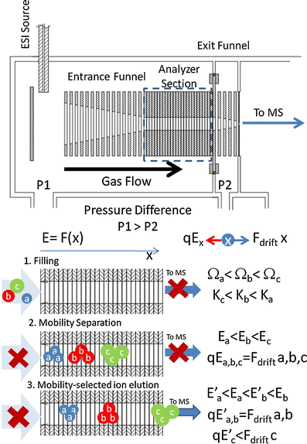
Figure ‎3.4 Schematic of Trapped Ion Mobility Principle
Schematic of TIMS device that demonstrates three stages of analysis. 1) Filling involves the introduction of ion swarms to the drift region – depicted here as three molecules with unique CCS, Ω, values that are inversely proportional to mobility, K. 2) Ions are separated by the carrier gas in accordance with their size-to-charge ratio. Ions will proceed through the mobility region until the electric field force is equivalent to the force applied by the carrier gas, reaching a “trapped” state. 3) Decreasing the electric field will allow ions to elute from high to low size-to-charge ratio.⁷⁶ Reprinted with permission from Fernandez-Lima, F., et al. (2011). "Gas-phase separation using a trapped ion mobility spectrometer." International Journal for Ion Mobility Spectrometry 14(2): 93-98. 2011. Springer Nature Publishers.

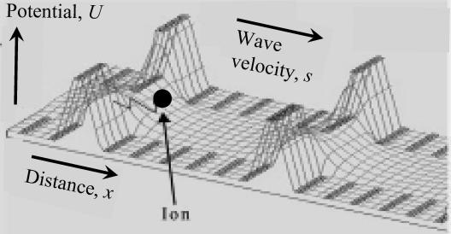
Figure ‎3.5 Traveling Wave Ion Mobility
A sketch of the working principle of TWIMS. Ions (black circle) are supported in the presence of an electric field and advanced toward the detector by a series sequential, uniform potential waves administered through the separation region – forcing ions to migrate based on their mobility. The traveling waves cause smaller ions to migrate faster than larger.⁷⁵ Reprinted with permission from Shvartsburg, A. A. and R. D. Smith (2008). "Fundamentals of Traveling Wave Ion Mobility Spectrometry." Analytical chemistry 80(24): 9689-9699. 2008. American Chemical Society.

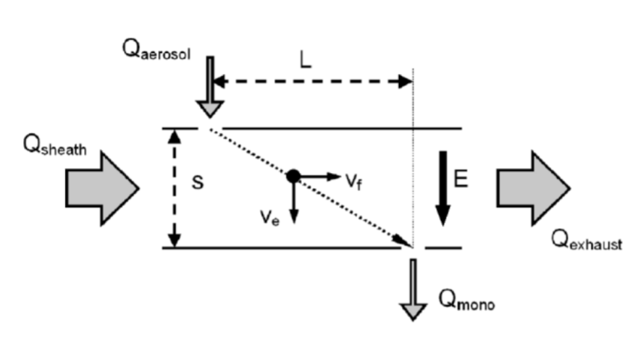
Figure ‎3.6 Schematic of Differential Mobility Analyzer
Pictorial representation of the analyzing region of differential mobility analyzers. Ions are introduced (top left) between planar electrodes in the presence of an electric field (E) acting in line with the angle of introduction and a sheath flow (Q_{sheath}) acting 90° to the same angle. Depending on ion characteristics and the electric field applied, only the analytes whose vector results in displacement equal to the distance L will be detected. The applied electric field is set to change over time and therefore selects for different species.⁷⁷ Reprinted with permission from de la Mora Juan, F., et al. (2006). "The potential of differential mobility analysis coupled to MS for the study of very large singly and multiply charged proteins and protein complexes in the gas phase." Biotechnology Journal 1(9): 988-997. 2006. Wiley and Sons Publishing.

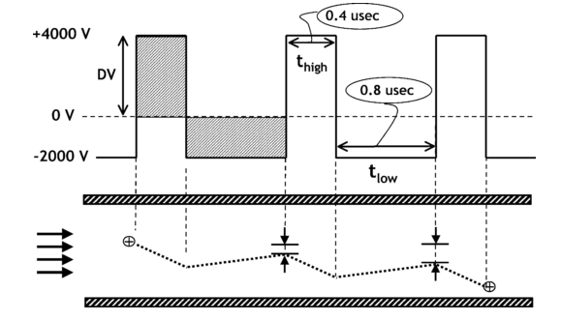
Figure ‎3.7 Asymmetric Waveform as Applied to FAIMS
Pictorial representation of the asymmetric RF voltages applied to FAIMS planar electrodes. Using otherwise random values, the high field operates at +4000V for a time of 0.4µs and the low field operates at negative one-half the high voltage, -2000V, for a time of 0.8µs. The resulting area under these curves is therefore equal in magnitude but opposite in polarity. As seen in the lower half of the figure, ionic species between the electrode will exhibit corresponding movement towards one electrode and then the other, being displaced along the y-axis according to the favored field.⁷⁹ Reprinted with permission from Guevremont, R. (2004). "High-field asymmetric waveform ion mobility spectrometry: A new tool for mass spectrometry." Journal of Chromatography A 1058(1-2): 3-19. 2004. Elsevier and Copyright Clearance Center.

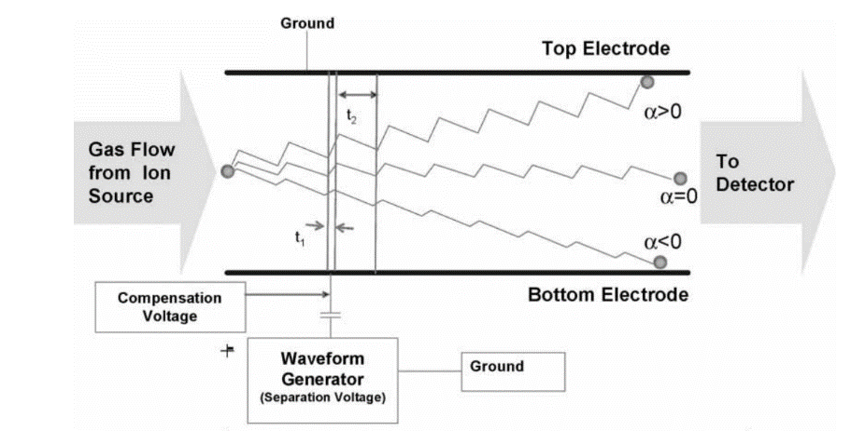
Figure ‎3.8 Compensation Voltage for Ion Path Correction
A schematic of the non-zero average migration of ions through FAIMS planar electrodes. Ions (grey circle) are introduced at the beginning of the separation region and are subjected to the asymmetric RF voltage that induces both high and low fields operating for times t₁ and t₂, respectively. Depending on ion characteristics, analytes could exhibit a greater response to either field and the average migration from center is denoted as α<0 for ions that respond to low fields and α>0 for ions responding to high fields. Only ions with α=0 will be detected, and, therefore, a compensation voltage may be superimposed over the RF dispersion voltage to correct an ion’s migration toward the center of the electrodes.⁷⁸ Reprinted with permission from Borsdorf, H. and G. A. Eiceman (2006). "Ion Mobility Spectrometry: Principles and Applications." Applied Spectroscopy Reviews 41(4): 323-375. 2006. Taylor & Francis Online Publishers.

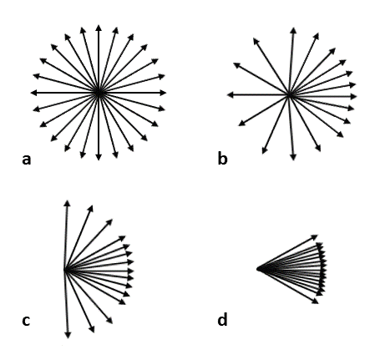
Figure ‎3.9 Dipole Alignments with Respect to Rotational Energy
Pictorial representation of the various dipole alignment states of an ion in the presence of electric field. At low field strengths, the rotational energy (ε_{r}) of an ion is far greater than the energy required to rotate the dipole (A) and will rotate freely (a). As field strength increases and the value of ε_{r}/A becomes smaller, the ion will gradually be confined to states of hindered rotation (b), a loose pendulum (c), and tight pendulum (d).⁴⁸ Original figure.

N-Linked Glycopeptide Feature Characterization Through FAIMS-Coupled Concurrent LC-MS Platform

Abstract
The extent of biologically and clinically relevant connections drawn to glycoproteins provide the separation, analysis, and characterization of these conjugates significant importance in the field of proteomics. However, the heterogeneity of glycoforms present for a protein makes separation and analysis quite challenging. Realizing the benefits of bottom-up investigation, the need for universal enrichment and separation methods, and the separating and analyzing power of gas-phase techniques, described here is a novel, three-dimensional glycopeptide workflow. Online monitoring of oxonium ions coupled to reverse-phase liquid chromatography allows for identification and enrichment of glycopeptides that may then be introduced to gas-phase ion mobility analysis for increased glycoform distinction. Our study shows the incorporation of differential ion mobility is useful for glycoform separation and may be used to assign glycopeptide features based on gas-phase ion behavior.

Introduction
In recent years, emphasis on proteomic studies have steadily increased in importance and significance across all sectors and fields of study. Due to the desire for increased comprehension of biological systems and how protein modification inspires or inhibits disease,⁸⁹⁻⁹¹ understanding the diversity present within the proteome is necessary before any conclusive biochemical processes may be determined. Complicating such endeavors, it has been repeatedly demonstrated – and can now be considered fundamental – that a single gene is the precursor for not one but many proteins. This diversity in gene products is largely due to the inherent potential for post-translational modification (PTM) of all proteins, each unique set of modifications producing an equally unique proteoform.⁹²
PTMs (methylation, phosphorylation, acetylation, etc.) are a diverse set of molecules, enzymatically deposited on conjugate proteins at different points along the maturation process, that reversibly or irreversibly alter protein structure and function.⁸⁹ Though a PTM may be present on a given protein in many locations, and multiple different modifications may be expressed on the same protein simultaneously, a saving grace to proteomics studies is that many PTMs are not diverse in their structure (i.e. all methyl groups are the same and all phosphoryl groups have the same structure). For this reason, proteomic studies of an individual PTM can be highly specific and optimized for a given sample to discover both the number of proteoforms present and the location of present PTMs along a protein backbone. Glycosylation, however, is a PTM that dwarfs others in terms of complexity and biological significance.
Glycosylation is one of few PTMs that exists as oligomers of its composing substituents – these oligomers are referred to throughout as glycans.¹ The diversity of glycans found on any modification site is substantial – a phenomenon known as microheterogeneity – and can only be remotely understood if the differences are grouped into three broad categories: modification site, composition, and structure. With respect to modification site, all commonly occurring modifications can be classified as either O- or N-linked. O-linked glycans attach to the peptide backbone through binding to the hydroxyl group of Serine and Threonine, whereas N-linked glycans are attached only to Asparagine residues that exist in the peptide motif of Asn-X-Thr, where X may be anything but Proline.^{1, 8, 18, 93} Furthermore, within the six classes of monosaccharides present in glycans (e.g. hexoses, pentoses, etc.) there have been reports of more than 70 unique sugar residues that may be incorporated into a glycan chain. However, there are only 12 monosaccharides commonly present in these modifications, still leading to a significant level of diversity. Finally, in regard to glycan structure, the glycosidic bonds that link monosaccharides together can be in either α or β confirmation and may be formed between the reducing end of one sugar and any hydroxide-containing carbon on the next.¹ Understanding the variety found in the glycans expressed on a given protein leads one to question: how, and for what reason, adequate glycosylation study may be facilitated.
Because it is well known that multiple glycans can exist at any modification site and that multiple modification sites can be present on any given protein, accurate separation and determination of individual glycoforms is quite difficult but is of significant value due to the broad number of connections drawn between glycosylation and organism function, disease, and response.^{1, 94} Enzymatic release of glycans would allow for in-depth characterization of all present modifications but would lose all site-specific information, whereas top-down analysis could only elucidate the number of glycoforms expressed and provide no relevant glycan structure information. Therefore, intact glycopeptides are a prime candidate for glycoform analysis, as examining intact modified peptides will allow for glycoform separation and analysis while retaining site-specificity.
Common glycopeptide analysis workflows (LC-MS and others), however, are often marked by significant limitations. Glycoproteins are quite diverse in character, level of modification, and level of expression, resulting in the current lack of a universal separation method. Also, the low abundance of glycopeptides compared to others from the same proteolytic activity necessitates the addition of an enrichment component, making studies more intricate. And additionally, the heterogeneity of glycoforms makes the separation of complex glycopeptide mixtures challenging, if not unfeasible. It has been noted that the implementation of a gas-phase separation component may benefit glycopeptide analysis – an idea that has been successfully proven in traditional ion mobility studies.^{7, 18, 43, 56, 69-71, 95} However, there exist few glycopeptide studies that utilize high-field asymmetric-waveform ion mobility (FAIMS) as the gas-phase separation component. Though not as useful for broad analysis,^{48, 78} the benefits of FAIMS are seen in its targeted detection and ion filtering capabilities,^{48, 78} tunability of gas composition, waveform, and compensation voltage, its smaller, simpler design⁷⁸ that allows it to be installed on existing MS instruments, and separation based on dipole alignment that results in good orthogonality to LC and MS.
Considering the need for a universally applicable method of glycopeptide analysis, reported here is an unbiased, RPLC-MS glycopeptide enrichment method coupled to differential ion mobility. Being one of few glycopeptide studies integrated with FAIMS, this method demonstrates that gas-phase analyte behavior can be used to reveal glycopeptide features, distinguish between modified and unmodified peptides, and evaluate conformations of charge-state variants.

Experimental

Materials
The standard protein Ribonuclease B (RNaseB), internal peptide standard Syntide 2 (Syn2), Ammonium bicarbonate (ABC), Urea, 1,4-Dithiothreitol (DTT), Iodoacetamide (IAA), TPCK Trypsin, and Acetonitrile (ACN) were all purchased from Sigma-Aldrich (Milwaukee, WI, USA). Ammonium bicarbonate solution was prepared at a concentration of 25mM; aliquots of this stock solution were used to prepare reducing (DTT) and alkylating (IAA) agents and Trypsin at concentrations of 200mM, 200mM and 1 mg/mL, respectively. Formic Acid and BCA protein assay kits were purchased from ThermoFisher (Hanover Park, IL, USA).

Trypsin Digestion
Prior to digestion, ~1 mg Standard protein was reconstituted in 10 µL of 25mM ABC and denatured at room temperature by a single 100 µL aliquot of 6M Urea with minimal mixing. Immediately following denaturation, 5 µL of DTT solution was introduced to the mixture, vortexed, and allowed to reduce at 37°C for 1 hour. 20 µL IAA was then added to the mixture and left to react in complete darkness at room temperature for 1 hour. Upon completion, 20 µL of DTT was added to deactivate any remaining IAA, followed by the addition of 900 µL ABC solution to dilute the remaining urea. Trypsin was introduced to the mixture in a 1:30 (enzyme:protein) ratio, w:w, and left to react at 37°C for 3 hours.

RPLC-MS
Following digestion, samples were desalted and concentrated to a final volume of ~1.5mg/mL according to BCA concentration measurements. 125 µL sample aliquots were injected on an Agilent C18 column (2.1x150mm, d_{p}=1.8µm) using a Thermo autosampler, pump, PDA detector setup. Using ultrapure H₂O+0.1% FA and ACN+0.1% FA as buffers A and B, respectively, samples were introduced at 97% A for 20 minutes and fully eluted on a 25-minute gradient to 97%B. Elutions were split on a T-junction between a Thermo LTQ Orbitrap Velos Pro with a custom nano-electrospray (ESI) interface and an Advion Triversa Nanomate, such that the bulk flow was sent for fraction collection. Capillary temperature was set to 275°C with a spray voltage of 2.6 kV. Full MS spectra were collected at a resolution of 60,000 with an m/z range of 350-2000. Data-dependent MS/MS collisional fragmentation data was collected using high-energy collisional dissociation (HCD) at an energy of 30.

Oxonium Ion Monitoring
Oxonium ions are singly-charged fragments of the glycan chains resulting from collisional dissociation methods. Oxonium ions and their associated masses are characteristic of glycopeptides and therefore can be used to identify when such analytes are eluted and have reached the detector.⁹⁶ Evaluating MS²-level data allowed for online monitoring of hexosamine (N-Acetylglucosamine) residues at m/z=204.09, z=1.

Concurrent Fractionation via Triversa Nanomate
Fraction collection parameters were set through the Advion ChipSoft program interface such that fractions were collected at a time interval of 60 seconds and deposited into a 96-well PCR Plate. The Nanomate fraction collection and MS analysis were manually started simultaneously to ensure accurate correlation between MS and fractionation timepoints. Temperature control was set to 4°C to avoid any extensive drying of highly-organic fractions.

FAIMS Instrumentation and Method
Maintaining previously reported instrumental methods, FAIMS analysis was conducted using planar electrodes with a gap width of 1.88 mm and a length of ~50 mm mounted to a Thermo LTQ XL ion trap.⁵¹ The asymmetric waveform, with harmonics in a 2:1 ratio, and dispersion voltage (DV) were provided by a generator purchased from Heartland Mobility. The ESI emitter voltage was set to ~3 kV above the curtain plate FAIMS inlet.⁵¹ Carrier gas compositions in all trials were optimized mixtures of N₂ and He formulated from UHP components by digital flow meters (MKS Instruments, Andover, MA, USA), purified by an Agilent filter, and delivered at a flow rate of 2 L/min. All fractions collected for FAIMS analysis were lightly concentrated and combined with ACN+0.1% FA for direct infusion (50:50 sample to buffer ratio). Sample flow rate was set to 0.3 µL/min while compensation voltage ranges and rates were determined as described (table 4.1).

Results

Digestion and Glycopeptide Separation Analysis
RNaseB, containing a single high-mannose glycan located on Asparagine³⁴, has been extensively studied and repeatedly characterized,^{10, 18, 43} making it a prime candidate for validation of this method. Trypsin digestion of RNaseB in preliminary trials yielded the base peptide of N³⁴LTK with five definitively resolved glycan modifications, GlcNAc₂Man₅₋₉ (figure 4.2); glycopeptide elution was confirmed through the MS² presence of fragmented hexosamine residues (figure 4.3). Due to the dominating hydrophilic character of these glycopeptides, retention on C18 should be highly unfavorable, an inference that is confirmed by elution peak occurring prior to gradient introduction (figure 4.3). Comparison of the LC retention for each of the five glycoforms showed only slight deviation or broadening based on hydrophilic character (figure 4.4), necessitating further separation.

FAIMS Separation of Base Peptide Glycoforms
In accordance with predictions, FAIMS demonstrated accurate separation of all 5 glycoforms at each tested gas composition, similar to the separation depicted at 60% He (figure 4.5). Notably, there was a linear correlation between the addition of one mannose residue and the compensation field (E_{c}) necessary to detect the analyte (figure 4.6). Such a trend indicates that the dipole alignment of glycopeptides is dominated by the glycan chain but will alter slightly with peptide backbone composition and FAIMS can, therefore, be later used to characterize peptide features. This linear trend demonstrated at all tested gas compositions (40, 50, and 60% He) is depicted by plotting the E_{c} corresponding to the major peak values and shows a regular deviation of the Man₆ glycoform – an occurrence also noted by Glaskin, et al., that was attributed to a prevailing elongated glycan confirmation. Selecting the Man₆ minor peak shows stronger correlation and linearity. The question then turns to differentiating between similar analytes when a single characteristic is changed (e.g. backbone, glycan, or presence/absence of modification).

Optimized Digestion for Increased Glycoform Presence
Having verified the three-dimensional glycopeptide enrichment and analysis method as viable, Trypsin digestion of RNaseB was performed in lowered enzyme:protein ratio to reduce digestion efficiency. Online monitoring of oxonium ions again displayed the pre-gradient elution corresponded to the elution of glycopeptides (figure 4.7). Summing the extract ion chromatography (EIC) region for these time points displayed the presence of 4 unique peptides each yielding 5 glycoforms (figure 4.8). In agreement with the preliminary trials, the complex mixture of 20 glycopeptides showed no discernable separation through the LC phase (figure 4.9); the corresponding fractions were collected for FAIMS analysis. Additionally, non-glycosylated peptides retained by the C18 column that eluted during the gradient were also kept for later comparison. The sample pool was adequate to provide analysis of FAIMS behavior for distinct groupings: glycopeptides of varying backbone with constant glycans, varying glycans with constant backbone, and modified versus unmodified peptides.

Feature Characterization Through FAIMS Behavior
The peptides observed varied in length from 4 to 8 residues, each expressing 5 glycan modifications (Man₅₋₉). To evaluate behavior of these analytes through FAIMS, plots of E_{c} vs. m/z, were created for each base peptide (e.g. N_{Man5-9}LTK, SRN_{Man5-9}LTK, etc.). Comparison of the trends expressed for each peptide were unique and displayed the most significant difference between the longest and shortest base peptides, -0.078 to -0.059, respectively (figure 4.10). The difference in trend between all four peptide backbones indicates that such features can be characterized by analyte behavior through FAIMS. Differentiating glycopeptides from RNaseB that varied by no more than 4 residues is promising, as backbones with greater difference in composition will almost assuredly display even greater difference in FAIMS behavior.
To determine if glycan composition can also be used to differentiate species in the gas phase, plots of E_{c} vs. m/z were formulated for each glycan chain (Man₅₋₉) as the attached peptide changes. The trend expressed for each is again well-defined showing the greatest difference between the shortest (Man₅) and longest (Man₉) glycan chains. Similar to the results discriminating based on backbone, the high-mannose glycan chains analyzed here exhibit only small changes to one another when compared the vast number of glycans presented in the proteome. If compared to glycans of vastly different composition, greater distinction in analyte behavior through FAIMS would be apparent.

Discrimination of Glycosylated and Non-Glycosylated Peptides
Though specific features were successfully characterized based on trends in FAIMS behavior, the 20 analyzed glycopeptides demonstrated an overall trend and can, therefore, be grouped together and compared to analytes of different classification (figure 4.11). Non-glycosylated peptides from the elution profile of RNaseB were identified using MS-GF+ (PNNL) and introduced to FAIMS (table 4.2). The dipole character of these non-glycosylated peptides should be greatly different from one another and exhibit very little correlation; this low correlation should, therefore, allow obvious discrimination from glycosylated peptides. Examination of non-glycosylated peptides against the original 20 glycopeptides studied showed not only a poorly correlated relationship of non-glycosylated peptides, but also no discernable relation to the established glycopeptide trend (figure 4.12). Though some peptides with m/z in the same range as the glycopeptides may be detected at similar compensation field values – providing data points close in proximity – these instances would only arise if there was a complete lack of liquid-phase separation prior to FAIMS analysis.

Altered Gas-Phase Confirmations for Higher Charge State Peptides
The 8-resiude glycopeptide is the only analyte that demonstrated multiple charge states, 2+ and 3+, whereas the other glycopeptides were confined to the lower state due to their small backbone and suppressed ionization commonly occurring with glycopeptides. Through FAIMS, the 2+ charge state of the longest peptide displayed moderate peak broadening and shouldering – indicating the possible presence of multiple isomeric species. Though no meaningful separation was obtained, optimizing FAIMS parameters could lead to separation of any simultaneously detected species. However, at the higher charge state of 3+, there was immediate peak divergence with sufficient resolution for the more abundant glycoforms (figure 4.13). While the increased charge certainly could reveal the presence of isomeric species in accordance with previous IMS experiments,⁴³ the nature of glycan chains suggest that charge will be located in the peptide backbone and the increase in charge state could, therefore, result in non-naturally occurring glycopeptide confirmations.¹⁸ Fragmentation analysis of the multiple peaks at charge state 3+ could lead to confirmation of either reality but routine commercial ionization techniques offer limited information for glycopeptides, indicating the need for further method consideration.

Conclusion
The online monitoring and concurrent fractionation method described has been proven successful for glycopeptide enrichment and can be further applied to a wide array of sample types due to the high accuracy resulting from oxonium ion monitoring. Analysis of analyte behavior through FAIMS has demonstrated that peptides can be differentiated based on subtle differences in peptide backbone and glycan composition while discrimination between glycopeptides and non-glycosylated peptides is easily obtained. FAIMS has also revealed that increased charge states could facilitate greater resolution of isomeric species, though more confirmation is needed. This three-dimensional method is tunable at the LC, MS, and FAIMS levels and can therefore be optimized to accurately separate, analyze, and characterize features of glycopeptides from multiple sample types for many use cases.

Acknowledgements
The authors thank all members of the Wu Research Group at the University of Oklahoma for their technical and material support, as well as the members of the Shvartsburg Lab at Wichita State University for their allowance of FAIMS operation time. This work was partly supported by grants from NIAID CSGADP Pilot project (NIH 5U01AI101990-04, BRI no. FY15109843), NIH NIGMS R01 GM118470, and OCAST HR16-125.

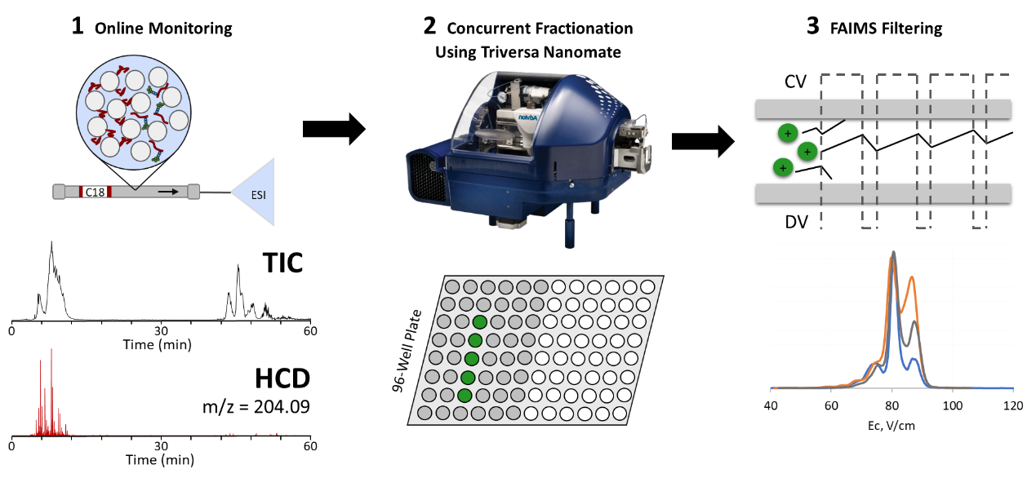
Figure ‎4.1 RPLC-MS-FAIMS Platform
The overall schematic of the platform utilized for glycopeptide identification and characterization. Digested glycoproteins are introduced to reverse-phase liquid chromatography coupled to mass spectrometry. As elution proceeds, the presence of oxonium ions is monitored, indicating the time points at which glycopeptides are eluted. Simultaneously, a Triversa Nanomate accurately deposits fractions in a 96-well plate format. The fractions corresponding to the detection of oxonium ions are then collected and introduced to FAIMS for glycoform analysis.

Fraction | Gas Composition (N₂:He) | C_{v} Scan Range
1-8 | 60:40 | 177-165
1-8 | 50:50 | 175-165
1-8 | 40:60 | 175-161
1-9 | 60:40 | 177-165
1-9 | 50:50 | 175-163
1-9 | 40:60 | 172-160
1-10 | 60:40 | 173-157
1-10 | 50:50 | 165-154
1-10 | 40:60 | 173-152

Table ‎4.1 Compensation Voltage Scan Ranges
Glycopeptides eluted across three fractions, as determined through online monitoring of oxonium ions. Each of the three fractions were unique in the peptides contained and their relative abundance, necessitating optimization of C_{v} scan range for each fraction. Furthermore, as He% increases, there is also a need to alter the C_{v} scan range to ensure accurate detection of all contained analytes. The C_{v} scan ranges listed were chosen through manual manipulation of C_{v} voltage and assessing the smallest range that allowed for the detection of the internal Syn2 standard and all present glycoforms.

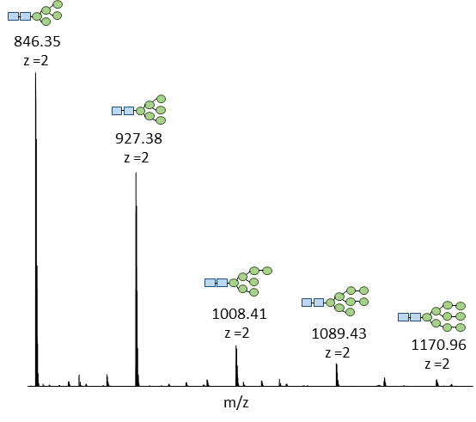
Figure ‎4.2 Mass Spectra of Summed Oxonium Ion Detection
Summing the time frame for the early elutions with corresponding oxonium ions yields 5 unique glycopeptides in the m/z range 846-1171. The glycan chains attached to the base peptide (N³⁴LTK) are illustrated above each m/z value – N-Acetylglucosamine residues depicted by blue squares and Mannose residues depicted by green circles. Illustrated structure and connectivity is arbitrary.

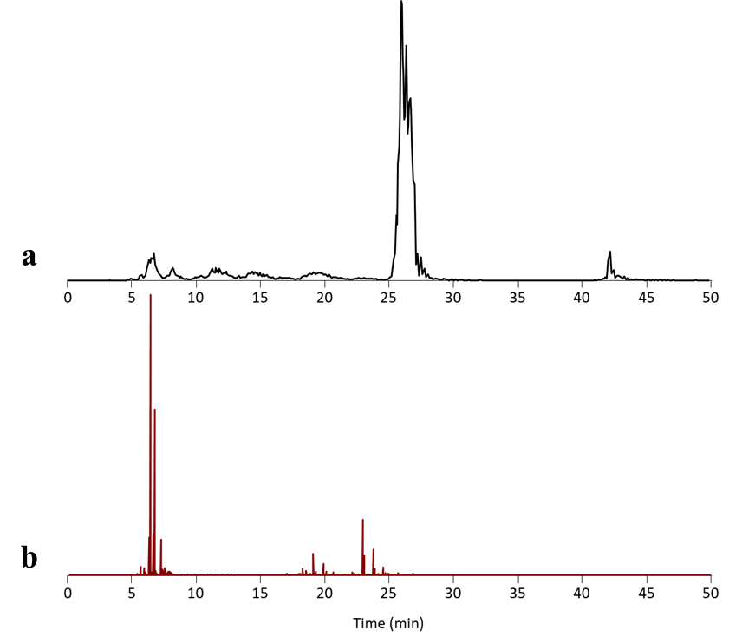
Figure ‎4.3 Preliminary RNaseB Chromatogram and MS² Oxonium Ion Abundance
Total ion chromatogram (a) for the initial reverse-phase chromatography separation of RNaseB subjected to tryptic digestion. The elutions appearing before the gradient began indicated the presence of low-binding peptides. Comparing the MS² extract ion chromatogram for m/z=204.09 (b) shows the presence of oxonium ions corresponding to the early elutions, indicating glycopeptide presence.

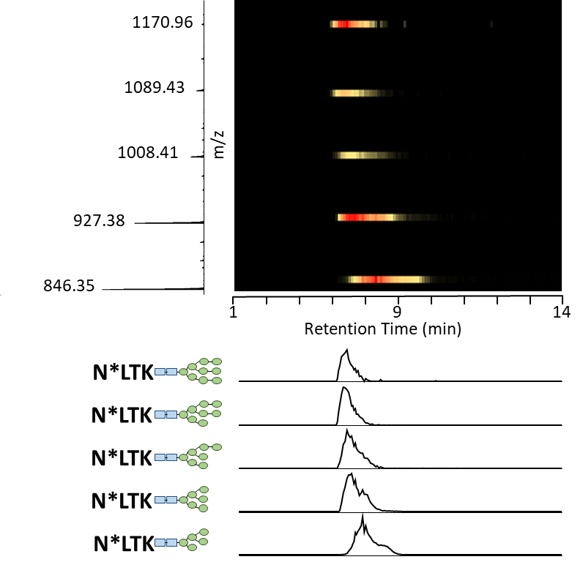
Figure ‎4.4 RPLC Retention of RNaseB Glycopeptides
The LC retention of the 5 glycoforms for the base peptide, N³⁴LTK, shown as a heat map with red indicating the most intense values. Being relatively uniform in composition, RPLC does not retain one glycoform more efficiently than another, making any differences in retention time or peak broadening due to the varying hydrophilic character – with the most hydrophilic species eluting first.

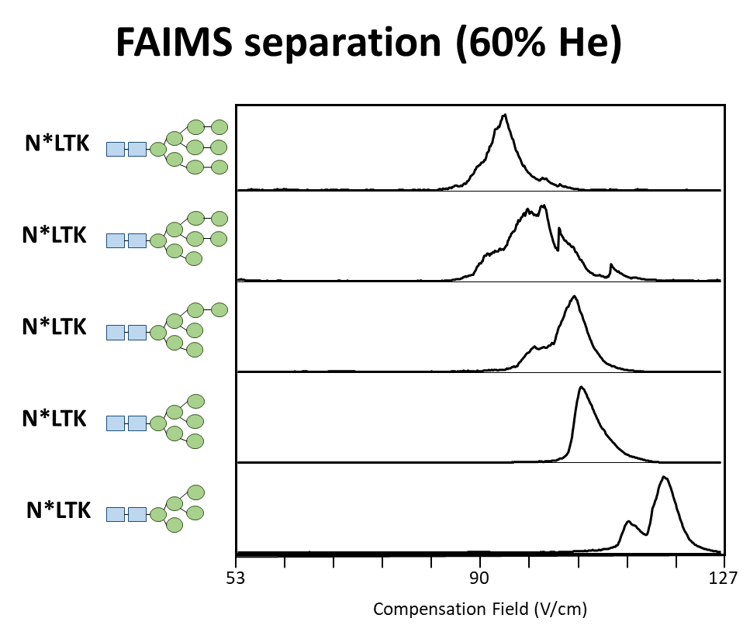
Figure ‎4.5 FAIMS Separation of RNaseB Base Glycopeptides
EIC for the 5 glycoforms of the base peptide through FAIMS filtering. Each glycoform responding to unique compensation fields indicates that FAIMS can be used as a separation component for glycopeptides. The linear trend demonstrated provides evidence that there is a connection between analyte composition or structure and behavior through FAIMS. All values plotted at 60% He gas composition.

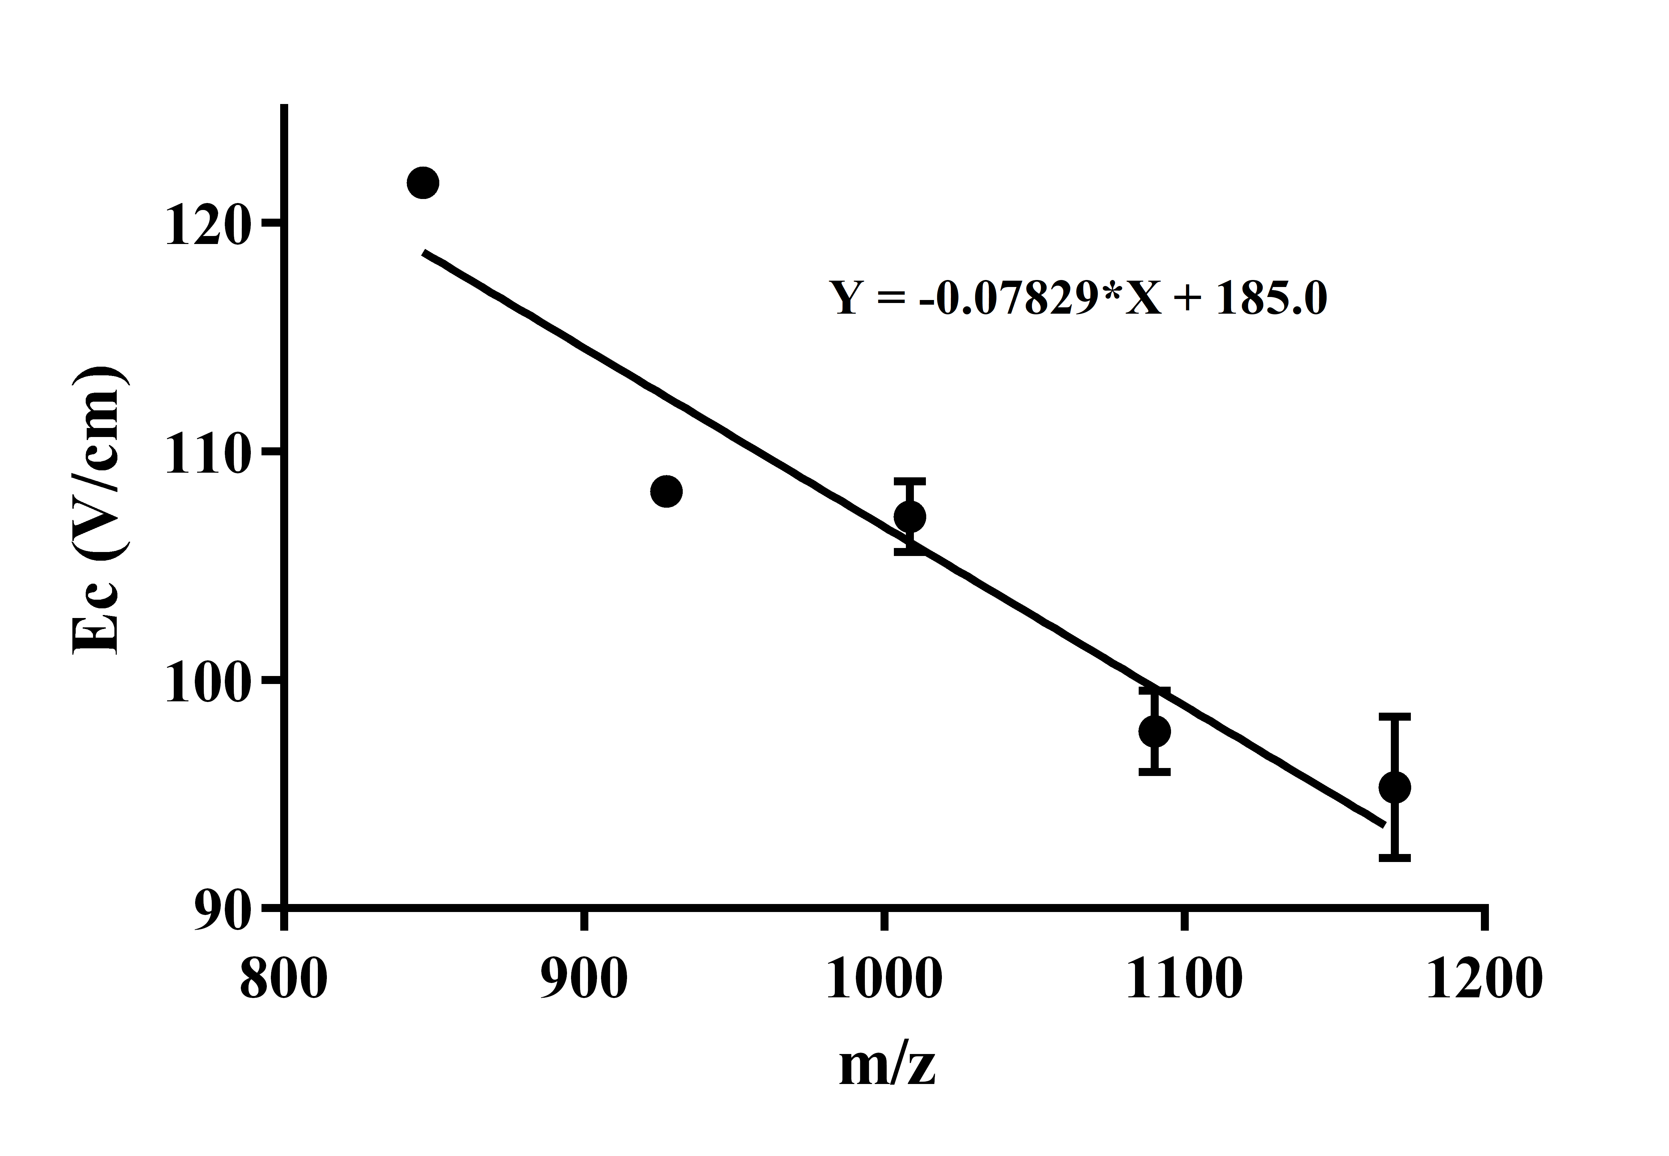
Figure ‎4.6 Compensation Field vs. m/z for RNaseB Base Peptides
M/z values of each glycoform plotted against the E_{c} value at which the analyte is detected, demonstrating the linear trend in their behavior through FAIMS. The deviating value, m/z=927.38, corresponds to the GlcNAc₂Man₆ glycoform, which has been previously noted to have a dominant elongated glycan conformation.¹⁸ The data points plotted above were chosen by inserting the major peak values according to EIC and substituting the minor peak value for GlcNAc₂Man₆ increases the correlation of the linear trend. All values plotted at 60% He gas composition.

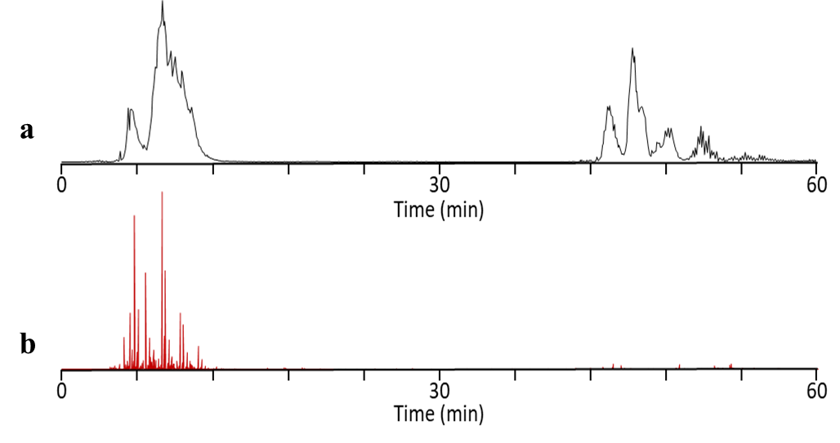
Figure ‎4.7 TIC and MS² Oxonium Ion Abundance for Optimized Digestion
TIC (a) and MS² extract ion chromatogram for m/z=204.09 (b) for the optimized digestion of RNaseB to inspire digestion inefficiency. Similar to the preliminary trials, the large elution prior to gradient corresponds to the presence of oxonium ions and indicates glycopeptide elution.

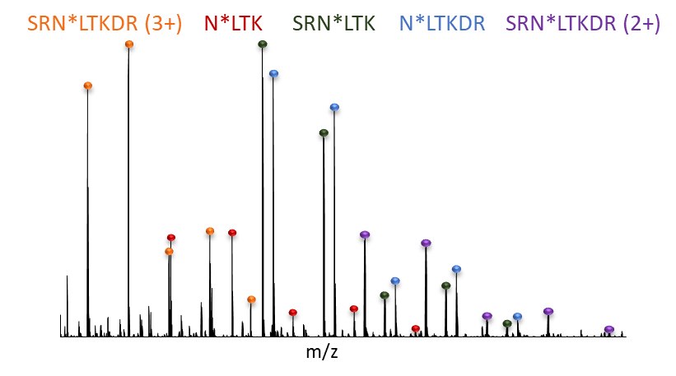
Figure ‎4.8 Summed Mass Spectra of Multiple Glycopeptide Elution
Summing the region corresponding to oxonium ion detection yields the base peptide (N³⁴LTK), two peptides with one missed cleavage site (SRN³⁴LTK, N³⁴LTKDR), and the 2+ and 3+ charge states of a peptide with two missed cleavage sites (SRN³⁴LTKDR). Each peptide exhibits the same 5 glycan modifications seen previously (GlcNAc₂Man₅₋₉).

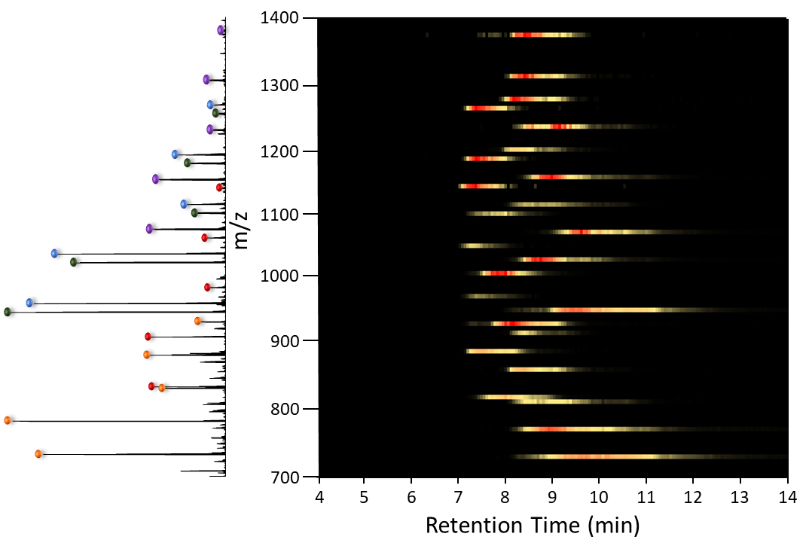
Figure ‎4.9 RPLC Retention Heat Map for Complex Glycopeptide Mixture
The complex mixture of glycopeptides plotted as a heat map of LC retention time. The extreme overlap and inconsistency of retention indicates that RPLC alone cannot be used as a separating component for these small glycopeptides from one another but can be used to enrich them from the sample pool.

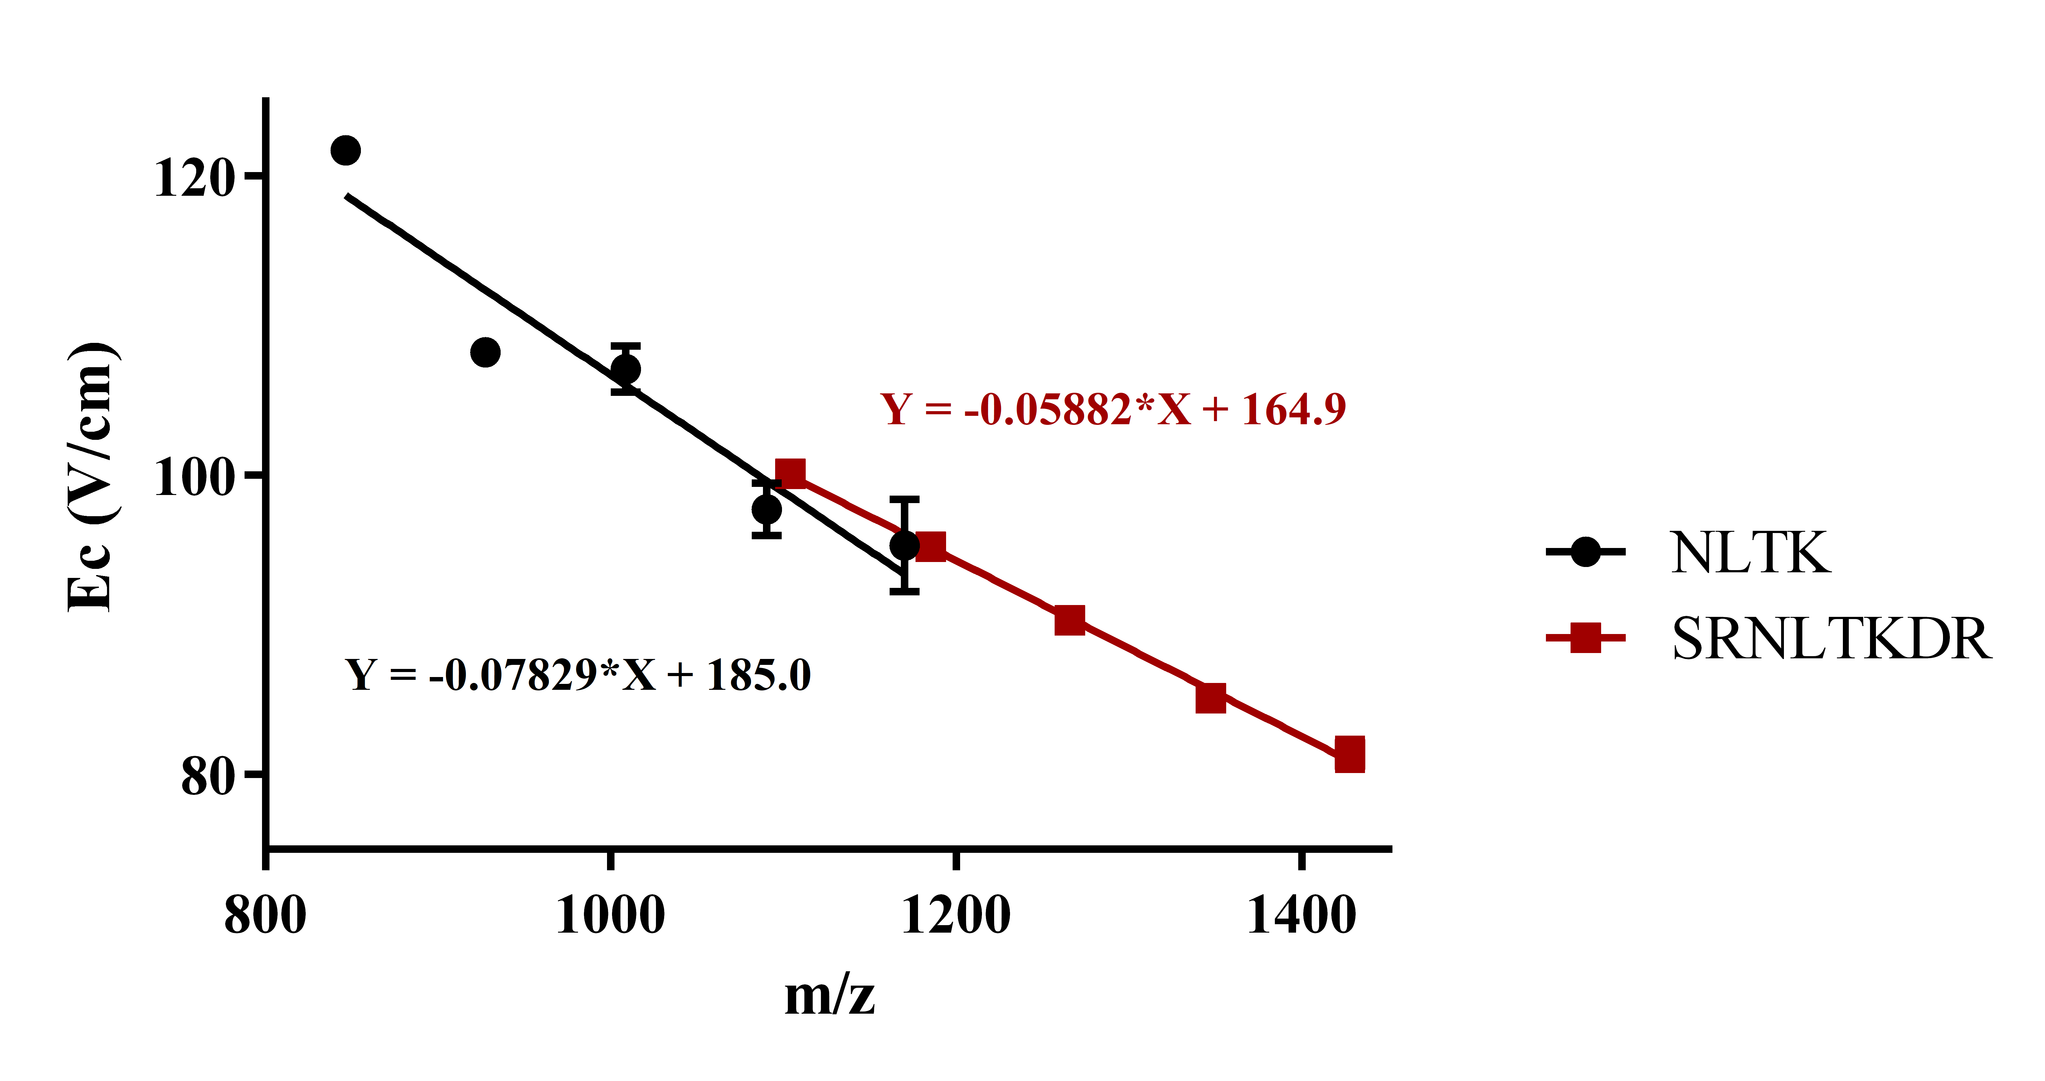
Figure ‎4.10 Ec vs. m/z for Shortest and Longest Peptide Backbone
Comparison of linear trends exhibited by the shortest and longest glycopeptides at charge state 2+. The difference in trend indicates that backbone features may be assigned to an analyte based on its behavior through FAIMS, especially when considering glycopeptides from other proteins could be much longer in length and will be distinguished even further. All values plotted at 60% He gas composition.

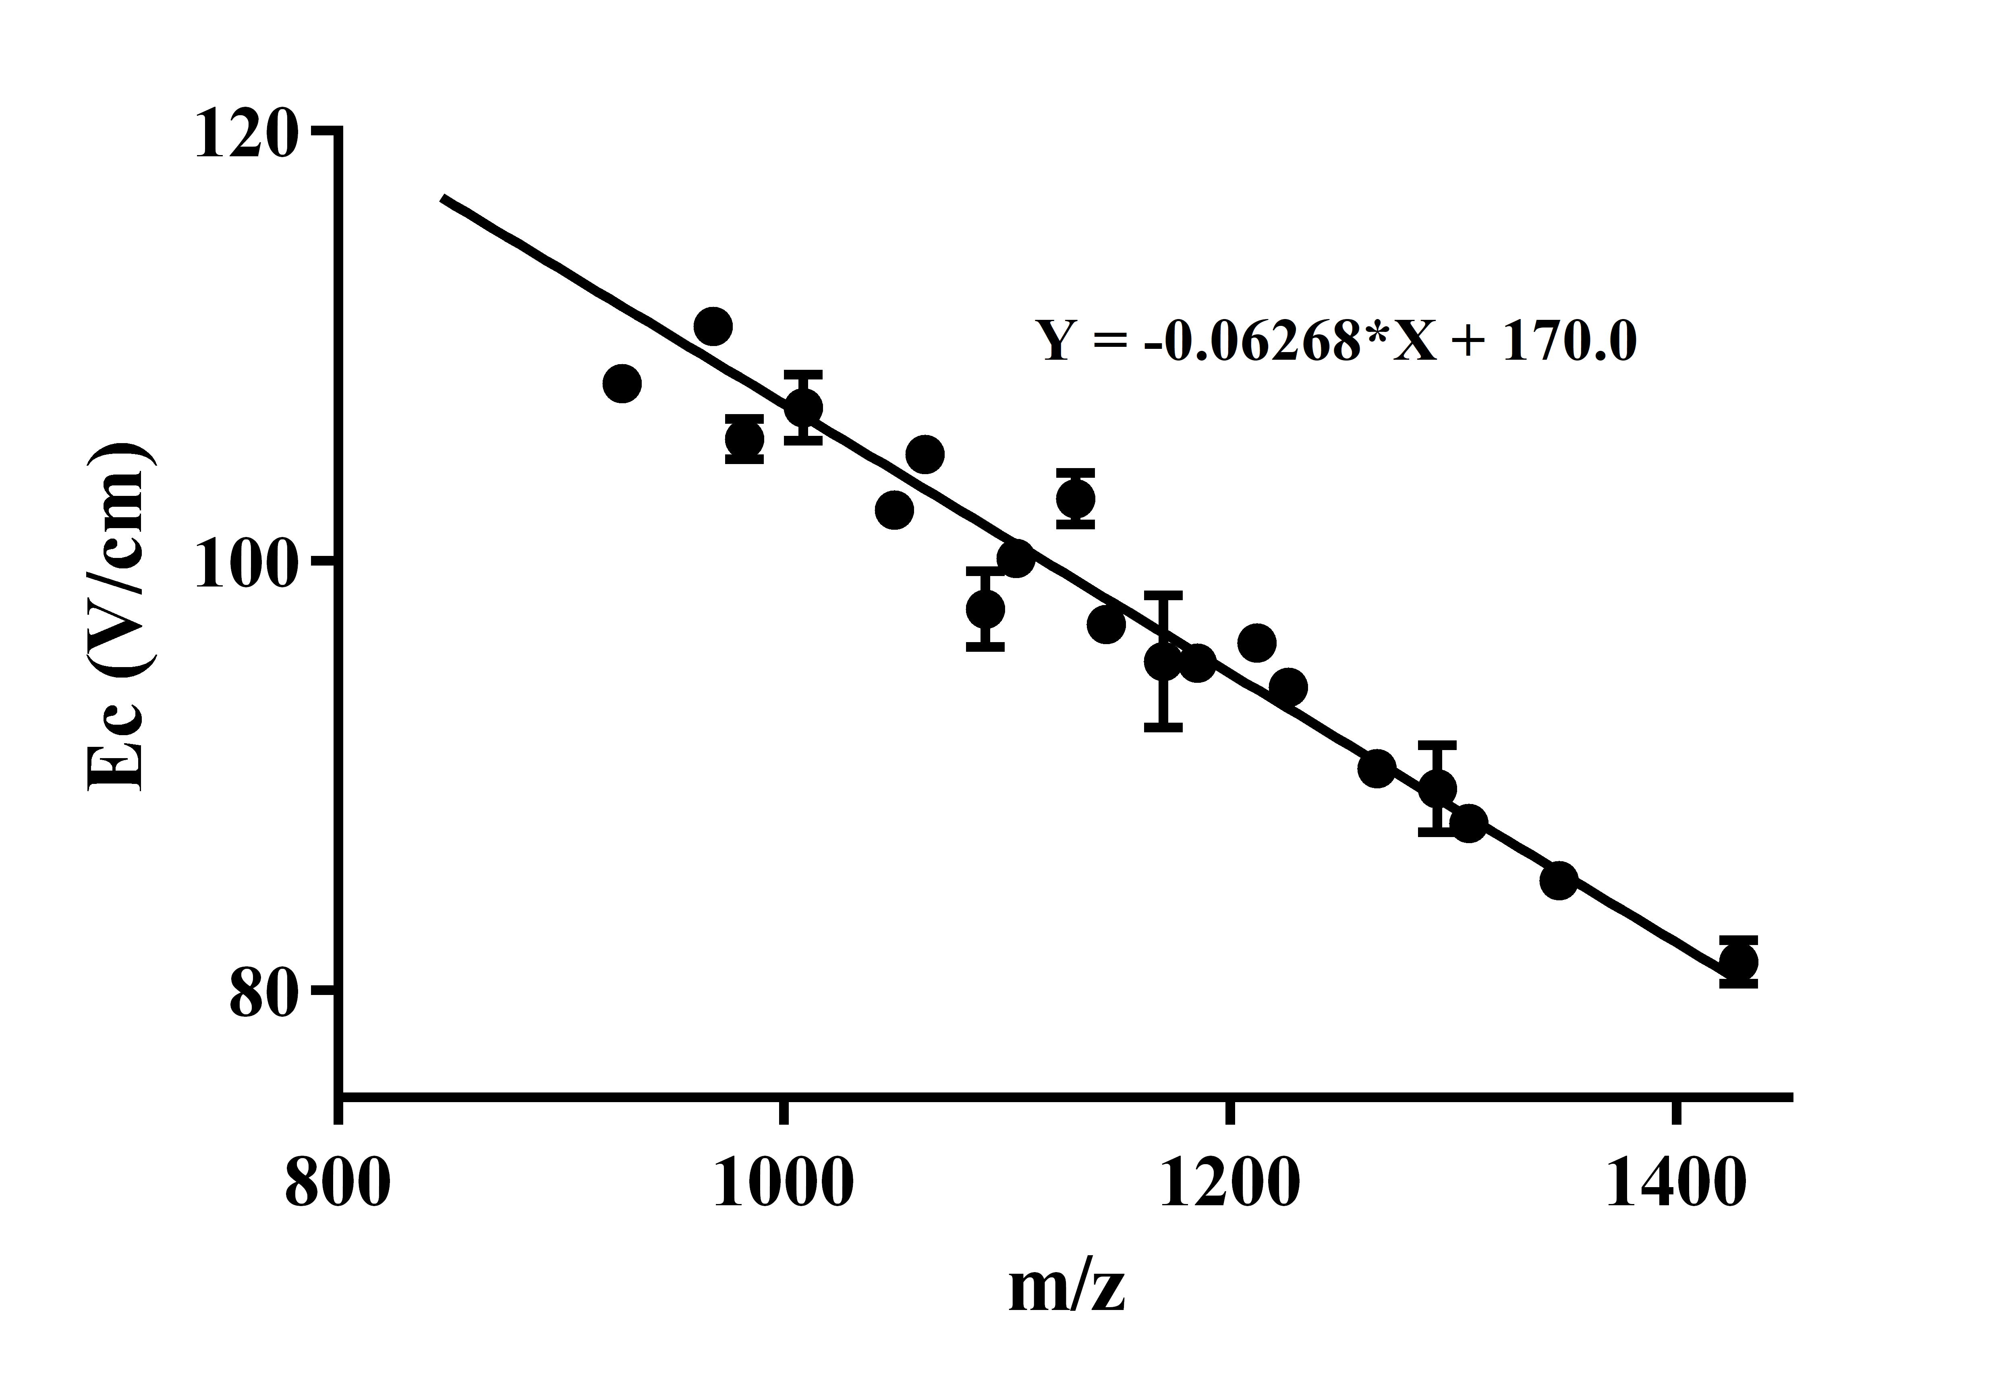
Figure ‎4.11 Overall Trend in Ec vs. m/z for All Glycopeptides
Plotted as E_{c} vs. m/z, the 20 glycopeptides of varying backbone and glycan feature demonstrate an overall trend after FAIMS analysis. This trend indicates that FAIMS behavior is more-than-likely dominated by the presence of a large glycan chain and will therefore allow discrimination of analytes containing these groups. All values plotted at 60% He gas composition.

Peptide Mass | Sequence | Charge State
653.32697 | E.SLADVQAVC(+57.021)SQK.N | 2
755.39166 | N.QMMKSRNLTKDR.C | 2
836.41473 | F.VHESLADVQAVC(+57.021)SQK.N | 2
927.8861 | D.SSTSAASSSNYC(+57.021)NQMMK.S | 2
1057.4916 | K.C(+57.021)AVNKQSC(+57.021)VAQVDALSEHV.F | 2
1065.9364 | G.QTNC+57.021YQSYSTM(+15.995)SITDC(+57.021)R.E | 2
1075.5173 | R.ETGSSKYPNC(+57.021)AYKTTQANK.H | 2
1183.9784 | R.QHMDSSTSAASSSNYC(+57.021)NQMMK.S | 2

Table ‎4.2 Non-Glycosylated Peptides Examined Through FAIMS
MS-GF+ analysis of the RNaseB elution profile allowed for the determination of identity for all retained and unretained peptides detected by MS. To determine the ability of FAIMS to discriminate between modified and unmodified peptides, several peptides at charge state 2+ with a m/z value within or near the range of the examined glycopeptides were also analyzed through FAIMS.

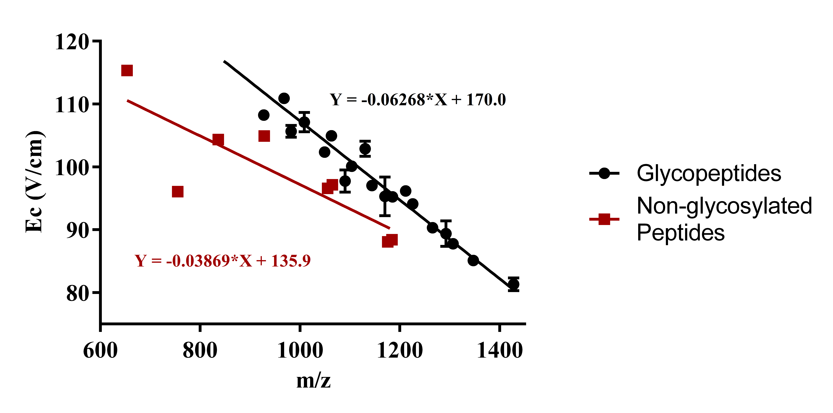
Figure ‎4.12 Discrimination of Glycopeptides and Non-Glycosylated Peptides
When examining m/z values that correspond to non-glycosylated peptides, not only does FAIMS analysis demonstrate a poorly correlated trend, but also clear distinction between modified and unmodified peptides. Increasing the number of non-glycosylated peptides analyzed through FAIMS will allow for a more well-defined trend. All values plotted at 60% He gas composition.

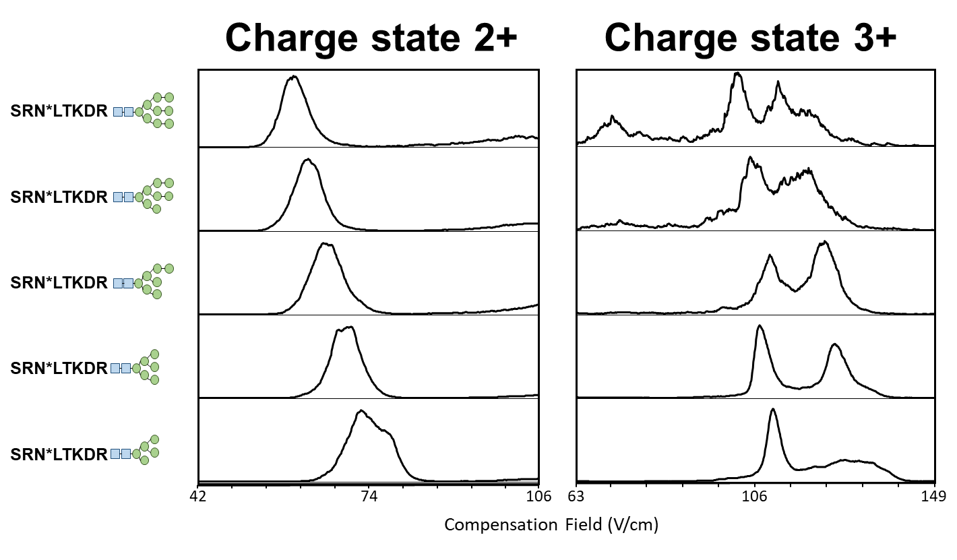
Figure ‎4.13 FAIMS Separation for Charge State Variants
Examining the EIC of the 2+ and 3+ charge states for the longest glycopeptide reveals additional gas-phase conformations for those with greater charge. The diverging peaks present in the higher charge state display either increased FAIMS separation of naturally occurring isomers or the possibility that increasing charge state of small glycopeptides forces them into conformations not commonly occurring. FAIMS can be used to further analyze which case presents the truth, but careful fragmentation studies would be necessary to provide confirmation.

References
1. Varki, A., Essentials of glycobiology. 2nd ed.; Cold Spring Harbor Laboratory Press: Cold Spring Harbor, N.Y., 2009; p xxix, 784 p.
2. Kinoshita, T., Glycosylphosphatidylinositol (GPI) Anchors: Biochemistry and Cell Biology: Introduction to a Thematic Review Series. Journal of Lipid Research 2016, 57 (1), 4-5.
3. Khanal, N.; Masellis, C.; Kamrath, M. Z.; Clemmer, D. E.; Rizzo, T. R., Glycosaminoglycan Analysis by Cryogenic Messenger-Tagging IR Spectroscopy Combined with IMS-MS. Analytical Chemistry 2017, 89 (14), 7601-7606.
4. Camby, I.; Le Mercier, M.; Lefranc, F.; Kiss, R., Galectin-1: a small protein with major functions. Glycobiology 2006, 16 (11), 137R-157R.
5. Breedam, W. V.; Pöhlmann, S.; Favoreel, H. W.; Groot, R. J.; Nauwynck, H. J., Bitter‐sweet symphony: glycan–lectin interactions in virus biology. FEMS Microbiology Reviews 2014, 38 (4), 598-632.
6. Contessa, J. N.; Bhojani, M. S.; Freeze, H. H.; Rehemtulla, A.; Lawrence, T. S., Inhibition of N-Linked Glycosylation Disrupts Receptor Tyrosine Kinase Signaling in Tumor Cells. Cancer Research 2008, 68 (10), 3803.
7. Zhu, F.; Clemmer, D. E.; Trinidad, J. C., Characterization of lectin binding affinities via direct LC-MS profiling: implications for glycopeptide enrichment and separation strategies. Analyst 2016, 142 (1), 65-74.
8. Creese, A. J.; Cooper, H. J., Separation and Identification of Isomeric Glycopeptides by High Field Asymmetric Waveform Ion Mobility Spectrometry. Anal. Chem. (Washington, DC, U. S.) 2012, 84 (5), 2597-2601.
9. Helenius, A.; Aebi; Markus, Intracellular Functions of N-Linked Glycans. Science 2001, 291 (5512), 2364.
10. Prien, J. M.; Ashline, D. J.; Lapadula, A. J.; Zhang, H.; Reinhold, V. N., The High Mannose Glycans from Bovine Ribonuclease B Isomer Characterization by Ion Trap MS. Journal of the American Society for Mass Spectrometry 2009, 20 (4), 539-556.
11. Han, L.; Costello, C. E., Mass Spectrometry of Glycans. Biochemistry. Biokhimiia 2013, 78 (7), 710-720.
12. Harvey, D. J., Electrospray mass spectrometry and fragmentation of N-linked carbohydrates derivatized at the reducing terminus. Journal of the American Society for Mass Spectrometry 2000, 11 (10), 900-915.
13. Yang, Y.; Liu, F.; Franc, V.; Halim, L. A.; Schellekens, H.; Heck, A. J. R., Hybrid mass spectrometry approaches in glycoprotein analysis and their usage in scoring biosimilarity. Nature Communications 2016, 7, 13397.
14. Cui, W.; Rohrs, H. W.; Gross, M. L., Top-Down Mass Spectrometry: Recent Developments, Applications and Perspectives. The Analyst 2011, 136 (19), 3854-3864.
15. Shajahan, A.; Heiss, C.; Ishihara, M.; Azadi, P., Glycomic and glycoproteomic analysis of glycoproteins—a tutorial. Analytical and Bioanalytical Chemistry 2017, 409 (19), 4483-4505.
16. Abdul Rahman, S.; Bergström, E.; Watson, C. J.; Wilson, K. M.; Ashford, D. A.; Thomas, J. R.; Ungar, D.; Thomas-Oates, J. E., Filter-Aided N-Glycan Separation (FANGS): A Convenient Sample Preparation Method for Mass Spectrometric N-Glycan Profiling. Journal of Proteome Research 2014, 13 (3), 1167-1176.
17. Harvey, D. J.; Seabright, G. E.; Vasiljevic, S.; Crispin, M.; Struwe, W. B., Isomer Information from Ion Mobility Separation of High-Mannose Glycan Fragments. Journal of The American Society for Mass Spectrometry 2018.
18. Glaskin, R. S.; Khatri, K.; Wang, Q.; Zaia, J.; Costello, C. E., Construction of a Database of Collision Cross Section Values for Glycopeptides, Glycans, and Peptides Determined by IM-MS. Anal Chem 2017, 89 (8), 4452-4460.
19. Cao, L.; Qu, Y.; Zhang, Z.; Wang, Z.; Prytkova, I.; Wu, S., Intact glycopeptide characterization using mass spectrometry. Expert Rev Proteomics 2016, 13 (5), 513-22.
20. Seipert, R. R.; Dodds, E. D.; Lebrilla, C. B., Exploiting Differential Dissociation Chemistries of O-Linked Glycopeptide Ions for the Localization of Mucin-Type Protein Glycosylation. Journal of Proteome Research 2009, 8 (2), 493-501.
21. Stavenhagen, K.; Plomp, R.; Wuhrer, M., Site-Specific Protein N- and O-Glycosylation Analysis by a C18-Porous Graphitized Carbon–Liquid Chromatography-Electrospray Ionization Mass Spectrometry Approach Using Pronase Treated Glycopeptides. Analytical Chemistry 2015, 87 (23), 11691-11699.
22. Ruhaak, L. R.; Xu, G.; Li, Q.; Goonatilleke, E.; Lebrilla, C. B., Mass Spectrometry Approaches to Glycomic and Glycoproteomic Analyses. Chemical Reviews 2018.
23. Di Silvestre, D.; Brambilla, F.; Agnetti, G.; Mauri, P., Bottom-Up Proteomics. In Manual of Cardiovascular Proteomics, Agnetti, G.; Lindsey, M. L.; Foster, D. B., Eds. Springer International Publishing: Cham, 2016; pp 155-185.
24. Gundry Rebekah, L.; White Melanie, Y.; Murray Christopher, I.; Kane Lesley, A.; Fu, Q.; Stanley Brian, A.; Van Eyk Jennifer, E., Preparation of Proteins and Peptides for Mass Spectrometry Analysis in a Bottom‐Up Proteomics Workflow. Current Protocols in Molecular Biology 2010, 90 (1), 10.25.1-10.25.23.
25. Gillet, L. C.; Leitner, A.; Aebersold, R., Mass Spectrometry Applied to Bottom-Up Proteomics: Entering the High-Throughput Era for Hypothesis Testing. Annual Review of Analytical Chemistry 2016, 9 (1), 449-472.
26. Wang, K.; Peng, E. D.; Huang, A. S.; Xia, D.; Vermont, S. J.; Lentini, G.; Lebrun, M.; Wastling, J. M.; Bradley, P. J., Identification of novel O-linked glycosylated Toxoplasma proteins by Vicia villosa lectin chromatography. PLoS One 2016, 11 (3), e0150561/1-e0150561/16.
27. Drake, P. M.; Schilling, B.; Niles, R. K.; Prakobphol, A.; Li, B.; Jung, K.; Cho, W.; Braten, M.; Inerowicz, H. D.; Williams, K.; Albertolle, M.; Held, J. M.; Iacovides, D.; Sorensen, D. J.; Griffith, O. L.; Johansen, E.; Zawadzka, A. M.; Cusack, M. P.; Allen, S.; Gormley, M.; Hall, S. C.; Witkowska, H. E.; Gray, J. W.; Regnier, F.; Gibson, B. W.; Fisher, S. J., Lectin Chromatography/Mass Spectrometry Discovery Workflow Identifies Putative Biomarkers of Aggressive Breast Cancers. J. Proteome Res. 2012, 11 (4), 2508-2520.
28. Xie, Y.; Liu, Q.; Li, Y.; Deng, C., Core-shell structured magnetic metal-organic framework composites for highly selective detection of N-glycopeptides based on boronic acid affinity chromatography. Journal of Chromatography A 2018, 1540, 87-93.
29. You, M.; Yang, S.; Tang, W.; Zhang, F.; He, P.-G., Ultrasensitive Electrochemical Detection of Glycoprotein Based on Boronate Affinity Sandwich Assay and Signal Amplification with Functionalized SiO2@Au Nanocomposites. ACS Appl. Mater. Interfaces 2017, 9 (16), 13855-13864.
30. Xing, R.; Wang, S.; Bie, Z.; He, H.; Liu, Z., Preparation of molecularly imprinted polymers specific to glycoproteins, glycans and monosaccharides via boronate affinity controllable-oriented surface imprinting. Nat. Protoc. 2017, 12 (5), 964-987.
31. Shi, Z.; Pu, L.; Guo, Y.; Fu, Z.; Zhao, W.; Zhu, Y.; Wu, J.; Wang, F., Boronic Acid-Modified Magnetic Fe3O4@mTiO2 Microspheres for Highly Sensitive and Selective Enrichment of N-Glycopeptides in Amniotic Fluid. Scientific Reports 2017, 7 (1), 4603.
32. Mysling, S.; Palmisano, G.; Højrup, P.; Thaysen-Andersen, M., Utilizing Ion-Pairing Hydrophilic Interaction Chromatography Solid Phase Extraction for Efficient Glycopeptide Enrichment in Glycoproteomics. Analytical Chemistry 2010, 82 (13), 5598-5609.
33. Palmisano, G.; Lendal, S. E.; Engholm-Keller, K.; Leth-Larsen, R.; Parker, B. L.; Larsen, M. R., Selective enrichment of sialic acid–containing glycopeptides using titanium dioxide chromatography with analysis by HILIC and mass spectrometry. Nature Protocols 2010, 5, 1974.
34. Alagesan, K.; Khilji, S. K.; Kolarich, D., It is all about the solvent: on the importance of the mobile phase for ZIC-HILIC glycopeptide enrichment. Analytical and Bioanalytical Chemistry 2017, 409 (2), 529-538.
35. Zhao, Y.; Szeto, S. S. W.; Kong, R. P. W.; Law, C. H.; Li, G.; Quan, Q.; Zhang, Z.; Wang, Y.; Chu, I. K., Online Two-Dimensional Porous Graphitic Carbon/Reversed Phase Liquid Chromatography Platform Applied to Shotgun Proteomics and Glycoproteomics. Analytical Chemistry 2014, 86 (24), 12172-12179.
36. Wohlgemuth, J.; Karas, M.; Jiang, W.; Hendriks, R.; Andrecht, S., Enhanced glyco‐profiling by specific glycopeptide enrichment and complementary monolithic nano‐LC (ZIC‐HILIC/RP18e)/ESI‐MS analysis. Journal of Separation Science 2010, 33 (6‐7), 880-890.
37. Stavenhagen, K.; Hinneburg, H.; Kolarich, D.; Wuhrer, M., Site-Specific N- and O-Glycopeptide Analysis Using an Integrated C18-PGC-LC-ESI-QTOF-MS/MS Approach. In High-Throughput Glycomics and Glycoproteomics: Methods and Protocols, Lauc, G.; Wuhrer, M., Eds. Springer New York: New York, NY, 2017; pp 109-119.
38. Lu, J.; Fu, D.; Yu, L.; Cao, C.; Zou, L.; Liang, X., Determination of N-Glycopeptides by Hydrophilic Interaction Liquid Chromatography and Porous Graphitized Carbon Chromatography with Mass Spectrometry Detection. Analytical Letters 2017, 50 (2), 315-324.
39. Zhou, S.; Huang, Y.; Dong, X.; Peng, W.; Veillon, L.; Kitagawa, D. A. S.; Aquino, A. J. A.; Mechref, Y., Isomeric Separation of Permethylated Glycans by Porous Graphitic Carbon (PGC)-LC-MS/MS at High Temperatures. Analytical Chemistry 2017, 89 (12), 6590-6597.
40. Zhou, S.; Dong, X.; Veillon, L.; Huang, Y.; Mechref, Y., LC-MS/MS analysis of permethylated N-glycans facilitating isomeric characterization. Analytical and Bioanalytical Chemistry 2017, 409 (2), 453-466.
41. Huang, Y.; Zhou, S.; Zhu, J.; Lubman David, M.; Mechref, Y., LC‐MS/MS isomeric profiling of permethylated N‐glycans derived from serum haptoglobin of hepatocellular carcinoma (HCC) and cirrhotic patients. ELECTROPHORESIS 2017, 38 (17), 2160-2167.
42. Fenn, L. S.; McLean, J. A., Structural resolution of carbohydrate positional and structural isomers based on gas-phase ion mobility-mass spectrometry. Physical Chemistry Chemical Physics 2011, 13 (6), 2196-2205.
43. Zhu, F.; Lee, S.; Valentine, S. J.; Reilly, J. P.; Clemmer, D. E., Mannose7 Glycan Isomer Characterization by IMS-MS/MS Analysis. Journal of the American Society for Mass Spectrometry 2012, 23 (12), 2158-2166.
44. Gregorich, Z. R.; Chang, Y. H.; Ge, Y., Proteomics in heart failure: top-down or bottom-up? Pflugers Arch 2014, 466 (6), 1199-209.
45. Eiceman, G. A.; Karpas, Z.; Hill, H. H., Ion mobility spectrometry. Third Edition. ed.; CRC Press: Boca Raton, 2014; p xvi, 428 pages.
46. Franklin, B., XCV. A letter of Benjamin Franklin, Esq; to Mr. Peter Collinson, F. R. S. concerning an electrical kite. Philosophical Transactions 1752, 47, 565-567.
47. Proceedings of the London Electrical Society, during the sessions 1841-2 and 1842-3. Walker, C. V., Ed. Simpkin, Marshall: London, 1843.
48. Shvartsburg, A. A., Differential ion mobility spectrometry : nonlinear ion transport and fundamentals of FAIMS. CRC Press: Boca Raton, 2009; p xxix, 299 p.
49. McDaniel, E. W.; Mason, E. A., The mobility and diffusion of ions in gases. Wiley: New York,, 1973; p xi, 372 p.
50. Bigeard, J.; Pflieger, D.; Colcombet, J.; Gerard, L.; Mireau, H.; Hirt, H., Protein complexes characterization in Arabidopsis thaliana by tandem affinity purification coupled to mass spectrometry analysis. Methods Mol Biol 2014, 1171, 237-50.
51. Baird, M. A.; Shvartsburg, A. A., Localization of Post-Translational Modifications in Peptide Mixtures via High-Resolution Differential Ion Mobility Separations Followed by Electron Transfer Dissociation. J. Am. Soc. Mass Spectrom. 2016, 27 (12), 2064-2070.
52. Shliaha, P. V.; Baird, M. A.; Nielsen, M. M.; Gorshkov, V.; Bowman, A. P.; Kaszycki, J. L.; Jensen, O. N.; Shvartsburg, A. A., Characterization of Complete Histone Tail Proteoforms Using Differential Ion Mobility Spectrometry. Anal. Chem. (Washington, DC, U. S.) 2017, Ahead of Print.
53. May, J. C.; Jurneczko, E.; Stow, S. M.; Kratochvil, I.; Kalkhof, S.; McLean, J. A., Conformational landscapes of ubiquitin, cytochrome c, and myoglobin: Uniform field ion mobility measurements in helium and nitrogen drift gas. International Journal of Mass Spectrometry 2018, 427, 79-90.
54. Claude, E.; Angel, P. M.; Drake, R. R.; Olivos, H.; Langridge, J. I., Abstract 4642: Ion mobility separation of N-Glycans directly from ffpe colon cancer tissue section in a MALDI imaging experiment. Cancer Research 2017, 77 (13 Supplement), 4642.
55. Stow, S. M.; Crescentini, T. M.; Forsythe, J. G.; May, J. C.; McLean, J. A.; Hercules, D. M., Structural Characterization of Methylenedianiline Regioisomers by Ion Mobility-Mass Spectrometry, Tandem Mass Spectrometry, and Computational Strategies. 3. MALDI Spectra of 2-Ring Isomers. Analytical Chemistry 2017, 89 (18), 9900-9910.
56. Gaye, M. M.; Ding, T.; Shion, H.; Hussein, A.; Hu, Y.; Zhou, S.; Hammoud, Z. T.; Lavine, B. K.; Mechref, Y.; Gebler, J. C.; Clemmer, D. E., Delineation of disease phenotypes associated with esophageal adenocarcinoma by MALDI-IMS-MS analysis of serum N-linked glycans. Analyst 2017, 142 (9), 1525-1535.
57. Cumeras, R.; Figueras, E.; Davis, C. E.; Baumbach, J. I.; Gràcia, I., Review on Ion Mobility Spectrometry. Part 1: Current Instrumentation. The Analyst 2015, 140 (5), 1376-1390.
58. Meek, J. M.; Craggs, J. D., Electrical breakdown of gases. Wiley: Chichester ; New York, 1978; p x, 878 p.
59. Cooper, H. J., To What Extent is FAIMS Beneficial in the Analysis of Proteins? Journal of the American Society for Mass Spectrometry 2016, 27, 566-577.
60. Peng, L.; Hua, L.; Wang, W.; Zhou, Q.; Li, H., On-site Rapid Detection of Trace Non-volatile Inorganic Explosives by Stand-alone Ion Mobility Spectrometry via Acid-enhanced Evaporization. Scientific Reports 2014, 4, 6631.
61. Zhou, Q.; Peng, L.; Jiang, D.; Wang, X.; Wang, H.; Li, H., Detection of Nitro-Based and Peroxide-Based Explosives by Fast Polarity-Switchable Ion Mobility Spectrometer with Ion Focusing in Vicinity of Faraday Detector. Scientific Reports 2015, 5, 10659.
62. Fetterolf, D. D. In Detection of Trace Explosive Evidence by Ion Mobility Spectrometry, Advances in Analysis and Detection of Explosives, Dordrecht, 1993//; Yinon, J., Ed. Springer Netherlands: Dordrecht, 1993; pp 117-131.
63. Harper, L.; Powell, J.; Pijl, E. M., An overview of forensic drug testing methods and their suitability for harm reduction point-of-care services. Harm Reduction Journal 2017, 14, 52.
64. Midey, A. J.; Patel, A.; Moraff, C.; Krueger, C. A.; Wu, C., Improved detection of drugs of abuse using high-performance ion mobility spectrometry with electrospray ionization (ESI-HPIMS) for urine matrices. Talanta 2013, 116, 77-83.
65. Lian, R.; Wu, Z.; Lv, X.; Rao, Y.; Li, H.; Li, J.; Wang, R.; Ni, C.; Zhang, Y., Rapid screening of abused drugs by direct analysis in real time (DART) coupled to time-of-flight mass spectrometry (TOF-MS) combined with ion mobility spectrometry (IMS). Forensic Science International 2017, 279, 268-280.
66. Gloess, A. N.; Yeretzian, C.; Knochenmuss, R.; Groessl, M., On-line analysis of coffee roasting with ion mobility spectrometry–mass spectrometry (IMS–MS). International Journal of Mass Spectrometry 2018, 424, 49-57.
67. Garrido-Delgado, R.; Eugenia Muñoz-Pérez, M.; Arce, L., Detection of adulteration in extra virgin olive oils by using UV-IMS and chemometric analysis. Food Control 2018, 85, 292-299.
68. Chouinard, C. D.; Beekman, C. R.; Kemperman, R. H. J.; King, H. M.; Yost, R. A., Ion mobility-mass spectrometry separation of steroid structural isomers and epimers. International Journal for Ion Mobility Spectrometry 2017, 20 (1), 31-39.
69. Gaye, M. M.; Kurulugama, R.; Clemmer, D. E., Investigating carbohydrate isomers by IMS-CID-IMS-MS: precursor and fragment ion cross-sections. Analyst 2015, 140 (20), 6922-6932.
70. Zhu, F.; Trinidad, J. C.; Clemmer, D. E., Glycopeptide Site Heterogeneity and Structural Diversity Determined by Combined Lectin Affinity Chromatography/IMS/CID/MS Techniques. Journal of The American Society for Mass Spectrometry 2015, 26 (7), 1092-1102.
71. Pu, Y.; Ridgeway, M. E.; Glaskin, R. S.; Park, M. A.; Costello, C. E.; Lin, C., Separation and Identification of Isomeric Glycans by Selected Accumulation-Trapped Ion Mobility Spectrometry-Electron Activated Dissociation Tandem Mass Spectrometry. Analytical Chemistry 2016, 88 (7), 3440-3443.
72. Guttman, M.; Lee, K. K., Site-Specific Mapping of Sialic Acid Linkage Isomers by Ion Mobility Spectrometry. Analytical Chemistry 2016, 88 (10), 5212-5217.
73. Manz, C.; Pagel, K., Glycan analysis by ion mobility-mass spectrometry and gas-phase spectroscopy. Current Opinion in Chemical Biology 2018, 42, 16-24.
74. Mookherjee, A.; Guttman, M., Bridging the structural gap of glycoproteomics with ion mobility spectrometry. Current Opinion in Chemical Biology 2018, 42, 86-92.
75. Shvartsburg, A. A.; Smith, R. D., Fundamentals of Traveling Wave Ion Mobility Spectrometry. Analytical chemistry 2008, 80 (24), 9689-9699.
76. Fernandez-Lima, F.; Kaplan, D. A.; Suetering, J.; Park, M. A., Gas-phase separation using a trapped ion mobility spectrometer. International Journal for Ion Mobility Spectrometry 2011, 14 (2), 93-98.
77. de la Mora Juan, F.; Ude, S.; Thomson Bruce, A., The potential of differential mobility analysis coupled to MS for the study of very large singly and multiply charged proteins and protein complexes in the gas phase. Biotechnology Journal 2006, 1 (9), 988-997.
78. Borsdorf, H.; Eiceman, G. A., Ion Mobility Spectrometry: Principles and Applications. Applied Spectroscopy Reviews 2006, 41 (4), 323-375.
79. Guevremont, R., High-field asymmetric waveform ion mobility spectrometry: A new tool for mass spectrometry. Journal of Chromatography A 2004, 1058 (1-2), 3-19.
80. Shvartsburg, A. A.; Smith, R. D., Protein Analyses Using Differential Ion Mobility Microchips with Mass Spectrometry. Anal. Chem. (Washington, DC, U. S.) 2012, 84 (17), 7297-7300.
81. Shvartsburg, A. A.; Creese, A. J.; Smith, R. D.; Cooper, H. J., Separation of a Set of Peptide Sequence Isomers Using Differential Ion Mobility Spectrometry. Analytical chemistry 2011, 83 (18), 6918-6923.
82. Creese, A. J.; Cooper, H. J., Separation of cis and trans Isomers of Polyproline by FAIMS Mass Spectrometry. J. Am. Soc. Mass Spectrom. 2016, 27 (12), 2071-2074.
83. Bowman, A.; Shvartsburg, A. A.; Abzalimov, R.; Anderson, G. In Broad separation of lipid isomers using high-definition differential ion mobility spectrometry and a range of ionizing species, American Chemical Society: 2016; pp MWRM-389.
84. Shvartsburg, A. A.; Singer, D.; Smith, R. D.; Hoffmann, R., Ion Mobility Separation of Isomeric Phosphopeptides from a Protein with Variant Modification of Adjacent Residues. Analytical Chemistry 2011, 83 (13), 5078-5085.
85. Garabedian, A.; Baird, M. A.; Porter, J.; Jeanne Dit Fouque, K.; Shliaha, P. V.; Jensen, O. N.; Williams, T. D.; Fernandez-Lima, F.; Shvartsburg, A. A., Linear and Differential Ion Mobility Separations of Middle-Down Proteoforms. Anal. Chem. (Washington, DC, U. S.) 2018, Ahead of Print.
86. Shvartsburg, A. A.; Zheng, Y.; Smith, R. D.; Kelleher, N. L., Separation of variant methylated histone tails by differential ion mobility. Anal. Chem. (Washington, DC, U. S.) 2012, 84 (15), 6317-6320.
87. Zhao, H.; Cunningham, D. L.; Creese, A. J.; Heath, J. K.; Cooper, H. J., FAIMS and Phosphoproteomics of Fibroblast Growth Factor Signaling: Enhanced Identification of Multiply Phosphorylated Peptides. J. Proteome Res. 2015, 14 (12), 5077-5087.
88. Ulasi, G. N.; Creese, A. J.; Hui, S. X.; Penn, C. W.; Cooper, H. J., Comprehensive mapping of O-glycosylation in flagellin from Campylobacter jejuni 11168: A multienzyme differential ion mobility mass spectrometry approach. Proteomics 2015, 15 (16), 2733-45.
89. Wang, Y.-C.; Peterson, S. E.; Loring, J. F., Protein post-translational modifications and regulation of pluripotency in human stem cells. Cell Research 2014, 24 (2), 143-160.
90. Su, M.-G.; Weng, J. T.-Y.; Hsu, J. B.-K.; Huang, K.-Y.; Chi, Y.-H.; Lee, T.-Y., Investigation and identification of functional post-translational modification sites associated with drug binding and protein-protein interactions. BMC Systems Biology 2017, 11 (Suppl 7), 132.
91. Santos, A. L.; Lindner, A. B., Protein Posttranslational Modifications: Roles in Aging and Age-Related Disease. Oxidative Medicine and Cellular Longevity 2017, 2017, 5716409.
92. Smith, L. M.; Kelleher, N. L.; The Consortium for Top Down, P., Proteoform: a single term describing protein complexity. Nature methods 2013, 10 (3), 186-187.
93. Qu, Y.; Feng, J.; Deng, S.; Cao, L.; Zhang, Q.; Zhao, R.; Zhang, Z.; Jiang, Y.; Zink, E. M.; Baker, S. E.; Lipton, M. S.; Pasa-Tolic, L.; Hu, J. Z.; Wu, S., Structural analysis of N- and O-glycans using ZIC-HILIC/dialysis coupled to NMR detection. Fungal Genet. Biol. 2014, 72, 207-215.
94. Arnold, J. N.; Wormald, M. R.; Sim, R. B.; Rudd, P. M.; Dwek, R. A., The impact of glycosylation on the biological function and structure of human immunoglobulins. Annu Rev Immunol 2007, 25, 21-50.
95. Isailovic, D.; Kurulugama, R. T.; Plasencia, M. D.; Stokes, S. T.; Kyselova, Z.; Goldman, R.; Mechref, Y.; Novotny, M. V.; Clemmer, D. E., Profiling of human serum glycans associated with liver cancer and cirrhosis by IMS-MS. J Proteome Res 2008, 7 (3), 1109-17.
96. Mechref, Y., Use of CID/ETD Mass Spectrometry to Analyze Glycopeptides. Current protocols in protein science / editorial board, John E. Coligan ... [et al.] 2012, 0 12, Unit-12.1111.

