University of Oklahoma

Graduate College

IMPACT OF SENSE OF BELONGING AND LEVEL OF RELATIONAL-INTERDEPENDENT SELF-CONSTRUAL ON RELATIONAL AGGRESSION

A Dissertation

submitted to the graduate faculty

in partial fulfillment of the requirements for the

Degree of

Doctor of Philosophy

By

ERIN Elaine wOIKE
Norman, Oklahoma
2016

Impact of sense of belonging and level of relational-interdependent self-construal on relational aggression

A Dissertation approved for the
Department of Educational Psychology

By

______________________________
Dr. Melissa Frey, Chair

______________________________
Dr. E. Laurette Taylor

______________________________
Dr. Denise Beesley

______________________________
Dr. Lara Mayeux

______________________________
Dr. T. H. Lee Williams

© Copyright by ERIN ELAINE WOIKE 2016
All Rights Reserved.

For David Doan
You are my husband and my rock. Thank you for moving with me to Oklahoma and for supporting me throughout this challenging and anxiety-provoking growth process. Our daughter is lucky to have a father like you who endlessly supports his wife as she chases her dreams. I am so grateful to have you in my life. This long paper is for you. I am sure you will read the whole thing. You’re welcome.

Also, I dedicate this to our beautiful, amazing daughter, Aurelia. Your presence in our life is such a blessing! I will support you as you work to achieve your dreams, just as you motivated me to reach mine!

Acknowledgements

I have been fortunate to have many supporters throughout this process. Thank you to my amazing parents for your tireless support throughout my education. To Louis Woike, for your endless help with proof-reading and for helping me stay focused on my goals. To Debra Woike, for your tireless support and for introducing me to feminism. You always supported me in the way I needed; whether, that be gentle nudges to get my work done or taking all pressure off when I was not sure I wanted to continue. Aurelia has an excellent role model in her “Nana.” Thank you for your unconditional love and for being such wonderful parents! I could not have done this without you.
Thank you to my fabulous sister, Danielle Barringer. Your clever wit and intelligence kept me laughing as I bounced ideas off of you and when I felt frustrated with the process. You are an amazing sister and I am so grateful to have you in my life! For Timothy Barringer, my awesome brother, thank you for being willing to read my dissertation. Thank you for your kindness and support throughout this process. I am so glad Danielle married you because that means I have my awesome “Bestie” for a brother! To Jaxon Barringer, my adorable nephew, whose Facetimes and stories of his escapades kept me entertained while simultaneously decreasing graduate school stress. I am so excited that Aurelia has you as a cousin and that I am lucky enough to be your Aunt!
Thank you to my grandparents. Grandma Elaine, I miss you every day. Thank you for always supporting my education and for providing an example of how to be a successful, intelligent woman who achieves her dreams. To Grandpa Otto for always supporting me. I have always been able to count on you to offer kind words, support, a smile, and love whenever I need it. You are an amazing grandfather and I am so grateful to have you in my life! For Grandma Ilene who has always supported my research in bullying prevention. I can always count on you to remind me of the importance of this research. You are an amazing role model and set a great example as a strong, intelligent woman in the work force. Thank you for your endless love and support!
Thank you to Ashley Stafford and Shannon Hackett. You are both such amazing friends! I am so grateful for the laughs, the creative adventures, and unusual coping strategies we came up with to get ourselves through graduate school. I look forward to many more years of friendship with you and your amazing partners! Thank you to David Stafford and Robert Bowen for being great friends to me and, especially, to Dave with your poker and video game nights. We were lucky to meet such amazing friends!
I am also fortunate to have had strong, female role models in the field. Thank you to my advisor, Lisa Frey, for the support and mentorship as I grew into my identity as a psychologist and researcher. Thank you to Karen Taylor, my Training Director and mentor who helped me secure my identity as a therapist and encouraged me to use my voice.
Table of Contents
Acknowledgements iv
Abstract viii
Impact of Sense of Belonging and Level of Relational-Interdependent Self-Construal on Relational Aggression 1
Literature Review 7
Relational Aggression 7
Gender and relational aggression. 8
Motivators of relational aggression. 10
Impacts of relational aggression. 10
Relational aggression as a reaction to social exclusion. 12
Sense of Belonging 13
Sense of belonging and behavior. 13
Impacts of a decreased sense of belonging. 15
Relational-Interdependent Self-Construal 16
Independent and interdependent construals of the self. 17
The emergence of relational-interdependent self-construal (RISC). 18
Influence of RISC on social behavior. 19
Is being high in RISC always positive? 20
RISC and relational aggression. 21
Relational Aggression, RISC, and Belonging 22
Method 25
Participants 25
Instruments 26
Self-Report of Aggression and Social Behavior Measure (SRASBM). 26
General Belongingness Scale (GBS). 27
Relational-Interdependent Self-Construal Scale (RISC scale). 28
Procedures 28
Research Questions and Data Analysis 30
Results 31
Discussion 34
Limitations and Suggestions for Future Research 38
Implications 40
References 42
Appendix A: Tables 48
Appendix B: IRB Approval Letter 50
Appendix C: Self-Report of Aggression and Social Behavior Measure (SRASBM) 51
Appendix D: The General Belongingness Scale (GBS) 54
Appendix E: Relational-Interdependent Self-Construal Scale (RISC scale) 55
Appendix F: Demographic Questionnaire 56

List of Tables

Table 1. Means, Standard Deviations, and Correlations for Variables 48
Table 2. Hierarchical Multiple Regression Analyses Predicting Relational
Aggression 49

Abstract

The college adjustment literature emphasizes the importance of social support for college students (Credé & Niehorster, 2012). Relational aggression is a form of aggression that attacks an individual’s social support system (Crick & Grotpeter, 1995) and, thus, could be harmful to students’ college adjustment. This study hypothesized that an individual’s sense of belonging, level of relational-interdependent self-construal (RISC), and the interaction of belonging and RISC would impact relational aggression. Thus, relevant demographic variables (i.e., age) and predictor variables (i.e., belonging, RISC, and the interaction between belonging and RISC) were entered into a hierarchical regression model to assess their impact on relational aggression. Age and belonging emerged as significant, independent predictors of relational aggression with belonging having the strongest relationship. This suggests that younger individuals who do not feel connected on campus could be more likely to engage in relational aggression. Additionally, results suggested that students who lived on campus were more likely to engage in relational aggression. Working with university personnel to incorporate prevention programming aimed at increasing sense of belonging in residence halls may be an effective way to decrease relational aggression on campus.

Impact of Sense of Belonging and Level of Relational-Interdependent Self-Construal on Relational Aggression
The college adjustment literature suggests that feeling connected and having social relationships on campus are important for positive college adjustment and, consequently, student retention. Research on theoretical models of college adjustment consistently identifies social support as an important factor of positive adjustment (Baker & Siryk, 1984; Campbell, Palmieri, & Lasch, 2006; Credé & Niehorster, 2012; Feldt, Graham, & Dew, 2011). Based on the finding that adjustment to college was linked to improved college grades and retention, Credé and Niehorster (2012) recommended that universities provide prevention programming centered around increasing each student’s access to social support on campus. The importance of social support to college adjustment and retention suggests that it would be helpful to identify specific factors that could negatively impact a student’s social relationships. One such factor is relational aggression, which is common at the college level and has been found to be a potential barrier to student retention (Dahlen, Czar, Prather, & Dyers, 2013; Verona, Sadeh, Case, Reed, & Bhattacharjee, 2008).
Relational aggression decreases students’ social support through “purposeful manipulation and damage of their peer relationships” (Crick & Grotpeter, 1995, p. 711). Examples of relational aggression include behaviors that decrease sense of inclusion in the peer group, social exclusion, withholding friendship to gain control, and rumor spreading (Crick & Grotpeter, 1995). This form of aggression has been connected to increased peer rejection, antisocial personality features, and decreased prosocial behavior (Werner & Crick, 1999). Dahlen et al. (2013) asserted that individuals who engage in relational aggression tend to show an increase in social, emotional, and behavioral problems. Storch, Bagner, Geffken, and Baumeister (2004) found that interpersonal aggression, such as overt and relational aggression, leads to problems in psychological adjustment in college students. The link between relational aggression and decreased adjustment to college suggests it would be beneficial to understand potential contributors to this form of aggression as a way to influence relational aggression prevention programming. The present study aims to identify correlations between two potential contributors, sense of belonging and relational interdependent self-construal, and relational aggression.
Relational aggression may be particularly harmful at the college level because the goal of this type of aggression is to sabotage the individual’s social support and increase social exclusion (Dahlen et al., 2013; Werner & Crick, 1999). This suggests that relational aggression may be connected to belonging, a construct introduced by Baumeister and Leary (1995) as an essential component to human functioning.
The belongingness hypothesis suggested that humans are motivated to achieve a sense of belonging in the same way they are motivated to find food and shelter (Baumeister & Leary, 1995). Belonging was described as engaging in multiple enjoyable relationships with individuals who care about the other’s well-being (Baumeister & Leary, 1995). Twenge, Cantonese, and Baumeister (2002) stressed the importance of the need to belong and asserted that feeling included allows individuals to self-regulate in a way that will protect the self and engage in behaviors that will increase their overall health and well-being. Recently, Greenaway et al. (2015) found that group identification was linked to increased sense of personal control (i.e., the feeling that one can control her or his own actions) and, through this increased sense of personal control, improved health and well-being. Particular to college students, Ostrove and Long (2007) found that belonging is crucial for college performance.
Interestingly, college students have been shown to become more aggressive, rather than more prosocial, in response to perceived social exclusion (Twenge, Baumeister, Tice, & Stuke, 2001). Bailey and Ostrov (2008) provided evidence that relational aggression could be a reactionary behavior to perceived threats from others. They found that individuals who perceived the intent behind social behaviors as hostile tended to respond with relational aggression. Thau, Derfler-Rozin, Pitesa, Mitchell, and Pillutla (2015) analyzed employee work behavior and found that employees who perceived potential social exclusion by coworkers were more likely to engage in “pro-group unethical behavior (e.g., discrediting, bad-mouthing, and excluding out-group individuals to enhance group goals)” (p. 105). This body of research suggests that relational aggression may be a negative coping strategy used by individuals to alleviate distress when their sense of belonging has been threatened.
Literature is sparse surrounding the link between sense of belonging and relational aggression. However, the link between relational aggression and social exclusion, which has been shown to decrease sense of belonging (Twenge et al., 2001), suggests that decreased belonging may contribute to relational aggression. Additional research is needed to assess this possible relationship.
Another important variable that may impact relational aggression is relational-interdependent self-construal (RISC) (i.e., the degree to which individuals define themselves in the context of their close relationships (Cross, Bacon, & Morris, 2000). Relational aggression often occurs within close relationships and could thus be impacted by an individual’s level of RISC. The construct of RISC is different from belonging in that RISC describes the extent to which individuals define themselves in terms of close relationships, while belonging is the extent to which individuals feel connected and cared for in their relationships (Baumeister & Leary, 1995; Cross et al., 2000).
To shed light on the possible influences of RISC on relational aggression, it becomes important to understand behavioral differences between people who identify as high and as low in RISC. The self-construal literature asserts that individuals who are high in RISC tend to engage in behaviors that will maintain social relationships while individuals who are low in RISC tend to engage in behaviors that maintain their personal interests (Cross et al., 2000; Newman, Lohman, & Newman, 2007). Cross et al. (2000) asserted that individuals who are high in RISC will be more likely to nurture close relationships, disclose information to their partners, and allow others to influence how they think and behave. Newman et al. (2007) found that adolescents who defined themselves in terms of peer group membership had a greater sense of belonging and fewer behavioral problems. This literature suggests that being high in RISC may have positive influences on interpersonal behavior, which could suggest a decrease in relational aggression.
There is no existing literature exploring the impact of RISC on use of relational aggression. However, Locke and Christensen (2007) found that individuals who were low in RISC tended to use relationships as a sense of comparison that allowed them to confirm valued individual traits such as control. Additionally, individuals who were low in risk were also shown to engage in more unethical behaviors (Cojuharenco, Shteynberg, Gelfand, & Schminke, 2012). Therefore, relational aggression may be used as a way to gain control over one’s friends, thus enhancing one’s valued individual characteristics (i.e., control).
Understanding the impact of RISC on relational aggression could provide valuable information for relational aggression prevention programming. Overall, an exploratory analysis of the relationships among belonging, level of RISC, and relational aggression would be beneficial in shedding additional light on these complex relational dynamics.
Current and historical research tends to focus on relational aggression as an independent variable. Dahlen et al. (2013), however, suggested that future research might want to examine relational aggression as a dependent variable to begin to understand predictors for this behavior. The literature outlined previously suggests that the need to belong is an essential human need (Baumeister & Leary, 1995). Belonging and social exclusion literature suggest that threatening one’s need to belong could result in aggressive behaviors. Additionally, the extent to which an individual defines her or himself by close social relationships (i.e., RISC) also may play an important role in relational aggression, although it is unclear what this role might be. Thus, it is the intent of this paper to explore the possible contributions of belonging and RISC to relational aggression in college students.
The current study addresses the following research questions: (a) Do college students’ sense of belonging and levels of RISC predict use of relational aggression? (b) Do college students’ levels of RISC and belonging individually impact relational aggression? and (c) Does level of RISC influence the relationship between belonging and relational aggression in college students?

Literature Review

Relational Aggression
The concept of relational aggression was developed at a time when aggression was assessed and defined in the context of male behavior. Crick and Grotpeter (1995) questioned the assumption that men are more aggressive than women and initially hypothesized that women might be equally aggressive through use of relational rather than overt forms of physical and verbal aggression. Relational aggression has since been distinguished from physical, psychological, emotional, and verbal aggression as its own unique construct (Crick & Grotpeter, 1995; Linder et al., 2002; Verona et al., 2008).
As previously stated, relational aggression is defined as “harming others through purposeful manipulation and damage of their peer relationships” (Crick & Grotpeter, 1995, p. 711). The following behaviors have been identified as forms of relational aggression: interfering with one’s sense of inclusion in the peer group, exclusion from the peer group, withdrawing friendship in order to gain control, and spreading rumors to cause rejection (Crick & Grotpeter, 1995). Other researchers have used the terms social aggression and indirect aggression to describe these behaviors. Galen and Underwood (1997) defined social aggression as “aggression directed towards damaging another’s self-esteem, social status, or both” (p. 589), and Verona et al. (2008) defined indirect aggression as “instances of manipulation in which the aggressor remains unidentified to the victim” (p. 494).
Notably, Verona et al. (2008) found overlap in the literature surrounding the definitions of relational, social, and indirect aggression. They argued that relational aggression includes more types of behavior and can also be direct, a characteristic not included in the term indirect aggression (Verona et al., 2008). According to Linder, Crick, and Collins (2002), “…the target of relational aggression is always relationships, regardless of whether the specific behaviors are verbal, non-verbal, direct, or indirect” (p. 70). In line with these findings, this study will use the term relational aggression instead of indirect aggression and social aggression to refer to the pattern of aggression in which individuals use relationships to harm one another. When citing a specific study, however, the terminology used by the authors (i.e., social aggression or indirect aggression) will be utilized.
Gender and relational aggression. Historically, research on relational aggression focused on use by gender. Males were seen as physically and overtly aggressive while the aggression used by females was believed to be more relational and covert in nature (Crick & Bigbee, 1998; Crick & Grotpeter, 1995). Eventually, studies began to show that young women also engaged in overt forms of aggression. Crick, Ostrov, and Werner (2006) found that “difficulties experienced by girls during childhood are more likely than previously believed to be externalizing in nature (i.e., behaviors that are self-serving, directed outward, and intended to harm others)” (p. 140).
A meta-analysis done by Card, Stucky, Sawalani, and Little (2008) did not find significant gender differences in use of indirect aggression; however, differences in gender with regard to form of aggression were moderated by the data collection method. For example, parent reports, teacher reports and studies containing the word gender in the title tended to show larger gender differences in indirect aggression. Thus, they suggested that researcher bias influenced previous findings with regard to gender and forms of aggression. Likewise, many recent studies have not found a difference in the use of relational aggression by gender. In a meta-analysis assessing five forms of aggression, Verona et al. (2008) found “significant gender differences across all of the forms of aggression subscales, with the exception of relational aggression, which was reported with equal frequency in male and female participants” (p. 502). With regard to romantic relationships, Linder et al. (2002) found that both men and women engaged in equal levels of romantic relational aggression.
A few studies have suggested that men at the college level engaged in more relational aggression than women (Dahlen, Czar, Prather, & Dyers, 2013; Loudin, Loukas, & Robinson, 2003; Storch, Bagner, Geffken, & Baumeister, 2004). Based on their research regarding college students, Kolbert, Field, Crothers, and Schreiber (2010) rejected the previous assertion that feminine gender identity leads to increased use of relational aggression and Dahlen et al. (2013) “found little basis for the common depiction of relational aggression as a female form of aggression” (p. 149).
There is evidence that age and situation may make a difference with regard to use of relational aggression across genders. Bjorkqvist, Osterman, and Lagerspetz (1994) reported that the adult men and women in their sample tried to harm others using means that were difficult to detect and attempted to hide their aggression by using relational aggression, which may go unnoticed by others. This supports the assertion that both men and women utilize relational aggression because it is less detectable, less risky, and less likely to result in social consequences (Bjorkqvist et al., 1994; Verona et al., 2008). Dahlen et al. (2013) suggested that the pattern in which young women engage in more relational aggression than young men may reverse once students enter college, at which time men engage in more relational aggression than women. This research emphasizes that it is important to research variables other than gender when assessing possible contributors to use of relational aggression.
Motivators of relational aggression. Crothers, Schreiber, Field, and Kolbert (2009) suggested differences in motivations for relational aggression and indicated that some individuals use this form of aggression because they lack the interpersonal skills to manage conflict effectively, while others use it as a means to control their interpersonal relationships. Additionally, Herrenkohl et al. (2007) suggested that factors such as peer influence may have a greater impact on use of relational aggression than gender.
Linder et al. (2002) found that victims of relational aggression within romantic relationships felt less secure and more jealous in the relationship, were less likely to turn to their partners for assistance in times of need, and were more likely to try to deal with needs on their own. If the relational aggression causes victims to withdraw from their relationally aggressive partners, the aggressor may experience an increase in loneliness and continue use of relational aggression as a coping strategy to regain control and decrease loneliness (Linder et al., 2002).
Impacts of relational aggression. Relational aggression appears to be associated with a number of adjustment problems. Verona et al. (2008) found that use of relational aggression was related to emotional instability and neuroticism. Use of relational aggression has also been associated with depression, social anxiety, and loneliness (Dahlen et al., 2013; Kolbert et. al, 2010; Storch, Bagner, Geffken, & Baumeister, 2004); substance abuse (Dahlen et al., 2013; Storch, Werner, & Storch, 2003); maladjustment and peer rejection (Werner & Crick, 1999); and problems with anger and increased academic burnout (Dahlen et al., 2013).
The hallmarks of relational aggression are exclusion and the damaging of relationships. Crick and Grotpeter (1995) found that children who engaged in relational aggression tended to be significantly more disliked, and peer groups who frequently used relational aggression were often rejected. Children who utilized relational aggression tended to exhibit externalizing problems (i.e., impulsivity, defiant behaviors, blaming tendencies) and internalizing problems (i.e., sadness, anxiety, somatic complaints) (Crick, 1997). With regard to college students, Dahlen et al. (2013) found that anger, anxiety, and problems related to alcohol use contributed to use of relational aggression.
Grotpeter and Crick (1996) found that children who utilized relational aggression endorsed increased jealousy within their relationships while also describing these relationships as “highly intimate and exclusive” (p. 2337). Importantly, aggressors encouraged friends to self-disclose to them but did not participate in high levels of disclosure themselves (Grotpeter & Crick, 1996). Considering that one behavior used in relational aggression is rumor spreading, obtaining additional information from a target could be a way to gain control. In contrast, it is possible that aggressors may utilize encouragement for disclosure as a way to connect and belong. Grotpeter and Crick (1996) and Linder et al. (2002) proposed that relational aggression is a means to cope with the need for closeness and exclusivity; thus, relational aggression may function as a way to gain some sense of connection (i.e., belonging) by use of control.
Among college students, Werner and Crick (1999) found that engaging in relational aggression was “correlated with higher levels of peer rejection and antisocial personality features and lower levels of prosocial behavior” (p. 621). Relationally aggressive women have been shown to experience dissatisfaction with their lives, feelings of sadness, negative beliefs about the future, and negative affect (Werner & Crick, 1999). Loudin, Loukas, and Robinson (2003) found that men who were low in empathy, as well as men and women who expressed fear of negative evaluation, showed increased relational aggression.
Dahlen et al. (2013) asserted that regardless of whether the college student is an aggressor or a victim, students who are involved in relational aggression “are at an increased risk of experiencing a number of social, emotional, and behavioral problems (e.g., loneliness, depression, anxiety, stress, academic burnout, anger, and alcohol-related problems)” (p. 152). Overall, research findings paint a picture of an aggressor who is lonely, isolated, and rejected. Though unhealthy, relational aggression may be a coping strategy to alleviate feelings of loneliness and isolation.
Relational aggression as a reaction to social exclusion. Twenge, Catanese, and Baumeister (2002) found that social exclusion led to “self-defeating tradeoffs” (p. 614), such as unhealthy behaviors, risk taking, and procrastination, for short-term, positive relief. According to Twenge, Baumeister, Tice, and Stucke (2001), social exclusion also produced strong increases in aggression that were often redirected towards individuals unrelated to the initial act of exclusion. Though they looked for evidence that individuals who were excluded engaged in prosocial behavior to gain additional friends, Twenge et al. (2001) were surprised to find that socially excluded individuals engaged in aggression rather than increased prosocial behaviors. In contrast, social inclusion was shown to result in positive outcomes. Specifically, individuals who experienced a strong feeling of inclusion tended to use positive coping strategies promoting their long-term health and well-being (Twenge et al., 2002). This research suggests that relational aggression may be motivated by an interruption to one’s sense of belonging.
Sense of Belonging
As noted previously, the importance of the need to belong was first introduced by Baumeister and Leary (1995) with their belongingness hypothesis. This hypothesis proposes that “human beings have a pervasive drive to form and maintain at least a minimum quantity of lasting, positive, and significant interpersonal relationships” (Baumeister & Leary, 1995, p. 497). A sense of belonging is made up of two main components: (a) a need for multiple enjoyable interactions with a small number of people and (b) the interactions must occur within a relationship in which individuals show consistent care for each other’s well being (Baumeister & Leary, 1995). It is believed that the need to belong is as important to human functioning as food and shelter (Baumeister & Leary, 1995).
Sense of belonging and behavior. Baumeister and Leary (1995) suggested that belongingness is related to multiple human behaviors, emotions, and thoughts. The belongingness hypothesis asserts that individuals who experience external threats try to strengthen their bonds with others and resist breaking these bonds, even if the relationship is negative (Baumeister and Leary, 1995, p. 502). This suggests that individuals seek close others to alleviate distress surrounding various problems. Decreased sense of belonging is believed to lead to an increase in negative affect and emotions as well as behavioral changes (Baumeister and Leary, 1995).
At the college level, a strong sense of belonging has been found to be related to increased social and academic adjustment to college, improved academic functioning, increased sense of competence with regard to academics, a high sense of self-worth, and fewer externalizing problems (Newman, Lohman, & Newman, 2007; Ostrove & Long, 2007; Pittman & Richmond, 2007). Peer support and belonging have also been linked to second year college retention (Morrow & Ackermann, 2012). Hale, Hannum, and Espelage (2005) found that a sense of belonging was an important component for physical health in college students. Women with a strong sense of belonging tended to see themselves as healthier and men who had a strong sense of belonging were shown to have fewer psychological problems (Hale et al., 2005).
Belongingness may be different for each student. Individuals who have many friends may still experience a low sense of belonging while students with few friends may feel that their need to belong has been met (Baumeister & Leary, 1995; Mellor, Stokes, Firth, Hayashi, & Cummins, 2008). Mellor et al. (2008) found that “the discrepancy between the need to belong and the degree to which this need is satisfied is the crucial variable” (p. 217). They suggested that when the need for belonging has been met, individuals no longer show a desire to achieve that need (Mellor et al, 2008). When the need for belonging has not been met, individuals may engage in behaviors to try to meet that need.
Impacts of a decreased sense of belonging. Baumeister and Leary (1995) asserted that a decreased sense of belonging could lead to negative impacts on behavior, emotions, and cognitions. They suggested that “people who are socially deprived should exhibit a variety of ill effects, such as signs of maladjustment or stress, behavioral or psychological pathology, and possibly health problems” (p. 500). Similarly, Twenge et al. (2002) found that social exclusion led to a decreased sense of belonging and an increase in negative coping strategies such as risk taking, making unhealthy choices, and procrastination.
In college students, a decreased sense of belonging has been linked to problems with academic performance, decreased self-worth, and increased internalizing and externalizing problems (Pittman & Richmond, 2007). Ostrove and Long (2007) suggested that a sense of belonging is crucial for the college experience and that a low sense of belonging may reduce class participation, willingness to seek help, and other important adaptive behaviors that lead to success at the university level. Understanding the need to belong may help researchers to understand why relational aggression occurs.
Underwood and Ehrenreich (2014) theorized that the reason for aggressive behavior (including relational aggression) may result from an individual’s need to belong:
…when their own needs for belongingness are threatened or when they want
to enhance their own status, they lash out and hurt others in the way they
think will be most painful, by engaging in behaviors that undermine the
target’s sense of belongingness. (p. 266)
This theory is in line with the previously cited research of Twenge et al. (2001) and suggests that relational aggression could be a coping strategy employed by individuals who do not have appropriate strategies to cope with feelings of disconnection and lack of belonging.
If Underwood and Ehrenreich (2014) are correct in their assumption that a decreased sense of belonging causes individuals to harm others’ sense of belonging, it is possible that they may also choose a form of aggression centered around social exclusion. Also, the link between social exclusion and the use of relational aggression suggests a similar relationship between belonging and relational aggression; that is, it is possible that threats to one’s sense of belonging may also lead to the use of relational aggression.
Additionally, individuals who have a desire to belong may emulate the behavior of a group as a way to gain acceptance (Newman et al., 2007). If a peer group tends to engage in relational aggression, it is possible that individuals who desire an increased sense of belonging may emulate relationally aggressive behavior as a way to gain group acceptance. As previously discussed, Thau et al. (2015) found that perceived social exclusion from coworkers led employees to engage in unethical behaviors they perceived would benefit their peer group. These included behaviors consistent with relational aggression (e.g., excluding and making negative comments about individuals who were not in the employee peer group). This research paints a picture of the use of relational aggression as a possible reaction to decreases in one’s sense of belonging.

Relational-Interdependent Self-Construal

Independent and interdependent construals of the self. Self-Construal is a term that was introduced by Markus and Kitayama (1991) to refer to the way in which one construes, or defines, the self in relation to others. Self-construal is an important part of regulating thoughts, emotions, and behaviors (Markus & Kitayama, 1991). Markus and Kitayama (1991) discussed two forms of self-construal: independent and interdependent self-construals. Independent self-construal “involves a conception of the self as an autonomous, independent person” (Markus & Kitayama, 1991, p. 226). A person who gravitates towards an independent self-construal tends to gain self-esteem from being a unique individual who is behaving according to her or his own goals, emotions, and thoughts rather than someone whose behavior is influenced by the goals, emotions, and behaviors of others (Markus & Kitayama, 1991). Early self-construal literature indicated that American culture facilitates the development of an independent self-construal (Markus & Kitayama, 1991, 226; Cross, Hardin, & Gercek-Swing, 2011).
In contrast, certain other cultures (e.g., Asian cultures) tend to adhere to an interdependent self-construal in which individuals see themselves as part of a relationship and behave in a way that the individual believes is in line with the goals, emotions, thoughts, and behaviors of others in the community or social relationship (Markus & Kitayama, 1991). Individuals who adhere to interdependent self-construal “are motivated to find a way to fit in with relevant others to fulfill and create obligation, and in general to become part of various interpersonal relationships” (Markus & Kitayama, 1991, p. 227). These individuals gain self-esteem from fitting in with the social group or relationship and do not find independence as important as individuals who are influenced by an independent self-construal (Markus & Kitayama, 1991; Cross, Hardin, & Gercek-Swing, 2011).
It is important to understand that this does not mean that individuals who value an independent self-construal do not value relationships. Rather, the goal of social behavior in independent self-construal is to express and confirm one’s valued, individual traits and relationships may serve as a method of comparison to allow these individuals to confirm that one has the valued traits (Markus and Kitayama, 1991). In short, individuals who value an interdependent self-construal define themselves according to shared beliefs, emotions, and thoughts within a relationship while individuals who adhere to an independent self-construal tend to value relationships as a way to enhance or confirm their individual traits or goals. Both self-construals find relationships to be important but differ in the ways in which relationships are used to define the self (Markus and Kitayama, 1991).
The emergence of relational-interdependent self-construal (RISC). Cross, Bacon, and Morris (2000) introduced the term relational-interdependent self-construal to best capture the variations of self-construal in Western populations. Cross, Hardin, and Gercek-Swing (2011) suggested that relational-interdependent self-construal is one of two components within interdependent self-construal, with the other component being the collective, or group-oriented, self-construal. Relational-interdependent self-construal (RISC) is operationally defined as “the degree to which individuals include close relationships in their self-concepts” (Cross et al., 2000, p. 793). Cross et al. (2011) suggested that individuals high in RISC value and seek out harmonious and close relationships. RISC can be differentiated from independent and interdependent self-construal by its focus on an individual’s close relationships rather than one’s uniqueness (i.e., independent self-construal) or community relationships (i.e., collective or group oriented self-construal) when defining the self (Cross et al., 2011).
Influence of RISC on social behavior. Research has suggested that there are differences in relationship behaviors according to RISC (Cross et al., 2000). Individuals who scored high in RISC tended to show more empathy and considered close relationships in decision-making more so than individuals who scored low in RISC (Cross et al., 2000). Cross et al. (2000) argued that “if the self is defined, at least in part, in terms of one’s close relationships, then the individual should be motivated to develop and nurture close relationships . . . individuals who view themselves as interdependent with others may be more likely to self-disclose and to permit close others to influence how they think and behave” (p. 793). Cross et al. (2011) suggested that RISC has an important impact on social behavior and asserted that there is a need for additional research in this area.
The literature overwhelmingly shows positive impacts for individuals high in RISC. Mattingly, Oswald, and Clark (2011) found that individuals who were high in RISC tended to have longer and more fulfilling relationships because their communal nature resulted in concern for others and prosocial behaviors. Cross, Bacon, and Morris (2000) indicated that individuals high in RISC tended to engage in more self-disclosure and were perceived as caring towards their partner, resulting in an increase in relationship satisfaction for both partners. Individuals who were high in RISC were shown to “organize their worlds in terms of relationships (p. 156),” valuing harmony and membership in social groups (Cross et al., 2011). Alternatively, individuals who were low in RISC tended to value relationships as a means of comparison to confirm individual personality traits (Cross et al., 2011). Morry, Hall, Mann, and Kito (2014) reported that, in contrast to individuals who were low in RISC, being high in RISC was related to higher self-disclosure, increased fulfillment of friendship functions, and greater relationship quality. Gabriel, Renaud, and Tippin (2007) found that individuals who scored high in RISC tended to demonstrate higher self-confidence than individuals who scored low in RISC when encouraged to reflect on a close friend. Such positive results suggest that it may be adaptive to be high in RISC.
Is being high in RISC always positive? To date, the self-construal literature has highlighted the positive benefits of being high in RISC. Little research exists that examines potential negative behaviors associated with high RISC. Baker and McNulty (2013) found that individuals who were high in RISC and low in self-esteem tended to utilize self-disclosure and other behaviors that risked rejection in order to increase connectedness in close relationships. Alternatively, individuals who were low in RISC and self-esteem tended to focus on self-protection and were less likely to utilize behaviors that may result in rejection (i.e., self-disclosure) (Baker & McNulty, 2013). Locke and Christensen (2007) examined the relationship between RISC and machiavellianism, as defined by Christie and Geis (as cited in Locke & Christensen, 2007) as “an unconcerned, emotionally detached, manipulative attitude towards others” (p. 392). According to this study, individuals who were higher in RISC and lower in machiavellian traits prioritized communion (e.g., group harmony) and individuals who were low in RISC and high in machiavellian traits prioritized dominance and power in the relationship. Machiavellian traits tended to be associated with individuals who were low in RISC.
Interestingly, individuals who were high in machiavellian traits tended to be more likely to disclose negative information about themselves than individuals who were high in RISC (Locke & Christensen, 2007), suggesting that the disclosure used by individuals high in RISC may be positive and less risky in nature. One component of relational aggression involves rumor spreading (Grotpeter & Crick, 1996) which leads one to wonder whether the differences in self-disclosure amongst RISC levels could impact relational aggression. If individuals who are lower in RISC and higher in machiavellian traits tend to be more likely to self-disclose negative information about themselves, this could create an imbalance between the information that is shared and known about each other. This is an important aspect of rumor spreading. Thus, it is possible that individuals who are higher in RISC and less likely to self-disclose have more information to use when spreading rumors.
RISC and relational aggression. More research is needed to assess whether or not there is a connection between RISC and aggressive behavior. Cojuharenco, Shteynberg, Gelfand, and Schminke (2012) assessed the impact of RISC on unethical behavior (e.g., cheating) in college and the work force and found that individuals who were lower in RISC tended to be more likely to engage in unethical behavior than individuals who were high in RISC. This study cites the definition of unethical behaviors provided by Kish-Gephart, Harrison, and Trevino (as cited in Cojuharenco et al., 2012): “behavior that violates widely accepted (societal) moral norms” (p. 450). If low RISC is associated with an increase in unethical behavior, it may also be associated with use of relational aggression, arguably a behavior that violates social moral codes. It is possible that individuals who are low in RISC may be more likely to engage in relational aggression because they are more focused on enhancing personal traits and less focused on increasing a sense of connectedness in their relationships. This is congruent with the work of Locke and Christensen (2007) that connects machiavellian traits with individuals who are low in RISC.

Relational Aggression, RISC, and Belonging

Little research has been done to examine potential connections of belonging and RISC to relational aggression. As stated earlier, sense of belonging at the college level has been shown to improve academic functioning, increase retention, decrease behavioral problems, increase one’s sense of competence, and increase one’s sense of self-worth (Newman, Lohman, & Newman, 2007; Ostrove & Long, 2007; Pittman & Richmond, 2007). Research has indicated that decreased sense of belonging is related to externalizing problems (Baumeister & Leary, 1995), aggression (Twenge et al., 2001), decreased academic performance (Pittman & Richmond, 2007), and bullying (Underwood & Ehrenreich, 2014). In adolescents, group belonging was shown to be important for positive mental health and negatively related to internalizing and externalizing behaviors (Newman et al., 2007). Underwood and Ehrenreich (2014) suggested that decreased sense of belonging may lead to an increase in forms of aggression, including relational aggression. This suggests that the more individuals feel they belong, the less likely they are to engage in self-defeating behaviors, such as relational aggression. Thus, belonging will be examined in terms of its association with relational aggression.
RISC is also likely to be connected to relational aggression, though current research has not assessed the relationship. Individuals who are high in RISC tend to engage in more prosocial behaviors, value harmony in their relationships, and experience better relationship quality (Baker & McNulty, 2013; Cross et al., 2011; Morry et al., 2014). Baker and McNulty (2013) suggested that, for individuals who are high in RISC, criticism may motivate them to engage in positive behaviors to resolve problems. In contrast, individuals who are low in RISC may react defensively in order to protect individual qualities they value about themselves (Baker & McNulty, 2013). That is, relational aggression may be a defensive behavior that protects these qualities.
Cojuharenco et al. (2012) asserted that individuals who are low in RISC tend to engage in more unethical behaviors, or behaviors that violate acceptable social norms (Cojuharenco et al., 2012). If relational aggression is considered an unethical behavior, this could indicate that individuals who are low in RISC may be more likely to engage in relational aggression. Further, Locke and Christensen (2007) found that individuals who were low in RISC and high in machiavellian traits tended to engage in fewer prosocial behaviors and more dominance enhancing behaviors. This suggests that being low in RISC could be related to an increase in behaviors that assert control (i.e., relational aggression). Thus, this study will examine the potential relationship between level of RISC and relational aggression.
Last, each individual differs in the importance placed on sense of belonging (Baumeister & Leary, 1995; Mellor, Stokes, Firth, Hayashi, & Cummins, 2008). Individuals who are high in RISC have been reported to value relationship harmony more than individuals who are low in RISC (Baker & McNulty, 2013; Cross et al., 2011; Locke & Christensen, 2007; Morry et al., 2014). An individual’s level of RISC may impact sense of belonging and, thus, moderate the relationship between sense of belonging and relational aggression. For this reason, this study will analyze whether or not an interaction effect exists between belonging and RISC on use of relational aggression.

Method

Participants

A total of 658 undergraduate and graduate students (460 females, 185 males, 12 individuals who did not identify by the gender binaries, 1 who did not respond to the item) participated in the study. The majority of the participants (63.5 %) reported attending a university at a Midwestern location, while 29.8% attended a Southwestern university, 5.6% attended school at a Southeastern university, .8% attended a Northeastern university, and .3% attended a university in the Northwestern United States. The age of participants ranged from 18 to 64 and the mean age was 22 years old.
The majority of participants identified as White (69.7%), while 10.5% identified as biracial or multiracial, 7.3% as Asian or Asian American, 5.5% as Hispanic/Latina/Latino, 3% as American Indian/Native American, and 2.3% as African or African-American. Additionally, 1.7% of participants indicated that they identified by an ethnicity not listed in these categories (i.e., African Black, American, Pacific Islander, Brazilian, Greek, Brown, Middle Eastern, Indian, European-American, Arab, South-Asian) and 1 participant did not complete this item. Four point seven percent of the participants indicated that they were international students. Countries of origin listed by participants included 96.3% from the United States; .6% from China; .3% from India, Saudi Arabia, or Venezuela; and .2% from Columbia, Iran, Mali, Bangladesh, Brazil, Mexico, Indonesia, Peru, Malaysia, Swaziland, Nigeria, Bolivia, Thailand, or Russia. Eight participants (1.2%) did not provide their country of origin. With regards to sexual orientation, individuals who identified as heterosexual/straight made up 84.3% of the population, while 7.2% identified as bisexual, 2.9% identified as gay, 2.9% identified as lesbian, and 2.7% indicated that they identified by a sexual orientation not listed on the survey (i.e., asexual, pansexual).
Regarding the participant’s educational status, 76.6% indicated they were undergraduates, 20.5% were graduate students, and 2.7% were attending a professional program. 14.6% of the participants indicated they were first generation college students. 36% identified as commuter students, and 35.1% indicated they lived on campus. The largest percentage of participants (67.5%) reported a yearly income of less than $9,999, while 13% reported earning between $10,000 and $19,999; 6.1% between $20,000 and $29,999; 2.9% between $30,000 and $39,999; 3.4% between $40,000 and $49,999; and 7.1% over $50,000.

Instruments
Participants were asked to complete the Self-Report of Aggression and Social Behavior Measure (SRASBM; see Appendix A), the General Belongingness Scale (GBS; see Appendix B), and the Relational-Interdependent Self-Construal Scale (RISC scale; see Appendix C). Demographic information was collected by a questionnaire (see Appendix D).
Self-Report of Aggression and Social Behavior Measure (SRASBM). Morales and Crick (1998) developed the SRASBM as a 56-item self-report instrument measuring aggression that consists of six scales: Relational Aggression, Physical Aggression, Relational Victimization, Physical Victimization, Exclusivity, and Prosocial Behavior. Each of the six scales can be further broken down into three subscales: Reactive, Proactive, and Cross-Gender (romantic) Aggression. For the purposes of this study, only the Relational Aggression scale (16 items) was used. In addition, because participants were instructed to leave the Romantic Relational Aggression (Cross-Gender) subscale items blank if they were not in a romantic relationship in the last year and many participants (33%) did not complete items on this subscale, only the Proactive and Reactive subscales of the Relational Aggression scale were used to measure relational aggression. Items are rated on a 7-point Likert type scale (1 = Not at All True to 7 = Very True) with higher scores indicating a greater likelihood of engaging in relationally aggressive behavior.
Murray-Close, Ostrov, Nelson, Crick, and Coccaro (2010) found adequate reliability for the Relational Aggression scale in adult participants (i.e., Cronbach’s alpha = .83, N = 1387 for the first sample and Cronbach’s alpha = .91, N = 150 for the second sample). Murray-Close et al. (2010) confirmed test-retest reliability (r = .92 for the Relational Aggression scale) as well as reported that the SRASBM demonstrated good validity. In the current study, the Cronbach’s alpha coefficient for the Relational Aggression scale, which consisted of the Proactive and Reactive relational aggression subscales, was .83.
General Belongingness Scale (GBS). Malone, Pillow, and Osman (2012) introduced a 12-item self-report measure assessing a general sense of belonging in college students and the degree to which the need to belong is satisfied. Items are rated on a 7-point Likert-type scale (1 = strongly disagree to 7 = strongly agree) with higher scores indicating a higher sense of achieved belongingness. Malone et al. included positively and negatively worded items as a way to increase incremental validity; the negatively worded items are reverse-scored.
Malone et al. (2012) also found that, in a population of college students, the GBS was reliable (i.e., Cronbach’s alpha = .94, N = 875 for the first sample and Cronbach’s alpha = .95, N = 213 for the second sample) and found that the GBS demonstrated convergent, discriminant, predictive, and incremental validity. In the current study, the Cronbach’s alpha for this measure was .93.
Relational-Interdependent Self-Construal Scale (RISC scale). Cross, Bacon, and Morris (2000) developed an 11-item self-report instrument measuring participants’ level of relational-interdependent self-construal (RISC), the degree to which individuals define themselves in the context of their close relationships. Items are rated on a 7-point Likert-type scale (1 = strongly disagree to 7 = strongly agree) with higher scores indicating a higher RISC (Cross et al., 2000). Two items are negatively worded and reverse-scored.
Cross et al. (2000) collected data from 8 samples (sample sizes ranged from 267 to 956) of undergraduate students. They found a mean Cronbach’s alpha = .88, with Cronbach’s alphas for all eight samples ranging from .85 to .90. In a subsequent study, Cross et al. found a Cronbach’s alpha of .84 in a sample of 181 female college students. Test-retest reliability (r= .73 with a sample size of 67 and r = .63 with a sample size of 317 over a two month period) was demonstrated as well as adequate convergent and discriminant validity (Cross et al., 2000). Assessment of the reliability of the current study yielded a Cronbach’s alpha of .89 for this measure.

Procedures

This study was submitted to the Institutional Review Board for approval prior to recruitment. Participants completed the survey via a web-based format. Participants received a recruitment email containing a hyperlink to the consent form and questionnaires, which were available on Qualtrics software through the University of Oklahoma’s Center for Educational Development and Research’s secure server. A snowball method was used in which professional contacts were sent the recruitment email and asked to forward it to their contacts who met criteria for this study. Additionally, a mass email containing the survey description and a link to the survey was sent to students at the University of Oklahoma.
Participation in this study remained anonymous and instruments were completed at a location chosen by the participant. Participants who read the informed consent and agreed to participate were directed to proceed to the electronic questionnaires presented in the following order: the demographic questionnaire, General Belongingness Scale (GBS), Relational-Interdependent Self-Construal scale (RISC scale), and the Self-Report of Aggression and Social Behavior Measure (SRASBM). The SRASBM was presented last to ensure that responses did not influence responding on the other measures. The survey took approximately 15-30 minutes to complete. Individuals who chose to participate were given a chance to enter a drawing for one of two $50 gift cards. In order to maintain confidentiality, participants who decided to enter the drawing were asked to provide an email address that was stored in a separate database that was not connected to their survey answers. After the drawing was completed, winning participants were emailed and asked to provide an address to which they would like the gift card to be mailed. They were instructed not to provide any additional identifying information in this email.

Research Questions and Data Analysis

In order to understand possible predictors of relational aggression, Dahlen et al. (2013) suggested using relational aggression as a dependent variable. In line with this suggestion, this study utilized GBS and RISC as predictor variables and Relational Aggression as the criterion variable. Participants’ total scores on the variables of interest, GBS, RISC, and relational aggression, were examined using a hierarchical multiple regression model. Relevant demographic variables were entered at Step 1 to control for their influence. Then, GBS and RISC scale scores were entered in Step 2 in order to determine if they contributed to use of relational aggression. An interaction term examining whether RISC moderated belonging in predicting relational aggression was entered in Step 3.
As previously noted, research questions were posited due to the exploratory nature of the study: (a) Do GBS and RISC significantly predict relational aggression? (b) Are GBS and RISC significant individual predictors of relational aggression? and (c) Does RISC moderate the relationship between GBS and relational aggression?

Results

Preliminary analyses were performed to explore normality, linearity, and homoscedascity. Pallant (2010) discusses options for addressing extreme outliers including deleting the outliers and adjusting outliers to a “less extreme value, thus including the person in the analysis but not allowing the score to distort the statistics” (p. 64). In order to include all responses without impacting the statistics, two extreme outliers on the Relational Aggression scale were adjusted to less extreme values while still maintaining the order of the scores.
The relationships between Relational Aggression (as measured by the SRASBM), belonging (as measured by the GBS), and relational-interdependent self-construal (as measured by the RISC scale) were investigated using Pearson product-moment correlations (see Table 1). There was a small, negative correlation between general belonging and relational aggression (r = -.15, p<.001). RISC was not significantly correlated with relational aggression. The predictor variables were not highly correlated. Regarding demographics, a small, negative correlation between age and relational aggression (r = -.14, p<.001) was found. As a result, age was entered into the regression model.
Independent samples t-tests were run to assess the relationship between the categorical student information variables (i.e., first-generation college student, commuter student, students living on campus, and graduate vs. undergraduate student status), and relational aggression. Results yielded significant differences on relational aggression scores for living on campus (t (438) = -2.77, p = .01) and identification as a graduate student (t (220) = 2.45, p = .05). The effect sizes for living on campus and identification as a graduate student were both small (eta squared = .01 for each). Because the majority of the sample identified as White, individuals who did not identify as White were combined into one group in an attempt to better account for differences in ethnicity. Independent samples t-test results did not yield a significant difference on relational aggression scores for ethnicity.
One-way between-groups analyses of variance (ANOVAs) were performed to explore the differences between relational aggression and gender, sexual orientation, highest education, income, and geographic location of the participant’s university and no significant differences were found. Of particular note, the relationship between relational aggression and gender was not significant.
As seen in Table 2, a hierarchical multiple regression was used to assess whether GBS, RISC, and the interaction between GBS and RISC predicted Relational Aggression, after controlling for the influence of age. To control for potential problems with multicollinearity and to create the interaction variable, the sum scores for all variables were first converted to centered-means. The centered means for all scale variables were used in the hierarchical regression.
The R square explained by the full model was .04 (F (4, 636) = 6.96, p < .001). As shown in Table 2, Age was entered at Step 1, explaining 2% of the variance in relational aggression. GBS and RISC were entered into Step 2, explaining an additional 2% of the variance in relational aggression after controlling for age. As shown in Table 2, belonging and age were individually significant in predicting relational aggression, with belonging being the stronger predictor. The interaction effect of GBS and RISC at step 3 was not significant. In summary, for university students, increased relational aggression was significantly predicted by lower age and decreased sense of belonging.

Discussion

The purpose of the present study was to explore the relationship between relational aggression and two predictor variables: sense of belonging and relational-interdependent self-construal, the degree to which individuals define themselves in the context of their close relationships (Cross et al., 2000). A hierarchical multiple regression model was developed to examine these relationships with relevant demographic variables (age) entered on Step 1, predictor variables (sense of belonging and relational-interdependent self-construal) entered on Step 2, and the possible interaction effect between belonging and relational-interdependent self-construal entered on Step 3.
The results of this study support the first research question in that the full model, including age, relational-interdependent self-construal, belonging, and the interaction between relational-interdependent self-construal and belonging, significantly accounted for 4% of the variance in relational aggression, which is considered a small effect size. The second research question was partially supported; that is, relational-interdependent self-construal and belonging significantly accounted for 2% of the variance in relational aggression after controlling for age. Age and belonging were significant individual predictors of relational aggression at the final step, with belonging being the strongest predictor. The third and final research question was not supported by the results. Specifically, relational-interdependent self-construal did not significantly influence the relationship between belonging and relational aggression.
Belonging was shown to be the strongest independent predictor of relational aggression. Specifically, students who experienced a decreased sense of belonging were more likely to engage in relational aggression. Though effect sizes were small, these findings are congruent with previous research connecting decreased sense of belonging to social exclusion, which has been found to be associated with increased aggression. For instance, Twenge et al. (2001) found that social exclusion was connected to increased aggression. They asserted that the social exclusion resulted in a decreased sense of belonging and increased aggression in participants (Twenge et al., 2001). Dahlen et al. (2013) and Werner and Crick (1999) also connected social exclusion to relational aggression. In addition, this finding supports Underwood and Ehrenreich’s (2014) theory that aggression may be used as a coping strategy when an individual experiences threats to her or his sense of belonging. Threats to belonging may cause individuals to resort to relational aggression as a way to alleviate the loss of this basic human need, though the small effect sizes found in this study suggest that additional research in this area is warranted.
Relational-interdependent self-construal did not predict relational aggression or moderate the relationship between belonging and relational aggression. According to the literature, relational-interdependent self-construal has been positively associated with increased self-disclosure and higher relationship satisfaction (Cross et al., 2000 & Morry et al., 2014) and increased self-confidence (Gabriel et al., 2007). Cojuharenco et al. (2012) asserted that individuals who are lower in relational-interdependent self-construal tend to engage in more unethical behaviors. The current study hypothesized that relational aggression could be considered a behavior violating social norms (i.e., unethical behavior) and, thus, low relational-interdependent self-construal would increase use of relational aggression. The definition for unethical behavior used by Cojuharenco et al. (2012) did not specifically include relational aggression; therefore, a possibility is that relational aggression may not be influenced by relational-interdependent self-construal in the same way as other unethical behaviors they discussed (e.g., cheating). It is possible that relational aggression may be seen as a social norm that is acceptable within the peer group rather than being regarded as an unethical behavior. If relational aggression is not seen as an unethical or inappropriate behavior, the extent to which individuals define themselves in terms of their close relationships may not impact the decision to engage in this behavior. In addition, the fact that younger students are more likely to engage in relational aggression suggests that, developmentally, they may define the self in terms of how much they fit in with their peer groups rather than through the quality of the relationship. Relational aggression may then become an acceptable behavior if an individual perceives it as a way to fit in with her or his close friends.
Last, though effect sizes were small, age was also shown to be a significant, independent predictor of relational aggression, suggesting that as age increases, use of relational aggression decreases. It is possible that, as individuals get older, they may begin to gain maturity and be less likely to need to engage in relational aggression due to learning other coping strategies. Of course, it is also possible that, as individuals get older, they may be more aware of the need to control aggression or be subtler in their expression of this behavior. Bjorkqvist et al. (1994) found that adult men and women used forms of aggression (i.e., relational aggression) that were less likely to be detected or noticed by others. This awareness suggests that participants may be less likely to endorse engaging in relational aggression on a self-report measure due to concerns related to impression management.
Of note is the finding that gender was not a significant predictor of relational aggression, which is consistent with recent studies indicating there are no gender differences in relational aggression at the college level (Card et al., 2008, Kolbert et al., 2010, Verona et al., 2008). This contributes to the growing body of literature emphasizing that relational aggression is not solely a female form of aggression. Considering that this sample focused on university students, it might be interesting to conduct longitudinal analyses spanning from childhood into adulthood to assess gender differences in relational aggression at various age levels. Additionally, a majority of the participants in this study were female. It may be helpful for future researchers to make efforts to obtain an equal representation of male and female participants.
An independent samples t-test indicated there was not a significant difference for relational aggression based on ethnicity; however, caution should be taken when assessing this result because participants were predominantly White. Significant differences with regard to ethnicity were shown by Dahlen et al. (2013) who also cautioned that their sample was predominantly White and encouraged future researchers to seek increased diversity in their samples. It would be helpful to conduct studies that assess the use of relational aggression using diverse and equal samples of ethnic groups. Additionally, because cultural norms may impact the expression of relational aggression, it will be important for future researchers to validate measures of relational aggression on a diverse group of participants.
Finally, students who lived on campus endorsed engaging in more relational aggression than students who did not live on campus, although it is important to note that the effect sizes were small. Of course, this is congruent with the finding that relational aggression decreased with increasing age since a greater number of younger students tend to live on campus.

Limitations and Suggestions for Future Research

It is possible that the relatively small number of participants identifying as ethnic minorities impacted the findings for this study. Caution should be taken in generalizing the results to ethnic minority groups and future studies should continue to make efforts to include a larger sample of ethnic minority individuals. Similarly, the fact that participants were predominantly female and heterosexual may have impacted the results for gender and sexual orientation. Collaborations among researchers from a variety of higher education settings (e.g., small and large universities, rural and urban settings) might be considered in order to increase diversity of participants. Although this study utilized a snowball method to sample from various parts of the country in an effort to increase diversity in the student population, having co-researchers from multiple universities could increase sample diversity.
Small effect sizes present an additional limitation to this study. The absence of a larger effect size in a study that had such a large number of participants could suggest that belonging is not a strong predictor of relational aggression. There may be other variables similar to belonging that have a stronger impact. For example, Baumeister and Leary (1995) suggest that belonging includes having multiple interactions with a few close friends who care for the individual’s well-being. Future researchers might consider looking into how related variables such as friendship satisfaction, use of prosocial behaviors in relationships, and perceived social support might influence use of relational aggression.
Another limitation to this study is the self-report nature of the questionnaires. Sum scores for relational aggression ranged from 11.00 to 54.00 with a mean score of 19.91. This suggests that there was a small amount of variance in relational aggression, which likely impacted the results. Relational aggression is generally seen as a negative behavior and it is possible that participants minimized their engagement in relational aggression when self-reporting. It is also possible that participants in this university population did not engage in a large amount of relational aggression. Observational data collected by researchers could be used to supplement survey data in order to get a more accurate picture of the frequency of relationally aggressive behavior. In their studies with children, Pellegrini and Bartini (2000) recommended using aggressor and victim self-report questionnaires and teacher observer reports when assessing this behavior. Residence life staff members and faculty might be appropriate observers at the college level. However, caution must be taken with regards to creating a clear, gender-neutral operational definition of relational aggression for observers to utilize. In a meta-analysis, Card et al. (2008) found that some of the gender differences with regards to relational aggression were a consequence of observer reports based on gendered definitional language used by the researchers. A multi-method approach, such as that proposed by Pellegrini and Bartini (2000), in addition to a clearly defined and gender-neutral operational definition of relational aggression, might help to alleviate problems with observer bias.

Implications
Ultimately, though effect sizes are small, the results of this study indicate there is a significant relationship between a lower sense of belonging and increased relational aggression. This finding provides direction for future researchers interested in identifying protective factors and warning signs for relational aggression. As stated earlier, positive college adjustment has been shown to predict improved grades and retention (Credé & Niehorster, 2012) and social support has been identified as vital to adjustment to college (Baker & Siryk, 1984; Campbell, Palmieri, & Lasch, 2006; Credé & Niehorster, 2012; Feldt, Graham, & Dew, 2011). Relational aggression harms social support and, according to Dahlen et al. (2013), is a potential barrier to student retention.
University personnel might use this information to target students who may be at risk for relational aggression by assessing their level of belonging on campus. Based on the findings of this study and the assertion made by Baumeister and Leary (1995) that belonging is a basic human need, universities interested in retention of students might consider providing campus programming specifically targeted at increasing students’ sense of belonging (e.g., wellness centers and staff members who specialize in outreach programming).
Student Life staff and faculty may be able to identify at risk groups based on the findings of this study. Younger students appear to engage in more relational aggression than older students. This indicates that starting programming aimed at increasing sense of belonging may be beneficial at the freshman level or as students enter into a university setting. Due to the relationship between living on campus and relational aggression, such programming would likely be particularly beneficial in the residence halls.
Greenaway et al. (2015) found that identifying with a group led individuals to experience an increased sense of personal control (e.g., feeling in control of their lives) and, as a result, improvements in health and well-being. Many universities already have student organizations on campus that encompass a variety of different interest areas. Faculty, advisors, and Student Life staff who become concerned about a student’s sense of belonging could refer her or him to a student organization with similar interests. If faculty, advisors, and Student Life staff become aware of students who have interpersonal difficulties that negatively impact their ability to connect with others on campus, they could also refer these students to the university’s counseling center.
Counseling center therapists can use individual and/or group therapy to help students who are experiencing a decreased sense of belonging to identify factors impacting this feeling, as well as facilitate building the interpersonal skills necessary for the student to enhance their relationships on campus. In addition, it might be helpful for counseling centers to create a group specifically for students who do not feel they belong on campus. This group could provide a sense of belonging as students build the skills they need to establish friendships and group memberships on campus.

References

Bailey, C. A., & Ostrov, J. M. (2008). Differentiating forms and functions of aggression in emerging adults: Associations with hostile attribution biases and normative beliefs. Journal of Youth and Adolescence, 37(6), 713-722. doi: 10.1007/s10964-007-9211-5

Baker, L. R., & McNulty, J. K. (2013). When low self-esteem encourages behaviors that risk rejection to increase interdependence: The role of relational self-construal. Journal of Personality and Social Psychology, 104(6), 995-1018. doi: 10.1037/a0032137

Baker, R. W., & Siryk, B. (1984). Measuring adjustment to college. Journal of Counseling Psychology, 31(2), 179-189. doi: 10.1037/0022-0167.31.2.179k

Baker, R. W., & Siryk, B. (1986). Exploratory intervention with a scale measuring adjustment to college. Journal of Counseling Psychology, 33(1), 31-38. doi: 10.1037/0022-0167.33.1.31

Baumeister, R. F., & Leary, M. R. (1995). The need to belong: Desire for interpersonal attachments as a fundamental human motivation. Psychological Bulletin, 117(3), 497-529. doi: 10.1037/0033-2909.117.3.497

Bjorkqvist, K., Osterman, K.; & Lagerspetz, K. M. J. (1994). Sex differences in covert aggression among adults. Aggressive Behavior, 20, 27-33. doi: http://dx.doi.org.ezproxy.lib.ou.edu/10.1002/1098-2337(1994)20:1

Campbell, M. H., Palmieri, M., & Lasch, B. (2006). Concurrent validity of the college adjustment scales using comparison with the MMPI College Maladjustment Scale. Psychological Reports, 99, 1003-1007. doi: 10.2466/PR0.99.3.10031007

Card, N. A., Stucky, B. D., Sawalani, G. M., & Little, T. D. (2008). Direct and indirect aggression during childhood and adolescence: A meta-analytic review of gender differences, intercorrelations, and relations to maladjustment. Child Development, 79(5), 1185-1229. doi: 10.1111/j.1467-8624.2008.01184.x

Christie, R., & Geis, F. (1970). Studies in Machiavellianism. San Diego, CA: Academic Press.

Cojuharenco, I., Shteynberg, G., Gelfand, M., & Schminke, M. (2012). Self-construal and unethical behavior. Journal of Business Ethics, 109, 447-461. doi: 10.1007/s10551-011-1139-8

Credé, M., & Niehorster, S. (2012). Adjustment to college as measured by the Student Adaptation to College Questionnaire: A quantitative review of its structure and relationships with correlates and consequences. Educational Psychology Review, 24, 133-165. doi: 10.1007/s10648-011-9184-5

Crick, N. R. (1996). The role of overt aggression, relational aggression, and prosocial behavior in the prediction of children’s future social adjustment. Child Development, 67, 2317-2327. doi: 10.2307/1131625

Crick, N. R. (1997). Engagement in gender normative versus nonnormative forms of aggression: Links to social-psychological adjustment. Developmental Psychology, 33(4), 610-617. doi: 10.1037/0012-1649.33.4.610

Crick, N. R., & Bigbee, M. A. (1998). Relational and overt forms of peer victimization: A multiinformant approach. Journal of Consulting and Clinical Psychology, 66(2), 337-347. doi:10.1037/0022-006X.66.2.337

Crick, N. R., & Grotpeter, J. K. (1995). Relational aggression, gender, and social psychological adjustment. Child Development, 66, 710-722. doi: 10.2307/1131945

Crick, N. R., Ostrov, J. M., & Werner, N. E. (April, 2006). A longitudinal study of relational aggression, physical aggression, and children’s social psychological adjustment. Journal of Abnormal Child Psychology, 34(2), 131-142. doi: 10.1007/s10802-005-9009-4

Cross, S. E., Bacon, P. L., & Morris, M. L. (2000). The relational-interdependent self-
construal and relationships. Journal of Personality and Social Psychology, 78(4), 791-808. doi: 10.1037//0022-3514.78.4.791

Cross, S. E., Hardin, E. E., & Gercek-Swing, B. (2011). The what, how, why, and where of self-construal. Personality and Social Psychology Review, 15(2), 142-179. doi: 10.1177/1088868310373752

Crothers, L. M., Schreiber, J. B., Field, J. E., & Kolbert, J. B. (2009). Development and measurement through confirmatory factor analysis of the Young Adult Social Behavior Scale (YASB): An assessment of relational aggression in adolescence and young Adulthood. Journal of Psychoeducational Assessment, 27, 17-28. doi: 10.1177/0734282908319664

Dahlen, E. R., Czar, K. A., Prather, E., & Dyers, C. (March/April, 2013). Relational aggression and victimization in college students. Journal of College Student Development, 54(2), 140-154. doi: 10.1353/csd.2013.0021

Feldt, R. C., Graham, M., & Dew, D. (2011). Measuring adjustment to college: Construct validity of the Student Adaptation to College Questionnaire. Measurement and Evaluation in Counseling and Development, 44(2), 92-104. doi: 10.1177/0748175611400291.

Gabriel, S., Renaud, J. M., & Tippin, B. (2007). When I think of you, I feel more confident about me: The relational self and self-confidence. Journal of Experimental Social Psychology, 43, 772-779. doi:10.1016/j.jesp.2006.07.004

Galen, B. R., & M. K. Underwood. (1997). A developmental investigation of social aggression among children. Developmental Psychology, 33, 589-600.

Greenaway, K. H., Haslam, S. A., Cruwys, T., Branscombe, N. R., Ysseldyk, R., & Heldreth, C. (2015). From “We” to “Me”: Group identification enhances perceived personal control with consequences for health and well-being. Journal of Personality and Social Psychology, 109 (1), 53-74. doi: 10.1037/pspi0000019

Grotpeter, J. K., & Crick, N. R. (1996). Relational aggression, overt aggression, and friendship. Child Development, 67, 2328-2338. doi: 10.2307/1131626

Hale, C. J., Hannum, J. W., & Espelage, D. L. (2005). Social support and physical health: The importance of belonging. Journal of American College Health, 53(6), 276-284. doi: 10.3200/JACH.53.6.276-284

Heppner, P. P., Wampold, B. E., & Kivlighan, D. M. (2008). Research Design in Counseling (Third Edition). Belmont, CA: Thompson Brooks/Cole.

Herrenkohl, T. I., McMorris, B. J., Catalano, R. F., Abbott, R. D., Hemphill, S. A., & Toumbourou, J. W. (2007). Risk factors for violence and relational aggression in adolescence. Journal of Interpersonal Violence, 22, 386-405. doi: 10.1177/0886260506296986

Kish-Gephart, J. J., Harrison, D. A., Trevino, L. K. (2010). Bad apples, bad cases, and bad barrels: Meta-analytic evidence about sources of unethical decisions at work. Journal of Applied Psychology, 95, 1-31. doi: http://dx.doi.org.ezproxy.lib.ou.edu/10.1037/a0017103

Kolbert, J. B., Field, J. E., Crothers, L. M., & Schreiber, J. B. (2010). Femininity and depression mediated by social and relational aggression in late adolescence. Journal of School Violence, 9, 289-302. doi: 10.1080/15388220.2010.483181

Linder, J. R., Crick, N. R., & Collins, W. A. (2002). Relational aggression and victimization in young adults’ romantic relationships: Associations with perceptions of parent, peer, and romantic relationship quality. Social Development, 11(1), 69-86. doi: 10.1111/1467-9507.00187

Locke, K. D., & Christensen, L. (2007). Re-Construing the relational-interdependent self-construal and its relationship with self-consistency. Journal of Research in Personality, 41, 389-402. doi: 10.1016/j.jrp.2006.04.005

Loudin, J. L., Loukas, A., & Robinson, S. (2003). Relational aggression in college students: Examining the roles of social anxiety and empathy. Aggressive Behavior, 29, 430-439. doi: 10.1002/ab.10039

Malone, G. P., Pillow, D. R., & Osman, A. (2012). The General Belongingness Scale (GBS): Assessing achieved belongingness. Personality and Individual Differences, 52, 311-316. doi: 10.1016/j.paid.2011.10.027

Markus, H. R., & Kitayama, S. (1991). Culture and the self: Implications for cognition, emotion, and motivation. Psychological Review, 98(2), 224-253. doi: 10.1037/0033-295X.98.2.224

Mattingly, B. A., Oswald, D. L., & Clark, E. M. (2011). An examination of relational interdependent self-construal, communal strength, and pro-relationship behaviors in friendships. Personality and Individual Differences, 50, 1243-1248. doi: 10.1016/j.paid.2011.02.018.

Mellor, D., Stokes, M., Firth, L., Hayashi, Y., & Cummins, R. (2008). Need for belonging, relationship satisfaction, loneliness, and life satisfaction. Personality and Individual Differences, 45, 213-218. doi: 10.1016/j.paid.2008.03.020

Morales, J. R. & Crick, N. R. (1998) Self-Report measure of aggression and victimization. Unpublished measure. Twin Cities Campus: University of Minnesota.

Morrow, J. A., & Ackermann, M. E. (September, 2012). Intention to persist and retention of first-year students: The importance of motivation and sense of belonging. College Student Journal, 46(3), 483-491. Retrieved from http://search.proquest.com.ezproxy.lib.ou.edu/docview/1122599740?accountid=12964

Morry, M. M., Hall, A., Mann, S., & Kito, M. (2014). A longitudinal investigation of the friendship model of relational interdependent self-construal. The Journal of Social Psychology, 154, 401-422. doi: 10.1080/00224545.2014.914883

Murray-Close, D., Ostrov, J. M., Nelson, D. A., Crick, N. R., & Coccaro, E. F. (2010). Proactive, reactive, and romantic relational aggression in adulthood: Measurement, predictive validity, gender differences, and association with Intermittent Explosive Disorder. Journal of Psychiatric Research, 44(6), 393-404. doi: 10.1016/j.jpsychires.2009.09.005

Newman, B. M., Lohman, B. J., & Newman, P. R. (2007). Peer group membership and a sense of belonging: Adolescent behavior problems. Adolescence, 42(166), 241-263. Retrieved from http://search.proquest.com.ezproxy.lib.ou.edu/docview/621845343?accountid=12964

Ostrove, J. M., & Long, S. M. (2007). Social class and belonging: Implications for college adjustment. The Review of Higher Education, 30(4), 363-389. doi: 10.1353/rhe.2007.0028

Pallant, J. (2010). SPSS survival manual: A step by step guide to data analysis using the SPSS program (4th ed.). Berkshire, England: McGraw Hill.

Pellegrini, A. D., & Bartini, M. (2000). An empirical comparison of methods of sampling aggression and victimization in school settings. Journal of Educational Psychology, 92 (2), 360-366. doi: 10.1037/0022-0663.92.2.360

Pittman, L.D., & Richmond, A. (2007). Academic and psychological functioning in late adolescence: The importance of school belonging. Journal of Experimental Education, 75(4), 270-290. doi: http://dx.doi.org.ezproxy.lib.ou.edu/10.3200/JEXE.75.4.270-292

Storch, E. A., Bagner, D. M., Geffken, G. R., & Baumeister, A. L. (2004). Association between overt and relational aggression and psychosocial adjustment in undergraduate college students. Violence and Victims, 19(6), 689-700. Retrieved from http://search.proquest.com.ezproxy.lib.ou.edu/docview/620793879?accountid=12964

Storch, E. A., Werner, N. E., & Storch, J. B. (2003). Relational aggression and psychosocial adjustment in intercollegiate athletics. Journal of Sport Behavior, 26(2), 155-167. Retrieved from http://search.proquest.com.ezproxy.lib.ou.edu/docview/619986771?accountid=12964

Thau, S., Derfler-Rozin, R., Pitesa, M., Mitchell, M. S., & Pillutla, M. M. (2015). Unethical for the sake of the group: Risk of social exclusion and pro-group unethical behavior. Journal of Applied Psychology, 100(1), 98-113. doi: 10.1037/a0036708

Twenge, J. M., Baumeister, R. F., Tice, D. M., & Stuke, T. S. (2001). If you can’t join them, beat them: Effects of social exclusion on aggressive behavior. Journal of Personality and Social Psychology, 81(6), 1058-1069. doi: 10.1037//0022-3514.81.6.1058

Twenge, J. M., Catanese, K. R., & Baumeister, R. F. (2002). Social exclusion causes self-defeating behavior. Journal of Personality and Social Psychology, 83(3),
606-615. doi: 10.1037//0022-3514.83.3.606

Underwood, M. K., & Ehrenreich, S. E. (2014). Bullying may be fueled by the desperate need to belong. Theory Into Practice, 53, 265-270. doi: 10.1080/00405841.2014.947217

Vaux, A. (1990). An ecological approach to understanding and facilitating social support. Journal of Social and Personal Relationships, 7, 507-518. doi: 10.1177/0265407590074007

Verona, E., Sadeh, N., Case, S. M., Reed, A., & Bhattacharjee, A. (2008). Self-reported use of different forms of aggression in late adolescence and emerging adulthood. Assessment, 15(4), 493-510. doi: 10.1177/1073191108318250

Werner, N. E., & Crick, N. R. (1999). Relational aggression and social-psychological adjustment in a college sample. Journal of Abnormal Psychology, 108(4), 615-623. Doi:10.1037/0021-843X.108.4.615

Appendix A: Tables

Table 1
Means, Standard Deviations, and Correlations for Variables
Table 2
Hierarchical Multiple Regression Analyses Predicting Relational Aggression

Appendix B: IRB Approval Letter

Appendix C: Self-Report of Aggression and Social Behavior Measure (SRASBM)

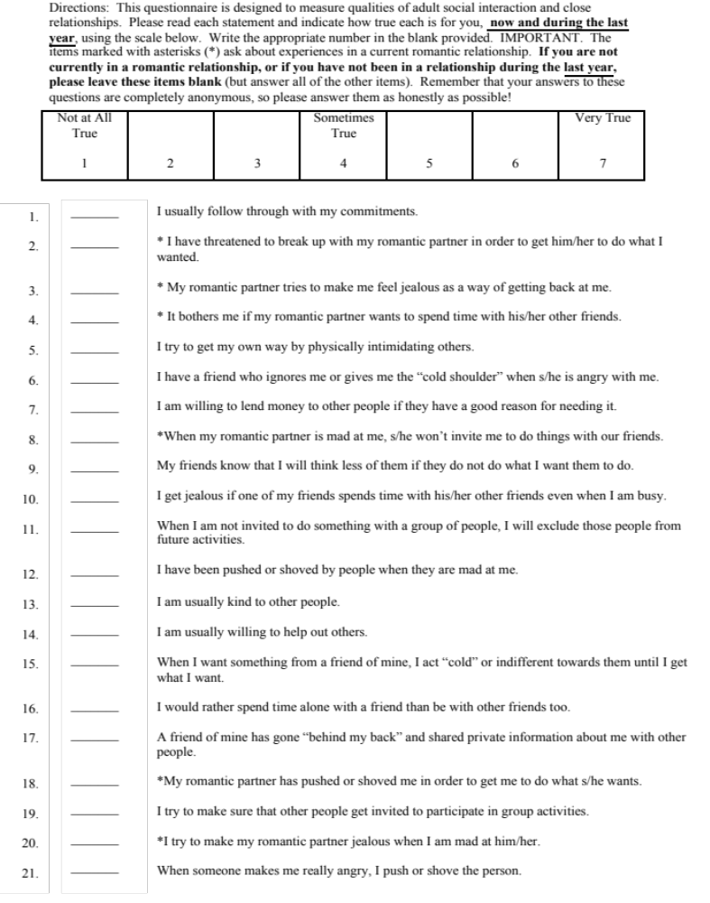

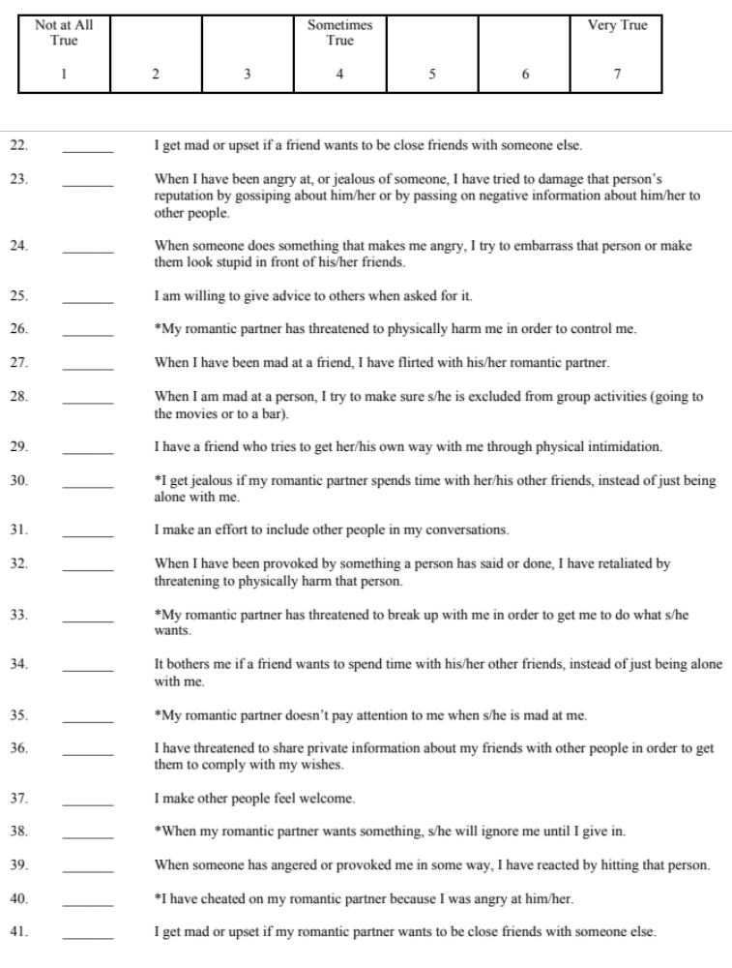

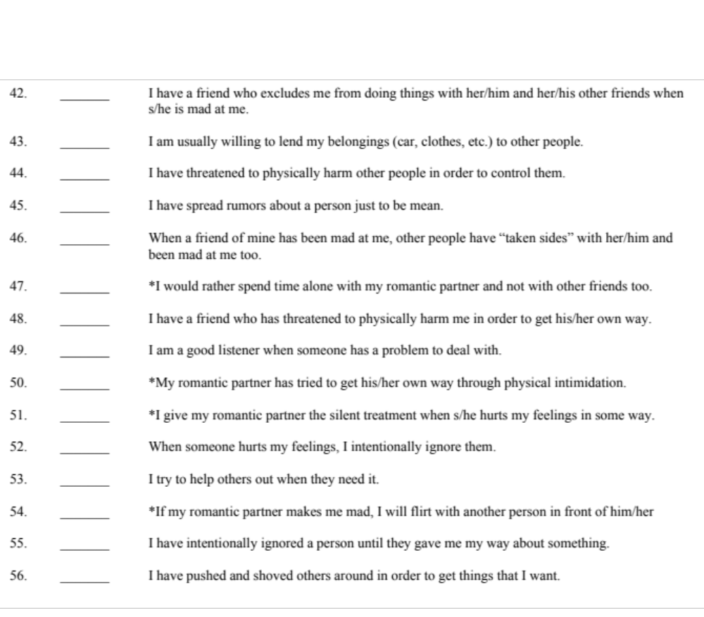

Appendix D: The General Belongingness Scale (GBS)

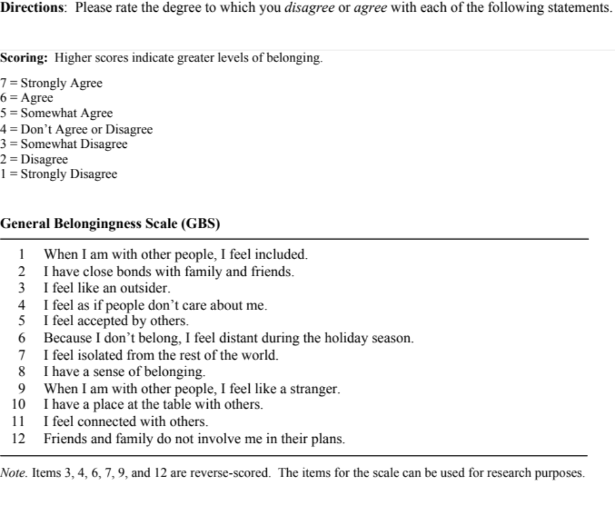

Appendix E: Relational-Interdependent Self-Construal Scale (RISC scale)

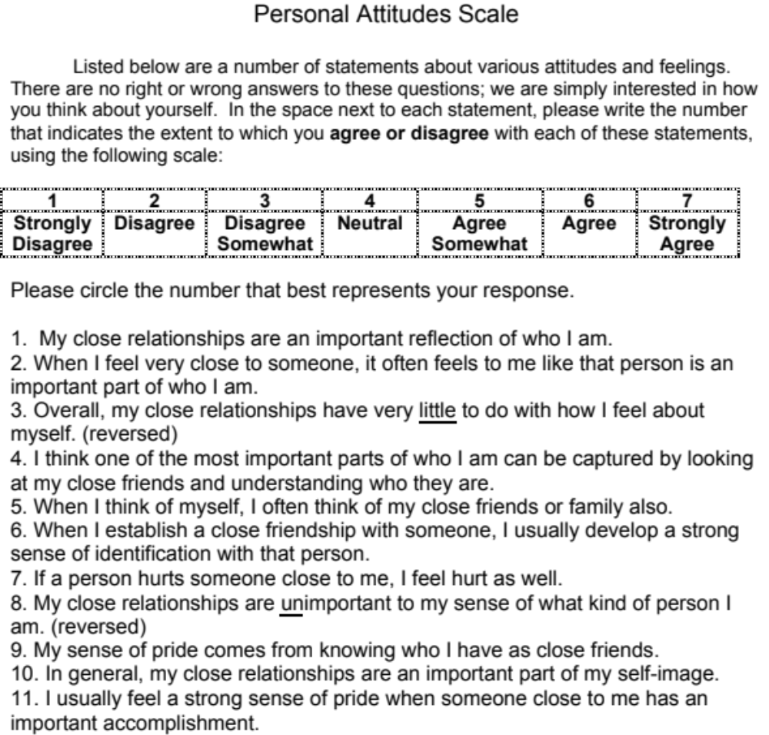

Appendix F: Demographic Questionnaire

In order to successfully complete this study, I would like to know more about you. The information you provide will not be used to identify you in any way.
- Age:

- Gender: a. Female b. Male c. Gender, please specify ___________

- Sexual Orientation:
a. Gay
b. Lesbian
c. Bisexual
d. Heterosexual/Straight
e. Sexual orientation, please specify
- Ethnicity (please select all that apply):
  - African or African-American
b. American Indian/Native American
c. Asian or Asian American
d. Biracial or Multiracial
e. Caucasian
f. Hispanic/Latina/Latino
g. Ethnicity, please specify: ___________________
5. Are you an International Student? a. Yes b. No

6. Please mark all that may apply to you:
- Undergraduate Student
- Nontraditional College Student
- International Student
- First-Generation College Student
- Commuter Student/Living Off Campus
- Living on Campus
- Graduate Student
- Student in a Professional Program (e.g., Law school)
- Other (please specify): ___________________________

7. What is the highest level of education you have completed?
a. Junior High/Middle school
b. High school
c. Some college
d. Vocational training
e. Associate’s degree
f. Bachelor’s degree
g. Master’s degree
h. Doctorate degree
i. Professional degree
j. Other (please specify): _________________________

8. Income:
a. Less than $4,999
b. $5,000 – $9,999
c. $10,000 – $14,999
d. $15,000 – $19,999
e. $20,000 – $24,999
f. $25,000 – $29,999
g. $30,000 – $34,999
h. $35,000 – $39,999
i. $40,000 – $44,999
j. $45,000 – $49,999
k. Over $50,000

9. Please list the geographic location of your current university:
- Northeastern United States
- Southeastern United States
- Midwestern United States
- Northwestern United States
- Southwestern United States

