University of Oklahoma

Graduate College

tHE ROLE OF HEALTH INEQUALITY IN ACHIEVING UNIVERSAL PRIMARY EDUCATION: A CROSS-NATIONAL Panel ANALYSIS

A thesis

submitted to the Graduate Faculty

in partial fulfillment of the requirements for the

Degree of

Master of Arts

By

kARA jANE sNAWDER
Norman, Oklahoma
2017

THE ROLE OF HEALTH INEQUALITY IN ACHIEVING UNIVERSAL PRIMARY EDUCATION: A CROSS-NATIONAL panel ANALYSIS

A thesis approved for the
Department of Sociology

By

______________________________
Dr. Rob Clark, Chair

______________________________
Dr. Ann Beutel

______________________________
Dr. Martin Piotrowski

© Copyright by Kara jane snawder 2017
All Rights Reserved.

I dedicate this to my partner, Mark, my parents, Rita and Robert, my long-time best friends, Jessica and Sydney, my cohort, Amy and Chelsea, and everyone else who gave me moments of much needed distraction. Thank you all for believing in me. You all kept me smiling.

Acknowledgements
I am forever grateful for the opportunities I have had to learn from and work with the phenomenal scholars and teachers in OU‘s Department of Sociology. I would like to give a special heartfelt thank you to those who served on the committee for this thesis, Dr. Rob Clark, Dr. Ann Beutel, and Dr. Martin Piotrowski. The insight that you all provided was invaluable. Lastly, to Dr. Clark, this project would not have been possible without your knowledge, guidance, and creativity. It has been a honor and a joy to work with you and I cannot thank you enough for your support throughout this project and graduate school.

Table of Contents
Acknowledgements..........................................................................................................iv
List of Tables...................................................................................................................ix
List of Figures..................................................................................................................xi
Abstract...........................................................................................................................xii
Chapter 1: Introduction......................................................................................................1
Chapter 2: Theoretical Framework and Relavant Literature.............................................4
Health Inequality: The Benefit of Distribution.....................................................4
Pathways from Health Inequality to Adverse Educational Outcomes…………..6
Chapter 3: Data and Methods…………………………………………………………..11
Sample………………………………………………………………………….11
Dependent Variables…………………………………………………………...12
Gross Primary Enrollment……………………………………………...13
Net Primary Enrollment………………………………………………..13
Independent Variable…………………………………………………………...14
Health Inequality……………………………………………………….14
Control Variables……………………………………………………………….16
Time Period…………………………………………………………….17
World Region…………………………………………………………..17
GDP per Capita…………………………………………………………18
Income Inequality………………………………………………………18
Fertility Rate……………………………………………………………19
Urbanization……………………………………………………………20
Gross Capital Formation………………………………………………..20
Democratization………………………………………………………..21
Gender Parity in Primary School……………………………………….21
Youth Age Dependency………………………………………………..22
Youth Sex Ratio………………………………………………………..22
Analytical Strategy………………………………………………………..……23
Sensitivity Analyses……………………………………………………25
Chapter 4: Results………………………………………………………………………28
Descriptive Trends……………………………………………………………...28
Bivariate Analyses……………………………………………………………...30
Multivariate Analyses…………………………………………………………..33
Control Variation across Analyses……………………..........................37
Sensitivity Analyses……………………………………………………39
Chapter 5: Discussion……………………………………………………….……….…42
Limitations and Future Research………………………………………….……42
Conclusion………………………………………………………………….…..45
References……………………………………………………………………………...47
Appendix A: Addressing Collinearity………………………………………………….56
Appendix B: Countries in Analyses……………………………………………………59
Appendix C: Calculating Health Ginis…………………………………………………60
Appendix D: Descriptive Statistics…………………………………………………….61
Appendix E: Zero-Order Correlation Matrices………………………………………...62
Appendix F: Mean-Deviated Correlation Matrices…………………………………….64
Appendix G: Random Effects Analyses………………………………………………..66
Appendix H: Fixed Effects Analyses…………………………………………………..68
Appendix I: 2SLS Analyses……………………………………………………………70
Appendix J: Pathways Linking Health Inequality and Enrollment………………….…71
Appendix K: Time Trends of Enrollment……………………………………………...72
Appendix L: Time Trends of Health Inequality……………..…………………………74
Appendix M: Scatter Plots of Health Inequality and Enrollment………………………75
Appendix N: Mean-Deviated Scatter Plots…………………………………………….77
Appendix O: Regional Gross Enrollment Relative to Europe………………………….79
Appendix P: Replication without GDP per Capita……………………………………..80
Appendix Q: Replication without Youth Age Dependency……………………………82
Appendix R: Replication without Fertility Rate………………………………………..84

List of Tables
Table 1. List of Countries Included in Anayses..............................................................59
Table 2. Calculating Health Ginis from Life Tables.......................................................60
Table 3. Sample Desciptive Statistics.............................................................................61
Table 4a. Correlation Matrix for Gross Enrollment........................................................62
Table 4b. Correlation Matric for Net Enrollment............................................................63
Table 5a. Mean-Deviated Correlation Matrix for Gross Enrollment..............................64
Table 5b. Mean-Deviated Correlation Matrix for Net Enrollment..................................65
Table 6a. Random Effects of Gross Enrollment..............................................................66
Table 6b. Random Effects of Net Enrollment.................................................................67
Table 7a. Fixed Effects of Gross Enrollment..................................................................68
Table 7b. Fixed Effects of Net Enrollment.....................................................................69
Table 8. Fixed Effects 2SLS............................................................................................70
Table 9a. Replication of Gross Enrollment without GDP per Capita.............................80
Table 9b. Replication of Net Enrollment without GDP per Capita.................................81
Table 10a. Replication of Gross Enrollment without Youth Age Dependency..............82
Table 10b. Replication of Net Enrollment without Youth Age Dependency..................83
Table 11a. Replication of Gross Enrollment without Fertility Rate................................84
Table 11b. Replication of Net Enrollment without Fertility Rate...................................85

List of Figures
Figure 1. Pathways Linking Health Inequality and Primary School Enrollment………71
Figure 2a. Time Trends of Average Gross Enrollment, 1970 – 2015…………..……...72
Figure 2b. Time Trends of Average Net Enrollment, 1970 – 2015………………..…..73
Figure 3. Time Trends of Health Inequality, 1970 – 2015………………………...…...74
Figure 4a. Scatter Plot of Gross Enrollment and Health Inequality, 1970 – 2015……..75
Figure 4b. Scatter Plot of Net Enrollment and Health Inequality, 1970 – 2015……….76
Figure 5a. Mean-Deviated Scatter Plot of Gross Enrollment and Health Inequality…..77
Figure 5b. Mean-Deviated Scatter Plot of Net Enrollment and Health Inequality…….78
Figure 6. Time Trend of Gross Enrollment Relative to Europe, 1970 – 2015…………79

Abstract
Throughout the latter half of the 20th century, cross-national primary education has improved substantially, even when considering remaining inequalities between nations. In order to further tease apart the complex mechanisms that have facilitated this growth, the present study posits that global reductions in health inequality (defined as a country’s distribution of age at death) has played a key role in increasing primary school enrollment. Health inequality is theorized to negatively affect primary school enrollment by acting as a collective proxy of distinct phenomena within a population, such as prevalence of mortality, prevalence of poor childhood health, and prevalence of parental health shocks. To test the relationship between health inequality and primary school enrollment, this study employed a cross-national unbalanced panel dataset of 806 observations across 142 nations from 1970 to 2015. Across random and fixed effects models as well as sensitivity analyses, higher levels of health inequality were significantly associated with lower primary school enrollment. Therefore, evidence suggests that improvements in cross-national health equality contributed in part to the substantial increase in global access to primary education.

Chapter 1: Introduction
Research demonstrates that ensuring access to primary education facilitates economic growth (Easterlin 1981), produces higher standards of living (Barro 1991; Firebaugh and Beck 1994; UNDB 2003), reduces fertility rates (Lam and Duryea 1999; Bittencourt 2014; Yoo 2014), increases environmentalist practices (Longhofer and Schofer 2010; Givens and Jorgenson 2013; Pampel 2014), and promotes gender equity (Malhotra, Pande, and Growth 2003; Birdsall, Levine, and Ibrahim 2005). Reflecting the need for global educational opportunities, the Education Millennium Development Goal of Universal Primary Education, put forth by the United Nations, aspired that “by 2015, children everywhere, boys and girls alike, will be able to complete a full course of primary schooling” (UN Statistics Division 2008). Evidence suggests that, fortunately, educational outcomes have improved substantially over time (Meyer et al. 1977; Windolf 1997; Schafer 1999; Schofer and Meyer 2005; Nagdy and Roser 2016) particularly since World War II, even when considering remaining inequalities between global regions and nation-states. Many financial and developmental mechanisms have facilitated the leap in primary education. However, among these causes, the present study posits that reductions in cross-national health inequality (measured by the distribution of age at death) may have contributed to converging global primary education.
Investing in primary school education has been shown to produce sizable private and social returns, particularly for developing and middle-income nations (World Bank 1995; Mingat and Tan 1996; Psacharopoulos 1996; Psacharopoulos and Patrinos 2002; Williamson 2002). Highly industrialized countries continue to reap value from primary education as well, though returns are notably lower than those received by non-industrialized countries (Psacharopoulos and Patrinos 2002). This trend has driven some to argue that the Millennium Development Goal should not stop merely at primary education, but be extended to universal secondary education (Cohen 2008). With this in mind, it is ideal to explore the many mechanisms that have historically influenced cross-national primary education in order to inform future goals to advance global secondary and tertiary education.
Poor health among school-age children has been frequently identified as a barrier to educational opportunities. Specifically, a vast body of research demonstrates a strong and consistent negative association between poor health conditions in childhood and on-time school enrollment (Glewwe and Jacoby 1995; Fentiman, Hall, and Bundy 1999; Glewwe, Jacoby, and King 2000; Alderman et al. 2001; Fentiman, Hall, and Bundy 2001; Khanam, Nghiem, and Rahman 2011; Ding 2014), retention into higher grades (Moock and Leslie 1986), and overall academic success (Pollitt 1984; Pollitt 1990; Behrman 1996). However, these studies predominantly examine health at the level of the individual (e.g. early-age malnutrition and adverse effects from poor parental health conditions), such that few have examined health-related conditions at the national level and their effects on populations’ access to education. This limits the ability to make comparisons world-wide and evaluate trends in educational outcomes.
This study proposes that health inequality, a country-level measure defined as the distribution of mortality across age groups, could substantially influence a population’s access to education. An unequal dispersion of mortality reflects precarious survivorship across a population’s age distribution. If it is uncertain that a child will survive to an age at which education is a viable and worthwhile investment, families may find it difficult to reconcile the potential risk of allocating resources toward sending the child to primary school. Furthermore, if mortality and its related health risks are felt by parents or siblings, school-age children may be forced to prioritize short-term familial and economic responsibilities over active and routine participation in formal education. Unlike macro measures such as life expectancy or infant mortality, which only capture an average and small aspect of the whole, or micro measures like caloric intake, which are reliant on particular individuals, health inequality can act as a proxy for all of these components operating together. Thus, this study asks whether net of financial, developmental, regional, and temporal factors, health inequality has historically disrupted nations’ attainment of widespread primary school enrollment and relatedly, whether increases in global access to primary school can be partially attributed to cross-national reductions in health inequality.

Chapter 2: Theoretical Framework and Relevant Literature
Case study research has routinely demonstrated the predictive power of health conditions on individual and household-level decisions to invest in educational opportunities for primary school-age children. However, fewer studies have taken a cross-national approach to determining the relationship between population health and education. Taking a macro approach is advantageous to determining the global similarities and differences in the current and historic prevalence of educational access. This study explores how observed sizable reductions in health inequality can explain a significant proportion of cross-national improvements in primary enrollment. Though average-based health measures such as increased length of life and reduced infant mortality benefit education, it is also valuable to consider distributions of experienced health. Analyzing health distributions allow for intensive comparative analysis of educational outcomes between global populations over time while also accounting for variations that are present within populations.
Health Inequality: The Benefit of Distribution
The present study employs a custom measure of health inequality that has rarely been utilized in a large-scale cross-national context. Here, health inequality is measured by a Gini coefficient capturing the distribution of mortality across age. Though commonly used in the analysis of income disparity, past work has confirmed that the health Gini is a meaningful method of analyzing length of life inequality within population groups and between nations (Silber 1988; Shkolnikov, Andreev, and Begun 2003; Goesling and Firebaugh 2004; Peltzman 2009; Smits and Monden 2009; Edwards 2011; Neumayer and Plumper 2016). Due to the usefulness of tracking health experiences within populations as well as national averages as they pertain to health and education, it is clear that the distribution of health inequality could also be relevant to analyzing changes in primary enrollment.
The primary advantage of inequality as a measure of health lies in its ability to account for variations in health experiences throughout a population while also operating on an aggregate scale upon which cross-national comparisons can be made. Measures such as life expectancy, infant mortality, or morbidity prevalence, while useful, do not capture the full spectrum of experienced health. The nature of an average implies that a measure is obscured when even just a few cases report very high values. This poses a problem when a small subset of a population is experiencing very good health while the rest are not. Furthermore, life expectancy does not indicate anything about the actual healthiness of the lifespans occurring within a nation (Pradhan, Sahn, and Younger 2003). Employing measures such as morbidity prevalence can assess healthiness of populations but pose difficulties due to often vague and inconsistent self-reports (Hill and Mamdani 1989; Over et al. 1992). Additionally, research indicates that taking into account the distribution of health for countries yields differences that are not always captured when life expectancy is used alone (Edwards and Tuljapurkar 2005; Peltzman 2009; Smits and Monden 2009). Difficulties also arise from commonly used measures such as infant mortality because widespread infant death in the late twentieth century and beyond is a relatively rare event and therefore requires very large samples (Mosley and Chen 1984). Accounting for only infant or child mortality also foregoes meaningful peaks of mortality in young or middle adulthood.
The health Gini accounts for variations in mortality throughout a population’s age distribution. Therefore, by utilizing this measure, one can capture the impact of high mortality at young ages while also accounting for higher-than-average mortality in adulthood. Also, due to the distribution’s ability to depict multiple peaks of mortality, it may imply that certain ages are being disproportionately affected by illness compared to those in more equal populations. Literature suggests that educational outcomes are affected by multitudinous health phenomena and as such, it is important to investigate the role that longevity inequality has played in facilitating the improvements in access to primary school throughout the world.
Pathways from Health Inequality to Adverse Educational Outcomes
Health inequality acts as a proxy of various health processes within a population which may adversely affect educational outcomes. Lived experiences of pathways from health inequality to educational barriers may appear through the prevalence of mortality, the prevalence of poor childhood health, and the prevalence of parental health shocks. The first pathway primarily captures the effects of infant and childhood mortality on school enrollment. If a nation contains mortality levels that are concentrated at younger ages, long-term investments in human capital such as education may hold less priority. In other words, as argued by Reher (2011), reductions in mortality and fertility spur social and economic change, including heightened investment in education. The second and third pathways are based upon the implication that peaks of death at childhood and middle ages (as opposed to being predominantly concentrated at old age) are a result of a higher prevalence of morbidity and physical frailty. If children are experiencing poor physical health, they may be unable to begin school at the recommended age. Similarly, if parents of school-age children face poor health conditions, their children may be required to forego enrollment in favor of tending to the home and family. Holistically, health inequality represents the combined influence of these separate parts which all are deleterious to education.
[FIGURE 1 ABOUT HERE]
Figure 1 details three pathways health inequality may act through to negatively affect school enrollment. Referring first to the pathway of mortality (P1, Figure 1), since the 19th century, human life expectancy and mortality rates have substantially improved for both wealthy and lower income countries (White 2002; Lee 2003). This was driven primarily by rising incomes which led to better and more effective nutrition, medical care, technology, and sanitation practices (McKeown and Record 1962). As mortality rates have fallen, thereby triggering demographic transitions throughout many countries, fertility rates have also declined over time at varying rates. When populations are able to live longer and invest more in fewer children, societies may then strive toward endeavors that increase human capital, such as ensuring access to formal education for present and future generations. Consistent with this expectation, studies indicate that reducing mortality produces heightened incentives to invest in educational opportunities (Ram and Schultz 1979; Ehrlich and Lui 1991; Meltzer 1992; Kalemli-Ozcan, Ryder, and Weil 2000). Conversely, nations with higher levels of mortality at younger ages see worse educational outcomes compared to nations with a strong concentration of death at old age (Ruger and Kim 2006). Thus, one may expect high levels of health inequality, in which peaks of death appear throughout the age distribution, especially in infancy and childhood, to be negatively associated with primary school enrollment and relatedly, reducing health inequality should increase enrollment.
Health inequality may also imply a high prevalence of disease and frailty in childhood (P2, Figure 1). As countries with higher levels of health inequality often see a substantial concentration of mortality at young ages, the factors that cause these deaths may also broadly produce poor health conditions such as lack of accessibility to sufficient medical care, disease immunization, nutritious food, and effective sanitation practices (Mosley 1983; Shrestha, Gubhaju, and Roncoli 1987; Suwal 2001). Embedded in these conditions, school-age children are more susceptible to health experiences that are detrimental to enrollment, retention, and success in primary school. Thus, one may also expect that in addition to acting upon education through mortality, health inequality negatively affects educational outcomes via lower levels of lived population wellness.
A substantial body of research indicates that poor health conditions in childhood negatively affects a battery of educational outcomes. These studies often utilize a case study approach in which childhood health is operationalized as one’s share of protein in caloric intake or height-by-age z-scores. Poor childhood health produces significant delays in primary school enrollment (Glewwe and Jacoby 1995; Fentiman, Hall, and Bundy 1999; Glewwe, Jacoby, and King 2000; Alderman, et al. 2001; Fentiman, Hall, and Bundy 2001; Khanam, Nghiem, and Rahman 2011; Ding 2014) as well as negatively affects school performance and achievement (Pollitt 1984; Moock and Leslie 1986; Pollitt 1990; Behrman 1996). Relatedly, health interventions in early childhood have positive impacts on primary school enrollment (Todd and Winters 2011) and achievement (Maluccio 2009). Therefore, efforts to improve health in childhood can lead to more consistently realized educational involvement.
Lastly, like children, parents may also be negatively affected by the conditions that contribute to high mortality across the age distribution (P3. Figure 1). In environments where reliable medical care and sufficient sanitation is scarce, mothers may undergo unsafe birthing procedures which can subsequently lead to illness or death. Furthermore, areas of high infant and child mortality may also see high levels of fertility which, in reducing the age at which mothers first give birth and increasing the number of children they will have throughout their lifetime, can lead to deleterious physical consequences such as pelvic floor complications, cardiovascular disease, and diabetes, depending on the quality of accessible prenatal care (Wall 1999; Lukacz et al. 2006; Parikh et al. 2010; Vandenheede et al. 2012). Evidence suggests that precarious parental health conditions negatively influence children’s involvement and achievement in school. For example, parental health shocks as well as parental malnutrition delays children’s enrollment into primary school and diminishes grade advancement (Ainsworth, Beegle, and Koda 2005; Yamano and Jayne 2005; Beegle, de Weerdt, and Dercon 2006; Case and Ardington 2006; Evans and Miguel 2007; Kim, et al. 2014; Dhanaraj 2016), potentially due to children being forced to allocate attention away from schooling and parents being unable to invest heavily in education.
By acting as a holistic measure of health and mortality, it is expected changes in health inequality have had a substantial impact on cross-national trends in education. Unlike other measures such as life expectancy and infant mortality, health inequality is multifaceted and captures more than one dimension of health. Rather, it demonstrates not only the general health status of a nation, but also whether longevity is being experienced equally throughout the population. As many past education studies have focused on specific individual factors that drive educational outcomes, this study offers a unique vantage point whereby the effect of health on education can be examined at the national level while simultaneously accounting for differences that exist within populations. This is important when considering the educational differences that have historically existed between developed and less developed nations and examining the degree to which these differences remain.
Considering the framework outlined above, it is hypothesized that:
Hypothesis I: The presence of health inequality negatively affects primary school enrollment.
This hypothesis will be tested using analyses that address cross-sectional trends as well as longitudinal variation cross-nationally. If it is confirmed that countries with high health inequality more often see lower levels of primary school enrollment, it can be assumed that the reductions in length of life inequality seen over time has helped facilitate growth toward universal primary education. The knowledge of such a relationship can then be used to improve cross-national convergence in secondary and tertiary enrollment and close the remaining gaps in primary enrollment.

Chapter 3: Data and Methods
Sample
The present study employs a compiled dataset that includes a custom measure of health inequality presented alongside variables primarily extracted from the World Bank’s World Development Indicators (World Bank 2014) unless otherwise noted. These data are structured as an unbalanced panel, meaning that countries contribute a differential number of observations per time period. Measures within each wave represent a five-year country average, which conforms to the health inequality measure calculated from the United Nation’s series of life tables. The earliest time period at which all relevant predictors are available is 1970, therefore analyses are limited to available observations across the nine-wave span between 1970 and 2015. The final base sample includes 806 observations (143 countries) for models of gross enrollment and 638 observations (139 countries) for models of net enrollment. The total selection of countries as well as the number of waves in which they each are present are shown in Table 1. The unit of analysis for this study is the count-year.
[TABLE 1 ABOUT HERE]
Cross-national panel data are often limited by missing data due to cultural differences between countries and difficulties in routinely coordinating data collection efforts (Oud and Voelkle 2014). If starting from a hypothetical situation in which all data in this study were available for all countries across each wave between 1970 and 2015, 1,800 observations would be available for estimation. However, accounting for missing data via listwise deletion substantially reduced the final sample size, thus, it is necessary to consider bias stemming from overrepresentation or underrepresentation of certain countries. Calculating the average number of waves containing observations from each region, when accounting for missing data across all predictors, indicated that Africa contributed to 4.4/3.7 (gross/net) waves, America to 6.4/5.2, Asia to 6.0/4.5, Europe to 6.3/5.2, and Oceania to 6.3/6.7. These values indicate that, as expected, data representation is skewed toward more wealthy, developed regions.
In order to account for this source of bias, in addition to the full sample of countries, analyses also estimate results for a sample of countries that exclude 22 high-income Organization for Economic Co-operation and Development (OECD) member nations. Doing so reduced the average contributions of Europe and Oceania to levels similar to Africa. Though this does not completely correct for the overrepresentation of wealthy countries in these data, it does allow for some control over the influence these countries evoke on estimations. Furthermore, no region provides observations for all 9 waves or for 0 waves, implying some additional balance to regional representation.
Dependent Variables
Though there are a variety of important educational measures, this study focuses on enrollment in primary education as the dependent variable for analyses. According to the International Standard Classification of Education (ISCED), primary education is the first stage of basic education. Primary education encompasses six years of full-time schooling with the typical legal age of entrance between ages 5 to 7 (UNESCO 2007). This study focuses on primary enrollment because it offers middle ground between exposure to educational material and embeddedness in the formal education system. For example, measuring a population’s literacy rate is a practical assessment of knowledge, however it does not directly indicate whether children are involved in formal schooling and data are limited. Conversely, measuring the completion of primary school or progression to secondary school does not directly consider general access to formal schooling.
Gross Primary Enrollment
Gross primary school enrollment refers to the ratio of students of all ages who are enrolled in formal primary school education to those in the population who fall within the age group that qualifies for enrollment in primary school. Gross enrollment can exceed 100% due to the inclusion of students who do not fall within the standard age group because of late enrollment or grade repetition. This measure aggregates information for both male and female students.
Net Primary Enrollment
It is also beneficial to measure effects for net primary school enrollment, an alternative and more specific measure of school participation. Like gross enrollment, net primary enrollment calculates the ratio of students enrolled in primary school who fall within the appropriate age group over the total population in that age group. Unlike gross enrollment, net enrollment does not include enrolled children of all ages. Rather, it only accounts for enrollment by those within the official school age group. This measure also aggregates data for males and females.
The differences between these two variables may allow for the discussion of two similar but distinct stories. Gross enrollment presents general access to primary school regardless of age. Specifically, it depicts trends for countries that possess enrollment that falls near 100% (indicating high enrollment of appropriately-aged children), countries that possess enrollment slightly or far below 100%, and finally, countries that possess enrollment that exceeds 100% (indicating high enrollment and the presence of delay and/or grade repetition). Conversely, net enrollment allows for a clear and concise picture of only “on-time” enrollment. Therefore, it represents a nation’s ability to enable its population to prioritize education at an early and targeted age. Both gross and net enrollment are important to consider when evaluating the reality of Universal Primary Education. For these reasons, models are estimated for both measures of enrollment.
Independent Variable
Health Inequality
Health inequality is drawn from a custom dataset of health Gini coefficients spanning from 1950 to 2015 for 200 nations. The Gini coefficient has traditionally been used as a measure of income inequality. This measure is based upon the location of the Lorenz curve within a triangular region composed of (1) the cumulative percent of the population, (2) the cumulative percent of the good’s distribution and (3), a diagonal line indicating an exactly equitable dispersion of the good across the population (Clark 2013). The Gini is the ratio encompassing the discrepancy between (1) the diagonal line of equality and the observed line and (2) the entire triangular region. The more the good departs from a completely equitable distribution, the more the ratio increases; therefore higher Gini scores indicate greater inequality within a population. As it pertains to health, the Gini coefficient measures the distribution of mortality across a population’s age distribution. A Gini of zero or close to zero would indicate that mortality is distributed equally across the population. In other words, all or almost all of the population is living to the same approximate age category, typically peaking at old age. Conversely, higher Ginis would indicate a wider range of mortality across the age distribution – oftentimes producing peaks at infancy and childhood.
Health Ginis were calculated from life tables provided by the United Nations. These life tables are featured alongside other demographic measures as a part of the World Population Prospects, which has most recently been updated as of 2015. Life tables refer to the number of survivors from age one to one-hundred (presented in five-year increments) for a hypothetical cohort of 100,000 individuals who are subject to the predicted mortality rates of a given nation at a given time period (UN Population Division 2015).
[TABLE 2 ABOUT HERE]
Table 2 presents an example of the process by which Ginis are calculated from life tables using an example of Egypt for the 1995-2000 time period. After life tables were obtained for each country (Step 1; Table 2), health Ginis were calculated by converting the age-specific survivorship estimations to age-specific mortality estimations (Step 2; Table 2). This was done by taking the difference between the proposed number of survivors in one age category and the number of survivors from the previous age category. For example, using data shown in Table 2, in order to find the estimated number of deaths by age one, of which there are 96,331 predicted survivors, one would subtract 96,331 from 100,000 (the total number of people within the hypothetical birth cohort), thereby producing a predicted number of 3,669 deaths. Furthermore, in order to find the estimated number of deaths by age five, of which there are 95,128 predicted survivors, one would subtract 95,128 from the 96,331 who survived until age one, producing a predicted number of 1,203 deaths. This process was performed for each age interval until all predicted survivorship values were converted to mortality values for each nation within a specific time period.
Once the full span of age-specific mortality was calculated, 100,000 mortality quantiles were then assigned for each nation per time period (Step 3; Table 2). Cases were assigned based upon the predicted number of deaths by the corresponding age category. For example, since 3,669 people within Egypt’s 1995-2000 cohort were predicted to die by age one, 3,669 cases were assigned a value of one. Furthermore, since 1,203 people were predicted to die by age five, 1,203 cases were assigned a value of five. Cases for each age category were assigned to all 100,000 people within every nation’s cohort. A dataset containing each nation’s quantiles at each time period was then compiled. Finally, Gini coefficients for each nation were calculated by assessing the distribution within each nation (Step 4; Table 2). For ease of interpretation, this measure is multiplied by 100 in the present study so that its scale is similar to primary enrollment.
Control Variables
In addition to health inequality, controls for financial, developmental, regional, and temporal factors that may be influential in predicting primary school enrollment rates are estimated. Control variables for these analyses included time period, world region, logged GDP per capita, income inequality, total fertility rate, urbanization, gross capital formation, democratization, gender parity in primary education, youth age dependency, and youth sex ratio. Unless otherwise specified, all independent variables were drawn from the World Development Indicators (World Bank 2014).
Time Period
In order to control for the substantial rise in primary school enrollment over time, a continuous measure of time period reflecting panel wave is included as a predictor. Time period has been recoded so that the first wave of data is defined as 0, with each subsequent wave increasing by 1 (i.e. 1970-1975 = 0; 1975-1980 = 1; 1980-1985 = 2; 1985-1990 = 3; 1990-1995 = 4; 1995-2000 = 5; 2000-2005 = 6; 2005-2010 = 7; 2010-2015 = 8). Each wave encompasses five-year averages due to the formatting of the life table data from which the Ginis were measured.
World Region
Regional indicators are also included to control for global variation in educational development over time. Countries are classified as belonging to one of the following five regions: (1) Europe (excluded as reference), (2) the Americas, (3) Africa, (4) Asia, and (5) Oceania. Together, observations from the European, African, and Asian regions encompassed approximately 75% of the total available sample. Similarly, the American region contributed approximately 20% of observations to the total available sample. The Oceanic region, composed of only four nations contributing 25 observations, made up less than 1% of the available sample. Regional categories are based upon the World Population Prospects data (UN Population Division 2015).
GDP Per Capita
Economic factors play a substantial role in facilitating access to primary education. Studies that utilize community-level analyses demonstrate this through the positive effect of household income on educational outcomes (Dostie and Jayaraman 2006; Glick and Sahn 2000; Nonoyama-Tarumi, Loaiza, and Engle 2010; Khanam, Nghiem, and Rahman 2011; Mani, Hoddinott, and Strauss 2013). Similarly, national economic development is shown to be strongly predictive of higher enrollment and persistence rates, indicating that some aspects of development and modernization have driven the expansion of cross-national educational outcomes (Schafer 1999). The current study focuses on cross-national observations between countries; therefore, economic factors are assessed using a national-level measure, GDP per capita, rather than a household or individual-level measure. Gross domestic product (GDP) per capita refers to the gross value contributed by all resident producers within a nation’s economy divided by the midyear population. In order to correct for skewness within the data, this measure is presented in the logged form of current U.S. dollars. GDP per capita is hypothesized to have a positive influence on primary school enrollment.
Income Inequality
Levels of income inequality between nations may also influence cross-national patterns in educational access. Countries with higher levels of income inequality may have subsets of their population with limited ability to invest in educational opportunities due to the uneven distribution of wealth. To this point, some have argued that income gaps between the rich and the poor may drive educational gaps due to differential ability of families and schools to invest in resources of educational development (Reardon 2011). Income inequality is drawn from the Standardized World Income Inequality Database (SWIID) which reports income Gini coefficients for a large selection of countries over the previous fifty years (Solt 2009). These data maximize the comparability of estimates found in the United Nations University-World Institute for Development Economics Research data set (UNU-WIDER 2008) by calculating Gini ratios from pairings of observations categorized by reference code and income definition (Clark 2013). It is hypothesized that income inequality will negatively affect primary school enrollment.
Fertility Rate
In his discussion of the trade-off between child quality and quantity, Becker (1960) argued that, when children are viewed as a source of income, the quality of children is directly related to the amount spent on them. Thus, lower fertility may be associated with more investments in children’s human capital (Lee and Mason 2010). To this point, analyses have indicated that high fertility has negatively affected educational outcomes historically (Becker, Cinnirella, and Woessmann 2010) as well as more recently (Cohen, Kravdal, and Keilman 2011) even when considering the opposite effect of education on fertility. Similarly, evidence suggests that lower fertility could contribute to more years of schooling (Liu 2014). In effort to control for this potential relationship, this study includes total fertility rate. Total fertility rate is defined as the total number of children that would be born to a woman if she were to live to the end of her childbearing years and bear children in accordance with the age-specific fertility rates of the specified year within a nation. It is expected that higher fertility rates will be negatively associated with enrollment.
Urbanization
According to various studies, the availability of schools and the distance from the household to schools is a strong predictor of whether children will be enrolled in formal education (Fentiman, Hall, and Bundy 1999; Dostie and Jayaraman 2006; Khanam, Nghiem, and Rahman 2011). Nations with higher levels of urbanization feature greater concentrations of the population around public resources such as schools. Therefore, more urbanized nations may experience higher primary school enrollment compared to more agrarian societies. Urbanization is specifically operationalized as the percentage of people living within an urban area relative to the total population within a nation. It is hypothesized that urbanization will be positively associated with enrollment.
Gross Capital Formation
Studies suggest that investments in social infrastructure, like the educational system, improves population educational attainment (Gupta, Clements, and Inchauste 2004; de Mello and Pisu 2009). However, other studies find insignificant direct effects on education from government social spending (Craigwell, Bynoe, and Lowe 2012). Despite inconsistency in findings, a measure of the degree to which governments allocate resources to improving social investments is also included in the present study. Gross capital formation refers to additions to fixed assets within a nation’s economy plus net changes in inventories. Capital formation encompasses improvements to land and machinery as well as the construction of transportation services, public buildings (e.g. schools and hospitals), and private dwellings. It is hypothesized that higher levels of gross capital formation will positively influence primary school enrollment.
Democratization
Studies demonstrate that higher levels of democracy within a nation can be an important determinant of educational opportunities (Brown 1999; Lake and Baum 2001; Baum and Lake 2003). Accordingly, an index measuring the type of political regime present within each nation is included as a control. A country’s level of democracy is measured via its polity score. Polity scores range from +10, which indicates a highly democratic society, to -10, which indicates a highly autocratic society. These data are coded according to an index comprised of (1) the competitiveness and openness of executive recruitment, (2) the constraints of executive power, and (3) the competitiveness of political participation within a nation (Torfason and Ingram 2010). These data are drawn from the Integrated Network for Societal Conflict Research’s (INSCR) Polity IV project, which assess characteristics of political regimes for various nations throughout the past century (Marshall and Jaggers 2005). These data have been utilized in several studies assessing democratization (Wejnert 2005; Gleditsch and Ward 2006; Clark 2012). It is hypothesized that higher levels of democratization will be associated with higher enrollment.
Gender Parity in Primary School
Gender can act as a significant predictor of enrollment in education (Knight and Song 2000; Brown and Park 2002; Connelly and Zheng 2003) which may subsequently skew the gender composition of schools. In turn, the gender makeup of the primary school populace can potentially have a substantial effect on enrollment rates. For example, if participation in formal schooling within a nation is heavily skewed toward boys, it is more unlikely primary school-aged girls will be enrolled due to social constraints. As a result, overall primary enrollment is lowered. To control for this possibility, analyses include the gender parity index for enrollment in primary education. This measure is defined as the ratio of girls to boys enrolled in primary education at public and private schools. It is expected that gender parity will be positively associated with primary school enrollment. Gender parity is multiplied by 100 so that it is presented on a similar scale to that of school enrollment.
Youth Age Dependency
In accordance with evidence that educational outcomes are often influenced by household choices, past studies demonstrate that household size negatively affects parental investment in academic endeavors (Jaeger 2008; Lee 2008; Kang 2011; Dang and Rogers 2015). As this study examines primary enrollment at the national level, data such as individual household size would not be appropriate. However, to effectively control for the number of dependent children that must be provided with resources, including education, analyses include a measure of youth age dependency. A nation’s youth age dependency is calculated as the ratio of children under the age of 15 to the entire working age population (aged 15 - 64). It is expected that youth age dependency will be negatively related to primary enrollment.
Youth Sex Ratio
Lastly, a heavily skewed sex ratio of the nation’s population may also influence primary enrollment. For example, if a nation demonstrates sex preference in the birth of boys over girls, this may also imply a tendency toward heightened investment in education for boys over girls. Youth sex ratio is drawn from data made available by the World Population Prospects (UN Population Division 2015). These data originally reflected the sex ratio across the entire age distribution within each nation. In order to determine the youth sex ratio, only data for the population aged 0 - 14 were included. The youth sex ratio specifically details the number of males per 100 females. It is expected that a more equitable sex ratio will be associated with higher enrollment.
Descriptive statistics for all variables are shown in Table 3.
[TABLE 3 ABOUT HERE]
Analytical Strategy
The data in the present study are an unbalanced panel, with some countries contributing more observations than others over time. To account for this structure, two primary analytical strategies are employed - random and fixed effects regression. These modeling strategies help address heterogeneity bias (the confounding effects of time-invariant unmeasured variables) in time-series data. Random and fixed effects modeling has been commonly used to deal with heterogeneity within cross-national panel data (Nielsen and Alderson 1995; Alderson and Nielsen 2002). While both random and fixed regression simulate unmeasured effects as country-specific intercepts, random effects include this estimation as a random component of the error term, whereas fixed effects controls for it by mean-deviating the data to reflect changes within a nation over time. Among the random and fixed effects models, there is a tradeoff between efficiency and bias. Due to the random effects model using both between and within unit variation, it tends to produce more efficient estimates. However, if model specification is flawed and unobserved factors are associated with predictors, it may also introduce bias to estimations (Allison 2009). Fixed effects modeling corrects for this by constraining all time-invariant data and only assessing changes within units over time while relaxing the assumption that unmeasured factors must not be associated with observed variables.
The random effects models take on the form:
$y_{it}=βx_{it}+α_{i}+u_{i}+ε_{it}$
where i is the country, t is the observed time period, y is the dependent variable (primary school enrollment), x represents a vector of predictor variables including health inequality, $β$ is a coefficient vector, α is a country-specific intercept, u is the error between units, and ε is the error term for variation over time. These errors are assumed to be independent of the predictors.
The fixed effects models can be generally written as:
$y_{it}=βx_{it}+α_{i}+z_{it}$
where i is the country, t is the observed time period, y is the dependent variable, x represents a vector of time-variant predictors, $β$ is a coefficient vector, and α is a country-specific intercept. The primary difference lies in the error term z, which is now assumed to capture the effect of all unmeasured time-invariant factors and is allowed to be associated with observed variables.
For each analytical strategy, four models are estimated to determine the cross-sectional and longitudinal effects of health inequality on primary school enrollment. Models are organized so that potential changes in controls once the health Gini is introduced may be observed. Models 1 and 2 include all countries with relevant data. Models 3 and 4 drop 22 high-income OECD nations from the sample in order to determine whether there is substantial difference in effect due to general levels of development. Models 1 and 3 present effects on primary school enrollment when including all controls except for health inequality. Models 2 and 4 present the aforementioned effects alongside health inequality. For the fixed effects models, regional effects are included by interacting the indicators with time period. All models will be estimated using a first-order autocorrelation correction.
Sensitivity Analyses
In order to account for the possibility that health inequality may be an endogenous regressor due to the potentially reciprocal relationship between health inequality and primary school enrollment, two-stage least squares (2SLS) regression with instrumental variables and fixed effects is also employed. In the first stage of 2SLS, health inequality is regressed on all exogenous predictors (the control variables) and the selected instrumental variables. In the second stage, primary school enrollment is regressed on health inequality and the controls. However, the suspected endogenous measure, health inequality, is included based upon the predicted values obtained from the first stage. Instrumental variables that are sufficient to predict the endogenous measure must be (1) strongly correlated with the endogenous measure and (2) uncorrelated with the error term from the second stage regression.
The fixed effects two-stage least squares models generally take on the form:
- ${\hat{x}}_{it}=α_{i}+βw_{it}+γc_{i}+z_{it}$
- $y_{it}=α_{i}+\hat{β}{\hat{x}}_{it}+\hat{γ}c_{i}+{\hat{z}}_{it}$
where i is the country, t is the observed time period, y is primary school enrollment, $\hat{x}$ is the predicted values of health inequality based upon the stage-one regression, c is a vector of controls, w is a vector of instrumental variables, α is an unknown intercept for each country, $β$ and $γ$ are coefficient vectors, and z is the error term including unmeasured time-invariant factors.
Two variables are included as instrument: (1) incidence of tuberculosis and (2) access to an improved water source. Incidence of tuberculosis refers to the estimated number of new and relapse tuberculosis cases, expressed as the rate per 100,000. This measure accounts for all forms of tuberculosis. Access to an improved water source is operationalized as the percentage of the population that have access to an improved drinking water source. These data include water present on private premises as well as other sources that are readily accessible by the population. Both instruments are drawn from the World Bank’s World Development Indicators. Full models for gross and net enrollment for full and non-OECD samples are estimated.
Preliminary diagnostics provided evidence that this set of instrumental variables can be generally considered both strong (i.e. correlated with health inequality) and valid (i.e. uncorrelated with the second-stage regression error term). First, both variables showed significant (p < 0.001) correlations with the theorized endogenous regressor, health inequality. Second, the Cragg-Donald Wald F statistic assessing instrument strength was above the standard threshold of 10 (Stock, Wright, and Yogo 2002) for all models and furthermore, was greater than the 5% critical value of relative bias. This is consistent with the first finding that both instruments are strongly associated with health inequality. Third, the Sargan-Hansen test of overidentifying restrictions was insignificant (p > 0.05) for three of the four models, indicating relatively stable evidence for instrument validity. In sum, there is predominantly empirical evidence that these instruments are both strong and valid.

Chapter 4: Results
Descriptive Trends
[FIGURE 2a ABOUT HERE]
[FIGURE 2b ABOUT HERE]
Figures 2a and 2b, respectively, illustrate time trends from 1970 to 2015 for average gross primary school enrollment and average net primary school enrollment. Looking first to gross enrollment, it is apparent that the global average since 1970 has been steadily increasing from approximately 85% in the earliest period to just below 110% in the latest period, yielding a 25% increase over the past 45 years. Similarly, the global average of net primary school enrollment has increased from just below 75% in the earliest years to approximately 90% in 2010 - 2015. These trends are consistent with past literature that has shown global access to formal educational has improved substantially over the latter half of the twentieth century. Regional averages in gross primary enrollment indicate that all regions are currently situated between 100 and 110%. Similarly, regional averages in net primary enrollment are mostly concentrated tightly around 90%.
By far, the African region has experienced the most substantial improvement in primary school enrollment over time and is likely a primary source of the increasing global average. This is demonstrated by a vast jump from just above 60% to approximately 105% for gross primary enrollment and an increase from 55% to just below 90% for net enrollment. Though less steep than its African counterpart, Asia has also seen positive, but fluctuating, growth in enrollment over the years. To this point, Asia increased its gross and net enrollment rapidly from 85% and 75% but reached a plateau and even a slight decline in enrollment throughout the 1990s. However, this decline reversed at the new millennium and resulted in a final gross enrollment of approximately 105% and net enrollment of 90%. The Americas have demonstrated moderate growth from 1970 to 2015, resulting in an overall increase of about 10% for gross and net enrollment. Finally, throughout the measured time period, European enrollment stayed relatively stable at approximately 95% net enrollment and 100% gross enrollment. Oceania displayed similar trends to Europe albeit with more fluctuation. However, as this region contains so few countries, it is difficult to make wholly accurate estimations about its change over time.
[FIGURE 3 ABOUT HERE]
Figure 3 illustrates average time trends in health inequality from 1970 to 2015. This graph indicates that for all global regions, the distribution of mortality across age within populations has become more equitable. Apart from an uptick in health inequality during 1975 – 1980, all regions experienced a consistent downward trend in health inequality. The global average indicates a drop in health inequality from approximately 0.24 in the earliest time period to just below 0.15 in the latest. By 2010 - 2015, the Americans, Asia, Europe, and Oceania have all clustered below Gini coefficients of 0.15. Notably, the African region started with and continues to hold the highest average level of health inequality, with the Gini decreasing from 0.35 to approximately 0.22 at the most recent time period. Though African countries are still markedly more unequal in age at death than countries in other world regions, these trends demonstrate that nations, on average, are more often seeing a clustering of mortality at older ages. This speaks to global improvements in not only quality of health but also access to health resources in recent years. However, there is certainly room to improve in the coming years.
Figures 2a and 2b demonstrate that, on average, cross-national primary enrollment has increased from 1970 to 2015, showing particularly notable improvements in African and Asian countries. Simultaneously, throughout the same time period and global regions, Figure 3 shows that average health inequality has declined. Taking these trends into consideration, it is apparent that the distribution of health within nations and involvement in formal primary schooling may be negatively associated. In order to more rigorously investigate this relationship, bivariate correlations and multivariate models were estimated while accounting for several controls.
Bivariate Analyses
[TABLE 4a ABOUT HERE]
[TABLE 4b ABOUT HERE]
Tables 4a and 4b respectively show zero-order correlations between gross and net primary enrollment with the independent variables. A few details about these correlations are worth noting. First, as expected, the correlation between health inequality and gross and net enrollment was negative, indicating that higher inequality is associated with lower enrollment. The correlation’s strength was moderate for gross enrollment (r = -0.46; p < 0.001). However, the correlation for net enrollment was much stronger (r = -0.74; p < 0.001). Second, it is apparent that health inequality is strongly correlated (r > 0.75; p < 0.001) with GDP per capita, youth age dependency, and fertility rate. In order to address this problem of collinearity, multivariate results were replicated first without GDP per capita, next without youth age dependency, and finally without fertility rate. Full reports of these analyses are discussed in Appendix A. To summarize these analyses, the exclusion of these variables did not highly influence the direction and magnitude of the coefficient for health inequality nor did it strongly influence results for other control variables.
[FIGURE 4a ABOUT HERE]
Figure 4a depicts a scatter plot of gross primary school enrollment over health inequality from 1970 to 2015 with a line of fitted values. First, this illustration indicates a strong clustering of countries around low levels of health inequality and enrollment rates situated around approximately 100%. This is to be expected considering the time trends featured above that predominantly show regional averages progressing toward high enrollment and low health inequality. Second, this plot shows that throughout the measured time period, as health Ginis reach levels of 0.2 or more, the clustering begins to disperse around the fitted line. Furthermore, many countries with health Ginis of 0.35 or more tend to show enrollment rates well below the fitted line.
[FIGURE 4b ABOUT HERE]
Figure 4b depicts a scatter plot of net primary enrollment over health inequality from 1970 to 2015 with a line of fitted values. First, similarly to Figure 4a, Figure 4b demonstrates a strong clustering of countries that possess both low health inequality and high net primary school enrollment. Second, as health inequality increases, countries begin to show an associated decrease in enrollment. The trend line in Figure 4b depicts a steeper negative decline compared to that seen in Figure 4a. This is to be expected considering the strength difference in zero-order correlations between gross enrollment and net enrollment with health inequality as shown in Tables 4a and 4b. Since gross enrollment is allowed to surpass 100%, its relationship with health inequality is somewhat less straightforward. However, when considering net enrollment which is forced to capture only those within the standard age group and does not exceed 100%, there is much less variation well above the trend line. As a result, net enrollment produces a stronger negative correlation with health inequality than gross enrollment.
[TABLE 5a ABOUT HERE]
[TABLE 5b ABOUT HERE]
In order to account for the influence of change over time on variable associations, mean-deviated correlation matrices for gross and net enrollment and their predictors were also calculated and are shown in Tables 5a and 5b. The mean-deviated correlations between health inequality and gross and net enrollment also fell in the expected direction and were both of moderate strength. Specifically, the correlation between gross enrollment and health inequality grew slightly (r = -0.55; p < 0.001) while the correlation for net enrollment was marginally reduced (r = -0.58; p < 0.001). Interestingly, Tables 5a and 5b indicate that when accounting for change over time, the strong correlation found between GDP per capita and youth age dependency on health inequality was reduced to a moderate association. Health inequality’s correlation with fertility rate was also reduced, but the association remained strong (r > 0.75; p < 0.001).
[FIGURE 5a ABOUT HERE]
[FIGURE 5b ABOUT HERE]
Figures 5a and 5b show scatter plots for health inequality and gross and net enrollment throughout 1970 – 2015 when all variables are mean-deviated. Both plots depict similar trends. First, the majority of observations are at or similar to the means of health inequality and primary school enrollment, indicating that only a select number of countries heavily deviate from the global average. Second, the observations that notably stand out from the average depict a negative relationship between health inequality and primary enrollment. For example, countries with higher than average health inequality tend to show enrollment levels below the average. Similarly, countries with lower than average health inequality report enrollment above the global average. Overall, these plots provide an additional layer of evidence that health inequality and primary enrollment are negatively related even when accounting for change over time.
Multivariate Analyses
[TABLE 6a ABOUT HERE]

[TABLE 6b ABOUT HERE]

Tables 6a and 6b respectively show the random effects of gross primary school enrollment and net primary school enrollment from 1970 to 2015. Model 2, which utilizes all countries in the sample, shows that health inequality produced a negative and significant association with gross and net primary school enrollment. More specifically, controlling for influential factors, for a nation with an additional unit of average health inequality when taking into account that health inequality changes over time, gross primary school enrollment is expected to decrease by a percentage of about 0.46. Similarly, net primary enrollment is expected to decrease by a percentage of about 0.59. This is similar to Model 4 which dropped high-income, OECD member countries from the sample. Specifically, a non-OECD nation with an additional unit of health inequality is expected to see a 0.43 percent decrease in gross enrollment and a 0.59 percent decrease in net enrollment.
Differences between Models 1 and 2 and Models 3 and 4 in Tables 6a and 6b indicate that accounting for the effect of health inequality on enrollment diminishes the effect of certain control variables. For example, the influence of time period on primary enrollment was significant for the full sample of gross enrollment and the non-OECD sample of net enrollment. However, when accounting for health inequality, this significance went away and its magnitude was reduced by approximately 30% in both cases. Similarly, fertility rate was initially a significant negative predictor in all random effects models. However, when health inequality was introduced, the significance of fertility rate disappeared in three of four models and was reduced by approximately 35% in all models. Lastly, GDP per capita produced a significant positive effect on net enrollment as shown in Models 1 and 3. When controlling for health inequality, the level of significance was reduced in Model 4 and completely removed in Model 2. Additionally, the magnitude of GDP per capita was reduced by approximately 30%.
[FIGURE 6 ABOUT HERE]
When considering gross enrollment, the positive and significant effects for America and Asia in reference to Europe is a notable trend. As shown in Figures 2a and 2b, recently, gross enrollment among all non-European regions has surpassed Europe. In order to further explore this trend, the ratio of gross enrollment over time for America, Asia, Africa, and Oceania relative to Europe was calculated. Figure 6 depicts each region’s enrollment compared to Europe (with Europe represented as the dashed line) at each wave. According to this figure, all regions apart from Oceania start with lower enrollment than Europe which is to be expected considering Europe possessed approximately 100% gross enrollment throughout 1970 to 2015. America exceeded Europe’s gross enrollment by the early 1980s and remained that way throughout the time span. Asia and Africa increased in enrollment over time and eventually exceeded Europe by the most recent decade. This pattern demonstrates that as of 2010 – 2015, America, Africa, and Asia have not only reached comparable levels of gross enrollment to Europe but have exceeded Europe. However, higher levels of gross enrollment as seen in non-European regions suggest a higher prevalence of delayed enrollment or a lack of retention into subsequent grades in these regions. Therefore, significant estimations for America and Asia indicate that, like Africa, these regions have seen improved access to formal primary school though it is necessary to consider the factors that may explain why these regions contain more primary students that are not of the standard age range.
Random effects models provided evidence that health inequality has negatively influenced global primary school enrollment. However, because this approach models between effects and within effects of countries over time simultaneously, it is susceptible to bias from unmeasured factors. In order to assess whether fixed effects would be an improvement upon this analysis, a Hausman test, which is based on the null hypothesis that the measurement errors are not correlated with regressors included in the models, was run. Indeed, this test was significant (p < 0.01) indicating that the between effects and within effects captured in these models are systematically different. Therefore, fixed effects estimations offer refinement to the results because they constrain unmeasured, time-invariant factors.
[TABLE 7a ABOUT HERE]
[TABLE 7b ABOUT HERE]
Tables 7a and 7b show the fixed effects of gross and net primary school enrollment respectively, from 1970 to 2015. As shown in the random effects models, health inequality produced a significant (p < 0.001) and negative effect on primary school enrollment across all models in Table 7a. Specifically, when controlling for all factors in the full model, one unit increase in health inequality within a nation is predicted to lead to a drop in enrollment by a percentage of about 0.76 within that same nation. Similarly, one unit increase in health inequality within a non-OECD nation as shown in Model 4, is predicted to lead to a decrease in gross enrollment by a percentage of about 0.77. For the fixed effects of net primary school enrollment, an increase in health inequality is expected to lead to a significant (p < 0.05) decrease in enrollment by a percentage of 0.70 (full sample) or 0.79 (non-OECD). Despite fixed effects producing more conservative estimations compared to random effects, the health inequality coefficients in Tables 7a and 7b reported larger reductions to gross and net primary school enrollment. This implies that random effects errors may have been dampening the negative influence of health inequality on enrollment.
Changes in control significance and magnitude with the introduction of health inequality were not as pronounced in the fixed effects estimations as they were in the random effects. However, there was a notable reduction in GDP per capita for gross enrollment. GDP per capita was initially significant in Models 1 and 3, but including health inequality in Models 2 and 4 removed its significance and reduced its magnitude by nearly 30%.
Control Variation across Analyses
In addition to health inequality, a few controls were notably influential on enrollment across random and fixed effects analyses. Some persisted across all models while others significance fluctuated. One measure that was strongly significant throughout all models was gender parity within primary schools. Results indicated that an increase in gender parity (meaning the number of females enrolled more roughly equates to, or exceeds, the number of enrolled males) leads to a significant (p < 0.001) increase in gross and net primary enrollment for full and non-OECD samples. At the most, the strength of this effect only dropped by approximately 13% with the inclusion of health inequality. Therefore, nations that are less inclusive of both male and female students in primary school seem to experience a detriment to their enrollment. Considering the positive effects of maintaining an educated population, this finding serves as evidence that nations should continue to make efforts to improve gender parity in formal education.
Another measure that addresses the distribution of males and females, youth sex ratio, also produced significant (p < 0.05) results within random effects analyses. This negative relationship indicates that societies with a heavier proportion of males compared to females see lower enrollment. In other words, the conditions that produce a greater proportion of male youth than female youth may translate into a preference to invest in education for predominantly boys, thereby reducing overall enrollment rates as girls are left out. However, this finding did not appear in fixed effects analyses, indicating that estimates may have been in part influenced by unmeasured factors.
Fertility rate was also significant and negative across most random effects models, particularly those that did not include health inequality. In other words, this finding suggests that higher average fertility among populations drives down primary enrollment over time. However, in fixed effects estimations, fertility rate was never significant. Therefore, when only addressing change within nations over time, fertility rate does not appear to substantially influence primary schooling compared to other factors such as health inequality and gender parity.
Financial controls such as gross capital formation and GDP per capita were also periodically positively associated with primary enrollment. Capital formation was significant (p < 0.001) in all models except the fixed effects of gross primary enrollment. In other words, for each unit of investment in a nation’s fixed assets, enrollment is expected to increase by approximately 0.2. Therefore, the more a country invests in its social assets such as the educational system, the more accessible these resources become to the population. Similarly, in some models of gross and net enrollment, a unit increase in logged GDP per capita produced significant (p < 0.05) increases to enrollment. As such, more wealthy countries may be able to facilitate greater educational opportunities for their populations. The magnitude of effect for both capital formation and GDP per capita on primary education was reduced when accounting for health inequality.
Finally, regional effects proved to have an interesting impact on primary enrollment. For example, fixed effects estimations of gross and net enrollment indicated that in reference to Europe, Africa contains significantly higher enrollment rates over time. Considering the differential trajectories of these two regions, the explanation of this finding lies in the vast improvements made by Africa. As shown in Figures 2a and 2b depicting time trends for gross and net enrollment, Africa made the most substantial improvement in enrollment compared to all regions. Conversely, Europe started at high enrollment and remained at high enrollment (with small fluctuations) throughout the time span. As fixed effects measure the effect of change over time within a unit of analysis, this significant positive effect is detailing Africa’s particularly substantial improvement in enrollment compared to Europe’s relative stability. Similarly, the main effects for region in random effects estimations of gross enrollment indicated that America, Africa, and Asia experienced more positive growth compared to Europe. Furthermore, the positive significance of American and Asian gross enrollment (but not net enrollment) indicate that these regions are experiencing a higher prevalence of enrollment that does not conform to the standard age group. Whereas Europe has already achieved high, on-time enrollment, other regions have experienced more recent increases in enrollment and still have a higher prevalence of delayed initiation and grade repetition.
Sensitivity Analyses
Two-Stage Least Squares: In order to account for the theoretical presence of endogeneity between health inequality and primary school enrollment, fixed effects two-stage least squares regression with the instrumental variables tuberculosis prevalence and access to an improved water source was also performed. Despite the theorized presence of endogeneity, testing its empirical presence produced an insignificant result. This indicates that the hypothesized endogenous regressor, health inequality, can be treated as exogenous. However, due to the theoretical importance of accounting for endogeneity, 2SLS results were modeled nonetheless.
[TABLE 8 ABOUT HERE]
Table 8 shows the results for 2SLS models with fixed effects for gross and net primary school enrollment from 1990 to 2015 for the full and non-OECD samples. The sample size and time span dropped due to limited availability of the selected instrumental variables. Consistent with other analyses, when accounting for the potential endogeneity of health inequality, across three of the four models, health inequality produced a negative and significant effect on primary school enrollment. For example, regarding the effect for all countries and gross enrollment, one unit increase in health inequality within a particular country is expected to produce a decrease in that country’s enrollment by approximately 1.50. Results for the full sample of net enrollment and the non-OECD sample of gross enrollment also produced a change in enrollment by over 1. Despite prevalent similarity in magnitude and significance across models, health inequality within estimations for net enrollment for non-OECD nations was not significant at the standard level, though it did achieve marginal significance (p < 0.1) and appeared in the expected direction. One reason for this change could be due to the drop in sample size for this model. This model only included 379 observations (almost 100 observations less than the lowest of the other three models), 101 countries, and a more limited time span. Another reason only marginal significance was achieved could be due to ceiling effects of net enrollment. Due to net enrollment being unable to exceed 100%, little room remains for variation among countries that possess high enrollment at the earliest time period.
Outlying and Influential Data: In order to determine if results were being driven by a subsection of outlying and influential data, results for gross and net enrollment were also reassessed using robust regression. Weights were assigned to each case according to their respective contribution to the estimations where particularly influential cases were assigned a lesser weight than those with low levels of influence. Using the respective cut-off points 0.1, 0.3, 0.5, and 0.7, results were separately estimated using only data that exceeded the specified cut-off point. Across all models for each cut-off point, results did not substantively change in magnitude, significance, or direction of association. Therefore, evidence suggests that results obtained from previous analyses were not heavily dependent on the influence of outlying data.

Chapter 5: Discussion
The current study sought to determine if health inequality (measured as the Gini coefficient of the distribution of mortality across age) has played a significant role in improving cross-national access to primary education. To test the hypothesized negative relationship between health inequality and enrollment, random and fixed effects were calculated for nine waves of data between 1970 and 2015. Overall, results indicated that higher health inequality indeed produced negative and significant effects on primary school enrollment. Furthermore, by separately estimating effects for a full sample of countries and a sample excluding high-income OECD members, it is evident that this association represents more than differences in structural development between nations. Sensitivity analyses addressing endogeneity and influential outliers showed that this relationship is robust when accounting for alternative approaches to analysis. Therefore reductions in length of life inequality operates as one of mechanisms that has improved educational outcomes.
Limitations and Future Research
Despite the meaningful results obtained in the present study, it is necessary to address several limitations in order to determine directions for future analyses. The first of these is data limitations. Though the time span utilized in the primary set of analyses encompasses nearly half a century, it would have been of interest to analyze the effect of health inequality on primary school enrollment before enrollment began to reach high levels. Widespread cross-national data on primary education before 1970 is limited, however, new data provided by Lee and Lee (2016), introduce educational outcomes for a large selection of countries across a wider span of time. Future work may consider examining the health-education association with these expanded data. The present study also suffered from considerable missing data across predictors and consequentially, a slight overrepresentation of wealthy countries. Parsing out effects for a non-OECD sample of countries did not produce sizable differences from the full sample, thereby indicating that overrepresentation did not strongly affect results. Yet, future studies may consider examining effects by region or by grouping similarly developed nations.
Second, as shown by Tables 4a, 4b, 5a, and 5b, health inequality is highly correlated with some control variables, particularly fertility rate and youth age dependency. Analyses conducted in Appendix A indicated results were not heavily dictated by this collinearity. However, correlation between health and fertility measures exemplify the difficulty of fully disentangling processes associated with international development. Reher (2011) notes that upon the reduction of widespread childhood mortality and the subsequent diminishment of number of births, parents were able to devote increased attention to education. As a result, the role of institutional schooling expanded greatly. However, Reher also theorizes that the larger process of demographic transition is cyclical in that reductions in mortality and fertility spur social and economic change, then these changes perpetuate further advancements in health and reproductive efficacy. Thus, as most of the countries included in the present study have already begun to experience the initial stages of transition (with other countries much further along in the process), the association between health inequality and education may be deeply embedded within a development feedback loop. It is important, therefore, to be cautious in attempting to generalize statements of strict causality between population health and education.
Third, the instrumental variables employed in the 2SLS sensitivity analyses may not be entirely appropriate as indicated by the significant Sargan-Hanson statistic for the full-sample model of net enrollment. Though the standard tests of strength and validity predominantly affirm evidence for both, these tests are contingent upon the assumption that instruments are both theoretically and statistically suited for the endogenous regressor. As a result, several scholars have discussed the importance of selecting valid instruments and the challenges in doing so (Staiger and Stock 1997; Rashad and Kaestner 2004; Angrist and Pischke 2009; French and Popovici 2011). Furthermore, like other predictors in this study, these instruments may be embedded within a larger context of demographic transition. Future studies may benefit from testing this relationship with instruments that extend further back in time or consider alternative approaches to account for reciprocity between health and education.
Lastly, this study only examined impacts of health inequality on gross and net primary school enrollment. Though enrollment is a valued measure that demonstrates a population’s ability to access formal schooling, it does not necessarily indicate anything about student success or quality of education received in a nation. Furthermore, many countries have already begun to experience widespread primary school enrollment at the time of this study. Therefore, future work should also determine whether health inequality influences other measures of education or enrollment at the secondary or tertiary level.
Beyond limitations, directions of future research could also further address the role of gender parity on educational outcomes and how it moderates the relationship between health and education. This study indicated that net of many other factors, gender parity was an extremely consistent and significant predictor of enrollment. This finding suggests incentive for nations to continue to facilitate the formal education of young women. Education and health inequality could also be decomposed by sex in future studies in order to determine whether the relationship between longevity inequality and education varies across male and female student populations.
Conclusion
Overall, this study contributes to the current literature in a few valuable ways. First, by incorporating a large-scale, cross-national selection of data, this study is able to compare global educational trajectories over time between regions and nations and establish that health inequality affects education at a global scale. Considering cross-national contexts is important to evaluate not only how trends have improved, but also to examine and explain why certain countries continue to lag behind in social outcomes. Second, this study employs a unique and multifaceted measure of health that does not purely focus on the average length of life within a nation or average mortality levels at a specific age range. Rather, health inequality simultaneously captures multiple peaks of mortality throughout the age distribution which reflects that, though a country may possess improving health conditions, these conditions may not be experienced equally throughout the population. Third, by measuring effects for both gross and net primary school enrollment, this study is able to parse out differences that arise from including or excluding students that do not fall within the standard age group. By considering both trends, it is evident that enrollment has improved substantially around the world however, certain countries continue to struggle with ensuring their population is able to enroll students on time.
The present study provides evidence that historically, health inequality has been a negative influence on primary school enrollment, net of developmental factors and differences. Furthermore, as people have begun to experience more similar lengths of life cross-nationally, enrollment rates have also grown substantially. This finding provides a unique and nuanced confirmation that international health and education are inextricably linked and that, despite widespread improvements in quality of life around the world, health still plays a role as a predictor of social outcomes. This finding may inform efforts to reduce remaining inequalities in global primary education and may also assist in improving educational outcomes at the secondary and tertiary level. To do so, nations should make efforts to continue improving health and ensure that this improvement is being experienced equally throughout the population. This process may entail identifying key factors, such as disease prevalence or lack of access to quality medical care, that contribute to heightened mortality and initiate programs to specifically target these problems. Of course, physical health is not the only factor that contributes to mortality. The presence of civil conflict, for example, may also increase mortality within certain age groups. However, in the interest of ensuring education for all children, countries should not disregard the health of its citizens.

References
Ainsworth, M., K. Beegle, and G. Koda. 2005. “The impact of adult mortality and parental deaths on primary schooling in North-Western Tanzania.” Journal of Developmental Studies 41: 412-39.

Alderman, H., J. Behrman, V. Lavy, and R. Menon. 2001. “Child nutrition, child health, and school enrollment: A longitudinal analysis.” Journal of Human Resources 36: 185-205.

Alderson, A. and F. Nielsen. 2002. “Globalization and the great U-Turn: Income inequality trends in 16 OECD countries.” American Journal of Sociology 107: 1244–99.

Allison, P. 2009. Fixed effects regression models. Los Angeles, CA: SAGE Publications.

Angrist, J. and J. Pischke. 2009. Mostly harmless econometrics: An empiricist’s companion. Princeton: Princeton University Press.

Barro, R. 1991. “Economic growth in a cross-section of countries.” Quarterly Journal of Economics 106: 407-37.

Baum, M. and D. Lake. 2003. “The political economy of growth: Democracy and human capital.” Population and Development Review 36: 253-81.

Baum, C., M. Schaffer, and S. Stillman. 2010. ivreg2: Stata module for extended instrumental variables/2SLS, GMM and AC/HAC, LIML and k-class regression.

Becker, G. 1960. “An economic analysis of fertility.” In Demographic and Economic Change in Developed Countries. Princeton: Princeton University Press.

Becker, S., F. Cinnirella, and L. Woessmann. 2010. “The trade-off between fertility and education: Evidence from before the demographic transition.” Journal of Economic Growth 15: 177-204.

Beegle, K., J. de Weerdt, and S. Dercon. 2006. “Orphanhood and the long-run impact on children.” American Journal of Agricultural Economics 88: 1266-72.

Behrman, J. 1996. “The impact of health on nutrition on education.” The World Bank Research Observer 11: 23-37.

Birdsall, N., R. Levine, and A. Ibrahim. 2005. “Towards universal primary education: Investments, incentives, and institutions.” European Journal of Education 40: 337-49.

Bittencourt, M. 2014. “Primary education and fertility rates in Southern Africa: Evidence from before the demographic transition.” IDEAS Working Paper Series.

Brown, D. 1999. “Reading, writing, and regime type: Democracy’s impact on primary school enrollment.” Political Research Quarterly 52: 681-707.

Brown, P. and A. Park. 2002. “Education and poverty in rural China.” Economics of Education Review 21: 523-41.

Case, A. and C. Ardington. 2006. “The impact of parental death on school outcomes: Longitudinal evidence from South Africa.” Demography 43: 401-20.

Clark, R. 2012. “World-system position and democracy, 1972 - 2008.” International Journal of Comparative Sociology 53: 367-99.

Clark, R. 2013. “Convergence in national income distributions.” Social Forces 92: 413-36.

Cohen, J. 2008. “Make secondary education universal.” Nature 456: 572-3.

Cohen, J., O. Kravdal, and N. Keilman. 2011. “Childbearing impeded education more than education impeded childbearing among Norwegian women.” Proceedings of the National Academy of Science of the United States of America 108: 11830-35.

Connelly, R. and Z. Zheng. 2003. “Determinants of school enrollment and completion of 10 to 18 year olds in China.” Economics of Education Review 22: 379-88.

Craigwell, R., D. Bynoe, and S. Lowe. 2012. “The effectiveness of government expenditure on education and health care in the Caribbean.” International Journal of Development Issues 11: 4-18.

Dang, H. and F. Rogers. 2015. “The decision to invest in child quality over quantity: Household size and household investment in education in Vietnam.” World Bank Economic Review 30: 104-42.

De Mello, L. and M. Pisu. 2009. “The effectiveness of education and health spending among Brazilian municipalities.” OECD Economics Department Working Papers, No. 712.

Dhanaraj, S. 2016. “Effects of parental health shocks on children’s schooling: Evidence from Andhra Pradesh, India.” International Journal of Educational Development 49: 115-25.

Ding, J. 2014. “The impact of early childhood nutrient intake on later educational attainment in China.” Thesis. Georgetown University.

Dostie, B. and R. Jayaraman. 2006. “Determinants of school enrollment in Indian villages.” Economic Development and Cultural Change 54: 405-21.

Drukker, D. 2003. “Testing for serial correlation in linear panel-data models.” Stata Journal 3: 168-77.

Easterlin, R. 1981. “Why isn’t the whole world developed?” Journal of Economic History 41: 1-17.

Edwards, R. and S. Tuljapurkar. 2005. “Inequality in life spans and a new perspective on mortality convergence across industrialized countries.” Population and Development Review 31: 645-74.

Edwards, R. 2011. “Changes in world inequality in length of life: 1970-2000.” Population and Development Review 37: 499-528.

Ehrlich, I. and F. Lui. 1991. “Intergenerational trade, longevity, intrafamily transfers, and economic growth.” Journal of Political Economy 99: 1029-59.

Evans, D. and E. Miguel. 2007. “Orphans and schooling in Africa: A longitudinal analysis.” Demography 44: 35-57.

Fentiman, A., A. Hall, and D. Bundy. 1999. “School enrolment patterns in rural Ghana: A comparative study of the impact of location, gender, age, and health on children’s access to basic schooling.” Comparative Education 35: 331-49.

Fentiman, A., A. Hall, and D. Bundy. 2001. “Health and cultural factors associated with enrollment in basic education: A study in rural Ghana.” Social Science and Medicine 52: 429-39.

Firebaugh, G. and F. Beck. 1994. “Does economic growth benefit the masses? Growth dependence and welfare in the third world.” American Sociology Review 59: 631-53.

French, M. and I. Popovici. 2011. “That instrument is lousy! In search of agreement when using instrumental variables estimation in substance use research.” Journal of Health Economics 20: 127-46.

Givens, J. and A. Jorgenson. 2013. “Individual environmental concern in the world polity: A multilevel analysis.” Social Science Research 42: 418-31.

Gleditsch, K. and M. Ward. 2006. “Diffusion and the international context of democratization.” International Organization 60: 911-33.

Glewwe, P. and H. Jacoby. 1995. “An economic analysis of delayed primary school enrollment in a low income country: The role of early childhood nutrition.” The Review of Economies and Statistics 77: 156-69.

Glewwe, P., H. Jacoby, and E. King. 2001. "Early childhood nutrition and academic achievement: A longitudinal analysis." Journal of Public Economics 81: 345-68.

Glick, P. and D. Sahn. 2000. “Schooling of girls and boys in a West African country: The effects of parental education, income, and household structure.” Economics of Education Review 19: 63-87.

Goesling, B. and G. Firebaugh. 2004. “The trend in international health inequality.” Population and Development Review 30: 131-46.

Gupta, S., B. Clements., and G. Inchauste. 2004. Helping countries develop: The role of fiscal policy. International Monetary Fund, Washington, DC.

Hill, A. and M. Mamdani. 1989. “Operational guidelines for measuring health through household surveys.” Mimeo, Centre for Population Studies, School of Hygiene and Tropical Medicine, University of London.

Jaeger, M. 2008. “Do large sibships really lead to lower educational attainment?”Acta Sociologica 51: 217 – 35.

Kalemli-Ozcan, S., H. Ryder, and D. Weir. 2000. “Mortality decline, human capital investment, and economic growth.” Journal of Development Economics 62: 1-23.

Kang, C. 2011. “Family size and educational investments in children: Evidence from private tutoring expenditures in South Korea.” Oxford Bulletin of Economics and Statistics 731: 59-78.

Khanam, R., H. Nghiem, and M. Rahman. 2011. “The impact of childhood malnutrition on schooling: Evidence from Bangladesh.” Journal of Biosocial Science 43: 437-51.

Kim S., Q. Deng, B. Fleisher, and S. Li. 2014. “The lasting impact of parental early life malnutrition on their offspring: Evidence from the China Great Leap Forward famine.” World Development 54: 232-42.

Knight, J. and L. Song. 2000. “Differences in education access in rural China.” Working paper, Department of Economics, University of Oxford.

Lake, D. and M. Baum. 2001. “The invisible hand of democracy: Political control and the provision of public services.” Comparative Political Studies 34: 587-621.

Lam, D. and S. Duryea. 1999. “Effects of schooling on fertility, labor supply, and investments in children, with evidence from Brazil.” Journal of Human Resources 34: 160-92.

Lee, J. 2008. “Sibling size and investment in children’s education: An Asian instrument.” Journal of Population Economics 21: 855-75.

Lee, J. and H. Lee. 2016. “Human capital in the long run.” Journal of Development Economics 122: 147-69.

Lee, R. 2003. “The demographic transition: Three centuries of fundamental change.” Journal of Economic Perspectives 17: 167-90.

Lee, R. and A. Mason. 2010. “Fertility, human capital, and economic growth over the demographic transition.” European Journal of Population 26: 159-82.

Liu, H. 2014. “The quality-quantity trade-off: Evidence from the relaxation of China’s one-child policy.” Journal of Population Economics 27: 565-602.

Longhofer, W. and E. Schofer. 2010. “National and global origins of environmental association.” American Sociological Review 75: 505-55.

Lukacz, E. et al. 2006. “Parity, mode of delivery, and pelvic floor disorders.” Obstetrics and Gynecology 107: 1253-60.

Malhotra, A., R. Pande, and C. Growth. 2003. “Impact of investments in female education on gender equality.” International Center for Research on Women.

Maluccio, J. 2009. “The impact of improving nutrition during early childhood on education among Guatemalan adults.” The Economic Journal 119: 734-63.

Mani, S., J. Hoddinott, and J. Strauss. 2013. “Determinants of schooling: Empirical evidence from rural Ethiopia.” Journal of African Economies 22: 693-731.

McKeown, T. and R. Record. 1962. “Reasons for the decline of mortality in England and Wales during the nineteenth century.” Population Studies 16: 94-122.

Meltzer, D. 1992. “Mortality decline, the demographic transition and economic growth.” Ph.D. Dissertation, University of Chicago.

Meyer, J., F. Ramirez, R. Rubinson, and J. Boli-Bennett. 1977. “The world educational revolution, 1950 – 1970.” Sociology of Education 50: 242–58.

Mingat, A. and J. Tan. 1996. The full social returns to education: Estimates based on countries’ economic growth performance. World Bank, Washington D.C.

Moock, P. and J. Leslie. 1986, "Childhood malnutrition and schooling in the Terai region of Nepal." Journal of Development Economics 20: 33-52.

Mosley, W. 1983. “Will primary health care reduce infant and child mortality?” In Health policy, social policy and mortality prospects. IUSSP, Ordina Editions.

Mosley, W. and L. Chen. 1984. “An analytical framework for the study of child survival in developing countries.” Population and Development Review 10: 25-45.

Nagdy, M. and M. Roser. 2016. “Primary education.” Our World in Data. Retrieved from: https://ourworldindata.org/primary-education-and-schools.

Neumayer, E. and T. Plumper. 2016. “Inequalities of income and inequalities of longevity: A cross-country study.” American Journal of Public Health 106: 160-65.

Nielsen, F. and A. Alderson. 1995. “Income inequality, development, and dualism: Results from an unbalanced cross-national panel.” American Sociological Review 60: 674–701.

Nonoyama-Tarumi Y., E. Loaiza, and P. Engle. 2010. “Late entry into primary school in developing societies: Findings from cross-national household surveys.” International Review of Education 56: 103-25.

Oud, J. and M. Voelkle. 2014. “Do missing values exist? Incomplete data handling in cross-national longitudinal studies by means of continuous time modeling.” Quality and Quantity 48: 3271-88.
Over, M. et al. 1992. “The consequences of adult ill-health.” In The Health of Adults in the Developing World. New York: Oxford University Press.
Pampel, F. 2014. “The varied influence of SES on environmental concern.” Social Science Quarterly 95: 57-75.
Parikh, N. et al. 2010. “Parity and risk of later-life maternal cardiovascular disease.” American Heart Journal 159: 215-21.
Peltzman, S. 2009. “Mortality inequality.” Journal of Economic Perspectives 23: 175- 90.

Pollitt, E. 1984. "Nutrition and educational achievement." Nutrition Education Series 9.

Pollitt, E. 1990. “Malnutrition and infection in the classroom. (Paris: UNESCO).

Pradhan, M., D. Sahn, and S. Younger. 2003. “Decomposing world health inequality.” Journal of Health Economics 22: 271-293.

Psacharopoulos, G. 1996. “Commentary on public spending on higher education in developing countries: Too much or too little.” Economics of Education Review 15: 421-22.

Psacharopoulos, G. and H. Patrinos. 2002. “Returns to investment in education: A further update.” Economics of Education Review 12: 111-34.

Ram, R. and T. Schultz. 1979. “Life span, health, savings, and productivity.” Economic Development and Cultural Change 13: 399-421.

Rashad, I. and R. Kaestner. 2004. “Teenage sex, drugs and alcohol use: Problems indentifying the cause of risky behaviors.” Journal of Health Economics 23: 493-503.

Reardon, S. 2012. “The widening academic achievement gap between the rich and the poor.” Community Investments 24: 19-39.

Reher, D. 2011. “Economic and social implications of the demographic transition.” Population and Development Review 37: 11-33.

Ruger, J. and H. Kim. 2006. “Global health inequalities: An international comparison.” Journal of Epidemiology and Community Health 60: 928-36.

Schafer, M. 1999. “International nongovernmental organizations and third world education in 1990: A cross-national study.” Sociology of Education 72: 69-88.

Schofer, E. and J. Meyer. 2005. “The worldwide expansion of higher education in the twentieth century.” American Sociological Review 70: 898–920.

Schultz, T. 1999. “Health and schooling investments in Africa.” The Journal of Economic Perspectives 13: 67-88.

Shkolnikov, V., E. Andreev, and A. Begun. 2003. “Gini coefficient as a life table function: Computation from discrete data, decomposition of differences and empirical examples.” Demographic Research 8: 305-58.

Shrestha, A., B. Gubhaju, and M. Roncoli. 1987. Survival and development in Nepal: An analysis of district level data on infant mortality. Nepal: New Era/UNICEF.

Silber, J. 1988. “On inequality before death and life table summary measures.” Genus 44: 25-39.

Smits, J. and C. Monden. 2009. “Length of life inequality around the globe.” Social Science and Medicine 68: 1114-23.

Solt, F. 2009. “Standardizing the world income inequality database.” Social Science Quarterly 90: 231-42.

Staiger, D. and J. Stock. 1997. “Instrumental variables regression with weak instruments.” Econometrica 65: 557-86.

Stata Corporation. 2013. Stata 13. College Station, TX: Stata Press.

Stock, J., J. Wright, and M. Yogo. 2002. “A survey of weak instruments and weak identification in Generalized Method of Moments.” Journal of Business and Economic Statistics 20: 518-29.

Suwal, J. 2001. “The main determinants of infant mortality in Nepal.” Social Science and Medicine 53: 1667-81.

Todd, J. and P. Winters. 2011. “The effect of early interventions in health and nutrition on on-time school enrollment: Evidence from the Oportunidades program in rural Mexico.” Economic Development and Cultural Change 59: 549-81.

Torfason, M. and P. Ingram. 2010. “The global rise of democracy: A network account.” American Sociological Review 75: 355-77.

UN Population Division. 2015. World population prospects: The 2015 Revision.

UN Statistics Division. 2008. “Official list of MDG indicators.”

UNDP (United Nations Development Program). 2003. Human development report 2003: Millennium development goals: A compact among nations to end poverty. Oxford: Oxford University Press.

UNESCO. 2007. Operational definition of basic education: Thematic framework.

UNU-WIDER. 2008. World Income Inequality Database, Version 2.0c. Helsinki, Finland: United Nations University-World Institute for Development Economics Research.

Vandenheede, H. et al. 2012. “The associations between nationality, fertility history and diabetes-related mortality: A retrospective cohort study in the Brussels-Capital Region (2001-2005). Journal of Public Health 34: 100-07.

Wall, L. 1999. “Birth trauma and the pelvic floor: Lessons from the developing world.” Journal of Women’s Health 8: 149-55.

Wejnert, B. 2005. “Diffusion, development, and democracy, 1800 - 1999.” American Sociological Review 70: 53-81.

White K. 2002. “Longevity advances in high-income countries.” Population and Development Review 28: 59-76.

Williamson, J. 2002. “Land, labor, and globalization in the third world, 1870-1914.” Journal of Economic History 62: 55-85.

Windolf, P. 1997. Expansion and structural change: Higher education in Germany, the United States, and Japan. Boulder, CO: Westview.

Woode, M. 2016. “Parental health shocks and schooling: The impact of mutual health insurance in Rwanda.” Social Science and Medicine 173: 35-47.

Wooldridge, J. 2002. Econometric analysis of cross section and panel data. Cambridge, MA: MIT Press.

World Bank. 1995. Priorities and strategies for education. A World Bank review. Washington D.C.: Oxford University Press for the World Bank.

World Bank. 2014. World development indicators. Work Bank.

Yamano, T. and T. Jayne. 2005. “Working-age adult mortality and primary school attendance in rural Kenya.” Journal of Economic Development and Cultural Change 53: 619-53.

Yoo, S. 2014. “Educational differentials in cohort fertility during the fertility transition in South Korea.” Demographic Research 30: 1463–94.

Appendix A: Addressing Collinearity

As shown in Tables 4a and 4b, GDP per capita and youth age dependency are strongly correlated (r > 0.75) with the focal independent variable, health inequality. Furthermore, all matrices indicate that fertility rate is also strongly correlated with health inequality. When accounting for change over time by mean-deviating variables, correlations with GDP per capita and youth age dependency were reduced to moderate levels. Fertility rate was also reduced, but still produced a strong correlation. The strength of these correlations pose a problem because they may be influencing the direction and significance of the hypothesized relationship between health inequality and primary enrollment. Therefore, in this section, random effects, fixed effects, and 2SLS models are estimated for gross and net enrollment, first excluding GDP per capita, next excluding youth age dependency, and finally, excluding fertility rate. If results are not substantively influenced by the exclusion of these variables, it can be assumed that results obtained in previous analyses were not greatly changed by collinearity.
GDP Per Capita
[TABLE 9a ABOUT HERE]
[TABLE 9b ABOUT HERE]
Tables 9a and 9b show the results for random effects, fixed effects, and 2SLS estimations when excluding GDP per capita. First, in every case health inequality remained negative and significant (p < 0.01). Second, health inequality coefficients tended to retain similar magnitudes to their analytical counterparts that included GDP per capita. Estimates for net enrollment produced the most notable disparities between health inequality coefficients with the largest change being an approximately 17% increase in magnitude. Apart from this case, most coefficients did not change beyond a margin of less than 0.1. Third, patterns of significance among control variables did not substantially change. As seen above, gender parity remained a positive predictor of both types of enrollment across the board while variables such as capital formation and African region were periodically significant. Lastly, neither youth age dependency nor fertility rate became significant or saw a large increase or decrease in magnitude with the exclusion of GDP per capita.
Youth Age Dependency
[TABLE 10a ABOUT HERE]
[TABLE 10b ABOUT HERE]
Tables 10a and 10b show the results for all analyses when excluding youth age dependency. Patterns shown between these results and results discussed in the main text were largely similar to that of results excluding GDP per capita. Health inequality coefficients retained the expected negative direction, significance, and magnitude across the board with all health inequality coefficients increasing by less than 0.1. One change of note entailed the shift from marginal significance to significance at the 0.05 level for the 2SLS estimation of net enrollment using a non-OECD sample. Additionally, gender parity continued to hold its notable association with primary enrollment despite dropping youth age dependency. Finally, the exclusion of youth age dependency did not produce any substantial patterns of change within GDP per capita or fertility rate.
[TABLE 11a ABOUT HERE]
[TABLE 11b ABOUT HERE]
Fertility Rate
Tables 11a and 11b show the results for fixed, random, and 2SLS analyses for gross and net enrollment when excluding fertility rate. These tables indicate that health inequality did not notably change in direction, significance, or magnitude when not controlling for fertility rate. Similarly, control variables did not substantially change in overall patterns of significance. Lastly, results for GDP per capita and youth age dependency did not produce large patterns of change when not controlling for fertility rate.
Summary
The similarity in findings of these analyses to each other and to the main results when respectively excluding GDP per capita, youth age dependency, and fertility rate indicate a few key implications. First, though each of the excluded variables was strongly correlated with health inequality in the zero-order and/or mean-deviated matrices, these correlations do not appear to be driving the direction, significance, or magnitude of the focal independent variable, health inequality. This lends evidence that health inequality is a reliable predictor of primary school enrollment despite its close relationship with other development factors. Second, GDP per capita, youth age dependency, and fertility rate do not appear to be largely influential upon each other in the multivariate models, as seen by the lack of substantive change when leaving out one. This implies that each control captures a nuanced aspect of cross-national development and are each uniquely necessary in determining education outcomes.

Appendix B: Countries in Analyses

Appendix C: Calculating Health Ginis

Appendix D: Descriptive Statistics

Appendix E: Zero-Order Correlation Matrices

Appendix F: Mean-Deviated Correlation Matrices

Appendix G: Random Effects Analyses

Appendix H: Fixed Effects Analyses

Appendix I: 2SLS Analyses

Appendix J: Pathways Linking Health Inequality and Enrollment

Figure 1. Pathways Linking Health Inequality and Primary School Enrollment

Appendix K: Time Trends of Enrollment

Figure 2a. Time Trends of Average Gross Enrollment, 1970 – 2015.
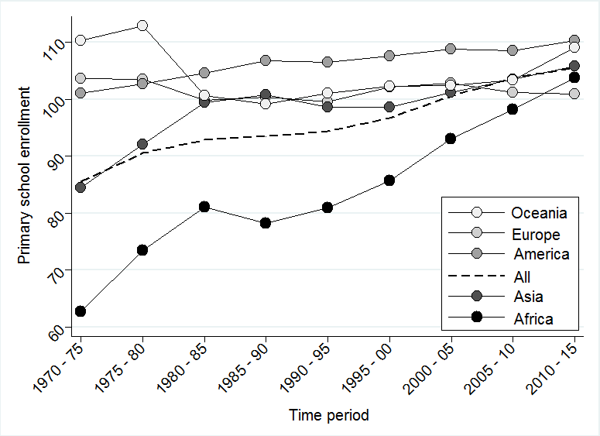

Figure 2b. Time Trends of Average Net Enrollment, 1970 – 2015.
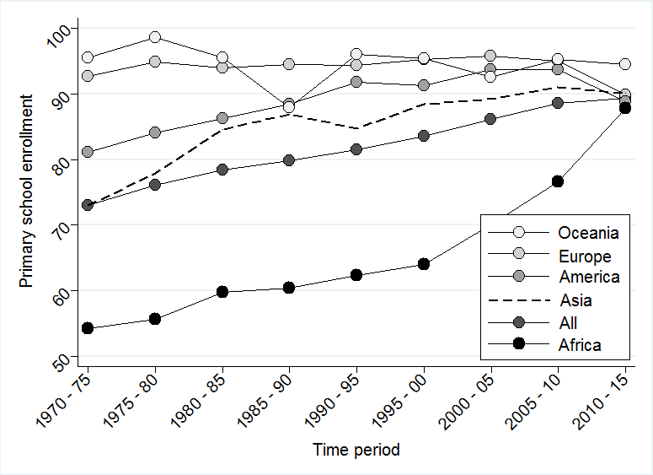

Appendix L: Time Trend of Health Inequality

Figure 3. Time Trends of Average Health Inequality, 1970 – 2015.
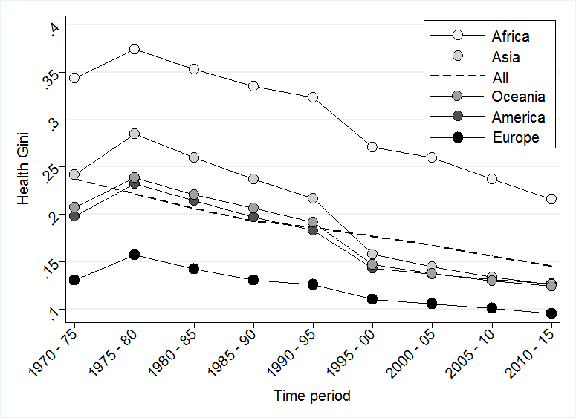

Appendix M: Scatter Plots of Health Inequality and Enrollment

Figure 4a. Scatter Plot of Gross Enrollment and Health Inequality, 1970 – 2015.
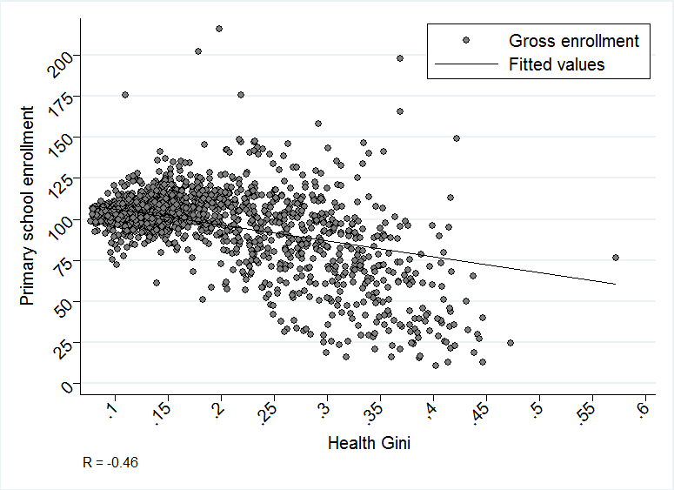

Figure 4b. Scatter Plot of Net Enrollment and Health Inequality, 1970 – 2015.
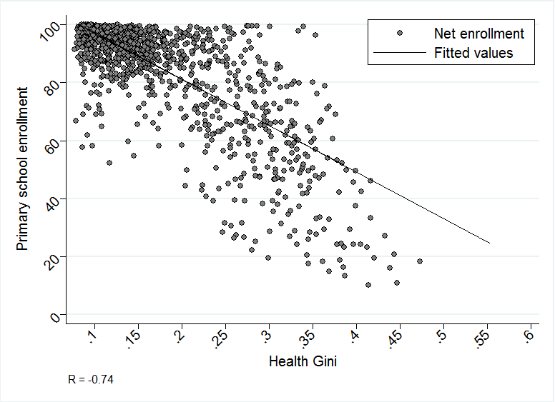

Appendix N: Mean-Deviated Scatter Plots

Figure 5a. Mean-Deviated Scatter Plot of Gross Enrollment and Health Inequality.
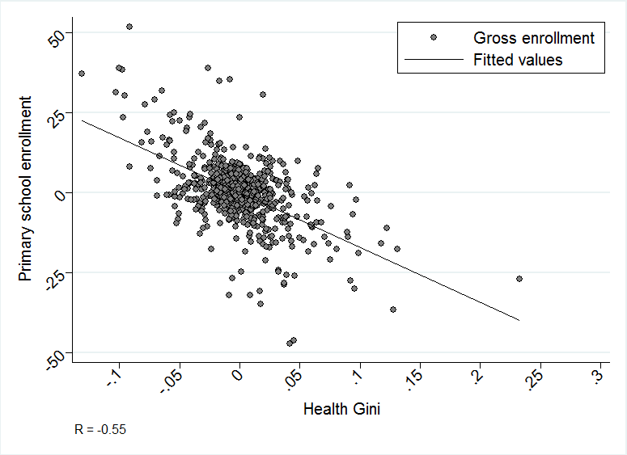

Figure 5b. Mean-Deviated Scatter Plot of Net Enrollment and Health Inequality.
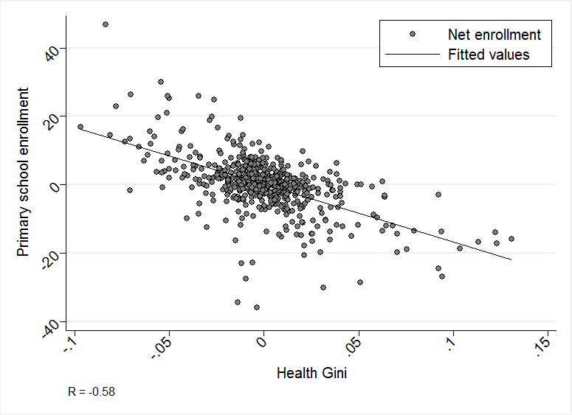

Appendix O: Regional Gross Enrollment Relative to Europe

Figure 6. Time Trend of Average Gross Enrollment Relative to Europe, 1970 – 2015.
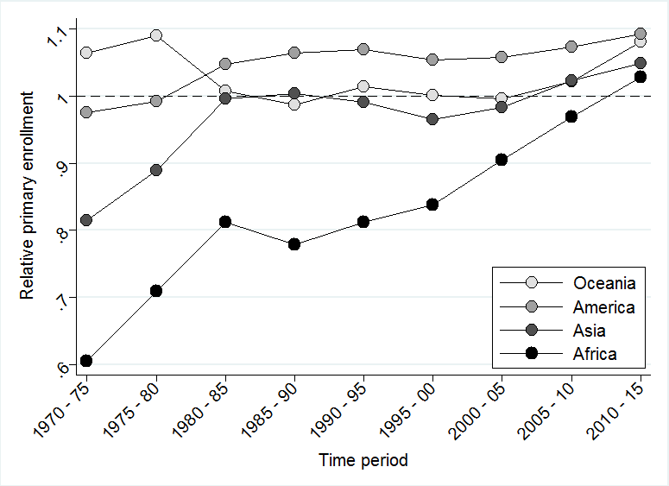

Appendix P: Replication without GDP Per Capita

Appendix Q: Replication without Youth Age Dependency

Appendix R: Replication without Fertility Rate

Health shocks have been operationalized as chronic to severe health problems due to infections, diseases, accidents, or other causes (Woode 2016).
The World Development Indicators compile national, regional, and global development measures from several officially recognized international sources.
Ginis were calculated using the “ineqerr” command in Stata 13 (Stata Corporation 2013).
The income cut-off was assigned for those countries that yielded a GDP per capita of $30,000 or more (measured in purchasing power parity) as of 2012. The specific countries coded as high-income OECD members are found denoted with an asterisk in Table 1.
Evidence for autocorrelation is shown via a significant test (p < 0.001) for serial correlation in the idiosyncratic errors of panel models (Wooldridge 2002; Drukker 2003).
The coefficients, $β$ and $γ$, and the error term, z, in the second stage equation are distinct from their stage one counterparts because $\hat{x}$ is now included as a predictor.
This test is based upon the null hypothesis that all instruments are uncorrelated with the error term.
Mean-deviations for each time-variant predictor were determined by 1) calculating the average for each variable over each wave, 2) subtracting this average from each country’s actual value, then 3) creating a new mean-deviated version of each variable, based upon this difference, from which correlations may be determined.
This test is available as an optional command in the user-written Stata package ivreg2 and is also available in the panel version, xtivreg2. The test statistic is defined as the difference between two Sargan-Hanson statistics composed of 1) the equation with the smaller set of instruments where the regressor is treated as endogenous and 2) the equation with the larger set of instruments where the regressor is treated as exogenous (Baum, Schaffer, and Stillman 2010).

