University of Oklahoma

Graduate College

A 16-YEAR OBSERVATIONAL ANALYSIS OF LAND-ATMOSPHERE COUPLING IN OKLAHOMA USING MESONET AND NORTH AMERICAN REGIONAL REANALYSIS DATA

A thesis

submitted to the Graduate Faculty

in partial fulfillment of the requirements for the

Degree of

Master of Science in Meteorology

By

RYANN ASHLEY WAKEFIELD
Norman, Oklahoma
2018

A 16-YEAR OBSERVATIONAL ANALYSIS OF LAND-ATMOSPHERE COUPLING IN OKLAHOMA USING MESONET AND NORTH AMERICAN REGIONAL REANALYSIS DATA

A thesis approved for the
School of Meteorology

By

______________________________
Dr. Jeffrey Basara , Chair

______________________________
Dr. Jason Furtado

______________________________
Dr. Bradley Illston

______________________________
Dr. Petra Klein

© Copyright by RYANN ASHLEY WAKEFIELD 2018
All Rights Reserved.

Acknowledgements
I’d like to begin first and foremost, by acknowledging Dalton Wakefield, my husband who has been steadfast in his support of my never-ending educational pursuits. When I told him I was going back to school for Meteorology he supported me and believed in me. 3 years later when I decided to apply to graduate school he never once doubted me and reminded me every day. He sacrificed race cars and vacations so that I can pursue this dream of mine and I am so grateful to have him by my side. His support and enthusiasm for me has made this challenging, but rewarding journey much easier to navigate and I could not ask for a better partner in this life.
I am also incredibly grateful to the School of Meteorology, and in particular, my advisor, Dr. Jeff Basara for taking a chance on me and providing me the opportunity to grow as a scientist during the last few years. There were many times when I doubted my own abilities, and he has worked hard to erase those doubts while giving me the confidence to develop my own scientific questions and to seek out their answers. Through his mentorship I have become a leader, scientist and teacher. He has given us students more networking, presentation and learning opportunities than I ever expected to have in graduate school and I look forward to continuing in my education with his guidance.
My committee is owed much gratitude for agreeing to mentor me and provide suggestions for polishing my work. I appreciate each of their diverse perspectives and the amount of time each member gave to helping me finish my thesis. Of these members, I want to especially thank Dr. Jason Furtado for patiently answering my endless questions and helping me to think critically. He never hesitated to provide ideas, support and resources to make my research stronger.
I cannot forget to mention my friends and family for listening to me excitedly talk about soil moisture and land-atmosphere coupling even when they’d rather me place moist soil in their ears.
Thank you to Mr. Jack Hales for his friendship and mentorship as I began my meteorology career. When I reached out to him as a first year undergraduate I never expected the friendship that would develop and all of the guidance he would give me along the way.
My mom has pushed me from childhood to become a meteorologist and she fought for me to have the best educational opportunities possible growing up. She has modeled persistence and work ethic for me throughout my life, and there is no doubt that she helped me get to where I am today. Speaking of hard workers, thank you to my dad for listening to me talk weather and for taking his brand new truck storm chasing in the Ozarks even though that was probably really stupid and dangerous. He has supported my passion, pushed me to do what I love, and learned with me during this process, even downloading RadarScope so he can follow along during storm season.
My officemates have made work a lot more fun and I’m happy they allowed me to make ridiculous CHEWe memes and harass everyone we can. Having a research group that enjoys working together has made this even more fun.
Also, I want to thank my doggoes. They can’t read but they’re awesome and let me use their luscious coats to dry my graduate school fueled tears.
Last but never least, I thank God and my faith for keeping me going when things were difficult. While many prefer to keep science and faith separate, I believe there is a place for both in my life and am grateful for the path He has set forth for me.

Table of Contents
Acknowledgements iv
Table of Contents vii
List of Tables ix
List of Figures x
Abstract xii
Chapter 1: Introduction 1
Chapter 2: Data and Methods 6
2.1 Oklahoma Mesonet 6
2.2 North American Regional Reanalysis (NARR) dataset 8
2.3 Creation of a CTP/HI Dataset 9
2.3.1 CTP 10
2.3.2 HI 10
2.4 Verification of CTP/HI 11
Chapter 3: Inter-annual Variability of CTP/HI in Oklahoma 13
3.1 Climatology of CTP/HI 13
3.2 A Revised Approach to the CTP/HI Climatology 15
3.2.1 CTP/HI Standardized Anomalies 15
3.2.2 A Parameter Space Approach 16
3.2.3 Wet vs. Dry Soils Warm Season 19
3.2.4 Wet vs. Dry Soils Warm Season Days with Precipitation 21
3.2.5 Extreme Year CTP/HI Space: Pluvial 23
3.2.6 Extreme Year CTP/HI Space: Drought 26
3.3 Discussion 31
Chapter 4: Intra-annual Variability of CTP/HI in Oklahoma 39
4.1 Annual Climatology 39
4.2 Monthly Evolution of CTP/HI During Selected Years 41
4.2.1 Pluvial Period: 2007 Warm Season 41
4.2.2 Drought Period: 2011 Warm Season 43
4.2.3 Mixed Rainfall Extremes: 2000 Warm Season 45
4.2.4 Pluvial No. 2: 2015 46
4.2 Discussion 48
4.2.1 Daily Evolution for 2007 Warm Season 48
4.2.2 CTP/HI Precursors to Tropical Storm Erin Redevelopment 51
4.2.3 Evidence of Land-Atmosphere Coupling during 2000 54
4.2.5 Lack of Land-Atmosphere Feedbacks During 2015 Pluvial 63
Chapter 5: Summary and Conclusions 65

List of Tables
Table 1: Calculation example for precipitation using average May precipitation of 132.83 mm for Norman, OK 8

List of Figures
Figure 1: (reproduced from Findell and Eltahir 2003b, Fig. 1) The CTP/HI framework thresholds 11
Figure 2: Scatterplot of CTP and HI computed by NARR and Mesonet methods 12
Figure 3: Monthly climatology of CTP and HI in Oklahoma 14
Figure 4: CTP/HI parameter space example. 18
Figure 5: Subdivided regions of study in Oklahoma 19
Figure 6: Parameter space over wet vs. dry soils 21
Figure 7: Parameter space over wet vs. dry soils soils with precipitation 23
Figure 8: 2007 and 2015 parameter space 25
Figure 9:Heavy rainfall year parameter space 26
Figure 10: 2006 and 2011 CTP/HI parameter space 27
Figure 11: Oklahoma Climate Divisions (credit: Oklahoma Climatological Survey). 28
Figure 12: Drought versus CTP/HI parameter space. 30
Figure 13: Statewide warm season (May-Sept.) CTP /HI std. anoms by year. 38
Figure 14: Mean warm season averaged CTP/HI std. anoms by year 40
Figure 15: 2007 Monthly CTP/HI std. anoms. 42
Figure 16: 2011 Monthly CTP/HI std. anoms. 44
Figure 17: 2000 Monthly CTP/HI std. anoms. 46
Figure 18: 2015 Monthly CTP/HI std. anoms 48
Figure 19: 2007 timeseries 51
Figure 20: 2007 Scatterplot 54
Figure 21: 2000 CTP/HI timeseries. 56
Figure 22: 2000 Scatterplot 58
Figure 23: 2011 Composite Soundings. 59
Figure 24: 2011 CTP/HI timeseries. 61
Figure 25: 2011 Scatterplot 62
Figure 26: 2015 CTP/HI timeseries 64

Abstract
Global “hot spots” for land atmosphere coupling have been identified through various studies. One particular region that has been identified in many of these global studies is the Southern Great Plains (SGP) of North America. Local coupling studies have identified links between boundary layer evolution and soil moisture at point locations. This analysis seeks to bridge the spatial and temporal gaps between the local and global approaches to better understand the nature of land atmosphere feedbacks during the warm season months of May through September during 2000 through 2015 using a local coupling framework. This framework was applied to the datasets to create a mesoscale climatology of land-atmosphere interactions in Oklahoma at varying temporal scales but did not adequately quantify land-atmosphere interactions. Therefore, a revised approach using standardized anomalies of previously developed metrics, Convective Triggering Potential (CTP) and low-level humidity index (HI), was developed to showcase the difference in low-level atmospheric response to extreme drought and pluvial years. Within pluvial years, unexpected differences in CTP/HI anomalies emerged suggesting differences precipitation drivers. While 2007 demonstrated characteristics of positive wet feedbacks, 2015 had behavior within the parameter space that was more similar to drought years despite having record rainfall suggesting an interannual variability in atmospheric response to soil moisture. Similarly, the CTP/HI standardized anomaly approach was able to demonstrate the atmospheric response to dry land surface conditions both locally and non-locally during drought years. At the intra-annual timescale, similar differences between drought and pluvial periods were observed. More importantly, these periods show similarities by demonstrating a greater atmospheric response to soil moisture during dry-down periods.

Chapter 1: Introduction
Land atmosphere (L-A) coupling quantifies the complex interactions between land surface conditions and the atmosphere to better understand the hydrologic cycle and can be viewed from the perspective of the terrestrial and atmospheric segments along with the mutual interactions between the two. Soil moisture plays an important role in the terrestrial segment through surface flux partitioning (Basara and Crawford 2002) and changes in evapotranspiration rates (Teuling et al. 2006; McPherson et al. 2007). However, these relationships are not necessarily linear and the soil moisture-evaporation relationship may be enhanced as soils become drier (Phillips and Klein 2014; Williams et al. 2016).
Within the atmospheric segment, surface fluxes impact boundary layer development (Rabin et al. 1990; Santanello et al. 2009, 2011, 2013). In addition, near surface atmospheric moisture can be driven by both nonlocal and local soil moisture anomalies (Atlas et al. 1993; Hong and Kalnay 2000; Pal and Eltahir 2003; Su and Dickinson 2017) and can modify the local environment making it more (or less) favorable for convective precipitation (Pielke 2001).
The scale dependency of these interactions is evident via past studies which have explored coupling through point scale analyses of diurnal boundary layer development and at the global spatial scale focused within the seasonal to interannual timescale. Land surface conditions may reinforce seasonal extremes over a large region (Trenberth and Guillemot 1996; Fischer et al. 2007 a, b) and may even play a role in large scale dynamics (Namias 1988). From the climatological perspective, some regions show a greater atmospheric response to soil moisture anomalies. The first phase of the Global Land-Atmosphere Coupling Experiment (GLACE) found that land atmosphere coupling tends to be favored over semi-arid/transition regions across climate models (Koster et al. 2004). While coupling strength identified by each individual climate model varied significantly, subsequent studies found similar results with stronger coupling in transition regions between arid and humid climates (Guo et al. 2006; Koster et al. 2006; Dirmeyer 2006). Semi-arid regions show an increased sensitivity of evapotranspiration (ET) to changes in soil moisture and atmospheric demand which are also more variable over such transition regions (Trenberth 1999; Guo et al. 2006; Koster et al. 2011; Dirmeyer 2011; Wei et al. 2016 ). Within regions of strong coupling, the strength of these soil moisture-evapotranspiration-precipitation relationships has been shown to change in both time and space (Findell and Eltahir 2003b; Guo and Dirmeyer 2013; Basara and Christian 2018). Transition regions may evolve following precipitation gradients and the greatest focus for land-atmosphere coupling may follow such gradients (Seneviratne 2006). Further, climatologically dry (wet) regions may experience an increase in sensitivity to land surface conditions during (wet) dry months (Schubert et al. 2008; Wei and Dirmeyer 2012). Wei and Dirmeyer (2012) also found that while non-local influences on soil moisture, evapotranspiration and precipitation feedbacks are present, in those regions where coupling plays a significant role local effects prevail.
While several studies have identified regions in which the atmosphere is more sensitive to changes in soil moisture, the nature of such feedbacks is still largely contested (Meng and Quiring 2010) and can change depending on spatial resolution of model simulations (Hohenegger, et al. 2009). The Southern Great Plains has been identified as a hot spot for land atmosphere coupling but the sign of the feedbacks within this region is still unclear.
Locally, an increase in sensible heat fluxes from dry soils leads to greater boundary layer growth and entrainment of dry air from the free atmosphere, resulting in a drying of the boundary layer and inhibition of convection (Findell and Eltahir 2003a). Conversely, dry soils have been argued to result in a greater probability of convective precipitation by destabilization of the lower atmosphere and rapid boundary layer growth and (Ek and Holtslag 2004; Santanello et al. 2011; Taylor et al. 2012; Gentine et al. 2013; Ford et al. 2015a). Ford et al. (2015b) demonstrated a preference for unorganized convection to develop over dry soils in Oklahoma, however there were also several instances where convection was favored over wet soils. The case for wet soils suggests that wet soils result in greater latent heat flux and an increase in boundary layer moist static energy. This decreases the level of free convection and destabilizes the boundary layer by increasing CAPE (Pielke 2001; Pal and Eltahir 2001; Findell and Eltahir 2003a; Findell et al. 2011; Ferguson and Wood 2011). The wet positive feedback results in a precipitation recycling regime in which precipitation originates from local evapotranspiration (Dirmeyer et al. 2009). Brubaker et al. (1999) and Trenberth (1999) both argue that on average 25-35% of precipitation in North America is a result of this wet positive feedback. The converse is a wet negative feedback in which wet soils reduce surface temperatures, increase surface pressure and increase surface stability which suppresses precipitation (Cook et al. 2006, Hohenneger et al. 2009).
Others argue that the sign of a soil moisture anomaly is perhaps not as important as a gradient in soil moisture. Such gradients can result in differential diabatic heating and resulting “land breezes” which may enhance surface convergence and the development of convection (Taylor et al. 2007; Frye and Mote 2010). Within the southern Great Plains, these gradients can shift the location of the dryline and subsequently dryline forced convective precipitation thus resulting in a feedback which perpetuates these gradients (Flanagan et al. 2017).
Findell and Eltahir (2003a) developed the Convective Triggering Potential Low-Level Humidity Index (CTP/HI) framework which diagnoses the potential for afternoon precipitation over a region based on soil moisture and early morning atmospheric profiles. CTP diagnoses the level of instability within the portion of the atmosphere between 100 mb and 300 mb above ground level (AGL) while the pre-existing moisture content of the layer 50 to 150 mb AGL is captured through HI. The authors classified Oklahoma and much of the southern Great Plains as a transitional regime where convection is equally likely over wet or dry soils and this preference may change on an interannual basis (Findell and Eltahir 2003b). Further application of the framework by Ferguson and Wood (2011) demonstrated an unintentional bias within the original framework. The authors found that latitudinal anomalies of CTP/HI better captured coupling than the original strict thresholds imposed. Roundy et al. (2013) established new thresholds for dry and wet coupling based on the joint probability space of CTP and HI over regional soil moisture distributions using satellite and reanalysis derived data.

This study applies the CTP/HI framework and attempts to bridge the gap between local and global coupling studies by examining land-atmosphere coupling via mesoscale observations collected at Oklahoma Mesonet sites at various timescales during the period spanning 2000 through 2015. The chosen temporal period exceeds the minimum number of years identified by Findell (2015) to adequately study land-atmosphere interactions. Land-Atmosphere coupling is first explored using inter-annual comparisons between regions in Oklahoma. The results from these comparisons merit further exploration at the intra-annual timescale and further analysis seeks to better understand the nature of land-atmosphere coupling as it evolves at finer timescales.

Chapter 2: Data and Methods

2.1 Oklahoma Mesonet
The Oklahoma Mesonet is an automated mesoscale observing network consisting of over 100 sites which report near real time, quality assured, meteorological conditions at 5 minute intervals (McPherson et al. 2007) and soil moisture every 30 minutes (Illston et al. 2008). Sensors are calibrated prior to placement and after repair, and are replaced at the end of recommended residence time even if there are no problems detected (McPherson et al. 2007). Observations from the Mesonet have been extensively validated (Scott et al. 2013) to ensure that all observations are of research quality. One limitation arises due to site placement within areas of uniform low-growing vegetation (McPherson et al. 2007) as observations may not be representative of those over other land-cover types.
To maintain spatial and temporal consistency and to establish a sufficient climatological analysis length, only stations which were continuously in operation from January 1, 2000 through December 31, 2015 were retained for the analysis. While stations may have been continuously in operation during this time there may have been periods of time with missing observations due to instrumentation and meteorological issues so stations which recorded data for less than 75% of days were omitted. Each station is less than 80 km from its nearest neighbor such that a missing observation at one point did not significantly impair the spatial resolution of the analyses. Computations were only performed on samples in which 75% of the sample had measurements.
Fractional water index is a normalized measurement of the Campbell Scientific 229-L sensor response to changes in soil moisture and ranges from 0 (dry soil) to 1 (saturated soil) (Schneider et al. 2003; Illston et al. 2008). The utility of FWI lies within its ability to capture soil wetness independent of soil texture thus standardizing the observation and allowing for intercomparison within the observational network. In this study, wet soils are defined as those with FWI greater than 0.7 which is considered optimal for plant growth and dry soils defined as having an FWI less than 0.4 which results in water stress (Illston et al. 2008, http://www.nue.okstate.edu/Weather/FractionalWaterIndex.pdf). Basara and Crawford (2002) showed the greatest relationship between surface latent and sensible heat fluxes and root zone soil moisture at the Norman, Oklahoma Mesonet site. Soil moisture is monitored via the Campbell Scientific 229-L heat dissipation sensor which is most commonly deployed at 5, 25 and 60 cm. This study primarily uses 25 cm soil moisture measurement depth as it is most representative of root zone soil moisture which is generally within the top 30 cm of the soil profile (Weaver 1958; Eggemeyer et al. 2009; Raz-Yaseef et al. 2016). This depth also yields the greatest sample size as some stations do not have sensors beyond this depth due to soil texture or bedrock. Note however that similar final conclusions of this study were found using soil moisture at all depths thus only results from 25 cm are shown.
The minimum measurable precipitation is 0.25 mm (McPherson et al. 2007) so values below this threshold were counted as no precipitation events. The original CTP/HI framework is designed to diagnose the potential for afternoon precipitation so only precipitation events which occurred between 2100 and 0300 UTC were included in the analysis. Precipitation events were also filtered to eliminate any false positive events using a novel approach. Average total monthly precipitation values were computed at every station by summing all precipitation events for a given month and dividing by the number of years in the dataset. Each day was then compared to the monthly average precipitation and assigned a percentage of that monthly average precipitation. For a 31-day month 0.03 or 3% would be considered the expected percentage of rainfall for any given day so the threshold for being considered a day with precipitation was set at 5%. An example calculation is shown in Table 1. The purpose of this approach is to distinguish heavy precipitation from light precipitation as fixed threshold amounts would not sufficiently capture the variability in precipitation intensity due to climatology. This threshold as well as 1%, 3% and 10% were tested with similar results, and thus, 5% was retained as the set value for this study.
Table 1: Calculation example for precipitation using average May precipitation of 132.83 mm for Norman, OK
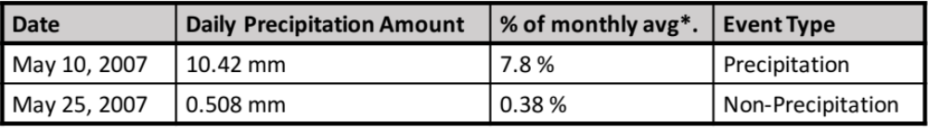

2.2 North American Regional Reanalysis (NARR) dataset
While Mesonet stations provide surface and sub-surface data, atmospheric profiles are necessary to calculate CTP/HI. North American Regional Reanalysis (NARR) data was used to obtain atmospheric profiles of temperature, pressure and specific humidity over Oklahoma during the study period. NARR data assimilates observations with model simulations to generate a 3-hourly gridded dataset with 32 km spatial resolution over the continental United States at 29 vertical levels (Mesinger et al. 2006) and at the time of the analysis was available from 1979 through 2015. Each Mesonet station was paired with the nearest NARR grid box center. This resulted in several stations which shared the same grid box. To eliminate redundancy only the station with the least number of missing observations was retained resulting in 93 stations being used for the analysis.
Each NARR vertical profile contains data at 29 levels starting with 1000 mb (Mesinger et al. 2006). Oklahoma’s sloping terrain means that surface pressure can range from approximately 850 mb in the panhandle to over 1000 mb in southeastern Oklahoma so it is necessary to start each atmospheric profile at the appropriate surface pressure measurement rather than the starting NARR measurement. Specific humidity profiles were converted to dewpoint profiles by converting specific humidity values to mixing ratio then vapor pressure using the formula from Wallace and Hobbs (1977) then inverting the Bolton (1980) formula for saturation vapor pressure to obtain temperature instead to obtain dewpoint from vapor pressure. This was completed using the MetPy software package for Python designed by May et al. (2017). Mesonet observations of temperature and dewpoint were used as the surface values for atmospheric profiles and values above the surface were obtained from the NARR dataset.

2.3 Creation of a CTP/HI Dataset
Vertical profiles were linearly interpolated at 1 mb intervals to ensure that calculations of CTP and HI were performed at their exact required levels above the surface. The 25 mb interval used by NARR is too large to adequately capture HI given the two levels used in the calculation are 100 mb apart.

2.3.1 CTP
Convective Triggering Potential was determined via:
- locating the moist adiabat which intersects the temperature profile 100 mb above ground level (AGL).
- Integrating the area between this moist adiabat and the temperature profile from 100 mb AGL to 300 mb AGL.
The methods used by the coupling metric toolkit (CoMeT Tawfik 2016) were adapted for Python to calculate values of CTP.

2.3.2 HI
The low-level humidity index (hereafter HI) is the sum of the dewpoint depression at 50 mb AGL and 150 mb AGL to determine the pre-existing moisture content of the lower atmosphere (Eq. 1)
$HI= { (T-T_{d}) }_{150 mb AGL}+{ (T-T_{d}) }_{50 mb AGL}$ (1)

Both CTP and HI were calculated at every Mesonet station for every day within the period to create a quasi-observational CTP/HI dataset across Oklahoma from 2000 through 2015. The original thresholds established by Findell and Eltahir (2003) are shown in Figure 1.

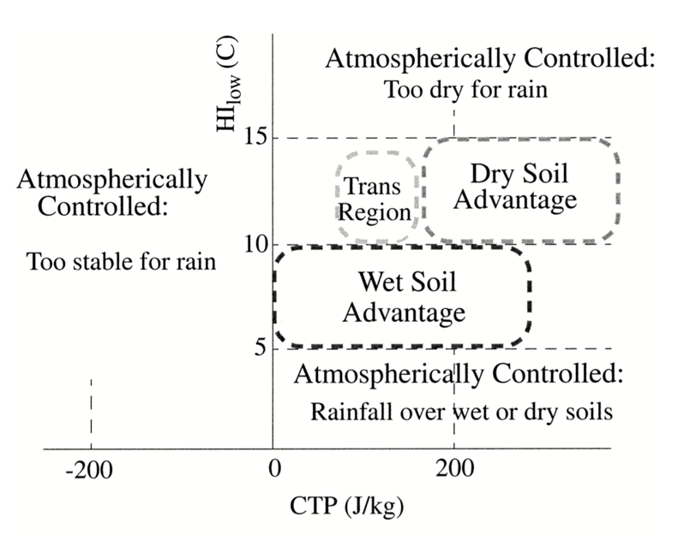
Figure 1: The CTP/HI framework thresholds for categorizing preferences for convection over wet or dry soils. The wet soil advantage describes a positive feedback in which wet soils result in convection. (Reproduced from Findell and Eltahir 2003b, Fig. 1)

2.4 Verification of CTP/HI
The aforementioned values of CTP/HI are derived from reanalysis data, and therefore, it is critical to quantify the reliability of the CTP/HI values. A time series of CTP and HI were calculated using observations from the Norman Mesonet station located near the center of the study domain and corresponding NARR profiles for the duration of the study period. In addition, CTP and HI values were explicitly computed from radiosonde data at the Norman upper air site and compared to the NARR derived values; the results are shown in Figure 2. Overall, the observed values of CTP and HI from the upper air soundings agree well with the NARR derived values with correlation coefficients of 0.930 and 0.945 respectively. One limitation is that the agreement between NARR-derived and observed profiles may be artificially inflated in locations
where upper air stations exist. Becausee NARR data is a result of the NCEP Eta Model and assimilated observations (Mesinger et al. 2006), areas where observations are sparse may be less representative of reality.
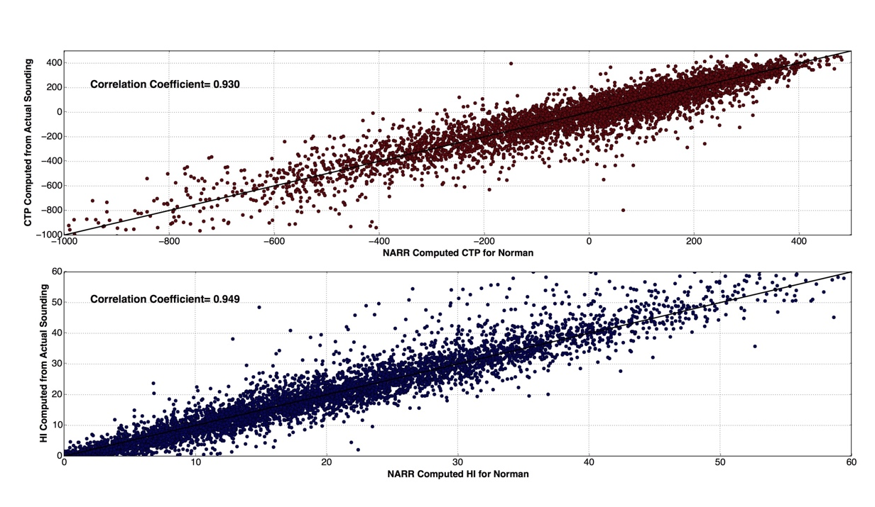
Figure 2: Scatterplot of CTP and HI computed by NARR and Mesonet methods (x-axes) versus CTP and HI computed using observed upper air sounding data (y-axes). The top plot shows values derived from both methods for CTP and the bottom shows the relationship between values derived from both methods for HI. Correlation coefficient is also shown.

Chapter 3: Inter-annual Variability of CTP/HI in Oklahoma

3.1 Climatology of CTP/HI
Monthly mean values of CTP and HI were computed at every Mesonet station for the entire period and the results are shown in Figure 3. In the monthly mean CTP plot, blue denotes values which are less than 0 on average; CTP values below 0 are not conducive for coupling as this would represent a stable profile. Western portions of the domain have the greatest number of months with CTP greater than 0, and therefore the greatest opportunity for coupling. The entire state experiences mean positive values of CTP during the warm season, or the months of May through September and, based on these results, further analysis will focus primarily on these months for the coupling analysis.
Less variability in the monthly mean HI plots exists throughout the year when compared to CTP though mean values do increase during the warm season. The most striking feature of the analysis is that few stations yield monthly mean values at or below 15°C. The original framework (Findell and Eltahir 2003a) states that 15°C is the upper limit for coupling classifications and anything greater than this falls into an atmospherically controlled regime. As such, these results would suggest that on average, land-atmosphere coupling is not occurring in Oklahoma according to the CTP/HI framework (Findell and Eltahir 2003a). However, this is an oversimplification and would contradict previous studies in the region which strongly suggest the presence of land atmosphere coupling (McPherson et al. 2004 ; Haugland and Crawford, 2005; McPherson and Stensrud, 2005; Santanello et al. 2009, 2011, 2013) or an interplay between land-atmosphere interactions and a pre-conditioned synoptic environment (Ford et al. 2015a, 2015b, 2015c). Ferguson and Wood (2011) noted that the thresholds set forth by the original framework may have been unintentionally biased by the location for which they were developed (Lincoln, Illinois). They also demonstrated that the framework is still a valuable tool in diagnosing the pre-existing atmospheric state but it can be modified to better capture coupling in varying climates.
a)
b)
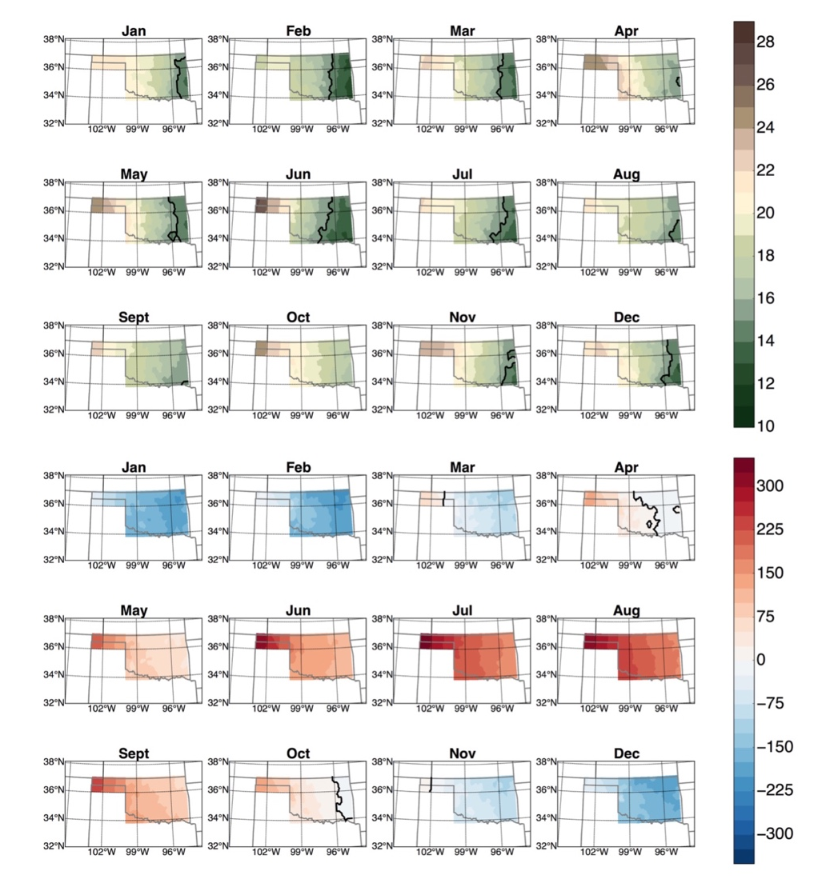
Figure 3: (Top) Monthly climatology of HI in Oklahoma. A black contour separates values which are greater than or less than 15 degrees Celsius when present. Values greater than 15 degrees are traditionally considered too dry for coupling to occur. (Bottom) Monthly climatology of CTP in Oklahoma with a black contour separating positive from negative values when negative values are present. Positive values are indicative of instability and a greater coupling potential on average.

3.2 A Revised Approach to the CTP/HI Climatology
Ferguson and Wood (2011) utilized latitudinal anomalies of CTP and HI is useful for global study areas which precludes its utility when only focusing on Oklahoma where latitudinal differences are likely to be minimal within such a small region, but longitudinal differences in climate and land cover are significant. Standardized anomalies are especially useful for expressing and comparing the relative magnitude of differences in meteorological variables in areas where the base state climate varies in space and time (Wilks 2011). Basara and Christian (2018) successfully applied a standardized anomaly approach to better assess land-atmosphere coupling in the Southern Great Plains and it is hypothesized that the use of standardized anomalies of CTP/HI based on station climatology better capture atmospheric response to different soil moisture states and would facilitate comparison of the magnitude of responses in both time and space.

3.2.1 CTP/HI Standardized Anomalies
Daily standardized anomalies or z-scores were computed for each individual station (Wilks 2011) as shown in Equation 2. The daily z-scores were computed using the mean and standard deviation for that particular day based on the 16 years within the dataset. For example, the June 1, 2004 CTP standardized anomaly value was computed using the mean and standard deviations of all 16 June 1 CTP values. Only days with more than 12 years or more (75%) of data were retained to obtain z-scores which were as representative of the 16 years as possible.

$Z_{i}=\frac{x_{i}-\overline{x}}{s_{x}}$ (2)
A Gaussian distribution is necessary for the computation of z-scores but the distribution of HI values was slightly skewed to the right since there were no negative HI values and therefore no negative outliers. Most HI values were between 0°C and 30°C with a few outliers greater than 50°C. To remedy this a square root power transform (Wilks 2011) was applied to each value which yielded more Gaussian distributions.

3.2.2 A Parameter Space Approach
Unique combinations of CTP and HI provide valuable information about the pre-existing atmospheric state and its potential for land atmosphere coupling. Thus, the four potential bivariate combinations of CTP and HI anomalies are examined in the CTP/HI parameter space in the following analysis and the combinations are shown in Figure 4 and described as follows:
- Quadrant I (Q1), CTP Below normal/ HI above normal: The atmosphere is generally more stable than normal in the CTP region, while it is drier than normal at the levels where HI is measured. This region is not likely to result in precipitation due to an overall lack of pre-existing instability and moisture.
- Quadrant II (Q2), CTP above normal/HI above normal: The atmosphere is more unstable than normal in the CTP region but it is also drier than normal. This classification suggests a dry adiabatic profile. Over dry soils increased partitioning of energy into sensible heating could result in more rapid boundary layer growth which despite limited moisture could result in convective initiation if the PBL reaches the LCL (Ek and Holtslag 2004.) On the other hand, wet soils could result in greater latent heat flux and an increase in moist static energy into an environment which was moisture limited. As such, local destabilization of the lower atmosphere could occur through increased CAPE and a lowering of the LCL (Taylor and Lebel 1998; Pielke 2001; Findell and Eltahir 2003; Pal and Eltahir 2003; Brimelow et al. 2011). Finally, this quadrant of the parameter space could also result in no convection if the lower atmosphere is too dry for local surface fluxes to overcome the moisture limited regime. During drier than normal periods it is expected that more days would fall within this parameter space as dry surface conditions would result in greater sensible heat fluxes, boundary layer mixing and entrainment of dry air. When the standardized anomalies within this space are exceptionally high, they may be considered too dry for convective precipitation or atmospherically controlled similar to the original framework.
- Quadrant III (Q3), CTP above normal/HI below normal: This regime would be considered primed for convection due to pre-existing above normal instability and above normal moisture in the lower troposphere. Little perturbation of these conditions is necessary for convective initiation.
- Quadrant IV (Q4), CTP below normal/HI below normal: In the moisture abundant, energy limited regime the atmospheric profile is likely near moist adiabatic (Findell and Eltahir, 2003). Precipitation recycling is expected over wet soils through the addition of moist static energy via evapotranspiration. Dry soils could also supply necessary energy and surface based instability in this case. It is also expected that anomalously wet periods would demonstrate a higher percentage of days occupying this parameter space as wet soils would provide a continuous supply of low level moisture.
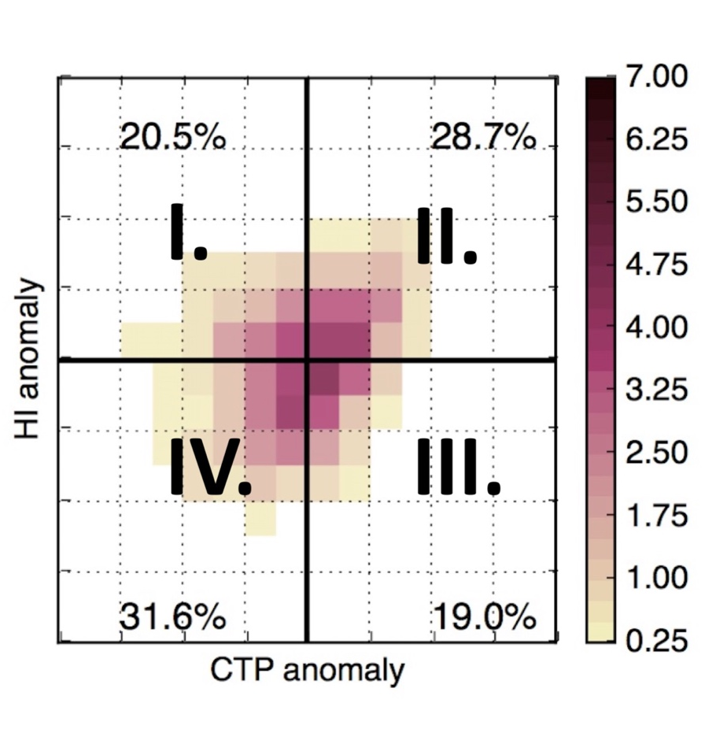
Figure 4: Example of a CTP/HI parameter space for a region. Quadrants are labeled I through IV in a clockwise direction and represent the 4 possibilities for CTP/HI anomaly pairing. I) CTP below normal, HI above normal II) CTP above normal, HI above normal III) CTP above normal HI below normal IV) CTP below normal, HI below normal. Colorbar represents the percentage of days that fall within a given CTP/HI bin pairing.

Oklahoma was divided into 9 subregions which were designed to capture a sufficient sample size of stations within each region while also capturing the distinct level II ecoregions within the state and highlighting the spatial variability in temperature and precipitation. The current regions differ slightly from the 9 Oklahoma Climate Divisions to allow for a more even areal distribution. Vegetation phenology plays a significant role on surface fluxes and therefore it is necessary to capture the variability in vegetation as well as local climate (Pielke 2001; McPherson et al. 2004, Raddatz 2007; Williams and Torn 2015). The divisions are shown in Figure 5. The parameter space for each region was analyzed and Z-scores are divided such that each bin represents an increment of one-half standard deviation in both the CTP and HI space. The shading in each bin represents the percentage of days within that region and time-period that fall within the bounds of that CTP/HI bin pairing.
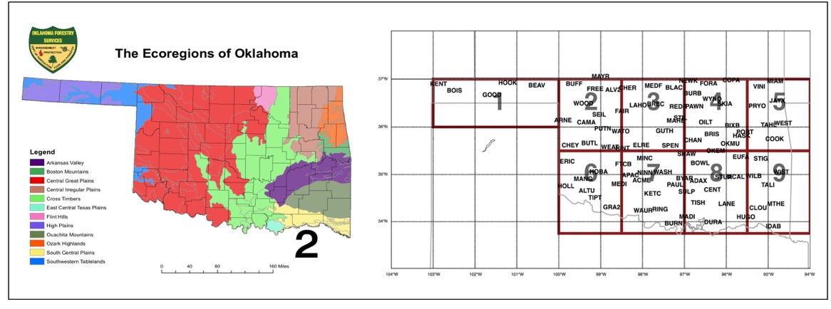
Figure 5: (Left) Level 2 Ecoregions of Oklahoma (credit Oklahoma Forestry Services) and (Right) The 9 subregions used in the current study and Mesonet stations which are included within each subregion.

3.2.3 Wet vs. Dry Soils Warm Season
Each region was separated into days with wet soils (FWI<0.4) or days with dry soils (FWI>0.7) during the warm season (May through September). The percentage of days which occupied each 2 dimensional CTP/HI anomaly bin are plotted for each individual region and shown in Figure 6a. Wet soil conditions result in the greatest number of days occupying Q4 in the parameter space suggesting moisture fluxes from the surface may aid in moistening the atmospheric profile. Another argument is that the overall large scale pattern which results in wet soils is also one that is characterized by moist atmospheric conditions. Overall there is a greater number of days with HI below normal, independent of whether CTP is above or below normal. In other words, the atmosphere is generally moister at low levels regardless of instability.
Dry soil days (Fig. 6b) are characterized by a nearly opposite response to those of wet soil days. The greatest percentage of days occur in Q2 while the second largest percentage of days is within Q4. The percentage of days in Q2 vs. Q4 for dry versus wet soils are mirror images of one another. These results suggest a different atmospheric response to dry versus wet soils with a shift toward Q4 when soils are wet and a shift toward Q2 when soils are dry.

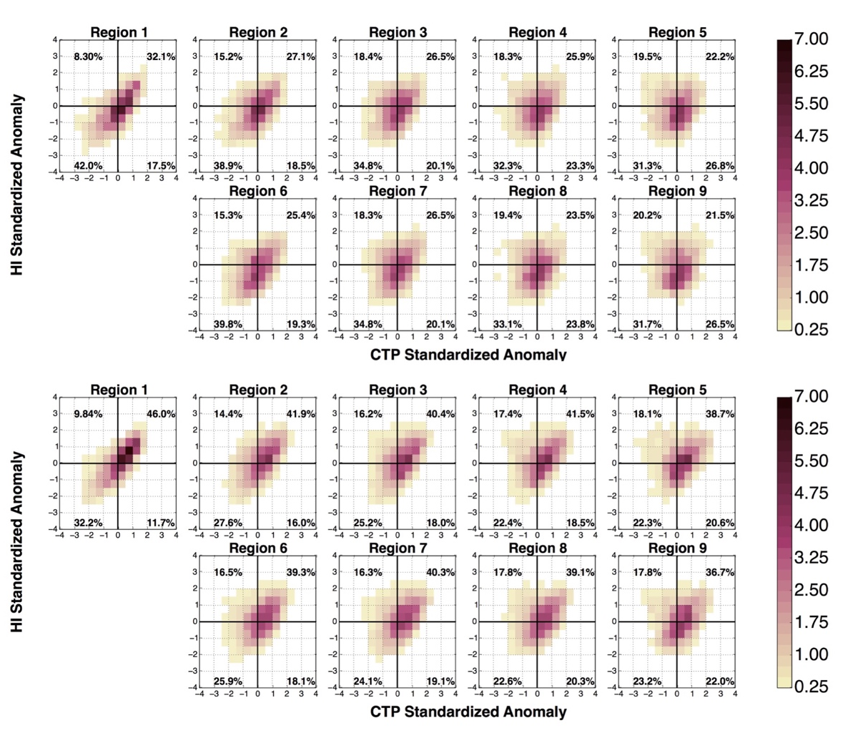
Figure 6: Distribution of CTP and HI standardized anomalies for warm season days with (a) wet soils (FWI>0.7) by region and (b) dry soils (FWI<0.4) by region. CTP standardized anomalies are represented on the y axes of each subplot while HI standardized anomalies are represented on the x axes. Fills represent the percentage of days within that region that occupy a given bin with darkest colors at or exceeding 7% of days.
a)
b)

3.2.4 Wet vs. Dry Soils Warm Season Days with Precipitation
Dry and wet soil cases were filtered to account for precipitation, defined as any day which is greater than or equal to 5% of the 16-year monthly average. The resulting parameter spaces were those with precipitation over wet soils and precipitation over dry soils (Figs. 7a and 7b respectively). Both cases show a preference for precipitation when CTP and HI are both below normal, while the greatest change in parameter space between all days and precipitation days occurs with the dry soil case as the distributions shift from being concentrated in Q2 to being concentrated in Q3 and Q4 when precipitation is a factor. The preference for Q4 is most apparent in the western regions of the domain, while the parameter space becomes more evenly distributed between Q4 and Q3 in the regions further to the east. The southeastern-most region shows the most minor difference between the percentage of days in Q2 and Q4 within the dry soil case. One possible reason for the longitudinal differences is that the eastern portions of the state are moisture abundant, but energy limited and surface fluxes may supply the necessary destabilization for precipitation development in the presence of moisture advection. This agrees with previous findings that wetter regions of the United States often experience inverse relationships between soil moisture and evaporative fraction (which supplies land surface based low level moisture) and the development of precipitation is energy limited (Dirmeyer 2011; Williams and Torn 2015). In the western domains the difference between wet soil and dry soil cases is also less pronounced.
Both parameter spaces appear to shift their distribution toward Q4 when filtered for precipitation. The parameter spaces shown are for the entire warm season but previous studies have demonstrated a distinct temporal variability in land atmosphere coupling even at the monthly scale (e.g., Basara and Christian 2018). When each month is examined individually, the greatest difference between dry and wet soils occurs during July and August (not shown). Unfortunately, there are few days with precipitation over dry soils earlier in the warm season as soils are climatologically moist during this period (Illston et al. 2004).
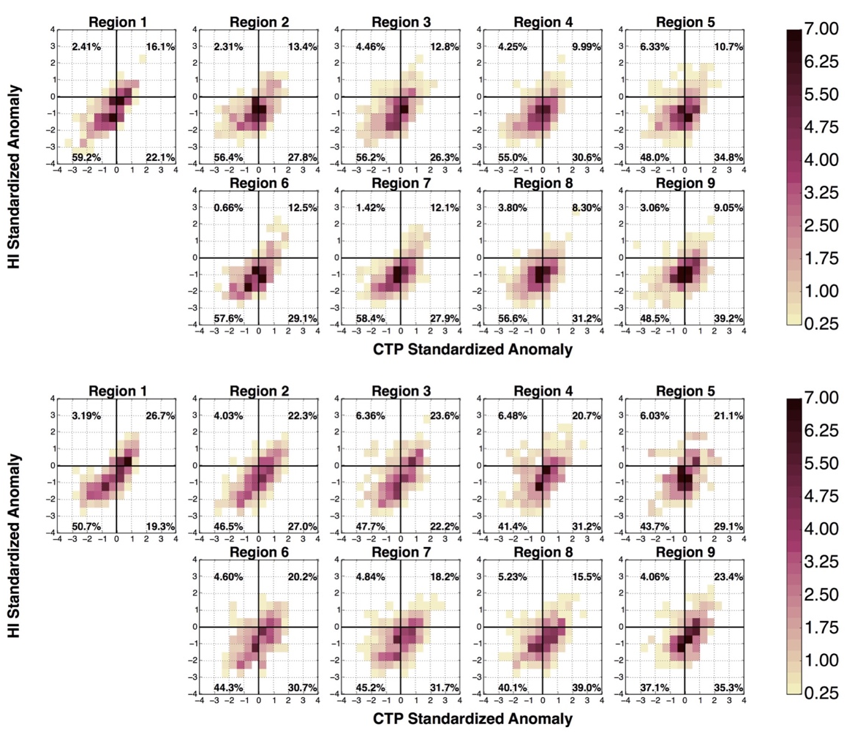
a)

b)
Figure 7: As in Figure 6 but for warm season days with precipitation.

3.2.5 Extreme Year CTP/HI Space: Pluvial
A distinct difference in the parameter space for wet versus dry soils is apparent and this difference decreases slightly when precipitation is considered. While the parameter space differences may be the result of an atmospheric response to the land surface, they may also reflect the dominant large scale pattern that accompanies wet or dry soils and precipitation anomalies. If the large scale atmospheric pattern drives the CTP/HI parameter space response to dry versus wet soils it is expected that years with similar precipitation anomalies will behave similarly within the parameter space. Within the current dataset there are two notable years with anomalously excessive precipitation during the warm season: 2007 and 2015. Figure 8 shows the warm season parameter space for 2007 (a) and 2015 (b). The two years show a drastic difference in behavior with the greatest percentage of days in 2007 occupying Q4 as expected if precipitation recycling is occurring. However, 2015 shows a much more even distribution across the four quadrants with the exception of Q1. Further, the greatest percentage of days in 2015 occurs in Q2 for all regions. If annual warm season rainfall anomalies are considered by region rather than statewide, regions which experienced above normal warm season precipitation during a given year show entirely different behavior than that same region in 2007.

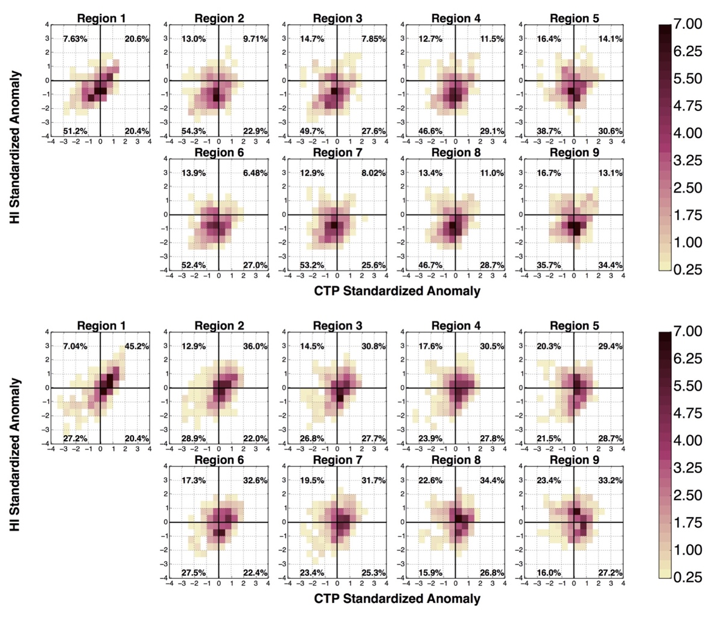
Figure 8: As in Figure 6 but for all warm season days and all soils during a) 2007 only and b) 2015 only.
a)

b)

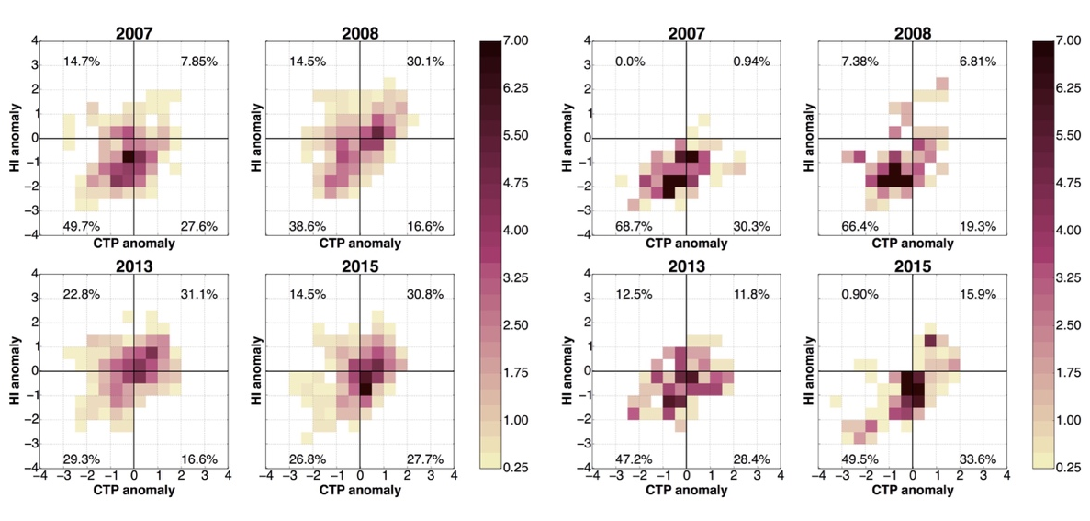
Figure 9a shows the parameter spaces for Region 3 during four years which experienced above normal warm season precipitation occurred: 2007, 2008, 2013 and 2015. Each of the years has approximately 30% of days occupying Q2 with the exception of 2007. When filtered for precipitation (Fig. 9b), 2007 still shows significantly fewer days in Q2 than the other years. During 2008 the parameter space is more similar to 2007 than the other years, but still most similar to the other rainfall years.
a) b)
Figure 9: Distribution of CTP and HI standardized anomalies for warm season days during selected heavy rainfall years in Region 3 only for (a) all warm season days and (b) only days with precipitation during 2007.
3.2.6 Extreme Year CTP/HI Space: Drought
Two of the most extreme drought years that occurred in the study domain, 2006 and 2011, were analyzed (Fig. 10). As a whole, both drought years show a higher percentage of days within Q2. Differences in the parameter space between the extreme drought years were not as extreme as those between extreme pluvial years. Even so, the differences are not negligible and 2011 shows a larger percentage of days occupying Q2 than 2006. During drought years Q2 and Q1 account for nearly 70% of all days, and in 2011, 60-70% of days fell within Q2 alone.

a)

b)
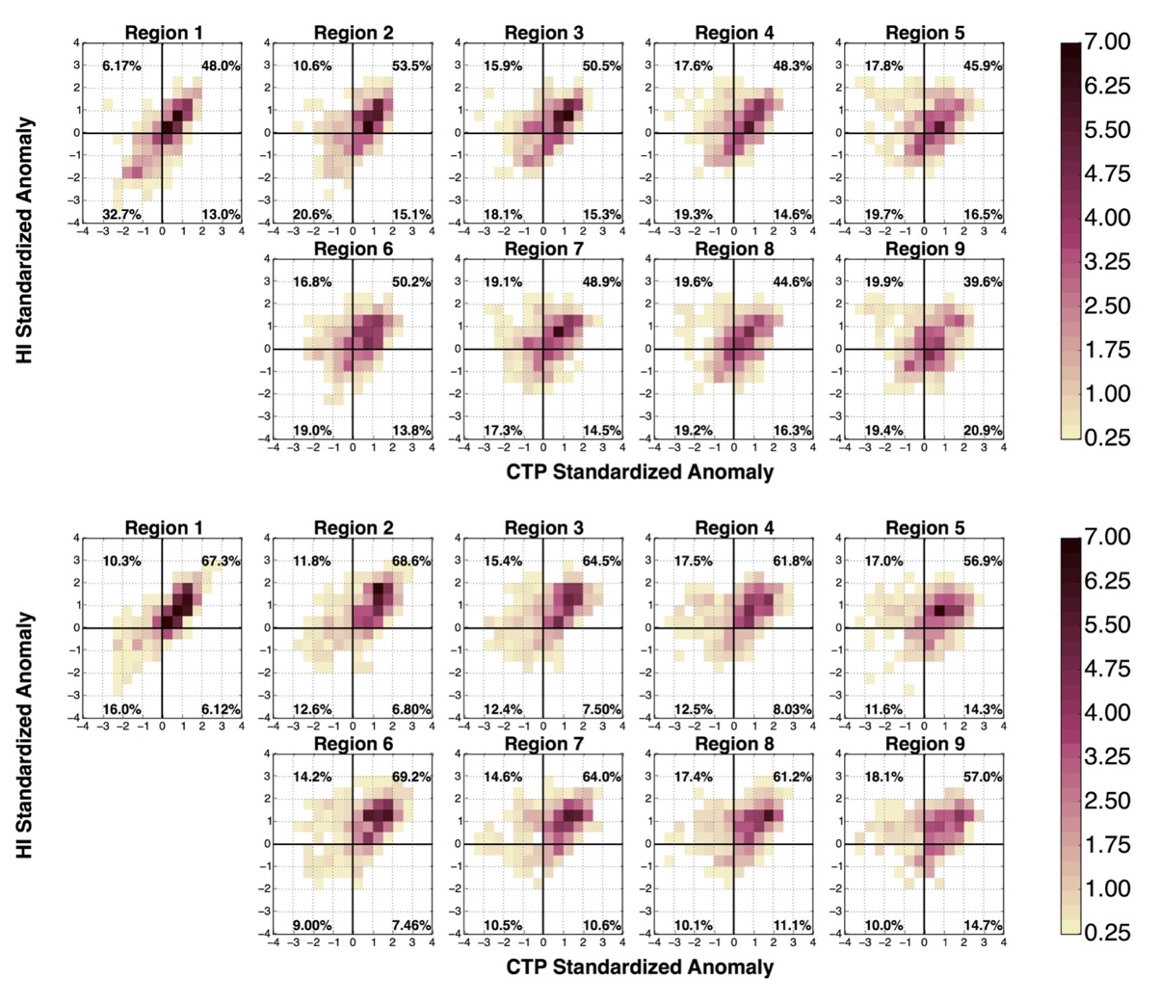
Figure 10: As in Figure 8 but for a) 2006 and b) 2011.
It is when the parameter spaces of individual regions are broken down by month that the strongest patterns emerge. To better visualize the relationship between drought development and the parameter space, particularly Q2, weekly classifications via the United States Drought Monitor (Svoboda et al. 2002) for each climate division in Oklahoma (Fig. 11) were compared to the nearest region in this study.
Figure 11: Oklahoma Climate Divisions (credit: Oklahoma Climatological Survey).

During 2006, drought improved within the panhandle throughout the warm season. The cumulative percentage area of the panhandle climate division (which corresponds to Region 1) within a given drought classification is shaded, and the percentage of days that region 1 spends in Q2 is plotted as a black line in Figure 12a. The greatest percentage of days in Q2 occurs in April, while the peak percentage of area in D3 (extreme drought) is during May and June. As the percentage of days within Q2 decreases so does the percentage of area in D3, D2 and D1 drought classifications. While most of the area is still in drought by September, the number of days within the worst classifications (D2, D3) are at a minimum and preceded by a minimum in number of days within Q2. Similarly, as the northwestern regions of the state oscillate between severe and extreme drought (not shown) during 2006, a greater percentage of the distribution falls in Q2 during the month before an increase in drought category.
Another example of local maxima in Q2 leading local maxima in drought classification occurred in 2011 when the eastern portion of the state was experiencing little to no drought at the onset of the warm season (Fig. 12b). Region 5 which is within the northeastern and east central climate divisions is of particular focus. As the percentage of days within Q2 increases the drought classification and percentage of area within worsening drought conditions also increased but not instantaneously. The peak in total area experiencing D2 or greater during September and October was preceded by the maximum in percentage of days in Q2 during August with approximately 75% of days having CTP and HI above normal. Conversely, the greatest percentage of area experiencing the most extreme drought classifications (D3 or greater) were collocated with these peaks.

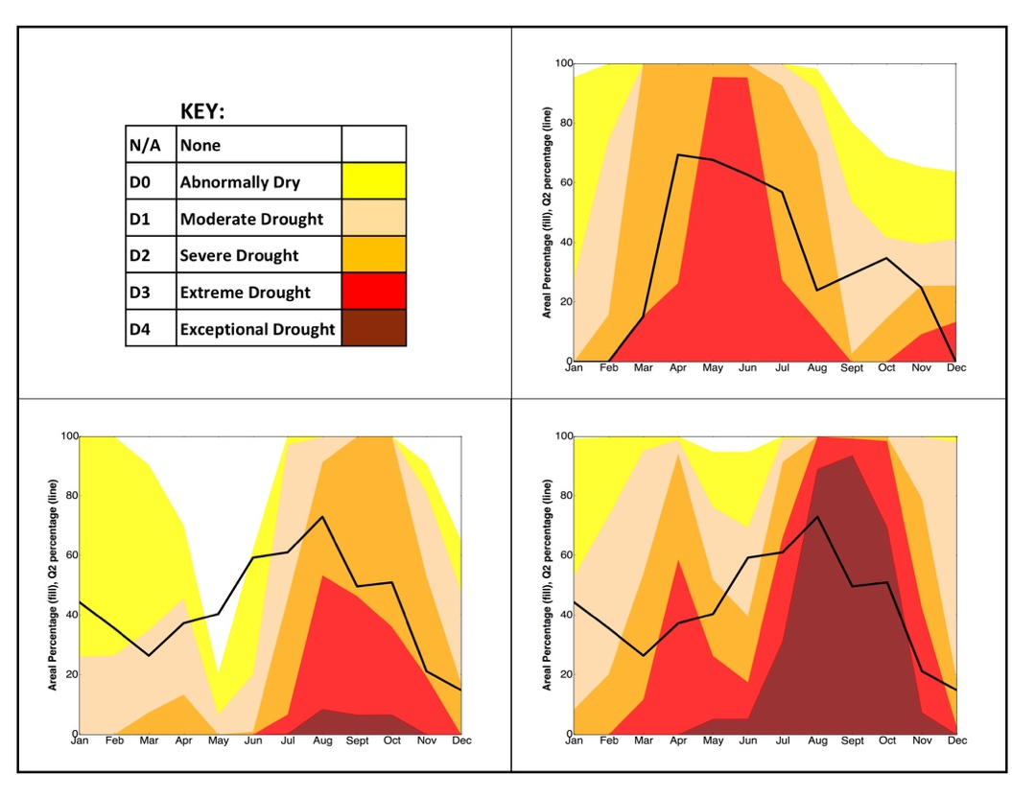
a)
b) c)
Figure 12: (a) percentage of days in Q2 (black line) during 2006 for Region 1 and average monthly cumulative percentage area (filled) in drought for nearest corresponding climate division (panhandle) during the same time. (b) percentage of days in Q2 (black line) during 2011 for Region 5 and average monthly cumulative percentage area (filled) in drought for nearest corresponding climate division (northeastern and east central) during the same time (c) same as (b) except drought area is for non-local climate divisions (central and south central) while Q2 remains only for Region 5.
If non-local effects are considered, average drought classifications from the central and south central climate divisions during this time and the percentage of days in Q2 show a lag in peak drought conditions versus peak percentage of days within Q2 (Fig. 12c). As the percentage of area in D3 or greater drought expanded rapidly from March to April showing with a local peak in D3 or worse area during April, Q2 increases resulting in a local maximum during June. The plateau area in D0 or worse in central Oklahoma between May and June was followed by a relative plateau in percentage of days in Q2 in northeast Oklahoma during June to July. The rapid increase in D4 drought area in the southwestern part of the state from June to July led to the increase in NE Q2 percentage that occurred from July to August. The peak D4 area occurred in late fall, while Q2 area decreased during this time.
During both years, the intensification of drought as evidenced by upgrades in drought classification were locally preceded by increases in percentage of days which occupy the Q2 portion of the parameter space. This suggests that feedbacks between the drying land surface and the drying of the lower atmosphere as drought worsens. As the drought propagates from west to east in 2011, so do the highest percentages of days within Q2.

3.3 Discussion
Significant uncertainty still exists regarding the nature of coupling in the Southern Great Plains. Some studies arguing that there is a significant impact of soil moisture on boundary layer processes (Santanello et al. 2009, 2011, 2013; Tawfik et al. 2015) while large scale analyses have shown a strong relationship between soil moisture and precipitation in the region (Koster et al. 2004, 2006; Dirmeyer et al. 2009). However, others argue that the impact of coupling is almost negligible compared to large scale moisture transport (Findell et al. 2011; Ruiz-Barradas and Nigam 2013). Such conflicting results can be a result of the spatial and temporal scale used which can produce contrasting results over the same region (Hoheneger et al. 2009). The focus of this study was, using a unique set of in situ observations, to provide a more holistic approach to land atmosphere coupling by evaluating soil moisture and subsequent atmospheric response initially at the diurnal scale and subsequently aggregating to a monthly, seasonal or interannual scales to bridge the gap between local and global coupling studies. This approach captured the spatial and temporal variability of land-atmosphere coupling in Oklahoma while also addressing the knowledge gap that exists regarding the physical links between soil moisture and precipitation (Seneviratne et al. 2010).
While the CTP/HI framework is a useful tool for quantifying the potential for land atmosphere coupling based on pre-existing boundary layer moisture and instability (Findell and Eltahir 2003a), on average, most stations in Oklahoma exceeded an HI value of 15°C during the warm season which would be considered an atmospherically controlled regime (Findell and Elathir 2003a). On the other hand, numerous studies have noted atmospheric responses to changes in land surface flux partitioning in Oklahoma (Basara and Crawford 2002; McPherson et al. 2004; McPherson et al. 2007; Ford et al. 2015). Ferguson and Wood (2011) suggested that the original framework may have been unintentionally biased by the location of its development (Illinois) and were able to better capture large scale coupling via departures from latitudinal means of CTP and HI. As such, the CTP/HI framework was modified to capture coupling in the study domain.
This study applied the CTP/HI framework from the perspective of standardized anomalies or Z-scores within small sub-regions in Oklahoma. Each sub-region was designed to capture the variability in precipitation, temperature and vegetation across the state while maintaining a relatively homogeneous environment within the region. Within each region the CTP/HI standardized anomaly parameter space was studied and responded differently for wet versus dry soil conditions; the cases were nearly a mirror image across the origin between Q2 and Q4. In the wet soil case, the greatest number of days were in Q4 while dry soils resulted in a greater number of days in Q2. This result could be a function of the pre-existing large scale atmospheric pattern that would lead to wet or dry soils but also a residual of the feedbacks between the land surface and the atmosphere.
Where previous studies (Frye and Mote 2010; Ford et al. 2015) carefully select singular precipitation events, the current study took a novel approach by examining coupling from a climatological perspective using daily precipitation events exceeding 5% of the monthly mean while also addressing the physical differences in the daily atmospheric profiles over wet versus dry soils during extreme years. Years with excessive rainfall showed distinct differences in the parameter space, particularly for those years of 2007 and 2015. It is expected that years with heavy rainfall would have parameter spaces which closely resemble the parameter space for precipitation over wet soils. Overall, 2015 appears similar to the parameter space for precipitation over dry soils with nearly an equal number of days occurring in both Q2 and Q4. However, 2007 had a majority of days in the Q4 space. These results might suggest that 2015 is the anomalous year with the greatest percentage of days in Q2 despite wetter than normal conditions. Flanagan et al. (2018) describes large scale patterns which are most conducive to heavy precipitation in the Southern Great Plains and 2015 is consistent with this large-scale dynamical pattern. However, the environment for 2007 was not consistent with the Flanagan et al. (2018) pattern and Dong et al. (2011) noted evidence of positive feedbacks between surface fluxes and subsequent rainfall. It is unlikely that the large scale pattern was operating independently of land-atmosphere coupling and large scale pattern could enhance the efficiency of land atmosphere feedbacks (Su et al. 2014; Wei et al. 2015; Su and Dickinson 2017). As such, the results suggest that the atmosphere was more responsive to land-atmosphere interaction producing precipitation recycling during 2007 versus 2015. Basara and Christian (2018) confirm the presence of strong coupling through use of a different metric during most of the warm season in 2007; 2015 was not analyzed in their study.
When anomalous rainfall years were examined by region, 2015 was more representative of other heavy rainfall years than 2007. For example, Region 3 was used as an example of several years with above normal warm season precipitation during 2007, 2008, 2013 and 2015. All years had a relatively even distribution across quadrants with a greater number of days in Q2 overall, except for 2007 which had less than 1% of days in Q2 and no days in Q1. In addition, the distribution during 2008 looked like a combination of 2007 and 2015, and the atmospheric response in 2008 may have been due to soil moisture memory from the heavy rainfall during 2007. Further, the increased frequency of days with precipitation in Q4 during 2007 are what may be expected during a precipitation recycling regime; this is also evident in 2008. Incorporating deep soil moisture memory into models has been shown to better reproduce precipitation variability (Dong et al. 2011; Schubert et al. 2002). Soil moisture memory from heavy rainfall in 2007 was possibly impacting the atmospheric response to land-surface conditions during 2008. The other quadrant heavily occupied during 2007 was Q3 which is more likely to be representative of a case when the atmosphere was primed for convection through increased low level humidity and enhanced instability. In this case the land surface may yield less influence which agrees with findings that large-scale drivers played a role in the anomalous precipitation in 2007 (Dong et al. 2011) but they were not the only influence. Conversely, the year with the greatest number of days in Q3 and Q2 compared to the other wet years was 2015 and the large scale atmospheric pattern likely played the greatest role in anomalous precipitation as shown by Flanagan et al. (2018).
A common factor across all years (except for 2007) was that at least 14% of days with rainfall had HI above normal, meaning local low level moisture was reduced so moisture necessary for precipitation was due to non-local influences. This would continue to suggest the presence of large scale drivers of precipitation or negative feedbacks in such cases rather than the strong tendency toward conditions most conductive to positive feedbacks in 2007 when above normal low level moisture was present for 99% of rainfall cases. Furthermore, the variability in atmospheric response during heavy precipitation years confirms previous studies which demonstrate significant interannual variability in land-atmosphere coupling strength (Guo and Dirmeyer 2013; Basara and Christian 2018) but the reasons for these differences remain largely unexplored. These results provide insight into the actual changes in the vertical structure of the atmosphere during extreme years even when similar soil moisture conditions are present to better explain the presence (or lack thereof) of land-atmosphere coupling.
Dry years also demonstrated a clearer feedback between soil moisture and atmospheric conditions. The atmospheric response within dry years was more consistent within the parameter space with a high percentage of days in Q2 and in 2011, a large percentage of days showed a high magnitude of CTP and HI anomalies within Q2. The magnitude of the CTP/HI anomalies within the Q2 space during dry years appears to be much greater than other years suggesting a feedback between dry land surface conditions and the atmosphere. The most significant finding was the presence of a peak in percentage of days within Q2 which led the peak in drought conditions by approximately one month during 2006. An increasingly dry and convectively hostile atmosphere appeared to drive the intensification of drought. This was also evident in 2011 when the evolution of drought in Northeastern Oklahoma was examined. The peak in percentage of days within Q2 leads the peak percentage of area in D2 or greater drought classification, however the peak percentage of area in D3 or greater drought was collocated with the Q2 peak. The Q2 peak may be driven by the extreme drought conditions locally and this peak in hostile atmospheric conditions could have driven the expansion of overall drought area noted by the increase in drought area one month later. The lag in such feedbacks was not as clear as during 2006, but an atmospheric response to drought intensification was evident.
Moreover, non-local effects were considered by examining the evolution of atmospheric conditions in northeastern Oklahoma and the intensification of drought in southwestern Oklahoma. Drought propagated from west to east during 2011 with little area in drought in eastern portions of the state at the onset of the warm season. Conversely, the southwestern climate division had nearly 80% of its area in D3 (extreme drought) or worse. Increases in percentage of days in Q2 in northeastern Oklahoma were preceded by increases in drought intensity in southwestern Oklahoma suggesting local atmospheric responses to non-local soil moisture conditions.
The current analysis focuses on the differences between years with varying hydroclimate extremes. As such, it is relevant to examine the mean behavior of all years within the parameter space to determine if these extreme years truly were anomalous in within the low-level atmospheric profile (Fig. 13). Statewide, 2007 and 2011 stand out as having opposite extremes to one another as expected from the interannual comparisons. The width of each ellipse represents 1 standard deviation in CTP standardized anomalies and the height represents 1 standard deviation in HI standardized anomalies computed from the statewide standard deviation for that year. The center of the ellipse represents the statewide mean. Thus, 2011 yielded more variability in CTP standardized anomalies while 2007 was nearly uniform. Despite heavy precipitation 2015 was representative of near average values statewide and lies in the middle of the parameter space. Other years which stand out include 2012 and 2006 which were both dry years, and 2000 which was not analyzed in the first part of this study; 2000 has significant variability and appears to have days that would be representative of both pluvial and dry years. The differences in variability across years provide further justification for exploring the intra-annual variability of CTP and HI standardized anomalies to better quantify the nature of land-atmosphere coupling in Oklahoma.
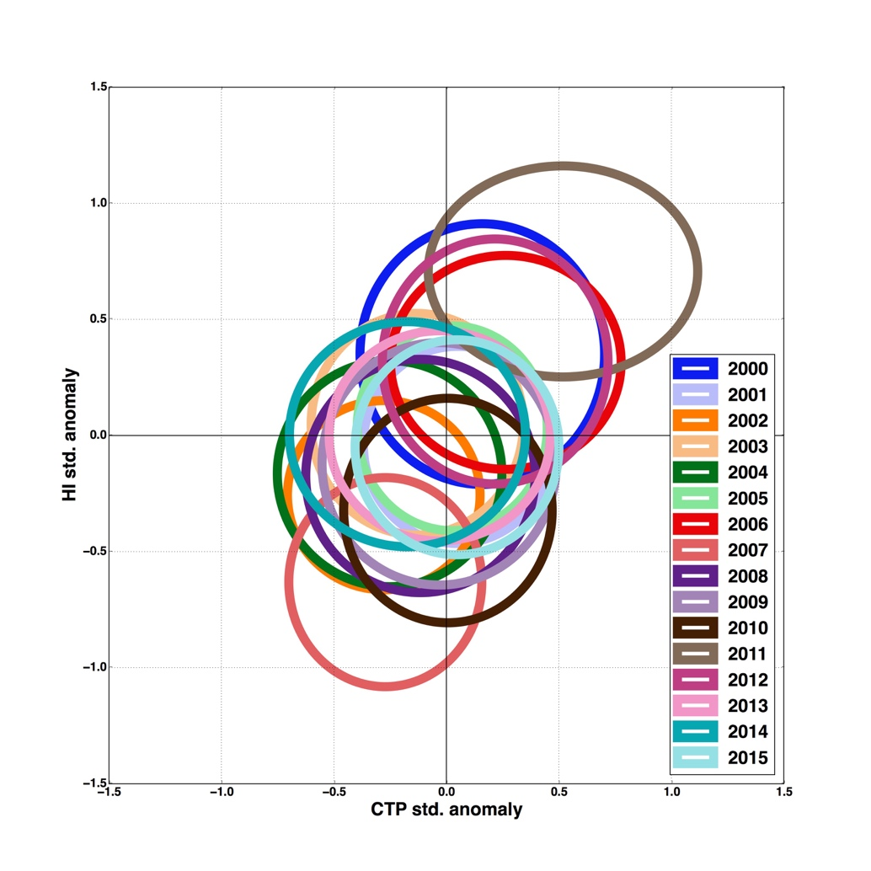
Figure 13: Statewide averaged warm season (May-September) CTP and HI standardized anomalies for each of the years in the dataset.

Chapter 4: Intra-annual Variability of CTP/HI in Oklahoma
Significant variability exists from year to year within the CTP/HI standardized anomaly parameter space even for years with seemingly similar hydrometerological extremes such as pluvial years (2015 and 2007) and drought years (2006 and 2011). Dry years also appeared to have a more consistent behavior within the warm season parameter space for each year whereas wet years differed from one another significantly. While 2015 appeared to be largely driven by the overall synoptic pattern, 2007 had potential for land-atmosphere feedbacks, and it has been suggested that anomalous rainfall may have been enhanced by land-atmosphere feedbacks (Dong et al. 2012). Considerable interannual variability merits further exploration into the intra-annual variability of the CTP/HI parameter space and how the evolution of these anomalies may be related to changes in soil moisture and precipitation at a finer timescale.

4.1 Annual Climatology
Annual warm season (May through September) regional-mean values and standard deviation values of CTP and HI were computed to quantify the spatial and temporal variability of the CTP/HI parameter space. Because the mean is a non-resistant measure of location and can be sensitive to outliers (Wilks 2011), median values were also computed; the results were similar (not shown) and the use of mean was retained for this study. Each year is represented by a colored ellipse in Figure 14 with the width representing one standard deviation in CTP and the height representing one standard deviation in HI.

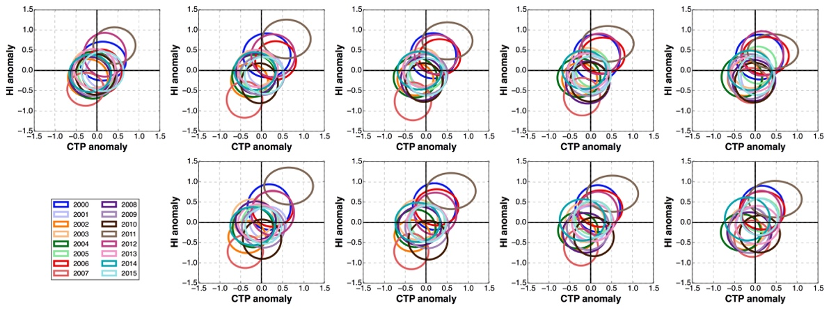
Figure 14: warm season CTP and HI anomalies for every year in each region. Each ellipse represents an individual year with width being equal to 1 standard deviation in CTP anomalies and height being equal to 1 standard deviation in HI anomalies.

Within the mean warm season parameter space, several years stand out by having the greatest anomalies. For example, 2011 had exceptionally positive CTP/HI anomalies with significant variability in the CTP anomaly space in every region. Conversely, 2007 demonstrated less variability and a significant negative departure for both CTP and HI (this distinction is less apparent within regions 5 and 9) and would be expected for a year with anomalously high precipitation. While record rainfall was also observed during 2015 across much of Oklahoma, the mean state of the CTP/HI anomalies for all regions was near normal. Additionally, 2000, 2006, and 2012 had notable positive anomalies in CTP and HI across most regions but variability in the CTP/HI parameter space was more symmetric than that of 2011. Finally, years other than 2007 with negative CTP/HI anomalies were regionally dependent; the same year was not consistently observed across all regions.
From a climatological standpoint, 2007 and 2011 are opposite examples of hydroclimate extremes. Statewide averaged summer precipitation for 2007 was nearly 18 mm above normal and is considered the wettest summer in the study period. Conversely, precipitation during summer of 2011 was nearly 13 mm below normal making it the driest summer of the study period. Statewide annual statistics rank 2007 second to 2015 which received its heaviest precipitation during spring, and 2011 ranked second to 2012.

4.2 Monthly Evolution of CTP/HI During Selected Years

4.2.1 Pluvial Period: 2007 Warm Season
The two extreme years (2007 and 2011) were broken down by month to diagnose the covariability of atmospheric profiles and changes in land surface conditions during the warm season (Fig. 15). As in the annual climatology, the mean and standard deviation values were computed for each region. The length of each bar in the horizontal direction represents one standard deviation in CTP and the length of each bar in the vertical direction represents one standard deviation in HI.
Precipitation for each month within each region was ranked by year with a rank of 1 representing the driest year of that month in that region and 16 being the wettest. Precipitation ranks are shown at the bottom of each monthly plot. Years which are considered below normal are those with a rank of less than 8 and years which are considered above normal have a rank greater than 8.

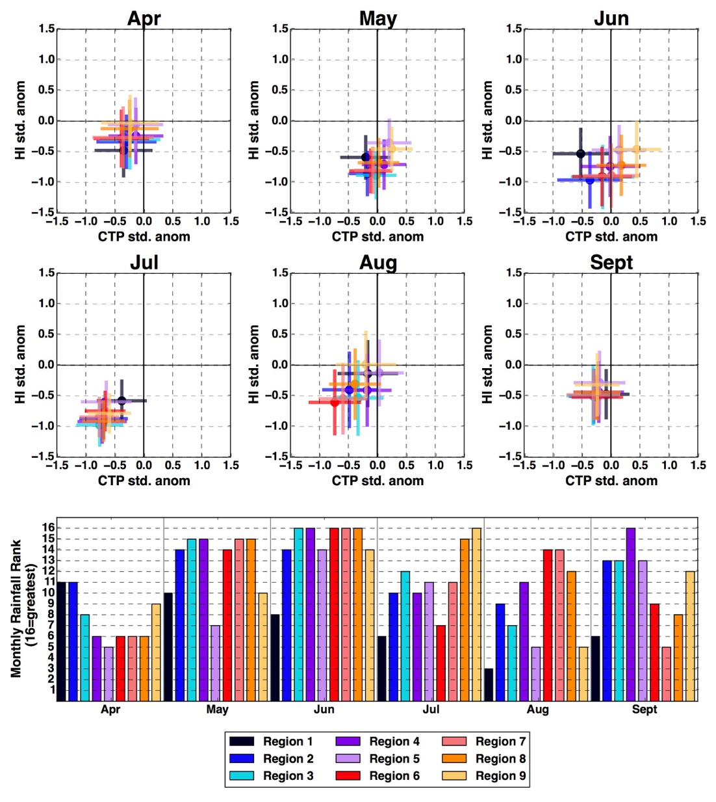
Figure 15: 2007 Monthly averaged CTP and HI standardized anomalies by region (top) and monthly precipitation rank (bottom) for the 16-year period with 16 being the wettest year and 1 being the driest.
While precipitation was below normal during April of 2007, CTP and HI anomalies were negative on average. As precipitation anomalies increased over the region, mean CTP/HI anomalies became more negative; June had the most variability between stations and had a significant amount of variability within each individual station. Regions in the eastern half of the state had positive CTP anomalies while in the western half of the state negative CTP anomalies prevailed. By July CTP/HI anomalies were negative in all regions despite the heaviest precipitation occurring the month before. Following a return to near normal precipitation in August, most regions had a reduction in magnitude of negative CTP and HI anomalies and an increase in overall variability, while the regions which received above normal precipitation maintained the greatest negative departures in CTP/HI. The difference in precipitation anomalies coincided with a greater spread in the mean CTP/HI anomalies for each region. Mean CTP/HI anomalies were nearly the same across all regions as differences in regional rainfall anomalies were reduced during September and overall rainfall was near normal.

4.2.2 Drought Period: 2011 Warm Season
Unlike 2007, HI anomalies during 2011 were already above normal prior to the beginning of the warm season and CTP anomalies ranged from slightly positive to slightly negative, except for region 1 (Fig. 15). Regions in the eastern half of the state had one of the wettest Aprils in the study period with regions 5 and 9 being the wettest while regions 4 and 8 recorded their 5th wettest. During May, precipitation became less anomalous or near normal across all regions. Regions which received more precipitation during April and May had the least deviation from normal in the HI space, while those with precipitation deficits had the largest, and all regions had near normal or negative CTP anomalies. Variability in CTP was greater than that of HI and was more pronounced for regions with greater rainfall deficits (those with lower precipitation ranks). Much of the state experienced the least June and July precipitation within the 16-year study period. As precipitation deficits accumulated, CTP/HI anomalies became more positive across all regions while variability decreased; August had the greatest positive anomalies and most regions experienced minimal precipitation. During September, CTP anomalies returned to near normal, while HI anomalies remained positive, especially in the southernmost regions. As such, the distribution of regional means appeared similar to April but slightly shifted toward more positive anomalies in both CTP and HI.
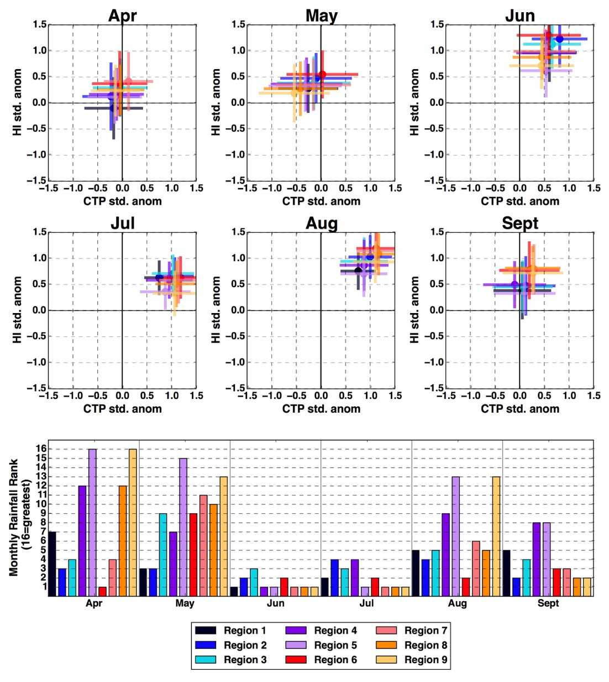
Figure 16: As in Figure 15 but for 2011.

4.2.3 Mixed Rainfall Extremes: 2000 Warm Season
The third year which stood out in the overall warm season climatology was 2000 (Fig. 16). On average, warm season CTP and HI anomalies were positive across all regions for the year, similar to 2011 but Spring, Summer and annual precipitation was near normal statewide (Oklahoma Climatological Survey). The April and May precipitation was near normal in most regions while those which received above normal rainfall during April (6 and 7) received below normal during May. The CTP anomalies were near normal during both months while HI anomalies became more positive. All regions had precipitation totals that were within the top 5 wettest Junes or greater while both CTP and HI anomalies were negative with departures similar in magnitude to those observed during July of 2007 when above normal precipitation was also recorded. Rainfall returned to near normal during July before entering a dry period during August and September. As rainfall deficits accumulated during 2000, CTP and HI anomalies became more positive with August means comparable to those of August 2011. All regions except for Region 1 recorded the driest August within the 16-year period during 2000. Variability in CTP/HI anomalies also decreased during this time before increasing during September in which CTP anomalies ranged from negative to the east to positive in western regions with all regions still experiencing HI anomalies well above normal.

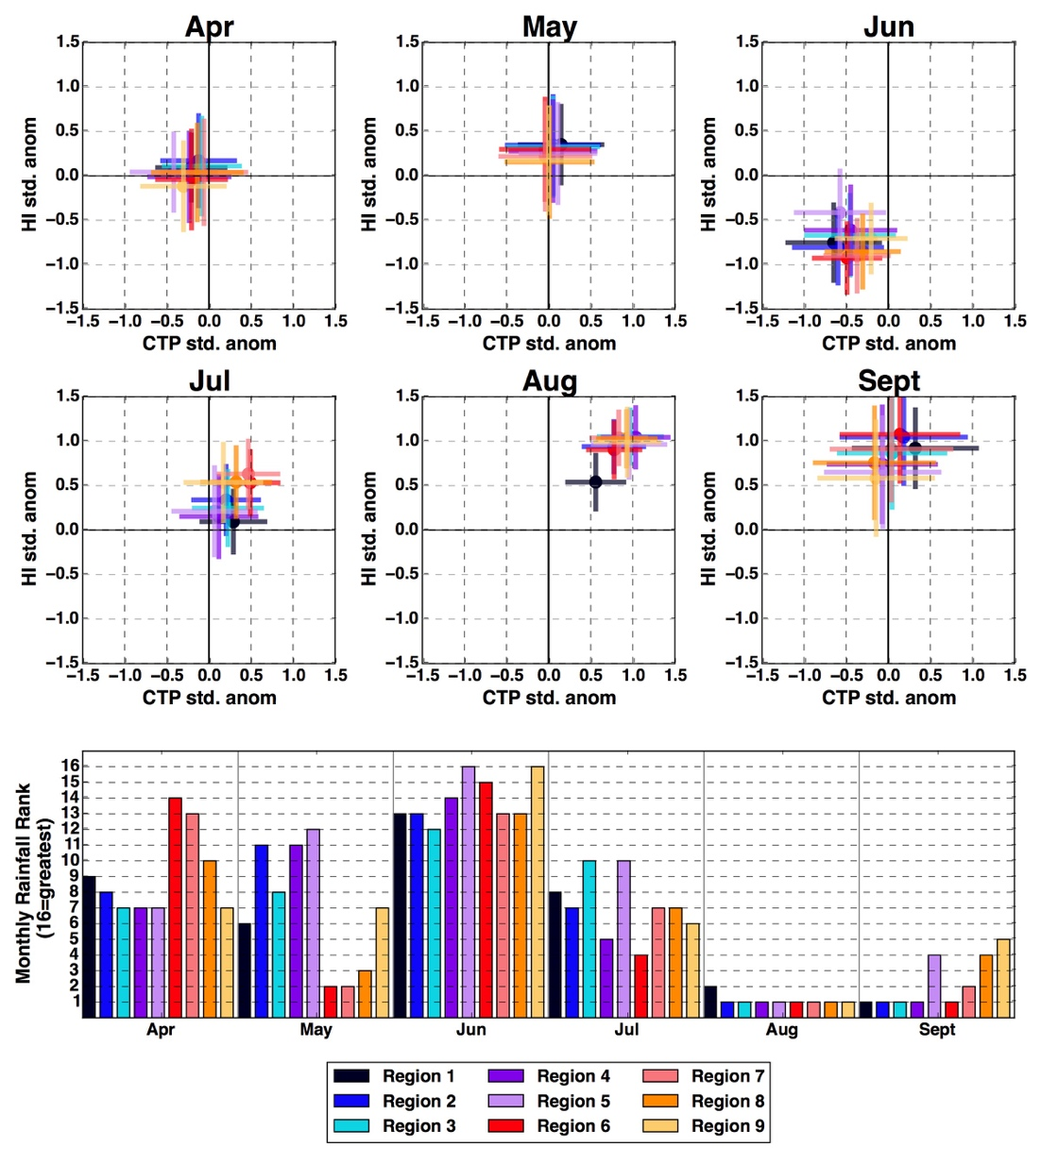
Figure 17: As in Figure 15 but for 2000

4.2.4 Pluvial No. 2: 2015
Because 2015 (Fig. 17) was an extremely anomalous year for precipitation with much of Oklahoma experiencing the wettest May on record, it was included in the analysis. However, despite anomalous rainfall, it did not stand out within the CTP/HI parameter space as the warm season mean values for each region were near normal. Further, while other years exhibited significant month to month changes in mean CTP and HI anomalies, 2015 had little movement within the parameter space. May was characterized by positive CTP anomalies and negative HI anomalies while June and July had near normal CTP anomalies and a steady progression toward slightly positive HI anomalies. The CTP anomalies were slightly negative during August coinciding with near or slightly positive HI anomalies and a reduction in precipitation. By September, mean CTP and HI anomalies were similar to those of April along with reduced variability in each region and a decrease in precipitation.

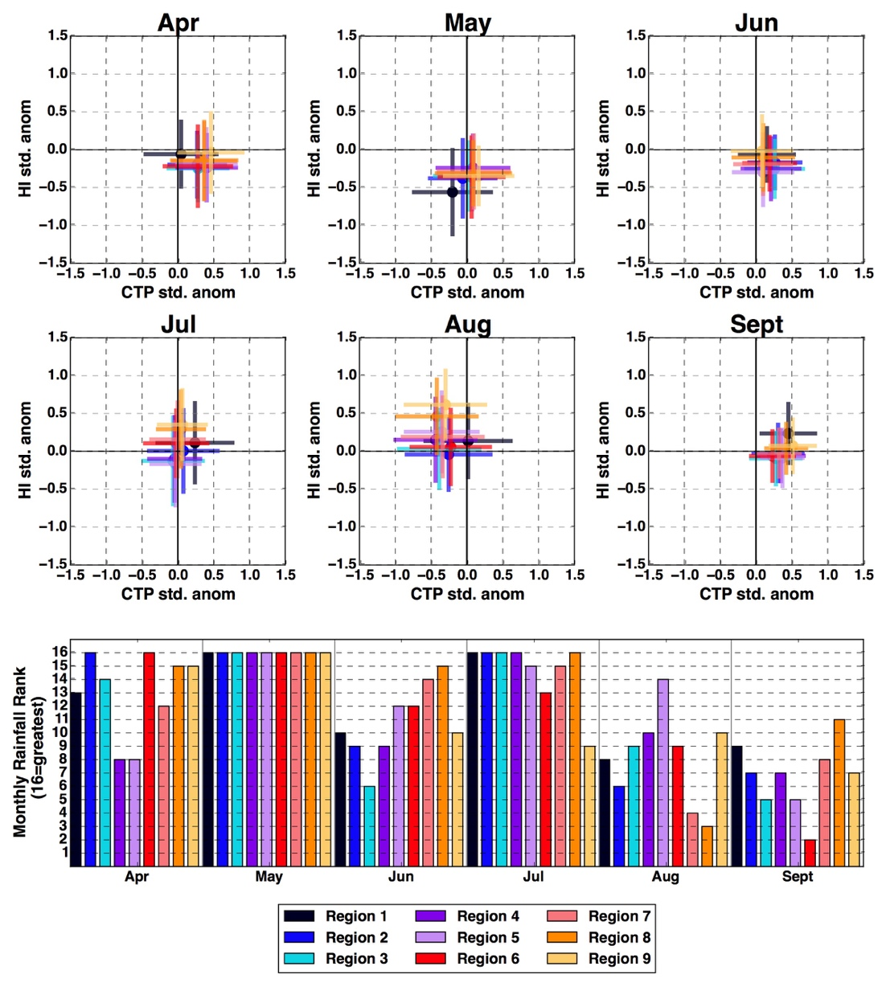
.Figure 18: As in Figure 15 but for 2015.

4.2 Discussion

4.2.1 Daily Evolution for 2007 Warm Season
Below normal precipitation during April of 2007 coinciding with negative CTP and HI anomalies was contradictory to results from part 1 of this study which showed a greater likelihood of negative CTP/HI anomalies over wet soils or during periods with above normal precipitation. However, April lies at the beginning of what is considered the transitional drying phase which occurs from Mid-March through mid-June (Illston et al. 2004) based on the climatology of fractional water index (FWI) in Oklahoma. From November to mid-March soils are generally moist due to minimal evaporation. However, with increased evaporation begins depletion of soil moisture and recharge is dependent upon precipitation during Oklahoma’s wet season. On average soil moisture across the state during spring of 2007 followed this climatological behavior (not shown) and April offers little time for substantial evaporation to deplete soil moisture so they remained moist during this time. The predominance of below normal CTP/HI values suggests a moist atmosphere despite the lack of precipitation which could have been sourced by local evaporation as well as advection. Above normal precipitation in May coinciding with negative HI anomalies reflected an increase in low-level moisture. The CTP anomalies, indicative of instability, were near normal such that the environment was neither moisture or energy limited in driving convective precipitation. The CTP anomalies were more variable during June with negative anomalies to the west and positive anomalies to the east.
While rainfall anomalies were less pronounced during July, the CTP and HI anomalies were most negative during this period. It is in this energy limited, moisture abundant environment that precipitation recycling may be expected. Furthermore, negative CTP anomalies may yield less buoyancy in the lower troposphere, and a stronger capping inversion that would allow for the accumulation of moist static energy within the boundary layer, lowering LCL height, and triggering convection. The additional moisture supplied from the land surface could result in triggering of deeper convection (Findell and Eltahir 2003a) and greater precipitation rates through increased latent heat flux (Cioni and Hohenegger 2017). Dong et al. (2011) showed that while synoptic scale processes were the main driver of precipitation during 2007, positive feedbacks between the moistened land surface and subsequent precipitation also played a role. The increased variability in CTP and HI anomalies during August coincides with a return to near normal rainfall.
A time series for June, July and August 2007 (Fig. 18) shows that 5-day running mean CTP and HI anomalies (hereafter CTP5/HI5) were relatively consistent from mid-June to mid-July when soils were near field capacity (FWI = 1). This provides an explanation for the lack of variability in CTP/HI anomalies displayed in Figure 2a during July due to limited change in land surface state. From mid-July to early August, the 25 cm FWI decreased steadily while CTP5 and HI5 remained negative. After the first week of August, CTP5 and HI5 began to increase rapidly and reach peak positive values near August 15.
Evaporative fraction has been shown to become more coupled with the land surface once soils begin to dry out after a precipitation event (Phillips and Klein 2014). Thus, atmospheric demand and a lack of precipitation to recharge soils drove increases in evapotranspiration (ET) which maintained a moist profile within the lower troposphere. Once soil moisture was depleted beyond a certain threshold in all regions, ET could no longer meet the atmospheric demand and the low-level atmospheric profile dried resulting in a rapid increase in CTP5 and HI5.
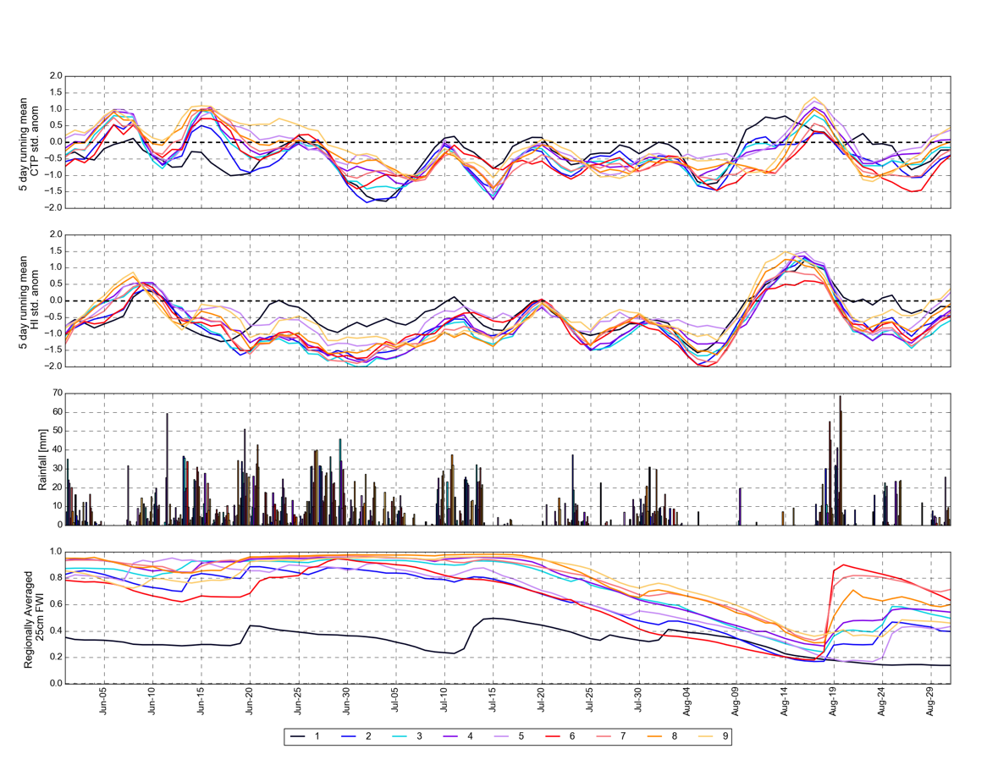
a)

b)

c)

d)

Figure 19: Time series of 5 day running mean (a) CTP and (b) HI standardized anomalies for each region, (c) daily precipitation and (d) daily 25 cm fractional water index for June, July and August of 2007.

4.2.2 CTP/HI Precursors to Tropical Storm Erin Redevelopment
The remnants of tropical storm Erin remoistened soils during late August 2007. Antecedent soil moisture and atmospheric conditions prior to the redevelopment of Erin agree with conclusions from other studies which suggest that inland reintensification was likely driven by anomalous soil moisture during this period (Arndt et al. 2009 ; Monteverdi and Edwards 2010 ; Evans et al. 2011). Southwestern Oklahoma had 25 cm FWI values that were indicative of water stress (Illston et al. 2008, http://www.nue.okstate.edu/Weather/FractionalWaterIndex.pdf) immediately preceding the reintensification of tropical storm Erin. During this time rain was observed while HI and CTP anomalies became more negative. The preceding environment characterized by positive CTP and HI anomalies suggesting a dry environment, however during the 24 hours preceding Erin’s reintensification strong moisture advection resulted in dewpoint temperature values which were well above normal (Arndt et al. 2009) and below normal HI observations. Furthermore, the drying of soils during the preceding period would have resulted in greater partitioning of fluxes into sensible heating which would warm the soils. Emmanuel (2008) noted that in northern Australia, hot dry soils become wetted by outer bands of tropical cyclones, and this combination of warm temperatures and surface moisture may supply sufficient latent heat flux to reintensify a tropical cyclone over land. Similar land surface conditions combined with warm moist advection from a minimally modified air mass (Monteverdi and Edwards 2010) as well as above average soil moisture upstream (Evans et al. 2011) may have contributed to Erin’s reintensification over Oklahoma on August 19, 2007.
Several additional important relationships were observed between fractional water index and CTP5/HI5 anomalies during July and August of 2007. First, the HI5 anomalies reached a local minimum as soil moisture was decreasing, then quickly transitioned toward positive anomalies once all regions reached a 25 cm FWI value less than 0.6. Such behavior may be indicative of initial moistening of the environment through surface evaporation from moisture abundant soils. Once soils became water stressed (FWI < 0.6), surface flux partitioning was toward sensible heating and the near surface environment dried. At this point CTP5 and HI5 anomalies became strongly positive. The drying soils resulted in 5 cm soil temperature values which were above normal across the southwestern portions of the state during August 12-16 (Oklahoma Mesonet). These warm surface temperatures combined with wetting of the soils by Erin’s outer bands during the 17th and 18th would have supplied a source of latent heat flux for redevelopment of Erin. Wetted soils by Erin correspond well to a period of negative HI5 and CTP5 anomalies. As in early August, the minimum in CTP5/HI5 followed the maximum in 25 cm FWI suggesting initial surface evaporation was maintaining a wet near surface environment before CTP5/HI5 increased at the end of the month as soils continued to dry. Overall, CTP5 and HI5 co-varied with FWI during June, July and August, but the relationship became even stronger when only considering August when the greatest declines in fractional water index occurred and many of the regions became water stressed (Fig. 19).

(a) (b) (c)

(d) (e) (f)

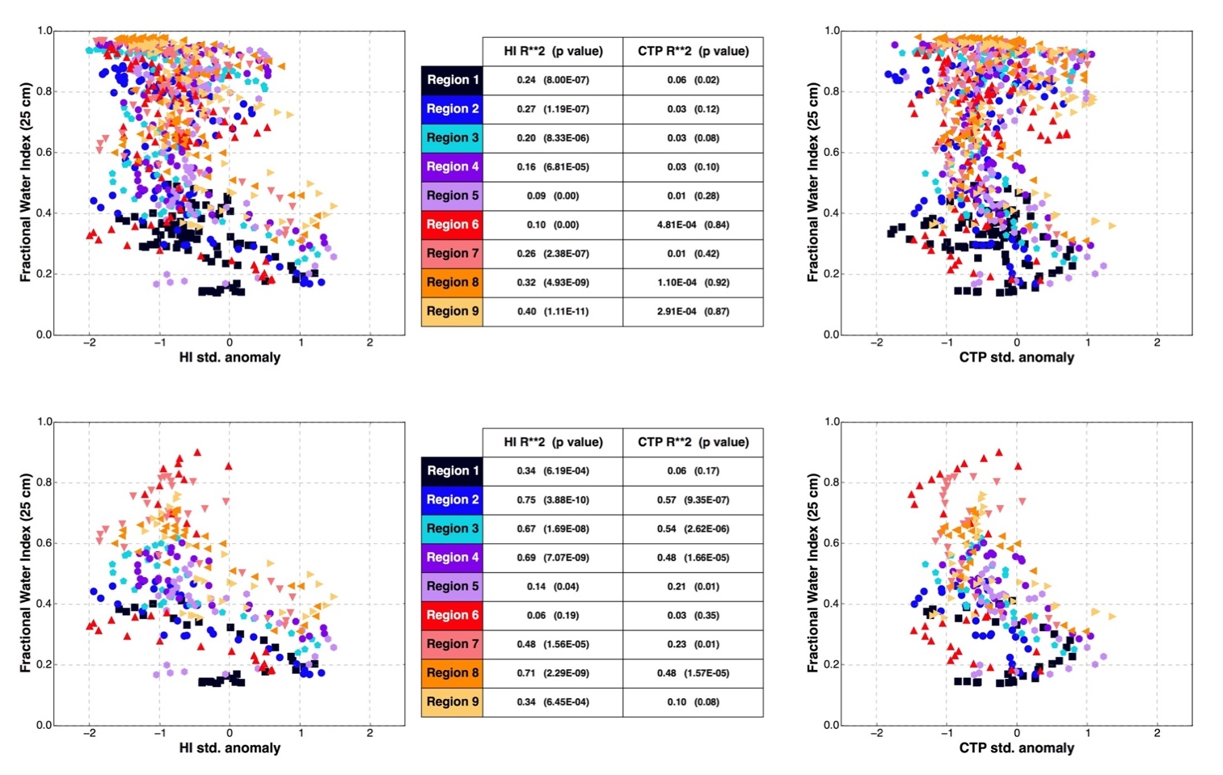
Figure 20: (a) scatter plot of fractional water index versus 5 day running mean HI standardized anomaly, (b) table of r-squared values for HI5 versus 25 cm FWI and CTP5 versus 25 cm FWI (c) as in (a) but for 5 day running mean CTP standardized anomaly. (a-c) June, July, and August 2007(d-f) same as (a-c) but for August only.

4.2.3 Evidence of Land-Atmosphere Coupling during 2000
An extended period of drying soils following an anomalously wet period was observed during 2000 resulting in similar land-atmosphere interactions. The main difference between the two years was the length of the period with above normal precipitation as this period during 2000 was relatively short lived compared to 2007. The time series for June, July and August (Fig. 20) demonstrates the rapid decrease in soil moisture during the period along with the rapid month to month shift in CTP5/HI5 anomalies. Similar to 2007, HI5 became positive as soil moisture decreased, but remained below normal while soils were relatively steady with FWI greater than 0.8. The FWI value for which the negative to positive HI5 shift occurred was 0.6 in 2007, but 0.8 in 2000 even though the dry-down period began during the same month. Further, soil moisture was depleted much more rapidly during 2000.

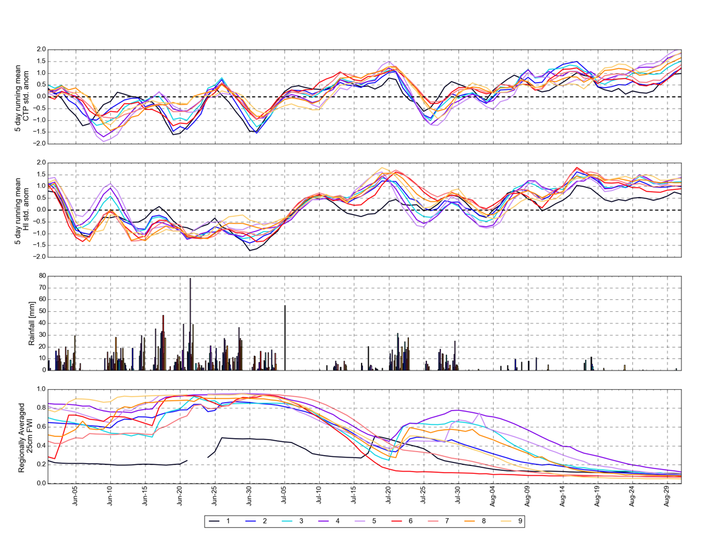
a)

b)

c)

d)
Figure 21: As in Figure 19 but for June, July and August of 2000.
Such differences may point to a difference in atmospheric demand driven by local versus non-local factors. Atmospheric demand preceded the onset of rapid soil moisture depletion as soils were still relatively moist when HI5 and CTP5 became positive during 2000. Surface evaporative fluxes were not sufficient to increase low-level humidity as reflected in HI5, and atmospheric demand may have been sourced upstream over a drier land surface. Conversely, during 2007 this switch occurred after a longer period of soil moisture depletion suggesting there was a slow feedback process between the land surface and atmosphere allowing both to become progressively drier. Periods of recharge occurred during late July of 2000, and the subsequent atmospheric response showed a decrease in CTP5 and HI5 anomalies. However, the rapid decline in soil moisture during August led to a rapid increase in CTP5 and HI5 anomalies once again with the anomalies becoming more positive as soils reached their driest values in late August. During both 2000 and 2007, atmospheric demand appeared to become amplified by decreased soil moisture and a shift from latent to sensible heat fluxes. When atmospheric demand preceded the strongest decrease in soil moisture, decreases in FWI occurred much more rapidly as shown in 2000 when most regions decreased by at least 0.6 over a period of approximately 15 days. While demand precedes the decline in soil moisture, once fractional water index decreased below 0.6 a secondary rapid increase in HI5 anomalies occurred near July 16. The FWI below 0.6 appears to be the inflection point by which the atmospheric demand was amplified by the local land surface conditions for both 2000 and 2007. As such, the trend for CTP5 and HI5 was generally toward positive anomalies as soils remained below 0.6 through August, with less variability as anomalies remained positive during the last two weeks of August 2000. Other years show similar responses with rapid increases in CTP5/HI5 anomalies when average FWI dropped below 0.6 for all regions. Figure 7 shows the r-squared values for CTP5/HI5 versus 25 cm FWI and it is clear that the atmospheric response demonstrated strong co-variability with fractional water index through the entire 3-month period (Fig. 21). However, some years do not exhibit this behavior despite having similar decreases in soil moisture and have constant near normal CTP5/HI5 anomalies (not shown).
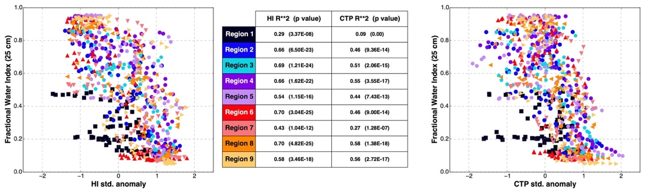
a) b) c)
Figure 22: (a) scatter plot of fractional water index versus 5 day running mean HI standardized anomaly, (b) table of r-squared values for HI5 versus 25 cm FWI and CTP5 versus 25 cm FWI (c) as in (a) but for 5 day running mean CTP standardized anomaly. (a-c) June, July, and August 2000.

The presence of positive HI anomalies, and negative CTP anomalies during May of 2011 indicated an atmospheric profile hostile to convective precipitation. A lack of instability paired with a dry low-level atmosphere precluded sufficient boundary layer growth to intersect increasing LCL heights due to lack of moisture. Furthermore, composite soundings (Fig. 22) of the regions with the most negative CTP anomalies yield a strong capping inversion which would suppress convective precipitation. The CTP was, on average, negative indicated by the temperature profile being to the right of the corresponding moist adiabat used in the CTP computation. Miralles et al. (2014) showed that depletion of soil moisture often corresponds with elevated temperatures, a warmer residual layer, and further diurnal entrainment of warm dry air from the residual layer to the surface. This increases surface temperatures and evaporative demand further depleting soil moisture and creating a positive feedback. Such a residual layer may be evident in this case and sourced upstream where soils were drier in the southern and western regions of the state.
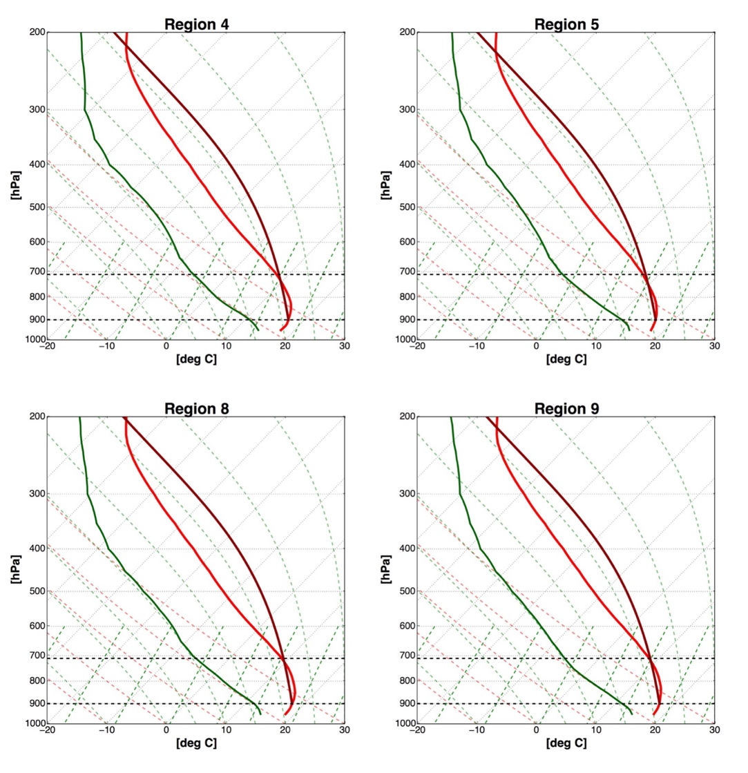
Figure 23: Composite soundings for May 2011 in regions with greatest negative CTP anomalies. All soundings begin at 50 mb AGL to capture the regions measured by CTP and HI. Red is the temperature profile and green is the dewpoint profile. Black dotted lines bound the regions of the profile which were used for the computation of CTP. Maroon represents the moist adiabat intersecting the temperature profile at 100 mb AGL that is used for calculating CTP.
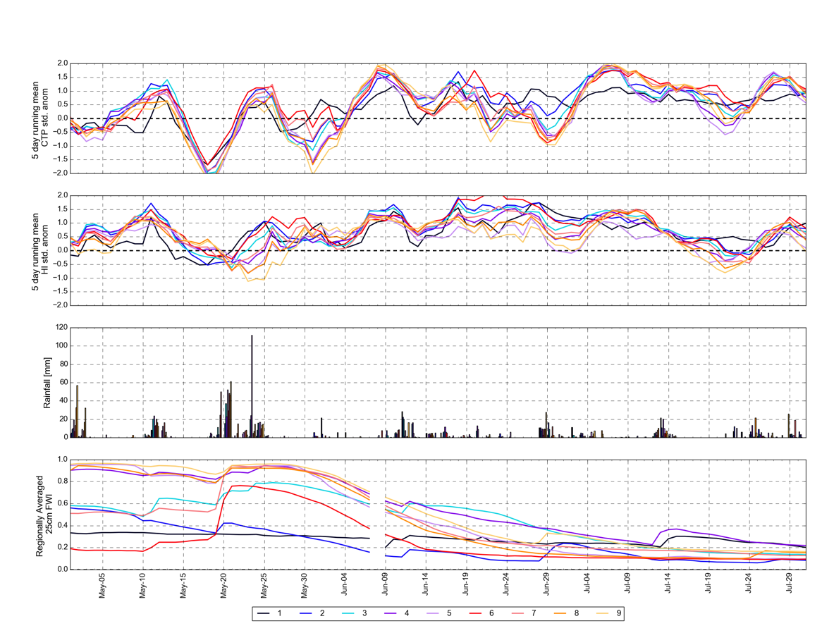
The time series for May, June and July of 2011 (Fig. 24) shows that eastern regions of the state maintained relatively saturated soils during May, but by June all regions not already dry experienced a rapid decrease in fractional water index. As fractional water index decreased, CTP5 increased becoming positive by early June. By June, HI5 was also strongly positive and while positive CTP anomalies may have been more conducive to convective mixing, moisture became a limiting factor for the generation of convective precipitation. During early July when soils were driest, CTP5 and HI5 were consistently positive indicating a strong feedback between the moisture limited land surface and continued drying of the atmosphere. The decrease in soil moisture between June 1 and July 15 coincides with a trend toward more positive CTP5 and HI5 anomalies during the period, and the atmosphere was coupled to the land surface in a drying cascade for much of the period. As in 2000, HI5 anomalies were positive prior to the greatest decreases in fractional water index once again indicating an increase in atmospheric demand preceded the dry-down period. Negative CTP anomalies may have modulated the decrease in soil moisture by hindering convective mixing and dry-air entrainment. However, once they became positive, soils dried more rapidly, particularly in Regions 7 and 8, as positive feedbacks amplified the atmospheric demand and drying of the land surface. While both 2000 and 2007 had the greatest decreases in soil moisture during July and August, the decrease occurred much earlier during 2011 with 25 cm FWI values below 0.2 by mid July. When May, June and July were all considered, the relationship between soil moisture and CTP5/HI5 is weak (Fig. 24 a-c) as much of the period had little change in soil moisture. The period of most rapid decrease in soil moisture was again used to determine co-variability between the atmosphere and the land surface such that when only May and June are considered, correlations between CTP5/HI5 and 25 cm fractional water index were much greater (Fig. 24 d-f). However, when compared to 2007 and 2000, the relationships were weaker and the results suggest that timing of the greatest decreases in soil moisture is an important factor for influencing land-atmosphere coupling.
a)

b)

c)

d)
Figure 24: As in Figure 19 but for May, June and July of 2011.

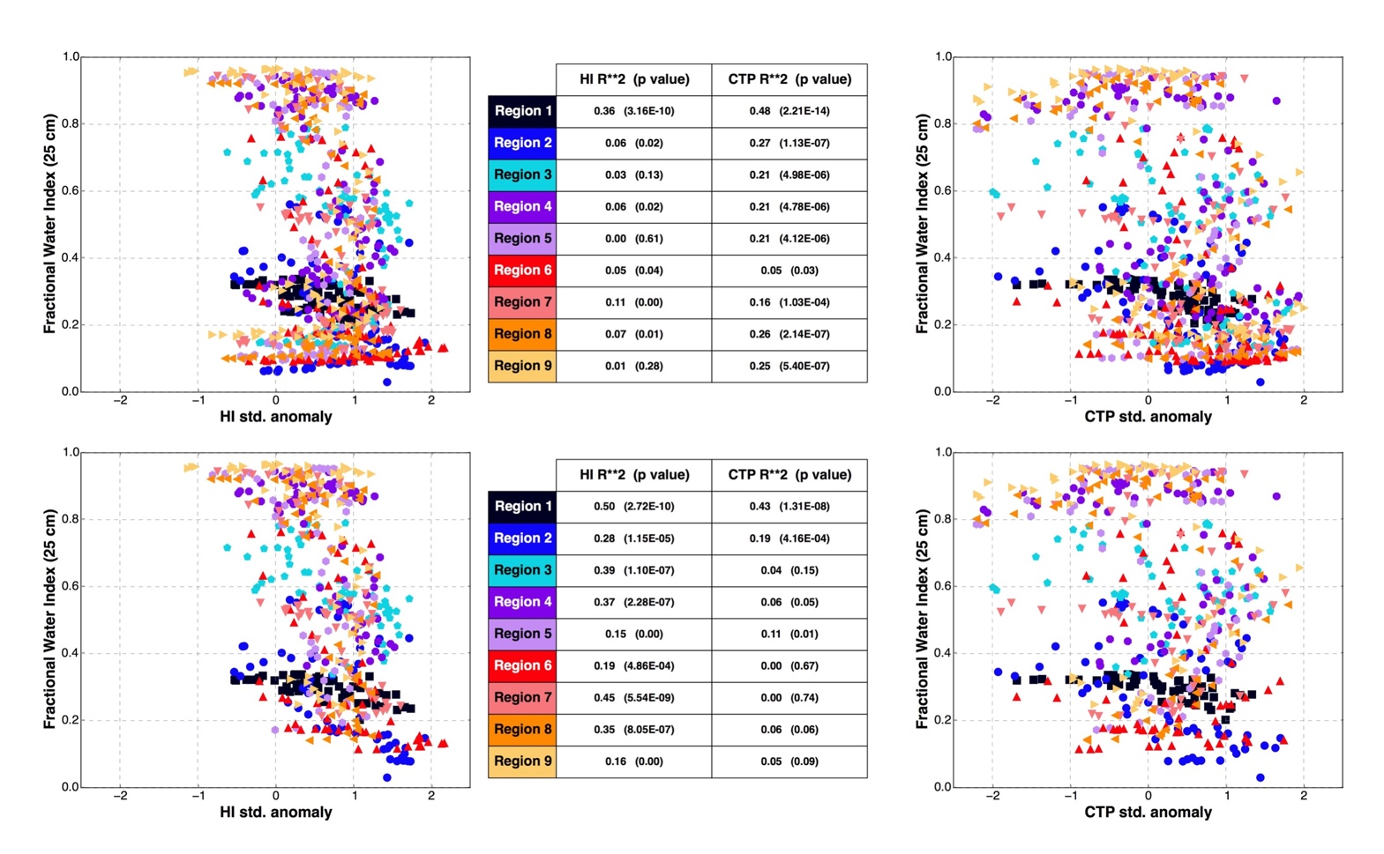
a) b) c)

d) e) f)
Figure 25: As in Figure 20 but for (a-c) May, June and July 2011(d-f) same as (a-c) but for May and June only.

4.2.5 Lack of Land-Atmosphere Feedbacks During 2015 Pluvial
While 2015 was an exceptional wet year, land-atmosphere coupling was weak with little change in the low-level atmospheric profile. April mean values were conducive for convective precipitation through above normal moisture and instability, while precipitation was near to above normal during this period. Conversely, May, June and July yielded near normal moisture and instability and August demonstrated a transition toward an environment more hostile to convective precipitation with near normal to slightly above normal HI anomalies and negative CTP anomalies (Fig. 17); near to below normal precipitation was observed during August. The September means were similar to those of April suggesting a more synoptically influenced pattern as the climatological ridge (Bluestein 1993) began to weaken. Regardless, the entire warm season appears to have been driven by large scale patterns and was void of the feedbacks which characterized 2007. Furthermore, the warm season lacked a sharp decrease in soil moisture that occurred in 2007 and 2000. The decrease within the 25 cm FWI values was much slower (Fig. 25) and sporadic periods of rainfall occurred which recharged soils (especially at 5 cm) whereas both 2000 and 2007 had negligible rainfall during the dry-down periods in those years which did little to impact the 25 cm FWI.
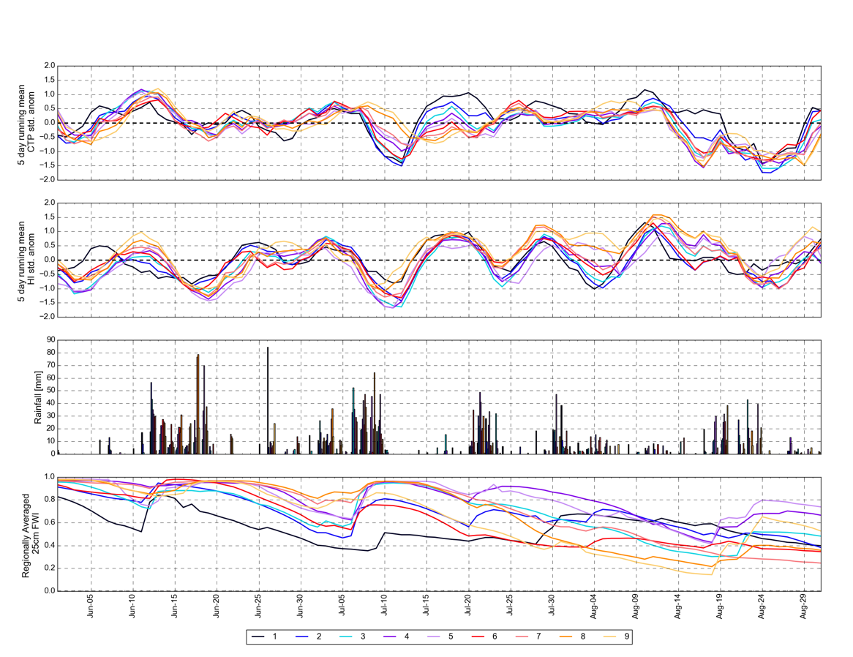
a)

b)

c)

d)

Figure 26: As in Figure 19 but for June, July and August of 2015.

Chapter 5: Summary and Conclusions
This study provides a more holistic view of mesoscale coupling in the Southern Great Plains than previous studies (Ford et al. 2015a; Basara and Christian 2018) by assessing the atmospheric response to changes in soil moisture rather than only quantifying whether precipitation fell more frequently over wet versus dry soils. While Ford et al. (2015b) does examine the atmospheric profiles for selected events, this study generated a composite view of low level atmospheric response for all events given different soil moisture and precipitation extremes. Results showed that precipitation over wet soils can occur in the presence of drastically different low-level atmospheric profiles suggesting strong variability in atmospheric response to soil moisture conditions. The vertical structure of the atmosphere represented by CTP/HI anomalies varies not only between drought and pluvial events but also within each extreme. Furthermore, there exists significant interannual variability in CTP/HI anomalies during similar hydroclimate extremes which suggested variability within sub-seasonal scales.
Results from the interannual analysis are novel in that a diurnal, point scale land-atmosphere coupling metric was applied across a larger temporal and spatial scale, which allowed for coupling to be examined in between the local and global space through the lens of the CTP/HI parameter space. The original framework (Findell and Eltahir 2003) was adapted to better capture coupling across varying precipitation and temperature conditions via standardized anomalies. This approach highlights how different the atmospheric response was to the varying precipitation and surface extremes in the study domain.
When CTP/HI variations were examined from a finer temporal scale within the intra-annual study several critical conclusions regarding the nature of land-atmosphere coupling in Oklahoma can be made:

- June, July and August yielded the greatest land-atmosphere coupling within the 16-year dataset. Climatologically, soil moisture decreases most during mid-June through late August while evapotranspiration increases (Illston et al. 2004). This provided the greatest opportunity for soil moisture to influence the atmospheric moisture profile as it is a necessary boundary condition for evapotranspiration.

- When abnormally wet periods precede this climatological “dry-down” such as in 2007, HI can often remain below normal while FWI decreases as healthy vegetation adds moisture to the lower atmosphere. Duerinck et al. (2016) showed that sub-continental scale land surface based moisture sources upstream can enhance atmospheric water content and act on seasonal to sub-seasonal time scales with late spring soil moisture influencing summer precipitation. The abnormally wet soils may have helped to aid in some precipitation recycling during this time which prevented a more rapid drying of soils until much later in the warm season.

- A critical inflection point in which soils are too dry to meet the atmospheric demand and HI increases rapidly can occur. When the preceding wet periods are shorter, as in 2000, HI and CTP anomalies become positive concurrently with the decrease in fractional water index. This is likely due to a lack of recharge at deeper soil levels (not shown) which limits the total column available water for evapotranspiration.

- During dry periods CTP may be anomalously negative and act to suppress necessary convective mixing and boundary layer growth to trigger convective precipitation over dry soils. This is evident in the composite soundings which show a stronger than normal capping inversion over many of the regions when CTP anomalies are negative. It is possible that non-local effects may be contributing to this observation during 2011. Western regions of the state were already significantly drier than those further east at the beginning of the warm season, and have the least negative CTP anomalies during May. These regions exist at slightly higher elevation, and air masses modified by these regions advected eastward may create the more negative anomalies observed further east.

- While many years demonstrate a trend toward positive CTP and HI anomalies when fractional water index decreases, not all years have this pattern confirming previous studies which show an inter-annual variability in land-atmosphere coupling strength in the Southern Great Plains (Guo and Dirmeyer 2013, Basara and Christian 2018). Furthermore, timing of the greatest decreases in soil moisture may play a critical role in influencing the strength of land-atmosphere coupling.

Overall, within the interannual variability shown there is also significant seasonal variability in land-atmosphere coupling as atmospheric response to decreases in soil moisture can vary significantly between years such as 2000 versus 2007. The strongest positive feedbacks occur once fractional water index is below 0.6 with both years exhibiting an increase in HI5 after this point. During 2011 a similar pattern occurred in early June, however it was less pronounced which may be due to an earlier onset of the “dry-down” period and a greater variability in soil moisture between regions. The strongest positive feedbacks occurred with the greatest changes in soil moisture which do not occur at the same time each year, and during exceptionally wet years such as 2015, may not occur at all. When soil moisture was persistent in magnitude the nature of land-atmosphere coupling was weaker. During 2007 when soils remained wet for much of the warm season, CTP5 and HI5 anomalies were persistent negative with HI5 exhibiting less variability than CTP5. Periods of persistent wet (dry) soils during 2000 also coincided with persistent negative(positive) HI5 anomalies. Overall HI is more responsive to changes in surface fluxes and less variable than CTP especially during periods of persistent soil moisture states.
A consistent finding from both interannual and intra-annual analyses is that dry positive feedbacks are much more apparent than wet positive feedbacks. During pluvial years it can be difficult to distinguish a dominant pattern in CTP and HI standardized anomalies, especially when focusing on 2007 and 2015. Conversely, years with considerable warm season drought, 2006 and 2011 also showed more consistent responses in the CTP/HI parameter space. Even when drought was not the dominant feature of the warm season, such as 2000, the trends in CTP and HI are positive when soil moisture decreases again suggesting some covariability once soil moisture begins to decrease and water stress is present.
The use of a coupling framework to predict convective precipitation is especially challenging as isolating the influences which solely arise from the land surface versus those which are driven by the large scale is not easily done through statistics. When soils are consistently saturated considerable variability is observed within the CTP/HI space. The two pluvial periods shown were largely driven by large scale patterns (Dong et al. 2011; Flanagan et al. 2018) thus it is difficult to distinguish those instances in which precipitation was triggered locally. Most importantly, the diurnal cycle of precipitation in the Southern Great Plains is largely dominated by a maximum in nocturnal precipitation (Wallace 1975) thus the incidences of afternoon precipitation is even more limited. The question of whether dry or wet soils are more likely to trigger precipitation in Oklahoma remains unanswered, but a different and vital conclusion arises from the current work.
Coupling can play a role in understanding positive feedbacks which lead to drought conditions and the CTP/HI framework can be used to better understand the evolution of the low-level atmosphere drought progresses and propagates. Such a conclusion is supported by the co-evolution of the CTP/HI space and drought intensity and coverage presented in this study. The relationships between soil moisture and CTP/HI anomalies were more consistent during dry periods. Similar findings are shown by Basara and Christian (2018) using a different coupling metric, where drought periods on average had much greater coupling than wet periods. While this study looked at the covariability of the local land-surface and the atmosphere, future work will benefit from analyzing upstream land surface conditions and whether these may be related to local CTP and HI values that would support drying of the local land surface and a propagation of drought.
The magnitude and time scale of dry-down periods also appear to be influential on the magnitude of covariability between observed soil moisture and CTP/HI anomalies. Future analyses should quantify whether the magnitude of the decrease in soil moisture over a given period is critical to creating feedbacks between the land surface and the atmosphere and establish necessary conditions for which this relationship may be relevant. Finally, timing of dry periods may also be significant. The strongest covariability between soil moisture and CTP/HI anomalies was observed during June, July and August and this may further narrow the temporal window in which coupling should be analyzed.
In conclusion, diagnosing land-atmosphere coupling as it relates to precipitation continues to be precluded by other factors such as large scale drivers of precipitation which were not accounted for or eliminated in this study. Most importantly, dry positive feedbacks are more readily observed in the data and the use of the CTP/HI framework could provide new information for diagnosing the potential for such feedbacks to take place. Non-local/advective influences are also important to consider and must be factored in to future work.

References
Arsenault, K. R., G. S. Nearing, S. Wang, S. Yatheendradas, and C. D. Peters-Lidard, 2018: Parameter Sensitivity of the Noah-MP Land Surface Model with Dynamic Vegetation. Journal of Hydrometeorology, doi:10.1175/jhm-d-17-0205.1.

Arndt, D. S., J. B. Basara, R. A. Mcpherson, B. G. Illston, G. D. Mcmanus, and D. B. Demko, 2009: Observations of the Overland Reintensification of Tropical Storm Erin (2007). Bulletin of the American Meteorological Society, 90, 1079–1094, doi:10.1175/2009bams2644.1.

Basara, J. B., 2002: Linear relationships between root-zone soil moisture and atmospheric processes in the planetary boundary layer. Journal of Geophysical Research, 107, doi:10.1029/2001jd000633.

Basara, J. B., and J. I. Christian, 2018: Seasonal and interannual variability of land–atmosphere coupling across the Southern Great Plains of North America using the North American regional reanalysis. International Journal of Climatology, 38, 964–978.10.1002/joc.5223.

Bluestein HB. 1993. Synoptic–Dynamic Meteorology in Midlatitudes. Oxford University Press: New York, NY.

Bolton, D., 1980: The Computation of Equivalent Potential Temperature. Monthly Weather Review, 108, 1046–1053, doi:10.1175/1520-0493(1980)108<1046:tcoept>2.0.co;2.

Brock, F. V., K. C. Crawford, R. L. Elliott, G. W. Cuperus, S. J. Stadler, H. L. Johnson, and M. D. Eilts, 1995: The Oklahoma Mesonet: A Technical Overview. Journal of Atmospheric and Oceanic Technology, 12, 5–19, doi:10.1175/1520-0426(1995)012<0005:tomato>2.0.co;2.

Brubaker, K. L., D. Entekhabi, and P. S. Eagleson, 1993: Estimation of Continental Precipitation Recycling. Journal of Climate, 6, 1077–1089, doi:10.1175/1520-0442(1993)006<1077:eocpr>2.0.co;2.
Cioni, G., and C. Hohenegger, 2017: Effect of Soil Moisture on Diurnal Convection and Precipitation in Large-Eddy Simulations. Journal of Hydrometeorology, 18, 1885–1903, doi:10.1175/jhm-d-16-0241.1.

Christian, J., K. Christian, and J. B. Basara, 2015: Drought and Pluvial Dipole Events within the Great Plains of the United States. Journal of Applied Meteorology and Climatology, 54, 1886–1898, doi:10.1175/jamc-d-15-0002.1.

Cook, B. I., G. B. Bonan, and S. Levis, 2006: Soil Moisture Feedbacks to Precipitation in Southern Africa. Journal of Climate, 19, 4198–4206, doi:10.1175/jcli3856.1.

Dirmeyer, P. A., 2006: The hydrologic feedback pathway for land– climate coupling. J. Hydrometeor., 7, 857–867, doi:10.1175/ JHM526.1.
Dirmeyer, P. A., C. A. Schlosser, and K. L. Brubaker, 2009: Precipitation, Recycling, and Land Memory: An Integrated Analysis. Journal of Hydrometeorology, 10, 278–288, doi:10.1175/2008jhm1016.1.

Dirmeyer, P. A., 2011: The terrestrial segment of soil moisture-climate coupling. Geophysical Research Letters, 38, doi:10.1029/2011gl048268.

Dong, X., and Coauthors, 2011: Investigation of the 2006 drought and 2007 flood extremes at the Southern Great Plains through an integrative analysis of observations. Journal of Geophysical Research, 116, doi:10.1029/2010jd014776.

Eggemeyer, K. D., T. Awada, D. A. Wedin, F. E. Harvey, and X. Zhou, 2006: Ecophysiology of Two Native Invasive Woody Species and Two Dominant Warm‐Season Grasses in the Semiarid Grasslands of the Nebraska Sandhills. International Journal of Plant Sciences, 167, 991–999, doi:10.1086/505797.

Emanuel, K., J. Callaghan, and P. Otto, 2008: A Hypothesis for the Redevelopment of Warm-Core Cyclones over Northern Australia*. Monthly Weather Review, 136, 3863–3872, doi:10.1175/2008mwr2409.1.

Evans, C., R. S. Schumacher, and T. J. Galarneau, 2011: Sensitivity in the Overland Reintensification of Tropical Cyclone Erin (2007) to Near-Surface Soil Moisture Characteristics. Monthly Weather Review, 139, 3848–3870, doi:10.1175/2011mwr3593.1.

Ferguson, C.R. and E.F. Wood, 2011: Observed Land–Atmosphere Coupling from Satellite Remote Sensing and Reanalysis. J. Hydrometeor., 12, 1221–1254.

Findell, K. L., and E. A. B. Eltahir, 2003a: Atmospheric controls on soil moisture–boundary layer interactions. Part I: Framework development. J. Hydrometeor., 4, 552–569. Link

Findell, K. L., and E. A. B. Eltahir, 2003b: Atmospheric controls on soil moisture–boundary layer interactions. Part II: Feedbacks within the continental United States. J. Hydrometeor., 4, 570–583. Link

Flanagan, P. X., J. B. Basara, J. Otkin, and B. G. Illston, 2017: The Effect of the Dryline and Convective Initiation on Drought Evolution Over Oklahoma During the 2011 Drought. Advances in Meteorology, doi:10.1155/2017/8430743.

Flanagan, P., J. Basara, J. Furtado, and X. Xiao, 2018: Primary Atmospheric Drivers of Pluvial Years in the United States Great Plains. J. Hydrometeor., 19, 643–658, https://doi.org/10.1175/JHM-D-17-0148.1

Fiebrich, C., and B. Illston, 1994: Oklahoma Mesonet. doi:10.15763/dbs.mesonet.

Findell, K. L., and E. A. B. Eltahir, 2003a: Atmospheric controls on soil moisture–boundary layer interactions. Part I: Framework development. J. Hydrometeor., 4, 552–569.

Findell, K. L., and E. A. B. Eltahir, 2003b: Atmospheric controls on soil moisture–boundary layer interactions. Part II: Feedbacks within the continental United States. J. Hydrometeor., 4, 570–583.

Findell,K.L.,Gentine,P.,Lintner,B.R.&Kerr,C.Probabilityofafternoon precipitation in eastern United States and Mexico enhanced by high evaporation. Nature Geosci. 4, 434–439 (2011).

Ford, T. W., C. O. Wulff, and S. M. Quiring, 2014: Assessment of observed and model-derived soil moisture-evaporative fraction relationships over the United States Southern Great Plains. Journal of Geophysical Research: Atmospheres, 119, 6279–6291, doi:10.1002/2014jd021490.

Ford, T. W., Rapp, A. D., and S. M. Quiring (2015a) Does Afternoon Precipitation Occur Preferentially over Dry or Wet Soils in Oklahoma? Journal of Hydrometeorology. 16, 874-888.

Ford, T.W., Rapp, A.D., Quiring, S.M., and J. Blake (2015b) Soil Moisture – Precipitation Coupling: Observations from the Oklahoma Mesonet and Underlying Physical Mechanisms. Hydrology and Earth Systems Science. 19, 3667-3679.

Frye, J. D., and T. L. Mote, 2010: Convection Initiation along Soil Moisture Boundaries in the Southern Great Plains. Monthly Weather Review, 138, 1140–1151, doi:10.1175/2009mwr2865.1.

Gentine, P., A. A. M. Holtslag, F. D’Andrea, and M. Ek, 2013: Surface and atmospheric controls on the onset of moist convection over land. J. Hydrometeor., 14, 1443–1462, doi:10.1175/JHM-D-12-0137.1.

Guo, Z., and Coauthors, 2006: GLACE: The Global Land– Atmosphere Coupling Experiment. Part II: Analysis. J. Hydrometeor., 7, 611–625, doi:10.1175/JHM511.1.

Haugland, M. J., and K. C. Crawford, 2005: The Diurnal Cycle of Land–Atmosphere Interactions across Oklahoma’s Winter Wheat Belt. Monthly Weather Review, 133, 120–130, doi:10.1175/mwr-2842.1.

Hohenegger, C., P. Brockhaus, C. S. Bretherton, and C. Schär, 2009: The Soil Moisture–Precipitation Feedback in Simulations with Explicit and Parameterized Convection. Journal of Climate, 22, 5003–5020, doi:10.1175/2009jcli2604.1.

Illston, B. G., J. B. Basara, and K. C. Crawford, 2004: Seasonal to interannual variations of soil moisture measured in Oklahoma. International Journal of Climatology, 24, 1883–1896, doi:10.1002/joc.1077.

Illston, B. G., J. B. Basara, D. K Fisher, C. Fiebrich, K. Humes, R. Elliott, K. C. Crawford, E. Hunt, 2008: Mesoscale monitoring of soil moisture across a statewide network. J. of Atmos. and Oceanic Tech., 25, 167-182.

Kim, Y., and G. Wang, 2007: Impact of Vegetation Feedback on the Response of Precipitation to Antecedent Soil Moisture Anomalies over North America. Journal of Hydrometeorology, 8, 534–550, doi:10.1175/jhm612.1.

Koster, R. D., et al. (2004), Regions of strong coupling between soil moisture and precipitation, Science, 305, 1138–1140.

Koster, R. D., et al. (2006), GLACE: The Global land–atmosphere coupling experiment. Part I: Overview, J. Hydrometeorol., 7, 590–610.

May, R. M., Arms, S. C., Marsh, P., Bruning, E. and Leeman, J. R., 2017: MetPy: A Python Package for Meteorological Data. Unidata, Accessed 31 March 2017. [Available online at https://github.com/Unidata/MetPy.] doi:10.5065/D6WW7G29.

McPherson, R. A., Stensrud, D. J., and Crawford, K. C.: The impact of Oklahoma’s winter wheat belt on the mesoscale envi- ronment, Mon. Weather Rev., 132, 405–421, doi:10.1175/1520- 0493, 2004.

McPherson, R. A., and D. J. Stensrud, 2005: Influences of a Winter Wheat Belt on the Evolution of the Boundary Layer. Monthly Weather Review, 133, 2178–2199, doi:10.1175/mwr2968.1.

McPherson, R. A., and Coauthors, 2007: Statewide Monitoring of the Mesoscale Environment: A Technical Update on the Oklahoma Mesonet. Journal of Atmospheric and Oceanic Technology, 24, 301–321, doi:10.1175/jtech1976.1.

McPherson, R. A.: A review of vegetation—atmosphere interac- tions and their influences on mesoscale phenomena, Prog. Phys. Geogr., 31, 261–285, doi:10.1177/0309133307079055, 2007.

Mei, R., and G. Wang, 2011: Impact of Sea Surface Temperature and Soil Moisture on Summer Precipitation in the United States Based on Observational Data. Journal of Hydrometeorology, 12, 1086–1099, doi:10.1175/2011jhm1312.1.

Mei, R., and G. Wang, 2012: Summer Land–Atmosphere Coupling Strength in the United States: Comparison among Observations, Reanalysis Data, and Numerical Models. Journal of Hydrometeorology, 13, 1010–1022, doi:10.1175/jhm-d-11-075.1.
Miralles, D. G., A. J. Teuling, C. C. V. Heerwaarden, and J. V.-G. D. Arellano, 2014: Mega-heatwave temperatures due to combined soil desiccation and atmospheric heat accumulation. Nature Geoscience, 7, 345–349, doi:10.1038/ngeo2141.

Monteverdi, J. P., and R. Edwards, 2010: The redevelopment of a warm-core structure in Erin: A case of inland tropical storm formation. Electron. J. Severe Storms Meteor., 5 (6), 1–18.

Pielke, R. A., 2001: Influence of the spatial distribution of vegetation and soils on the prediction of cumulus Convective rainfall. Reviews of Geophysics, 39, 151–177, doi:10.1029/1999rg000072.

Phillips, T. J., and S. A. Klein, 2014: Land-atmosphere coupling manifested in warm-season observations on the U.S. southern great plains. Journal of Geophysical Research: Atmospheres, 119, 509–528, doi:10.1002/2013jd020492.

Raddatz, R., 2007: Evidence for the influence of agriculture on weather and climate through the transformation and management of vegetation: Illustrated by examples from the Canadian Prairies. Agricultural and Forest Meteorology, 142, 186–202, doi:10.1016/j.agrformet.2006.08.022.

Raz-Yaseef, N., D. P. Billesbach, M. L. Fischer, S. C. Biraud, S. A. Gunter, J. A. Bradford, and M. S. Torn, 2015: Vulnerability of crops and native grasses to summer drying in the U.S. Southern Great Plains. Agriculture, Ecosystems & Environment, 213, 209–218, doi:10.1016/j.agee.2015.07.021.

Roundy, J. K., C. R. Ferguson, and E. F. Wood, 2013: Temporal Variability of Land–Atmosphere Coupling and Its Implications for Drought over the Southeast United States. Journal of Hydrometeorology, 14, 622–635, doi:10.1175/jhm-d-12-090.1.

Ruiz‐Barradas, A., and S. Nigam (2013), Atmosphere–land surface interactions over the Southern Great Plains: Characterization from pentad analysis of DOE ARM Field observations and NARR, J. Clim., 26(3), 875–886.

Schubert, S. D., M. J. Suarez, P. J. Pegion, R. D. Koster, and J. T. Bacmeister, 2004: Causes of Long-Term Drought in the U.S. Great Plains. Journal of Climate, 17, 485–503, doi:10.1175/1520-0442(2004)017<0485:coldit>2.0.co;2.

Scott, B. L., Ochsner, T. E., Illston, B. G., Fiebrich, C. A., Basara, J. B., and Sutherland, A. J.: New soil property database improves Oklahoma Mesonet soil moisture estimates, J. Atmos. Ocean. Tech., 30, 2585–2595, doi:10.1175/1520- 0493(2001)129<3413:OMOMMC>2.0.CO;2, 2013.

Seneviratne, S. I., D. Lüthi, M. Litschi, and C. Schär, 2006: Land–atmosphere coupling and climate change in Europe. Nature, 443, 205–209, doi:10.1038/nature05095.

Song, H.-J., C. R. Ferguson, and J. K. Roundy, 2016: Land–Atmosphere Coupling at the Southern Great Plains Atmospheric Radiation Measurement (ARM) Field Site and Its Role in Anomalous Afternoon Peak Precipitation. Journal of Hydrometeorology, 17, 541–556, doi:10.1175/jhm-d-15-0045.1.

Su, H., Z.-L. Yang, R. E. Dickinson, and J. Wei, 2014: Spring soil moisture-precipitation feedback in the Southern Great Plains: How is it related to large-scale atmospheric conditions? Geophysical Research Letters, 41, 1283–1289, doi:10.1002/2013gl058931.

Su, H., and R. E. Dickinson, 2017: On the Spatial Gradient of Soil Moisture–Precipitation Feedback Strength in the April 2011 Drought in the Southern Great Plains. Journal of Climate, 30, 829–848, doi:10.1175/jcli-d-13-00185.1.

Svoboda, M., and Coauthors, 2002: The Drought Monitor. Bulletin of the American Meteorological Society, 83, 1181–1190, doi:10.1175/1520-0477-83.8.1181.

Tawfik, A.B., 2016: CoMeT: Coupling Metrics Toolkit. Accessed November 2017, http://www.coupling-metrics.com

Teuling, A. J., Seneviratne, S. I., Williams, C., and Troch, P. A.: Observed timescales of evapotranspiration re- sponse to soil moisture, Geophys. Res. Lett., 33, L23403, doi:10.1029/2006GL028178, 2006.

Trenberth, K. E., 1999: Atmospheric Moisture Recycling: Role of Advection and Local Evaporation. Journal of Climate, 12, 1368–1381, doi:10.1175/1520-0442(1999)012<1368:amrroa>2.0.co;2.

Wallace JM. 1975. Diurnal variations in precipitation and thunderstorm frequency over the conterminous United States. Mon. Weather Rev. 103(5): 406–419.

Wilks, D. S., 2011: Statistical Methods in the Atmospheric Sciences Third Edition. Elsevier Inc., 676 pp.

Wei, J., and P. A. Dirmeyer, 2012: Dissecting soil moisture-precipitation coupling. Geophysical Research Letters, 39, doi:10.1029/2012gl053038.

Wei, J., H. Su, and Z.-L. Yang, 2015: Impact of moisture flux convergence and soil moisture on precipitation: a case study for the southern United States with implications for the globe. Climate Dynamics, 46, 467–481, doi:10.1007/s00382-015-2593-2.

Williams, I. N., Y. Lu, L. M. Kueppers, W. J. Riley, S. C. Biraud, J. E. Bagley, and M. S. Torn, 2016: Land-atmosphere coupling and climate prediction over the U.S. Southern Great Plains. Journal of Geophysical Research: Atmospheres, 121, doi:10.1002/2016jd025223.

Williams, I. N., and M. S. Torn, 2015: Vegetation controls on surface heat flux partitioning, and land-atmosphere coupling. Geophysical Research Letters, 42, 9416–9424, doi:10.1002/2015gl066305.

