University of Oklahoma

Graduate College

A STYLISTIC AND PERFORMANCE ANALYSIS OF
SYMPHONIA ELEGIACA, OP. 83 BY CAMIL VAN HULSE

A Document

submitted to the Graduate Faculty

in partial fulfillment of the requirements for the

Degree of

Doctor of Musical Arts

By

STEPHEN WURST
Norman, Oklahoma
2023

A STYLISTIC AND PERFORMANCE ANALYSIS OF
SYMPHONIA ELEGIACA, OP. 83 BY CAMIL VAN HULSE

A Document approved for the
School of Music

By THE COMMITTEE CONSISTING OF

Dr. Marvin Lamb, Chair

Dr. Barbara Fast, Co-Chair

Dr. Damin Spritzer, Co-Chair

Dr. Jennifer Saltzstein

Dr. Maeghan Hennessey

© Copyright by STEPHEN WURST 2023
All Rights Reserved.

Acknowledgements
The completion of this document would not have been possible without the support of my mentors, family, and friends. My sincere gratitude goes to my committee members for their wisdom and guidance while writing this document: Dr. Marvin Lamb, Dr. Barbara Fast, Dr. Damin Spritzer, Dr. Jennifer Saltzstein, and Dr. Maeghan Hennessey. Dr. Lamb, thank you for your advice and assistance in chairing my document. Dr. Fast, your guidance and unwavering support in completing this document has been invaluable. Dr. Spritzer, you have led me through my doctoral studies at OU; I am grateful for your enthusiasm and encouragement throughout my degree studies. Dr. Saltzstein, thank you for your attention to detail and suggesting further areas of focus in my research. Dr. Hennessey, thank you for your willingness to serve as my outside committee member and providing your unique perspective.
I am extremely grateful for those who assisted in my research for this project, especially Chris Stoop of Bibliotheca Wasiana in Sint-Niklaas, Belgium, and Delores Schultz of Tucson, Arizona, who provided many essential materials and primary sources. Many thanks to Emma Brouwer, who translated articles from Dutch to English so that I could use them effectively in my research. Thank you also to Bruce Lincoln for your information and encouragement of pursuing this topic.
To J. P. Murphy, for acting as an editor, sounding board, and my main source of encouragement throughout this long process. To my former teachers Sally Lewis and Dr. John Behnke: thank you for your guidance and care at the beginning of my organ studies and fostering my love of the organ. To Mom, Dad, Grace, and Sam: your love and support have kept me going throughout all my studies and life changes. And to my friends and church community, I am so fortunate to be surrounded by so many who provide so much encouragement along the way.
Table of Contents
Acknowledgements iv
List of Tables ix
List of Figures x
Abstract xiv
Chapter 1: Introduction 1
Overview 1
Overview of the Organ Symphony 4
Purpose of the Study 5
Need for the Study 6
Limitations of the Study 7
Organization of the Study 7
Review of Related Literature – Camil Van Hulse 8
Review of Related Literature – The Organ Symphony 15
Chapter 2: Biography 18
Early Years and Training 18
Royal Flemish Conservatory 21
First Years in the United States of America 22
Establishment of Tucson Music Organizations 26
Musical and Teaching Career 29
Van Hulse the Composer 32
Celebrations of Van Hulse 35
Legacy. 38
Chapter 3: Introduction to Symphonia Elegiaca, op. 83 40
Introduction 40
Historical Context of Symphonia Elegiaca 43
Premiere and Publication of Symphonia Elegiaca 45
Use of Requiem Mass Chant Melodies in Symphonia Elegiaca 47
Chapter 4: Analysis of Symphonia Elegiaca, op. 83: Movement I 51
Introduction to Movement I 51
Analysis of Section A 53
Analysis of Section B 55
Analysis of Section A1 and Coda 58
Chapter 5: Analysis of Symphonia Elegiaca, op. 83: Movement II 60
Introduction to Movement II 60
Analysis of Section A 63
Analysis of Section B 70
Analysis of Section C 76
Optional Ending 78
Chapter 6: Analysis of Symphonia Elegiaca, op. 83: Movement III 82
Introduction to Movement III 82
Analysis of Section A 86
Analysis of Section B 90
Analysis of Section C 94
Analysis of A1 section 97
Chapter 7: Analysis of Symphonia Elegiaca, op. 83: Movement IV 100
Introduction to Movement IV 100
Analysis of Section A 102
Analysis of Section B 111
Analysis of Section C 113
Chapter 8: Analysis of Symphonia Elegiaca, op. 83: Movement V 117
Introduction to Movement V 117
Analysis of Section A 121
Analysis of Section B 124
Analysis of Section C 127
Analysis of Section A1 131
Chapter 9: Conclusion 134
Summary 134
Recommendations for Further Research 139
Bibliography 140
Books and Chapters 140
Articles and Journals 141
Dissertations and Theses 143
General Reference Material 144
Primary Source Materials 146
Musical Scores 146
Audio.. 147
Appendix A – Catalogue of Van Hulse’s Works for Solo Organ 148
Appendix B – Primary sources 163
Appendix C – Copyright Permission 170

List of Tables
Table 3.1: Outline of Symphonia Elegiaca 41
Table 4.1: Structural Outline of Movement I, “Death” 51
Table 5.1: Structural Outline of Movement II, “Last Judgment” 61
Table 6.1: Structural Outline of “Divine Mercy” 82
Table 6.2: Outline of Movement III: Section B, m. 46-55 91
Table 7.1: Structural Outline of “Supreme Anguish” 100
Table 8.1: Structural Outline of “Resignation” 118

List of Figures
Example 4.1: “Death,” Recurring Introduction, mm. 1-4 52
Example 4.2: “Death” theme - movement of thirds, mm. 8-21 53
Example 4.3: “Death,” Developing the “Death” theme, mm. 22-28 54
Example 4.4: “Death,” Beginning of B section, mm. 35-41 55
Example 4.5: “Death,” Demonstration of Inversion of Dies irae 55
Example 4.6: “Death,” Harmonic progression and inverted introductory material, mm. 54-66 56
Example 4.7: “Death” theme in the pedal, half-step variations, mm. 68-72 57
Example 4.8: “Death,” Final use of introductory material, mm. 81-83 58
Example 4.9: “Death,” End of Movement I, dying away, mm. 97-101 58
Example 5.1: Dies irae chant melody 60
Example 5.2: “Last Judgment,” Oscillation in pedals splits into two voices, mm. 1-3 62
Example 5.3: Van Hulse’s manuscript with notes, Movement II 63
Example 5.4: “Last Judgment,” Introduction of chromatic motive, mm. 6-9 64
Example 5.5: “Last Judgment,” Chromatic motive in Movement II 64
Example 5.6: “Last Judgment,” End of pedal solo, mm. 10-12 65
Example 5.7: “Last Judgment,” Manuals entrance of Dies irae fragment, mm. 13-14 65
Example 5.8: “Last Judgment,” First appearance of Dies irae theme (T1), mm. 17-19 66
Example 5.9: “Last Judgment,” T1 in diminution transforming into oscillation, mm. 27-28 67
Example 5.10: “Last Judgment,” T1A and chromatic motive, mm. 28-30 68
Example 5.11: “Last Judgment,” T1B, mm. 38-39 69
Example 5.12: “Last Judgment,” T1C, mm. 55-56 70
Example 5.13: “Last Judgment,” Fanfare, mm. 61-63 71
Example 5.14: “Last Judgment,” T1D, mm. 65-67 72
Example 5.15: “Last Judgment,” T1D and chromatic motive moving upward, mm. 83-84 73
Example 5.16: “Last Judgment,” Dies irae theme and chromatic motive, mm. 84-87 74
Example 5.17: “Last Judgment,” Canonic treatment of Dies irae theme, mm. 93-95 75
Example 5.18: “Last Judgment,” T1ost., mm. 105-107 76
Example 5.19: “Last Judgment,” Segue to Movement III, mm. 115-118 77
Example 5.20: “Last Judgment,” Alternate ending, mm. 86a-91a. 78
Example 5.21: “Last Judgment,” Alternate ending, mm. 98a-100a 79
Example 5.22: “Last Judgment,” Alternate ending to Movement II, mm. 112a-114a 80
Example 6.1: Pie Jesu chant melody 83
Example 6.2: Domine Jesu Christe chant melody 83
Example 6.3: “Divine Mercy,” “Hostias” phrase of Domine Jesu Christe chant melody 84
Example 6.5: “Divine Mercy,” Beginning – Pie Jesu and Domine Jesu Christe, mm. 1-8 86
Example 6.6: “Divine Mercy,” Domine Jesu Christe and Requiem Aeternam, mm. 17-23 87
Example 6.7: “Divine Mercy,” Pie Jesu four-note motive, mm. 31-37 88
Example 6.8: “Divine Mercy,” Pie Jesu in retrograde, closing of Section A, mm. 38-45 89
Example 6.9: “Divine Mercy,” “Hostias” chant melody, second iteration, m. 47 90
Example 6.10: “Divine Mercy,” “Hostias” chant melody and Counter melody, mm. 47-48 91
Example 6.11: “Divine Mercy,” Counter melody, “fac eas” chant phrase, mm. 51-52 92
Example 6.12: “Divine Mercy,” Beginning of Section C using “Hostias” motive, mm. 55-59 93
Example 6.13: “Divine Mercy,” Texture change in manuals and pedals, mm. 62-63 94
Example 6.14: “Divine Mercy,” Texture change and Harmonic Progression, mm. 63-72 95
Example 6.15: “Divine Mercy,” Return Pie Jesu and Domine Jesu Christe, mm. 77-83 96
Example 6.16: “Divine Mercy,” Conclusion of Movement III, mm. 88-92 97
Example 7.1: “Mors stupebit” Gregorian chant 99
Example 7.2: “Supreme Anguish,” first alternation of Fanfare and T1, mm. 1-2 101
Example 7.3: “Supreme Anguish,” T1A – “Mors stupebit,” m. 8-10 102
Example 7.4: “Supreme Anguish,” “Mors stupebit” T1 and T1B, Dies irae T2, mm. 23-24 103
Example 7.5: “Supreme Anguish,” interlude in Section A, mm. 33-34 104
Example 7.6: “Supreme Anguish,” T1C in pedal with T1B in hands, mm. 39-40 104
Example 7.7: “Supreme Anguish,” T1D, mm. 51-54 106
Example 7.8: “Supreme Anguish,” Dies irae theme T2A with T1C, mm. 66-69 107
Example 7.9: “Supreme Anguish,” Fragmentation and building toward Section B, mm. 73-75 108
Example 7.10: “Supreme Anguish,” Transition into Section B, mm. 77-79 109
Example 7.11: “Supreme Anguish,” Transformation of “Death” theme, mm. 82-84 110
Example 7.12: “Supreme Anguish,” End of Section B, mm. 89-95 111
Example 7.13: “Supreme Anguish,” Pie Jesu and “Mors stupebit” motive, mm. 96-97 112
Example 7.14: “Supreme Anguish,” Transformation of Pie Jesu into the repeating motive 113
Example 7.15: “Supreme Anguish,” End of Movement IV, m. 100-103 114
Example 8.1: Requiem Aeternam chant melody 117
Example 8.2: “Resignation,” Repeating motive (RM1) 117
Example 8.3: “Resignation,” Repeating motive (RM1), Requiem Aeternam (T1), mm. 1-12 120
Example 8.4: “Resignation,” T1 as a solo line, mm. 13-16 121
Example 8.5: “Resignation,” Transformation of repeating motive (RM1 to RM2), mm. 17-20 122
Example 8.6: “Resignation,” RM1 transforming to RM3, mm. 28-30 123
Example 8.7: “Resignation,” First phrase of T2 and introduction of RM3 alt., mm. 31-36 124
Example 8.8: “Resignation,” End of Section B, mm.41-45 125
Example 8.9: “Resignation,” “Te decet” phrase from Requiem Aeternam chant melody 126
Example 8.10: “Resignation,” “Te decet” phrase (T1A), mm. 46-50 126
Example 8.11: “Resignation,” Climax of Movement V, mm. 56-60 127
Example 8.12: “Resignation,” T1A and T1, mm. 61-62 128
Example 8.13: “Resignation,” Ending of Section C and beginning of Section A1, mm. 63-67 128
Example 8.14: “Resignation,” RM1 and T1, the beginning of final ascent, mm. 68-72 129
Example 8.15: “Resignation,” Return of Pie Jesu, morendo, mm. 78-85 130

A STYLISTIC AND PERFORMANCE ANALYSIS OF
SYMPHONIA ELEGIACA, OP. 83 BY CAMIL VAN HULSE

ABSTRACT
Stephen R. Wurst, D.M.A.
The University of Oklahoma, 2023
Chair: Dr. Marvin Lamb
Co-Chairs: Dr. Barbara Fast and Dr. Damin Spritzer

This document provides an analysis of the second organ symphony of Camil Van Hulse: Symphonia Elegiaca, op. 83. This analysis provides a historical overview, an examination of programmatic content, and a compositional analysis of each of the five movements of Symphonia Elegiaca. Additionally, a biography of Camil Van Hulse and a chronological catalog of his published compositions for solo organ are included.
Chapter One defines the purpose, need, limitations, organization of the study, and provides a summary of related literature on Camil Van Hulse’s organ symphonies, including biographical materials relating to Van Hulse and literature related to the organ symphony. Chapter Two provides a biographical sketch of Camil Van Hulse, detailing his life and notable achievements. Chapter Three provides historical context related to Symphonia Elegiaca. Chapters Four, Five, Six, Seven, and Eight contain an analysis of each of the five movements of Symphonia Elegiaca, op. 83. Each chapter provides a historical overview and a compositional analysis. Chapter Nine is a conclusion and summary of the findings of this study. By exploring Symphonia Elegiaca by Camil Van Hulse, this study recognizes the significance of Van Hulse’s contributions to the organ repertoire and musical life in the United States and Belgium.

Chapter 1: Introduction

Overview
Belgian-American composer, organist, pianist, pedagogue, and writer Camil Van Hulse (1897-1988) was a prolific composer known best for his solo organ and sacred choral music. Born and educated in Belgium, he spent nearly his entire professional career in Tucson, Arizona. While Van Hulse’s European conservatory training in composition and performance is prevalent in his works, there is an American infusion that blends into a language distinctly his own. Camil van Hulse composed many solo works for the organ, including three organ symphonies, setting him apart from many contemporary American composers and giving him a unique place in the organ world.
Van Hulse was a pivotal leader in establishing and growing the musical scene in Tucson from his arrival in 1923 until his death in 1988. He was described as “a pioneer in Tucson’s artistic development,” evidenced in his involvement and development of multiple musical organizations in Tucson still in operation in the present day, including the Tucson Symphony Orchestra, a chapter of the American Guild of Organists, and a Gregorian Schola Cantorum. Former president of the Southern Arizona chapter of the American Guild of Organists, Elizabeth French, described Van Hulse as at the “foundation of our [Tucson’s] musical life.” He worked as an organist and director of music in Catholic churches in the Tucson area until his compositional prowess allowed him to focus solely on composing in the 1950s. Van Hulse published 169 opus numbers in many different musical genres.
Camil Van Hulse was well-recognized in his lifetime for his contributions to music and work in his community in the United States and his home country of Belgium, receiving numerous awards and seeing frequent programming of his compositions. He launched his compositional career by winning prizes in multiple competitions, including those by the Lorenz Publishing Company, J. Fischer and Bros., the Broadman anthem competition, and numerous local competitions. Van Hulse’s Toccata, op. 39, was awarded the Fischer & Co. first prize in a national competition held by the American Guild of Organists in 1946. He was honored with the awards “Knight of the Order of Leopold II” and “Officer of the Order of the Crown” from the Belgian government for his contributions to music. Many concerts of his music were given in his honor for milestone birthdays. His compositions were performed by numerous ensembles and performers, including the National Orchestra of Belgium and the Tucson Symphony, and a debut in Carnegie Hall. His works were premiered by many influential organists during his lifetime, including Alexander Schreiner, Joyce Jones, and Claire Coci.
Van Hulse’s contributions to organ literature continue to be heard in recordings and concert halls in the 21st century. A large concert of Van Hulse’s music was given in honor and memory of Van Hulse in 2018 in Tucson. Though name recognition of Van Hulse has waned in the United States, his music is more frequently performed and recorded in Europe. Two of his three organ symphonies and other works for solo organ have been recorded since the turn of the century.
While there are still some performances and recordings of his music in the present day, there is limited information on Van Hulse’s music, and no studies have been devoted to his compositional output for solo organ. He composed three organ symphonies, Symphonia Mystica, op. 53 (1949), Symphonia Elegiaca, op. 83 (1956), and Sinfonia da Chiesa, op. 144 (1973), when very few of these symphonies were being written in the United States. Symphonia Elegiaca, op. 83 is one of the best representations of Van Hulse’s musical style and compositional craft. By reviewing Van Hulse’s organ compositions, especially Symphonia Elegiaca, this document brings recognition to this composer and places his music within the context of a substantial repertory of organ symphonies.

Overview of the Organ Symphony
The organ symphony is intrinsically linked with the nineteenth-century French organ school and the new symphonic tonal palette made possible by the instruments of Aristide Cavaillé-Coll (1811-99). Belgian organist César Franck (1822-90) propelled the French organ school into the new symphonic tradition with his works for organ using these new instruments. One such composition, the Grand piéce symphonique, written in 1860-62, introduced the concept of the organ symphony. Though a work of only one movement, it moves through different sections emulating various forms and encapsulating many of the techniques later composers adopted, including cyclicism. The organ symphony as a genre can often be described as more akin to a suite than a symphony in the traditional orchestral sense as it developed through the nineteenth and twentieth centuries.
Most published organ symphonies originated in France. Charles-Marie Widor (1844-1937), who composed ten organ symphonies, succeeded more than any other composer in combining the different divisions (reeds, strings, and flues) of the Cavaillé-Coll organ into a single huge ‘orchestra’ without sacrificing its nobleness of character.” Louis Vierne (1870-1937) authored six symphonies, using a distinct chromatic language and heavy use of cyclicism. Marcel Dupré (1886-1971) continued in this tradition, publishing two organ symphonies and improvising many more. Other composers of French organ symphonies include Alexandre Guilmant (1837-1911), Charles Tournemire (1870-1939), Jean Langlais (1907-91), André Fleury (1903-95), and Naji Hakim (b. 1955), among others. Dutch organists also composed organ symphonies, including Hendrik Andriessen (1892-1981) and Paul de Malingreau (1887-1956).
This document reviews Camil van Hulse’s unique contributions to the genre of organ symphony and demonstrates the importance of these substantial works in the repertoire of solo organ music. Camil Van Hulse contributed three organ symphonies to the organ repertoire, serving as a fascinating bridge between Europe and the United States. Though less popular with composers in the United States, the organ symphony became influential from touring European concert organists and the study of their compositions and improvisations in America. Due to the genre's somewhat ambiguous nature, many pieces for solo organ called sonatas or suites could also be categorized as an organ symphony. However, composers such as Leo Sowerby (1895-1968) and Edward Shippen Barnes (1887-1958) did write solo organ works with the title of symphony in them.

Purpose of the Study
The purpose of this study is to provide a detailed analysis of the second organ symphony of Camil Van Hulse: Symphonia Elegiaca, op. 83. This analysis provides a historical overview, an examination of programmatic content, and a compositional analysis of each of the five movements of Symphonia Elegiaca. This document also serves as a biographical reference of Camil Van Hulse and provides a chronological catalog of his published compositions for solo organ.

Need for the Study
Limited research has been conducted on the life of Camil Van Hulse and his compositional output for solo organ. While several publications document his biography and compositional output, no significant research document has been written on the solo organ works of Camil Van Hulse. There is a need for an in-depth analysis of the solo organ works of Camil Van Hulse.
Although Camil Van Hulse composed pieces in numerous genres for solo organ, his second organ symphony, Symphonia Elegiaca, op. 83, represents one of his most substantial contributions to the organ repertoire. This multi-movement large-scale work is representative of Van Hulse’s compositional style and is significant for its contribution to the organ symphony genre in the United States. In contrast to the other two organ symphonies, this work contains a compelling programmatic narrative that adds to its musical interest. This document strives to fill the need for a comprehensive resource that analyzes one of Van Hulse’s organ symphonies.
Camil Van Hulse incorporated his Western European musical training from Belgium to the American Southwest and is a notable bridge between Western European and American musical traditions in the twentieth century. His three organ symphonies are some of the few written by an American composer. By analyzing Symphonia Elegiaca, this document places Van Hulse’s organ symphonies in context with other French, Belgian, and American organ symphonies and draws attention to their importance as representatives of the genre of organ symphony in the United States.

Limitations of the Study
This study is restricted to the analysis of the second organ symphony written by Camil Van Hulse: Symphonia Elegiaca, op. 83. Providing an analysis of his entire output of works for solo organ is beyond the scope of this study. Van Hulse’s compositions for other instruments, choral music, masses, and symphonic works are not examined.

Organization of the Study
This document is organized into nine chapters followed by a bibliography and three appendices. After an introduction to the document, Chapter One defines the purpose, need, limitations, organization of the study, and provides a summary of related literature on Camil Van Hulse’s organ symphonies. The literature review includes biographical materials relating to Van Hulse as well as literature related to the organ symphony.
Chapter Two provides a biographical sketch of Camil Van Hulse, detailing his life and notable achievements. Chapter Three provides an introduction to Symphonia Elegiaca by providing historical context through primary sources and a brief introduction to the Roman Catholic Requiem Mass to contextualize the borrowed chant melodies and programmatic content found in Symphonia Elegiaca.
Chapters Four, Five, Six, Seven, and Eight provide an analysis of the second organ symphony by Camil Van Hulse: Symphonia Elegiaca, op. 83. Each chapter focuses on one movement of the symphony. Each chapter provides a historical overview and a compositional analysis. The historical overview of each movement is provided to contextualize the movement and its programmatic meaning. The compositional analysis includes analyses of form, melody, harmony, and rhythm as well as programmatic content. Lastly, interpretive considerations for the programmatic narrative are given to aid in learning and performing the composition.
Chapter Nine is a conclusion and summary of the findings of this study. The five movements are briefly compared and contrasted according to their musical structures, use of programmaticism, and harmonic language. A summary of the findings of this study demonstrates the significance of Camil Van Hulse’s contributions to the organ repertoire and musical life in America and Belgium. This study concludes with recommended areas for further study.
Following the conclusion, three appendices contain additional information. Appendix A contains a chronological list of Van Hulse’s published organ music. Appendix B provides primary source materials. Appendix C contains a letter of permission from the Schott Music company, which owns the copyright for Symphonia Elegiaca.

Review of Related Literature – Camil Van Hulse
Current literature focused specifically on Van Hulse consists of articles, biographical sketches, compact disc liner notes, and newspaper articles as well as mentions in numerous dissertations. These sources appear both in English and in Dutch, owing to Van Hulse’s origin and prominence in Belgium. Though he is not included in major research sources, much can be found in smaller publications and in articles written about and by Van Hulse. Much of the existing literature about Camil Van Hulse is biographical; summaries of his life are found in numerous articles in reference materials, though he is not found in the New Grove or Baker’s Biographical Dictionary of Musicians. Biographical entries about him are found in Contemporary American Composers: a biographical dictionary, Directory of Composers for Organ, the ASCAP Biographical Dictionary of Composers, Authors, and Publishers, two editions of Who’s Who in American Music: Midcentury and Classical, and The American Catholic Who’s Who. There are also sources in Dutch that have biographical information, including in Bondsnieuws, Algemene muziek encyclopedie, Vlaamse componisten geboren na 1800: lexicon, and Vlaanderen. These sources go into more detail about Van Hulse and focus more specifically on his musical accomplishments.
The most significant biographical source is a transcription of a recorded interview with Van Hulse conducted by the Arizona Historical Society. Van Hulse gave an interview as part of an oral history project “Remembering Tucson” led by the Arizona Heritage Center. During this interview, Van Hulse recounts his life and the changes he has witnessed in Tucson during the decades he lived there. It has a wealth of information and nuanced detail all in Van Hulse’s own words, as it is a transcription of a tape recording. It describes not only Van Hulse’s history, but his own descriptions of his music and compositional approach.
The most extensive accounts of Van Hulse’s life can be found in Dutch sources. Lexicon van het muziekleven in het Land van Waas, edited by André Stoop, includes one of the most detailed accounts of Van Hulse’s life. This source is a compendium of biographies of musicians from Waas, a region of Belgium. While many sources focus on Van Hulse’s origin story and immigration to the United States, this source goes beyond a chronology and places some of Van Hulse’s more significant works in context of his life. In addition to the descriptive biography, it lists all his compositions both by opus number and by genre. An article in the Dutch magazine Vlaanderen by Bart Moenssens titled “Organist-composer Camil Van Hulse (1897-1988): a musical pioneer in the West” paid tribute to Van Hulse nearly a decade after his death. Written in 1997, this biographical sketch also focuses on Van Hulse’s compositional style. This discussion is unique to this source. It also discusses the collection of Van Hulse’s documents held in Van Hulse’s hometown of Sint-Niklaas.
There are many articles in music periodicals written about Van Hulse, most notably in The American Organist (also called Music), Diapason, and the Hammond Times. All three of these sources have biographies of Van Hulse with varying degrees of detail. There are many mentions of Van Hulse in The American Organist during his compositional career in small articles announcing releases of his music and awards given to him. A more significant article from The American Organist in 1978 called “Camil Van Hulse: A Belgian Composer Who Adopted the Southwest” by Elizabeth French details his life and contributions to the musical scene in Tucson, Arizona. While most biographical information can be found in other places, the description of his impact in Tucson is unique. It also includes a full page of his published compositions for organ and choir, sorted chronologically.
There are two web-based resources that provide brief biographical information that accompanies a list of his works in varying degrees of detail. A website for the Study Centre for Flemish Music has a variety of resources including information on his father, Gustaaf, and Camil Van Hulse. The web page “Biographical Dictionary of the Organ” lists Van Hulse’s musical compositions for the organ. Other sources have less extensive listings of his musical works.
Summaries of Van Hulse’s compositional output can be found in varying degrees of detail in numerous sources. Lexicon van het muziekleven in het Land van Waas has a complete list of all 169 opus numbers along with all unpublished works. Sources that list only Van Hulse’s organ works can be found in Plovie’s 1998 article in Orgelkunst, which includes publication date, publisher, and dedications. Van Hulse is also included in Organ Literature: A Comprehensive Survey with an alphabetical list of his organ compositions and brief biography.
There is a catalogue of Van Hulse’s opus numbers and many manuscripts in an archival document compiled by Moniek Joos that lists all the materials housed by the Municipal Library in Van Hulse’s hometown of Sint-Niklaas, Belgium. This document was compiled in 1977 when Van Hulse bequeathed his personal collection of books, scores, manuscripts, correspondence, programs, and other documents that categorized them. The beginning of this document includes a chronological list of important life events in Van Hulse’s life.
Primary sources about Van Hulse include his correspondence with musicians and programs featuring his works as well as newspaper articles. These can be found at the Fine Arts Library at the University of Arizona in Tucson, Arizona, in his family’s personal collection, online, and in the municipal library of Sint-Niklaas, Belgium. These programs provide invaluable insight into premieres, frequency of performance, and other details. There are other primary source materials that give more information on Camil Van Hulse such as interviews and personal recollections of friends. One of these recollections are prewritten remarks written by Alan Schultz, a Tucsonan musician and friend of Van Hulse. There are numerous newspaper articles that mention Van Hulse’s works, usually to announce premieres. Two newspaper articles outlining his life are found in the Arizona Daily Star with articles by Urreiztieta: “Camil Van Hulse: He helped compose Tucson’s music scene” and Van Hulse’s obituary, “Composer Van Hulse dies at 90.”
In addition to his compositional output, Van Hulse also wrote articles in some of the leading publications for organ and music. His article “What Chance Has the Adult Beginner in Music?” was published the Etude magazine in 1924. Another article titled “Learning to Play the Organ” was written for Etude in 1946. In 1955, he wrote “Jaak Lemmens, Who Founded the Belgian School of Organ Playing” for the Diapason in 1955, which is a glimpse into the Belgian organ school of music from someone trained in that discipline. There are a number of articles that appear in the New York-based newspaper Nueva Democracia on a range of musical topics, including one written about “Juan Sebastián Bach.” Many of his articles and musical reviews can be found in Books Abroad, a publication on the arts and humanities now called World Literature Today. These reviews provide insight into Van Hulse’s views on music and literature.
Though no scholarly publications have been written about Camil Van Hulse, his works for organ are discussed in numerous articles and dissertations. He is mentioned in in Cordeiro’s 1968 dissertation “A Century of Musical Development in Tucson, Arizona 1867-1967.” Most other references to Van Hulse in dissertations are of his organ works. Brief mentions of his organ symphonies can be found in numerous scholarly works, including Joseph Jongen and His Organ Music by Whiteley, “The Life and Organ Works of Paul De Maleingreau” by Boggess, “Transformations of Harmony and Consistencies of Form in the Six Organ Symphonies of Louis Vierne” by Long, and “Alexander Schreiner: Mormon Tabernacle Organist” by Berghout. Berghout illuminates that Van Hulse’s first organ symphony was featured regularly on this performer’s concert programs. Mention of other organ works by Van Hulse can be found in “A survey and critique of Marian antiphons in organ literature” by Stiehl.
Only a small portion of Van Hulse’s organ music has been recorded and reviewed, including Symphonia Mystica and Symphonia Elegiaca. Laure Dermaut recorded Symphonia Elegiaca on a CD bearing the same title in a recent recording. The insights that she provides in the liner notes provide important insight on Van Hulse’s treatment of themes and musical inclinations. Gabriel Dessauer has recorded Symphonia Mystica in Orgel-Feuerwerk V as well as other works such as Toccata, op. 39, Marche Pontificale, and Fantasie-Toccata on Dies Irae in earlier volumes of that series. His liner notes also describe Van Hulse’s musical style. There are some reviews of Van Hulse’s organ works, most notably some recent reviews for Laure Dermaut’s recording of Symphonia Elegiaca. Contemporary reviews for Symphonia Mystica are found in the 1950 edition of Notes; Symphonia Elegiaca’s review can be found in 1958 edition of The American Organist.

Review of Related Literature – The Organ Symphony
There are many scholarly dissertations and books written about the organ symphony as a genre. Books focusing on individual composers include Playing the Works of César Franck by Smith, Near’s Widor: A Life beyond the Toccata, and Near’s Widor on Organ Performance Practice and Technique. Books such as French Organ Music: From the Revolution to Franck and Widor edited by Archbold and Peterson, Organists and Organ Playing in Nineteenth-Century France and Belgium by Ochse, and Murray’s French Masters of the Organ: Saint-Saëns, Franck, Widor, Vierne, Dupré, Langlais, Messiaen give surveys of French organ literature which includes the organ symphonies. Chapters in volumes or broader-scope books such as Twentieth-Century Organ Music, edited by Anderson and The Cambridge Companion to the Organ, edited by Thistlethwaite and Webber contain helpful overviews.
The organ symphony has been examined in numerous studies. These studies fall into two broad categories: the development or evolution of the symphony, or a study of the life and works of a particular composer. Studies tracing the development include those by Beckford, Jones, and Johnson. Dissertations on the life and works of specific composers are more common than these broad overviews. The symphonies of Charles-Marie Widor are written about by Near, Libra, and Bang. Writings on Louis Vierne and his organ symphonies can be found by Long, Kim, Meixner, and Coetzee. Surveys of other composers such as Charles Tournemire, Augustin Barie, and Paul de Malingreau can be found in documents by Sisson, Walton, and Boggess.
While a wealth of literature exists on the organ symphony, specific studies on the organ symphony in America are much rarer. Organ symphonies by American composers such as Leo Sowerby and Edward Shippen Barnes can be found in studies by Parris and Richardson. There are also journal articles that deal with topics related to the organ symphony such as those by Altena, Thomson, Verkade, and Barber.
Based on this review, the body of literature supports the idea that Camil Van Hulse is a significant composer and a need for an in-depth study of his life and organ music. This study seeks to fill this need by offering information on the content and performance applications of his organ music, including in-depth analyses of his second organ symphony: Symphonia Elegiaca, op. 83. By examining these compositions, this study contextualizes and highlights Van Hulse’s significant contributions to the world of organ music.

Chapter 2: Biography

Early Years and Training
Camillus Antonius Joannes (Camil) Van Hulse (1897-1988) was born into a musical family on August 1, 1897, in Sint-Niklaas, the capital city of Waasland in the East Flanders region of Belgium, to parents Gustaaf (Gustave) Van Hulse (1862-1954) and Maria Pelagia Coppens (1871-1927). Along with his younger brother, Frans, Camil Van Hulse received his first lessons in piano, solfege, and counterpoint from his parents at home. His mother, Maria, was a singer and pianist, though limited scholarship is available detailing her life. Van Hulse’s father, Gustaaf, was the organist and choirmaster at the Sint-Niklaaskerk, also called the Hoofdkerk, a prominent and historic Catholic church in Sint-Niklaas. His father was his first instructor on the organ. By the age of twelve, Van Hulse was assisting his father on the church organ and singing in the boys’ choir. Van Hulse’s father’s profession as a composer and church musician and his mother’s musical training provided a strong foundation for Camil’s interest and education in music.
In addition to his duties at the Sint-Niklaaskerk, Gustaaf Van Hulse was a sexton and composer of sacred music. Bart Moenssens, a Van Hulse biographer, states that Gustaaf “composed simple, religious works, which the church authorities put on the list of recommended religious music.” Gustaaf studied with Edgar Tinel (1854-1912), a well-respected composer and virtuoso in the Flanders region at the École de musique religieuse (School of Religious Music), in Mechelen, Belgium. This school, founded in 1879, was designed to “train clergy, organists, and choirmasters for their work in Belgium.” The first director of this school was organist and composer Jacques Lemmens, who is among the founders of the French Romantic organ school. Camil Van Hulse benefited from this training as he began his studies in music surrounded by the soundscape of the Belgian and French Romantic organ repertoire.
Van Hulse attended school at the Saint Joseph Institute in Sint-Niklaas, Belgium. He also studied Greek, Latin, ethics, and mathematics at the St. Joseph Minor Seminary in Sint-Niklaas. Moenssens explains, “After the first trimester of his third year of Greek and Latin studies, Van Hulse decided to quit his high school education and to devote himself to music definitively. He stayed at home and practiced the piano for hours every day.” A lover of linguistics, most of his time not spent practicing was occupied with reading and language study. By age sixteen, Van Hulse had already learned eight languages, including French, Flemish, Greek, and Latin. His early interest in linguistics became a lifelong passion.
The first World War halted Van Hulse’s momentum toward a career in music. Just after his seventeenth birthday, Van Hulse enlisted in the Belgian army at the onset of the war on August 4, 1914, believing it would only last several weeks. The intended short enlistment lasted more than four years until the armistice in 1918. Van Hulse recounted this in an interview he gave in 1983 for the Arizona Historical Society:
“My career was entirely stunt[ed] by the war. I was just getting on to be seventeen when the war broke out and I enlisted as a volunteer. Studying was finished, playing piano, playing organ, everything was finished, and I had four years and three months of trenches and dodging bullets.”

During that time in the trenches, he was wounded by shrapnel in his left leg and suffered from gas poisoning at Streenstrate at the first battle of Ypres, eventually developing tuberculosis.
Just two days before Armistice Day in 1918, Van Hulse contracted Spanish influenza and was rendered unconscious, awakening two days later in Bruges, Belgium. Van Hulse remembered when he awoke, “… the first thing they told me was the war is finished. So, I missed liberating my hometown, and I missed the end of the war.” The months following his return to Sint-Niklaas included many visits to the hospital. His doctors gave him only six months to live and urged Van Hulse to move to a more arid climate.

Royal Flemish Conservatory
Despite this diagnosis, Van Hulse decided to pursue a degree in music. His father urged him to study church music, hoping that he would succeed him as organist at the Sint-Niklaaskerk. Instead, Camil enrolled at the Royal Flemish Conservatory in Antwerp in 1919 to study piano. There, he studied harmony and composition with Edward Verheyden, piano with Frans Lenaerts, chamber music with Constant Lenaerts, and counterpoint with Lodewijk Mortelmans. He also studied piano with Arthur De Greef in Brussels. Though his degree was in piano, he excelled in harmony and composition and was told his true musical talents lay there. While he studied at the conservatory from 1919-23, he served as the organist at the Sint-Niklaaskerk, succeeding his father.
Van Hulse graduated from the Royal Flemish Conservatory with honors in 1922, receiving multiple awards from the school. One of the pieces he played as part of his final exam was his composition titled “Verlangen.” This was only the second time in the conservatory’s history that a student played their own composition for the exam. In 1922, Van Hulse was awarded First Prize in harmony with the highest distinction, the royal medal, and Albert de Vleeshouwer Prize for composition. Additionally, on July 10, 1923, the conservatory awarded him First Prize in piano. He gave a recital on August 8, 1923, in Sint-Niklaas, playing works by Liszt, Chopin, Debussy, and Tchaikovsky and two of his own compositions.

First Years in the United States of America
Earning a music degree was taxing on Van Hulse’s already poor health, and his doctor again advised him to seek a different climate. Van Hulse recounted the doctor telling him, “…if you can go to a warm and dry climate, that’s where you can still go on, because…if you have something to live for, you can overcome anything.” On September 2, 1923, Van Hulse arrived in New York City as an immigrant to the United States of America. Three of his uncles had lived and worked as Catholic priests in Eastern Oklahoma since the 1890s. He first briefly settled in Muskogee, Oklahoma, and lived with an uncle, Father Joseph Van Hulse, a priest at the Church of the Assumption.
Van Hulse gave his debut piano recital in the United States on November 5, 1923, in Muskogee, Oklahoma, receiving accolades from multiple local reviewers. He performed piano works by Bach, Schubert, Mendelssohn, Debussy, Liszt, Chopin, and his own compositions. A review by Garland Ashcraft followed a few days later in the Muskogee Times-Democrat, which said Van Hulse “possesses requisites of greatness” and that the recital “elicited prolonged applause from his hearers.” Another review in the Muskogee Daily Phoenix and Times-Democrat says, “It seemed that such hands never could have known the rigors of five years of war. Elasticity and flexibility were there, leashed only by a brilliant technique.” These reviews show this town’s appreciation for Van Hulse’s artistry and a reluctance to see him go, which would happen soon after this concert.
Van Hulse stayed in Muskogee with his uncle from September through November of 1923. During his stay there, he read in a local newspaper that Tucson, Arizona was the “most musical city in the whole United States.” He moved to Tucson, then a town with a population of 26,000, in November of 1923 due to both the draw of this claim and its dry desert climate.
At that time, much of the music in Tucson, Arizona was coordinated through the Saturday Morning Music Club, an organization founded by Madeline Heineman Berger, commonly referred to as “Mrs. Heineman.” Mrs. Heineman raised money by holding concerts performed by local amateurs so that she could bring in featured soloists such as Fritz Kriesler, Sergei Rachmaninoff, and Ignacy Jan Paderewski. In his dissertation “A Century of Musical Development in Tucson, Arizona, 1867-1967,” Joseph Cordeiro describes the Saturday Morning Music Club as providing the residents of Tucson with “the majority of the music heard in the city” during the first years of Arizona’s statehood, which included the building of the Temple of Music and Art in 1927 to host concerts and activities of the club. Van Hulse had multiple small appearances in performances through the Club during his first year in Tucson and slowly built a piano studio through recommendations from Mrs. Heineman.
Mrs. Heineman’s prominent influence in Tucson society through the Saturday Musical Club was part of a larger trend happening across the United States. In her essay “Women as ‘Keepers of Culture’,” Linda Whitesitt writes that Madeline Heineman Berger’s thirty-year tenure in the organization grew the club from an “informal association of musically dedicated women” to raising more than $30,000 a year to bring in concert artists. “It was a success that echoed throughout the country as upper- and middle-class women stepped out of the protective sanctuary of members-only music-club recitals and study groups and assumed the organizational and much of the financial responsibility for the cultural development of their communities.” Heineman acted as an impresario to help develop the musical scene in Tucson and Van Hulse was a direct beneficiary of this influence.
After just one summer in Tucson, Van Hulse’s health had “improved noticeably” and he launched his early career as a musician. Van Hulse was appointed organist at All Saints Catholic Church in Tucson, Arizona, on May 1, 1924, staying there until 1939, establishing his place in the community as a church organist. Van Hulse recalled that he had to spend three months in the hospital before he was well enough to start practicing. When he was physically able, Mrs. Heineman organized a highly-publicized piano recital on December 12, 1924 for Van Hulse in Tucson at the newly built Tucson High School. The concert was well-received, with a review in the Tucson Citizen claiming Van Hulse “gloriously put his best, to realize that he is undoubtedly one of the truest artists ever heard here, and that we Tucsonans are honored that he is one of us.” This concert was similar in programming to his Oklahoma debut, with the addition of three encores.
With improved health and the ability to support a family, Van Hulse wrote to his fiancée, who was still living in Belgium, Augusta Nijs (Nys), to join him in the United States. The couple were engaged before Van Hulse left for the United States. Augusta emigrated from Belgium in 1924 and they were married on December 12, 1924, the morning of his debut solo recital in Tucson. They were married in All Saints Church with a small group of friends as witnesses, including Van Hulse’s sister, Madeline Van Hulse, who traveled with Augusta from Belgium. The couple had two daughters, Lesghinka and Aziadé (Aziyade), who were born in 1925 and 1927 respectively.

Establishment of Tucson Music Organizations
Over the course of a decade, Van Hulse was instrumental in creating new musical organizations throughout Tucson. Bart Moenssens describes: “Through the eyes of this young migrant, Tucson was a musically unexplored territory, where [Van Hulse] could develop all sorts of initiatives himself. The university town became his second home.” Throughout his time in Tucson, Van Hulse would continue the efforts of the Saturday Morning Music Club of bringing music to his new hometown.
In the years 1928 and 1929, just four years after he arrived in Tucson, Van Hulse collaborated with Harry Juliani as co-founder of the Tucson Symphony Orchestra. André Stoop, biographer of Van Hulse, explains, “In a time without radios or gramophones, the Tucson Symphony Orchestra was a symphony orchestra consisting solely of amateur musicians, the only medium for the local population to get acquainted with works from the classical repertoire.” The players were recruited from townspeople and from the faculty of the University of Arizona. Even with no formal conducting experience, Van Hulse had the necessary knowledge of orchestral repertoire to choose a program and rehearse with the musicians.
The Tucson Symphony Orchestra first performed at the Tucson High School Auditorium on January 13, 1929, with Van Hulse as the conductor. The debut performance included pieces by Schubert, Beethoven, Mozart, Luigini, and Borodin. The success of the debut concert is documented in the following review: “Local papers hailed the debut as a monumental achievement and said the audience greeted the Symphony’s performance with ‘surprise, admiration and bursts of enthusiasm.’” A review in the Tucson Citizen furthers this sentiment, saying, “the audience last night rose to enthusiastic heights of appreciation” and described the concert as a “triumph.”
Though the symphony’s first season featured few performances, it was the start of the now oldest continuously running performing arts organization in the Southwest. Van Hulse was the conductor of the Tucson Symphony Orchestra for one season; the directorship then passed to Joseph De Luca. Van Hulse conducted the orchestra for their twenty-fifth and fiftieth anniversary concerts, reprising their debut concert with Schubert’s “Rosamunde” overture.
In addition to the Tucson Symphony Orchestra, Van Hulse was helped found four other musical organizations in Tucson. The Tucson Chamber Music Society, a precursor of the Symphony, was founded by Van Hulse in 1926. He was a founding member of the Tucson Chorus and was also a member of the Society of Arizona Composers, serving as president of that organization for multiple terms. Van Hulse was also a founding member of the Tucson chapter of the American Guild of Organists (AGO), which had its first meeting on March 5, 1937. Later on, Van Hulse served as dean of this AGO chapter from 1944-48 and was granted an honorary life membership in 1966. Elizabeth French, a dean of this AGO chapter, declared that “Van Hulse’s active participation did much to stimulate and encourage the efforts of young composers.” Through these numerous organizations, music in Tucson expanded to a wider population.
Van Hulse’s establishment of these organizations represented a blending of American and European musical traditions. Van Hulse helped to establish European cultural institutions in the American Southwest, bringing his Belgian background and conservatory training. However, Van Hulse did have an interest in music of the Pascua Yacqui tribe and visited their village to transcribe music. His travels to Central and South America also gave him the opportunity to hear and transcribe music there. He eventually incorporated that music into several orchestral works later in his life, including Symphonia Pax Mundo, Sinfonia Maya, and The Kino Saga.

Musical and Teaching Career
Van Hulse’s primary occupation from his arrival in Tucson in 1924 to 1957 was that of church musician. His first position as organist at All Saints Catholic Church in Tucson, Arizona, lasted from 1924 until 1939. He used his conservatory education and his experience as a Catholic church musician to introduce Gregorian chant to the Tucson-area Catholic churches. Elizabeth French, a chapter dean of the American Guild of Organists there recalls that All Saints church had a “small two-manual Hillgreen Lane instrument,” which she described as “the only respectable organ in any of the Catholic churches of this community.” She continues describing his duties, saying that “he often substituted in the cathedral on feast days, playing an Estey two-manual portable organ…” In 1939, Van Hulse was appointed organist and leader of the Gregorian Schola at SS. Peter and Paul Catholic Church in Tucson. In the years 1940-49 he served again as organist at All Saints Church. From 1944 to 1957 he was again organist, choirmaster, and leader of the Gregorian Schola at SS. Peter and Paul Church.
In addition to working as a church musician, Van Hulse gave a series of piano recitals in the 1930s throughout South and Central America including the countries of Argentina, Uruguay, Chile, and Mexico. Van Hulse did not describe it as a tour, but rather a desire to experience other countries, using concerts to fund the travel. Still in frail health, a doctor gave him strychnine before performances to prevent him from collapsing while performing.
As he established his career and began touring as a performing recitalist, Van Hulse continued his education in Tucson, earning a Master of Music degree with an emphasis in composition from the University of Arizona in 1936. He was an initiate of Phi Kappa Phi, a fraternity based on academic merit. Van Hulse’s thesis was an original composition, a large-scale orchestral work titled Parnassian Overture. While at the University, he was a member of Sigma Delta Pi, a National Honorary Spanish Fraternity. He also took courses in philology, though he did not complete a degree in that field.
After seven years, Van Hulse returned to his home country of Belgium in 1930 for the first time since leaving in 1923. Following this first trip home, he returned to his home country more regularly to visit family. He was recognized in 1931 by the Belgian government and awarded Knight of the Order of Leopold II.
Van Hulse became known as a teacher and writer throughout the 1930s and 40s and was increasingly involved in the Tucson community. In addition to having a studio where he taught piano, organ, and harmony, he taught at several institutions for high school-aged students, including the Thomas school in 1931, the Hacienda del Sol from 1936-41, the Potter School from 1938-40, and the Arizona Desert School from 1940-48. During that time, his articles and reviews were published in journals including The Diapason, The Etude, and Books Abroad, among others. An article in The Diapason describes Van Hulse’s studio as “a popular gathering place for organists and choir directors, both local and national.” Van Hulse notably hosted Belgian organist Flor Peeters at his home when Peeters played a concert at the Fine Arts Festival in Tucson on his third concert tour of the United States in 1950.
Throughout his life, Van Hulse was fascinated with the study of language, knowing over sixty different languages by the end of his life. “Studying languages was Van Hulse’s main hobby. Self-taught, he grew into a polyglot who could grammatically dissect dozens of languages.” After initially learning the Spanish language by reading a local newspaper, he authored many articles in Spanish for La Nueva Democracia, a Spanish publication from New York. He taught the Greek, Latin, German, and French languages in addition to giving private lessons in his music studio.

Van Hulse the Composer
Van Hulse continued to compose in addition to his many other musical involvements. Though his compositions earned much more recognition in the 1940s, Van Hulse’s first composition to earn an award happened soon after he arrived in Tucson. In 1925, the composition "Because I Love You," a song for solo voice and piano won the Nora Seeley Nichols Prize. This local honor was awarded annually by the Phoenix Musicians Club for the best composition of the year. Van Hulse was the recipient of this honor three more times in 1944, 1945, and 1946. Van Hulse recounted that the choral oratorio The Beatitudes, the recipient of this same award in 1946, was one of his most successful compositions during his lifetime.
Van Hulse’s first published work for solo organ, Toccata, op. 39, won first prize in a national competition held by the American Guild of Organists for their fiftieth anniversary in 1946. As part of this competition, the piece was awarded the Fischer & Co. prize, which included publication by that company in addition to a cash prize. He dedicated the piece to his brother, Frans, who succeeded their father as organist at the Sint-Niklaaskerk in their hometown. After this success, Van Hulse recounted that he “didn’t have to look for any more publishers.” The publicity from this award attracted attention from many different publishers. In 1957, he left his church positions and devoted the rest of his career entirely to composition.
Three years after this success, Van Hulse began writing in earnest for the organ. His first multi-movement work for solo organ was Symphonia Mystica, op. 53, which was published in 1949. He published two more organ symphonies: Symphonia Elegiaca, op. 83 in 1956, seven years later, and Sinfonia da chiesa, op. 144, much later in 1973. Van Hulse composed other large works for solo organ, including symphonic poems and suites, as well as a large amount of smaller works such as chorale preludes, collections of small liturgical works, pedagogical pieces, and other individual titles. In addition to his solo organ works, many of his choral works and masses have organ accompaniment.
Van Hulse’s compositions for both organ and other genres and instrumentations were increasingly visible on the national stage in the 1950s and 60s. His chamber work Pentachrome for violin and piano, op. 67 was performed at Carnegie Hall in New York in April 1950 by violinist Sidney Tretick. His choral anthem O Praise the Lord was given First Prize by the Lorenz Publishing Company in 1950. In 1959, Van Hulse won the Broadman anthem competition with Praise ye the Lord, op. 49a. Van Hulse was the recipient of the grand prize in the Centennial Competition held by J. Fischer and Brothers in 1964 for the Christmas cantata Night of wonder, op. 131 for choir, soloists, and orchestra.
By the 1950s, Van Hulse was gaining much more appreciation and recognition for his contributions to the organ scene in Tucson and further abroad. Seth Bingham, famed American composer and organist, listed Van Hulse with other “challenging modern composers” such as Alain, Dupré, Langlais, Peeters, and Sowerby. His works were increasingly programmed nationally and internationally, and he presented at engagements such as American Guild of Organists conventions and Organ Writers’ Week at the University of Redlands, California. One of his works for solo organ, Jubilee Suite, was even included as repertoire for the 1953 American Guild of Organists Examinations, a professional certification system for organists.
Van Hulse received critical acclaim for his oratorio titled Via Crucis, op. 95, which was written for orchestra, chorus, soloists, and narrator. After its first performance on April 23, 1963, critics hailed the work as “one of the greatest and certainly one of the most moving works of the century.” Camil van Hulse based Via Crucis on the passion story.
Sinfonia Maya, op. 154, an orchestral work published in 1975, was of particular importance in Van Hulse’s later compositional output. The Tucson Symphony Orchestra premiered this work in 1979 for their 50th anniversary with further performances on April 30 and May 1 in 1981 with the Pima College Chorus. It was also slated for debut in Guatemala, but those plans were prevented due to an earthquake in the area. This work was premiered in Sint-Niklaas, Belgium, in September of 1982 by the National Orchestra of Belgium, conducted by Georges Octors. It was described as “undoubtedly the most prestigious celebration” of Van Hulse in his hometown by Moenssens. He wrote two other programmatic symphonic works: Kino Saga, op. 165 and Pax Mundo, op. 169, which is the last opus number in Van Hulse’s catalog. Van Hulse composed throughout his life until his death in 1988 at the age of ninety.

Celebrations of Van Hulse
A significant increase in recognition occurred in Van Hulse’s hometown of Sint-Niklaas, Belgium, starting in the 1950s. He was given the award “Chevalier de l’Ordre de la Couronne” (Knight of the Order of the Crown) in 1954 by King Baudouin of Belgium. A tribute concert was given for him on October 24, 1957 in recognition of his sixtieth birthday. It was given at the O. L. Vrouwkerk, an area cathedral with Van Hulse’s choral and organ works, including the Symphonia Mystica, op. 53, for solo organ and The Beatitudes, op. 43, among others. The organists were Jules Verniers and Gabriel Verschraegen with the mixed choir Koninklijk Gemengd Koor Sint-Gregoriusgilde from Sint-Niklaas. After this initial event, similar tributes recurred every five years through the remainder of Van Hulse’s life, commemorating landmark birthdays.
The city of Tucson recognized Van Hulse many times throughout the composer’s lifetime. In 1959, the American Guild of Organists sponsored a week-long celebration of “his thirty-six-year residency in the city” in 1959 with concerts featuring compositions by Van Hulse. These works were performed by organists, choirs, and instrumental groups; the highlight of the event was a recital by Charles Shaffer. Van Hulse was granted an honorary lifetime membership of the American Guild of Organists in 1966 from the chapter that he helped found nearly thirty years ago. In 1975, Van Hulse was recognized with the Distinguished Citizen Award from the University of Arizona. Tucson also celebrated the composer by presenting two concerts of his works on October 23, 1977.
Van Hulse’s hometown of Sint-Niklaas, Belgium, recognized his contributions to music with many more concerts throughout his lifetime. The celebration in 1967, his seventieth birthday, was of particular importance. On September of 1967, he received another decoration as “Officer of the Order of the Crown.” This event coincided with the 750th anniversary of his hometown, and there were two concerts of Van Hulse’s music, one of organ, piano, and chamber works and another organ solo concert performed by the seventy-year-old Van Hulse. This concert was broadcast by the Dutch broadcasting service BRT (Belgian Radio and Television). As part of this celebration, a Belgian television program called “Ten huize van Camil Van Hulse” (At home with Camil Van Hulse) aired, reflecting Van Hulse’s popular appeal in Belgium.
These commemorative concerts often featured prominent recognitions and premieres of Van Hulse’s most significant works. His third organ symphony, Sinfonia da Chiesa, op. 144, had its European debut on August 22, 1972, by Robert E. Flood in commemoration of Van Hulse’s seventy-fifth birthday. 1977, the year of Van Hulse’s eightieth birthday, was a year of exceptional honor. He was presented with a medal from the Minister of Netherland Culture as a culmination of a three-day festival in his honor. Concerts were also given in Belgium in commemoration of his eighty-fifth birthday in 1982 and ninetieth birthday on September 11, 1986.

Legacy
Camil Van Hulse died of pneumonia on July 16, 1988, at the age of ninety. His legacy and impact was honored by interring his remains in his two homes: Tucson, United States and Sint-Niklaas, Belgium. Summing up the composer’s life, Stoop says,
“After Van Hulse’s death, his connection to his hometown was symbolized by the scattering of half of his ashes in Sint-Niklaas. The other half was scattered thousands of miles away, in southern Tucson. After all, the frail, amiable Fleming who spoke many languages will forever remain linked to the development of the musical life of Tucson.”

His hometown of Sint-Niklaas, Belgium, now houses the archives of Van Hulse in the Bibliotheca Wasiana, the Municipal Public Library. It holds scores, manuscripts, programs, correspondence, photographs, recordings, and a book collection of over eight hundred volumes. Other documents and scores are held at his studio and Arizona home, which his family still owns in Arizona.
Van Hulse forged a connection between Belgium and the American Southwest, particularly in Tucson, Arizona. In an interview about Tucson, he said, “…I am inclined to think that it was divine providence that got me here. There’s no other way around it.” On the occasion of Van Hulse’s induction to the Grand Order of Reynaert in 1978, Stoop described Van Hulse as follows: “... he has remained Flemish and European, and has propagated our cultural values to the New World whilst keeping in touch with the cultural growth in Flanders and Europe.” Camil Van Hulse’s published catalog reached 169 opus numbers in many genres. During his lifetime, some of the most well-known contemporary performers played his works across the United States and throughout Europe. His legacy continues as his music continues to be heard and played today.

Chapter 3: Introduction to Symphonia Elegiaca, op. 83
Chapter 3 provides an introduction to Symphonia Elegiaca, op. 83 by Camil Van Hulse. After a brief introduction and structural overview of Symphonia Elegiaca, the author presents the historical background of the work. The chapter concludes with a brief introduction to the Roman Catholic Requiem Mass to contextualize the borrowed chant melodies and programmatic content found in Symphonia Elegiaca.

Introduction
Full Title: Symphonia Elegiaca for Organ (In Memoriam Bernard LaBerge) Composer: Camil Van Hulse
Publication: Musikverlag Cranz, Mainz, Germany, 1956.
Dedication: To Claire Coci
Movements: I. Death, II. Last Judgment, III. Divine Mercy, IV. Supreme Anguish, V. Resignation
First Performances: February 7, 1954, Claire Coci, Tucson, AZ
April 12, 1954, Claire Coci, New York City, NY

Symphonia Elegiaca, op. 83 is the second of three symphonies for solo organ in Camil Van Hulse’s output. Though the term symphony usually implies the use of orchestral instruments, this piece uses the stops of the organ and the form of organ symphony set forth by composers such as Widor and Vierne as its structure. Published in 1956 by Musikverlag Cranz, this work is still in publication and available for purchase.
Symphonia Elegiaca is written in five movements, tracing a programmatic arc that uses chant melodies from the Requiem Mass. Concert organist Stephen Buzard described Symphonia Elegiaca in the following way: “The work is at once virtuosic and contemplative, exciting and meditative. In style, it is stark and modernist like Stravinsky, yet with the liturgical sensibility of Duruflé, a unique, yet neglected voice of the organ repertoire.” Van Hulse’s musical language, while stark in some areas, still remains relatively tonal compared to many organ symphonies written by his contemporaries. The nature of the material being quoted may have contributed to this stylistically more conservative work. Symphonia Elegiaca is one of the most technically demanding pieces in Van Hulse’s solo organ output.
Symphonia Elegiaca calls for a large symphonic organ with a stoplist substantial enough to accomplish large crescendi and diminuendi, similar to what Van Hulse would have heard in Belgium. A statement about organ registration in the preface to Symphonia Elegiaca reads as follows: “In view of the great diversity of organs over two continents, the composer has thought it would be better to omit all indications of stops. Tempo indications and dynamics will guide the performer in selecting and combining the different timbres at his disposal.” The lack of organ registration provided by Van Hulse permits the performer to take liberty in selecting organ registrations as the instrument allows. Though Van Hulse did not indicate any stops in his manuscript, there are editorial suggestions in the final published edition by Cranz which can aid in the performer’s interpretation.
Van Hulse included notes in his manuscript about which chant melodies he used in Symphonia Elegiaca as well as program notes that were included in the premiere of the performances. The introduction to these program notes describes Symphonia Elegiaca: “Written as a posthumous tribute to Bernard La Berge, this symphony for organ in five movements illustrates some of the ideas contained in the text of the Burial Service.” (See Appendix B) These program notes describe which chant tunes are included in each movement as well as an evocative programmatic narrative.

Table 3.1: Outline of Symphonia Elegiaca
Movement | I. Death | II. Last Judgment | III. Divine Mercy | IV. Supreme Anguish | V. Resignation
Measures | 101 | 118 | 92 | 103 | 85
Key Area(s) | Cm | Am | Em | Dm/ many | F M/ D-flat M
Chants used | “Death” Theme  Dies Irae  (retrograde) | Dies Irae | Pie Jesu  Domine Jesu Christe | Mors stupebit  Dies irae  “Death” Theme  Pie Jesu | Requiem Aeternam  Pie Jesu

Symphonia Elegiaca is built around the musical material of the Requiem Mass, the Roman Catholic worship service for the dead. The composer wrote in his manuscript that Movement I: “Death” was a prelude. Table 3.1 contains information about chants used in the five movements of Symphonia Elegiaca. Movements II-V are built around specific phrases of chant melodies found in the Requiem Mass. Movement IV: “Supreme Anguish” combines all the themes introduced in the first three movements. All five movements are intended to be played together to tell a story about the soul’s quest for God’s mercy after death.

Historical Context of Symphonia Elegiaca
Van Hulse wrote Symphonia Elegiaca in memory of Bernard La Berge (1891-1951), an impresario who specialized in coordinating North American tours of European organ and chamber music. Before his death on December 28, 1951, La Berge ran his company from Montreal and New York, bringing many European musicians through his agency, Administration Bogue-Laberge. An article in The Canadian Encyclopedia by Gilles Potvin states that La Berge was a “true pioneer” in organ and chamber concerts, bringing artists including Joseph Bonnet, Marcel Dupré, and Flor Peeters, among many others.
Bernard La Berge was highly regarded in the organ community and his death was commemorated by notable organists of the time. An obituary in The Diapason stated that La Berge “attained an eminence that no other concert manager ever attained and received credit for a unique and very valuable service to organ music.” La Berge’s significance to the organ world was evident at his funeral; the dean of the New York City Chapter of the American Guild of Organists, Carl Wiesemann was in attendance and a statement was issued by Seth Bingham, the vice-president of the Guild.
Van Hulse wrote Symphonia Elegiaca in La Berge’s memory for Claire Coci to premiere. La Berge was married to Claire Coci, a virtuoso organist who performed worldwide and taught at several institutions, including Oberlin College, Westminster Choir College, and the School of Sacred Music of the Union Theological Seminary. Camil Van Hulse and Claire Coci were already acquainted before the death of Bernard La Berge, as letters were exchanged between them and Coci had programmed at least one of Van Hulse’s pieces in her concerts. Soon after the death of La Berge, Van Hulse suggested that he write a piece in La Berge’s honor. In a letter dated April 3, 1952, Claire Coci wrote to Van Hulse:
“Camil, I am thrilled with the idea of your writing ‘In Memoriam to Bernard.’ Inasmuch as you first mentioned that you were writing a composition for me, I feel that it is more deserving that the work which I am sure will be monumentaly [sic] dedicated to his memory. Please do not feel that it will dampen my effervescence of spirit or for that matter cause me to feel morose.”

With this blessing, Van Hulse quickly began composing.
By May 15, 1952, Van Hulse had sent her three movements of the symphony. Coci was delighted and sent him the following praise:
“I find it hard to express myself in words as you are expressing yourself in notes, and musical thoughts in the Symphonia Alegiaca [sic]. It is a tonal picture of Bernard, his moods, his reaction and his characteristics. It is beyond me to understand how you are able to capture all this reality in the one composition. They are right, the emotional impact is tremendous. Frankly, Camil it is a monumental work and to me you are paying me a tremendous tribute. I only hope that I can do as great, in part a job in playing it as you are doing in writing it.”

Coci expressed that she wanted to begin programming it at once but needed time to memorize it. Settling on learning the fifth movement first, she told Van Hulse that she wanted to have Van Hulse’s name on a program of her concert at a convention due to Van Hulse’s “closeness to Bernard and the purpose of the composition.” Concluding this letter, she said, “I will not say thank you for the Symphonia but rather, ask you to wait until I perform the whole composition in which I hope to express my fullest and heartfelt appreciation in the interpretation of your masterpiece.”

Premiere and Publication of Symphonia Elegiaca
Ultimately, Claire Coci programmed movements I, IV, and V in her premiere of Symphonia Elegiaca. She expressed in a letter to Van Hulse on June 9, 1953, that she recognized it does not include the whole scope of the story of the symphony. In another letter, she said that the amount of new music she was required to learn limited her time with Symphonia Elegiaca. Calling it “our Symphony,” she said in the same letter that she had recorded a radio program for the American Music Festival on Station WNYC, including two of those movements, though she did not specify which movements.
Coci traveled to Tucson, Arizona, to perform at the Scottish Rite Cathedral on February 7, 1954. Three movements of Symphonia Elegiaca were premiered there. A report in The Diapason said, “Both Miss Coci and Mr. Van Hulse received warm applause from an enthusiastic audience.” Coci sent a letter following this visit on February 17, 1954, saying,
“It was wonderful seeing you again and to know that you approve of some of the things that I am doing with ‘our’ symphony. I have resumed my work on it…and by April 12th I shall do the type of job on it that the composition merits.”

This date is in reference to the concert on April 12, 1954, given in honor of La Berge in New York City at the American Academy of Arts and Letters. Though it first premiered in Tucson, this was the official premiere of the piece, as described in the score of Symphonia Elegiaca.
After its premiere, Coci and Van Hulse discussed how to publish the work. There was some discussion of publishing each movement separately, but it was ultimately published as a symphony in five movements in 1956 by Edition A. Cranz in Brussels. Coci sent Van Hulse a letter dated June 1, 1957 that said:
“I was extremely delighted and thrilled to receive the first printed copy of ‘Our Symphony.’ It looks wonderful to see it in print, and I am so happy to know that this has been accomplished. I will use parts of it on my tours this coming year, and I am sure it will meet with great success as it had previously.”

Five and a half years after La Berge’s death, the piece dedicated to his memory was finally in print.
A review of Symphonia Elegiaca by Gilman Chase in a 1958 publication of The American Organist states: “Van Hulse has created a work of major proportions and a commanding style that requires a facile technique and first-rate musicianship in performance.” Chase calls it an “excellent composition” that was “obviously influenced by the French styles of Dupré and Langlais, with dashes of Messiaen thrown in here and there.” He ends the review by saying, “This is organ music in the grand manner.” In addition to Claire Coci, Symphonia Elegiaca was championed by Joyce Jones in many of her concerts, particularly the second movement.

Use of Requiem Mass Chant Melodies in Symphonia Elegiaca
Symphonia Elegiaca is built around the musical material of the Requiem Mass, the Roman Catholic worship service for the dead. In his book Dies Irae, A Guide to Requiem Music, Robert Chase describes the Requiem Mass: “It is celebrated as an intercessory prayer on behalf of the deceased person and its name comes from the first words of the opening introit, Requiem Aeternam.” The chants traditionally associated with the poetry of the Requiem Mass were in place by the 1300s, designed to be sung by unaccompanied voices. It uses many similar texts and music to the Catholic Mass Ordinary except for the omission of the Gloria and Credo.
The Requiem Mass contains texts and music that is full of possibilities for drama and programmatic effect. There is a wealth of theological and poetic ideas that coexist within its framework. Chase says of the Requiem Mass: “Accompanying this optimistic pursuit for everlasting bliss is its quintessential antithesis – eternal damnation, a concept spelled out so clearly in the medieval text Dies irae.” Van Hulse, who grew up playing and hearing this liturgy, made full use of these concepts and ideas in his work Symphonia Elegiaca, which emphasizes a dichotomy of the themes “fear” and “mercy.”
The last portion of the Requiem Mass to be included was the sequence hymn Dies irae, officially included much later by the Council of Trent (1543-63) though it had been in use earlier in different versions. Though Robert Chase describes this text as “muted” in the Orthodox church, he says, “this terrifying facet of death had vividly announced its presence in the Roman rite, at least until the arrival of the Second Vatican Council, when the voice of Dies irae was greatly softened, or, in some cases, virtually eradicated.” Though attributed to Thomas of Celano, a Franciscan monk, it is now attributed to an earlier time period. The text describes the wrath and final judgment of God at the end times.
In addition to settings of the Requiem, the Dies irae was also independently set to music by many composers starting in the Renaissance period. The original Gregorian chant was not always present, though it resurged in popularity during the Romantic period. Composers such as Hector Berlioz, Antonin Dvorak, and Giuseppe Verdi all set the text of the sequence in “picturesque and dramatic settings.”
The Dies irae melody and its association with the macabre captured the imagination of many composers, which Van Hulse was sure to have heard and studied. Composers in the Romantic era also incorporated the Dies Irae Gregorian chant melody. Hector Berlioz used the melody in the fifth movement of Symphonie Fantastique, which was written in 1830. Franz Liszt, Camille Saint-Saëns, and Sergei Rachmaninoff also used this melody to profound effect. Composers in the twentieth century also incorporated this melody, including Claude Debussy, Arthur Honegger, and Aram Khachaturian. Robert Chase also states that a number of organ pieces using this music were written during this time, including Dies Irae by Charles Villiers Stanford, Fantasie on “Dies Irae” by Francis Snow (1890-1961), and Dorian Prelude on “Dies Irae” by Bruce Simonds (1895-1989).
Symphonia Elegiaca contains similarities to Hector Berlioz’s Symphonie Fantastique, most notably the use of the Dies irae chant melody. While the author has not found any documentation to this effect, the use of this melody, the number of five movements, and the use of programmatic intent provide interesting similarities. Berlioz used the Dies irae in a secular inversion of the melody, offering no hope programmatically in the end. Van Hulse uses this melody in its sacred context and ends in a much more hopeful tone.
Symphonia Elegiaca is programmatic, depicting scenes of the afterlife through chants in the Requiem Mass. The editorial preface to the work reads as follows:
“The present work, a ‘program symphony,’ was written to the memory of Bernard R. La Berge, American impressario [sic] who died December 28th 1951, after having devoted his life to the advancement of organ music. The first performance of the work took place in New York April 12th 1954 in the auditorium of the American Academy of Arts and Letters. The performing artist was the celebrated American organ virtuosa Claire Coci.”

Symphonia Elegiaca uses melodies from the Requiem Mass, including the Introit Requiem Aeternam, the Dies Irae Sequence, the Pie Jesu, and the Offertory Domine Jesu Christe. Van Hulse uses these melodies and the powerful symbolism behind the words associated with those chants to create a work that memorializes a friend and portrays a compelling programmatic narrative.
Symphonia Elegiaca is not a full setting of the Requiem Mass but rather borrows the musical material and the imagery surrounding it. Symphonia Elegiaca depicts Van Hulse’s belief of the end of times and the afterlife deeply rooted in his Roman Catholic faith. Through five movements, Van Hulse pays homage to a friend while simultaneously showcasing the capabilities of both performer and instrument.

Chapter 4: Analysis of Symphonia Elegiaca, op. 83: Movement I
Chapter 4 provides an analysis of Movement I: “Death” of Symphonia Elegiaca, op. 83 by Camil Van Hulse. The chapter begins with an introduction that provides a brief overview of programmatic content and structure. Following this, a compositional analysis further examines form, melody, harmony, rhythm, and thematic development. This analysis is organized in three sections: Analysis of Section A, Section B, and Section A1 & Coda. Score examples included in this chapter are from the Musikverlag Cranz edition and are reprinted with permission from the publisher. (See Appendix C)

Introduction to Movement I
Though he lists no chant melodies, Van Hulse uses a variety of compositional techniques to conjure a terrifying image of death in the first movement of Symphonia Elegiaca, “Death.” Van Hulse leaves the listener with this description to evoke the feeling of the piece: “I. DEATH. The traditional figure of the white robed skeleton armed with a scythe, and spreading desolation among the world.” (See Appendix B) The composer uses tritones, minor seconds, and long note values to create an ominous and stark beginning to Symphonia Elegiaca.
“Death” is defined by stark contrasts in pitch, dynamics, affect, and the juxtaposition of dissonance and consonance, which are used by Van Hulse to create a sense of shock and intensity, depicting the desolation inflicted by Death. The first movement is written in 4/2 with the tempo indication of Largo. Comprised of 101 measures, the movement’s performance duration is approximately eight minutes and forty-five seconds. No tempo changes are written in this movement; there is perpetual motion in half and whole notes. Only extreme ranges of dynamics are shown, usually as fortissimo or piano. This is a contrast from other movements, which generally implement more gradual changes in dynamics.
Movement I is organized into four sections based on use of two themes and a recurring introduction. (See Table 4.1) Van Hulse uses a recurring introduction to introduce the A section, the A1 section, and the Coda. The A section, B section, and A1 section all contain the “Death” theme. The B section contains a second theme that provides a contrast to the A and A1 section. The Coda marks another change in character, becoming quieter and lower in register, foreshadowing the beginning of the next movement, “Last Judgment.”

Table 4.1: Structural Outline of Movement I, “Death”
Section | Section A |  |  | Section B
Measure | 1-4 | 5-21 | 22-36 | 37-57 | 58-63
Thematic Material | Recurring  Introduction | Theme 1  “Death” | Development of Theme 1 | Theme 1 “Death”  Inverted Dies irae | transition
Key area | C octaves  B/C/D-flat cluster | C m  A-flat M | Chromatic,  E-flat m | E-flat m | G-flat m  A-flat m

Section A1 |  | Coda
64-67 | 68-81 | 82-84 | 85-92 | 93-105 | 106
Recurring  Introduction | Theme 1 (inverted)  “Death” | Recurring  Introduction | Coda? | transition | end
F# octaves  E#/F#/G cluster | F#  C m  E-flat m | B-flat octaves  A-flat octaves | A-flat M  C m  A-flat 4/2 | C m  E-flat m | C open

Analysis of Section A
Movement I begins with a four-measure declamatory motive. The right hand plays Cs in octaves that leap from low to high while the left hand alternates playing a dissonant B-natural and joining the hands. Below in the pedals, the feet play the dissonant intervals of major sevenths and minor seconds. In both the pedals and manuals, Van Hulse uses the pitches chromatically adjacent to C: B-natural and D-flat for maximum dissonance. (See Example 4.1) Van Hulse uses this motive two more times later in the movement to begin the A1 section in measure 64 and the Coda in measure 85. A scan of the first page of Van Hulse’s hand-written manuscript for Movement I of Symphonia Elegiaca can be found in Appendix B.

Example 4.1: “Death,” Recurring Introduction, mm. 1-4
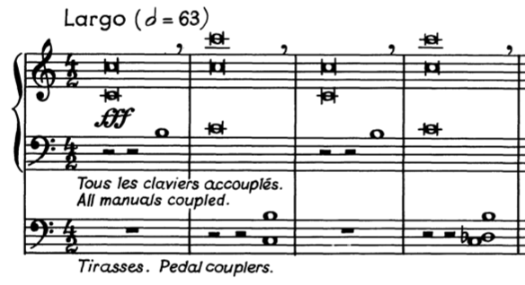

Following the introduction, Van Hulse introduces the main theme of the movement, an alternating motion of a third between C and E-flat. (See Example 4.2) For sake of comparison later in the work with other movements, the author has labeled this theme as the “Death” theme. One of the defining characteristics of Movement I is the intervallic relations to the key center, usually moving by thirds. The right hand plays the same movement of E-flat to C in octaves while the left hand harmonizes underneath with dissonant chords featuring B-natural or G-flat. The pedal joins in moving down in thirds and then sixths, the inversion of the third. One final motion of a third is elongated in the pedal in measures 16-21. (See Example 4.2) All these elements work together to ultimately tonicize A-flat major, a key a third away from the initial tonic of C.

Example 4.2: “Death” theme - movement of thirds, mm. 8-21
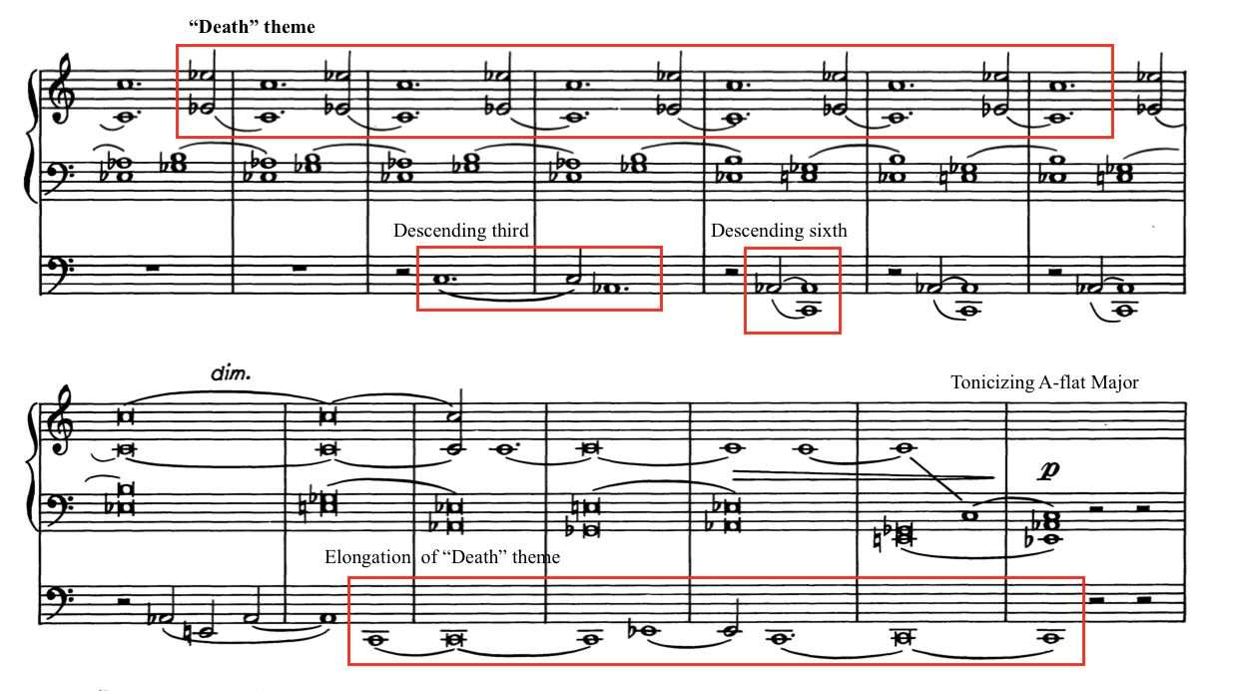

Van Hulse then further highlights the interval of a third found in the “Death” theme by modulating to E-flat minor in measure 22. (See Example 4.3) He alternates between two dissonant chords underneath the main theme playing E-flat and G-flat, ultimately arriving at E-flat minor in measure 27. Much of this movement is characterized by slow-moving alternations between two harmonies and an aversion to a final resolution. Instead of resolving the suspension of the final E-flat minor chord in the first inversion in measure 36, Van Hulse instead ends on a unison E-natural, which begins a new section.

Example 4.3: “Death,” Developing the “Death” theme, mm. 22-28
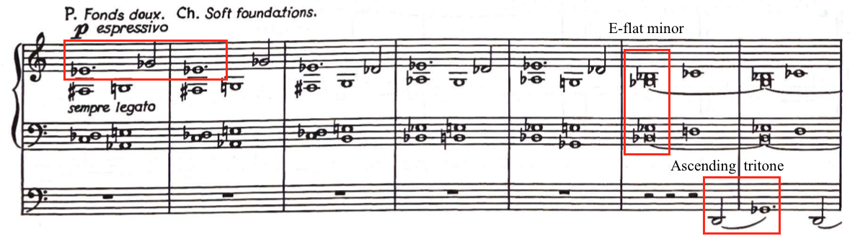

Analysis of Section B
The B section, which lasts from measure 37 to measure 63, begins with a quiet contrasting melody starting on the pitch G-flat, a tritone from the original starting pitch of C (See Example 4.4). G-flat features prominently in this second section of Movement I. In measures 41-43, Van Hulse introduces a harmonic progression built around a pedal tone of G-flat. This progression later appears in measures 58-60 and measures 61-63. This is later used at the very end of the movement in measure 94.

Example 4.4: “Death,” Beginning of B section, mm. 35-41
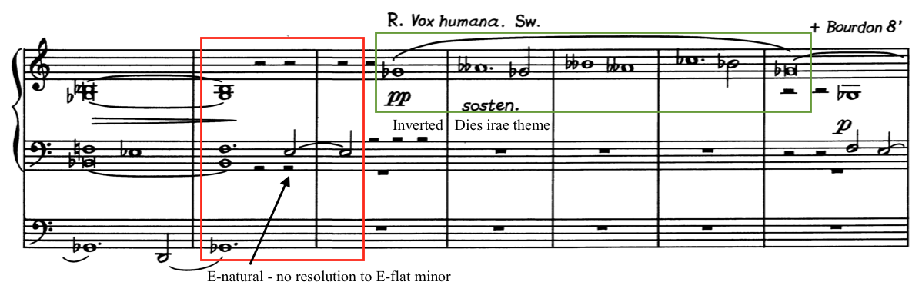

Contrary to Van Hulse’s program notes, recording artist and organist Laure Dermaut claims that Van Hulse did use a chant melody in Movement I of Symphonia Elegiaca. Dermaut wrote in her liner notes that the first movement “is musically expressed by using dark fortissimo chords, representing the motive ‘Mors stupebit’ of the Gregorian chant ‘Dies irae.’ In the intimate interlude from ‘Death,’ van Hulse uses the inversion of the ‘Dies irae’ theme.” The second section of Movement I, which begins in measure 37, has a solo line that closely follows the inversion of the Dies irae theme. (See Example 4.5)

Example 4.5: “Death,” Demonstration of Inversion of Dies irae
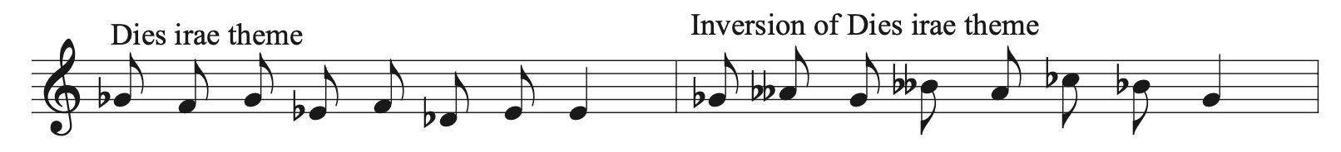

Throughout the B section, the melody ascends slowly by thirds in the upper voice, eventually moving up an octave. Instead of alternating between two notes, the melody now acts as a pedal tone while the harmony shifts underneath it. From G-flat, the melody moves to G-natural and jumps to B-flat in measure 47. It then starts on B natural and moves to D in measures 50 and 51. (See Example 4.6) Finally, in measures 54 and 55, the melody extends a diminished 4th from D-sharp to G-flat, an equivalent to a minor third. After this section, the previously mentioned harmonic progression transitions back to the original introductory material.

Example 4.6: “Death,” Harmonic progression and inverted introductory material, mm. 54-66

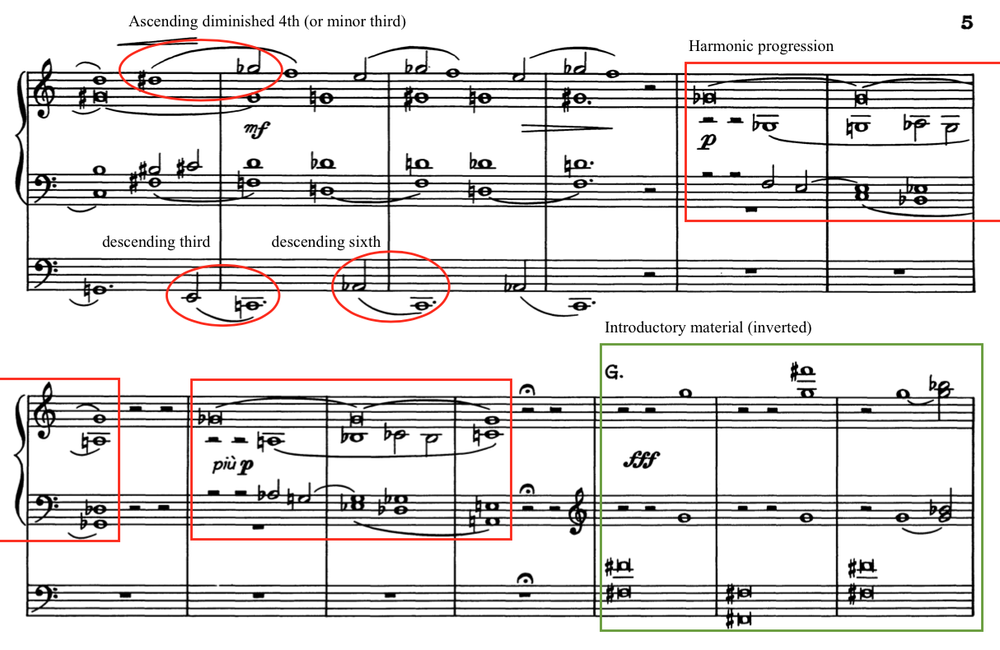

Analysis of Section A1 and Coda
After ending the B section quietly in A minor with the G-flat pedal tone in measure 63, Van Hulse reverts back to the A section with a startling use of the introductory material, this time inverted entirely from its initial occurrence in measure 1. (See Example 4.6) The pedals begin with fortississimo F-sharp octaves that leap up and down an octave while the hands now play the dissonant half steps. The “Death” theme heard at the beginning of the work now occurs in the pedals in measure 68, a tritone away from its original key center. (See Example 4.7) Subtle movements by half step further develop the theme and harmony. The inverted “Death” theme continues in the pedals without variation in measures 74-81. The hands harmonize in E-flat minor over the F-sharp pedal notes, eventually ending in a first inversion E-flat minor chord.

Example 4.7: “Death” theme in the pedal, half-step variations, mm. 68-72
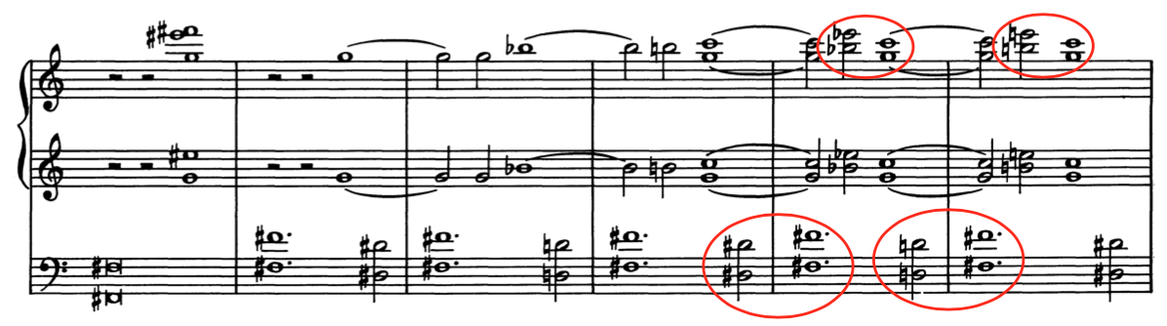

Van Hulse introduces the Coda, mm. 81-101, of Movement I with a third and final iteration of the introductory material in measure 81. This time, the introductory material is more fragmented, first holding B-flat in measures 81-82 and then holding A-flat in measures 83-84. (See Example 4.8) The piece then transitions into a Coda structure, starting fortissimo and then slowly sinking down in pitch and volume to a sustained A-flat 4/2 chord in measure 93.

Example 4.8: “Death,” Final use of introductory material, mm. 81-83
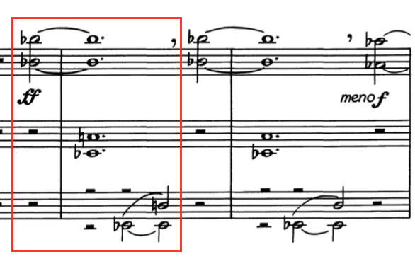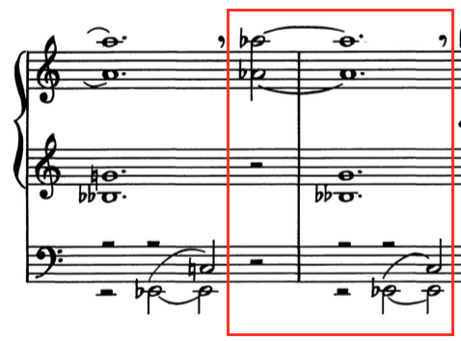

The movement concludes with two statements of the harmonic progression introduced in the B section with pedal tones of middle C, first cadencing in C minor in measure 96 and E-flat minor in measure 99. (See Example 4.9) The middle C pedal point continues to hold while an indication of morendo tells the player to die away, a fitting end to a movement entitled “Death.” Two final chords sound, first D-flat minor, then an open C chord marked pianississimo. This slow descension achieves an effect of solemnity after an austere and jarring fanfare. The earth, now awakened, awaits the final judgment depicted in the second movement: Last Judgment.

Example 4.9: “Death,” End of Movement I, dying away, mm. 97-101
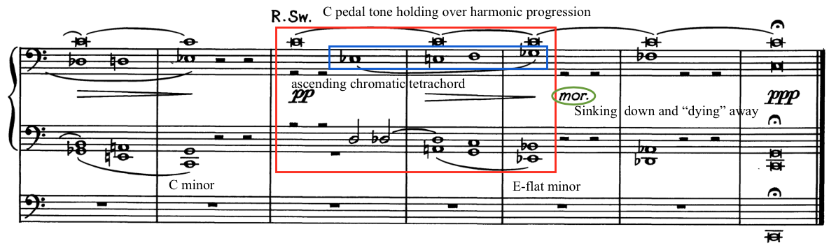

Chapter 5: Analysis of Symphonia Elegiaca, op. 83: Movement II
Chapter 5 provides an analysis of Movement II: “Last Judgment” of Symphonia Elegiaca, op. 83 by Camil Van Hulse. The chapter begins with an introduction that provides a brief overview of historical context, programmatic content, and structure. Following this, a compositional analysis further examines form, melody, harmony, rhythm, and thematic development. This analysis is organized in four sections: Analysis of Sections A, B, and C, and an Optional Ending. Score examples included in this chapter are from the Musikverlag Cranz edition and are reprinted with permission from the publisher. (See Appendix C)

Introduction to Movement II
The second movement of Symphonia Elegiaca, titled “Last Judgment,” is a virtuoso showpiece, which includes an alternate ending should the movement be extracted and performed independently. Marked Allegro, Movement II is 118 measures in length with an optional alternate ending and is approximately seven and a half minutes in performance length. Van Hulse describes the programmatic narrative of this evocative movement: “Depicting the confusion that will prevail when the angel Gabriel shall sound his trumpet. (Based on the theme of “Dies Irae” – “Day of wrath, day of mourning”).” The second movement is through-composed, improvisatory in nature, and incorporates quotations of the Dies irae chant melody.
Van Hulse uses many programmatic devices in the second movement to depict the end of the world as illustrated in the text of the Dies irae chant. The Dies irae chant is a medieval Gregorian sequence from the Catholic Requiem Mass. An excerpt of the Dies irae is translated by Ron Jeffers as follows:
Day of wrath, that day shall dissolve the world into embers as David prophesied with the Sibyl.
How great the trembling will be, when the Judge shall come, the vigorous investigator of all things!
The trumpet, spreading its wondrous sound through the tombs of every land, will summon all before the throne.

Van Hulse bases the entire second movement on the first eight pitches of the chant melody, which appear throughout the movement in multiple transformations. Additional phrases of the Dies irae chant are stated at the conclusion of the second movement, however no complete statement of the chant is found. (See Example 5.1)

Example 5.1: Dies irae chant melody
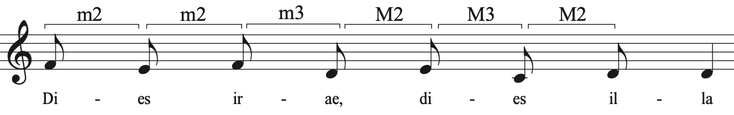

The melodic contour of the Dies irae chant provides ample opportunity for Van Hulse to develop this eight-note motive into a constantly transforming theme. Tonally centered in the Aeolian mode, the distinctive melody is based on descending thirds, except for the first interval between the second and third notes of the scale. There is also a minor and major third built into this melody, which Van Hulse uses in his harmonic interpretation, using augmented chords and extended tertian harmonies.
While there is no discernable traditional form, the second movement can be organized into three larger sections. (See Table 5.1) The structure of the piece is determined by the use of the Dies irae chant melody and its transformations, as well as a contrasting five-note chromatic motive. While Van Hulse moves rapidly through key areas, the tonal centers of the iterations of the Dies irae melody demonstrate a larger structure based on the interval of the tritone. The tension between A minor and E-flat minor is present throughout the movement, which conveys the unsettling image of the Day of Wrath.

Table 5.1: Structural Outline of Movement II, “Last Judgment”
Section | Section A
Measure | 1-16 | 17-26 | 27 | 28-37 |  | 38-44
Thematic material | Introduction | Full theme (T1) | Transformed theme
Dies irae | fragment | T1 | T1 | T1A | T1B
Key area | Chromatic | A m | E-flat m | F# M,  A M | B m,  F m,  F# m

Section | Section B
Measure | 45-54 | 55-64 | 65-79 | 80-86 | 87-91
Thematic material | Full theme | Transformed theme |  |  | Climax
Dies irae | T1 | T1C | T1D | T1 | T1
Key area | G m,  E m | G+,  A-flat+,  A + | E-flat m | B-flat m,  F# m,  E-flat m/M | B-flat m/M

Section | Section C
Measure | 92-105 | 106-114 | 115-118
Thematic material | Canonic treatment | Coda | Transition
Dies irae | T1 | T1ost. | frag
Key area | A m/  E-flat m | Am,  B-flat m/M | D-flat m,  A-flat m

Analysis of Section A
Van Hulse begins Section A, mm. 1-44 of Movement II: “Last Judgment” with a rumbling pedal solo that seems to emulate the earth trembling. It starts as an oscillation of sixteenth-note triplets between the pitches of D-flat and C at the lowest range of the pedals. A single line branches into two in measure 2 as the right foot begins a chromatic journey upward. (See Example 5.2)

Example 5.2: “Last Judgment,” Oscillation in pedals splits into two voices, mm. 1-3
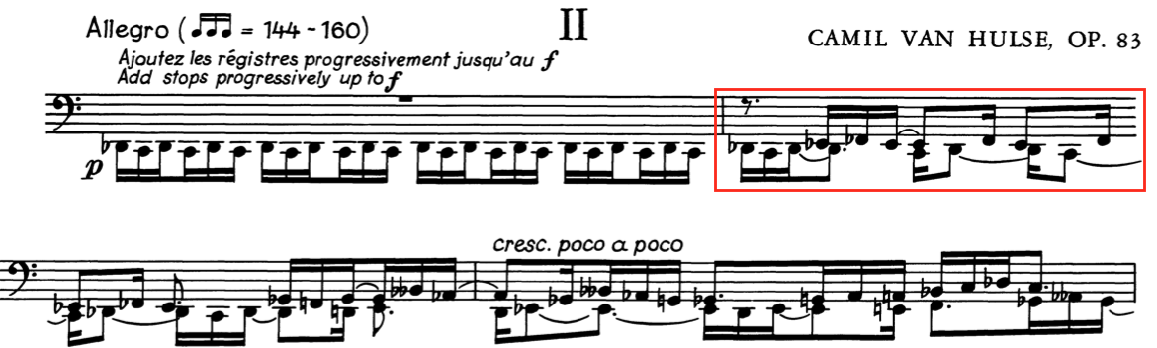

The pedal solo that makes up the beginning of Movement II is unmetered with no time signature or key signature indicated. In his manuscript, Van Hulse notes, "Barlines are used solely to set a limit on the value of accidentals.” (See Example 5.3) The perpetual motion of sixteenth triplets, ungoverned by the structure of barlines or a larger pulse, gives a sense of rhythmic ambiguity. Van Hulse marked some time signature counts in pencil in his manuscript, alternating between 24/16 and 15/16 in groups of 8 and 5, though these are not a part of the published score. (See Example 5.3) The constant groupings of 3 grow in significance later in Movement II.

Example 5.3: Van Hulse’s manuscript with notes, Movement II
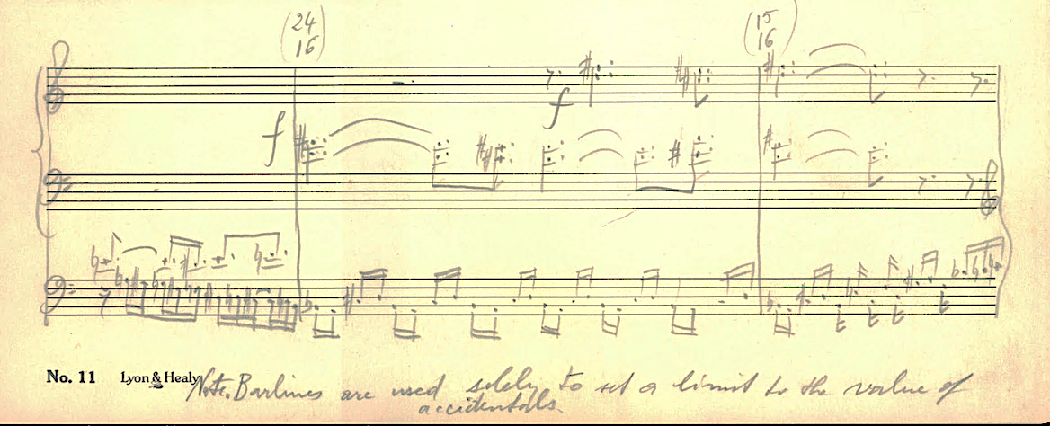

From the trembling in the lowest range of the pedals, the notes in the pedals climb upward chromatically in the first three measures. Van Hulse uses all twelve chromatic scale tones by the end of measure 3. Van Hulse indicates a dynamic of piano, then instructs the player to add stops progressively up to forte, which can be accomplished by the performer using their hands to add stops. In measures 7 and 8, the feet play three voices, with the right foot holding a minor third based on A-flat over a pedal tone of A-natural. (See Example 5.4)

Example 5.4: “Last Judgment,” Introduction of chromatic motive, mm. 6-9
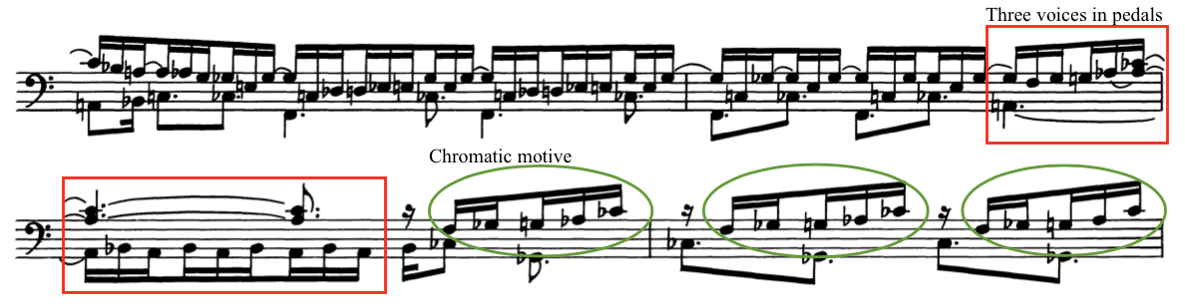

In measure 8, Van Hulse introduces a five-note chromatic motive. He later uses this five-note motive as a contrast to the Dies irae theme and as a modulatory device. (See Example 5.5) The contour is four tones ascending chromatically and a leap of a minor third, spanning an interval of a tritone. Van Hulse uses this interval as an important motive throughout the work, creating a sense of unease and tonal ambiguity. In measures 8 and 9, Van Hulse states the chromatic motive three times quickly in succession. (See Example 5.4)

Example 5.5: “Last Judgment,” Chromatic motive in Movement II
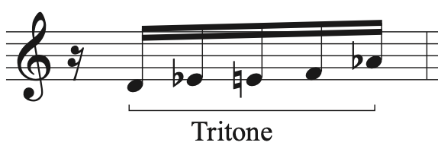

Van Hulse continues to build anticipation and angst by moving higher on the pedalboard, building in dynamics, range, and intervals. Once the pedal solo arrives at the designation of forte in measure 10, the music builds in intensity by moving in contrary motion by larger intervals. The right foot plays the first three notes of the Dies irae chant melody six times, ascending by whole steps. This whole tone motion is contrasted by the left foot playing chromatic scales under each iteration, playing eleven notes, then moving a seventh higher to give a constant feeling of downward motion. (See Example 5.6)

Example 5.6: “Last Judgment,” End of pedal solo, mm. 10-12
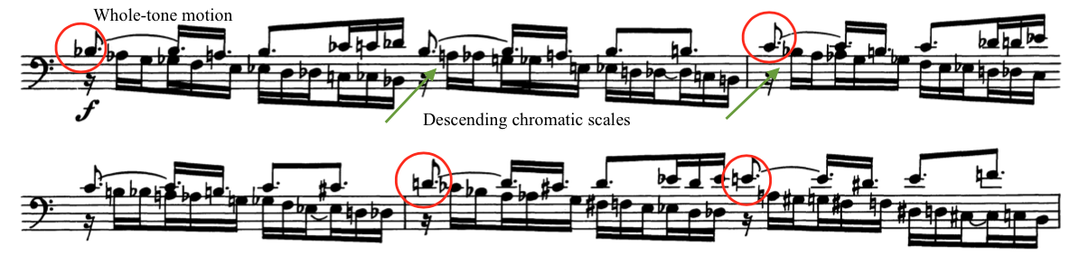
The manuals finally enter in measure 13, continuing the fragment of the Dies irae theme first heard in the pedals. (See Example 5.7) The rhythm in the pedals is constantly in motion, first playing an ostinato in duple groupings that settles into the familiar triplets by measure 15. This fragmented theme is introduced in the manuals three times in measures 13, 15, and 17, descending a half step each time. Van Hulse frequently uses groupings of three, often directly modulating, throughout the movement to provide structure in a constantly shifting environment.

Example 5.7: “Last Judgment,” Manuals entrance of Dies irae fragment, mm. 13-14
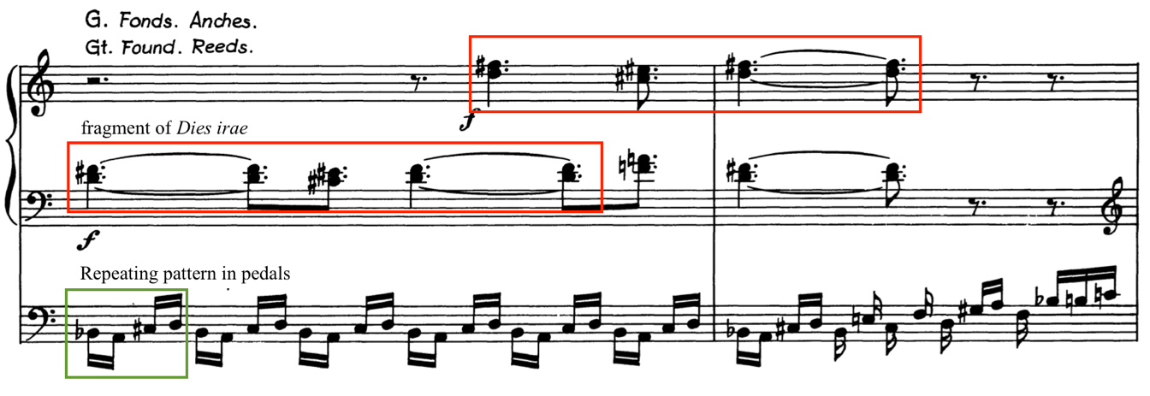
The first statement of the whole Dies irae theme (T1) is stated in measure 17 in parallel major thirds in the right hand. The left hand moves with the right hand and provides rhythmic variations underneath while the pedals continue their energetic sixteenth-note motion. (See Example 5.8) Instead of using a modal or minor tonality, Van Hulse eschews any semblance of stability by using augmented chords at the end of most phrases, always with constant motion underneath in the pedals.

Example 5.8: “Last Judgment,” First appearance of Dies irae theme (T1), mm. 17-19
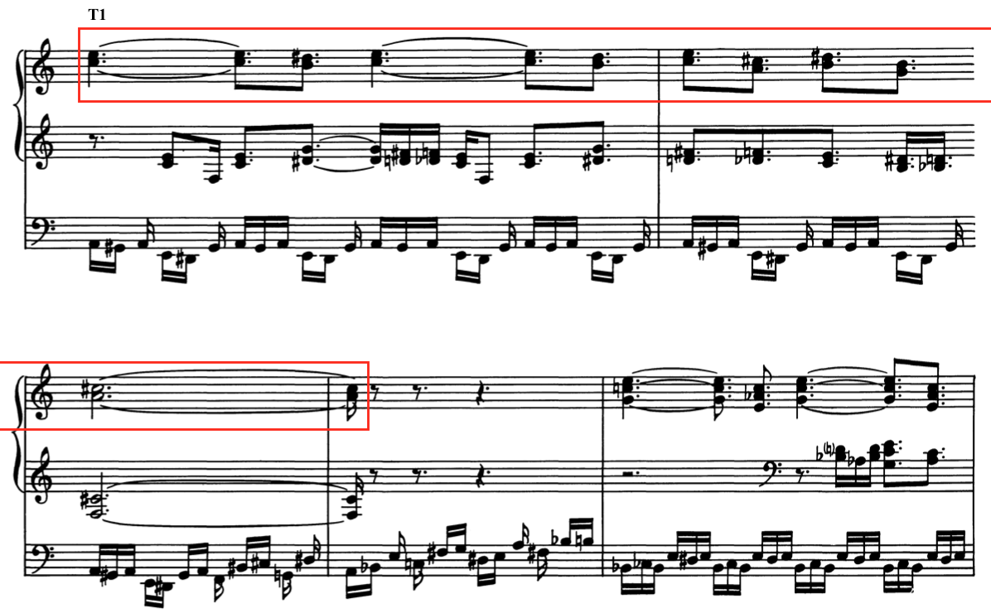

After a brief interlude of alternating between C major and C-augmented triads, Van Hulse states the Dies irae theme (T1) three times. T1 occurs an octave higher in measure 23 and then up a step to D in measure 25. Finally, in measure 27, Van Hulse arrives at E-flat minor, sustained in the manuals as a modified version of T1 occurs with the pedals playing the theme in rhythmic diminution underneath as an ostinato. (See Example 5.9) This fragment of the Dies irae chant melody then morphs into an oscillation between E-flat and D, reminiscent of the opening pedal sequence. This sixteenth-note rhythm in the pedals moves to the manuals (see Example 5.9), and the pedals now provide the harmonic foundation.

Example 5.9: “Last Judgment,” T1 in diminution transforming into oscillation, mm. 27-28
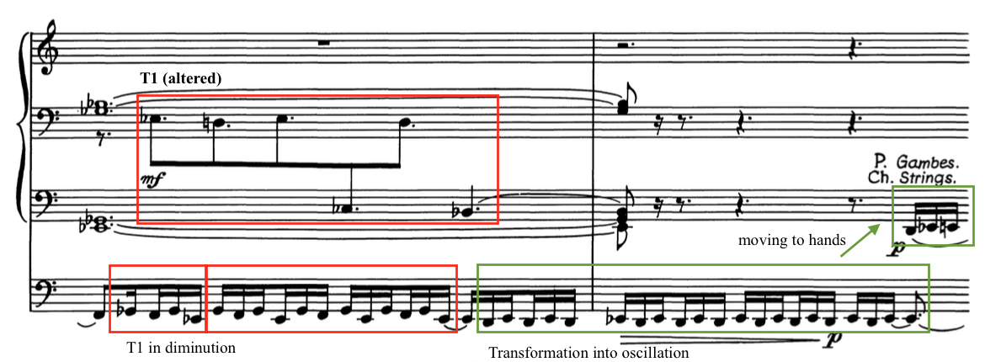

The Dies irae theme (T1A) is first transformed in measure 28 as a rapid, winding phrase on the swell reeds over an F-sharp seventh chord sustained in the left hand and pedals. Following this, in measure 29, the chromatic motive moves downward by a whole step, repeated up an octave with each iteration. (See Example 5.10) Another iteration of the chant (T1A) occurs in measure 30, this time a third higher. Again, the chromatic motive moves downward as Van Hulse moves into a more developmental section in measures 31-37, using the chromatic motive as a modulatory device.

Example 5.10: “Last Judgment,” T1A and chromatic motive, mm. 28-30
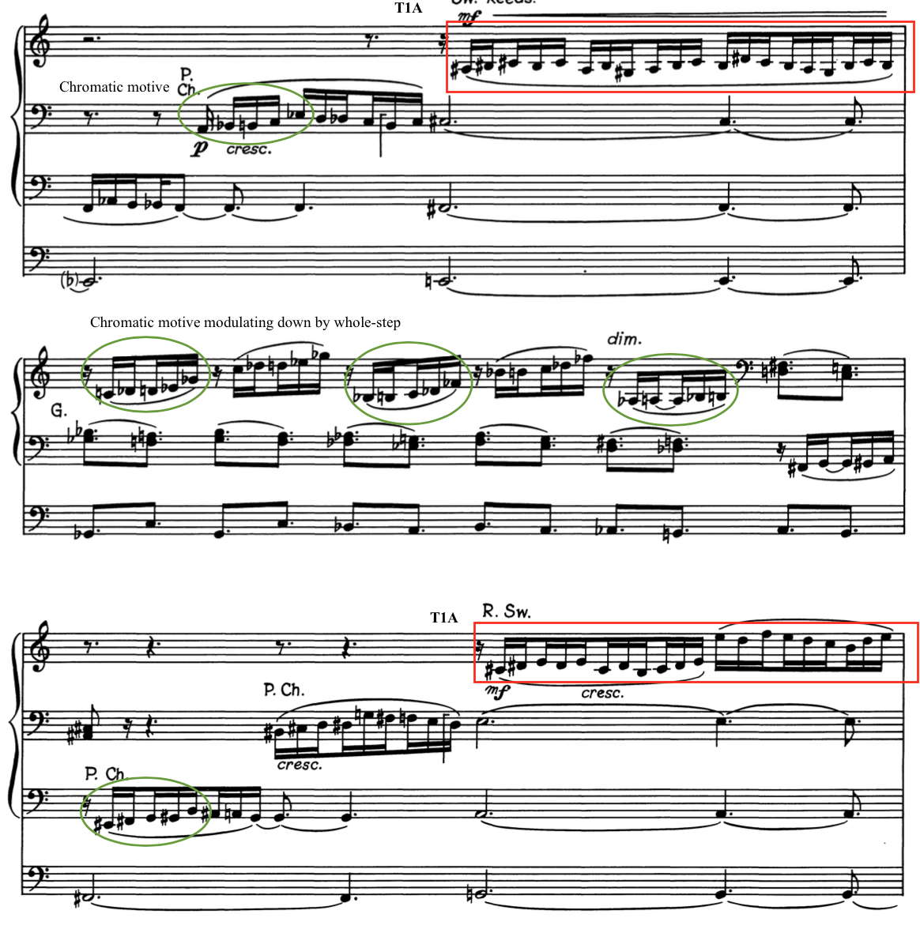

After an interlude using the chromatic motive, Van Hulse creates a new variation of the Dies irae theme (T1B) which appears in measures 38, 41, and 43. This variation occurs in a toccata figuration in the manuals. (See Example 5.11) The right hand plays the melody in octaves and thirds with the left hand and pedal outlining the harmony underneath. Instead of following the motion of the original theme, the melody moves back up by a half step to the starting note. A measure of the chromatic motive interjects between each of the three statements of T1B.

Example 5.11: “Last Judgment,” T1B, mm. 38-39
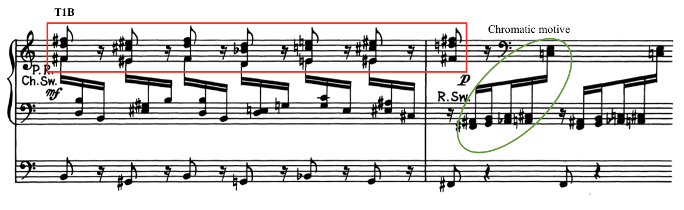

Analysis of Section B
Section B, mm. 45-92, of Movement II is a more developmental section compared to Section A, with a return to T1 in measure 45, more transformations of the Dies irae theme, and a climax in measures 85-86. Van Hulse depicts agitation and confusion throughout Section B by using unresolved dissonance, constant motion, and trumpet fanfares. The original theme (T1) returns in measure 45 based in the key of G minor. It is restated in measure 47 up a whole step in A minor. An abrupt flourish interrupts this theme in measure 49. Three statements of ascending marcato fortissimo chords lead into three chromatic transformations of the Dies irae theme (T1C) moving up by half step with each statement in measures 55, 57, and 59, which moves the movement into a more developmental structure. (See Example 5.12)

Example 5.12: “Last Judgment,” T1C, mm. 55-56
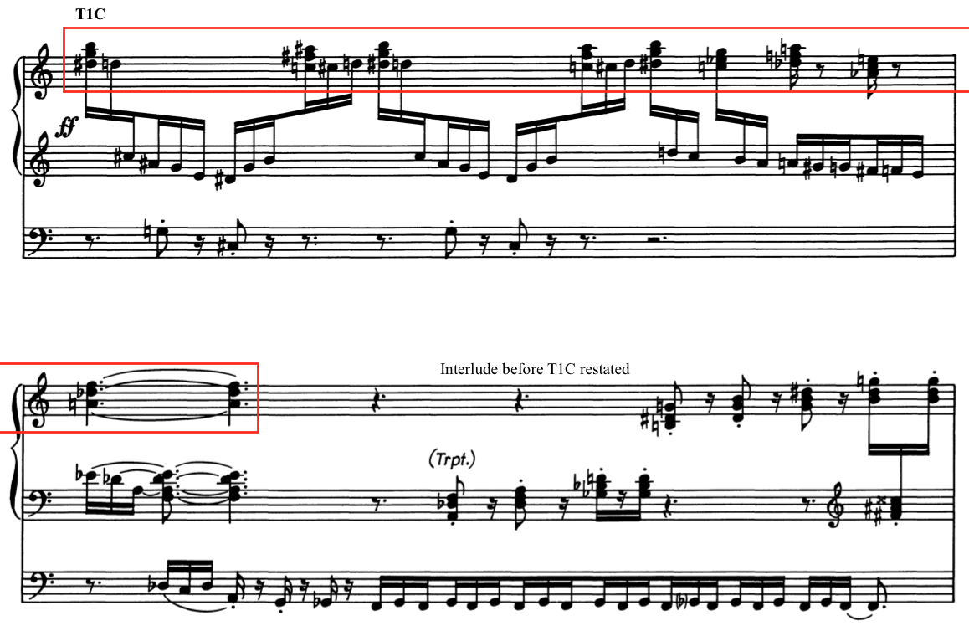

All motion stops suddenly with a fanfare in measure 61. (See Example 5.13) By using a pedal point underneath, Van Hulse finally ends the constant movement of the sixteenth triplets. The fanfare sounds again in measure 63 up a minor third. These fanfares may be evoking the angel’s trumpet sounding as described by Van Hulse in the program notes.

Example 5.13: “Last Judgment,” Fanfare, mm. 61-63
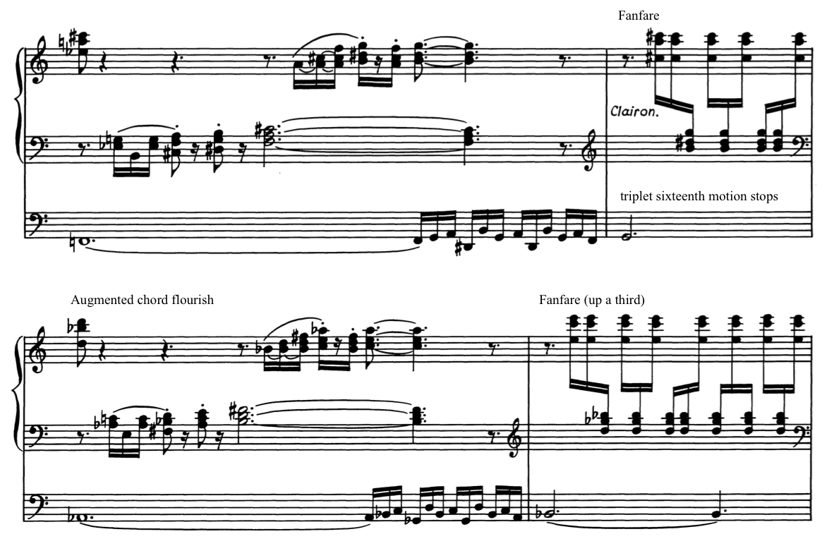

This fanfare heralds a new transformation of the Dies irae theme as the movement intensifies toward the climactic point in measure 85. The previous fanfares lead to another transformation of the Dies irae theme (T1D) centered around E-flat minor in measure 65. (See Example 5.14) In this transformation, the Dies irae theme is fragmented and developed through short staccato homophonic chords jumping between manuals. Each transformation of the theme moves further away from the original thematic material. This transformation of the theme is stated three times in three different keys in measures 68-79 before a return to T1 in measure 80.

Example 5.14: “Last Judgment,” T1D, mm. 65-67
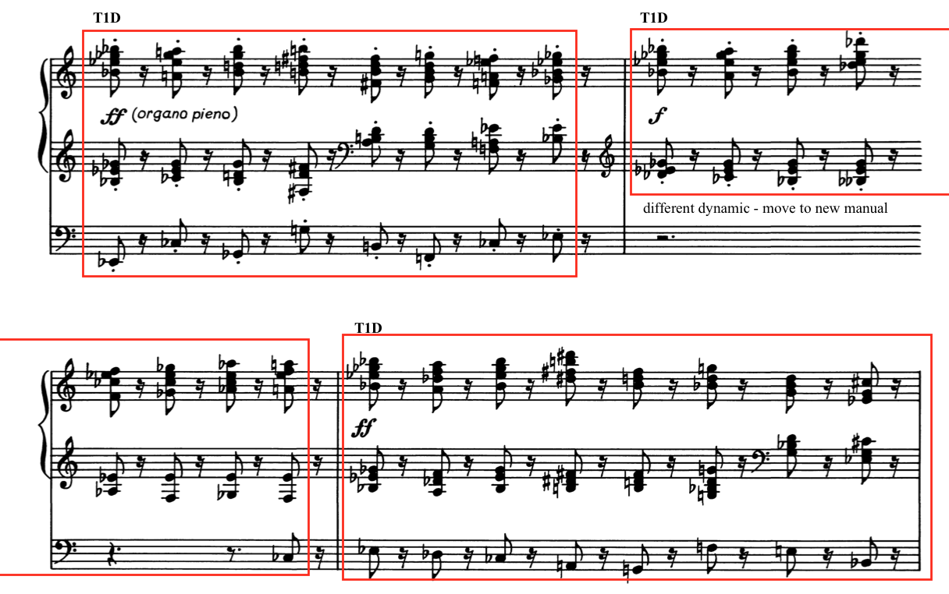

The entire Dies irae theme (T1) returns in measure 80 in both the right hand starting on D-flat and the left hand beginning on A-flat, moving at double the time of the right hand which continues to heighten tension and confusion. The pedal plays a descending chromatic scale under the manuals in measure 80, stopping on a minor sixth in measure 81. The hands in the manuals play a flourish in measures 81-82 up to a new iteration of T1 in measure 83. This iteration of T1 is the most tonal statement in the second movement; it is rhythmically and tonally more straightforward, using dotted rhythms, perfect fifths in the pedal, and all centered in F-sharp minor. (See Example 5.15) This heroic statement ends with another diminution of the theme in the pedal and the re-emergence of the chromatic motive moving up by half step in measure 84.

Example 5.15: “Last Judgment,” T1D and chromatic motive moving upward, mm. 83-84
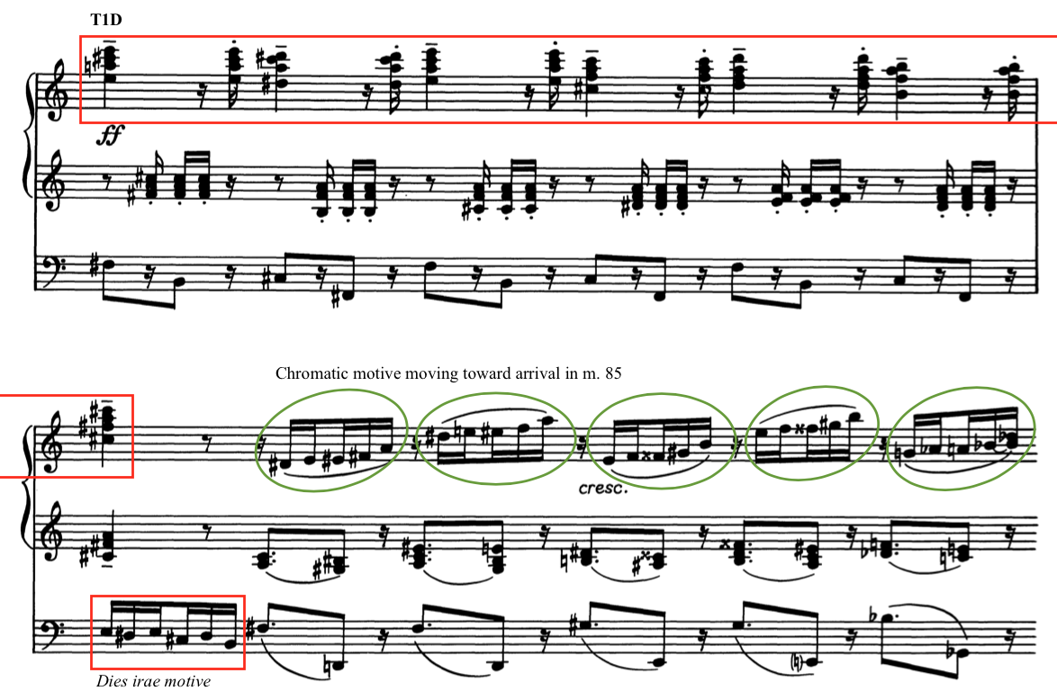

The climactic statement of Movement II depicts the arrival of God’s final judgment on the earth. This musical apex appears in measure 85 at a fortississimo in long-held notes centered around E-flat minor with a final resolution to the parallel key of E-flat major. (See Example 5.16) The chromatic motive plays underneath in the pedals, a final statement of the earth shaking that began in measure 1 of this movement. This is the only time the two motives play simultaneously. This converging of the two themes is a dramatic emotional pinnacle to this tumultuous movement.

Example 5.16: “Last Judgment,” Dies irae theme and chromatic motive, mm. 84-87
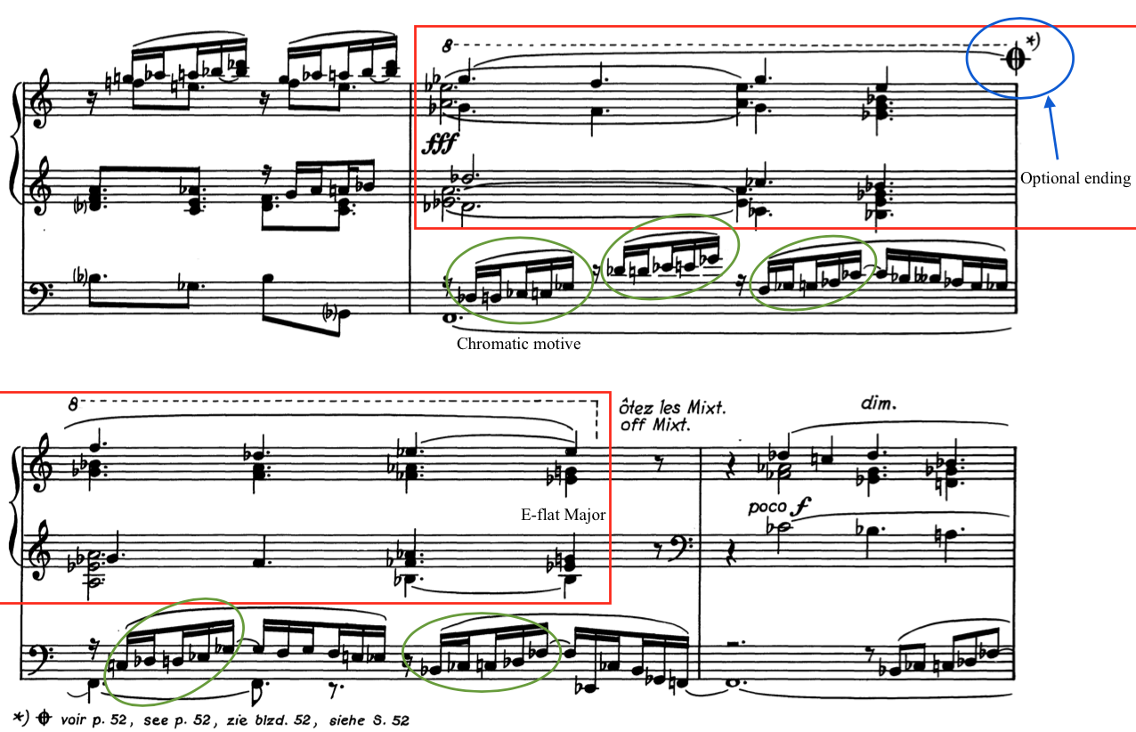

If Movement II is to be played as a standalone work instead, there is a sign at the end of measure 85 to move to an alternate ending. Following the apex in measure 85, Van Hulse indicates a gradual diminuendo to the end of the piece by removing stops and slowing rhythmic values. The Dies irae (T1) occurs in measure 87, centered around B-flat. Underneath, the chromatic motive plays one last time in the pedals in measure 88. The transition leads into Section C.

Analysis of Section C
Section C, mm. 92-118, continues to lessen in intensity and treats the Dies irae in a much more straightforward fashion. This section is marked by an indication of “L’istesso tempo” in measure 92, and is in common time. The groups of three eighth notes from the previous unmetered section now become eighth-note triplets undulating in the left hand. Though no audible change occurs, the spelling of the notes enharmonically changes from C-flat and B-double flat to B-natural and A-natural to better match the new key center of A-minor. This oscillation occurs over an E-flat, the ultimate expression and juxtaposition of the tritone relationship.
The Dies irae chant tune (T1) is presented in a three-part canon between two voices in the right hand and another voice in the pedals while the left hand undulates between B and A. The key center of the right hand is A minor while the key center in the pedal is in E-flat minor. (See Example 5.17) This key relationship further emphasizes the tension of the tritone. Significantly, this is the only time other phrases of the Dies irae chant melody appear. The unadorned treatments of entire lines of chant is a stark contrast to the fragmentation of one line of chant heard throughout the earlier sections of the movement.

Example 5.17: “Last Judgment,” Canonic treatment of Dies irae theme, mm. 93-95
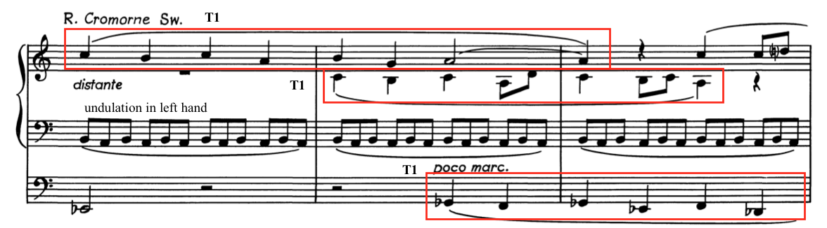
After the canonic section, the undulating eighth notes in the left hand transform into an ostinato (T1ost.) in measure 106. This ostinato is based on the Dies irae theme centered in A minor, which then moves to the pedals. (See Example 5.18) The hands play a descending planing figure of four chords in measures 107-108, all within the key of A minor. This planing figure foreshadows the use of the Pie Jesu chant tune used in Movement III. The ostinato shifts down a whole step in measure 109, but now the key area is in B-flat minor, eventually ending in B-flat major in measure 112, the last tonal arrival point in the movement.

Example 5.18: “Last Judgment,” T1ost., mm. 105-107
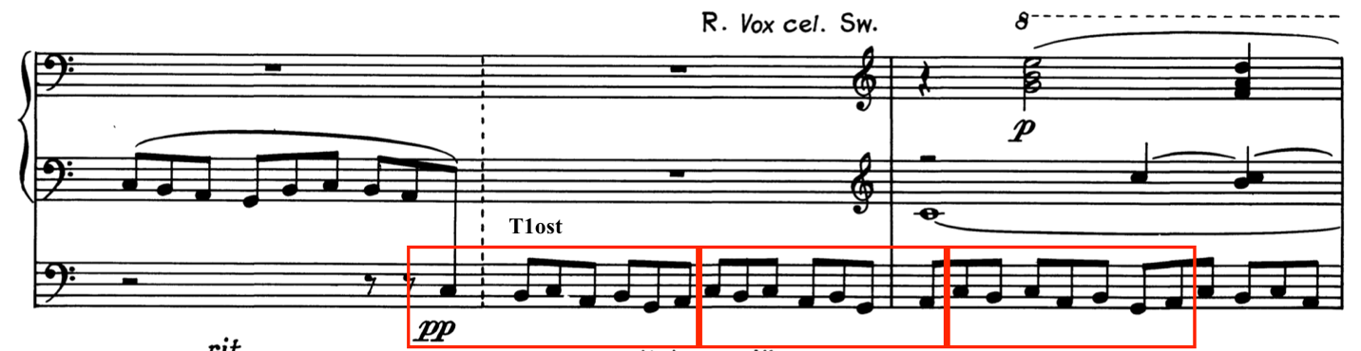

In measures 113-115, Van Hulse tonicizes D-flat minor, ultimately cadencing in the manuals on an A-flat minor chord while the pedal plays a fragment of the Dies irae chant melody in D-flat minor. (See Example 5.19) This chant fragment is then repeated in A-flat minor in the pedals as a solo in measure 116. The final two measures transition into the third movement, modulating enharmonically from C-flat to B-natural.

Example 5.19: “Last Judgment,” Segue to Movement III, mm. 115-118

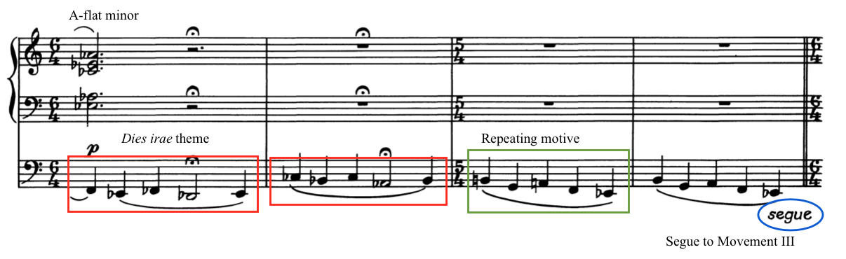
The final two measures, measures 117 and 118, contain a five-note motive that occurs at the beginning of movement III, the end of movement IV, and acts as a repeating motive and important theme in Movement V. These seemingly innocuous two measures act as foreshadowing to the end of Symphonia Elegiaca. Though Movement II starts with a sinister and dark pedal solo, the pedal solo at the end of the movement plays more of an unstable dirge, signaling more to come in the following movements.

Optional Ending
Van Hulse wrote an optional, more triumphant, ending for the second movement if “Last Judgment” is to be played as a standalone composition. Instead of fading away into the next movement, this ending maintains the energy from the rest of the movement and drives toward an exciting end. The climactic statement of the Dies irae theme in measure 85 has a symbol indicating where to cut to the optional ending. (See Example 5.16) Marked “Tempo guisto (alla breve),” this alternate ending is 29 measures long, lasting from measures 86a-114a. This new ending does not resolve to E-flat major but remains unstable, revisiting the fanfare motive heard earlier in the movement in measure 60. A final descent in the pedal stops on a B-flat pedal point in measure 4 into a new tempo indication: “Tempo guisto (alla breve).” (See Example 5.20)

Example 5.20: “Last Judgment,” Alternate ending, mm. 86a-91a.
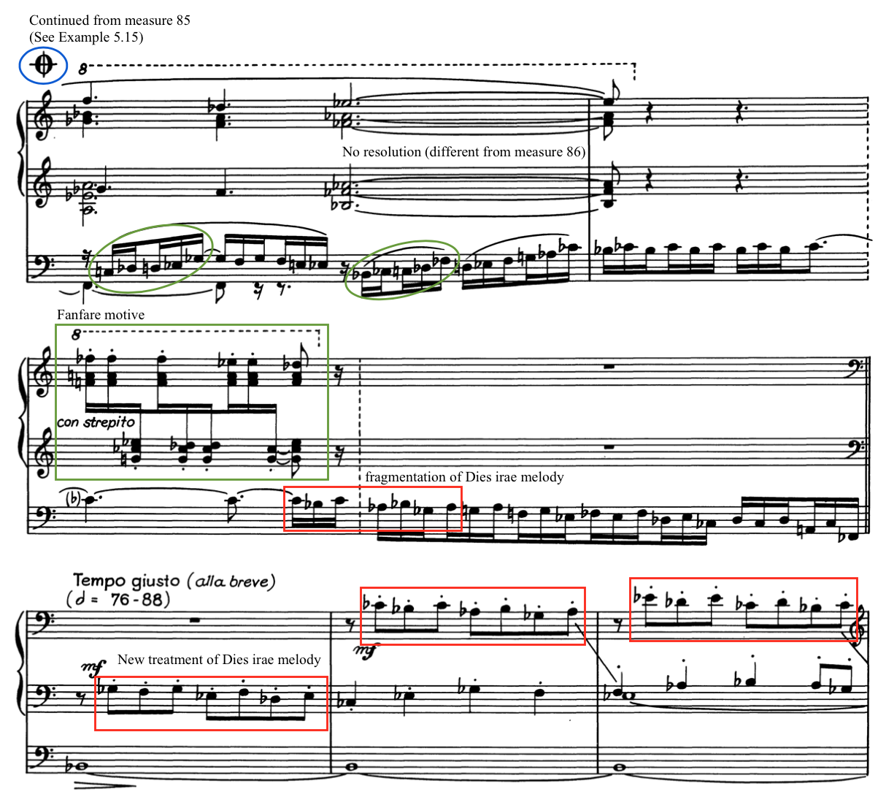

Following this transition from measure 85, the optional ending continues with a section marked “Tempo guisto (alla breve)” in measure 89a. The new treatment of the Dies irae melody is surprisingly straightforward and tonal in E-flat minor. The original theme is now staccato and transformed into a series of stepwise descending duples. The Dies irae melody (T1) then moves to an alternation between the manuals and pedals in measure 98a. (See Example 5.21) In measures 104a-107a, this alternation begins to fragment into shorter phrases.

Example 5.21: “Last Judgment,” Alternate ending, mm. 98a-100a
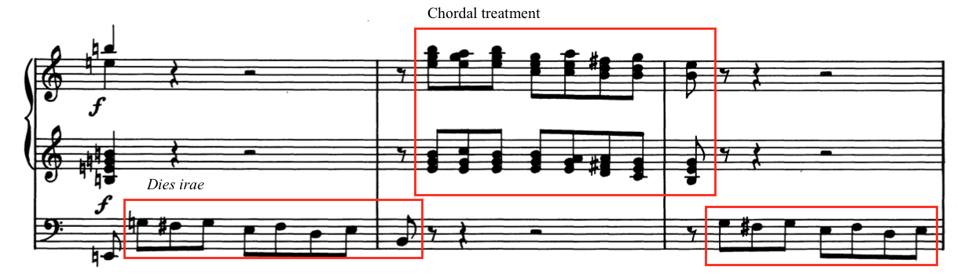

A gradual increase of notes and a written-in crescendo brings the piece to measure 109a, indicated with “stretto” and “cresc. molto” as the music moves upward in broken thirds. Van Hulse designates a tempo of Presto at measure 110a on a first-inversion B-Flat Major chord as the motion continues in middle voices. One final fragmentation of the Dies irae chant melody provides a figure in measures 110a-112a that launches the piece to its ending of four discordant chords ultimately ending in A major. (See Example 5.22)

Example 5.22: “Last Judgment,” Alternate ending to Movement II, mm. 112a-114a
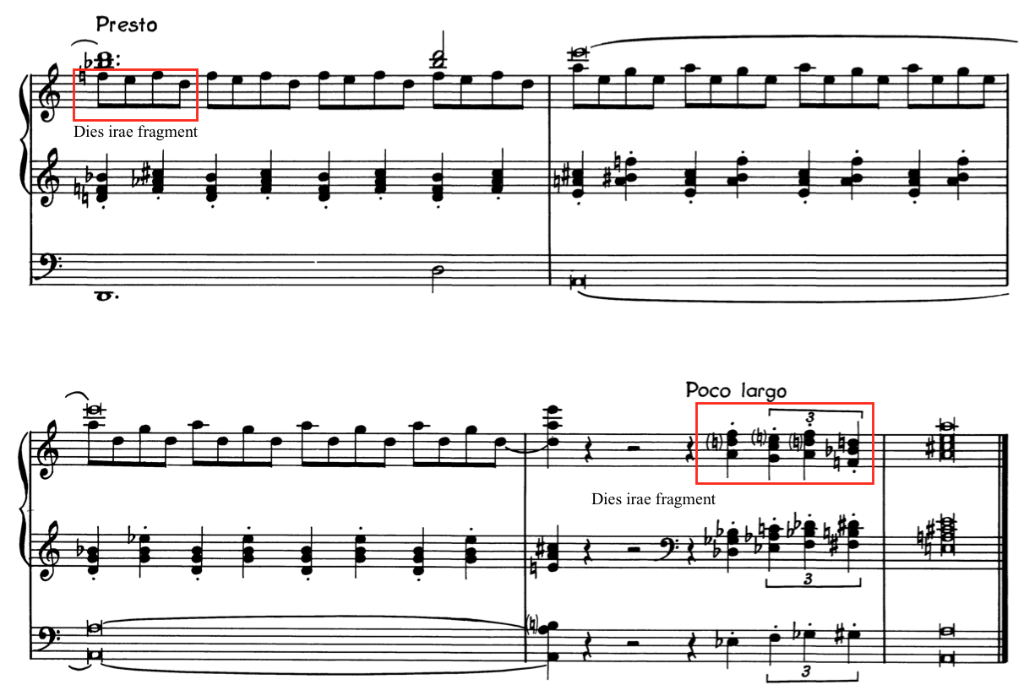

The character of this markedly different ending lends itself well to concert performances as a stand-alone piece. While this optional ending ends with a more triumphant character, the original ending Van Hulse wrote for Movement II allows for the emotion contained in the music to continue to flow into the next movement. Van Hulse paints a vivid picture of a vision of the Last Judgement with rumbling pedals, trumpet fanfares, and dramatic explosions of sound. All of this dies away as Van Hulse prepares the listener for the next movement: “Divine Mercy.”

Chapter 6: Analysis of Symphonia Elegiaca, op. 83: Movement III
Chapter 6 provides an analysis of Movement III: “Divine Mercy” of Symphonia Elegiaca, op. 83 by Camil Van Hulse. The chapter begins with an introduction that provides a brief overview of programmatic content and structure. Following this, a compositional analysis further examines form, melody, harmony, rhythm, and thematic development. This analysis is organized in four sections: Analysis of Section A, Section B, Section C, and Section A1. Score examples included in this chapter are from the Musikverlag Cranz edition and are reprinted with permission from the publisher. (See Appendix C)

Introduction to Movement III
Movement III: “Divine Mercy” is a reflective movement that depicts prayers for God’s mercy through extended use of flowing chant melodies. This movement is the most sectional of Symphonia Elegiaca and can be organized into four distinct sections: Section A, Section B, Section C, and Section A1. (See Table 6.1) Set in an Andante tempo, Movement III is 92 measures in length and is approximately seven minutes in performance length. When performing the complete Symphonia Elegiaca, Van Hulse directs the organist to segue from the second movement into the third movement without pause. The repeating motive formed from the Dies irae theme in the second movement moves effortlessly from 5/4 to 6/4, the new time signature for Movement III: Divine Mercy.

Table 6.1: Structural Outline of “Divine Mercy”
Section | Section A
Measure | 1-16 | 16-21 | 22-30 | 31-37 | 38-46
Chant used | Pie Jesu  Domine Jesu | Domine |  | Pie Jesu (alt.) | Pie Jesu (alt.)
Key area | Chromatic  E m  G# m | D m  chromatic | Chromatic A-flat m | Chromatic  E m | E m  G M

Section B | Section C |  |  | Section A1
46-55 | 56-61 | 62-67 | 67-75 | 76-83 | 83-92
Domine (Hostias) | Domine (frag.) | Domine (frag.) | Domine (frag.) | Pie Jesu  Domine | Pie Jesu
E m - G# M | A-flat M  E M  C M | D-flat M  C M | Chromatic  E-flat m | E m  Chromatic | Chromatic  G# m  half-diminished

Movement III is the only movement in Symphonia Elegiaca in which Van Hulse does not give a programmatic narrative in his program notes. The program notes only provide the chant themes and the translations of the Latin titles. Van Hulse’s notes read as follows: “Divine Mercy. Based on the themes “Pie Jesu” – “Merciful Jesus” and “Domine Jesu Christe” – “Lord, Jesus Christ.” These melodies and texts of Pie Jesu and Domine Jesu Christe contain their own programmatic narrative that Van Hulse may have assumed would speak for itself.
Pie Jesu, a prayer for God’s mercy, appears at the conclusion of the Dies irae sequence hymn. Ron Jeffers translates these lines in Translations and Annotations of Choral Repertoire, Volume I here: “Merciful Jesus, Lord, Grant them eternal rest.” (See Example 6.1) This prayer, only briefly heard at the end of movement II, is now the driving force thematically and programmatically in the third movement. The Pie Jesu theme is prominently featured in Section A (mm. 1-46) and in Section A1 (mm. 76-92).

Example 6.1: Pie Jesu chant melody
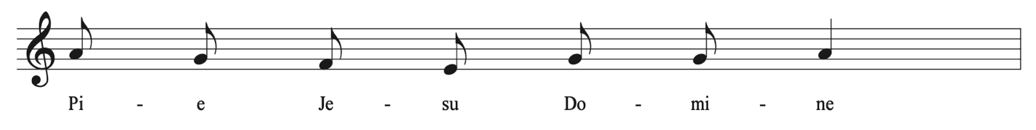

The second text and melody quoted in Movement III is the Domine Jesu Christe. This text is used as the Offertory in the Requiem Mass, the time for the presenting of gifts during the worship service. Ron Jeffers explains that the text for the Domine Jesu Christe “was formerly a prayer that was recited for the sick who were about to die; it was later adopted into the Requiem Mass for the Dead.” The text of Domine Jesu Christe can be translated as “Lord Jesus Christ, King of glory, liberate the souls of all the faithful departed…” (See Example 6.2)

Example 6.2: Domine Jesu Christe chant melody
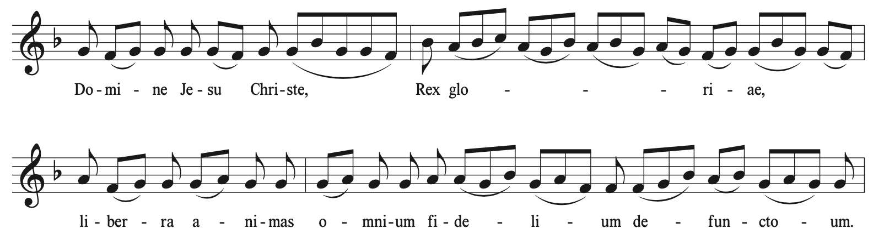

In Section B, mm. 46-55, Van Hulse uses melodic material which is found later in the Domine Jesu Christe chant. The phrase, “Hostias et preces tibi Domine,” provides contrasting melodic material to the previously heard chant melody motives. (See Example 6.3) The text associated with this tune is translated as “Sacrifices and prayers of praise, O Lord, we offer to thee.” Van Hulse uses this chant phrase in alternation with a counter melody to emulate people’s prayers being offered.

Example 6.3: “Divine Mercy,” “Hostias” phrase of Domine Jesu Christe chant melody
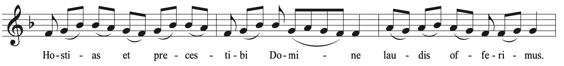

In addition to the “Hostias” chant melody phrase, Van Hulse quotes a third phrase from the Domine Jesu Christe chant melody: “fac eas, Domine.” Taken from the very end of this chant melody, the phrase started with “fac eas” appears only once in measure 52. (See Example 6.4) This phrase of the chant text is translated “Grant them, O Lord, to pass from death unto life.” Van Hulse uses this text to evoke further prayers being offered and only implements it one time, giving it extra significance.

Example 6.4: “Divine Mercy,” End of Domine Jesu chant used in Section B
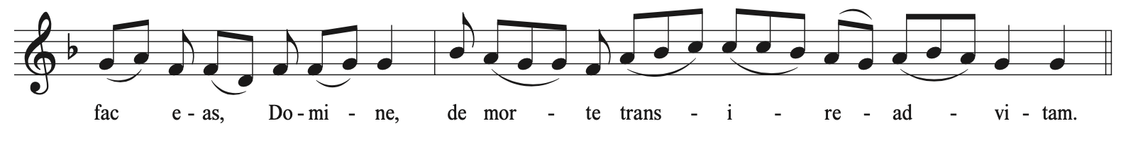
Section C, mm. 56-75, is the apex of the movement that abruptly changes tempo and dynamics to contrast the previous sections. Van Hulse uses the first three notes of the “Hostias” phrase as a developmental motive. Set in a time signature of 9/4, Van Hulse creates rhythmic contrast to the previously free use of chant phrases.
The third movement concludes with a brief return of the A section, identified by the author as A1, mm. 76-92. Van Hulse again quotes the Pie Jesu and Domine Jesu Christe themes. Van Hulse ends the third movement mysteriously and without a tonal cadence, which is unexpected for a movement so consonant and tonally centered.

Analysis of Section A
Section A of the third movement (mm. 1- 46) begins with the first four descending notes of Pie Jesu chant melody played in the right hand. This motive is played over a repeating five-note motive that was previously introduced in Movement II. The pedal accompaniment gradually loses notes from this repeating motive until it is just an alternation between A-sharp and E-natural, the interval of a tritone. Van Hulse then adds the last three notes of the first phrase of the Pie Jesu in measures 3-4 to develop an accompanimental figure in the form of a two-voice canon over the Domine Jesu Christe chant played in the left hand. (See Example 6.5)

Example 6.5: “Divine Mercy,” Beginning – Pie Jesu and Domine Jesu Christe, mm. 1-8
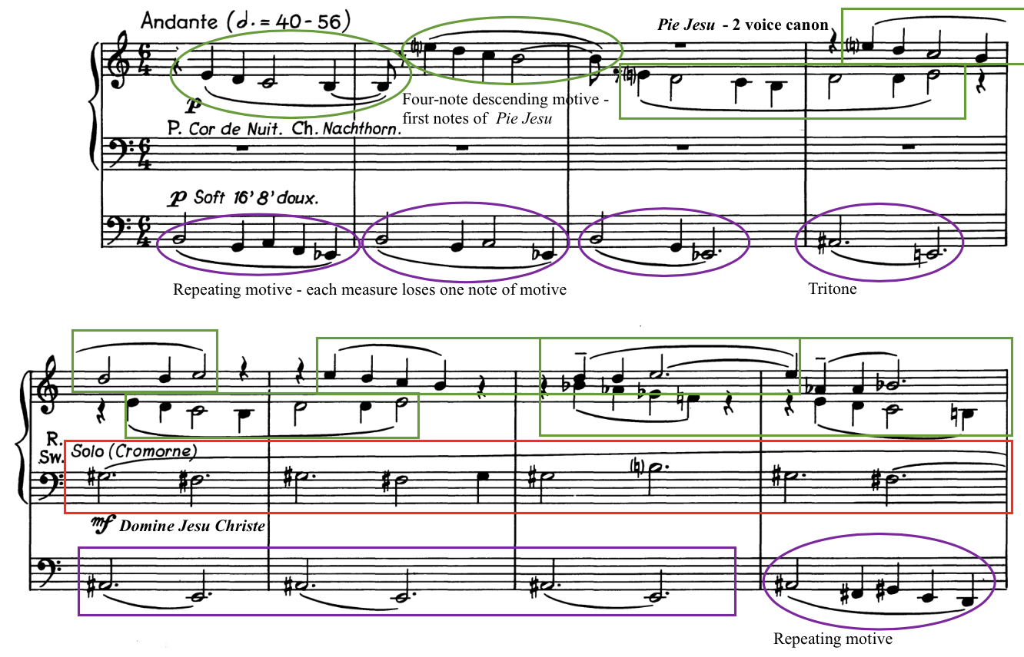

Compositional techniques from the previous movement are found in the third movement, creating a sense of continuity throughout Symphonia Elegiaca. The intervals of the tritone and third have been used most often throughout the work, as well as movements by half steps, all of which are present in the first eight measures of this movement. Van Hulse also makes frequent use of enharmonic transposition. The Domine Jesu Christe chant begins on G-sharp, the enharmonic equivalent of the second movement’s ending in A-flat minor.
While most of Van Hulse’s use of chant melodies in Symphonia Elegiaca uses only the first few notes or first phrase, this movement differs. Van Hulse uses multiple phrases of Domine Jesu Christe chant melody throughout the work. The first two lines of this chant melody are in the left hand on a solo organ voice. The melody then continues in the right hand, starting in the pickup to measure 17 and ending in measure 21. (See Example 6.6) This is the most prolonged use of any of the Requiem chant melodies found in Symphonia Elegiaca.
Following the statement of the Domine Jesu chant, Van Hulse reintroduces the melody from the repeating motive in the pedal, with slight changes each time. (See Example 6.6) A three-note figure is played by the right hand with different accompanimental figures in the left hand, alternating between different dynamic levels. These three notes, comprised of a starting note, an ascending neighbor tone, and back to the starting note, are the first three notes of the Requiem Aeternam chant. The Requiem Aeternam chant melody begins the entire Requiem Mass and is discussed in more detail in Chapter 7’s analysis of Movement V.

Example 6.6: “Divine Mercy,” Domine Jesu Christe and Requiem Aeternam, mm. 17-23
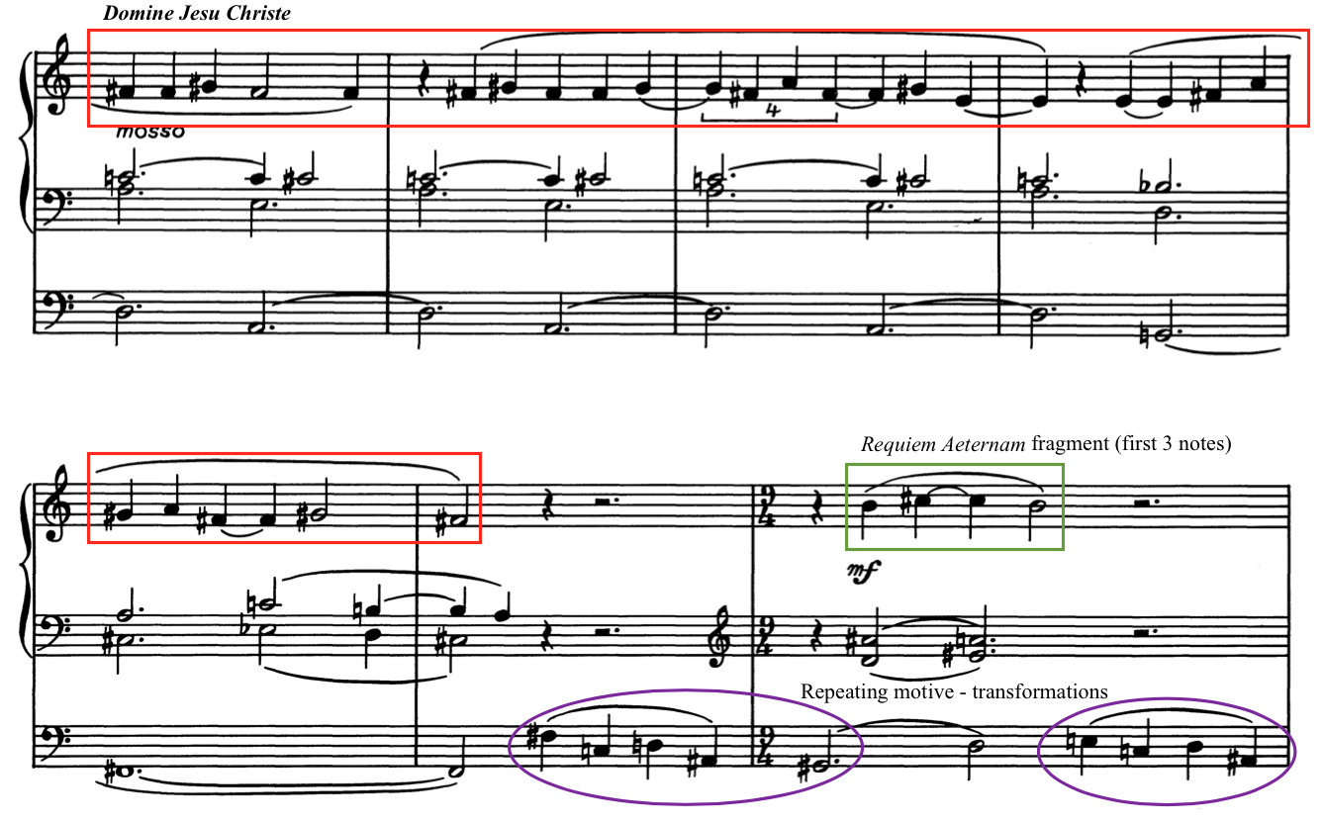

After the fragment of the Requiem Aeternam is stated three times, Van Hulse uses this motive to create a dramatic crescendo in measures 26 and 27 that peaks and then chromatically descends in pitch, harmony, and dynamics through measure 32. The pedal plays a solo of another transformation of the repeating motive in measure 33 before the reintroduction of the Pie Jesu motive, again using only the first four notes of the melody. (See Example 6.7) The motive is now higher in range in the right hand and alternated with the pedal, which is transformed into a descending four-note chromatic scale.

Example 6.7: “Divine Mercy,” Pie Jesu four-note motive, mm. 31-37
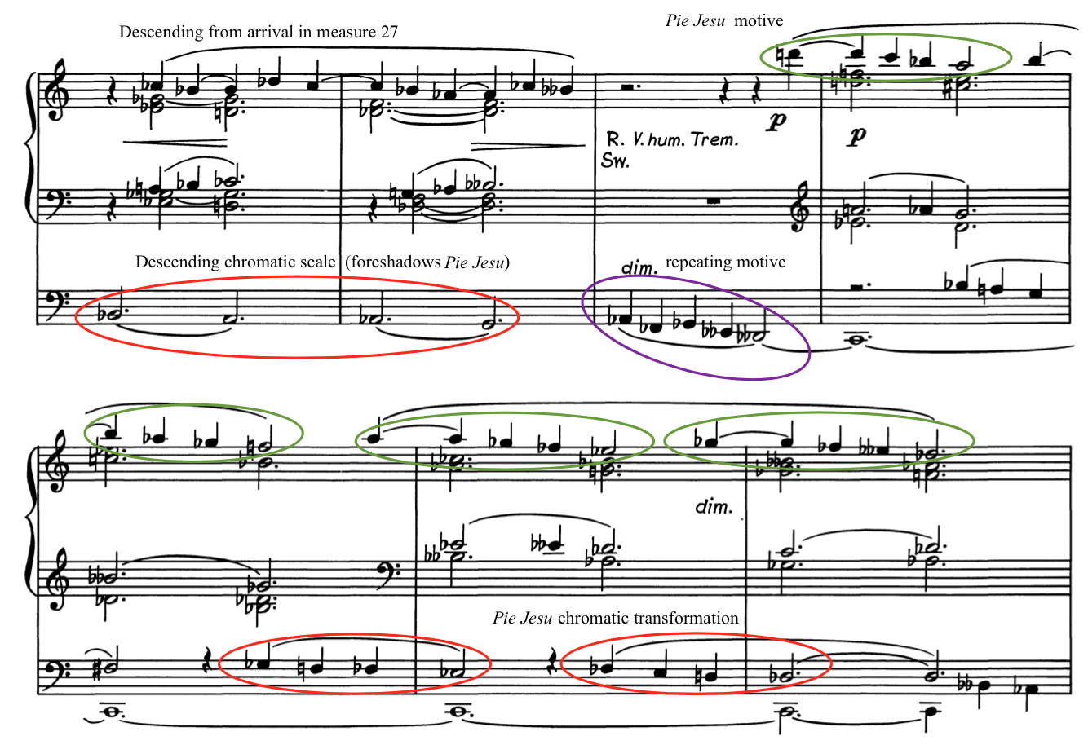

Van Hulse concludes Section A of the third movement in measures 38-46 by thinning out the texture and simplifying the harmony in his treatment of the Pie Jesu. In measures 38-41, Van Hulse uses a retrograde of the Pie Jesu chant, moving up from B to E instead of down from E to B. (See Example 6.8) The pedal returns to an alternation between G and C-sharp in another unsettling tritone accompaniment. The Pie Jesu four-note motive appears twice in measures 41-42 and once as a complete phrase in measures 43-44 to conclude the A section.

Example 6.8: “Divine Mercy,” Pie Jesu in retrograde, closing of Section A, mm. 38-45
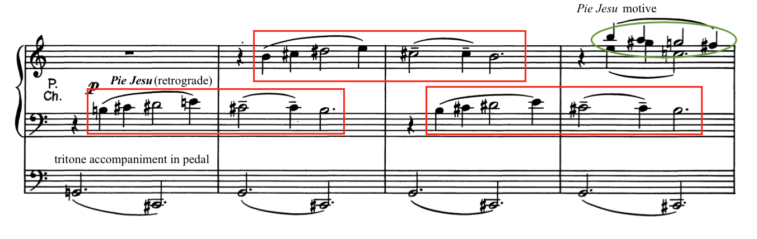

Analysis of Section B
Section B of the third movement, mm. 46-55, is based on a new section of the Domine Jesu Christe chant, “Hostias et preces tibi Domine, laudis offerimus,” which is translated as “Sacrifices and prayers of praise, O Lord, we offer to thee.” Marked with the word “salmeggiando,” Italian for “chanting,” Van Hulse uses this section to programmatically evoke the prayers of the faithful asking God to have mercy. This entire section is unmetered, which allows for the chant melodies to flow freely as if sung. First occurring over a pedal drone, the left and right hands play the chant melody in octaves. The Van Hulse modulates up a third to G-sharp minor in measure 47, now with the chant played by the right hand with chordal accompaniment in the left hand. (See Example 6.9)

Example 6.9: “Divine Mercy,” “Hostias” chant melody, second iteration, m. 47
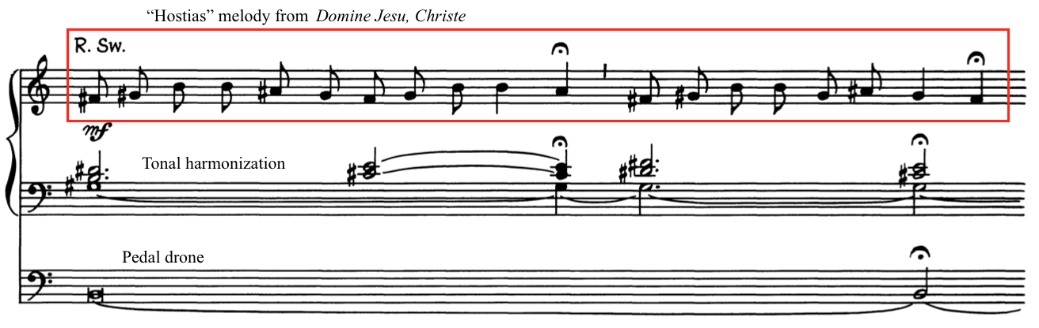

Section B is by far the most consonant section in the movement, with a slower harmonic rhythm and frequent cadences in major or minor tonalities. Throughout this section, Van Hulse evokes a worship service, with accompaniments one could easily imagine playing in a liturgical setting. The whole section is a quiet and tonal respite in an otherwise tumultuous and dissonant symphony.
Van Hulse uses a counter melody in measure 48 that does not occur in the Domine Jesu Christe or the Pie Jesu. (See Example 6.10) This counter melody appears two more times in this section, each time in a different key. In measure 48, it occurs in E minor. Then, in measure 51, it moves a half step lower in E-flat minor, appearing for the third time in F-sharp minor in measure 53. It also occurs in its original key of E minor at the end of the piece. Harmonized diatonically in the minor mode each time, it acts as a dialogue with the Domine Jesu chant.

Example 6.10: “Divine Mercy,” “Hostias” chant melody and Counter melody, mm. 47-48

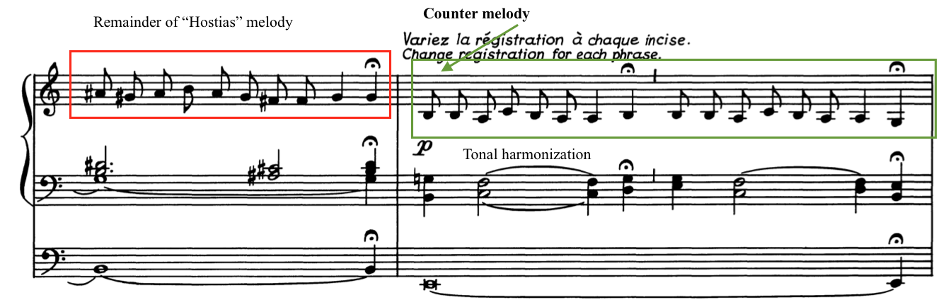

Van Hulse builds intensity through expansion of range and exploration of tonal centers in measures 46-54. What starts as a single chanted line in measure 46 develops into a persistent cry for mercy by measure 54. The “Hostias” section of the chant occurs four times in the B section, first in E minor, then G-sharp minor in measure 47. (See Table 6.2) Following the new counter melody in E minor, the Domine Jesu chant occurs in C-sharp minor in measure 49, enharmonically transposing to G-flat Major and cadencing in B-flat major in measure 50. This leads to the counter melody in measure 51 in E-flat minor.

Table 6.2: Outline of Movement III: Section B, m. 46-55
 | A | B | A | B | C | B | A | B
Measure | 46-47 | 48 | 49-50 | 51 | 52 | 53 | 54 | 55
Chant | Hostias | Counter melody | Hostias | Counter melody | Domine  (“fac eas”) | Counter melody | Hostias | Counter melody
Key | E m  G# m - C# m | E m | C# m  G-flat M - B-flat M | E-flat m/M | C m –  G m | F# m | F# M  C# M | C# m - G# M

Van Hulse introduces the last line of the Domine Jesu Christe chant melody in measure 52. (See Example 6.11) This line of chant occurs only once in the entire movement, giving it a special significance. This phrase of the chant text, beginning in the Latin “fac eas,” is translated as “Grant them, O Lord, to pass from death unto life.” This new chant phrase is prominently presented much higher in the range of the organ at a dynamic of forte. After this apex of Section B, the counter melody occurs for the third time in measure 53, followed by the last iteration of the original section of the Domine Jesu Christe chant melody. The counter melody occurs one final time in measure 55 and fades away to conclude Section B.

Example 6.11: “Divine Mercy,” Counter melody, “fac eas” chant phrase, mm. 51-52
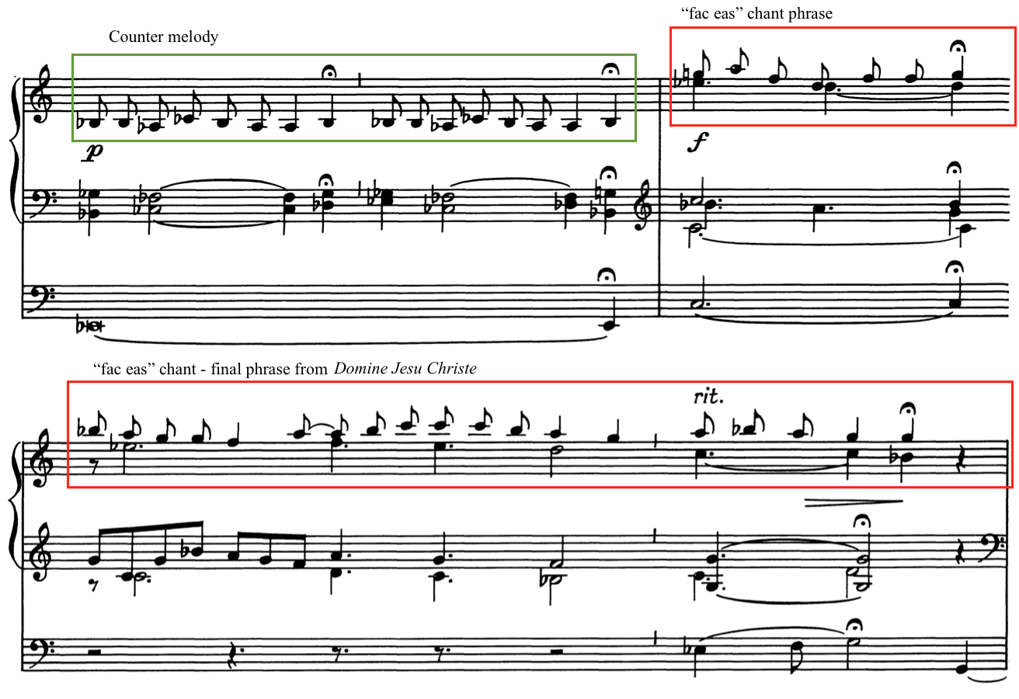

Analysis of Section C
Section C (mm. 56-75) shatters the prayerful character of Section B in measure 56 in what organist Laure Dermaut describes as a “macabre, powerful dance.” The time signature changes to 9/4 with a tempo indication of “Andante con moto” and begins fortissimo. (See Example 6.12) This is in stark contrast to the earlier quieter, unmeasured section. To begin this new section, Van Hulse uses another enharmonic modulation from G-sharp major to A-flat Major.

Example 6.12: “Divine Mercy,” Beginning of Section C using “Hostias” motive, mm. 55-59
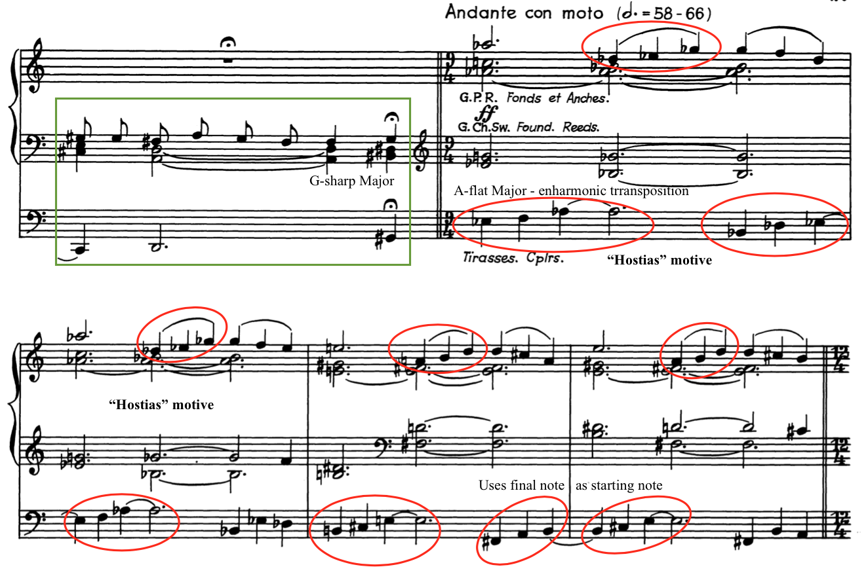

Back to using fragments of chant, Van Hulse uses only the first three notes of the previously used “Hostias” phrase of the Domine Jesu chant melody from Section B. Through the numerous entrances of this motive in many keys and ranges, Van Hulse programmatically depicts prayers ascending upward. The “Hostias” motive is presented in a dialogue between manuals and the pedal. (See Example 6.12) Van Hulse uses the motion from the fifth degree of the scale to the tonic found in this motive to rapidly tonicize to different key areas.
Van Hulse modulates from A-flat major to E Major in measure 58, again emphasizing the tritone. The time signature changes to 12/4 and the tonal center modulates to C major in measure 60. A new texture emerges in measure 62, with the “Hostias” motive continuously moving upward in the pedal while the hands play chords above. (See Example 6.13) Van Hulse alternates between D-flat Major and D Major in measures 62-63.

Example 6.13: “Divine Mercy,” Texture change in manuals and pedals, mm. 62-63
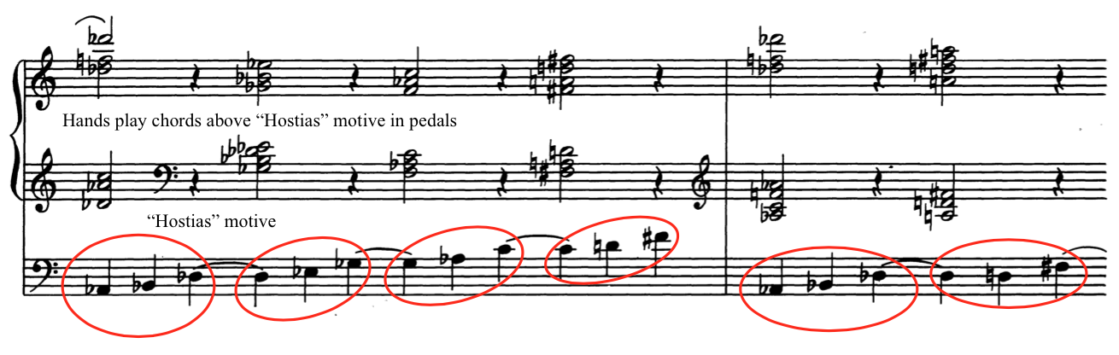

The texture changes again in measure 64 with a new time signature 6/4, followed by a tonal shift to C Major in measure 66. The hands now answer the pedal “Hostias” motive with their own chordal version of this motive in measures 64-67. (See Example 6.14) Van Hulse abruptly shifts in measure 70 to a transition section to close out Section C. Measures 70-73 contain the same progression based on the Requiem Aeternam that was first heard in measures 26-28 to transition back into the material from the beginning of the movement. A three-bar transition using melodic material from this progression brings the movement back to what appears to be a return to Section A.

Example 6.14: “Divine Mercy,” Texture change and Harmonic Progression, mm. 63-72
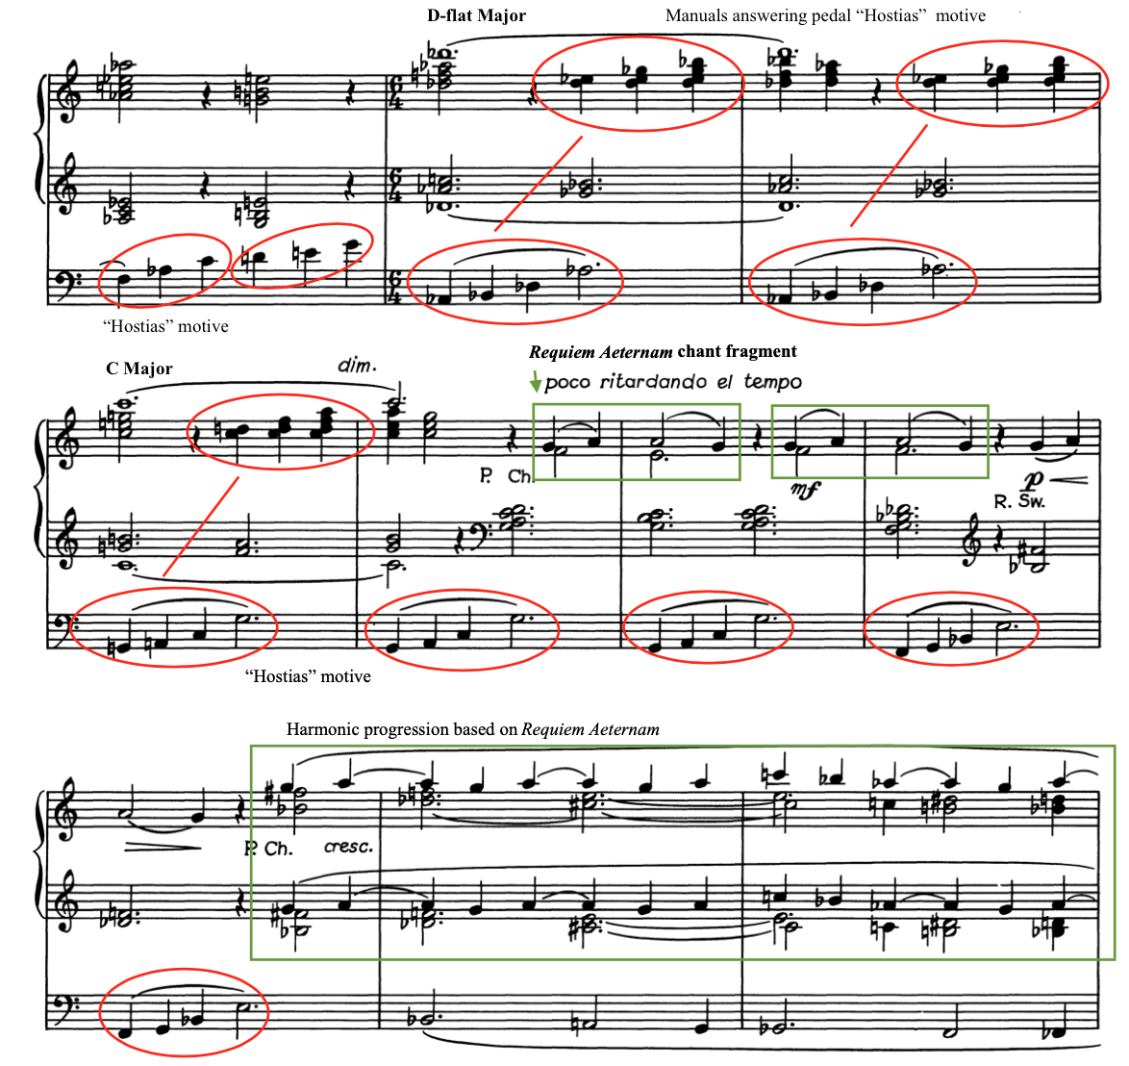

Analysis of A1 section
Van Hulse concludes Movement III with a brief restatement of the A section at measure 77. Identified as the A1 section by the author, mm. 77-92, Movement III returns to its original melodic an accompanimental figures with the reintroduction of the Pie Jesu and Domine Jesu Christe. The first phrase of the Domine Jesu is the extent of the recapitulation, with a sudden interruption at measure 83. Van Hulse abruptly reintroduces the counter melody from Section B of this movement. (See Example 6.15)

Example 6.15: “Divine Mercy,” Return Pie Jesu and Domine Jesu Christe, mm. 77-83
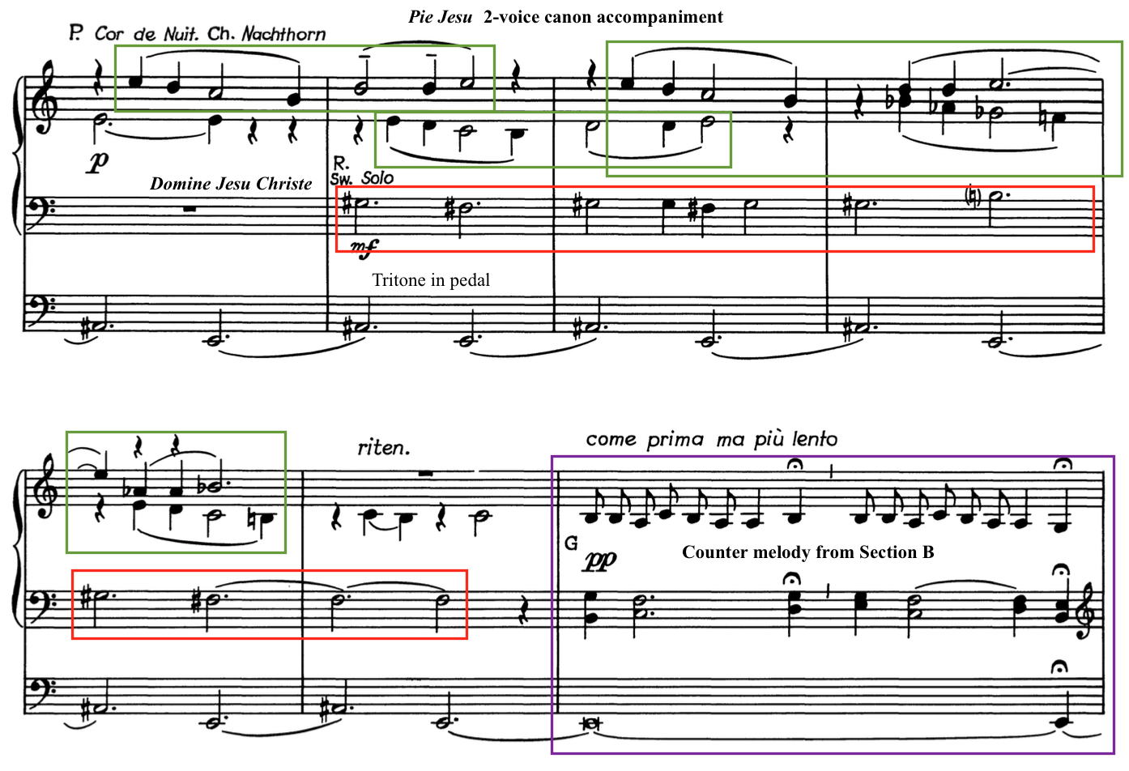

The last nine measures of the piece, measures 84-92, are a gradual diminuendo to a marking of pianissimo in measure 90 and “lento” in measure 91. Van Hulse accomplishes this by reducing registration and moving hands to the swell manual where the dynamics can be controlled with swell shades. Descending from the highest E in the manuals down to the bass clef, Van Hulse uses the four-note Pie Jesu motive to gradually die away. He gives indications of “dim.,” “mancando” (Italian – to die away), and a final tempo indication of “lento.” Van Hulse writes a diminished third in the pedal low in the register in measure 90 to create a low rumble, creating an unsettling character. (See Example 6.16) Movement III ends without resolution on a half-diminished chord, indicating that the prayers offered in this movement continue past the end of this movement.

Example 6.16: “Divine Mercy,” Conclusion of Movement III, mm. 88-92
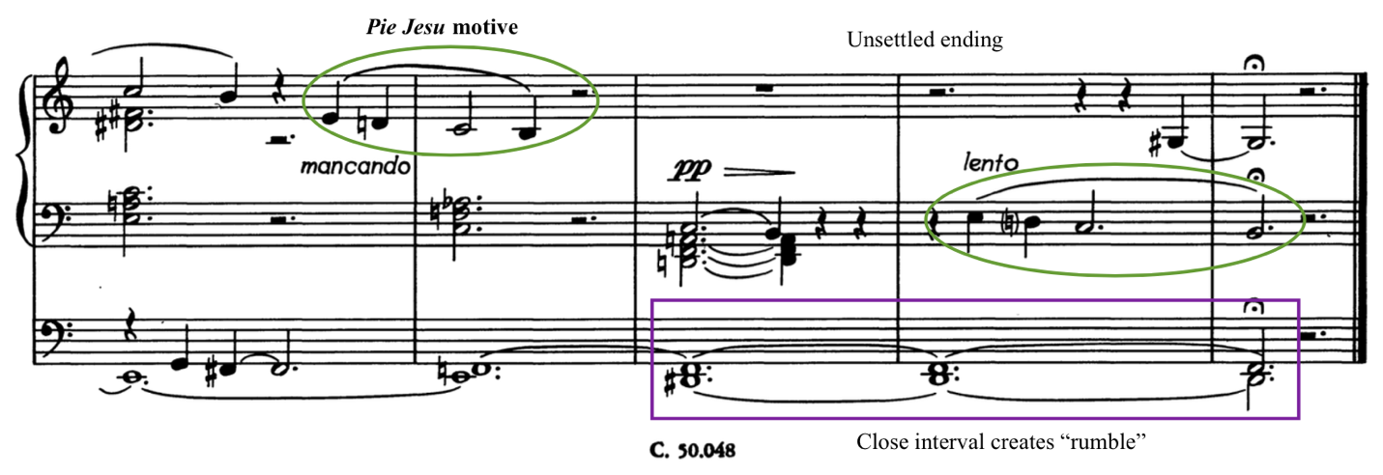
Through the use of the Pie Jesu and Domine Jesu Christe chant melodies, Van Hulse depicts prayers pleading for God’s mercy. In Section A, Van Hulse intertwines the two melodies and uses full phrases of the chant melodies. Section B features the “Hostias” phrase of the Domine Jesu Christe and alternates it with a counter melody. Section C takes a fragment from this “Hostias” phrase and develops it into a fortissimo dance, eventually returning to the original melodies of the Pie Jesu and Domine Jesu Christe. This focus on longer phrases of chant melodies and the reflective character of the movement provides a respite from the tumultuous movements before and after it.

Chapter 7: Analysis of Symphonia Elegiaca, op. 83: Movement IV
Chapter 7 provides an analysis of Movement IV: “Supreme Anguish” of Symphonia Elegiaca, op. 83 by Camil Van Hulse. The chapter begins with an introduction that provides a brief overview of programmatic content and structure. Following this, a compositional analysis further examines form, melody, harmony, rhythm, and thematic development. This analysis is organized in three sections: Analysis of Section A, Section B, and Section C. Score examples included in this chapter are from the Musikverlag Cranz edition and are reprinted with permission from the publisher. (See Appendix C)

Introduction to Movement IV
Movement IV: “Supreme Anguish” tells a captivating story of fear and anxiety of the soul before its judgment expressed in this fast-paced, sinister movement. This movement is the emotional apex of Symphonia Elegiaca, reintroducing themes from all previous movements. Set in a Moderato tempo, Van Hulse creates an improvisatory character by not including a time signature or key signature. As described in the manuscript, barlines are solely used for organization of accidentals. Written in 103 measures, this piece is approximately ten minutes in performance duration.
Much of the fourth movement is comprised of different variations of the “Mors stupebit” phrase of the Dies irae Sequence Hymn. (See Example 7.1) Van Hulse’s program notes provide this description: “Anguish and Fear of the soul before seeing its Creator and Judge. (based on the theme ‘Mors stupebit et natura’ – ‘Death and Nature are struck with awe.’” The text associated with this phrase is translated by Ron Jeffers as follows: “Death will be stunned, likewise nature, when all creation shall rise again to answer the One judging.” The “Mors stupebit” chant melody spans a wider range than the Dies irae theme, with a distinctive ascending third at the beginning and a descending fifth for the final interval. Four melodic transformations of this chant phrase occur throughout the movement, identified by the author as T1A, T1B, T1C, and T1D.

Example 7.1: “Mors stupebit” Gregorian chant
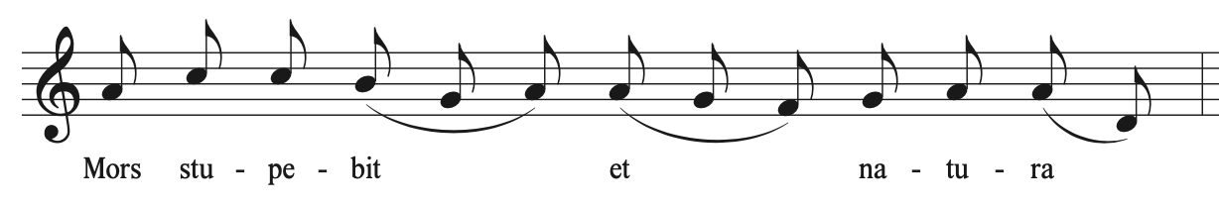

Like the second movement, the fourth movement, “Supreme Anguish,” of Symphonia Elegiaca is through-composed and organized into three distinct sections. (See Table 7.1) Van Hulse creates a sense of unrest by constantly transforming themes and moving to new ideas. An Introduction, mm. 1-17, is improvisatory in nature, dialoguing between fanfares and fragments of the “Mors stupebit” chant melody theme (T1). Section A, mm. 18-65 is by far the largest section of the fourth movement, containing the “Mors stupebit” theme (T1) and the Dies irae theme heard in the second movement (T2). Section B, mm. 78-95, directly quotes the “Death” theme from the first movement. In Section C, mm. 96-103, Van Hulse briefly quotes the Pie Jesu theme from Movement III and another variation of the “Mors stupebit.” At the conclusion of Movement IV, the organist is directed to segue into Movement V without pause. This collision of themes brings all of the programmatic ideas from in Symphonia Elegiaca together to express an emotional apex and juxtaposition of the themes of fear and mercy.

Table 7.1: Structural Outline of “Supreme Anguish”
Section | Introduction |  | Section A
Measure | 1-7 | 8-17 | 18-28 | 29-41 | 41-51 | 52-65
Theme | “Mors  Stupebit” T1 | T1A | “Mors” T1  T1B  Dies Irae T2 | T1B  T1C | T1B  T2 | T1D  T2
Key area | D m  Cm  A M | B-flat m  D m | D m - E m  A m - E m | A m  F m  D-flat m/C# m | E m  Sequence  G-flat m | F# m  D m  C m

Section | Section A - Transition |  | Section B | Section C
Measure | 66-73 | 74-77 | 78-95 | 96-103
Theme | T1D  T2A  T1C | T1B  T2 | Movement I “Death” Theme | Pie Jesu (Movement III)  “Mors stupebit” fragment
Key area | B-flat m  E m  B m | Chromatic | C m | Chromatic  D-flat M  Repeating motive segue

Analysis of Section A
Movement IV, “Supreme Anguish” begins with introductory material in measures 1-17. Measure 1 contains a dramatic flourish and fanfare, holding a sustained chord with the pedal playing rapid figuration underneath. This follows the serene ending of Movement III, contrasting abruptly with the quiet character that preceded it. The second measure is a complete contrast with constant sixteenth-note chords alternate between the right and left hands, introducing the first iteration of the “Mors stupebit” theme, T1. (See Example 7.2) Using the text “Death and nature are struck with awe,” the beginning of this movement the “Mors stupebit” theme to create a sense of unease and anticipation. This alternation between the fanfare and T1A occurs again in measures 3 and 4. The dramatic rests at the end of each measure are just as important, giving the sound a chance to reverberate in the room in which it is played.

Example 7.2: “Supreme Anguish,” first alternation of Fanfare and T1, mm. 1-2
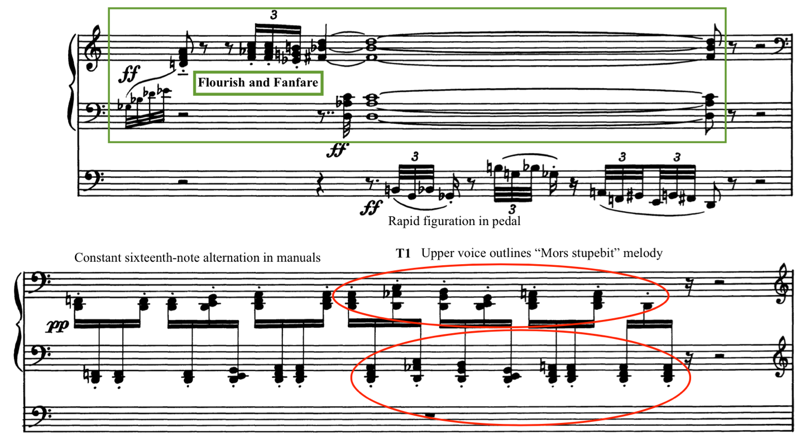

In measures 5-7, the fanfare becomes more frenzied with echoes using reed stops on multiple manuals, depicting more action and anticipation. This builds to measures 8-14, where the “Mors stupebit” theme is played in longer note values (T1A) over a winding sixteenth-note passage that also follows the contour of the theme (See Example 7.3). This presentation of the “Mors stupebit” theme pierces through at a high register in the key of B-flat minor. The sixteenth notes underneath foreshadow the future development of this theme found later in Section A. T1A is presented a final time an octave lower in D minor and fades away to a single note held in the pedal. This effect could be interpreted as the trumpet heralding the arrival of the Creator and Judge, as is described in the translation of the “Mors stupebit” text.

Example 7.3: “Supreme Anguish,” T1A – “Mors stupebit,” m. 8-10
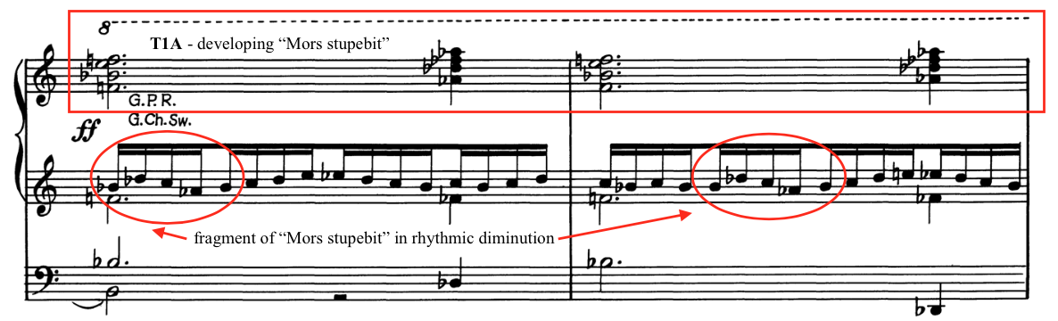
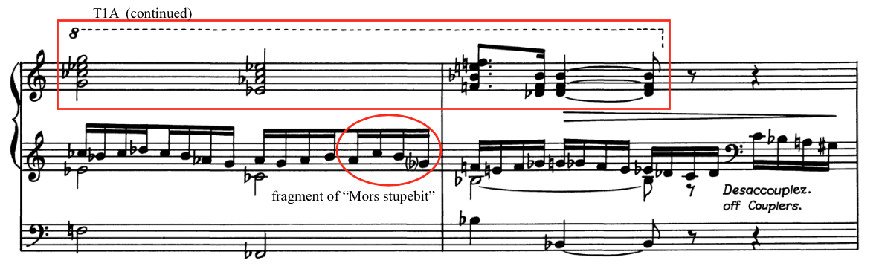

Following this extended introduction, Van Hulse begins Section A (mm. 18-77) with a driving rhythm of perpetual sixteenth-note chords, a development of the material first introduced in the second measure. (See Example 7.4) Called an “unstoppable flow of semiquavers” by Dermaut, this breathless onslaught of sixteenth notes portrays a heightening of anxiety, continually building from measures 18-64. There are two presentations of the “Mors stupebit” theme: T1 in measure 18 and transformation T1B in measure 19. T1B is a diminution of the musical material and is used as a recurring developmental force in Section A. Measures 18-28 feature dialogue between the “Mors stupebit” in the manuals (T1 and T1B) and the first four notes of the Dies irae theme, labeled by the author as T2 in this movement. These two themes are excerpted from the same melody, conveying similar themes of wrath and anguish.

Example 7.4: “Supreme Anguish,” “Mors stupebit” T1 and T1B, Dies irae T2, mm. 23-24
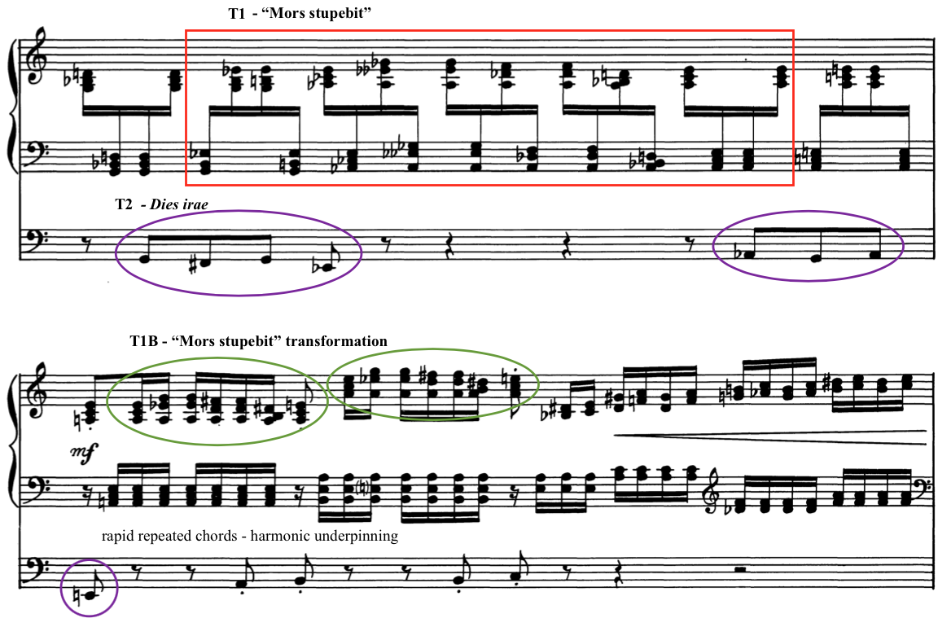

Van Hulse continues to intensify the feeling of anxiety by further use of perpetual motion rhythm, use of multiple key areas, and recurring statements of T1B. Brief statements of the Dies irae theme (T2) occur in the pedal, further underscoring the impending judgement of the soul. The presentation of T1B and T2 occur concurrently with interludes of augmented chords arpeggiating upwards starting in measure 27. Van Hulse uses measures 29-36 as an extended interlude to continue developing T1B and T2, creating momentum with alternating chords in the manuals. (See Example 7.5)

Example 7.5: “Supreme Anguish,” interlude in Section A, mm. 33-34
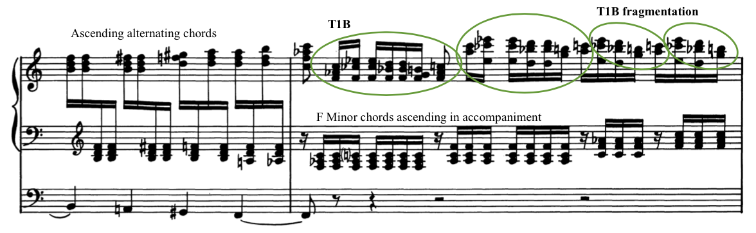

When the extended interlude in measures 29-36 concludes, Van Hulse introduces a new variation of the “Mors stupebit” theme in measure 37: T1C. (See Example 7.6) This theme is legato eighth notes in the pedal, a stark contrast to the detached articulation used in T1 and T1B, which highlights the melody and its anticipatory message of anguish even further. This variation occurs four times, followed by a return of the Dies irae motive (T2) in the pedal, measures 42-50. T1B again is the predominant variation, which Van Hulse continues to use throughout this section to develop the “Mors stupebit” theme. Van Hulse uses a constant barrage of sixteenth notes in measures 42-51 to build toward the first major arrival point of the movement in measure 52, emphasizing a different key area in each measure, with the Dies irae motive (T2) underpinning the harmonic shifts.

Example 7.6: “Supreme Anguish,” T1C in pedal with T1B in hands, mm. 39-40
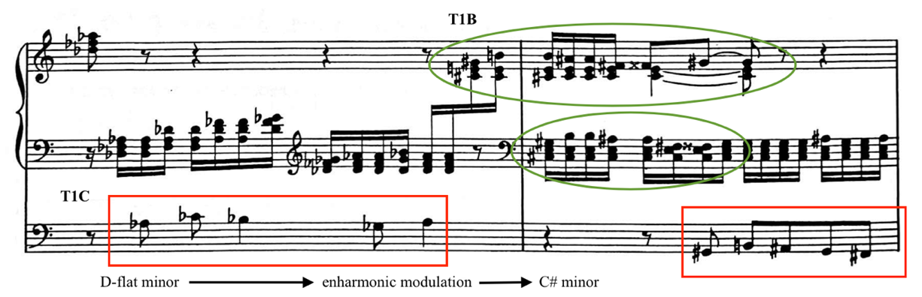

The climatic arrival of Section A occurs in measure 52 with the statement of T1D, the final transformation of the “Mors stupebit” theme. This transformation is the most dramatic expression of anguish to happen in this movement as Van Hulse moves closer to the programmatic entrance of Death in the next section. This variation uses musical material from the end of the “Mors stupebit” phrase, first expressed in alternating sixteenth-note chords between the hands and then as a legato melody over the alternating chords. (See Example 7.7) The first occurrence of T1D, which only happens twice, occurs in measures 52-54 in F-sharp minor. Van Hulse then modulates to D minor and repeats T1D in measures 57-58. The pedal provides a counter melody in both instances, playing T2 and holding notes of longer duration that provides stability while the hands play rapid chords above. Measures 58-65 are comprised of T1B and a sequence of arpeggiated augmented chord that move toward the next arrival point in measure 66.

Example 7.7: “Supreme Anguish,” T1D, mm. 51-54
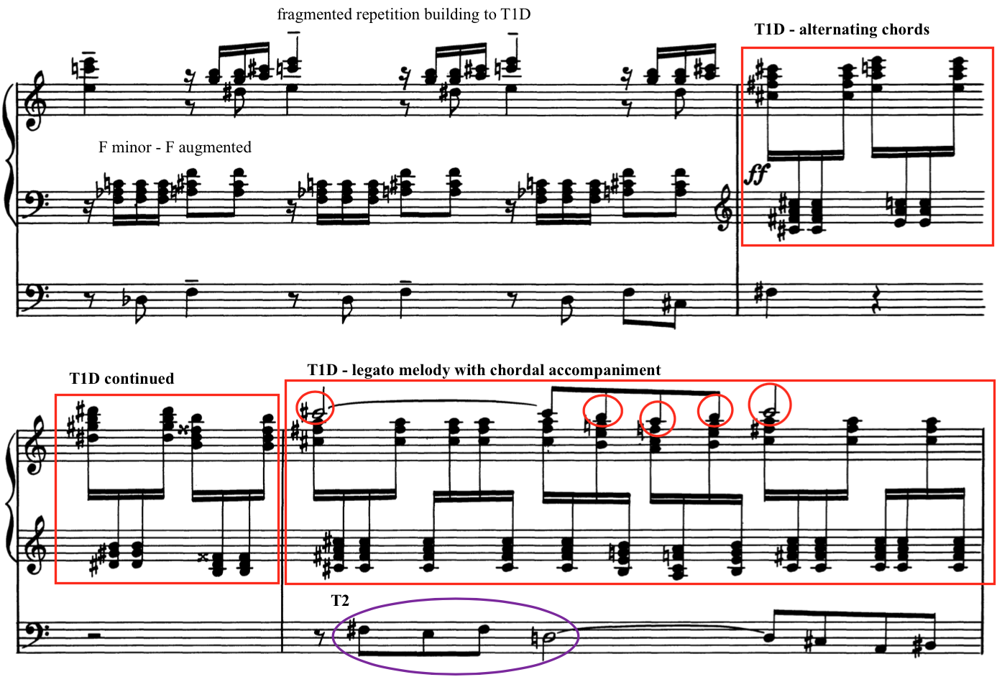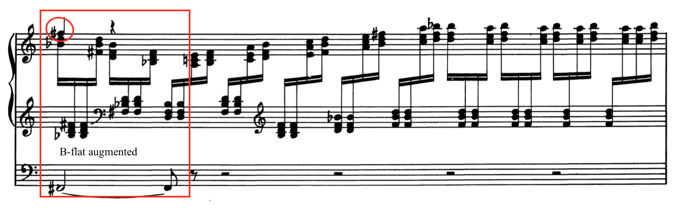

Measures 66-77 are a transitional area of Section A as Van Hulse begins to quote material from previous movements starting in measure 66, building toward the emotional apex of Movement IV. He uses more of the Dies irae melody (called T2A in this movement), first in the pedals underneath a toccata-like figuration of an open C chord in measures 66-68. The left hand also plays a variation of the T1C theme, which will appear in full force in measure 69. Measure 69 contains the T1C variation in the pedal, while the right hand quickly follows with the T2A theme in open chords above a continuing toccata figuration in the left hand. (See Example 7.8) This first quotation foreshadows the return of more themes from previous movements as suspense continues to build.

Example 7.8: “Supreme Anguish,” Dies irae theme T2A with T1C, mm. 66-69
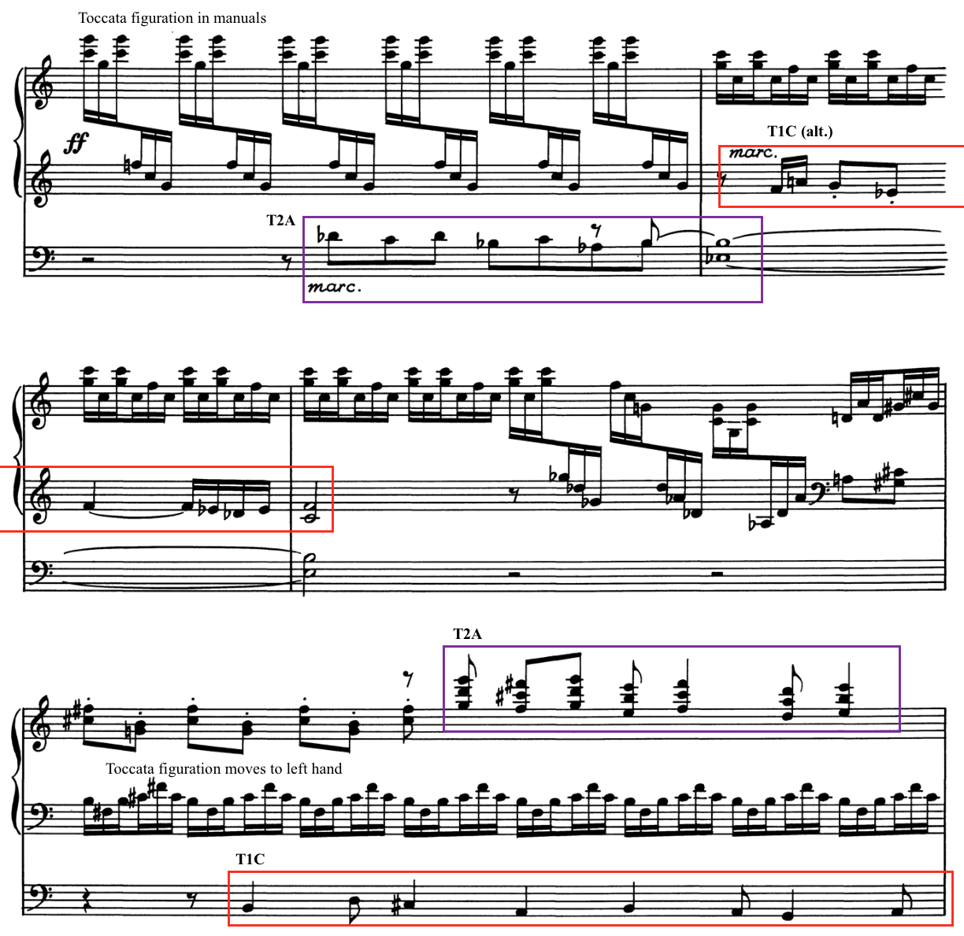
Van Hulse concludes Section A in measures 70-78 with statements of T1B and T2, while also introducing a new theme. This new theme, first appearing in measure 73, is identified by an ascending outline of a seventh chord. Van Hulse states this theme five times in the hands and pedals in quick succession, creating a dialogue between the highest and lowest textures. (See Example 7.9) Instead of continuing to develop this new melody, Van Hulse then uses T1B and the Dies irae melody (T2A) as a transition to the new section. Van Hulse fragments T1B, extracting a four-note descending motive, repeating it and increasing in intensity until an explosion of sound in measure 78 with the surprise arrival of the “Death” theme.

Example 7.9: “Supreme Anguish,” Fragmentation and building toward Section B, mm. 73-75
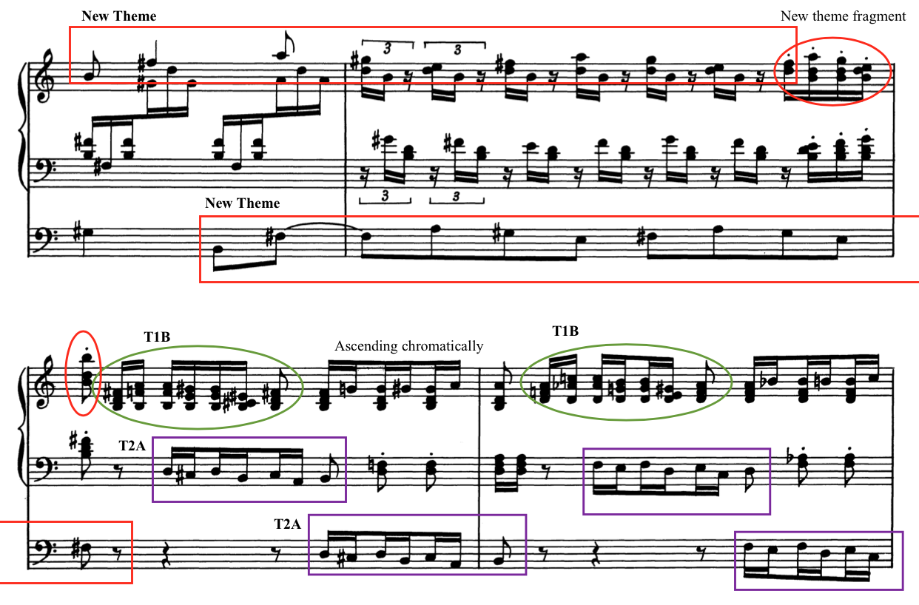

Analysis of Section B
Van Hulse uses Section B, mm. 78-95, to restate themes from previous movements in Symphonia Elegiaca. Section B, set in a time signature of 4/2 and a new tempo of Largo, begins with the recurring introduction first heard in Movement I, now with chromatic transformations. The musical material from Movement I: “Death” bursts forth from the frenzied transition in measure 78 with octaves Cs held in the right hand and the left hand holding a dissonant B-natural underneath. (See Example 7.10) The four-note chromatic motive heard in measure 77 sounds again, this time in the pedals as rapid eighth notes continuing the frantic motion from Section A. The surprise arrival of the “Death” theme proclaims the arrival of the Creator and Judge as the soul waits for judgment.

Example 7.10: “Supreme Anguish,” Transition into Section B, mm. 77-79
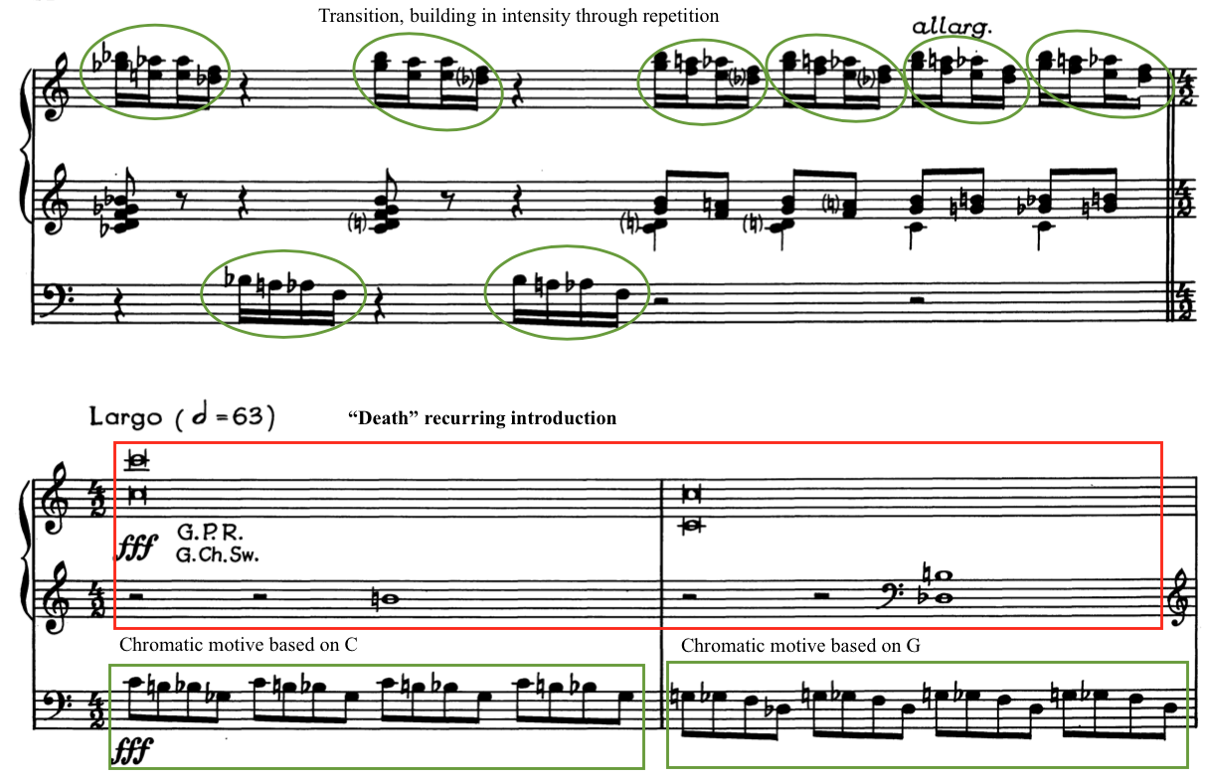

The “Death” theme from the first movement is reintroduced in measures 82-88. Van Hulse transforms this theme by ascending chromatically instead of the endless alternation between the E-flat and C. (See Example 7.11) The left hand trades the chromatic theme with the pedals in measures 82-88, while the right hand plays the altered “Death” theme. The whole and half notes abruptly end in measure 88 with a scalar passage in octaves made from the chromatic motive descending from high G down to low C in the pedals. This musical passage seems to convey that Death itself rises up to greet the soul.

Example 7.11: “Supreme Anguish,” Transformation of “Death” theme, mm. 82-84
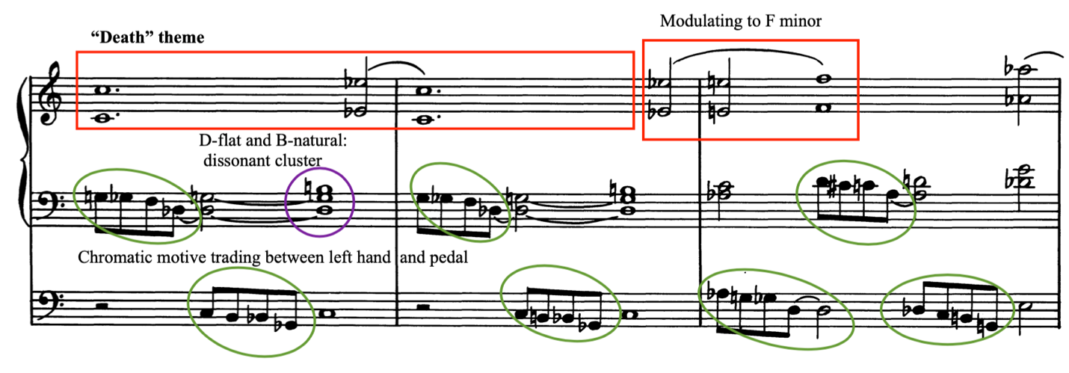

The hands move to the highest note on the organ manuals, the C three octaves above middle C, in measure 88. As the pedals arrive on the lowest note of the pedals in measure 89, the hands play B-natural and D-flat high above, which is a striking use of this cluster featured throughout Section B. Van Hulse repeats this pattern in the manuals three times, moving to a new manual each time and indicating a diminuendo, fading away into the organ's lower register. (See Example 7.12) Van Hulse ends the Section B in measure 95, augmenting the chromatic motive in the feet and finally resting on a chord using C, B, and D-flat in the pedals with the hands holding D-flat, B, F, and G. This unresolved chord gives no sense of closure to this section, but rather extends into the final section beginning at measure 96.

Example 7.12: “Supreme Anguish,” End of Section B, mm. 89-95
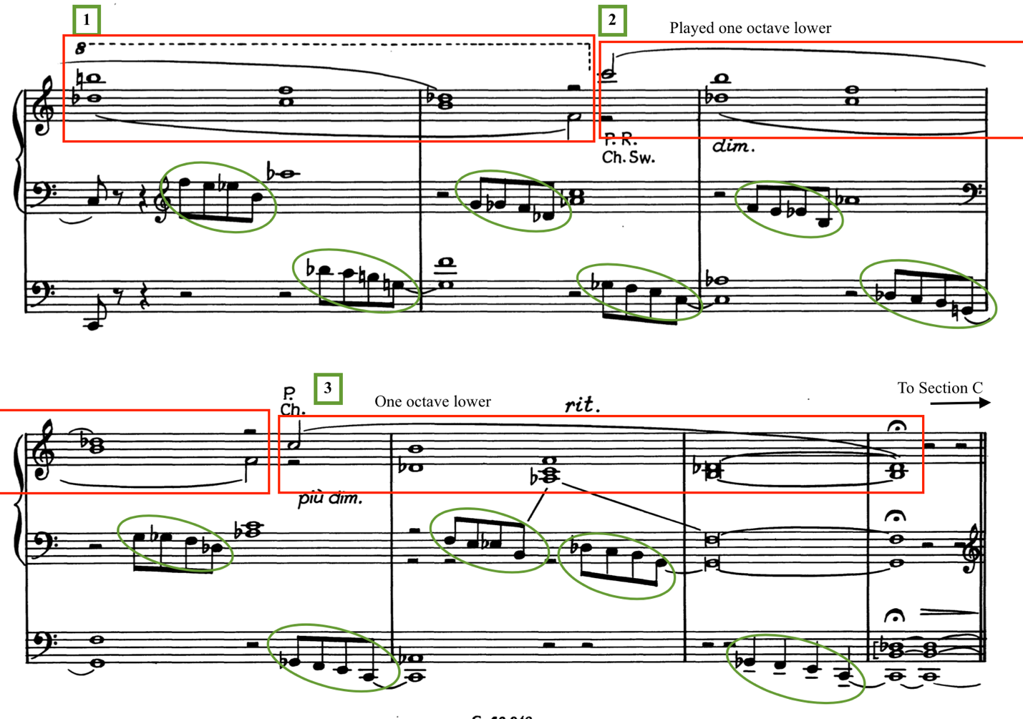

Analysis of Section C
In a surprising turn of events, “Supreme Anguish” concludes with none of the frenzy of the “Mors stupebit” nor the angular appearance of “Death.” Instead, the fourth movement ends with Section C, mm. 96-103, quoting the Pie Jesu motive from Movement III, a calling for Divine Mercy. Once the Pie Jesu motive is heard, Van Hulse has used themes from all three previous movements, using movement IV as a summation of the narrative that has happened in Symphonia Elegiaca.
Section C begins in measure 96 with the Pie Jesu motive stated four times in the manuals, starting high in range and descending with each repetition. (See Example 7.13) The last presentation of the Pie Jesu motive in measure 96 sustains into a chord that holds while the pedal plays pesante underneath. Van Hulse introduces one more melodic motive in measure 97, which is excerpted from the “Mors stupebit,” comprised of a melodic turn spanning a third that appears at the end of the “Mors stupebit” chant phrase. The fragment taken from the “Mors stupebit” supplants the Pie Jesu and indicates that mercy has not yet conquered fear.

Example 7.13: “Supreme Anguish,” Pie Jesu and “Mors stupebit” motive, mm. 96-97
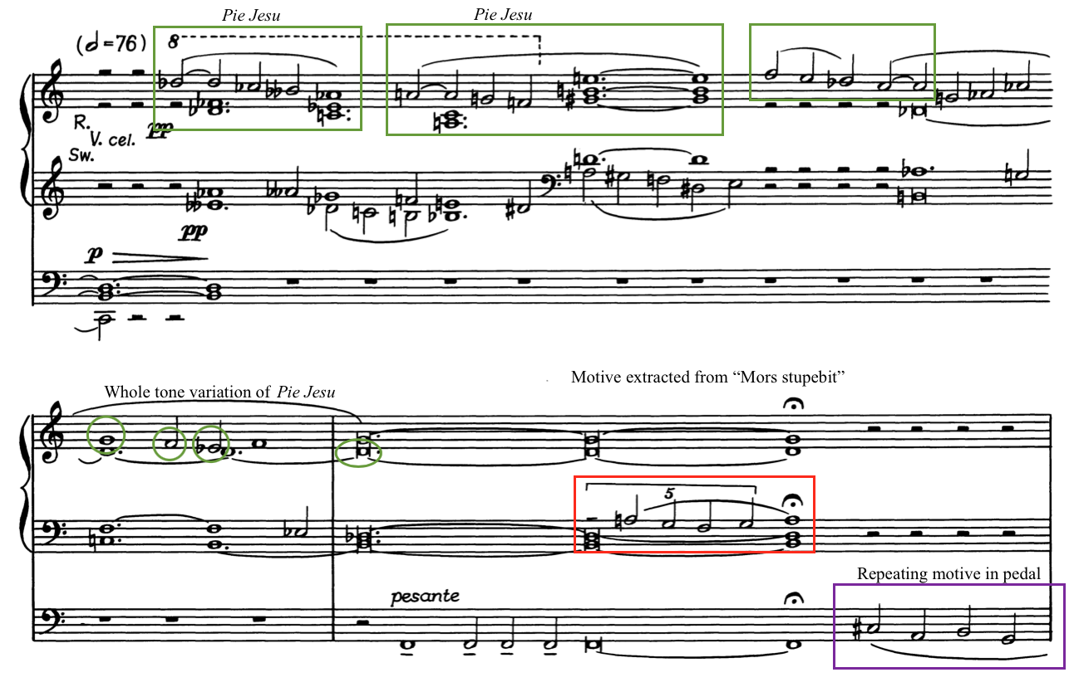

Echoes of Pie Jesu occur underneath in the lower voices, but the motive now is comprised entirely of whole steps. This altered figure then transforms into the repeating motive heard in Movement III, which uses a whole tone scale like the altered Pie Jesu. (See Example 7.14)

Example 7.14: “Supreme Anguish,” Transformation of Pie Jesu into the repeating motive
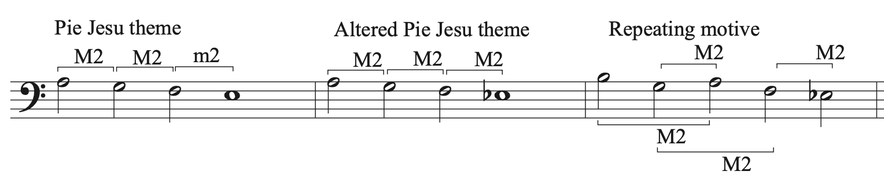
Following this introduction and a mark of “pesante” in the pedals in measure 97, the repeating motive found at the end of Movement II, and the beginning of Movement III reappears as a solo line in the pedal. This repeating motive occurs four times, each time centered around a different key area. It alternates with the “Mors stupebit” motive in the manuals as the piece lowers in register and dynamics. After a moment of consonance in D-flat major, the final iteration of the repeating motive in measure 103 in the pedals segues into the fifth and final movement: Resignation. (See Example 7.15)

Example 7.15: “Supreme Anguish,” End of Movement IV, m. 100-103
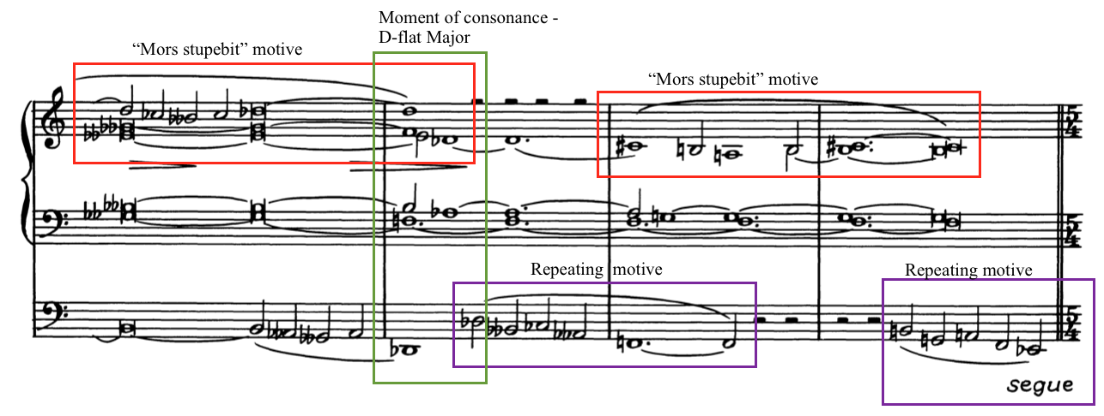
In some ways, Movements III and IV are linked by their beginning and ending. Programmatically, it appears that the prayers for mercy from movement III intercede in the end and ask for rest. But one final fragment of the “Mors stupebit” interjects in the final measures. The repeating motive from the beginning of the movement has the final word and continues into the next movement. Rather than judgment and anguish, Van Hulse ends the fourth movement in uncertainty and ambiguity with no resolution, the repeating motive drawing the listener into the final movement.

Chapter 8: Analysis of Symphonia Elegiaca, op. 83: Movement V
Chapter 8 provides an analysis of Movement V: “Resignation” of Symphonia Elegiaca, op. 83 by Camil Van Hulse. The chapter begins with an introduction that provides a brief overview of programmatic content and structure. Following this, a compositional analysis further examines form, melody, harmony, rhythm, and thematic development. This analysis is organized in four sections: Analysis of Section A, Section B, Section C and Section A1. Score examples included in this chapter are from the Musikverlag Cranz edition and are reprinted with permission from the publisher. (See Appendix C)

Introduction to Movement V
“Resignation” is the closing movement in Symphonia Elegiaca’s journey through the Requiem mass. Van Hulse writes the following description of the intended effect of this movement: “The bereaved pray in silence. (Based on the theme ‘Requiem Aeternam’ – ‘Grant them eternal rest, O Lord’)” This movement depicts those grieving and praying for solace the deceased, whose fate still seems to hang in the balance following the conclusion of the fourth movement. Written in 85 measures, this movement lasts approximately nine minutes in performance length. The distinctive tempo marking of Lugubremente suggests a mournful or somber tone. “Resignation” has an otherworldly ambiance, grounded only by a pervasive repeating motive, though even this motive changes with the many somber and ultimately peaceful moods expressed in this movement.

Claire Coci wrote to Van Hulse in a letter dated June 9, 1953, about this particular movement:
“Camil, I have only started to memorize the last movement yesterday, and may I say that I have seen much music, have learned much music, and have used much music, but I think, without a doubt, that this movement, in particular, has moments of tremendous greatness! I sincerely hope you will not disapprove too greatly of some of my interpretive ideas. Just remember that we Latins sometimes permit our imaginations to run away with us. For example, 21 bars from the end – I feel that the entire phrase depicts the final sealing of the tomb. I would like to build that phrase to a tremendous climax, and then, return to the farewell dirge.”

Her building to a climax is antithetical to Van Hulse’s marking of pianississimo in measure 65. Whether or not Van Hulse intended Section C to depict the sealing of the tomb, Coci thought that the fifth movement provided a sense of closure and peace.
Movement V is based on the Requiem Aeternam chant melody. (See Example 8.1) This melody is part of the Introit, which is the opening prayer to begin the Catholic burial service, the Requiem Mass. Van Hulse had only used the first three notes of this melody in previous movements. Interestingly, Van Hulse uses the beginning of the Requiem Mass to end Symphonia Elegiaca. Van Hulse uses the first phrase of this chant as an opening theme in Movement V, which is translated by Ron Jeffers as: “Rest eternal grant to them, O Lord, and let perpetual light shine upon them.” Van Hulse foreshadowed the use of the Requiem Aeternam chant melody by introducing the first three notes in Movement III. He features the entire first phrase prominently throughout Movement V.

Example 8.1: Requiem Aeternam chant melody
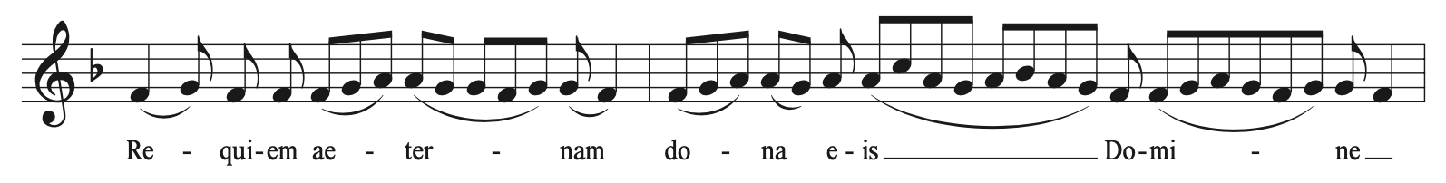

Movement V, “Resignation,” begins as Movement IV, “Supreme Anguish,” ended, with the repeating motive in the pedals. (See Example 8.2) Though this motive has appeared at the conclusion of the second and fourth movement or beginning of the third movement, it faded away or changed quickly. Van Hulse now uses it as a theme and developmental force in the movement. The beginning and end of the movement use this repeating motive as an ostinato. Written in 5/4, it marches unsteadily but inevitably as the chant tunes float above. When learning this movement, Claire Coci called this repeating motive a “farewell dirge.”

Example 8.2: “Resignation,” Repeating motive (RM1)
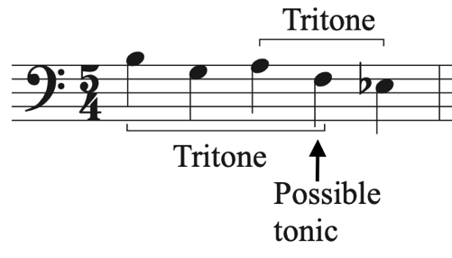

Movement V: “Resignation” is tonally ambiguous, though the repeating motive offers some clues to a tonal framework. The tonal center of the motive occurs on the fourth note, with the fifth note acting as the seventh degree of the scale and the first note a tritone away, a favorite interval in Symphonia Elegiaca. As was previously analyzed in Movement IV, the repeating motive is based entirely on whole steps, which is the pervading tonality throughout this piece. In addition to the transformation of the Pie Jesu, the contour of the repeating motive pays homage to the Dies irae as a subtle undertone to the work, emphasizing the dichotomy of fear and mercy in Symphonia Elegiaca.
The fifth movement is organized into four sections that develop two main themes: the Requiem Aeternam chant melody (T1) and the repeating motive (RM1). (See Table 8.1) Section A, mm. 1-28, contains T1 and RM, with one transformation of the repeating motive (RM2). Section B, mm. 29-45, develops T1 and introduces a new theme, T2, while also transforming the repeating motive (RM2, RM3). Section C, mm.46-65, fragments the Requiem Aeternam chant melody (T1A) and does not use the repeating motive until a transition back to Section A1. Section A1, mm. 66-85, returns to the texture and affect of Section A with T1 and RM1, acting as a Coda. In the last measures of the movement, Van Hulse states a transformed version of the Pie Jesu, implying the arrival of grace to the soul, to conclude Symphonia Elegiaca.

Table 8.1: Structural Outline of “Resignation”
Section | Section A |  |  | Section B
Measure | 1-12 | 13-18 | 19-28 | 29-35 | 36-45
Thematic material | T1 | T1 | T1 | T2 | T2
Repeating Motive | RM1 | RM1 | RM2  RM 1 | RM3 | RM3  RM3 alt.
Key Area | FM/D-flat M | D-flat M | G M | E m/Fm  D-flat pedal | D m/Em  B-flat pedal

Section C |  |  | Section A1
46-53 | 54-60 | 61-65 | 66-76 | 77-85
T1A | T1A | T1A  T1 (fragment) | T1 (fragment) | Pie Jesu
N/A | N/A | RM1 | RM1 | RM1
C M  A-flat pedal | C  Whole tone | C Whole tone | A m  Whole tone | D-flat M

Analysis of Section A
Section A of the fifth movement, mm. 1-28, introduces both themes that Van Hulse will develop throughout the movement: the Requiem Aeternam chant melody (T1) and the repeating motive (RM1). In measures 1-2, the pedal plays RM1 as a solo, establishing it as an ostinato in this section. (See Example 8.3) The left hand states the Requiem Aeternam theme (T1) in parallel thirds in measures 3-6, with the melody beginning on F and D-flat. The tonality of the piece is based on a whole tone scale through measure 18 with some slight chromaticism in measure 9. This chromatic gesture in the lowest voice of the left hand eventually turns into a pedal tone of D-flat, which is held from measures 10-12, preparing the listener for the next entrance of T1 starting on D-flat in measure 13.

Example 8.3: “Resignation,” Repeating motive (RM1), Requiem Aeternam (T1), mm. 1-12
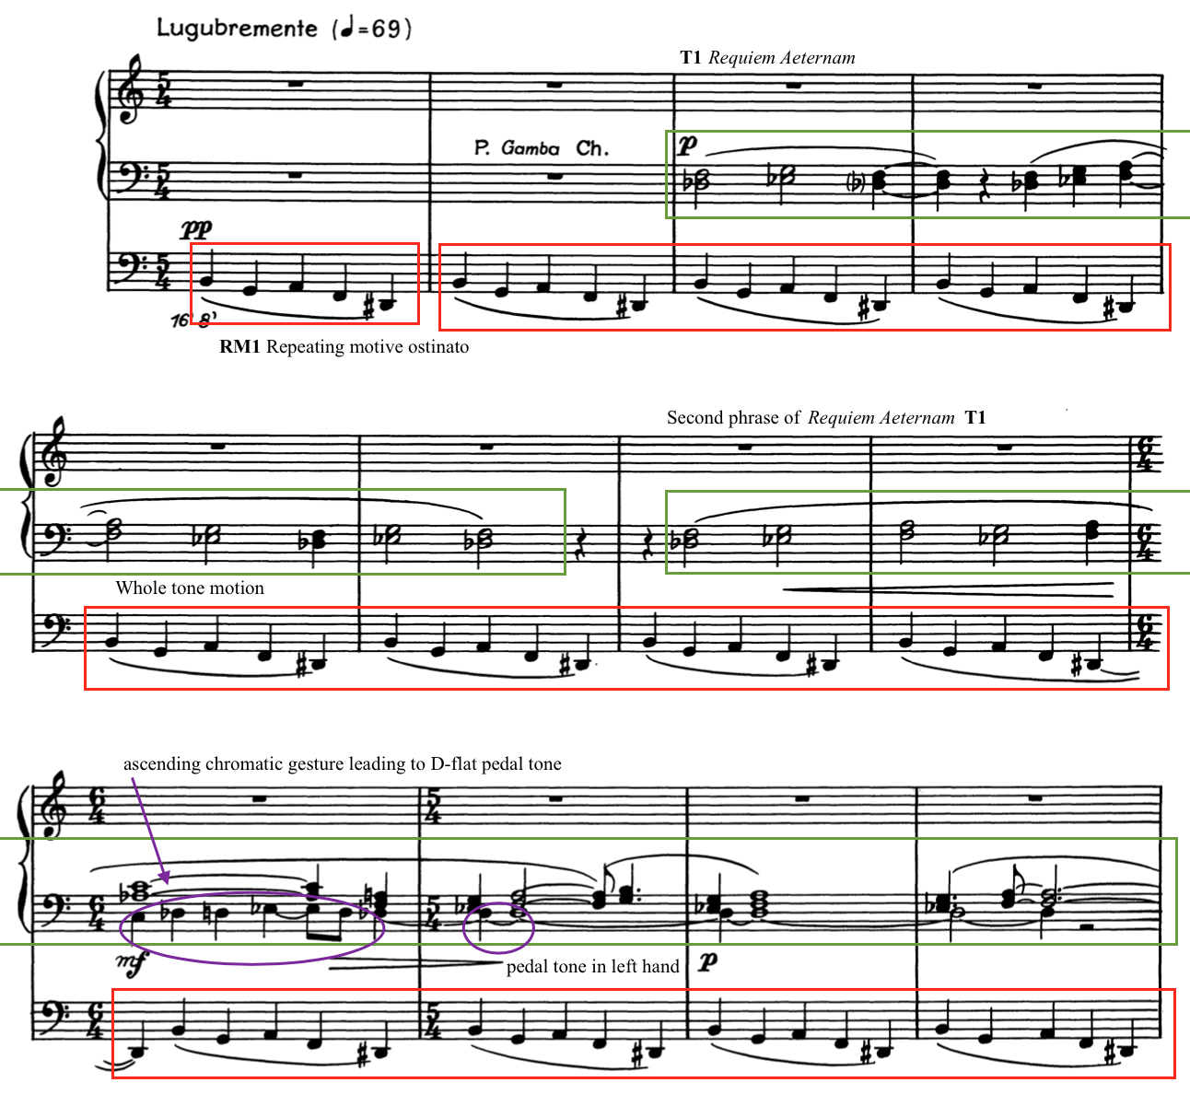

Measures 13-28 feature the Requiem Aeternam theme (T1) more prominently as a solo line. After the full statement of T1 ends in measure 12, Van Hulse continues the parallel thirds motion in the left hand as an accompanimental figure. The right hand states the first phrase of T1 in D-flat in measure 13 as a solo line. (See Example 8.4) The left hand then moves in parallel thirds up the whole tone scale to measure 19. With each increasingly prominent presentation of this theme, Van Hulse conveys a growing intensity in a prayer for peace and rest.

Example 8.4: “Resignation,” T1 as a solo line, mm. 13-16
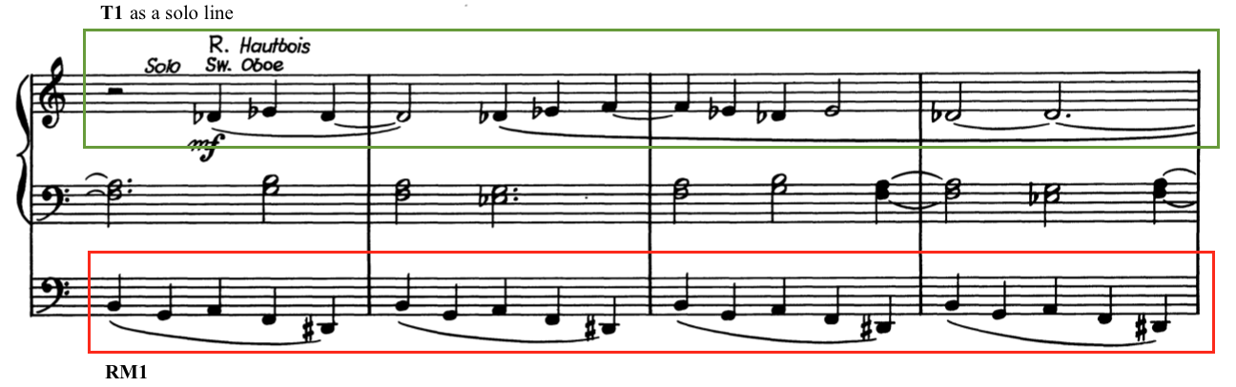

Van Hulse continues to develop the Requiem Aeternam theme and the repeating motive in measures 19-28 with a change to a more stable tonality and time signature. The time signature changes from 5/4 to 4/4, which alters the repeating motive from a five- to a four-note pattern. This new repeating motive (RM2) keeps the first three notes of RM1, but changes the last note to E-natural, removing the presence of the tritone and the whole tone tonality. (See Example 8.5) The Requiem Aeternam theme (T1), a solo in the right hand, now begins on G with the accompaniment continuing in parallel thirds. The melody again includes the second phrase of the Requiem Aeternam chant tune (T1A) in measures 23-27. Following this statement of T1, Van Hulse uses one measure of RM1 in 5/4 in measure 28 before returning to 4/4 and beginning Section B in measure 29. Prayers for peace and rest continue on as the repeating motive depicts the “farewell dirge” pressing forward.

Example 8.5: “Resignation,” Transformation of repeating motive (RM1 to RM2), mm. 17-20
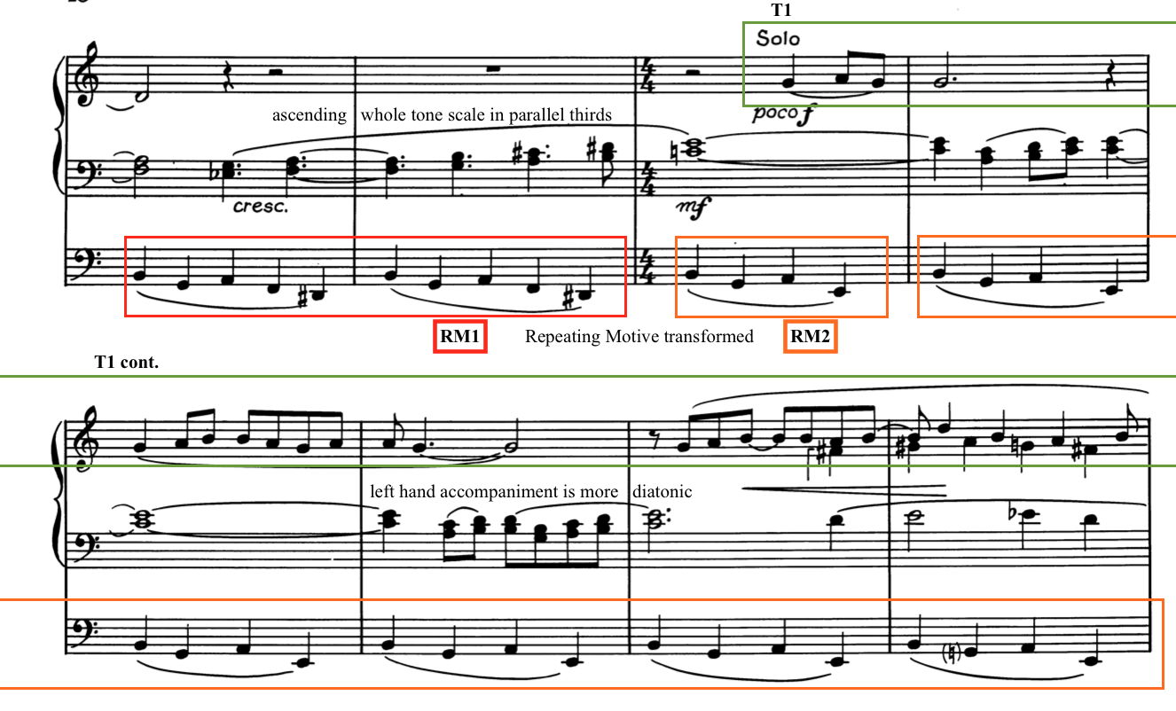

Analysis of Section B
Van Hulse begins Section B, mm. 29-45, with a new repeating motive (RM3) and a new theme (T2). The repeating motive that acted as a monophonic ostinato in the pedals, RM1 and RM2, now moves to the manuals as RM3, with the motion now occurring in four voices. (See Example 8.6) The right hand plays the altered repeating motive in the upper voice while also holding a D-flat pedal tone in the middle voice. The left hand plays a four-note descending chromatic scale, which moves to the right hand in measure 31 resulting in all three voices played in the right hand. The pedals alternate between a B-natural and an E-flat, the outer notes of the original repeating motive pattern. The dirge of the repeating motive reaches even more prominence as Van Hulse uses this motive to slowly build intensity and a sense of foreboding.

Example 8.6: “Resignation,” RM1 transforming to RM3, mm. 28-30
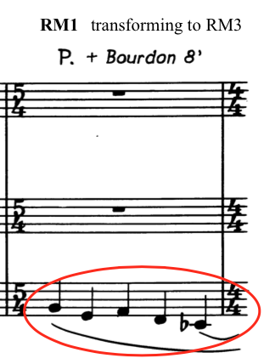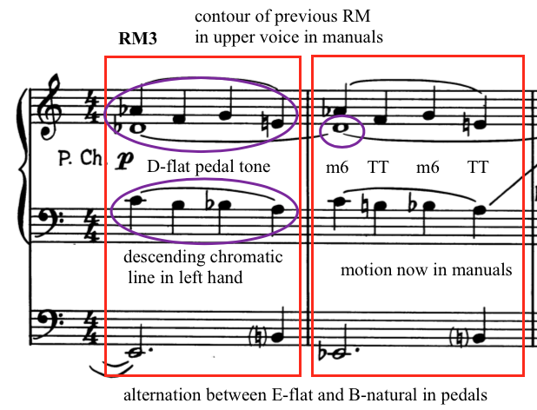

Van Hulse introduces T2 in the left hand in measure 31 after he establishes the new repeating motive in the right hand. Section B is a total change in use of themes from Section A; all voices move to different parts of the texture. Played above the right hand, this melody is the highest in the organ’s register so far in the movement, which lends prominence to the new melody. This theme (T2) does not belong in the Requiem Aeternam chant nor any other chants found in the Requiem Mass. T2 is comprised of two phrases with no repetitions and is not in same tonal center as the repeating motive, establishing an unsteady and pseudo-polytonal effect, continuing the feeling of uncertainty.
Underneath the second phrase of T2 in measures 35-40, Van Hulse adds a new bass line to the repeating motive in the hands (RM3 alt.). In measure 35, the bass line changes to A-G-sharp-E-flat while the notes in the manuals are transposed down a minor third. (See Example 8.7) The repeating motive (RM3 alt.) ends in measure 40 and the right hand plays a fragment of the Requiem Aeternam while the feet alternate between E-flat and A-flat.

Example 8.7: “Resignation,” First phrase of T2 and introduction of RM3 alt., mm. 31-36
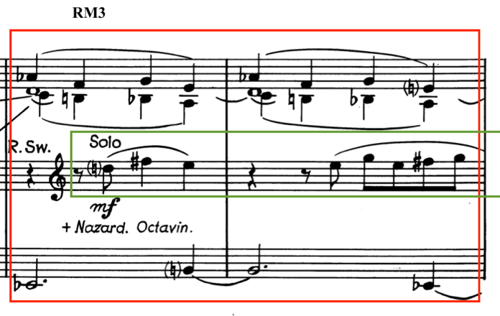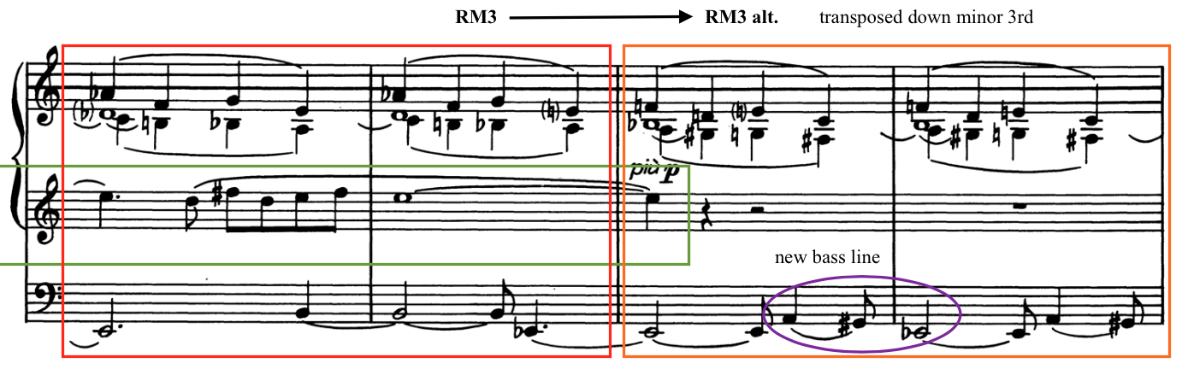

Measures 40-45 contain the end of the second phrase of T2 and foreshadow the return of the Requiem Aeternam chant melody in the following section. The final note of T2 sustains through measures 41-15, stretching out over the first three notes of the Requiem Aeternam theme (T1) as it begins to transition to the new section. (See Example 8.8) These measures alternate between two harmonies, which is similar to the harmonic motion in Movement I. Section B ends in measure 45 on a mysterious chord with no sense of tonal finality as the pedal sustains an A-flat into the beginning of Section C in measure 46. Each section moves forward into the next, which creates a sense of forward motion and momentum.

Example 8.8: “Resignation,” End of Section B, mm.41-45
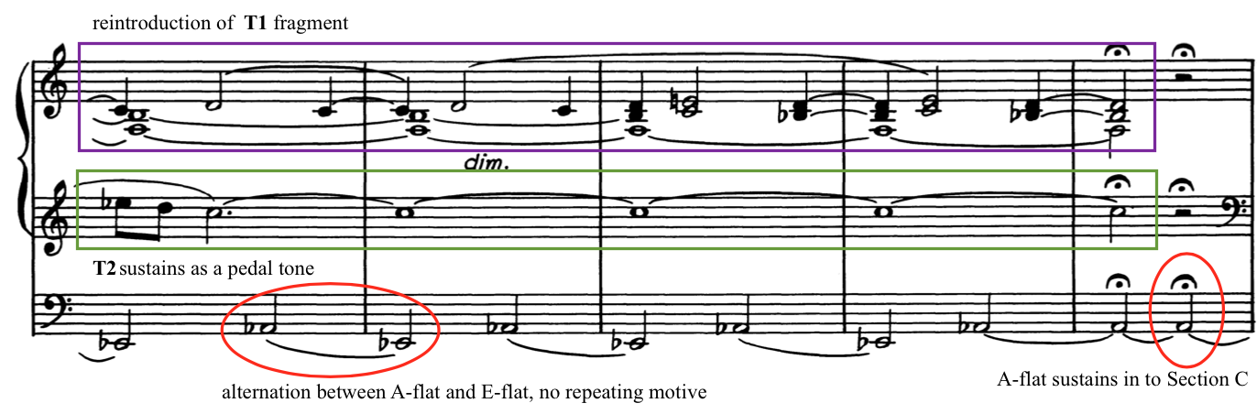

Analysis of Section C
Section C, mm. 46-62, features a return to the Requiem Aeternam chant melody with a slight variation (T1A), borrowing from a new section of the chant melody. There is no repeating motive present in this section. The hands play the new theme (T1A), a unison line that comes from the middle contrasting section of the Requiem Aeternam chant beginning at “Te decet hymnus Deus in Sion,” (See Example 8.9) Ron Jeffers translates the middle section as follows: “A hymn befits Thee, O God in Zion, and to thee a vow shall be fulfilled in Jerusalem. Hear my prayer, for unto thee all flesh shall come.” The supplication for God to hear prayers especially fits the programmatic effect in the fifth movement.

Example 8.9: “Resignation,” “Te decet” phrase from Requiem Aeternam chant melody
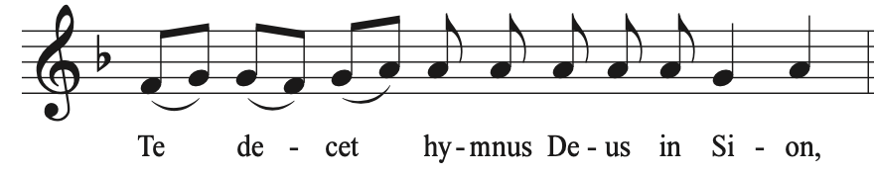

Section C begins in measure 46 with the “Te decet” phrase of the Requiem Aeternam chant melody (T1A) stated in octaves in the manuals over a pedal tone of A-flat. (See Example 8.10) This variation on T1 was alluded to in Section B, measures 43-45. T1A is stated again in the left hand in C and in the pedals starting on G-flat in measures 46-53. These entrances overlap, emulating multiple prayers happening simultaneously.

Example 8.10: “Resignation,” “Te decet” phrase (T1A), mm. 46-50
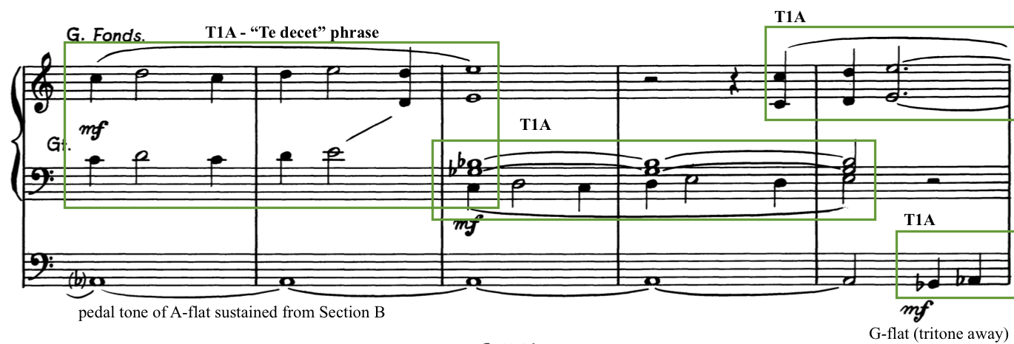

Van Hulse uses T1A to build to a climax in Movement V. The unison entrances of T1A build into augmented chords played in both hands in measure 54, using the whole tone scale. Following the contour of the melody, they use an ascending planing motion in triplets that crescendos to a climax in measure 60. (See Example 8.11) With this arrival, the hands hold a C augmented chord while the pedals tumble down from high D on the pedalboard to an eventual unison arrival at low C.

Example 8.11: “Resignation,” Climax of Movement V, mm. 56-60
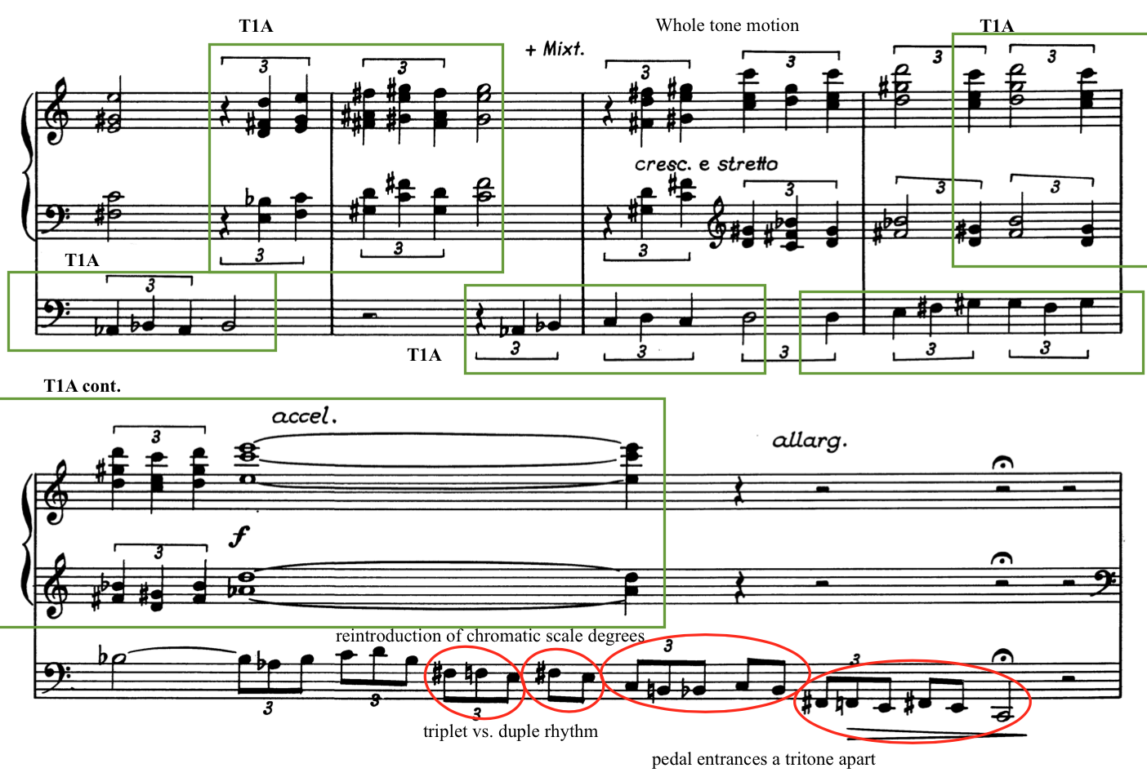

The last five measures of Section C, mm.61-65, return to previous themes and prepare for the arrival of Section A1 in measure 66. Returning to mezzo-forte in measure 61, T1A is played as a unison line in three voices, each starting in a different key center (C, A-flat, and E), spelling out an inverted augmented chord. (See Example 8.12) The E in the pedal sustains underneath while the hands play a fragment of T1, arriving at a tonally ambiguous chord at the end of measure 62.

Example 8.12: “Resignation,” T1A and T1, mm. 61-62
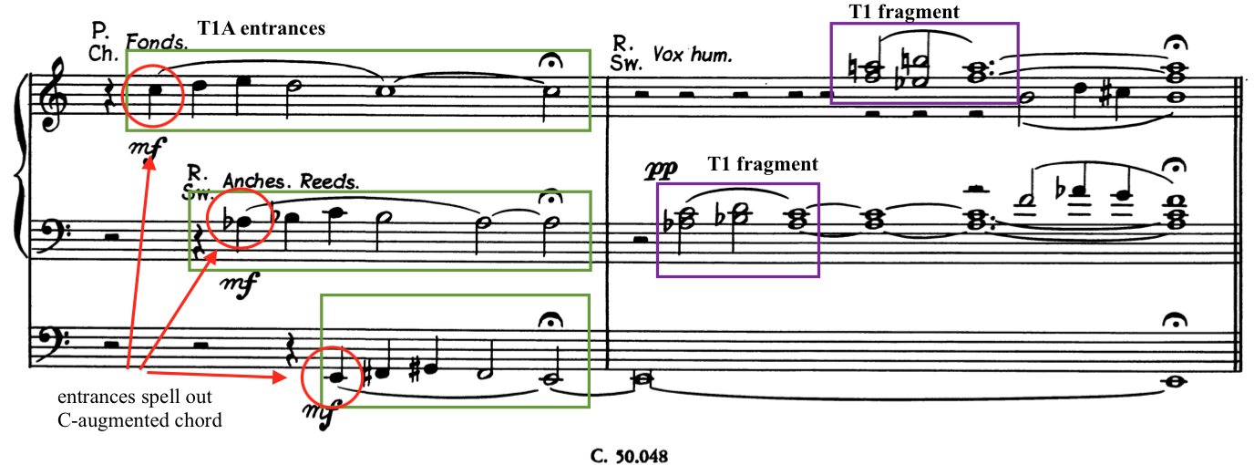

Measures 63-65 end Section C quietly with another fragment of the Requiem Aeternam and reintroduce the repeating motive (RM1) in the pedals. (See Example 8.13) Another ethereal chord marked pianississimo closes the penultimate section of this movement. Called the “sealing of the tomb” by Claire Coci, this otherworldly ending leads to the concluding section of the fifth movement of Symphonia Elegiaca.

Example 8.13: “Resignation,” Ending of Section C and beginning of Section A1, mm. 63-67
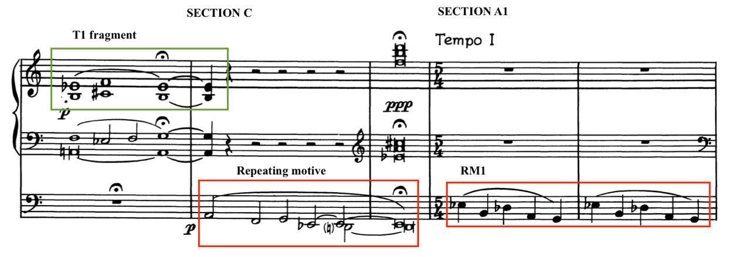

Analysis of Section A1
Marked Tempo I and set in a time signature of 5/4, Section A1, mm. 66-85, serves as a Coda with brief returning statements of themes from Section A. Though spelled differently from its first appearance in Section A, RM1 returns in Section A1 in measure 66. The tritone returns in the repeating motive, this time spelled as a diminished 5th instead of an augmented 4th. The tonal center of A is temporarily created by entrances of fragmented T1 on A and C-sharp. (See Example 8.14)

Example 8.14: “Resignation,” RM1 and T1, the beginning of final ascent, mm. 68-72
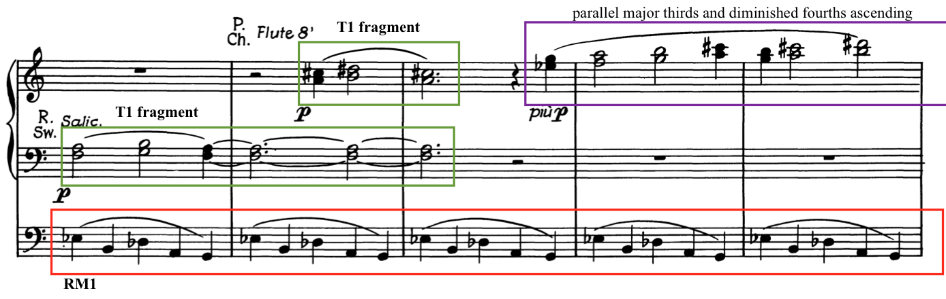

Van Hulse subverts expectations of a return of themes from Section A by stating only the first three notes of the Requiem Aeternam (T1 frag.) in measure 68. The right hand ascends increasingly higher, playing parallel major thirds and diminished fourths until reaching the highest B and G on the manuals, indicating a decrescendo until it disappears in measure 76. This effect could be interpreted to be the prayers of the faithful ascending heavenward and being received while those on earth continue to continue onward.
After this effect dies away in measure 76, the repeating motive continues once more in measures 77 and 78, elongating and arriving at low F in the pedals, the original key center of the Requiem Aeternam theme heard at the beginning of this movement. No further Requiem Aeternam fragments are heard. Rather, in measures 80-83, a descending line marked pianissimo plays in the manuals. The lowest voice of the chords is a descending D-flat major scale. Played four notes at a time, it is reminiscent of the Pie Jesu heard so many times throughout Symphonia Elegiaca. The whole tone tonality is replaced with a moment of major tonality and two final mysterious chords in the low register of the manuals. This descending melody could be interpreted as the indescribable arrival of God’s mercy on the soul following the ascending prayers.

Example 8.15: “Resignation,” Return of Pie Jesu, morendo, mm. 78-85
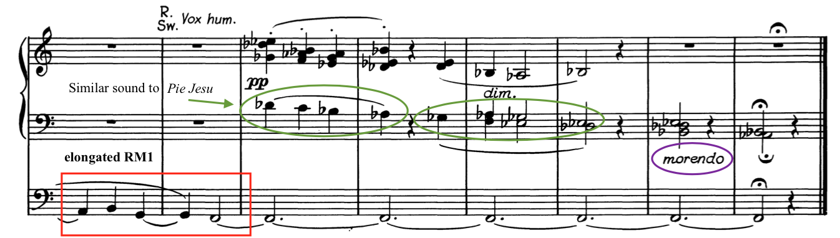

Death is literally the first and last word in Symphonia Elegiaca. Van Hulse indicates “morendo” in the penultimate measure. This work, in which the central theme is death, dies away with three notes holding a sonority that leaves more questions than answers. The Dies irae and “Death” themes defeated by the themes depicting rest and mercy. There is no final cadence, but rather an evocative picture lingers of a soul rising to paradise while souls still grieve below.

Chapter 9: Conclusion

Summary
Camil Van Hulse (1987-1988) was a prolific composer who contributed significantly to the musical communities in Tucson, Arizona, and Sint-Niklaas, Belgium. Though he was born and educated in Belgium, he moved to the United States after suffering gas poisoning from trench warfare in World War I. After his immigration, Van Hulse was first known as a concert pianist, touring in the United States as well as countries in Central and South America. He eventually settled in Tucson, Arizona, where he was instrumental in further establishing the musical scene there, which included founding the Tucson Symphony Orchestra.
Van Hulse was a founding member in many Tucson musical societies still in operation today. He helped found and was the first conductor of the Tucson Symphony Orchestra in 1928-1929. Van Hulse was a founder of The Tucson Chamber Music Society, the Tucson Chorus, and the Society of Arizona Composers. He was also a founding member of the Tucson chapter of the American Guild of Organists, later serving as dean of that chapter.
In addition to his involvement in this musical groups, Van Hulse was also a church musician for much of his career in Tucson. He served in a variety of roles including organist, choirmaster, and director of a Gregorian Schola at All Saints Catholic Church and SS. Peter and Paul Catholic Church in Tucson in the years 1939-1957. At times, Van Hulse even worked in both places. He eventually turned full-time to composition and teaching later in his career in 1957.
Van Hulse was recognized during his lifetime for his contributions to music and his community with many awards for composition and frequent programming of his works by concert artists. Some of these awards include composition competitions held by music publishers and recognitions by the Belgian government. He was honored with the awards “Knight of the Order of Leopold II” and “Officer of the Order of the Crown” from the Belgian government for his contributions to music. He wrote many large-scale compositions, including several orchestral symphonies, large choral works, and organ works. Those organ works include three organ symphonies and several tone poems and suites. For a complete listing of Van Hulse’s published solo organ works, please refer to Appendix A.
Camil Van Hulse wrote Symphonia Elegiaca, op.83 in 1952 and 1953 in response to the death of Bernard La Berge, an influential impresario based in Montreal and New York. Van Hulse dedicated this work to La Berge’s wife, Claire Coci, a well-known concert organist. Claire Coci gave the premiere performance of Symphonia Elegiaca in 1954 in Tucson and New York City. Symphonia Elegiaca was later published in 1956 by Edition Cranz in Mainz, Germany.
Symphonia Elegiaca is a solo organ work written in five movements. Written with the programmatic titles of “Death,” “Last Judgment,” “Divine Mercy,” “Supreme Anguish,” and “Resignation,” this composition is based on chant melodies from the Catholic burial service, the Requiem Mass. These chant melodies includes the Introit Requiem Aeternam, the Sequence Hymn Dies irae, and the Offertory Domine Jesu Christe. Multiple phrases of the Dies irae chant are used, which includes the opening phrase Dies irae, the “Mors stupebit” phrase and the Pie Jesu, which is used extensively throughout Symphonia Elegiaca. Van Hulse consulted with Claire Coci in many letters about these themes and was met with her strong approval as a fitting tribute to Bernard La Berge.
Symphonia Elegiaca contains several musical ideas that provide a continuous thread in an otherwise through-composed work. The entire emotional sequence from Movement I to Movement V hinges on the journey of the human soul after death and the quest for God’s mercy. Symphonia Elegiaca is characterized by a constant tension between fear, often depicted by the Dies irae, and mercy depicted by the Pie Jesu. Van Hulse does not shy away from the idea of death, but rather confronts it directly with the way he treats the programmatic and musical material.
Van Hulse uses several compositional methods to depict uncertainty and the juxtaposition of fear and mercy through Symphonia Elegiaca. He uses the tritone interval throughout the symphony as a vehicle for stark contrasts and unexpected key relations. He also uses the whole tone scale and augmented chords to modulate or move freely between tonalities. Constant motion between key centers and lack of resolution after dissonance in many movements also subvert traditional expectations. The use and transformation of the repeating motive, continuous development of the Dies irae, and prevalence of the Pie Jesu are a constant thread. The Dies irae, the chant melody depicting God’s judgment, has a presence in every movement, whether overt or transformed.
Movement I: “Death” acts as an introduction or prelude to Symphonia Elegiaca. The first theme, called the “Death” theme, starts the work and sets the emotional tone for the entire symphony. Slowly moving note values and harmonies with extreme chromaticism develop the “Death” theme and a recurring introduction, both of which appear later in Movement IV. Movement I contains the Dies irae in retrograde but saves the real exposition for the following movement.
Movement II, “Last Judgment” depicts God’s wrath and final judgment of the earth. The Dies irae theme is developed continuously throughout the movement in a through-composed and improvisatory form. This frenzied movement finally gives way to the repeating motive at the end of the movement.
The repeating motive first introduced at the end of Movement II is a pivotal idea in the development and emotional journey of Symphonia Elegiaca. This repeating motive appears in every movement except Movement I. Based on intervals found in both the Dies irae and the Pie Jesu, it acts as a compositional bridge between the two main themes of the symphony: fear and mercy. Though it quickly fades away in Movement III, acting only as that bridge, it reappears at the end of Movement IV, segueing into Movement V. While the repeating motive acted only as a bridge in previous movements, Movement V prominently features and transforms it throughout the movement, making it the central vehicle for development.
Movement III: “Divine Mercy,” is a respite from the turmoil of Movement II, featuring the melodies of the Pie Jesu and Domine Jesu Christe from the Requiem Mass. These chant melodies depict the theme of mercy in Symphonia Elegiaca. Van Hulse uses a descending motive from Pie Jesu to symbolize God answering prayers and delivering forgiveness and mercy.
Movement IV, “Supreme Anguish,” is the culmination and emotional apex of Symphonia Elegiaca. It depicts the anguish of the soul before meeting its Creator, uses another theme from the Dies irae chant, the “Mors stupebit,” while also quoting musical material from previous movements. The “Death” theme, Dies irae, Pie Jesu, and the repeating motive all feature in a final battle between fear and mercy. This work, which is so focused on death and anxiety of the soul, finally finds its resolution (or resignation) in the final movement with the Requiem Aeternam chant melody.
Although Symphonia Elegiaca’s primary focus seems to be of death and anguish, Van Hulse uses evocative compositional methods to depict the quiet victory of mercy over fear. Van Hulse prominently features the Requiem Aeternam chant in the final movement, “Resignation,” and ends the entire symphony with the Pie Jesu motive. He uses segues at the end of both Movement II and Movement IV to ease into the themes of Mercy and Resignation. The Requiem Aeternam soars above and eventually floats heavenward as mercy, depicted by the Pie Jesu, descends one final time, ending with mysterious, uncertain chords that die away into eternity.
Camil Van Hulse was well-known during his lifetime as a composer and his works merit renewed attention. There is more to discover on the topic of Camil Van Hulse and his contributions to music through his compositions and community involvement. Many of Van Hulse’s solo organ works are excellent for use in concert or ecclesiastical settings; they are only unknown because of their unavailability. If more people knew about Van Hulse and his work, they would wish to program these compositions, creating an avenue for publishers to make this music more readily available. It is the author’s hope that as more know about the varied and exciting compositions of Camil Van Hulse, they will learn also of his significance as a church musician, scholar, and teacher in the Catholic church and within the Tucson community.

Recommendations for Further Research
The author makes the following recommendations for further research studies relating to the music of Camil Van Hulse:

1. Publish performance editions of Van Hulse’s currently published works for solo organ. This can be accomplished currently by distributing or publishing these works by recording lectures and recitals or possibly creating a self-publishing company devoted to his music compositions.
2. Conduct a survey of the out of print and unpublished organ works by Camil Van Hulse.
3. Complete analyses of Van Hulse’s other large-scale works for solo organ. Such large works include Symphonia Mystica, op. 49; Jubilee Suite, op. 65; Saint-Louis, roi de France, op. 66; Sinfonia da chiesa, op. 144; and Hommage à Breughel, op. 140.
4. Conduct an examination of Van Hulse’s compositions in sacred music, orchestral music, and instrumental music, in relation to his solo organ output.
5. Write a biography of Van Hulse and his impact on music and importance as a church musician in Tucson, the United States, and in Belgium.

Bibliography

Books and Chapters
Benedictines of Solesmes, editors. The Liber Usualis. Tournai and New York: Desclee and Cie, 1956.
Brooks, Gerard. “French and Belgian Organ Music after 1800.” Essay. In The Cambridge Companion to the Organ, edited by Nicholas Thistlethwaite and Geoffrey Webber, 263–78. Cambridge: Cambridge University Press, 2013.
Chase, Robert. Dies Irae: A Guide to Requiem Music. Lanham, MD: The Scarecrow Press, Inc, 2003.
Jeffers, Ron. Translations and Annotations of Choral Repertoire. Volume I: Sacred Latin Texts. Corvallis, OR: Cascade Printing Co., 1988.
Ochse, Orpha. Organists and Organ Playing in Nineteenth-Century France and Belgium. Bloomington: Indiana University Press, 1994.

Peeters, Flor. "The Belgian Organ School." In Hinrichsen’s musical yearbook. London, Hinrichsen Edition Ltd., 1950. https://archive.org/details/hinrichsensmusic00lond/page/270/mode/2up

Peterson, William. “Lemmens, His École d’orgue, and Nineteenth-Century Organ Methods.” In French Organ Music From the Revolution to Franck and Widor. Edited by Lawrence Archbold and William Peterson. University of Rochester Press, NY. 1997, 51-102.

Stoop, André, editor. “Van Hulse, Camil.” Translated by Emma Brouwer. Lexicon van het muziekleven in het Land van Waas. Stadsbestuur in samenwerking met V.Z.W. Bibliotheca Wasiana, 1987, p. 210-224.

Viktor, Lukas. A Guide to Organ Music. Translated by Anne Wyburd from the Fifth Revised and Enlarged Edition. Portland, Oregon: Amadeus Press, 1989.

Whiteley, John Scott. Joseph Jongen and His Organ Music. Stuyvesant, NY: Pendragon Press, 1997.

Whitesitt, Linda. “Women as ‘Keepers of Culture’.” In Cultivating Music in America: Women Patrons and Activists since 1860, edited by Ralph P. Lock and Cyrilla Barr, 65-86. Berkeley and Los Angeles: University of California Press, 1997.

Articles and Journals

“A. G. O. Examinations.” The Diapason (August 1953): 8.

Altena, James A. “Advocating for the American Organ Symphony: An Interview with Christopher Marks.” Fanfare (November/December 2020): 152-158.

Ashcraft, Garland. “Van Hulse, Belgian Pianist, Makes Bid For Recognition As A Master of His Art.” Muskogee Time-Democrat, November 9, 1923, 3. https://www.newspapers.com/image/904263592

“Belgian Artist Plays for Vets.” Muskogee Times-Democrat, September 11, 1923. https://www.newspapers.com/image/904265052/

“Bernard R. La Berge Heart Attack Victim.” The Diapason (February 1952): 1.

Bingham, Seth. “Concert Organ’s Future Expansion Is Considered Near.” The Diapason (July 1954): 34.

“Camil Van Hulse.” The Diapason 29, no. 12 (1946): 3.

“Camil Van Hulse – A Tribute.” The American Organist 40, no. 12 (1957): 406.

“Camil Van Hulse Honored By Belgian King Baudouin.” The Diapason (May 1954): 27.

“Camil Van Hulse Revelation To Tucson In Concert; Gill’s Numbers Add Beauty.” Tucson Citizen, December 14, 1924. https://www.newspapers.com/image/580446214

Chase, Gilman. “Music for Organ.” The American Organist 42 (1958): 112.

"Claire Coci, noted concert organist and teacher, at 63.” The Record, October 3, 1978. https://www.newspapers.com/clip/51003991/obituary-for-claire-coci-aged-63/

“Debut Here for Belgian Pianist.” Muskogee Times-Democrat, November 5, 1923, 11. https://www.newspapers.com/image/904263417

Devine, David. “This Old House.” Tucson Weekly, September 18, 2003. https://www.tucsonweekly.com/tucson/this-old-house/Content?oid=1073938

French, Elizabeth C. “Camil Van Hulse: A Belgian Composer Who Adopted the Southwest.” Music 12 (1978): 40-42.

“Ill Health Brought Camil Van Hulse to U.S. and Recovery.” The Diapason (August 1952): 27.

LaFave, Kenneth. “Van Hulse has inspiring understanding of music.” Arizona Daily Star, February 6, 1984.

Leighton, David. "Hacienda del Sol Rd. grew out of early girls' school". Arizona Daily Star, October 8, 2013, A2.

“Like Old Masters Is Young Pianist.” Muskogee Daily Phoenix and Times-Democrat. November 9, 1923, 5. https://www.newspapers.com/image/898087021

Marks, Christopher. “Organ Sonatas and the Development of an American Musical Style.” Keyboard Perspectives XI (2018?): 36-59.

Moenssens, Bart. “Organist-composer Camil van Hulse (1897-1988: a ‘Wase’ musical pioneer in the West.” Translated by Emma Brouwer. Vlaanderen 46, no. 1 (January-February 1997): 399-401. https://www.dbnl.org/tekst/_vla016199701_01/_vla016199701_01_0079.php

“Music Club Will Present Camil Van Hulse, Pianist.” Tucson Citizen, November 16, 1924, 6.
https://www.newspapers.com/image/580444309

“Organ Writers’ Week Topic at Redlands University.” The Diapason (April 1954): 2.

Plovie, Rony. “Camil Van Hulse.” Translated by Emma Brouwer. Orgelkunst 21, no. 1 (March 1998): 26-31.

Scott, Effie Leese. “Symphony Orchestra Scores Triumph In Its Initial Concert.” Tucson Citizen, January 14, 1929, 7. https://www.newspapers.com/image/581077130/

“Symphony Unit is Competent.” Arizona Daily Star, January 14, 1929, 2. https://www.newspapers.com/image/162491792

“The President’s Column.” The Diapason (June 1953): 14.

Thomson, Andrew. “Some Wider Perspectives in French Romantic Organ Music.” The organ yearbook 34 (2005): 133-142. “Travels 7,000 Miles to Wed Tucson Pianist.” Arizona Daily Star, December 13, 1924, 9. https://www.newspapers.com/image/163150655

“Tucson Celebrates Van Hulse 36 Years.” The Diapason (November 1959): 1.

Urreiztieta, Arizeder. “Composer Van Hulse dies at 90.” Arizona Daily Star, January 25, 1988.

Urreiztieta, Arizeder. “Camil Van Hulse: He helped compose Tucson’s music scene.” Arizona Daily Star, May 10, 1987.

“Van Hulse is Honored as Symphony Marks 25 Years.” The Diapason (March 1954): 7.

Van Hulse, Camil. “Jaak Lemmens, Who Founded the Belgian School of Playing.” The Diapason 38, No. 2 (February 1955).

Van Hulse, Camil. “Learning to Play the Organ.” The Etude 64 (October 1946): 557, 588.

Van Hulse, Camil. “Linguistics with a Purpose.” Books Abroad 17, no. 4 (1943): 398–99. https://doi.org/10.2307/40083737.

Van Hulse, Camil. “What Chance Has the Adult Beginner in Music?” The Etude (November 1924): 737-38.

Verkade, Gary. “César Franck: Grand Pièce Symphonique — Some Aspects of Form.” The Diapason 84, No. 1 (January 1993): 11-13.

Verthé, Arthur. “Camil van Hulse – componist.” Vlaanderen 17, no. 97 (1968): 47-48.

“Work in memory of La Berge Played By Widow.” The Diapason (April 1954): 2.

“Young Belgian Musician Will Play For Club.” Tucson Citizen, February 10, 1924. https://www.newspapers.com/image/580253136

Dissertations and Theses

Beckford, Richard Edward. "The Organ Symphony: Its Evolution in France and Transformation in Selected Works by American Composers of the Twentieth Century." DMA diss., Louisiana State University and Agricultural & Mechanical College, 1997. https://www.proquest.com/dissertations-theses/organ-symphony-evolution-france-transformation/docview/304378129/se-2?accountid=12964.

Boggess, Ralph Robert. “The Life and Organ Works of Paul De Maleingreau.” PhD diss., Florida State University, 1985.

Berghout, Daniel Frederick. “Alexander Schreiner: Mormon Tabernacle Organist.” DMA diss., University of Kansas, 1998.

Cordeiro, Joseph. “A Century of Musical Development in Tucson, Arizona, 1867-1967.” A.Mus.D diss., University of Arizona, 1968. https://repository.arizona.edu/handle/10150/284974

Johnson, Bruce. “The Rise of the French Organ Symphony.” PhD diss., Rhodes University, 1990. http://vital.seals.ac.za:8080/vital/access/manager/PdfViewer/vital:2643/
SOURCEPDF?viewPdfInternal=1

Long, Page Caroll. “Transformations of Harmony and Consistencies of Form in the Six Organ Symphonies of Louis Vierne.” A.Mus.D. diss., University of Arizona, 1963. https://repository.arizona.edu/handle/10150/284469

Meixner, Emily Marie. “The Sixth Organ Symphony of Louis Vierne (1870-1937): An Analysis.” DMA diss., University of Notre Dame, 2017.

Prichard, Robert Paul. “Factors Influencing the Development of the Contemporary French Organ School.” Master’s thesis, University of Southern California, 1960.

Sorensen, Clyde Edwin. The Development of the Organ Symphony Since Cesar Franck.” Master’s Thesis, University of Southern California, 1947.

Stiehl, Martha H. “A survey and critique of Marian antiphons in organ literature.” DMA diss., University of Illinois at Urbana-Champaign, 2018. https://www.ideals.illinois.edu/bitstream/handle/2142/103435/Martha%20Stiehl_thesis.pdf?sequence=2&isAllowed=y

Van Hulse, Camil A. J. “Parnassian Overture.” Master’s Thesis, University of Arizona, 1936.

Wilson, John Russell. “The Organ Symphonies of Charles Marie Widor.” Ph.D. diss., 1966.

General Reference Material

Anderson, Ruth. “Van Hulse, Camil.” Contemporary American Composers: a biographical dictionary. Boston, Mass. G. K. Hall, 1982, p. 530.

“Announcement for Academic Year 1937-1938: Record of University Activities for Academic Year, 1935-1936.” University of Arizona, 1937. https://repository.arizona.edu/handle/10150/626625

Arnold, Corliss Richard. “Van Hulse, Camil.” Organ Literature: A Comprehensive Survey Volume II: Biographical Catalogue. Third Edition. Scarecrow Press, 1995, p. 834-35.

Henderson, John. “Hulse C. van.” Directory of Composers for Organ. Swindon, Wiltshire: J. Henderson, 2005.

Heughbaert, H. “Hulse, Camil van.” Algemene muziek encyclopedie / Deel (part) 4. Haarlem: De Haan, 1981, p. 331-333.

Joos, Moniek. Catalogus van de Verzameling Camil Van Hulse Catalogi van speciale verzamelingen nr. 3). Stedelijke Openbare Bibliotheek Sint-Niklaas. Sint-Niklaas, Belgium, 1977.

Knowles, Ralph E., ed. The Desert. University of Arizona, 1934. https://repository.arizona.edu/handle/10150/188850

Mize, Dr. J. T. H., editor. “Van Hulse, Camil.” Who Is Who in Music, Fifth (Mid-Century) ed., Sterling Publishing Company, 1951, p. 414.

“Profile: Hulse, Camil van.” Translated by Helena Caldwell. Bondsnieuws, no. 97 (September 1988): 34.

Rornig, Walter. “Van Hulse, Camil.” The American Catholic Who’s Who. Volume 12. Walter Romig, Gross Pointe, Michigan. 1957, p. 464.

Roquet, Flavie. “Van Hulse, Camille (‘Camil’).” Translated by Emma Brouwer. Vlaamse componisten geboren na 1800: lexicon. Roeselare, Belgium: Roularta Books, 2007, p. 801.

“Van Hulse, Camil.” ASCAP Biographical Dictionary of Composers, Authors, and Publishers. American Society of Composers, Authors and Publishers, 1966, p. 750.

“Van Hulse, Camil A J.” Edited by Jacques Cattel Press. Who’s Who in American Music: Classical. Second ed., 1985, p. 609.

Vanhulst, Henri. "Tinel, Edgar." The New Grove Dictionary of Music and Musicians, 2nd ed., vol. 25. Oxford University Press, 2001, p. 501-2.

Websites

Burch, Cathalena E. “Unpublished WWI ode to premiere at last.” Tucson.com. Accessed Feb 1, 2023. https://tucson.com/entertainment/arts-and-theatre/unpublished-wwi-ode-to-premiere-at-last/article_1b2bc74b-d16b-57e6-822c-950344cadaf9.html

“Camil Van Hulse.” Accessed February 19, 2021. Wikipedia. https://en.wikipedia.org/wiki/Camil_Van_Hulse

Dewilde, Jan. “Van Hulse, Gustaaf.” Study Centre for Flemish Music. Accessed February 19, 2021. https://www.svm.be/content/van-hulse-gustaaf?display=biography&language=en

Focquaert, Annelies. “Van Hulse, Camil.” Study Centre for Flemish Music. Accessed February 19, 2021. https://www.svm.be/content/van-hulse-camil?display=biography

Frontz, Kim. “Finding Aid. MS 1245 Potter School Yearbook, 1949.” Accessed Jan 31, 2023. https://www.arizonahistoricalsociety.org/wp-content/upLoads/library_Potter-School.pdf

Henshaw, Warwick B. “Camil van Hulse.” Biographical Dictionary of the Organ. Accessed February 19, 2021.
https://www.organ-biography.info/index.php?id=Hulse_Camilvan_1897

“Musical Meditation: “Symphonia Elegiaca” by Camil Van Hulse.” Accessed May 15, 2023. https://www.saintthomaschurch.org/events/musical-meditation-symphonia-elegiaca-by-camil-van-hulse-2015-03-30/

Potvin, Gilles. “Bernard R. Laberge” The Canadian Encyclopedia. Accessed May 15, 2023. https://www.thecanadianencyclopedia.ca/en/article/bernard-r-laberge-emc

Tucson Symphony Orchestra. “History: 1929-1949.” Mission and History. Accessed January 8, 2021. https://www.tucsonsymphony.org/about-tso/mission-a-history/

Primary Source Materials

Camil Van Hulse Archives. Bibliotheca Wasiana, Sint-Niklaas, Belgium.

Schultz, Alan. “Program by the Tucson Chapter AGO In Celebration of Camil Van Hulse.” (Concert remarks, presented at “A Celebration of Camil Hulse” memorial concert, 2018).

Van Hulse, Camil. “Remembering Tucson: Oral History Project of Arizona Heritage Center. Interview with Camil Van Hulse.” Interview by Jean M. Blackwell. Arizona Historical Society, May 7, 1983.

Van Hulse, Camil. "El Universalismo y el Absolutismo en la Obra de Juan Sebastián Bach." Nueva Democracia (New York, New York), October 25, 1934: 16. Readex: America's Historical Newspapers. https://infoweb-newsbank-com.ezproxy.lib.ou.edu/apps/readex/doc?p=EANX&docref=image/v2%3A11EC6760B48FF642%40EANX-11F3B7A55E2ED650%402427736-11F25DA01D429DA8%4015-12799D1455E35E2F%40El%2BUniversalismo%2By%2Bel%2BAbsolutismo%2Ben%2Bla%2BObra%2Bde%2BJuan%2BSebasti%25C3%25A1n%2BBach.

Musical Scores

Van Hulse, Camil. Sinfonia da chiesa per organo, opus 144. Brussels: Schott Frêres: 1973.

Van Hulse, Camil. Symphonia Elegiaca, opus 83. Mainz, Germany: Musikverlag Cranz: 1956.

Van Hulse, Camil. Symphonia Mystica for Organ, opus 53. New York: J. Fischer Bro.: 1949.

Audio

Dermaut, Laure. Symphonia Elegiaca. Netherlands: Animato Music Productions, 2012.

Dessauer, Gabriel. Orgel-Feuerwerk II. Germany: Wiesbaden Kath. Kirchengemeinde St. Bonifatius, 1999.
(includes Marche Pontificale)

Dessauer, Gabriel. Orgel-Feuerwerk III. Germany: Wiesbaden Kath. Kirchengemeinde St. Bonifatius, 2001.
(includes Fantasie-Toccata on Dies Irae)

Dessauer, Gabriel. Orgel-Feuerwerk V. Germany: Wiesbaden Kath. Kirchengemeinde St. Bonifatius, 2006.
(includes Symphonia Mystica)

Heye, Frank. Frank Heye bespeelt het orgel van de Onze-Lieve-Vrouw ter Sneeuwkerk te Destelbergen. Datasound. Belgium: ANZ, 1996.
(includes Toccata, op. 39)

Van De Velde, Peter. Bach Inspirations. Aeolus, AE 10661, 2008.
(includes H. Villa-Lobos: Aria de la 5e Bachianas Brasileiras, transc. C. van Hulse)

Appendix A – Catalogue of Van Hulse’s Works for Solo Organ
Toccata (Op. 39) | 1946 | J. Fischer & Bro., Glen Rock, NJ  Dedicated to my brother Franz, organist at the primary church of St. Nicholas (Waes), Belgium
Festival Postlude on “Veni Creator Spiritus” (Op. 52/1) | 1948 | M. Witmark & Sons, New York  Dedicated to Edwin Arthur Kraft
Symphonia Mystica (Op. 53)  I. Prelude  II. Meditation  III. Scherzo  IV. Intermezzo  V. Finale | 1949 | J. Fischer & Bro., Glen Rock, NJ  Dedicated to Alexander Schreiner
Ricercata quasi fantasia sopra B-A-C-H  (Op. 56/1) | 1949 | M. Witmark & Sons, New York  Dedicated to A. Maekelberghe
Easter Morn – Fantasy on Easter Themes for organ and piano (Op. 56/2) | 1951 | H.W. Gray Co., New York
Fantasia Contrapuntistica sopra “O Filii et Filiæ” (tombeau de J.S. Bach) (Op. 58) | 1949 | M. Witmark & Sons, New York
Lamentoso (Op. 64)  (Also called Funeral Elegy) | 1951 | H. T. Fitzsimons Co., Chicago  In memoriam A.C.D. (+1948)
A Little Devotional Triptych (Op. 64b) | 1951 | Dedicated to Richard and Luc Biggs

Jubilee Suite (Op. 65)  I. Intrada  II. Ricercata  III. Canzonetta  IV. Passacaglia | 1951 | H.W. Gray Co., New York  Dedicated to Edwin Arthur Kraft
Saint-Louis, roi de France – poème symphonique en 7 tableaux (Op. 66)  1. Saint Louis, Crusader  II. Saint Louis, Comforter  III. Saint Louis, Justicer  IV. Saint Louis, Mystic  V. Saint Louis, Christian King of France  VI. Death of Saint Louis  VII. Saint Louis, King and Confessor | 1951 | H. T. Fitzsimons Co., Chicago
Devotional Moments, Book 1 (Op. 68)  I. Faith  II. Prayer  III. Tenderness  IV. Fond hope  V. Serenity  VI. Supplication  VII. Improvisation  VIII. Quietude  IX. Twilight musings  X. Praise be to God | 1951 | R. D. Row, Boston  Dedicated to my friends, the members of the Southern Arizona Chapter of the A.G.O.
Three Short Pieces for Organ (Op. 73/1-3)  I. Prelude  II. Prayer  III. Offertory | 1951 | H. T. Fitzsimons Co., Chicago  Dedicated to Mrs. Nellie L. Schreiner
Three Interludes on a Plain Chant (Op. 73/4-6) | 1951 | H. T. Fitzsimons Co., Chicago  Dedicated to Dr. Louis L. Balogh

Three Chorale Preludes (Op. 73/7-9)  I. Irene  II. St. James  III. Thy Life Was Given | 1951 | H. T. Fitzsimons Co., Chicago  Dedicated to Thomas H. Webber, Jr.
Chorale Fantasy on St. Magnus (Op. 73/10) | 1951 | H. T. Fitzsimons Co., Chicago  Dedicated to Dr. Leslie P. Spelman
Five Christmas Fantasies (op. 76)  I. Father Brebeufs Carol  II. Papago Christmas  III. Yuletide Echos  IV. Child Jesus in Flamders  V. Joyeux Noël! | 1951 | H. T. Fitzsimons Co., Chicago  I. Dedicated to the memory of all pioneer missionaries  II. To Frances Douglas De Kalb  III. To Dr. Roland Diggle  IV. To my wife  V. To Lucienne and Richard Keys Biggs
Messe Basse No 1, Organ Music for Low Mass on Eucharistic Themes (Op. 77)  I. Praeludium  II. Offertory  III. Elevation  IV. After the elevation  V. Domine, non sum dignus  VI. Communion  VII. Postlude | 1952 | McLaughlin & Reilly, Boston  Dedicated to Philip G. Kreckel
Seven Preludes on Advent Hymns (Op. 80/1-7)  I. O Lord, how shall I meet thee  II. On Jordan’s Bank the Baptist’s cry  III. The advent of our King  IV. Oh, come, oh, come, Emmanuel  V. Come, thou precious ransom, come  VI. When sinners see their lost condition  VII. Hail to the Lord’s anointed | 1952 | Concordia, St. Louis  Dedicated to Richard Purvis
Seven Preludes on Christmas Hymns (Op. 80/8-14)  I. Oh, rejoice, ye Christians, loudly  II. Hail the day so rich in cheer  III. Saviour of the nations, come  IV. All my heart this night rejoices  V. O Jesus Christ, thy manger is  VI. Christians, sing out with exultation  VII. Christ the Lord to us is born | 1952 | Concordia, St. Louis  Dedicated to Casimir and Antoinette Parmentier
Call to Praise | 1953 | The Lorenz Corp., Dayton, OH
Gaudeamus – Toccata Fantasy (Op. 62) | 1953 | H.W. Gray Co., New York  Dedicated to Frank Campbell-Watson
Eleven Meditations on Well-known Hymn Tunes (Op. 78)  I. Evan  II. Holley  III. Sardis  IV. St. Andrew  V. Sefton  VI. Beatitudo  VII. Mendon  VIII. Hanover  IX. Elm  X. St. Luke  XI. Greenwood | 1953 | Carl Fischer Inc., New York  Dedicated to Richard Ellsasser
Chorale Prelude on “Magdalen” (Op. 79/1)  Part of a collection: The Parish Organist, Part 2 | 1953 | Concordia, St. Louis
Chorale Prelude on “Patmos” (Op. 79/2)  Part of a collection: The Parish Organist, Part 3 | 1953 | Concordia, St. Louis

Seven Preludes for on Hymns Holy Week (Op. 80/22-28)  I. ‘Twas on that dark, that doleful night  II. The seven words on the cross  III. Our blessed saviour seven times spoke  IV. Lord Jesus, we give thanks to thee  V. Behold the saviour of mankind  VI. Jesus, I will ponder now  VII. Throned upon the awe-full tree | 1954 | Concordia, St. Louis  Dedicated to Frederick L. Mariot
Seven Preludes on Hymns for Lent  (Op. 80/15-21)  I. Upon the cross extended  II. Lord Jesus, thou art going forth  III. O darkest woe  IV. The death of Jesus Christ, our Lord  V. Glory be to Jesus  VI. O dearest Jesus, what law hast thou broken  VII. There is a fountain, filled with blood | 1954 | Concordia, St. Louis  Dedicated to my teacher Edward Verheyden
Ten preludes on Well-Known Hymn Tunes  (Op. 88)  I. Austrian Hymn  II. Bently  III. He Leadeth Me  IV. I Love to Tell the Story  V. Morecambe  VI. Need  VII. Olivet  VIII. St. Catherine  IX. Sweet Hour of Prayer  X. Toplady | 1954 | J. Fischer & Bro., Glen Rock, NJ

Messe Basse No. 2, organ music for Low Mass in honor of the Blessed Virgin Mary (Op. 89)  I. Prelude and Introit  II. Offertory  III. Elevation  IV. Communion  V. Postlude | 1954 | McLaughlin & Reilly, Boston  Dedicated to Louis Huybrechts
Seven Preludes on Hymns for Easter  (Op. 80/36-42)  I. Ye sons and daughters of the King  II. Welcome, happy morning  III. Morning breaks upon the tomb  IV. Christ is arisen  V. Abide with us, the day is waning  VI. Come, ye faithful, raise the strain  VII. Awake, my heart, with gladness | 1955 | Concordia, St. Louis  Dedicated to Edward Shippen Barnes
Seven Preludes on Plainsong Hymns (Op. 81)  I. Drop down, ye heavens, from above  II. Jesu, the Father’s only son  III. Day of wrath, O day of mourning  IV. The royal banners forward go  V. Christians, to the paschal victim  VI. Come, Holy Ghost, creator blest  VII. O Trinity of blessed light | 1955 | Concordia, St. Louis  Dedicated to Achille P. Bragers
Symphonia Elegiaca (Op. 83)  I. Death  II. Last Judgment  III. Divine Mercy  IV. Supreme Anguish  V. Resignation | 1956 | A. Cranz, Brussels, Belgium  Dedicated to Claire Coci, in memoriam Bernard La Berge

Devotional Moments, Book 3 (Op. 99)  I. Opening Sentence  II. Salutation  III. Litany  IV. Invocation  V. Interlude  VI. Petition  VII. Canticle  VIII. Elegy  XI. Threnody  X. Alleluia | 1956 | R. D. Row, Boston  Dedicated to my grandchildren Lynn, Camille, John, Gregory, Bruce
Breugheliana – Symphonic Rhapsody (Op. 72) | 1956 | Dedicated to Mario Salvador
Ten Preludes on Hymns in Free Style (Op. 85)  I. Solemn Entry  II. Vesper Meditation  III. Trope  IV. Imitazione a Duo Dopra C. F.  V. Introit  VI. Contrapunctus  VII. Lament  VIII. Sicilienne  IX. Toccatina  X. Sortie | 1957 | Carl Fischer Inc., New York  Dedicated to Dr. Paul N. Elbin
Eleven Improvisations on Hymn Tunes (Op. 86)  I. St. Catherine  II. St. Agnes  III. St. Bernard  IV. Filius Dei  V. Sawley  VI. Magdalen  VII. Newington  VIII. Everton  IX. Waring  X. St. John  XI. St. Anne | 1957 | H. T. Fitzsimons Co., Chicago  Dedicated to all members of the A.G.O.
Exultate Deo (Op. 90/4) | 1957 | Nemmers, Milwaukee
Four Short Pieces for organ (Op. 94)  I. Preludietto  II. Sarabande on a chorale by M. Vulpius  III. Dirge on a chorale by J. B. Koenig  IV. Passacaglia brevis on the tune St. Bernard | 1957 | Novello & Co Ltd., London  Dedication:  Sarabande: To Helen Whitmars Summers  Dirge: To Adelia Hulse  Passacaglia Brevis: To O.M.J. Wehrley
Messe Basse No. 3 for Christmastide (Op. 93)  I. Prelude  II. Introit  III. Offertory  IV. Elevation  V. Communion  VI. Postlude | 1957 | McLaughlin & Reilly, Boston  Dedicated to Coza and William Ripley Dorr  (Sometimes labeled as Op. 100)
Organ postlude on “Adeste fidelis,” from Messe Basse No. 4 (Op. 93/5) | 1957 | McLaughlin & Reilly, Boston  Dedicated to Coza and William Ripley Dorr
Organ and Chimes – ten easy pieces (Op. 102)  I. Prelude  II. Meditation  III. Improvisation  IV. Reverie  V. Bells in the distance  VI. Evening song  VII. Introduction and processional  VIII. Offertory (canon)  IX. Chorale and variations  X. Recessional | 1957 | R. D. Row, Boston  Dedicated to Marenka B.

Petite Suite: Seven Pieces for the Service  (Op. 108)  I. Prelude  II. Interlude  III. Offertory  IV. Interlude: ostinato  V. Twilight improvisation  VI. Interlude: divertimento  VII. Postlude: Deo gratias | 1957 | Edward B. Marks, New York  Dedicated to A.C.D.
Messe Basse No. 4, organ music for low mass on Paschal themes (Op. 100)  I. Prelude  II. Offertory  III. Elevation  IV. After Communion  V. Postlude | 1958 | McLaughlin & Reilly, Boston  Dedicated to the Reverend John C. Selner, S.S., D.D., Saint Mary’s Seminary, Baltimore President of the Society of St. Gregory of America  (Sometimes labeled as Op. 93)
Christmas Rhapsody (Op. 103/2) | 1958 | Novello & Co Ltd., London  Dedicated to Charles Shaffer
Biblical Sketches (Op. 107)  I. The Creation  II. Moses brings the decalogue from Mount Sinai  III. The blessing  IV. The Death of Moses | 1958 | Novello & Co Ltd., London  Dedicated to Jessie F. Coleridge-Taylor, in memory of her late husband Samuel Coleridge-Taylor
Church Modes (Op. 82)  I. Part 1. Modes I-V  II. Part 2. Modes VI-VIII | 1959 | Concordia, St. Louis
Bachianas Brasileras No. 5 by Heitor Villa-Lobos – Aria Cantilena  arranged for organ solo by Van Hulse | 1960 | Associated Music Publisher, New York  Dedicated to Mindinna
Harqua-Hala: Three Nature Sketches for Hammond organ (Op. 98)  I. Sunset hues  II. Lengthening shadows  III. Evening peace | 1960 | Willis Music Company, Cincinnati  Dedicated to Elsa De Volder
Little Cycle through the Christian Year  (Op. 104)  I. Invocation  II. A morning prayer  III. An evening prayer  IV. Advent  V. Christmas  VI. Lent  VII. Passion Week  VIII. Easter Dawn  IX. Ascension  X. Pentecost  XI. Trinity  XII. Thanksgiving | 1960 | Willis Music Company, Cincinnati  Dedicated to Marenka and Alvon; Earl Cedric Jones; Herbert D. Bruening
Suite for Organ (Op. 110)  I. Prelude  II. Meditation  III. Reverie  IV. Toccata | 1960 | J. Fischer & Bro., Glen Rock, NJ  Dedicated to Marenka
Seven Preludes on Hymns for General Use  (Op. 80)  I. Open now thy gates of beauty  II. God of mercy, God of grace  III. O day of rest and gladness  IV. Blessed are the sons of God  V. All ye who on this earth do dwell  VI. It is not death to die  VII. Praise God, from whom all blessings flow | 1961 | Concordia, St. Louis  Dedicated to Dr. Alexander McCurdy
Seven Preludes and Fugues (Op. 106) | 1961 | Novello & Co Ltd., London  Dedication: To 1. Blaho Balcar; 2. Theo Marier; 3. M.B.-A.J.; 4. Karel B. Jirak; 5. Robert McBride; 6. Nita Akin; 7. Josef Tönnes
Little Organ Book: thirty seven easy pieces in all Tonal Centers (Op. 121) | 1961 | Willis Music Company, Cincinnati
Solemn Prelude for a Festal Day (Op. 103/3) | 1962 | Willis Music Company, Cincinnati  Dedicated to Carl Anderson
Ten Service Pieces Based on Hymn Tunes  (Op. 122)  I. Solemn entry on “Vigiles et Sancti”  II. Improvisation on “Veni, Emmanuel”  III. Improvisation on “Picardy”  IV. Improvisation on “Victory”  V. Little triptych on “Leoni”  VI. Aria on “Christ, the life of all”  VII. Chorale prelude on “Frankfurt”  VIII. Chorale prelude on “O quanta qualia”  IX. Chorale prelude on “Vienna”  X. Postlude on “St. Theodulph” | 1962 | H. T. Fitzsimons Co., Chicago  Dedicated to Karl Ahlgren; Alexander Schreiner; Martha Cox; Martha Hume; M.B.M.
Marche Pontificale (Op. 125/1) | 1962 | J. Fischer & Bro., Glen Rock, NJ  Dedicated to Lolita Van Hulse on her wedding day
At the Manger in Bethlehem (Op. 125/7) | 1962 | Shawnee, Marshalls Creek, PA  Dedicated to newborn Bernard and his parents Faby and Henry
Postlude (Op. 125/8) | 1962 | Shawnee, Marshalls Creek, PA
Præludia breviora per omni toni – 12 short preludes in all keys (Op. 114) | 1963 | World Library of Sacred Music, Cincinnati
Soli Deo Gloria (Op. 124)  I. Prelude  II. Offertory  III. Offertory  IV. Chorale prelude on a hymn tune by Praetorius  V. Versicle  VI. Versicle  VII. Meditation  VIII. Meditation  IX. Communion  X. Variations and finale on a hymn tune from the Mainz Gesangbuch | 1963 | Harold Flammer, Delaware
Solemn Processional on “God Father, Praise and Glory” (Op. 125/3)  In Gloria Deo – eight organ works by contemporary composers, p. 16 | 1963 | McLaughlin & Reilly, Boston  Dedicated to Faby and Henri for their wedding
Eight Short Pieces on Gregorian Themes  (Op. 126)  I. Common of a confessor not a bishop  II. Common of the dedication of a church  III. Common of a confessor bishop  IV. Common of two or more martyrs  V. Common of a confessor not a bishop  VI. Votive mass of the s. heart of Jesus  VII. Mass of the 23d Sunday after Pentecost  VIII. Mass of the feast of all saints | 1963 | Gregorian Institution of America, Chicago  Dedicated to Lolita Van Hulse

Organ Music for Church: Eleven pieces  (Op. 127)  I. Prelude  II-V. Improvisation (4)  VI. Interlude  VII-X: Versicle (4)  XI. Toccata | 1963 | Willis Music Company, Cincinnati  Dedicated to my brother Frans
Sonata for Organ (Op. 105) | 1964 | J. Fischer & Bro., Glen Rock, NJ  Dedicated to Robert Herberigs
Devotional Moments, Book 2 (Op. 92)  I. Truth Eternal  II. Naomi  III. Ruth  IV. Boaz  V. Invocation  VI. Offertory  VII. Communion  VIII. And I looked for comforters but I found none  IX. Thou hast laid me ... in the darkness in the deep  X. Feet have they .. but they walk not | 1965 | R. D. Row, Boston
Devotional Moments, Book 4 (Op. 118)  I. Prelude  II. Dedication  III. Adoration  IV. Consolation  V. Supplication  VI. Meditation  VII. Tender memories  VII. Interlude  XI. Soul’s longings  X. Postlude | 1965 | R. D. Row, Boston  Dedicated to Marenka
Cortège Nuptial (Op. 125/2) | 1965 | J. Fischer & Bro., Glen Rock, NJ  Dedicated to Isabelle Baffert
Three Chorale Preludes (Op. 125/4-6) | 1965
Ten Pieces for church use (Op. 130)  I. The rock of faith  II. Quiet prelude  III. Prayer  IV. Monastery chant  V. Sorrow  VI. Devotion  VII. Meditation  VIII. Evensong  IX. Aria  X. Thanks be to God | 1966 | J. Fischer & Bro., Glen Rock, NJ  Dedicated to Leda  (Also sometimes called  Devotional Moments V)
Suite for Easter (Op. 132)  I. Prelude on “Singers, Sing”  II. Meditation on “Jesus Christ Is Risen Today”  III. Improvisation on “Ye Sons and Daughters”  IV. Toccatina on “Christ, the Lord, is risen today” | 1966 | World Library of Sacred Music, Cincinnati  Dedicated to Dorothy Addy
Three Pieces for Organ (Op. 91)  I. Processional  II. Aria  III. Marche Pontificale | 1967 | Willis Music Company, Cincinnati  II. Dedicated to Leda
Lenten Meditation (“Audi Bénigne Conditor”) | 1968 | World Library of Sacred Music, Cincinnati
Sinfonia da Chiesa (Op. 144) | 1973 | Schott & Co., Mainz, Germany  Dedicated to Robert Flood
Hommage à Breughel: poème rhapsodique pour grand orgue (Op. 140) | 1974 | Schott & Co., Mainz, Germany  Dedicated to Joyce Jones

Prélude et Fugue sur B.A.C.H (Op. 150) | 1974 | Schott & Co., Mainz, Germany  Dedicated to Robert Flood
Kleine koraalprelude op Ps. 132 | 1977 | Dedicated to Jan and Mevr. Kwant
Epithalamium (Wedding Music) (Op. 159) | 1978 | Harold Flammer, Delaware  Dedicated to Karen and Jimmy
Fantasia rapsodica sopra “Haec dies” | 1978 | Harold Flammer, Delaware  Dedicated to Ch. M. Courboin
Three chorale preludes  I. Heath  II. St. George  III. Herzlich thut mich verlangen | ? | Shawnee, Marshalls Creek, PA

This list was compiled from multiple sources, which include compilations by Arnold, Henderson, Henshaw, Orr, and Plovie.

Appendix B – Primary sources
Program from Symphonia Elegiaca premiere in Tucson, AZ – February 7, 1954, page 1

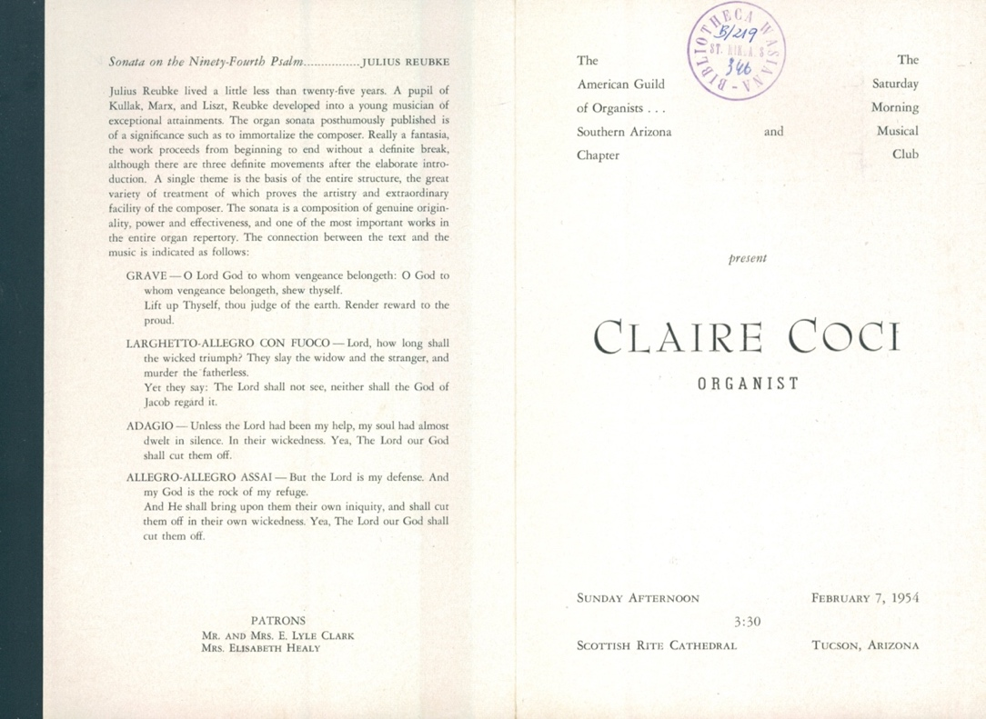

Program from Symphonia Elegiaca premiere in Tucson, AZ – February 7, 1954, page 2

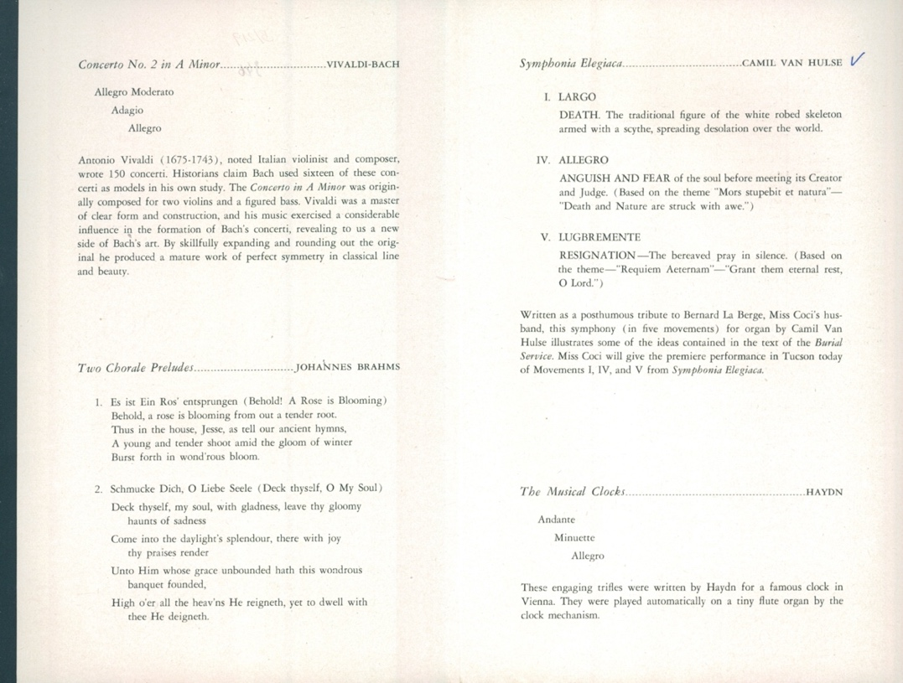

Program from Symphonia Elegiaca premiere in Tucson, AZ – February 7, 1954, front cover

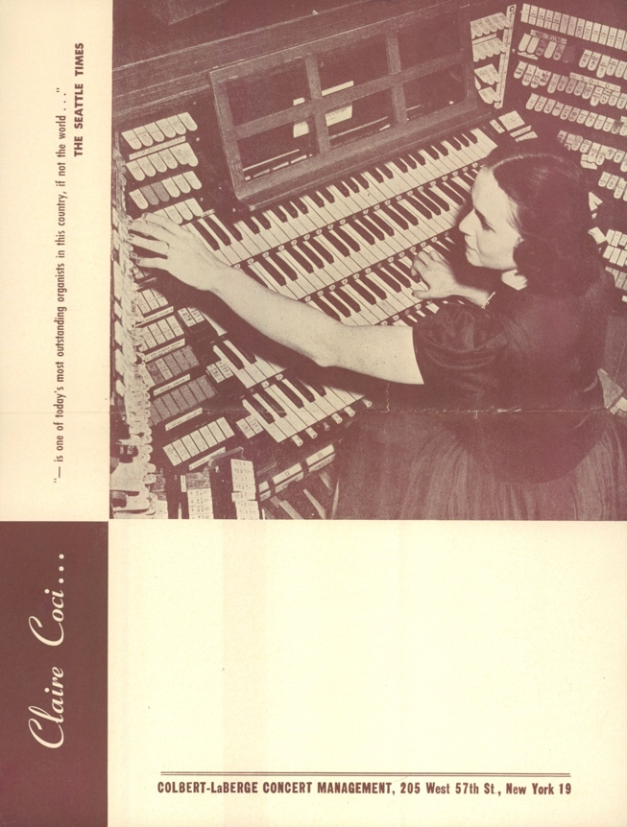

Program from Symphonia Elegiaca premiere in Tucson, AZ – February 7, 1954, back cover

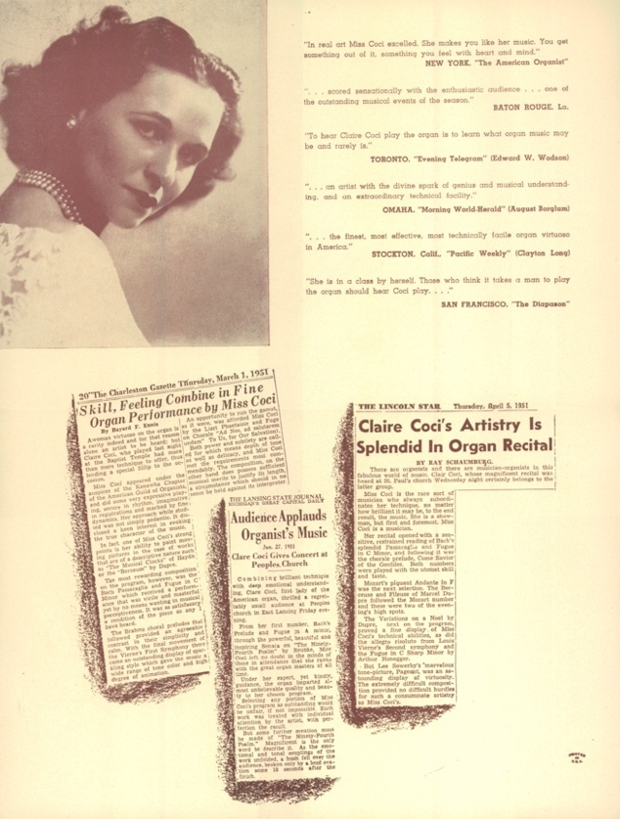

Program from Symphonia Elegiaca premiere in New York City, NY – April 12, 1954, cover

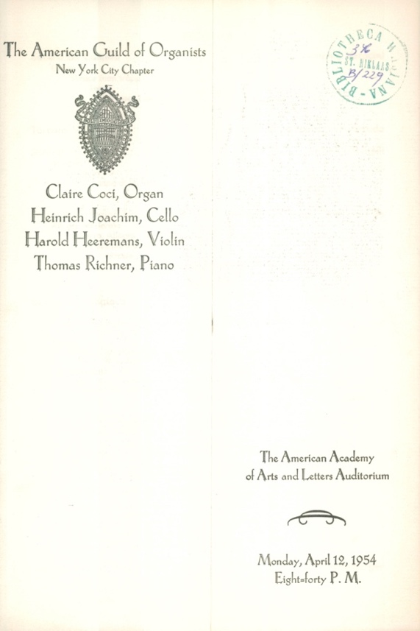

Program from Symphonia Elegiaca premiere in New York City, NY – April 12, 1954, page 2

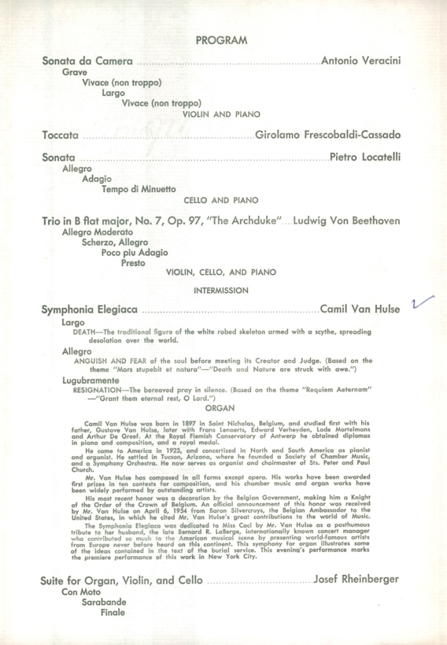
Program Notes for Symphonia Elegiaca written by Van Hulse

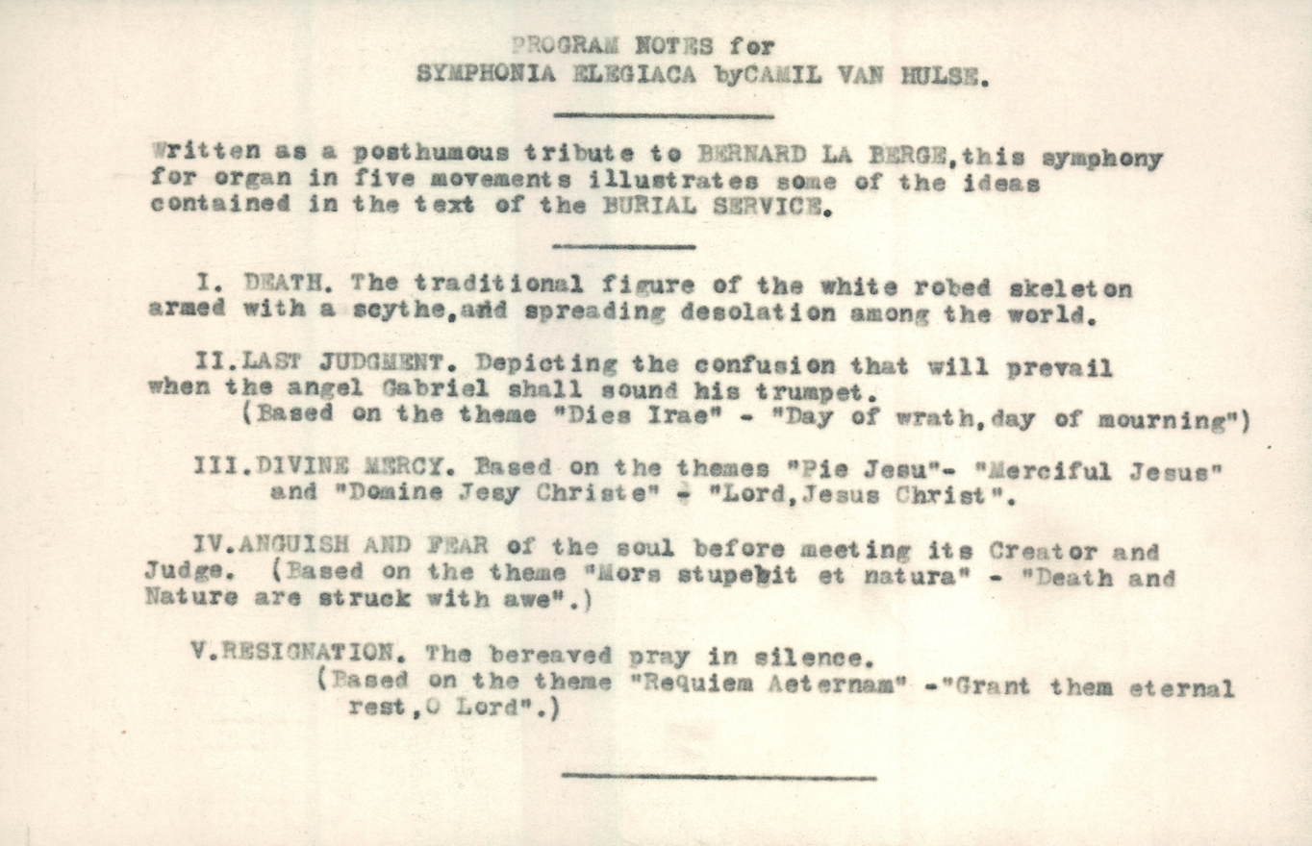

Another version of Program Notes for Symphonia Elegiaca by Van Hulse

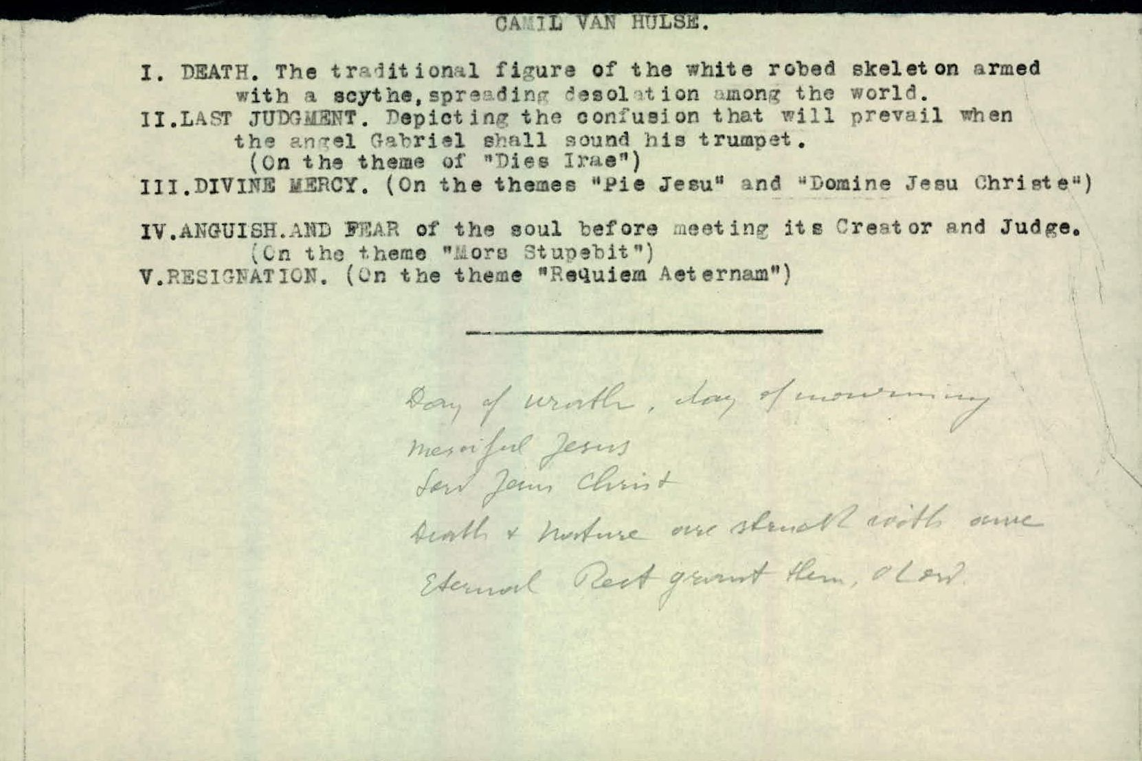

First page of manuscript of Symphonia Elegiaca

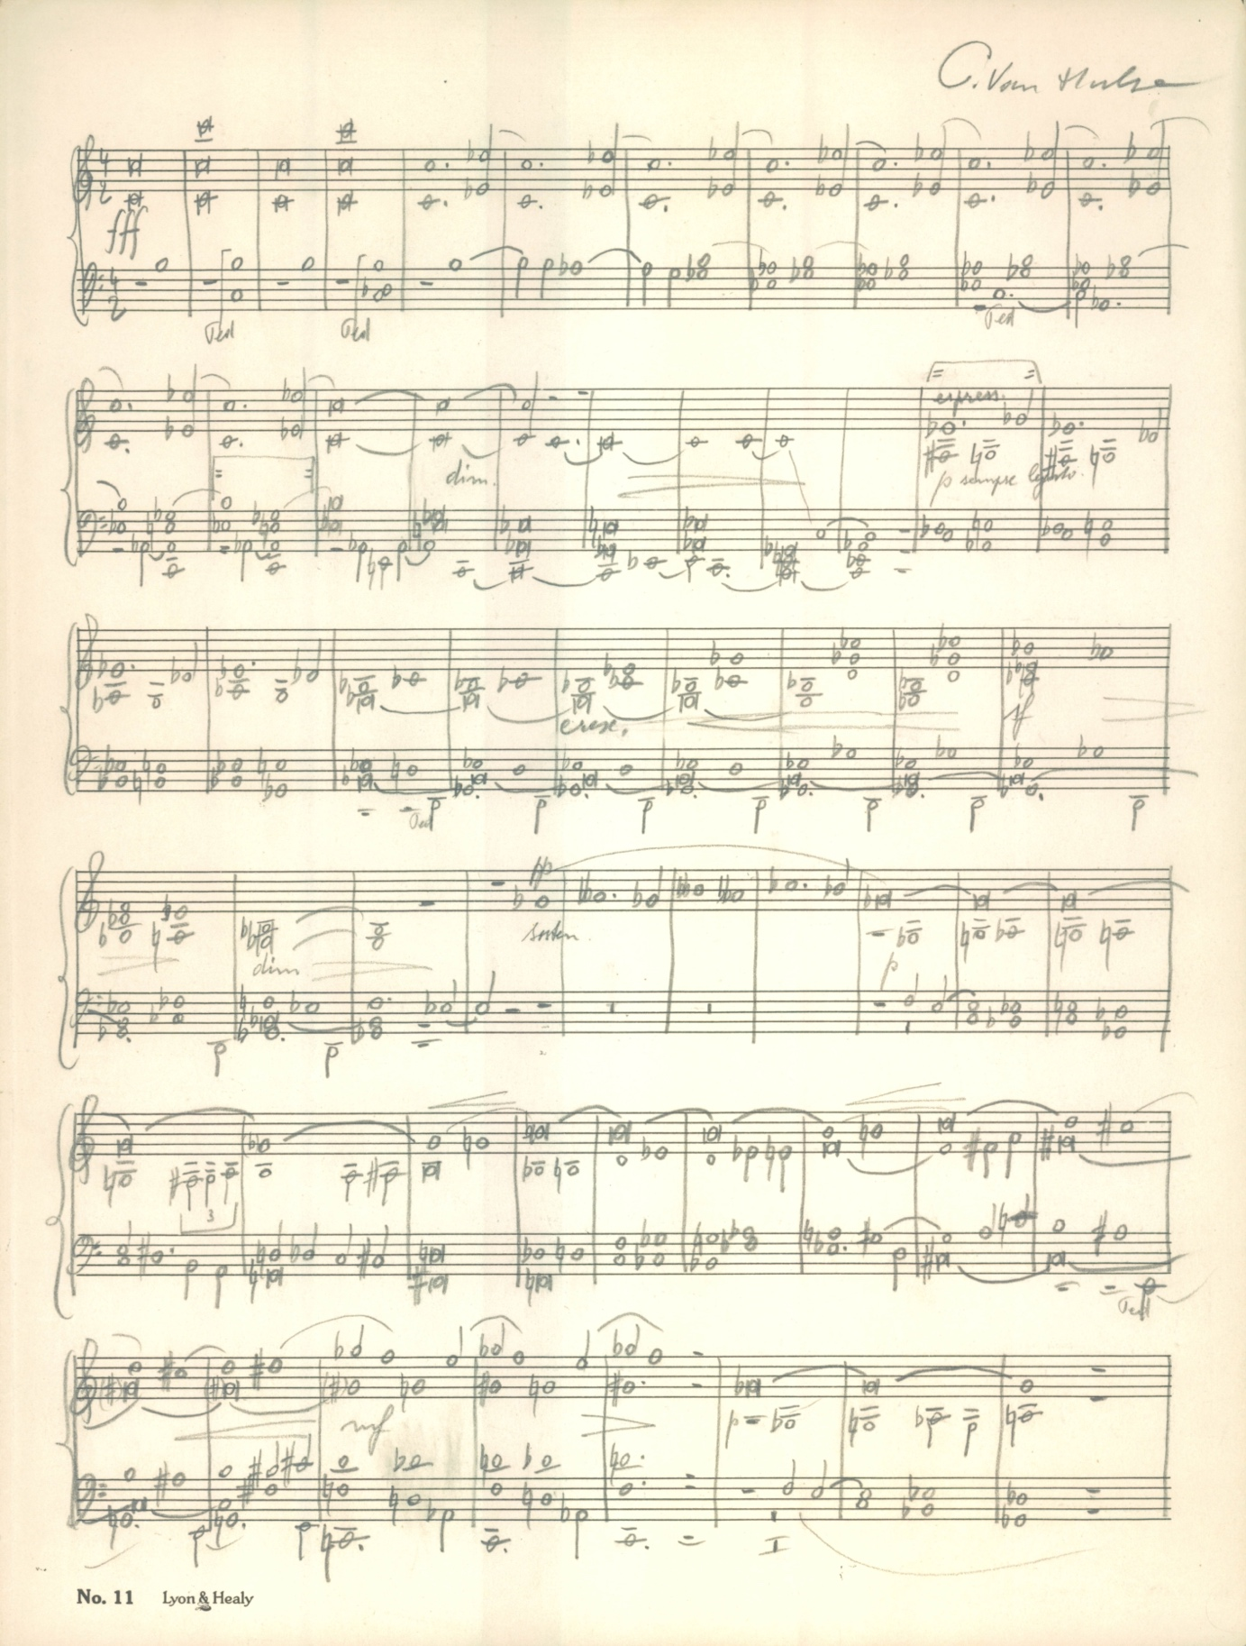
Photo of Camil Van Hulse

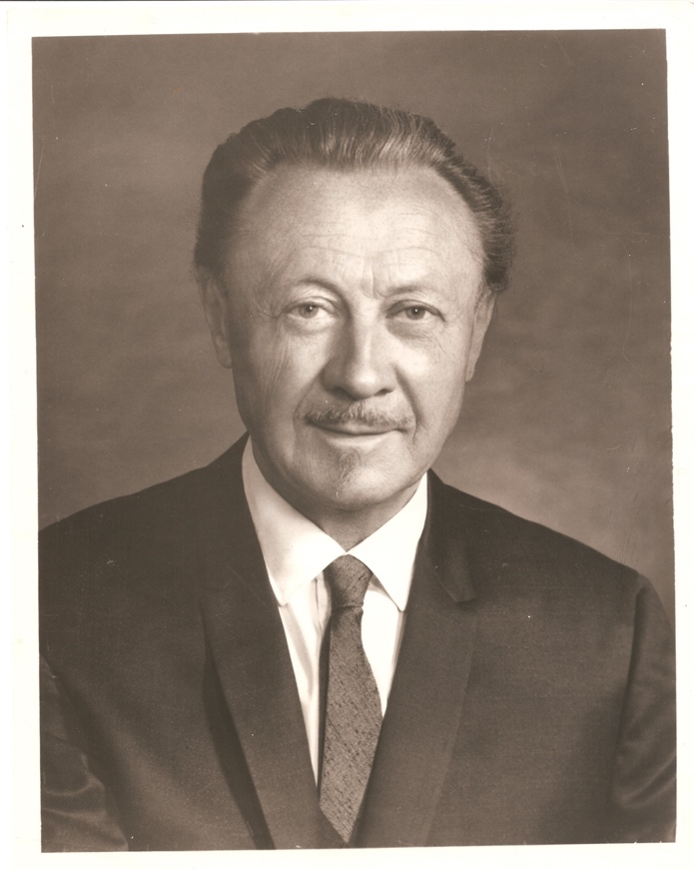

Photo of Camil Van Hulse in his studio

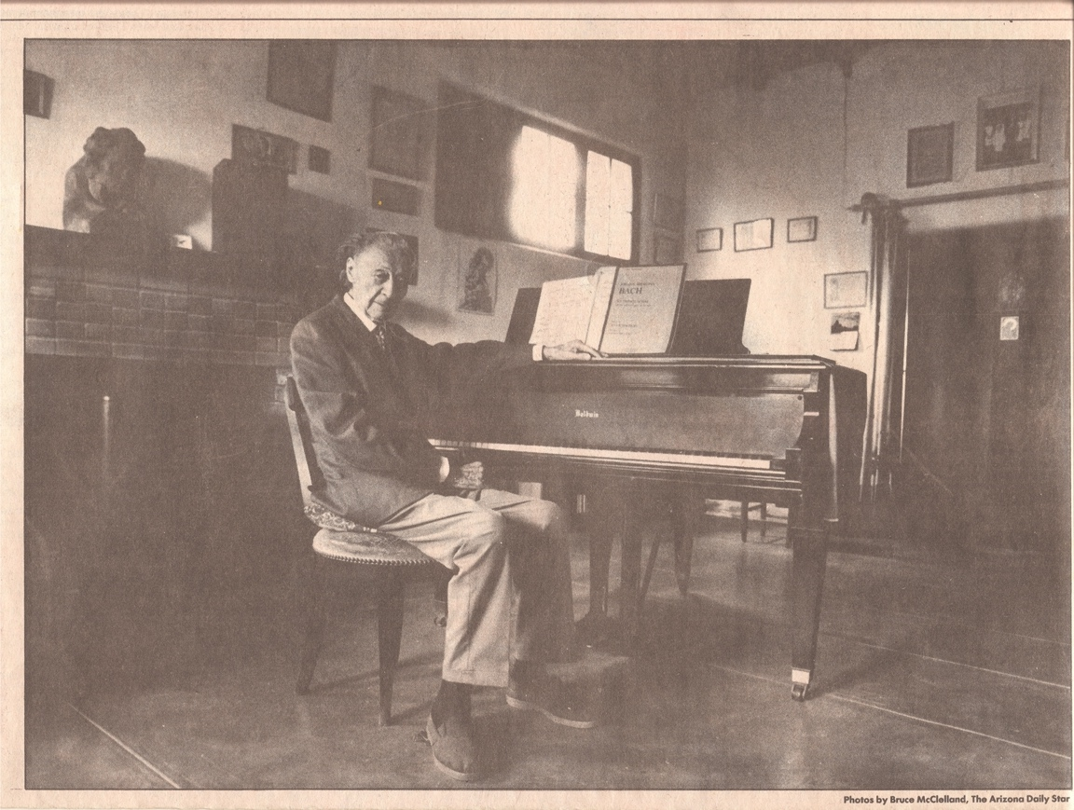
Order of Service for Requiem Memorial Mass for Camil Van Hulse, front and back cover

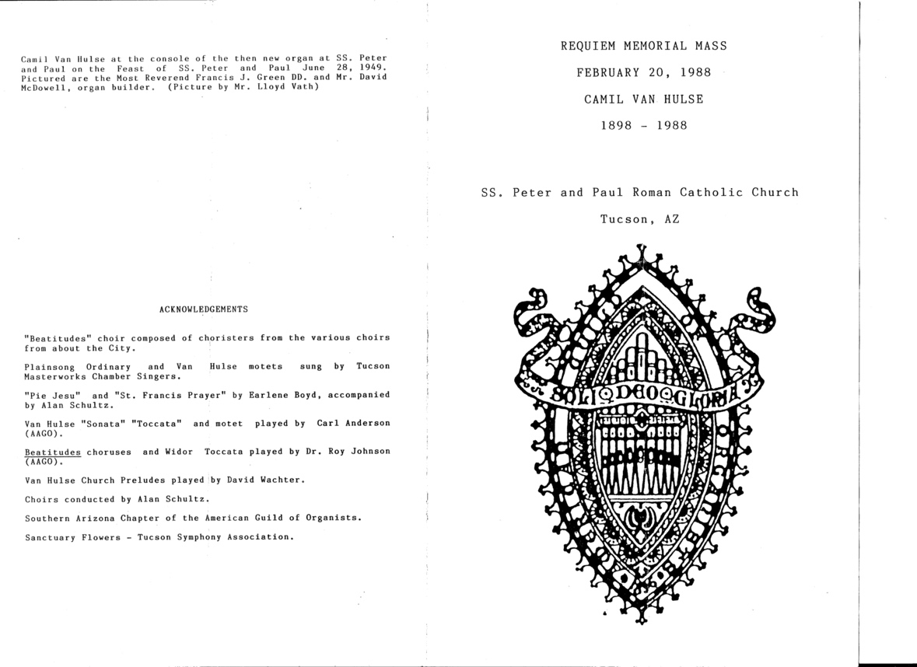

Order of Service for Requiem Memorial Mass for Camil Van Hulse, inner pages

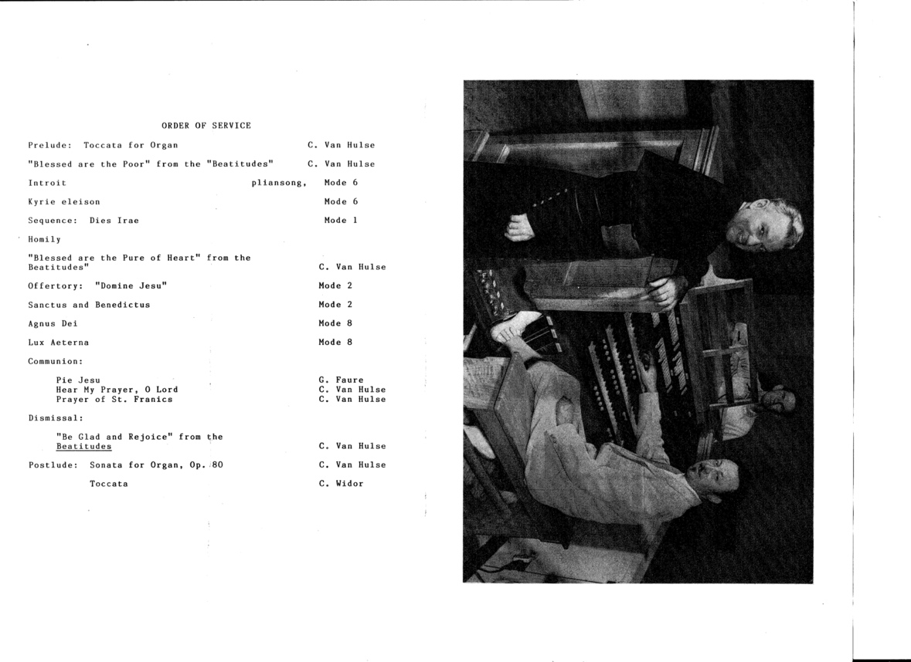

Appendix C – Copyright Permission
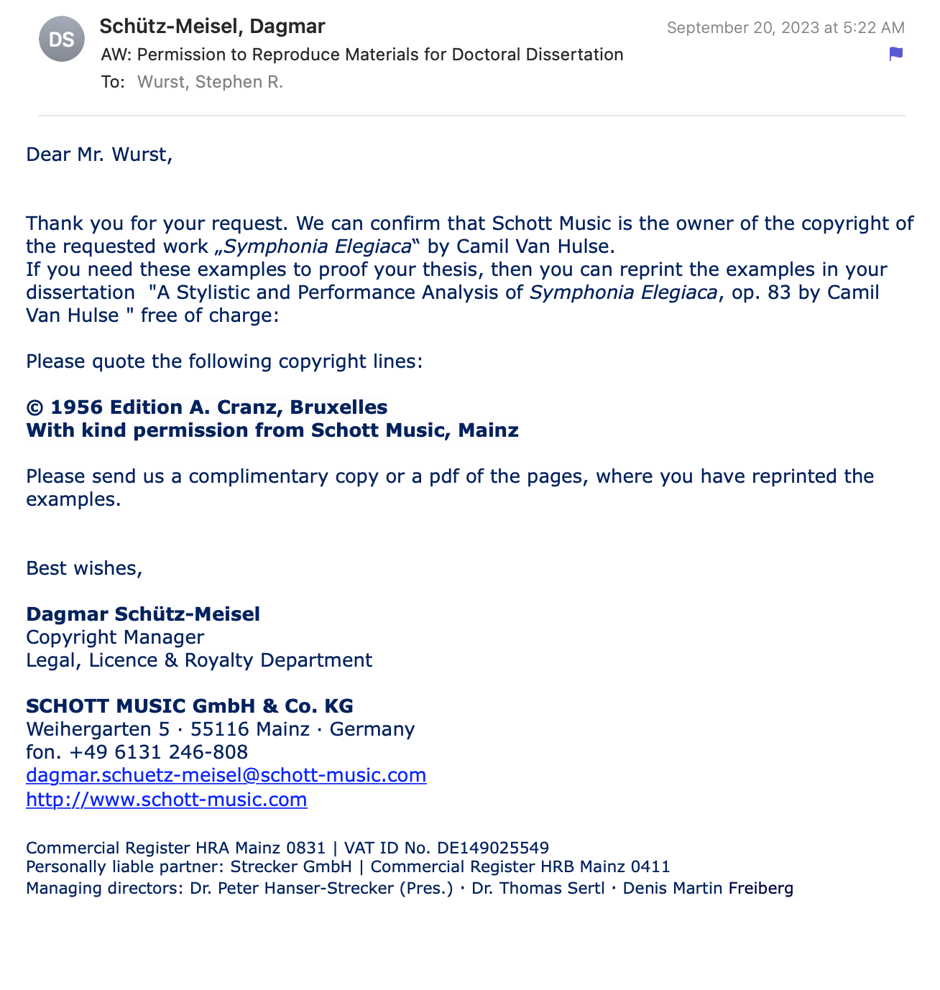

Arizeder Urreiztieta, “Composer Van Hulse dies at 90,” Arizona Daily Star, January 25, 1988.
Tucson Symphony Orchestra “History: 1929-1949,” Mission and History, https://www.tucsonsymphony.org/about-tso/mission-a-history/
Elizabeth C. French, “Camil Van Hulse: A Belgian Composer Who Adopted the Southwest,” Music 12 (1978): 41.
Ibid.
Ibid.
In 1950, his choral anthem “O Praise the Lord” was given First Prize by the Lorenz Publishing Company.
In 1964 the Christmas cantata "Night of wonder" (op. 131) was awarded the Grand Prix of the national competition organized by the publishing house J. Fischer and Brothers in New York on the occasion of their centenary.
In 1959 Van Hulse won the Broadman anthem competition with "Praise ye the Lord" (op. 49a). Stoop, 214.
He was awarded the Nora Seeley Nichols Prize for composition of "Because I love you," a song for solo voice and piano in 1925. He was the recipient of this honor three more times in 1944, 1945, and 1946. This local honor was awarded annually by the Phoenix Musicians Club for the best composition of the year. Stoop, 214.
“Camil Van Hulse,” The Diapason 29, no. 12 (1946): 3.
His chamber work Pentachrome for Violin and Piano, op. 67 was performed at Carnegie Hall in New York in April 1950 by violinist Sidney Tretick. Stoop, 213.
Arizeder Urreiztieta, “Camil Van Hulse: He helped compose Tucson’s music scene,” Arizona Daily Star, May 10, 1987.
Alan Schultz, “Program by the Tucson Chapter AGO In Celebration of Camil Van Hulse” (concert remarks, presented at “A Celebration of Camil Hulse” memorial concert, 2018).
Camil Van Hulse, Symphonia Mystica for Organ, opus 53 (New York: J. Fischer Bro., 1949).
Camil Van Hulse, Symphonia Elegiaca, opus 83 (Mainz, Germany: Musikverlag Cranz, 1956).
Camil Van Hulse, Sinfonia da chiesa per organo, opus 144 (Brussels: Schott Frêres, 1973).
Gerard Brooks, “French and Belgian Organ Music after 1800,” in The Cambridge Companion to the Organ, ed. Nicholas Thistlethwaite and Geoffrey Webber (Cambridge, UK: Cambridge University Press, 2013), 274.
Brooks, “French and Belgian Organ Music,” 274.
Ralph Robert Boggess, “The Life and Organ Works of Paul De Maleingreau,” PhD diss., Florida State University, 1985.
Robert Parris, “A Performer’s Companion to Leo Sowerby’s Symphony in G Major for Organ” DMA diss., The University of Rochester, 1982.
Collin A. Richardson, “Form in the Organ Symphonies of Edward Shippen Barnes” DMA diss., University of Cincinnati, 2015.
Ruth Anderson, “Van Hulse, Camil,” Contemporary American Composers: A Biographical Dictionary (Boston, Mass. G. K. Hall, 1982), 530.
John Henderson, “Hulse C. van,” Directory of Composers for Organ (Swindon, Wiltshire: J. Henderson, 2005).
“Van Hulse, Camil,” ASCAP Biographical Dictionary of Composers, Authors, and Publishers, American Society of Composers, Authors and Publishers (1966), 750.
Dr. J. T. H. Mize, ed., “Van Hulse, Camil,” Who Is Who in Music, Fifth (Mid-Century) ed. (Sterling Publishing Company, 1951), 414.
“Van Hulse, Camil A J,” Who’s Who in American Music: Classical, Second ed. (Jacques Cattel Press, 1985), 609.
Walter Romig, “Van Hulse, Camil,” The American Catholic Who’s Who 12 (Walter Romig, Gross Pointe, Michigan, 1957), 464.
Helena Caldwell, trans., “Profile: Hulse, Camil van,” Bondsnieuws, 97 (September 1988), 34.
H. Heughbaert, “Hulse, Camil van,” Algemene muziek encyclopedie / Deel (part) 4 (Haarlem: De Haan, 1981), 331-33.
Flavie Roquet, “Van Hulse, Camille (‘Camil’),” Vlaamse componisten geboren na 1800: lexicon (Roeselare, Belgium: Roularta Books, 2007), 801.
Arthur Verthé, “Camil van Hulse – componist,” Vlaanderen 17, no. 97 (1968), 47-48.
Camil Van Hulse, “Remembering Tucson: Oral History Project of Arizona Heritage Center. Interview with Camil Van Hulse,” Interview by Jean M. Blackwell, Arizona Historical Society, May 7, 1983.
Stoop, André, ed., “Van Hulse, Camil,” in Lexicon van het muziekleven in het Land van Waas (Stadsbestuur in samenwerking met V.Z.W. Bibliotheca Wasiana, 1987), 210-24.
Bart Moenssens, “Organist-componist Camil Van Hulse (1897-1988): een Wase muzikale pionier in de West,” Vlaanderen 46, no. 1 (January-February 1997), 399-401.
Translations by Emma Brouwer were acquired for this article as well as Lexicon van het muziekleven in het Land van Waas in order to use these resources to their fullest extent.
French, “Camil Van Hulse,” 40-42.
Jan Dewilde, “Van Hulse, Gustaaf,” Study Centre for Flemish Music, https://www.svm.be/content/van-hulse-gustaaf?display=biography&language=en
Annelies Focquaert, “Van Hulse, Camil,” Study Centre for Flemish Music, https://www.svm.be/content/van-hulse-camil?display=biography
Warwick B. Henshaw, “Camil van Hulse,” Biographical Dictionary of the Organ, Accessed February 19, 2021. https://www.organ-biography.info/index.php?id=Hulse_Camilvan_1897
Rony Plovie, “Camil Van Hulse,” Orgelkunst 21, no. 1 (March 1998): 26-31.
Corliss Richard Arnold, “Van Hulse, Camil,” Organ Literature: A Comprehensive Survey Volume II: Biographical Catalogue, Third Edition (Scarecrow Press, 1995), 834-35.
Moniek Joos, Catalogus van de Verzameling Camil Van Hulse Catalogi van speciale verzamelingen nr. 3 (Stedelijke Openbare Bibliotheek Sint-Niklaas: Sint-Niklaas, Belgium, 1977).
Alan Schultz, “Program by the Tucson Chapter AGO In Celebration of Camil Van Hulse,” (Concert remarks, presented at “A Celebration of Camil Hulse” memorial concert, 2018).
Urreiztieta, “Camil Van Hulse: He helped compose Tucson’s music scene,” Arizona Daily Star, May 10, 1987.
Arizeder Urreiztieta, “Composer Van Hulse dies at 90,” Arizona Daily Star, January 25, 1988.
Van Hulse, “What Chance Has the Adult Beginner in Music?” in The Etude (November 1924), 737-38.
Camil Van Hulse, “Learning to Play the Organ,” The Etude 64 (October 1946), 557, 588.
Van Hulse, “Jaak Lemmens, Who Founded the Belgian School of Playing,” in The Diapason 38, No. 2 (February 1955).
Van Hulse, "El Universalismo y el Absolutismo en la Obra de Juan Sebastián Bach" in Nueva Democracia (New York, New York), October 25, 1934: 16. Readex: America's Historical Newspapers.
Van Hulse, “Linguistics with a Purpose” in Books Abroad 17, no. 4 (1943): 398–99. https://doi.org/10.2307/40083737.
Joseph Cordeiro, “A Century of Musical Development in Tucson, Arizona, 1867-1967” (A.Mus.D diss., University of Arizona, 1968).
John Scott Whiteley, Joseph Jongen and His Organ Music (Stuyvesant, NY: Pendragon Press), 1997.
Ralph Robert Boggess, “The Life and Organ Works of Paul De Maleingreau” (PhD diss., Florida State University, 1985).
Page Caroll Long, “Transformations of Harmony and Consistencies of Form in the Six Organ Symphonies of Louis Vierne” (A.Mus.D. diss., University of Arizona, 1963).
Daniel Frederick Berghout, “Alexander Schreiner: Mormon Tabernacle Organist” (DMA diss., University of Kansas, 1998).
Martha H. Stiehl, “A survey and critique of Marian antiphons in organ literature” (DMA diss., University of Illinois at Urbana-Champaign, 2018).
Laure Dermaut, Symphonia Elegiaca, Animato Music Productions, 2012, compact disc.
Gabriel Dessauer, Orgel-Feuerwerk V, Germany: Wiesbaden Kath. Kirchengemeinde St. Bonifatius, 2006.
Luther Noss, “Reviewed Work(s): Symphonia Mystica, Op. 53 by Camil van Hulse; Fantasia Contrappuntistica Sopra "O Filii et Filiae," Op. 58 by Camil van Hulse” in Notes Vol. 7, No. 3 (Jun. 1950): 446-447.
Gilman Chase, “Camil Van Hulse: Symphonia Elegiaca (In Memoriam Bernard LaBerge), Op 83” in The American Organist (1958): 112.
Rollin Smith, Playing the Organ Works of César Franck (Stuyvesant, NY: Pendragon Press, 1997).
John R. Near, Widor: A Life beyond the Toccata, (New York: Boydell & Brewer, 2011).
Near, Widor on Organ Performance Practice and Technique (New York: Boydell & Brewer: 2019).
Lawrence Archbold and William J. Peterson, ed., French Organ Music: From the Revolution to Franck and Widor (New York: University of Rochester Press, 1997).
Orpha Ochse, Organists and Organ Playing in Nineteenth-Century France and Belgium (Bloomington: Indiana University Press, 1994).
Michael Murray, French Masters of the Organ: Saint-Saëns, Franck, Widor, Vierne, Dupré, Langlais, Messiaen (Yale University Press, 1998).
Christopher Anderson, ed. Twentieth-Century Organ Music (New York: Taylor Francis, 2012).
Nicholas Thistlethwaite and Geoffrey Webber, ed., The Cambridge Companion to the Organ, (Cambridge, UK: Cambridge University Press, 2013).
Richard Edward Beckford, "The Organ Symphony: Its Evolution in France and Transformation in Selected Works by American Composers of the Twentieth Century" DMA diss., Louisiana State University and Agricultural & Mechanical College, 1997.
Celia Grasty Jones, “The French Organ Symphony from Franck to Langlais” DMA diss., The University of Rochester, 1979.
Johnson, Bruce. “The Rise of the French Organ Symphony.” PhD diss., Rhodes University, 1990.
John Richard Near, “The Life and Work of Charles-Marie Widor” DMA diss., Boston University, 1985.
Samuel D. L. Libra, “Charles-Marie Widor’s Ten Organ Symphonies: A Formal Analysis” DMA diss., University of Washington, 2020.
Shin-Kyung Bang, “The Evolution of Widor’s Compositional Style, As Evidenced in His Ten Organ Symphonies” DMA diss., Indiana University, 2012.
Page Caroll Long, “Transformations of Harmony and Consistencies of Form in the Six Organ Symphonies of Louis Vierne” A.Mus.D. diss., University of Arizona, 1963.
Yeo Jung Kim, “Cyclical treatment in organ symphonies by Louis Vierne: Thematic analyses of the first three symphonies DMA diss., Northwestern University, 1999.
Emily Marie Meixner, “The Sixth Organ Symphony of Louis Vierne (1870-1937): An Analysis” DMA diss., University of Notre Dame, 2017.
Lourens Coetzee, “An Interpretation of the Organ Symphonies of Louis Vierne (1870-1937) with Specific Reference to his Méthode d’Orgue.” Master’s thesis, Stellenbosch University, 2020.
Ruth Sisson, “The Symphonic Organ Works of Charles Arnould Tournemire.” Ph.D. diss., Florida State University, 1984.
Gail Lynne Walton, “The Life and Organ Works of Augustin Barie (1883-1915).” DMA diss., The University of Rochester, 1986.
Ralph Robert Boggess, “The Life and Organ Works of Paul De Maleingreau.” PhD diss., Florida State University, 1985.
Robert Parris, “A Performer’s Companion to Leo Sowerby’s Symphony in G Major for Organ” DMA diss., Eastman School of Music, 1982.
Collin A. Richardson, “Form in the Organ Symphonies of Edward Shippen Barnes” DMA diss., University of Cincinnati, 2015.
James A. Altena, “Advocating for the American Organ Symphony: An Interview with Christopher Marks,” Fanfare (November/December 2020): 152-158.
Andrew Thomson, “Some Wider Perspectives in French Romantic Organ Music,” The organ yearbook 34 (2005): 133-142.
Gary Verkade, “César Franck: Grand Pièce Symphonique - Some Aspects of Form,” The Diapason 84, No. 1 (January 1993): 11-13.
Graham Barber, “‘Symphonic Metamorphosis’: Karg-Elert’s Symphony for Organ,” The Musical Times 130, no. 1762 (1989): 769–71. www.jstor.org/stable/966776
André Stoop, “Van Hulse, Camil,” trans. Emma Brouwer, Lexicon van het muziekleven in het Land van Waas (Stadsbestuur in samenwerking met V.Z.W. Bibliotheca Wasiana, 1987), 1.
Bart Moenssens, “Organist-componist Camil Van Hulse (1897-1988): een Wase muzikale pionier in de West,” trans. Emma Brouwer, Vlaanderen, volume 46, no. 1, January-February 1997, 1.
“The Church of St. Niklaas was fortunate enough to possess a rather large instrument designed by Schrijnen, a pupil of Cavillé-Coll.” French, “Camil Van Hulse: A Belgian Composer Who Adopted the Southwest,” 40.
“At age twelve, Camil sang in a boys’ choir which he often led himself, and he frequently played the organ during services. He practiced the organ with his friend Casimier Parmentier. When one was pumping, the other would play.” Stoop, 1.
Moenssens, 1.
Ibid.
Henri Vanhulst, "Tinel, Edgar," The New Grove Dictionary of Music and Musicians, 2nd ed., vol. 25, Oxford University Press, 2001, 501-2.
“The curriculum included courses in: religion, liturgy, and the Latin Church; plainchant; organ and piano; harmony, counterpoint and fugue; and the composition of sacred music (vocal and instrumental).” William Peterson, “Lemmens, His École d’orgue, and Nineteenth-Century Organ Methods,” in French Organ Music From the Revolution to Franck and Widor, University of Rochester Press, NY, 1997, 58.
The École de musique religieuse was later renamed as the Lemmens Institute after its first director, Jacques Lemmens. Peterson, 58.
Moniek Joos, Catalogus van de Verzameling Camil Van Hulse, Stedelijke Openbare Bibliotheek Sint-Niklaas. Sint-Niklaas, Belgium, 6.
Moenssens, 1.
Stoop, 1
A newspaper article in the Muskogee Times says that Van Hulse served as a corporal in King Albert’s infantry. “Belgian Artist Plays for Vets.” Muskogee Times-Democrat, September 11, 1923, https://www.newspapers.com/image/904265052/
Moenssens, 1.
Camil Van Hulse, Remembering Tucson, Interview by Jean M. Blackwell, May 7, 1983, 20.
“Debut Here for Belgian Pianist.” Muskogee Times-Democrat, November 5, 1923, 11, https://www.newspapers.com/image/904263417.
Camil Van Hulse, Remembering Tucson, 20.
French, 40.
Flavie Roquet, “Van Hulse, Camille (‘Camil’),” trans. Emma Brouwer, Vlaamse componisten geboren na 1800: lexicon (Roeselare, Belgium: Roularta Books, 2007), 801.
Arizeder Urreiztieta, “Camil Van Hulse: He helped compose Tucson’s music scene,” in Arizona Daily Star, May 10, 1987.
Van Hulse, Remembering Tucson, 20.
“Initially, he had been denied access to the final exam because of his many absences. One of his sisters wrote a letter to Queen Elisabeth, whose mediation then allowed Van Hulse to be admitted to the exam after all.” Stoop, 1.
Moenssens, 1.
Roquet, 801.
Stoop, 1.
“On August 8, 1923, the young piano virtuoso performed a recital in Sint-Niklaas with piano works by Chopin, Liszt, and Debussy, his own compositions Verlangen and Klokkeklanken, and the premiere for Sint-Niklaas of the famous Piano Concerto in B-flat minor by Tschaikovsky.” Stoop, 2.
Van Hulse, Remembering Tucson, 21.
Urreiztieta, “Camil Van Hulse: He helped compose Tucson’s music scene.”
Joos, 6.
The program is as follows: “Prelude and Fugue in D Minor” – Bach; “Prelude and Fugue in B Flat Major” – Bach; “Impromptu in A Flat” – Schubert, “Variations, D Minor” - Mendelssohn; “Feux d’Artifice (Fireworks)” – Debussy; “Klokkenklanken (Chimes)” – Van Hulse; “St. Francis Merchant sur les Flots (St. Francis Walking on Waves)” – Liszt; “Prelude in D Flat,” “Waltz in E Flat,” “Nocturne in E Flat,” “Scherzo in B Flat Minor,” “Berceuse,” and “Etude in C Minor” – Chopin. “Debut Here for Belgian Pianist.” Muskogee Times-Democrat, November 5, 1923, 11, https://www.newspapers.com/image/904263417.
Garland further elaborates on Van Hulse’s musicianship: “What the young man lacked in maturity, he more than compensated for in enthusiasm and individual mode of expression. The sole fact that a youth out of the conservatory barely a year should have already acquired an individuality so pronounced as to be noted even to the casual and unpretending critics in his audience is and assurance that Camil Van Hulse, given health and opportunity to develop his art, will be heard from at an early day in this country.” Garland Ashcraft, “Van Hulse, Belgian Pianist, Makes Bid For Recognition As A Master of His Art,” Muskogee Time-Democrat, November 9, 1923, 3.
“Like Old Masters Is Young Pianist,” Muskogee Daily Phoenix and Times-Democrat, November 9, 1923, 5, https://www.newspapers.com/image/898087021.
Van Hulse, Remembering Tucson, 1.
French, 41.
“Mrs. Madeline Heineman, later to be Mrs. Harry Berger, who arrived in Tucson in 1898, was to become one of Tucson’s most active musical organizers.” Joseph Cordeiro, “A Century of Musical Development in Tucson, Arizona, 1867-1967.” A.Mus.D diss., University of Arizona, 1968, 49.
Van Hulse, Remembering Tucson, 2.
Cordeiro quotes the bylaws of the club as “to develop the musical talent of its members” and “to stimulate musical interest in Tucson and to promote social intercourse in the club.” Cordeiro, 50.
Linda Whitesitt, “Women as ‘Keepers of Culture’,” in Cultivating Music in America: Women Patrons and Activists since 1860, ed. Ralph P. Lock and Cyrilla Barr (Berkeley and Los Angeles: University of California Press, 1997): 65.
Stoop, 2.
French, 41.
“Music Club Will Present Camil Van Hulse, Pianist.” Tucson Citizen, November 16, 1924, 6, https://www.newspapers.com/image/580444309.
Van Hulse, Remembering Tucson, 3.
“Camil Van Hulse Revelation To Tucson In Concert; Gill’s Numbers Add Beauty,” Tucson Citizen, December 14, 1924, 6, https://www.newspapers.com/image/580446214.
The encores included: “Once Upon a Time” by Grieg, “chromatic Waltz” by Godard, and “O Thou Sublime Sweet Evening Star” for the left hand from Tannhauser by Wagner. Tucson Citizen, December 14, 1924, 6, https://www.newspapers.com/image/580446214.
Van Hulse, Remembering Tucson, 4.
“Travels 7,000 Miles to Wed Tucson Pianist.” Arizona Daily Star, December 13, 1924, 9, https://www.newspapers.com/image/163150655
Joos, 6.
Stoop, 2.
“Van Hulse is Honored as Symphony Marks 25 Years.” The Diapason (March 1954): 7.
The entire program is as follows: Rosamund Overture – Schubert; Unfinished Symphony, Allegro Moderato and Andante Con Moto – Schubert; Finale from Symphony No. 7 – Beethoven; Overture from Marriage of Figaro – Mozart; Egyptian Ballet – Luigini; Polovtzen Dances – Borodin. “Symphony Unit is Competent.” Arizona Daily Star, January 14, 1929, 2, https://www.newspapers.com/image/162491792.
Tucson Symphony Orchestra. “History: 1929-1949.” Mission and History.
Effie Leese Scott, “Symphony Orchestra Scores Triumph In Its Initial Concert,” Tucson Citizen, January 14, 1929, 7. https://www.newspapers.com/image/581077130/
Tucson Symphony Orchestra. “History: 1929-1949.” Mission and History.
“Van Hulse is Honored as Symphony Marks 25 Years.” The Diapason (March 1954): 7.
“Van Hulse conducted Schubert’s Rosamunde, being the orchestra’s debut overture, again on January 19, 1954, and on January 11 & 12 in 1979, respectively for the 25th and 50th anniversary of the Tucson Symphony Orchestra.” Stoop, 2.
“Mr, Van Hulse founded a Society of Chamber Music with members A. Kronkowski, Violinist, Lenard Kline, Violinist, Joe Karr, Violist, and Dr. John Mez, Cellist. This group played together for about two years before being incorporated into the Tucson Symphony Orchestra.” Cordeiro, 109.
Stoop, 2.
“Camil Van Hulse.” The Diapason 29, no. 12 (1946): 3.
“The Tucson Chapter of the American Guild of Organists held its first meeting on March 5, 1937. Organized by Camil Van Hulse, Mr. William Voris and John McBride, the Guild’s founding membership consisted of twenty-one persons.” Cordeiro, 115.
French, 41.
Ibid.
Van Hulse, Remembering Tucson, 8.
Moenssens, 1.
Ibid.
Van Hulse, Remembering Tucson, 11.
French, 41.
Ibid.
Rony Plovie, “Camil Van Hulse,” trans. Emma Brouwer, Orgelkunst 21, no. 1 (March 1998).
According to Rony Plovie, Van Hulse served a brief time at the St. Elizabeth Church in Altadena, California from 1929-1930 where he was organist and director of a Gregorian choir. Other sources do not mention this appointment. Rony Plovie, “Camil Van Hulse,” trans. Emma Brouwer.
Stoop, 2.
Van Hulse, Remembering Tucson, 24.
“Announcement for Academic Year 1937-1938: Record of University Activities for Academic Year, 1935-1936.” University of Arizona, 1937, 253. https://repository.arizona.edu/handle/10150/626625
Camil A. J. Van Hulse, “Parnassian Overture,” Master’s Thesis, University of Arizona, 1936.
Knowles, Ralph E., ed. The Desert. University of Arizona, 1934. https://repository.arizona.edu/handle/10150/188850
Joos, 7.
Moenssens, 1.
Ibid.
David Leighton, "Hacienda del Sol Rd. grew out of early girls' school," Arizona Daily Star, October 8, 2013, A2.
“Founded by Dickson B. Potter, Potter School was a private girls’ finishing school. It was located at 2102 E. Elm and operated in the 1940s and early 1950s.” Kim Frontz, “Finding Aid, MS 1245 Potter School Yearbook, 1949,” Accessed Jan 31, 2023. https://www.arizonahistoricalsociety.org/wp-content/upLoads/library_Potter-School.pdf
Stoop, 2.
“’Camil,’ as his intimates know him, is tall and distinguished in appearance and has an affable nature and a rare talent for playing host to his friends. His studios are a popular gathering place for organists and choir directors, both local and national.” “Camil Van Hulse.” The Diapason 29, no. 12 (1946): 3.
In addition, “Camil Van Hulse contributed to the Liber Amicorum Flor Peeters, which was published on the occasion of the fiftieth birthday of the grand master from Mechelen.” Stoop, 5.
Stoop says, “He was actually included in the ‘Dictionary of Linguists’ even before he was included in the “Dictionary of Musicians.” Stoop, 3.
Moenssens, 2.
“I had never seen any Spanish in print. When I came here I subscribed right away to La Tucsonensa… I read that from cover to cover…and that is how I learned Spanish. In no time I could speak Spanish like the rest of them.” Van Hulse, Remembering Tucson, 7.
French, 41.
Van Hulse, Remembering Tucson, 36.
Joos, 6.
Stoop, 9.
“For the third time Mr. Van Hulse has won the Nora Seeley Nichols prize, with his cantata ‘Jerusalem, the Fallen,’ for women’s chorus and baritone solo, with piano accompaniment.” “Camil Van Hulse.” The Diapason 29, no. 12 (1946): 26.
Van Hulse, Remembering Tucson.
French, 41.
“Camil Van Hulse.” The Diapason 29, no. 12 (1946): 3.
The American Guild of Organists magazine includes this review: “Camil Van Hulse, Tucson, Ariz., won the $100. J. Fischer & Bro. prize under Guild auspices for this organ Toccata; judges were Dr. T. F. H. Candlyn, H. Leroy Baumgartner, Powell Weaver; blame them if you don’t like the music when you buy it.”
Van Hulse, Remembering Tucson, 18.
French, 41.
Stoop, 213.
Ibid., 214.
French, 41.
Seth Bingham, “Concert Organ’s Future Expansion Is Considered Near,” The Diapason (July 1954): 34.
“The President’s Column.” The Diapason (June 1953): 14.
“Organ Writers’ Week Topic at Redlands University,” The Diapason (April 1954): 2.
“A. G. O. Examinations,” The Diapason (August 1953): 8.
Stoop, 214.
Ibid., 213.
Moenssens, 2.
“Camil Van Hulse Honored by Belgian King Baudouin,” The Diapason (May 1954): 27.
“Camil Van Hulse – A Tribute,” The American Organist 40, no. 12 (1957): 406.
“These works were played: two motets on the Latin text Veritas Mea op. 28 and Filii et Filiae op. 31a; three choral preludes (op. 73); Irene, St. James and thy Life was given; the fragment De Hemelvaart from the cantata Our glorious King op. 60, the Symphonia Mystica op. 53 and The Beatitudes op. 43. Stoop, 10.
“His friend, the late André Stoop, who was a city librarian and archivist in Sint-Niklaas, organized a Van Hulse celebration in Sint-Niklaas every five years, starting from Van Hulse’s sixtieth birthday.” Moenssens, 3.
“Tucson Celebrates Van Hulse 36 Years,” The Diapason (November 1959): 1.
Stoop, 5.
Roquet, 801.
“A concert of chamber music, choral and solo literature, and a premier performance of a work for organ and ten French horns comprised the afternoon programs… A second program of organ works was held at the Trinity Presbyterian Church the same evening. Joyce Jones, professor of organ at Baylor university, was the guest recitalist.” French, 40.
Joos, 7.
“The program of the concert on September 8 in the banquet hall of the town hall was comprised of a prelude for organ, the Elegy op. 38, a divertimento for organ, an aria for organ, the Quintet op. 111 and the Toccata for organ op. 127 nr. 11. Participating in this concert, among others: Victor Hens (organ), Heribert De Caluwe (piano), and the wind quintet of the Chamber orchestra of the BRT.” Stoop, 10.
“On September 18, 1967, the Bibliotecha Wasiana organized an organ concert in the chapel of the Insitute Onze Lieve Vrouw Presentatie, where Van Hulse performed some of his own works.” Stoop, 10.
“On August 22, 1972, a third honorary concert took place in the city theatre, with soloists Mireille Flour on harp, and organist Robert E. Flood. Stoop, 10.
French, 41.
On September 8 and 11, 1977… Jos D’hollander played carillon works by Van Hulse. The 3-voice mass for mixed choir and organ Fiat voluntas tua op. 50 was performed in the Onze Lieve Vrouwekerk. Stoop, 10.
The program included, among others: the Elegy op. 38 and the Duet for flute and clarinet op. 168a. Soloists were: Dirk De Caluwe (flute), Walter Boeykens (clarinet), Hilde Pas (violin), Paul van Egghen (cello), and Louis Pas (piano). Stoop, 11.
Ibid., 1.
Ibid.
Joos, Catalogus van de Verzameling Camil Van Hulse.
Devine, David. “This Old House.” Tucson Weekly, September 18, 2003.
Van Hulse, Remembering Tucson, 38.
Stoop, 9.
Partial premiere of movements I, IV, and V. “Work in memory of La Berge Played By Widow” in The Diapason (April 1954): 2.
Partial premiere of movements I, IV, and V. Camil Van Hulse, Symphonia Elegiaca, opus 83. Mainz, Germany: Musikverlag Cranz: 1956, i.
This work can be purchased online through the Schott Music Group at the time of this document’s publication.
“Musical Meditation: “Symphonia Elegiaca” by Camil Van Hulse,” Accessed May 15, 2023. https://www.saintthomaschurch.org/events/musical-meditation-symphonia-elegiaca-by-camil-van-hulse-2015-03-30/
Van Hulse, Symphonia Elegiaca, manuscript, item A71, 2, Camil Van Hulse Archives, Bibliotheca Wasiana, Sint-Niklaas, Belgium. (Altered: “Burial Service” originally in all capital letters: BURIAL SERVICE.)
On a page of the manuscript, Van Hulse left hand-written notes that listed movement I with the designation “Prel.” (See Appendix B) Van Hulse, Symphonia Elegiaca, manuscript, item A71, 2, Camil Van Hulse Archives, Bibliotheca Wasiana, Sint-Niklaas, Belgium.
“[La Berge] organized tours by the European organists Joseph Bonnet, Charles Courboin, Marcel Dupré (who played the entire organ works of Bach in 10 Montreal recitals during 1923), Fernando Germani, André Marchal, Flor Peeters, Günther Ramin, Louis Vierne, and Carl Weinrich. He also sponsored recitals by North American organists, including the Canadian Bernard Piché. Among the chamber ensembles which toured North America for Laberge were the Hungarian, Paganini, Pascal, Pro Arte, and Roth quartets, the Nuovo Quartetto Italiano, the Pasquier Trio, the Belgian Piano Quartet, and the Pro Musica Antiqua of Brussels.” Gilles Potvin, “Bernard R. Laberge” The Canadian Encyclopedia, Accessed May 15, 2023. https://www.thecanadianencyclopedia.ca/en/article/bernard-r-laberge-emc
“Bernard R. La Berge Heart Attack Victim” in The Diapason (February 1952): 1.
Ibid.
"Claire Coci, noted concert organist and teacher, at 63,” The Record, October 3, 1978. https://www.newspapers.com/clip/51003991/obituary-for-claire-coci-aged-63/
Claire Coci to Camil Van Hulse, November 9, 1951, Catalogus Van De Verzameling Camil Van Hulse, Stedelijke Openbare Bibliotheek Sint-Niklaas, C2-86.
Claire Coci to Camil Van Hulse, April 3, 1952, C2-105.
Claire Coci to Camil Van Hulse, May 15, 1952, C2-111.
Ibid.
Ibid.
“You were quite right, it will not work programmatically to program the movements independently from each other. One does not lead extremely well into Four, but I strongly feel that it is possible to add a bit of drama which will avoid the feeling one may have going from One to Four.” Claire Coci to Camil Van Hulse, June 9, 1953, C2-155.
Claire Coci to Camil Van Hulse, undated, probably 1954, C2-12.
See Appendix for the complete program.
“Work in memory of La Berge Played By Widow” in The Diapason (April 1954): 2.
Claire Coci to Camil Van Hulse, February 17, 1954, C2-210.
See Appendix B for the complete program.
“Camil, true to artist form, I must ask you to again send me the name of the person at Fischer's Publishing Co. Now that I am back in New York, and have the score with me, I shall send it on to them.” Claire Coci to Camil Van Hulse, May 13, 1954, C2-225.
“About the score of “our” symphony - certainly I fully intend to program it again in the future. However, your idea of making a fresh copy to send to some other publisher is good. I am convinced that making each movement a separate entity is a good one period that is, for publication I feel the publisher would react favorably.” Claire Coci to Camil Van Hulse, April 16, 1955, C2-259.
Claire Coci to Camil Van Hulse, June 1, 1957, C2-322.
“I wish I could have heard Claire Coci play the first performance of this at the American Academy of Arts and Letters (N.Y.) in 1951 for I am certain that it was an impressive occasion. Van Hulse has created a work of major proportions and a commanding style that requires a facile technique and first rate musicianship in performance. The work is divided into five sections whose titles will give you some general idea of contents: 1. Death; 2. Last Judgment; 3. Divine Mercy; 4. Supreme Anguish; and 5. Resignation. Nos. 1, 3, and 5 are suitable for church work, while 2 and 4 are plainly intended to scare the daylights out listeners – and here the technical difficulties may do the same for many performers! Much of the writing is obviously influenced by the French styles of Dupré and Langlais, with dashes of Messiaen thrown in here and there. This is not to disparage the merits of this fine work, for I think it an excellent composition, but rather to relate it stylistically for those interested. And, finally, a word of warning: don’t try this on a ‘baroquey’ chamber organ for it requires all of the resources of a great French cathedral instrument to bring out its thunderous message. This is organ music in the grand manner.” Gilman Chase, “Music for Organ” in The American Organist 42 (1958): 112.
Robert Chase, Dies Irae: A Guide to Requiem Music, Lanham, MD: The Scarecrow Press, Inc., 2003, 1.
Ibid, 2.
Chase, xiii.
Chase, 2.
Chase, xiii.
Quotations of this text can be found on page 18 in the section about Movement II: Last Judgment
Chase, 511.
Franz Liszt used the Dies Irae melody in Totentanz (1849). “Other composers who employed this melody were Camille Saint-Saëns in his Danse Macabre (1874) and Sergei Rachmaninoff in his tone-poem Isle of the Dead (1909) and the famous, oft-played Rhapsody on a Theme by Paganini (1934).” Chase, 512.
Ibid.
Ibid.
Van Hulse, Symphonia Elegiaca, i.
Camil Van Hulse, Symphonia Elegiaca.
Van Hulse, Symphonia Elegiaca, manuscript, item A71, 2, Camil Van Hulse Archives, Bibliotheca Wasiana, Sint-Niklaas, Belgium.
Laure Dermaut, liner notes for Symphonia Elegiaca, Laure Dermaut recorded November 3-4, 2011, Animato Music Productions, CD, 2012, 4.
Camil Van Hulse, Symphonia Elegiaca.
Van Hulse, Symphonia Elegiaca, manuscript, item A71, 53, Camil Van Hulse Archives, Bibliotheca Wasiana, Sint-Niklaas, Belgium.
Ron Jeffers, Translations and Annotations of Choral Repertoire. Volume I: Sacred Latin Texts, Corvallis, OR: Cascade Printing Co., 1988, 67.
Van Hulse, Symphonia Elegiaca, manuscript, item 71A, 2.
Van Hulse, Symphonia Elegiaca, manuscript, 53.
The author has labeled these measures as 86a-114a to differentiate them from the original measures found in Movement II.
Camil Van Hulse, Symphonia Elegiaca.
Van Hulse, Symphonia Elegiaca, manuscript, 53.
Jeffers, Translations and Annotations of Choral Repertoire, 79.
Ibid., 79.
Ibid., 78.
Ibid.
Ibid., 79.
Ibid, 78.
Ibid., 79.
Laure Dermaut, liner notes for Symphonia Elegiaca, 5.
Camil Van Hulse, Symphonia Elegiaca.
Van Hulse, Symphonia Elegiaca, manuscript, 2.
Ibid.
Jeffers, Translations and Annotations of Choral Repertoire, 67.
Laure Dermaut, liner notes for Symphonia Elegiaca, 5.
Camil Van Hulse, Symphonia Elegiaca.
Van Hulse, Symphonia Elegiaca, manuscript, 2.
Claire Coci to Camil Van Hulse, June 9, 1953, C2-155.
Jeffers, Translations and Annotations of Choral Repertoire, 64.
Claire Coci to Camil Van Hulse, June 9, 1953, C2-155.
Jeffers, Translations and Annotations of Choral Repertoire, 64.
Claire Coci to Camil Van Hulse, June 9, 1953, C2-155.
Arnold, “Van Hulse, Camil” in Organ Literature: A Comprehensive Survey Volume II: Biographical Catalogue.
Henderson, “Hulse C. van” in Directory of Composers for Organ.
Henshaw, “Camil van Hulse” Biographical Dictionary of the Organ. https://www.organ-biography.info/index.php?id=Hulse_Camilvan_1897
French, “Camil Van Hulse: A Belgian Composer Who Adopted the Southwest.”
Plovie, “Camil Van Hulse,” trans. Emma Brouwer in Orgelkunst 21, no. 1 (March 1998).

