University of Oklahoma

Graduate College

A Cross Validation of the effects of leg size, limb composition, and blood pressure on arterial occlusion in women aged 20 to 30 years

A Dissertation

submitted to the Graduate Faculty

in partial fulfillment of the requirements for the

Degree of

Doctor of Philosophy

By

CHARITY CAVAZOS
Norman, Oklahoma
2016

A Cross Validation of the effects of leg size, limb composition, and blood pressure on arterial occlusion in women aged 20 to 30 years

A Dissertation approved for the
Department of Health and Exercise Science

By

______________________________
Dr. Michael Bemben, Chair

______________________________
Dr. Debra Bemben

______________________________
Dr. Carl Ade

______________________________
Dr. Christopher Black

______________________________
Dr. Rosemary Knapp

© Copyright by CHARITY CAVAZOS 2016
All Rights Reserved.

Acknowledgements
I am hugely indebted to Dr. Mike Bemben who was by far the strength behind this project. Your expertise, understanding, patience, guidance, and support made it possible for me to work on a topic that was of great interest to me. I know I did not make it easy and I feel truly blessed to have worked with you and even more grateful for guiding me as you pushed me beyond my limits.

I want to express my gratitude to Dr. Deb Bemben who I have worked closely with since the beginning of this program and have learned a lot from over the years. Thank you for your time and patience with me as I worked to grow as a student and as an instructor.

I am indebted to Dr. Carl Ade for working with me over the years and for providing me with material that could not possibly have discovered on my own. I am grateful for your kind words and suggestions over the years and I wish you the best in your upcoming job opportunity.

I am indebted to Dr. Christopher Black for working with me even though I was never your student. Thank you for being a constant source of assistance and with your suggestions, making my project stronger.

I am grateful to Dr. Rosemary Knapp who found time to reply to my e-mails, for being ever so kind to show interest in my research and for giving me kind advice throughout this process.

To Zhaojing Chen, a.k.a. Echo, I am forever grateful for your friendship that has grown over the years. I do not think I could have gotten through this without you. Thank you for all the time we spent together all the late nights and weekends, and all your assistance over the years. I wish you the best in your future and know that I will support you no matter how far apart we may be.

To David Ross, there are no words to express how honored I feel to call you my colleague and my friend. I am forever indebted to you for your commitment to work with me during those long days, nights and weekends of data collection. Thank you for putting up with me over the last year as my stress levels rose and caffeine wore off.

To Chris Hayes, there are no words to express how grateful I am for your friendship and support. Thank you for always motivating me and listening to my crazy ideas and thoughts about life. I am forever grateful to have met you and cannot wait to see your dreams come true.

Finally, I am hugely indebted to my mom and dad who have done nothing but support me with your unconditional love, care, concern, and faith in me. I am a better and stronger person because of the values you have instilled in me. What I have done, I have done to make you proud.

Table of Contents

Acknowledgements iv
List of Tables x
Abstract xiv
Chapter I: Introduction 1
Purpose 5
Research Question 5
Hypotheses 5
Subquestion 6
Subhypotheses 6
Significance of Study 6
Assumptions 7
Delimitations 7
Limitations 7
Operational Definitions 7
Chapter II: Literature Review 9
History of Blood Flow Restricted Exercise 9
Potential Mechanisms Associated with Blood Flow Restriction 9
Blood Flow Restriction and Cuff Type 12
Blood Flow Restriction and Cuff Size 13
Blood Flow Restriction and Occlusion Pressure 14
Comparison of Males and Females 15
Blood Flow Restriction and Leg Dominance 16
Blood Flow Restriction and Safety 17
Chapter III: Methodology 19
Participants 19
Inclusion Criteria 19
Exclusion Criteria 20
Experimental Design 20
Standing Height and Body Mass 21
Brachial Blood Pressure 22
Ankle Brachial Index 22
Thigh Circumference (33%, 50%) 22
Ultrasound 23
Pregnancy and Hydration 23
Dual Energy X-ray Absorptiometry (DXA) 24
Peripheral Quantitative Computed Tomography (pQCT) 25
Arterial Occlusion Pressure 26
Statistical Analyses 27
CHAPTER IV: Results and Discussion 30
Results ……………………………………………………………………………...30
Participant Characteristics 30
Ultrasound Results 31
DXA Results 49
pQCT Results 59
Discussion 79
Main Findings 80
Arterial Occlusion 81
Anterior and Lateral Ultrasound Measures 83
Differences in Methods 85
Practicality of Equations 866
Chapter V: Conclusions 900
Research Question 900
Hypotheses 900
Subquestion 911
Subhypotheses 911
Limitations 91
Significance of Study 922
Future Research 933
References 944
Appendix A: IRB Approval Letter, Consent Form, HIPPA 99
Appendix B: Other Forms 105
Appendix C: Data Collection Forms 115
Appendix D: Descriptives and Raw Ultrasound Data 120
Appendix E: Raw DXA Data 130
Appendix F: Raw pQCT Data for Left Leg 132
Appendix G: Raw pQCT for Right Leg 136

List of Tables

Table 1. Reliability of Height, Weight, Blood Pressures, Thigh Circumferences and ………..Total Occlusion Pressures for Ultrasound Subjects ………...for Day 1 and Day 2 (N=50) 31
Table 2. Reliability of Ultrasound Measurements for Day 1 and Day 2 at 33% and ………...50% Sites (N=50) 33
Table 3. Summary of Ultrasound Data from the 94 Participants 35
Table 4. Correlation Matrix (Pearson r) for Ultrasound Measurements ………...33% and 50% Sites for Right Leg (N=94) 36
Table 5. Correlation Matrix (Pearon r) for Ultrasound Measurements ………...33% and 50% Sites for Left Leg (N=94) 37
Table 6. Correlation Matrix (Pearson r) for Ultrasound Measurements ………..from Anterior and Lateral Sites for Right Leg (N=94) 37
Table 7. Correlation Matrix (Pearson r) for Ultrasound Measurements ………...from Anterior and Lateral Sites for the Left Leg (N=94) 38
Table 8. Correlation Matrix for Ultrasound Measurements for Limb ………..Composition and Thigh Circumference for Right and Left Leg (N=94) 39
Table 9. Regression Analysis for Ultrasound Model for Right Leg- ……….. ENTER Method 41
Table 10. Regression Analysis for Ultrasound Model for …………Right Leg -STEPWISE Method 43
Table 11. Regression Analysis for Ultrasound Model for ………….Left Leg-ENTER Method 45
Table 12. Regression Analysis for Ultrasound Model for ………….Left Leg - STEPWISE Method 47
Table 13. Reliability of DXA Measurements for Day 1 and Day 2 Testing …………for Thigh Lean Muscle and Fat Tissue (N=50) 49
Table 14. DXA Participant Characteristics (N=94) 50
Table 15. Correlation Matrix for DXA Measurements for Limb Composition ………….and Thigh Circumference for Right and Left Leg (N=94) 51
Table 16. Regression Analysis for DXA Model for …………Right Leg - ENTER Method 52
Table 17. Regression Analysis for DXA Model for …………Right Leg-STEPWISE Method 53
Table 18. Regression Analysis for DXA Model for …………Left Leg - ENTER Method 55
Table 19. Regression Analysis for DXA Model for …………Left Leg - STEPWISE Method 57
Table 20. Reliability of Height, Weight, Blood Pressure, Thigh Circumferences and …………Total Occlusion Pressures for pQCT Subjects ………….for Day 1 and Day 2 on Left Leg (N=38) 59
Table 21. Reliability of Height, Weight, Blood Pressure, Thigh Circumferences and …………Total Occlusion Pressures for pQCT Subjects …………for Day 1 and Day 2 on Right Leg (N=10) 60
Table 22. Reliability Measurements from pQCT for Day 1 and Day 2 Testing for …………Muscle and Fat Area 61
Table 23. Subject 03 Raw Data for Muscle and Fat from …………pQCT Right and Left Leg 62
Table 24. Participant Characteristics and Right Leg Measurements …………from pQCT (N=59) 63
Table 25. Participant Characteristics and Left Leg Measurements …………from pQCT (N=73) 64
Table 26. Correlation Matrix for pQCT Measurements for Limb Composition and …………Thigh Circumference for Right (N=59) and Left (N=73) Leg 65
Table 27. Regression Analysis for pQCT Model for the …………Right Leg - ENTER Method 66
Table 28. Regression Analysis for pQCT Model for the …………Right Leg - STEPWISE Method 68
Table 29. Regression Analysis for pQCT Model for the …………Left Leg - ENTER Method 69
Table 30. Regression Analysis for pQCT Model for the ………….Left Leg - STEPWISE Method 71
Table 31. Summary of Variables Included in STEPWISE Prediction …………Equations across Methods 73
Table 32. Simplified Regression Equation using only SBP and …………Thigh Circumference to Predict Occlusion Pressure 74
Table 33. Comparing Regression Equations based on the Akaike ………….Information Criterion Scores 75
Table 34. Mean and Standard Deviations for Actual and Predicted Occlusion Pressures …………(mm Hg) from All Methods in the Right and Left Leg 76
Table 35. Correlation Matrix (Pearson r) and t values for Ultrasound Measurements ………….from Actual and Predicted Arterial Occlusion Pressures for the Right ………….and Left Leg (N=94) 77
Table 36. Correlation Matrix (Pearson r) and t values for DXA Measurements ………….from Actual and Predicted Arterial Occlusion Pressures for the Right …………. and Left Leg (N=94) 78
Table 37. Correlation Matrix (Pearson r) and t values for pQCT Measurements from ………….Actual and Predicted Arterial Occlusion Pressures for the Right (N=59) ………….and Left (N=73) Leg 79

Abstract
Blood flow restriction (BFR) on the upper and lower limbs, in combination with resistance training, has been found to increase muscle strength and muscle mass. Previous research has used either arbitrary pressures or a pressure based on systolic blood pressure (1.3 x SBP) to try and individualize the restriction of blood flow to the lower limbs. Recent studies suggest that restrictive pressure should be individualized and based on thigh circumference and limb composition. PURPOSE: The purpose of this study was to cross-validate the effects of leg size, limb composition, and blood pressure on arterial occlusion in women aged 20 to 30 years. METHODS: A total of 94 healthy college-aged women visited the laboratory for 2-3 visits. Forty-four participants visited the lab for 2 visits (1 paperwork/screening and 1 testing visit), and 50 women were asked to return for a third visit (1 paperwork/screening and 2 testing visits) to assess reliability and consistency of our measurements. On the first visit, participants completed paperwork and were screened for blood pressure (BP) and ankle brachial index (ABI). During the subsequent visit (s), participants subject’s height, body mass, pregnancy and hydration status were measured. Participants were then tested using Dual Energy X-Ray Absorptiometry (DXA) for determining total and regional body composition, followed by Peripheral Quantitative Computed Tomography (pQCT) of the mid-thigh (50% of thigh length) in both legs to assess muscle and fat cross-sectional areas (mCSA and fCSA). Next, muscle and fat thickness, measured by ultrasound, and thigh circumference at 33% and 50% of thigh length were measured on both legs followed by measurement of ABI and total occlusion pressure. RESULTS: From a total of 94 participants (age = 24.7 ± 2.5, height = 165.6 ± 6.5, weight = 64.7 ± 10.2), 50 returned for reliability testing. Day 1 and day 2 values for height, weight, SBP and diastolic blood pressure (DBP), had strong intraclass correlations (ICC’s; 0.73-0.99), small standard errors of the measurement (SEM; 0.21-3.78) and small to moderate mean differences (MD; 0.6 -10.5). Muscle and fat thickness measured using ultrasound had strong ICC’s (0.77-0.98), small SEM (0.06-0.29) and small MD (0.22-0.82). Regional lean muscle and fat tissue measured using DXA had strong ICC’s (0.95-0.99), moderate SEM (81.89-155.35), and moderate MD (226.99-430.60). Muscle area and fat area measured using pQCT had strong ICC’s (0.99), small SEM (1.51-2.51) and small MD (4.16-6.95). In the regression analysis the variables that remained constant in all three models to predict arterial occlusion pressure included SBP, DBP, and thigh circumference at 50% of thigh length, only the technique (Ultrasound, DXA, and pQCT) used to assess thigh composition (muscle and fat) changed. For ultrasound measurements, STEPWISE method beta weights and partial correlation coefficients explained 62% of the variance (R²=0.620) with the following variables for the right leg, SBP (ß=0.510, P=0.000); thigh circumference at 50% of thigh length (ß=0.266, P=0.000); anterior right 50% fat (ß=0.328, P=0.000). For the left leg, the following variables significantly predicted arterial occlusion pressures were: SBP (ß=0.482, P=0.000); thigh circumference at 50% of thigh length (ß=0.348, P=0.000); DBP (ß=0.225, P=0.006) and explained 64% of the variance (R²=0.638). For DXA, the STEPWISE method explained 56% of the variance (R²=0.560) with the following variables for the right leg, SBP (ß=0.479, P=0.000) and thigh circumference at 50% of thigh length (ß=0.484, P=0.000). For the left leg, the following variables significantly predicted arterial occlusion pressure: SBP (ß=0.482, P=0.000); thigh circumference at 50% of thigh length (ß=0.348, P=0.000); DBP (ß=0.225, P=0.006) and explained 64% of the variance (R²=0.638). For pQCT, the STEPWISE method explained 48% of the variance (R²=0.480) with the following variables significantly predicting arterial occlusion pressure for the right leg: SBP (ß=0.443, P=0.000) and thigh circumference at 50% of thigh length (ß=0.467, P=0.000). For the left leg, the following variables significantly predicted arterial occlusion pressure: SBP (ß=0.356, P=0.001); thigh circumference at 50% of thigh length (ß=0.388, P=0.000); DBP (ß=0.320, P=0.003) and explained 55% of the variance (R²=0.551). CONCLUSION: The results indicate that thigh circumference at 50% of thigh length and SBP are the main determinants of arterial occlusion pressures in both legs for 20-30 year old women. Despite differences in field (Ultrasound) and laboratory (DXA and pQCT) models, the prediction equations explained similar amounts of variance in the dependent variable, occlusion pressure (about 63% for ultrasound averaged across both legs; 60% for DXA averaged across both legs; and 52% for pQCT averaged across both legs). Therefore, arterial occlusion pressure should be based on thigh circumference and systolic and diastolic blood pressures without the need to assess limb composition.

Chapter I: Introduction
The American College of Sports Medicine (ACSM) has categorized high load resistance exercise at loads ≥ 70% 1-RM (repetition maximum) as the recommended load to elicit increases in skeletal muscle size and strength [1]. However, this high mechanical load may not be appropriate for elderly populations as well as for individuals requiring rehabilitation in which the loss of muscle mass and strength are debilitating. On the other hand, numerous research studies have examined the effects of blood flow restriction (BFR) with low intensity resistance exercise on skeletal muscle hypertrophy and strength, in addition to the effects on neural, cardiovascular and endocrine responses[2]. BFR, as the name denotes, involves decreasing blood flow to a muscle by the application of a wrapped device, for example, blood pressure cuffs or specially designed restrictive straps. Evidence suggests that this technique provides a beneficial mode of training that corresponds to an individual’s daily physical activity (10-30% of maximal work capacity) [3]. Therefore, research evidence suggests that low intensity resistance exercise in combination with BFR have a wide range of practical applications from clinical and rehabilitation aspects, to athletic populations.
The novelty of resistance exercise with BFR is that at relatively low exercise intensities (i.e. 20% 1RM), skeletal muscle hypertrophy and increase muscular strength can still be elicited [3]. The practice of restricting blood flow during exercise is done by placing a restrictive band or pneumatic cuff on the most proximal portion of the exercising limb, which reduces arterial blood inflow to the working muscle, while occluding venous return, thus resulting in pooling of venous blood around the exercised muscle [4]. To date, there is no standard protocol for the application of blood flow restriction during resistance exercise. This lack of a standard procedure may be due in part to the differences in restrictive cuff types, with respect to material and size, as well as the overall technique of applying the restriction. Many studies have used 2cm wide elastic restrictive KAATSU Master cuffs (Sato Sports Plaza, Tokyo, Japan) for the upper limbs and 5cm Hokanson wide cuffs for the lower limbs [5]. However, research suggests that utilizing a wider cuff (13.5cm width x 85cm length; Hokanson, Bellevue, WA, USA) to determine total occlusion pressures may be the best, since occlusion may be dependent upon limb circumference and body composition [4]. These differences in technique may explain the discrepancies in the literature regarding the ideal method with which to restrict blood flow.
There is some variability in devices being used for the purposes of blood flow restriction. These devices include elastic knee wraps [6-9], nylon pneumatic cuffs [10], elastic belts containing a pneumatic bag [11, 12], or traditional nylon blood pressure cuffs [13, 14]. This variability also affects the size of the cuffs applied on the exercising limbs, which can range from 5cm to 20.5cm [15, 16]. Some of these techniques use a series of restrictive cuff pressures that range from 1.3 times greater than systolic blood pressure (SBP;160mm Hg) to over 200mm Hg [17]. However, some studies use pressures that are not set relative to the individual (1.3 x SBP), but rather use a generalized pressure for all individuals. A few studies [18] have also utilized two different elastic cuffs interchangeably, which raises the questions of whether the same amount of blood flow restriction was achieved with each cuff. Different blood flow restriction devices and cuff sizes may not produce the same effects on tissues and their surrounding blood vessels as found in previous research [19]. This variation may be due to the amount of tissue surrounding the blood vessel which influences the pressure exerted on the vasculature and therefore the degree of blood flow restriction that is achieved at a given pressure. Furthermore, such devices may have detrimental effects on muscles utilized during exercise depending on the amount of occlusion to which the muscle is exposed [20]. Some evidence suggests that it is important to define the initial restrictive pressures and target restrictive pressures as a means to obtain the desired training-related physiological adaptations [21]. However, other research focuses on individualizing the technique by determining the limb circumference and adjusting the pressures to obtain similar restriction across subjects. The overall size of the cuff is an important variable to consider, as wider restrictive cuffs have been shown to be a more effective means in restricting arterial blood flow at lower inflation pressures in comparison to narrower restrictive cuffs [19]. Loenneke et al. [17] compared the effect of cuff width on arterial occlusion utilizing both narrow cuffs (5cm) connected to a KAATSU Master Cuff inflator (Sato Sports Plaza, Tokyo, Japan), and a wide cuff (13.5cm) connected to an E 20 Rapid Cuff Inflator (Hokanson, Bellevue, WA), and reported that the restrictive cuff pressure should largely be based on thigh circumference rather than pressures previously stated in the literature. Since some research studies determine the pressures used to restrict blood flow during exercise based on limb circumference [2], and others still base occlusion pressures based on SBP [10], further research is required to assess the influence of leg size, limb composition, and resting blood pressure on arterial occlusion.
A gap between the amount of research conducted on males compared to females, especially in blood flow restriction studies exists. This is important because if thigh circumference is an important factor to consider when determining the restriction pressure of the limb, differences between the sexes’ body composition must be taken into account. Previous research indicates that there are sex differences for regional and whole body mass where men tend to have more muscle mass in the lower and upper body compared to women [22]. Women’s body composition is such that the storage of adipose tissue is distributed towards the lower limbs. This may warrant modifications to the technique based not only on the thigh circumference, but also on muscle cross-sectional area (mCSA) and fat cross-sectional area (fCSA) as more fat would require greater pressures to occlude the lower limb. Furthermore, leg dominance may cause various differences between the lower limbs in terms of composition and/or strength, as previous research has found that the dominant leg is 5.3% stronger than the non-dominant leg [23]. Thus further research is required to study the effect of BFR on both limbs.
Despite the efficacy of blood flow restriction, some studies have raised potential safety concerns [24-26]. However recent research confirms the reports that, when used in a controlled environment by experienced and trained personnel, blood flow restriction is a safe and effective training alternative for healthy populations [27] and not for those with diagnosed or uncontrolled hypertension or peripheral vascular disease [28]. While the research on blood flow restriction is promising, its limitations require further research to better define the ideal conditions in which this style of training can be used.

Purpose
The purpose of this study was to cross-validate the effects of leg size, limb composition, and resting blood pressure blood pressure on arterial occlusion pressures in women aged between 20 and 30 years.

Research Question
- What effects do resting blood pressure, thigh circumference, and thigh composition (mCSA and fCSA) have on arterial occlusion pressure in both lower limbs when assessed utilizing a wide cuff (Hokanson)?

Hypotheses
- Since DBP is clinically linked to peripheral resistance and SBP contributes to arterial perfusion it was anticipated that DBP and SBP would have significant effects on arterial occlusion pressure. However, Crenshaw et al. [19] found that SBP did not affect arterial occlusion pressure and Loenneke et al. [17] suggested that brachial SBP did not explain additional variance when used in any of the regression models to predict total arterial occlusion pressure, therefore it is hypothesized that SBP will only have a minimal impact on arterial occlusion pressure. There is a tendency for pressure beneath a pneumatic cuff to decrease soft tissue depth and this tendency becomes more pronounced as the circumference of the limb increases [29]. Therefore, it was hypothesized that limb circumference would be a determining factor of arterial occlusion pressure as there is a consistent decrease in the mean maximal tissue-fluid pressure when thigh circumference increases. Previous research suggests that limb composition (muscle and fat cross sectional and thickness) has a greater influence on the pressure at which arterial blood flow restriction occurs [17, 30] , therefore it was hypothesized that muscle cross-sectional area (mCSA) and fat cross-sectional area (fCSA) would have significant effects on arterial occlusion pressure. A larger fCSA would require higher occlusion pressures and a larger mCSA would require lower occlusion pressures.

Subquestion
- Would the same factors (SBP, DBP, mCSA, fCSA and thigh circumference) that affect arterial occlusion pressure be similar for both right and left legs independent of limb dominance?

Subhypothesis
- Previous research suggests that differences exist in muscle mass and strength between right and left limbs; however it was hypothesized that the factors that contribute the most to arterial occlusion pressure may differ depending on leg dominance from the right or left lower limb.

Significance of Study
Past research has prescribed blood flow restriction training using arbitrary pressures which may not be the most effective pressure for arterial restriction in a particular person as differences in cuff width would restrict blood flow to differing amounts at the same pressure [17, 31]. The results from this research provides information for designing optimal protocols for determining the appropriate restrictive pressures that should be used for designing BFR resistance training protocols for women, especially those who do not normally perform high intensity resistance training due to physical limitations or injury. The effect of different variables on arterial occlusion pressure can provide more insight into this methodology, which may indicate that restricting cuff pressures should be based on thigh circumference, or composition, and not simply on arbitrary or standardized pressures that have been previously suggested in the literature.

Assumptions
- Participants answered all questions on questionnaires truthfully.
- Participants maintained their current level of physical activity and diet.
- DXA and pQCT provide valid measures of muscle and fat.

Delimitations
- The findings of this study are only applicable to women between 20-30 years of age.
- The participants were willing volunteers and do not represent a true random sample.

Limitations
- Physical activity level was not controlled.
- Participation was limited to individuals within DXA guidelines: weight capacity (300lbs) and height (6ft 4in).
- Hand-held directional Doppler was site-specific per individual and pressure dependent.

Operational Definitions
- Blood flow restriction (BFR) - decreasing blood flow to a muscle by the application of a wrapped device or pneumatic cuff.
- Muscle cross-sectional area (mCSA) – the area of a cross-section of the thigh at 50% of thigh length that excludes bone, fat, and skin.
- Fat cross-sectional area (fCSA) – the area of a cross-section of the thigh at 50% of thigh length that excludes bone, muscle, and skin.
- Dual Energy X-Ray Absorptiometry (DXA) – assesses bone density by measuring the attenuation of two x-ray energy beams passing through the body. This method is used to measure total body bone mineral density, bone mineral content, fat, and lean soft-tissue mass.
- Peripheral Quantitative Computed Tomography (pQCT) – a low-voltage x-ray procedure that quantifies total, trabecular, and cortical bone mineral density (mg/cm³) and validated as a measure of muscle and fat cross-sectional area in the mid-thigh [32].
- Ankle-brachial index (ABI) – the ratio of the blood pressure in the lower legs to the blood pressure in the arms used to detect peripheral vascular disease.
- Systolic Blood Pressure (SBP) – the brachial systolic blood pressure or the pressure blood exerts on the brachial arterial walls during systole.
- Diastolic Blood Pressure (DBP) – the brachial diastolic pressure or the pressure blood exerts on the brachial arterial walls during diastole.

Chapter II: Literature Review

History of Blood Flow Restricted Exercise
Blood flow restriction (BFR) was developed in 1966 by Yoshiaki Sato after he noticed some numbness in his calf while kneeling at a Buddhist ceremony [5]. During this time, Sato realized that the feeling was comparable to that of heavy calf-raise resistance exercise and theorized that the muscle swelling and alteration in sensation was associated with reduced blood flow to the working muscle. Shortly after, he began developing a prototype of a flexible pressurizing cuff with pressure sensors that could successfully test his theory. He surmised that the stimulus elicited while using this technique during exercise, could produce favorable and effective skeletal muscle adaptations. After a few years of constant modifications to the equipment, he completed the basic training manual for BFR and began providing bands for use by the general public and athletic populations in Japan. His research drew acclaims from across the world. Numerous laboratories are continuing to investigate this training method, as it has been found to increase skeletal muscle size and strength [5].

Potential Mechanisms Associated with Blood Flow Restriction
Blood flow restricted (BFR) exercise training, coined “KAATSU Training”, has been the subject of numerous studies on skeletal muscle hypertrophy, strength gains, and neural, endocrine, and cardiovascular responses. This technique has been used in combination with resistance exercise at relatively low intensities (i.e. 20% 1-RM), as well as low-intensity aerobic exercise (i.e. walking, cycling) for eliciting skeletal muscle hypertrophy and strength respectively [3]. These studies have shown favorable results in a variety of populations, including the elderly [33-35], trained athletes [36, 37], people recovering from injury (i.e. ACL, osteochondral fracture) [38, 39], people diagnosed with idiopathic inflammatory myopathy [40] and even astronauts [18]. Thus, BFR has a wide range of practical applications because all observed changes have occurred at low intensities/loads, therefore benefiting populations that are contraindicated to perform high intensity/loads and thus are limited to lower loads.
To restrict blood flow during exercise, a restrictive band or cuff is placed on the lower and upper proximal portions of the exercising limbs. This reduces the amount of arterial blood inflow to the muscle, occluding venous return, which in turn results in venous pooling in the localized muscle. As a result of exercising with BFR, myogenic and proteolytic markers increase, correlative evidence that cell signaling pathways, rates of protein synthesis, hormonal responses, and satellite cell activation is taking place. Previous research suggests that BFR produces a metabolic accumulation that causes positive physiological adaptations. These include fast twitch fiber recruitment and subsequent increases in both anabolic growth factors and protein synthesis through the rapamycin (mTOR) pathway [41]. The novel aspect of BFR is that fast twitch fibers are recruited even though training intensity is low. Research shows significant increases in motor unit (MU) firing rate and MU spike amplitude associated with the arterial occlusion imposed by BFR. This suggests that the recruitment of high threshold MU is not merely affected by force and speed of contraction, but more so by the availability of oxygen [42-45]. Loenneke et al. [46] suggested that cell swelling appears to be a likely mechanism through a combination of blood pooling, accumulation of metabolites, and reactive hyperemia. Any cell swelling in the muscle induces changes in protein metabolism, first identified by Haussinger [47] and inhibits catabolic reactions, shifting the anabolic protein balance, therefore sparing protein and promoting lipolysis [48]. Furthermore, other research suggests that BFR also increases water content of a muscle cell, inducing a cascade of cellular signaling pathways including activation of S6K, a critical regulator of exercise induced muscle protein synthesis [49] and enhances the mTOR signaling pathway, the master network regulating skeletal muscle growth. When activated, signals act as downstream targets to increase muscle protein synthesis and lead to skeletal muscle hypertrophy. Additionally, increases in whole blood lactate, plasma lactate, and muscle cell lactate accumulation in response to BFR results in increased growth hormone (GH) secretion, which has been shown to be stimulated by an acidic intramuscular environment and therefore is stimulated at lower loads [50] compared to typical high intensity resistance programs. Heat shock proteins (HSP), nitric oxide synthase -1 (NOS-1) and myostatin levels have also been shown to be affected by BFR in combination with exercise and consequently increase the muscle cross-sectional area of the muscle. HSP are induced through stressors such as heat, hypoxia, and ischemia, and are useful for slowing down muscle atrophy by playing a protective role by preventing protein degradation during lack of use, and also inhibiting the key atrophy signaling pathway, known as ubiquitin proteasome signaling pathway. NOS-1, the enzyme responsible for modulating vascular tone, functions as a retrograde neurotransmitter, stimulating muscle growth through the increased activation of satellite cells. Levels of myostatin, a negative regulator of muscle growth, have been shown to decrease as a result of mechanical overloading, including exercising with BFR. Therefore, BFR exercise elicits a comparable increase in muscle protein synthesis compared to high intensity exercise. However, the underlying mechanisms behind muscle hypertrophy with BFR may be quite different.

Blood Flow Restriction and Cuff Type
Currently, there is no standardized method for the application of BFR during resistance exercise due to the differences in cuff design (cuff size and material). Differences in cuffs also result in alterations in restrictive cuff pressures. Therefore, the duration of restrictive pressure applied will fluctuate and may affect the degree of BFR to the working muscles. The careful manipulation of the degree of BFR during exercise has been shown to affect muscle activation patterns and the degree of muscle fatigue [4]. The occlusive stimulus is typically produced by a KAATSU Master Apparatus or modified blood pressure cuffs. This style of training is expensive because it requires a high level of skill to operate the apparatus and difficulty obtaining the apparatus makes it available to only a few [41]. Consequently, a need still exists for the development of a practical application of an occlusive stimulus. Loenneke et al. [9] found that performing four sets of leg extension exercise (30-15-15-15) with 150-second rest between sets at 30% 1RM with elastic knee wraps did not significantly increase metabolic stress. This study suggested that elastic knee wraps, although inexpensive, easy to obtain, and practical, do not elicit similar blood flow restriction adaptations as seen with more traditional BFR techniques. Teramoto and Golding [14] found that vascular occlusion with the BFR cuff after a 5-week of 12-inch step exercise program resulted in greater muscular strength gain of the lower leg that was using a traditional nylon blood pressure cuff compared to the non-occluded leg. Other methods of BFR include an elastic belt containing a pneumatic bag [11] and pneumatic cuffs [10] that also change the range of restrictive pressures, the duration of restriction pressure, and the overall restriction of blood flow to the working limb. Thus, it is important to distinguish the type of device used to induce BFR for future research designs.

Blood Flow Restriction and Cuff Size
Across the literature, a variety of devices and different cuff sizes have been used for blood flow restriction exercise. However, the latest research has found that the size of the cuff, especially its width, is an important factor to consider when exercising. Studies have shown that using a wider restrictive cuff is more effective in restricting arterial blood flow at lower inflation pressures compared to narrow cuffs used to elicit the same results [19]. Still, recent literature suggests that the actual restrictive device is of less importance for muscle adaptation than the actual degree of BFR applied during exercise. For example, most published studies that demonstrate positive adaptations to BFR have used narrow elastic cuffs with the internal pneumatic bags (KAATSU Master Apparatus). With the narrow cuffs, the belts are regulated by pressure sensors throughout the inflation period to account for changes in muscular pressure while the muscle contracts. However, it has been hypothesized that the pressures used to restrict blood flow while exercising should be determined by the width of the cuffs and limb circumference, rather than using pressures that are estimated as 1.3 times greater than systolic blood pressure [17]. Furthermore, from a physiological perspective, the magnitude of reductions in arterial and venous blood flow does appear to be an important factor; however the devices used to restrict the blood flow is still not standardized relative to material or size.

Blood Flow Restriction and Occlusion Pressure
Occlusion pressure is the amount of pressure required to restrict vascular blood flow in the exercising muscle. The theory of BFR restriction exercises is that the cuff appears to restrict venous outflow that occurs at low pressures ranging from 7 to 35mm Hg in elbow flexors [4] during upper body resistance training and is dependent on body position. The restriction may also depend on the amount of soft tissue that surrounds the artery [29], therefore it should be noted that initial pressure, meaning how tightly the elastic cuffs are applied initially, may have an effect on the level of tissue oxygenation at the given pressure. Furthermore, previous studies have utilized restrictive cuff pressures of 140-240mm Hg for lower body exercise and between 100-160mm Hg for upper body exercise in the upright position [4]. It is noted that a reduction in arterial blood flow to the exercising skeletal muscle increases the chemoreflex thereby increasing heart rate (HR) and blood pressure (BP) while exercising. Renzi et al. [26] studied the effects of blood flow restriction during low-intensity aerobic exercise and found an increase the HR and BP responses compared to traditional exercise. Sakamaki et al. [51] compared a higher restrictive pressure (200mm Hg) to a lower restrictive pressure (160mm Hg) during walking at 67m/min (4 km/hr) for 20 minutes suggesting that higher restrictive pressures elicit greater HR and BP response. A few studies have used complete arterial occlusion (300mm Hg) thereby eliciting greater HR and BP responses [52]. However, restrictive pressures above 300mm Hg are not recommended as a safe practice. Loenneke et al. [30] assessed SBP, DBP, muscle and fat thickness, and thigh circumference in the upper and lower extremities in men and women between the ages of 18 to 35 years, to measure their relationship to arterial occlusion. Their study assessed a laboratory model consisting of muscle and fat cross section (estimated by pQCT), SBP, and DBP, and a field method consisting of thigh circumference, SBP, and DBP. His findings suggest that although SBP and DBP were important variables to consider, thigh circumference was the greatest predictor of arterial occlusion in the lower extremities. Therefore, a restrictive cuff pressure based on limb circumference may be more advisable when combining BFR with exercise. However, limb size can vary based on sex differences in skeletal muscle mass, muscular strength and fat content which may have had a significant effect on the prediction equation produced from their analysis where men and women were combined. Further research is needed to investigate the importance of limb circumference, limb composition and blood pressure in women when exercising while using blood flow restriction cuffs.

Comparison of Males and Females
Sex differences based on skeletal muscle mass have indicated that men generally have larger and stronger muscles compared to women. These differences tend to be more pronounced in the upper limbs compared to the lower extremities [53, 54]. Janssen et al. [22] studied skeletal muscle mass and distribution in 468 men and women, finding that, on average, skeletal muscle mass in men is 36% greater than in women. Muscle distribution measurements showed that women tend to have 40% less muscle mass than men in the upper body, but only 33% less in the lower body. Together, these findings suggest that sex differences in lower body strength are smaller than those observed in upper body strength [55, 56]. Factors that may affect maximal voluntary strength include mCSA, specific tension (force per unit of CSA), full activation of motor units, and possible anatomical differences in mechanical advantages [55]. Additionally, studies [22, 23] have indicated that sex differences include the fact that women tend to have a smaller proportion of lean tissue and greater amount of fat in the body compared to men.
It is a well-known observation that women generally have a greater amount of body fat compared to men. Studies indicate that women hold a higher proportion of body fat in the gluteal-femoral region, whereas men have more body fat in the abdominal (visceral) region [57]. These body fat distributions may be due to differences in regional fatty acid storage, mobilization and/or oxidation which contribute to differentiation between the sexes [58]. The mechanisms for the sex differences in body fat distribution, as well as the interaction between sex and fat distribution are still largely unknown. However, body fat distribution should be a factor to consider when accounting for the pressure used for BFR in women. It is expected that women will have smaller mCSA and larger fCSA than men, in the lower extremities, due to the increased fat distribution in the thigh. Typically, greater amounts of fat will require a greater amount of pressure to compress the fat and ultimately the blood vessels during BFR protocols, whereas, a more muscular leg would require less pressure to affect the blood vessels in the limb. The area of limb composition relative to BFR protocols needs further investigation.

Blood Flow Restriction and Leg Dominance
Leg dominance is defined as the preferential use of one leg over the other. Previous research has demonstrated that the preferential use of one limb over the other can result in greater differences in muscle thickness between the dominant and non-dominant legs [59]. Lanshammar and Ribom [23] studied the differences in muscle strength in dominant and non-dominant legs in females, demonstrating a significant asymmetry in leg muscular strength favoring the dominant leg compared to the non-dominant leg. However, blood flow restriction studies testing both limbs during supine testing, walking and/or resistance training have found increases in muscle strength and hypertrophy in both limbs suggesting that leg dominance does not play a significant role. Therefore, differences in muscle thickness and cross-sectional area may indicate differences in arterial occlusion pressures for each limb. Therefore, further research is needed to compare muscle and fat composition of each limb and their effect on arterial occlusion pressures with BFR.

Blood Flow Restriction and Safety
A comprehensive review of the literature, with respect to safety and blood flow restriction, suggests that the application of BFR can be performed safely across various populations when performed correctly [2]. Due to the manipulation of blood flow dynamics with BFR, safety concerns have arisen with respect to the cardiovascular system, skeletal muscle damage, oxidative stress, and nerve conduction velocity responses compared to what is observed during regular exercise. With respect to the cardiovascular system, the congestion and distention of veins due to blood pooling with BFR could potentially result in damage to the valves within the veins. However studies suggest that the peripheral blood flow during BFR responds in a similar fashion as to traditional resistance exercise because it is partially dependent upon the type of muscle contraction and exercise intensities [2]. With respect to blood coagulation, coagulation activity has not been reported, however fibrinolytic potential appears to be enhanced [2] with BFR exercise compared to traditional resistance exercise. The studies citing these findings have investigated coagulation activity with different cuff sizes that range from 50 to 60cm with restrictive pressures of 150 to 200mm Hg with a standardized resistance protocol [18], however these findings may not be necessarily applicable to BFR models outside the standardized protocol. The term oxidative stress indicates a combination of an imbalance between increased free radical production and exhaustion of antioxidant defense. Under normal conditions, oxidative stress increases in proportion to exercise intensity [60]. High intensity exercise (≥ 70% 1RM) elicits a measureable increase in blood oxidative stress markers [60], however, studies suggest that 20% 1RM knee extension with BFR does not elicit a similar oxidative stress response [61]. Muscle damage occurs due to an unaccustomed bout of exercise or eccentric muscle contractions [62]. Both resistance exercise at 20% 1RM [61] and walk training at 50m/min [3] have found that BFR induces hypertensive responses in the aorta [63], however this does not result in changes to either creatine kinase or myoglobin content following BFR exercise.
Though research is encouraging, it is still limited and more research should be completed to determine under what conditions BFR training should be used. Blood flow restriction when used in a controlled environment elicits similar training results as regular exercise, therefore it is considered a safe training alternative for populations and individuals with safety concerns.

Chapter III: Methodology

Participants
One hundred women aged 20-30 (24.7 ± 2.5) years from Norman, Oklahoma and the surrounding areas were recruited to participate in the study. To establish a statistical power of 0.80, a sample size of 40 subjects was determined to be necessary, based on previously published literature utilizing similar sample sizes [17]. However, since linear regression was being used to predict occlusion pressures from several different outcome variables, a sample size of 100 was recruited to allow for approximately 20 subjects per prediction variable with the idea that at most, five prediction variables would be used in each prediction equation. An article by Peduzzi et al. [64] reported that as few as 10 subjects per prediction variable was sufficient when developing prediction equations.

Inclusion Criteria
- Women between the ages of 20-30 years.
- Participants were ambulatory and had no disabilities or hemodynamic disorders preventing them from sustaining short bouts of limb compression.
- Normotensive.
- Free of overt clinical disease as determined from a health history questionnaire.
- Ankle Brachial Index of >0.9.

Exclusion Criteria
- Weight over 300lbs.
- Joint replacement/metal implants.
- Pregnant.
- Cardiovascular or metabolic disease.
- Having more than one risk factor for thromboembolism [65]:
  - Classified as obese based on a Body Mass Index > 30kg/m²;
  - Diagnosed Crohn’s or inflammatory bowel disease;
  - Past fracture of a hip, pelvis, or femur;
  - Major surgery within the last 6 months;
  - Varicose veins;
  - Family history of deep vein thrombosis or pulmonary embolism.
- Hypertensive (>140/90mm Hg).
- Ankle Brachial Index of <0.9.

Experimental Design
One-hundred women aged 20 to 30 (24.7 ± 2.5) years visited the lab on two occasions. In addition, to assess reliability and consistency of our measures, a subset of 50 women, systematically selected by asking every second subject recruited if they would be willing to return for a third visit to establish reliability measures for each outcome variable (exactly the same as visit two), returned for a third visit. If the subject did not want to return for a third visit, the next subject that was recruited was asked to come in for the reliability testing to maintain the alternation of assignment of women to the reliability testing group. Almost all subjects returned for their second visit within a one week time period (39/50 subjects) and most were tested at the same time of day for both visits (41/50 subjects).
During the initial visit, participants completed paperwork consisting of informed consent, a Health Insurance Portability and Accountability act (HIPAA) form, physical activity readiness questionnaire (PAR-Q), health status questionnaire, menstrual history questionnaire, and inclusion/exclusion criteria. Following this paperwork, participants had their right arm blood pressure taken and ankle brachial index (ABI) measured on each of their upper and lower limbs to exclude those participants who may be hypertensive or those who had indications of peripheral vascular disease. All subjects were instructed to refrain from caffeine, medication, and exercise on the day of the testing visit. On the second and third visits, subject’s height and body mass was measured using a standard stadiometer and an electronic scale, followed by a urine sample to assess pregnancy and hydration status. Then, participants were tested using DXA to determine total and regional body composition, followed by pQCT of the mid-thigh in both legs to assess mCSA and fCSA. Next, muscle thickness (ultrasound) and thigh circumference were measured on both the non-dominant leg and dominant leg, followed by measurement of blood flow occlusion pressures for each leg.

Standing Height and Body Mass
Height was measured to the nearest 0.5cm using a calibrated stadiometer (Stadi-o-meter, Novel Products, Inc., Rockton, Illinois, USA) while body mass was measured using a calibrated scale (Tanita, Digital Scale, Model BWB-800A, Japan) to the nearest 0.1 kg with participants wearing minimal clothing such as shorts and a t-shirt and no shoes.

Brachial Blood Pressure
Participants rested in a supine position for 10 minutes. Brachial blood pressure was determined using an automatic blood pressure cuff (Omron Healthcare Inc. Vernon Hills, IL, Model HEM-773). Blood pressure was taken twice and the values were averaged. If the measurements were not within 5mm Hg, a third measurement was taken and the closer of the two values was averaged for use in future analyses.

Ankle Brachial Index
Ankle brachial index is the ratio of the blood pressure in the lower legs to the blood pressure in the arms and is used to detect peripheral vascular disease. Participants had an MV10 segmental cuff placed on their left arm and inflated to occlude blood flow. A hand-held bidirectional Doppler (MD4, Hokanson, Bellevue, WA) was placed on the brachial artery at an angle of 45-60⁰ and detected blood flow as the arm cuff was slowly deflated until a pulse (arterial flow) was detected giving the highest pressure at which blood flow was present; this was defined as brachial blood pressure. This measurement was repeated on the right and left arm. Next, the blood pressure cuff was placed on the participant’s left ankle and inflated. The Doppler probe was again used to measure posterior tibial blood flow pulse as the ankle pressure cuff was slowly released. This measurement was repeated on the right ankle. The ankle brachial index was calculated by dividing the highest ankle pressure by the highest brachial pressure for each side of the body.

Thigh Circumference (33%, 50%)
Participant’s thigh circumference was measured with a tape measure at the distance from the inguinal crease to the top of the patella, and marks were made at 33% distal to the inguinal crease determined by the tape measure, and at 50% distal from the greater trochanter and the femoral condyle determined by pQCT scan, to accurately represent the site at which the cuffs were placed (33%), and the location of the pQCT scan (50%) respectively.

Ultrasound
Muscle and fat thicknesses were measured using a Fukuda Denshi UF-4500 (Tokyo, Japan) ultrasound unit and a 5 MHz linear probe. The probe was coated with transmission gel and placed perpendicular to the tissue interface at the marked site without depressing the skin. Muscle thickness was determined as the distance from the adipose tissue-muscle interface to the muscle-bone interface and fat thickness was determined as the distance from the adipose tissue-muscle interface to the top of the skin. All measurements were taken while standing with feet, hip width apart, with arms and legs relaxed and fully extended. Three measurements at each individual site and anterior and lateral (33% determined by a tape measure and 50% of thigh length determined by pQCT) were recorded and then averaged with the in vivo precision (CV %) for muscle at 4.28% and 4.10% and fat at 6.81% and 5.60% for right and left leg respectively.

Pregnancy and Hydration
A urine sample was used to assess pregnancy status and hydration status for each subject. Each pregnancy test was measured by SAS pregnancy strip (SAS Scientific, Mega Cor, GmbH Europaplatz 88131 Lindau, Germany) and hydration status was assessed by a refractometer (Brix 0-32PCT .2 VEE GEE Scientific). Normal hydration ranged from 1.004-1.029 urine specific gravity [66].

Dual Energy X-ray Absorptiometry (DXA)
Dual energy X-ray absorptiometry (DXA) (Lunar Prodigy, GE Medical System, Madison, MI) was used to measure body composition. Each participant completed one total body scan to assess total body composition and regional composition of the upper portion of both legs that included: total percent fat mass (FM) and bone free lean body mass (BFLBM). Scans were analyzed using the encore 2010 software, version 13.31.016 (GE Healthcare, Madison, WI.) Each DXA scan consisted of two different x-ray beams at 40 and 70kV, which were attenuated based on the differences in densities, to assess bone mineral density, fat mass, and BFLBM. This study involved radiation exposure ranging from 0.02 to 1.5mrem. This exposure was similar to that of daily exposure to environmental radiation and less than the typical radiation exposure found in X-rays and CT scans (25-270 mrem) [67]. A Quality Assurance (QA) test was used to calibrate the DXA at the beginning of each day that testing sessions took place. A standard calibration block was placed on the DXA table for this test.
Participants were required to wear minimal clothing and remove all metal and attenuating materials along with their shoes. Subjects were asked to lie in a supine position on the table, with their head approximately 2-3cm below the horizontal line located at the top of the table. Hips and shoulders were evenly spaced in the middle of the table, arms were close to the body, and knees and feet were secured with one strap each to keep the legs straight and in place. In the Bone Density Research laboratory the in vivo precision (CV%) for DXA assessed fat mass , body fat, fat free mass at 2.33% and 2.54% for the right and left leg respectively, and bone free lean body mass at 2.26% and 3.02% for the right and left leg, respectively.

Peripheral Quantitative Computed Tomography (pQCT)
Peripheral Quantitative Computed Tomography (pQCT) is an effective supplement to DXA and provides detailed information about the cross-sectional geometry of skeletal sites and muscle. The mCSA and fCSA of both right and left thighs of all participants was measured by a pQCT scanner (XCT 3000) using software version 6.00 (Stratec Medizintechnik GmbH, Pforzheim, Germany). A trained technician measured all pQCT scans with the coefficient of variation of mCSA of 2.09% and 2.06% for the right and left leg respectively, and fCSA of 1.09% and 3.01% for the right and left leg respectively. The length of the femur was measured as the distance between the greater trochanter and the femoral condyle using a tape measure. With the subject seated, the right and left leg of each participant was positioned in the center of the scanning area and each leg was secured to minimize any movement. A scout view was used to find the end of the femur, and the gantry moved proximally from the femoral condyle area to 50% of the femoral length. Before the start of the scan, pQCT determined the mark at 50% of thigh length that would be used for the ultrasound and thigh circumference measurements. All scans were performed using a 0.4 mm voxel and a scan speed of 20mm/sec. The pQCT software generated image files directly after the CT was performed. All images were exported and analyzed using ImageJ and the BoneJ soft tissue distribution analysis. A Batch macro process was use to prepare the image and run the soft tissue distribution analysis. Preparing the image consisted of “Rotate 90 Degrees right”, Flip Horizontally, and a 7x7 normalized kernel filter using the convolve function so that the muscle edge was better defined. The Distribution soft tissue Analysis was then run using the following default settings: voxel size = 0.4 x 0.4 x 2.2 mm; air threshold = -40.0000; fat = 40.0000; muscle threshold = 40.0000; marrow threshold = 80.0000; soft tissue threshold = 200.0000; rotation threshold = 200.0000; area = 550.0000; BMD = 690.0000; scaling coefficient = 1.4840; scaling constant = -337.3000; ROI selection = bigger soft tissue; and ROI selection = bigger rotation selection [68].

Arterial Occlusion Pressure
Participants reclined in a supine position, and the blood flow restriction cuff (13.5cm x 83cm; Hokanson, SC12, Bellevue, WA) was applied to the most proximal portion of each leg. The design of the pressure cuff resulted in the inflation bladder to be located over the femoral artery on the left leg but closer to the outside of the thigh on the right leg. The pulse at the ankle (arterial blood flow) was detected by using a hand-held bidirectional Doppler probe that was placed on the posterior tibial artery. This site was selected because femoral arterial blood flow is challenging to measure while the cuffs are applied since the size of the cuff covered the ideal testing site of the femoral artery. Both visual and auditory signals from the Doppler probe indicated when the pulse was present.
The cuffs were connected to an E 20 Rapid Cuff Inflator (Hokanson, Bellevue, WA) where the cuff pressure automatically adjusted and was confirmed on the machines’ digital window. Based on previous research methods that have found to progressively restrict arterial flow [30], the cuffs were first inflated to 50mm Hg for 30s and then deflated for 10s. Next, the cuffs were inflated to the participant’s systolic blood pressure (SBP) for 30s and then deflated for 10s. The cuff pressure was then increased incrementally by 40mm Hg (30s inflation followed by a 10s deflation) until arterial flow was no longer present. When arterial flow was no longer detected, cuff pressure was decreased in 10mm Hg increments until arterial flow was regained. Arterial occlusion pressure was recorded to the nearest 10mm Hg as the lowest cuff pressure at which pulse was not present. This process was used on both the right and left legs and cuff pressure was increased up to but not over 300mmHg.

Statistical Analyses
To establish a statistical power of 0.80, a sample size of 40 subjects was determined to be necessary based on previous literature [17]. However, since linear regression was being used to predict occlusion pressures from several different outcome variables, a sample size of 100 was recruited to allow for approximately 20 subjects per prediction variable with the idea that five prediction variables would be used to generate the regression equation. All recorded data were analyzed using PAWS Statistics 20. Data are reported as means () and standard deviations (SD). Normality of the data was checked by skewness and kurtosis values (normal ranges for both skewness and kurtosis are between ± 4), as well as the Kolmogorov-Smirnov test. The skewness and kurtosis analysis provides information regarding the shape of the distribution curve for each variable compared to the normal curve distribution. Skewness values outside the ± 4 range would indicate either a positive skewed distribution (to the right) or a negative skewed distribution (to the left). Kurtosis values outside that of ± 4 range would indicate either a leptokurtic distribution (more peaked in the middle) or a platykurtic distribution (more flat across the entire distribution curve). The Kolmogorov-Smirnov test actually tests whether or not the curve distribution is statistically the same or different from a normal distribution but tells nothing of the shape of the curve. Reliability of each objective measure was determined by Intraclass Correlation Coefficient (ICC), Standard Error of the Measurement (SEM), Minimal Difference (MD), Pearson r, and paired t-tests. If the two separate days of testing were considered reliable based on ICC, SEM, MD, Pearson r, and paired t-test, the data were averaged and used in further analyses. Two different linear regression techniques (STEPWISE and ENTER methods) were used with three different model of predictor variables (i.e. three different models: field –ultrasound; laboratory – DXA and pQCT), with each model representing an increase in detail and complexity, for obtaining measures of body composition to predict arterial occlusion pressure for each leg. Each model consisted of individual blocks based on changes in the Pearson correlation coefficient, adjusted R², standard error of the estimate (SEE), and also on changes in the F value when all variables were included. Prediction equations were then generated using unstandardized beta weights and the constant for each separate analysis (12 separate equations, two regression techniques (STEPWISE and ENTER), three different sets of predictor variables, and two separate legs). Simplified regression equations were also developed by using either SBP or thigh circumference at 50% of thigh length independently to predict occlusion pressure for each model (US, DXA, and pQCT) and both legs (right and left) and the R²values (amount of variance explained in the dependent variable) were reported. To compare the appropriateness of each regression equation, the Akaike Information Criterion (AIC) Scores were computed for each model and the equation with the lowest scores were considered more accurate. Finally, to compare the actual mean occlusion pressures to the occlusion pressures obtained from each model (US, DXA, pQCT) both legs (right and left) and the two regression techniques (ENTER and STEPWISE) mean values for each parameter were calculated and Pearson Correlation coefficients (r) and Paired t-tests were used for each comparison. A statistical significance level of p ≤ 0.05 was used.

CHAPTER IV: Results and Discussion

Results

Participant Characteristics
One hundred women aged 20-30 (24.6 ± 2.46) years from Norman, OK and the surrounding areas were recruited to participate in this study. Out of the initial 100, only 94 completed all the testing sessions. Six subjects were excluded based on the following reasons: 1) having a metal implant after completion of the screening; 2) no further contact after the first screening visit; 3) having an Ankle Brachial Index < 0.9; 4) under the age requirement of 20 years old; 5) the size of the limb was too large for the pQCT gantry to scan and therefore none of the measurements from this subject were used; and 6) the Hokanson cuffs being too small for the subject’s thigh circumference. Thus the sample size of 94 subjects was used for this research study. Out of 94 subjects, 50 participants were used to assess reliability and consistency of each outcome measurement. Every second subject recruited was asked if they would be willing to return for a third visit, if they declined then the next subject recruited was asked to come in for the reliability measures, and every second subject after them would be asked to return. Participant characteristics are presented in Table 1.

Ultrasound Results
Table 1. Reliability of Height, Weight, Blood Pressures, Thigh Circumferences and
Total Occlusion Pressures for Ultrasound Subjects for Day 1 and Day 2
(N=50)
Variable | ₁ ± SD | ₂ ± SD | Pooled SD | ICC | SEM | MD | Pearson r | t value | P value
Height (cm) | 165.2 ± 6.8 | 165.2 ± 6.8 | 6.80 | 0.99** | 0.21 | 0.60 | 0.99** | -.38 | .71
Weight (kg) | 63.3 ± 10.6 | 63.1 ± 10.4 | 10.52 | 0.99** | 0.47 | 1.30 | 0.99** | 2.16 | .04*
SBP(mmHg) | 109.5 ± 7.7 | 110.1 ± 6.8 | 7.25 | 0.73** | 3.78 | 10.5 | 0.73** | -.69 | .49
DBP(mmHg) | 66.6 ± 6.9 | 66.6 ± 5.9 | 6.41 | 0.82** | 2.69 | 7.5 | 0.83** | -.21 | .84
TC 50 R (cm) | 51.4 ± 4.8 | 51.3 ± 4.7 | 4.76 | 0.98** | 0.60 | 1.67 | 0.98** | 1.02 | .32
TC 50 L (cm) | 50.8 ± 4.7 | 50.9 ± 4.7 | 4.77 | 0.98** | 0.69 | 1.92 | 0.98** | -.249 | .81
OCC R(mmHg) | 146.8 ± 21.1 | 143.5 ± 18.9 | 20.04 | 0.86** | 7.63 | 21.15 | 0.86** | 2.16 | .035*
OCC L(mmHg) | 136.2 ± 16.9 | 134.2 ± 14.3 | 15.70 | 0.88** | 5.44 | 15.07 | 0.89** | 1.86 | 0.69
Systolic blood pressure (SBP); Diastolic blood pressure (DBP); Thigh circumference at 50% of thigh length (TC 50); Occlusion Pressure (OCC); Right (R); Left (L); Mean (); Standard Deviation (SD); Intraclass Correlation Coefficient (ICC); Standard Error of Measurement (SEM); Minimal Difference (MD);**(p=0.01); *(p=0.05)
Table 1 presents the anthropometric measures of height, weight, systolic and diastolic blood pressures for day 1 and day 2, as well as the thigh circumference and total occlusion pressures for both legs for the 50 subjects who were tested to establish the reliability for each of the outcome variables. Results are expressed as means () ± standard deviations (SD) for all variables. Reliability between days was established by calculating intraclass correlation coefficients (ICC), Standard Error of Measurement (SEM), minimal difference (MD), Pearson correlation coefficients (r), and paired t-test (t values). All variables had a highly significant (p<0.01) ICC’s ranging from 0.73 for SBP to 0.99 for height and weight. The SEM were quite small, ranging from 0.21 for height (cm) to 7.63 (mm Hg) for OCC Pressure, as were the minimal differences (ranging from 0.6cm for height to 21.15mm Hg for occlusion pressure for the right leg). The Pearson r’s (indicating ranking order) were all significant (p<0.01) and strong, and ranged from r = 0.99 (height and weight) to r = 0.73 (SBP). Paired sample t-tests found no significant mean differences between day 1 and day 2 for height, SBP, and DBP. However there was a significant mean difference between day 1 and day 2 for weight (t value = 2.16, p < 0.04) and occlusion pressure for the right leg (t value = 2.16, p < 0.04) despite the mean and standard deviations for day 1 (63.3 ± 10.6kg) and day 2 (63.0 ± 10.4kg) for weight, and day 1(146.8 ± 21.1mm Hg) and day 2 (143.5 ± 18.9mm Hg) for occlusion pressure for the right leg being close. Measurements shown in Table 1 were averaged and then added to the data for subjects with only one visit for subsequent analyses.

Table 2. Reliability of Ultrasound Measurements for Day 1 and Day 2 at 33% and
50% Sites (N=50)
Variable (cm) | ₁ ± SD | ₂ ± SD | Pooled SD | ICC | SEM | MD | Pearson r | t value | P value
Ant R 33 M | 4.9 ± 0.6 | 4.9 ± 0.6 | 0.62 | 0.77** | 0.29 | 0.82 | 0.77** | -.58 | .57
Ant R 33 F | 1.5 ± 0.5 | 1.5 ± 0.6 | 0.54 | 0.96** | 0.11 | 0.29 | 0.96** | .16 | .87
Ant L 33 M | 5.1 ± 0.6 | 5.0 ± 0.6 | 0.59 | 0.90** | 0.18 | 0.51 | 0.90** | 3.2 | .002**
Ant L 33 F | 1.5 ± 0.5 | 1.5 ± 0.5 | 0.51 | 0.97** | 0.09 | 0.25 | 0.97** | .93 | .36
Ant R 50 M | 4.4 ± 0.6 | 4.4 ± 0.6 | 0.63 | 0.91** | 0.19 | 0.53 | 0.91** | -.58 | .57
Ant R 50 F | 1.2 ± 0.4 | 1.2 ± 0.4 | 0.41 | 0.96** | 0.08 | 0.22 | 0.96** | .04 | .97
Ant L 50 M | 4.4 ± 0.7 | 4.4 ± 0.7 | 0.69 | 0.93** | 0.19 | 0.52 | 0.93** | .16 | .87
Ant L 50 F | 1.2 ± 0.4 | 1.2 ± 0.4 | 0.41 | 0.98** | 0.06 | 0.17 | 0.98** | .32 | .75
Lat R 33 M | 3.2 ± 0.5 | 3.2 ± 0.4 | 0.47 | 0.82** | 0.20 | 0.55 | 0.83** | .31 | .76
Lat R 33 F | 2.0 ± 0.8 | 2.0 ± 0.8 | 0.80 | 0.97** | 0.14 | 0.39 | 0.97** | 1.15 | .26
Lat L 33 M | 3.1 ± 0.4 | 3.1 ± 0.4 | 0.39 | 0.86** | 0.15 | 0.41 | 0.86** | .07 | .95
Lat L 33 F | 2.0 ± 0.8 | 2.0 ± 0.7 | 0.74 | 0.97** | 0.13 | 0.37 | 0.97** | 2.3 | .30
Lat R 50 M | 3.5 ± 0.4 | 3.5 ± 0.4 | 0.44 | 0.93** | 0.12 | 0.33 | 0.93** | -.42 | .68
Lat R 50 F | 1.2 ± 0.5 | 1.1 ± 0.5 | 0.51 | 0.97** | 0.09 | 0.24 | 0.97** | .69 | .49
Lat L 50 M | 3.4 ± 0.4 | 3.4 ± 0.4 | 0.36 | 0.90** | 0.12 | 0.32 | 0.90** | .34 | .73
Lat L 50 F | 1.0 ± 0.5 | 1.0 ± 0.5 | 0.47 | 0.94** | 0.11 | 0.32 | 0.94** | .09 | .93
Anterior (Ant); Lateral (Lat); Muscle (M); Fat (F); Mean (); Standard Deviation (SD); Intraclass Correlation Coefficient (ICC); Standard Error of Measurement (SEM); Minimal Difference (MD); 33% of thigh length (33); 50% of thigh length (50);** (p=0.01)
Table 2 presents day 1 and day 2 data for each measurement site (33% and 50%) for both muscle and fat thickness at the anterior and lateral sites for each thigh. Femur length was taken from the top of the inguinal crease to the top of the patella and measurements sites were chosen at 33% and 50% of femur length to closely represent the location where the Hokanson cuffs would be placed (33%), and to match the scan locations for pQCT (50%). ICC ranged from 0.77-0.98, SEM ranged from 0.06 -0.29, and MD ranged from 0.17-0.82. Paired sample t-tests and Pearson correlation coefficients (r) were used to compare mean differences and rank order for each variable between day 1 and day 2. Pearson r values were statistically significant (0.77-0.98) and considered strong for all variables and both anterior and lateral sites between day 1 and day 2. There was one significant t-test (p < 0.01) for the Anterior Left 33% Muscle (p=0.002) indicating mean difference between visits, however the means for day 1 (5.1 ± 0.6cm) and day 2 (5.0 ± 0.6cm) were also nearly identical. Measurements shown in Table 1 and Table 2 for both day 1 and day 2 were averaged and added to the data of those subjects with only one visit and used for subsequent analyses.

Table 3. Summary of Ultrasound Data from the 94 Participants
Variable | ± SD | Skewness | Kurtosis | K-S test
Age (yrs) | 24.6 ± 2.46 | 1.37 | 1.52
Height (cm) | 165.6 ± 6.5 | .025 | -.001
Weight (kg) | 64.7 ± 10.2 | .571 | .096
SBP (mmHg) | 110.7± 7.5 | .364 | -.236
DBP (mmHg) | 66.7 ± 5.8 | .981 | 1.83
Ant R 33 M (cm) | 5.1 ± .63 | -.088 | -.002
Ant R 33 F (cm) | 1.5 ± .52 | 1.14 | 1.46 | **
Ant L 33 M (cm) | 5.2 ± .57 | -.071 | -.32
Ant L 33 F (cm) | 1.5 ± .52 | 1.09 | 1.14 | **
Ant R 50 M (cm) | 4.6 ± .66 | -.001 | -.022
Ant R 50 F (cm) | 1.2 ± .42 | 1.19 | 1.90 | **
Ant L 50 M (cm) | 4.6 ± .67 | .089 | -.291
Ant L 50 F (cm) | 1.3 ± .56 | 3.11 | 15.11** | **
Lat R 33 M (cm) | 3.3 ± .45 | -.212 | 1.29
Lat R 33 F (cm) | 2.1 ± .75 | .743 | .54 | **
Lat L 33 M (cm) | 3.2 ± .42 | .131 | .63
Lat L 33 F (cm) | 2.1 ± .73 | .847 | 1.16 | **
Lat R 50 M (cm) | 3.6 ± .48 | -.332 | 1.22
Lat R 50 F (cm) | 1.2 ± .46 | 1.36 | 4.05** | **
Lat L 50 M (cm) | 3.5 ± .42 | .08 | .39
Lat L 50 F (cm) | 1.1 ± .44 | 1.95 | 8.23** | **
TC R 33 (cm) | 58.6 ± 5.8 | .194 | -.317
TC L 33 (cm) | 58.3 ± 5.8 | .280 | -.329
TC R 50 (cm) | 52.5 ± 4.7 | .166 | -.082
TC L 50 (cm) | 51.8 ± 4.7 | .317 | -.162
OCC R (mmHg) | 149.1 ± 19.2 | .925 | 1.03
OCC L (mmHg) | 137.9 ± 15.3 | .887 | 1.11 | *
Systolic blood pressure (SBP); Diastolic blood pressure (DBP); Anterior (Ant); Lateral (Lat); Muscle (M); Fat (F); Thigh Circumference (TC); Occlusion Pressure (OCC); Right (R); Left (L); Mean (); Standard Deviation (SD); ** (p<0.01) from normal distribution; * (p<0.05) from normal distribution; 33% of thigh length (33); 50% of thigh length (50); Kolmogorov-Smirnov test (K-S test)
Table 3 summarizes the ultrasound data from 94 subjects (50 from the reliability analyses and 44 with only one visit) who were included in the ultrasound analyses. Results are expressed as means () ± standard deviations (SD) for all variables. Skewness and kurtosis values demonstrate normal distributions for each variable with the exception of Lateral Right 50 Fat (kurtosis = 4.05), and Lateral Left 50 Fat (kurtosis = 8.23). Kurtosis values for these three variables demonstrate a leptokurtic distribution. The Kolmogorov-Smirnov test confirmed a normal distribution for all variables except fat thickness at the anterior and lateral 33% sites of thigh length for both legs and anterior and lateral 50% sites of thigh length for both legs. However, since only the data from the anterior 50% of thigh length mark for both legs were used for the regression analysis, and since they were normally distributed based on skewness and kurtosis measurements, the data was not transformed.
Table 4. Correlation Matrix (Pearson r) for Ultrasound Measurements 33% and
50% Sites for Right Leg (N=94)
Variable | Ant R 50 M | Ant R 50 F | Lat R 50 M | Lat R 50 F
Ant R 33 M | .914**
Ant R 33 F |  | .914**
Lat R 33 M |  |  | .864**
Lat R 33 F |  |  |  | .925**
Anterior (Ant); Lateral (Lat); Muscle (M); Fat (F); Right (R); 33% of thigh length (33); 50% of thigh length (50); ** (p=0.01)
Table 4 presents the correlation matrix for the anterior and lateral thigh sites at 33% and 50% of the thigh length of the right leg. This analysis was done to check for multicollinearity among outcome variables that might be used in the regression analysis. Pearson r values were statistically significant and strong (0.86-0.93) between variables when comparing anterior 33% to 50% sites, and lateral 33% and 50% sites for both muscle and fat. Both muscle and fat exhibited strong correlations between 33% and 50% sites with significance values of p = 0.00. Based on these correlations, the 50% sites were chosen for the remainder of the analyses since these sites corresponded to the measurement site for the pQCT measures.
Table 5. Correlation Matrix (Pearson r) for Ultrasound Measurements for 33%
and 50% Sites for Left Leg (N=94)
Variable | Ant L 50 M | Ant L 50 F | Lat L 50 M | Lat L 50 F
Ant L 33 M | .914**
Ant L 33 F |  | .915**
Lat L 33 M |  |  | .868**
Lat L 33 F |  |  |  | .909**
Anterior (Ant); Lateral (Lat); Muscle(M); Fat (F); Left(L); 33% of thigh length (33); 50% of thigh length (50); ** (p=0.01)
Table 5 presents the correlation matrix for the anterior and lateral thigh sites at 33% and 50% of the thigh length of the left leg. This analysis was done to check for multicollinearity among outcome variables that might be used in the regression analysis. Pearson r values were statistically significant and strong (0.86-0.91) between variables when comparing anterior 33% to 50% sites, and lateral 33% and 50% sites for both muscle and fat. Both muscle and fat were strongly correlated between 33% and 50% sites with significance values of p = 0.00. Based on these correlations, the 50% sites were chosen for the remainder of the analyses since they corresponded to the measurement site for the pQCT measures.
Table 6. Correlation Matrix (Pearson r) for Ultrasound Measurements from
Anterior and Lateral Sites for Right Leg (N=94)
Variable | Lat R 33 M | Lat R 33 F | Lat R 50 M | Lat R 50 F
Ant R 33 M | .556** |  | .611**
Ant R 33 F |  | .848** |  | .839**
Ant R 50 M | .506** |  | .618**
Ant R 50 F |  | .816** |  | .861**
Anterior (Ant); Lateral (Lat); Muscle (M); Fat(F); Right (R); 33% of thigh length (33); 50% of thigh length (50);** (p = 0.01)
Table 6 presents the correlation matrix between the anterior and lateral thigh sites at 33% and 50% of the thigh length of the right leg. This analysis was done to check for multicollinearity among outcome variables that might be used in the regression analysis. Pearson r values were statistically significant and strong (0.51-0.86) between variables when comparing anterior 33% to lateral 33% sites, and anterior 50% to lateral 50% sites for both muscle and fat. Both muscle and fat demonstrated strong correlation between 33% and 50% sites with significance values of p = 0.00. Based on these correlations, the 50% sites were chosen for the remainder of the analyses since they corresponded to the measurement site for the pQCT measures.
Table 7. Correlation Matrix (Pearson r) for Ultrasound Measurements from
Anterior and Lateral Sites for Left Leg (N=94)
Variable | Lat L 33 M | Lat L 33 F | Lat L 50 M | Lat L 50 F
Ant L 33 M | .339** |  | .377**
Ant L 33 F |  | .905** |  | .797**
Ant L 50 M | .322 ** |  | .407**
Ant L 50 F |  | .797** |  | .883**
Anterior (Ant); Lateral (Lat); Muscle (M); Fat (F); Left (L); 33% of thigh length (33); 50% of thigh length (50); ** (p = 0.01)
Table 7 presents the correlation matrix for the anterior and lateral thigh sites at 33% and 50% of the thigh length of the left leg. This analysis was done to check for multicollinearity among outcome variables that might be used in the regression analysis. Pearson r values were statistically significant (0.32-0.90) between variables when comparing anterior 33% to lateral 33% sites, and anterior 50% to lateral 50% sites for both muscle and fat. Both muscle and fat demonstrated strong correlations between 33% and 50% sites with a significance values of p<0.05. Based on these correlations, the 50% sites were chosen for the remainder of the analyses since they corresponded to the measurement sites for the pQCT measures.

Table 8. Correlation Matrix for Ultrasound Measurements for Limb
Composition and Thigh Circumference for Right and Left Leg (N=94)
Right Leg |  |  |  |  |  |  |  | Left Leg
Variable |  | Fat | Thigh Circumference |  |  |  |  |  | Fat | Thigh Circumference
Muscle | 0.07 |  | 0.62** |  |  |  |  | 0.06 |  |  | 0.60**
Fat |  |  | 0.64** |  |  |  |  |  |  |  | 0.46**
Thigh Circumference at 50% of thigh length (Thigh Circumference); ** (p = 0.01)

Table 8 presents the correlation matrix between limb composition (muscle and fat thickness) and thigh circumference at 50% of thigh length of the right and left leg from Ultrasound. This analysis was done to check for multicollinearity among the outcome variables that were used for the regression analysis. Pearson r values ranged from 0.07-0.64 when comparing muscle, fat and thigh circumference at 50% of thigh length for the right leg and 0.06-0.60 when comparing muscle, fat and thigh circumference at 50% of thigh length for the left leg. Both muscle and thigh circumference at 50% of thigh length for both right and left legs, and fat and thigh circumference at 50% of thigh length for both right and left legs demonstrated low to moderate correlations. Based on these correlations, all three variables were chosen as independent prediction variables for the remainder of the regression analyses.
Based on previous research and the current analysis regarding multicollinearity, five prediction variables were selected to predict arterial occlusion pressures for each leg. As mentioned in the Methods section, two linear regression techniques (ENTER method and STEPWISE method) were used. The variables used in the first model (based on ultrasound measures of thigh composition) were SBP, DBP, thigh circumference at 50% of thigh length, anterior muscle thickness at 50% of thigh length, and anterior fat thickness at 50% of the thigh length.
In later analyses, two linear regression techniques were used (ENTER and STEPWISE method) for both right and left legs and three of the five prediction variables were used in both regressions (SBP, DBP, thigh circumference at 50% of thigh length). Only the technique used to assess thigh composition (fat and muscle) differed between the regressions. In the second set of regression equations, thigh fat and thigh muscle were obtained from DXA, and in the third set of regression equations, thigh fat and muscle were obtained from pQCT. With the ENTER technique, all five variables were input into the regression analysis at the same time and produced a prediction equation with all five variables even though not all variables were significant or contributed significantly to changes in R². With the STEPWISE technique, all five variables were available for the regression analysis, however, only the variables that significantly added to the explained variance in arterial occlusion pressure (R² changes) were used.

Table 9. Regression Analysis for Ultrasound Model for Right Leg- ENTER
Method
Variable | Standardized ß | P value | Partial correlation
Systolic blood pressure | .486 | .000 | .366
Diastolic blood pressure | .045 | .603 | .034
Anterior Right 50 Muscle | .046 | .641 | .031
Anterior Right 50 Fat | .336 | .001 | .223
Thigh Circumference 50 | .231 | .077 | .117
R | R² | SEE | Sig. F change
.788 | .621 | 12.12 | < 0.000
Measurement at 50% of thigh length (50)

Arterial Occlusion (mm Hg) = 1.239 (SBP) +.146 (DBP) + 1.338 (Ant R 50 M) + 15.221 (Ant R 50 F) + .942 (TC 50) - 71.934

Table 9 presents the linear regression model for ultrasound measurements when using the ENTER method (N=94) on the right leg. None of the variables met the criteria for multi-collinearity. Standardized beta weights and partial correlation coefficients indicated that when adding all five variables into the equation, SBP (ß=0.486) (p=0.000), Anterior Right 50% Fat (ß=0.336) (p=0.001) and thigh circumference 50% (ß=0.231) (p=0.077) explain the most variance in the dependent variable, occlusion pressure. R² changes explain 62% (0.621) of the variance of the outcome variable (arterial occlusion pressure) by the prediction equation with a Standard Error of Estimate (SEE) of 12.12mm Hg. This means that even though five prediction variables were analyzed at the same time, only three prediction variables significantly impacted arterial occlusion pressure and two variables did not add any additional changes in the to the explained variance of R². The formula for the ultrasound regression model of the right leg was developed from the unstandardized beta weights and the constant of -71.934 from the ENTER regression analysis.
To demonstrate the effectiveness of the prediction equation based on the ENTER method, subject number 03 was randomly chosen to compare predicted occlusion pressures to actual occlusion pressures for the right leg. The raw data for the five variables were as follows: 1) SBP = 112mm Hg; 2) DBP = 66mm Hg; 3) anterior right 50% muscle = 4.4cm; 4) anterior right 50% fat = 0.8cm; 5) thigh circumference = 49.5cm; and occlusion value = 142mm Hg. When all variables were entered into the prediction equation, the predicted occlusion pressure was 141.2mm Hg.

Table 10. Regression Analysis for Ultrasound Model for Right Leg –
STEPWISE Method
Variables | Standardized ß | p value | Partial Correlation
block 1
Thigh Circumference 50 | .581 | .000 | .581
R | R² | SEE | Sig. F change
.581 | .338 | 15.68 | < 0.000
block 2
 | Standardized ß | p value | Partial Correlation
Thigh Circumference 50 | .484 | .000 | .474
Systolic Blood Pressure | .479 | .000 | .469
R | R² | SEE | Sig. F change
.747 | .558 | 12.88 | < 0.000
block 3
 | Standardized ß | p value | Partial Correlation
Thigh Circumference 50 | .226 | .000 | .198
Systolic Blood Pressure | .510 | .000 | .495
Anterior Right 50 Fat | .328 | .000 | .249
R | R² | SEE | Sig. F change
.787 | .620 | 12.01 | < 0.000
Systolic blood pressure (SBP); Anterior(Ant); Fat(F); Right (R); Thigh circumference at 50% of thigh length (TC 50)

Arterial Occlusion (mm Hg): 1.085 (TC 50) + 1.299 (SBP) + 14.847 (Ant R 50 F) – 69.639

Table 10 presents the linear regression model for ultrasound measurements when using the STEPWISE method (N=94) on the right leg. None of the variables met the criteria for multi-collinearity. Standardized beta weights and partial correlation coefficients indicated that when adding all five variables into the equation, block 1 demonstrates a single variable that significantly predicted arterial occlusion pressures seen in the explained variance of R². Block 2 demonstrates a second variable that significantly predicted arterial occlusion pressure and increased the variance explained as seen in R². Finally, block 3 demonstrates the most significant variables; thigh circumference at 50% of thigh length (ß=0.266) (p=0.000), SBP (ß=0.510) (p=0.000), and Anterior Right 50% Fat (ß=0.328) (p=0.000) explaining the most variance. R² changes explain 62% (0.620) of the variance of the outcome variable (arterial occlusion pressure) by the prediction equation with a Standard Error of Estimate (SEE) of 12.01 mm Hg. The formula for the ultrasound regression model of the right leg was developed from the unstandardized beta weight and the constant of -69.639 from the STEPWISE regression analysis.
To compare predicted occlusion pressure to actual occlusion pressure for the right leg for randomly chosen subject 03, the raw data for the five variables were as follows: 1) SBP = 112mm Hg; 2) anterior right 50% fat = 0.8cm; 3) thigh circumference = 49.5cm; and occlusion value = 142mm Hg. When all variables were entered into this prediction equation, the predicted occlusion pressure was 141.4mm Hg.

Table 11. Regression Analysis for Ultrasound Model for Left Leg-
ENTER Method
Variable | Standardized ß | P value | Partial correlation
Systolic blood pressure | .485 | .000 | .373
Diastolic blood pressure | .223 | .008 | .174
Anterior Right 50 Muscle | .019 | .818 | .015
Anterior Right 50 Fat | .021 | .792 | .017
Thigh Circumference 50 | .327 | .001 | .215
R | R² | SEE | Sig. F change
0.799 | .639 | 9.48 | <0.000
Measurement at 50% of thigh length (50)

Arterial Occlusion (mm Hg) = .989 (SBP) + .582 (DBP) + .443 (Ant L 50 M) + .564 (Ant L 50 F) + 1.055 (TC 50) – 67.797
Table 11 presents the linear regression model for ultrasound measurements when using the ENTER method (N=94) on the left leg. None of the variables met the criteria for multi-collinearity. Standardized beta weights and partial correlation coefficients indicated that when adding all five variables into the equation, SBP (ß=0.485) (p=0.000), Anterior left 50% Fat (ß=0.021) (p=0.792) and thigh circumference 50% (ß=0.327) (p=0.001) explain the most variance. R² changes explain 64% (0.639) of the variance of the outcome variable (arterial occlusion pressure) by the prediction equation with a Standard Error of Estimate (SEE) of 9.48mm Hg. This means that even though five prediction variables were analyzed at the same time, only three prediction variables significantly predicted arterial occlusion pressure and two variables did not add any additional changes in the to the explained variance of R².
The formula for this ultrasound regression model of the left leg was developed from the unstandardized beta weight and the constant of -67.797 from the ENTER regression analysis.
To compare predicted occlusion pressure to actual occlusion pressure for the left leg for a randomly chosen subject 03, the raw data for the five variables were as follows: 1) SBP = 112mm Hg; 2) DBP = 66mm Hg; 3) anterior left 50% muscle = 4.4cm; 4) anterior left 50% fat = 1.0cm; 5) thigh circumference = 49cm; and occlusion value = 135mm Hg. When all variables were entered into the prediction equation, the predicted occlusion pressure was 135.6mm Hg.

Table 12. Regression Analysis for Ultrasound Model for Left Leg –
STEPWISE Method
Variables Standardized ß p value Partial correlation
block 1
Systolic Blood Pressure .701 .000 .701
R R² SEE Sig. F change
.701 .491 11.00 < 0.000
block 2
Standardized ß p value Partial correlation
Systolic Blood Pressure .619 .000 .602
Thigh Circumference 50 .349 .000 .340
R R² SEE Sig. F change
.779 .606 9.73 < 0.000
block 3
Standardized ß p value Partial correlation
Systolic Blood Pressure .482 .000 .376
Thigh Circumference 50 .348 .000 .338
Diastolic Blood Pressure .225 .006 .179
R R² SEE Sig. F change
.799 .638 9.38 < 0.006
Thigh circumference at 50% of thigh length (TC 50)

Arterial Occlusion (mm Hg) = .984 (SBP) + 1.125 (TC 50) + .587 (DBP) – 68.442
Table 12 presents the linear regression model for ultrasound measurements when using the STEPWISE method (N=94) on the left leg. Measurements considered in this method were SBP, DBP, Anterior left 50% Muscle from ultrasound, Anterior left 50% Fat from ultrasound, and Thigh Circumference 50% of thigh length. None of the variables met the criteria for multi-collinearity. Standardized beta weights and partial correlation coefficients indicated that when adding all five variables into the equation, block 1 demonstrates a single variable that significantly predicted arterial occlusion pressures seen in the explained variance of R². Block 2 demonstrates a second variable that significantly predicted arterial occlusion pressure and increased the variance explained as seen in R². Finally, block 3 demonstrates the most significant variables; SBP (ß=0.482) (p=0.000), thigh circumference at 50% of thigh length (ß=0.348) (p=0.000), and DBP (ß=0.225) (p=0.006) explaining the most variance. R² changes explain 64% (.638) of the variance of the outcome variable (arterial occlusion pressure) by the prediction equation with a Standard Error of Estimate (SEE) of 9.38mm Hg. The formula for the ultrasound regression model of the left leg was developed from the unstandardized beta weights and the constant of -68.442 from the STEPWISE regression analysis.
To compare predicted occlusion pressure based on the STEPWISE method, to actual occlusion pressure for the right leg for randomly chosen subject 03, the raw data for the five variables were as follows: 1) SBP = 112mm Hg; 2) DBP = 66mm Hg; 3) thigh circumference = 49.5cm; and occlusion value = 135mm Hg. When all variables were entered into this prediction equation, the predicted occlusion pressure was 136.2mm Hg.

DXA Results
Table 13. Reliability of DXA Measurements from Day 1 and Day 2 Testing for
Thigh Lean Muscle and Fat Tissue (N=50)
Variable | ₁ ± SD | ₂ ± SD | Pooled SD | ICC | SEM | MD | Pearson r | t value | P value
R Fat (g) | 3465.6 ± 1050.8 | 3487.0 ± 1063.5 | 1057.18 | 0.99** | 81.89 | 226.99 | 0.99** | -1.26 | .213
L Fat (g) | 3377.3 ± 1014.2 | 3385.1 ± 1020.3 | 1017.27 | 0.99** | 96.51 | 267.50 | 0.99** | -.399 | .692
R Lean (g) | 4311.8 ± 696.5 | 4337.2 ± 7.24.8 | 710.79 | 0.98** | 103.00 | 285.51 | 0.98** | -1.23 | .225
L Lean (g) | 4291.3 ± 719.5 | 4283.6 ± 713.6 | 716.56 | 0.95* | 155.35 | 430.60 | 0.95** | 0.25 | .805
Right(R); Left (L); Mean (); Standard Deviation (SD); Intraclass Correlation Coefficient (ICC); Standard Error of Measurement (SEM); Minimal Difference (MD); ** (p=0.01);* (p=0.05)
Table 13 presents data from day 1 and day 2 for each measurement site for both lean muscle and fat each thigh from DXA. The custom analysis femur length was measured using a region of interest (ROI) starting at the femoral neck to the top of the patella on both legs. ICC ranged from 0.95-0.98, SEM ranged from 81.9-155.3, and MD ranged from 226.9-430.6g. Paired sample t-tests and Pearson correlation coefficients (r) were used to compare mean differences and rank order for each variable between day 1 and day 2. Pearson r values were statistically significant (0.95-0.99) and considered strong for all variables comparing day 1 and day 2. There were no significant differences between the means for day 1 and day 2 (all p>0.21). All measurements shown in Table 13 for both day 1 and day 2 were averaged and these subjects’ data were added to the data from subjects with only one visit and used in further analyses.

Table 14. DXA Participant Characteristics (N=94)
Variable | ± SD | Skewness | Kurtosis | K-S test
Age (yrs) | 24.6 ± 2.46 | 1.37 | 1.52
Height (cm) | 165.6 ± 6.5 | .025 | -.001
Weight (kg) | 64.7 ± 10.2 | .571 | .096
SBP (mmHg) | 110.7± 7.5 | .364 | -.236
DBP (mmHg) | 66.7 ± 5.8 | .981 | 1.83
R Fat (g) | 3638.2 ± 1131.8 | .738 | .362 | **
L Fat (g) | 3541 ± 1089.6 | .702 | .312 | **
R Lean (g) | 4466.5 ± 676.9 | .349 | -.086
L Lean (g) | 4418.7 ± 675.1 | .452 | .281
TC R 50 (cm) | 52.5 ± 4.7 | .166 | -.082
TC L 50 (cm) | 51.8 ± 4.7 | .317 | -.162
OCC R (mmHg) | 149.1 ± 19.2 | .925 | 1.03 | **
OCC L (mmHg) | 137.9 ± 15.3 | .887 | 1.11 | *
Systolic blood pressure (SBP); Diastolic blood pressure (DBP); Right (R); Left (L); Thigh Circumference at 50% of thigh length (TC); Occlusion Pressure (OCC); Kolmogorov-Smirnov test (K-S test); Mean (); Standard Deviation (SD)
Table 14 presents data from the 94 subjects (50 from the reliability analyses and 44 with only one visit) who were included in the DXA analysis. Results are expressed as means () ± standard deviation (SD) for all variables. Both right and left legs demonstrated larger muscle mass (4466.5 ± 676.9g and 4418.7± 675.1g) when compared to fat mass (3638.2± 1131.8g and 3541± 1089.6g) respectively, however when comparing fat mass between the right and left legs, the right leg contained greater muscle and fat mass though not statistically significant. Skewness and kurtosis values demonstrate normal distributions. The Kolmogorov-Smirnov test confirmed a normal distribution for all variables except DBP, fat for both right and left legs, and occlusion pressures in both right and left legs.

Table 15. Correlation Matrix for DXA Measurements for Limb Composition and
Thigh Circumference for Right and Left Leg (N=94)
Right Leg |  |  |  |  |  |  |  |  | Left Leg
Variable |  | Fat | Thigh Circumference |  |  |  |  |  |  | Fat | Thigh Circumference
Muscle | 0.31** |  |  | 0.28** |  |  |  |  | 0.34** |  |  | 0.20
Fat |  |  |  | 0.19 |  |  |  |  |  |  |  | 0.17
Bone Free Lean Body Mass (BFLBM); Thigh Circumference at 50% of thigh length (Thigh Circumference); ** (p = 0.01); * (p = 0.05)

Table 15 presents the correlation matrix between limb composition (bone free limb body mass and fat) and thigh circumference at 50% of thigh length of the right and left leg from DXA. This analysis was done to check for multicollinearity among the outcome variables that were used for the regression analysis. Pearson r values ranged from 0.19 -0.31 when comparing muscle, fat and thigh circumference at 50% of thigh length for the right leg and 0.17 - 0.34 when comparing muscle, fat and thigh circumference at 50% of thigh length for the left leg. Bone free lean body mass, fat mass and thigh circumference at 50% of thigh length demonstrated low correlations for both the right and left legs. Based on these correlations, all three variables were chosen as independent prediction variables for the remainder of the regression analyses.

Table 16. Regression Analysis for DXA Model for Right Leg - ENTER
Method
Variables Standardized ß p value Partial coefficient
Systolic blood pressure .401 .000 .311
Diastolic blood pressure .128 .157 .100
R – Fat .012 .874 .011
R - Lean -.043 .572 -.040
Thigh Circumference 50 .494 .000 .466
R R² SEE Sig. F change
.754 .568 12.94 < 0.000
Right (R); Thigh circumference at 50% of thigh length (Thigh Circumference 50)

Arterial Occlusion (mm Hg): 1.022 (SBP) + .418 (DBP) + .000 (R-FAT) -.001 (R-Lean) + 2.014 (TC-R) - 92.932
Table 16 presents the DXA linear regression model when using the ENTER method (N=94) on the right leg. None of the variables met the criteria for multi-collinearity. Standardized beta weights and partial correlation coefficients indicated that when adding all five variables into the equation, SBP (ß=0.401) (p=0.000) and thigh circumference 50% (ß=0.494) (p=0.000) explain the most variance. R² changes explain 57% (0.568) of the variance of the outcome variable (arterial occlusion pressure) by the prediction equation with a Standard Error of Estimate (SEE) of 12.94mm Hg. This means that even though five prediction variables were analyzed at the same time, only three prediction variables significantly predicted arterial occlusion pressure and two variables did not add any additional changes in the to the explained variance of R².The formula for the DXA regression model of the right leg was developed from the unstandardized beta weights and the constant of -92.932 from the ENTER regression analysis.
To demonstrate the effectiveness of the prediction equation based on the ENTER method, subject number 03 was randomly chosen to compare predicted occlusion pressures to actual occlusion pressures for the right leg. The raw data for the five variables were as follows: 1) SBP = 112mm Hg; 2) DBP = 66mm Hg; 3) right lean muscle area = 4315g; 4) right fat area = 2319.5g; 5) thigh circumference = 49.5cm; and occlusion value = 142mm Hg. When all variables were entered into the prediction equation, the predicted occlusion pressure was 144.5mm Hg.
Table 17. Regression Analysis for DXA Model for Right Leg-STEPWISE
Method
Variables Standardized ß p value Partial correlation
block 1
TC 50 .581 .000 .581
R R² SEE Sig. F change
.581 .338 15.68 < 0.000
block 2
Standardized ß p value Partial correlation
TC 50 .484 .000 .474
SBP .479 .000 .469
R R² SEE Sig. F change
.747 .558 12.88 < 0.000
Systolic blood pressure (SBP); Thigh circumference at 50% of thigh length (TC 50);
Arterial Occlusion (mm Hg) = 1.972 (TC 50) + 1.221 (SBP) – 89.634
Table 17 represents the linear regression model for DXA measurements when using the STEPWISE method (N=94) on the right leg. None of the variables met the criteria for multi-collinearity. Standardized beta weights and partial correlation coefficients indicated that when adding all five variables into the equation, block 1 demonstrates a single variable that significantly impacted arterial occlusion pressures seen in the explained variance of R², and block 2 contained a second variable that significantly impacted arterial occlusion pressure and increased the variance explained as seen in R². Block 2 demonstrates the most significance variables; thigh circumference at 50% of thigh length (ß=0.484) (p=0.000) and SBP (ß=0.479) (p=0.000), explaining the most variance. R² changes explain 56% (0.558) of the variance of the outcome variable (arterial occlusion pressure) by the prediction equation with a Standard Error of Estimate (SEE) of 12.88mm Hg. The formula for the DXA regression model of the right leg was developed from the unstandardized beta weights and the constant of -89.634 from the STEPWISE regression analysis.
To compare predicted occlusion pressure to actual occlusion pressure for the right leg for randomly chosen subject 03, the raw data for the five variables were as follows: 1) SBP = 112mm Hg; 2) thigh circumference = 49.5cm; and occlusion value = 142mm Hg. When all variables were entered into this prediction equation, the predicted occlusion pressure was 144.7mm Hg.

Table 18. Regression Analysis for DXA Model for Left Leg - ENTER
Method
Variables Standardized ß p value Partial correlation
Systolic blood pressure .474 .000 .366
Diastolic blood pressure .238 .005 .185
Left – Fat -.009 .895 -.008
Left - Lean -.047 .501 -.043
Thigh Circumference 50 .359 .000 .340
R R² SEE Sig. F change
.800 .641 9.45 .000
Thigh circumference at 50% of thigh length (Thigh Circumference 50)

Arterial Occlusion (mm Hg): .967 (SBP) + .620 (DBP) + .000 (L-Fat) - .001 (L-Lean) + 1.161 (TC-50) – 65.407
Table 18 presents the DXA linear regression model when using the ENTER method (N=94) on the right leg. None of the variables met the criteria for multi-collinearity. Standardized beta weights and partial correlation coefficients indicated that when adding all five variables into the equation, SBP (ß=0.474) (p=0.000), thigh circumference 50% (ß=0.395) (p=0.000) and DBP (ß=0.238) (p=0.005) explain the most variance. R² changes explain 64% (0.641) of the variance of the outcome variable (arterial occlusion pressure) by the prediction equation with a Standard Error of Estimate (SEE) of 9.45mm Hg. This means that even though five prediction variables were analyzed at the same time, only three prediction variables significantly impacted arterial occlusion pressure and two variables did not add any additional changes in the to the explained variance of R². The formula for the DXA regression model of the left leg was developed from the unstandardized beta weights and the constant of -65.407 from the ENTER regression analysis.
To compare predicted occlusion pressure to actual occlusion pressure for the left leg for randomly chosen subject 03, the raw data for the five variables were as follows: 1) SBP = 112mm Hg; 2) DBP = 66mm Hg; 3) left lean muscle area = 4175g; 4) left fat area = 2257g; 5) thigh circumference = 49cm; and occlusion value = 135mm Hg. When all variables were entered into the prediction equation, the predicted occlusion pressure was 136.5mm Hg.

Table 19. Regression Analysis for DXA Model for Left Leg - STEPWISE
Method
Variables Standardized ß p value Partial correlation
block 1
Systolic blood pressure .701 .000 .701
R R² SEE Sig. F change
.701 .491 11.00 < 0.000
block 2
Standardized ß p value Partial correlation
Systolic blood pressure .619 .000 .602
Thigh Circumference 50 .349 .000 .340
R R² SEE Sig. F change
.779 .606 9.73 < 0.000
block 3
Standardized ß p value Partial correlation
Systolic blood pressure .482 .000 .376
Thigh Circumference 50 .348 .000 .338
Diastolic blood pressure .225 .006 .179
R R² SEE Sig. F change
.799 .638 9.38 < 0.006
Thigh circumference at 50% of thigh length (Thigh Circumference 50)

Arterial Occlusion (mm Hg): .984 (SBP) + .587 (DBP) + 1.125 (TC 50) – 68.442
Table 19 presents the linear regression model for DXA when using the STEPWISE method (N=94) on the left leg. None of the variables met the criteria for multi-collinearity. Standardized beta weights and partial correlation coefficients indicated that when adding all five variables into the equation, block 1 demonstrates a single variable that significantly impacted arterial occlusion pressures seen in the explained variance of R². Block 2 demonstrates a second variable that significantly impacted arterial occlusion pressure and increased the variance explained as seen in R². Finally, block 3 demonstrates the most significant variables; thigh circumference at 50% of thigh length (ß=0.348) (p=0.000), SBP (ß=0.482) (p=0.000) and DBP (ß=0.225) (p=0.006) explaining the most variance. R² changes explain 64% (0.638) of the variance of the outcome variable (arterial occlusion pressure) by the prediction equation with a Standard Error of Estimate (SEE) of 9.38mm Hg. The formula for the DXA regression model of the left leg was developed from the unstandardized beta weights and the constant of -68.442 from the STEPWISE regression analysis.
To compare predicted occlusion pressure to actual occlusion pressure for the left leg for randomly chosen subject 03, the raw data for the five variables were as follows: 1) SBP = 112mm Hg; 2) DBP = 66mm Hg; 3) thigh circumference = 49cm; and occlusion value = 135mm Hg. When all variables were entered into the prediction equation, the predicted occlusion pressure was 135.6mm Hg.

pQCT Results
Table 20. Reliability of Height, Weight, Blood Pressure Thigh Circumferences and
Total Occlusion Pressure for pQCT Subjects for Day 1 and Day 2 on
Left Leg (N=38)
Variable | ₁ ± SD | ₂ ± SD | pooled SD | ICC | SEM | MD | Pearson r | t value | P value
Height (cm) | 165.8 ± 6.7 | 165.8 ± 6.7 | 6.73 | 0.99** | 0.21 | 0.59 | 0.99** | -.132 | .89
Weight (kg) | 60.8 ± 8.6 | 60.5 ± 8.4 | 8.51 | 0.99** | 0.47 | 1.29 | 0.99** | 1.866 | .07
SBP (mmHg) | 108.5 ± 6.8 | 108.9 ± 5.6 | 6.22 | 0.60** | 3.94 | 10.92 | 0.61** | -.524 | .60
DBP (mmHg) | 65.5 ± 6.5 | 65.9 ± 5.6 | 6.04 | 0.81** | 2.65 | 7.36 | 0.82** | -.518 | .60
Systolic blood pressure (SBP); Diastolic blood pressure (DBP); Thigh circumference at 50% of thigh length (TC 50); Occlusion (OCC); Left (L);Mean (); Standard Deviation (SD); Intraclass Correlation Coefficient (ICC); Standard Error of Measurement (SEM); Minimal Difference (MD); ** (p=0.01)
Table 20 presents day 1 and day 2 data for the anthropometric measures of height and weight, as well as the systolic and diastolic blood pressure for 38 subjects who were tested to establish the reliability for each of the outcome variables. Out of 50 subjects, 12 subject’s measurements were excluded from the analysis due to inconsistent limb positioning or involuntary muscle activity affecting scan quality. Therefore a total of 38 subject measurements were used for reliability. Results are expressed as means () ± standard deviations (SD) for all variables. Reliability between days was established by calculating intraclass correlation coefficients (ICC), Standard Error of Measurement (SEM), minimal difference (MD), Pearson correlation coefficients (r), and paired t-test (t values). All variables had a highly significant (p < 0.01) ICC’s ranging from 0.60 for SBP to 0.99 for height and weight. The SEM were quite small, ranging from 0.21 for height (cm) to 5.54 (mm Hg) for occlusion pressure for the left leg as were the minimal differences (ranging from 0.6 cm for height to 15.35 mm Hg for occlusion pressure for the left leg). The Pearson r‘s (indicating rank order) were all highly significant (p<0.01) and strong, and ranged from r = 0.99 (height and weight) to r = 0.61 (SBP). Paired sample t-test found no significant mean differences between day 1 and day 2. Measurements shown in Table 20 were averaged and the data added to that for subjects with only one visit for subsequent analyses.
Table 21. Reliability of Height, Weight, Blood Pressure, Thigh Circumferences and
Total Occlusion Pressures for pQCT Subjects for Day 1 and Day 2 on
Right Leg (N=10)
Variable | ₁ ± SD | ₂ ± SD | pooled SD | ICC | SEM | MD | Pearson r | t-value | P-value
Height (cm) | 166.1 ± 4.8 | 165.9 ± 4.6 | 4.70 | 0.99** | 0.26 | 0.71 | 0.99** | 1.406 | .19
Weight (kg) | 61.4 ± 10.5 | 61.1 ± 9.9 | 10.23 | 0.99** | 0.79 | 2.20 | 0.99** | .728 | .49
SBP (mmHg) | 107.6 ± 6.5 | 106.3 ± 6.5 | 6.5 | 0.70** | 3.57 | 9.89 | 0.70** | .783 | .45
DBP (mmHg) | 64.4 ± 5.1 | 64.3 ± 3.7 | 4.47 | 0.82** | 1.89 | 5.24 | 0.87** | .118 | .91
Systolic blood pressure (SBP); Diastolic blood pressure (DBP); Thigh circumference at 50% of thigh length (TC 50); Occlusion (OCC); Right (R); Mean (); Standard Deviation (SD); Intraclass Correlation Coefficient (ICC); Standard Error of Measurement (SEM); Minimal Difference (MD); ** (p=0.01)
Table 21 represents day 1 and day 2 data for the anthropometric measures of height and weight, as well as the systolic and diastolic blood pressure for the 10 subjects who were tested to establish the reliability for each of our outcome variables for the right leg. Out of 50 subjects, 40 subject’s measurements were excluded from the analysis due to inconsistent limb positioning or involuntary muscle activity, so a total of 10 subjects’ measurements were used for reliability. Results are expressed as means () ± standard deviations (SD). Reliability between days was established by calculating intraclass correlation coefficients (ICC), Standard Error of Measure (SEM), minimal difference (MD), Pearson correlation coefficients (r), and paired t test (t values). All variables had a highly significant (p<0.01) ICC’s ranging from 0.60 for occlusion pressure for the right leg to 0.99 for height and weight. The SEMs were quite small, ranging from 0.26 for height (cm) to 6.02 (mm Hg) for occlusion pressure for the right leg as were the minimal differences (ranging from 0.7cm for height to 16.69mm Hg for occlusion pressure for the right leg). The Pearson r’s (indicating rank order) were all highly significant (p<0.01) and strong, and ranged from r=0.99 (height and weight) to r=0.61 (OCC R). Paired sample t-test found no significant mean differences between day 1 and day 2. Measurements summarized in Table 21 were averaged and then added to those of subjects with only one visit for subsequent analyses.
Table 22. Reliability Measurements from pQCT for Day 1 and Day 2 Testing for
Muscle and Fat Area
Variable | N | ₁ ± SD | ₂ ± SD | pooled SD | ICC | SEM | MD | Pearson r | T-value | P-value
MuA L (cm²) | 38 | 112.21 ± 18.55 | 112.74 ± 18.32 | 18.44 | 0.99** | 2.10 | 5.83 | 0.99** | -1.108 | .275
MuA R (cm²) | 10 | 114.16 ± 27.74 | 114.24 ± 25.07 | 26.44 | 0.99** | 2.51 | 6.95 | 0.99** | -.068 | .948
FatA L (cm²) | 38 | 75.98 ± 19.46 | 76.01 ± 19.03 | 19.25 | 0.99** | 2.19 | 6.08 | 0.99** | -.061 | .952
FatA R (cm²) | 10 | 75.6 ± 17.16 | 75.13 ± 16.58 | 16.87 | 0.99** | 1.51 | 4.16 | 0.99** | .730 | .484
Muscle Area (MuA); Fat Area (FatA); Right (R); Left (L); Mean (); Standard Deviation (SD); Intraclass Correlation Coefficient (ICC); Standard Error of Measurement (SEM); Minimal Difference (MD); ** (p=0.01)
Table 22 presents day 1 and day 2 data for each measurement site for both muscle area and fat area of each thigh from pQCT. Femur length was measured from the greater trochanter to the distal tip of the femur on both legs distal from the most distal portion of the femur. A mark at 50% of thigh length was made where the pQCT gantry was positioned during the testing scan. Muscle and fat cross sectional area had high ICC was 0.99, SEM ranged from 1.5-2.5, and MD ranged from 4.1 – 6.9. Paired sample t-tests and Pearson correlation coefficients (r) were used to compare mean differences and rank order for each variable between day 1 and day 2. Pearson r values were statistically significant (r=0.99) and considered strong for all variables and for both legs within both day 1 and day 2. There were no significant differences between the means for day 1 and day 2 (p>0.05). Measurements shown in Table 22 for both day 1 and day 2 were averaged and added to those subjects with only one visit and used for subsequent analyses.
Table 23. Subject 03 Raw Data for Muscle and Fat from pQCT Right and Left Leg
Variable | Day 1 (cm²) | Day 2 (cm²) | Mean (cm²)
MuA L | 128.6 | 126.76 | 127.65
Fat A L | 59.19 | 57.92 | 58.55
MuA R | 120.24 | 104.52 | 120.24
Fat A R | 117.67 | 75.21 | 96.44
Muscle Area (MuA); Fat area (FatA); Left (L); Right (R)
To explain the method used to exclude subjects from the reliability analysis, Table 23 represents the raw data for subject 03 for both left and right leg for muscle and fat area using pQCT. The values for the left leg were as follows: 1) day 1 muscle area left leg = 128.55cm², day 2 muscle area left leg = 126.76cm² and average = 127.65cm²; 2) day 1 fat area left leg = 59.19cm², day 2 fat area left leg = 57.92cm² and average = 58.55 cm². Therefore, analysis for the left leg was kept for further analyses. However, in regards to the right leg, the values were as follows: 1) day 1 muscle area right leg = 120.24cm², day 2 muscle area right leg = 104.52cm², since on the right leg on day 1 (120.24cm²) the values were close to the values for the left leg (127.65cm²), the day 1 value was used to represent the muscle area for the right leg because the day 2 value apparently was in error; 3) day 1 fat area right leg = 117.67cm², day 2 fat area right leg = 75.21cm², and mean = 96.44cm² of fat area for the right leg. After careful visual judgement of the image and apparent errors within the analysis (incorrect placement of the limb on holder and movement), subject 03 data was removed from the analysis for the right leg only. This explains the sample size differences between the right and left leg pQCT regression analyses in Tables 20-22.

Table 24. Participant Characteristics and Right Leg Measurements from
pQCT (N=59)
Variable | ± SD | Skewness | Kurtosis | K-S test
Height (cm) | 165.1 ± 5.9 | -.418 | -.527
Weight (kg) | 63.7 ± 9.3 | .717 | .610
Systolic blood pressure (mmHg) | 109.6 ± 7.1 | .250 | -.200
Diastolic blood pressure (mmHg) | 66.3 ± 5.3 | .380 | -.675
Muscle Area R (cm²) | 117.9 ±19.2 | .354 | .359
Fat Area R (cm²) | 89 ± 26.6 | 1.152 | 1.659
TC R 50 (cm²) | 52.4 ± 4.4 | .444 | .287
OCC R (mmHg) | 147.9 ± 19.5 | 1.001 | 1.473
Thigh circumference at 50% of thigh length (TC 50); Occlusion pressure (OCC); Right (R); Mean (); Standard Deviation (SD)
Table 24 represents the 59 subjects (10 subjects with 2 days of testing from the reliability analysis , 19 subjects that came in twice but only 1 day of data was ultimately used and 20 subjects that only came for 1 visit) that were included in the pQCT analysis for the right leg. Many of the right leg scans were not used due to inconsistent limb positioning or involuntary muscle activity. Results are expressed as means () ± standard deviations (SD) for all variables. Skewness and kurtosis values demonstrated normal distributions. The Kolmogorov-Smirnov test confirmed a normal distribution for all variables (p > 0.05).

Table 25. Participant Characteristics and Left Leg Measurements from pQCT
(N=73)
Variable | ± SD | Skewness | Kurtosis | K-S test
Height (cm) | 165.9 ± 6.1 | .109 | .126
Weight (kg) | 63.1 ± 9.34 | .685 | .570
Systolic blood pressure (mmHg) | 109.4 ± 7.3 | .577 | .260
Diastolic blood pressure (mmHg) | 66.1 ± 5.6 | 1.365 | 4.058 | **
Muscle area L (cm²) | 117.2 ± 17.4 | .211 | -.043
Fat area L (cm²) | 84.4 ± 25.9 | 1.109 | 2.233 | **
TC L 50 (cm²) | 51.1 ± 4.5 | .371 | .175
OCC L (mmHg) | 135 ± 13.8 | 1.334 | 3.519
Thigh circumference at 50% of thigh length (TC 50); Occlusion (OCC); Left (L); Mean (); Standard Deviation (SD); Kolmogorov-Smirnov Test (KS-Test); ** (p = 0.01)
Table 25 represents the 73 subjects (38 subjects with 2 days from the reliability analyses and 35 from only one day of testing) that were included of the pQCT analysis on left leg. Some of the scans for the left leg were not used due to inconsistent limb positioning or involuntary muscle activity. Results are expressed as means () ± standard deviations (SD) for all variables. The skewness and kurtosis values demonstrated normal distributions. The Kolmogorov-Smirnov test confirmed a normal distribution for all variables expect for DBP and fat cross sectional area.

Table 26. Correlation Matrix for pQCT Measurements for Limb
Composition and Thigh Circumference for Right (N=59) and Left
(N=73) Leg
Right Leg |  |  |  |  |  |  |  |  | Left Leg
Variable |  | Fat | Thigh Circumference |  |  |  |  |  |  | Fat | Thigh Circumference
Muscle | 0.33* |  |  | 0.68** |  |  |  |  | 0.31** |  |  | 0.74**
Fat |  |  |  | 0.74** |  |  |  |  |  |  |  | 0.84**
Thigh Circumference at 50% of thigh length (Thigh Circumference);** (p = 0.01)

Table 26 presents the correlation matrix between limb composition (mCSA and fCSA) and thigh circumference at 50% of thigh length of the right and left leg when using pQCT. This analysis was done to check for multicollinearity among the outcome variables that were used for the regression analysis. Pearson r values ranged from 0.33 – 0.74 when comparing mCSA, fCSA and thigh circumference at 50% of thigh length for the right leg and 0.31-0.84 when comparing mCSA, fCSA and thigh circumference at 50% of thigh length for the left leg. Both muscle and thigh circumference at 50% of thigh length for both right and left legs, and fat and thigh circumference at 50% of thigh length for both right and left legs demonstrated a low to high correlations. Based on these correlations, all three variables were chosen as independent prediction variables for the remainder of the regression analyses.

Table 27. Regression Analysis for pQCT Model on the Right Leg –
ENTER Method
Variables Standardized ß p value Partial correlation
Systolic blood pressure .391 .002 .324
Diastolic blood pressure .138 .235 .117
Muscle Area Right -.104 .479 -.069
Fat Area Right -.010 .950 -.006
Thigh Circumference 50 .524 .011 .255
R R² SEE Sig. F change
.706 .499 14.45 < 0.000
Thigh circumference at 50% of thigh length (Thigh Circumference 50)
Arterial Occlusion (mm Hg): 1.076 (SBP) + .508 (DBP) - .106 (MuA R) - .007 (FatA R) + 2.339 (TC 50 R) – 113.046
Table 27 presents the linear regression model for pQCT measurements when using the ENTER method (N=59) on the right leg. None of the variables met the criteria for multi-collinearity. Standardized beta weights and partial correlation coefficients indicated that when adding all five variables into the equation, SBP (ß=0.391) (p=0.002) and thigh circumference 50% (ß=0.524) (p=0.011) explain the most variance. R² changes explain 50% (0.499) of the variance of the outcome variable (arterial occlusion pressure) by the prediction equation with a Standard Error of Estimate (SEE) of 14.45mm Hg. This means that even though five prediction variables were analyzed at the same time, only three prediction variables significantly predicted arterial occlusion pressure and two variables did not add any additional changes in the to the explained variance of R². The formula for the pQCT regression model of the right leg was developed from the unstandardized beta weights and the constant of -113.046 from the ENTER regression analysis.
To demonstrate the effectiveness of the prediction equation based on the ENTER method, subject 01 was randomly chosen to compare predicted occlusion pressures to actual occlusion pressures for the right leg because subject 03 was excluded from the right leg analysis due to inconsistencies in her measurements. The raw data for the five variables were as follows: 1) SBP = 118mm Hg; 2) DBP = 66mm Hg; 3) right lean muscle area = 124.09cm²; 4) right fat area = 89.89cm²; 5) thigh circumference = 53cm; and occlusion value = 158mm Hg. When all variables were entered into the prediction equation, the predicted occlusion pressure was 157.6mm Hg.

Table 28. Regression Model for pQCT Model of Right Leg – STEPWISE
Method
Variables Standardized ß p value Partial correlation
block 1
Thigh Circumference 50 .538 .000 .538
R R² SEE Sig. F change
.538 .289 16.60 < 0.000
block 2
Standardized ß p value Partial correlation
Thigh Circumference 50 .467 .000 .461
Systolic blood pressure .443 .000 .437
R R² SEE Sig. F change
.693 .480 14.32 < 0.000
Thigh circumference at 50% of thigh length (Thigh Circumference 50)

Arterial Occlusion (mm Hg) = 2.083 (TC 50 R) + 1.218 (SBP) – 94.599
Table 28 presents the pQCT linear regression model when using the STEPWISE method (N=59) on the right leg. None of the variables met the criteria for multi-collinearity. Standardized beta weights and partial correlation coefficients indicated that when adding all five variables into the equation, block 1 demonstrates a single variable that significantly predicted arterial occlusion pressures seen in the explained variance of R², and block 2 determined a second variable that significantly predicted arterial occlusion pressure and increased the variance explained as seen in R². Block 2 demonstrates the most significance variables: SBP (ß=0.443) (p=0.000) and thigh circumference 50% (ß=0.467) (p=0.000) explain the most variance. R² changes explain 48% (0.480) of the variance of the outcome variable (arterial occlusion pressure) by the prediction equation with a Standard Error of Estimate (SEE) of 14.32mm Hg. The formula for the pQCT regression model of the right leg was developed from the unstandardized beta weights and the constant of -94.599 from the STEPWISE regression analysis.
To demonstrate the effectiveness of the prediction equation, subject 01 raw data for the five variables were as follows: 1) SBP = 118mm Hg; 2) thigh circumference = 53cm; and occlusion value = 158mm Hg. When all variables were entered into the prediction equation, the predicted occlusion pressure was 159.5mm Hg.
Table 29. Regression Analysis for pQCT Model for the Left Leg – ENTER
Method
Variables Standardized ß p value Partial correlation
Systolic blood pressure .350 .001 .261
Diastolic blood pressure .356 .001 .270
Muscle Area Left .517 .014 .196
Fat Area Left .646 .013 .198
Thigh Circumference 50 -.534 .139 -.117
R R² SEE Sig. F change
.770 .593 9.11 < 0.000
Thigh circumference at 50% of thigh length (Thigh Circumference 50)
Arterial Occlusion (mm Hg): .665 (SBP) + .871 (DBP) + .410 (MuA L) + .344 (FatA L) – 1.639 (TC 50 L) + 11.332
Table 29 presents the linear regression model for pQCT measurements when using the ENTER method (N=73) on the left leg. None of the variables met the criteria for multi-collinearity. Standardized beta weights and partial correlation coefficients indicated that when adding all five variables into the equation, SBP (ß=0.350) (p=0.001), DBP (ß=0.524) (p=0.011), muscle area (ß=0.517) (p=0.014), and fat area (ß=0.646) (p=0.013) explain the most variance. R² changes explain 59% (0.593) of the variance of the outcome variable (arterial occlusion pressure) by the prediction equation with a Standard Error of Estimate (SEE) of 9.11mm Hg. This means that even though five prediction variables were analyzed at the same time, only three prediction variables significantly predicted arterial occlusion pressure and two variables did not add any additional changes in the to the explained variance of R². The formula for the pQCT regression model of the left leg was developed from the unstandardized beta weights and the constant of +11.332 from the ENTER regression analysis.
To compare predicted occlusion pressure to actual occlusion pressure for the left leg for subject 03, the raw data for the five variables were as follows: 1) SBP = 112mm Hg; 2) DBP = 66mm Hg; 3) left lean muscle area = 127.66cm²; 4) left fat area = 58.56cm²; 5) thigh circumference = 49cm; and occlusion value = 135mm Hg. When all variables were entered into the prediction equation, the predicted occlusion pressure was 135.5mm Hg.

Table 30. Regression Analysis for pQCT Model for the Left Leg –
STEPWISE Method
Variables Standardized ß p value Partial correlation
block 1
Systolic blood pressure .596 .000 .596
R R² SEE Sig. F change
.596 .355 11.15 < 0.000
block 2
Standardized ß p value Partial correlation
Systolic blood pressure .561 .000 .559
Thigh Circumference 50 .369 .000 .367
R R² SEE Sig. F change
.700 .490 9.98 < 0.000
block 3
Standardized ß p value Partial correlation
Systolic blood pressure .356 .001 .272
Thigh Circumference 50 .388 .000 .385
Diastolic blood pressure .320 .003 .246
R R² SEE Sig. F change
.742 .551 9.44 < 0.003
Thigh circumference at 50% of thigh length (Thigh Circumference 50)

Arterial Occlusion (mm Hg): .676 (SBP) + .783 (DBP) + 1.190 (TC 50 L) – 51.459
Table 30 presents the pQCT linear regression model when using the STEPWISE method (N=59) on the left leg. None of the variables met the criteria for multi-collinearity. Standardized beta weights and partial correlation coefficients indicated that when adding all five variables into the equation, block 1 demonstrates a single variable that significantly predicted arterial occlusion pressures seen in the explained variance of R². Block 2 demonstrates a second variable that significantly predicted arterial occlusion pressure and increased the variance explained as seen in R². Finally, block 3 demonstrates the most significant variables: SBP (ß=0.356) (p=0.001), thigh circumference 50% (ß=0.388) (p=0.000) and DBP (ß=0.320) (p=0.003) explain the most variance. R² changes explain 55% (0.551) of the variance of the outcome variable (arterial occlusion pressure) by the prediction equation with a Standard Error of Estimate (SEE) of 9.44mm Hg. The formula for the pQCT regression model of the left leg was developed from the unstandardized beta weights and the constant of -51.459 from the STEPWISE regression analysis.
To compare predicted occlusion pressure to actual occlusion pressure for the left leg for subject 03, the raw data for the five variables were as follows: 1) SBP = 112mm Hg; 2) DBP = 66mm Hg; 3) thigh circumference = 49cm; and occlusion value = 135mm Hg. When all variables were entered into the prediction equation, the predicted occlusion pressure was 134.2mm Hg.

Table 31. Summary of Variables Included in STEPWISE Prediction Equations
across Methods
Ultrasound |  | DXA |  | PQCT
Right | Left | Right | Left | Right | Left
TC 50 | SBP | TC 50 | SBP | TC 50 | SBP
SBP | TC 50 | SBP | TC 50 | SBP | TC 50
Ant R 50 F | - | - | - | - | -
- | DBP | - | DBP | - | DBP
Thigh circumference at 50% of thigh length (TC 50); Systolic Blood Pressure(SBP); Diastolic Blood Pressure(DBP); Anterior(Ant); Fat(F)
Table 31 summarizes the STEPWISE results for each method of testing and the variables that explained the most variance in occlusion pressure for each leg. The right leg results consistently included thigh circumference and systolic blood pressure with only the ultrasound method including the anterior fat thickness measurement in the prediction equation. The left leg results included systolic blood pressure, thigh circumference and diastolic blood pressure in the prediction equations across all methods of testing.
In an effort to present an even simpler regression equation for each model (US, DXA, pQCT) an equation was developed using only SBP or Thigh Circumference for each model and both techniques (ENTER and STEPWISE) based on the finding for previous studies. These new equations and the R² are presented in the Table 32.

Table 32. Simplified Regression Equation using only SBP and Thigh
Circumference to Predict Occlusion Pressure
Prediction Variable | Model | Equation | R²
Systolic Blood Pressure
 | US/DXA- Right Leg | 1.337 (SBP) + 1.282 | 0.31
 | US/DXA- Left Leg | 1.319 (SBP) – 7.790 | 0.47
 | pQCT – Right Leg | 1.423 (SBP) – 7.989 | 0.27
 | pQCT – Left Leg | 1.283 (SBP) – 5.471 | 0.39
Thigh Circumference
 | US/DXA- Right Leg | 2.369 (TC) + 24.674 | 0.34
 | US/DXA- Left Leg | 1.597 (TC) + 55.180 | 0.24
 | pQCT – Right Leg | 2.399 (TC) + 22.228 | 0.29
 | pQCT – Left Leg | 1.294 (TC) + 68.944 | 0.18
Thigh Circumference at 50% of thigh length (Thigh Circumference); Ultrasound (US); Dual energy X-ray absorptiometry (DXA); Peripheral Quantitative Computed Tomography (pQCT); Systolic Blood Pressure (SBP); Thigh Circumference at 50% of thigh length (TC)

Table 32 presents the simplified regression equations when only using SBP and Thigh Circumference to predict arterial occlusion pressures. The R² values ranged from 0.18 - 0.49 which are considerably lower than the R² from the previous regression tables; indicating less of the variance accounted for by the equation of the dependent variable, occlusion pressure.
Then, in an attempt to compare regression equations, the Akaike Information Criterion (AIC) scores for each model were computed and the models with the lowest scores were considered more accurate. The AIC score is calculated as follows: AICc = N x ln (RSS/N) + 2 K + [(2K (K+1))/(N-K-1)] where N is the number of subjects used in the analysis, RSS is the residual sum of squares from the regression analysis and K is the number of prediction variables used in the regression analysis. The criterion scores are described in Table 33 and are arranged in ascending order for each leg (right and left), model (US, DXA, pQCT) and regression technique (ENTER and STEPWISE).
Table 33. Comparing Regression Equations based on the Akaike Information
Criterion Scores [69-71]
Model | Technique | Right Leg | Model | Technique | Left Leg
pQCT | ENTER | 319.63 | pQCT | ENTER | 324.80
pQCT | STEPWISE | 322.06 | pQCT | STEPWISE | 329.74
pQCT | TC only | 331.53 | pQCT | SBP only | 348.59
pQCT | SBP only | 333.25 | pQCT | TC only | 369.80
US | STEPWISE | 469.69 | DXA | STEPWISE | 423.63
US | ENTER | 471.10 | US | STEPWISE | 427.10
DXA | STEPWISE | 483.79 | US | ENTER | 427.10
DXA | ENTER | 485.38 | DXA | ENTER | 427.10
US/DXA | TC only | 517.43 | US/DXA | TC only | 454.34
US/DXA | SBP only | 521.11 | US/DXA | SBP only | 454.34
Ultrasound (US); Dual energy X-ray absorptiometry (DXA); Peripheral Quantitative Computed Tomography (pQCT); Systolic Blood Pressure (SBP); Thigh Circumference at 50% of thigh length (TC)

Based on the lowest AIC scores it appears that the ENTER technique for the pQCT model provided the lowest scores in both the right and left legs compared to all other regression equations however many of the differences between models or techniques were quite small indicating that several regression equations could be used as effectively as others.
Finally, to compare the mean occlusion pressures from each model (US, DXA, pQCT) and both legs (right and left) using the two regression techniques (ENTER and STEPWISE) the mean values for each parameter were calculated (Table 34) and Pearson Correlation (r) and paired t-test were used to compare regression to the actual occlusion pressures for all subjects (Table 34-37).

Table 34. Mean and Standard Deviations for Actual and Predicted Occlusion
Pressures (mm Hg) from All Methods in the Right and Left Leg
Technique | Leg | Actual Occ  Pressure  ± SD |  | Predicted  ENTER  ± SD |  | Predicted  STEPWISE  ± SD
US
 | R | 150.00 ± 19.98 | 149.04 ± 15.13 |  | 149.17 ± 15.12
 | L | 137.96 ± 15.34 | 137.88 ± 12.26 |  | 137.95 ± 12.25
DXA
 | R | 149.12 ± 19.16 | 149.39 ± 14.44 |  | 149.09 ± 14.31
 | L | 137.96 ± 15.34 | 138.75 ± 12.30 |  | 137.95 ± 12.25
pQCT
 | R | 147.88 ± 19.51 | 147.81 ± 13.71 |  | 147.81 ± 13.55
 | L | 135.01 ± 13.78 | 135.21 ± 9.99 |  | 135.17 ± 9.56
Ultrasound (US); Dual energy X-ray absorptiometry (DXA); Peripheral Quantitative Computed Tomography (pQCT); Right (R); Left (L); Occlusion (Occ); Mean (); Standard Deviation (SD)

Table 34 presents mean () and standard deviations (SD) for each model (US, DXA, and pQCT) for the actual occlusion pressures, and the predicted ENTER and STEPWISE occlusion pressures for both the right and left legs. When comparing the actual occlusion pressures to both ENTER and STEPWISE predicted occlusion pressures within all three models, the means and standard deviations were very close to the actual occlusion pressure.

Table 35. Correlation Matrix (Pearson r) and t values for Ultrasound from Actual
and Predicted Arterial Occlusion Pressures for the Right and Left
Leg (N=94)
Right Leg
 | ENTER | STEPWISE | t value | p value
Actual Occlusion Pressure | .790 |  | .755 | .452
 |  | .790 | .659 | .512
ENTER |  | .998 | -1.357 | .178
Left Leg
 | ENTER | STEPWISE | t value | p value
Actual Occlusion Pressure | .800 |  | .069 | .945
 |  | .799 | .018 | .986
ENTER |  | 1.000 | -2.127 | .036*
** (p<0.01); *(p < 0.05)
Table 35 presents that correlation matrix between the ultrasound predicted equations to the actual occlusion pressures for the 94 subjects in both the right and left leg. The results indicate high correlations ranging from 0.79 - 0.99 and 0.79 – 1.00 when comparing the actual occlusion pressure to both ENTER and STEPWISE techniques, as well as comparing ENTER and STEPWISE for both the right and left leg respectively. Paired sample t-tests found no significant mean differences between actual occlusion pressures and predicted occlusion pressures for the right and left leg except when comparing ENTER and STEPWISE prediction equations for the left leg (p<0.05).

Table 36. Correlation Matrix (Pearson r) and t values for DXA Measurements
for Actual and Predicted Arterial Occlusion Pressures for the Right
and Left Leg (N=94)
Right Leg
 | ENTER | STEPWISE | t value | p value
Actual Occlusion Pressure | .754 |  | -.208 | .835
 |  | .747 | .023 | .982
ENTER |  | .991 | 1.500 | .137
Left Leg
 | ENTER | STEPWISE | t value | p value
Actual Occlusion Pressure | .800 |  | -.828 | .410
 |  | .799 | .018 | .986
ENTER |  | .999 | 11.971 | .000**
*(p<0.01); *(p < 0.05)

Table 36 presents that correlation matrix between the DXA predicted equations to the actual occlusion pressures for the 94 subjects in both the right and left leg. The results indicate high correlations ranging from 0.75 - 0.99 and 0.79 – 0.99 when comparing the actual occlusion pressure to both ENTER and STEPWISE techniques, as well as comparing ENTER and STEPWISE for both the right and left leg respectively. Paired sample t-tests found no significant mean differences between actual occlusion pressures and predicted occlusion pressures for the right and left leg except when comparing ENTER and STEPWISE prediction equations for the left leg (p<0.01).

Table 37. Correlation Matrix (Pearson r) and t values for pQCT Measurements
from Actual and Predicted Arterial Occlusion Pressures for the Right
(N=59) and Left (N=73) Leg
Right Leg
 | ENTER | STEPWISE | t value | p value
Actual Occlusion Pressure | .717 |  | .038 | .969
 |  | .702 | .039 | .969
ENTER |  | .981 | .005 | .996
Left Leg
 | ENTER | STEPWISE | t value | p value
Actual Occlusion Pressure | .782 |  | -.197 | .844
 |  | .758 | -.152 | .880
ENTER |  | .958 | .114 | .909
*(p<0.01); *(p < 0.05)

Table 37 presents that correlation matrix between the pQCT predicted equations to the actual occlusion pressures for the 59 subjects in right leg and 73 subjects in left leg. The results indicate high correlations ranging from 0.71 - 0.98 and 0.78 – 0.95 when comparing the actual occlusion pressure to both ENTER and STEPWISE techniques, as well as comparing ENTER and STEPWISE for both the right and left leg respectively. Paired sample t-tests found no significant mean differences between actual occlusion pressures and predicted occlusion pressures for the right and left leg except when comparing ENTER and STEPWISE prediction equations for the left leg with a significant value set at p<0.05.

Discussion
This study demonstrated that independent of the model chosen (ultrasound, DXA, pQCT) the variables that best accounted for the variance in occlusion pressure included measurements of SBP, DBP, and thigh circumference and these variable were fairly consistent between right and left legs. Also, by comparing the R² from the ENTER and STEPWISE regression methods, it was determined that the STEPWISE equation for predicting arterial occlusion was the most practical since it explained more of the variance in the dependent variable and included only the variables that were significant predictors of occlusion pressures. However, when using the Akaiki scores, the ENTER method generally had a slightly lower scores from the STEPWISE equation but were so close that either equations could be used. These variables for the right leg were: 1) SBP (all three models); 2) thigh circumference at 50% of thigh length (all three models); and 3) fat thickness (ultrasound model only). However, the variables that explained the most variance for the left leg were: 1) SBP; 2) thigh circumference at 50% of thigh length; and 3) DBP in all three regression models.

Main Findings
- All subjects occluded at pressures under 300 mmHg unlike studies that utilized men and women.
- Anterior and lateral measures of muscle and fat thickness at 33% and 50% marks were significantly correlated in both right and left legs.
- Thigh circumference at 50% of thigh length and SBP were the significant variables for predicting arterial occlusion for the right leg using DXA and pQCT.
- SBP, thigh circumference at 50% of thigh length, and anterior fat thickness at 50% of thigh length were the significant variables for predicting arterial occlusion for the right leg using ultrasound.
- SBP, thigh circumference at 50% of thigh length, and DBP were the significant variables for predicting arterial occlusion for the left leg for all three regression models (ultrasound, DXA, and pQCT).
- The STEPWISE regression model seemed the most practical and just as predictive as the ENTER model when assessing five variables (SBP, DBP, thigh circumference at50% of thigh length, and muscle and fat tissue) for all three methods (ultrasound, DXA, pQCT).

Arterial Occlusion
The pressures for lower body resistance training exercise in combination with BFR are commonly set to arbitrary or standardized pressures for individuals without any attempt to individualize the pressure relative to SBP, DBP, thigh circumference, or thigh composition (mCSA and fCSA). A few previous studies have suggested that thigh circumference [27, 72] and limb composition [21] are the overall determinants of arterial occlusion. The results from this study confirm that thigh circumference and not limb composition should be taken into consideration when this type of training is used.
Findings from this study indicate that women between the ages of 20 and 30 years with an average thigh circumference of 53cm (21 inches) on the right leg and 52cm (20 inches) on the left leg occlude at less than 300mm Hg. These findings are consistent with Loenneke et al. [30] who suggested that when estimating arterial occlusion pressure, thigh circumference is the main determinant for both men and women between the ages of 18 to 35 years, although they reported that several subjects did not occlude unless the restrictive pressure was above 300mm Hg. Loenneke et al. [17] suggested that a bigger thigh would require greater pressure, and a smaller thigh would require less pressure; however that study had a few limitations. For the regression analysis in that study, both men and women were included in the same testing pool which might have resulted in two very different groups of mean values (men having larger legs compared to women) that might have affected the regression results. The study also used two different sets of analyses; one with a group that occluded < 300mm Hg and one with a group that occluded > 300mm Hg. The findings established a method of estimating occlusion pressures for each group. However, there was no mention of the number of subjects that were women and who occluded > 300mm Hg or < 300mm Hg within each group analysis. Therefore the goal of this study was to not only replicate his methodologies, but also to try and standardize a method of individualizing BFR restriction pressures for college-aged women. The fact that all subjects in the current study occluded at < 300mm Hg indicates that women do require as high an occlusion pressure to occlude thigh arterial flow as do men. Men generally have larger legs, and therefore would require greater restrictive forces to elicit complete arterial occlusion. As mentioned earlier, a few previous studies suggested that when trying to predict arterial occlusion pressures, thigh circumference was the main determining factor for both legs [30]. However, the findings from this study suggest that these variables are somewhat dependent on the leg dominance in women, as three variables (SBP, DBP, and TC 50) predicted arterial occlusion pressures for the left leg and only two variables (SBP and TC 50) predicted arterial occlusion pressures for the right leg. An interesting finding from the current study was that although there were no significant differences in mean occlusion pressures between right (149mm Hg) and left (138mm Hg) legs, the dominant leg (90/94 women were right leg dominant) would occlude at slightly higher pressures compared to the non-dominant leg. Although not statistically significant, some women did have a larger muscle mass on the dominant leg (Ultrasound = 0.8%, DXA = 1.13% and pQCT = 0.47%) compared to the non-dominant leg but this was not a consistent finding. Another reason for the slight right to left leg differences in occlusion pressures may be due to the cuff design and the location of the inner bladder exerting pressure more directly on the femoral artery of the left leg versus the bladder being located on the outside of the thigh for the right leg.
In the STEPWISE analysis for the right leg in the ultrasound model, thigh circumference at 50% of thigh length was the most important variable, followed by SBP, and then anterior fat thickness at 50% of the right leg. This model explained 62% of the variance in occlusion pressure, the highest for all three models for the right leg. However, when looking at the standardized beta weights, SBP (ß = 0.510), anterior fat thickness at 50% (ß = 0.328), and thigh circumference (ß = 0.266) had the greatest impact on arterial occlusion pressures. This is especially interesting since both SBP and thigh circumferences at 50% of thigh length have been reported in previous literature. However, inclusion of fat thickness has not been previously addressed. Therefore, further research is needed to assess the importance of limb composition on arterial occlusion pressures and the possibility that differences may exist between the right and left leg arterial occlusion pressures.

Anterior and Lateral Ultrasound Measures
The location of the cuffs when training with BFR is 33% distal from the inguinal crease to the top of the patella. This location is strategically placed to ensure that applied pressures result in restricted blood flow to the exercising limbs. The importance of reporting cuff size and type is critical because the arterial occlusion pressures can be influenced by the material of the cuff, the width of the cuff, and the amount of tissue surrounding the blood vessels which thereby influences the pressures exerted on the vasculature and consequently, the degree of blood flow restriction [17, 21, 73]. Although it seems logical to measure the factors that are affecting the different levels of occlusion pressures on the limbs at the site of the cuff placement (33% of femur length), some limitations interfere with this practice. Cuff placement precludes measurements of limb composition (mCSA and fCSA) directly under the cuffs, therefore distal sites need to be measured to determine whether leg size or leg composition independently affect arterial blood flow restriction pressures.
Previous research compared the anterior and lateral 33% sites (where the BFR cuffs would be located to occlude the right and left leg) to the 50% site where a pQCT scan would occur, and found that thigh circumference at 33% of thigh length is highly correlated with thigh composition at 50% (mCSA and fCSA) of thigh length [17]. Other research used the anterior and posterior sites midway between the lateral condyle of the femur and greater trochanter to assess limb composition (muscle and fat thickness) [74]. However, excess amounts of adipose tissue in the posterior region of the thigh affected the ability to obtain an accurate measurement. Therefore, in this study, anterior and lateral sites were chosen at both 33% and 50% of thigh length to represent limb composition for the right and left legs. The research findings from this current study indicate that there is a high correlation between 33% and 50% (r = .86 to .92) sites at the anterior and lateral sites for both muscle and fat thickness (p=0.00).

Differences in Methods
Previous studies indicate a strong relationship between field methods (thigh circumference and ultrasound) and more sophisticated (pQCT and DXA) methods [75-77] and that limb circumference predicts cuff pressures needed to restrict arterial blood flow equally well if not better than limb composition. When comparing limb circumference to limb composition, circumference has been shown to be a better predictor of arterial occlusion pressure than muscle and fat thickness [30]. The findings from this study suggests that when comparing all three methods of testing (ultrasound, DXA, pQCT) the ultrasound model predicted arterial occlusion pressures in both right and left legs, and explained a greater proportion of the variance (62% and 64%, respectively) compared to DXA (right leg = 56%; left leg = 64%) and pQCT (right leg = 48%; left leg = 55%). However, only the right leg in the ultrasound model included fat thickness as an important factor for predicting occlusion pressures. These results suggest that absolute limb size may be more important than limb composition; however composition of the leg is something that still might be taken into consideration. The results from this study indicate that the variables that predicted occlusion pressures for the field model (ultrasound) and laboratory models (DXA and pQCT) for both right and left legs are similar; thus there may be no need to use the more sophisticated and expensive techniques of DXA and pQCT.
It should be mentioned that these findings are only applicable to the lower limbs and may not translate to the upper extremities. To date, this is the first study to focus on college-aged (20-30 years) women since most previous research studies tested women and men together or only men. This population was chosen because healthy college aged women would have a smaller range of thigh circumference and limb composition among the right and left legs as compared to a testing pool that included both women and men combined.

Practicality of Equations
When comparing two different linear regression techniques (ENTER vs STEPWISE), five variables were included in each analysis (SBP, DBP, thigh circumference at 50% of thigh length, and muscle and fat tissue). The composition of each limb was determined by three different methods (ultrasound, DXA, and pQCT) and the equations included the variables that explained the most variance to predict arterial occlusion pressures for each leg. When using the ENTER method for the Ultrasound data for the right and left legs, the equation utilized all five variables (SBP, DBP, thigh circumference at 50% of thigh length, and muscle and fat thickness at 50 % of thigh length), even if some variables did not add any additional precision to the prediction equation (DBP (p=0.603) and muscle thickness at 50% of thigh length (p=0.641) for the right leg, and (muscle (p=0.818) and fat thickness at 50% of thigh length (p=0.792) for the left leg). This analysis explained 62% and 64% of the variance in the dependent variable (occlusion pressure) for the right and left leg respectively. The STEPWISE equation included the three variables (SBP, thigh circumference at 50% of thigh length, and fat thickness at 50% of thigh length) for the right leg and three variables (SBP, thigh circumference at 50% of thigh length, and DBP) for the left leg that had the greatest impact on arterial occlusion pressures. Each STEPWISE equation explained 62% and 64% of the variance in the dependent variable on the right and left legs respectively, but the explained variances were very close. When comparing the two methods (ENTER and STEPWISE) for the right and left legs when using ultrasound, the equation with the fewest variables (STEPWISE) seemed to be the most practical and just as good as when five variables were used in the ENTER method. Previous research has suggested that muscle and fat thicknesses are important variables for the upper limbs [17], however they had no or very minimal influence for the lower extremities in the current study. These results are consistent with previous research that reported that thigh circumference at 50% of thigh length, SBP and DBP were the most important variables for arterial occlusion pressures and explained 49% of the variance [30]. Loenneke et al. [30] suggested that when assessing the aforementioned variables in the lower limbs in a group that contained both men and women, thigh circumference at 50% of thigh length was the best determinant of occlusion pressure, followed by DBP, and SBP. However, the current study’s findings suggest that occlusion pressure is best predicted by SBP, followed by thigh circumference at 50% of thigh length, and DBP, and explained 64% of the variance in occlusion pressure for the left leg. Differences in the explained variances between studies may be attributed to the sex of the participants selected. The inclusion of men in a sample can influence the relationship between limb composition (muscle and fat tissue) and arterial occlusion as men have more muscle and less fat tissue in the lower extremities when compared to women.
When using the ENTER method for the DXA data on the right leg and left legs, the equation included five variables (SBP, DBP, thigh circumference at 50% of thigh length, and regional muscle and fat tissue), even if some variables did not add any precision to the prediction equation (DBP (p=0.157), regional muscle tissue (p=0.572), and regional fat tissue (p=0.874) for the right leg, and (regional muscle (p=0.501) and fat tissue (p=0.895) for the left leg). This analysis explained 57% and 64% of the variance in the dependent variable (occlusion pressure) for the right and left leg respectively. The STEPWISE method included two variables (SBP and thigh circumference at 50% of thigh length) for the right leg and three variables (SBP, thigh circumference at 50% of thigh length, and DBP) for the left leg. Each STEPWISE equation explained 56% and 64% of the variance in occlusion pressure for the right and left leg respectively. When comparing the two methods (ENTER and STEPWISE) on the right and left legs when using DXA data, the equation with the fewest variables (STEPWISE) seemed to be the most practical and just as good as when five variables were used in the ENTER method.
When using the ENTER method for the pQCT data for the right leg and left legs, the equation included five variables (SBP, DBP, thigh circumference at 50% of thigh length, mCSA, and fCSA), even if some variables did not add any precision to the prediction equation (DBP (p=0.235), mCSA (p=0.479), and fCSA (p=0.950) for the right leg and (thigh circumference at 50% of thigh length (p=0.139) for the left leg). This analysis explained 50% and 59% of the variance in occlusion pressure for the right and left leg respectively. The STEPWISE method included two variables (SBP and thigh circumference at 50% of thigh length) for the right leg and three variables (SBP, thigh circumference at 50% of thigh length, and DBP) for the left leg that had the greatest effect on arterial occlusion pressures. Each STEPWISE equation explained 48% and 55% of the variance in occlusion pressure in the right and left leg respectively. When comparing the two methods (ENTER and STEPWISE) on the right and left legs when using pQCT data, the equation with the fewest variables (STEPWISE) seemed to be the most practical and just as good as when five variables were used in the ENTER method. These findings are consistent with the literature as SBP, DBP and thigh circumference at 50% of thigh length are critical determinants of arterial occlusion pressures for both the right and left legs [30], however in this equation, DBP is not significant variable for the right leg. Since this is the first study to find differences in both right and left leg significant variables on arterial occlusion pressures, further research is needed to understand the role DBP has on the right and left legs. The results are inconsistent with Loenneke et al. [17] who found that limb composition (mCSA and fCSA) were important variables to explain arterial occlusion for the right and left leg. However, the findings from the current study suggest that pQCT measurements of mCSA and fCSA are not needed to determine right and left arterial occlusion pressures. These differences may be due to differences in pQCT analyses software and filtering systems. Loenneke et al. [17] utilized the Stratec threshold driven software and smoothing filter F01F06U01 separating fat and marrow from muscle and bone within a total cross-sectional slice and thus providing mCSA and fCSA. Due to problems with movement and placement of the legs, a stronger filtering system was needed for the current study, thus the reduction in subject numbers for the pQCT analysis. All images were analyzed using ImageJ and BoneJ soft tissue distribution analysis. Therefore, differences between these findings and the previous study may be due to analytical techniques. It is important to note, that this is the first research study that has utilized ImageJ and BoneJ analysis for pQCT measurements of the thigh, and therefore is an improvement in analytical software compared to the threshold driven software.

Chapter V: Conclusions
The purpose of this study was to cross-validate the effects of leg size, limb composition and blood pressure on arterial occlusion in women aged between 20 to 30 years. The main research question was to assess the effect of blood pressure, body composition, thigh circumference, and limb composition (mCSA and fCSA) on arterial occlusion in both lower limbs when utilizing a wide cuff (Hokanson).

Research Question
- What effects do resting blood pressure, thigh circumference, and thigh composition (mCSA and fCSA) have on arterial occlusion pressure in both lower limbs when assessed utilizing a wide cuff (Hokanson)?

Hypotheses
- It was hypothesized that DBP would have a significant effect on arterial occlusion pressures and that SBP would only have a minimal impact on arterial occlusion pressures.
This hypothesis was partially supported since DBP was an important determinant for predicting arterial occlusion pressures for the left leg in each model whereas SBP was a significant predictor of arterial occlusion pressures for both legs in each model.
- It was also hypothesized that limb circumference is a determining factor of arterial occlusion pressure as there is a consistent decrease in the mean maximal tissue-fluid pressure when thigh circumference increases.
This hypothesis was accepted, as each model used thigh circumference as a determinant for arterial occlusion pressures in both right and left legs. However the hypothesis that mCSA and fCSA would have a significant effect on arterial occlusion pressures was not supported.

Subquestion
Would the factors (SBP, DBP, mCSA, fCSA and thigh circumference) that affect arterial occlusion pressure be similar for both the right and left legs independent of limb dominance?

Subhypotheses
Previous research suggests that differences exists in muscle mass and strength between right and left limbs; however it was hypothesized that the factors that contribute the most to arterial occlusion pressure may differ depending on leg dominance from the right and left lower limbs.
This hypothesis was partially supported as both the right and left leg’s prediction variables included SBP and TC and for each method. However, the ultrasound method also included fat thickness as a determining variable for predicting occlusion pressure for the right leg only. Additionally, DBP was only an important variable for the left leg across all models.

Limitations
The results from this present study are limited to women between the ages of 20 to 30 years; therefore the prediction formulas may only be applicable to this population. Also, measurements were taken in a supine position and may not translate directly to seated/standing postural changes in blood flow. In a supine position, blood is able to flow more easily to the upper and lower extremities due to the even distribution of gravity throughout the body. However in a seated or standing position, the blood pools in the lower extremities due to momentary drop of blood pressure, causing blood vessels to contract and increase pressure to pump the blood upwards [78] . Therefore, these physiological changes may have an effect on arterial occlusion pressures. It is important to note that if postural changes in blood flow are assessed, it is hypothesized that greater pressures would be needed to completely occlude the lower extremities well above 300mm Hg. However, the Hokanson device will only reach pressures up to 300mm Hg and therefore may not be a feasible tool for assessment. Another limitation was the pQCT gantry size, since some subjects were involuntarily excluded due the size of their limb which decreased statistical power. Also, regarding pQCT, there was an increased measurement error of muscle and fat area due to movement of the participant while testing, or the uncentered placement of the leg on the holder. Lastly, another limitation is the size of the Hokanson cuffs, as the larger the thigh circumference, the less secure the cuff would be on the thigh.

Significance of Study
Previous research has prescribed BFR training using arbitrary pressures or uniform standardized pressures that may not be the optimal pressure for arterial occlusion in a particular individual. The results from this proposed research provides an easily obtainable arterial occlusion formula specific for a 20 to 30 year old female population and therefore provides an opportunity to individualize the restrictive pressures and possibly maximize the potential for adaptation from BFR training especially in college aged women. The effect of the different variables on arterial occlusion pressure indicates that thigh circumference should not be the sole determining factor to predict occlusion pressures since SBP and DBP are still key variables for the left leg. This study may help future investigations reach their goal of developing a prediction model producing similar levels of BFR across all participants.

Future Research
All subjects who participated in this study were 20 to 30 years old; therefore future research should investigate different age groups to determine if the prediction variables would remain the same regardless of age. Additionally, future research should investigate the effect of seated and standing body positioning on occlusion pressures and the ability to predict these values. Finally, due to the inconsistency of the reliability measurements for pQCT, future studies should focus on a more precise method of centering the thigh placement on the holder, other than simply a subjective visual judgement from in front of the gantry.

References
1. ACSM, American College of Sports Medicine position stand. Progression models in resistance training for healthy adults. Med Sci Sports Exerc, 2009. 41(3): p. 687-708.
2. Loenneke, J.P., Wilson, J.M., Wilson, G.J., Pujol, T.J., Bemben, M.G., Potential safety issues with blood flow restriction training. Scand J Med Sci Sports, 2011. 21: p. 510-518.
3. Abe, T., C.F. Kearns, and Y. Sato, Muscle size and strength are increased following walk training with restricted venous blood flow from the leg muscle, Kaatsu-walk training. J Appl Physiol (1985), 2006. 100(5): p. 1460-6.
4. Fahs, C.A., Loenneke, J.P, Russow, L.M., Thiebaud, R.S., Bemben, M.G., Methodological considerations for blood flow restricted resistance exercise. Journal of Trainology, 2012. 1: p. 14-22.
5. Sato, Y., The history and future of KAATSU training. International Journal of KAATSU Training Research 2005. 1(1): p. 1-5.
6. Loenneke, J.P., Balapur, A., THrower, A.D., Barnes, J.T., Pujol, T.J., Blood flow restriction reduces time to muscular fatigue. Eur J of Sport Sci, 2011.
7. Loenneke, J.P., Thrower, A.D, Balapur, A., Barnes, J.T., Pujol, T.J., The energy requirement of walking with restricted blood flow. Acta Kinesiologica, 2011.
8. Loenneke, J.P., et al., The perceptual responses to occluded exercise. Int J Sports Med, 2011. 32(3): p. 181-4.
9. Loenneke, J.P., et al., The acute response of practical occlusion in the knee extensors. J Strength Cond Res, 2010. 24(10): p. 2831-4.
10. Cook, S.B., B.C. Clark, and L.L. Ploutz-Snyder, Effects of exercise load and blood-flow restriction on skeletal muscle function. Med Sci Sports Exerc, 2007. 39(10): p. 1708-13.
11. Fahs, C.A., et al., Effect of different types of resistance exercise on arterial compliance and calf blood flow. Eur J Appl Physiol, 2011. 111(12): p. 2969-75.
12. Rossow, L.M., et al., The effect of acute blood-flow-restricted resistance exercise on postexercise blood pressure. Clin Physiol Funct Imaging, 2011. 31(6): p. 429-34.
13. Laurentino, G., Ugrinowitsch, C., Aihara A.Y., Fernandes, A.R., Parcell, A.C., Ricard, M., Tricoli, V., Effects of strength training and vascular occlusion. Int J Sports Med, 2008. 29(8): p. 664-667.
14. Teramoto, M. and L.A. Golding, Low-intensity exercise, vascular occlusion, and muscular adaptations. Res Sports Med, 2006. 14(4): p. 259-71.
15. Inagaki, Y., et al., Increase in serum growth hormone induced by electrical stimulation of muscle combined with blood flow restriction. Eur J Appl Physiol, 2011. 111(11): p. 2715-21.
16. Karabulut, M., et al., Effects of high-intensity resistance training and low-intensity resistance training with vascular restriction on bone markers in older men. Eur J Appl Physiol, 2011. 111(8): p. 1659-67.
17. Loenneke, J.P., et al., Effects of cuff width on arterial occlusion: implications for blood flow restricted exercise. Eur J Appl Physiol, 2012. 112(8): p. 2903-12.
18. Iida, H., et al., Hemodynamic and neurohumoral responses to the restriction of femoral blood flow by KAATSU in healthy subjects. Eur J Appl Physiol, 2007. 100(3): p. 275-85.
19. Crenshaw, A.G., et al., Wide tourniquet cuffs more effective at lower inflation pressures. Acta Orthop Scand, 1988. 59(4): p. 447-51.
20. Kacin, A. and K. Strazar, Frequent low-load ischemic resistance exercise to failure enhances muscle oxygen delivery and endurance capacity. Scand J Med Sci Sports, 2011. 21(6): p. e231-41.
21. Karabulut, M., et al., The effects of different initial restrictive pressures used to reduce blood flow and thigh composition on tissue oxygenation of the quadriceps. J Sports Sci, 2011. 29(9): p. 951-8.
22. Janssen, I., et al., Skeletal muscle mass and distribution in 468 men and women aged 18-88 yr. J Appl Physiol (1985), 2000. 89(1): p. 81-8.
23. Lanshammar, K. and E.L. Ribom, Differences in muscle strength in dominant and non-dominant leg in females aged 20-39 years--a population-based study. Phys Ther Sport, 2011. 12(2): p. 76-9.
24. Clark, B.C., et al., Relative safety of 4 weeks of blood flow-restricted resistance exercise in young, healthy adults. Scand J Med Sci Sports, 2011. 21(5): p. 653-62.
25. Madarame, H., et al., Effects of low-intensity resistance exercise with blood flow restriction on coagulation system in healthy subjects. Clin Physiol Funct Imaging, 2010. 30(3): p. 210-3.
26. Renzi, C.P., H. Tanaka, and J. Sugawara, Effects of leg blood flow restriction during walking on cardiovascular function. Med Sci Sports Exerc, 2010. 42(4): p. 726-32.
27. Loenneke, J.P., et al., Potential safety issues with blood flow restriction training. Scand J Med Sci Sports, 2011. 21(4): p. 510-8.
28. Spranger, M.D., et al., Blood flow restriction training and the exercise pressor reflex: a call for concern. Am J Physiol Heart Circ Physiol, 2015. 309(9): p. H1440-52.
29. Shaw, J.A. and D.G. Murray, The relationship between tourniquet pressure and underlying soft-tissue pressure in the thigh. J Bone Joint Surg Am, 1982. 64(8): p. 1148-52.
30. Loenneke, J.P., et al., Blood flow restriction in the upper and lower limbs is predicted by limb circumference and systolic blood pressure. Eur J Appl Physiol, 2015. 115(2): p. 397-405.
31. Rossow, L.M., et al., Cardiovascular and perceptual responses to blood-flow-restricted resistance exercise with differing restrictive cuffs. Clin Physiol Funct Imaging, 2012. 32(5): p. 331-7.
32. DeFreitas, J.M., et al., A comparison of techniques for estimating training-induced changes in muscle cross-sectional area. J Strength Cond Res, 2010. 24(9): p. 2383-9.
33. Abe, T., et al., Effects of low-intensity walk training with restricted leg blood flow on muscle strength and aerobic capacity in older adults. J Geriatr Phys Ther, 2010. 33(1): p. 34-40.
34. Karabulut, M., et al., The effects of low-intensity resistance training with vascular restriction on leg muscle strength in older men. Eur J Appl Physiol, 2010. 108(1): p. 147-55.
35. Patterson, S.D. and R.A. Ferguson, Enhancing strength and postocclusive calf blood flow in older people with training with blood-flow restriction. J Aging Phys Act, 2011. 19(3): p. 201-13.
36. Takarada, Y., Y. Sato, and N. Ishii, Effects of resistance exercise combined with vascular occlusion on muscle function in athletes. Eur J Appl Physiol, 2002. 86(4): p. 308-14.
37. Yamanaka, T., R.S. Farley, and J.L. Caputo, Occlusion training increases muscular strength in division IA football players. J Strength Cond Res, 2012. 26(9): p. 2523-9.
38. Loenneke, J.P., et al., Rehabilitation of an osteochondral fracture using blood flow restricted exercise: a case review. J Bodyw Mov Ther, 2013. 17(1): p. 42-5.
39. Takarada, Y., H. Takazawa, and N. Ishii, Applications of vascular occlusion diminish disuse atrophy of knee extensor muscles. Med Sci Sports Exerc, 2000. 32(12): p. 2035-9.
40. Gualano, B., et al., Resistance training with vascular occlusion in inclusion body myositis: a case study. Med Sci Sports Exerc, 2010. 42(2): p. 250-4.
41. Loenneke, J.P., and Pujol, T., The use of occlusion training to produce muscle hyperthrophy. Strength Cond J, 2009. 31: p. 77-84.
42. Abe, T., et al., Effects of Low-Intensity Cycle Training with Restricted Leg Blood Flow on Thigh Muscle Volume and VO2MAX in Young Men. J Sports Sci Med, 2010. 9(3): p. 452-8.
43. Idstrom, J.P., et al., Energy metabolism in relation to oxygen supply in contracting rat skeletal muscle. Fed Proc, 1986. 45(13): p. 2937-41.
44. Katz, A. and K. Sahlin, Effect of decreased oxygen availability on NADH and lactate contents in human skeletal muscle during exercise. Acta Physiol Scand, 1987. 131(1): p. 119-27.
45. Moritani, T., M. Muro, and A. Nagata, Intramuscular and surface electromyogram changes during muscle fatigue. J Appl Physiol (1985), 1986. 60(4): p. 1179-85.
46. Loenneke, J.P., et al., The anabolic benefits of venous blood flow restriction training may be induced by muscle cell swelling. Med Hypotheses, 2012. 78(1): p. 151-4.
47. Haussinger, D., et al., Cellular hydration state: an important determinant of protein catabolism in health and disease. Lancet, 1993. 341(8856): p. 1330-2.
48. Loenneke, J.P., et al., Blood flow restriction: how does it work? Front Physiol, 2012. 3: p. 392.
49. Fujita, S., et al., Blood flow restriction during low-intensity resistance exercise increases S6K1 phosphorylation and muscle protein synthesis. J Appl Physiol (1985), 2007. 103(3): p. 903-10.
50. Reeves, G.V., et al., Comparison of hormone responses following light resistance exercise with partial vascular occlusion and moderately difficult resistance exercise without occlusion. J Appl Physiol (1985), 2006. 101(6): p. 1616-22.
51. Sakamaki, M., Fukita, S., Sato, Y., Bemben, G., Abe. T., Blood pressure response to slow walking combined with KAATSU in the elderly. International Journal of KAATSU Training Research, 2008. 4: p. 17-20.
52. Yasuda, T., et al., Muscle activation during low-intensity muscle contractions with restricted blood flow. J Sports Sci, 2009. 27(5): p. 479-89.
53. Heyward, V.H., Johannes-Ellis S.M., Romer, J.F., Gender differences in strength. Res Q, 1986. 57: p. 154-159.
54. Levine, L., Falkel, J.E., Sawka, M.N., Upper to lower body strength ratio comparison between men and women. Med Sci Sports Exerc, 1984. 16(125).
55. Miller, A.E.J., Mac Fougall, J.D., Tarnapolsky, M.A., and Sale, D.G., Gender differences in strength and muscle fiber characteristics. Eur J Appl Physiol, 1993. 66: p. 254-262.
56. Morrow, J.R., Hosler, W.W., Strength comparison in untrained men and women. Med Sci Sports Exerc, 1981. 13: p. 194-197.
57. Lemieux, S., et al., Sex differences in the relation of visceral adipose tissue accumulation to total body fatness. Am J Clin Nutr, 1993. 58(4): p. 463-7.
58. Blaak, E., Gender differences in fat metabolism. Curr Opin Clin Nutr Metab Care, 2001. 4(6): p. 499-502.
59. Kearns, C.F., M. Isokawa, and T. Abe, Architectural characteristics of dominant leg muscles in junior soccer players. Eur J Appl Physiol, 2001. 85(3-4): p. 240-3.
60. Lee, J., et al., Eccentric exercise effect on blood oxidative-stress markers and delayed onset of muscle soreness. Med Sci Sports Exerc, 2002. 34(3): p. 443-8.
61. Takarada, Y., et al., Rapid increase in plasma growth hormone after low-intensity resistance exercise with vascular occlusion. J Appl Physiol (1985), 2000. 88(1): p. 61-5.
62. Wilson, J.M., et al., Acute and timing effects of beta-hydroxy-beta-methylbutyrate (HMB) on indirect markers of skeletal muscle damage. Nutr Metab (Lond), 2009. 6: p. 6.
63. Sugawara, J., T. Tomoto, and H. Tanaka, Impact of leg blood flow restriction during walking on central arterial hemodynamics. Am J Physiol Regul Integr Comp Physiol, 2015. 309(7): p. R732-9.
64. Peduzzi, P., et al., A simulation study of the number of events per variable in logistic regression analysis. J Clin Epidemiol, 1996. 49(12): p. 1373-9.
65. Motykie, G.D., et al., A guide to venous thromboembolism risk factor assessment. J Thromb Thrombolysis, 2000. 9(3): p. 253-62.
66. Armstrong, L.E., et al., Human hydration indices: acute and longitudinal reference values. Int J Sport Nutr Exerc Metab, 2010. 20(2): p. 145-53.
67. Heymsfield, S.B., et al., The end of body composition methodology research? Curr Opin Clin Nutr Metab Care, 2005. 8(6): p. 591-4.
68. Rantalainen, T., et al., An open source approach for regional cortical bone mineral density analysis. J Musculoskelet Neuronal Interact, 2011. 11(3): p. 243-8.
69. Aikieki, H., New look at statistical-model identification. IEEE Trans Autom Control, 1974(19): p. 716-723.
70. Burnham, K.P., Anderson, D.R., Understanding AIC and BIC in Model Selection. Socioloogical Methods and Research 2004. 33(2): p. 261-304.
71. Spencer, M.D., Murias, J.M., Paterson, D.H, Characterizing the profile of muscle deoxygenation during ramp incremental exercise in young men. Eur J appl Physiol 2004. 112: p. 3349-3360.
72. Manini, T.M., et al., Myogenic and proteolytic mRNA expression following blood flow restricted exercise. Acta Physiol (Oxf), 2011. 201(2): p. 255-63.
73. Loenneke, J.P. and T.J. Pujol, Sarcopenia: An emphasis on occlusion training and dietary protein. Hippokratia, 2011. 15(2): p. 132-7.
74. Abe, T., et al., Validity of ultrasound prediction equations for total and regional muscularity in middle-aged and older men and women. Ultrasound Med Biol, 2015. 41(2): p. 557-64.
75. Dupont, A.C., et al., Real-time sonography to estimate muscle thickness: comparison with MRI and CT. J Clin Ultrasound, 2001. 29(4): p. 230-6.
76. Kawakami, Y., T. Abe, and T. Fukunaga, Muscle-fiber pennation angles are greater in hypertrophied than in normal muscles. J Appl Physiol (1985), 1993. 74(6): p. 2740-4.
77. Koskelo, E.K., et al., Quantitation of muscles and fat by ultrasonography: a useful method in the assessment of malnutrition in children. Acta Paediatr Scand, 1991. 80(6-7): p. 682-7.
78. Brooks, G.A., Fahey, T.D., & Baldwin, K.M. , Exercise Physiology Human Bioenergetics and its Application. 4th ed. 2005, Boston.

Appendix A: IRB Approval Letter, Consent Form, HIPPA

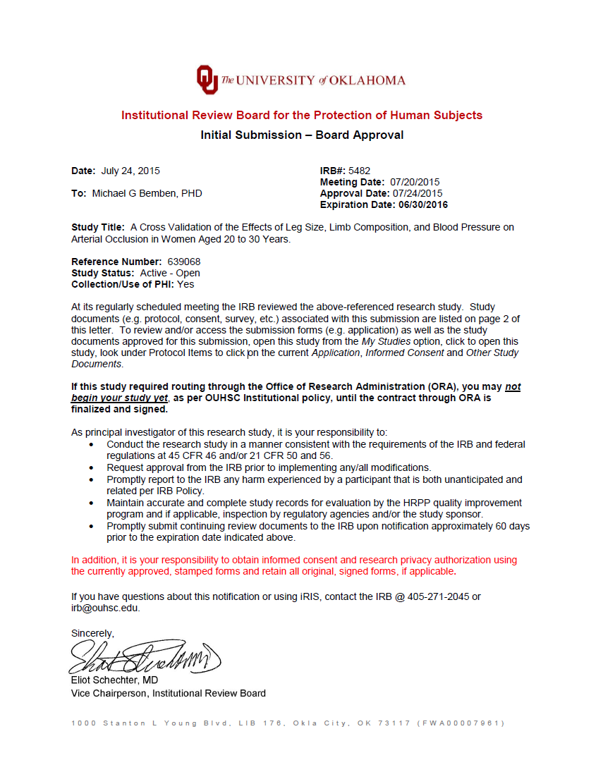
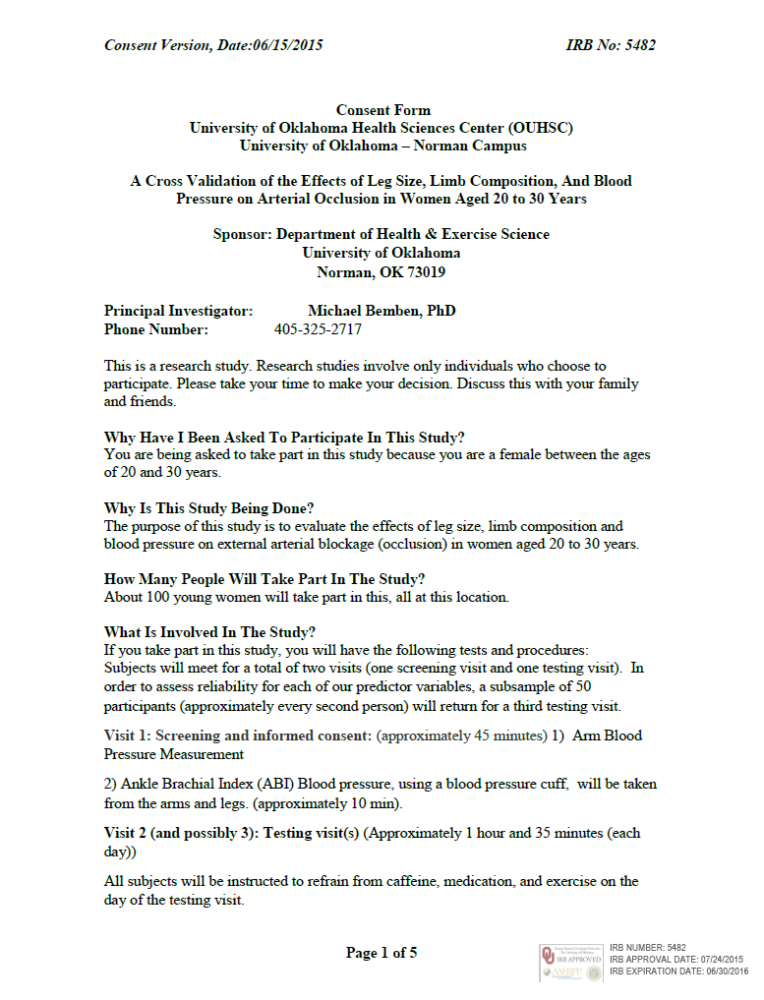
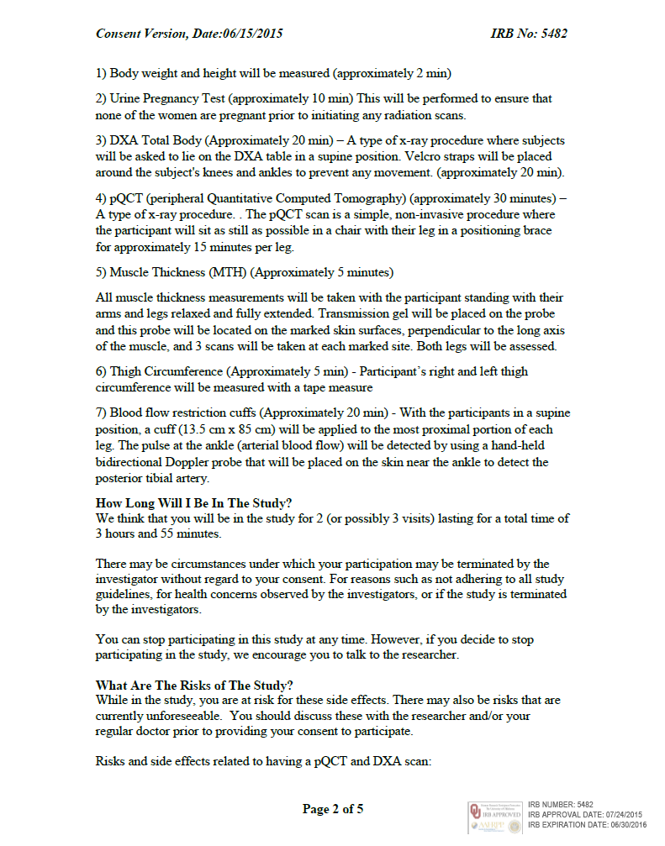




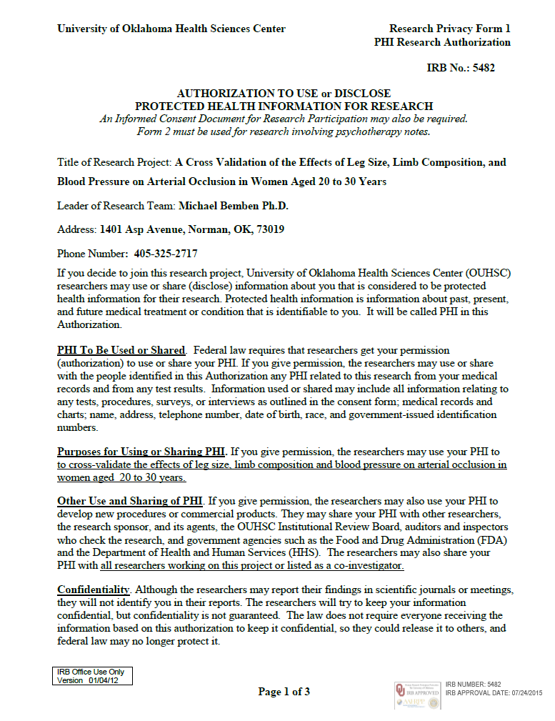

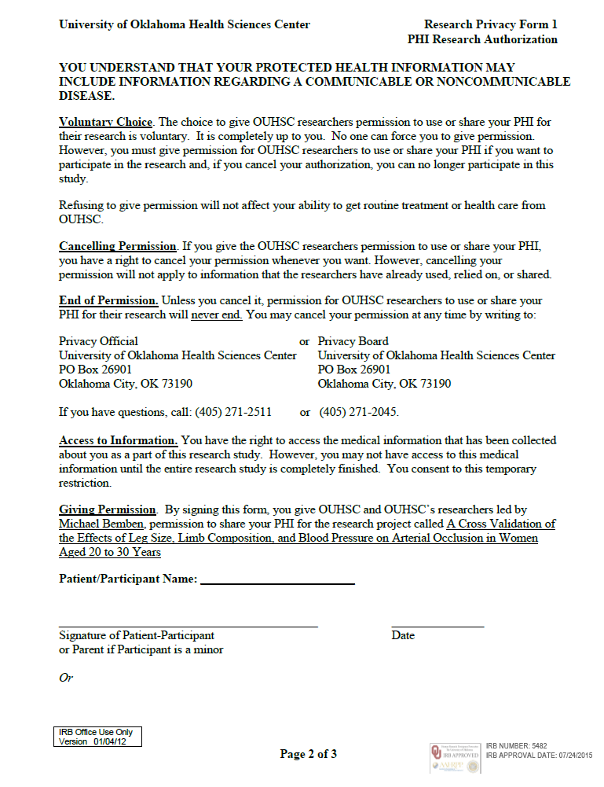

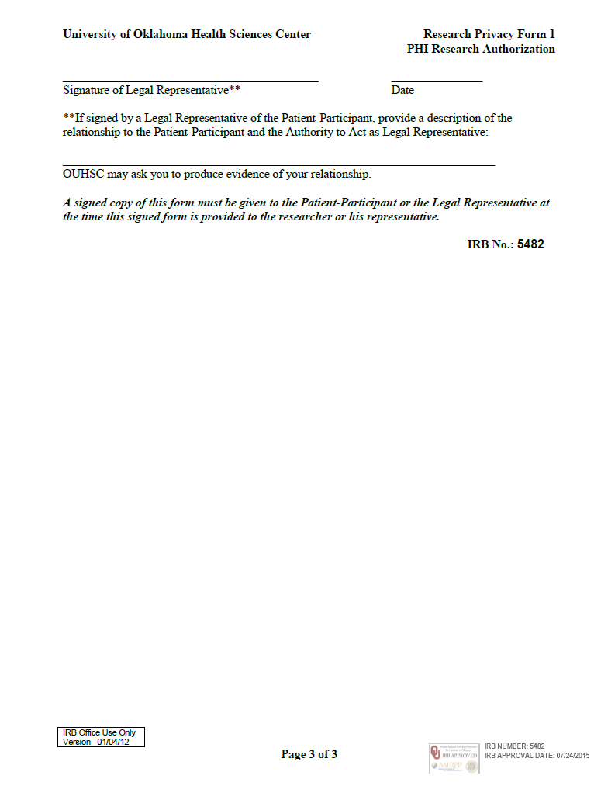

Appendix B: Other Forms

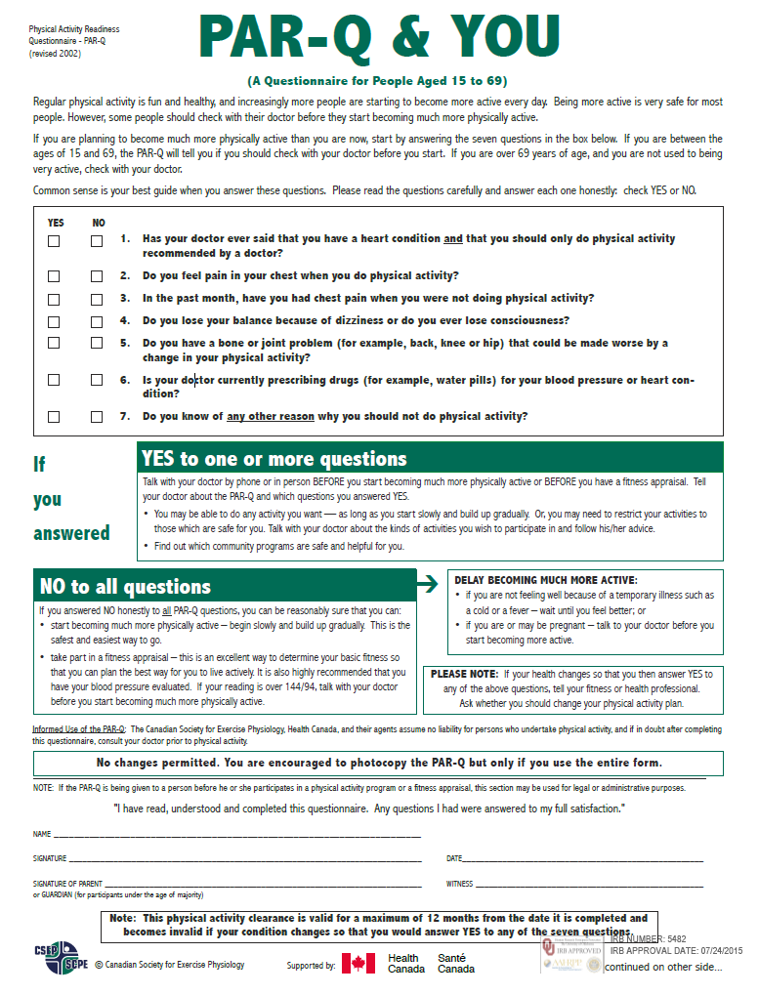

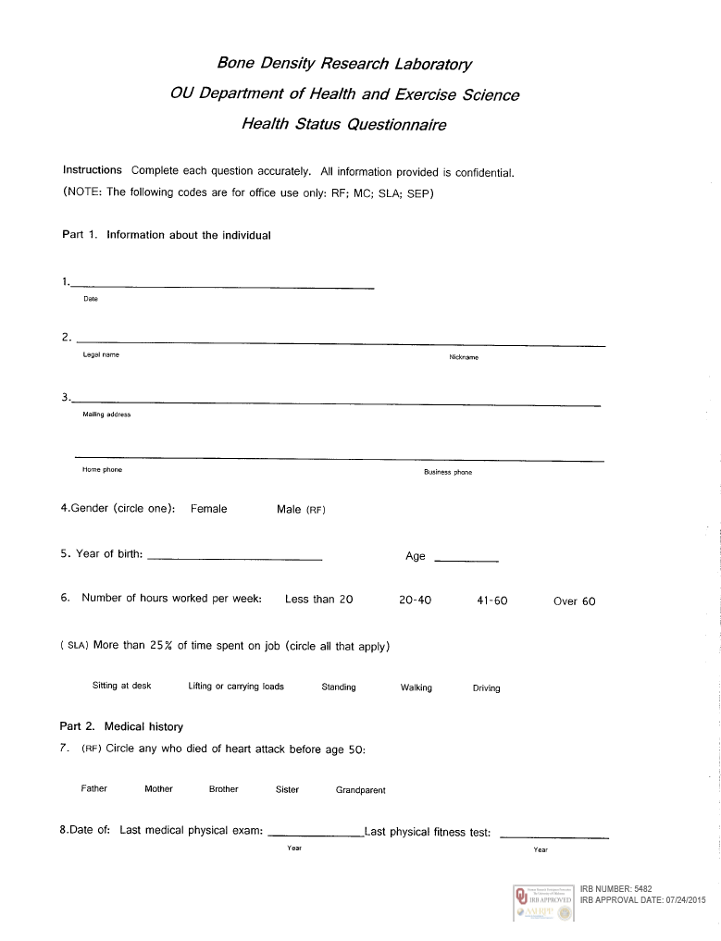

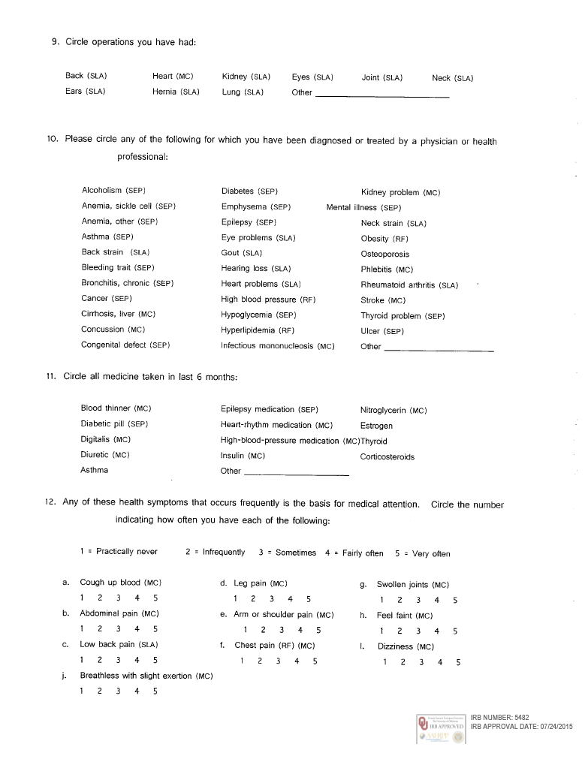







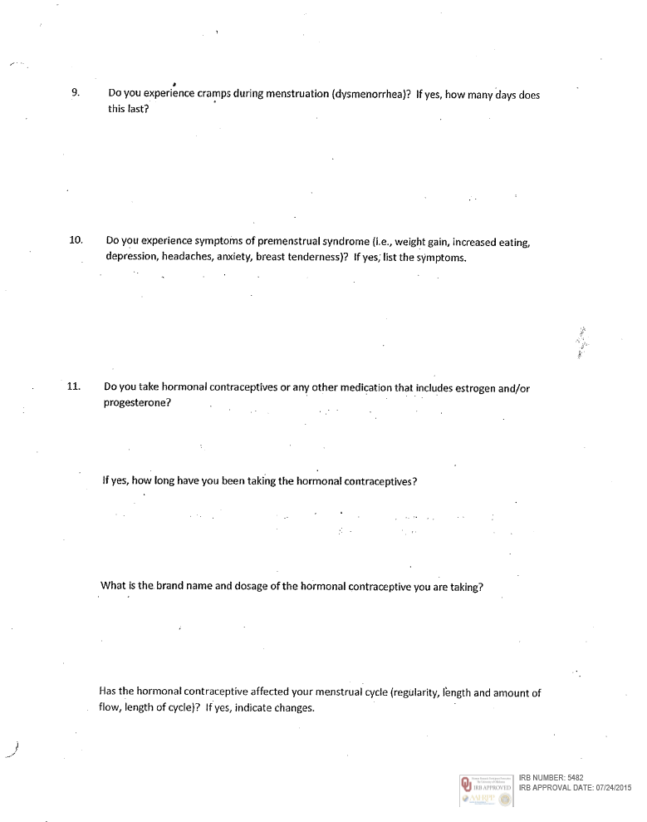

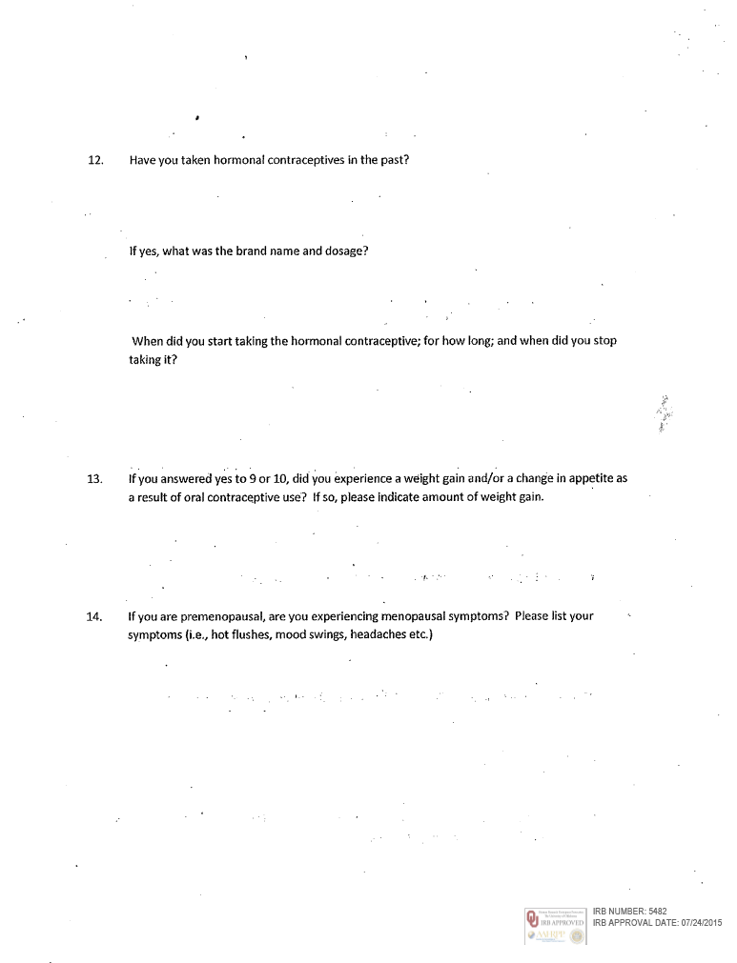

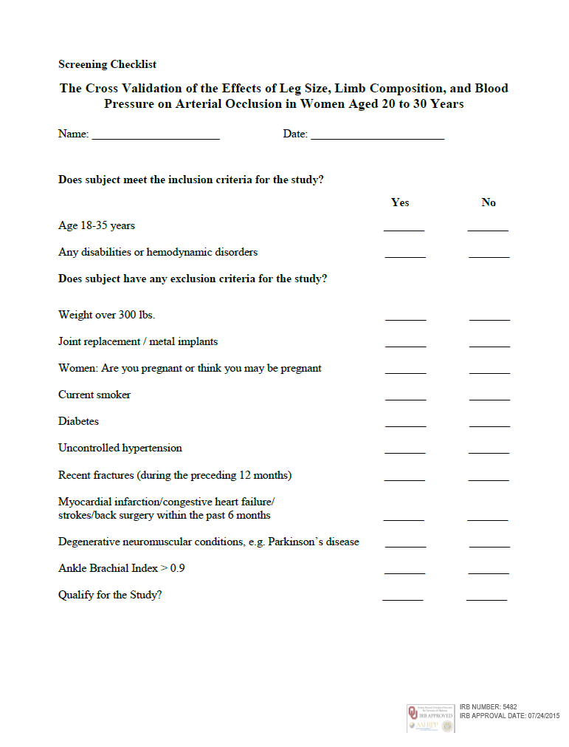

Appendix C: Data Collection Forms

Data Collection Sheet ID #CCDISS
Screening
Blood Pressure | Trial #1 | Trial #2 | Average
 | / | / | /

AB Index | Right Arm
 | Right Leg
 | Left Leg
 | Left Arm
*Right leg: get the highest of the two right ankle pressures / highest of the two arm pressures
*Left leg: get the highest of the two left ankle pressures / highest of the two arm pressures
*Ankle brachial index of <0.9

Visit 2
Step 1:
Urine Test
Pregnancy
Hydration Status
Step 2:
Height (cm)
Weight (kg)

Step 3: DXA
Ethnicity Origin (Circle)
White
Hispanic or Latino
Black or African American
Native American or American Indian
Asian/ Pacific Islander
Other
Step 4: pQCT
Right femur length: _____________ mm
Left femur length: ______________mm
Step 5: Ultrasound
- – Right Femur Length: ________cm Left Femur Length: ________cm
- – Right Femur 33%: ______cm and 50%: ______cm
- – Left Femur 33% : ______ cm and 50%: ______cm

Anterior
MT | Right (33%)  M F | Left (33%)  M F | Right (50%)  M F | Left (50%)  M F
Trial # 1 | / | / | / | /
Trial # 2 | / | / | / | /
Trial # 3 | / | / | / | /
Average | / | / | / | /

Lateral
MT | Right (33%)  M F | Left (33%)  M F | Right (50%)  M F | Left (50%)  M F
Trial # 1 | / | / | / | /
Trial # 2 | / | / | / | /
Trial # 3 | / | / | / | /
Average | / | / | / | /

Step 6:

Thigh Circumference | Right | Left
33%
50%
Step 7:
 | Trial #1 | Trial #2 | Average
Blood Pressure | / | / | /
HR
Step 8:
Arterial Occlusion | Right | Left
mmHg

Visit 3
Step 1:
Urine Test
Pregnancy
Hydration Status

Step 2:
Height (cm)
Weight (kg)

Step 3: DXA
Step 4: pQCT
Right femur length: _____________ mm
Left femur length: ______________mm
Step 5: Ultrasound
- – Right Femur Length: ________cm Left Femur Length: ________cm
- – Right Femur 33%: ______cm and 50%: ______cm
- – Left Femur 33% : ______ cm and 50%: ______cm

Anterior
MT | Right (33%)  M F | Left (33%)  M F | Right (50%)  M F | Left (50%)  M F
Trial # 1 | / | / | / | /
Trial # 2 | / | / | / | /
Trial # 3 | / | / | / | /
Average | / | / | / | /

Lateral
MT | Right (33%)  M F | Left (33%)  M F | Right (50%)  M F | Left (50%)  M F
Trial # 1 | / | / | / | /
Trial # 2 | / | / | / | /
Trial # 3 | / | / | / | /
Average | / | / | / | /

Step 6:
Thigh Circumference | Right | Left
33%
50%
Step 7:
 | Trial #1 | Trial #2 | Average
Blood Pressure | / | / | /
HR
Step 8:
Arterial Occlusion | Right | Left
mmHg

Appendix D: Descriptives and Raw Ultrasound Data
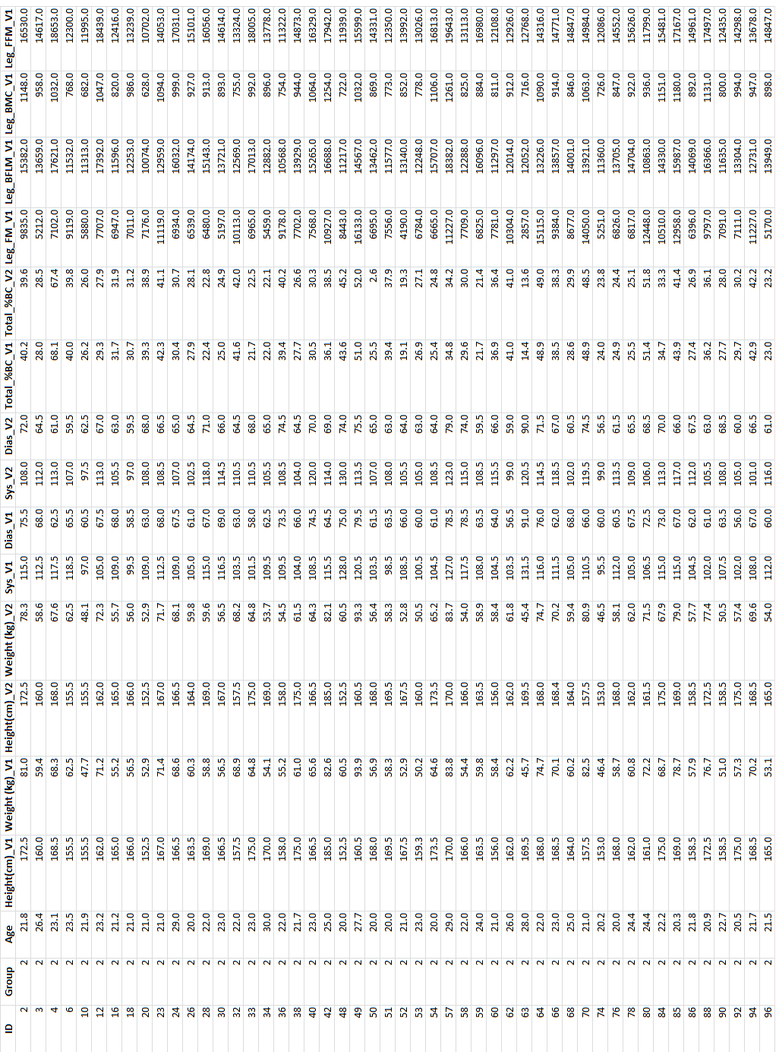

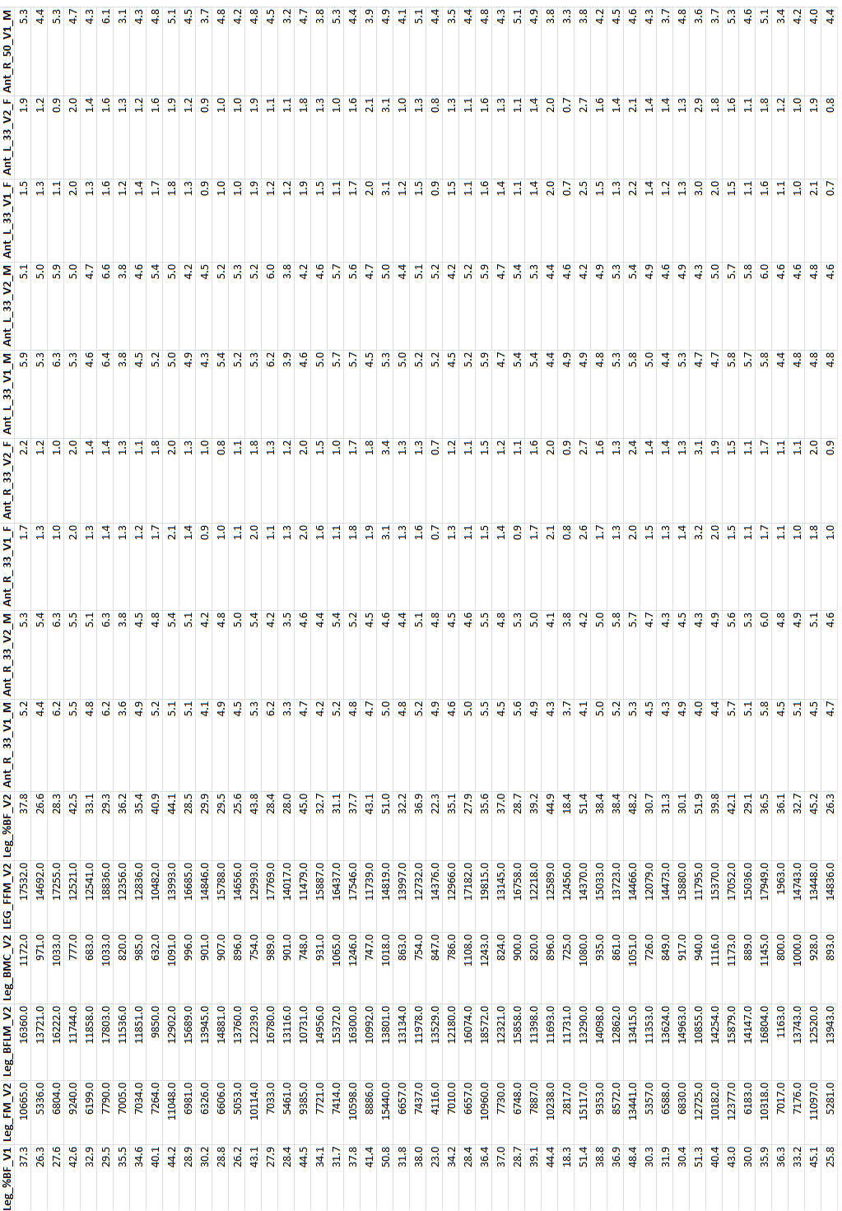

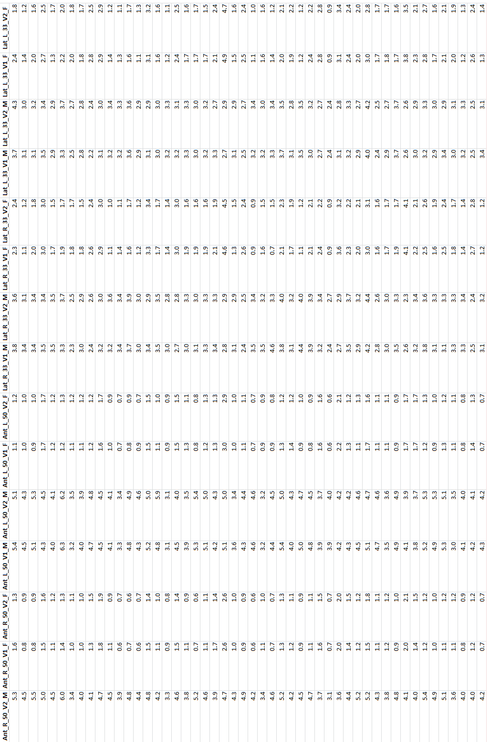
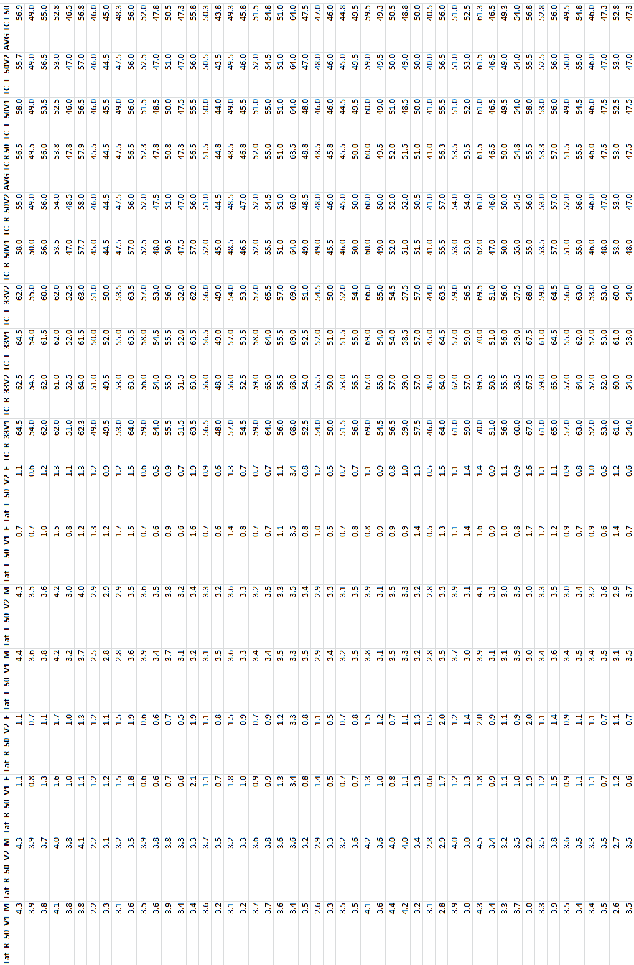
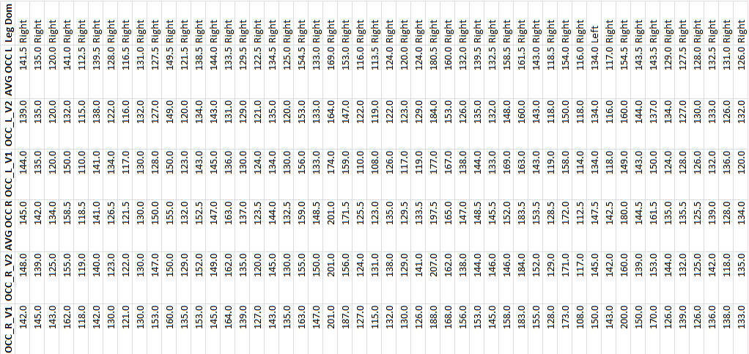
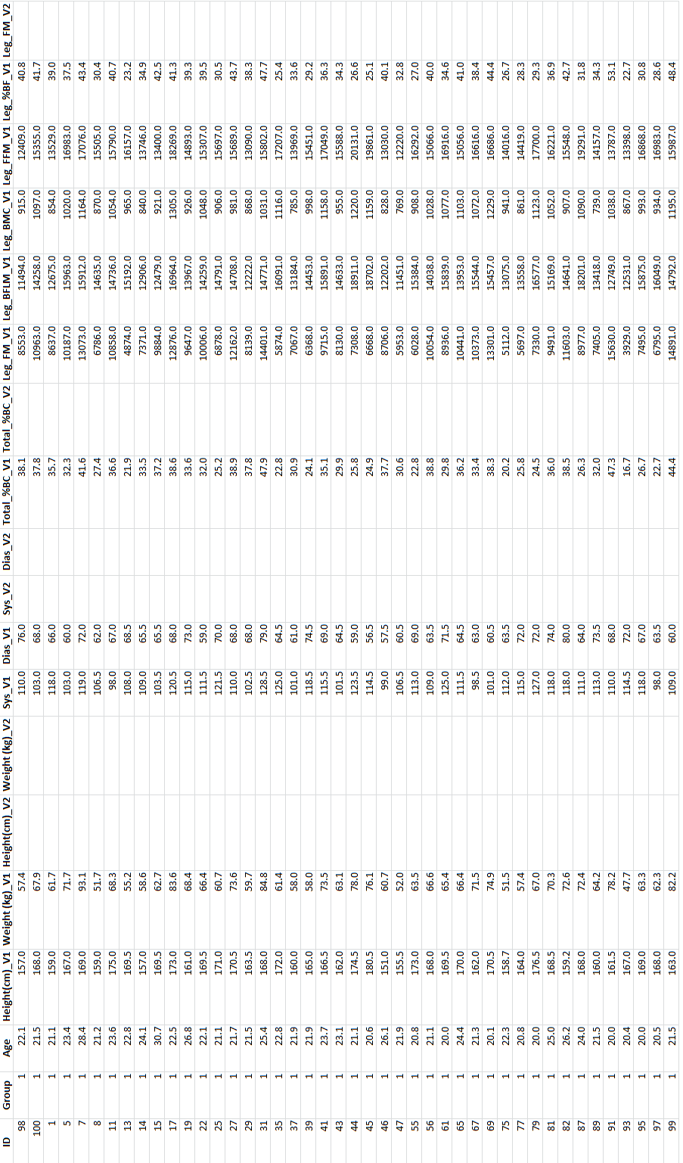
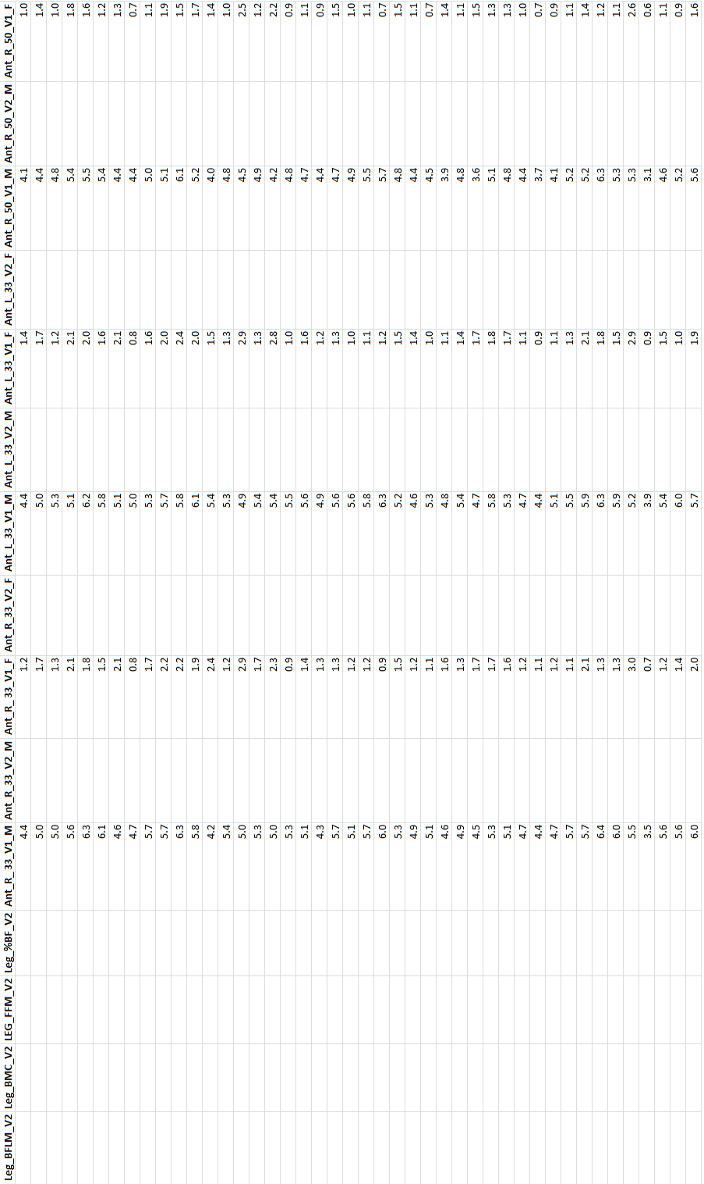
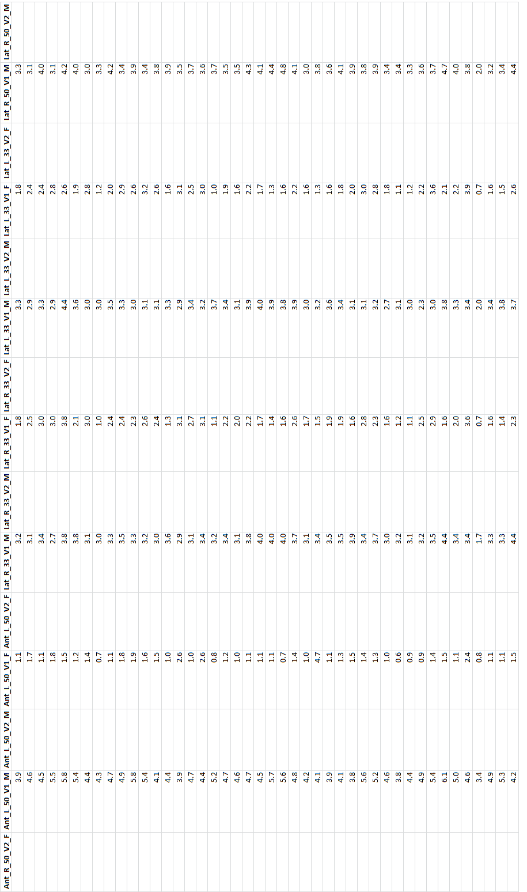
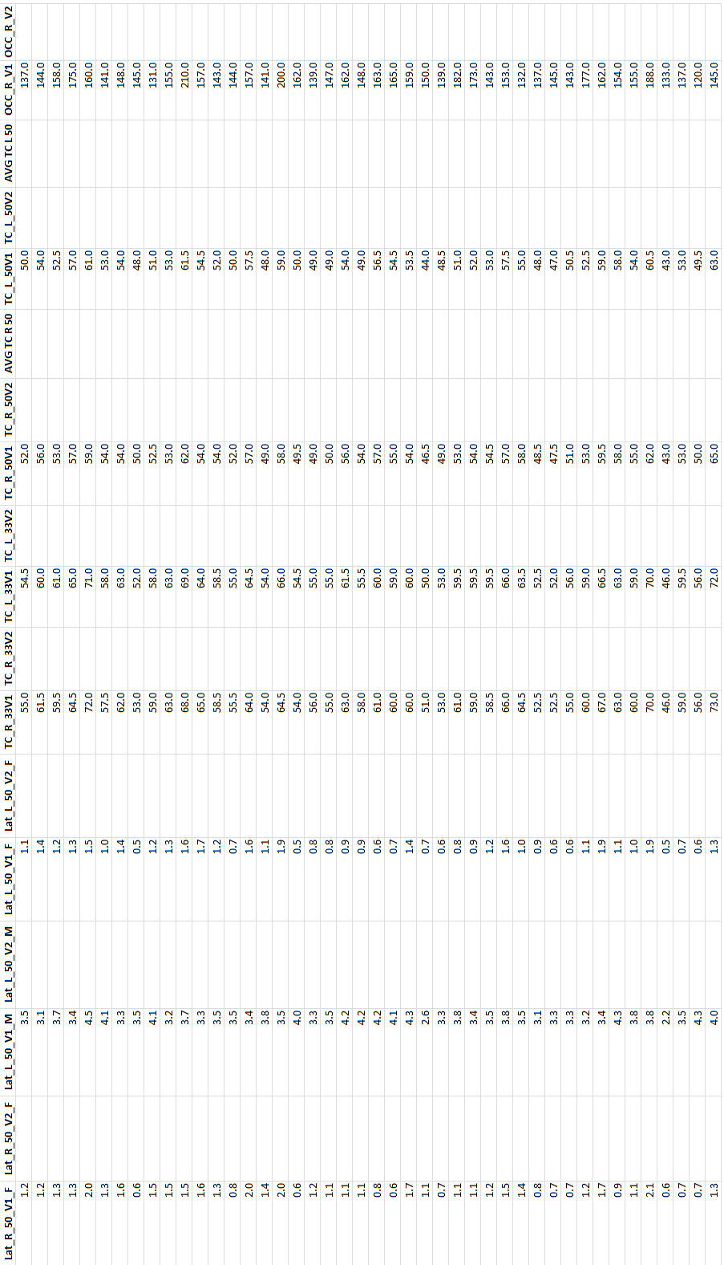
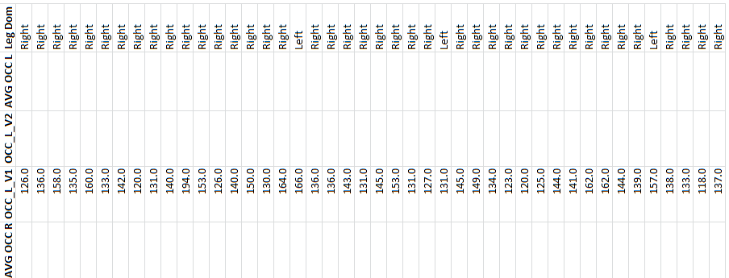

Appendix E: Raw DXA Data
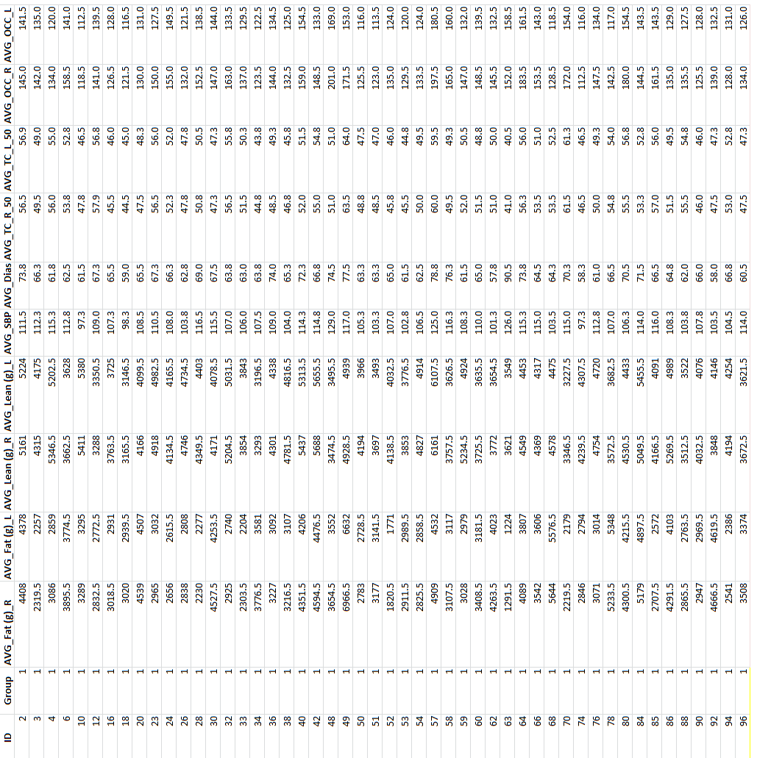
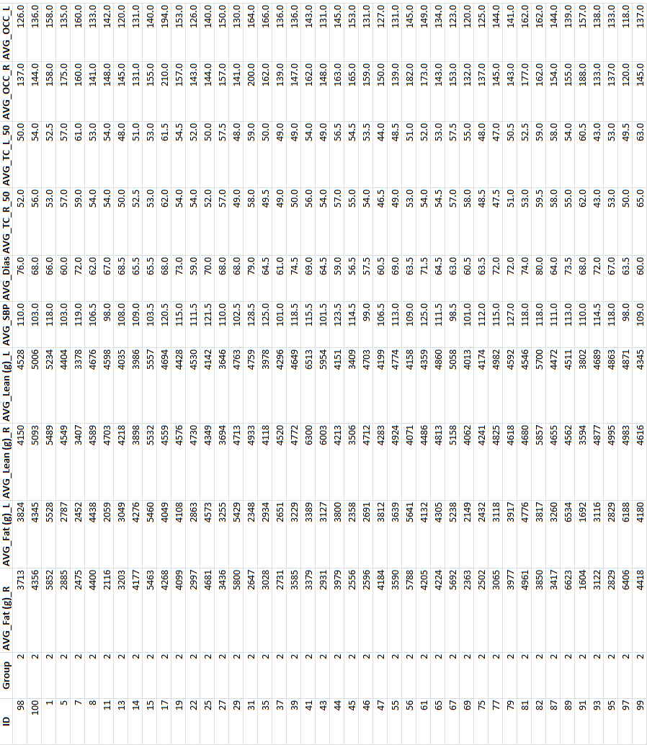

Appendix F: Raw pQCT Data for Left Leg
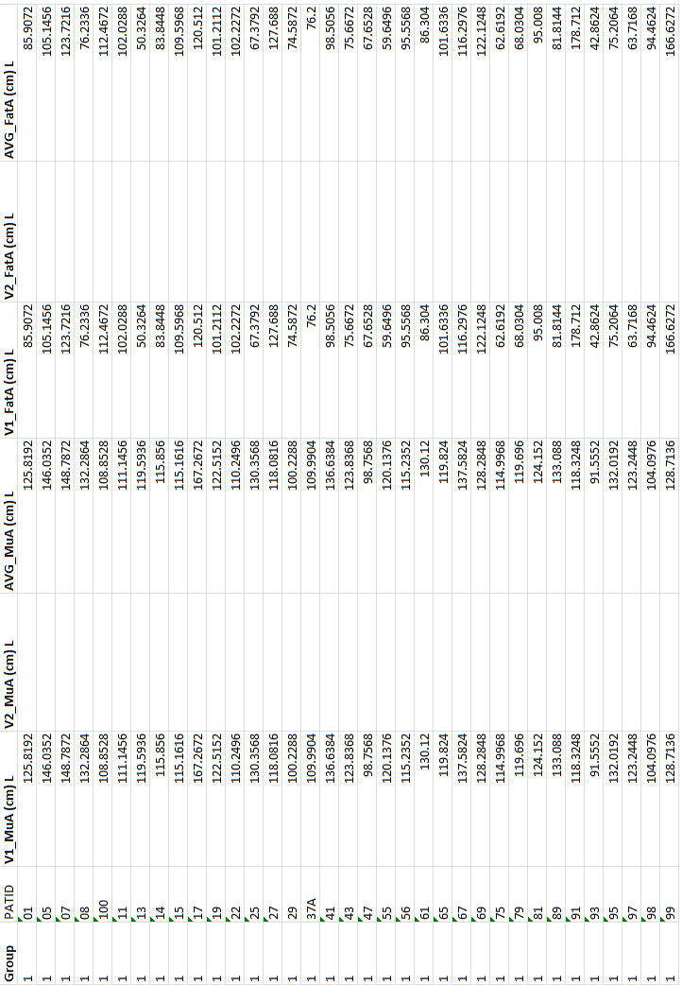
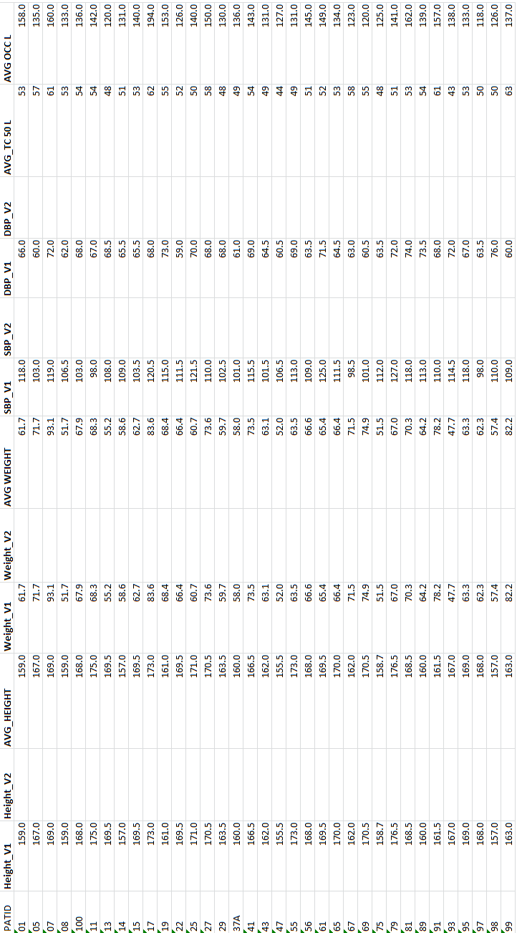

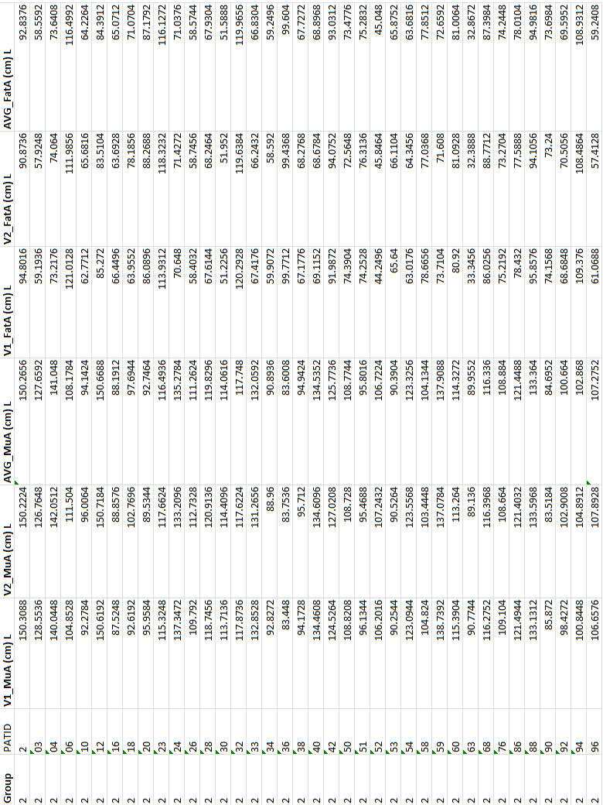

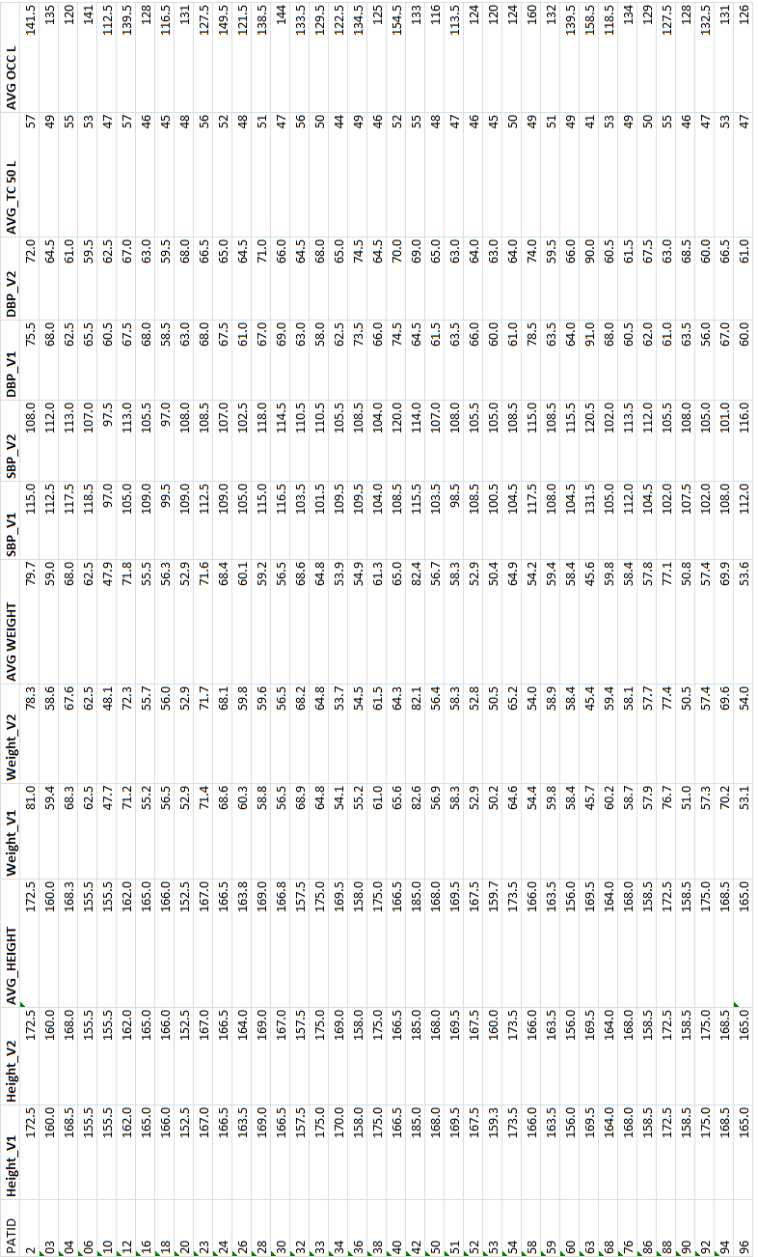

Appendix G: Raw pQCT for Right Leg
