UNIVERSITY OF OKLAHOMA

GRADUATE COLLEGE

EXPLORING COLLABORATION AND ITS INFLUENCE ON ARTISTIC CREATIVITY THROUGH AN INVESTIGATION OF LITERATURE, PERSONAL INTERVIEWS, AND THE CREATION OF A NON-HIERARCHICAL COLLABORATIVE PROCESS IN DANCE, MUSIC, AND PAINTING

A THESIS
SUBMITTED TO THE GRADUATE FACULTY
in partial fulfillment of the requirements for the
Degree of
MASTER OF FINE ARTS IN DANCE

By
Mary Ann Mayer
Norman, Oklahoma
2022
EXPLORING COLLABORATION AND ITS INFLUENCE ON ARTISTIC CREATIVITY THROUGH AN INVESTIGATION OF LITERATURE, PERSONAL INTERVIEWS, AND THE CREATION OF A NON-HIERARCHICAL COLLABORATIVE PROCESS IN DANCE, MUSIC, AND PAINTING

A THESIS APPROVED FOR
THE SCHOOL OF DANCE

BY THE COMMITTEE CONSISTING OF

Boyko Dossev, Chair

Mary Margaret Holt

Igor Lipinski

© Copyright by MARY ANN MAYER
All Rights Reserved.
Acknowledgements

The collaborative effort on the part of many incredibly generous individuals has resulted in the creative completion of a choreographic work and the fulfillment of this thesis.

I extend my heartfelt appreciation to everyone involved and acknowledge the following:

Chair of my thesis committee Boyko Dossev, Assistant Professor of Dance and Oklahoma Festival Ballet Artistic Director. His faith in my choreographic endeavors and his continued support of my aspirations for this project have been extraordinary. His generosity, uplifting spirit and constant encouragement made the journey an easier road to travel.

Thesis committee member Dean of OU’s Weitzenhoffer Family College of Fine Arts, Nichols Chair, Presidential Professor, and Regents’ Professor of Dance, Mary Margret Holt for generously providing invaluable advice and insight throughout the process.

Thesis committee member Dr. Igor Lipinski, Assistant Professor of Piano, for his advice, thoughtful observations, and provocative questions.

Katie Ostrosky, PhD candidate, School of Music, and my daughter, Sylvie Mayer for their creativity and their unending dedication to the project. They were the heart of the collaborative team and continued to fill me with excitement and enthusiasm. The project was enriched by their commitment and talent and sustained by our shared vision.

The Faculty and Staff of the School of Dance, especially Michael Bearden, Director School of Dance, for his continued support of my creative endeavors and Roxanne Lyst, Graduate Student Liaison. Glenn Edgerton and Leslie Kraus for their support throughout YCS.

The School of Dance undergraduate dancers who so beautifully performed in Tendrils and who brought life to our collaborative creative vision. Gabrielle Brown, Stephanie Eggers, Delaney Gondo, Eliza Harden, Harry Hefner, Sofia Redford, and Alayna Wong.

Assistant Professor, Helmerich School of Drama, Renée Brode; undergraduate students Ian Evans and Logan Wynn for their special talent with projection and lighting design. Marissa (Ris) Carroll and Charis Christy as well as the entire stage crew.

Friends and family, who remained supportive throughout. Especially, Sylvie Mayer for her ongoing editing and intellectual insights, Richard Derry for last minute edits and accepting the long distance, Katie Ostrosky for academic guidance and helping me manage Zotero, EJ Chamorro, Deb Meunier, Ron Schmitt and The Peppes, Mercer, Mayer, and Derry Families.

The amazing cohort of graduates who shared with me in this three year journey.
J’Aime Griffith and Greta Nunez. You will be missed.

Finally, I extend my deepest appreciation to The University of Oklahoma’s Dean’s Circle Funding, the School of Dance, and the Graduate College Robberson Fund for the financial support provided for the performance aspect of the thesis.

iv.
Abstract

This thesis explores collaboration and its influence on artistic creativity through an investigation of literature, personal interviews, and an autoethnographic case study of a non-hierarchical collaboration that began in August 2021 and culminated with a fully staged performance piece in January 2022. The purpose of the case study was to investigate how the collaborative process informed and inspired the creativity of each participating artist toward the goal of developing a fully staged presentation. The non-hierarchical component was defined as collaboration whereby each artist contributed, reacted, and participated without dictating concept or design. The primary team of collaborators consisted of a choreographer, a composer, and a visual artist. Each had been classically trained in their respective fields and were inherently interested in collaboration. Documentation of the collaborative process is presented through a chronological narrative from inspiration, concept design, and various experiments that led to a presentation of music, dance, and visual art. The final result was a ballet in eight movements that traveled between a reality space and a memory space, and was supported by eight original music scores and six original projected paintings.
This thesis offers insight into the collaborative process and its influence on each collaborator, participating dancers, projection artist, and lighting designer. It discusses the characteristics and elements that are integral for successful collaboration and sheds light on the creative potential and possibilities that collaboration can provide in the educational and professional studio setting.
Analysis of the case study and of the information gleaned from interviews as well as the review of literature support the premise that collaboration influences creative output. This thesis is intended to strengthen the reader’s understanding of successful collaborative creativity while aiming to inspire and enhance future research.
v.

Table of Contents

Introduction 1
Chapter One: Theoretical Overview 3
1.1 Creativity 3
1.2 Collaboration 11
1.3 Improvisation and the Jam Session Model 17
1.3 Contact Improvisation 24
1.3.1 Interview with Shura Baryshnikov 24
Chapter Two: Autoethnographic Case Study 27
2.1 Introduction 27
2.2 Project Description and Concept Development 28
2.3 Casting the Dancers 34
2.4 Collaboration and the Choreographic Process 37
2.5 Projections and Lighting Design 57
2.6 Performance 67
Chapter Three: Literature Review of Collaborative Individuals 71
3.1 Sergei Diaghilev and the Ballets Russes 71
3.2 George Balanchine and Igor Stravinsky 73
3.3 The Modernist Movement in Dance and Music 86
3.4 Pablo Picasso and Georges Braque 96
Chapter Four: Interviews 101
3.1 Robyn Mineko Williams 101
4.2 Kirsten Evans 103
Chapter Five: Conclusion 105
5.1 Future Research Questions 105
5.2 Reflections and Analysis 106
Bibliography 114
Appendix 121
Appendix A: Images 121
A.1 Original Images. Sylvie Mayer 121
A.2 Final Images - Cropped by Sylvie Mayer - Masked, Edited
and Saturated by Ian Evans 122
Appendix B: Performance 123
B.1 Tendril Performance Link: https://youtu.be/6kIC9nVZbaQ 123

vi.
B.2 Tendrils Dress Rehearsal Photographs, edited by Ian Evans 123
B.3 Tendrils Poster 126
B.4 Young Choreographer’s Showcase Program Notes 127
Appendix C: Projection and Lighting Design 132
C.1 Projection Design Diagram. Ian Evans 132
C.2 Lighting Design Plot. Logan Wynn 133
Appendix D: Post Performance Reflections 134
D.1 Collaborators: Journal Prompts 134
D.2 Collaborators: Post Collaboration Survey 136
D.3 Projection and Lighting Designers: Post Collaboration Survey 137
D.4 Dancers: Post Collaboration Survey 138
Appendix E: Interviews 139
E.1 Interview Protocol 139
E.2 Interview Questions 141
Appendix F: IRB 142
F.1 Certificate 142
F.2 Outcome Letter - Approval of Initial Submission 143
F.3 Outcome Letter - Final Report 144
F.4 Consent to Participate Form 145
Appendix G. Supporting Documents 146
G.1 Emotion Wheel 146
G.2 Color Wheel 147

vii.

Introduction
Inspired by the collaborative work of significant choreographers, musicians, and artists of the twentieth and twenty-first centuries, the writing of Joshua Wolf Shenk in the Powers of Two, and my personal collaborative experiences, in this thesis, I investigate the influence of collaboration on creativity. To examine this topic effectively, I completed an autoethnographic case study through a non-hierarchical process of collaboration in dance, music, and painting, as well as personal interviews, and a literature review.
The purpose of the case study was to investigate how a collaborative process could inform and inspire the creativity of each participating artist toward the goal of developing a fully staged performance. We defined non-hierarchical collaboration as a process whereby each artist would contribute, react, and participate without dictating concept or design. The primary team of collaborators in the case study consisted of a choreographer, a composer, and a visual artist. Each had been classically trained in their respective fields and were inherently interested in and committed to collaboration. We mutually agreed upon the initial inspiration and concept for the performance piece. Creation happened simultaneously, with music, movement, and painting sketches being shared among collaborators. We edited and completed works in tandem. I staged choreography on six undergraduate ballet dancers from the School of Dance at the University of Oklahoma. As ideas evolved, the choreography, music, and visual art went through several revisions. To bring the painting element to the stage a student projection artist and a lighting designer were involved in the project. In an effort to document the process for future analysis, each artist kept a journal. The journals later became a tool for developing a narrative and for recognizing themes and understanding the collaboration’s impact on inspiration and creativity.
To support the case study and gain further insight into creativity and collaboration I conducted personal interviews with contemporary collaborators in the dance field. I reviewed literature on the theory of creativity and collaboration. I studied the jam session model of jazz ensembles, introduced by Keith Sawyer and further synthesized by Monika Herzig and David Baker. I spoke with a contact improvisation artist to better understand the importance of improvisation in collaborative groups. And finally, I reviewed the history of various collaborative partnerships in dance, music, and visual arts. I examined different types of collaborations across various fields to compare the characteristics of the collaborators and the methods used to influence successful creative output.
The methodology used throughout this project was qualitative; based on observation, and delivered through narrative. However the lines were blurred regarding the methodological approach since I began with a premise, implying deductive research yet over time the process was altered by the outcome. Through induction, I discovered many themes that support collaborations' influence on creativity and its ability to stretch the individual.

Chapter One: Theoretical Overview

1.1 Creativity

As a dance artist, I can easily recognize when a piece of choreography is interesting and creatively constructed, however I often find it difficult to explain why. Before delving into the topic of collaboration and its effect on creativity, addressing the definition of creativity is vitally important to my investigation. Many theories, methods, and perspectives are offered in literature, and according to M. S. Lindauer, “Definitions of creativity vary considerably, initiate fierce discussions and arouse controversy.” Smith, in his 2005 article How Should Creativity Be Defined?, introduces Nobel laureate Herbert Simon as an individual known for “the exactitude of his prose,” He cites the definition authored by Simon for the centennial exhibition of the first Nobel prize, “We judge thought to be creative when it produces something that is both novel and interesting and valuable.” Smith goes on to say that psychologists’ attempts at defining creativity “mix different perspectives, one referring to the cognitive sphere, the unchained freedom of thought, another to the expectations associated with creative activities.” The different psychological approaches to studying creativity, including general, psychoanalytical, and scientific, have contributed disparate outcomes to the definition. These contributions are each incorporated into the current overarching view of creativity as having core components of novelty and relevance, with experts still questioning whether a unified definition is possible.
Important issues remain unresolved when considering the many ways in which creativity can be expressed and the many fields within which it can be actualized. Perhaps creativity cannot be described generally and must be defined specifically for different areas of expertise, like arts or sciences. Today fields which employ creativity are not confined to the fine arts, literature, performing arts, music, philosophy, and similar artistic/aesthetic domains but also include science, business, technology, administration, defense, manufacturing, medicine, and law enforcement. In addition, interpretations and explanations of creativity are dependent on the perspective and the purpose of the person doing the research.
Mihaly Csikszentmihalyi, an influential psychologist who has contributed substantially to advancing the research and theory around creativity, asks the question, ‘Where is Creativity?’ rather than, ‘what is creativity?’ Csikszentmihalyi states that “creativity does not happen inside people’s head, but in the interaction between a person’s thought and a sociocultural context. It is systematic rather than an individual phenomenon.” He asserts that if the term is defined too broadly and not considered systematically we compromise the significance of the meaning and creativity becomes “a subjective phenomenon.”
Csikszentmihalyi has classified three designations to distinguish creative people. These include Brilliant, Personally Creative, and The Creative Ones. These three
designations indicate distinctly different modes of being creative, rather than simply different degrees of creativity. He refers to Brilliant people as those who appear to be unusually bright, interesting, and stimulating. He describes Personally Creative people as those who experience the world in novel and original ways and whose judgments are insightful. And explains that The Creative Ones are public figures who have changed our culture in some important way; these people include Picasso, Edison, and Einstein. Within these designations he sees a range of possibilities for creativity and explains that it is “possible to make a creative contribution without being brilliant or personally creative and that someone personally creative may never contribute a thing to the culture.” He further posits that “All three kinds of creativity enrich life by making it more interesting and fulfilling.”
In considering the different types of creativity, many researchers follow the same line of thinking as Csikszentmihalyi. The model system distinguishes between the creativity of figures like Pablo Picasso or Johann Sebastian Bach compared to the creativity of a home cook. The creativity of a home cook who changed the ingredients of a familiar recipe thereby formulating a new taste which never becomes known outside the family may be referred to as “little c” creativity or according to Csikszentmihalyi’s designations, Personally Creative. On the other hand, Picasso’s influence on Cubism, which created a paradigm shift in the visual
arts and inspired others to follow new and divergent directions, may be referred to as “big C’ creativity or, according to the designations of Csikszentmihalyi, The Creative Ones.
Csikszentmihalyi’s definition of creativity as “an act, idea, or product that changes an existing domain, or that transforms an existing domain into a new one” is consistent with “big C” creativity of the model system. However, Csikszentmihalyi brings the individual back into the equation stating that “the final component of the creative system is the individual person.” He defines the creative person as “someone whose thoughts or actions change a domain, or establish a new domain. It is important to remember, however, that a domain cannot be changed without the explicit or implicit consent of a field responsible for it.” He refers to a domain as a culture or a particular society that shares certain knowledge and/or symbols, and the field as consisting of the individuals who serve as “gatekeepers” to the domain. For example, if visual arts is a domain, the field includes art teachers, curators, collectors, critics, and administrators of foundations and government granting organizations. He states that “creativity occurs when a person, using the symbols of a given domain such as music, engineering, business, or mathematics has a new idea or sees a new pattern, and when this novelty is selected by the appropriate field for inclusion into the relevant domain.”
Researchers, including Csikszentmihalyi, further address the fact that a certain level of expertise, knowledge, and understanding must be achieved before a person can be creative
in a given domain. Cropley confirms the role of knowledge in creativity, citing the following example,
The Canadian Intellectual Property Office reported in 2007 that no less than 90% of new patents are improvements of existing patents. In explaining his own generation of effective novelty Edwin Land, the inventor of the Polaroid camera, expressly emphasized knowledge. He argued that he had had a
purpose – the invention of a camera that developed its own pictures on the spot – and that all the necessary knowledge already existed. His achievement was to become familiar with this knowledge and work his way logically through it to the almost inevitable result, the Polaroid camera.

It is generally understood that knowledge is gained through long periods of work within a particular domain. While the knowledge gained through hard work can promote effective novelty, it can also produce tunnel vision where one becomes too familiar with the domain to innovate. Cropley refers to this relationship as curvilinear and cites Colin Martindale’s argument that “In order to achieve effective surprise, experts need to be thoroughly familiar with the contents of their field but capable of seeing them in a new light.”
Another area considered by scholars in defining creative output has to do with traits and characteristics of the individual. Researchers have discovered that creative individuals present a paradoxical thought process of contradiction and incompatibility. Cropley exemplifies this by explaining that a creative individual may experience both divergent and convergent thinking; they may experience both internal and external drivers of motivation; and may experience fear of failure while at the same time enjoy the thrill of the chase. Csikszentmihalyi agrees that individual traits of creative people are paradoxical; stating that creative people embody playfulness and discipline simultaneously, can be both responsible and irresponsible, are focused but sometimes idle, fluent yet flexible, and grounded in reality while being deeply imaginative. Scott Kaufman, in his article “The Messy Minds of Creative People”, cites Csikszentmihalyi as saying, “creative individuals show tendencies of thought and action that in most people are segregated. They contain contradictory extremes; instead of being an ‘individual,’ each of them is a ‘multitude.’”
In considering the traits of the creative individual Csikszentmihalyi, through extensive
observation and interviews with highly creative individuals, makes the following statements, “Creative people, it seems, are original without being bizarre,” and “the novelty they see is rooted in reality.” He goes on to say that if he had to express in one word what makes a creative personality different from others, “it would be complexity.” And finally he remarks that “Perhaps the most important quality, the one that is most consistently present in all creative individuals, is the ability to enjoy the process of creation for its own sake.”
Cropley posits that the paradox and ambiguity of personal characteristics of creative people may be better understood and more clearly organized through the four-phase approach. In this model, the individual's thinking fluctuates as they pass through the different stages of the creative process. He attributes the understanding of this methodology to Graham Wallas, explaining that it includes processing through the following stages: Information, Incubation, Illumination, and Verification. In the phase of Information a person becomes familiar with the area of investigation. In the Incubation phase the person ponders, considers, and absorbs the information until a solution appears. The solution represents the Illumination phase. As Cropley notes, during the Illumination phase individuals may feel as though the solution appeared out of nowhere. The final stage of Verification is when the person tests the potential solution. As a person passes through these stages, they experience different motivations that allow for processing.
Further complexities in defining creativity are introduced by Csikszentmihalyi in his discussion around “context” and “talent.” He exposes sociocultural context as a determining factor in deciding whether something or someone is creative, reminding us that a particular creative idea may be more or less relevant at different times in history. For example, the choreography of Paul Taylor in the 1970’s was revolutionary, but if his choreography were to be introduced today it may seem relevant but no longer as cutting-edge as it did in the 1970’s. In considering the terms “talent” and “genius,” he explains that the two are often used interchangeably when discussing creativity. However, he cautions that there may be overlaps with genius and creativity or talent and creativity but firmly states that they are not “synonymous.”
In my discussion with Eric Day, Professor of Psychology at the University of Oklahoma, he explained that within the field of Psychology, Creativity is currently understood in this way, “divergent thinking and novel ideas or originality are just part of the equation.” Continuing to explain that in order for something or someone to be creative the outcome produced by the individual “must effectively serve a purpose.” He went on to state that psychologists add a third parameter which includes the “principle of parsimony in that there should be elegance.” Parsimony encompasses elegance and is described as an outcome which is efficient and simple in its creation or design. Day further remarked that, “these terms depend on the field in which creativity is being considered.”
For years the idea of the solitary genius possessing creativity and ingenuity was dominant, with various scholars referring to the twentieth century as the Age of the Individual. In the forward to Vera John-Steiner’s book Creative Collaboration, David Henry Feldman, psychology professor at Tufts University addresses this phenomenon,
Although it is not widely known, the greatest developmental theorist of the twentieth century played an important role in bringing about the revolution that placed the individual self as the highest and most valuable element in
western society. Jean Piaget, born in 1896, fashioned a theory of intellectual development that placed a lone seeker of knowledge (an “epistemic subject'' as he called it) at the center of the developmental process. Each individual, according to Piaget, must construct or create increasingly sophisticated instruments for knowing and understanding the world.

Piaget's theories most certainly influenced the development of the concept of the individual genius in reference to creativity. However, toward the end of the 20th century, as society at large became more aware of diversity, scholars began to accept different opinions. As the Russian psychologist Lev Vygotsky’s work on collectivism, social interaction, and relationship-oriented theory became known, a more balanced outlook came into focus. Society gradually moved away from its preoccupation with the development of the individual. Csikszentmihalyi adds to this theory by stating that “the individual is not as important as it is commonly supposed” however he proposes yet another paradox when he states that novelty could not come about “without the contributions of individuals, and that all individuals have the same likelihood of producing novelty.”
The evolution of the definition of creativity has moved away from the lone-genius theory and toward a more collective and sociocultural perspective. If we look closely at historically creative innovations and outcomes we find that these ideas have been generated
from the work of cooperative pairs and groups, or from a network of gathered information over time. Across many fields we see collaborative efforts towards creative outcomes becoming widely accepted, evidenced by the idea of the 'incubator' or 'think tank' common in business, as well as the establishment of the 'artist collective'.

1.2 Collaboration
To provide an overview on collaboration’s influence on creativity, I explore the contrasting concepts of the lone-genius model versus the collaborative network model. Exploring theoretical literature regarding these concepts, I look to research on cognition and human development as a process of social interaction. I examine the synthesis associated with cognitive development and the aspect of complementarity in partnerships. I relate these theories to language learning and the dance studio as a laboratory for collaborative endeavor. I further explore the collaborative aspect of the practice of improvisation in jazz and dance; exposing its organic influence on creative output.
Joshua Wolf Shenck, the author of Powers of Two, in considering creativity, contrasts the lone-genius concept with collaboration, arguing that the collaborative model, although complex, is more accurate than the lone-genius model. In Powers of Two, Shenk immediately exemplifies his belief in the importance of collaboration and the network model of creativity by titling the Introduction to his book, 1 + 1 = Infinity. Regarding the network model, he posits, “Rather than focus on the solitary hero snatching inspiration from the heavens (or the unconscious), this concept emphasizes the long, meandering course of innovation. Instead of heroic individuals, it prioritizes heroic cultures - the courts of sixteenth-century Florence, say,
or the coffee shops of Enlightenment London, or the campus of Pixar.” In considering these disparate perspectives throughout his book, Shenck points out that the lone-genius model is simplistic, easy to explain, and basically “makes for a good story.” While the collaborative network model is “actually more accurate but complex, nuanced, and hard to explain.”
Vera John-Steiner shares a similar ideology and argues that collaboration is linked with human development. Steiner, a scholar who views learning and thinking as a social process, addresses intellectual and artistic collaboration in her book Creative Collaboration. She states that “The notion of the solitary thinker still appeals to those modeled by the Western belief in individualism. However, a careful scrutiny of how knowledge is constructed and artistic forms are shaped reveals a different reality. Generative ideas emerge from joint thinking, from significant conversations, and from sustained, shared struggles to achieve new insights by partners in thought.”
In considering the study of human cognition, the debate over the concept of nature versus nurture represents a dichotomy between individual processes and social constructs in understanding cognitive development. Moving away from the traditional approaches of the individual-centered theories of Freud, Erikson, and Piaget and other biologically driven psychological theories, John-Steiner presents a “life-span” approach. She states, “central to such an approach is the principle that humans come into being and mature in relation to others.” She refers to the theoretical work of Vygotsky and his concept of the “zone of proximal development” to explain how cognitive development begins first in “shared
activities of individuals followed by internalization of the consequences of such interaction.” An example of this process is in how humans develop language skills. Young children learn language through interaction, mimicry, and appropriation of what they hear and eventually the synthesis of the specific symbols and codes of language become part of their own cognition.
Vygotsky’s work explains that “some dichotomies are resolved through syntheses.” Other scholars including Sarah Harvey consider synthesis in group activities. Harvey describes group creativity in her article Creative Synthesis: Exploring the Process of Extraordinary Group Creativity, as being most effective when the resources of the group are
“diverse and are applied to developing a synthesized understanding of the problem or task, rather than to promoting divergence between group members.” She states that “Creative synthesis recognizes and develops complex connections between previously unrelated concepts.” She further cites Catmull’s reference to the creative teams at Pixar, where he states that “attempts to synthesize art and technology create tension, but the resolution of that tension produces novelty.”
Recognizing that synthesis cannot always be accomplished, John-Steiner references the work of James Wertsch, where he “suggested that thinking, communicating, and acting constitute a complex system. He viewed some individual and social processes in
dynamic tension with each other, and this tension produces important and, frequently, useful
changes.” Using Wertsch’s approach, John-Steiner developed her own theory of “conceptual complementarity.” The American Psychological Association (APA) defines complementarity in a dyadic relationship as “the existence of different personal qualities in each of the partners that contribute a sense of completeness to the other person and provide balance in the relationship.” John-Steiner further expresses her belief that collaborative partnerships are made strong not only by a shared vision but also by the nature of each individual and by their complementary skills. She continues by stating that “In generative scientific partnerships, collaborators redefine their own personal boundaries as they strive toward mutuality and deep understanding.”
Many aspects of the work done in a dance studio constitute the notions of proximal development, interdependence and complementarity. Consider the relationships of teacher/student, choreographer/dancer, dancer/dancer. The process of proximal development is seen in the early stages of ballet training when students learn the codified language of ballet through slow, progressive appropriation and mimicry of steps. Eventually the young dancer, through the process of conceptual complementarity develops technical acumen from practicing with other dancers, feedback from teachers, and personal failures that lead to change and accomplishment. In essence the dance studio becomes a laboratory for collaborative endeavor and creative output.
Further, if we consider creativity as a process of discovery, improvisation becomes an avenue that provides a space for individual and collective creativity. Keith Sawyer, author of Group Genius: The Creative Power of Collaboration proposes that “improvisation, interwoven with planning, is the key to successful innovation.” He states that there is a parallel between the two and that “radical innovation requires tremendous improvisation.”
There are dance genres which currently use improvisation as a way to research, innovate, and develop new ideas. A richer understanding of the process and its use across the full spectrum of dance genres could enhance the creative process in a meaningful way. For instance, the training of young ballet dancers rarely includes improvisation work yet its practice could enhance the dancers’ artistic development for future contemporary choreographic work.
To understand improvisation, researchers have again referred to the insights of psychologist Mihayi Csikszentmihalyi by relating his seminal work on the positive aspects of human experience, to group interaction in the practice of improvisation. In his book, flow: the Psychology of Optimal Experience, Csikszentmihalyi investigates, explains, and popularizes the “process of the total involvement with life,” and summarizes it in a single word - flow. This term describes a state of ordered consciousness whereby one feels a sense of control, freedom, and exhilaration. Respondents in Csikszentmihalyi’s studies “describe the feeling when things are going well as an almost automatic, effortless, yet highly focused state of consciousness. He explains that these experiences do not happen to us, rather they are “something that we make happen.” He further explains that these moments happen “when a person’s body or mind is stretched to its limits in a voluntary effort to accomplish
something difficult and worthwhile.” His research with rock climbers, dancers, sailors, musicians, composers, and chess players has revealed that involvement in these types of activities facilitates concentration in a very distinct environment and allows for optimal
experience. Additionally, Csikszentmihalyi found that in every flow activity participants experienced discovery and a sense of heightened reality. “It pushed the person to higher levels of performance and led to previously un-dreamed of states of consciousness.” According to Sawyer, Csikszentmihalyi “has gathered years of data documenting that flow is the most essential ingredient in creativity.” Through this extensive research he has found that the flow state is most easily achieved when the following four distinct characteristics are present: “1 - The person has achieved a certain level of skill that matches the endeavor. 2 - The goal is clear. 3 - Feedback related to achievement is constant and immediate. 4 - The individual has the time and space to concentrate fully on the task.”
Scholars, influenced by Csikszentmihalyi’s research on the flow state, have further investigated its relevance in group situations. At the University of Chicago, Keith Sawyer was directly guided by the work of Mihaly Csikszentmihalyi while studying for his PhD in psychology. Sawyer’s decade-long research activities in creativity, his background in business management, and his accomplishments as a jazz pianist led him to investigate the collaborative process of the jazz ensemble. In his book, Group Genius, he expresses his disbelief in the “one-genius” approach to creativity, believing instead that all innovation comes from multiple layers of collaborative ideas, whether these layers are transparent or not. Through the use of “interaction analysis,” he studied the minute-to-minute interactions of
collaboration in various domains including theater, music, and business. He states that
“innovations all result from an invisible collaborative web.” Sawyer further explains that
“researchers have discovered that the mind itself is filled with a kind of internal collaboration, that even the insights that emerge when you’re completely alone can be traced back to previous collaborations.” Resolving that, “even though insight often feels like a solitary, private event, its roots are in collaboration.” He has contributed to creativity research through his study of theater groups and jazz ensembles, believing that the non-hierarchical approach of these creative endeavors offers an example of “the purest form of group genius.”
By relating Csikszentmihalyi’s work on flow to collaboration and group experiences, Sawyer raises the following questions; “What happens when flow emerges in a group activity? Does the group itself enter a flow state? Might there be something like “group flow?” And what happens when everything comes together to help a group be in flow? Sawyer defined Group Flow as a “collective state of mind...a peak experience, a group performing at its top level of ability.” Sawyer’s investigation of the jazz ensemble, as it relates to the “flow state,” provides valuable insight into the practice of improvisation within the collaborative process.

1.3 Improvisation and the Jam Session Model

“Throughout its historical development from the New Orleans red light districts to
concert halls, from party music to art form, from segregation to worldwide integration, from
musical illiteracy to integration into the university curricula, the model of the jazz combo combining improvisation with collaboration has proven successful as an incubator for innovation and creativity.” The jam session, through its improvisational aspect, was viewed as the most authentic expression of jazz. Sawyer explains its significance, “Improvised innovation is not additive; it’s exponential whereby a collective product emerges that could not be created by an individual or by bringing individual contributions together.” By looking at improvisation through the lens of the jazz ensemble we are able to find unique and important insights into the collaborative process and its impact on innovation.
Studying jazz ensembles, Sawyer observed ten conditions present in Group Flow and notes that when these conditions are in place “genius groups tend to emerge.” Sawyer describes these ten conditions as follows: 1- Goal Setting. This is necessary to provide focus and clarity yet must be open-ended enough to allow for “problem-finding creativity.” 2- Close Listening. This is needed for group improvisation; everyone listens and responds based on what is heard and not on a pre-planned score or script. 3- Complete Concentration. Musicians and athletes can attest to the need for complete concentration during a performance or game. Anything otherwise would be a distraction that could cause a breakdown of the group dynamics. 4- Control. This is paradoxical, whereby participants of a group must feel in control yet must also understand that they are part of a collaborative group requiring flexibility. There are formulas used in jazz ensembles to help deal with this
paradox. 5- Blending of Egos. This requires balancing creative contribution with deep listening. Ideas are built upon each other not from a dominant idea of one individual. A conversation occurs. “Each performer is managing the paradox of improvisation by balancing deep listening with creative contribution.” 6- Equal Participation. All must have a similar skill level or flow will be blocked. 7- Familiarity. Sharing a common language and common set of symbols, referred to as tacit knowledge. Jazz musicians need to know all the rules before playing in a group successfully, however, another paradox exists whereby too much familiarity might inhibit creative output. Different approaches appeal to different types of groups; “problem finding” groups are more successful with less familiarity and “problem
solving” groups are more effective when tacit knowledge exists. 8- Communication. Constant communication leads to spontaneous conversation and deeper innovative insight. This is inherent in a jazz ensemble. 9- Moving It Forward. Follows the first rule of improvisation. “Yes, and…” 10- The Potential For Failure. Risk taking is a very big part of the improvisation sessions of a jazz ensemble. The risk of being in front of an audience promotes group flow.
Through his analysis of the jazz ensemble, Sawyer presents an understanding of the importance of finding the right amount of structure to support innovation without stifling creativity. His research provides a unique example of how to balance the many tensions and paradoxes that allow for successful group collaboration and creativity.
Monika Herzig and David Baker presented an article in the Journal of The Music & Entertainment Industry Educators Association in 2014 which took Sawyer’s observations a step further by analyzing the creative process of the jazz ensemble through the lens of the jam session. From an historical, social, and musical perspective they analyzed data based on literature reviews, oral histories, interviews, and extensive surveys which led them to similar
yet more precise findings related to improvisation within the jam session. A preliminary survey conducted in 2009 revealed that the musicians themselves had high regard for the process of improvisation. The majority of the 178 jazz musicians that participated in the survey indicated “that they were initially attracted to the art form through recordings, live performances, and role models because of its unique process of improvisation and self-expression.” Literature on the history and development of jazz refers to improvisation
and risk taking as the basic premise of the artform. Regarding risk, the article acknowledged Charles Limb’s study which documented that “the brain can be trained in taking risks by engaging in improvisational activities.”
The outcome of Herzig and Baker’s analysis of the jazz jam session produced a seven factor model that facilitated its success. 1. Individual competence and knowledge of the field, 2. Practicing Improvisation as the ability to overcome self-consciousness, 3. Establishing a mentoring system and role models, 4. Democracy and collaboration, 5. Leaders and sidemen, 6. Community support, and 7.Continuous evaluation systems.
Building on Hertzig and Baker’s study of the jam session model, Maksim Belitski together with Monika Herzig investigated the model’s relevance and usefulness in the domains of business and technology. They utilized multiple case studies from innovative technology firms as empirical data. In their 2017 article The Jam Session Model for Group
Creativity and Innovative Technology in the Journal of Technology Transfer, they posit that
their study enables the transfer of the jam session model to a variety of business and technology applications. Belitski and Herzig offer the seven factor jam session model as a tool box for innovation. “We propose that the jam session model facilitates group creativity and organizational innovation and can be applied to facilitate creative group interaction in any field as an analysis and training tool.”
Sawyer had made earlier claims to this proposition where he cited Peter Druker ‘s 1988 article modeling business after a symphony orchestra noting that it is not a perfect metaphor since businesses need to be improvisational. Sawyer then went on to cite John Kao, a Harvard Business School professor who related business to jazz performances. My investigation led me to a 1996 interview with Kao in the Strategy and Business Newsletter published by Harvard Business School. This interview reveals Kao’s understanding of improvisation in jazz as it relates to success in business:
Jazz musicians can be great teachers of business. Their creativity is not dependent on their mood, it does not have to be coaxed out of them, it has nothing to do with the phases of the moon or even how they feel that day. They go on stage and start playing. Being creative is their job.
Now jamming -- which is about collaborative improvisation -- has to do with getting people together to be creative musically. But it is a very powerful metaphor for understanding the grammar of the creative process. It applies to business and to other pursuits as well. The capacity to creatively improvise is an important factor that differentiates successful companies -- or teams -- from those that are not successful.
Improvisation in the jazz sense -- like the business sense -- is not formless. It is built on a skill set. Jazz, for example, involves selecting a tune. Tunes have notes and tempos and rules. If the tune is "All the Things You Are," you have to adhere to its structure and to the tradition behind that structure. Jazz is not about getting and playing whatever notes you want. It is about reworking themes in a manner that sounds good, that can be followed by the other musicians and that the audience enjoys. You cannot do that without first acquiring skills. In the end, as Duke Ellington said, "If it sounds good, it is good," which is to say, ultimately, jazz has to work. It has to play with the audience and with the marketplace. I think that is relevant to business.
In describing how each of the seven factors in the jam session model has contributed to the development of its organic collaborative phenomenon, Belitski and Herzig further explain the value and transferability of the model. In considering 1- Individual competence and knowledge of the field the authors note that one musician in a session who is less competent than others will hinder the creative potential of the entire group. When 2-
Practicing improvisation as the ability to overcome self-consciousness, they point out that risk taking is an inevitable circumstance of the jam session that enables growth. Performing on stage without a script, with new musicians, different equipment and a new audience is a risky endeavor. The authors cite Limb and Braun’s 2008 research documenting that “ jazz musicians actually train their brains in the type of risk-taking by extensive deactivation of the prefrontal cortex as they engage in the process of improvisation.” Musicians note that a big part of the jam session is learning how to figure things out as they unfold and that “breaking the rules” is part of the equation. The process of 3- Establishing a mentoring system and role models developed out of the necessity to learn the art through oral imitation without written materials. The authors noted that many musicians attributed the success of their careers to their mentors. It is crucial for musicians to be willing to exchange roles within an ensemble
and therefore they must engage through 4- Democracy and collaboration. To be able to play as a soloist at one moment and then to provide a supporting role at another is an imperative skill in the jazz ensemble. This further plays into the identity of each individual as either 5- Leaders and/or side(wo)men. Over time, members learn where they best fit into the group and how their contributions are most valuable. The value of 6- Community support, throughout history, has contributed to the success of jazz ensembles and jazz musicians. The ensemble is inherently a community of learning through social interaction and support. “A host of legendary jazz musicians including Wes Montgomery, Slide Hampton, Freddie Hubbard, J.J. Johnson, David Baker, Larry Ridley and many more were the result of this community investment. Finally, 7- The Continuous evaluation system that is “embedded in the DNA of jam sessions” is shaped by the immediate feedback from the audience and the other musicians. This inherent system leads to exponential creativity and growth.
The collaborative success of the jam session is evident through the fact that some of the best known jazz music came out of these sessions, including “Sonny Rollins’ ‘St. Thomas’ and ‘Pent-up House,’ John Lewis’ ‘Django,’ Lee Konitz’s ‘Subconscious-Lee,’ and the famous saxophone exchange of Sonny Stitt and Gene Ammons on ‘Blues Up and Down.’ In addition, the Miles Davis recordings Relaxin’ with the Miles Davis Quintet, Steamin’ with the Miles Davis Quintet, Workin’ with the Miles Davis Quintet, and Cookin’ with the Miles Davis Quintet were completed in two days of non-stop jam sessions on May 11 and October 26, 1956.”
Herzig and Belitski have asserted that the Jam Session Model works as a foundation for group innovation through improvisation which can be applied across many domains including business and technology. They challenge researchers to continue to focus on empirical evidence and quantitative analysis to determine the most effective use of this model in other domains.

1.3 Contact Improvisation

1.3.1 Interview with Shura Baryshnikov

In relating The Jam Session Model to dance, I interviewed Shura Baryshnikov, Teaching Associate in the Department of Theatre Arts and Performances Studies,

Brown/Trinity MFA Programs for Actors and Directors. Baryshnikov embraces the
performing arts through a multidisciplinary approach from her background in physical theatre, contemporary dance and improvisation practices. During our conversation we discussed the correlation between contact improvisation and the jam session model.
“Contact Improvisation is an evolving system of movement initiated in 1972 by American choreographer Steve Paxton. The improvised dance form is based on the communication between two moving bodies that are in physical contact and their combined relationship to the physical laws that govern their motion—gravity, momentum, inertia. The body, in order to be open to these sensations, learns to release excess muscular tension and abandon a certain quality of willfulness in order to experience the natural flow of movement. Practice includes rolling, falling, being upside down, following a physical point of contact, supporting and giving weight to a partner.”
According to Barysknikov, Paxton’s intention for the evolution of contact
improvisation was for his work to remain open for inquiry. Because of this there are many ways in which contact improvisation is practiced including; experimental practice-based dance research, improvised performances, as an educational tool, through informal gatherings known as "jams,” and through somatic practices. Baryshnikov is involved in this practice on many levels and in many contexts.
We discussed the many parallels between the jazz jam sessions and contact improvisation whereby Baryshnikov emphasized that both practices “look for intention” in order to remain open and available for “departures and innovation.” She stated that in contact sessions there is “excitement in the unknown gap where you are metaphorically in free fall.” I related this to the jazz session model where Sawyer discusses how the jazz ensemble reaches
“group flow” when playing in front of a live audience. Baryshnikov noted that even though there is a similar heightened awareness and excitement for the dancer when performing with a live audience, there is a significant difference in the dancer's experience compared to the musician. In the jam session model the musicians find inspiration from the heightened awareness that the audience provides, enabling them a certain level of freedom and exploration. In contact improvisation dancers are aware of the “adrenal state of performance” and find that the heightened awareness potentially puts them at greater risk for accidents. The dancer is therefore more cautious under these conditions and less free in their approach.
We also discussed the unspoken language and communication that occurs in both practices which allows the participants to read the space and to intuit what should happen next. Baryshnikov explained that in contact improvisation it is important that “participants understand the cues in order to make the process legible.”
In closing, I asked Baryshnikov how improvisation has influenced her own choreographic practice. She stated that the greatest benefit has been the range of language tools that she has developed from spending time cuing individuals into investigation. The job of a leader in contact improvisation is to “facilitate language systems'' that lead to investigation. She feels as though she has become extremely adept at describing “the way things feel” and at “inviting exploration into imaginative spaces.”
I believe that this collaborative process of experimentation provides bonding, inspiration, and innovation and could be a useful tool for all dancers and choreographers.

Chapter Two: Autoethnographic Case Study

2.1 Introduction

Ethnography is a method of research that investigates and explores culture through “being there.” Ethnographers gather their information through observation over extended periods of time. “Autoethnography is typically defined as an approach to research that puts the self at the center of cultural analysis.” It is a qualitative method of research through narrative writing that seeks to describe and analyze personal experience to better explain and understand cultural experience. “Thus, as a method, autoethnography is both process and product.” In this methodological approach the author usually supports their findings with archival materials and interviews.
My autoethnographic case study provides a personal narrative of experimentation and investigation through a collaborative process and offers insight into collaboration’s influence on the creative output of artistic individuals. Throughout this study I was involved with a musician/composer and a visual artist/painter in a non-hierarchical collaboration from August 2021 to January 2022. I documented our journey from concept through various collaborative experiments that lead to a fully staged presentation of music, dance, and visual art. While our collaboration took many forms throughout the process, we produced a final ballet supported by eight original music scores and projections of six original paintings. The final version of the ballet that moved between a reality space and a memory space included the following eight movements: Opening Reflection, Separation, The Meadow, Second Reflection, Sisters, Acceptance, “All Together Now” - Octopus, and Final Reflection. The narrative follows the

chronology of the process from inception to stage presentation.

2.2 Project Description and Concept Development
As with many creative projects, the inspiration for this thesis came to me slowly, through a thread of experiences leading to a deep interest in collaboration. Prior to coming to the University of Oklahoma I had been involved in several collaborative endeavors. At the University of Hartford, I worked with a composer where we created an original music score and choreography for the annual HarttWorks concert. At Festival Ballet Providence, I collaborated with a balloon artist in the creation of a Bauhaus themed presentation of dance and costuming for DesignXRI 2018 Designer’s Ball. Working in the University of Oklahoma’s Ballets Russes Archives during Fall 2019 I developed an interest in the exciting collaborations that were an influential part of the Ballets Russes’ experimental and evolutionary productions. In the Spring of 2020 I designed a sample project for a course in Arts Administration and Entrepreneurship to develop a collaborative workshop for residency programs. In the Spring of 2021 I was involved in a collaborative recital of music composed for modern dance titled Modernist Adventures in Music and Dance. I was one of six choreographers from the The University of Oklahoma School of Dance MFA program who worked with Katie Ostrosky, University of Oklahoma doctoral student in the School of Music. Through collaboration, we presented a concert experience featuring more than forty undergraduate modern dancers. Throughout this project I worked with the musician as well as other choreographers in the creative process of developing original choreography. Various teams of choreographers worked together on concept, choreography, and costume design. We spent time reworking the musical scores to accommodate movement concepts. The involvement in this process informed my thinking around collaboration and provided me with the impetus to further investigate new possibilities for similar experiences.
As I contemplated collaboration and how it could relate to my thesis work, I decided to design a non-hierarchical process of collaboration where experimentation would dictate the outcome. By defining non-hierarchical collaboration as a process whereby each participating artist would contribute, react, and participate without dictating concept or design, I felt as though this method would provide a deeper level of experimentation without imposing one individual vision. The purpose of the case study was to investigate how this type of collaboration could inform and inspire the creativity of each participating artist toward the goal of developing a fully staged performance. I requested that the final piece of choreography be presented during the University of Oklahoma School of Dance Young Choreographer’s Showcase in January 2022.
Early on, I decided that the collaboration would include dance, music, and painting. This decision informed who, within these domains, I would invite to participate in the process. Having had a successful collaborative experience with Katie Ostrosky, I approached her during the summer of 2021. I explained my thoughts and began sharing information on choreo-musical collaborations. She was interested and we subsequently met in person in early August 2021 to discuss my ideas. She was thrilled and enthusiastic about working on a second collaboration with me but was a bit concerned about the time commitment considering her workload. I also approached Brian Daley, percussion accompanist for the School of Dance at The University of Oklahoma, to see if he would be interested in a collaborative project as well. He was also interested but equally concerned about the time commitment. I originally thought it could be very interesting to engage two musicians in creating the score together. I presented this idea to both Katie and Brian with excitement. They, however, were a bit more hesitant because of time constraints. In the end Brian declined, feeling that it would require too much of his time with two composers working in tandem. Katie became increasingly invested in the project after our initial conversation.
Once I knew that Katie was on board, I approached my daughter Sylvie Mayer, who is a classically trained painter and graduate of the Rhode Island School of Design, to join the team. I felt that the third element of painting and the addition of a third person would make the project more experimental and dynamic. I have collaborated with Sylvie in the past and I find her intellect and input incredibly valuable in my creative process. She inspires me in a unique and organic way. She quickly said yes to the idea, with the only concern being that she had a few residencies that she would be attending and was worried that they might interfere with our process. Since her work could be done remotely I didn’t think it would present any difficulties.
We scheduled an initial meeting for September 8, 2021 via Zoom. Prior to this meeting, Richard Derry, a Rhode Island musician, introduced me to the website of East Coast photographer Karl Christoff Dominey. I was struck byDominey’s artist statement and the words that he used to capture his inspiration. I was open to suggestions or conceptual interests of the other collaborators, so to avoid dictating the concept, I presented this idea as a jumping off point. I shared the statement with Katie and Sylvie, they were both inspired by his words and the idea of using this concept as a starting point. After reading Katie’s reflections, following the completion of the project, I discovered that she was not comfortable with offering conceptual ideas, having stated, “I was anxious about coming up with a concept, as that is an area I feel uncomfortable and vulnerable in. I was happy that MaryAnn and Sylvie took the lead there.”
The following excerpt is what became the inspiration for our concept.
As a child growing up with my mother in Australia I was surrounded by the potent photography of two talented young uncles whom I adored. Though the memories of my childhood experiences have blurred into mellow colors and tones that evoke feelings rather than lucid, articulate recollections, the images that my uncles captured cut through that soft focus blur and remain as powerful today as they were 40 years ago. They have become the inherited icons of my childhood – now lovingly hung on the walls of my home – with tendrils reaching out and connecting me to a past that would otherwise be lost. They are alive in the memory and not dead on a page. I have always been grateful that they bothered to capture these images at all but, more than that, I am grateful that they cared enough to capture them artfully.

We began formulating thoughts on how to proceed, initially talking about how to capture memories and emotions. Katie suggested that she could create music motifs to represent initial feelings and the transformation of image to memory. Sylvie decided to work on creating paintings from several random photographs of moments from her past. I thought I would begin by working on phrase material that was organically motivated by feelings of past memories and emotions.
We met a second time on September 12, 2021 when we shared our individual ideas and sketches as well as thoughts on the development of the overall concept. Each of us felt influenced and informed by the others’ choices. Katie presented three musical sketches that we titled according to the mood evoked by each as Reality, Loneliness, and Peaceful. They were melodic, understandable, and emotionally indicative without implying a specific mood. The movement phrases I shared were developed through a classically influenced vocabulary without adhering to strict convention. Though not intended, the musical and choreographic ideas seemed to mesh. Sylvie presented two portraits that we titled Purple Lady (Fig. 1) and Angry Man (Fig. 2) and a third painting which was of a portion of a house. The portraits captured a strong emotion that was difficult to fully articulate. The expression and color of each portrait produced strong intent. Like the music and dance, which were classical without being narrative, they were figurative, yet abstracted in their form. We immediately associated the Purple Lady with the Loneliness music sketch. We were all uncertain about whether the house would fit into the project.

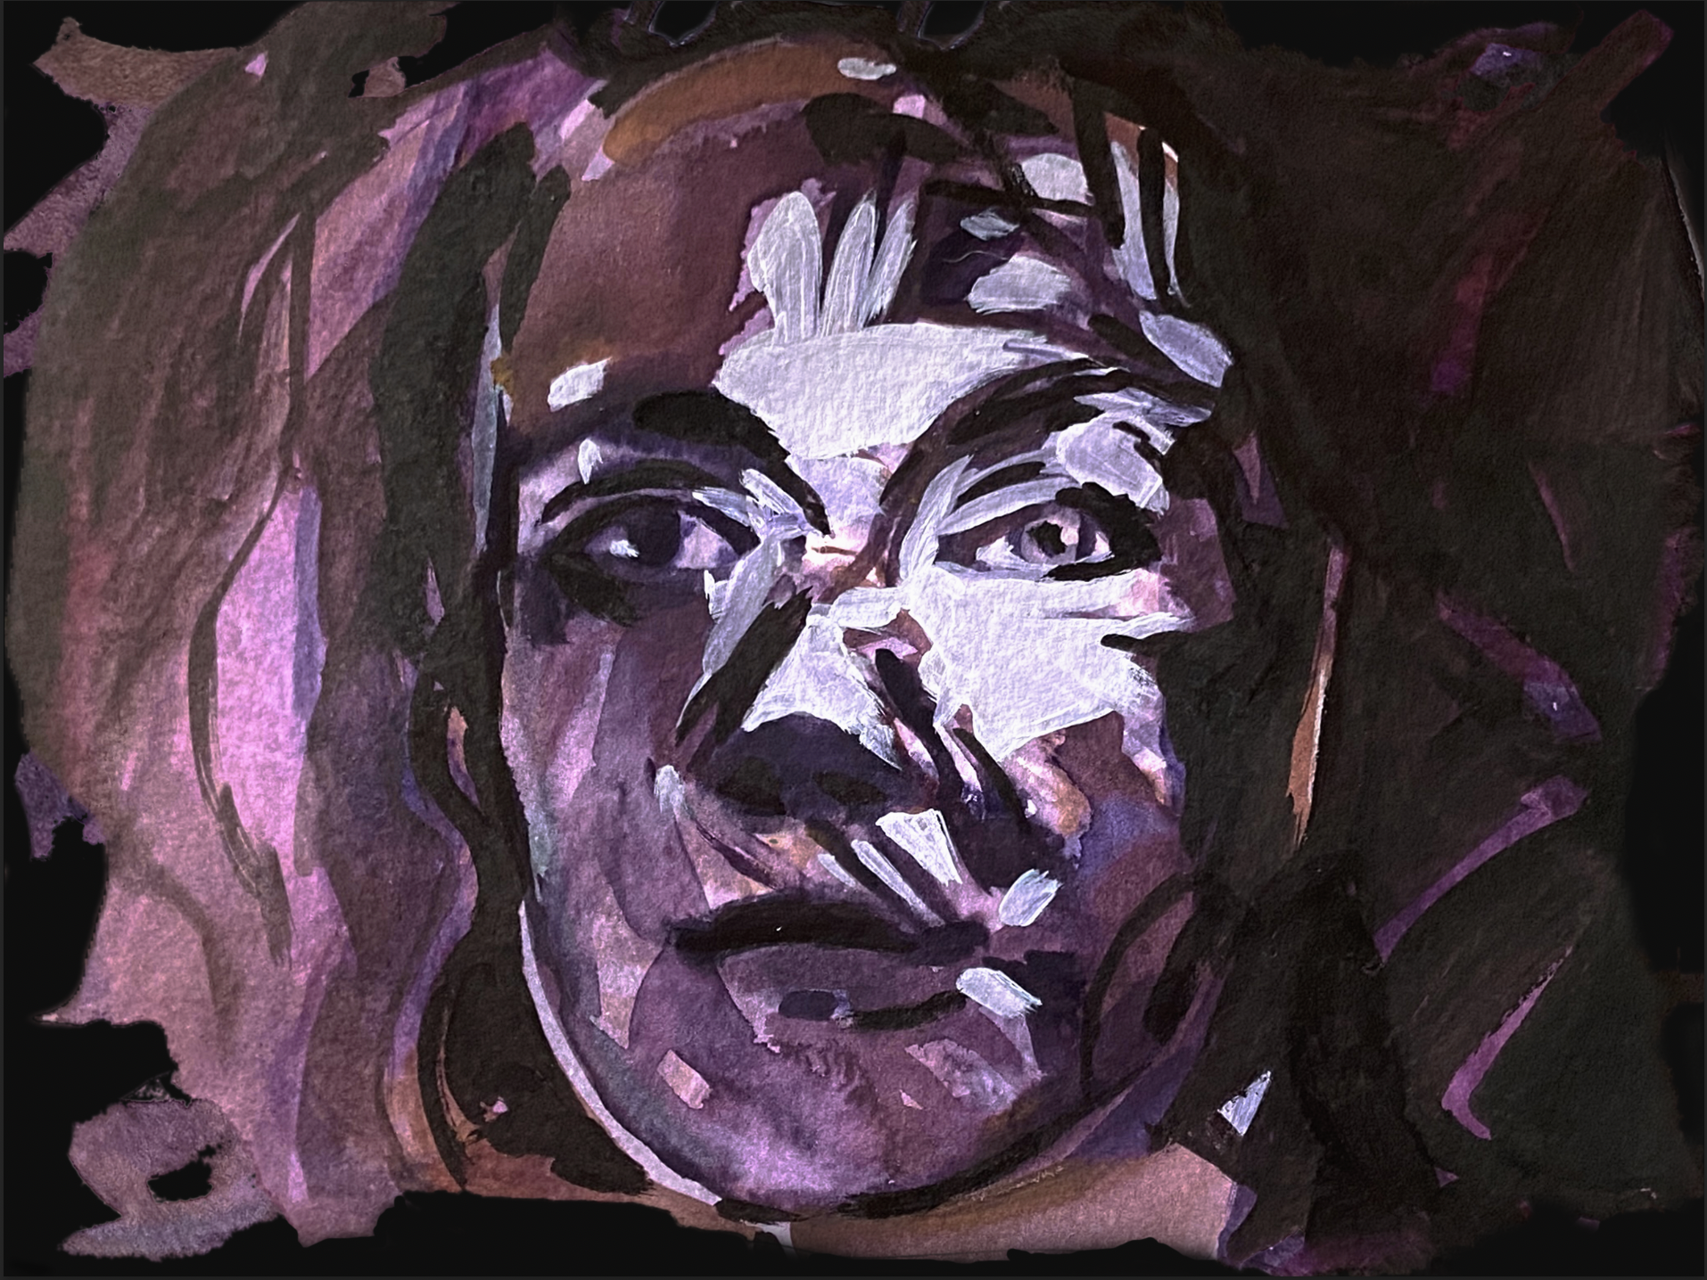
Figure 1. Sylvie Mayer. Purple Lady. Referenced Loneliness at this point in the project.
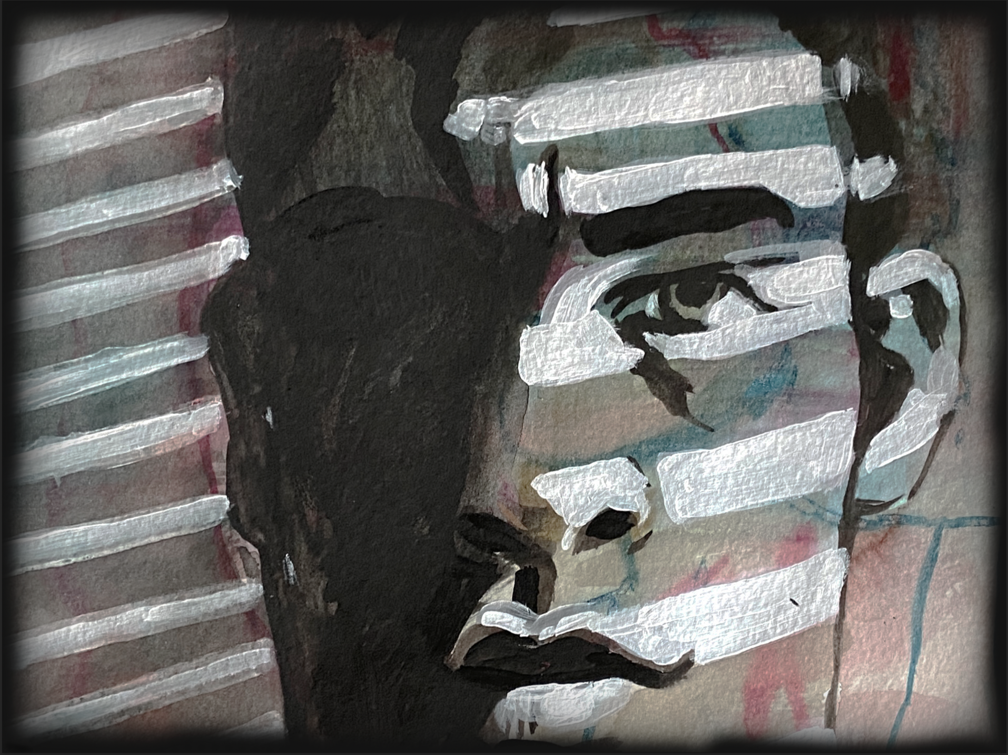
Figure 2. Sylvie Mayer. Angry Man. Referenced Anger at this point in the project.

One idea that surfaced was for each dancer to represent multiple characters at different times throughout the piece. Mother/Daughter/Grandmother, Friend/Sister/Cousin, Father/Son/Grandfather, Boyfriend/Husband/Brother. The idea that we collectively landed on was that one dancer would be looking back at past memories and that the other dancers would represent the journey through these memories. The single dancer would depict what we referred to as Reality. The “memory” dancers would each represent multiple characters. After much conversation we decided, rather than creating from character representation, we would begin working from emotional and situational prompts, eventually creating vignettes to represent several emotions. This choice reflected our inherent way of working - from more abstract feeling, rather than direct storytelling. We chose the following evocations for exploration: 1. peaceful, comforting, family gatherings, and contentment, 2. confusion and transition, 3. happiness, delight, and nature, 4. anxiety, trauma, grief, and loss, 5. loneliness and melancholy, 6. longing, and 7. nostalgia.
During this meeting we also discussed the paintings' relationship to the stage presentation as well as the costume design in relation to the paintings. Our initial thoughts were to costume all the “memory” dancers in white and the Reality dancer in a color. Our intention was for the white costumes to serve as a canvas that could reflect the paintings. We discussed the use of projection in allowing us to bring the paintings to the stage. We were all very interested in the idea of blurred images, portraiture, and color to express emotion.
Following a few email discussions regarding each emotional prompt, we decided to remove Nostalgia from our list.
I sent the following email to Katie:
I was thinking of other musicians you might tap into for the nostalgia section... Elton John, Van Morrison!! Some of my favorites but feel free to do what feels best to you.
Katie’s reply was as follows:
About the nostalgia section, I've been thinking about it and have some reservations about being too direct with quoting other music. With all of the rest of the ideas both musically and visually being abstract, it seems out of character to have specific references in one portion. What are your thoughts there? I love those artists, but I wonder if that will be out of place with the rest of the moods.
Although recognizing that we might have biases, we tried not to let them dictate our responses to one another. Since we were committed to the idea of maintaining a non-hierarchical process and to an open minded approach to the opinions of others, it was important for Katie to take the lead on this decision.
During our next meeting on September 19, 2021 we discussed my role in the non-hierarchical process. We decided that it was important for me to take a leadership role in developing specific expectations for the project, to lay out our goals, and to develop a series of semi-structured prompts for the collaborators to respond to. I would not dictate creative concepts or design in any way. This proved to be a very important decision in helping to keep us on track and in providing structure for the team. Once we began creating, we no longer met formally to discuss concepts. Most of our conversation resulted from interaction through sharing of our individual work. The project turned to the collaboration of artistic ideas, improvisation, and back and forth communication. We shared our work as it developed and offered feedback to each other. Our process varied with each vignette we created.

2.3 Casting the Dancers
Casting the dancers had a significant impact on the creative process. Working with our collaborative ideas I needed to quickly decide how many and which dancers I would like to cast in the work. The typical protocol for choosing dancers for the Young Choreographer’s Showcase (YCS) is through an audition process. This offers the choreographers the opportunity to see the interested dancers at one time. It provides choreographers with information regarding the dancer’s ability and movement style. Since the audition was canceled due to Covid-19 restrictions, we had to choose dancers based on prior knowledge and without information regarding the dancers’ interest.
My original casting choice was Darcey Lynn, Eliza Harden, Ana Vega, Sofia Redford, Lucy Shepard and Christian Garcia. I sent an invitation email to the dancers on September 13, 2021. Darcey immediately replied to say that she was not available due to her commitment to Oklahoma City Ballet’s Nutcracker production. As a replacement I invited Elizabeth Fillingim. She along with the other dancers, except for Ana Vega, accepted the invitation. A few days later, Ana declined. I then asked Stephanie Eggers if she would be interested, she accepted on the spot, expressing that she loved dancing in YCS.
On September 15th I met with the dancers to explain my ideas, and how the process would differ somewhat from their prior experiences in YCS because the piece was being created for a thesis project. I intended for them to be part of the collaborative nature of the work and wanted to be sure that they understood their involvement. While I would not be asking for extra rehearsals, I would be tapping into their creativity in exploring movement, and in addition, I would require them to answer a series of questions following the performance. I suggested that they keep journals throughout the process in order to be able to reflect back. This meeting went well with everyone seeming to be excited and committed.
The next day Elizabeth sent me an email explaining that she would not be able to participate in my piece for personal reasons. Although this was disappointing, I accepted it as part of the process. At this point, I decided not to search for another dancer and to work on the choreography with the five students committed to the project.
I was moving along with the choreography and making steady progress when a third dancer, Lucy Sheppard, told me that she would not be returning to OU in the Spring and I would need to find a replacement. I had originally decided to cast several freshman and sophomore dancers for this piece, thinking that they would be more available than the juniors and seniors, so this was another disappointment. Lucy suggested Delaney Gondo as her replacement, explaining that she was interested in dancing in YCS and would be committed. I didn’t know Delaney’s dancing but thought it would be good to have a committed dancer. She joined our next rehearsal and learned the first major section. She was a very different dancer than Lucy and, although I had choreographic ideas for Lucy, I had not yet created anything specifically on her, so I was able to pivot and find the right role for Delaney.
A few days later Christian reported that he would be having surgery during the spring semester and not able to dance in YCS so he would also need to be replaced. By now I had learned to expect these disappointments. I immediately asked Julian Cottrell if he would be interested in joining us, however I knew that he was already overcommitted so I assumed it would not work. I then invited Kel Martin who joined us for the next rehearsal when we revisited the first vignette. Kel was unable to commit to the rehearsal schedule so I pivoted once again. At this point I decided to ask both a male and female dancer to join the process. I originally considered a male dancer for two of the sections since I was developing partnering work within both vignettes. However, if I readjusted my ideas a bit, I could use a female dancer for one of the sections which would allow me to split the remaining roles between two dancers. I invited Gabby Brown and Harry Hefner.
After much back and forth, Harry and Gabby committed to participating in the project. Integrating Gabby into the project was challenging, as she had several scheduling conflicts because of rehearsals for Professor Rebecca Herrin’s thesis project. Professor Herrin and I worked out a schedule so that Gabby could attend parts of each of our rehearsals.
There were times when our rehearsal process felt a little like “Groundhog Day” as we continued to revisit the same sections each time a new cast member joined. However, I was extremely happy with this new and final cast and from this point on we moved forward without any adjustments.

2.4 Collaboration and the Choreographic Process
Originally, while developing choreography for this project, I was very interested in exploring movement vocabulary through working with the dancers in an experimental way. I was hoping to improvise with them and gain insight into my choreographic voice through this process. As the project evolved I spent more time on conceptual ideas and managing cast changes and rehearsal time effectively than on experimentation. Exploring a narrative and working with the dancers to tell a story was a novel approach to my choreography and afforded me experimentation in a different way. Watching the dancers grow, both as movers and as artists, was a rewarding experience.
Following our initial collaborators’ meetings, once we decided on a concept, and once casting decisions were finalized, I moved deeper into developing the choreography. Studio rehearsals with the dancers became my focus. The first studio rehearsal with the dancers was on September 17, 2021. I presented the project and explained the University’s Internal Review Board (IRB) protocol. Since the dancers would be considered human subjects in my study, I needed to be sure that they understood their commitment and were willing to sign a consent to participate document. Once this was done I was able to move forward artistically.
I initially chose to work on the Reality music sketch that Katie had presented in our second meeting. I found ideas in the music that had addressed our original concept and was ready to put movement to the score. It was a clear path to investigating the first vignette and helped to ground the rest of the work. I found it easy to react to Katie’s musical structure, making it possible for me to explore narrative composition. In the past, I typically created more neoclassical work that may have had an implicit meaning but was not at all narrative. This was a new process for me.
We workshopped some of the conceptual ideas during part of the rehearsal through improvisational prompts. This process helped the dancers relax into the rehearsal and understand the intention for the choreography. During the second half of the rehearsal I taught them a movement phrase to the Reality music sketch. I had them experiment with the movement phrase with and without music. Further exploring the Opening Reality section, I worked to create a tableau of four “memory” dancers walking around an imaginary table, interacting and depicting conversation, while the Reality dancer was exploring memories through photographs. It would serve as a literal concept for creating the choreography. I cast Eliza Harden as the Reality dancer since I felt a maturity and expressiveness as we developed the choreography. By early October, the architecture for the Reality section was pretty well formed, although I felt the need to explore the concept more fully. In our next rehearsal, we explored several iterations of the original idea before I settled on the final choreography. As I looked back at video footage from rehearsals I think some of my initial concepts were actually more interesting. With more time to experiment with these ideas I believe I could have developed a stronger movement narrative using the original concepts.
Next, Katie, Sylvie and I tasked ourselves with the goal of fleshing out the concept, musical composition, choreography, and visuals for Confusion. Katie sent us her musical vision for this idea. I was having a hard time connecting with this music sketch and since I was not able to speak with Katie immediately, I shared my thoughts with Sylvie and asked her what her feelings were about the music. She liked the score more than I did but she also felt that it expressed something different than “confusion.” We both expected something more playful and possibly a bit scattered and disjointed musically rather than something that was so dramatic and fluid. We discussed the need to redefine our thoughts about “confusion” realizing that we might be looking at it incorrectly. We talked about how confusion motivates one to work through perplexing information, yet we wondered if it was an actual emotion. Classifying an emotion as a heart response, we decided that “confusion” is not an emotion, but a thought response. Therefore, according to the terms by which we were defining emotions, confusion may cause an emotion but is not one itself. These ideas would hang in the balance for a bit. I searched the internet and literature for more concrete information on emotions and discovered the emotion wheel. (Appendix C) The emotion wheel, developed by Dr. Robert Plutchik, is analogous to a color wheel. (Appendix C) “Dr. Plutchik was an American psychologist who proposed that there are eight primary emotions that serve as the foundation for all others: joy, sadness, acceptance, disgust, fear, anger, surprise, and anticipation.” Without delving too deeply into the psychology behind his theory we decided to use this tool to define our vignettes and to solidify our concept. It helped us determine which ideas to focus on and allowed us more accuracy in determining emotional states. We met to rework our original list of emotional prompts and created the following list: 1. peaceful, comforting, family gatherings, and contentment became: Acceptance and Trust, 2. confusion and transition were eliminated, 3. happiness, delight, and nature became: Joy and Serenity, 4. anxiety, trauma, grief, and loss became: Anger, 5. Loneliness and melancholy became: Melancholy, 6. Longing would be addressed in Melancholy and 7. from the emotion wheel we added: Surprise and Distraction. The final list included Acceptance/Trust, Joy/Serenity, Anger, Melancholy and Surprise/Distraction.
Evaluating our new prompts, I decided to move away from the sketch Katie had sent for “confusion” and instead began to work with the music we had titled Loneliness – now referred to as Melancholy. The music captured my attention in its relationship to the concept. I worked on this section with Sofia Redford as the central female dancer. All the other dancers, including Christian (male dancer), learned the movement as we completed the choreography to the existing one minute musical sketch. Inspired to continue, even though the music was incomplete, in our next rehearsal, I added a partnering section with Sofia and Christian. I sent Katie an email explaining that I moved away from the Confusion idea and worked on Melancholy. Katie was eager to see what I had developed so I sent her a video. She was inspired and excited to add her music to the movement. She attended a rehearsal on October 15th where she played the first part of the Melancholy sketch with the dancers and then listened and watched them work through the choreography that I had created in silence. Katie suggested I record the dancing and count with the movement so that she could get a feeling for the aural component in order to complete the music structure in relationship with the choreography. The music Katie added to the developed choreography partnered the movement beautifully. I wish I had had additional time to delve more deeply into the complexity of the dance partnering. In the end, the final version was about “separation.” While rehearsing, I encouraged the dancers to consider a relationship that was coming to a bittersweet end whereby the couple knew that it needed to be over but didn’t want to let go. Thus, the evolution of entrances and exits of the male partner in the choreography.
Following this rehearsal our work came to a stand still for a short while since I needed to travel to the East Coast for five days, Katie was in the middle of a heavy exam schedule, and Sylvie was busy with other work. The time away gave each of us an opportunity to reflect and refresh.
Coming back to the process was not an easy task since at the time, casting was in flux and I was finding it difficult to schedule rehearsals. I attempted to work with individual dancers on specific parts in order to keep things moving. We had an important rehearsal scheduled for October 20th to look at projections and to work on the Melancholy section with Sophia and a partner in question. Boyko Dossev, Artistic Director, Oklahoma Festival Ballet, Assistant Professor of Dance in Ballet and Chairman of my thesis committee was planning to attend the rehearsal to see our progress. Katie was eager to play the full Melancholy sketch for Sofia and the male dancer to see if it coalesced with the movement. I was excited to see the music and dance come together. Sylvie planned to bring her projector and new images for additional sections. By this time Harry was committed and planning to attend rehearsal, however Sofia was sick so we canceled the rehearsal for the dancers. Sylvie, Katie, and I had our own workshop session in the studio. Professor Dossev arrived in time to see the images projected and was excited with the possibilities. We looked at the original house image, which was actually of a garage door with shadows cast on it, and thought it wasn't quite right since it did not depict “home” in relation to Reality as we had intended. (This idea is discussed later in the Projection section) Sylvie had a different house piece in her portfolio that I absolutely love so we looked at the “Pink House” painting and unanimously decided that it was the right choice (Fig. 3).
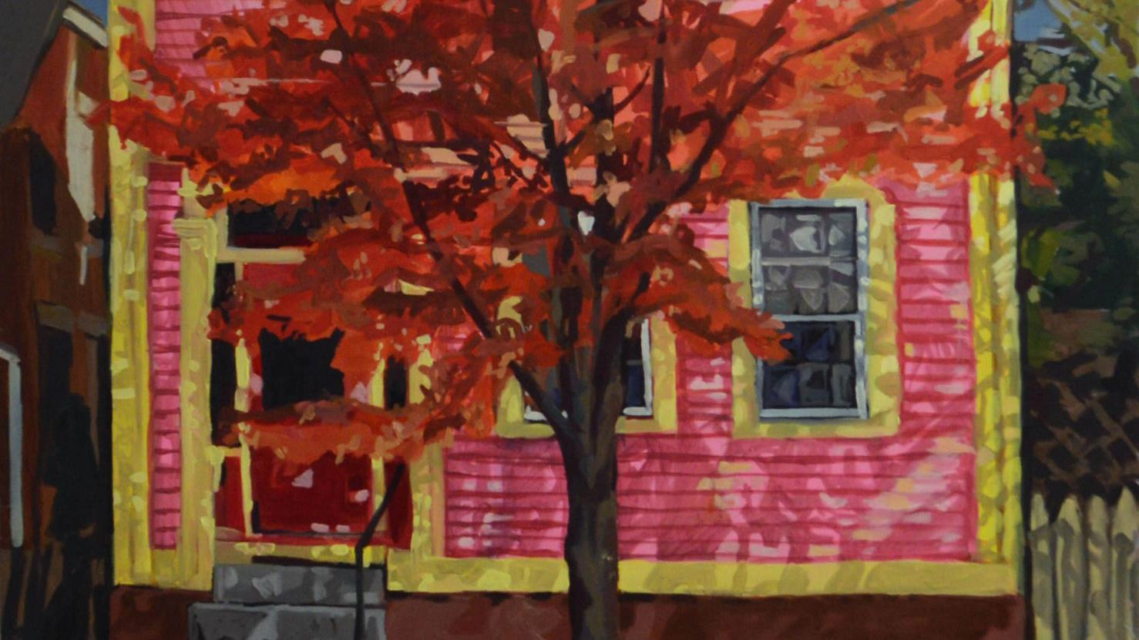
Figure 3. Sylvie Mayer. Pink House. Cropped for the project. Referenced Reality vignette at this point in the project.

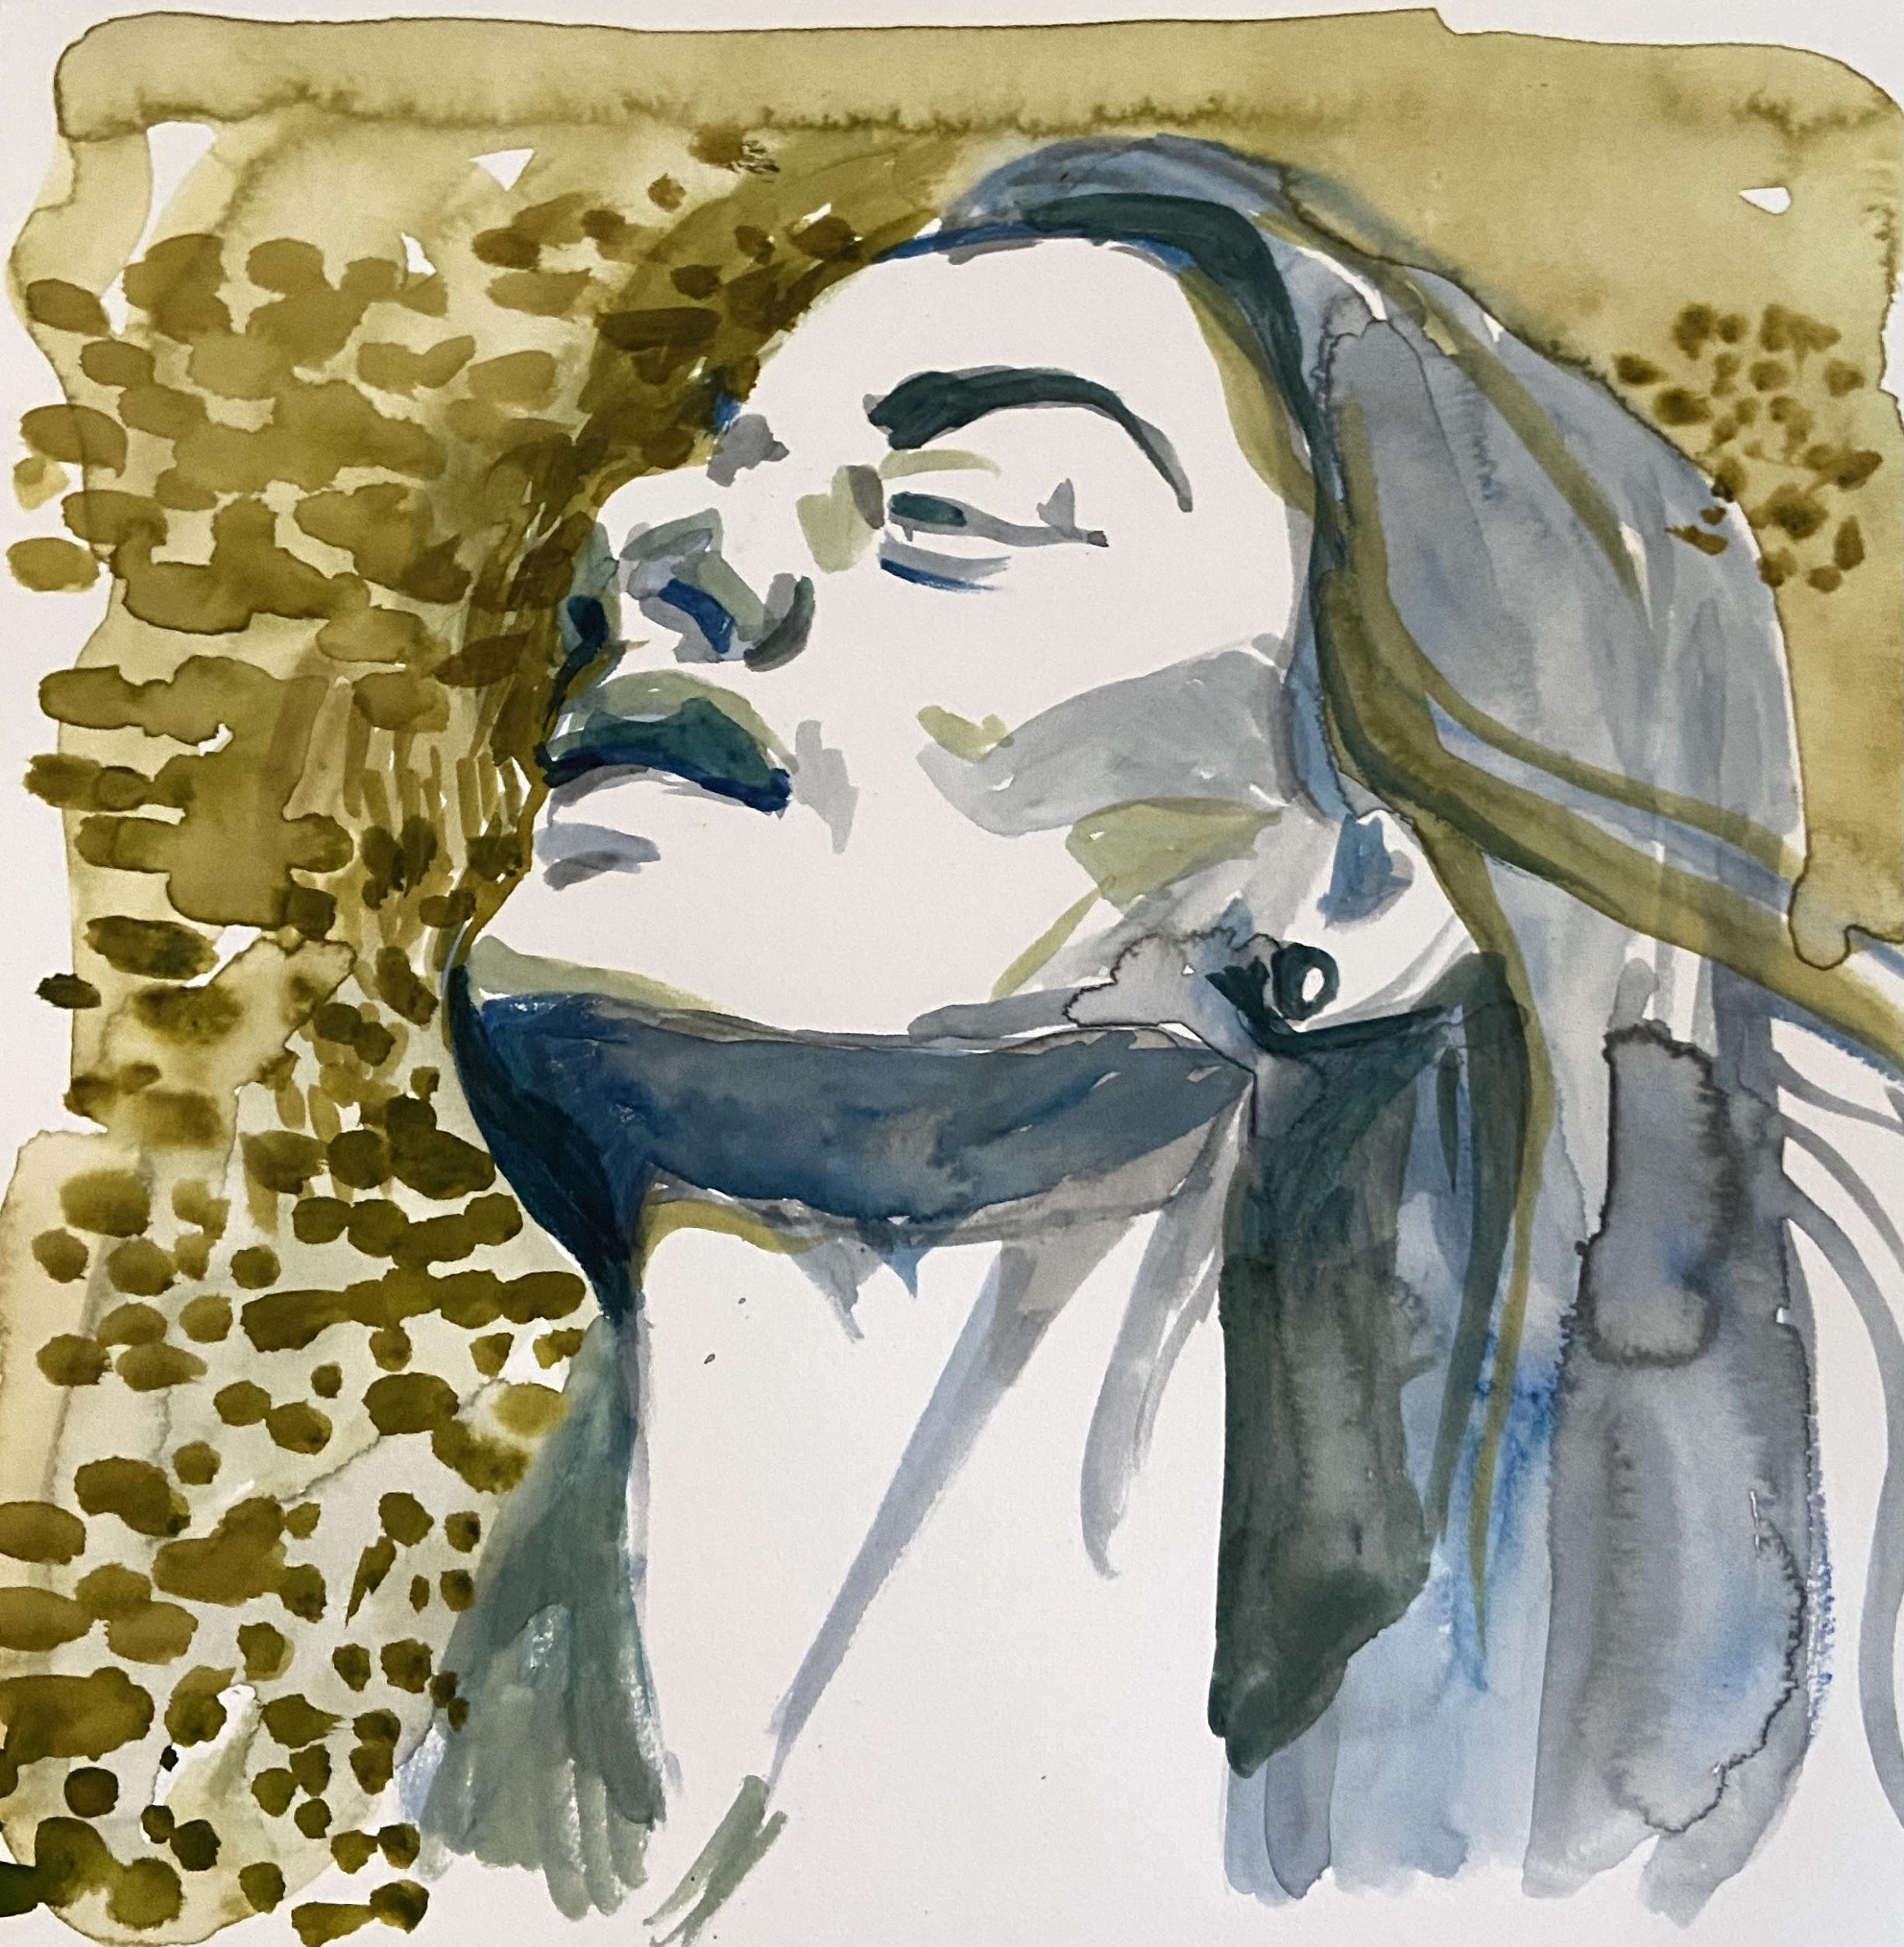
Sylvie also presented several new paintings, one in particular appealed to both Katie and I. (Fig. 4) We couldn’t decide which emotion to attach to it so we decided to project the image onto the wall. Katie improvised on the piano while Sylvie and I experimented with movement to the music. This process helped generate new ideas for each of us. The painting and improvised movement seemed to evoke a sense of release, so we decided to consider a duet about release and support. This later became the Acceptance vignette.

Figure 4. Sylvie Mayer. Ocre/Green Lady. Referenced Acceptance vignette at this point in the project.

As we continued, Katie reflected on her personal process throughout the collaboration explaining that she would “ruminate on a specific emotion while improvising at the piano.” She said she tried to turn off her “academic” brain and just think in the moment. Once she arrived at something that made her feel the emotion she would develop it further and then send it to Sylvie and I. She exemplifies this process in the email she had sent to me regarding the music sketch for Confusion.
It ended up going in another direction than what I was expecting, but that's what came out today. Let me know what you think, and I can work on it more.
Reflecting back on this email and my original reaction to this music sketch I decided to give it another chance. I contacted Katie so that we could meet in person to revisit the possibilities. Katie and I spent time together listening and discussing options for the sound quality and phrasing, eventually softening the dramatic line and changing some of the phrasing. We talked about the ideas that Sylvie and I had discussed earlier and Katie remarked that when she sent this sketch she had been thinking of it as Anger not Confusion. This gave me something new to think about in considering choreography for this music and it explained the more dramatic and melodic line.
With this new information, I began experimenting with movement in new ways as I responded to the music. Letting myself engage without judgment, I began creating a solo for Stephanie Eggers. The personal difficulty I was having choreographing this section led me to develop a few creative exercises. With eyes closed, I listened to the music in an effort to visualize the essence of the piece without thinking about steps. I was still not certain where I was going with this piece but I wanted to give the music sketch a chance. After my visualization exercises and after working with Katie I began to see the architecture of the piece which helped to inform a clearer concept. The male figure in the corresponding painting we had been considering inspired me to consider a partnering section. Since I was still dealing with casting issues, I continued to work on the ideas with Stephanie alone. Throughout the process, I had been contemplating an idea of incorporating a shirt into the choreography. Stephanie and I experimented together to develop the concept and choreography, using the shirt to represent a form of attachment/detachment. The length of music for this section was not long enough for the duration of choreography so I asked Katie if she could add more to the composition. Katie and I worked to create more music for this section by filming as I worked through the movement with counts spoken out loud. She found a way to add extra music without changing the overall structure.
Near the beginning of this same vignette, I was creating a small bit of choreography in silence, and would need to work on the musical arrangement with Katie. I showed her the choreography so that she could pause to accommodate the choreographic phrase. In the process, I assumed that while Katie was playing, she would know how to come out of the silence if I simply explained the dancer’s movement to her, but this was not immediately the case. We needed to count the silence so that Katie and Stephanie would line up. Eventually Katie began to recognize the movement and it became more fluid. This incident illustrates the possibility of miscommunication between composer and choreographer when things become lost in translation due to the level of knowledge and ability to communicate within each other’s domains.
I continued to work with Stephanie, hoping to be able to fit a male dancer into this section. I felt that the piece needed a second person to fully complete the narrative. Eventually, I pivoted from using a male dancer and added Gabby Brown to the Anger section. This decision afforded me the opportunity to complete the vignette. While working on the “shirt” segment of this vignette, with both Gabby and Stephnie for the first time, Brandin Steffensen, Visiting Professor in Modern Dance at the University of Oklahoma, attended rehearsal. Brandin has extensive knowledge in improvisation and dramaturgy and I thought having his eye on this part of the choreography would be invaluable. He helped me solidify this work by asking me many questions. His approach helped me slow down and understand the direction and purpose of the idea. I realized that I needed to take the time to develop this section and not rush through the rehearsal process. Because time was limited, I was in the mode of trying to get things completed, often feeling pressured to move too quickly during rehearsals. The experience working with Brandin was invaluable to the collaborative nature of the project. Once fully developed, this section became an important part of the narrative.
In the meantime, I listened to the original Peaceful sketch that Katie created early on in the project, and thought that it could make for a good return to a Second Reality. On October 24th we began working on the choreography for this section. It was a rough sketch since I had not decided which dancers would be in the final version. I also needed to check with Katie to see if she was satisfied with the musical structure since she had mentioned that it was a musical idea she could expand on. Working with the dancers I was able to complete the choreographic idea within the existing music and Katie agreed that it worked. I began the choreography with Eliza, Stephanie, and Delaney — intending for Harry to step into Delaney’s spot. In the end, the Second Reality section became the transition piece into Anger. Once I put Gabby into the Anger vignette with Stephanie, I began to see the thread between the two sections. I then finalized the casting for the Second Reality with Eliza, Stephanie, and Gabby. These decisions allowed the work to gel. The idea I offered the dancers for the narrative within these two sections was to consider that they were sisters, and that Gabby was expressing her independence, or was possibly ill and dying. In the end, I allowed them to choose their own story within these parameters. In either case, she was leaving the relationship and Stephanie was angered by the circumstance. The “dialogue” with the shirt began at the end of the Second Reality and segued into Anger. These scenes were difficult to work out and challenging to set on the dancers. I used imagery and storytelling to promote an organic unfolding of the storyline. Gabby was more natural in taking to the acting while Stephanie needed more direction. Gabby took the place of the male figure from the original idea in both the Second Reality and Anger vignettes. I took out the partnering and instead created small female duets.
Contemplating next steps I studied the emotion wheel to see what emotions we had and had not yet tapped into. In an effort to find some cohesiveness between each vignette, I created a sequence that served as a structure for developing a complete work. This exercise helped us plan for what needed to be accomplished and also informed our decision on which paintings best fit with the current narrative. I proposed the following as an initial structure for music, painting, and choreography (Fig. 5).

Initial Structure for Music Painting and Choreography
Section Title |  | Casting |  | Painting |  | Music |  | Choreography
Reality |  | Full Cast |  | Pink House |  | Complete |  | Complete
Melancholy |  | Sophia/Harry |  | Purple Lady |  | Complete |  | Complete
Joy |  | 3 Dancers |  | Abstract |  | Begin next |  | Begin Next
2nd Reality |  | 3 Dancers |  | Pink House |  | Peaceful sketch |  | Working
Anger |  | Stephanie +1 |  | Angry Man |  | Working |  | Working
Acceptance |  | 2 Dancers |  | Ocre/Green Lady |  | Not started |  | Not Started
Surprise |  | Full Cast |  | Not started |  | Not started |  | Not Started
Final Reality |  | Full Cast |  | Pink House |  | Not started |  | Not Started

Figure 5. Mary Ann Mayer, Sylvie Mayer and Katie Ostrosky. Initial Structure for Music Painting and Choreography. October 2021 Initial Project Structure.

Once this structure was conceived, we decided to move away from the heavier melancholic mood. I asked Katie and Sylvie to consider a more upbeat, bright, and joyful theme. We were concerned about how to portray this type of emotion since each of us confessed to working better in melancholic themes, finding it difficult to create emotional work around happiness. I personally lean towards creating things that are too “pretty'' when I think upbeat and happy. So our task was to create Joy without it becoming too saccharine.
To this end, during the October 24th rehearsal, I developed and taught two movement phrases to Sofia, Stephanie, Eliza, and Delaney. I was working rhythmically in a waltz tempo even though I was creating the movement in silence. Watching them go through the steps made me think of friends running through a meadow, enjoying a beautiful day. I filmed the movement phrases so that I could share them with Katie and Sylvie. At the same time Katie uploaded her music sketch for Joy to our shared folder. We didn't discuss timing prior to creating our individual sketches. To our surprise we were both working in 3/4 time. In the next rehearsal I had the dancers run the two
movemenment phrases in cannon to Katie's music and it lined up beautifully. Katie sent the following email to me after seeing the video of the movement phrases.
I'm amazed at how well your joy sketch goes with my joy sketch. Are we starting to share a brain?? The choreography is so pretty, I can't wait to see it more fleshed out.
As I continued to choreograph this vignette, I visualized myself painting the movements onto a canvas. We worked with the imagery of three friends running through a meadow with abandon and freedom. Trust and vulnerability were at the core of the characterization. This vignette was becoming playful and seemed to express the type of joy we were intending to communicate. In order to create more interaction between the dancers, in one section, I asked them to pretend they were throwing and catching a ball with each other. This helped them interact more dynamically and also helped with eye contact. Throughout the choreographic process I felt as though Katie’s music described the meadow and supported the idea of abandon and playfulness, which made it easy for me to find structure and create movement phrases.
We worked from an abstract painting of Sylvie’s for inspiration (Fig. 6), but once the choreography and music were complete, Sylvie felt as though the abstract oil
painting didn’t work with the rest of the paintings, which were figurative watercolors, and decided to revisit the work. We concluded that another watercolor portrait would be more appropriate. She worked from the idea of the meadow, freedom, and abandon. Although Sylvie was uncertain about the new painting she created, Katie and I both thought that it fit the mood ideally by portraying an unusual beauty and a sense of joy (Fig. 7).
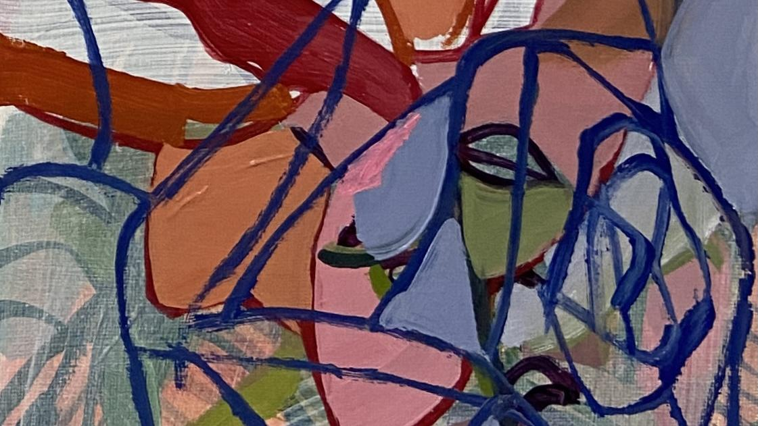

Figure 6. Sylvie Mayer. Abstract image referenced Joy vignette as initial inspiration.

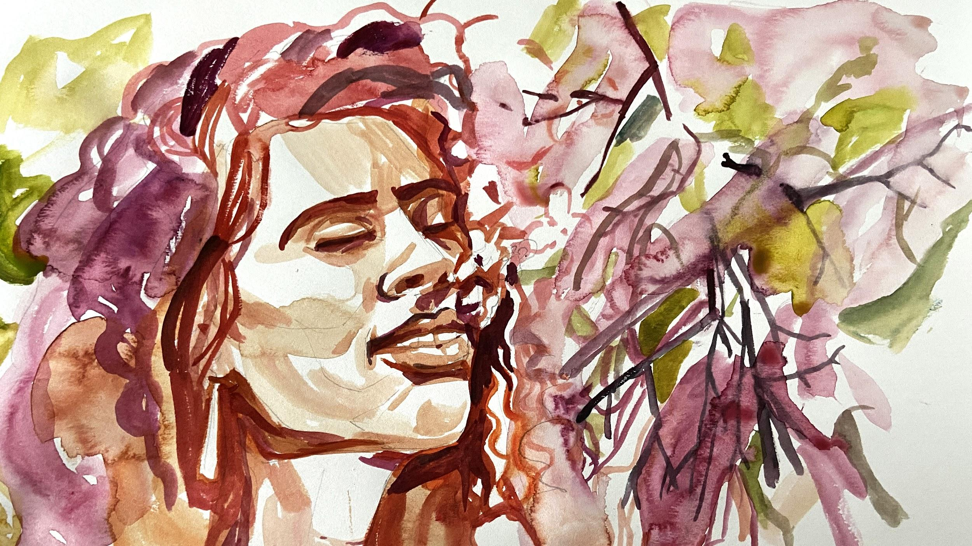

Figure 7. Sylvie Mayer. New image referenced Joy vignette.

The next major step in the process was to present the work to the faculty. With so many cast changes, it was remarkable that on November 11, 2021 we were able to show five movements from the ballet for the studio adjudication. The adjudication process is intended to give the faculty an opportunity to see the work of each potential choreographer and to choose which pieces will be accepted for the showcase. This year, Leslie Kraus, Assistant Professor of Modern Dance, and Glenn Edgerton, Instructor of Ballet, were serving as mentors for YCS. After a few brief rehearsals with Harry and Gabby, we presented what we had completed up to this point. To my amazement the new dancers managed to learn the choreography very quickly and the cast gave an excellent presentation. They performed the Opening Reality, Melancholy, Joy, Second Reality, and Anger for adjudication. Professor Dossev projected the paintings so that the faculty could get a sense of the work’s overall concept. Professor Kraus was concerned with the length of the piece since it was already fifteen minutes long and we still had three sections to complete. Although the typical time limit for a YCS piece is six minutes, the School of Dance made accommodations for me to present a longer piece of choreography since it was a thesis project. I do not think anyone, including myself, thought that it would run longer than fifteen minutes. I believe Professor Kraus wanted to be sure there would be enough opportunity for other choreographers to participate so she suggested I keep the next three uncompleted sections as short as possible. This provided new constraints for us to work in since, up until now, we had used as much time as needed to fully realize the music and choreography for each section.
Next, Sylvie, Katie, and I spent some time discussing our thoughts for the Surprise vignette. Katie took the lead by providing us with a musical sketch. Before rehearsing with the dancers, I met with Katie to get her input on counts and phrasing. I would have counted the music differently but using her musical phrasing provided new parameters for me to work within. I loved Katie’s interpretation of the concept and her musical ideas had a strong influence on my choreographic development. I wanted to make something that had full expressive movement and angularity with a bit of chaos. I began creating movement phrases based on crowds, confusion, interruption, and chaos.
I had a preliminary idea for the architecture of the piece, but had not worked out all of the phrase material. On November 14th I began developing the phrase material in the studio with the dancers. I experimented with, and edited movement phrases until I found what worked best to communicate my ideas. One of the sections in this vignette required more planning since two lines of dancers were weaving in and out of each other. I created two different phrases and then worked out how they would best interact.
I searched for places to insert unexpected moments that could potentially produce an element of “surprise.” I noticed a short pause just before the last phrase of music and thought that this could be an interesting place to insert silence, allowing the dancers a moment to speak. I thought it would be unexpected and fun to have the dancers abruptly stop moving and begin talking in loud voices over one another while slowly working their way across the stage in a group. The dancers each created their own line of dialogue, referencing something personally surprising. In the beginning, they had a difficult time with the speaking element, feeling self conscious and winded from the dancing that came before. They eventually embraced this section, developed stamina, and had fun with it.
Katie worked with us on coordinating the interruption from a musical standpoint. During a rehearsal, we realized that following the pause and the dancers’ talking, Katie would need an aural cue to indicate when the music should begin again. Stephanie’s personal line of dialogue included an incident with a jellyfish and an “Octopus.” It was a great image that also related to the original concept inspired by photographer Karl Christoff Dominey’s artist statement which included the idea of “Tendrils reaching.” We decided to use the word “Octopus” as the prompt for Katie to pick up the music. This unexpected aural prompt seemed to create an interesting distraction for the audience as evidenced by their laughter and reactions during the performance. This vignette was fun to create and helped develop a collaborative atmosphere among the dancers. Coming full circle with these ideas, the title of our collaborative work became Tendrils.
From a visual standpoint, Sylvie was contemplating how she would approach the idea of Surprise without it becoming too cliche. We spent time looking at images of faces with surprised expressions and found examples of the typical open mouth expression. (Fig. 8)

Figure 8. Surprise Face. Reference photo for Surprise vignette. Getty Images.

I suggested that Sylvie listen to the music and paint while listening. She explained that listening to music was not usually a source of inspiration for her painting. She stated that “since she predominantly works figuratively, she finds it difficult to translate the abstract notion of sound into color and form.” She mentioned that she tried it, and “while it did not produce results for this particular work, she said she has since become more open to working in this way.” I also suggested that she conceive of movement that corresponded to
the music and use that to create her painting. Eventually, Sylvie studied the choreography and created a more structural painting that was inspired by the movement patterns, and developed the portrait through geometric figuration. She also took some inspiration from reference photos. In the end, her painting of two faces (Fig. 9) captured the emotion behind our ideas without giving away the “surprise.”
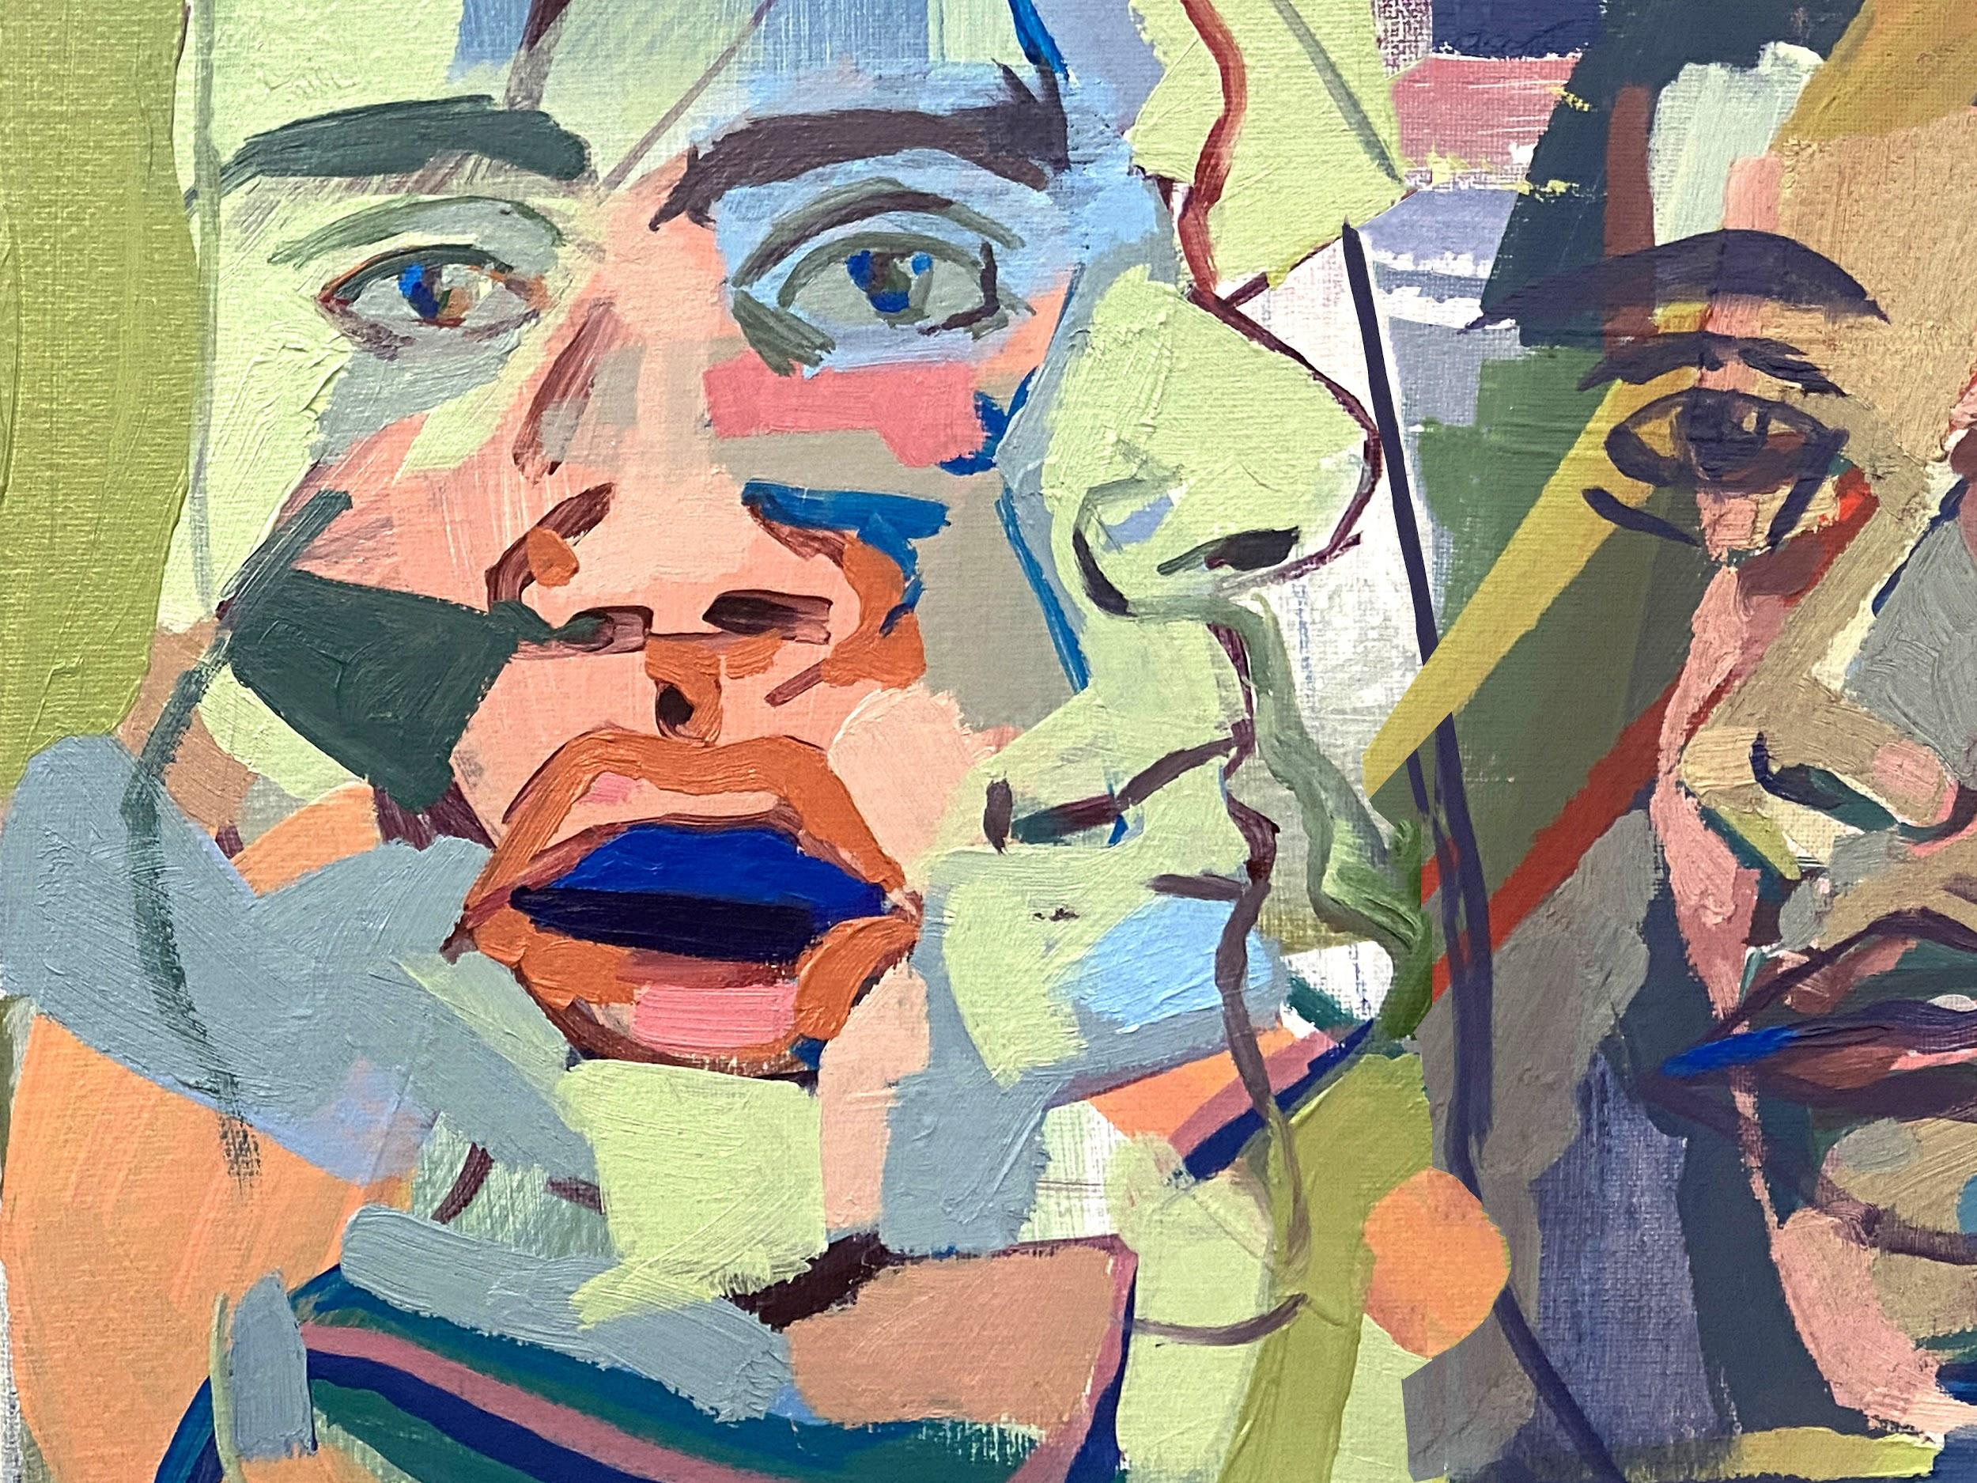
Figure 9. Sylvie Mayer. Two Faces. Referenced Surprise vignette at this point in the project.

In the meantime, Katie and I discussed the music for the Final Reality vignette. We wanted the music to quote moments from the other sections of the ballet and thought of combining phrases from the first two Reality vignettes. Katie sent a new short music sketch that she planned to develop more fully at a later time. I actually liked the sketch and in an effort to keep the remaining vignettes short in duration, I decided to use the music as it was.
On November 14th, I went into rehearsals for the Final Reality vignette with a pretty well fleshed out choreographic concept. I intended to reference some of the moments from other parts of the work but did not want to be redundant. My objective was for the Reality dancer to become intertwined with the rest of the cast through the same tableau as the Opening Reality. The music felt like a lullaby to me, so I asked the dancers in the upstage right circle to face upstage while rocking back and forth. We experimented with the configuration and settled on the placement that they were in for Opening Reality. With more time, I would have explored different and more interesting options. I choreographed movement for Eliza (Reality dancer) which reflected back to previous vignettes. She eventually moved into the circle to join the other dancers in the same phrase of movement around the table that I had choreographed for Opening Reality. The dancers then moved out of the circle into a diagonal with phrase material that suggested a disruption of the borders between memories and reality, creating a feeling of moving through solution, dissolution, and back. The Final Reality resolved into the original “memory” poses from Opening Reality, with Eliza coming back to downstage left, into the pool of light, with palms raised. Though this was the end of the ballet, we still had one remaining section to create.
Our final section was to create both music and choreography that would correlate with Sylvie’s Ocre/Green Lady painting. Our original inspiration for this section was related to the ideas of acceptance, support, and release. Katie and I were not sure where to begin so we decided to workshop together. Since the inspiration for this concept was originally through improvisation we decided to try the process again. We reserved a music classroom where Katie improvised on the piano while I experimented with movement. We recorded our session for reference. This opportunity to experiment together allowed us the freedom to develop an organic pathway into this section. We were inspired by improvising much like that of the jam sessions typical in jazz ensembles. As we worked, Katie asked me for a musical influence for what I was envisioning; I mentioned Erik Satie. With this prompt, Katie began to play something that spoke to my imagination allowing me an inroad to react to her improvisational score. The process was fun, rewarding, and productive.
My intention was for the Anger vignette to relate to this new section. Katie and I discussed its ending where Stephanie throws the shirt to the floor as she exits. I then considered the idea of Stephanie returning to the stage feeling as though this would allow for the resolve from Anger into Acceptance. I envisioned a duet, however I was unsure how I might incorporate the shirt. As we talked through the idea, Katie mentioned something about “when she folds the shirt.” This statement hit a chord with me and gave me an idea of how to create a transition. The emotional resolution would begin with Eliza (Reality dancer) running onto the stage, into the pool of light where the shirt had been left. Her interaction with the shirt would begin the transition from “loss and anger” to “acceptance.” I decided that Stephanie would re-enter following her Anger scene and would witness Eliza’s interaction with the shirt. The big challenge was to develop the transitional ideas and communicate them to the audience within two minutes and fifty seconds of music. I asked Stephanie to think about going through the stages of grief as she approached Eliza. We all laughed, thinking, “ok you have thirty two counts to get over your anger and loss!” Eventually Eliza would fold the shirt and hand it to Stephanie who would then release the shirt into the wings. This series of interactions would represent her release from Anger and would segue into Acceptance.
I originally had Stephaine entering from behind Eliza and a bit off to one side. However, during our break, I had been watching the Underground Railroad Miniseries and was inspired by a lighting element which influenced me to change her entrance. I decided to have her enter from downstage left and approach Eliza on a diagonal, walking upstage toward her, through a ray of light. We were not able to work this out fully until we were in the theater for the dress rehearsal.
In creating the choreography for Acceptance, I envisioned the dancers working in a supportive yet independent manner. Through fluid movement phrases that incorporated support and release I intended for the dance to resolve into a feeling of mutual “acceptance.” I developed complimentary movements for each dancer through the use of canons, release, and extension to create the desired atmosphere. Stephanie and Eliza interpreted the music and choreography beautifully.
The Ocre/Green Lady painting was the inspiration at the outset, however Sylvie wanted to redo it since she didn’t think it would project well. I was adamant about retaining it since it was the inspiration for both Katie and I in this section. Eventually Ian Evans, our projection designer suggested a color change that would work better as a projected image (Fig. 10).

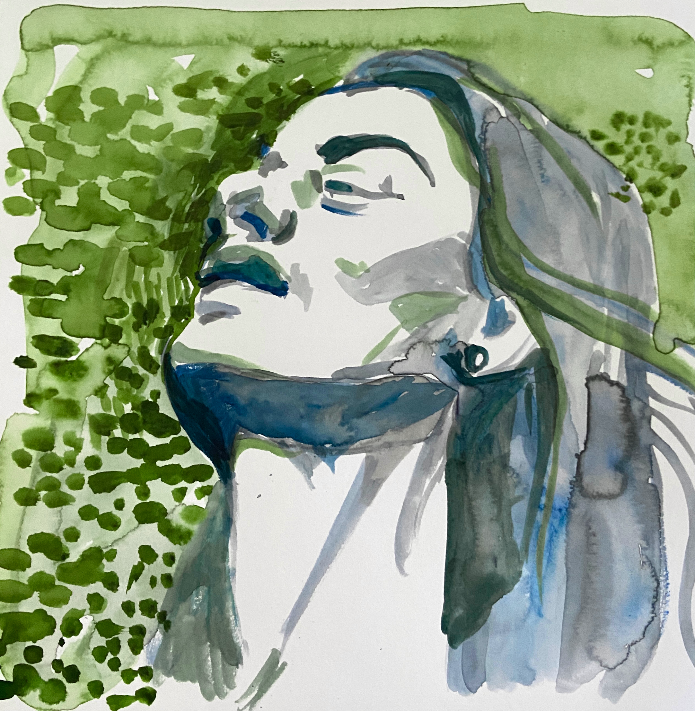

Figure 10. Sylvie Mayer. Ocre/Green Lady. New color saturation for Acceptance image at this point in the project.

During the last week before winter break, Katie spent time taking notes while watching rehearsals for musical timing and cues. Sylvie and I discussed costuming and our expectations for the projections. Rehearsals were short and broken up by dancers coming into my rehearsal late from other scheduled rehearsals, or leaving early to join Contemporary Dance Oklahoma rehearsals. We scheduled one hour for our final rehearsal together before winter break, however we had only 30 minutes with all the dancers together. The choreography ran twenty two minutes with transitions, so our time was limited to just running through the piece once for continuity. Some of the dancers were struggling with the timing for the group sections, others were still working on remembering particular phrase material. I was frustrated that we didn't have more time to work this out. I also felt as though some of the choreography was unfinished. Reflecting on this, I believe it was a good thing to leave a little undone and for the dancers to come back with questions. Returning from break to revisit some of the material that felt incomplete gave the dancers something to focus on, rather than just cleaning and reworking the same things over and over again. Additionally, I was able to see the piece from a fresh perspective and could view it more objectively before making any changes.
As we returned to campus for Spring semester 2022, everyone involved in the upcoming YCS production hit the ground running. The semester began on Tuesday, January 18th, leaving just nine days for choreographers to revisit their work and prepare the dancers for the performances. Our first spacing rehearsal in the theater was scheduled for Tuesday evening, January 18th. I was fortunate that my cast was interested in rehearsing on the Monday prior to this first rehearsal. I knew the dancers were coming into this process after a long break and I wanted to carefully ease them back into the rehearsal process. I was pleased to see that they retained most of the work and were in good shape and ready to go. I knew that the choreography would come together since we had plenty of stage and studio time for the next eight days.
The dancers and I continued to work on the quality of the choreography, tightening up timing in the group sections, working on the dancers’ lines and execution of particular steps, developing the scenes, as well as working out any spacing issues. Katie was able to play live for the dancers daily so the communication between them improved. At the end of the first week one of the dancers was exposed to Covid-19 and needed to be tested and quarantined for five days. This meant that if all went well we would be missing this particular dancer for all of the studio and technical rehearsals as well as the first dress rehearsal. If this dancer were to become sick then we would be without a dancer for the entire run. I asked Alyana Wong if she would be interested in learning the parts just in case I needed a replacement. Amazingly she learned Opening Reality, Second Reality, Anger and Closing Reality in two days and graciously stepped into the first dress rehearsal. This rehearsal was a bit precarious since Alyana had stepped into the parts with minimal preparation. In addition, there had not been enough time for her to learn every part so some of the sections were without coverage. We also needed to use recorded music for this first dress rehearsal since Katie was at a class she could not miss. Fortunately, by the second rehearsal, Katie was back and the dancer who was out due to Covid-19 restrictions was able to return.
I was waiting to make choreographic transition choices based on projection transitions, and since we had not worked this out before break, I was very concerned about the transitions from one section to the next, both in terms of projections and choreography. Professor Kraus, following the first rehearsal, addressed me specifically about the same concerns, saying that I needed to tighten up the transitions and to be sure that the projections lined up with the choreographic intent. At one point I made choreographic changes during a dress rehearsal in order for the sections to mesh. Additionally, we realized we needed to add music to the very beginning of the Final Reality to create a bridge from Surprise into the final vignette. Katie created a 16 count seque that worked beautifully. The dancers remained strong and positive throughout the long and arduous stage rehearsal process.

2.5 Projections and Lighting Design
Projection design became a big part of the equation early on in the project. This was the process whereby the images would be realized on stage and coordinated with the choreography and music. Determining how the images would interact with the ballet was an ongoing conversation between Sylvie and I. Katie was less involved in this aspect though continued to be influenced by the images and interested in the results.
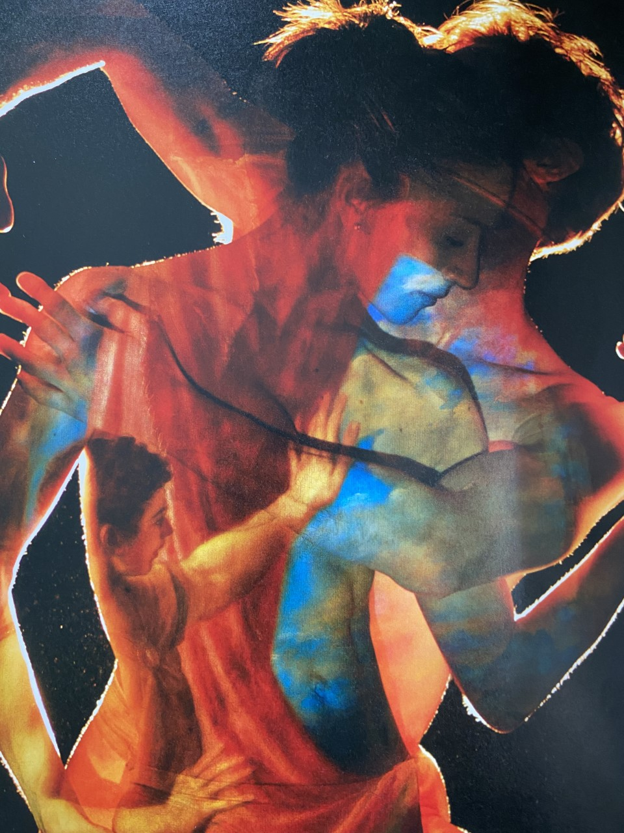
In September I had discovered a fantastic book titled, “Titian|Metamorphosis.” This book chronicled the collaborative project between The Royal Ballet and the National Gallery that premiered in London at the Royal Opera House on July 14, 2012. The project involved three creative teams of choreographers, composers, and visual artists who were responsible for “creating a new ballet in response to three of the Renaissance artist Titian’s greatest mythological paintings: Diana and Callisto, Diana and Actaeon and The Death of Actaeon.” The book was a photographic essay with depictions of each ballet, the costumes, the set design, and the process with brief written descriptions of each team’s work, journal entries, and conversations with some of the artists. A photograph (Fig. 11) in this book caught my eye. It captured the visual outcome that we were hoping for with Sylvie’s artwork. Sylvie and Katie were just as excited to see if we could create something as visually stimulating.
Figure 11. Photograph included in the Titian | Metamorphosis Book from the 2013 Royal Ballet and The National Gallery Collaboration. Photographer Chris Nash, Image Concept: Dewynters in collaboration with the National Gallery. Design: The National Gallery. Photography copyright 2013 The National Gallery.

This was a timely find since I had scheduled a meeting with Professor Renée Brode, Assistant Professor of Lighting Design at the University of Oklahoma. Professor Brode was the mentor assigned to the student lighting designers throughout the YCS process. She was responsible for approving our concept for image and stage design. We scheduled a meeting for October 1, 2021. Sylvie was not able to attend this meeting but provided me with an arsenal of questions. Professor Brode was very positive and excited about the collaboration. After explaining our ideas, she felt that what we were proposing, “in theory, should be
possible.” She suggested I consider transitions from each movement as we developed the concept, the choreography, the artwork, and the musical score. At the time, and up until we
finished technical rehearsals, I was concerned with these transitions, since much of it would be out of my control. She mentioned that the lighting designer, Ian Evans, whom I had worked with on my YCS piece in 2021, was interested in working with me again and, although he was not slated to work as a lighting designer for YCS this year, he could work on the projection design for this piece. Professor Brode suggested that Sylvie and I get together with Ian to test the projections in the studio. Since Sylvie owned a projector, we were able to do this early in the process, which helped us visualize what effects we might be able to achieve. The meeting with Professor Brode concluded with a discussion about the overall concept. I explained the opening of the Reality section with the idea of a single dancer in a downstage left pool of light abstractly looking through a series of photographs that were intended to evoke memories. At some point, the upstage right dancers (representative of her memories) would be lit by another pool of light. We discussed the idea of memories as a journey and Professor Brode offered the idea that, for her, “home” represented “reality.” At this moment I felt as though she had stepped into the collaborative process by setting off a spark of inspiration. Her idea of “home” resonated with me and became the grounding element for the Reality vignettes. This moment with Professor Brode was what influenced our decision to bring back the painting of a house to depict Reality.
Following this meeting, Ian and I connected briefly to discuss the projection ideas. However, we did not engage fully until he attended a rehearsal on October 13th. This rehearsal with Ian also involved the dancers, Sylvie, Katie, and myself. Sylvie brought her projector so that we could see what the effect would be on the dancers. We were all taken by the images and inspired by the results. We loved how the images projected onto on the dancers and also how the dancers’ reflected shadows played into the projected images. (Fig. 12) Following this rehearsal Ian provided us with technical parameters so that Sylvie could start working in the correct size and color saturation. We discussed the possibility of writing a grant to help fund projection rental.
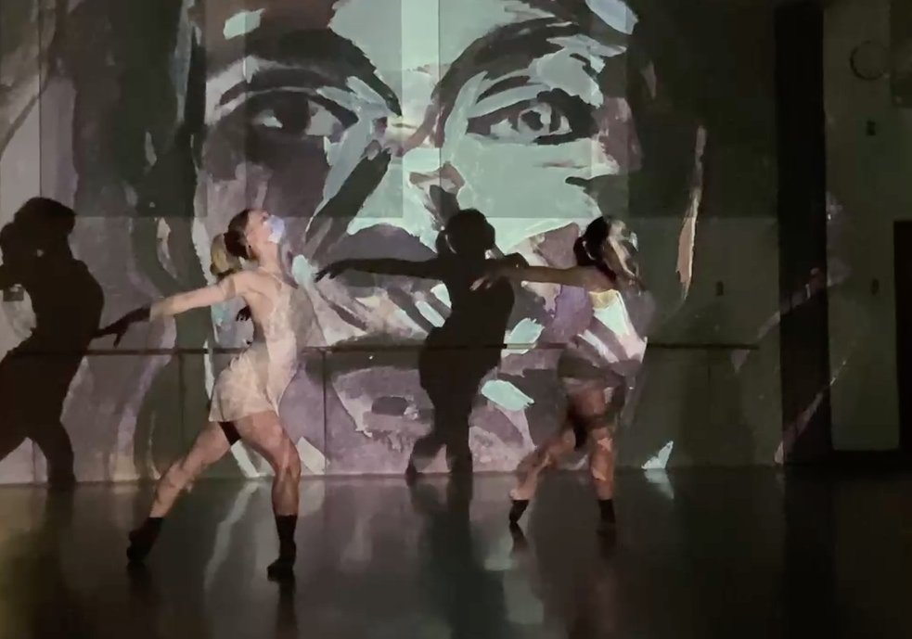
Figure 12. Sylvie Mayer. Purple Lady. Projected image during studio rehearsal.

At the end of October, I had a very productive second meeting with Ian when we discussed color palette, transitions, projection coverage onto the stage, as well as lenses and camera equipment. He showed me several options for projection layout, which looked very technical and out of my area of expertise. I trusted his design suggestions and let him take the lead on determining what was needed for equipment and how the setup would work. In an effort to be sure we understood each others’ expectations, we had lengthy discussions about where the light would hit the dancers, the interaction of several projectors at one time, what areas of the stage would not be lit by the projectors, how the projection would cast shadows onto the scrim and so forth. He had originally suggested renting projectors, however after some research on the university’s equipment, he thought he could make it work with the equipment available to him through the school. Once Ian determined the equipment and projection set up, he provided Sylvie with an image ratio for her paintings. She then had to crop the paintings to accommodate this new ratio.
We discussed the possibility of going into the theater in the next few weeks to look at the projections and the possible effects that could be produced. The plan was to invite the dancers, all wearing white, to help us determine the effects the projections would have on their bodies, and whether or not the white costumes would actually serve as a canvas. We discussed using the cyc (cyclorama or scenic backdrop, which is a flat muslin panel hung furthest upstage, used for lighting effects) for most sections since this would allow the images to be fully visible. We discussed pairing the Purple Lady with Melancholy and thought it could be interesting to bring the black curtain in so that the projections would work solely off the dancers’ bodies and costumes, thereby achieving the effect that was evoked by the image from the Titan collaboration. Beginning on November 3rd, several emails went back and forth between myself, Ian, Professor Brode, and Associate Professor Richard Sprecker. We were attempting to find a mutual time when we could go into the theater for a projection markup rehearsal. There were many technical issues as well as problems with theater availability that stood in the way and, unfortunately, this rehearsal never materialized.
Just before winter break Ian was able to reserve the theater and set up the projectors according to his design. He met with Sylvie, Eliza, and I for a brief look at the projected images and costumes. I had ordered several white costume pieces which arrived in time for Eliza to model on stage with the projected images. Unfortunately, the projectors were not functioning correctly, and the time allotted was limited, so we were unable to experiment fully with the costumes and projections. The black curtain was not available to us so we could not determine if it would create the desired effect. In addition, Ian reported that the 16:9 projector ratio he had originally given to Sylvie, would change to 4:3. This meant that Sylvie would need to crop the images for a second time. She expressed her frustration, stating, “Usually I consider an entire composition, but in this case, I had to crop the images twice in order to fit them to the stage.” From a technical standpoint, I felt frustrated with the process of making the project work. Ian spent so much time designing the projection layout and working with Sylvie to help with sizing, color palette, and saturation and yet, there seemed to be a missing link to finding a process for envisioning the expected outcome of the projections on the stage.
In addition to the technical struggles, we also experienced difficulties agreeing on the projection concept. Ian was interested in photoshopping many of the paintings to add dimension. For example, he wanted to add red lines into the Anger painting (Fig. 13) to exaggerate the depiction of anger as well as brushstroke the image to create a shaped appearance. Sylvie was working in a particular color palette for this project which was somewhat muted and subdued while Ian pushed to create something more highly saturated. Because of this, we tried to understand the collaborative role that the projection artist should be playing and whether they should be a part of the non-hierarchical process within the
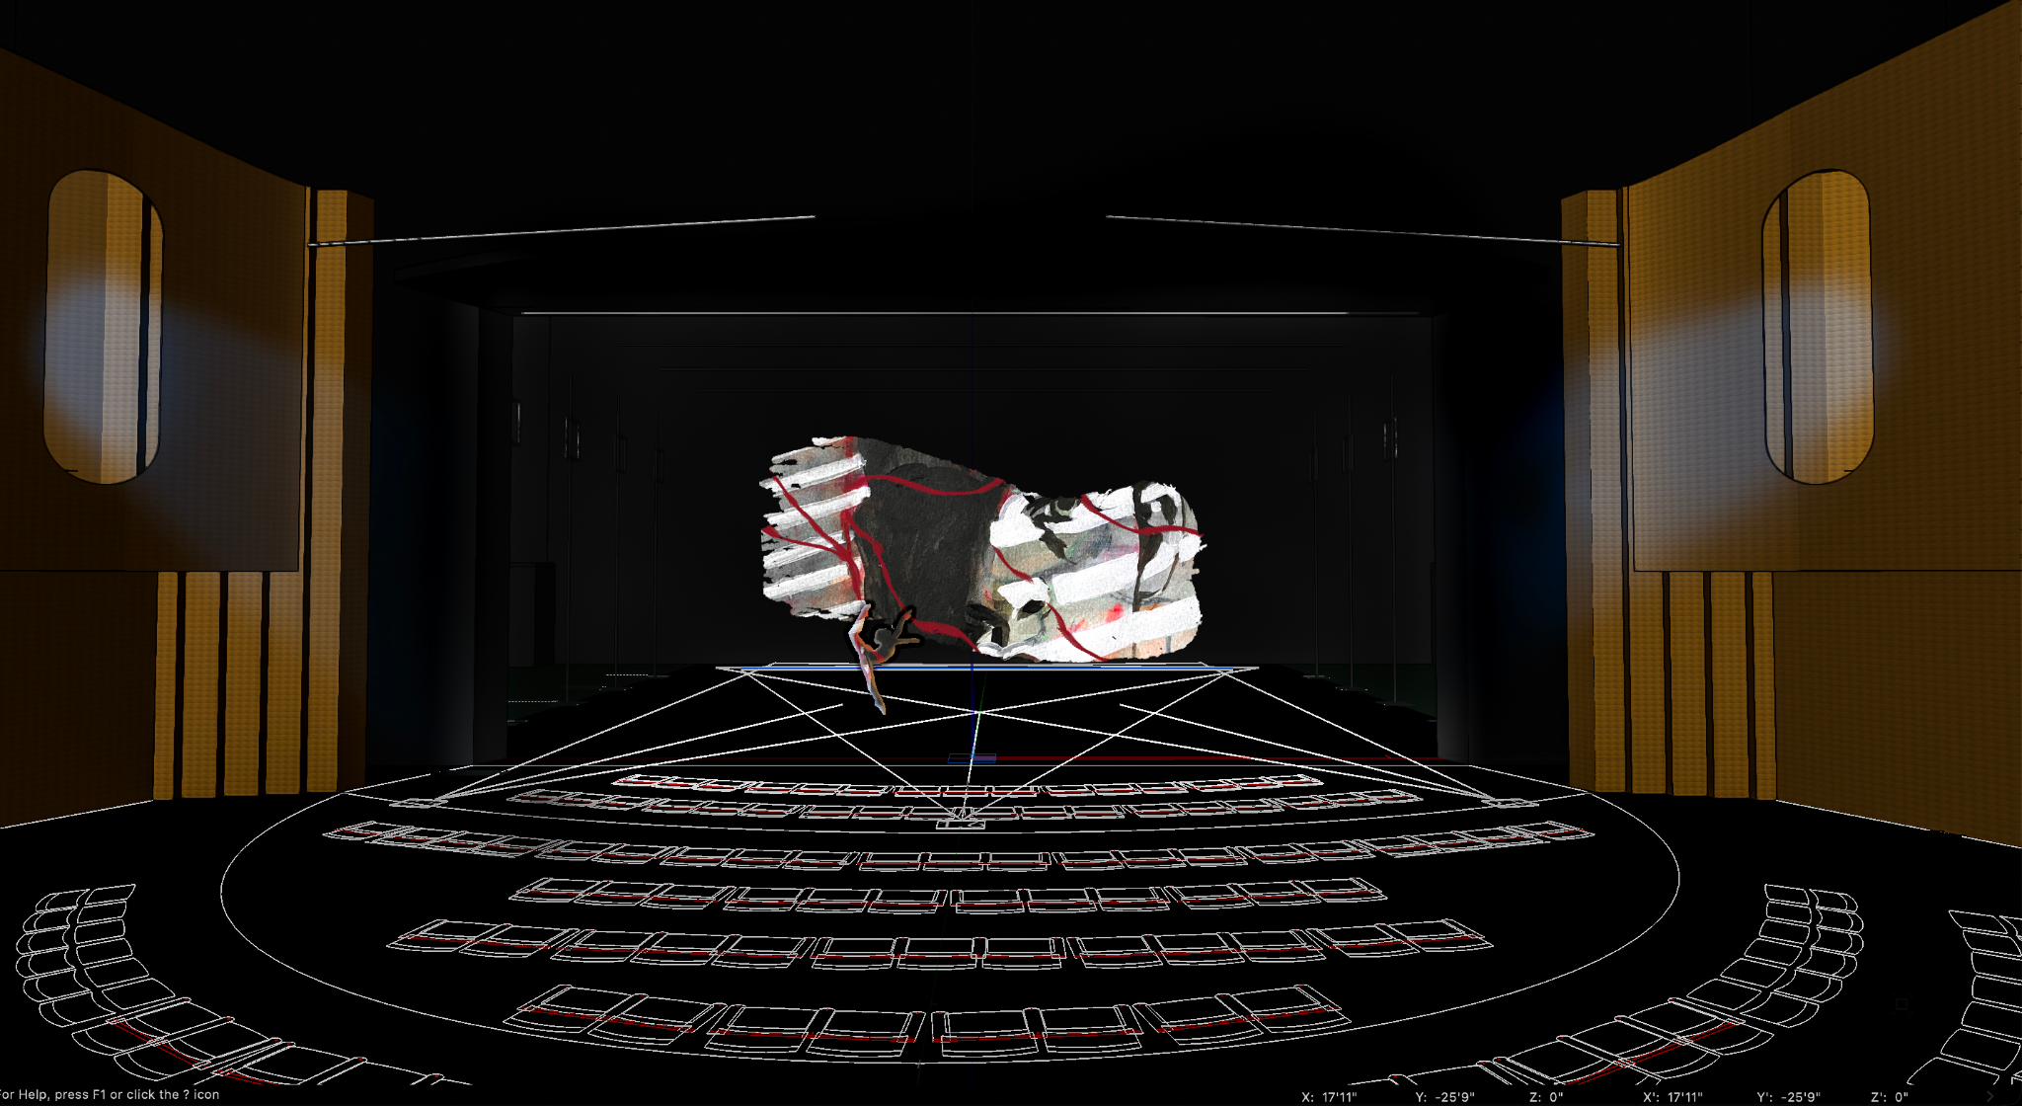
Figure 13. Sylvie Mayer, Ian Evans. Anger/Separation. Ian’s rendering of the original Anger/Separation painting.

collaboration. We ultimately decided the main collaboration was between choreographer, pianist, and painter. Finally Sylvie and I decided to rename the paintings and reconsider which images best suited each section since, over the evolution of the project, we realized some of our original concepts had changed. By changing the names of each image and vignette, we were able to communicate the concept and design elements in a different and more cohesive manner. (Fig. 14)

Renaming Vignettes. Rearranging Images
Initial Title |  | New Title |  | Initial Image |  | Final Image
Opening Reality |  | Opening Reflection |  | Pink House |  | Pink House
Melancholy |  | Separation |  | Purple Lady |  | Angry Man
Joy |  | The Meadow |  | Abstract |  | New Portrait
2nd Reality |  | 2nd Reflection |  | Pink House |  | Pink House
Anger |  | Sisters |  | Angry Man |  | Purple Lady
Acceptance |  | Acceptance |  | Ocre/Green Lady |  | Ocre/Green Lady
Surprise |  | "All together Now" - Octopus |  | Two Faces |  | Two Faces
Final Reality |  | Final Reflection |  | Pink House |  | Pink House

Figure 14. Mary Ann Mayer. Concept Chart. This chart shows the renaming of each vignette and the repositioning of several images.
Next, Sylvie and I met with Ian to go through each image and to discuss the concept changes to be sure that we were all on the same page with concept, cropping, color, and saturation. With these changes, Ian became less concerned with editing and photoshopping the original images. Due to his ancillary role, he had not been involved in the evolution of the ballet so he did not see the changes that we had been experiencing in real time. Renaming and moving the images gave us each clarity for the overall project. Ian reflected on this situation in regard to the collaborative process and his creative output stating,
I do think it (the collaboration) affected my creative output / limitations but not in any negative sense. I think needing to be accountable somewhat to the original work and the original artist removed some potentially interesting opportunities in creating totally new synthesized content or adding more abstract concepts that manipulated the original works more, but needing to stay fairly true to the original work was a unique challenge.

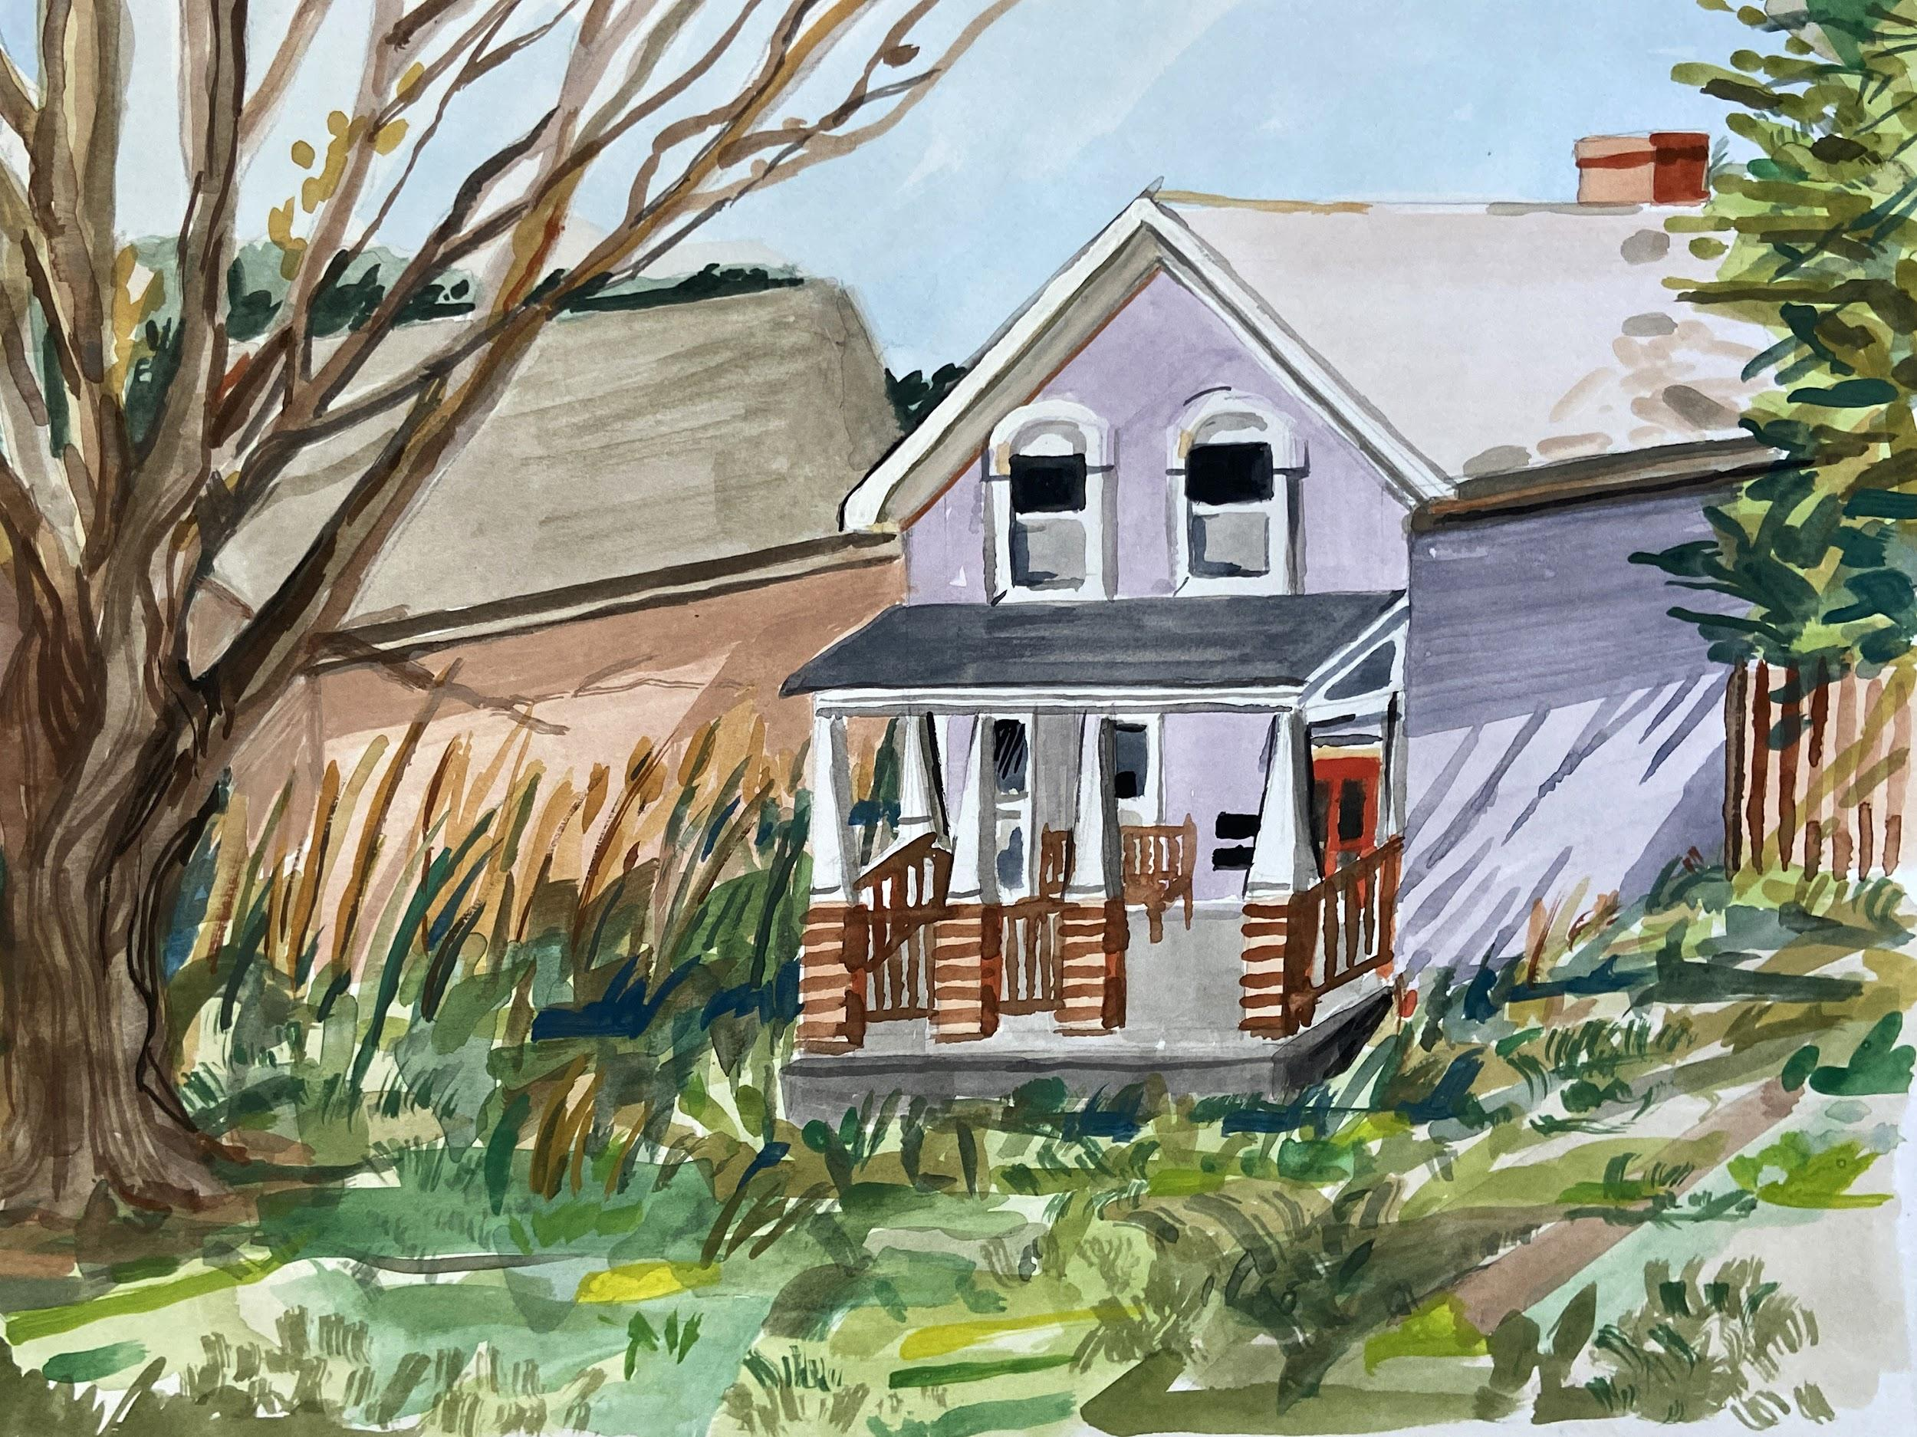
Collectively, Sylvie, Ian, and I decided that the Pink House was not the right piece for Reflection (formerly Reality), and tasked Sylvie with creating yet another house image. Her new painting (Fig. 15) provided the space for reflection, nostalgia, and memory. However, in the end, I wish we had used the original Pink House painting. I feel as though it may have created a more dynamic aesthetic during the Reality/Reflection vignettes.

Figure 15. Sylvie Mayer. Bungalow. New house image referenced the three Reflection vignettes. Formerly Reality vignettes.
During this time I also met with Logan Wynn, the lighting designer assigned to my piece, to discuss concepts and ideas for lighting. He attended one of the rehearsals with Ian so that they could collaboratively decide on several design elements. I gave him specific direction on where I would like pools of light and other details. I shared the projection images, we discussed the overall concept, sequencing, and transitions. Additionally, we both participated in a lighting workshop for choreographers and lighting designers. At this workshop we had a second conversation and then met one last time to go over the order of the ballet and the transitions. I sent Ian and Logan a video of our final rehearsal before winter break. Ian and I met once over winter break to talk through transitions one last time.
Once we returned from winter break I found that I was most concerned with the projection aspect of the performance since we still had not seen the final product and had not been able to experiment with the options of cyc versus black drop. Additionally, we had not worked through the projection and choreographic transitions in real time.
The process from spacing rehearsal to final dress rehearsal seemed long and laborious. We seemed to be spending hours in the theater lighting the show without making much progress. Realizing that this was a learning experience for the students, I tried to be patient with the length and format of the process. During the spacing rehearsal I thought I would get to see the projections and an initial aspect of Logan’s lighting design. However, the projections were again not working properly, and Logan did not get to present fully realized ideas. Logan and I both felt frustrated since working on the lighting without the projections seemed pointless, agreeing that the projections needed to be in place to know how to light the piece. As Logan mentioned in his reflection to me, “it was a challenge to record my cues before seeing the projections, because they were cohesive, but I wasn’t able to see how they both interacted until tech.” We were able to address some of the simple lighting elements like where the pools of light would be for each section. However, the overall look was impossible to discuss without the projections. In creating lighting cues, Logan was also dealing with other limitations. He explained that “There were a few challenges; the first one that comes to mind is my limit for cues— I was given 20 cues for a 20 minute piece, while the other 5 minute pieces got 10 (1 per minute vs 2).”
Throughout the stage rehearsal process, technical difficulties continued to plague us. On the Saturday before the first dress rehearsal, each choreographer had a lengthier lighting rehearsal to work out technical details. The five minute pieces were allotted thirty minutes to finalize lighting cues. I was allotted just forty five minutes to finalize projections and lighting cues, for a twenty two minute piece. Ian and I decided that the most important element was to work on the transitions and to see how the projections interacted with the lighting. Since we had not been able to workshop any of the ideas ahead of time we were pressured into rushing through the process. In order to address the projection transitions in the given time, I made a decision, in the moment, to cut the black drape to save time. I wanted to be sure we would be able to get through the entire piece in the time allotted so that we could decide on each transition, crossfades, and final lighting. This meant we would not be able to achieve one of the desired lighting effects that we were hoping for.
Lighting and projection design came together in the first dress rehearsal. Upon finally seeing both the lighting and projection elements together, I felt as though Logan had been a bit too conservative with his lighting design in an effort not to upstage the projections. Many sections were underlit and needed to be enhanced in order to sculpt the dancers properly, create the mood, and tie together the choreography and projections. Logan and I shared several emails to discuss his lighting, whereby he agreed that he was holding back in his lighting design and would address my concerns. In order to achieve our goals Logan needed to develop several lighting changes within one light cue due to the limitations imposed on him. Several timing issues surfaced because of this. Although there were a few technical malfunctions and timing issues with lighting cues, over the course of the rehearsal process, the lighting design elements tightened up and became a successful part of the collaboration.

2.6 Performance
Throughout the process of creating this ballet and considering its stage presentation, we continued revisiting our concept, reorganizing the structure of the work and redefining the vignettes. As the work evolved we felt as though we had developed a cohesive structure (Fig. 16 & 17) that communicated the narrative of the full ballet. As we considered the outcome, we decided that we wanted the audience to interpret the emotional aspect of the ballet from their own perspective. So as not to impose a literal interpretation, we collectively decided that the titles of each section and descriptions would not be printed in the program. Katie and I began to refer to the eight vignettes that we had each created as poems, referencing the music as a series of tone poems and the choreography as a series of movement poems. The structure that developed over time was presented as an eight movement ballet with the projection of Sylvie’s paintings to support and interact with each vignette.

Final Ballet Structure in 8 Movements
Vignette Title |  |  | Final Image
Opening Reflection |  |  | Bungalow
Separation |  |  | Angry Man
The Meadow |  |  | Portrait w/Dogwood
2nd Reflection |  |  | Bungalow
Sisters |  |  | Purple Lady
Acceptance |  |  | Ocre/Green Lady
"All Together Now " - Octopus! |  |  | Two Faces
Final Reflection |  |  | Bungalow

Figure 16. Mary Ann Mayer. Final Ballet Structure in eight movements.
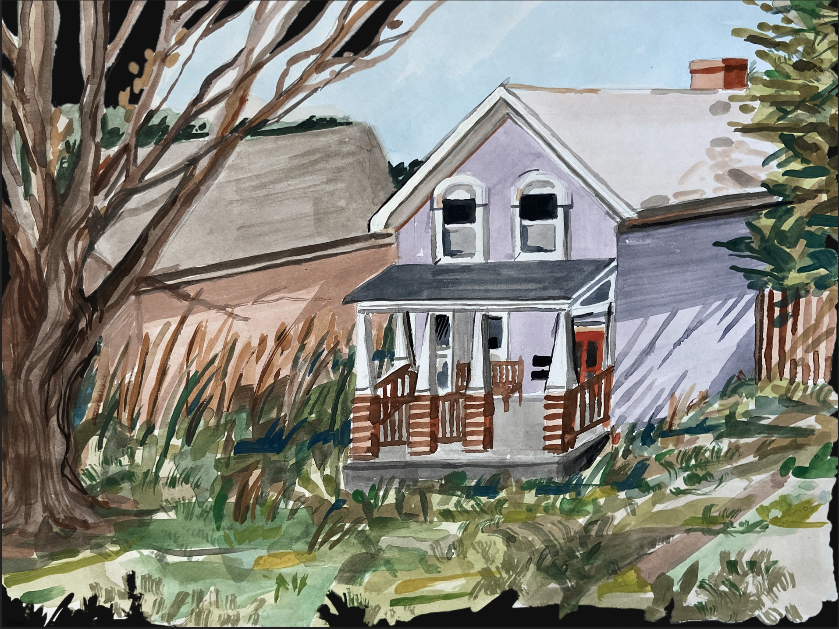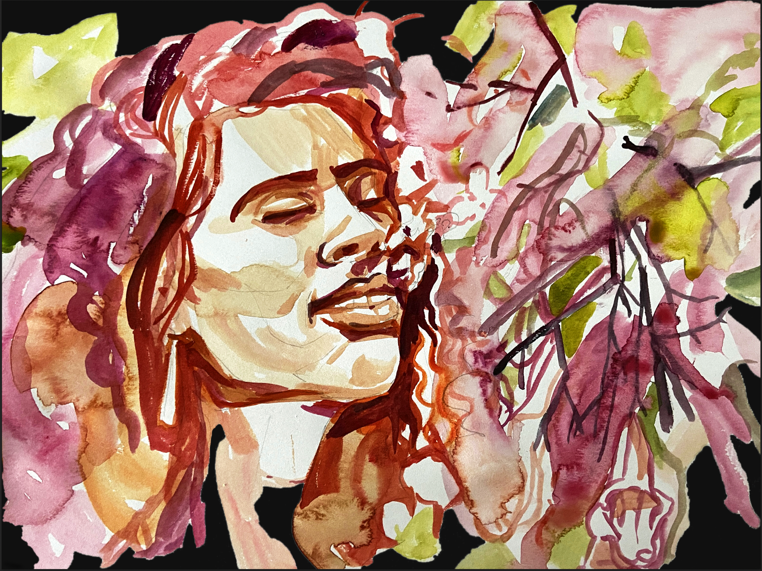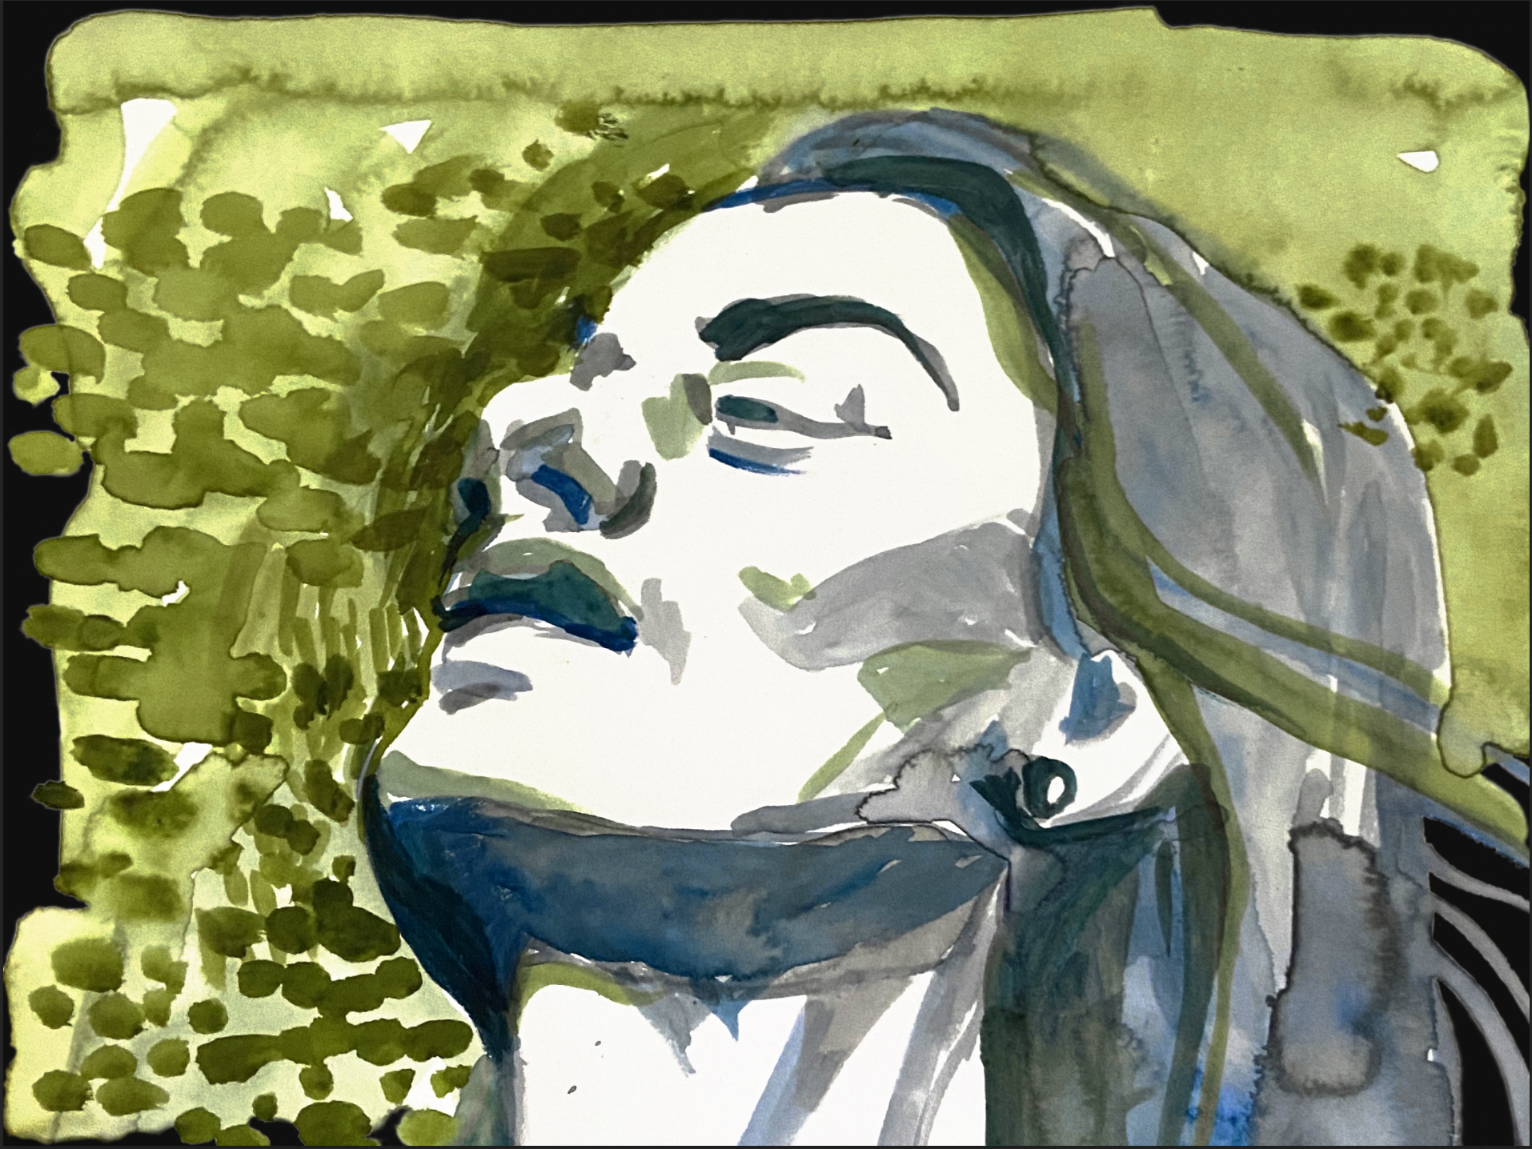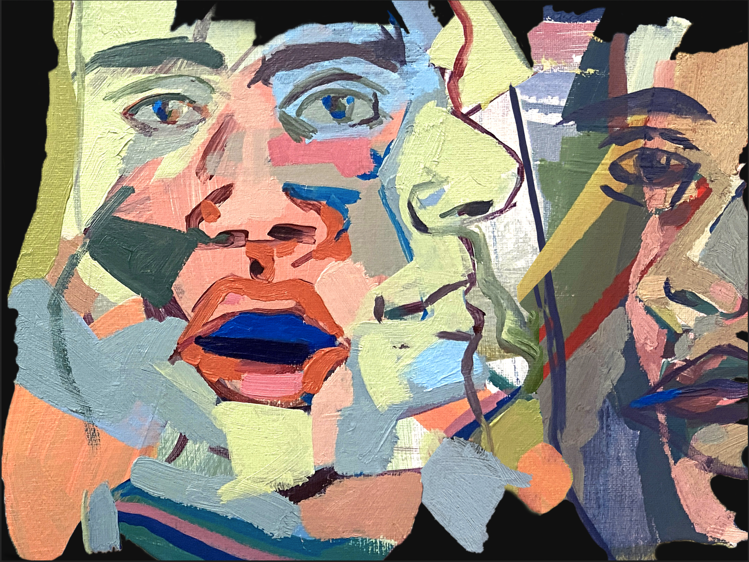
Figure 17. Sylvie Mayer. Final images in performance order.

Although there were technical difficulties that surfaced throughout the run, the performances came together visually and aurally. The Friday evening performance was the most successful. The dancers were fully engaged in the work; achieving their fullest potential, coordinating their timing, and developing each scene with confidence and emotion. Katie played as if she were playing a solo recital in a concert hall. She and the dancers were in complete communication while I sat and watched these memorable moments unfold.
This production combining music, dance, and painting evolved from an interest in collaboration’s impact on creativity. In the process of a non-hierarchical collaborative endeavor, one musician, one choreographer, and one painter produced a fully formed ballet in eight movements. Without the support and input of many others - dancers, professors, projection and lighting designers, stage and technical crew - this project could not have been realized. Collaboration happened on many levels in this artistic endeavor and supported the creative output of each of the artists in various ways.

Chapter Three: Literature Review of Collaborative Endeavors
Literature provides many examples of creative pairs, married couples, business partners, teams, groups; those working in the arts, the sciences, in business, and technology; many from different periods of history as well as from the present who have contributed with great creativity to their fields in a collaborative manner. Since time does not permit me to provide an exhaustive list of the many documented collaborations, I will present a sampling of collaborative endeavors that have inspired creativity within dance, music, and visual arts that reveal an insider's view of complementarity and interdependence.

3.1 Sergei Diaghilev and the Ballets Russes
At the turn of the 20th century, the great impresario Sergei Diaghilev brought dancers, choreographers, musicians, composers, and visual artists together in unique collaborative ventures throughout the development of the Ballets Russes. This company produced a revolutionary change in the dance world, particularly in ballet. Diaghilev’s vision, cunning, determination, and penchant for bringing artists together provided for large group collaboration. Through the organization of the Ballets Russes, he contributed to radical changes in the domains of both music and dance. The changes that occurred in both domains during this period of the Ballets Russes are referred to in psychology as resulting in ‘big C’ creative output.
American dance musician Katherine Teck in referring to Diaghilev stated, “If anyone needed a role model of fresh collaboration for theatrical dance, this (Diaghilev and the Ballets Russes) was it.” Whether Diagilev realized it or not, the support that he offered artists through the establishment of the troupe, and his adventurous, risk-taking spirit, fostered a collaborative environment that became the heart of the Ballets Russes’ tremendous impact on the expansion of music and dance. In addition to allowing for collaboration between choreographer, composer, and visual artists, his efforts contributed to the mutual influence between musicians and the overarching relationship between music and dance. Vera John-Steiner in her book Creative Collaboration stated that, “It (the Ballets Russes) was one of the most important artistic ensembles established early in this (twentieth) century.” Teck quotes Lynn Garafola from a collection of her writings titled Legacies of Twentieth-Century Dance:
He (Diaghilev) brought new music to dance and commissioned some of its greatest scores, including works that were equally at home in the concert hall. He reared a whole generation of composers willing and able to write for the dance and totally revamped what was thought of as dance music. His influence was felt throughout Europe as well as in the United States, in modern dance as well as in ballet.

Following Ballets Russes’ first American tour in 1916 many American choreographers began searching for composers to collaborate with. In the theatrical works of the Ballets Russes, Diaghilev made use of the music of talented and eager classical composers of the time (mostly Russian or European). This long list of musicians includes Darius Milhaud, Sergei Prokofiev, Erik Satie, Nicolai Rimsky-Korsakov, and Igor Stravinsky.
In Stravinsky Dances: Re-visions Across a Century, Stephanie Jordan writes that it was Diaghilev who was “responsible for establishing Stravinsky as a major composer and giving him his seminal dance experience.” Diaghilev had been attracted to Stravisky’s unique use of rhythm and tone and, by pairing the choreography of Fokine and the artistry of Leon Bakst with the compositions of Stravinsky, he created a collaborative team that brought
revolutionary change to dance. This included the creation of Petrushka, Le Sacre du Printemps (The Rite of Spring), and Le rossignol (The Nightingale). Although these works were seen as artistically successful, Stephanie Jordan explains that Stravinsky began to move away from working with choreographers, feeling constrained by the need to produce a “danceable style of music.” Further stating that “According to Nabokov, he also felt that choreographers (other than Balanchine) misused his music: they would employ it as mere ‘expressive background’ or ‘count up beats and measures and base their choreography on the durative elements of music.’”
Although the alliance with Ballets Russes and Diagilev afforded Stravisky many great opportunities, the relationship between the two men was somewhat troubled both personally and professionally. Despite the circumstances, John-Steiner remarks that “One of the most important partnerships that emerged from this large group was between George Balanchine and Igor Stravisky.”

3.2 George Balanchine and Igor Stravinsky
The opinion among scholars is consentient regarding the collaborative achievements of these two artists, agreeing that their collective creative output was exceptional. However, some scholars and critics have questioned whether or not their work was truly collaborative due to the fact that Balanchine choreographed ballets to many of Stravinsky’s pre-existing scores. Additionally, some argue that Balanchine’s best and most creative works were to the music of other composers besides Stravinsky. In what follows, I reveal an intimate perspective on what appears to be a truly collaborative relationship between the two artists.
In Stravinsky & Balanchine by Charles M. Joseph the reader is offered a comprehensive view of the two artists' partnership. Joseph’s extensive research reveals insight into their collaborative process through an exploration of several primary sources, including unpublished scores, film clips, correspondence, and other archival materials. Two of the archival organizations that he gives special attention to are the Paul Sacher Stiftung in Basel, Switzerland which holds more than one hundred boxes of Stravinsky’s correspondence, manuscripts, scores, unreleased films and portions of his library. The other important source used in writing this manuscript is The George Balanchine Archive which is held by the Harvard Theatre Collection, part of Harvard’s Houghton Library, and includes 81 boxes of informative documents. Through his book, Joseph’s exhaustive investigation provides the public with an insider’s look at intimate moments, revealing just how much each was influenced by the other and how collaboration impacted their output. Because of the extensive research and intimate documentation that Joseph provides, I use Stravinsky & Balanchine as my primary reference in unfolding the collaborative nature of their relationship.
Although Balanchine was familiar with Stravinsky's compositions, since he had choreographed to his music as a student at the Imperial Ballet School in Petrograd in 1924, it was Diaghilev who played a role in bringing the two together. In 1928 Diaghilev offered Balanchine the opportunity to choreograph to Stravinsky’s ballet score of Apollo. The musical score was originally written for the Elizabeth Sprague Coolidge Foundation in Washington, D.C. as a short ballet to be performed at a festival of contemporary music at the Library of Congress in April 1928. The original choreography was by Adolph Bolm. Apparently, Stravinsky was not completely satisfied with this production since he agreed to a

restaging with Balanchine as choreographer for the Ballets Russes just two months later.
According to Joseph, Stravinsky was a “ballet composer who understood the language
of dance better than any other musician of the twentieth century” and that he (Stravinsky) “needed to find an artist - a very sympathetic artist - capable of complementing his own clearly envisaged ideas.” Though twenty-two years Stravinsky’s junior, Balanchine had established himself as a competent choreographer by the time they began their first collaborative endeavor. With the premier of this newly staged Apollo, Stravinsky found his choreographic muse in George Balanchine. Following the premier in June 1928, Balanchine wrote that this collaboration marked a turning point in his life: “In its discipline and restraint, its sustained one-ness of tone and feeling, the score was a revelation. It seemed to tell me that I could dare not to use everything, that I too could eliminate.”
For Balanchine, “music was everything” and Stravinsky’s music stimulated his choreographic ideas. Paul Mason in his article, Music, dance and the total art work: choreomusicology in theory and practice cites Charles Joseph, stating, “Balanchine thought of dance as ‘music’s younger sister’ and his sense of movement ‘counterbalanced the music in a way that was neither superficially or superfluously imitative’.” He found inspiration in the fresh ideas that Stravinsky brought to the table and although they may not have seen eye to eye on every musical arrangement or choreographic moment, Balanchine was committed to their work which led to novelty and invention in the fields of music and dance.
Many have accused Balanchine of acquiescing to Stravinsky’s ideas. However, I believe that he was able to work beside Stravinsky without overshadowing his music because
of his understanding of musical composition and his belief that music created the architecture for dance. Taken together with his opinion that the body, without music’s rhythmic pulse, could not sustain itself, was clearly what allowed him to adapt to his role as junior partner. Balanchine’s statements in a June 14, 1954 article in the Herald Tribune written by Jay S. Harrison entitled “ Balanchine: He Fills Time in Space,” supports this thought, “Music is something that occupies architecturally a certain portion of time. Now, in the dance, unless your body fills time, occupies time, as music does, then it means nothing. Gesture itself is meaningless.”
Balanchine, a well trained musician himself, found something in Stravinsky’s music that appealed to him, something that spoke to his creative desires and therefore developed a congenial working relationship with the elder Russian composer that satisfied his own artistic vision. As I consider their work together I am struck by the many aspects of their lives that were suited to what scholars might consider necessary for successful collaborative output. They were like-minded with a similar artistic vision. Both were émigrés of Russian descent, both classically trained and proficient in their respective fields, with the added benefit of Balanchine having studied music. They were both captured by the fresh atmosphere of American culture and intrigued with the melting pot and the African American sound of jazz. Both men considered themselves makers; craftsmen who needed to put things together. These similarities together with the deep admiration that each had for the other laid the groundwork for successful collaborative endeavors.
Aside from the interest in their joint ventures, both Stravinsky and Balanchine, throughout their careers, continued to work on various other projects. During the ongoing
partnership with Stravinsky, Balanchine collaborated with other composers, namely Tchaikovsky and Ravel, on commissioned works. Stravinsky continued writing concert pieces, collaborating with other ballet companies and traveling and conducting in Europe. Balanchine was busy in New York City working with Lincoln Kirstein on creating a new American Ballet while choreographing for other ballet companies, broadway musicals, and festivals. Their busy schedules and responsibilities kept them from working together through the early 1930’s although they, according to Joseph, “kept track of each other:” Their paths would occasionally cross during the decade that separated Apollo from their next collaboration of Jeu de Cartes. Another ten years would pass before the composer and choreographer began their work on Orpheus. This ballet, two years in the making, was first performed in April 1948. It is considered their closest collaboration and a landmark venture, expressed by its “tranquil power” within a unified whole.
Documentation from this period provides a glimpse into their working relationship and the collaborative aspects of the building of Orpheus as well as the restaging of the Firebird. As Joseph reminds us, the Stravinsky-Balanchine partnership was much more ‘elastic’, much more ‘contrapuntal’ than might first appear. Further explaining, “they were each ‘interested in counterpoint’… Balanchine visually and Stravinsky in writing music.”
Joseph considers the following as one of the most colorful memories of the working process leading up to the creation of Orpheus. Explaining that Balanchine discussed the

following with Jonathan Cott during the summer of 1982 as recorded in Portrait of Mr. B:
I would visit (Stravinsky's) home in California and we’d talk. ‘What do you want to do?’ he’d ask, and I’d say, ‘Supposing we do Orpheus.’ ‘How do you
think Orpheus should be done?’ ‘Well,’ I’d say, ‘a little bit like an opera.’ And Stravinsky said, ‘I’ll write the end first; I sometimes have an appetite to write the end first.’ And that’s what he did, with the two horns - it’s a beautiful thing, sad, hair flowing. We couldn’t have a river on stage, but it suggests something like that. Then he asked ‘Now, how to begin?’ and I said, ‘Eurydice is in the ground, she’s already buried, Orpheus is sad and cries - friends come to visit him, and then he sings and plays.’ ‘Well,’ Stravinsky asked, ‘how long does he play?’ And I started to count, (Balanchine snaps his fingers), the curtain goes up. ‘How long would you like him to stand without dancing, without moving? A sad person stands for a while, you know.’ ‘Well,’ I said, ‘maybe at least a minute.’ So he wrote down “minute.” And then, I said, ‘his friends come in and bring something and leave.’ ‘How long?’ asked Stravinsky, I calculated it by walking. ‘That will take about two minutes.’ He wrote it down. And it went on like that.

Joseph also notes that from Stravinsky’s early sketch scores of Orpheus, there seemed to have been many collaborative revisions including tempo changes and the re-thinking or addition of instrumental indications. He states that “Balanchine persuaded Stravinsky - as no other choreographer ever could - to extend certain passages, including the concluding section of the famous Pas de deux.” Studying the musical sketches Joseph continues, “Stravinsky labored to reapportion the passage according to Balanchine’s durational demands for this closing, dramatically pivotal music. There are at least ten separate drafts illustrating that rhythms were altered, meters rethought, melodic motives modified.” Throughout his writing, Joseph provides several examples that acknowledge Stravinsky’s “willingness to reposition ideas” according to Balanchine’s vision of his ballets.
Stravinsky’s inclination to physically involve himself in the choreographic process when in the studio, sometimes taking it upon himself to redesign choreographic phrases, may
be what led dancers, critics, and scholars to believe that Balanchine played a subordinate role in their partnership. However, Stravinsky entrusted his full confidence in Balanchine’s choreographic decisions. According to Violette Verdy, Balanchine was complicit but he did not perceive it as “kowtowing” and because Balanchine was able to take on the junior position, their partnership was successful. Furthermore, when Balancine asked for additional musical phrases to complete a section of choreography, Stravinsky was flexible in adding music on the spot.
Joseph includes Maria Tallchief’s recollection of rehearsal moments with Balanchine and Stravinsky; where she states that they worked “side by side in the rehearsal studio. Ordinarily, when George was choreographing, Stravinsky kept his distance.” Referring to rehearsals for Orpheus she goes on to say: “But this time was different. He was always making suggestions, and was exacting about what he wanted.” Joseph continues with one of the most often retold moments in the history of the Stravinsky-Balanchine collaborations,
Tallchief reports that when Eurydice died in the Pas de deux the composer asked, ‘Maria! How long it will take you to die?’ Nicky (Magallanes) was standing there, so I put my head on his shoulder and began to fall to the floor, as the choreography demanded, and hands reached out from where the silk curtain would be to drag me back to Hades. Stravinsky began snapping his fingers – snap, snap, snap, snap– I think it was four counts. ‘That is enough,’ he decided. ‘Now you are dead.’ And he put those counts into the score.

This account speaks to the collaborative atmosphere in the studio, Stravinsky’s involvement
in the choreographic design, and his flexibility to alter his original ideas.
Both men took risks in the creation of Orpheus. Balanchine displayed courage in
creating an understated choreographic expression that supported the theatricality of the ballet. His sense of balance attributed to his goal of presenting a unified whole. For Stravinsky he worked to create a “dignified, gracious work, far away from the bombastic, hard-driving Russian scores critics still longed to hear.” Their collaborative one-mindedness, trust in each other, and ability to risk a possible failure allowed them to create a “powerful expressive statement.”
Their next significant collaboration was the re-choreographing of Stravinsky’s Firebird with Maria Tallchief. Stravinsky was thrilled to have Balanchine choreograph his “streamlined” 1949 score and to have Tallchief dancing the leading role. In a Balanchine Foundation Interview with Arlene Croce and Nancy Reynolds, Maria Tallchief comments about Balanchine’s choreography in regard to Stravinsky’s scores “what he (Balanchine) did was… the music, it was completely the music. For instance Terpsichore in Apollo has a great deal of jazz in it.” She continued by saying that.…”Everything had to do with the music.” “What’s very important… is the nuance of Stravinsky’s music (pause) that, that wonderful underneath, underlying sort of jazz, it’s there and George - Stravinsky sent him piece by piece this music from California, as he was writing it - and George would sit at home and copiously learn each note. By the time we came to the studio he knew what he wanted. Very modern.”
Stravinsky continued to work closely with Balanchine in reshaping the ballet as well as conducting the premiere. Firebird was a major triumph and put New York City Ballet on the roster at the Metropolitan Opera House. Balanchine and Kirstein won the approval of

Stravinsky with the successful outcome of the premiere, giving them more clout in commissioning the composer for future works. In fact, Stravinsky was often approached by others for commissions whereby his acceptance hinged increasingly on Balanchine’s interest and availability. Joseph notes that he refused work if Balanchine were not involved.
Kirstein continually prodded Stravinsky to create a sequel to Orpheus, suggesting that a third Greek mythological ballet would create a triptych of sorts. He had hoped that Stravinsky would consider a “third act of Apollo-Orpheus.” Between 1948 and 1957 Kirstein exchanged dozens of letters with the composer in this regard. According to Joseph, “the notion of linked works held little interest for a composer who took each compositional challenge as a single, independent problem to be solved.” He considered and quickly eliminated many ideas that were proposed throughout the years but “it was his interest in literary models – perhaps even more deeply than in musical ones – that almost always informed and shaped Stravinsky’s thinking.” He found initial inspiration in T.S. Eliot’s poems “Sweeney Agonistes.” In the end, Stravinsky did not create the ballet in relation to this work, however Eliot’s poems were certainly the source of Agon’s title. It was not until Kirstein sent a letter outlining Balanchine’s specific vision for the ballet that Stravinsky would show a real interest in the project. This letter detailed Balanchine's ideas, “He suggested a competition before the gods; the audience are statues; the gods are tired and old; the dancers reanimate them by a series of historic dances” Kirstein continued by saying “It would be in the form of a suite of dances, or variations, numbers of as great variety as you
pleased.” He referenced historical costumes and added that “your music is the drama; his dances would attempt to stage dramatic tensions entirely in terms of dancing.” Ending with “But you are the boss.” According to Joseph, this letter was the impetus that finally gave Stravinsky a tangible resource; something he apparently needed to guide his imagination.
The development of Agon began with Stravinsky’s study of early dance music which informed his exploration of the musical and choreographic components of the dance. During his research he introduced Balanchine to different styles of music including Schoenberg’s twelve-tone style which is claimed to have influenced the bold experimentation in the composition. His score's choreographic implication stimulated Balanchine’s thinking through a musical structure that furnished visual counterpoint for his choreographic ideas. Neither Stravinsky nor Balanchine wanted to produce a “simple re-creation” of a Greek myth but were more interested in telling a universal story.
Between 1953 and 1957 the two met often to discuss the evolution of their work. Apparently, Stravinsky offered many choreographic ideas along the way. “Balanchine claimed that it was he (Balanchine) who decided on twelve dancers, conceding that the two-to-one ratio of eight females to four males was Stravinsky’s idea.” He also recalled that “Stravinsky offered specific choreographic suggestions from the beginning. Once Stravinsky began composing, and even as his preliminary ideas took shape, his notations of
stick figures and spatial diagrams throughout his sketches reveal a constant awareness of the work’s choreographic demands.” He went on to say that “We discussed timing and decided that the whole ballet should last about twenty minutes. Stravinsky always breaks things down
to essentials.” Balanchine remarked that “To have all the time in the world means nothing to Stravinsky,” quoting him as saying, “When I (Stravinsky) know how long a piece must take, then it excites me.”
While in California, the two men frequently met in the afternoons at Stravinsky’s Hollywood home. During these sessions Joseph retells Stravinsky’s wife, Vera’s, recollection of hearing Balanchine and her husband talking and singing in the composer’s studio. Vera Stravinsky remarked, “each time they came (out, they) were very satisfied. He (Stravinsky) would say, ‘Good, we did a lot today.’” Joseph points out that “these afternoon sessions produced one of the most illuminating documents.” He explains that “a record of their exchanges, in the form of a detailed summary chart, plots each component of Agon’s planned action.” It was drafted on several single leaves of paper in Stravinsky’s writing. As Joseph explained, this document “represents the end product not the original version” and reveals the constant revision of formal divisions, durations, dance forms, and combination of dancers as the concept took form.
From the very beginning, Stravinsky involved himself in the rehearsal process in shaping the outline and fundamental design of the choreography; trusting Balanchine to complete the choreographic details. As usual, Balanchine’s approach to the choreography began with studying the score. Even he, as a highly trained musician, found the score
complicated and hard to fully decipher. He envisioned the many musical canons inventively
and not imitatively. He wrote that he “would produce a ‘visual equivalent which is a complement; not an illustration.’” Joseph tells us that during rehearsal, “Balanchine would
constantly consult the piano score, darting back and forth from the dancers to the piano in an effort to match what he was seeing with what he was hearing.” Dancers remember Balanchine piecing together Agon in isolated sections and not following the constructed order of the ballet.
Though Agon did not fulfill Kirstein’s vision of a Greek trilogy nor as a “great lyric-drama,” it was at least nominally Greek. Edwin Denby, in his review, “Three Sides of Agon, 1959,” captures the Olympic spirit in his description, “The subject is shown in terms of a series of dances, not in terms of a mimed drama… The ‘basic gesture’ of Agon has a frank, fast thrust like the action of Olympic athletes, and it also has a loose-fingered goofy reach like the grace of our local tenenagers.”
Thirty years in the making and considered the last full length Stravinsky-Balanchine ballet, Agon stands “a world apart from Orpheus and Apollo.” Joseph describes it as one of “this century’s most ingenious ballets, the collaborative genius behind the work came at a slow, hard-earned price. Both in historical context and artistic conception, Agon remains an absorbingly complex, resistant work.”
After Stravinsky’s death Balanchine continued to find influence, inspiration, and innovation in his music. He presented two posthumous Stravinsky Festivals and continued to create ballets from the composer’s preexisting scores.
Though scholars are unable to agree whether Balanchine's most creative ballets were the ones created as a direct result of their collaboration, it is hard to ignore the influence each had on the other’s creative output. ​​Igor Stravinsky and George Balanchine were tremendous artists who, by working together, developed a rich vocabulary in their individual expressions.
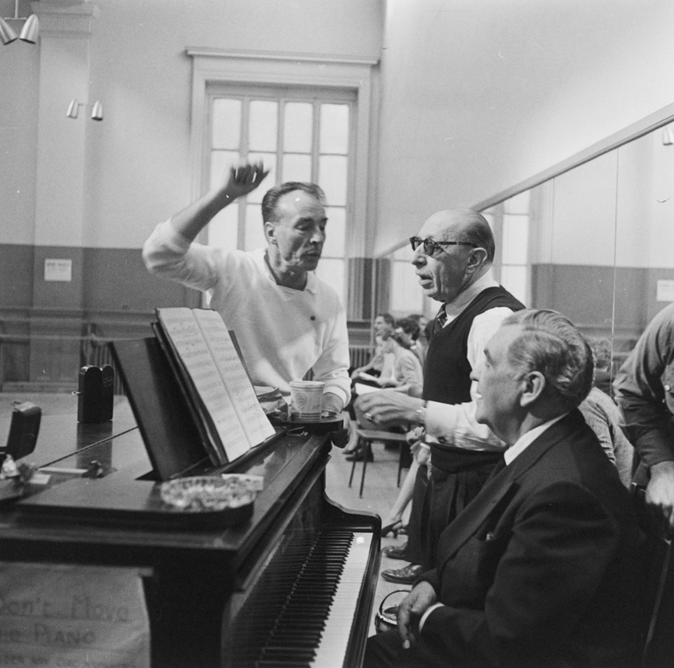

Figure 17. Choreographer George Balanchine and composer Igor Stravinsky with pianist Nicholas Kopeikine at rehearsal of the New York City Ballet production of "Agon" (New York). New York Public Library Digital Collections.

As Clive Barnes stated in the opening sentence of a 2004 article in “Classic Art
Features” Balanchine & Stravinsky: The Sublime Couple, “The names run together like vodka and caviar: remarkable separate, sublime together.” And, although they had only five productions where they collaborated directly, the overall conversation of Stravinsky’s music with Balanchine’s choreography is significant. In reviewing the 1972 Stravinsky Festival of
the New York City Ballet, Andrew Porter wrote in the New Yorker Magazine, that ballets like Orpheus and Agon seemed; “almost to flow from a single mind; an entity called Stravinsky-Balanchine.” The collaboration that continued for nearly forty five years and
beyond Stravinsky's death has been poignantly referred to by some as the Alternative Russian Revolution.

3.3 The Modernist Movement in Dance and Music
Modernism, a term that has been employed for centuries to describe any prevailing object or event that is deemed fashionable at the time, has undergone significant shifts in context and meaning, as pointed out by Daniel Albright (October 29, 1945 – January 3, 2015), Ernest Bernbaum Professor of Literature at Harvard and the editor of Modernism and Music: An Anthology of Sources. Defining modernism in the capital 'M’ context, he states, “Modernism is a deliberate philosophical and practical estrangement or divergence from the past in the arts and literature occurring especially in the course of the 20th century and taking form in any of various innovative movements and styles.”
Mark Feeney discussed the Ballets Russes and its impact on artistic modernism in his May 15, 2009 Boston Globe, G Magazine article titled Russian Revelry: A Weeklong Festival Celebrates the 100th Anniversary of the Ballets Russes, “Certainly there has never been a more spectacular marriage of movement, music, and design...Coming from Russia, the most backward society in Europe [at the time] and performing ballet, the most traditional of art forms, the Ballets Russes nonetheless managed to do more than any other single institution to popularize artistic modernism.” Susan Calkin, in her article Modernism in Music and Erik Satie’s Parade, discusses further the collaborations of the Ballets Russes and its influence on Modernism as follows:
The premiere of Parade caused a considerable stir amongst journalists and critics. Response to the work was controversial and divided. The piece not only challenged audiences; it pushed the technical and creative limits and abilities of its collaborating artists: it was Jean Cocteau's first scenario for a ballet, Satie's first orchestral score, Picasso's debut into theater design, and
Massine's first commission as a choreographer.” …. “The artists seemed to possess a collective discontent with the rigid self-importance of the European arts establishment and rejected the notions of the artist-as-genius.

At the same time in America, choreographers were distancing themselves from the high art of ballet and other popular genres while American composers were looking to create music distinct from their European colleagues. American composers did not have the same caché as their European counterparts and were seeking additional opportunities for creative output. It was important for composers’ careers, both financially and artistically, to collaborate with dancers and choreographers.
No longer satisfied with the status quo and the classical repertory of both music and dance, artists were asking questions that challenged the aesthetic and prompted change. This change came slowly as musicians and dancers experimented in new and innovative ways like never before. In the early decades of the twentieth century, early modern dancers like Isadora Duncan choreographed to preexisting music with choreography relying on the music for structure and emotional context. As new ideas formed there was a shift away from creating dance to preexisting music. Both the American dancer and musician were attempting to say
something new and fresh, attempting to create something that reflected the world in which they lived. Katherine Teck in her book, Making Music for Modern Dance: Collaboration in the Formative Years of a New American Art, posits that the collaborations between modern dancers and composers influenced the development of American music styles. Choreographers and composers of the time were creating musical scores and dance pieces influenced by jazz, regional folk, and spiritual music which lent itself to the “Americana''

sound, like that established in Aaron Copland’s Appalachian Spring and Rodeo.
These changes were occurring on both coasts with New York and California the central points for investigation. Colleges such as Black Mountain College, in North Carolina; Hampshire College in Amherst, Massachusetts; Bennington College in Bennington, Vermont; and New York University in New York City provided artists a place for experimentation. The Bennington School of Dance became a hub for modern dance and encouraged collaboration as process. Music and dance co-existed in this setting, allowing both student and professional composers the opportunity to explore possibilities in creating for dancers.
Katherine Teck, speaks of the influence that Louis Horst, musician and composer, had on the development of modern dance, remarking that he was among the first to spearhead much of the investigation. After ten years touring with Denishawn as accompanist, conductor, and arranger, Horst left to work with Martha Graham. He became her mentor, composer, and accompanist. He trained generations of choreographers, encouraged his contemporaries to participate in the dance movement, and raised the standards of musical
collaboration. Horst was among one of the most important artists to influence the shaping of
modern dance. Teck offers insight into his contributions through the writing of Gertrude Lippincott (1913-1996). Lippincott became immersed in the modern dance world through her training at Bennington College and New York University, and was a former student of Louis Horst. Speaking of Horst’s classes, “The class in Modern Forms constituted a remarkable method of showing the relationships between all the modern arts while giving the students insights into space, time and texture, as well as the attitudes, styles, and idioms of the
contemporary artistic era.” She made note of the reach that he had in the dance world, stating, “There is hardly an American dancer of my generation and later years who did not go through his hands.”
Many dancers and choreographers felt the need for dance to be independent from music and not reliant on its form and content. This desire pushed the exploration even further. Horst, reflecting on what he felt occurred when choreographers began to develop movement without first looking to existing musical scores for reference and structure, states that “Dance has obtained its liberty as a creative form. It doesn’t need music, just as painting doesn’t need a frame. A frame, however, serves a painting well, if it isn’t badly constructed.” He goes on to say that “ music is only in the manner of speaking a frame for dance; it enters more directly and is much more a part of the composition.”
Horst believed that the composer was influenced in a deep way through collaborations with dancers and choreographers; particularly as modern dance evolved. As modern dancers
began to explore the natural rhythmic qualities of the body, their collaboration with musicians
had its influence on the composer. He believed that composition changed during this period
as a result of these relationships, becoming “more direct, less verbose” as it related to the dance. Horst stated further that “I believe the composers gain a vitality and their composition, deleted of useless phraseology, a rhythmic strength from association with dance.”
Henry Cowell (1897-1965) was a California composer who gained recognition through his inventive use of “tone clusters and techniques of strumming, plucking and biting
the strings directly inside the piano.” He became a force in the dance world; collaborating with Jean Erdman, Hanya Holm, Erick Hawkins, Martha Graham, and many others. He worked to create a “contrapuntal relationship between music and dance.” Following Cowell’s death, Norman Lloyd, composer-pianist, wrote, “He was always inventing sounds that stirred the imagination of the dancer.” … “The American dancer maybe felt he was one of them.” Lloyd spoke of Cowell’s composition for Martha Graham’s Immediate Tragedy, saying that it “was written by Cowell in California while Martha Graham composed the dance in Bennington, Vermont. Cowell knew the mood of the dance, it’s tempo and it’s meter. Not knowing how long any section of the dance was, Cowell invented a method he called ‘elastic form’ by which his music could be matched to the dance.” In this, he devised a series of melodic phrases that could be expanded or contracted according to the choreographer’s needs. In a 1937 article for Dance Observer, Cowell explained its relevance: “This type of form would be used as a foundation for both music and dance, and either the dancer or the musician could take the first step in making a creation in it. Its relation to older form would be much the same as the relation between ancient and modern conceptions of the Universe.” He continued this thought by comparing his use of ‘elastic form’ to the theory-of-relativity whereby “the universe makes provisions for constant change.”
Norman Lloyd and Lois Horst were at Bennington College when Cowell’s score for Immediate Tragedy arrived for the premiere. The two were fascinated by his innovation, remembering that they had “never seen anything like it.” Martha Graham is quoted as saying, “Henry Cowell has been to me, as to so many others, a stimulant and a delight. When I worked with him it was most serious, and yet about it all was an atmosphere of sustained gaiety - torment, too. Any dancer who worked with him must have felt, as I did, profoundly stirred to a new expressiveness in terms of body movement.” We see from the results of Graham and Cowell’s work that, out of necessity and through collaborative inventiveness, Cowell developed a unique and innovative concept for scoring music for dance.
Artists further questioned structure and how to merge style with changing ideas. The debate over which should come first; music or dance evoked experimentation and new approaches. Some began creating movement without music and others created music to frame the dance following its choreographic structure.
Black Mountain College, established in 1933, emphasized experimental art in a community-oriented atmosphere. At the time, this was an innovative approach that was unique in higher education. John Cage and Merce Cunningham became part of this community in 1948, staging a collaboration called the Ruse of Medusa with Buckminster Fuller playing the lead and music and text by Erik Satie. In 1952 Black Mountain College introduced the Theater of the Absurd with the first so-called “happening in the performing arts world” through the collaboration of Cage, Cunningham, and Rauschenberg.
From the beginning of their collaborations Cunningham insisted on the “independence of the dance, the music, and the design.” The collaboration happened during the performance rather than as a creative process between the artists. Nelson Rivera in his article Visual Artists Design for the Merce Cunningham Dance company, 1967-1970 quotes Cunningham,
What we have done in our work is to bring together three separate elements in time and space, the music, the dance and the decor, allowing each one to remain independent. The three arts don’t come from a single idea which the dance demonstrates, the music supports and the decor illustrates, but rather they are three separate elements each central to itself.

Creating in the avant-garde space, John Cage and Merce Cunningham both explored the use of chance procedures.Their unconventional approach led to discoveries and possibilities within two domains that were original and distinctive. According to Carolyn Brown, former Cunningham dancer, Cunningham made the following decisions early in his explorations and continued to rely on them throughout his career. “1) The relationship between dance and music is one of coexistence: dance and music are unrelated in the majority of his works; they simply exist at the same time; 2) the choreography is constructed in time, not on or opposed to a metric beat (though for practicality’s sake, phrases are rehearsed to counts).” This process led to a freedom between the music and dance that allowed for improvisation and change from one performance to the next. And although the music and dance were independent of each other and that choreography and music, according to Brown was “relatively fixed”, she goes on to say:
The dancers did pay attention to the music in its temporal relations to the movement, and they did rely on it for cues. But more than that, whether the score was determinate or indeterminate, the simultaneous action of the music and dance together had - on us as well as on the audience - a greater effect than the sum of their individual parts. And because we were not, afterall,
robots, neither mindless nor heartless, there was always a deeper, visceral involvement in response to the sound. How could we be human and it be otherwise?”

Cunnigham and Cage were creating their parts independently and were relying on
their work’s coalessence to occur at the end of the development of each form. Yet, their continual interaction with one another and their ongoing discussions certainly must have informed the result of their work. I believe the collaborative process actually occurred during the discussions and interactions prior to developing their individual creations rather than during the development process or simply by chance.
Many artists, during this period, including choreographer Erick Hawkins, believed that if dance was being created in the modern era then the music associated with it also needed to be of the time. In his effort for dance to be viewed as a mature art form and for music and dance to co-exist on equal ground, he wrote, “I would like today’s dance to stop “interpreting” music, to stop its slavish dependence on music, whether “good” music or “bad,” such as jazz. I would like to see dance challenge composers to write a live new music, written now for dance itself.”
Erick Hawkins was the first male dancer to join the Martha Graham company. Their artistic and personal relationship lasted for twelve years. In 1951, after leaving Graham, he founded the Erick Hawkins dance company. Searching for a unity between music and dance, he was one of the few choreographers and dancers who never used recorded music and is known among choreographers, “as one of the few who used absolutely nothing but contemporary and commissioned music.”
In his book, The Body Is a Clear Place, Hawkins remarks, “I have never been able to see how new dance can be served by old music.” He lists four reasons why relating new sound to new movement is so important to him “1- I cannot see how new dance can be new, when danced to old music, 2- I cannot tolerate the mechanization of records or tapes when used with live dancers in performance, 3-I cannot imagine new dance that is beautiful without being rhythmic, and this presupposes a new music for our contemporary dance, and 4- I am involved with a new body discipline and new movement vocabulary that demands a new kind of music.”
Discussing his “love affair with music,” Hawkins remarks that “Dance needs music, but it has been commonly held that music does not need dance. In an effort for freedom, now a certain kind of dance has decided not to need music and from my point of view, this makes them both damned.” He continues by saying that “we are reaching the era where not only does dance need music, but music needs dance. Explaining that music and dance can stand on their own yet when put together a juxtaposition of movement and sound from beginning to end is present. Hawkins was searching for a new and poetic type of music that may have been born out of the dance. In this search he was looking for the ideal composer, describing this person as someone who loves sound as much as he loves movement and who also loves
movement. He describes the relationship of dance to music as an “instant-by-instant poetic
dialogue between the two” with love at the root. He continued by saying that he “has known this type of collaboration with music and words in Debussy and Maeterlinck and Boulez and Mallarmé and that he has had such a collaboration with Dlugoszewski.''
His collaboration with Lucia Dlugoszewski, experimental musician, composer, poet, inventor and author, was something that contributed to his new and original approach to the
use of music. There was a shared philosophy, vision, and purpose in their dynamic partnership. Hawkins credits Dlugoszewski with contributing to modern dance through her ability to “see and hear at the same time.” Her unique method of creating sound with found objects and her devoted interest in Hawkins’ work supported his choreography for more then four decades. Dlugoszewki’s conception of sound was tied directly to Hawkins gestural practice and philosophy. The dance always came first, with Hawkins creating in silence while Dlugoszewski sat in on rehearsals. She developed a sonic score that would become an independent component to the complete theatrical work. Their artistic efforts developed into an organic relationship of sound and gesture. As mentioned in the Library of Congress video recording, Discovering Creative Connections: The Collaboration of Erick Hawkins & Lucia Dlugoszewski, their collaboration resulted in an “innovative perspective on the sculpting of sound.”
In the 21st century choreographers such as Jiří Kylián, William Forsyth, Wayne McGregor, Paul Lightfoot, Sol León, Robyn Mineko Williams and others have engaged in
various collaborative endeavors. These artists have felt the influence of collaboration on their
creative output through Postmodern experimentation. A significant 21st century example of experimental collaboration between the dance world and visual art world took place on July 14, 2012. The Royal Ballet collaborated with the National Museum of Art providing multiple teams of choreographers, musicians, and visual artists an opportunity to respond to three great works by the painter Titian in a grand collaboration of dance, music, and visual art.
The naturally interconnected nature of music and dance has resulted in many collaborative endeavors throughout history and has played an important part in influencing creative output. Though choreographers have been inspired by visual art and have worked together with fine artists, the nature of their collaborations has been somewhat ancillary. Diaghilev, because of his background in visual arts, promoted a more collaborative environment for choreographers and visual artists. He invited the collaboration of contemporary fine artists in the design of sets and costumes, including Alexandre Benois, Léon Bakst, Georges Braque, Natalia Goncharova, Pablo Picasso, Coco Chanel, Henri Matisse, Joan Miró, Giorgio de Chirico, Salvador Dalí, and Marc Chagall. The involvement of these artists resulted in the creation of a new and revolutionary experience in fine art theater and certainly had an influence on the creative output of the choreographers.
Robert Rauschenberg, a fine artist, who was immersed in the modern dance world, created stage sets for many of Merce Cunningham's productions. Their collaboration evolved, much in the same manner as did Cunningham and Cage collaborations, through independent creation of their work. As I consider the influence of the fine artist on the collaborative process, I look to the nature of the relationship between Pablo Picasso and George Braque as a means to understand how artists, working in the same domain, collaborate and influence one another and their field.

3.4 Pablo Picasso and Georges Braque
Throughout history there have been several examples of collaborations that have influenced a shift in aesthetics in the visual art world. These collaborations existed mostly because of historical implications and particular art movements that pushed artists to work in a distinct style, for instance the Renaissance painters and the Impressionists. Most of the influence occured through webs of interconnected groups and not through the impetus of one-on-one collaboration. However, a particular relationship in the arts that speaks to intimate collaboration occurred between Pablo Picasso and Georges Braque. Their relationship exemplifies the effect that collaboration has had on creativity in the visual art world in the form of “big C” - creativity which has had a lasting impact on the course of culture.
While living in Paris the two artists were introduced to each other through a circle of Montmartre-based poets and artists. Braque was the son of a house painter, reserved and private in nature, while Picasso, the son of an academic painter, was known to be egotistical and drawn to celebrity. Although the two were from different backgrounds and led opposing lifestyles, they took a distinct interest in one another and in 1907 began a collaborative partnership. Their most productive period occurred between 1907 and 1913, working in an incubator of their own creation. Referring to this time, Braque stated “we were like mountain climbers roped together.” Picasso recalled “almost every evening I went to Braque’s studio or Braque came to mine. Each of us had to see what the other had done during the day.” In a press release from the 1990 exhibition, Picasso and Braque:
Pioneering Cubism at the Museum of Modern Art, William Rubin, organizer of the
exhibition, wrote: “The collaboration between Picasso and Braque is unique in the history of art for its intensity, duration, and generative impact. No other modern style was the simultaneous invention of two artists in dialogue with each other.” In referring to the exhibition Rubin remarks, “Implicit in the presentation is an exploration of the ways in which Picasso's and Braque's differences, in temperament, mind, and pictorial gift, complemented each other and contributed to the realization of a common vision.” Their collaboration consisted of constant scrutiny of each other’s work whereby their output was influenced by the challenge, motivation, and encouragement they each provided the other.
Naturally, as in the case of many collaborations, the artists were affected by their historical context and outside influences. They were surrounded by the energy of pre-war Paris, a time of increasing modernity, and mounting uncertainty - and a time when many artists, writers and critics were converging in the city. They were influenced by the pioneering impressionists who worked before them, in the late 1800s and early 1900s. Of special note, is the influence that Cezanne - whose landscapes had fragmented shapes and flat fields of color - had on both Braque and Picasso.
Their surroundings, influences, and conversations created fertile ground for the creation of a wholly new art movement, Cubism, with implications lasting long past the short years they spent in intimate collaboration. ‘Cubism’, a term coined by French art critic Louis Vauxcelles in 1908, represented a turn towards abstraction in painting - in which figures were
depicted in fragments from multiple perspectives and angles. Cubism introduced artists to a new language, a discontinuous approach to subject matter, and the tendency to drive the picture plane forward. Its influence can be seen in successive movements, from Dada and Surrealism, to abstract expressionism and even post-internet art.
In addition, the effects of colonialism had an influence on the development of cubism. During colonial expeditions, many artifacts were taken from Africa, exposing Europeans to African art for the first time. Around 1907, Picasso visited the ethnographic museum in the Palais du Trocadero, first encountering African masks and sculptures. The African-inspired form and technique implemented by Picasso and Braque influenced the development of the Cubists’ works.
The period of their collaboration came to an end when Braque enlisted in the war. Although the two would never have another period of sustained collaboration, the effects of their six years of conversations and critiques altered the course of painting as a practice and created a “new visual language.” Rubin remarked, “Cubism as we know it was a vision that neither artist could have realized alone."
Collaboration has had a long history in the arts and continues to be a wellspring for inspiration. Not every artist has achieved creative output in the form of “big C” in the way
that Picasso and Braque did, impacting a culture and creating the impetus for a new art movement. However, many artists have innovated their fields through collaborative experiences and continue to add to an evolving web of artistic creativity that may eventually lead to a paradigm shift.
When considering collaboration we see there are endless possibilities to individual approach and overall methodology. A system for successful collaboration does not exist, however literature cites insightful methods and possible recommendations for such collaborative work within various disciplines. Collaborations occur in many fields including business, science, and the arts. Collaborations can foster creative growth in all types of situations and can be successful in terms of output but may also be turbulent and tumultuous in practice. The success of the collaboration depends on each collaborators’ temperament, communication style, openness, and flexibility, as well as the collaborators' field of expertise.

Chapter Four: Interviews
Through discussions with dance artists who work collaboratively, I address two views on collaboration in the dance world as it exists today. Their different approaches and individual situations offer unique insight into the role that collaboration can have on influencing creative output.

3.1 Robyn Mineko Williams

Robyn Mineko Williams is a director, multi-disciplinary artist, and producer.

Following a remarkable 17 year career as a dancer at River North Dance Company and Hubbard Street Dance Chicago, Chicago-native Robyn Mineko Williams shifted her focus to artistic creation and collaboration. As a dance maker, Robyn has choreographed commissions for Pacific Northwest Ballet, Royal New Zealand Ballet, Hubbard Street Dance Chicago, Malpaso Dance Company, Charlotte Ballet and others. As a director and producer, Robyn believes in the power of making performance art accessible to all. She founded Robyn Mineko Williams and Artists (RMW&A) in 2015, with a mission to partner with a variety of dynamic artists including musicians, filmmakers, fashion designers, sketch comedians, puppeteers and more, to make and share a body of independent, immersive and collaborative new works. Collaborations include projects with Manual Cinema, Califone, Ohmme, Verger, Kyle Vegter, the Second City, Mike Gibisser, Brian Case, Alicia Walter, Aitis Band and more.

Author: How has collaboration affected your work and your creative process?

Mineko Williams: Collaboration has become so important to me. Working with collaborators sparks different parts of my brain. I explore in new ways and develop new pathways that I might not on my own. Making with others is my favorite type of work. I also like to step outside these collaborations to direct and to edit my work.

Robyn mentioned a collaboration with Second City when she was in Chicago.

Author: Tell me about Second City.

Mineko Williams: The biggest take away from this project was the process. Their (Second City) practice is through performing in front of a live audience. This is where they figure out
if something is working or not. For us (dancers/choreographers), we process in the studio. We shine things up before presenting anything. This project was stressful as it was two totally different mindsets creating together. The Preview was the first time that the work would actually be put together and I thought it would be a disaster, in fact just the opposite. Surprising production.

Author: Please explain the process. (With Second City)

Mineko Williams: Three large stories were sewn together into episodes where in the end you see the throughline. There were five choreographers and three writers. I worked with one writer on one act. I created a physical environment to show the story through the movement of the five dancers while the two actors were in dialogue. There was also original song as part of the act.

Author: What are some of the highlights of your collaborative experiences?

Mineko Williams: The closest collaboration to me at this time is Echo Mind, a 60 minute piece that was built in 2018 and premiered December 2019. After its premiere the pandemic hit so it wasn’t presented again until 2020 as a livestream. This piece began with the idea of me creating on my mentor Claire Bataille. She was diagnosed with a serious illness three months after starting the project so the process shifted. I brought on two friends, who knew Claire, to work with her. The projection designer took archival footage of Claire. Claire passed away during the process and the musician involved in the project had a death in his family as well so the project became a very emotional experience with shared grief at the core. I had begun a chair solo with Claire which was the heartbeat and seed of the project. The two new women learned the solo. It was performed with video of Claire moving, dancing and of interviews with her. The musician and I created music and movement together. Through conversations about life, we inspired each other's thinking and then we would go off and do our own thing. We shared sketches of our work and magically things would line up. In fact, the band members remarked that it was a bit like Pink Floyd and Wizard of Oz.

Author: Have you ever collaborated with another choreographer?

Mineko Williams: My first larger piece of choreography was with Terence Marling. It was based on the children’s story Harold And The Purple Crayon. I choreographed the first half and he the second half so it was not blended choreography. We agreed on a direction, visual look. The only thing we discussed regarding the actual choreography was not to dumb down the movemenet vocabulary for children. We decided that they are smart enough to understand. We communicated together with Andrew Bird, who created the music, and with the projection designer on the video content. All of this centered us and gave us a way to bond so that our ideas worked well together. To engage the kids, we inserted interactive moments like tracing video shapes and saying the name Harold at different times during the performance. The movement vocabulary was true to each of our own styles. We engaged in a sense of play but stayed away from each other's work throughout the process.

Author: In choreographing, do you collaborate with the dancers?

Mineko Williams: I rely on the dancers to try to be open to bring through the interpretation of the work. I look to them to help me imagine the pathway. I often jump in to find the pathway since a lot of what I do is feeling based. The goal is to try to make it feel natural. As I’m coaching, if a dancer askes “where should the arm be” my reaction is not about the placement of the arm but where the movement comes from. So I will say something like …”try it to see what happens” or “think of moving the clavicle forward and dipping the foot in peanut butter here.”

My interview with Mineko Williams was refreshing and inspiring. I felt as though she embodied the essence of my definition of a collaborator. Through multidisciplinary work she has engaged with artists from many fields, which she explained, has informed her creative endeavors.

4.2 Kirsten Evans
Kirsten Evans is a ballet dancer with Festival Ballet Providence and director of a collaborative summer performing group Revolve.

A veteran company member of Festival Ballet Providence, Kirsten Evans became the founding director of REVOLVE Dance Project in 2021. REVOLVE is a collaborative performing arts company based in Providence, Rhode Island. The summer company was born from a desire to explore cross disciplinary partnerships, specifically the intrinsic connection between music and dance.

Author: What was the impetus and inspiration for this project?

Evans: Those historic partnerships that you kind of mentioned in the beginning. I just thought it was strange that those don't really exist that much anymore and I wanted to give musicians and choreographers of today that experience and opportunity.

Author: Since you are still performing I wonder what inspired you to take on this director role, and what has that been like for you?

Evans: I was very interested in the pairing together of different artists. For me the creativity is in deciding which musician might fit better with which choreographer. And then deciding which dancers would enjoy working with which artists. A big goal for me in taking this on was that everyone should have a good time. I wanted it to be a really positive and enthusiastic process and not something that's hard or feels like an obligation. Of course there's a time and a place for that as well. It's nice to be involved in exploration with less focus on the end result and more focus on the process.

Author: Have you found that the work you are involved in, through these collaborations, impacts the way you move and how you approach your own dancing?

Evans: Yes! Totally! A good example is with the piece I danced in for the opening of the show last year. This piece was developed as a drum solo. It was very exciting music with a tribal sound. The music was not melodic in any way which is what I’m more accustomed to dancing to. I’m not one who really likes counting but to this music if I didn’t count I would not be able to keep track of where we were musically. The choreography was very grounded and based in hip-hop and African dance. I had no experience in this kind of work so it was very different. It completely changed how I thought about music and how I thought about counting. In order to learn the music, there were nights when I would have the drummer playing so that I could be sure I had all the steps lined up with the music. On opening night, I lost track of where I was in the music at one point and just improvised until we got it together. It was an interesting process that changed the way I look at myself as a dancer. This process changed my appreciation and allowed me agency over my dancing. Before this I was considering retiring from performing. Having this experience definitely gave me the feeling that I have a lot more power over what I get to perform and that I can make some choices.

Author: How do you see the project moving forward?
Evans: I am trying to build a collaborative atmosphere where all of the dancers feel supported and have agency to make decisions. Since the choreographers are all very different, I work to be sure that the dancers are paired with the right choreographer.

Through the discussion with Kirsten Evans I discovered that her leadership as Director of REVOLVE Summer Dance Festival is not only personally fulfilling but has created opportunities for dance artists to collaborate in a supportive and inspiring setting. The creative output is evidenced by the level of performance that she has produced. Evans has achieved personal satisfaction through the benefits of bringing artists together and has grown as a dance artist by developing agency over her choices.

Chapter Five: Conclusion

5.1 Future Research Questions
Collaboration has become a popular area of research in many fields with scholars investigating its impact on the arts, business, science, technology, and society. Focusing on the arts, and on dance in particular, I found a sampling of writing that included artistic collaboration that was interdisciplinary, whereby musicians may collaborate with dancers, dancers with fine artists or poets, scientists with choreographers, musicians with videographers, and so on. However, it is rare to find research regarding collaboration among artists from the same discipline. In particular, there is very little written about choreographers who work together in collaboration as makers. I believe that this is an area open for future investigation, where one might research the existence of these specific types of collaborations. Once identified, one might follow up with interviews and observations of the process used by the collaborators. Detailed documentation on the findings could add depth and understanding to current literature.
In addition, designing a second case study, to include a pair or group of choreographers working together as makers, would provide deeper insight into the collaborative process. An autoethnographic approach could impart a great deal of personal information to serve as a model for continued investigation. Following this investigation, a methodological design could be created for developing collaborative choreography workshops. This research may help to temper the belief that choreographers must take a lone-genius approach to ownership of their work. I believe this is an important aspect in providing choreographers opportunity for collaboration, artistic growth, and overall satisfaction.
Lastly, room exists for deeper exploration, research, and documentation on collaboration, in general, and of its influence on creative output, in particular. Studies that investigate the role of collaboration in the dance studio may help shed light on the innate collaborative environment the dance studio fosters and may help to promote a deeper understanding of the role collaboration plays in nurturing dancers.

5.2 Reflections and Analysis
Reflecting on the interdependence of human existence, I conclude that it is collaborative in nature. Whether realized or not, we each collaborate on a daily basis. Creative output in our personal lives and in our fields of interest is affected by how we perceive and engage in collaborative experiences. It has become evident to me that if we are open to outside influences, our creativity is enhanced. By listening deeply and engaging with others in meaningful dialogue we are able to develop nuanced approaches to achieving solutions.
In Vera John Steiner’s writing on collaboration, she refers to cultural biases, stating that “engaging in collaboration in Western societies, partners need to shed some of their cultural heritage, such as the powerful belief in a separate, independent self and in the glory of individual achievement.” Considering her opinion, I believe it is important to recognize how our biases regarding the individual are firmly established in us and affect how we engage with others. For generations, our society has placed value on the individual genius and therefore we have evolved as people who see creativity as an individual process rather than as a network of many, contributing to the whole. In the arts we have been taught that individuals are the primary contributors to the creative growth of a given field. I believe that we are more likely to find deeper satisfaction and creative growth if we are able to let go of our egos and challenge our cultural beliefs. By engaging in purposeful collaboration and

shared partnerships we allow ourselves the opportunity to stretch beyond our own individual
capacities.
From the onset of this thesis, an important part of the case study was for engagement in collaboration through active focus on the process rather than the result. Equally important to us was maintaining a non-hierarchical structure. We did this with honesty and mutual respect. When necessary, we were each willing to acquiesce or to take the lead in different situations. This resulted in open dialogue and easy communication.
The parameters that we followed were developed as we became more familiar with the structures associated with successful collaboration. We began by considering communication, shared vision, potential for failure, and flexibility. Patterns in literature revealed several elements, characteristics, and components that were deemed necessary for successful collaboration. We synthesized the information gathered to create a working list for our purposes. As we gained deeper understanding, the following elements became the gold standard for developing a successful collaboration: 1 - A deep knowledge base in the area of expertise, 2 - respect for others’ contributions, 3 - engagement in deep listening, 4 - a shared vision or common outlook, 5 - the ability to know when to lead and when to follow, 6 - flexibility and the ability to pivot, 7 - willingness for experimentation, 8 - risk taking and allowing for potential failure, and 9 - above all an ability to enjoy the collaborative work without expectations for reward.
Further, as we considered the importance of improvisation in our work, we looked to Csikszentmihalyi’s insight on flow states, and were reminded that creative output is at its best when one is completely immersed in the creative process. Utilizing the four elements Csikszentmihalyi attributes to the flow state, 1 - having a skill set that matches the endeavor, 2 - setting clear goals, 3 - creating a system that provides constant feedback, and 4 - the availability of time and space to allow for full concentration and incubation, we discovered new ways to innovate. Throughout the case study, the most successful moments of collaboration occured when we were in deep conversation about a particular subject or when we allowed ourselves time to experiment and improvise together. In both of these situations, we were engaged in a state of flow where all the elements were in place. From the agency we had over our time in the process, the freedom we allowed ourselves for creative exploration, and the exhilaration induced by the collaborative feedback and inspiration from others, our imaginations were stretched. These experiences led to a heightened sense of reality and new discoveries. Most importantly we enjoyed the process rather than focusing on the outcome.
We offered each other feedback and ample time for our contributions to unfold. However, when we attempted to gain perspective from others in the “field,” I often felt that we did not receive enough feedback from those outside our circle of collaborators. Although our case study had a clear goal of being experimental, constraints imposed by casting issues and the limited and interrupted rehearsals, did not allow for the type of experimentation with the dancers that I was hoping for. As a result, this may have impacted my creative output. Additionally, the many roadblocks that we encountered with regard to the projections did not afford us any experimental opportunities in that aspect of the production, and in my opinion, hindered the overall result of the visual presentation.
Throughout the project, creative output and individual motivation were enhanced by the support of the collaborative team. We grew to understand collaboration as mutually beneficial - enhancing individual abilities while benefiting the partnership. Each of us found that the influence from others impacted our creativity in a variety of ways. Sylvie found that the project forced her to work in larger scale than usual which in turn inspired her to continue to work this way more often. She was also inspired by the “clarity of the concept” and felt as though she created work that she would not have developed on her own accord. Ian had a similar response, “I do feel like the results of this project were unique. In any other collaboration, or in any projections design where I was the sole source of content, I do not think I would have led down the same path with the content, and because of that interaction the product produced was unique and different.” The influence that the collaboration had on Logan speaks for itself in his remarks, “The painting and projections basically became my research imagery, because there was so much to play off of from that alone. In addition, I loved the texture of the sound and costumes, they both created a beautiful canvas for me personally. Finally, one thing I loved seeing was the contrast of dark and light through the projectors; for example, the dark spots in Sisters seemed very intentional.”
Katie remarked that “This collaboration impacted my creative output in that we followed the germ of an idea from beginning to performance. Much of my creative work happened in the practice room, so seeing this work coalesce into something more than the sum of its parts was artistically rewarding.” Katie, Sylvie, and I each agreed that the process of creating a fully developed piece from beginning to end was what pushed our creativity the most. Since I had not previously developed a narrative of this length, without the inspiration from the collective concept, music, and visual prompts, I do not believe that I could have conceived of and completed this project in such a short amount of time. Sylvie and Logan expressed similar feelings, Sylvie stated, “​​I don't think any of us would create a piece of this magnitude in just a few months on our own.” While Logan remarked, “I am super pleased with our final product, not only do the pictures look amazing, but I believe the audience thoroughly enjoyed the project. This is one of those projects that I will look back on and be able to describe the process and the story vividly, because of how interactive and collaborative it was. For this reason alone I am very proud of the work that we accomplished.”
In understanding creativity, many researchers discussed the characteristics of the individual, explaining that a paradox exists in the personalities of creative individuals. It is recognized that collaborative partnerships support the paradoxical nature of the individual. In this project, we each experienced moments when personal thoughts may have influenced our decisions and output in a negative way but, because the team was there to support the overall process, we were able to work through our own personal difficulties. There was a period of time when Sylvie felt as though her input was not important to the project and felt a bit isolated. This was a result of the nature of her work and how it related to the overall design, rather than how Katie and I felt about Sylvie’s involvement. When we engaged in displaying Sylvie’s new paintings, and improvised ideas through music, movement, and conversation, she reconnected to the process. This group connection gave Sylvie a renewed confidence about her contribution to the whole. When I was having difficulty working with the music Katie had sent for Confusion/Anger/Sisters, without the support of the team, I may have given up on the music or the vignette altogether. In the end, I believe this vignette became one of the most interesting pieces of choreography and storytelling.
Researchers also discuss the tension that precedes novelty and that many creative partnerships experience difficulty dealing with this process. There were times when tension played into our process and we found that each of us needed to adjust our personal goals in order to reach a team decision. Ian had moments where he questioned his role in regard to the painting element and needed to readjust stating that “I think the most difficult was the process of deciding on the content (paintings to be projected) and finding a balance between being the projections designer but not being the content creator, but also somewhat being the content creator. It was a difficult position to feel out and figure out how to function in without limiting the product produced onstage.” Sylvie expressed similar difficulties in this regard and mentioned that she “found it difficult to express her feelings when she did not like the suggestions.” I supported both Ian and Sylvie through this process and helped to make it easier for them to communicate different points of view without it becoming confrontational. I believe that if we had more time to experiment, each of Ian’s and Sylvie’s perspectives and the tension caused by their differences, may have informed different and more interesting solutions.
Understanding paradoxes in collaboration is also important when considering risk. In a collaboration, risk is shared and thus allows for failure within a supported network. It is much easier to take a risk when failure is not solely ascribed to an individual, and is instead an important step taken by a collective team in the ongoing process of creativity. Each of us took risks throughout the process. As we initially shared our ideas, there was the risk that the others would not find our work interesting. That risk quickly vanished and eventually turned into exploration and ongoing communication about ideas. Once the project got underway, we realized that the big risk was in tying the music, dance, and art together in a cohesive and eloquent fashion. Although we knew there was a possibility that, at any moment, the project could fall apart or that we would not be able to meet our goals and expectations, it was easier for us to continue, knowing that the risk of failure was shared between us. We spoke of this project as an experiment and continued to remind ourselves that the process was more important than the result of the final performance.
The feedback we received from the dancers offers a perspective on how this collaboration had its impact on their creative process. Gabrielle Brown, Sofia Redford and Eliza Harden each addressed the experience of developing a particular character. Gabby noted, “I learned more about the importance of connection between other dancers and myself. My duet with Stephanie was technically simple, but emotionally challenging. I learned that I was capable of pushing myself not only in a technical way but in an emotional way.” She also made reference to how the projections impacted her performance positively and stated, “They gave me a visual to aid in my understanding of what I was supposed to be feeling while dancing, and allowed the audience to connect with the piece through an extra layer of art beyond movement and sound.” Sofia talked about her role in the Separation vignette. “In my experiences performing on stage, I have never had the opportunity to portray a melancholic character. I feel as a dancer, I am usually cast into more joyful, excited, and lively characters. Through this piece, I really had a chance to explore a character that broke away from what I was used to. There are so many roles in ballets that require dancers to be versatile not only physically but also emotionally. Through this piece, I was pushed towards exploring something out of my comfort zone, which I found very beneficial.” Eliza discussed the aspect of storytelling as a dancer, “I learned more about myself as a storyteller and that I have to fully commit and believe in the emotions and story I’m telling.” Throughout the project, the dancers were engaged and committed to the collaborative experience and process. Several remarked that the intimacy of creating a narrative ballet within an emotional context was new for them and helped them bond with the other dancers.
Each and every one of us was uniquely inspired by the collaborative process that influenced our creative output. We experienced what, according to John Steiner, occurs in creative partnerships, “Each participant’s individual capacities are deepened at the same time that participants discover the benefits of reciprocity.” We also learned how improvisation and experimentation can induce a heightened sense of awareness and a deeper level of creativity. We were able to see when this worked in our favor and when the lack of experimentation affected the overall outcome. I believe additional experimentation, through improvisation and editing, would have been a beneficial experience for myself as well as the dancers and would have resulted in more innovative choreography and storytelling.
My goal through this thesis was to gain a deeper understanding of the process of successful collaboration and the influence it may have on artistic output and, in particular, on myself as a choreographer. The literature provided an understanding of theoretical knowledge regarding successful collaboration as well as examples of fruitful collaborative endeavors. This information influenced the development of the case study which was used for practical understanding of the theoretical framework. The limitations imposed during the case study may not have allowed for the level of experimentation I would have liked, but in the end these limitations helped me to recognize the importance time and improvisational experimentation have in achieving maximum creative output. Although the success of the final presentation was not the major intent of the project, I believe that presenting a twenty two minute narrative ballet was an achievement in itself.
As I relate this research to the wider field of dance, which has evolved through the artistic vision of many and passed on through generations of collective experience, I recognize that tradition has dictated the development of the dance studio culture. The lone-genius model is an inherent characteristic of the hierarchy that has developed in the dance studio. Choreography, in particular, is very rarely seen as a co-creation and the choreographer is generally recognized as the master of their work. As new generations question the accepted norm, we see changes occurring over time. In my opinion, these changes could be enhanced if dance makers and educators were to engage in a deeper understanding of the characteristics of successful collaboration. Since the dance studio is a web of information gathering I believe that it is an ideal place to innovate through collaborative experiences. I posit that admiration and accomplishment can be achieved through shared authorship.

Bibliography

“APA Dictionary of Psychology.” Accessed February 26, 2022. https://dictionary.apa.org/.

Balanchine Foundation Interview: Maria Tallchief FIREBIRD and ORPHEUS, 2016. https://www.youtube.com/watch?v=0BNfep9Qdec.

Balanchine, George. 101 Stories of the Great Ballets / George Balanchine and Francis Mason. New York, NY: Anchor Books Doubleday, 1975.

Barnes, Clive. “Balanchine & Stravinsky: The Sublime Couple.” Playbill, June 1, 2004. https://playbill.com/article/balanchine-stravinisky-the-sublime-couple.

Belitski, Maksim, Monika Herzig, and this link will open in a new window Link to external site. “The Jam Session Model for Group Creativity and Innovative Technology.” Journal of Technology Transfer 43, no. 2 (April 2018): 506–21. http://dx.doi.org/10.1007/s10961-017-9574-z.

Bowlt, John E., Zelʹfira Tregulova, Nathalie Rosticher, and Gosudarstvennai︠a︡ Tretʹi︠a︡kovskai︠a︡ galerei︠a︡, eds. A Feast of Wonders: Sergei Diaghilev and The Ballets Russes / Edited by John E Bowlt, Zelfira Tregulova, Nathalie Rosticher Giordano. Milano: Skira, 2009.

Brenson, Michael. “Picasso and Braque, Brothers in Cubism.” The New York Times, September 22, 1989, sec. Arts. https://www.nytimes.com/1989/09/22/arts/picasso-and-braque-brothers-in-cubism.html.

Calkins, Susan. “Modernism in Music and Erik Satie’s Parade.” International Review of the Aesthetics and Sociology of Music 41, no. 1 (2010): 3–19.

Cottington, David. Cubism and Its Histories. Manchester University Press, 2004.

Cropley, A. J. “Definitions of Creativity.” In Encyclopedia of Creativity. New York, New York, 2020.

Csikszentmihalyi, Mihaly. Creativity: The Psychology of Discovery and Invention. New York, NY: HarperCollins Publishers, 1997.

Csikszentmihalyi, Mihaly. Flow: The Psychology of Optimal Experience. 1st ed. New York, NY: HarperCollins Publishers, 1990.

Damman, Catherine. “Dance, Sound, Word: The ‘Hundred-Jointed Body’ in Zurich Dada Performance.” The Germanic Review: Literature, Culture, Theory 91, no. 4 (October 2016): 352–66. https://doi.org/10.1080/00168890.2016.1223485.

Discovering Creative Connections: The Collaboration of Erick Hawkins & Lucia Dlugoszewski. Accessed February 18, 2022. https://www.loc.gov/item/webcast-8138/.

Dominey, Karl Christoff. “DOMINEY Photography.” DOMINEY photography. Accessed February 23, 2022. https://www.domineyphotography.com.

Dorris, George. “Balanchine on Stravinsky.” Opera Quarterly 22, no. 1 (Winter 2006): 136–38. https://doi.org/10.1093/oq/kbi112.

Dreyer, Lindsay. “Concurrence: A Twenty-First Century Choreomusical Model.” University of Oregon, 2020.

Drucker, Peter F. “The Discipline of Innovation.” Harvard Business Review, August 1, 2002. https://hbr.org/2002/08/the-discipline-of-innovation.

Ellis, Carolyn, Tony E. Adams, and Arthur P. Bochner. “Autoethnography: An Overview.” Forum Qualitative Sozialforschung / Forum: Qualitative Social Research 12, no. 1 (2011). https://doi.org/10.17169/fqs-12.1.1589.

Farrugia-Kriel, Kathrina, and Jill Nunes Jensen, eds. The Oxford Handbook of Contemporary Ballet. 1st ed. New York, NY: Oxford University Press, 2021.

Feeney, Mark. “Russian Revelry.” Boston.Com, May 15, 2009. http://archive.boston.com/ae/theater_arts/articles/2009/05/15/russian_revelry/.

Fetterman, William. “Merce Cunningham and John Cage: Choreographic Cross-Currents.” In Merce Cunningham: Creative Elements, Choreography and Dance Studies Series, 55–74. New York, NY: Routledge, 2013.

Fitzpatrick, Jacob. “Stravinsky, Balanchine, and Agon: An Intersection of Musical Movement and Dance.” Ph.D., The University of Wisconsin - Madison. Accessed September 16, 2021. http://www.proquest.com/docview/2414751520/abstract/A1091EA3FF7D4448PQ/1

Gardner, Howard. Creating Minds : An Anatomy of Creativity Seen Through the Lives of Freud, Einstein, Picasso, Stravinsky, Eliot, Graham, and Gandhi. New York : BasicBooks, 1993. http://archive.org/details/creatingmindsana00gard.

MFA Masterworks Fine Arts Gallery. “Georges Braque and Pablo Picasso.” Accessed February 14, 2022. https://news.masterworksfineart.com/2017/07/11/georges-braque-and-pablo-picasso.

Goldner, Nancy. “Stravinsky and Balanchine.” Raritan 23, no. 1 (Summer 2003): 119–28.

Golus, Carrie. “What’s in a Game?” The University of Chicago Magazine, Fall 2021. https://mag.uchicago.edu/education-social-service/whats-game.

Harvey, Sarah. “Creative Synthesis: Exploring the Process of Extraordinary Group Creativity.” The Academy of Management Review 39, no. 3 (2014): 324–43.

Hawkins, Erick. The Body Is a Clear Place and Other Statements on Dance. 1st ed. Pennington, NJ: Princeton Book Company, 1992.

Henry, Todd. The Accidental Creative: How to Be Brilliant at a Moment’s Notice. 1st ed. New York, NY: Penguin Group, 2011.

Herzig, Monika, and David Baker. “Beyond Jamming: A Historical and Analytical Perspective on the Creative Process.” Music & Entertainment Educators Association 14, no. 1 (2014): 36.

Imber, Amantha. “Csikszentmihalyi’s ‘Flow’ and How to Spur Innovation Among Employees: Harvard Business Review ·Claremont Graduate University.” Claremont Graduate University, October 18, 2016. https://www.cgu.edu/news/2016/10/distinguished-professor-of-psychology-and-management-mihaly-csikszentmihalyis-concept-of-flow-in-harvard-business-review-article-on-how-to-spur-innovation-and-creativity-among-employees.

John-Steiner, Vera. Creative Collaboration. New York, NY: Oxford University Press, 2000.

Jordan, Stephanie. Stravinsky Dances: Re-Visions across a Century. Hampshire, England: Dance Books Ltd, 2007.

Joseph, Charles M. Stravinsky & Balanchine: A Journey of Invention. New Haven, CT & London, England: Yale University Press, 2002.

Joseph, Charles M.. “‘Stravinsky and Balanchine.’” The New York Times, August 4, 2002, sec. Books. https://www.nytimes.com/2002/08/04/books/chapters/stravinsky-and-balanchine.html.

Kaufman, Scott Barry. “The Messy Minds of Creative People.” Scientific America, December 24, 2014. https://blogs.scientificamerican.com/beautiful-minds/the-messy-minds-of-creative-people/.
Keith Sawyer. Group Genius: The Creative Power of Collaboration. Perseus Books Group, 2007. http://archive.org/details/groupgeniuscreat00sawy.

Kurtzman, Joel. “An Interview with John Kao.” Strategy+Business Fourth Quarter 1996, no. 5 (October 1, 1996). https://www.strategy-business.com/article/12574.

Lewis Shaw, Mary. “Ephemeral Signs: Apprehending the Idea through Poetry and Dance on JSTOR.” Dance Research Journal 20, No. 1 (1988). https://www-jstor-org.ezproxy.lib.ou.edu/stable/1478811.

Lindauer, M. S. “Art, Artists, and Arts Audiences: Their Implications for the Psychology of Creativity.” In Encyclopedia of Creativity, 58–65. State University of New York: Academic Press, 2011.

Macdonald, Hugh. “Apollo (Choreography by George Balanchine*) (Igor Stravinsky).” LA Phil, 2022. https://www.laphil.com/musicdb/pieces/200/apollo-choreography-by-george-balanchine.

Mallarmé, Stéphane, and Evlyn Gould. “Ballets.” Performing Arts Journal 15, no. 1 (1993): 106–10. https://doi.org/10.2307/3245803.

Martin, Leslie. “Black Mountain College and Merce Cunningham in the Fifties: New Perspectives on JSTOR.” Dance Research Journal Vol. 26, No. 1 (1994): 3.

Mason, PaulH. “Music, Dance and the Total Art Work: Choreomusicology in Theory and Practice.” Research in Dance Education 13, no. 1 (April 2012): 5–24. https://doi.org/10.1080/14647893.2011.651116.

May, Jon, Beatriz Calvo-Merino, Scott deLahunta, Wayne McGregor, Rhodri Cusack, Adrian M. Owen, Michele Veldsman, Cristina Ramponi, and Philip Barnard. “Points in Mental Space: An Interdisciplinary Study of Imagery in Movement Creation.” Dance Research: The Journal of the Society for Dance Research 29 (2011): 404–32.

Meglin, Joellen A., and Lynn Matluck Brooks. “Music and Dance: Conversations and Codes.” Dance Chronicle 36, no. 2 (May 2013): 137–42. https://doi.org/10.1080/01472526.2013.794052.

Miller, Leta E. “Henry Cowell and Modern Dance: The Genesis of Elastic Form.” American Music 20, no. 1 (2002): 1–24. https://doi.org/10.2307/3052241.

Moore Ede, Minna, ed. Titian| Metamorphosis. Art Music Dance. A Collaboration between The Royal Ballet and the National Gallery. 1st ed. London, United Kingdom: Art Books Publishing Ltd and the Royal Opera House, 2013.

Paulus, Paul B., Bernard Arjan Nijstad, and Bernard A. Nijstad. Group Creativity: Innovation Through Collaboration. Cary, UNITED STATES: Oxford University Press, Incorporated, 2003. http://ebookcentral.proquest.com/lib/ou/detail.action?docID=279671.

Paxton, Steve. “Contact Quarterly: Dance and Improvisation Journal, Books, Dvds.” Contact Quarterly, 1979. https://contactquarterly.com/index.php.

Plutchik. “The Emotion Wheel: What It Is and How to Use It.” PositivePsychology.com, December 24, 2017. https://positivepsychology.com/emotion-wheel/.

Pritchard, Jane, ed. Diaghilev and the Ballets Russes, 1909-1929: When Art Danced With Music / Edited by Jane Pritchard. Washington, DC: National Gallery of Art, Washington, 2013.

Revolve DanceProject. “REVOLVE Dance Project | Dance Company | United States.” Accessed February 28, 2022. https://www.revolvedanceproject.com.

Rewald, Authors: Sabine. “Cubism | Essay | The Metropolitan Museum of Art | Heilbrunn Timeline of Art History.” The Met’s Heilbrunn Timeline of Art History. Accessed February 14, 2022. https://www.metmuseum.org/toah/hd/cube/hd_cube.htm.

Rivera, Nelson. “Visual Artists Design for the Merce Cunningham Dance Company, 1967-1970.” In Choreography and Dance Studies Series, Merce Cunningham: Creative Elements, Choreography and Dance Studies Series, 27–41. New York, NY: Routledge, 2013. https://search-alexanderstreet-com.ezproxy.lib.ou.edu/view/work/bibliographic_entity%7Cbibliographic_details%7C3911863#page/31/mode/1/chapter/bibliographic_entity%7Cdocument%7C3911868.

Robyn Mineko Williams and Artists. “Robyn Mineko Williams Bio.” Accessed February 27, 2022. https://www.robynminekowilliams.com/rmw.

Rooij, Alwin de. “Hacking into the Emotion-Creativity Link.” City University Of London, 2016. https://openaccess.city.ac.uk/id/eprint/15121/.

Rosenberg, Douglas. Erick Hawkins - Poet of the Modern: Speaking of Dance. American Dance Festival, 1995.

Roulston, Kathy. “What Is Autoethnography?” QualPage (blog), November 15, 2018. https://qualpage.com/2018/11/15/what-is-autoethnography/.

Rubin, William. “Picasso and Braque: Pioneering Cubism.” Press release. https://www.moma.org/documents/moma_press-release_327550.pdf, 1989.

Rymer, Jess. “An Argument for Investigation into Collaborative, Choreomusical Relationships within Contemporary Performance: A Practical and Theoretical Enquiry into the Distinct Contributions of a Collaborative, Co-Creative Approach.” AVANT. The Journal of the Philosophical-Interdisciplinary Vanguard VIII, no. Special (November 21, 2017): 181–96. https://doi.org/10.26913/80s02017.0111.0017.

Shenk, Joshua Wolf. Powers of Two. First Mariner Books edition 2015. New York, NY: Houghton Mifflin Harcourt Publishing Company, 2015.

Smith, Gudmund J. W. “How Should Creativity Be Defined?” Creativity Research Journal 17, no. 2 & 3 (2005): 293–95. https://doi.org/10.1207/s15326934crj1702&3_14.

Stravinsky and Diaghilev: The Alternative Russian Revolution. Museum of London, 2009. https://www.gresham.ac.uk/lectures-and-events/stravinsky-and-diaghilev-the-alternative-russian-revolution.

Swope, Martha. Billy Rose Theatre Division, The New York Public Library. “(L-R) Choreographer George Balanchine and Composer Igor Stravinsky with Pianist Nicholas Kopeikine at Rehearsal of New York City Ballet Production of ‘Agon’ (New York).” Accessed February 5, 2022. https://digitalcollections.nypl.org/items/a62f4ba0-4e90-0133-3905-00505686d14e.

Teck, Katherine. Making Music for Modern Dance: Collaboration in the Formative Years of a New American Art / Source Readings Compiled and Edited by Katherine Teck. New York: Oxford University Press, 2011.

Vaughan, David. “Diaghilev/Cunningham.” Art Journal 34, no. 2 (Winter74/75 1974): 135. https://doi.org/10.1080/00043249.1975.10793670.

Weber, Nicholas. “Music and Dance: Carolvn Brown Offers an Insider’s View of the Modernist Pioneers John Cage and Merce Cunningham.” New York Times. 2007, sec. Section 7.

Weinstein, Beth. “The Collaborative Legacy of Merce Cunningham.” Places Journal, March 7, 2011. https://doi.org/10.22269/110307.

Wigman, Mary. “Mary Wigman Speaks to Her Pupils: Excerpts from the Final Lecture Addressed to the Dancers in the Zurich School, Switzerland, the Summer of 1949.” Dance Magazine, August 1950.

Wittstruck, Anna. “Neoclassical Gestures: Music-Dance Collaborations Between the Two World Wars.” Ph.D., Stanford University. Accessed November 22, 2021. https://www.proquest.com/docview/2507712711/abstract/737040F7308F4C28PQ/1.

Yamasaki, Hiroyuki. “In Memory of Professor Daniel Albright: A Short Sketch of His Development as a Whimsical Modernist Scholar.” Journal of Irish Studies 30 (2015): 39–48.

Yang, Sandra Sedman. “The Composer and Dance Collaboration in the Twentieth Century: Darius Milhaud’s Ballets, 1918-1958 - ProQuest.” University of California, 1997. https://www-proquest-com.ezproxy.lib.ou.edu/docview/304325971/fulltextPDF/648BBB667814766PQ/1?accountid=12964.

Appendix

Appendix A: Images

A.1 Original Images. Sylvie Mayer
Reality

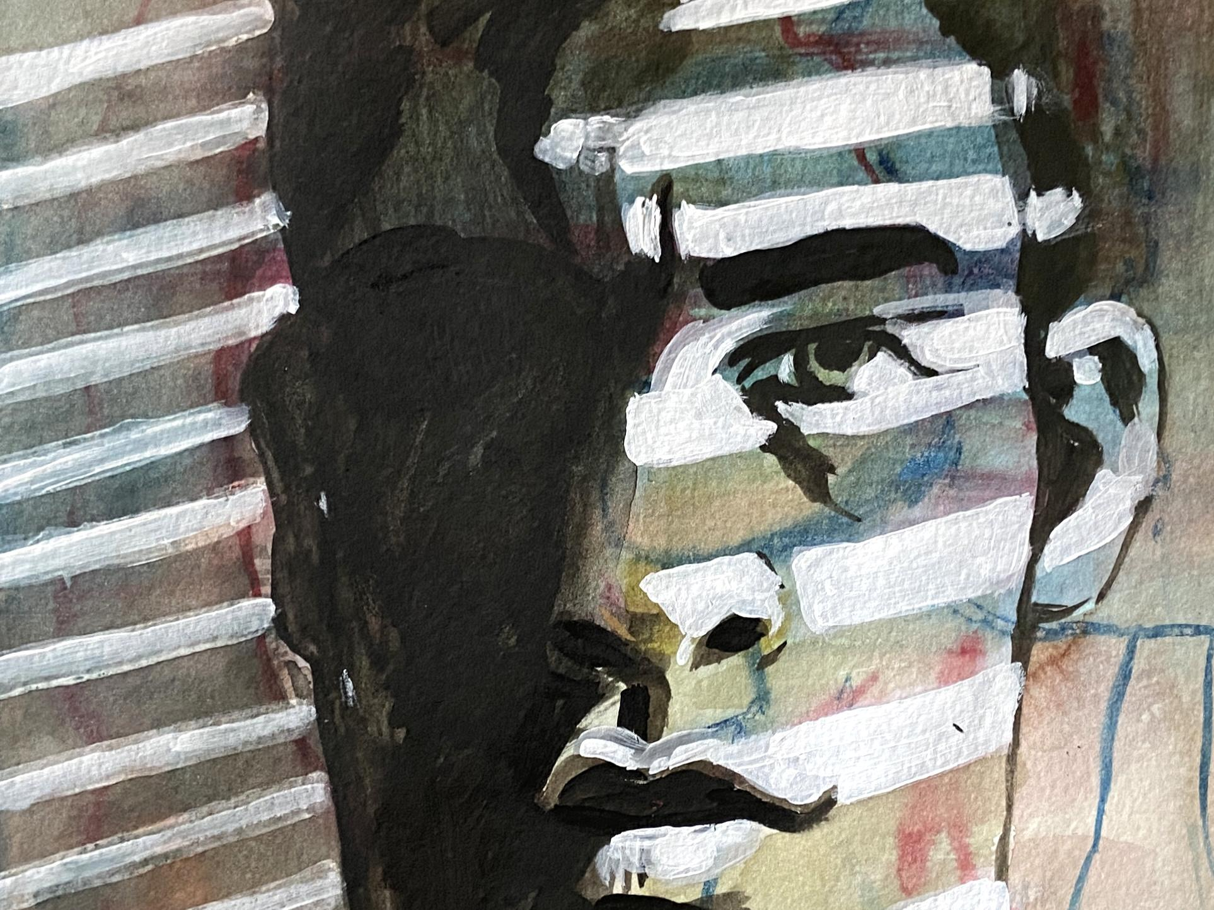

Anger/Separation

Joy/Meadow

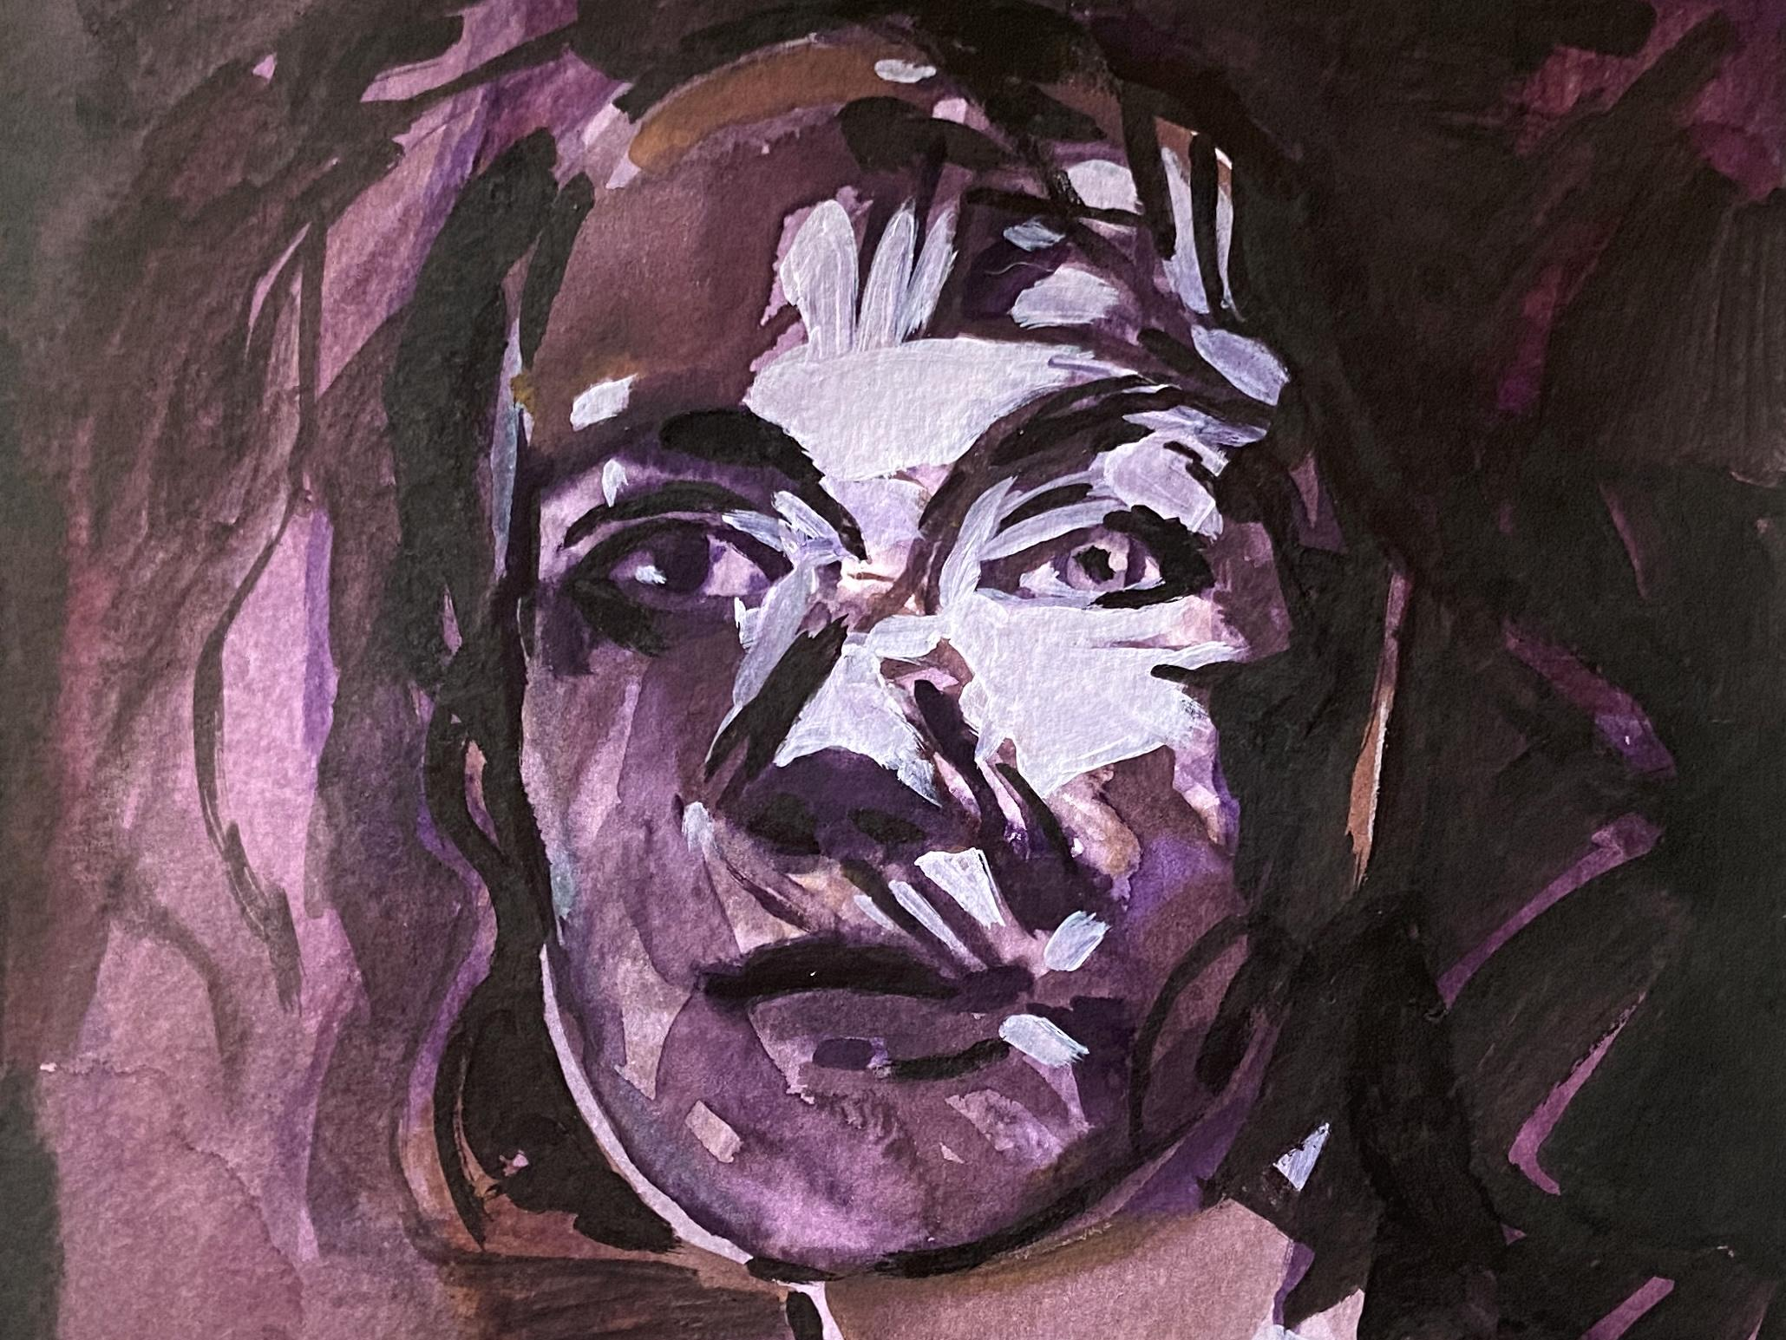

Melancholy/Sisters

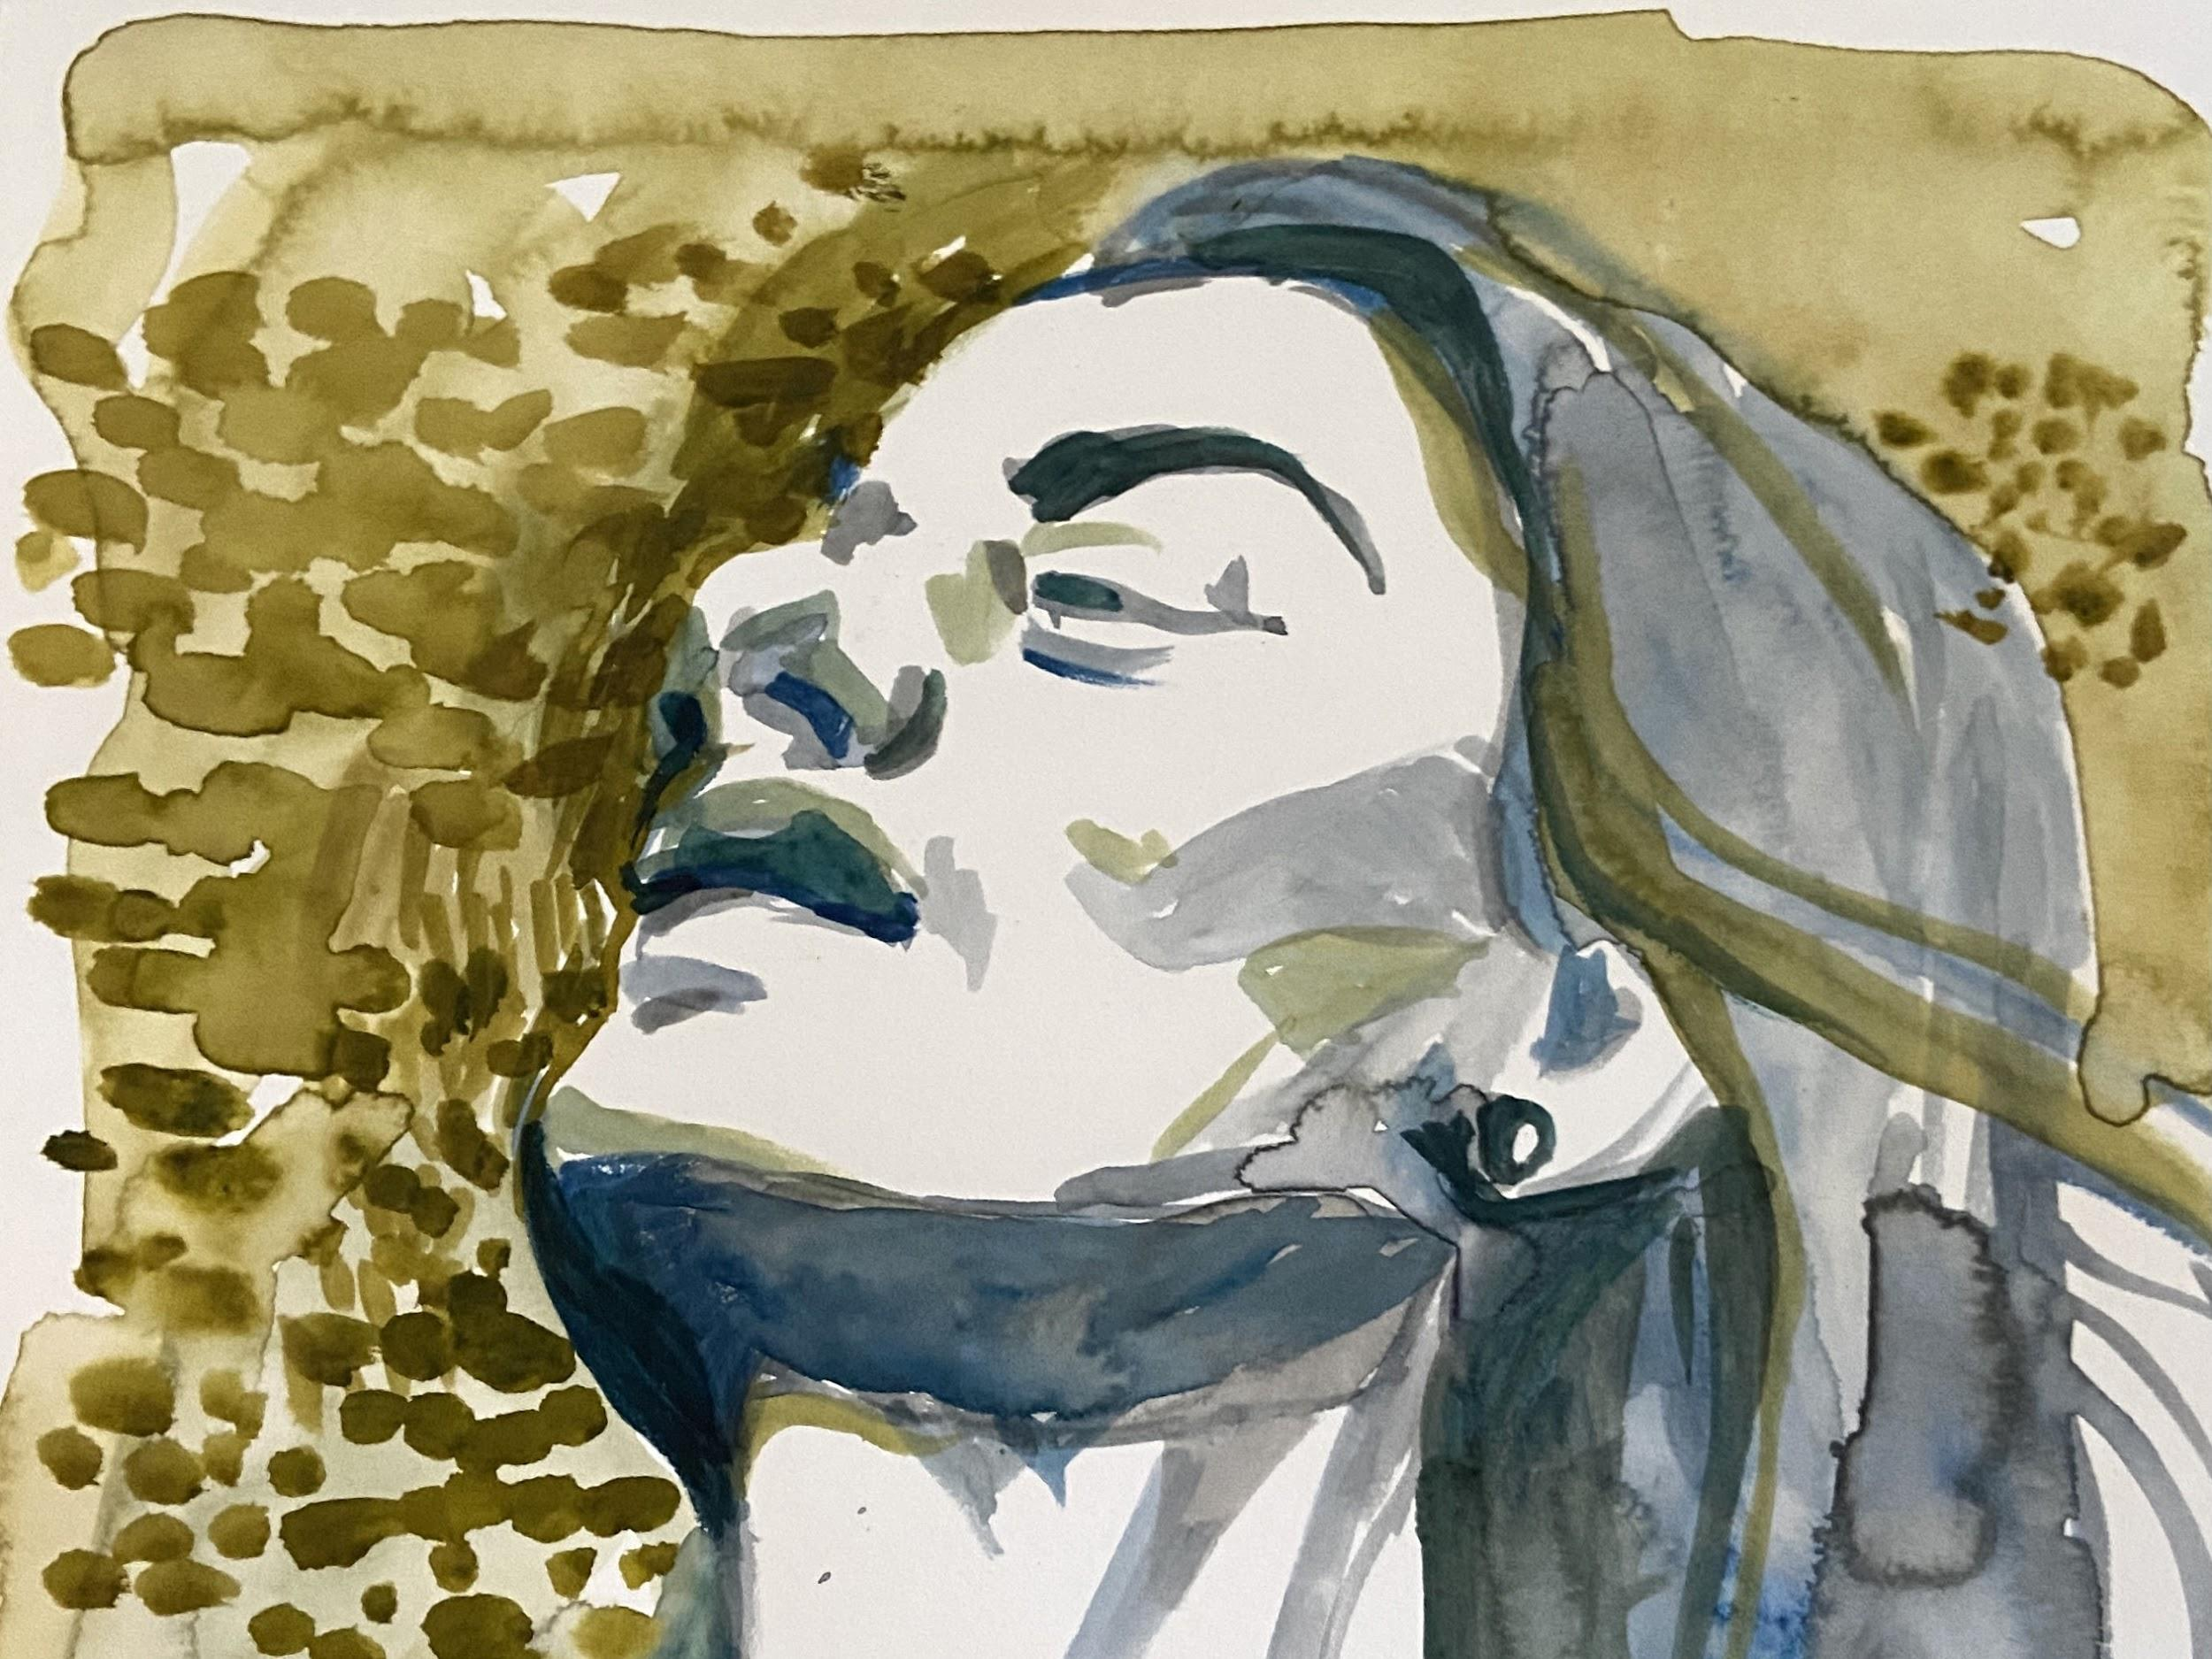

Acceptance

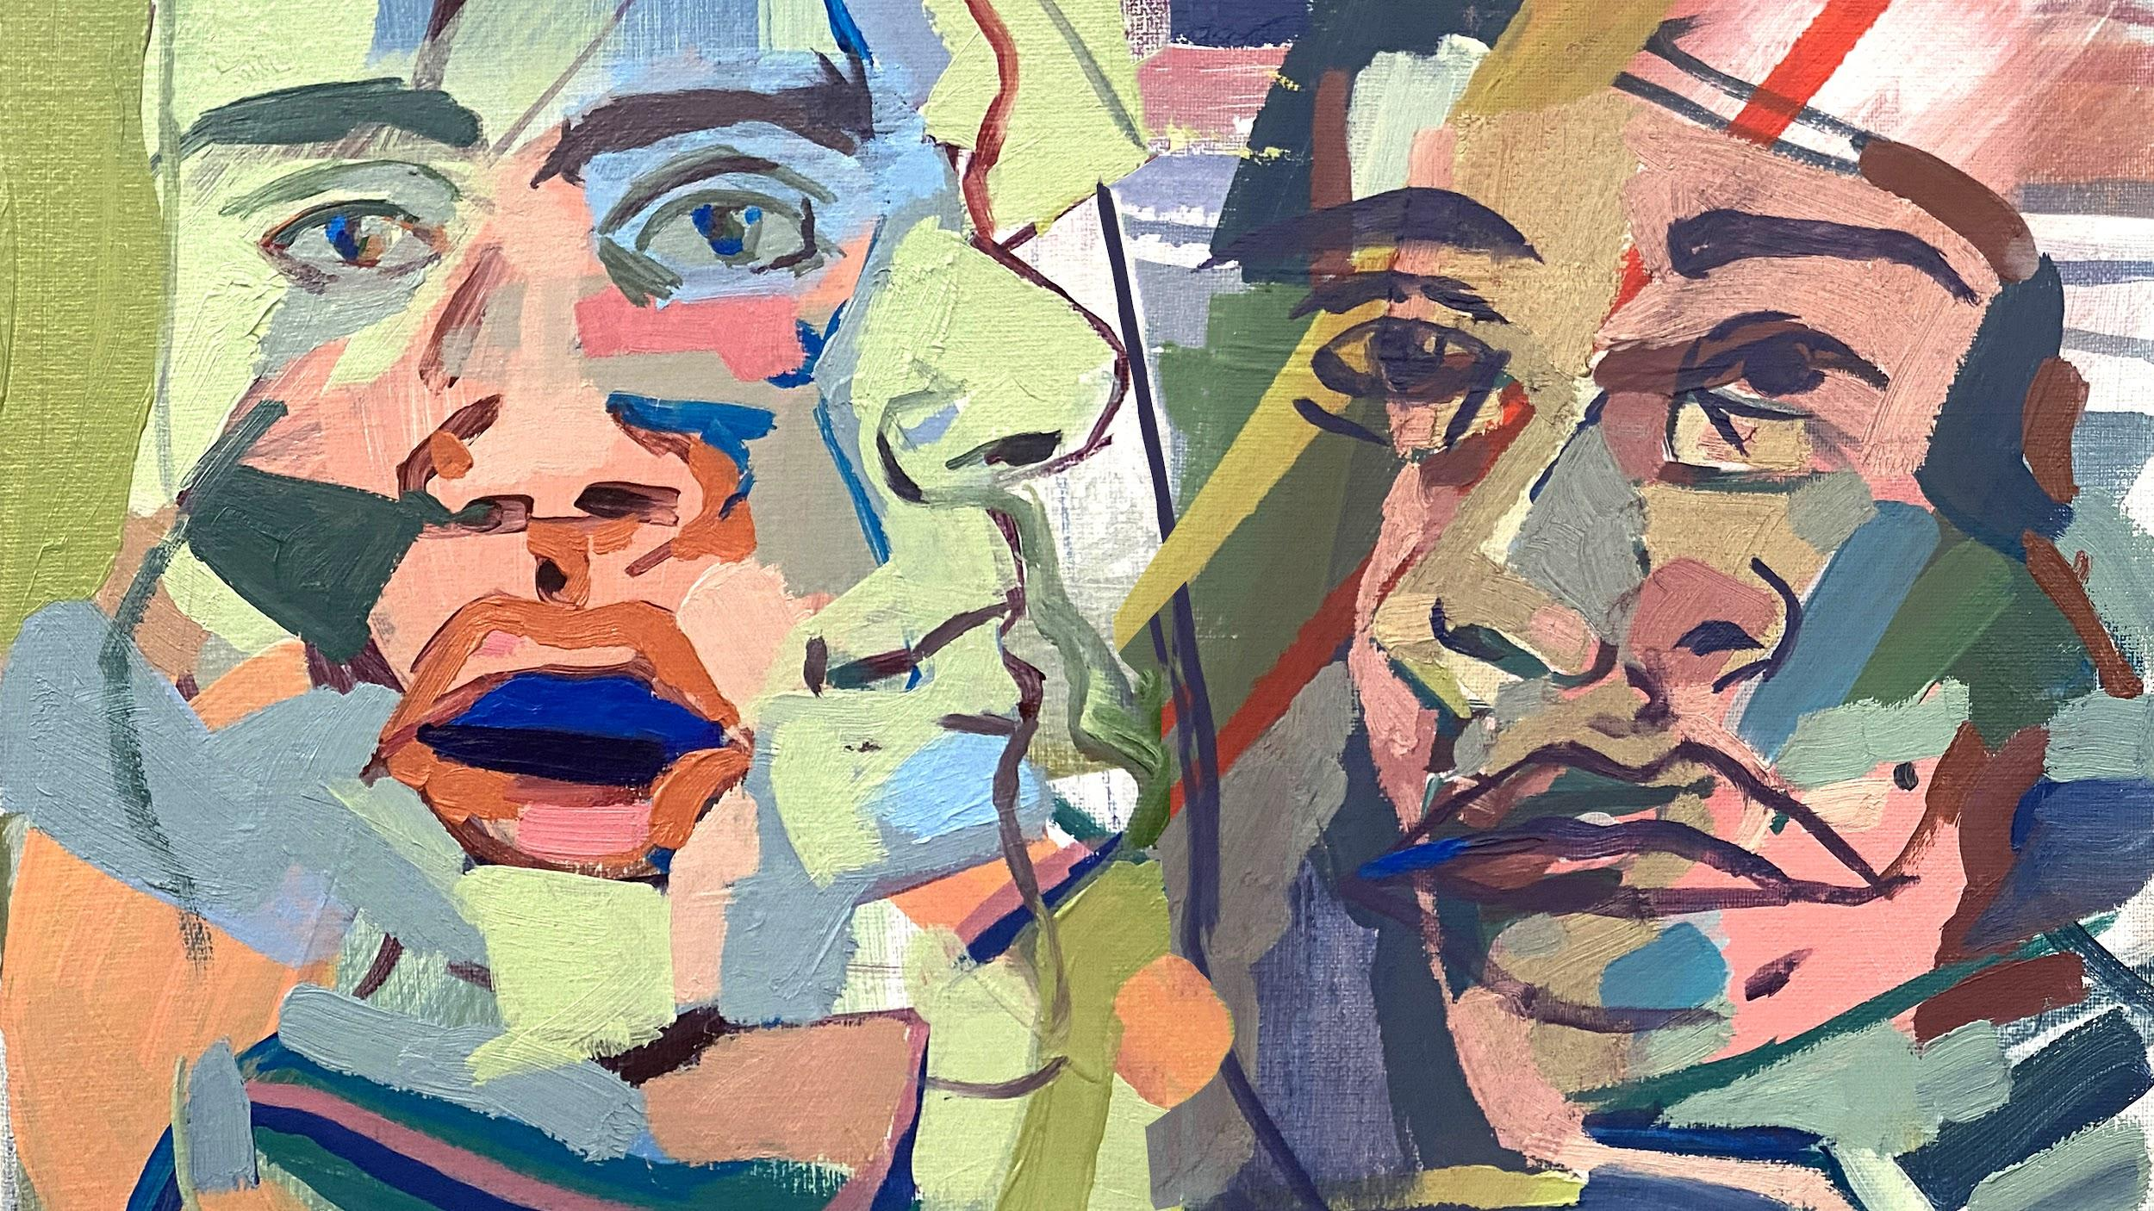

Surprise/”All Together Now” - Octopus!

A.2 Final Images - Cropped by Sylvie Mayer - Masked, Edited and Saturated by Ian Evans
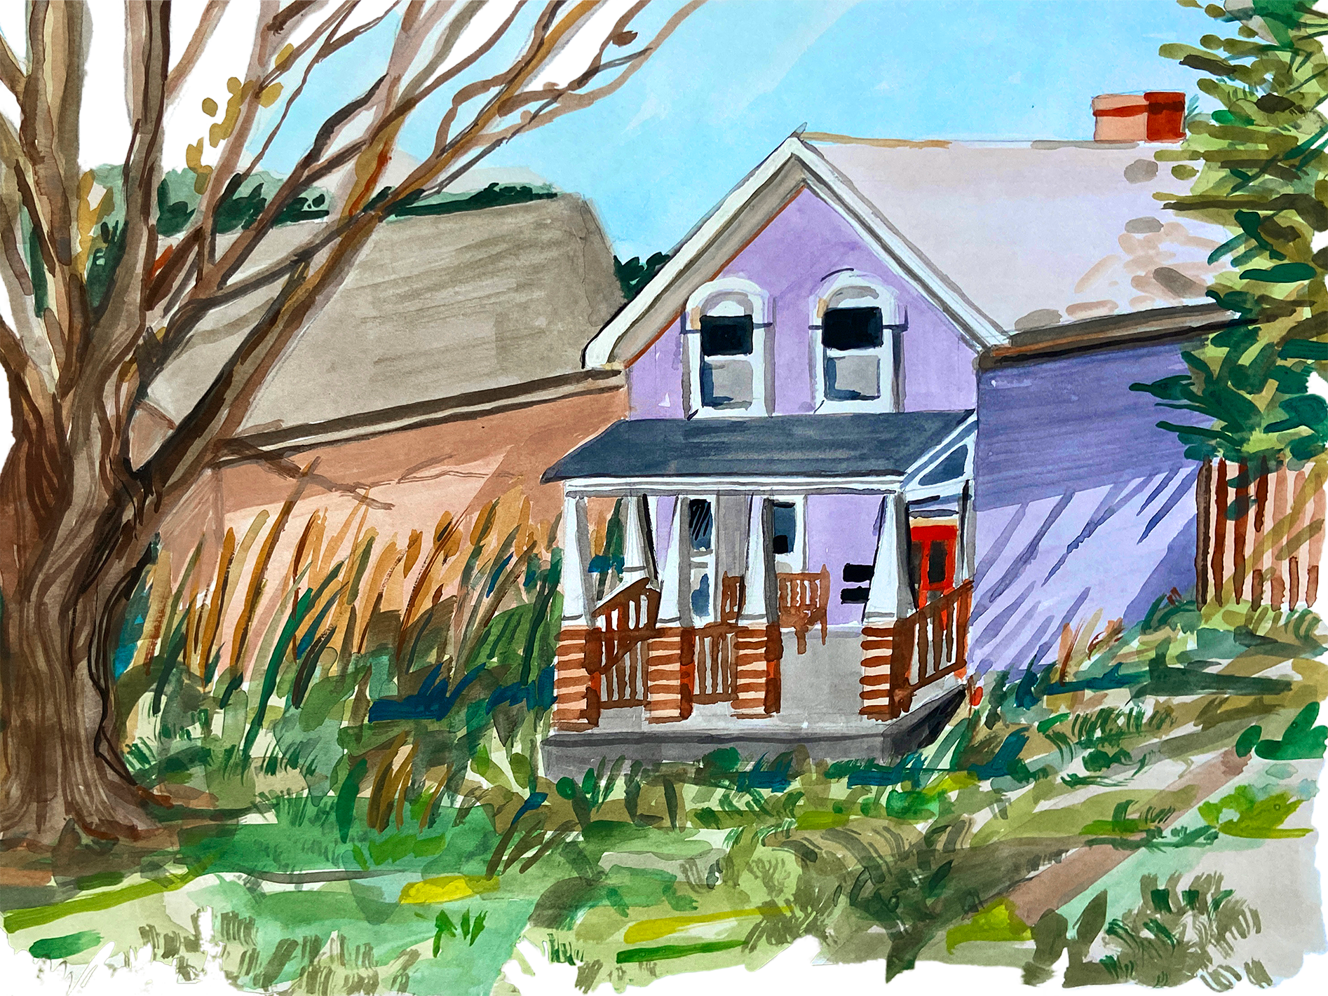

Reality
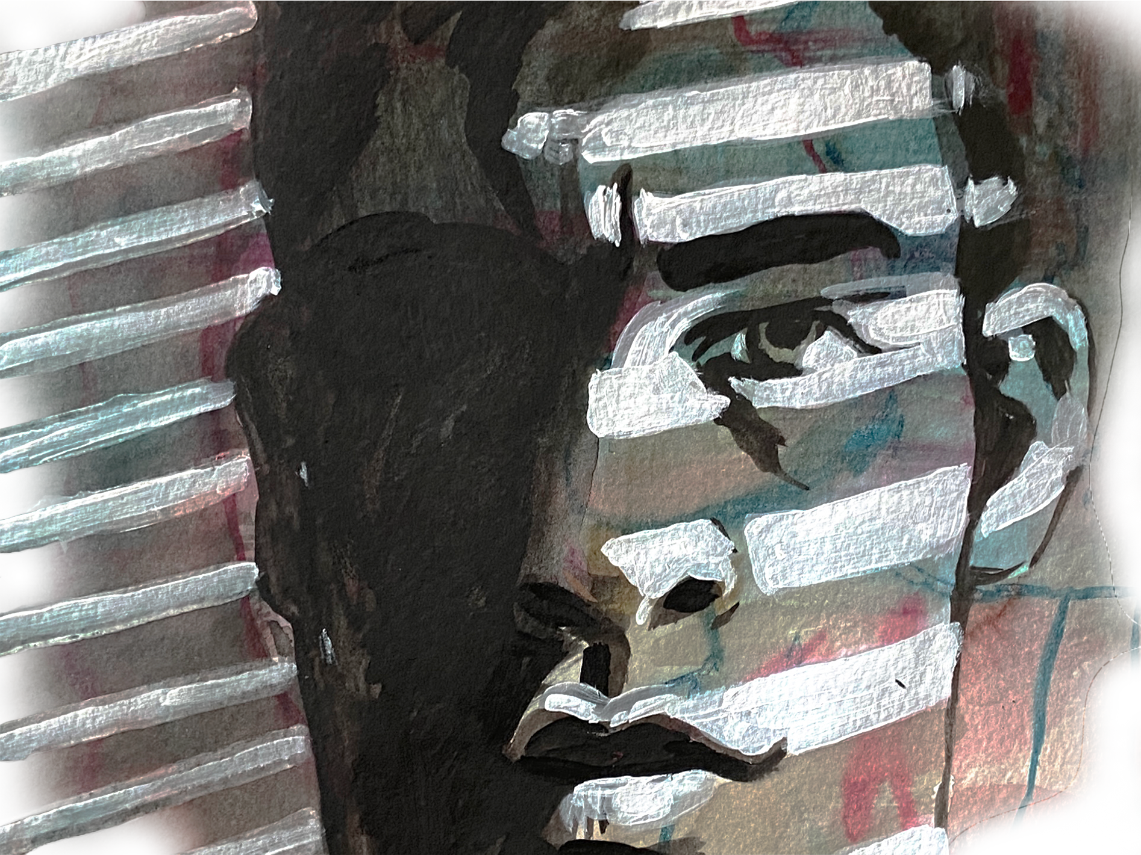

Separation
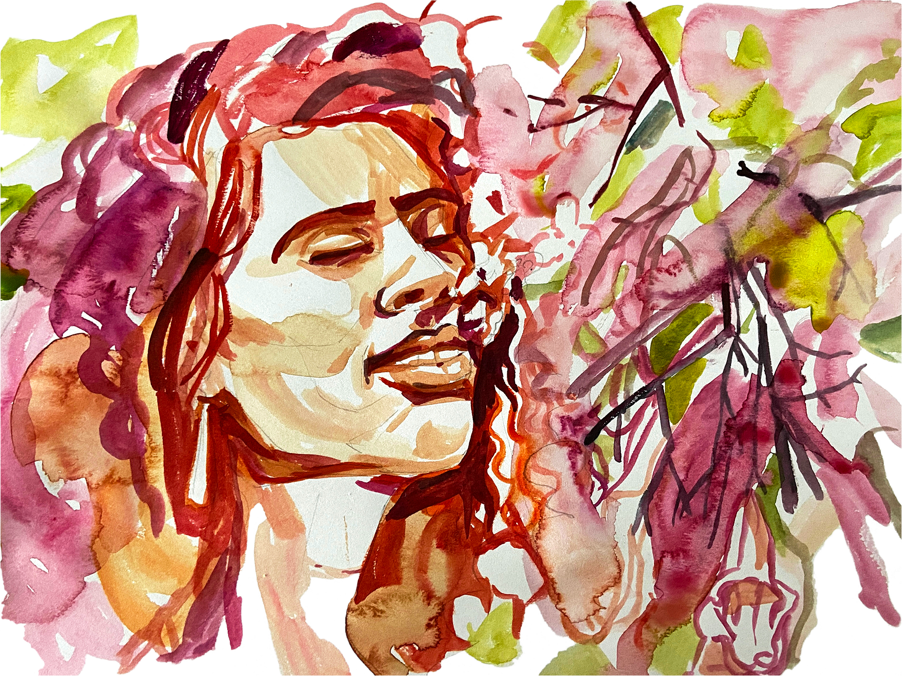

Meadow
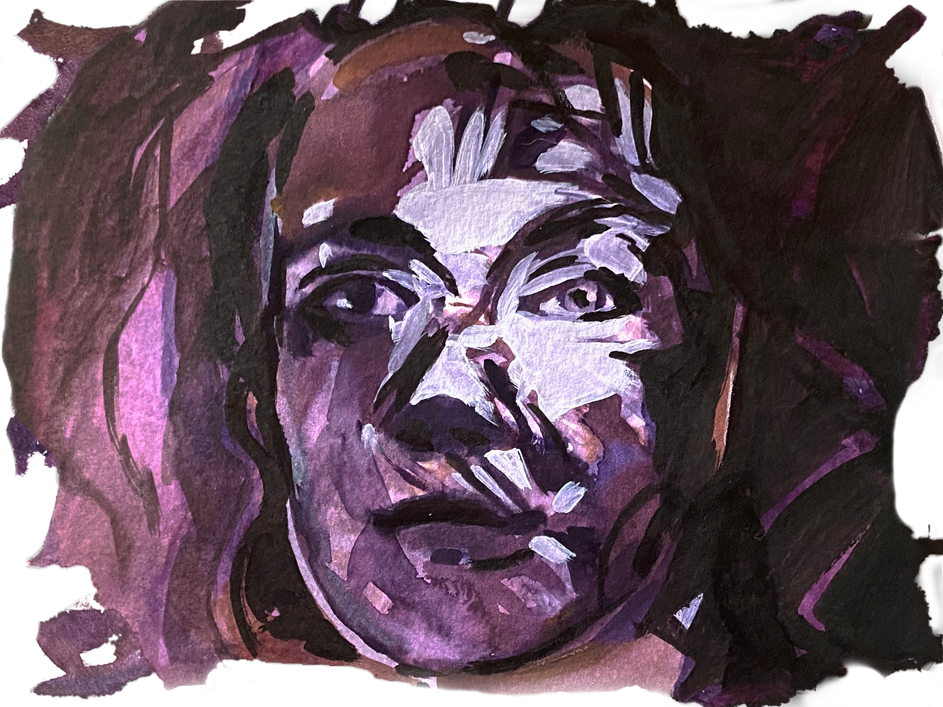

Sisters

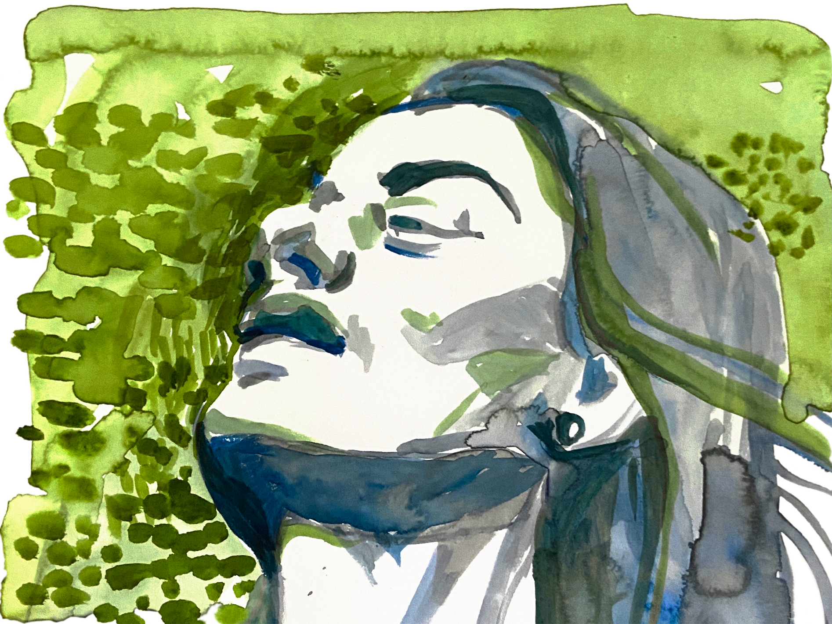

Acceptance

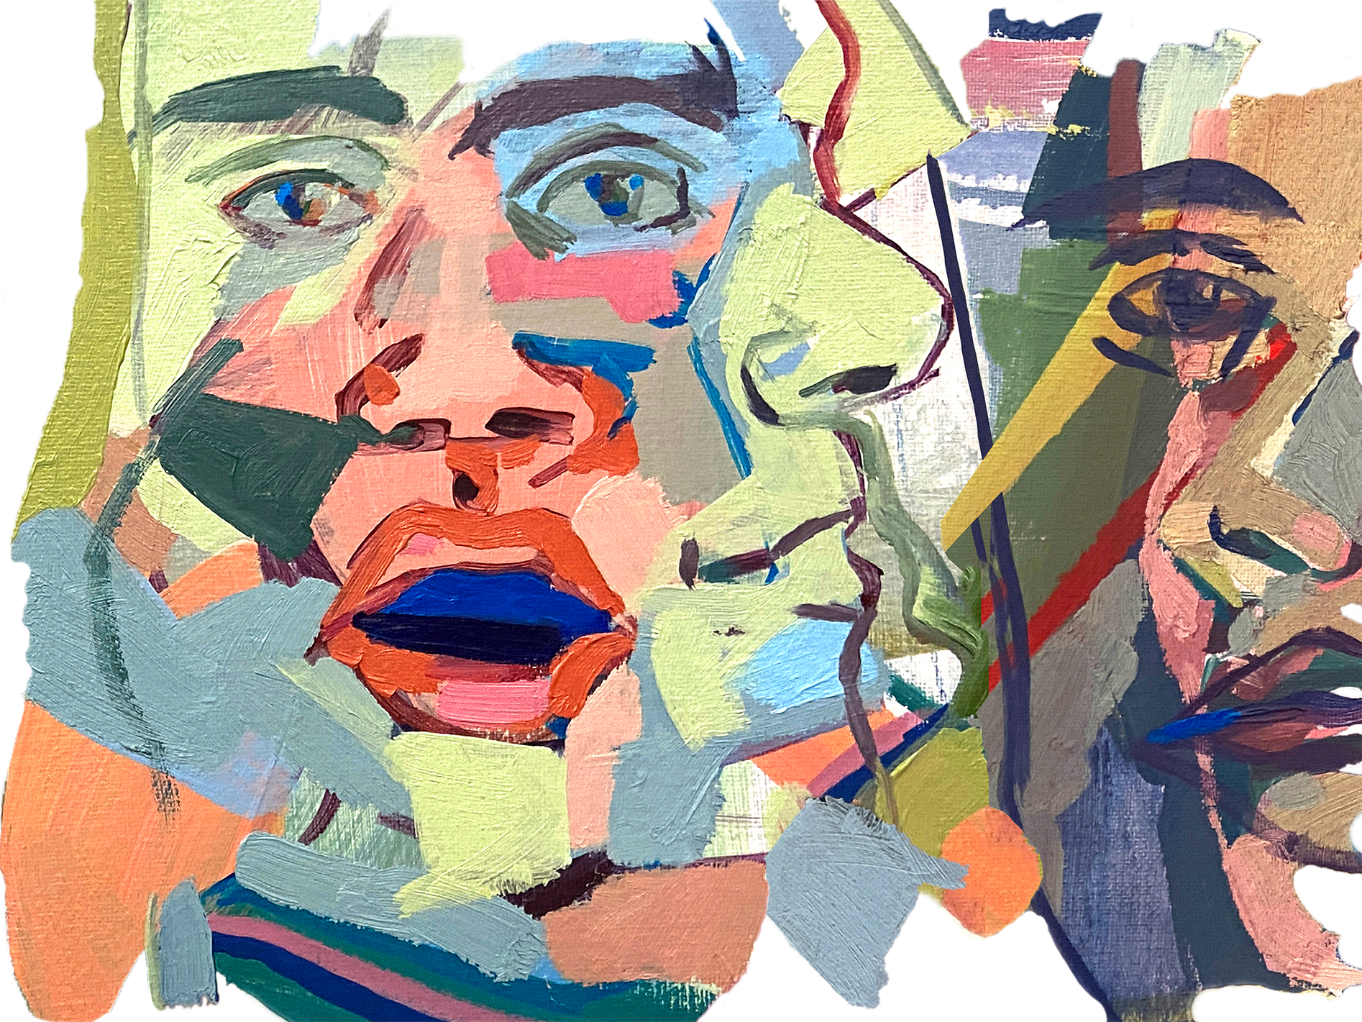

“All Together Now” - Octopus!

Appendix B: Performance

B.1 Tendril Performance Link, Friday, January 28, 2022. https://youtu.be/6kIC9nVZbaQ

B.2 Tendrils Dress Rehearsal Photographs, edited by Ian Evans
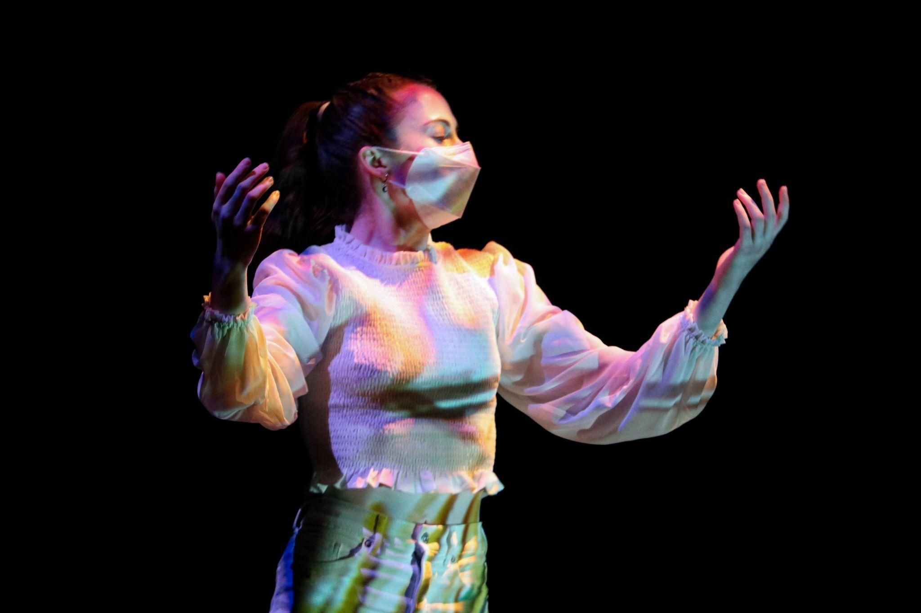
B.2.1 Eliza Harden. Reflection Vignette

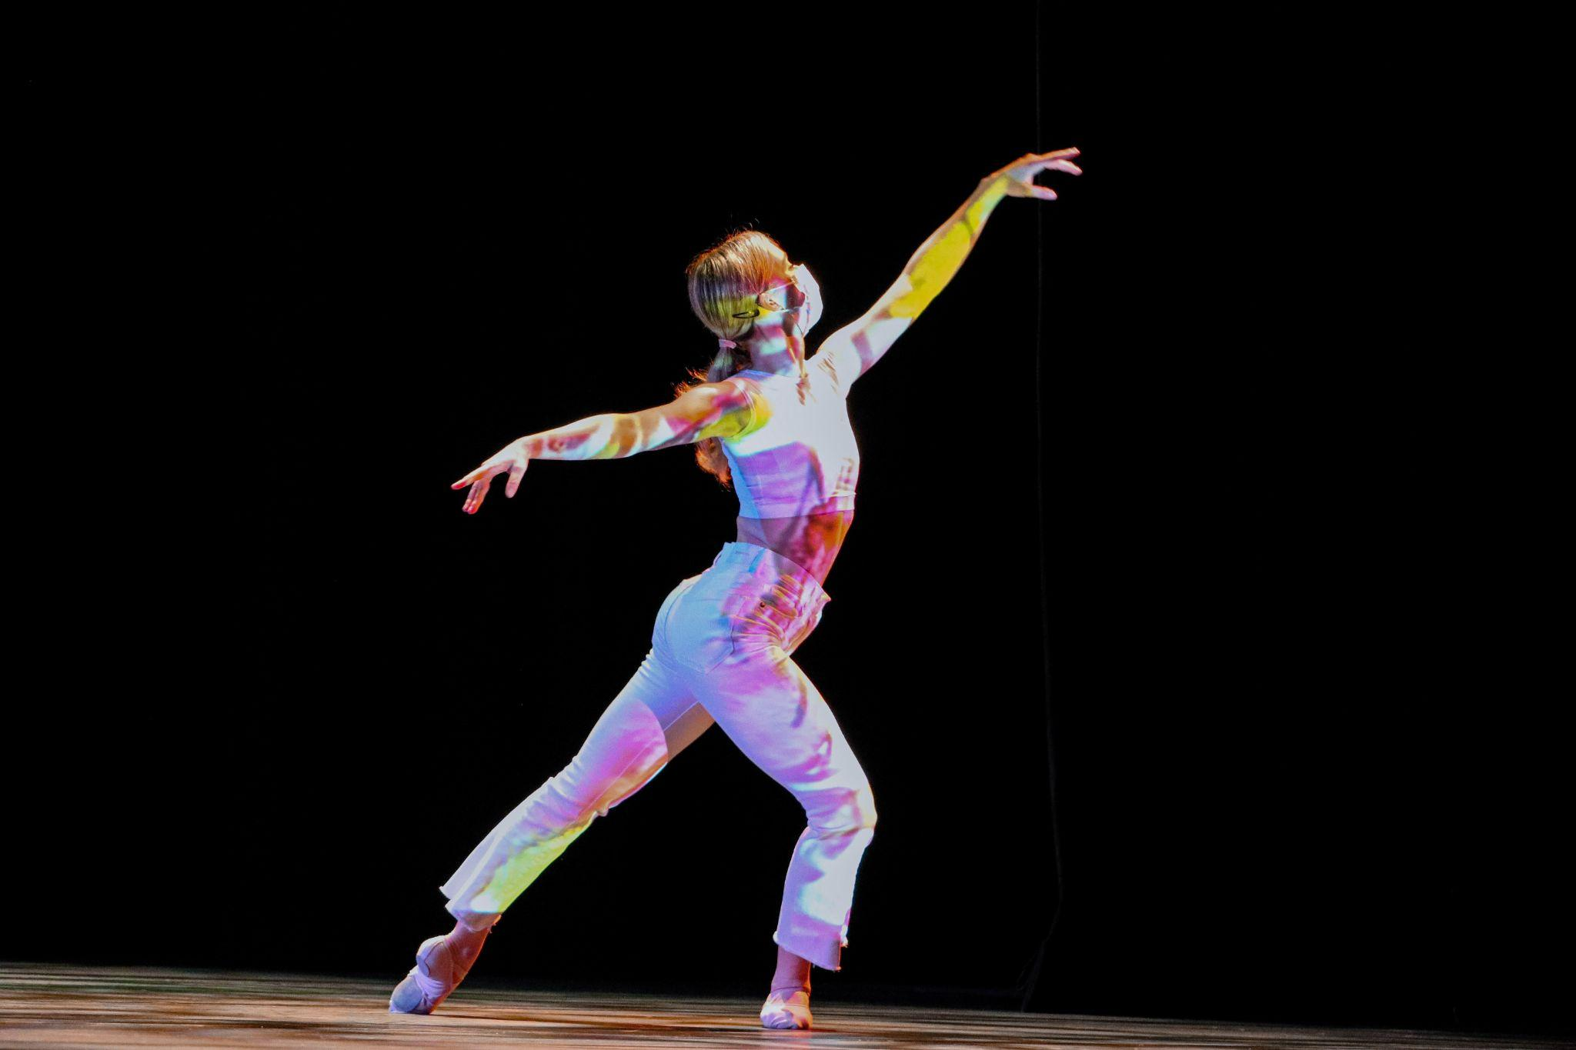
B.2.2 Sofia Redford, Meadow Vignette

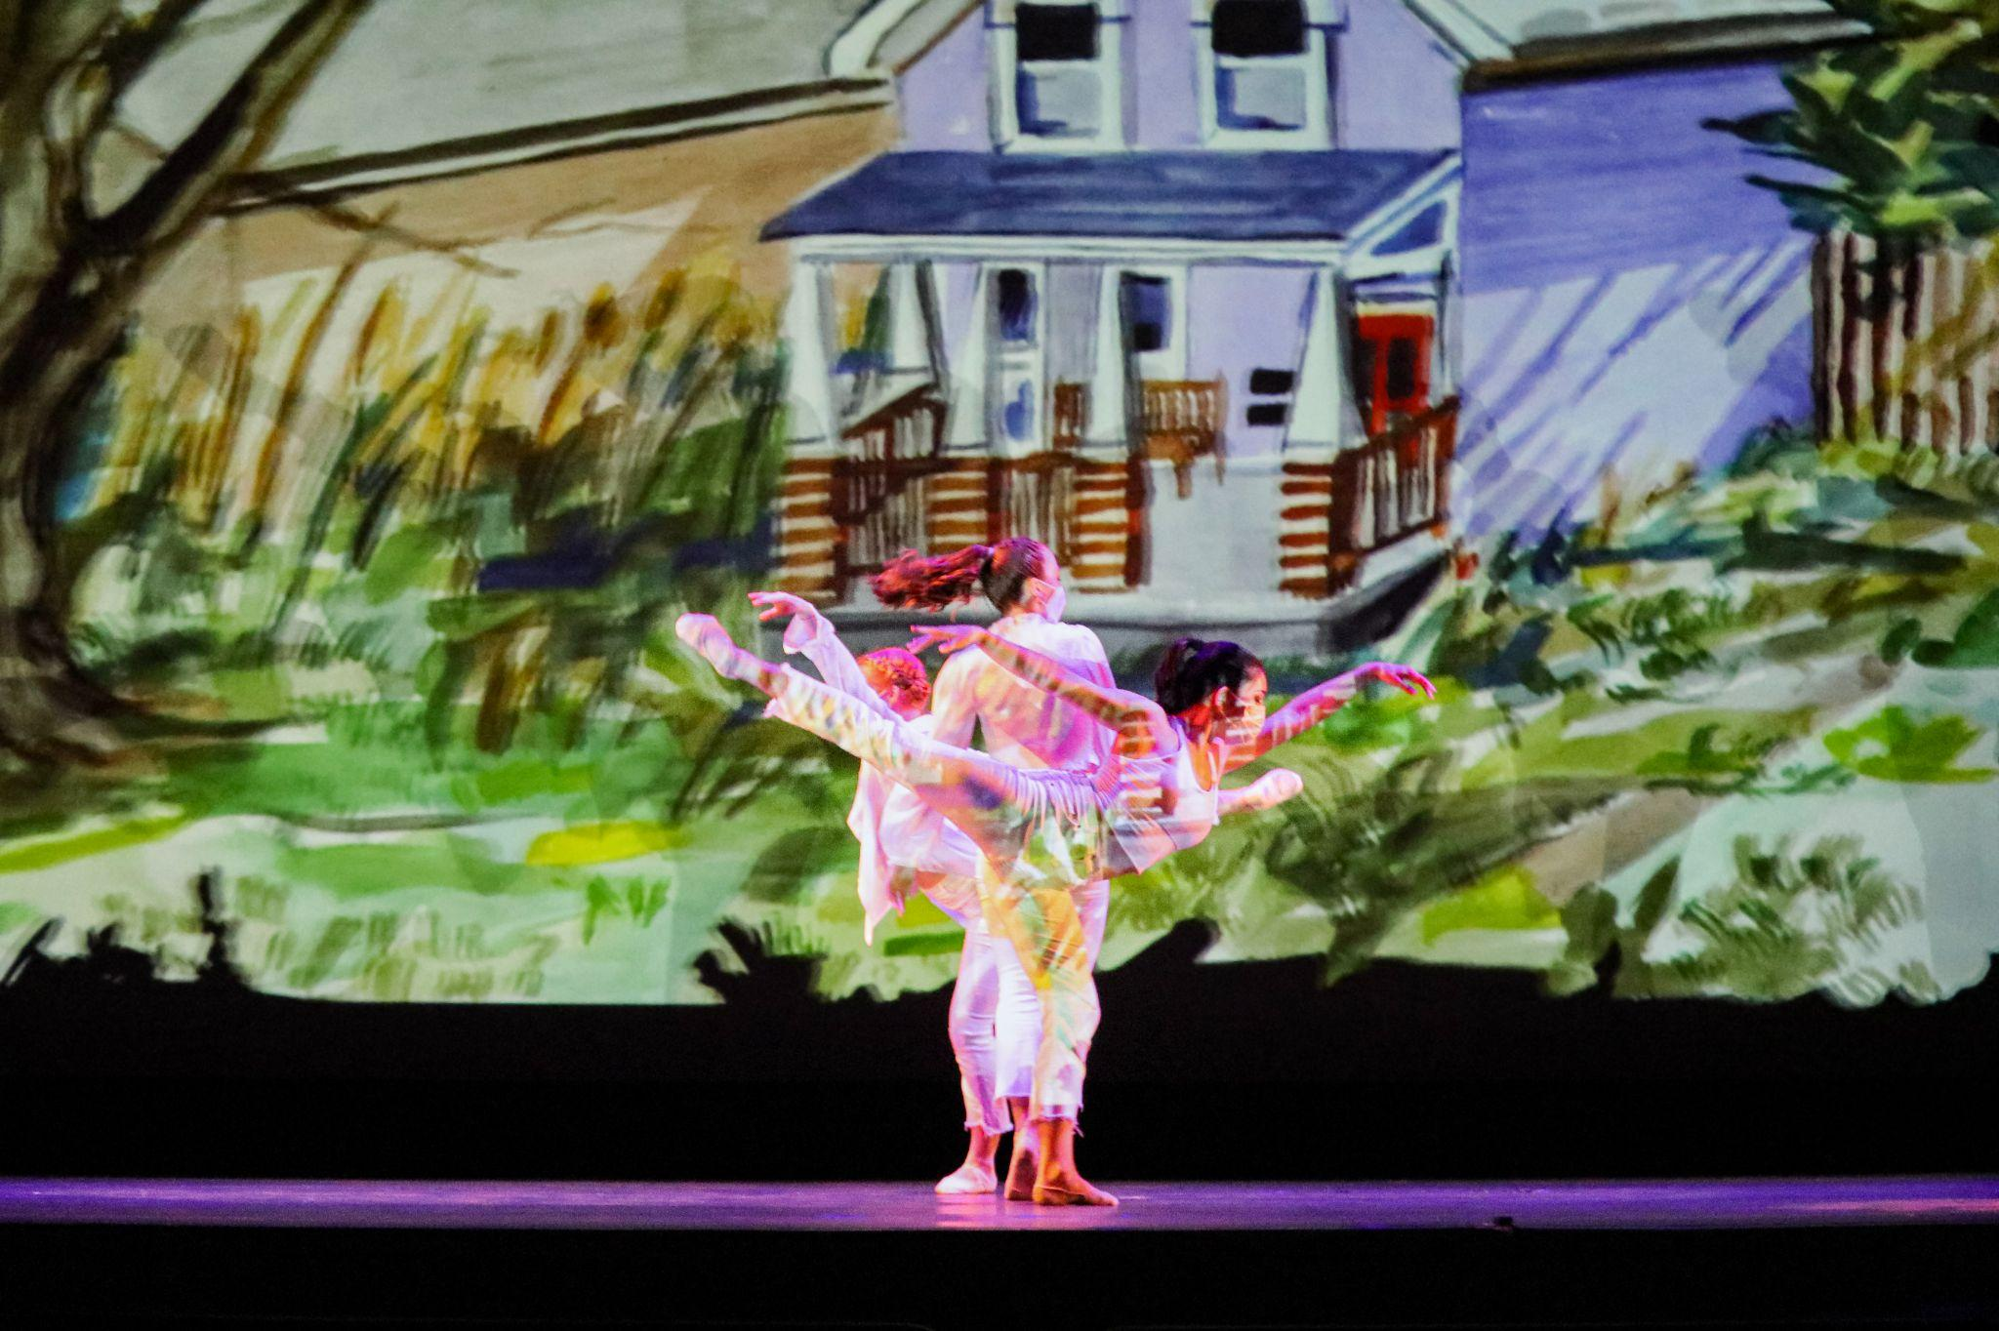
B.2.3 Gabrielle Brown, Stephanie Eggers, Eliza Harden, Second Reflection Vignette

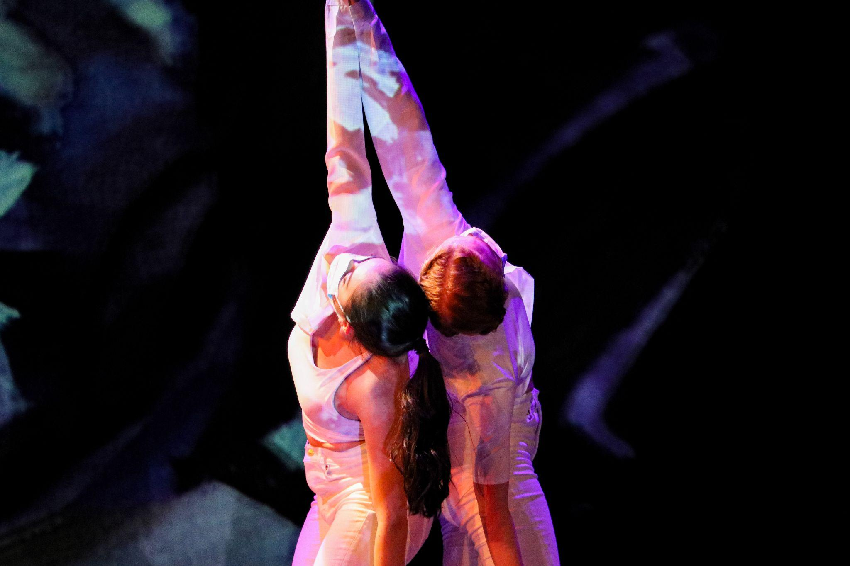
B.2.4 Gabrielle Brown, Stephanie Eggers, Sisters Vignette

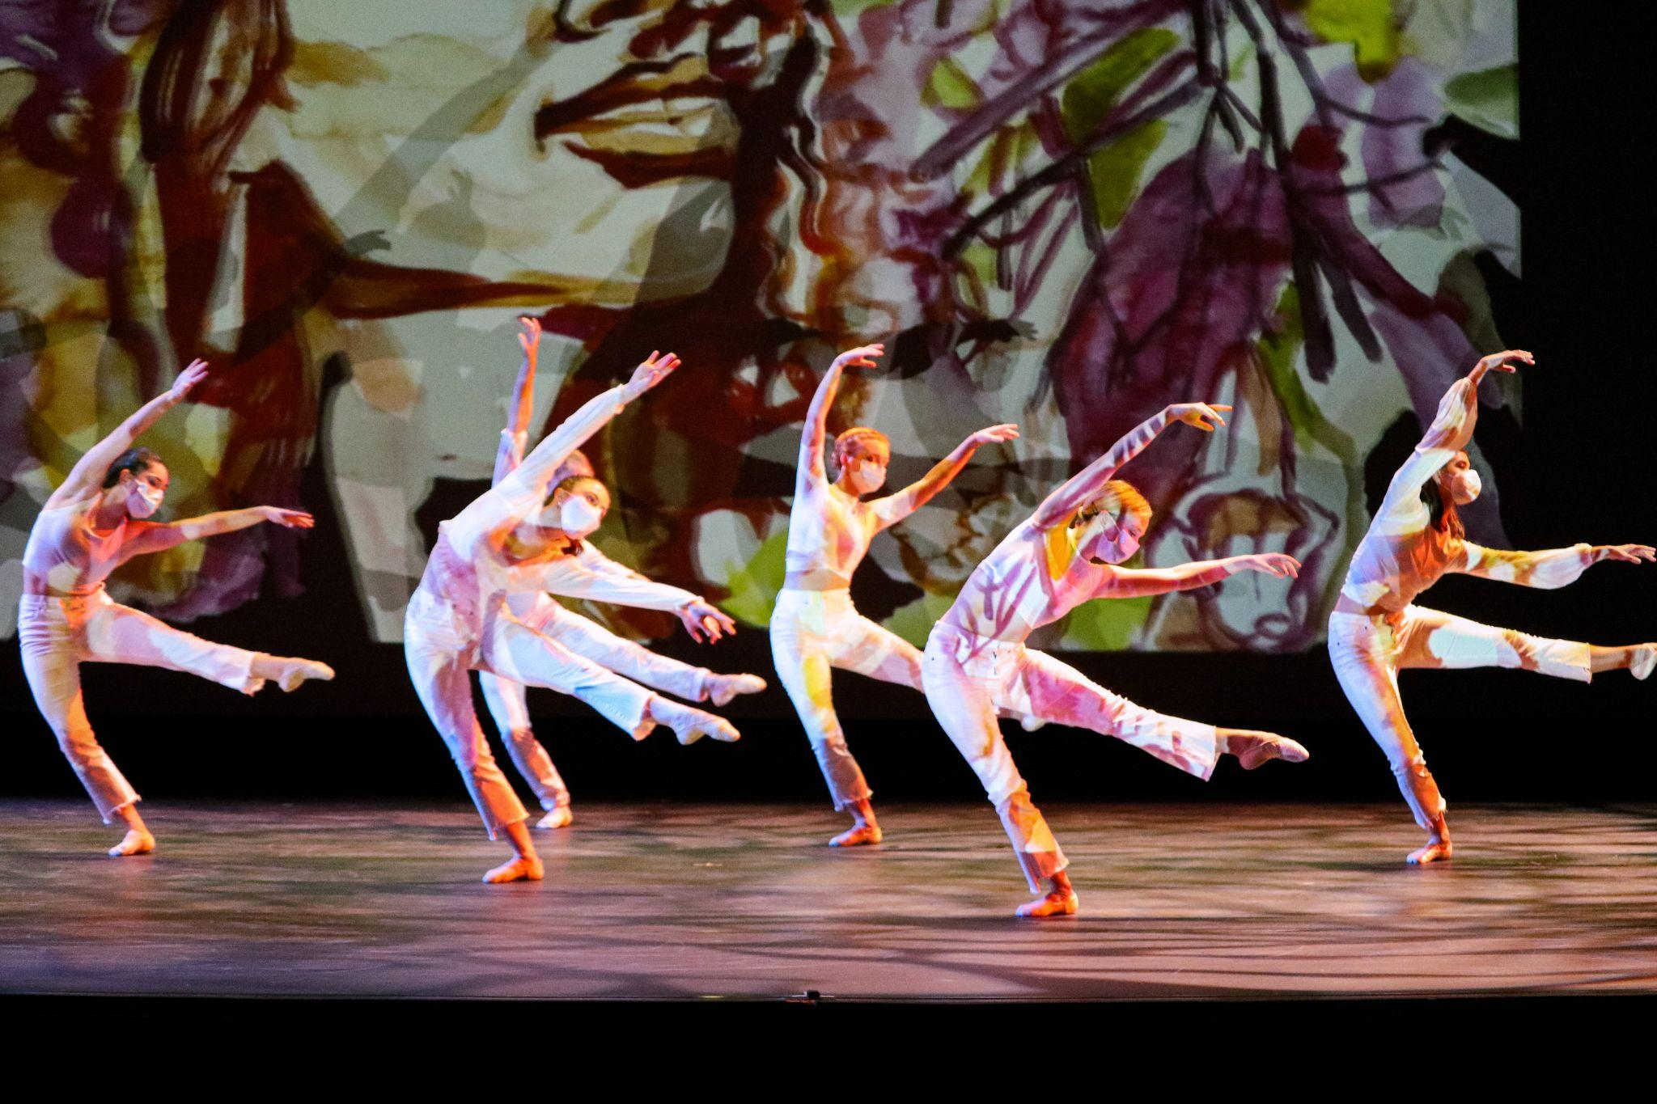
B.2.5 Gabrielle Brown, Stephanie Eggers, Delaney Gondo, Eliza Harden, Harry Hefner, Sofia Redford, Posed Photo of Final Reflection Movement, Meadow Projection.

B.3 Tendrils Poster

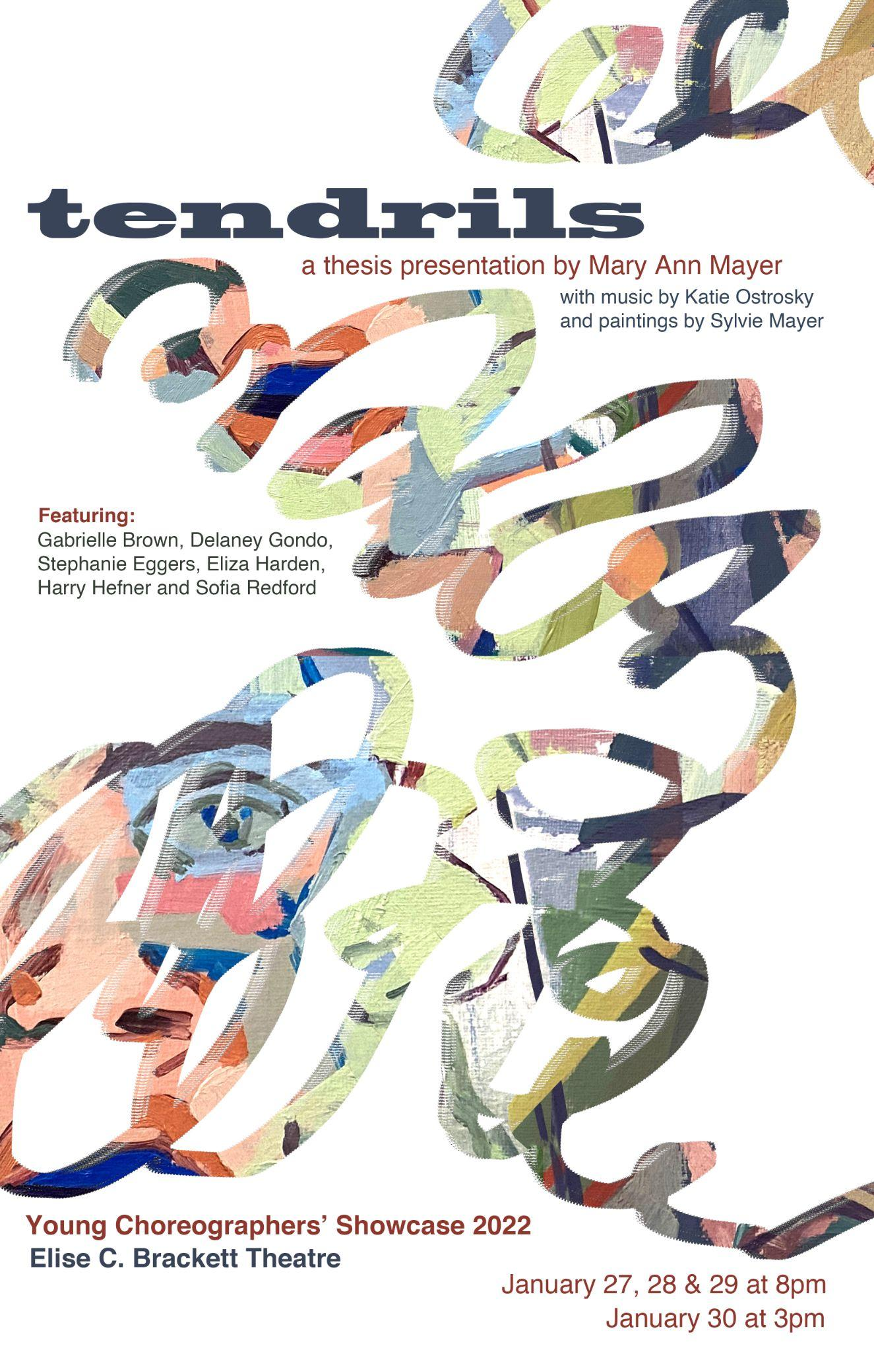

B.4 Young Choreographer’s Showcase Program Notes

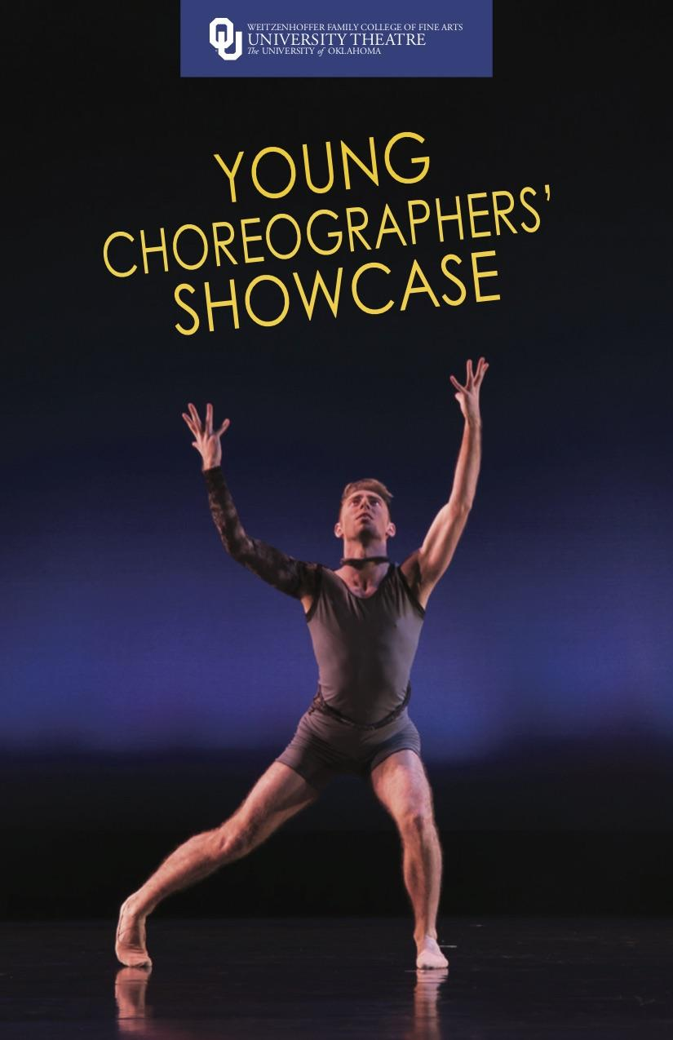
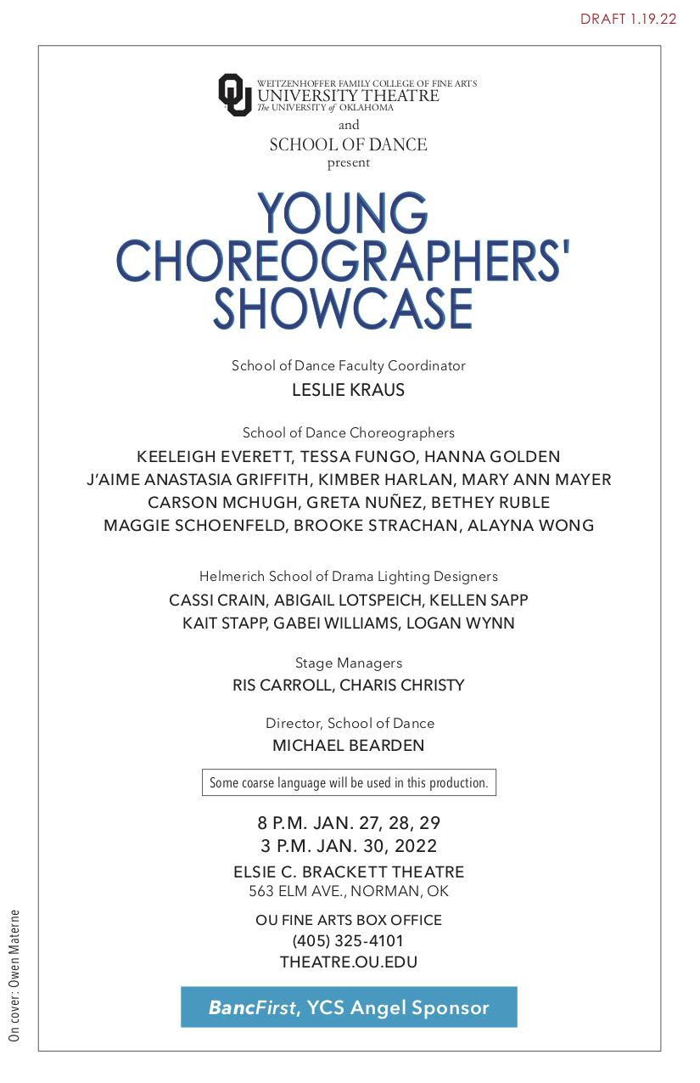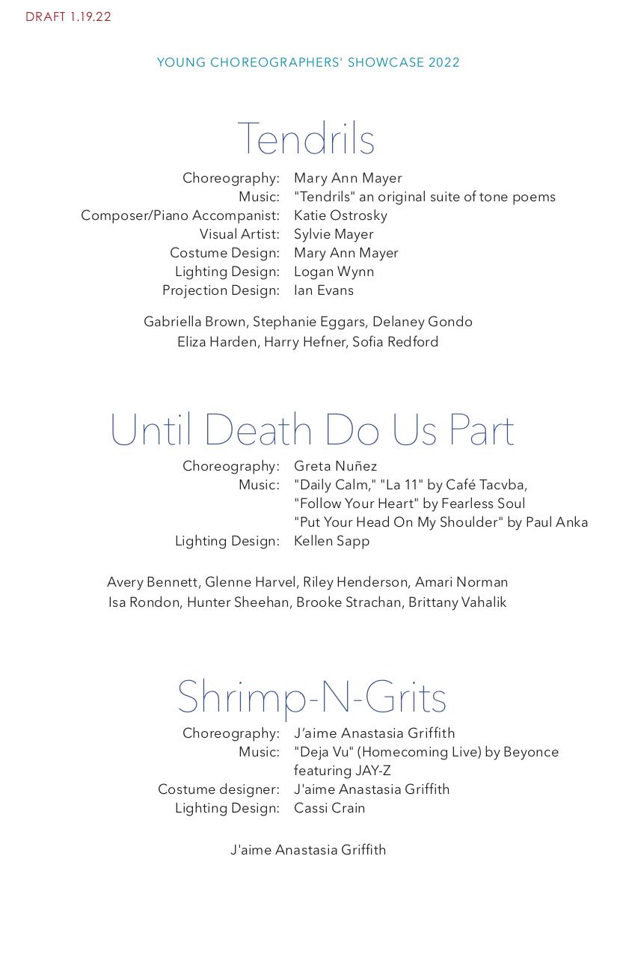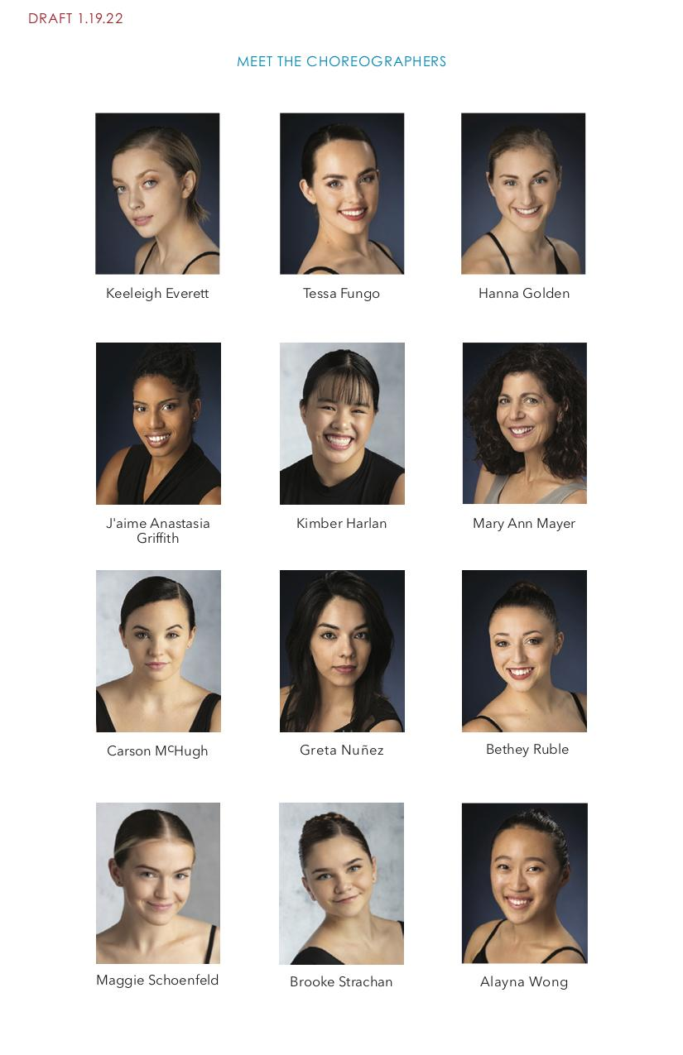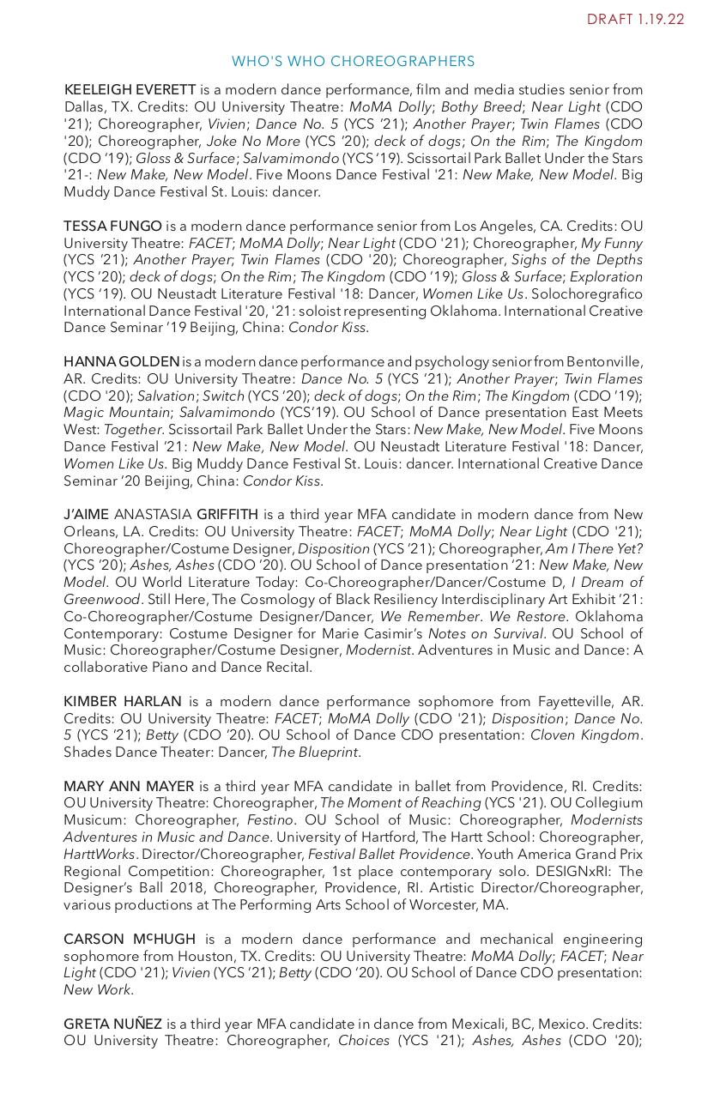

Appendix C: Projection and Lighting Design

C.1 Projection Design Diagram. Ian Evans

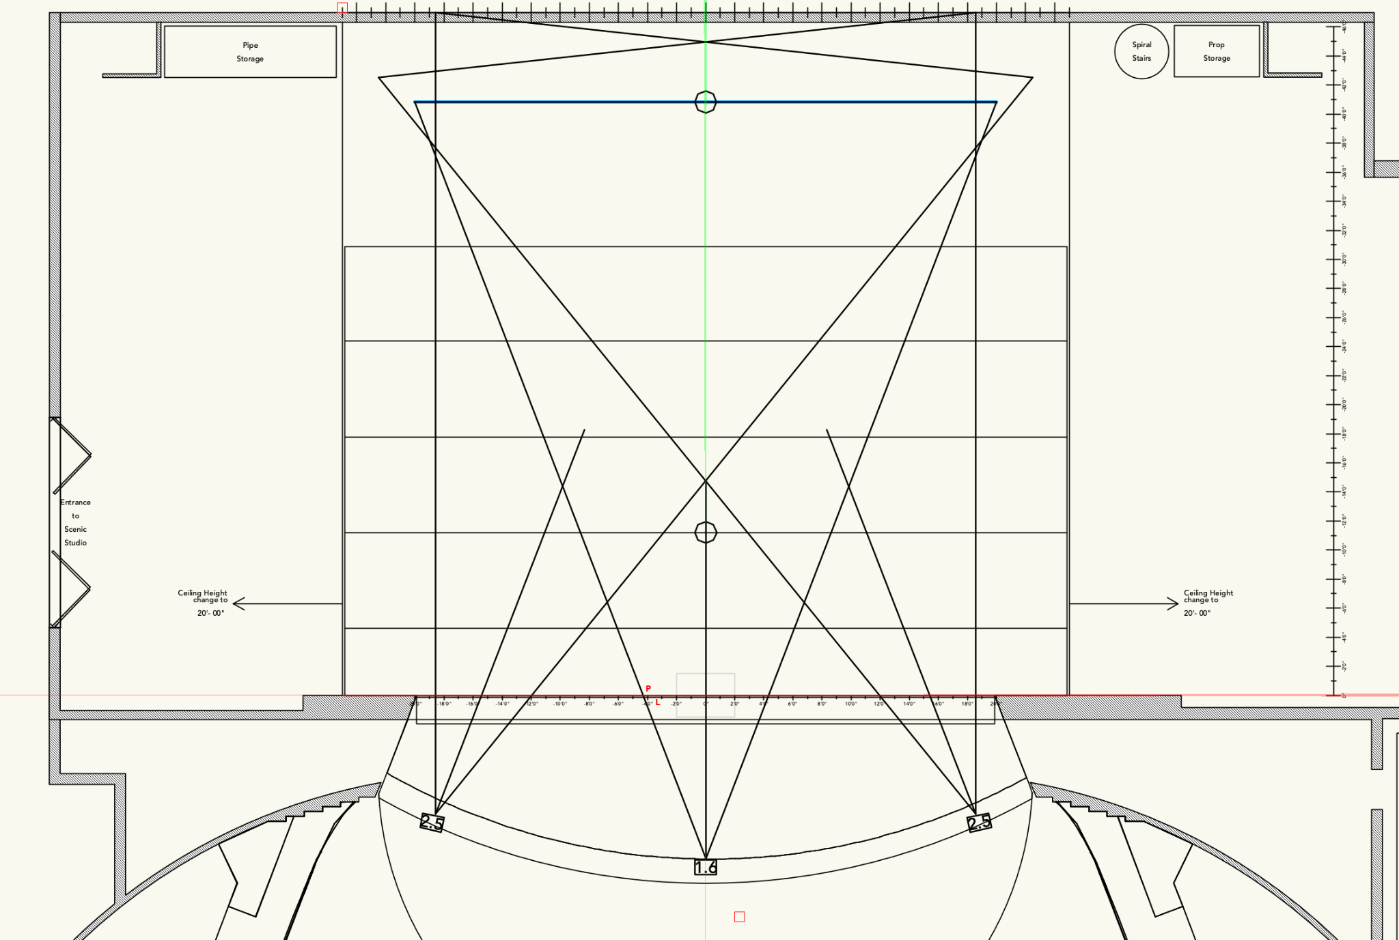

C.2 Lighting Design Plot. Logan Wynn

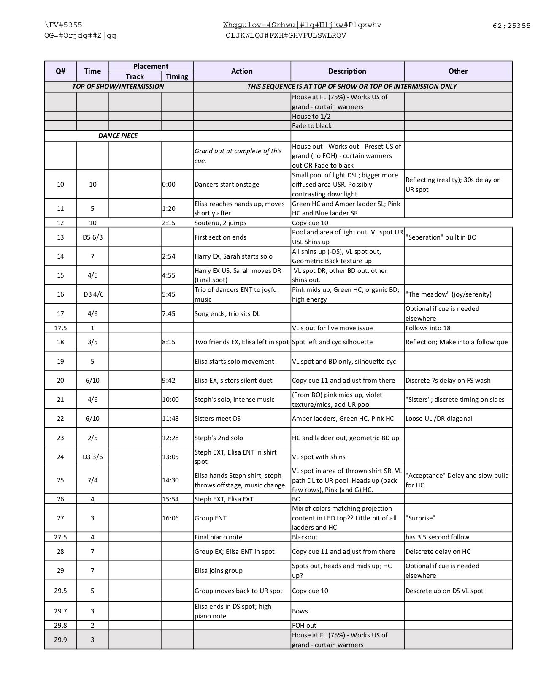

Appendix D: Post Performance Reflections

D.1 Collaborators: Journal Prompts

Dear Katie and Sylvie,
This is what I submitted to IRB last week…On the next page I made a list of prompts and suggestions for each meeting. Let me know what you think.

Research Collaborators Journal parameters: Ongoing journal writing throughout the project will include your feelings going into the project, throughout the project and at the end of the project. You will consider the non-hierarchical format, the collaboration, the influence each artist brings to the project and how this informs your own creativity. You will consider what you anticipate to gain from this collaboration and at the end whether or not the project met this anticipated goal. Consider any challenges imposed by the project. Explain how the project could be improved. And, finally include how you feel about the results of your work and the other artists involved in the collaboration.

Prompts for Collaborator’s journal writing:
Communication of your thoughts throughout the process will help with the overall collaboration. I suggest we address some of these prompts following each meeting. Bring some of our thoughts to the following meeting as the project unfolds.

- Your perception of the project
  - Going in.
  - How you feel about the process throughout
  - Final thoughts on the project
- Consider the non-hierarchical format
  - Is it working
  - What are the benefits
  - What are the disadvantages
  - How could it work better
- The collaborative aspects
  - The influence each artist brings to the project
  - How this influences your own creativity
  - How it informs your next steps throughout the projects
  - Have there been any areas where we have differed? How has this been resolved?
- What you anticipate getting from this collaboration
  - Is it meeting your goals - beginning, middle, end
- Consider any challenges imposed by the project
  - How these challenges enhance the project
  - How these challenges detract from the project
- Consider any improvements you would suggest along the way
- Finally, consider how this collaboration has affected your work.
- How do you feel about the end result of each artist's work and do you think that this work is cohesive in its presentation?
- Could your work stand alone?

D.2 Collaborators: Post Collaboration Survey

Have you worked collaboratively with dance artists in the past?

Have you approached collaboration through a non-hierarchical format in the past?

Did you feel as though you had equal input on the concept and design of the project? Please explain.

How do you define creativity in your work?

Do you feel as though the collaboration impacted your creative output and how?

Were there any limitations imposed by the collaboration and how did they impact your work?

What did you anticipate would be the benefit of this collaboration?
Did the project meet your expectations?
Did the project disappoint you in any way?

How did you feel about this particular collaborative process, both good and bad?

What parts of the process were easy for you and what parts were difficult or challenging?

Do you feel as though the results you achieved were unique because of the collaboration?

How do you feel about the results of the work that you produced?

How do you feel about the results of the work that the other artists produced?

Do you feel as though the artists influenced each other in the process?

To me collaboration requires the following to be successful:
Communication, Inventiveness, Improvisation, Sharing, Risk taking,
Accepting the possibility of failure.

Have you considered these qualities as part of collaboration and do you think that these are important for success? From your point of view, are there other factors necessary for successful collaboration? Do you feel as though we utilized these factors in our collaborative process?

Do you have any suggestions for improvement?

Would you consider additional collaborative projects in the future?

Thank you for your time in answering these questions.

D.3 Projection and Lighting Designers: Post Collaboration Survey

How do you define creativity in your work?

How is working with dancers unique to your process?

Do you feel as though the collaboration with painting and dance impacted your creative output and how?

Were there any limitations imposed by the collaboration and how did they impact your work?

What did you anticipate would be the benefit of this collaboration?

Did the project meet your expectations?
Did the project disappoint you in any way?

What parts of the process were easy for you and what parts were difficult or challenging?

Do you feel as though the results you achieved were unique because of the collaboration?

How do you feel about the results of the work that you produced?

How do you feel about the results of the work that the other artists produced?

Were you influenced in any particular way by this process?

Would you consider additional collaborative projects of this type in the future?

Thank you for your time in answering these questions.

D.4 Dancers: Post Collaboration Survey
How did you feel about the process of setting this piece?
Did you enjoy the process?
What did you learn from the process?
Was this a different process considering that it was a thesis experiment or did the process feel similar to other pieces of choreography that you have been involved in?
What could have been different and/or better?
How did you feel about the outcome of the piece?
How did you feel about the performance?
Did live accompaniment have an effect on your performance?
To what extent did you feel like you were participating as a collaborator?
How did working with a musician and a painter affect you in the process?
Was there anything that made the process special or unique, difficult, or challenging?
How did the projections impact your performance?
What part of the process stretched your artistry?

Appendix E: Interviews

E.1 Interview Protocol

E.1.1 Recruiting email

Dear ….,
I am a third year Master’s Degree Candidate in the School of Dance at the University of Oklahoma. I am currently working on completing my thesis which is an exploration of the creative process in a non-hierarchical collaboration of music, dance and painting. I have read about your projects and would like to ask if you would be willing to schedule an interview with me. I am curious about your collaborative work and believe you could offer a great deal of insight into my research and ongoing exploration.
If you are interested and available we can arrange for a zoom meeting at a date and time convenient for you.
I look forward to hearing from you.
Best regards,
Mary Ann Mayer

E.1.2 Oral Consent to Participate
Oral Consent to Participate in Research

Good afternoon. You are invited to participate in research investigating the creative process of a non-hierarchical collaboration of music, dance and painting that will culminate in a fully produced performance piece.

If you agree to participate I will be asking you to participate in an interview regarding your experiences with choreo-musical collaborations. These interviews will be recorded on zoom for reference only. I may use quotes from our interview to include in the thesis manuscript when appropriate.

There are no risks or benefits to your involvement.

There will not be any compensation.

After removing all identifiers, we might share your data with other researchers or use it in future research without obtaining additional consent from you.

Data is collected via an online platform (zoom not hosted by OU that has its own privacy and security policies for keeping your information confidential. Please note no assurance can be made as to the use of the data you provide for purposes other than this research.

Your participation is voluntary. Even if you choose to participate now, you may stop participating at any time and for any reason. I can be reached at 401-527-9957 or mamayer@ou.edu or you may contact my faculty advisor, Roxanne Lyst at rlyst@ou.edu.

You can also contact the University of Oklahoma - Norman Campus Institutional Review Board at 405-325-8110 or HYPERLINK “mailto:irb@ou.edu” irb@ou.edu with questions, concerns or complaints about your rights as a research participant, or if you don’t want to talk to me.

E.2 Interview Questions
Tell me about your choreo-musical collaborative process and experiences.
How has collaborating affected your work and your creative process? Positively, negatively and in general.
Have you ever collaborated with another choreographer? If yes, tell me about your experience. If no, why not.
What are some of the highlights of your collaborative experiences?
What have been some of the challenges in collaborative work?
What have been the most successful collaborations and why?
In choreographing do you collaborate with the dancers? Explain your approach.

Appendix F: IRB

F.1 Certificate
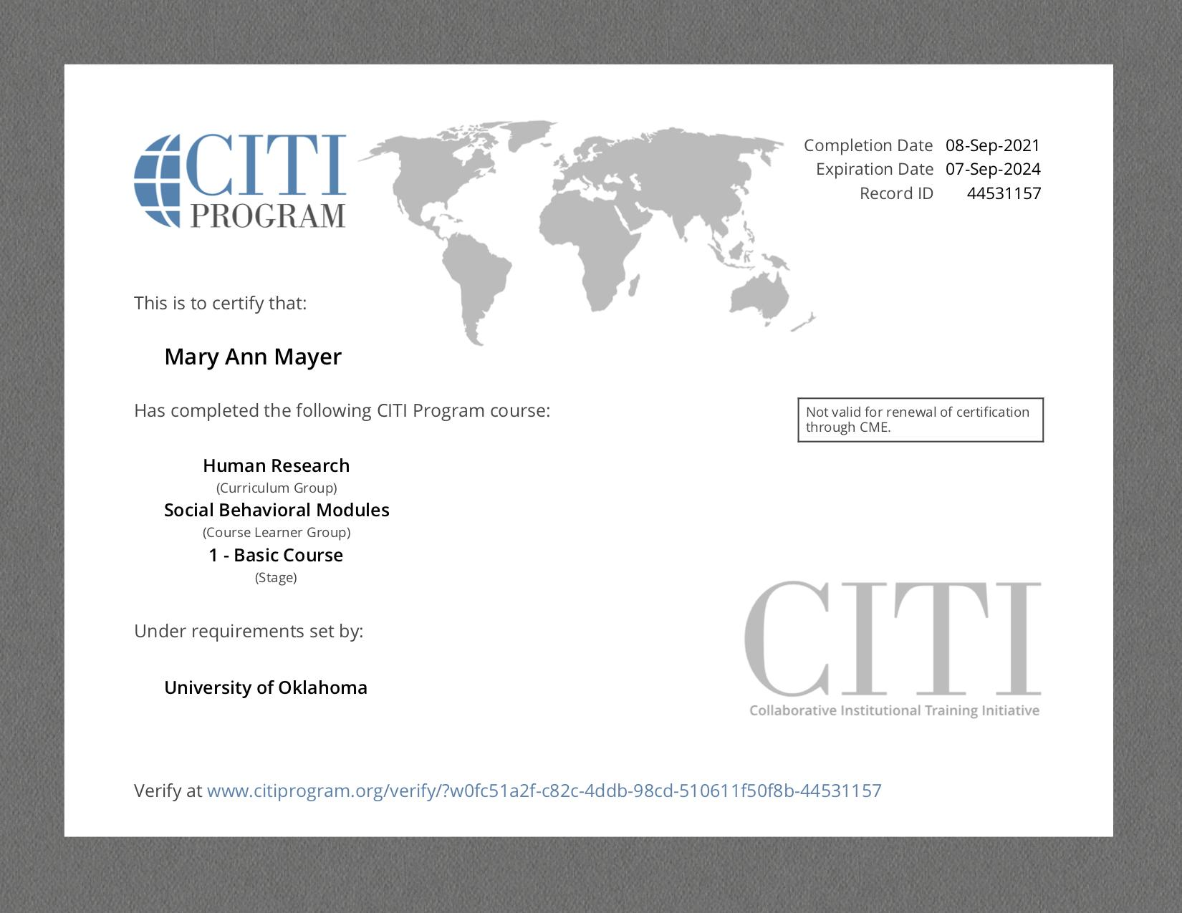

F.2 Outcome Letter - Approval of Initial Submission
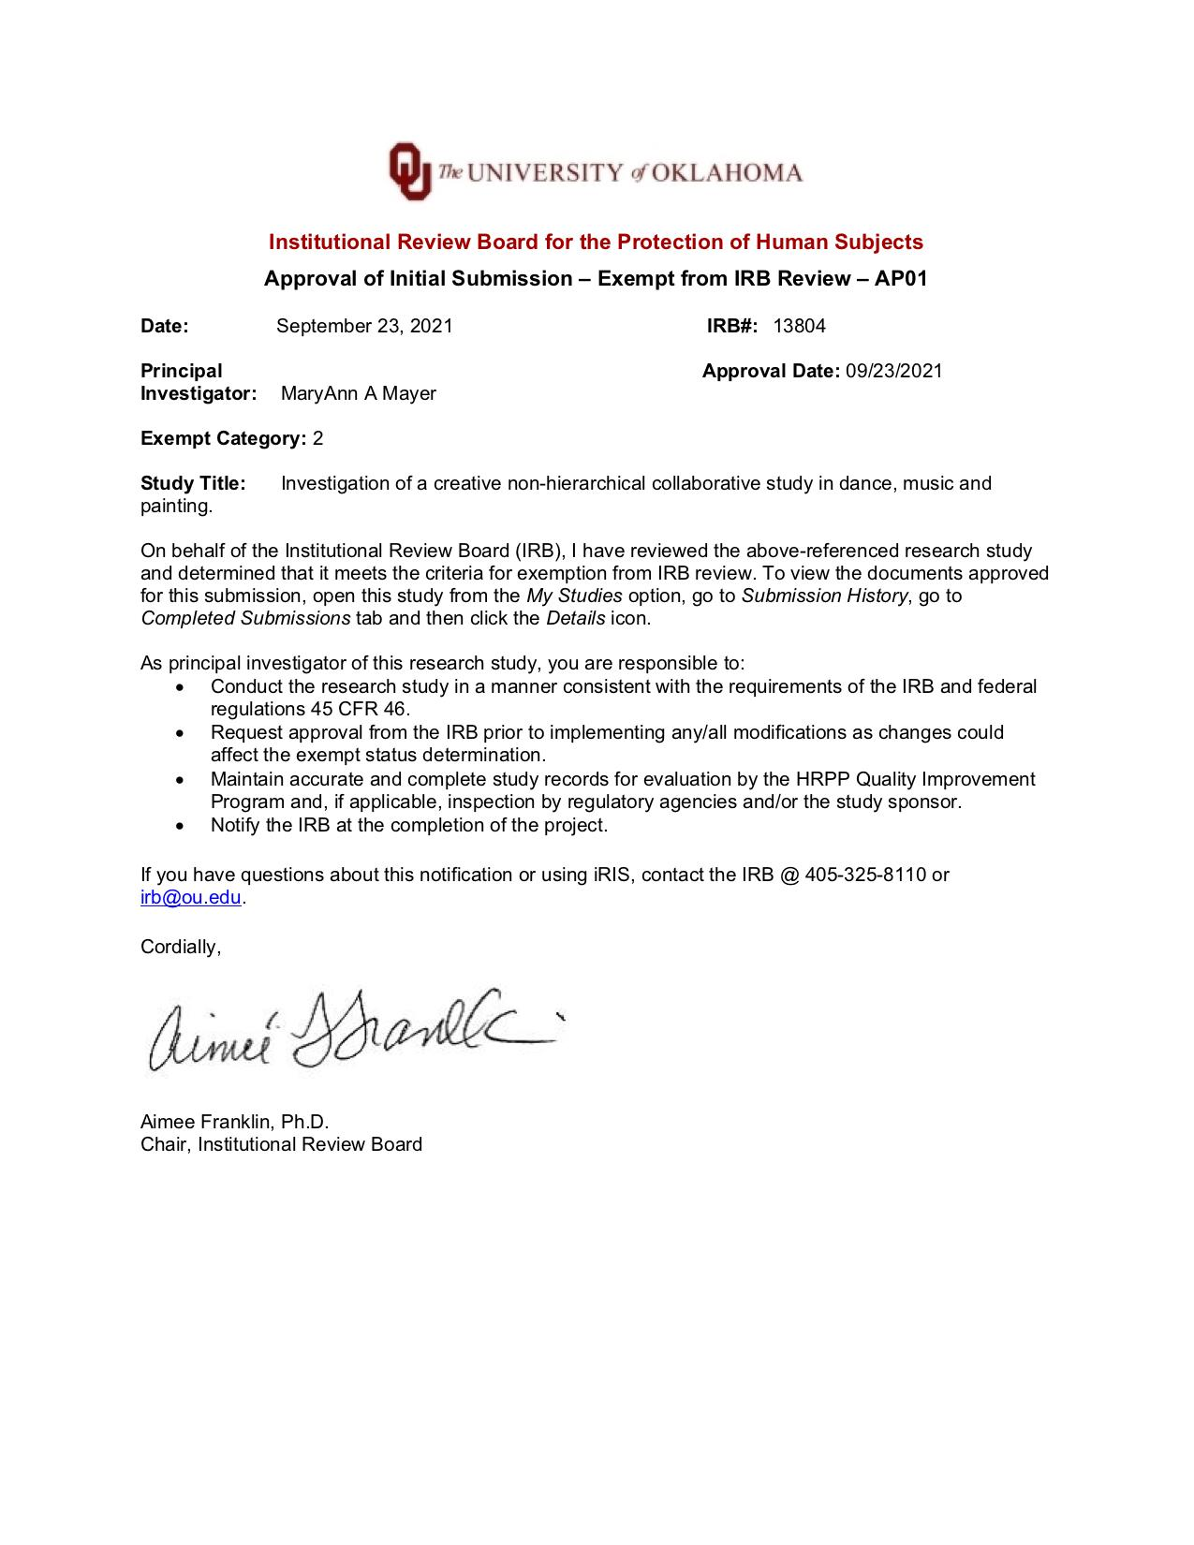

F.3 Outcome Letter - Final Report

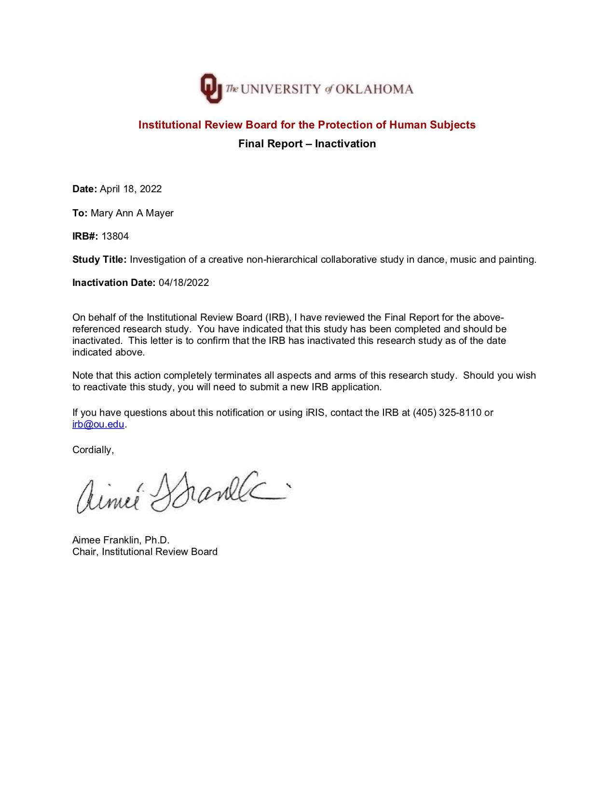

F.4 Consent to Participate Form
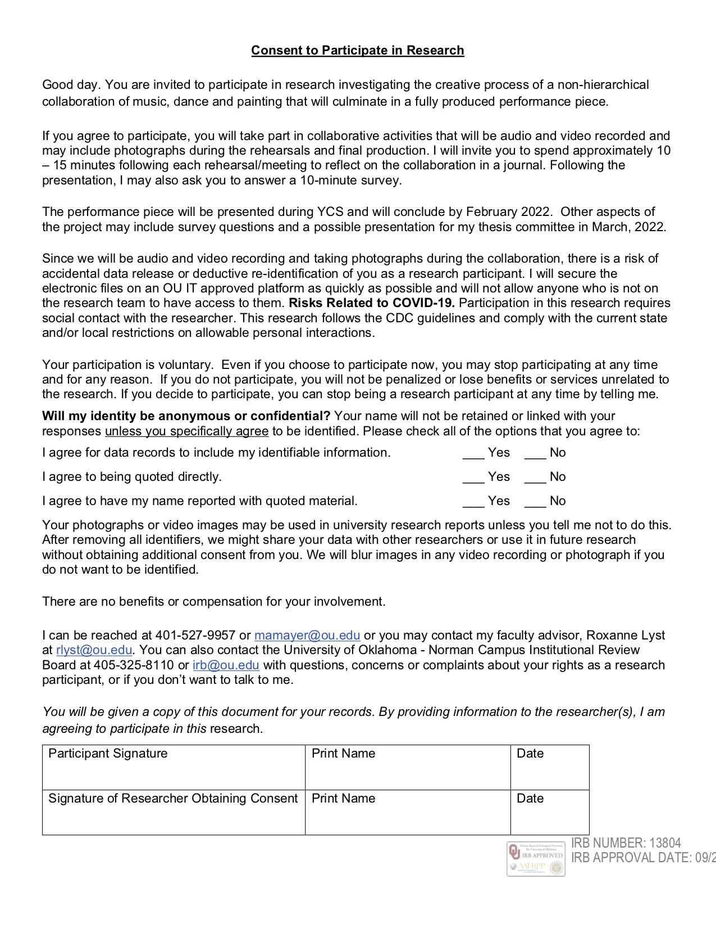

Appendix G. Supporting Documents

G.1 Emotion Wheel

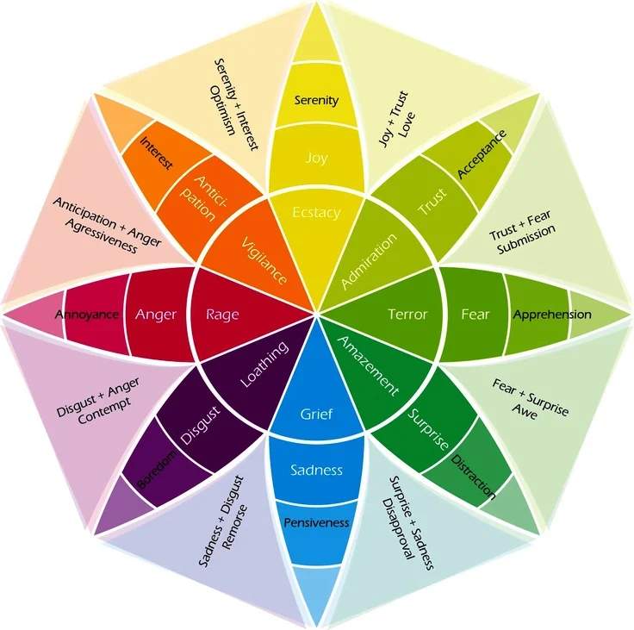The Emotion Wheel.

G.2 Color Wheel

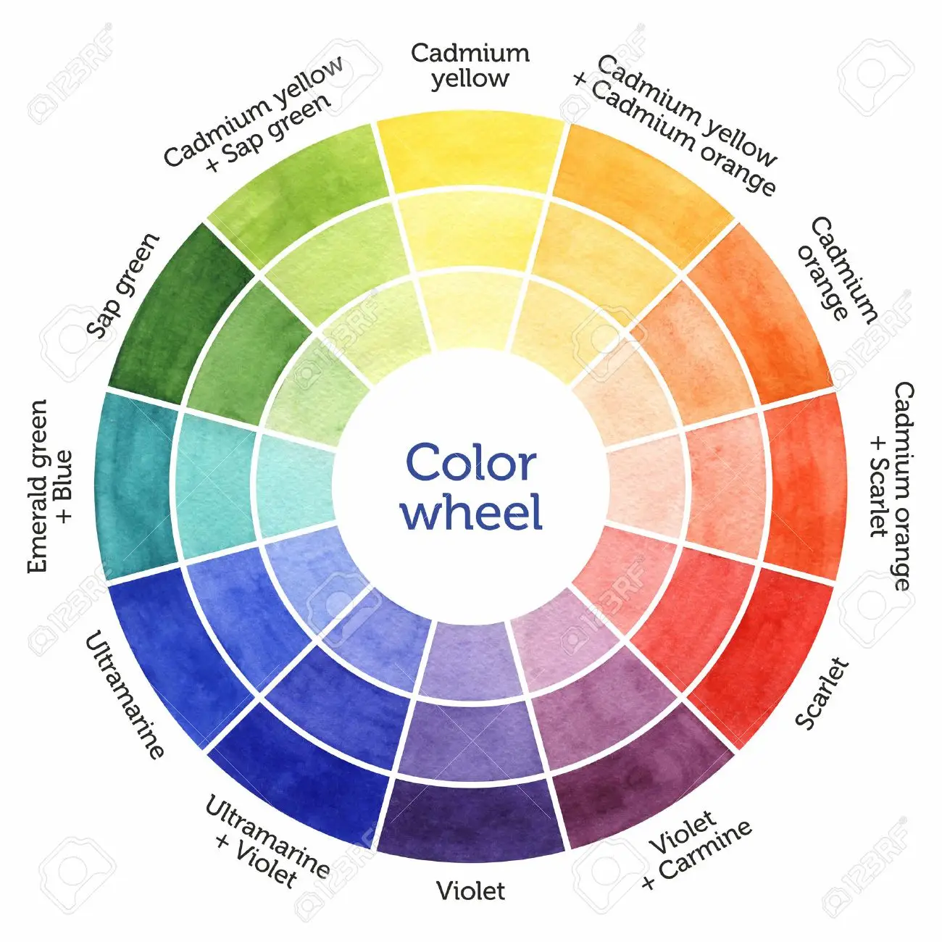
The Color Wheel.

M. S. Lindauer, “Art, Artists, and Arts Audiences: Their Implications for the Psychology of Creativity,” in Encyclopedia of Creativity (State University of New York: Academic Press, 2011), 59.
Gudmund J. W. Smith, “How Should Creativity Be Defined?,” Creativity Research Journal 17, no. 2 & 3 (2005): 293–95, https://doi.org/10.1207/s15326934crj1702&3_14, 293.
Ibid., 293.
Ibid., 293.
M. S. Lindauer, “Art, Artists, and Arts Audiences: Their Implications for the Psychology of Creativity,” in Encyclopedia of Creativity (State University of New York: Academic Press, 2011), 59.
A. J. Cropley, “Definitions of Creativity,” in Encyclopedia of Creativity (New York, New York, 2020), 360.
Ibid, 358-359.
M. S. Lindauer, “Art, Artists, and Arts Audiences: Their Implications for the Psychology of Creativity,” in Encyclopedia of Creativity (State University of New York: Academic Press, 2011), 59-60.
Ibid., 23.
Ibid., 25.
Mihaly Csikszentmihalyi, Creativity: The Psychology of Discovery and Invention (New York, NY: HarperCollins Publishers, 1997), 25-26.
Ibid., 25-26.
Ibid, 25-26.
Ibid., 27.
A. J. Cropley, “Definitions of Creativity,” in Encyclopedia of Creativity (New York, New York, 2020), 360.
Ibid., 47.
Ibid., 28.
Ibid., 36-45.
Ibid., 28.
Cropley, “Definitions of Creativity,” in Encyclopedia of Creativity (New York, New York, 2020), 361.
Cropley, “Definitions of Creativity,” in Encyclopedia of Creativity (New York, New York, 2020), 361.
Ibid., 366.
Mihaly Csikszentmihalyi, Creativity: The Psychology of Discovery and Invention (New York, NY: HarperCollins Publishers, 1997), 55-76.
Scott Barry Kaufman, “The Messy Minds of Creative People,” Scientific America, December 24, 2014, https://blogs.scientificamerican.com/beautiful-minds/the-messy-minds-of-creative-people/.
Mihaly Csikszentmihalyi, Creativity: The Psychology of Discovery and Invention (New York, NY: HarperCollins Publishers, 1997), 63.
Ibid., 75.
Cropley, “Definitions of Creativity,” in Encyclopedia of Creativity (New York, New York, 2020), 365.
Ibid., 365.
Ibid., 365-366.
Mihaly Csikszentmihalyi, Creativity: The Psychology of Discovery and Invention (New York, NY: HarperCollins Publishers, 1997), 32-36.
Ibid., 27.
Vera John-Steiner, Creative Collaboration (New York, NY: Oxford University Press, 2000), Forward.
Vera John-Steiner, Creative Collaboration (New York, NY: Oxford University Press, 2000), Forward.
Ibid., 6.
Joshua Wolf Shenk, Powers of Two, First Mariner Books edition 2015 (New York, NY: Houghton Mifflin Harcourt Publishing Company, 2015), Introduction.
Ibid., xv-xvi.
Ibid., xvi.
Vera John-Steiner, Creative Collaboration (New York, NY: Oxford University Press, 2000), 3.
Ibid., 187.
Ibid., 187.
Ibid., xi, 56, 199, 200.
Sarah Harvey, “Creative Synthesis: Exploring the Process of Extraordinary Group Creativity,” The Academy of Management Review 39, no. 3 (2014), 325.
Ibid. 330.
Ibid., 328.
Vera John-Steiner, Creative Collaboration (New York, NY: Oxford University Press, 2000), 56.
“APA Dictionary of Psychology,” accessed February 26, 2022, https://dictionary.apa.org/.
Vera John-Steiner, Creative Collaboration (New York, NY: Oxford University Press, 2000), 57.
Monika Herzig and David Baker, “Beyond Jamming: A Historical and Analytical Perspective on the Creative Process,” Music & Entertainment Educators Association 14, no. 1 (2014), 184.
Ibid., 185.
Keith Sawyer, Group Genius: The Creative Power of Collaboration, (Perseus Books Group, 2007), http://archive.org/details/groupgeniuscreat00sawy, 66.
Keith Sawyer, Group Genius: The Creative Power of Collaboration, (Perseus Books Group, 2007), http://archive.org/details/groupgeniuscreat00sawy, 43.
Ibid., 50.
Keith Sawyer, Group Genius: The Creative Power of Collaboration, (Perseus Books Group, 2007), http://archive.org/details/groupgeniuscreat00sawy, 43-56.
Ibid., 56.
Maksim Belitski, Monika Herzig, and this link will open in a new window Link to external site, “The Jam Session Model for Group Creativity and Innovative Technology,” Journal of Technology Transfer 43, no. 2 (April 2018): 506–21, http://dx.doi.org/10.1007/s10961-017-9574-z., 509.
Monika Herzig and David Baker, “Beyond Jamming: A Historical and Analytical Perspective on the Creative Process,” Music & Entertainment Educators Association 14, no. 1 (2014), 205.
Ibid., 205.
Ibid., 194-203.
Maksim Belitski, Monika Herzig, and this link will open in a new window Link to external site, “The Jam Session Model for Group Creativity and Innovative Technology,” Journal of Technology Transfer 43, no. 2 (April 2018): 506–21, http://dx.doi.org/10.1007/s10961-017-9574-z., 508.
Ibid., 508.
Keith Sawyer, Group Genius (Perseus Books Group, 2007), http://archive.org/details/groupgeniuscreat00sawy, 36.
Joel Kurtzman, “An Interview with John Kao,” Strategy+Business Fourth Quarter 1996, no. 5 (October 1, 1996), https://www.strategy-business.com/article/12574.
Maksim Belitski, Monika Herzig, and this link will open in a new window Link to external site, “The Jam Session Model for Group Creativity and Innovative Technology,” Journal of Technology Transfer 43, no. 2 (April 2018): 506–21, http://dx.doi.org/10.1007/s10961-017-9574-z., 510.
Ibid., 509-517.
Ibid., 511.
Maksim Belitski, Monika Herzig, and this link will open in a new window Link to external site, “The Jam Session Model for Group Creativity and Innovative Technology,” Journal of Technology Transfer 43, no. 2 (April 2018): 506–21, http://dx.doi.org/10.1007/s10961-017-9574-z., 516.
Monika Herzig and David Baker, “Beyond Jamming: A Historical and Analytical Perspective on the Creative Process,” Music & Entertainment Educators Association 14, no. 1 (2014), 187.
Maksim Belitski, Monika Herzig, and this link will open in a new window Link to external site, “The Jam Session Model for Group Creativity and Innovative Technology,” Journal of Technology Transfer 43, no. 2 (April 2018): 506–21, http://dx.doi.org/10.1007/s10961-017-9574-z, 519.
Katherine Teck, Making Music for Modern Dance: Collaboration in the Formative Years of a New American Art / Source Readings Compiled and Edited by Katherine Teck. (New York: Oxford University Press, 2011), 4.
Vera John-Steiner, Creative Collaboration (New York, NY: Oxford University Press, 2000), 93.
Katherine Teck, Making Music for Modern Dance: Collaboration in the Formative Years of a New American Art / Source Readings Compiled and Edited by Katherine Teck. (New York: Oxford University Press, 2011), 117.
Stephanie Jordan, Stravinsky Dances: Re-Visions across a Century (Hampshire, England: Dance Books Ltd, 2007)., 28.
Stephanie Jordan, Stravinsky Dances: Re-Visions across a Century (Hampshire, England: Dance Books Ltd, 2007)., 47.
Vera John-Steiner, Creative Collaboration (New York, NY: Oxford University Press, 2000), 93.
Hugh Macdonald, “Apollo (Choreography by George Balanchine*) (Igor Stravinsky),” LA Phil, 2022, https://www.laphil.com/musicdb/pieces/200/apollo-choreography-by-george-balanchine.
Ibid., Preface, x.
Hugh Macdonald, “Apollo (Choreography by George Balanchine*) (Igor Stravinsky),” LA Phil, 2022, https://www.laphil.com/musicdb/pieces/200/apollo-choreography-by-george-balanchine.
Paul H. Mason, “Music, Dance and the Total Art Work: Choreomusicology in Theory and Practice,” Research in Dance Education 13, no. 1 (April 2012): 5–24, https://doi.org/10.1080/14647893.2011.651116, 10.
Charles M. Joseph, Stravinsky & Balanchine: A Journey of Invention (New Haven, CT & London, England: Yale University Press, 2002), 148.
Charles M. Joseph, Stravinsky & Balanchine: A Journey of Invention (New Haven, CT & London, England: Yale University Press, 2002), 219.
Ibid., 192, 210.
Ibid., Preface, x.
Charles M. Joseph, Stravinsky & Balanchine: A Journey of Invention (New Haven, CT & London, England: Yale University Press, 2002), 193.
Ibid., 202.
Charles M. Joseph, Stravinsky & Balanchine: A Journey of Invention (New Haven, CT & London, England: Yale University Press, 2002), 148.
Ibid.,149.
Ibid., 205.
Ibid., 205.
Ibid., 205.
Charles M. Joseph, Stravinsky & Balanchine: A Journey of Invention (New Haven, CT & London, England: Yale University Press, 2002), 210.
Ibid., 210.
Balanchine Foundation Interview: Maria Tallchief FIREBIRD and ORPHEUS, 2016, https://www.youtube.com/watch?v=0BNfep9Qdec.
Charles M. Joseph, Stravinsky & Balanchine: A Journey of Invention (New Haven, CT & London, England: Yale University Press, 2002), 214.
Ibid., 214.
Ibid., 222.
Ibid., 224.
Ibid., 225.
Charles M. Joseph, Stravinsky & Balanchine: A Journey of Invention (New Haven, CT & London, England: Yale University Press, 2002), 227.
Ibid., 191.
George Balanchine, 101 Stories of the Great Ballets / George Balanchine and Francis Mason. (New York, NY: Anchor Books Doubleday, 1975), 3.
Charles M. Joseph, Stravinsky & Balanchine: A Journey of Invention (New Haven, CT & London, England: Yale University Press, 2002), 241.
Ibid., 241.
Ibid., 242.
Ibid., 259.
Charles M. Joseph, Stravinsky & Balanchine: A Journey of Invention (New Haven, CT & London, England: Yale University Press, 2002), 260.
Ibid., 211.
Clive Barnes, “Balanchine & Stravinsky: The Sublime Couple,” Playbill, June 1, 2004, https://playbill.com/article/balanchine-stravinisky-the-sublime-couple.
Charles M. Joseph, “‘Stravinsky and Balanchine,’” The New York Times, August 4, 2002, sec. Books, https://www.nytimes.com/2002/08/04/books/chapters/stravinsky-and-balanchine.html.
Stravinsky and Diaghilev: The Alternative Russian Revolution (Museum of London, 2009), https://www.gresham.ac.uk/lectures-and-events/stravinsky-and-diaghilev-the-alternative-russian-revolution.
Susan Calkins, “Modernism in Music and Erik Satie’s Parade,” International Review of the Aesthetics and Sociology of Music 41, no. 1 (2010), 12.
Mark Feeney, “Russian Revelry,” Boston.Com, May 15, 2009, http://archive.boston.com/ae/theater_arts/articles/2009/05/15/russian_revelry/, 19.
Susan Calkins, “Modernism in Music and Erik Satie’s Parade,” International Review of the Aesthetics and Sociology of Music 41, no. 1 (2010), 5.
Katherine Teck, Making Music for Modern Dance: Collaboration in the Formative Years of a New American Art / Source Readings Compiled and Edited by Katherine Teck. (New York: Oxford University Press, 2011), 87.
Katherine Teck, Making Music for Modern Dance: Collaboration in the Formative Years of a New American Art / Source Readings Compiled and Edited by Katherine Teck. (New York: Oxford University Press, 2011), 105-118.
Ibid., 41.
Ibid., 41.
Katherine Teck, Making Music for Modern Dance: Collaboration in the Formative Years of a New American Art / Source Readings Compiled and Edited by Katherine Teck. (New York: Oxford University Press, 2011), 56.
Ibid., 56.
Ibid., 46.
Ibid., 52.
Katherine Teck, Making Music for Modern Dance: Collaboration in the Formative Years of a New American Art / Source Readings Compiled and Edited by Katherine Teck. (New York: Oxford University Press, 2011), 86.
Leta E. Miller, “Henry Cowell and Modern Dance: The Genesis of Elastic Form,” American Music 20, no. 1 (2002): 1–24, https://doi.org/10.2307/3052241, 3.
Katherine Teck, Making Music for Modern Dance: Collaboration in the Formative Years of a New American Art / Source Readings Compiled and Edited by Katherine Teck. (New York: Oxford University Press, 2011), 92.
Ibid., 88.
Leta E. Miller, “Henry Cowell and Modern Dance: The Genesis of Elastic Form,” American Music 20, no. 1 (2002): 1–24, https://doi.org/10.2307/3052241, 10.
Katherine Teck, Making Music for Modern Dance: Collaboration in the Formative Years of a New American Art / Source Readings Compiled and Edited by Katherine Teck. (New York: Oxford University Press, 2011), 92.
Leslie Martin, “Black Mountain College and Merce Cunningham in the Fifties: New Perspectives on JSTOR,” Dance Research Journal Vol. 26, No. 1 (1994): 3, 46.
Nelson Rivera, “Visual Artists Design for the Merce Cunningham Dance Company, 1967-1970,” in Choreography and Dance Studies Series, Merce Cunningham: Creative Elements, Choreography and Dance Studies Series (New York, NY: Routledge, 2013), 30.
Nelson Rivera, “Visual Artists Design for the Merce Cunningham Dance Company, 1967-1970,” in Choreography and Dance Studies Series, Merce Cunningham: Creative Elements, Choreography and Dance Studies Series (New York, NY: Routledge, 2013), 29.
Katherine Teck, Making Music for Modern Dance: Collaboration in the Formative Years of a New American Art / Source Readings Compiled and Edited by Katherine Teck. (New York: Oxford University Press, 2011), 232.
Katherine Teck, Making Music for Modern Dance: Collaboration in the Formative Years of a New American Art / Source Readings Compiled and Edited by Katherine Teck. (New York: Oxford University Press, 2011), 235.
Erick Hawkins, The Body Is a Clear Place and Other Statements on Dance, 1st ed. (Pennington, NJ: Princeton Book Company, 1992), xi.
Discovering Creative Connections: The Collaboration of Erick Hawkins & Lucia Dlugoszewski, accessed February 18, 2022, https://www.loc.gov/item/webcast-8138/.
Erick Hawkins, The Body Is a Clear Place and Other Statements on Dance, 1st ed. (Pennington, NJ: Princeton Book Company, 1992), 78.
Ibid., 79.
Ibid., 87.
Ibid., 85.
Erick Hawkins, The Body Is a Clear Place and Other Statements on Dance, 1st ed. (Pennington, NJ: Princeton Book Company, 1992), 85.
Ibid., 85.
Discovering Creative Connections: The Collaboration of Erick Hawkins & Lucia Dlugoszewski, accessed February 18, 2022, https://www.loc.gov/item/webcast-8138/.
Ibid.
Minna Moore Ede, ed., Titian| Metamorphosis. Art Music Dance. A Collaboration between The Royal Ballet and the National Gallery, 1st ed. (London, United Kingdom: Art Books Publishing Ltd and the Royal Opera House, 2013).
“Georges Braque and Pablo Picasso,” MFA Masterworks Fine Arts Gallery, accessed February 14, 2022, https://news.masterworksfineart.com/2017/07/11/georges-braque-and-pablo-picasso.
William Rubin, “Picasso and Braque: Pioneering Cubism,” press release, https://www.moma.org/documents/moma_press-release_327550.pdf, 1989, 2.
Ibid., 2.
William Rubin, “Picasso and Braque: Pioneering Cubism,” press release, https://www.moma.org/documents/moma_press-release_327550.pdf, 1989,, 3.
Ibid., 2.
Michael Brenson, “Picasso and Braque, Brothers in Cubism,” The New York Times, September 22, 1989, sec. Arts, https://www.nytimes.com/1989/09/22/arts/picasso-and-braque-brothers-in-cubism.html.
Authors: Sabine Rewald, “Cubism | Essay | The Metropolitan Museum of Art | Heilbrunn Timeline of Art History,” The Met’s Heilbrunn Timeline of Art History, accessed February 14, 2022, https://www.metmuseum.org/toah/hd/cube/hd_cube.htm.
David Cottington, Cubism and Its Histories (Manchester University Press, 2004), 188.
Authors: Sabine Rewald, “Cubism | Essay | The Metropolitan Museum of Art | Heilbrunn Timeline of Art History,” The Met’s Heilbrunn Timeline of Art History, accessed February 14, 2022, https://www.metmuseum.org/toah/hd/cube/hd_cube.htm.
Ibid.
Ibid.
William Rubin, “Picasso and Braque: Pioneering Cubism,” press release, https://www.moma.org/documents/moma_press-release_327550.pdf, 1989, 1.
Kathy Roulston, “What Is Autoethnography?,” QualPage (blog), November 15, 2018, https://qualpage.com/2018/11/15/what-is-autoethnography/, 1.
Ibid., 1.
Carolyn Ellis, Tony E. Adams, and Arthur P. Bochner, “Autoethnography: An Overview,” Forum Qualitative Sozialforschung / Forum: Qualitative Social Research 12, no. 1 (2011), https://doi.org/10.17169/fqs-12.1.1589.
Karl Christoff Dominey, “DOMINEY Photography,” DOMINEY photography, accessed February 23, 2022, https://www.domineyphotography.com.
Minna Moore Ede, ed., Titian| Metamorphosis. Art Music Dance. A Collaboration between The Royal Ballet and the National Gallery, 1st ed. (London, United Kingdom: Art Books Publishing Ltd and the Royal Opera House, 2013), 14.
Steve Paxton, “Contact Quarterly: Dance and Improvisation Journal, Books, Dvds,” Contact Quarterly, 1979, https://contactquarterly.com/index.php.
Ibid., 9.
Ibid., 3.
Ibid., 3.
Ibid., 74.
Keith Sawyer, Group Genius: The Creative Power of Collaboration, (Perseus Books Group, 2007), http://archive.org/details/groupgeniuscreat00sawy, 42.
Ibid., 41.
Ibid., xi.
Ibid., xi.
Ibid., xi.
Keith Sawyer, Group Genius: The Creative Power of Collaboration, (Perseus Books Group, 2007), http://archive.org/details/groupgeniuscreat00sawy, 9.
Ibid., 43.
Plutchik, “The Emotion Wheel: What It Is and How to Use It,” PositivePsychology.com, December 24, 2017, https://positivepsychology.com/emotion-wheel/.
“Robyn Mineko Williams Bio,” Robyn Mineko Williams and Artists, accessed February 27, 2022, https://www.robynminekowilliams.com/rmw.
Robyn Mineko Williams, interview by author, Norman, Oklahoma, February 2022.
Kirsten Evans, interview by author, phone conversation, February 2022.
“REVOLVE Dance Project | Dance Company | United States,” Revolve DanceProject, accessed February 28, 2022, https://www.revolvedanceproject.com.
Mihaly Csikszentmihalyi, Creativity: The Psychology of Discovery and Invention (New York, NY: HarperCollins Publishers, 1997), 27-28.
Vera John-Steiner, Creative Collaboration (New York, NY: Oxford University Press, 2000), 204.
Ibid.
Plutchik, “The Emotion Wheel: What It Is and How to Use It,” PositivePsychology.com, December 24, 2017, https://positivepsychology.com/emotion-wheel/.
“Hand Drawn Color Wheel. Color Mixing Chart for Watercolor Painting.,” 123RF, accessed March 17, 2022, https://www.123rf.com/photo_53973472_hand-drawn-color-wheel-color-mixing-chart-for-watercolor-painting.html.
Charles M. Joseph, Stravinsky & Balanchine: A Journey of Invention (New Haven, CT & London, England: Yale University Press, 2002), 132.
Ibid. 88.
Ibid., 202.
Charles M. Joseph, Stravinsky & Balanchine: A Journey of Invention (New Haven, CT & London, England: Yale University Press, 2002), Preface, x.
Keith Sawyer, Group Genius: The Creative Power of Collaboration, (Perseus Books Group, 2007), http://archive.org/details/groupgeniuscreat00sawy, 29.
George Balanchine, “The Dance Element in Stravinsky’s Music,” The Opera Quarterly 22, no. 1 (2006): 138.
Ibid., 149.
Mihaly Csikszentmihalyi, Flow: The Psychology of Optimal Experience, 1st ed. (New York, NY: HarperCollins Publishers, 1990), x.
Vera John-Steiner, Creative Collaboration (New York, NY: Oxford University Press, 2000), 56
Ibid., 37.
Mihaly Csikszentmihalyi, Creativity: The Psychology of Discovery and Invention (New York, NY: HarperCollins Publishers, 1997), 27.
Vera John-Steiner, Creative Collaboration (New York, NY: Oxford University Press, 2000), 204.
Ibid., 212.
Ibid., 6.
“Georges Braque and Pablo Picasso,” MFA Masterworks Fine Arts Gallery, accessed February 14, 2022, https://news.masterworksfineart.com/2017/07/11/georges-braque-and-pablo-picasso.
Mihaly Csikszentmihalyi, Creativity: The Psychology of Discovery and Invention (New York, NY: HarperCollins Publishers, 1997), 47.

