THE UNIVERSITY OF OKLAHOMA

GRADUATE COLLEGE

MEDICAL AND NURSING STUDENTS’ COGNITIVE LEVELS MEASURED BY

THE CLASSROOM TEST OF SCIENTIFIC REASONING AND

CORRELATION TO KNOWLEDGE GAINED FROM

LECTURE, SIMULATION, OR LECTURE WITH SIMULATION

A DISSERTATION

SUBMITTED TO THE GRADUATE FACULTY

in partial fulfillment of the requirements for the

Degree of

DOCTOR OF PHILOSOPHY

By

ALBERTO JOSÉ DE ARMENDI
Norman, Oklahoma
2014

MEDICAL AND NURSING STUDENTS’ COGNITIVE LEVELS MEASURED BY
THE CLASSROOM TEST OF SCIENTIFIC REASONING AND
CORRELATION TO KNOWLEDGE GAINED FROM
LECTURE, SIMULATION, OR LECTURE WITH SIMULATION

A DISSERTATION APPROVED FOR THE
DEPARTMENT OF INSTRUCTIONAL LEADERSHIP
AND ACADEMIC CURRICULUM

BY

____________________________
Dr. Edmund A. Marek, Chair

____________________________
Dr. Timothy Laubach

____________________________
Dr. John J. Chiodo

____________________________
Dr. Stacy L. Reeder

____________________________
Dr. Xun Ge

© Copyright by ALBERTO JOSÉ DE ARMENDI 2014
All Rights Reserved.

DEDICATION
I would also like to give special recognitions to all my family members for all of their unrelenting love, support, and encouragement throughout my doctoral education. The Gold Medals go to my wife and companion, Shadynne Maria de Armendi, my son and his wife, Philip Albert de Armendi and Joyce Tatiana de Armendi, and my mother, Celia de la Torre y de Armendi and my father, Dr. Carlos Manuel de Armendi (MD). Several Silver Medals go to all my brothers and sisters, their spouses and their sons and daughters: Dr. Fernando Juan de Armendi (MD), Maria Teresa de Armendi, Dr. Nicole de Armendi (PhD), Dr. Robert Miller (PhD), Dr. Giselle de Armendi (JD), and Alex de Armendi; Carlos Francisco de Armendi, Aime de Armendi, Carlos de Armendi, Monica de Armendi, and Leah de Armendi; Consuelo de Armendi; Maria Celia de Armendi (MA); Juan Rafael de Armendi; Max Alejandro de Armendi, Janii de Armendi, Nic de Armendi, Mollye de Armendi, Dr. Alexis de Armendi Backs (JD), and Sean Backs; and Esperanza de Armendi Collado, Dr. Allyson de Armendi Jarvis (MD), Jeremy Jarvis, Amali Jarvis, and Dr. Carolina Collado (JD).
Alberto José de Armendi, MD, MA, MBA

ACKNOWLEDGEMENTS

I am grateful to all my Doctoral Committee members: Dr. Edmund A. Marek, Dr. Timothy Laubach, Dr. John J. Chiodo, Dr. Stacy L. Reeder, and Dr. Xun Ge for having taken their time, energy and concerns in my Doctoral Degree of Philosophy.
I give special thanks to my Doctoral Committee Chairman and mentor, Dr. Edmund A. Marek, for all of his guidance and support. From the very beginning when I arrived at the University of Oklahoma, I was enthusiastically encouraged throughout all of my learning in education by Dr. Marek. Without his words of wisdom, this doctorate would not have materialized.
Lastly, I would like to acknowledge my friends and colleagues in the Department of Anesthesia and at the Oklahoma University Health Sciences Center for their continuous support: Dr. Jane C.K. Fitch, Chairman of the Department of Anesthesia at OUHSC, and research coordinators, Drs. Jorge Cure and Amir Butt and all the students at the University of Oklahoma. Without their continuous support from all the above noted family, friends and departmental members, I would not be here at the University of Oklahoma.
Alberto José de Armendi, MD, MA, MBA

TABLE OF CONTENTS

Pages

TITLE i

SIGNATURES ii

COPYRIGHT iii

DEDICATION

ACKNOWLEDGEMENTS iv

TABLE OF CONTENTS v-viii

LIST OF TABLES ix

LIST OF FIGURES x

PROLOGUE xi

MANUSCRIPTS 1-67

JOURNAL READY FORMATTED DOCTORAL DISSERTATION

MANUSCRIPT NUMBER 1:

Medical and Nursing Students’ Cognitive Levels

Measured by the Classroom Test of Scientific Reasoning 1-18

References 18

MANUSCRIPT NUMBER 2:

Effects of Lecture, Simulation or Both Teaching Methods

on Immediate Knowledge Gain and

Long-Term Knowledge Retention in Health Care Students 19-67

References 48-49

APPENDICES 68-69

APPENDIX A: Approved Prospectus 70-103

APPENDIX B: Classroom Test of Scientific Reasoning

Neonatal Resuscitation, Simulation Protocol 104-132

APPENDIX C: Consent Form 133-137

APPENDIX D: Internal Review Board for the

Protection on Human Subjects Letters 138-143

APPENDIX E: Education & Fun with Neonates

Nursing and Medical Students Presentation 144-147

APPENDIX F: Classroom Test of Scientific Reasoning

Multiple Choice Exam and Answer Sheet 148-158

APPENDIX G: Classroom Test of Scientific Reasoning Rubric 159-163

APPENDIX H: Student Group Research Randomizer Results 164-166

APPENDIX I: Neonatal Resuscitation Program

Lecture Presentation 167-172

APPENDIX J: Simulation Cheat Sheet Presentation 173-183

APPENDIX K: Neonatal Resuscitation Program Exam

Question Randomization Results 184-186

APPENDIX L: Neonatal Resuscitation

Exam #1 and Answer Sheet 187-192

APPENDIX M: Neonatal Resuscitation

Exam #2 and Answer Sheet 193-197

APPENDIX N: Neonatal Resuscitation

Exam #3 and Answer Sheet 198-203

APPENDIX O: Sample Size Determination/Calculation 204-207

APPENDIX P: SAS 9.3 Program and Output Analysis

Classroom Test of Scientific Reasoning Manuscript Analysis 208-219

APPENDIX Q: SAS 9.3 Program and Output Analysis

Neonatal Resuscitation Program Manuscript 220-246

APPENDIX R: Thesis Dissertation Defense Presentation 247-254

APPENDIX S: Disk. Education & Fun with Neonates

Nursing and Medical Student Presentation 255-256

APPENDIX T: Disk. Newborn Resuscitation Program

Lecture Presentation 255-256

APPENCIX U: Disk. Thesis Dissertation Defense Presentation 255-256

APPENDIX V: Disk. Thesis Dissertation 255-256

APPENDIX W: USB Drive. Education & Fun with Neonates

Nursing and Medical Student Presentation 255-256

APPENDIX X: USB Drive. Newborn Resuscitation Program

Lecture Presentation 255-256

APPENDIX Y: USB Drive

Thesis Dissertation Defense Presentation 255-256

APPENDIX Z: USB Drive. Thesis Dissertation 255-256

Thank You! 257

LIST OF TABLES
MANUSCRIPT 1

Medical and Nursing Students’ Cognitive Levels Measured by the

Classroom Test of Scientific Reasoning

TABLE 1: Lawson’s Reasoning Patterns Assessed by Different Questions 9

TABLE 2: Student Demographics 10

TABLE 3: Comparison of CTSR Raw and Rubric Scores with

Professional Preference and Gender 11

TABLE 4: Comparison of Rubric Classification with Professional Program 12

TABLE 5: Comparison of Rubric Classification with Gender 12

TABLE 6: Cognitive Classification Comparison with

Years of Schooling and Age 13

MANUSCRIPT 2:

Effects of Lecture, Simulation or Both Teaching Methods on

Immediate Knowledge Gain and Long-Term Knowledge Retention in

Health Care Students

TABLE 1: Demographics and Characteristics of All Students 33

TABLE 2: Univariate Analysis between

Mean Exam Score Differences and Covariates 34

TABLE 3: Differences in Exam Mean Scores as a

Function of Teaching Method 35

TABLE 4: Multivariate Analysis between

Mean Exam Score Differences and Covariates 39

LIST OF FIGURES

MANUSCRIPT 2:

Effects of Lecture, Simulation or Both Teaching Methods on

Immediate Knowledge Gain and Long-Term Knowledge Retention in

Health Care Students

FIGURE 1: Mean Exam Scores for Each Teaching Method 33
PROLOGUE

This Journal Ready Formatted Doctoral Dissertation consists of two manuscripts prepared for submission to one refereed journal, Medical Education. The two articles are Medical and Nursing Students’ Cognitive Levels as Measured by the Classroom Test of Scientific Reasoning and Effects of Lecture, Simulation, or Both Teaching Methods on Immediate Knowledge Gain and Long-Term Knowledge Retention in Health Care Students. The appendices include the Prospectus and all the Institutional Review Board for the Protection of Human Subjects documentation and approvals for the carrying out of this study (Protocol and Informed Consent). In addition, included in the appendices are the presentation at recruitment (Education & Fun with Neonates Nursing and Medical Students Presentation), the Classroom Test of Scientific Reasoning exam and rubric, the Neonatal Resuscitation Program Lecture Presentation , the Neonatal Resuscitation Program exams and questionnaires, the Simulation Cheat Sheet Presentation, the randomization of questions and students, the SAS size determination and analysis of the data, and a disk and USB drive with the presentations and thesis.

MANUSCRIPT 1
Medical and Nursing Students’ Cognitive Levels Measured by the
Classroom Test of Scientific Reasoning

This manuscript, Medical and Nursing Students’ Cognitive Levels Measured by the Classroom Test of Scientific Reasoning, is the first of two articles which are part of the Journal Ready Formatted Doctoral Dissertation. The manuscript is prepared for submission to the peer-reviewed target journal, Medical Education.

Medical and Nursing Students’ Cognitive Levels Measured by the
Classroom Test of Scientific Reasoning

Title: Medical and Nursing Students’ Cognitive Levels Measured by the Classroom Test of Scientific Reasoning
Authors:
Names
Full Addresses
Institution
Contact Details of All Authors
Individual Contributions
Running Title: Medical and Nursing Cognitive Levels
Abstract word count: 361
Article word count: 3339 (not including references, but including text in the tables)
Number of tables: 6
Number of figures: None
Funding source: None
IRB approval statement: The study was carried out in accordance with the Declaration
of Helsinki: there being no potential harm to participants, the anonymity of the
participants was guaranteed, and participant informed consent was obtained.
Conflict of interest declaration: No conflict of interests existed from any authors.
Acknowledgements: A. E. Lawson for supporting this research and allowing the use
the Classroom Test of Scientific Reason examination tool.
Abstract:

Various forms of students’ reasoning characteristics have been studied, especially in pre-college students. A principled pedagogical framework reflecting the cognitive processes of health care students has not been investigated. Most cognitive studies evaluated patients who had experienced traumatic brain injury, brain surgery, or cancer. In the past, cognition tests have been used as an evaluation tool among college/university students. To date, no study has evaluated the cognitive levels of nursing and medical students.
Pedagogical tenets of critical thinking are presently being used to design and implement newer teaching modules for health care students. Before launching a newer pedagogical approach for health care students, we must first understand their cognitive strategies, whether they are concrete operational, transitional, or formal operational thinkers. In order to avoid an experienced interviewer, special materials, study-specific equipment and time-consuming classroom use, Lawson developed a reliable development-specific classroom test of formal level reasoning (1). To understand how years of education influences cognitive levels of scientific reasoning, nursing and medical students at the University of Oklahoma Health Sciences Center (OUHSC) were asked to complete the Classroom Test of Scientific Reasoning (CTSR), a validated measure of hypothetico-deductive and probabilistic reasoning (1). To the best of our knowledge, the use of CTSR for the assessment of college/university students has not been studied extensively. Our overall univariate analysis show significant differences in rubric CTSR scores between nursing students versus medical students (p<0.0001), between genders (p<0.0001), as well as differences based on years of schooling (p<0.0003). However, the association between rubric CTSR scores and gender disappeared when analysis was performed among nursing and medical students separately. Students differed in the distribution of their CTSR classification according to Piaget’s operational standards (concrete operational, low transitional, high transitional, and formal operational) with respect to gender and to training program. Seventy percent of nurse of the nursing student totals were concrete operational or low transitional thinkers, while 96% of medical student of the medical student totals were high transitional or formal operational thinkers. Forty three percent of females in both student groups were low transitional and high transitional thinkers, while 32% of the males of both professional programs were high transitional and formal operational thinkers.

Introduction:

It is imperative for educators to know how to best help nursing and medical students develop intellectually. And for instructors in health care settings understanding students’ cognitive strategies can be a powerful tool, to support and apply constructivist learning theory and inquiry-based teaching (2).
How do people learn? One theory is that we do so by encountering puzzling observations and trying to explain them through cycles of if/then/therefore hypothetico-deductive reasoning (3). Presumably, this occurs as the brain spontaneously processes information. The more developed people are at hypothetico-deductive reasoning, the better they are at learning and constructing new knowledge (4). The key goal for instructors then is to produce meaningful and lasting learning. Therefore, nursing and medical students must personally and repeatedly engage in generating new information and testing their self-generated ideas implying that laboratory and field-based activities may be the main instructional vehicles for this population of students (5).
In the healthcare setting, one of the most complex problems faced by professionals is make correct diagnoses and ensuring optimal treatments. Unfortunately, current estimates place the rate of medical misdiagnosis as high as 10-20% (6). Eddy reported that in 10-50% of the cases, physicians disagree on a medical diagnosis when assessing the same patient (5). Eighty percent of errors result from a cascade of cognitive errors caused by ineffective communication, and inadequate training or supervision (6).
Health care workers, including doctors, seldom make mistakes because of lack of knowledge of clinical facts. Instead, physicians misdiagnose as they subconsciously fall into any number of cognitive traps (7). Cognitive traps include the following: limiting the number of hypotheses, including rare diagnoses, formulating diagnoses prematurely on incomplete information, biasing perception or confirmation from past examples or personal investments, anchoring on the obvious while failing to consider alternative diagnoses, stereotyping hypotheses, hypothesizing one’s favorite discipline with favorable outcome while ignoring rational supportive or contradictory evidence, recalling only the beginning and end of the patient interview, blaming patients for their illness instead of seeking alternative diagnoses, and closing an interview prematurely. Some medical professionals’ preferred-strategies for cognitive reasoning may predispose them to fall into these traps (7). Cognitive traps act as a barrier for students to explore new strategies beyond the familiar strategies that they normally apply. Routinely resulting in previously proven efficient practices, in inappropriate circumstances, questions individual problem-solving strategies (8). In order to understand how clinicians address challenging questions/problems, we explore the cognition and reasoning strategies of nursing and medical students through the administration, analysis, and interpretation of the Classroom Test of Scientific Reasoning (CTSR).
The Lawson Test of Scientific Reasoning or the Classroom Test of Scientific Reasoning (CTSR), which evolved from the Test of Scientific Reasoning (TOSR), was developed by Anton Lawson to measure habitual or preferred reasoning strategies. The widely accepted and used instrument is an updated version of Lawson’s Test of Formal Reasoning (TOFR), which was developed in 1978, after it was widely acknowledged that curricula needed to be adapted to match participant’s needs and developmental levels (cognitive levels) (8). The CTSR measures concrete and formal operational reasoning, is easily and rapidly scored when administered, involves physical concepts requiring little reading/writing, and includes a variety of problems that assure reliability. The CTSR measures formal operations and includes the reasoning processes that guide to search for an evaluation of evidence to support or reject hypothetical causal propositions. These operations are used in the isolation and control of variables, the combinatorial analysis of possible causal factors (combinatorial reasoning), the weighing of confirming and disconfirming cases (correlational reasoning), the recognition of the probabilistic nature of phenomena (probabilistic reasoning), and the eventual establishment of functional relationships among variables (proportional reasoning) (9). Most of the items ask the participant to identify the correct answer to a question, and then to identify the correct reasoning for choosing that answer. In order to get credit for the question, the participant must choose the correct answer and the correct reason for arriving at the answer. A total of 24 items are included for a theoretical point score of 0-14 points. A participant’s strategy of thinking is categorized, according to one of Piaget’s four operational cognitive standards as follows: 0–4 correct answers = concrete operational thinking; 5–7 correct answers = low transitional thinking; 8–10 = high transitional thinking; 11–14 correct answers = formal thinking (1,9). In this study, nursing and medical students from OUHSC were asked to take the CTSR.
Methods:
Selection and description of participants:
Nursing students in their first semester of nursing school were approached by their instructor and recruited at a one-time presentation. Medical students were recruited by the fellow students in all years of medical school by making announcements during lectures, hall meetings and through conversations, discussions, and e-mails. Medical faculty recruited medical students while medical students were on clinical rotations. Medical students were recruited at different times: seven percent at a one-time presentation for first year medical students and 8% at a one-time presentation for second year medical students. Third and fourth year medical students (35%) were recruited biweekly during their anesthesia clinical rotation. Overall, 49% of students were nursing students and 51% were medical students. The recruitment period was three months and the study was completed in five months.
Technical information:
With prior IRB approval, nursing and medical students signed the Informed Consent; voluntarily answered questions on professional preference, age, gender and years of schooling; and completed the hard copy of the Classroom Test of Scientific Reasoning (CTSR) at OUHSC. The research coordinator graded each item as correct or incorrect, and assigned each participant a score out of a maximum of 24 possible single correct answers (8). If one or both responses were incorrect, no points were awarded. The last two hypothetico-deductive reasoning questions could earn two points each. The maximum theoretical point score for these 24 questions is 14 points (10 points for the first 20 combined items, and four points for the last four questions). The CTSR rubric score is the final score (0–14 points) derived from the theoretical CTSR point score of the 24 questions. The reasoning patterns assessed by the different items are outlined in Table 1.
Table 1: Lawson’s Reasoning Patterns Assessed by Different Questions
Question Number | Reasoning Level Assessed
1, 2 | Conservation of weight
3, 4 | Conservation of displaced volume
5, 6 | Proportional thinking
7, 8 | Advanced proportional thinking
9, 10 | Identification and control of variables
11, 12,13, 14 | Identification and control of variables and probabilistic thinking
15, 16 | Probabilistic thinking
17, 18 | Advanced probabilistic thinking
19, 20 | Correctional thinking (includes proportions and probability)
21, 22 | Hypothetico-deductive thinking
23, 24 | Hypothetico-deductive reasoning

Statistics:
Data were analyzed using SAS software version 9.3 (SAS Institute, Inc., Cary, NC). The CTSR rubric mean scores were compared by t-test between nursing and medical students. Because the nursing and medical students differed in their gender distribution, CTSR rubric scores were studied in a two-factor analysis of variance. The chi-Square test was used to detect differences among cognitive classifications between the CTSR rubric student’s cognitive classification and the student’s professional program or gender. Linear regression was used to independently examine the association of mean CTSR rubric scores and age, and the association between the mean CTSR rubric scores and years of schooling. Multiple regression analysis was performed to compare the mean CTSR rubric scores and the interaction of years of schooling and age. A multiple regression analysis explored mean CTSR rubric scores’ association with gender, educational program (nursing versus medical), years of schooling, and age, and considered possible interactions among these variables.
Yi = B_{CTSRi} + B_{Age} + B_{Gender} + BProgram (Nursing versus Medical) + B_{Years of Schooling} + Possible Interactions (Age, Gender, and Years of Schooling) + Errors
F_{c} (alpha = 0.05)
t_{c} (alpha/2)
Y_{i} and Y_{ii} was compared for nursing and medical students.
Demographic data collected from students in the nursing and medical programs were compared for gender, years of schooling, and age.
No student data were excluded from analysis. All students answered all 24 CTSR items and were classified into Piaget’s cognitive categories (n=89). However, two students did not answer all of the demographic questions: neither answered the question about years of schooling, and one did not answer the question about gender and age. Analysis was performed only on data from students who answered the specific demographic questions (n=87).
Results:
Table 2 displays the demographic information of the sample. Eighty-nine students were enrolled in the study. Ages ranged from 19 to 39 years of age (n=88), with a mean of 24.5 years of age. The number of years of schooling ranged from 14 to 26 years (n=87). The mean number of years of schooling was 16.5 years.
Table 2: Student Demographics

Student | Nursing Student | Medical Student | Totals
Number | 43 | 46 | 89
Female | 38 (90%) | 20 (43%) | 58
Male | 4 (10%) | 26 (57%) | 30
Average Age | 23.1 (±5.1) | 25.8 (±3.2) | 24.5 (±4.4)
Average Schooling years | 15.2 (±2.9) | 18.5 (±1.6) | 17.0 ±2.8
In this study, medical student mean (+SD) raw CTSR scores (20.2+2.6) were higher than those of nursing students (13.8+4.3; p<0.0001). Similarly, the mean (+SD) raw CTSR rubric scores were higher among males (20.2+2.2) than among females (15.6+4.9; p<0.0001) (Table 3). However, when we tested a main effects model and found that, after adjusting for educational program, mean rubric scores did not differ between genders (F=2.44, DF=1, p=0.12). Therefore, the association of rubric scores and gender in the overall population is confounded by professional preference. Since professional preference is related to years of education, it is hard to separate which is the confounding factor(s) (years of schooling and/or professional preference). In this study, the temporality of relationship cannot be determined between cognition level and professional preference and/or years of schooling.
Table 3: Comparison of CTSR Raw and Rubric Scores with
Professional Preference and Gender

 |  | Mean CTSR + SD; 95% CI
Professional | Number | CTSR Raw Score | CTSR Rubric Score
Medical Student | 46 | 20.2 + 2.6; 19.4 - 20.9 | 10.2 + 2.0; 9.6 - 10.8
Nursing Student | 43 | 13.8 + 4.3; 12.4 - 15.1 | 6.2 + 2.8; 5.3 - 7.0
p-Value |  | <0.0001 | <0.0001
Gender
Male | 30 | 20.2 + 2.2; 19.4 - 21.0 | 10.2 + 2.0; 9.4 - 10.9
Female | 58 | 15.6 + 4.9; 14.3 - 16.9 | 7.4 + 4.2; 6.5 - 8.2
p-Value |  | <0.0001 | <0.0001

Chi-Square test results were used to determine whether an association existed between the student’s cognitive rubric classification and student program (nursing v. medical) or gender. The association of the CTSR rubric classification with the type of student (nursing v. medical) was significant at p<0.0001. Forty-four percent of the nursing students were low transitional thinkers, followed by 26% concrete operational, 23% high transitional, and 7% formal operational. Fifty percent of the medical students were formal operational thinkers, followed by 46% high transitional and 4% low transitional (Table 4).
The majority of females were in the low transitional operational thinkers group (33%), with 17% concrete operational, 31% high transitional, and 19% formal operational thinkers. Fifty percent of males were formal operational thinkers, with the remainder 7% low transitional and 43% high transitional thinkers (Table 5). Mean rubric scores did not differ by gender for medical students (t=1.24, p=0.22), nor between male and female nursing students (t=1.15, p=0.26). In a two-factor analytic model, we verified that there was no interaction between educational program and gender (F=0.42, DF=1, p=0.52).
Table 4: Comparison of Rubric Classification with Professional Program

Piaget's Cognitive Classification | Concrete  Operational | Low Transitional | High Transitional | Formal  Operational
Number | 11 | 21 | 31 | 26
Nursing Students Number | 11 | 19 | 10 | 3
Medical Students Number | 0 | 2 | 21 | 23
% Nurse Stud. of Nurse Stud. Tot. | 25.6% | 44.2% | 23.3% | 7%
% Med. Stud. of Med. Stud. Tot. | 0% | 4.4% | 45.7% | 50%

Table 5: Comparison of Rubric Classification with Gender

Piaget's Cognitive Classification | Concrete  Operational | Low Transitional | High Transitional | Formal  Operational
Number | 10 | 19 | 31 | 26
Percent Females of Total | 11.4% | 21.6% | 20.5% | 12.5%
Percent Females of Female Total | 17.2% | 32.8% | 31.0% | 19%
Percent Males of Total | 0% | 2.3% | 14.8% | 17.1%
Percent Males of Male Total | 0% | 6.7% | 43.3% | 50%

Linear regression found an association between mean CTSR rubric score and years of schooling (p<0.0003), but, no association with age (p=0.76) if medical students have more years of schooling. A multiple regression model including years of schooling and age showed that the years of schooling remained significant when age was added to the model (p<0.006), while the interaction with age remained non-significant (p<0.27). Further multiple regression models including gender, years of schooling, and age showed that gender remained significant at p<0.007, years of schooling remained significant at p<0.06, and age remained insignificant at p=0.27. Years-of-schooling was unassociated with mean rubric scores across both programs (F=0.01, DF=1, p=0.93).
Finally, age did not increase while the number of years of schooling increased (4.7 years) as the student developed from concrete operational to formal operational (Table 6). Years of schooling was associated with the ordinal variable, Piaget’s four cognitive classifications (p<0.0001, Table 6). Age is not associated with Piaget’s four cognitive classifications (p=0.19, Table 6). The effect of age on mean rubric scores did not differ between students in the two educational programs (F=0.23, DF=1, p=0.63).
Table 6: Cognitive Classification Comparison with Years of Schooling and Age
Classification | Average Age (Years.) | Average Schooling (Years.)
Concrete Operational | 25.8 | 13.3
Low Transitional | 22.8 | 16.3
High Transitional | 25.0 | 17.6
Formal Operational | 24.8 | 18.0

Discussion and Conclusion:
The CTSR has been validated and used widely with PreK-12 students to assess cognitive developmental strategies. Cognition research at the college and post-graduate level is rare, if not absent. Literature searches failed to identify any research conducted among healthcare students. The results of medical cognition literature searches show that studies of cognition in health care are geared toward patients who have experienced traumatic brain injury, brain surgery, or cancer. To our knowledge, no study has evaluated the cognitive level of nursing and medical students. Furthermore, health care students’ cognition is rarely discussed in the academic arena. Perhaps it is assumed that once students enter college, they are “mature” and can address life’s problems, and once they enter professional training programs, they are formal thinkers.
Only a few currently validated tests clearly address the cognition of college and post-graduate students. Pedagogical studies on clinical critical thinking are presently being used to design and implement newer teaching modules for health care education. However, before we embark on these studies, we need to know more about health care students’ levels of cognition, so that we may tailor our new approach to the students’ cognitive stage(s).
Our results show that raw rubric CTSR scores were statistically significant for medical students when compared to nursing students. When the rubric CTSR scores were classified into concrete operational, low transitional, high transitional, or formal operational, the association of the classification was also statistically significant for medical students when compared to nursing students. Ninety-six percent of the medical students were formal operational and high transitional thinkers, while 70% of nursing students were low transitional and concrete operational thinkers. The data also showed, on average, a difference of 2.1 years of schooling between the concrete operational and formal operational groups of students (Table 6). The statistically significant association of years of schooling with the rubric CTSR score further supports this statement. Although there are differences in the rubric CTSR scores and after CSTR classification between nursing and medical students, the years of schooling may account for the difference in the results. If we were not to account for this difference, we would incorrectly compare second year college students (mostly nursing students) to first-to-fourth year post-graduate students (mostly medical students), and attribute the statistical significance of the difference to their choice of profession (nursing versus medicine).
A statistically significant difference in CTSR scores was found when comparing males to females. Therefore, a stratified (nursing and medical student) gender association approach was taken. When the rubric CTSR scores were classified into concrete operational, low transitional, high transitional, or formal operational categories, the association of the classification was also statistically higher for males. Eighty-three percent of males were at the formal operational and high transitional levels, while 64% of the females were at the high and low transitional operational levels. Further analysis of those data show that 66% of all students, and 90% of nursing students, were female. Students in the nursing and medical programs differ in their gender distribution and in their educational experience. Gender differences might be apparent, and will disappear when we control for education. The statistically significant association of the raw rubric CTSR score and gender further supports this statement. In addition, the multivariate model including gender, years of schooling, and age showed that gender remained significant with years of schooling, while age became insignificant.
We offer the following reservations. Students were not randomized to take the CTSR. Students voluntarily participated in our study: thereby, they created a voluntary bias to be in the study. We also experienced difficulty in recruiting health care students to participate, even after multiple approaches were tried. Furthermore, we preselected students who wanted to learn more in an atmosphere of an already highly demanding learning environment. Lastly, we may have introduced a systematic bias by trying to enroll a similar number of students from both nursing and medical professional programs.
The cognitive reasoning characteristics of students have been studied primarily in pre-college students. A principled pedagogical framework that reflects the cognition of health care students has not been described. Health care student cognition is rarely discussed as a part of nursing and medical education. Students in the medical field are expected to learn from lectures, observation, conferences such as Grand Rounds, rounding on patients, hands-on experience (learning by ‘doing’ at the bedside), and by modeling the experts. Our study addresses the question of whether all the health care students have the same cognitive ability to consider and rationalize the same scenarios, and if there are major differences in their capacity to do so.
In this study we noted differences in cognition from concrete operational to formal operational categories in nursing students, and from low transitional to formal operational categories in medical students. This is a new finding, since few cognition studies have been conducted in students in the health care environment. Factors affecting the final rubric CTSR scores are professional program (nursing v. medical), gender, and years of schooling. Age was not a contributing factor. At first glance, the data support that medical and male gender students generate scores that are statistically significantly different from their nursing and female student counterparts. However, when we further analyze the data, results show that the years of schooling also has an effect.
At the time of CTSR administration, nursing students had been exposed to approximately 3.3 fewer years of education than medical students. This may be explained by the fact that nursing school students are usually in the process of obtaining their first degree, while medical students are in post-graduate studies after having received a college/university degree. We anticipate an increase in the raw rubric CTSR scores and in Piaget’s classification after the average nursing student is exposed to the additional 3.3 years of education, as knowledge and cognitive skills are acquired.
Rubric was related to professional program (nursing v. medical) and to gender. An association was made between rubric and gender, and rubric and years of schooling, but not rubric and age. No other associations were generated among variables. The results of this study showed that both nursing and medical students work at different cognitive levels than we anticipated. We hope that future studies involving health care students will continue to shed light on the selection, admission, and support of nursing and medical students as they mature to become formal operational rational thinkers.
However, we cannot determine the temporality of causation of different cognitive levels among nursing and medical students. The difference could be attributed to the cognitive ability of the student accepted to the professional program, rather than years of schooling. Similarly, we cannot deduce that the additional 3.3 years of schooling accounts for the reported higher cognitive levels in medical students.
References:

- Lawson AE. The development and validation of a classroom test of formal reasoning. J Res Sci Teach. 1978;15(1):11-24.

- Lawson AE. Points of view: on the implications of neuroscience research for science teaching and learning: are there any? CBE Life Sci Educ [Electronic Resource]. 2006;5(2):111-7.

- Lawson, AE. The nature and development of scientific reasoning: A synthetic view. International J Sci Math Ed. 2004;2:307–338.

- Lawson AE, Alkhoury S, Benford R, Clark BR, Falconer KA. What kinds of scientific concepts exist? Concept construction and intellectual development in college biology. J Res Sci Teach. 2000;37(9):996-1018.

- Eddy DM. The challenge. JAMA. 1990;263(2):287-290.

- Boodman, S. Doctors' diagnostic errors are often not mentioned but can take a serious toll," Kaiser Health News. 2013.

- Flexner A. Medical Education in the United States and Canada. A Report to the Carnegie Foundation for the Advancement of Teaching. Bulletin Number Four. New York City. 1910.

- Bonini N, Egidi M. Cognitive traps in individual and organizational behavior: some empirical evidence. Institute of Psychology, Cagliari University and Princeton University, *CEEL ,Trento University. 1999.

- Lawson AE, Daniel ES. Inferences of clinical diagnostic reasoning and diagnostic error. J Biomed Inform. 2011;44:402-412.

MANUSCRIPT 2
Effects of Lecture, Simulation, or Both Teaching Methods on
Immediate Knowledge Gain and Long-Term Knowledge Retention in
Health Care Students

This manuscript, Effects of Lecture, Simulation, or Both Teaching Methods on Immediate Knowledge Gain and Long-Term Knowledge Retention in Health Care Students, is the second of two articles which are part of the Journal Ready Formatted Doctoral Dissertation. The manuscript is prepared for submission to the peer-reviewed target journal, Medical Education.

Effects of Lecture, Simulation, or Both Teaching Methods on
Immediate Knowledge Gain and Long-Term Knowledge Retention in
Health Care Students
Title: Effects of Lecture, Simulation, or Both Teaching Methods on Immediate Knowledge Gain and Long-Term Knowledge Retention in Health Care Students
Authors:
Names
Full Addresses
Institution
Contact Details of All Authors
Individual Contributions
Running Title: Neonatal Resuscitation Program and Evaluation of Lecture, Simulation,
or Both for Knowledge Retention
Abstract word count: 301
Article word count: (not including references, but including text in the tables) 5854
Number of tables: 4
Number of figures: 1
Funding source: None
IRB approval statement: The study was carried out in accordance with the Declaration
of Helsinki: there being no potential harm to participants, the anonymity of the participants was guaranteed, and participant informed consent was obtained.
Conflict of interest declaration: No conflict of interests existed from any of the
authors.
Acknowledgements: American Heart Association and the American Academy of
Pediatrics for supporting this research and allowing us to use the Neonatal Resuscitation Program Examination.

Title: Effects of Lecture, Simulation, or Both Teaching Methods on Immediate Knowledge Gain and Long-Term Knowledge Retention in Health Care Students
Abstract:
Background: Recent studies supports simulation training as a superior teaching method compared to conventional lectures. Results are mixed regarding which teaching methods yield greater immediate knowledge gain and long-term knowledge retention in health care students. A few studies addressed the use of a combination of different teaching methods. The combination of lecture and simulation training could improve knowledge retention. The primary aims of this study are to: 1) identify which teaching method or combination yields the greatest immediate knowledge gain and long-term knowledge retention, and 2) identify how health care students’ prior cognition levels (concrete operational, low transitional, high transitional, and formal operational) correlates with the teaching methods.
Methods: Medical and nursing students were recruited from the University of Oklahoma Health Sciences Center. Demographic data were collected. Students were randomized into four groups based on the teaching methods used to deliver neonatal resuscitation training to each group: control, video-lecture, simulation, and a combination of video-lecture with simulation. To assess knowledge retention, three exams were administered: 1) Pre-Intervention Baseline Knowledge Exam #1, 2) Immediate Post-Intervention Knowledge Gain Exam #2, and 3) Long-Term Knowledge Gain/Loss with Retention Exam #3.
Results and Conclusion: Teaching methods had an effect on immediate knowledge gain and on long-term knowledge gain/loss with retention relative to immediate knowledge gained, but not on long-term knowledge gain/loss with retention when compared to baseline knowledge. For immediate knowledge gain, video-lecture with simulation performed the best numerically and video-lecture and video-lecture with simulation were significantly better than control. For long-term knowledge gain/loss with retention relative to knowledge gained, video-lecture with simulation was significantly worse than control. Multivariate analyses of all three outcomes did not reveal new findings beyond the univariate analyses.

Introduction:

Medical health education has undergone many changes in pedagogy. When Abraham Flexner was a research scholar at the turn of last century, he described medical education as “students paying a fee for a diploma for their mediocre medical education.”¹ The Flexner Report transformed medical school education to a program of strict adherence to protocols of mainstream science teaching and clinical care.¹ Since then, multiple reports have criticized the use of rote lecture memorization and the regurgitation of scientific knowledge in medical schools. Does passing organic chemistry with good grades guarantee the development of good doctors? Cooke and others² disagree, and instead emphasize the need to focus on practical and professional skills that allow for the maturation of reasoning and the development of professional values and compassion. As Cooke points out, it is much easier to teach basic sciences than to teach interpersonal skills, professional teamwork, self-evaluation, and self-improvement.
The single mission of academic medicine is to improve the health of the population.³ Unfortunately, healthcare costs have escalated and waste persists, with major medical errors and patient safety concerns. In 2011, the Director of the U.S. Congressional Budget Office reported that more than $2 trillion dollars are spent on medical care, with $700 billion dollars failing to improve health care, when compared with other countries that spend less.⁴ Medical and health education needs to change its focus if we are going to control the continuously rising cost of health care.
What is the condition of Medical and Health Education (MHE) today? Do MHE instructors continue to deliver large residential conference lectures to health care students in conventional settings? Some recent innovations began in the early 1990s at Harvard University Medical School. Harvard’s medical education program connected knowledge learned in the classroom with immediate clinical applicability of the material, thereby translating the basic sciences into clinical rotations. A new era had begun. The relationship of classroom learning and immediate applicability was the hot topic of the time.
Aware of deficiencies in MHE, the Graduate Medical Education committee recognized the importance of self-improvement and system awareness.⁵ In 2006, the Accreditation Council for Graduate Medical Education set requirements for integrating six general competencies into the medical school curricula: a) medical knowledge, b) patient care, c) professionalism, d) interpersonal and communication skills, e) system-based practice, and f) practice-based learning and improvement. MHE continues to struggle with how to teach and evaluate these competencies.⁶
In 2001, the Institute of Medicine (IOM) proposed six fundamental patient care aims for health care students: a) safety, b) effectiveness, c) patient-centeredness, d) timeliness, e) efficiency, and f) equitability.⁷ A premium must be placed on efficient team-oriented promoters of quality, safety, patient preferences, prevention, and wellness.⁸ In 2002, the American Board of Internal Medicine, the American College of Physicians, the American Society of Internal Medicine, and the European Federation of Internal Medicine chartered a professionalism creed that states the following list of priorities, “…improvement of quality of care, maintaining clinical competence, reduce medical errors, work with other professionals, increase patient safety, and optimize outcomes.”⁹ In 2004, the IOM reported the need to teach behavioral and social sciences to better equip health care students to respond to patients as individuals and not just symptoms. The expected outcome was better therapeutic relationships and more patient-centered care. The University of South Florida created a project addressing these issues in surgical residents. When educated with lectures, role-playing, and mentoring, residents’ medical errors decreased.¹⁰ The University of North Carolina uses the Team Strategies and Tools to Enhance Performance and Patient Safety (TeamSTEPPS) to prepare medical health care providers. TeamSTEPPS has resulted in physicians reporting a) prevention of medical errors, b) removal of the hierarchical inhibition to speak, c) time-outs, d) sign placement to protect patients, and e) utilization of team huddles before procedures.¹¹ Other centers are applying similar educational tools to address these areas.
Nationally and internationally, efforts have been made to incorporate simulation technology in the education of health care workers. Traditional teaching involves the use of classroom style lectures and textbooks to expand knowledge. Simulation training, on the other hand, makes use of computer programs in an effort to enhance the learning experience. Examples of this technology include computer-based virtual reality simulators, high fidelity and static mannequins, plastic models, live animals, inert animal products, professional patient actors, and human cadavers. Gurusamy and others¹² evaluated randomized controlled trials of simulation technology. These authors concluded that virtual reality training can replace conventional laparoscopic training in surgical house officer trainees who have been exposed to surgical laparoscopy. In a systematic review and meta-analysis of 20 studies of central venous line catheterization, Ma et al.¹³ concluded that simulation-based education was associated with significant improvement and benefits in learner outcomes and selected patient clinical outcomes. In a systematic review and meta-analysis, Cook et al.¹⁴ concluded that, when compared with no intervention, technology-enhanced simulation training of health care professionals was consistent with large effects for knowledge, skills, and behavior, and with moderate effects for patient-related outcomes.
While the above studies suggest that the use of simulation training provides benefits, the utility of a combination of lecture and simulation training and the effects on long-term knowledge retention have not been established. One of the main goals in simulation research should be to determine if the use of simulation training can result in better long-term knowledge retention than do traditional teaching methods. The premise is that the use of simulation training and computers can provide an environment that is similar to real life situations, which lectures and textbooks cannot offer. Since the learning environment is closer to what professionals would encounter in practice, it is believed that the knowledge gained through simulation training will be retained for a longer period of time. The rate of knowledge retention appears to remain high compared with practical skills retention, which decreases significantly.¹⁵
Although it would seem that simulation training would provide more long-term knowledge retention, the literature on this subject is divided. One study considered the effects of computerized training and traditional teaching on the retention of neonatal resuscitation skills.¹⁵ Results showed that while differences in knowledge test scores were not statistically significant, face-to-face scores were significantly different between the groups. The group who worked with a simulator did better in face-to-face testing after the first workshop and after the final simulation training. The participants reported greater confidence in the simulation training with 81% of the respondents agreeing that it allowed them to better perform neonatal resuscitation in emergencies and 87% stating that simulation training was a useful tool.¹⁵
A study of the use of a simulator in training for the diagnosis and treatment of dysrhythmias in Advanced Cardiac Life Support (ACLS) revealed different results.¹⁶ The textbook-trained group showed the greatest improvement between pre- and post-training. Scores for the simulator-trained group declined less between the post-training and follow-up tests than did scores for the control group. One reason for these differences could be the time elapsed between post-training and follow-up tests. The ACLS follow-up test took place one week after the learning period, whereas eight months elapsed between the post-training and follow-up tests in the Neonatal Resuscitation Magnitude Assessment study. One week may not be a sufficient amount of time to accurately determine long-term knowledge retention.
We chose to examine teaching methods in neonatal resuscitation because we are based in a pediatric hospital: we hoped we would thus be able to recruit a larger number of students. Had we been based in adult hospital, we might have examined teaching methods for ACLS.
In view of the lack of information that exists regarding the effectiveness of the combined use of lecture and simulation training, and the scant number of studies of long-term knowledge retention, the primary aim of this study was to identify which teaching method (video-lecture or simulation) or combination (video-lecture with simulation) yields the greatest immediate knowledge gain and long term knowledge retention. Since we have cognition level data on this same cohort of students from a prior study, our secondary aim was to correlate our teaching method results to the health care student’s prior cognition levels (concrete operational, low transitional, high transitional, and formal operational).
Methods:

The students enrolled in the study were at different stages of their nursing or medical school training. The nursing students were in their first, second, or third semester of nursing school (juniors or seniors). Medical students in all four years of training participated in this study. To recruit nursing and medical and students, announcements about the study were made during lectures and at hall meetings by one medical student and nursing school instructor, as well as during their clinical rotations. Student’s participation in the study was completely voluntary without any incentive or influence used for recruitment. Students were also recruited for the initial enrollment via e-mails sent out by the same medical student and one nursing school instructor. Two to three e-mails were sent out before the initial enrollment (Appendix 1).
This study was reviewed and approved by the University of Oklahoma Health Sciences Center’s Institutional Review Board before any participants were enrolled. Participants signed the Informed Consent before taking part in the study.
The following demographic and baseline data were collected: teaching method (control, video-lecture, simulation or video-lecture with simulation), cognition level (concrete operational, low transitional, high transitional, and formal operational), professional program (nursing or medicine), gender, years of schooling, years working, years of medical education, specialty/training, age, and prior cardiac arrest resuscitation exposure (defined as Advanced Cardiac Life Support [ACLS], Pediatric Advanced Life Support [PALS], Neonatal Resuscitation Program [NRP], resuscitations or any cardiac arrest management). These factors may affect the final neonatal resuscitation results. See Appendix 2 for the demographic questionnaire.
The difference of Exam #2 and Exam #1 (Diff 2,1) reveals knowledge gain. The difference of Exam #3 and Exam #2 (Diff 3,2) shows knowledge retention. Lastly, the difference of Exam #3 and Exam #1 (Diff 3,1) refers to knowledge gain or loss with or without retention.
To detect a four-point difference in the mean scores between groups with a standard deviation of five, 26 students per group results in a study power of 80. Adjusting for attrition or loss to follow up, we worked to enroll 30 students per group (120 total participants). Interim analysis of the study cohort showed that the number of participants could be decreased to 68 total students. Therefore, a new goal was set to enroll a minimum of 80 students for the study.
Information on the Neonatal Resuscitation Program (NRP) Exam #1, #2, and #3 questionnaires is attached as Appendix 3. In order to establish a baseline level of Neonatal Resuscitation Program knowledge, all participants completed the Pre-Intervention Baseline Knowledge Exam #1.Then, the Student Group Record Randomizer (http://www.randomizer.org/form.htm) was used to evenly randomize the students into one of four teaching methods. Group 1 (Control) had no exposure to video-lectures or simulation and served as controls. Group 2 (Video-Lecture) watched a video-lecture on neonatal resuscitation. Group 3 (Simulation) participated in simulation hands-on training in neonatal resuscitation. Group 4 (Video-Lecture with Simulation) received both the video-lecture and participated in simulation training.
After each group’s assigned intervention, the participants took the Immediate Post-Intervention Knowledge Gain Exam #2 of the neonatal resuscitation questionnaire. Approximately three months later, participants completed the Long-Term Knowledge Gain/Loss with Retention Exam #3. (The nursing instructor and clinical research coordinator sent weekly reminder e-mails for one month prior to administration of Exam #3). The information gathered from this last exam revealed which teaching technique resulted in the best long-term knowledge gain/loss with or without retention. A diagram of the research design is attached as Appendix 6.
Outcome variables included immediate knowledge gain (Exam #2 – Exam #1), long-term knowledge gain/loss with retention (Exam #3 – Exam #1), and long-term knowledge gain/loss with retention relative to immediate knowledge gained (Exam #3 – Exam #2). Outcome variables were analyzed using univariate analyses (t-test, ANOVA, and correlation), as well as multivariate linear regression analyses. In multivariate analysis, multiple linear regression models were used to assess the effects of teaching method intervention assignment, while controlling for cognition level, professional training program, gender, years of schooling, years working, years of medical education, age, prior exposure to cardiac arrest resuscitation, and any interactions. P-values lower than .05 were considered significant. Pairwise comparisons in outcome variables among teaching methods were performed using Tukey multiplicity adjustment. Statistical analyses were carried out using SAS 9.3 (SAS Institute, Inc., Cary, NC).
Results:

- Descriptive Statistics:

Eighty-nine health care students were enrolled in this study. Forty-three (48%) were nursing students and 46 (52%) were medical students. The Medical Students (MS) were stratified according to their year in medical school (6.7% MS I [n=6], 7.9% MS II [n=7], 33.7% MS III [n=30], and 3.4% MS IV [n=3]). All participants completed the Pre-Intervention Baseline Knowledge Exam #1. Ninety-five percent of nursing students and all medical students answered the Immediate Post-Intervention Knowledge Gain Exam #2. Fewer participants completed the Long-Term Knowledge Gain/Loss with Retention Exam #3 (72% of nursing students, 74% of medical students). Not all students answered all 56 questions. Students who did not answer questions were excluded from the analysis of those variables. Demographic and baseline data by teaching method are summarized in Table 1. All of the demographics and baseline characteristics were equally distributed across the four teaching methods. Sixty-six percent of all students were female and 34% of the students were males. Fifty-five percent of all students had no exposure to a cardiac arrest scenario while 45% had been trained or witnessed a cardiac arrest. On average students had 17 years of schooling, had been working for 2.1 years and had been exposed to medical training for 1.4 years. In terms of cognition levels, 12% of the students were concrete operational, 24% were low transitional, 35% were high transitional and 29% were formal operational thinkers (Table 1).

Table 1: Demographics and Characteristics of All Students
Variables | Control (n=23) | Lecture (n=22) | Simulation (n=22) | Lecture/  Simulation  (n=22) | Overall  Mean ±SD | p-Value
Profession:  Nursing Students  Medical Students | 11 (47.8%)  12 (52.2%) | 11 (50.0%)  11 (50.5%) | 11 (50.0%)  11 (50.5%) | 10 (45.5%)  12 (54.6%) | 43 (48.3%)  46 (51.7%) | 0.99
Gender:  Females  Males | 13 (59.1%)  9 (40.9%) | 15 (68.2%)  7 (31.8%) | 16 (72.7%)  6 (27.3%) | 14 (63.6%)  8 (36.4%) | 58 (65.9%)  30 (34.1%) | 0.80
Arrest Exposure:  No  Yes | 11 (50.0%)  11 (50.5%) | 14 (63.6%)  8 (36.4%) | 11 (50.0%)  11 (50.0%) | 12 (57.1%)  9 (42.9%) | 48 (55.2%)  39 (44.8%) | 0.77
Years of Schooling | 17.3±2.1 | 16.2±3.1 | 16.9±3.2 | 17.5±2.8 | 17.0±2.8 | 0.41
Years of Working | 2.26±2.8 | 1.30±2.9 | 2.65±4.6 | 2.06±3.5 | 2.1±3.5 | 0.67
Medical Training | 1.55±1.4 | 1.10±1.2 | 1.68±1.7 | 1.23±1.3 | 1.4±1.4 | 0.48
Age | 24.0±2.4 | 24.8±5.5 | 24.9±5.2 | 24.5±3.9 | 24.5±4.4 | 0.91
Exam #1 | 9.3±2.1 | 9.6±2.3 | 10.4±2.4 | 9.4±2.3 | 9.7±2.3 | 0.37
Cognition Level:  Concrete Operational  Low Transitional  High Transitional  Formal Operational | 5 (21.7%)  3 (13.0%)  6 (26.1%)  9 (39.1%) | 2 (0.1%)  6 (27.3%)  11 (50.0%)  3 (13.4%) | 2 (9.1%)  7 (31.8%)  7 (31.8%)  6 (27.3%) | 2 (9.1%)  5 (22.7%)  7 (31.8%)  8 (36.4%) | 11 (12.4%)  21 (23.6%)  31 (34.8%)  26 (29.2%) | 0.42

B. Univariate Analysis
The mean scores of three exams were plotted for all four teaching methods in Figure 1.
Figure 1. Mean Exam Scores for Each Teaching Method
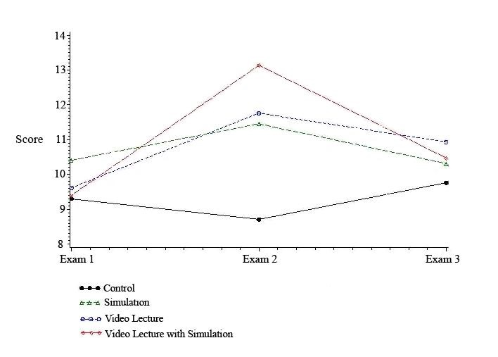
We performed a univariate analysis to determine any association between the outcome variables and the above mentioned covariates. Data for years of employment, years of medical education, and specialty were skewed and unreliable and were not used for any analyses. Teaching method, cognition level, professional program, gender, years of schooling, age, and any prior exposure to cardiac arrest resuscitation allowed for analyses of the responses.
None of the associations between the differences in exam scores (baseline knowledge Exam #1, immediate knowledge gain Exam #2 and long-term knowledge gain/loss with retention Exam #3) and the demographic covariates were statistically significant, except for teaching method (Table 2). Teaching method was the only significant variable for differences in Exam #2 and Exam #1 (Diff 2,1; p=0.0001) and differences in Exam #3 and Exam #2 (Diff 3,2; p=0.001). No statistically significant differences were found in scores on the difference between scores on Exam #3 and Exam #1 (Diff 3,1). Of note, professional program was significant (p=0.02) for the difference between scores on Exams #3 and #2 (Table 2).
Table 2: Univariate Analysis between Mean Exam Score Differences and Covariates
Covariates | Difference in Exam #1, #2, and #3 Results
 | Difference 2,1  Knowledge Gain | Difference 3,1  Knowledge Gain/Loss; Retention | Difference 3,2  Knowledge Retention
Teaching Method | <0.0001 | 0.40 | 0.001
Cognition Level | 0.84 | 0.73 | 0.23
Profession | 0.23 | 0.40 | 0.02
Gender | 0.63 | 0.73 | 0.16
Years Schooling | 0.72 | 0.84 | 0.35
Age | 0.83 | 0.32 | 0.60
Arrest Exposure | 0.50 | 0.95 | 0.30
Table 3 showed that there was immediate knowledge gain for all teaching methods except for the control group. In order to understand the effect of individual teaching methods, each intervention was analyzed separately. The Video-Lecture intervention showed a positive difference between scores on Exams #2 and #1 (2.1±2.4). Exposure to Simulation alone also showed a positive difference: however, the difference was not as large (1.0±2.2). The combination of Video-Lecture with Simulation showed the largest positive difference: this difference was more than additive for the Video-Lecture alone and Simulation alone (3.7±2.4 versus predicted value of 3.1±2.3, Table 3). The correlations and statistical significance results for the teaching methods are as follows: Control, r(1)=0.04, p=0.09; Video-Lecture, r(1)=(-)0.09, p=0.7; Simulation, r(1)=0.25, p=0.3; and Video-Lecture with Simulation, r(1)=0.4, p=0.05. The only teaching method with a positive correlation and borderline significance was Video-Lecture with Simulation.
Table 3: Differences in Exam Mean Scores as a Function of Teaching Method

Teaching Method | Exam #1, #2, and #3 Differences (±SD); p-Value
 | Difference 2,1  Knowledge Gain | Difference 3,1  Knowledge Gain/Loss;  Retention | Difference 3,2  Knowledge Retention
Control | (-)0.7±2.4  p=0.18 | 0.2±2.7  p=0.72 | 0.9±2.3  p=0.15
Video Lecture | 2.1±2.4  p=0.0005 | 1.2±3.5  p=0.20 | (-)1.0±3.7  p=0.31
Simulation | 1.0±2.2  p=0.04 | (-)0.56±3.8  p=0.56 | (-)1.4±3.1  p=0.08
Video-Lecture with Simulation | 3.7±2.4  P<0.0001 | 0.9±2.3  p=0.12 | (-)3.5±1.7  P<0.0001
Means ± SD | 1.6±2.8 | 0.4±3.1 | (-)1.3±3.1

The results were positive for the difference of mean scores of Exams #3 and Exam #1 across all group interventions (0.4±3.1) suggesting that all students gained immediate knowledge when compared with baseline knowledge across all teaching interventions (Table 3). Each intervention was analyzed separately to determine its significance. The Video-Lecture intervention had a positive difference between scores on Exams #3 and #1 (1.2±3.5), followed closely by Video-Lecture with Simulation (0.94±2.3). Simulation alone showed a negative difference at (-)0.6±3.8. The combination of Video-Lecture with Simulation showed a positive difference, and the difference was more than additive for the Video-Lecture with Simulation alone (0.94±2.3 versus a predicted value of 0.6±3.7) suggesting more knowledge retention with the combination of Video-Lecture with Simulation when compared with baseline.
Finally, there was a negative difference [(-)1.3±3.1] between the results of the mean values obtained from the difference of scores on Exams #3 and #2 across all group interventions indicating a loss of knowledge relative to the immediate knowledge gained (Table 3). Each intervention was analyzed separately to determine which contributed the most to this negative difference. Video-Lecture with Simulation showed the largest negative difference between Exams #3 and #2 [(-)3.5±1.7], followed by Simulation alone [(-)1.4±3.1] and Video-Lecture alone [(-)1.0±3.7]. The combination of Video-Lecture with Simulation showed a greater negative difference than the anticipated addition of both teaching methods alone [(-)3.5±1.7 instead of the predictive additive value of (-)2.4±3.4)], implying greater loss of knowledge when compared to immediate knowledge gained.
Univariate analysis of the comparison between student’s professional program and the differences in exam scores show that comparison of Long-Term Knowledge Gain/Loss with Retention Exam #3 scores with Pre-Intervention Baseline Knowledge Exam #1 for nursing students (p=0.007) and medical students (p<0.001) were statistically significant, while the Immediate Post-Intervention Knowledge Gain Exam #2 scores were not. The Immediate Post-Intervention Knowledge Gain Exam #2 and the Long-Term Knowledge Gain/Loss with Retention Exam #3 results were compared to the Pre-Intervention Baseline Knowledge Exam #1: these differences were not statistically significant. The difference between Long-Term Knowledge Gain/Loss with Retention Exam #3 scores when compared to Immediate Post-Intervention Knowledge Gain Exam #2 scores was statistically significant (p<0.02).
Analyses of the results of Long-Term Knowledge Gain/Loss with Retention Exam #3 and cognition levels showed that Simulation (r(1)=0.3, p=0.05) and Video-Lecture with Simulation (r(1)=0.25, p=0.3) were slightly positive for both and for statistically significant for Simulation and not statistically significant for Video-Lecture with Simulation. For Video-Lecture, the correlation was slightly positive and borderline statistically significant (r(1)=0.5, p=0.05). The cognition level for Exam #3 was strongly correlated and statistically significant for Control (r(1)=0.75, p=0.0006).
Ninety-eight percent of nursing students and 100% of medical students answered the question on gender. There was a statistically significant difference for each gender for scores on the Pre-Intervention Baseline Knowledge Exam #1 (p=0.008) which disappeared when adjusted for profession. The Long-Term Knowledge Gain/Loss with Retention Exam #3 (p=0.001) was significant for gender but disappeared when adjusted for profession. There were more male medical students and more female nursing students; so, the difference noted is due to profession (nursing versus medical) rather than gender. There was no difference between genders for scores on Immediate Post-Intervention Knowledge Gain Exam #2 (p=0.1). Within gender, the difference between scores on Immediate Post-Intervention Knowledge Gain Exam #2 and Pre-Intervention Baseline Knowledge Exam #1 (Difference Exam #2 – Exam #1) was statistically significant for both females (p=0.0001) and males (p=0.01), suggesting immediate knowledge gained for both genders after an intervention. The difference between scores on Long-Term Knowledge Gain/Loss with Retention Exam #3 and Immediate Post-Intervention Knowledge Gain Exam #2 (Difference between Exam #3 – Exam #2) was statistically significant only for females (p=0.002) suggesting decreased long-term knowledge retention when compared to knowledge gained after an intervention. The mean age for nursing students was 23.1 years and the mean age for medical students was 25.8 years (p=0.005).
- Multivariate Analysis
A multivariate analysis of the comparison of the differences of three individual Neonatal Resuscitation Program (NRP) questionnaire scores was statistically significant for knowledge gain (the difference between Exam #2 and Exam #1) at p<0.0001 and knowledge retention (the difference between Exam #3 and Exam #2) for the covariate teaching method only (Table 4). Professional program was only borderline statistically significant at p=0.06.

Table 4: Multivariate Analysis between Mean Exam Score Differences and Covariates
Covariates | Difference in Exam #1, #2, and #3 Results
 | Difference 2,1  Knowledge Gain | Difference 3,1  Knowledge Gain/Loss;  Retention | Difference 3,2  Knowledge Retention
Teaching Method | <0.0001 | 0.70 | 0.001
Cognition Level | 0.80 | 0.94 | 0.86
Profession | 0.12 | 0.50 | 0.06
Gender | 0.80 | 0.81 | 0.83
Years Schooling | 0.90 | 0.38 | 0.13
Age | 0.80 | 0.35 | 0.45
Arrest Exposure | 0.42 | 0.91 | 0.76

Data from this study were compared to prior cognition level data from this same cohort of students (personal communication, manuscript about to be submitted for publication). Analyses showed that Video-Lecture, Simulation, or a combination of Video-Lecture with Simulation is correlated with Concrete Operational, Transitional, or Formal Operational thinking. Pre-Intervention Baseline Knowledge Exam #1 results and cognition levels showed a positive correlation, and were statistically significant among both professions, r(3)=0.38, p=0.0003. When separated by profession, there is a slight correlation with no statistical significance for medical students’ results, r(3)=0.12, p=0.43. Nursing students’ results show a strong correlation and statistical significance, r(3)=0.37, p=0.01. After the intervention was applied, there was a weak positive correlation between the scores on the Immediate Post-Intervention Knowledge Gain Exam #2 and cognition levels for all students, r(3)=0.19, p=0.07. This correlation was not statistically significant.
In order to evaluate long-term retention, the results of the Long-Term Knowledge Gain/Loss with Retention Exam #3 and cognition levels were analyzed and showed a strong statistically significant positive correlation (r(3)=0.41, p=0.0007), regardless of which teaching method the student received. Finally, each group was analyzed by cognition level, in order to understand if cognition level was a contributing factor once group assignments were made. No statistically significant differences were noted. Differences in exam scores as a function of cognition levels were not statistically significant. Lastly, analysis of differences between the means of the exams for each professional program and between each medical school class did not yield any statistical significance.
Discussion and Conclusions:

Studies on the effectiveness of simulation in health care education are beginning to appear in the literature. These studies provide information comparing standard lecture hall presentations vs. learning in simulation centers. However, few researchers have compared more than one intervention at a time, and even fewer address long-term knowledge retention. Our study compared learning and knowledge formation obtained from standard lectures to learning and knowledge formation acquired from simulation training. We compared the results of each of these two separate learning modalities to results acquired from a consecutively administered combination of video-lecture and simulation training.
The data obtained in this research study could either be presented as exam results (Exam #1, #2 and #3) or the difference in exam scores (Diff 2,1, Diff 3,1, and Diff 3,2). We chose to represent our data as differences rather than individual exam results; but, the data analyses and interpretation are almost the same.
As shown in Table 1, all of the demographics and baseline characteristics were balanced across the four intervention groups, allowing us to start our study with no statistical differences among students assigned to teaching methods. The demographic variables years of employment, years of medical education and specialty had skewed data and were not used for any analyses. Teaching method assignment, cognition level, professional program, gender, years of schooling, age, and any prior exposure to cardiac arrest resuscitation responses were allowed as covariates for analyses. Exam #1 results showed no statistical differences among all students in teaching method assignments (Table 1).
Differences between the scores on the Immediate Post-Intervention Knowledge Gain Exam #2 and the Pre-Intervention Baseline Knowledge Exam #1 [difference of Exam #2 – Exam #1 results] were statistically significant for both nursing students (p=0.0002) and medical students (p=0.002). Differences between scores on the Long-Term Knowledge Gain/Loss with Retention Exam and the Pre-Intervention Baseline Knowledge Exam [difference of Exam #3-Exam #1 results] were not statistically significant for either group. Finally, differences in scores between the Long-Term Knowledge Gain/Loss with Retention Exam #3 and the Immediate Post-Intervention Knowledge Gain Exam #2 [difference of Exam #3-Exam #2 results] were statistically significant for nursing students (p<0.0001), but not for medical students.
In univariate analyses between mean exam score differences and each covariate, only the teaching method intervention was shown to be statistically significant. Teaching method had 1) an effect on immediate knowledge gained when compared to baseline knowledge [Difference 2,1, p<0.0001], 2) an effect on long-term knowledge gain/loss with retention when compared to immediate knowledge gained after an intervention [Difference 3,2, p=0.001], and 3) no effect on long-term knowledge gain/loss with retention when compared to baseline knowledge [Difference 3,1, p=0.40]. Except for profession, none of other covariates were statistically significant for the difference of Exam #3 and #2 (p=0.02) implying loss of long-term knowledge retention when compared to immediate post-intervention knowledge gained.
We next looked to see how within professional factors affected our results. Female students had a statistically significant immediate knowledge gain when compared to all female students, but also lost some of that knowledge two to three months following the interventions. Similarly, male students had a statistically significant immediate knowledge gain when compared to other male students, and retained more of that information a few months following interventions. Overall, nursing and medical student groups had significant variability before beginning this study, male students had more baseline knowledge and retained more knowledge after interventions. When comparing the differences in scores on Exams #2 and #1, there was a statistically significant difference within nursing students (p<0.0002), within medical students (p=0.002) and between profession for the difference in scores on Exams #3 and #2 (p=0.02). This suggests variability in the immediate knowledge gained and long-term knowledge gain/loss with retention among these two professional groups. Negative scores on the difference between Exams #3 and #2 were also statistically significant (p<0.0001) for long-term knowledge gain/loss with retention, but only among nursing students. This suggests that nursing students retain less long-term knowledge two to three months after an intervention than do medical students. However, most females in this study were younger nursing students with fewer years of schooling than their medical student counterparts. Therefore, age, years of schooling, years of medical exposure, and professional program may be responsible for the difference rather than gender alone. The fewer medical students who were older and further along in their preferred professional career and the larger number of younger female nursing students may have resulted in an unequal gender distribution among our cohort and have affected our statistically significant professional covariate finding mentioned above.
Table 3 shows the positive difference (1.6±2.8) between the mean values of results obtained from the difference of scores on Immediate Post-Intervention Knowledge Gain Exam #2 and the Pre-Intervention Baseline Knowledge Exam #1, suggesting immediate knowledge gains across all teaching methods. In order to understand the effect of teaching methodintervention, each teaching method intervention was analyzed separately. The combined intervention of Video-Lecture with Simulation was the best for immediate knowledge gain, with a positive difference in scores (3.7±2.4) between Exams #2 and #1. Of note, participants receiving the Video-Lecture with Simulation interventions were exposed to information for about twice as long as students in the Video-Lecture alone and Simulation alone teaching methods. Therefore, the amount of knowledge acquisition time may have been a contributing factor. The Video-Lecture intervention alone produced the next highest difference between scores on Exams #2 and #1, suggesting it as the next best teaching method intervention.
The positive difference (0.44±3.1) of the mean value results obtained from the difference of Long-Term Knowledge Gain/Loss with Retention Exam #3 and Pre-Intervention Baseline Knowledge Exam #1 across all group interventions suggests that all interventions had a positive impact on long-term knowledge retention. As each group intervention was analyzed separately, Video-Lecture alone had the most positive difference between Exam #3 and Exam #1 (1.2±3.5), followed closely by Video-Lecture with Simulation (0.94±2.3). Both Video-Lecture alone and Video-Lecture with Simulation teaching methods resulted in long-term knowledge retention. However, Simulation alone resulted in the least amount of long-term retention, with a negative difference at (-)0.6±3.8.
The negative difference from the mean value results obtained from the difference of Long-Term Knowledge Gain/Loss with Retention Exam #3 and Immediate Post-Intervention Knowledge Gain Exam #2 [(-)1.3±3.1] across all group interventions suggests that there is a loss of knowledge two to three months after training, regardless of teaching method. When each group intervention was analyzed separately, the intervention Video-Lecture with Simulation showed the largest negative difference between scores on Exams #3 and #2 [(-)3.5±1.7], followed by Simulation alone [(-)1.4±3.1] suggesting that there is greater long-term knowledge loss with Simulation exposure than when students are exposed to Video-Lecture. The results show that knowledge was lost from Exam #2 to Exam #3 among all group interventions, with borderline statistically significant knowledge loss for the Video-Lecture with Simulation intervention. Video-Lecture with Simulation is not as effective as Video-Lecture alone or Simulation alone as a teaching intervention for long-term knowledge gain with retention.
We compared our data with prior cognition study results obtained from this same cohort of students. Analysis showed that there is a statistically significant difference in scores on Exams #1 and #3 for concrete operational, low transitional, high transitional, and formal operational thinkers. Among these cognition levels, the difference in all three exam scores remained statistically significant only for high transitional thinkers (p=0.004) followed closely by low transitional thinkers. In multivariate analysis, cognition level was not statistically significant. After the intervention was applied, there was a weak positive non-significant correlation between the scores on Immediate Post-Intervention Knowledge Gain Exam #2 and cognition levels for all students (r(1)=0.19, p=0.07). Therefore, there is an effect of the teaching methods administered to the students: that is, a change occurs in correlation and statistical significance when comparing the results of Exam #1 and cognition levels and Exam #2 and cognition levels.
Medical health education continues to advance through technology by the use of evolving digital computer innovations, which allow us to share in global knowledge. Perhaps the future of health care education is global Massive Open Online Courses (MOOC) or a high-quality online educational content course made available to the international health care community. These are not online lecture courses, but provide a forum to communicate an understanding, make connections, and exchange ideas by interacting with others in discussions which may form the basis of the future of education.¹⁷ Skype is one example. Both MOOCs and simulations may lead medical health education in the years to come.
The limitations of the study are many. We found an increase in knowledge gain when comparing the difference in scores between Exams #2 and #1. We attributed the difference to the group intervention of Video-Lecture with Simulation. However, students experiencing Video-Lecture with Simulation were exposed to new information for about twice as long as students in the other two group interventions alone. We cannot rule out the importance of the longer time of information exposure as a contributing factor, were unable to control for this exposure and were cognizant of this issue at the time of study design. Second, students performed well on exams after the Video-Lecture intervention (or when Video-Lecture preceded Simulation), but did not perform well after the Simulation intervention. We acknowledge that the exams had been standardized for the Video-Lecture, but not for the Simulation part of the study. This may be a contributing factor due to the differences in intervention followed by standardized exams. Third, recruitment of medical students was difficult and cumbersome. This may have caused a bias from recruiting a select subset of medical students that were willing to participate: these students may not represent the typical student in their medical school class. Finally, we acknowledge that the information obtained about immediate knowledge retention is probably real. But, we caution the application of the long-term knowledge retention results to the “real world”. Students may not have had an interest in remembering something for an exam three months from now, may not have reviewed the material as they would in the real world, and, once exposed to specific material, may have decided that they did not want to retain that information.
In conclusion, we acknowledge that the large number of young female nursing students with fewer years of education and medical exposure may have created an unequal professional distribution among our student cohort. We conclude that teaching method had an impact on immediate knowledge gain, but not on long-term knowledge gain/loss with retention. Video-Lecture with Simulation was statistically significant for immediate knowledge gain when compared to baseline knowledge. Video-Lecture alone was best for long-term knowledge gain/loss with retention when compared to baseline knowledge. Long-term knowledge gain/loss with retention when compared to immediate knowledge gain after an intervention was best preserved with Video-Lecture. In multivariate covariate analyses, after controlling for the effects of all of the other variables, only teaching method yielded a statistically significant difference, implying that teaching method influences immediate knowledge gain. Future research with larger databases, as well as different groups of health care students, may help to solidify that teaching method is important. Specifically, further research may show that simulation intervention may not be as a potent teaching tool for immediate knowledge gain and long-term knowledge gain with retention as recent articles claim.
Acknowledgements:

References:

- Flexner A. Medical education in the United States and Canada. A Report to the Carnegie Foundation for the Advancement of Teaching. Bulletin Number Four. New York City. 1910.

- Cooke M, Irby DM, Sullivan W, Ludmerer KM. American medical education 100 years after the Flexner Report. New England Journal of Medicine. 2006;355(13):1339-1344. Available online at: http://content.nejm.org/cgi/reprint/355/13/1339.pdf.

- Ramsey PG, Miller ED. A Single mission for academic medicine. Improving Health. Journal of the American Medical Association. 2009; 301(145):1475-1576. Available online at: http://jama.ama-assn.org/cgi/content/full/310/14/1475.

- de Armendi, AJ, Marek, EA. Pedagogical Shifts in Medical Health Education. Creative Education. 2013; Vol. 4, No. 6A, 20-22. Available online at: http://www.script.org/journal/ce.

- http://www.acgme.org/acgmeweb/ Portals/0/PDFs/ACGME-2011_AR_F.pdf.

- Institute of Medicine. Initial National Priorities for Comparative Effectiveness Research. (Washington DC: The National Academies Press, 2009). http://www.iom.edu/cerpriorities.

- http://www.nap.edu/catalog.php?record_id=10073

- Institute of Medicine. Crossing the Quality Chasm: A New Health System for the 21st Century. (Washington DC: The National Academies Press, 2001).

- ABIM Foundation, American Board of Internal Medicine, ACP-ASIM Foundation, American College of Physicians-American Society of Internal Medicine, European Federation of Internal Medicine. Medical professionalism in the new millennium; A Physician Charter. Ann Intern Med. 2002;136(3):243-246.

- Brannick MT, Fabri PJ, et al. Evaluation of an error-reduction training program for surgical residents. Academic Medicine, 2009; 84(12):1809-1814.

- Agency for Health Care Research Quality. TeamSTEPPS: National Implementation. Available online at: http://teamstepps.ahrq.gov/index.htm.

- Gurusamy K, Aggarwal R, Palanivelu L, Davidson BR. Systematic review of randomized controlled trials on the effectiveness of virtual reality training for laparoscopic surgery. Br J Surg. 2008;95(9):1088-1097. Available online at: Wiley InterScience (www.bjs.co.uk). DOI: 10.1002/bjs.6344.

- Ma IW, Brindle ME, Ronksley PE, Lorenzetti DL, Sauve RS, Ghali WA. Use of simulation-based education to improve outcomes of central venous catheterization: A systematic review and meta-analysis. Acad Med. 2011;86:1137–1147.

- Cook DA, Hatala R, Brydges R, Zendejas B, Szostek JH, Wang AT, Erwin PJ, Hamstra SJ. Technology-enhanced simulation for health professions education: A systematic review and meta-analysis. JAMA. 2011;306(9):978-988.

- Curran VR, Aziz K, O'Young S, Bessell C. Evaluation of the effect of a computerized training simulator (ANAKIN) on the retention of neonatal resuscitation skills. Teach Learn Med. 2004;16(2):157-64.

- Kim JH, Kim WO, Min KT, Yang JY, Nam YT, Kim JH, et al. Learning by computer simulation does not lead to better test performance than textbook study in the diagnosis and treatment of dysrhythmias. Journal of Clinical Anesthesia. 2002;14(5):395-400.

- Faust D. The future of education: the view from mast hall. Harvard Magazine. March-April 2013. Page 63.

Appendix 1: Email Sample

Dear Nursing Students:
Dear Medical Students:
You are invited to participate in a study that we are conducting called The Evaluation of Lecture, Simulation or Both (Lecture and Simulation) in Nursing and Medical Students for Immediate and Long Term Knowledge Retention and Its Relation to Cognition Level as Measured by the Classroom Test of Scientific Reasoning. Our goal is to categorize cognition level and to understand which educational learning method is best [video-lecture, simulation, or both (video-lecture with simulation)] for immediate knowledge gain and long-term knowledge retention, and to evaluate if a correlation exists between cognition levels and learning methods.
Once we have obtained IRB approval, you will be asked to sign an Informed Consent, and you will be asked to fill out a questionnaire of general demographic information.
Immediately afterwards, you will be asked to take a Pre-Intervention Baseline Knowledge Exam #1, which will serve as our measure of neonatal resuscitation baseline knowledge.
Then, you will be separated into one of the following four teaching methods: 1) Twenty-five percent will not receive any teaching method and will serve as controls, 2) Twenty-five percent will watch a video-lecture, 3) Twenty-five percent will participate in simulation training, and 4) Twenty-five percent will watch both the video-lecture and participate in simulation training.
After the teaching method intervention, you will be asked to take the Immediate Post-Intervention Knowledge Gain Exam #2, which will serve as a measure of initial knowledge gained.
Two-to-three months later, you will be asked to take a third and final exam, which should reveal long-term knowledge gain/loss with retention (Long-Term Knowledge Gain/Loss with Retention Exam #3).
Thank you for your time and interest in being part of this study.

Appendix 2: Demographic Information

1. Type of medical education/training (please circle one): MS RN MD

2. Gender (circle one): F M

3. Age: __________Years

4. Total years of schooling: __________Years

5. Total years of work: __________Years

6. Total years of medical education/training: __________Years

7. Specialty/Training (if applicable)? _______________

8. Have you had any prior exposure, didactic or clinical exposure, to:
ACLS (Advanced Cardiac Life Support),
NRP (Neonatal Resuscitation Program),
PALS (Pediatric Advanced Life Support),
or any clinical management of cardiac arrest? (circle one) Yes No

Appendix 3: Neonatal Resuscitation Program Questionnaire

With permission to do the present research, the Neonatal Resuscitation Program (NRP) Examination version 5 and answers were obtained from the NRP Association headquarters office (www2.aap.orp/nrp).
NRP questions and answers are not included in this manuscript, since these questions may be part of present/future exams administered by the NRP Association. All 94 NRP questions have been validated by NRP headquarters. A total of 45 questions were taken from the main NRP exam as representative questions with material which could be covered in both a video-lecture format, as well as a simulation format. For example, questions with material referencing the intubation of the trachea of a patient were included, since the material for tracheal intubation could be shown within a lecture-video, as well as with simulation experience. Questions that dealt with pharmacology drugs and dosages were not included, since the information would be didactic and not easily addressed in a simulation scenario. All 90 questions were randomized by a computer program, SAS PROC SURVEYSELECT, to draw a random sample of 32 questions which were used for the Pre-Intervention Baseline Knowledge Exam #1. A second randomization sample from the remaining 62 questions (94-32 = 62) that were not selected for the Pre-Intervention Baseline Knowledge Exam #1 was used to draw a second sample of 32 questions for the Immediate Post-Intervention Knowledge Gain Exam #2. This two-step process left 30 questions that were administered as Long-Term Knowledge Gain/Loss with Retention Exam #3.
A group of 15 questions were taken from each of these three computer-randomized sets of questions. These 45 questions contained material which could easily be covered/presented in a video-lecture and simulation format.
In order to be sure that students were not just marking any answer in the exam, control “trap questions” were imbedded in each of the three NRP questionnaires (Appendix 4, Trap Questions). The trap questions are simple questions that any first year nursing or medical student should be able to answer. For example, the administered control trap questions with answers in capitals below were: “the study of body normal systems is called PHYSIOLOGY,” “the study of human parts is called ANATOMY,” and “studying with the aid of mannequins and computers could be done in laboratories having SIMULATORS.” Each trap question is multiple-choice. Higher scores will give more weight to the exam results and lower scores will give less weight to the exams. The control trap questions were added as numbers 4, 8, and 12 on all three exams. During statistical analysis, the weighted variable responses to these three questions (one for each questionnaire) validated the student’s answers and allowed the inclusion of the participant’s specific questionnaire answers in the final analysis.
Since the lecture could be affected by the presenter or be material-presenter-personality-enthusiasm-biased, the lecture was presented by a video. In this way, each student sees and hears the same lecture delivered in the same manner. Similarly, since the material presented in the video-lecture could theoretically be different from the material presented in the simulation presentation, all of the information presented in the video-lecture was written down verbatim. From this information, a cheat sheet was made of the material that needed to be presented in the simulation (Appendix 5, Cheat Sheet Material for Simulation Presentation). In this way, the material presented in both the video-lecture and the simulation presentation was context neutral. Finally, the video-lecture and the simulation presentation were timed so that both presentations were the same duration, and neither teaching method would involve a longer period of time that could affect acquisition and retention of knowledge. However, by necessity, participants in video-lecture with simulation had a longer period of exposure to the educational material. Any difference in the group findings that could be due to the longer period of information exposure will be addressed in the discussion.

Appendix 4: Trap Questions
Three control trap questions were embedded in each of the three NRP questionnaires.
Question 4: Pre-Intervention Baseline Knowledge Exam #1
The study of body normal systems is called:
- Methodology
- Neurology
- Physiology
- Pharmacology
Question 8: Immediate Post-Intervention Knowledge Gain Exam #2
The study of human parts is called:
- Measurements
- Anatomy
- Cellular Anatomy
- Biochemistry
Question 12: Long-Term Knowledge Gain/Loss with Retention Exam #3
Studying with mannequins/computers in the laboratory could be done with:
- Simulators
- Microscope
- Histology
- Introduction to Medicine
Appendix 5: Cheat Sheet Material for Simulation Presentation

- Equipment
- Self-Inflating Bag
  - Always refills after bag squeeze
  - Self inflates without seal
  - Does not reliably deliver oxygen (need to squeeze bag)
  - Show oxygen inlet
  - Show oxygen reservoir
  - Show appliance over air inlet
  - Show how gas collects, prevents oxygen dilution with room air
  - Show air inlet
  - Show pressure gauge attachment site
  - Show Pressure Release Valve (Pop-Off Valve)
  - Occlusion allows increased pressure
  - Show valve assembly
  - Show patient outlet
- Flow Inflating Bag
  - Collapses when not in use
  - Inflates with gas source, usually oxygen
  - Needs/requires good seal
  - Requires sufficient gas source to inflate
  - Usually without pop-off valve
  - Flow Control Valve (Flow Inflating Valve, FIV)
  - Desired CPAP/PEEP controlled by flow inflating valve
  - If over-inflated, can over-inflate/distend the baby’s lung
  - If under-inflated cannot achieve desired pressure (check for bag tears, FIV open)
  - Takes practice to know how to work with the flow control valve
  - With manometer, can set to handle easily
  - Show oxygen inlet
  - Can deliver 21%-100% depending on source
  - Allows easy adequacy of face-mask seal
  - Can deliver free-flow oxygen
  - Check for disconnection/occlusion
  - Pressure manometer attachment site (needs to be connected)
  - Patient outlet
- T-Piece Resuscitator
  - Oxygen inlet, connect
  - Consistent pressure
  - Lung compliance cannot be felt
  - Reliable 100% oxygen delivery (when required)
  - Patient t-piece with PEEP cap
  - Circuit pressure gauge
  - Maximum pressure relief control
  - Inspiratory pressure control
  - Pressure limited
  - Requires compressed gas source (before to set pressure prior to use)
  - Flow-controlled
  - Pressure limited
  - PIP and PEEP are set manually, reliable
  - Changing pressure while use is hard
  - Minimally operator fatigue
  - Show patient outlet
  - Identify gas supply line
  - Adjust flow-meter (recommended 5-15 l/min)
  - Set maximum pressure; show two pictures
  - Occlude PEEP cap with finger
  - Adjust maximum pressure relief valve to 40 cm H₂O
- Air Blender
  - When less than 100% FiO₂ is needed
- Pulse Oximeter
  - O₂ binds hemoglobin making it bright red
  - Measures change in color
  - Readings 0%-100%
  - Preductal SpO₂
    - 1 minute = 60%-65%
    - 5 minute = 80%-85%
    - 10 minute = 85%-95%
- Endotracheal Tube Stylet
  - Secure in the ETT
  - Tip should not protrude
- Laryngoscope and Blade
  - Select blade (preterm = size 0, term = size 1)
  - Check light
- EtCO₂ Detector
  - Attach to ETT
  - Watch color change (purple to yellow)
  - Yellow! “Yes for gold.” ETT is in the trachea

        - Resuscitation
- ABCs of Resuscitation
  - Airway
  - Breathing
  - Circulation
- Four Initial Questions
  - Is baby term?
  - Amniotic fluid clear?
  - Baby breathing/crying?
  - Good muscle tone?
- Continuous Assessment
  - Respirations
  - Heart rate
  - Oxygenation
    - Color
    - Pulse oximeter
- Most Important Step
  - Ventilation
- Initial Resuscitation (first 30 seconds)
  - Drying
    - Warm dry towels (provides stimulation)
  - Rubbing/slapping/tactile stimulation
    - Rubbing gently newborn’s back, trunk, or extremities
    - Slapping/flicking soles of feet
  - Mouth/tracheal suctioning
    - Suction mouth to reduce possible aspiration
    - Mouth before nose (M before N)
- Primary Apnea
  - Stimulation
    - Drying baby
    - Rubbing back
    - Slapping feet
  - All above leads to resumption of breathing in primary apnea
- Secondary Apnea
  - Stimulation does not help in secondary apnea
  - Assisted ventilation needed (Positive Pressure Ventilation, PPV)
- Heart Rate (Pulse)
  - Should be > 100 bpm
  - Feel pulse at base of umbilical cord
    - Count beats for 6 seconds x 10 = bpm
  - Rising heart rate - most successful indicator of successful resuscitation
    - When PPV is initiated, HR is assessed first
- Gasping
  - Series of deep single or stacked inspirations with hypoxia or ischemia
  - Can be indicative of severe neurological and respiratory depression
- Positive Pressure Ventilation
  - Gas is forced in oropharynx (can enter both trachea and esophagus)
  - Gas in stomach interferes with ventilation
    - Upward pressure on the diaphragm
    - Limits lung expansion
    - Increases regurgitation potential
- Oxygen Delivery
  - FiO₂ determined by O₂ arriving to patient
- Indications for PPV
  - Apnea/gasping/labored breathing
  - HR < 100 bpm
  - Low O₂ saturations (hypoxemia) despite supplemental oxygen
- Neck Extension
  - Slightly extended (sniffing position)
- Mask Application
  - Airtight seal
- Mask Air Leak
  - Leads to inadequate air entry (poor chest movement)
  - If hear/feel air escaping, reapply mask for better seal
  - Most common leak (cheeks and nose bridge)
- Oxygen Blow-By (Free-Flow O₂)
  - Use flow-inflating bag
  - T-piece resuscitator
  - No mask, funnel or cup hand
- Choanal Atresia
  - Congenital obstruction of nasal airway
  - Baby cannot breathe except when crying
  - Relieve symptoms:
    - Suction nares (diagnosis)
    - PPV
    - Oral airway

        - Clinical
- Chest Compressions
  - Compress sternum
  - Compresses heart
  - Increases intrathoracic pressure to push blood out into arteries
- Two-Thumbs Wrap Compressions
  - Two-thumbs depress sternum
  - Hands encircle torso
  - Fingers support spine
  - Preferred technique
- 1 and 2 and 3 and Breathe
- Compressor counts (1and 2 and 3 and “Breathe”)
  - One ventilation every three compressions
  - 90 compressions/min and 30 breaths/min
- Person ventilating
  - Squeezes during “Breathe”
  - Relaxes on “One ….”
  - Must be coordinated
- Endotracheal Intubation
  - Indications
    - Meconium
    - Depressed respirations
    - Depressed heart rate
    - Depressed muscle tone
    - If PPV is ineffective (no clinical improvement, no good chest rise)
    - If PPV is needed for longer than a few minutes
- Head Stabilization
  - Stabilize head with right hand (laryngoscope with left hand)
  - Administer free-flow oxygen
- Neck Extension
  - Slightly extended (sniffing position)
- Laryngoscopy (midline with Miller blades)
  - Insert blade
  - Raise entire blade (no rocking motion)
  - Esophagus (if too deep/far in)
  - Pull back to epiglottis
  - Vocal cords come into view underneath epiglottis
- Preterm Infant
  - Most likely will require resuscitation (support personnel)
  - Risk heat loss (delivery room 26ºC, radiant warmer, exothermic pad, plastic bag)
  - Risk intracranial bleeding
  - Risk lung injury
  - Risk hypoxemic injury
    - Pulse oximeter
    - O₂ blender (adjust 21% - 100%)
- Outside the Delivery Room
  - Temperature control (skin-to-skin with mother)
  - Clear airway (bulb syringe, handkerchief over index finger)
  - Ventilation
  - Chest compressions
- Monitoring after Resuscitation
  - Oxygenation
  - Blood pressure
  - Blood glucose
  - Temperature
  - Fluid status
  - Respiratory effort
  - Nutritional issues

Appendix 6: Diagram of Research

Cognition Level: Classroom Test of Scientific Reasoning

Twenty-five percent of the students will be assigned to each group.
CTSR CTSR CTSR TCSR

Pre-Intervention Baseline Knowledge Exam #1
Pre-intervention exam results obtained as baseline knowledge.

No Intervention Video-Lecture Simulation Video-Lecture
(Control) with Simulation

Immediate Post-Intervention Knowledge Gain Exam #2
Post-intervention exam results after:
1) no intervention/control, 2) video-lecture, 3) simulation, and
4) video-lecture with simulation to determine immediate knowledge gain.

Long-Term Knowledge Gain/Loss with Retention Exam #3

Two-three months after the post-intervention exam elicits long-term knowledge gain/loss with or without retention.

APPENDICES

These appendices are being presented in a chronological manner as the study materialized from beginning to end and as the students were exposed to the study.

Appendix A: Approved Prospectus

Appendix B: Classroom Test Scientific Reasoning, Neonatal Resuscitation, Simulation

Protocol

Appendix C: Consent Form

Appendix D: Internal Review Board for the Protection on Human Subjects Letters

Appendix E: Education & Fun with Neonates

Nursing and Medical Students Presentation

Appendix F: Classroom Test of Scientific Reasoning Multiple Choice Exam and

Classroom Test of Scientific Reasoning Answer Sheet

Appendix G: Classroom Test of Scientific Reasoning Rubric

Appendix H: Student Group Research Randomizer Results

Appendix I: Neonatal Resuscitation Program Lecture Presentation

Appendix J: Simulation Cheat Sheet Presentation

Appendix K: Neonatal Resuscitation Program Exam Question Randomization Results

Appendix L: Neonatal Resuscitation Program Exam 1 and Answer Sheet

Appendix M: Neonatal Resuscitation Program Exam 2 and Answer Sheet

Appendix N: Neonatal Resuscitation Program Exam 3 and Answer Sheet

Appendix O: Sample Size Determination/Calculation

Appendix P: SAS System Data Analysis for CTSR Rubric and Classification
Appendix Q: SAS System Data Analysis NRP Examinations and CTSR Correlations

Appendix R: Thesis Dissertation Defense Presentation

Appendix S: Disk. Education & Fun with Neonates

Nursing and Medical Student Presentation

Appendix T: Disk. Newborn Resuscitation Program Lecture Presentation

Appendix U: Disk. Thesis Dissertation Defense Presentation

Appendix V: Disk. Thesis Dissertation

Appendix W: USB Drive. Education & Fun with Neonates

Nursing and Medical Student Presentation

Appendix X: USB Drive. Newborn Resuscitation Program Lecture Presentation

Appendix Y: USB Drive. Thesis Dissertation Defense Presentation

Appendix Z: USB Drive. Thesis Dissertation

Thank You!

Appendix A

Approved Prospectus

Appendix A is the prospectus that was presented to the Dissertation Committee and approved in the spring 2011 semester.

Approved Prospectus

ABSTRACT

Educators work on the assumption that all medical students, nurses, residents and other health care allied professionals are at the same maturity and cognitive level. However, searches in PubMed, Ovid, and Google, reveal that there are no data to support that all of these healthcare students are at the same intellectual level for their given field of study. Anesthesia residents examined in a pilot study using the Test of Logical Thinking (TOLT) while rotating for one month in the Division of Pediatric Anesthesia at the Oklahoma University Health Sciences Center showed that these residents were not all at the same presumed formal operational level.
At present no study has reported the cognitive level of medical students and residents. In order to do this, medical students and residents at the University of Oklahoma Health Sciences Center (OUHSC) will be asked to participate in a study by first taking the Lawson Classroom Test of Scientific Reasoning (CTSR). This test will reveal the cognitive level of the students/residents as concrete operational, transitional or formal operational according to Piagetian levels. Therefore, the first question to be answered in our Problem Statement is, “What is the cognitive developmental level of medical students and residents at our institution?” Our CTSR data showed values x, y, and z. Medical students and residents are/are not formal thinkers (or XX% of medical students and YY% of residents are at a formal operational level).
Declining opportunities due to the number of hours that students and residents are allowed to be in the hospital ‘working’ has decreased the desire for medical students and residents to learn medicine and technical skills. This has now leading to alternative options/opportunities, such as, the use of simulators in anesthesia education. Theoretical information is readily available, but, little research data exist for the use of simulation for education, skill training, and expertise development in anesthesia. (Castanelli, 2009). The literature suggests that simulator learning results in greater knowledge retention than standard lecture learning. But, no research has explored whether immediate knowledge understanding transforms into long-term knowledge retention when learning with simulators. The second question to be answered in our Problem Statement is, “Does Simulation Learning Result in Higher Scores than Lecture Learning for Immediate and Long-Term Knowledge Retention in Medical Students and Residents?”
Comparison of the Second Baseline Knowledge After Lecture or Simulator data to the First Baseline Knowledge results shows an improvement in immediate knowledge retention and is significant at the p<0.05 level. (Or there is no improvement in immediate knowledge retention and is not significant at the p>0.05).
Comparison of the Second Baseline Knowledge after Simulator Results to the No Lecture and No Simulator Exposure, to the Second Baseline Knowledge After Lecture Results shows an improvement in immediate knowledge retention at the p<0.05 and p<0.05, respectively. (Or there is no improvement in immediate knowledge retention and is not significant at the p>0.05 and p>0.05, respectively). Furthermore, comparison of the Second Baseline Knowledge after Lecture Results group (without any simulator learning exposure) to the Control Results and to the Baseline Knowledge Results shows an improvement in immediate knowledge retention and is significant at the p<0.05 and p< 0.05 respectively. (Or it shows no improvement and is significant at the p>0.05 and p> 0.05 respectively).
Lastly, comparison of the Third Final Retention Knowledge Results to the Simulation Knowledge Results shows no further knowledge retention and is not significant at the p>0.05. (Or shows some improvement in long-term knowledge retention and is significant at the p<0.05). Comparison of the Third Final Retention Knowledge Results to the Second Baseline Knowledge after Lecture Results is significant at the p<0.05. (Or it is not significant at the p>0.05). But, comparison of the Third Final Retention Knowledge Results exposed to simulation learning to the No Exposure and to the Second Baseline Knowledge After Lecture and Simulator Results shows only greater retention and is significant at the p<0.05. (Or it does not show greater retention and is not significant at the p>0.05).
In conclusion, data from medical students and residents exposed to the simulator learning show that immediate and long-term knowledge retention is significant at six months when compared to the lecture learning group at a p<0.05 and p<0.05. (Or there is no immediate and long-term knowledge retention at a p>0.05 and p>0.05 in either group). We suggest change/no change in our ways of teaching when considering lecture hall learning or simulator learning with manikins to teach medical students and other health care providers.

CHAPTER I

INTRODUCTION

Particular forms of reasoning characteristic of medical practitioners have been studied; but, a principled pedagogical framework that also reflects clinical practice has not been delineated.[1] Fuks et al., reviewed prior work on clinical thinking of physicians and medical students, as well as, reflective pieces by seasoned clinicians.[1] They developed five core features of a pedagogic framework on clinical thinking and used them to design and implement new series of teaching modules for first-year medical students[1]. At present, no study has reported the cognitive level of medical students and residents.
Educators of medical students, nurses, residents and other health care allied professionals, work on the assumption that all these students are at the same maturity and cognitive level to understand or not understand, reject or accept, assimilate and process, partly or fully understand and finally use the data presented before each of them. However, there are no data to support these assertions. A pilot study of anesthesia residents rotating for one month in the Division of Pediatric Anesthesia at the Oklahoma University Health Sciences Center showed that not all residents were at the same formal cognitive level which implies that we are teaching some students which are below what the impression of their cognitive level should be. Should we be changing our teaching method to reach all students in their cognition? Before embarking on any educational study involving health care professionals, we must take into account the cognitive level of those being studied. Otherwise, we most likely end up with results of unequal comparisons. In order to do this, medical students and residents at the University of Oklahoma Health Sciences Center (OUHSC) will be asked to participate in a study by first taking the Lawson Classroom Test of Scientific Reasoning (CTSR). This test will reveal the cognitive level of the students/residents into concrete operational, transitional, and formal operational thinking as described by Piaget’s standards.
Before deciding to administer the Lawson TOSR, the Test of Logical Thinking (TOLT) was considered. This test was developed for the information of the time that formal reasoning abilities were lacking in society and that formal reasoning ability is an important mediator of cognitive achievement[2]. This study developed the TOLT exam based many of the questions used in the Lawson test. The TOLT measures five modes of formal reasoning: controlling variables, proportional reasoning, combinatorial reasoning, probabilistic reasoning, and correlational reasoning. Ten items are presented on the test from which students are given multiple choice answers, and a follow question is asked after each question in which the student must choose the correct reasoning behind the answer to the previous question. In order to receive a point for a correct response, the student must answer the question and the reason correctly. The basis behind this test is to measure the cognitive level of students by an easy to administer exam as opposed to interviewing each student by Piaget standards[2]. The information about the students’ cognitive levels can then be used to develop curriculum that will help them develop into more mature, formal cognitive levels.
The TOSR is an exam developed by Anton Lawson which measures the cognitive level of the examinee. The exam is based on Lawson’s Test of Formal Reasoning (TOFR) which was developed in 1978 after it was widely acknowledged that curricula needed to be adapted to match the developmental levels of learners. This need for adaptation was the motivation for Lawson to develop his tests [3]. Once the cognitive level of the learners is measured by the test, curriculum can be adapted to meet the needs and cognitive level of the learners. The formal operations being measured include those reasoning processes that guide the search for a evaluation of evidence to support or reject hypothetical causal propositions [3]. These operations are used in the isolation and control of variables, the combinatorial analysis of possible causal factors (combinatorial reasoning), the weighing of confirming and disconfirming cases (correlational reasoning), the recognition of the probabilistic nature of phenomena (probabilistic reasoning), and the eventual establishment of functional relationships between variables (proportional reasoning) [3]. Most of the questions ask the learner to: 1) identify the correct answer and 2) identify the correct reasoning for choosing that answer. In order to get the question correct, both the answer and the reason must be chosen correctly. A total of 15 items were tested upon, and scores are as follows: 1) 0-5 correct answers correlate to concrete thinking, 2) 6-11 correct answers correlate to transitional thinking (in-between concrete and transitional), and 3) 12-15 correct answers correlate to formal thinking [3].
Although the TOSR is somewhat different than the TOFR, the same basic principles apply and many questions are very similar. The Classroom Test of Scientific Reasoning is an updated version of the TOFR and will therefore be used in our study. Medical students and residents from OUHSC will be randomly recruited to take the CTSR through an internet based exam via surveymonkey.com. Once the exam scores are evaluated, students will be recognized as either concrete, transitional, or formal operational thinkers. A learning module will be designed to test whether students learn clinical knowledge better by traditional lecture learning or through simulators.
The first section of this thesis will address the cognitive level of the participants with plans to determine if any correlation exists to teaching methods (lecture versus simulation versus both lecture with simulation learning and knowledge retention). Therefore, the first question to be answered in the Statement of the Problem is, “What is the cognitive level of medical students and residents?” To that end, the CTSR will be administered to healthcare provider students to determine the relationship that may exist between cognitive level and years of education and learning results.
Traditional learning involves the use of classroom style lectures and textbooks to expand knowledge. Simulators, on the other hand, make use of computer programs in an effort to enhance the learning experience. One of the main goals in simulator research is to determine if simulators can provide long term knowledge retention better than traditional learning can. The premise for this idea is that computers can provide an environment similar to real life situations more so than lectures and textbooks. Since the learning environment is more similar to what students and residents would see in a clinic, it is assumed that the knowledge gained through simulators will be retained for a longer period of time. This is crucial considering knowledge retention does not decline at the same rate that practical skill retention declines and in many cases remains high, whereas retention of skills decreases substantially [4].
Although it would seem that simulators would provide more long term knowledge retention, the literature on this subject is somewhat split. One simulator study considered the effect of computerized training on the retention of neonatal resuscitation skills [4]. The study split the participants into two groups. One group received training through a computer simulator and another through traditional learning. At the beginning, all participants were training during a workshop in neonatal resuscitation. Four months later, the experimental group was exposed to the simulator and the control group was shown a video. Four months after this, both groups were given a Neonatal Resuscitation Magnitude Assessment via the simulator. Knowledge tests were given after the initial workshop, before the 4 month meeting, after the 4 month meeting, before the 8 month meeting, and after the 8 month meeting[4]. Results showed that while knowledge test scores were insignificantly different, face-to-face scores were significantly different for the experimental and control groups. The experimental group did better in face-to-face testing after the first workshop and after the final simulator at eight months[4]. Although the numbers from the study seem ambiguous, the participants in the study showed great confidence in the simulator. In terms of the simulator’s efficiency, 81.3% of respondents agreed or strongly agreed that it helped them better understand the performance of neonatal resuscitation, and 87.5% agreed or strongly agreed that the simulator was a useful training tool for medical students[4]. Also, a majority of the students felt their use of the simulator better prepared them to deal with a neonatal emergency in the future[4].
A different study considered the use of a simulator in the diagnosis and treatment of dysrhythmias[5]. In this study participants were divided into an experimental group that used a simulator and a control group that learned by textbooks. Both were learning advanced cardiac life support (ACLS). Pretests were given before instruction, and other tests were given immediately after a study period and one week after the second test a third test was given [5]. The results of the study were as follows: scores on the pretest were similar in both groups, and both groups improved on the second test with the control group seeing greater improvement between the pretest and second test. Both groups scored higher on the third test than the pretest, with the control group scoring higher on the third test. However, the simulator group declined less than the control group in scores from second to third test.[5]. These results are somewhat different than those for the neonatal resuscitation study, but the timing of tests are also different. Only one week was given between the learning period and the final test for the ACLS study. This might not be a significant amount of time to determine long term knowledge retention. Also, the ACLS simulator group studied hard throughout the study period, whereas the textbook group showed boredom after 2 hours of studying[5]. This may show that the simulator is better able to hold the attention of trainees and would therefore provide better training for clinical situations.
Castanelli reports that work practice changes have led to a decline in the opportunities for medical students to learn medicine and technical skills. Alternative methods have led to an increase in the range of simulators available. Thus far, simulators are available, among others, for management crisis training in anesthesia and aviation. Theoretical information exists for the use of simulation for education, skill training, and expertise development in anesthesia. (Castanelli, 2009). The literature suggests that simulator learning as an instrument results in greater knowledge retention than standard lecture learning in medical school. But, no research has addressed if the immediate knowledge understanding transforms into long-term knowledge retention when learning with simulators. Therefore, the second question to be answered in our Problem Statement addresses, “Does Simulation Learning Result in Higher Scores than Lecture Learning for Immediate and Long-Term Knowledge Retention in Medical Students and Residents?”
The use of a simulator in our study will include a pretest to evaluate the baseline knowledge of the participants. 100% of the participants will receive the pretest. Then, 25% of the participants will be given a 1) no lecture nor simulator, 2) lecture, 3) simulator, and 4) both lecture and simulator. An exam will be presented after the lecture/simulator teaching methods. The participants will be given a third exam after a six month period. Results will be compared between the groups and between the previous tests to obtain long term knowledge retention results.
STATEMENT OF THE PROBLEM

The statement of the problem in teaching medical students and residents and for them to learn from the teaching is that there is no data that has addressed and quantified the cognitive level of medical students and residents and there is questionable data that one method of teaching (via the traditional lecture hall type of lectures) is better than newer methods of teaching (such as learning from hands on a simulator). Therefore, the goals of the present research are to understand: 1) the cognitive level of medical students and residents and 2) to answer the question if simulation learning results in higher scores than lecture learning for immediate and long-term knowledge retention in medical students and residents of different cognitive levels.
HYPOTHESIS STATEMENT
The hypothesis statements are as follows. There are no data to support that all medical students/residents are at the same cognitive level. Predictors of who will do well in medical school continue to be examined. Although, most likely, medical students and residents are formal thinkers, some may not be so. Therefore, it is important to address the research and define the cognitive levels of medical students and residents (and/or other health care providers). Secondly, there are no data to support that lecture learners retain knowledge to a greater degree and result in higher scores than simulator learning or that simulator learning have greater immediate and long-term knowledge retention than lecture learning. Therefore, it is important again to address the research which will answer these questions. Lastly, data from re-certification exams in Advanced Cardiac Life Support, Pediatric Advanced Life Support and Neonatal Advanced Life Support report that knowledge retention is ten percent at six months. In this study, I chose the six month time frame as it is a popular time cited in the need for recertification process of life support exams. (American Society of PeriAnesthesia Nurses, 2006).
DEFINITION OF TERMS – DATA SOURCES
- First Baseline Knowledge: information obtained from the initial exam prior to any exposure to lectures, simulator or both (lecture with simulator).
- Second Baseline Knowledge after Lecture or Simulator: information obtained from exams immediately after exposure to formal lecture, simulator, or both (lecture with simulator).
- Third Final Retention Knowledge: information obtained from exams at six-month after the first exam.
NEED FOR THE STUDY (PURPOSE AND SIGNIFICANCE OF THE STUDY)
The need for the study is as follows. Limited data exists related to the cognitive level of medical students and residents. We assume that all medical students and residents are at the same cognitive level. If we knew before the medical students entered medical school that they were not ready, it would make their lives and the administration job easier for them to wait out a year before entering medical school. Secondly, no data exists that simulators are better than lectures in immediate and long-term knowledge retention. The significance of the study is that it will answer these questions. With these results, we may change the way we interview and accept medical students into medical school and the way we teach medical students and residents. If simulators were to be used to teach medical students and residents, will it show a higher level of immediate and long-term knowledge retention?
RESEARCH QUESTIONS
The research questions are as follows:
- What is the cognitive level of medical students and residents based on CTSR?
- Does simulation learning result in higher scores than lecture learning for immediate and long-term knowledge retention in medical students and residents?
CHAPTER II

REVIEW OF RELATED LITERATURE

The literature review is divided into three main components: a) the Test of Logical Thinking (TOLT or TOSR), the Automated Neuropsychological Assessment Metrics Information (ANAM) and the Anton Lawson Test, b) the Accreditation Council for Graduate Medical Education (ACGME) Information, and c) Simulator Information on Newborn Resuscitation. Recently, at the 2010 NARST meeting in Philadelphia, Jones presented that the TOLT was correlated with zoom assessment and with spatial visualization of shape memory, building memory, storage test and surface development test in middle school children. (Gail Jones, 2010). The Test of Logical Thinking information has little to offer in graduate and medical school. Among others, neither PubMed nor Medline (Ovid) searches came up with any manuscripts written on the topic of TOLT for these graduate level students. Therefore, we must assume that all graduates from college are formal thinkers. Or are they? The first part of this research is designed to collect data and hopes to answer the question, “How cognitively developed are medical students and post-graduate school students, such as residents?”
Secondly, the Accreditation Council for Graduate Medical Education (ACGME) information requires that residency education program curriculum teach and evaluate residents on six Core Competencies. (Bancroft et al., 2008; Reed et al., 2004). These six Core Competencies are Patient Care, Medical Knowledge, Practice-based Learning and Improvement, Interpersonal and Communication Skills, Professionalism, and Systems-based Practice. Evaluation of residents in these Core Competencies is part of an initiative of the ACGME to increase “emphasis on educational outcomes in the accreditation of residency education programs.” The ACGME requires residency programs to assess a program’s actual accomplishments by studying the program’s outcomes. By measuring a program’s actual accomplishments and not the potential to educate, evaluation of residency education programs is objective rather than subjective. Assessment of the accomplishments of residency education programs can be used to provide evidence that residents achieve learning objectives set by the program and that the program demonstrates continuous improvement in educational processes. In order to emphasize educational outcomes assessment, the ACGME requires programs to:
1) Identify learning objectives related to the ACGME’s general competencies.
2) Use increasingly more useful, reliable, and valid methods of assessing residents’ attainment of these competency-based objectives.
3) Use outcome data to facilitate continuous improvement of both resident and residency program performance. Outcome-based residency curriculum requires two parts: a) the teaching of the Core Competencies and b) the assessment of how well the residents are learning them. (Bancroft et al., 2008). The ACGME provides a table of methods which can be used for the evaluation of each of the Core Competencies and offers an informational guide that explains which assessment methods are appropriate for each Core Competency. (Illustration 2: ACGME Core Competencies Evaluation). These assessment tools help evaluate the residents’ “knowledge, capacity, and real-time professional competency” during training. (Larkin, Binder, Houry, & Adams, 2002). Assessment of how well the residents are learning can be used to facilitate the learning process in residency and also evaluate how well the residency education program is educating its residents. (Bancroft et al., 2008).
Developing the curriculum and an outcome-based curriculum to teach the Core Competencies and curriculum is challenging and must include objective and reliable evaluation of residents. The addition of educational opportunities to a resident’s already full schedule is a challenge and is well documented in the literature. (Cook, Thompson, Thomas, Thomas, & Pankratz, 2006; Yeazel & Center, 2004). Residents’ schedules and time-constraints can allow only so many learning opportunities, and therefore the curriculum and assessments must be structured in a way to “maximize learning with the available opportunities.” (Cook et al., 2006). Similarly, the “administrative burden for the documentation” of objective assessment of residents “may be significant”, making it important that the development and utilization of methods of assessment not be too burdening for administration or residents. (Wagner & Thomas, 2002). Another challenge faced by the residency education programs is teaching life-long learning skills to create residents who continue to be “scientists” beyond their academic learning years. Not only is it important to learn during their academic careers, but we are also faced with the challenge of information/knowledge retention. An important aspect of preparing residents for practice is the instillation of the drive to continue seeking knowledge and learning in the ever-changing science of medicine. (Yeazel & Center, 2004). The program must teach residents methods to teach themselves, as well, as instill the drive to teach themselves that lasts throughout their careers. Programs must seek to make additions to an already full curriculum and instill qualities that last a physician’s lifetime. The curriculum must objectively evaluate residents in each of the six Core Competencies.
The ACGME requires that residents “demonstrate knowledge of established and evolving biomedical, clinical, epidemiological and social-behavioral sciences, as well as, the application of this knowledge to patient care.” Medical education as a Core Competency entails more than just the general knowledge required as a physician. (Bancroft et al., 2008). It also demands the specific areas of knowledge required for that residency’s specialty. (Bancroft et al., 2008). Core competencies can be taught by many methods. These include but are not limited to: conferences, clinical teaching, journal clubs, lectures, and morbidity and mortality conferences. (Bancroft et al., 2008; Cook et al., 2006; de Armendi et al., 2010; AJ; Reed et al., 2004; Rosen et al., 2008; Yeazel & Center, 2004). Medical challenging cases, modules, operating room bedside teaching, Problem Based Learning Discussions of cases, self-directed learning, simulators, web-based learning, and poster discussion workshops are also used. (Bancroft et al., 2008; Cook et al., 2006; R. M. de Armendi et al., 2010; de Armendi et al., 2004; Ro et al., 2008; Yeazel & Center, 2004). Residency curriculum involves more than teaching of Core Competencies. Programs must also assess how well the residents are learning.
Specifically, a method to measure Medical Knowledge is the Multiple Choice Question (MCQ) examination. This is the type of exam used for the present study. According to the ACGME “Toolbox of Assessment Methods”, MCQ is the “number one” or “most desirable” method for evaluation of medical knowledge in the area of “knowledge and application of basic sciences.” The MCQ exam used in our study was used as a pre/post exam. These exams “have been shown to be a valid measure of learning outcomes in a number of settings, including physician education and medical faculty development.” (Yeazel & Center, 2004).
Although Medical Knowledge has been “well addressed in residency programs” “there has been inadequate documentation of a resident’s knowledge base.” (Wagner & Thomas, 2002). Residency education programs are beginning to investigate the use of web-based learning and the use of exams to evaluate resident education and knowledge. “The Council of Emergency Medicine Residency Directors provides their residents with access to 50 Internet online exams to assess their Medical Knowledge.” (Beeson & Jwayyed, 2006; de Armendi et al., 2010). Also, “Family Medicine residencies use a pre/post-exam of a resident’s ability to meet self-study module’s objectives on preventative medicine topics” as well as multiple choice-knowledge tests at the conclusion of the modules.(Yeazel & Center, 2004).
Examinations to evaluate Medical Knowledge have a two-fold benefit. Examinations not only give residencies a way to evaluate residents and the effectiveness of a program’s curriculum, but the use of a question format in residency education has been shown to produce higher test scores and “enhance learning.” (O. P. ACGME, Toolbox of Assessment Methods; Cook et al., 2006). In a study involving Internal Medicine residents at Mayo-Rochester, residents who participated in Web-based modules with questions had higher test scores than those who completed the modules without questions. (Cook et al., 2006). In addition, the residents also felt that the question format “facilitated more efficient and effective learning.” (Cook et al., 2006). The examination of Medical Knowledge may also be “considered part of the educational strategy” itself. (Yeazel & Center, 2004). Family Medicine residents who took a “multiple-choice knowledge test” at the conclusion of a learning module were able to use the “feedback” to return to areas where they felt “further learning needs were identified”. (Yeazel & Center, 2004).
Future residents may be interested to learn that prior residents seem to be responding positively to the testing of their Medical Knowledge. There has been an increase in the use of the testing system by the Council of Emergency Medicine Residency Directors shown by a study that presented “an indication of its acceptance by residents and residencies.” (Beeson & Jwayyed, 2006). Internal Medicine residents involved in the Mayo-Rochester study reported that they preferred the learning format that included questions compared to the format without questions. (Cook et al., 2006).
A formal exam which objectively evaluates the medical knowledge in a pediatric anesthesia rotation does not exist.” (de Armendi et al, 2010). Therefore, a study was designed to document the objective evaluation of medical knowledge in anesthesiology residents during their pediatric anesthesia rotations. In addition to pre/post MCQ exam, the study utilized web-based learning. Wagner and Thomas reported that a computer-based learning module that included a teaching component and standardized exam component, which is similar to the structure of the curriculum investigated in the present study, was an “innovative education tool” and an “efficient means of educating and assessing specific topic areas in medical knowledge.”(Wagner & Thomas, 2002). Wagner and Thomas also mentioned that one of the “most appropriate tools for assessment of Medical Knowledge” is objective standardized testing such as in-service exams or mini-quizzes, which are comparable to exams used in the present study. (Wagner & Thomas, 2002). The purpose of our study is to describe an objective method of evaluation of one of the Core Competencies, Medical Knowledge, for medical students and residents. We will compare the use of standard lecture teaching and simulator hands-on teaching and compare the results of each with reference to immediate and long-term knowledge retention.
Lastly, in Simulation Information, Castanelli reports that work practice changes have led to a decline in the opportunities for anesthetic trainees to learn medicine and technical skills. Alternative methods have lead to an increase in the range of simulators available. Thus far, simulators are available for management crisis training in anesthesia. However, little information exists of the use of simulators for educational and skills training. Theoretical information exists for the use of simulation for education, skill training, and expertise development in anesthesia. (Castanelli, 2009).
A key aspect of the practice of anaesthesia is the ability to perform practical procedures efficiently and safely. Decreased working hours during training, an increasing focus on patient safety, and greater accountability have resulted in a paradigm shift in medical education. The resulting international trend towards competency-based training demands robust methods of evaluation of all domains of learning. The assessment of procedural skills in anaesthesia is poor compared with other domains of learning and has fallen behind surgical fields. Logbooks and procedure lists are best suited to providing information regarding likely opportunities within training programs. Retrospective global scoring and direct observation without specific criteria are unreliable. The current best evidence for a gold standard for assessment of procedural skills in anaesthesia consists of a combination of previously validated checklists and global rating scales, used prospectively by a trained observer, for a procedure performed in an actual patient. Future research should include core assessment parameters to ensure methodological rigor and facilitate robust comparisons with other studies: (i) reliability, (ii) validity, (iii) feasibility, (iv) cost-effectiveness, and (v) comprehensiveness with varying levels of difficulty. Simulation may become a key part of the future of formative and summative skills assessment in anaesthesia; however, research is required to develop and test simulators that are realistic enough to be suitable for use in high-stakes evaluation. (Bould, Crabtree, & Naik, 2009).
CHAPTER III

RESEARCH DESIGN

Lawson CTSR exams will be given to first-to-fourth year medical students and residents post-graduate level I-IV (PGL I-IV) on a voluntary basis. Lawson exams will show percentages of first, second, third and fourth year medical students and residents and their ability to correctly answer the Lawson questions. The analysis of Lawson information should show cognitive abilities of first-to-fourth year medical students and residents.
Thereafter, first-to-fourth year medical students and residents (PGL I-IV) will be given a standardized American Heart Association Newborn Resuscitation exam. The information obtained from this exam will be the “first baseline knowledge” of all medical students prior to any formal lectures, simulator exposure or both (lecture with simulator).
Twenty-five percent (one in four) of the medical students and residents will not be exposed to any lecture or simulator and these students/residents will serve as controls. A second twenty-five percent of the medical students and residents will be exposed to a lecture, Newborn Resuscitation. A third twenty-five percent of the medical students and residents will be exposed to the same information presented at the Simulator Center at OUHSC with hands-on experience. The last twenty-five percent of the students will be exposed to both the lecture and the simulator. The groups that did not (control group) and the groups that were exposed to the lecture, the simulator experience or both (lecture with simulator experience) will be given the same standardized American Heart Association Newborn Resuscitation exam. These test exam results will be referred to here as the “second baseline knowledge after lecture or simulator.” The information obtained from this exam will show the increase/decrease/no change from “first baseline knowledge” of all medical students/residents on the topic of Newborn Resuscitation. Analysis of Variance (ANOVA) will be used to compare the “second baseline knowledge” results to the “first baseline knowledge” results.
Six months later, the same standardized American Heart Association Newborn Resuscitation exam will be administered to all the students. These results will be called, “third final retention knowledge.” Comparison of the ‘third final retention knowledge data’ with the ‘first baseline knowledge’ and the ‘second baseline knowledge after lecture or simulator’ hopefully will show an increase/decrease/no change in knowledge retention at six months.
Lastly, the standardized American Heart Association Newborn Resuscitation exam is composed of multiple questions. At each of these three exams, a randomization of the questions will be done in order not to expose the students/residents to the same questionnaire three times.
DESCRIPTION OF THE SAMPLE
Medical students and residents associated with a medical school at a large Midwestern university will comprise the sample. First year medical students are mostly recent college graduates; but, some medical students may have a PhD or may have been in the work force in another field prior to entering medical school. Analysis of the data will take into consideration the number of college years, number of postgraduate education years and the number of post graduate years of work.
The lecture will be obtained from the standardized American Heart Association Newborn Resuscitation lecture in order to decrease any unwanted bias in the lecture presentation by the presenter. The simulator experience will present the same information as that given in the lecture. The amount of time of the lecture and the simulator will be the same so as to decrease the time to ‘learning’ in two different environments (lecture versus simulator).
CHAPTER IV
PRESENTATION AND INTERPRETATION OF THE DATA

  - Lawson tests data
  - First baseline knowledge results
  - Second baseline knowledge after lecture or simulator
  - Third final retention knowledge results
  - Full data presentation
DATA ANALYSIS

- Analysis of Lawson data
- Scores of first baseline knowledge results
- Scores of first baseline knowledge results comparison to:
  - Second baseline knowledge after no lecture nor simulator nor both (lecture or simulator)
  - Second baseline knowledge after lecture
  - Second baseline knowledge after simulator
  - Second baseline knowledge after lecture with simulator
  - Third final retention knowledge after no lecture nor simulator nor both (lecture with simulator)
  - Third final retention knowledge after lecture
  - Third Final retention knowledge after simulator
  - Third final retention knowledge after lecture with simulator
- Scores of second baseline knowledge after no lecture nor simulator nor both (lecture with simulator) results comparison to:
  - Second baseline knowledge after lecture
  - Second baseline knowledge after simulation
  - Second baseline knowledge after lecture with simulation
  - Third final retention knowledge after no lecture nor simulator nor both (lecture with simulation)
  - Third final retention knowledge after lecture
  - Third final retention knowledge afer simulation
  - Third final retention knowledge after lecture with simulation
- Scores of second baseline knowledge after lecture results comparison to:
  - Second baseline knowledge after simulation
  - Second baseline knowledge after lecture with simulation
  - Third final retention knowledge after no lecture nor simulation nor both (lecture with simulation)
  - Third final retention knowledge after lecture
  - Third final retention knowledge after simulation
  - Third final retention knowledge after lecture with simulation
- Scores of second baseline knowledge after simulation results comparison to:
  - Second baseline knowledge after lecture with simulation
  - Third final retention knowledge after no lecture nor simulation nor both (lecture with simulation)
  - Third final retention knowledge after lecture
  - Third final retention knowledge after simulation
  - Third final retention knowledge after lecture with simulation
- Scores of third final retention knowledge after no lecture nor simulation nor both (lecture with simulation) results comparison to:
  - Third final retention knowledge after lecture
  - Third final retention knowledge after simulation
  - Third final retention knowledge after lecture with simulation
- Scores of third final retention knowledge after lecture results comparison to:
  - Third final retention knowledge after simulation
  - Third final retention knowledge after lecture and simulation
- Scores of third final retention knowledge after simulation results comparison to:
  - Third final retention knowledge after lecture with simulation
LIMITATIONS OF THE STUDY
The study is limited by several factors. The study is voluntary and many medical students and residents are busy studying in their new courses, studying for their exams, and may not want to participate in a research study. Therefore, we may be preselecting for a special group of medical students and residents who are willing to participate. Secondly, medical students and residents as a whole are hard workers who have proven themselves by excelling in prior college years. Today, some read medical books by themselves without attending classes (since it is no longer required to attend classes) and will learn on their own. So, a lecture or a simulator may not show a difference to this new group of students/residents who have learned to study by themselves.
Other limitations of the present study, among others, are:
- Who is giving the lecture? Is there enthusiasm, or not? Is the lecture presented the same way by the same presenter to all the students? Or, are there more than one presenter? Did the presenter engage the students?
- Who is administering the simulator? Is there enthusiasm, or not? Is the simulator presented the same way by the same simulation presenter to all the students? Or, are there more than one presenter? Did the simulation presenter engage the students?
- At what time of the day is the lecture given? Are the students tired?
- What are the studying habits of the students for that day close to the lecture or simulator? Did the students have an exam near the date of the lecture/simulator education day?
- Were the residents tired or coming off call or where they energetic early in the morning?
CHAPTER V

CONCLUSIONS, IMPLICATIONS, AND RECOMMENDATIONS

- CONCLUSIONS

- IMPLICATIONS

- RECOMMENDATIONS
REFERRENCES

ACGME. Outcome Project, C., Common Program Requirements.
ACGME, O. P., Toolbox of Assessment Methods. Retrieved from <http://www.acgme.org/Outcome/assess/Toolbox.pdf>
ACGME Outcome Project, A. I.
ACGME Outcome Project, C., Common Program Requirements Retrieved from <http://www.acgme.org/outcome/comp/GeneralCompetenciesStandards21307.pdf>.
American Society of PeriAnesthesia Nurses, P. P. S. W. T. (2006). ASPAN'S evidence-based clinical practice guideline for the prevention and/or management of PONV/PDNV. [Practice Guideline]. Journal of PeriAnesthesia Nursing, 21(4), 230-250.
Bancroft, G. N., Basu, C. B., Leong, M., Mateo, C., Hollier, L. H., Jr., & Stal, S. (2008). Outcome-based residency education: teaching and evaluating the core competencies in plastic surgery. Plast Reconstr Surg, 121(6), 441e-448e.
Beeson, M. S., & Jwayyed, S. (2006). Development of a specialty-wide web-based medical knowledge assessment tool for resident education. Acad Emerg Med, 13(3), 337-340.
Bould, M. D., Crabtree, N. A., & Naik, V. N. (2009). Assessment of procedural skills in anaesthesia. [Review]. British Journal of Anaesthesia, 103(4), 472-483.
Castanelli, D. J. (2009). The rise of simulation in technical skills teaching and the implications for training novices in anaesthesia. Anaesthesia & Intensive Care. 37(6):, 2009 Nov., 37(6), 903-910.
Cook, D. A., Thompson, W. G., Thomas, K. G., Thomas, M. R., & Pankratz, V. S. (2006). Impact of self-assessment questions and learning styles in Web-based learning: a randomized, controlled, crossover trial. Acad Med, 81(3), 231-238.
Curran, V.R., et al., Evaluation of the effect of a computerized training simulator (ANAKIN) on the retention of neonatal resuscitation skills. Teach Learn Med, 2004. 16(2): p. 157-64.
de Armendi AJ, R. M., Seshachar A, Borissova I, Ponder J, Strong P, Cure JA, Peek EA. (2010). Final Evaluation of Medical Knowledge of Core Competencies of the Accreditation Council for Graduate Medical Education. Paper presented at the 62nd PostGraduate Assembly in Anesthesiology
de Armendi AJ, S. M., Rafique M, Seshachar A, Borissova I, Ponder J, Strong P, Cure JA, Peek EA. Final Evaluation of Medical Knowledge of Core Competencies of the Accreditation Council for Graduate Medical Education Paper presented at the 62nd PostGraduate Assembly in Anesthesiology
Fuks, A., J.D. Boudreau, and E.J. Cassell, Teaching clinical thinking to first-year medical students. Med Teach, 2009. 31(2): p. 105-11.
Gail Jones, G. E. G., Amy R. Taylor, Eric N. Wiebe, Jennifer Forrester. (2010). Scale, Magnification, and Zooming: Logical Thinking and Spatial Visualization. Paper presented at the NARST.
Kane, R. (1997).
Kim, J.H., et al., Learning by computer simulation does not lead to better test performance than textbook study in the diagnosis and treatment of dysrhythmias. Journal of Clinical Anesthesia, 2002. 14(5): p. 395-400.
Larkin, G. L., Binder, L., Houry, D., & Adams, J. (2002). Defining and evaluating professionalism: a core competency for graduate emergency medicine education. Acad Emerg Med, 9(11), 1249-1256.
Lawson, A.E., Development and Validation of the Classroom Test of Formal Reasoning. Journal of Research in Science Teaching, 1978. 15(1): p. 11-24.
Reed, V. A., Jernstedt, G. C., Ballow, M., Bush, R. K., Gewurz, A. T., & McGeady, S. J. (2004). Developing resources to teach and assess the core competencies: a collaborative approach. Acad Med, 79(11), 1062-1066.
Rosen, M. A. M. A., Salas, E. P., Silvestri, S. M. D., Wu, T. S. M. D., & Lazzara, E. H. B. S. (2008). A Measurement Tool for Simulation-Based Training in Emergency Medicine: The Simulation Module for Assessment of Resident Targeted Event Responses (SMARTER) Approach. Simulation in Healthcare: The Journal of the Society for Simulation in Healthcare Fall, 3(3), 170-179.
Tobin KG and Capie W, The Development and Validation of a Group Test of Logical Thinking. Educational and Psychological Measurement, 1981. 41(2): p. 413-423.
Wagner, M. J., & Thomas, H. A., Jr. (2002). Application of the medical knowledge general competency to emergency medicine. Acad Emerg Med, 9(11), 1236-1241.
Yeazel, M. W., & Center, B. A. (2004). Demonstration of the effectiveness and acceptability of self-study module use in residency education. Med Teach, 26(1), 57-62.

ILLUSTRATION 1

C.T.S.R./T.O.L.T. DATA

A.J. de Armendi. February, 2007 CTSR/TOLT Data

EDSC 5513 ILAC PhD Program E. Marek, PhD, Professor

V: Conservation of Volume

G: Grade in School

T: Totals

R: Ratios

V: Variables

B: Probability

P: Proportions

C: Combinations

V | V |  | G | T | R | R | V | V | B | B | P | P | C | C | C | C | C | C
C | T |  |  |  | 1 | 2 | 3 | 4 | 5 | 6 | 7 | 8 | C | T | F | C | T | F
13 | 6 |  | 7 | 19 | 1 | 1 | 1 | 2 | 3 | 2 | 5 | 2 | 13 | 1 | 5 | 13 | 14 | 2
24 | 12 |  | 8 | 36 | 7 | 7 | 6 | 6 | 6 | 8 | 15 | 11 | 17 | 1 | 18 | 14 | 4 | 18
1 | 5 |  | 9 | 6 | 4 | 3 | 3 | 4 | 4 | 3 | 3 | 1 |  | 2 | 4 |  | 3 | 3
4 | 7 |  | 10 | 12 | 3 | 4 | 1 | 1 | 2 | 2 | 4 | 4 | 6 | 1 | 4 | 2 | 3 | 6
36 | 54 |  | 11 | 90 | 39 | 38 | 29 | 30 | 48 | 48 | 43 | 38 | 9 | 15 | 28 | 11 | 16 | 26
10 | 24 |  | 12 | 34 | 17 | 14 | 8 | 16 | 17 | 18 | 15 | 14 | 5 | 10 | 19 | 6 | 11 | 16
1 | 9 |  | 16 | 10 | 7 | 9 | 3 | 2 | 7 | 6 | 4 | 4 |  |  |  | 1 | 9
2 | 5 |  | 30+ | 7 | 4 | 2 | 5 | 6 | 5 | 4 | 6 | 4 |  |  | 5 |  |  | 5
1 | 1 |  | 40+ | 2 | 1 | 1 |  |  | 1 | 1 |  | 1 |  |  |  | 2
1 |  |  | 50+ | 1

ILLUSTRATION 2

ACGME COMPETENCIES EVALUATION
ACGME Competencies: Suggested Best Methods for Evaluation
Record Review | Objective Structured Clinical Exam | Oral Exam
Chart Stimulated Recall Exam | Simulations and Models | Procedure or Case Logs
Checklist | 360 degree Global Rating | Patient Survey
Global Rating | Portfolios
Standardized Patient Exam | MCQ Exam

ILLUSTRATION 3

DIAGRAM OF RESEARCH
First Baseline Knowledge Results
Exam results obtained as baseline knowledge in 100% of the students. Information obtained from the initial exam prior to any exposure to lectures, simulator or both (lecture and simulator).

Both Lecture and
Simulator Exposure

No Lecture, Simulator or Both (lecture and simulator) Exposure
Simulator Exposure
Lecture
Exposure

Second Baseline Knowledge Results

Exam results obtained after 1) no lecture or simulator, 2) lecture, 3) simulator and 4) lecture and simulator. Representation is 100% of the students with 25% of the students per group.

Six Months

Third Final Retention Knowledge Results
Exams after six months

Appendix B

Classroom Test of Scientific Reasoning

Neonatal Resuscitation, Simulation Protocol

Appendix B is the protocol submitted to the Institutional Review Board for the Protection of Human Subjects at the Oklahoma University Health Sciences Center and was approved on June 30th, 2013.

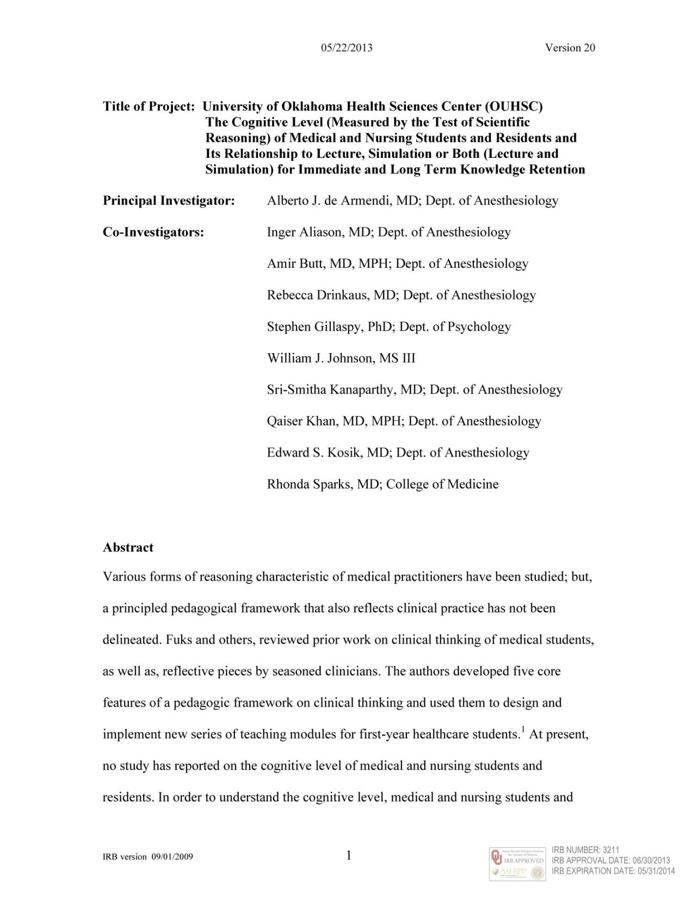



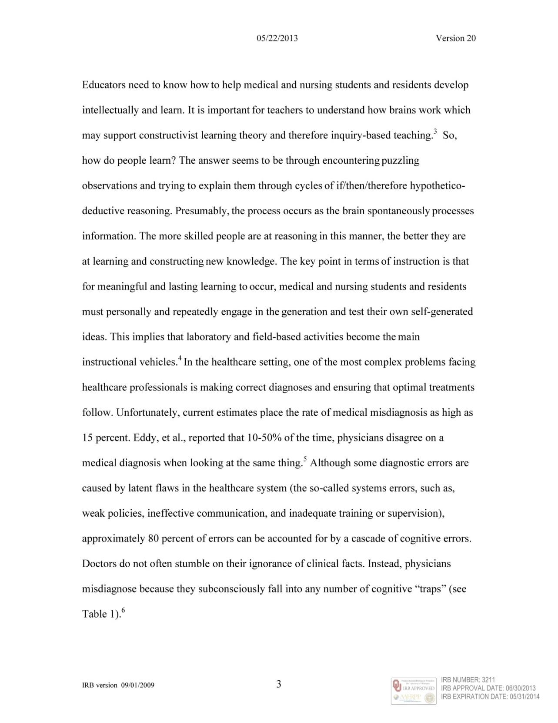

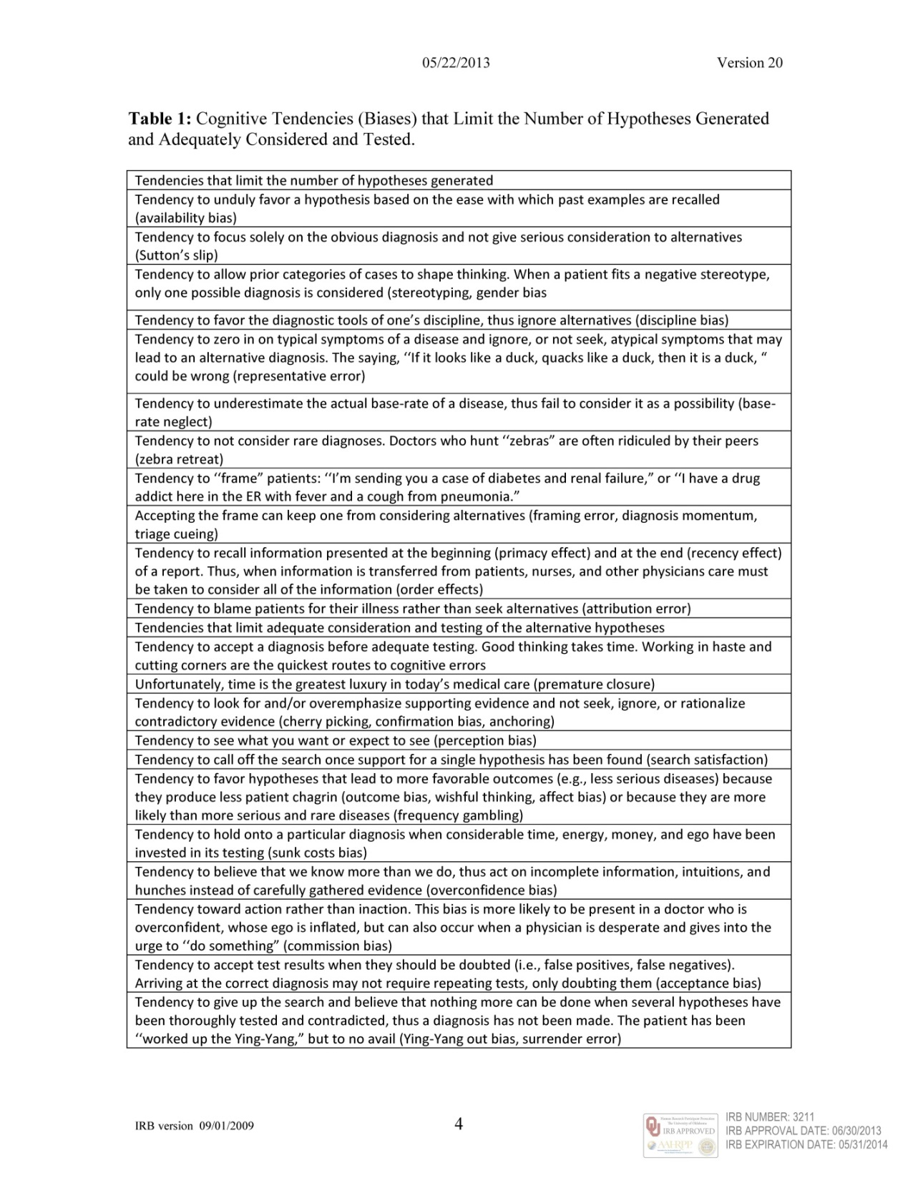

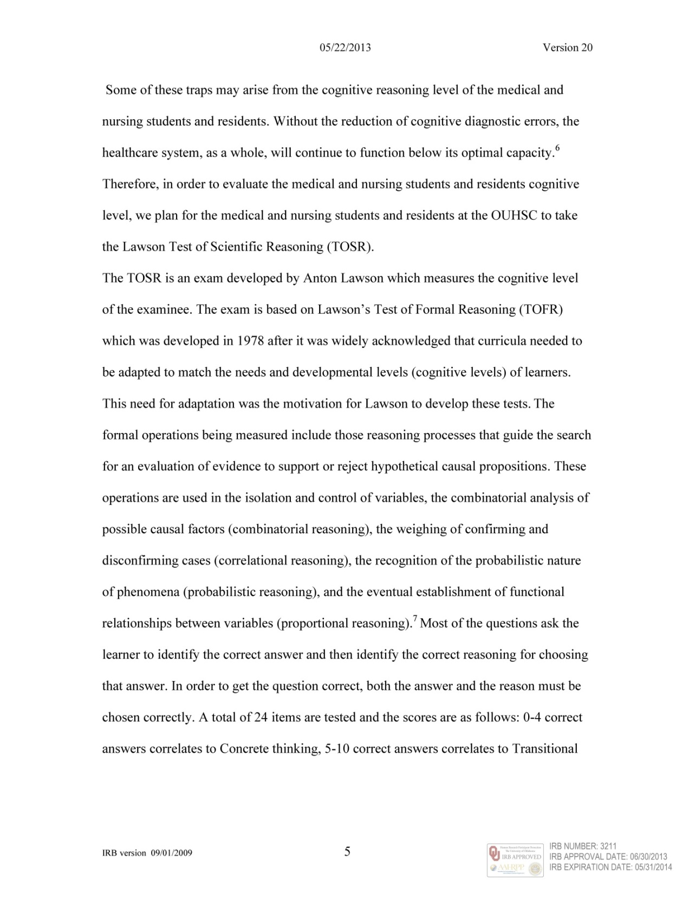

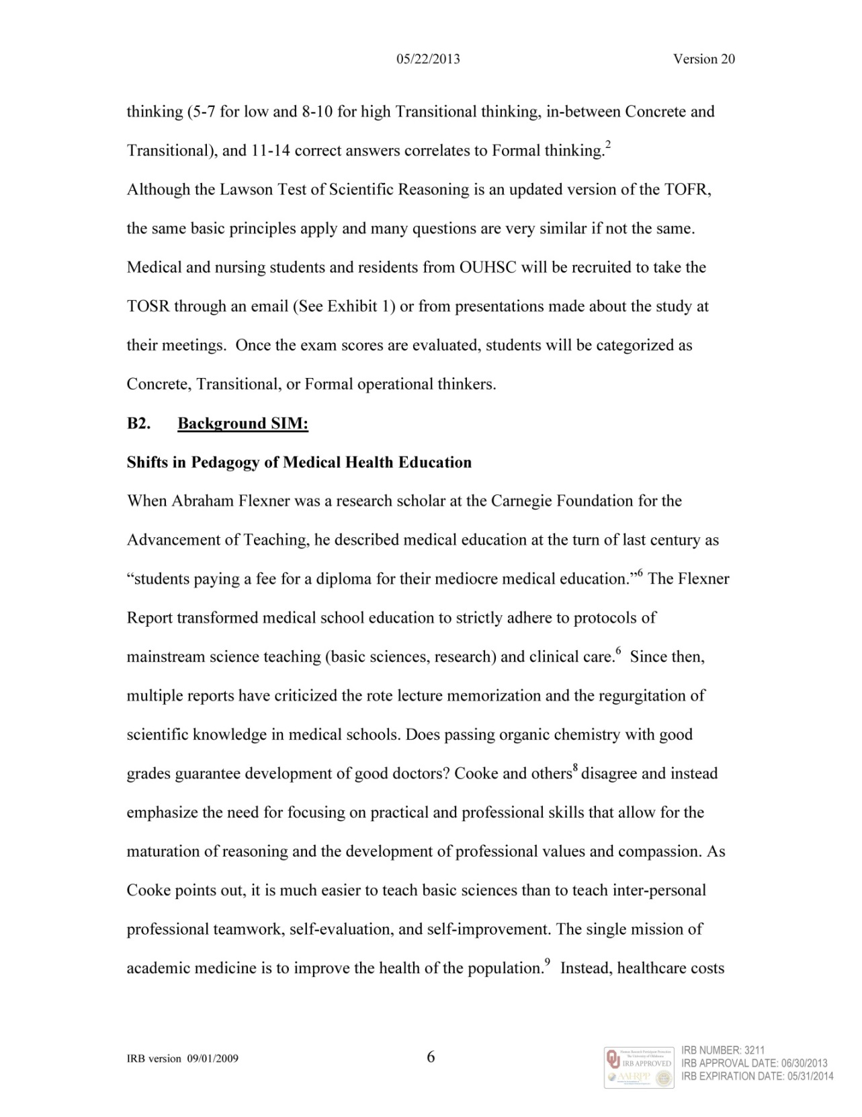

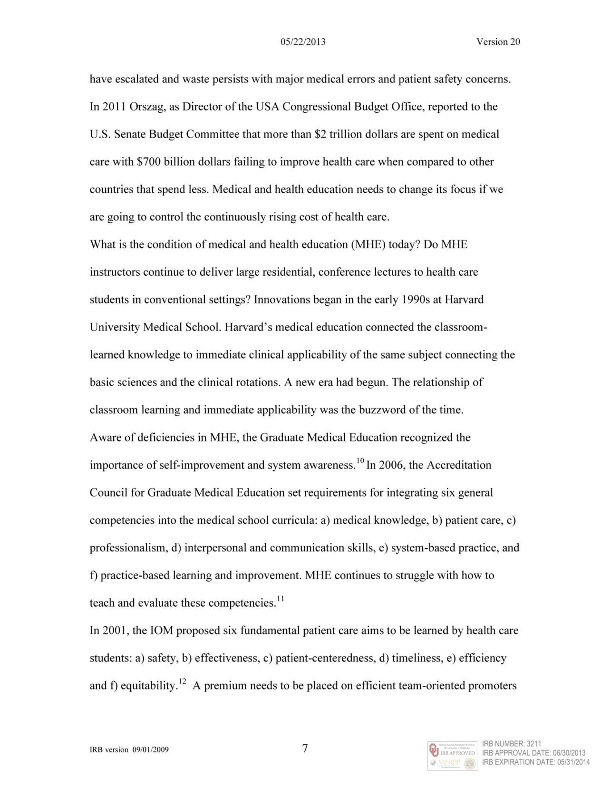

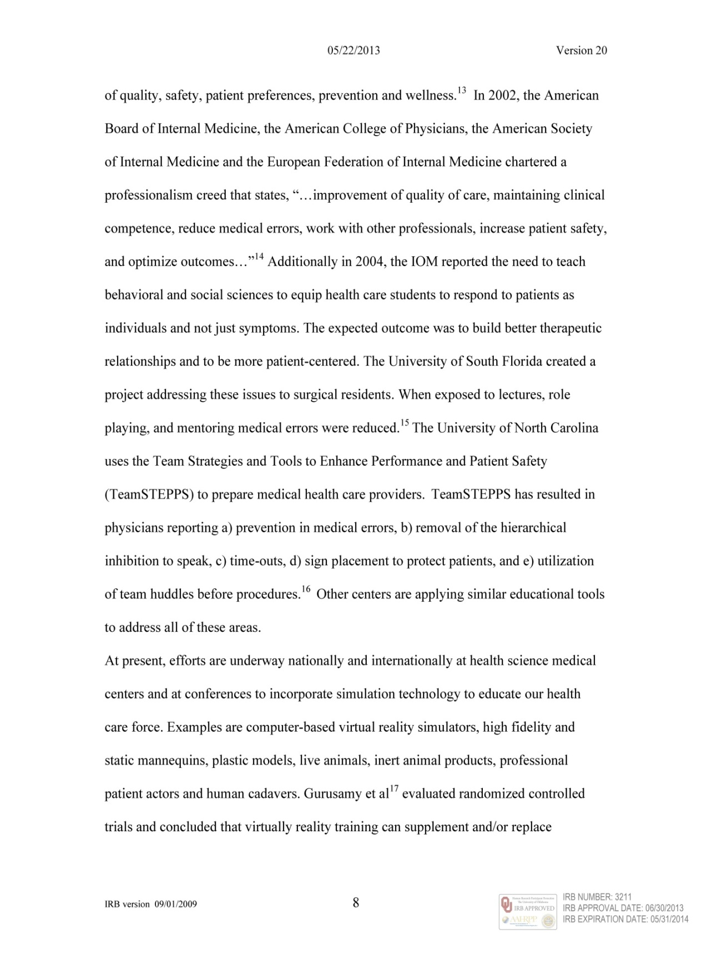

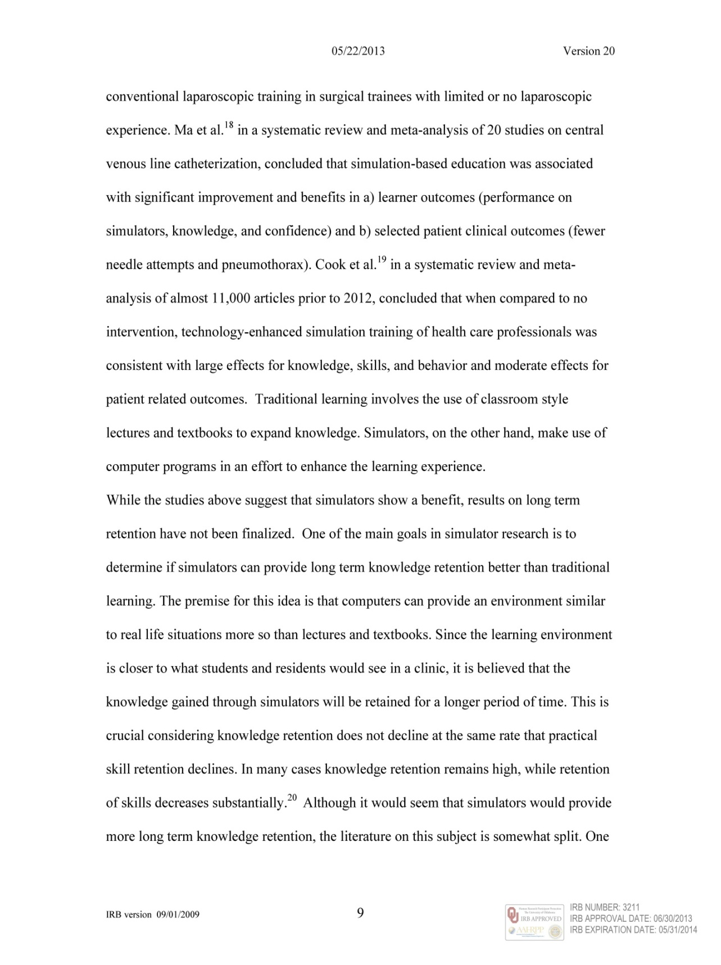

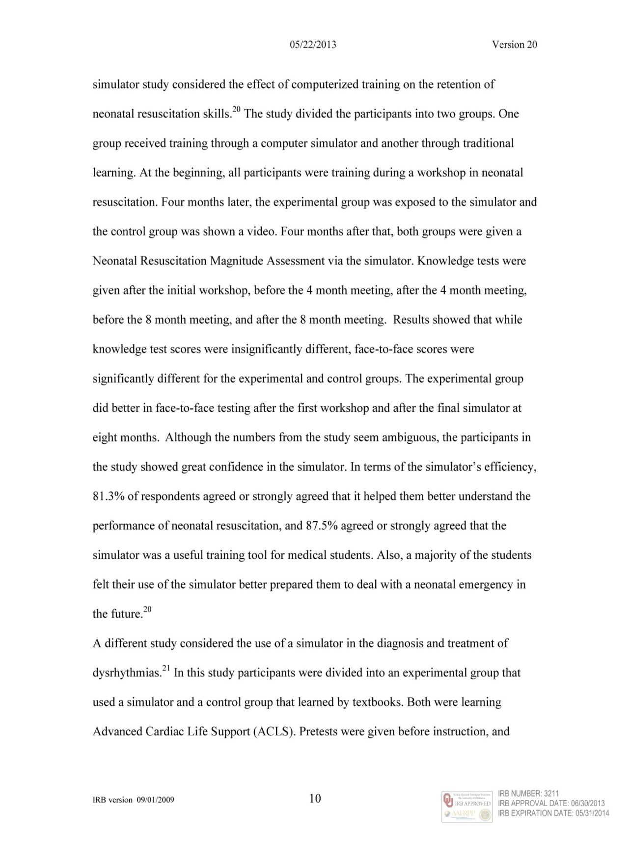





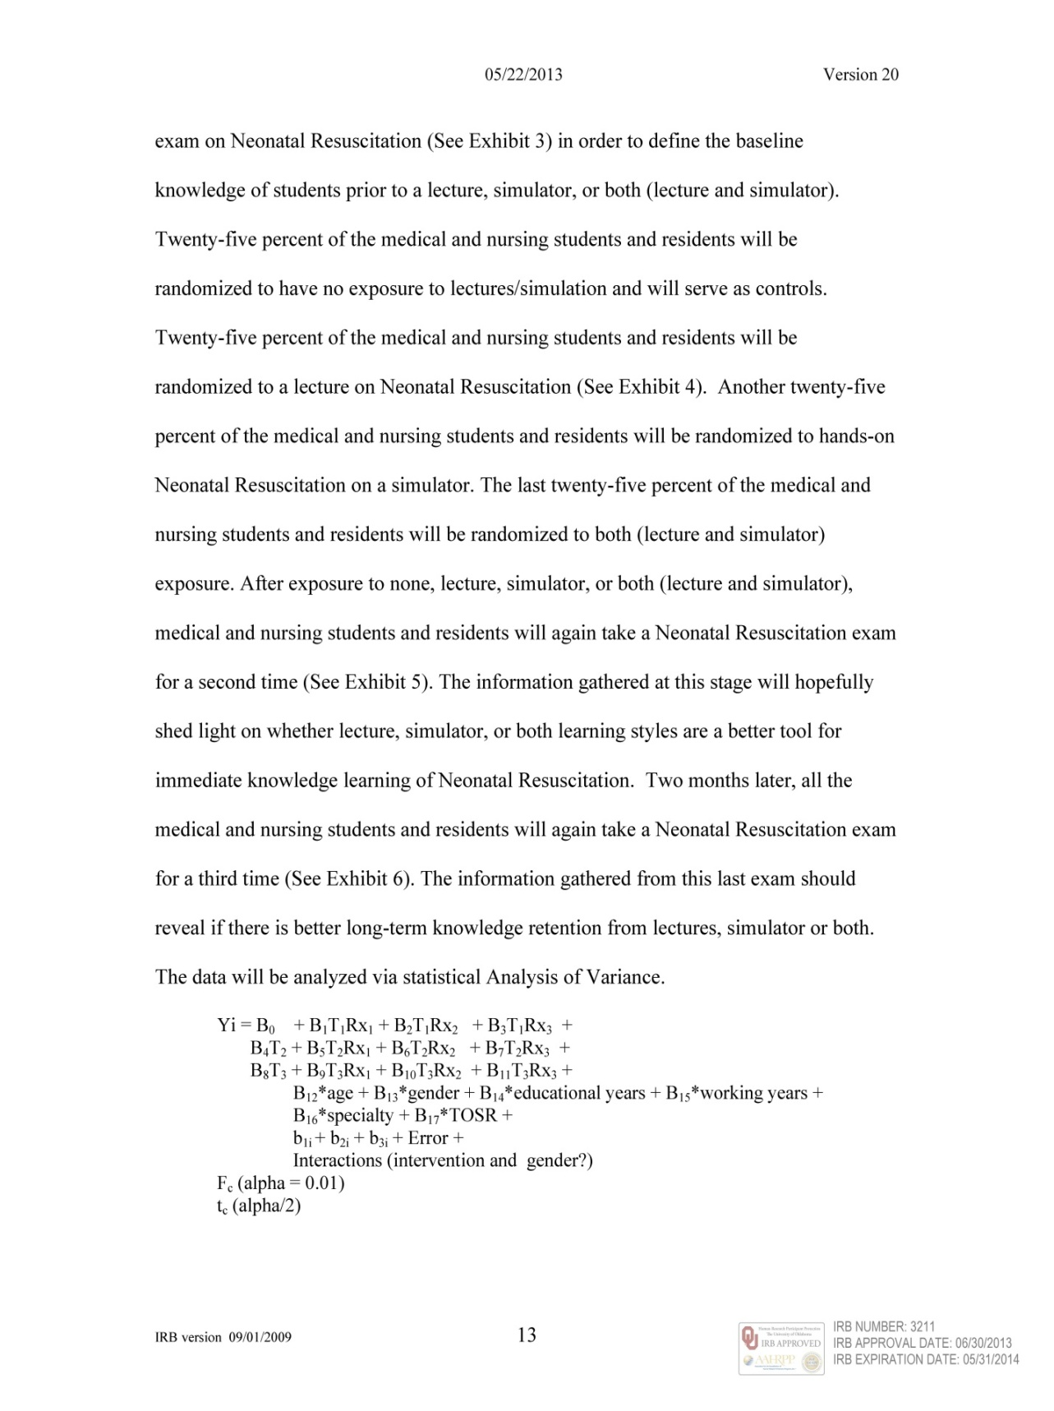

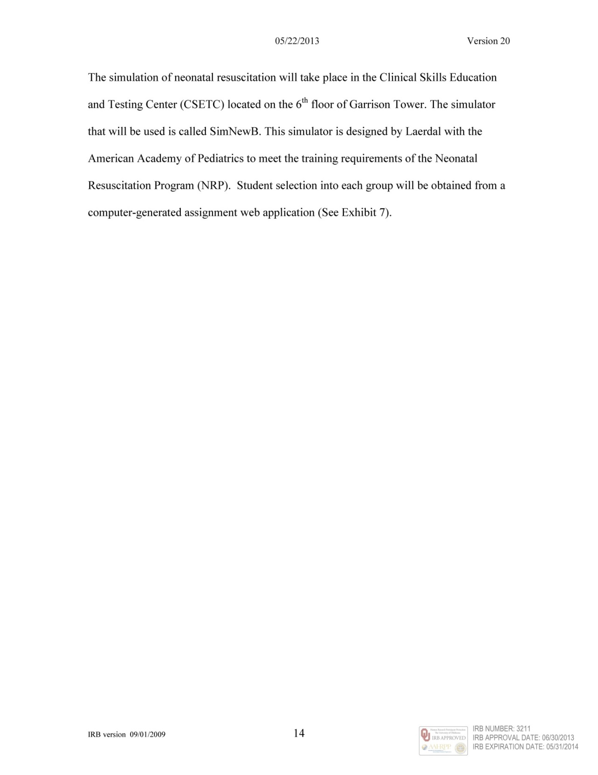

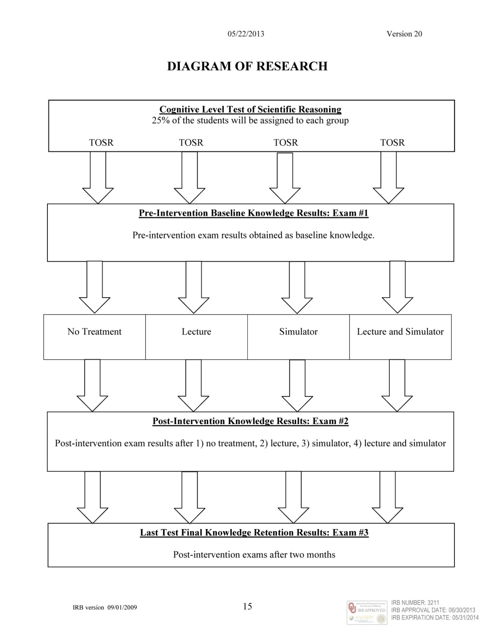

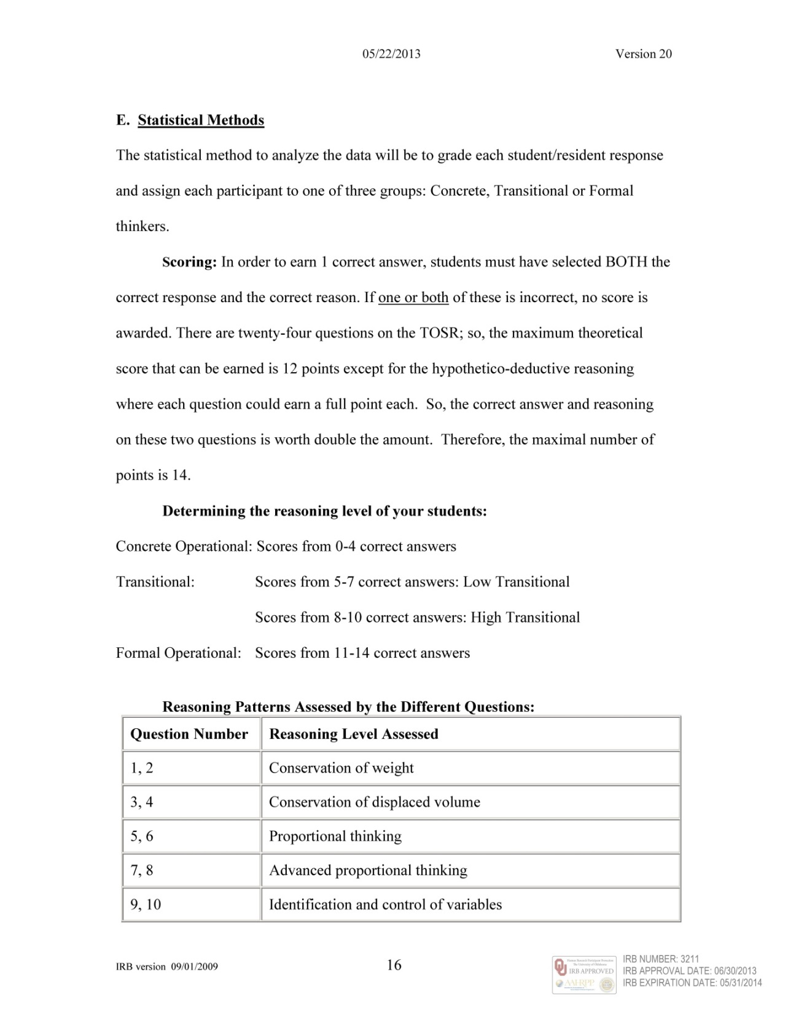

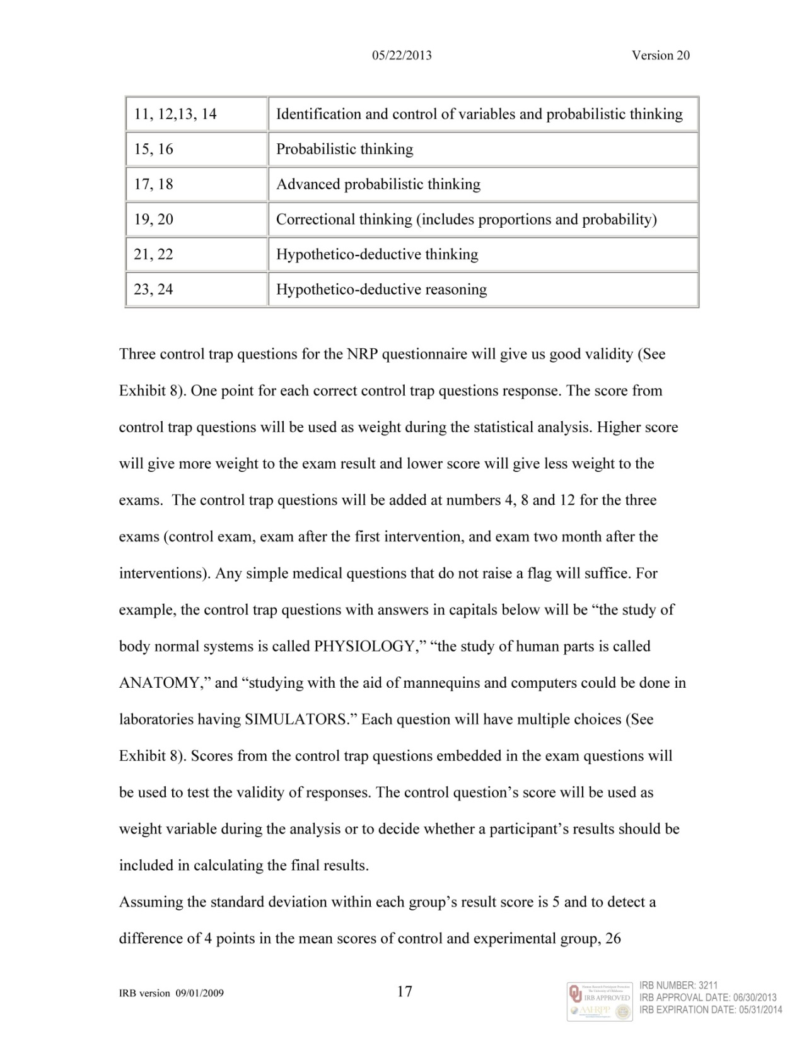

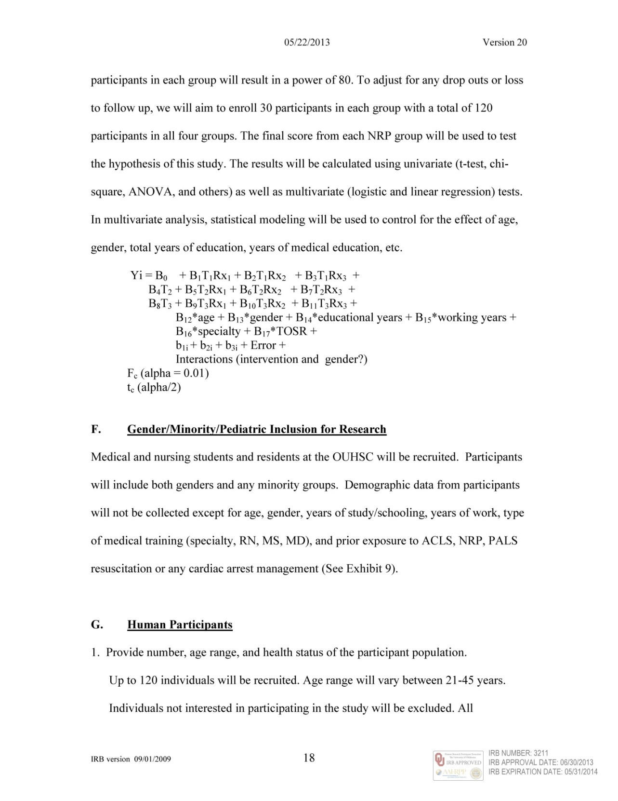



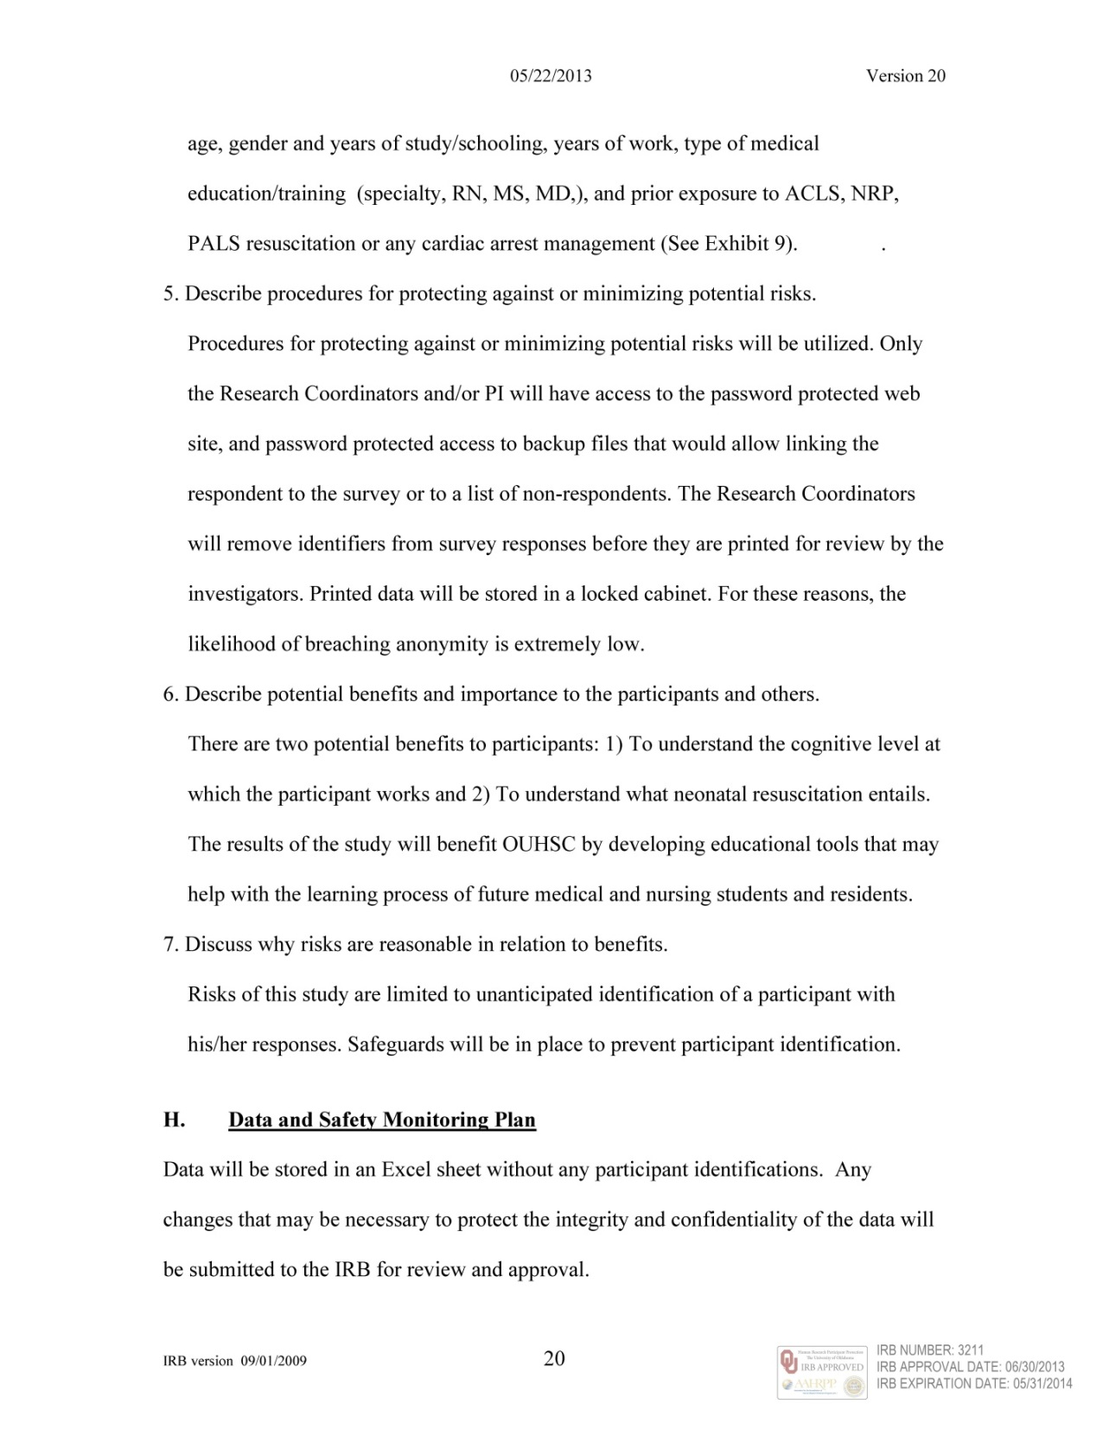

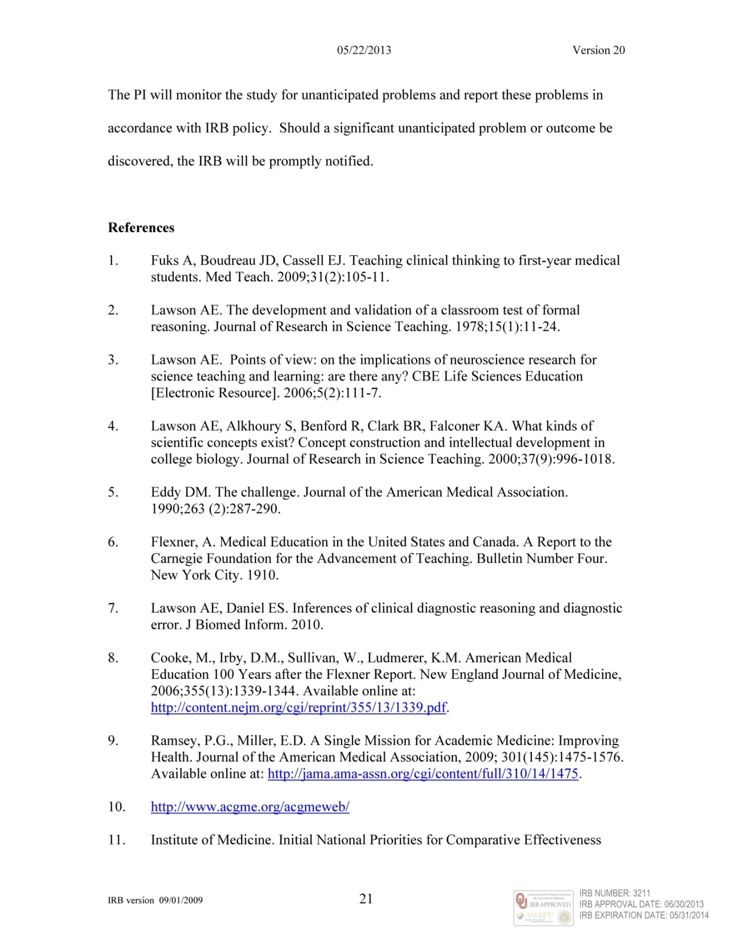

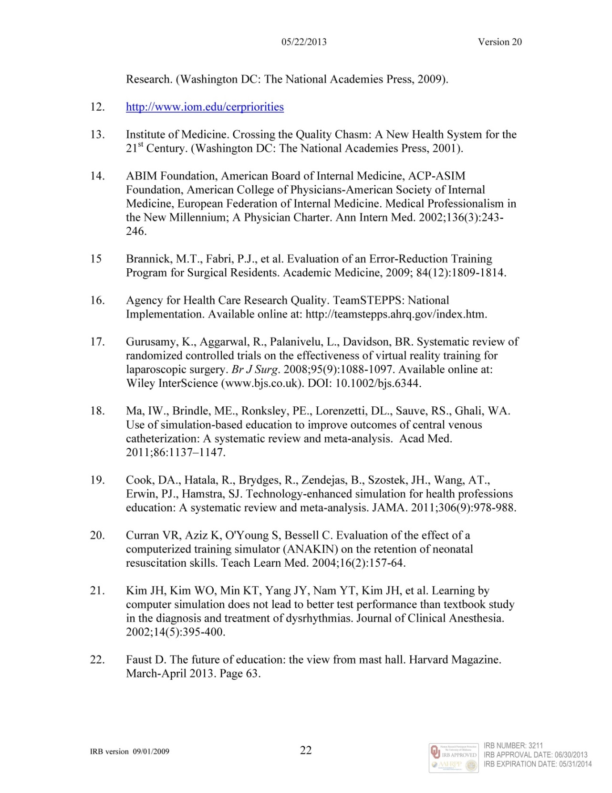

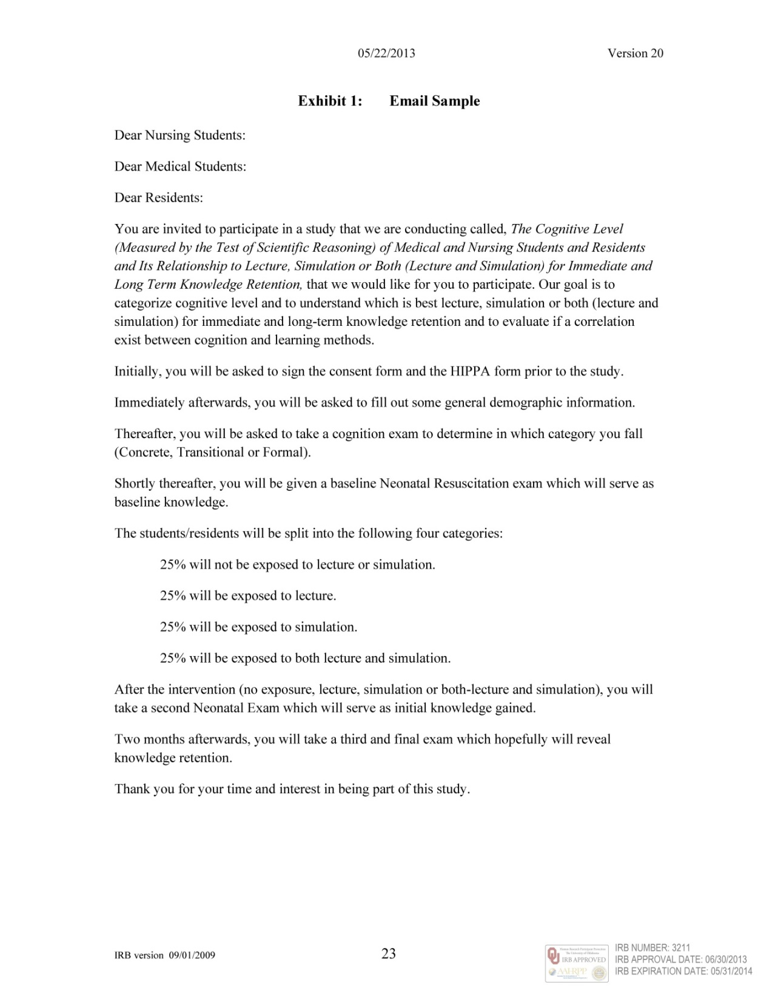

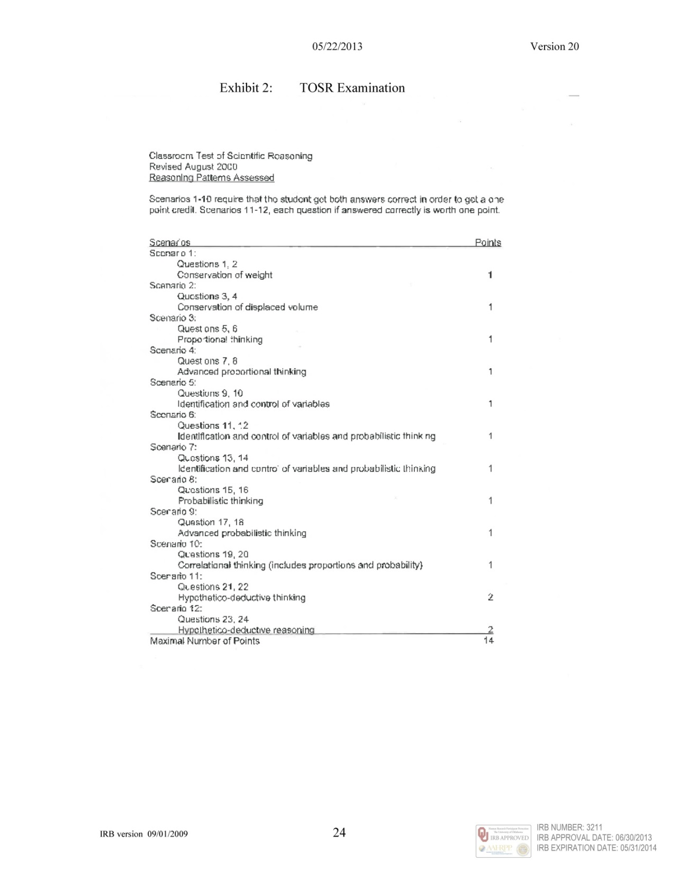

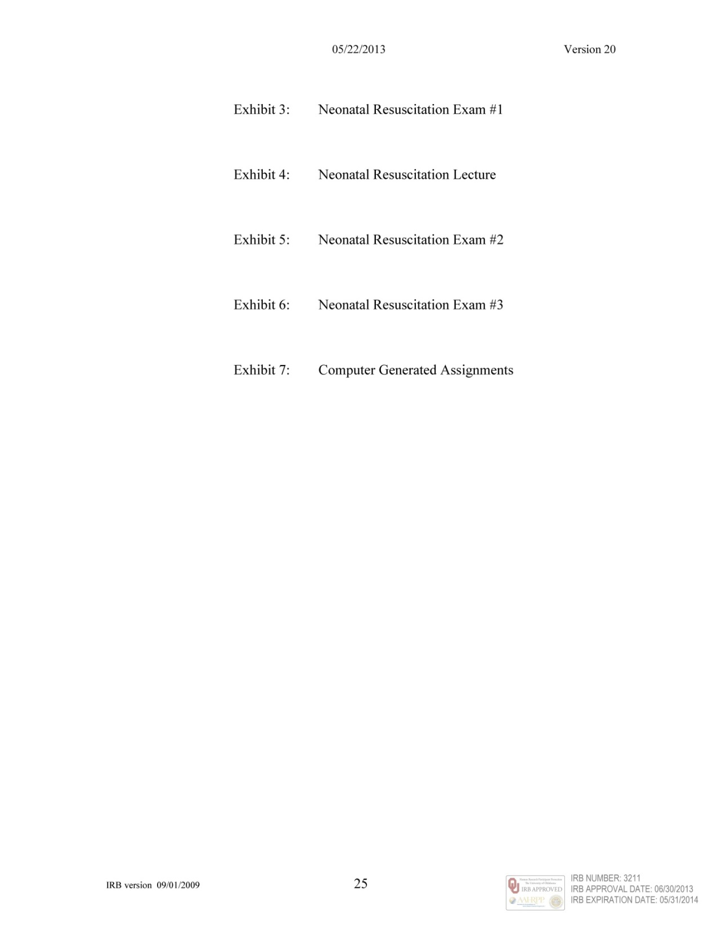



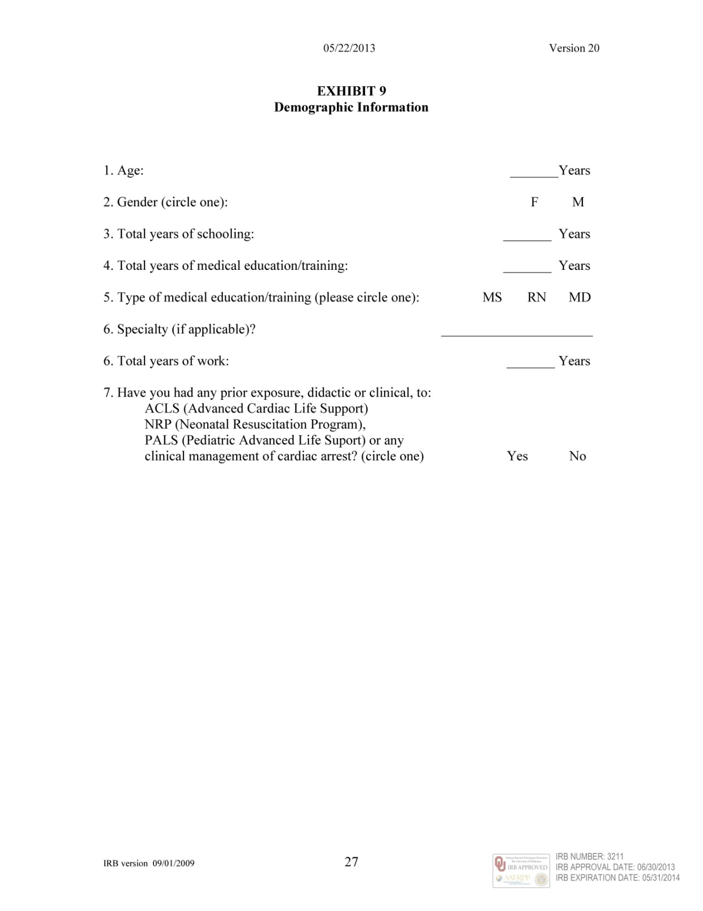



Appendix C

Consent Form

Appendix C is the Consent Form which was submitted to the Institutional Review Board for the Protection of Human Subjects at Oklahoma University Health Sciences Center and was approved on June 30th, 2013.

Consent Form





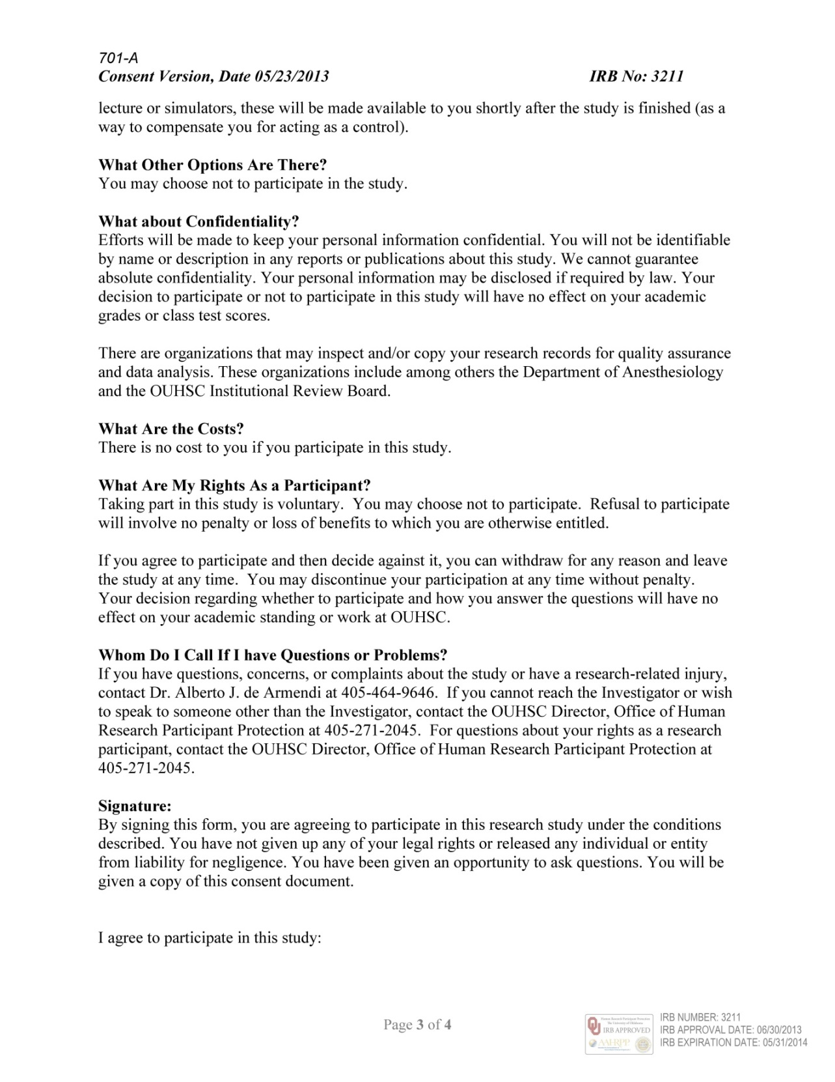

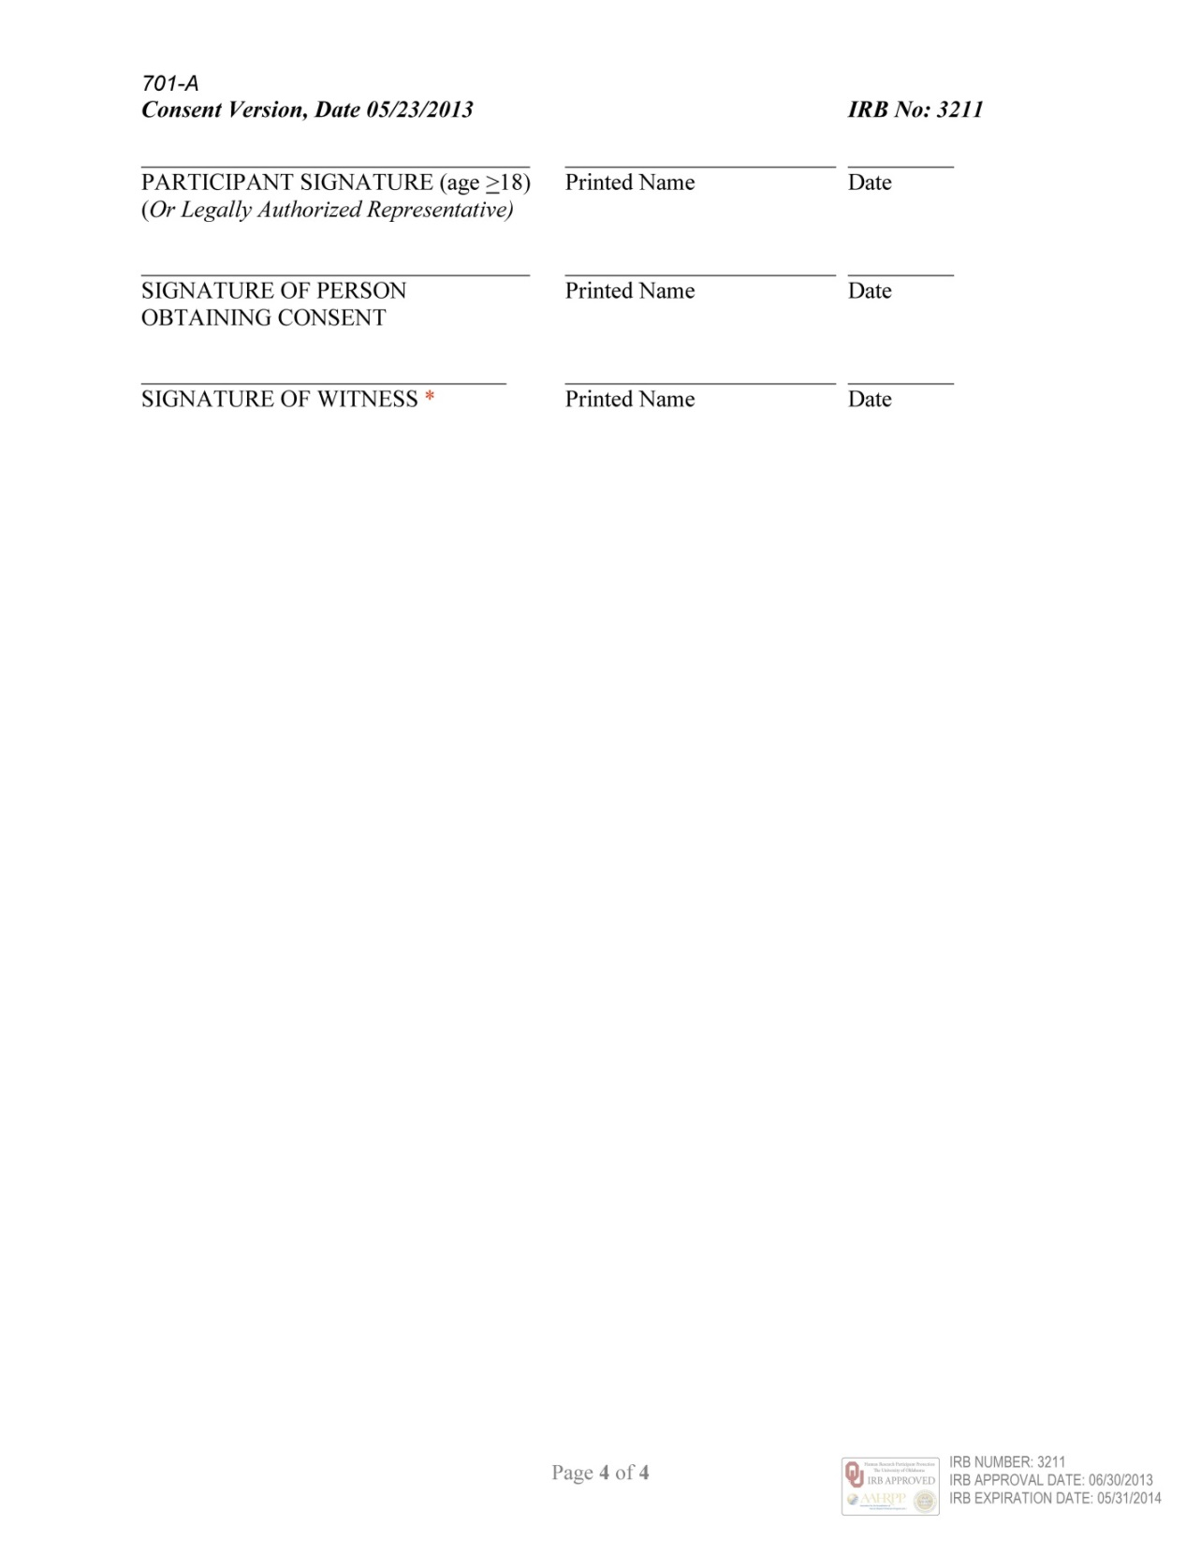

Appendix D
Internal Review Board for the Protection on Human Subjects Letters
Appendix D contains all of the documentation approval letters from the Internal Review Board for the Protection of Human Subjects necessary to carry out the research study (Protocol and Informed Consent). Included are the first Internal Review Board Approval Letter (Initial Submission Approval Letter dated July 1st, 2013) and two Internal Review Board Modification/Notification Letters (New Power Point Presentation Modification Letter dated July 30th, 2013 and Request to Increase the Total Number of Participants to 500 Modification Letter dated August 5th, 2013).

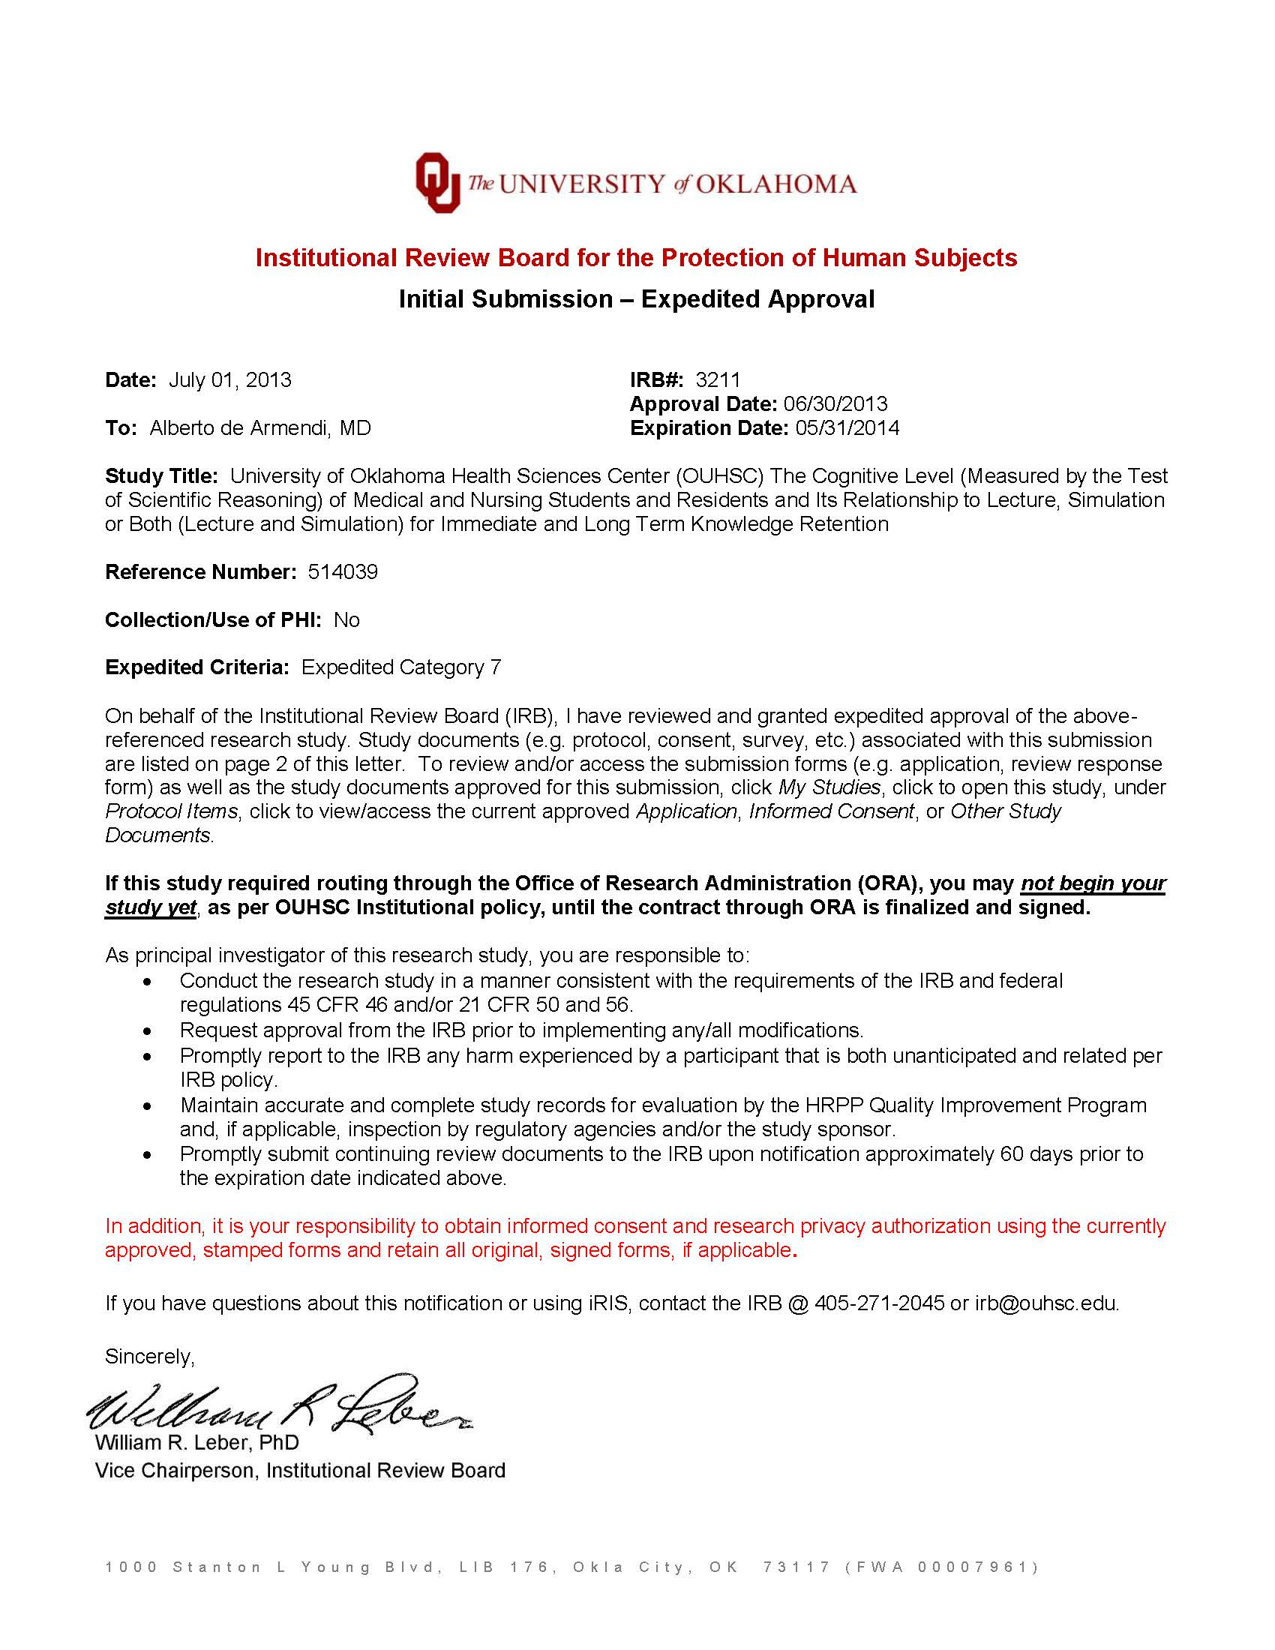

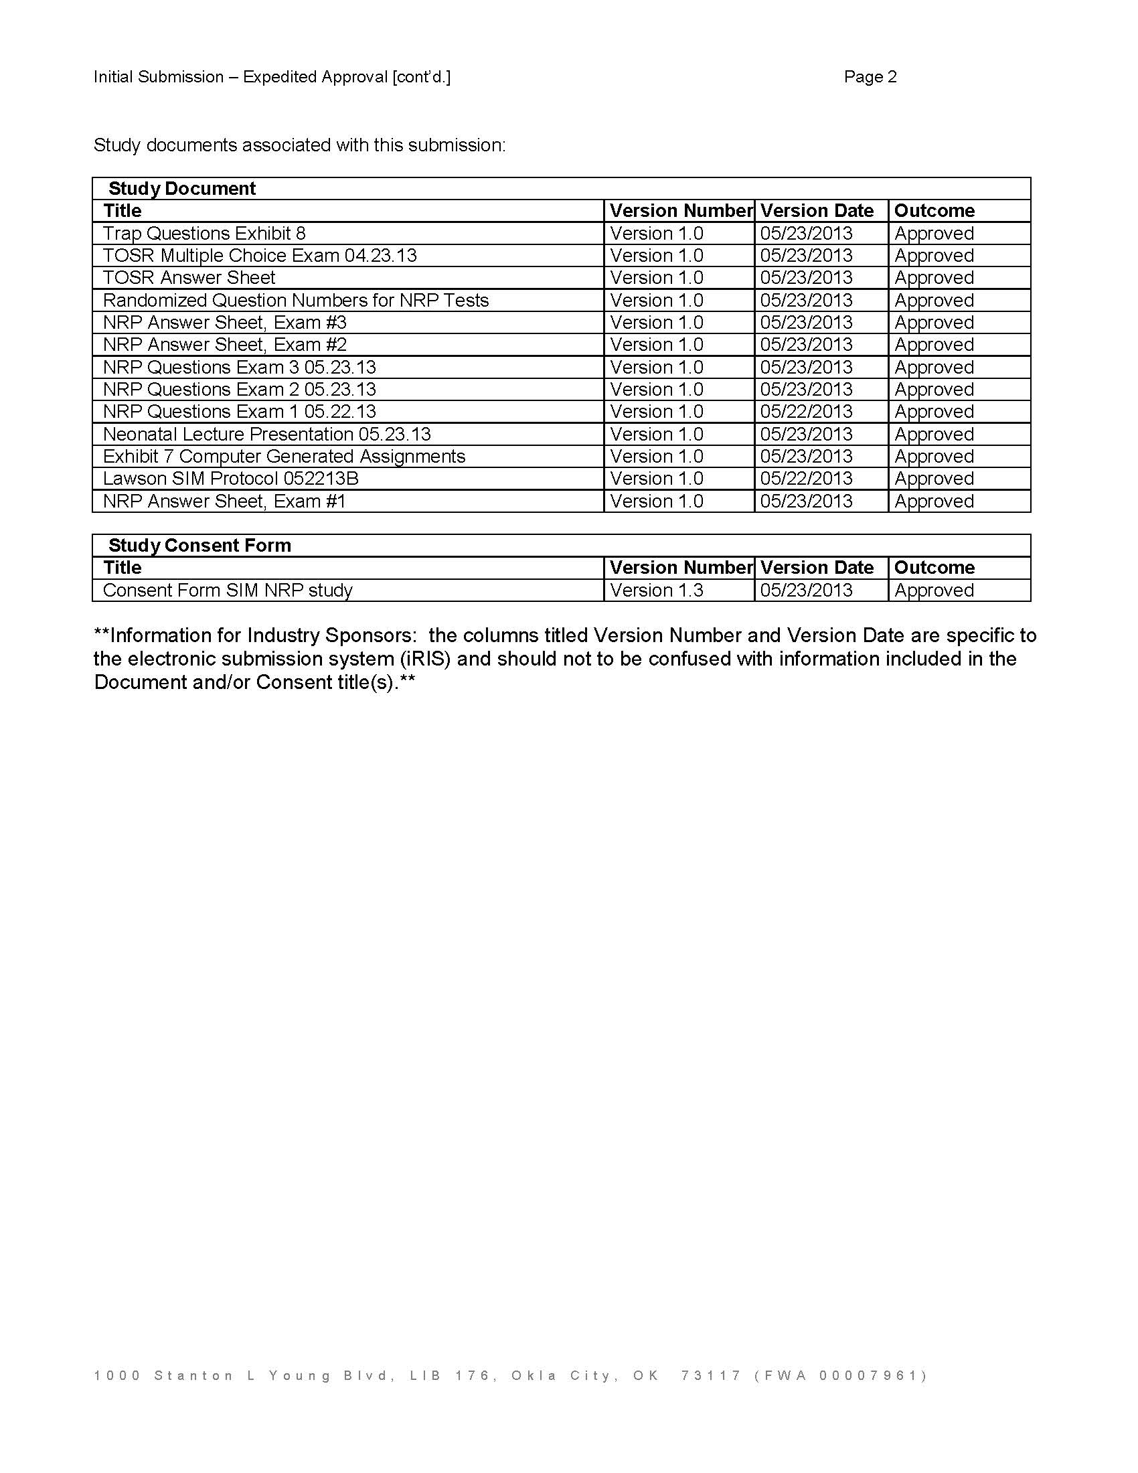

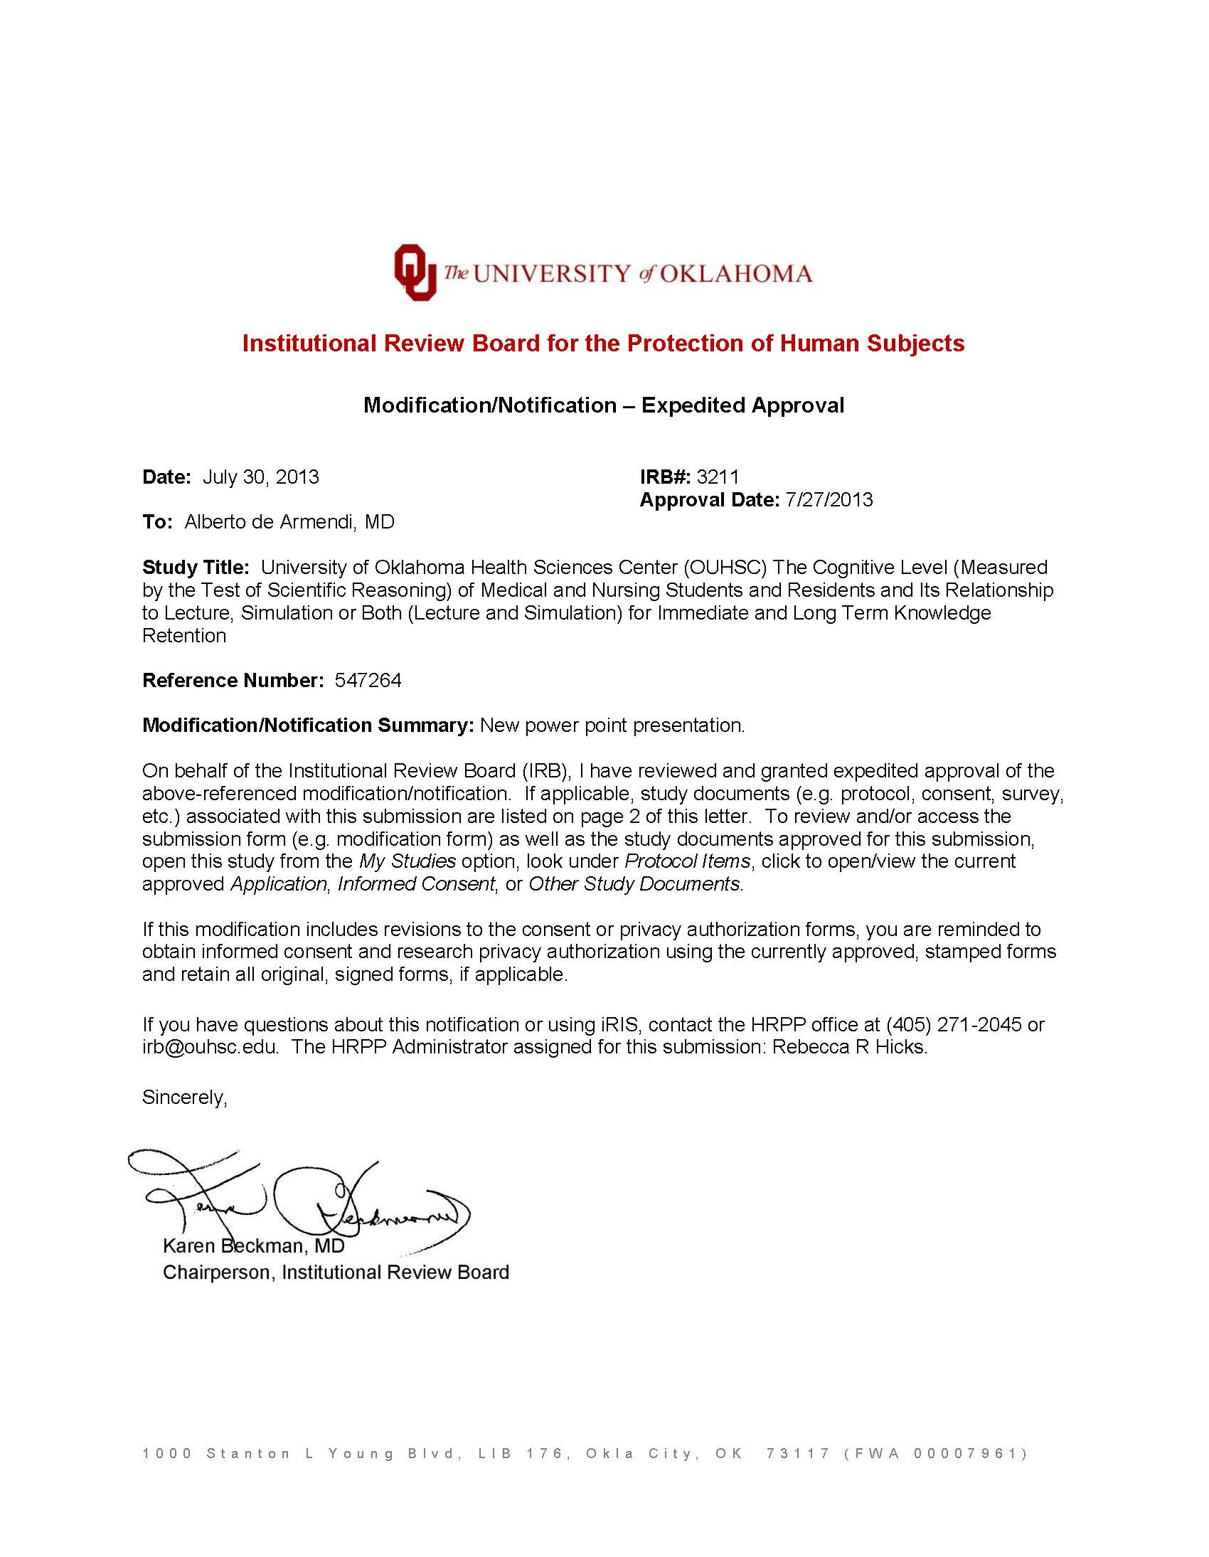

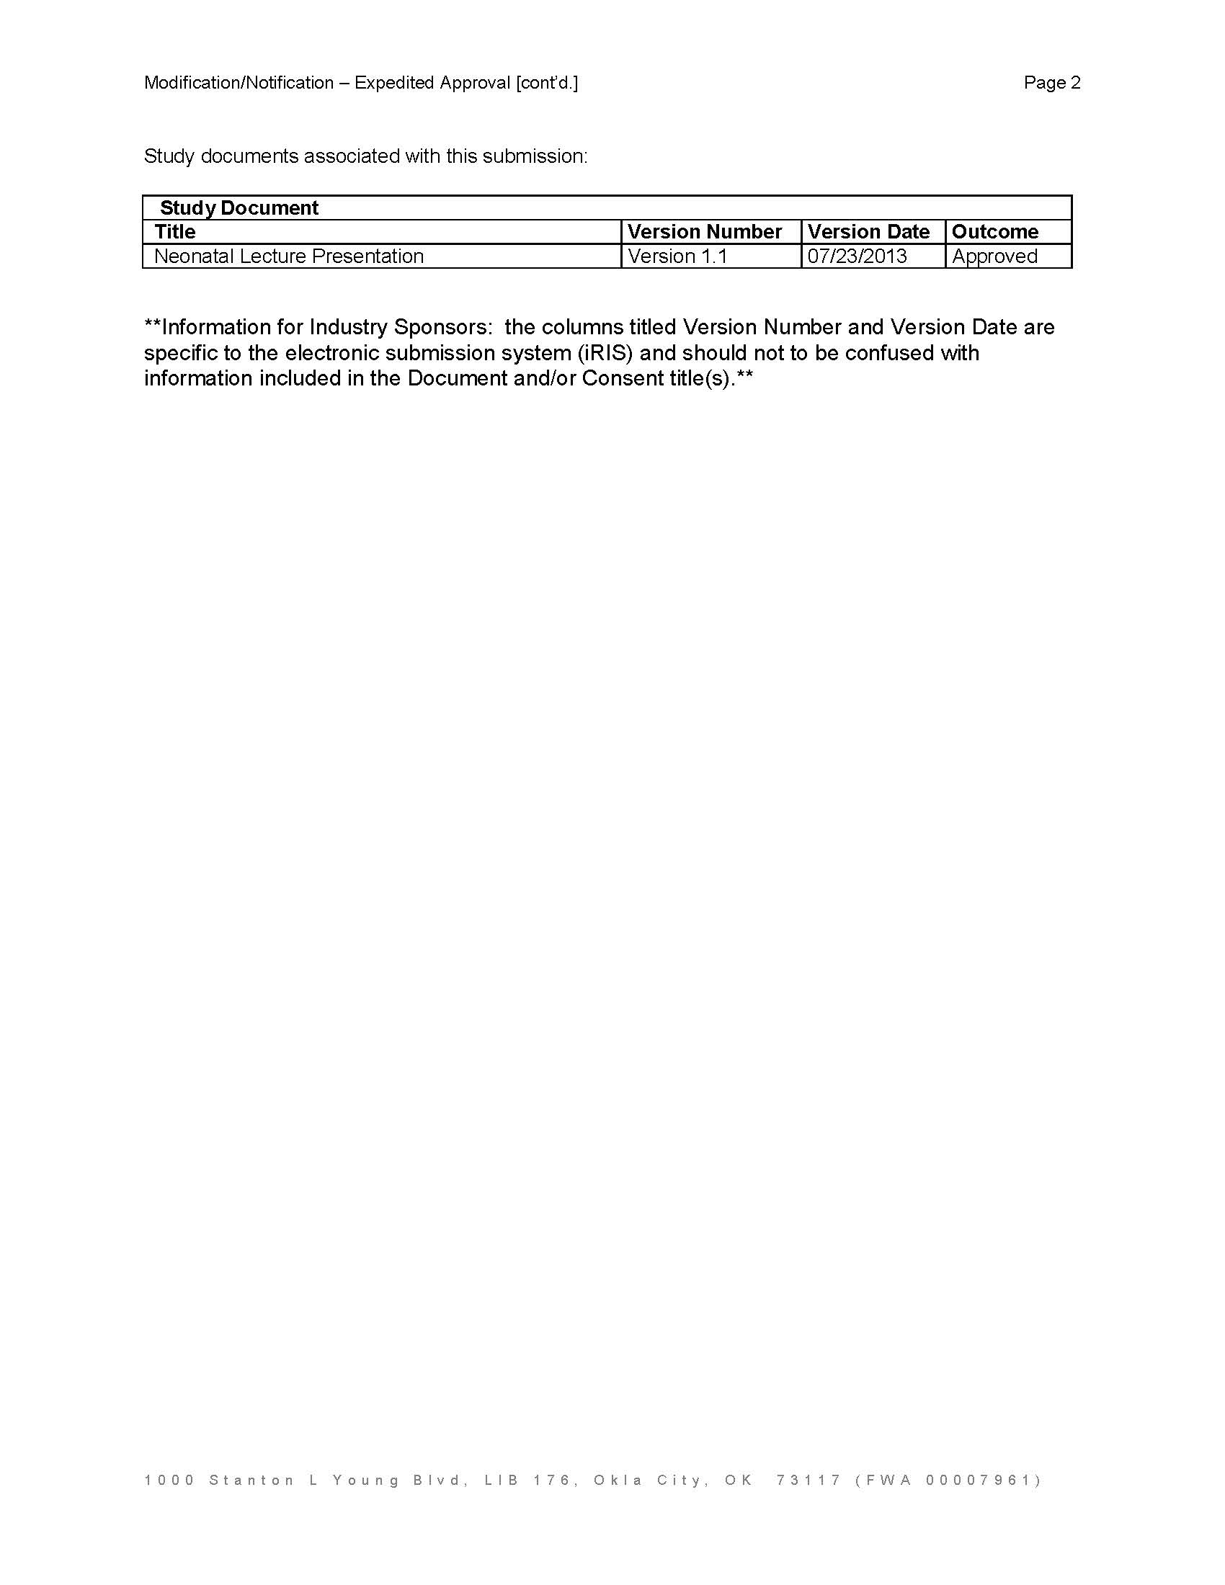

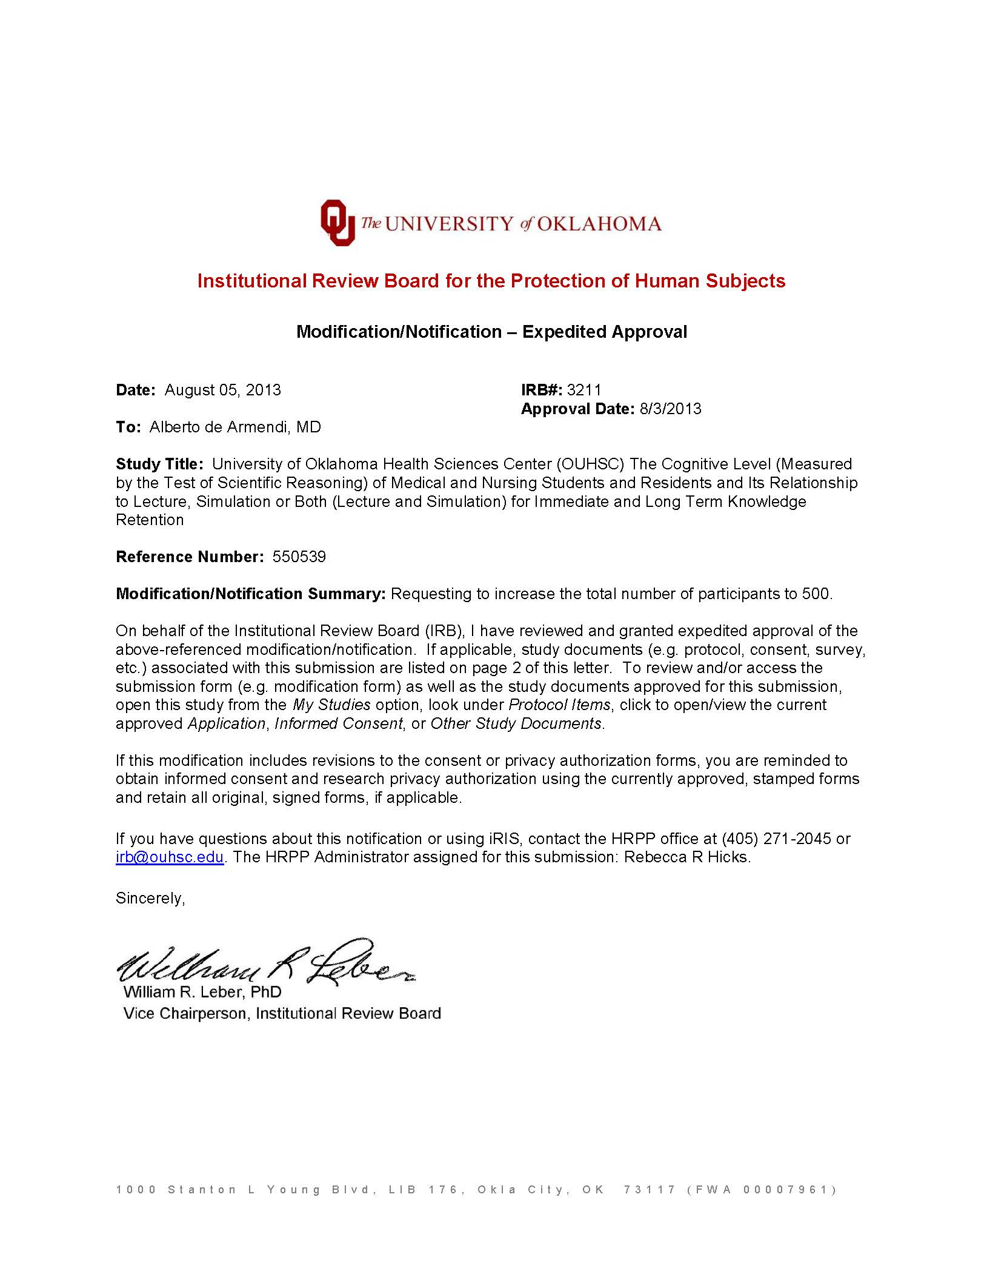

Appendix E
Education & Fun with Neonates Nursing and Medical Students Presentation
Appendix E shows the presentation delivered to nursing and medical student s at the time of recruitment. The presentation highlights the importance of research, the study diagram, the consent forms that need to be signed for the Internal Review Board for the Protection of Human Subjects (researcher’s copy and student’s copy), the student randomization, the Classroom Test of Scientific Reasoning questionnaire and answer sheet, and the Neonatal Resuscitation Program Exams #1 and #2 and their respective answer sheets. This presentation is also enclosed in the last Appendices in a disk and in a USB drive (Appendices S and W).

Education & Fun with Neonates
Nursing and Medical Students Presentation

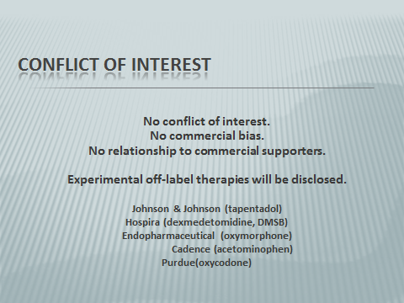

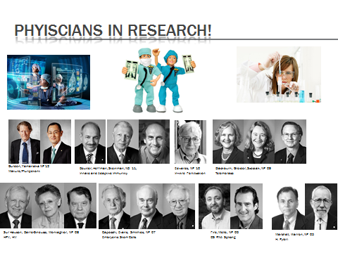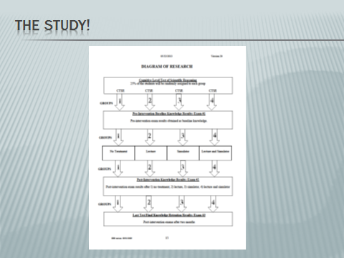

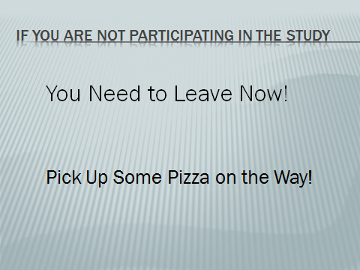

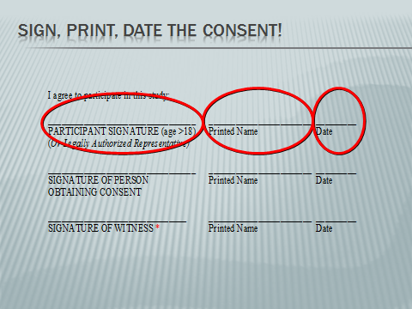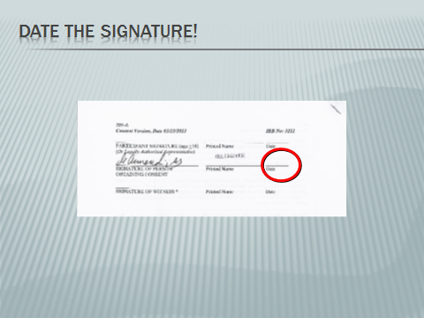



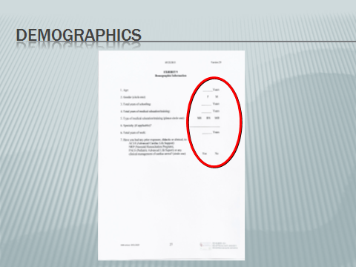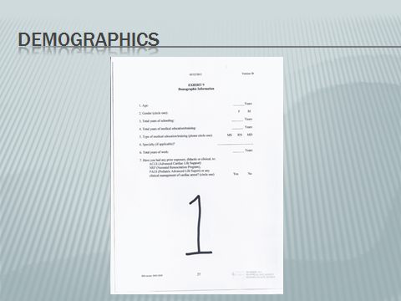

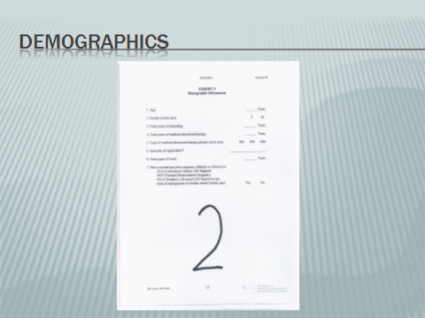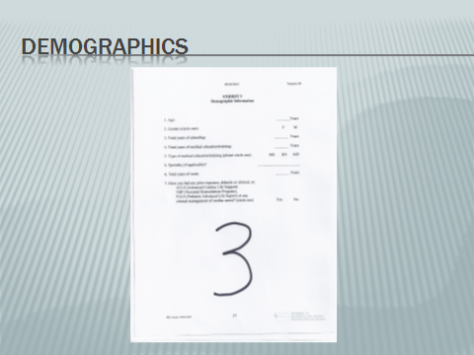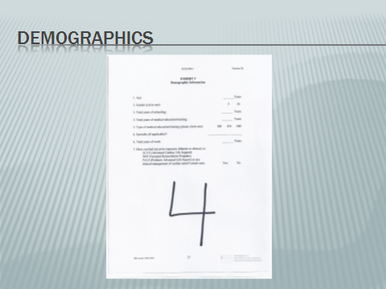



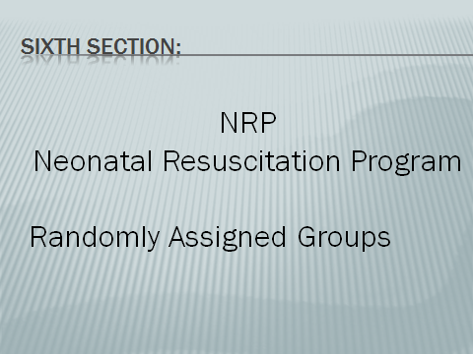

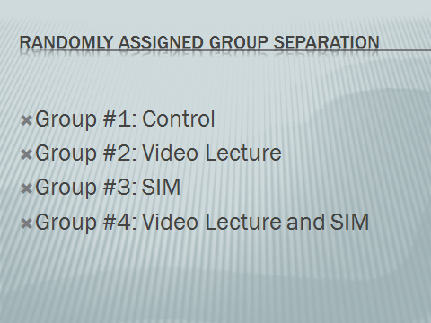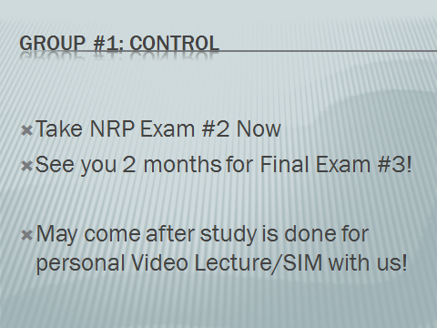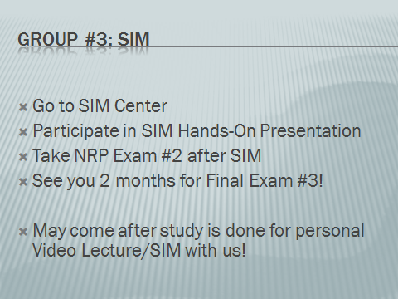

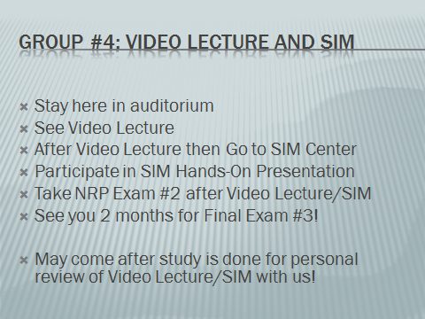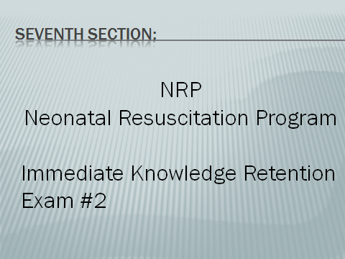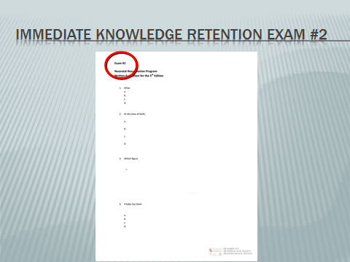

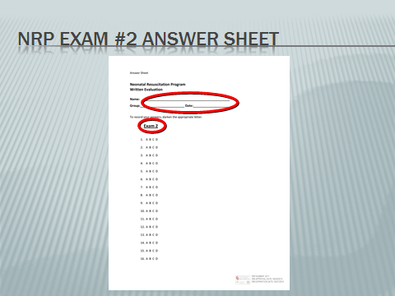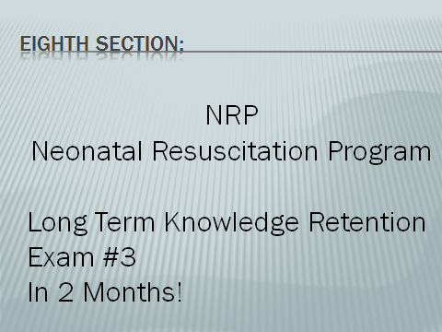

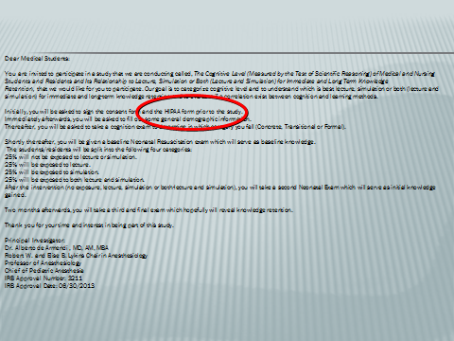
Appendix F
Classroom Test of Scientific Reasoning Multiple Choice Exam and Answer Sheet
Appendix F shows the Classroom Test of Scientific Reasoning Exam and Answer Sheet that was submitted to the Internal Review Board for the Protection of Human Subjects at Oklahoma University Health Sciences Center and was approved on June 30th, 2013. Please note that the assignment of the words ‘Test of Scientific Reasoning’ (TOSR) as noted in the answer sheet is the same or synonymous to the ‘Classroom Test of Scientific Reasoning’ (CTSR) for the practical purpose of this study.

Classroom Test of Scientific Reasoning Exam





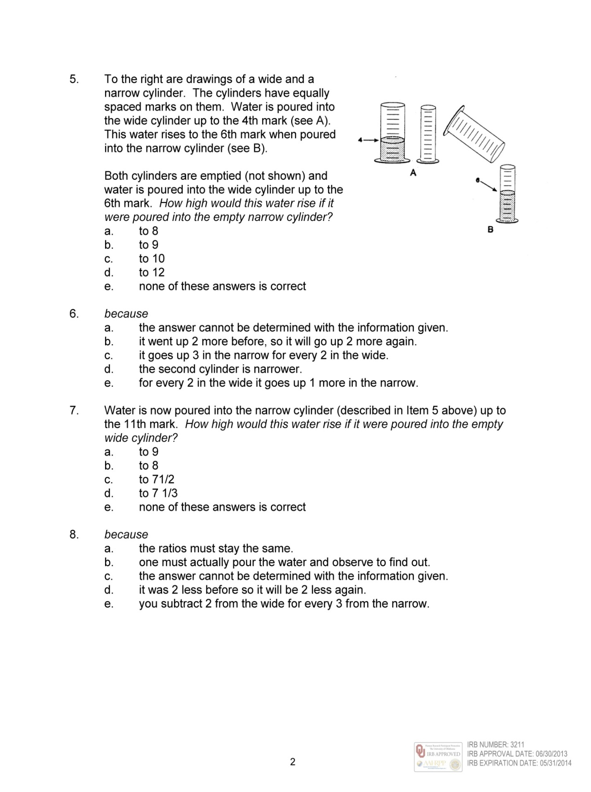

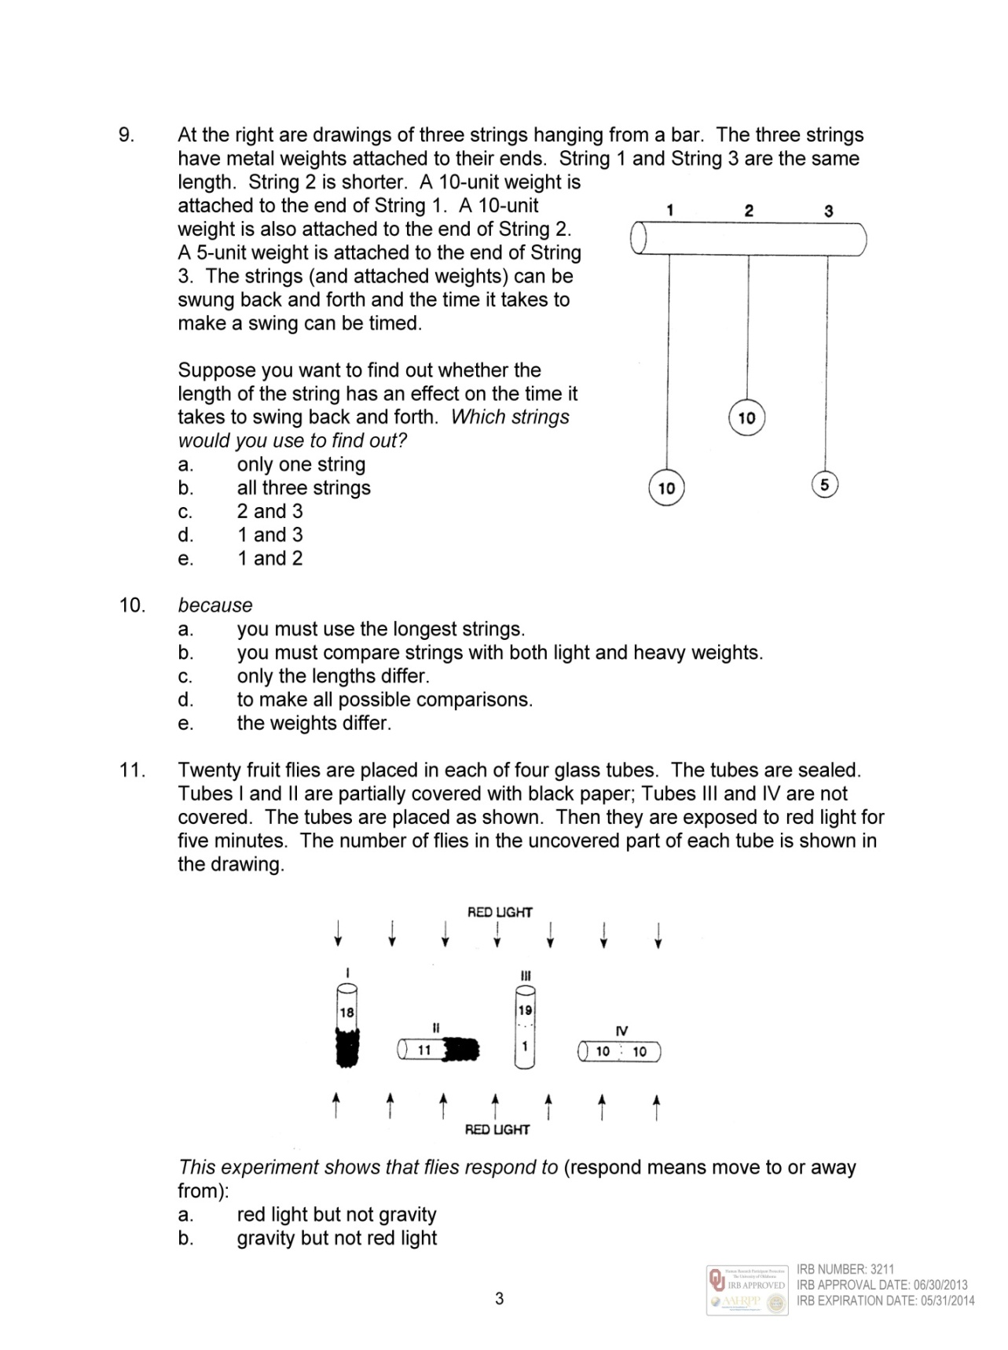

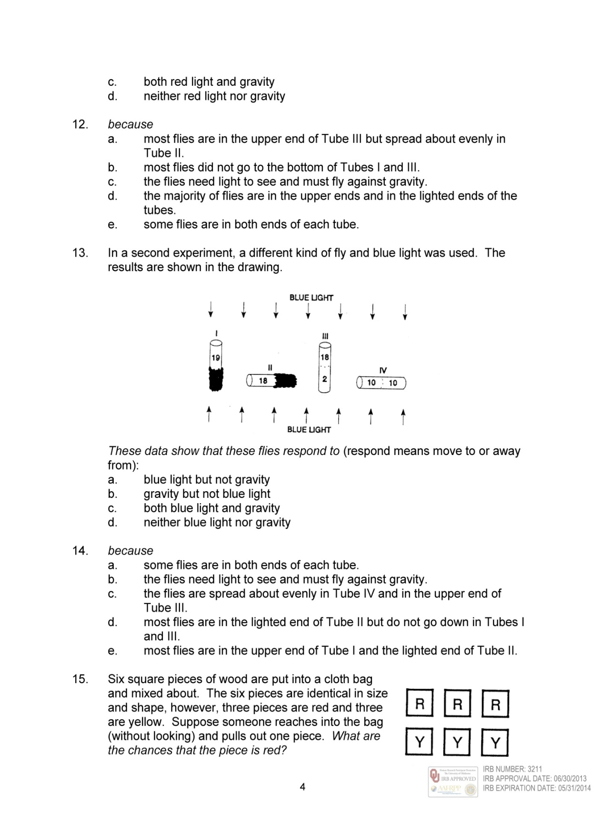

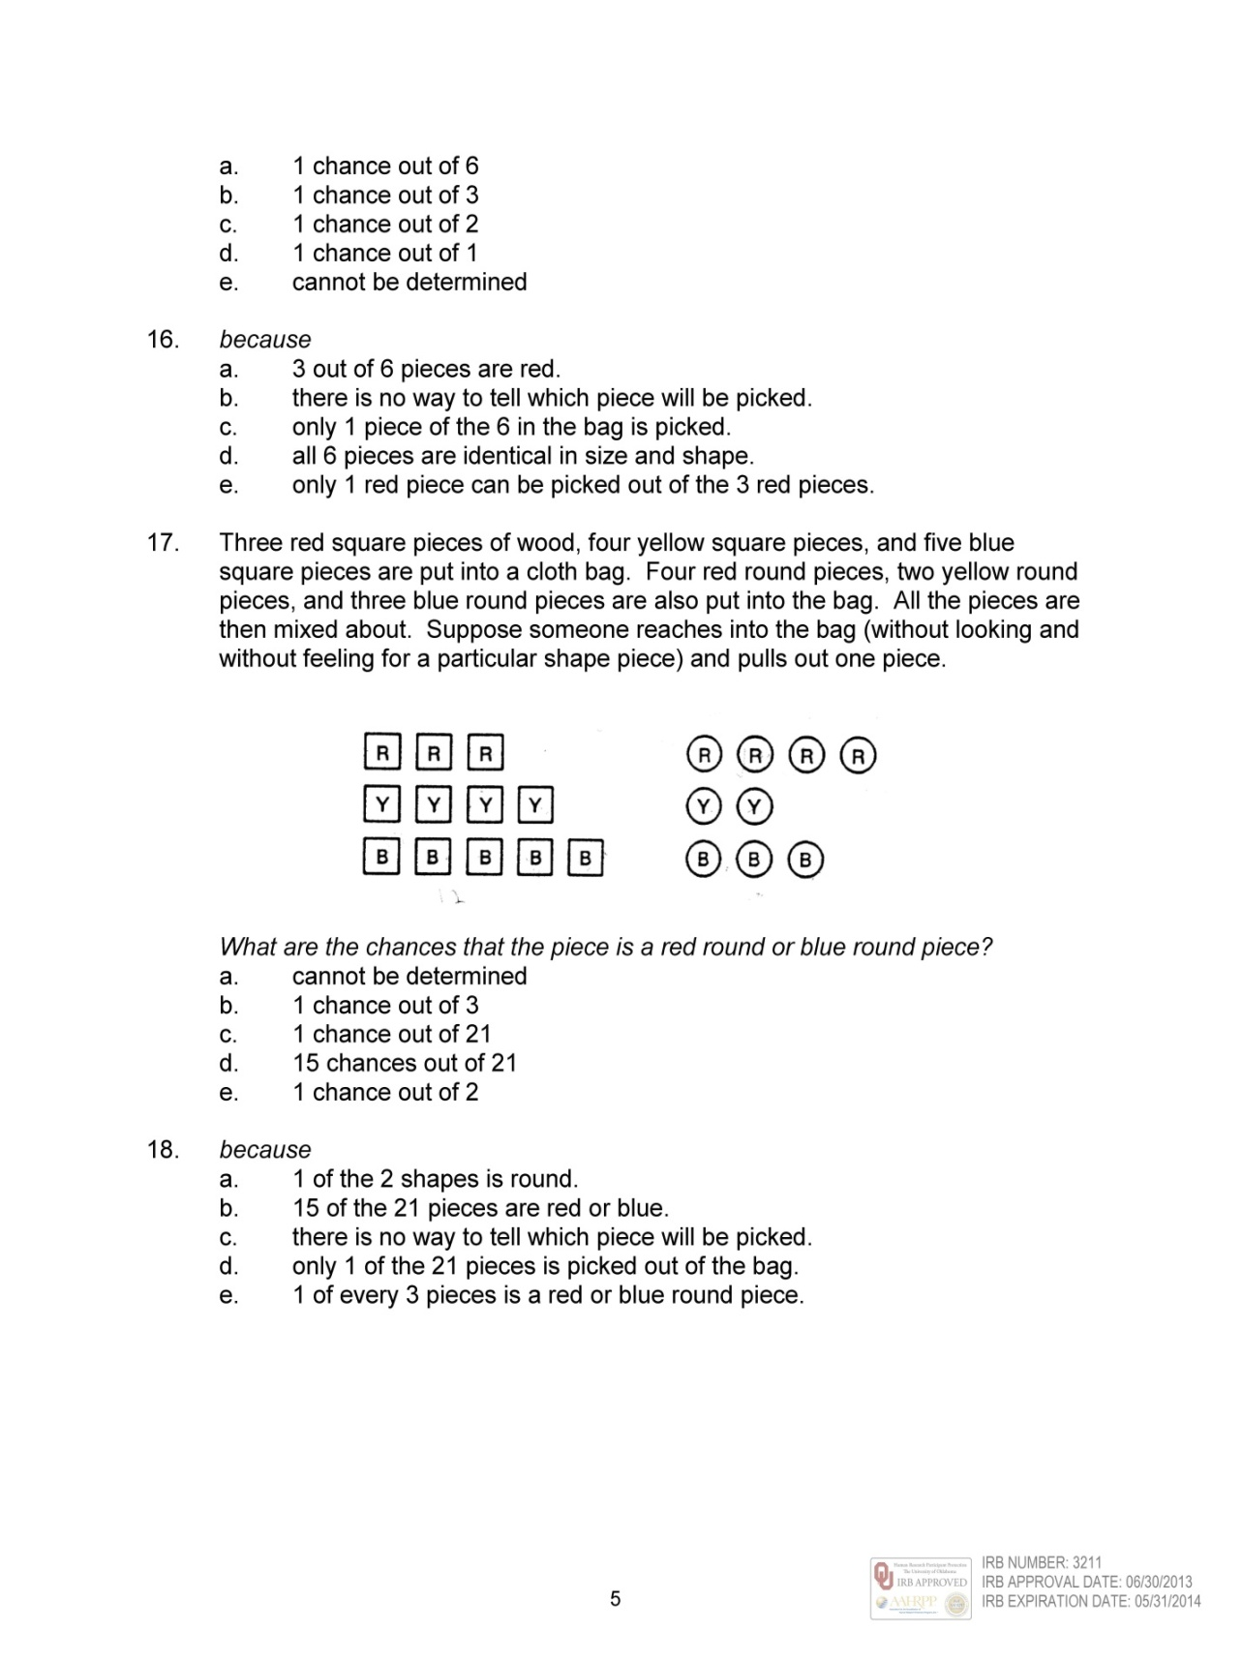



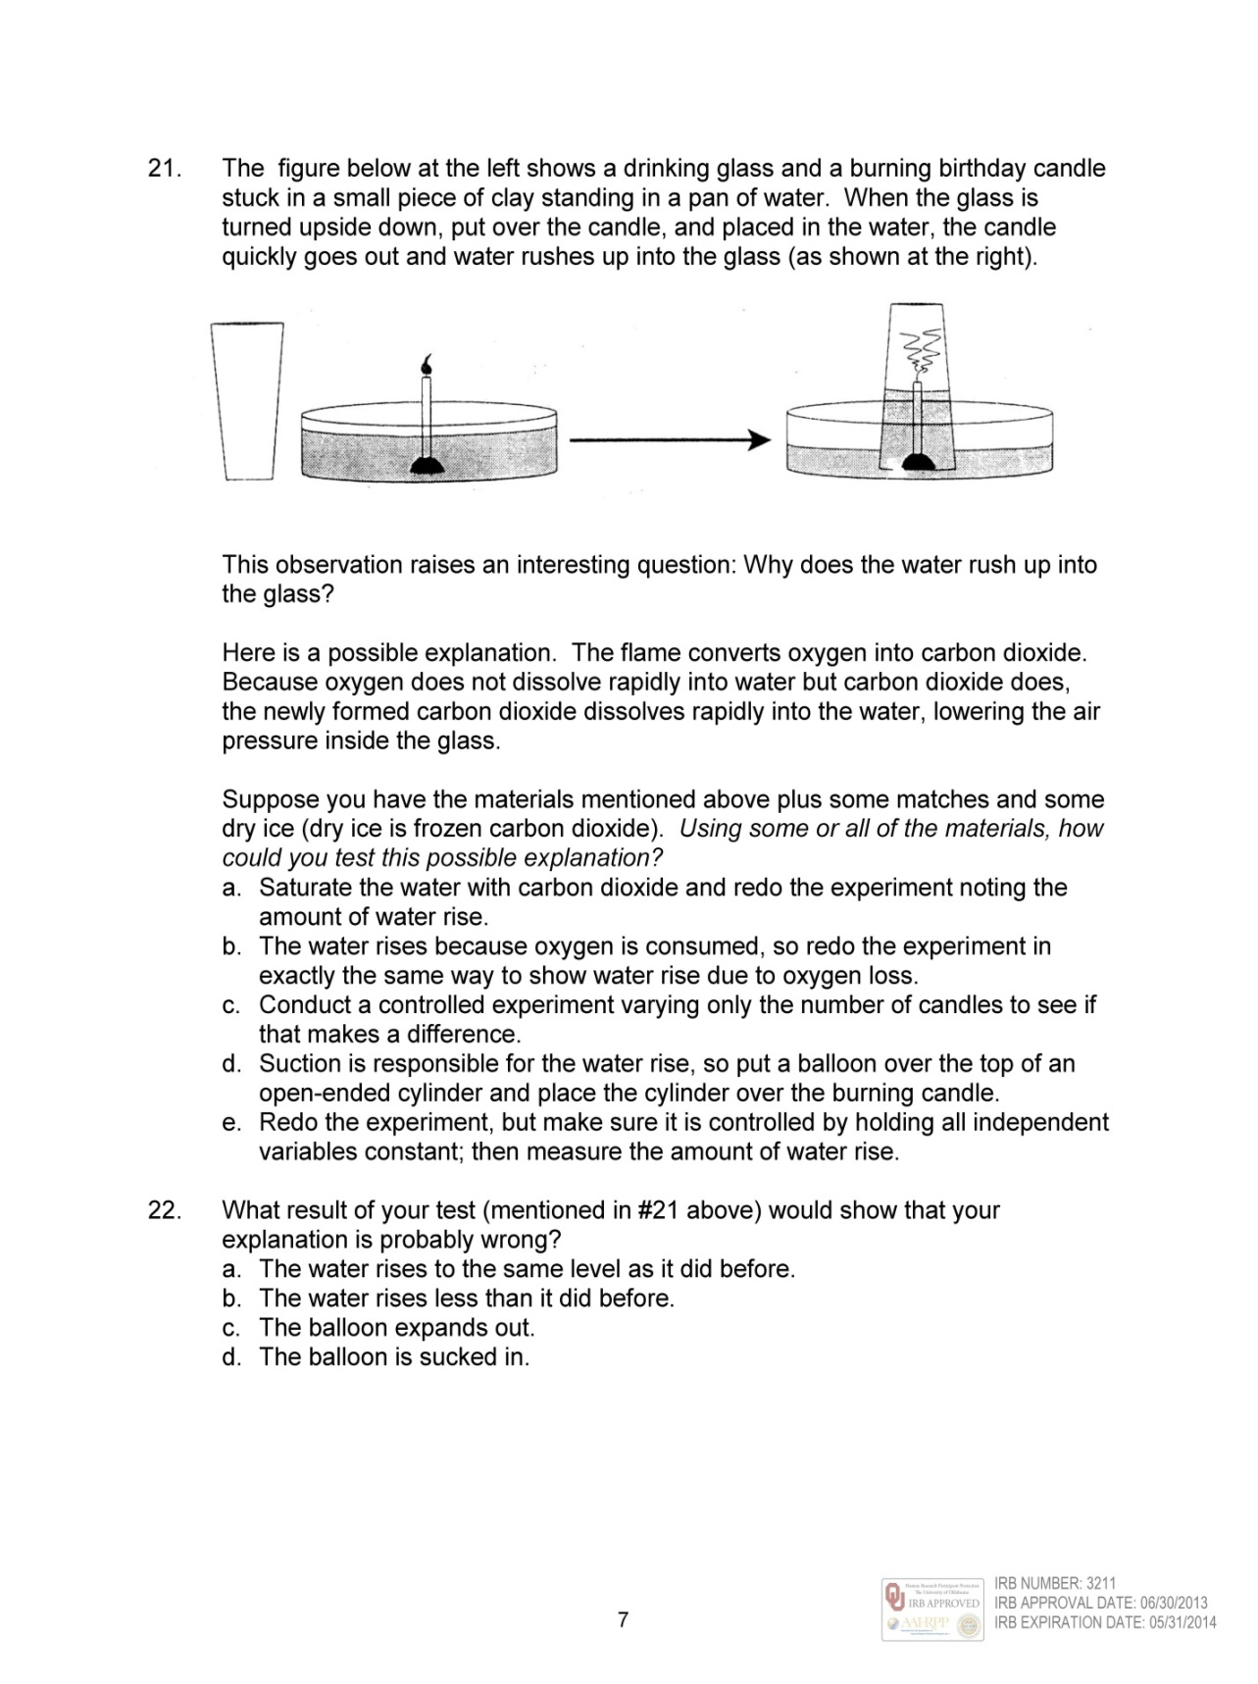

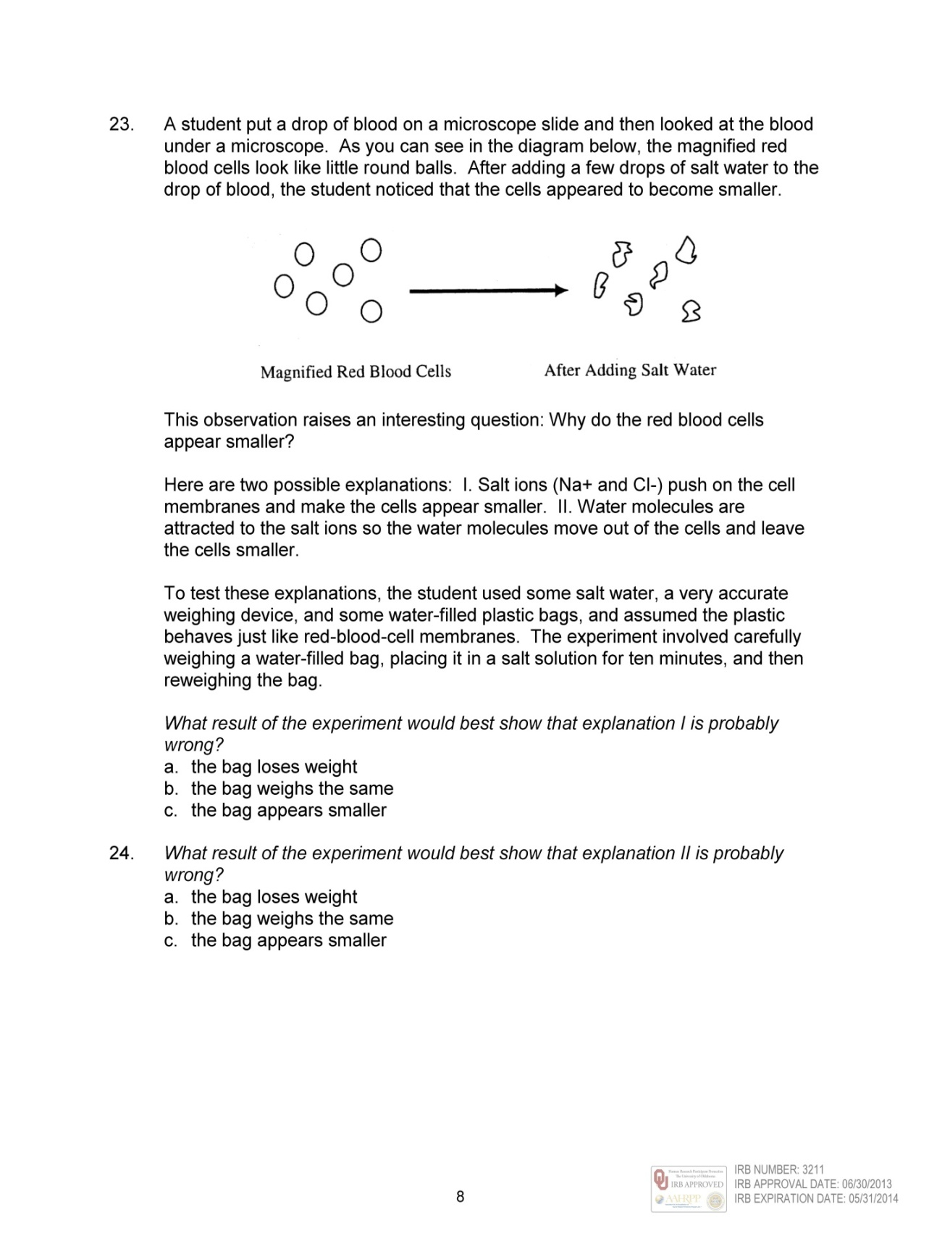

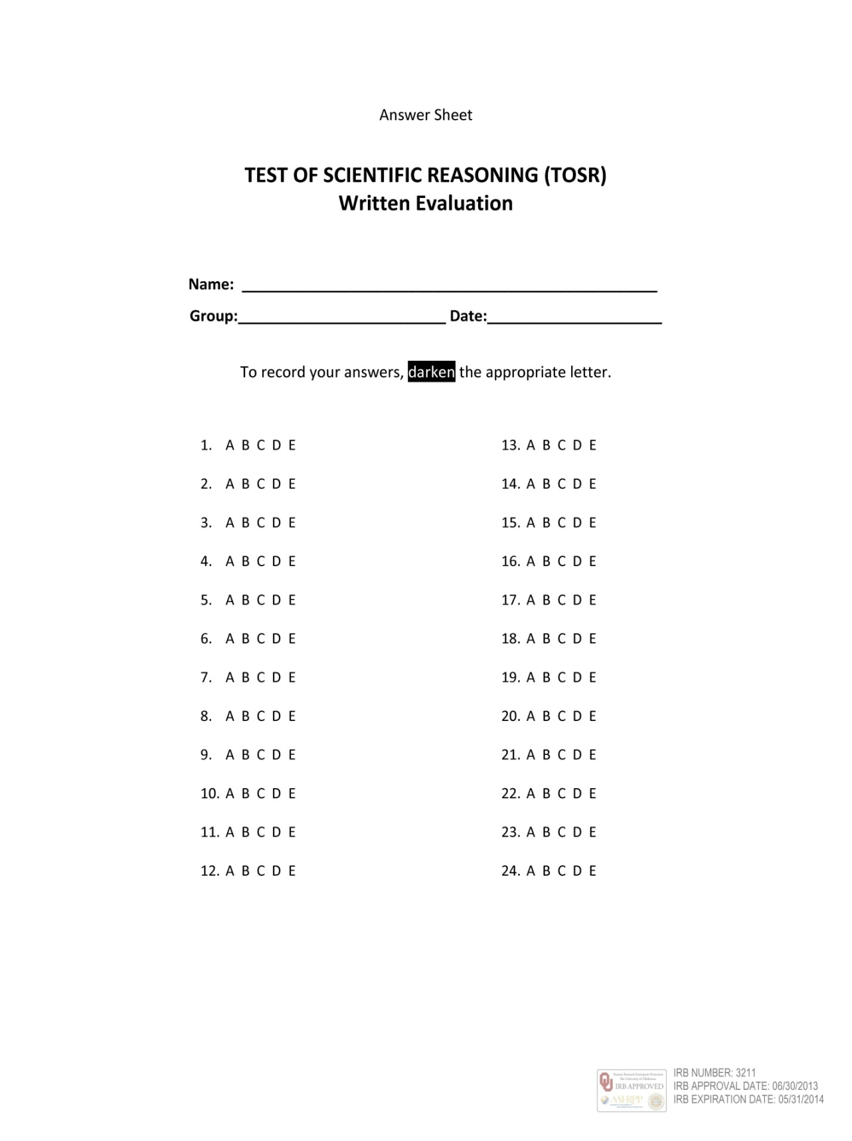

Appendix G:

Classroom Test of Scientific Reasoning Rubric

Appendix G is the Classroom Test of Scientific Reasoning Rubric. The rubric is the same, but with more detailed explanations, as the Classroom Test of Scientific Reasoning, Neonatal Resuscitation, Simulation Protocol submitted to the Internal Review Board for the Protection of Human Subjects Protocol as Exhibit 2, page 24 (see Appendix B, Page 33).

Classroom Test of Scientific Reasoning Rubric

Scoring Rubric

Classroom Test of Scientific Reasoning. Revised: August, 2000

Sample Answer Key: Multiple Choice Version. (Correct Answers Left Out Purposely).

1.: A 2.: B 3.: C 4.: D

5.: A 6.: B 7.: C 8.: D

9.: A 10.: B 11.: C 12.: D

13.: A 14.: B 15.: C 16.: D

17.: A 18.: B 19.: C 20.: D

21.: A 22.: B 23.: C 24.: D

Reasoning Patterns Assessed

Scenarios 1-10: Requires both answers to be correct to be worth one point credit.

Scenarios 11-12: Each question if answered correctly is worth one point credit.

Scenarios Points

Scenario 1:

Questions 1, 2

Conservation of weight 1

Scenario 2:

Questions 3, 4

Conservation of displaced volume 1

Scenario 3:

Questions 5, 6

Proportional thinking 1

Scenario 4:

Questions 7, 8

Advanced proportional thinking 1

Scenario 5:

Questions 9, 10

Identification and control of variables 1

Scenario 6:

Questions 11, 12

Identification and control of variables and probabilistic thinking 1

Scenario 7:

Questions 13, 14

Identification and control of variables and probabilistic thinking 1

Scenario 8:

Questions 15, 16

Probabilistic thinking 1

Scenario 9:

Question 17, 18

Advanced probabilistic thinking 1

Scenario 10:

Questions 19, 20

Correlational thinking (includes proportions and probability) 1

Scenario 11:

Questions 21, 22

Hypothetico-deductive thinking 2

Scenario 12:

Questions 23, 24

Hypothetico-deductive reasoning 2

Maximal Number of Points 14

Scoring the Lawson Test

There are 12 separate scenarios on the Lawson Test of Scientific Reasoning. Each question asks for an answer and then a follow up reason question is asked, which gives a total of 24 different questions. In order to receive one point for an answer, the participant must select both the correct answer to the question and the correct reasoning behind the answer. However, the last two scenarios which involve the burning candle scenario and the red blood cell scenario are worth double the amount of points, or two points for a correct answer and reason.
Based on the nature of the test items and the number of each type of item:
A. Scores of 0–3
Classified as Level 0
For example, students were not able to test hypotheses involving observable causal agents.
B. Scores of 4–6
Classified as Low Level 1
For example, students inconsistently were able to test hypotheses involving observable causal agents.
C. Scores of 7–10
Classified as High Level 1
For example, students were consistently able to test hypotheses involving observable causal agents.
D. Scores of 11–14
Classified as Level 2
For example, students were able to test hypotheses involving unobservable
entities. ¹
Reference:
- Lawson, A. E., Development of Scientific Reasoning in College Biology: Do Two Levels of General Hypothesis-Testing Skills Exist? Journal of Research in Science Teaching, 2000. 37(1): p 81-101.

Appendix H

Student Group Research Randomizer Results
The Student Group Research Randomizer was used to assign the students to the four groups (Control or No Intervention, Video Lecture, Simulation, or Both [Video Lecture and Simulation]). One hundred and twenty-five sets of four unique numbers per set with a range of 1-4 unsorted numbers was used for the randomization of an approved five hundred students in the study.

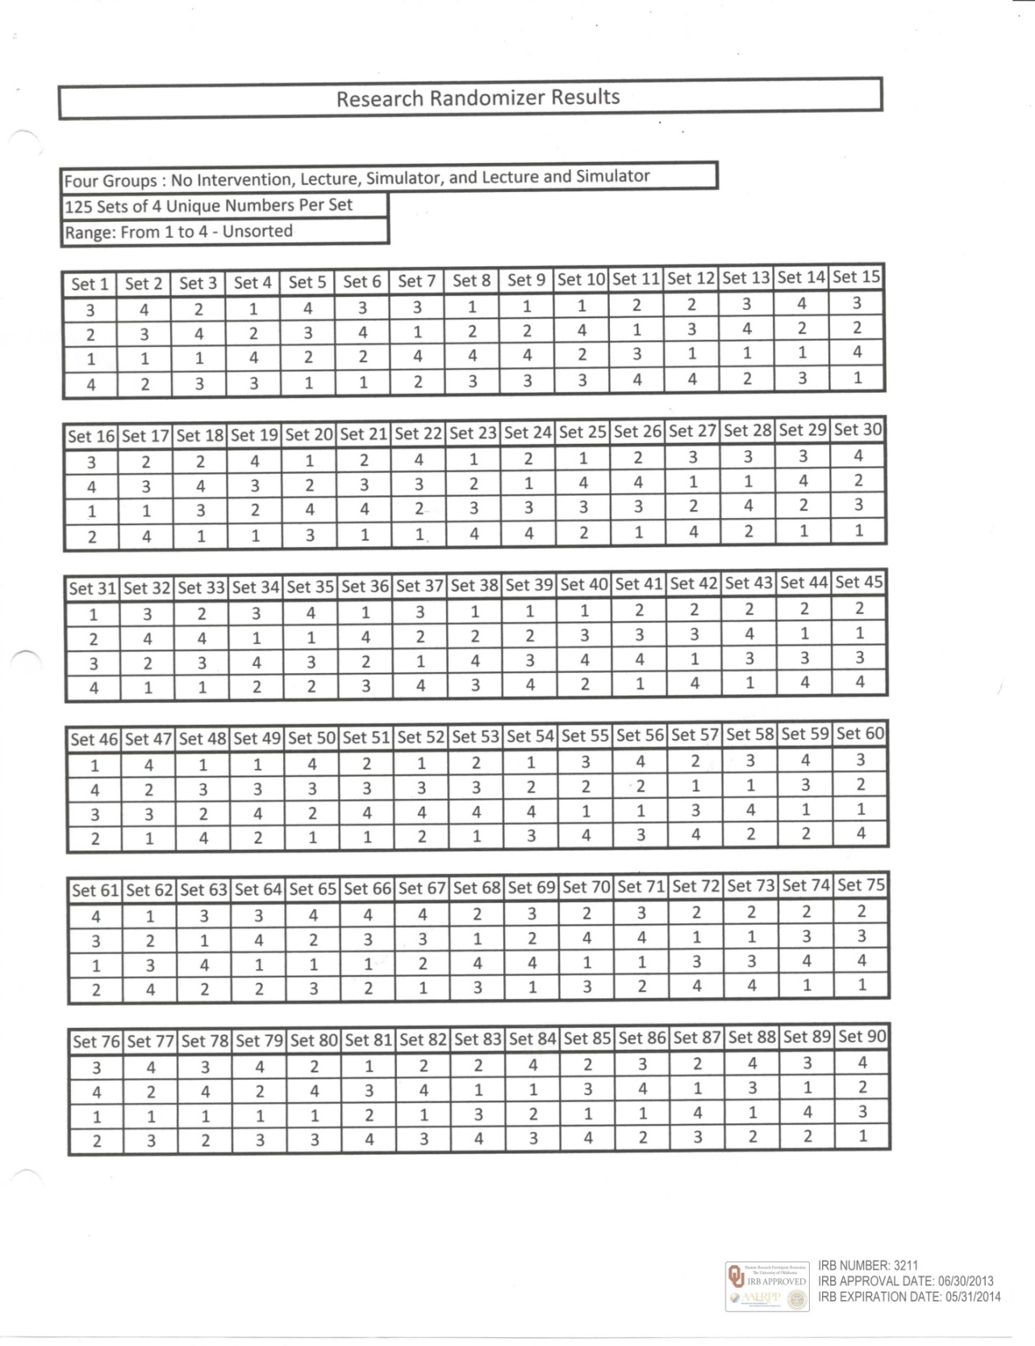

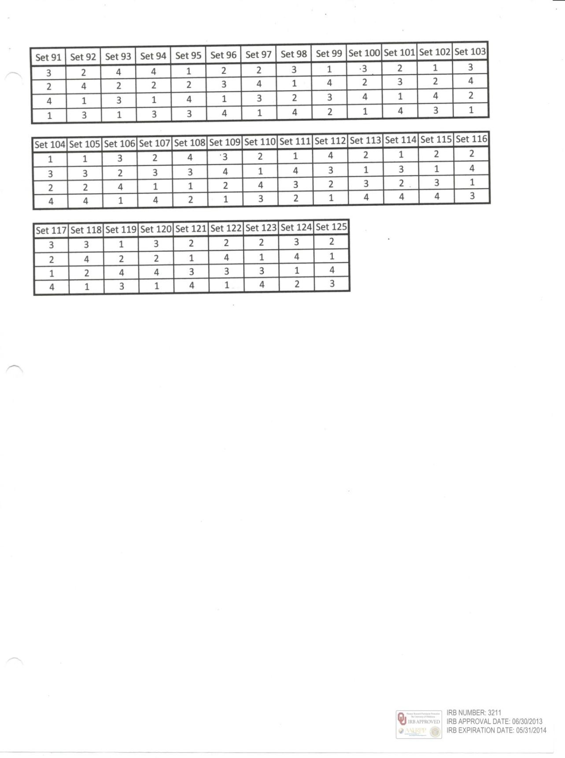

Appendix I
Neonatal Resuscitation Program Lecture Presentation
Appendix I shows the static first impression of each slide in the Neonatal Resuscitation Program Lecture Presentation, an automatic slide video lecture presentation. The slide video lecture presentation is also enclosed in the last appendices in a disk and in a USB drive (Appendices T and X) where it is not shown as a static presentation; but rather, it is shown as a slide video “motion picture” presentation. By having the slide video lecture presented as a video, the lecture has always been time, content and presentation neutral. The IRB approval of these slides was not included here because they would have consumed too many pages since fewer slides per page were approved on the protocol submitted to the IRB. I am purposely representing more than three slides per page in the following pages (in order to decrease the total number of dissertation pages).

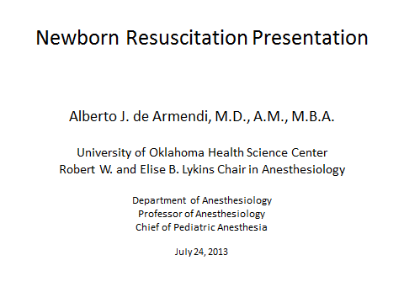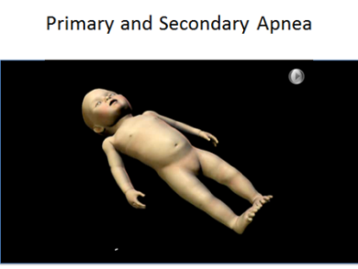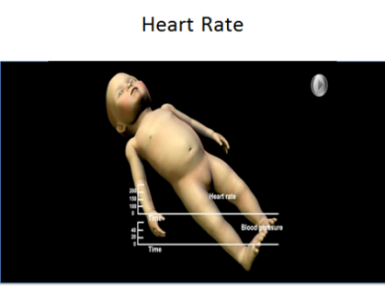

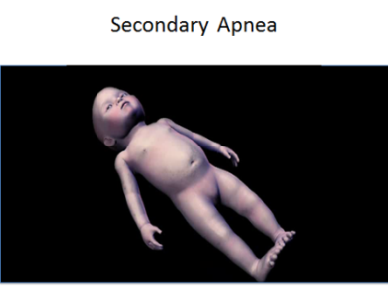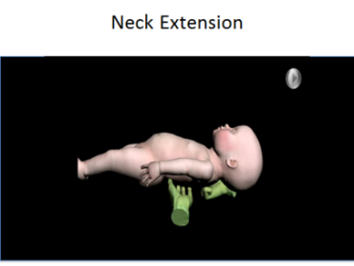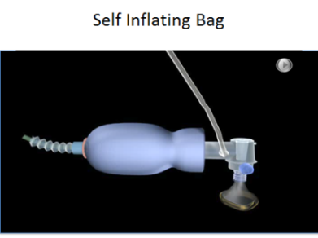

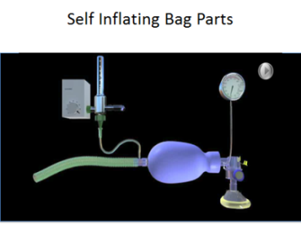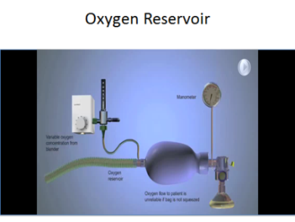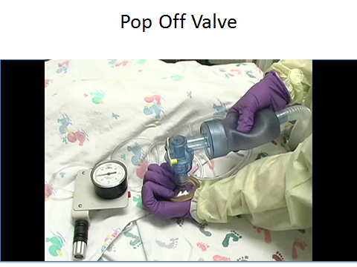

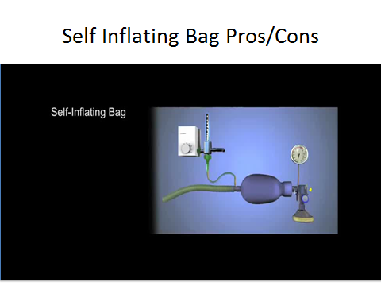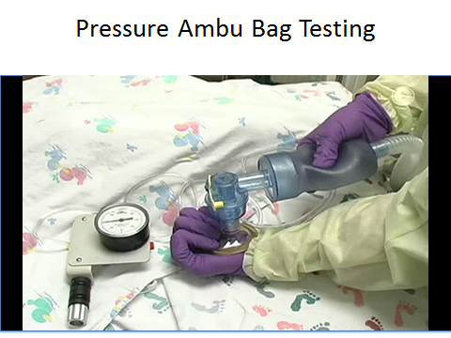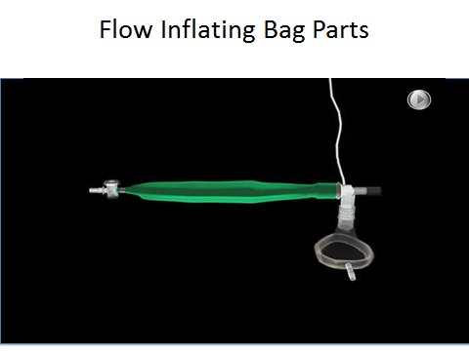

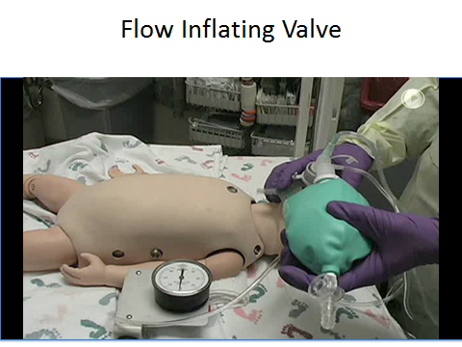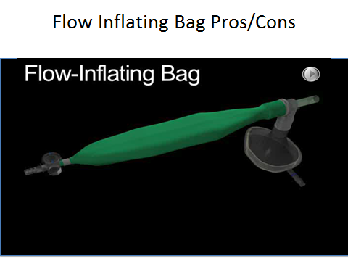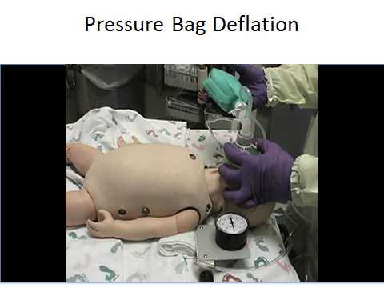

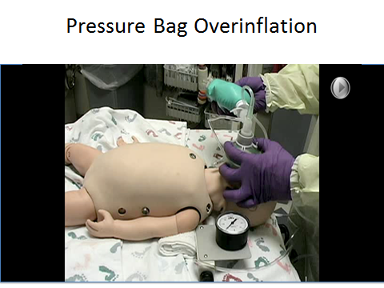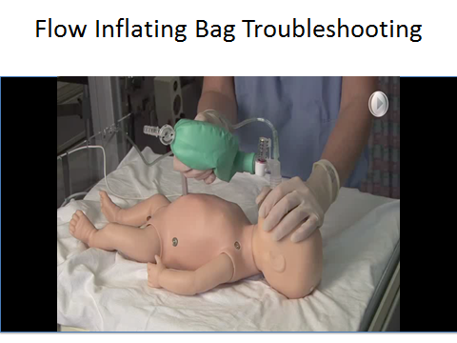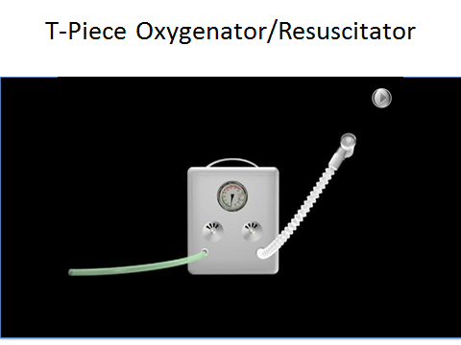

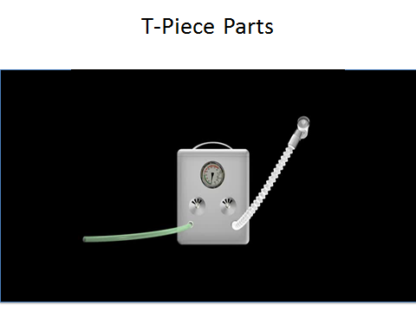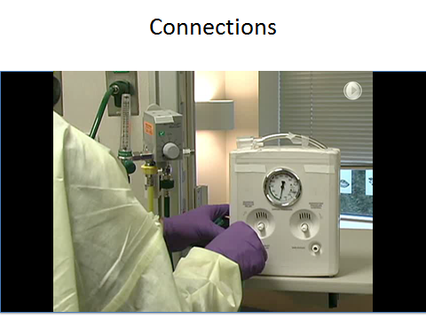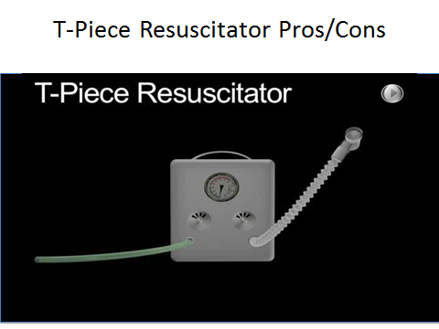

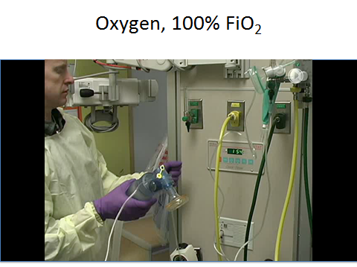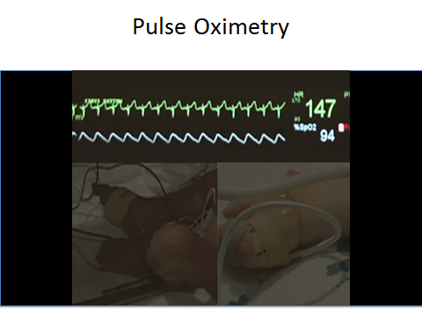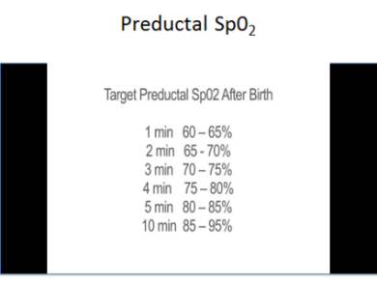

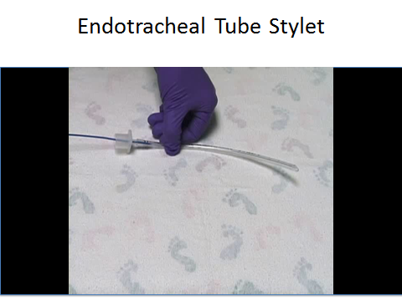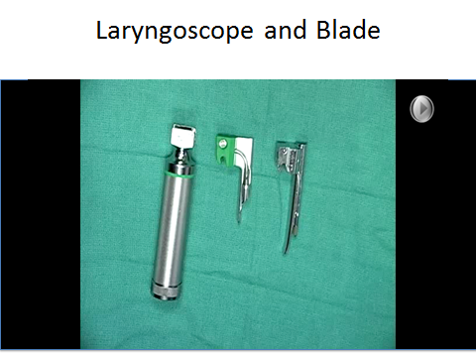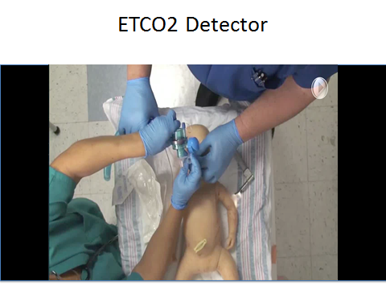

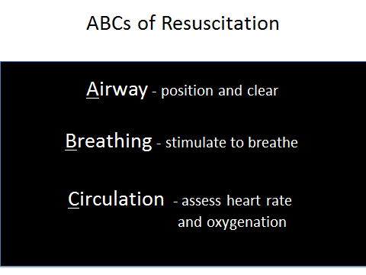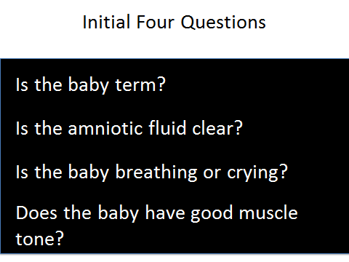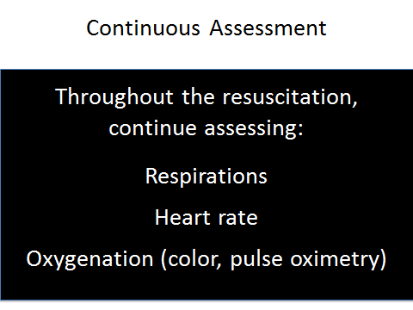

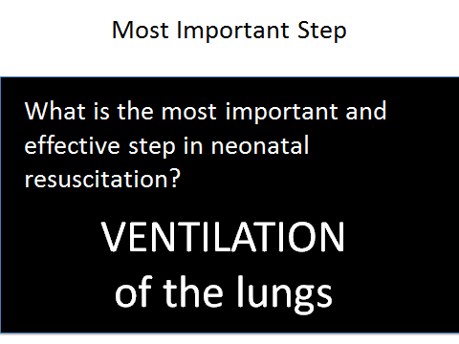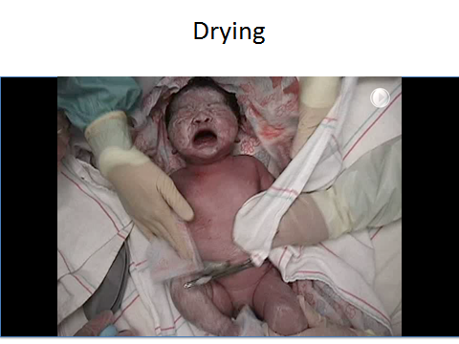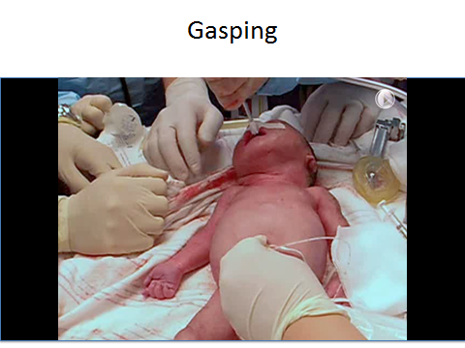

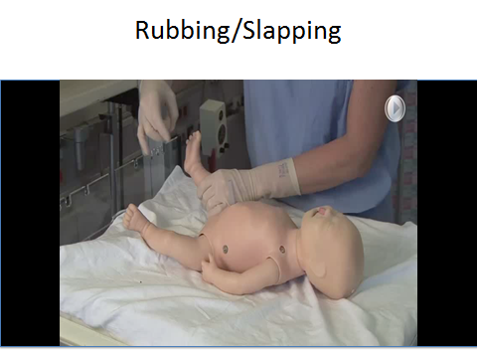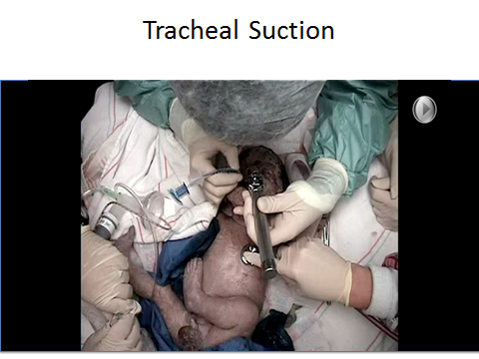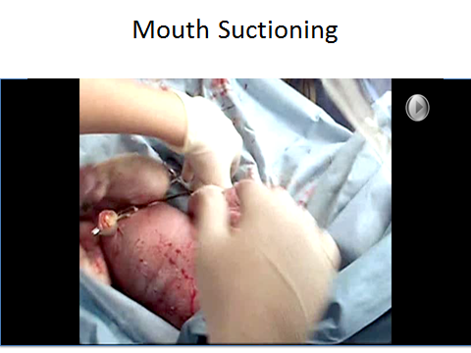

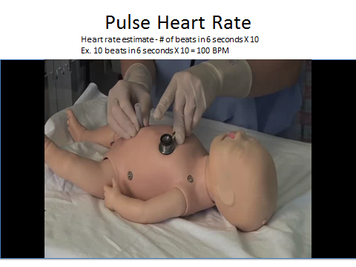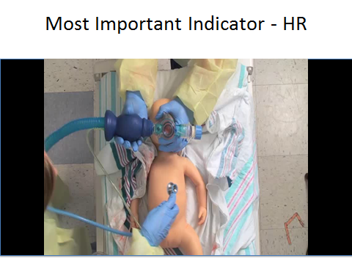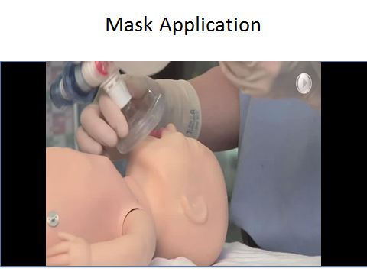

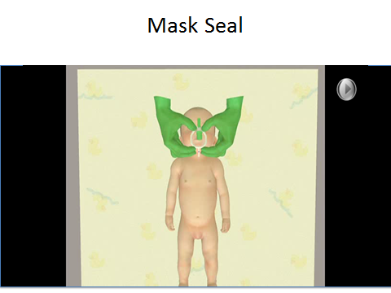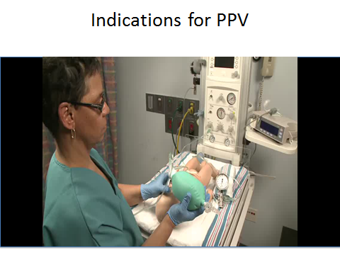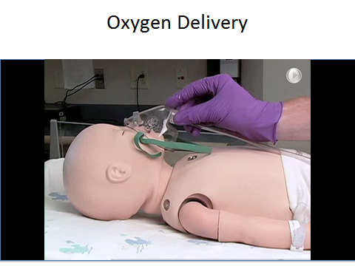

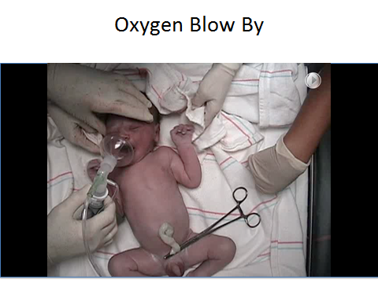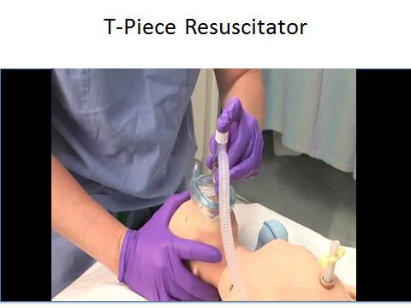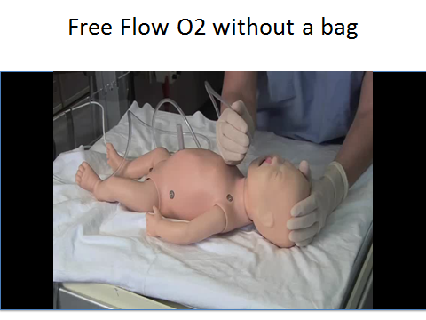

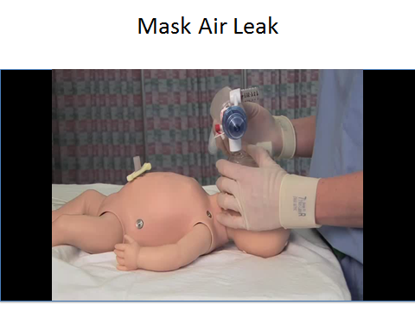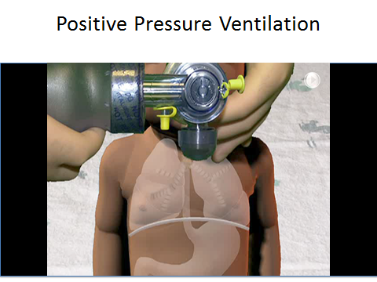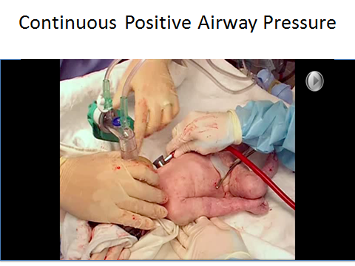

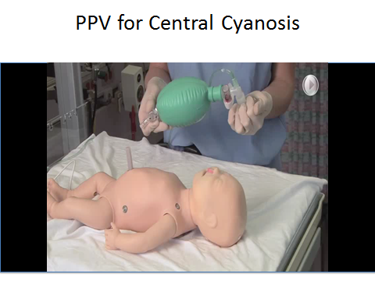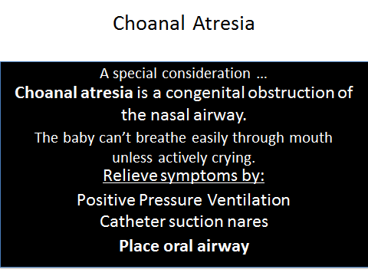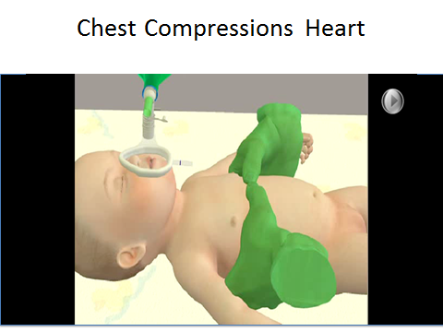

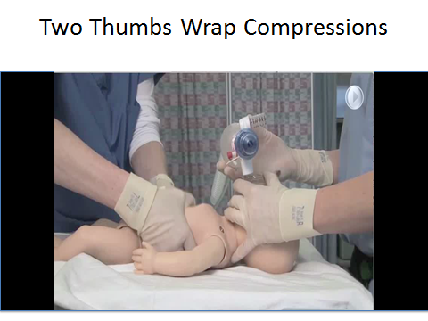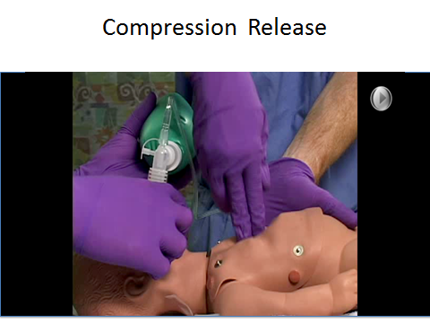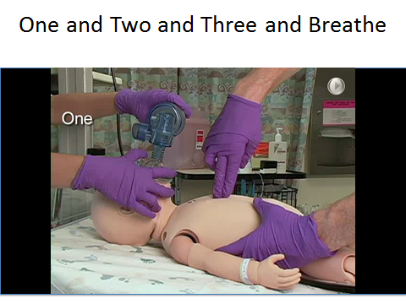

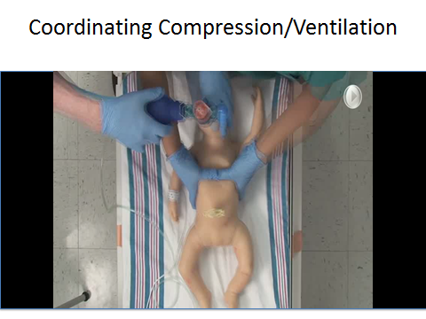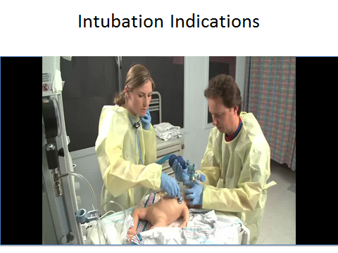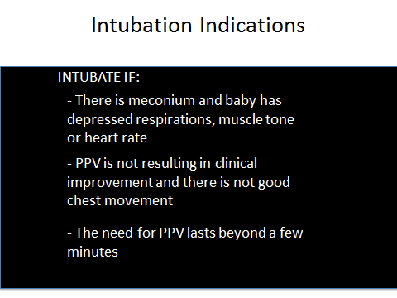

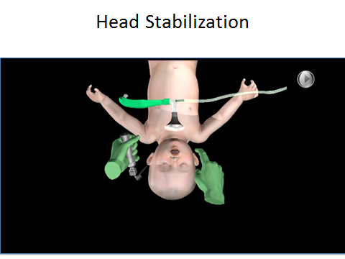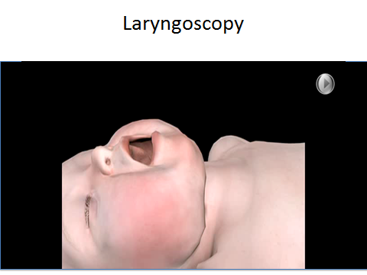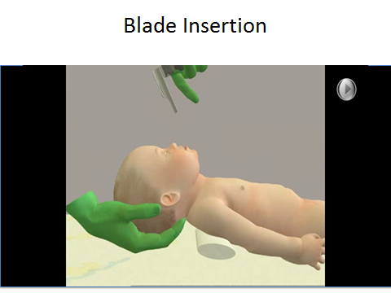

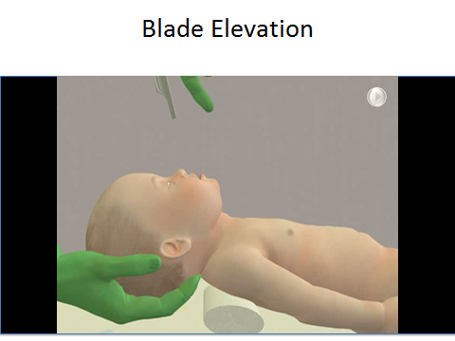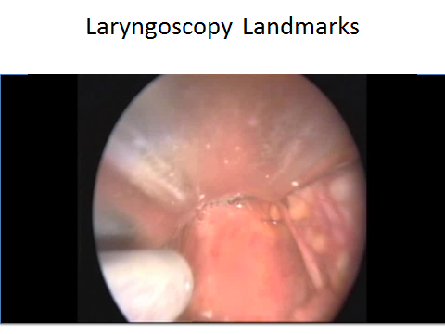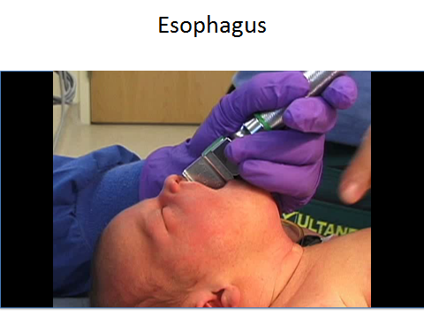

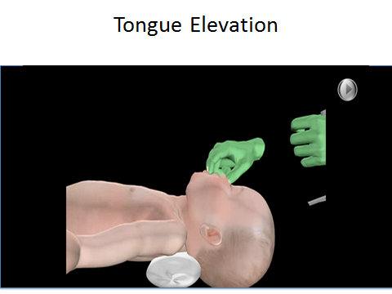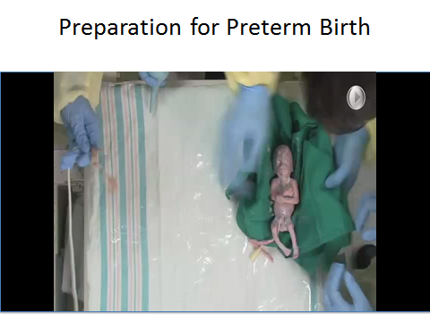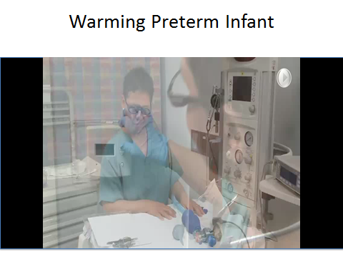

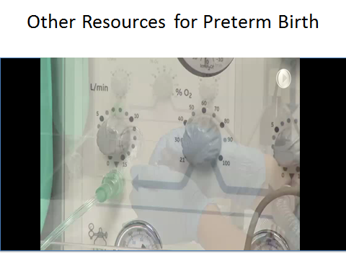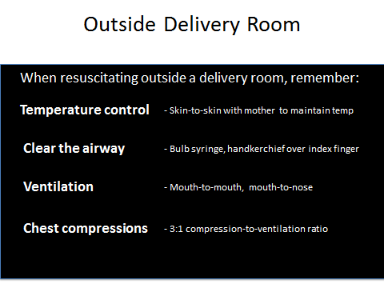

Appendix J
Simulation Cheat Sheet Presentation
Appendix J shows the key words used in the simulation presentation for the nursing and medical students. By going over each of the key topic words as noted in this Simulation Cheat Sheet Presentation, the content covered was the same as the content covered during the video lecture presentation. The goal was to be content and time neutral during both of these presentations (the video-lecture presentation and the simulation presentation).

Simulation Cheat Sheet Presentation
- Equipment
  - Self-Inflating Bag
    - Always refills after bag squeeze
    - Self inflates without seal
    - Does not reliably deliver oxygen (need to squeeze bag)
    - Show oxygen inlet
    - Show oxygen reservoir
    - Show appliance over air inlet
    - Show how gas collects, prevents oxygen dilution with room air
    - Show air inlet
    - Show pressure gauge attachment site
    - Show Pressure Release Valve (Pop-Off Valve)
    - Occlusion allows increased pressure
    - Show valve assembly
    - Show patient outlet
  - Flow Inflating Bag
    - Collapses when not in use
    - Inflates with gas source, usually oxygen
    - Needs/requires good seal
    - Requires sufficient gas source to inflate
    - Usually without pop-off valve
    - Flow Control Valve (Flow Inflating Valve)
    - Desired CPAP/PEEP controlled by flow inflating valve
    - If over-inflated, can over-inflate/distend the baby’s lung
    - If under-inflated cannot achieve desired pressure (check for bag tears, FCV open)
    - Takes practice to know how to work with the flow control valve
    - With manometer, can set to handle easily
    - Show oxygen inlet
    - Can deliver 21%-100% depending on source
    - Allows easy adequacy of face-mask seal
    - Can deliver free-flow oxygen
    - Check for disconnection/occlusion
    - Pressure manometer attachment site (needs to be connected)
    - Patient Outlet
  - T-Piece Resuscitator
    - Oxygen inlet, connect
    - Consistent pressure
    - Lung compliance cannot be felt
    - Reliable 100% oxygen delivery (when required)
    - Patient t-piece with PEEP cap
    - Circuit pressure gauge
    - Maximum pressure relief control
    - Inspiratory pressure control
    - Pressure limited
    - Requires compressed gas source (before to set pressure prior to use)
    - Flow-controlled
    - Pressure limited
    - PIP and PEEP are set manually, reliable
    - Changing pressure while use is hard
    - Minimally operator fatigue
    - Show patient outlet
    - Identify gas supply line
    - Adjust flow-meter (recommended 5-15 l/min)
    - Set maximum pressure; show two pictures
    - Occlude PEEP cap with finger
    - Adjust maximum pressure relief valve to 40 cm H₂0
    - Air Blender (when less than 100% fiO₂ is needed)
  - Pulse Oximeter
    - O₂ binds hemoglobin making it bright red
    - Measures change in color
    - Readings 0-100%
    - Preductal SpO₂
      - 1 minute = 60-65%
      - 5 minute = 80-85%
      - 10 minute = 85-95%
  - Endotracheal Tube Stylet
    - Secure in the ETT
    - Tip should not protrude
  - Laryngoscope and Blade
  - Select blade (preterm = size 0, term = size 1)
  - Check light
  - EtCO₂ detector
  - Attach to ETT
  - Watch color change (purple to yellow)
  - Yellow! “Yes for gold.” ETT is in the trachea
- Resuscitation
          - ABCs of Resuscitation
            - Airway
            - Breathing
            - CirculationFour Initial Questions
B. Is Baby Term?
- Amniotic fluid clear?
- Baby breathing/crying?
- Good muscle tone?
C. Continuous Assessment
- Respirations
- Heart rate
- Oxygenation
- Color
- Pulse oximeter
- Most Important Step
  - Ventilation
- Initial Resuscitation (first 30 seconds)
- Drying
- Warm dry towels (provides stimulation)
- Rubbing/Slapping/Tactile stimulation
  - Rubbing gently newborn’s back, trunk, or extremities
    - Slapping/Flicking soles of feet
- Mouth/Tracheal suctioning
    - Suction mouth to reduce possible aspiration
    - Mouth before nose (M before N)
- Primary Apnea
- Stimulation
    - Drying baby
    - Rubbing back
    - Slapping feet
    - All above leads to resumption of breathing in primary apnea
K. Secondary Apnea
  - Stimulation does not help in secondary apnea
  - Assisted Ventilation needed (Positive Pressure Ventilation)
- Heart Rate (Pulse)
- Should be > 100 bpm
  - Feel pulse at base of umbilical cord
  - Count beats for 6 seconds x 10 = bpm
  - Rising heart rate - most successful indicator of resuscitation
  - When PPV is initiated, HR is assessed first
- Gasping
- Series of deep single or stacked inspirations with hypoxia or ischemia
- Can be indicative of severe neurological and respiratory depression
- Positive Pressure Ventilation (PPV)
  - Gas is forced in oropharynx (can enter both trachea and esophagus)
  - Gas in stomach interferes with ventilation
    - Upward pressure on the diaphragm
    - Limits lung expansion
    - Increases regurgitation potential
- Oxygen Delivery
  - FiO₂ determined by O₂ arriving to patient
- Indications for PPV
  - Apnea/gasping/labored breathing
  - HR < 100 bpm
  - Low O₂ saturations (hypoxiemia) despite supplemental oxygen
- Neck Extension
  - Slightly extended (sniffing position)
- Mask Application
  - Airtight seal
- Mask Air Leak
  - Leads to inadequate air entry (poor chest movement)
  - If hear/feel air escaping, reapply mask for better seal
  - Most common leak (cheeks and nose bridge)
- Oxygen Blow-By (Free-Flow O₂)
  - Use flow-inflating bag
  - T-piece resuscitator
  - No mask, funnel or cup hand
- Choanal Atresia
  - Congenital obstruction of nasal airway
  - Baby cannot breathe except when crying
  - Relieve symptons:
    - Suction nares (diagnosis)
    - PPV
    - Oral airway
III. Clinical
- Chest Compressions
  - Compress sternum
  - Compresses heart
  - Increases intrathoracic pressure to push blood out into arteries
B. Two-Thumbs Wrap Compressions
  - Two-thumbs depress sternum
  - Hands encircle torso
  - Fingers support spine
  - Preferred technique
C. 1 and 2 and 3 and Breathe
    - Compressor counts (1and 2 and 3 and “Breathe”)
    - One ventilation every three compressions90 compressions/min
    - 30 breaths/min
    - Person ventilating
    - Squeezes during “Breathe”
    - Relaxes on “One ….”
    - Must be coordinated
D. Endotracheal Intubation
  - Indications
    - Meconium
    - Depressed respirations
    - Depressed heart rate
    - Depressed muscle tone
    - If PPV is ineffective (no clinical improvement)
    - If PPV is ineffective (no good chest rise)
    - If PPV is needed for longer than a few minutes
E. Head Stabilization
  - Stabilize head with right hand (laryngoscope with left hand)
  - Administer free-flow oxygen
F. Neck Extension
- Slightly extended (sniffing position)
- Laryngoscopy (midline with Miller blades)
- Insert blade
- Raise entire blade (no rocking motion)
- Esophagus (if too deep/far in)
- Pull back to epiglottis
- Vocal cords come into view underneath epiglottis
G. Preterm Infant
- Most likely will require resuscitation (support personnel)
- Risk heat loss (delivery room at 26ºC, radiant warmer, exothermic pad, plastic bag)
- Risk intracranial bleeding
- Risk lung injury
- Risk hypoxemic injury
- Pulse oximeter
- O₂ blender (adjust 21% - 100%)
H. Outside the Delivery Room
- Temperature control (skin-to-skin with mother)
- Clear airway (bulb syringe, handkerchief over index finger)
- Ventilation
- Chest compressions
I. Monitoring after Resuscitation
- Oxygenation
- Blood pressure
- Blood glucose
- Temperature
- Fluid status
- Respiratory effort
- Nutritional issues

Appendix K
Neonatal Resuscitation Program Exam Question Randomization Results
The Neonatal Resuscitation Program Exam Questions Randomization was applied to the questions from the Neonatal Resuscitation Program questions in order to permeate a random sequence of all the questions prior to the exam. Proc Surveyselect function of SAS software version 9.3 (SAS Institute, Inc., Cary, NC) was used to non-repeated randomly assigning the study questions from a pool of 94 Neonatal Resuscitation Exam questions. The first two sets included 32 questions each (Pre-Intervention Baseline Knowledge Exam #1 and Immediate Post-Intervention Knowledge Gain Exam #2) and the third set had 30 questions (Long-Term Knowledge Gain/Loss with Retention Exam #3). From each set, 15 video and simulation content representative questions were selected to finalize the three exams. By doing so, the study would be content neutral for both the video-lecture and the simulation presentations.

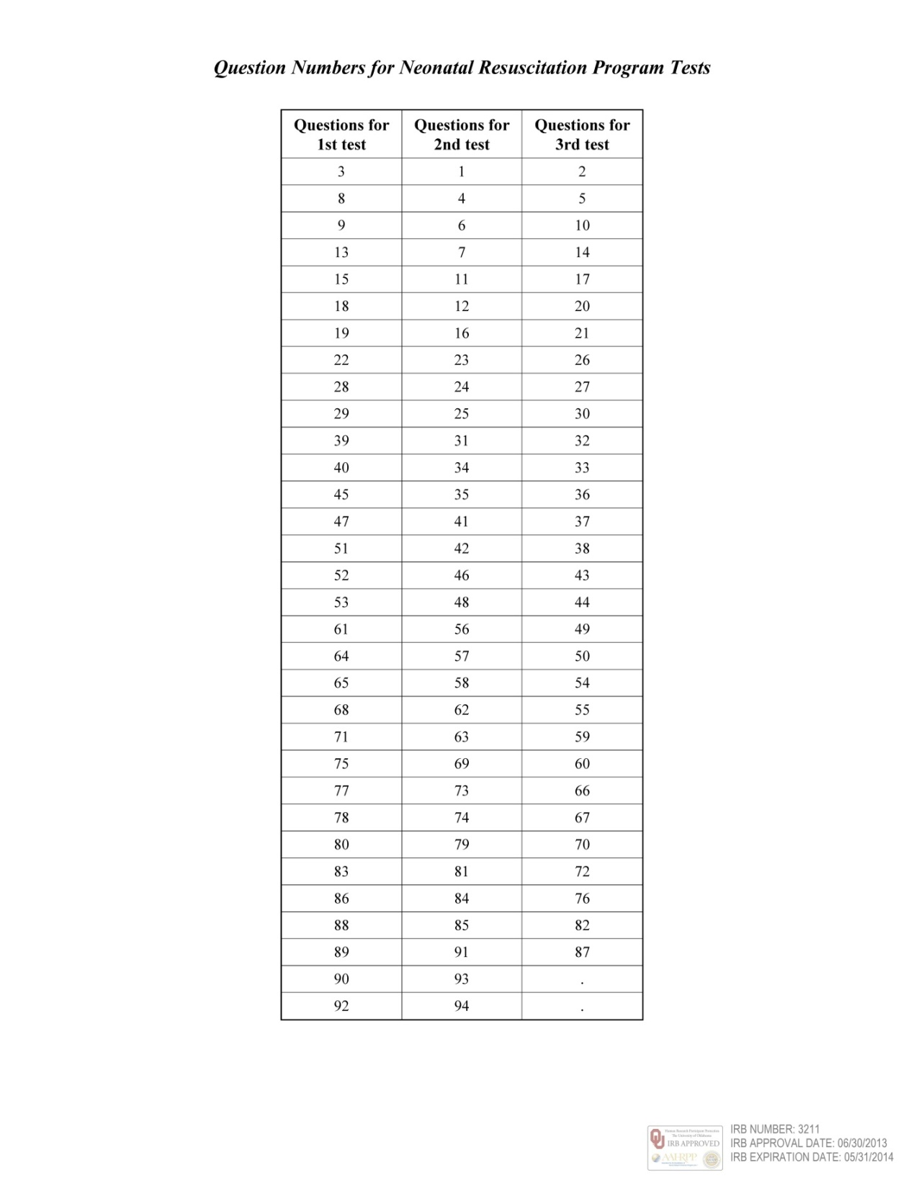

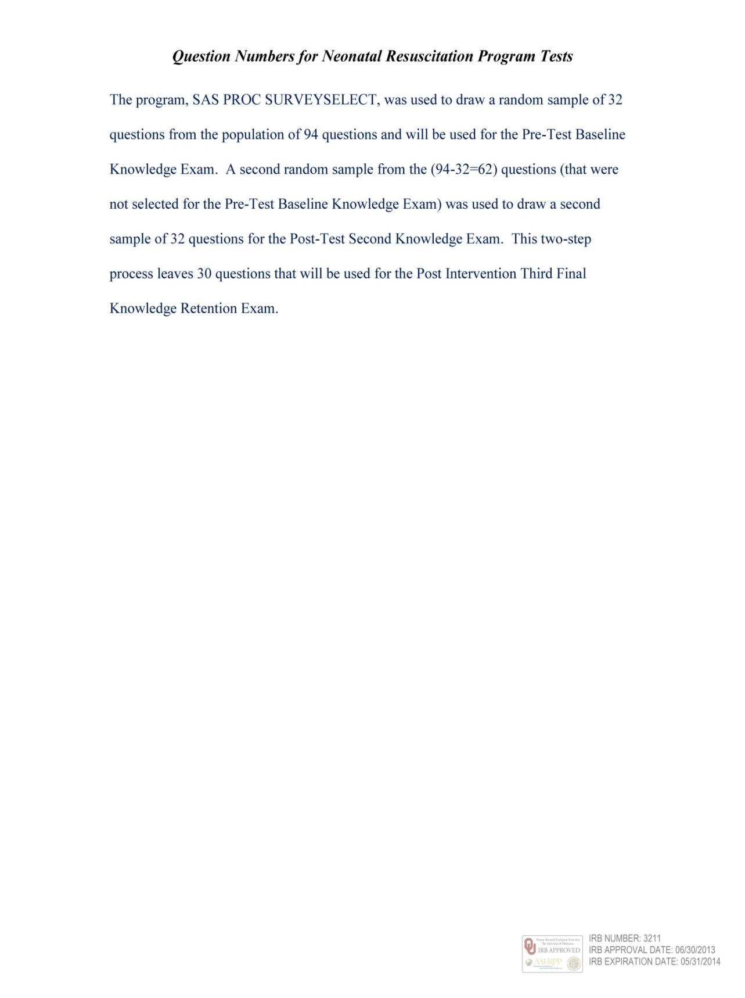

Appendix L
Neonatal Resuscitation Program Exam #1 and Answer Sheet
From the Neonatal Resuscitation Program Exam Questions Randomization, thirty-two questions (Pre-Intervention Baseline Knowledge Exam #1) were used to arrive at 15 video lecture and simulation content neutral questions for exam number one.



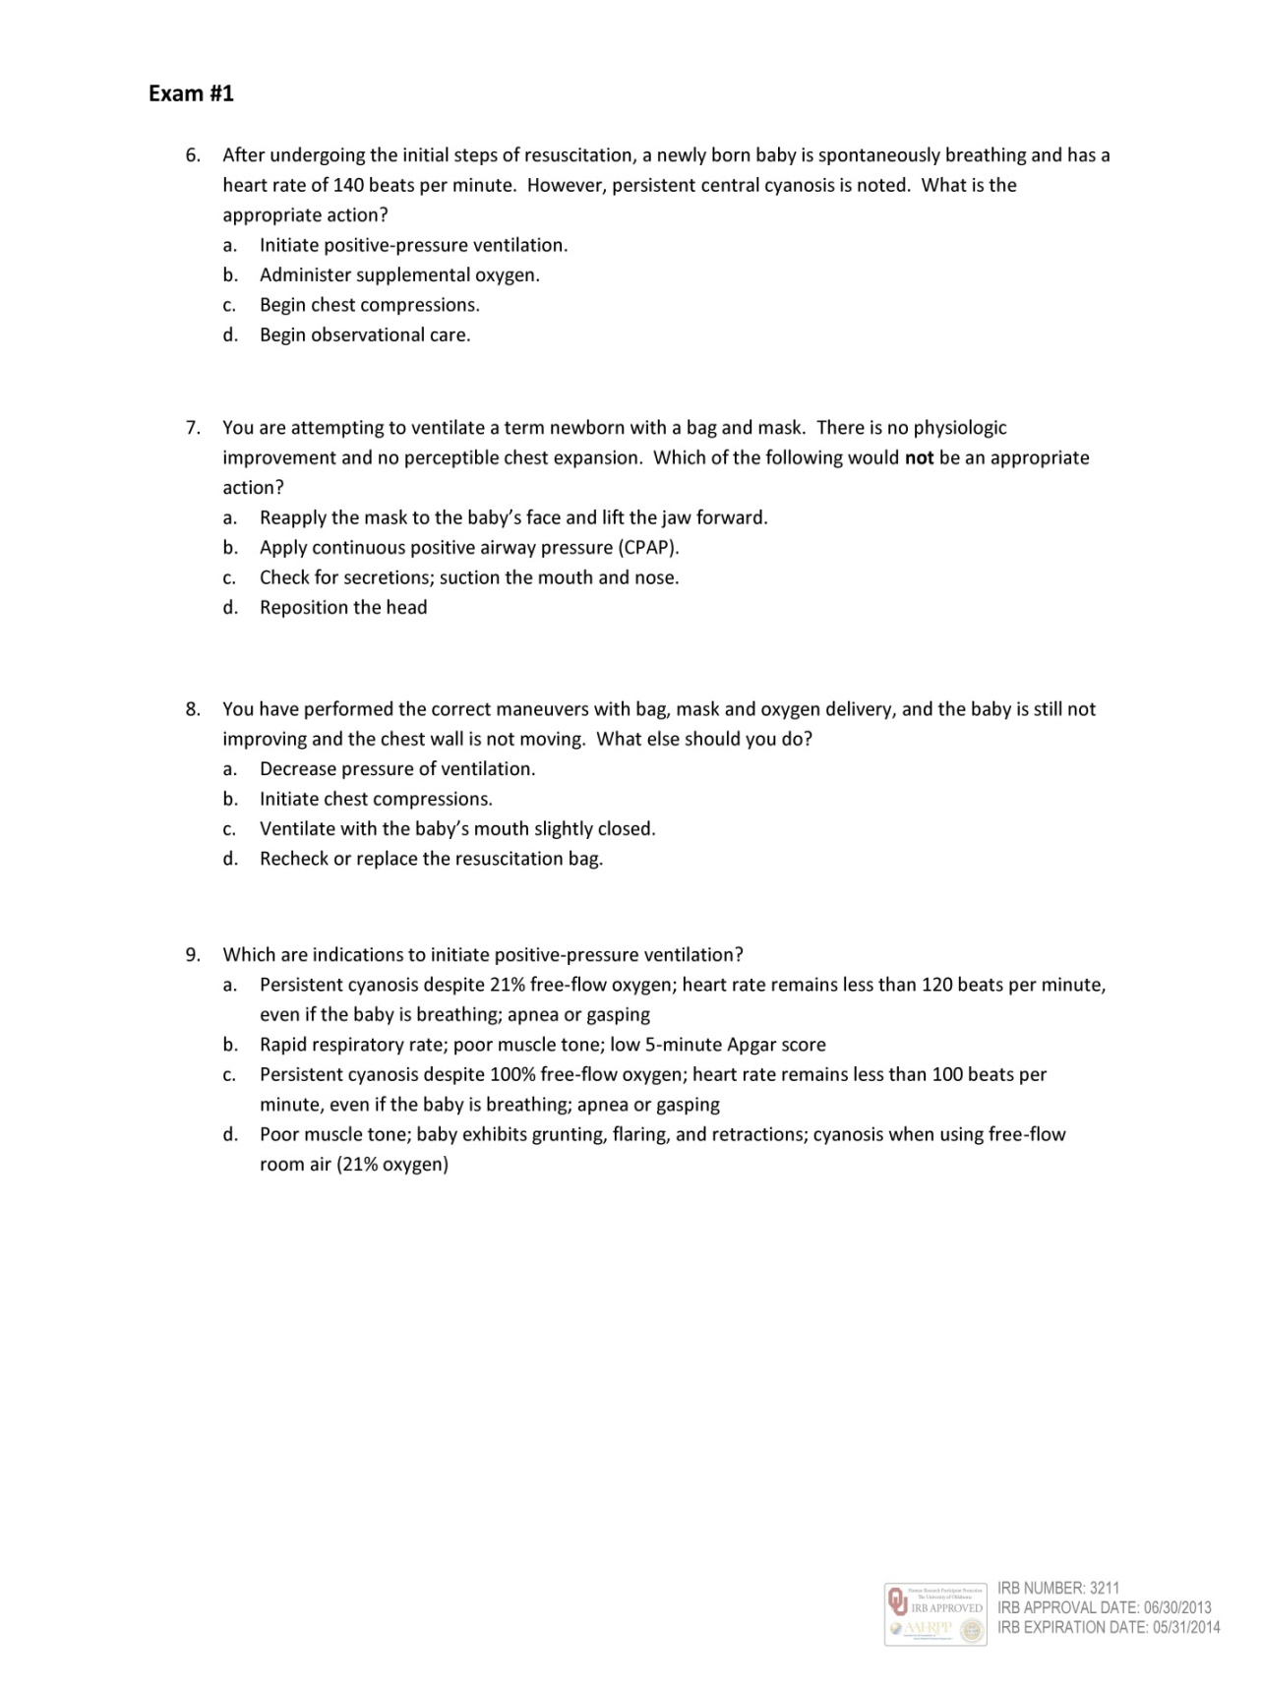

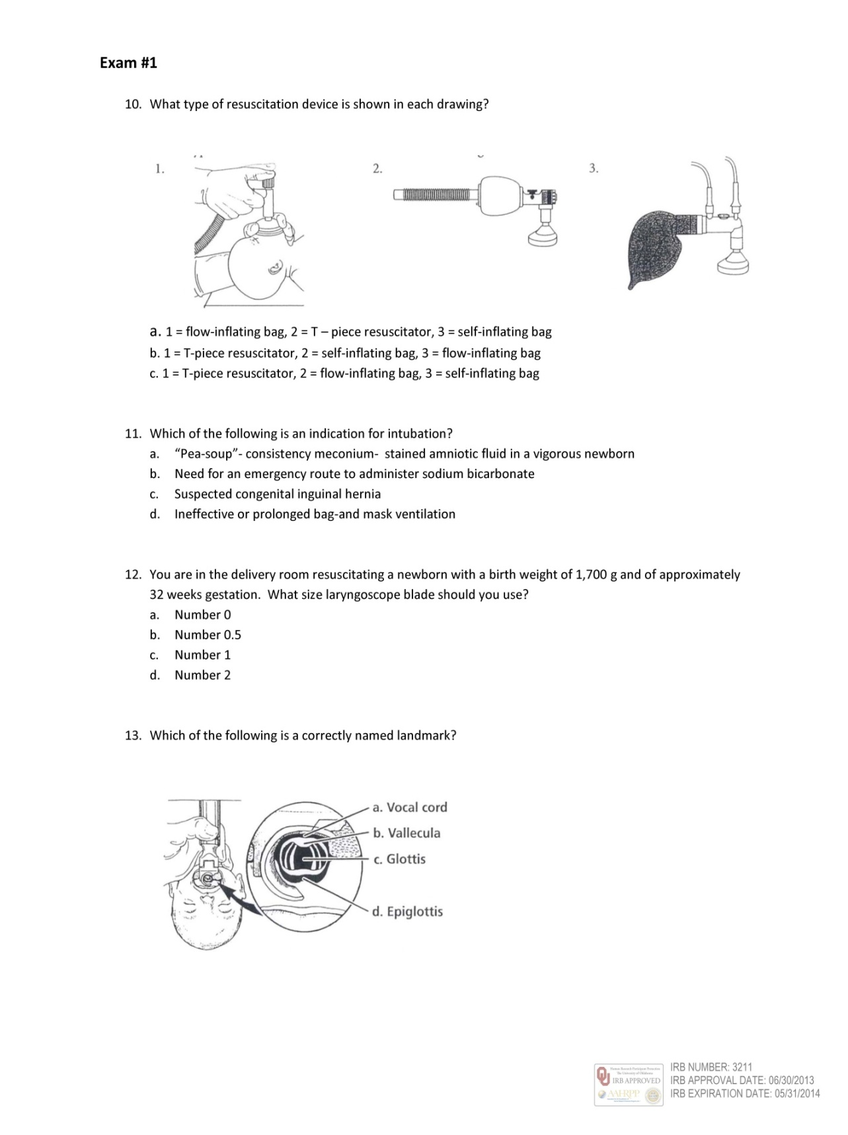

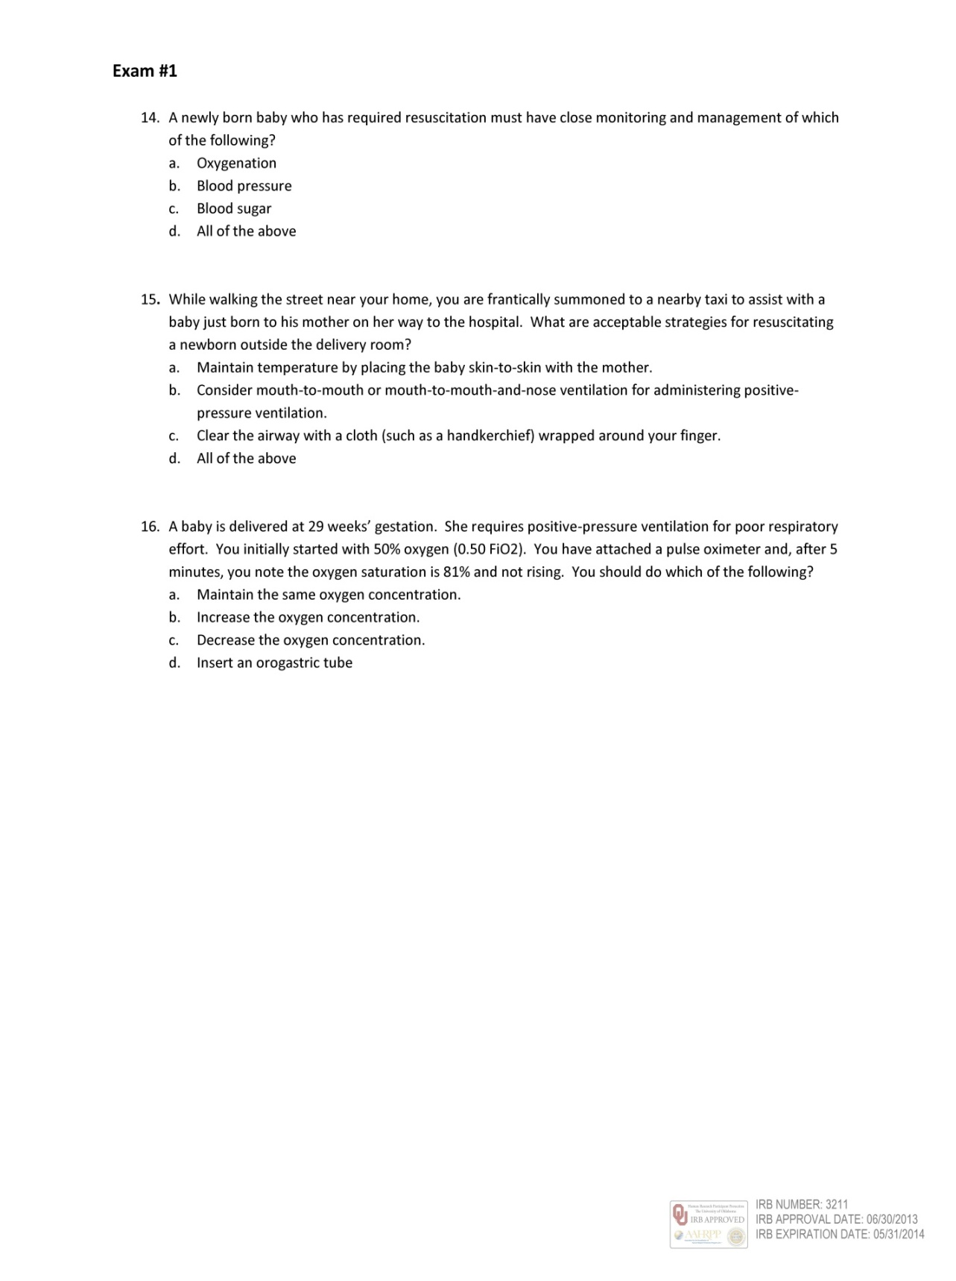

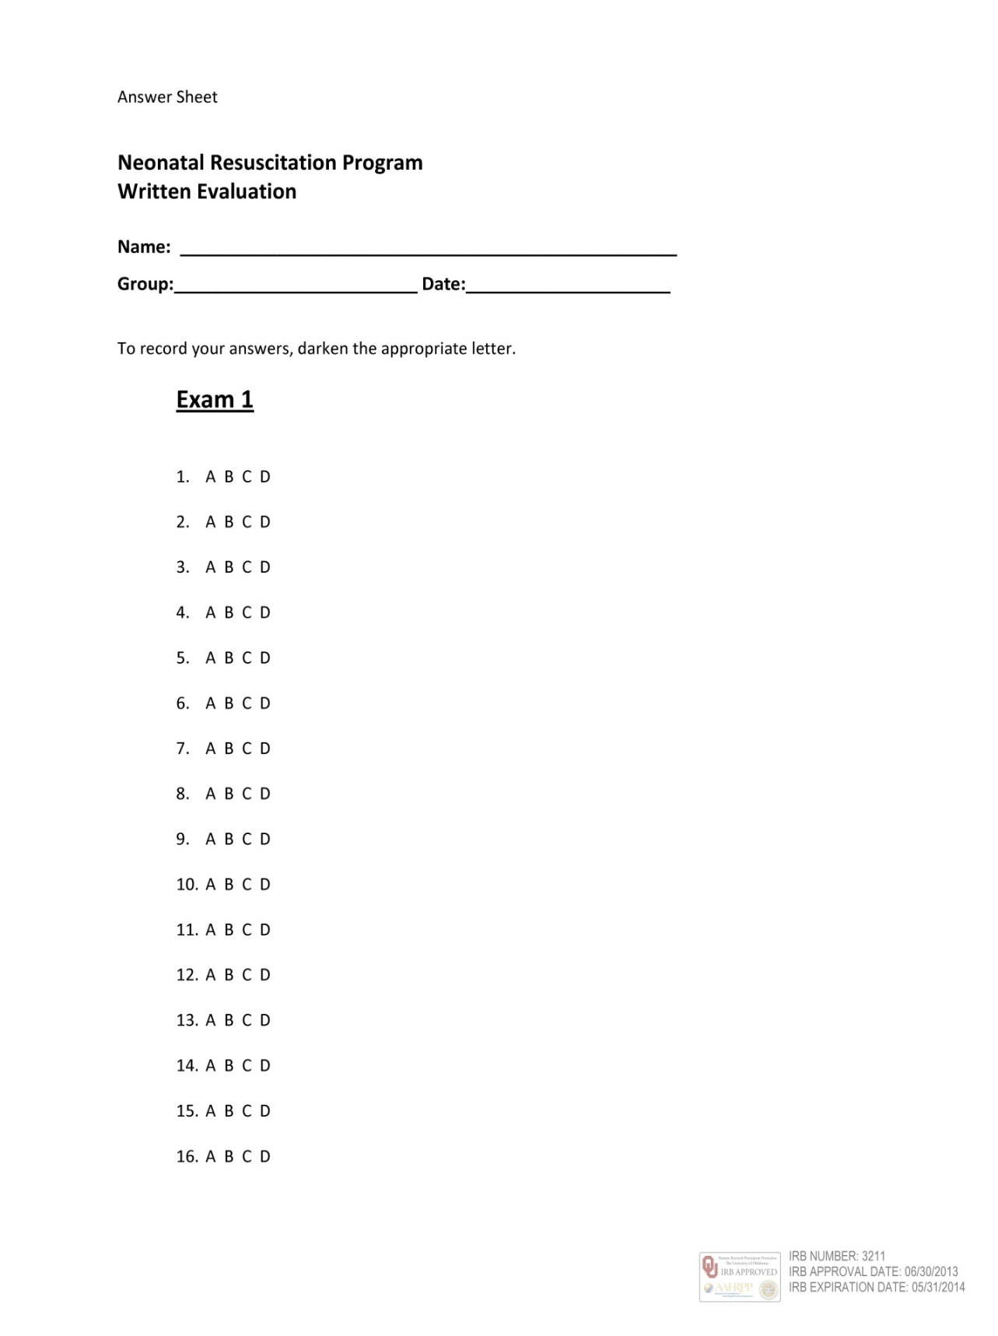

Appendix M

Neonatal Resuscitation Program Exam #2 and Answer Sheet
From the Neonatal Resuscitation Program Exam Questions Randomization, thirty-two questions (Immediate Post-Intervention Knowledge Gain Exam #2) were used to arrive at 15 video-lecture and simulation content neutral questions for exam number two.

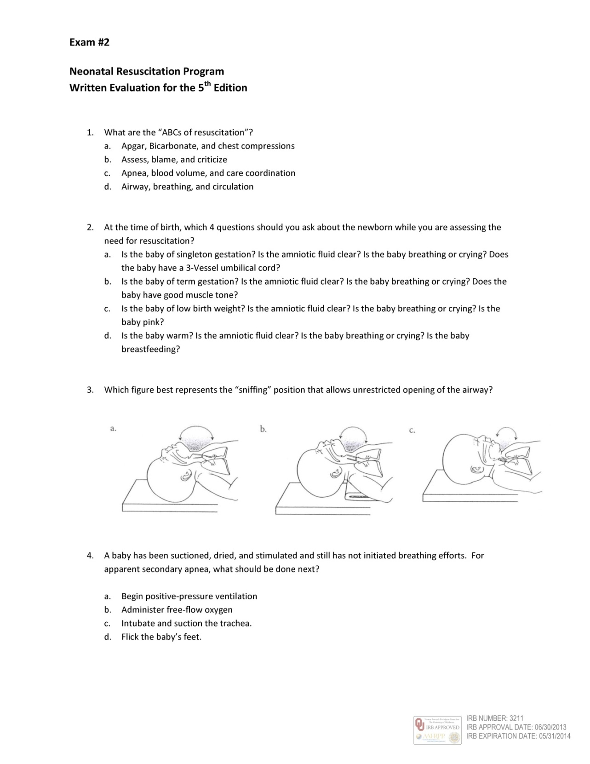

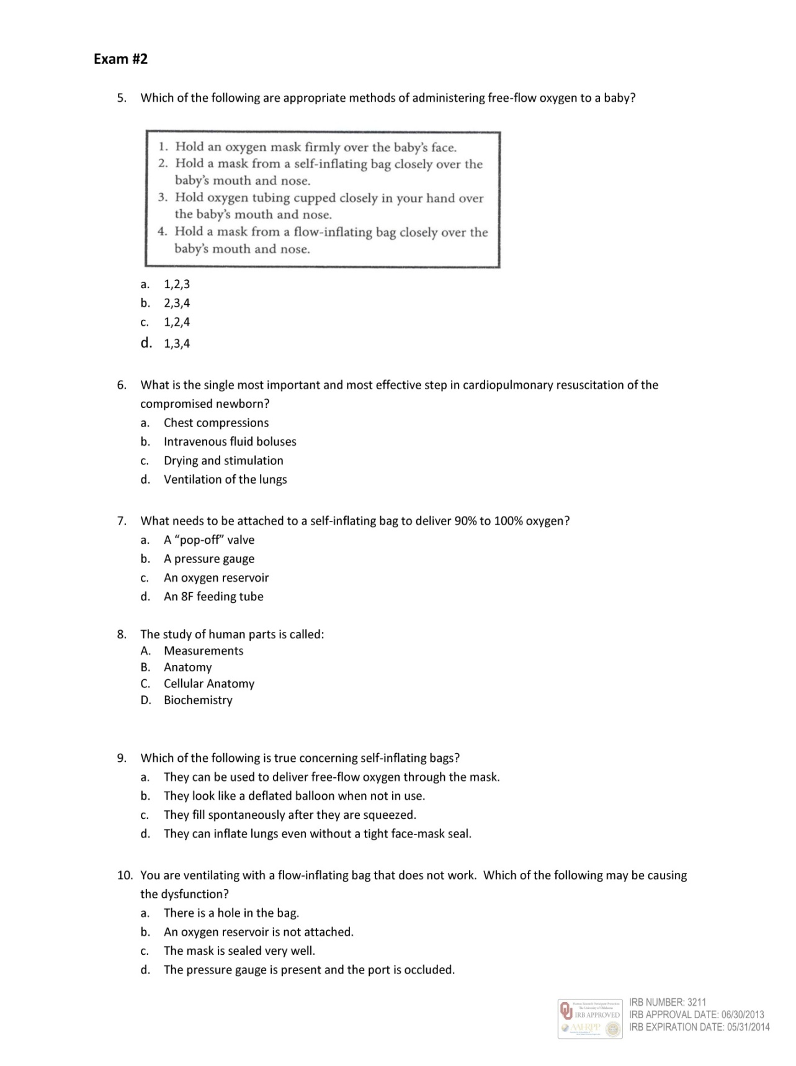

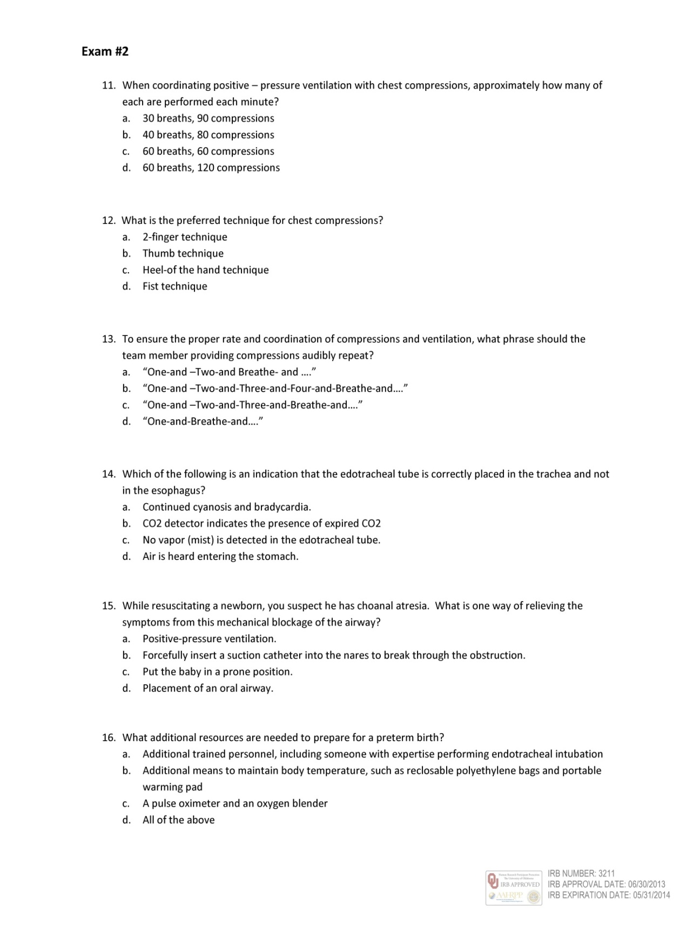

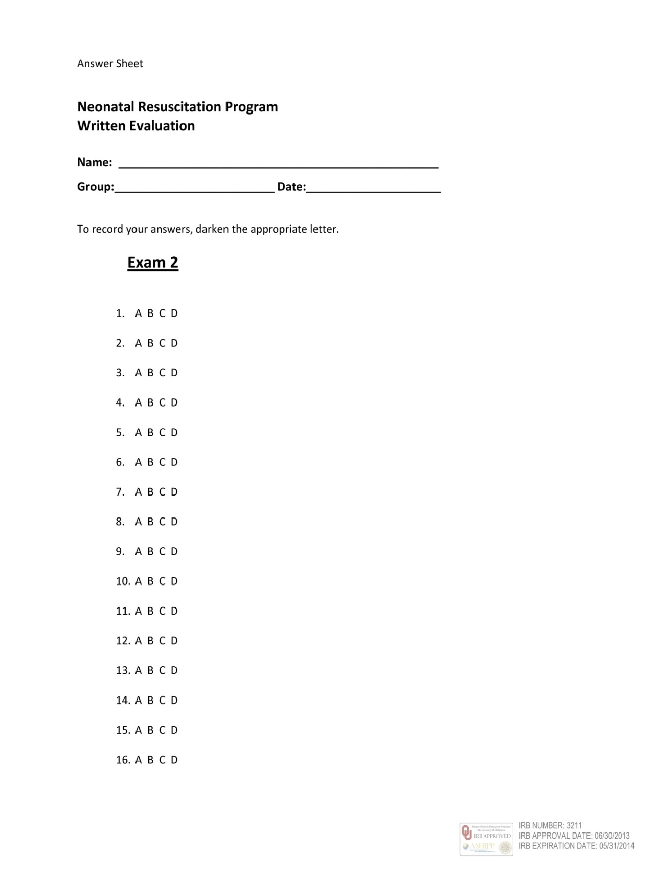

Appendix N

Neonatal Resuscitation Program Exam #3 and Answer Sheet
From the Neonatal Resuscitation Program Exam Questions Randomization, thirty questions remained (Long-Term Knowledge Gain/Loss with Retention Exam #3) and were used to arrive at 15 video lecture and simulation content neutral questions for exam number three.

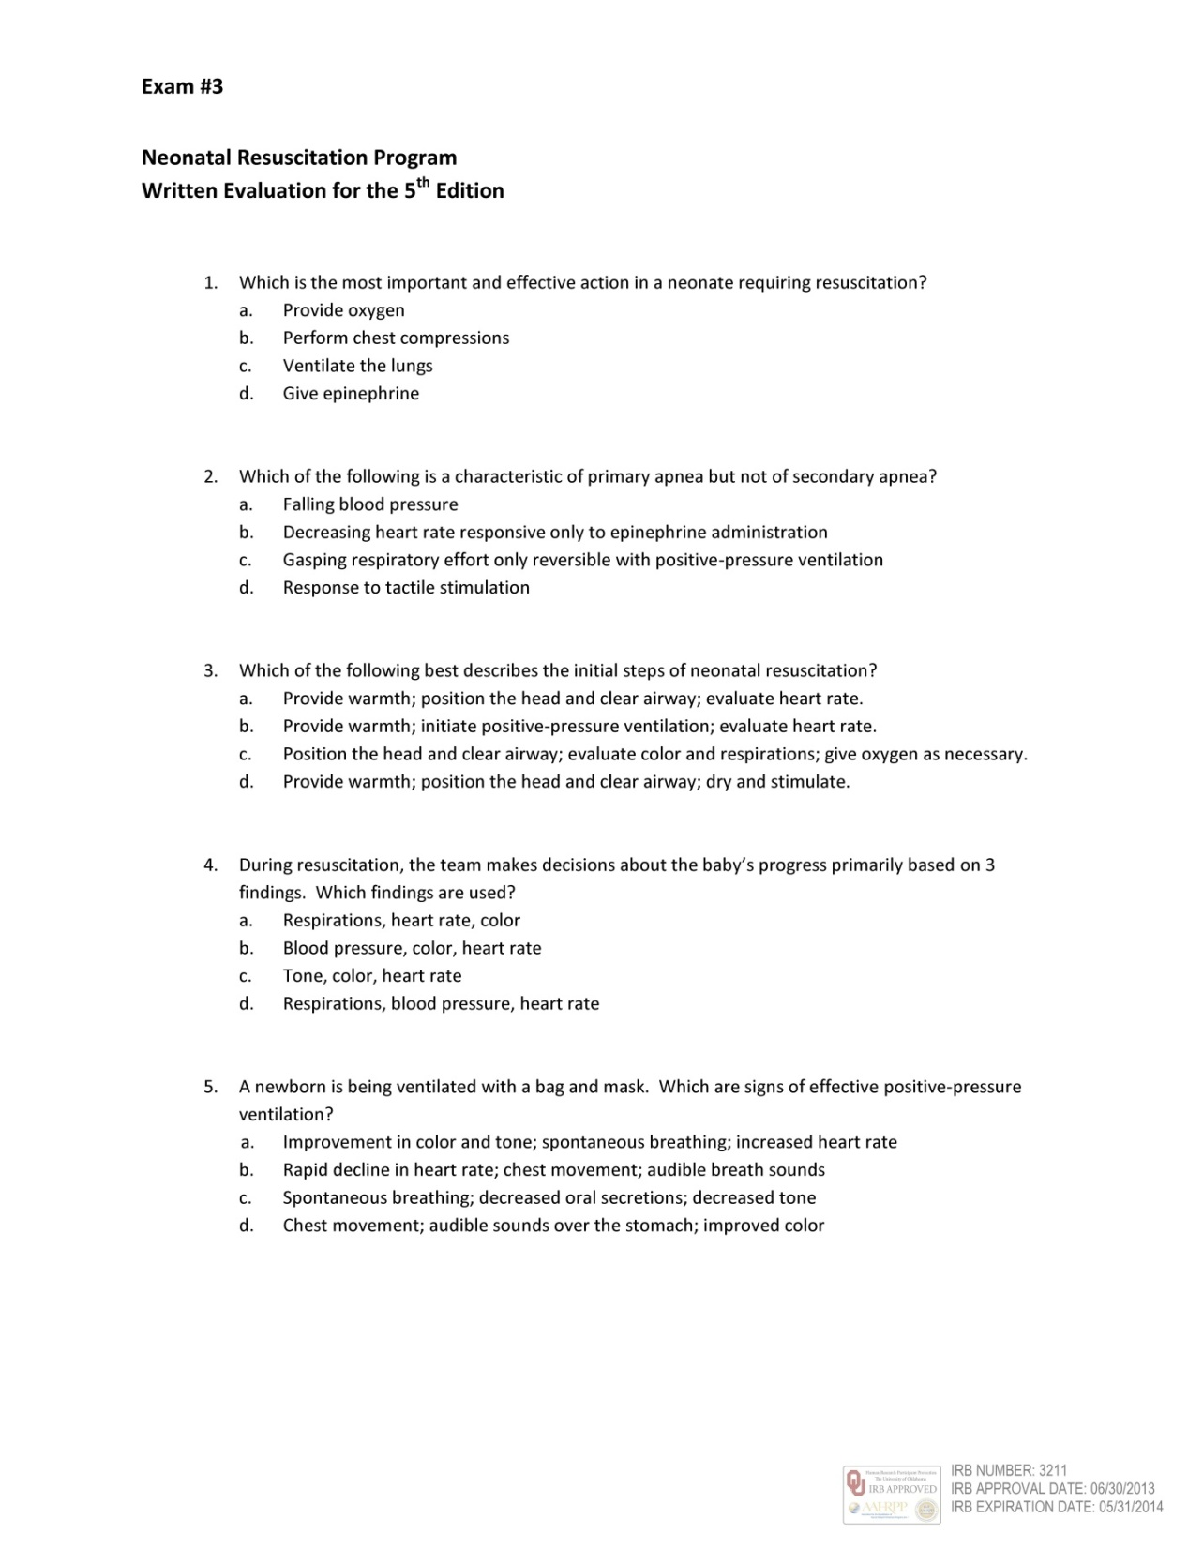

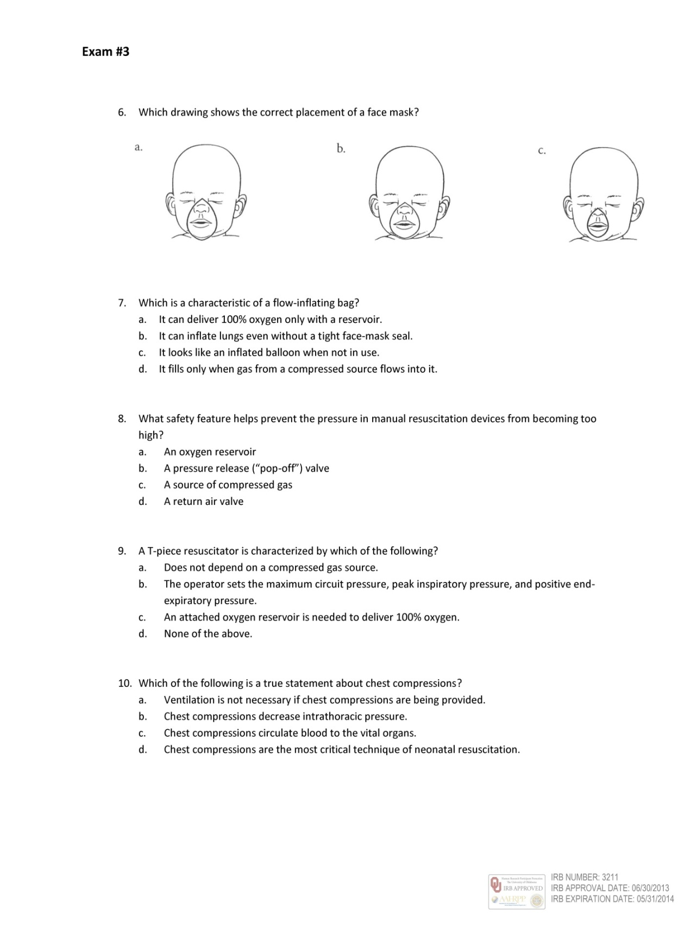

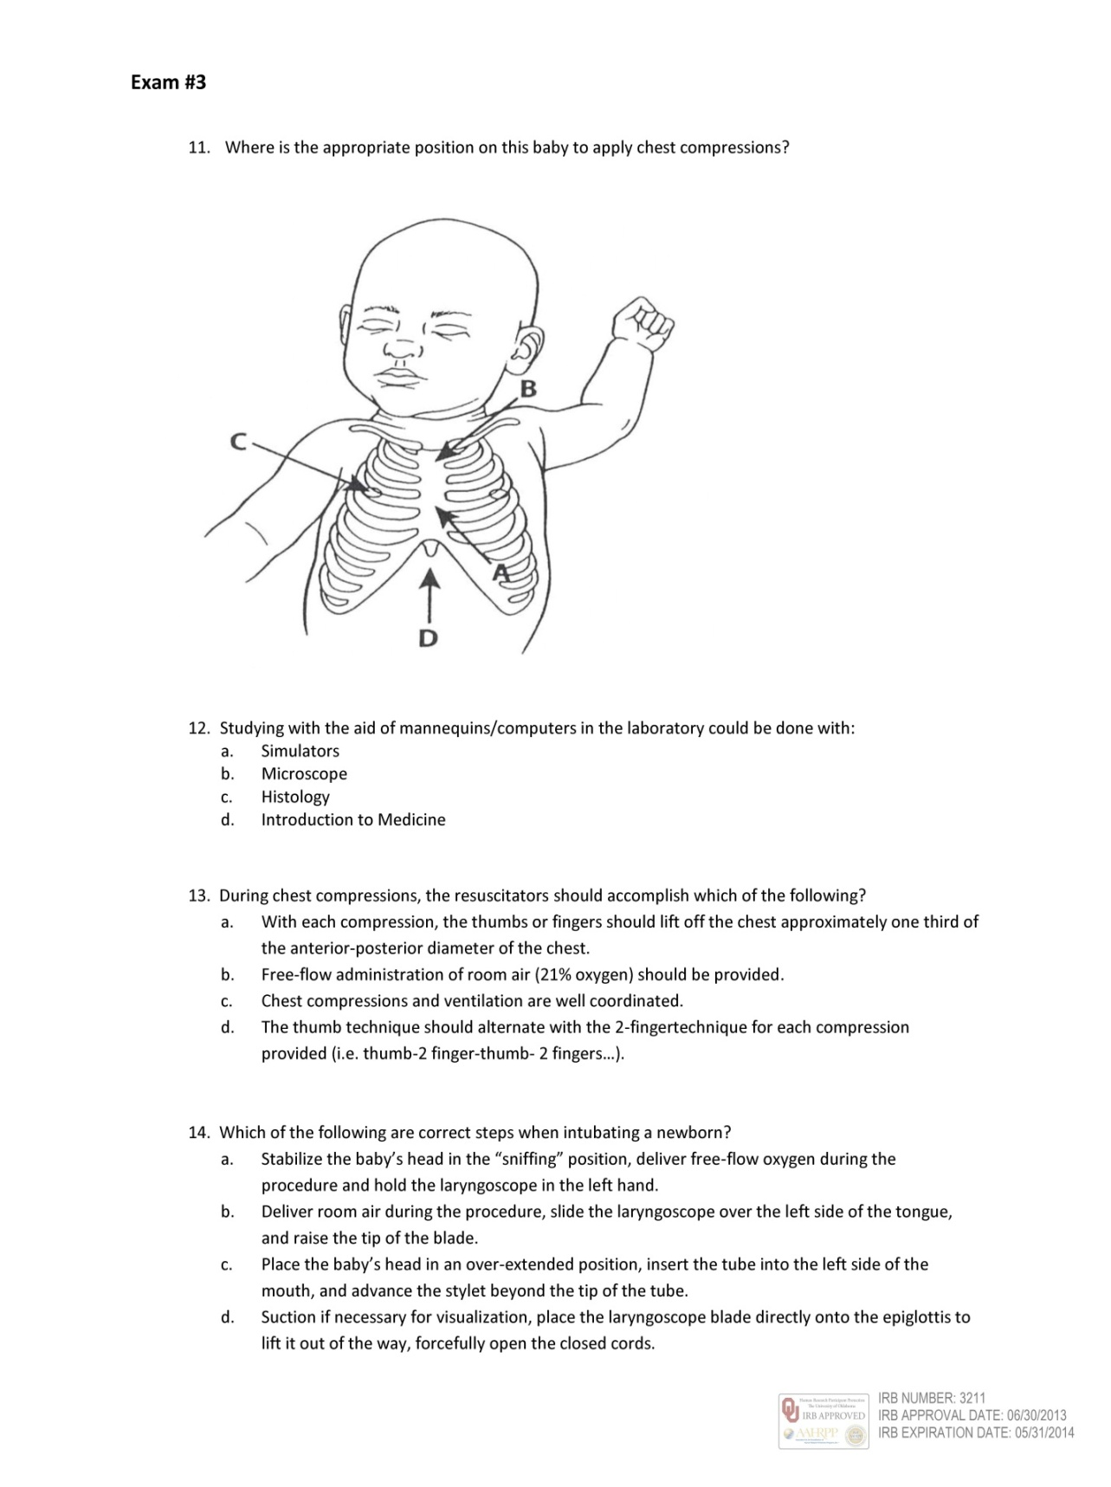

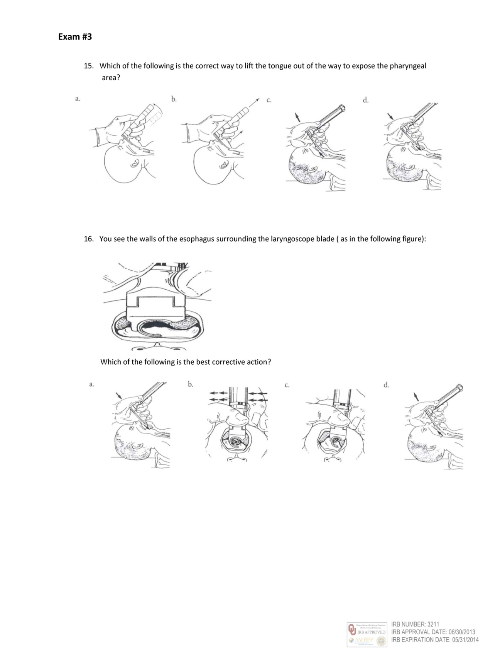

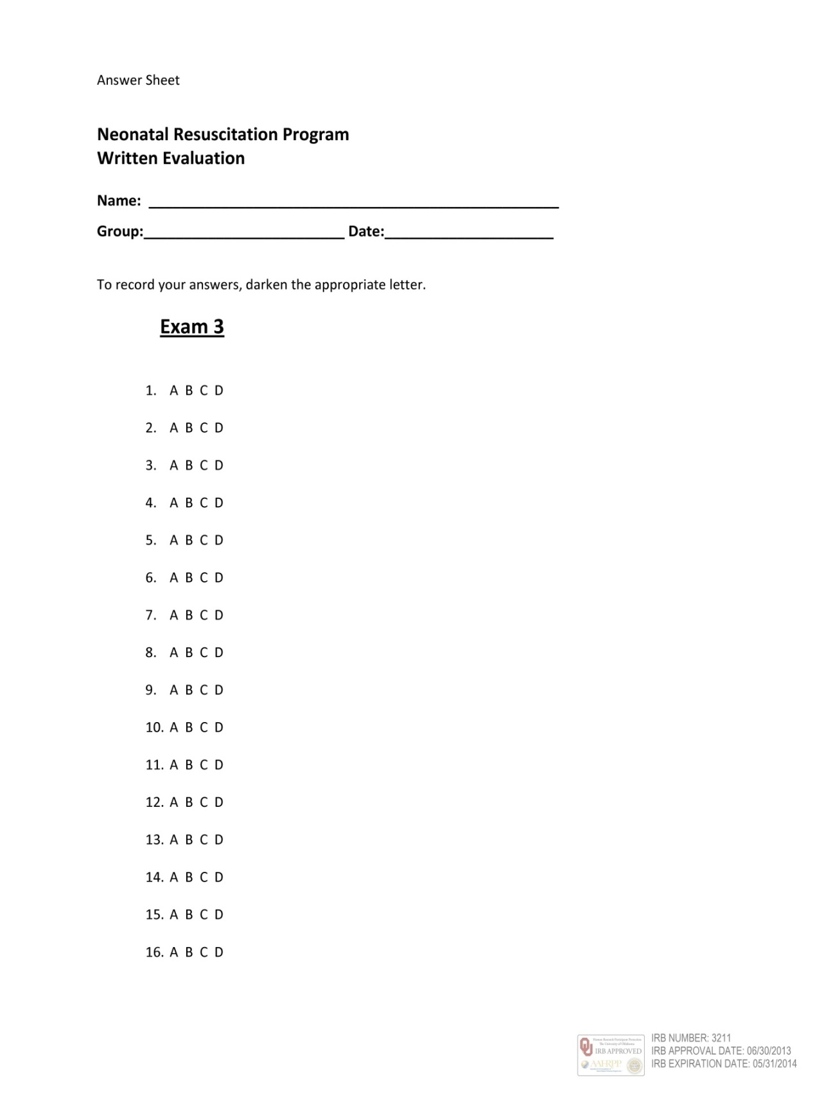

Appendix O
Sample Size Determination/Calculation
Appendix O shows the initial program calculation used in SAS software version 9.3 (SAS Institute, Inc., Cary, NC) to determine the sample size for the study. The second SAS program calculations show the sample size determination after an interim analysis.

Sample Size Determination/Calculation
Proc Power function of SAS software version 9.3 (SAS Institute, Inc., Cary, NC) was used to detect a mean difference of 4 and a Standard Deviation of 5 for the whole study (CTSR cognition results and NRP knowledge results). The power selected was 0.8 and the significance was set at an alpha value of 0.05.
SAS Program:
proc power; twosamplemeans test=diff; groupmeans = 0 | 4; stddev = 5
npergroup = power = 0.8; run;
SAS Results:
The POWER Procedure
Two-Sample t Test for Mean Difference
Fixed Scenario Elements
Distribution Normal
Method Exact
Group 1 Mean 0
Group 2 Mean 4
Standard Deviation 5
Nominal Power 0.8
Number of Sides 2
Null Difference 0
Alpha 0.05
Computed N Per Group
Actual Power 0.8
N Per Group 26.
After an interim analysis, Proc Power function of SAS software version 9.3 (SAS Institute, Inc., Cary, NC) was used to detect a mean difference of 3 and a Standard Deviation of 3.22 for the whole study (CTSR cognition results and NRP knowledge results). The power selected was 0.8 and the significance was set at an alpha value of 0.05.
SAS Program:
proc power; twosamplemeans test=diff; groupmeans = 0 | 3; stddev = 3.22
npergroup = power = 0.8; run;
SAS Results:
The POWER Procedure
Two-Sample t Test for Mean Difference
Fixed Scenario Elements
Distribution Normal
Method Exact
Group 1 Mean 0
Group 2 Mean 3
Standard Deviation 3.22
Nominal Power 0.8
Number of Sides 2
Null Difference 0
Alpha 0.05
Computed N Per Group
Actual Power 0.819
N Per Group 20

Appendix P
SAS System Data Analysis for CTSR Rubric and Classification
The Classroom Test of Scientific Reasoning Rubric score analysis (from the raw score of 0-24 possible points to the 0-14 possible rubric score points) and cognition classification determination (concrete operational, low transitional, high transitional, and formal operational) were analyzed to detect significance among nursing and medical students. Appendix P contains the SAS 9.3 Program used in the analysis and the SAS 9.3 Output for the Classroom Test of Scientific Reasoning rubric and cognition classification data. Appendix P, Part 1 shows the SAS 9.3 Program used for the analysis. Appendix P, Part 2 shows the SAS 9.3 Output.
Appendix P, Part 1
SAS 9.3 Program Analysis of Classroom Test of Scientific Reasoning Manuscript
Appendix P, Part 2
SAS 9.3 Program Output of Classroom Test of Scientific Reasoning Manuscript

Appendix P, Part 1
SAS 9.3 Program Analysis of Classroom Test of Scientific Reasoning Manuscript
Data one; set SIM; if student = "NU" then SDN = "Nur"; else SDN = "Med";

if gender = "F" then sex = 0; else if gender = "M" then sex = 1; run;

Proc ttest; Class SDN; var TSOR; run; Proc ttest; Class SDN; var Rubric; run;

Proc ttest; Class Sex; var TSOR; run; Proc ttest; Class Sex; var Rubric; run;

Proc reg; Model Rubric = yschool; run; Proc reg; Model Rubric = age; run;

Proc freq; Tables Classification*SDN/chisq; run; Proc means; var age; run;

Proc freq; Tables Classification*sex/chisq; run; Proc means; var yschool; run;

Proc reg; Model Rubric = age yschool sex; run;

/*The order of cognition is: 0, low level, high level and 2. These numbers refer to Concrete Operational, Low Transitional, High Transitional and Formal Operational thinkers.*/
Data two; Set one;

If Classification = "Level 0" then cogstrat=1;

Else if Classification = "Low Level 1" then cogstrat=2;

Else if Classification = "High Level 1" then cogstrat=3;

Else if Classification = "Level 2" then cogstrat=4; run;

Proc format; Value cogf.

1 = "Concrete" 2 = "Low transitional" 3 = "High transitional" 4 = "Formal"; run;

Proc sort data = two out = bycogstrat; by cogstrat; run;

Proc freq data = bycogstrat order = data; Tables cogstrat*sex / chisq; exact chisq / mc;
format cogstrat cogf.; run;

Proc glm data = one; Class sdn sex yschool age; Model Rubric = sdn age; run;

Proc glm data = one; Class sdn sex yschool age; Model Rubric = sdn yschool; run;

Proc glm; Class cogstrat; Model age = cogstrat; Format constrat cogf.; run;
Proc glm; Class cogstrat; Model yschool = cogstrat; Format constrat cogf.; run;
Proc glm; Class SDN Sex; Model Rubric = sdn sex; run;

Proc sort; by Classification; run; Proc means; var yschool age; by classification; run;

Proc sort; by SDN; run; Proc means; var age yschool; by sdn; run;

Proc ttest; Class sex; var Rubric; by sdn; run;

Key: SIM = Data Base, SDN = Student, NU = Nur = Nursing Students, Med = Medical Student,

F = Female, M = Male, TOSR = Raw Data, Rubric = Analyzed Data, Classification =

Operational Categories, Y-school = Years of Schooling, and Var = Variable.

Appendix P, Part 2

SAS 9.3 Program Output of Classroom Test of Scientific Reasoning Manuscript

The SAS System. The T-TEST Procedure. Variable: TSOR (TSOR)
Student (SDN) N Mean Std Dev Std Err Minimum Maximum
Medical 46 20.1522 2.5558 0.3768 12.0000 24.0000
Nursing 43 13.7674 4.3361 0.6612 4.0000 22.0000
Diff (1-2) 6.3847 3.5292 0.7486
Student (SDN) Method Mean 95% CL Mean Std Dev 95% CL Std Dev
Medical 20.1522 19.3932 20.9111 2.5558 2.1198 3.2190
Nursing 13.7674 12.4330 15.1019 4.3361 3.5753 5.5112
Diff (1-2) Pooled 6.3847 4.8968 7.8727 3.5292 3.0737 4.1444
Diff (1-2) Satterthwaite 6.3847 4.8656 7.9038
Method Variances DF t Value Pr > |t|
Pooled Equal 87 8.53 <.0001
Satterthwaite Unequal 67.103 8.39 <.0001
Equality of Variances
Method Num DF Den DF F Value Pr > F
Folded F 42 45 2.88 0.0006

The SAS System. The T-TEST Procedure. Variable: Rubric (Rubric)
Student (SDN) N Mean Std Dev Std Err Minimum Maximum
Medical 46 10.2174 2.0211 0.2980 5.0000 14.0000
Nursing 43 6.1860 2.7538 0.4200 1.0000 12.0000
Diff (1-2) 4.0313 2.4029 0.5097
Student (SDN) Method Mean 95% CL Mean Std Dev 95% CL Std Dev
Medical 10.2174 9.6172 10.8176 2.0211 1.6764 2.5457
Nursing 6.1860 5.3385 7.0336 2.7538 2.2706 3.5002
Diff (1-2) Pooled 4.0313 3.0182 5.0444 2.4029 2.0928 2.8218
Diff (1-2) Satterthwaite 4.0313 3.0059 5.0568
Method Variances DF t Value Pr > |t|
Pooled Equal 87 7.91 <.0001
Satterthwaite Unequal 76.777 7.83 <.0001
Equality of Variances
Method Num DF Den DF F Value Pr > F
Folded F 42 45 1.86 0.0432

The SAS System. The T-TEST Procedure. Variable: TSOR (TSOR)
Sex N Mean Std Dev Std Err Minimum Maximum
0-Female 58 15.5862 4.9312 0.6475 4.0000 24.0000
1-Male 30 20.1667 2.1827 0.3985 15.0000 23.0000
Diff (1-2) -4.5805 4.2099 0.9468
Sex Method Mean 95% CL Mean Std Dev 95% CL Std Dev
0-Female 15.5862 14.2896 16.8828 4.9312 4.1689 6.0374
1-Male 20.1667 19.3516 20.9817 2.1827 1.7384 2.9343
Diff (1-2) Pooled -4.5805 -6.4626 -2.6983 4.2099 3.6639 4.9488
Diff (1-2 Satterthwaite -4.5805 -6.0923 -3.0686
Method Variances DF t Value Pr > |t|
Pooled Equal 86 -4.84 <.0001
Satterthwaite Unequal 84.524 -6.02 <.0001
Equality of Variances
Method Num DF Den DF F Value Pr > F
Folded F 57 29 5.10 <.0001
The SAS System. The T-TEST Procedure. Variable: Rubric (Rubric)
Sex N Mean Std Dev Std Err Minimum Maximum
0-Female 58 7.3621 3.1827 0.4179 1.0000 14.0000
1-Male 30 10.1667 1.9667 0.3591 6.0000 13.0000
Diff (1-2) -2.8046 2.8316 0.6368
Sex Method Mean 95% CL Mean Std Dev 95% CL Std Dev
0-Female 7.3621 6.5252 8.1989 3.1827 2.6907 3.8967
1-Male 10.1667 9.4323 10.9010 1.9667 1.5663 2.6438
Diff (1-2) Pooled -2.8046 -4.0705 -1.5387 2.8316 2.4644 3.3286
Diff (1-2) Satterthwaite -2.8046 -3.9004 -1.7088
Method Variances DF t Value Pr > |t|
Pooled Equal 86 -4.40 <.0001
Satterthwaite Unequal 83.153 -5.09 <.0001
Equality of Variances
Method Num DF Den DF F Value Pr > F
Folded F 57 29 2.62 0.0061

The SAS System. The REG Procedure. Model: MODEL 1. Dependent Variable: Rubric (Rubric)
Number of Observations Read 89
Number of Observations Used 87
Number of Observations with Missing Values 2
Analysis of Variance
Source DF Sum Squares Mean Square F Value Pr > F
Model 1 117.38630 117.38630 14.27 0.0003
Error 85 699.09645 8.22466
Corrected Total 86 816.48276
Root MSE 2.86787 R-Square 0.1438
Dependent Mean 8.37931 Adj R-Sq 0.1337
Coeff Var 34.22558
Parameter Estimates
Variable Label DF Parameter Estimate Std Error t Value Pr > |t|
Intercept Intercept 1 1.38966 1.87552 0.74 0.4608
Years School Yschool 1 0.41213 0.10909 3.78 0.0003

The SAS System. The REG Procedure. Model: MODEL 1. Dependent Variable: Rubric (Rubric)
Number of Observations Read 89
Number of Observations Used 88
Number of Observations with Missing Values 1
Analysis of Variance
Source DF Sum Squares Mean Square F Value Pr > F
Model 1 0.96032 0.96032 0.10 0.7552
Error 86 844.13059 9.81547
Corrected Total 87 845.09091
Root MSE 3.13297 R-Square 0.0011
Dependent Mean 8.31818 Adj R-Sq -0.0105
Coeff Var 37.66406
Parameter Estimates
Variable Label DF Parameter Estimate Std Error t Value Pr > |t|
Intercept Intercept 1 7.72984 1.91038 4.05 0.0001
Age Age 1 0.02398 0.07667 0.31 0.7552

The SAS System. The FREQ Procedure. Table of Classification by Student (SDN)
Classification (Classification) SDN
Frequency ‚
Percent ‚
Row Pct ‚
Col Pct ‚ Medical‚Nursing ‚ Total
ƒƒƒƒƒƒƒƒƒƒƒƒƒˆƒƒƒƒƒƒƒƒˆƒƒƒƒƒƒƒƒˆ
Level 0 ‚ 00 ‚ 11 ‚ 11
‚ 00.00 ‚ 12.36 ‚ 12.36
‚ 00.00 ‚ 100.00 ‚
‚ 00.00 ‚ 25.58 ‚
ƒƒƒƒƒƒƒƒƒƒƒƒƒˆƒƒƒƒƒƒƒƒˆƒƒƒƒƒƒƒƒˆ
Low Level 1 ‚ 2 ‚ 19 ‚ 21
‚ 2.25 ‚ 21.35 ‚ 23.60
‚ 9.52 ‚ 90.48 ‚
‚ 4.35 ‚ 44.19 ‚
ƒƒƒƒƒƒƒƒƒƒƒƒƒˆƒƒƒƒƒƒƒƒˆƒƒƒƒƒƒƒƒˆ
High Level 1 ‚ 21 ‚ 10 ‚ 31
‚ 23.60 ‚ 11.24 ‚ 34.83
‚ 67.74 ‚ 32.26 ‚
‚ 45.65 ‚ 23.26 ‚
ƒƒƒƒƒƒƒƒƒƒƒƒƒˆƒƒƒƒƒƒƒƒˆƒƒƒƒƒƒƒƒˆ
Level 2 ‚ 23 ‚ 3 ‚ 26
‚ 25.84 ‚ 3.37 ‚ 29.21
‚ 88.46 ‚ 11.54 ‚
‚ 50.00 ‚ 6.98 ‚
ƒƒƒƒƒƒƒƒƒƒƒƒƒˆƒƒƒƒƒƒƒƒˆƒƒƒƒƒƒƒƒˆ
Total 46 43 89
51.69 48.31 100.00
Statistics for Table of Classification by Student (SDN). Sample Size = 89
Statistic DF Value Prob
ƒƒƒƒƒƒƒƒƒƒƒƒƒƒƒƒƒƒƒƒƒƒƒƒƒƒƒƒƒƒƒƒƒƒƒƒƒƒƒƒƒƒƒƒƒƒƒƒƒƒƒƒƒƒ
Chi-Square 3 43.9986 <.0001
Likelihood Ratio Chi-Square 3 52.4882 <.0001
Mantel-Haenszel Chi-Square 1 5.4288 0.0198
Phi Coefficient 0.7031
Contingency Coefficient 0.5752
Cramer's V 0.7031

The SAS System. The FREQ Procedure. Table of Classification by Sex
Classification (Classification) Sex
Frequency ‚
Percent ‚
Row Pct ‚ Females Males
Col Pct ‚ 0‚ 1‚ Total
ƒƒƒƒƒƒƒƒƒƒƒƒƒˆƒƒƒƒƒƒƒƒˆƒƒƒƒƒƒƒƒˆ
Level 0 ‚ 10 ‚ 0 ‚ 10
‚ 11.36 ‚ 0.00 ‚ 11.36
‚ 100.00 ‚ 0.00 ‚
‚ 17.24 ‚ 0.00 ‚
ƒƒƒƒƒƒƒƒƒƒƒƒƒˆƒƒƒƒƒƒƒƒˆƒƒƒƒƒƒƒƒˆ
Low Level 1 ‚ 19 ‚ 2 ‚ 21
‚ 21.59 ‚ 2.27 ‚ 23.86
‚ 90.48 ‚ 9.52 ‚
‚ 32.76 ‚ 6.67 ‚
ƒƒƒƒƒƒƒƒƒƒƒƒƒˆƒƒƒƒƒƒƒƒˆƒƒƒƒƒƒƒƒˆ
High Level 1 ‚ 18 ‚ 13 ‚ 31
‚ 20.45 ‚ 14.77 ‚ 35.23
‚ 58.06 ‚ 41.94 ‚
‚ 31.03 ‚ 43.33 ‚
ƒƒƒƒƒƒƒƒƒƒƒƒƒˆƒƒƒƒƒƒƒƒˆƒƒƒƒƒƒƒƒˆ
Level 2 ‚ 11 ‚ 15 ‚ 26
‚ 12.50 ‚ 17.05 ‚ 29.55
‚ 42.31 ‚ 57.69 ‚
‚ 18.97 ‚ 50.00 ‚
ƒƒƒƒƒƒƒƒƒƒƒƒƒˆƒƒƒƒƒƒƒƒˆƒƒƒƒƒƒƒƒˆ
Total 58 30 88
65.91 34.09 100.00
Frequency Missing = 1
Statistics for Table of Classification by Sex. Effective Sample Size = 88
Statistic DF Value Prob
ƒƒƒƒƒƒƒƒƒƒƒƒƒƒƒƒƒƒƒƒƒƒƒƒƒƒƒƒƒƒƒƒƒƒƒƒƒƒƒƒƒƒƒƒƒƒƒƒƒƒƒƒƒƒ
Chi-Square 3 18.1079 0.0004
Likelihood Ratio Chi-Square 3 22.1284 <.0001
Mantel-Haenszel Chi-Square 1 1.5342 0.2155
Phi Coefficient 0.4536
Contingency Coefficient 0.4131
Cramer's V 0.4536

The SAS System. The MEANS Procedure. Analysis Variable: Age (Age)
N Mean Std Dev Minimum Maximum
88 24.5340909 4.3811216 20.0000000 39.0000000

The SAS System. The MEANS Procedure. Analysis Variable: Years of Schooling (Yschool)
N Mean Std Dev Minimum Maximum
ƒƒƒƒƒƒƒƒƒƒƒƒƒƒƒƒƒƒƒƒƒƒƒƒƒƒƒƒƒƒƒƒƒƒƒƒƒƒƒƒƒƒƒƒƒƒƒƒƒƒƒƒƒƒƒƒƒƒƒƒƒƒƒƒƒƒ
87 16.9597701 2.8348110 6.0000000 26.0000000

The SAS System. The REG Procedure. Model: MODEL 1. Dependent Variable: Rubric (Rubric)
Number of Observations Read 89
Number of Observations Used 87
Number of Observations with Missing Values 2
Analysis of Variance
Source DF Sum Squares Mean Square F Value Pr > F
Model 3 209.36475 69.78825 9.54 <.0001
Error 83 607.11801 7.31467
Corrected Total 86 816.48276
Root MSE 2.70457 R-Square 0.2564
Dependent Mean 8.37931 Adj R-Sq 0.2295
Coeff Var 32.27671
Parameter Estimates
Variable Label DF Parameter Estimate Std Error t Value Pr > |t|
Intercept Intercept 1 4.16302 2.28158 1.82 0.0717
Age Age 1 -0.07613 0.06888 -1.11 0.2722
Years School Yschool 1 0.31177 0.10957 2.85 0.0056
Sex 1 2.30886 0.65605 3.52 0.0007

The SAS System. The FREQ Procedure. Table of Cognitive Stratification (Cogstrat) by Sex
Cogstrat Sex
Frequency ‚
Percent ‚
Row Pct ‚ Females Males
Col Pct ‚ 0‚ 1‚ Total
ƒƒƒƒƒƒƒƒƒƒƒƒƒƒƒƒƒˆƒƒƒƒƒƒƒƒˆƒƒƒƒƒƒƒƒˆ
Concrete ‚ 10 ‚ 0 ‚ 10
‚ 11.36 ‚ 0.00 ‚ 11.36
‚ 100.00 ‚ 0.00 ‚
‚ 17.24 ‚ 0.00 ‚
ƒƒƒƒƒƒƒƒƒƒƒƒƒƒƒƒƒˆƒƒƒƒƒƒƒƒˆƒƒƒƒƒƒƒƒˆ
Low Transitional ‚ 19 ‚ 2 ‚ 21
‚ 21.59 ‚ 2.27 ‚ 23.86
‚ 90.48 ‚ 9.52 ‚
‚ 32.76 ‚ 6.67 ‚
ƒƒƒƒƒƒƒƒƒƒƒƒƒƒƒƒƒˆƒƒƒƒƒƒƒƒˆƒƒƒƒƒƒƒƒˆ
High Transitional ‚ 18 ‚ 13 ‚ 31
‚ 20.45 ‚ 14.77 ‚ 35.23
‚ 58.06 ‚ 41.94 ‚
‚ 31.03 ‚ 43.33 ‚
ƒƒƒƒƒƒƒƒƒƒƒƒƒƒƒƒƒˆƒƒƒƒƒƒƒƒˆƒƒƒƒƒƒƒƒˆ
Formal ‚ 11 ‚ 15 ‚ 26
‚ 12.50 ‚ 17.05 ‚ 29.55
‚ 42.31 ‚ 57.69 ‚
‚ 18.97 ‚ 50.00 ‚
ƒƒƒƒƒƒƒƒƒƒƒƒƒƒƒƒƒˆƒƒƒƒƒƒƒƒˆƒƒƒƒƒƒƒƒˆ
Total 58 30 88
65.91 34.09 100.00
Frequency Missing = 1
Statistics for Table of Cognitive Stratification by Sex
Statistic DF Value Prob
ƒƒƒƒƒƒƒƒƒƒƒƒƒƒƒƒƒƒƒƒƒƒƒƒƒƒƒƒƒƒƒƒƒƒƒƒƒƒƒƒƒƒƒƒƒƒƒƒƒƒƒƒƒƒ
Chi-Square 3 18.1079 0.0004
Likelihood Ratio Chi-Square 3 22.1284 <.0001
Mantel-Haenszel Chi-Square 1 17.0962 <.0001
Phi Coefficient 0.4536
Contingency Coefficient 0.4131
Cramer's V 0.4536

The SAS System. The FREQ Procedure. Statistics for Table of Cognitive Stratification by Sex
Pearson Chi-Square Test
ƒƒƒƒƒƒƒƒƒƒƒƒƒƒƒƒƒƒƒƒƒƒƒƒƒƒƒƒƒƒƒƒƒƒ
Chi-Square 18.1079
DF 3
Asymptotic Pr > ChiSq 0.0004
Monte Carlo Estimate for the Exact Test
Pr >= ChiSq 2.000E-04
99% Lower Conf Limit 0.0000
99% Upper Conf Limit 5.643E-04
Number of Samples 10000
Initial Seed 913981000
Likelihood Ratio Chi-Square Test
ƒƒƒƒƒƒƒƒƒƒƒƒƒƒƒƒƒƒƒƒƒƒƒƒƒƒƒƒƒƒƒƒƒƒ
Chi-Square 22.1284
DF 3
Asymptotic Pr > ChiSq <.0001
Monte Carlo Estimate for the Exact Test
Pr >= ChiSq 2.000E-04
99% Lower Conf Limit 0.0000
99% Upper Conf Limit 5.643E-04
Number of Samples 10000
Initial Seed 1048842639
Mantel-Haenszel Chi-Square Test
ƒƒƒƒƒƒƒƒƒƒƒƒƒƒƒƒƒƒƒƒƒƒƒƒƒƒƒƒƒƒƒƒƒƒ
Chi-Square 17.0962
DF 1
Asymptotic Pr > ChiSq <.0001

The SAS System. The FREQ Procedure. Statistics for Table of Cognitive Stratification by Sex
Monte Carlo Estimate for the Exact Test
Pr >= ChiSq 0.0000
99% Lower Conf Limit 0.0000
99% Upper Conf Limit 4.604E-04
Number of Samples 10000
Initial Seed 1340950216
Effective Sample Size = 88
Frequency Missing = 1

The SAS System. The GLM Procedure. Class Level Information
Class Levels Values
Student (SDN) 2 Medical Nursing
Sex 2 0-Female 1-Male
Years Schooling 13 6 7 14 15 16 17 18 18.5 19 20 21 22 26
Age 17 20 21 22 23 24 25 26 27 28 29 30 31 33 34 37 38 39
Number of Observations Read 89
Number of Observations Used 87

The SAS System. The GLM Procedure. Dependent Variable: Rubric (Rubric)
Source DF Sum Squares Mean Square F Value Pr > F
Model 17 416.3482181 24.4910717 4.22 <.0001
Error 69 400.1345405 5.7990513
Corrected Total 86 816.4827586
R-Square Coeff Var Root MSE Rubric Mean
0.509929 28.73890 2.408122 8.379310
Source DF Type I SS Mean Square F Value Pr > F
Student (SDN) 1 329.7786229 329.7786229 56.87 <.0001
Age 16 86.5695952 5.4105997 0.93 0.5367
Source DF Type III SS Mean Square F Value Pr > F
Student (SDN) 1 171.5654595 171.5654595 29.59 <.0001
Age 16 86.5695952 5.4105997 0.93 0.5367

The SAS System. The GLM Procedure. Class Level Information
Class Levels Values
Student (SDN) 2 Medical Nursing
Sex 2 0-Female 1-Male
Years School 13 6 7 14 15 16 17 18 18.5 19 20 21 22 26
Age 17 20 21 22 23 24 25 26 27 28 29 30 31 33 34 37 38 39
Number of Observations Read 89
Number of Observations Used 87

The SAS System. The GLM Procedure. Dependent Variable: Rubric (Rubric)
Source DF Sum Squares Mean Square F Value Pr > F
Model 13 406.2221330 31.2478564 5.56 <.0001
Error 73 410.2606256 5.6200086
Corrected Total 86 816.4827586
R-Square Coeff Var Root MSE Rubric Mean
0.497527 28.29178 2.370656 8.379310
Source DF Type I SS Mean Square F Value Pr > F
Student (SDN) 1 329.7786229 329.7786229 58.68 <.0001
Years School 12 76.4435101 6.3702925 1.13 0.3474
Source DF Type III SS Mean Square F Value Pr > F
Student (SDN) 1 140.0136709 140.0136709 24.91 <.0001
Years School 12 76.4435101 6.3702925 1.13 0.3474

The SAS System. The GLM Procedure. Class Level Information
Class Levels Values
Student (SDN) 2 Medical Nursing
Sex 2 0-Female 1-Male
Number of Observations Read 89
Number of Observations Used 88

The SAS System. The GLM Procedure. Dependent Variable: Rubric (Rubric)
Source DF Sum Squares Mean Square F Value Pr > F
Model 2 361.5319468 180.7659734 31.78 <.0001
Error 85 483.5589623 5.6889290
Corrected Total 87 845.0909091
R-Square Coeff Var Root MSE Rubric Mean
0.427802 28.67391 2.385148 8.318182
Source DF Type I SS Mean Square F Value Pr > F
Student (SDN) 1 347.6457745 347.6457745 61.11 <.0001
Sex 1 13.8861723 13.8861723 2.44 0.1219
Source DF Type III SS Mean Square F Value Pr > F
Student (SDN) 1 206.0042561 206.0042561 36.21 0001
Sex 1 13.8861723 13.8861723 2.44 0.1219

The SAS System. The MEANS Procedure.
Classification (Concrete Operational to Formal Operational)
------------------------------- Classification = Level 0 = Concrete Operational -------
Variable Label N Mean Std Dev Minimum Maximum
ƒƒƒƒƒƒƒƒƒƒƒƒƒƒƒƒƒƒƒƒƒƒƒƒƒƒƒƒƒƒƒƒƒƒƒƒƒƒƒƒƒƒƒƒƒƒƒƒƒƒƒƒƒƒƒƒƒƒƒƒƒƒƒƒƒƒƒƒƒƒƒƒƒƒƒƒƒƒƒƒƒƒƒƒƒƒƒ
Yrs School Yschool 9 13.3333333 4.0620192 6.0000000 18.0000000
Age Age 10 25.9000000 7.5196040 20.0000000 39.0000000
------------------------------- Classification = Low Level 1 = Low Transitional -------
Variable Label N Mean Std Dev Minimum Maximum
ƒƒƒƒƒƒƒƒƒƒƒƒƒƒƒƒƒƒƒƒƒƒƒƒƒƒƒƒƒƒƒƒƒƒƒƒƒƒƒƒƒƒƒƒƒƒƒƒƒƒƒƒƒƒƒƒƒƒƒƒƒƒƒƒƒƒƒƒƒƒƒƒƒƒƒƒƒƒƒƒƒƒƒƒƒƒƒ
Yrs School Yschool 21 16.3571429 2.7071334 14.0000000 26.0000000
Age Age 21 22.8095238 3.1403670 20.0000000 30.0000000
----------------------------- Classification = High Level 1 = High Transitional -------
Variable Label N Mean Std Dev Minimum Maximum
ƒƒƒƒƒƒƒƒƒƒƒƒƒƒƒƒƒƒƒƒƒƒƒƒƒƒƒƒƒƒƒƒƒƒƒƒƒƒƒƒƒƒƒƒƒƒƒƒƒƒƒƒƒƒƒƒƒƒƒƒƒƒƒƒƒƒƒƒƒƒƒƒƒƒƒƒƒƒƒƒƒƒƒƒƒƒƒ
Yrs School Yschool 31 17.5806452 2.1256245 14.0000000 21.0000000
Age Age 31 25.0322581 4.7852821 20.0000000 38.0000000
--------------------------------- Classification = Level 2 = Formal Operational -------
Variable Label N Mean Std Dev Minimum Maximum
ƒƒƒƒƒƒƒƒƒƒƒƒƒƒƒƒƒƒƒƒƒƒƒƒƒƒƒƒƒƒƒƒƒƒƒƒƒƒƒƒƒƒƒƒƒƒƒƒƒƒƒƒƒƒƒƒƒƒƒƒƒƒƒƒƒƒƒƒƒƒƒƒƒƒƒƒƒƒƒƒƒƒƒƒƒƒƒ
Yrs School Yschool 26 17.9615385 2.1256673 14.0000000 22.0000000
Age Age 26 24.8076923 2.7279183 20.0000000 31.0000000

The SAS System. The MEANS Procedure
--------------------------------------------- SDN=Medical -----------------------------
Variable Label N Mean Std Dev Minimum Maximum
ƒƒƒƒƒƒƒƒƒƒƒƒƒƒƒƒƒƒƒƒƒƒƒƒƒƒƒƒƒƒƒƒƒƒƒƒƒƒƒƒƒƒƒƒƒƒƒƒƒƒƒƒƒƒƒƒƒƒƒƒƒƒƒƒƒƒƒƒƒƒƒƒƒƒƒƒƒƒƒƒƒƒƒƒƒƒƒ
Age Age 46 25.8043478 3.1384325 22.0000000 37.0000000
Yrs School Yschool 46 18.5217391 1.5739424 15.0000000 22.0000000
--------------------------------------------- SDN=Nursing -----------------------------
Variable Label N Mean Std Dev Minimum Maximum
ƒƒƒƒƒƒƒƒƒƒƒƒƒƒƒƒƒƒƒƒƒƒƒƒƒƒƒƒƒƒƒƒƒƒƒƒƒƒƒƒƒƒƒƒƒƒƒƒƒƒƒƒƒƒƒƒƒƒƒƒƒƒƒƒƒƒƒƒƒƒƒƒƒƒƒƒƒƒƒƒƒƒƒƒƒƒƒƒ
Age Age 42 23.1428571 5.1113047 20.0000000 39.0000000
Yrs School Yschool 41 15.2073171 2.9218479 6.0000000 26.0000000

The SAS System. The T-TEST Procedure
--------------------------------------------- SDN=Medical Student ----------------------
Variable: Rubric (Rubric)
Sex N Mean Std Dev Std Err Minimum Maximum
0-Female 20 9.8000 2.2850 0.5109 5.0000 14.0000
1-Male 26 10.5385 1.7716 0.3474 8.0000 13.0000
Diff (1-2) -0.7385 2.0094 0.5977
Sex Method Mean 95% CL Mean Std Dev 95% CL Std Dev
0-Female 9.8000 8.7306 10.8694 2.2850 1.7377 3.3374
1-Male 10.5385 9.8229 11.2540 1.7716 1.3894 2.4455
Diff (1-2) Pooled -0.7385 -1.9429 0.4660 2.0094 1.6635 2.5383
Diff (1-2) Satterthwaite -0.7385 -1.9929 0.5159
Method Variances DF t Value Pr > |t|
Pooled Equal 44 -1.24 0.2232
Satterthwaite Unequal 34.954 -1.20 0.2401
Equality of Variances
Method Num DF Den DF F Value Pr > F
Folded F 19 25 1.66 0.2317

The SAS System. The T-TEST Procedure
--------------------------------------------- SDN=Nursing------------------------------
Variable: Rubric (Rubric)
Sex N Mean Std Dev Std Err Minimum Maximum
0-Female 38 6.0789 2.8321 0.4594 1.0000 12.0000
1-Male 4 7.7500 1.5000 0.7500 6.0000 9.0000
Diff (1-2) -1.6711 2.7546 1.4480
Sex Method Mean 95% CL Mean Std Dev 95% CL Std Dev
0-Female 6.0789 5.1481 7.0098 2.8321 2.3089 3.6640
1-Male 7.7500 5.3632 10.1368 1.5000 0.8497 5.5928
Diff (1-2) Pooled -1.6711 -4.5975 1.2554 2.7546 2.2616 3.5245
Diff (1-2) Satterthwaite -1.6711 -3.8600 0.5179
Method Variances DF t Value Pr > |t|
Pooled Equal 40 -1.15 0.2553
Satterthwaite Unequal 5.6098 -1.90 0.1096
Equality of Variances
Method Num DF Den DF F Value Pr > F
Folded F 37 3 3.56 0.3218

The SAS System. The GLM Procedure. Class Level Information
Class Levels Values
cogstrat 4 1 2 3 4
Number of Observations Read: 89 Number of Observations Used: 88

The SAS System. The GLM Procedure. Dependent Variable: Age (Age)
Source DF Sum Squares Mean Square F Value Pr > F
Model 3 90.753429 30.251143 1.61 0.1934
Error 84 1579.144299 18.799337
Corrected Total 87 1669.897727
R-Square Coeff Var Root MSE Age Mean
0.054347 17.67263 4.335820 24.53409
Source DF Type I SS Mean Square F Value Pr > F
cogstrat 3 90.75342856 30.25114285 1.61 0.1934
Source DF Type III SS Mean Square F Value Pr > F
cogstrat 3 90.75342856 30.25114285 1.61 0.193
R-Square Coeff Var Root MSE Yrs school Mean
0.237340 14.85867 2.519996 16.95977
Source DF Type I SS Mean Square F Value Pr > F
cogstrat 3 164.0278413 54.6759471 8.61 <.0001
Source DF Type III SS Mean Square F Value Pr > F
cogstrat 3 164.0278413 54.6759471 8.61 <.0001

Appendix Q
SAS System Data Analysis of the Neonatal Resuscitation Program Examinations and
Classroom Test of Scientific Reasoning Correlations
Appendix Q contains the SAS 9.3 Program used in the analysis and the SAS 9.3 Output for the Neonatal Resuscitation Program Examinations and correlations to the Classroom Test of Scientific Reasoning data. The Neonatal Resuscitation Program exams #1, #2 and #3 data were analyzed to detect differences in immediate and long-term knowledge retention among all four teaching method interventions (control, video-lecture, simulation, and both [video-lecture and simulation]). The data were further correlated to the Classroom Test of Scientific Reasoning rubric and cognition classification results. Appendix Q, Part 1 shows the SAS 9.3 Program used for the analysis. Appendix Q, Part 2 shows the SAS 9.3 Output.
Appendix Q, Part 1
SAS 9.3 Program Analysis of the Neonatal Resuscitation Program Examinations and
Classroom Test of Scientific Reasoning Correlations
Appendix Q, Part 2
SAS 9.3 Program Output of the Neonatal Resuscitation Program Examinations and
Classroom Test of Scientific Reasoning Correlations

Appendix Q, Part 1
SAS 9.3 Program Analysis of the Neonatal Resuscitation Program Examinations and
Classroom Test of Scientific Reasoning Correlations
Data three; Set SIM;
If student="NU" then SDN="Nur"; else SDN="Med";
If Ymedical GT 0 then Medical="Y"; else Medical="N";
If gender="F" then sex=0; else if gender="M" then sex=1;
diff21=exam2-exam1; diff31=exam3-exam1; diff32=exam3-exam2; diff 121=diff31-diff21; run;
Data four; Set three;
If classification ="Level 0" then cogstrat=1;
Else if classification ="Low Level 1" then cogstrat=2;
Else if classification ="High Level 1" then cogstrat=3;
Else if classification ="Level 2" then cogstrat=4;
if exposure="no" then ACLS=0; else if exposure="yes" then ACLS=1; run;
Proc format; Value cogf 1="concrete" 2="low transitional" 3="high transitional" 4="formal";
Format cogstrat cogf.; run;
Proc ttest; Class sex; Var exam1 exam2 exam3; run;
Proc ttest; Class sdn; Var age; run;
Proc glm; Class group; model diff21=group; lsmeans group/adjust=tukey; run;
Proc ttest; By group; Var diff21 diff31 diff32; run;
Proc glm; Class sdn; model Exam1 = sex sdn; run;
/*This will give you means for 3 exams and 3 differences broken down by Nur, MS1, MSII etc*/
Proc sort; By Student; run;
Proc means; Var exam1 exam2 exam3 diff21 diff31 diff32; By student; run;
/*This will give overall means of 3 exams and 3 differences*/
Proc sort; By SDN; run;
Proc means; Var exam1 exam2 exam3 diff21 diff31 diff32; run;
/*Means of 3 exams and 3 differences by NUR and MED*/
Proc means; Var exam1 exam2 exam3 diff21 diff31 diff32; By SDN; run;
/*Means of 3 exams and 3 differences by Male and females*/
Proc sort; By sex; run;
Proc means; Var exam1 exam2 exam3 diff21 diff31 diff32; By sex; run;
/*Means of 3 exams and 3 differences by cognition level and group*/
Proc sort; By cogstrat group; run;
Proc means; Var exam1 exam2 exam3 diff21 diff31 diff32; By cogstrat group;
Format cogstrat cogf.; run;
/*Overall means of 3 exams and 3 differences by cognition level*/
Proc means; Var exam1 exam2 exam3 diff21 diff31 diff32; By cogstrat ;
Format cogstrat cogf.; run;
/*Ttest of 3 differences by NUR and MED*/
Proc sort; By SDN; run;
Proc univariate; Var diff21 diff31 diff32; By SDN; run;
/*Ttest of 3 differences by Male and Female*/
Proc sort; By Sex; run;
Proc univariate; Var diff21 diff31 diff32; By Sex; run;
Proc sort; By sdn; run;
Proc univariate; Var exam1 exam2 exam3; by sdn; run;
Proc univariate; Var exam1 exam2 exam3; run;
Proc glm; Class sdn; Model exam1 = sdn yschool; run;
Proc glm; Class sdn; Model exam1 = sdn; run;
Proc sort; By sdn; run;
Proc corr; Var yschool exam1; By sdn; run;
Proc corr; Var yschool exam2; By sdn; run;
Proc corr; Var yschool exam3; By sdn; run;
Proc corr; Var exam1 rubric; run;
Proc corr; Var exam2 rubric; run;
Proc corr; Var exam3 rubric; run;
Proc sort; By sdn; run;
Proc corr; Var exam1 rubric; By sdn; run;
Proc corr; Var exam2 rubric; By sdn; run;
Proc corr; Var exam3 rubric; By sdn; run;
Proc sort; By group; run;
Proc corr; Var exam2 rubric; By group; run;
Proc corr; Var exam3 rubric; By group; run;
Proc ttest; Class sdn; Var exam1 exam2 exam3; run;
Proc ttest; Class sex; Var exam1 exam2 exam3; run;
Proc ttest; Class ACLS; Var exam1 exam2 exam3; run;
Proc glm; Model exam1=age; run;
Proc glm; Model exam2=age; run;
Proc glm; Model exam3=age; run;
Proc glm; Model exam1=yschool; run;
Proc glm; Model exam2=yschool; run;
Proc glm; Model exam3=yschool; run;
Proc glm; Class cogstrat SDN sex ACLS; Model exam1=cogstrat SDN sex ACLS ;run;
Proc glm; Class cogstrat SDN; Model exam1=cogstrat SDN; run;
Proc sort; By cogstrat; run;
Proc means; Var exam1; By cogstrat; Format cogstrat cogf.; run;
Proc glm; Class cogstrat SDN sex ACLS; Model exam2=cogstrat ; run;
Proc glm; Class cogstrat SDN; Model exam2=cogstrat; run;
Proc sort; By cogstrat; run;
Proc means; var exam2; By cogstrat; Format cogstrat cogf.; run;
Proc glm; Class cogstrat SDN sex ACLS;
Model exam3=cogstrat SDN sex age ACLS yschool; run;
Proc glm; Class cogstrat SDN; Model exam3=cogstrat ; run;
Proc sort; By cogstrat; run;
Proc means; Var exam3; By cogstrat; Format cogstrat cogf.; run;
Proc glm; Class group SDN sex ACLS; Model exam2=group ; run;
Proc glm; Class group; Model exam2=group ; run;
Proc sort; By group; run;
Proc means; Var exam2; By group; run;
Proc glm; Class group SDN sex ACLS; Model exam3=group sdn sex age ACLS yschool; run;
Proc glm; Class group; Model exam3=group ; run;
Proc sort; By group; run;
Proc means; Var exam3; By group; run;
Proc freq; Tables sdn*group/chisq; run;
Proc freq; Tables sex*group/chisq; run;
proc freq; Tables group*sex/chisq; run;
Proc freq; Tables ACLS*group/chisq; run;
Proc freq; Tables cogstrat*group/chisq; Format cogstrat cogf.; run;
Proc sort; By group; run;
Proc glm; Class group; Model yschool=group; Proc means; Var yschool; By group; run;
Proc glm; Class group; Model age=group; Proc means; Var age; By group; run;
Proc glm; Class group; Model exam1=group; Proc means; Var exam1; By group; run;
Proc glm; Class cogstrat group SDN sex ACLS;
Model exam1=group cogstrat SDN sex age ACLS yschool; run;
Proc glm; Class cogstrat group SDN sex ACLS;
Model exam2=group cogstrat SDN sex age ACLS yschool; run;
Proc glm; Class cogstrat group SDN sex ACLS;
Model exam3=group cogstrat SDN sex age ACLS yschool; run;
Proc glm; Class cogstrat group SDN sex ACLS;
Model diff21=group cogstrat SDN sex age ACLS yschool; run;
Proc glm; Class cogstrat group SDN sex ACLS;
Model diff31=group cogstrat SDN sex age ACLS yschool; run;
Proc glm; Class cogstrat group SDN sex ACLS;
Model diff32=group cogstrat SDN sex age ACLS yschool; run;
Proc means; Var diff21 diff31 diff32; run;
Proc sort; By group; run;
Proc means; Var diff21 diff31 diff32; By group; run;
Proc means; Var exam1; run;
Proc means; Var exam1 yschool ywork age ymedical; run;
Proc freq; Tables sdn; run;
Proc freq; Tables sex ACLS cogstrat; Format cogstrat cogf.; run;
Proc ttest; Class sdn; Var diff21 diff31 diff32; run;
Proc ttest; Class sex; Var diff21 diff31 diff32; run;
Proc ttest; Class ACLS; Var diff21 diff31 diff32; run;
Proc glm; Model diff21=age; run;
Proc glm; Model diff31=age; run;
Proc glm; Model diff32=age; run;
Proc glm; Model diff21=yschool; run;
Proc glm; Model diff31=yschool; run;
Proc glm; Model diff32=yschool; run;
Proc glm; Class cogstrat; Model diff21= cogstrat; run;
Proc glm; Class cogstrat; Model diff31= cogstrat; run;
Proc glm; Class cogstrat; Model diff32= cogstrat; run;
Proc glm; Class group; Model diff21= group; run;
Proc glm; Class group; Model diff31= group; run;
Proc glm; Class group; Model diff32= group; run;
Data cog;set cognitive;
Proc ANOVA; Class exam_C; Model score_C=exam_C; Means exam_C; run;
Proc ANOVA; Class exam_LT; Model score_LT=exam_LT; Means exam_LT; run;
Proc ANOVA; Class exam_HT; Model score_HT=exam_HT; Means exam_HT; run;
Proc ANOVA; Class exam_F; Model score_F=exam_F; Means exam_F; run;
Proc ttest; Class exam_1; Var score_1; run;
Proc ttest; Class exam_2; Var score_2; run;
Proc ttest; Class exam_3; Var score_3; run;
Proc ttest; Class exam_4; Var score_4; run;
Data med; set four; If sdn = "Med"; run; Proc corr; Var ymedical exam1; run;

Appendix Q, Part 2
SAS 9.3 Program Output of the Neonatal Resuscitation Program Examinations and
Classroom Test of Scientific Reasoning Correlations
The FREQ Procedure Student
Cumulative Cumulative
Student Frequency Percent Frequency Percent
ƒƒƒƒƒƒƒƒƒƒƒƒƒƒƒƒƒƒƒƒƒƒƒƒƒƒƒƒƒƒƒƒƒƒƒƒƒƒƒƒƒƒƒƒƒƒƒƒƒƒƒƒƒƒƒƒƒƒƒƒ
MS1 6 6.74 6 6.74
MS2 7 7.87 13 14.61
MS3 30 33.71 43 48.31
MS4 3 3.37 46 51.69
NU 43 48.31 89 100.00

The MEANS Procedure N
SDN Obs Variable Label N Mean Std Dev Minimum Maximum
ƒƒƒƒƒƒƒƒƒƒƒƒƒƒƒƒƒƒƒƒƒƒƒƒƒƒƒƒƒƒƒƒƒƒƒƒƒƒƒƒƒƒƒƒƒƒƒƒƒƒƒƒƒƒƒƒƒƒƒƒƒƒƒƒƒƒƒƒƒƒƒƒƒƒƒƒƒƒƒƒƒƒƒƒƒƒƒƒ
Med 46 Exam1 Exam1 45 10.3111111 2.0869968 3.0000000 15.0000000
Exam2 Exam2 45 11.5333333 2.6764970 4.0000000 16.0000000
Exam3 Exam3 34 11.1470588 1.6901202 6.0000000 14.0000000
Nur 43 Exam1 Exam1 43 9.0232558 2.3144306 4.0000000 14.0000000
Exam2 Exam2 41 11.0243902 2.8852019 5.0000000 16.0000000
Exam3 Exam3 31 9.4838710 2.1889262 5.0000000 13.0000000
Ƒƒƒƒƒƒƒƒƒƒƒƒƒƒƒƒƒƒƒƒƒƒƒƒƒƒƒƒƒƒƒƒƒƒƒƒƒƒƒƒƒƒƒƒƒƒƒƒƒƒƒƒƒƒƒƒƒƒƒƒƒƒƒƒƒƒƒƒƒƒƒƒƒƒƒƒƒƒƒƒƒƒƒƒƒƒƒƒ

The TTEST Procedure Variable: diff21
SDN N Mean Std Dev Std Err Minimum Maximum
Med 45 1.2222 2.5396 0.3786 -4.0000 6.0000
Nur 41 1.9512 3.0980 0.4838 -5.0000 8.0000
Diff (1-2) -0.7290 2.8193 0.6087
SDN Method Mean 95% CL Mean Std Dev 95% CL Std Dev
Med 1.2222 0.4592 1.9852 2.5396 2.1024 3.2080
Nur 1.9512 0.9734 2.9291 3.0980 2.5435 3.9639
Diff (1-2) Pooled -0.7290 -1.9394 0.4814 2.8193 2.4499 3.3210
Diff (1-2) Satterthwaite -0.7290 -1.9522 0.4942
Method Variances DF t Value Pr > |t|
Pooled Equal 84 -1.20 0.2344
Satterthwaite Unequal 77.548 -1.19 0.2390
Equality of Variances
Method Num DF Den DF F Value Pr > F
Folded F 40 44 1.49 0.1992

The TTEST Procedure
Variable: diff31
Equality of Variances
Method Num DF Den DF F Value Pr > F
Folded F 30 33 1.16 0.6726
Variable: diff32
SDN N Mean Std Dev Std Err Minimum Maximum
Med 34 -0.4118 3.2109 0.5507 -6.0000 8.0000
Nur 30 -2.3000 2.7687 0.5055 -7.0000 4.0000
Diff (1-2) 1.8882 3.0122 0.7545
SDN Method Mean 95% CL Mean Std Dev 95% CL Std Dev
Med -0.4118 -1.5321 0.7086 3.2109 2.5899 4.2265
Nur -2.3000 -3.3338-1.2662 2.7687 2.2050 3.7220
Diff (1-2) Pooled 1.8882 0.3800 3.3965 3.0122 2.5627 3.6543
Diff (1-2) Satterthwaite 1.8882 0.3940 3.3825
Method Variances DF t Value Pr > |t|
Pooled Equal 62 2.50 0.0150
Satterthwaite Unequal 61.973 2.53 0.0141
Equality of Variances
Method Num DF Den DF F Value Pr > F
Folded F 33 29 1.35 0.4208

Variable: diff32
SDN N Mean Std Dev Std Err Minimum Maximum
Med 34 -0.4118 3.2109 0.5507 -6.0000 8.0000
Nur 30 -2.3000 2.7687 0.5055 -7.0000 4.0000
Diff (1-2) 1.8882 3.0122 0.7545
SDN Method Mean 95% CL Mean Std Dev 95% CL Std Dev
Med -0.4118 -1.5321 0.7086 3.2109 2.5899 4.2265
Nur -2.3000 -3.3338 -1.2662 2.7687 2.2050 3.7220
Diff (1-2) Pooled 1.8882 0.3800 3.3965 3.0122 2.5627 3.6543
Diff (1-2) Satterthwaite 1.8882 0.3940 3.3825
Method Variances DF t Value Pr > |t|
Pooled Equal 62 2.50 0.0150
Satterthwaite Unequal 61.973 2.53 0.0141
Equality of Variances
Method Num DF Den DF F Value Pr > F
Folded F 33 29 1.35 0.4208

The TTEST Procedure Variable: diff21
sex N Mean Std Dev Std Err Minimum Maximum
0 56 1.6786 2.9115 0.3891 -5.0000 8.0000
1 30 1.3667 2.6972 0.4924 -4.0000 5.0000
Diff (1-2) 0.3119 2.8393 0.6424
sex Method Mean 95% CL Mean Std Dev 95% CL Std Dev
0 1.6786 0.8989 2.4583 2.9115 2.4546 3.5789
1 1.3667 0.3595 2.3738 2.6972 2.1480 3.6258
Diff (1-2) Pooled 0.3119 -0.9656 1.5894 2.8393 2.4673 3.3445
Diff (1-2) Satterthwaite 0.3119 -0.9420 1.5658
Method Variances DF t Value Pr > |t|
Pooled Equal 84 0.49 0.6286
Satterthwaite Unequal 63.466 0.50 0.6209
Equality of Variances
Method Num DF Den DF F Value Pr > F
Folded F 55 29 1.17 0.6666

The TTEST Procedure Variable: diff31
sex N Mean Std Dev Std Err Minimum Maximum
0 42 0.3571 3.4769 0.5365 -7.0000 9.0000
1 23 0.6087 2.3304 0.4859 -4.0000 5.0000
Diff (1-2) -0.2516 3.1247 0.8105
sex Method Mean 95% CL Mean Std Dev 95% CL Std Dev
0 0.3571 -0.7263 1.4406 3.4769 2.8608 4.4336
1 0.6087 -0.3991 1.6164 2.3304 1.8023 3.2984
Diff (1-2) Pooled 0.2516 -1.8713 1.3682 3.1247 2.6616 3.7844
Diff (1-2) Satterthwaite -0.2516 -1.6993 1.1962
Method Variances DF t Value Pr > |t|
Pooled Equal 63 -0.31 0.7573
Satterthwaite Unequal 60.27 -0.35 0.7294

The TTEST Procedure Variable: diff31
Equality of Variances
Method Num DF Den DF F Value Pr > F
Folded F 41 22 2.23 0.0474
Variable: diff32
sex N Mean Std Dev Std Err Minimum Maximum
0 41 -1.7073 3.2729 0.5111 -7.0000 8.0000
1 23 -0.5652 2.7933 0.5824 -6.0000 5.0000
Diff (1-2) -1.1421 3.1112 0.8105
sex Method Mean 95% CL Mean Std Dev 95% CL Std Dev
0 -1.7073 -2.7404 -0.6742 3.2729 2.6871 4.1877
1 -0.5652 -1.7731 0.6427 2.7933 2.1603 3.9535
Diff (1-2) Pooled -1.1421 -2.7623 0.4781 3.1112 2.6470 3.7744
Diff (1-2) Satterthwaite 1.1421 -2.6971 0.4129
Method Variances DF t Value Pr > |t|
Pooled Equal 62 -1.41 0.1638
Satterthwaite Unequal 51.98 -1.47 0.1466
Equality of Variances
Method Num DF Den DF F Value Pr > F
Folded F 40 22 1.37 0.4315

The MEANS Procedure
SDN Obs Variable N Mean Std Dev Minimum Maximum
ƒƒƒƒƒƒƒƒƒƒƒƒƒƒƒƒƒƒƒƒƒƒƒƒƒƒƒƒƒƒƒƒƒƒƒƒƒƒƒƒƒƒƒƒƒƒƒƒƒƒƒƒƒƒƒƒƒƒƒƒƒƒƒƒƒƒƒƒƒƒƒƒƒƒƒƒƒƒƒƒƒƒƒƒƒƒƒƒ
Med 46 diff21 45 1.2222222 2.5395856 -4.0000000 6.0000000
diff31 34 0.7647059 2.9955404 -7.0000000 9.0000000
diff32 34 -0.4117647 3.2109439 -6.0000000 8.0000000
Nur 43 diff21 41 1.9512195 3.0979931 -5.0000000 8.0000000
diff31 31 0.0967742 3.2285687 -6.0000000 9.0000000
diff32 30 -2.3000000 2.7686671 -7.0000000 4.0000000

The GLM Procedure Class Level Information
Class Levels Values
Classification 4 High Level 1 Level 0 Level 2 Low Level 1
SDN 2 Med Nur
Number of Observations Read 89
Number of Observations Used 84

The GLM Procedure Dependent Variable: diff21
Sum of
Source DF Squares Mean Square F Value Pr > F
Model 8 21.3271665 2.6658958 0.32 0.9575
Error 75 631.6609287 8.4221457
Corrected Total 83 652.9880952
R-Square Coeff Var Root MSE diff21 Mean
0.032661 195.0207 2.902093 1.488095
Source DF Type I SS Mean Square F Value Pr > F
Classification 3 6.66181319 2.22060440 0.26 0.8514
SDN 1 8.29624401 8.29624401 0.99 0.3241
sex 1 0.08485113 0.08485113 0.01 0.9203
Yschool 1 0.21977116 0.21977116 0.03 0.8721
Age 1 5.85501161 5.85501161 0.70 0.4071
ACLS 1 0.20947540 0.20947540 0.02 0.8751
Source DF Type III SS Mean Square F Value Pr > F
Classification 3 9.68398184 3.22799395 0.38 0.7653
SDN 1 7.67044844 7.67044844 0.91 0.3430
sex 1 0.00977865 0.00977865 0.00 0.9729
Yschool 1 0.10949086 0.10949086 0.01 0.9095
Age 1 6.02282968 6.02282968 0.72 0.4004
ACLS 1 0.20947540 0.20947540 0.02 0.8751

The GLM Procedure Class Level Information
Class Levels Values
Classification 4 High Level 1 Level 0 Level 2 Low Level 1
SDN 2 Med Nur
Number of Observations Read 89
Number of Observations Used 63

The GLM Procedure Dependent Variable: diff31
Sum of
Source DF Squares Mean Square F Value Pr > F
Model 8 42.2197535 5.2774692 0.51 0.8450
Error 54 560.8596115 10.3862891
Corrected Total 62 603.0793651
R-Square Coeff Var Root MSE diff31 Mean
0.070007 812.1397 3.222777 0.396825
Source DF Type I SS Mean Square F Value Pr > F
Classification 3 16.23888889 5.41296296 0.52 0.6695
SDN 1 2.35534722 2.35534722 0.23 0.6358
sex 1 0.31261542 0.31261542 0.03 0.8629
Yschool 1 5.24661703 5.24661703 0.51 0.4803
Age 1 17.94240160 17.94240160 1.73 0.1943
ACLS 1 0.12388339 0.12388339 0.01 0.9134
Source DF Type III SS Mean Square F Value Pr > F
Classification 3 8.91002936 2.97000979 0.29 0.8353
SDN 1 6.72971649 6.72971649 0.65 0.4244
sex 1 0.08994510 0.08994510 0.01 0.9262
Yschool 1 15.39224339 15.39224339 1.48 0.2288
Age 1 17.30032995 17.30032995 1.67 0.2023
ACLS 1 0.12388339 0.12388339 0.01 0.9134

The GLM Procedure Class Level Information
Class Levels Values
Classification 4 High Level 1 Level 0 Level 2 Low Level 1
SDN 2 Med Nur
Number of Observations Read 89
Number of Observations Used 62

The GLM Procedure Dependent Variable: diff32
Sum of
Source DF Squares Mean Square F Value Pr > F
Model 8 74.5620051 9.3202506 0.95 0.4856
Error 53 520.8089627 9.8265842
Corrected Total 61 595.3709677
R-Square Coeff Var Root MSE diff32 Mean
0.125236 -252.4075 3.134738 -1.241935
Source DF Type I SS Mean Square F Value Pr > F
Classification 3 37.91519851 12.63839950 1.29 0.2887
SDN 1 18.60762364 18.60762364 1.89 0.1746
sex 1 0.00262716 0.00262716 0.00 0.9870
Yschool 1 15.07217806 15.07217806 1.53 0.2210
Age 1 0.55260212 0.55260212 0.06 0.8135
ACLS 1 2.41177558 2.41177558 0.25 0.6224
Source DF Type III SS Mean Square F Value Pr > F
Classification 3 4.14603113 1.38201038 0.14 0.9352
SDN 1 28.89850496 28.89850496 2.94 0.0922
sex 1 0.40860025 0.40860025 0.04 0.8392
Yschool 1 8.09255128 8.09255128 0.82 0.3683
Age 1 0.06761495 0.06761495 0.01 0.9342
ACLS 1 2.41177558 2.41177558 0.25 0.6224

The MEANS Procedure Student=MS1
Variable N Mean Std Dev Minimum Maximum
ƒƒƒƒƒƒƒƒƒƒƒƒƒƒƒƒƒƒƒƒƒƒƒƒƒƒƒƒƒƒƒƒƒƒƒƒƒƒƒƒƒƒƒƒƒƒƒƒƒƒƒƒƒƒƒƒƒƒƒƒƒƒƒƒƒƒƒƒƒƒƒƒƒƒƒƒƒƒ
diff21 6 0.5000000 3.5071356 -4.0000000 5.0000000
diff31 6 -0.1666667 5.4924190 -7.0000000 9.0000000
diff32 6 -0.6666667 5.0464509 -6.0000000 8.0000000
ƒƒƒƒƒƒƒƒƒƒƒƒƒƒƒƒƒƒƒƒƒƒƒƒƒƒƒƒƒƒƒƒƒƒƒƒƒƒƒƒƒƒƒƒƒƒƒƒƒƒƒƒƒƒƒƒƒƒƒƒƒƒƒƒƒƒƒƒƒƒƒƒƒƒƒƒƒƒ
------------------------------------------- Student=MS2 --------------------------------
Variable N Mean Std Dev Minimum Maximum
ƒƒƒƒƒƒƒƒƒƒƒƒƒƒƒƒƒƒƒƒƒƒƒƒƒƒƒƒƒƒƒƒƒƒƒƒƒƒƒƒƒƒƒƒƒƒƒƒƒƒƒƒƒƒƒƒƒƒƒƒƒƒƒƒƒƒƒƒƒƒƒƒƒƒƒƒƒƒ
diff21 7 1.2857143 1.9760470 -1.0000000 4.0000000
diff31 7 1.0000000 2.8867513 -2.0000000 5.0000000
diff32 7 -0.2857143 3.1997024 -4.0000000 4.0000000
ƒƒƒƒƒƒƒƒƒƒƒƒƒƒƒƒƒƒƒƒƒƒƒƒƒƒƒƒƒƒƒƒƒƒƒƒƒƒƒƒƒƒƒƒƒƒƒƒƒƒƒƒƒƒƒƒƒƒƒƒƒƒƒƒƒƒƒƒƒƒƒƒƒƒƒƒƒƒ
------------------------------------------- Student=MS3 --------------------------------
Variable N Mean Std Dev Minimum Maximum
ƒƒƒƒƒƒƒƒƒƒƒƒƒƒƒƒƒƒƒƒƒƒƒƒƒƒƒƒƒƒƒƒƒƒƒƒƒƒƒƒƒƒƒƒƒƒƒƒƒƒƒƒƒƒƒƒƒƒƒƒƒƒƒƒƒƒƒƒƒƒƒƒƒƒƒƒƒƒ
diff21 29 1.3103448 2.5086059 -4.0000000 6.0000000
diff31 21 0.9523810 2.1089379 -2.0000000 6.0000000
diff32 21 -0.3809524 2.7472930 -4.0000000 5.0000000
ƒƒƒƒƒƒƒƒƒƒƒƒƒƒƒƒƒƒƒƒƒƒƒƒƒƒƒƒƒƒƒƒƒƒƒƒƒƒƒƒƒƒƒƒƒƒƒƒƒƒƒƒƒƒƒƒƒƒƒƒƒƒƒƒƒƒƒƒƒƒƒƒƒƒƒƒƒƒ
------------------------------------------- Student=MS4 --------------------------------
Variable N Mean Std Dev Minimum Maximum
ƒƒƒƒƒƒƒƒƒƒƒƒƒƒƒƒƒƒƒƒƒƒƒƒƒƒƒƒƒƒƒƒƒƒƒƒƒƒƒƒƒƒƒƒƒƒƒƒƒƒƒƒƒƒƒƒƒƒƒƒƒƒƒƒƒƒƒƒƒƒƒƒƒƒƒƒƒƒ
diff21 3 1.6666667 3.0550505 -1.0000000 5.0000000
diff31 0 . . . .
diff32 0 . . . .
ƒƒƒƒƒƒƒƒƒƒƒƒƒƒƒƒƒƒƒƒƒƒƒƒƒƒƒƒƒƒƒƒƒƒƒƒƒƒƒƒƒƒƒƒƒƒƒƒƒƒƒƒƒƒƒƒƒƒƒƒƒƒƒƒƒƒƒƒƒƒƒƒƒƒƒƒƒƒ
------------------------------------------- Student=NU ---------------------------------
Variable N Mean Std Dev Minimum Maximum
ƒƒƒƒƒƒƒƒƒƒƒƒƒƒƒƒƒƒƒƒƒƒƒƒƒƒƒƒƒƒƒƒƒƒƒƒƒƒƒƒƒƒƒƒƒƒƒƒƒƒƒƒƒƒƒƒƒƒƒƒƒƒƒƒƒƒƒƒƒƒƒƒƒƒƒƒƒƒ
diff21 41 1.9512195 3.0979931 -5.0000000 8.0000000
diff31 31 0.0967742 3.2285687 -6.0000000 9.0000000
diff32 30 -2.3000000 2.7686671 -7.0000000 4.0000000
ƒƒƒƒƒƒƒƒƒƒƒƒƒƒƒƒƒƒƒƒƒƒƒƒƒƒƒƒƒƒƒƒƒƒƒƒƒƒƒƒƒƒƒƒƒƒƒƒƒƒƒƒƒƒƒƒƒƒƒƒƒƒƒƒƒƒƒƒƒƒƒƒƒƒƒƒƒƒ

--------------------------------------------- Group=1 Control --------------------------
The MEANS Procedure
Variable N Mean Std Dev Minimum Maximum
ƒƒƒƒƒƒƒƒƒƒƒƒƒƒƒƒƒƒƒƒƒƒƒƒƒƒƒƒƒƒƒƒƒƒƒƒƒƒƒƒƒƒƒƒƒƒƒƒƒƒƒƒƒƒƒƒƒƒƒƒƒƒƒƒƒƒƒƒƒƒƒƒƒƒƒƒƒƒ
diff21 21 -0.7142857 2.3694484 -5.0000000 4.0000000
diff31 17 0.2352941 2.6816369 -6.0000000 4.0000000
diff32 16 0.8750000 2.2766935 -2.0000000 5.0000000
ƒƒƒƒƒƒƒƒƒƒƒƒƒƒƒƒƒƒƒƒƒƒƒƒƒƒƒƒƒƒƒƒƒƒƒƒƒƒƒƒƒƒƒƒƒƒƒƒƒƒƒƒƒƒƒƒƒƒƒƒƒƒƒƒƒƒƒƒƒƒƒƒƒƒƒƒƒƒ
--------------------------------------------- Group=2 ---------------------------------
Variable N Mean Std Dev Minimum Maximum
ƒƒƒƒƒƒƒƒƒƒƒƒƒƒƒƒƒƒƒƒƒƒƒƒƒƒƒƒƒƒƒƒƒƒƒƒƒƒƒƒƒƒƒƒƒƒƒƒƒƒƒƒƒƒƒƒƒƒƒƒƒƒƒƒƒƒƒƒƒƒƒƒƒƒƒƒƒƒ
diff21 21 2.1428571 2.3724610 -4.0000000 6.0000000
diff31 15 1.2000000 3.4887575 -4.0000000 9.0000000
diff32 15 -1.0000000 3.7032804 -7.0000000 8.0000000
ƒƒƒƒƒƒƒƒƒƒƒƒƒƒƒƒƒƒƒƒƒƒƒƒƒƒƒƒƒƒƒƒƒƒƒƒƒƒƒƒƒƒƒƒƒƒƒƒƒƒƒƒƒƒƒƒƒƒƒƒƒƒƒƒƒƒƒƒƒƒƒƒƒƒƒƒƒƒ
--------------------------------------------- Group=3 Simulation------------------------
Variable N Mean Std Dev Minimum Maximum
ƒƒƒƒƒƒƒƒƒƒƒƒƒƒƒƒƒƒƒƒƒƒƒƒƒƒƒƒƒƒƒƒƒƒƒƒƒƒƒƒƒƒƒƒƒƒƒƒƒƒƒƒƒƒƒƒƒƒƒƒƒƒƒƒƒƒƒƒƒƒƒƒƒƒƒƒƒƒ
diff21 22 1.0454545 2.2355839 -3.0000000 6.0000000
diff31 16 -0.5625000 3.7765725 -7.0000000 9.0000000
diff32 16 -1.4375000 3.0977142 -6.0000000 4.0000000
ƒƒƒƒƒƒƒƒƒƒƒƒƒƒƒƒƒƒƒƒƒƒƒƒƒƒƒƒƒƒƒƒƒƒƒƒƒƒƒƒƒƒƒƒƒƒƒƒƒƒƒƒƒƒƒƒƒƒƒƒƒƒƒƒƒƒƒƒƒƒƒƒƒƒƒƒƒƒ
--------------------------------------------- Group=4 Video-Lecture with Simulation-----
Variable N Mean Std Dev Minimum Maximum
ƒƒƒƒƒƒƒƒƒƒƒƒƒƒƒƒƒƒƒƒƒƒƒƒƒƒƒƒƒƒƒƒƒƒƒƒƒƒƒƒƒƒƒƒƒƒƒƒƒƒƒƒƒƒƒƒƒƒƒƒƒƒƒƒƒƒƒƒƒƒƒƒƒƒƒƒƒƒ
diff21 22 3.7272727 2.4335320 0 8.0000000
diff31 17 0.9411765 2.3310563 -4.0000000 5.0000000
diff32 17 -3.4705882 1.7362908 -6.0000000 -1.0000000
ƒƒƒƒƒƒƒƒƒƒƒƒƒƒƒƒƒƒƒƒƒƒƒƒƒƒƒƒƒƒƒƒƒƒƒƒƒƒƒƒƒƒƒƒƒƒƒƒƒƒƒƒƒƒƒƒƒƒƒƒƒƒƒƒƒƒƒƒƒƒƒƒƒƒƒƒƒƒ

The MEANS Procedure--------------------- cogstrat=concrete -----------------------------
Variable N Mean Std Dev Minimum Maximum
ƒƒƒƒƒƒƒƒƒƒƒƒƒƒƒƒƒƒƒƒƒƒƒƒƒƒƒƒƒƒƒƒƒƒƒƒƒƒƒƒƒƒƒƒƒƒƒƒƒƒƒƒƒƒƒƒƒƒƒƒƒƒƒƒƒƒƒƒƒƒƒƒƒƒƒƒƒƒ
diff21 10 1.9000000 3.8137179 -4.0000000 8.0000000
diff31 7 0.2857143 3.5923199 -6.0000000 5.0000000
diff32 7 -2.4285714 1.9023795 -6.0000000 0
ƒƒƒƒƒƒƒƒƒƒƒƒƒƒƒƒƒƒƒƒƒƒƒƒƒƒƒƒƒƒƒƒƒƒƒƒƒƒƒƒƒƒƒƒƒƒƒƒƒƒƒƒƒƒƒƒƒƒƒƒƒƒƒƒƒƒƒƒƒƒƒƒƒƒƒƒƒƒ
------------------------------------ cogstrat=low transitional -------------------------
Variable N Mean Std Dev Minimum Maximum
ƒƒƒƒƒƒƒƒƒƒƒƒƒƒƒƒƒƒƒƒƒƒƒƒƒƒƒƒƒƒƒƒƒƒƒƒƒƒƒƒƒƒƒƒƒƒƒƒƒƒƒƒƒƒƒƒƒƒƒƒƒƒƒƒƒƒƒƒƒƒƒƒƒƒƒƒƒƒ
diff21 20 1.7000000 2.6377822 -3.0000000 6.0000000
diff31 14 -0.2857143 3.4956802 -4.0000000 9.0000000
diff32 13 -2.5384615 2.7572748 -7.0000000 3.0000000
ƒƒƒƒƒƒƒƒƒƒƒƒƒƒƒƒƒƒƒƒƒƒƒƒƒƒƒƒƒƒƒƒƒƒƒƒƒƒƒƒƒƒƒƒƒƒƒƒƒƒƒƒƒƒƒƒƒƒƒƒƒƒƒƒƒƒƒƒƒƒƒƒƒƒƒƒƒƒ
----------------------------------- cogstrat=high transitional -------------------------
Variable N Mean Std Dev Minimum Maximum
ƒƒƒƒƒƒƒƒƒƒƒƒƒƒƒƒƒƒƒƒƒƒƒƒƒƒƒƒƒƒƒƒƒƒƒƒƒƒƒƒƒƒƒƒƒƒƒƒƒƒƒƒƒƒƒƒƒƒƒƒƒƒƒƒƒƒƒƒƒƒƒƒƒƒƒƒƒƒ
diff21 30 1.7333333 2.7907894 -5.0000000 6.0000000
diff31 24 0.9166667 2.9030219 -7.0000000 6.0000000
diff32 24 -0.8750000 2.8332268 -5.0000000 4.0000000
ƒƒƒƒƒƒƒƒƒƒƒƒƒƒƒƒƒƒƒƒƒƒƒƒƒƒƒƒƒƒƒƒƒƒƒƒƒƒƒƒƒƒƒƒƒƒƒƒƒƒƒƒƒƒƒƒƒƒƒƒƒƒƒƒƒƒƒƒƒƒƒƒƒƒƒƒƒƒ
----------------------------------------- cogstrat=formal ------------------------------
Variable N Mean Std Dev Minimum Maximum
ƒƒƒƒƒƒƒƒƒƒƒƒƒƒƒƒƒƒƒƒƒƒƒƒƒƒƒƒƒƒƒƒƒƒƒƒƒƒƒƒƒƒƒƒƒƒƒƒƒƒƒƒƒƒƒƒƒƒƒƒƒƒƒƒƒƒƒƒƒƒƒƒƒƒƒƒƒƒ
diff21 26 1.1538462 2.7083915 -4.0000000 8.0000000
diff31 20 0.4500000 3.0170568 -4.0000000 9.0000000
diff32 20 -0.6000000 3.8306245 -6.0000000 8.0000000
ƒƒƒƒƒƒƒƒƒƒƒƒƒƒƒƒƒƒƒƒƒƒƒƒƒƒƒƒƒƒƒƒƒƒƒƒƒƒƒƒƒƒƒƒƒƒƒƒƒƒƒƒƒƒƒƒƒƒƒƒƒƒƒƒƒƒƒƒƒƒƒƒƒƒƒƒƒƒ

The MEANS Procedure ----------------- Group=1 cogstrat=concrete ------------------------
Variable N Mean Std Dev Minimum Maximum
ƒƒƒƒƒƒƒƒƒƒƒƒƒƒƒƒƒƒƒƒƒƒƒƒƒƒƒƒƒƒƒƒƒƒƒƒƒƒƒƒƒƒƒƒƒƒƒƒƒƒƒƒƒƒƒƒƒƒƒƒƒƒƒƒƒƒƒƒƒƒƒƒƒƒƒƒƒƒ
diff21 4 -0.2500000 3.8622101 -4.0000000 4.0000000
diff31 3 -0.6666667 5.0332230 -6.0000000 4.0000000
diff32 3 -1.3333333 1.1547005 -2.0000000 0
ƒƒƒƒƒƒƒƒƒƒƒƒƒƒƒƒƒƒƒƒƒƒƒƒƒƒƒƒƒƒƒƒƒƒƒƒƒƒƒƒƒƒƒƒƒƒƒƒƒƒƒƒƒƒƒƒƒƒƒƒƒƒƒƒƒƒƒƒƒƒƒƒƒƒƒƒƒƒ
-------------------------------- Group=1 cogstrat=low transitional ---------------------
Variable N Mean Std Dev Minimum Maximum
ƒƒƒƒƒƒƒƒƒƒƒƒƒƒƒƒƒƒƒƒƒƒƒƒƒƒƒƒƒƒƒƒƒƒƒƒƒƒƒƒƒƒƒƒƒƒƒƒƒƒƒƒƒƒƒƒƒƒƒƒƒƒƒƒƒƒƒƒƒƒƒƒƒƒƒƒƒƒ
diff21 2 -0.5000000 0.7071068 -1.0000000 0
diff31 2 0 1.4142136 -1.0000000 1.0000000
diff32 1 0 . 0 0
ƒƒƒƒƒƒƒƒƒƒƒƒƒƒƒƒƒƒƒƒƒƒƒƒƒƒƒƒƒƒƒƒƒƒƒƒƒƒƒƒƒƒƒƒƒƒƒƒƒƒƒƒƒƒƒƒƒƒƒƒƒƒƒƒƒƒƒƒƒƒƒƒƒƒƒƒƒƒ
------------------------------- Group=1 cogstrat=high transitional ---------------------
Variable N Mean Std Dev Minimum Maximum
ƒƒƒƒƒƒƒƒƒƒƒƒƒƒƒƒƒƒƒƒƒƒƒƒƒƒƒƒƒƒƒƒƒƒƒƒƒƒƒƒƒƒƒƒƒƒƒƒƒƒƒƒƒƒƒƒƒƒƒƒƒƒƒƒƒƒƒƒƒƒƒƒƒƒƒƒƒƒ
diff21 6 -0.5000000 2.5099801 -5.0000000 2.0000000
diff31 5 1.2000000 2.1679483 -1.0000000 4.0000000
diff32 5 2.0000000 1.8708287 0 4.0000000
ƒƒƒƒƒƒƒƒƒƒƒƒƒƒƒƒƒƒƒƒƒƒƒƒƒƒƒƒƒƒƒƒƒƒƒƒƒƒƒƒƒƒƒƒƒƒƒƒƒƒƒƒƒƒƒƒƒƒƒƒƒƒƒƒƒƒƒƒƒƒƒƒƒƒƒƒƒƒ
------------------------------------- Group=1 cogstrat=formal --------------------------
Variable N Mean Std Dev Minimum Maximum
ƒƒƒƒƒƒƒƒƒƒƒƒƒƒƒƒƒƒƒƒƒƒƒƒƒƒƒƒƒƒƒƒƒƒƒƒƒƒƒƒƒƒƒƒƒƒƒƒƒƒƒƒƒƒƒƒƒƒƒƒƒƒƒƒƒƒƒƒƒƒƒƒƒƒƒƒƒƒ
diff21 9 -1.1111111 2.0275875 -4.0000000 3.0000000
diff31 7 0 2.4494897 -4.0000000 3.0000000
diff32 7 1.1428571 2.5448360 -2.0000000 5.0000000
ƒƒƒƒƒƒƒƒƒƒƒƒƒƒƒƒƒƒƒƒƒƒƒƒƒƒƒƒƒƒƒƒƒƒƒƒƒƒƒƒƒƒƒƒƒƒƒƒƒƒƒƒƒƒƒƒƒƒƒƒƒƒƒƒƒƒƒƒƒƒƒƒƒƒƒƒƒƒ
------------------------------------ Group=2 cogstrat=concrete -------------------------
Variable N Mean Std Dev Minimum Maximum
ƒƒƒƒƒƒƒƒƒƒƒƒƒƒƒƒƒƒƒƒƒƒƒƒƒƒƒƒƒƒƒƒƒƒƒƒƒƒƒƒƒƒƒƒƒƒƒƒƒƒƒƒƒƒƒƒƒƒƒƒƒƒƒƒƒƒƒƒƒƒƒƒƒƒƒƒƒƒ
diff21 2 2.5000000 2.1213203 1.0000000 4.0000000
diff31 1 0 . 0 0
diff32 1 -1.0000000 . -1.0000000 -1.0000000
ƒƒƒƒƒƒƒƒƒƒƒƒƒƒƒƒƒƒƒƒƒƒƒƒƒƒƒƒƒƒƒƒƒƒƒƒƒƒƒƒƒƒƒƒƒƒƒƒƒƒƒƒƒƒƒƒƒƒƒƒƒƒƒƒƒƒƒƒƒƒƒƒƒƒƒƒƒƒ

The MEANS Procedure ------------ Group=2 cogstrat=low transitional --------------------
Variable N Mean Std Dev Minimum Maximum
ƒƒƒƒƒƒƒƒƒƒƒƒƒƒƒƒƒƒƒƒƒƒƒƒƒƒƒƒƒƒƒƒƒƒƒƒƒƒƒƒƒƒƒƒƒƒƒƒƒƒƒƒƒƒƒƒƒƒƒƒƒƒƒƒƒƒƒƒƒƒƒƒƒƒƒƒƒƒ
diff21 6 2.1666667 2.6394444 -1.0000000 6.0000000
diff31 4 -1.0000000 3.1622777 -4.0000000 3.0000000
diff32 4 -4.0000000 2.1602469 -7.0000000 -2.0000000
ƒƒƒƒƒƒƒƒƒƒƒƒƒƒƒƒƒƒƒƒƒƒƒƒƒƒƒƒƒƒƒƒƒƒƒƒƒƒƒƒƒƒƒƒƒƒƒƒƒƒƒƒƒƒƒƒƒƒƒƒƒƒƒƒƒƒƒƒƒƒƒƒƒƒƒƒƒƒ
------------------------------- Group=2 cogstrat=high transitional ---------------------
Variable N Mean Std Dev Minimum Maximum
ƒƒƒƒƒƒƒƒƒƒƒƒƒƒƒƒƒƒƒƒƒƒƒƒƒƒƒƒƒƒƒƒƒƒƒƒƒƒƒƒƒƒƒƒƒƒƒƒƒƒƒƒƒƒƒƒƒƒƒƒƒƒƒƒƒƒƒƒƒƒƒƒƒƒƒƒƒƒ
diff21 10 2.2000000 2.8205594 -4.0000000 5.0000000
diff31 9 1.4444444 2.6977357 -2.0000000 6.0000000
diff32 9 -0.6666667 2.7386128 -4.0000000 3.0000000
ƒƒƒƒƒƒƒƒƒƒƒƒƒƒƒƒƒƒƒƒƒƒƒƒƒƒƒƒƒƒƒƒƒƒƒƒƒƒƒƒƒƒƒƒƒƒƒƒƒƒƒƒƒƒƒƒƒƒƒƒƒƒƒƒƒƒƒƒƒƒƒƒƒƒƒƒƒƒ
------------------------------------- Group=2 cogstrat=formal --------------------------
Variable N Mean Std Dev Minimum Maximum
ƒƒƒƒƒƒƒƒƒƒƒƒƒƒƒƒƒƒƒƒƒƒƒƒƒƒƒƒƒƒƒƒƒƒƒƒƒƒƒƒƒƒƒƒƒƒƒƒƒƒƒƒƒƒƒƒƒƒƒƒƒƒƒƒƒƒƒƒƒƒƒƒƒƒƒƒƒƒ
diff21 3 1.6666667 0.5773503 1.0000000 2.0000000
diff31 1 9.0000000 . 9.0000000 9.0000000
diff32 1 8.0000000 . 8.0000000 8.0000000
ƒƒƒƒƒƒƒƒƒƒƒƒƒƒƒƒƒƒƒƒƒƒƒƒƒƒƒƒƒƒƒƒƒƒƒƒƒƒƒƒƒƒƒƒƒƒƒƒƒƒƒƒƒƒƒƒƒƒƒƒƒƒƒƒƒƒƒƒƒƒƒƒƒƒƒƒƒƒ
------------------------------------ Group=3 cogstrat=concrete -------------------------
Variable N Mean Std Dev Minimum Maximum
ƒƒƒƒƒƒƒƒƒƒƒƒƒƒƒƒƒƒƒƒƒƒƒƒƒƒƒƒƒƒƒƒƒƒƒƒƒƒƒƒƒƒƒƒƒƒƒƒƒƒƒƒƒƒƒƒƒƒƒƒƒƒƒƒƒƒƒƒƒƒƒƒƒƒƒƒƒƒ
diff21 2 0.5000000 2.1213203 -1.0000000 2.0000000
diff31 1 -1.0000000 . -1.0000000 -1.0000000
diff32 1 -3.0000000 . -3.0000000 -3.0000000
ƒƒƒƒƒƒƒƒƒƒƒƒƒƒƒƒƒƒƒƒƒƒƒƒƒƒƒƒƒƒƒƒƒƒƒƒƒƒƒƒƒƒƒƒƒƒƒƒƒƒƒƒƒƒƒƒƒƒƒƒƒƒƒƒƒƒƒƒƒƒƒƒƒƒƒƒƒƒ
-------------------------------- Group=3 cogstrat=low transitional ---------------------
Variable N Mean Std Dev Minimum Maximum
ƒƒƒƒƒƒƒƒƒƒƒƒƒƒƒƒƒƒƒƒƒƒƒƒƒƒƒƒƒƒƒƒƒƒƒƒƒƒƒƒƒƒƒƒƒƒƒƒƒƒƒƒƒƒƒƒƒƒƒƒƒƒƒƒƒƒƒƒƒƒƒƒƒƒƒƒƒƒ
diff21 7 1.8571429 3.3380918 -3.0000000 6.0000000
diff31 6 -0.5000000 4.7644517 -4.0000000 9.0000000
diff32 6 -2.0000000 3.4641016 -6.0000000 3.0000000
ƒƒƒƒƒƒƒƒƒƒƒƒƒƒƒƒƒƒƒƒƒƒƒƒƒƒƒƒƒƒƒƒƒƒƒƒƒƒƒƒƒƒƒƒƒƒƒƒƒƒƒƒƒƒƒƒƒƒƒƒƒƒƒƒƒƒƒƒƒƒƒƒƒƒƒƒƒƒ

The MEANS Procedure ----------- Group=3 cogstrat=high transitional ---------------------
Variable N Mean Std Dev Minimum Maximum
ƒƒƒƒƒƒƒƒƒƒƒƒƒƒƒƒƒƒƒƒƒƒƒƒƒƒƒƒƒƒƒƒƒƒƒƒƒƒƒƒƒƒƒƒƒƒƒƒƒƒƒƒƒƒƒƒƒƒƒƒƒƒƒƒƒƒƒƒƒƒƒƒƒƒƒƒƒƒ
diff21 7 0.4285714 1.5118579 -2.0000000 2.0000000
diff31 4 -2.0000000 4.3969687 -7.0000000 3.0000000
diff32 4 -1.7500000 3.2015621 -5.0000000 1.0000000
ƒƒƒƒƒƒƒƒƒƒƒƒƒƒƒƒƒƒƒƒƒƒƒƒƒƒƒƒƒƒƒƒƒƒƒƒƒƒƒƒƒƒƒƒƒƒƒƒƒƒƒƒƒƒƒƒƒƒƒƒƒƒƒƒƒƒƒƒƒƒƒƒƒƒƒƒƒƒ
------------------------------------- Group=3 cogstrat=formal --------------------------
Variable N Mean Std Dev Minimum Maximum
ƒƒƒƒƒƒƒƒƒƒƒƒƒƒƒƒƒƒƒƒƒƒƒƒƒƒƒƒƒƒƒƒƒƒƒƒƒƒƒƒƒƒƒƒƒƒƒƒƒƒƒƒƒƒƒƒƒƒƒƒƒƒƒƒƒƒƒƒƒƒƒƒƒƒƒƒƒƒ
diff21 6 1.0000000 1.5491933 -1.0000000 3.0000000
diff31 5 0.6000000 2.6076810 -2.0000000 4.0000000
diff32 5 -0.2000000 3.1937439 -4.0000000 4.0000000
ƒƒƒƒƒƒƒƒƒƒƒƒƒƒƒƒƒƒƒƒƒƒƒƒƒƒƒƒƒƒƒƒƒƒƒƒƒƒƒƒƒƒƒƒƒƒƒƒƒƒƒƒƒƒƒƒƒƒƒƒƒƒƒƒƒƒƒƒƒƒƒƒƒƒƒƒƒƒ
------------------------------------ Group=4 cogstrat=concrete -------------------------
Variable N Mean Std Dev Minimum Maximum
ƒƒƒƒƒƒƒƒƒƒƒƒƒƒƒƒƒƒƒƒƒƒƒƒƒƒƒƒƒƒƒƒƒƒƒƒƒƒƒƒƒƒƒƒƒƒƒƒƒƒƒƒƒƒƒƒƒƒƒƒƒƒƒƒƒƒƒƒƒƒƒƒƒƒƒƒƒƒ
diff21 2 7.0000000 1.4142136 6.0000000 8.0000000
diff31 2 2.5000000 3.5355339 0 5.0000000
diff32 2 -4.5000000 2.1213203 -6.0000000 -3.0000000
ƒƒƒƒƒƒƒƒƒƒƒƒƒƒƒƒƒƒƒƒƒƒƒƒƒƒƒƒƒƒƒƒƒƒƒƒƒƒƒƒƒƒƒƒƒƒƒƒƒƒƒƒƒƒƒƒƒƒƒƒƒƒƒƒƒƒƒƒƒƒƒƒƒƒƒƒƒƒ
-------------------------------- Group=4 cogstrat=low transitional ---------------------
Variable N Mean Std Dev Minimum Maximum
ƒƒƒƒƒƒƒƒƒƒƒƒƒƒƒƒƒƒƒƒƒƒƒƒƒƒƒƒƒƒƒƒƒƒƒƒƒƒƒƒƒƒƒƒƒƒƒƒƒƒƒƒƒƒƒƒƒƒƒƒƒƒƒƒƒƒƒƒƒƒƒƒƒƒƒƒƒƒ
diff21 5 1.8000000 2.1679483 0 5.0000000
diff31 2 1.5000000 2.1213203 0 3.0000000
diff32 2 -2.5000000 0.7071068 -3.0000000 -2.0000000
ƒƒƒƒƒƒƒƒƒƒƒƒƒƒƒƒƒƒƒƒƒƒƒƒƒƒƒƒƒƒƒƒƒƒƒƒƒƒƒƒƒƒƒƒƒƒƒƒƒƒƒƒƒƒƒƒƒƒƒƒƒƒƒƒƒƒƒƒƒƒƒƒƒƒƒƒƒƒ
------------------------------- Group=4 cogstrat=high transitional ---------------------
Variable N Mean Std Dev Minimum Maximum
ƒƒƒƒƒƒƒƒƒƒƒƒƒƒƒƒƒƒƒƒƒƒƒƒƒƒƒƒƒƒƒƒƒƒƒƒƒƒƒƒƒƒƒƒƒƒƒƒƒƒƒƒƒƒƒƒƒƒƒƒƒƒƒƒƒƒƒƒƒƒƒƒƒƒƒƒƒƒ
diff21 7 4.2857143 1.7994708 1.0000000 6.0000000
diff31 6 1.8333333 1.8348479 0 4.0000000
diff32 6 -3.0000000 1.2649111 -4.0000000 -1.0000000
ƒƒƒƒƒƒƒƒƒƒƒƒƒƒƒƒƒƒƒƒƒƒƒƒƒƒƒƒƒƒƒƒƒƒƒƒƒƒƒƒƒƒƒƒƒƒƒƒƒƒƒƒƒƒƒƒƒƒƒƒƒƒƒƒƒƒƒƒƒƒƒƒƒƒƒƒƒƒ

The MEANS Procedure ----------------- Group=4 cogstrat=formal ---------------
Variable N Mean Std Dev Minimum Maximum
ƒƒƒƒƒƒƒƒƒƒƒƒƒƒƒƒƒƒƒƒƒƒƒƒƒƒƒƒƒƒƒƒƒƒƒƒƒƒƒƒƒƒƒƒƒƒƒƒƒƒƒƒƒƒƒƒƒƒƒƒƒƒƒƒƒƒƒƒƒƒƒƒƒƒƒƒƒƒ
diff21 8 3.6250000 2.4458420 0 8.0000000
diff31 7 -0.4285714 2.2253946 -4.0000000 2.0000000
diff32 7 -3.8571429 2.1930627 -6.0000000 -1.0000000
ƒƒƒƒƒƒƒƒƒƒƒƒƒƒƒƒƒƒƒƒƒƒƒƒƒƒƒƒƒƒƒƒƒƒƒƒƒƒƒƒƒƒƒƒƒƒƒƒƒƒƒƒƒƒƒƒƒƒƒƒƒƒƒƒƒƒƒƒƒƒƒƒƒƒƒƒƒƒ

The GLM Procedure
Class Level Information
Class Levels Values
Group 4 1 2 3 4
SDN 2 Med Nur
ACLS 2 0 1
sex 2 0 1
Number of Observations Read 89
Number of Observations Used 84

The GLM Procedure Dependent Variable: diff21
Sum of
Source DF Squares Mean Square F Value Pr > F
Model 8 238.0403121 29.7550390 5.38 <.0001
Error 75 414.9477831 5.5326371
Corrected Total 83 652.9880952
R-Square Coeff Var Root MSE diff21 Mean
0.364540 158.0649 2.352156 1.488095
Source DF Type I SS Mean Square F Value Pr > F
Group 3 227.5597403 75.8532468 13.71 <.0001
SDN 1 4.7940101 4.7940101 0.87 0.3549
ACLS 1 4.0539794 4.0539794 0.73 0.3947
sex 1 1.1097172 1.1097172 0.20 0.6555
Yschool 1 0.0129873 0.0129873 0.00 0.9615
Age 1 0.5098780 0.5098780 0.09 0.7623
Source DF Type III SS Mean Square F Value Pr > F
Group 3 226.3971275 75.4657092 13.64 <.0001
SDN 1 9.7253517 9.7253517 1.76 0.1889
ACLS 1 3.0696366 3.0696366 0.55 0.4587
sex 1 0.9112135 0.9112135 0.16 0.6860
Yschool 1 0.0140716 0.0140716 0.00 0.9599
Age 1 0.5098780 0.5098780 0.09 0.7623

The GLM Procedure Class Level Information
Class Levels Values
Group 4 1 2 3 4
SDN 2 Med Nur
ACLS 2 0 1
sex 2 0 1
Number of Observations Read 89
Number of Observations Used 63

The GLM Procedure Dependent Variable: diff31
Sum of
Source DF Squares Mean Square F Value Pr > F
Model 8 53.7653722 6.7206715 0.66 0.7233
Error 54 549.3139929 10.1724813
Corrected Total 62 603.0793651
R-Square Coeff Var Root MSE diff31 Mean
0.089151 803.7371 3.189433 0.396825
Source DF Type I SS Mean Square F Value Pr > F
Group 3 32.74186508 10.91395503 1.07 0.3683
SDN 1 9.07271757 9.07271757 0.89 0.3492
ACLS 1 1.53363877 1.53363877 0.15 0.6993
sex 1 0.91437474 0.91437474 0.09 0.7655
Yschool 1 1.03221540 1.03221540 0.10 0.7513
Age 1 8.47056063 8.47056063 0.83 0.3656
Source DF Type III SS Mean Square F Value Pr > F
Group 3 20.45564800 6.81854933 0.67 0.5740
SDN 1 12.31164761 12.31164761 1.21 0.2762
ACLS 1 0.15172930 0.15172930 0.01 0.9032
sex 1 0.65335873 0.65335873 0.06 0.8009
Yschool 1 7.81964082 7.81964082 0.77 0.3845
Age 1 8.47056063 8.47056063 0.83 0.3656

The GLM Procedure
Class Level Information
Class Levels Values
Group 4 1 2 3 4
SDN 2 Med Nur
ACLS 2 0 1
sex 2 0 1
Number of Observations Read 89
Number of Observations Used 62

The GLM Procedure Dependent Variable: diff32
Sum of
Source DF Squares Mean Square F Value Pr > F
Model 8 212.5141747 26.5642718 3.68 0.0018
Error 53 382.8567931 7.2237131
Corrected Total 61 595.3709677
R-Square Coeff Var Root MSE diff32 Mean
0.356944 -216.4119 2.687697 -1.241935
Source DF Type I SS Mean Square F Value Pr > F
Group 3 141.0626344 47.0208781 6.51 0.0008
SDN 1 47.4291508 47.4291508 6.57 0.0133
ACLS 1 4.6804351 4.6804351 0.65 0.4245
sex 1 0.0134544 0.0134544 0.00 0.9657
Yschool 1 15.8220826 15.8220826 2.19 0.1448
Age 1 3.5064174 3.5064174 0.49 0.4890
Source DF Type III SS Mean Square F Value Pr > F
Group 3 142.0982007 47.3660669 6.56 0.0007
SDN 1 53.1722827 53.1722827 7.36 0.0090
ACLS 1 0.6691618 0.6691618 0.09 0.7620
sex 1 0.3754884 0.3754884 0.05 0.8205
Yschool 1 16.9342429 16.9342429 2.34 0.1317
Age 1 3.5064174 3.5064174 0.49 0.4890

Ymedical Ymedical 88 1.3863636 1.4014099 0 6.0000000
TSOR TSOR 89 17.0674157 4.7548964 4 4.0000000
Rubric Rubric 89 8.2696629 3.1325420 1 14.0000000
Exam1 Exam1 88 9.6818182 2.2820915 3 15.0000000
Exam2 Exam2 86 11.2906977 2.7732600 4 16.0000000
Exam3 Exam3 65 10.3538462 2.1023110 5 14.0000000
Trap Trap 88 2.6363636 0.5504819 0 3.0000000
sex 88 0.3409091 0.4767313 0 1.0000000
diff21 86 1.5697674 2.8265160 -5 8.0000000
diff31 65 0.4461538 3.1025734 -7 9.0000000
diff32 64 -1.2968750 3.1354587 -7 8.0000000
diff3121 64 -1.2968750 3.1354587 -7 8.0000000
cogstrat 89 2.8089888 0.9985945 1 4.0000000
ACLS 87 0.4482759 0.5002004 0 1.0000000

The TTEST Procedure
Variable: diff21
sex N Mean Std Dev Std Err Minimum Maximum
0 56 1.6786 2.9115 0.3891 -5.0000 8.0000
1 30 1.3667 2.6972 0.4924 -4.0000 5.0000
Diff (1-2) 0.3119 2.8393 0.6424
sex Method Mean 95% CL Mean Std Dev 95% CL Std Dev
0 1.6786 0.8989 2.4583 2.9115 2.4546 3.5789
1 1.3667 0.3595 2.3738 2.6972 2.1480 3.6258
Diff (1-2) Pooled 0.3119 -0.9656 1.5894 2.8393 2.4673 3.3445
Diff (1-2) Satterthwaite 0.3119 -0.9420 1.5658
Method Variances DF t Value Pr > |t|
Pooled Equal 84 0.49 0.6286
Satterthwaite Unequal 63.466 0.50 0.6209
Equality of Variances
Method Num DF Den DF F Value Pr > F
Folded F 55 29 1.17 0.6666
Variable: diff31
sex N Mean Std Dev Std Err Minimum Maximum
0 42 0.3571 3.4769 0.5365 -7.0000 9.0000
1 23 0.6087 2.3304 0.4859 -4.0000 5.0000
Diff (1-2) -0.2516 3.1247 0.8105
sex Method Mean 95% CL Mean Std Dev 95% CL Std Dev
0 0.3571 -0.7263 1.4406 3.4769 2.8608 4.4336
1 0.6087 -0.3991 1.6164 2.3304 1.8023 3.2984
Diff (1-2) Pooled -0.2516 -1.8713 1.3682 3.1247 2.6616 3.7844
Diff (1-2) Satterthwaite -0.2516 -1.6993 1.1962
Method Variances DF t Value Pr > |t|
Pooled Equal 63 -0.31 0.7573
Satterthwaite Unequal 60.27 -0.35 0.7294

The TTEST Procedure
Variable: diff31
Equality of Variances
Method Num DF Den DF F Value Pr > F
Folded F 41 22 2.23 0.0474
Variable: diff32
sex N Mean Std Dev Std Err Minimum Maximum
0 41 -1.7073 3.2729 0.5111 -7.0000 8.0000
1 23 -0.5652 2.7933 0.5824 -6.0000 5.0000
Diff (1-2) -1.1421 3.1112 0.8105
sex Method Mean 95% CL Mean Std Dev 95% CL Std Dev
0 -1.7073 -2.7404 -0.6742 3.2729 2.6871 4.1877
1 -0.5652 1.7731 0.6427 2.7933 2.1603 3.9535
Diff (1-2) Pooled -1.1421 -2.7623 0.4781 3.1112 2.6470 3.7744
Diff (1-2) Satterthwaite -1.1421 -2.6971 0.4129
Method Variances DF t Value Pr > |t|
Pooled Equal 62 -1.41 0.1638
Satterthwaite Unequal 51.98 -1.47 0.1466
Equality of Variances
Method Num DF Den DF F Value Pr > F
Folded F 40 22 1.37 0.4315

--------------------------------------------- SDN=Med ---------------------------------
The UNIVARIATE Procedure
Variable: Exam1 (Exam1)
Moments
N 45 Sum Weights 45
Mean 10.3111111 Sum Observations 464
Std Deviation 2.08699678 Variance 4.35555556
Skewness -0.5134243 Kurtosis 2.42553369
Uncorrected SS 4976 Corrected SS 191.644444
Coeff Variation 20.2402705 Std Error Mean 0.31111111
Basic Statistical Measures
Location Variability
Mean 10.31111 Std Deviation 2.08700
Median 10.00000 Variance 4.35556
Mode 11.00000 Range 12.00000
Interquartile Range 2.00000
Tests for Location: Mu0=0
Test -Statistic- -----p Value------
Student's t t 33.14286 Pr > |t| <.0001
Sign M 22.5 Pr >= |M| <.0001
Signed Rank S 517.5 Pr >= |S| <.0001
Quantiles (Definition 5)
Quantile Estimate
100% Max 15
99% 15
95% 14
90% 13
75% Q3 11
50% Median 10
25% Q1 9
10% 8
5% 8
1% 3
0% Min 3

--------------------------------------------- SDN=Med ----------------------------------
The UNIVARIATE Procedure
Variable: Exam1 (Exam1)
Extreme Observations
----Lowest---- ----Highest---
Value Obs Value Obs
3 5 13 21
8 31 13 38
8 29 14 11
8 19 14 20
8 14 15 3
Missing Values
-----Percent Of-----
Missing Missing
Value Count All Obs Obs
. 1 2.17 100.00

--------------------------------------------- SDN=Nur ----------------------------------
The UNIVARIATE Procedure
Variable: Exam1 (Exam1)
Moments
N 43 Sum Weights 43
Mean 9.02325581 Sum Observations 388
Std Deviation 2.31443063 Variance 5.35658915
Skewness -0.0296019 Kurtosis -0.0699776
Uncorrected SS 3726 Corrected SS 224.976744
Coeff Variation 25.6496178 Std Error Mean 0.35294736
Basic Statistical Measures
Location Variability
Mean 9.023256 Std Deviation 2.31443
Median 9.000000 Variance 5.35659
Mode 9.000000 Range 10.00000
Interquartile Range 4.00000
Tests for Location: Mu0=0
Test -Statistic- -----p Value------
Student's t t 25.56544 Pr > |t| <.0001
Sign M 21.5 Pr >= |M| <.0001
Signed Rank S 473 Pr >= |S| <.0001
Quantiles (Definition 5)
Quantile Estimate
100% Max 14
99% 14
95% 13
90% 12
75% Q3 11
50% Median 9
25% Q1 7
10% 7
5% 5
1% 4
0% Min 4

--------------------------------------------- SDN=Nur ----------------------------------
The UNIVARIATE Procedure
Variable: Exam1 (Exam1)
Extreme Observations
----Lowest---- ----Highest---
Value Obs Value Obs
4 61 12 75
4 51 13 73
5 48 13 74
6 63 13 88
7 85 14 69

--------------------------------------------- SDN=Med ----------------------------------
The UNIVARIATE Procedure
Variable: Exam2 (Exam2)
Moments
N 45 Sum Weights 45
Mean 11.5333333 Sum Observations 519
Std Deviation 2.67649703 Variance 7.16363636
Skewness -0.4256679 Kurtosis 0.06854572
Uncorrected SS 6301 Corrected SS 315.2
Coeff Variation 23.2066217 Std Error Mean 0.39898862
Basic Statistical Measures
Location Variability
Mean 11.53333 Std Deviation 2.67650
Median 11.00000 Variance 7.16364
Mode 14.00000 Range 12.00000
Interquartile Range 4.00000
Tests for Location: Mu0=0
Test -Statistic- -----p Value------
Student's t t 28.90642 Pr > |t| <.0001
Sign M 22.5 Pr >= |M| <.0001
Signed Rank S 517.5 Pr >= |S| <.0001
Quantiles (Definition 5)
Quantile Estimate
100% Max 16
99% 16
95% 15
90% 15
75% Q3 14
50% Median 11
25% Q1 10
10% 9
5% 8
1% 4
0% Min 4

--------------------------------------------- SDN=Med ----------------------------------
The UNIVARIATE Procedure
Variable: Exam2 (Exam2)
Extreme Observations
----Lowest---- ----Highest---
Value Obs Value Obs
4 5 15 12
6 32 15 30
8 46 15 38
8 2 16 4
9 25 16 44
Missing Values
-----Percent Of-----
Missing Missing
Value Count All Obs Obs
. 1 2.17 100.00

--------------------------------------------- SDN=Nur ----------------------------------
The UNIVARIATE Procedure
Variable: Exam2 (Exam2)
Moments
N 41 Sum Weights 41
Mean 11.0243902 Sum Observations 452
Std Deviation 2.88520194 Variance 8.32439024
Skewness -0.2816304 Kurtosis -0.5790831
Uncorrected SS 5316 Corrected SS 332.97561
Coeff Variation 26.1710796 Std Error Mean 0.45059284
Basic Statistical Measures
Location Variability
Mean 11.02439 Std Deviation 2.88520
Median 11.00000 Variance 8.32439
Mode 11.00000 Range 11.00000
Interquartile Range 4.00000
Tests for Location: Mu0=0
Test -Statistic- -----p Value------
Student's t t 24.46641 Pr > |t| <.0001
Sign M 20.5 Pr >= |M| <.0001
Signed Rank S 430.5 Pr >= |S| <.0001
Quantiles (Definition 5)
Quantile Estimate
100% Max 16
99% 16
95% 15
90% 15
75% Q3 13
50% Median 11
25% Q1 9
10% 7
5% 6
1% 5
0% Min 5

--------------------------------------------- SDN=Nur ----------------------------------
The UNIVARIATE Procedure
Variable: Exam2 (Exam2)
Extreme Observations
----Lowest---- ----Highest---
Value Obs Value Obs
5 77 15 62
5 54 15 75
6 53 15 79
7 63 15 88
7 47 16 89
Missing Values
-----Percent Of-----
Missing Missing
Value Count All Obs Obs
. 2 4.65 100.00

--------------------------------------------- SDN=Med ----------------------------------
The UNIVARIATE Procedure
Variable: Exam3 (Exam3)
Moments
N 34 Sum Weights 34
Mean 11.1470588 Sum Observations 379
Std Deviation 1.69012018 Variance 2.85650624
Skewness -0.6848787 Kurtosis 1.14013188
Uncorrected SS 4319 Corrected SS 94.2647059
Coeff Variation 15.162028 Std Error Mean 0.28985322
Basic Statistical Measures
Location Variability
Mean 11.14706 Std Deviation 1.69012
Median 11.00000 Variance 2.85651
Mode 12.00000 Range 8.00000
Interquartile Range 2.00000
Tests for Location: Mu0=0
Test -Statistic- -----p Value------
Student's t t 38.4576 Pr > |t| <.0001
Sign M 17 Pr >= |M| <.0001
Signed Rank S 297.5 Pr >= |S| <.0001
Quantiles (Definition 5)
Quantile Estimate
100% Max 14
99% 14
95% 14
90% 13
75% Q3 12
50% Median 11
25% Q1 10
10% 9
5% 9
1% 6
0% Min 6

--------------------------------------------- SDN=Med ----------------------------------
The UNIVARIATE Procedure
Variable: Exam3 (Exam3)
Extreme Observations
----Lowest---- ----Highest---
Value Obs Value Obs
6 1 13 24
9 31 13 26
9 22 13 28
9 7 14 19
9 2 14 38
Missing Values
-----Percent Of-----
Missing Missing
Value Count All Obs Obs
. 12 26.09 100.00

--------------------------------------------- SDN=Nur ----------------------------------
The UNIVARIATE Procedure
Variable: Exam3 (Exam3)
Moments
N 31 Sum Weights 31
Mean 9.48387097 Sum Observations 294
Std Deviation 2.18892619 Variance 4.79139785
Skewness -0.5883297 Kurtosis -0.4825016
Uncorrected SS 2932 Corrected SS 143.741935
Coeff Variation 23.0805142 Std Error Mean 0.39314275
Basic Statistical Measures
Location Variability
Mean 9.48387 Std Deviation 2.18893
Median 10.00000 Variance 4.79140
Mode 10.00000 Range 8.00000
Interquartile Range 3.00000
Tests for Location: Mu0=0
Test -Statistic- -----p Value------
Student's t t 24.12322 Pr > |t| <.0001
Sign M 15.5 Pr >= |M| <.0001
Signed Rank S 248 Pr >= |S| <.0001
Quantiles (Definition 5)
Quantile Estimate
100% Max 13
99% 13
95% 12
90% 12
75% Q3 11
50% Median 10
25% Q1 8
10% 6
5% 5
1% 5
0% Min 5

--------------------------------------------- SDN=Nur ----------------------------------
The UNIVARIATE Procedure
Variable: Exam3 (Exam3)
Extreme Observations
----Lowest---- ----Highest---
Value Obs Value Obs
5 48 12 69
5 47 12 75
6 87 12 76
6 67 12 78
7 80 13 61
Missing Values
-----Percent Of-----
Missing Missing
Value Count All Obs Obs
. 12 27.91 100.00

The TTEST Procedure
Variable: Exam1 (Exam1)
SDN N Mean Std Dev Std Err Minimum Maximum
Med 45 10.3111 2.0870 0.3111 3.0000 15.0000
Nur 43 9.0233 2.3144 0.3529 4.0000 14.0000
Diff (1-2) 1.2879 2.2010 0.4694
SDN Method Mean 95% CL Mean Std Dev 95% CL Std Dev
Med 10.3111 9.6841 10.9381 2.0870 1.7277 2.6363
Nur 9.0233 8.3110 9.7355 2.3144 1.9083 2.9417
Diff (1-2) Pooled 1.2879 0.3548 2.2209 2.2010 1.9155 2.5873
Diff (1-2) Satterthwaite 1.2879 0.3523 2.2235
Method Variances DF t Value Pr > |t|
Pooled Equal 86 2.74 0.0074
Satterthwaite Unequal 84.137 2.74 0.0076
Equality of Variances
Method Num DF Den DF F Value Pr > F
Folded F 42 44 1.23 0.4987

Variable: Exam2 (Exam2)
SDN N Mean Std Dev Std Err Minimum Maximum
Med 45 11.5333 2.6765 0.3990 4.0000 16.0000
Nur 41 11.0244 2.8852 0.4506 5.0000 16.0000
Diff (1-2) 0.5089 2.7778 0.5997
SDN Method Mean 95% CL Mean Std Dev 95% CL Std Dev
Med 11.5333 10.7292 12.3374 2.6765 2.2157 3.3810
Nur 11.0244 10.1137 11.9351 2.8852 2.3688 3.6916
Diff (1-2) Pooled 0.5089 -0.6837 1.7016 2.7778 2.4139 3.2721
Diff (1-2) Satterthwaite 0.5089 -0.6884 1.7063
Method Variances DF t Value Pr > |t|
Pooled Equal 84 0.85 0.3985
Satterthwaite Unequal 81.672 0.85 0.4002
Equality of Variances
Method Num DF Den DF F Value Pr > F
Folded F 40 44 1.16 0.6252

Variable: diff21
SDN N Mean Std Dev Std Err Minimum Maximum
Med 45 1.2222 2.5396 0.3786 -4.0000 6.0000
Nur 41 1.9512 3.0980 0.4838 -5.0000 8.0000
Diff (1-2) -0.7290 2.8193 0.6087
SDN Method Mean 95% CL Mean Std Dev 95% CL Std Dev
Med 1.2222 0.4592 1.9852 2.5396 2.1024 3.2080
Nur 1.9512 0.9734 2.9291 3.0980 2.5435 3.9639
Diff (1-2) Pooled -0.7290 -1.9394 0.4814 2.8193 2.4499 3.3210
Diff (1-2) Satterthwaite -0.7290 -1.9522 0.4942
Method Variances DF t Value Pr > |t|
Pooled Equal 84 -1.20 0.2344
Satterthwaite Unequal 77.548 -1.19 0.2390
Equality of Variances
Method Num DF Den DF F Value Pr > F
Folded F 40 44 1.49 0.1992

Variable: diff31
SDN N Mean Std Dev Std Err Minimum Maximum
Med 34 0.7647 2.9955 0.5137 -7.0000 9.0000
Nur 31 0.0968 3.2286 0.5799 -6.0000 9.0000
Diff (1-2) 0.6679 3.1087 0.7720
SDN Method Mean 95% CL Mean Std Dev 95% CL Std Dev
Med 0.7647 -0.2805 1.8099 2.9955 2.4161 3.9430
Nur 0.0968 -1.0875 1.2810 3.2286 2.5800 4.3155
Diff (1-2) Pooled 0.6679 -0.8748 2.2106 3.1087 2.6480 3.7650
Diff (1-2) Satterthwaite 0.6679 -0.8810 2.2169
Method Variances DF t Value Pr > |t|
Pooled Equal 63 0.87 0.3902
Satterthwaite Unequal 61.264 0.86 0.3920

The TTEST Procedure
Variable: diff31
Equality of Variances
Method Num DF Den DF F Value Pr > F
Folded F 30 33 1.16 0.6726

Variable: diff32
SDN N Mean Std Dev Std Err Minimum Maximum
Med 34 -0.4118 3.2109 0.5507 -6.0000 8.0000
Nur 30 -2.3000 2.7687 0.5055 -7.0000 4.0000
Diff (1-2) 1.8882 3.0122 0.7545
SDN Method Mean 95% CL Mean Std Dev 95% CL Std Dev
Med -0.4118 -1.5321 0.7086 3.2109 2.5899 4.2265
Nur -2.3000 -3.3338 -1.2662 2.7687 2.2050 3.7220
Diff (1-2) Pooled 1.8882 0.3800 3.3965 3.0122 2.5627 3.6543
Diff (1-2) Satterthwaite 1.8882 0.3940 3.3825
Method Variances DF t Value Pr > |t|
Pooled Equal 62 2.50 0.0150
Satterthwaite Unequal 61.973 2.53 0.0141
Equality of Variances
Method Num DF Den DF F Value Pr > F
Folded F 33 29 1.35 0.4208
Variable: diff3121
SDN N Mean Std Dev Std Err Minimum Maximum
Med 34 -0.4118 3.2109 0.5507 -6.0000 8.0000
Nur 30 -2.3000 2.7687 0.5055 -7.0000 4.0000
Diff (1-2) 1.8882 3.0122 0.7545

The TTEST Procedure
Variable: diff3121
SDN Method Mean 95% CL Mean Std Dev 95% CL Std Dev
Med -0.4118 -1.5321 0.7086 3.2109 2.5899 4.2265
Nur -2.3000 -3.3338 -1.2662 2.7687 2.2050 3.7220
Diff (1-2) Pooled 1.8882 0.3800 3.3965 3.0122 2.5627 3.6543
Diff (1-2) Satterthwaite 1.8882 0.3940 3.3825
Method Variances DF t Value Pr > |t|
Pooled Equal 62 2.50 0.0150
Satterthwaite Unequal 61.973 2.53 0.0141
Equality of Variances
Method Num DF Den DF F Value Pr > F
Folded F 33 29 1.35 0.4208
Appendices R
Thesis Presentation
The actual defended thesis presentation.

Thesis Presentation

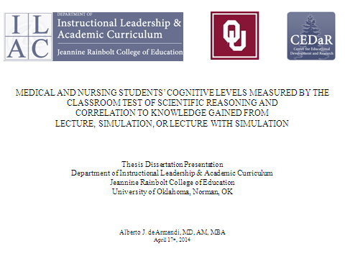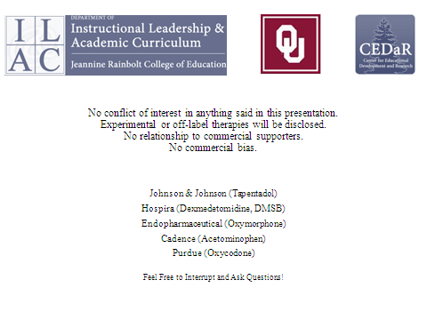

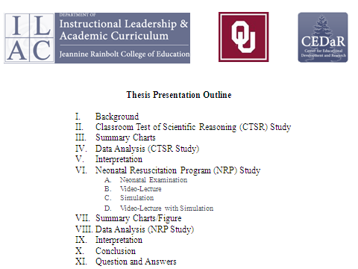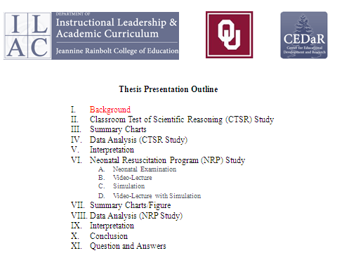

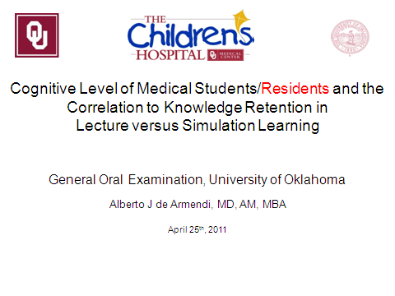

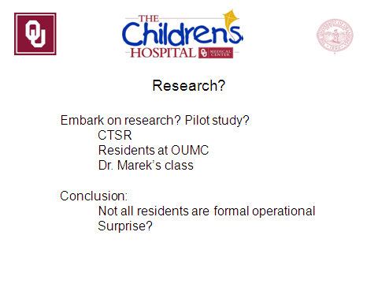

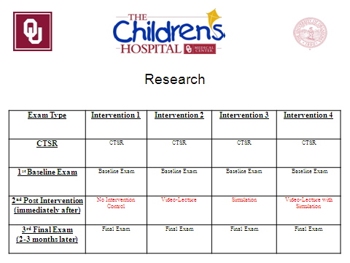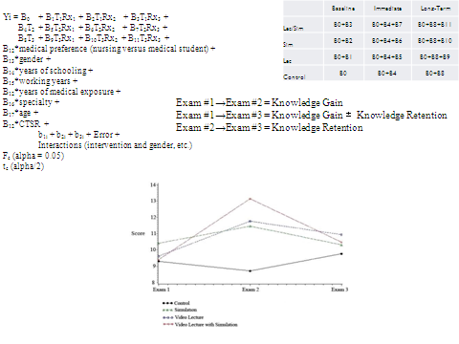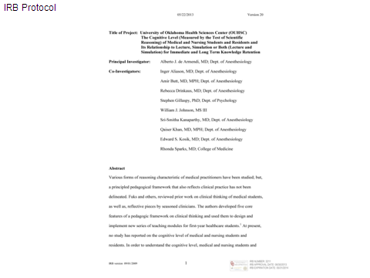

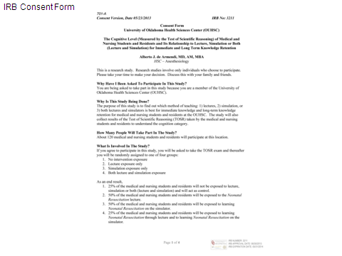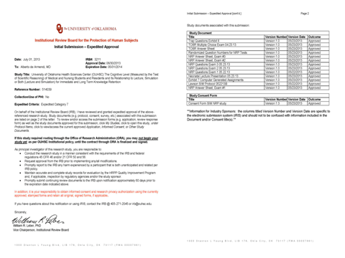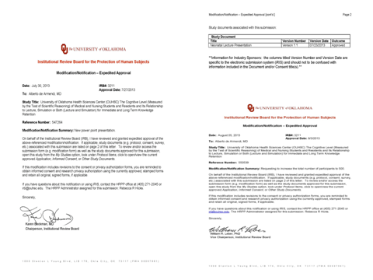

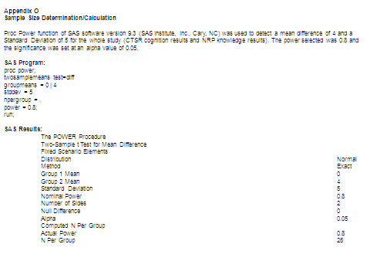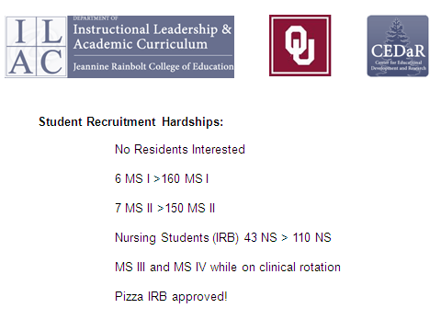

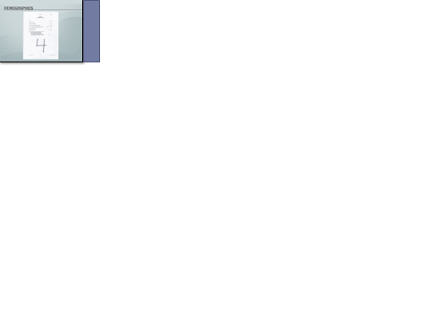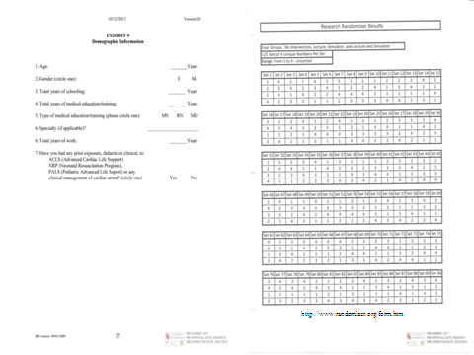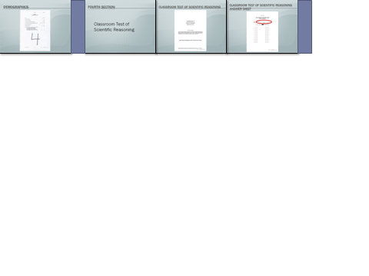

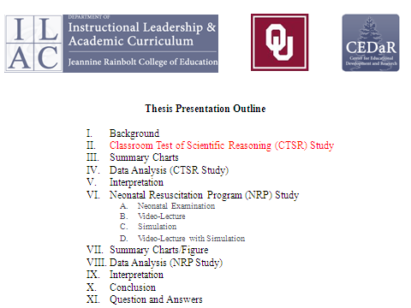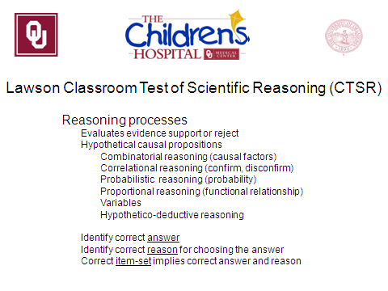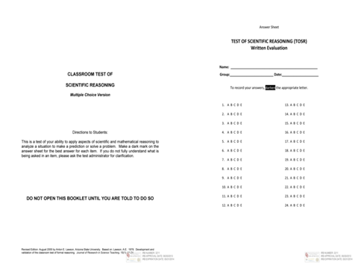

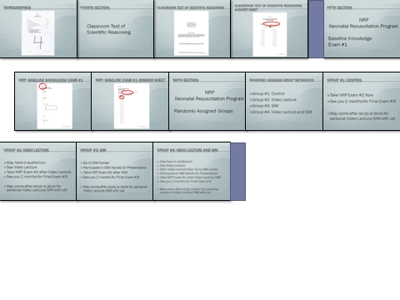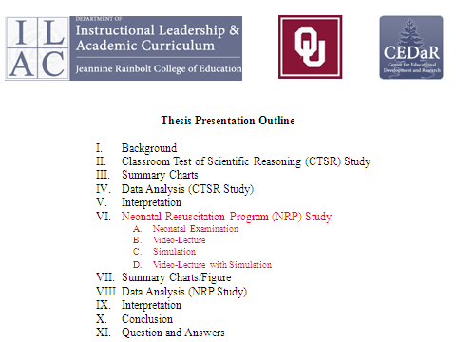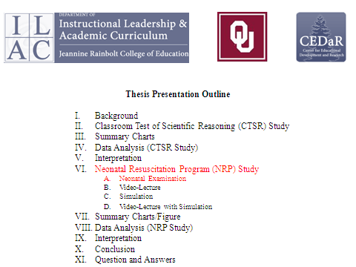

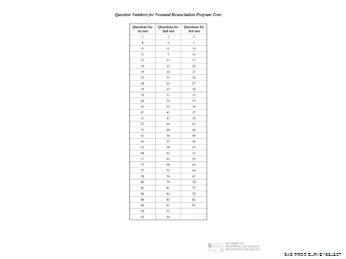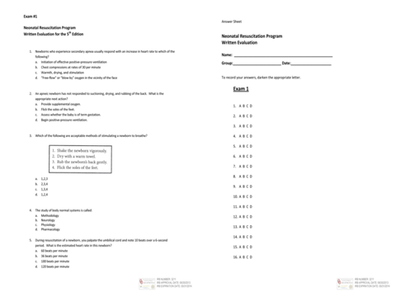

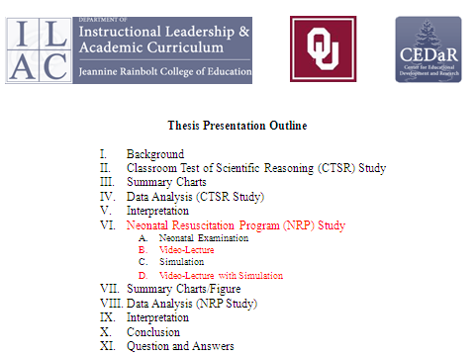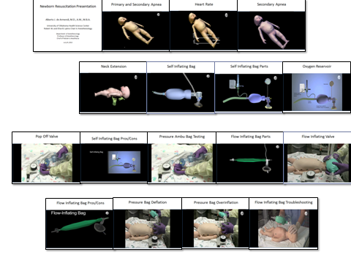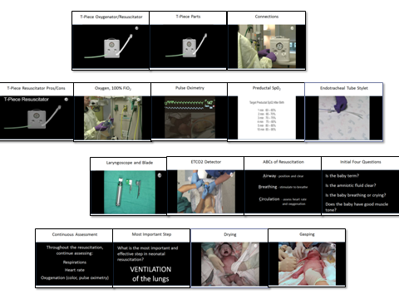

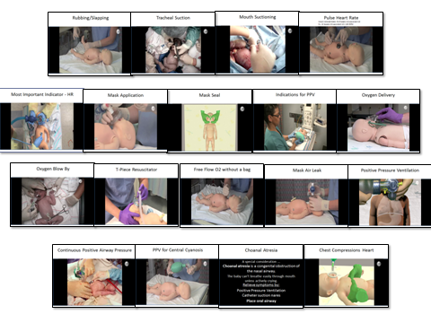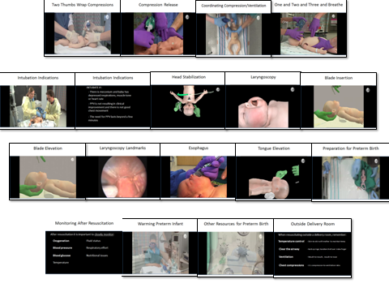

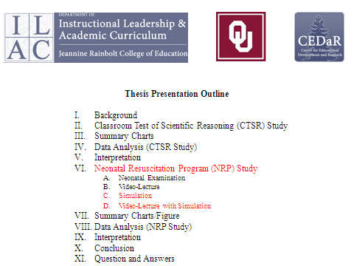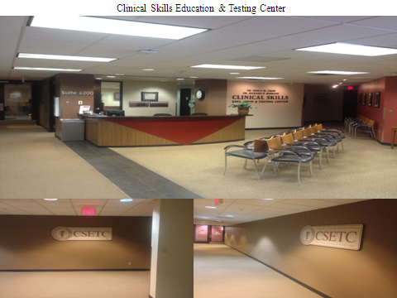

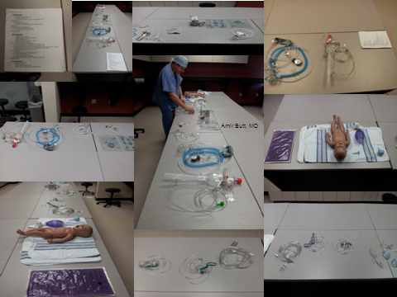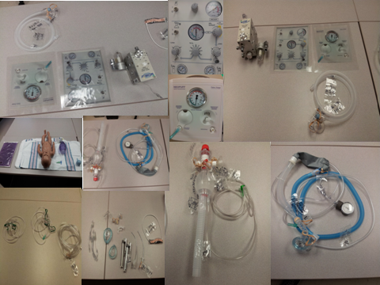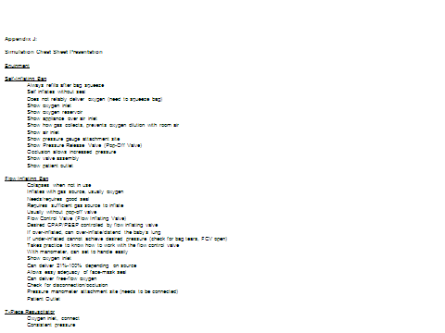

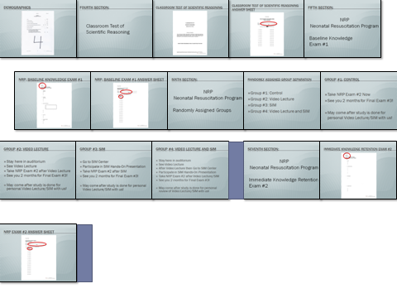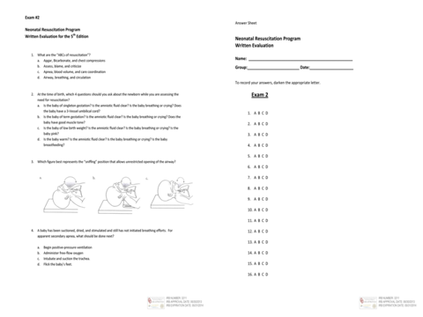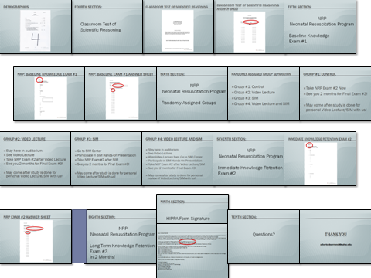

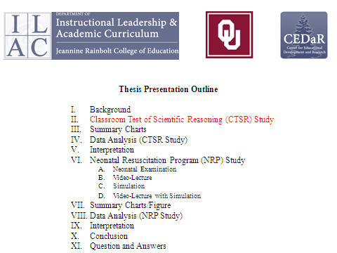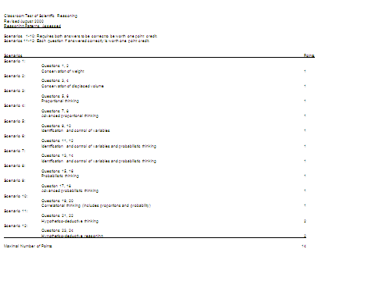

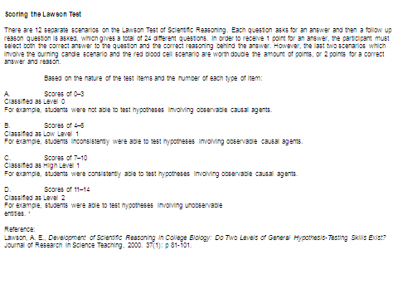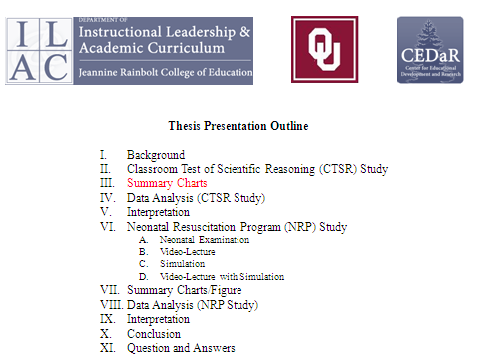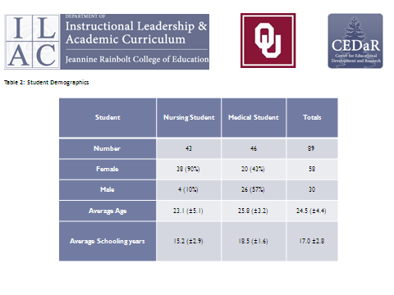

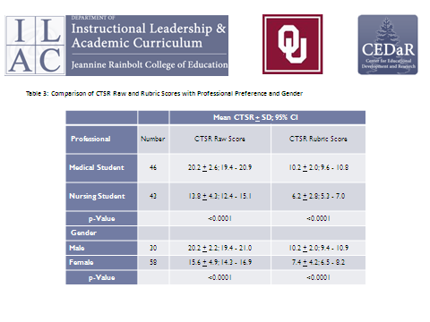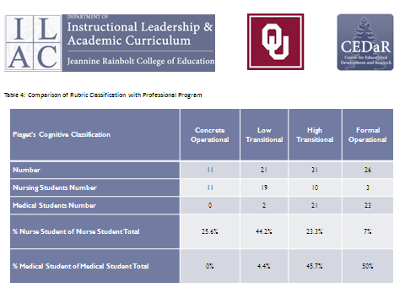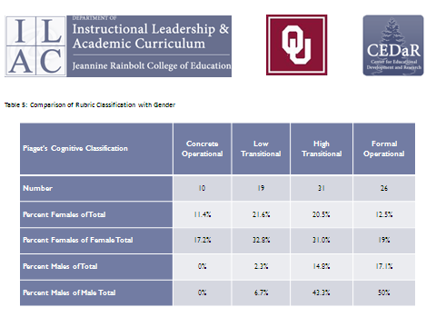

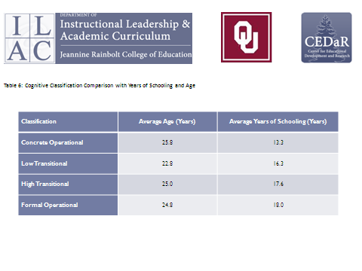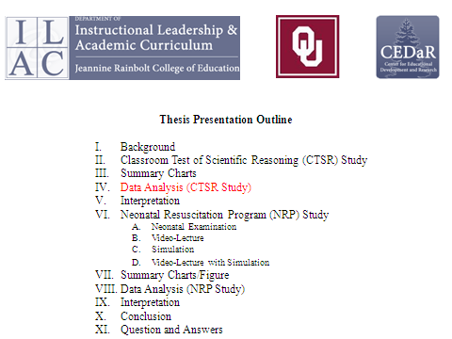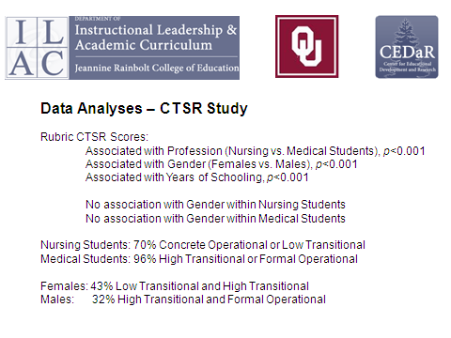

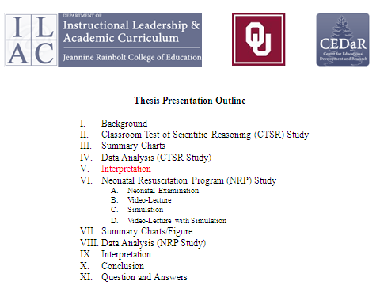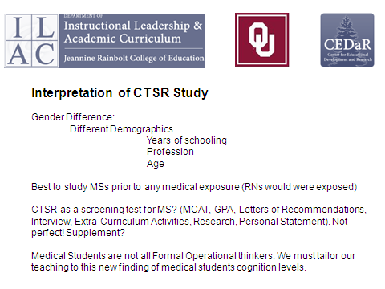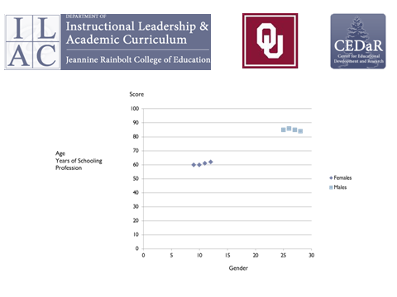

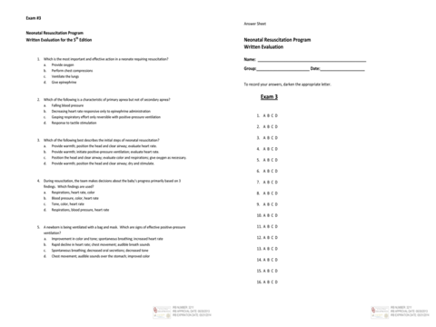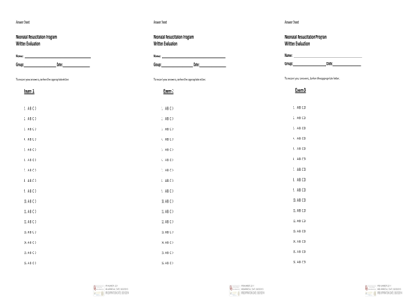

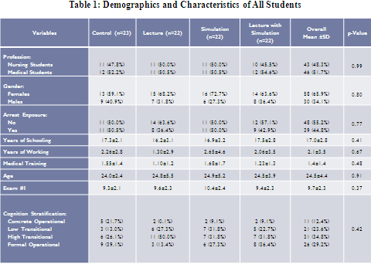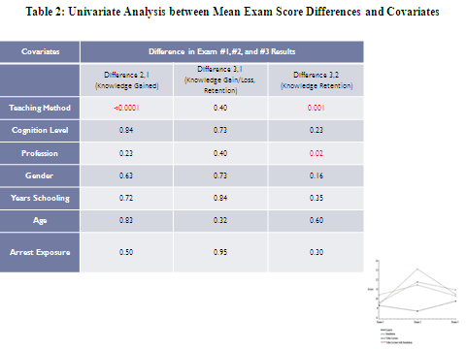

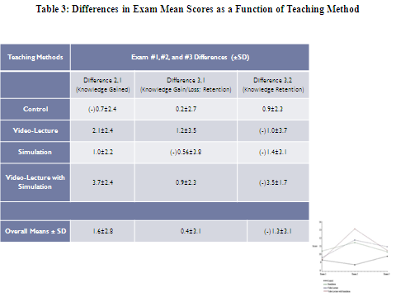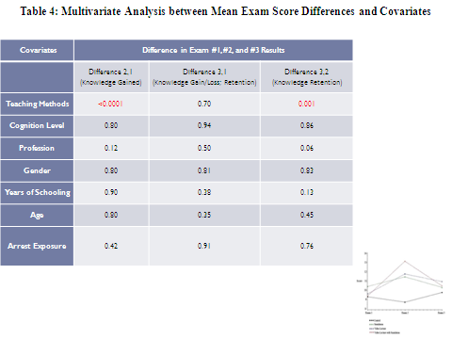

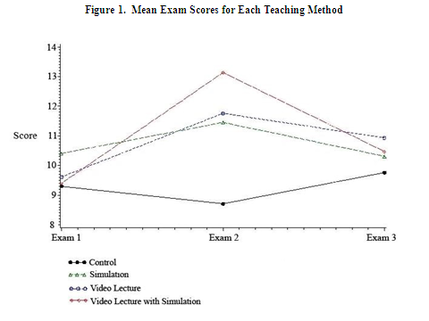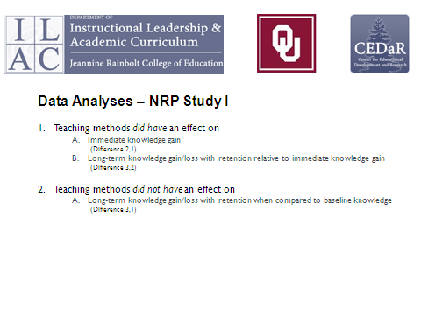

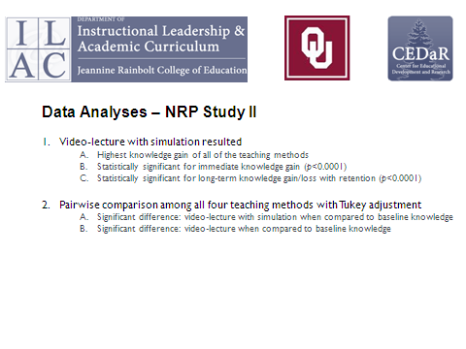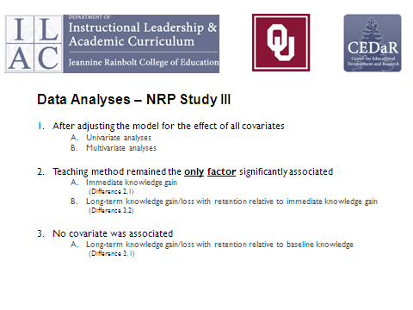

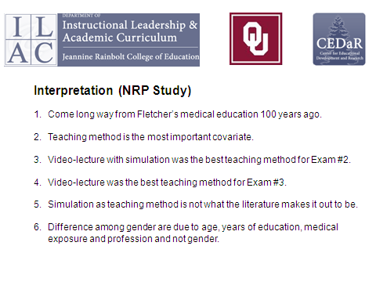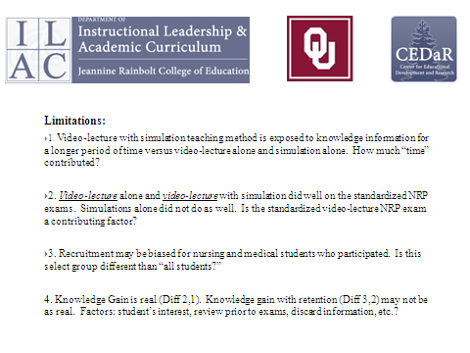

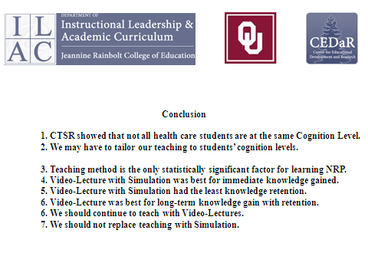

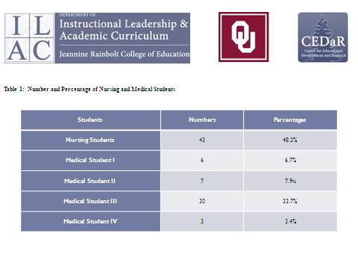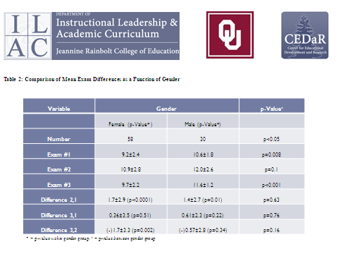

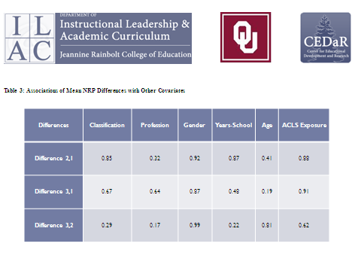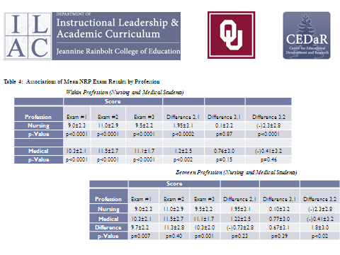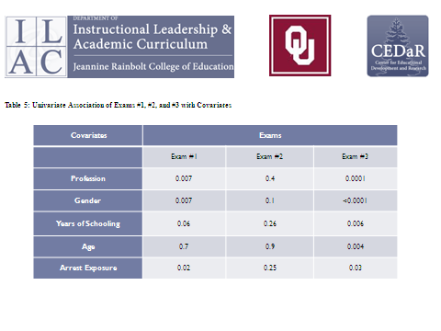

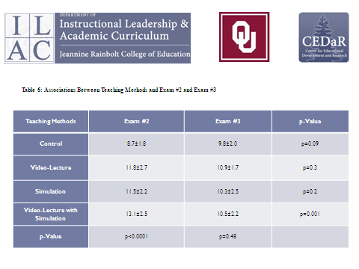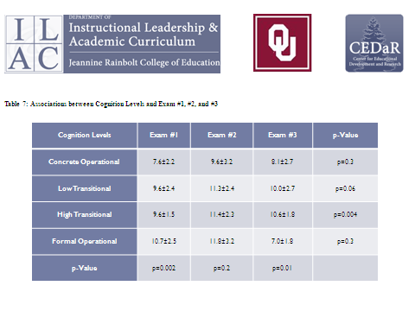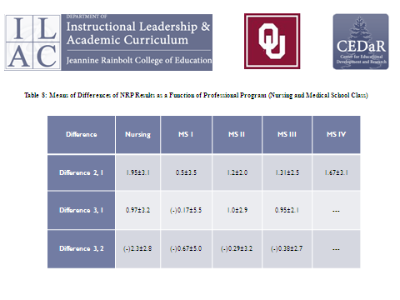

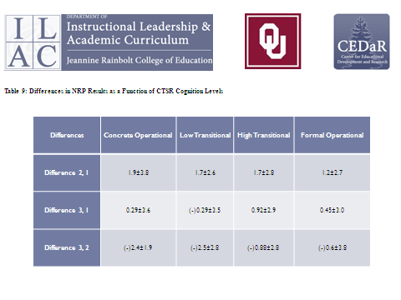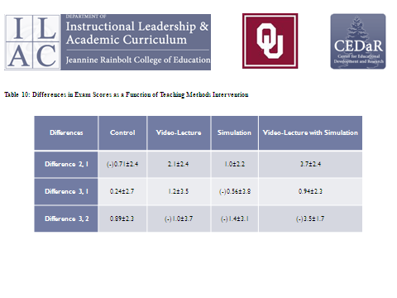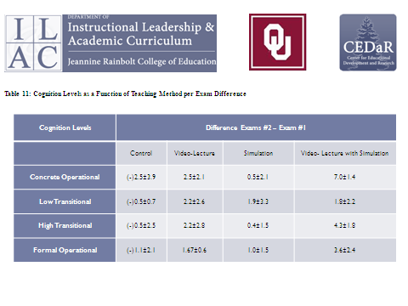

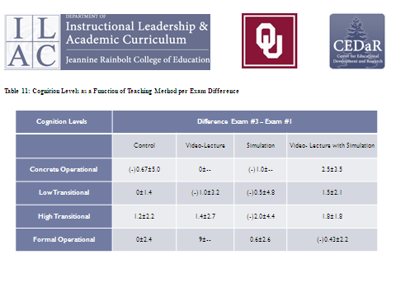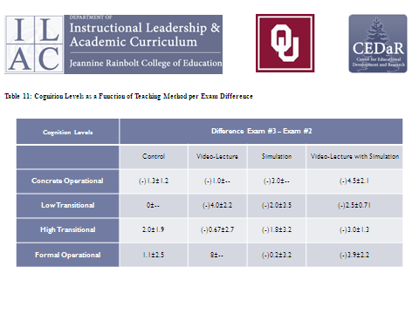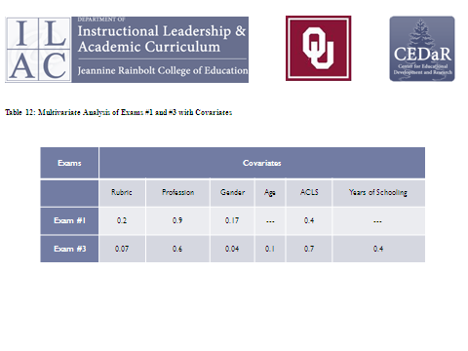

Appendices S, T, U, V, W, X, Y, and Z
Disk and USB Drive
Education & Fun with Neonates, Nursing and Medical Student Presentation
Newborn Resuscitation Program Lecture Presentation
Thesis Dissertation Defense Presentation
Thesis Dissertation
The enclosed disk and USB drive contain: 1) the Education & Fun with Neonates, Nursing and Medical Student Presentation, 2) the Newborn Resuscitation Program Lecture Presentation 3) the Thesis Dissertation Defense Presentation and 4) the Thesis Dissertation.
Appendix S refers to the Education & Fun with Neonates, Nursing and Medical Student Presentation in the disk.
Appendix T refers to the Newborn Resuscitation Program Lecture Presentation in the disk.
Appendix U refers to the Thesis Dissertation Defense Presentation in the disk.
Appendix V refers to the Thesis Dissertation in the disk.
Appendix W refers to the Education & Fun with Neonates, Nursing and Medical Student Presentation in the USB drive.
Appendix X refers to the Newborn Resuscitation Program Lecture Presentation in the USB drive.
Appendix Y refers to the Thesis Dissertation Defense Presentation in the USB drive.
Appendix Z refers to the Thesis Dissertation in the USB drive.
Disk and USB Drive
Education & Fun with Neonates, Nursing and Medical Student Presentation
Newborn Resuscitation Program Lecture Presentation
Thesis Dissertation Defense Presentation
Thesis Dissertation

Please see Disk and USB Drive inside envelope.

THANK YOU!

