UNIVERSITY OF OKLAHOMA

GRADUATE COLLEGE

SYMPHONY NO. 5: “Westward Journey”

A DOCUMENT

SUBMITTED TO THE GRADUATE FACULTY

In partial fulfillment of the requirements for the

Degree of

DOCTOR OF MUSICAL ARTS

By

ZACHARY C DANIELS
Norman, Oklahoma
2019

SYMPHONY NO. 5: “Westward Journey”

A DOCUMENT APPROVED FOR THE
SCHOOL OF MUSIC

BY

Dr. Marvin Lamb, Chair

Dr. Konstantinos Karathanasis

Dr. Michael Lee

Dr. Jeffrey Swinkin

Dr. Judith Pender

© Copyright by ZACHARY C DANIELS 2019
All Rights Reserved

Acknowledgments

I would like to express my sincere appreciation to Marvin Lamb for his continuous guidance and advice during the composition of Symphony No. 5, editing this document, and for listening to multiple drafts of the work in its earliest iterations; to the members of my committee, Konstantinos Karathanasis, Michael Lee, Jeffrey Swinkin, and Judith Pender for their continuous support and wisdom in guiding me through the process; to my parents and sister for their never-ending encouragement and understanding through the years; and to my incredible wife Ashlie, for supporting and encouraging me through a seemingly endless amount of writing, editing, listening, research, and deep thought while working on this document. I also extend gratitude toward the many mentors, teachers, professors, and friends that inspired and supported me through an undergraduate degree and graduate school.

Table of Contents

Acknowledgments iv
Table of Contents v
List of Tables vi
List of Figures vii
Abstract 1
Chapter 1: Introduction 2
Section A: History of the Symphony in Relation To This Work 2
Section B: The Narrative 6
Section C: Compositional Philosophy & Influences 9
Section D: Architecture of Symphony No. 5 11
Chapter 3: The Theremin 13
Section A: History of the Theremin 13
Section B: Incorporating Theremin 16
Chapter 3: The First Movement 19
Chapter 4: The Second Movement 30
Chapter 5: The Third Movement 38
Chapter 6: The Fourth Movement 44
Chapter 7: Summary 55
Bibliography 56
Appendix A: Images of Uncommon Instruments Used in Symphony No. 5: Westward Journey 58
Image of a Shekere 58
Image of Carolina Eyck Playing a Theremin 59
Appendix B: Instrumentation 60
Appendix C: Complete Score of Symphony No. 5: Westward Journey 61

List of Tables

Table 1: Formal Structure of Symphony No. 5 12
Table 2: Formal Structure of Movement 1 20
Table 3: Architecture of Movement 4 45

List of Figures
Figure 1: Sunrise Gesture 19
Figure 2: Pedal Notes with Directionality 21
Figure 3: Transition Material 22
Figure 4: Secondary Theme 23
Figure 5: Development Section Percussion 24
Figure 6: Motivic Development Material 25
Figure 7: Motivic Excerpt From Beethoven’s 5th Symphony 25
Figure 8: References to Beethoven’s 5 Symphony 26
Figure 9: measures 108 - 111 27
Figure 10: Theremin Entrance 28
Figure 11: Interruptions in the Recapitulation 29
Figure 12: Movement II opening melody 30
Figure 13: Movement II Bird Calls – m. 10 – 16 flute 1 31
Figure 14: Haydn, Opus 33 no 3 in C Major (“The Bird”) mvt 4 m. 15-18 first violin 31
Figure 15: [II-T1] 31
Figure 16: [II-T2] 32
Figure 17: m. 83 Brass 34
Figure 18: Time-Dilation in m. 96 - 97 34
Figure 19: m. 102 – 106, tpts, tbns/tba,tmp, vln1 @ 105-106 36
Figure 20: m. 110 – 114 trumpet solo 36
Figure 21: m. 116 – 118 flute 37
Figure 22: m. 1-2, vln1 39
Figure 23: m. 9-16 vln1 40
Figure 24: Measure 90-96 [I-A] 41
Figure 25: Timpani Solo – Mvt. 4 m. 8 - 29 46
Figure 26: Hemiola at the Beginning of Mvt. 4 47
Figure 27: <025> Viola Ostinato 49
Figure 28: <025> In Movement 1 49
Figure 29: <015> Cello Ostinato 49
Figure 30: Melody [I-A] new 49
Figure 31: [II-T1] in Movement IV 50
Figure 32: Fully-formed Ostinato in Movement IV 50
Figure 33: [IV-B1] 51
Figure 34: [IV-B2] 51
Figure 35: [IV-B3] 52
Figure 36: Ritardando/Rallentando at Q 54

Abstract
This document contains the score to Symphony No. 5: Westward Journey, an original composition for symphony orchestra consisting of four movements, lasting approximately twenty-eight minutes. This work is rooted in the Western European symphonic tradition utilizing a four-movement structure, which I chose in order to carry forward the symphonic tradition, as well as to allow each movement to feature different aspects of the entirety of my compositional catalogue. The lyricism and limited tonality of Movement II stem from my earliest compositions; Movement IV uses my typical strategy of re-contextualizing all previously introduced melodic and motivic material; Movement III alludes to much of my chamber music in tone and formal structure, while Movement I focuses on the re-imagining of compositional influences that have permeated my music for several years. The piece follows a traditional pattern as to form, opening with a sonata-allegro first movement, followed by a slower theme-and-variations movement, then a slow minuet-like dance movement, finally a rondo, with extended opening material. The score to the symphony is accompanied by an analytical document.

Chapter 1: Introduction
Section A: History of the Symphony in Relation To This Work
The symphony, as developed by Franz Joseph Haydn, became a staple of orchestral music throughout in the late 1700s through composers such as Wolfgang Amadeus Mozart. Then, with Ludwig van Beethoven, the symphony became regarded as instrumental music’s highest and most exalted form throughout the nineteenth, and even twentieth centuries.
Many composers of the early to mid-1800s wrote symphonies, or symphonic works. Franz Schubert, a contemporary of Beethoven, wrote several; Robert Schumann wrote four symphonies between 1840 and 1850, and many others would go on to write symphonies. Among these, however, Hector Berlioz stands out as unique. To his name, only four symphonies exist, but Symphony Fantastique (1829/38) was a work of orchestrational genius, inspired by a narrative of his own design. This symphony makes frequent use of extended techniques to create imaginative soundscapes. These things, in combination with the harmonic language used throughout the work, create an incredibly different type of symphony than that which Beethoven or Schubert had written.
By the end of the nineteenth century, many music critics across Europe were certain that Johannes Brahms would be the composer to take the mantle from Beethoven but, like many nineteenth-century composers, he was struggling to master that which Beethoven had seemingly perfected, the symphony. He would eventually write four symphonies, perhaps most impactful for the purposes of this document would be the first, written in 1876. Meanwhile, in Russia, composers such as Pyotr Ilyich Tchaikovsky and Nikolai Rimsky-Korsakov were writing colorful symphonies with brilliant orchestrations. In America, the turn of the century would have John Knowles Paine attempting to carry forward the genre in an effort to imitate the perceived greatness of his European counterparts. Although his music would not be fully recognized for its full value until the centenary of his birth, Gustav Mahler is often considered to be the last great Austro-German composer of the symphonic tradition.
From this point, several different streams of symphonic music permeate the music world with composers such as Igor Stravinsky leaning heavily into the narrative by adapting his ballet music into the symphonic medium. Others, such as Dimitri Shostakovich continued the Russian tradition of lush, colorful symphonic music while adding complex harmonic structures more typical of the twentieth century. We also have the Americans of the early and middle twentieth century such as Aaron Copland who, like Stravinsky, adapted works for ballet into the symphonic medium as well as writing stand-alone works, frequently with a definitive “Americana” sound.
Late in the twentieth century, the symphonic tradition takes on new life through the compositions of minimalists such as Phillip Glass who continues to write in the medium significantly into the twenty-first century. While there are no clear “champions” of the symphonic tradition today, there are many composers writing symphonies/symphonic works that have gained significant recognition including Jennifer Higdon, Steven Bryant, and others.
Symphonic music today is also seen as a staple of the film, television, and games industries. Some well-known composers from these industries such as Koji Kondo (Legend of Zelda, Mario) and John Williams (Star Wars, Jurassic Park, Jaws) have also gone on to write stand-alone symphonic works based both on original material, and that of the film/game scores they have written. Other composers, such as Martin O’Donnell (Halo), Jason Hayes (World of Warcraft), and Alan Silvestri (Marvel’s Avengers: Infinity War and Avengers: Endgame) have written symphonic music that is immensely popular and even performed as separate concert works. The symphonic tradition, though very different from its eighteenth-century roots, is as relevant as ever and this document is a testament to that.
My fifth symphony is the product of this proud heritage of symphonic music, from Mozart’s G minor symphony (No. 40) to Phillip Glass’s Sixth Symphony and from Beethoven’s 5th to Martin O’Donnell’s main theme to Halo. The symphony discussed in this document is a continuation of this legacy, and careful attention was given to ensure that the piece builds on each of these traditions to create a portrait of what I see as a merging of these different symphonic identities. This is accomplished through direct and indirect musical references, orchestration decisions, and even the structure of the symphony itself.

Section B: The Narrative

Symphony No. 5, Westward Journey, draws from several influences both in the European classical tradition, and from various American composers such as Aaron Copland, Philip Glass and John Adams. For the first time in my compositional career, I have decided to use a re-imagining of my own journey to the American West to form a narrative for the work. The narrative is relatively straightforward but leaves room for a listener’s imagination. Imagine a young man in his early twenties, moving out of Missouri and into the West for the first time, to Oklahoma.
This initial idea is represented by the march-like musical material in movement one as the sun rises on open plains (represented by the “sunrise” gesture). This sunrise gesture is my interpretation of the sunrise in Oklahoma’s famously blue skies. The primary recurrent theme in this piece, found first in measure 13 of the movement, is initially timid and undeveloped, much as we frequently are unsure of ourselves as we set out on our life journey. This is reflective of my own experiences moving to Oklahoma, as I had moved away from everything and everyone I had ever known for the first time and often felt homesick as a result. The melodic material in this first movement is inspired by the main theme to World of Warcraft because it was a welcome, familiar theme for me to hear any time I returned home to my small, lonely apartment.
What appears at first to be desolate, unforgiving, and unfamiliar territory eventually leads to a place that can be called home, and even brings companionship as represented by the countermelody, representative of when my long-time companion, Ashlie, followed me here after six months on my own. Theremin is used as a primary instrument to represent the unfamiliar, or alien, becoming familiar over time. It is utilized first in the recapitulation of Movement I as a representation of that which is unfamiliar slowly becoming part of life in a new area.
The second movement’s romance and lyricism represent this new home filled with love and happiness. Even so we often find ourselves longing for old familiar places. This is true even when the new and unfamiliar has much to offer to newcomers, as represented by the focus on theremin in a heartfelt, lyrical second movement.
The third movement is representative of the long and tedious nature of building a life in my journey to the American West. It is a lot of hard work to create a new life for yourself in unfamiliar territory. In my case, it took the better part of four months to grow accustomed to the environments in which I found myself. Although the same struggles exist here as in our previous environment, we succeed eventually by pushing through to the end (represented by the accelerando as we head to the 4/4 in movement four). Through perseverance and dedication to a goal, life can be everything you wanted it to be and more, as heard when the “victory” fanfare comes in at the halfway point of movement four. As the sun sets on our journey west in the final measures of the piece, we can look back at what was accomplished with pride as we took an initially timid theme and helped it grow and be full of life.

Section C: Compositional Philosophy & Influences

Early in my compositional career, I was composing in a tonal fashion, completely avoiding anything remotely non-tonal. Then, early in my undergraduate study I was introduced to concepts of extended tonality, minimalism, and serialist technique. I particularly grew fond of American composers John Cage, Philip Glass, and Steve Reich. These composers, as well as Japanese composer Koji Kondo, American composer Jennifer Higdon, and the serialist Anton Webern would influence much of my compositional output during my later studies.
Once I began graduate school, my focus shifted heavily to avant-garde, electroacoustic, and minimalist composers. This was due to a lack of exposure, as well a growing fascination with the techniques involved in Philip Glass and Steve Reich’s chamber music. I would be introduced to avant-garde composers such as La Monte Young during my time pursuing a Masters, as well as many composers of electronic music. My interests in electronic music were particularly vague for a while, as I was freely exploring the medium though I eventually narrowed my focus to that of the fixed-media soundscape, and laptop ensembles. In parallel with this newfound fascination with electronic music, I also became fascinated with instruments of the genre, particularly FM synthesizers and the theremin.
As my influences have changed, so have my compositional aspirations and compositional philosophy. My personal views on music have become blended, with aspects of minimalism, experimentalism, Americana, serialism, and more coming together to shape both my music as well as my views on music. I now believe that music should take the listener on a personal journey with a definitive beginning and end. This journey should take the listener to both familiar and unfamiliar places in context of the music they are listening to, and in the greater context of their lifelong experiences with the arts. The journey is not always obvious when initially creating a work of art. However, with careful reflection and an inquisitive mindset, a work of art’s narrative can be found. What is most important is that a composer decides upon the journey his/her piece will take their intended audience on and that they use the music to convince them of this journey’s existence.

Section D: Architecture of Symphony No. 5

The architecture of this symphony is in four-movements, beginning with a C - F# motion in movement I that is never fully resolved to F-natural or G-natural as one would typically expect in a first movement. This F# ending is disrupted by the theremin’s ending on E-natural to set up the second movement’s tonality of E-major. Movement III begins in A-minor tonality before falling to F-minor by the end to create a noticeable difference between this and the final movement when it begins in an E-hypophrygian mode. The finale has a tonality of C/E, but ends with a key center of F to bring finality to the C-F downward motion that was alluded to, but never achieved in movement I’s C-F# downward motion. The musical material used in each movement is related on some level to other music within the work itself. This is seen most often in the case of the G-Ab-G (referenced later as <010>) motif that is the genesis of the melodic content in movements I and III, also re-appearing in movement IV.
Movement I is written using sonata-allegro form, opening with a “sunrise” gesture and beginning with a strong C pedal that shifts down to an A, then eventually to F#. This motion is repeated in the exposition before returning one last time in the recapitulation of the movement. Movement II is a blend between verse-chorus, and rondo form heavily featuring theremin as a soloist throughout the movement. This movement, primarily written around an E Major key center, functions also as an individual work for theremin and orchestra. Movement III is a minuet written with an A minor key center at the beginning, which makes its way to F minor by the end. Movement IV has four distinct parts. The opening is focused around a timpani solo. This is followed by the scherzo section of the movement which is structured around a long textural crescendo that capitalizes on minimalist techniques. It moves to the finale of the symphony, beginning with a meter change to 4/4 at the halfway point of the movement. This ending acts as the sunset at the end of a long journey by re-imagining the sunrise gesture, as the symphony’s final moments fade into nothingness and the bells take their final toll.

 | Movement I | Movement II | Movement III | Movement IV
Form | Sonata-Allegro | Verse-Chorus  Rondo | Minuet | Scherzo-Allegro
Sub-sections |  | ABABACA | A B A
Tonality | C min.  A min. F# dim. | E Major | A min.F min. | A min.E  CEF
Major Components | Sunrise, March,  <010> motif | Solo Theremin,  Lyricism | <010> motif,  Lyricism | Timpani Solo,  Hemiola, Scherzo, Finale, Sunset
Table 1: Formal Structure of Symphony No. 5

Chapter 3: The Theremin

Section A: History of the Theremin

The theremin is a monophonic electronic instrument developed by Lev Sergeyevich Termen in the early twentieth century, and is the first successful attempt to create an electronic instrument. Early demonstrations of the concept were given to Lenin in 1922 with the name “termenvox”, and in the United States of America by 1927 with the name “thereminvox” before being changed to “theremin” by 1929. The theremin has been featured in over 100 concert works, and 35 films since its introduction.
To play the theremin is unusual, as the performer does not actually touch the instrument in order to play it. Performers use their hands in the space above the body of the instrument to control pitch and volume. Pitch is controlled by the right hand’s proximity to a vertical antenna, while dynamics are controlled by the left hand’s proximity to a loop-antenna that is typically positioned horizontally coming out of the left side of the body of the instrument. The theremin produces sound as a single sine wave that can be given different timbres on advanced models of the instrument by cycling through different filters, or through external patching through standard audio equipment or a computer. The range of a theremin can be from two octaves on smaller instruments to seven on larger professional-grade instruments. Today, there are many manufacturers of theremins including RCA, Moog, and others.
Although simple in concept and design, to perform on a theremin with any level of accuracy requires a great deal of practice. Unlike other instruments, there is no physical reference point which performers can use to determine pitch before actuating it. This unique problem has been addressed in a number of ways including a version with a “fingerboard” that has lines drawn out on the body of the instrument to approximate pitch locations in the space above. The pedagogy of the instrument has developed since the 1920s to accommodate better performance practice, different requirements in pieces featuring the theremin, and technological advancements that have improved the instrument over time. A popular technique called the “8 finger position technique” was developed by Carolina Eyck, a student of Lydia Kavina, in the early 2000s and written about in the first extensive theremin method book, The Art of Playing the Theremin.
Orchestral works with a solo electronic instrument date back to May of 1924 with the premiere of Paschenko’s Simfonicheskaya misteriya in Leningrad featuring Termen as the soloist. In film, Valentin Yakovlevich Kruchinins featured the theremin in his score to the science-fiction film Áelita. Other composers would begin to write for theremin by the middle of the century including Joseph Schillinger, Edgar Varèse and Percy Grainger. Today, composers such as Andrew Norman, Kalevi Aho, Christopher Tarnow, and Carolina Eyck have written for the instrument.

Section B: Incorporating Theremin

I decided early in the process to incorporate an electronic element into this symphony. Early drafts incorporated brief fixed media interludes between movements, but the decision was made to further integrate the electronic element beyond the scope of the interludes. Upon further consideration the fixed media concept was replaced with a live electronic instrument, akin to Messiaen’s Turangalila – Symphonie. The decision to incorporate theremin was a logical next step, as before beginning to write Symphony No. 5, I was struck with the instrument, inspired to purchase one and try my hand at writing for it. I learned the theremin well enough to create basic gestures and ideas, but I needed more guidance due to a lack of performer’s familiarity with the instrument. In an effort to further my understanding of the instrument, I discovered an online video series by Dr. Carolina Eyck, a major performer and pedagogue for the instrument. While the videos proved helpful in the basics of writing for the instrument, I decided to contact Dr. Eyck directly for further advice and guidance. That contact has led to a wonderful collaboration with her in learning the proper way to voice Theremin in an orchestral setting. A “cardinal rule” I have developed in working with Dr. Eyck, and through my own experience on the instrument, is to write as if it were a human voice. This led me to treat the theremin as an extended vocal solo in movement two of my symphony, lasting the entire movement.
With Movement II quickly becoming focused on writing for the theremin, I needed to incorporate further what I’d learned from the writing of Movement II, as well as my communications with Dr. Eyck in the other movements of the symphony. I returned to what I had for the instrument in movement one at this point and removed most of what I had written for it. This decision was two-fold: first, the instrument is slightly overbearing if used too much in an ensemble of any size due to it being a mostly unaltered sine wave that pierces through most textures with ease. The second reason was not wanting to make use of the theremin’s full capabilities until it was time for the featured solo element in movement two.
The dynamic capabilities of the Theremin are a great role for it in the greater orchestral setting. Incorporating this idea in a purely background capacity, as color, for Movement III was an easy decision after getting to know the instrument in the writing of Movement II. Movement IV uses the theremin primarily to reinforce another instrument as it echoes thematic content, or in its’ low register as a strong compliment to the warm sound of the strings.

Chapter 3: The First Movement

The first movement serves both as an exposition to what comes later, and as a means to get the listener invested in what’s about to happen. This movement is written in sonata-allegro form with the overarching sections appearing as shown in Table 2. Movement I of this symphony opens with a short series of step-wise whole notes in the bassoon and horn over a powerful C-pedal in the low brass and strings. This slow-moving line, or “sunrise gesture” (Figure 1) is used to signify the beginning of major sub-sections in the exposition and recapitulation. It also musically represents multiple days passing on a journey.
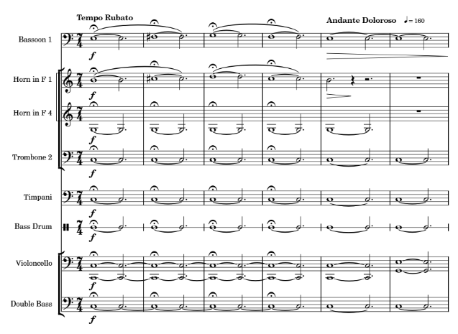
Figure 1: Sunrise Gesture
C - A | Sunrise | m. 1 |  | Exposition | Movement I
C - A |  | m. 5 | P | Exposition
A - F#  Table 2: Formal Structure of Movement 1 |  | m. 39 | T | Exposition
A - F#  Table 2: Formal Structure of Movement 1 | Sunrise | m. 47 | T | Exposition
C - A |  | m. 51 | S | Exposition
F# |  | m. 85 | K | Exposition
 |  | m. 93 | Development
C - A | Sunrise | m. 103 |  | Recapitulation
C - A |  | m. 108 | P | Recapitulation
A |  | m. 126 | T | Recapitulation
A |  | m. 130 | S | Recapitulation
F# |  | m. 143 | K | Recapitulation
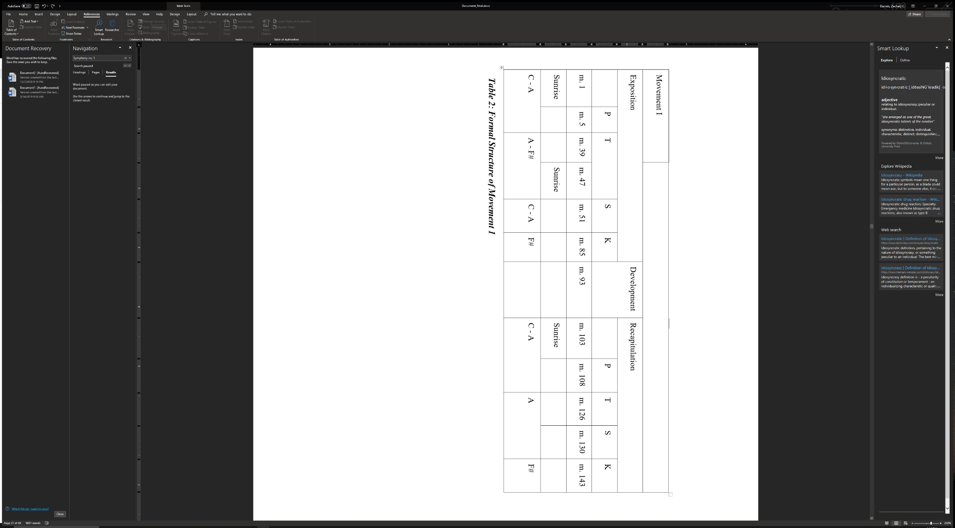

The C-pedal persists through measure 20 before descending to an A-natural via B-flat, after which there is an abrupt change back to C-natural following the first-ending repeat. At this point, the pedal-note travels in a descending manner through an F# dim. triad over the course of the first 46 measures of the movement. This motion is demonstrated in Figure 2.
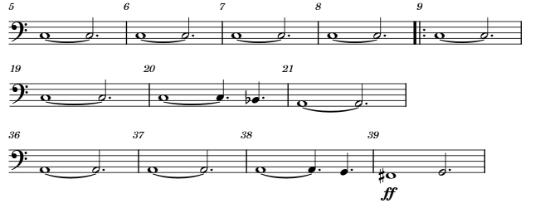Figure 2: Pedal Notes with Directionality

Immediately following the opening “sunrise” gesture, the rhythmic engine of the movement is heard as a 7/4 march starting in measure 5 with the 2nd violin section. This march slowly evolves over the course of measures 5 – 38 and serves as the primary driving force behind this opening movement.
The transition material, as found for the first time in measures 39 – 46, (Figure 3) is written with significantly more focus on the 7/4 march than the primary thematic area. The primary idea for the transition itself appears in measure 43 in the horns and trumpets, despite the same material appearing four measures earlier, in measure 39. The version beginning at measure 39 emphasizes different beats, due to its placement in the measure.
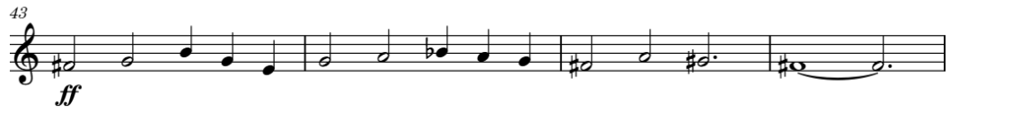Figure 3: Transition Material

The second “sunrise” gesture, at measure 47, signifies the beginning of the exposition’s secondary thematic area, with the new thematic material appearing in measure 59 and lasting through measure 66. This theme shares much of the same contour and rhythmic structure as the primary theme. Key differences lie in splitting the melodic voice in two dissonant, sometimes contrapuntal and otherwise parallel, melodic lines. The secondary theme itself appears in measure 59 in the flutes and trumpets (Figure 4), followed by a very familiar answer in 67. The pedal-notes follow a similar contour to in the primary thematic area, with the exception of not doubling back to C before descending all the way to F# by the downbeat of measure 89.
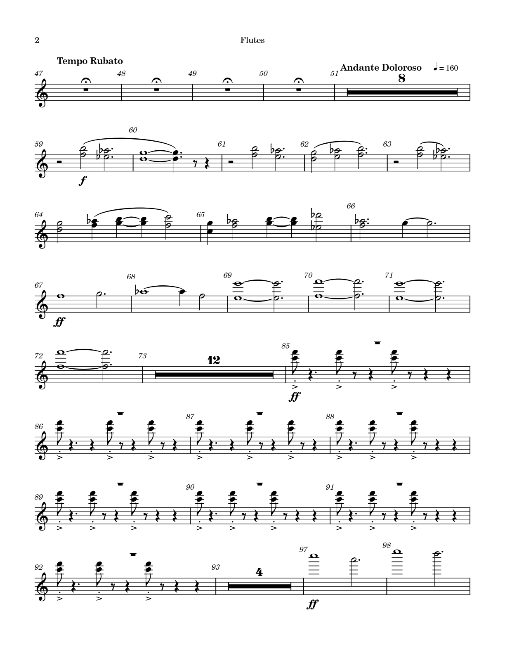Figure 4: Secondary Theme

The development section begins at measure 93 and focuses on having higher levels of activity than the surrounding areas, as well as dropping the persistent pedal-tone voices that have permeated the movement until this point. The texture is much thinner than that found in either the exposition or recapitulation as a result of this. The only low-end voices heard are that of the bassoons continuing the 7/4 march, the intermittent bass drum, and a low-end piano octave meant to serve as a reaction to the bass drum. Also featured in the development section are a series of cymbal scrapes meant to give the texture a small amount of extra shimmer, as shown in Figure 5.

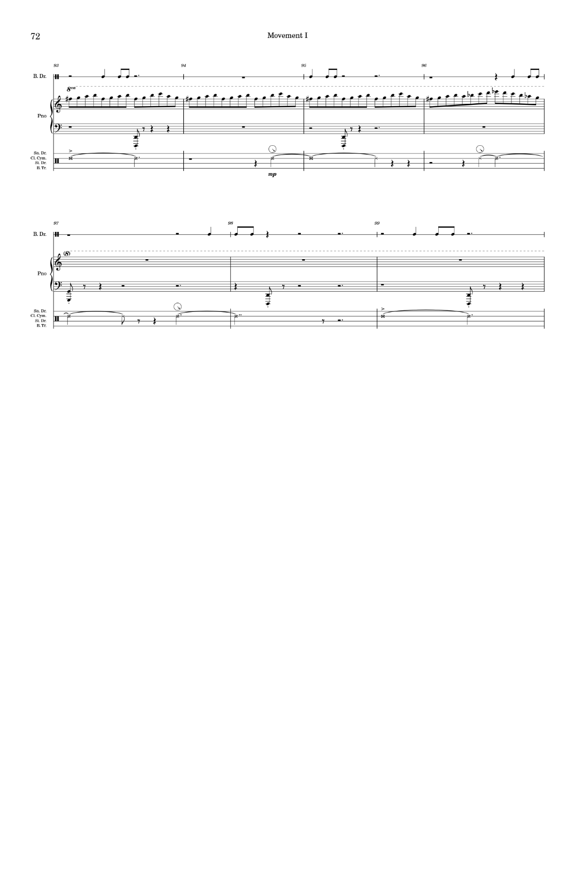
Figure 5: Development Section Percussion

The development adds one important new motivic element, which is seen only in this section of the movement, first hinted at in the violins (Figure 6):
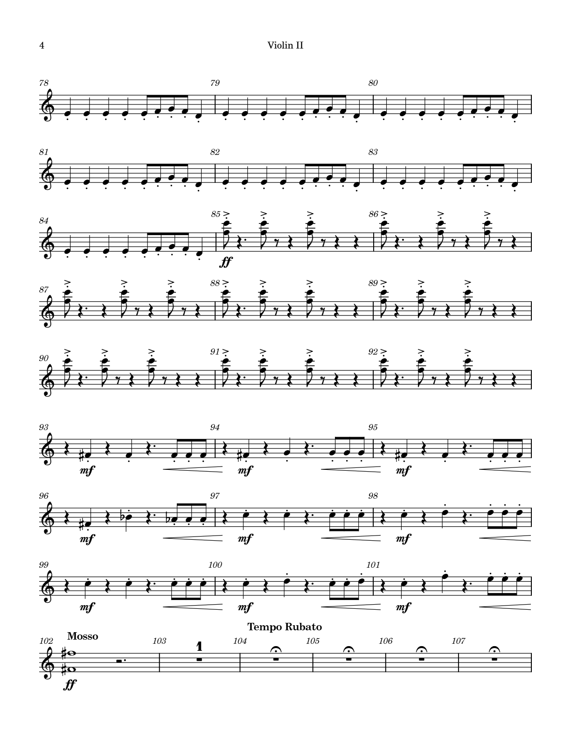
Figure 6: Motivic Development Material

This repeated set of three short notes leading into the weakened downbeat of the violin line foreshadows the brass in measures 96 and 97 to fully realize the rhythmic gesture as a reference to Beethoven’s Fifth Symphony (Figures 7 and 8).

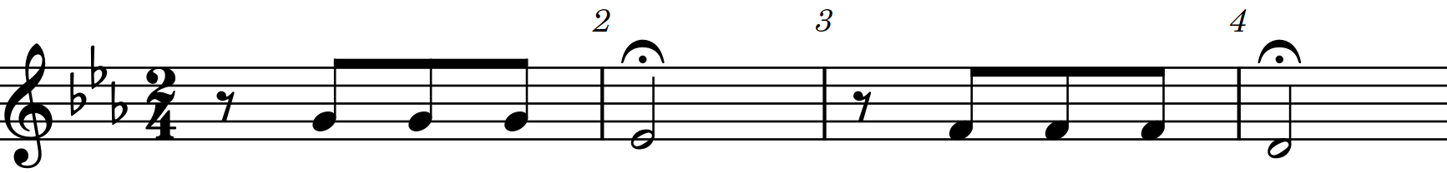
Figure 7: Motivic Excerpt From Beethoven’s 5th Symphony

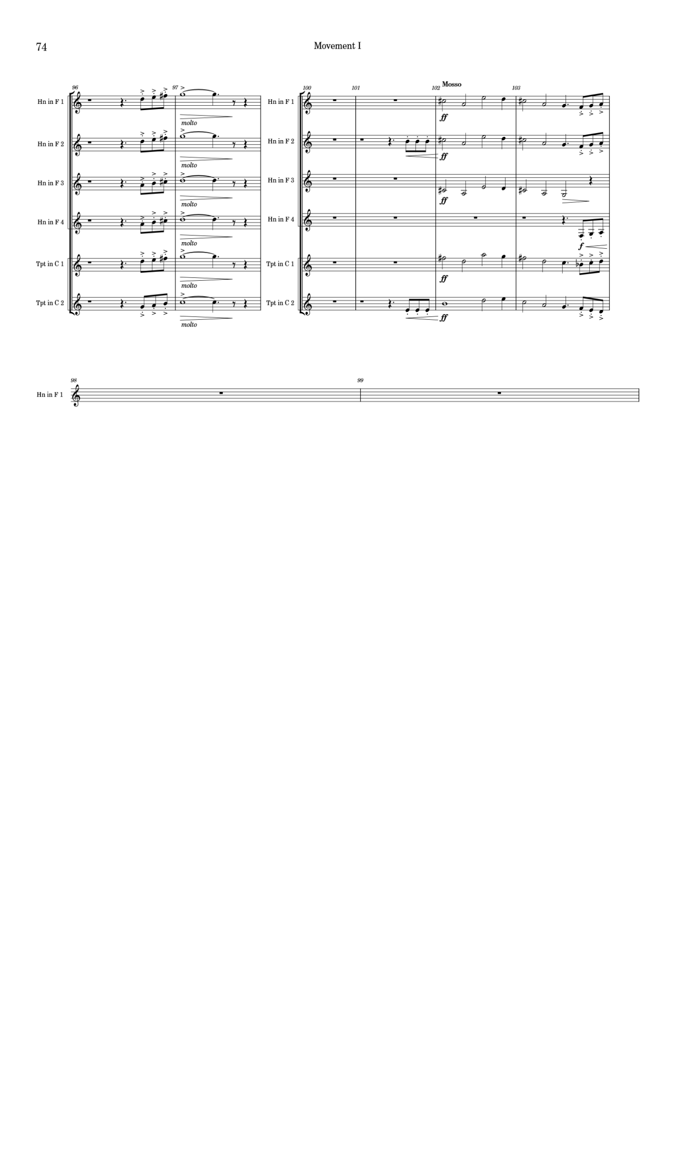

Figure 8: References to Beethoven’s 5 Symphony

The third “sunrise” gesture, at measure 104, marks the beginning of the recapitulation. There are several “interruptions” that are purposefully designed to come off as awkward, strange, and slightly comical in nature to differentiate this section from the more serious, grim nature of the exposition. The first of these interruptions, a molto ritardando over the 7/4 march just after measure 108, acts as structural prolongation via tempo alteration. This allows for the building of tension by stretching the tempo out slowly (Figure 9), before at last allowing the march to begin at the original tempo in measure 112.
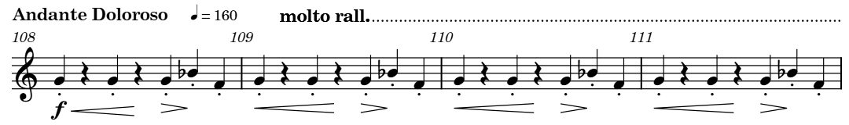
Figure 9: measures 108 - 111
Four measures into the newly reinvigorated march, all voices stop except for a single oboe that carries forward without change. This interruption in texture adds extra emphasis to the accompanying pedal-note voices when they come back in the following measure which, in turn sets the stage for a new sound, the theremin (Figure 10).
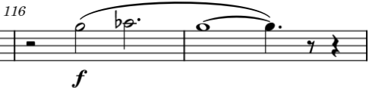
Figure 10: Theremin Entrance
The next section of the movement, at measure 126, is focused on driving the piece forward, utilizing a 3/2 meter to create an almost impatient feeling in the ensemble as we finally get to the closing section of the recapitulation after one final interruption, found in measure 132.
The closing section of the movement, beginning at measure 134, features the return of both the primary theme’s second iteration as well as the transitionary material from the exposition before the majority of voices in the orchestra stop, save for the lone sound of a theremin’s downward glissando in the closing moments of the movement. This serves to introduce the theremin as a primary agent in the second movement.
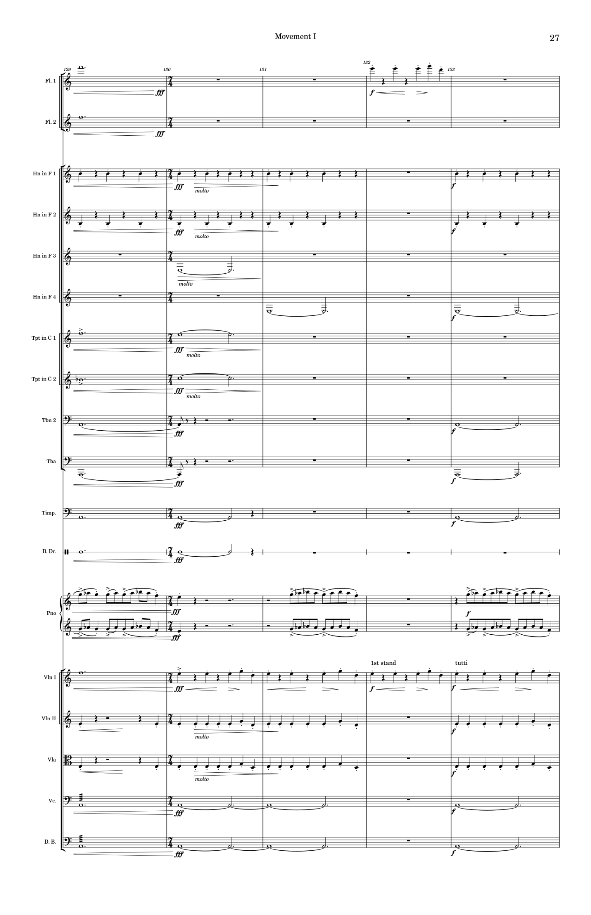
Figure 11: Interruptions in the Recapitulation

Chapter 4: The Second Movement

The second movement serves not only as the second movement in the work, but also as a separate individual work for solo theremin and orchestra. The movement opens with a solo violin melody over a bass drum roll and a series of horn calls. This opening theme, repeated in the clarinet 8 measures later, sets up the primary rhythmic cadence of the movement’s melodic content, and helps to establish our new tonality of E Major.
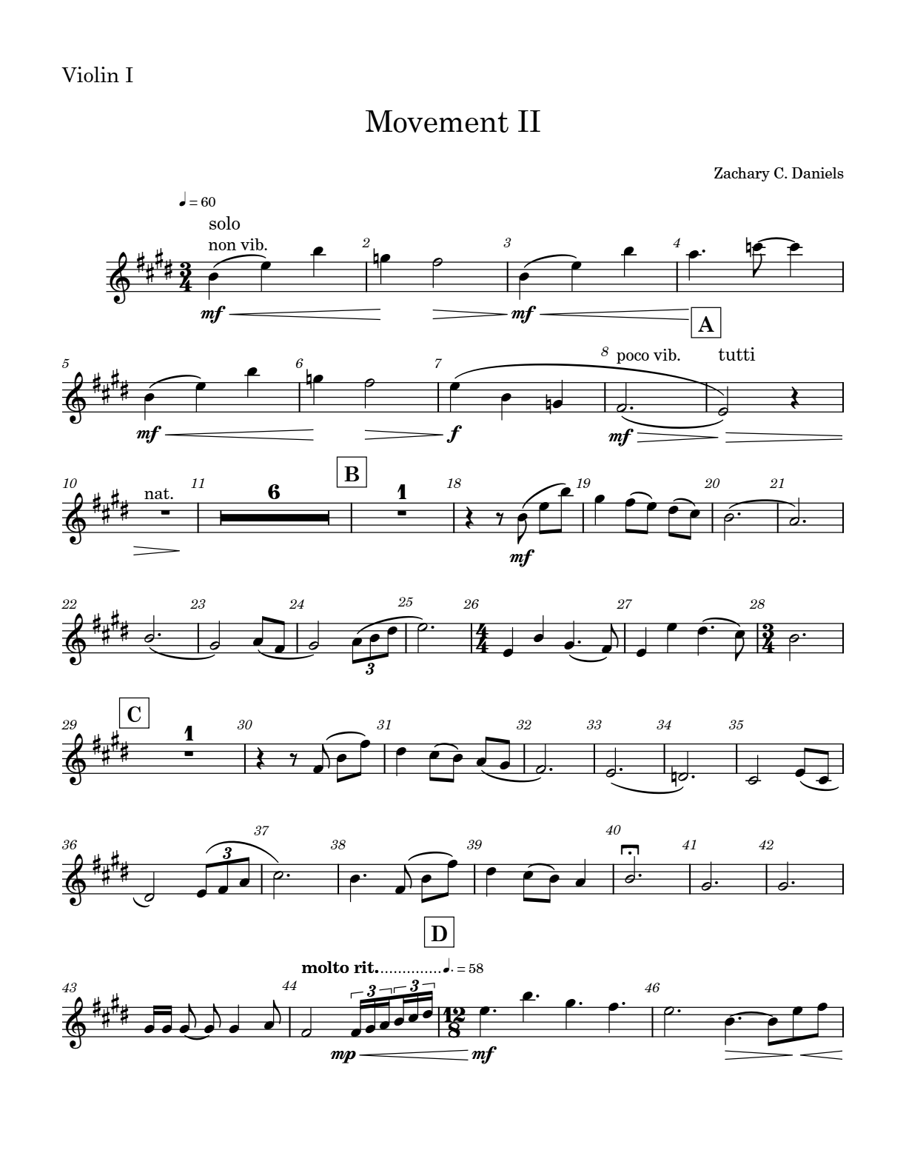
Figure 12: Movement II opening melody

A secondary focus of this opening section is flute 1. Here, the flute imitates bird calls from outside the composer’s workspace windows, that serve to set the mood of this movement as significantly lighter than the dark and heavy first movement (Figure 13). This also serves as a reference to the string quartet Op. 33 no. 3 “The Bird” by Haydn, whose string quartets heavily influenced much of the composer’s earliest work (Figure 14).
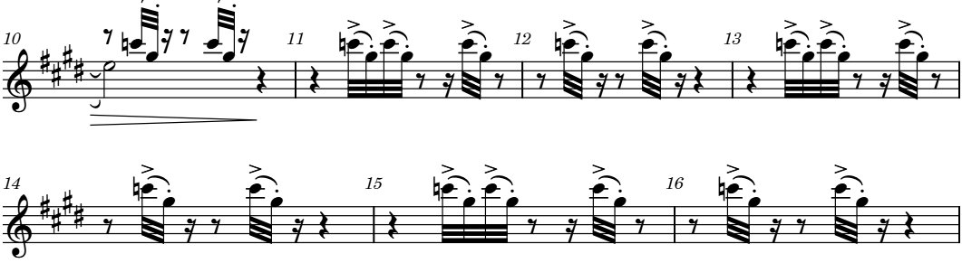
Figure 13: Movement II Bird Calls – m. 10 – 16 flute 1
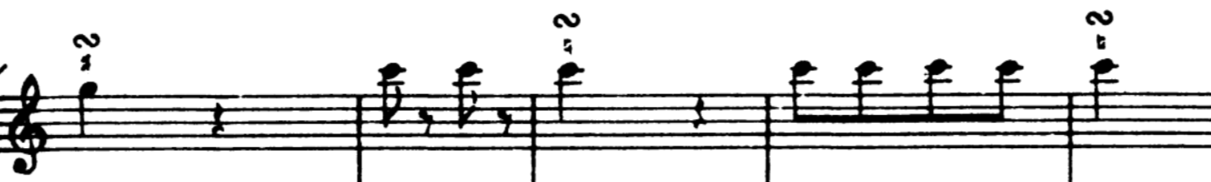 Figure 14: Haydn, Opus 33 no 3 in C Major (“The Bird”) mvt 4 m. 15-18 first violin

In the third beat of measure 16 the primary focus of the movement, theremin, is brought in with the melody [II-A]. The beginning of this melody shares the same rhythmic cadence as the movement’s opening theme before augmenting the rhythms toward the end of its moving lines later on in the phrase. This A section is interrupted in the middle by a fragmentation of what will later become a recurring B theme in the movement. This gesture at measure 26 will be referred to as transition [II-T1], as shown in Figure 15.
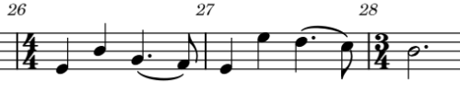
Figure 15: [II-T1]

In the anacrusis to measure 29, the A theme’s answer is heard in the theremin, which lasts until measure 41. It is here, that there is a transitional theme [II-T2] leading to the secondary (II-B) theme at measure 45. The transition is emphasized by rhythmically unified strings sustaining a C# minor chord while the theremin carries the melodic content forward, and by the introduction of percussion in the final beat of measure 44, which is greatly exaggerated by the inclusion of a ritardando for extra tension as we approach the downbeat of the B theme in measure 45, which contrasts starkly with the A theme.
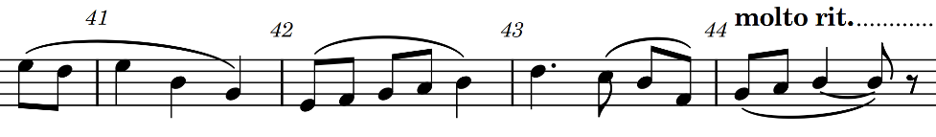
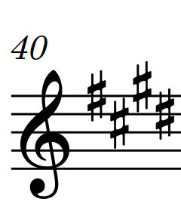
Figure 16: [II-T2]

The secondary theme of this movement (II-B) develops the idea of ascending triads established in the opening theme. It accelerates the theme while also inverting it to create a pulsing eighth-note line heard in the middle voices of the strings, accented in places by the low strings and brass. The melodic line reaches its climax at the second beat of measure 49 which is given focus due to the persistent eight-note engine being put to rest by the downbeat of the measure. This high point in the theremin’s melodic line echoes in the strings in measure 51 as the theremin brings the [II-B] theme to a close. The [II-B] theme transitions back to the second incarnation of [II-A] in measure 54 with a four-beat descending line in the first violin [II-T3] that serves to homogenize the dynamic landscape of the B theme before returning to [II-A].
[II-A]’s return from measures 54 to 82 features much of the same melodic design with minor variations throughout. The most notable change to the material is the absence of theremin until measure 65. It also features several new orchestrations of the existing material. This includes an extra octave in parts of the string accompaniment to open up the chordal accompaniment gestures, and the melody being taken by the oboe in the first half of the statement of II-A. The transition from II-A to measure 83’s returning II-B theme is given to mallet percussion as a means of creating a break from the theremin sound, and also to serve as a sort of ‘sparkle’ before the return of II-B. This transition takes place over deep, warm string chords just as in the previous iteration of [II-T2].
Measure 83’s statement of II-B contains minor orchestrational differences as shown in Figure 17, and rhythmic augmentation in the melody, but otherwise remains the same. The most notable addition to the orchestration is a short descending trumpet line at the beginning of the section, reinforced on their final note by the horns.

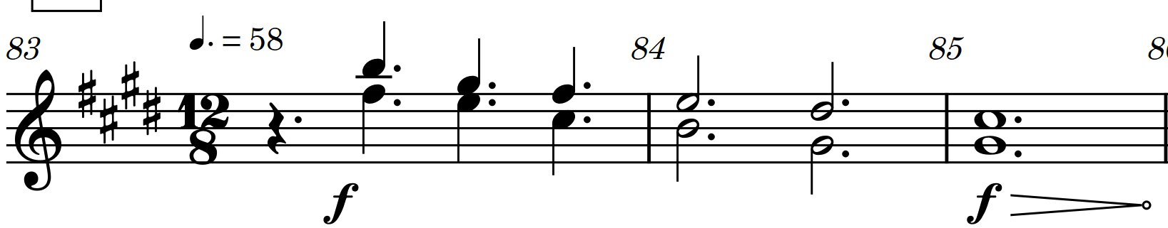
Figure 17: m. 83 Brass

Measures 90 and 91 act as a brief transition before a reprisal of previous material II-A2. This precedes a transition that ends in a time-dilation effect in measures 96 and 97. This section serves to move the piece to its climax, and briefly sets at the arrival of measure 98’s downbeat. (Figure 18)
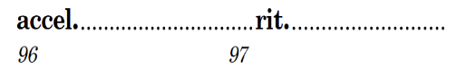
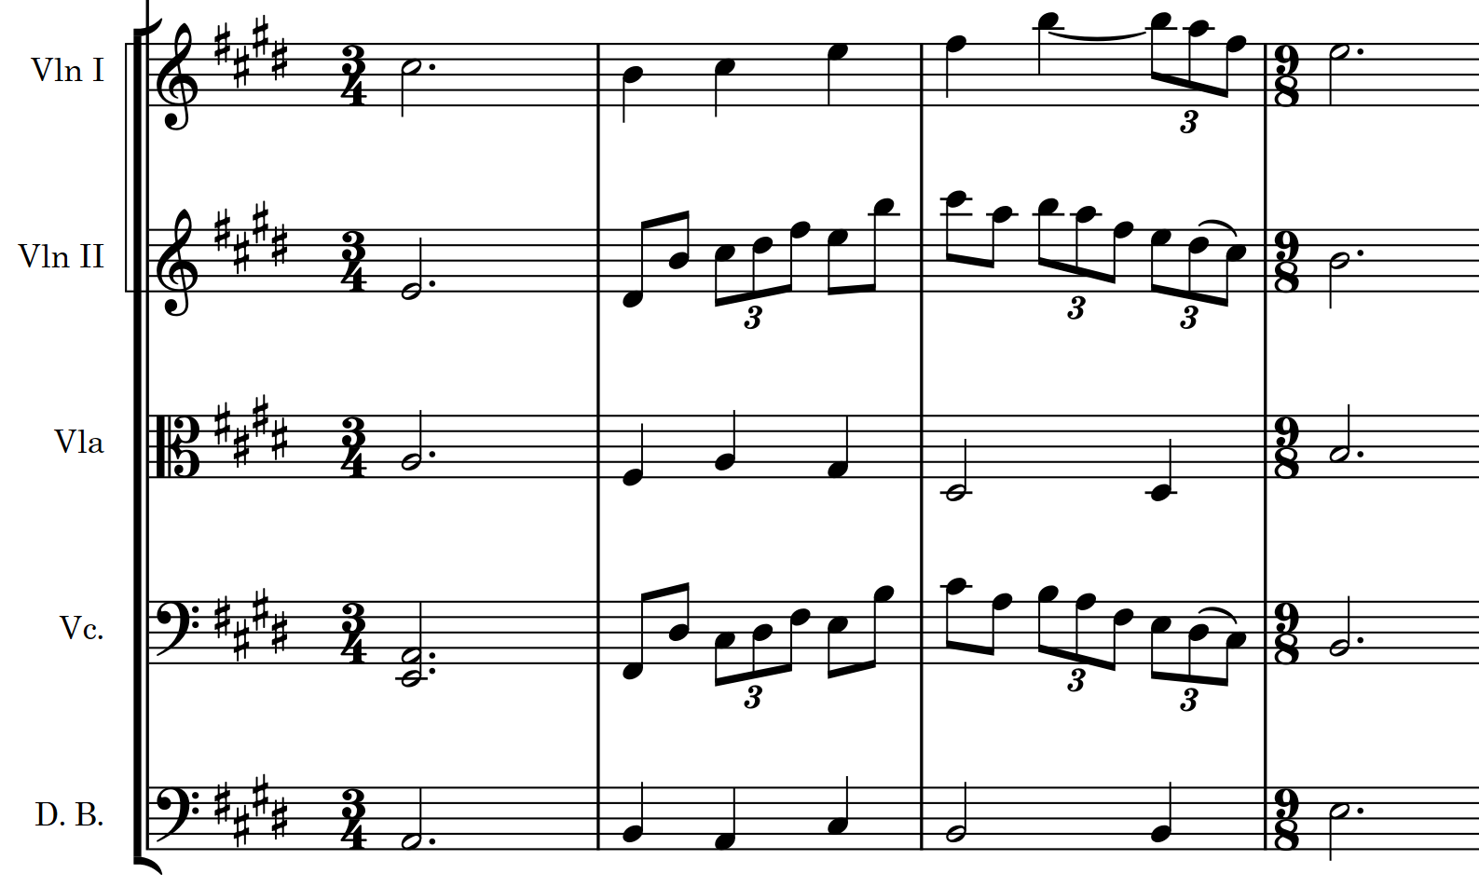
Figure 18: Time-Dilation in m. 96 - 97

The C section was initially difficult to properly notate and has gone through many iterations in the pursuit of clarity. These iterations mostly centered around the rhythmic emphasis of the melodic line, and the meter in which it is presented. In the end, a 4-against-3 feel would be secondary to the needs of the melodic line in the horns and percussion in order to make this section feel organic to the lyricism found throughout the movement.
Of the given options, the above metric framing was decided upon, despite the sight-reading struggles a group might have with the dotted-sixteenth note runs in the cello, bassoons, and glockenspiel. This decision was reached through a series of trial-runs in which a small ensemble read one of the three versions three times to account for learning curves. While first readings of the dotted sixteenth-note line were significantly weaker than other first readings, the second and third readings were significantly stronger with this version than others.
This section of music, [II-C], acts as the climax to the second movement, with the theremin reaching new highs in the melody, and the use of horn and bells to add further level of brilliance to an already bright melodic passage. The second phrase beginning in measure 103, features the strong re-entry of low brass and trumpets to the forefront. The goal of this passage is meant to invoke a sense of victory in the listener.

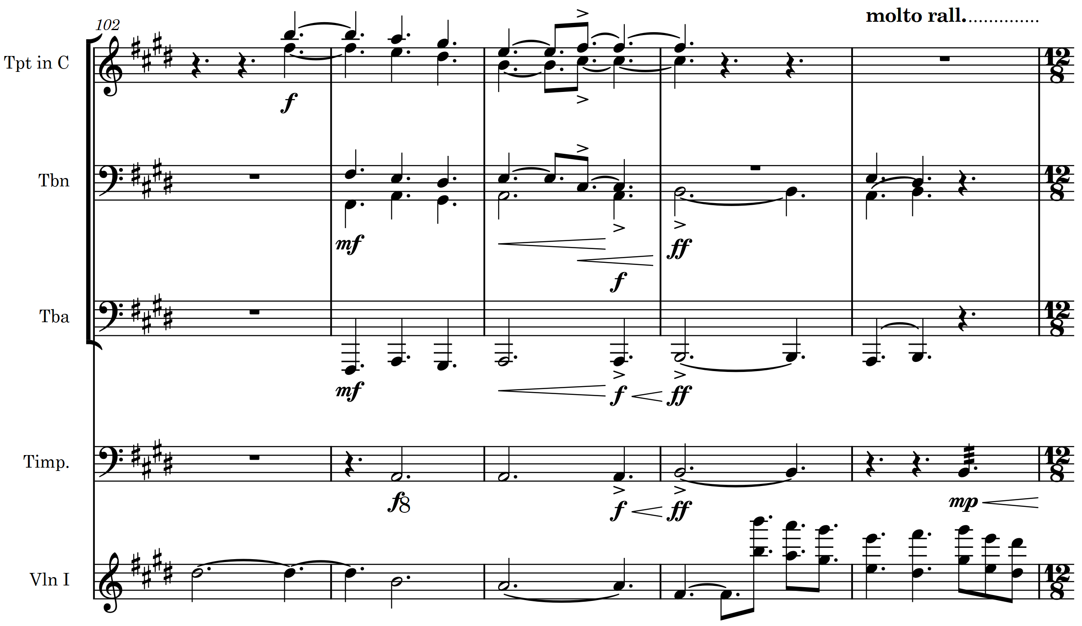
Figure 19: m. 102 – 106, tpts, tbns/tba,tmp, vln1 @ 105-106

The B material beginning in measure 107, [II-B3], builds on the orchestration choices used in section C to create a lush background for the theremin, trumpet, and oboe to pierce through with their respective solo sections. The trumpet is not a typical choice for the end of a movement that is mostly devoid of any significant brass. This decision was made to contradict the otherwise soothing nature of the movement. (Figure 20)
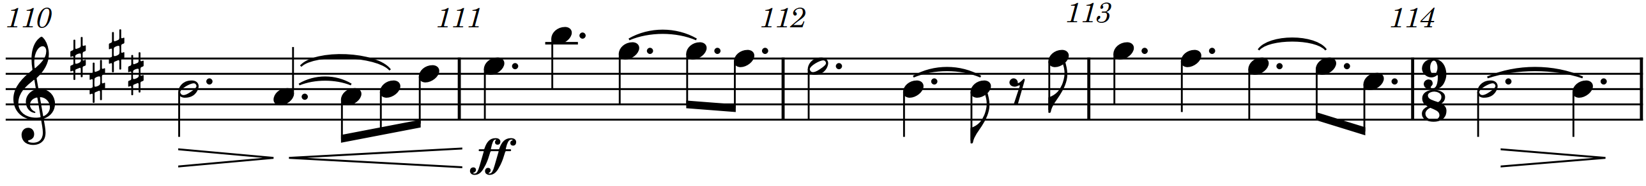
Figure 20: m. 110 – 114 trumpet solo

The orchestration in this section is also quite sparse compared to the much more densely orchestrated climax preceding it, from measures 98 - 114. The closing section of the movement also harkens back to earlier parts of the movement, in which the solo flute is heard ‘chirping’ over the rest of the ensemble in small utterances. However, now the flute is heard on the melody, unimpeded by other voices. This moment (Figure 21) creates a very peaceful resolution to the flute’s usage in the movement.
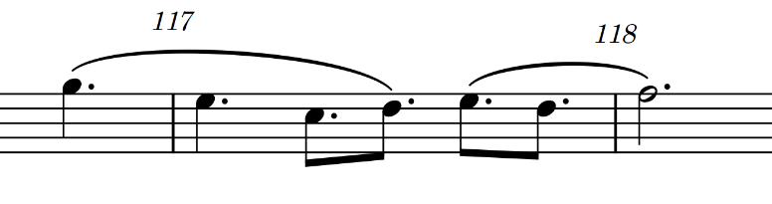
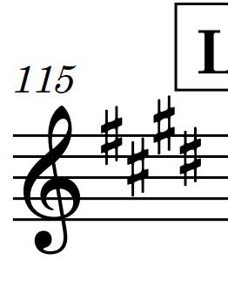
Figure 21: m. 116 – 118 flute

The decision to suspend all accompaniment gestures during the final phrase of the movement was made to feature the theremin’s unique timbre (more specifically that of the soloist) in one final, uninterrupted setting before the close of the movement. The motive is designed to suspend the tension built in measure 121’s string swell, creating a much more meaningful and satisfying ending to the movement once the strings return in the final measure.

Chapter 5: The Third Movement

The third movement in a traditional symphonic form is typically a dance movement. Symphony No. 5 builds on this tradition, with the third movement being inspired by a minuet. A minuet is typically light-hearted and written in a quick ‘Allegro’ tempo using ¾ time, with a contrasting middle section (often a trio) that is usually slower than the minuet preceding and following it. My take on a minuet in this movement is much slower in tempo and darker in timbre. The movement is still ternary, with a focus on the sonic world of A minor and its bII as an extension of the primary 0 to 1 thematic motive. There is a shift to F minor by measure 137 that continues through the end of the movement.
The A section’s opening phrase [III-1] occurs from measures 1-32, with a transition [III-T1] from 33-37 and a second permutation of the A theme [III-2] occurring from measures 38-69. The material from 70-85 should be seen as a return to [III-1]. Following this first large section of music, to be referred to as A, there is a developmental section that functions structurally as B beginning at measure 86. This developmental B section lasts through measure 117, after which there is a transition [III-T2] that makes use of material from A (specifically [III-1]). It creates a brass chorale that serves to announce the coming of the end of the movement, and a shift to the tonality of F minor. Measures 139-170 are a restatement of the A material in the new key of F minor, structured the same way as before, except with the melody starting immediately on the V before settling into the newly established key center. The movement’s closing section begins at measure 171 and focuses on the background material from the movement which, due to the orchestration used, creates a significantly darker tone than the rest of the movement featuring bassoons, low-register violas, and two of the lowest commonly-used notes on the double bass.
It was important for this movement that the principal melodic material somehow create a linkage to what had already been introduced in earlier movements. To that end, the introduction to the first phrase of the movement utilizes the same 0-1-0 movement found frequently throughout the first movement. This fragmentation of I-A (Figure 22) will be referred to as a fragmentation of III-1 throughout this chapter.
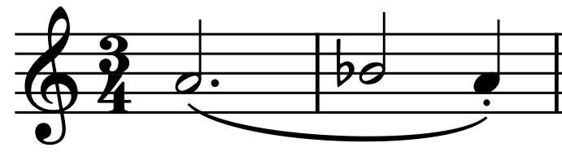
Figure 22: m. 1-2, vln1

This fragmentation is used again in measures 5-8 with rhythmic variance, before the phrase officially begins at measure 9 (Figure 23). The second phrase, beginning at measure 17 and lasting through measure 32, takes place in a higher register, focusing on E, as the V of the established key center of A. The orchestration in this section remains unchanged, with a steady pulse in the cellos and bassoons that is reinforced by the double basses on the downbeats and featuring an A Bb trill in the violas.

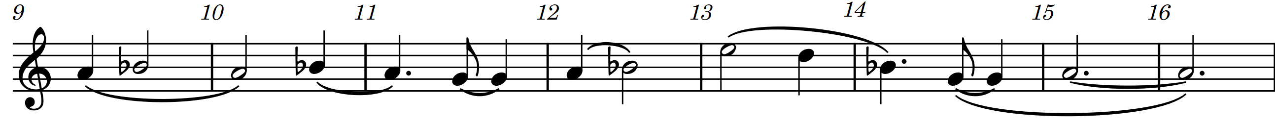
Figure 23: m. 9-16 vln1

In measure 33, there is a 4-measure extension to the third phrase (heard in the clarinets) that returns the melody back to the I, closing the first section of the movement. This extension underwent several iterations, beginning as a simple repetition of the E F motion, as a continuation of the I – bII motion from earlier, with a rhythmic alteration in its’ third iteration which morphed slowly into an ornamented, rhythmically augmented transformation of this same 0-1-0 material used as the genesis of much of this symphony.
The next section begins immediately on the downbeat of measure 38 with what can be considered a second statement of the A material, III-2. This material is very similar to III-1, with minor changes to orchestration to fill out the sonic landscape more. These changes include the addition of glockenspiel, and an additional octave in the violins for the melodic line, and the addition of clarinet to fill out the quarter-note pulse.
The third and final phrase of the A section of music is a return to III-1, but with an important additional element. This additional element, found in the theremin and reinforced by the trombone, is a simple, sustained D natural that rises and falls from pp f pp twice before jumping up a fifth to A natural and repeating the same dynamic arc.
Over the theremin/trombone sustained notes, the B section of the movement begins in measure 86 with a far more contrapuntal textural treatment of the [III-1] material, as well as extrapolations from movement I’s melodies. (Figure 24)
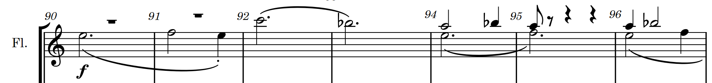
Figure 24: Measure 90-96 [I-A]

At the beginning of the developmental material, the double bass’s accompaniment dotted-half notes are doubled in length to suspend time slightly, by removing the emphasis from every other downbeat, instead sustaining through. The first half of section B’s developmental material is with the double phrase extensions in the clarinets and horns in measures 104 and 106 respectively, before the return of familiar material from movement III’s A section at measure 110. This helps to set up a more meaningful transition to measure 110’s eighth-notes in the bass line. This section was activated with eighth-notes to push the music forward into the brass chorale that occurs during measures 131-138. This chorale serves to move into the ending section of the piece, second A section at measure 139. The brass chorale isn’t complex, or contrapuntal but instead acts as a single unified instrument that has an underlying purpose of taking the tonality from A minor, to F minor.
This final A section of music has one crucial difference to previous iterations of the theme found in III-1 and III-2, in that it begins on V instead of on I, to make the transition to the new key a little more gradual, and allow for measure 155’s arrival of the melody on I to feel more final. This is something that is commonly seen in many forms within the classical idiom in which a section of music’s melodic content is re-used. It seemed fitting here as the composer is setting up the finale. The orchestration used here combines bassoons with the low register of the violas to create a dark-toned, smooth passage that sets up a darker atmosphere out of which the final movement breaks free.
The closing section of the movement begins at measure 171 and is devoid of any melodic content or complex harmonies. The only sound heard is that of the double basses on the downbeat, and the bassoons/cellos on the quarter-note pulse that has persisted throughout the movement. This moment of taking that which was in the background and elevating it to be the forefront of musical material is a technique commonly used by the composer, and has roots in works by Igor Stravinsky, Philip Glass, and other minimalists of the mid-to-late twentieth century. The violas eventually join the double basses in one last incarnation of the I-bII-I motion found throughout the movement, as the bassoons and cellos begin to play more sparsely before the piece ends with just a single bassoon playing the pitch F alone to the end of the movement.

Chapter 6: The Fourth Movement

The final movement of this symphony ties together the various ideas found throughout the other movements while drawing a satisfying conclusion to the musical narrative set in motion back in measure one of the first movement. The final movement has three parts; the opening, the scherzo and the finale with a short codetta at the end. The macro-level form of the movement can be considered binary with a short introduction and codetta. The introduction, from measures 1 through 31 features a timpani solo, and a shifting hemiola between 6/8 and 3/4. The A section is a scherzo featuring a long textural crescendo leading to the second half of the movement, in which melodic ideas from other movements make their return. The finale, or B section, beginning at measure 127, features a triumphant brass fanfare, sweeping melodic contours, and a driving rhythmic bass line for the rest of it. The architecture of this movement was decided upon early in the symphony’s development and had the most forethought as a result. This architectural framework is given in Table 3.

Table 3: Architecture of Movement 4
Coda “Sunset” | (m. 241) | Bell Tolls,  Molto Expressivo Rallentando | F minor
B  Finale | Recapitulation  (m. 214) | Brass Fanfare, Percussive, Return of Theremin | E
B  Finale | Development  (m. 174) | Brass Fanfare, Percussive, Return of Theremin | C minor
B  Finale | Exposition  (m. 127) | Brass Fanfare, Percussive, Return of Theremin | E
A  Scherzo | (m. 33) | Ostinato  <015>, <025> | E minor
A  Opening | (m. 1) | Timpani Solo,  Hemiola | E minor
The introduction of this movement draws inspiration from Jennifer Higdon’s Cityscapes: Movement 3 - Peachtree Street. In this piece, there is a timpani solo that becomes the sole focus of the movement for a brief time beginning in measure 84 of the movement. This solo continues the existing energy level of the piece while making use of the unique power of the instrument without the section feeling out of place when looked at within the greater context. The brief timpani solo found in the first 30 measures of this symphony’s movement is very much inspired by that solo section of Higdon’s piece.

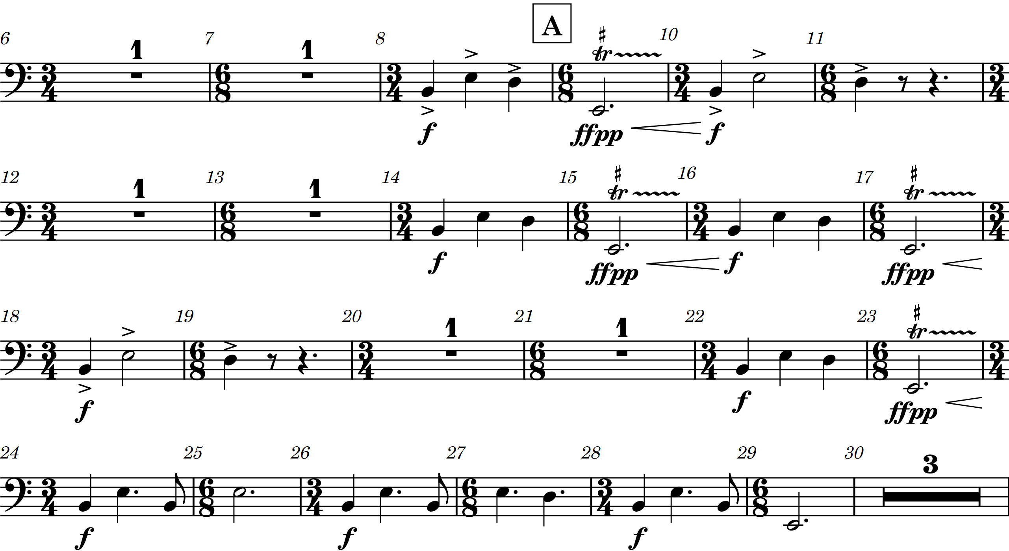
Figure 25: Timpani Solo – Mvt. 4 m. 8 - 29

The movement’s introduction is written in a 6/8 – 3/4 hemiola pattern which creates a rising and falling feel between two and three-beat rhythmic sets. This pushes the piece forward, creating a call and response pattern between the strings, more active in the 6/8, and the brass, more active in the 3/4 measures. These contrasting rhythmic patterns are permeated by running sixteenth notes in the flutes and high-register piano. These figurations act as connective tissue throughout this section of music. The timpani solo comes to its final form in measure 24, where the new phrase rhythm is acting as a hybrid between the two pre-existing rhythmic ideas from the brass and strings. The addition of low brass is a means to harmonically re-enforce the strings after the first eight measures.
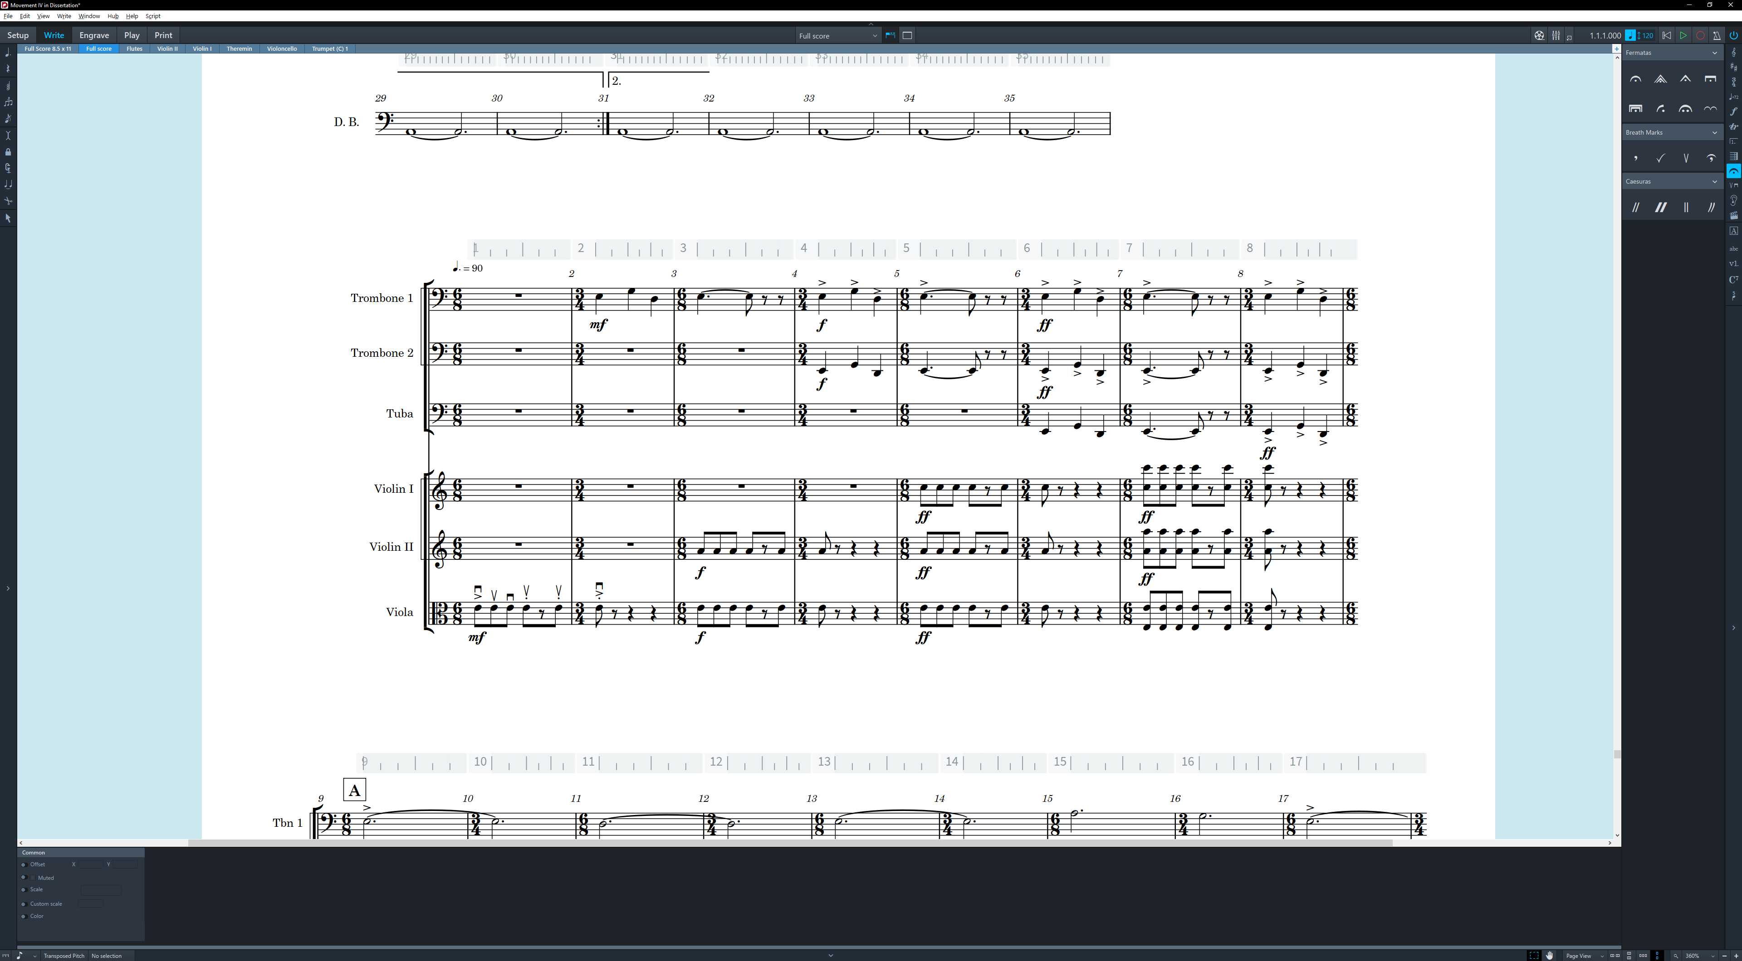
Figure 26: Hemiola at the Beginning of Mvt. 4

The scherzo begins in measure 33, with the ceaseless eighth-note ostinato that begins in the viola. This ‘engine’ never loses its energy until after the scherzo has ended. The building ostinato has four different components, introduced as a canon that also serves as a textural crescendo. This textural crescendo lasts through the entire scherzo section of the movement. The idea for such a device is an idea that the composer gained from a popular wind band transcription by Lucien Cailliet of “Elsa’s Procession to the Cathedral” originally from Richard Wagner’s Lohengrin. That work is written as one large textural crescendo. In Symphony No. 5, the composer uses this idea to write the scherzo, leading into the B section while also re-introducing previously heard melodic content and building momentum for the upcoming finale.
At measure 37, rehearsal C, the textural crescendo begins with the cellos taking the ostinato pattern that the violas previously had, and the double basses reinforcing every other measure with a pizzicato E-natural that serves a practical purpose of aiding other ensemble members in counting out their measures of rest before an entrance. The violas, over the course of the next thirty measures, slowly evolve their rhythmic utterances into an ostinato pattern which uses the <025> pitch-class set used in movement one. (Figures 27 & 28) The half-step difference (more specifically a minor ninth) between the starting pitch of the viola <025> ostinato, and cello <015> ostinato is crucial to the textural crescendo, adding a gradual dissonance that increases tension in the approach to the B section.
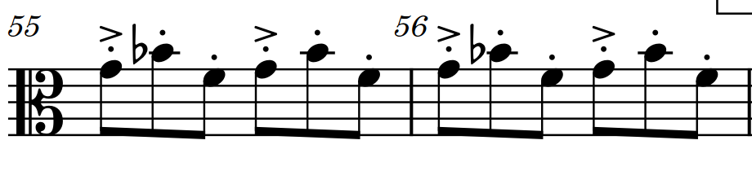
2 5 0
Figure 27: <025> Viola Ostinato
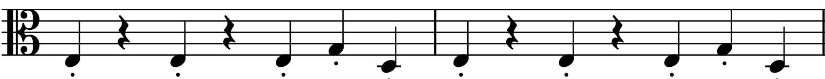
5
2
0
Figure 28: <025> In Movement 1

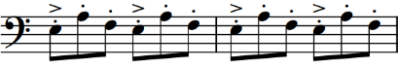
0 5 1
Figure 29: <015> Cello Ostinato
The first melodic fragment of the section is found in measure 41, where an oboe plays the [I-A1] theme as a return to familiar musical territory. This material is heard again in the flutes starting in measure 61. Measures 52 – 58 and 70 - 76 feature the clarinets playing a version of transition [II-T1] that has been altered to fit the tonality of the viola section’s ostinato figure.
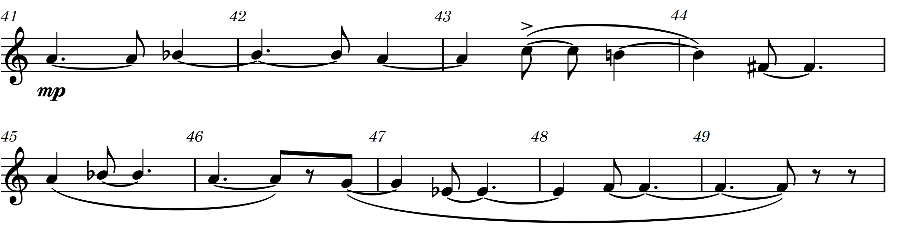
Figure 30: Melody [I-A] new
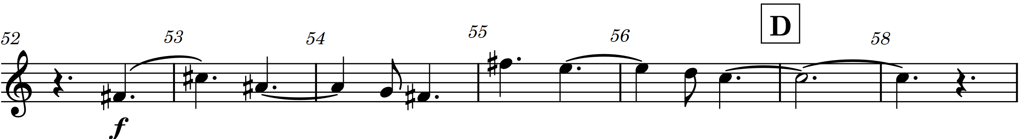
Figure 31: [II-T1] in Movement IV

At rehearsal D, the second violins have a similar entrance to that of the violas at the beginning of the scherzo, and the first violins begin the formation of their own ostinato line at rehearsal E. The string section ostinato is fully formed at measure 140 and forms the basis for the remaining ensemble members to make their respective entrances, building on the foundation created by the strings.
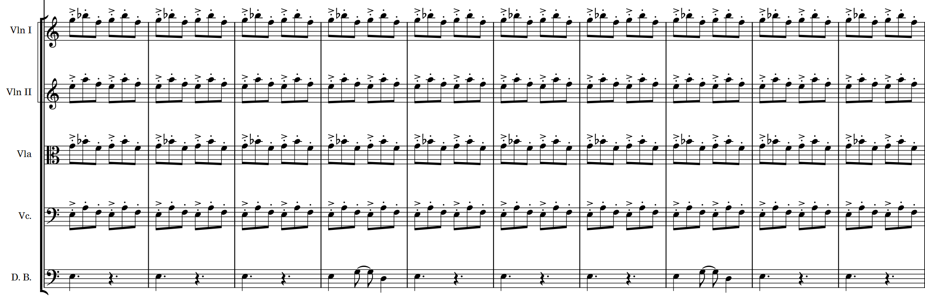
Figure 32: Fully-formed Ostinato in Movement IV

The next event of note within the movement happens in measure 85, where the oboes and orchestral bells play an echo of [II-T1] and the horns create accent-points during their decay, moving the music closer to the goal of section B. The musical material in the flutes beginning in measure 93 is simply a devolution of melodic material from movement I’s [I-A] material, with the driving force of an accelerando leading to measure 127, the long-awaited B section of the movement.
It is here that the fast-paced finale of the symphony begins, with two ideas competing for dominance. First, the trumpets and horns [IV-B1] have simple chordal movements focusing on the 1st and 3rd beats of the 4/4 meter. Second, we hear the low brass, strings, and timpani re-enforced by piano [IV-B2] on the 1st, 3rd, 6th, and 8th eighth note beats of the measures. Beneath these competing forces, the violins and violas press onward with a version of their ostinato from A for just over seven and a half measures, at which point the ostinato passes to the bassoons before finally dissipating during measure 143.
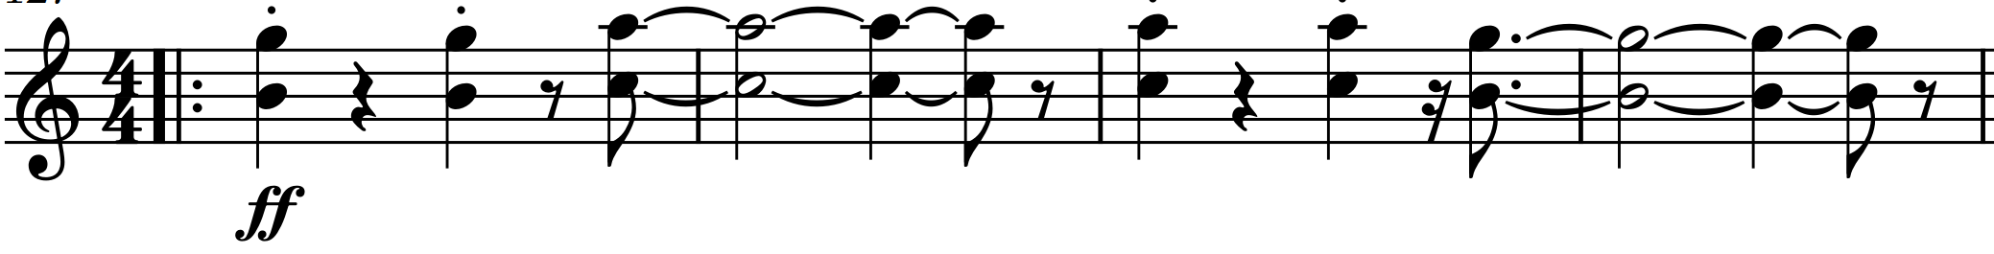
Figure 33: [IV-B1]

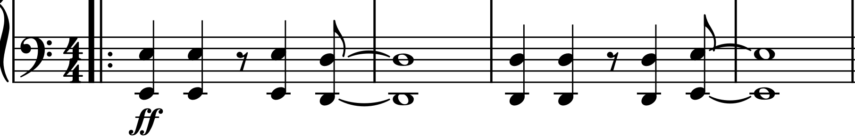
Figure 34: [IV-B2]

In measure 134 a contrasting, more lyrical theme [IV-B3] is heard in the flutes and violins as [IV-B1] drops out entirely, with [IV-B2] transitioning into a structural background role. Measure 143 re-integrates [IV-B1] into the piece on the piano, alongside fragmentations of [IV-B3] in the winds and brass while simultaneously dropping [IV-B2] entirely.
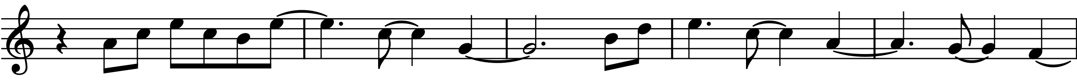
Figure 35: [IV-B3]
The remainder of musical material leading to the repeat sign has its’ roots in the melodic content of movement two, a relationship that is formed both by the pitch material used, and the return of the theremin in measure 155. The repeat here is structurally significant, as the first ending material is used as a small development section in relation to the A Section that is measures 127 - 161. Measures 170 - 173 act as a closing section to the exposition set in motion at the beginning of the finale in measure 127.
With the development section beginning in measure 174, the focus is on the bass-line and percussion which are developing the [IV-B2] material, as the glockenspiel plays a thin, regressed version of movement one’s primary theme. This section of music introduces a new idea beginning in measure 190 in the clarinets, where the running eighth-note passages alternate between the clarinets over the bass-line and shekeres beneath them. This idea continues in measure 197, where the new material passes to the oboes, and the second violins join the low strings on the bass-line. The development section comes to a climax in measure 205, where the brass enter the fray. The final two measures of the brass performing the development material in the style of a chorale serve as a brief retransition to the recapitulation in measure 214.
This creates a firm barrier between the A material of the recapitulation, and the A prime material [IV-B3] beginning in measure 221. With [IV-B2] now firmly established as background material, the [IV-B1] material in the high strings is the focus of attention with percussion and bassoons driving the piece forward with the eighth-note ostinato from before. Fragmentations of [IV-B3] make an appearance in measures 230 - 232, followed by a twist on the ending heard twice before in the piano and strings. Where previously these voices descended to a key center of A, now they cadence on E instead with the same emphasis points from earlier in the recapitulation. The fragmentations of [IV-B3] in the winds starting in measure 230 serve as a brief transition to the closing material which is dominated by the molto ritardando. This creates a gesture that feels as though the timpani and brass are pulling us back in time at m. 241 with material from [II-T1].
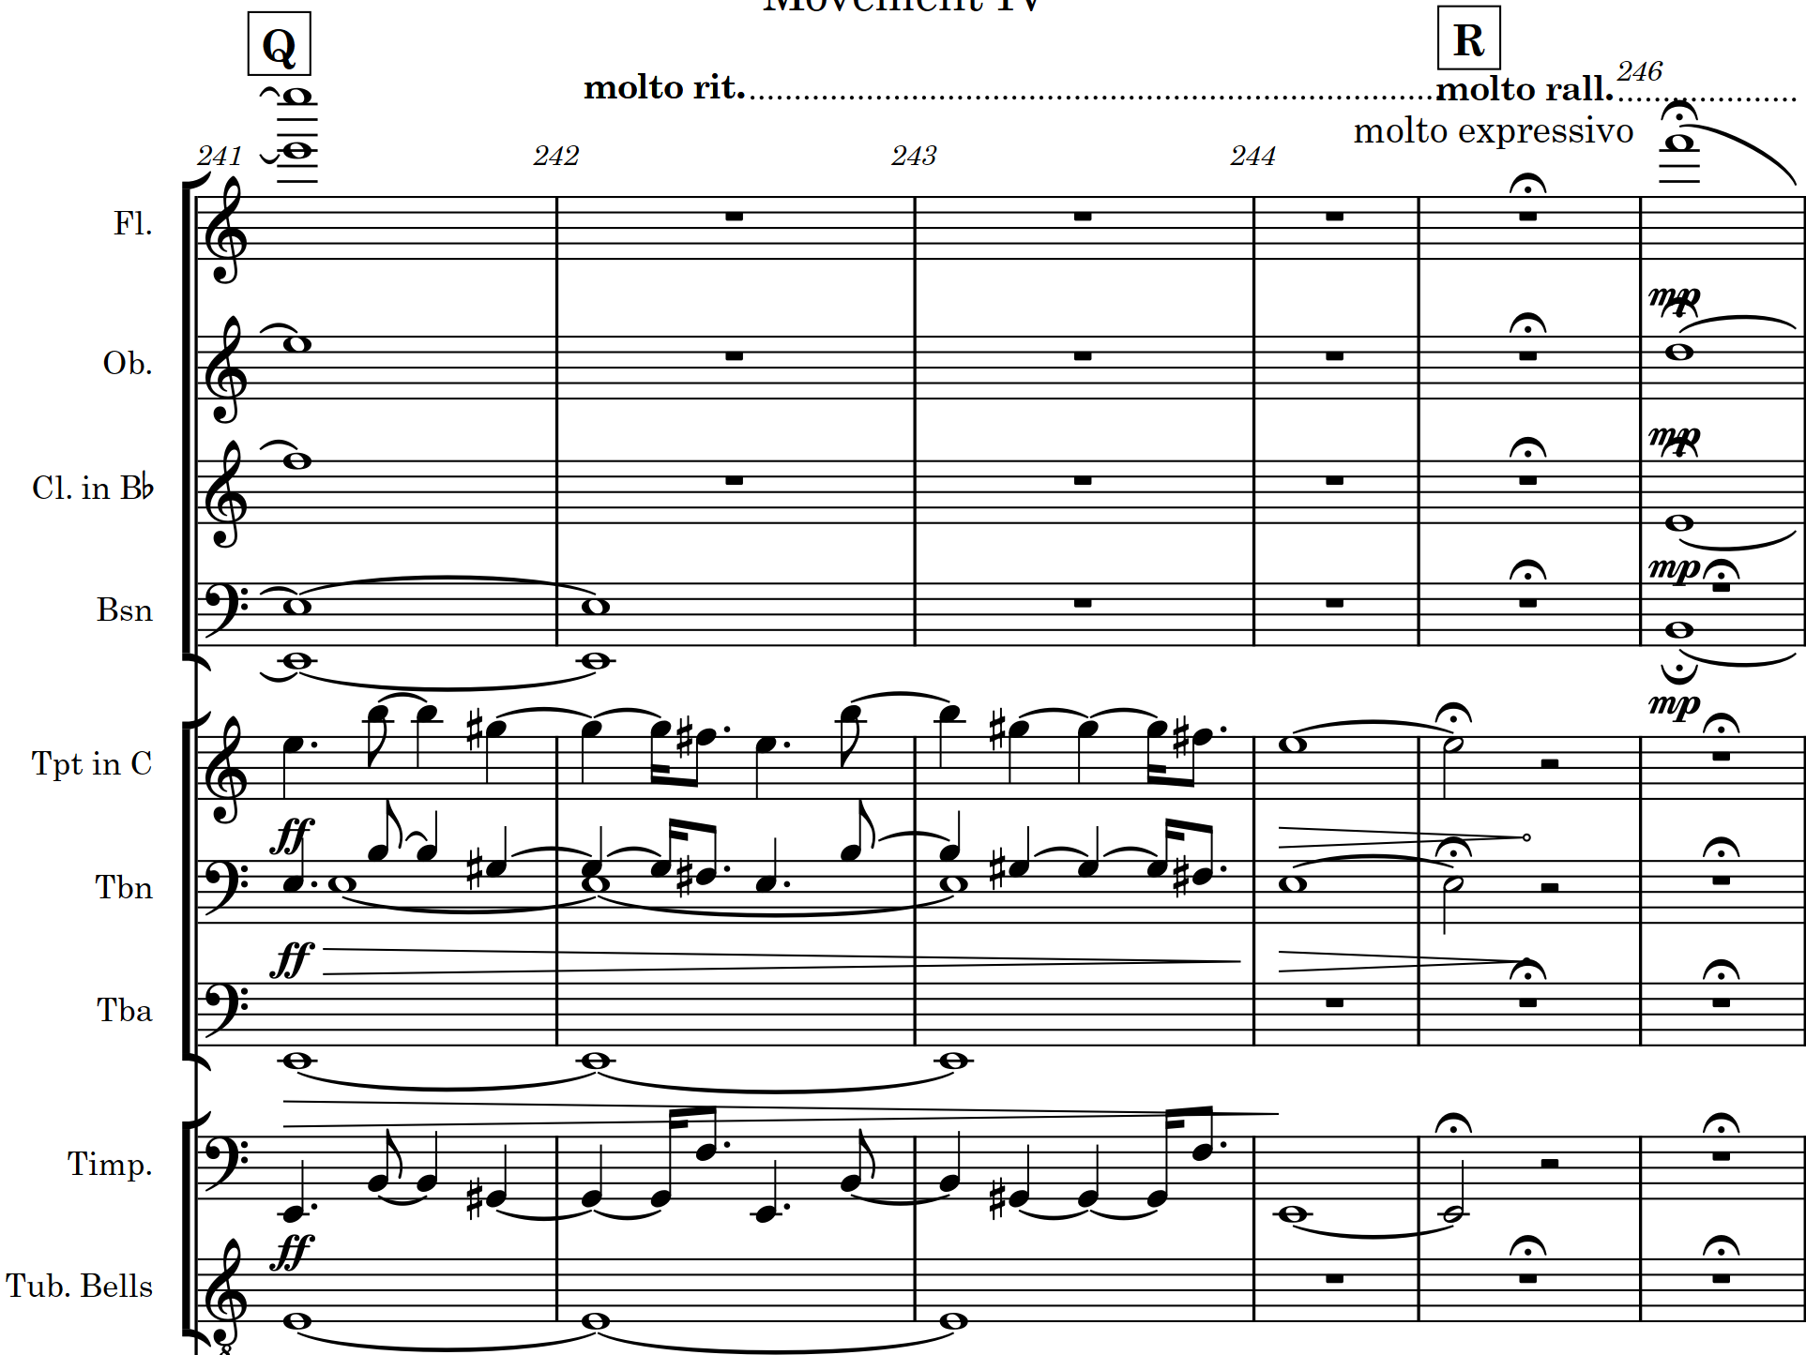
Figure 36: Ritardando/Rallentando at Q

The closing of this movement is the coda to the sonata form used in the B section of this movement. This final iteration is meant to feel as though time itself is coming to a halt when compared to the aggressive tempos used in the second half of this final movement of the symphony. The molto expressivo expressive marking at measure 246 cannot be emphasized enough. This finale serves as the emotional sunset to the journey introduced at the beginning of the symphony with the opening “sunrise” gesture.

Chapter 7: Summary
Symphony No. 5: Westward Journey is a multi-movement work for orchestra that features four movements with varying formal structures. The first movement, written in sonata-allegro form, utilizes a “sunrise gesture” to delineate different sections of musical content. It is meant to create the feeling of a long, sustained journey towards a narrative goal. Movement II is written using verse-chorus and rondo forms, featuring theremin as a solo instrument. This movement focuses on allowing what was once unfamiliar to become familiar, as well as ideas of love that two companions may have for one another as they travel into the unknown together. Movement III is an idiosyncratic minuet in ternary form; it is a musical reprieve before Movement IV begins. The final movement is written in two parts, arguably in binary form. The first part, a scherzo preceded by a timpani solo, is written as a build-up to the finale in the second part of movement four. The second part serves as a finale to the entire work. This section employs principal elements of sonata form with definable exposition, development and recapitulation. This movement concludes using brass fanfare, driving rhythmic ideas, and bright, colorful orchestration to create a feeling of celebration at the end of the work and our westward journey.

Bibliography

Bozarth, G. & Frisch, W. 2001. "Brahms, Johannes." Grove Music Online. January 01. Accessed Mar 20, 2019. http://www.oxfordmusiconline.com.ezproxy.lib.ou.edu/grovemusic/view/10.1093/gmo/9781561592630.001.0001/omo-9781561592630-e-0000051879.
Caplin, William E. 1998. Classical Form: A Theory of Formal Functions for the Instrumental Music of Haydn, Mozart, and Beethoven. Oxford: Oxford University Press.
Costa, Ananda. 2019. "Theremin Fantasies." Match Houston. Jan 1. Accessed Apr 9, 2019. https://matchouston.org/events/2019/theremin-fantasies.
Cuyler, Louise. 1973. The Symphony. New York City: Harcourt Brace Jovanich, Inc.
Davies, Richard Orton and Hugh. 2001. "Theremin." Grove Music Online. Accessed Mar 28, 2019. http://www.oxfordmusiconline.com.ezproxy.lib.ou.edu/grovemusic/view/10.1093/gmo/9781561592630.001.0001/omo-9781561592630-e-0000027813.
Eyck, Carolina. 2015. An overview for composers and music lovers | Carolina talks Theremin. Mar 5. Accessed May 2018. https://www.youtube.com/watch?v=MJACNHHuGp0.
—. 2018. Carolina Eyck. Accessed Dec 13, 2018. https://www.carolinaeyck.com.
—. 2006. The Art of Playing Theremin. Berlin: SERVI Verlog.
Freddythehat. 2007. "File:Shekere,jpg." Wikimedia Commons. Feb 17. Accessed Apr 9, 2019. https://commons.wikimedia.org/wiki/File:Shekere.jpg.
Gould, Elaine. 2011. Behind Bars: The Definitive Guide To Music Notation. London: Faber Music Ltd.
Higdon, Jennifer. 2002. City Scape. Philadelphia: Jennifer Higdon.
LaRue, Jan, Eugene K. Wolf, Mark Evan Bonds, Stephen Walsh, and Charles Wilson. 2019. "Symphony." Grove Music Online. Accessed March 22, 2019. http://www.oxfordmusiconline.com/grovemusic/view/10.1093/gmo/9781561592630.001.0001/omo-9781561592630-e-0000027254.
Mahler, Gustav. 1987/2016. Symphonies Nos. 1 and 2 in Full Score. New York City: Dover Publications.
Messiaen, Olivier. 1948. Turangalila - Symphonie. Paris: Durand.
1952. La Habana. Vol. 2, in Los Instrumentos de la musica Afrocubana, by Fernando Oritz, p. 124.
Risatti, Howard. 1975. New Music Vocabulary. Chicago: University of illinois Press.
Rosen, Charles. 1988, 1980. Sonata Forms: Revised Edition. London: W.W. Norton & Company.
2003. "Sekere." Grove Music Online. Accessed Apr 9, 2019. http://www.oxfordmusiconline.com.ezproxy.lib.ou.edu/grovemusic/view/10.1093/gmo/9781561592630.001.0001/omo-9781561592630-e-2000790600.
Wagner, Richard, Transcribed by Lucian Cailliet. n.d. Elsa's Procession To The Cathedral. New York City: Warner Bros. Publications Inc.

Appendix A: Images of Uncommon Instruments Used in Symphony No. 5: Westward Journey

Image of a Shekere
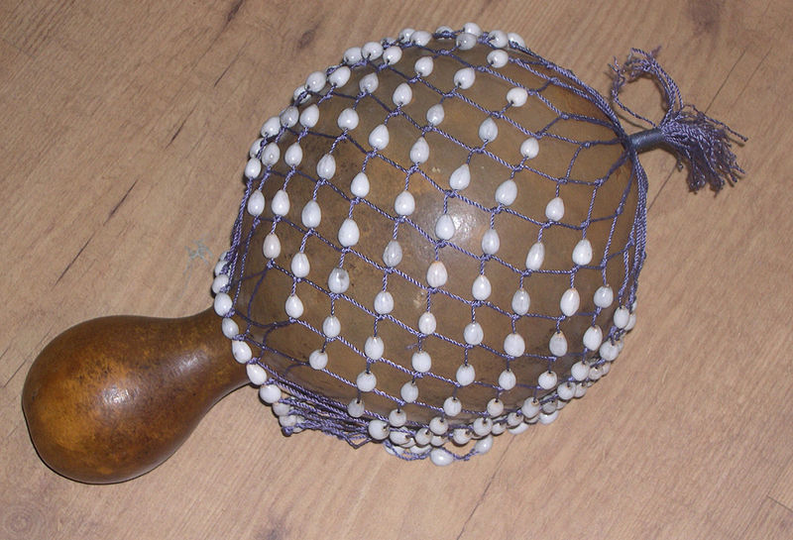

Image of Carolina Eyck Playing a Theremin
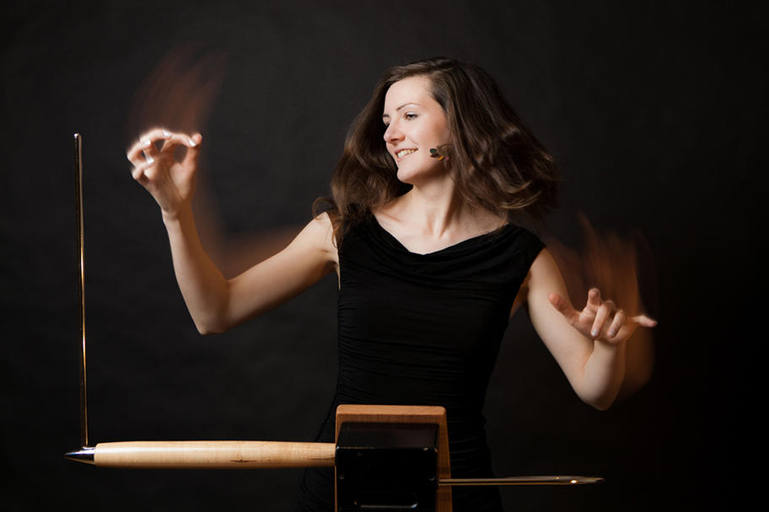

Appendix B: Instrumentation
2 Flutes
2 Oboes
2 Clarinets in Bb
2 Bassoons
4 Horns in F
2 Bb trumpets
2 Trombones
1 Tuba
Percussion Section: Bass Drum, Tom-Toms, Orchestral Bells, Snare Drum, Shakers, Crash Cymbal, Side Drum, Bell Tree, Glockenspiel
Timpani
Celeste
Piano
Theremin
Strings (12,12,7,8,4)

Appendix C: Complete Score of
Symphony No. 5: Westward Journey

By
Zachary C. Daniels
2018

LaRue, Jan, Eugene K. Wolf, Mark Evan Bonds, Stephen Walsh, and Charles Wilson. 2001 "Symphony." Grove Music Online. 27 Mar. 2019. http://www.oxfordmusiconline.com/grovemusic/view/10.1093/gmo/9781561592630.001.0001/omo-9781561592630-e-0000027254.
Bozarth, George S., and Walter Frisch. 2001 "Brahms, Johannes." Grove Music Online. 3 Apr. 2019. http://www.oxfordmusiconline.com.ezproxy.lib.ou.edu/grovemusic/view/10.1093/gmo/9781561592630.001.0001/omo-9781561592630-e-0000051879.
Perhaps of greatest note by Rimsky-Korsakov as it pertains to this document, would be his symphonic work Sheherezade which has narrative elements from 1001 Arabian Nights.
Davies, Richard Orton and Hugh. 2001. "Theremin." Grove Music Online. Accessed Mar 28, 2019. http://www.oxfordmusiconline.com.ezproxy.lib.ou.edu/grovemusic/view/10.1093/gmo/978156156 0.001.0001/omo-9781561592630-e-0000027813.
Eyck, Carolina. 2018. Carolina Eyck. Accessed Dec 13, 2018. https://www.carolinaeyck.com.
Joseph Schillinger, First Airphonic Suite (1929)
Edgar Varèse, Ecuatorial (1932-1934)
Percy Grainger, Free Music No. 1 (For Four Theremins) (1936)
Davies, Richard Orton and Hugh. 2001. "Theremin." Grove Music Online. Accessed Mar 28, 2019. http://www.oxfordmusiconline.com.ezproxy.lib.ou.edu/grovemusic/view/10.1093/gmo/978156156 0.001.0001/omo-9781561592630-e-0000027813.
Eyck, Carolina. 2018. Carolina Eyck. Accessed Dec 13, 2018. https://www.carolinaeyck.com.
Eyck, Carolina. 2015. An overview for composers and music lovers | Carolina talks Theremin. Accessed May 2018. https://www.youtube.com/watch?v=MJACNHHuGp0.
This stand-alone work for theremin and orchestra is unaltered from the original score and has the title of Journey into the Unknown.
Haydn, Franz Joseph. 1985. String Quartets, Opp. 20 and 33. New York City: Dover Publications.
Higdon, Jennifer. 2002. City Scape. Philadelphia: Jennifer Higdon.
A hollowed-out gourd vessel rattle used originally by the Yoruba people of Nigeria. It has external strikers, consisting of a network of small shells or beads strung together in a net encasing the body of the gourd. Instruments of similar construction and sonic qualities are known as the lilolo, djabara, ushaka, chequere, and saa saa. It is commonly used in African, Latin American, and Cuban musical traditions. An image of the instrument is included in Appendix A.
Public Domain image of a Shekere, provided by user Freddythehat via Wikimedia Commons
Apollo Chamber Players – Carolina Eyck – Photos by Ananda Costa

