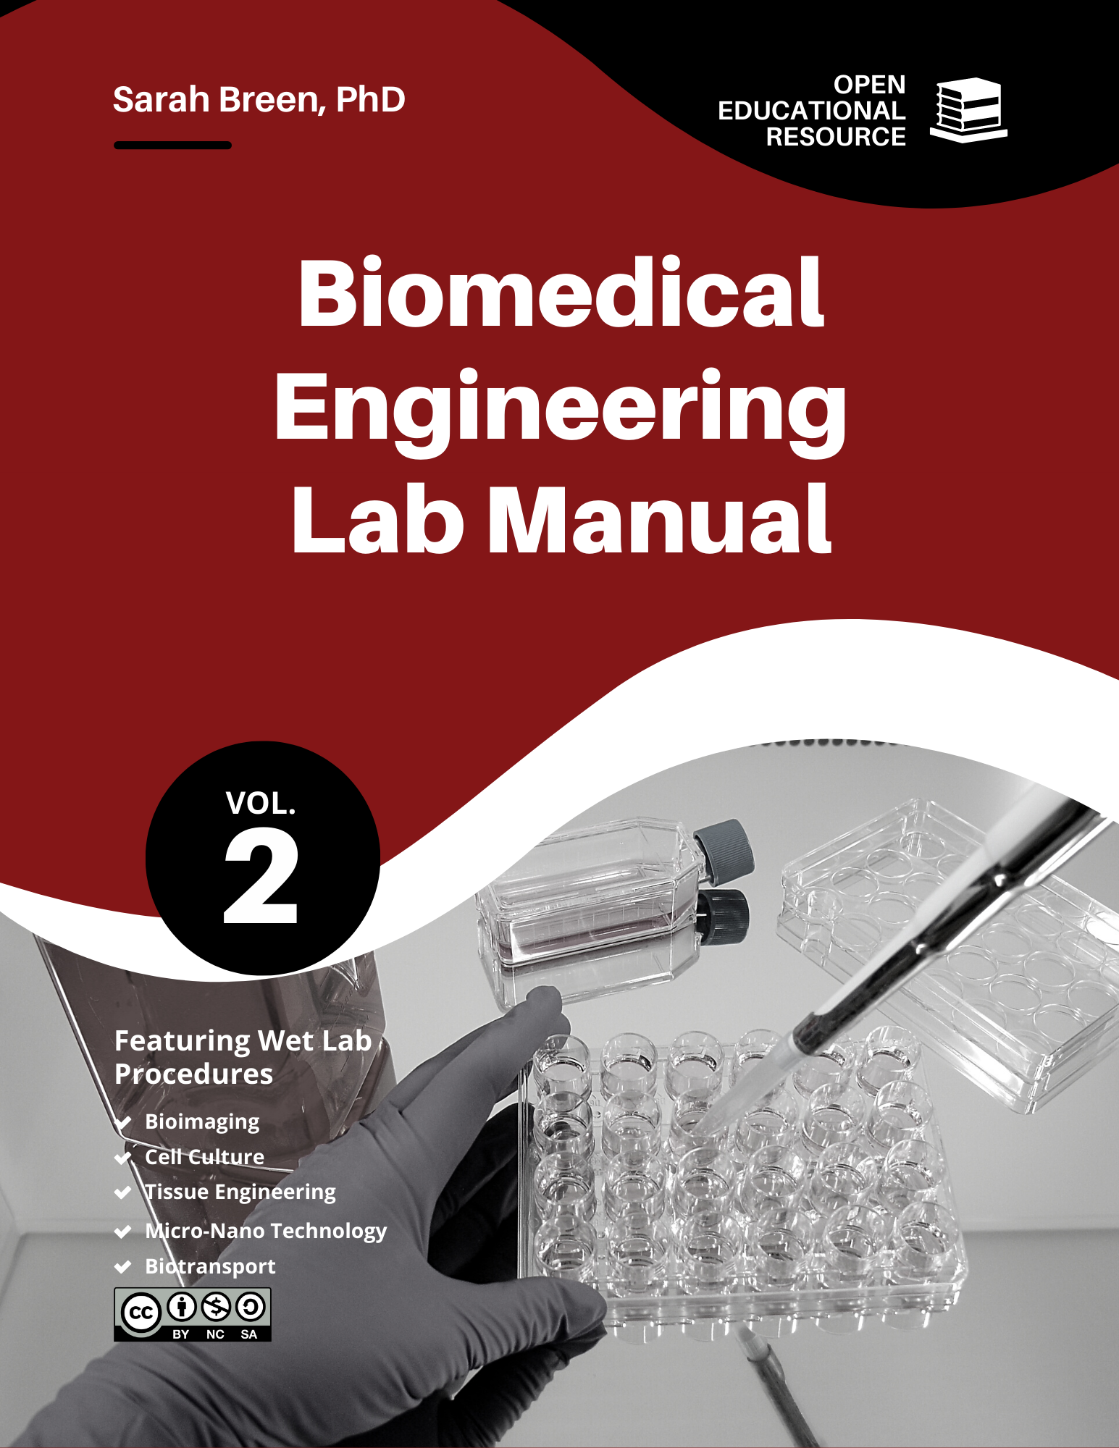

© Sarah Breen, PhD, FISBS, FHEA, 2023

This lab manual has been adapted from educational materials which have been prepared and refined by instructional staff of the University of Oklahoma School of Biomedical Engineering (SBME). Notably, Dr Rachel Childers is credited with the initial development of the original SBME lab courses and procedures. SBME project engineer Kirsten Jeffries and many SBME graduate and undergraduate teaching assistants have also played an important role in refining these past lab procedures and the current manual.

This book was created by Sarah Breen and released under the Creative Commons License.
Table of Contents
Module 1 Introduction to BME3181 & Microscopy 1:1
Module 1 Lab Procedure 1:1
Introduction: 1:1
Learning Objectives 1:1
Materials 1:1
Important Terms 1:1
Safety 1:1
Setup: 1:1
Procedure 1:3
Post Lab Questions 1:8
Post-Lab Checklist: 1:8
Module 2 Micropipetting & Dilutions 2:9
Pre Lab-Review 2:9
Pre-Lab Checklist: 2:9
Pre-Lab 2: Micropipetting & Dilutions 2:9
Module 2 Lab Procedure 2:1
Introduction: 2:1
Learning Objectives 2:1
Materials 2:1
Important Terms 2:1
Safety: 2:1
Teamwork: 2:1
Setup: 2:2
Procedure Exercise 1 (Quick Test) 2:4
Procedure Exercise 2 (Pipetting Challenge) 2:4
Procedure Part 3 (Serial Dilutions & Standard Curve) 2:6
Post-Lab Checklist: 2:7
Module 3 Fluorescence 3:1
Pre Lab-Review 3:1
Pre-Lab Checklist: 3:1
Pre-Lab 3: Fluorescence 3:1
Module 3 Lab Procedure 3:1
Introduction: 3:1
Learning Objectives 3:1
Materials 3:1
Important Terms 3:1
Safety 3:1
Prelab Notes: 3:2
Demonstration Notes: 3:2
Procedure Part 1a Remove PFA & Rinse cells 3:3
Procedure Part 1b Prepare & Apply Fluorescent Stain 3:3
Procedure PART 2a Fluorescent Microscopy 3:3
Procedure PART 2b Spectrophotometry 3:4
Procedure PART 3 Quantifying Fluorescent Micrographs 3:5
Module 3 Post Lab Questions 3:8
Post-Lab Checklist: 3:8
Module 4 Aseptic Technique & Cell Passaging 4:A
Pre Lab-Review 4:A
Pre-Lab Checklist: 4:A
Pre-Lab 4: Aseptic Technique & Cell Passaging 4:A
Module 4 Lab Procedure 4:1
Introduction: 4:1
Learning Objectives 4:1
Materials 4:1
Important Terms 4:1
Safety 4:2
Hypothesis 4:2
Demonstration Notes: 4:2
Procedure 4:3
Module 4 Post Lab Questions 4:7
Module 4 Post Lab Activity 4:8
Post-Lab Checklist: 4:8
Introduction Writing Assignment: 4:8
Module 5 Live/Dead Assay 5:A
Pre Lab-Review 5:A
Pre-Lab Checklist: 5:A
Pre-Lab 5: Live/Dead Assay 5:A
Module 5 Lab Procedure 5:1
Introduction: 5:1
Learning Objectives 5:1
Materials 5:1
Important Terms 5:1
Safety: 5:2
Notes: 5:2
Hypothesis 5:2
Procedure: 5:3
Module 5 Post Lab Questions 5:5
Module 5 Post Lab Activity 5:7
Post-Lab Checklist: 5:7
Methods Writing Assignment: 5:7
Module 6 Primary Cell Isolation 6:A
Pre Lab-Review 6:A
Pre-Lab Checklist: 6:A
Pre-Lab 6: Primary Cell Isolation 6:A
Module 6 Lab Procedure 6-1
Introduction: 6-1
Learning Objectives 6-1
Materials 6-1
Important Terms 6-1
Safety: 6-1
Notes: 6-2
Hypothesis 6-2
1. Steps completed in advance by your instructors: 6-3
2. Cell Digestion Procedure: 6-3
3. Tissue Viability Procedure: 6-4
4. Cell Isolation Procedure: 6-5
Module 6 Post Lab Questions 6-6
Post-Lab Checklist: 6-6
Module 7 dsDNA Quantification Assay 7-A
Pre Lab-Review 7-A
Pre-Lab Checklist: 7-A
Pre-Lab 7: dsDNA Quantification Assay 7-A
Module 7 Lab Procedure 7-1
Introduction: 7-1
Learning Objectives 7-1
Materials 7-1
Important Terms 7-1
Safety: 7-1
Notes: 7-2
Hypothesis 7-2
Module 7 Procedure 7-3
Module 7 Post Lab Questions 7-5
Module 7 Post Lab Activity 7-6
Post-Lab Checklist: 7-6
Group Results & Discussion Writing Assignment: 7-6

Introduction to BME3181 & Microscopy

Module 1 Lab Procedure

Introduction:
BME3181 is a hands-on lab class that teaches students technical skills associated with Biomedical Engineering, specifically, biotransport and quantitative physiology, bioimaging, and micro/nanotechnology. Lab components include hypothesis testing and analysis, computer simulation, lab safety and instrument training, and technical communication.
By successfully completing this course, you will be able to add these technical skills to your resume:
Microscopy, histological analysis, spectrophotometry, sterile techniques, dilutions, tissue
culture, data analysis, experimental documentation.
In this Module you will become familiar with your classmates and instructors, the course requirements, and review and practice the use of phase contrast microscopy as your first lab skill.

Learning Objectives
- Develop familiarity with the operation of a phase contrast microscope.

  - Adjusting ocular lenses
  - Using stage to position specimen
  - Changing focus
  - Changing objective
  - Saving images
  - Scaling images

Materials
Equipment | Software | Misc
Phase Contrast Microscope | Image J | Calibration Slide
 | AmScope | Histology slide

Important Terms
Calibration
Phase Contrast
Inverted Microscope
Focus
Objective
Lumen
Cross Sectional Area

Safety
Handling Biological Specimens: | Wear gloves

Setup:
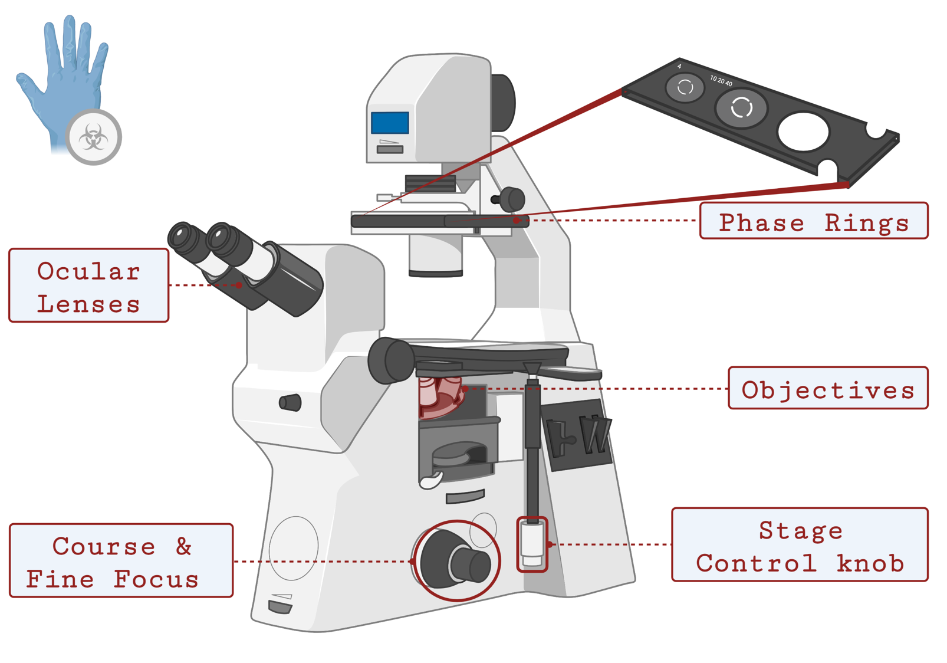
Figure 1-1. Labelled illustration of an inverted phase contrast microscope.
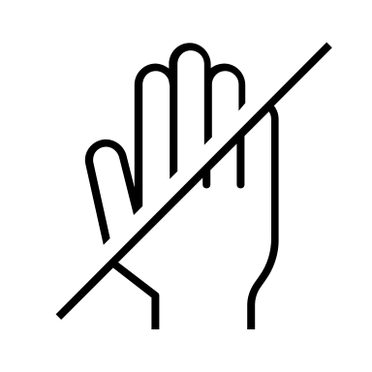
Notes for working with a microscope:
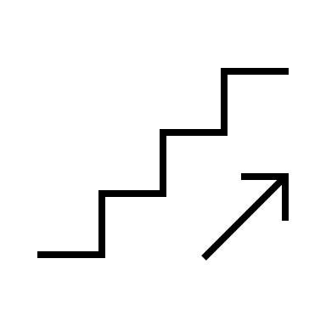
- Never touch the lens (ocular or objectives) with your hands or gloved fingers. To change objective, turn the rotating nosepiece (also called a turret) but NEVER touch the lenses themselves. The objectives are extremely expensive to replace.
- Start with the lowest power objective (4x) to locate your specimen and move to high power objectives to focus your microscope. ALWAYS carefully watch the lenses move in place under the specimen. You can scratch the lens by rubbing it against the slide!

- Make sure your phase ring matches your objective
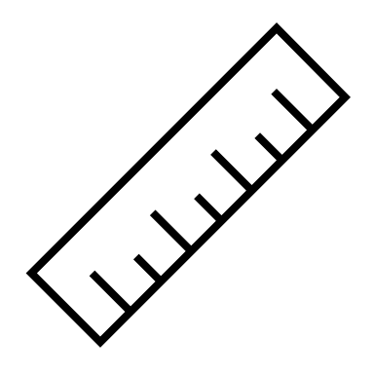
- When saving images, save them in your sections folder on the laptop desktop with a useful name (your team name, microscope objective or other important settings, short description of what it is. E.g. “Breen_20x_Vein_control.tiff”.
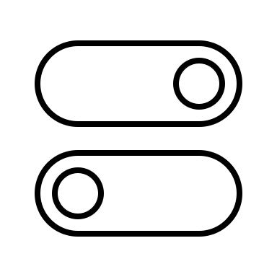
- If you will be making measurements on any images, make sure to take a calibration image. Using the same objective, and microscope settings, snap a picture of the calibration slide or something else of known dimensions.
- Never leave slides or culture plates on the stage of the microscope.
- Reset objectives and phase rings and turn off microscope after each use and cover the with the dust cover if you are the last person to use the microscope.

BME3181: Microscopy Practical
- Obtain a cell specimen for imaging.
- Locate and operate a phase contrast microscope to capture and save an image of the cell specimen which will be used for further quantitative data analysis.

FOR INTRUCTOR USE

EXCEPTIONAL CRITERIA
Phase contrast matches magnification
Light is adjusted as needed
Focus is adjusted as needed
Adjust ocular lenses as needed
Look through both ocular lenses simultaneously
Complete task in timely manner
SATISFACTORY CRITERIA
DEMONSTRATES ABILITY TO CHANGE MAGNIFICATION
CAPTURE A CLEAR IMAGE WITH CELL STRUCTURES PRESENT
CALIBRATION IMAGE AT CORRECT MAGNIFICATION IS CAPTURED
BOTH CAPTURE AND CALIBRATION IMAGE ARE SAVED TO THE COMPUTER DESKTOP WITH APROPIATE FILENAMES
CORRECT PPE IS WORN
MICROSCOPE IS TURNED OFF AFTER USE
NOTES

DON’T FORGET!
Practice for lab practical

Procedure
Introduction: In this activity, you will become familiar with the operation of the microscopes in the lab. We have several inverted microscopes, and all of them have the capability for phase contrast (great for imaging live cells). An instructor will provide an initial demonstration of how to use a microscope and point out any important procedures and tips for each microscope. Afterwards, you will image a tissue specimen. For part of your post-lab you will use ImageJ software to estimate the cross-sectional area of a particular blood vessel.

Image Acquisition
- After the instructor’s demonstration, decide which objective you will use to image a blood vessel on the provided histology slide.
- Ensure that the whole internal cross-section is visible in the field of view and the tissue is in focus after you snap a picture.
  - You may have to adjust your objective and field of view.
- Make sure you save the picture with a useful name (your last name, microscope objective, short description of what it is. E.g. “Breen_20x_Vein.tiff”) on the lab laptop.
- Try to get images of at least 3 blood vessel cross-sections.
- Using the same objective, and microscope settings, snap a picture of the calibration slide. (Now you have a calibration image, an image of an object with known dimensions).
  - Make sure you take a note, in your lab notebook, of the units on the calibration slide.
  - Anytime you use a different microscope or different objective, you’ll have to acquire a calibration slide for that specific set-up.
- Make sure to also save your calibration image under a useful name.
- Include your original slide images in Figure 1-2 below, note down the filenames, and any important microscope settings that you used to take the pictures.
Slide Images
Slide Image Name | .tiff | .tiff | .tiff
Calibration File Name | .tiff | .tiff | .tiff
Microscope Settings
Figure 1-2 Images of histology slides, filenames, and microscope settings for each histology slide image.

Image Analysis
We will use ImageJ software to make measurements on the blood vessel you imaged.
- If you have not already done so install ImageJ (Windows) or Fiji (Mac)(link and instructions are on Canvas or here https://imagej.net/ij/download.html )
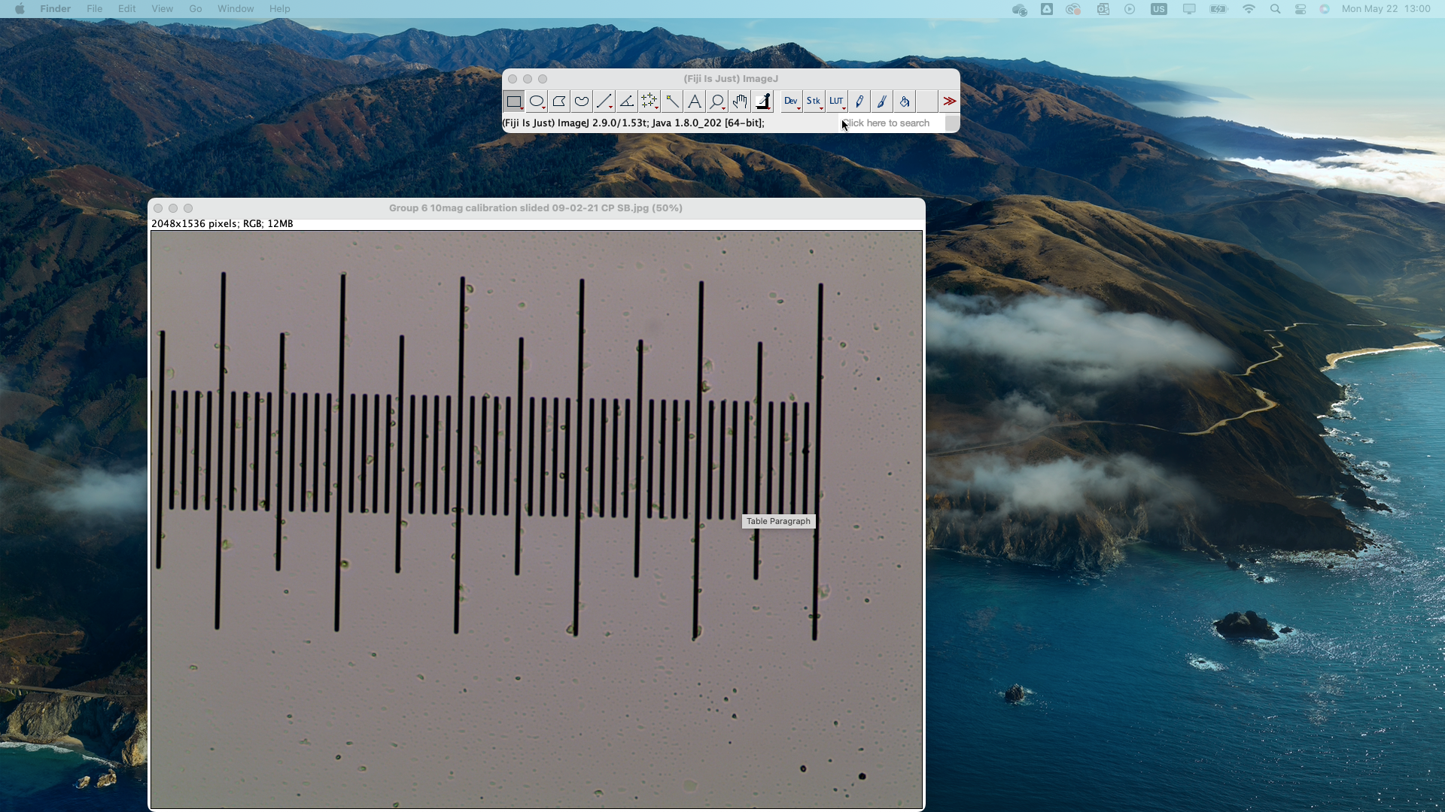
Figure 1-3 ImageJ 1.53t Toolbar
- Open the calibration image for your first histology slide in ImageJ by:
  - File → Open → Select your image file
- Select “Straight Line Selections” tool from the ImageJ toolbar (See Figure 1-3 )
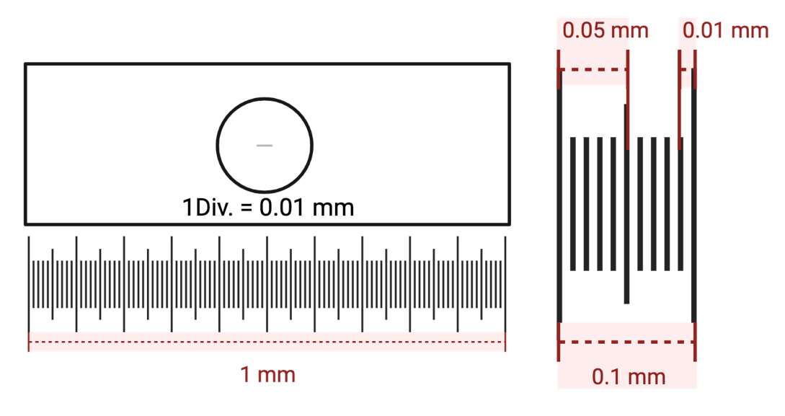
Figure 1-4 Calibration Slide Dimensions. Entire line is 1 mm with each large increment 0.1 mm apart and each of the smallest increments are 0.01 mm apart.
- Draw a straight line of a known distance on your calibration slide image (See Figure 1-4)
  - Hint: use the magnifying glass tool on ImageJ toolbar() to zoom in on what you are measuring to help measure with accuracy
  - Another hint: take multiple measurements on your calibration slide, if there are slight variations take the average of your measurements. If there are large variations, check your work and try again.
- Measure the straight line by:
  - Menu Button Analyze → Measure
  - Your line length is provided in units of pixels in the pop-up results window under “Length”.
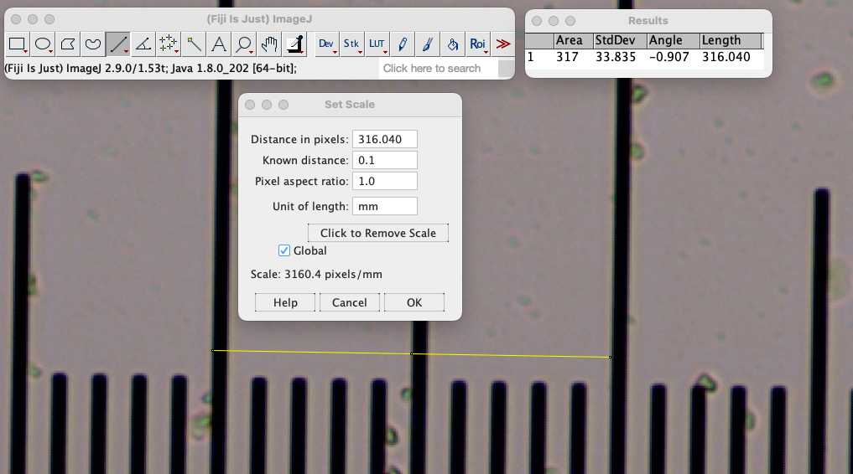
Figure 1-5 Screenshot of setting the scale of an image in ImageJ
- Set the scale of your image based on your known dimensions by:
  - Analyze → Set Scale
  - As shown in Figure 1-5, enter the pixel distance you measured in step 5 in “distance in pixels” box
  - Enter the known distance of your line
  - Don’t forget to enter the appropriate units in the “unit of length”!
  - By selecting the “global” check box, you will apply your calibration to all images you open in ImageJ after your calibration.
  - Select “OK”
- Check your calibration by re-measuring your known distance (like in steps 4 and 5)
  - Note: your line length this time should be given in appropriate dimensions in the pop-up results window.
- Measure Cross Sectional Area of the vessel lumens captured in your images.
  - You’ll use two methods to measure lumen area in ImageJ.
    - Use the “Straight line” tool ()to take diameter measurements, and assume the cross-section is an ellipse, estimate the cross-sectional area of your blood vessel using Equation 1.
    - Use the “Freehand selection” tool () to trace and measure the inside of the blood vessel as accurately as you can.
  - Before acquiring your results, write a measurable hypothesis in Table 1-1 below about the results of the different measurement methods. Get feedback about your hypothesis from your instructor before you leave.
  - When you have completed your analysis report your results in your results in Table 1-3 below.
  - STRAIGHT LINE TOOL ANALYSIS: Repeat the measure tools used in steps 4 and 5 to obtain the radius dimensions for the lumen in your images. Review Equation 1 and Figure 1-6 and show your calculations for each image in Table 1-2 below.
    - Hint: Remember your required radius measurements will be 50% of any measured diameters.
  - FREEHAND TOOL ANALYSIS: Use the “Freehand selection” tool () to trace and measure the inside of the blood vessel as accurately as you can. Use the Menu Button Analyze → Measure. Your lumen area is provided in the pop-up results window under “Area”.
    - You will need to export and save a screenshot of your traces for each image in Table 1-2 below. When taking quantitative measurements, it is always recommended that exported images have scale bar, please follow the steps outlined below to add a scale bar and to flatten and export your image:
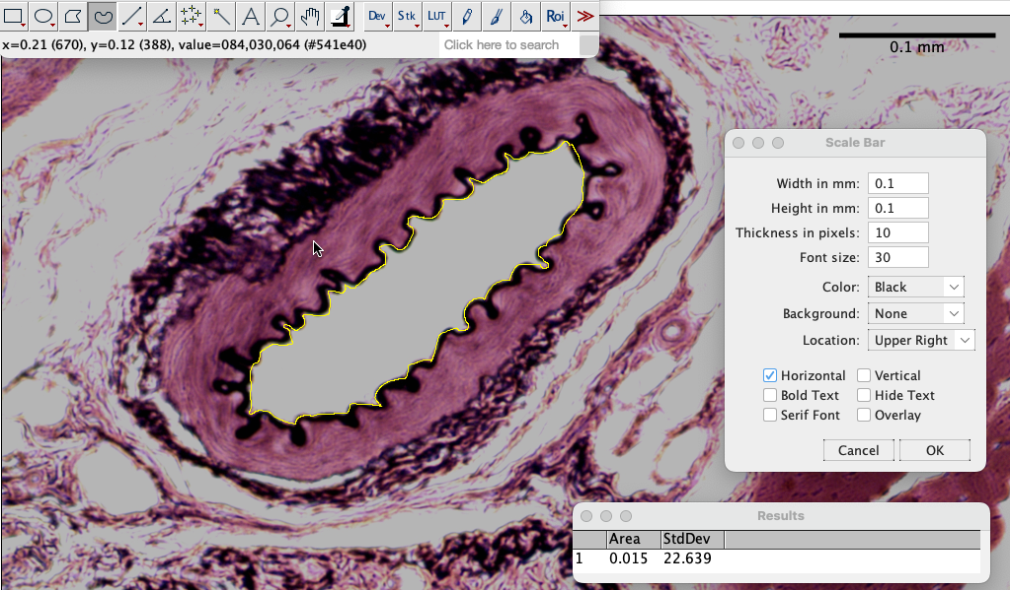 Figure 1-6 Screenshot of adding a scalebar to an image in ImageJ | ADD SCALE BAR (See Figure 1-5):  - Menu Button Analyze → Tools … → Scale bar …  - Adjust Width, Height, Thickness and Font Size appropriately  - Use an upper or lower right or left location (do not use “at selection”)  FLATTEN & EXPORT IMAGE:  - Menu Button Image → Overlay → Flatten  - Menu Button File → Export → Image

Equation 1-1. Cross Sectional Area of an Ellipse where a is the major radius, b is the minor radius and $π$ is 3.14159.  $$CSA= a×b×π$$ | 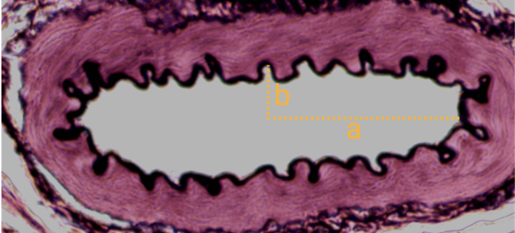  Figure 1-7 Major (a) and minor radius (b) illustrated on sample vessel lumen

Table 1-1 Hypothesis and experimental variables for measurement comparison for lumen cross sectional area
Independent Variable(s):
Dependent Variable(s):
Control Variable(s):
Hypothesis:

Table 1-2 Cross Sectional Area calculations and screenshots for three images
 | Straight Line Tool Calculations | Freehand Trace | Freehand Area
Sample | Major Axis: 0.131 mm  Minor Axis: 0.039 mm  CSA:  0.131 * 0.039 * 3.14159  0.016 mm² | 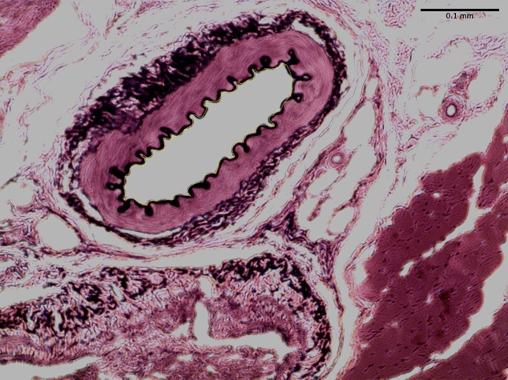 | 0.015 mm²
Image 1 | Major Axis: _____  Minor Axis: _____  CSA:
Image 2 | Major Axis: _____  Minor Axis: _____  CSA:
Image 3 | Major Axis: _____  Minor Axis: _____  CSA:

Table 1-3. Comparison of vessel lumen cross sectional area between the "Freehand" and "Straight line" measurement methods.
 |  | Freehand Method | Straight Line Method | p-value
Cross Sectional Area (mm²) | Average
Cross Sectional Area (mm²) | Standard Deviation

Post Lab Questions
We will conclude lab with a guided group discussion on the data your group, and section collected. Please take notes on this discussion below within the relevant question areas.

Hypothesis
When reviewing your data, and the results of your statistical testing, does is support your hypothesis? Please provide reasoning to support your answer
Is your hypothesis supported?
Reasoning

Data Validity
Is the data you collected valid? Please provide reasoning to support your answer
Is your data valid?
Reasoning

Data Reliability
Is the data you collected reliable? Please provide reasoning to support your answer
Is your data valid?
Reasoning

Limitations & Future work
If you were to conduct this experiment again, what changes would you make? Please provide reasoning to support your answer
Changes
Reasoning

Post-Lab Checklist:
Submit completed procedure and post lab questions (Upload completed pages 1:1-1:7)

Micropipetting & Dilutions

Pre Lab-Review

Pre-Lab Checklist:
Complete Lab Safety Training (Upload Certificate to Canvas)
Complete CATME Team-Maker Survey
Complete B-Me Survey on Canvas
Complete Pre-Lab 2

Pre-Lab 2: Micropipetting & Dilutions
This pre-lab will be available on Canvas as a quiz with unlimited attempts and no time limit. Please use the space below to review and work on your questions before opening the quiz.

Introductory Video:
Step one of your pre-lab is watching an informational video on Micropipetting that is less than 10 minutes long. You can access that video here: https://youtu.be/aSeod1Y5MRc

Background Information:
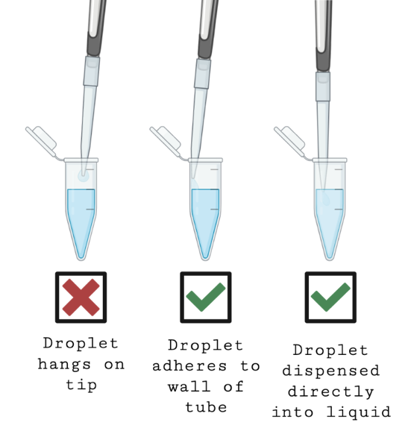
Selecting the appropriate micropipette: The lab is outfitted with several sets of micropipettes. Each set consists of 4 different sizes: P1000, P200, P100, and P10, all color-coded with lab tape, so you know easily if you have a whole set. The largest size, the P1000 has a working range of 1000 – 200 μL, and works with the largest size tips. The medium size tips fit both the P200, which has a range of 200 – 20 μL and the P100, which has a range of 100-10 μL. The smallest micropipette, the P10, uses the smallest tips and has a working range of 10 - 1 μL. Never try to adjust the micropipettes outside of these ranges. Keep in mind, during your micropipette selection, that micropipettes are most accurate in the middle of their working range.
Pipetting technique will affect accuracy: Be sure to use proper pipetting technique. Proper technique involves drawing up (aspirating) and dispensing (ejecting) the liquid in a smooth motion. Putting the pipette tip in the water and quickly releasing the plunger will give you inaccurate results—even if your pipette is properly calibrated. In fact, using proper pipetting technique will not only increase the robustness (and reliability) of your results but will also decrease the wear and tear on your pipette.
One of the most common problems for the beginner is the tendency of small liquid volumes to adhere to the pipette tip rather than dispensing into the tube. Never dispense a small volume into thin air. As shown in Figure 2-1 always dispense into a liquid or onto the wall of a tube so that adhesion will draw the expelled liquid off the tip.
The Weight of Water: The most common way to check your pipette accuracy is by weighing water. The density of water is 1 g/mL. This means that every microliter (µL) should have a mass of 0.001 g. In other words, if your pipette is accurate, the amount of water you dispense will equal the amount the water weighs. So, if your pipette is set to 100 µL, then the scale should read 0.1 g.
Figure 2-1 Dispensing small volumes from a micropipette

Question 1:
Identify the pipetting ranges of the micropipettes we have in the lab:
 | Minimum Volume (μl) | Maximum Volume (μl)
P2
P10
P200
P1000
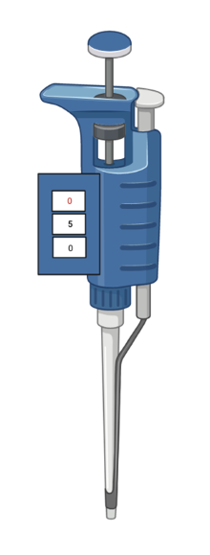
Figure 2-2 P1000 Micropipette with volume readout set to 050

Question 2:
What volume (in units of mL) would be pipetted if a P1000 was set in to have the digits 050 as shown in Figure 2-1?
Answer: [ ] mL

Question 3:
As part of your lab procedure this coming week you will pipette several volumes of liquid as noted in Table 2-1. Fill in Table 2-1. with your chosen micropipette and dial readings.
What is the final total volume you should have based on Table 2-1?
Answer: [ ] µL
Using the density of water, estimate the final weight of water that will be in your microcentrifuge tube. Show your work for the estimations.
Answer: [ ] g
Show your work here:
Table 2-1 Liquid volumes and corresponding micropipette settings
Amount of water to add to tube | 220 µl |  |  | 7.0 µl |  |  | 123 µl |  |  | 0.0183 ml |  |  | 0.583 ml |  |  | 197 µl |  |  | 0.0047 ml |  |  | 347 µl
Micropipette used (e.g. P10, P100) |  |  |  |  |  |  |  |  |  |  |  |  |  |  |  |  |  |  |  |  |  | P1000
Volume readout |  |  |  |  |  |  |  |  |  |  |  |  |  |  |  |  |  |  |  |  |  |  | 0
Volume readout |  |  |  |  |  |  |  |  |  |  |  |  |  |  |  |  |  |  |  |  |  |  | 3
Volume readout |  |  |  |  |  |  |  |  |  |  |  |  |  |  |  |  |  |  |  |  |  |  | 4.7

Additional Background Information:
Preparing reagents and solutions is a never-ending task in most laboratories. This is a basic laboratory skill that often confuses people at first. Here we present the standard, general approach to computing dilutions and concentrations, the Dilution Factor Technique. It is a convenient way of computing dilutions at the bench.

Dilution Factor (DF): The DF is a dimensionless number that unambiguously describes the "strength" of the dilution. It is equal to the volume of stock solution used (V1), divided by the total volume of working solution produced (V2). In turn, V2 = V1 + the volume of diluent used. The dilution factor also gives the relationship between solute concentration in the stock solution (C1) and the working solution (C2).

The precise relationships are given by:
REMEMBER:
V2 > V1 | C2 < C1 | DF < 1.0
- A "50-fold [50X]" dilution has DF = 1/50 = 0.02
- When you add 1.0 ml of stock to 4.0 ml of diluent, DF = 1/5, NOT 1/4.

Equation 2-1 Dilution Factor (DL) where the concentration (C) and volume (V) are shown for the stock (1) and working (2) solutions.
$$Dilution factor \left(DF\right)=\frac{C2}{C1}=\frac{V1}{V2}$$

This is sometimes given as:

Equation 2-2 Rearranged Dilution Factor (DL) equation where the concentration (C) and volume (V) are shown for the stock (1) and working (2) solutions.
$$C1×V1=C2×V2$$

Serial dilutions: A serial dilution is a step-wise series of dilutions, where the dilution factor stays the same for each step. It is a sequential set of dilutions in which the stock for each dilution in the series is the working solution from previous dilution. In effect, except for the last dilution, each dilution is both a stock and a working solution. The DF for the entire series as a whole is the product of the DF's of each individual dilution.

Equation 2-3 Dilution Factor (DF) for a series of three dilutions
$$DF total =DF1×DF2×DF3$$

Ordinarily, volumes are chosen to give DF values that are simple powers of ten. This makes it relatively simple to remember what you are doing and to perform the dilution calculations in your head.

Example: If you have 1.0 ml of bovine serum albumin (BSA) at a concentration of 10 mg/ml. You want 1.0 ml of BSA at a concentration of 10 ng/ml. What is the procedure you would use to dilute your sample to 10 ng/ml?

- DF = C2 / C1 = 10 (ng/mL) / 10⁷ (ng/mL) = 10⁻⁶
- V1 = DF X V2 = 10⁻⁶ X 1,000 μL = 10⁻³ μL

Add 0.01 μL stock to 1.0 mL water.

This is not as straightforward as it appears. Remember that you cannot measure volumes less than 1 μl accurately. Instead, you would perform a series of standard dilutions otherwise known as a serial dilution. For example, could do a series of three consecutive 10⁻² dilutions to reach a total dilution of 10⁻⁶.

Standard Curves: Trypan Blue is a common dye reagent used to cell studies. By measuring the absorbance (the amount of light absorbed) of a sample containing Trypan Blue at 595 nm and comparing the result to a standard, one can determine the dye concentration in a solution. Standards can be created by adding a known amount of solute (in this case, dye) to a solution. The samples can be read in the plate reader to create a standard curve, or calibration curve (Figure 2-3). Unknown standards can be determined by interpolation. Typically, standards are made across a range of concentrations so that the expected values of the unknown fall within the range of the known standards.
Figure 2-3 Example of a Trypan Blue Standard Curve

Question 4:
As part of your lab procedure this coming week you will prepare a standard curve of trypan blue solution. Below you will prepare your calculations for the serial dilution so that the readings of the sample can be done in triplicate.
Serial dilutions can be used to make standards (solutions of a known concentration of some solute, like dye). To make a serial dilution, rather than pipetting exact volumes from the stock to make each concentration individually, you start with an initial concentration, take a sample from that, and dilute it to your next concentration, and so on (See Example on page 2:12).
On page 2:13, calculate and detail, how you will prepare a series of serial dilutions to get the final required standard concentrations. The stock concentration of Trypan Blue is at a concentration of 0.1%. Your will need samples at the following concentrations: 0%, 0.0125%, 0.025%, 0.5% and 0.1%. You will create standards for the concentrations of 0.0125%, 0.025%, and 0.05%, and use the diluent and stock for the 0% and 0.1% samples respectively. You will need to make enough solution for three 100 μL replicates, 330 μL should be sufficient for three 100 μL with 10% overage.
Hint: To help you plan, review the step-by-step serial dilution example below which uses a series of 2⁻¹ or 2x dilutions.

Example: Prepare a series of serial dilutions to create a standard curve for Trypan Blue. Your will need samples at the following concentrations: 0%, 0.0125%, 0.025%, 0.5% and 0.1%. The stock concentration of Trypan Blue is at a concentration of 0.1%. Plan so that you have 50 μL of each concentration with 10% overage.
Step 1 Determine the diluent:
Trypan Blue can be diluted in distilled water.

Step 2 Fill target containers with diluent:
Required Data: [1] Number of serial dilutions and containers, [2] volume required of each standard, [2] volume of diluent per container.
Concentration (%) | 0% | 0.1% | 0.05% | 0.025% | 0.0125%
Dilution Factor | NA | NA | DF= C2 / C1  = 0.05% / 0.1%  = 0.5 or 2⁻¹  = 2 X or 1:2  V2= V1/DF  = 55 / 0.5 μL = 110 μL | DF= C2 / C1  0.025% / 0.1%  = 0.25 or 2⁻²  = 4 X or 1:4 | DF= C2 / C1  0.0125% / 0.1%  = 0.125 or 2⁻³  = 8 X or 1:8
Volume Diluent | 55 μL | 0 μL | 55 μL | 55 μL | 55 μL
Volume Stock | 0 μL | 55 μL 0.1% | 55 μL 0.1% | 55 μL 0.05% | 55 μL 0.025%
We will perform three serial dilutions with a DF of 2⁻¹ to produce 55 μL of each standard and use 55 μL of diluent in each container

Step 3 Perform the first dilution:
Place 55 μL of the 0.1% stock solution into Tube 1 which has already contains 55 μL of water. The resulting volume is Tube 1 is 110 μL with a concentration of 0.05%.
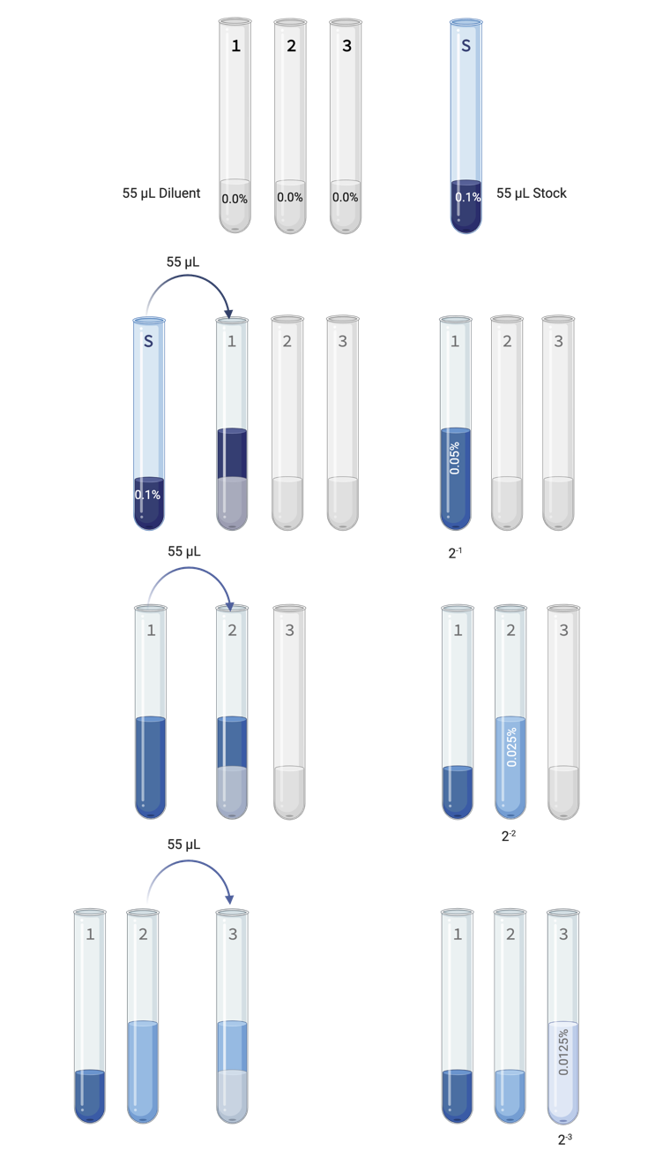
Step 4 Perform the second dilution:
Place 55 μL of the well mixed 0.05% solution into Tube 2 which already contains 55 μL of water. The resulting volume is Tube 2 is 110 μL with a concentration of 0.025%.
Step 5 Perform the last dilution:
Place 55 μL of the well mixed 0.025% solution into Tube 3 which already contains 55 μL of water. The resulting volume is Tube 3 is 110 μL with a concentration of 0.0125%.

Question 4 continued …
Determine the diluent: _________________
What diluent is appropriate for Trypan Blue Dye?
What is the dilution factor for each required concentration:
DF=C2/C1
Concentration (%) | 0% | 0.1% | 0.05% | 0.025% | 0.0125%
Dilution Factor
How many serial dilutions need to be completed: _________
How many serial dilutions are required to reach your desired concentrations?
What volume each concentration is needed: _________ μL
How many replicates, at what volume, with how much overage? [replicates*volume+overage]
How much diluent needs to be placed in each container: _________ μL
V2= V1/DF, the working solution V2 includes the diluent and the stock solution.
Concentration (%) | 0% | 0.1% | 0.05% | 0.025% | 0.0125%
Volume Diluent
Complete Serial Dilutions Table 2-3:
Table 2-2. Serial Dilutions Table for Example on page 2:12. A threefold serial dilution of 0.1% stock Trypan Blue dye to 0.05, 0.025 and 0.0125% stock to produce a total volume of 50 ml with 10% overage.
Concentration (%) | Source | Volume Stock (μL) | Volume Diluent (μL) | Final Volume (μL) | Dilution Factor
0 | Diluent | 0 | 220 | 55 | 0 | 0 | 0
0.1 | Stock | 110 | 0 | 55 | 2⁰ | 1 | 1x
0.05 | Tube 1 | 55 | 55 | 55 | 2⁻¹ | 0.5 | 2x
0.025 | Tube 2 | 55 | 55 | 55 | 2⁻² | 0.25 | 4x
0.0125 | Tube 3 | 55 | 55 | 110 | 2⁻³ | 0.125 | 8x
Table 2-3 Serial Dilutions Table for a threefold serial dilution of 0.1% stock Trypan Blue dye to 0.05, 0.025 and 0.0125% stock to produce a total volume for three 100 ml replicates with 10% overage.
Concentration (%) | Source | Volume Stock (μL) | Volume Diluent (μL) | Final Volume (μL) | Dilution Factor
0 | Diluent
0.1 | Stock
0.05 | Tube 1
0.025 | Tube 2
0.0125 | Tube 3

Module 2 Lab Procedure

Introduction:
Depending upon the procedure being performed, cell engineering experiments can utilize a variety of volumes of biological samples and reagents, ranging from several hundreds of liters to very small microliter (µL) volumes. Pipetting is a critically important technique in life science experiments to ensure accurate experimental results. For example, small differences in drug concentrations can make a huge difference in cell engineering experiments.

Learning Objectives
- Identify the components of a micropipette
- Accurately pipet different microliter volumes using a micropipette
- Practice serial dilutions and create a standard curve generated through spectrophotometry to check pipetting accuracy

Materials
Equipment | Software | Materials | Misc.
Phase Contrast Microscope | Gen5 | Aliquot of 0.1 % Trypan Blue Dye | Absorbent pad
Spectrophotometer |  | Aliquot of mystery Trypan blue sample | Transparent 96-well plate
Electronic balance |  | 20 ml of Deionized (DI) water | 1.5 ml microcentrifuge tubes
 |  |  | Small beaker

Important Terms
Microliter (μL)
Milliliter (mL)
Percentage error
Regression Equation
Standard Curve
R² value
Intercept

Safety:
We are using a potentially toxic material—Trypan Blue-- so gloves, lab coat, and goggles are necessary to protect your skin and clothing.

Teamwork:
You may work in groups, but each individual student should complete the pipetting exercises 1 and 2 independently. Meaning, everyone should test and practice their pipetting skills. Procedure Part 3 should be completed in pairs.

Setup:
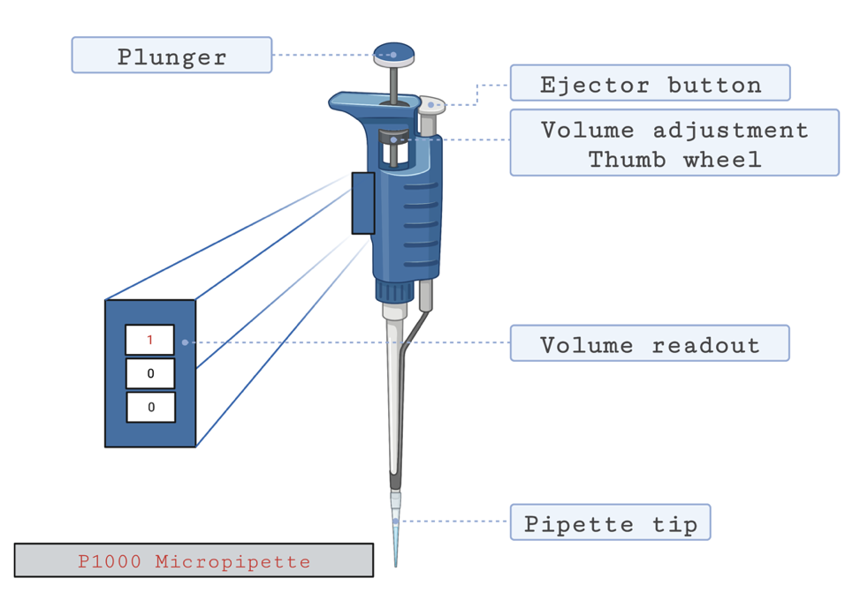
Figure 2-4. A P1000 micropipette is shown with parts labelled. The pipette is shown with a pipette tip attached, set a maximum volume (1000 µl).
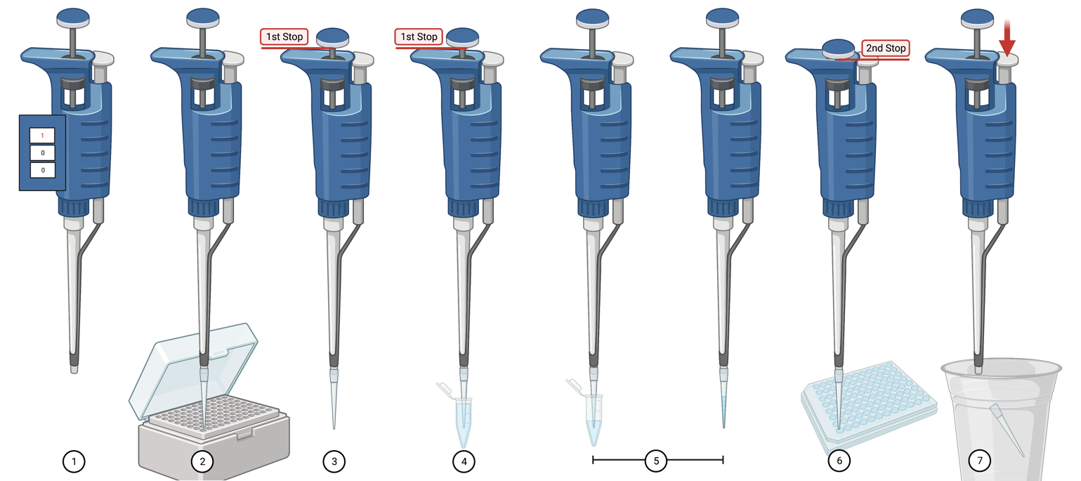
1 | Set the micropipette volume readout to the required volume by adjusting the thumb wheel.
2 | Place a clean pipette tip on the micropipette.
3 | Press the plunger down to the first stop.
4 | Hold the plunger down while placing the pipette tip just beneath the surface of the liquid.
5 | ASPIRATION: Slowly release the plunger to draw sample into the pipette tip
6 | DISPENSING: Deliver the sample by slowly pressing the plunger to the first stop, pause, then continue to depress the plunger to the second stop and expel any remaining sample. Do not release the plunger until the tip is out of the sample container.
7 | Discard the tip in the waste cup by pressing the ejector button.
Figure 2-5 Steps 1 - 7 of using a micropipette to transfer fluid.

BME3181: Micropipetting Practical
- Obtain a clean 1.5 mL microcentrifuge tube and weigh it on the balance.
- Label the microcentrifuge tube with its mass.
- Review the volumes of water listed in the first row of Table 1, decide on your micropipettes and volume readouts and complete Table 1
- Add the volumes of water listed to the microcentrifuge tube.
Table 1: Water added and corresponding micropipette settings.
Amount of water to add to tube | 220 µl |  |  | 7.0 µl |  |  | 123 µl |  |  | 0.0183 ml |  |  | 0.583 ml |  |  |  | 197 µl |  |  | 0.0047 ml |  |  | 347 µl
Micropipette used
Volume readout
Please note these volumes will be randomized and will vary for each lab practical.
FOR INTRUCTOR USE
Table 2: Weights and volumes of microcentrifuge tube
Estimated Volume of water (µl) | Estimated mass of water (g) | Actual mass of empty tube (g) | Actual mass of tube + water (g) | Actual mass of water (g) | Actual volume of water (µl) | Pipetting % Error
EXCEPTIONAL CRITERIA
Correctly holds micropipette in one hand
Only uses thumb on plunger
Plunger is depressed to first stop before tip is placed in fluid
Plunger speed is slow and controlled
Plunger is depressed to second stop when dispensing fluid
Correctly discards tips
Uses benchtop space efficiently
SATISFACTORY CRITERIA
PIPETTING ERROR < 10%
CORRECT PPE IS WORN
NOTES
DON’T FORGET!
Practice for lab practical

Procedure Exercise 1 (Quick Test)
Here are two quick tests of your independent ability to operate the micropipettes.
- Use a P1000 to transfer 0.5 mL of DI H₂O to a microfuge tube.
  - Set the P200 to 100 μL and aspirate the entire 0.5 ml in five separate increments.
  - Were you able to withdraw exactly five 100 μL quantities?

- Use a P100 to add 0.05 mL of DI H₂O to a microfuge tube.
  - Set the P10 to 10 μL and aspirate the entire 0.05 ml in five separate increments.
  - Were you able to withdraw exactly five 10 μL quantities?

Procedure Exercise 2 (Pipetting Challenge)
The most common way to check your pipette accuracy is by weighing water. The density of water is 1 g/mL. This means that every microliter (µL) should weigh 0.001 g. In other words, if your pipette is accurate, the amount of water you dispense will equal the amount the water weighs. So, if your pipette is set to 100 µL, then the scale should read 0.1 g.
- The data for Table 2-4 should be drafted from your pre-lab. Consult with your teammates and instructors to finalize the data in Table 2-4.
- What is the final total volume you should have based on Table 2-4? Put this number in Table 2-5 under “Calculated Final Volume of Water”.
- Using the density of water, estimate the final weight of water that will be in your microcentrifuge tube. Note under “Estimated Final Weight of Water”. Show your work for the estimations.
CHECK THE NUMBERS in Table 2-4 and Table 2-5 WITH YOUR LAB INSTRUCTORS
- Obtain a clean 1.5 mL microcentrifuge tube and weigh it on the balance. Note the mass in Table 2-5.
- Add the amounts of water listed in the first row of Table 2-4, to the microcentrifuge tube that you weighed (carefully note the volume units). If required update Table 2-4 with the micropipette you used, and the digit setting on the micropipette.
- Now weigh your microcentrifuge tube with water. Note in Table 2-5.
- Does this match the volume of water you can “eyeball” with the graduation on the outside of the tube?
- Analyze your pipetting technique by calculating the percentage error of your measured (actual) value vs your correct known value of the calculated value of water volume, place your value in Table 2-5. Please review Equation 1-1 for calculating percentage error.
Equation 2-4 Calculation of percent error
$$Percent Error = \frac{\left|Measured- Correct\right|}{Correct} ×100$$

Table 2-4 Liquid volumes and corresponding micropipette settings for Exercise 1
Amount of water to add to tube | 220 µl |  |  | 7.0 µl |  |  | 123 µl |  |  | 0.0183 ml |  |  | 0.583 ml |  |  | 197 µl |  |  | 0.0047 ml |  |  | 347 µl
Micropipette used (e.g. P10, P100)
Volume readout

Table 2-5 Masses and volumes of microcentrifuge tube at various stages of Exercise 1 process
[Correct]  Calculated Volume of water (µl) | [Correct]  Estimated mass of water (g) | [Measured]  Actual mass of empty tube (g) | [Measured]  Actual mass of tube + water (g) | [Measured]  Actual mass of water (g) | [Measured]  Actual volume of water (µl) | Pipetting % Error

Show your work here:

Procedure Part 3 (Serial Dilutions & Standard Curve)
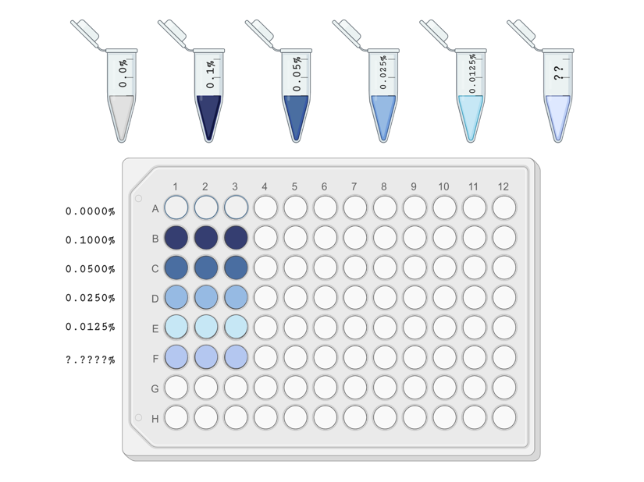
Please complete procedure part 3 in pairs. Preparing accurate standard curves is another necessary skill and requires accurate pipetting for accurate results.
Figure 2-6 Layout of a 96-well plate for 5 standards and a mystery sample in triplicate.

Serial Dilution & Standards Data Collection
- Prepare your Trypan Blue standards through a serial dilution in 1.5 ml centrifuge tubes, based on your calculations and plan in your pre-lab assignment.
- Prepare 100 μL samples in triplicate (that means 3 x 6 different wells. That is, 5 standards plus 1 mystery sample) on a clean transparent 96-well plate. See example in Figure 2-6.
  - Prepare all your samples in wells near each other, we recommend running triplicates in the same row next to each other with standards along the columns.
  - You prepared more than the required volume for overage, you should have some sample left over in your sample tube (if not, check your pipetting technique).
  - In another set of wells, pipette the mystery sample (unknown) into your well plate.
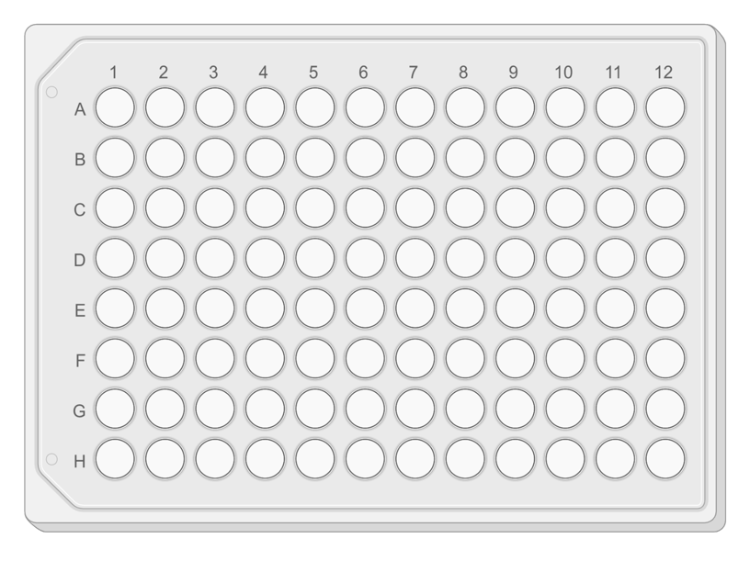
- Take note in the blank well plate layout in Figure 2-7 of which standards and samples are in which well.
Figure 2-7 Blank 98 well plate layout

- Using the spectrophotometer plate reader, measure absorbance of the samples at a wavelength of 595 nm.
Please note down the make and model of the spectrophotometer plate reader.

Please note down the software used on the spectrophotometer.

Please note down the settings used to measure absorbance.

Place Figure here
Insert Caption here

Standards Data Analysis
- From the data collected in step 3.4 please create a standard curve.
  - Label your x and y axes.
  - Provide a caption for your Figure.
  - Display the equation and R2 value on the graph.
  - Please calculate standard deviations for your triplicate samples and indicate standard error with error bars on your standard curve.

- Please describe your standard curve:
Please report the equation, the R-value, the intercept and if the curve is linear.

- Use this information provided in Step 3.6 to calculate and report the concentration of the mystery sample.
Show your work here:

Concentration of mystery sample:

Post-Lab Checklist:
Submit completed procedure and post lab questions (Upload completed pages 2:1-2:7)

Fluorescence

Pre Lab-Review

Pre-Lab Checklist:
Submit Pre-Lab 3 (Complete Quiz on Canvas)

Pre-Lab 3: Fluorescence
This pre-lab will be available on Canvas as a quiz with unlimited attempts and no time limit. Please use the space below to review and work on your questions before opening the quiz.

Introductory Video:
Step one of your pre-lab is watching two informational videos on Fluorescence [09:32] and Fluorescent Microscopy [05:41]. You can access the videos here:
- Fluorescence as a Biological Tool [09:32] https://youtu.be/rE42zZ-3wNo
- Fluorescent Microscopy [05:41] https://youtu.be/PE3XBYebtZQ

Question 1:
What is the difference between excitation and emission, with regards to a fluorophore?

Question 2:
Why is it necessary to keep fluorescently stained samples protected from light? Describe how light affects fluorescent stains. A useful resource to answer this question is cited here:Ettinger, A., & Wittmann, T. (2014). Fluorescence live cell imaging. Methods in cell biology, 123, 77–94. https://doi.org/10.1016/B978-0-12-420138-5.00005-7

Question 3:
Review the next section of your lab book at the procedure for your fluorescence lab.
Write a measurable hypothesis based on the lab procedure.
Describe how you will analyze this hypothesis:

Question 4:
Calculate the amount of TRITC-conjugated phalloidin and DAPI solution necessary for 6 wells. You will need at least 200 μL of total solution per well, plus ~10% overage. You can mix the TRITC-phalloidin and DAPI in the same solution.
- You will add the TRITC-phalloidin at a ratio of 1:250 in PBST-T solution.
- You will add DAPI (in the same solution) at a ratio of 1:500 in PBST-T solution.

What volume of TRITC-phalloidin do you need? [______] μL
What volume of DAPI solution do you need? [______] μL
What volume of PBST-T solution do you need? [______] μL

Show your work here:
Please upload a copy of this page to your canvas quiz to show your work.

Module 3 Lab Procedure

Introduction:
You will be given a 48-well plate with cultured NIH 3T3 fibroblasts that have been fixed and permeabilized. You will use TRITC-conjugated phalloidin to fluorescently stain the actin cytoskeleton. Phalloidin is a toxin derived from a mushroom that preferentially binds to filamentous actin (f-actin) in permeabilized cells. This phalloidin has a TRITC fluorophore attached to it allowing you to visualize the cytoskeleton of the cells. DAPI is a fluorescent nucleic acid stain that binds strongly to A-T-rich regions in DNA, allowing you to visualize the nucleus of the cells.

Learning Objectives
- Use a fluorescent microscope to obtain images of cells for qualitative and quantitative analysis
- Use a plate reader to analyze fluorescence quantitatively.

Materials
Equipment | Software | Materials | Misc.
Phase Contrast Microscope | Gen5 | TRITC-conjugated phalloidin fluorophore | Absorbent pad
Fluorescence Microscope | AmScope | PBST-T (0.05% Tween + 0.5% Triton-x in PBS) | Foil
Spectrophotometer | ImageJ | DAPI fluorophore | Kimwipes
Shaker |  | Fixed NIH 3T3 fibroblast cells on a 48-well plate | 1.5 ml centrifuge tubes
 |  | 1X PBS solution | Serological pipettes and micropipettes

Important Terms
Actin Cytoskeleton
Cell Nucleus
Florescence
Absorbance
Excitation
Emission
PFA
Positive Control
Negative Control

Safety
You need to protect your skin and eyes from several chemicals today. Wear goggles, gloves, closed toe shoes, and a lab coat.

Prelab Notes:
Use this space for making notes on any prelab calculation or question errors.

Independent Variable(s):
Dependent Variable(s):
Control Variable(s):
Positive Control Condition(s):
Negative Control Condition:
Hypothesis:

Demonstration Notes:
Use this space for making notes on your instructor demonstration.

What is power washing and how will you avoid it?
How will you avoid the cells drying out?
Other notes:

Procedure Part 1a Remove PFA & Rinse cells
- Visualize the cells under a phase contrast microscope. Select 6 wells that you will stain.
  - You are limited to ~6 experimental wells due to limited reagents
  - Select 3 wells with cells at low density and 3 wells with high cell density.
**Note: Your instructional team will prepare negative and positive controls for you.
- Remove PFA from chosen wells
- Gently rinse the cells in the 48-well plate with 1X PBS solution.
  - This involves placing 200 μL of PBS into each well and rising the well by moving the PBS in and out of the well with your pipette.
  - Please review your notes from your instructor’s pre-lab demonstration.
    - Important: Be careful not to “power wash” the cells with PBS. To help avoid this, dispense the PBS along the wall of the well rather than directly on the cells attached to the bottom of the well.
    - Important: Do not let the cells dry out at any point in the procedure.
- Remove PBS and repeat step 1.3 to wash a second time.

Procedure Part 1b Prepare & Apply Fluorescent Stain
- Make the DAPI/TRITC-phalloidin/PBST-T solution.
  - Use the calculated volumes of TRITC-phalloidin, DAPI, and PBST-T from your pre-lab.
  - Protect the TRITC-phalloidin solution from light.
- Visualize the cells under a phase contrast microscope to ensure cells are still intact.
- Remove the PBS on the plate and add 200 μL of the TRITC-phalloidin to each of the 6 wells containing cells in the cell culture plate.
- Let sit for 30-45 minutes, protected from the light, on a shaker.
Note the make and model of the shaker you used here:
Note the exact incubation time here: [_________] minutes

Procedure PART 2a Fluorescent Microscopy
- After the ~45 minute incubation period, remove the TRITC-phalloidin solution on the well-plate and wash with PBS several times.
- Cover the stained wells with PBS to prevent the cells from drying out.
- Wipe the bottom of the well plate with Kimwipes or paper towel to remove any debris or smudges.
- Take multiple images in different fields of view using the TRITC filter to observe the fluorescently stained cytoskeleton.
  - Make sure to get at least three images of each confluence at a consistent magnification
  - When naming files, include details of your team, well location, confluence and magnification e.g. Team1_A1_low_4x.tif
- Don’t forget to get an image of your calibration slide
Please note down the name, make, and model of the microscope used.
Please note down the software used to save images from the microscope.

- Save pictures on your USB or One Drive for analysis.
Please keep track of the image filenames below:
High Confluence filenames | Low Confluence filenames | Calibration filenames
.tif | .tif | .tif
.tif | .tif | .tif
.tif | .tif | .tif

Procedure PART 2b Spectrophotometry
- For a quantitative assessment of the fluorescently stained wells, read the fluorescent intensity on the plate reader
  - Use the Costar 48-well plate, without a lid.
  - Read with the RED (TRITC) filter.
Please note down the make and model of the spectrophotometer plate reader.
Please note down the software used on the spectrophotometer.
Please note down the settings used to measure fluorescent intensity.

- Save your data on your USB or One Drive for analysis.
- You will present this data in a table as part of your post lab questions

Procedure PART 3 Quantifying Fluorescent Micrographs
Use ImageJ software to make measurements on the cells that you imaged. If there isn’t enough time in lab, this can be done at home after you have downloaded ImageJ (see the link on Canvas).
If your staining wasn’t successful, you can analyze the sample images provided on Canvas instead.

SET THE SCALE.
If needed review Module 1 for reminders on the basics of ImageJ.
- Open a calibration image in ImageJ
- Select “Straight Line Selections” tool from the ImageJ toolbar (See Figure 1-3 ).
- Draw a straight line of a known distance on your image
- Set the scale of your image based on your known dimensions
- To check the calibration by re-measuring the straight line
- You will include sample images of both confluency conditions and stains as part of your post lab questions, make sure they include a scale bar.

MEASURE CELL AREA.
- Obtain dimensions of unknown areas of your cell images.
  - Open one of your fluorescent images.
  - Use the “Freehand selection” tool (See Figure 1-3 ) to trace the outline of several of the cells in your image
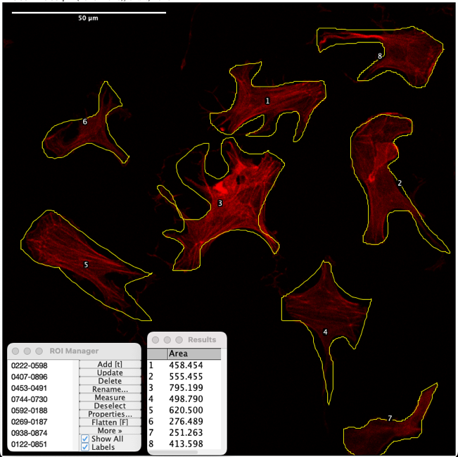
    - Do this as accurately as you can (it doesn’t have to be perfect).
Figure 3-1 NIH 3T3 fibroblast cells stained with TRITC-conjugated phalloidin which have been outlined and labelled in ImageJ.
    - Press “t” to add traces to your Region of Interest (ROI) Manager
      - In your ROI Manager check the boxes for “Show All” and “Labels” to ensure all traces are visible on your sample
    - Add a screen shot of your final image with all traces, for each image to Table 3-1.
      - Don’t forget to add a scale bar and flatten your image before saving (guidance on this is available Step 8.e.i in Module 1)
      - A Sample image is available in ##

  - In the ROI Manager, click → Measure to quantify the area of each trace in your freehand selection.
    - Record average cell area across all traces for each sample and note it in Table 3-1.
  - Repeat these steps for each image
    - You will calculate and record average cell area across all samples and will present this data in a table as part of your post lab questions

MEASURE RELATIVE FLUORESCENCE.
- In ImageJ, open the original untraced image and convert to gray scale
  - Image→Type→RBG
  - Image→Color→Make Composite
  - Image→Color→Channels Tool
    - Select Greyscale from the dropdown menu
- Set your measurements
  - Analyze → set measurements
  - Make sure “integrated density” is checked, this is a report of arbitrary units of fluorescence
  - Click “measure”
- For each image you have taken, use the “IntDen” value as a measure of the total fluorescence intensity in arbitrary units (a.u.).
  - Record fluorescence intensity for each image and note it in Table 3-1.
    - Repeat these steps for each image
    - You will present this data in a table as part of your post lab questions

RECORD FLUORESCENCE.
Table 3-1 Display of micrograph data of cell area (mm²) and relative fluorescence (a.u.) for three samples of high and low confluence wells.
 | Low Confluence |  | High Confluence
#1
#1 | Cell area: |  | Cell area:
#1 | IntDen |  | IntDen
#2
#2 | Cell area: |  | Cell area:
#2 | IntDen |  | IntDen
#3
 | Cell area: |  | Cell area:
 | IntDen |  | IntDen

Module 3 Post Lab Questions
Please answer each of the following questions and upload to your assignment dropbox on Canvas.

Question 1
Please include the Fluorescent Microscopy data, presented according to your hypothesis:
- Include one Figure which display at least two samples’ images for the TRITC stain
- Include one Table with data for average cell area
  - Include mean and standard deviation data for both high- and low-density wells
  - Include results of statistical testing comparing confluence
- Include one Table with data for relative florescence for the TRITC stain
  - Include mean and standard deviation data for both high- and low-density wells
  - Include results of statistical testing comparing confluence

Question 2
Please include the Spectrophotometry data, presented according to your hypothesis
- Include one Table with data for relative florescence for high- and low-density wells for the TRITC stain
  - Include mean and standard deviation data for both high- and low-density wells
  - Include results of statistical testing comparing confluence

Question 3
Please discuss the following: Do the quantitative results from the plate reader validate your quantitative results from the microscope image analysis?

Post-Lab Checklist:
Document and submit completed procedure (Upload completed procedure page 3:1-3:7)
Complete and submit Module 3 post lab questions (See Page 3:8)

Aseptic Technique & Cell Passaging

Pre Lab-Review

Pre-Lab Checklist:
Submit Pre-Lab 4 (Complete Quiz on Canvas)

Pre-Lab 4: Aseptic Technique & Cell Passaging
This pre-lab will be available on Canvas as a quiz with unlimited attempts and no time limit. Please use the space below to review and work on your questions before opening the quiz.

Introduction to Aseptic Technique:

Disinfection
It is common practice to use a disinfectant such as 70% ethanol or 10% bleach to decontaminate work surfaces and equipment (e.g. BSCs, micropipettes, etc.). This should be done before and after protocol execution, particularly when working with cell cultures. Both solutions are prepared in squirt bottles. Bleach offers advantages of being a broad-spectrum disinfectant; however, the solution can be toxic or corrosive. Ethanol is relatively fast acting and nontoxic; however, solutions can catch fire if near high-heat sources. Both disinfectants can be dangerous if splashed in the eyes.
Other methods to prevent microbial contamination in the labs are used. Germicidal UV lamps are equipped in biosafety cabinets (more detail below) to sterilize cabinet surfaces. Autoclaves can be used to sterilize liquid medium, containers, and supplies such as micropipette tips and microcentrifuge tubes. These are usually marked with autoclave tape, which has stripes that turns a dark brown color after they have been autoclaved. If you see striped autoclave tape on any materials, you may assume that it is sterile and must be kept sterile. If you accidentally contaminate these items, remove the striped tape to signify it is no longer sterile.

Preparing the Biosafety Cabinet
Use the following procedures to maintain the best conditions:
- Turning on the BSC (when needed). If the fan is off and the sash is closed, the BSC must be properly vented and disinfected before use. Raise the sash, the BSC will automatically turn on the light and start the blower. If the sash is lifted too high or pulled to low, and alarm will sound. Activate the blower and wait at least 15 minutes to allow airflow to equilibrate before use. Particulate accumulated within the cabinet will be removed by the HEPA filter.
- Disinfecting the BSC. Ensure that shirt sleeves are confined and remove jewelry from wrists. Wear nitrile gloves and spray both hands with 70% ethanol, rubbing hands together to spread the alcohol evenly (gloves should be visibly wet at first). Spray the interior of the cabinet with ethanol and use lab tissues to wipe down the work surface.
- Arrange necessary items in the BSC. All items must be disinfected with 70% ethanol before being moved into the BSC. For each item that will be used in the BSC, spray the surface with 70% ethanol and wipe with a lab tissue. Move item into the BSC (ethanol will evaporate quickly). Position the items around the perimeter of the cabinet surface. Do not block your primary work surface, which is in the middle, and do not block the air intake grill.
- Working in the BSC. Sit Comfortably so that your arms can move freely. Do not put your elbows on the air intake grill as this will block airflow and increase the risk of contamination. Minimize the number of times you remove your hands from inside the cabinet while working. Assemble all required reagents and consumables inside the hood before beginning work.

Introductory Videos:
Please review two informational videos on Tissue Culture [12:00] and Cell Counting [05:01]. You can access the videos here:
- Aseptic Technique and Cell Passaging [12:00]: https://youtu.be/zpmPFOFGhiQ
- Cell Counting with a hemocytometer [05:01]: https://youtu.be/WWS9sZbGj6A

Introductory to Cell Counting:
In the LabXchange video above on cell passaging, the demonstration dilutes the cells on a 1:20 ratio. Because our cells are fresh out of cryo we want to count our cells to make sure we are re-seeding at an appropriate concentration. To do this we will use a hemocytometer.
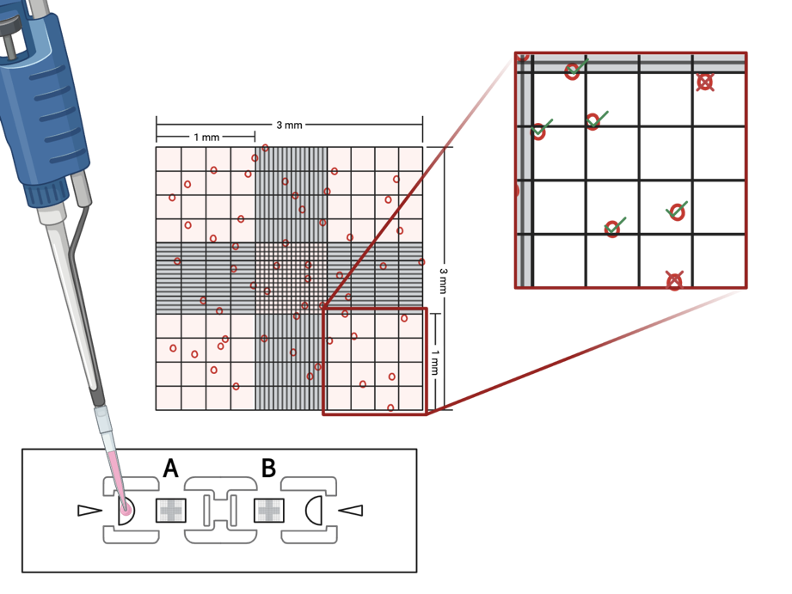
Using a Hemocytometer: A hemocytometer is used to calculate the number of cells growing in a culture so that you can transfer a desired cell density into a new culture flask or experiment. As shown in Figure 4-1, a hemocytometer has two separate sample introduction points, each of which enters a separate counting chamber. The counting chambers are covered by a glass cover slide spaced 0.1 mm above the chamber bottom. You will inject 10 μL of cells suspended in medium through one of the sample induction points into a counting chamber.
Figure 4-1 Illustration of counting cells using a hemocytometer
There is a grid inside each counting chamber like the grid shown in Figure 4-1. The grid is divided into several smaller boxes. You will count your cells using the 5 boxes in the top left, top right, center, bottom left, and bottom right. These boxes are each 1mm² - one box is magnified for you. You will count the number of cells present within each lettered square. Include cells touching the gridlines along the top and left border but omit cells touching the gridlines along the bottom and right border (as shown).

Question 1:
Count the number of cells in the hemocytometer grids shown in the image below:
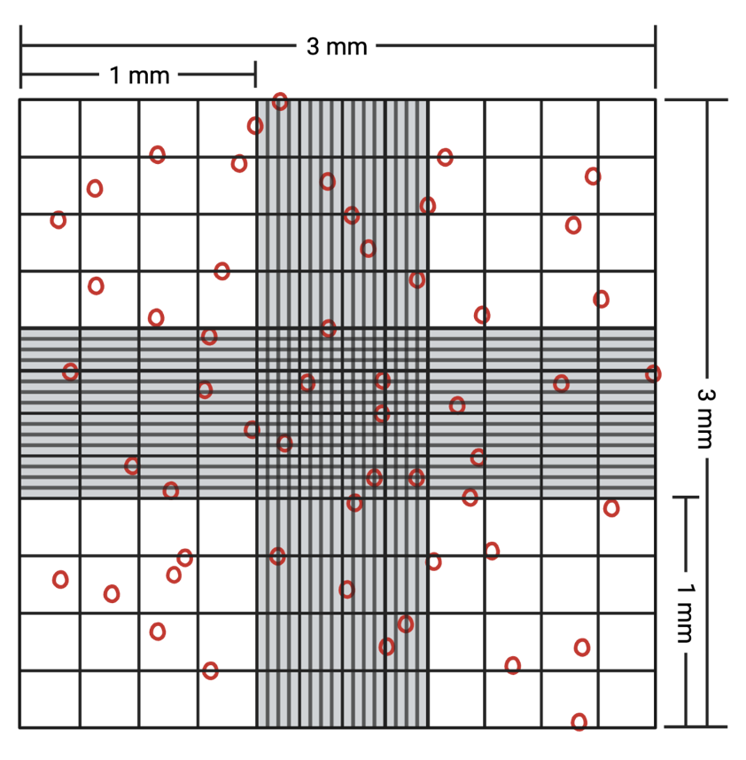
Show your work here:
Please upload a copy of this page to your canvas quiz to show your work.
Number of cells

Question 2:
Using the number of cells you calculated above, determine the cell density (number of cells per milliliter) in your sample.
Hint: You will need to calculate the total volume contained within the five red squares. Remember, 1 cm³ = 1 mL
Show your work here:

Cell Density (cells / ml)

Question 3:
Given your calculated cell density, how many milliliters of medium should you use to resuspend your solution so that you have 1.0 x 10⁴ cells/mL?
For this calculation you will use Equation 2-1 the C1*V1= C2*V2 method covered in Module 2 page 2:10
C1 = concentration of provided solution [answer to Question 2]
V1 = volume of provided solution [4 ml see step 1.13 in your procedure]
C2 = desired concentration [4.0 x 10³ cells/mL]
V2 = volume for resuspension [unknown]
Show your work here:
Please upload a copy of this page to your canvas quiz to show your work.
Resuspension Volume (ml)

Question 4:
Review the next section of your lab book at the procedure for your aseptic technique and cell passaging lab.
What is the independent variable being investigated in this experiment.

Question 5:
Review the next section of your lab book at the procedure for your aseptic technique and cell passaging lab.
One possible dependent variable we could measure for our experiment is cell confluence. Based on your experience in ImageJ and the knowledge gained from your videos from this prelab, how could we quantify cell confluence.

Module 4 Lab Procedure

Introduction:
Passaging of cells is used to expand cells (give them more area to grow so that they can multiply) and to replate cells in different dishes to be used in experiments. Different cell types require different rates of passaging and cell density to thrive. Some cell types proliferate quickly while other more slowly.
Typically, 3T3 fibroblasts, the cells you will be using in your experiments, are grown on a dish until ~80% confluence. Confluence is an estimate of the area covered by adherent cells on the cell culture surface. If cells are at 100% confluence, that means there the dish is completely covered with cells in a monolayer. 100% confluence tends to be too crowded for most cell types and will prevent cells from proliferating further. For this reason, it is important to carefully plan cell density and plating experiments.

Learning Objectives
- Operate a phase contrast microscope to obtain images of cells for qualitative and quantitative analysis
- Use a hemocytometer to quantify cell density
- Use sterile procedures to passage cells

Materials
Equipment | Software | Materials | Misc.
Phase Contrast Microscope | AmScope | T-12 culture flask with NIH 3T3 fibroblast cells | 15 ml centrifuge tubes
48-well plate (sterile, tissue culture treated) | ImageJ | Modified Essentials Medium (MEM) supplemented with 10% Calf Bovine Serum (CBS) and 1% antibiotic-antimycotic (MEM+10% CBS+1% anti-anti) | Sterile Serological pipettes and micropipettes
C-chip disposable hemocytometer |  | Modified Essentials Medium (MEM) supplemented with 0.5% Calf Bovine Serum (CBS) and 1% antibiotic-antimycotic (MEM+0.5% CBS+1% anti-anti) | Kimwipes
 |  | 0.05% trypsin with ethylenediaminetetraacetic acid (EDTA)
 |  | Sterile Phosphate buffered saline (PBS)

Important Terms
BSC
Media/Medium
PBS
Trypsin
Incubator
Adhere
Aspirate
Centrifuge
Seed
Pellet
Live Dead Assay
Confluence

Safety
- You need to protect your skin and eyes from several chemicals today. Wear goggles, gloves, closed toe shoes and a lab coat.
- Dispose of anything disposable exposed to the cells/protein in the biohazard box.
- Clean any glassware exposed to the cells/protein with bleach before cleaning detergent
- Use 70% ethanol to disinfect all surfaces after your experiments
- Keep all cells and related solutions sterile and inside the biosafety cabinet using aseptic technique

Hypothesis
Today we will start a two week experiment where we will measure and compare viability, for cells seeded in 10% MEM and 0.5% MEM.
What is your Hypothesis for this experiment.
Independent Variable(s):
Dependent Variable(s):
Control Variable(s):
Hypothesis:

Demonstration Notes:
Use this space for making notes on your instructor BSC demonstration.

How does your instructor prepare the BSC?
What equipment does your instructor use to aspirate waste in the BSC?
Other notes:

Procedure

Materials Preparation
- Warm Materials
  - Make sure you label (e.g. put your initials on) your groups reagent aliquots
  - Warm your groups’ aliquots of PBS and cell medium in a water bath to 37°C.
  - Let Trypsin warm to room temperature.
Please note down the make and model of the water bath.
- While your reagents are warming:
  - Review the protocol again.
  - Prepare the BSC (wipe down with ethanol and arrange any necessary materials)
Please note down the make and model of the Biosafety Cabinet.
  - Take an image with a phase contrast microscope at 4x magnification to record the cell confluence in the original cell culture vessel.
  - Save pictures on your USB or One Drive for analysis. When naming files, include details of your team, image purpose and magnification e.g. Team1_InitialConfluence_4x.tif
Please note down the name, make, and model of the microscope used.
Please note down the software used to save images from the microscope.
Please keep track of the image filenames below:
Initial Confluence filenames | Calibration filenames
.tif | .tif

Passaging of Cells
- In the BSC, carefully remove old medium from culture flask using a glass pipette and vacuum
- Gently pipette ~2 mL of PBS into the flask. Lightly tilt the flask left and right to wash the entire cell culture surface gently.
- Remove PBS with a glass pipette and vacuum (be careful not to scrape the cells)
- Pipette 1.5 mL of Trypsin into the flask. Start a timer once the trypsin is placed on the cells. To preserve cell life, we need to prevent cell exposure to trypsin solution for longer periods (≥10 min)
- Close flask and place in incubator for 1-5 minutes to allow cells to lift.
Note the make and model of the incubator you used here:
Note the exact incubation time here: [_________] minutes

- Remove flask from incubator and observe under a microscope. If the cells are still adhering to the flask bottom, tap the flask against your palm or edge of the microscope base to dislodge the cells. If the cells are still adhering return the flask to the incubator for a few minutes. Repeat until all the cells are detached. Be careful not to let the Trypsin sit on the cells for more than 10 minutes
- Add 1.5 mL of fresh medium (use 10% CBS medium, which includes serum which will deactivate trypsin) for a total of 3.0 mL of cell suspension
- Divide your 3.0 mL cell suspension into two equal volumes (1.5 mL of each) and put them into two separate 15 mL falcon tubes.
- Centrifuge them at 300 rcf for 5 min.
- After centrifugation, discard medium.
  - Pro tip: Take note of where the pellet is in the tube when removing from the centrifuge, you may mark it with a sharpie.
  - Try not to disturb the cell pellet while removing the supernatant!
  - When removing medium from pelleted cells, do not let aspirator pipette go past the bend of the cone of the falcon tube. Doing so may result in a loss of cells.
- Resuspend the first tube with 4 mL 10% CBS/medium and the second tube with 4 mL of 0.5% CBS/ medium. Do not forget to label your tubes. Make sure your solution is mixed well with cells suspended throughout.
- Pipet 10 µL of the cell solution from each sample into the hemocytometer notch for counting the cells. You can use the A side for your 10% sample and the B side for your 0.5% sample. We do this to confirm the exact concentration of each sample so we can control seeding density for each condition.

The density of cells in your final solution will vary from experiment to experiment and depends on the purpose of the experiment. For the purposes of this lab, we will be doing a Live/Dead assay. Today you will be plating your cells to be used in those experiments later next week. Let’s plan on plating ~2,000 cells per well of a 48-well plate to get something like Figure 4-2.
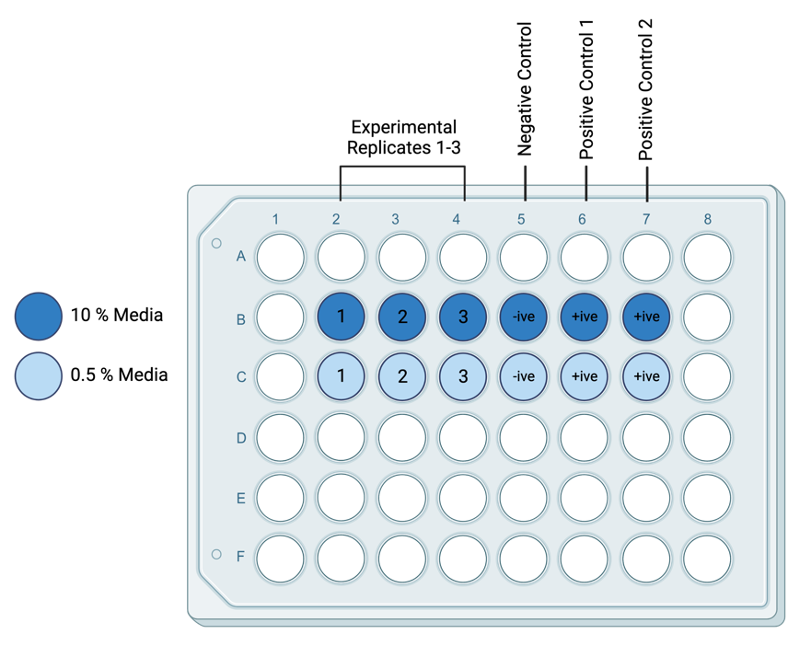
Figure 4-2 Example 48-well plate experimental layout
- For this experiment, you will need to end up with 2.1 mL (300 µL is extra) of each cell suspension at 4,000 cells per mL to plate onto your well plate. (Total number of cells you need is 8,400 cells in 2.1 mL).
- Label two new 15 mL falcon tubes (10% and 0.5%) for seeding the cells.
- Calculate the volume you need to take from your cell solutions (the solutions prepared at step 1.13 above) to get 8,400 cells. Review notes from example calculation at start of class.
- You will dilute the calculated volume from step 1.13 in a new 15 ml tube with the appropriate medium to bring it up to 2.1 ml.
Show your work for these calculations here, include the calculation for cell counting and for calculating the cell suspension calculations:
Cell Counting Calculations | Cell Suspension Calculations
- Pipette 300 µL from your new cell solutions into each well of a new sterile 48 well plate according to your experiment setup (similar to Figure 4-2). You may have some extra cell solution leftover, so you can pipet extra wells as back-up.
Note: make sure that your cell suspension stays well mixed, if you work very slowly, cells will settle to the bottom, so they may need to be periodically remixed by pipetting up and down again.
- Close the well plate lid and label including:
  - Group name
  - Date
  - Cell type
  - Label wells according to experimental setup
- Check the cells in all wells with microscope to make sure you seeded them correctly. Save a selection of images to the folder on the laptop desktop or a USB. When naming files, include details of your team, well location, media concentration and magnification e.g. Team1_A1_10pc_4x.tif
Please keep track of the image filenames below:
10% Media filenames | 0.5% Media filenames | Calibration filenames
.tif | .tif | .tif
.tif | .tif | .tif
.tif | .tif | .tif

- Insert a sample image that you collected from one well of your choice here:
Insert Image here >>
Insert Caption here >> | .tif

- Place the well plate in the incubator until the next lab day.
- Ask your instructor about proper clean up and disposal protocols for all your equipment and materials
- Clean up and return any extra reagents to their appropriate storage location. Wipe down the BSC with 70% ethanol.
- You may keep leftover PBS, cell medium, and trypsin. Label it with initials and store in the fridge in the rack for your section.

Module 4 Post Lab Questions
Please answer each of the following questions and upload to your assignment dropbox on Canvas.

Question 1a
From the images of cells collected from the initial flask (Step 1.2), provide a quantitative estimate of the confluence using ImageJ.

Question 1b
Explain the step-by-step details of how you calculated this confluence

Question 1c
Explain one limitation of the method you chose to use to calculate confluence. What alternative method could you use to overcome that limitation

Module 4 Post Lab Activity

Post-Lab Checklist:
Document and submit completed procedure and post lab questions (Upload completed procedure page 4:1-4:7)
Complete Introduction Writing Assignment (Individual Assignment – details below)

Introduction Writing Assignment:
This week you will work individually to prepare an introduction for the experiment you started this week in Module 4.
Scientific paper introductions typically have 3-4 main sections; (1) General Background, (2) Specific Information (3) The gap in previous research, the novelty or importance of the current experiment (4) A clear statement of your research questions or hypothesis.

Please write all parts for this week’s lab.

Is there a special format for my report?
Yes, there is a lab report template which is required. Your submission will be returned and receive late penalty deductions if you fail to use the template. You can access the template for your introduction submission here or on your canvas page.
When citating relevant sources in your lab reports, you will need to use IEEE citation style. IEEE in-text citations consist of numbers provided in square brackets, which correspond to the appropriate sources in the reference list at the end of the paper. Please review the IEEE Reference Guide on their website.

How do I get an A grade?
To get an A grade your paper will need to meet most of the “Excellent” criteria in your rubric. There is an A standard abstract available for you to review on Canvas.
Please review your rubric provided below as you prepare your lab report introduction.

Can I get feedback on my paper before submission?
Yes! Please come to office hours, your instructional team would be delighted to answer specific questions and once you have completed your paper and paper self-assessment.

Introduction Rubric:
RUBRIC | Missing | Poor | Developing | Average | Adequate |  | Excellent
[1] General Background | Not provided | Briefly Mentioned | Vague, background not relevant or inaccurate statements on the topic | Gives a general summary of the purpose of the experiment. Doesn’t link background information to experiment. May provide one reference. | Concise introduction, appropriate length. Clearly links background information to experiment. Provides one reference. |  | Concise with relevant information pertinent to planned experiment. Real world uses stated. Provides 2-3 references of relevant studies.
[2] Specific Information | Not provided | Briefly Mentioned | May not define all terms from hypothesis or may not be put into context | Correctly stated in context, terms from hypothesis may be incorrectly defined; some variables not explained fully | Clear statement describing variables, assumptions, and relationships of the independent/ dependent variables of your hypothesis, but not explained; may be missing typical values from literature |  | Description of dependent and independent variables for hypothesis, assumptions and relationships clearly stated and explained; connections made to experiments that were tested, providing typical values from literature
[3] The novelty or importance of the experiment | Not provided | Problem not stated clearly. Justification is entirely personal and largely incoherent. | Irrelevant problem is stated. Justification is offered but largely personal and rambling. | Problem stated broadly. Justification is offered but is not sufficiently grounded in theory or literature. | Problem stated with clarity and specificity. Comprehensive background is articulated. Justification is clear and cognizant of previous research in the field. |  | Problem stated with high degree of clarity and specificity. Comprehensive background is articulated with brevity. Justification is sharp, logical, and extremely well informed. Draws specific connection to what is already known and the importance of the study.
[4] Research Questions or Hypothesis | Not provided | Briefly Mentioned or not logical | Too little/too much or unnecessary info, does not flow well into the rest of the report; not logical or not measurable hypothesis | States specific goals of experiment, may not connect back to background info provided in the introduction or explain why the experiments are performed | Clearly stated, with connections drawn to background info, with summary of what experiments will be done and why; measurable hypothesis related to experimental design. |  | Clearly stated with relationship to background info, clear hypothesis stated, summary of what experiments will be done and why, flows well with intro and prepares reader well for the rest of the paper; hypothesis is measurable, worthwhile, and directly tested by experimental design
Grammar, Spelling and Formatting | Clearly not proofread, inappropriate report length | Several errors, text in figures too small |  | A few errors, major sections labeled with headings, appropriate report length |  | Less than 2 errors, headings and sub- headings used | Correct grammar and spelling, legible text, headings, and sub-headings used
References | No references cited | No relevant references cited. references not cited in a consistent format; some references might be from Wikipedia |  | At least one relevant reference cited. Several missing citations supporting claims. |  | At least two relevant references cited. | Two or more relevant references cited appropriately. All statements requiring citation are cited using IEEE style.

Live/Dead Assay

Pre Lab-Review

Pre-Lab Checklist:
Read: Sanfilippo et al., 2011 “Viability assessment of fresh and frozen/thawed isolated human follicles: reliability of two methods (Trypan blue and Calcein AM/ethidium homodimer-1).”Sanfilippo, S, Canis, M, Ouchchane, L, Botchorishvili, R, Artonne, C, Janny, L, & Brugnon, F. “Viability assessment of fresh and frozen/thawed isolated human follicles: reliability of two methods (Trypan blue and Calcein AM/ethidium homodimer-1).” J Assist Reprod Genet., Vol. 28, no. 12, pp. 1151-6, 2011, https://doi.org/10.1007/s10815-011-9649-y
Submit Pre-Lab 4 (Complete Quiz on Canvas)

Pre-Lab 5: Live/Dead Assay
This pre-lab will be available on Canvas as a quiz with unlimited attempts and no time limit. Please use the space below to review and work on your questions before opening the quiz.

1. Quantities of Reagents:

Total Solution Volume:
For each well that you plan to stain (i.e., the experimental wells and both positive control wells, refer to your notes in your lab notebook from Module 4), in your 48 well plate, you will need to make at least 150 µL of Live/Dead Solution. What is the minimum amount of total solution (Vtotal) you should make (include 10% overage)?
What is the minimum amount of total solution (Vtotal)? [______] μL
Show your work here:

Reagent Volumes:
Assume you will prepare 2 mL of the Live/Dead solution with the following dye stocks: 4.0 mM calcein AM and 2.0 mM Ethidium homodimer-III (EthD-III).
In order to prepare V_{total}= 2 mL, how much (µL) of the stock calcein AM will you need for a final 2.0 µM concentration of calcein AM?
What volume of stock calcein AM do you need? [______] μL
In order to prepare V_{total}= 2 mL, how much (µL) of the stock EthD-III dye solution will you need for a 4.0 µM concentration of EthD-III?
What volume of stock EthD-III dye solution do you need? [______] μL
In order to prepare V_{total}= 2 mL, how much PBS will you need to add to your dye solution to have a final solution total of 2 mL?
What volume of PBS do you need? [______] μL
Is it practical to measure this volume in the lab? What (if any) adjustments would you make?

Show your work for all reagent calculations here:

2. Theoretical Understanding:
Read Sanfilippo et al., 2011 as noted in pre lab checklist and answer the following questions:

Question 2a
What is the purpose of the PBSTT in the procedure?

Question 2b
Describe the differences between how calcein and Ethidium homodimer III enter cells.

Question 2c
Describe how calcein AM (a non-fluorescent substrate) is able to provide a fluorescent signal in living cells.

Question 2d
Describe how EthD-III provides a fluorescent signal in dead cells.

Module 5 Lab Procedure

Introduction:
The Live/Dead assay provides green/red fluorescent staining of viable and dead cells, respectively, using probes for intracellular esterase activity in viable cells, and compromised plasma membrane integrity in dead cells.
Calcein AM is a membrane-permeable, non-fluorescent esterase substrate, which enters the cytoplasm and is cleaved by esterases in live cells to yield the green fluorescent dye calcein. Fluorescent calcein is negatively charged and cell membrane-impermeable, and consequently is retained in the cytoplasm of viable cells with intact plasma membranes. Dead cells either do not stain with calcein due to lack of esterase activity or fail to retain calcein in the cytoplasm due to compromised plasma membrane integrity.
Ethidium homodimer III (EthD-III) is a plasma membrane-impermeable DNA dye that is excluded by viable cells. EthD-III is virtually non-fluorescent until it binds DNA, upon which it undergoes a 25-fold enhancement of fluorescence. EthD-III penetrates dead cells with compromised plasma membranes and stains the nucleus with bright red fluorescence.

Learning Objectives
- Operate a fluorescence microscope to obtain images of cells for quantitative analysis
- Utilize positive and negative controls to determine the validity of your experiment.
- Quantify cell viability using a live-dead assay

Materials
Equipment | Software | Materials | Misc.
Phase Contrast Microscope | AmScope | 48-well plate with NIH 3T3 fibroblast cells | Absorbent pad
Fluorescence Microscope | ImageJ | Phosphate buffered saline (PBS) (non-sterile is ok) | Foil
 |  | 4 mM Calcein AM dye stock (green) | Kimwipes
 |  | 2 mM Ethidium homodimer-III dye stock (red) | 2 ml centrifuge tubes
 |  | Permeabilization buffer (PBSTT)

Important Terms
Vortex
Cell Count
Cell Viability
Live Dead Ratio
PBS-TT
Positive Control
Negative Control
Labelled Cell

Safety:
- You need to protect your skin and eyes from several chemicals today. Wear goggles, gloves, closed toe shoes and a lab coat.
- Dispose of anything disposable exposed to the cells/protein in the biohazard box.
- Clean any glassware exposed to the cells/protein with bleach before cleaning detergent
- Use 70% ethanol to disinfect all surfaces after your experiments

Notes:
- Reagents are light sensitive. When storing or preparing avoid exposure to light.
- Keep fully prepared wells in the dark until you are ready to image.

Hypothesis
Today we will finish a two week experiment where we will measure and compare viability, for cells seeded in 10% MEM and 0.5% MEM.
What is your Hypothesis for this experiment.
Independent Variable(s):
Dependent Variable(s):
Control Variable(s):
Positive Control Condition(s):
Negative Control Condition:
Hypothesis:

Procedure:
- Warm PBS in waterbath at 37°C. Non-sterile PBS is preferred since the cells will be terminated at the end of this assay.
- Allow the dye stocks to warm to room temperature but keep protected from light.
  - After the stocks thaw, they need to be mixed. Make sure this has happened before you prepare your solutions.
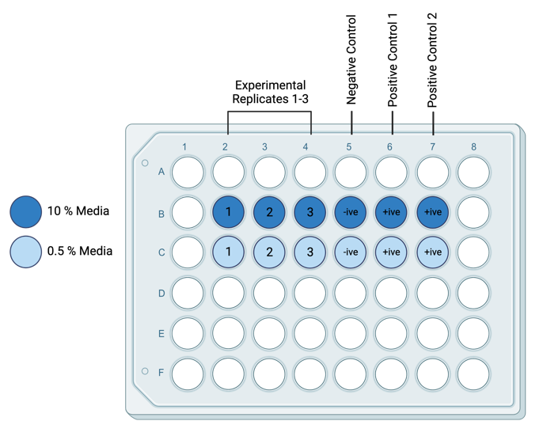
- Remove the medium from only two wells and add 200 uL of cell permeabilization buffer (PBSTT) to these wells.
  - This will serve as a positive control for dead staining. This will be Positive Control 1 (See Figure 4-2)
  - Leave on for at least 1 minute while your lab mate prepares the live/dead solution.
- Prepare Live/Dead assay reagents according to your example pre-lab calculations
  - The staining solution should be prepared to yield a 2 µM calcein AM/4 µM EthD-III concentration in PBS.
  - Vortex to ensure thorough mixing.
Figure 4-2 Example 48-well plate experimental layout
- Carefully remove old media and permeabilization buffer (PBSTT) from all wells of the well plate using a micropipette OR a glass pipette and vacuum. This does not have to be done inside of the BSC.
- Gently pipet ~0.3 mL of pre-warmed PBS into each well to wash off any residual liquid. Lightly tilt the dish to wash.
- Remove PBS with micropipette OR a glass pipette and vacuum.
  - Do not let your cells dry out!
- Pipette reagents into wells as follows:
  - Add 150 µL of the combined Live/Dead assay reagents to each experimental well
  - Add 150 µL of the combined Live/Dead assay reagents to the Positive Control 1 well.
  - Add 150 µL of the instructor prepared EthD-III assay only reagents to the Positive Control 2 well.
- Incubate the cells for ~15 minutes at 37°C.
- Remove the Live/Dead solution by aspiration.
- Add ~0.3 mL of PBS to each well to prevent them from drying out while imaging

- View the labeled cells under the fluorescence microscope
- Capture at least three images per experimental well. Save images to the folder on the laptop desktop or a USB. When naming files, include details of your team, well location, media concentration and magnification e.g. Team1_A1_10pc_4x.tif
Please keep track of the image filenames below:
10% Media filenames | 0.5% Media filenames | Calibration filenames
.tif | .tif | .tif
.tif | .tif | .tif
.tif | .tif | .tif
.tif | .tif | .tif
.tif | .tif | .tif
.tif | .tif | .tif
.tif | .tif | .tif
.tif | .tif | .tif
.tif | .tif | .tif

- Count the number of cells that appear red vs green and report your findings in Table 5-1
Table 5-1. Live (L) and Dead (D) cell count data for the 10% and 0.5% Media conditions are reported for the three experimental wells, and averaged.
 | 10% Media |  |  |  |  |  | 0.5% Media |  |  |  |  |  | Negative Control |  |  |  | Positive Control 1 |  |  |  | Positive Control 1
 | Well 1 |  | Well 2 |  | Well 3 |  | Well 1 |  | Well 2 |  | Well 3 |  | 10 % |  | 0.5 % |  | 10 % |  | 0.5 % |  | 10 % |  | 0.5 %
 | L | D | L | D | L | D | L | D | L | D | L | D | L | D | L | D | L | D | L | D | L | D | L | D
Image 1
Image 2
Image 3
Average

How to manually count the live and dead cells in Image J or Fiji :
  - Open the image you want to count
  - Select Plugins è Analyze è Cell Counter (or PlugInsè Cell counter)
  - Click Initialize
  - Click one of the type under counters sections like Type 1
  - Click directly on a cell you wish to count, and repeat until all cells of that type are counted
  - Click the next counters sections like Type 2
  - Click directly on a cell you wish to count, and repeat until all cells of that type are counted

How to automatically count the live and dead cells in Image J or Fiji :
  - Open the image you want to count
  - Split the image into its color channels (Red | Green | Blue).
    - Select Image è Color è Split Channels
    - Discard the blue channel
    - Channels will be analyzed separately for live (green) and dead (red) cells.
  - Convert both the red and green channels to 8-bit if required.
    - Select Image è Type è 8-bit
  - Work separately on each channel to find the image maxima.
    - Select Process è Find Maxima
    - Select the “Point Selection” output type
    - Check the box for “Preview point selection”
    - Adjust the “Prominence” values by increments of 5-10 until the background staining is excluded
    - The number of points will be the number of cells positive for the stain of interest.

- Convert the average live and dead cell counts from Table 5-1 into viability data using Equation 5-1 and report in Table 5-2.
Equation 5-1 Cell Viability Calculation
$$\frac{Live Cell Count}{(Live Cell Count +Dead Cell Count}×100$$

Table 5-2. Cell Viability data for each experimental well of the 10% and 0.5% Media conditions are reported along with their average and standard deviation. Cell Viability is also presented for each control well.
 | 10% Media |  |  | 0.5% Media |  |  | Negative Control |  | Positive Control 1 |  | Positive Control 2
 | Well 1 | Well 2 | Well 3 | Well 1 | Well 2 | Well 3 | 10% | 0.5% | 10% | 0.5% | 10% | 0.5%
Cell Viability
Average
St. Deviation

Module 5 Post Lab Questions

Question 1 [Results]
Please prepare a graphical figure to show your results. This Figure should allow the reader to determine if the experimental conditions significantly affected the ratio of living to dead cells? You will need to use some statistics to understand the difference between two conditions and show the results of this statistical analysis in your figure.
Insert Image here >>
Insert Caption here >>

Question 2 [Discussion i]
When writing a lab report discussion, you need to identify if your hypothesis was supported. Did your results match your predictions that you made in the pre-lab? Why or why not?

Question 3 [Discussion ii]
When reviewing the experimental results, you need to ensure the validity of your experiment. Please discuss the validity of your experiment by reviewing your positive and negative control results.

Question 3 [Discussion iii]
When writing a lab report discussion, you need to integrate limitations. Please describe at least 2 limitations to this live-dead assay. Do not describe what can go wrong with the assay, but rather the limitation of the method to assess viability. Can you think of an alternative method that would address these limitations?

Module 5 Post Lab Activity

Post-Lab Checklist:
Document and submit completed procedure and post lab questions (Upload completed procedure page 5:1-5:6)
Complete Methods Writing Assignment (Individual Assignment – details below)

Methods Writing Assignment:
This week you will work individually to prepare a methods section for the two week experiment you started last week in Module 4 and completed this week in Module 5.
Scientific papers always include a methods section. Methods sections typically include several sections ; (1) Experimental Design, (2) Experimental set-up (3) Measurements and analysis.

Please write all parts for this week’s lab.

Is there a special format for our lab reports?
Yes, there is a lab report template which is required. Your submission will be returned and receive late penalty deductions if you fail to use the template. You can access the template for your methods section submission here or on your canvas page.
When citating relevant sources in your lab reports, you will need to use IEEE citation style. IEEE in-text citations consist of numbers provided in square brackets, which correspond to the appropriate sources in the reference list at the end of the paper. Please review the IEEE Reference Guide on their website.

How do I get an A grade?
To get an A grade your paper will need to meet most of the “Excellent” criteria in your rubric. There is an A standard abstract available for you to review on Canvas.
Please review your rubric provided below as you prepare your lab report methods section.

Can I get feedback on my paper before submission?
Yes! Please come to office hours, your instructional team would be delighted to answer specific questions and once you have completed your paper and paper self-assessment.

Methods Section Rubric:
Should be written in third person past tense.
RUBRIC | Missing |  | Poor | Developing |  | Average | Adequate | Excellent
[1] Experimental design | Not provided |  | Briefly mentioned, unclear. | States the experimental parameters used, but little or no explanation of why they were chosen. Most participant or specimen demographics are missing. |  | Appropriate design but may not have attempted to collect appropriate data for full assessment of hypothesis. Most participant or specimen demographics are detailed clearly. | Describes how/why experimental parameters were selected, may be missing appropriate controls. All participant or specimen demographics are detailed clearly. | Provides clear and concise reasoning for how/why experimental parameters were selected; Appropriate controls included. All participant or specimen demographics are detailed clearly and concisely
[2] Experimental Setup | Not provided |  | Briefly mentioned, no details | Too vague, may not say how many trials performed. Most data collection tools are missing |  | Basic summary of how experiments were performed, may omit some specific details, includes number of trials. Most data collection tools are identified. | Summarizes all details for creating experimental conditions, including description of all independent variables used and number of trials. All data collection tools are identified. | All key details for creating experimental conditions clearly and concisely included such that a skilled researcher could replicate the experiment, includes a diagram or table summarizing experimental conditions if necessary. All data collection tools are identified. Manufacturer details and software versions are specified correctly.
[3] Measurement & Analysis | Not provided |  | May be incorrect or only briefly mentioned | Data analysis procedures are described. Most required elements are missing. Incorrect explanation, missing info, experiment never repeated |  | Data analysis procedures are described clearly. Most required elements are included. Simply states statistics tests used; experiments repeated at least twice | Data analysis procedures are described clearly. Most required elements are included. States how/why statistics were chosen; experiments repeated appropriately. | Data analysis procedures are described clearly and succinctly. All required elements are included [key steps of data processing, calculation of variables]. States how/why statistics were chosen; experiments repeated appropriately.
Grammar, Spelling and Formatting | Clearly not proofread, inappropriate report length | Several errors, text in figures too small |  |  | A few errors, major sections labeled with headings, appropriate report length |  | Less than 2 errors, headings and sub- headings used |  | Correct grammar and spelling, legible text, headings, and sub-headings used
References | No references cited | No relevant references cited. references not cited in a consistent format; some references might be from Wikipedia |  |  | At least one relevant reference cited. Several missing citations supporting claims. |  | At least two relevant references cited. |  | Two or more relevant references cited appropriately. All statements requiring citation are cited using IEEE style.

Primary Cell Isolation

Pre Lab-Review

Pre-Lab Checklist:
Review Cell Counting Procedure from Module 4
Review Live Dead Procedure from Module 5
Submit Pre-Lab 6 (Complete Quiz on Canvas)

Pre-Lab 6: Primary Cell Isolation
This pre-lab will be available on Canvas as a quiz with unlimited attempts and no time limit. Please use the space below to review and work on your questions before opening the quiz.
Read through the cell isolation procedure carefully. You will have to read the procedure to answer the questions below correctly.
To finish the lab on time, all group members should be familiar with the procedure and comfortable with both Live/Dead and cell counting procedures. Review your notes about live/dead and cell counting to refresh your memory.

Question 1:
If you have 0.45 g of cartilage (wet weight), what volume of collagenase solution should you make, if you need 6.0 mL for every gram of cartilage to be digested and include 25% overage?
What volume of collagenase do you need? [______] mL
Show your work here:

Question 2:
You have suspended your cell pellet in 1.0 mL of medium. Using the hemocyotometer, you have counted 205 cells in 5 of the boxes. You plan to seed your cells into wells of a 48-well plate, which has wells with an area of 0.95 cm².
How many wells do you have enough cells for? [______] wells
Show your work here:

What volume of your cell suspension, should you add to each well of your 48-well plate? [______] μL
Show your work here:

Module 6 Lab Procedure

Introduction:
This experiment involves enzymatically digesting cartilage to release chondrocytes from their surrounding ECM. Specifically, cartilage is minced into small pieces and digested with collagenase for ~1 hour. Large pieces of undigested tissue are then separated from the isolated cells using a strainer and a monolayer culture is established with the freshly isolated chondrocytes. While the cartilage is being digested, the viability of cells within a sample of intact cartilage can be observed using a Live/Dead assay and fluorescence microscope.

Learning Objectives
- Operate a fluorescence microscope to obtain images of cells for qualitative analysis
- Quantify cell viability of cartilage using a live-dead assay
- Isolate and seed chondrocyte cells from fresh articular cartilage

Materials
Equipment | Software | Materials | Misc.
Phase Contrast Microscope | AmScope | Fresh articular cartilage (~0.5 g wet weight) | Absorbent pad
Fluorescence Microscope | ImageJ | Serum -free chondrocyte medium (+anti-anti + L-proline) | Foil
Cell strainer (40 μm mesh) |  | Chondrocyte medium (10% CBS +anti-anti + L-proline) | Sterile 50 ml tube
Sterile stir bar |  | 0.60 % Collagenase solution (4 ml) | 100 mm petri dish
Sterile scalpel + blade |  | 1x Phosphate buffered saline (PBS) (with Ca2+ and Mg2+)
Sterile spatula + forceps |  | 4 mM Calcein AM dye stock
48-well plate (sterile, tissue culture treated) |  | 2 mM Ethidium homodimer-III dye stock
48-well plate (sterile, tissue culture treated) |  | Phosphate buffered saline (PBS) (non-sterile)
 |  | 70% Ethanol (EtOH)

Important Terms
ECM
Chondrocytes
Collagenase
Monolayer culture
Isolation
Aliquot
Serum-free
Sterile

Safety:
- You need to protect your skin and eyes from several chemicals today. Wear goggles, gloves, closed toe shoes and a lab coat.
- Dispose of anything disposable exposed to the cells/protein in the biohazard box.
- Clean any glassware exposed to the cells/protein with bleach before cleaning detergent
- Use 70% ethanol to disinfect all surfaces after your experiments

Notes:
- Reagents are light sensitive. When storing or preparing avoid exposure to light.
- Keep fully prepared wells in the dark until you are ready to image.

Hypothesis
Today we will start a two-week experiment where we will prepare chondrocyte cells for proliferation and measure and compare the cells doubling time against, expected values in the literature.
What is your Hypothesis for this experiment.
Theoretical Assumption being tested:
Dependent Variable(s):
Control Variable(s):
Positive Control Condition(s):
Negative Control Condition:
Hypothesis:

1. Steps completed in advance by your instructors:

Prepare 0.60 % collagenase solution [Already completed by your instructor]
- In a clean 30 mL beaker, weigh out the appropriate amount of collagenase needed to make a 0.60% solution
- Within the BSC, dissolve the collagenase in serum-free chondrocyte media. Mix up and down to dissolve.
- Sterilize the collagenase solution by passing it through a 0.2 μm syringe filter. Collect the filtrate in a sterile 15 ml tube as demonstrated in the pre-lab video.
- Cap the tube and place it in the incubator or 37°C water bath to warm the collagenase solution.

Determine wet weight of the cartilage to be digested [Already completed by your instructor]
- Measure and record the mass of an empty, sterile 50 ml centrifuge tube.
- In the BSC, pour the contents of the 15 ml tube with cartilage into to the sterile 50 ml tube to be digested.
- Using a sterile spatula, transfer two cartilage fragments into a 48 well plate. Close and place this well plate aside to be used later to assess cell viability within the tissue.
- Gently aspirate the liquid surrounding the cartilage from the 50 ml tube, leaving just enough to hydrate the tissue.
- Cover the 50 ml tube and re-weigh it to determine the tissue’s wet weight.
- You will only have 4 ml of available collagenase solution therefore if your wet weight is >0.5 g please discard some cartilage to ensure your wet weight is < 0.5 g
Optional: if there are large chunks (> ~ 3 mm²) of tissue, mince the cartilage:
- Place cartilage in petri dish
- Aspirate off excess media surrounding the cartilage in the petri dish, leaving just enough to maintain tissue hydration.
- Carefully mince the cartilage into fragments, each a few cubic millimeters in volume (like small bacon bits J), using a sterile scalpel and forceps.
- IF YOU HAVE YOUR COLLAGENASE SOLUTION READY, PLEASE SKIP THIS STEP. THIS IS ONLY REQUIRED TO KEEP YOUR CARTILAGE HYDRATED. Rehydrate the tissue with approximately 4 ml of sterile serum-free medium and set the 50ml tube aside in the BSC.

2. Cell Digestion Procedure:
The following protocol is for a relatively high collagenase concentration and short digestion time. For higher cell yield, the procedure could be performed over a much longer period of time by decreasing the collagenase concentration and increasing the digestion time (e.g., 0.018% for 16 h)
- Have one member of your group prepare the biosafety cabinet for use by wiping it down with 70% ethanol and arranging necessary reagents and disposables.
- Meanwhile, have one member of your group sterilize the stir bar, forceps, scalpel handle, and spatula in 70% ethanol
  - This can be done by submerging the utensils in a centrifuge tube with 70% EtOH and then letting them air dry in the BSC in a sterile container, such as a sterile 100 mm petri dish.
    - Push these back toward the back of the BSC, so that they don’t get contaminated by anyone moving things over them.
  - This needs to be done well in advance, so the ethanol has time to evaporate.
- Prepare collagenase solution
  - Retrieve the warm collagenase solution, place it in the BSC,
  - Determine the volume of collagenase solution needed; you need 6.0 mL for every gram of cartilage to be digested (like your pre-lab calculation).
Show your work here:
- Gently aspirate off any remaining liquid surrounding the cartilage.
- Place the appropriate volume of warm collagenase solution into the 50 mL tube onto the cartilage.
- Add a sterile stir bar to the 50 mL tube.
- Cap the 50 mL tube and start a timer. This tissue will be digested in collagenase for 1 hour. Longer incubation times will increase cell yield.
- Your instructors have prepared the magnetic stir plate and placed it on the bottom shelf of the incubator. Place the 50 mL tube on the stir plate and adjust the speed to stir the solution gently.
  - Be sure the door is closed tightly, and the temperature and percentage of CO₂ are stable.
  - Tighten the lid fully (not too tight that you break the seal).
  - Flip the 50 mL tube upside down so that it stands up on the stir plate, make sure all the tissue is submerged in the collagenase solution.

3. Tissue Viability Procedure:
While the tissue is digesting, measure the viability of cells within the reserved cartilage pieces. It is not necessary to keep the fragments sterile since they will be discarded after viability has been assessed.
- For each tissue fragment, mix 2 μL calcein AM, 2 μL EthD-1, and 200 μL non-sterile PBS.
- Cover the plate to protect the samples from light and incubate for 10 min at room temperature.
- Remember: after incubation, the cytoplasm of the live cells will fluoresce green, and the nucleus of dead cells will fluoresce red.
- Check with an instructor to make sure that the fluorescent lamp has been allowed to warm up for about 10 min.
- Remove the stain solution and place 200 μL non-sterile PBS in each well.
- Determine chondrocyte cell viability by estimating the percentage of cells that are alive within a representative region in each cartilage fragment.
  - Is viability lower near cut surfaces? Is the whole fragment stained or would a longer incubation time be beneficial?

  - Capture two representative microscope images of the cartilage. Save images to the folder on the laptop desktop or a USB. When naming files, include details of your team, specimen and magnification e.g. Team1_A1Cartilage_4x.tif
Please keep track of the image filenames below:
Cartilage viability filenames | Calibration filenames
.tif | .tif
.tif | .tif

  - Insert two of the images and the cell count estimates here:
Replace this text with image | Replace this text with image
Estimated Cell Viability: [___] % | Estimated Cell Viability: [___] %
Replace this text with caption | Replace this text with caption

4. Cell Isolation Procedure:
- At the end of the collagenase incubation period, transfer the 50 ml tube from the incubator to the BSC and pass the digested solution through the 40 μm cell strainer into a new sterile 50 mL centrifuge tube. The strainer will remove any large, undigested pieces of cartilage.
  - Drip a few mL of sterile serum free media over the cell strainer to wash any additional cells through and increase yield.
  - Dispose of the cell strainer and any leftover debris.
- Wash the chondrocytes by adding 10 mL of cold sterile PBS to the conical tube.
  - Spin cells down using a centrifuge, at 500 RCF for 3 min.
  - Observe the pellet and discard the supernatant.
- Resuspend the cell pellet in 10.0 mL of 10% CBS chondrocyte media. If your pellet is not visible or very small adjust this resuspension volume to 1 ml and adjust your calculations accordingly.
- Use a hemocytometer to determine the density of cells in the suspension. Show your work for these calculations below, include the calculations for cell counting and for the cell suspension:

Cell Counting Calculations | Cell Suspension Calculations
- Plate the cells in 4 wells of a new 48-well plate (make sure it is for tissue culture, not suspension) at a density of 800 cells/cm² (each well is approximately 1 cm²).
  - Refer to your pre-lab calculations for help.
- Add media to reach a total volume of 0.5 mL in each well of the 48 well-plate.
- Label your well plate with your initials, date, and cell type. Also indicate on the lid which wells contain cells.
- Place your well plate in the incubator until next lab period.

Module 6 Post Lab Questions

Question 1
Calculate the efficiency of the isolation protocol. Assume that the cartilage contained exactly 5.0 x 10⁷ cells per gram wet weight (Kim et al. 1988). Use the percentage viability estimated in the Live/Dead assay and measured wet weight to estimate the number of viable cells originally within the cartilage.

Question 3
During the next lab period you will approximate how many cells you have with a DNA Assay. If chondrocytes have a doubling time of 20.0 hours, how many cells would you expect per well? Make sure to include the method you use to estimate. Are there any limitations to this method?

Reference:
Kim, Y. J., R. L. Sah, J. Y. Doong, and A. J. Grodzinsky. 1988. Fluorometric assay of DNA in cartilage explants using Hoechst 33258. Analytical Biochemistry.174 (1): 168 – 176

Post-Lab Checklist:
Document and submit completed procedure and post lab questions (Upload completed procedure page 6-1-6-6)

dsDNA Quantification Assay

Pre Lab-Review

Pre-Lab Checklist:
Read: Ch 13, Sections 13.11-13.13 from Fundamentals of Biomechanics “Stress & Strain” by Ӧzkaya et al., 2017.
Özkaya, N., Leger, D., Goldsheyder, D., Nordin, M. "Stress & Strain." in Fundamentals of Biomechanics. Switzerland, Springer, 2017. 287-316. https://doi-org.ezproxy.lib.ou.edu/10.1007/978-3-319-44738-4_13
Submit Pre-Lab 7 (Complete Quiz on Canvas)

Pre-Lab 7: dsDNA Quantification Assay
Cell-based tissue-engineering therapies typically require tens of millions or billions of cells per patient. In general, it is not feasible to isolate enough primary cells directly from tissue. To expand the number available, cells are cultured in vivo, in conditions that stimulate cell division.
We will use a simplified growth model to predict the number of cells in culture:
$X=X_{0}e^{μt}$ or $X=X_{0}2^{t/{t_{d}}}$
Where:
X = the number of cells currently in culture
X₀ = initial cell number
μ = growth rate
t_{d} = doubling time
Cell growth in culture can be monitored by plotting the density (or number) of cells versus time in culture. Multiple experimental methods can be used to measure the number of cells in culture at a particular point in time. For example, a DNA assay can provide a quantity of DNA in sample. That quantity of DNA can be related to the number of cells based on a predicted and established amount of DNA per cell.
Using the AccuGreen dsDNA quantitation assay, you can selectively detect as little as 100 pg of dsDNA in the presence of ssDNA, RNA, and free nucleotides. After the cells have been lysed, the AccuGreen solution can be added to the sample and run on a spectrophotometer to gain insight into the number of cells in that given sample. This pre-lab will walk you through setting up the layout of your well plate.
Read through the dsDNA Assay procedure carefully. You will have to read the procedure to answer the questions below correctly.

Question 1 [DNA Standards]:
Complete the table below to prepare a series of 25.0 µL DNA standards from 10.0 ng/µL DNA standard stock solution. You will make each standard in 1.5 mL centrifuge tubes as follows:
Volume of DNA standard used (μL) | Volume TE Buffer (μL) | Standard concentration obtained (ng/µL) | ng DNA per well (using 10 μL samples)
25.00 | 0.00 | 10.00 | 100.00
 |  | 7.00
 |  | 5.00
 |  | 2.00
 |  | 0.50
 |  | 0.00

Show a sample calculation here:

Question 2 [Well plate layout]:
Plan the well-plate layout.
- Each sample/standard should be assayed in duplicate, meaning each of the 6 standards and each of your samples from the last lab should be done in two separate wells each.
- X indicates wells not to be used, the outside wells are typically ignored on the model plate reader used in class, because they may exhibit inconsistent results.
- Identify where you will pipet your “unknowns”. These should also be measured in at least duplicate.
 | 1 | 2 | 3 | 4 | 5 | 6 | 7 | 8 | 9 | 10 | 11 | 12
A | X | X | X | X | X | X | X | X | X | X | X | X
B | X |  |  |  |  |  |  |  |  |  |  | X
C | X |  |  |  |  |  |  |  |  |  |  | X
D | X |  |  |  |  |  |  |  |  |  |  | X
E | X |  |  |  |  |  |  |  |  |  |  | X
F | X |  |  |  |  |  |  |  |  |  |  | X
G | X |  |  |  |  |  |  |  |  |  |  | X
H | X | X | X | X | X | X | X | X | X | X | X | X

Question 3 [Reagent Calculations]:
Answer the following questions to calculate the amount of AccuGreen reagents needed.

You will need 150 µL of total working solution per well of your culture plate. You must do every sample and standard in duplicate, how much working solution do you need? Add 10.% overage.
V_{total}(μL) = [(# of samples + # of standards) * 2 ) * 150 μL]*1.1
What volume of working solution do you need? V_{total}(μL) = [______] μL
Show your work here:

To make your final solution you must mix 200x AccuGreen dye and AccuGreen Buffer solutions at a ratio of 1:200. Given the total volume of working solution (V_{total}), calculated in part (a), how much AccuGreen dye and how much AccuGreen Buffer Solution do you need (µL)?
What volume of AccuGreen dye do you need? [______] μL
What volume of AccuGreen Buffer Solution do you need? [______] μL
Show your work here:

Question 4 [Cell Count & DNA Estimations]:
During the last lab period you approximated your initial cell density. If chondrocytes have a doubling time of 20 hours
How many cells would you expect per well of the culture plate? [______] cells
Show your work here:

Given the estimated 8 μg of DNA per 10⁶ chondrocytes, how much DNA would you expect to measure from each well?
How much DNA would you expect from each well of the culture plate? [______] μg of DNA
Show your work here:

Hypothesis
This week we will finish a two-week experiment where we will quantify cell proliferation, for chondrocyte cells harvested from fresh articular cartilage.

What is your Hypothesis for this experiment.
Theoretical Assumption(s):
Dependent Variable(s):
Control Variable(s):
Positive Control Condition(s):
Negative Control Condition:
Hypothesis:

Module 7 Lab Procedure

Introduction:
AccuGreen assays are based on binding of fluorescent DNA dyes that selectively detect double-stranded DNA over RNA or single-stranded DNA. Using the AccuGreen dsDNA quantitation assay, you can selectively detect as little as 100 pg of dsDNA in the presence of ssDNA, RNA, and free nucleotides. After the cells have been lysed, the AccuGreen solution can be added to the sample and run on a plate reader to gain insight into the number of cells in that given sample.

Learning Objectives
- Quantify dsDNA using an AccuGreen assay

Materials
Equipment | Software | Materials | Misc.
Phase Contrast Microscope | AmScope | Prepared 48-well plate with chondrocyte cells | Absorbent pad
Fluorescence Microscope | ImageJ | 200x AccuGreen dye | Foil
Opaque 96 V bottom well plate | Gen5 | AccuGreen Buffer Solution | Sterile 50 ml tube
 |  | 10 ng/mL DNA standard | 100 mm petri dish
 |  | PBST-T (0.05% Tween + 0.5% Triton-x in PBS) | 1.5 ml centrifuge tubes
 |  |  | Serological pipettes + micropipettes

Important Terms

Safety:
- You need to protect your skin and eyes from several chemicals today. Wear goggles, gloves, closed toe shoes and a lab coat.
- Dispose of anything disposable exposed to the cells/protein in the biohazard box.
- Clean any glassware exposed to the cells/protein with bleach before cleaning detergent
- Use 70% ethanol to disinfect all surfaces after your experiments

Notes:
- AccuGreen is light sensitive. When storing or preparing avoid exposure to light.
- Keep fully prepared well in the dark until you are ready to put the plate in the microplate reader.
- You are working with small volumes, make sure to practice good pipetting skills for the best accuracy.

Hypothesis
This week we will finish a two-week experiment where we will quantify cell proliferation, for chondrocyte cells harvested from fresh articular cartilage.
What is your Hypothesis for this experiment.
Theoretical Assumption(s):
Dependent Variable(s):
Control Variable(s):
Positive Control Condition(s):
Negative Control Condition:
Hypothesis:

Module 7 Procedure

1. Lyse cells
      - Remove the well plate containing your isolated cells from the incubator
      - Look at them under the microscope and note the relative number of cells and confluence.
 | Well 1 | Well 2 | Well 3 | Well 4
Well Location (e.g. A3)
Estimated Confluence

      - Aspirate the media from each well.
      - Add 100 μL of PBSTT permeabilization solution to each well of the plate that contains cells.
        - Let the plate incubate at room temp while you finish preparing DNA reagents.
        - Ensure that the monolayer of cells is covered by the PBSTT solution.
        - Use the pipet tip to scrape the bottom of the well to help detach and lyse cells

2. Prepare DNA Assay Reagents
- Ensure that kit components are warmed to room temperature and are well mixed.
  - If you see any precipitation in the solutions, vortex until dissolved
  - Briefly centrifuge small vials before opening to minimize reagent loss on the cap
- Have one member of your group prepare DNA standards determined from pre-lab and noted below:
Confirm your DNA Standard volumes here:
Volume of DNA standard used (μL) | Volume TE Buffer (μL) | Standard concentration obtained (ng/µL) | ng DNA per well (using 10 μL samples)
25.00 | 0.00 | 10.00 | 100.00
 |  | 7.00
 |  | 5.00
 |  | 2.00
 |  | 0.50
 |  | 0.00

- Meanwhile, have another member of your group prepare the working solution for the DNA assay.
  - Prepare 150 µL plus 10% overage of working solution, per well of the 96 well plate you will use.
    - To determine the number of wells in the 96-well plate, you will need to know the number of samples and the number of standards you will measure. Remember the number of samples (i.e. number of wells plated with chondrocytes) from the previous lab. Review the pre-lab to determine the number of standards. Then account for the fact that you will do all measurements in duplicate. Finally makes sure to add 10% overage.
  - You will need to mix the 200X AccuGreen Dye solution with the AccuGreen Buffer at a ratio of 1:200 (e.g., 1 µL of 200X AccuGreen Dye + 199 µL AccuGreen Buffer = 200 μL working solution).
  - Mix the working solution well.
Confirm your Working Solution volumes here:
Total volume (µL) | 200X AccuGreen Dye (µL) | AccuGreen Buffer (µL)

Prepare 96-well plate for DNA Assay
Confirm your 96 well plate layout here:
 | 1 | 2 | 3 | 4 | 5 | 6 | 7 | 8 | 9 | 10 | 11 | 12
A | X | X | X | X | X | X | X | X | X | X | X | X
B | X |  |  |  |  |  |  |  |  |  |  | X
C | X |  |  |  |  |  |  |  |  |  |  | X
D | X |  |  |  |  |  |  |  |  |  |  | X
E | X |  |  |  |  |  |  |  |  |  |  | X
F | X |  |  |  |  |  |  |  |  |  |  | X
G | X |  |  |  |  |  |  |  |  |  |  | X
H | X | X | X | X | X | X | X | X | X | X | X | X

- Add 10 µL of each dsDNA standard and unknown (cell sample) to its own separate well of an opaque 96-well plate according to the well plate layout above.
  - Don’t forget, you will be testing the samples in duplicate. So, you will need to prepare two separate wells for each DNA standard and each unknown sample
- Pipet 150 µL of working solution into each well of the 96-well plate that contains samples or standards.
- Mix wells by pipetting up and down (be careful to replace micropipette tips in order to minimize cross-contamination).
- Incubate the microplate at room temperature for about 2 minutes before reading on the spectrophotometer.
- Measure fluorescence using a spectrophotometer using the green fluorescent cube.
  - Make sure the Greiner 96 V Bottom dish is selected. Check the “Use Lid” box, and make the “Read Height” 11.00 mm.
  - Note the fluorescent wavelengths used on the spectrophotometer.

- Remember to save your results to the desktop or to a USB drive.

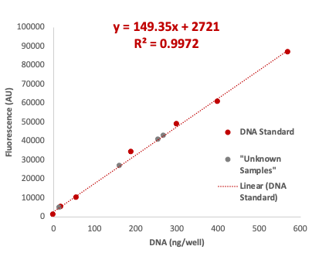
3. Data Analysis
Figure 7-1 Example DNA Standard Curve
- Generate a standard curve to determine the unknown DNA concentration.
  - Plot the fluorescence values for the DNA standards on the y-axis and the ng/μL of DNA on the x-axis.
  - Fit a trend line through these points to generate a standard curve trend line similar to Figure 1.
- Use the equation for the standard curve trend line to calculate the amount of unknown DNA in each well (y = fluorescence and x = ng/μL DNA per well).

Note: the standard curve shown in Figure 1 is for reference only. You must generate your own standard curve using the plate reader results to calculate the amount of DNA in your unknown samples.
Important: be careful and consistent about units on the x-axis: ng vs ng/μL vs ng/well.

- Using statistical analysis determine whether your cell numbers are significantly different from your predicted cell number.

Module 7 Post Lab Questions
This week you will work individually to prepare a results & discussion sections for the two week experiment we just completed, below are some questions to prompt your discussion writing.

Question 1 [Discussion i]
Explain the results of your statistical analysis used to determine whether your cell numbers are significantly different from your predicted cell number. Did your results match your predictions that you made in pre-lab? Why or why not?

Question 2 [Discussion ii]
What are the limitations of the growth model that was used to predict the number of cells? [This may be useful to help explain any differences between your results and your prediction]

Question 3 [Discussion iii]
Describe at least 2 limitations to this DNA assay. Do not list limitations due to human error, but rather the limitations of the experimental methods. Can you think of an alternative method that would address these limitations?

Module 7 Post Lab Activity

Post-Lab Checklist:
Document and submit completed procedure (Upload completed procedure page 7-1-7-6)
Complete Results & Discussion Writing Assignment (Individual Assignment – details below)

Group Results & Discussion Writing Assignment:

Is there a special format for your lab reports?
Yes, there is a lab report template which is required. Your submission will be returned and receive late penalty deductions if you fail to use the template. You can access the template for your results and discussion submission here or on your canvas page.
When citating relevant sources in your lab reports, you will need to use IEEE citation style. IEEE in-text citations consist of numbers provided in square brackets, which correspond to the appropriate sources in the reference list at the end of the paper. Please review the IEEE Reference Guide on their website.

How do I get an A grade?
To get an A grade your paper will need to meet most of the “Excellent” criteria in your rubric. There is an A standard results & discussion section available for you to review on Canvas.
Please review your rubric provided below as you prepare your lab report results & discussion.

What do we include in the results section?
Please follow your rubric but including the key items below is a great start:
- REQUIRED TABLE:
  - Must Include average and standard deviation data for each dependent variable.
  - Must include p-value for comparison of sample sets.
  - Should not include raw replicate data.
- REQUIRED SUPPORTING TEXT:
  - Each Table & Figure that is provided in your results section needs to be mentioned in the main body text of either your results or discussion section.
- OPTIONAL FIGURE:
  - A figure displaying your data would be very useful for visual comparison.

Can I get feedback on my group’s paper before submission?
Yes! Please come to office hours, your instructional team would be delighted to answer specific questions and once you have completed your paper and paper self-assessment.

Results & Discussion Rubric
RUBRIC | Missing | Poor | Developing | Average | Adequate | Excellent
[1a] Data Presentation tables & figures | No data provided | Figures and or tables are not well-designed and have several issues and the choice of data presentation is an inaccurate representation of the data collected and/or data is missing.  Figures and or tables do not use space effectively and would benefit from redesign.  There are several instances of extra information in the figures or tables.  Axes, symbols, legends, etc. are not labeled, have incorrect units, or are missing.  Captions are lacking key pieces of information or experimental details. | Figures and or tables have several issues and the choice of data presentation may not clearly match the hypothesis.  Figures and or tables may not use space effectively and would benefit from redesign.  There are some instances of extra information in the figures or tables.  Axes, symbols, legends, etc. may not be correctly labeled, or have incorrect units, or may be missing.  Captions contain some of the information needed to interpret the figure but are missing more than two minor details. | Figures and or tables adequately show the data and are mostly well-designed with a few minor issues.  There are a few instances of extra information in the figures or tables.  Axes, symbols, legends, etc. are appropriately labeled with correct units with two minor exceptions.  Captions contain most of the information needed to interpret the figure but may be missing one or two minor details. | Figures and or tables adequately show the data and are mostly well-designed.  Figures and or tables mostly use space in effectively.  There may be one or two instances of extra information in the figures or tables.  Axes, symbols, legends, etc. are appropriately labeled with correct units with one minor exception.  Captions contain the appropriate details for the data presented. | Figures and or tables are well-designed and are the best representation of the data.  Figures and or tables use space in the report effectively  There is no extra information, titles, coloring, gridlines, or other features in the figures. Tables are concise and do not include extra information such as raw trial data, or t-values.  All axes, symbols, legends, etc. are appropriately labeled with correct units.  Captions are clear and concise and contain the appropriate details for the data presented.
[1b] Data Presentation text |  | None of the figures, diagrams, and tables are referred to in text. | Some of the figures, diagrams, and tables are not referred to in text. | Most figures, diagrams, and tables are referred to in the body of the report text. | All figures, diagrams, and tables are referred to in the body of the report text. | All figures, diagrams, and tables are referred to succinctly in the body of the report text.
[2] Data Validity | No data provided | Data analysis is incorrect and/or incomplete. | Data analysis is mostly inaccurate with several minor errors. | Data analysis is mostly accurate with two minor errors. | Data analysis is mostly accurate with one minor errors. | Data analysis is accurate and complete.  Data matches the hypothesis presenting the average and standard deviation for each dependent variable across each level of the independent variable. Correct and precise P values for each comparison are also included.
[1]  Discusses results | No data provided | Discussion of data is vague or not present  . | Not all data is discussed | Discussion of results is somewhat related to the goals from the introduction | Discusses results in the context of the experimental procedure and experimental goals | Discusses results in the context of the experimental procedure and experimental goals, explains limitations of methods used  .
[2]  Discusses statistics | No data provided | Discussion of statistics is vague or not present | Incorrect statistical tools used or incorrect statistical interpretation | Correct statistical tools used, limited discussion of statistical meaning | Correct statistical tools used, discussion of statistical meaning of data | Correct statistical tools used, discussion of statistical meaning of data, presents suggestions for improvement of statistical methods
[3] Organization | - | Incomplete | No logical order to the discussion points | Organizational mistakes impact overall understanding of discussion | Some organizational mistakes, such starting a discussion point then finishing the discussion point at later in the report | Discussion follows logical order
Grammar, Spelling and Formatting | Clearly not proofread, inappropriate report length |  | Several errors, text in figures too small | A few errors, major sections labeled with headings, appropriate report length | Less than 2 errors, headings and sub- headings used | Correct grammar and spelling, legible text, headings, and sub-headings used
References | No references cited |  | No relevant references cited. references not cited in a consistent format; some references might be from Wikipedia | At least one relevant reference cited. Several missing citations supporting claims. | At least two relevant references cited. | Two or more relevant references cited appropriately. All statements requiring citation are cited using IEEE style.

