UNIVERSITY OF OKLAHOMA
GRADUATE COLLEGE

THE BRANDING OF THE UNIVERSITY OF OKLAHOMA

A THESIS
SUBMITTED TO THE GRADUATE FACULTY
In partial fulfillment of the requirements for the
Degree of
MASTER OF ARTS

By
CHARLOTTE RENAE STUTZ
Norman, Oklahoma
2021
THE BRANDING OF THE UNIVERSITY OF OKLAHOMA

A THESIS APPROVED FOR THE DEPARTMENT OF HISTORY

BY THE COMMITTEE CONSISTING OF

Dr. Ben Keppel, Chair
Dr. Raphael Folsom
Dr. Anne F. Hyde

© Copyright by CHARLOTTE RENAE STUTZ 2021
All Rights Reserved.

Abstract:
My thesis focuses on the process of branding the University of Oklahoma between 1890 and 1930. I examine the origins of the administrative brand, the shift after Oklahoma statehood, the impact of World War One and the brand students crafted for themselves. This is a study of the University of Oklahoma using the analytical lenses of modern democratic capitalism, cultural influences and the process of branding. I explore what the brand seeks to represent and the interpretations of its audience during these years.

Contents

Acknowledgments vi

Introduction/Chapter 1 Preparatory School or University? 1890-1892 1/4

Chapter 2 Who’s Land, Who’s State, Who’s University? 1892-1907 21

Chapter 3 From Preparatory School to University: 1908-1916 42

Chapter 4 WWI Transforms the University of Oklahoma 1917-1919 57

Chapter 5/Conclusion: The Politics of Nation Building at The University of Oklahoma: 1920-1930 81
Bibliography 11

Acknowledgements
It is impossible to achieve a study of this magnitude without a village of support and guidance. I have many wonderful people that I have had the benefit of working with on this project. I will attempt to express my gratitude here; however, I fear it will take a lifetime to fully express all of the appreciation I have. To Dr. Ben Keppel, you and your family have been the most generous and supportive support network I have had the pleasure of working with. There was never a time you did not go above and beyond to ensure I had the absolute best resources possible. The legacy you have bestowed upon this scholar will follow me for a lifetime. Thank you. To Dr. Hyde, Dr. Folsom, Dr. Faison, and many others, thank you for your patience, steadfast guidance, and inclusion. To Janie Adkins, Jackie Reese, Laurie Scrivener, David Levy, and all who assisted me in research, I am so glad to have been in the company of such incredible expertise and eagerness to assist. You made the experience pleasurable and kept the motivation flowing. To my dear friends Brooke Hadley, John Truden, Natalie Wilkerson, and James Gregory, this experience will forever impact my journey going forward; thank you for making it the most amazing one possible in a time of COVID-19 uncertainty and confusion.
The most important thanks of all go to my friends and family who supported me through this project, my graduate schooling, and my return to Active Duty in order to teach at West Point. This dream was upon the backs of all of us, and you lifted me to heights that made it possible. Thank you. The biggest part of my journey and the other half of my soul belongs to my beloved Tony (and always will). Thank you for making every sacrifice needed and accepting every challenge with grace in order to allow me this opportunity. I am so very excited for our path forward and and to welcome our newest family member in a few short months. You are my

reason for all things, my very confidence to strive for the excellence you and our family so deserve. Without you, there is no me. For that reason, I dedicate this thesis to you

Introduction
This is a study of how a public university in a newly founded state establishes itself as a symbol of the state and its people. In this study, I investigate who the university’s various constituencies are, referred to as “the people.” I use the theory of commercial and political branding to explain how the University of Oklahoma (OU) established itself as a seemingly natural part of the community known as the state of Oklahoma.
It is especially appropriate that we apply the theory of branding to the history of the University. OU was born and came of age at the same time as a modern consumer economy driven by sophisticated advertising campaigns. Over the period covered by this study, OU’s leaders came to understand the need to embrace this new intellectual and cultural technology as they sought to market their university to the people of Oklahoma and the surrounding region.
This study begins by looking at OU as a product of a frontier culture within an advanced democratic capitalist society featuring widespread consumption and greater leisure time across many social classes. I will explore OU’s academic space as it developed its brand and reputation through the students that attended it. My study is one of interaction between two factors: an “administrative vision” and the culture developed by students as they populated the campus and built a space of their own. In this study, I will examine OU from its founding in 1890 until approximately 1930. I selected this time frame for multiple reasons: significant growth of the student body occurred between 1892 and 1915; student publications with contributions from undergraduate students became prominent beginning in the 1920s; and World War I and the start
of the Great Depression had an impact on the university for many years to come. World War One was a transformative event for the university, there was not a defined methodology for preparing for this formative war from administration and faculty but it transcended all other happenings on campus for its duration.
This chronology will be separated into five chapters, each encompassing a pivotal time of founding for the university according to several major events. Chapter one will explore the time from the conception of the university after the 1889 Oklahoma land run until the first classes took place in 1892. These crucial years hold the mere suggestion of a brand as settler children attended a preparatory school environment more than collegiate courses. This chapter details the first efforts to found an academic space in Norman, Oklahoma, which mirrored many of the same challenges. The second chapter explores the period from the first preparatory classes held in 1892 until Oklahoma statehood in 1907. This politically volatile time reflected pressure to produce a higher learning environment on campus and heavily “muted” the voices of many minority and female students on campus. This chapter looks at the uncertain changes between the first courses and approaching Oklahoma statehood.
Chapter three, covering 1907 to 1916, looks at the impact of statehood on the university, community, and campus, and addresses the years approaching World War I. Oklahoma entering as a state in the union redefined the territory’s identity both institutionally and ideologically. Where there were previous opportunities for youth, legislature changes significantly changed the
ability for admission and acceptance on campus. These changes had a fascinating impact on the university and led to a series of social changes. The onset of World War I provided one of the most drastic shifts in culture on campus, as explored in chapter four, which covers 1917 to 1919. The war served as a lynchpin for the university, providing one of the greatest influences on the students and faculty in the history of OU. For the first time, the university was confronted with events outside of the state for the first time, and as a result, students began to mobilize on campus. Chapter five encompasses the greatest years of student-driven change on campus from 1920 until the 1930s. In these crucial years, we see the rise of student voices and critical interactions from and about minorities and women, who had long been “muted” on the OU campus. The changes on campus also feature a newly mobile leisure class of students in the 1920s, for the first time breaking away from puritan norms and societal pressures. This would serve as a crucial time for analysis and formation of the OU brand.

Chapter 1: Preparatory School or University? 1889–1892
My focus will be on the process of branding the University of Oklahoma. The growth of OU’s success occurred slowly as the physical landscape was altered to craft a grand university. The process of establishing OU included cultivating a reputation of esteem among the contested western landscape, expanding available educational specialties, and fostering a community essential to the city of Norman and students alike. From its founding, OU faced a challenging environment to educate citizens. The university was situated in a unique territorial space within the west, with the convergence of Native American populations, homesteading settlers, and minorities taking part in the 1889 land run. The idea of creating a higher learning institution was formed in 1890, with the first classes held at OU in 1892. The first two years were consumed with the desire to rival eastern universities, but reality dictated that the institution’s first years instead would be devoted to providing preparatory courses for settler communities.
The movement of settlers into Oklahoma during the 1889 land run replaced the original native population of colonized territory with a new society of settlers. To these newly settled populations, the university meant an opportunity for education, upward social mobility, and sustainable employment for the first time in their lives. The impact of these “Sooners” upon the state would form a rift between existing and incoming populations, often further complicated by popular racist ideology and societal expectations. The acceptance of women and native students to OU’s programs, activities, and courses faced challenges due to both societal pressures and lack of financial opportunities. The strategy behind forging a branded institution attempted to maintain a façade of equality and inclusion; however, only some undergraduate and graduate students were considered “worthy” of admission. The land that became home for the university was seen by as its founders as unoccupied and underdeveloped, two assumptions which are quite problematic. The university’s land was not empty, later exposures of this fact by residents who were minority stakeholder would also show inequalities throughout institutions in this new state. I argue that the OU brand does not acknowledge the violent and contested history of the territory, and later state, of Oklahoma.
In 1889, the Oklahoma land run brought white settlement in droves, pressing the diverse populations to the fringe of “civilized” society on reservations and segregated public spaces. This land was originally designated as Indian Territory, and many tribes were forced to the state as an effort both to control their sovereignty and to limit movement to favorable areas for white homesteading. Incoming populations were racially diverse, and many were forced to the land through violence and destruction. One of the beneficiaries of this movement was OU, whose land was secured during the negotiations of allotment. The selection of the site of the future university was a political and legislative process. Oklahoma’s first governor, George Washington Steele, signed a bill that designated a bond and 40 acres to establish a state university. But later, the legislature stipulated that the city housing the university had to raise a $10,000 bond through the local population; without these funds, the bill would be voided. In addition, the town destined to house the university had to be suitable for building and instruction. Initially, there were several potential sites considered for the university. Norman was selected after a local farmer deeded the land at a discounted $1,000 to the Oklahoma territorial government. It was immediately apparent Norman’s pioneering community was devoted to the grand university as its residents sacrificed personal funds, did fundraising, and deeded their land in order to provide a proper American education for their children.
Without ambitious and empathetic leadership possessing a vision, expertise, and resources, a university campus is simply a collection of buildings. The desire to found a university led the community to create a physical location and infrastructure worthy of a state university, and the heart and soul came from the early administration and faculty. Dr. David Boyd, the first president of the university, was selected for his affiliation with the Republican Party and appropriate complexion (he was clearly “white”). He arrived at the “barren” and “uncivilized” campus-to-be committed to creating an academic giant amongst western territories. Dr. Boyd was ambitious and persistent in his mission, advertising in local newspapers, giving speeches in small towns, and meticulously recruiting hard-working young white men to the budding school. To garner support, he offered preparatory courses with free tuition and schooling opportunities open to all applicants, regardless of financial status (Levy, 47). His advertising and networking efforts were successful in recruiting the territory’s youth for many years to come. Oklahoma’s Sooner settlers would set the university’s values and beliefs and determine which populations would be invited to the institution.
Established in 1890, OU did not hold student classes for another two years. It spent that time training instructors and contending with the rudimentary curriculum essential to success. The next decade was consumed by collecting funds and support for needed buildings, hiring faculty, and developing a curriculum appropriate for students’ needs. The establishment of the university’s infrastructure and education advanced in tandem as the young faculty and administration worked to identify the needs of a newly settled community. Early publications from founding until 1893 advertised the budding institution as an incredible opportunity for education and advancement, but in fact, it was the only option for many, as the only other institution of higher learning was located at Fort Sill. The Board of Regents organized their first efforts by allotting funding for building materials and various salary schedules for the university’s first employees, from faculty through various categories of support staff. Newspaper advertising and speeches given by faculty throughout the region promoted fundraising and enrollment. During these early years, there was little time to refine the university’s contribution to the nation.
The creation of a university held great appeal for legislators and citizens alike as a profitable and valuable addition to the new state they hoped to build. But OU’s brand ostracized minorities by ignoring the land’s historical significance to native sovereignty and black settlement. The state and university administration dreamed of a university that would instill vital scholarship and knowledge in what they perceived to be a barren landscape devoid of any culture or civilization. OU’s appeal and reputation would go through many branding and motto changes to rectify its past. This process is at the heart of my topic: Can we build a more inclusive institution from a brand initially conceived for its ability to exclude, or at least admit only selectively, members of “uncivilized” groups? How does an institution rectify the violent past it has inflicted upon the ground it occupies? OU’s brand has brought great academic success for thousands. This study is particularly concerned with the differential experience faced by those among this group who did not share fully in the rights of membership within the OU community. For minority populations and women, the pursuit of education came with social and political pressures limiting their freedom to grow and evolve naturally in academic spaces, largely from founding until the 1920s.
The identity selected by OU’s founders was aimed at their product: education. This demanded new tactics to appeal to a wider audience of students. At the same time, their plans deliberately excluded African Americans narraowly circumscribed the inclusion of American Indians. Over the twentieth century and into the twenty-first, those once excluded people demanded and achieved inclusion, but participation did not guarantee respect or equality in the classroom or throughout the campus. As an institution, OU would be required to change with notions of the value of “tradition” always close at hand, represented by the relative symbolic stability of its emblematic icon (its brand). It is imperative that we study the muted voices of participants who were once dismissed by the university administration and other stakeholders. This historical study is dedicated to the proposition that the unrest of recent years regarding racism at OU can provide us with both the will and the tools to understand the problematic advertisements, treatment of students, and mistakes made by an institution dedicated to educating Oklahoma’s modern society.
The concept of “branding” is a relatively new body of theory that first began to gain traction as a way of understanding the power of modern advertising through the traditional consumer marketplace and in the “selling” of political candidates and issues in the public sphere. This thesis draws inspiration from histories of advertising written in the 1980s, all of which examine “branding” as a necessary function of public life in any society; perhaps especially one that aspires to be genuinely democratic in its politics and capitalistic in its economics—a consumer society based on the ideal of “democratic capitalism.” Crucial contributions to the study of branding and democratic capitalism have been made by several key historians: Michael Schudson, Susan Strasser, Jackson Lears, Roland Marchand, Elizabeth Cohen, and New Deal era cultural analyst Thurman Arnold, whose ideas presaged many of the most important themes of cultural history as it is written today. By examining OU founders’ early efforts to culturally legitimize the institution through branding, I argue that branding moves beyond the boundaries of production, goods, and services; rather it becomes a standard of communication and education nationally. The brand created by the university becomes synonymous with an idealized vision of Oklahoma as a new state being settled by a new generation of American pioneers.
Founding a successful state university for the newly admitted state of Oklahoma proved difficult. Designing a higher education institution upon a falsely claimed unadulterated space was defined by notions of “pioneer grit” and “demand for civilization” (Sooner, 1911). Universities and educational institutions across America extol a highly controlled rhetoric of motives and prospects achieved by promising both personal and economic greatness to aspiring scholars. How did these promises evolve as OU developed as a key political and cultural institution in Oklahoma? One of the understandings I have gained during my research is that there is not a less impressive or darker reality hiding behind a shiny public façade. What I am looking at is the interplay and sometimes conflict between different groups with differing visions and priorities. In these formative years, certain students are admitted but pressed by both by the administrative vision and emerging campus culture to be muted, acting from behind a veil of societal expectations erasing their heiratage and individuality.
Some students experienced adiscrepancy in their academic experience at OU due to their race, gender, or personal circumstances. Critical insight on the restrictions placed on African American Oklahomans will be derived from the works of historians George Fredrickson and Mia Bay, as their work provides expertise in the growth of American racial ideology and cultural branding. Later in my thesis, Fredrickson’s and Bay’s contributions will form the framework of my perspective on social and cultural branding. I will analyze the way in which a process that originated in strategically selling a product to a scientifically targeted audience became a method for the university to promote attendance and build the value of its domestic reputation.
This study will serve as a contribution in the use of certain techniques from advertising to brand a new cultural institution—the University of Oklahoma—as a legitimate expression of the values and ideals held by a new category of Americans, a new political community within the American republic, the people residing in the state of Oklahoma. Branding encompasses more than just the relationships between consumer and producer; it is a vital communication network of communal issues and cultural standards. We encounter branding during the purchase of our necessities and luxuries, in our pursuit of entertainment, and in educational institutions. Unlike many non-essential goods and services, educational branding imparts knowledge and expertise on a scholar for the remainder of their lives. At OU, not all experiences were equal for enrolled students. Women and native students were admitted to the university at higher rates than at most comparable schools at the time, but their attendance did not equal being valued. Many were able to attend thanks to state-led policies but did not find an institution willing to include their voices or work beyond specified limitations. Women were expected to fill stereotyped gender roles on campus, facing restriction of programs they could attend and facilities they could frequent. Native students were almost indiscernible from their white counterparts in records; their work was expected to be in line with white normative culture. These muted voices demand our analysis of the obstacles these populations endured in the form of institutional and cultural restrictions and how they navigated them in OU’s founding years.
OU as an Expression of a Consumer Culture within Democratic Capitalism
Many historians have engaged the history and historiography of capitalism as a characteristic of modern democratic society in the United States. They often analyze the impact of consumer culture on American capitalism, politics, and social reformation as a social influence on consumers. The framework that I have created to study how the commercial techniques of branding were applied to building OU’s regional and national reputation relies on the insights of several important scholars: David Levy, Alan Trachtenberg, Thorstein Veblen, John Patrick Diggins, Susan Strasser, Paula Fass, and Daniel Bell. Their works provide important insights into the development of consumer culture in American capitalism that, when paired with historic corollaries, document the rise of an American style of democratic capitalism based upon not only the production of goods, but their consumption by a larger segment of the population than ever before. The goods consumed were not just the necessities of intellectual and cultural subsistence, but the extension of leisure comfort and knowledge to more and more people. To date, there is little historical consideration or analysis of educational institutions as political and cultural entities that succeed in part because of the symbolic power of their brand. For OU, the brand targeted only a small part of the population, mainly upper-middle-class white men and women. Much of the restriction of educational and economic opportunity to minority populations was in line with the larger consequences of settler colonialism.
By choosing the University of Oklahoma as my topic, I contribute to the study of branding in another way. Much of the literature on branding discusses the American west as an image, but other than those studies focused on Hollywood, does not actually study the territory as a real and definitive place. The west is still an ambiguous and contested environment regarding historical exploration of regional importance; what remains missing is the connection of the history of education and branding addressing the associated impacts on the scholars produced. This study engages several central topics of historiography spanning the history of the west. Democratic capitalism developed differently in the west than anywhere else in the United States; Oklahoma provides its own format worthy of study within the broader national picture. The social movements in the west changed the landscape of American both politically and culturally, and these newly defined territories became essential to both the development and sustainability of the nation.
In Rebirth of a Nation (2009), Jackson Lears examines the rise of American capitalism from the Civil War through World War I. He argues that the development of capitalism brought a national search for regeneration, which spiritually, morally, and physically drove social movements and policy in the 19th century and created economic stability and national participation. Lears gives one of the most comprehensive surveys of the development and reform of markets in the United States and their relationship to society and culture in which they operate. He identifies the lingering impact of the Civil War as the catalyst for fantasies of heroism that encouraged faith in regeneration through the war and Protestantism. Lears’ analysis of American capitalism’s effect on the social movements and policy throughout the nation also applies to education: The development of an independent and prosperous economy with free market interaction allowed the elite classes to pursue higher education. OU contended with the need to redefine and regenerate support for the institution through several difficult points in its early years. The 1889 land run served as a catalyst for redefining and generating an acceptable example of culture and favorable society in a landscape defined by war and loss.
Alternatively, in Commodifying Everything: Relationships of the Market (2003), Susan Strasser examines the process of commodifying goods and the strategic targeting of consumers on a domestic and international scale. Strasser argues that commodification both enabled the accessibility of goods beyond the bourgeois class to a lower class of society and created a dynamic of falsehood for consumers through false advertisements and inequality in opportunity for goods and services (racism, sexism, ageism, etc.). Strasser stresses that hyper-capitalism implies that everything is for sale and can be granted a price; however, it is the value and social aspect of items that appeals to consumers. White consumers taking part in the market were often sold more than a product; they were sold a dream and a promise of a better life, whereas minority consumers were not offered the same dream or promises. Importantly, consumers did not blindly partake in the economic markets they circulated but rather shaped them through their demands for quality and products and rejection of subpar products and guarantees. Likewise, OU also used promises and strategic recruitment techniques to garner support for widespread state education. Promoting OU also came with certain important financial requirements that led administrations to establish fundraising campaigns, an effort that effectively ensured the commodification of Oklahoma state education.
The core of American capitalism lies in its methods of incorporation, which extends to how labor is organized and valued. The process of building corporations, buying land, and manufacturing goods created an entirely new landscape for the American people. Factories became centers of employment, encouraging suburban neighborhoods and public transportation to allow for essential labor. Employment became available for women, minorities, and men outside of agrarian means. Corporations formed their own cultural societies, influencing their consumers and employees. Alan Trachtenberg’s The Incorporation of America: Culture and Society in the Gilded Age examines the relationships between literal and figurative senses of incorporations in the 1890s following the end of the Civil War. He argues that economic incorporation wrenched American society from familiar values; the process was preceded by contradiction and conflict changing all perspectives, politics, culture, and other aspects of American life. Trachtenberg examines the social and cultural impact of the industrial age through capital and labor, setting up the metropolis and political movements.
My Tools of Analysis
In my effort to understand branding as a part of the cultural politics inherent in OU’s founding, I have drawn specific analytical inspiration from some key scholars of modern American culture. From historian Elizabeth Cohen’s study of how brand names helped guide the progress of European immigrants to Chicago, I found a way of seeing student life on campus at OU. In Making a New Deal, Cohen examines labor mobilization in the 1930s after the Great Depression caused upheaval for families, employment, leisure, stores, theaters, and churches. Cohen argues against the conventional view that mass culture in the 1920s moved Americans into a mainstream middle-class; instead, she focuses on mass consumption, the nature of ethnic norms, racial identity, civic engagement, welfare capitalism, welfare state, and gendering of unions. These social and cultural shifts created the economic freedom and labor reform we know today.
Cohen’s significant contribution to the history of labor mobilization, immigrant history, and cultural history illuminates a new perspective on the idea of a brand. She challenges historians to question the brand not as a manufactured image but as the ideas it is meant to represent and the labor behind it. Furthermore, the identification of cultural diversity within a brand is greatly influenced by Cohen’s analysis of immigrant communities fostering their own ethnic culture. For OU, social and cultural collaboration took place through various fraternities and sororities, providing both living and personal space to define connections. Native and gendered spaces within the social societies, fraternities, and sororities eventually led to both the confrontation and adaptation of the university brand by students themselves. The 1920s brought a large influx of social clubs for students further defining modern culture and engagement with peers during leisure. With the shift toward greater periods of leisure, and with youth becoming socially mobile in the 1920s, OU’s student societies and publications began to symbolize modernity and independence. Physically on campus, the Memorial Union building was erected in 1922 as a center of social and cultural connection for students, symbolizing a shift into modern culture. Several publications began to move outside of editorial restrictions, instead reflecting the student voices of women and minorities.
A similar shift in the demand for knowledge, reliable communication, and accessible education took place during the 1920s for academic institutions. A combination of social movements promoting diversity and the demand to raise profits for OU led to funding opportunities and expansion of department programs to women and minority populations. The university hosted several cultural and social programs to further secure community buy-in and profitable investments in future academic studies. These programs included a children’s hospital in Oklahoma City serving as a medical school for OU students and a military infirmary/training camp on campus. The pairing of public academic pursuit and community involvement recalls the work of historian Susan Strasser, who masterfully describes bridging the divide between public and private life in Satisfaction Guaranteed: The Making of the American Mass Market. She examines the impact of consumer culture as rural shop-keeping gave way to industrial selling and marketing. Strasser argues that advertising and branding redefined the way Americans related to their communities and became the basis for contemporary consumer culture after the divide of private and public production.
According to Strasser, consumer decision-making turned products into intimate objects of daily use. Advertising promoted certain social status and luxuries but promised unattainable results, leading to a movement for regulations, restrictions, and responsibility upon the retail goods market. Restructuring corporations and industrial production lead to a shift in consumer culture for America as consumers began to demand standardization, quality, and warranties for their chosen products. In the late 1920s, OU worked to regain acclaim after mass exodus and the start of the Great Depression. The Grapes of Wrath by John Steinbeck painted the state as a place of despair devoid of opportunity. By promoting available academic programs and employment opportunities, OU worked diligently to counteract the popular novel’s portrayal of the state.
Several historians have explored the problems that seem inherent in this version of consumer culture. To better understand the culture of democratic capitalism and advertising, I have grappled with the work of scholars who have been troubled by the development of modern capitalism. Thorstein Veblen, John Patrick Diggins, and Roland Marchand expose the divide between consumer expectations and reality of product inadequacies, not to mention manifest social inequities. In The Theory of the Leisure Class (1908), Thorstein Veblen coined the term “conspicuous consumption” to describe the consumption of lavish goods and products in hopes of heightening one’s prestige. Veblen’s analysis of modern society centers on a world where businesspeople remain obsessed with production and society obsessed with consumption after 19th-century industrialization. Veblen argues that consumer culture has become wasteful and without function in modern society, degrading the environment and the value of workmanship and promoting wasteful and unproductive habits. Interestingly, Veblen does not consider the leisure that enables scholarly pursuits to be related to laziness; instead, he asserts that commitment to education is necessary and admirable as long as they serve the community at large.
Correspondingly, in Roland Marchand’s Advertising the American Dream (1985), he examines the 1920s and 1930s as a culture inundated with advertising that demanded new standards of living and consumption. During these decades, cultural pressure to own a defined standard of products became a societal norm. He argues that this cultural pressure was problematic, creating a divide between the lives promised in advertising versus what real life could offer. Marchand works to unravel advertising as a catalyst of modernity and a mediator of progress. He notes the use of television, newspapers, and comics as a shift in advertising to lower classes. He asserts that advertisements were created not to reflect social reality, but rather as an idealized and aspirational vision. Such studies of history as culture highlight the complicated relationship between the consumption of goods and the falsehoods of advertising to a wider audience. Just as producers promise that their products will bestow status, academic institutions sell the dream of societal prominence and economic prosperity. For some OU students, promises of grand opportunity were met with disappointment. Many women attendees were more likely to find a husband than a paying wage as a result of their degree. There would not be a shift in the commitment to ensuring job opportunities for graduates with degrees until more than 30 years after OU’s founding.
The 1920s and 1930s were instrumental in social and cultural reforms that led young people to break away from the expectations of previous generations in an unprecedented way. For OU, the end of the World War I brought hope for a new beginning and profitable opportunities. The voices of these dreams and aspirations were magnified by the founding of student publications such as The Umpire in 1897, The Oklahoma Daily in 1916, The Sooner university yearbooks in 1909, and the University of Oklahoma Magazine in 1911. Students began writing in these publications as an effort to build a student community and explain the benefits of campus life and merits of academic studies for young attendees. The first few editions of the university magazine proclaimed the many opportunities on campus with the addition of the Campus Corner, Memorial Union, and football stadium available to all students. Sooner Magazine and Oklahoma Daily both explored campus life and criticized global events effecting the nation.
In similar fashion, historian Paula Fass’s The Damned and the Beautiful also focuses on social movements, examining the collective efforts of youth in the 1920s and 1930s to challenge societal expectations. Fass argues that American culture was remade in the 1920s when young adults openly challenged the historical impacts of puritan and conservative society. The strict expectations of sexual propriety, limited consumer spending, and staunch religious judgement were contested by those searching for individualism and sexual freedom. For many young adults, the college experience supplied freedom away from their hometowns and supportive comradery amongst aspiring scholars. This division from strict family lifestyles in pursuit of employment mainly in urbanized communities allowed a space for young adults to explore themselves; this is one place where modernity and democratic capitalism based on consumption can be viewed working in tandem. By contrast, in Daniel Bell’s The Cultural Contradictions of Capitalism, he explores modernity as both a catalyst and contradiction in the 1950s. He argues that cultural influences were more potent than socioeconomic pressures in the formation of capitalism. Advertising provided social guidance on how to live “better” through movies, television, fashion, new foods, and even changes to the basic habits of life such as morals, ffamily life, and achievement.
The claims sold through advertising of consumer goods promised unattainable dreams and unrealistic representations of life. Bell argues that advertising changed the cultural landscape, casting a burning brand upon the lives of consumers. Consumers began to question the merit of spending their hard-earned money in exchange for falsehoods. The historiographies explored in this chapter establish a starting point for consumer culture and show how consumers began to structure life beyond commercial transactions. These contributions are critically important to my study, as studying the University of Oklahoma lends a controlled view on a larger process in which needs are first created and then met.

Chapter 2: Whose Land, Whose State, Whose University? 1892–1907
It is impossible to understand the reasons for the radical changes that influenced the university and its brand without acknowledging the evolution of the land it occupies. Between the first classes held in 1892 and Oklahoma’s adoption into statehood in 1907, there was a significant transformation in policy and culture in the territory. Brief interactions before 1892 in my analysis during this chapter will serve as “setting the stage” to understand the shift that occurred during this volatile time. These changes had political and social implications that even the University of Oklahoma could not escape. Oklahoma’s adoption of statehood thoroughly redefined the university’s institutional goals and ideological approach. This transformation resulted in several interesting and often unfortunate circumstances for state citizens and students alike. These foundational moments in Oklahoma’s history reveal crucial insights about founding a state university.
The territory we now know as Oklahoma has a violent and contested history characterized by decades of racial tension. The land was originally designated as Indian Territory, and the federal government forced many tribes to the future state. This movement undermined American Indian sovereignty and promoted gentrification of previously native-occupied spaces. The racial profiles of incoming populations were diverse, each driven to the territory after enduring violence and destruction. In 1889, the Oklahoma land run brought white settlement in droves, pressing the diverse populations to the fringe of “civilized” society on reservations and segregated public spaces. For white and black settlers alike, the territory to become Oklahoma was a place of hope and opportunity. For native residents, the loss of land to the influx of settlers signified the beginning of further restrictions upon their nations. Before Oklahoma became a state in 1907, the territory was free of legislatively imposed racial restrictions. However, to demonstrate that the territory was indeed worthy of statehood, the new state’s leaders claimed that they had a civilizing mission to accomplish. The adoption of statehood brought with it Jim Crow laws and radical cultural shifts in racial theory. This heralded decades of inequality, violence, and discrimination against minority populations. Of particular interest to my study are the efforts of higher education institutions to limit education and opportunities for minority populations. The study of a state institution in Oklahoma demands special attention to the unique and convoluted history of this disputed environment.
The study of a public university in the middle west of the United States also requires acknowledgement and consideration of the impacts of settler colonialism. The Oklahoma land run of 1889 serves as a perfect example of white settlers’ impact upon the western landscape. Hundreds of families rushed into what was previously native territory, hoping to secure an allotment for themselves. The University of Oklahoma came into existence through this process. In Oklahoma, the territory also faced moral and political contention from the very beginning. To an extent that university’s founders could not acknowledge, the land we call Oklahoma was not a culturally barren place waiting to be discovered and organized for greatness. OU was established in a land with many different cultures, visions, and interests that would remain unacknowledged for many decades. From its designation as Indian Territory and the forced relocation of Native peoples to the 1889 land run and the implementation of Jim Crow laws and white ideology, there was much contention and injustice that were not confronted until later years. Oklahoma’s contested status would be a part of a larger movement to rectify the disillusionment of the romanticized settlement of the American west. We must acknowledge that, before statehood, there were sovereign nations with established native cultures within the territory, and these were forever changed by statehood in 1907.
The University of Oklahoma was founded in 1890 in the city of Norman to provide access to higher education to white land run participants. The institution’s initial mission was perhaps best summarized by OU’s first president, David Ross Boyd, who hoped to build an institution of culture on an otherwise empty prairie. This assumption began the pursuit to establish a grand and respected institution dedicated to instilling youth with the moral and cultural values required to flourish in white society. The future site of OU had belonged to the Creeks through the treaties of 1832-1833 and had been given to the Seminoles in 1856. The federal government later pressed the Seminoles to sell their lands after accusations of siding with the Confederate Army.
In 1889, during the Oklahoma land run, the region was forever changed by a massive influx of white settlers to the city of Norman. It was not long after settlement that planning for an institution began, producing space for the University of Oklahoma. New residents of the town of Norman supported the university’s founding, believing it would raise land values, attract desirable white populations, and provide necessary educational capability. This marked the beginning of OU’s relationship with and impact on the surrounding territory. In 1890, the institution’s location was selected in central Norman, and funding was provided for the first buildings to be erected. It was two more years before any students would grace the institution. The next decade was devoted to developing facilities for instruction, fund-raising, recruiting faculty and students, and building a reputation. The first administrators realized that the available population of students required rudimentary instruction in order to progress towards college degrees, so they set to work providing that foundation. The classes held between 1892 and statehood in 1907 were preparatory; they prepared students for higher education but did not provide college-level instruction.
OU’s marketing of itself evolvedbased on several key events and phases in its history: the founding years following the land run in 1889, the preparatory classes initiated in 1892, statehood in 1907, the onset of World War I, and the great generational cultural shift in the 1920s. In its earliest years, OU’s mission was presented as a bold effort to bring civilization and modernity to a land thought to be lacking in them. In the years covered in later chapters, OU became a competitor with elite eastern institutions and an invaluable ally of the American national state in the strenuous mobilization of resources required by the Great War. Throughout these changes, the official image of the University was modified to accommodate the impact of World War I and the student demands. But, remarkably, the general message and legacy of the brand maintains stability. The following question is at the heart of my topic: can we build upon the original brand and reputation of an institution in a space won by violence and broken treaties?
This question was not asked at the time of OU’s founding, although it is beginning to be broached by the university and its stakeholders today. Although OU is not a land-grant university, there is evidence of dispossession in the education of indigenous students. Indigenous communities viewed the relationship between higher education and native students as a treaty, and these relationships were broken continuously throughout the university’s history. For those of African descent, OU offered no opportunities at all for more than five decades. Not only were blacks excluded from educational opportunities, but Norman itself was a hostile and dangerous sundown town for black Oklahomans. The University faced many challenges during its formation, and the impact of excluded populations is still being realized today.
Building an Academic Brand
It is revealing that the question at the heart of my thesis was not one that the Uuniversity’s founders could even conceive, much less answer. The administrative leadership of OU worked to create a brand for the institution by developing academic standards, university rules, and moral expectations. During the young university’s development and growth, the local legislature made an OU education available to a broad range of students without limitations based on religion, political affiliation, or gender. Unfortunately, this institutional spirit of inclusion was not extended to all racial backgrounds, which mirrored many other American universities at that time, particularly in the Southern states. The early days of OU were marked by trial and error. Within a year of the school’s existence, advertisements were placed in local newspapers to raise the necessary bonds for facilities and instructors. These bonds raised the $10,000 necessary to erect the first buildings and provide for the first university funds.
Most settlers in the area did not have more than a rudimentary education, so the first years instruction at OU were preparatory courses rather than collegiate programs. From the beginning of his tenure, President Boyd placed advertisements in territory newspapers to recruit hard-working young men and women from surrounding towns for little or no tuition. These advertisements began in May 1891 with promises to increase local populations, provide much needed educational resources, and raise profits for the territory. Boyd also recruited students by traveling the territory to attract literate and hard-working students able to raise the reputation of the new institution. Most of Boyd’s advertising appealed to the pioneer spirit of Oklahoma residents, promising that an education would ensure a prosperous and civilized start for the budding territory. Many of those admitted were working students. Although most students were from Norman, OU also admitted four from Indian territories. OU’s student population was quite different from that of many Eastern universities in two prominent ways: women made up half of the enrolled population, and native students were in attendance. Furthermore, OU integrated native students, women students, and white male students into one student body, which was not typical for the region at the time; many other schools separated students by race, religion, and gender. Reservation and women’s schools existed at this time, but they did not provide education beyond the middle-school level and did not offer the same amount of social interaction amongst the middle class as OU did.
Although there was no explicit ban on the enrollment of African Americans, not a single African American student applied to the budding university, and none were permitted to enroll for another 58 years. The admission of American Indian students and the absence of black students were attributable to the white racial thought permeating the nation. Not all faculty supported a racially diverse student body. There is also evidence that the admission of women, although permitted, stretched the boundaries of tradition too far for some. The founding of OU would be dependent on white middle-class Sooners for many decades, and the value of diversity were not realized until much later in its history. The early middle-class students were characterized by their ability to support themselves with employment and housing during their studies without supplementary financial support.
Although the university’s founders did not say so outright, they gave strong clues suggesting that only some sorts of students were to be admitted and trained. OU was founded to meet the needs of resident white settlers who conformed to the preferred selection criteria. The development of the university in the untamed west was extolled as “civilization coming to the plains country” marked by a first-class education and “the best possible cultural advantage” for residents’ children. OU’s founding served as a starting point for inculcating a particular interpretation of “whiteness” and “culture” among Oklahoma’s youth. Many OU leaders believed the state needed a proper white example of civilization and culture in the wild territory. No acknowledgement of tribal sovereignty or cultural contributions were present in early university or statehood social consideration, although a territorial newspaper called for the educational and governmental regulation of native peoples due to their lack of literacy and inability to coincide with white society’s expectations. Unfortunately, this restrictive outlook was foundational to settler colonialism as the westward advance for land and opportunity took hold. The university administrators did not explicitly ostracize certain populations, there was evidence this occurred anyway. This was not the effect of a single university pioneering systemic racism and exclusion, but rather an unfortunate cultural impact of political and social pressures that infiltrated higher education for decades.
Native Territory Becomes the State of Oklahoma
Oklahoma’s past is unique due to its previous history as Indian Territory. For many tribes, the forced relocation from their ancestral homes to the future site of the state of Oklahoma was traumatic and brutal. For thousands of years, native peoples had resided in the territory that became the 46th state of the union. Yet most white settlers did not acknowledge native peoples’ cultures, educational practices, or other valuable contributions. The 1889 Oklahoma land rush signified the end of the area’s designation as federal native territory and the beginning of white property ownership, which isolated the minority tribes from their designated land. The encroachment of settlers upon Indian Territory undermined tribal sovereignty, replacing the narrative with the push for white civilization and society. OU admitted four students from native territories into its first class in 1892. Although native students arrived from their respective communities in small numbers at first, the attendance of these students at OU was unique among colleges throughout the nation.
To continue the enrollment of students from Indian Territory, Governor Barnes in 1899 instituted educational opportunities for those in Indian territory within settler communities allowing for the admittance of applicants from both areas on a tuition-free basis. The Board of Regents accepted this mandate and advertised in territorial newspapers. Like many other schools established to educate native students, OU emphasized moral guidance, self-discipline, and social expectations developed from religious teachings. The faculty and leaders placed importance on living a life of industriousness and upstanding character. As many studies of American Indian education in Oklahoma have suggested, religious and social pressures to conform to white societal norms placed native students in conflict with their indigenous values and identity.
American Indians were admitted to the university with the first class in 1892. But their existence was not readily visible, although not quite a secret. The only record of their indigenous heritage was captured in a single sentence stating that they had joined the university from native territory. OU yearbooks as early as 1914 included pictures showing missionary work involving native peoples, and many of the editorial depictions aligned with the “vanishing red man” motif. It was not until late 1928 that the Sooner Magazine published editorials confronting the treatment of native students and acknowledged land dispossession by settlers and lack of educational resources.
On campus, indigenous students participated in social events such as the Indian clubs and homecoming ceremonies in wigwams. During sporting events, an Indian queen attended events along with a white queen in the late 1920s. Although native students did not meet the same hostility that African American students (later) did, this does not denote acceptance and equality in their academic instruction and experience. OU’s indigenous populations struggled with lack of financial resources, separation in courses from their white peers, and problematic university representation of red bodies.
One instance of this on campus was the mascot “Lil Red,” a caricature of stereotypical racial depictions of indigenous peoples. The mascot was protested several times in the 1950s and 1960s and was finally banned in 1970. The character’s stereotypical appearance and behaviors, including war whooping, tribal dress, and interpretive dance, caused indignation and outrage among native students. As the 1920s came to a close, the voices of native students began to emerge, negotiating their place both in the classroom and on campus. In 1929, the Kiowa Art Reproductions, including students of the OU Art Department, called for better treatment of natives in Oklahoma and for a national effort to end assimilation endeavors. This was but one instance of indigenous students negotiating their place in the university.
A Point of Comparison
In 1880, the American Baptist Reverend Almon C. Bacone established an institution called Indian Unviersity (later Bacone University) in Muskogee, Oklahoma. The original mission of the university was to use education and religious conversion to convert red bodies into the fold of white society, effectively winning souls for Christ. In Lisa Neuman’s Indian Play: Indigenous Identities at Bacone College (2013), she argues that Indian University was originally established as a school for natives, but it transformed into a school defined by them. This incredible transformation occurred through a rare freedom to negotiate their native identities. Bacone University fostered an inclusive community that allowed students to confront and challenge their “Indianness.”
Unfortunately, not all institutions devoted to Indian education celebrated the differences that American Indians brought to the creation of American culture. Brenda Child’s Boarding School Seasons: American Indian Families, 1900-1940 (1998) and Clyde Ellis’s To Change Them Forever: Indian Education at the Rainy Mountain Boarding School 1983-1920 (2008) demonstrate how pedagogy has been weaponized as a tool of assimilation. Efforts by the OU faculty and administration attempted to strip away the very fiber of native identity from the students in order to produce citizens synonymous with mainstream white culture. Ironically, many of the efforts to assimilate students instead encouraged them to explore their native identities after experiencing maltreatment, degradation, and discrimination at institutions that claimed to be “instructing a better way of life.”
The process of commodifying education has created a significant divide in opportunity for many minority students. Among students at OU, American Indians were able to attend the university if they could provide their own funding for room and board. Compared to today’s high tuition and living expenses, this might sounds like a reasonable arrangement, but for early native students, opportunities to support themselves were hindered by employment and housing prejudice. For these reasons, only a small percentage of indigenous students attended campus until the 1920s.
In 1927, a group of four Kiowa students enrolled in the art program at OU (although they did not meet the enrollment requirements) to attend Professor Oscar Jacobs’ basics of art course. From the university’s perspective, these students were in a special category. They were valued because their presence was seen as confirmation that the university valued diversity and avoided discrimination against indigenous people. At the same time, university leaders realized that these students needed the opportunity for education regarding the greater importance of other genres and styles of art. Thanks to their untainted indigenous art, the Kiowa artists brought artistic diversity and acclaim to OU. Their work adorned exhibits, museums, and galleries in notable places. Yet these students were separated from white students in courses and struggled financially, often resorting to selling their personal pieces and performing to make ends meet. Although the sacrifices of Kiowa students promised additional funding and benefit for the school during a time of native art revival, their efforts were not met with financial or academic support. Through both the Kiowa artists physical and cultural separation from their peers, these students were muted in their academic experience. Their “academic value” transposed to the will of Professor Jacobsen instead of based on their own individual merits and talents. Their work became a vehicle of acclaim for the university without proper credit or consideration given to those that created the pieces in the first place.
In 1929, journalism student Edith Mahier wrote an article about the book Kiowa Art, which reproduced artworks by “Indians of Oklahoma” and had an introduction by Professor Jacobson. Mahier confronted the plight of native students and advocated for the replacement of stereotyped caricatures with authentic art. However, to the university administration, the value of these students was viewed only by the profits they could produce. Not until much later did American Indian students become recipients of reform-bill scholarships or tuition waivers. The social reforms following each world war served as catalysts for inclusion, and without such pressures many higher education institutions may have continued to ostracize indigenous populations by dismissing their individual resource needs. For many indigenous students, education was an effort to change their identity or capitalize on their skills in industry and performing arts. This would forever affect the relationships between native communities and academic institutions, often signifying a treaty between parents and the academic administration. Unfortunately, these treaties would be broken more than upheld through lack of resources, discrimination, and maltreatment.

The Exclusion of Black Students
Unlike American Indian students, black students were banned from the University of Oklahoma after statehood in 1907, and this did not change for almost 58 years after OU’s founding. State legislation and white racial thought kept African descendants off campus and away from the surrounding sundown town of Norman, which exhibited pervasive racial laws well into the 1940s. Immediately after statehood in 1907, the legislature began restricting the freedoms and opportunities of black citizens. For many black land run participants, of the sense of hope and potential growth in the new territory quickly faded.
Historian George Frederickson’s The Black Image in the White Mind (1971) provides one of the most comprehensive and significant accounts of the development of intellectualized racial theory and ideology regarding the “black problem” in the early United States. Fredrickson’s exploration begins with the earliest recorded controversy regarding American chattel slavery and ends with World War I, tracking the power and influence of scientific and academic thought on the social treatment of people descended from Africa. Many of the racist ideologies formulating Jim Crow laws and restrictions on education for black residents were adopted quickly in Oklahoma. These injustices were not confronted head-on for more than half a century.
Early OU student publications imparted unfortunate cultural appropriation and stereotypical racist imagery regarding African peoples. Student calls for equality and educational support advocated for white students, even going so far as to relate apprenticeship to slavery. As early as 1915, the Sooner yearbooks depicted cartoon imagery of black residents in unfavorable ways. Both among the administration and in campus publications, we see a clear rejection of black residents as viable candidates for admission to the grand university or any of its surrounding landscape.
In George Lynn Cross’s Blacks in White Colleges: Oklahoma’s Landmark Cases, (1975), he details his experience as OU president during a time of racial unrest and the process of desegregation. Some eastern universities had admitted black students even before OU was founded, but the stringent racial legislation separating black and white students in Oklahoma persisted until the 1950s. Jimmie Franklin’s Journey Toward Hope: A History of Blacks of Oklahoma (1982) details restrictive legislation, cultural biases, and the progress of black citizens of Oklahoma. His work provides an insightful timeline of historic court cases and social movements among black populations. Langston University, founded in 1897 just 61 miles from OU, was the only higher education option for black students in the state. The founding of a black college both allowed for the education of students and justified segregation of classrooms and public spaces. This segregation of community spaces fostered an environment of mistrust and hatred towards black bodies. After being granted American citizenship, many black residents in Oklahoma endured appalling treatment; many were viewed as the opposite of the desired character and moral aptitude of white society.
Although not in the scope of my study, it is important to acknowledge the gap between founding and lifting the restrictions on the attendance of African Americans at OU. These unfortunate societal pressures formed the boundaries of black education for years to come, resulting in hostile and degrading conditions for black students. These prohibitive measures extended well beyond the white classroom, restricting access to employment, housing, and public resources. Cheryl E. Brown-Wattley’s A Step Toward Brown v. Board of Education (2014) details the tribulations of Ada Lois Sipuel Fisher’s fight to end educational segregation in Oklahoma. Brown-Wattley’s analysis illuminates the tension between restrictive segregation laws and black determination in Oklahoma. The University of Oklahoma did not admit its first black student to any program until 1948; indeed, the admission of black students after World War II received only limited support for decades. I contend that the reception of black students recalls the issue raised by the admission of indigenous peoples. These populations were able to enroll in the university, but how much of their culture and their voice would the university allow these students to bring to campus?
The absence of black voices from many white narratives persisted for many years beyond the scope of legislative restriction. Historian Mia Bay’s The White Image in the Black Mind (2000) provides a counterpoint to Frederickson’s study of racial ideology in the white mind. Her analysis considers the development of scientific and educational racial ideology through the minds of black scholars and former slaves. She acknowledges the reeducation in these ideologies for many historians. Her contribution to my study expands the narrative by establishing a new perspective on social and cultural branding when reconsidering the black narrative connected to historical ideologies.
Meanwhile, OU faculty confronted the issue of race in discussions and publications. In 1926, Professor Jerome Dowd published The Negro in American Life, in which he argues that black students are not able to advance in education or citizenship in Oklahoma due to the lack of opportunities and resources provided by the state, despite blacks’ efforts to build the economy, provide domestic and industrial services, and serve in the military. Finally, in 1949, the university reversed its prohibition against enrolling black students, but this was followed by the largely social cause of segregating blacks in public spaces and economic progress. The integration of black students was not without conflict; for many years after integration, students negotiated these changes in everyday life and in their written work.
Black students at OU endured even more difficult struggles enrolling at OU and other historically white universities because, as first half of the twentieth century proceeded, the legislature codified their exclusion. The stringent legal barriers imposed on these institutions were not removed until 1950. Such legislation threatened fines and prohibited enrollment for any student of African descent admitted to a white school. Later, these threats were overturned by the success of Ada Lois Sipuel in her legal struggle to gain admittance to OU’s law school. Beyond the Oklahoma courtroom, the GI Bill challenged the limitations placed on black bodies after courageous effort in combat and veteran confrontation with treatment of minorities after witnessing World War II atrocities. How could a person condemn another nation for its treatment of minorities abroad if American society condemned black citizens based simply on skin color? As support for public and private higher education grew with the help of the GI Bill, many universities began to realize the impact of diversification efforts. These efforts began to shift racial norms preceding the Civil Rights movement. Finally, OU experienced recruiting efforts in the 1950s focused on potential black students gifted in athletics. The university began a campaign to add talented black players into collegiate sports to promote OU’s athletic success. While the desegregation and integration of black students on campus was long overdue, the journey to future educational opportunities was paved by collective black determination.
OU was not unique in the values and attitudes that many of its people and their leaders brought to the institution’s founding. Indeed, to varying degrees, many public and private colleges and universities were exclusive in ways that would correctly be understood as discriminatory. Where the University of Oklahoma differed from its academic brethren was in its opportunity for racial integration before statehood. Indigenous communities endured forced removal, dispossession of their ancestral homes, and mandated regulation in the newly defined Indian Territory. Their way of life was tied to a space that, in many cases, was not their original home. Even this fresh territory was not a peaceful place for them to heal; soon after treaties were promised to different tribes, greed led to the pursuit of tribal lands for white settlers. From the 1889 land run until 1897, there were no legal or territorial restrictions on race; the adoption of restrictive laws were implemented after court cases solidified the division between races for decades after adjudication.
What was once a hopeful opportunity for peace and healing in black communities became frustration and despair after Jim Crow laws permeated their new settlements. These challenges for both native and black communities were not without protest; collective action from minority communities led to progress. These battles with state and federal government institutions had impacts far beyond the walls of a courthouse. Most of OU’s history reflects the racial discrimination and violence rooted deep in the state it serves. Administrators’ assertions that civilization was not present until the establishment of OU were later challenged by student publications and minority students’ scholarship. There would be trials and tribulations in the negotiation of a new university and its brand. In an ironic twist, educational spaces became the recipients of a much-needed course in civil rights, forced to change the broken systems of the past with a new and inclusive beginning.

Branding OU before Statehood
To recruit students to OU meant selling a promise of prosperity and opportunity beyond its doors, a vision of bettering oneself through gaining knowledge. This process underwent many changes and challenges both by the administration and by students’ own adaptations of the imagery and standards put forward. Immediately after appointment to the position of university president, Dr. Boyd began to advertise the University of Oklahoma in local newspapers and by traveling to give speeches. His first publications appeared in August 1892, stating the university building would be ready to accept students the following week: “The interior is finished in the best style and will be on par with the best institutions of its class.” Before statehood, the focus of the university was building facilities and programs that would attract settler communities to its doors. The university finished its first fine building and boasted a full corps of professors who developed preparatory and college studies with low expenses and free tuition. The advertisement promoted an unparalleled institution and opportunity for those residing within the state. Dr. Boyd and his faculty also spent years traveling to rural communities giving speeches and hosting recruiting events in hopes of gaining young men and women for admission. These personal efforts contributed greatly to recruitment and lent a personal touch to an otherwise intangible institution. Likewise, the newspaper advertisement encouraged students to reach out to Dr. Boyd personally: “Anyone who is of sufficient age and who will work will find a place in some class. Every young man or woman who wishes to improve their scholarship should write to Pres. Boyd.” Many students from outlying communities contacted Dr. Boyd to gain needed support for their enrollment in the school’s early years, especially from Indian Territory. In his responses, Dr. Boyd encouraged students to come to campus on their own merits and fund their stay through local resources.
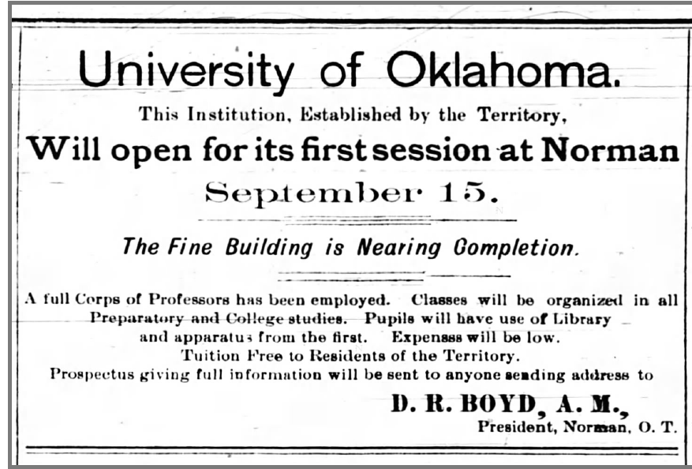
Figure 1: Advertisement Posted in the Kingfisher Free Press on 18 Aug 1892 for student recruitment

If raising admission rates was the first priority, establishing a standard of acceptable behavior and moral guidance was the second. The students quickly learned that the university president expected industriousness, upstanding character, temperance, and physical fitness. He did not demand a standard of education from the community, however: “No one should hesitate to come because he does not know enough. That is the very reason why he should come.” The first brand of OU began to emerge within these expectations and their impact on students. It would be through the persistence and ambition of the administration that the beginning of a pioneer spirit and established brand would be built for OU.
The president and his faculty quickly learned that meeting the educational needs of the surrounding settler communities would be relatively simple. But funding and selling the value of education to a pioneer audience were greater challenges. This audience was interested in education to secure their economic and social future in Oklahoma. These residents had left previous territories in search of a personal change; whether it was related to finances, religion, persecution, or forced relocation depended on the individual. It was not easy to craft an education that provided promising opportunities and comprehensive knowledge and appealed to these various communities. For the administration, the main targets of these efforts would be white men and women in the middle class and some working class students able to provide their own lodging. During a visit with the territorial governor Cassius McDonald Barnes in 1904, Boyd illustrated the sentiment of the time perfectly in calling for “sturdy young citizens to step aboard the ship of progress, steer straight for the haven of education and drink deep of the fountain of knowledge”. OU developed the call to provide an education of the highest order to the young people of the territory, but whether it would deliver its promise was yet to be seen.

Chapter 3: From Preparatory School to University: 1908–1916
The years following statehood fostered an acknowledgement of the need to change from a simple preparatory school to an accredited university. The admission of Oklahoma as a state in the union redefined the territory’s identity both institutionally and ideologically. Oklahoma as a territory was less socially restrictive than it became as a state. We see one of the most pronounced examples of this in the status of African Americans, who were marginalized by the state constitution, which explicitly endorsed racial discrimination and inequality. The admission of Oklahoma into the union as a state immediately and dramatically limited access and mobility for African American and native populations. Where there previously had been a middle ground for diverse populations to come together in an opportunity to own land and define their own future, the new legislature separated and ostracized minorities for white populations. The ideological result of these changes influenced further restrictions in towns throughout the state, a prime example being the sundown town of Norman, Oklahoma. The community surrounding the campus explicitly prohibited black citizens from the city limits after dark, and OU similarly prohibited black participation. The culture on campus was shifting in ways that reflected societal changes. The previous ambiguity about which students had academic and societal value began to dissipate following statehood as the constitution clarified certain groups’ lesser status.
Building OU was an arduous task for the Board of Regents, President Boyd, and the city of Norman. Creating the infrastructure, selecting the land, and recruiting the faculty were just the beginning; carefully crafting the university’s brand was the next step. For some native and settler communities, the very establishment of a state university signaled an effort to at least subordinate the cultural heritage of indigenous peoples if not outright replace them. Statehood drove white ownership of property and institutional power in the region, further muting the traditions and values of native communities. Oklahoma citizens looking for new opportunities and wealth descended upon the city in an effort to exploit its natural resources and establish their communities. With these “Sooners” came new expectations, demand for community resources, and religious values that later became a backdrop for both the legislature and the university.
Shifting from the preparatory school environment to one of higher education producing collegiate degrees took considerable time and diligence. Until approximately 1901, the school as a whole was a fragile idea desperate to gain enough support to prosper. Those who invested in the growth of admissions spread the word of the grand university, claiming it provided an education equal to that of its eastern competitors. Economic depression, several fires, and administrative transitions repeatedly challenged the efforts of the faculty and students fighting to maintain the fledgling enterprise. Yet President Boyd spread his message far and wide for students to come forth to a community that “looked to build an institution of culture in an otherwise empty prairie.”
Oklahoma Territory as Contested Cultural Space
From the beginning, there were some defining differences between OU and more established eastern universities. There was no consideration of the value and values that indigenous peoples had already created long before Oklahoma had even become a territory. To the pioneering Sooners settling the land, it was a barren space in need of civilization and progress. Being located in a contested western landscape brought both astronomical challenges and a degree of institutional freedom not seen in many areas settlers had left behind. Some of these ideological and fundamental differences made OU unique. The focus allotted to academic needs was to establish schooling in line with European and religious school models and break away from the allegedly inferior methods used to educate native students on reservations. This formation of scholastic value assigned to white methodologies over the cultural and traditional practices of native societies set in motion an effort to erase indigenous sovereignty in schooling. The administration acknowledged early on that the surrounding community was not well educated and was in need of rudimentary academic skills. To create a strong place for itself that was rooted in the city of Norman, OU had to provide an academic foundation and curriculum for these students, constituting a preparatory school. The preparatory school provided a unique opportunity to admit higher percentages of women and native communities than many of its sister institutions.
The race to provide funding and land to the only state university was amongst the larger efforts to define and legislate the founding laws of Oklahoma Territory. Slavery only lasted around thirty years in Oklahoma, with black chattel slavery persisting with native owners instead of white, but the impact of native relocation and black discrimination lasted for many years. Prior to statehood, the legislature did not define the boundaries or limitations of institutional spaces, and some black students even attended school with native students in reservation schools. But 1907, when Oklahoma entered the union as a state, marked the beginning of a disruptive and violent time against minority populations. Both Norman and the OU campus became models of white society that shrouded the minority citizens from scholastic view.
In Jimmie Franklin’s Journey Toward Hope: A History of Blacks of Oklahoma, he details the restrictive legislation, cultural biases, and progress of Oklahoma’s black citizens. His analysis provides an insightful timeline of historic court cases and social movements among black populations. Langston University provided the only higher education opportunities to black students in Oklahoma following statehood. The prohibition of black students in Norman and on campus was even more prominent after 1907 and continued through World War I. These formative years for academic and physical progress at OU occurred without considering African American scholarship. These unfortunate societal pressures formed the boundaries of black education for years to come, resulting in hostile and degrading conditions for black students.
Indigenous residents faced their own tribulations followingstatehood through land dispossession and lack of economic opportunities, though to lesser impacts of racial ideological thought than black minorities did. As unfortunate as these racial developments were, many important scholars point out that this time period witnessed the new state’s growth into national acclaim. Here, I will focus on some of the defining features of OU as an academic space and crucial tool, leaving the issue of racial inequality for further exploration later in my thesis. Shortly after settlement, Oklahoma’s natural resources further transformed residents’ thoughts of its many opportunities towards harvesting its natural commodities.
When we speak of the communities that encountered the settlers who came to be known as “Sooners,” we must add Latinos to that list of the early cultural communities in Oklahoma Territory. Michael Smith has documented the importance of treaties and contracts between Mexicans and the early residents of Oklahoma Territory. In Latinos in Oklahoma” (2006), Smith explores the second largest and most neglected group in Oklahoma, the Mexican-American population. He analyzes the critical commercial contracts held between colonial forces and independent Mexico through great cattle drives and Mexican cowboy influences that persist in the state today. His analysis contributes to the study of Oklahoma as an academic space through the historical impact of these treaties and contracts between native residents and Latino populations. The 1900s were a defining time for many Mexican people as they sought to escape political turmoil at home. As a result, Mexicans became major landowners in Oklahoma. The livestock industry, which preceded petroleum as the state’s most important industry, owes much to the expertise of these Mexican settlers. These influential populations were a driving force for cattle ranching and oil drilling in the territory.
Similarly, the discovery of valuable oil and minerals led to heavy enrollment in geological courses in hopes of future prosperous employment. The sentiment towards natural resources is best recorded in Sooner Magazine, which used pioneer language to justify the “sacrifices made for the finer and truer things in life,” citing oil as nature’s gift to man. Students lauded Oklahoma as a leader in the nation’s production, manufacturing lead, zinc, winter wheat, and broom corn. These were credited at the highest quality only possible due to the state’s fertile and generous land; not an easy claim in western Oklahoma. Well before the magazine’s celebration of the state, many working-class populations attempted to profit from the territory’s natural abundance. The Oklahoma City oilfield brought many Latino residents and the first reported Mexican restaurants, which imparted their culture upon the growing city. OU came to be considered one of the best schooling opportunities for local Hispanic students for many years.
Indigenous People at the University of Oklahoma
The forced relocation and confinement of native peoples from their ancestral homes to Indian Territory forever redefined the history of Oklahoma despite many white narratives’ erasure of the significance of such events. However, research concerning the contributions to the land by residents before settlers gradually became apparent to scholars studying the state’s history and legacy. The encroachment of white settlers upon native territory and their demand for civilization led the federal government to establish schools designed to assimilate native children into model citizens of white society. For many native communities, the pressure upon their children to subscribe to societal expectations and the oppression of their culture and traditional ways of life negatively influenced their futures. In the case of OU, students’ ability to gain admission from native territory directly after foundation was beneficial for their academic growth but stifling for their social and cultural autonomy. Only in 1913 was the Ethnology department established on campus, creating an intellectual base from which a long history of cultural dispossession and systemic discrimination of native peoples could be documented for later analysis.
The inclusion of native students in the available courses did not guarantee equality of opportunity or education, as many were forced to work several jobs or sell personal items to afford housing and materials. In 1915, the yearbook discussed exhibits at the OU university museum, describing them as memorials to the “vanishing Indians” once gathered in Oklahoma. OU publications from the first two decades of the 20th century display highly problematic ideology and language, but they also demonstrate that students were reconsidering the status and value of native communities. The collection of native legends, imagery, and anthropological items increased students’ interest in researching these populations. Around the same time, several social clubs boasting native terminology in their titles arose on campus, including the Pe-et Men’s Honor Society and Oklushe Degataga (aka Indian Club of OU), both recording their purpose as a tribute to the “rapidly disappearing Redman.” In this sense, OU and Oklahoma were ahead of their time; it was several more decades before national attention turned towards the treatment of native peoples, and many of their stories tied back to events in Oklahoma.
Establishing OU took years of diligence and dedicated effort. As the physical landscape was altered to accommodate the expectations of the administration leadership and Norman community, a vision was implemented of a “grand university.” Oklahoma’s adoption of statehood, the discovery of natural resources, and impacts on minority communities had strong and various influences on the state’s development. With these changes also came the demand for a brand, the very lifeblood of the university itself. What would the University wish to become?
What the Brand Represents: The Academic Programs of OU
Statehood shifted OU’s focus to transition from a preparatory school to an institution of higher learning. The administration began working to build permanent facilities, establish a permanent faculty, and develop comprehensive department programs to raise the quality of both education and campus life. Following the fragile first years after founding, OU moved into a dedicated effort to craft a western university. The decade following statehood in 1907 marked significant improvements in hiring talented and long-term faculty for the first time and designating physical areas for academic departments. While the structures on campus were changing, so too was the culture. During this period, students began engaging in scholarship that led to accredited degrees and potential careers. There was an air of growth and prosperity about the university. It was during this time that the administration created a brand synonymous with a great university crafted in the west.
OU used its pioneer identity to define its marketing, university seal, motto, and curriculum. As established infrastructure solidified the housing, coursework, and physical space for students, the society on campus began to flourish under permanent faculty. The city of Norman contributed to the investment of student support and society through its businesses, religious institutions, and domestic services. Many in university leadership measured success by comparison with better established and more prestigious eastern competitors. A mood of anxiety was also palpable during the founding years: would the university be able to shape higher education equal to that of schools already established throughout the nation? The faculty and students certainly made their best efforts to create an environment worthy of academic acclaim. A local newspaper article demonstrated the concern for a worthy institution: “In educational enterprise, the territory of Oklahoma is determined not to be a whit behind the most progressive states of the great west.”
The faculty’s significant efforts to establish departments and programs produced national awards and high academic ratings for programs including the medical school, geology department, western history studies, and athletic department. To raise attendance, the university offered free tuition, scholarships, and financial support for graduate teaching assistants financial support. The newspaper article mentioned above assured students of the high standards available at the local university: “The Territorial University now about to open, completes a series of educational facilities which would do honor to any state. The establishment of these institutions needs no defense. The nature of the work they are to do in their respective fields scarcely needs explanation.” As at other public universities being established in western states and territories, OU students contributed to the process of creating a standard for student life set by private eastern colleges and universities by starting fraternities and other organizations that established a new sense of hierarchy on campus. This newly defined leisure class mimicked elite American society in their decorum and social activities.
Even before it could prove itself a worthy competitor to eastern Ivy League schools, OU’s mission was to prove itself of value to the people of Oklahoma. For the first time, the University of Oklahoma became synonymous with expertise and invaluable knowledge throughout the state through its localized programs and western heritage. Within three years of statehood in 1907, the university came to be viewed as a state asset and was a recognized brand within the state. Because it was one of the first and only places for pioneer education and medical care, OU’s resources soon were highly sought after statewide. OU’s medical school offered free tuition, making the program very attractive to students, compared with competing institutions that required students to find financial support. The OU medical school helped the territory become a modern state, and OU’s reputation benefited when the medical school gained admission to the Association of American Medical Colleges.
The use of the medical school to treat state residents without financial resources to pay local doctors increased local communities’ support for funding OU programs. The state’s health department worked with a professor of bacteriology to define health and hygiene standards for the state. The geology department employed one of the most prolific geologists in the nation, Dr. Gould, and produced talented students who would go on to be valuable members of the state’s geological staff. Under new leadership by President Evans in 1910, OU began displaying its expertise in various subjects at national meetings and conventions. Native student-produced art graced reputable galleries around the United States. The brand built by the university administration and students became a national token of academic success.
As the University of Oklahoma focused its resources on meeting the needs of the state’s people and industries, it also created a reputation as a “grand university” that was an affordable alternative to the Ivy League. This change in focus opened the eyes of the students and the local communities to the incredible value of the state school that once had struggled simply to survive.
One of the first efforts to expand the curriculum and service of OU to the state was through the medical school, which became part of OU in 1910. For many rural communities and Oklahoma residents, private medical care was simply financially unattainable. OU’s decision to provide supervised medical care for state residents while fostering student learning was beneficial for both students and patients. Free tuition was certainly a factor encouraging students from around the nation to apply, and the fact that the medical school admitted women was another advantage. By 1917, the School of Medicine had advanced to an “A” grading, marking it as one of the best facilities in the state and propelling it to combine with the State Hospital for the Insane in training nursing students. This would not be the first time the School of Medicine was called upon for service to the state. The approach of World War I brought a demand for the training of soldiers before battle, and one of the most important types was medical training. Later, in 1927, a change in legislature provided funding to construct the Oklahoma Hospital for Crippled Children, which provided care for children from impoverished families and expanded the range of available training for OU students in medicine and nursing. For the first time, OU became a community brand providing support to those within the region needing expertise and education by an accredited institution.
The Department of Geology was another of the most profitable and unique offerings at OU. In 1900, President Boyd hired geology professor Charles Gould, who developed the department and its first classes and also served as a territorial geologist. He quickly gained acclaim for several of his federal geological surveys in Indian Territory, becoming one of the best-known geologists in the nation and fostering distinguished geology students of his own. Gould’s dedicated search for harvestable natural resources, such as oil and gas, led to discoveries that were profitable for the university and the state and that, for more than a decade, encouraged students to enroll in his courses. Unfortunately, the discovery of oil did not benefit all Oklahoma’s residents. Some native communities grew wealthy thanks to oil leases, but others were stripped of their property. While the pursuit of natural resources provided geology students with a path to prosperity, it also created a division between the university alumni and the native communities enduring dispossession due to mining of resources.
Professor Gould was instrumental in leading the Department of Geology to national renown. He became the state authority of regents and one of the nation’s best-known geologists. Charles Buttram, who studied as a special student under Gould, became a master at identifying and finding petroleum and one of the wealthiest men in the state. The discovery of oil and minerals throughout the state led to greater interest in geological education. For some native people on reservations and allotted land, oil discovery was the sole reason for their wealth or their dispossession. For many years leading up to 1930, Oklahoma was seen as a land rich in natural resources, with great promise for anyone dedicated enough to exploit it. Only at the beginning of the Great Depression did the truth became evident: the resources were finite. Once beyond that threshold, the state faced disappointment and financial ruin. Ecological efforts to conserve resources and spread education throughout the state became imperative following the Great Crash of 1929.
As Professor Gould’s triumphs secured for OU the beginning of a national and international reputation, the university made a special effort to create a library worthy of it. This did not occur until the late 1920s, when President Bizzell oversaw the construction of a substantial library with student study areas and expanded storage. President Bizzell’s passion and devotion to scholarship prioritized the building as a grand feat of architecture and the first southern-facing building on campus.
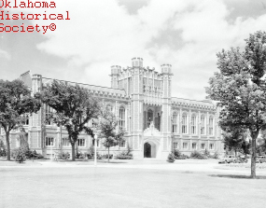
Figure 2: The University of Oklahoma, The Bizzell Memorial Library, from the Oklahoma Historical Society
The Administration’s Brand
OU spent the first part of the 20th century adding a wider breadth of collegiate programs, constructing additional facilities for instruction, and refining employment protocols for faculty. Curriculum shifted from a preparatory school level to that of higher education. The first decade was dedicated to the formation of legitimate schools of learning on campus. The Regents and Board of Education worked to establish academic standards across the state. The University hired President Stratton Brooks in March of 1912. This was a defining moment in the administrative processes of OU, as he demanded the separation of administrative politics and the running of the university. He led the university through many foundational changes, establishing much of the structure that defined the beginning years of a college and leaving behind the preparatory school environment. The school shifted from an institution offering rudimentary education for a pioneer community to a university with permanent staff providing higher academic learning. This shift happened incrementally with the guidance of a more experienced and politically separated administration. The OU brand became associated with accredited education and a national reputation in line with Oklahoma’s state values, rather than a preparatory school in an ambiguous territory.
President Brooks’ administration spent its first two years seeking permanent faculty and department heads and establishing comprehensive administrative processes throughout the university. Brooks formally recommended removing the Board of Education from controlling the employment of university instructors, reserving the right for employment and termination to the university president with approval of the board; his recommendations were accepted. This was the first active example of separation between state politics and the university in Oklahoma’s history and the first glimpse of the modern university that was gradually taking shape. The new president’s next order of business was establishing academic standards for the university, based on coordination with other state schools and the support of the State Board of Education. The Regents Minutes for 1913 also addressed the adoption of textbooks, streamlined admission recruiting advertising, salaries for incoming instructors, and facility needs. For the first time, the university president and Board of Regents worked together to create administrative clarity. This cohesion defined the very first efforts to create a functional university with solid leadership.

Chapter 4: World War I Transforms the University of Oklahoma: 1917–1919
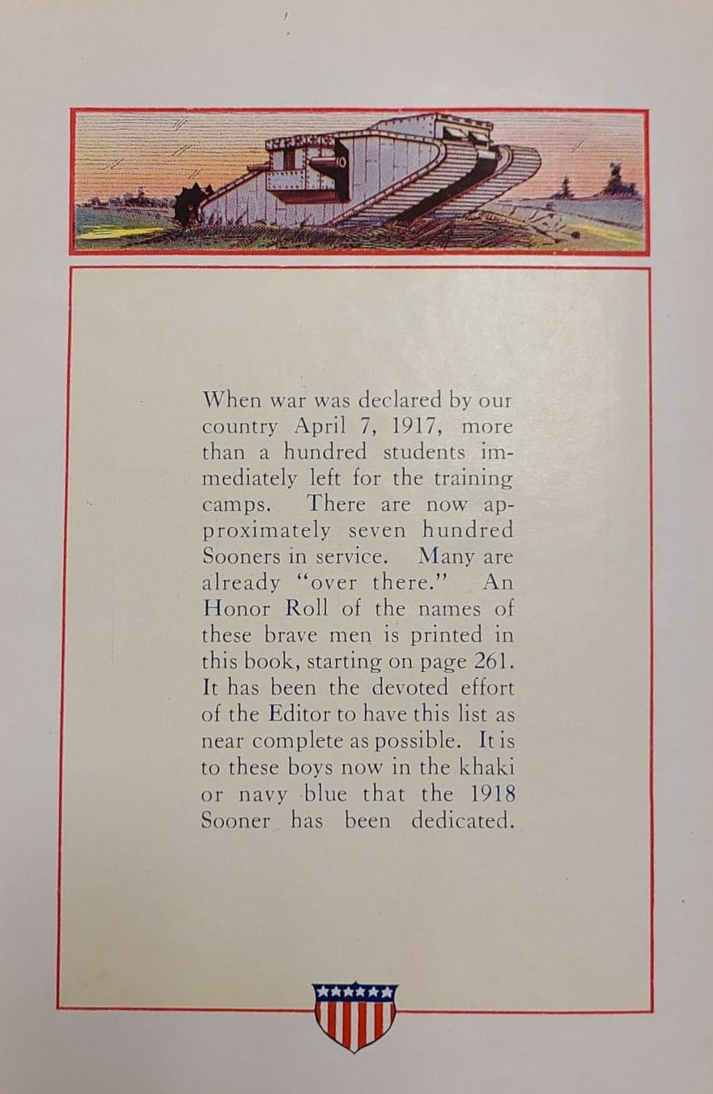
Figure 3: The addition of Sooner Students who enlisted in military service and the dedication of the 1918 Sooner yearbook to these brave men.
The early history of OU ends with the advent of World War I. This global war served as a lynchpin for the development of the university, serving as one of the greatest cultural and institutional influences on campus in its history. The war added a new layer of expectations to academic achievement and general campus life clearly visible in the administration, culture and curriculum changes between the end of the preparatory school phase until the years leanding up to the World War. By that point, the basic curriculum and administrative structure were in place. And by this point, too, the careful reader of student publications can discern a change in tone. The discourse shifted to focus on mastering the academic challenge and preparing for the next chapter in the student’s life. The early enthusiasm for a mission to civilize the prairie and bring needed expertise to a new state receded and was now regarded as a past era. These settlers were celebrated as “young, energetic and active” and viewed as “pioneers embarking on an area only cowboys and Indians knew.” The 1917 yearbook editor claims that the state’s first citizens “were the ones who were first to bring an advanced civilization into Oklahoma.” Much like the early settlers, the university was also viewed as young, energetic and ambitious, advancing both science and discovery throughout Oklahoma. The shift in language and tone was palpable in a single advertisement holding the end page of the yearbook: for the first time, a university publication acknowledged the impact of a global event upon the state’s university. This advertisement called for all young men not enlisting in the war to come to OU and for those serving in the war to attend OU afterwards to prepare to re-integrate into civilian society.
The student publications mirrored this break from the previously romanticized language of youthful and energetic land-run pioneers into an educated society seeking economic prosperity. Up until World War I, no discussion of national or global events was present in student publications. The change in language and imagery occurred quickly. The next yearbook in 1918 featured imagery depicting war and patriotism. These images included soldiers, war ships with Oklahoma painted on the side, and beauty queens featured in soldiers’ attire. Patriotic imagery was supplemented with calls to support those serving overseas, and new content supporting war efforts was added. This edition of the yearbook includes information about OU’s commitment to food rationing, special courses to train soldiers, and recruitment calls for young Americans not enlisted to attend college in support of special jobs. An added military section listed the Sooners who served, the military companies assigned to the university, and medical students drafted into the service. The edition also included advertisements promoting the call to war, sales of War Savings stamps as bonds, and the conservation of resources. By the time of World War I, OU was a still-growing but stable institution that was able to take on the new responsibilities for recruitment and training that came with what was then called the Great War.
A Divided Community
The University of Oklahoma experienced a shift in campus life and instruction after the declaration of the United States’ entrance into World War I. Before the war, campus life was consumed with football games, homecoming, and student dances. But during the war, the campus became a hub of support for a nation on the brink of a global deployment. By the spring of 1917, the university had become one of the state’s most important training, fund-raising, and recruitment centers for military service.
There began an immediate campaign for support on campus that was not matched by the city of Norman. The global conflict brought implications of further financial and economic restrictions to provide resources for the war effort. The reaction in Norman paralleled that of many cities throughout the nation: some citizens were in support, while some were hesitant to see the nation involved. In surrounding communities, many families that sent students to OU were suffering from downturns in the state economy and implications of rampant political interference, as was the university itself. Many Sooners in these communities identified as members of the socialist party and struggled as tenant farmers no longer able to afford operating their agricultural enterprises; they did not want to become involved in a global war and its associated costs.
Overall, the city of Norman supported the war, but there was an undercurrent of unrest, as many citizens were coerced by city leadership into supporting the war effort by purchasing war bonds and liberty loans, joining the Red Cross, and changing their consumer habits to conserve resources. Those who failed to give the support demanded were subjected to ridicule or physical constraint in the town’s “slacker pen.” This was a physical system of confinement to hold people until they “picked the right thing to do” and secured their release. Meanwhile on campus, President Brooks echoed the calls of former United States President Taft during a speech in Oklahoma City shortly after the declaration of war. Taft urged every able-bodied American male to fulfill their duty to their nation in confronting Germany, standing up for American rights and the nation’s honor.
The Onset of the Great War
Some of OU’s patriotic initiatives are best described by the University and Editor paper published by the School of Journalism: “More than 200 students or alumni have enlisted for military or naval service… Members of the faculty subscribed more than $25,000 to the two Liberty bond campaigns” Male students and faculty took on the role of both academic participant and soldier ready to defend the nation. This was the first time the nation’s affairs interfered with the university’s planning and events. Even the university president had a part to play. President Brooks devoted his time to food conservation work throughout the state without financial compensation. As a byproduct of the rationing effort, more than a thousand students took a food card pledge in support of rationing initiatives. Every aspect of administration, faculty life, and student life became an opportunity to volunteer, support, or raise funds for those heading off to war.
The university administration and faculty took an unprecedented approach to military training and discipline on campus. Even before the state and national governments could provide military officers to properly train and prepare students for the upcoming draft, faculty rose to the occasion. Students who remained on campus to attend classes formed a volunteer regiment headed by a designated “Regiment Colonel,” Professor Guy Williams, who taught these students drill and ceremony, military tactics, and patriotic cadences. Faculty began to monitor global events, and they established a “war cabinet,” mandating military drilling and training for all first- and second-year male students on campus. Students began to train on campus daily, marching to classes and learning Army tactics. The OU war cabinet worked to identify relevant courses needed to make soldiers successful during war, and faculty restructured coursework and curriculum to ensure the utmost support for educating and training the nation’s future troops. Furthermore, the war cabinet ensured that all men leaving for the Army or National Guard would receive a passing grade and full credit in their enrolled courses as long as they were in good academic standing. Administration waived all entrance fees for soldiers in an effort to afford them maximum training before deployment. By mid-1918, the university housed several military companies with associated military structure and leadership, and with female students assigned as sponsors. These companies performed military tasks and battle drills to prepare for war. The presence of these units on campus became permanent fixture; this will be explored in more detail later in this chapter.
Men were not the only ones on campus supporting the war effort. The women of OU began supportive roles in the ongoing war effort by joining the Red Cross, enrolling in nursing courses, and developing extracurricular skills to help replace men in business. Female students came together to send Christmas boxes to deployed Sooner soldiers, held meetings to discuss replacing men called to war, and sent care packages with hand written letters. Instead of sorority meals and entertainment, female students began to use their leisure time to raise troop morale. The social spaces on campus shifted from discussions of upcoming dances to collecting materials to provide to soldiers. Mrs. Marcia D. Brooks, the University President’s wife, hosted a community book drive to collect reading material for deployed soldiers. As consumers, women began to purchase items for reasons of conservation rather than convenience, looking for appliances, tires, and cars that conserved resources for war production needs. Fundraising efforts also shifted towards the needs of the nation. Women collectively came together to raise Y.M.C.A relief funds with a total contribution outnumbering that of male counterparts. OU was dedicated from the very declaration of war to supporting the cause, going beyond the call of duty. OU took the lead in the state’s support of the nation’s wartime needs, positioning Oklahoma as a patriotic state in grand service to the nation.
The Transformation of the University
When we examine student publications of this time, we can see that the brand of the frontier university open to everyone became merged with another brand—OU as a vital force in a great national war effort. World War I demanded OU’s consideration of global events affecting national institutions. The nation required leadership, support, and education from every state in the union. This message was reflected in OU’s brand as new campaigns for service and support formed on campus. The federal government and military leadership soon realized that there were not enough military officers or enlisted soldiers to deploy on a global scale. Administrators’ and students’ focus shifted completely with the onset of a military presence on campus; they cancelled social events or using them to raise funds and donated the proceeds to national organizations supporting war efforts. Likewise, athletic events were delayed to prioritize fit young men’s training in military tactics instead of competing in local sports competitions. Students began to volunteer for various war efforts in the community instead of spending time on the clubs and social events they had previously supported so fully. This shift in perspective and dedication produced a new class of students, no longer focused on leisure but on diligently supporting a nation in need.
The related imagery in the Sooner Yearbooks shifted from romanticized early settlers to patriotic troops and disciplined soldiers. In comparison to the previous edition, which was free of all military-related propaganda save a single advertisement, the 1918 Sooner Yearbook contained beautifully illustrated examples of patriotism. These images provided a stark contrast to previous years’ editions, which had evoked the land run, pioneering settlers, and native illustrations. In 1918, the yearbook illustrations featured marching soldiers, patriotic women, and war machinery.
The cover of the 1918 yearbook depicted soldiers in formation marching to battle with a lone Conestoga wagon slowly retreating towards the sunset. This scene placed the modern march towards a nation’s call in the foreground, with the state’s settler history fading into a distant landscape. This yearbook edition was dedicated with a proud military tribute to those brave students who answered the call of their nation by enlisting in the service. Similarly, many of the student-run newspapers transitioned from social gossip and commentary on football events to calls for action. Many of these examples of student newsletters will be highlighted throughout this chapter.

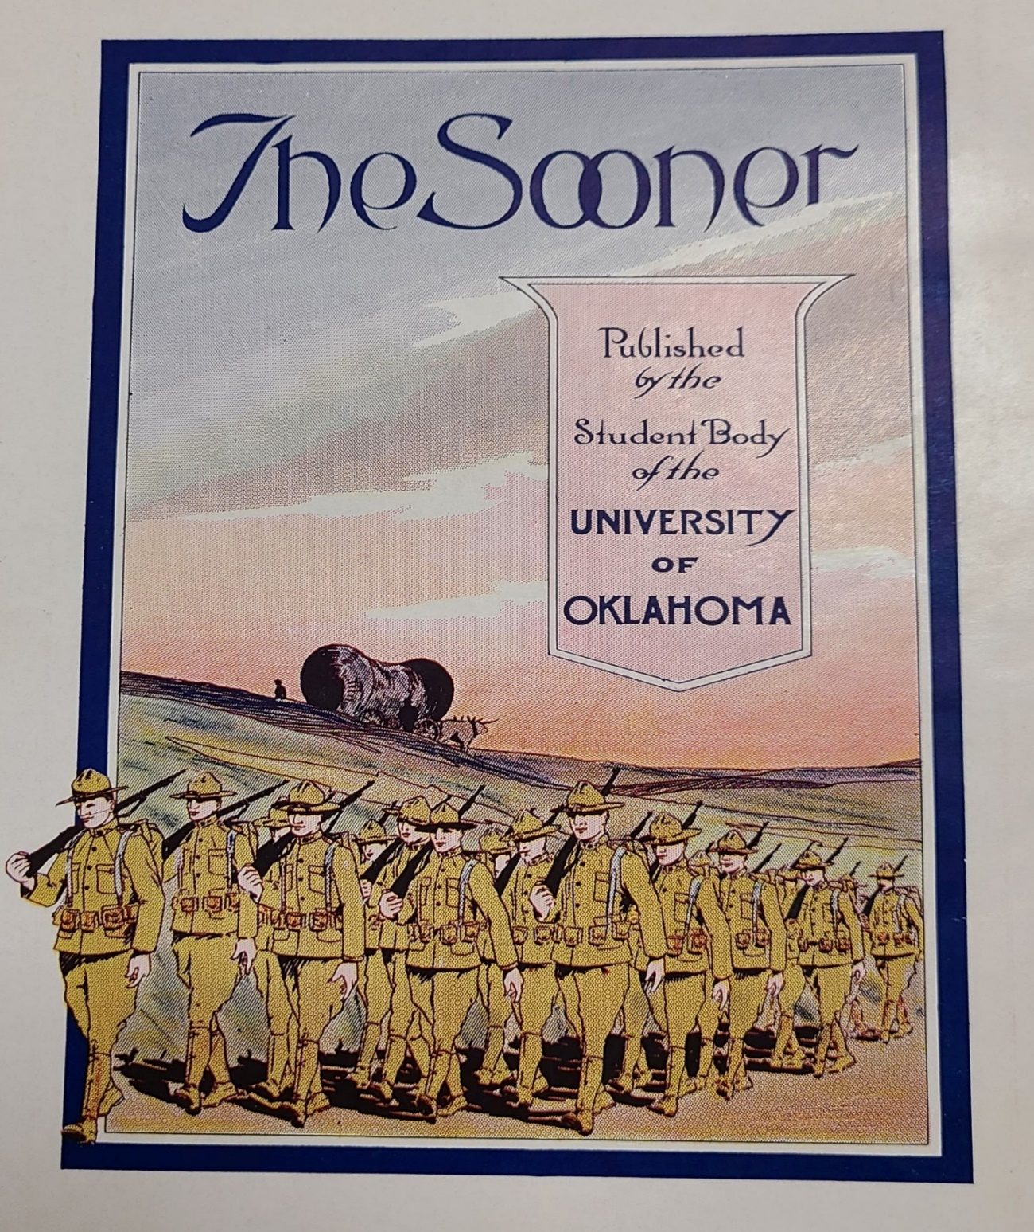

Figure 4: 1918 Sooner Yearbook Cover

A Newly Defined University Brand
The new OU brand was patriotic, dedicated, and ready to conquer enemy forces. Beginning with the 1918 Sooner Yearbook, the imagery and language shifted from a conquering settler colonial ambiance to one dedicated to serve against “Hun domination” and German imperialism. In hopes of raising student support, the 1918 yearbook published the call to serve the nation put forth by President Wilson and the secretaries of the war and naval departments. Language and imagery throughout the edition demonstrated support for deployed troops and training men. Several calls for fundraising appeared throughout the edition. Even the humor section shared in the trend, including a soldier’s funny letter home to his family and a joke about the ability of a drill sergeant to strengthen the spine of a young student. Even the advertisement section was geared towards the war instead of just student retail consumption. Beyond the student publications, the faculty redesigned coursework to suit the national demands, adding thirteen courses to train young male students to become soldiers. Similarly, a reorganization of the medical and engineering courses added special courses specifically tailored to the needs of young men planning to commission or enlist. Additional courses in wireless telegraphy and oxy-acetylene welding were offered for all students entering military service to meet the expected demand from the government.
Even before male students began to enlist, women on campus launched their own support of the war effort through the organization of a Red Cross society on campus that enrolled 160 women in first aid or home nursing classes. A motivated group of fifty medical school students organized a volunteer hospital company in preparation of recall by the government, preparing their members with summer school and additional medical training. President Brooks volunteered to supervise the state’s food administration programs for ten months, adopting an external staff for the task, while other professors lectured on patriotism and spearheaded their own volunteer services. Indeed, the campus had become an entirely different world dedicated to a cause that united almost all of its academic departments.
The face of OU was enduring massive change, shifting the focus from building a young state to a university in support of training needed officers for a global war. Advertising shifted in imagery and language, advocating for the enlistment and education of young men leaving for battle both in Norman and on campus. The 1918 yearbook and student newsletters featured advertisements to promote the purchase of War Savings Stamps, recruit young men to enroll in courses, and advocate for conservation of limited supplies. Several editions of the School of Journalism’s weekly newsletter discussed the university’s contributions to the war effort and called attention to the Sooner students who had achieved military accolades.
OU no longer sold itself as a pioneering incubator of civilization but as a campus gearing up to produce young officers and support the national mission. Those who could enlist, students and faculty alike, began to depart in droves. Those who could not were encouraged instead to come to the university for training to support the cause. In 1919, OU established one of the nation’s first organized Reserve Officer Training Corps and military unit. This new program fostered training with the assignment of commissioned Army officers, maintained United States military equipment, operated military artillery, and stored ammunition at the armory on campus. Almost overnight, OU became “practically a military school,” in the words of Dr. David Levy, historian and author of the two-volume University of Oklahoma: A History.
OU’s focus broadened from supporting the campus and the state to supporting the nation’s need to win the war. As recorded in the 1918 Sooner Yearbook, 700 students and faculty answered the call to war. OU waived all entrance fees for soldiers seeking admission and called upon young American males with high school diplomas who had not enlisted to attend courses in support of special jobs necessary for the war’s success. A special call for women to study subjects to replace men in business positions also joined the chorus of advertisements and guidance to incoming students.
Until 1918, the global war and impending military service of OU’s students and faculty was the only topic to interrupt the yearbook’s normal focus on social and administrative happenings on campus. A military section was added to yearbook editions from this point forward, highlighting the various training units and social functions hosted for support of World War I. This section listed all the Sooner students currently serving their nation, their unit assignment, and the year they were to graduate. It also highlighted the military battalions and their respective subordinate companies in alphabetical order, complete with a female student sponsor assigned to each unit. This section became a permanent fixture in every future edition.
Medical students were drafted into the service when they completed training and transferred into the enlisted reserve. The University Medical Center set up an emergency trauma hospital teaching critical medical skills for the battlefield, focusing on orthopedic surgery and preparing to provide care at their volunteer hospital to wounded veterans upon their return. Advertisements shifted towards selling war saving stamps and bonds and advocated the purchase of more efficient appliances, tires, and cars to save resources for the war. At every turn, students and faculty were confronted with the impact of a massive global war, and this became a permanent part of OU’s heritage and legacy.
In the fall of 1918, the U.S. War Department established a new national organization referred to as the Student Army Training Corps (SATC) to provide a streamlined system of producing young soldiers for the military on designated campuses. The SATC was established for several key reasons. Hundreds of young men had been pulled away from campuses for war, leaving more than half of the nation’s colleges with large drops in enrollment and funding. President Woodrow Wilson anticipated a large postwar demand for trained professionals in many fields, prompting the establishment of this nationwide program to supply the massive military demand with competent officers. This program enabled men eligible for the draft who were attending college to volunteer for service and receive training through the SATC on their campus; some could advance into Officer Training Camps if accepted.
In the fall of 1918, the SATC arrived on campuses throughout the nation. OU appropriated buildings, equipment, and living quarters to this effort and required all eligible male undergraduates to enroll in mandatory training. The university became a legitimate provider of military training and discipline. This was seen as a solemn duty to the nation. For the transition and appropriation of resources, the Army paid OU approximately $900 per student-turned-soldier for their tuition, facility use, and housing.
The impact of war requirements and the institution on the SATC on campus little left room for little other activities on campus. The university transitioned from a social and academic space of leisure to one mirroring a military camp with drill and ceremony, daily guard duty, marching students, and the appropriation of physical spaces to accommodate the military needs. This shift, along with the devastating influenza pandemic of 1918, left little energy for activities on campus. Despite these monumental pressures, the student body continued to support with enrollment in medical courses, nursing school, and memorial tributes to fallen comrades. The morale and spirit on campus remained high in support of their comrades in arms. Students dedicated the 1919 Sooner Yearbook to those who had sacrificed their youth and their lives during the war. This edition included no jokes or pranks,just a heartfelt tribute to those lost. In later years, those who had sacrificed all in the Great War would were memorialized in buildings and funds that I will discuss later.
The SATC was disbanded after the armistice in 1918 but was followed closely by the permanent establishment of the Reserve Officer Training Corps (ROTC) on campus in 1919. This program began with the 1916 National Defense Act and offered a four-year program to qualified student candidates in order to commission officers in the United States Army. Nationally, the program suffered a slow start, but at OU, the program became a catalyst of social and academic involvement. Initially, OU’s ROTC program required all physically fit male students to enroll for a minimum of two years of mandated training, with the ability to expand to four years resulting in commissioning as an Army officer.
The End of the Great War
The end of World War I set the university and city of Norman abuzz with celebrations of the victory and the beginning of a new era. The announcement of the armistice sent the town into raucous celebrations, with citizens and vehicles parading around the community. On campus, female students marched up and down the town and rode around in vehicles loudly celebrating the war’s end. Meanwhile, males on campus were restricted under military orders from the SATC to remain in their classrooms. That very afternoon, the Norman mayor declared a formal celebration, leading the soldiers of the SATC unit and the university band to participate in a town parade including floats and a “kaiser” that was burned on Main Street.
The end of the war did not bring an end to military activity on campus. The influence and production of United States Army officers continued to grow and eventually flourish in the OU ROTC program. The program and the cadre teaching the cadets on campus soon became a source of social life, boasting one of the best horse riding schools and competitive horse polo teams in the western United States. The Sooner Yearbook added a military section in each edition beginning in 1918, listing the students that served, showcasing units on campus, and highlighting events conducted by the SATC and ROTC. The onset of World War I brought to the forefront the need to incorporate national happenings into students’ daily lives. The 1920 Sooner Yearbook featured cadets participating in bayonet drills, target practice, and artillery firing tables on campus.
The yearbook’s club section featured new clubs tailored to military and veteran students and even admitting women students as sponsors of these military social entities. Later, in the 1923 edition, military happenings on campus were incorporated into the “Life” section, with images of cadets conducting drill and ceremony, gun squad bivouac exercises (army field training), and mounted competitions as a normal aspect of student life on campus. The 1923 edition also used the ROTC section to acknowledge the many instructors who had deployed and had combat experience, bringing military service as a source of pride and patriotism to the forefront of student’s minds. World War 1 was the first global event to cause a complete upheaval in OU’s administrative and social functions, and its impact had a permanent effect on OU’s brand.
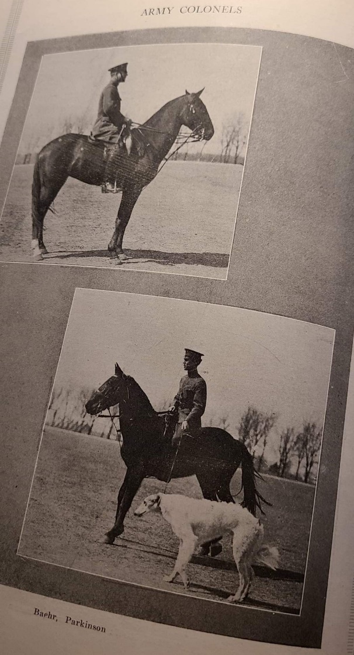
Figure 5: Army Colonels Mounted Training, 1923 Sooner Yearbook
The war’s challenges did not end with the armistice signed in 1918. After the Great War ended, the state economy suffered as agricultural prices fell, and many farmers suffered. With the drop in the state’s budget came limited funding for OU’s expansion. Yet in this predicament, President Brooks and his administration formulated a plan resulting in the largest growth of the university post-World War I. The medical school was one of the first academic units to expand after the war, dedicating an entire ward to injured and discharged servicemen. The medical school administration moved all instruction and support services for the medical center to Oklahoma City. In the wake of the end of the war, the university experienced increased admissions, demand for education, and a new type of student. Increasing enrollment raised the demand for the expansion of proper housing and infrastructure in order to avoid a pandemic. After his wartime medical service, OU alumnus Gayfree Ellison, a World War I veteran, returned to OU and established a formal health service in 1919. Initiatives for building new housing facilities were pursued heavily. Campus growth was in full swing, with President Brooks and his team credited at the front of the operation.
Postwar Youth at OU
The Great War changed the nation’s youth. At the University of Oklahoma, students began expressing skepticism for some aspects of traditional culture, especially the constraints on individual conduct between men and women. As the war came to an end, the discussion of women’s suffrage permeated local publications. Acknowledgement of the great sacrifices and leadership provided by women during the war led to debates and protests about the continued prohibition of their right to vote. In the fall of 1918, the state legislature passed an amendment allowing women to vote in the state election. By 1925, women had become far more visible in the yearbook as active members of the OU community; they participated in more clubs, councils, and activities than ever before, including rifle team and minor sports, and theywore the coveted “O” in sports. By the mid-1920s, the yearbook imagery depicted leisure and modern glamour, with women pictured wearing fashionable trends of the roaring twenties. The university now boasted a fully formed curriculum and academic standing. The student-led WNAD radio station broadcast news throughout the region, commented on athletic events, and played music on campus. Beginning in 1928, new student publications such as the Oklahoma (Sooner) Magazine included student articles and student voices exploring a variety of topics. These topics expanded in scope to include societal normative culture, encompassing topics that once were considered indecent for an young adult to discuss openly.
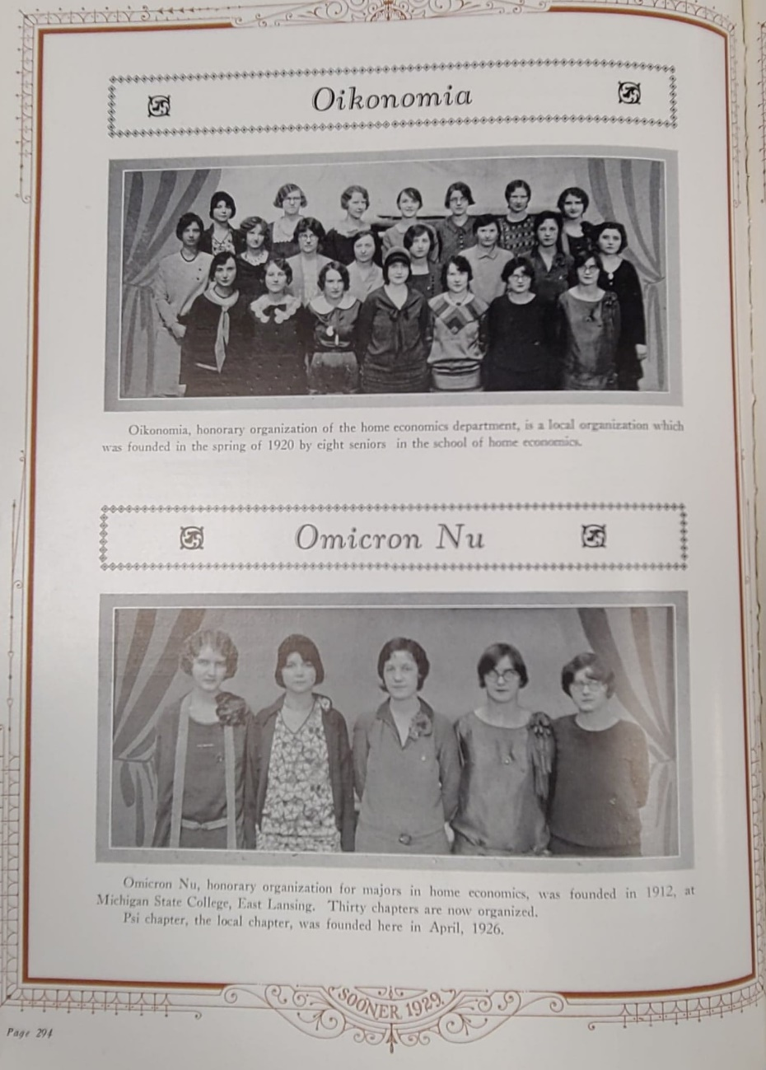
Figure 6: Women as Members of Social Clubs at OU, 1929 Sooner Yearbook, p. 294
After the end of World War I, the 1920s brought a new type of young adult never seen before in the nation. This new and “modern” version of American adults was forged during one of the most devastating wars to date, which had led young people to question the religious beliefs and traditions of the generations before them. These adults wanted to experience a more leisurely life with fewer social restrictions. Previous societal expectations asserting the sanctity of women’s bodies, temperance, and decorum became were heavily criticized by the young adults of the late 1920s. This shift in social ideology amongst young adults is explored deeply in historian Paula Fass’ The Damned and the Beautiful (1977). She examines the remaking of American culture in the 1920s by young adults, asserting that the “emergence of youth was a social and political component that fed into the youth of today.” Fass argues that “the War created a divide between the youth and the older eras, no longer trusting their elders in social matters.” The youth of this era became the focus of markets, institutions, and votes, for the first time truly granting them a great impact on the world around them. At OU, the young adults of the 1920s made one of the largest impacts on the now-established university through student publications, rejection of previous moral standards, and participation in leisure. The 1920s became the first true instance of student voice and critical analysis captured in the Oklahoma (Sooner) Magazine, established in 1928, and various other publications.
Physical spaces on campus became available to more students as previously gendered spaces became co-ed, allowing for shared education in home economics, the swimming pool, tennis courts, and newly established group social spaces. Student publications began to illustrate the shift in societal ideology, pushing the limits of sexual propriety through humor and glamorizing alcohol consumption. The early editions of the Sooner Magazine demonstrated this shift in social freedom by discussing the treatment of native peoples, demonstrating women in leadership throughout the community, and commenting on the nation’s political environment. Students’ moral shifts, as indicated by behaviors such as openly drinking, gambling, smoking, and engaging in pre-marital sex, caused unease among the faculty and the religious community in Norman. The patriotic support of the war shifted to idealization of a glamourous and uninhibited life for many students, and this caused some contention between them and the community. This conflict of ideals between the administration, the community, and students themselves will be explored more deeply in the next chapter.
After the devastating war and the sacrifice of many proud Americans in World War I, President Brooks and others on campus felt a need to memorialize the students and faculty who had lost their lives in service of their nation. President Brooks collected literature from other universities and studied their memorials in his effort to create an appropriate memorial to OU’s fallen. Along with prominent alumni, he advocated the building of two grand structures on campus: the Memorial Stadium and the Memorial Student Union. This initiative was started in the final weeks of President Brooks’ tenure, eventually passing on to his successor, President Buchanan.
These grand structures were designed and supported by multiple alumni and faculty as a tribute to the great sacrifice of those who served. The Memorial Stadium, which hosted a playing field named after Coach Bennie Owen, became one of the most sought-after facilities on campus. The Memorial Student Union, chartered as a nonprofit corporation, served as thecenter for many students’ social meetings. The devastating loss of students and faculty during World War I brought sadness, but also two beacons of light in the memorial structures that housed student meetings, laughter, and social functions for many decades to come.
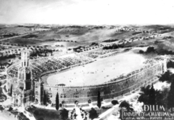
Figure 7: Early Drawing of the Gaylord Memorial Stadium. This version was modified to the one today for cost

The branding process of the University of Oklahoma changed between the university’s founding and the onset of World War I, mainly through the efforts of the university administration and faculty. The university grew from a preparatory school providing minimal schooling to settler youth to a military training and recruitment site during one of the most calamitous wars in the nation’s history. Facilities were carefully designed and built to accommodate the academic and social needs of students on campus. Permanent faculty were hired and managed by an administration that now had a hierarchy of leadership and standardized procedures. The conditions had been set for a grand university to redefine the education of students in Oklahoma and beyond.
Chapter 5. Conclusion: The Politics of Nation Building at The University of Oklahoma: 1920–1930
The University of Oklahoma advertised the merits of a controlled learning environment dedicated to supplying a comprehensive and valuable education to the community it occupied. OU lifted its immediate geographic location to prominence after enduring political and environmental tribulations. The university served as a beacon of opportunity and hope after World War I and during the decade before the mass exodus of Oklahoma residents during the Great Depression left the dust to settle upon a new generation of scholars within the territory. The student population shifted from puritan norms and war support to a leisurely class of elites. During this changing decade, student voices became more prominent, and student demands began to affect OU and its brand. Likewise, a once-muted population of women and native students became a newly mobile and active cultural force on campus. For these groups, the 1920s witnessed a shift toward fuller citizenship in the university. Acquiescence and silence were no longer viewed as a requirement to participate in academic spaces on OU by native and women scholars.
As we consider the unofficial and even underground student activism at OU, we must remember that any human community of any size will have some conflict (whether public or submerged beneath the public sphere). It will also have members who construct themselves either in opposition to public values, or as the most faithful interpreters of core values. Such conflicts inevitably raise the question: Who belongs and who does not? We find a “dark web” of such fringe activity flourishing at OU long before the creation of the “dark web” associated with the internet, and its presence continues at OU in our own time. As I conclude my analysis of OU’s branding, I address how the brand was interpreted and perpetuated by students. This brand would have powerful influence on administrative and social happenings for many years to come.
The Official Branding Campaign
Part of the formalization of the university as an institution of higher learning includes the adoption of a motto, mascot, and university seal. This process initially was strongly influenced by administration and faculty. The 1916 Sooner Yearbook reported that, when selecting the official university colors, President Brooks consulted the only female faculty member. After a student demonstration, Miss Overstreet chose crimson and white, ensuringthat those solors would adorn the university going forward. The adoption of a university seal took much longer and was less straightforward. The history of the OU Yell goes back to the campus Glee Club, which devised and developed the approved “Boomer, Sooner” yell in 1916. This break from branding efforts led only by administration and faculty began to matter to students on campus. The young people began to craft their own meanings of what OU meant to them. Students involved in the athletic department wore uniforms adorned with an “O.” Students were beginning to craft their own interpretations of campus life into a public and identifiable brand for all to behold.
Visual representations accepted by the university and its students took slightly longer to develop. It is difficult for the historian to study these images due to the the lack of historical documentation procedures at OU, but my analysis includes the images I was able to find. The early yearbooks held illustrations from local printing companies depicting settlement in Oklahoma, wartime tributes, and western landscapes, but did not have a formalized process or university department to accredit early university logos. In true form, the first seal on official university documents came from a friendship between the president of the university and George Augustus Bucklin. His participation in a geological survey with Professor Gould gave him access to the school’s administration; he developed the first iteration of the “seed sower” used in the university seal today.
The Sooner Magazine, founded in 1928, adoped an emblem used consistently for publications between 1928 and 1930. The first depicted a buffalo in the foreground with a native tepee behind it. Both images would paid to the origin of settlers in Oklahoma and the land run. This marked a notable shift away from the World War I patriotic displays and back to the grassroots of Oklahoma. The use of an American Indian motif throughout illustrations and the “conquering” images and language later brought protest and contention between the school and students. Not until the 1950s was an official university seal and licensing department developed to mediate the university’s image. The recording of used images did not become commonplace Bud Wilkinson was hired in 1947 and the first licensing department began to organizebrands for the athletic department in 1950. Until then, it was up to the students to accept or reject the images and rhetoric tied to the university brand and develop their own interpretations of their meanings.
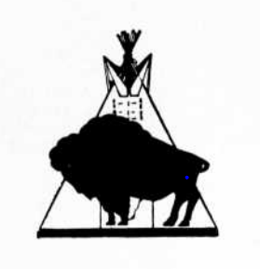
Figure 8: Sooner Magazine Emblem 1928
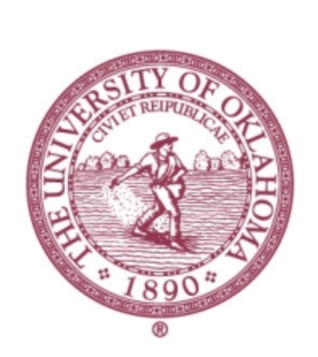
Figure 9: OU Official Seal, Crimson Version, Official Seal used today from OU Licensing Department
Religious Influence at OU
As a part of larger national trends, the introduction of religious values and standards in Oklahoma had a profound effect on the formation of nearly every institution. Many searching for a new opportunity became drawn to Norman, which was growing in popularity due to its reputation as a religious and moral town. The University of Oklahoma was no different. Many of the morals and standards that administrators and faculty expected for student conduct drew back to Christian influences. The morals and standards adopted into the university legislature would come from religious teachings. The selection of the President Boyd, a deeply religious man, further engrained asserted values according to religious expectations into the fiber of the school and instilled an undercurrent of social unrest. President Boyd and early faculty used guidance from religious teachings to impart moral lessons to students on campus; their expectations encouraged students to live a life of industriousness and upstanding character. President Boyd found it especially important for students on campus to practice temperance. His firm belief in abstaining from alcohol led to him working with local saloons to ensure that students and minors could not buy libations in the city of Norman.
Most residents in Norman were Baptists and Southern Methodists, causing contention in the community when faculty were hired with other religious affiliations, such as Presbyterians. This tension built on campus and politically within the administration, eventually leading to President Evans usurping Boyd through the Presbyterian church’s crusade to control the school. After this shift in leadership, the impact of religion permeated the campus in several formats. Students formed several Christian societal communities on campus to advocate for their values and gain membership with like-minded colleagues. The 1914 Sooner Yearbook introduced several newly formed men’s Christian social groups, and the association used this edition to highlight the ongoing missionary work between Christian students and native communities in Colorado. An image shows a group of native people wrapped in blankets with a small Oklahoma sports flag placed in front of them. Later yearbooks include the prayers adopted for individual departments, such as the 1916 edition featuring a “Lawyer’s Prayer” calling for the protection and prosperity of all students of law.
Also in the 1916 yearbook, the Young Men’s Christian Association (YMCA) and Young Women’s Christian Association (YWCA) both appeared in the social club section as new organizations inviting students to join to advance Christianity on campus and in the community. The university gained partnerships and funding through the spirit of Christian idealism and education with Kingfisher College and other theology programs. Unfortunately, the religious influence was not tolerant or inclusive of certain populations. The message of religious service, advancement, and charity sometimes became an effort to dilute or even erase the beliefs of minority populations to create a more desirable citizen of modern white society.
At OU, religious influence and its impact went through several key transitions. At founding, the pressures for students to participate in religious activities produced participation in and acceptance of the standards placed upon them in the name of religion. Early publications had a degree of censorship between founding and 1919, always showing various Christian organizations and activities in a favorable light. Strict expectations of morality and decorum were encouraged on campus, and an allegation of immorality had the power to ruin the reputation of a woman forever or end the employment of a male professor. There were additional negative consequences for women on campus. Women were believed to be the weaker gender by athletic faculty and were restricted from developing serious physical fitness regimes or participating in sports; instead, they were encouraged to participate in easier activities for fun and enjoyment. Due to this restriction, women were not allowed to participate in competitive sports for several decades at OU, although they were included in several approved fitness programs in order to foster obedience and discipline for the more delicate sex. The additional religious standards and expectations imposed on women had a lasting impact that was finally confronted by students in the 1920s.
Native populations also faced religious discrimination, as illustrated in several editions of university and student publications. The 1916 Sooner Yearbook featured the “Legend of the May Festival” and “Legend of Medicine Bluff,” two narratives that took sacred teachings of native communities and turned them into a source of entertainment and tribute to the “vanishing Indian.” The sacred and religious beliefs of American Indian populations were not seen as valid or beneficial to those who participated in Christian activities on campus; instead, they were seen as an opportunity to tell an interesting story of a conquered people. Later in the same edition, a poem titled “On an Indian Burial Ground” by student Jack McClure tells the story of a deceased and vanished native warrior in a land once habited by these peoples, exposing both ignorance of their continued existence and acknowledgment of their traditional religious burial practices. Several images depicting theological content appear in other yearbook editions. In the 1922 Sooner Yearbook, the religious section showed an image of a religious man preaching to a female American Indian draped in the arms of a white cowboy suggesting, that white salvation was bestowed upon an unfortunate and uneducated soul. In the next year’s edition, the religious section featured an indigenous man in tribal dress sitting cross-legged with a human skull in his lap. The meaning of this image is not explained in the text but relates back to white assumptions of savagery in native religious practices. It was several decades before the consideration of traditional native religions as viable and imperative sources of spiritual importance came to fruition; although many native people in Oklahoma did adopt other religious practices, mentioned previously, also of equal importance to their spiritual identity. Until this occurred, those attending OU had their own internal struggles with the restrictions and discrimination imposed upon them by religion, whether due to their denomination, their gender, or or cultural heritage, a practice imbued with the idea of the racial and genetic superiority of white people.
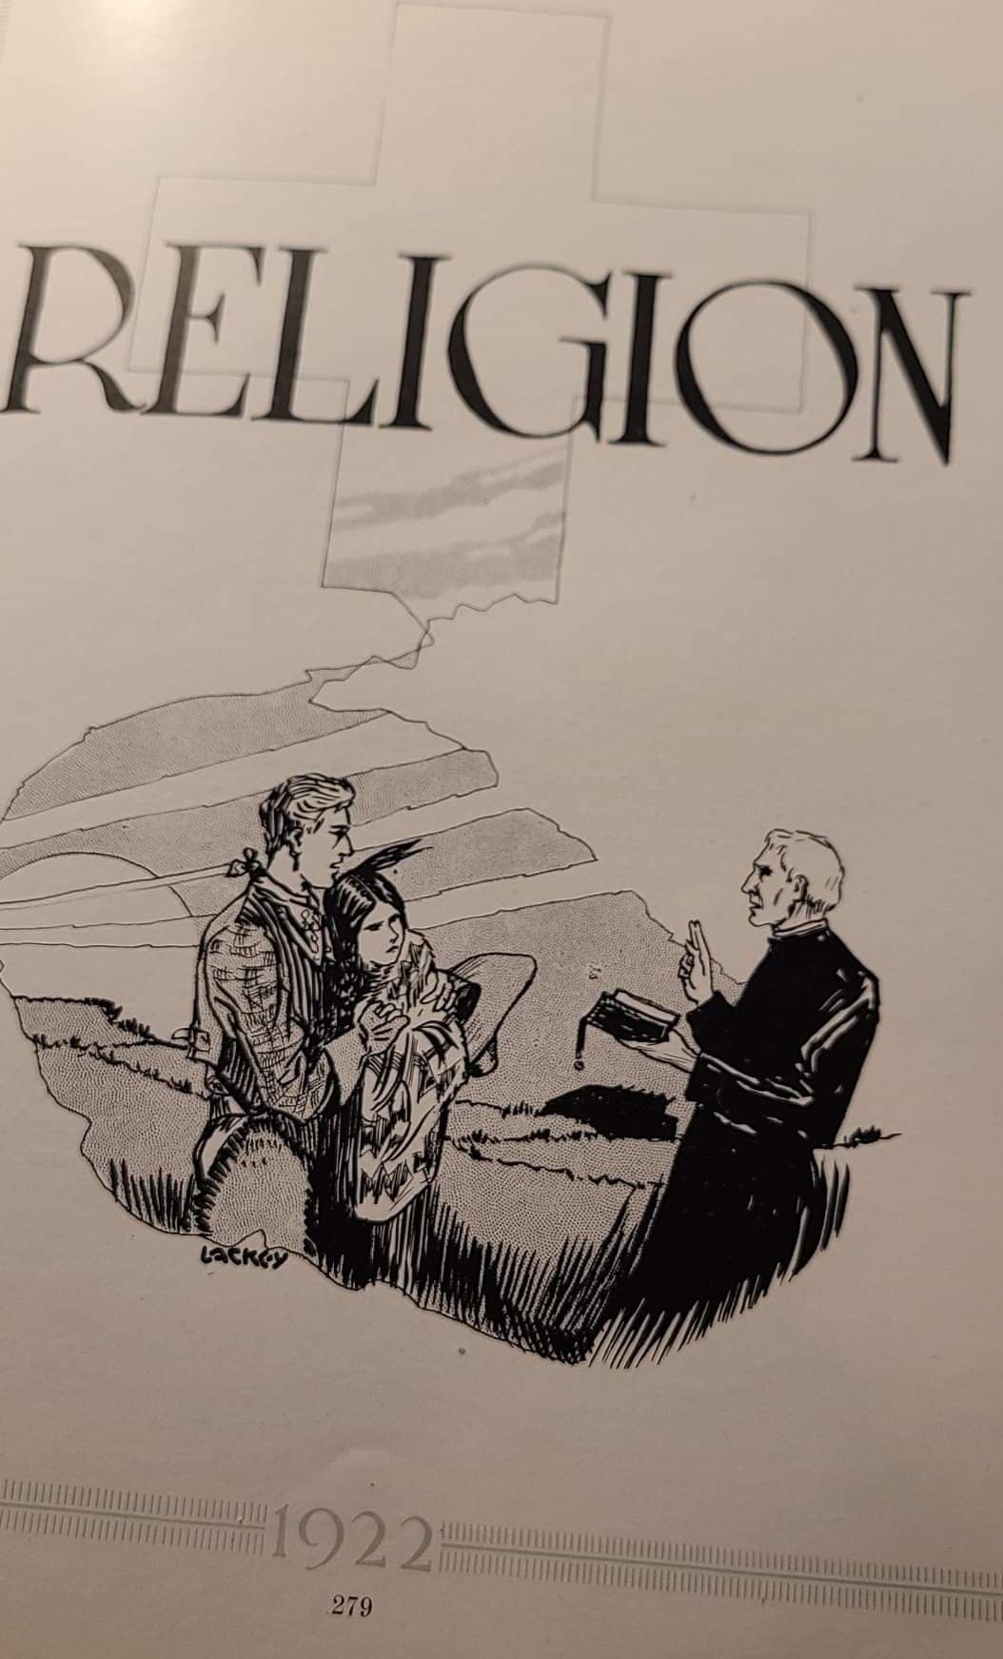
Figure 10: White salvation through religion depicted in 1922 Sooner Yearbook, PG 279
We can discern in the records of student life some evidence that students were growing impatient with the “traditional values” of what came to be known as fundamentalist Christianity. The atrocities of the Great War and its devastating impact on the older generations, communities, and nation led many young adults to question their own faith. The shift in social, cultural, and economic priorities in these youth began to take hold in 1926, shifting from settler imagery towards a modern image of a college man or woman. With this shift in imagery came a change in priorities and ideals regarding fashion, women, natives, and marriage. The mobilization of America’s youth towards institutions and universities came with a break from the previous religious restrictions that were the foundation of earlier communities. It is in this decade that an organized version of student voice began to appear in university publications and throughout the community.
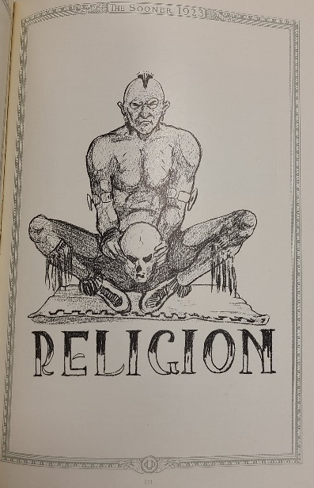
Figure 11: Religious Section Cover from 1923 Sooner Yearbook, p. 311
Women of OU
The University of Oklahoma provided employment opportunities to women much earlier than most universities in the nation. The first women were hired as early as 1895, although for a decade there were only two women who taught courses. OU’s location on the western front allowed a certain amount of social freedom that was not available in many eastern universities. Women enrolled at the university from the very first class, but their ability to enroll did not mean they were valued or respected physically or intellectually. Similarly, women were not treated equally with regard to pay or freedom of course selection. For hired women of the campus, their salaries were less than half of the salary of their male counterparts. Most male employees in 1898 were paid between $1300 and $1600 annually, whereas the female employee was paid $900, indicating a significant wage gap from founding without justification other than gender. Women instructors were also subjected to higher regulation and stricter evaluations than male instructors in their teaching.
This disparity in standards and treatment of female employees is also evident in early publications; the first terminations were of women with miniscule infractions compared with those of their male counterparts. The first termination of an employee on campus was recorded as a Miss Howell in 1896, a music teacher. No reason was stated for her termination. Accounts of the terminations of male instructors, on the other hand, listed a reason for their departure. The first instance of evaluations with consequences occurred under President Evans, and this process was especially critical of women in paid positions. TheRegents Minutes show that women were under extreme scrutiny, with claims that they did not work as hard for their pay and that funding should be cut to women’s less important programs, such as the women’s culture and elocution departments in 1910. The same Minutes listed requirements for each female instructor to be retained but not for male instructors, and a substantial amount of justification was required to hire or increase the salary of female instructors. The inclusion of women in the hiring process certainly did not ensure their treatment would be on par with their male colleagues.
The roles of women within society and gendered expectations also appeared on campus. From founding until the mid-1920s, women enrolled in courses at OU were restricted to certain departments, clubs, and physical spaces on campus. Women were allowed to participate in approved athletics in separate physical locations from males and in certain clubs, such as literature clubs and social clubs. Perception of propriety was also heavily influential in early years at the university. The Board of Regents carefully hired and placed female employees in positions of supervision over those women enrolled. It was important for women on campus to manage their image within societal expectations to maintain their reputation within their family and the one expected of them by the university. Participation in social groups and clubs on campus was commonplace for many women who joined the clubs allowed to their gender, such as the Old Maids Convention and Women’s Literary Club.
Only a handful of clubs were co-ed, including the Oratorical Council and several student publication committees. For women, these clubs may have provided a social space to explore ideas and share experiences, but for men, they were an opportunity to pursue the fairer sex. Many women came to the university not to actually study for a career but as an opportunity to gain an education and meet a potential suitor. The early yearbooks portray most women at OU as physical specimens and items of pursuit for male students, not people with inherent intellectual value. The 1911 yearbook has several instances that speak of women gaining attraction from more suitors on campus and the fine reputations of the women of OU; otherwise, the only praise for women was for collecting ticket fees at athletic events. Additionally, women were viewed as a renewable asset to many young men on campus who were advised “to date several women before finally settling for just one”.
Women were frequently portrayed visually throughout publications as representations of the values and appeal of the OU brand. As mentioned previously, even the official colors of the university were selected by the only female instructor on campus at the time; indeed, she was the only person consulted for the task by the university president. For almost three decades, women were portrayed in student publications in various roles without hearing their perspectives or scholastic contributions. The dark webs across campus served as a shroud for many women, silencing their narrative but utilizing their image. The first images of women showed them as parts of campus clubs and as the consumer expert in domestic conveniences for Norman Milling and Grain Company through encouraging purchases of electric irons, dishes, toasters to better equip a woman to take care of their household and family. Women continued to serve as central figures in campus images promoting stereotypical gender roles for the next several decades. There was a development of a “Beauty Queens” section in the annual yearbooks featuring women students selected for their beauty for the school overall and for special festivals and individual departments. There was simply a professional profile snapshot of these elected “queens,” with no description of their studies or interests and no instances of their voice. It seems that women on campus were certainly seen but they were not to be heard. Women’s imagery was also used to promote support of the Indian Club and military organizations on campus through the depiction of an “Indian Queen” and female sponsors for SATC and ROTC units. In effect, part of the OU brand served only white men, while women were expected to be admired physically, not valued academically. These depictions of women as a part of the OU brand in illustration, not narration, persisted in the form of beauty contests, which were advertised during all of the years covered by this study. In the 1923 yearbook, the editor acknowledge the campus students’ protest against the selection of Sooner Queens with allegations of favoritism and personal bias, which he denied; later a local publisher and photographer would pick the women featured in each edition. The impact of women being used as illustrations of beauty and not for their valuable scholarly and intellectual contributions was not addressed for another few years.
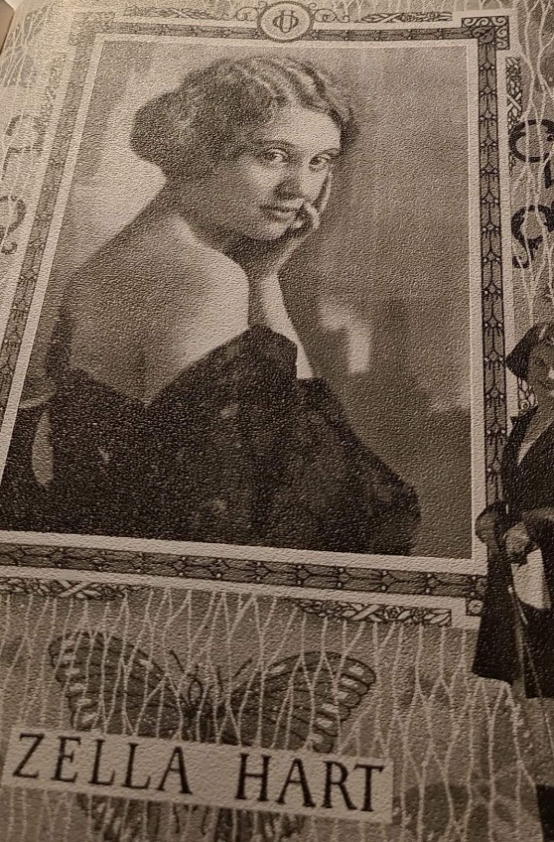
Figure 12: One of Many Attractive OU Women Depicted as a "Beauty Queen" in the yearbooks
As the university continued to progress as an institution of higher learning at the end of the 1920s, several gendered spaces and programs began to emerge as opportunities for female student growth. There were several departments where women were able to flourish in their studies at during their time at OU, including Department of Women’s Studies, Department of Education, and the Nursing Program. Many women came to OU to gain a degree in education and earn a teaching certificate for the state of Oklahoma, and they were able to achieve their goals and receive a lifetime certificate of teaching from very early on in the school’s formation. It would take several decades for women to outnumber men in enrollment on campus because many women were away teaching elementary and high school courses in Oklahoma and only able to take summer classes on campus. Many women also found great success in the pursuit of medical and nursing degrees and performed incredible acts of service during the Great War for the community and the state. The partnership between the University Medical Center and the State Hospital for the Insane provided unique expertise and experiences for OU nurses that raised their marketability to outside employment. Women also excelled in English and literature studies, providing invaluable support on student editorial committees and publications. In 1920, Mary Jane Brown received the first Ph.D earned by a female student; she became an assistant professor of biology. It would not be until the shift in youth culture of the 1920s that young women began to gain traction in their pursuit of academic and social equality on campus.

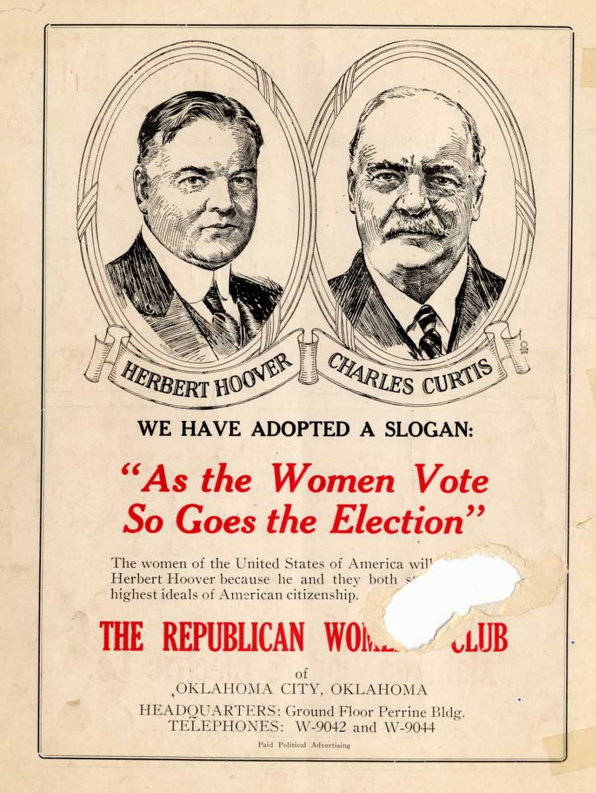
Figure 13: Call for Women's Vote from 1928 Sooner Magazine, Vol 1. No 1.

One of the most restrictive departments to women on campus was the athletic department. Women were believed to be too weak physically and emotionally to handle the rigors of collegiate sports. Due to this bias, women were not authorized to wear the coveted “O” while participating in athletic activity until the mid-1920s, despite efforts from devoted female faculty advocating for athletic equality. By 1925, women’s ability to perform with gender restrictions began to surface, with women appearing in the yearbook under men’s minor sports wearing the “O” for the university on their uniforms. The same edition showed a newly established women’s rifle team, showing one of the first breaks from gender stereotypes in OU publications. The first instance of senior female leadership in higher administration occurred with the addition of a female lawyer serving on the Board of Regents in 1927, showing a true step forward for the university in diversifying leadership at the highest levels.
The shift in women’s opinions and instances of individual voice became assigned to themselves instead of interpreted through male students or imagery in the Sooner Magazine beginning in 1928. The first volume hosted an advertisement from the Republican Women’s Club encouraging women to vote for the Republican candidate, adopting the slogan “As the Women Vote So Goes the Election.” Additional advertisements and articles shifted their approach to a co-ed audience enabling participation from both male and female students for the first time. Women were now viewed as valuable beyond their physical appearance. In 1929, the first OU female student was invited to speak in front of an international congress regarding the equal rights of women. The same year, a Sooner woman was selected as the top violinist at a prominent school in France. The next Sooner Magazine issue featured articles by female students. A 1929 article by Mrs. Walter Ferguson, an OU alumna of 1907, expressed criticism of women in the workplace, demeaning treatment in careers, and poor representation in the national media. The next article written by Mrs. Ferguson fostered a criticism of a Mr. Bok running a ladies’ journal and his assertion of a “woman’s place.” She countered Bok’s assertions with an analysis of the way women are controlled and told to act by men in society. In Issue 8 of the same year, an article by Merle Prunty, principal of Tulsa High School, addressed the disparity between secondary and higher education, arguing there was not a large one; she questioned the aim and depth of college education. Women, inspired by the experiences of the wife of the Board of Regent President, also began to discuss the benefits of education of women all over the world in order to expand both their global influence and their opinions outside of their immediate communities. For the first time, women were considered contributors to the narrative of student publications beyond the scope of domestic service, matrimony, or physical depictions of beauty. Their narrative changed the restricted view of earlier years.
Indigenous People at OU
Oklahoma was known best for two things throughout the nation: Indians and oil. But the native people were seen as a bygone people “wrapped in blankets and emitting war whoops.” This stereotypical portrayal of a varied and culturally significant people prevented institutions and the legislature from consideration of the value of the academic and intellectual contributions of these students. This oversight robbed the University of Oklahoma of the voices of native students for the entire first four decades after founding. In academic spaces throughout the state, indigenous people were viewed as a silent party in a movement to erase and civilize their traditions and cultures from the landscape to make way for white progress. The very ability to establish the university came from the strategic treaty manipulation and dispossession of native people in Oklahoma before the land run. As the legislature made way for new settlers, and OU tailored its programs to their educational needs and aspirations. The University of Oklahoma admitted indigenous students well before other institutions after Governor Barnes instituted legislature to enroll students from Indian Territory tuition-free in 1899.
In response to his proclamation, the university called for youth of the Cherokee, Choctaw, Chickasaw, Creek, and Seminole nations to attend courses, viewing these tribes as more sophisticated and capable than others throughout the state. These five tribes were alleged to be more amenable to and capable of scholastic pursuit than other nations, a restrictive and incorrect assumption by educators in general. These campaigns for recruitment targeted these specific populations to attend the university, but their voices at OU were muted during the early years, much like the voices of women. The OU brand put the conquering of a vanished people at the forefront, with depictions of a bygone tribal tepee with an eradicated buffalo in front of it then a seed sower who replaced the landscape with agriculture and civilization. Native people were portrayed in images but silenced in narrative throughout publications. Most were only identifiable as from Indian Territory by inclusion of their hometowns listed next to their school photos, as seen in the 1915 Sooner Yearbook, which listed “Indian territory” next to the names of several law students.
Visual representations in student publications and illustrations of indigenous people were dismissive of their existence and the value of tribal heritage in Oklahoma. In the 1916 yearbook, most references to indigenous people adopted the national themes of preserving relics and traditions of “the rapidly disappearing Redman.” The “administrative vision” that became the official brand of the University fostered a complicit process by students and faculty that selectively appropriated native imagery and presence on campus that kept it stereotyped and far from the center of what OU is supposed to mean and represent. To excel in academic arenas, indigenous people were expected to reject their tribal culture and knowledge in pursuit of allegedly more civilized and valuable scholastic content.
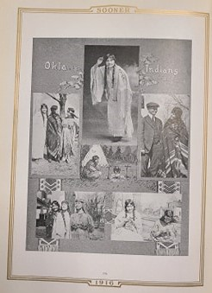
Figure 14: Native photographs in 1916 Sooner Yearbook
One of the most persistent reminders of rejection of native culture as synonymous with acceptable education was evident in the illustrations and legends that adorned the Sooner Yearbooks from the very first edition. Many images and references to these peoples were used to show the progress of the university away from a previously untamed and uncivilized territory and towards a more advanced formed of society. In 1915, the mention of indigenous peoples revealed their existence as exhibits at the museum as memorials of men once gathered in Oklahoma. This perspective did not account for the native students and peoples that were on campus and in the state still living; instead, it erased their existence from consideration. Many of the illustrations throughout the yearbooks from 1911 to 1928 represented native men and women suspended in scenery in various formats indicating an era past. In the same timeframe, photographs of natives showed either students posing in tribal attire during campus celebrations or as recipients of charity work.
World War I would interrupt the now customary images of settlers civilizing a landscape once only occupying natives for several years, eventually returning to images of settler colonialism in 1921. The 1921 yearbook reverted to imagery matching the “vanishing Indian motif” with images of native warriors chasing buffalo and engaging in tribal ways of life. The next year highlighted military officers shaking hands with natives holding a peace pipe indicating a truce between natives and movement towards civilization through white progress. The impression of this type of image implied Oklahoma was established in agreement with the indigenous population. The following two years would also feature similar imagery, with the 1924 edition adopting a romantic notion of native spirit and vision to build upon the land, crediting Oklahoma’s discoverer La Selle with the vision and ambition to bring progress to this great state. These dismissive and destructive images continued to appear throughout the university for many years.
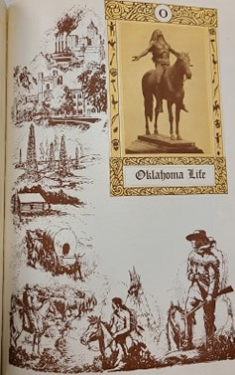
Figure 15: Example of "Vanishing Redman" in pursuit of civilization in Sooner Yearbook
Regarding scholastic pursuits, early records did not differentiate those of native descent from others, which makes it difficult for historians to statistically represent the correct data. The establishment of the Ethnology department in 1913 brought a new awareness to native history, claiming its purpose as looking at people of Oklahoma’s past. This department hosted the first scholarly collective group of students with native descent who worked to collect information on the tribes of Oklahoma. These students created a collection of articles and remnants of about sixty native tribes and supported the department’s interests through their affiliation with American Indian student organizations on campus.
This use of legends and depictions suggest a nonexistent people who no longer required their own voice or intellectual space. This was not the case for native students OU who participated in social clubs, contributed to valuable scholarship, and volunteered in the community. The first clubs to create awareness and conversation regarding the forgotten people of the landscape OU occupied began to change the belief that they no longer existed. The Oklushe Degataga (also known Indian Club) organized to collect tribal culture, legends and relics, representing seven of the nearly sixty tribes in the state of Oklahoma in the university museum collection. There was also an inclusive list of all students affiliated with tribal membership in the same club section for the first time in 1916.
The same edition introduced the “Pe-et” senior men’s honor society, “Pe-et” was listed as a native term meaning “Honor Man.” The edition goes on to tell of several native legends with interesting narratives, one of which was the “Legend of the May Festival.” This legend told the story of a young warrior who was spurned by a chief’s daughter when asked for her hand due to his tribal affiliation but who earned the respect of the chief and the hand of his daughter when he hunted buffalo to end a famine for the tribe. This story is significant because it claimed that the site of the hunted buffalo bones that saved the starving tribe was now the site of the university itself, and this legend became the catalyst for several different annual events on the campus, including a festival, election of a “May Queen,” and celebration of spring. Despite the depictions of a vanished people in many publications, there were influencers of collective action on campus working to interrupt this narrative long before their voices were recorded. Discussion of the white settlers’ treatment of native people in Oklahoma did not appear until the third issue of the Sooner Magazine in 1928. “As more whites continued to invade the last stronghold of the red man, the school grew and by 1900 it was running in fine style.” This was the first acknowledgement of white encroachment on the land and destruction of native practices. .
In an issue of Sooner Magazine later in 1928, Professor Dale published an article on ranching practices on Indian reservations, showcasing one of the first times a member of OU faculty found value in the study of native peoples in the state. The next issue discussed the practice of reproducing Kiowa Art by Indians of Oklahoma and calling for better treatment and the end of assimilation efforts. Not all who wrote on the topic had academic ties. In the 1929, under the “Here and There with Sooners” section of Sooner Magazine, Secretary Wilbur of Indian Affairs published his opinions, exposing his desire to force natives to become independent, self-sufficient citizens weaned off of the support of the state and government. In opposition to his views was his opponent running for the Indian Affair Commissioner position, Dr. Dale, who supported federal control of Indian affairs and argued that without support these peoples would be robbed of their properties and farms. There would be many more trials and tribulations for native rights to come.
In many ways OU, provided an opportunity for American Indian student participation well before other established institutions throughout the nation. The ability to enroll in courses and attend social functions did not mean that their individual contributions as experts on their own heritage or their perspectives were valued and respected. For many of these students, to gain an education meant to assimilate to white normative culture on campus. The addition of the Ethnology Department and art programs featuring native pieces shifted this shrouded attendance of students slightly. Clubs on campus openly celebrating students with native descent helped to grant awareness and exposure to the general population of the school. The realization of the detrimental impact of settling the state of Oklahoma on native populations would take much longer to form. Meanwhile, students in publications and a few select faculty began to discuss it nearing the end of the 1920s. This has continued to the present day as a topic of debate and value.
The Prohibition of Black Students
Norman established itself as a community devoid of African American residents from its very establishment through the implementation of sundown town legislation and social hostility. Although it is undeniable that Norman granted no safe space for people of African descent within the city limits, residents’ desire to promote a godly and inclusive façade led to outright denial of the situation. The local newspaper, The Norman Transcript, published claims that Norman was not a “negro hating community.” But the fact remained it was dangerous for those with black bodies to be within the community outside of a few specified manual labor jobs. This rejection of African Americans was also seen at the University of Oklahoma. Perhaps the impact of the community of Norman further mirrored that of a state that chose to implement Jim Crow laws in its very constitution, or perhaps it was due to the influence of early leadership. OU was no exception. Did OU belong to Norman, or did Norman have value because of it was the location of the university? Whatever the case, no black person made a request for enrollment until almost six decades after OU’s founding, even though no legislation prohibited black students from enrolling until 1907. .
There is no ambiguity about how unwelcome black people were on the OU campus for the first half century of its existence. In early efforts to recruit quality residents to surrounding communities, Dr. Boyd attempted to assist a young black man in his travels; when he stopped by for a brief visit on campus with the president, it created an incendiary response, resulting in students burning an effigy of the president later that day. It is very clear there would not be negotiation or consideration of black students on campus regardless of circumstance. African Americans would be accepted in the university hospital for treatment of illness and injury, but only in separate wards. The only instance of any discussion in higher administration publications appear in regards to the Regents Minutes for Langston University. These sessions discussed faculty allotments, funding, and maintenance for buildings; it did not address the division between the races or content comparison of courses. Among faculty, Professor Dowd became a source of expertise after his publication “The Negro in American Life,” which purported to show social breakdown among African Americans after the paternalism of slavery had ended. Many years later, another graduate of OU’s Ph.D. program, Jimmie Lewis Franklin (1968), rebutted this racism in his own history of blacks in Oklahoma, Journey Toward Hope (1982). There were other faculty who influenced the continued restriction of black students on campus. For instance, in a local newspaper, the openly racist Professor DeBarr blamed the death of his poisoned wife on a “negro.” These impacts on campus would ensure that black students were not considered for recruitment for academic opportunities at OU until forced to by legislature.
In contrast to depictions of native students as conquered and vanished as a people, visual representations of African Americans portrayed them as beastly and an affront to civilization—not fit to join the university in any capacity. There were no romanticized notions of powerful warrior legends; rather, they were used to demonstrate the very lowest forms of human society. Throughout the annual Sooner Yearbooks, calls for equality and discussions of community would be completely devoid of contemplation for African Americans. Students participated in the degradation and hostility toward this population in nearly all of their publications. The first instance of offensive and dismissive treatment of black bodies appears in the 1916 Sooner Yearbook in the “Stunts” section, showing a white student in blackface perpetuating the stereotypical representations of oppression through implementation of exaggerated features attributed to blackness. In the next edition, the practice of apprenticeship was related to slavery and called for equality for all underprivileged in education but blatantly ignored black discrimination despite the use of chattel slavery. Like the issues of other minority groups, the Great War changed the content of the university’s intellectual life as seen in campus publications. Blacks continued to appear in editions as caricatures and as jokes after the war. In the 1922 yearbook, there appears a caricature of an exaggerated Pacific Islander in stereotypical fashion and a caption that makes fun of the Fiji Island king. The same edition showed an image of two black men playing instruments, with a caption stating “The Black Plague” underneath it. In the 1926 edition, a black woman was depicted in caricature with over exaggerated lips as a joke for too much lipstick. Students and editors had no qualms with depicting black bodies as the images of oppression and humor. The unfortunate truth remained that this type of behavior was accepted and allowed on campus in nearly every aspect of student life until well into the 1940s. 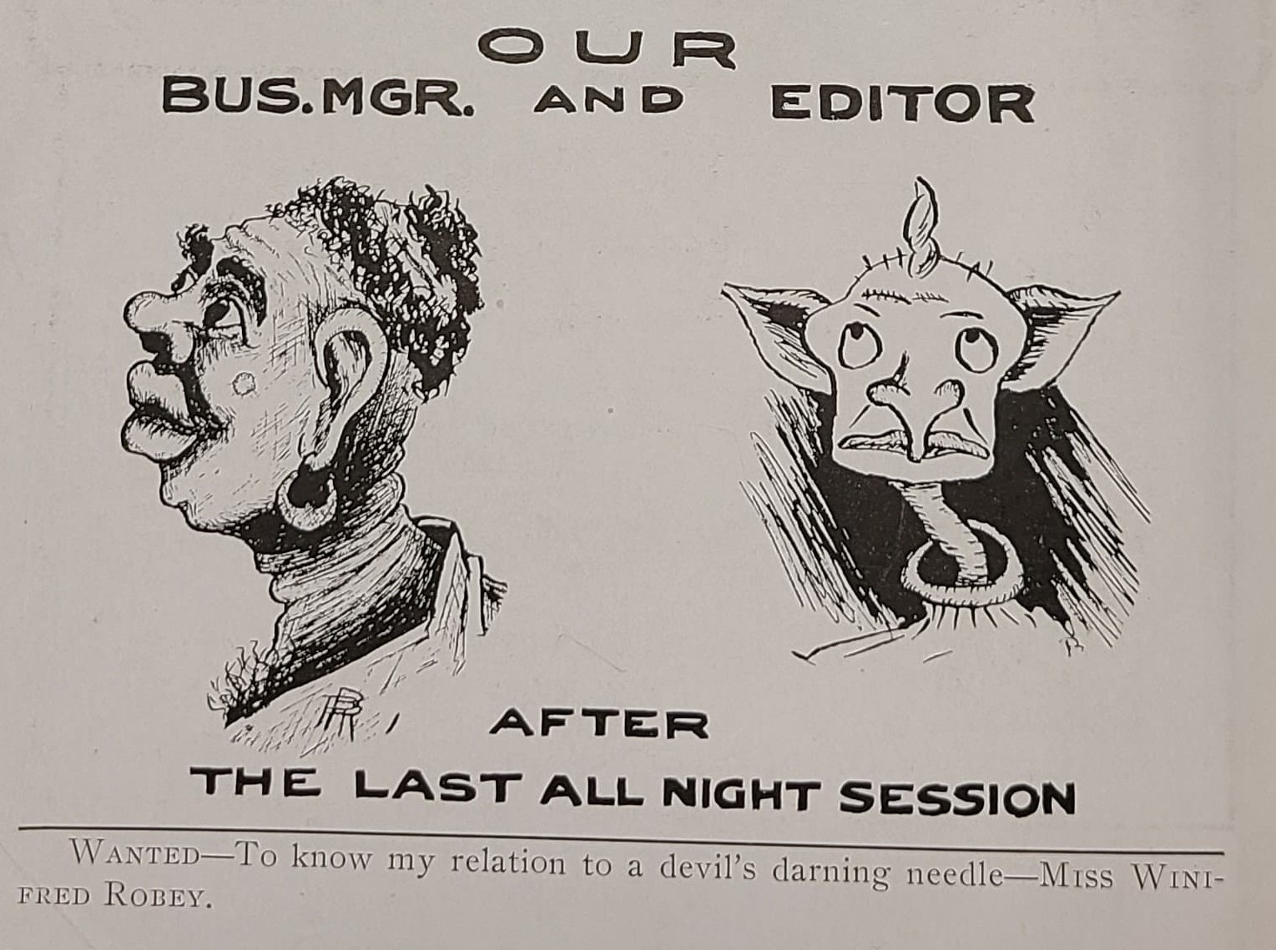
Figure 16: Typical depiction of African Americans via exaggerated features and stereotypes

Blacks were used visually to relate the struggles and oppression white students felt they endured in a relatable thematic representation towards their audience. In a 1929 issue of Sooner Magazine, a female student named Olinka Hrdy who had become an artist of some acclaim created several images of southern themes featuring “black mammies” amongst hoary trees and swamps in her work. Hrdy would later be hired to develop a mural painting by the university in the womens’ dining hall, where she painted images of black harvesters smiling and plucking watermelon and other food in a work titled “The Maker of Dreams.” It is apparent in these created scenes that black bodies were viewed as an means to an end, a necessary component of labor for the greater good of white society. These were not people that were believed to have intellectual or cultural value within proper civilization. Instead, their skin color was used as a justification for degrading treatment of their race in order to illustrate the plights white students were enduring. There were no instances of black voice or defense of black bodies in any of the publications on campus during the course of my study. In fact, in 1929, there was a request to rescind the law prohibiting blacks from staying overnight in the city in order to move shops from Purcell into Norman, but this request was denied and Norman refused to allow any African American laborers to stay overnight within city limits. Blatant racism against blacks simply was not viewed as an issue worthy of analysis until civil rights protests in the late 1940s.
The necessary changes to allow inclusion of all students regardless of racial background in America did not occur until a series of lawsuits demanded change in the 1940s. Well before these cases reached Oklahoma court systems, students confronted the unequal treatment of black students in a variety of ways. In a February 1929 edition of a local newspaper, OU students and faculty questioned the treatment of black students in Oklahoma higher education institutions, challenging the meager resources and opportunities afforded to those of African descent.
Secret Societies on Campus
There would be a much more sinister movement towards the prohibition of black students on campus in the early 1920s with the appearance of the Klu Klux Klan (KKK) on campus. The first advertisement for club attendance would appear in 1920, depicting a mask with the caption “nemo nos impune lacessit,” meaning “no one attacks me with impunity.”. Although alarming to us today, the inclusion of this blatantly racist and violent club on campus reflected a larger national movement towards promoting white superiority at the expense of black bodies. Partly resulting from World War One and the social value shift among youth in the 1920s, there is a more unstable campus culture; the Klan are there to enforce certain cultural traditions, especially black exclusion. They coexist with a growing segment of the student body that does not support their message or their semi-official status on campus; as a distinctive youth culture emerges which is less deferential to tradition, the social control exercised by other masked clubs begins to be challenged. The inclusion of the KKK on campus would be a part of a larger movement of masked vigilante clubs on campus. The inclusion of the KKK as part of the campus social structure highlighted the prevalence of rejection towards black bodies, not only in the community but among students as well. The influence of several faculty further promoted this racist behavior. One of the leaders of this initiative was Professor Edwin DeBarr. His influence as one of the first faculty members led to strident racist support of restriction of African American and mixed-race students from founding. In the 1920s, he was removed by the OU regents for his connections to the KKK, and his name was later removed from the campus later for the same reason. The damage had already been done for many, however, as the impact of the club’s acceptance had displayed an undercurrent of hatred towards black students that would be difficult to uncover for many years to come.
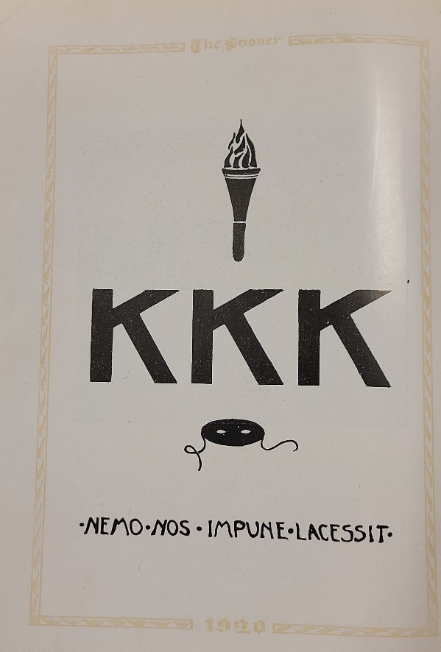
Figure 17: KKK Club Advertisement in 1920 Sooner Yearbook

Other secret societies on campus featured masked students in various images without the ties to racial violence and promotion of white superiority. The purpose of other masked clubs on campus was in protest to alleged underground activity. The Deep Dark Mystery Club (DDMC) was first mentioned in the 1915 Sooner Yearbook. This club was organized “to correct infractions and broken rules of honor codes.” A later yearbook listed 1905 as the founding year of the DDMC on campus. Images showed this club’s members in masks, but it was separate society from the KKK, although it used some of the samemethodologies. Members saw themselves as guardians of the “Soonerland” and were known to take matters into their own hands, beating and terrorizing students who were alleged cheaters on tests, adulterers, or participants in inappropriate student conduct. Incredibly, this type of hazing was not only allowed on campus, it was recorded in student publications. Images appeared in various editions of the yearbook depicting masked students in various poses. One image in the 1920 yearbook showed the masked club pinning a hooded student to the ground next to a bonfire with an iron brand positioned over their chest. The following year featured a restrained student kneeling in front of hooded figures brandishing sticks and captioned “free sooner for anyone guessing entire membership of this organization.” It was made clear to students on campus that there were severe consequences for anyone unable to heed the social expectations of the secret societies on campus.

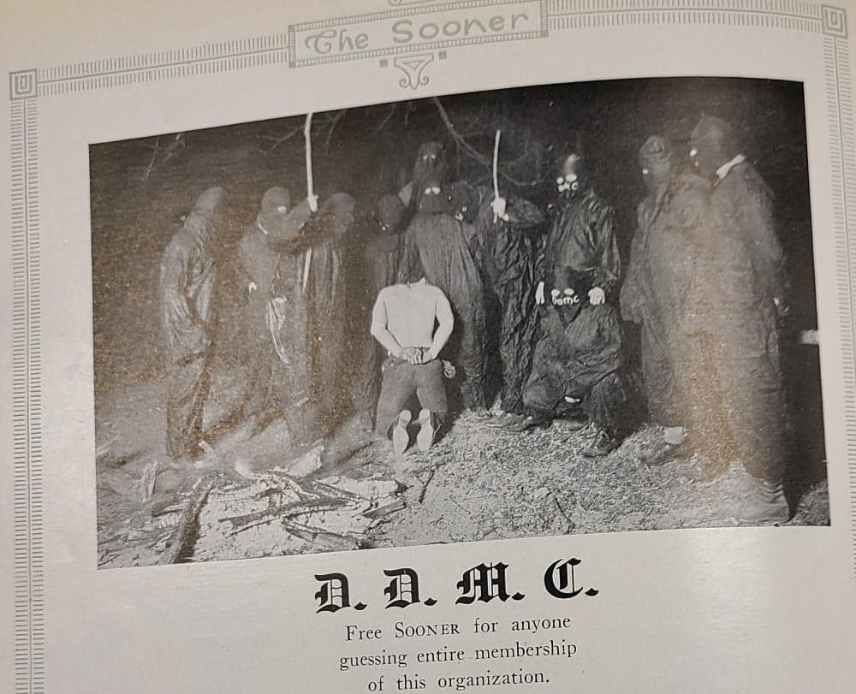
Figure 18: Typical DDMC Image, in 1922 Sooner Yearbook PG 442

It would seem there was no population on campus that did not have the pressures of expectation placed upon them, even if it was created by students themselves. Physical punishment from upperclassmen was also commonplace on campus. The use of paddles for disciplinary action occurred on campus was acknowledged through a debate in the Sooner Magazine to end the practice. Some students argued that the practice was old-fashioned but necessary to instill discipline and humility on freshmen, while others claimed it was a form of bullying and hazing. Several incidents occurred on campus where the beatings that took place ended in hospitalizations and permanent injuries. This display of violence and masculinity would soon lose the support of students and administration alike. The practice of paddling freshmen for initiation would ultimately be banned by the OU Board of Regents when a woman almost lost an eye during a paddling incident. The first ban on these masked clubs came after a confrontation between the KKK and DDMC regarding the first club’s violence towards black in the community resulted in a shooting incident that left one student injured. The Board of Regents instituted legislature prohibiting any student from joining an organization that was not approved by the administrative council, but these masked clubs persisted for several more years. After several more incidents between the DDMC and other organization occurred, the Board of Regents banned all masked clubs on campus. This was the first time in the university’s history that there were limitations set in place for the physical and emotional protection of students on campus.
The dark web that shadowed the university was not a singular event in the nation. Most institutions in the nation battled their own forms of racism, sexism, and student discrimination to varying degrees and with different results. The effects of national ideology instilled certain responses toward women and minorities as commonplace in white society and normalizing discriminatory behavior. These instances are all results of country’s growth and the painstaking processes that come with that progression. There is no handbook that immediately instilled equality, empathy, or respect for all people and gender for the human race; rather it is a progressive pursuit and the obligation of every facet of leadership. OU had its own tribulations during multiple phases of its history, with some unfortunate periods of poor treatment and oversight, but it was dedicated in its quest to establish a grand university that could bring knowledge to all on its campus. Most instances in which the OU brand gained negative attention could be attributed to manipulation for personal gain, political bias, or personal bias of leadership and students in order to serve oneself. Eventually, the demands of thoughtful and intelligent people would bring the changes necessary to expand this mission to all of the diverse populations OU serves today.

Conclusion (Summary of Major Points)
In order to understand the ground upon which we stand, we must take the time it takes to research and critically analyze the history around us. The University of Oklahoma was founded as a state university through several major events. The early years beginning in 1890 were encompassed by a monumental effort to create an institution of higher learning in a territorial space without an organized legislature. This timeframe wrongfully assumed that the land was free of culture and civilization, leaving an entire nation of indigenous people without consideration in thea quest for statehood. In its formative years, OU endured its first massive shift as Oklahoma was admitted as a state into the union in 1907. In the decade that followed, OU attempted to craft an institution both physically and ideologically aligned with the newly founded state. Unfortunately, this included a legislature and state constitution that immediately imposed restrictions and prohibitions on black communities. This instituted a level of control and exclusion never before seen in the territory. Although female students, native students, and some students of other minority backgrounds were admitted to OU during this time, they were not invited to participate fully. These populations were be considered academically valuable or worthy of individual contributions until much later.
The years after statehood and leading to World War I were marked by relative ease, characterized by expanding facilities and developing accredited college programs. The university grew beyond any previous scale, unaware of the coming global event that would forever change it. The impact of World War I would change the campus both physically, through military training and facilities, as well as ideologically, as it shaped young people’s thinking significantly. The naivety and joyful celebration of leisurely abundance would be replaced by a patriotic desire to perform in service of the nation. The war years were followed by a cultural and social shift in the youth of America in the 1920s and 1930s. During this time period, we see the previously muted voices of minorities and women come to the forefront with assertions of self-worth and scholarly value. In this space, for the first time, OU worked to become an inclusive space, albeit without equality of opportunity for many years to come. The face of the university has changed many times leading to what it has become today. Yet even with time, the same challenges, histories, and legacies still apply to this very moment.
I have been fortunate in my lifetime to learn lessons through atypical scenarios and experiences. As an avid equestrian, one of the greatest life lessons bestowed on me came in an unexpected avenue. I grew up at the foothills of the Sierra Nevada Mountains in one of the largest deserts in the United States. To be raised in a desert community of California afforded me unique opportunities. I grew up on a large pistachio farm in one of the most desolate areas of the region. While others see the lack of water and lush green grass, I had one of the most precious opportunities in the nation at my disposal, the Wild Horse and Burro Sanctuary maintained by the Bureau of Land Management (BLM). I understand that there are many differing opinions and perspectives on the management and capture of wild horses and burros in the nation today, and I am not here to debate the intricacies of this debate. Instead, I am here to share a life lesson horses have taught me. I was attending a clinic with one of the most famous natural horsemen in the nation, Pat Parelli, at a young age when he said something to me that I will never forget and will always use to improve my work. I was getting frustrated with the behavior of a young wild horse and losing focus on the goal at hand when he said, “take the time it takes, so it takes less time.” This simple sentence changed my perspective on the world. There are things we simply cannot rush, and yet we must use the time required to make change occur—always insisting there is a better, more equal, and higher standard that must be reached now. There are lessons that can only be learned in time, even if it means enduring war, anguish, or inequality. To find solutions, we have to learn the intricacies of the problems at hand and share collectively in the solution. There is no rush to the finish line that will solve these societal issues, but the conscious effort to educate ourselves and our students in their histories so a way forward is possible.
We have a special obligation as historians to acknowledge the instances of social issues within the institutions and organizations of our nation, I am fortunate to study these factors in a time when the nation is willing to listen. I was not at OU during the Sigma Alpha Epsilon (SAE) racism incident in 2015, but I see actions today that showcase how OU is trying to change for the better and the need for it to happen. We must remember that every institution in the nation was going through the same growing pains and changes; there were just differing displays of the same issues from region to region. OU’s dark web has always been there, but for the first time, these restricted and shrouded places are no longer protected or allowed, giving students the ability to develop their own spaces of culture, inclusion, and equality. These students need to be heard, we cannot move forward in academic spaces without the input and interventions of scholars from every diverse background possible. This process is not an easy one; people are imperfect as are institutions. We must rely on each other’s perspectives, backgrounds, and interpretations to develop the best collective way forward. We cannot be the generations before, instead we have to come together to forge a new way forward.

Bibliography
Bay, Mia. The White Image in the Black Mind New York: Oxford University Press, Incorporated, 2000.
Bell, Daniel. The Cultural Contradictions of Capitalism. New York: Basic Books, 1976.
Brown-Wattley, Cheryl E. A Step Toward Brown v. Board of Education: Ada Louis Sipuel Fisher and Her Fight to End Segregation. Norman; University of Oklahoma Press, 2014.
Child, Brenda J. Boarding School Seasons: American Indian Families, 1900-1940. Lincoln: University of Nebraska Press, 1998.
Cohen, Lizabeth. Making a New Deal: Industrial Workers in Chicago, 1919-1939. Cambridge: University Press, 2008.
Cross, George L. Blacks in White Colleges: Oklahoma’s Landmark Cases. Norman: University of Oklahoma Press, 1975.
Dowd, Jerome. The Negro in American Life. New York, London: Century, 1926.
Ellis, Clyde. To Change Them Forever: Indian Education at the Rainy Mountain Boarding School. Norman: University of Oklahoma Press, 2008.
Ellison, Ralph. Going to the Territory. New York: Random House, 1986.
Fass, Paula S. The Damned and the Beautiful: American Youth in the 1920’s. New York: Oxford University Press, 1977.
Franklin, Jimmie Lewis. Journey toward Hope: A History of Blacks in Oklahoma. Norman: University of Oklahoma Press, 1982.
Fredrickson, George M. The Black Image in the White Mind: The Debate on Afro-American Character and Destiny, 1817-1914. New York: Harper & Row, 1971.
Lears, T. J. Jackson. Rebirth of a Nation: The Making of Modern America, 1877-1920. New York: Harper Collins Publishing, 2009.
Levy, David W. The University of Oklahoma: a History. 1, 1890-1917. Vol. 1, 2 vols. Norman, Oklahoma: University of Oklahoma Press, 2005.
Levy, David W. The University of Oklahoma: a History. 2, 1917-1950. Vol. 2, 1917-1950. 2 vols. Norman, Oklahoma: University of Oklahoma Press, 2015.
Limerick, Patricia Nelson. The Legacy of Conquest: The Unbroken past of the American West. New York: W.W. Norton, 2006.

Marchand, Roland. Advertising the American Dream: Making Way for Modernity, 1920-1940. Berkeley: University of California Press, 1985.

Neuman, Lisa Kay. Indian Play: Indigenous Identities at Bacone College. Lincoln, Nebraska: University of Nebraska Press, 2013.
Steinbeck, John. The Grapes of Wrath. New York: The Viking Press, INC, 1939.
Susan Strasser, Susan. Commodifying Everything: Relationships of the Market (United Kingdom: Routledge, 2003), 58.
Strasser, Susan. Satisfaction Guaranteed: The Making of the American Mass Market. New York: Pantheon Books, 1989.
Trachtenberg, Alan. The Incorporation of America: Culture and Society in the Gilded Age. New York: Hill and Wang, 2007.
Veblen, Thorstein. The Theory of the Leisure Class; an Economic Study of Institutions. New York: Macmillan, 1908.

Primary Sources
Magazines
“As the Women Vote So Goes the Election”, Sooner Magazine, Vol. 1, iss. 1, November 1928. Back Cover.
“As We Were Saying”, Sooner Magazine, Vol. 1, iss. 2, November 1928. 54.
“Feminine Sooner Musicians”, Sooner Magazine, Vol. 1, iss. 5, February, 1929. 177.
“Hats Off To”, Sooner Magazine, Vol. 1, iss. 4, January, 1929. 122.
“Here and There with Sooners: 1911.” The Sooner Magazine, May 1929. pp. 272. Sooner Heritage, https://digital.libraries.ou.edu/sooner/articles/p270-273,276_1929v1n8_OCR.pdf
“On Ranching in Oklahoma.” The Sooner Magazine, Feb. 1929. pp. 180. Sooner Heritage, https://digital.libraries.ou.edu/sooner/articles/p179-180_1929v1n5_OCR.pdf
“Pretty How-de-do.” The Sooner Magazine, Jan. 1929. p. 126. Sooner Heritage, https://digital.libraries.ou.edu/sooner/articles/p126-127_%201929v1n4_OCR.pdf
“Sooner Books and Authors.” The Sooner Magazine, Apr. 1929. pp. 247. Sooner Heritage, https://digital.libraries.ou.edu/sooner/articles/p247-248_1929v1n7_OCR.pdf
“What the Regents Did.” The Sooner Magazine, Apr. 1929, p. 230, Sooner Heritage, https://digital.libraries.ou.edu/sooner/articles/p230-231_1929v1n7_OCR.pdf
Brandt, Joseph A, editor. “A Student Shock Absorber.” The Sooner Magazine, Oct. 1928, pp. 12–13. Sooner Heritage, digital.libraries.ou.edu/sooner/articles/p12-13_1928v1n1_OCR.pdf
Brandt, Joseph A. “Wanted: Oklahomans to Invest in Culture.” The Sooner Magazine, Nov. 1929, pp. 57. Sooner Heritage, https://digital.libraries.ou.edu/sooner/articles/p57_1929v2n2_OCR.pdf
Dodge, Homer L. “Granting the First Ph.D. Degree.” The Sooner Magazine, July, 1929, pp. 327-9. Sooner Heritage, https://digital.libraries.ou.edu/sooner/articles/p327-329_1929v1n10_OCR.pdf
Ferguson, Mrs. Walter “A Woman’s Viewpoint.” The Sooner Magazine, Mar. 1929, pp. 207. Sooner Heritage, https://digital.libraries.ou.edu/sooner/articles/p183-184,208_1929v1n6_OCR.pdf
Ferguson, Mrs. Walter “The Point of a Woman’s Viewpoint.” The Sooner Magazine, Mar. 1929, pp. 183. Sooner Heritage, https://digital.libraries.ou.edu/sooner/articles/p183-184,208_1929v1n6_OCR.pdf
Mahier, Edith. “Kiowa Art.” Sooner Magazine 1, no. 7, April 1929, 247. https://digital.libraries.ou.edu/sooner/articles/p247-248_1929v1n7_OCR.pdf
Milburn, George. “Planting a University.” Sooner Magazine, Vol. 1, iss. 2, November 1928. https://digital.libraries.ou.edu/sooner/articles/p39-41_1928v1n2_OCR.pdf.
Mills, Ed. “Memories of Yesteryear.” Sooner Magazine, Vol. 1, iss. 3, December 1928. 76. https://digital.libraries.ou.edu/sooner/articles/p75-77,100_1928v1n3_OCR.pdf
Prunty, Merle. “Insuring Educational Co-operation.” The Sooner Magazine, May 1929, pp. 280-281. Sooner Heritage, https://digital.libraries.ou.edu/sooner/article_info.asp?articleID=2387&issueID=158&period=May&year=1929&volume=1&issue=8
Richardson, I.G. “Sooner to Sooner.” The Sooner Magazine, Nov. 1929. p 53. Sooner Heritage, https://digital.libraries.ou.edu/sooner/articles/p49-54_1929v2n2_OCR.pdf
Sheldon, F.M. “Norman’s New College.” The Sooner Magazine, Oct. 1928, pp. 6-7. Sooner Heritage, https://digital.libraries.ou.edu/sooner/articles/p6-7_1928v1n1_OCR.pdf
d’Ucel, Jeanne. “Eli-Artist and Teacher.” The Sooner Magazine, May 1929. pp. 256-258. Sooner Heritage, https://digital.libraries.ou.edu/sooner/articles/p256-258_1929v1n8_OCR.pdf
d’Ucel, Jeanne. “Olinka Hrdy.” The Sooner Magazine, July 1929. pp. 344-345. Sooner Heritage, https://digital.libraries.ou.edu/sooner/articles/p344-345,368,370_1929v1n10_OCR.pdf
Newspapers
Brown, Quincey T., “Commencement Exercises,” The Democratic-Topic (Norman, Oklahoma), Jun. 11, 1897.
D.R. David Boyd, “University of Oklahoma,” The Norman Transcript (Norman, Oklahoma), September 2, 1892.
C.B. McGinley and J.M. Daniel. “Order for Special Election.” The Norman Transcript (Norman, Oklahoma), May 9, 1891.
C.B. McGinley and J.M. Daniel. “Order for Special Election.” The Norman Transcript (Norman, Oklahoma), May 16, 1891.
C.B. McGinley and J.M. Daniel. “Mr. Fairbanks Wants Something.” The People’s Voice (Norman, Oklahoma), September 30, 1892.
Fenwick, Ben. “Debarr Remains Problem Controversial Scholar's Ashes in Storage for 30 Years.” The Oklahoman, 8 Aug. 1988, debarr-remains-problem-controversial-scholars-ashes-in-storage-30-years.
Tramel, Berry. “Little Red Sparked Indian Symbolism Debate Nicknames, Mascots under Siege since OU Dropped Mascot in '70.” The Oklahoman (Oklahoma City, OK), July 14, 2020.
“University Notes,” The Norman Transcript (Norman, Oklahoma), Aug. 4, 1893.
“Unrest Among Negro College Students.” Cleveland-Co. Democrat-News. February 10, 1929.
Regents Minutes
“Minutes” of the University Regents, 1892-1930, Evans Hall, University of Oklahoma, https://digital.libraries.ou.edu/regents/
“Minutes” of the University President, 1892, Evans Hall, University of Oklahoma.
“Minutes” of the University Regents 1899, Evans Hall, University of Oklahoma.
“Minutes” of the University Regents, 7 March 1912, Evans Hall, University of Oklahoma.
“Minutes” of the University Regents, 21 March 1912, Evans Hall, University of Oklahoma.
“Minutes” of the University Regents, 14 February 1913, Evans Hall, University of Oklahoma.
“Minutes” of the University Regents, 1913, Evans Hall, University of Oklahoma.
Yearbooks
University of Oklahoma. The Sooner; Yearbook of the University of Oklahoma (Norman: University of Oklahoma Press, 1911).
University of Oklahoma. The Sooner; Yearbook of the University of Oklahoma (Norman: University of Oklahoma Press, 1914).
University of Oklahoma. The Sooner; Yearbook of the University of Oklahoma (Norman: University of Oklahoma Press, 1915).
University of Oklahoma. The Sooner; Yearbook of the University of Oklahoma (Norman: University of Oklahoma Press, 1916).
University of Oklahoma. The Sooner; Yearbook of the University of Oklahoma (Norman: University of Oklahoma Press, 1917).
University of Oklahoma. The Sooner; Yearbook of the University of Oklahoma (Norman: University of Oklahoma Press, 1918).
University of Oklahoma. The Sooner; Yearbook of the University of Oklahoma (Norman: University of Oklahoma Press, 1919).
University of Oklahoma. The Sooner; Yearbook of the University of Oklahoma (Norman: University of Oklahoma Press, 1920).
University of Oklahoma. The Sooner; Yearbook of the University of Oklahoma (Norman: University of Oklahoma Press, 1921).
University of Oklahoma. The Sooner; Yearbook of the University of Oklahoma (Norman: University of Oklahoma Press, 1922).
University of Oklahoma. The Sooner; Yearbook of the University of Oklahoma (Norman: University of Oklahoma Press, 1923).
University of Oklahoma. The Sooner; Yearbook of the University of Oklahoma (Norman: University of Oklahoma Press, 1924).
University of Oklahoma. The Sooner; Yearbook of the University of Oklahoma (Norman: University of Oklahoma Press, 1925).
University of Oklahoma. The Sooner; Yearbook of the University of Oklahoma (Norman: University of Oklahoma Press, 1926).
University of Oklahoma. The Sooner; Yearbook of the University of Oklahoma (Norman: University of Oklahoma Press, 1927).

Finding aids/Other
[Student Army Training Corps Papers, 1918-1919], UA294, Rare Books, Special Collections, and Preservation, River Campus Libraries, University of Rochester.
United States Army Cadet Command. “Army ROTC.” The United States Army, 2018, www.cadetcommand.army.mil/history.aspx.
Articles
Levy, David W. “’Practically a Military School’:The University of Oklahoma and World War One.” ChO 84 (Summer 2006): 132-61.
Smith, Michael. “Latinos in Oklahoma: A History of Four and a Half Centuries,” Chronicles of Oklahoma 87, no.2 (Summer 2006): 186-223.
Turman, Fred E. “Christmas Boxes Sent By Sooners”, University and Editor (Norman, Oklahoma), Nov. 19, 1917.
Turman, Fred E. “Commissions Awarded to 26 Sooners”, University and Editor (Norman, Oklahoma), December 3, 1917.
Turman, Fred E. “Sooners Enlisting for War Service”, University and Editor (Norman, Oklahoma), December 3, 1917.
Turman, Fred E. “University Gives $5100 to War Fund”, University and Editor (Norman, Oklahoma), Nov. 19, 1917.
Fred E. Turman, “Women Exceed Men in Contributions to Army Y.M.C.A Relief Work”, University and Editor (Norman, Oklahoma), Nov. 19, 1917.
Turman, Fred E. “Write to Soldiers”, University and Editor (Norman, Oklahoma), Nov. 19, 1917.
“University to Be a Training Center for Army Officers” The Daily Transcript (Norman, Oklahoma), July 9, 1918.
Widener, Jeffrey. “The Latin Impress in Oklahoma City” Chronicles of Oklahoma 89, no. 1 (2011): 22.
“Woman’s Suffrage”, The Norman Transcript (Norman, Oklahoma), April 5, 1917.

During the period of my research, the COVID-19 pandemic severely limited access to archives and microfilm. This was not detrimental to my study, but it did lessen the primary sources I would have been able to include in my study pre-pandemic.
David Levy, The University of Oklahoma: a History. Vol. 1, 1890-1917. 2 vols. (Norman, Oklahoma: University of Oklahoma Press, 2005).
Levy, v.1, 20.
Levy, v.1, 15.
Levy, v.1, 22
From these historical pieces, we begin our dissection of branding in scholarly spaces. Most books that examine consumer culture and capitalism focus on the beginning of incorporation and the process of commodifying American products. After defining these foundational pieces of capitalism, these works confront the problematic nature of mass consumption through over-production, environmental impact, and advertising falsehoods. It is imperative to consider the societal impact of branding in the capitalist marketplace outside of goods and services, as it is a daily part of American life. The rise of American capitalism can be researched through two historians: Jackson Lears and Susan Strasser. Jackson Lears, Rebirth of a Nation: The Making of Modern America, 1877-1920 (New York: HarperCollins Pub, 2009), 21.
Susan Strasser, Commodifying Everything: Relationships of the Market (United Kingdom: Routledge, 2003), 58.
Lears and Strasser piece together the reasons for the rise of capitalism through the process of creation and commodification as the consumer culture that drove it. Notably, not all consumption was met with contentment. Historically, the rise of capitalism brought both access to goods for many and disappointments as falsehoods arose in the quality of the product and the inability to wrest livelihoods due to lack of opportunity or prosperity. Strasser, Satisfaction Guaranteed, 17.
Alan Trachtenberg, The Incorporation of America: Culture and Society in the Gilded Age (New York: Hill and Wang, 2007), 5.
David Levy, The University of Oklahoma: A History. Vol. 2, 1917-1950. (Norman, Oklahoma: University of Oklahoma Press, 2015), 51, 120.
Strasser, Satisfaction Guaranteed, 27.
John Steinbeck, The Grapes of Wrath (New York: Viking Press, 1939).
Thorstein Veblen, The Theory of the Leisure Class: An Economic Study of Institutions (New York: Macmillan, 1908), 178.
Roland Marchand, Advertising the American Dream: Making Way for Modernity, 1920-1940 (Berkeley: University of California Press, 1985), 121.
Joseph Brandt, “A Student Shock Absorber,” Sooner Magazine (Oct. 1928), 12-13.
Paula S Fass, The Damned and the Beautiful: American Youth in the 1920’s (New York: Oxford University Press, 1977)
Daniel Bell, The Cultural Contradictions of Capitalism. (New York: Basic Books, 1976), 68.
Bell, The Cultural Contradictions of Capitalism, 78.
Levy,vol. 1, xv.
Levy, vol 1, 5.
Levy, vol 1, 6.
Levy, vol. 1, 17.
C.B. McGinley and J.M. Daniel, “Order for Special Election,” Norman Transcript (Norman, Oklahoma), May 16, 1891.
Levy, vol. 1, 44.
C.B. McGinley and J.M. Daniel. “Order for Special Election.” The Norman Transcript (Norman, Oklahoma), May 9, 1891.
Levy, vol 1, 52.
Milburn, George. “Planting a University.” Sooner Magazine, Vol. 1, iss. 2, November 1928. https://digital.libraries.ou.edu/sooner/articles/p39-41_1928v1n2_OCR.pdf.
C.B. McGinley and J.M. Daniel. “Mr. Fairbanks Wants Something.” The People’s Voice (Norman, Oklahoma), September 30, 1892.
Levy, vol. 1, 47.
Levy, vol. 1, 51.
Levy, vol. 1, 103.
University of Oklahoma, The Sooner: Yearbook of the University of Oklahoma (Norman: University of Oklahoma Press, 1914), 234; University of Oklahoma, The Sooner: Yearbook of the University of Oklahoma (Norman: University of Oklahoma Press, 1915), 31.
Ed Mills, “Memories of Yesteryear,” Sooner Magazine (vol. 1, iss. 3), December 1928), 76. https://digital.libraries.ou.edu/sooner/articles/p75-77,100_1928v1n3_OCR.pdf
Berry Tramel, “Little Red Sparked Indian Symbolism Debate Nicknames, Mascots under Siege since OU Dropped Mascot in '70,” The Oklahoman (Oklahoma City, OK), July 14, 2020.
Mahier, Edith. “Kiowa Art.” Sooner Magazine 1, no. 7, April 1929. 247. https://digital.libraries.ou.edu/sooner/articles/p247-248_1929v1n7_OCR.pdf
Lisa Neuman, Indian Play: Indigenous Identities at Bacone College. (Lincoln, Nebraska: University of Nebraska Press, 2013), 29.
Neuman, 15.
Neuman, 9.
Brenda Child, Boarding School Seasons: American Indian Families, 1900-1940 (Lincoln: University of Nebraska Press, 1998)
Clyde Ellis, To Change Them Forever: Indian Education at the Rainy Mountain Boarding School (Norman: University of Oklahoma Press, 2008), 7.
Neuman, 165.
Neuman, 167.
Edith Mahier, “Sooner Books and Authors,” Sooner Magazine 1, no. 7, April 1929, 247. https://digital.libraries.ou.edu/sooner/articles/p247-248_1929v1n7_OCR.pdf
George Cross, Blacks in White Colleges: Oklahoma’s Landmark Cases (Norman: University of Oklahoma Press, 1975).
George Fredrickson, The Black Image in the White Mind: The Debate on Afro-American Character and Destiny, 1817-1914 (New York: Harper & Row, 1971).
Jimmie Franklin, Journey toward Hope: A History of Blacks in Oklahoma (Norman: University of Oklahoma Press, 1982).
Franklin, 46.
Franklin, 60.
Cheryl Brown-Wattley, A Step Toward Brown v. Board of Education: Ada Louis Sipuel Fisher and Her Fight to End Segregation (Norman: University of Oklahoma Press, 2014), 8.
Mia Bay, The White Image in the Black Mind (New York: Oxford University Press, Incorporated, 2000)
Jerome Dowd,. The Negro in American Life (New York, London: Century, 1926).
Franklin, 80.
Brown-Wattley, 157.
Brown-Wattley, 106.
Franklin, 215.
Franklin, 28.
“University Notes,” The Norman Transcript (Norman, Oklahoma), Aug. 4, 1893.
“University Notes”, The Norman Transcript.
“University Notes”, The Norman Transcript.
Levy, vol.1, 101.
“University Notes,” The Norman Transcript.
Quincey T. Brown, “Commencement Exercises,” The Democratic-Topic (Norman, Oklahoma), June 11, 1897.
Levy, vol 1, 16.
Minutes of the University Regents, 1901, Evans Hall, University of Oklahoma.
Levy, Foreword.
Levy, 41.
Franklin, xi.
Michael Smith, “Latinos in Oklahoma: A History of Four and a Half Centuries,” Chronicles of Oklahoma 87, no.2 (Summer 2006): 186-223.
Smith, 193.
Sooner Magazine, 1928.
Jeffrey Widener, “The Latin Impress in Oklahoma City” Chronicles of Oklahoma 89, no. 1 (2011): 22.
Widener, 24.
1917 Sooner Yearbook, 53.
1915 Sooner Yearbook, 31.
1916 Sooner Yearbook, 188 & 240.
David Boyd, “University of Oklahoma,” Norman Transcript (Norman, Oklahoma), September 2, 1892, 2
1908 Regents Minutes, 1893 RMs
“The University of Oklahoma,” Norman Transcript (Norman, Oklahoma), September 9, 1892.
Levy, 133.
1914 Sooner Yearbook, 30.
“Minutes” of the University Regents, 1910, Evans Hall, University of Oklahoma.
1917 Sooner Yearbook, 39.
1919 Sooner Yearbook, 294.
Brandt, “A Student Shock Absorber”.
Levy, 67.
Neuman, 60.
Levy, Vol 2, 84.
Levy, Vol 1, 124.
Levy, Vol 2, 115.
Minutes of the University Regents, 7 March 1912, Evans Hall, University of Oklahoma.
Minutes of the University Regents, 21 March 1912, Evans Hall, University of Oklahoma.
Minutes of the University Regents, 14 February 1913, Evans Hall, University of Oklahoma.
“Minutes” of the University Regents, 1913, Evans Hall, University of Oklahoma.
1917 Sooner Yearbook, 56.
1917 Sooner Yearbook, 57.
1917 Sooner Yearbook, 389.
1917 Sooner Yearbook, 53.
1918 Sooner Yearbook, cover.
1918 Sooner Yearbook, 32-40.
1918 Sooner Yearbook, 25-27.
1918 Sooner Yearbook, 261-294.
1918 Sooner Yearbook, 350.
Levy Vool 2, 6.
Levy, Vol 2, 4.
Levy, Vol 2, 6.
Levy, Vol 2, 8.
Levy, “Practically a Military School,” 136.
Levy, vol. 2, 7.
Fred E. Turman, “The University and the War,” University and Editor (Norman, Oklahoma), November 19, 1917.
Turman, “The University and the War”.
Levy, vol. 2, 12.
Levy, Vol 2, 11.
This information can be found both in Levy Vol 2. On PG 27 and in the 1918 Sooner Yearbook.
1918 Sooner Yearbook, 27.
Levy, Vol 2, 10.
1918 Sooner Yearbook, 29.
1918 Sooner Yearbook, 263.
Levy, “Practically a Military School,” 141-142.
Fred E. Turman, “Write to Soldiers; “University Gives $5100 to War Fund”; “Christmas Boxes Sent By Sooners,” University and Editor (Norman, Oklahoma), November 19, 1917.
“University to Be a Training Center for Army Officers” The Daily Transcript (Norman, Oklahoma), July 9, 1918.
1919 Sooner Yearbook, 48.
Fred E. Turman, “Women Exceed Men in Contributions to Army Y.M.C.A Relief Work,” University and Editor (Norman, Oklahoma), November 19, 1917.
Levy, Vol 2, PG 13.
Levy, 13.
See Figure 1; Sooner Yearbook 1918 Cover
1918 Sooner Yearbook, 25.
1918 Sooner Yearbook, 31.
1918 Sooner Yearbook, 349
1918 Sooner Yearbook, 352.
1918 Sooner Yearbook, 26.
1918 Sooner Yearbook, 28.
Levy, “Practically a Military School”, 141.
Levy, “Practically a Military School”, 142.
Levy, “Practically a Military School”, 143.
1918 Sooner Yearbook
Fred E. Turman, “Commissions Awarded to 26 Sooners”; “Sooners Enlisting for War Service,” University and Editor (Norman, Oklahoma), December 3, 1917.
1917 Sooner Yearbook
1923 Sooner Yearbook, 240.
OU was also feeling the pressures of war requirements, the heavy enlistment of students and demanding military training schedule lead to suspended production of the Daily paper and cancelled campus social functions.
Dr. David Levy has produced two volumes of The University of Oklahoma; a history. The second volume’s Chapter I is titled “Practically a Military School”.
1918 Sooner Yearbook, 25.
1918 Sooner Yearbook, 30.
1918 Sooner Yearbook, 261-286.
Levy, vol. 2, 42.
1918 Sooner Yearbook, 48.
[Student Army Training Corps Papers, 1918-1919], UA294, Rare Books, Special Collections, and Preservation, River Campus Libraries, University of Rochester.
Levy, Vol 2, 15.
Levy, Vol 2, 15.
[Student Army Training Corps Papers, 1918-1919], UA294, Rare Books, Special Collections, and Preservation, River Campus Libraries, University of Rochester.
Levy, vol, 2, 16.
Levy, vol. 2, 17.
Levy, vol. 2, 19.
Levy, vol. 2, 23.
Levy, vol. 2, 24.
United States Army Cadet Command, “Army ROTC,” The United States Army, 2018, www.cadetcommand.army.mil/history.aspx.
Levy, vol. 2, 25.
Levy, “Practically a Military School,” 154.
Levy, “Practically a Military School,” 154.
Levy, vol. 2, 26.
1918 Sooner Yearbook
1920 Sooner Yearbook, Military Section.
1920 Sooner Yearbook, 70.
1923 Sooner Yearbook, 213.
1923 Sooner Yearbook, 325.
Levy, vol. 2, 39.
Levy, vol.2, 45.
Levy, vol.2, 51.
Levy, vol.2, 52.
Levy, vol.2, 54.
1924 and 1925 Sooner Yearbook
This article written in April of 1917 spoke of the introduction of the amendment allowing women to vote in the state election and referenced a deciding vote to be held in the fall of 1918 “Woman’s Suffrage,” The Norman Transcript (Norman, Oklahoma), April 5, 1917.
1925 Sooner Yearbook, 429.
1926 Sooner Yearbook.
1926 Sooner Yearbook, 204.
Levy, vol.2, 55.
Fass, 8.
Fass, 16.
“As We Were Saying,” Sooner Magazine, vol. 1, no. 2, November 1928. 54.
Levy, vol. 2, 59.
Sooner Magazine, vol. 1, nos. 1-5.
Levy, vol. 2, 79.
Levy, vol. 2, 105.
Levy, vol. 2, 106.
Levy, vol. 2, 107.
Levy, vol. 2, 109.
1916 Sooner Yearbook, 325.
1916 Sooner Yearbook, 325.
1916 Sooner Yearbook, 326.
Minutes of the University President, 1892, Evans Hall, University of Oklahoma.
Figure 1; 1928 Sooner Magazine, 1. Issue 1, November 1928.
Levy, vol. 2, 332.
Levy, vol. 1, 147.
Levy, vol. 1, 103.
Levy, Vol 1, 104.
Levy, Vol 1, 104.
Levy, Vol 1, 168.
Levy, Vol 1, 168-171.
Levy, Vol 1, 234.
1916 Sooner Yearbook, 125.
1916 Sooner Yearbook, 189.
F.M. Sheldon, “Norman’s New College,” The Sooner Magazine, October 1928, pp. 6-7, Sooner Heritage, https://digital.libraries.ou.edu/sooner/articles/p6-7_1928v1n1_OCR.pdf
Levy, vol. 1, 177.
1914 Sooner Yearbook, 36.
1914 Sooner Yearbook, 36.
1916 Sooner Yearbook, 322-325.
1916 Sooner Yearbook, 326.
1922 Sooner Yearbook, 279.
1923 Sooner Yearbook, 311.
1926 Sooner Yearbook, 174.
Levy, vol. 1, 74.
First instances of wage gap in women’s hiring recorded in the Regents Minutes 1898 indicating a 40-50% decrease in pay scale from their male counterparts.
“Minutes” of the University Regents, 1896, Evans Hall, University of Oklahoma.
Minutes of the University Regents, 1910, Evans Hall, University of Oklahoma.
Minutes of the University Regents, 1910, Evans Hall, University of Oklahoma.
Minutes of the University Regents, 1910, Evans Hall, University of Oklahoma.
1911 Sooner Yearbook
1911 Sooner Yearbook
1915 Sooner Yearbook, 308.
1915 Sooner Yearbook, 337.
1916 Sooner Yearbook, 319-22.
1919 Sooner Yearbook, 263.
1923 Sooner Yearbook, 345.
Levy, vol. 2, 121.
Levy, vol. 2, 21.
1917 Sooner Yearbook, 39.
Homer L. Dodge, “Granting the First Ph.D. Degree,” Sooner Magazine, July, 1929, pp. 327-9, Sooner Heritage, https://digital.libraries.ou.edu/sooner/articles/p327-329_1929v1n10_OCR.pdf
1925 Sooner Yearbook, 428.
1925 Sooner Yearbook, 426.
1925 Sooner Yearbook, 429.
1927 Sooner Yearbook, 21.
“As the Women Vote So Goes the Election”, Sooner Magazine, Vol. 1, iss. 1, Nov. 1928. Back Cover.
“Hats Off To,” Sooner Magazine, vol. 1, iss. 4, Jan. 1929. 122.
“Feminine Sooner Musicians”, Sooner Magazine, Vol. 1, iss. 5, Feb. 1929. 177.
Mrs. Walter Ferguson, “The Point of a Woman’s Viewpoint,” The Sooner Magazine, March 1929, p. 183. Sooner Heritage, https://digital.libraries.ou.edu/sooner/articles/p183-184,208_1929v1n6_OCR.pdf
Mrs. Walter Ferguson, “A Woman’s Viewpoint,” The Sooner Magazine, March 1929, p. 207. Sooner Heritage, https://digital.libraries.ou.edu/sooner/articles/p183-184,208_1929v1n6_OCR.pdf
Merle Prunty, “Insuring Educational Co-operation,” The Sooner Magazine, May 1929, pp. 280-281. Sooner Heritage, https://digital.libraries.ou.edu/sooner/article_info.asp?articleID=2387&issueID=158&period=May&year=1929&volume=1&issue=8
Elizabeth Ann McMurray, “An Hawaiian Hiatus that Led to Love for Lotus-Land,” The Sooner Magazine, November. 1929, p. 60. Sooner Heritage, https://digital.libraries.ou.edu/sooner/articles/p60,63_1929v2n2_OCR.pdf
Joseph Brandt, “Wanted: Oklahomans to Invest in Culture,” The Sooner Magazine, November 1929, p. 57. Sooner Heritage, https://digital.libraries.ou.edu/sooner/articles/p57_1929v2n2_OCR.pdf
Levy, vol. 1, 52.
Minutes of the University Regents 1899, Evans Hall, University of Oklahoma.
1915 Sooner Yearbook, 87.
1916 Sooner Yearbook, 188 .
1915 Sooner Yearbook, 31.
1916 Sooner Yearbook, 336.
1921 Sooner Yearbook, 50.
1922 Sooner Yearbook, 1.
1924 Sooner Yearbook, 2.
1917 Sooner Yearbook, 52.
1917 Sooner Yearbook, 53.
1916 Sooner Yearbook, 188.
1916 Sooner Yearbook, 188.
1916 Sooner Yearbook, 239.
1916 Sooner Yearbook, 323.
1916 Sooner Yearbook, 324.
1916 Sooner Yearbook, 323.
Ed Mills, “Memories of Yesteryear,” The Sooner Magazine, Dec. 1928. pp. 76. Sooner Heritage, https://digital.libraries.ou.edu/sooner/articles/p75-77,100_1928v1n3_OCR.pdf
“On Ranching in Oklahoma.” The Sooner Magazine, Feb. 1929. pp. 180. Sooner Heritage, https://digital.libraries.ou.edu/sooner/articles/p179-180_1929v1n5_OCR.pdf
“Sooner Books and Authors.” The Sooner Magazine, Apr. 1929. pp. 247. Sooner Heritage, https://digital.libraries.ou.edu/sooner/articles/p247-248_1929v1n7_OCR.pdf
“Here and There with Sooners: 1911.” The Sooner Magazine, May 1929. pp. 272. Sooner Heritage, https://digital.libraries.ou.edu/sooner/articles/p270-273,276_1929v1n8_OCR.pdf
Levy, Vol 1, 124.
Levy, Vol 1, 51.
Levy, vol. 2, 118.
Ben Fenwick, “Debarr Remains Problem Controversial Scholar's Ashes in Storage for 30 Years,” The Oklahoman, 8 August 1988, debarr-remains-problem-controversial-scholars-ashes-in-storage-30-years.
1916 Sooner Yearbook, 347.
1917 Sooner Yearbook, 58.
1923 Sooner Yearbook, 473.
1922 Sooner Yearbook, 482.
1926 Sooner Yearbook, 419.
Jeanne d’Ucel, “Eli-Artist and Teacher,” The Sooner Magazine, May 1929. pp. 256-258. Sooner Heritage, https://digital.libraries.ou.edu/sooner/articles/p256-258_1929v1n8_OCR.pdf
Jeanne d’Ucel, “Olinka Hrdy,” The Sooner Magazine, July 1929. pp. 344-345. Sooner Heritage, https://digital.libraries.ou.edu/sooner/articles/p344-345,368,370_1929v1n10_OCR.pdf
“Pretty How-de-do,” The Sooner Magazine, January 1929, p. 126. Sooner Heritage, https://digital.libraries.ou.edu/sooner/articles/p126-127_%201929v1n4_OCR.pdf
Franklin, 79.
“Unrest Among Negro College Students.” Cleveland-Co. Democrat-News. February 10, 1929.
1920 Sooner Yearbook, Club Section.
Levy, Vol 1, 50.
1915 Sooner Yearbook, 38.
1923 Sooner Yearbook, 505.
1924 Sooner Yearbook, 225.
1920 Sooner Yearbook
1921 Sooner Yearbook, 280.
I.G. Richardson, “Sooner to Sooner,” The Sooner Magazine, November 1929. P. 53. Sooner Heritage, https://digital.libraries.ou.edu/sooner/articles/p49-54_1929v2n2_OCR.pdf
“What the Regents Did.” The Sooner Magazine, Apr. 1929, p. 230, Sooner Heritage, https://digital.libraries.ou.edu/sooner/articles/p230-231_1929v1n7_OCR.pdf
“Def… Defuct.” The Sooner Magazine, Oct. 1929, p. 9, Sooner Heritage, https://digital.libraries.ou.edu/sooner/articles/p5-14_1921v2n1_OCR.pdf
Levy Vol 2, 62.
Levy Vol 2. 64.

