University of Oklahoma

Graduate College

TOWARDS A MORE INCLUSIVE FLUTE PEDAGOGY: ANALYSIS AND PEDAGOGICAL STRATEGIES FOR THE TEACHER TO FACILITATE STUDENT LEARNING OF ODD-YEAR OKLAHOMA HONOR BAND FLUTE AUDITION ETUDES

A Document

submitted to the Graduate Faculty

in partial fulfillment of the requirements for the

Degree of

Doctor of Musical Arts

By

Elizabeth anne wolfrey
Norman, Oklahoma
2023

TOWARDS A MORE INCLUSIVE FLUTE PEDAGOGY: ANALYSIS AND PEDAGOGICAL STRATEGIES FOR THE TEACHER TO FACILITATE STUDENT LEARNING OF ODD-YEAR OKLAHOMA HONOR BAND FLUTE AUDITION ETUDES

A DOCUMENT APPROVED FOR THE
SCHOOL OF MUSIC

By
THE COMMITTEE CONSISTING OF

Dr. Valerie Watts, Chair

Dr. Marvin Lamb

Dr. Jennifer Saltzstein

Dr. Andrew Madden

Mr. Professor Rodney Ackmann

© Copyright by Elizabeth anne wolfrey 2023
All Rights Reserved.

Acknowledgements
The completion of this dissertation and my doctoral degree would not have been possible without the contributions of many people. I’d like to extend my sincerest thanks to all of you.
First, to my flute teacher, Valerie Watts, whose guidance and wisdom transformed my flute playing, teaching, and life. The creation of this document and the companion project with the Oklahoma Flute Society would not have been possible without her encouragement and support. I’d also like to thank Rodney Ackmann for his commitment to my artistic development. I am so grateful for his infectious enthusiasm and dedication to musical excellence.
To my committee members, Jennifer Saltzstein, Marvin Lamb, and Andrew Madden whose unfailing support inspired and enabled me to cross the finish line. Their advice and guidance on this dissertation was invaluable and helped me realize the true potential of this project.
There are many friends and family members whose love and support should also be mentioned here. My parents never once doubted my musical journey and, thanks to live streaming, didn’t miss a single performance over the last ten years. My sister’s never-ending chorus of “you’re gonna crush it” kept me going even when I wanted to quit. I am exceedingly thankful for Caleb Westby’s personal and professional contributions to this dissertation. His love and support, combined with his editorial skills truly ensured the completion of this document.
Lastly, I’d like to acknowledge the two people this dissertation is dedicated to, and who are most responsible for my love of music and success throughout my career. My grandparents, John and Tina Stapleton were my biggest supporters throughout my musical education. They eagerly shared their mutual love of the performing arts and deep connection to the music community in the Washington, D.C. area with me and I am forever grateful. None of this would have been possible without them.

Table of Contents

Acknowledgements iv
List of Tables viii
List of Figures x
Abstract xii
Chapter 1: Introduction 1
Statement of Purpose 1
Need for the Study 2
Scope and Limitations of the Project 4
Methodology 7
Chapter 2: Literature Review 8
Chapter 3: Discussion of the NFA Leveling Guide 13
Chapter 4: Etude Analyses 20
Lyrical Beginner 20
Technical Beginner 39
Recommendations on Overcoming Challenges at the Beginner Level: 44
Lyrical Intermediate 46
Technical Intermediate Etudes 55
Recommendations on Overcoming Challenges at the Intermediate Level: 84
Lyrical Advanced 87
Technical Advanced 109
Recommendations on Overcoming Challenges at the Advanced Level 132
Chapter 5: Summary of Common Performance Problems and Their Solutions Found in the Methods 138
Poor Instrument Balance 138
Poor Hand Position 140
Poor Tone Quality 141
Technique Issues and Contrary Finger Motion 147
Inconsistent Articulation Technique 149
Poorly Managed Breath Control 155
Weak Low Register Tone and Projection 158
Poor Upper Register Response, Intonation, and Dexterity 159
Chapter 6: Conclusion 161
Recommendations for Further Research 163
References 164
Appendixes 167
Appendix A: Licensing Permissions 167
Appendix B: Etudes from Voxman Selected Studies 169
Appendix C: Etudes from Rubank Advanced Method for Flute, vol. 1 173
Appendix D: Etudes by H.E. Koehn 177
Appendix E: Other Uncredited Original Etudes 181
Appendix F: Link to Video Recordings 186

List of Tables

Table 1 Pitch and Key Range Leveling Criteria 15
Table 2 Rhythm and Meter Leveling Criteria 16
Table 3 Articulation Leveling Criteria 17
Table 4 Musical Symbol Leveling Criteria 18
Table 5 Pedagogical Focus Leveling Criteria 19
Table 6 ECOBDA Middle School Etude #2 Leveling Summary 23
Table 7 SEOBDA 7th Grade Etude #1 Leveling Summary 28
Table 8 GCBDA 7th Grade Etude #1 Leveling Summary 32
Table 9 SWOBDA 7th Grade Etude #2 Leveling Summary 37
Table 10 SEOBDA 7th Grade Etude #2 Leveling Summary 42
Table 11 GCBDA 8th & 9th Grade Etude #1 Leveling Summary 50
Table 12 EDBDA 7th Grade Etude #2 Leveling Summary 53
Table 13 ECOBDA Middle School Etude #1 Leveling Summary 58
Table 14 SEOBDA 8th & 9th Grade Etude #2 Leveling Summary 61
Table 15 GCBDA 7th Grade Etude #2 Leveling Summary 66
Table 16 EDBDA 7th Grade Etude #2 Leveling Summary 70
Table 17 SWOBDA 7th Grade Etude #1 Leveling Summary 74
Table 18 NBDA/NCDA Etude #1 Leveling Summary 78
Table 19 NBDA/NCDA 7th Grade Etude #2 Leveling Summary 82
Table 20 SEOBDA 8th & 9th Grade Etude #1 Leveling Summary 90
Table 21 EDBDA 8th & 9th Grade Etude #1 Leveling Summary 94
Table 22 SWOBDA 8th & 9th Grade Etude #2 Sivori Romance Leveling Summary 99
Table 23 OkMEA Etude #2 Köhler Etude in F major Leveling Summary 104
Table 24 OkMEA Etude #3 Köhler Etude in A major Leveling Summary 107
Table 25 GCDA 8th & 9th Grade Etude #2 Leveling Summary 112
Table 26 EDBDA 8th & 9th Grade Etude #2 Leveling Summary 116
Table 27 SWOBDA 8th & 9th Grade Etude #2 Rubank Advanced pg. 54-55 120
Table 28 OKMEA Etude #3 Kummer Vivace Leveling Summary 125
Table 29 CODA High School Etude Karg-Elert Cappriccio Leveling Summary 130
Table 30 Tone Development for Beginning Level Flutists 144
Table 31 Tone Development Technique at the Intermediate and Advanced Level 147

List of Figures

Figure 1 Flute Registration Used in Leveling 14
Figure 2 ECOBDA Middle School Etude #2 21
Figure 3 SEOBDA 7th Grade Etude #1 25
Figure 4 GCBDA 7th Grade Etude #1 29
Figure 5 SWOBDA 7th Grade Etude #2 34
Figure 6 Contrary Finger Motion Ab2 to Bb2 35
Figure 7 SEOBDA 7th Grade Etude #2 39
Figure 8 SEOBDA 8th Note Subdivision Exercise mm. 1-8 40
Figure 9 GCBDA 8th & 9th Grade Etude #1 46
Figure 10 Subdivision Exercise for GCBDA 8th/9th Etude #2 mm. 5-8 47
Figure 11 EDBDA 7th Grade Etude #1 51
Figure 12 EDBDA 7th Grade Etude #1 Subdivision Exercise mm. 1-4 52
Figure 13 ECOBDA Middle School Etude #1 55
Figure 14 ECOBDA MS Etude #1 Rhythm Practice m. 23 56
Figure 15 SEOBDA 8th & 9th Grade Etude #2 59
Figure 16 GCBDA 7th Grade Etude #2 63
Figure 17 EDBDA 7th Grade Etude #2 67
Figure 18 Rhythm Practice for Sixteenth Note Passages in EDBDA 7th Grade Etude #2 68
Figure 19 SWOBDA 7th Grade Etude #1 71
Figure 20 Practice Articulations for SWOBDA 7th Grade Etude #1 m. 1 72
Figure 21 NBDA/NCDA 7th Grade Etude #1 75
Figure 22 NBDA/NCDA 7th Grade Etude #2 79
Figure 23 SEOBDA 8th & 9th Grade Etude #1 87
Figure 24 EDBDA 8th & 9th Grade Etude #1 91
Figure 25 SWOBDA 8th Grade Etude #2 95
Figure 26 OKMEA All-State Etude #1 101
Figure 27 OKMEA All-State Etude #3 105
Figure 28 GCBDA 8th & 9th Grade Etude #2 109
Figure 29 EDBDA 8th & 9th Grade Etude #2 113
Figure 30 SWOBDA 8th Grade Etude #1 118
Figure 31 OKMEA All-State Etude #3 123
Figure 32 CODA High School Etude 127
Figure 33 Examples of Difficult Contrary Finger Motion Note Pairings 148

Abstract
The purpose of this study is to provide a pedagogical guide for students preparing the odd-year honor band flute audition etudes in Oklahoma. This document expands access to specialized flute instruction and is a resource for students in all regions of Oklahoma. The etudes in this document were analyzed, leveled based on the National Flute Association (NFA) leveling criteria, and matched with pedagogical advice appropriate to the level determination. This analysis was then used to determine learning outcomes expected of beginning, intermediate, and advanced level flute students in Oklahoma. To determine the performance skills and associated technical problems expected at each level, several band and flute method books were evaluated.
The summary that follows the etude analyses details the various problems associated with learning the flute and addresses each in turn. The pedagogical summary includes instruction to overcome the following list of issues associated with playing the flute: poor instrument balance, poor hand position, poor tone quality, technique issues, inconsistent articulation, poorly managed breath control, weak low register tone and projection, and poor upper register response, intonation, and dexterity.

Chapter 1: Introduction

Statement of Purpose
Every year, band students in Oklahoma have the option to audition to participate in regional honor band. As a part of the audition process, students are required to prepare two audition etudes unique to the instrument which are evaluated and scored in blind auditions on parameters including tone, rhythm, dynamics, musicality, and technique. These etudes demand technical and performance skills specialized to the instrument for which they’re assigned which necessitates further individualized instruction beyond what is offered in a typical group band class. For students that don’t have access to a private flute instructor, preparation can be fraught with many technical challenges they may otherwise easily overcome with specialized instruction.
The purpose of this study is to provide a pedagogical guide for students preparing the honor band auditions etudes thereby filling in the educational gaps flutists often miss out on in a general band class and without private specialized instruction. This study will determine the level of, and performance skills required to perform 24 of the odd-year flute audition etudes for regional honor band auditions in Oklahoma and recommend the best pedagogical practices to help students prepare.
The project is threefold, 1) determine the performance skills required to perform the flute auditions etudes, 2) determine the level of the etudes using the NFA Guide to Levels for Pedagogy Publications, and 3) recommend achieved level in four methods (two band methods, two flute methods) that would help the student in their preparation.
Ultimately, the goal of this document is to provide a supplemental written resource for students preparing these etudes without the aid of a private flute instructor. This resource will summarize the pedagogy of two complete, progressive band methods and two complete, progressive flute methods, level the audition etudes, and demonstrate how to apply the most relevant and helpful pedagogy.

Need for the Study
Preparing etudes from Rubank’s Advanced Method and Voxman’s Selected Studies has become a rite of passage for many young flutists participating in band programs, especially those in Oklahoma. The use of these texts, and additional original compositions, for Oklahoma Honor Band audition etudes present unique challenges to students that they would not necessarily find in their class band method. Due to various geographic restrictions, many areas of Oklahoma lack access to specialized private instruction on the flute, thereby putting those students at a disadvantage in their All-State auditions.
The Oklahoma Flute Society (OFS) has historically presented masterclasses and clinics on honor band audition music; however, these opportunities have been limited to serving students only in the central Oklahoma area. Students outside of central Oklahoma must rely on their band director who may or may not have the advanced flute technique to help their student prepare. The primary goal of this study is to expand access to flute-specific educational support for students auditioning for honor band in all regions of Oklahoma.
While it may be easily accomplished for standard repertoire, finding supplemental educational material specific to the regional honor band music from Oklahoma is a trying task for students and band directors. This document seeks to fill that gap for students who lack a private flute teacher by applying both familiar (e.g., band methods) and unfamiliar (e.g., flute methods) pedagogies to the Oklahoma honor band audition etudes. As instrumental generalists, band directors that lack experience or confidence in flute pedagogy may also consult this document as they help their students prepare these etudes.
There are a wide variety of reputable flute methods available, but it can be difficult to parse out the most salient pedagogical advice or assign the appropriate level book without specialized knowledge of the instrument. On the other hand, band methods omit flute-specific pedagogy from the text and rely instead on the band director, who may or may not have specialized experience on flute, to transmit vital flute technique concepts. This document seeks to fill in the flute-specific pedagogy missing from band methods and serve as a one-stop resource for band directors and students needing more detailed technical instruction.
Unlike band method books that present information and repertoire in a format that has all members of a mixed ensemble playing together from the very beginning, honor band audition music is unique to the instrument, which prevents a class from preparing their audition music together.
This document seeks to illuminate the ways in which band method books fall short of preparing flutists early in their study to accomplish intermediate and early advanced level repertoire. The end goal for this document is to provide educators with a pedagogical framework of fundamental flute performance skills and strategies, and how they can be applied to Oklahoma flute honor band audition etudes.
The utility of this dissertation is further demonstrated in the 2018 article, Equity in Music Education, Vincent Bates discusses the ways in which students of affluent backgrounds benefit from current systems in place in music education. In it, Bates highlights issues with current methodologies and proposes five ways to address socioeconomic inequalities in the music classroom. His proposals range from diversifying repertoire taught in the class itself to eliminating associated fees for instruments and lessons that often create financial barriers for students. Bates’s article emphasizes the importance of leveling the playing field for all students to create a more equitable music education that is representative of the values of all students, not just those that can afford to pay-to-play. This document is an earnest effort towards a more equitable music education in regards to who is successful and can participate in the honor bands across Oklahoma.

Scope and Limitations of the Project
This document sets out to analyze etudes, summarize and apply various flute pedagogies, and to provide a resource for students to refer to as they prepare for honor band auditions. The 24 etudes analyzed in this document are from the 2021 (also referred to as “Odd-Year”) Oklahoma Honor Band Audition materials for flute students. Of the many leveling systems available (i.e., publisher specific, district or state specific, etc.), the leveling system used in this study is the Guide to Levels for Pedagogy Publications created by the National Flute Association (NFA). The four series of method books selected cover a breadth of material and comprehensively provide a progressive methodology for study of the flute.
The 24 etudes analyzed in this study come from three sources: four of the etudes are from Voxman’s Selected Studies, four are from Rubank’s Advanced Method for Flute, vol. 1, and the remaining sixteen are original compositions specifically composed for the Oklahoma honor band auditions in that region. This selection of etudes are from the “odd-year” Oklahoma honor band audition music and were used in 2021.
The NFA’s Guide to Levels for Pedagogy Publications provides a comprehensive leveling guide and is used in this study due to its clear and concise summarization of technical skills at various levels of flute playing. The NFA’s leveling guide was created by a group of respected and experienced flute pedagogues and evaluates material based on five categories: Pitch and Key Range, Rhythm and Meter, Articulations, Musical Symbols, and Pedagogical Focus. While other leveling guides are available, only the NFA’s provides detailed lists of the exact musical skills within those categories at each level of performance from beginner through professional.
In addition to applying the leveling guide, the content and materials taught to flutists from several common band method books and flute method books are reviewed for their applicability in preparation of the audition etudes. Two complete progressive method books series for band and for flute were selected to provide a breadth of pedagogy in a manageable and accessible format for younger students.
Flute method books were selected based on reputation in the flute community, expertise of the authors, and their applications during the first few years of flute study. These flute methods have been reviewed and analyzed in other dissertations for their repertoire contents and pedagogical progression which helped determine their pedagogical utility. Sequenced flute methods that will be examined include Patricia George and Phyllis Avidan Louke’s series Flute 101, Flute 101.5, Flute 102, and Flute 103 and Trevor Wye’s Beginner’s Book for the Flute parts 1 and 2, as well as his Practice Books for the Flute.
Band methods were selected based on the results of studies that analyzed their content and determined their merit and that they meet the national standards for music education. They were also selected based on this document’s author’s anecdotal experience teaching flute students from public schools in Oklahoma. Band method books selected for this study include Bruce Pearson’s three-book sequence Standard of Excellence and the three-book sequence Essential Elements for Band by Tim Lautzenheiser, John Higgins, Charles Menghini, Paul Lavender, Tom C. Rhodes, and Don Vierschenk.

Methodology
First, each of the 24 etudes will be evaluated on its basic compositional components to a listing of the composer, key signature, time signature, tempo, and form/phrase structure. Next, a summative list of required skills for performance will be created for the etude. Lastly, the etude will be evaluated on how it measures in each of the NFA's categories to determine its final level designation. This leveling information will then be used as the starting point for discussion of common performance problems unique to that etude, with suggestions to circumvent these issues appropriate to its level.
Etudes will be assigned one of six categories: Lyrical Beginner, Technical Beginner, Lyrical Intermediate, Technical Intermediate, Lyrical Advanced, and Technical Advanced. The final pedagogical discussion will outline the skills required of flutists at the beginner, intermediate, and advanced levels and illuminate how various pedagogies address resolving those performance issues in both lyrical and technical examples.

Chapter 2: Literature Review
This chapter discusses dissertations and other publications relevant to the topics of flute pedagogy, progressive curriculums, honor band auditions, and performance deficiencies of flutists. There are several dissertations that address similar topics as this document but fail to address repertoire leveling, progression of skill acquisition, and solving common performance problems and their applications to Oklahoma honor band audition etudes.
The most closely related project was a dissertation completed by Jennifer Lynn Amox at the University of Memphis. Amox’s project, “Polishing Gems: A Supplemental Curriculum for Developing the Musical Literacy and Musical Expression Skills of Junior High Flute Students” determined a supplemental curriculum to help students achieve greater musical literacy and musical expression in performance of the Arkansas all-state junior high flute etudes. Amox reviewed recordings of flutists from Arkansas honor band auditions in 2016 and determined performance deficiencies in the following areas: tone, intonation, rhythmic accuracy, technique/articulation, and interpretation. From this data, Amox developed a supplemental curriculum around Patrick Juslin’s GERMS model of components of musical expression.
Kie Watkins dissertation “An Analysis of Select Beginning Band Method Books and the Level to Which They Address the National Standards for Music Education” analyzed twelve common clarinet method books and found that they each met at least two content standards. This study focused solely on the first book in each method book series and evaluated them based on their national standards. Watkins’s analysis includes information on the publisher, authors, number of exercises, and key features of the method as well as details and categorizes exercises by standard they fulfil. Watkins determined that both Essential Elements and Standard of Excellence met multiple national standards, Standard of Excellence met at least two more standards than all other methods.
Pamela Turowski’s 2017 dissertation, “Beginning Band Students’ Familiarity with Method Book Repertoire as Predictor of Music Achievement” examined how method books and familiarity with the music in them prepares students for future musical experiences. Turowski’s study focuses on repertoire in historically significant method books and the extent to which they utilize aural-based teaching methods. Turowski includes both Standard of Excellence and Essential Elements as methods examined and compares common repertoire between them. Although Turowski was concerned with aural based methods and success singing, Turowski’s study determined that familiarity with common repertoire does predict achievement singing a familiar song.
Olivia Suzanne Boatman’s examined a collection of flute methods in her dissertation, “A Comparison of Four Selected American Flute Method Books from the 20th and Early 21st Centuries: Ernest F. Wagner, William Kincaid with Claire Polin, Robert Dick, and Patricia George with Phyllis Avidan Louke.” Boatman’s dissertation compares flute methods written for beginning to advanced flutists with a brief biography of the author(s) and summaries of the books’ contents. After the biographies and summaries, Boatman compares how each text addresses the following topics: breathing/posture, tone/embouchure, technique, and musicality. Although her dissertation addresses what the content is and how it is taught, Boatman does not discuss repertoire leveling, the distinction in skill between beginning, intermediate, and advanced levels nor does she elaborate on common problem areas typical of those students.
Mary Birkner’s dissertation reviewed current trends in flute methods courses for music education majors at colleges in the United States. Her project, “A Flute Skills Guidebook Based on Current Practices at Selected Colleges and Universities in the United States” surveyed 65 institutions on their current curriculum practices for the flute skills class for music education majors. Using this data, Birkner then created a methods class handbook informed by what future band directors feel will help them teach flute most successfully. Birkner’s survey respondents deemed the following topics the most important: embouchure formation, tone production, articulation, breathing, and performance technique.
Josef Hanson’s article “Assessing the Educational Value of YouTube Videos for Beginning Instrumental Music” discusses the pedagogical utility of supplemental videos for beginning instrumentalists. Hanson’s study assessed available tutorials on four criteria: credibility, musicality, efficiency, and overall value. The results of this study determined that teachers could expand their pedagogical reach through supplemental videos and that those videos, when made by professional musicians, are beneficial and relevant for beginning instrumental students.
The National Flute Association’s (NFA) Guide to Levels for Pedagogy Publications (Appendix C) is available on their website and provides a resource for those seeking information regarding the levels of common flute publications, as well as how to level literature based on five categories. The NFA’s leveling guide evaluates literature on the following parameters: Key and Range, Rhythm and Meter, Articulations, Musical Symbols, and Pedagogical Focus. Each category lists specific criteria within those categories. Levels are designated by letters with the lowest level beginning at A and the highest level ending at K.
The first band method book series used in this study is Essential Elements by Tim Lautzenheiser, Johns Higgins, et al. This is a three-book progressive method, book one is leveled for Beginning Students, book two is leveled for Advanced Beginner Students, and book three is for Intermediate to Advanced Students. The method instructs students on the most basic instrumental technique, notation reading, music theory and history through an approximately three-year curriculum.
The second band method series evaluated is Standard of Excellence by Bruce Pearson provided an additional three-book progression. Like other methods evaluated, this progression is designed for the beginner student (book 1), intermediate student (book 2), and advanced intermediate student (book 3). This method begins with instrument assembly and the basics of making a sound and offers a three-year course of study that progresses through the basics of notation reading, music theory and history, and performance.
One of the flute methods evaluated for this document is the Flute 101 series by Phyllis Avidan Louke and Patricia George. This series is a progressive method that contains Flute 101: Mastering the Basics, Flute 102, Flute 103, and the supplemental book Flute 101.5: Enrichment. These books introduce the fundamentals of flute technique and progress in a way so that they can be used in addition to common band methods at the same stage of development. The enrichment book, Flute 101.5, is unique in the series in that it is designed to supplement the flutist’s education in between their first and second years of study.
The second flute method series included in this document are the Beginner’s Book for Flute volumes 1 and 2 and the six-book series Practice Book for the Flute by Trevor Wye. The Beginner’s Books are the first in Wye’s course of study and cover the most fundamental elements of flute playing from sound production to notation reading and basic fingerings. They cover the first two years of study at the instrument and focus primarily on developing tone and technique.
The six-book volume by Trevor Wye, Practice Book for the Flute examines the primary areas of flute performance a flutist should work on in their course of study. These books are intended as an extension and supplement for the student that has made it through the Beginner’s Books and is seeking to develop their technique further. The Practice Book includes much more detailed information on the physical mechanisms required to perform effectively on the instrument.

Chapter 3: Discussion of the NFA Leveling Guide
The leveling guide used in this study was created by the National Flute Association (NFA) and originally published in 2009. The NFA grading rubric evaluates repertoire and methods using detailed lists of skills in five elements of flute performance over eleven levels. Levels are assigned letters beginning with the most foundational playing skills with the level designation “A” through professional level performance skills with the level designation “K.” The rubric for level determination evaluates musical characteristics in five areas: Pitch and Key Range, Rhythm and Meter, Articulation, Musical Symbols, and Pedagogical Focus. Within each of these areas, distinct criteria are enumerated for each level. Because the NFA leveling guide served as a critical tool for the evaluation of the etudes, it warrants comprehensive discussion in the context of this document. The application of the leveling guide to the regional honor band audition etudes used in Oklahoma in 2021 revealed what skills are expected of flutists at three points in their early study of the instrument (beginning, intermediate, and advanced).
The NFA leveling guide was created by a group of nearly 40 professional flutists and teachers. The main contributors include professors of flute from universities around the United States and other well-known private instructors. Mary C.J. Byrne details the goals of the pedagogy committee in the publication of this guide:
“Our mission has been to exercises the considerable collective experience of the flute
instructors who make up the Pedagogy Committee and its subcommittees in the selection of the best instruction materials for the flute and the classification of these materials according to predetermined and progressively leveled criteria, useful for students from first notes through professional-level training. As we scrutinized the selected materials for currency and relevance, we held always to our twin mantras: ‘Best of the Best’ and ‘Love It, Use It.’ We demanded that each work selected be the best of the available teaching materials and be a work that we genuinely love and use in our own teaching.”

The NFA considered additional sources in the creation of their leveling guide including graded repertoire lists from solo/ensemble lists from different states around the U.S. as well as examination syllabi from countries outside the United States. These sources, combined with the expertise of dozens of flutists, contributed to a well-rounded leveling guide and list of graded repertoire. There have since been several updates to the guide, most recently, in 2020, the guide was updated to include more information on each publication and diversify the repertoire and studies evaluated.
The first category of criteria assesses the pitch range and key of the music. The registration used in the leveling guide was also used in the etude analyses for this document and describes pitch by note name and designates the octave with a number (fig. 1). In addition to range, this category of criteria describes the key signatures one would expect to see at each level. The use of accidentals, enharmonics, and chromatic scales and alterations are also accounted for in this category.

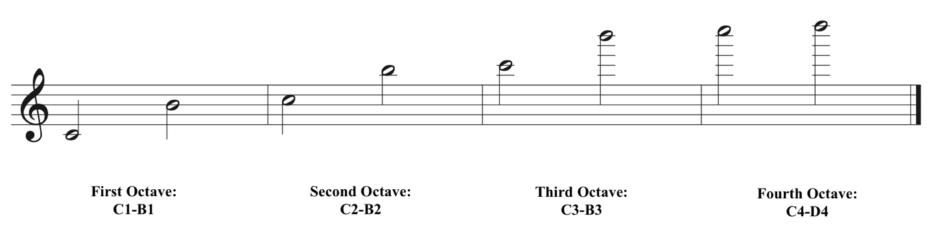
Figure 1 Flute Registration Used in Leveling

NFA Level Letter | Range | Key Signatures | Use of Accidentals | Etude Level Designation
A | G1-A2 | Major & minor key signatures up to 1# & 2¯ | Limited use of accidentals. | Beginner
B | D1-D3 | Major & minor key signatures up to 2# & 3¯ | Limited use of accidentals. | Beginner
C | C1-F3 | Major & minor key signatures up to 3# & 3¯. May change key signature within piece. | Moderate use of accidentals. | Intermediate
D | C1-G3 | Major & minor key signatures up to 4# & 4¯. | Free use of accidentals and enharmonics. Short chromatic passages. | Advanced
E | C1-A3 | Major & minor key signatures up to 5# & 5¯. | Free use of accidentals and enharmonics. Some forms of minor and chromatic scales. | Advanced
Table 1 Pitch and Key Range Leveling Criteria

All the etudes analyzed in the following chapter were evaluated based on the content of their key signatures, use of accidentals, and range. Within the category of Pitch and Key Range, the etudes were determined to meet the criteria detailed in the first five levels described by the NFA (Table 1).
The second category (Rhythm and Meter) accounts for time signature, rhythmic values, and rhythmic patterns. These criteria include general descriptions of common rhythmic patterns that may be used in the music, possible meter changes, and accounts for the inclusion of more complex rhythmic combinations for each level (Table 2). The criteria in the Rhythm and Meter category account for most rhythmic situations and include notes of exceptions to these guidelines.

NFA Level | Time Signatures | Limited Use | Syncopation | Rhythmic Combinations | Etude Level Designation
A | 2/4; 3/4; 4/4 | 2/2 & cut time | No | Basic combinations of whole, half, quarter, and eighths | Beginner
B | All of the above with the addition of 3/8; 6/8 | 2/2 & cut time | No; Isolated appearances of dotted notes and triplets | All of the above with the addition of dotted half, dotted quarter, and eighths in 3/8 and 6/8 time | Beginner
C | All of the above with the addition of 5/4; 6/4; 2/2; 3/2 | Change between meters with same beat note; use of ties and rests | Yes, simple syncopation | All of the above with the addition of eighth note triplets, and sixteenths. | Intermediate
D | All of the above with the addition of 5/8; 7/8; 9/8; and 12/8 | Possible change of meter where beat note remains constant | Yes, possible extended use of syncopation or hemiola | All of the above with the addition of sixteenth note triplets, quarter note triplets, thirty-second notes, and note groups up to quintuplets. | Advanced
E | Full spectrum of most common simple, compound, and mixed meters. | All of the above | All of the above | Moderately complex rhythmic combinations, use of note groups up to sextuplets | Advanced
Table 2 Rhythm and Meter Leveling Criteria

The third category of leveling criteria considers the articulation content of the music under evaluation. Articulation is evaluated by tonguing technique (i.e.,, single or multiple), styles of articulation used, and articulation patterns. The progression of articulation styles in the leveling guide demonstrates a gradual maturation of articulation style consistent with the development of greater musical expression.
NFA Level | Articulation Technique | Articulation Style | Etude Level Designation
A | Basic single tonguing | Simple slurs, legato, and staccato | Beginner
B | Basic single tonguing | Slurs, legato, and staccato | Beginner
C | Various single tonguing patterns | Legato, staccato, detaché, use of articulated eighth note slurs | Intermediate
D | Various articulations, exploration of flutter tonguing and multiple tonguing | All of the above in a variety of combinations | Advanced
E | Free use of single tonguing techniques, moderate use of multiple tonguing | Free use of a variety articulation styles | Advanced
Table 3 Articulation Leveling Criteria

The next category includes musical symbols and generalizes the expected fluency with musical notation at each level. This category includes the foundational skill of reading treble clef notation through advanced techniques like reading notated extended techniques. This category is especially helpful for judging musical literacy and accounts for the development of stylized playing. It also depicts the standard progression of incorporating ornamentation into the development of technique on the instrument (Table 4).

NFA Level | Notation Fluency | Ornamentation and Extended Techniques | Etude Level Designation
A | Treble clef pitch notation, accidentals, repeats, D.C., D.S. Dynamics (p,mp, mf, f, ff) | None | Beginner
B | The above with addition of ritardando, accelerando, and fermatas. Basic ornamentation. | Simple ornaments: grace notes, mordents, trills, short cadenza figures | Beginner
C | Symbols for standard rhythm, meter, and notation. Basics ornamentation. | All of the above | Intermediate
D | All of the above with the addition of ornamentation and notated extended techniques | Trills, mordents, terminations, turns/gruppeti, grace notes, short cadenzas, Basic harmonics, multiphonics, and flutter tonguing notation included. | Advanced
E | Free use of standard rhythm, meter, dynamics, articulation, and treble clef notation. | Free use of all symbols of simple articulation (trills, mordents, graces, grupetti, terminations). Limited use of harmonics, multiphonics, and flutter tonguing notation. | Advanced
Table 4 Musical Symbol Leveling Criteria

The final category of criteria used for leveling evaluates the pedagogical focus of the music under examination. This category examines broader musical concepts, like phrase length, quality of the execution of expressive markings, and quality of fundamental playing techniques (Table 5). This is the only category in which quality of execution is a factor. The progression of skills in this category exemplifies the ideal musical development at each stage of learning. All the etudes analyzed in the following chapter meet criteria within the first five levels of the NFA guide.

NFA Level | Technique | Expressive Fluency | Melodic Content | Etude Level Designation
A | Basics of posture, tone production, fingering, articulation, and notation reading. | Rudiments of playing softer and louder (p and f) | Primarily conjunct, occasional leaps of up to an octave | Beginner
B | All of the above | All of the above | All of the above | Beginner
C | All of the above with the addition of greater rhythmic understanding | Greater dynamic control over the spectrum from p to f, and use of crescendo and diminuendo | Primarily conjunct, regular use of leaps of up to an octave, melodies approximately four measures long | Intermediate
D | Tone development and beginning of vibrato development appropriate at this level. Ease with lower 2.5 octaves, increased stamina and breath control | Control of dynamic spectrum p through f, crescendo/diminuendo over two bars | Control of phrases four measures and more, introduction to extended techniques | Advanced
E | Tone development and vibrato, ease with lower 2.5 octaves, extension of breath control | Control of dynamic spectrum including extreme dynamics | Control over longer phrases of four to six measures, use of harmonics, multiphonics, and flutter tonguing. Increased ease with varied musical styles. | Advanced
Table 5 Pedagogical Focus Leveling Criteria

Chapter 4: Etude Analyses

Lyrical Beginner
Lyrical Beginner Etude #1
The second etude for middle school flutists in the East Central Oklahoma region (ECOBDA) was a lyrical etude. The range, key, articulations, musical symbols, and pedagogical focus all meet leveling criteria at the A and B levels resulting in its overall designation. Although all other categories are leveled as a beginner etude, the rhythm and meter are more appropriate for intermediate level students.
The range of this etude is quite compact and spans only an octave, from C2 to C3 with one instance of a D3. Generally, the melody moves in step-wise motion and all leaps are no larger than a fifth. The articulation is very simple and mostly consists of slurred passages that are one measure long. There are four instances of accidentals but those appearances are generally idiomatic to the instrument with the exception of the D2 to C#2 that occurs three measures from the end.
There is a distinct lack of expressive performance instructions beyond the mezzo forte indication in the first measure. The lack of performance instructions beyond the tempo and dynamic markings at the beginning simplifies the etude for early level players, especially those that find the rhythm challenging.
The rhythm in this etude requires fine attention to detail because of the different placement of dotted-eighth-sixteenth rhythms (fig. 2). The finger technique is generally idiomatic throughout with much of the fingerings changing one finger at a time. The most challenging technical moments would likely be the sections at rehearsal letter A and B. The most significant technical moment is the third and final instance of contrary finger motion required to execute the change between D2 to C#2 and back in the long sixteenth note runs that make up the last four measures.
This etude meets leveling criteria most consistent with an overall designation of Level B. Beginner level students are most likely to encounter challenges with the rhythm and meter, some of the finger technique, and maintaining a singing tone throughout. Practice strategies and exercises from both Flute 101 and the Beginner’s Book for the Flute vol. 1 are well suited to prepare flute students for encountering an etude like this.

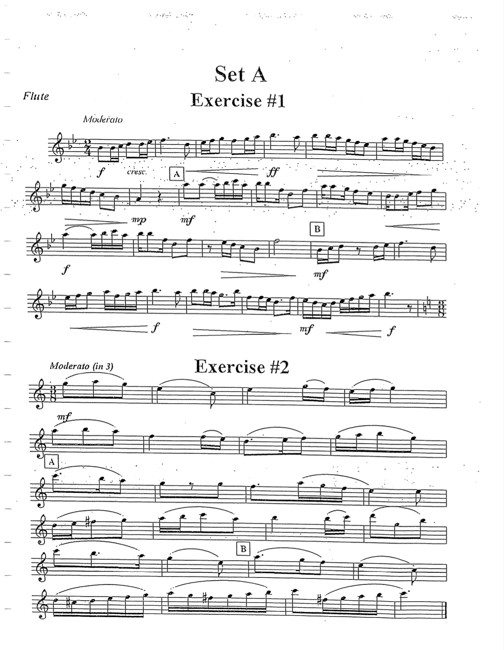
Figure 2 ECOBDA Middle School Etude #2

Summary of Etude
Region/Grade Level Assignment | ECOBDA Middle School
Title of Composition (if any) | Exercise #2
Composer (if indicated) | N/A
Key Signature | C major
Time Signature | 3/8
Tempo Indication | Moderato (in 3)
Form/Phrase Structure | ABC
NFA Level | B
Overall Categorization | Lyrical Beginner

Required Performance Skills
- Playing Position, Balance, and Posture
- Tone Production/Development
- Breathing and Phrasing
- Rhythmic Precision

Etude Level as Determined by the Above Elements Compared to Criteria on NFA’s Leveling Guide
Pitch and Key Range | Rhythm and Meter | Articulation | Musical Symbols | Pedagogical Focus
B | C | B | A | B

Overall Level: B
Comments:
Pitch and Key Range: This etude’s range remains within an octave from C2 to C3, utilizes a key signature with no sharps and no flats, and has limited appearances of accidentals
Rhythm and Meter: The etude is in 3/8 time and uses a combination of basic rhythms of dotted quarters, quarters, dotted eighths, eighths, and sixteenths.
Articulations: This etude’s articulations are generally simple and utilizes mostly short slurred phrases to guide the phrases and formal structure of the work.
Musical Symbols: This etude uses the basics of treble clef notation and includes accidentals. Dynamically it’s very simple with one marking at the beginning of the piece.
Pedagogical Focus: Due to the lack of performance instructions, this etude demands the performer make informed decisions on the musical interpretation of the etude. Performers must be able to successfully handle primarily conjunct melodies with occasional leaps of up to a fifth.
Table 6 ECOBDA Middle School Etude #2 Leveling Summary
Problems students at the beginning level may encounter
- Poor instrument balance
- Poor hand position
- Contrary finger motion and finger technique issues
- Poor tone quality
- Poorly managed breath control

Lyrical Beginner Etude #2
The first etude designated for 7th grade flutists in the Southeast region of Oklahoma was evaluated as a beginner level lyrical etude (fig. 3). The rhythm, meter, articulation, and musical symbols all meet criteria for NFA level A while the remaining two categories of pitch, key range, and pedagogical focus meet criteria consistent with NFA level B. There are several problems beginner students may encounter in preparation of this etude including issues with instrument balance and hand position, finger technique, dynamic nuance, articulation, and poor tone quality.

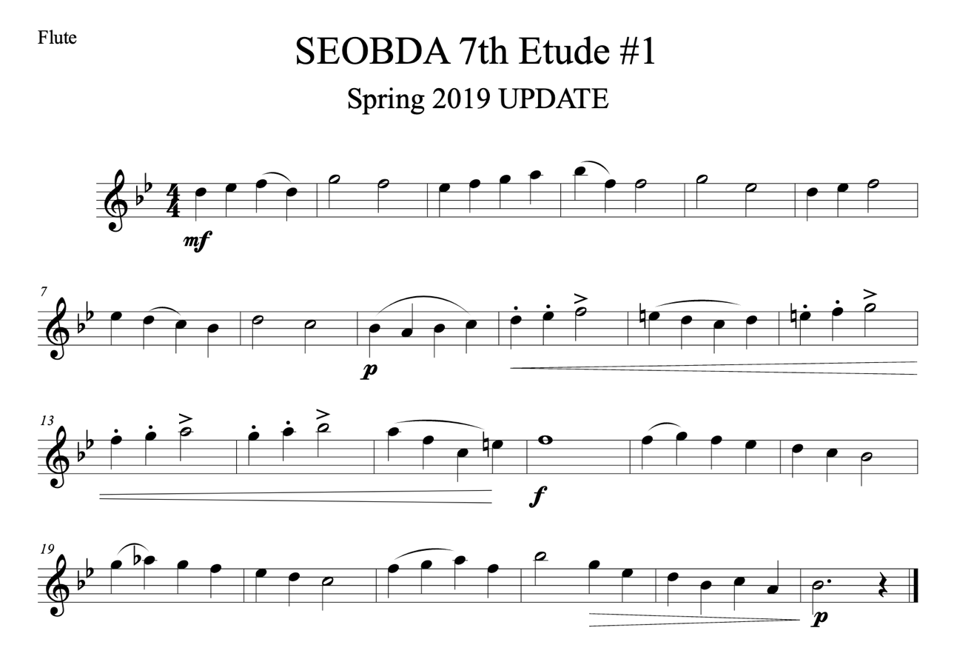
Figure 3 SEOBDA 7th Grade Etude #1

Issues with instrument balance and hand position are quite common at the beginner level and should be examined in the preparation of this etude. There are many instances in this etude in which poor instrument balance and poor hand position would contribute to technique issues for example, the contrary finger motion required to play C2 and D2 in mm. 7-11, m. 18, and m. 20.
This etude demands control over dynamic nuance in a way that may be challenging to younger students. Long crescendos over six bars may stretch the breath stamina while also challenging students to create distinct contrast from piano to forte at the same time. In addition to these dynamic challenges, there are copious articulation markings and styles that must be performed too. Flutists learning this etude should practice accent, staccato, and legato articulations at all dynamic levels to best prepare. Breath attack practice would also be appropriate and beneficial for improving the single tonguing technique required within.
Breath attack exercises, good instrument balance, and good hand position should ideally resolve any lingering issues of tone quality in this etude. If there are still tone quality issues, or issues with breath support and stamina, long tone exercises may be useful to supplement this etude. Long tone exercises that mimic the long crescendo in mm. 9-15 and decrescendo in mm. 22-24 would help students develop the technique and stamina to sustain such phrases.
This etude is a good example of a piece that might be encountered in any of the Essential Elements or Standard of Excellence books but students may find additional exercises in the Flute 101 and Beginner’s Book series helpful as well.

Summary of Etude
Region/Grade Level Assignment | SEOBDA 7th Grade #1
Title of Composition (if any) | N/A
Composer (if indicated) | N/A
Key Signature | B-flat major
Time Signature | 4/4
Tempo Indication | N/A
Form/Phrase Structure | ABC
NFA Level | B
Overall Categorization | Lyrical Beginner

Required Performance Skills
- Playing Position, Balance, and Posture
- Tone Production/Development
- Dynamic Nuance
- Articulation Clarity
- Intonation

Etude Level as Determined by the Above Elements Compared to Criteria on NFA’s Leveling Guide
Pitch and Key Range | Rhythm and Meter | Articulation | Musical Symbols | Pedagogical Focus
B | A | A | A | B

Overall Level: B

Comments:
Pitch and Key Range: Etude is in B-flat major and spans the range of a 9th— from A1 to Bb2. Limited use of accidentals to establish key.
Rhythm and Meter: Both rhythm and meter are quite simple in this etude. Quarter notes are the fastest rhythm and make up most of the phrases.
Articulations: This etude is quite diverse in its articulation spectrum and varies patterns of slurred and tongued quarter notes. There are staccato markings and accent markings in addition to patterns of slurs.
Musical Symbols: This etude has a range of dynamic markings, articulation markings, and other expressive indications.
Pedagogical Focus: Basics of posture, tone, articulation, fingering, and notation reading are required. Rudiments of playing softer and louder are needed to perform phrases of four to eight measures in primarily conjunct melodies.
Table 7 SEOBDA 7th Grade Etude #1 Leveling Summary

Problems students at the beginning level may encounter
- Poor instrument balance
- Poor hand position
- Contrary Finger Motion & Finger Technique Issues
- Poor Tone Quality
- Poorly managed breath control

Lyrical Beginner Etude #3
The first etude assigned the 7th graders in the Green County region of Oklahoma was determined to meet the criteria for NFA level B (fig. 4). Rhythm, meter, articulation, and musical symbols all meet criteria for level B whereas key, range, and pedagogical focus meet some of the criteria for level C. Students may have problems executing the articulations, dynamics, and upper register notes as well as find difficulty with maintaining good tone quality.
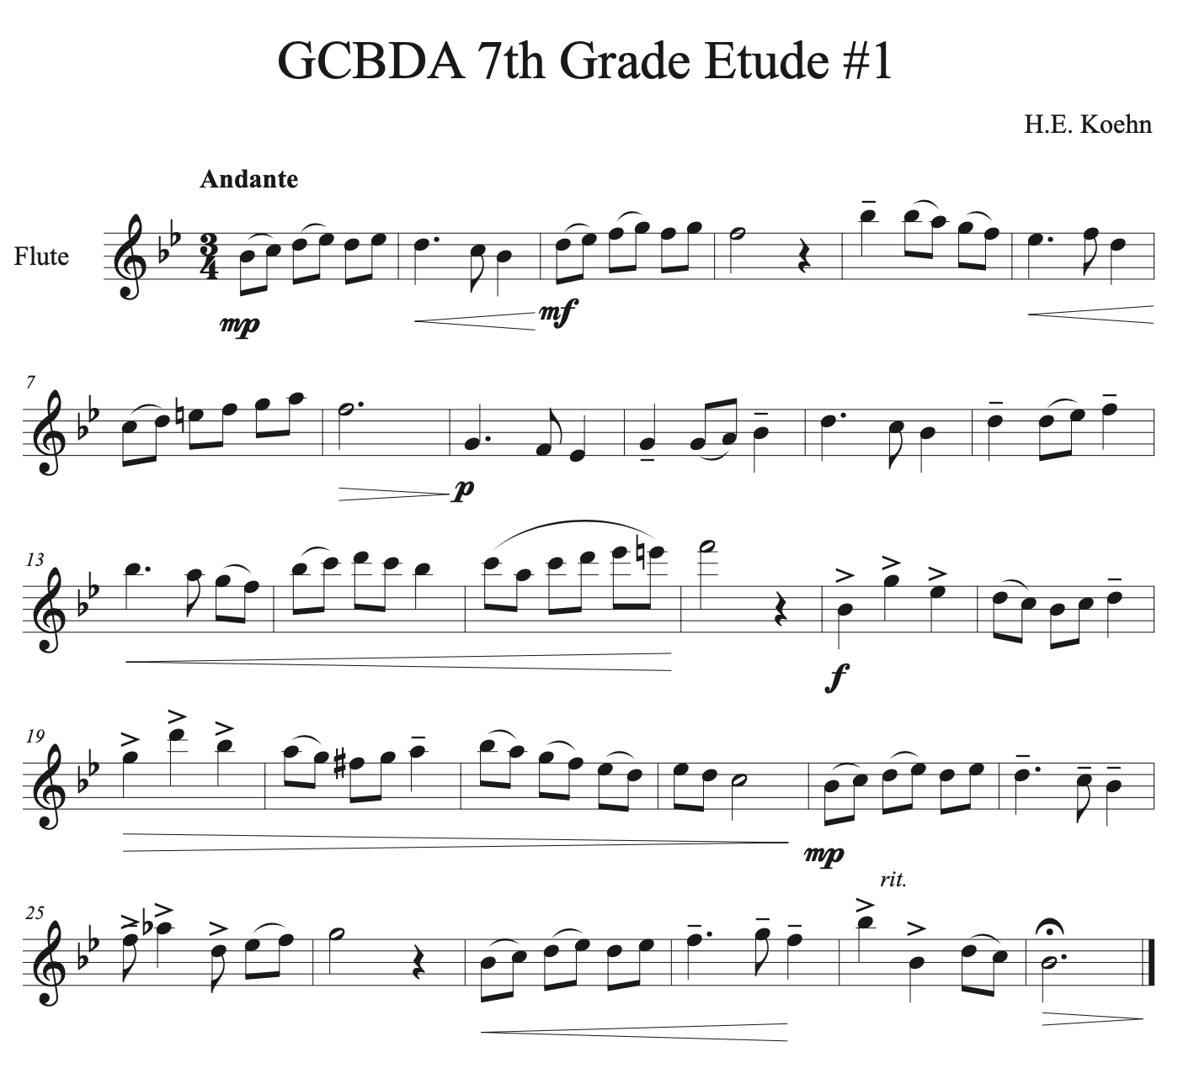
Figure 4 GCBDA 7th Grade Etude #1

The meter of this etude is standard for the beginning level and the rhythms in it are typical combinations of half-notes, quarter-notes, and eighth-notes. There are few dotted rhythms and one instance of syncopation in m. 25 that may warrant extra attention, but rhythmically this etude is straightforward.
Although the key of B-flat major would be very familiar for beginner students that work out of a band method book, the range this etude covers outpaces band methods at this level. The phrase in mm. 9-16 requires the most confidence and skillful technique on the instrument and students without prior experience playing in the upper register may find it particularly challenging. There are many exercises in Flute 101.5 that would be beneficial for resolving these particular issues and are intended for a bridge from beginning level literature to intermediate level literature.
The dynamics of this etude are rather demanding for a beginner, long crescendos and diminuendos can be challenging for beginner level students that lack the breath support to sustain them. There are several exercises for improving lung capacity and breathing musically in the Practice Books that may be beneficial for students working on this etude.
In addition to working on breath support and stamina, issues of articulation may be resolved through incorporating breath attack exercises into the practice routine. Breath attack exercises help students learn to engage the diaphragm when playing the flute and will assist with breath support and overall tone production.
If the flutist is struggling with their technique, tone, and inconsistent articulation then the body position, posture, and hand position should be closely examined. If the instrument is out of balance then tone quality will suffer and articulations and other expressive markings may be more difficult to execute.
Summary of Etude
Region/Grade Level Assignment | GCBDA 7th Grade #1
Title of Composition (if any) | Etude #1
Composer (if indicated) | H.E. Koehn
Key Signature | B-flat major
Time Signature | 3/4
Tempo Indication | Andante
Form/Phrase Structure | ABA’
NFA Level | B
Overall Categorization | Lyrical Beginner

Required Performance Skills
- Playing Position, Balance, and Posture
- Tone Production
- Dynamic Nuance
- Ease of Finger Technique
- Articulation Clarity
- Breathing and Phrasing
- Rhythmic Precision

Etude Level as Determined by the Above Elements Compared to Criteria on NFA’s Leveling Guide
Pitch and Key Range | Rhythm and Meter | Articulation | Musical Symbols | Pedagogical Focus
C | B | B | B | C

Overall Level: B

Comments:
Pitch and Key Range: Etude is in B-flat major and has a range of Eb1 to F3, and has a few occurrences of accidentals.
Rhythm and Meter: Uses a combination of dotted half, half, quarter, and eighth notes in 3/4 time. Isolated appearances of syncopation.
Articulations: Basic single tonguing techniques, combinations of slurred and tongued notes. Instances of legato and accent markings.
Musical Symbols: Treble clef notation, use of accidentals, wide range of dynamic markings, liberal use of crescendo and decrescendo effects.
Pedagogical Focus: Basics of posture, tone, articulation, fingering, and notation reading are required. Rudiments of playing softer and louder are needed to perform phrases of four to eight measures in primarily conjunct melodies.
Table 8 GCBDA 7th Grade Etude #1 Leveling Summary

Problems students at the beginning level may encounter
- Poor instrument balance
- Poor hand position
- Contrary finger motion & finger technique issues
- Poor Tone Quality
- Poorly managed breath control
- Poor low register tone and projection

Lyrical Beginner Etude #4
The second etude assigned to the Southwest region of Oklahoma was determined to meet the criteria for NFA level A. The only category of leveling criteria in which this etude is not level A is the key signature which meets leveling criteria for NFA level B. This etude is particularly interesting due to its lack of performance instructions and repetitive form (fig. 5). Flutists may struggle with maintaining good tone quality, creating dynamic nuance, and breath support and stamina issues.
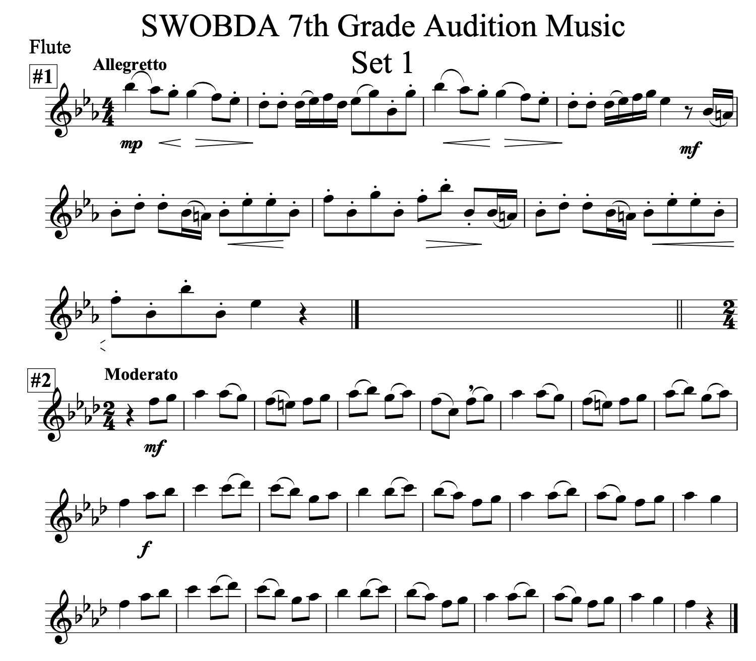
Figure 5 SWOBDA 7th Grade Etude #2

The only category in which this etude surpasses NFA level A is key and range. The key of F minor meets criteria for NFA level D however the range of this etude (E2 to Db3) only spans a major sixth which meets level B criteria. Due to the conflicting criteria and overall limited range, Key and Range was given the overall NFA level designation of B for this etude. Students at the beginning level that are unfamiliar with this key signature should practice the F minor scale and especially playing from Ab2 to Bb2 and C3 to Db3.

One difficult aspect of the technique required to perform this etude is the contrary finger motion required to move from Ab2 to Bb2 and back. If the fingers are not precise in their lifting and depressing, there’s the potential for an extra note to slip in between the Ab2 and Bb2 (fig. 6, arrows indicate the motion of the fingers when playing from Ab2 to Bb2). This problem may be ameliorated altogether if the flutist elects to use the B-flat thumb key to finger Bb in lieu of the long fingering (“thumb, 1 and 1”).
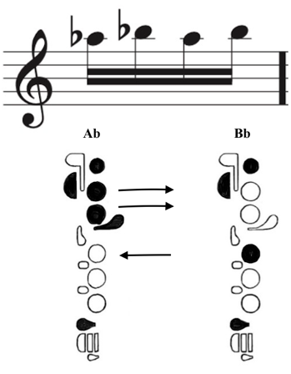
Figure 6 Contrary Finger Motion Ab2 to Bb2

Beginning level flutists often struggle to maintain the second octave notes that make up this entire etude. Students struggling to maintain the second octave notes and their tone in this etude should practice long tones on the harmonic series as this will help them learn to control their air speed and air direction. If they are struggling to balance the instrument or have poor hand position, that will need to be addressed as part of this practice because that would likely be a cause of poor tone quality.
The rhythm and meter of this etude is standard for what flutists will encounter at the beginning level. Quarter notes and eighth notes in 2/4 time are quite common for beginning level literature and this etude meets the criteria for rhythm and meter NFA level A. The rhythm in this etude is straightforward and repetitive which makes it one of the easier aspects for flutists to prepare.
The lack of expressive instructions beyond the two dynamic marks provide a simple etude for flutists that struggle with the technical elements but may prove complicated it for more advanced beginning students. The repetition of the B phrase may challenge some flutists in their interpretation of this etude and guidance from a teacher may be most useful.

Summary of Etude
Region/Grade Level Assignment | SWOBDA 7th Grade #2
Title of Composition (if any) | Set 1 #2
Composer (if indicated) | N/A
Key Signature | F minor
Time Signature | 2/4
Tempo Indication | Moderato
Form/Phrase Structure | ABB
NFA Level | A
Overall Categorization | Lyrical Beginner

Required Performance Skills
- Playing Position, Balance, and Posture
- Tone Production
- Dynamic Nuance
- Ease of Finger Technique
- Articulation Clarity
- Breathing and Phrasing
- Rhythmic Precision

Etude Level as Determined by the Above Elements Compared to Criteria on NFA’s Leveling Guide
Pitch and Key Range | Rhythm and Meter | Articulation | Musical Symbols | Pedagogical Focus
B | A | A | A | A

Overall Level: A

Comments:
Pitch and Key Range: The key signature has four flats and the etude is in F minor, there are occasional instances of E-natural accidentals. The range of the etude begins at C2 and spans a ninth up to Db3.
Rhythm and Meter: The etude is in 2/4 and is simple rhythmically, entirely made up of eighth and quarter notes.
Articulations: Etude uses basic single tonguing techniques, simple patterns of slurred and tongued notes.
Musical Symbols: Treble clef pitch notation, accidentals, basic dynamic markings.
Pedagogical Focus: Basics of position, posture, tone production, fingering, articulations, and notation reading. Rudiments of playing softer and louder through short phrases of primarily conjunct melody.
Table 9 SWOBDA 7th Grade Etude #2 Leveling Summary
Problems students at the beginning level may encounter
- Poor instrument balance
- Poor hand position
- Contrary finger motion & finger technique issues
- Poor Tone Quality
- Poorly managed breath control

Technical Beginner
Technical Beginner Etude #1
The second etude assigned to flutists auditioning in the Southeast region of Oklahoma was evaluated and determined to meet leveling criteria consistent with NFA level B (fig. 7). The pitch, range, rhythm, meter, and pedagogical focus of this etude met level B criteria while the remaining categories of articulation and musical symbols were slightly easier and met criteria for NFA level A. Beginning level flutists may struggle with the range of the etude, the finger technique, and performing with dynamic nuance.

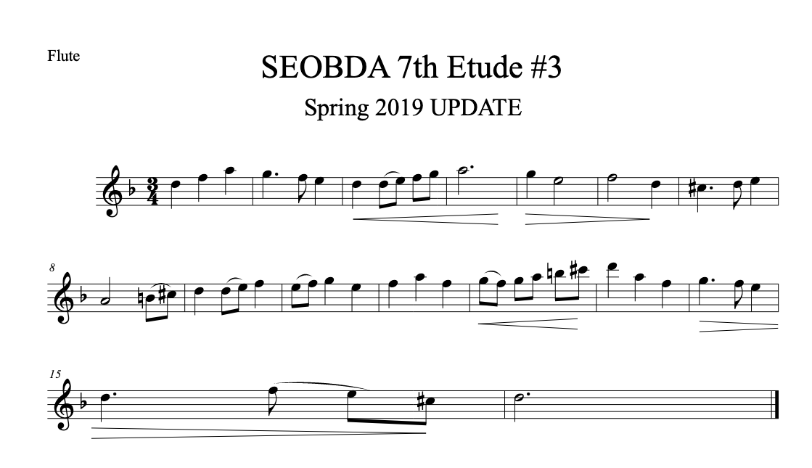
Figure 7 SEOBDA 7th Grade Etude #2

This etude is written in D minor and has a few instances of accidentals to establish melodic minor. The key likely won’t cause many issues with beginner flutists but they may find playing the top of the melodic minor scale up to D3 challenging. To help students remember the fingering for D3, Louke and George recommend either teaching it by which fingers move between octaves of the same pitch or by looking at a fingering chart.
The rhythm and meter in this etude are consistent with literature at level B. Syncopation is limited to dotted quarter and eighth rhythms that appear four times in the etude. Beginning level students that struggle to play in time may find playing each of the eighth notes in the measure a beneficial way to work on subdividing (fig. 8).
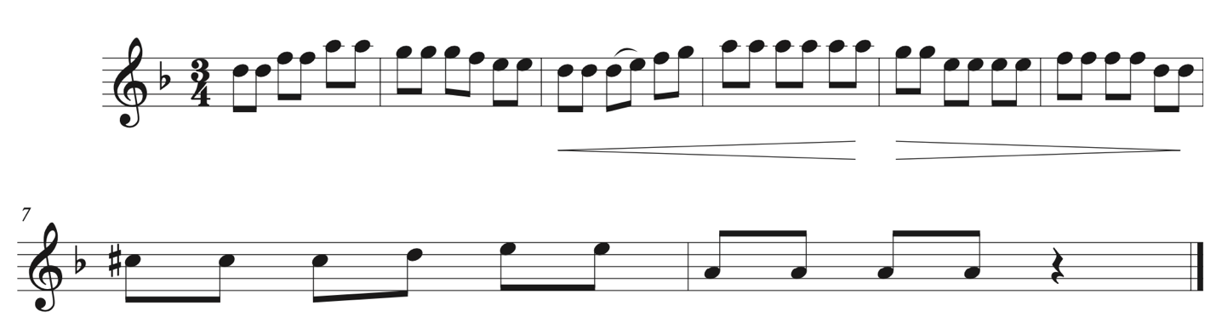
Figure 8 SEOBDA 8th Note Subdivision Exercise mm. 1-8

The finger technique required to perform this etude may provide a challenge for some beginning level students. The first area that should be examined is how they are holding and balancing the instrument. If the instrument is out of balance or the hand position is poor, then moving the fingers will be difficult. The tin-can exercise George and Louke suggest in Flute 101.5 may be beneficial to help students find a good right hand position that supports the flute and is conducive to playing B2 to C#3 to D3 in succession.
The final aspect of this etude beginners may struggle with is achieving the dynamic nuance required by the long crescendo and diminuendo figures in mm. 3-6 and mm. 12-15. Exercises for breath support and stamina from the Practice Books may be particularly useful to help students develop the technique necessary to sustain phrases of four or more measures.

Summary of Etude
Region/Grade Level Assignment | SEOBDA 7th Grade #2 (marked #3 on page)
Title of Composition (if any) | N/A
Composer (if indicated) | N/A
Key Signature | D minor
Time Signature | 3/4
Tempo Indication | N/A
Form/Phrase Structure | AB
NFA Level | B
Overall Categorization | Technical Beginner

Required Performance Skills
- Tone Production/Development
- Dynamic Nuance
- Ease of Finger Technique
- Articulation Clarity
- Breathing and Phrasing
- Intonation

Etude Level as Determined by the Above Elements Compared to Criteria on NFA’s Leveling Guide
Pitch and Key Range | Rhythm and Meter | Articulation | Musical Symbols | Pedagogical Focus
B | B | A | A | B

Overall Level: B

Comments:
Pitch and Key Range: Key signature has one flat and is in D minor There are a few appearances of accidentals confirming the key area of melodic minor. Range extends from A1 to D3.
Rhythm and Meter: Etude uses combinations of basic rhythms in 3/4. Brief appearances of syncopation in dotted-quarter eighth rhythms.
Articulations: Simple patterns of single tongued articulations using legato and slur markings.
Musical Symbols: Treble clef notation, accidentals, symbols for crescendo and decrescendo.
Pedagogical Focus: Basics of position and posture, tone production, fingering, articulation, and notation reading. Basic uses of dynamic range, mostly conjunct melodies of four to eight bars.
Table 10 SEOBDA 7th Grade Etude #2 Leveling Summary

Problems students at the beginning level may encounter
- Poor instrument balance
- Poor hand position
- Contrary finger motion & finger technique issues
- Poor Tone Quality
- Poorly managed breath control
- Poor low register tone and projection

Recommendations on Overcoming Challenges at the Beginner Level:
Pearson, Standard of Excellence, Flute books 1-3:
- Keep fingers close to the keys (bk. 3, pg. 18)
- For higher notes use a smaller aperture and aim air higher (bk. 1, pg. 28)
- For low notes aim air lower and use a bigger aperture, move lower jaw and lips back (bk. 3, pg. 14)
- Direct your air stream lower for a full tone (bk. 3, pg. 14)

Lautzenhauser, et al, Essential Elements, Flute books 1-3:
- No flute specific advice available
George & Louke, Flute 101, 101.5, 102, 103:
- “When lifting the left thumb, keep the flute balanced above the left hand third knuckle. This will prevent the flute from rolling back.” (Flute 101, pg. 9)
- “Right Hand Position: Make a fist. Place right pinky on tenon (when footjoint is added, pinky will be placed on D#/Eb key.) Place the other fingers on the D, E, and then F keys. Then bring the thumb forward to touch the back side of the flute.” (Flute 101, pg. 13)
- “Marking Breath Marks: Practice marking breath marks at the end of each phrase in the music. Good places to breathe are after a long note, tied note, or in a rest.” (Flute 101, pg. 59)
- “It is difficult to balance the flute when playing C2/C3 and C#2/C#3 for two reasons. First, the weight of the mechanism of the flute is heavier on the back or rod side of the flute, and second, there are few fingers involved in fingering the notes. If the flute is not well-balanced just above the left knuckle, the flute will roll back toward the player when the thumb is removed. If the student moves the left elbow when lifting the left thumb, the flute is being balanced on the thumb… Both elbows should hang down and not move when playing the flute.” (Flute 101, pg. 77)
- “Part of the secret of developing a beautiful sound has to do with making the oral cavity large (drop or hang the jaw) and directing a consistent air stream high on the embouchure hole wall. In order to direct the air stream high on the wall, the student must develop the embouchure. Having the lips in the ‘Pooh’ position is a winner.” (Flute 101, pg. 77)
- “Balancing the Flute: The goal is to balance the flute in the hands so the flute remains still when moving the fingers. Many flutists have a tendency to lift the end of the flute when playing ascending notes (removing fingers) and lower the end of the flute when descending (adding fingers). Try to keep the flute still.” (Flute 101.5, pg. 3)
- “Octaves: Notice that both octaves have the same fingering. The upper octave is playing with a slightly smaller aperture (opening between the lips) as if squeezing slightly on a small straw.” (Flute 101.5, pg. 11)

Wye, Beginner’s Book & Practice Book:
- “Try not to lose too much air. Try to keep the sound steady… Do not end the note with the tongue.” (Beginner’s Book, vol. 1, pg. 2)
- “Left hand position: The left hand first finger curves under the flute to support it whilst the fingers curve over the keys. Notice the left hand thumb. Keep the thumb on the right lever.” (Beginner’s Book, vol. 1, pg. 3)
- “Right hand position: Hold up your right arm with the hand limp. Notice that the fingers are curved. Notice also that the thumb is sideways-on to the first finger. Place the hand over the flute without changing this relationship between the thumb and the hand. Place the curved fingers on the keys and the little finger on its key. The fingers should be at right angles to the flute: not pointing to the left or right.” (Beginner’s Book, vol. 1, pg. 4)
- “Breathing: Put the flute down and take a big breath without raising the shoulders. The stomach should expand followed by the chest. If you have any difficulty doing this, sit in an upright chair and hold onto the seat. Take another breath: this time the stomach should expand. Repeat without the air of the chair.” (Beginner’s Book, vol. 1, pg. 5)
- “Whilst playing don’t let the right hand fingers rest on the keywork.” (Beginner’s Book, vol. 1, pg. 12)
- “N.B. Don’t be tempted to support the flute with the left thumb when C is played.” (Beginner’s Book, vol. 1, pg. 12)
- “Tone Development: The development of a beautiful tone is most important to your further progress. In these exercises… experiment with the speed of the air which you blow into your flute. Does increasing the air speed make a firmer tone? If it does, try: a) decreasing the size of the hole in your lips through which you blow. Whilst obtaining a clear sound, try to be economical with the quantity of air used. b) moving the jaw backwards and forwards slightly, note any improvement. Play each note as long as possible. Take big breaths. Avoid turning the flute blow-hole in on your lip. No more than half should be covered.” (Beginner’s Book, vol. 1, pg. 19)

Lyrical Intermediate
Lyrical Intermediate Etude #1
The first etude assigned to 8th and 9th grade students in the Green County region of Oklahoma met the criteria most consistent with NFA level C. The only category that failed to meet level C criteria was Rhythm and Meter which was determined to meet criteria consistent with level D. This etude poses many challenges for intermediate level flutists but has the distinct benefit of being quite idiomatic for the instrument (fig. 9).

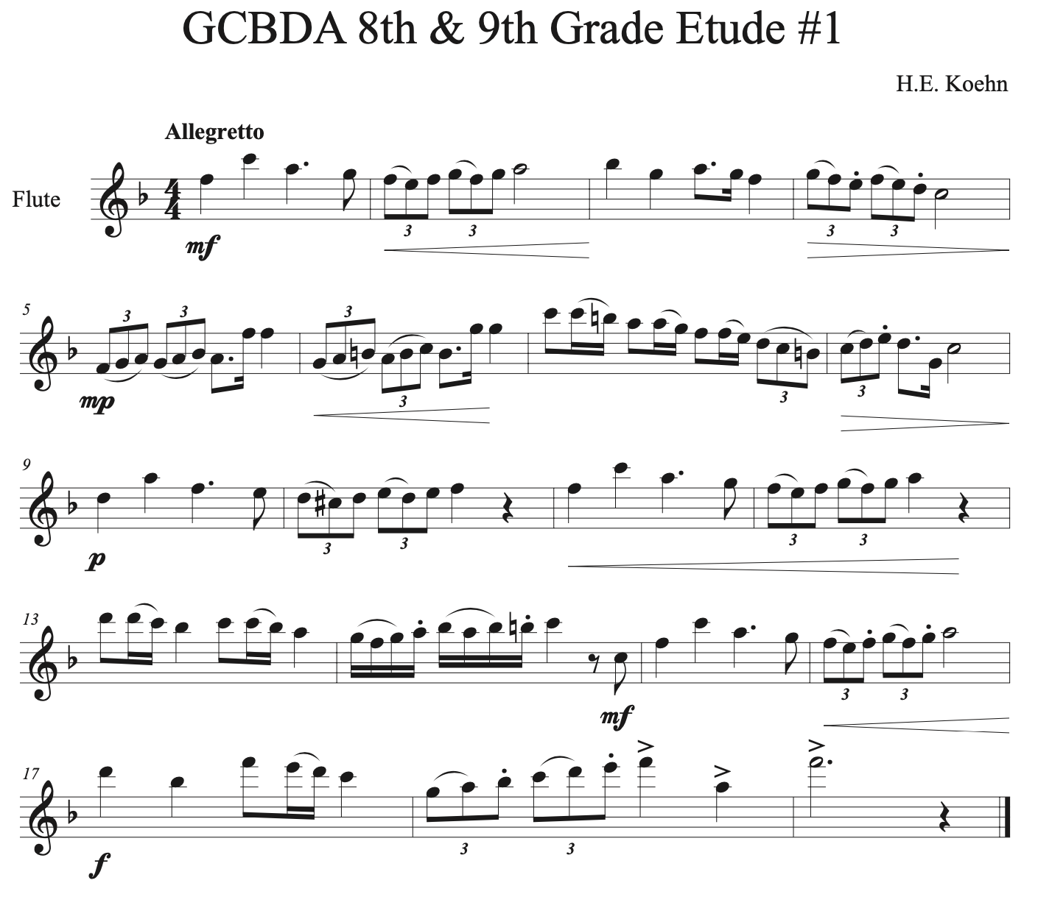
Figure 9 GCBDA 8th & 9th Grade Etude #1

The most challenging aspect of this etude is the rhythm. The juxtaposition of triplet eighths and dotted eighth-sixteenths requires accurate subdividing to ensure the latter rhythm doesn’t end up sounding like a triplet. One exercise to combat this habit would be to articulate all of the sixteenth notes in the beat to train the ear and mind to switch to quadruple subdivision (fig. 10).

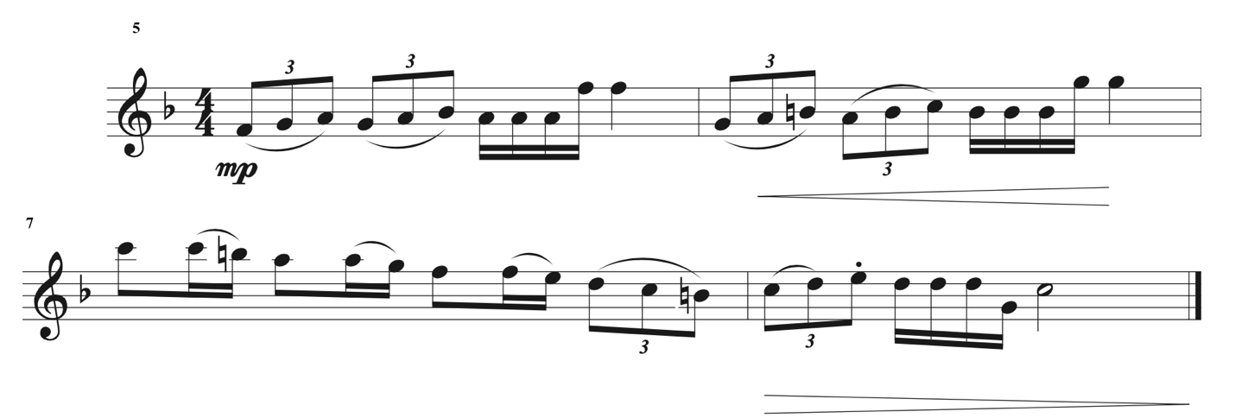
Figure 10 Subdivision Exercise for GCBDA 8th/9th Etude #2 mm. 5-8

Intermediate students may also find difficulty with the articulation in this etude. At the intermediate level, flutists should be exploring common articulations of sixteenth note passages including some of the articulations seen here. Articulation practice in which the tonguing pattern is changed often might help some students workout the tongue so that it is better equipped to handle passages where the last note of a group is articulated, like those found in mm. 8, 14, and 16. For unclear and fuzzy articulation issues, practicing on breath attacks would be the appropriate course of action.
For students struggling with tone on this etude, hand position and how they’re balancing the instrument as they play should be examined closely. If there are no issues in the body position or balance, then tone issues are likely air and/or embouchure related. If the upper register isn’t speaking or sounds fuzzy it may be that too much of the embouchure hole is being covered by the lip, if this is the case, check flute alignment and the positioning of the embouchure hole in relation to the lips. If tone issues persist, harmonic and long tone exercises would be appropriate for learning to manage air speed and direction.
The phrasing in this etude is ideal for playing four measures to a breath. Flutists that struggle to sustain phrases of this length should practice long tone exercises and breathing exercises. Intermediate students that need to work on breath control may benefit from some of the breath trainers available for supplement use.

Summary of Etude
Region/Grade Level Assignment | GCBDA 8th Grade #1
Title of Composition (if any) | N/A
Composer (if indicated) | H.E. Koehn
Key Signature | F major
Time Signature | 4/4
Tempo Indication | Allegretto
Form/Phrase Structure | AA’
NFA Level | C
Overall Categorization | Lyrical Intermediate

Required Performance Skills
- Tone Production/Development
- Dynamic Nuance
- Ease of Finger Technique
- Articulation Clarity
- Breathing and Phrasing
- Intonation

Etude Level as Determined by the Above Elements Compared to Criteria on NFA’s Leveling Guide
Pitch and Key Range | Rhythm and Meter | Articulation | Musical Symbols | Pedagogical Focus
C | D | C | C | C

Overall Level: C

Comments:
Pitch and Key Range: Etude is in the key of F major And covers the range from F1 to F3. There are several accidentals written in as lower neighbor tones.
Rhythm and Meter: Etude is rhythmically diverse and uses duple, triple, and quadruple subdivisions of the quarter note.
Articulations: Etude uses a variety of single tonguing techniques in staccato and legato passages. Various combinations of slurs and tongues in eighth-note and sixteenth-note passages.
Musical Symbols: Treble clef pitch notation, use of accidentals, use of various dynamic markings and crescendo/decrescendo symbols.
Pedagogical Focus: Basics of position, posture, tone production, fingering, articulation, notation reading, and dynamic contrast between soft and loud over four-bar phrases.
Table 11 GCBDA 8th & 9th Grade Etude #1 Leveling Summary

Problems students at the intermediate level may encounter
- Poor Hand Position
- Contrary Finger Motion & Finger Technique Issues
- Inconsistent Intonation
- Poor Tone Quality
- Poorly Managed Breath Control
- Rhythmic Precision

Lyrical Intermediate Etude #2
The first etude assigned to 7th graders from the Eastern District was found to have met the criteria consistent with NFA level C (fig. 11). Five out of the six categories were determined to meet criteria for NFA level C, while the remaining category of key and pitch was determined to meet criteria for NFA level A.
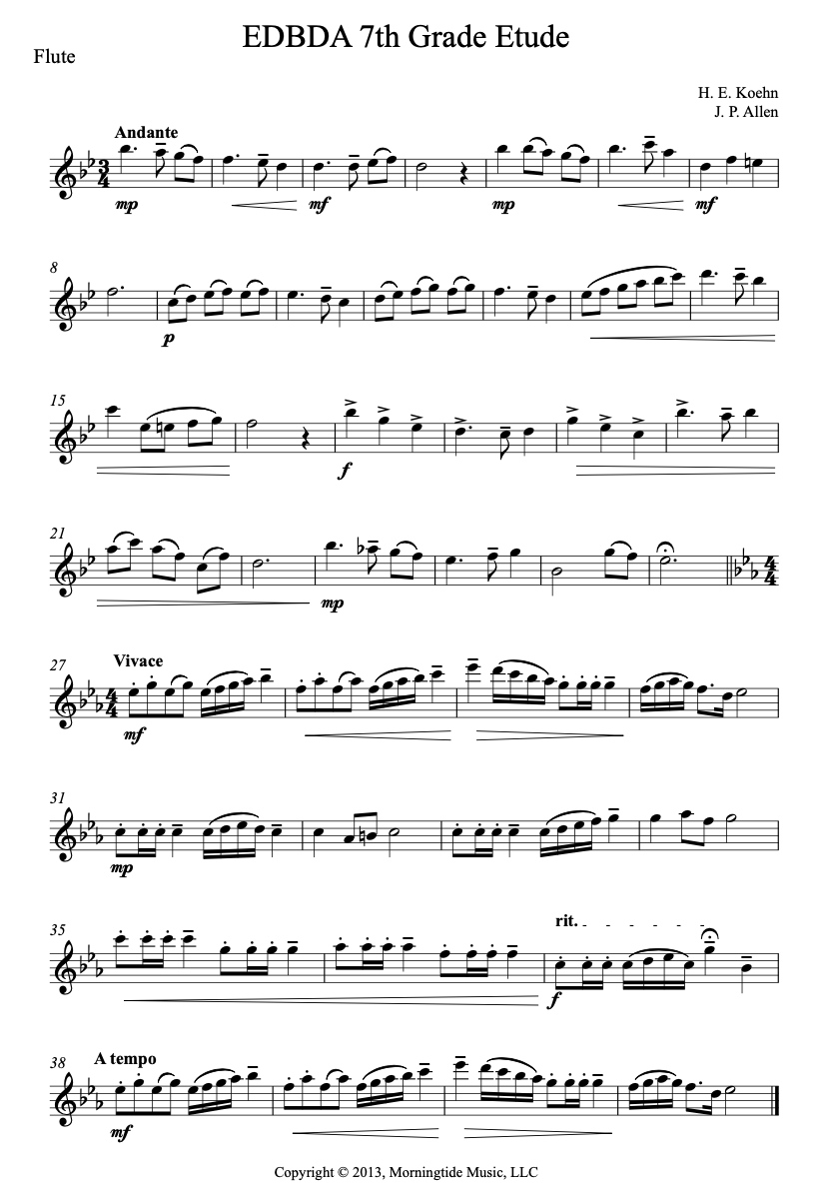
Figure 11 EDBDA 7th Grade Etude #1

The phrasing of this etude is one of the most challenging aspects of this etude because it requires the flutists to sustain a phrase for up to 8 measures. The musical maturity required to perform this etude led to the NFA level C evaluation in Pedagogical Focus. Control of the dynamic spectrum from piano through forte and greater execution of articulations is expected for the intermediate level.
Students that struggle with counting the dotted quarter rhythms may benefit from the subdivision exercise in which they play all of the eighth notes in the measure (fig. ).
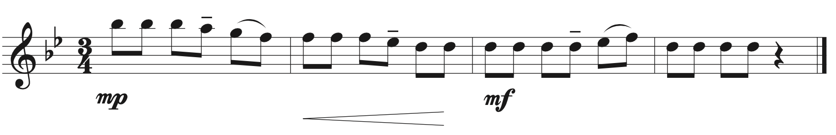
Figure 12 EDBDA 7th Grade Etude #1 Subdivision Exercise mm. 1-4

Summary of Etude
Region/Grade Level Assignment | EDBDA 7th Grade #1
Title of Composition (if any) | N/A
Composer (if indicated) | H.E. Koehn & J.P. Allen
Key Signature | B-flat major
Time Signature | 3/4
Tempo Indication | Andante
Form/Phrase Structure | ABC
NFA Level | C
Overall Categorization | Lyrical Intermediate

Required Performance Skills
- Tone Production/Development
- Dynamic Nuance
- Ease of Finger Technique
- Articulation Clarity
- Breathing and Phrasing
- Intonation

Etude Level as Determined by the Above Elements Compared to Criteria on NFA’s Leveling Guide
Pitch and Key Range | Rhythm and Meter | Articulation | Musical Symbols | Pedagogical Focus
B | C | C | C | C

Overall Level: C

Comments:
Pitch and Key Range: Etude has two flats in the key signature and is primarily in the key of B-flat major There are a few appearances of accidentals and the range of the etude is from Bb1 to D3.
Rhythm and Meter: Etude is in 3/4 time and uses combinations of dotted-quarters, quarters, and eight notes. Some appearances of syncopated rhythms.
Articulations: Etude uses a variety of single tongue styles. Articulations are mostly legato and accents.
Musical Symbols: Treble clef pitch notation, use of accidentals, use of various dynamic markings and crescendo/decrescendo symbols.
Pedagogical Focus: Basics of position, posture, tone production, fingering, articulation, notation reading, and dynamic contrast between soft and loud over four-bar phrases.
Table 12 EDBDA 7th Grade Etude #2 Leveling Summary

Problems students at the intermediate level may encounter
- Poor Hand Position
- Contrary Finger Motion & Finger Technique Issues
- Inconsistent Intonation
- Poor Tone Quality
- Poorly Managed Breath Control

Technical Intermediate Etudes
Technical Intermediate Etude #1
The first etude for middle school flutists in the East Central region of Oklahoma was determined to meet criteria for NFA level C. The rhythm in this etude may be the most difficult musical parameter for intermediate level students to contend with, but they’ll also be challenged to create dynamic nuance among some tricky articulations.
Figure 13 ECOBDA Middle School Etude #1

The most challenging aspect of this etude is the rhythm. For many intermediate level flutists, this may be their introduction into sixteenth-eighth-sixteenth rhythms and rhythms that tie to the first note of a group of sixteenths. Students that struggle with the rhythm at rehearsal letter A would benefit from breaking the tie and articulating the sixteenth note on beat two until the timing of the sixteenths has been securely established (fig. 13).
In addition to the technical challenge of the rhythms, there are many instances of contrary finger motion in the sixteenth note passages like those found in rehearsal B to the end. These passages may benefit from rhythm practice to help train the fingers to move quickly (fig. 14). For dotted rhythms, articulating all of the sixteenth notes in the measure may help the timing so that they are not played as a triplet.

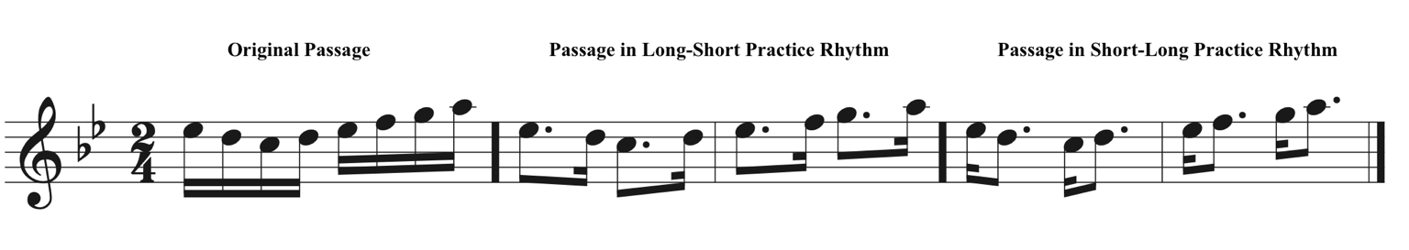
Figure 14 ECOBDA MS Etude #1 Rhythm Practice m. 23

Flutists that struggle with tone quality on this etude may benefit from breath attack exercises and harmonic long tones. These exercises will aid in the development of good tone by learning to control air speed and direction while supporting the sound.

Summary of Etude
Region/Grade Level Assignment | ECOBDA Middle School Set A
Title of Composition (if any) | Exercise #1
Composer (if indicated) | N/A
Key Signature | B-flat major
Time Signature | 2/4
Tempo Indication | Moderato
Form/Phrase Structure | ABA’
NFA Level | C
Overall Categorization | Technical Intermediate

Required Performance Skills
- Tone Production/Development
- Dynamic Nuance
- Ease of Finger Technique
- Articulation Clarity
- Breathing and Phrasing
- Intonation

Etude Level as Determined by the Above Elements Compared to Criteria on NFA’s Leveling Guide
Pitch and Key Range | Rhythm and Meter | Articulation | Musical Symbols | Pedagogical Focus
B | C | C | B | C

Overall Level: C

Comments:
Pitch and Key Range: Key signature has two flats and the etude has a few appearances of accidentals. Range extends from A1 to C3.
Rhythm and Meter: The etude is in 2/4 and uses combinations of dotted-quarter, quarter, eighth, and sixteenth notes. There are a couple of instances of basic syncopation and more challenging sixteenth-eighth-sixteenth groups.
Articulations: All tonguing can be done using single tonguing technique. Some patterns of tongued and slurred articulations in the groups of sixteenth notes pose more significant challenges.
Musical Symbols: Treble clef pitch notation, use of accidentals, use of various dynamic markings and crescendo/decrescendo symbols.
Pedagogical Focus: Basics of position, posture, tone production, fingering, articulation, notation reading, and dynamic contrast between soft and loud over four-bar phrases.
Table 13 ECOBDA Middle School Etude #1 Leveling Summary

Problems students at the intermediate level may encounter
- Poor Instrument Balance
- Poor Hand Position
- Contrary Finger Motion and Finger Technique Issues
- Poor Tone Quality
- Poorly Managed Breath Control
- Poor Low Register Tone and Projection

Technical Intermediate Etude #2
The second etude assigned to 8th and 9th grade flutists from the Southeast region of Oklahoma was determined to meet criteria for NFA level C (fig. 15). Rhythm and articulation are the two parameters in which intermediate level students may find the most difficulty with this etude but issues of tone quality and managing the finger technique can trip up even the seasoned intermediate flutist.
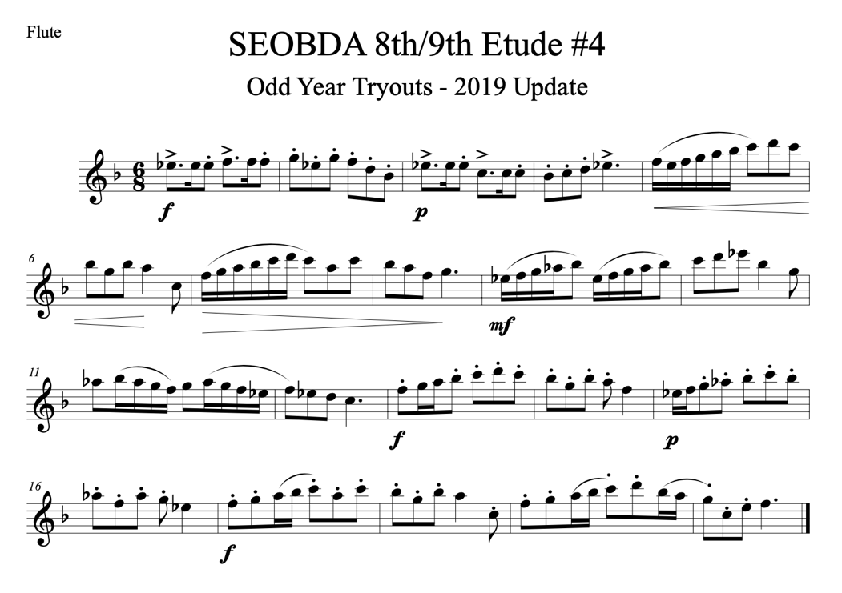
Figure 15 SEOBDA 8th & 9th Grade Etude #2

The most challenging aspect of this etude for intermediate students will likely be quality of the execution of the articulations. Some flutists have trouble executing a true staccato articulation and need to work on making the articulation with the very tip of the tongue. Breath attack exercises may be useful to help mimic the support and quantity of air necessary to execute a quality single tongue. Additional exercises to practice using the tip of the tongue to articulate should also be included. If students struggle with the opening dotted rhythm, it may be appropriate to incorporate multiple tonguing for those measures (mm. 1 & 2).
In addition to articulation, the rhythm should be closely observed for accuracy. The placement of pairs of sixteenth notes changes which may cause problems for those that struggle with rhythm. If rhythm issues persist, students should practice this etude with a metronome set to the eighth note so that they can more easily subdivide the sixteenths.
Summary of Etude
Region/Grade Level Assignment | SEOBDA 8th Grade #2 (Marked #4)
Title of Composition (if any) | N/A
Composer (if indicated) | N/A
Key Signature | F major
Time Signature | 6/8
Tempo Indication | N/A
Form/Phrase Structure | ABC
NFA Level | C
Overall Categorization | Technical Intermediate

Required Performance Skills
- Tone Production/Development
- Dynamic Nuance
- Ease of Finger Technique
- Articulation Clarity
- Breathing and Phrasing
- Intonation

Etude Level as Determined by the Above Elements Compared to Criteria on NFA’s Leveling Guide
Pitch and Key Range | Rhythm and Meter | Articulation | Musical Symbols | Pedagogical Focus
B | C | C | C | D

Overall Level: C

Comments:
Pitch and Key Range: The key signature for this etude has one flat and it’s primarily in F major. There are several appearances of accidentals and the etude range extends from Bb1 to Eb3.
Rhythm and Meter: Etude is in 6/8 and uses basic combinations of dotted-quarter, eighth, dotted-eighth, and sixteenth notes.
Articulations: Etude uses a diverse variety of articulations including accented notes, slurred and legato phrases, and staccato passages.
Musical Symbols: Treble clef pitch notation, use of accidentals, use of various dynamic markings and crescendo/decrescendo symbols.
Pedagogical Focus: Basics of position, posture, tone production, fingering, articulation, notation reading, and dynamic contrast between soft and loud over four-bar phrases.
Table 14 SEOBDA 8th & 9th Grade Etude #2 Leveling Summary

Problems students at the intermediate level may encounter
- Poor Instrument Balance
- Poor Hand Position
- Contrary Finger Motion and Finger Technique Issues
- Poor Tone Quality
- Poorly Managed Breath Control
- Poor Low Register Tone and Projection

Technical Intermediate Etude #3
The second etude assigned to 7th graders in the Green County region of Oklahoma was determined to meet the overall criteria for NFA level C (fig. 16). This etude met criteria for NFA level C in all criteria categories and is an excellent example of an etude for intermediate level flutists. Flutists at the intermediate level may encounter challenges in the quality of the execution of the articulation or struggle to execute the dynamic nuance required.
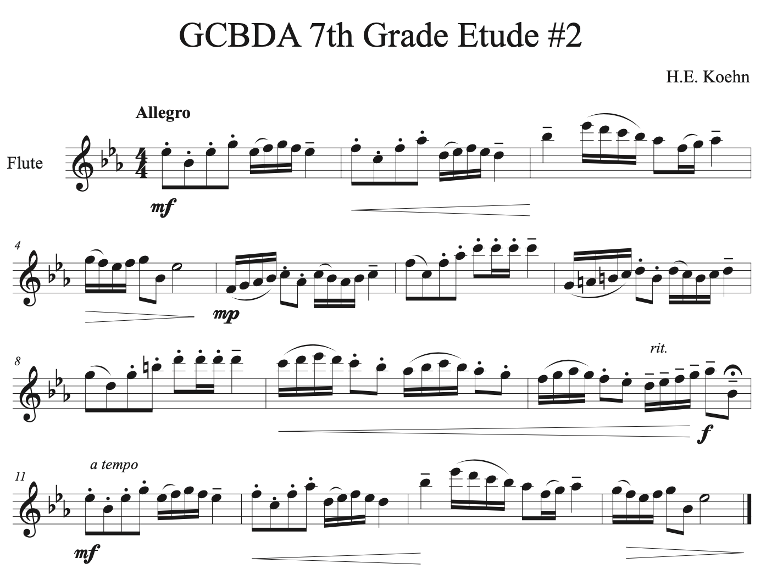
Figure 16 GCBDA 7th Grade Etude #2

This etude requires a diverse repertoire of articulations to be performed which may be challenging for intermediate students who are still in need of developing their articulation. Breath attack exercises would be beneficial for working on all aspects of articulation in this etude: accents, staccato, and overall quality of single tonguing. At this level, flutists may struggle to keep the articulation far enough forward on the tongue to execute a clean, crisp attack. If this is the case, the “Spitting Rice” technique would be a good way to learn to bring the tongue forward to the lips to articulate.
Due to the range of this etude, some of the finger technique at the allegro tempo is quite challenging. The three instances of sixteenth notes that require dexterity navigating around D3 and Eb3 in mm. 3, 9, & 13 are challenging for intermediate students that are just getting acquainted with those fingerings. If the fingerings are new to the flutist, they may find it beneficial to say the note name and fingering out loud while fingering the pitch. Some students may finger the Eb3 incorrectly and use the Eb2 fingering and overblowing to make the octave which negatively affects tone and should be corrected.
Technique issues unrelated to register are likely to occur in the sixteenth note passages, especially those that require contrary finger motion. It may be advisable for intermediate students to use their B-flat Thumb Key for most of this etude as it will ameliorate problems cause by contrary finger motion from Ab to Bb in the first and second register. If issues persist, rhythm practice (either short/long or long/short) organized by phrase would be a good way to build the muscle memory needed to perform the etude. Articulation practice in which the articulations are changed would be beneficial to not only iron out finger technique but improve overall quality of articulation.

Summary of Etude
Region/Grade Level Assignment | GCBDA 7th Grade #2
Title of Composition (if any) | N/A
Composer (if indicated) | H.E. Koehn
Key Signature | E-flat major
Time Signature | 4/4
Tempo Indication | Allegro
Form/Phrase Structure | ABA
NFA Level | C
Overall Categorization | Technical Intermediate

Required Performance Skills
- Tone Production/Development
- Dynamic Nuance
- Ease of Finger Technique
- Articulation Clarity
- Breathing and Phrasing
- Intonation

Etude Level as Determined by the Above Elements Compared to Criteria on NFA’s Leveling Guide
Pitch and Key Range | Rhythm and Meter | Articulation | Musical Symbols | Pedagogical Focus
C | C | C | C | C

Overall Level: C

Comments:
Pitch and Key Range: Key signature has three flats and is written in E-flat major. Range extends from F1 to Eb3.
Rhythm and Meter: Etude is written in 4/4 and uses basic combinations of half notes, quarter, eighth, and sixteenth notes.
Articulations: Etude uses a variety of single tonguing techniques. Combinations of staccato and legato tonguing patterns across entire etude.
Musical Symbols: Treble clef pitch notation, use of accidentals, use of various dynamic markings and crescendo/decrescendo symbols.
Pedagogical Focus: Basics of position, posture, tone production, fingering, articulation, notation reading, and dynamic contrast between soft and loud over four-bar phrases.
Table 15 GCBDA 7th Grade Etude #2 Leveling Summary

Problems students at the intermediate level may encounter
- Poor Instrument Balance
- Poor Hand Position
- Contrary Finger Motion and Finger Technique Issues
- Poor Tone Quality
- Poorly Managed Breath Control
- Poor Low Register Tone and Projection

Technical Intermediate Etude #4
The second etude assigned the 7th graders in the Eastern region of Oklahoma met criteria for NFA level C. This etude is appropriate for intermediate level students in all assessment categories. Flutists at this level may find some of the finger technique challenging, as well as maintaining good tone quality across many styles of articulation and playing this etude at the Vivace tempo that is indicated.
Figure 17 EDBDA 7th Grade Etude #2

If there are any immediate issues with the technique, the first area that should be examined is body position, posture, hand position, and instrument balance. These are all areas of performance that are commonly associated with issues at all levels of playing and if poorly executed can contribute to many technical problems. For the right hand, the soda-can test may be appropriate, especially if it is causing balance issues. For the left hand, evaluate where the tube of the flute rests on the index finger, resting it on the fleshy part of the finger may compress the ulnar nerve and lead to reduced dexterity in that finger.
If there are lingering issues with finger technique but hand position and instrument balance have been eliminated as a cause, practice rhythms may be appropriate to help the fingers develop the muscle memory needed to execute the passage (fig. 18).
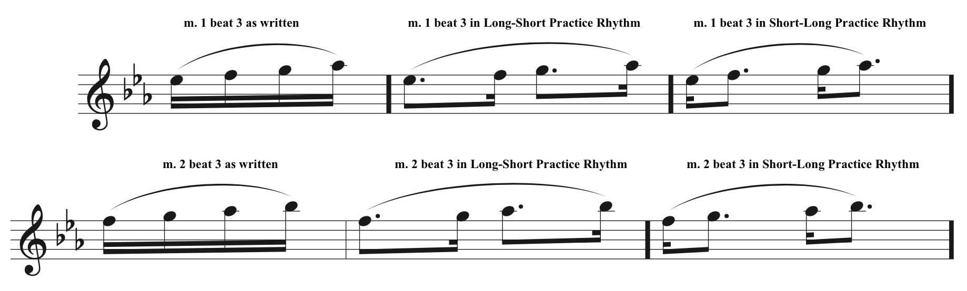
Figure 18 Rhythm Practice for Sixteenth Note Passages in EDBDA 7th Grade Etude #2

Problems with tone quality at this level, that are not caused by issues of balance and hand position, are likely caused by lack of control of air speed and air direction. Tone exercises for intermediate flutists practicing this etude would include long tones on the Eb major scale and harmonic exercises to build embouchure flexibility.

Summary of Etude
Region/Grade Level Assignment | EDBDA 7th Grade #2
Title of Composition (if any) | N/A
Composer (if indicated) | H.E. Koehn
Key Signature | E-flat major
Time Signature | 4/4
Tempo Indication | Vivace
Form/Phrase Structure | ABA
NFA Level | C
Overall Categorization | Technical Intermediate

Required Performance Skills
- Tone Production/Development
- Dynamic Nuance
- Ease of Finger Technique
- Articulation Clarity
- Breathing and Phrasing
- Intonation

Etude Level as Determined by the Above Elements Compared to Criteria on NFA’s Leveling Guide
Pitch and Key Range | Rhythm and Meter | Articulation | Musical Symbols | Pedagogical Focus
C | C | C | C | C

Overall Level: C
Comments:
Pitch and Key Range: Etude has 3 flats in the key signature and is in E-flat major with one appearance of an accidental. Range extends from Ab1 to Eb3.
Rhythm and Meter: Etude is in 4/4 and uses basic rhythms of half, quarter, eighth, and sixteenth notes. There are several sixteenth-note passages and some appearances of dotted-eighth-sixteenth note combinations.
Articulations: All articulations can be achieved with single tonguing technique. Etude uses various patterns of articulations including slurred groups of four sixteenth notes, tongue-two slur-two eighth note patterns, and combinations of staccato and tenuto markings.
Musical Symbols: Treble clef pitch notation, use of accidentals, use of various dynamic markings and crescendo/decrescendo symbols.
Pedagogical Focus: Basics of position, posture, tone production, fingering, articulation, notation reading, and dynamic contrast between soft and loud over four-bar phrases.
Table 16 EDBDA 7th Grade Etude #2 Leveling Summary

Problems students at the intermediate level may encounter
- Poor Instrument Balance
- Poor Hand Position
- Contrary Finger Motion and Finger Technique Issues
- Poor Tone Quality
- Poorly Managed Breath Control
- Poor Low Register Tone and Projection

Technical Intermediate Etude #5
The first etude assigned to 7th grade flutists in the Southwest region of Oklahoma met the criteria for NFA level C. There are many challenges for intermediate flutists in this etude including various dynamic markings to adhere to, contrary finger motion in the sixteenth note passages, and requires a good staccato articulation (fig. 19).
Figure 19 SWOBDA 7th Grade Etude #1

Although only eighth measures long, this etude manages to pack in several challenges for intermediate level flutists learning it. As always, balance of the instrument and proper hand position should be established otherwise the flutist will experience additional technique problems unrelated to the etude. The key of Eb major and range of a 9th from A1 to Bb2 should be of little difficulty for intermediate level students though the execution of some of the leaps in the etude may need attention.
Articulations in this etude should be refined and most intermediate flutists benefit from breath attack exercises to strengthen the quality of single tonguing. Breath attacks would help create a consistent, bouncy staccato for the eighth note passages found throughout this etude. For the Slur 2-Tongue 2 groups of sixteenths, articulation practice moving around the placement of the slurred and tongued notes would improve agility and improve overall execution.
Issues of finger technique are likely to appear in the contrary finger motion between F2 and D2 in the sixteenth note group in m. 2. This group of notes is an ideal candidate for rhythm and articulation practice to develop the muscle memory needed to execute the passage (fig. 20).

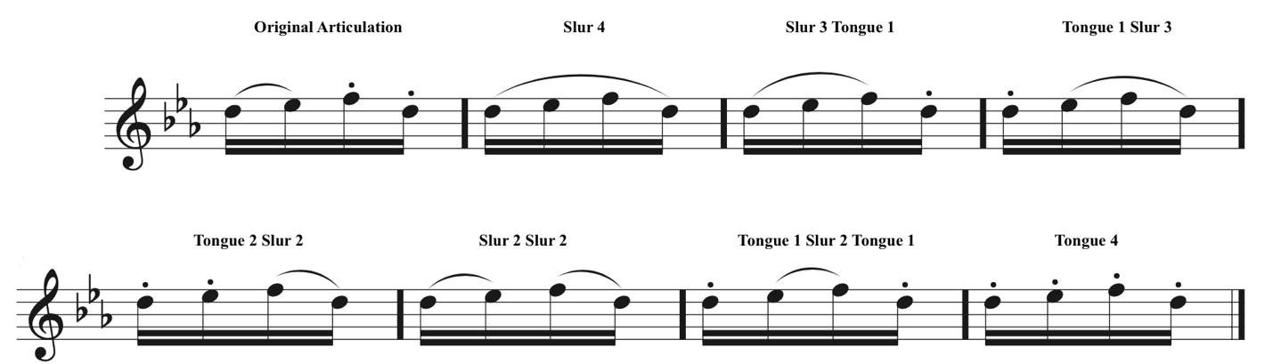
Figure 20 Practice Articulations for SWOBDA 7th Grade Etude #1 m. 1

Summary of Etude
Region/Grade Level Assignment | SWOBDA 7th Grade #1
Title of Composition (if any) | N/A
Composer (if indicated) | N/A
Key Signature | E-flat major
Time Signature | 4/4
Tempo Indication | Allegretto
Form/Phrase Structure | ABA’
NFA Level | C
Overall Categorization | Technical Intermediate

Required Performance Skills
- Tone Production/Development
- Dynamic Nuance
- Ease of Finger Technique
- Articulation Clarity
- Breathing and Phrasing
- Intonation

Etude Level as Determined by the Above Elements Compared to Criteria on NFA’s Leveling Guide
Pitch and Key Range | Rhythm and Meter | Articulation | Musical Symbols | Pedagogical Focus
B | C | C | C | C

Overall Level: C

Comments:
Pitch and Key Range: Etude has three flats in the key signature and is in E-flat major. The range extends from A1 to Bb2. There are several appearances of accidentals.
Rhythm and Meter: Etude is written in 4/4 and marked Allegretto. It includes basic rhythms of quarter, eighth, and sixteenth notes.
Articulations: Etude features several instances of slur-two tongue-two articulation patterns. All passages could be completed with single tonguing, but at faster tempi may be better suited to be double tongued in the sixteenth note passages.
Musical Symbols: Treble clef pitch notation, use of accidentals, use of various dynamic markings and crescendo/decrescendo symbols.
Pedagogical Focus: Basics of position, posture, tone production, fingering, articulation, notation reading, and dynamic contrast between soft and loud over four-bar phrases.
Table 17 SWOBDA 7th Grade Etude #1 Leveling Summary

Problems students at the intermediate level may encounter
- Poor Instrument Balance
- Poor Hand Position
- Contrary Finger Motion and Finger Technique Issues
- Poor Tone Quality
- Poorly Managed Breath Control
- Poor Low Register Tone and Projection

Technical Intermediate Etude #5
This etude from the Rubank Advanced Method for Flute, vol. 1 was assigned to 7th graders from both the Northeast (NBDA) and North Central (NCDA) regions of Oklahoma (fig. 21). This etude met criteria for NFA level C and would be on the more challenging end of intermediate literature. Flutists at this level may have difficulty managing the finger technique, phrasing, and range of this etude.
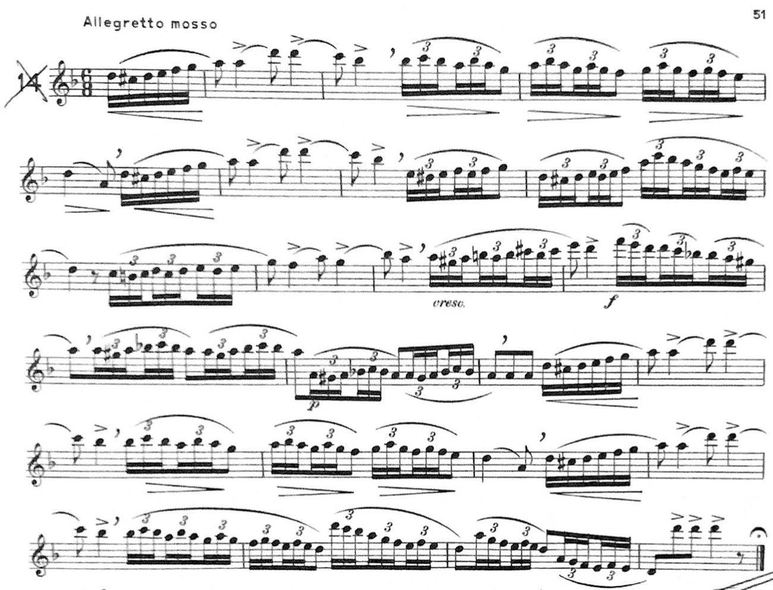
Figure 21 NBDA/NCDA 7th Grade Etude #1

The sixteenth note triplets that make up much of this etude are idiomatic for the flute, even more-so if the flutist elects to use their B-flat thumb key. Flutists at the intermediate level will likely find some of these sixteenth note triplet passages easier than others, like those in the middle register or those in which only one finger needs to move at a time (e.g., mm. 2-4, mm. 12-13). The passages that will be most difficult for intermediate students will be when the range goes above C2 because the fingerings for the third octave are different.
Intermediate level flutists may struggle to maintain the long slurs over the triplet sixteenths, if this is the case long tone and breathing exercises can be done to work up to performing those phrases. If the flutist can play a long tone for the duration of the phrase then they should also be able to execute the phrase itself: air and fingers have nothing to do with each other.
For flutists that are having trouble with their tone or consistency playing the high notes, harmonic long tone exercises would be beneficial for establishing air speed and direction. As always, examine hand position and instrument balance as this causes issues for players at all levels.

Summary of Etude
Region/Grade Level Assignment | NBDA/NCDA 7th Grade Etude #1 from Rubank Advanced vol. 1, pg. 51 Allegretto mosso
Title of Composition (if any) | N/A
Composer (if indicated) | N/A
Key Signature | D minor
Time Signature | 6/8
Tempo Indication | Allegretto mosso
Form/Phrase Structure | ABA’
NFA Level | C
Overall Categorization | Technical Intermediate

Required Performance Skills
- Tone Production/Development
- Dynamic Nuance
- Ease of Finger Technique
- Articulation Clarity
- Breathing and Phrasing
- Intonation

Etude Level as Determined by the Above Elements Compared to Criteria on NFA’s Leveling Guide
Pitch and Key Range | Rhythm and Meter | Articulation | Musical Symbols | Pedagogical Focus
C | D | C | C | C

Overall Level: C

Comments:
Pitch and Key Range: The key signature contains one flat and is in D minor. There are several appearances of accidentals both as chromatic neighbor tones and to reinforce the D minor tonality. Range is quite expansive and extends from D1 to F3.
Rhythm and Meter: Etudes is in 6/8 time and uses combinations of quarter, eighth, and sixteenth notes. There are many instances of sixteenth-note triplets in scale patterns and chromatic-neighbor patterns.
Articulations: This etude is rather simple in articulation and consistent in the use of long passages of slurred sixteenths. There are accent markings at many of the beginnings of the slurred passages but otherwise those are the two articulations present in the music.
Musical Symbols: Treble clef pitch notation, use of accidentals, use of various dynamic markings and crescendo/decrescendo symbols.
Pedagogical Focus: Basics of position, posture, tone production, fingering, articulation, notation reading, and dynamic contrast between soft and loud over four-bar phrases.
Table 18 NBDA/NCDA Etude #1 Leveling Summary

Problems students at the intermediate level may encounter
- Poor Instrument Balance
- Poor Hand Position
- Contrary Finger Motion and Finger Technique Issues
- Poor Tone Quality
- Poorly Managed Breath Control
- Poor Low Register Tone and Projection

Technical Intermediate Etude #6
The second etude assigned to 7th graders in the North Central and Northeast regions of Oklahoma was the Gavotte by C.W. Gluck from the Rubank Advanced Method for Flute, vol. 1. This etude met the criteria for NFA level C and is appropriate for intermediate level flute students. Flutists at this level will likely find the range, articulations, dynamic requirements, and performance tempo of this etude challenging.
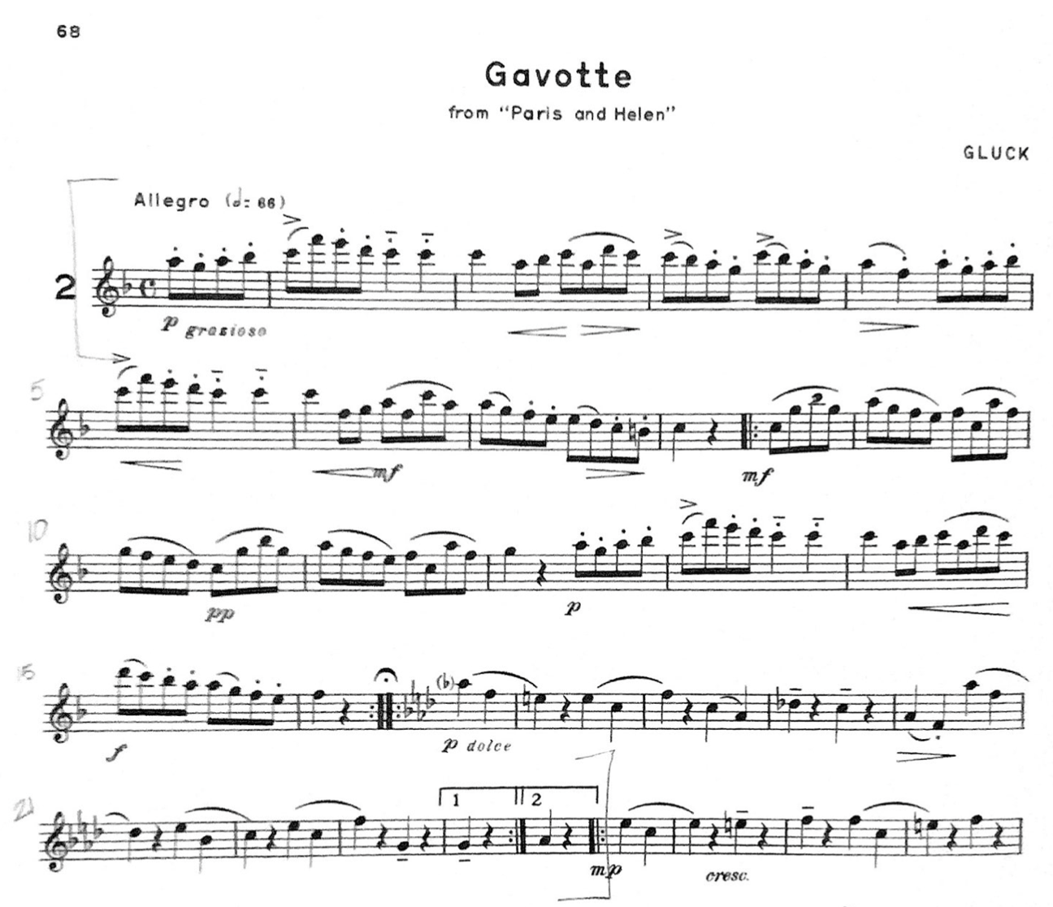
Figure 22 NBDA/NCDA 7th Grade Etude #2

The key of F major should be familiar to intermediate level flutists and at level C they should be working towards a two octave F major scale. The etude’s range B1 to F3 is typical of intermediate literature but students that struggle to maintain the second and third octave pitches may find it difficult. Long tone harmonic exercises would be ideal for developing the control of air speed and direction and embouchure flexibility necessary to maintain the upper register.
The recurring leaps from C2 to F3 are another challenge due to either the change in air speed and direction needed to slur the interval or due to balance issues when not using the thumb on C2. The slurred intervals in the B section of the etude (mm. 8-11) may also suffer from similar problems of air management or instrument balance. Again, long tone harmonic exercises would be a good practice technique to develop the necessary embouchure flexibility to slur intervals larger than a third.
This etude incorporates the portato articulation which may be especially difficult for intermediate level students. Creating a quality portato articulation, indicated either by a staccato dot placed under a tenuto like in m. 5 or dot under a slur like beat 2 of m. 4, should be played separated but still legato. Portato articulations can be difficult for flutists who can otherwise manage legato articulation and staccato articulation well but struggle to create meaningful differences in note lengths longer than an eighth note. Developing a good portato articulation comes down to Trevor Wye’s mantra, “it’s all a question of time, patience, and intelligent work.”

Summary of Etude
Region/Grade Level Assignment | NBDA/NCDA 7th Grade Etude #2 from Rubank Advanced vol. 1, pg. 68
Title of Composition (if any) | Gavotte
Composer (if indicated) | C.W. Gluck
Key Signature | F major
Time Signature | Common time
Tempo Indication | Allegro
Form/Phrase Structure | AB
NFA Level | C
Overall Categorization | Technical Intermediate

Required Performance Skills
- Tone Production/Development
- Dynamic Nuance
- Ease of Finger Technique
- Articulation Clarity
- Breathing and Phrasing
- Intonation

Etude Level as Determined by the Above Elements Compared to Criteria on NFA’s Leveling Guide
Pitch and Key Range | Rhythm and Meter | Articulation | Musical Symbols | Pedagogical Focus
C | C | C | C | C

Overall Level: C

Comments:
Pitch and Key Range: This etude is in F major and its range extends from B1 to F3.
Rhythm and Meter: Etude is written in common time. The tempo marking indicates the tempo for the half note suggesting the etude be played in a fast two.
Articulations: This etude uses combinations of staccato, legato, and portato articulations. All articulations could be achieved using single tongue technique but at faster tempi may be suitable for double tonguing. There are several accents included and various combinations of slurred and tongued passages.
Musical Symbols: Treble clef pitch notation, use of accidentals, use of various dynamic markings and crescendo/decrescendo symbols.
Pedagogical Focus: Basics of position, posture, tone production, fingering, articulation, notation reading, and dynamic contrast between soft and loud over four-bar phrases.
Table 19 NBDA/NCDA 7th Grade Etude #2 Leveling Summary

Problems students at the intermediate level may encounter
- Poor Instrument Balance
- Poor Hand Position
- Contrary Finger Motion and Finger Technique Issues
- Poor Tone Quality
- Poorly Managed Breath Control
- Poor Low Register Tone and Projection

Recommendations on Overcoming Challenges at the Intermediate Level:
Pearson, Standard of Excellence, Flute books 1-3:
- Keep fingers close to the keys (bk. 3, pg. 18)
- For higher notes use a smaller aperture and aim air higher (bk. 1, pg. 28)
- For low notes aim air lower and use a bigger aperture, move lower jaw and lips back (bk. 3, pg. 14)
- Direct your air stream lower for a full tone (bk. 3, pg. 14)

Lautzenhauser, et al, Essential Elements, Flute books 1-3:
- No flute specific advice available
George & Louke, Flute 101, 101.5, 102, 103:
- “Stance: The left foot is placed at 12:00 and the right foot is placed at 2:00 with the body facing 45 degrees to the right. As the flute is raising into playing position, the head turns to the left so the aperture in the lips and the embouchure hole align with the left big toe and the center of the music stand. The embouchure plate is placed firmly in the chin and the end of the flute is pushed forward from the right shoulder… When sitting to play, rotate the chair 45 degrees to the right and repeat the above directions achieving the same lineup of nose, aperture, embouchure hole, and crease in the left elbow with the center of the music stand.” (Flute 101.5, pg. 2)
- “Balancing the Flute: The goal is to balance the flute in the hands so the flute remains still when moving the fingers. Many flutists have a tendency to lift the end of the flute when playing ascending notes (removing fingers) and lower the end of the flute when descending (adding fingers). Try to keep the flute still.” (Flute 101.5, pg. 3)
- “Right-Hand position: Borrowing from violin pedagogy, the soda can (or tin can) test is useful in position the right-hand thumb. Pick up the can and see where the thumb naturally aligns with the fingers. About a third of all flutists are most comfortable with the thumb directly under the index finger. Another third are most comfortable with the thumb between the index and middle finger, and a third directly under the middle finger. Use whichever right thumb position is most comfortable for you when balancing the flute.” (Flute 101.5, pg. 4)
- “To determine the proper playing angle for you, gently push the end of the flute forward and then back as if the embouchure plate is rocking to the left and then to the right in your chin. Listen for any change of sound. There will be one spot where the sound is the best. We call this the sweet spot. This is where you want to position the flute.” (Flute 101.5, pg. 6)
- “In this position [with the end of the flute too close to the player’s right shoulder], because of the design of the embouchure hole, the flute will not ring as much as in the forward position. Most flutes sound best when the end of the flute is in front of the player’s nose.” (Flute 101.5, pg. 6)
- “Tone Exercise: alternate between the regular fingering and the harmonic fingering to develop your tone.” (Flute 101.5, pg. 45)
- “If the tone lacks center or core and is airy, have the student direct the air stream towards the left big toe.” (Flute 101.5, pg. 60)
- “Playing octaves develops the embouchure and teaches the running of the perfect octave. The upper note is achieved by making a smaller aperture (opening between the lips) and slightly increasing the air speed. It may be helpful to have the student think of blowing through a soda straw for the low note and a flatter coffee stirrer straw for the upper note. Keep the embouchure hole level and pointed to the ceiling. Do not roll the flute.” (Flute 101.5, pg. 60)
- “The best tone is achieved by blowing an even air stream. Use a run, not to check the pitch, but to gauge if your air stream is even. If the needle is still then your air stream is even.” (Flute 101.5, pg. 71)
- “If your tone cracks low, aim the air stream higher. If it cracks high, aim the air stream lower.” (Flute 101.5, pg. 71)

Wye, Beginner’s Book & Practice Book:
- “The word ‘tone’ is a collective noun for a formula containing a number of ingredients, each of which contributes significantly to the concept of tone, for example: color, size, projection, intensity, vibrato, loudness, and purity. If your tone contains these ingredients, it might be regarded as beautiful but your tone is only as good as its weakest part.” (Practice Books, pg. 5)
- “Long slow tones by themselves give the player the opportunity to examine their tone in fine detail and allows time to hear undesirable aspects of it and to make corrections accordingly. Long tones really can’t fail to help improve your tone, though if played without care or thought won’t achieve a result so quickly.” (Practice Books, pg. 5)
- “For younger players, the low and high registers are more difficult. The easiest register is generally the middle. If there are harmonics or overtones present when playing in the low register, the second and third registers are easier and can be played with more confidence.” (Practice Books, pg. 6)
- “Take care not to turn the flute in on your lip when descending, or to lower your head; this might appear to make the note more resonant, but will also flatten the pitch.” (Practice Books, pg. 7)
- “Make small adjustments to your lips as you descend so that each note is the best that you can play. Take care not to turn the lip plate in, or to lower your head when descending as the tone can sound buzzy - like a bad full of wasps! Keep your tone warm…” (Practice Books, pg. 9)
- “Remember one important point: as you rise to middle E, avoid raising the airstream or air direction. We all have a tendency to do this without realizing it because it helps to get middle E more cleanly and smoothly.” (Practice Books, pg. 15)
- “Remember the earlier advice? Don’t raise the air stream too much as you play into the third octave. This is easier said than done, perhaps because the top notes are easier when the air is directed upwards - but the tone will be thinner and you should avoid this. More importantly, the third octave generally suffers from being too sharp.” (Practice Books, pg. 20)
- “In a diminuendo, as the air speed is reduced and the pitch goes flat, so the embouchure hole (blow hole) needs to be uncovered to compensate for this drop in pitch. This action will make the note sharper, returning it back to its correct pitch. The simultaneous movements of air speed, jaw, lips and perhaps the head too, have to be co-ordinated and practiced together before achieving any long-term result.” (Practice Books, pg. 40)
- “Problems Box: 1. Never end notes with your tongue or by shutting you lips together [...]. 2. Do not roll the flute in or out with your hands to alter the pitch. 3. The end of the note is flat? Use your jaw and lips - and head, if necessary-more. 4. The notes get wispy at the very end of soft notes? Push the lips forward towards the end of the note. It will get better with practice. 5. The overall pitch is wrong? Check your tuning before and during your practice…” (Practice Books, pg. 42)
- “Articulation is the speech of music. No matter how powerful or compelling your musical ideas, they will not be communicated to the listener unless your articulation is clear.” (Practice Books, pg. 93)
- “To get ‘bounce’ and a lively character into single tonguing we use the abdominal muscles to start and stop the notes. It is the same muscle used in laughing or coughing. It must be trained to start the air moving into the flute speedily and to stop it quickly too, and this is achieved by practice in three ways: short, fast, and later, loud.” (Practice Books, pg. 98)

Lyrical Advanced
Lyrical Advanced Etude #1
The first etude assigned to flutists in the 8th and 9th grades in the Southeast region of Oklahoma met leveling criteria for NFA level D. This etude is written in a challenging key signature, has grace note ornamentation, uses an extensive dynamic palette, and requires a variety of articulations. Advanced level students are likely to have many issues handling this etude.
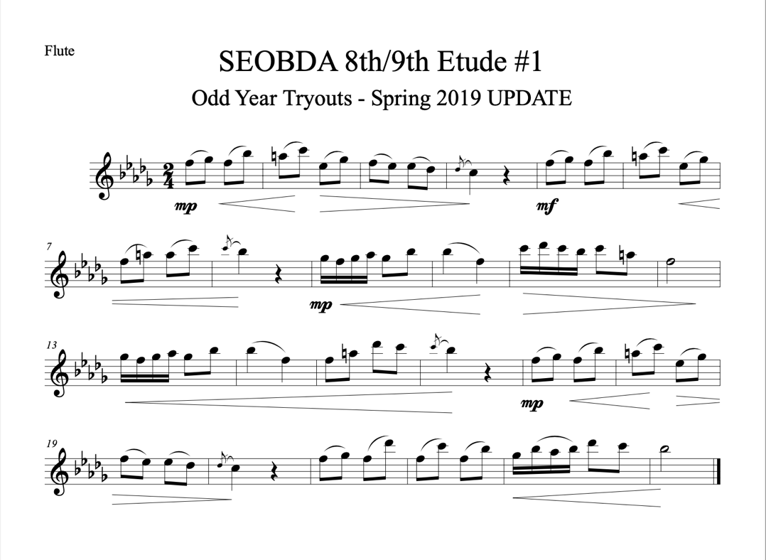
Figure 23 SEOBDA 8th & 9th Grade Etude #1

This etude’s key signature poses quite the challenge evene for advanced students, Bb minor can be a challenging key to navigate. First, the issue of playing Gb consistently and managing the contrary finger motion between F1/2 and Gb1/2. Second, it can’t be assumed that all of the As will be raised to provide a leading tone, this is an etude where writing in courtesy accidentals should be encouraged.
There are no Bs or Gb3s which enable the flutist to use the Bb thumb key throughout the etude which should resolve lingering contrary motion issues between Bb and A/Ab. Other technique issues that arise in the sixteenth note passages should be treated with rhythm practice to develop the muscle memory needed to execute the technique.
There are a few common problems among advanced flutists still struggling to create dynamic contrast in their playing. Some at this level, to the detriment of their upper register and volume capabilities, will find an improvement in their low register tone by turning the headjoint inward. This should be discouraged because covering too much of the embouchure hole negatively affects tone production and intonation across all registers and makes the upper register more challenging to play. Others struggling to create dynamic contrast may be in need of work with a breath builder or other breathing exerciser to develop greater lung capacity and improve breath control.

Summary of Etude
Region/Grade Level Assignment | SEOBDA 8th & 9th Grade #1
Title of Composition (if any) | N/A
Composer (if indicated) | N/A
Key Signature | B-flat minor
Time Signature | 2/4
Tempo Indication | N/A
Form/Phrase Structure | ABA’
NFA Level | D
Overall Categorization | Lyrical Advanced

Required Performance Skills
- Playing Position, Balance, and Posture
- Tone Production/Development
- Dynamic Nuance
- Ease of Finger Technique
- Articulation Clarity
- Breathing & Phrasing
- Rhythmic Precision
- Intonation
- Upper Register Response/Technique

Etude Level as Determined by the Above Elements Compared to Criteria on NFA’s Leveling Guide
Pitch and Key Range | Rhythm and Meter | Articulation | Musical Symbols | Pedagogical Focus
E | C | C | C | D

Overall Level: C

Comments:
Pitch and Key Range: This etude has five flats in the key signature and is in the key of B-flat minor in a range that extends from C2 to Db3. There are several appearances of accidentals reinforcing the key of B-flat harmonic minor.
Rhythm and Meter: The etude is written in ¾ time and uses a variety of rhythms includes half, quarter, eighth, and sixteenth notes with a few instances of grace notes.
Articulations: Etude uses a variety of slurred and tongued articulations that can be accomplished by single tonguing.
Musical Symbols: Treble clef pitch notation, use of accidentals, use of various dynamic markings and crescendo/decrescendo symbols.
Pedagogical Focus: Basics of position, posture, tone production, fingering, articulation, notation reading, and dynamic contrast between soft and loud over four-bar phrases.
Table 20 SEOBDA 8th & 9th Grade Etude #1 Leveling Summary

Problems students at the advanced level may encounter
- Poor Instrument Balance
- Poor Hand Position
- Contrary Finger Motion and Finger Technique Issues
- Poor Tone Quality
- Poorly Managed Breath Control
- Poor Low Register Tone and Projection

Lyrical Advanced Etude #2
The first etude assigned to flutists in the 8th and 9th grades in the Eastern region of Oklahoma met the criteria for NFA level D. Advanced level flutists should have experience playing in 6/8 time and/or playing in a key signature with four flats but may find difficulty with some of the rhythmic patterns or chromaticism in this etude. The tempo and phrasing of this etude are challenging musically and issues of tone will be apparent in performance.
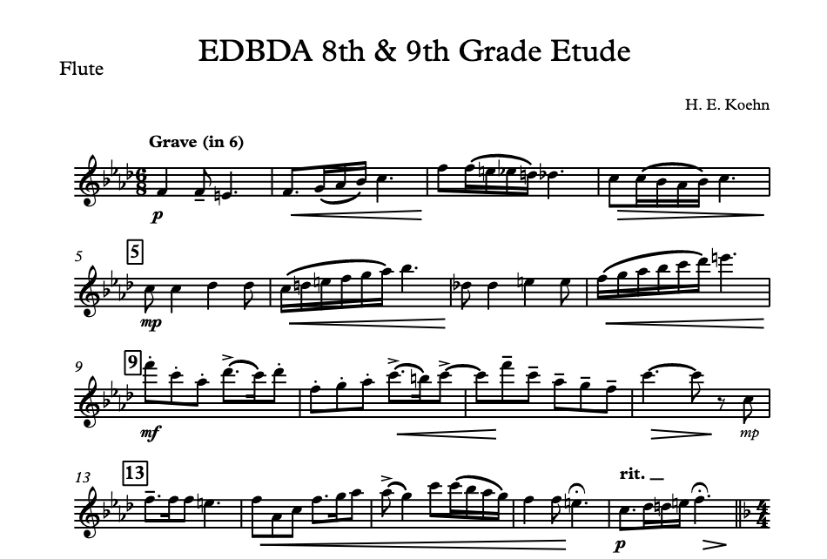
Figure 24 EDBDA 8th & 9th Grade Etude #1

This etude’s slow tempo and time signature might challenge some advanced flutists unaccustomed to playing in a slow 6. The time and tempo will be exceptionally challenging for flutists that have problems with tone quality. Breathing exercises with the instrument, working with some sort of breath builder, or long tone exercises would benefit students that struggle with tone quality issues. Other tone issues may be solved in articulation practice.
Breath attack exercises for articulation practice should be the first recommendation for advanced level flutists as this will help improve their overall articulation quality and prepare them for multiple tonguing techniques. This etude requires accent, staccato, legato, and slur articulations that can all be achieved with single tonguing techniques. These articulations should be practiced at all dynamic levels to accommodate the requirements of the etude.

Summary of Etude
Region/Grade Level Assignment | EDBDA 8th & 9th Grade #1
Title of Composition (if any) | N/A
Composer (if indicated) | H.E. Koehn
Key Signature | F minor
Time Signature | 6/8
Tempo Indication | Grave (in 6)
Form/Phrase Structure | ABC
NFA Level | D
Overall Categorization | Lyrical Advanced

Required Performance Skills
- Playing Position, Balance, and Posture
- Tone Production/Development
- Dynamic Nuance
- Ease of Finger Technique
- Articulation Clarity
- Breathing & Phrasing
- Rhythmic Precision
- Intonation
- Upper Register Response/Technique

Etude Level as Determined by the Above Elements Compared to Criteria on NFA’s Leveling Guide
Pitch and Key Range | Rhythm and Meter | Articulation | Musical Symbols | Pedagogical Focus
C | D | D | C | D

Overall Level: D
Comments:
Pitch and Key Range: Etude has four flats in the key signature, there are many instances of accidentals but the etude is primarily in F minor and spans the range of E1 to F3.
Rhythm and Meter: The etude is written in 6/8 and the tempo indicates it is to be played in 6. There are several instances of syncopation in dotted eighth-sixteenth rhythms. Etude uses combinations of dotted-quarter, quarter, eighth, and sixteenth notes.
Articulations: Etude uses a variety of articulations that can all be accomplished by single tonguing at a slow tempo. There are various styles of articulation including legato, staccato, and accented passages across phrases of four measures.
Musical Symbols: Treble clef pitch notation, use of accidentals, use of various dynamic markings and crescendo/decrescendo symbols.
Pedagogical Focus: Basics of position, posture, tone production, fingering, articulation, notation reading, and dynamic contrast between soft and loud over four-bar phrases.
Table 21 EDBDA 8th & 9th Grade Etude #1 Leveling Summary

Problems students at the advanced level may encounter
- Poor Instrument Balance
- Poor Hand Position
- Contrary Finger Motion and Finger Technique Issues
- Poor Tone Quality
- Poorly Managed Breath Control
- Poor Low Register Tone and Projection

Lyrical Advanced Etude #3
The Sivori Romance from Rubank Advanced Method for Flute, vol. 1 was assigned to 8th and 9th grade flutists in the Southwest region of Oklahoma. This etude is quite challenging and met criteria for NFA level E. Advanced flutists may struggle with the range of the etude, the ornamentation, maintaining good tone quality in all registers, and creating dynamic contrast.
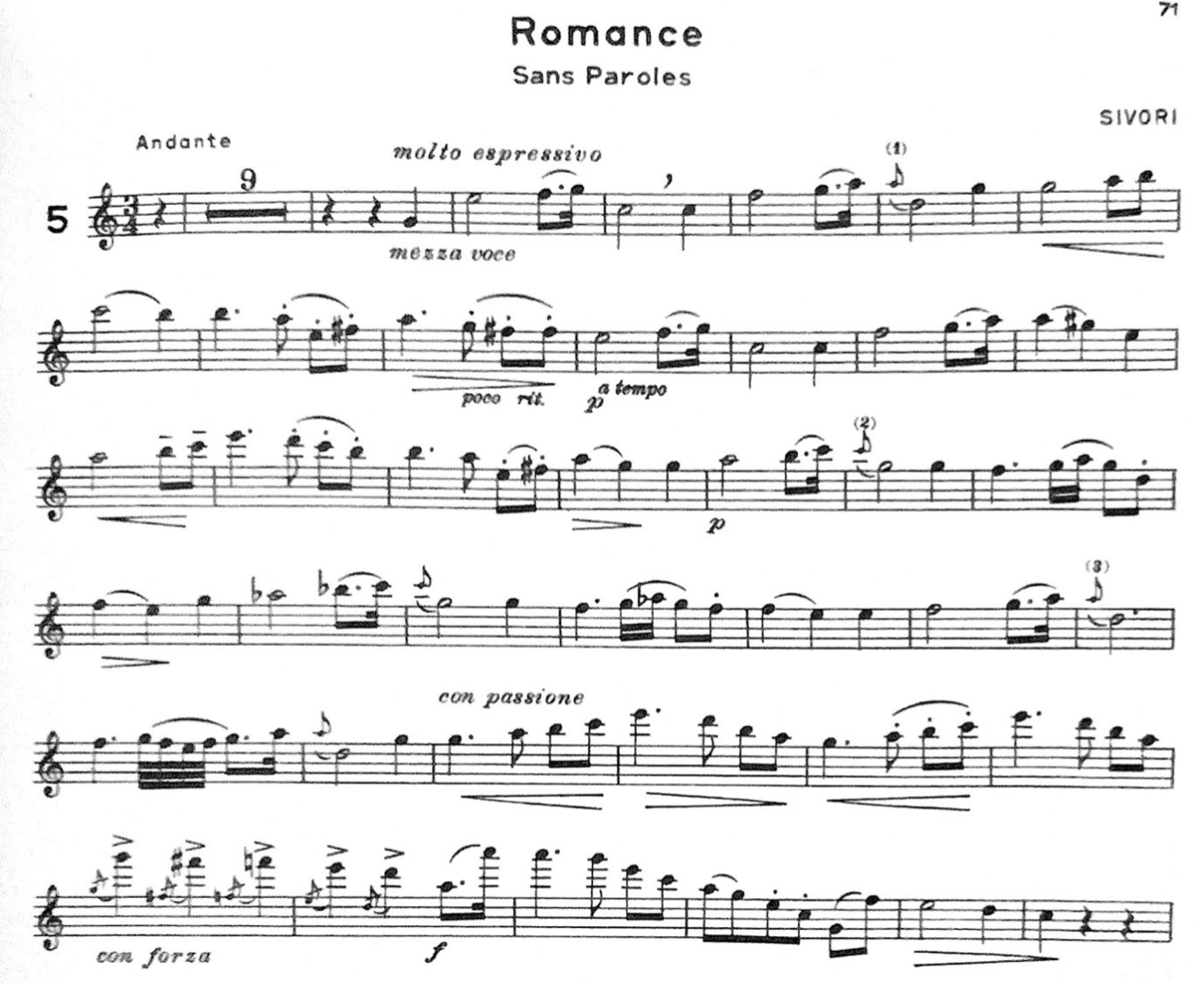
Figure 25 SWOBDA 8th Grade Etude #2

Problems of tone quality should be immediately addressed in the process of learning this etude. Causes may stem from issues of instrument balance and hand position or from issues with air speed and direction. Advanced students struggling with issues of balance and hand position should review the photographs and positioning instructions George and Louke provide in Flute 101.5. Long tone harmonic exercises are especially beneficial for advanced flutists that still struggle with managing their air.
The ornamentation that appear in this etude may be the flutist’s first encounter with both styles of grace note: the appoggiatura and the acciaccatura. Appoggiaturas are grace notes that are played on the beat and do not have a slash through them, the grace note is placed on the strong beat. Acciaccaturas are grace notes that are played before the beat and indicated by a slash through the grace note, the note that follows the grace note receives the emphasis.
This etude uses several different styles of articulation including slurs, staccato, legato, and portato. These types of articulation should be in the repertoire of an advanced flutist but those that are struggling likely are not tonguing far enough forward or not supporting the air behind the tongue adequately. If this is the case, they likely also struggle with articulation at faster tempi. Breath attack exercises are particularly useful for overcoming both of these issues when it comes to articulation. As well as practicing breath attacks, advanced flutists should practice common articulation patterns (e.g., slur 2 tongue 2, slur 4, slur 3 tongue 1, etc).

Summary of Etude
Region/Grade Level Assignment | SWOBDA 8th Grade #2 from Rubank Advanced vol. 1, pg. 71
Title of Composition (if any) | Romance
Composer (if indicated) | Sivori
Key Signature | C major
Time Signature | 3/4
Tempo Indication | Andante – molto espressivo
Form/Phrase Structure | A (played at various transpositions with increasing amounts of decoration)
NFA Level | E
Overall Categorization | Lyrical Advanced

Required Performance Skills
- Playing Position, Balance, and Posture
- Tone Production/Development
- Dynamic Nuance
- Ease of Finger Technique
- Articulation Clarity
- Breathing & Phrasing
- Rhythmic Precision
- Intonation
- Upper Register Response/Technique

Etude Level as Determined by the Above Elements Compared to Criteria on NFA’s Leveling Guide
Pitch and Key Range | Rhythm and Meter | Articulation | Musical Symbols | Pedagogical Focus
D | E | D | E | E

Overall Level: E
Comments:
Pitch and Key Range: This etude has no sharps or flats in the key signature and is generally in C major. There are many instances of accidentals that temporarily signal modulations to another key. And the range of the etude is quite expansive extending from G1 to A3.
Rhythm and Meter: Etude is in 3/4 time and marked Andante. It uses a variety of rhythms including combinations of half, quarter, eighth, sixteenth, and thirty-second notes. There are many instances of grace notes, some to be played on the beat and some to be played just before the beat.
Articulations: The etude uses a variety of articulatios including staccato, legato, and portato articulations. All articulations can be accomplished with single tonguing at the tempo indicated.
Musical Symbols: Symbols for standard rhythms, meter, treble clef pitch notation, dynamics, articulations, etc. Symbols for simple ornamentation including grace notes, mordents, trills, and small cadenza figures.
Pedagogical Focus: Tone development (vibrato study is appropriate). Ease with lower 2.5 octaves of the range. Extension of breath control. Control of dynamics and crescendo/diminuendo over several bars.
Table 22 SWOBDA 8th & 9th Grade Etude #2 Sivori Romance Leveling Summary

Problems students at the advanced level may encounter
- Poor Instrument Balance
- Poor Hand Position
- Contrary Finger Motion and Finger Technique Issues
- Poor Tone Quality
- Poorly Managed Breath Control
- Poor Low Register Tone and Projection

Lyrical Advanced Etude #4
Although this etude is attributed to Ernesto Köhler, it is not a part of his 25 Romantic Etudes, op. 66 collection but is included in the Voxman Selected Studies Collection and was chosen for high school students auditioning for Oklahoma All-State. This etude met criteria most consistent with NFA level E and has many significant challenges. There are two tempo changes, thirty-second note passages in the Lento e cantabile sections, ornamentation including trills, terminations, grupettos, and grace notes, and uses nearly the complete range of the instrument (fig. 26).
For tone related problems, examine the body and hand positions and verify the instrument is well balanced in the hands before working on tone exercises as some issues may be resolved by better positioning. If tone quality issues persist, long tone harmonic exercises will help improve embouchure flexibility and improve tone overall. Breath attack exercises will not only improve articulation, but help train the diaphragm to properly support the sound which is essential in performance of this etude.
To practice the ornamentation, first its recommended to learn the music without ornamentation to learn the rhythm and notes, isolate the ornamentation during this stage to work solely on its execution out of context. Once the grace notes, gruppeti, trills, and terminations are established on their own, they can then be added to the context of the music.
The tempo changes from Lento e cantabile to Un poco animato (and then back to Lento e cantabile) is a significant challenge to be worked out in this etude. The creation of a click track could be extremely beneficial.
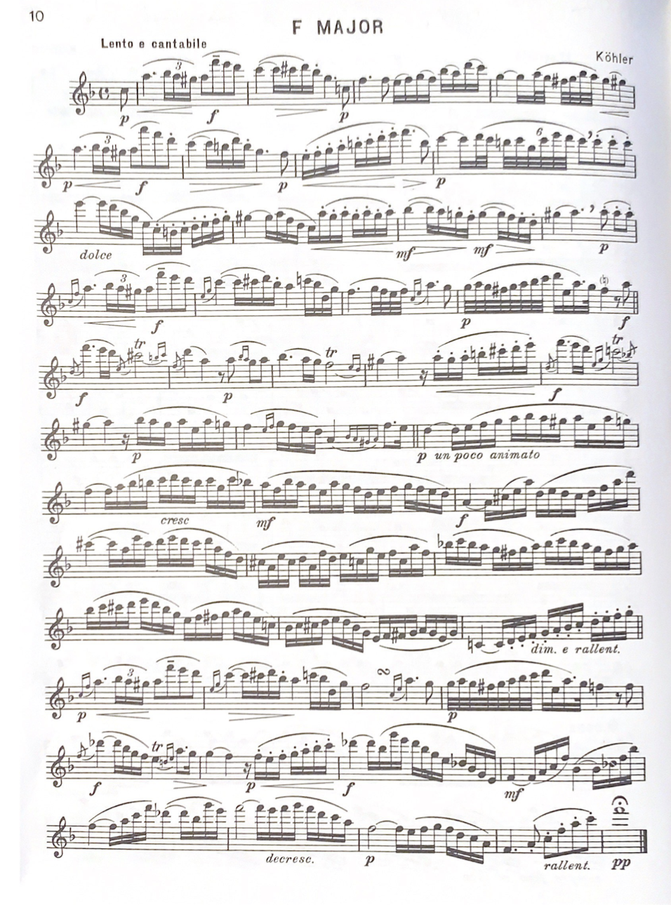
Figure 26 OKMEA All-State Etude #1

Summary of Etude
Region/Grade Level Assignment | OkMEA All-State from Selected Studies pg. 10
Title of Composition (if any) | Etude in F major
Composer (if indicated) | Ernesto Köhler
Key Signature | F major
Time Signature | Common time
Tempo Indication | Lento e cantabile
Form/Phrase Structure | ABA’
NFA Level | E
Overall Categorization | Lyrical Advanced

Required Performance Skills
- Playing Position, Balance, and Posture
- Tone Production/Development
- Dynamic Nuance
- Ease of Finger Technique
- Articulation Clarity
- Breathing & Phrasing
- Rhythmic Precision
- Intonation
- Upper Register Response/Technique

Etude Level as Determined by the Above Elements Compared to Criteria on NFA’s Leveling Guide
Pitch and Key Range | Rhythm and Meter | Articulation | Musical Symbols | Pedagogical Focus
E | E | E | E | E

Overall Level: E
Comments:
Pitch and Key Range: Etude has one flat in the key signature and is in F major. The range is quite expansive and extends from C1 to A3. There are many instances of accidentals across the entirety of the etude.
Rhythm and Meter: The etude is in common time with the A section tempo at Lento e cantabile and the B section slightly faster at the un poco animato. The etude is rhythmically diverse and moderately complex rhythmic combinations using values as short as thirty-second notes. There are copious ornamental indications for grace notes, trills with terminations, mordents, and grupetti.
Articulations: The etude uses a variety of legato and staccato articulations. There are many long slurred passages, extended passages of portato articulations.
Musical Symbols: Symbols for standard rhythms, meter, treble clef pitch notation, dynamics, articulations, etc. Symbols for simple ornamentation including grace notes, mordents, trills, and small cadenza figures.
Pedagogical Focus: Tone development (vibrato study is appropriate). Ease with lower 2.5 octaves of the range. Extension of breath control. Control of dynamics and crescendo/diminuendo over several bars.
Table 23 OkMEA Etude #2 Köhler Etude in F major Leveling Summary

Problems students at the advanced level may encounter
- Poor Instrument Balance
- Poor Hand Position
- Contrary Finger Motion and Finger Technique Issues
- Poor Tone Quality
- Poorly Managed Breath Control
- Poor Low Register Tone and Projection

Lyrical Advanced Etude #5
This etude in A-major by Ernesto Köhler was selected for the first-round of OkMEA High School All-State auditions (Oklahoma Music Educators Association). Students preparing it were in tenth, eleventh, and twelfth grades and likely late intermediate to early advanced players. Like other Köhler etudes in Voxman’s collection, this one is another selection originally from his 25 Romantic Etudes op. 66, and presents several challenges for flutists: passages with juxtaposition of duple and triple subdivisions, expressively demanding, contrasting dynamics and articulations across full compass of the instrument, and challenging extended chromatic phrases.

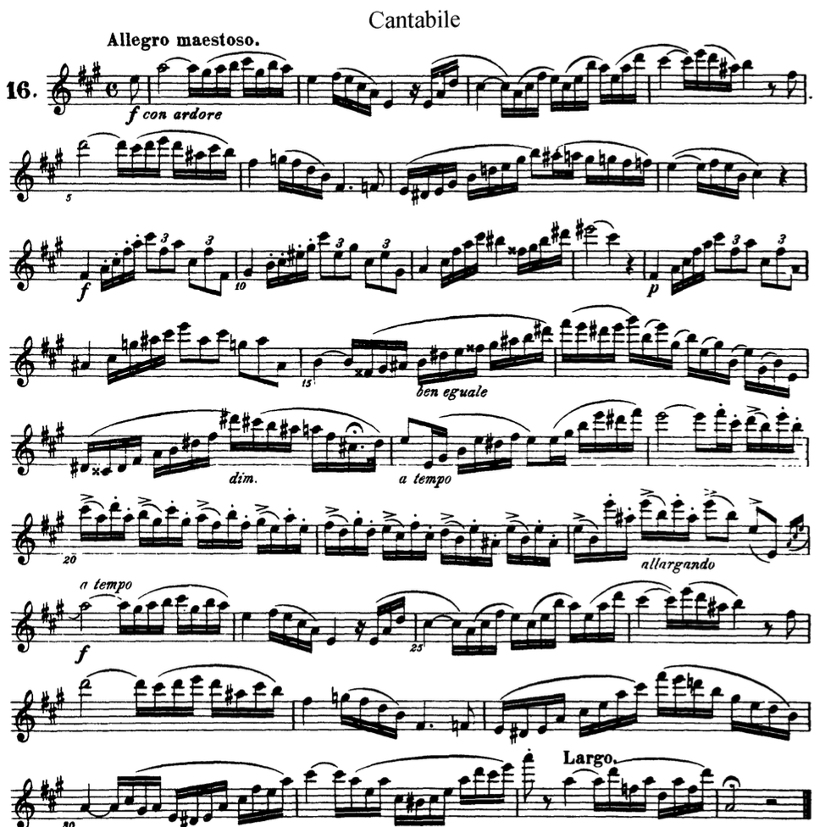
Figure 27 OKMEA All-State Etude #3

Summary of Etude
Region/Grade Level Assignment | OkMEA All-State
Title of Composition (if any) | Etude in A-Major
Composer (if indicated) | Ernesto Kohler
Key Signature | A-Major (3 sharps)
Time Signature | Common Time
Tempo Indication | Allegro maestoso
Form/Phrase Structure | ABA’
NFA Level | E
Overall Categorization | Lyrical Advanced

Required Performance Skills
- Tone Production/Development
- Dynamic Nuance
- Ease of Finger Technique
- Articulation Clarity/Multiple Tonguing
- Breathing and Phrasing
- Rhythmic Precision
- Intonation
- Upper Register Response/Technique
- Ornamentation

Etude Level as Determined by the Above Elements Compared to Criteria on NFA’s Leveling Guide
Pitch and Key Range | Rhythm and Meter | Articulation | Musical Symbols | Pedagogical Focus
E | D | E | E | E

Overall Level: E
Comments:
Pitch and Key Range: This etude’s range extends from D1 to A3, utilizes a key with 3-sharps, and freely uses accidentals and enharmonics to signal temporary modulations
Rhythm and Meter: Although the etude is in Common Time, Köhler freely alternates between duple and triple subdivisions, uses various combinations of 16ths and other rapid moving figures.
Articulations: This etude’s articulation content poses some of the most significant challenges. Köhler’s free use of various articulation combinations (patterns of tongues and slurs) in staccato and legato styles and included many accent indications.
Musical Symbols: Köhler uses a wide variety of musical symbols requiring more advanced notation literacy
Pedagogical Focus: This etude is musically demanding, requires the flutist to sustain long phrases and utilize expressive devices like vibrato and rubato techniques. It requires ease across 2.5 octaves of the instrument and control over extreme dynamic contrasts.
Table 24 OkMEA Etude #3 Köhler Etude in A major Leveling Summary
Problems students at the beginning/intermediate/advanced level may encounter
- Poor instrument balance
- Poor hand position
- Contrary Finger Motion & Finger Technique Issues
- Inconsistent Intonation
- Poor Tone Quality
- Poorly Managed Breath Control
- Weak Low Register Tone and Projection
- Poor Upper Register Response, Intonation, and Dexterity

Technical Advanced
Technical Advanced Etude #1
The second etude assigned to 8th and 9th grade flutists in the Green County region of Oklahoma met criteria for NFA level D. Advanced level students may find difficulty with the range, rhythm, and articulations of this etude.
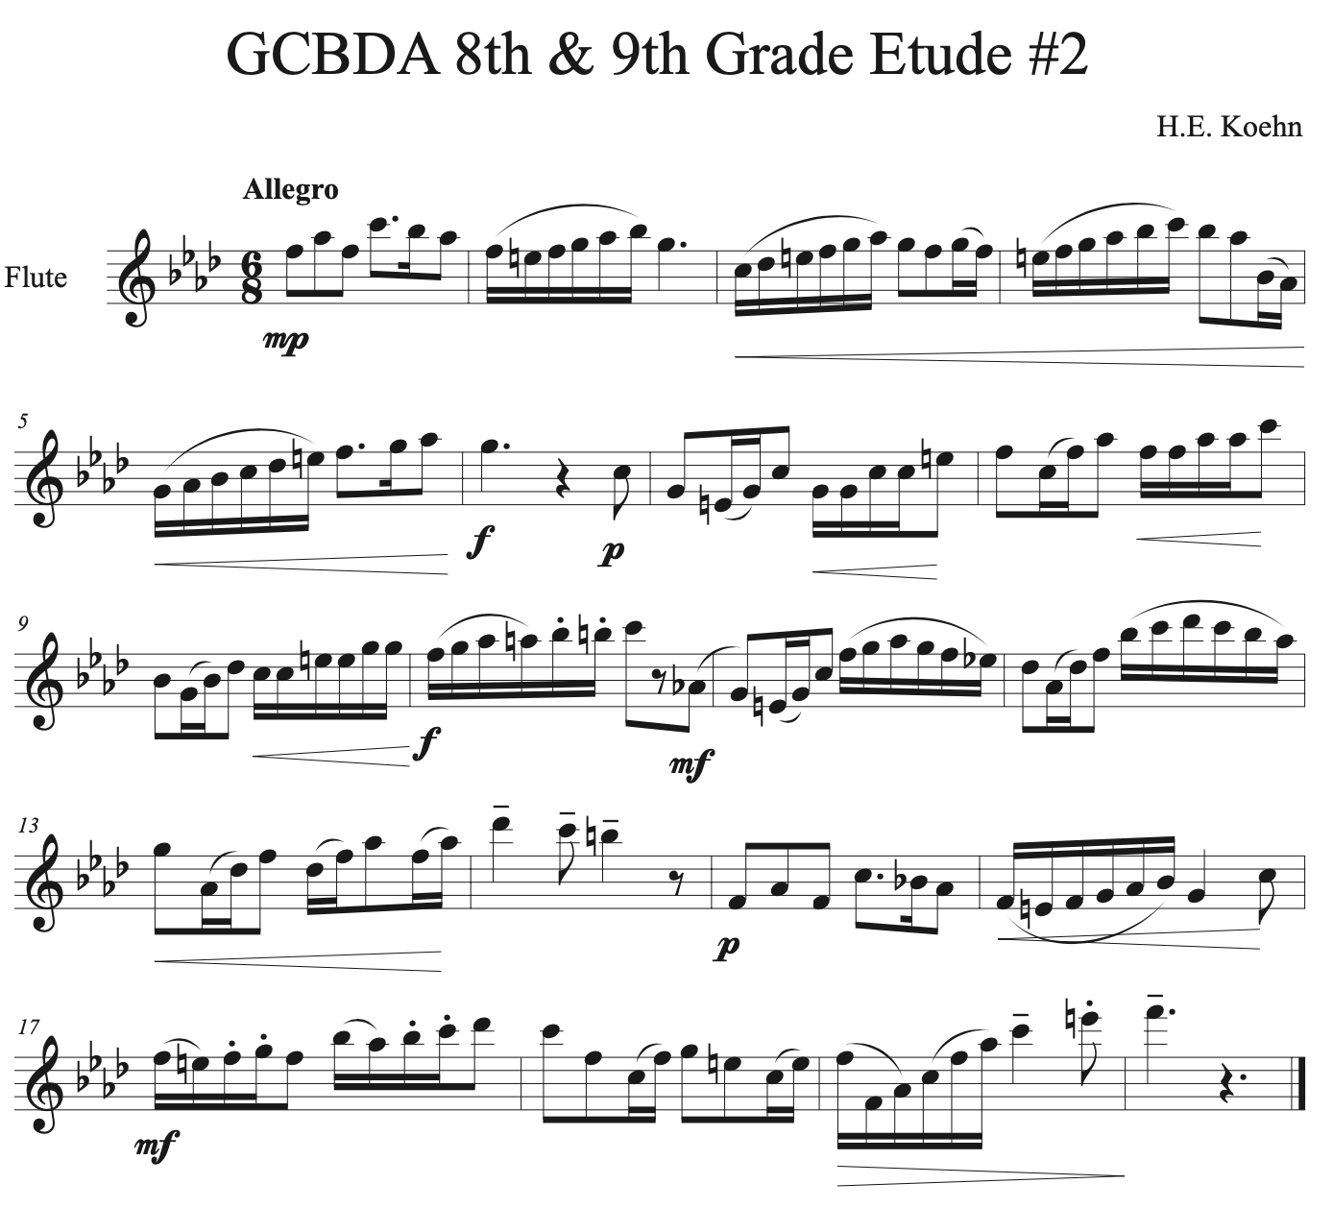
Figure 28 GCBDA 8th & 9th Grade Etude #2

This etude is straightforward and typical of advanced level literature in all areas. It’s in F minor and 6/8, a key and time signature which advanced flutists should have experience with. This etude extends quite low into the range (down to E1) so some advanced flutists may have trouble creating a homogenous tone across all registers. Embouchure flexibility exercises like harmonic long tones would help establish the air speed and direction needed to play the full compass of the instrument.
Issues with articulations may be ameliorated by employing breath attack exercises through sixteenth note passages. This etude could be played with a well-executed single tongue but students that struggle to play an allegro single tongue may need to incorporate double tonguing for a cleaner articulation.
Flutists should also practice making dramatic changes in dynamic over short periods of time to execute the dynamic plan in this etude. This can be done in long tone practice while working on tone quality or can be done in the context of the etude. If there are difficulties achieving a wide spectrum of dynamics, look to see how much of the embouchure hole is covered by the lip; if too much is covered, it will be hard to play above a mezzo forte dynamic.

Summary of Etude
Region/Grade Level Assignment | GCBDA 8th & 9th Grade #2
Title of Composition (if any) | N/A
Composer (if indicated) | H.E. Koehn
Key Signature | F minor
Time Signature | 6/8
Tempo Indication | Allegro
Form/Phrase Structure | ABA’
NFA Level | D
Overall Categorization | Technical Advanced

Required Performance Skills
- Playing Position, Balance, and Posture
- Tone Production/Development
- Dynamic Nuance
- Ease of Finger Technique
- Articulation Clarity
- Breathing & Phrasing
- Rhythmic Precision
- Intonation
- Upper Register Response/Technique

Etude Level as Determined by the Above Elements Compared to Criteria on NFA’s Leveling Guide
Pitch and Key Range | Rhythm and Meter | Articulation | Musical Symbols | Pedagogical Focus
D | D | C | C | D

Overall Level: D

Comments:
Pitch and Key Range: This key signature of this etude has four flats and is in the key of F minor. There are many accidentals throughout the etude indicating different key areas or serving as chromatic gestures.
Rhythm and Meter: The etude is written in 6/8 time and marked Allegro. Etude has moderately complex rhythmic combinations using values as short as thirty-second notes.
Articulations: A variety of articulations are used in this etude including various patterns of tongued and slurred notes. Etude could be accomplished using entirely single tonguing techniques but at faster tempi may benefit from some double tonguing.
Musical Symbols: Symbols for standard rhythms, meter, treble clef pitch notation, dynamics, articulations, etc. Symbols for simple ornamentation including grace notes, mordents, trills, and small cadenza figures.
Pedagogical Focus: Tone development (vibrato study is appropriate). Ease with lower 2.5 octaves of the range. Extension of breath control. Control of dynamics and crescendo/diminuendo over several bars.
Table 25 GCDA 8th & 9th Grade Etude #2 Leveling Summary

Problems students at the advanced level may encounter
- Poor Instrument Balance
- Poor Hand Position
- Contrary Finger Motion and Finger Technique Issues
- Poor Tone Quality
- Poorly Managed Breath Control
- Poor Low Register Tone and Projection

Technical Advanced Etude #2

The second etude for 8th and 9th grade students in the Eastern region of Oklahoma met the criteria for NFA level D (fig. 29). The articulations and finger technique are likely to cause the most trouble for the advanced level flutist. The etude covers a range of just over two octaves, so flutists struggling with tone may find this particularly difficult.

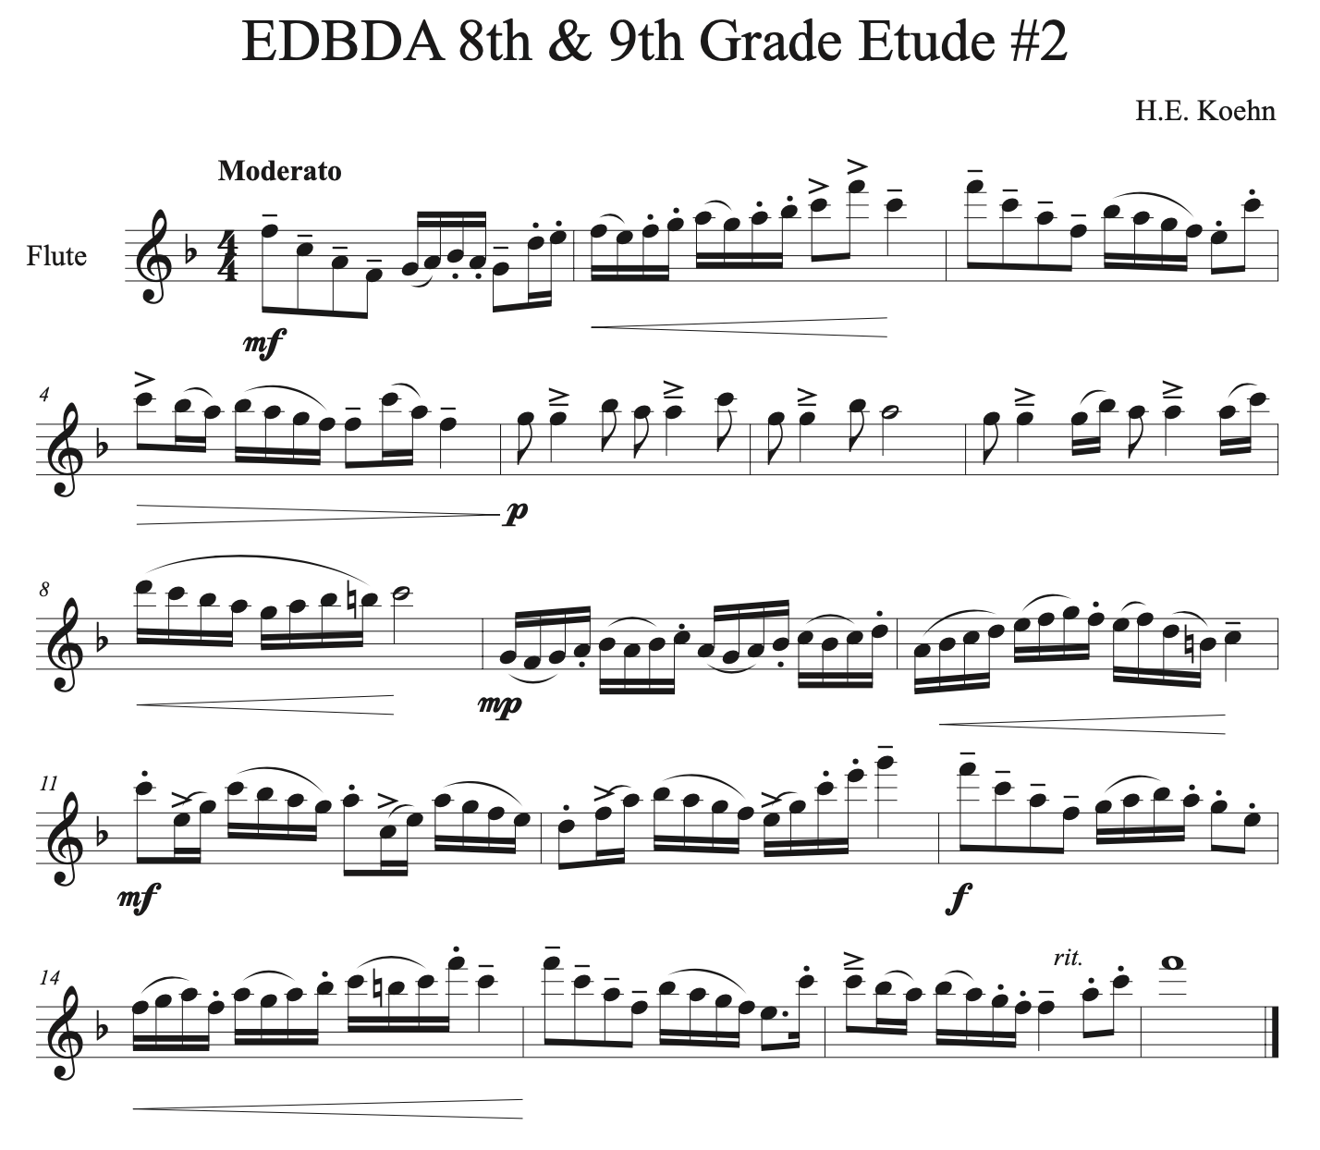
Figure 29 EDBDA 8th & 9th Grade Etude #2

This etude requires many different styles and patterns of articulation. These articulations and patterns should be familiar to the advanced level flutist but if there are lingering issues of execution then breath attacks are recommended. Altering the pattern of articulation of the sixteenth note passages may also help coordinate the tongue and fingers and ameliorate issues when returning to the original articulation.
Some finger technique issues caused by contrary finger motion may be resolved by using the Bb thumb key when applicable. Other technical issues may be worked out through the use of Long-Short and Short-Long practice rhythms.

Summary of Etude
Region/Grade Level Assignment | EDBDA 8th & 9th Grade #2
Title of Composition (if any) | N/A
Composer (if indicated) | H.E. Koehn
Key Signature | F major
Time Signature | 4/4
Tempo Indication | Moderato
Form/Phrase Structure | ABA’
NFA Level | D
Overall Categorization | Technical Advanced

Required Performance Skills
- Playing Position, Balance, and Posture
- Tone Production/Development
- Dynamic Nuance
- Ease of Finger Technique
- Articulation Clarity
- Breathing & Phrasing
- Rhythmic Precision
- Intonation
- Upper Register Response/Technique

Etude Level as Determined by the Above Elements Compared to Criteria on NFA’s Leveling Guide
Pitch and Key Range | Rhythm and Meter | Articulation | Musical Symbols | Pedagogical Focus
D | D | C | C | D

Overall Level: D
Comments:
Pitch and Key Range: Etude has one flat in the key signature and is in F major. There are several appearances of accidentals and the range extends from F1 to G3.
Rhythm and Meter: Etude is in 4/4 time and marked Moderato. There are many instances of syncopation and moderately complex rhythmic combinations using values as short as sixteenth notes.
Articulations: A variety of articulations are used in this etude including various patterns of tongued and slurred notes. Etude could be accomplished using entirely single tonguing techniques but at faster tempi may benefit from some double tonguing.
Musical Symbols: Symbols for standard rhythms, meter, treble clef pitch notation, dynamics, articulations, etc. Symbols for simple ornamentation including grace notes, mordents, trills, and small cadenza figures.
Pedagogical Focus: Tone development (vibrato study is appropriate). Ease with lower 2.5 octaves of the range. Extension of breath control. Control of dynamics and crescendo/diminuendo over several bars.
Table 26 EDBDA 8th & 9th Grade Etude #2 Leveling Summary

Problems students at the advanced level may encounter
- Poor Instrument Balance
- Poor Hand Position
- Contrary Finger Motion and Finger Technique Issues
- Poor Tone Quality
- Poorly Managed Breath Control
- Poor Low Register Tone and Projection

Technical Advanced Etude #3
This etude, from Rubank’s Advanced Method for Flute, vol. 1, was designated as the second etude for 8th and 9th grade students in the Southwest region of Oklahoma and met the criteria for NFA level D. This etude is significantly challenging for advanced level students mostly because of the tempo and double tonguing required throughout.
The tempo and articulation pattern of this etude requires double tonguing unless a spectacular single tonguing technique can be achieved at the allegretto tempo. Breath attack practice is especially prudent to work on the breath support required for effective double tonguing. If the “K” stroke of the tongue is too weak and the articulation seems to “limp,” use Wye’s recommendation and switch the syllable placement of the articulation so that it’s performed “K-T-K-T” to strengthen the “K” stroke.
The form and repeated sections of the etude are ideal candidates for rhythm practice (either long-short or short-long) and may additionally benefit from articulation practiced. If the flutists is struggling to support the breath behind a rapid double tongue articulation, slurring the passage with full support and at a forte dynamic will help create the necessary sensation of support that should be carried over to the double tonguing.
The ornamentation at the end of this etude is its own challenge and should be practiced out of context before being applied in run-throughs so that the timing of the underlying rhythm is learned accurately. If the Bb thumb key has not already been selected for use in this etude, then it should at the very least be applied to the final five measures so that the trills and terminations are snappy and accurate.
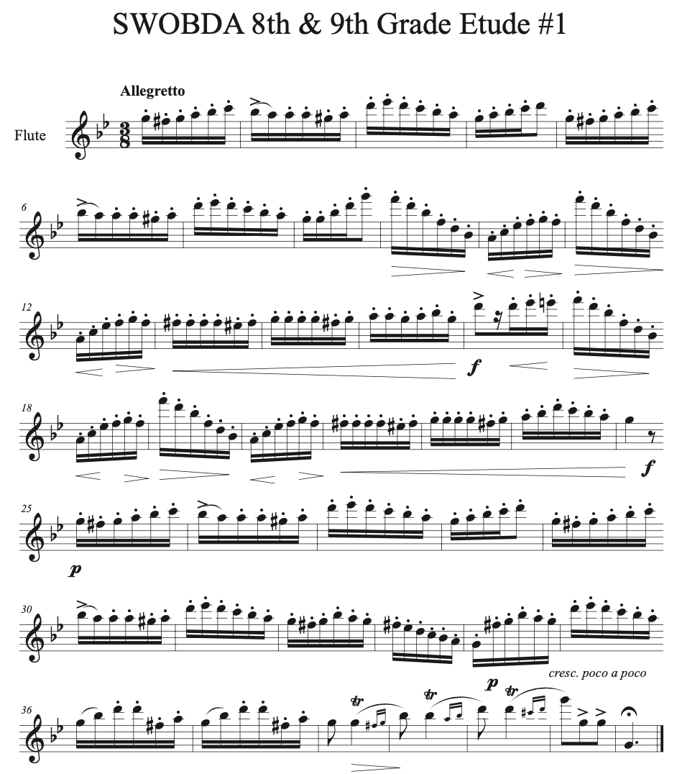
Figure 30 SWOBDA 8th Grade Etude #1

Summary of Etude
Region/Grade Level Assignment | SWOBDA 8th Grade #1 from Rubank Advanced vol. 1, pg. 54-55
Title of Composition (if any) | N/A
Composer (if indicated) | N/A
Key Signature | G minor
Time Signature | 3/8
Tempo Indication | Allegretto
Form/Phrase Structure | ABA’
NFA Level | D
Overall Categorization | Technical Advanced

Required Performance Skills
- Playing Position, Balance, and Posture
- Tone Production/Development
- Dynamic Nuance
- Ease of Finger Technique
- Articulation Clarity
- Breathing & Phrasing
- Rhythmic Precision
- Intonation
- Upper Register Response/Technique

Etude Level as Determined by the Above Elements Compared to Criteria on NFA’s Leveling Guide
Pitch and Key Range | Rhythm and Meter | Articulation | Musical Symbols | Pedagogical Focus
C | C | D | D | D

Overall Level: D
Comments:
Pitch and Key Range: Etude has two flats in the key signature and is in G minor and has several accidentals throughout. The range extends from G1 to G3.
Rhythm and Meter: The etude is written in 3/8 and uses mostly straight sixteenth note passages throughout.
Articulations: The tempo of this etude demands agile tonguing technique and would benefit from the use of double tonguing throughout.
Musical Symbols: Symbols for standard rhythms, meter, treble clef pitch notation, dynamics, articulations, etc. Symbols for simple ornamentation including grace notes, mordents, trills, and small cadenza figures.
Pedagogical Focus: Tone development (vibrato study is appropriate). Ease with lower 2.5 octaves of the range. Extension of breath control. Control of dynamics and crescendo/diminuendo over several bars.
Table 27 SWOBDA 8th & 9th Grade Etude #2 Rubank Advanced pg. 54-55

Problems students at the advanced level may encounter
- Poor Instrument Balance
- Poor Hand Position
- Contrary Finger Motion and Finger Technique Issues
- Poor Tone Quality
- Poorly Managed Breath Control
- Poor Low Register Tone and Projection

Technical Advanced Etude #4

The third etude used for All-State auditions in Oklahoma was the Kummer Etude in F# Minor from the Voxman Selected Studies. The Kummer etude met criteria consistent with NFA level E and provided significant challenges for advanced level students. Problems with articulation, finger technique, and dynamic contrast are most likely to occur for advanced flutists preparing this etude.
The tempo Vivace and the triplet eighths that make up the primary rhythmic content of this etude, in combination with the staccato articulation, demands quality multiple tonguing technique to be performed well. Either double tonguing in a triplet pattern or triple tonguing would be appropriate, whichever is most comfortable for the flutist playing. Playing this etude solely on breath attacks will certainly be advantageous and help improve articulation technique.
If there are issues with tone, especially in the articulation passages, slurring the passages at a forte dynamic will help expose where the support and air drops off when the passage is tongued. Steady work with a metronome will help improve speed and spending time triple tonguing away from the flute will help the process go faster.
Some of the neighbor figures may be easier to accomplish at a fast tempo if the trill fingering is used. This should be up to the discretion of the performer. If played too slowly then tone quality through the use of trill fingerings may not be ideal but if played fast enough there should be no discernible difference between the standard fingering and trill fingering.
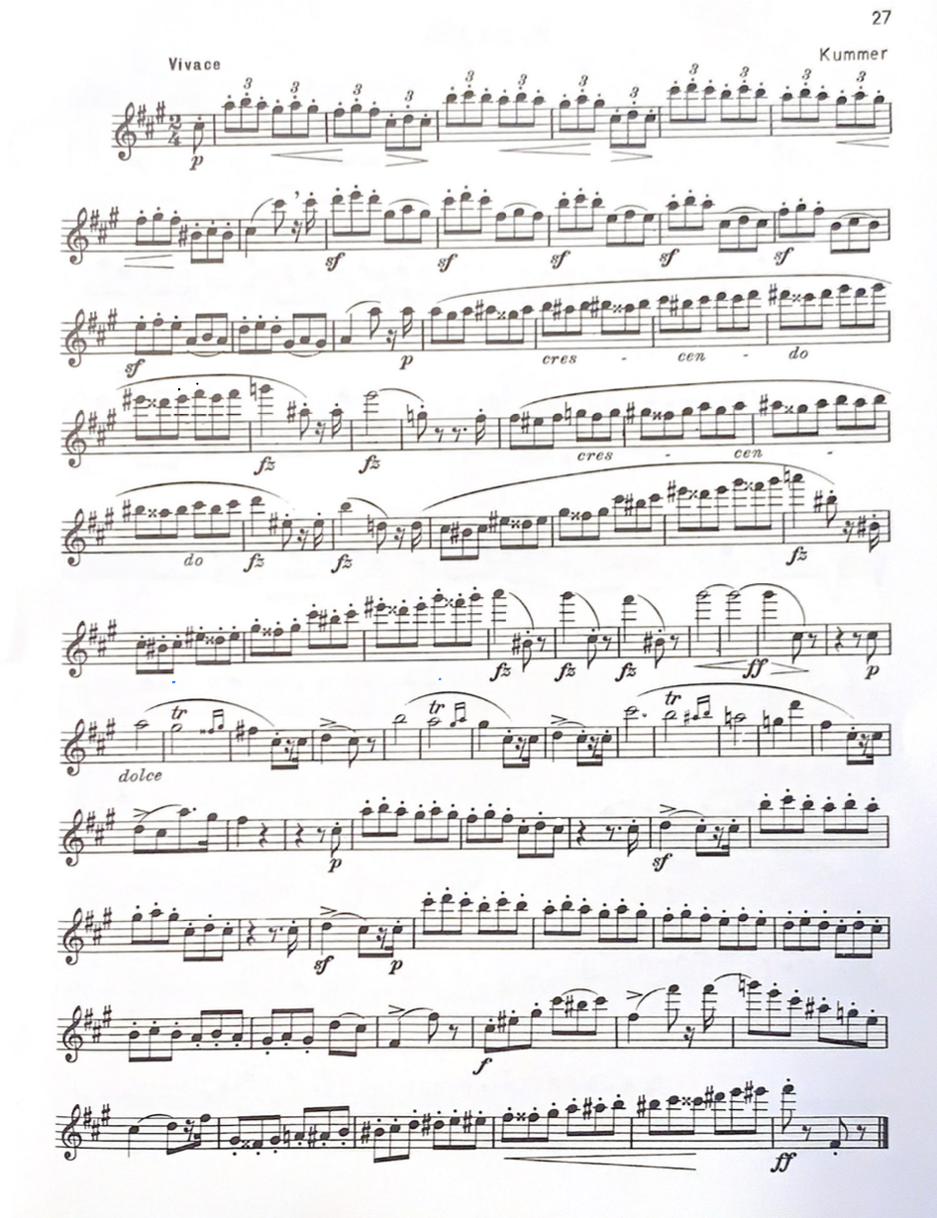
Figure 31 OKMEA All-State Etude #3

Summary of Etude
Region/Grade Level Assignment | OKMEA All-State Etude from Selected Studies, pg. 27
Title of Composition (if any) | N/A
Composer (if indicated) | Kummer
Key Signature | F# minor
Time Signature | 2/4
Tempo Indication | Vivace
Form/Phrase Structure | AA’
NFA Level | E
Overall Categorization | Technical Advanced

Required Performance Skills
- Playing Position, Balance, and Posture
- Tone Production/Development
- Dynamic Nuance
- Ease of Finger Technique
- Articulation Clarity
- Breathing & Phrasing
- Rhythmic Precision
- Intonation
- Upper Register Response/Technique

Etude Level as Determined by the Above Elements Compared to Criteria on NFA’s Leveling Guide
Pitch and Key Range | Rhythm and Meter | Articulation | Musical Symbols | Pedagogical Focus
E | E | E | E | E

Overall Level: E
Comments:
Pitch and Key Range: Key signature of this etude has three sharps and is in F# minor. The range extends from F#1 to A3 and includes an extensive amount of accidentals.
Rhythm and Meter: The etude is written in 2/4 and marked Vivace. The primary rhythms throughout are triplet eighths with a brief melodic section in the middle with note durations up to a half note.
Articulations: : The tempo of this etude demands agile tonguing technique and would benefit from the use of either triple tonguing or compound-double tonguing throughout.
Musical Symbols: Symbols for standard rhythms, meter, treble clef pitch notation, dynamics, articulations, etc. Symbols for simple ornamentation including grace notes, mordents, trills, and small cadenza figures.
Pedagogical Focus: Tone development (vibrato study is appropriate). Ease with lower 2.5 octaves of the range. Extension of breath control. Control of dynamics and crescendo/diminuendo over several bars.
Table 28 OKMEA Etude #3 Kummer Vivace Leveling Summary

Problems students at the advanced level may encounter
- Poor Instrument Balance
- Poor Hand Position
- Contrary Finger Motion and Finger Technique Issues
- Poor Tone Quality
- Poorly Managed Breath Control
- Poor Low Register Tone and Projection
- Poor Upper Register Response, Intonation, and Dexterity

Technical Advanced Etude #5
Sigfried Karg-Elert’s Capriccio in D major was assigned to high school flutists auditioning for the Central Oklahoma region (CODA). This etude is quite difficult and presents many challenges for flutists and meets leveling criteria for NFA level E. The finger technique required in this etude is the most obvious challenge however, the embouchure flexibility required to execute the large, slurred intervals may prove to be unexpectedly difficult. The variety of articulations, range, and tempo of this etude all meet criteria for categorizing this as an advanced technical etude (fig. 32).
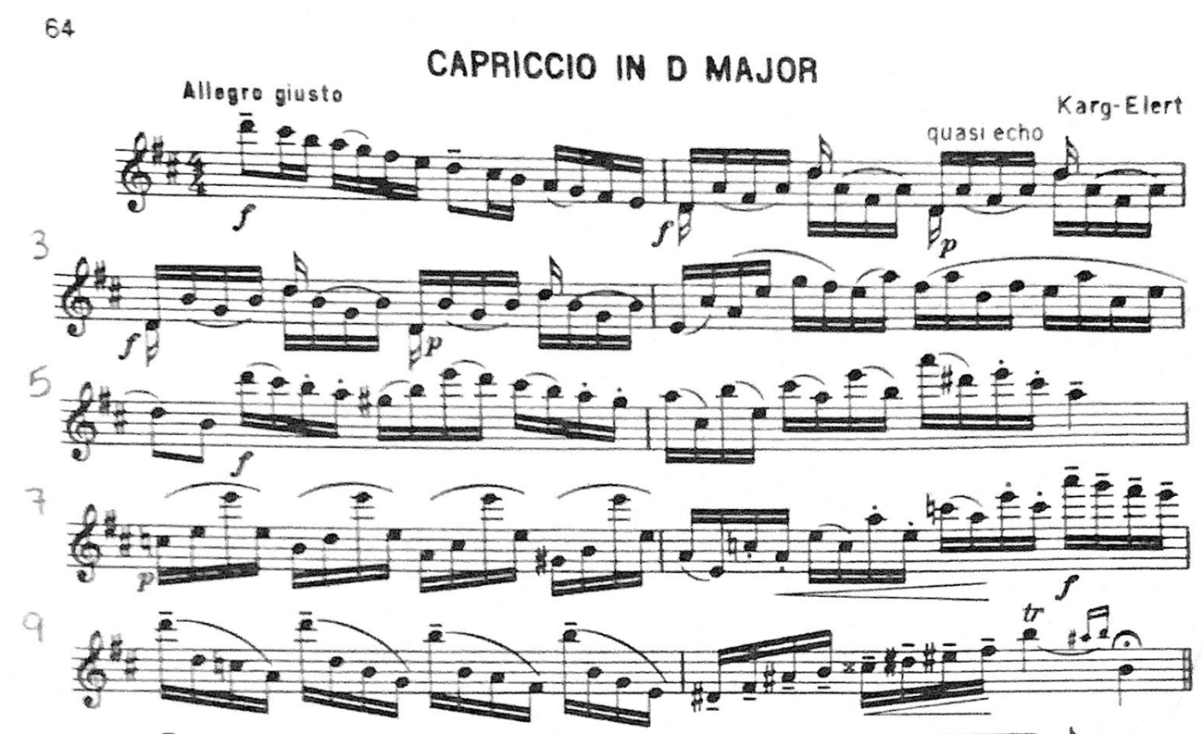
Figure 32 CODA High School Etude

Although the key signature of D major should not be difficult for advanced level flutists, the exploration of chromaticism in the melody is sure to provide a challenge. The range of this etude is quite extensive and spans almost the entire range of the flute from D1 up to A3. The flutist performing this must be comfortable playing diatonically in D major as well as reading the many accidentals that contribute to the NFA level E designation.
At the advanced level, students still struggling with tone quality should practice long tones and harmonics exercises to gain embouchure flexibility and learn how to control air speed and direction. Tone quality issues common for flutists learning this etude arise in the execution of the large, slurred intervals in mm. 7 and 9. The slurring from the middle register up to E3 is particularly challenging and students may find that E3 either cracks or doesn’t speak at all when played at a rapid tempo. One option that may resolve this is to instruct the student to not depress the D# key with their pinky on E3 which may help with response. Another option is to practice the air speed and direction change using the harmonic finger for E3 and overblowing an A2 to reach the harmonic E3. A combination of both options should help resolve issues of response in that section as well as improve the flutist’s technique overall.
There are many challenges in the articulation of this etude and some students may find the tongued passages easier to manage with multiple tonguing technique. Many of the passages (e.g., mm. 2-4 and mm. 7-9) would benefit from articulation practice in which the articulation is altered and practiced many different ways so that when the student returns to the original articulation it seems comparatively easy. Students should also practice legato and staccato articulations at all dynamic levels to prepare for the many dynamic changes in this etude.

Summary of Etude
Region/Grade Level Assignment | CODA High School from Selected Studies, pg. 64
Title of Composition (if any) | Capriccio in D major
Composer (if indicated) | Sigfried Karg-Elert
Key Signature | D major
Time Signature | 4/4
Tempo Indication | Allegro giusto
Form/Phrase Structure | AB
NFA Level | E
Overall Categorization | Technical Advanced

Required Performance Skills
- Playing Position, Balance, and Posture
- Tone Production/Development
- Dynamic Nuance
- Ease of Finger Technique
- Articulation Clarity
- Breathing & Phrasing
- Rhythmic Precision
- Intonation
- Upper Register Response/Technique

Etude Level as Determined by the Above Elements Compared to Criteria on NFA’s Leveling Guide
Pitch and Key Range | Rhythm and Meter | Articulation | Musical Symbols | Pedagogical Focus
E | E | E | E | E

Overall Level: E
Comments:
Pitch and Key Range: This etude has two sharps in the key signature and is generally in D major although there are many accidentals throughout. The range extends from D1 to A3.
Rhythm and Meter: The etude is written in 4/4 and uses primarily sixteenth notes throughout.
Articulations: Articulations are varied in the etude and include tenuto and staccato markings over passages of sixteenth notes. There are many slurred passages of notes more than a fifth apart.
Musical Symbols: Symbols for standard rhythms, meter, treble clef pitch notation, dynamics, articulations, etc. Symbols for simple ornamentation including grace notes, mordents, trills, and small cadenza figures.
Pedagogical Focus: Tone development (vibrato study is appropriate). Ease with lower 2.5 octaves of the range. Extension of breath control. Control of dynamics and crescendo/diminuendo over several bars.
Table 29 CODA High School Etude Karg-Elert Cappriccio Leveling Summary
Problems students at the advanced level may encounter
- Poor Instrument Balance
- Poor Hand Position
- Contrary Finger Motion and Finger Technique Issues
- Poor Tone Quality
- Poorly Managed Breath Control
- Poor Low Register Tone and Projection
- Poor Upper Register Response, Intonation, and Dexterity

Recommendations on Overcoming Challenges at the Advanced Level
Pearson, Standard of Excellence, Flute books 1-3:
- Keep fingers close to the keys (bk. 3, pg. 18)
- For higher notes use a smaller aperture and aim air higher (bk. 1, pg. 28)
- For low notes aim air lower and use a bigger aperture, move lower jaw and lips back (bk. 3, pg. 14)
- Direct your air stream lower for a full tone (bk. 3, pg. 14)

Lautzenhauser, et al, Essential Elements, Flute books 1-3:
- No flute specific advice available
George & Louke, Flute 101, 101.5, 102, 103:
- “Balancing the Flute: The goal is to balance the flute in the hands so the flute remains still when moving the fingers. Many flutists have a tendency to lift the end of the flute when playing ascending notes (removing fingers) and lower the end of the flute when descending (adding fingers). Try to keep the flute still.” (Flute 102, pg. 3)
- “To determine the proper playing angle for you, gently push the end of the flute forward and then back as if the embouchure plate is rocking to the left and then to the right in your chin. Listen for any change of sound. There will be one spot where the sound is the best. We call this the sweet spot. This is where you want to position the flute.” (Flute 102, pg. 6)
- “Octaves: Notice that both octaves have the same fingering. The upper octave is playing with a slightly smaller aperture (opening between the lips) as if squeezing slightly on a small straw.” (Flute 102, pg. 11)
- “Vibrato Preparation: Practice the following {see example} with HAH, a tongueless attack. There should be no movement in the jaw, chest, or abdomen.” (Flute 102, pg. 12)
- “Balance of Trills: A trill is a musical ornament that alternates rapidly and evenly between a written note and the next note higher… Balance the flute in your hands. There should be no movement of the flute as you lift your finger. Move fingers evenly from the third knuckle back from the nail.” (Flute 102, pg. 12)
- “Lower Mordent: Play the written note ON the beat, followed by a rapid alternation between it and its lower neighbor. Mordents can be found in Baroque music… **Leave right hand down when playing D to C# to D.” (Flute 102, pg. 32)
- “[Some octaves] require moving [a] finger(s) to play the upper octave note. The connection between two notes is cleaner when the player thinks of which finger(s) actually move.” (Flute 102, pg. 41)
- “[Descending] Octaves: Relax the embouchure to play the lower pitches. Do not roll the flute.” (Flute 102, pg. 43)
- “Tone Exercise: alternate between the regular fingering and the harmonic fingering to develop your tone.” (Flute 102, pg. 45)
- “Playing octaves develops the embouchure and teaches the running of the perfect octave. The upper note is achieved by making a smaller aperture (opening between the lips) and slightly increasing the air speed. It may be helpful to have the student think of blowing through a soda straw for the low note and a flatter coffee stirrer straw for the upper note. Keep the embouchure hole level and pointed to the ceiling. Do not roll the flute.” (Flute 102, pg. 60)
- “If the tone is airy and lacks core, have students aim the air stream towards their left big tone. If the tone is edgy, have students raise their air stream higher on the blowing edge of the embouchure hole.” (Flute 102, pg. 61)
- “In teaching tonguing, use the ‘spitting rice’ technique developed by the Suzuki Flute Institute. Place one grain of rice on the tip of the tongue, and then spit the rice out. This technique teaches the motion of the tongue as it releases the air through the aperture.” (Flute 102, pg. 67)
- “Once the student is successful at the ‘spitting rice’ technique, have the student repeat this tonguing gesture using the headjoint only. While practicing tonguing, remember the flutist’s head is positioned at the bottom of a small nod, where the head is balanced on the spine, and the embouchure hole is level and pointed to the ceiling… If the air comes first, there will be a hooting sound rather than a clean attack.” (Flute 102, pg. 67)
- “There are three parts to a note: the beginning (attack), middle (even air), and release. The release is accomplished by partially closing the vocal folds, which slows the speed of the air stream. When the air stream is no longer fast enough, no sound is produced. This slowing of air occurs in the part of the throat we close off while swallowing. If the vocal folds close abruptly and completely, there is an ugly sound produced called a glottal stop. Try saying ‘uh-oh.’ The glottal stop occurs between the two words.” (Flute 102, pg. 67)
- “If your tone cracks low, aim the air stream higher. If it cracks high, aim the air stream lower.” (Flute 102, pg. 71)
- “The best tone is produced with a larger oral cavity; so, drop your jaw. Another way of thinking about this is to put more space between the wisdom teeth. When playing, the jaw is hung from the skull.” (Flute 102, pg. 71)
- When playing a sequence: “Plan the dynamic design. Either start softer and increase the volume or do the opposite.” (Flute 103, pg. 58)
- “Syncopated rhythms stress the weak beats or off-beats. Separate all articulated notes to bring out the syncopation.” (Flute 103, pg. 59)
- “You will have an excellent attack on the note if you place your tongue in the aperture (opening between your lips) and at the right moment pull the tongue back releasing the air.” (Flute 103, pg. 64)
- “Since there are so many lower notes in this piece, you might try blowing on the pads of the footjoint notes before you begin to be sure your flute is sealing well. Blowing on the pads will add moisture to the pads and increase the response of the lower notes.” (Flute 103, pg. 78)
- “Mark breathing points based on the teachings of William Kincaid: At the end of of a phrase (may be 2 bars, 4 bars, 8 bars), In a rest, After a long note or a tie, After 1 (as in 2, 3, 4, 1), Between repeated notes or syncopated figure, Where the composer or conductor indicates.” (Flute 103, pg. 91)

Wye, Beginner’s Book & Practice Book:
- “Tone exercises are better started in the low register and built upwards as the second octave is already contained in the low notes as the second harmonic and you should build on that.” (Practice Books, pg. 5)
- “The word ‘tone’ is a collective noun for a formula containing a number of ingredients, each of which contributes significantly to the concept of tone, for example: color, size, projection, intensity, vibrato, loudness, and purity. If your tone contains these ingredients, it might be regarded as beautiful but your tone is only as good as its weakest part.” (Practice Books, pg. 5)
- “Long slow tones by themselves give the player the opportunity to examine their tone in fine detail and allows time to hear undesirable aspects of it and to make corrections accordingly. Long tones really can’t fail to help improve your tone, though if played without care or thought won’t achieve a result so quickly.” (Practice Books, pg. 5)
- “For younger players, the low and high registers are more difficult. The easiest register is generally the middle. If there are harmonics or overtones present when playing in the low register, the second and third registers are easier and can be played with more confidence.” (Practice Books, pg. 6)
- “Most experienced players will benefit from a few minutes of daily practice on harmonics to establish air speed and a richer tone. Place low C then overblow it until the octave sounds; then blow harder to get the third harmonic, and carry on through the whole series of harmonics as far as you can.” (Practice Books, pg. 6)
- “Take care not to turn the flute in on your lip when descending, or to lower your head; this might appear to make the note more resonant, but will also flatten the pitch.” (Practice Books, pg. 7)
- “The last few notes become progressively more difficult and this is because the tube length is longer and offers more resistance the lower you descend. Notice that you crescendo as you descend. This will help strengthen the lower notes.” (Practice Books, pg. 8) (referring to E1 and lower)
- “Make small adjustments to your lips as you descend so that each note is the best that you can play. Take care not to turn the lip plate in, or to lower your head when descending as the tone can sound buzzy - like a bad full of wasps! Keep your tone warm…” (Practice Books, pg. 9)
- “Remember one important point: as you rise to middle E, avoid raising the airstream or air direction. We all have a tendency to do this without realizing it because it helps to get middle E more cleanly and smoothly.” (Practice Books, pg. 15)
- “As you continue down, it should all go fairly well as far as G, but from here down to the left hand C in the lower register, there are some problems to overcome. The area from F# to E inclusive can easily crack or break up if blown too hard. Then the Eb and D have a slightly different color to the notes around them. From D to C# there is always a change of color. These differences must be ironed out…Evenness of tone is what you are striving for.” (Practice Books, pg. 16)
- “Remember the earlier advice? Don’t raise the air stream too much as you play into the third octave. This is easier said than done, perhaps because the top notes are easier when the air is directed upwards - but the tone will be thinner and you should avoid this. More importantly, the third octave generally suffers from being too sharp.” (Practice Books, pg. 20)
- “You may have noticed that the top E and F# are sharp in pitch. It is important to know that almost every note of the 3rd octave has an intonation problem, most of them suffering from being sharp. To answer your unasked question: they can’t be fixed without interfering with the tuning of the first two octaves!” (Practice Books, pg. 25)
- “The worst notes prone to sharpness are top E and F#.” (Practice Books, pg. 25)
- “Noticed that you need to increase the air speed as you ascend, using more for E and F# than for the other notes.” (Practice Books, pg. 25)
- “The solution is to play all the notes in the scale with a faster air speed than necessary. Not only will this help your tone, but it will also remove the problem. To make these two notes even more secure, use your faster air speed as you approach the problem note. In other words, the problem isn’t with E and F#: it is with the notes just before them which need extra air speed.” (Practice Books, pg. 25)
- “The other problem notes are D above the stave, Eb and G#. These notes are variable on any individual flute as the makers are not always in agreement about the placing of the tone hole, or the ‘scale’ of the flute. The 3rd octave D is usually flat and Eb and G# are very sharp notes. These notes can be controlled with the lips, especially D as there are no easy fingering solutions to help you out of trouble here! Eb can be careful lipped down when sharp, while for top G#, a less easily moveable note, you can use the alternative ‘long fingering’...” (Practice Books, pg. 26)
- “Playing in tune is inseparable from a beautiful musical performance. To play expressively, the performer is required to play loudly, softly and all the different levels in between, and in addition, make crescendos and diminuendos too. The superior player will also use tone colors to enhance their music making. All these attributes need careful control of the lips and jaw and of the air direction.” (Practice Books, pg. 39)
- “In a diminuendo, as the air speed is reduced and the pitch goes flat, so the embouchure hole (blow hole) needs to be uncovered to compensate for this drop in pitch. This action will make the note sharper, returning it back to its correct pitch. The simultaneous movements of air speed, jaw, lips and perhaps the head too, have to be co-ordinated and practiced together before achieving any long-term result.” (Practice Books, pg. 40)
- “Your head should be down and your jaw back for the forte, gradually raising the airstream, uncovering the mouth hole and keeping the pitch exactly the same during the diminuendo. Make sure that you keep your arms still; don’t turn the flute in with your hands as you practice this exercise.” (Practice Books, pg. 40)
- “The daily practice of difficult passages can cause pains and aches in the shoulders, arms and neck… It’s always a good idea to check your posture, particularly your arms in relation to your body. Problems here will show themselves as pain when practicing difficult finger exercises.” (Practice Books, pg. 76)
- “Make a note of the following points: Even when playing slowly, move the fingers quickly up and down. Be particularly careful about rhythm and evennes. Use a good tone on trills: some require extra help with the lips when using trill keys or other tonally weak note… Try to keep your hands still while trilling; only the fingers should move.” (Practice Books, pg. 77)
- “Articulation is best practiced in small but frequent sessions during the practice of other exercises.” (Practice Books, pg. 92)
- “Articulation is the speech of music. No matter how powerful or compelling your musical ideas, they will not be communicated to the listener unless your articulation is clear.” (Practice Books, pg. 93)
- “We must acquire a fast, reliable and above all, clear single tonguing. It is a short cut to fluency and clarity in double tonguing. A good tone is essential to obtaining a clear articulation. Think of an articulation exercise as a tone exercise, but broken up.” (Practice Books, pg. 98)
- “Single notes are not made by the tongue but by the breath. The tongue’s job is to make a clear start to the note. Notes are ‘made’ by the breath, and at slow speeds are made by starting and stopping the breath, the tongue merely cleaning up the start of the note. Notes are not stopped by the tongue but by the breath, though this does change when playing very fast.” (Practice Books, pg. 98)
- “To get ‘bounce’ and a lively character into single tonguing we use the abdominal muscles to start and stop the notes. It is the same muscle used in laughing or coughing. It must be trained to start the air moving into the flute speedily and to stop it quickly too, and this is achieved by practice in three ways: short, fast, and later, loud.” (Practice Books, pg. 98)
- “In all research into articulation, it is clear that tonguing forward against the teeth- rather than at the roof of the mouth- makes for a clearer and more precise articulation. The tip of the tongue should be touching the lower part of the front teeth. The principle behind this is that the tongue, which acts as a valve, can stop and start the note with precision and speed when it is closest to the place where the tone is produced- the lips.” (Practice Books, pg. 99)
- “Use the tip of the tongue lightly. The aim is to use the tongue as lightly and effectively as possible. Try to keep the lips still- you can check in a mirror to see if there is any movement.” (Practice Books, pg. 99)
- “As your single tonguing becomes more assured, the abdominal muscles will take a smaller part in forming the note but will continue to give some bounce and will also support the tone.” (Practice Books, pg. 101)
- “Your tone is unclear when tonguing? For some people it is more difficult than for others to make the tongue move quickly, neatly and yet gently. Sometimes the cause is that the base of the tongue moves as well; in fact the whole muscle moves when articulating. This causes turbulence in the mouth as the air is passing through. In time, and with thoughtful practice, the articulation movement will gradually transfer only to the tip of the tongue. This will make a cleaner attack to each note without sounding explosive.” (Practice Books, pg. 104)
- “Good work on double tonguing can be achieved without the flute because the tongue needs practice in this movement for which the flute isn’t necessary. Work at double tonguing both with and without the flute…” (Practice Books, pg. 104)
- “Double tonguing should be practiced in small portions at a fast speed: this will get the quickest results.” (Practice Books, pg. 104)
- “You can’t get your tongue to move fast enough? Practice - without the flute - on buses, trains, or even when walking. Don’t use the flute as a piece of gymnastic apparatus. Tongue forward in the mouth - near the teeth.” (Practice Books, pg. 112)
- “Your tongue gets tired? That’s quite normal. Exercise it every day both with and without the flute. When the tongue gets really tired, have a legato exercise on the music stand to practice for a few moments to provide a rest for the muscles - then continue tonguing.” (Practice Books, pg. 112)
- “Your articulation limps with the ‘K’ weather than the ‘T’? That too is a common problem. Starting off with the back stroke (K) play the double tonguing exercise all the way through. Also practice saying it, starting with ‘L’ Put accents on all ‘K’s’. It will help to get rid of unevenness.” (Practice Books, pg. 112)

Chapter 5: Summary of Common Performance Problems and Their Solutions Found in the Methods
The review of methods for this document yielded the following list of issues students commonly encounter when learning to play the flute: Poor Instrument Balance, Poor Hand Position, Poor Tone Quality, Contrary Finger Motion and Technique Issues, Inconsistent Articulation, Poorly Managed Breath Control, Weak Low Register Tone and Projection, and Poor Upper Register Response, Intonation, and Dexterity. Many of these issues are interrelated and can be addressed simultaneously, for instance, poor hand position will almost certainly lead to poor instrument balance and both topics may benefit from being addressed together in the lesson.
These issues present in a variety of ways throughout each level of development and though not every student will experience every issue, the ability to diagnose problems and determine a course of resolution is a skill all students should develop.

Poor Instrument Balance
Poor instrument balance is a problem that affects all areas of flute playing; an unbalanced flute creates a moving target for the creating tone, breathing, articulation, and intonation problems. In addition to air and tone related issues, poor instrument balance may lead to difficulty accomplishing finger technique.
Beginning students may experience trouble balancing due to the physical limitations of their size in proportion to the length/weight of the instrument which makes it more difficult to maintain proper hand position. Phyllis Avidan Louke and Patricia George recommend students use just the headjoint and body of the flute to reduce the weight of the instrument. In addition to playing without the footjoint, Louke and George recommend playing left hand notes only and holding the flute at the barrel with the right hand to stabilize the flute while they develop proper hand and playing position.
Intermediate and advanced level students also may experience balance issues that affect their tone, articulation, and finger technique but aren’t caused by body and hand size relative the size and weight of the flute. For older students experiencing balance issues, the first area to examine is hand and body position. Louke and George note that balance issues are often due to “First, the weight of the mechanism of the flute is heavier on the back or rod side of the flute, and second, there are few fingers involved in the fingering of the notes [C2/C3 and C#2/C#3].” This leads to the flute rocking back in the flutist’s hands when playing and/or navigating between those notes.
Balance issues occur at all levels of playing and may be caused by fingers that are too far away from the keys or improperly positioned on the instrument. Trevor Wye remarks that the “most frequently recurring problem that teachers, at whatever level of teaching, have to contend with” are body and hand position related. As repertoire gets more demanding for the fingers, an unbalanced flute will lead to trouble executing technical passages.
In Flute 101.5, Patricia George and Phyllis Avidan Louke give in-depth descriptions of three elements which contribute to balancing the flute. First, the alignment of the headjoint with the body of the flute. Second, the stance of the body and position of the hands. And third, the balance points where the body comes into contact with the instrument: the lip plate cradled in the chin, the left-hand knuckle, the right-hand thumb, and the right-hand pinky.
Louke and George identify an additional problem common to flutists and state that “Many flutists tend to lift the end of the flute when playing ascending notes (removing fingers) and lower the end of the flute when descending (adding fingers). Try to keep the flute still.” The goal is to balance the instrument in the hands so that it doesn’t move while the flutist is playing.

Poor Hand Position
Poor hand position is one of the main causes of poor instrument balance and can lead to many performance issues for flutists at every level. Causes of poor hand position can be related to hand size relative to the instrument and playing posture, caused by improper instruction when learning how to hold the instrument, or from the flute being poorly balanced in the hands. There is no one-size-fits all hand position for playing the flute, especially when it comes to placement of the right-hand thumb, however, there are ways to help students find their natural hand position that is most conducive for fluent performance.
Patricia George and Phyllis Avidan Louke offer the most detailed guide on how to find this hand position and achieve balance of the instrument. For the left hand, the thumb should be straight and pointed towards the ceiling and the flute should rest on the base of the knuckle of the forefinger. Maintaining a good left-hand position is important not just for technique, but helps prevent the flute from rolling backwards in the hands which changes the position of the embouchure hole relative to the player’s mouth and affects tone.
For the right hand, George and Louke offer three different thumb positions based on comfort level of the flutist. They contend that a third of all flutists find the most comfort placing the thumb under the index finger, the next third prefer placing the thumb between the index and middle finger, while the remaining third find the ideal placement of the thumb to be under the middle finger. They suggest using the “soda can test,” borrowed from violin pedagogy, to determine the natural placement of the thumb. In addition to the thumb, when placing the other fingers on the flute, it’s recommended that flutists place the ring finger on the D key first, then place the middle and index fingers on the E and F keys for better finger positioning and more ease when balancing the flute.
Poor hand position not only affects the sound and technical ability of the flutist but has the potential to cause pain and inflict injury. The band methods used in this document make no mention of potential injury but Flute 101 authors, Patricia George and Phyllis Louke, as well as Trevor Wye speak to this topic in their methods.

Poor Tone Quality
The causes of poor tone quality are dependent upon the issue present in the flutist’s tone (e.g.,, small tone with trouble projecting, an airy tone, weakness in any register, etc.). Diagnosing and treating these issues should be tailored to the level of the flutist playing, and students can be taught how to problem solve tone issues on their own.
To diagnose a tone issue, the various elements that go into producing sound on the flute must be considered; at the most basic level, these are: speed, quantity, and direction of air as well as shape and size of the aperture. Tone issues by symptom are detailed in the following table, these symptoms, technical issues, and suggested resolutions are appropriate for the beginning flutist.

Symptom | Issue | Resolution
Airy Tone/ Tone Lacks Core | Air Speed  Air Direction  Air Quantity  Aperture Size/Shape | “Direct the airstream slightly toward the left big toe.”  “Start each note as though you are spitting rice.”  “Use a strong stream of air as you would use to blow out birthday candles.”
Multiple Issues (e.g., small tone and little projection; thin upper register and little dynamic variation) | Flute Alignment: Turned Too Far In | “[If] the tone is small and often cloyingly sweet; it is much thinner in the third octave; there is little variation in loudness; it varies between mf and pp; soft sound, in fact very soft sounds are easy; it is difficult to be heard above the piano unless the lid is shut; other players sound stronger; the headjoint has to be pushed right in and even then it is sometimes flat.”  “The reason why all players have a leaning toward turning in is that (a) octave playing is easier, (b) the upper notes are easier, (c) pp is easier and (d) it avoids or diminishes any air-escape, or hiss in the tone.”
Edgy Tone | Air Speed  Air Direction | “Direct the airstream higher on the blowing edge of the embouchure hole.”
Tone Cracks Low | Air Direction | “Aim the air stream higher.”
Tone Cracks High | Air Direction | “Aim the air stream lower.”
Making the Octave | Air Speed  Air Direction | “Playing octaves develops the embouchure and teaches the running of the perfect octave. The upper note is achieved by making a smaller aperture (opening between the lips) and slightly increasing the air speed. It may be helpful to have the student think of blowing through a soda straw for the low note and a flatter coffee stirrer straw for the upper note. Keep the embouchure hole level and pointed to the ceiling. Do not roll the flute.”  “Your lips should be pursed as if saying ‘Pooh’ as in ‘Winne-the-Pooh.’ Blow a strong air stream across the embouchure hole.”
Inconsistent Tone | Air Speed | “The best tone is achieved by blowing an even air stream.”
Trouble Projecting | Aperture Size/Shape  Oral Cavity | “The best tone is produced with a larger oral cavity; so, drop your jaw. Another way of thinking about this is to put more space between the wisdom teeth. When playing, the jaw is hung from the skull.”  “The aperture is oval on the lowest notes and becomes smaller on the ascent. For the three octaves, say: Sue, See, Boo to change the angle of the air stream on the blowing edge of the embouchure hole.”
General Tone Development |  | “Tone Development: The development of a beautiful tone is most important to your further progress. In these exercises… experiment with the speed of the air which you blow into your flute. Does increasing the air speed make a firmer tone? If it does, try: a) decreasing the size of the hole in your lips through which you blow. Whilst obtaining a clear sound, try to be economical with the quantity of air used. b) moving the jaw backwards and forwards slightly, note any improvement. Play each note as long as possible. Take big breaths. Avoid turning the flute blow-hole in on your lip. No more than half should be covered.”
Table 30 Tone Development for Beginning Level Flutists

Tone Development Advice and Issues at the Intermediate and Advanced Level
Tone issues at the intermediate and advanced level can be assessed in much the same way as the beginning level but areas examined (air speed, direction, etc.) can be assessed at a deeper level. Suggestions for general tone development at this level are tailored toward building a homogenous tone across all registers of the flute. At the intermediate and advanced level, students can expect to expand the range of notes they’re familiar with down to C1 (or low B0 if they have a B footjoint) and up to Bb3.
Dedicated practice of tone at this stage is crucial for developing a ringing and clear tone. At the intermediate and advanced levels, Air Direction may also be referred to as “Embouchure Flexibility” which is the development of the lips to play comfortably in all registers. Recommendations and topics of tone development for the intermediate and advanced level student are detailed in the table below (Table 31).
Technique or Problem | Possible Cause or Area to Focus On | Practice Method or Resolution
General Tone Development | Embouchure Flexibility | “Long slow tones by themselves give the player the opportunity to examine their tone in fine detail and allows time to hear undesirable aspects of it and to make corrections accordingly. Long tones really can’t fail to help improve your tone, though if played without care or thought won’t achieve a result so quickly.”  “Most experienced players will benefit from a few minutes of daily practice on harmonics to establish air speed and a richer tone. Place low C then overblow it until the octave sounds; then blow harder to get the third harmonic, and carry on through the whole series of harmonics as far as you can.”
Weak Tone in the Low Register | Embouchure Flexibility | “Take care not to turn the flute in on your lip when descending, or to lower your head; this might appear to make the note more resonant, but will also flatten the pitch.”
Adjusting the Oral Cavity |  | “As you play the exercise, slightly and gently, yawn. This should (a) increase the cavity at the back of the mouth and throat and (b) allow the nasal cavity to influence the sound.”
Tone in the Upper Register | Air Speed  Embouchure Flexibility | “Remember the earlier advice? Don’t raise the air stream too much as you play into the third octave. This is easier said than done, perhaps because the top notes are easier when the air is directed upwards - but the tone will be thinner and you should avoid this. More importantly, the third octave generally suffers from being too sharp.”  “Notice that you need to increase the air speed as you ascend, using more for E and F# than for the other notes.”  “The solution is to play all the notes in the scale with a faster air speed than necessary. Not only will this help your tone, but it will also remove the problem. To make these two notes even more secure, use your faster air speed as you approach the problem note. In other words, the problem isn’t with E and F#: it is with the notes just before them which need extra air speed.”
Slurred Intervals, Octaves, and Upper Register Response | Embouchure Flexibility | “To play a single note with a good tone is not difficult. It needs the right combination of air speed, direction, and lip positioning relation to the embouchure hole. When we move to another note, these ingredients have to alter slightly to play this note with an equally good tone. In fact, each note has its own air speed, air direction and lip position.”  “Octaves and the harmonic series are also introduced to develop the embouchure… The left-handed G-scale exercise with the right hand on the barrel will help the student naturally develop the embouchure and learn to use the correct air speed.”  “Octaves: Notice that both octaves have the same fingering. The upper octave is playing with a slightly smaller aperture (opening between the lips) as if squeezing slightly on a small straw.”  “[Descending] Octaves: Relax the embouchure to play the lower pitches. Do not roll the flute.”  “Playing octaves develops the embouchure and teaches the running of the perfect octave. The upper note is achieved by making a smaller aperture (opening between the lips) and slightly increasing the air speed. It may be helpful to have the student think of blowing through a soda straw for the low note and a flatter coffee stirrer straw for the upper note. Keep the embouchure hole level and pointed to the ceiling. Do not roll the flute.”  “The aperture is oval on the lowest notes and becomes smaller on the ascent. For the three octaves, say: Sue, See, Boo to change the angle of the air stream on the blowing edge of the embouchure hole.”
Table 31 Tone Development Technique at the Intermediate and Advanced Level

Technique Issues and Contrary Finger Motion
There are several finger technique issues common among flutists during their development. Some of these technique issues are caused by posture problems like poor instrument balance or poor hand position, which inhibit the hands from performing finger movements easily. Other technique issues may be caused by finger movement in the passage itself, among these challenges are passages that require contrary finger motion. Technical issues may also be caused by individual finger weaknesses requiring technical exercises to develop dexterity in an individual digit.
Technique issues caused by poor instrument balance and hand position contribute to a general state of bad technique and make scales, arpeggios, and other note combinations particularly challenging. When the instrument is unbalanced or the hands aren’t placed correctly, the fingers are unable to move rapidly or cleanly execute changes between notes. In the Practice Books, Trevor Wye dedicates a portion of the “Advanced Practice” section to hand and body position and states such issues with body and hand position are the “most frequently recurring problem that teachers, at whatever level of teaching, have to contend with.”
Technique issues caused by passages that utilize the fingers moving in contrary motion require more detailed practice. There are several pairs of notes that are particularly difficult and appear in technique exercises at every level of development. These pairs of notes include C2/D2, D1/E1, C1/E1, Bb2/D3, and E3/F#3 (fig.25).
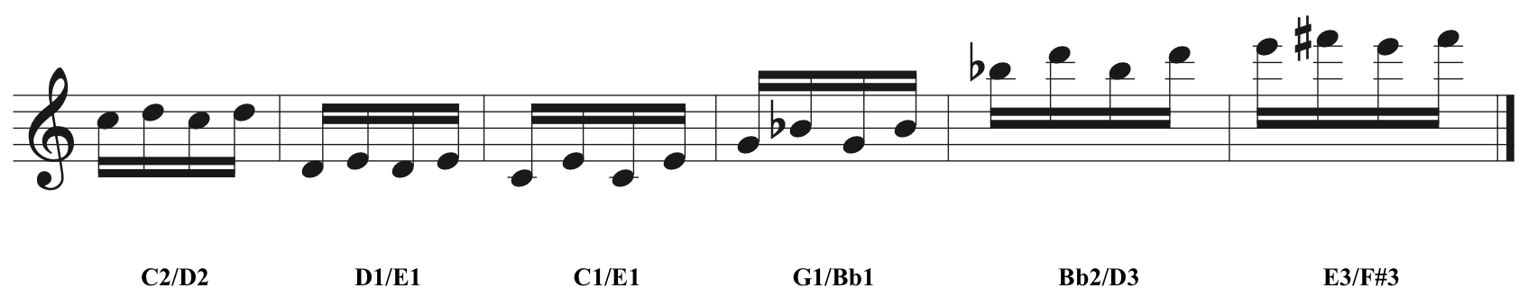
Figure 33 Examples of Difficult Contrary Finger Motion Note Pairings

Trevor Wye has this advice for practicing some of these more challenging finger movements:
“Regular practice is most important to progress in technique. Time lost cannot be made up the next day… Work regularly at technique. Work for longer at the keys you find most difficult. Whatever practice time you have available, about one third of it should be spent on these and similar exercises. Work hardest at the weakest fingers. When a difficulty arises, repeat the difficult bar four times…”

Finger Independence is a necessary skill overcoming technical challenges due to natural weakness in particular fingers. Trevor Wye identifies the right hand third finger (ring finger) and the pinky as two fingers that need additional work to develop fluid technique. Wye offers myriad exercises dedicated towards strengthening and developing the independence of these digits, all of which can be found in the Practice Books.

Inconsistent Articulation Technique
Problems of articulation generally fall into two categories: either 1) problems executing the physical technique of articulation or 2) articulation style and overall quality of the execution. The first part of this section details the physical mechanism behind single, double, and triple tonguing and the section that follows discusses the development of stylistic articulation and articulation patterns.
The Use of the Tongue: Single Tonguing
The most basic tonguing technique is described in each of the first volumes of the methods used for this study and are detailed in the table below. The most valuable contribution for beginner level students learning articulation is the use of the Spitting Rice technique, developed by the Suzuki Flute Institute and described by Louke and George in Flute 101 (Table 2).
Method Book | Basic Articulation Instructions
Flute 101 | “The ‘spitting rice’ technique, developed by the Suzuki Flute Institute, will coordinate the air and tongue. Take the student outside to spit rice, using the type of rice that must be boiled. Place one grain of uncooked rice on the tip of the tongue and spit the rice out. This technique will teach the motion of the tongue as it releases the air through the aperture. Once the student can spit rice off the tongue well, begin ‘target’ practice. One target spot should be on the ground. Other spots will be positioned at various heights on a fence or wall. This technique teaches how to angle the air as if blowing in the first, second, and third octaves of the flute. Repetitive practice of the spitting rice technique enhances tone and articulation control. Be patient. Repetition is good!”
Standard of Excellence | “Take a full breath of air and blow over the hole using the syllable ‘doo’ to play a long, steady tone.”
Essential Elements | “Inhale deeply through the corner of your mouth, keeping the shoulders steady. Your waist should expand like a balloon. Slowly whisper ‘too’ as you gradually exhale air into your palm. The air you feel is the airstream. It produces sound through the instrument. Your tongue is like a faucet or valve that releases the airstream.”
Beginner’s Book for the Flute, Part One | “Tongue as if making the syllable te at the beginning of each note. It will give the note a clean start.”

For single tonguing, authors of the flute specific method books all describe the act of tonguing to be like a release valve for the air. George and Louke go into more detail on the physical act of tonguing in Flute 101.5:
“The tongue is placed between the upper and lower teeth touching the top lip in the center of the aperture. If the aperture is naturally off-side to the left, then the tongue needs to move to the left to be in the center of the aperture. When tonguing properly there is no movement in the jaw. The air builds up behind the tongue and when the tongue is released the sound is made.”

Single tonguing is the foundation of articulation in flute playing and should be clear and at a rapid tempo before attempting to learn multiple tonguing. General problems that arise in single tonguing include issues with clarity of the attack and speed issues. At the beginner level, flutists may struggle to produce a tongued articulation at all and need additional help coordinating the air and the tongue. Beginner and intermediate level flutists also need to spend focused time on creating stylized articulations (e.g., staccato, legato, portato, and accents) with a single tongue articulation. By the advanced level, flutists should feel comfortable using single tonguing techniques at various tempi, and in various styles and combinations. Problems that occur for advanced students when articulating often are related to tempo and multiple tonguing or particularly challenging combinations of slurred and tongued notes at rapid tempi.
If the tone is unclear when single tonguing, Trevor Wye suggests the cause to be too much of the tongue muscle is being used to execute the articulation and advises practicing moving the articulation to the tip of the tongue. When developing a clear articulation, Trevor Wye recommends students “think of an articulation exercise as a tone exercise, but broken up.”
The Use of the Tongue: Multiple Tonguing
When a reliable single tonguing technique has been established it is then appropriate to begin multiple tonguing techniques. Double tonguing is a technique in which the flutist is able to tongue more rapidly by alternating between syllables made with a forward stroke of the tongue and a backward stroke of the tongue. Syllables most often used for double tonguing include “TK” and “DG,” either being acceptable and used at the discretion of the flutist.
Wye recommends practicing double tonguing technique away from the instrument to help develop the necessary reflex of rapidly alternating syllables of the tongue. In general, Wye also recommends practicing the articulation “in small portions at a fast speed: this will get the quickest results.”
Common problems flutists encounter when double tonguing include clarity issues at fast tempi, uneven syllable strength (i.e.,, weaker “K” syllable), and miscoordination between the tongue and fingers.
To prevent and overcome the issue of uneven syllable strength, Wye recommends to “reverse the tongue movement so as to place the accent on the ‘back stroke’, the ‘K’. Work at [the exercise] with K-T-K-T-K. Do this for all the exercises.” Placing the “K” syllable on the stronger part of the beat helps to train and strengthen the tongue’s back stroke in this technique of articulation.
For flutists facing tempo issues and struggle to speed up their double tonguing, Wye recommends additional practice without the flute focusing on keeping the tongue forward in the mouth. Other recommendations for developing speed in double tonguing include practicing for small periods of time sporadically in a practice session and to only practice double tonguing at a fast tempo to encourage the tongue’s reflex development.
At this stage, if there are clarity issues, elements of performance that should be examined are those that apply to tone (e.g., air speed, air direction, air quantity, oral cavity, etc.) because, as Wye says, “an articulation is a tone exercise, but broken up.”
Another form of multiple tonguing available to flutists is triple tonguing which is generally done either of two ways: 1) using double tonguing in triple time “T-k-t-T-k-t” or 2) the pattern “T-k-t-K-t-K.” Trevor Wye recommends practicing both styles of triple tonguing as both are advantageous depending on the musical situation. All of the same articulation practice advice regarding single and double tonguing can be applied to triple tonguing.
The Use of the Tongue: Stylized Articulation
Speed and clarity are only two dimensions of articulation that must be practiced by flutists. The style of articulation and preparation of common articulation patterns allow a flutist true fluency in musical expression. Trevor Wye’s apt description that “Articulation is the speech of music” affirms that articulation is more than placing the T’s and K’s in the right place.
To develop the skill of playing stylized articulations, Trevor Wye discusses the “Use of the Slur” in depth in the Practice Books. At the most basic level, Wye advises that “a slur over two notes raises the importance of the first and diminishes the importance of the second. A slur is a diminuendo – except sometimes.” Patricia George offers similar advice in their section “Simple Suggestions to Musical Phrasing” in Flute 102 saying “Two slurred notes of any duration should be playing strong/weak as in a sigh figure, except for some pick-up notes.”
For staccato articulations and to “get a ‘bounce’,” Wye recommends using the abdominal muscles to help start and stop the notes. To practice exercising the abdominal muscles to help create the bounce of the articulation it’s recommended to use breath attack exercises, in which no tongue is used at all to start or stop the air. Breath attacks are beneficial for students to learn how to utilize the abdominal muscles to support the tone behind the articulation while laying the foundation for clear single tonguing.
Some issues that might come up when working on stylized articulations, that can be addressed in general articulation technique practice or in the context of the music itself, include movement of the lips or jaw during articulation, an unintended explosive accent, or unclear articulation caused by tonguing too far back in the mouth.
Movement of the jaw or lips when tonguing creates an unbalanced instrument and can affect tone quality during the articulation and often inhibits speed. To overcome this the flutist should watch themselves in the mirror to be sure the lips aren’t resetting for each note or that the jaw isn’t “chewing” with each tongue movement. Additionally, they should examine their balance points to ensure the instrument is stabilized in the hands.
An explosive accent might be caused by a build-up of air behind the articulation that upon release is uncontrolled. This may be worsened by the tongue being positioned too far back in the mouth preventing the tip of the tongue from creating the articulation at the front of the mouth at the lip opening.

Poorly Managed Breath Control
Breath control is a topic that should be discussed and practiced at every stage of a flutist’s development. For flutists (and wind players more generally), breath control concerns several areas: breathing technique, air management, increasing lung volume, and breathing musically.
Breathing Technique
The main problem to be aware of in breathing technique is raising the shoulders when inhaling. Wye clearly details the reasoning for avoiding this in the Practice Books:
“It is wrong [to raise the shoulders when breathing] because it may tighten the throat and can lead to a bleating, goat-like vibrato which, in turn usually encourages the development of grunts or vocal cord noises, whilst playing. Raising the shoulders also makes it impossible to control the expulsion of air from the lungs and it conflicts with the way in which the flute tone will develop using the mouth and throat cavities.”

He offers this helpful exercise in the first volume of his Beginner’s Book for the Flute:
“for students that struggle to breathe without raising the shoulders is to have the lay on their back on the floor. “Breathing: Put the flute down and take a big breath without raising the shoulders. The stomach should expand followed by the chest. If you have any difficulty doing this, sit in an upright chair and hold onto the seat. Take another breath: this time the stomach should expand. Repeat without the aid of the chair.”

Another helpful way to conceive of breathing is to think of the lungs expand outward horizontally rather than upward vertically (Wye says “you become wider, not taller”). When inhaling, the breath should feel cold on the back of the throat, this guarantees the throat is open and the air can easily flow in and out of the lungs. If there is noise upon breathing, it could be caused by raised shoulders, a closed off throat, not opening the mouth widely enough, or the chin is too low to the chest.
Air Management
Air management refers to the act of managing the air flow into and out of the lungs. To phrase properly, flutists must develop both the knowledge of how much air to inhale, as well as how to distribute that air accordingly. Knowing how much air to use-- and when-- is a skill to be practiced often and at wide range of dynamics.
Increasing Lung Volume
It is possible with dedicated and consistent practice to improve using full lung volume and Trevor Wye has recommendations on how to do so. One exercise he recommends tracks rib expansion over the course of the year when completing the following breathing exercise:
“Start by breathing out, expelling all the air in your lungs. All the air, not just most of it. Yes, all of it! It should feel uncomfortable. Now breathe in slowly through your nose. Start filling out. Take in the maximum amount [of air] that you can. Do not breathe out: now take a bit more. Yes you can! And a bit more, and a bit more still. Hold it. Now breathe out slowly. Get rid of every bit of air in your lungs and keep breathing out until it feels almost painful. Now relax. Begin again. Repeat this six times.”

Louke and George encourage developing lung volume by playing the same piece or phrase multiple times and trying to make each breath last longer with every repetition. They also advise students attempt to play long tones, holding the note for as long as possible, on all pitches learned.
There are also several teaching devices on the market that help wind players develop greater lung capacity and control. Some of these include volumetric breathing exercisers used in the medical field, the Breath Builder, breathing bags, or even the PneumoPro. Many of these products can be found at music instrument stores or online retailers as accessories.

Breathing Musically
Breathing without disrupting the flow of the music is a skill especially necessary for flutists to learn. Playing the flute demands a lot of air which often leads to students developing bad habits in the act of breathing while performing a piece of music (e.g.,, gasping for air, breathing too frequently, raising the shoulders, etc.).
Knowing when and where to breathe may not come naturally to some students but there are some general guidelines to help flutists who struggle with this decision. George and Louke offer this advice for finding the appropriate places in the music to breathe:
“Mark breathing points based on the teachings of William Kincaid: At the end of a phrase (may be 2 bars, 4 bars, 8 bars), In a rest, After a long note or a tie, After 1 (as in 2, 3, 4, 1), Between repeated notes or syncopated figure, Where the composer or conductor indicates.”

To make a performance more musically expressive, flutists should breathe in ways that complement and aid in the expression of the music. Loud gasps during a delicate melody would be inappropriate and detract from the music while thoughtful, calm breaths may help convey that delicate mood. Wye encourages flutists consider the breath in the following ways: where to breathe, how the breath is taken, how the breath is prepared, and how the music is restarted after the breath’s interruption.
A closed throat when taking a breath is often the cause of a gasping which becomes especially problematic when taking quick breaths. Trevor Wye recommends practicing this as well so that no matter how much time there is to breathe, a full breath can always be taken.

Weak Low Register Tone and Projection
The low register of the flute poses its own set of difficulties when it comes to tone quality and projection. In an attempt to improve low register tone, some students form habits that can cause issues later in their development. Such habits include turning the flute headjoint inward when aligning the instrument, turning the flute inward with the hands while playing, or dipping their head in order to direct the air lower on the playing edge. These habits should be discouraged, as they prevent the flutist from achieving a homogenous tone across all register and can negatively impact intonation.
To develop warm and rich low register tone on the flute, students must be prepared to work on their embouchure flexibility. Unlike the middle and upper registers of the instrument,, the air should be directed more downwards into the embouchure hole. If C1 through E1 are challenging, Louke and George recommend slurring from F1 down to C1 while maintaining the same embouchure position that was used on F1 for all of the pitches below it.
Issues of projection often stem from having too much of the embouchure hole covered by the lip when playing. Trevor Wye explains this clearly in the “Advanced Practice” section of the Practice Books and states:
“the size of the tone is affected by the amount the embouchure hole is uncovered. The more it is uncovered, the larger the tone. The more it is uncovered, the louder the tone. The more it is uncovered, the more air is needed… The size and volume of tone is directly proportional to (a) the amount the hole is covered and (b) to the natural cavities of the head.”

If there are concerns too much of the embouchure hole is covered, the flutist should observe themselves playing in a mirror. To check if the flute is rolled inward look at the back rod of the mechanism in relation to the hand position. If the keys and embouchure hole are facing the ceiling when playing, the flute is in the proper position. If the rod of the mechanism is closer to the palm of the hand and the flute is turned inward either by the hands or the dipping of the chin, then too much of the embouchure hole will be covered by the lips and the sound will be affected.

Poor Upper Register Response, Intonation, and Dexterity
There are many common problems associated with the upper register of the flute. The main concerns when dealing with the upper register are response, intonation, and dexterity of the fingers. Factors to be considered when addressing upper register concerns include air speed and direction, fingering chosen, space in the oral cavity, and adjustments for pitch and problematic notes.
There are two notes on the flute that are a challenge to play due to the acoustics of the instrument. Many students struggle to play E3 and F#3 and find alternate fingerings for those two notes that are easier on the attack and better intonation. Students that struggle with upper register response beyond those two pitches would benefit from long tone practice to build embouchure flexibility necessary to direct the air stream higher to achieve upper register notes.
The upper register of the flute has a tendency towards sharpness but there are many ways for flutists to accommodate this tendency and manage their pitch. There are a multitude of alternate fingerings available for notes in the upper register used specifically to help manage pitch. Flutists should also be aware of how the dynamic they’re playing affects pitch. It may be tempting to turn the flute inwards to help lower the pitch but that should be avoided and the lips should be used to direct the airstream downwards to lower the pitch of the note. Rolling in to accommodate pitch, will change tone quality and intonation overall and may cause additional unintended pitch or tone issues.
Some issues of dexterity in the upper register involve managing the different fingerings for the notes and/or incorporating alternate fingerings with ease. Trevor Wye recommends using some alternate fingerings in place of the standard fingerings and incorporating those into regular technique practice. To improve dexterity in the upper register, recommended practice includes scales across the full range of the instrument and completing the same technical exercises available throughout the Practice Books. George and Louke offer reviews of the notes of the third octave throughout Flute 101.5 and include other technical exercises for the upper register in Flute 102.

Chapter 6: Conclusion
Learning to play the flute is a life-long lesson in problem solving and critical thinking skills. Throughout their education on the instrument, flutists will encounter problems with their tone, articulation, rhythm, finger dexterity, dynamics, and intonation; and how they solve these problems often determines the degree of success they experience on the instrument. Teaching flute students how to analyze and overcome these problems will create more independent and capable musicians and lay the foundation needed to play the instrument in various contexts successfully. This is essential knowledge that empowers self-sufficient flutists that are well-prepared when they face honor band audition music.
The pedagogical framework that guided this document was informed by several well-reputed flute and band method books. Each of the books have their own merits and prepare flutists for a variety of musical situations. The Flute 101 series by Phyllis Avidan Louke and Patricia George was, by far, the most comprehensive progressive flute method. The most notable positive of this series, is that it prepares beginning level students to play in sharp and flat keys and introduces chromaticism earlier. A drawback of the band methods was that they focused primarily on playing in flat keys and introduced sharps and naturals late in the text. On the other hand, the band methods progress more slowly and focus on fewer key areas. For advanced students, Trevor Wye’s Practice Books are ideal. Wye’s method provides a comprehensive musical education that prepares the flutist for all that they would encounter in the honor band audition music.
These books, in combination with the National Flute Association’s Guide to Levels for Pedagogy Publications provided the list of performance skills and problems at various skill levels. The most cited problems for students of all levels related to instrument balance and hand position. This suggests it should be a topic of greater importance when working with flutists and should be elaborated on long after the first time they learn how to hold the instrument. The NFA Guide helpfully includes posture in the pedagogical focus category for the beginning and intermediate levels A through C. There are many instances in the etudes analyzed in which problems of instrument balance and hand position will be particularly glaring which makes this an essential topic of discussion.
Many of the etudes analyzed were appropriate for the grade level to which they were assigned. Beginner flutists were expected to perform short phrases up to four measures, use legato and staccato single tonguing articulations, and play basic rhythms (i.e., whole, half, quarter, and eighth notes) in simple meter. The most challenging etudes for beginners had some syncopation, greater use of accidentals, and phrases of more than four bars. Intermediate level flutists were expected to have a greater dynamic range, play syncopations and rhythms as quick as sixteenth notes, and sustain phrases of four to eight measures. Significant challenges at the intermediate level were usually due to expressive demands rather than technical ones.
The advanced level etudes were a significant step-up from the beginner and intermediate level etudes. These etudes required expressive sophistication and challenged all areas of technique. The advanced etudes were all selected from a collection of flute literature that contains a variety of advanced (level D and E) etudes and movements of larger works. Many of these etudes are from standard flute repertoire and require a strong technical foundation to perform well. Flutists that study out of the Flute 101 series would be most prepared because Louke and George include many etudes and exercises that come from standard literature, including music by Köhler, Kummer, and Karg-Elert. Essential skills for the advanced flutist include basic multiple tonguing technique, ease playing from C1 to A3, control of the dynamic spectrum, and the ability to play phrases of eight measures or more.

Recommendations for Further Research
There are a few different ways this research could be taken further. This project could be expanded to include the odd-year etudes that were excluded from this study in addition to all of the even-year etudes. This information could then be distributed to band directors and their students based on region.
This research could also be expanded to include the other instruments that audition for honor bands. This study was limited to the state of Oklahoma and each state has their own set of etudes/repertoire worthy of analysis. This would of course apply to all instruments, not just flutists.
Further pedagogical research could be done to include more instructional texts beyond the limited texts used here. There are several method books that would be an ideal starting point. Terri Sanchez’s books, The Aspiring Flutist’s Practice Companion and The Aspiring Flutist’s Sound & Scale Book, offer a plethora of additional practice resources and exercises. Roger Mather’s three volume series The Art of Playing the Flute is also worthy of inclusion for its thorough exploration of all aspects of playing the instrument. And Thomas Nyfenger’s Music and the Flute may also be useful for getting into even more technical detail.
There are many ways in which to create a more equitable music education and providing open-source materials is just the beginning. It is the author’s sincerest hope that detailed flute pedagogy and private instruction become freely accessible to all students who study the flute.

References
Amox, Jennifer Lynn. “Polishing Gems: A Supplemental Curriculum for Developing the Musical Literacy and Musical Expression Skills of Junior High Flute Students.” PhD diss., University of Memphis, 2018. ProQuest Dissertations.
Bates, Vincent. “Equity in Music Education.” Music Educator’s Journal 105, no. 2 (December 2018): 72-74.
Birkner, Mary E. “A Flute Skills Guidebook Based on Current Practices at Selected Colleges and Universities in the United States.” PhD diss., University of Florida, 2014. ProQuest Dissertations.
Bishop, Rose, and Lizzy Darling. A Flutist’s Guide to the Voxman Etudes. Edited by Steven Darling. 2020.
Budiansky, Stephen, and Timothy W. Foley. “The Quality of Repertoire in School
Music Programs: Literature Review, Analysis, and Discussion.” Journal of the World Association for Symphonic Bands and Emsembles 12 (2005): 17-39.

Debost, Michel. “Contrary Finger Motion and the Three Little Devils of Flute Playing.” In The Flutist’s Handbook: A Pedagogy Anthology, edited by Michael C. Stoune, 11-16. Santa Clarita: The National Flute Association, 1998.
Edgar, Scott N. “Approaches of High School Instrumental Music Educators in
Response to Student Challenges.” Research Studies in Music Education 38, no.
2 (2016): 235-253.

George, Patricia, and Phyllis Avidan Louke. Flute 101.5: Enrichment: A Method and
Duet Collection for the Advanced Beginner Flutist. Pennsylvania: Theodor
Presser, 2022.

George, Patricia, and Phyllis Avidan Louke. Flute 102: Mastering the Basics: A Method
and Solo Collection for the Intermediate Flutist. Pennsylvania: Theodor Presser,
2011.

George, Patricia, and Phyllis Avidan Louke. Flute 103: Mastering the Basics: A Method
and Solo Collection for the Intermediate Flutist. Pennsylvania: Theodor Presser,
2013.

Latimer, Marvin E. Jr., Martin J. Bergee, and Mary L. Cohen. “Reliability and
Perceived Pedagogical Utility of a Weighted Music Performance Assessment
Rubric.” Journal of Research in Music Education 58, no. 2 (July 2010): 168-
183.

Lautzenheiser, Tim, John Higgins, Charles Menghini, Paul Lavender, Tom C. Rhodes,
and Don Bierschenk. Essential Elements for Band. Milwaukee: Hal Leonard
Corporation, 1999.

Lortz, Mark. “Criteria, Composition, and Compliance: Concert Band Directors’
Perception of Concert Band Publishers Grading Systems.” PhD diss., Temple
University, 2020. ProQuest Dissertations.

Louke, Phyllis Avidan, and Patricia George. Flute 101: Mastering the Basics: A Method
for the Beginning Flutist. Pennsylvania: Theodor Presser, 2010.

McPherson, Gary. “From Child to Musician: Skill Development During the Beginning
Stages of Learning an Instrument.” Psychology of Music 33, no. 1 (January
2005): 5-35.

Miksza, Peter. “Effective Practice: An Investigation of Observed Practice Behaviors,
Self-Reported Practice Habits, and the Performance Achievement of High
School Wind Players.” Journal of Research in Music Education 55, no. 4 (Winter 2007): 359-375.

National Flute Association. “Guide to Levels for Pedagogy Publications.”
https://www.nfaonline.org/docs/default-source/default-document-library/nfa-
guide-to-levels-for-pedagogy-publications.pdf?sfvrsn=1935ff06_6

Pearson, Bruce. Standard of Excellence. California: Neil A. Kjos Music Company, 2006.

Pearson, Lea. Body Mapping for Flutists: What Every Flute Teacher Needs to Know About the
Body. Chicago: GIA Publications, 2006.

Phillips, Scott Linford. “Contributing Factors to Music Attitude in Sixth-, Seventh-, and
Eighth-Grade Students.” PhD diss., University of Iowa, 2003. ProQuest
Dissertations.

Schatt, Matthew D. “Middle School Band Students’ Self-Determination to Practice.”
Psychology of Music 46, no. 2 (2018): 208-221.

Turowski, Pamela. “Beginning Band Students’ Familiarity with Method Book
Repertoire as Predictor of Music Achievement.” PhD diss., Temple University,
2017. ProQuest Dissertations.

Watkins, Kie. “An Analysis of Select Beginning Band Method Books and the Level to
Which They Address the National Standards for Music Education.” PhD diss.,
Ohio State University, 2011. ProQuest Dissertations.

Wesolowski, Brian C., Myriam I. Athanas, and Jovan S. Burton. “Judgmental Standard
Setting: The Development of Objective Content and Performance Standards for
Secondary-Level Solo Instrumental Music Assessment.” Journal of Research in
Music Education 66, no. 2 (July 2018): 224-245.

Wye, Trevor. Beginner’s Book for the Flute vol. 1. London: Novello Publishing, 1984.
Wye, Trevor. Beginner’s Book for the Flute vol. 2. London: Novello Publishing, 1984.
Wye, Trevor. Practice Book for the Flute: Books 1-6. London: Novello Publishing, 2014.
Gower, W.M., and Himie Voxman, ed. Advanced Method for Flute vol. 1. Milwaukie, WI: Hal Leonard, 1940.
Voxman, Himie, ed. Selected Studies for Flute: Advanced Etudes, Scales and Arpeggios in All Major and All Minor Keys. Milwaukie, WI: Hal Leonard, 1948.

Appendixes

Appendix A: Licensing Permissions
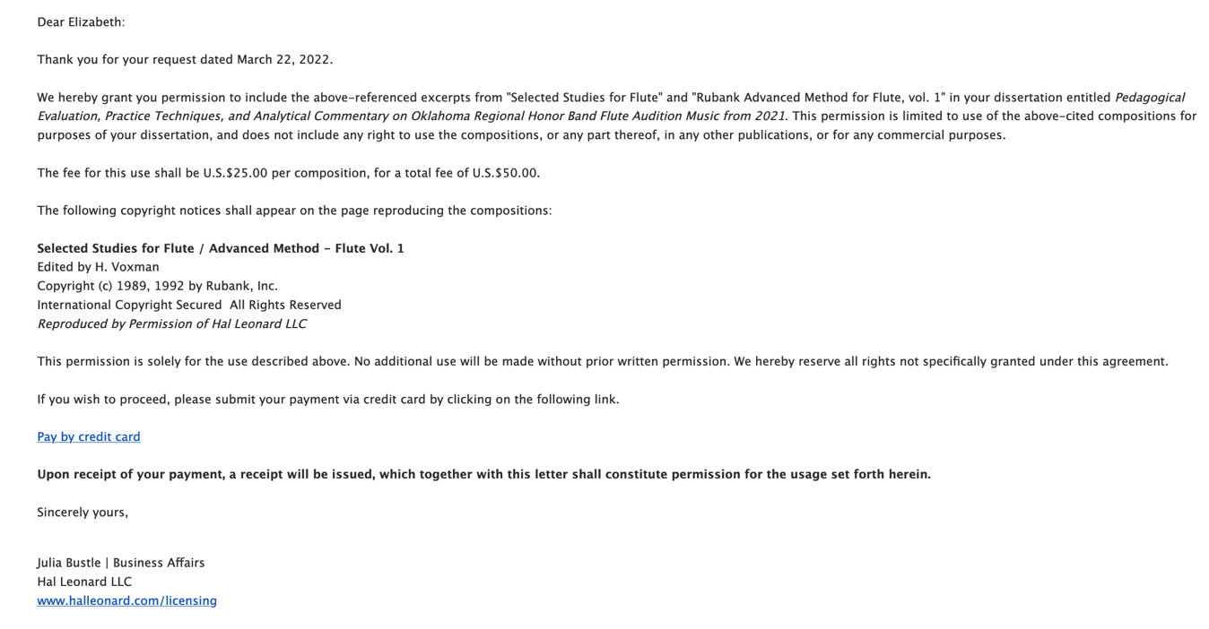

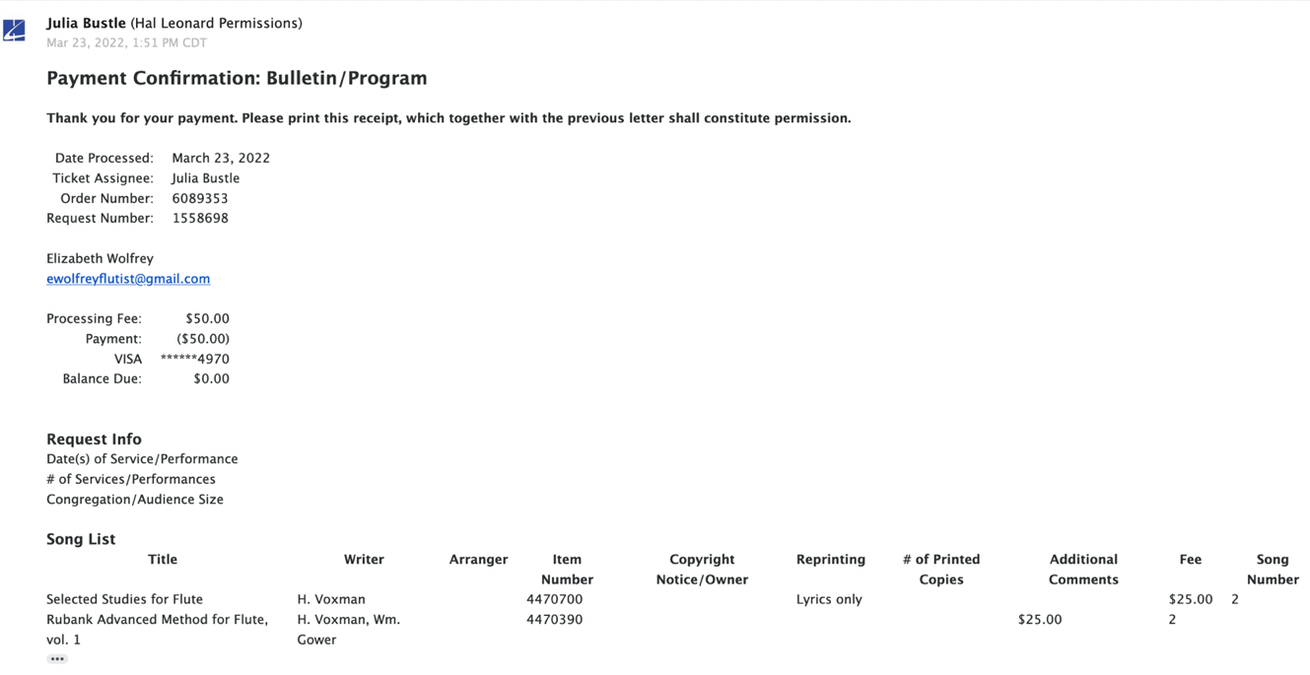

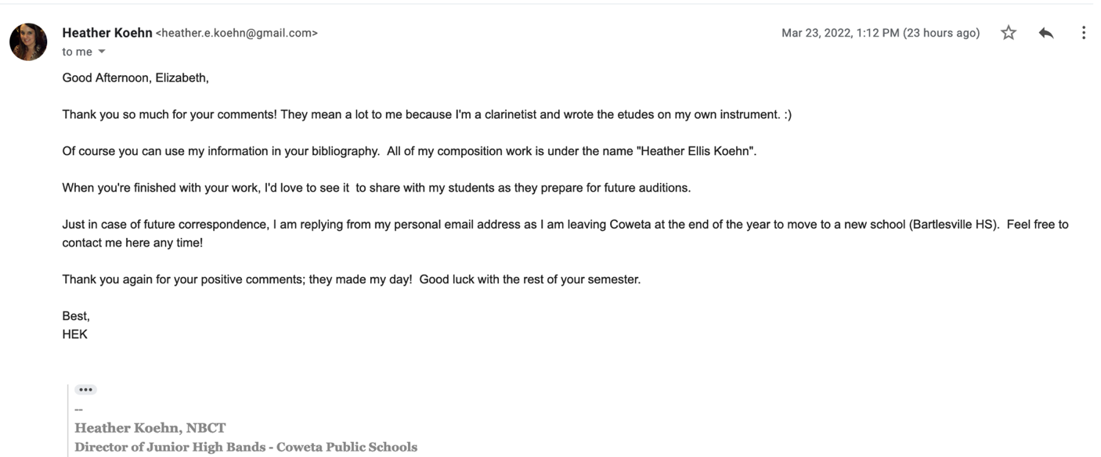

Appendix B: Etudes from Voxman Selected Studies

A. Köhler Etude in A-major.

B. Köhler Etude in F-major.

C. Kummer Etude in F#-minor.

D. Karg-Elert Capriccio in D-major.

Appendix C: Etudes from Rubank Advanced Method for Flute, vol. 1

E. Gluck Gavotte.

F. Allegretto Mosso pg. 51.

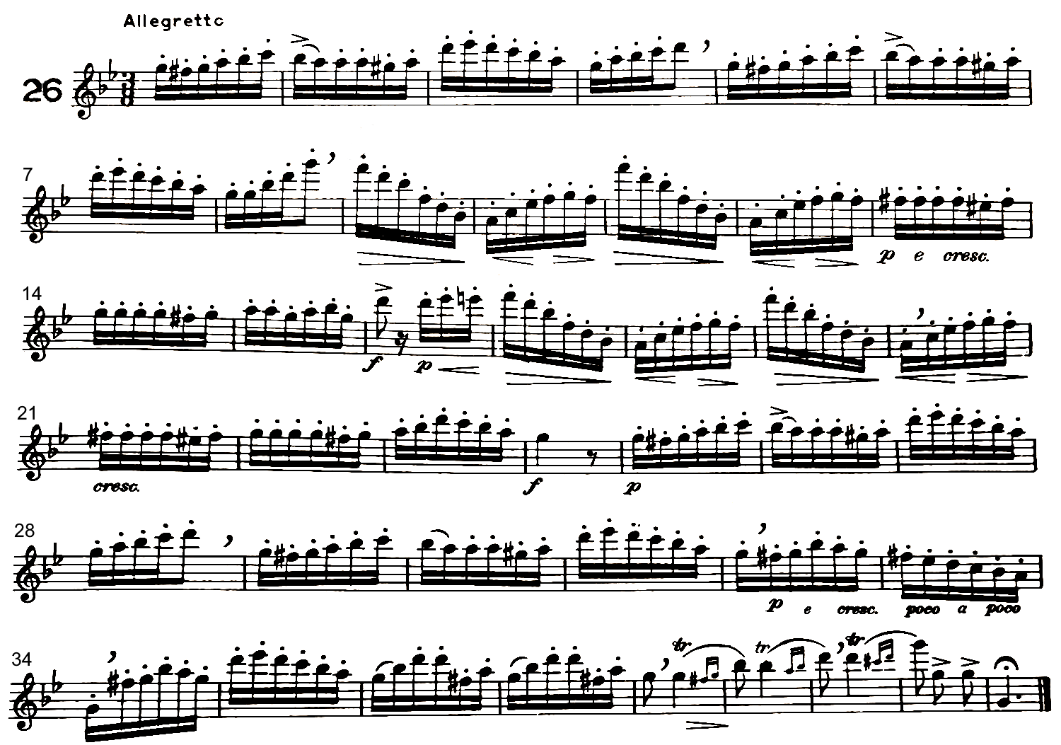
G. Allegretto, pg. 54-55.

H. Sivori Romance.

Appendix D: Etudes by H.E. Koehn
I. EDBDA 7th Grade Etudes by H.E. Koehn

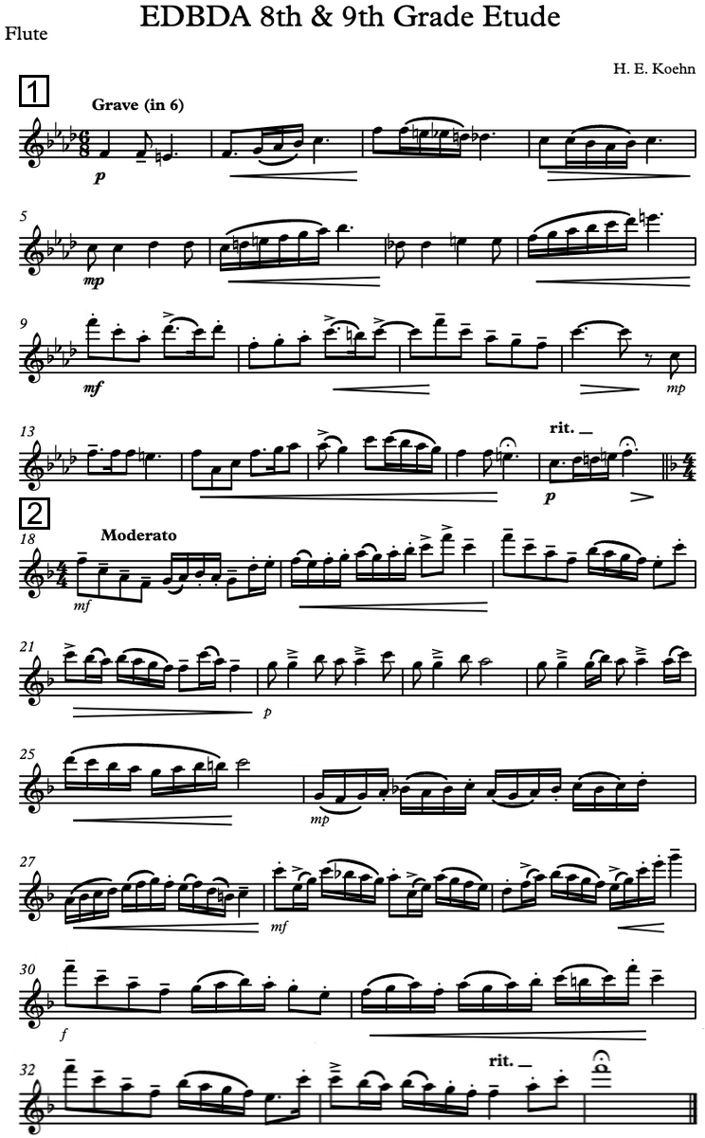
J. EDBDA 8th Grade Etudes by Heather Ellis Koehn.

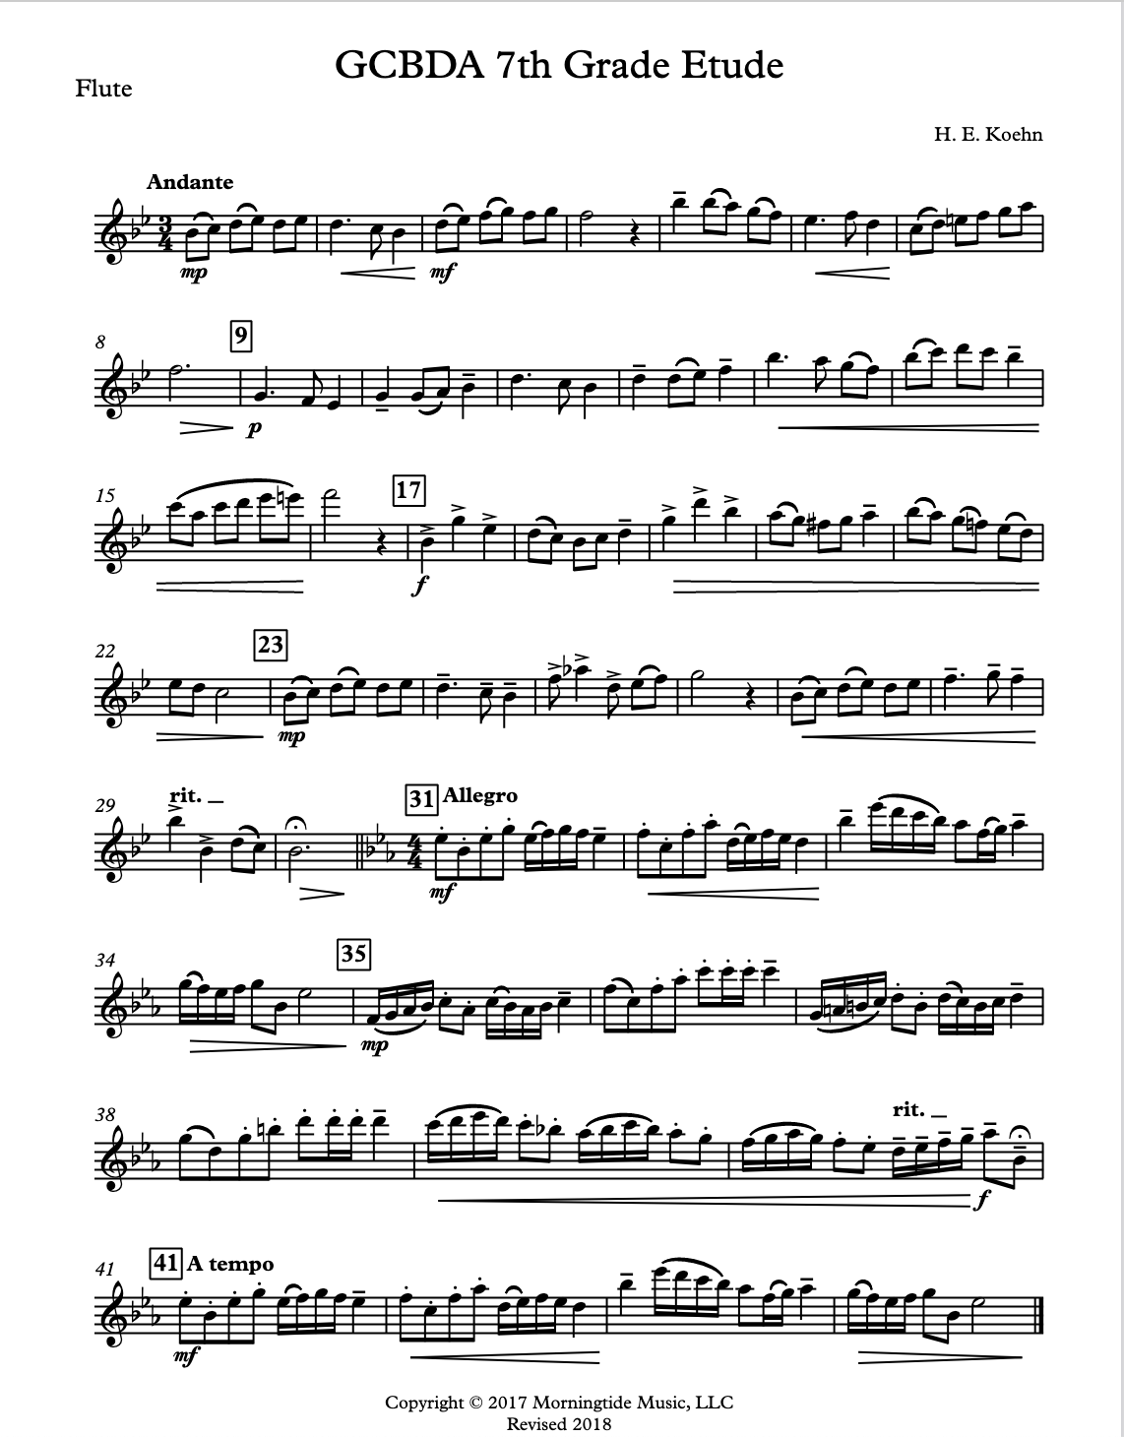
K. GCBDA 7th Grade Etudes by H.E. Koehn.

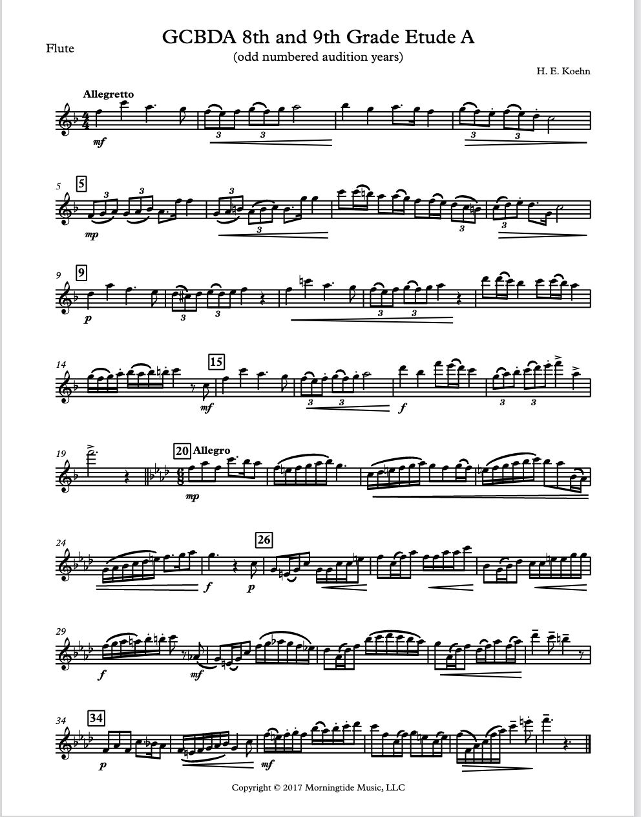
L. GCBDA 8th/9th Grade Etudes by H.E. Koehn.

Appendix E: Other Uncredited Original Etudes

M. SWOBDA 7th Grade Etudes.

N. SEOBDA 7th Grade Etude #1.

O. SEOBDA 7th Grade Etude #2.

P. SEOBDA 8th/9th Grade Etude #1.

Q. SEOBDA 8th/9th Grade Etude #2.

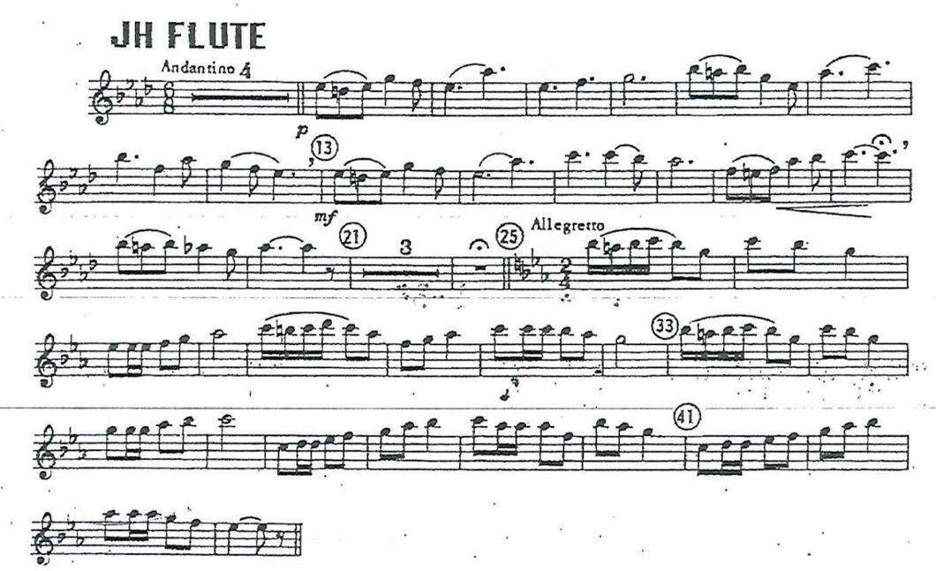
R. RCHB 8th/9th Grade Etudes.

S. ECOBDA 6th/7th Grade Etudes.

Appendix F: Link to Video Recordings

https://youtube.com/playlist?list=PL6NBgVJlLH9XNVXLxolk01o8USzW4qADe

Additional video resources were created to supplement this written document and can be found on the Oklahoma Flute Society and/or author’s YouTube Channel.
W.M. Gower and Himie Voxman, ed., Advanced Method for Flute, vol. 1 (Milwaukee, WI: Hal Leonard, 1940).
Himie Voxman, ed., Selected Studies for Flute: Advanced Etudes, Scales and Arpeggios in All Major and All Minor Keys. (Milwaukie, WI: Hal Leonard, 1948).
Vincent C. Bates, “Equity in Music Education,” Music Educator’s Journal 105, no. 2 (December 2018): 72-74.
National Flute Association, Guide to Levels for Pedagogy Publications (Chicago, IL: National Flute Association, 2009), https://www.nfaonline.org/docs/default-source/default-document-library/nfa-guide-to-levels-for-pedagogy-publications.pdf?sfvrsn=1935ff06_6.
Voxman, Selected Studies; Rubank, Advanced.
See Appendix B for leveling guide in full.
There are an abundance of flute and band method books available that have uses and merits but were not chosen for this study. The author additionally considered texts that had been academically reviewed previously and that the author had the most experience with in band classes and with flute students in Oklahoma between 2017 and 2022.
Olivia Suzanne Boatman, “A Comparison of Four Selected American Flute Method Books from the 20th and Early 21st Centuries: Ernest F. Wagner, William Kincaid with Claire Polin, Robert Dick, and Patricia George with Phyllis Avidan Louke” (PhD diss., Florida State University, 2016), ProQuest Dissertations.
Patricia George and Phyllis Avidan Louke, Flute 101.5: Enrichment (Malvern, PA: Theodore Presser, 2022); Patricia George and Phyllis Avidan Louke, Flute 102: Mastering the Basics (Malvern, PA: Theodore Presser, 2012); Patricia George and Phyllis Avidan Louke, Flute 103: Mastering the Basics (Malvern, PA: Theodore Presser, 2013); Trevor Wye, Beginner’s Book for the Flute, Part 1 (London, UK: Novello Publishing, 1984); Trevor Wye, Beginner’s Book for the Flute, Part 2 (London, UK: Novello Publishing, 1984); Trevor Wye, Practice Book for the Flute: Books 1-6 (London, UK: Novello Publishing, 1984).
Kie Watkins, “An Analysis of Select Beginning Band Method Books and the Level to Which They Address the National Standards for Music Education” (PhD diss., Ohio State University, 2018), ProQuest Dissertations.
Bruce Pearson, Standard of Excellence (California: Neil A. KJos Music Company, 2006); Tim Lautzenheiser et al., Essential Elements (Milwaukee, WI: Hal Leonard Corporation, 1999).
The National Flute Association’s (NFA) Guide to Levels for Pedagogy Publications defines specific criteria for each level across these categories: Pitch & Key Range, Rhythm & Meter, Articulation, Musical Symbols, and Pedagogical Focus. Levels are designated by letters with the lowest beginning level assigned Level A up through professional performance assigned Level K.
Jennifer Lynn Amox, “Polishing Gems: A Supplemental Curriculum for Developing the Musical Literacy and Musical Expression Skills of Junior High Flute Students” (PhD diss., University of Memphis, 2018), ProQuest Dissertations.
Amox contends that Juslin’s GERMS (Generative rules, Emotional expression, Random variability, Motion principles, and Stylistic unexpectedness) model is effective in portraying the various components of musical expression and a valuable tool for teaching the Arkansas honor band audition music.
Watkins, “Analysis of Beginning Band.”
Lautzenheiser et al., Essential Elements; Pearson, Standard of Excellence.
Pamela L. Turowski, “Beginning Band Students’ Familiarity with Method Book Repertoire as Predictor of Music Achievement” (PhD diss., Temple University, 2017), ProQuest Dissertations.
Olivia Suzanne Boatman, “A Comparison of Four Selected American Flute Method Books from the 20th and Early 21st Centuries: Ernest F. Wagner, William Kincaid with Claire Polin, Robert Dick, and Patricia George with Phyllis Avidan Louke” (PhD diss., Florida State University, 2014), ProQuest Dissertations.
Mary Birkner, “A Flute Skills Guidebook Based on Current Practices at Selected Colleges and Universities in the United States” (PhD diss., University of Florida, 2014), ProQuest Dissertations.
Josef Hanson, “Assessing the Educational Value of YouTube Videos for Beginning Instrumental Music,” Contributions to Music Education 43 (2018).
Lautzenheiser et al., Essential Elements.
Pearson, Standard of Excellence.
George and Louke, Flute 101-103; George and Louke, Flute 101.5.
Wye, Beginner’s Books; Wye, Practice Books.
Wye, Practice Books.
Mary C.J. Byrne, Holly O. Clemans, Rebecca Dunnell, et al., Selected Flute Repertoire and Studies: A Graded Guide (Santa Clarita, CA: National Flute Association, 2009).
Byrne, et al., Selected Flute Repertoire and Studies: A Graded Guide, 1.
Ibid, 2.
The NFA does not categorize the leveling guide beyond the letter system. The beginning, intermediate, and advanced specification was added for use in this document to categorize the etudes used in Oklahoma honor band auditions. All etudes analyzed in the following chapter are categorized this way (i.e., all A and B level etudes were designated as beginner level, all C level etudes were designated intermediate level, and all D and E level etudes were designated advanced level.)
NFA, Guide to Levels.
NFA, Leveling Guide.
Louke & George, Flute 101; Wye, Beginner’s Book for the Flute vol. 1.
The NFA’s Guide to Levels for Pedagogy Publications begin with level A as the foundation of flute study with each letter gradually getting harder. Levels D and E are indicative of a later-intermediate/early-advanced ability on the instrument.
Wye, Practice Books, 209.
Louke & George, Flute 101.5, 15.
Lautzenheiser, et al. Essential Elementsi; Perason, Standard of Excellence; Louke & George, Flute 101; Wye, Beginner’s Book.
George & Louke, Flute 101.5, 17-20.
Wye, Practice Books, 154-162.
Ibid, 155.
Wye, Practice Books, 6.
Ibid.
Louke & George, Flute 101, 77.
George & Louke, Flute 101.5, 4.
Wye, Practice Books, 156-162.
Pearson, Standard of Excellence, books 1-3.
Lautzenheiser et al., Essential Elements: Flute Books 1-3.
George and Louke, Flute 101-103.
Wye, Practice Book.
Wye, Practice Books, 6.
Wye, Practice Books, 154-162.
The Breath Builder is particularly useful for flutists who struggle with air management and taking full breaths.
Wye, Practice Books, 5.
Wye, Practice Books, 226.
Wye, Practice Books, 226.
Louke & Goerge, Flute 101, 75.
Wye, Practice Books, 209.
George & Louke, Flute 101.5, 3.
Ibid, 2.
Wye, Practice Books, 209.
Ibid, 226.
Wye, Practice Books, 93.
Ibid, 209.
Wye, Practice Books, 6.
Ibid, 5.
Pearson, Standard of Excellence, books 1-3.
Lautzenheiser et al., Essential Elements: Flute Books 1-3.
George and Louke, Flute 101-103.
Wye, Practice Book.
Wye, Practice Books, 226.
Wye, Practice Books, 206-209.
George & Louke, Flute 101.5, 2-6.
George & Louke, Flute 102, 27.
Wye, Practice Books, 226.
Wye, Practice Books, 6.
A click track was created by the author of this document and included in the instructional video OFS posted on Youtube.
Breath attack practice will help both single and double tonguing technique.
Wye, Practice Books, 104.
The author of this document recommends practicing the phrase “Take It To Kitty-Cat” away from the instrument to recreate the motion of the tongue when triple tonguing “T-K-T-K-T-K.”
Wye, Practice Books, 113.
Wye, Practice Books, 6.
Pearson, Standard of Excellence, books 1-3.
Lautzenheiser et al., Essential Elements: Flute Books 1-3.
George and Louke, Flute 101-103.
Wye, Practice Book.
Louke & George, Flute 101, 77.
Ibid.
Ibid.
George and Louke, Flute 101.5, 3.
George & Louke, Flute 101.5, 3.
George & Louke, Flute 101.5, 3-6.
Ibid.
George & Louke, Flute 101.5, 4.
The soda can (or tin can) test is done by simply picking up a soda can or tin can with the right hand to see where the thumb naturally aligns with the fingers.
George & Louke, Flute 101.5, 5.
There are also several hand position supports available for purchase that help guide the hand into a comfortable position. A popular recommendation is the Thumbport which is mentioned in Dr. Lea Pearson’s book, Body Mapping for Flutists.
For more information on potential injury and/or detailed explanation on positioning of the wrists, movement of the fingers, and angle of the flute see George & Louke, Flute 101.5, 2-6; Wye, Practice Books, 209-210; Wye, Beginner’s Book, 2-5.
This section is related to general tone quality issues, for more in-depth information on more advanced and specific tone issues relating to the low and upper registers, see headings Weak Low Register Tone and Projection and Poor Upper Register Response, Intonation, and Dexterity.
Sometimes Flute Alignment plays into tone issues at the beginning level but students should be instructed by their teacher on where to align the instrument. Students tend to roll the headjoint in because they find it improves their tone in the middle register and makes the upper register easier but doing so affects the tone and especially intonation.
Some early intermediate students may also benefit from a review of these elements of tone production.
George & Louke, Flute 101.5, 71.
Louke & George, Flute 101, 7.
Ibid.
Wye, Practice Books, 207.
Ibid, 207.
George & Louke, Flute 101.5, 71.
Ibid.
Ibid.
George & Louke, Flute 101.5, 60.
Louke & George, Flute 101, 11.
Ibid, 71.
Ibid.
George & Louke, Flute 101.5, 71.
Wye, Beginner’s Book, vol. 1, 19.
Wye, Practice Books, 5.
Ibid, 6.
Ibid, 7.
Ibid, 206.
Wye, Practice Books, 20.
Ibid, 25.
Wye, Pratice Books, 25.
Wye, Practice Books, 31.
Louke & George, Flute 101, 78.
George & Louke, Flute 101.5, 11.
Ibid, 43.
Ibid, 60.
George & Louke, Flute 101.5, 71.
Michel Debost refers to contrary finger motion as awkward passages of notes that involve one or more fingers moving in opposite directions.
Refer to the section headings Poor Instrument Balance and Poor Hand Position for suggestions on how to correct these issues.
Wye, Practice Books, 209.
Michel Debost, “Contrary Finger Motion and the Three Little Devils of Flute Playing,” in The Flutist’s Handbook: A Pedagogy Anthology, ed. Michael C. Stoune (Santa Clarita: The National Flute Association, Inc., 1998), 11-16.
Wye, Practice Books, 51.
Ibid.
See Wye, Practice Books, 51-85 for exercises.
Ibid.
Louke & George, Flute 101, 75.
Louke & George, Flute 101, 75.
Pearson, Standard of Excellence: Flute Book 1, 3.
Lautzenheiser et al., Essential Elements: Flute Book 1, 2
Wye, Beginner’s Book Part One, 8.
George & Louke, Flute 101.5, 67.
If this is the case, the Spitting Rice technique described by Louke & George in Flute 101 should be practiced.
Wye, Practice Books, 98.
Ibid, 104.
Ibid.
See Wye, Pracitce Books, 91-120 for a multitude of tonguing exercises to help students develop their tonguing technique. He goes into detail on these specific issues and offers specific exercises to help improve in those areas.
Wye, Practice Books, 104.
Wye, Practice Books, 11. In which he advises “Don’t use the flute as a piece of gymnastic apparatus. Tongue forward in the mouth – near the teeth. As the weeks go by, the base of the tongue- which is creating such an upheaval in the mouth- will move less an dless and most of the action will be in the tip of the tongue. This will result in a clearer articulation.”
George & Louke, Flute 101.5, 67.
Wye, Practice Books, 96.
Wye, Practice Books, 113.
Wye, Practice Books, 93.
George & Louke, Flute 102, 75.
Ibid, 98.
Wye recommends additional articulation studies and practice using his book The Complete Daily Exercises.
Wye, Practice Books, 226.
Ibid.
Dr. Lea Pearson goes into extreme detail on all of the physical mechanisms behind breathing in her book Body Mapping for Flutists: What Every Flutists Needs to Know About the Body. She offers a multitude of exercises and helpful advice on how to develop a natural breathing technique.
Wye, Practice Books, 155.
Wye, Beginner’s Book vol. 1, 5.
Wye, Practice Books, 162.
Wye, Practice Books, 159.
Louke & George, Flute 101, 12-13.
Ibid, 13.
The PneumoPro by Kathy Blocki is a wonderful teaching device that mimics the flute headjoint and helps students train their embouchure flexibility with fans at varying points for air direction targets.
For flutists, these products are available from most reputable flute dealers.
Wye, Practice Books, 155.
George & Louke, Flute 101.5, 91.
Wye, Practice Books, 161.
Wye, Practice Books, 7.
Louke & George, Flute 101, 60.
Wye, Practice Books, 207.
For a detailed explanation on the scale of a flute and discussion on acoustic properties of the flute see the section “Intonation and Vibrato” in the Practice Books, 122-143.
Some students find E3 easier to play without the right pinky down. Additionally, some students fine F# easier to play when using the right hand middle finger instead of ring finger. Both of these fingering choices have the benefit of lowering the pitch of two notes that tend
Long tone practice of scales, arpeggios, slurred intervals, harmonics, and other extended techniques are particularly useful for tone development in the upper register.
It should be noted that although a few notes reliably trend a certain direction in pitch, there is a degree of variability for each flute, and player will have their own intonation tendencies. It is essential that every flutist should spend time getting to know the scale of their flute and their pitch tendencies in the upper register (and the full compass of the instrument.)
When playing loud there is a tendency to play sharp and when playing soft there is a tendency to play flat. Upper register intonation is especially sensitive to the effect dynamics have on pitch.
Wye, Practice Books, 228.
George & Louke, Flute 101.5, 15-72; George & Louke, Flute 102, 10-85

