UNIVERSITY OF OKLAHOMA
GRADUATE COLLEGE

EFFECTS OF AN EIGHT WEEK MAXIMAL JUMPING INTERVENTION
ON BONE CHARACTERISTICS IN COLLEGE-AGED FEMALES

A THESIS
SUBMITTED TO THE GRADUATE FACULTY
in partial fulfillment of the requirements for the
Degree of
MASTER OF SCIENCE

By
ALISON BALDERAS
NORMAN, OKLAHOMA
2019

EFFECTS OF AN EIGHT WEEK MAXIMAL JUMPING INTERVENTION
ON BONE CHARACTERISTICS IN COLLEGE-AGED FEMALES

A THESIS APPROVED FOR THE
DEPARTMENT OF HEALTH AND EXERCISE SCIENCE

BY

Dr. Debra Bemben, Chair

Dr. Michael Bemben

Dr. Rebecca Larson

© Copyright by ALISON BALDERAS 2019
All Rights Reserved.

Acknowledgements

First and foremost, I would like to thank my mentor and supervisor, Dr. Debra Bemben for her constant guidance and support throughout the duration of this study as well as for the past two years of my time in the program. She has encouraged me and advised me throughout the duration of my thesis and was always willing to share her insight and knowledge. I enjoyed my time in the Bone Lab, and learning from Dr. Deb.
I would also like to thank the participants who volunteered for this study, without whom I would not have been able to complete my thesis. As well as Bree, Sam, Michelle, and Cameron who helped me collect data and played an integral role in shaping me as a graduate student and encouraging and supporting me when I was unsure of myself. I would also like to thank the graduate students of the Health and Exercise Department, each of whom provided support, shared their intelligence, provided guidance when I was in need, and was always available to chat when I needed them to.
Lastly, I would like to thank my family. My parents for their constant belief that I can achieve anything I set my mind to and for their reminders that I am capable of more than I realize. Without them, I would not be where I am today, nor the person I am today, and for that I am grateful. My sister, Sara, who always provides a lending ear when I am stressed or worried, for always being there when I need to step away from my work, and who never lets me down. And finally, I would like to thank my husband, Nicholas, for always loving me and listening to me when I doubt myself and remind me that I am wrong. Thank you all for being with me as I complete my graduate career and supporting me through whatever lies ahead.

Table of Contents
Acknowledgements iv
List of Tables viii
List of Figures ix
List of Appendices x
Abstract xi
Chapter 1: Introduction 1
Purpose 5
Research Questions 5
Research Hypotheses 5
Significance of Study 6
Delimitations 6
Limitations 7
Assumptions 7
Operational Definitions 7
Chapter 2: Literature Review 11
Bone Physiology 11
Fracture Risk and Osteoporosis 12
Hormonal Contraceptive Effects on Bone Mineral Density 14
High-Intensity Exercise Effects on Bone 17
Jump Protocol Effects on Bone 20
Summary 24
Chapter 3: Methods 25
Participants 25
Inclusion Criteria 26
Exclusion Criteria 26
Research Design 26
Bone-Specific Physical Activity Questionnaire (BPAQ) 30
International Physical Activity Questionnaire (IPAQ) 30
Calcium Intake Questionnaire 31
Menstrual History Questionnaire 31
Anthropometric Measurements 31
Hydration and Pregnancy Testing 32
Dual Energy X-Ray Absorptiometry (DXA) 33
Peripheral Quantitative Computed Tomography (pQCT) 34
Jump Test Measurements 35
Statistical Analysis 37
Chapter 4: Results and Discussion 38
Participant Characteristics 38
Dual Energy X-Ray Absorptiometry Measures 40
Peripheral Quantitative Computed Tomography Measures 50
Jump Test Measurements 57
Discussion 61
Areal Bone Mineral Density and Body Composition 61
Volumetric Bone Mineral Density 65
Physical Performance 67
Limitations 69
Chapter 5: Conclusions 71
Research Questions 71
Clinical Significance 72
Suggestions for Further Research 73
References 75
Appendix A 79
Appendix B 86
Appendix C 95

List of Tables

Table 1. Baseline Participant Characteristics (Mean ± SD)…………………………………..39
Table 2. Total Body aBMD and Body Composition Over Time (Mean ± SD)………………40
Table 3. Regional aBMD and Body Composition Over Time (Mean ± SD)…………………41
Table 4. Lumbar Spine and Dual Hip aBMD Over Time (Mean ± SD)……………………...42
Table 5. Hip Structural Analysis Variables Over Time (Mean ± SD)………………………..47
Table 6. 4% Non-Dominant Tibia pQCT Variables Over Time (Mean ± SD)……………….50
Table 7. 38% Non-Dominant Tibia pQCT Variables Over Time (Mean ± SD)……………. 51
Table 8. 66% Non-Dominant Tibia pQCT Variables Over Time (Mean ± SD)………………52
Table 9. Jump Variables Over Time (Mean ± SD)……………………………………………57

List of Figures

- Overview of Research Design……………………………………………….…………..26
- Overview of the Maximal Countermovement Jump……………………………..………36
- Percent Change for Lumbar Spine (L1-L4) aBMD…………………………….……......43
- Percent Change for Dominant Neck aBMD……………………………………....……..43
- Percent Change for Non-Dominant Neck aBMD………………………………....….….44
- Percent Change for Dominant Trochanter aBMD……………………………………….44
- Percent Change for Non-Dominant Trochanter…………………………...……………..45
- Percent Change for Dominant Hip Total aBMD………………………..……………….45
- Percent Change for Non-Dominant Hip aBMD…………………………..……………..46
- Percent Change for Dominant Hip Section Modulus…………..………………………..48
- Percent Change for Dominant Hip CSMI………………………………………………..49
- Percent Change for 66% Tibia Total BMC………………………………………………54
- Percent Change for 66% Tibia Total vBMD……………...……………………………..55
- Percent Change for 66% Tibia Cortical BMC………..……………….…………………56
- Percent Change for Jump Height from Pre to Mid-Test and Pre to Post-Test……….…..59
- Percent Change for Jump Time from Pre to Mid-Test and Pre to Post-Test……...……..60

List of Appendices

Appendix A
- Flyer
- Mass Email Script
- Facebook.com Script
- Screening Checklist

Appendix B
- Informed Consent Form
- HIPPA Form

Appendix C
- Health Status Questionnaire
- Par-Q and You
- Calcium Intake
- Bone Specific Physical Activity Questionnaire
- International Physical Activity Questionnaire
- Menstrual History Questionnaire

Abstract

Peak bone mass occurs between the second and third decade, around a person’s late twenties and is followed by a plateau in bone mineral density (BMD). Osteoporosis can be a result from a failure to achieve peak bone mass (Forwood, 2013a). Although there is a time delay, exercise has shown to have positive effects on bone accrual and to alter bone geometry and density (Reiger & Yingling, 2016). Longitudinal jump interventions have been shown to increase BMD of the femoral neck and lumbar spine in college-aged females. Purpose: The purposes of this study were to: (1) compare bone mineral density before and after an eight-week low-repetition, high-impact loading jump intervention in premenopausal women between the ages of 18-24, (2) compare bone geometry before and after the intervention to determine alterations, and (3) compare cross-sectional area of the muscle in the lower limb before and after the intervention. Methods: Twenty healthy college-aged females were randomly assigned to a control group or a jump intervention group for the eight-week intervention. Body composition and areal bone mineral density (aBMD) measurements were analyzed using dual energy x-ray absorptiometry (DXA). Peripheral quantitative computed tomography (pQCT) was utilized to measure volumetric bone mineral density (vBMD) of the 4%, 38%, and 66% sites of the nondominant tibia. Jump power and velocity were measured using the Tendo FiTRODYNE power and speed analyzer while jump height and airtime were measured using a Just Jump mat. All tests were measured at the beginning of the study (pre-test) and again eight-weeks later for the post-test. The jump variables were also measured at the four-week time-point (mid-test). The control group was instructed to continue their lives without increasing their physical activity for the eight-week duration of the study. The intervention group engaged in ten maximal countermovement jumps five days per week for the first two weeks of the study, and increased their jumps by five every two weeks (jumping 15, 20, and 25 times). Independent t-tests were run to compare the control group to the intervention group for all dependent variables at baseline. Two-way repeated measures ANOVA (group x time) were run to compare the group differences in changes in the dependent variables from pre to post intervention. Percent changes in variables were analyzed by independent t-tests (group) or two-way repeated measures ANOVA (group x time) depending on if the dependent variables had one or two time points. Results: There were no significant differences in physical characteristics, DXA bone variables or pQCT bone variables, between the two groups at baseline. There were no significant group, time, or group x time effects for any of the bone or body composition variables assessed by DXA. There were significant time effects for the cross-section moment of inertia and section modulus as both groups decreased over time. No significant group, time, group x time effects were found for pQCT variables at the 4% or 38% site of the nondominant tibia. However, significant group x time effects were found for the vBMD of the 66% site of the nondominant tibia and significant time effects were found for total BMC and cortical BMC. Conclusion: The jump intervention did not increase DXA variables, 4% and 38% pQCT variables, or jump variables in this cohort of young women. There was a group x time effect on the vBMD of the 66% site of the nondominant tibia. Future studies should focus on a longer intervention to provide time for bone formation to begin. Additionally, recruiting a larger sample size would provide a greater statistical power. Future studies could also increase the intensity of the intervention throughout the duration by using weighted vests or utilizing drop jumps.

Chapter 1: Introduction
Bone without a cortex and trabeculae is like a building without support beams, it will fracture or breakdown when compressed. In the 1830s, Jean Georges Chretien Frederic Martin Lobstein, a French pathologist, discovered that some patients had more porous bones than others and coined the term “osteoporosis” (Patlak, 2001). Extensive pores in the bones weaken the skeleton by deteriorating both cortical and trabecular bone, causing the bone to become fragile enough that simple actions, such as sneezing or stepping off a curb, can cause the bone to break. Fractures from osteoporosis can be fatal due to complications such as thromboembolism, delirium, and pain management (Colón-Emeric & Saag, 2006). It was discovered early on that bone loss is an inevitable consequence of age, and postmenopausal women have a higher risk for the skeletal disease (Patlak, 2001).
One in two women over the age of 50 are affected by osteoporosis and an estimated ten million Americans have osteoporosis, which is why researchers are intent on discovering a cure for the disease (Reiger & Yingling, 2016). Estrogen builds the calcium reserves in bones, but there is a reduction of estrogen at the onset of menopause. The decrease in estrogen causes the breakdown of bone to exceed the buildup, resulting in bone loss and an increased risk of fractures. Estrogen replacement therapy has been shown to prevent a loss in height and reduces fractures risk by half. However, it is not a cure for the disease because it cannot replace the bone matrix that has deteriorated. In order for estrogen to be an effective method of preventing the symptoms of osteoporosis, the replacement therapy needs to be initiated prior to the onset of excessive bone loss. Unfortunately, by the time the symptoms of osteoporosis are apparent, there has already been irreversible damage to the bones, therefore it is imperative to develop effective measures of reducing the effects of osteoporosis (Patlak, 2001). In addition to taking estrogen replacement therapy prior to the onset of menopause, increasing peak bone mineral density before menopause will also be beneficial.
Mass, geometry, and material properties of bone determine its capacity to resist fractures. Bone mineral density (BMD) can predict the risk of fractures, and although it is determined by genetics, it is also influenced by mechanical factors. The geometry, architecture, and strength of the bone achieved during childhood via mechanical strains are preserved into adulthood and are more important than just BMD for preventing fractures. Peak bone mass occurs between the second and third decade of life, and followed by a plateau in bone mass accrual. Peak bone mass is site specific to each individual bone; the lower extremities reach peak bone mass first, within one year of peak height velocity, while the lumbar spine achieves its peak last at about four years after peak height velocity (Forwood, 2013b). Osteoporosis can result from a failure to achieve peak bone mass early in life. Mechanical loading, in addition to genetics, age, body weight, and calcium intake, influences the variation of peak bone mass (Forwood, 2013b; Tucker, Strong, LeCheminant, & Bailey, 2015). In order for new bone to be acquired, a mechanical strain threshold must be exceeded by the rate and amplitude of the loading; for example, static and isometric exercises do not exceed this threshold and therefore provide minimal adaptation to bone (Forwood, 2013b).
Bone tissue is in a constant state of flux in order to respond to a changing environment and be structurally efficient. Each individual bone undergoes the process of remodeling, which takes three to six months to complete. Through remodeling, the osteoclasts are recruited to a specific site on the bone surface and resorb the bone cells causing the osteoblast to then be recruited to the site in order to deposit matrix to form new bone. During maintenance, remodeling is a balanced process where resorption is matched by formation of the bone matrix. After stress has been placed on the bone, bone hypertrophy occurs due to the osteoblast activity exceeding the osteoclast activity (Snow-Harter & Marcus, 1991).
Bone adaptation allows the bone to respond to the loading signals placed upon it by altering bone geometry. However, there are three rules that govern bone adaptation: it is driven by dynamic loading not static; only a short duration of loading is required; and bones become less responsive to routine loading (Turner, 1998). Since novel dynamic loading patterns of short duration are sufficient for bone adaptation to occur, static strains do not reach this threshold and therefore do not enhance bone adaptation. Dynamic strains increase bone formation due to the ability to overcome the threshold and apply the necessary strain on the bone in order for adaptation to occur. In addition to dynamic strain on the bone, the frequency and strain rate of the mechanical loads are essential factors in adaptation. The second rule discusses how the formation of bone saturates with longer the duration of dynamic loading, contrary to the belief that the longer the mechanical load, the greater the adaptation of bone. Short duration loading at the same strain rate as a long duration loading will have similar effects on the bone due to the saturation of bone formation. Lastly, bones become accustomed to routine strains such as daily activities like walking. In order to allow for adaptation to continue, the mechanical loading on bone should be atypical of the strains typically placed upon it (Turner, 1998). These rules are imperative to remember when forming a regimen that will result in bone adaptation, especially an alteration in bone mass and geometry.
Exercise has been shown to have a positive effect on bone accrual, however, the results can take several months before changes in the density and geometry can be recognized. There is a time-delay from the onset of exercise strain and stimulation on the bone and the alterations of geometry and density (Reiger & Yingling, 2016). Short bouts of mechanical loads that provide enough stress on the bone to surpass the threshold in order to allow for adaptations of the bone result in an increase in bone and muscle mass in those with low bone mineral density (Gilsanz et al., 2006). In order to increase strength of bone, the exercise intervention needs to be a protocol to which the bone is not accustomed (Tucker et al., 2015). Impact-loading physical activity involve Ground Reaction Forces (GRFs) and strains on the bone through the muscle contractions. Jump interventions are impact-loading exercises that involve GRFs and imposing stresses on the bone to have an effect on hip BMD in women (Tucker et al., 2015). Maximally jumping produces a dynamic strain on the bone that exceeds the threshold required in order for the bone to adapt. Due to the GRF and strain rate on the bone due to muscle contractions, a maximal jumping intervention in which an individual engages in multiple repetitions of high-impact loading will result in an adaptation of the weight-bearing skeleton that will allow for an increase in BMD and alter the bone geometry. The beneficial effect of jumping protocol was documented by Kato et al. in which premenopausal women participated in a six-month study (Kato et al., 2006a). The women jumped ten times per day, three days per week, which resulted in a significant increase in the BMD of the femoral neck and lumbar spine. A meta-analysis reporting on six studies that examined the effects of a 6-12 month jump intervention in premenopausal women who did not engage in regular exercise documented that high-impact, short duration jump interventions significantly increase the BMD of the femoral neck, lumbar spine, and trochanter compared to a control group. Although previous jump studies reported increases in the BMD, the literature does not discuss the changes in bone geometry and structure that arise from a high-impact exercise intervention (Zhao et al., 2014). This study examined the effects of a high-impact exercise intervention in addition to the potential changes in bone geometry and structure.

Purpose
The purposes of this study were to: (1) compare bone mineral density before and after an eight-week low-repetition, high-impact loading jump intervention in women between the ages of 18-24 years, (2) compare bone geometry before and after the intervention to determine alterations, and (3) compare cross-sectional area of the muscle in the lower, non-dominant leg before and after the intervention. Areal bone mineral density (aBMD) of the dual proximal femur, lumbar spine and total body was measured by dual energy x-ray absorptiometry (DXA), while the volumetric BMD (vBMD), bone geometry, and bone strength of the tibia, and cross-sectional area of the muscle was measured by peripheral Quantitative Computed Tomography (pQCT).

Research Questions
- Will engaging in maximally jumping five days a week for eight weeks improve bone mineral density and bone mineral content in the lumbar spine, dual proximal femur, and total body density in college-aged females?
- Will the eight-week jumping intervention alter bone geometry in the 4%, 38%, and 66% tibia sites of the non-dominant leg?
- Will the jumping intervention increase cross-sectional area of the muscle at the tibia 66% site of the non-dominant leg?
- Will the eight-week intervention increase vertical jump power output and velocity?

Research Hypotheses
- It was hypothesized that bone mineral density and bone mineral content will increase in the proximal femur, lumbar spine, and total body after an eight-week intervention in which a college-age individual engaged in a progressive maximal jump intervention five times per week.
- It was hypothesized that the jumping intervention will increase bone geometry variables: vBMD, total BMC, cortical vBMD, and cortical BMC at the 4%, 38%, and 66% site of the tibia.
- It was hypothesized that the jumping protocol will increase the muscle cross-sectional area at the 66% site of the tibia.
- It was hypothesized that the vertical jump power output and velocity will increase after the eight-week jump intervention.

Significance of Study
By the third decade of life, a person has attained the maximum bone mineral density that they will acquire in their lifetime. Thus, it is important to increase the mass of a person’s bone by this time in order to prevent the risk of osteoporosis and fractures later in life. After the third decade has begun, bone mineral density begins to decrease in a consistent manner as the person ages. It is well-documented that high-impact mechanical loading will increase the BMD and alter the geometry. The findings of this study may lead to a feasible, inexpensive way for college-age females to improve their bone health.

Delimitations
Delimitations for this study included the following.
- This study included healthy women aged 18-24 years.
- All participants were recruited from the University of Oklahoma, Norman, Oklahoma City area.
- The findings of this study apply to individuals who have not engaged in regular mechanical loading on their lower limbs in the past six months.
- All tests were performed at the Bone Density Lab, Sarkeys Fitness Center in Norman, Oklahoma.

Limitations
Limitations for this study included the following.
- Participants in this study were volunteers and may not be representative of the population.
- Participation was limited due to the 300-pound weight limit of the DXA and the height limit of 6 feet, 4 inches.
- This was a longitudinal study and relied on the participant being engaged in the study for eight weeks.

Assumptions
The assumptions of this study included the following.
- Subjects were honest and accurate when completing all health-related questionnaires.
- Subjects did take any medication that affects bone metabolism except hormonal contraceptives prior to and during the study.
- Participants were honest about in their self-reports of engaging in the intervention each day.
- Subjects performed each jump to their maximal ability.

Operational Definitions
- Areal BMD (aBMD): mineral mass of bone divided by its projection area in a given direction (g/cm²) (Schoenau, 2005).
- Bone Architecture: the cortical and trabecular composition of the bone (Frost, 1997).
- Bone Mineral Content: the mass of mineral per unit bone length (g/cm) or the mass of mineral contained in the entire bone (g) (Schoenau, 2005).
- Bone Mineral Density: measured density of a bone dependent on the mineralization of the bone and the amount of bone present (Allen & Burr, 2014).
- Bone Remodeling: the process of the osteoclasts removing mineralized bone followed by the osteoblast forming new bone matrix, this occurs when a stress has been placed on the bone in order to allow for a balance between bone resorption and formation (Hadjidakis & Androulakis, 2006).
- Bone Strength Index (BSI): a non-invasive indicator of bone strength by determining the product of the cross-sectional moment of inertia (mm⁴) and cortical volumetric density (mg/mm³) (Cointry et al., 2014).
- Cortical Bone: also called compact bone, has porosity less than 15% (Schaffler & Burr, 1988).
- Cortical Thickness: the thickness of the cortical bone pixels identified by the pQCT (mm) (Swinford & Warden, 2010).
- Dual-Energy X-Ray Absorptiometry (DXA): an x-ray scan that provides a two-dimensional scan of the total body, lumbar spine, and dual femur focusing on site specific bone mass, fat mass, bone-free lean body mass, the scan can allow for a quantitative method of diagnosis osteoporosis and fracture risk. The DXA measures attenuation throughout the body using x-ray beams (40 KeV and 70 KeV) to identify bone mineral and soft tissue composition, the software detects the outline of the bone while the pixels then determine the bone area (Adams, 2013; Bauer, 2013).
- Endosteal Circumference: the circumference of the inner membrane lining the medullary cavity (mm) (Swinford & Warden, 2010).
- Ground Reaction Force: non-invasive measure of bone strain during weight-bearing activities, it is the rate of force applied on the bone determined by the peak ground reaction force multiplied by the individual’s body weight (Weeks & Beck, 2008).
- Mechanical Strain: the adaptive reaction of the bone to the mechanical stress placed upon it (Ehrlich & Lanyon, 2002).
- Mechanical Stress: the physical load that is placed upon the bone that causes bone remodeling to occur resulting in the change of the shape of the bone (Nomura & Takano-Yamamoto, 2000).
- Muscle Cross-Sectional Area (MCSA): the total area of muscle (mm²) (Rauch & Schoenau, 2008).
- Osteoblast: cells utilized for bone formation (Huiskes, Ruimerman, Van Lenthe, & Janssen, 2000).
- Osteoclast: cells utilized for bone resorption (Huiskes et al., 2000).
- Osteocyte: a cell that can regulate mineralization located in the bone matrix (Bonewald, 2011).
- Osteoporosis: a T-Score of 2.5 SD and below the young adult mean value of BMD resulting in reduce bone strength and increase risk of injury or falls (Kanis, Melton, Christiansen, Johnston, & Khaltaev, 1994).
- Periosteal Circumference: the circumference of the outer membrane lining the cortical shell (mm) (Swinford & Warden, 2010).
- Peripheral Quantitative Computed Tomography (pQCT): a 3D x-ray scan that allows the analysis of cortical and trabecular microarchitecture of peripheral bones (Scharmga et al., 2016).
- Strength Strain Index (SSI): an indicator of bone strength by measuring the bone geometry (section modulus) and the properties of cortical bone tissue (mm³) (Kontulainen et al., 2008).
- T-Score: determines how many standard deviations above or below the mean BMD with a reference population of young Caucasian females (Carey & Delaney, 2010).
- Trabecular Bone: porous bone that is found in the spine and articulating joints (Huiskes et al., 2000).
- Volumetric Cortical Bone Mineral Density (cortical vBMD): reflects the material density of the solid cortex as well as the cortical porosity (mg/cm³) (Rauch & Schoenau, 2008).
- Volumetric Bone Mineral Density (vBMD): the ratio of the BMC and the total cross-sectional area of bone (mg/cm³) (Rauch & Schoenau, 2008).
- Z-Score: determines how many standard deviations above or below the mean BMD with a reference population of individuals of a matched age, sex, ethnicity, and body-mass (Carey & Delaney, 2010).

Chapter 2: Literature Review
The purposes of this study are to: (1) compare bone mineral density before and after an eight-week low-repetition, high-impact loading jump intervention in premenopausal women between the ages of 18-21, (2) compare bone geometry before and after the intervention to determine alterations, and (3) compare cross-sectional area of the muscle in the lower limb before and after the intervention. This chapter will examine previous literature that discusses the effects of high-intensity activities, especially jumping, on BMD, as well as the effects of hormonal contraceptives on BMD. This literature review is organized into the following sections: (1) Bone Physiology, (2) Fracture Risk and Osteoporosis, (3) Hormonal Contraceptive Effects on BMD, (4) High-Intensity Exercise Effects on BMD, (5) Summary.

Bone Physiology
Bone is a living, dynamic connective tissue that must be able to react to metabolic and structural changes. The composition of bone is dictated by the functional demands being placed upon it. Bone turnover is regulated by the balance between osteoblast and osteoclast functions. When placed under stress, remodeling occurs in bone- the process of resorption and formation (breaking down and being reformed). Remodeling in the endosteal surface of bones takes about 3-6 months to complete (Marcus et al., 2009).
If there is an imbalance in remodeling resulting in an increase in osteoclast activity favoring resorption, then bone loss occurs. Osteoclasts arise at or near the bone surface and erode the underlying bone once activated (Boyle et al., 2003). Osteoblasts are in communication with osteocytes, meaning that there is a structural basis for controlling remodeling when there is strain placed upon the bone (Lanyon, 1987). Once a strain is placed upon a bone, the osteocytes are activated and gravitate towards the area of the bone. Once there, the osteocytes form a vacuole to the bone surface, creating a sealed compartment. This compartment is then acidified through the use of hydrochloric acid and acidic proteases- causing the osteoclasts to resorb the underlying bone. This method of bone degradation relies on the physical relationship between the bone matrix and osteoclasts. The osteoblast will then be recruited to the site and inhibit the osteoclasts from eroding the bone more and begin forming new bone matrix over the now eroded bone (Boyle et al., 2003; Ross, 2006).
The composition and structure of bone is controlled by the functional demands placed upon the bone. The trabecular bone is in the epiphyses of long bones in the axial skeleton and is highly porous. The porosity of the trabecular bone is a determinant of the stiffness and strength of the bone. If the bone has disuse with age, it will become progressively thinner and perforated by resorption cavities. Cortical bone, also known as compact bone is more dense than trabecular bone and is only 5-20% porous (Marcus et al., 2009). Increasing the osteoclast activity results in a decrease in cortical bone through an increase in porosity. This decline in cortical bone leads to a loss in strength of the bone (Reid, 2013). Additionally, the reduction of cortical bone is more predictive of femoral neck fractures then the loss of trabecular bone. There is a larger age-related loss of cortical bone as well compared to trabecular bone.

Fracture Risk and Osteoporosis
With an increase in age, comes an increase in the risk of fractures associated with osteoporosis. Osteoporosis is caused by a failure to attain an optimal peak bone mineral density early in life. Endosteal bone apposition is ceasing as well as epiphyses are closing by the age of 16, meaning that it is imperative for people to increase their BMD before their third decade of life when BMD begins to decline. Although different skeletal locations achieve peak BMD at different ages, so there is no defined age that a person will know that they have reached their peak. However, peak BMD is attained around late adolescence but could continue to increase into the early twenty’s (Matkovic et al., 1994; Recker et al., 1992; Teegarden et al., 1995).
Low bone mineral density and increased defective osteocytes are the main causes of osteoporosis and other skeletal diseases. Osteoporosis occurs when bone resorption exceeds the demand of the osteoblasts and the BMD T-score falls below -2.5 (Cohen & Shane, 2009; Rubin et al., 2009). Fractures of the hip are the most common osteoporotic fractures. Although the femoral neck and the trochanter are at an equal chance for becoming fractured, there is evidence that suggests that trochanter density is the predominant indicator of the vulnerability of the femur. It is imperative to increase the BMD of the femur early in life in hopes of reducing the risk of osteoporosis with age. Once peak BMD is attained, BMD begins its general decline with age- meaning it is important to prevent the decline of BMD into the third decade (Bassey & Ramsdale, 1994). By the age of 48-50 years, women reach a cessation of their menstrual cycle known as menopause. This marks the beginning of bone loss which continues until death. Trabecular bone has a larger surface area than cortical bone, causing the matrix of the distal arm and vertebrae to have primary fractures at the onset of menopause (Favus, 2006).
In premenopausal women, a Z-score is used to categorize BMD: below -2.0 is below expected range for age, and above -2.0 has a BMD above expected range per age. Due to the use of Z-scores, osteoporosis cannot be diagnosed in premenopausal women because T-scores are the criteria for diagnosis. Although premenopausal women with low BMD are at a higher risk for fractures, the evidence is still unclear as to the extent which BMD predicts the prevalence for fractures. Young women with low BMD generally have an underlying exposure that altered the bone mass accumulation during adolescent years, such as medications (glucocorticoids, cancer chemotherapy, heparin), anorexia nervosa, or vitamin D and calcium deficiencies (Cohen & Shane, 2009).

Hormonal Contraceptive Effects on Bone Mineral Density
The female reproductive system affects skeletal growth and development through modeling and remodeling into adulthood and menopause. Menarche begins in most females at the age of 11-13 years old and stimulates mineral acquisition and skeletal growth for the next decade. Within the first four years after menarche, BMD reaches a third of the BMD peak then the increase slows but continues into the third decade of life. The menstrual cycle typically last 28 days in females but could vary from 21-40 days. The hypothalamus secretes gonadotropin-releasing hormones (GnRH) allowing the gonadotrophs in the anterior pituitary gland to secrete Follicle Stimulating Hormone (FSH) and Luteinizing Hormone (LH) in a cyclical pattern (Clarke & Khosla, 2010; Hartard et al., 2007).
The menstrual cycle can be divided in to the earlier follicular (proliferative) phase and the later luteal (secretory) phase. At the end of the follicular phase, before the transition into the luteal phase, ovulation occurs. Gonadotrophs secrete FSH and LH in a pulsatile pattern dependent on the pulsatile secretion of GnRH by the hypothalamus. FHS secretion increases during the late luteal phase and continues its increase into the early follicular phase, allowing the ovarian follicles to develop and grow before the decrease in FSH secretion for the rest of the cycle until the late luteal phase. However, FSH does surge during ovulation before continuing its decrease in secretion. LH secretion has a slower onset increase in the late follicular phase until it surges for 1-3 days in the middle of the cycle then begins to decrease until its lowest levels in the late luteal phase. In addition, the ovaries secrete serum estradiol and progesterone. Estradiol secretion increases 7-8 days prior to the LH surge, decreases quickly while LH peaks, then increases again a week after the LH surge. Progesterone also increases secretion prior to the LH surge and peaks about a week after the LH surge before decreasing secretion towards baseline levels. Estrogen and progesterone have receptors on bone cells that allow the hormones to directly benefit the skeleton. Both estrogen and progesterone stimulate an increase in BMD beginning at menarche. At the onset of menarche, estrogen suppresses the resorption and increases formation of bone cells (Clarke & Khosla, 2010; Hartard et al., 2007).
According to Chiu et al. (Chiu et al., 1999) the increase in bone resorption in the middle and late follicular phase is due to the low levels of estrogen and progesterone during the earlier follicular phase. Additionally, the low levels of bone resorption during the late luteal phase is due to the increased levels of estrogen and progesterone in the mid-luteal phase. The researchers wanted to investigate the changes in female sex hormones during the menstrual cycle and determine if these changes were related to changes in bone formation and resorption. This study measured bone-specific alkaline phosphatase (BAP), osteocalcin (OC), and bone resorption markers, serum and urine deoxypyridinoline (Dpyr) in 20 premenopausal women, age 23-40 years old, who were not taking oral contraceptives. During one menstrual cycle, measurements were taken three times a week. Estrogen and progesterone levels are known to fluctuate throughout the cycle, however, BAP, OC, and Dpyr levels did not show a significant change throughout the cycle. It was concluded that due to the relationship between these hormones, women experience increased bone resorption each month during a normal menstrual cycle from the onset of menarche to menopause.
Burr et al. (Burr et al., 2000) documented that when young women take oral contraceptives, there is the potential that it could alter the normal accretion of bone mass that would occur due to exercise. Women between the ages of 18-31 (n=123) were classified by oral contraceptive use (OC, NOC) and divided into an exercise group and non-exercise group randomly. This was designed as a longitudinal study, lasting two years with measurements taken every six months. Measurements included using a Lunar DXA to measure the bone mineral content, density and geometric information of the femoral neck in order to calculate the bending rigidity of the hip. The study concluded that either exercise or OC use alone depresses the normal increase of bone mass and the femoral neck mechanical strength; however, the combination of the exercise and OC use was less detrimental than each one individually. This could be due to the fact that long-term exercise and OC use suppress the increase of bone density and strength at the femoral neck. The researchers believed that impact exercises are more osteogenic than aerobic exercises.
Oral contraceptive pills contain lower estrogen doses in order to reduce the risks of thromboembolic events (Cromer et al., 2008). This increases the chance that OCs no longer provide enough estrogen to allow for optimal bone accrual in young women. In addition, it had become apparent that the depot medroxyprogesterone acetate (DMPA) contraceptive injection reduces the peak bone mass a woman taking the injection will achieve as well as increases the risks of osteoporotic fractures later in life. This was a longitudinal study, lasting for two years that focused on 433 postmenarcheal girls who were between the ages of 12-18 who were on the injection, taking OC, or were untreated. A DXA was performed every six months in order to observe the BMD of the spine and femoral neck. It was concluded that those receiving the injection had significant loss of BMD in the lumbar spine and femoral neck while those taking OC or untreated had an increase in BMD. The researchers believed it is important to determine if there is a sufficient level of estrogen in OCs that allow an optimal skeletal development in young women.

High-Intensity Exercise Effects on Bone
During the onset of puberty and into adolescent years, young women attain about 45-60% of their adult peak bone mass. Although there have been conflicting results, it is possible that bone mass and density of several important skeletal regions may increase into the early adult years (Blimkie et al., 1996). Past research has found contrasting results; exercise interventions in adolescent girls resulted in no significant change in bone mass, whereas exercise interventions resulted in a significant change in bone mass. Even with contrasting results from numerous studies, there is evidence that high-intensity loading is an effective bone-building activity. According to Witzke & Snow (Witzke & Snow, 2000) a high intensity loading activity must have a ground reaction force (GRF) greater than four times the body weight. Additionally, static loading is known to be less effective for increasing BMD than dynamic loading while strain rate is more effective than the number of trials performed (Kato et al., 2006b).
A meta-analysis that combined seven studies was added to the literature in 2013; this was the first meta-analysis on exercise and the effects on bone mineral density that included randomized control trials (Kelley et al.,, 2013). The seven studies included in the meta-analysis had interventions that lasted at least 24 weeks in order to allow sufficient time for bone remodeling to occur. Exercise protocols for the seven studies included a frequency ranging from 2-7 days per week throughout the study, and exercises that included circuit training, strength training, and aerobic activities. Overall, the seven studies documented that there was a statistically significant increase in the both the femoral neck and the lumbar spine BMD (Kelley et al., 2013).
Poor muscle strength and coordination can result in an increase in falls and fall-induced fractures later in life. While an increase in physical activity and performance can improve bone mass and strength in hopes of reducing the chance for falls and osteoporosis with age. An 18-month study, in which healthy, sedentary females between the ages of 35-45 engaged in an exercise intervention, had two groups: a training group and a control group (Heinonen et al., 1996). The training group exercised at a frequency of 3 times a week and performed high-impact exercises for twenty minutes in addition to a warm-up and cool-down period of 15 minutes. For the high-impact exercises, the subjects alternated between an aerobic jump protocol and a step program. The BMD of the femoral neck, lumbar spine, and distal femur where measured for baseline values and after the 18-month study. The training group had a significant increase in the BMD of the femoral neck, lumbar spine, and distal femur compared to the control group. The high-impact exercise protocol promoted the integrity of the skeleton; however, the researchers were unsure as to how long the effects on the BMD last or if the effects will disappear once training has stopped. If continued, high-impact exercises will result in an increase in bone mass and potentially a decrease in osteoporosis and osteoporotic falls later in life (Heinonen et al., 1996).
High-impact as well as low-impact exercises improve the bone mass of the lumbar spine, however, only high-impact exercises have a positive effect on the femoral neck (Wallace & Cumming, 2000). High-impact exercises have a positive benefit on L1 compared to L2-L4. This may be due to the fact that L1 is smaller than L2-L4 and therefore has a lower BMD and generates higher loading stresses. This discovery was documented in a 12-month exercise intervention in which a training group exercised three times a week and the control group continued with their everyday activities. For the training exercises, the 35-40-year-old women recruited for the study engaged in 60 minutes of high-impact exercises including stamping, running, walking, and step patterns. At the end of the 12 months, the BMD of the training group increased significantly compared to the control group in the femoral neck and L1, however, there were no significant changed in L2-L4 in the training group. This study shows that a high-impact exercise intervention can increase the BMD of the lumbar spine as well as the upper femur in a safe and efficient manner (Vainionpää et al., 2005).
Resistance training has been shown to have a positive effect on BMD and muscular strength due to high joint compressive forces (Blimkie et al., 1996). In a 26-week study in which adolescent females were assigned to either a resistance training group (3 days/week) or to a control group, bone mineral content was measured for the total body and lumbar spine. Although the lumbar spine BMD of the treatment group increased in the first 13 weeks of the study, there were no statistically significant changes between the control group and the resistance training group’s bone mineral content at the end of the 26 weeks. Additionally, there was significant increases in strength for the resistance group at the end of the study (Blimkie et al., 1996). This study showed that resistance training protocols increase the bone mineral content as well as muscular strength.
One major barrier to engaging in the minimum amount of activity (150 minutes of moderate-intensity aerobic activity and two days of muscular strength training a week) necessary to maintain and improve body composition and bone health is a lack of time to complete these activities (Brown et al., 2018). Sixteen women participated in a 12-week intervention study looking at how different high-intensity interval training protocols affect body composition and physical fitness. The college-aged females were randomly assigned into the multimodal HIIT group or the rowing HIIT training group. The multimodal group utilized resistance training exercises including barbells for squats, dumbbells for lunges, and sprints-like movements such as hurdle hops. The rowing HIIT group utilized a rowing ergometer for each training session. At the end of the 12 weeks, there was an overall decrease in the total body fat percentage for both groups and a significant increase in total body BMC. This study demonstrated that high-intensity exercises are feasible options in improving skeletal health in college-aged females.

Jump Protocol Effects on Bone

Jumping is a high-impact exercise that has been discovered to place a strain on the bone that overcomes the threshold necessary to increase the BMD. An animal study in which rats were divided into 5 jump groups based on how many jumps they would engage in per day (5,10,20,40, 100), five days per week and one control group took place for 8 weeks. At the end of the study, the lengths of the tibia and femur of the rats were measured as well as the mass and morphometry of the bones. The training groups had a significant increase in bone mass compared to the control group. Additionally, the cortical areas of the tibia and femur were significantly greater in the training groups compared to the control group. This study showed that a large number of jumps per day were not necessary in order for bone hypertrophy to occur and for the bone geometry to alter (Umemura et al., 1997).
Rodent studies have shown that if there is a time delay between jumps to allow for a restore of bone sensitivity, then the overall BMD increase will be greater than if the jumps are consecutive. Although human research on this concept is minimal, Tucker et al. performed a sixteen-week exercise intervention in 60 women between the ages of 25 to 50 (2015). The women were placed into three groups: a control group, a treatment group that jumped ten times in each set, and a treatment group that jumped twenty times per set. Each treatment group engaged in two sets per day with an eight-hour rest period between, and allowed 30 seconds of recovery in-between each jump. After the 16 weeks, hip BMD was measured for all participants. Both treatment groups significantly increased their hip BMD compared to the control group by the end of the 16 weeks. There was not a significant difference between the two treatment groups, possibly due to the concept that once the threshold for the increase in BMD has been attained during an exercise, the continued stimulus on the bone will not result in greater gains (Tucker et al., 2015).
The most common sites for osteoporotic fractures are the hip and the spine, which is why it is imperative to determine an exercise protocol that results in an increase in BMD of the lumbar spine and femoral neck. A meta-analysis combined six studies in which healthy, premenopausal women engaged in a jump protocol exercise intervention (Zhao et al., 2014). The interventions lasted from 6-12 months and involved 10-50 jumps per day, 3-7 times per week. The overall results of the studies were that the BMD of the femoral neck increased significantly; however, there was no significant change in the lumbar spine. This could be due to the fact that the femoral neck is more sensitive in its response to the high-impact exercise and the response of bone to the jump protocol may be site specific. The findings of the women jumping both 10 times per day and 50 times per day had a similar increase in the femoral neck BMD, indicating that once the threshold for the mechanical strain has been reached, there is no further increase in BMD. This means that continuous bouts of exercise will not result in an increase in the BMD accrual. However, this meta-analysis documents that a high-impact jump intervention is beneficial in increasing the BMD of the femoral neck which could decrease the chance for hip fractures later in life (Zhao et al., 2014).
According to Kato et al. (2006) the BMD of the femoral neck could be increased by performing 10 maximum vertical jumps three days a week. This was a six-month study in which 42 college age women were randomly divided into two groups (jump training vs. control). Measurements were taken prior to the study and after the six months had ended; BMD was measured in the lumbar spine and femoral neck using DXA. After the six months, there was a significant increase in the lumbar spine BMD and femoral neck BMD compared to the control group. The researchers chose a low-repetition protocol because after a certain number of repetitions, there is a decrease of sensitivity in the mechanoreceptors of bone. Young women who had not yet reached the age of peak bone mass were the participants of this study, however, it can be assumed that low-repetitions of maximum vertical jumps are ideal for enhancing and maintaining peak bone mass in young adult women.
The BMD of the femur could be increased by exercises, such as jumping, that engage the weight-bearing skeleton with repeated extra loads according to Bassey and Ramsdale (Bassey & Ramsdale, 1994). This was a six-month study in which 27 premenopausal women were randomly assigned to a control group and a treatment group. Both groups exercised in a group setting as well as at home (test group performed high-impact exercises while the control group performed low-impact exercises). Prior to the study, BMD of the lumbar spine and femoral neck were measured on the participants using DXA; measurements were taken again at the end of the six months. The treatment group attained a significant increase in BMD after the six months compared to the control group. The researchers purported that the BMD of the femur increased because the landing ground reaction force would produce tensile forces at the trochanter and increase the functional strain at the trochanter. However, the BMD of the lumbar spine did not significantly increase because there was no overload of the spine during their high-impact exercises.
Exercise protocols consisting of jumping for three weeks stimulates bone metabolism in women who take oral contraceptives and those who do not (Reiger & Yingling, 2016). This was a 15-day study in which 23 college-age females between the age of 18-25 engaged in 10 42cm drop jumps 5 days a week for 3 weeks. Serum markers for bone formation were taken during three time periods (day 0, between day 8-13, and day 21). After the three weeks, the bone formation and resorption markers had increased for both groups- the OC group had lower levels than the non-oral contraceptive group but not significantly. This study also proved that OC use is not detrimental to bone metabolism and will respond in the same way that non-OC users respond in regard to exercising.
It has been documented that an increase in repetitions of exercises do not elicit a linear increase in BMD due to the desensitizing of the mechanoreceptors. It is unclear, if the sensitivity of the mechanoreceptors are restored after a recovery period has occurred (Erickson & Vukovich, 2010). Twenty-one males participated in a study in which they were divided into three groups, a control group, a group that jumped once a day, (J1) and a group that jumped twice a day (J2). All participants in intervention groups jumped 3 days a week for eight weeks, there was a six-hour recovery period for the group that jumped twice a day. All participants jumped the same number of jumps each (i.e.- J1 group jumped 10 times for two sets, while J2 jumped 5 times the first set and 5 times six hours later), with a progressive protocol in which they increased number of jumps each week. By the end of the eight weeks, there was a significant time effect for the serum bone formation marker. This increase in the serum bone formation marker demonstrated that the jump protocol was able to elicit a response from bone turnover that favored formation. There was no difference in the serum marker between the two groups meaning that the difference in the protocols did not stimulate greater results in one protocol versus another and that both jump interventions could result in an increase in bone formation (Erickson & Vukovich, 2010).

Summary

Peak bone mineral density is attained by the beginning of the third decade of life. In order to prevent the onset of osteoporosis and reduce the risks of fractures, it is imperative to increase BMD as well as prevent the decrease of BMD with age. Oral Contraceptives do not impede the increase of BMD that can be achieved through high-impact exercise, such as maximum vertical jumping. Maximum vertical jumping is a feasible way for college-aged females (no matter if they take oral contraceptives) to increase BMD and prevent the decrease of BMD.

Chapter 3: Methods
The purposes of this study were to: (1) compare bone mineral density before and after an eight-week low-repetition, high-impact loading jump intervention in premenopausal women between the ages of 18-21, (2) compare bone geometry before and after the intervention to determine alterations, and (3) compare cross-sectional area of the muscle in the lower limb before and after the intervention. This chapter describes the methods to be used for this research study, focusing on the sample, instrumentation and measurement protocols, research design, data collection procedures, and data management and analysis.

Participants
Participants for this research study were recruited from the University of Oklahoma Norman campus, Norman, and Oklahoma City. Methods of recruiting included the distribution of flyers as well as through classroom recruitment, word of mouth, and advertisement. All of the participants in the study were healthy women between the ages of 18-24 years. Additionally, none of the participants had engaged in regular mechanical loading of their lower limbs in the past six months in order to ensure that potential changes in bone characteristics are due to the jump protocol. The University of Oklahoma Institutional Review Board (#9716) approved all of the protocols prior to beginning the study. The subjects were then randomly divided into two groups: a jump group and a control group. All testing was conducted at the Bone Density Lab in the Sarkeys Fitness Center, University of Oklahoma- Norman campus.
Power analysis was determined using G Power (software 3.1). The meta-analysis analyzed by Kelley et al. (2013) was utilized to determine the effect size and power size based to enter into the G Power software. An effect size of 0.342 for the femoral neck was analyzed as well as an effect size of 0.201 for the lumbar spine with a power size of 0.8 for both. Based on these effect sizes, 20-52 participants were required for adequate statistical power.

Inclusion Criteria
The following subjects were included in this research study.
- All subjects were healthy, premenopausal women ranging in age from 18-24 years.
- Women did not have chronic back or joint problems.
- The subject’s weight was less than 300 pounds due to the weight limit of the DXA.
- The subject’s height was less than 6 feet due to the height limit of the DXA and pQCT to ensure for accurate measurements.

Exclusion Criteria
The following subjects were excluded from this research study.
- Women taking medications that could alter bone density or metabolism such as glucocorticoids, GnRH agonist, immunosuppressants, and anti-depressants.
- Women who engaged in regular exercise that included mechanical loading of the lower limbs in the past six months (i.e.- gymnastics, cycling, running, weight lifting, etc.).
- Women who had surgery, fractures, or open wounds in the past year.
- Women who have metal implants in their spine, hip or leg regions.

Research Design
This research study was a mixed factorial research design with one repeated measures variable (time) and one between subjects variable (group). The intervention for this study included an eight-week protocol in which the subjects in the jump group engaged in 10 maximal jumps five times for two weeks, then increase five jumps every two weeks to a total of 25 jumps in order to examine the difference in BMD, BMC, bone geometry, bone strength, calf muscle cross-sectional area and jump power before and after the intervention. The time-frame of eight weeks was chosen due to the fact that it takes three to six months for bones to remodel, however, changes can be detected in eight weeks using the pQCT. Additionally, the maximal jumping protocol was chosen based on previous literature showing that the BMD of the femur can be increased through exercises that engage the weight-bearing skeleton, such as jumping.
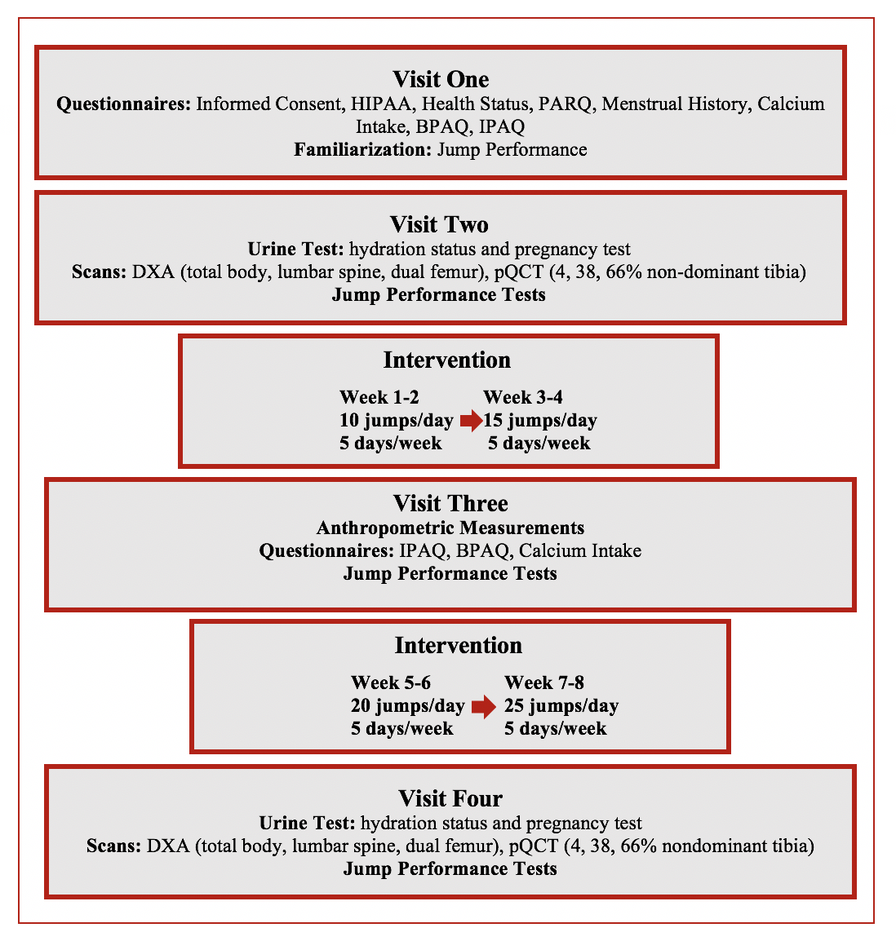
Figure 1. Overview of the Research Design

The study required the participants to visit the Bone Density Research Laboratory at the University of Oklahoma-Norman campus on four different occasions. The first visit consisted of the participants filling out an informed consent form and the appropriate HIPAA forms, health-related questionnaires that include: a Health Status Questionnaire, Bone-Specific Physical Activity Questionnaire (BPAQ), International Physical Readiness Questionnaire (IPAQ), calcium intake food frequency questionnaire, menstrual history questionnaire, and Physical Activity Readiness Questionnaire (PAR-Q). The Health Status Questionnaire included questions regarding age, gender, normal physical activity, and medications taken over the past six-months. The questionnaires also provided information about medical history and exclusion criteria for each woman. The first visit included informing the subject of how the DXA and pQCT test will be performed and what to expect from each test. In addition, the first visit included familiarization with the Tendo and the Just Jump mat so the subject understood what was expected of them when the research study began.
The second visit involved DXA scans of the proximal femur, the lumbar spine, and the total body. These scans took approximately twenty minutes to complete and required the subject to lay on the DXA as still as possible. Next, the subject was instructed to sit in a chair and have a pQCT scan performed at different sites of their tibia in order to determine the geometry of the subject’s bone. The pQCT scan took approximately eight minutes. After the scans were completed, the subject performed a maximal jump test using the Tendo and the Just Jump mat in order to measure the maximal power output, maximal velocity, jump height, and air time of the jump.
Once the pre-test was completed, the subject was informed that the eight-week testing period had begun. If they were in the jump group, the researchers reminded the subjects how to maximally jump and had them practice so the researchers can improve or critique their form. They were reminded to jump 10 times a day, five days a week for the first two weeks and then increase the number of jumps by five jumps every two weeks until the intervention period was completed. The repetition count, 10 jumps per day for the first two weeks then increasing by five jumps every two weeks was decided because magnitude of the exercise is more important than the number of trials performed. Additionally, the number of jumps increased every two weeks to ensure that there was progression in the intervention. The subjects were allowed to perform their daily maximal jumps on a hard, flat surface, such as tile or wood floors in their home or any building of their choosing. Additionally, the subjects could chose whether to jump in the morning or in the evening, but were be asked to keep the time-frame consistent throughout the study to increase compliance to the study. The subjects were sent a daily text message reminder every night at 8:00 pm to ensure that they jumped five times a week. The communication between the researchers and the participants allowed the participant to discuss any issues that arose, such as injuries, lack of compliance to the study, or complications with the protocol. If the subject was in the control group, they were told to continue their normal daily activities for the next eight-weeks until time for the mid-test and post-test.
The third visit, the mid-test, took place after four weeks and required the participants in both groups to return to the Bone Density Laboratory. The participants were asked to fill out the calcium intake questionnaire, BPAQ, and the IPAQ. After the questionnaires were completed, the participant’s weight was measured and they were asked to perform three jump tests in order to determine the jump height, jump power, jump velocity, and time in air. The mid-test was used to check for compliance over the course of the eight weeks as well as to ask the participants if there were any problems or issues they had when performing the jumps. The control group were reminded to continue their normal daily living for the remaining four weeks.
The fourth visit took place 8 weeks following the pre-test and was a repeat of the second visit. After the fourth visit, the subjects received a ten dollar Starbucks gift card as well as their DXA results and they were finished with the research study.

Bone-Specific Physical Activity Questionnaire (BPAQ)
This questionnaire instructed the subject to record any sport or physical activity they participated in regularly as well as the age they were when engaging in the activity from the age of one to their current age. Additionally, the questionnaire asked the subject to list any sport or physical activity they participated in regularly in the past twelve months and the average frequency (sessions per week). The goal of the questionnaire was to evaluate the past and current status of the bone-loading sports and physical activities of the subject and give a total, past, and current BPAQ score. The BPAQ is a good predictor of BMD and has been validated with other methods. The questionnaire is able to establish the effect of mechanical loading on site specific elements of the skeleton (Weeks & Beck, 2008).

International Physical Activity Questionnaire (IPAQ)
This questionnaire was used to determine the physical activities that participants engaged in as part of their everyday life. The questionnaire asked the subject in the past seven days how long they spent being physically active including activities they do around the house and yard, getting from place to place, and activities they do recreationally as well as sports or exercise they engage in. The goal of the questionnaire was to determine if the subject is designated into a low, moderate, or high intensity physical activity level. Other assessments of physical activity scores have been used to validate the IPAQ (Craig et al., 2003).

Calcium Intake Questionnaire
This questionnaire presented a list of food options and instructed the subject to record the number of servings of the particular food they consume in a week as well as daily in order to get an estimate of their calcium intake for the past year. In addition, the subjects were asked to list any dietary supplements they take daily/weekly, listing the brand name, amount (mg per dose), and total number of doses per day/week. The purpose of the questionnaire was to evaluate the daily amount of calcium (mg/day) that the subject consumed based on specific foods. The calcium intake questionnaire is based on a validated quantitative food frequency questionnaire (Musgrave, Giambalvo, Leclerc, Cook, & Rosen, 1989).

Menstrual History Questionnaire
This questionnaire instructed the subject to provide the researchers with a complete menstrual status and menstrual history. Questions regarding their menstrual status included frequency and length of their cycle, symptoms they have, and information about oral contraceptive use. Additional questions regarding their menstrual history included when their first menstrual cycle began, any irregularities or abnormalities in their cycle, and if any problems arose in which consultation with a doctor was necessary.

Anthropometric Measurements
The subject’s height was measured using a wall stadiometer (Novel products Inc., Rockton, IL) and rounded to the nearest half centimeter. The subject was instructed to remove their shoes, stand against the stadiometer with their heels against the wall, head facing forward, and arms at their side while holding their breath. Weight was measured using a digital weight scale (Tanita Corporation of America, Arlington Heights, IL) and recorded in kilograms. The subjects were instructed to remove their shoes, empty their pockets, and wear minimal clothing while recording their weight.

Hydration and Pregnancy Testing
The subject’s hydration status was measured by measuring a urine sample with an optical refractometer (VEE GEE CLX-1, Rose Scientific Ltd., Alberta, Canada) prior to testing with the DXA and pQCT. The refractometer was calibrated each day prior to testing to ensure for accurate results. Hydration status were evaluated by measuring the urine specific gravity of each subject. The researcher transferred 1-2 drops of urine onto the daylight prism of the refractometer, then closed the plate to allow for a thin layer of urine, free of gaps or air bubbles, to cover the daylight prism plate. The urine specific gravity was then read by holding the refractometer upwards into the light. This allowed the researchers to ensure that the subject’s hydration was within the accepted ranges (1.004-1.029 USG). If the subject’s hydration did not fall within the accepted ranges, it would affect the level of accuracy of the BMD measurements and the subject had to be rescheduled until returned to normal hydration levels.
A pregnancy test was also be conducted using test strips (SAS Pregnancy Strip, SAS Scientific, San Antonio, TX) prior to testing. To perform this test, the test strip was positioned vertically above the urine sample with the arrows pointing downward. The strip was then placed into the urine, making sure not to touch the stop line into the urine sample, for 15 seconds. Once removed, the strip was placed on a flat, non-absorbent surface for four minutes. After four minutes, the test strip was read to check if the results were negative or positive. None of the women had a positive pregnancy test.

Dual Energy X-Ray Absorptiometry (DXA)
DXA (GE Lunar Prodigy, Version 16, Madison, WI) was used to measure BMC (g) and BMD (g/cm²) of the total body, lumbar spine (L1-L4), and dual proximal femur. The DXA filter converts an x-ray beam into low (40 KeV) and high (70 KeV) energy peaks. During the total body scan, body composition variables including fat mass, fat free mass, bone free lean body mass, and percent body fat were measured. The x-ray attenuation after passing through tissue produces a scan image on the computer. The total radiation emitted by the DXA onto the subject was a minimal 0.05-1.5 mrem, which is comparable to spending an extra day in the sunlight each year. The DXA produces 2D images, meaning that it is unable to measure the thickness of the bone. Prior to testing each day, calibration and quality assurance (QA) procedures were completed according to the proper procedures per the given software. A calibration block of a known density was scanned during the QA in order to conduct a series of test to analysis the functional performance of the software.
The subject was instructed to lie on the DXA after removing shoes and any metal or jewelry they may have on during the scan. For positioning of the subjects, they had to lie supine in the middle of the DXA table with their hips and shoulders aligned. Three different scans were performed and took about twenty minutes to complete. The thickness of the participant at the navel determined the speed scan for the total body and lumbar spine scan. The precision, or reproducibility of the DXA scan, can be affected by the positioning of the participant on the table. Poor positioning can incorrectly increase or decrease the BMC measured by the software (Baim et al., 2005). To correct for the precision of the scan, each researcher underwent competency tests to ensure they understood the proper positioning of each test. For the total body, the subject positioned themselves supine in the middle of the table with their hips and shoulders aligned. Additionally, a Velcro strap was placed around their ankles and just below the knees to prevent their legs from moving. For the second scan, the lumbar spine (L1-L4), the researcher placed a foam block under the legs to ensure the spine is flat against the table and the hip joint is at a 45-90-degree angle. The subject then crossed their arms and moved their arms so they were perpendicular to the table and would not be seen in the scan. The scan measured from T12 to L5 vertebrae, meaning that when the scan began, the laser crosshairs were placed 2 cm below the umbilicus so the iliac crest and T12 vertebra was visible in the scan. The final scan on the DXA was the dual femur scan. The foam block from the previous test was removed and the participant’s feet were placed in the foot brace to allow internal rotation of the leg. This internal rotation allowed the femoral neck and femur to be properly exposed in the scan. The laser crosshairs were then placed 7-8 cm below the trochanter so the ischium was visible. In the Bone Density Research Laboratory, the coefficient of variation (%CV) for the precision and accuracy of the DXA for the total body BMD is 0.7%, the spine is 1.4%, the total left and right hip is 0.6%, the right trochanter is 0.6%, the left trochanter is 0.7%, the right femoral neck is 0.9%, and the left femoral neck is 1.01%. The %CV for the precision of the DXA for body composition variables is the percent body fat and fat mass is 2.0%, the bone free lean body mass is 1.9%, and the fat free mass is 1.7%.

Peripheral Quantitative Computed Tomography (pQCT)
A peripheral quantitative computed tomography XCT scanner with software version 6.0 (Stratec Medizintechnik GmbH, Pforzheim, Germany) was used to measure cortical BMC (mg/mm), cortical area (mm²), trabecular BMC (mg/mm), and trabecular area (mm²) of the tibia at the 4%, 38%, and 66% sites of the nondominant leg. The pQCT measurements allowed the technician to assess the thickness of cortical and trabecular bone and bone strength (SSI) at multiple bone sites. Additionally, calf muscle cross-sectional area at the 66% site was measured in order to determine if the training program had any effect on the CSA of the muscle in the leg. The pQCT can accurately measure small changes in the muscle CSA that can occur due to training programs (DeFreitas et al., 2010). Calibration and quality assurance of the pQCT took place prior to testing each day. The researcher measured the tibia length of the nondominant leg from the tibia plateau to the medial malleolus. Afterwards, the subject sat in the chair and placed their nondominant leg into the gantry of the pQCT machine. The subject’s information was entered into the pQCT and a scout view was run to identify the reference point at the medial malleolus. Once the reference point was set, the scans of the 4%, 38%, and 66% of the tibia were performed. The technicians were instructed and understood the proper placement and positioning of each leg before beginning the experiment in order to ensure for proper precision and reproducibility of the scans. Sharmga et al. determined that the pQCT was reliable and valid compared to a microCT in terms of being highly sensitive to cortical bone alterations (Scharmga et al., 2016). For the Bone Density Research Laboratory, the %CV for the 4% of the tibia total vBMD is 1.01%, the total vBMC is 1.19%, Peri C is 1.39%, the 38% for the tibia total vBMD is 0.21%, the vBMC is 0.33%, Peri C is 0.19%, the Endo C is 0.35%, Cort vBMD is 0.20%, the Cort vBMC is 0.36%, the Cort Area is 0.47%, the 66% of the tibia total vBMD is 0.67%, the total vBMC is 0.24%, the Peri C is 0.33%, the Endo C is 0.74%, the Cort vBMD is 0.25%, the Cort vBMC is 0.34%, and the Cort Area is 0.38%.

Jump Test Measurements
Jump velocity and power were measured using the Tendo FiTRODYNE power and speed analyzer (Tendo Sports Machines, Trencin, Slovak Republic), and jump height and air time were measured using a jump mat (Just Jump, Probotic, AL). During the first visit to the laboratory, the subject had a familiarization session prior to the actual testing to allow the subject to understand the motion of the countermovement jump and to become comfortable with the action.
The jump tests were performed during the first and fourth visits after the DXA and pQCT scans as well as during the mid-test visit. Their height and weight were measured while wearing shoes and a transfer belt. Three practice countermovement jumps were performed by having the participant crouch down and jump maximally with non-restrictive arm movements, making sure they cushion their landing. The technician checked that the subject did not tuck the feet under nor did she squat too far when landing. To set up the test, the jump mat was placed on a level surface, the transfer belt was placed snugly around the subject’s waist, and the tether from the Fitrodyne was securely attached to the belt near the iliac crest. The barbell from the Fitrodyne was placed parallel to the jump mat on a level surface, but at a distance to ensure that the subject did not land on it. To perform the test, the subject stood in the middle of the jump mat with their feet shoulder-width apart, crouched down, then jumped maximally with non-restrictive arm movements, and landed on the mat. The FiTRODYNE recorded the power (watts) and velocity (meters/seconds) of the jump while the Just Jump device recorded the jump height (inches) and air time of the jump (seconds). The subject was then instructed to perform three maximal jumps with one-minute rest between each jump. The variables from the jumps were recorded in on the subject’s data sheet and the average of each variable will be used for the data analysis. Intraclass Correlations (ICCs) values for the jump power, velocity, air time, and jump height range from 0.80-0.98 for the Bone Density Research Laboratory.
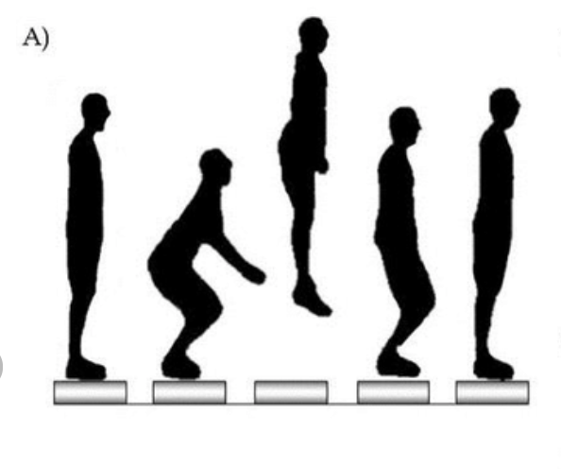
Figure 2. Overview of the Maximal Countermovement Jump.

Statistical Analysis
All statistical procedures were performed using IBM SPSS 24 (SPSS Inc., Chicago, IL) software. All descriptive data were reported as mean ± SD. Dependent variables were checked for normality using the Shapiro-Wilks test. Independent t-tests were performed to determine the differences between the jump intervention group and the control group for physical characteristics, BMD, BMC, bone geometry, jump power, and jump height at baseline. If significant group differences were detected, those baseline variables will be used as covariates in subsequent analyses. Two-way repeated measures ANOVA (group × time) with a Bonferroni post hoc test were performed to determine group differences in changes in the dependent variables from pre to post intervention. If a significant group × time interaction was found, the model was decomposed by performing paired t-tests comparing time points within each group. Independent T-tests were used to analyze the percent changes of the variables when there were two timepoints, if there were three timepoints, a two-way repeated measure ANOVA was utilized in order to determine the level of significances. The level of significance was be set at p<0.05.

Chapter 4: Results and Discussion
The purposes of this study were to: (1) compare bone mineral density before and after an eight-week low-repetition, high-impact loading jump intervention in premenopausal women between the ages of 18-21, (2) compare bone geometry before and after the intervention to determine alterations, and (3) compare cross-sectional area of the muscle in the lower limb before and after the intervention.

Participant Characteristics
A total of 20 participants (Intervention n=10, Controls n=10) between the ages of 18-24 years completed the study and were included in the final analysis. Nine females had signed consent forms but were excluded from the study due to an age that exceeded the inclusion criterion (n=1), exercised more than the inclusion criterion (n=4), medications that altered bone geometry (n=1), had surgery in the past year (n=1), and voluntarily withdrew from the study (n=2). Of the females enrolled, two reported having an IUD while seven reported taking hormonal contraceptives. Of the participants not taking hormonal contraceptives, 9 participants reported having regular menstrual cycles while two participants reported having an irregular menstrual cycle. There were no significant height or weight differences between the two groups. Leg dominance was determined by asking the participants which foot they kicked a ball with. Nineteen participants reported being right footed while only one participant reported being left footed. The majority of participants self-identified as Caucasian (n= 17); other ethnicities represented were Black (n=2) and Asian (n=1). No participants reported any signs or symptoms of any bone injuries throughout the eight-week intervention period. Participants did not report compliance on their jumps, it was not stated if a subject did not jump on days they were required to.
Baseline participant characteristics are found in Table 1. No significant differences existed between the two groups for age, height, weight, calcium intake, or past, current, or total BPAQ scores (all p≥0.121). Additionally, no significant group differences were found for total MET minutes/week and total walking/week, as assessed by the International Physical Activity Questionnaire. Calcium intake group means were below the recommended 1000 mg/day for 18 participants (n=9 from both groups) (Quann, Fulgoni, & Auestad, 2015).
Table 1. Baseline Participant Characteristics (means ± SD)
 | Time | Intervention (n=10) | Controls (n=10)
Age (years) |  | 20.50 ± 2.12 | 20.50 ± 2.22
Height (cm) |  | 165.00 ± 7.96 | 166.85 ± 5.81
Weight (kg) |  | 65.86 ± 7.34 | 71.39 ± 14.83
Calcium Intake (mg/day) | Pre | 665.92 ± 263.99 | 746. 92 ± 685. 06
 | Post | 607.50 ± 232.68 | 641.71 ± 369.41
BPAQ-Past |  | 48.99 ± 45. 90 | 80.88 ± 73.51
BPAQ-Current | Pre | 14.83 ± 15.84 | 9.10 ± 10.83
 | Mid | 12.88 ± 16.40 | 7.55 ± 10.51
 | Post | 9.31 ± 11.37 | 2.24 ± 5.28
BPAQ-Total | Pre | 31.92 ± 26.81 | 44.99 ± 37.77
 | Mid | 30.11 ± 26.22 | 44.22 ± 35.76
 | Post | 26.71 ± 19.75 | 39.56 ± 35.65
Total MET (min/week) | Pre | 2414.55 ± 2151.89 | 4088.50 ± 3077.26
 | Mid | 2031.05 ± 2327.22 | 3284.25 ± 3640.52
 | Post | 3695.85 ± 4628.72 | 3405.90 ± 3705.09
Total Walking/week | Pre | 1232.55 ± 1529.24 | 2805.00 ± 2147.55
 | Mid | 1315.05 ± 1495.80 | 1955.25 ± 2260.82
 | Post | 1631.85 ± 1723.11 | 1824.90 ± 1910.82
BPAQ: Bone Physical Activity Questionnaire

Dual Energy X-Ray Absorptiometry Measures
DXA was used to assess changes in aBMD and body composition for the total body, and site-specific areas. There were no significant group differences in baseline DXA variables. Table 2 shows information pertaining to the two total body scans that were completed pre and post the eight-week intervention period. No significant group x time interactions or main effects for time or group were found for total body aBMD, BMC, percent fat mass, fat mass, total body bone free lean body mass, or fat free mass (all p≥ 0.105). No significant time effects were found for total body aBMD, BMC, percent body fat, fat mass, bone free lean body mass, or fat free mass (all p≥0.068). Based on the International Society for Clinical Densitometry guidelines, all participants had normal aBMD values according to their Z-Scores (Lewiecki, Baim, Langman, & Bilezikian, 2009).
 | Time | Intervention (n=10) | Controls (n=10)
Total Body aBMD (g/cm²) | Pre | 1.206 ± 0.077 | 1.226 ± 0.058
 | Post | 1.186 ± 0.088 | 1.227 ± 0.057
Total Body BMC (g) | Pre | 2598.97 ± 403.78 | 2673.69 ± 278.41
 | Post | 2607.38 ± 403.40 | 2684.83 ± 270.11
Total Body % Fat | Pre | 33.91 ± 6.88 | 35.62 ± 8.59
 | Post | 34.47 ± 7.12 | 36.16 ± 8.70
Total Body Fat Mass (kg) | Pre | 22.33 ± 5.93 | 26.21 ± 11.32
 | Post | 22.57 ± 6.37 | 26.44 ± 11.09
Total Body BFLBM (kg) | Pre | 40.30 ± 4.68 | 41.79 ± 3.52
 | Post | 39.72 ± 4.66 | 41.70 ± 3.98
Fat Free Mass (kg) | Pre | 42.89 ± 4.98 | 43.68 ± 4.37
 | Post | 42.38 ± 4.94 | 43.38 ± 4.34
Table 2. Total Body aBMD and Body Composition Over Time (mean ± SD)
aBMD: Areal Bone Mineral Density
BMC: Bone Mineral Content
BFLBM: Bone Free Lean Body Mass

Regional aBMD and body composition information is shown in Table 3. There were no significant group differences at baseline for DXA variables. No significant main effects for time or group or group x time interactions were found for dominant leg fat mass, dominant leg lean mass, nondominant leg fat mass, or nondominant leg lean mass. Additionally, there were no significant main effects for time or group, or group x time interactions for right arm fat mass, right arm lean mass, left arm fat mass, or left arm lean mass (all p≥ 0.180). There were no significant time effects for dominant leg fat mass, dominant leg lean mass, nondominant leg fat mass, nondominant leg lean mass, for right arm fat mass, right arm lean mass, left arm fat mass, or left arm lean mass (all p≥0.076).
Table 3. Regional aBMD and Body Composition Over Time (means ± SD)
 | Time | Intervention (n=10) | Controls (n=10)
Dominant Leg Fat Mass (g) | Pre | 4414.10 ± 1280.12 | 5000.50 ± 2001.03
 | Post | 4257.00 ± 1199.80 | 5024.10 ± 1876.41
Dominant Leg Lean Mass (g) | Pre | 6081.30 ± 964.75 | 6924.55 ± 873.81
 | Post | 6611.50 ± 866.39 | 6804.90 ± 861.29
Nondominant Leg Fat Mass (g) | Pre | 4329.90 ± 1215.20 | 4929.80 ± 2001.99
 | Post | 4245.80 ± 1244.45 | 4930.60 ± 1869.19
Nondominant Leg Lean Mass (g) | Pre | 6687.40 ± 884. 27 | 6811.55 ± 839.92
 | Post | 6574.70 ± 826.70 | 6716.35 ± 829.03
Right Arm Fat Mass (g) | Pre | 1109.40 ± 375.95 | 1206.75 ± 514.36
 | Post | 1127.10 ± 392.14 | 1229.80 ± 508.17
Right Arm Lean Mass (g) | Pre | 2281.30 ± 256.69 | 2372.05 ± 345.64
 | Post | 2279.90 ± 260.84 | 2341.15 ± 294.58
Left Arm Fat Mass (g) | Pre | 1071.90 ± 356.71 | 1177.90 ± 515.26
 | Post | 1093.60 ± 373.55 | 1209.35 ± 528.11
Left Arm Lean Mass (g) | Pre | 2202.10 ± 206.83 | 2264.00 ± 265.34
 | Post | 2215.40 ± 235.34 | 2288.25 ± 292.59

Lumbar Spine (L1-L4) and dual hip aBMD variables are shown in Table 4. There were no significant group differences at baseline for lumbar spine and dual hip aBMD DXA variables. No significant group x time interactions, or main effects for time or group were found for lumbar spine (L1-L4) aBMD or BMC (all p≥0.105). Additionally, no group x time interactions or main effects for time or group were found for any dominant and nondominant hip aBMD variables (all p≥0.105). There were no significant time effects for any lumbar spine variables or dominant and nondominant hip variables (all p≥0.274). Calcium intake was significantly positively correlated with dominant femoral neck aBMD at the pre (r=0.455, p=0.042) and post (r=0.472, p=0.036) time points.
Table 4. Lumbar Spine and Dual Hip aBMD Over Time (means ± SD)
 | Time | Intervention (n=10) | Controls (n=10)
Lumbar Spine (L1-L4) aBMD (g/cm²) | Pre | 1.253 ± 0.109 | 1.132 ± 0.148
 | Post | 1.258 ± 0.110 | 1.317 ± 0.147
Dominant
Femoral Neck (g/cm²) | Pre | 1.116 ± 0.074 | 1.199 ± 0.138
 | Post | 1.106 ± 0.071 | 1.207 ± 0.132
Trochanter (g/cm²) | Pre | 0.872 ± 0.043 | 0.890 ± 0.105
 | Post | 0.871 ± 0.035 | 0.882 ± 0.103
Total Hip (g/cm²) | Pre | 1.109 ± 0.066 | 1.152 ± 0.093
 | Post | 1.095 ± 0.064 | 1.149 ± 0.94
Non-Dominant
Femoral Neck (g/cm²) | Pre | 1.116 ± 0.089 | 1.177 ± 0.119
 | Post | 1.108 ± 0.101 | 1.179 ± 0.115
Trochanter (g/cm²) | Pre | 0.872 ± 0.055 | 0.897 ± 0.088
 | Post | 0.877 ± 0.051 | 0.891 ± 0.089
Total Hip (g/cm²) | Pre | 1.100 ± 0.073 | 1.143 ± 0.089
 | Post | 1.095 ± 0.069 | 1.139 ± 0.091

There were no significant group differences in percent changes in Lumbar Spine (L1-L4) aBMD from pre to post-time points (p=0.476).

Figure 3. Percent Change for Lumbar Spine (L1-L4) aBMD
X denotes mean, line denotes median, boxes denote the 25th and 75th quartiles.

There were no significant group differences for percent changes in dominant neck aBMD from pre to post-time points (p=0.748).

Figure 4. Percent Change in Dominant Neck aBMD
X denotes mean, line denotes median, boxes denote the 25th and 75th quartiles.
There were no significant group differences for percent changes in nondominant neck aBMD from pre to post-time points (p=0.300).

Figure 5. Percent Change in Non-dominant Neck aBMD
X denotes mean, line denotes median, boxes denote the 25th and 75th quartiles.

There were no significant group differences for percent changes in dominant trochanter aBMD from pre to post-time points (p=0.359).

Figure 6. Percent Change in Dominant Trochanter aBMD
X denotes mean, line denotes median, boxes denote the 25th and 75th quartiles.
There were significant group differences for percent changes in nondominant trochanter aBMD from pre to post-time points in which the intervention group increased over time and the control group decreased over time. (p=0.035).

Figure 7. Percent Change in Nondominant Trochanter aBMD
X denotes mean, line denotes median, boxes denote the 25th and 75th quartiles.

There were no significant group differences for percent changes in mean dominant total hip aBMD from pre to post-time points (p=0.268).

Figure 8. Percent Changes for Dominant Hip Total aBMD
X denotes mean, line denotes median, boxes denote the 25th and 75th quartiles.

There were no significant group differences for percent changes in nondominant total hip aBMD from pre to post-time points (p=0.425).

Figure 9. Percent Change in Nondominant Hip Total aBMD
X denotes mean, line denotes median, boxes denote the 25th and 75th quartiles.

Hip Structural Analysis variables over time are shown in Table 5. There were no significant group differences for hip structural variables at baseline. There were no significant group x time interactions, or main effects for time or group were found in dominant and nondominant hip variables for strength index, buckling ratio, section modulus, or cross-section moment of inertia (all p≥ 0.095). There were significant time effects for the dominant hip section modulus (p=0.022) and cross-section moment of inertia (p=0.030) with both groups significantly decreasing over time.

Table 5. Hip Structural Analysis Variables Over Time (means ± SD)
 | Time | Intervention (n=10) | Controls (n=10)
Dominant Hip
Strength Index | Pre | 1.670 ± 0.562 | 1.520 ± 0.301
 | Post | 1.690 ± 0.360 | 1.530 ± 0.283
Buckling Ratio | Pre | 2.700 ± 0.986 | 2.200 ± 1.013
 | Post | 2.500 ± 0.897 | 2.630 ± 1.124
Section Modulus (mm³) | Pre | 714.320 ± 186.179 | 728.590 ± 80.949
 | Post | 698.880 ± 149.949* | 687.460 ± 65.146*
CSMI (mm⁴) | Pre | 10767.100 ± 4187.241 | 10184.700 ± 1472.188
 | Post | 10487.300 ± 3376.704* | 9500.400 ± 1027. 685*
Non-Dominant Hip
Strength Index | Pre | 1.570 ± 0.340 | 1.540 ± 0.320
 | Post | 1.600 ± 0.170 | 1.550 ± 0.217
Buckling Ratio | Pre | 2.210 ± 0.968 | 2.420 ± 1.203
 | Post | 2.660 ± 0.938 | 2.310 ± 0.893
Section Modulus (mm³) | Pre | 688.030 ± 138.910 | 690.410 ± 59.062
 | Post | 673.920 ± 143.447 | 702.100 ± 56.903
CSMI (mm⁴) | Pre | 10045.000 ± 2918.481 | 9832.400 ± 1366.255
 | Post | 10154.500 ± 2792.040 | 9730.500 ± 1442.144
CSMI: Cross-Section Moment of Inertia
*p≤0.05 significant vs pre

There were no significant differences for percent changes in mean dominant hip section modulus from pre to post-time points (p=0.221).

Figure 10. Percent Changes for Dominant Hip Section Modulus
X denotes mean, line denotes median, boxes denote the 25th and 75th quartiles.

There were no significant group differences for percent changes in mean dominant hip CSMI from pre to post-time points (p=0.763).

Figure 11. Percent Changes for Dominant Hip CSMI
X denotes mean, line denotes median, boxes denote the 25th and 75th quartiles.

Peripheral Quantitative Computed Tomography Measures

Tables 6-8 show the changes over time in pQCT variables from the 4%, 38%, and 66% non-dominant tibia sites. There were no significant group differences for pQCT variables at baseline. No significant main effects for group or time, or group x time interactions were found for any of the 4% site of the nondominant tibia (all p≥0.134), including total and trabecular BMC, vBMD, area, bone strength index, and the periosteal circumference. Additionally, there were no significant time effects for the variables of the 4% site of the nondominant tibia (all p≥0.1919).
Table 6. 4% Non-Dominant Tibia pQCT Variables Over Time (means± SD)
 | Time | Intervention (n=10) | Controls (n=10)
Total
BMC (mg/mm) | Pre | 318.135 ± 53.202 | 322.757 ± 40.588
 | Post | 318.483 ± 53.546 | 320.948 ± 40.915
vBMD (mg/cm³) | Pre | 325.920 ± 46.198 | 318.940 ± 46.178
 | Post | 325.000 ± 47.027 | 318.480 ± 46.359
Area (mm²) | Pre | 978.608 ± 110.415 | 1016.608 ± 77.699
 | Post | 983.696 ± 118.145 | 1012.352 ± 78.382
BSI (mg²/mm⁴) | Pre | 105.387 ± 30.241 | 104.340 ± 27.030
 | Post | 105.180 ± 30.366 | 103.628 ± 26.978
Trabecular
BMC (mg/mm) | Pre | 210.961 ± 38.707 | 223.780 ± 32.977
 | Post | 212.025 ± 38.616 | 222.490 ± 33.151
vBMD (mg/cm³) | Pre | 268.650 ± 40.886 | 270.890 ± 44.167
 | Post | 268.730 ± 40268 | 270.420 ± 44.692
Area (mm²) | Pre | 787.648 ± 99.367 | 830.544 ± 74.921
 | Post | 792.416 ± 106.622 | 827.312 ± 74.877
BSI (mg²/mm⁴) | Pre | 57.746 ± 17.853 | 61.685 ± 18.503
 | Post | 57.976 ± 17.709 | 61.262 ± 18.624
Periosteal Circ. (mm) | Pre | 110.73 ± 6.29 | 111.84 ± 5.40
 | Post | 111.00 ± 6.69 | 111.86 ± 5.60
BMC: Bone Mineral Content BSI: Bone Strength Index
vBMD: Volumetric Bone Mineral Density Circ.: Circumference

Table 7 shows the nondominant tibia pQCT variables for the 38% site. There were no significant group variables for the 38% site of the tibia at baseline. There were no significant main effects for group or time, or group x time interactions for any of the variables of the 38% site of the nondominant tibia (all p≥0.223) including total and cortical BMC, vBMD, area, cortical thickness, periosteal circumference, endosteal circumference, iPolar, and stress strain index. Additionally, there were no significant time effects for the variables at the 38% site (all p≥0.211).
Table 7. 38% Non-Dominant Tibia pQCT Variables Over Time (means± SD)
 | Time | Intervention (n=10) | Controls (n=10)
Total
BMC (mg/mm) | Pre | 326.461 ± 53.645 | 342.948 ± 42.229
 | Post | 326.719 ± 52.976 | 343.147 ± 41.547
vBMD (mg/cm³) | Pre | 957.940 ± 43.643 | 958.090 ± 58.253
 | Post | 958.510 ± 45.159 | 957.310 ± 59.315
Area (mm²) | Pre | 340.896 ± 55.339 | 359.968 ± 56.164
 | Post | 340.944 ± 54.209 | 360.560 ± 56.117
Cortical
BMC (mg/mm) | Pre | 313.655 ± 51.617 | 331.561 ± 41.580
 | Post | 314.145 ± 50.947 | 331.765 ± 40.857
vBMD (mg/cm³) | Pre | 1185.750 ± 15.740 | 1189.850 ± 21.518
 | Post | 1185.230 ± 12.003 | 1188.180 ± 24.153
Area (mm²) | Pre | 264. 688 ± 44. 826 | 279.104 ± 38.515
 | Post | 265.088 ± 43.358 | 279.712 ± 38.281
Thickness (mm) | Pre | 5.498 ± 0.662 | 5.647 ± 0.445
 | Post | 5.512 ± 0.639 | 5.656 ± 0.429
Periosteal Circ. (mm) | Pre | 65.255 ± 5.334 | 67.076 ± 5.196
 | Post | 65.268 ± 5.226 | 67.132 ± 5.191
Endosteal Circ. (mm) | Pre | 30.712 ± 4.014 | 31.593 ± 4.478
 | Post | 30.633 ± 4.068 | 31.593 ± 4.478
iPolar (mm⁴) | Pre | 20375.982 ± 6705.018 | 22003.777 ± 6422.248
 | Post | 20354.056 ± 6667.516 | 22060.205 ± 6364.701
SSI (mm³) | Pre | 1412.328 ± 351.283 | 1542.741 ± 312.412
 | Post | 1403.053 ± 340.621 | 1542.567 ± 307.460
BMC: Bone Mineral Content Circ.: Circumference
vBMD: Volumetric Bone Mineral Density SSI: Stress Strain Index
Table 8 shows the nondominant tibia pQCT variables of the 66% site. There were no significant group differences for the 66% site of the tibia at baseline. There were no significant group x time interactions or main effects for group or time for total and cortical BMC, area, cortical thickness, periosteal circumference, endosteal circumference, iPolar, stress strain index, or muscle cross sectional area (all p≥0.085). There was a significant group x time interaction for total vBMD (p=0.043) as the control group decreased in total vBMD over time while the intervention group increased in total vBMD over time. There was a significant time effect for total BMC (p= 0.028) and cortical BMC (p=0.037) as both groups had an increase in the variables over time.

Table 8. 66% Non-Dominant Tibia pQCT Variables Over Time (means± SD)
 | Time | Intervention (n=10) | Controls (n=10)
Total
BMC (mg/mm) | Pre | 358.332 ± 61.315 | 376.294 ± 38.720
 | Post | 359.336 ± 61.349* | 376.429 ± 38.570*
vBMD (mg/cm³)† | Pre | 741.130 ± 54.733 | 734.850 ± 56.096
 | Post | 743.010 ± 53.793* | 733.480 ± 56.331*
Area (mm²) | Pre | 484.816 ± 84.236 | 514.576 ± 64. 012
 | Post | 485.008 ± 84.786 | 515.680 ± 63.396
Cortical
BMC (mg/mm) | Pre | 325.420 ± 54.988 | 343.514 ± 35.287
 | Post | 326.460 ± 55.021* | 343.919 ± 35.251*
vBMD (mg/cm³) | Pre | 1150.520 ± 14.650 | 1153.240 ± 23.440
 | Post | 1150.290 ± 11.508 | 1152.540 ± 21.478
Area (mm²) | Pre | 282.960 ± 48.779 | 298.368 ± 35.424
 | Post | 283.872 ± 48.410 | 298.864 ± 35.002
Thickness (mm) | Pre | 4.415 ± 0.545 | 4.515 ± 0.415
 | Post | 4.343 ± 0.545 | 4.519 ± 0.422
Periosteal Circ. (mm) | Pre | 77.789 ± 6.767 | 80.274 ± 4.982
 | Post | 77.802 ± 6.797 | 80.364 ± 4.934
Endosteal Circ.(mm) | Pre | 50.048 ± 5.942 | 51.903 ± 5.061
 | Post | 49.942 ± 6.087 | 51.969 ± 5.140
iPolar (mm⁴) | Pre | 35701.333 ± 11973.456 | 39148.889 ± 9516.589
 | Post | 35739.463 ± 11990.101 | 39136.185 ± 9448.099
SSI (mm³) | Pre | 2106.059 ± 507.615 | 2300.964 ± 366.140
 | Post | 2111.279 ±514.030 | 2308.397± 370.585
Muscle CSA (mm²) | Pre | 6997.248 ±1199.7 | 6976.612 ±1222.981
 | Post | 6962.624± 1200.210 | 7028.688 ±1128.129
BMC: Bone Mineral Content Circ.: Circumference
vBMD: Volumetric Bone Mineral Density SSI: Stress Strain Index
*p≤0.05 Significant vs pre
† p≤0.05 Significant Group x Time Effect

There were no significant group differences for percent changes in mean 66% tibia total BMC from pre to post-time points (p=0.254).

Figure 12. Percent Changes for 66% Tibia Total BMC
X denotes mean, line denotes median, boxes denote the 25th and 75th quartiles.

There were no significant group differences for percent changes in mean 66% tibia total vBMD from pre to post-time points (p=0.171).

Figure 13. Percent Changes for 66% Tibia Total vBMD
X denotes mean, line denotes median, boxes denote the 25th and 75th quartiles.

There were no significant group differences for percent changes in mean 66% tibia cortical BMC from pre to post-time points (p=0.054), however, there was a trend.

Figure 14. Percent Changes for 66% Tibia Cortical BMC
X denotes mean, line denotes median, boxes denote the 25th and 75th quartiles.

Jump Test Measurements

Maximal jump variables were the highest value the subject achieved in the three jumps, while the average variable was the average of the three trials. There were no significant group differences for jump variables at baseline. There were no significant group x time interactions or main effects for group or time for average and maximal jump height, time in air, jump power, and jump velocity (all p≥0.147). There was a significant time effect for maximal jump height (p=0.031), which decreased from mid to post in both the control group and the intervention group. Additionally, there was a significant time effect for average jump height (p=0.041) and average jump time (p=0.028) with both groups increasing from pre to mid time points.

Table 9. Jump Variables Over Time (means± SD)
 | Time | Intervention (n=10) | Controls (n=10)
Average Jump Height (cm) | Pre | 32.08 ± 3.51 | 32.92 ± 3.33
 | Mid | 33.38 ± 4.93* | 34.16 ± 2.84*
 | Post | 33.12 ± 4.22 | 33.40 ± 3.38
Average Time in Air (s) | Pre | 0.51 ± 0.03 | 0.51 ± 0.02
 | Mid | 0.52 ± 0.04* | 0.52 ± 0.02*
 | Post | 0.51 ± 0.03 | 0.52 ± 0.03
Average Jump Power (W) | Pre | 755.16 ± 159.23 | 801.46 ± 245.94
 | Mid | 760.67 ± 163.28 | 868.03 ± 206.61
 | Post | 769.73 ± 174.45 | 822.47 ± 194.75
Average Jump Velocity (m/s) | Pre | 1.17 ± 0.20 | 1.13 ± 0.13
 | Mid | 1.18 ± 0.22 | 1.23 ± 0.10
 | Post | 1.21 ± 0.19 | 1.17 ± 0.08
Max Jump Height (cm) | Pre | 32.31 ± 3.10 | 33.25 ± 3.67
 | Mid | 33.91 ± 5.00 | 35.05 ± 3.51
 | Post | 33.25 ± 4.04# | 33.22 ± 3.58#
Max Time in Air (s) | Pre | 0.51 ± 0.02 | 0.52 ± 0.03
 | Mid | 0.52 ± 0.04 | 0.53 ± 0.03
 | Post | 0.52 ± 0.03 | 0.52 ± 0.03
Max Power (W) | Pre | 791.50 ± 183.48 | 842.50 ± 260.93
 | Mid | 792.00 ± 184.38 | 897.90 ± 219.73
 | Post | 794.20 ± 180.62 | 861.50 ± 201.07
Max Jump Velocity (m/s) | Pre | 1.23 ± 0.23 | 1.18 ± 0.14
 | Mid | 1.22 ± 0.24 | 1.27 ± 0.11
 | Post | 1.25 ± 0.20 | 1.23 ± 0.09
*p≤0.05 significant vs pre
#p≤0.05 significant vs mid

.

There were no significant group differences for percent changes in mean jump height from the pre to mid-test or the pre to post-test (all p≥0.172).

Figure 15. Percent Changes for Jump Height Pre to Mid-Test and Pre to Post-Test
X denotes mean, line denotes median, boxes denote the 25th and 75th quartiles.

There were no significant group differences for percent changes in mean jump time from the pre to mid-test or the pre to post-test (all p=0.127).

Figure 16. Percent Changes for Jump Time Pre to Mid-Test and Pre to Post-Test
X denotes mean, line denotes median, boxes denote the 25th and 75th quartiles.

Discussion

The purposes of this study were to: (1) compare bone mineral density before and after an eight-week low-repetition, high-impact loading jump intervention in premenopausal women between the ages of 18-21, (2) compare bone geometry before and after the intervention to determine alterations, and (3) compare cross-sectional area of the muscle in the lower limb before and after the intervention.

Areal Bone Mineral Density and Body Composition
In this study, the jump intervention was not effective for improving total body and site specific aBMD or BMC at any site. In a six-month study performed by Kato et al. college-aged women were asked to engage in 10 maximal countermovement jumps a day, 3-7 days per week (Kato et al., 2006a). By the end of the six months, the researchers found a significant increase in the aBMD of the femoral neck of the intervention group and no change in the aBMD of the femoral neck in the control group. These results contradicted those in the current study, where the intervention group had a decrease in femoral neck aBMD, and the control group observed an increase in aBMD of the femoral neck. This difference could be due to the short duration of the current study, whereas Kato et al. performed a jump intervention over a six-month period. They also observed a significant increase in the lumbar spine of the intervention group, whereas the current study found no significant differences in the lumbar spine. This could be due to the subjects not performing a true maximal countermovement jump and therefore not having an overload of strain on their spine. Since the current study was unsupervised, the subjects informed the researchers that they engaged in maximal countermovement jumps. However, they could have been jumping but not to their maximal ability (Kato et al., 2006a). The current study had subjects engaging in over 10 jumps as well as a progressive intervention in which they increased by 5 jumps every two weeks, whereas Kato and colleagues continued to have their subjects jump 10 times throughout the six months. The reason behind the current study increasing the participant’s jumps throughout the duration was to ensure that the body was not adapting to the unusual stress placed upon the bone and allow the sensitivity of the markers to continuously be overloaded. Unfortunately, even with the increase in the number of jumps completed, the current study did not find the same results as Kato et al. Due to the lack of supervision, it is possible that as the intervention continued, the participants may have decreased their efforts and did not adhere to the proper protocols.
Tucker et al. divided women between the ages of 25-50 into three groups (Tucker et al., 2015). The two jumping groups completed 10 CMJ and 20 CMJ twice per day for 16 weeks respectively and a sedentary control group was also included. Tucker et al. found that there was a significant increase in hip BMD and hip structural analysis (HSA) variables in the intervention groups compared to the control group, but there was no significant difference among the two intervention groups. The data suggest that both CMJ groups performed a sufficient volume of exercise to elicit a positive bone remodeling response (Tucker et al., 2015). In the current study, no significant group x time interactions were found from the HSA variables. The changes in the hip BMC were likely too small to translate into significant differences in hip structural analysis measure. There was a significant time effect found for the Section Modulus and CSMI for the dominant hip with a decrease in both groups over time. The lack of significance found in the BMC of the femur could be due to the participants not engaging in their true maximal countermovement jump, and therefore not placing enough strain on the bone to elicit a response. The subjects were not required to demonstrate their maximal jumps to the researchers on a daily basis, nor were they asked if they engaged in their complete training set for each day. If the subjects were not placing a maximum strain on the bone, then an insufficient stimulus was sustained to result in consistent osteogenesis.
Bassey and Ramsdale performed a study in which premenopausal women were randomly separated into a control group in which they engaged in low-impact exercise and a treatment group that engage in high-impact exercises for six months (Bassey & Ramsdale, 1994). At the end of the six months, there was a significant group difference in the femoral neck BMD in which the treatment group increased. There were no significant differences in the lumbar spine BMD. This contradicted the current study which discovered no significant differences in the lumbar spine BMD, nor the femoral neck BMD. Studies have shown that maximal countermovement jump protocols provide enough of a landing ground reaction force to allow for a functional strain on the femur to cause an increase in BMD (Bassey & Ramsdale, 1994). The subjects of the current study were not compliant enough with the protocol to elicit an increase in BMD of the femoral neck and lumbar spine.
A meta-analysis combined studies in which premenopausal women jumped between 10-50 times a day, 3-7 days a week for 6-12 months. The consensus of the studies was that maximal countermovement jump studies in premenopausal women results in a significant increase in the BMD of the femoral neck, but no significant differences in the lumbar spine. It takes 3-6 months in order for bone turnover to take place and an increase in BMD to be noticeable on the DXA. There is a chance that the short duration of the current study was causing an increase in the BMD of the lumbar spine and dual femoral neck, however, the DXA would have been unable to detect the slight changes. Future studies are encouraged to lengthen the duration of the intervention period to maximize the effect of the femoral neck or lumbar spine. There is a threshold for bone turnover, and once it has been achieved, no more formation can occur, it is probable that the number of jumps in the current study were not enough to surpass the threshold. It could be possible that an increase in the number of jumps performed could have elicited a greater increase in the BMD variables of the lumbar spine and femoral neck (Zhao et al., 2014).
In this study, the jump intervention was not effective for improving total body BMC. The lack of significance could be due to the short duration of the intervention. Witzke & Snow (2000) saw similar results in which after their nine-month plyometric jump training in adolescent girls, there was an overall increase in total body BMC. The difference in nine-months versus eight-weeks may have been the reason that the current study did not see a significant difference in the increase in total body BMC between the two groups whereas Witzke saw a significant difference. Witzke saw significant changes with a small sample size (n=25), similar to the current study, but contradicted the results of the current study which did not find any significant changes in total body BMC (Witzke & Snow, 2000).
Body composition and total BMC improved in a 12-week intervention in which college-aged females were randomly divided into a multimodal intervention group or a rowing intervention group. The multimodal group performed exercises such as lunges and hurdle hops while the rowing group used a rowing ergometer throughout the 12 weeks. By the end of the intervention, both groups had a significant decrease in body fat percent, an increase in total body BMC, and an increase in lean mass (Brown et al., 2018). The current study analyzed no significant differences in either group for total body percent fat, total body BMC, or lean mass. The lack of findings for BMC could be due to the short duration of the intervention, or the jump protocol did not allow for a stress to be placed on bone throughout different areas of the body. Additionally, the participants of the study were sedentary and jumping 10-25 times a day would not cause them to be in a calorie deficit state and therefore would not change body composition. The jump intervention focused on straining the bones of the spine and the femur while neglecting to stress the arms. In order to see an increase in the total body BMC, exercises in which the total body is engaged are necessary. Additionally, there was no significant increase in lean mass, potentially due to the jump exercises not placing enough strain on the muscle of the legs to elicit an improvement. The jump exercise was not enough work placed upon the body to allow for more muscle cells to develop and increase the lean mass of the subjects.

Volumetric Bone Mineral Density
In this study, the jump intervention was not effective in improving the bone geometry of the 4% and 38% site of the nondominant tibia, the total and cortical BMC of the 66% site improved throughout the study as well as the vBMD in the intervention group. The lack of significant findings in the 4% and 38% site could be due to the short duration of the study or the small sample size observed. In a 13-week long study, Evans and colleagues found a group x time interaction for the trabecular vBMD at the 4% site of the tibia as well as a group x time effect at the 38% site for total area (Evans et al., 2012). The study divided 57 college-aged females into a sedentary control group and three groups which trained three days a week: resistance training, aerobic training, and a combined resistance and aerobic trained. At the 38% site, there was an increase in total area in the aerobic training group and the combined training group compared to the resistance training group and the control group. The 4% site of the tibia had a significant increase in the trabecular density in the aerobic and combined exercise groups compared to the resistance exercise and control group (Evans et al., 2012). The current study observed that the 4% trabecular vBMD remained the same in both the intervention group and control group over time. Additionally, the 38% total area of the tibia remained the same in both the intervention and control group. Evans et al. found no significant differences at the 66% site of the tibia (Evans et al., 2012). This could be due to the current study placing a higher load on the cortical bone at the 66% site that bone turnover was activated. The differences in the exercises shown in the study performed by Evans et al. and the jumps from the current study place strains on different parts of the tibia, allowing for different bone alterations to occur. However, the 4% site of the tibia contains more trabecular bone and is more metabolically active than trabecular bone, therefore the 4% site of the tibia should have experienced more bone turnover and formation. The lack of significant change in the 4% site could be potentially the sample size was too small to observe a noticeable change or the jump intervention did not place a great enough load on the site. Additionally, it takes about eight weeks in bone remodeling to see a change in bone geometry on the pQCT, although this study was eight-weeks, it might not have been enough time for the changes to be noticeable on the pQCT.
Lester et al. observed differences in bone geometry pre and post an eight-week intervention (Lester et al., 2009). Fifty-six college-aged women were divided into four groups: control group, aerobic exercise group, resistance training group, and combined aerobic and resistance training group. All treatment groups exercised three times a week for the eight-week duration of the study. The researchers found a significant difference in the vBMD of the 4% site of the tibia. They also found no significant differences in the 38% and 66% site of the tibia. The current study found no significant group differences in the 4% site of the tibia after the eight-week intervention. The 4% site of the tibia had a significant difference in the study performed by Lester and colleagues due to the fact that the site is more metabolically active and bone remodeling takes about 8 weeks to occur, which was the timeframe of the study. In the current study, no change was found potentially due to the small sample size of 20 participants compared to 56 participants. Lester and colleagues also had all training protocols done in a supervised location, meaning that their participants were compliant with the intervention. The participants were also sedentary individuals, who were more responsive to the training protocol than sedentary individuals. Additionally, although both studies were eight weeks long, maybe more time was necessary in order to allow for bone turnover to complete and be detected by the pQCT. Lester et al. saw no significant change in the 38% and 66% site of the tibia while the current study found a significant group difference in the vBMD of the tibia as well as significant time effects of the total and cortical BMC of the 66% site (Lester et al., 2009). The findings in the current study could be due to the maximal countermovement jump intervention placing a higher load on the 66% site of the tibia compared to the aerobic and resistance training exercises performed by Lester et al. This higher load could activate the bone formation at the 66% site which was detected by the pQCT.

Physical Performance
In this study, the jump intervention was effective in improving the average jump height and jump time in both groups while the maximal jump height decreased over time. Vlacholpoulos et al. reported that after nine months of a high-impact jump intervention, there was an increase, though not significant, for countermovement jump height, which was observed in the current study (Vlachopoulos et al., 2018). They had 93 adolescent male athletes perform 20 maximal countermovement jumps four times a day, four times a week for nine months. The lack of significant group x time effect in the current study could be due to the fact that all participants were sedentary, and therefore at the same physical level at baseline. However, by the end of the eight weeks, the intervention group had been engaging in multiple jumps a week for eight weeks and therefore would be more likely to improve their overall jump output variables. It is also possible that the controls increased their level of physical activity despite being encouraged to keep their activity levels the same throughout the eight weeks. Since the subjects were not asked to record their level of activity throughout the duration of the study, their activity levels could have increased, and the subjects did not feel inclined to inform the researchers. This could result in the lack of significant findings between the two groups at the end of the study.
Physically active men with osteopenia of the hip or spine participated in a study in which they were randomly placed in a resistance training group or a jump intervention group (Hinton et al., 2015). The resistance training group exercised twice a week that included exercises that load the hip and spine such as lunges, modified deadlifts, and squats. The jump protocol included exercises that involved single leg and double leg jumps and that varied by direction and intensity and performed them at a supervised location three times a week. At the end of the 12-month study, the participants in the jump intervention group increased their vertical jump height (Hinton et al., 2015). The current study had the same findings in that both the control group and intervention group significantly increase their vertical jump height on average throughout the duration of the study. The intervention group increased their height because they were consistently jumping five days a week and therefore better able to perform the exercise by the end of the eight weeks. The control group may have seen an increase in their jump height because it was their third time jumping for the study and they better understood what was expected and how to perform the jump. There also could have been a learning curve with the control group in which they got better each time they jumped because they were realizing their past mistakes and how to correct them.
In determining if a time effective HIIT protocol could have an osteogenic effect on bone metabolism, Brown et al. analyzed college-aged females participating in a multimodal HIIT protocol versus a rowing HIIT protocol (Brown et al., 2018). The multimodal HIIT protocol included exercises such as hurdle hops, lunges, and squats while the rowing HIIT protocol used the rowing ergometer. All participants went to the supervised location three times a week for the 12-week study duration. By the end of the study, both groups had an increase in overall muscular power of their jump (Brown et al., 2018). The current study found no significant differences between the average jump power at the end of the eight weeks versus baseline measurements. The lack of findings could be due to the participants giving their maximal effort at the beginning of the study, then not trying their best since the study was unsupervised, and they performed the exercises on their own throughout the study. Since the study was not supervised, the participants were able to perform the jumps how they wished and whether or not they were maximally performed was not documented.

Limitations
There are several weaknesses to consider for this study. The sample size was small which could have prevented finding any significance in the study and underestimated the significant changes between the two groups. The study duration should also be considered when interpreting the findings due to the fact that it generally takes four to six months to see changes in bone mineral density by DXA. It takes eight-weeks to see a change in bone geometry on the pQCT and the study should have been long enough to observe the changes, but no changes were detected, meaning the protocol was not effective in improving bone geometry of the tibia. The intervention group had to hold themselves accountable to jump every day on their own terms. They were sent a daily reminder in order to ensure that they engaged in the intervention and continuously jumped, however, it was up to the individual to perform the jump correctly as well as jump on a hard surface and complete the appropriate number of jumps each day. Unfortunately, compliance was not monitored throughout the study. They were asked at the mid-test if they were compliant with the protocol of the intervention and if they had any issues, but they did not record their jumps or issues with each individual jump day. The novelty of the intervention was that the subjects were unsupervised while performing each maximal countermovement jump, this was a limitation to the study because researchers are unsure if the subjects performed the jumps everyday as well as if they performed them to their maximal ability.

Chapter 5: Conclusions
The purposes of this study were to: (1) compare bone mineral density before and after an eight-week low-repetition, high-impact loading jump intervention in premenopausal women between the ages of 18-24, (2) compare bone geometry before and after the intervention to determine alterations, and (3) compare cross-sectional area of the muscle in the lower limb before and after the intervention.

Research Questions
- Will engaging in maximally jumping five days a week for eight weeks improve bone mineral density and bone mineral content in the lumbar spine, dual proximal femur, and total body density in college-aged females?
No, this unsupervised jump intervention did not improve BMD or BMC in the lumbar spine, dual proximal femur, and total body density in this cohort of females.
- Will the eight-week jumping intervention alter bone geometry in the 4%, 38%, and 66% tibia sites of the non-dominant leg?
No, this unsupervised jump intervention did not improve bone geometry in the 4% or 38% site of the non-dominant tibia in this cohort of females.
There was an increase in the vBMD of the 66% site of the non-dominant tibia of the intervention group compared to a decreased in the vBMD of the 66% site in the control group.
There was also an increase in total BMC and cortical BMC of the 66% site of the nondominant tibia for both groups.
- Will the jumping intervention increase cross-sectional area of the muscle at the tibia 66% site of the non-dominant leg?
No, this unsupervised jump intervention did not improve the cross-sectional area of the muscle at the 66% site of the tibia of the non-dominant leg in this cohort of females.
- Will the eight-week intervention increase vertical jump power output and velocity?
No, this unsupervised jump intervention did not improve the vertical jump power output and velocity in this cohort of females.

Clinical Significance
The current study found a significant group x time interaction for the 66% total vBMD of the non-dominant tibia in which the control group decreased while the intervention group increased. Thus, a maximal jump intervention increases bone mineral density and geometry in the 66% of the tibia of college-aged females. Although the protocol assigned for the current study may not be the ideal way to improve peak bone mass before the second decade of life, since total body, lumbar spine, and dual femur BMD was not improved. An increase in bone variables and peak bone mineral density could prevent or reduce the risk of fractures and osteoporosis later in life. Which is why an intervention program in which lumbar spine and dual femur BMD increase are important to research. The current study was an unsupervised program, in which the subjects engaged in the maximal jump protocol on their own without logging their jumps. The purpose of the study being unsupervised was to allow for college-aged females to be given a protocol in which they can improve their BMD while not having to go to the gym or spend hours a day engaging in osteogenic exercises. The lack of improvements in BMD and BMC found in this study could be due to compliance issues from the participants that would not have been an issue if the study was supervised. The subjects were asked to engage in the maximal countermovement jumps on their own time to their best ability. Since they were not supervised nor reported their jumps to the researchers, they were able to perform the jumps however they wished. The subjects may not have been performing maximal jumps when engaging in the intervention nor are the researchers aware if the subjects jumped five times a day. There were significant findings of the bone geometry in the tibia, which shows that the jump intervention has a potential to increase BMC of college-aged females. Additionally, the short duration prevented the DXA from analyzing improvements in BMD and BMC, but bone turnover could have started favoring bone formation and rebuilding bone that was absorbed. This study gives an intervention that is a feasible, inexpensive way for college-age females improve their bone health before reaching their peak, if they perform maximal countermovement jumps five days a week correctly.

Suggestions for Further Research
A larger sample size should determine the effects of a maximal jumping intervention on bone characteristics, a larger sample size should be utilized. The larger the sample size, the more accurate and observable the results from the DXA and pQCT will be and more significant differences between the groups may arise. A larger sample size in an intervention study, the more statistical power and the more likely a change will be detected in BMD and BMC from the intervention protocol. Additionally, a longer duration for the intervention should be considered when determining the effects on bone mineral density and bone geometry because it takes 4-6 months in order for bone formation to be observed due to high mechanical loads being placed upon the bone. The current study took place over eight weeks, which did not give enough time for bone formation to begin and be observed through the DXA. With a longer study, the differences in total body, lumbar spine, and dual femur BMD could be detected and analyzed to determine if the protocol provided significant differences between groups as well as from baseline. A weighted vest could be used to increase the overall weight of the subject in order to increase the load placed upon the ground reaction forces. With the use of a weighted vest, there can be a progression of the weight in order to continue to overload the ground reaction force and hopefully increase the change in BMD. The eight-week intervention may not have allowed the bone formation to be fully completed or activated. Supervision to the jump program would allow for more compliance and assurance that the participants engage in the protocol throughout the duration of the study. Without supervision to the protocol, a log or daily monitoring of the subject’s compliance would be beneficial. A record of how the subject performs each jump is necessary throughout the study to determine if they are constantly jumping to their maximal ability, or if they are altering how they perform the jump. Without supervision of the participants, there needs to be more assurance that they are completing the maximal jump intervention and complying to the exercise description. It would be beneficial in future research to supplement calcium intake to meet the recommended daily allowance of 1000 mg/day to ensure that there is sufficient calcium to support osteogenic processes.

References
Adams, J. E. (2013). Dual-Energy X-Ray Absorptiometry. In: Osteoporosis and Bone Densitometry Measurements. Springer. Berlin, Heidelberg, 2013. 101-122.
Allen, M. R., & Burr, D. B. (2014). Bone modeling and remodeling. In: David A. Burr, Matthew R. Allen (eds) Basic and Applied Bone Biology. Elsevier. Indianapolis, IN. 75-90.
Baim, S., Wilson, C. R., Lewiecki, E. M., Luckey, M. M., Downs Jr, R. W., & Lentle, B. C. (2005). Precision assessment and radiation safety for dual-energy x-ray absorptiometry: position paper of the international society for clinical densitometry. Journal Of Clinical Densitometry, 8(4), 371-378.
Bassey, E., & Ramsdale, S. (1994). Increase In Femoral Bone Density In Young Women Following High-Impact Exercise. Osteoporosis International, 4(2), 72-75.
Bauer, D. C. (2013). Investigation of metabolic bone diseases. In: Rosen CJ (ed) Primer on the metabolic bone diseases and disorders of mineral metabolism, 8th edn. Wiley-Blackwell, Ames Iowa, pp 249-250.
Blimkie, C., Rice, S., Webber, C., Martin, J., Levy, D., & Gordon, C. (1996). Effects of resistance training on bone mineral content and density in adolescent females. Canadian Journal Of Physiology And Pharmacology, 74(9), 1025-1033.
Bonewald, L. F. (2011). The amazing osteocyte. Journal Of Bone And Mineral Research, 26(2), 229-238.
Boyle, W. J., Simonet, W. S., & Lacey, D. L. (2003). Osteoclast differentiation and activation. Nature, 423(6937), 337.
Brown, E. C., Hew-Butler, T., Marks, C. R., Butcher, S. J., & Choi, M. D. (2018). The impact of different high-intensity interval training protocols on body composition and physical fitness in healthy young adult females. Bioresearch Open Access, 7(1), 177-185.
Burr, D., Yoshikawa, T., Teegarden, D., Lyle, R., Mccabe, G., Mccabe, L., & Weaver, C. (2000). Exercise and oral contraceptive use suppress the normal age-related increase in bone mass and strength of the femoral neck in women 18–31 years of age. Bone, 27(6), 855-863.
Carey, J. J., & Delaney, M. F. (2010). T-Scores and Z-Scores. Clinical Reviews In Bone And Mineral Metabolism, 8(3), 113-121.
Chiu, K. M., Ju, J., Mayes, D., Bacchetti, P., Weitz, S., & Arnaud, C. D. (1999). Changes In bone resorption during the menstrual cycle. Journal Of Bone And Mineral Research, 14(4), 609-615.
Clarke, B. L., & Khosla, S. (2010). Female reproductive system and bone. Archives Of Biochemistry And Biophysics, 503(1), 118-128.
Cohen, A., & Shane, E. (2009). Premenopausal osteoporosis. In: Rosen CJ (ed) Primer On The Metabolic Bone Diseases And Disorders Of Mineral Metabolism, Wiley-Blackwell, Ames Iowa, 289.
Cointry, G., Ferretti, J., Reina, P., Nocciolino, L., Rittweger, J., & Capozza, R. (2014). The Pqct “Bone Strength Indices”(Bsis, SSI). relative mechanical impact and diagnostic value of the indicators of bone tissue and design quality employed in their calculation in healthy men and pre-and post-menopausal women. Journal of Musculoskeletal Neuronal Interaction, 14(1), 29-40.
Colón-Emeric, C. S., & Saag, K. G. (2006). Osteoporotic fractures in older adults. Best Practice & Research Clinical Rheumatology, 20(4), 695-706.
Craig, C. L., Marshall, A. L., Sjorstrom, M., Bauman, A. E., Booth, M. L., Ainsworth, B. E., . . . Sallis, J. F. (2003). International Physical activity questionnaire: 12-country reliability and validity. Medicine And Science In Sports And Exercise, 35(8), 1381-1395.
Cromer, B. A., Bonny, A. E., Stager, M., Lazebnik, R., Rome, E., Ziegler, J., . . . Secic, M. (2008). Bone mineral density in adolescent females using injectable or oral contraceptives: a 24-month prospective study. Fertility And Sterility, 90(6), 2060-2067.
Defreitas, J. M., Beck, T. W., Stock, M. S., Dillon, M. A., Sherk, V. D., Stout, J. R., & Cramer, J. T. (2010). A comparison of techniques for estimating training-induced changes in muscle cross-sectional area. Journal Of Strength & Conditioning Research, 24(9), 2383-2389.
Ehrlich, P., & Lanyon, L. (2002). Mechanical strain and bone cell function: a review. Osteoporosis International, 13(9), 688-700.
Erickson, C. R., & Vukovich, M. D. (2010). Osteogenic index and changes in bone markers during a jump training program: a pilot study. Medicine And Science In Sports And Exercise, 42(8), 1485-1492.
Evans, R., Negus, C., Centi, A., Spiering, B., Kraemer, W., & Nindl, B. (2012). Peripheral QCT sector analysis reveals early exercise-induced increases in tibial bone mineral density. Journal of Musculoskeletal & Neuronal Interactions, 12(3), 155-164.
Favus, M. J. (2006). Primer On The Metabolic Bone Diseases And Disorders Of Mineral Metabolism: Rittenhouse Book Distributors.Wiley-Blackwell, Ames Iowa.
Forwood, M. R. (2013). Growing a healthy skeleton: the importance of mechanical loading. In: Rosen CJ (ed) Primer On The Metabolic Bone Diseases And Disorders Of Mineral Metabolism, 8th edn. Wiley-Blackwell, Ames Iowa, pp 149-155.
Frost, H. M. (1997). On our age‐related bone loss: insights from a new paradigm. Journal Of Bone And Mineral Research, 12(10), 1539-1546.
Gilsanz, V., Wren, T. A., Sanchez, M., Dorey, F., Judex, S., & Rubin, C. (2006). Low‐level, high‐frequency mechanical signals enhance musculoskeletal development of young women with low BMD. Journal Of Bone And Mineral Research, 21(9), 1464-1474.
Hadjidakis, D. J., & Androulakis, I. I. (2006). Bone remodeling. Annals Of The New York Academy Of Sciences, 1092(1), 385-396.
Hartard, M., Kleinmond, C., Wiseman, M., Weissenbacher, E. R., Felsenberg, D., & Erben, R. G. (2007). Detrimental effect of oral contraceptives on parameters of bone mass and geometry in a cohort of 248 young women. Bone, 40(2), 444-450.
Heinonen, A., Kannus, P., Sievänen, H., Oja, P., Pasanen, M., Rinne, M., . . . Vuori, I. (1996). Randomised controlled trial of effect of high-impact exercise on selected risk factors for osteoporotic ractures. The Lancet, 348(9038), 1343-1347.
Hinton, P. S., Nigh, P., & Thyfault, J. (2015). Effectiveness of resistance training or jumping-exercise to increase bone mineral density in men with low bone mass: a 12-month randomized, clinical trial. Bone, 79, 203-212.
Huiskes, R., Ruimerman, R., Van Lenthe, G. H., & Janssen, J. D. (2000). Effects of mechanical forces on maintenance and adaptation of form in trabecular bone. Nature, 405(6787), 704.
Kanis, J. A., Melton, L. J., Christiansen, C., Johnston, C. C., & Khaltaev, N. (1994). The diagnosis of osteoporosis. Journal Of Bone And Mineral Research, 9(8), 1137-1141.
Kato, T., Terashima, T., Yamashita, T., Hatanaka, Y., Honda, A., & Umemura, Y. (2006a). Effect of low-repetition jump training on bone mineral density in young women. Journal Of Applied Physiology, 100(3), 839-843.
Kelley, G. A., Kelley, K. S., & Kohrt, W. M. (2013). Exercise and bone mineral density in premenopausal women: a meta-analysis of randomized controlled trials. International Journal Of Endocrinology, 2013, 1-17.
Kontulainen, S., Johnston, J., Liu, D., Leung, C., Oxland, T., & Mckay, H. (2008). Strength indices from Pqct imaging predict up to 85% of variance in bone failure properties at tibial epiphysis and diaphysis. Journal of Musculoskeletal Neuronal Interaction, 8(4), 401-409.
Lanyon, L. (1987). Functional strain in bone tissue as an objective, and controlling stimulus for adaptive bone remodelling. Journal Of Biomechanics, 20(11-12), 1083-1093.
Lester, M. E., Urso, M. L., Evans, R. K., Pierce, J. R., Spiering, B. A., Maresh, C. M., . . . Nindl, B. C. (2009). Influence of exercise mode and osteogenic index on bone biomarker responses during short-term physical training. Bone, 45(4), 768-776.
Lewiecki, E. M., Baim, S., Langman, C. B., & Bilezikian, J. P. (2009). The official positions of the tnternational society for clinical densitometry: perceptions and commentary. Journal Of Clinical Densitometry, 12(3), 267-271.
Marcus, R., Feldman, D., Nelson, D., & Rosen, C. J. (2009). Fundamentals Of Osteoporosis: Academic Press, Cambridge, MA.
Matkovic, V., Jelic, T., Wardlaw, G. M., Ilich, J. Z., Goel, P. K., Wright, J. K., . . . Heaney, R. P. (1994). Timing of peak bone mass in caucasian females and its implication for the prevention of osteoporosis Journal Of Clinical Investigation, 93(2), 799-808.
Musgrave, K., Giambalvo, L., Leclerc, H., Cook, R., & Rosen, C. (1989). Validation of a quantitative food frequency questionnaire for rapid assessment of dietary calcium intake. Journal Of The American Dietetic Association, 89(10), 1484-1488.
Nomura, S., & Takano-Yamamoto, T. (2000). Molecular events caused by mechanical stress in bone. Matrix Biology, 19(2), 91-96.
Patlak, M. (2001). Bone builders: the discoveries behind preventing and treating osteoporosis. The FASEB Journal, 15(10), 1677e-1677e.
Quann, E. E., Fulgoni, V. L., & Auestad, N. (2015). Consuming the daily recommended amounts of dairy products would reduce the prevalence of inadequate micronutrient intakes in the united states: diet modeling study based on NHANES 2007–2010. Nutrition Journal, 14(1), 90.
Rauch, F., & Schoenau, E. (2008). Peripheral quantitative computed tomography of the proximal radius in young subjects—new reference data and interpretation of results. Journal of Musculoskeletal & Neuronal Interactions, 8(3),217-226.
Recker, R. R., Davies, K. M., Hinders, S. M., Heaney, R. P., Stegman, M. R., & Kimmel, D. B. (1992). Bone gain in young adult women. Journal of the American Medical Association, 268(17), 2403-2408.
Reid, I. R. (2013). Overview of pathogenesis. In: Rosen CJ (ed) Primer On The Metabolic Bone Diseases And Disorders Of Mineral Metabolism, Eighth Edition, 357-360.
Reiger, J., & Yingling, V. R. (2016). The effects of short-term jump training on bone metabolism in females using oral contraceptives. Journal Of Sports Sciences, 34(3), 259-266.
Ross, F. P. (2006). Osteoclast biology and bone resorption. In: Rosen CJ (ed) Primer On The Metabolic Bone Diseases And Disorders Of Mineral Metabolism, 6th ed. pp 30-35.
Rubin, C., Rubin, J., & Judex, S. (2009). . Exercise and the prevention of osteoporosis. In: Rosen CJ (ed) Primer On The Metabolic Bone Diseases And Disorders Of Mineral Metabolism, 227-231.
Schaffler, M. B., & Burr, D. B. (1988). Stiffness of compact bone: effects of porosity and density. Journal Of Biomechanics, 21(1), 13-16.
Scharmga, A., Peters, M., Van Tubergen, A., Van Den Bergh, J., De Jong, J., Loeffen, D., . . . Geusens, P. (2016). Visual detection of cortical breaks in hand joints. BMC Musculoskeletal Disorders, 17, 271-278.
Schoenau, E. (2005). From mechanostat theory to development of the" functional muscle-bone-unit". Journal Of Musculoskeletal And Neuronal Interactions, 5(3), 232-238.
Snow-Harter, C., & Marcus, R. (1991). 10 Exercise, bone mineral density, and osteoporosis. In: Roger M. Enoka (ed) Exercise And Sport Sciences Reviews, 19(1) Philadelphia, PA, 351-388.
Swinford, R. R., & Warden, S. J. (2010). Factors affecting short-term precision of musculoskeletal measures using peripheral quantitative computed tomography (pQCT). Osteoporosis International, 21(11), 1863-1870.
Teegarden, D., Proulx, W. R., Martin, B. R., Zhao, J., Mccabe, G. P., Lyle, R. M., . . . Weaver, C. M. (1995). Peak bone mass in young women. Journal Of Bone And Mineral Research, 10(5), 711-715.
Tucker, L. A., Strong, J. E., Lecheminant, J. D., & Bailey, B. W. (2015). Effect of two jumping programs on hip bone mineral density in premenopausal women: a randomized controlled trial. American Journal Of Health Promotion, 29(3), 158-164.
Turner, C. (1998). Three rules for bone adaptation to mechanical stimuli. Bone, 23(5), 399-407.
Umemura, Y., Ishiko, T., Yamauchi, T., Kurono, M., & Mashiko, S. (1997). Five jumps per day increase bone mass and breaking force in rats. Journal Of Bone And Mineral Research, 12(9), 1480-1485.
Vainionpää, A., Korpelainen, R., Leppäluoto, J., & Jämsä, T. (2005). Effects of high-impact exercise on bone mineral density: a randomized controlled trial in premenopausal women. Osteoporosis International, 16(2), 191-197.
Vlachopoulos, D., Barker, A. R., Ubago-Guisado, E., Williams, C. A., & Gracia-Marco, L. (2018). The effect of a high-impact jumping intervention on bone mass, bone stiffness and fitness parameters in adolescent athletes. Archives Of Osteoporosis, 13(1), 128-140.
Wallace, B., & Cumming, R. (2000). Systematic review of randomized trials of the effect of exercise on bone mass in pre-and postmenopausal women. Calcified Tissue International, 67(1). St. Louis, MO, 10-18.
Weeks, B. K., & Beck, B. R. (2008). The BPAQ: A bone-specific physical activity assessment instrument. Osteoporosis International, 19(11), 1567-1577.
Witzke, K. A., & Snow, C. M. (2000). Effects of polymetric jump training on bone mass in adolescent girls. Medicine And Science In Sports And Exercise, 32(6), 1051-1057.
Zhao, R., Zhao, M., & Zhang, L. (2014). Efficiency of jumping exercise in improving bone mineral density among premenopausal women: a meta-analysis. Sports Medicine, 44(10), 1393-1402.

Appendix A

Flyer
Verbal Script
Mass Email Script
Facebook.com Script
Screening Checklist

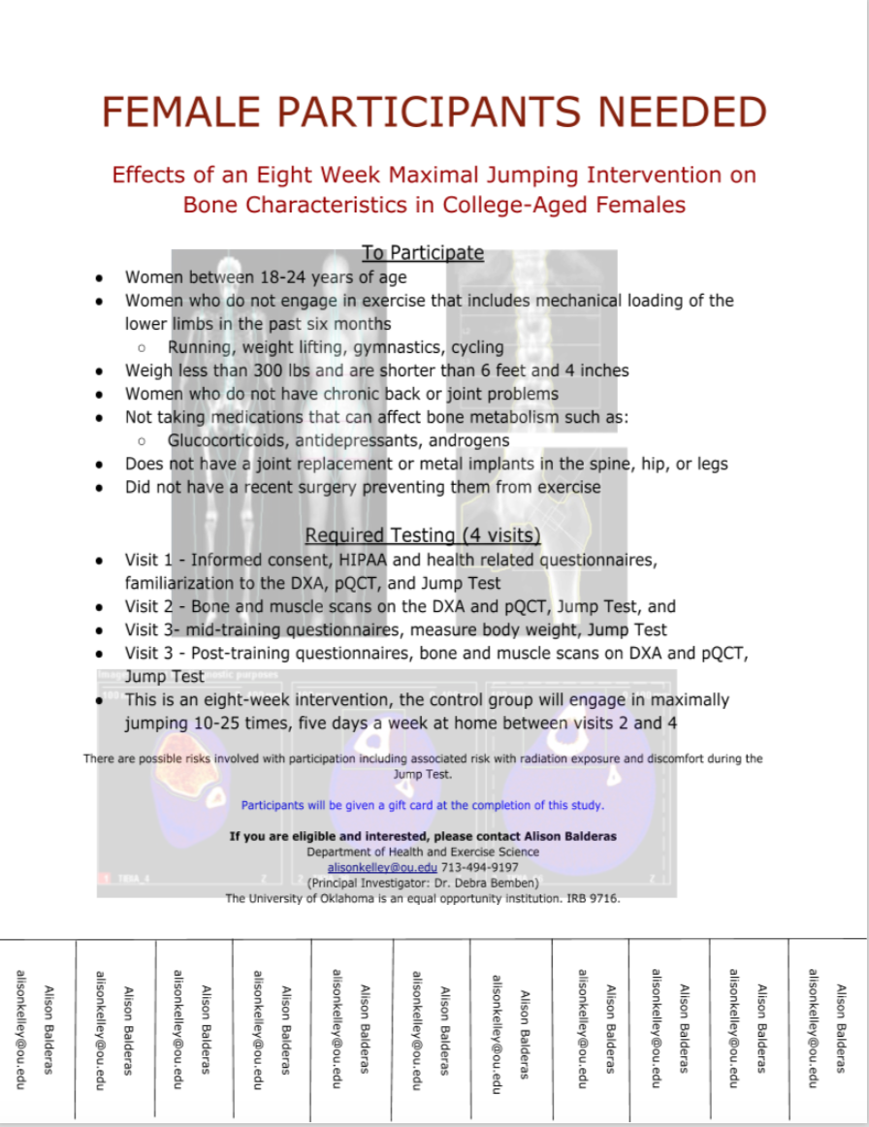

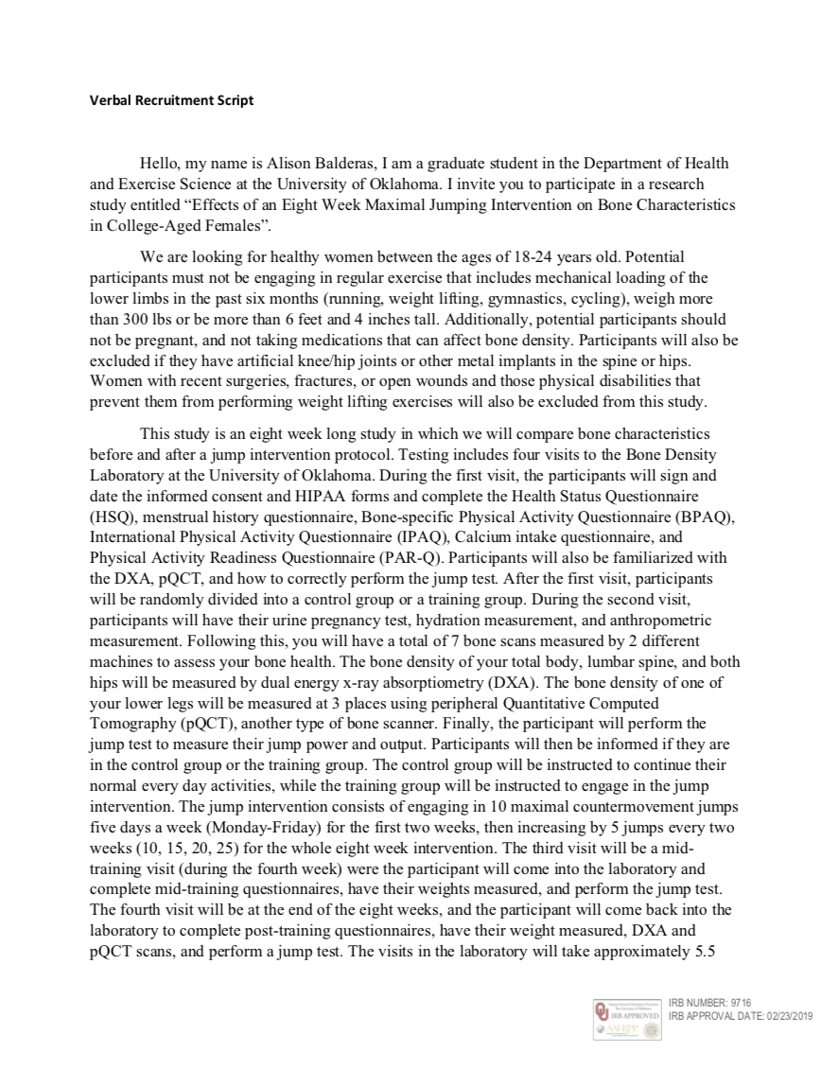



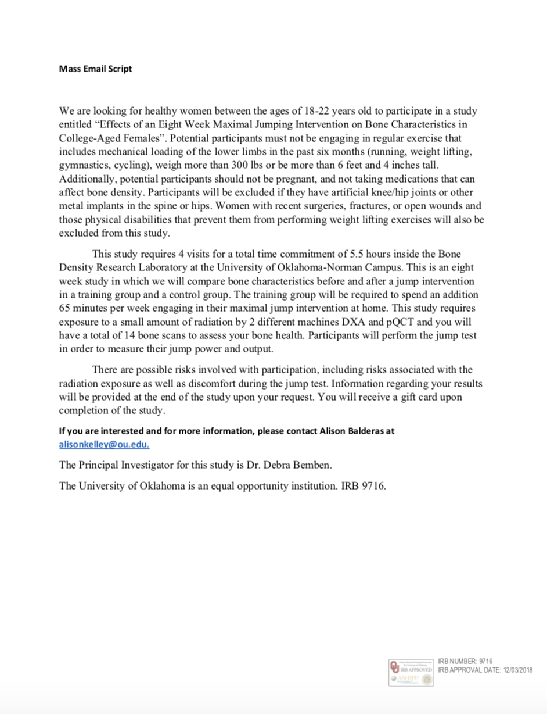
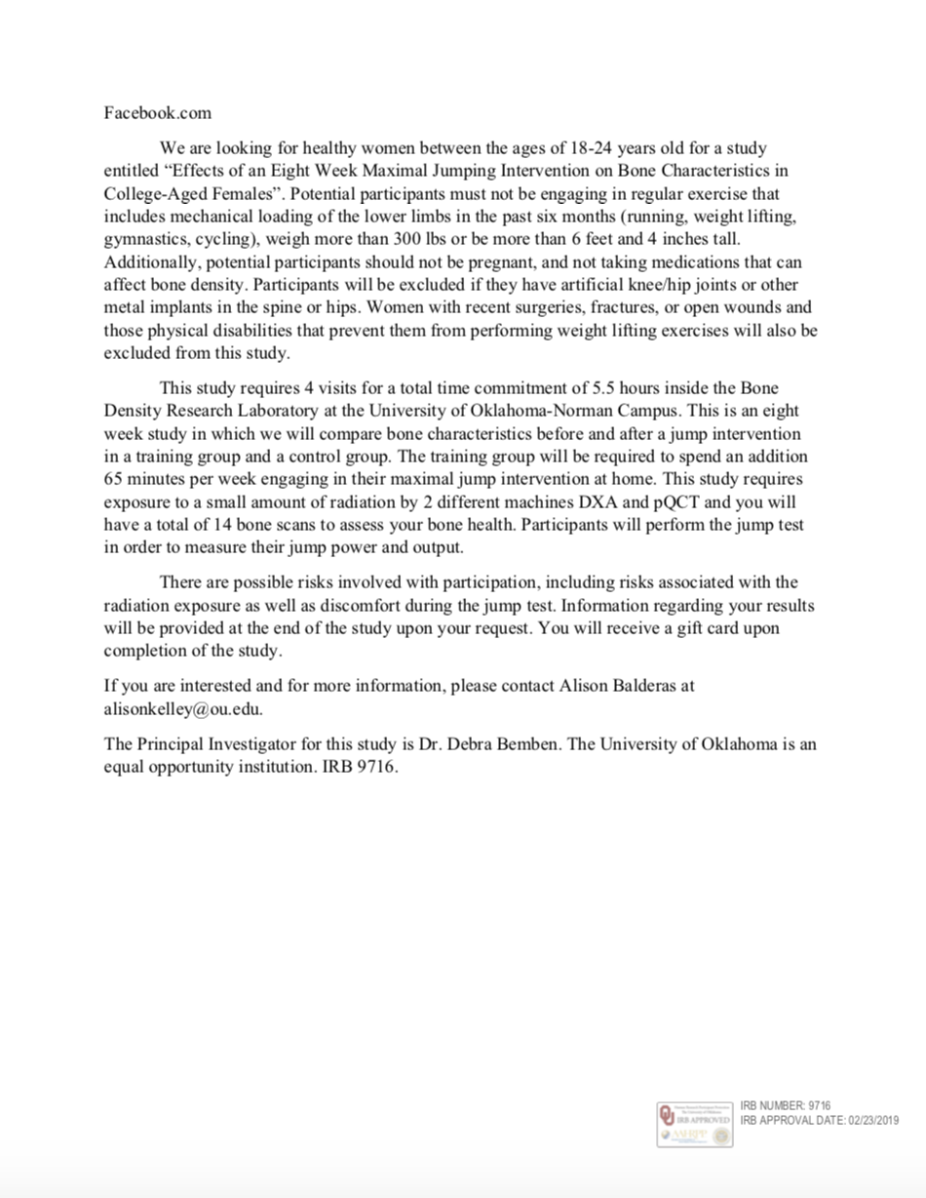



Appendix B

Informed Consent
HIPPA Form









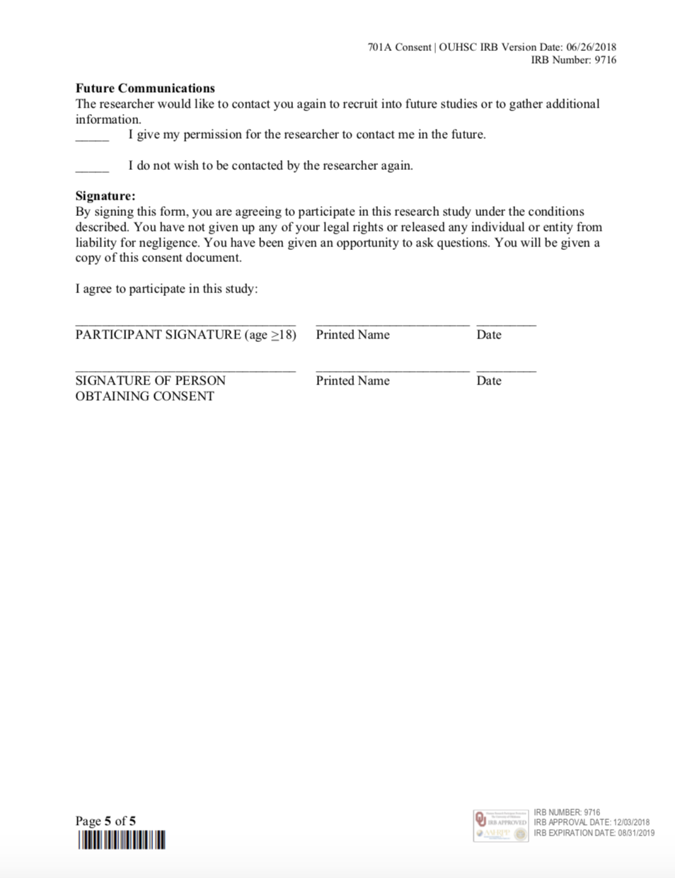

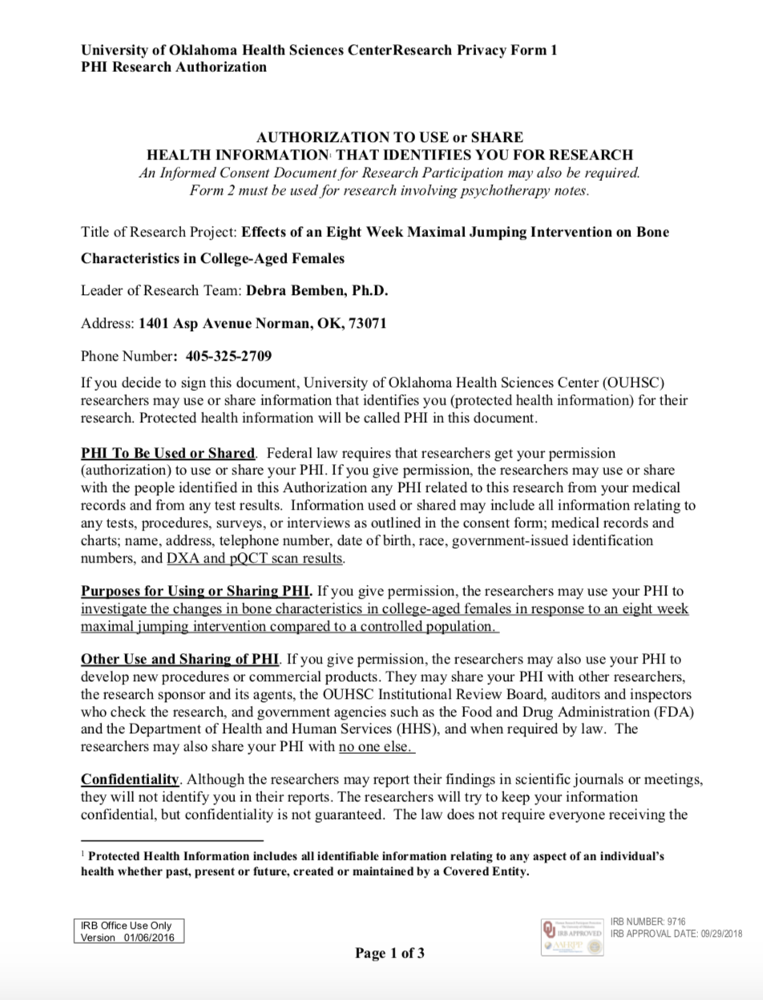



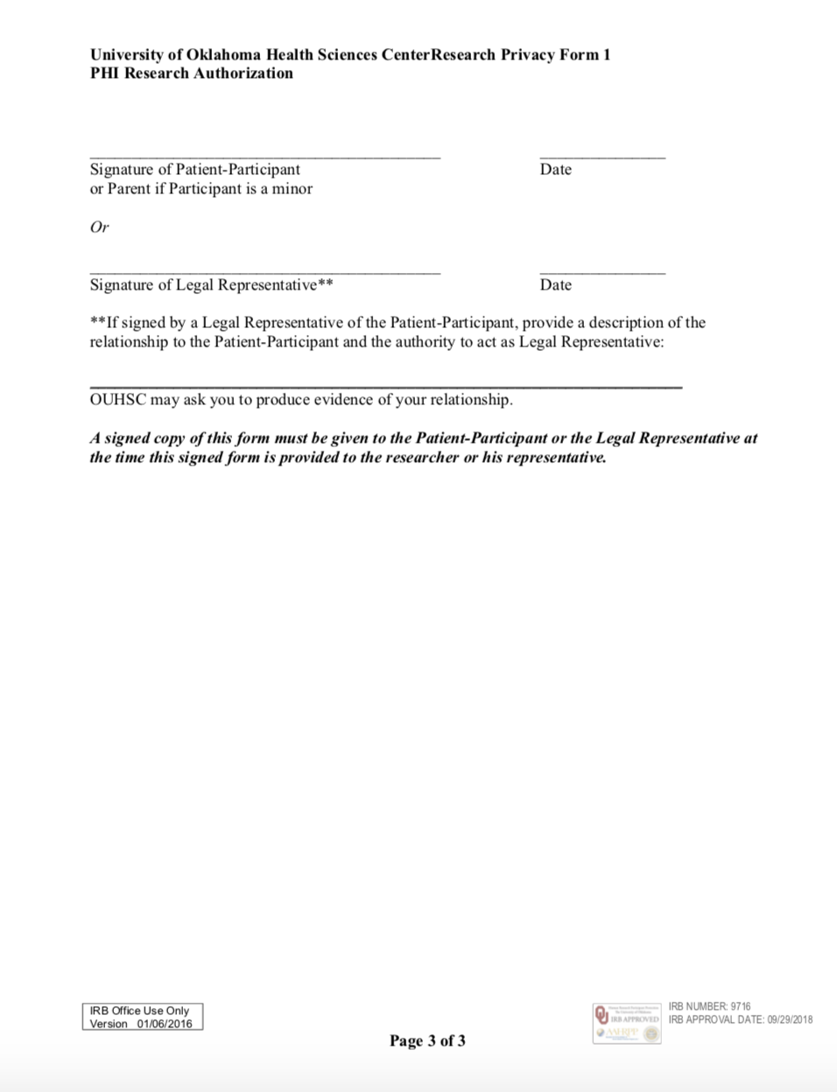

Appendix C

Health Status Questionnaire
PAR-Q and You
Calcium Intake
Bone Specific Physical Activity Questionnaire
International Physical Activity Questionnaire
Menstrual History Questionnaire







