University of Oklahoma

Graduate College

CAPILLARY-BASED ANALYTICAL TECHNIQUE DEVELOPMENTS FOR ANALYSIS OF BIO-SAMPLE

A Dissertation

submitted to the Graduate Faculty

in partial fulfillment of the requirements for the

Degree of

Doctor of Philosophy

By

HUANG CHEN
Norman, Oklahoma
2017

CAPILLARY-BASED ANALYTICAL TECHNIQUE DEVELOPMENTS FOR ANALYSIS OF BIO-SAMPLE

A Dissertation approved for the
Department of Chemistry and Biochemistry

By

______________________________
Dr. Shaorong Liu, Chair

______________________________
Dr. Jizhong Zhou

______________________________
Dr. Zhibo Yang

______________________________
Dr. Robert L. White

______________________________
Dr. George B. Richter-Addo

© Copyright by Huang chen 2017
All Rights Reserved.

Acknowledgements
I would like to thank Dr. Shaorong Liu for mentoring me in these six years. I really appreciate all help and support I got from him. Without these support, I really could not finish my doctoral degree and find a job after graduation. He taught me not only how to be a good analytical chemist but also how to be a good man, which will benefit all my life.

I would like to appreciate all of help and training from Mrs. Joann Lu. With her help, I learned how to operate a variety of instruments including ESI-MS, MALDI-MS, HPLC and LIF. She also shared her best knowledge with me and helped me solve problems in my research.

I would like to thank Dr. Zhibo Yang, Dr. George Richter-Addo, Dr. Robert White, and Dr. Jizhong Zhou for being in my advisory committee. Your kind guidance are greatly appreciated.

I would like to thank Dr. Qiang Liu for giving me an internship in ARL. This opportunity opened my eyes to industrial research and pharmaceutical industrial regulations.

I would like to appreciate the help from my former and present group members: Dr. Congying Gu, Dr. Wei Wang, Dr. Lei Zhou, Dr. Min Zhang, Dr. Haiqing Yu, Dr. Xiaochun Wang, Dr. Jiangtao Ren, Aaron Morgan, Apeng Chen, Yu Yang, Kyle Lynch, Piliang Xiang, Matthew Beckner, and Mitchell Weaver. I specially thank Dr. Zaifang Zhu, who is my good tutor.

I would like to thank my parents for the encourage and love, which always help me face challenges and problems. I want to dedicate this dissertation to my wonderful wife Zhenzhen Qiao for her understanding when I worked very late in lab, for her sacrifice to take care of our home alone, and for love and support to help me complete this dissertation.

Table of Contents
Acknowledgements iv
Table of Contents vi
List of Tables vii
List of Figures viii
Abstract x
Chapter 1: Introduction 1
1.1 Background 1
1.2 DNA separation 2
1.2.1 Conventional DNA separation 3
1.2.2 Free solution DNA separation 4
1.3 Capillary Isoelectric Focusing (CIEF) 5
1.3.1 Process of CIEF 5
1.3.2 Carrier Amholytes 6
1.4 Two dimensional (2D) HPLC 7
1.4.1 Conventional configurations of 2D-HPLC 8
1.5 capillary liquid chromatography 10
1.5.1 Open tubular capillary 11
1.6 Dissertation Synopsis 12
Chapter 2 Integrating multiplex PCR and bare narrow capillary – hydrodynamic chromatography for on-line DNA analysis 14
2.1 Introduction 14
2.2 Experimental section 15
2.2.1 Materials and reagents 15
2.2.2 Apparatus 16
2.2.3 Preparation of chip injector 21
2.2.4 Capillary surface modification for capillary PCR amplification 22
2.2.5 Capillary PCR 22
2.2.6 Performing multiplex PCR, on-line YOYO-1 intercalation, and BaNC-HDC separation 24
2.3 RESULTS AND DISCUSSION 25
2.3.1 Characterization of on-line DNA–YOYO-1 intercalation 25
2.3.2 Incompatibility of YOYO-1 with PCR 30
2.3.3 Demonstration of integrating multiplex PCR, on-line injection, BaNC-HDC separation, and on-line DNA-YOYO-1 intercalation. 32
2.3.4 Calculation of the three multiplex products length 35
2.4 Conclusions 37
Chapter 3: Simple means for fractionating protein based on isoelectric point without ampholyte 38
3.1 Introduction 38
3.2 Experimental section 42
3.2.1 Reagents and Materials 42
3.2.2 Capillary coating 43
3.2.3 Bradford assay 43
3.2.4 Sodium dodecylsulfate – polyacrylamide gel electrophoresis (SDS-PAGE) of fractionated sample 44
3.2.5 Preparation of soluble protein extract from Hela cell 44
3.2.6 Preparation of protein complex from Hela cell mitochondria 45
3.2.7 Two-dimensional electrophoresis (2DE) of fractionated sample 46
3.2.8 Apparatus 46
3.2.9 Electrokinetic fractionation 48
3.3 Results and Discussion 49
3.3.1 Suppression of electroosmotic flow (EOF) 49
3.3.2 Effect of Pharmalyte on MS signal 49
3.3.3 DMI 51
3.3.4 pH variation in collection reservoir 51
3.3.5 Protein recovery 52
3.3.6 Electrophoresis time 53
3.3.7 Multi-level fractionation 54
3.3.8 Fractionation of Hela cell protein extract 56
3.3.9 MALDI-TOF-MS analysis of fractionated protein 57
3.4 Conclusion 58
Chapter 4: Two-dimensional chromatographic analysis using three second-dimension columns for continuous comprehensive analysis of intact proteins 60
4.1 Introduction 60
4.2 Experimental section 62
4.2.1 Reagents and Materials 62
4.2.2 Preparation of Reverse-Phase (RP)-HPLC Monolith 63
4.2.3 Preparation of Ion Exchange (IEX) Monolith 63
4.2.4 Sample Preparation 64
4.2.5 Online 2D HPLC Platform 64
4.2.6 2D HPLC Separation 65
4.3 Results and Discussion 66
4.3.1 RP-HPLC separation 66
4.3.2 Column preparation for 2D HPLC 67
4.3.3 Second-D separation speed consideration 69
4.3.4 Use of multiple columns to address second-D speed demand 74
4.3.5 Sample complexity reduction after 2D separation 74
4.4 Conclusion 75
Chapter 5: A single pore liquid chromatography for high resolution and efficiency separation of peptides 87
5.1 Introduction 87
5.2 Experimental section 89
5.2.1 Reagents and Materials 89
5.2.2 Apparatus 89
5.2.3 HPLC procedures 90
5.2.4 Preparation of capillary 90
5.2.5 Fluorescence Labeling of Amino acids and peptides 91
5.3 Results and discussion 91
Chapter 6: Conclusion and future directions 104
6.1 Conclusions 104
6.2 Future directions 105
References 105

List of Tables
Table 2.1 DNA length (kbp) of multiplex PCR products.
Table 4.1 Gradients used in the second dimension.

List of Figures
Figure 1.1 The profile of parabolic flow curve under the pressure driven condition.
Figure 1.2 Schematic setup for CIEF.
Figure 1.3 Illustration of the relationship between the peak capacities of the independent first and second dimensions in comprehensive two-dimensional separations.
Figure 1.4 Schematic of setup used for fast 2DLC using high temperature and high velocity.
Figure 1.5 Scheme of the instrument conﬁgurations.
Figure 2.1 Schematic diagram of experimental setup for characterization.
Figure 2.2 Schematic diagram of experimental setup for PCR-BaNC-HDC.
Figure 2.3 The comparison of on-line labelled method and prelablled method.
Figure 2.4 Repetitive run after single-time YOYO-1 charging.
Figure 2.5 Resolution, efficiency and retention time varying with number of runs
Figure 2.6 PCR of a tandem repeat (microsatellite marker) in Bioethanol Saccharomyces cerevisiae strain BG-1.
Figure 2.7 Performing multiplex PCR, BaNC-HDC separation, and on-line dye intercalation on an integrated microfluidic platform.
Figure 2.8 Curve-fitting results between DNA relative mobility and fragment length.
Figure 3.1 Schematic representation of electrokinetic fractionation working principle.
Figure 3.2 Apparatus for electrokinetic fractionation.
Figure 3.3 Effect of Pharmalyte on MS signal.
Figure 3.4 Effect of electrophoresis time on separation.
Figure 3.5 Multi-level fractionation.
Figure 3.6 2DE results of soluble Hela cell proteins.
Figure 3.7 MALDI-TOF MS of Intact proteins from fractionated mitochondrial complexes.
Figure 4.1. Column-to-column reproducibility in RP HPLC.
Figure 4.2 Batch-to-batch reproducibility in RP HPLC.
Figure 4.3 Separation of protein lysates from E. Coli cells with RP HPLC.
Figure 4.4 Testing the 2D HPLC platform with protein standards.
Figure 4.5 Performance of IEX chromatography.
Figure 4.6 Performance of RP HPLC.
Figure 4.7 Separation of protein lysates from E. Coli cells using the 2D HPLC platform.
Figure 4.8 Typical sample complexity after 2D HPLC separation.
Figure 4.9 Schematic diagram of the new developed 2D-HPLC-UV/Vis platform.
Figure 5.1 Schematic diagram of the single channel LC system.
Figure 5.2 Comparison of isocratic and gradient elution.
Figure 5.3 Effect of pressure on separation.
Figure 5.4 Effect of gradient time on separation.
Figure 5.5 Effect of separation pressure when gradient time is constant.
Figure 5.6 Separation of mixture of BSA trypsin digest and Myoglobin trypsin digest.
Figure 5.7 The effect of inner diameter of capillary on separation.

Abstract

Analytical chemistry plays a significant role in bioscience research. Bio-samples, such as DNA and proteins, are often used for identification purpose or disease related research. Analyzing a biological sample typically includes sample preparation, separation, analyte detection and identification. Of these procedures, separation is the most essential procedure because bio-samples are usually very complicated. Unseparated sample makes it impossible to detect the molecule of interest. A successful separation should isolate the analytes from matrix, which may interfere with the accuracy, precision and sensitivity of the analytical method. The establishment of a separation technique should be specific to the features of analytes, including size, pKa, molecular weight, polarity, functional group, solubility, etc. This dissertation focuses on the development of various capillary-based separation techniques towards bio-samples.

We have developed an innovative and simple approach for on-line intercalation of YOYO-1 with DNA. A capillary PCR with BaNC-HDC and this on-line intercalation approach were integrated onto a microfluidic platform. The feasibility of using this platform for multiplexed PCR, on-line intercalation of the amplified products, BaNC-HDC separation, and LIF detection was demonstared. The microfluidic platform, combining with the PCR microfluidic chips and a miniaturized LIF, holds great promises for point-of-care applications.

We have developed a simple electrokinetic means to fractionate protein samples according to their pI values and demonstrated the feasibility of using this approach for fractionating real-world samples. The method does not require sophisticated equipment, and its consumable costs are low. More importantly, the fractionated samples are MS-friendly because we eliminate the use of ampholytes that interfere with MS analysis. The method will be an excellent way to purify a specific protein (e.g., an antibody) for analytical and micropreparative purposes.

We have coupled IEX (the first-D) chromatography with multiple-column RP (the second-D) chromatography for comprehensive and 2D separation of intact proteins. With n columns incorporated in the second-D, we can theoretically reduce the speed requirement of the second-D by a factor of n. This system has been tested for separating both protein standards and E. Coli lysates; baseline resolutions were obtained for separating 11 standard proteins while more than 500 protein peaks were detected for the E. Coli lysate sample.

We have developed a fast and exceptionally high efficient single pore capillary LC to resolve amino acids and peptides; in only ten minutes separation efficiencies of more than ten millions plates per meter are already obtained. We are going to combine this separation technique with MS to make an outstanding alternative technique to conventional LC-MS.

Chapter 1: Introduction

Background
Analytical chemistry plays a significant role in bioscience research. Bio-samples, such as DNA and proteins, are often used for identification purpose or disease related research. Analyzing a biological sample typically includes sample preparation, separation, analyte detection and identification. Of these procedures, separation is the most essential procedure because bio-samples are usually very complicated. Unseparated sample makes it impossible to detect the molecule of interest. A successful separation should isolate the analytes from matrix, which may interfere with the accuracy, precision and sensitivity of the analytical method. The establishment of a separation technique should be specific to the features of analytes, including size, pKa, molecular weight, polarity, functional group, solubility, etc. Chromatography and electrophoresis are two major separation systems. In chromatography, pump-driven gas or liquid flow drives the movement of analytes through the stationary phase for separation. Different stationary phases make various chromatography modes such as reverse phase, normal phase, ion exchange, size exclusion, etc. Hydrodynamic chromatography separates analytes by parabolic flow instead of a kind of stationary phase. High selectivity and reliability, and simple automation make chromatography most widely used. In electrophoresis, the analytes are electrically driven when they carry charges under a particular condition. The analytes with different mass to charge ratios can be separated in a free solution but analytes of similar mass to charge ratios, like DNA, can only be separated with the help of matrix, like gel. Gel electrophoresis is often used for DNA, RNA and protein analysis but regular electrophoresis could not be automated and not precise enough for analysis of small molecules like drugs and metabolites. The advent of capillary electrophoresis (CE) makes the automation of electrophoresis possible and the properties of capillary allow low sample and solvent consumption, and allow high voltage application for high-efficiency separation. The capillary electrophoresis chromatography (CEC) is a combination of electrophoresis and chromatography. These two different separation mechanisms combined can give a high efficiency and selectivity separation.
The objectives of this dissertation were to develop capillary based analytical techniques to overcome the drawbacks of regular methods and to facilitate automation by integrating multiple offline steps to an online platform.

DNA separation
DNA separation and analysis are essential to molecular biological research. Among all bio-molecules such as amino acids and proteins, DNA is a large molecule containing genetic coding information, which determines the biological processes from birth to death¹. DNA separation is the most important part in the DNA analysis, which often answers how DNA works. Nowadays, genetic information is used to diagnose a genetic disease; forensic field uses comparison of the DNA of suspect with that found at the scene to identify the real criminal; and DNA fingerprints of bacteria and fungi are used to identify the pathogen strain. In all these applications, DNA separations are carried out.
Electrophoresis is the most widely used for DNA separations. When the voltage is applied, the negatively charged nucleic acids move toward the positive electrode. Because of presence of the sieve matrix of the gel, shorter DNA fragments travel more rapidly than longer fragments. Agarose gel is the most common material for the separation of a wide range of DNA (75-20,000 bp) while polyacrylamide gels can provide very high resolution of DNA molecules in the 10–3,000 bp size range. Without gel, DNA fragments larger than ~400 bp could not be resolved in free solutions².

Conventional DNA separation
Since 1970s, gel-electrophoresis became commonly used for DNA separation in a slab-gel design³, which achieved good separations for a common DNA size range. The DNA fragments larger than 40-50 kb⁴ were separated by pulsed field gel electrophoresis (PFGE)⁵. These methods require time-consuming manual operation and produce excessive Joule heating. In order to improve the resolving power, lower separation time, and enhance the throughout, capillary gel electrophoresis was invented⁶. An array of parallel capillaries for gel electrophoresis has been developed for high throughput⁷. Automated multicapillary electrophoresis has completely changed the DNA sequencing method by replacing the labor-intensive slab gel electrophoresis. The capillary based conventional DNA separations require sieving gel, which introduces drawbacks including irreproducibility of gel preparation and high pressure for injecting gel into capillary.

Free solution DNA separation
DNA separation in free solution was developed to get rid of problems related to gel. Based on the separation mechanism, they are electrophoresis in free solution and liquid chromatography for DNA separations. Electrophoresis in free solution separates species only based on their mass to charge ratio, so DNA cannot be separated because different DNA fragments have similar mass to charge ratio. To overcome this problem, the end of DNA molecule was labeled to make DNA of different size have different mass to charge ratios^{8, 9}. High performance liquid chromatography was another attempt for DNA separation in free solution. Ion-exchange chromatography ¹⁰ and reverse phase chromatography ^{11, 12} were developed based on interaction with anion-exchange resin and with nonpolar stationary phase respectively . However, resolving power of HPLC for DNA is not comparable to electrophoresis. The most recent attempt developed a novel DNA separation technique, called bare narrow capillary-open tubular chromatography. DNA molecules are separated in a very narrow capillary in the pressure driven flow. Large DNA molecules have bigger effective diameters and get further away from the capillary wall (slow flow rate region) than small DNA molecules as shown in the figure 1. This free solution technique provides separation of wide range of DNA size and high resolution comparable to electrophoresis.


Figure 1.1 The profile of parabolic flow curve under the pressure driven condition. The circles represent distribution of small DNA (small circle) and large DNA (big circle) in the parabolic flow.

Capillary Isoelectric Focusing (CIEF)
IEF is considered to provide best resolution among different separation techniques¹³. For this reason, it is selected as the first dimension of conventional two-dimensional gel separation for proteomics. CIEF is the version of IEF occurring in a capillary, which only requires a small amount of sample and buffer consumption. Most importantly because of high resistance and wonderful heat dissipation, very high voltage can be applied across a capillary, which dramatically speeds up the focusing process. CIEF has been widely used for protein separation¹⁴⁻¹⁶ and determination of isoelectric point (pI) ¹⁷⁻¹⁹ because it provides excellent resolution of proteins with the advantage of on-line detection and automated operation.

Process of CIEF
In CIEF, protein sample is mixed with carrier ampholytes before they are introduced into capillary by pressure. The carrier ampholytes will generate a pH gradient when voltage is applied. Analytes move in the capillary when they carry either negative or positive charges until they reach the position where pH equals to their pIs. On the specific pH spot, analytes spontaneously accumulate. After the focusing is done, the focused analytes are driven toward the detection window by either hydrodynamic or chemical mobilization. The whole setup is briefly shown in figure 1.2.

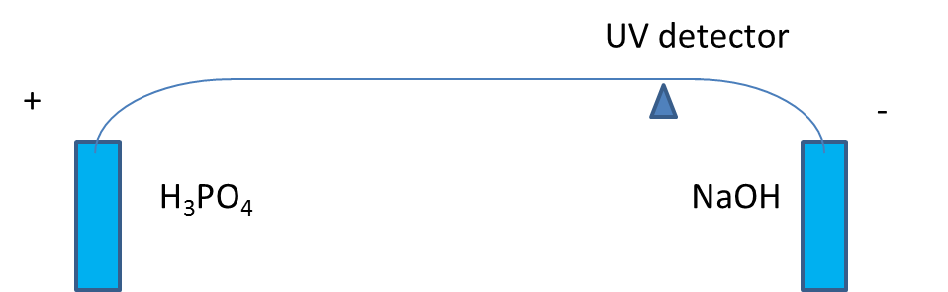
Figure 1.2 Schematic setup for CIEF

Carrier Ampholytes
For CIEF separation, carrier ampholytes are the essential part for generating a desirable pH gradient. In 1960s, the term of carrier ampholytes was put forward by Svensson, who discovered that under a voltage a stable pH gradient can be built by a mixture of different ampholyte compounds²⁰. The composition of the carrier ampholyes is very complicated because they are the synthetic heterogeneous mixture of isomers of polyamino polycarboxlic acids²¹. To be distinguished from analytes, carrier ampholytes have unique properties, for example they are small molecules (1,000-15,000 Da) compared with proteins and they do not interfere UV detection. However, with ease of ionization they seriously suppress the ionization of analytes when Mass spectrometer is used for detection and identification.

Two dimensional (2D) HPLC
The term “2D-HPLC” describes the technique in which two independent liquid phase separation systems are applied to the sample. The fractions from the first dimension are to be further separated in the second dimension for better resolution. If only the interesting portion of the first-dimension effluent is transferred to the second dimension it is referred to as “heartcutting” chromatography. If all fractions from first dimension are sequentially transferred in many small aliquots to the second dimension, it is known as “comprehensive” 2D chromatography. The true value of an ideal comprehensive 2D separation was pointed out as overall peak capacity (nc,2D) should be equal to the product of the individual peak capacities of the first and second dimension separations (1nc and 2nc, respectively){Eon, 1974 #2}{Eon, 1974 #2}^{22, 23}: (Shown in figure 1.3)
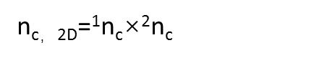 ²²

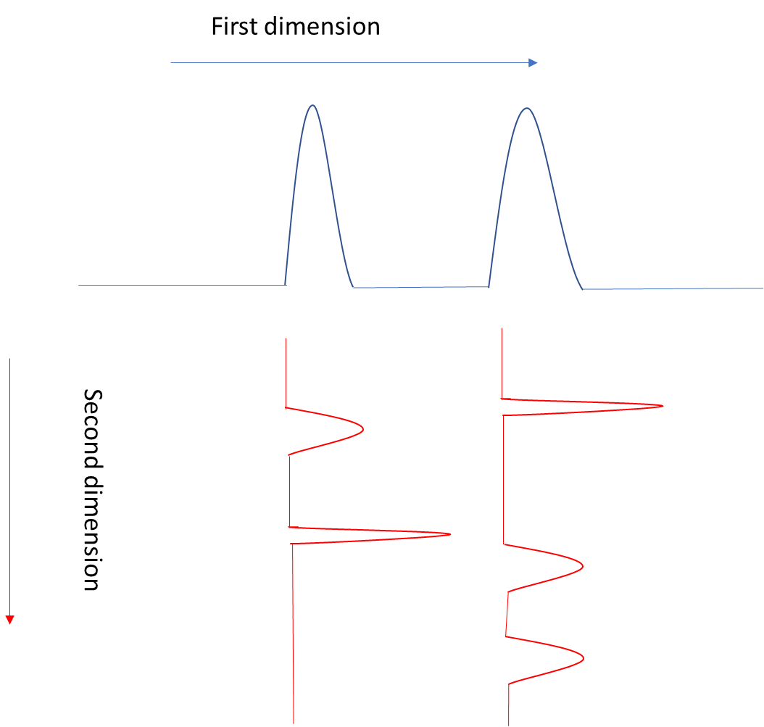

Figure 1.3 Illustration of the relationship between the peak capacities of the independent first and second dimensions in comprehensive two-dimensional separations

1.4.1 Conventional configurations of 2D-HPLC
In the last decade, 2D-HPLC has received considerable attention. Erni and Frei started the online comprehensive 2DLC ²⁴. Jorgenson and Bushey first applied 2D-HPLC for protein separations²⁵. Since then, a variety of 2D-HPLC separation methods had been developed for proteomics research^{26, 27}. In 2006, a supra-ambient temperatures (110 °C) and high linear velocities (>3 cm/s) on the second dimension column was developed by Stoll et al. to speed up second dimension separations to about 20 s, and thereby the overall comprehensive 2DLC separation was reduced to about 30 min²⁸. A schematic of the setup used for this work is shown in figure 1.4. In 2014, Angilent published 1290 Inﬁnity 2D-LC Solution with Diode Array Detection and Q-TOF LC/MS for analysis of E.coli Tryptic Digest, the configuration of which is currently the most common design shown in figure 1.5. Using this configuration, the fraction is immediately transferred into second dimension upon it is ready.

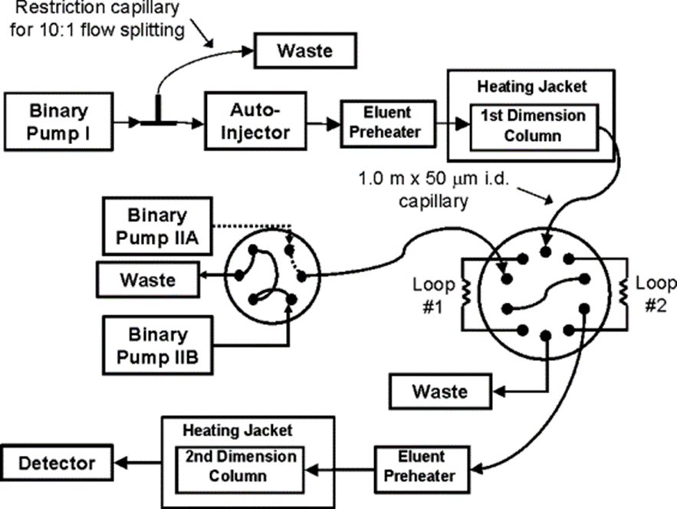 Figure 1.4 Schematic of setup used for fast 2DLC using high temperature and high velocity²⁸.
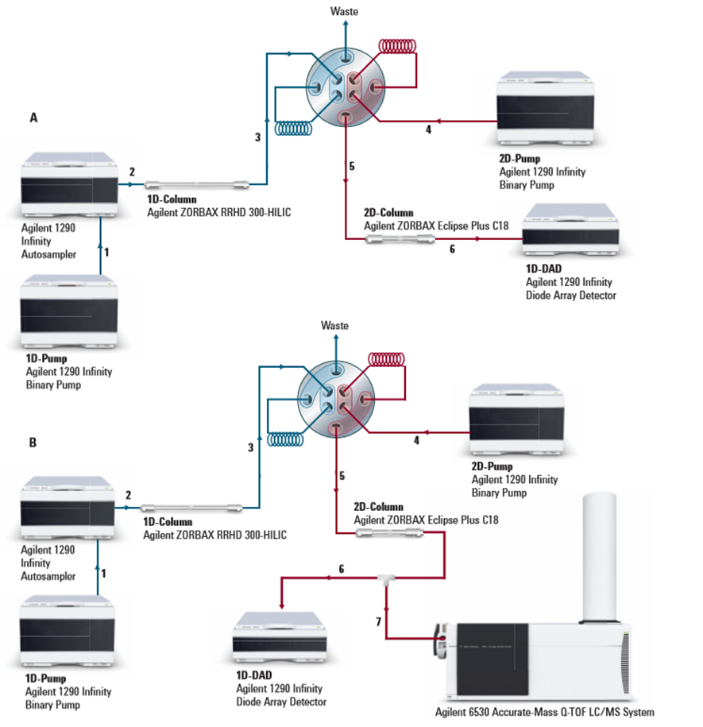
Figure 1.5 Scheme of the instrument conﬁgurations (http://www.agilent.com/en-us/products/liquid-chromatography/extended-lc-systems-workflow-solutions/2d-lc-solution/1290-infinity-ii-2d-lc-solution)

capillary liquid chromatography
The conventional liquid chromatography was miniaturized by using capillary for the analysis of nanoliter and subnanoliter samples. Packed, semi-packed, monolithic and open tubular capillary columns have been developed for this purpose. Packed capillary is the mini version of the conventional column, but to pack a narrow capillary is very tedious and time consuming. Semi-packed capillaries are prepared by packing particles around 10-100 µm into capillary. Then the packed capillaries are drawn on a glass drawing machine to make the diameter of the capillary 2-3 times the diameter of the particles²⁹. To prepare these columns with smaller inner tube diameters and smaller particle diameters is also difficult. Monolithic capillary columns are prepared by creating polymer in the capillary and the polymer serves as the stationary phase through their interaction with analytes^{11, 30}. However, the polymer in different portions of capillary is likely to be nonuniform, which introduces high eddy diffusion to separation. In addition, to control the extent to which the polymerization occurs is challenging; over polymerization often causes the clog in the capillary, especially in narrow capillary with inner diameter of 5-10 µm. In this dissertation, open tubular capillary is the focus, which will be discussed in detail as follows.

1.5.1 Open tubular capillary
Open tubular columns were first applied in gas chromatography for high separation efficiencies. Later, the application of open-tubular columns in liquid chromatography received considerable attention. Knox, Gilbert and Guiochon discussed the theoretical aspects of open-tubular columns in their papers^{23, 31}. Only small inner diameter capillary (5-20 µm) has been utilized for open tubular column because the low surface area to volume ratio of big open tubes causes low capacity and retention factor. Unlike the conventional matter, the stationary phase is directly bound to the inner wall of the capillary rather than to particles packed into the capillary or column. The open capillary column has only one pathway, which eradicates the eddy diffusion caused by non-ideal packing in conventional chromatography. Small dimension also limits the longitudinal diffusion. All these features make open tubular column exceed the resolving power of modern HPLC packed columns. However, loading capacity is still problematic. To improve loading capacity, porous layer open tubular (PLOT) was invented by Tsuda et al. in 1978, using an i.d. of 60 µm³². The only difference between conventional open tubular and PLOT is the existence of a layer of polymers, which enhances the loading capacity by increasing the ratio of stationary phase to mobile phase. However, producing this layer of polymer is not practical in the very narrow capillary (i.d. ~5 µm).

1.6 Dissertation Synopsis
The objective of the dissertation is to develop capillary-based analytical techniques for bio-sample analysis. Chapter2 will present a capillary-based set up for integration of PCR, DNA separation, DNA labeling and detection. The goal of this study is to develop a simple DNA analysis microfluidic platform as a key component of the portable setup for point of care applications.

In chapter 3, we developed a simple means for fractionating protein based on isoelectric point without ampholyte. The goal of this study is to develop a simple protein fractionation method to purify a specific protein (e.g., an antibody) for analytical and micropreparative purposes. And the final fractionated sample is MS-friendly.

In chapter 4, we developed a new 2D HPLC configuration by using parallel second-dimension columns for comprehensive analysis of intact proteins. The goal of this study is to demonstrate the advantage of the new design and applications for rea-world sample.

In chapter 5, a 2-µm-i.d. capillary liquid chromatography was developed for high resolution and efficiency separation of amino acids and peptides. The goal of this study is to first demonstrate the hyphenation of the narrow capillary with conventional HPLC pump for LIF detection. The second goal is to explore the high separation efficiency of extremely narrow capillary.

Chapter 6 gives an overall summary and conclusion, and future directions of the achievement presented in the dissertation.

Chapter 2 Integrating multiplex PCR and bare narrow capillary – hydrodynamic chromatography for on-line DNA analysis

2.1 Introduction
Polymerase chain reaction (PCR) is widely used for analysis of a specific segment of DNA, or a DNA variation. Multiplex PCR is a variant of conventional PCR in which two or more loci are simultaneously amplified in the same reaction. Since its introduction in 1988³³, this technique has been utilized successfully in various areas of DNA analyses such as DNA deletion^{34, 35}, mutation³⁶ and polymorphism³⁷, etc. Multiplex PCR can also be utilized to boost the sample throughput³⁸⁻⁴⁰ for strain identification. Analyzing the products of multiplex PCR is often carried out by electrophoretic separation⁴⁰, or DNA melting curve analysis⁴¹. PCR and the following electrophoretic separation have been integrated⁴²⁻⁴⁵, but, because the gels used in the above integrated devices need to be replenished after each run to prevent the gels from being blocked by large DNA templates, performing the separations is tedious and time-consuming. In this technical note, we describe a new approach to address this issue. We perform multiplex PCR inside a capillary tube, transfer the amplified fragments to a narrow capillary on-line, and measure their lengths by Bare Narrow Capillary – Hydrodynamic Chromatography (BaNC-HDC)⁴⁶, a new technique developed in our lab for free-solution DNA separation. BaNC-HDC is capable of resolving DNA with a wide size range, and the separation is performed in a solution without any sieving matrices. PCR products can be injected directly into a BaNC-HDC column for separation without any purification (such as DNA template/enzyme removal, desalting, etc.).
To prepare a sample for BaNC-HDC separation, the PCR products need to be fluorescently labelled. Labelling these DNA can be accomplished by throwing a fluorescent intercalating dye in the solution either during the reactions if the dye (e.g., SYBR Green I) is compatible, or after the reactions if the dye (e.g., YOYO-1) is incompatible with the PCR. We focus on the latter in this experiment. To intercalate the DNA with YOYO-1, we flush the bare narrow capillary with a YOYO-1 solution; positively charged YOYO-1 is adsorbed (or charged) onto the negatively charged capillary wall. As DNA molecules are driven down the capillary column for separation, they react with YOYO-1 stored on the capillary wall and are on-line intercalated with the dye. With a single YOYO-1 charging, the column can be used for more than 40 runs, although the fluorescence signal intensities of the DNA peaks decrease gradually. Although the dye-DNA intercalation occurs during the separation, it does not affect the retention times, separation efficiencies, or resolutions.

2.2 Experimental section

2.2.1 Materials and reagents
YOYO-1 was purchased from Life Technologies (Grand Island, NY). A DNA ladder (1-kb plus), tris(hydroxymethyl)aminomethane (Tris), ethylenediaminetetraacetic acid (EDTA), and other common reagents were purchased from Fisher Scientific (Pittsburgh, PA). Fused-silica capillaries were purchased from Polymicro Technologies (Phoenix, AZ). 10.0 mM tris-EDTA (TE) buffer consisted of 10.0 mM Tris and 1.00 mM EDTA, and its pH was adjusted to 8.0. All solutions were prepared using ultrapure water (Nanopure ultrapure water system, Barnstead, Dubuque, IA), filtered through a 0.22 µm filter (VWR, TX), and vacuum-degassed before use.

2.2.2 Apparatus
The experimental setup for characterizing on-line DNA and YOYO-1 intercalation is schematically shown in Figure 2.1. A 50-cm capillary with an i.d. of 2 μm was used for gel-free DNA separations. The inlet of the nanocapillary was inserted into a solution inside a pressure chamber. The pressure chamber was capped and sealed with a septum. The solution was driven into capillary by pressure-regulated nitrogen. The polyimide coating (~3 mm in length) was removed at a position ~10 cm away from the outlet end of the capillary to form a detection window. A laser-induced fluorescence (LIF) detector was used to monitor the DNA fragments passing through the window. The detector was built in our laboratory. Briefly, a 488 nm beam from an argon ion laser (LaserPhysics, Salt Lake City, UT) was directed by a dichroic mirror (Q505LP, Chroma Technology, Rockingham VT) and focused onto the detection window of the capillary via an objective lens (20×and 0.5 NA, Rolyn Optics, Covina, CA). The emitted fluorescence was collimated by the same lens, went through the same dichroic mirror, an interference band-pass filter (532 nm, Carlsbad, CA), a 1-mm pinhole and finally collected by a photosensor module (H5784-04, Hamamatsu). A measurement computing USB-1208FS (Measurement Computing, Norton, MA) was used to measure the output of the photosensor module. The data were acquired and analyzed using a program written in-laboratory with labview (National Instruments, Austin, TX). The alignment of the detection window with the LIF detector was achieved via an x-y-z translation stage.

To align the detection window with the LIF detector, a fixed pressure was applied to the pressure chamber to drive a fluorescein solution through the capillary at constant flow rate. While the fluorescence signal was monitored, the position of the detection window was adjusted via the x-y-z translation stage. The x, y and z positions of the translation stage were fixed once the maximum signal was achieved. Before charging the capillary with YOYO-1, the capillary was thoroughly washed with 1×TE buffer until the florescence signal reached the background level. The separation capillary was flushed with approximately ~4 nL of 7.0 µM YOYO-1 in 1× TE buffer and then ~4 nL of 1× TE buffer under a pressure of ~350psi. After a DNA sample was placed in the pressure chamber, a pressure of ~40 psi was applied to effect sample injection for 10 s. Then the sample was replaced with an eluent vial, and a pressure of 350 psi was applied to the pressure chamber to carry out the separation.

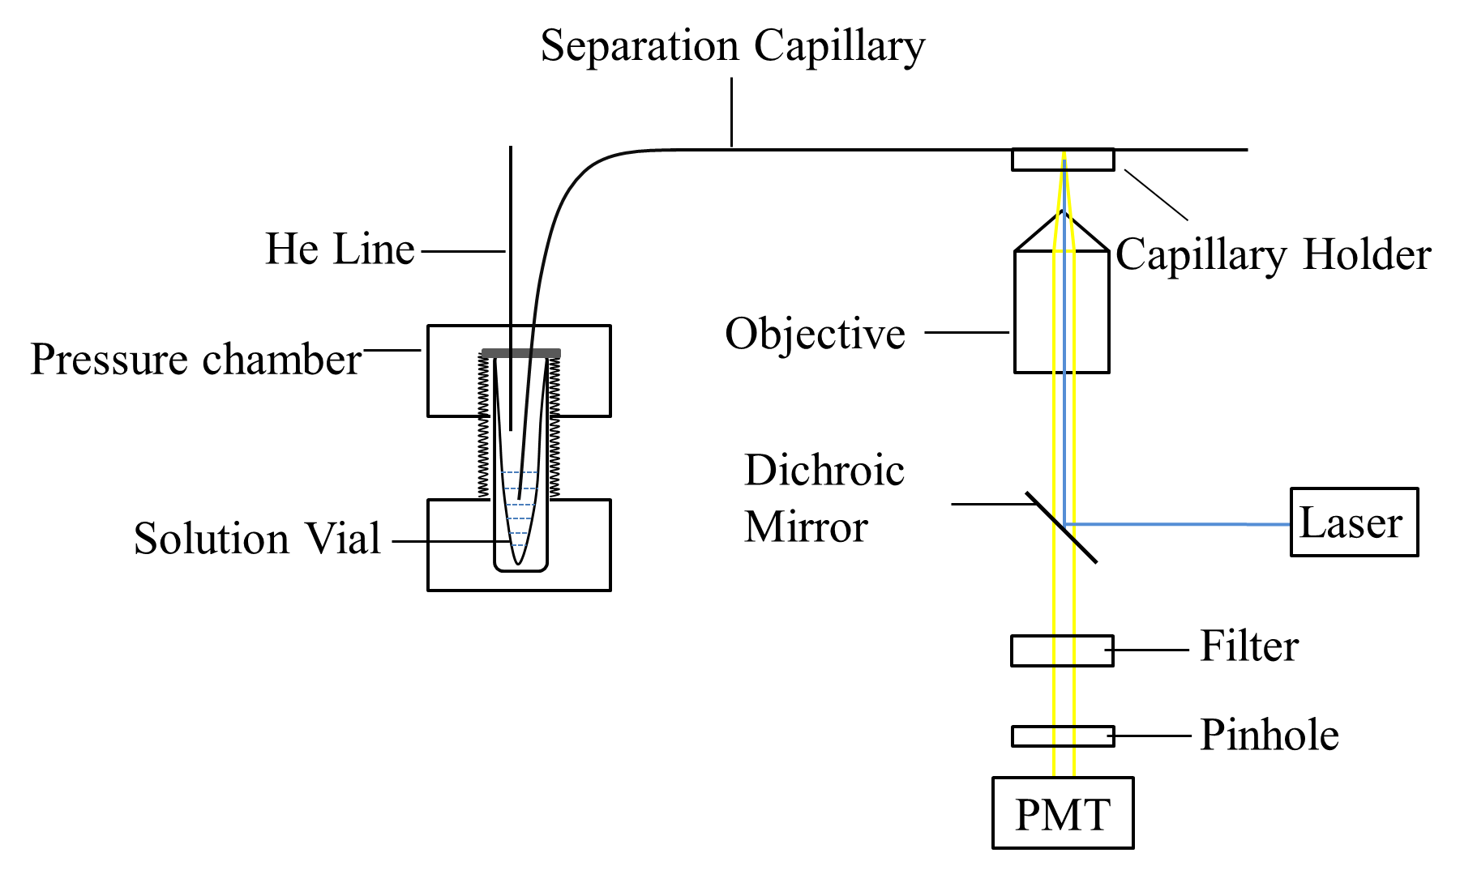Figure 2.1 Schematic diagram of experimental setup for characterization.

Figure 2.2 presents the apparatus used in this experiment to perform multiplex PCR, on-line DNA–YOYO-1 intercalation, and BaNC-HDC separation. The system consisted of a pressure chamber (PC), a chip injector (C), a PCR capillary and a thermocycler (TC), a six-port valve, a BaNC-HDC column, and a confocal laser-induced fluorescence detector (D). The detailed descriptions of the pressure chamber, chip injector, and detector can be seen in Supporting Information (SI). The PCR capillary had a length of 2 m, and an i.d. of 75 μm, and it was treated with dichlorodimethylsilane and bovine serum albumin; the detailed treatment procedure is described in SI. TC is a MJ Research PTC-200 Peltier Thermal Cycler. A six-port valve was utilized in conjunction with the chip injector to facilitate sample injection for BaNC-HDC separation. The valve could be switched between an “open” position [as the PCR capillary from position 2 and auxiliary capillary from position 4 on the chip injector were connected to sample (S) and waste (W)] and a “closed” position (as the above two capillaries were connected to blocked ports). The BaNC-HDC column was a fused silica capillary having a length of 55 cm and an i.d. of 2µm.

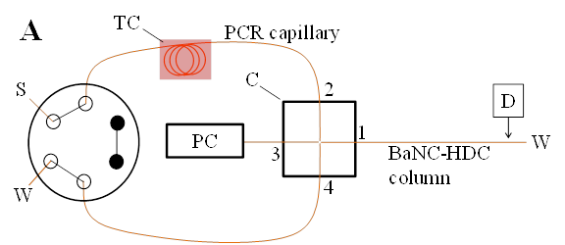
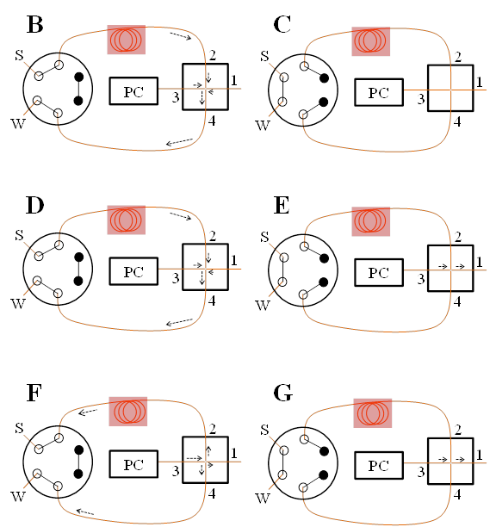
Figure 2.2 Schematic diagram of experimental setup for PCR-BaNC-HDC. (A) Experimental setup. S – sample, W – waste, C – microchip injector, PC – pressure chamber, and TC – thermocycler. The solid dots on the six-port injection valve indicate ports that are blocked. Capillaries are connected to positions 1, 2, 3, and 4 on microchip injector are separation capillary, PCR capillary, pressure capillary, and waste capillary respectively. The separation capillary had a length of 55 cm (35 cm effective), an o.d. of 150 μm and an i.d. of 2 μm. The PCR capillary had a length of 2 m, an o.d. of 150 μm and an i.d. of 75 μm. The pressure capillary had a length of 10 cm, an o.d. of 150 μm and an i.d. of 20 μm. The waste capillary had a length of 30 cm, an o.d. of 150 μm and an i.d. of 75 μm. (B) through (G) depict schematic diagrams for illustrating major operating procedures. The arrows indicate the flow directions (see details in text).

2.2.3 Preparation of chip injector
A chip injector was used in this experiment (see Figure 2.2) to implement sample injection and DNA separation. The chip injector (Figure 2.2C) consisted of a microfabricated cross channel inside a glass chip, and an off-chip six-port valve (Model 7725i, IDEX Corporation, Lake Forest, IL). The cross channels in the chip were round and had a diameter of ~170 μm, which were produced using standard photolithographic technologies. Briefly, cross grooves were first created on two glass wafers. Because the cross pattern on a photomask had a line-width of 10 μm, the grooves were virtually semicircular after they were isotropicly etched to a depth of 85 μm. Two etched wafers were face-to-face aligned and bonded to form round channels. As shown in Figure2.2A, the separation capillary was connected to the chip cross at position 1,and PCR capillary, pressure capillary, and waste capillary were connected to the chip cross at positions 2,3, and 4, respectively. Epoxy adhesive was used to secure all capillaries in positions. The other ends of PCR capillary and waste capillary were connected to the six-port valve. The two solid dots on the six-port valve indicated that those ports were blocked.

2.2.4 Capillary surface modification for capillary PCR amplification
To prevent reagent adsorption, the PCR capillary was silanized with dichlorodimethylsilane (DDMS) and coated with bovine serum albumin (BSA) according to the following protocol^{47, 48}. After the capillary was flushed with acetone for half hour, it was filled with 1 M NaOH, with both ends being blocked by a silicone rubber stopper, and placed in an oven at 110 ℃ for 2 h. The capillary was then flushed with water, acetone, and dried with N2. After the capillary was filled with a 5% DDMS in chloroform, a vacuum was applied to evaporate the solvent, and a thin film of DDMS was formed on the capillary channel wall. The capillary was rinsed with 50 μL chloroform, 50 μL acetone and 50 μL water, successively. After the capillary was dried with N₂, it was flushed with 50 μL of 1 mg/mL BSA at the flow rate of 0.12 μL/min, and then 20 μL water.

2.2.5 Capillary PCR
Three sequences from two different DNA methylases genes and one green fluorescent protein (GFP) were amplified simultaneously in capillary. DNA templates were three plasmids, two of which contain different methylase genes and one of which contains a GFP gene. The expected length of sequence from one methylase gene (methylase I) is 1074 bp while the sequence from the other methlylase gene (methylase II) is 874 bp. GFP sequence is expected to be 400 bp. Three 0.5 μL of each plasmid (approximately 50 ng) were added to 18.5 μL of PCR mixture containing 1×Taq buffer (Invitrogen, Grand Island, NY), 2.5 mM MgCl₂ (Invitrogen), 0.2 mM dNTP mix (Invitrogen), 1 unit of Taq DNA polymerase (Invitrogen) and 0.2 μM of each pair of primers. The multiplex PCR solution was aspirated into the PCR capillary by applying a vacuum to W on the six-port valve for 6.5 min. The PCR was performed using the following thermal cycling program: 5 min at 95 ℃, then 30 cycles of 30 s at 95 ℃, 30 s at 55 ℃, 30 s at 72 ℃ and 10 min at 72 ℃. After the PCR was finished, a vacuum was applied to W to pull the PCR products for 2 min into the cross section of the chip injector. The PCR reaction didn’t take place in the capillary section (~20 cm) between the chip and the thermocycler. According to the calculated velocity (~0.648 cm/s) of PCR products in the PCR capillary, it theoretically takes ~0.5 min for nearest PCR products to pass this capillary zone to arrive at the cross section. The calculated time range for all PCR products to reach the cross section is from ~0.5 to 4.5 min. A pressure of 40 psi was applied to the pressure chamber for 10 s (while PCR and waste capillaries were connected to the blocked positions on the six-port valve) to drive a plug of sample to BaNC-HDC column. Then, a pressure of 40 psi was applied to flush away the residue sample in the cross section for 10 s and ~1/1000 of normal injected volume of sample was expected to flow into the separation capillary in this step. For BaNC-HDC separation, ~200 psi was applied to the pressure chamber.

The DNA template for amplifying actin was the genomic DNA of rice (Oryza sativa L.), cv Nipponbare. The amplified actin sequence is expected to be 405 bp. To prepare the PCR solution for amplification, 2 μL (approximately 50 ng) of genomic DNA was added to 18 μL of PCR mixture containing 1×Taq buffer (Invitrogen, Grand Island, NY), 2.5 mM MgCl₂ (Invitrogen), 0.2 mM dNTP mix (Invitrogen), 1 unit of Taq DNA polymerase (Invitrogen) and 0.2 μM of primers. The same thermal cycling program was used and all following steps were the same as described for the multiplex PCR in capillary. For BaNC-HDC separation, ~400 psi was applied to the pressure chamber.

2.2.6 Performing multiplex PCR, on-line YOYO-1 intercalation, and BaNC-HDC separation
After the apparatus was assembled as shown in Figure 2.2, ~4 nL of 7.0 µM YOYO-1 in 1× TE buffer (10.0 mM Tris-HCl and 1.0 mM EDTA at pH 8.0), and then ~4 nL of 1× TE buffer were flushed through the BaNC-HDC column from the waste-side under a pressure of ~350 psi. The system was initialized after a vacuum was applied to W on the six-port valve to clean the YOYO-1 in the chip injector. Step 1 (Figure 2.2B): a multiplex PCR solution was first aspirated into the PCR capillary by applying a vacuum to W on the six-port valve while the valve was set at the “open” position. At this time, an ambient pressure or a pressure (~10 psi) slightly higher than the ambient pressure was applied to PC. Step 2 (Figure 2.2C): the valve was switched to the “closed” position, and thermal cycle reactions were performed. Step 3 (Figure 2.2D): the valve was switched back to the “open” position while a vacuum was applied to W to pull the PCR products into the cross section of the chip injector. Step 4 (Figure 2.2E): the valve was switched to the “closed” position, and a pre-determined pressure (e.g., 40 psi) was applied to PC for a given period of time (e.g., 10 s); a portion of the sample in the cross section was driven to the BaNC-HDC column. The amount of the injected sample was controlled by the pressure and the injection time. Step 5 (Figure 2.2F): the valve was switched to the “open” position while a pressure (e.g., 40 psi) was applied to PC; the residue sample in the cross section of the chip injector was flushed away from the inlet of the BaNC-HDC column. Step 6 (Figure 2.2G): the valve was switched to the “closed” position, and a pre-determined pressure (e.g., 200 psi) was applied to PC to effect BaNC-HDC separation.

2.3 RESULTS AND DISCUSSION

2.3.1 Characterization of on-line DNA–YOYO-1 intercalation
For characterizing our approach for on-line DNA–YOYO-1 intercalation, we used an experimental setup that was reported previously (see Figure 2.1 for details). In one experiment, we used a bare capillary column and separated a 1-kbp-plus DNA ladder pre-intercalated with YOYO-1. The bottom-trace of Figure 2.3 presents the separation results. In a separate experiment, we charged YOYO-1 on the interior surface of the capillary column and separated the same DNA ladder but without YOYO-1 intercalation. The top-trace of Figure 2.3 presents the separation results; all DNA fragments were nicely labeled and detected, and comparable resolutions and similar retention times were obtained. That is, we did not sacrifice any performance by using the on-line intercalation approach.
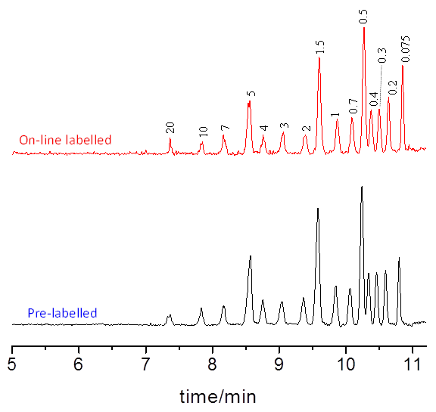
Figure 2.3 The comparison of on-line labelled method and prelablled method. The top trace shows the BaNC-HDC separation of on-line labelled DNA ladder (0.075, 0.2, 0.3, 0.4, 0.5, 0.7, 1.0, 1.5, 2.0, 3.0, 4.0, 5.0, 7.0, 10 and 20 kbp), while the bottom trace presents the separation of pre-labelled DNA ladder. The nanocapillary had a total length of 50 cm (40 cm effective) and a radius of 1 μm. The 1-kb-plus DNA ladder (total DNA 4 ng/μL) was injected at 40 psi for 10 s, and the separation was carried out at 350 psi.

Importantly, we do not need to recharge YOYO-1 for every BaNC-HDC separation. Figure 2.4A presents a few typical traces (of the 1st, the 10th, the 20th, the 30th, and the 45th runs) as we injected the same sample repetitively after we charged the BaNC-HDC column once. Apparently, as the repetitive-injection test proceeded, the YOYO-1 storage on the capillary wall shrank. As a result, the number of YOYO-1 molecules intercalated with each DNA fragment diminished, and consequently the fluorescence intensities decreased (Figure 2.4B). An excellent feature of this approach is that, although fluorescence intensities decreased gradually, the resolution, efficiency and retention time remained virtually unchanged (see Figure 2.5 for details). All DNA fragments could be positively identified and their sizes be accurately measured even after dozens of injections (e.g., see the inset of Figure 2.4A for an expanded view of the BaNC-HDC trace of the 45th run).

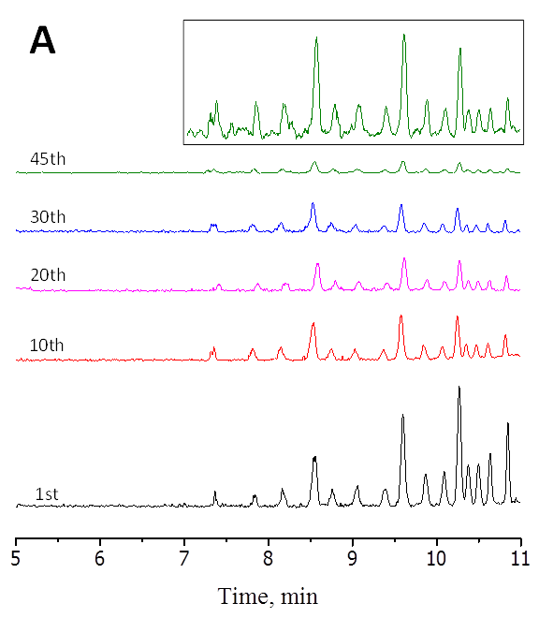
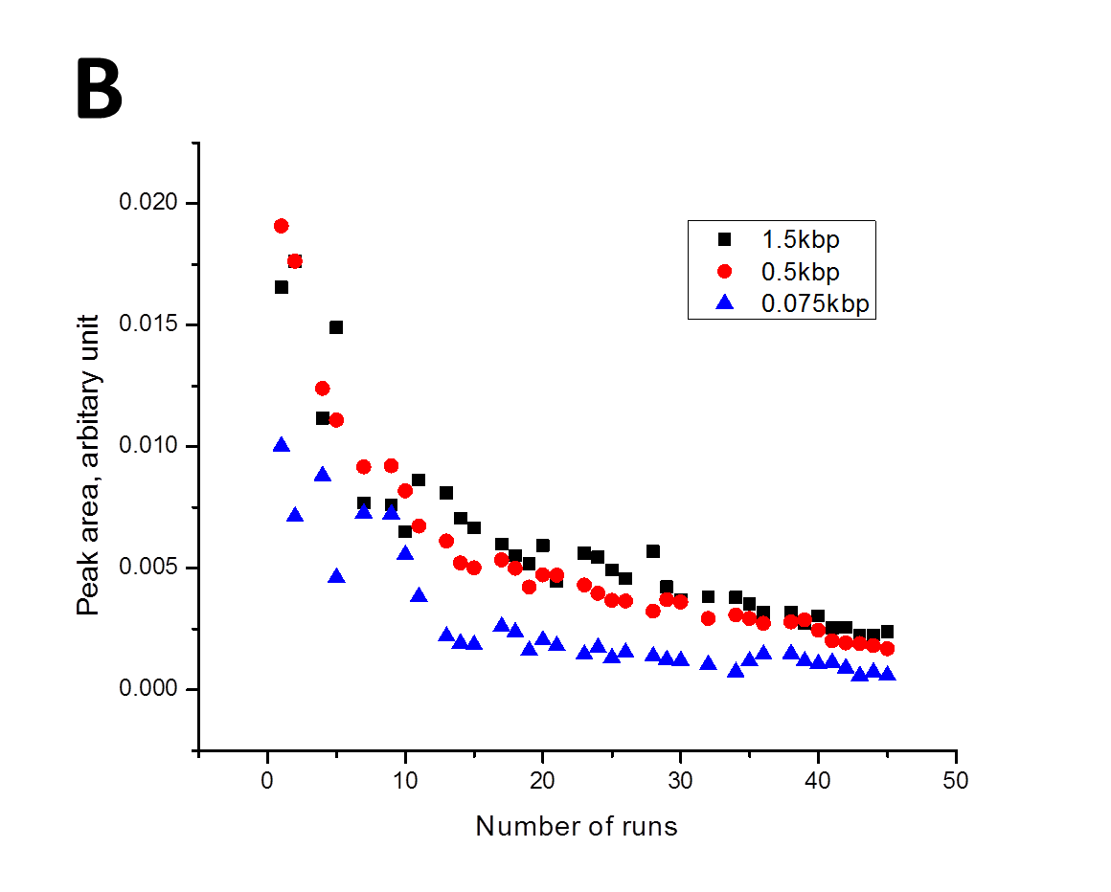
Figure 2.4 Repetitive run after single-time YOYO-1 charging. (A) Typical separation traces of DNA ladder (4 ng/μL total DNA). The inset presents an expanded view of the 45th run. (B) Peak areas varying with the number of repetitive runs. All separation conditions were the same as presented in Figure 2.3.
(A)
(B)

(C)
Figure 2.5 Resolution, efficiency and retention time varying with number of runs

2.3.2 Incompatibility of YOYO-1 with PCR
A Tandem repeat (microsatellite marker) was amplified using a PCR machine. The length is expected to be 300 bp. The template DNA was the genomic DNA of Bioethanol Saccharomyces cerevisiae strain BG-1 which was donated by Drs. Antonangelo and Colombi. Strains grew in 10 ml yeast peptone dextrose (YPD) medium for 12~16 h at 30 °C until A600 of culture reached to 0.6~0.8. Genomic DNA of the yeast culture was extracted using Yeast Genomic DNA Purification Kit (AMRESCO, LLC, Solon, OH). 4 μL of genomic DNA (approximately 100 ng) was added to 46 μL of PCR mixture containing 1×Taq buffer (Invitrogen, Grand Island,NY), 2.5 mM MgCl2 (Invitrogen), 0.2 mM dNTP mix (Invitrogen), 1.25 units of Taq DNA polymerase (Invitrogen) and 0.2 μM primers. The microsatellite marker was amplified using the following thermal cycling program: 5 min at 95 ℃, then 30 cycles of 30 s at 95 ℃, 30 s at 55 ℃, 30s at 72 ℃ and 10 min at 72 ℃. Figure 2.6 presents the separation results.
Figure 2.6 PCR of a tandem repeat (microsatellite marker) in Bioethanol Saccharomyces cerevisiae strain BG-1. (A) Slab gel electrophoresis result of PCR products from the PCR with or without YOYO-1. Lane1: 1kb plus DNA ladder. Lane2: PCR products without YOYO-1 as control. Lane3: 50 μL of the products when 0.1 nmol YOYO-1 was added in the PCR reactions (all other conditions were the same as the control). 0.1 nmol of YOYO-1 was the amount adequate for labelling 500 ng DNA (at a dye:bp ratio of 1:10). Lane4: 50 μL of the products when 0.01 nmol YOYO-1 was added in the PCR reactions (all other conditions were the same as the control). 0.01 nmol of YOYO-1 was the amount adequate for labelling 50 ng DNA (at a dye:bp ratio of 1:10). (B) BaNC-HDC chromatograms of the same PCR products for (A). Top trace: 1-kb-plus DNA ladder; middle trace: PCR products without YOYO-1 as control; and bottom trace: products when 0.01 nmol YOYO-1 was added in the PCR reactions. We also ran a BaNC-HDC separation for the products when 0.1 nmol YOYO-1 was added in the PCR reactions; the chromatogram (not shown) was similar to that of the bottom trace.

2.3.3 Demonstration of integrating multiplex PCR, on-line injection, BaNC-HDC separation, and on-line DNA-YOYO-1 intercalation.
To demonstrate the utility of this approach for practical uses, we assembled a system (Figure 2.1) that integrated a capillary PCR device, a microchip injector, and a BaNC-HDC column in a microfluidic format for multiplex PCR, on-line injection, BaNC-HDC separation, and on-line DNA-YOYO-1 intercalation. The resolved DNA bands were monitored via an LIF detector. Figure 2.7A presents the separation results of multiplex PCR products. The sizes of three products were estimated (see table 2.1 for details) to be 1.080, 0.895, and 0.398 kbp, in excellent agreement with their theoretical values (1.074, 0.874, and 0.400, respectively). Figure 2.7B presents the slab-gel separation results; the multiplex PCR was performed using a conventional Eppendorf tube and a MJ Research thermocycler. Figure 2.7C presents the separation of a segment of a rice genomic DNA amplified in the PCR capillary. Because BaNC-HDC can tolerate large DNA template, the amplified fragment was on-line transferred to the BaNC-HDC column for separation. The BaNC-HDC separations were executed under ~400 psi, and DNA–YOYO-1 intercalation was accomplished during the separation. The size of the fragment was measured to be 404 bp, compared to its theoretical value of 405 bp. Figure 2.7D presents the slab-gel separation result of the conventionally amplified product.

Figure 2.7 Performing multiplex PCR, BaNC-HDC separation, and on-line dye intercalation on an integrated microfluidic platform. (A) BaNC-HDC separation traces. The top trace was obtained from separating 1-kbp-plus DNA ladder, and the bottom trace was obtained from separating the multiplex PCR products amplified in the capillary thermocycler (30 cycles, see Capillary PCR in SI for details). The BaNC-HDC separations were executed under ~200 psi. (B) Slab-gel electrophoresis of the crude multiplex PCR products amplified by a MJ Research thermocycler (30 cycles). Lane 1 – DNA ladder; Lane 2 – crude PCR multiplex products. (C) BaNC-HDC separation of a PCR-amplified genomic region (30 cycles, see Capillary PCR in SI for details). The top trace represents the separation of a 1-kbp-plus DNA ladder, and the bottom trace is the result of the separation of an actin sequence from a rice genomic DNA that was amplified by the capillary PCR and on-line intercalated with YOYO-1. The BaNC-HDC separations were executed under ~400 psi. Other conditions were similar to (A). (D) Slab-gel electrophoresis of conventional PCR-amplified actin sequence. Lane 1 – DNA ladder, and Lane 2 – actin. Other conditions were similar to (B).

2.3.4 Calculation of the three multiplex products length
To validate the method for measuring the lengths of DNA fragments, we use the top chromatogram in Fig. 2.7A to establish a relationship between the relative mobility of a DNA and its length based on an HDC quadratic model as we described previously⁴⁹. Relative mobility was defined as the ratio of the velocity of a DNA fragment to the average velocity of the eluent. The fragment velocity was calculated by dividing the effective capillary length by its retention time, while the eluent velocity was obtained by measuring its flow rate and dividing the measured flow rate by the narrow capillary cross-section area. As presented in Figure 2.8, the curve-fitting generated an excellent correlation coefficient (R² = 0.9999) for equation (1).
$$Y_{i}=1+2*\left(117.9*\frac{{L_{i}}^{0.799}}{R}\right)-{\left(117.9*\frac{{L_{i}}^{0.799}}{R}\right)}^{2}-0.06516*L_{i} (1)$$
Y_{i} is the relative mobility of DNA fragment i (Y_{i}=v_{i}/v₀, where v_{i} and v₀ are the transport velocities of DNA fragment i and the eluent), L_{i} is the length of the fragment in kbp, and R (1000nm) is the radius of the narrow capillary. Y_{i} values for the fragments in all repetitively injected samples were measured and substituted into Equation 1, and L_{i} was computed. These results are listed in Table 2.1; excellent length accuracies were obtained.

Figure 2.8 Curve-fitting results between DNA relative mobility and fragment length. All data were obtained from Figure 2.7A.

Table 2.1 DNA length (kbp) of multiplex PCR products
Theoretical calculated values |  | Measured experimental values (L_{i})
1.074 | 1.080±0.005
0.874 | 0.895±0.004
0.400 | 0.398±0.002

2.4 Conclusions
We have developed an innovative and simple approach for on-line intercalation of YOYO-1 with DNA. The method consumed only ~4 nL YOYO-1 solution to charge the BaNC-HDC column, and the YOYO-1 adsorbed on the capillary wall allows for dozens of BaNC-HDC runs without recharging. Taking advantage of an excellent feature of BaNC-HDC for tolerating high salt contents, large DNA templates, and big enzyme molecules required for PCR, we have integrated a capillary PCR with BaNC-HDC and this on-line intercalation approach onto a microfluidic platform. We finally demonstrated the feasibility of using this platform for multiplexed PCR, on-line intercalation of the amplified products, BaNC-HDC separation, and LIF detection. With the advancement of microfluidic and nanofluidic devices for bioanalysis, single-DNA molecules have been entrapped in nanopores for enzyme digestions⁵⁰, microfluidic chips have been developed for PCR^{51, 52}, and a miniaturized LIF detector⁵³ has also been constructed for detection on microfluidic chips. The reported microfluidic platform, combining with the above technologies, holds great promises for point-of-care applications.

The material in chapter 2 is adapted from Chen, H., Zhu, Z., Lu, J. J., Liu, S., Analytical chemistry 2015, 87 (3), 1518-1522. The copyright permission is obtained from ACS.

Chapter 3: Simple means for fractionating protein based on isoelectric point without ampholyte

3.1 Introduction
Biological samples are usually too complex for analyzing all directly. Fractionation or prefractionation is a technique commonly used to reduce sample complexities before analysis in proteomic research⁵⁴⁻⁵⁶. Protein fractionation based on isoelectric focusing (IEF) is a great example⁵⁷⁻⁶⁰, and several commercial instruments are constructed to take advantage of this principle.
Rotofor® is such an electrophoretic instrument manufactured by Bio-Rad (Hercules, CA). The system has 20 sample chambers separated by liquid permeable nylon screens with cation and anion exchange compartments at its extremities. At the end of IEF with conventional carrier ampholytes, proteins focused in their corresponding isoelectric point (pI) zones can be collected for further analysis (www.bio-rad.com).
Proteome™ Lab (PF-2D) is a two-dimensional protein fractionation platform launched by Backman Coulter (Indianapolis, IN) for mapping protein profiles. The platform utilizes high performance liquid chromatography (HPLC) as a basis for two-dimensional separation of proteins in a liquid phase in an automated format (www.beckmancoulter.com). The outcome of the fractionation is the generation of a protein map based on pI and hydrophobicity. The gel-free liquid nature of the system allows for isolation of the proteins of interest in their native, intact states that can be further analyzed using conventional techniques (e.g., ELISA, Western blot, or mass spectrometry).
OFFGEL is an apparatus developed by Agilent Technologies (www.agilent.com) for fractionating proteins/peptides in liquid phase. A sample is placed in a liquid chamber, and the solution is positioned on top of an immobilized pH gradient (IPG) gel and allowed to be in direct contact with the gel. Several such liquid chambers can be arranged in a row along the IPG gel. The gel buffers a thin layer of the solution in each liquid chamber and the proteins are charged according to their pI and the pH imposed by the gel. Upon application of an electric field perpendicularly to the liquid chambers, the electric field penetrates into every chamber and extracts charged species into the gel. After separation, only the neutrally charged species remain in chamber solutions⁶¹⁻⁶⁴.
Other approaches have been explored, but their practical uses are not as successful as the above mentioned devices. A multicompartment electrolyzer (MCE) was built by Proteome Systems, Inc. (Woburn, MA). [Note: Proteome Systems went out of business in 2008.] MCE is similar to Rotofor®, but it is compartmentalized by immobilized pH membranes that do not allow free exchange of solution between chambers⁶⁵. A free-flow electrophoresis (FFE) system was developed by Becton Dickinson (Franklin Lakes, NJ) to fractionate proteins for preparative purification. However, Becton Dickinson has announced to exit the FFE business (www.bd.com) because they concluded that the sales outlook for FFE did not justify the ongoing investment in the product platform. PBE-94 resin has been used as an anion exchanger to fractionate complex protein samples.5 When a protein sample and the resin is mixed in a solution at an given pH, negatively charged proteins bind to the resin while neutrally and positively charged proteins remain free in the solution. Centrifugation is then utilized to collect the negatively charged proteins. An online multiple-junction capillary isoelectric focusing fractionator (OMJ-CIEF) was recently introduced⁶⁶. In OMJ-CIEF, the separation capillary is segmented into seven equal sections, and adjacent sections are joined via tubular Nafion membrane insertions. Each junction is immersed in an external buffer to manipulate the pH of the solution inside the capillary. By applying a voltage across the capillary, proteins are focused in particular capillary segments according to their pI values.
Here we introduce a simple alternative means to fractionate proteins in liquid phase. Referring to Figure 3.1, we first adjust the pH of a protein sample to pH₁. Depending on pH1 and protein pI values, some proteins are positively charged, some are negatively charged, while some are neutral. We then introduce the sample into an acrylamide-coated capillary, and dip the capillary ends into an anode reservoir containing a buffer (B₁) with a pH=pH₁-ΔpH and a cathode reservoir containing a buffer (B₂) with a pH=pH+ΔpH. As an electric field is applied across the capillary, positively charged proteins move to cathode reservoir, negatively charged proteins migrate to anode reservoir, while neutral proteins [with (pH1-ΔpH)<pI<(pH1+ΔpH)] remain inside the capillary. The sample is separated into three fractions, and the sample complexity is thus reduced. This step is considered to be the 1st-level (L1, see Figure 3.1B) fractionation. We then adjust the pH of the solution from the anode reservoir to pH₂ [pH₂< (pH₁-ΔpH)] and the pH of the solution from the cathode reservoir to pH₃ [pH₃> (pH₁+ΔpH)] to perform the 2nd-level fractionations. (Note: as long as the value of ΔpH is small, the solution inside the separation capillary does not need to be fractionated.) At the end of the 2nd-level separations, the original sample is fractionated into 7 fractions (1 from the separation capillary in the 1st-level fractionation, and 6 from the 2nd-level fractionations). The complexities of the resultant fractions are therefore further reduced. These operations can be repeated as desired. The number of fractions at the end of the nth-level separation equals (n²+5n)/2. In this work, we explore the feasibility of this approach. Since no pH gradient is needed, we eliminate ampholytes which interfere with MS analysis of the fractionated samples⁶⁷⁻⁶⁹.

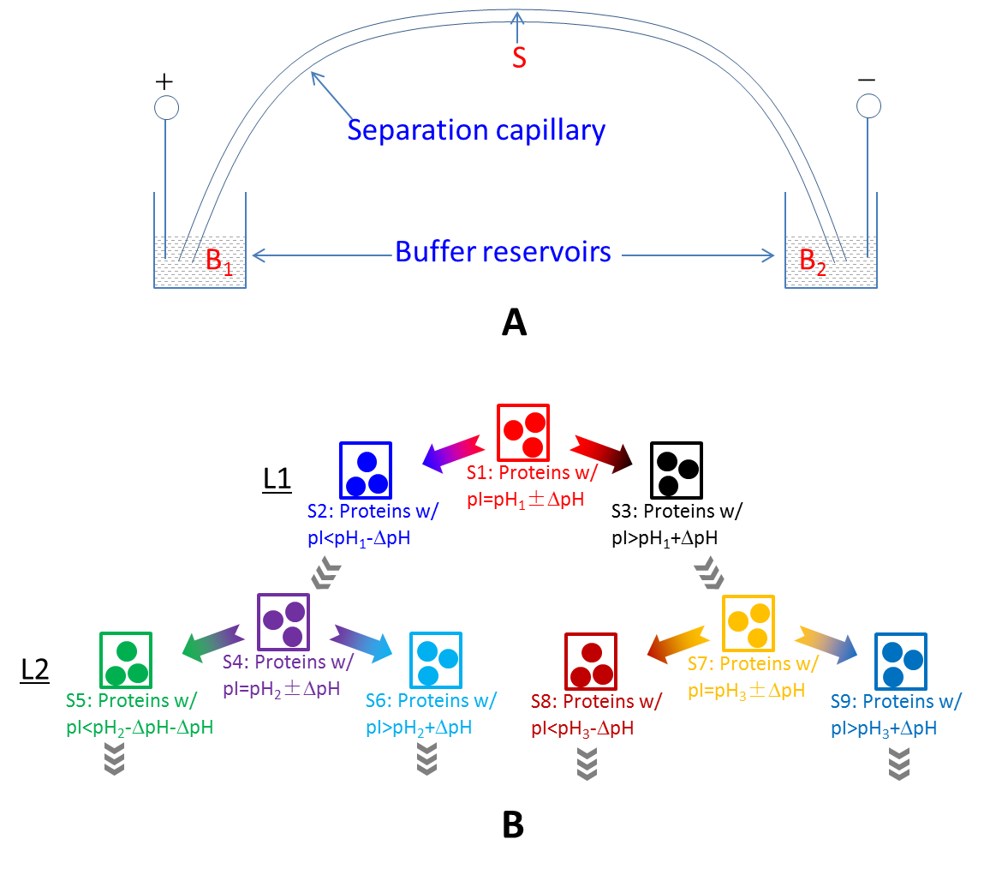
Figure 3.1 Schematic representation of electrokinetic fractionation working principle. A. Schematic arrangement of experimental setup. S: sample buffered at pH₁, B₁: buffer solution with a pH of pH₁-ΔpH, and B₂: buffer solution with a pH of pH₁+ΔpH. B. Schematic representation of electrokinetic fractionation principle. L1 (level 1): original sample being separated into three fractions; L2 (level 2): collection reservoir solutions being further separated; and so on.

3.2 Experimental section

3.2.1 Reagents and Materials
Acrylamide, N,N′-ethylenebisacrylamide (bis, a cross-linker), (3-methacryloxypropyl)-trimethoxysilane (a bifunctional reagent), N,N,N′,N′-tetramethylethylenediamine (TEMED), Benzonase, ammonium persulfate (APS), α-cyano-4-hydroxycinnamic acid (CHCA), 2,5-dihydroxybenzoic acid (DHB), ribonuclease A (pI 9.6), amyloglucosidase (pI 3.6), myoglobin (pI 6.8 and 7.2), trypsinogen (pI 9.3), carbonic anhydrase from bovine (pI 5.9), carbonic anhydrase from human (pI 6.6), bovine serum albumin (BSA, pI 4.9) and trypsin inhibitor (pI 4.6) were all purchased from Sigma (St. Louis, MO). Fused silica capillaries were purchased from Polymicro Technologies (Phoenix, AZ) and Teflon tubing was purchased from Cole-Parmer Instrument (Vernon Hills, IL). All solutions were prepared with double-deionized (DDI) water purified by a NANOpure infinity ultrapure water system (Barnstead, Newton, WA). Dialysis membrane (MWCO: 3.5-5 kD and 100-500 D) was purchased from Spectrum Laboratories (Rancho Dominguez, CA). OmniPur Coomassie Blue G-250 was bought from EMD (Gibbstown, NJ).

3.2.2 Capillary coating
The coating protocol is modified based on a method^{70, 71}. Briefly, a 100 cm long capillary with 360 μm outer diameter (o.d.) and a 150 μm inner diameter (i.d.) was filled with a 1.0 M NaOH solution and kept at 100 ℃ for 2 h with two ends sealed to activate the inner surface. It was then flushed with 1.0 M HCl for 1 h, DDI water for 0.5 h, and acetonitrile for 12 min. After being dried with helium, the inner surface of the capillary was reacted with a 30% 3-(Trimethoxysilyl)propyl methacrylate in acetonitrile for 19 h at 50 ℃, rinsed with acetonitrile for 10 min, and dried with helium. The capillary was then flushed with a degassed solution containing 3%T (the total weight concentration of acrylamide and bis in the solution) and 0.6%C (the concentration of bis relative to the total of acrylamide and bis), 0.05% (v/v) TEMED, and 0.075% APS for 5 min in an ice bath, another degassed solution containing 12%T and 0.6%C for 6 min, and then dried with helium. The capillary was cut into desired length for pI based fractionation.

3.2.3 Bradford assay
Bradford assay was used to determine protein concentrations in fractionated solutions for recovery evaluations. Bradford reagent was prepared by dissolving 5 mg Coomassie Blue G-250 in 2.5 mL 95% ethanol, 5 mL 85% phosphoric acid, and some DDI water. The solution was then transferred to a 50-mL flask, and filled with DDI water to mark. Calibration curve was established using BSA as a standard at different concentrations (0, 0.15, 0.30, 0.45 and 0.60 mg/mL). For concentration determination, 4 μL of a sample or standard was mixed with 400 μL of Bradford reagent, and its absorbance was measured at 595 nm.

3.2.4 Sodium dodecylsulfate – polyacrylamide gel electrophoresis (SDS-PAGE) of fractionated sample
SDS-PAGE was performed by mixing ~8 μL sample with 2 μL 5× sample buffer (0.5 M Tris-HCl pH 6.8, 10% SDS, 30% glycerol, 5% beta-mercaptoethanol, 0.05% bromophenolblue) and cooked in a boiling water bath for 5 min before electrophoresis. A Bio-Rad Mini-PROTEAN Tetra Cell system was used for running the SDS−PAGE. The separating gel contained 11.7% acrylamide and 0.3% bis, while the stacking gel contained 3.9% acrylamide and 0.1% bis. Gels were polymerized between two glass plates in a gel caster, with a 15-well comb inserted at the top to create sample wells. After the gel was polymerized, the comb was removed and the gel was ready for electrophoresis. A running buffer was prepared by adding 3.03 g Tris, 12.01 g glycine, and 1.00 g SDS in 1.00 L DDI water. A constant voltage (200 V) mode was used for the separation. The separation was stopped when the sample front moved ~0.5 cm to the end of the gel; usually the electrophoresis time was 50 min. The gel was then taken out, and silver stained for visualization of the protein bands.

3.2.5 Preparation of soluble protein extract from Hela cell
HeLa cells were cultured in Dulbecco’s Modified Eagle’s medium (Invitrogen, Green Island, NY) supplemented with 10% fetal bovine serum (FBS), penicillin (100 units/mL) and streptomycin (100 ug/mL). Approximately 6*10⁷ cells were harvested and then washed with PBS three times at 1000 rpm for 5 min each time. Cells suspended in 1 mL PBS were sonicated at 30% power output and 20% duty cycle using a Branson Sonifier 450 for four rounds; 5 s sonication for each round. The mixture was then centrifuged at 13000 rpm for 10 min to remove solid debris. 0.5 μL Benzonase and 5 mM MgCl₂ were added into the resultant supernatant to digest DNA and RNA at room temperature for 1 h. An Amicon Ultra-0.5 centrifugal filter device from Sigma was used to desalt the DNA-digested sample. The proteins were collected by spinning off from upside-down filter device at 1,000 × g, and then re-dissolved in DDI water.

3.2.6 Preparation of protein complex from Hela cell mitochondria
Approximately 6*10⁷ cells were harvested and then washed with PBS three times at 1000 rpm for 5 min each time after trypsinization. Cells suspended in PBS were broken by sonication as described in the manuscript text. All cell debris and nuclei were removed by centrifugation at 1000 x g for 10 min at 4 °C. Mitochondria was collected from the supernatant by centrifuging at 12,000 x g for 20 min at 4 °C and washed once with PBS buffer. The obtained mitochondrial pellets can be stored at -80 °C for future use or suspended by adding 250 μL of sample buffer containing 1 % w/v lauryl maltoside, 250 mM sucrose, 10 mM HEPES, and 1 mM EDTA (pH 7.0) for immediate use. The sample was layered on the top of a stepwise density gradient of sucrose, which was prepared by orderly adding 300 μL each of 43, 40, 37.5, 35, 32.5, 30, 27.5, 25, 22.5, 20, 17.5, 15, 10 % in 10 mM HEPES and 0.05 % w/v lauryl maltoside pH 7.0 onto an Ultra-ClearTM centrifuge tube (Beckman Coulter, Inc., CA). The ultracentrifugation proceeded for 20 h at 40000 rpm in the MLS-50 swing-bucket rotor of Beckman OptimaTM MAX-XP machine (Beckman Coulter, Inc.). The protein complex from mitochondria was aspirated out from centrifuge tube.

3.2.7 Two-dimensional electrophoresis (2DE) of fractionated sample
A Protein i12 IEF system and Criterion Vertical Electrophoresis Cell both from Bio-Rad were employed for 2DE. 16 μL of fractionated sample was mixed with 190 μL Bio-Rad ReadyPrep Rehydration/Sample Buffer (8 M urea, 2% CHAPS, 50 mM dithiothreitol, 0.2% (w/v) Bio-lyte 3/10 ampholytes, and bromophenol blue (trace)). A Bio-Rad 11-cm, pH 3–10, immobilized pH gradient (IPG) strip was rehydrated with 206 μL sample solution at room temperature for 16 h. After rehydration, the Bio-Rad 11cm, pH 3-10 R protocol stored in Protein i12 IEF system was used for focusing. After focusing, the IPG strip was transferred onto a Bio-Rad 4–20%, 11-cm precast gel for the second dimension separation. Gels were silver stained for visualization of the protein bands.

3.2.8 Apparatus
Figure 3.2A presents the apparatus configuration of the anode-side; the cathode-side is identical to the anode-side but the anode is replaced by a cathode. The separation capillary had a length of 45 cm, an o.d of 360 µm and an i.d. of 150 µm. The anode collection reservoir had a volume of 600 μL, and the anode reservoir had a volume of 100 mL. The teflon tubing had a length of 22 cm, an o.d. of 1.05 mm, and an i.d. of 0.55 mm. A dialysis membrane interface (DMI) was utilized to facilitate the application of an electric field across the separation capillary. Construction of the DMI is presented in Figure 3.2B. A 10-µL pipette tip was cut (so that it could put inside the anode collection reservoir properly), its smaller end was wrapped with a dialysis membrane (DM), and the DM was fixed in position and sealed with a parafilm tape.
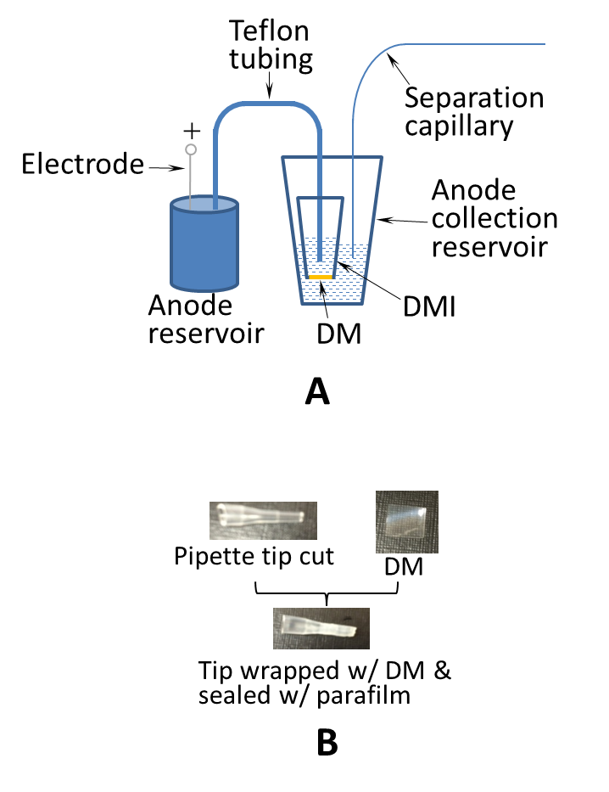
Figure 3.2 Apparatus for electrokinetic fractionation. A. Apparatus configuration of the anode-side. The apparatus on the cathode-side is image-symmetric to that on the anode-side. DM: dialysis membrane; DMI: dialysis membrane interface; Separation capillary: 45 cm coated capillary with an o.d of 360 µm and an i.d. of 150 µm; Teflon tubing: 22 cm with an o.d. of 1.05 mm, and an i.d. of 0.55 mm; Anode/cathode reservoir: 100 mL container; Anode/cathode collection reservoir: 600 μL tube. B. Preparation of DMI.

3.2.9 Electrokinetic fractionation
After the pH of 10 mM ammonium acetate buffer was adjusted to pH₁, sample proteins were dissolved with this buffer. B₁ was prepared by adding a small amount of acetic acid (HAc) while B₂ was prepared by adding a small amount of ammonia (NH₄OH). The pH of B₁ and B₂ were then measured. The teflon tubing and the DMI on the anode side, and the anode reservoir were filled with B₁, while the anode collection reservoir was loaded with 8.5 μL B₁. The teflon tubing and the DMI on the cathode side, and the cathode reservoir were filled with B₂, while the cathode collection reservoir was loaded with 8.5 μL B₂. After the separation capillary was filled with a sample (~8 μL), 20 kV was applied between the cathode and anode for electrophoresis. The electrophoretic separation was allowed to proceed for a given period of time (usually 50 min unless otherwise indicated), the solutions from the anode and cathode collection reservoirs and the separation capillary were harvested for further analyses.
To perform the next-level fractionation, the pH of a new sample was adjusted to a different value (e.g., pH_{i}), buffers with pH=pH_{i}-ΔpH and pH=pH_{i}+ΔpH were prepared, and the same procedure was followed for electrokinetic separations.

3.3 Results and Discussion

3.3.1 Suppression of electroosmotic flow (EOF)
Suppression of the EOF inside the separation capillary is key to the success of our fractionation approach. Otherwise, the sample will be moved out to a collection reservoir during electrokinetic separations. In this experiment, a coated capillary usually had a μ_{eo} of less than 1×10⁻¹⁰m²V⁻¹s⁻¹. Under the experimental conditions (20 kV across a 45 cm separation capillary), the solution inside the separation capillary should not move more than 13 mm for a 50 min run.

3.3.2 Effect of Pharmalyte on MS signal
To examine the effect of additives on MS signal, we mixed Pharmalyte at various concentrations with Trypsinogen, and loaded this solution (~0.5 µL per spot) directly onto a MALDI-MS target plate. After the solvent was dried, we added 0.5 µL of MALDI-MS matrix, a 1:1 mixture of solution A and solution B (A: 20 mg/mL α-cyano-4-hydroxycinnamic acid, 50% ACN and 50% Methanol; B: 30% ACN and 0.1% Trifluoroacetic acid) to each sample spot and allowed the sample to evaporate again. Figure 2s exhibits the effect of Pharmalyte on the MS signal. Figure 3.3B, 3.3C and 3.3D show that Pharmalyte severely suppressed the MS signal. At 3.6% Pharmalyte, no MS signal could be detected. Even at 0.9% Pharmalyte, the MS signal was reduced by 17 fold relative to the MS signal of the protein in 10 mM ammonium acetate buffer.
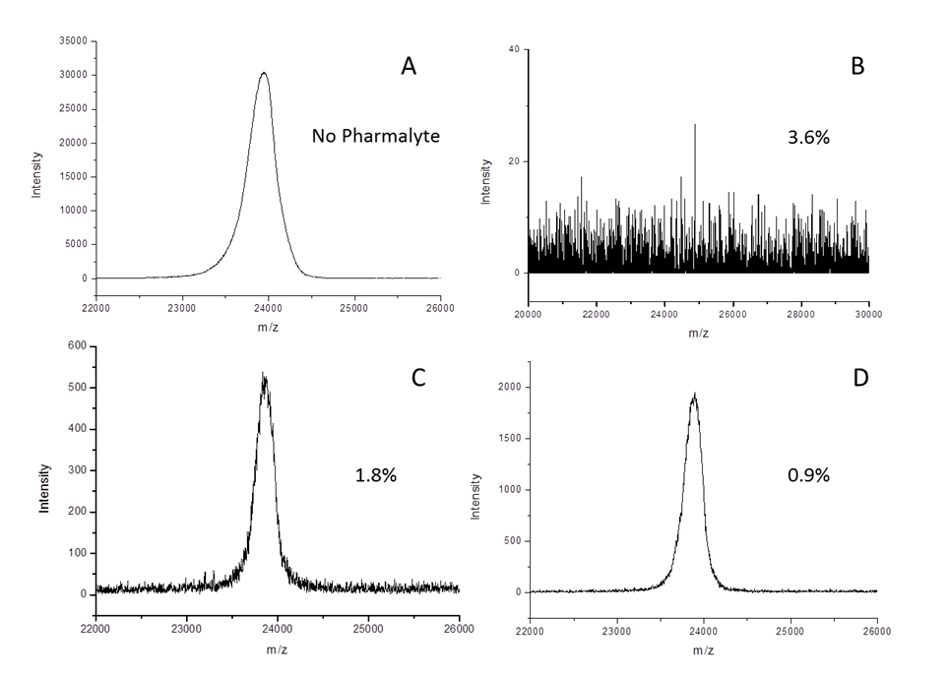
Figure 3.3 Effect of Pharmalyte on MS signal. The sample contained 0.2µg/µL Trypsinogen and various concentrations of Pharmalyte. 0.5 µL of this sample was loaded a MALDI target plate. After the sample was dried, 0.5 µL of a matrix solution was added to the sample spot. Then the matrix solvent was evaporated and the target plate was loaded into an Applied Biosystems 4800 Proteomics Analyzer. The MS spectra were measured at an m/z range of 15 kDa- 30 kDa with a focus m/z of 24 kDa in a linear mode. Spectra in Figures B, C and D were obtained from the protein-Pharmalyte mixtures, while spectra in Figures A were obtained from the protein in 10 mM ammonium acetate buffer.

3.3.3 DMI
The use of DMI is necessary because (1) putting a metal electrode directly in a collection reservoir will oxidize/reduce the proteins and (2) electrolysis will change the pH of the solution inside the reservoir. This issue can be serious if a small volume of solution will be used in the reservoir. By using a DMI, we can employ a large-volume container (e.g., 100 mL) as an anode or cathode reservoir. Since electrolysis will occur only in the anode or cathode reservoir, proteins in the collection reservoir will not be oxidized/reduced, and the electrolysis-generated H⁺ or OH⁻ will be effectively buffered by the large-volume buffer solution.

3.3.4 pH variation in collection reservoir
Electrolysis can still cause the pH variations of the solution inside a collection reservoir owing to the blockages of charged proteins by the DM. Let us take the anode collection reservoir (see Figure 3.2A) as an example to explain this effect. During electrophoresis, the electric current will be carried by all electrolytes including negatively-charged proteins. If a negatively-charged protein is blocked by the DM, some other anions (a portion of it will be OH⁻) will have to move from the collection reservoir across the DM to the DMI solution or/and some other cations (a portion of it will be H⁺) will have to move across the DM in the opposite direction in order to maintain the solution neutrality. As H⁺/OH⁻ leaves/enters the collection reservoir, its pH will decrease. Similarly, when a positively charged protein is blocked by the DM inside the cathode collection reservoir during electrophoresis, some H⁺/OH⁻ will leave/enter the reservoir, its pH will increase.

The pH changes due to the above effect can be alleviated effectively by adding some electrolyte (e.g., NaCl) in the buffer. [Note: the electrolyte should not be added in the sample solution.] The increased electrolyte concentration will reduce the probability of H⁺/OH⁻ as current carriers and hence suppress the pH variations.

3.3.5 Protein recovery
If a DMI was not properly constructed (e.g., the DM was not tightened well to the pipette tip or it was broken), proteins would migrate across the DM to the DMI solutions and be lost. To examine whether proteins were lost, we measured the recovery rate of our fractionation method. We first prepared three 0.2 mg/mL protein (BSA, myoglobin or trypsinogen) standard solutions in 10 mM ammonium acetate at pH=7.0. These samples were then electrokinetically fractionated at pH₁=7.0 with a ΔpH between 0.4~0.5. At the end of each separation (50~60 min), BSA migrated into the anode collection reservoir, trypsinogen migrated into the cathode collection reservoir, and myoglobin remained in the separation capillary. Protein quantities in these solutions were determined via Bradford method. The ratio of measured value to the theoretical value was recorded as the recovery rate. Recovery rates between 93-97% were obtained. We also fractionated a sample containing all three proteins, similar recovery rate were obtained. This indicated that most proteins were constrained in the two collection reservoirs and the separation capillary.

3.3.6 Electrophoresis time
Electrophoresis time was an important parameter for our method. If too short, proteins would not have time to migrate to their equilibrated positions. If too long, time was wasted. To determine the optimum electrophoresis time, we prepared a standard solution containing 8 proteins and electrokinetically fractionated the sample at pH₁=6.65 with a ΔpH of ~0.1 under different electrophoresis times. The results are presented in Figure 3. At an electrophoresis time of 30 min, some trypsinogen (pI 9.3) still remained inside the separation capillary. An electrophoresis time of 50 min or longer, protein migration equilibria seemed to have been reached because the band patterns/intensities in the 50-min and 70-min boxes looked very similar. In this work, 50-min electrophoresis time was selected to run all electrokinetic fractionations under the captioned experimental conditions.
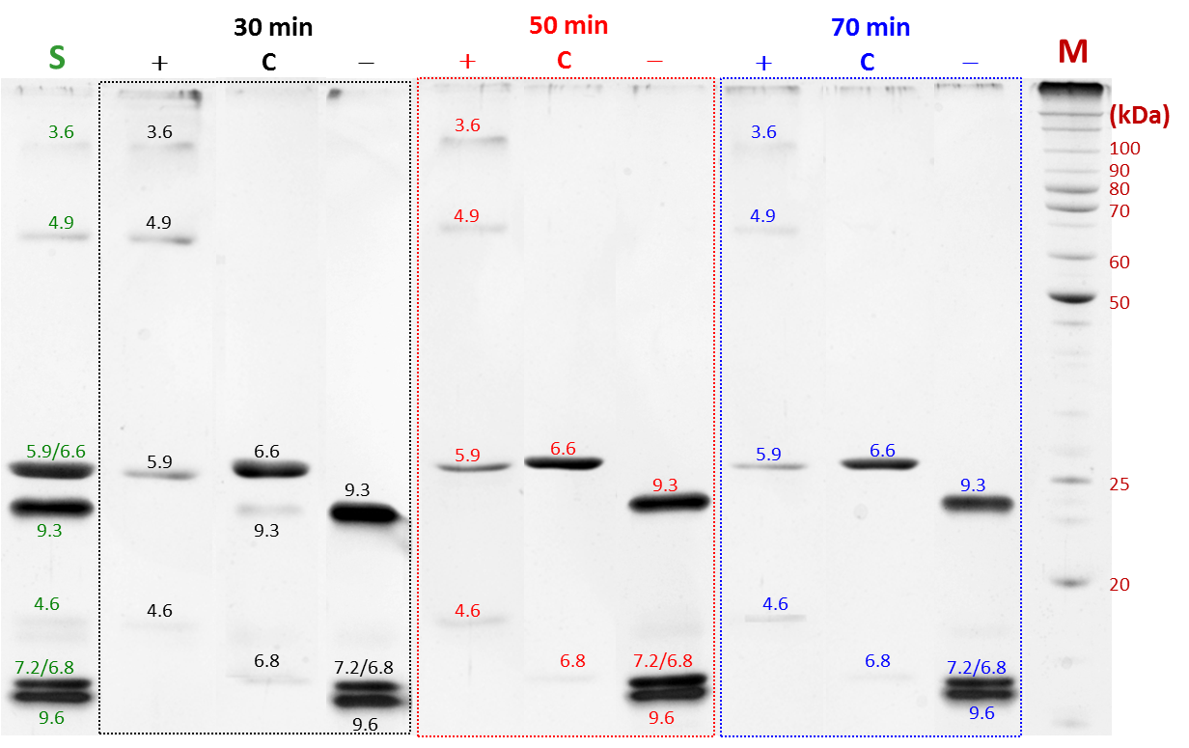
Figure 3.4 Effect of electrophoresis time on separation. Electrokinetic fractionation was performed at pH₁=6.65 with a ΔpH of ~0.1 and a voltage of 20 kV under different electrophoresis times. SDS-PAGE was carried out on a Bio-Rad Mini-PROTEAN Tetra Cell system using a 0.75 mm separating gel (11.7% acrylamide and 0.3% bis) and stacking gel (3.9% acrylamide and 0.1% bis) at 200 V. Gels were silver stained for visualization of the protein bands. The electrophoresis time of each test was placed on top of each dashed box. Lane S: original sample; Lane C: fraction from separation capillary; Lane +: fraction from anode collection reservoir; Lane -: fraction from cathode collection reservoir; Lane M: molecular weight marker. The number above each protein band represents the PI of the protein. Sample: mixture of eight proteins [ribonuclease A (pI 9.6), amyloglucosidase (pI 3.6), myoglobin (pI 6.8 and 7.2), trypsinogen (pI 9.3), bovine carbonic anhydrase (pI 5.9), human carbonic anhydrase (pI 6.6), bovine serum albumin (BSA, pI 4.9) and Trypsin inhibitor (pI 4.6)] at a concentration of 0.2 mg each/mL.

3.3.7 Multi-level fractionation
To demonstrate feasibility of running multi-level fractionation, we used the same eight-protein sample and performed the 2nd-level and the 3rd-level (partial) fractionation. The results are presented in Figure 3.5. All eight proteins were effectively separated and fractionated.
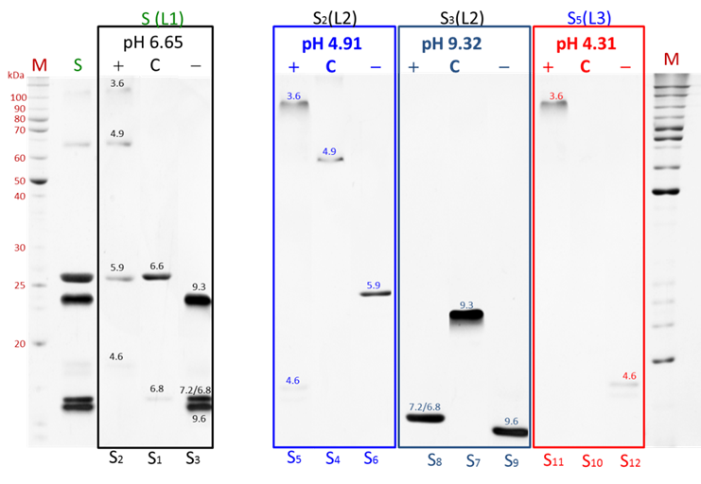
Figure 3.5 Multi-level fractionation. Eight proteins were initially (L1) fractionated at pH 6.65; this separation results in three fractions S1, S2 and S3. S2 and S2 are then (L2) fractionated at pH 4.91 and 9.32, resulting in S4, S5 and S6, and S7, S8 and S9, respectively. S5 is further (L3) fractionated at pH 4.31 resulting in S10, S11 and S12. In all tests, ΔpH was ~0.1. The symbol on top of each box stands for the sample before that fractionation, the symbol in each parenthesis indicates the level of fractionation, and the symbols underneath each box represent the samples after that fractionation. The pH at the top but inside each box indicates the sample solution pH for running that fractionation. Electrokinetic fractionation and SDS-PAGE conditions, the meanings of other symbols are the same as presented in Figure 3.4.

3.3.8 Fractionation of Hela cell protein extract
To demonstrate feasibility of fractionating real-world samples, we prepared a protein sample from Hela cells. The sample was fractionated at pH₁=7.0 with a ΔpH of ~0.5. The 2DE separation results of solutions from anode collection reservoir, separation capillary and cathode collection reservoir were respectively presented in Figures 3.6A, 3.6B and 3.6C. When these three figures were combined together, a full 2DE image of the sample was synthesized (see Figure 3.6D). To examine where proteins were lost during the fractionation process, we ran a 2DE separation of the original sample. Figure 3.6E presents the results. The similarity between Figures 3.6D and 3.6E indicates few proteins were lost.
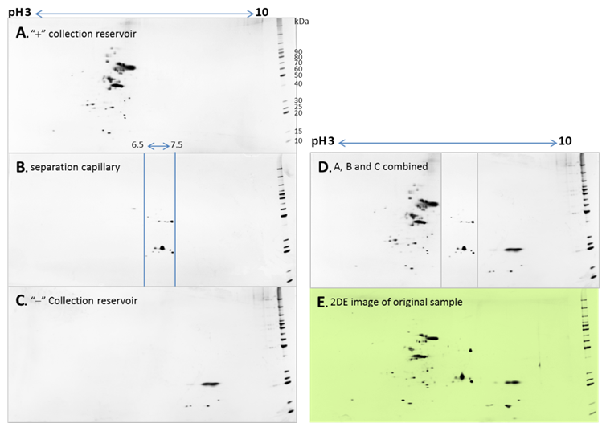
Figure 3.6 2DE results of soluble Hela cell proteins. IEF was performed using a Bio-Rad 11cm-pH 3-10 IPG strip. After focusing, the IPG strip was transferred onto a Bio-Rad 4–20%, 11 cm precast gel on a Bio-Rad Protein i12 IEF system for the second dimension separation. Running voltage was 200 V. Gels were silver stained for visualization of the proteins. Electrokinetic fractionation was carried as described in Figure 3.4 with sample pH of 6.78 and a electrophoresis time of 50 min. (A), (B) and (C) show the 2DE results of fractions collected from cathode collection reservoir, separation capillary and anode collection reservoir; (E) is an overlaid image of (A), (B) and (C); (D) is the 2DE image of the original sample as a control.

3.3.9 MALDI-TOF-MS analysis of fractionated protein
A commercial MALDI-TOF-MS (model 4800 plus, AB Sciex, Darmstadt, Germany) was used for mass analysis of fractionated protein complex sample. Positively charged ions were analyzed in the linear mode. Two basic matrixes (matrix A containing 10 mg/mL CHCA in 70 % v/v acetonitrile-water with 5 % v/v formic acid; Matrix B containing 10 mg/mL DHB in 70 % v/v acetonitrile-water with 0.05 % v/v trifluoroacetic acid) were 1:1 mixed right before use. The above mixture was then mixed with a sample at a 1:1 ratio. The sample-matrix mixture was then loaded onto a metal target plate. Mass spectra of intact proteins was obtained by averaging 1000 random laser shots on each sample spot as shown in Fig.3.7.
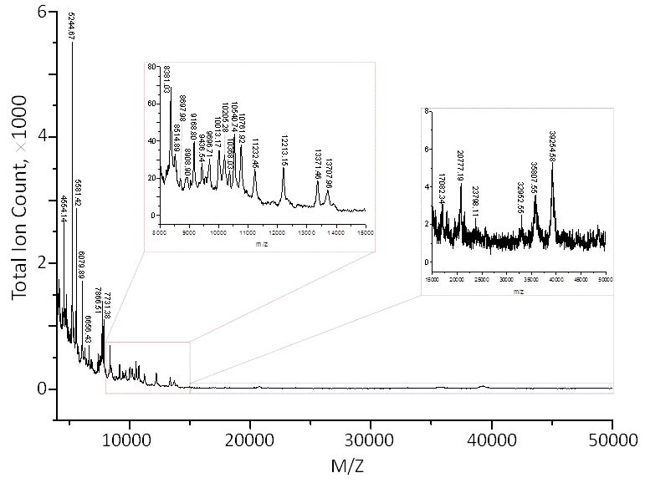
Figure 3.7 MALDI-TOF MS of Intact proteins from fractionated mitochondrial complexes.

3.4 Conclusion
We have developed a simple electrokinetic means to fractionate protein samples according to their pI values and demonstrated the feasibility of using this approach for fractionating real-world samples. The method does not require sophisticated equipment, and its consumable costs are low. More importantly, the fractionated sample are MS-friendly because we eliminate the use of ampholytes that interfere with MS analysis (see Figure 3.3). Figure 3.7 presents an example of a MS spectrum for a sample fractionated by this method. The method will be an excellent way to purify a specific protein (e.g., an antibody) for analytical and micropreparative purposes. The method is fast compared to some other approaches (e.g., OFFGEL), but its sample throughput is low. We have an on-going project for implementing this approach on a microfabricated device. Duplicated structures will be arranged on the device to perform multiple electrokinetic fractionations in parallel, which will increase the sample throughput dramatically. Nevertheless, because of its simplicity and low cost, the method will be an outstanding choice for research labs with limited resources.

The material in chapter 3 is adapted from Chen, H., Zhu, Z., Yu, H., Lu, J. J., Liu, S., Analytical Chemistry 2016, 88 (18), 9293-9299. The copyright permission is obtained from ACS.

Chapter 4: Two-dimensional chromatographic analysis using three second-dimension columns for continuous comprehensive analysis of intact proteins

4.1 Introduction
In proteomic research, two complementary approaches (bottom-up and top-down) are commonly used for protein analysis. The bottom-up approach has progressed rapidly due to the advancement of modern mass spectrometry (MS), enabling identification and quantitation of hundreds or even thousands of proteins in single analysis⁷²⁻⁷⁵. However, this approach can miss the information of post-transitional modification, mutations and proteolytic cleavage, and therefore other approaches are constantly sought⁷⁶⁻⁷⁸. The top-down approach is a great alternative, in which intact proteins are individually analyzed. One of the most challenging tasks in the latter approach is to isolate proteins from a background of many other proteins and complex matrices. Often, this is beyond the resolving power of a one-dimensional separation technique. Vast effort has been invested on exploiting multi-dimensional separation strategies and progress has been made recently^{79, 80}.
Two-dimensional electrophoresis (2DE) is a powerful method for separating intact proteins. It quickly became routine after its introduction in 1975⁸¹. However, extracting individual proteins after 2DE separation is tedious and time-consuming. In the last decade or so, two-dimensional (2D) high performance liquid chromatography (HPLC) has received considerable attention due to its attractive features⁸²⁻⁸⁴ such as great number of column (or HPLC mode) choices, high resolving power, convenience for collecting resolved-proteins, straightforwardness for automating 2D HPLC, etc.
While some 2D HPLC techniques⁸⁵⁻⁸⁷analyze portions of the first dimension (first-D) effluents, a comprehensive 2D HPLC analyzes all of them, preventing losses of any proteins. One of the early comprehensive 2D HPLC systems was constructed by Bushey and Jorgenson²⁵. Through an eight-port valve, these authors coupled cation exchange and size exclusion chromatography for intact protein separations. Carr’s group11^{24, 88, 89}, is also an active team on developing comprehensive 2D HPLC, especially on the high-speed 2D HPLC. More recent advances in 2D HPLC have been reviewed by Hanash⁹⁰, Carr⁹¹, and Stoll⁹².
A major challenge in current 2D HPLC is the limited separation speed in the second dimension (second-D). Because current 2D HPLC systems employ one first-D column and one second-D column, and the first-D effluent is fractionated and sequentially analyzed by the second-D. In order to retain the first-D resolution, one has to fractionate its effluent frequently (or in small segments) to minimize the re-mixing of the resolved analytes. Unless the effluent fractions are parked somewhere for later or off-line analyses, the second-D separation has to be fast in order for all the first-D fractions to be analyzed in time. The use of multiple parallel columns at the second-D can be a solution to this problem.
In this work, we develop an innovative approach to overcome this problem. We incorporate multiple columns in the second-D to enable several second-D separations to be performed in parallel. That is, while the effluent of the first-D is loaded into one of the second-D columns, separations in other second-D columns are preceded simultaneously. By doing so, we reduce the speed requirement of the second-D separation by a factor of n, where n is the number of the second-D columns. To demonstrate the feasibility of this approach, here we construct a 2D HPLC with three second-D columns and show the results of using this system for analyzing both proteins standards and E. Coli lysates.

4.2 Experimental section

4.2.1 Reagents and Materials
Fused-silica capillaries were products of Polymicro Technologies Inc. (Phoenix, AZ). Tetrahydrofuran, 1-propanol, 1,4-butanediol, 1-decanol, 2,2’-azobisisobutyronitrile (AIBN, 98%), and protein standards were obtained from Sigma (St. Louis, MO). Hydrochloric acid, sodium chloride, sodium hydroxide, tris(hydroxyl-methyl)aminomethane (Tris), and ethylenediamine- tetraacetic acid (EDTA) were obtained from Fisher Scientific (Fisher, PA). Ethylene glycol dimethacrylate (EDMA, 98%), glycidyl methacrylate (GMA, 97%), styrene (99%), divinylbenzene (80%), and diethylamine were purchased from Alfa Aesar (Ward Hill, MA). Methanol, acetonitrile, and tetrafluoric acid were products of EMD Chemicals, Inc. (Gibbstown, NJ). Methacryloyloxypropyltrimethoxysilane (γ-MAPS, 98%) was purchased from Acros (Fairlawn, NJ). All solutions were prepared with ultrapure water purified by a NANO pure infinity ultrapure water system (Barnstead, Newton, WA).

4.2.2 Preparation of Reverse-Phase (RP)-HPLC Monolith
The inner wall of a capillary (120 cm length × 250 μm i.d. × 360 μm o.d.) was vinylized following the procedures we reported previously. A 30-cm-long vinylized capillary was filled with a mixture composed of 48 μL styrene, 48 μL divinylbenzene, 130 μL decanol, 20 μL tetrahydrofuran, and 10 μg/μL AIBN. The mixture was polymerized in a water bath at 60 ℃ for 20 h. After polymerization, ~2 cm of the capillary at both ends was cut off and discarded. The monolith was then rinsed with acetonitrile at ~800 psi for 4 h and deionized water at ~1500 psi for 1 h.

4.2.3 Preparation of Ion Exchange (IEX) Monolith
A 30-cm-long piece of vinylized capillary (250 μm i.d. × 360 μm o.d.) was filled with a mixture comprising 225 μL GMA, 75 μL EDMA, 250 μL 1-propanol, 400 μL 1,4-butadiol, 50 μL deionized water, and 10 μg/μL AIBN. The polymerization was processed in a water bath at 60 ℃ for 16 h. After ~2 cm of the capillary at both ends was cut off, the monolith was washed with methanol at 800 psi for 4 h.Tertiary-amine groups were then created in the monolith via a ring-opening reaction of epoxy groups. 1 M diethylamine in methanol was pressurized through the above monolith in an oven at 75 ℃ with a 500-psi pressure for 2 h. The modified monolith was then flushed with methanol at room temperature with methanol at 800 psi for 1 h and deionized water at 1500 psi for 30 min.

4.2.4 Sample Preparation
2.0 mg/mL stock solutions of protein standards were prepared by dissolving the appropriate amount of protein powder in deionized water. The stock solutions were stored at a ultra-low temperature freezer. Test solutions were produced by diluting the stock solution to the desired concentrations with the mobile phase A for IEX or RP-HPLC.
The E. coli [a transformant of BL21(DE3) competent cell] was grown in a complete Luria-Bertani medium at 37 ℃ overnight. Bacteria cells were harvested by centrifugation at 13,000 rpm for 5 min. Approximately 800 mg of wet bacteria pallet was suspended in 10 mL chilled sample buffer at pH ~7.6 containing 50 mM Tris-HCl, 1 mM EDTA, and 1 mM 2-mercaptoethanol. The suspended cells were finally sonicated in an ice bath by 3 cycles of 30s bursts with 30s cooling intervals (amplitude 55%, cycle 0.5 in a Branson Sonifier 450 W). The soluble proteins in the supernatant were collected by centrifugation at 13000 rpm for 10 min. The obtained protein lysates were directly analyzed without further purification.

4.2.5 Online 2D HPLC Platform
Figure 4.9 represents a schematic diagram of our 2D HPLC platform. It consisted of two gradient pumps (RP Pump – Agilent 1200 Series Binary Pump, and IEX Pump –Dionex GP50 Gradient Pump), one isocratic pump (ISO pump – Jasco PU-1580 Intelligent Pump), one 20μL injector, two flow-through stream selectors (Valco Instruments, Houston, TX), and three UV detectors (Linear Instruments, Reno, NV). IEX Pump was used for gradient IEX and RP Pump for RP HPLC separations. ISO Pump was used for equilibrating columns with an equilibration solution. In the first-D, intact proteins were separated using a laboratory-made IEX monolith column, and the effluent was injected directly, continuously and alternately into the three second-D RP-HPLC columns.

4.2.6 2D HPLC Separation
All three second-D columns were washed with an equilibration solution [5% (v/v) acetonitrile and 0.2% (v/v) tetrafluoric acid in DI water] for five minutes before a 2D HPLC separation was started. Once the gradient separation in the first-D was initiated (t = 0 min), the system was set to a configuration as shown in Figure 4.9A. From t = 0 min to t = 5 min, the first-D effluent was loaded into RP #1 column while an equilibration solution was flushing through RP #3 column and a gradient eluent was running through RP #2 column. From t = 5 min to t = 15 min, the left stream selector was switched to Position 3 (see Figure 4.9B). While the first-D effluent was still loaded into RP #1, an equilibration solution was driven through RP #2 to prepare it for sample loading. At this time, a gradient eluent was running through RP #3; if RP #3 had been loaded with a sample, a gradient elution would have started by now. From t = 15 min to t = 20 min, the right stream selector was switched to Position 5 (see Figure 4.9C). The first-D effluent was now loaded into RP #2, while an equilibration solution was flushing through RP #1 to wash away the matrix (including IEX eluent) from sample loading. At this moment, a gradient eluent was still running through RP #3. From t = 20 min to t = 25 min, the left stream selector was switched to Position 5 (see Figure 4.9D). While the first-D effluent was still loaded into RP #2, gradient separation in RP #1 started. At this time, an equilibration solution was flushing through RP #3 to get it ready for sample loading. From t = 25 min to t = 35 min, the right stream selector was switched to Position 1 (see Figure 4.9E). The first-D effluent was now loaded into RP #3, an equilibration solution was flushing through RP #2 to wash away the matrix from sample loading, and a gradient eluent was running through RP #1 for separation. From t = 35 min to t = 40 min, the left stream selector was switched to Position 1 (see Figure 4.9F). The first-D effluent was still loaded into RP #3, gradient eluent was running through RP #2, and an equilibration solution was flushing through RP #1 to get it ready for sample loading. After 45 min, the operation cycled back to the configuration as shown in Figure 5A.
As a result of the above operation, every column was loaded with the first-D effluent (or sample) for 15 min, washed with the equilibration solution for 5 min, eluted with the RP gradient for 15 min, and washed again with the equilibration solution for 10 min before being loaded with another sample.

4.3 Results and Discussion

4.3.1 RP-HPLC separation
In our second-D (RP-HPLC) separation, we used a multi-step protocol, i.e., sample loading, matrix washing, analyte elution, and column equilibration. A column-equilibration step was important because the residual RP gradient in the column would mess up with the sample loading. The matrix washing step was also important because some matrix compounds such as lipids and carbohydrates interfered with RP-HPLC separation and absorption detection. This step would be critical if MS was used as a detector because the first-D eluent contained a lot of salt that interferes with MS measurements.

4.3.2 Column preparation for 2D HPLC
Columns for separating intact proteins rarely perform as well as those for peptides. Initially, we attempted to utilize commercial columns for both dimensions, but the separation results were not satisfactory. Therefore, we developed our own capillary (250-μm i.d.) monolithic columns. An IEX column was used for the first-D and multiple RP columns were used for the second-D. The IEX column was prepared using a two-step procedure. Briefly, a co-polymer monolith was first synthesized by in-situ polymerization of GMA and EDMA in a 250-μm i.d. vinylized capillary. Tertiary-amine groups were then introduced into the monolith to serve as weak anion-exchanger via a ring-opening reaction of the epoxy groups. Figure 4.5 presents two chromatograms when this column was used to separate a standard protein mixture and a protein lysate sample from E. Coli cells. Baseline separation is achieved for the standard protein mixture (see Figure 4.5A) while more than 70 peaks were identifiable for the E. Coli lysates (see Figure 4.5B); these are excellent results for separating proteins using monolith columns. Optimizations and characterizations of these columns will be reported in details elsewhere.
RP columns were PS/DVB-based monolithic columns, and they were prepared following a procedure published previously. Both standard proteins and E. Coli cell lysates were separated using this column; high quality results were obtained as well (see Figure 4.6). Varied performances between the second-D columns had been a concern for us because that would make it difficult to compile all second-D chromatograms into one 2D image. This concern was removed as long as we kept the conditions the same in preparing the RP columns. Figure 4.1 presents the performance comparison between columns of the same batch and Figure 4.2 shows the comparison between columns from different batches using the same sample; similar performances were obtained.
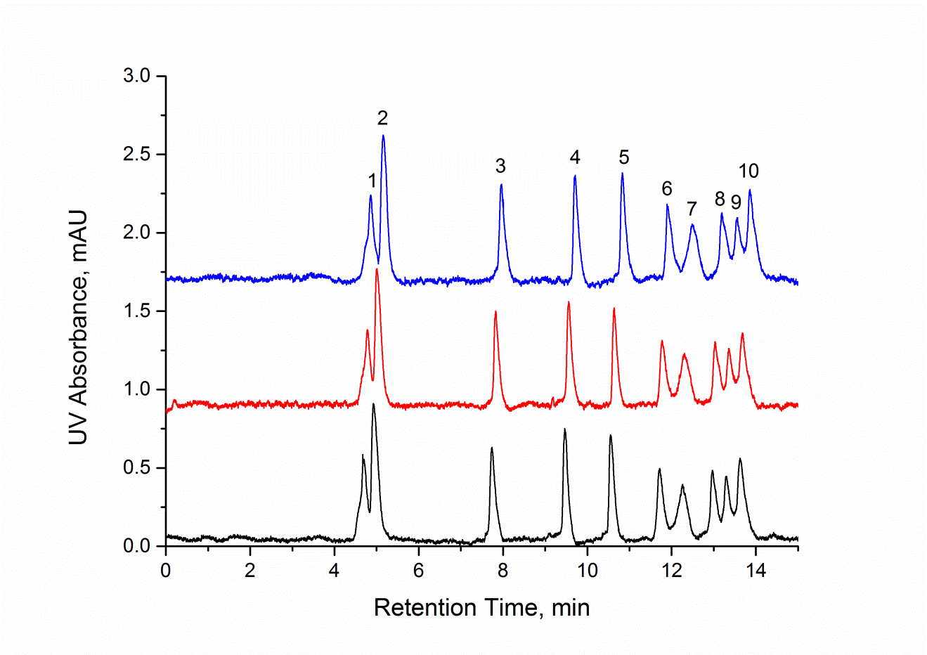
Figure 4.1. Column-to-column reproducibility in RP HPLC. Three monolithic columns were simultaneously made in the laboratory. Each column was of 20-cm length, 360-µm o.d. and 250-µm i.d.. Mobile phase A, 5% (v/v) acetonitrile and 0.05% (v/v) tetrafluoric acid in DDI water; mobile phase B, 90% (v/v) acetonitrile and 0.05% (v/v) tetrafluoric acid in DDI water. Gradient, as indicated with the dashed line in the figure; detection, UV at 280 nm; injection volume, 50 nL; sample, a mixture of ribonuclease a (a), insulin (2), cytochrome c (3), lysozyme (4), α-lactalbumin (5), transferrin (6), conalbumin (7), myoglobin (8), β-lactoglobulin b (9) & a (10); each at 200 μg/mL; pressure on column, ~1100 psi.
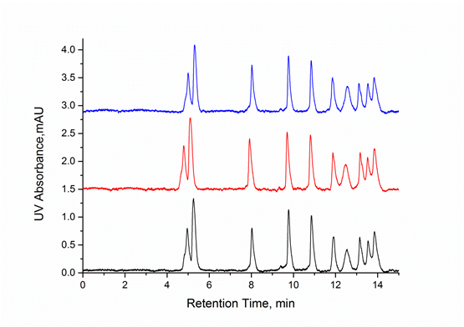
Figure 4.2 Batch-to-batch reproducibility in RP HPLC. Three batches of monolithic monolithic columns were made in different days. All experimental conditions were as in Figure 4.1.

4.3.3 Second-D separation speed consideration
A conventional 2D HPLC system usually consists of one first-D column and one second-D column. In a comprehensive 2D separation, the first-D effluent is continuously segmented and injected into the second-D column for analysis. If the separation time of the first-D is t and its effluent is segmented into n fractions, the separation time for the second-D should be t/n or less. This constraint imposes a great challenge for utilizing optimum conditions for both separation dimensions.
Here we present an example showing the adverse effect of this constraint. As can be seen in Figures 4.5 and 4.6, both IEX and RP columns exhibited reasonable resolving power for intact proteins under optimized conditions. In order to retain the resolution of the first-D, we would like to segment its effluent into 100 aliquots for the second-D separations. We would also like to run the second-D separations in a continuous fashion, i.e., no fractionated solution parking. If one IEX column and one RP column were used for the first- and second-D, we would have to finish each second-D separation in less than 2 min based on the chromatogram in Figure 4.5. Figure 4.3 presents three chromatograms of different gradient ramp rates; resolutions deteriorated seriously as the ramp rate increased. Apparently, we could not utilize any parameters close to optimized conditions in such a 2D HPLC system.

Figure 4.3 Separation of protein lysates from E. Coli cells with RP HPLC. Three different gradients were used to demonstrate the effect of the gradient ramp rate on the separation performance. The gradient was indicated with the dashed line in its corresponding figure. Sample, 70-fold diluted protein lysates from E. Coli cells. All other conditions were as in Figure 4.1.

4.3.4 Use of multiple columns to address second-D speed demand
A possible solution to mitigate the speed constraint is to incorporate parallel columns in the second-D so that the first-D effluent can be analyzed simultaneously by multiple columns. For the aforementioned example, if we could arrange 20 columns in the second-D to run separations simultaneously, the time required for each separation would increase to 40 min, which would allow us to utilize the optimized separations conditions in both dimensions.
To demonstrate the feasibility of this approach, we incorporated three columns in the second-D. Only three second-D columns would not allow us to run both separation dimensions at their optimized conditions. As a compromise for this three-second-D column setup, we extended the first-D separation to 10.5 h and shortened the second-D separation to 15 min. With this set of conditions, we could fractionate the first-D effluent into 42 fractions. Figure 4.7 presents the 2D separation results for E. Coli cell lysates; greater than 500 peaks were obtained, even only three second-D columns were incorporated. It should be pointed out that different gradients were used for the second-D separations in this experiment, and the detailed gradient conditions are listed in Table 4.1.

4.3.5 Sample complexity reduction after 2D separation
To determine the sample complexity after 2D separation, the effluents from the second-D were collected and analyzed by SDS–PAGE. As shown in Figure 4.8, several bands were observed in SDS–PAGE, indicating that multiple proteins still existed in each of these samples. The magnificent point was that only several bands were observed in any lane; compared to hundreds or thousands of proteins in the original sample. The sample complexities were greatly reduced! These samples can be conveniently analyzed by MS. We anticipate the number of proteins in each sample would reduce proportionally with the increasing number of the second-D columns.

4.4 Conclusion
We have coupled IEX (the first-D) chromatography with multiple-column RP (the second-D) chromatography for comprehensive and 2D separation of intact proteins. With n columns incorporated in the second-D, we can theoretically reduce the speed requirement of the second-D by a factor of n. To demonstrate the feasibility of this approach, we have incorporated three second-D columns, and we have reduced the speed requirement of the second-D by a factor of 3. This system has been tested for separating both protein standards and E. Coli lysates; baseline resolutions were obtained for separating 12 standard proteins (see Figure 4.4) while more than 500 protein peaks were detected for the E. Coli lysate sample. We have collected the second-D effluents from separating E. Coli lysates and analyzed these samples by SDS-PAGE. Only several proteins were found in each of these samples, and these samples can be easily analyzed by MS or other techniques. It is logic to believe that the number of proteins in each sample would further decrease as the number of the second-D columns increase. This approach could potentially be an excellent technique for reducing the complexities of real-world proteomic samples. However, it is currently a challenge to integrate a multiple-column HPLC with a mass spectrometer.
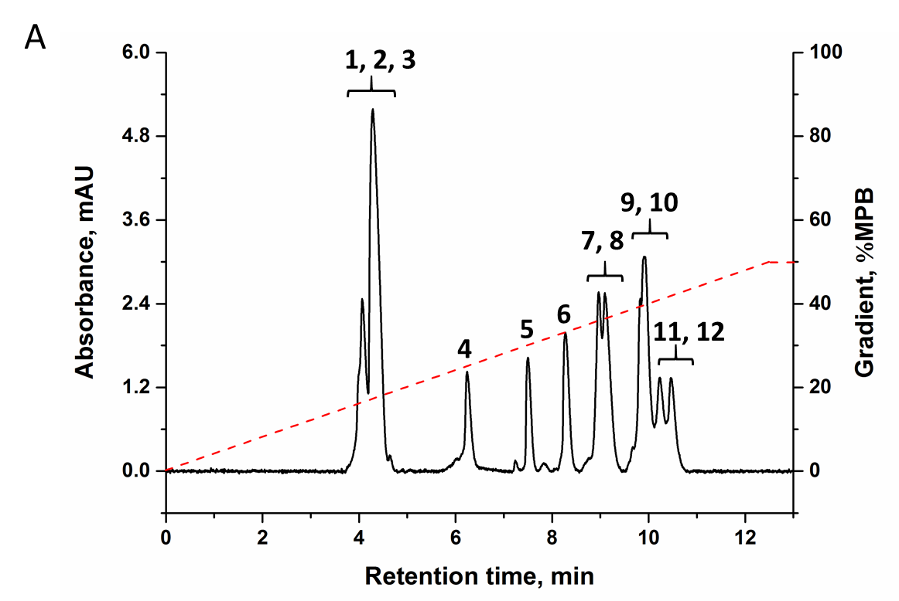

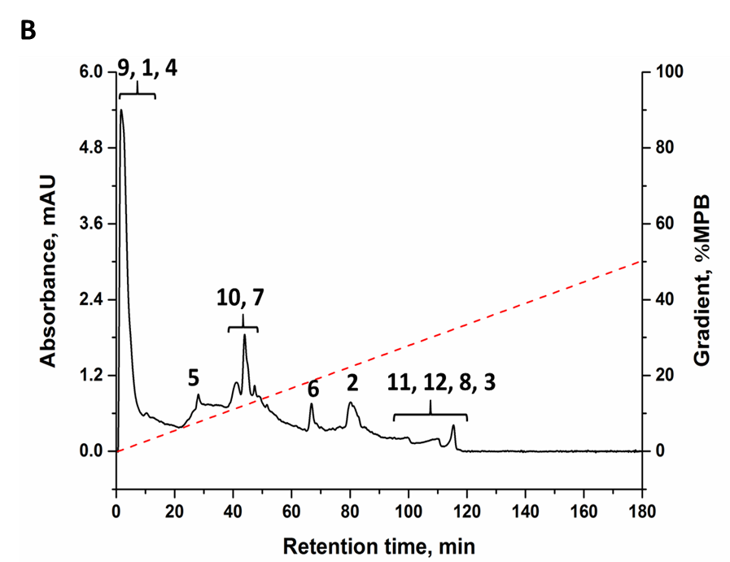

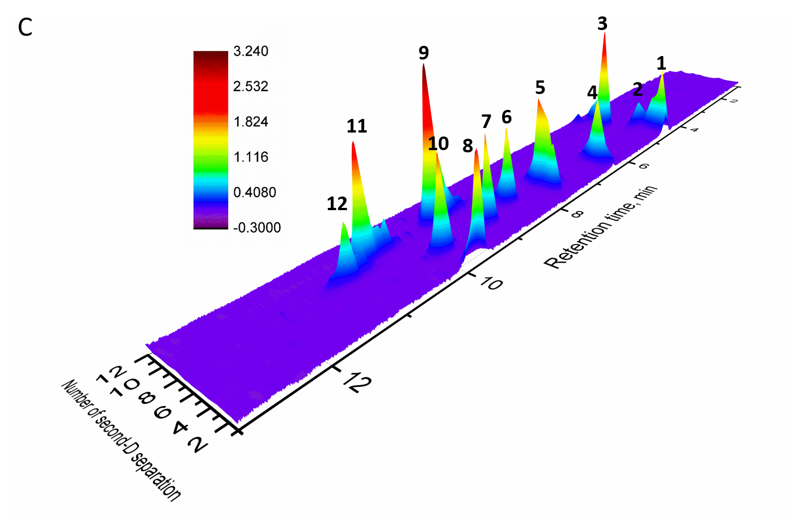

Figure 4.4 Testing the 2D HPLC platform with protein standards. (A) Separation of protein standards with RP HPLC. Gradient, as indicated with the dashed line in the figure; sample, a mixture of ribonuclease a (1), ovalbumin (2), insulin (3), cytochrome c (4), lysozyme (5), α-lactalbumin (6), transferrin (7), trypsin inhibitor (8), myoglobin (9), conalbumin (10), β-lactoglobulin b (11) & a (12); each at 4 μg/mL; all other conditons were as in Figure 4.1. (B) Separation of protein standards with IEX chromatography. The column was a monolithic one made in laboratory. It was of 20-cm length, 360-µm o.d. and 250-µm i.d.. Mobile phase A, 10 m M Tris/HCl at pH ~7.6 in DDI water; mobile phase B, 1 M NaCl dissolved in mobile phase A. Gradient, as indicated with the dashed line in the figure; detection, UV at 280 nm; injection volume, 20 μL; sample, a mixture of ribonuclease a (1), ovalbumin (2), insulin (3), cytochrome c (4), lysozyme (5), α-lactalbumin (6), transferrin (7), Trypsin inhibitor (8), myoglobin (9), conalbumin (10), β-lactoglobulin b (11) & a (12); each at 50 μg/mL; pressure on column, ~1900 psi. (C) Separation of standard proteins with the new developed 2D HPLC platform. The second-dimension chromatograms was stacked side by side in the order of fraction number, which was assembled using Origin. Injection volume, 20 μL; sample, a mixture of ribonuclease a (1), ovalbumin (2), insulin (3), cytochrome c (4), lysozyme (5), α-lactalbumin (6), transferrin (7), Trypsin inhibitor (8), myoglobin (9), conalbumin (10), β-lactoglobulin b (11) & a (12); each at 4 μg/mL. The length of each RP column, and IEX column was 20 cm. The pressure was ~3500 psi on IEX Pump and ~1100 psi on RP Pump. The gradients for the first and second dimensions were as in Figure 4.4A and 4.4B, respectively.

Table 4.1 Gradients used in the second dimension.
Fractions | Gradients, % MPB
1 – 7 | 25 – 55
8 – 14 | 28 – 58
15 – 21 | 31 – 61
22 – 28 | 34 – 64
29 – 35 | 37 – 67
36 – 42 | 40 – 70

MPA, 5% (v/v) acetonitrile and 0.05% (v/v) tetrafluorci acid in DDI water; MPB, 90% (v/v) acetonitrile and 0.05% (v/v) tetrafluorci acid in DDI water. 14-min gradients were used for protein separations and the pump was conditioned with MPA for one minute between two gradients.

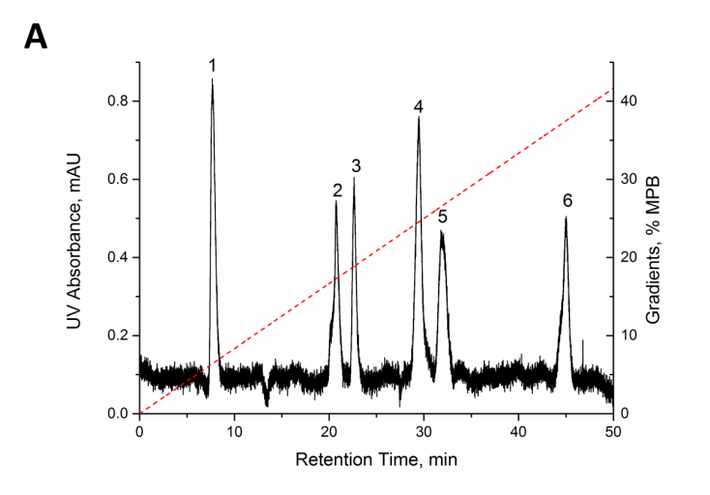

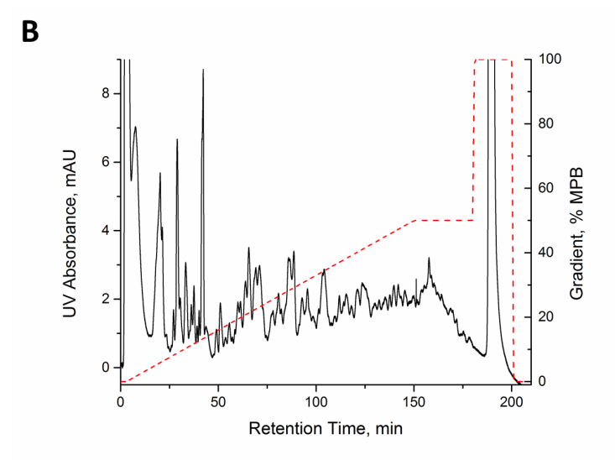
Figure 4.5 Performance of IEX chromatography. (A) Separation of protein standards. The column was a monolithic one made in laboratory. It was of 20-cm length, 360-µm o.d. and 250-µm i.d.. Mobile phase A, 10 m M Tris/HCl at pH ~7.6 in DDI water; mobile phase B, 1 M NaCl dissolved in mobile phase A. Gradient, as indicated with the dashed line in the figure; detection, UV at 280 nm; injection volume, 20 μL; sample, a mixture of a-lactalbumin (1), trypsin inhibitor (2), phosphorylase b (3), carbonic anhydrase (4), ovalbumin (5), and transferrin (6); each at 0.3 μg/mL; pressure on column, ~1200 psi. (B) Separation of protein lysates from E. Coli cells. The pressure on the column was ~1900 psi. All other conditions were as in Figure 4.5A.

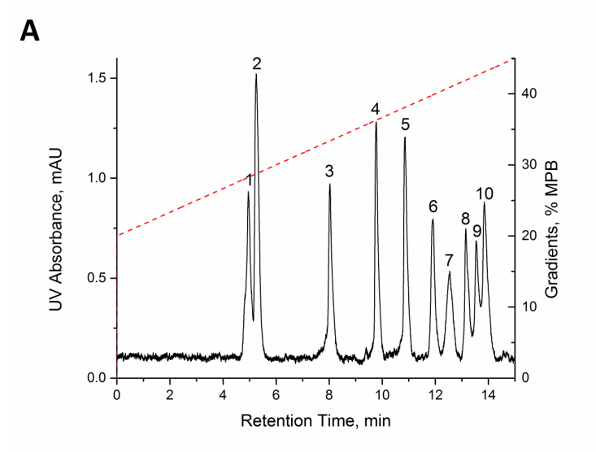
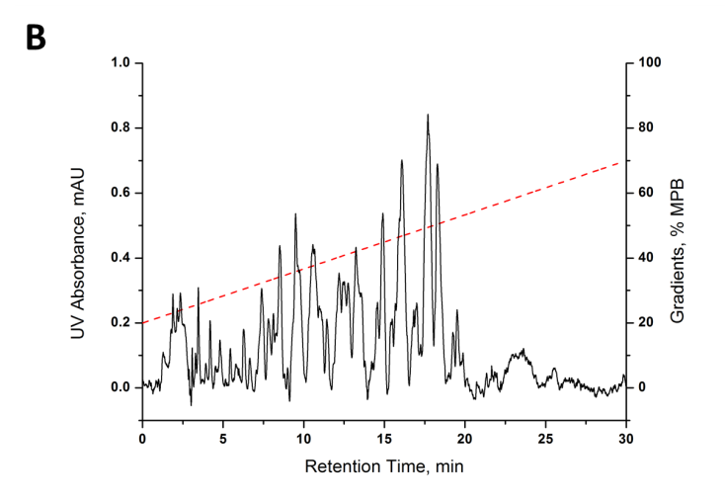
Figure 4.6 Performance of RP HPLC. (A) Separation of protein standards. The monolithic column was of 20-cm length, 360-µm o.d. and 250-µm i.d. and it was made in laboratory. Mobile phase A, 5% (v/v) acetonitrile and 0.05% (v/v) tetrafluoric acid in DDI water; mobile phase B, 90% (v/v) acetonitrile and 0.05% (v/v) tetrafluoric acid in DDI water. Gradient, as indicated with the dashed line in the figure; detection, UV at 280 nm; injection volume, 50 nL; sample, a mixture of ribonuclease a (a), insulin (2), cytochrome c (3), lysozyme (4), α-lactalbumin (5), transferrin (6), conalbumin (7), myoglobin (8), β-lactoglobulin b (9) & a (10); each at 200 μg/mL; pressure on column, ~1100 psi. (B) Separation of protein lysates from E. Coli cells. The gradient was indicated with the dashed line in the figure. Detection, UV at 210 nm. Sample, 70-fold diluted protein lysates from E. Coli cells. Pressure on column, ~1100 psi; all other conditions were as in Figure 4.6A.

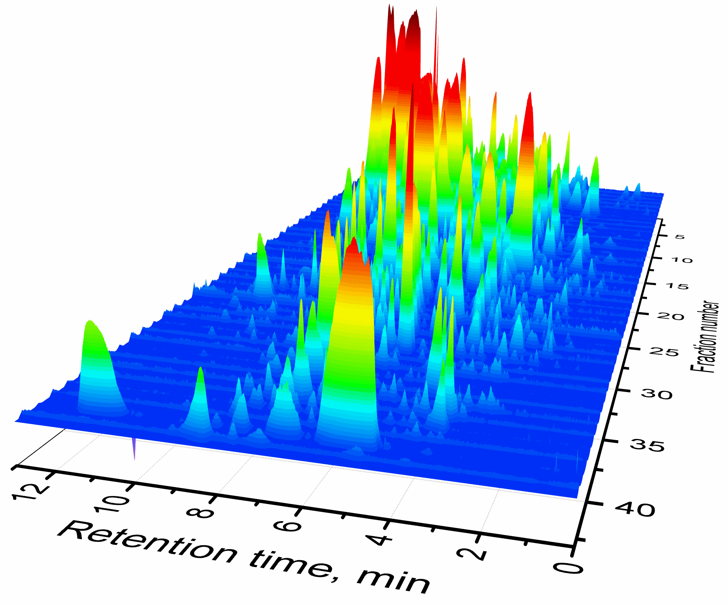

Figure 4.7 Separation of protein lysates from E. Coli cells using the 2D HPLC platform. Present a scale-bar in the figure for UV absorbacne. Also change “fraction number” to “number of second-D separation”. Sample – E. Coli cells lysates; IEX and RP column length – 20 cm; Separation pressure for the first-D: 3500 psi; Separation pressure for the second-D: 1100 psi; The first-D gradient: [NaCl] increased linearly from 0–0.5 M in 600 min, increased from 0.5–1 M in 0.1 min, and kept at 1 M for 30 min; The first-D injection volume: 20 μL; The gradients for the second-D separations are presented in Table 4.1.

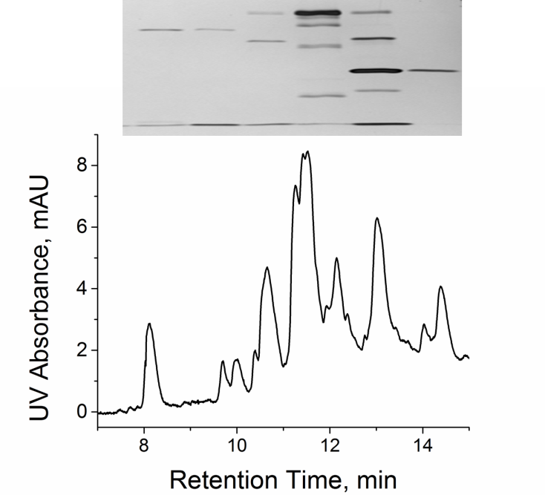
Figure 4.8 Typical sample complexity after 2D HPLC separation. Bottom: a second-D chromatogram (the seventh RP separation from Figure 4.7); Top: SDS-PAGE results of six effluent fractions (the fractions were collected from 8 – 15 min retention time, and each fraction was collected for 70 s). Electrophoretic separation was performed using Mini-PROTEIN® Electrophoresis System (Bio-Rad, Hercules, CA) at 200 volts for 40 min. The gel contained 12% acrylamide. The image was created using silver stain. The positions of the sample in the SDS-PAGE gel image matched vertically with the retention time of the chromatogram.

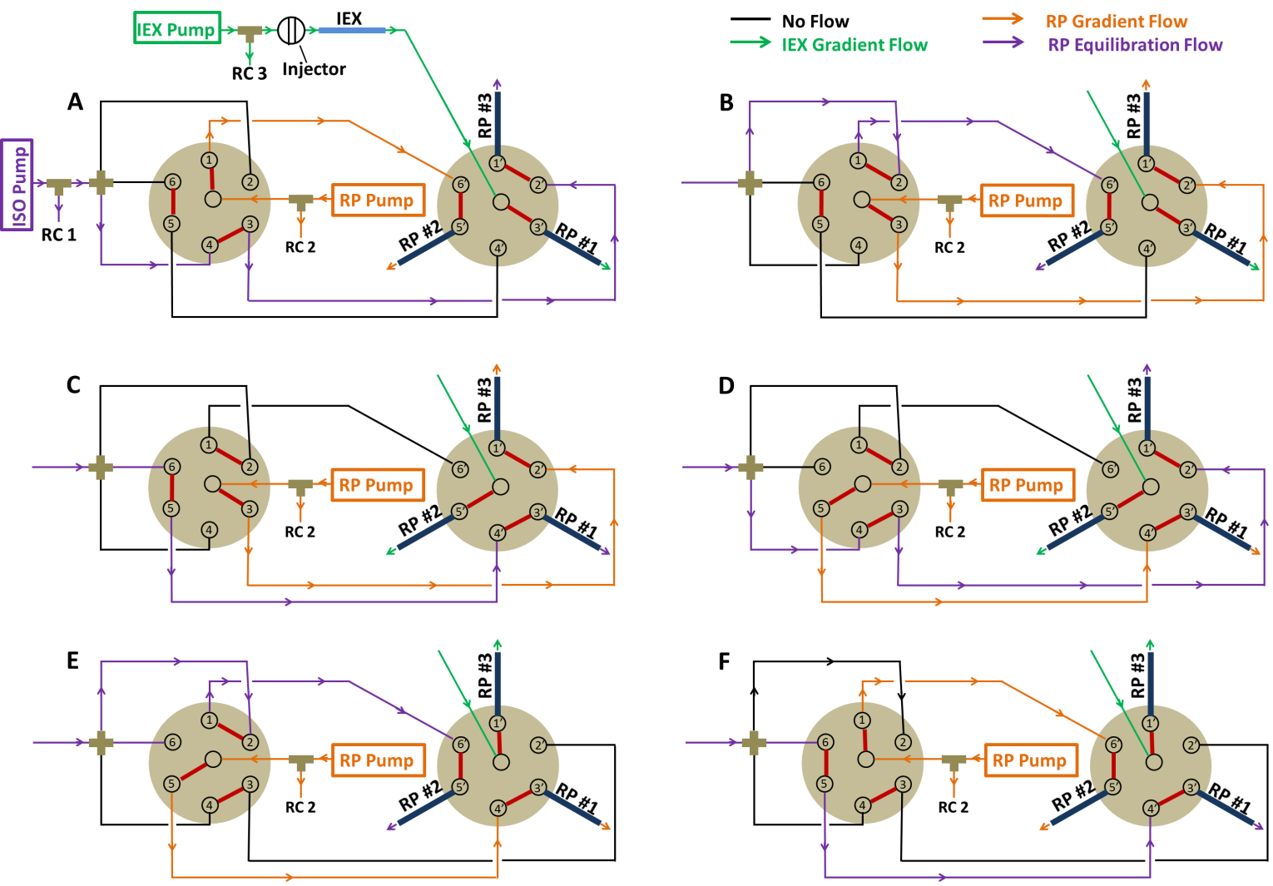
Figure 4.9 Schematic diagram of the new developed 2D-HPLC-UV/Vis platform. IEX Pump – Dionex GP50, a gradient pump for IEX chromatography; RP Pump – Agilent 1200, a gradient pump for reverse-phase high performance liquid chromatography; ISO Pump – Jasco PU1580, an isocratic pump for column equilibration; IEX – monolithic column for IEX chromatography; RP #1, #2, and #3 – three parallel monolithic columns for reverse-phase high performance liquid chromatography. RC represents restriction capillaries, which are used to control the back pressure on respective columns.

Chapter 5: 2-µm-i.d. capillary liquid chromatography for high resolution and efficiency separation of peptides

5.1 Introduction
Open tubular columns were first applied for liquid chromatography (LC) by Tsuda et al. in 1978, using an 60 μm i.d. tube³². Later, the first research about open tubular columns with an small inner diameter close to 15 μm was reported by Jorgenson and Guthrie⁹³. They developed Chemical medication of the surfaces to prepare Open tubular capillary LC columns, which suffered from low retention and low sample loading capacity.
To increase sample loading capacity, porous layer open tubular (PLOT) columns has been studied in the last 30 years to provide improved capillary LC columns^{31, 94-96}, which has been shown a higher separation efficiency than conventional packed columns. But the success of PLOT was limited due to the major challenge of casting a uniform porous layer on the capillary. Several methods have been developed to generate a retentive layer, two- step coating methods include static⁹⁷, dynamic^{98, 99}and precipitation coating¹⁰⁰and one step procedure was developed via sol-gel process ¹⁰¹. Polymeric PLOT columns have been developed in two different strategies. The first strategy is to first prepare polymer particles, which are chemically anchored onto the capillary inner wall in the second step^{102, 103}. In the second strategy, the polymer is produced on the capillary inner wall by in-situ polymerization ^{104, 105}. PLOT polystyrene divinylbenzene (PS-DVB) columns as the most popular Polymeric PLOT columns, have been used for high resolution, ultra-trace separation of peptides and intact proteins^{106, 107}. This one step method significantly improves the reproducibility in producing columns but it is not practical in producing a polymer layer in the very narrow-bore capillary.
In order to overcome the band broadening caused by the laminar flow in the open tubular capillary, capillaries of 5-10 μm i.d. were early considered to be necessary for open tubular LC. Theory already predicted that open tubular columns have a maximum efficiency when the i.d. is ~ 2 μm ⁹³. On chip-based platform, a highly efficient separation (440000 plates/ m) by pressure-driven liquid chromatography in extended nanochannels has been achieved¹⁰⁸. To the best of my knowledge, using HPLC format no capillary of i.d smaller than 5 μm has been applied for open tubular LC due to experimental limitations such as low sensitivity and difficulties in the preparation of retentive layer in the capillary of i.d smaller than 5 μm.
In this work, an open tubular LC was made by using 2 μm i.d. capillary, which is close to the dimension of single pathway in the conventional packed column. Because of the small bore, the only chemical modification on the inner wall of the capillary can provide high ratio of stationary phase to mobile phase, leading to high retentive ability. The clogging issues, which often occurred in preparation of retentive layer via polymerization in small-bore capillaries, were fixed by innovatively using chemical grafting modification. The separations of amino acids and peptides using this column result in a high resolution, fast separation and high separation efficiency. The study of the 2 μm i.d. single pore chromatography can potentially become an optimal model for exploring fundamental behaviors in liquid chromatography.

5.2 Experimental section

5.2.1 Reagents and Materials
Elven amino acids (histidine, asparagine, glycine, arginine, tyrosine, trytophan, alanine, phenylalanine, leucine, valine and, isoleucine), peptide standard mixture, trimethoxy(octadecyl)silane, toluene, and bovine serum albumin (BSA) were all purchased from Sigma (St. Louis, MO). Sequencing Grade Modified Trypsin was purchased from Promega (Madison, WI). Fused silica capillaries were purchased from Polymicro Technologies (Phoenix, AZ). ATTO-TAG™ FQ Amine-Derivatization Kit was the product of ThermoFisher Scientific (Lafayette, Co). All solutions were prepared with double-deionized (DDI) water purified by a NANOpure infinity ultrapure water system (Barnstead, Newton, WA).

5.2.2 Apparatus
The experimental setup is schematically shown in Figure 5.1. The flow driven by HPLC pump was split by a peek tee. A 20 cm capillary of 50 μm i.d. was used as the splitting capillary, which determined the flow rate in the downstream of the system. The dwell time can be adjusted by changing this capillary. The second peek tee was used to connect 180 μm i.d. and 360 μm o.d. capillary with 2 μm i.d. and 150 μm o.d. column. The small o.d. column passed through the second tee with a small portion inserted into the 180 μm i.d. and 360 μm o.d. capillary to avoid dead volume between these two capillaries. A 10 cm capillary of 20 μm i.d. was used as splitting capillary in the second tee to control the amount of sample injected into the 2 μm i.d. and 150 μm o.d. column.

5.2.3 HPLC procedures
HPLC separation was performed using the pump from Angilent 1200 system. Mobile phase A, 10 mM NH4HCO3in DDI water; mobile phase B, acetonitrile were used for gradient separation. The configuration of the nanoLC/LIF system using the 2 μm i.d. column is shown in figure 5.1. 2 μL of sample was injected by using a six port injection valve (VICI, TX, USA). Two peek tees were used as splitters; one was used for splitting the main stream from the pump, and the other for splitting the stream out from the injection valve. A small portion of 2 μm i.d. and 150 μm o.d. column was inserted into 180 μm i.d. and 360 μm o.d. capillary to avoid dead volume between these two capillaries. The polyimide coating of inserted portion was removed because it would fall off after soaking in organic containing solution for a long time. At 4 cm away from the end of the 2 μm i.d. column, a detection window was made by peeling off ~1 cm long polyimide coating for LIF detection.

5.2.4 Preparation of capillary
A capillary of o.d. of 150 μm and an i.d. of 2 μm was flushed with 1 M NaOH at 100 ℃ for 2 h and then washed with DDI water of at least 5 times of capillary volume. Rinse the capillary with acetonitrile of 3 times of capillary volume, followed by drying with nitrogen gas for one hour. Then the capillary was flushed with a mixture of 50 μL trimethoxy(octadecyl)silane and 50 μL toluene at 50 ℃ for 16 h, followed by toluene wash of at least 5 times of capillary volume. Nitrogen gas was finally used to dry the capillary before use.

5.2.5 Fluorescence Labeling of Amino acids and peptides
According to the instruction of ATTO-TAG™ FQ Amine-Derivatization Kit, 5.0 mg of ATTO-TAG FQ was dissolved in 2.0 mL of methanol to make a 10 mM stock solution. A 0.20 M KCN stock solution was prepared by dissolving 20 mg of KCN in 1.5 mL of ultrapure water. Working KCN solution (10 mM) was prepared just before use. Amino acid stock solutions (each containing 1 mM of one amino acid) were prepared in ultrapure water. A volume of 1.0 µL of the amino acid stock solution was mixed with 4.0 µL of 10 mM pH 9.2 Borax solution, 10 µL of the 10 mM KCN working solution, and 5 µL of the 10 mM FQ solution in a vial, and this mixture was maintained at room temperature under light protection for 1 h before. The resulting FQ-labeled-amino acid was diluted with ultrapure water prior to analysis. A tryptic digest of BSA protein was used for peptides labeling. The digestion of BSA was performed as follows: 52 µL of filtered 10 mg/ml BSA was mixed with 10 µL of Trypsin solution, 20 of µL filtered 500 mM NH₄HCO₃, 1 µL 1 M DTT, and 117 µL ultrapure water. The mixture was kept at 37 ℃ for 8 hours before labeling. 5 µL of digestion mixture mixed with 10 µL of 10 mM KCN working solution, and 5 µL of the 10 mM FQ solution in a vial was maintained at room temperature under light protection for 1 h prior to analysis.

5.3 Results and discussion
Figure 5.3 presents chromatograms under different elution pressures. The zoom-in chromatograms were placed on the right accordingly. While the separation speed increased, the separation efficiencies decreased (see Fig. 5.3B) with the increasing elution pressure. We used the half height width of each peak to calculate theoretical plates per meter. At 300 psi, all 11 peaks of amino acids had efficiencies over 800,000 theoretical plates per meter, 5 of them (Histidine (1), Asparagine (2), Glycine (3), Tryptophan (7), Isoleucine (9)) had efficiencies over 2 million plates per meter, and the separation efficiency of Isoleucine amazingly reached over 10 million plates per meter in just 10 min. No efficiency result was shown for tyrosine (4), Arginine (5) at 900 psi and 1200 psi because these two peaks merged into one peak at high pressure. Even at 1250 psi when 11 peaks were eluted out in less than 2.5 min, the efficiencies of 7 peaks had more than 400,000 plates per meter. To my best knowledge, these efficiencies are exceptionally high for fast separation and had never been achieved by chromatography.
Figure 5.2 shows the gradient elution was applied to separate these 11 amino acids. Compared to the isocratic elution at 300 psi, the gradient elution made better and faster separation and all peaks were uniformly sharp as expected.
Besides separation of amino acids, this column was also able to efficiently separate more complicated sample, trypsin-digested protein. Peptides were retained on the column and resolved as well as amino acids. Gradient elution was applied to the separation of the peptides sample. Peptides were more retentive than amino acids, therefore the gradient with higher elution strength was applied. Referring to peak capacity optimization¹⁰⁹, the optimum flow rate varies substantially with gradient time when the other factors are held constant. So we first optimized gradient time. Figure 5.4 shows chromatograms using different gradient times. The peak capacity increased with the gradient time. In only 15 min separation (corresponding to 10 min gradient time), ~40 peaks from trypsin digested BSA sample were obtained, which required more than 40 min by conventional packed column. 10 min gradient time was picked after compromising the time and separation efficiency. Then pressure applied on the column was further optimized with 10 min gradient time. 675 psi was chosen as the optimal pressure for this gradient time based on the separation shown in figure 5.5. These optimized pressure and gradient were finally applied for separation of BSA and Myoglobin trypsin digest. In less than 15 min, more than 60 peaks from both digest were separated as shown in figure 5.6. A peak capacity calculation based on the average peak width 10% height ~2s resulted in an average value of 300 expected peak capacity, which shows a potential capacity for more complicated sample in a fast separation.
Figure 5.7 shows the comparison of separation efficiency between i.d. 5 µm and i.d. 2 µm capillaries. The same column preparation process was applied to different i.d. capillaries, so the formation of stationary phase was expected to be identical in different i.d. capillaries, which resulted in the same dimension of stationary phase. With bigger cross section area, the i.d. 5 µm capillary had a much smaller ratio of stationary phase to mobile phase than i.d. 2 µm, which leaded to undesirable partition of the solutes between two phases. As a result, under the same linear velocity the i.d. 2 µm has much better separation of 11 amino acids than i.d. 5 µm capillary.

In conclusion, we have developed a fast and exceptionally high efficient single pore capillary LC to resolve amino acids and peptides; in only ten minutes separation efficiencies of more than ten millions plates per meter are already obtained. For this narrow capillary, the on-line detection, avoiding the dead volume from the post column detector, contributes a lot to the high separation efficiency. Complicated protein trypsin digested sample are used to demonstrate the high efficient separation of peptides, which proves the potential of this technology to be excellent alternative separation method for the proteomic study. Due to the use of narrow capillaries, attention is needed to avoid capillary clogging. LIF detector is required to meet the low detection limit of the narrow capillaries. With the development of interface for extremely low flow rate ESI-MS, we are going to combine this separation technique with MS to make an outstanding alternative technique to conventional LC-MS for proteomic research.

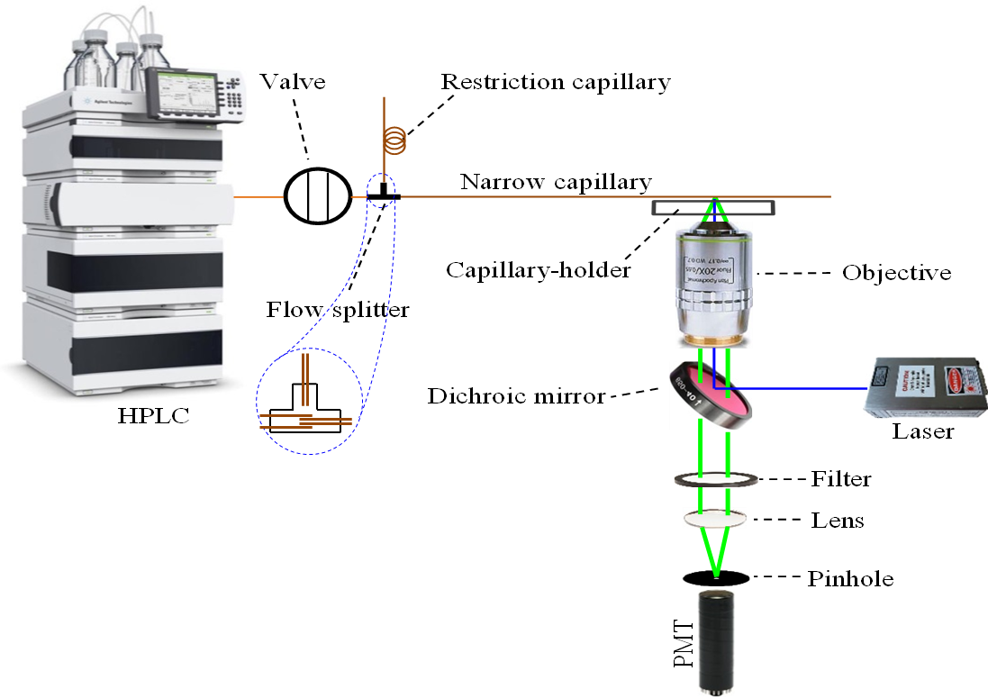
Figure 5.1 Schematic diagram of the single channel LC system. Full details are in the experimental section.
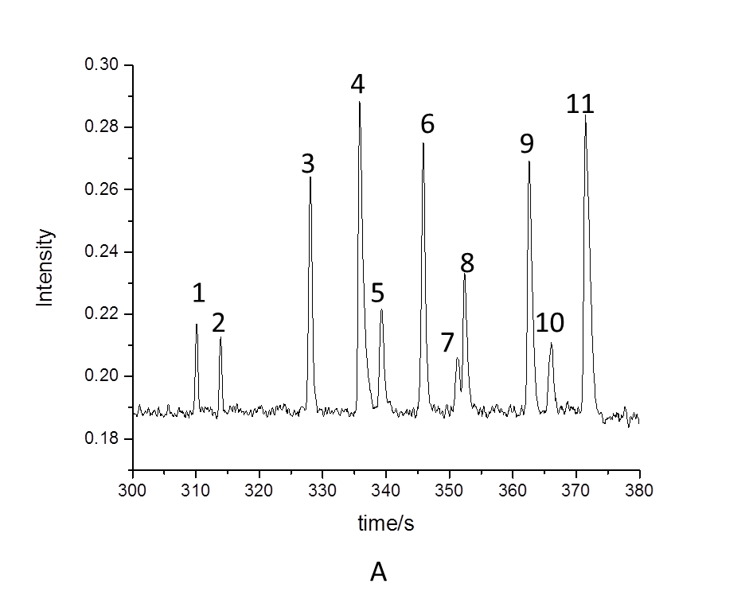
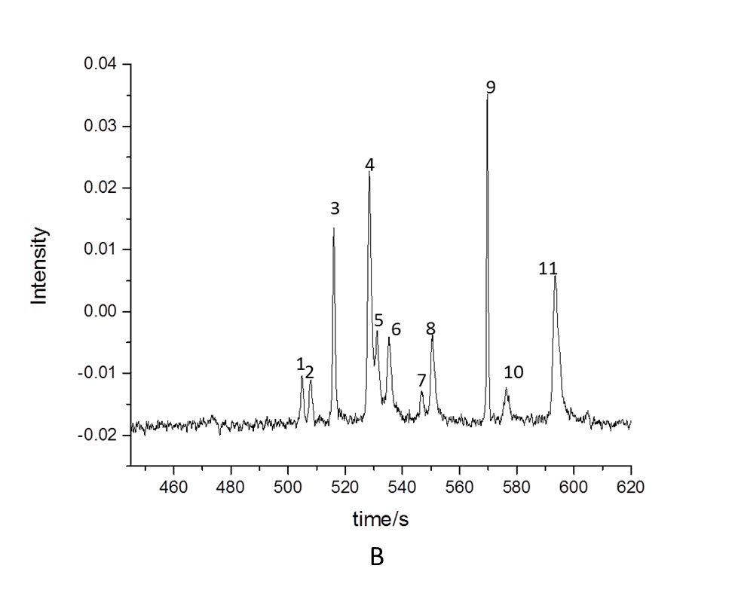
Figure 5.2 Comparison of isocratic and gradient elution. The separation column was of 48-cm total length and 44-cm effective length, 150-µm o.d. and 2-µm i.d. Gradient elution: Mobile phase A, 10 mM NH₄HCO₃ in DDI water; mobile phase B, acetonitrile. Gradient, 0-50% mobile phase B in 1.5 min, 50% B for 0.5 min then down to 0% in 3.5 min; Isocratic elution: 20% mobile phase B. Injection volume, 2μL; sample, a mixture of Histidine (1), Asparagine (2), Glycine (3), tyrosine (4), Arginine (5), Alanine (6), Tryptophan (7), Valine (8), Isoleucine (9), Phenylalanine(10), Leucine(11); each at 6.5 μM; pressure on column, ~300 psi.
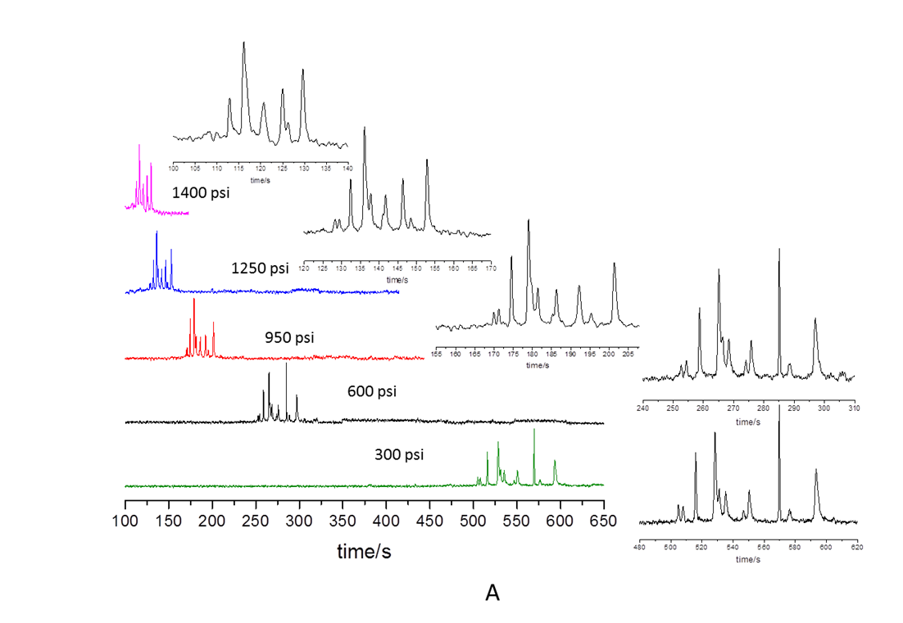
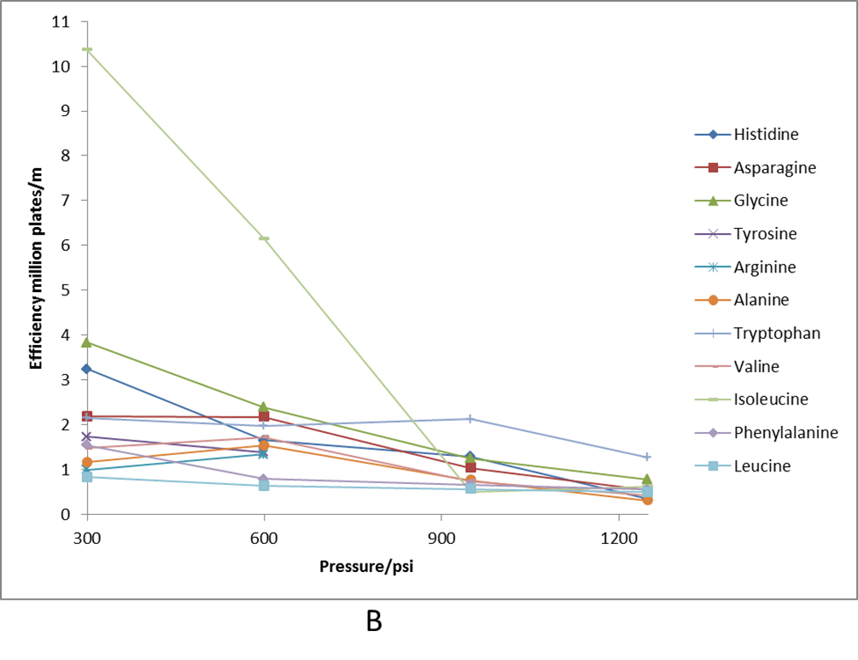
Figure 5.3 Effect of pressure on separation. The separation column was of 48-cm total length and 44-cm effective length, 150-µm o.d. and 2-µm i.d. Gradient elution: Mobile phase A, 10 mM NH₄HCO₃ in DDI water; mobile phase B, acetonitrile. Isocratic elution: 20% mobile phase B. Injection volume, 2μL; sample, a mixture of Histidine (1), Asparagine (2), Glycine (3), tyrosine (4), Arginine (5), Alanine (6), Tryptophan (7), Valine (8), Isoleucine (9), Phenylalanine(10), Leucine(11); each at 6.5 μM; various pressures applied on column.
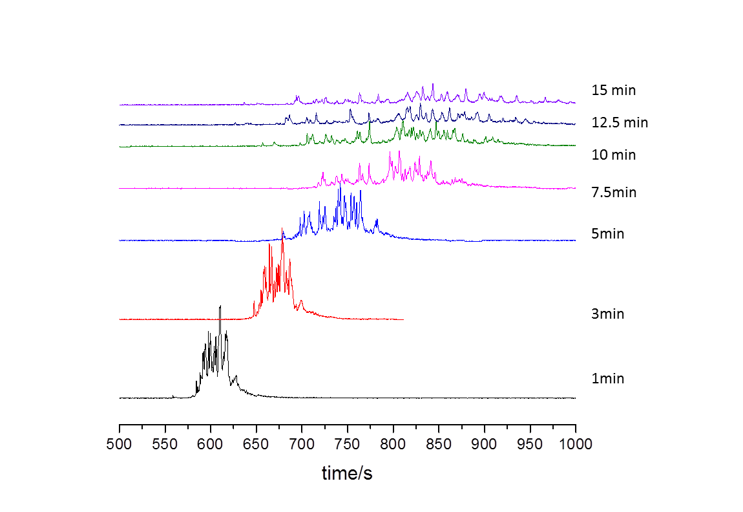
Figure 5.4 Effect of gradient time on separation. The separation column was of 48-cm total length and 44-cm effective length, 150-µm o.d. and 2-µm i.d.. Mobile phase A, 10 mM NH₄HCO₃in DDI water; mobile phase B, acetonitrile. Gradient, 0-82.5% mobile phase B in different gradient times, injection volume, 2μL; sample, digestion of 0.62 mg/mL BSA; pressure on column, ~600 psi.
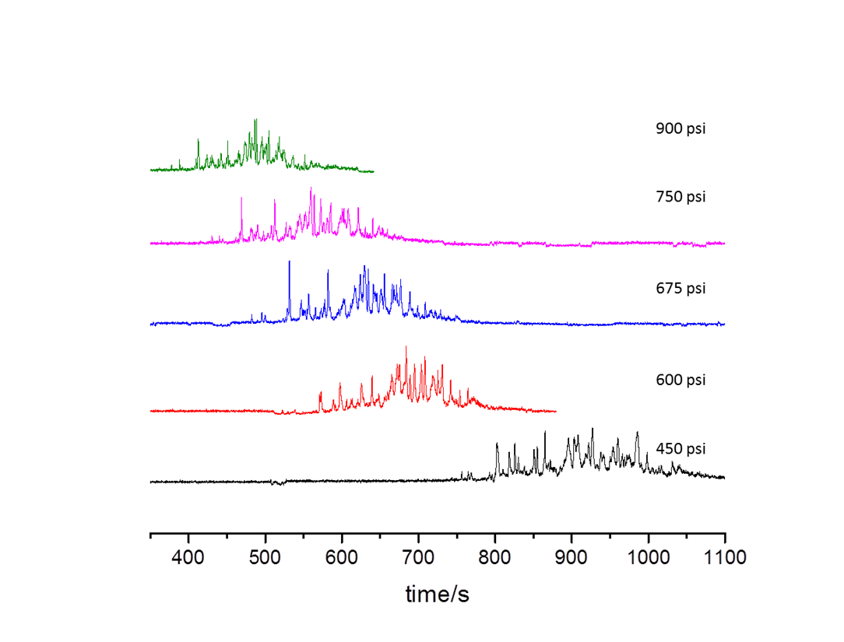
Figure 5.5 Effect of separation pressure when gradient time is constant. The separation column was of 48-cm total length and 44-cm effective length, 150-µm o.d. and 2-µm i.d.. Mobile phase A, 10 mM NH₄HCO₃in DDI water; mobile phase B, acetonitrile. Gradient, 0-82.5% mobile phase B in 10 min, injection volume, 2μL; sample, digestion of 0.62 mg/mL BSA; pressure on column were various.
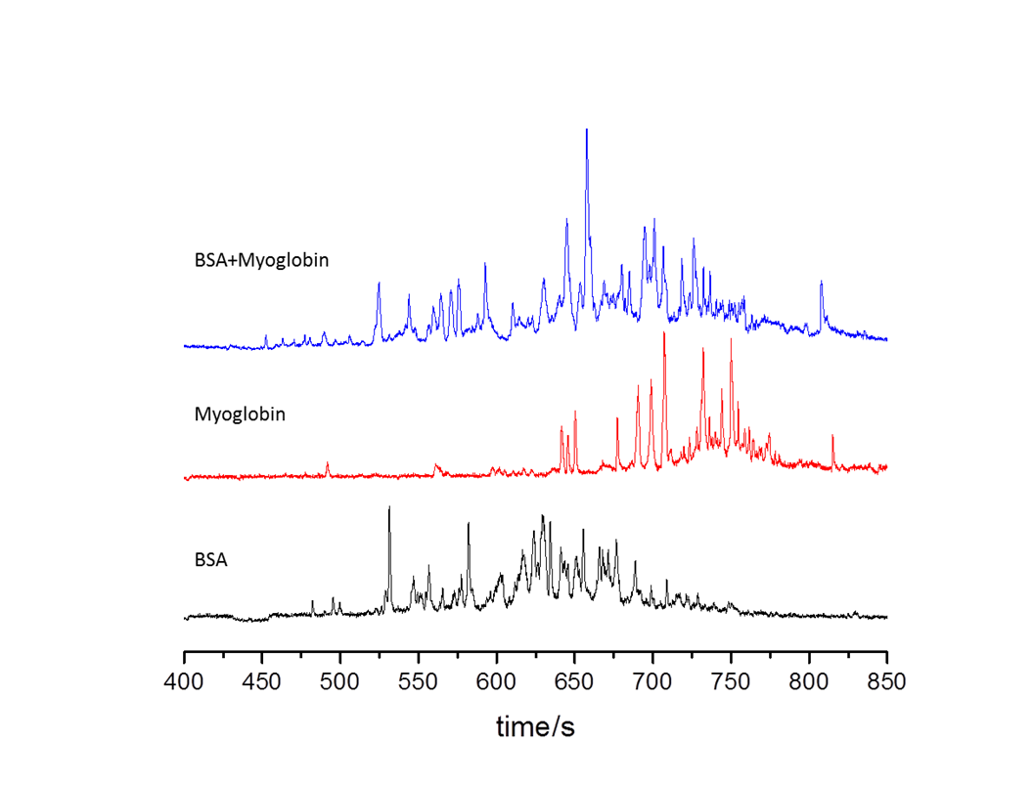
Figure 5.6 Separation of mixture of BSA trypsin digest and Myoglobin trypsin digest. The separation column was of 48-cm total length and 44-cm effective length, 150-µm o.d. and 2-µm i.d.. Mobile phase A, 10 mM NH₄HCO₃ in DDI water; mobile phase B, acetonitrile. Gradient, 0-82.5% mobile phase B in 10 min, injection volume, 2μL; sample, digestion of 0.62 mg/mL BSA; pressure on column~675 psi. BSA trypsin digest and Myoglobin trypsin digest were separated respectively, followed by the separation of mixture of both trypsin digests.
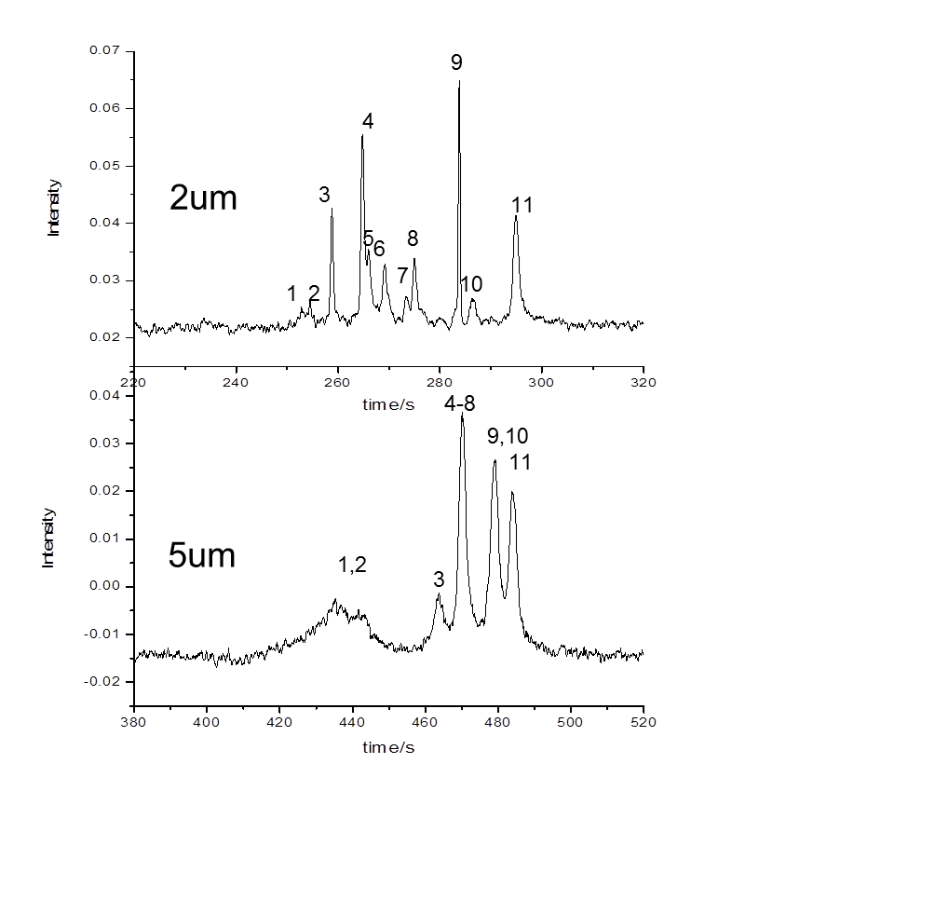Figure 5.7 The effect of inner diameter of capillary on separation. The separation column of i.d. 5 μm or 2 μm was of 48-cm total length and 44-cm effective lengths, and150-µm o.d. Mobile phase A, 10 mM NH₄HCO₃in DDI water; mobile phase B, acetonitrile. Isocratic, 20% mobile phase B. Injection volume, 2μL; sample, a mixture of Histidine (1), Asparagine (2), Glycine (3), tyrosine (4), Arginine (5), Alanine (6), Tryptophan (7), Valine (8), Isoleucine (9), Phenylalanine(10), Leucine(11); each at 6.5 μM for 2 μm i.d. capillary;0.3 μM for 5μm i.d. capillary; pressure on 2 μm i.d. column, 600 psi and pressure on 5 μm i.d. column, 100 psi.

Chapter 6: Conclusion and future directions

6.1 Conclusions
Capillary-based analytical techniques have broad applications in separation of biomolecules (DNA, amino acids, peptides, and proteins). The small dimension of capillary allows small amount of sample analysis and high voltage application. In the extremely narrow capillary, we are not surprised to discover some special separation behaviors, which result in unusually good separation resolution and efficiency. The special chemical property of the inner wall of capillary gives an interaction with a DNA dye, which was used to develop a simple on-line DNA labeling method. Then the on-line DNA analysis by coupling on-line labeling, PCR, and bare narrow capillary – hydrodynamic chromatography provides us a way to make a portable platform for point-of-care applications. With high voltage applied, the isoelectric point based fractionation of protein took place in a capillary, which provides us a simple method to purify or fractionate a protein sample for MS analysis because the method is MS friendly by not using carrier ampholytes. Monolithic capillary columns are successfully prepared for a new 2D-HPLC configuration, which has three columns parallel for second dimension separation for reducing the speed requirement of the second-D. More capillary columns can be paralleled to further decrease the speed requirement. For open tubular capillary separation, the extremely high separation efficiency has been obtained in 2 μm i.d. capillary, which cannot be done in 5 μm i.d. capillary. Overall, the capillary-based development of technique can provide many outstanding alternatives for bio-research.

6.2 Future directions
As analysis of tiny amount of sample for example sample from a single cell, and miniaturization and portability of analysis platform are desired, capillary-based techniques are required for small sample and reagent consumption, and small size of setup. The special separation properties of extremely narrow capillary will be used to revolutionize the conventional HPLC column in future.

References
[1]. Stein, L. D., Nature 2004, 431 (7011), 915-916.
[2]. Ross, P. D., Scruggs, R. L., Biopolymers 1964, 2 (3), 231-236.
[3]. Danna, K., Nathans, D., Proceedings of the National Academy of Sciences 1971, 68 (12), 2913-2917.
[4]. Chou, H.-P., Spence, C., Scherer, A., Quake, S., Proceedings of the National Academy of Sciences 1999, 96 (1), 11-13.
[5]. Regtmeier, J., Duong, T. T., Eichhorn, R., Anselmetti, D., Ros, A., Analytical chemistry 2007, 79 (10), 3925-3932.
[6]. Ruiz-Martinez, M. C., Berka, J., Belenkii, A., Foret, F., Miller, A. W., Karger, B. L., ANALYTICAL CHEMISTRY-WASHINGTON DC- 1993, 65, 2851-2851.
[7]. Huang, X. C., Quesada, M. A., Mathies, R. A., Analytical chemistry 1992, 64 (18), 2149-2154.
[8]. Noolandi, J., Electrophoresis 1992, 13, 394-395.
[9]. Mayer, P., Slater, G. W., Drouin, G., Analytical chemistry 1994, 66 (10), 1777-1780.
[10]. Yamakawa, H., Higashino, K.-i., Ohara, O., Analytical biochemistry 1996, 240 (2), 242-250.
[11]. Premstaller, A., Oberacher, H., Huber, C. G., Analytical chemistry 2000, 72 (18), 4386-4393.
[12]. Huber, C. G., Oefner, P. J., Preuss, E., Bonn, G. K., Nucleic acids research 1993, 21 (5), 1061-1066.
[13]. Bjellqvist, B., Ek, K., Righetti, P. G., Gianazza, E., Görg, A., Westermeier, R., Postel, W., Journal of biochemical and biophysical methods 1982, 6 (4), 317-339.
[14]. Shen, Y., Xiang, F., Veenstra, T. D., Fung, E. N., Smith, R. D., Analytical chemistry 1999, 71 (23), 5348-5353.
[15]. Jensen, P. K., Paša-Tolić, L., Anderson, G. A., Horner, J. A., Lipton, M. S., Bruce, J. E., Smith, R. D., Analytical chemistry 1999, 71 (11), 2076-2084.
[16]. Tang, Q., Harrata, A. K., Lee, C. S., Analytical chemistry 1996, 68 (15), 2482-2487.
[17]. Jin, Y., Luo, G., Oka, T., Manabe, T., Electrophoresis 2002, 23 (19), 3385-3391.
[18]. Schnabel, U., Groiss, F., Blaas, D., Kenndler, E., Analytical chemistry 1996, 68 (23), 4300-4303.
[19]. Kilár, F., Journal of Chromatography A 1991, 545 (2), 403-406.
[20]. Righetti, P. G., Simó, C., Sebastiano, R., Citterio, A., Electrophoresis 2007, 28 (21), 3799-3810.
[21]. Shang, T. Q., Ginter, J. M., Johnston, M. V., Larsen, B. S., McEwen, C. N., Electrophoresis 2003, 24 (14), 2359-2368.
[22]. Eon, C., Guiochon, G., Jones, C. E., Chromatographia 1974, 7 (10), 632-632.
[23]. Guiochon, G., Beaver, L., Gonnord, M., Siouffi, A., Zakaria, M., Journal of Chromatography A 1983, 255, 415-437.
[24]. Erni, F., Frei, R., Journal of Chromatography A 1978, 149, 561-569.
[25]. Bushey, M. M., Jorgenson, J. W., Analytical chemistry 1990, 62 (2), 161-167.
[26]. Wolters, D. A., Washburn, M. P., Yates, J. R., Analytical chemistry 2001, 73 (23), 5683-5690.
[27]. Regnier, F., Amini, A., Chakraborty, A., Geng, M., Ji, J., Riggs, L., Sioma, C., Wang, S., Zhang, X., LC GC 2001, 19 (2), 200-213.
[28]. Stoll, D. R., Cohen, J. D., Carr, P. W., Journal of Chromatography a 2006, 1122 (1), 123-137.
[29]. McGuffin, V., Novotný, M., Journal of Chromatography A 1983, 255, 381-393.
[30]. Lee, D., Svec, F., Fréchet, J. M., Journal of Chromatography A 2004, 1051 (1), 53-60.
[31]. Knox, J. H., Gilbert, M. T., Journal of Chromatography A 1979, 186, 405-418.
[32]. Tsuda, T., Hibi, K., Nakanishi, T., Takeuchi, T., Ishii, D., Journal of Chromatography A 1978, 158, 227-232.
[33]. Chamberlain, J. S., Gibbs, R. A., Rainer, J. E., Nguyen, P. N., Thomas, C., Nucleic acids research 1988, 16 (23), 11141-11156.
[34]. Chamberlain, J., Chamberlain, J., Fenwick, R., Ward, P., Caskey, C., Dimnik, L., Bech-Hansen, N., Hoar, D., Richards, S., Covone, A., Jama 1992, 267 (19), 2609-2615.
[35]. Henegariu, O., Hirschmann, P., Kilian, K., Kirsch, S., Lengauer, C., Maiwald, R., Mielke, K., Vogt, P., Andrologia 1994, 26 (2), 97-106.
[36]. Richards, B., Skoletsky, J., Shuber, A. P., Balfour, R., Stern, R. C., Dorkin, H. L., Parad, R. B., Witt, D., Klinger, K. W., Human molecular genetics 1993, 2 (2), 159-163.
[37]. Mutirangura, A., Greenberg, F., Butler, M. G., Malcolm, S., Nicholls, R. D., Chakravarti, A., Ledbetter, D. H., Human molecular genetics 1993, 2 (2), 143-151.
[38]. Stiller, M., Knapp, M., Stenzel, U., Hofreiter, M., Meyer, M., Genome research 2009, 19 (10), 1843-1848.
[39]. Yang, M. J., Luo, L., Nie, K., Wang, M., Zhang, C., Li, J., Ma, X. j., Journal of medical virology 2012, 84 (6), 957-963.
[40]. Li, J., Mao, N.-Y., Zhang, C., Yang, M.-J., Wang, M., Xu, W.-B., Ma, X.-J., BMC infectious diseases 2012, 12 (1), 189.
[41]. Giglio, S., Monis, P. T., Saint, C. P., Nucleic Acids Research 2003, 31 (22), e136-e136.
[42]. Woolley, A. T., Hadley, D., Landre, P., deMello, A. J., Mathies, R. A., Northrup, M. A., Analytical Chemistry 1996, 68 (23), 4081-4086.
[43]. Waters, L. C., Jacobson, S. C., Kroutchinina, N., Khandurina, J., Foote, R. S., Ramsey, J. M., Analytical chemistry 1998, 70 (1), 158-162.
[44]. Zhang, N., Tan, H., Yeung, E. S., Analytical chemistry 1999, 71 (6), 1138-1145.
[45]. Lagally, E. T., Simpson, P. C., Mathies, R. A., Sensors and Actuators B: Chemical 2000, 63 (3), 138-146.
[46]. Wang, X., Wang, S., Veerappan, V., Byun, C. K., Nguyen, H., Gendhar, B., Allen, R. D., Liu, S., Analytical chemistry 2008, 80 (14), 5583.
[47]. Wang, H., Chen, J., Zhu, L., Shadpour, H., Hupert, M. L., Soper, S. A., Analytical chemistry 2006, 78 (17), 6223-6231.
[48]. Obeid, P. J., Christopoulos, T. K., Crabtree, H. J., Backhouse, C. J., Analytical chemistry 2003, 75 (2), 288-295.
[49]. Wang, X., Liu, L., Pu, Q., Zhu, Z., Guo, G., Zhong, H., Liu, S., Journal of the American Chemical Society 2012, 134 (17), 7400-7405.
[50]. Lee, S., Kang, S. H., Yeung, E. S., Talanta 2011, 85 (4), 2135-2141.
[51]. Auroux, P.-A., Koc, Y., Manz, A., Day, P., Lab on a Chip 2004, 4 (6), 534-546.
[52]. Roper, M. G., Easley, C. J., Landers, J. P., Analytical chemistry 2005, 77 (12), 3887-3894.
[53]. Shrinivasan, S., Norris, P. M., Landers, J. P., Ferrance, J. P., Clinics in laboratory medicine 2007, 27 (1), 173-181.
[54]. Magdeldin, S., Moresco, J. J., Yamamoto, T., Yates III, J. R., Journal of proteome research 2014, 13 (8), 3826-3836.
[55]. Righetti, P. G., Castagna, A., Antonioli, P., Boschetti, E., Electrophoresis 2005, 26 (2), 297-319.
[56]. Fitzgerald, A., Walsh, B. J., Electrophoresis 2010, 31 (21), 3580-3585.
[57]. Davidsson, P., Folkesson, S., Christiansson, M., Lindbjer, M., Dellheden, B., Blennow, K., Westman‐Brinkmalm, A., Rapid communications in mass spectrometry 2002, 16 (22), 2083-2088.
[58]. Sahab, Z. J., Suh, Y., Sang, Q.-X. A., Journal of proteome research 2005, 4 (6), 2266-2272.
[59]. Tran, J. C., Doucette, A. A., Journal of proteome research 2008, 7 (4), 1761-1766.
[60]. Foret, F., Müller, O., Thorne, J., Götzinger, W., Karger, B., Journal of Chromatography A 1995, 716 (1-2), 157-166.
[61]. Moreda-Piñeiro, A., García-Otero, N., Bermejo-Barrera, P., Analytica chimica acta 2014, 836, 1-17.
[62]. Ros, A., Faupel, M., Mees, H., Oostrum, J. v., Ferrigno, R., Reymond, F., Michel, P., Rossier, J. S., Girault, H. H., Proteomics 2002, 2 (2).
[63]. Zhang, Y., Li, Y., Qiu, F., Qiu, Z., Electrophoresis 2010, 31 (23‐24), 3797-3807.
[64]. Michel, P. E., Reymond, F., Arnaud, I. L., Josserand, J., Girault, H. H., Rossier, J. S., Electrophoresis 2003, 24 (1‐2), 3-11.
[65]. Smejkal, G. B., Lazarev, A., Briefings in functional genomics & proteomics 2005, 4 (1), 76-81.
[66]. Chingin, K., Astorga-Wells, J., Najafabadi, M. P., Lavold, T., Zubarev, R. A., Analytical chemistry 2012, 84 (15), 6856-6862.
[67]. Cheng, C., Lu, J. J., Wang, X., Roberts, J., Liu, S., Electrophoresis 2010, 31 (15), 2614-2621.
[68]. Zhou, F., Johnston, M. V., Analytical chemistry 2004, 76 (10), 2734-2740.
[69]. Tang, Q., Harrata, A. K., Lee, C. S., Analytical Chemistry (Washington) 1995, 67 (19).
[70]. Lu, J. J., Zhu, Z., Wang, W., Liu, S., Analytical chemistry 2011, 83 (5), 1784-1790.
[71]. Gao, L., Liu, S., Analytical chemistry 2004, 76 (24), 7179-7186.
[72]. Liu, H., Sadygov, R. G., Yates, J. R., Analytical chemistry 2004, 76 (14), 4193-4201.
[73]. Zhang, Y., Fonslow, B. R., Shan, B., Baek, M.-C., Yates III, J. R., Chemical reviews 2013, 113 (4), 2343.
[74]. Plazas-Mayorca, M. D., Zee, B. M., Young, N. L., Fingerman, I. M., LeRoy, G., Briggs, S. D., Garcia, B. A., Journal of proteome research 2009, 8 (11), 5367.
[75]. Sun, L., Hebert, A. S., Yan, X., Zhao, Y., Westphall, M. S., Rush, M. J., Zhu, G., Champion, M. M., Coon, J. J., Dovichi, N. J., Angewandte Chemie 2014, 126 (50), 14151-14153.
[76]. Parks, B. A., Jiang, L., Thomas, P. M., Wenger, C. D., Roth, M. J., Boyne, M. T., Analytical chemistry 2007, 79 (21), 7984.
[77]. Ansong, C., Wu, S., Meng, D., Liu, X., Brewer, H. M., Kaiser, B. L. D., Nakayasu, E. S., Cort, J. R., Pevzner, P., Smith, R. D., Proceedings of the National Academy of Sciences 2013, 110 (25), 10153-10158.
[78]. Meng, F., Du, Y., Miller, L. M., Patrie, S. M., Robinson, D. E., Kelleher, N. L., Analytical chemistry 2004, 76 (10), 2852-2858.
[79]. Xiu, L., Valeja, S. G., Alpert, A. J., Jin, S., Ge, Y., Analytical chemistry 2014, 86 (15), 7899-7906.
[80]. Geiger, M., Frost, N. W., Bowser, M. T., Analytical chemistry 2014, 86 (10), 5136-5142.
[81]. O'Farrell, P. H., Journal of biological chemistry 1975, 250 (10), 4007-4021.
[82]. Stoll, D. R., Carr, P. W., Journal of the American Chemical Society 2005, 127 (14), 5034-5035.
[83]. Gwarda, R. Ł., Dzido, T. H., Journal of Chromatography A 2013, 1312, 152-154.
[84]. Zhao, Y., Szeto, S. S., Kong, R. P., Law, C. H., Li, G., Quan, Q., Zhang, Z., Wang, Y., Chu, I. K., Analytical chemistry 2014, 86 (24), 12172-12179.
[85]. Takeuchi, T., Asai, M., Haraguchi, H., Ishii, D., Journal of Chromatography A 1990, 499, 549-556.
[86]. Luijten, W., Damien, G., Capart, J., Journal of Chromatography A 1989, 474 (1), 265-273.
[87]. Mifune, M., Krehbiel, D., Stobaugh, J., Riley, C., Journal of Chromatography B: Biomedical Sciences and Applications 1989, 496, 55-70.
[88]. Fairchild, J. N., Horváth, K., Guiochon, G., Journal of Chromatography A 2009, 1216 (9), 1363-1371.
[89]. Sweeney, A. P., Shalliker, R. A., Journal of Chromatography A 2002, 968 (1), 41-52.
[90]. Gray, M., Dennis, G. R., Wormell, P., Shalliker, R. A., Slonecker, P., Journal of chromatography A 2002, 975 (2), 285-297.
[91]. Tanaka, N., Kimura, H., Tokuda, D., Hosoya, K., Ikegami, T., Ishizuka, N., Minakuchi, H., Nakanishi, K., Shintani, Y., Furuno, M., Analytical chemistry 2004, 76 (5), 1273-1281.
[92]. Shalliker, R. A., Gray, M. J., ADVANCES IN CHROMATOGRAPHY-NEW YORK- 2006, 44, 177.
[93]. Jorgenson, J. W., Guthrie, E. J., Journal of Chromatography A 1983, 255, 335-348.
[94]. Kennedy, R. T., Oates, M. D., Cooper, B. R., Nickerson, B., Jorgenson, J. W., Science 1989, 246 (4926), 57.
[95]. Tijssen, R., Bleumer, J., Van Kreveld, M., Journal of Chromatography A 1983, 260, 297-304.
[96]. Guiochon, G., Analytical Chemistry 1981, 53 (9), 1318-1325.
[97]. Göhlin, K., Larsson, M., Journal of Chromatography A 1993, 645 (1), 41-56.
[98]. Tock, P., Boshoven, C., Poppe, H., Kraak, J., Unger, K., Journal of Chromatography A 1989, 477 (1), 95-106.
[99]. Yun, H., Markides, K. E., Lee, M. L., Journal of Microcolumn Separations 1995, 7 (2), 153-158.
[100]. Dluzneski, P., Jorgenson, J., Journal of Separation Science 1988, 11 (4), 332-336.
[101]. Guo, Y., Colón, L. A., Journal of Microcolumn Separations 1995, 7 (5), 485-491.
[102]. Hulthe, G., Petersson, M. A., Fogelqvist, E., Analytical Chemistry 1999, 71 (14), 2915-2921.
[103]. Bakry, R., Gjerde, D., Bonn, G., Journal of proteome research 2006, 5 (6), 1321-1331.
[104]. Huang, X., Zhang, J., Horváth, C., Journal of Chromatography A 1999, 858 (1), 91-101.
[105]. Shen, T., Journal of chromatographic science 1992, 30 (6), 239-240.
[106]. Rogeberg, M., Wilson, S. R., Greibrokk, T., Lundanes, E., Journal of Chromatography A 2010, 1217 (17), 2782-2786.
[107]. Yue, G., Luo, Q., Zhang, J., Wu, S.-L., Karger, B. L., Analytical Chemistry 2007, 79 (3), 938-946.
[108]. Ishibashi, R., Mawatari, K., Kitamori, T., Small 2012, 8 (8), 1237-1242.
[109]. Wang, X., Stoll, D. R., Schellinger, A. P., Carr, P. W., Analytical chemistry 2006, 78 (10), 3406.

