UNIVERSITY OF OKLAHOMA
GRADUATE COLLEGE

A STUDY OF TWO PIANO WORKS AND THEIR ROOTS IN ANCIENT CHINESE POETRY AND LITERATI MUSIC: TWO POEM CLASSICS OF THE TANG DYNASTY BY XU, ZHENMIN (B. 1934) AND THREE PRELUDES BY GONG, XIAOTING (B. 1970)

A DOCUMENT
SUBMITTED TO THE GRADUATE FACULTY
in partial fulfillment of the requirements for the
Degree of
DOCTOR OF MUSICAL ARTS

By
DAN YU
Norman, Oklahoma
2022

A STUDY OF TWO PIANO WORKS AND THEIR ROOTS IN ANCIENT CHINESE POETRY AND LITERATI MUSIC: TWO POEM CLASSICS OF THE TANG DYNASTY BY XU, ZHENMIN (B. 1934) AND THREE PRELUDES BY GONG, XIAOTING (B. 1970)

A DOCUMENT APPROVED FOR THE
SCHOOL OF MUSIC

BY THE COMMITTEE CONSISTING OF

Dr. Barbara Fast, Chair

Dr. Igor Lipinski, Co-Chair

Dr. Marvin Lamb

Dr. Nian Liu

© Copyright by DAN YU 2022
All Rights Reserved.

ACKNOWLEDGEMENTS
I would like to express my sincere gratitude to the people who have supported me during my doctoral studies. Their guidance, assistance, and encouragement are the motivation for me to successfully complete this degree.
To Dr. Fast, my committee chair: Your thoughtful editing suggestions have been invaluable. Your investment has helped me become a better writer and researcher.
To my committee members and professors:
Dr. Lipinski, I could never have completed this degree without your generous support, encouragement, and wisdom. It is my honor to be one of your students. Your guidance on piano performance and views on the arts will be my life-long possessions.
Dr. Lamb, I am especially thankful that you were willing to serve on my committee. Your insightful suggestions and kind encouragement were always relevant and valuable.
Dr. Liu, thank you for your willingness to serve as my outside committee member and for taking an interest in this project. I am very fortunate to have your advice and opinions on Chinese literature which allowed me to refine the relevant parts of my project.
To my editor, Ms. Elise Fast: Thank you so much for assisting me with my English writing and providing me all kinds of intelligent writing suggestions so that I, as a non-native English speaker, could successfully complete this project.
To my family: Many thanks for your constant support and unconditional love during the last four years.

TABLE OF CONTENTS
ACKNOWLEDGEMENTS i
TABLE OF CONTENTS ii
LIST OF EXAMPLES vi
LIST OF TABLES ix
ABSTRACT x
CHAPTER 1: Introduction 1
Purpose of the Study 6
Need for the Study 6
Review of Related Literature 8
Xu Zhenmin 8
Gong Xiaoting 10
Ancient Chinese Poetry, Literati Music, and Modern Chinese Piano Compositions 12
Limitations of the Study 13
Organization of the Study 14
CHAPTER 2: Tang Poetry and Song Ci 16
Poetry in the Tang Dynasty and the Idea of Yijing 16
The Song Ci and Its Aesthetic Code: “Sorrow as Beauty” 24
CHAPTER 3: Ancient Chinese Literati Music 28
The Chinese Pentatonic Scale System 28
The Aesthetic Philosophy in Ancient Literati Music 31
Guqin Music 33
The Influence of the Guqin on Contemporary Chinese Piano Music 36
CHAPTER 4: Xu Zhenmin and Two Poem Classics Of The Tang Dynasty 40
Xu’s Musical Style 40
Two Poem Classics of the Tang Dynasty 42
Song on Youzhou Terrace 44
Written on the Meditation Garden Behind Broken Mountain Temple 54
CHAPTER 5: Gong Xiaoting and Three Preludes 64
Gong’s Musical Style 64
Three Preludes 66
Mengling 67
Taosha 75
Luoxiang 88
CHAPTER 6: Conclusion 94
APPENDIX: Suggestions for Further Reading 96
BIBLIOGRAPHY 99
Books 99
Books on the Topic of Ancient Chinese Poetry: 99
Books on the Topic of Music: 100
Journal Articles 101
Journal Articles on the Topic of Ancient Chinese Poetry: 101
Journal Articles on the Topic of Chinese Music: 101
Theses and Dissertations 103
Theses on the Topic of Ancient Chinese Poetry: 103
Theses and Dissertations on the Topic of Chinese Music: 103
Musical Scores 104
Lecture 104
Websites 104
GLOSSARY 105

LIST OF EXAMPLES
Example 4.1. Xu Zhenmin, Song on Youzhou Terrace, mm. 1–2.
Example 4.2. Xu Zhenmin, Song on Youzhou Terrace, mm. 1–5.
Example 4.3. Xu Zhenmin, Song on Youzhou Terrace, A section, mm. 1–14.
Example 4.4. Xu Zhenmin, Song on Youzhou Terrace, mm. 15–22.
Example 4.5. Xu Zhenmin, Song on Youzhou Terrace, mm. 29–34.
Example 4.6. Xu Zhenmin, Written on the Meditation Garden Behind Broken Mountain Temple, mm. 1–2.
Example 4.7. Xu Zhenmin, Written on the Meditation Garden Behind Broken Mountain Temple, mm. 18–20.
Example 4.8. Xu Zhenmin, Written on the Meditation Garden Behind Broken Mountain Temple, mm. 30–31.
Example 4.9-1. Xu Zhenmin, Written on the Meditation Garden Behind Broken Mountain Temple, mm. 32–36.
Example 4.9-2. Xu Zhenmin, Written on the Meditation Garden Behind Broken Mountain Temple, mm. 39–50.
Example 4.10-1. Xu Zhenmin, Written on the Meditation Garden Behind Broken Mountain Temple, mm. 12–17.
Example 4.10-2. Xu Zhenmin, Written on the Meditation Garden Behind Broken Mountain Temple, mm. 21–27.
Example 5.1. Gong Xiaoting, Mengling, m. 1.
Example 5.2-1. Gong Xiaoting, Mengling, mm. 1–2.
Example 5.2-2. Gong Xiaoting, Mengling, the first appearance of the theme, mm. 5–14.
Example 5.3. Gong Xiaoting, Mengling, m. 5.
Example 5.4. Gong Xiaoting, Mengling, mm. 22–31.
Example 5.5. Gong Xiaoting, Mengling, coda, mm. 32–34.
Example 5.6. Gong Xiaoting, Mengling, mm. 1–3.
Example 5.7. Gong Xiaoting, Mengling, mm. 8–11.
Example 5.8. Gong Xiaoting, Taosha, mm. 2–3, left-hand section.
Example 5.9. Gong Xiaoting, Taosha, A section (with the one-measure introduction), mm. 1–13.
Example 5.10. Gong Xiaoting, Taosha, mm. 14–22.
Example 5.11. Gong Xiaoting, Taosha, mm. 22–33.
Example 5.12. Gong Xiaoting, Taosha, mm. 41–43.
Example 5.13. Gong Xiaoting, Taosha, mm. 44–48.
Example 5.14. Gong Xiaoting, Taosha, mm. 1–3.
Example 5.15. Gong Xiaoting, Luoxiang, mm. 27–29.
Example 5.16. Gong Xiaoting, Luoxiang, mm. 18–29.

LIST OF TABLES
Table 3.1. The Same Gong System (in C).
Table 5.1. The Tonalities and Modulations in the A section (mm. 2–13) of Gong Xiaoting, Taosha.

ABSTRACT
This document studies Xu Zhenmin’s Two Poem Classics of the Tang Dynasty and Gong Xiaoting’s Three Preludes, and discusses how ancient Chinese poetry and literati music influence these two modern Chinese piano compositions. The author will introduce the general styles of the poetry in the Tang dynasty and the ci of the Song dynasty, the style of ancient Chinese literati music, and the timbre characteristics of guqin — one of the representative instruments of ancient Chinese literati music. Building on this understanding, the author will demonstrate how the elements of ancient Chinese poetry and literati music manifest in the two works of Xu and Gong. This document will also provide musical analyses and discuss performance interpretation of these two works.

CHAPTER 1: Introduction
The piano was introduced to China in the final decades of the nineteenth century by western missionaries and businessmen. At first, it only appeared in the empire court, and as a polyphonic-based instrument it did not evoke people’s interest at the time because music in China was based on a monophonic, pentatonic system. At the beginning of the twentieth century, with the rise of western-style schools and institutions, western music gained traction, and the piano gradually gained status in China. During this period, piano teachers were mainly foreign missionaries and musicians, and some Chinese musicians who returned from overseas. They introduced western-based piano courses into the region and made important contributions to the early spread of piano music in China. By the second half of the twentieth century, the piano had become a common instrument in China, and writing piano music had become popular.
Influenced by the overall trend of the twentieth-century western classical world, most Chinese composers attempted to write music representing their own nationality. Popular source material for Chinese composers included Chinese traditional musical elements, as well as the arts and literatures. In particular, composers in China inserted into their piano music the flavor of ancient Chinese poetry, a prominent genre in the history of Chinese literature, and this practice has remained popular among Chinese composers today.
This document is a study of the influence of ancient Chinese poetry on the creation of Chinese piano works. Two solo piano collections associated with Chinese poems have been selected for this study: Xu Zhenmin (1934—)’s piano set Two Poem Classics of the Tang Dynasty, composed in 1998, and Gong Xiaoting (1970—)’s Three Preludes, composed in 1999. The composers of these two works take selected poetry of the Tang and Song dynasties as inspiration, using different textures, harmonies, tone colors, and timbres to create the artistic conception of the poems.
Xu’s Two Poem Classics of the Tang Dynasty is based on two poems that were written during the Tang period. The first piece of the set quotes the poem登幽州台歌Deng youzhoutai ge (Song on Youzhou Terrace) by Chen Zi’ang. Xu creates tone colors through the combination of atonal and polytonal methods to portray the empty and desolate setting of the poem and reflect the poet’s despondent and solemn moods. The second piece in the set quotes the poem题破山寺后禅院 Ti poshansi houchanyuan (Written on the Meditation Garden Behind Broken Mountain Temple) by Chang Jian. This piece uses the Chinese pentatonic and hexatonic scale to depict the peaceful scenery of the Buddhist temple and expresses the reclusive attitude of the poet.
Gong’s Three Preludes adopts three typical词牌 cipai as the title of each piece. Cipai in ancient China were specific tunes with unique characters written to fixed forms. Gong combines the traditional Chinese mode system with modern western compositional techniques, such as parallel motion, ostinato, and clusters, to create the different characteristics and atmospheres of the three cipai: 如梦令Rumeng Ling (Like a Dream), 浪淘沙 Lang Taosha (Sand-Sifting Waves), and 绮罗香 Qiluo Xiang (Fragrance of Silk Brocade).
Both works were influenced by the aesthetics of ancient Chinese literati music. Literati music was the music created by “literati” of ancient China and this type of music had its specific tastes as simple, quiet, and elegant. These two piano works reflect the aesthetic characteristics of ancient Chinese literati music to varying degrees.
In recent years, Chinese piano teachers and musicologists have begun to realize the importance of bringing Chinese piano works to the teaching studio and concert hall. Chinese musicians and scholars have increasingly held concerts, seminars, and conferences on modern Chinese musical works, and have published collections and anthologies of different eras of modern Chinese composers. Works of Xu Zhenmin and Gong Xiaoting are now featured in some anthologies, resulting in increasing visibility in the last ten years. For example, Xu’s Two Poem Classics of the Tang Dynasty is included in both of the anthologies中国当代钢琴曲选（1980年以后） The Selection of the Contemporary Chinese Piano Music After 1980 and 中国钢琴独奏作品百年经典A Century of Piano Solo Works by Chinese Composers, as well as an anthology of Xu’s various compositions, 徐振明作品选 A Collection of Xu Zhenmin. Gong’s Three Preludes was collected in夜是. 水中云—龚晓婷抒情钢琴新音乐 Night is Clouds Reflected in Water—New Lyrical Piano Works by Gong Xiaoting.
Despite the recently broadened exposure of these works, like other Chinese piano works, these two works are still largely unknown, even to many Chinese pianists and teachers. This study will build on the renewed interest in Chinese piano music by contextualizing these works within the traditions of Chinese poetry, Chinese music, Chinese cultural aesthetics, and the western music system.

Purpose of the Study
The purpose of this study is to present a performance resource and detailed analysis of two piano works: the piano set Two Poem Classics of the Tang Dynasty by Xu Zhenmin and Three Preludes by Gong Xiaoting. In addition, this study aims to introduce to teachers and pianists the influence of ancient Chinese poetry and ancient Chinese literati music on contemporary piano works, and to provide guidance for how to interpret these two works based on an understanding of ancient Chinese poetry and the aesthetics of ancient Chinese literati music.

Need for the Study
There is limited research, in both Chinese and English languages, regarding the influence of Chinese ancient poetry on the creation of piano works. Most of the existing Chinese language studies on the correlation between ancient Chinese poems and musical works mainly focus on vocal works and discuss the interaction between the lyric and the music. However, studies of ancient Chinese poetry and literati music’s influence on instrumental works are rare. Some research on Xu Zhenmin’s Two Poem Classics of the Tang Dynasty exists, but primarily focuses on compositional techniques., Scholarly documents on Gong Xiaoting’s Three Preludes are difficult to find. One Chinese journal article about this piano set discusses the use of Chinese traditional music modes and tunes without discussing the influence of poetry. The interaction between ancient Chinese poetry and instrumental music, with regard to how the music reflects the content of the poems or techniques for highlighting the poetic and cultural roots through performance, remains largely nonexistent.
Research in English on the relationship between ancient Chinese poems, literati music, and modern Chinese piano works is uncommon. Thus, there is a need for research that studies the interaction between ancient Chinese poetry and Chinese contemporary piano works. Researching these two solo piano works based on an investigation of ancient Chinese literature, music, and cultural aesthetics will help fill the void in the field.

Review of Related Literature
Most materials that focus on the lives and musical works of Xu Zhenmin and Gong Xiaoting are currently written in Chinese. There are few studies on the influences of ancient Chinese poetry and literati music on modern Chinese piano works, and they are only available in Chinese.

Xu Zhenmin
The only English biographical information about Xu Zhenmin (1934— ) is available in the program note of his orchestral-work album on Naxos, and it is only a brief introduction. At present, there is no English research that specifically studies Xu’s piano works. The piece Written on the Meditation Garden Behind Broken Mountain Temple from the piano cycle Two Poem Classics of the Tang Dynasty is mentioned in an English journal article, “Impressionistic Music Features in Chinese Piano Works,” which discusses the influences of Impressionism on modern Chinese piano works.
Most of the Chinese-language-based biographical materials about Xu Zhenmin appear in research papers, dissertations, and album introductions. The biography of Xu in the anthology A Century of Piano Solo Works by Chinese Composers is one of the most authoritative materials. Other research papers, such as “徐振民钢琴作品研究” (“A Study on Xu Zhenmin’s Piano Works”) and “徐振民钢琴作品创作研究” (“A Study on Xu Zhenmin’s Piano Works from Different Compositional Periods”) also have detailed biographical introductions and interviews about Xu.
The materials on the piano cycle Two Poem Classics of the Tang Dynasty are only available in Chinese, and most of them are journal articles and academic research papers. Both the two master’s theses mentioned above (“A Study on Xu Zhenmin’s Piano Works” and “A Study on Xu Zhenmin’s Piano Works from Different Compositional Periods”) adopted this piano cycle as one of the study examples. In addition, there is a journal article “徐振民《唐人诗意两首》的音高结构关系分析” (“The Compositional Analysis of Xu Zhenmin’s Two Poem Classics of the Tang Dynasty”) written by professor Xu Weiya from the Shenyang Conservatory of Music, which comprehensively discusses the compositional techniques of the piano cycle. However, none of these papers study how the work expresses the content of the corresponding poem, nor do they discuss how the Chinese literati’s musical aesthetics are reflected.
Recordings of Xu Zhenmin’s piano works are also rare. A recording of Two Poem Classics of the Tang Dynasty is included in the recording of the anthology A Century of Piano Solo Works by Chinese Composers. Unfortunately, performer is unknown.

Gong Xiaoting
There are no English materials about the composer Gong Xiaoting (1970— ) and her works. The information in Chinese about Gong’s life is sparse. There is a brief introduction about her on the website of the Central Conservatory of Music. In addition, there is a detailed introduction about her in the liner note of her personal piano collection Night is Clouds Reflected in Water—New Lyrical Piano Works by Gong Xiaoting.
There are few studies on Gong’s piano work Three Preludes. The only Chinese journal article about this work, written by professor Wang Zujun from Jiujiang College, “民族性旋律与现代音响组建方式的巧妙糅合—以龚晓婷的《三首前奏曲》为例” (“The Ingenious Blending of National Tune and the Modern Musical Language—an Analysis of Gong Xiaoting’s Three Preludes”), discusses the compositional techniques and the use of Chinese folk music elements in these three preludes. However, the influence of Chinese Song ci poetry and its aesthetic tendencies on the three preludes is not discussed.
Although there is little research about the set Three Preludes, there are some studies on Gong’s other piano works, which can help to understand her musical style and how to interpret her piano works. For example, the master’s thesis “龚晓婷钢琴套曲《淡彩五帧》研究” (“The Research of Gong Xiaoting’s Piano Cycle Five Paintings in Light Color”) and “龚晓婷钢琴作品《水中云》的创作及演奏研究” (“A Study on Gong Xiaoting’s Piano Work Clouds Reflected in Water”) each discuss the styles and playing suggestions for these particular pieces in detail.
Some pianists have recorded albums for Gong’s many piano works. For example, young Chinese pianists Huang Yameng and Ju Jin recorded the CD for Gong’s piano album Night is Clouds Reflected in Water—New Lyrical Piano Works by Gong Xiaoting, which include Gong’s major piano works Three Preludes, Five Paintings in Light Colors, and Clouds Reflected in Water.

Ancient Chinese Poetry, Literati Music, and Modern Chinese Piano Compositions
There are few materials that study the influences of ancient Chinese poetry and literati music on modern Chinese piano works, and most of them are written in Chinese. At present, there is only one English dissertation about the influence of ancient Chinese poetry on modern music: “Reimagining the Story of Lu You and Tang Wan: Ge Gan-Ru’s Wrong, Wrong, Wrong! and Hard, Hard, Hard!” written by Yen-Lin Goh. While Goh’s paper analyzes the aesthetic characteristics of Song ci poetry and how it affects the creation of modern music, it discusses the study of melodramas, not piano music. This paper focuses on the influence of Song ci on the two melodramas.
There is one significant Chinese-language thesis that focuses on the influences of ancient Chinese poetry on modern Chinese piano compositions: “唐诗题材中国钢琴作品研究” (“A Study About Tang Poetry’s Influences on Modern Chinese Piano Works”). This master’s thesis, written by Ding Yang, summarizes modern Chinese piano music with relation to different themes of Tang poetry, and it is of great help for studying how to play piano works related to Tang poetry. In addition, one thesis “古琴元素在中国钢琴创作中的运用与发展—以《梅花三弄》，《升F商调：书法与琴韵》，和《高古》为例” (“The Embodiment and Development of Guqin Music Elements in Chinese Piano Works—Take Plum Blossom, Mode F-Sharp Shang: Calligraphy and Guqin, and High Ancient as Examples”) written by Duan Xiaoyue discusses the ancient Chinese instrument guqin’s influences on modern Chinese piano music.

Limitations of the Study
As the focus of this study is the piano works: Two Poem Classics of the Tang Dynasty by Xu Zhenmin and Three Preludes by Gong Xiaoting, an in-depth discussion of other works by these two composers will not be included. Also, since the focus of this paper is the analysis of each piece based on a guided interpretation of its poetic and cultural basis, the overall theoretical and tonal analyses and composer biographies will only be discussed briefly. Lastly, the broader discussion of ancient Chinese poetry and its basic aesthetic interests will be limited to an elementary overview, as the piano music is the primary focus of this document.

Organization of the Study
This document contains six chapters. After this introduction of the study, Chapters Two and Three provide background and understanding of the ancient Chinese cultural, literary, and musical underpinnings of these two works. Chapter Two offers an overview of Chinese ancient poetry in the Tang and Song periods, and is divided into two sections. Section I of this chapter is the study of the poems in the Tang dynasty. In this section, the author will discuss the different forms of Tang poetry and the general aesthetic ideology of the Tang intellectual. Section II of the chapter is the study of the ci in the Song dynasty. This section will discuss the origins and the essential characters of ci and the aesthetics of the Song poets.
Chapter Three contains a discussion of the main elements of ancient Chinese literati music and its relationship to ancient Chinese poetry. This chapter is divided into three sections. Section I is a brief introduction of the traditional Chinese pentatonic scale system. Section II discusses ancient Chinese literati music and its aesthetics. Section III introduces the ancient Chinese instrument, the guqin, and explains its relationship to ancient Chinese poetry. The author will also discuss guqin music and its aesthetic influences on modern Chinese compositions.
Chapters Four and Five focus on the two works that are studied in this document. Chapter Four analyzes Xu Zhenmin’s piano set Two Poem Classics of the Tang Dynasty, while Chapter Five analyzes Gong Xiaoting’s Three Preludes. Each chapter begins with a brief biographical introduction of the composer, along with a summary of the composer’s writing style and the composer’s other influential works with similar compositional characteristics.
Following the composer biographies, each chapter offers an analysis of each piece of the set. The first section of each analysis sheds light on the context of the piece with a brief literary analysis of the poem that inspired it, including notes about the form and tone of the poem, and then discusses the general atmosphere and character that the composer intended to create. The second section provides the musical analysis, including the tone qualities of the piano piece, articulations, dynamics, and transitions necessary to perform this piece successfully. Finally, Chapter Six offers concluding thoughts and suggestions for further research.

CHAPTER 2: Tang Poetry and Song Ci
Ancient Chinese poetry, art, and music have closely influenced and penetrated each other. A basic understanding of the aesthetics of ancient Chinese poetry is useful in order to illuminate the foundational roots of traditional and contemporary Chinese music. This chapter provides an overview of the poetry in the Tang dynasty and the ci in the Song dynasty. The author will introduce the main formats, linguistic features, and the aesthetic tendencies of these two genres.

Poetry in the Tang Dynasty and the Idea of Yijing
In the Tang dynasty (618–907 CE), China entered a period of peaceful reunification, stability, and prosperity: the heyday of China’s feudal society. The stable social environment and the profound cultural accumulation of the previous dynasties provided Tang people enough energy and resources to invest in culture and art. Poetry creation became a very popular social activity in the Tang dynasty, with emperors, nobles, intellectuals, and ordinary people participating in the process of producing and disseminating poetry in various subjects and diversified styles. Poetry creation also was an important element of high-society life, and it was involved in celebrations, banquets, excursions, parties, farewells, and other occasions. In the Tang dynasty, poetry was not only a form for poets to express their emotions and aspirations, but it was also a mode of cultural construction, a symbol of political success, a common tool for interpersonal communication, and a manifestation of noble life.
Tang poetry has particularly strict requirements on rhythm, meter, and number of sentences. There are two main genres of Tang poetry: quatrains and regulated verse. Quatrains have four lines, each of which rhymes according to the regulations, and the upper and lower lines are required to have matching tones. By contrast, there are eight lines in a regulated verse. Both quatrains and regulated verse include five-syllable and seven-syllable forms.
The beauty of ancient Chinese poetry is mainly reflected in the various scenes and emotions that are created by the poets’ writing techniques, and the ancient Chinese believed that the ultimate beauty lay in the 意境 yijing conveyed by the poem. Literally, 意 “yi” means mind or spirit; 境 “jing” means the environment or space. Most modern scholars believe that yijing is the poetic world created by the poet through the artistic language, intended so that readers could be involved in and perceive the poet’s mood at the time., In the oldest tradition of Chinese poetry, poetry expresses intent: that is, the poet desires to express their internal state through artistic language. Yijing has always been an element in ancient Chinese poetry, but the concept was formally put forward in the Tang dynasty. From the Tang dynasty onward, Chinese poets took the aesthetic concept of yijing as one of the most important standards for evaluating poetry.
Although the following poem is not from the Tang dynasty, it is an intuitive example for understanding the concept of yijing according to the interpretations by critics from different historical periods, such as 彭孙遹 Peng Sunyu (1631–1700), 谭献 Tan Xian (1832–1901), 梁启超 Liang Qichao (1873–1929), and 王国维 Wang Guowei (1877–1927): 辛弃疾 Xin Qiji’s 青玉岸. 元夕 Qingyu an. Yuanxi (To the Tune “Green Jade Cup”. The Lantern Festival Night),
东风夜放花千树，更吹落，星如雨。
宝马雕车香满路，凤萧声动，壶光转，一夜鱼龙舞 。
蛾儿雪柳黄金缕，笑语盈盈暗香去。
众里寻他千百度，蓦然回首， 那人却在灯火阑珊处。
One night's east wind adorns a thousand trees with flowers, and blows down stars in showers.
Fine steeds and carved cabs spread fragrance on route, music vibrates from the flute, the moon sheds its full light, while fish and dragon lanterns dance all night.
In gold-thread dress, with moth or willow ornaments, giggling, she melts into the throng with trails of scents.
But in the crowd once and again, I look for her in vain.
When all at once I turn my head, I find her there where lantern light is dimly shed.
Before the last two sentences, the poem exhibits a lively carnival night, with all kinds of lights, fireworks, and beautiful ladies. However, it is not until the second-to-last sentence that the reader knows that in the crowd, the poet is looking for a person. When the poet feels that they are going to miss each other, he suddenly finds her standing beside a dim light. This moment of seeing the person is what the poet really wants to depict, and it is this point that stimulates readers’ emotional reactions. The external scene—the lanterns, fireworks, music, and the crowds—are designed to build up to the emotional moment “all at once” when he sets eyes on the woman he seeks. This interpretation, a “blending of feeling and scenery,” represents the mainstream method of understanding yijing, which is by experiencing “the incidental and abrupt coalescence of impression and inner state of mind.”
In addition to the combination of the poet’s subjective state and the objective world, ancient Chinese poetry also requires readers to pay attention to the meanings beyond the words, which is an idea that was influenced by Taoism. 老子Laozi, the founder of the Taoist school of thought, wrote in his foundational Taoism text道德经 Daode jing (Laws Divine and Human), “大象无形” (“a great image is formless”). 庄子Zhuangzi, an influential philosopher and another founder of Taoism, wrote in the chapter外物 Waiwu (External Things) of his Taoism text book, “…言者所以在意, 得意而忘言” (“…once you've gotten the meaning, you can forget the words”), indicating that the true meaning of a poem does not need to be embellished by words. This idea has influenced poets for generations, leading to the belief that yijing is not only in the images that the poet creates, but beyond them. It is the breakthrough and transcendence of the limited images. Take the previous work by Xin Qiji, for example: the moment when he finds the woman is the focus of the poem, but he never explicitly expresses his exact emotions at the time, and it is left for the reader to imagine and experience. In fact, the emotion of this moment in the poem is intended to be complex and indescribable. It might be a mixture of excited, touched, elated, and reassured, but once the poet puts these feelings explicitly into words, it will break the yijing of the poem. In the history of ancient Chinese poetry, the tradition of hiding the implication or subaudition within a sentence, a specific image, or even a single word led to the special aesthetic tendency of not expressing true feelings and moods directly, and modern Chinese culture still views this style of expression as very elegant and tasteful. Ancient Chinese poets wanted to let the reader feel and imagine their true intentions, and at the same time, readers enjoyed the charming process of experiencing and feeling the poets’ spiritual activities.
The following additional two examples illustrate how Chinese poets express “the meanings beyond the words”: 白居易Bai Juyi, a realist poet of the Tang dynasty, wrote in his seven-character quatrains 邯郸冬至夜思家Handan dongzhiye sijia (Thinking of Home on Winter Solstice Night at Handan):
邯郸驿里逢冬至，抱膝灯前影伴身。
想得家中夜深坐，还应说着远行人。
At roadside inn I pass the Winter Solstice Day,
Clasping my knees, my shadow is my company.
I think, till dead of night my family would stay,
And talk about the poor lonely wayfaring me.
The first two lines of the poem are actual scenes, which show the poet spending a holiday night alone in a hotel while traveling. The last two lines reflect the poet’s imagination. The poet expresses his loneliness and homesickness without stating it: by imagining the scene in which his family members are talking about and missing him.
李白 Li Bai’s 黄鹤楼送孟浩然之广陵 Huanghelou song Meng Haoran zhi guanglin (Seeing Meng Haoran off at Yellow Crane Tower) has a similar idea:
故人西辞黄鹤楼，烟花三月下扬州。
孤帆远影碧空尽，唯见长江天际流。
My friend has left the west where the Yellow Crane Towers,
For river town green with willows and red with flowers.
His lessening sail is lost in the boundless blue sky
Where I see but the endless river rolling by.
This poem describes the scene of farewell. In the first two lines, it exhibits a real scenery in a beautiful season, wherein the poet’s friend has left the Yellow Crane Tower for the river town by ship. The focus of the poem is on the last two lines, which the poet uses to describe the scene that he sees. However, beyond the surface of the imagery, he is pulling the reader to visualize the poet standing on the bank and watching the ship leave, staring until the sails disappear into the skyline, and noticing there is only the river rolling away. The heart of the poem is in the meaning beyond the words, meant to be experienced by the reader: the poet’s reluctance when parting with his friend.
Both of the above poems involve yijing in accordance with the aesthetics of ancient Chinese poetry. Poets did not directly mention their spirit and emotion in the poems, but still completely convey them to the reader through the poetic world they created, which is the essence of yijing.
The body of Tang poetry encounters many different themes, including historical poems, satirical poems, landscape poems, and so on. The language styles are also diverse; some of them are subtle and euphemistic, some are cold and sharp, and some are heroic and bold. Regardless of theme and style, to express the specific yijing was always the priority for ancient Chinese poets, especially from the Tang dynasty.

The Song Ci and Its Aesthetic Code: “Sorrow as Beauty”
As previously mentioned, social life in the Tang dynasty (618–907 CE) included many types of celebrations, in which poetry played an important role. In the court of the Tang dynasty, there appeared a style of music— 燕乐yanyue—which provided entertainment for nobility. Yanyue included many genres including vocal music, dance, and musical drama. Vocal music was favored by people. This type of music was usually sung by women, and singers of the time would choose existing multi-character poems to set to music. During the time period when the Tang dynasty began to collapse, the court musicians drifted into the common class and yanyue became popular among the social occasions, such as banquets, teahouses, and wineshops. As the need for new lyrics increased, singers began to hire poets to write ci, which translate as “lyrics,” to existing tunes. As it developed, ci became an independent literary genre to be sung with music, reaching its developmental peak in the Song dynasty (960–1279 CE). In ci, each poem has a fixed format (since the tunes are in fixed form), including the length of the lines, the pattern of tones within a line, the number of lines in a strophe, and the rhyme scheme for the stanza. The poet writes ci to the corresponding tunes while following these requirements. Each tune has its own name, known as cipai (tune name), and some of the tune names reflect the basic characteristics and mood of the tunes. In order to distinguish different ci that share the same cipai, poets would add the name of the ci next to the tune name. For example: 念奴娇 Niannu jiao (To the Tune “Charm of a Maiden Singer) is a popular cipai for which many poets wrote ci. A famous ci work written to this tune is 苏轼Su Shi’s 念奴娇·赤壁怀古 (To the Tune “Charm of a Maiden Singer”—Memories of the Past at Red Cliff). To be clear, most of the musical tunes have been lost, leaving only the ci. Modern readers can make educated guesses at the general characteristics of these cipai based on the meter, phrasing, and articulation of the poem. We do not know what the tunes actually sound like.
The ci from this period can be divided into two major schools according to their language styles: 婉约派 wanyue (“tender and delicate”) and豪放派 haofang (roughly translatable as “brash”). The wanyue school was formed earlier. This type of ci employed roundness, softness, and elegance of tone and wording. The haofang school tended to use bold and vigorous language.
Like the poetry in the Tang dynasty, ci also valued yijing as a crucial element. In addition, poets in the Song dynasty had added the aesthetic tendency of “taking sorrow as beauty.” The formation of this concept was mainly related to the origin of ci and the declining social environment after the Tang dynasty. Most of the early Tang ci were written for female singers, usually on topics of romantic love, the passage of time, or farewells which were full of sorrow and regrets. Later, the social problems caused by the collapse of the Tang dynasty affected poets to a great extent, and many ci reflected the grief of the conquered nation and feelings of the helplessness in their failure to defend the country. The sociopolitical shift from prosperity to decline stimulated darker poetic moods more broadly as well.
This sorrowful and sentimental sensibility can be seen in almost all of the ci poems, especially in the works of the major poets in the Song dynasty, such as 李煜 Li Yu, 苏轼Su Shi, 辛弃疾Xin Qiji, and 李清照 Li Qingzhao. Although this aesthetic concept of “sorrow as beauty” also appeared before the Song dynasty, Song ci praised the extreme of sadness and resentment, encouraging readers to bathe in the emotion of despair.
Yijing is the poetic world that can infect readers. It could reflect the complex intent of the poets. The idea of “taking sorrow as beauty” in ancient Chinese poetry has a profound cultural and historical accumulation, which was deeply related to the social and cultural atmosphere and philosophical background. Ancient Chinese poets’ pursuit of yijing and their aesthetic conception of “taking sorrow as beauty” became the traditional Chinese aesthetic mentality, influencing the ancient literati music and modern Chinese music. The next chapter will provide a discussion about ancient Chinese literati music.

CHAPTER 3: Ancient Chinese Literati Music
There are many types of traditional Chinese music, including folk music, court music, religious music, and literati music. Literati music refers to the music created by intellectuals in ancient Chinese dynasties, and it had a tight relationship with ancient Chinese poets and poetry. This chapter starts with an introduction of the traditional Chinese pentatonic system. Then the author will talk about the aesthetics of the literati music, provide examples of how these ideas were reflected in one of the main genres of literati music: guqin music, and discuss its influences on modern Chinese piano music. By studying aesthetics of the literati music and its poetic roots, musicians can better understand contemporary Chinese musical works.

The Chinese Pentatonic Scale System
Traditional Chinese music was based on the Chinese pentatonic scale, which consists of five notes. Traditional Chinese music theory referred to these five pitches as 宫gong -商shang -角jue -徴zhi -羽yu, similar to the relative pitches do-re-mi-so-la in the movable-do western solmization system. In the key of C, for example, these pitches are C-D-E-G-A. In addition to the pentatonic scale, some regions in ancient China used the heptatonic scale, consisting of a pentatonic scale with two additional notes between the largest intervals. These two added “inflections” varied by semitones to form multiple modes within the heptatonic scale. These “inflections” functioned as ornamentation and embellishment in order to highlight the pentatonic tones. The scales with added inflections are still based on the pentatonic system. The ancient Chinese music system was based on monophony, and there was almost no concept of polyphony in China until the twentieth century.
Traditional Chinese music allowed for the pentatonic scale to begin on different tonic pitches, known as 同宫系统 “the same gong system.” This concept has a bit of a resemblance to the western church mode system; in this system, each scale is governed by a specific order of intervals, although unlike western equal temperament, these intervals are not determined by the twelve semitones. In a C pentatonic scale, C (gong)-D (shang)-E (jue)-G (zhi)-A (yu), C is the tonic, and the scale is called C gong scale. However, each scale degree can be a new tonic and form a new scale which has the exact same notes as in the C gong scale. These scales are in the “C gong” system, and they share the same gong note, hence the name “same gong system,” as illustrated in Table 3.1.

Table 3.1. The Same Gong System (in C).
Name of the scale | Tonic pitch | Second pitch | Third pitch | Fourth pitch | Fifth pitch
C gong scale | C (gong) | D (shang) | E (jue) | G (zhi) | A (yu)
D shang scale | D (shang) | E (jue) | G (zhi) | A (yu) | C (gong)
E jue scale | E (jue) | G (zhi) | A (yu) | C (gong) | D (shang)
G zhi scale | G (zhi) | A (yu) | C (gong) | D (shang) | E (jue)
A yu scale | A (yu) | C (gong) | D (shang) | E (jue) | G (zhi)

All of the twelve semitones can be the gong note and form a gong scale and the corresponding gong system. Due to the differing order of intervals, each scale has a distinct character. For example, the ancient Chinese thought the zhi scale had the character of summer and sounded lively and light-hearted; the yu scale had the character of water and sounded gentle and soft.
The concept of the same gong system has been used for modulation in traditional Chinese music and in the modern Chinese music. However, in the traditional Chinese music, tonality is formed by the melody but not the harmonic progression. There were no obvious primary and secondary differences between different modes, and the passage may end up in any mode.

The Aesthetic Philosophy in Ancient Literati Music
Ancient Chinese literati music was the music created by the intellectuals of the ancient dynasties. Most of these musicians were experts in many other fields; they might have been poets, artists, philosophers, educators, politicians, or historians at the same time, and their contemporaries called them 文人wenren (literati). The poets among these literati had profound knowledge of poetry, music, and other art forms. Their aesthetical taste was influenced by Confucianism, Taoism, Buddhism, and all kinds of social environments, such as wars and the miserable life of the underclass, which form literati music’s unique aesthetic standards: 古gu (antiquity), 淡dan (lightness), and 静jing (quietness).
“Antiquity” has specific connotations to an artwork or a musical work. While it refers to old age in English, the word “antiquity” in the context of Chinese culture connotes noble, unpretending, orthodox, and gracious qualities. These characteristics were respected by ancient Chinese literati and were regarded as indications of high virtue. In addition, “antiquity” also represents a traditional Chinese aesthetic mentality of the “fascination with the past.”
In the context of Chinese culture, the word “lightness,” means natural, not exaggerated, and not artificial. It also symbolizes sophisticated taste. “Quietness,” means not only quiet, but also clean. Both meanings describe the profound peace of the human heart, which is the necessary condition to achieve the ultimate state of an “empty mind” in ancient Chinese philosophy, and it also indicates the noble morality.
Like the ancient Chinese poetry, the literati music was influenced by the social environment, such as dynastic succession, political oppression, and wars. Over time, especially from the Weijin and Northern-Southern period (220–589 CE), literati music became a tool to express the anguish, and it gradually formed the aesthetic tendency of “sorrow as beauty,” which became one important aesthetic tradition in literati music.
Ancient Chinese literati thought these three elements—antiquity, lightness, and quietness—represented their sophisticated and well-behaved taste. Valuing these three elements led literati musicians to favor a deep and long-lasting sound, which was believed to be able to evoke the sense of age. The style of literati music usually consisted of a slow tempo and simple tune, which embodied the lightness and quietness. The prioritization of these sound qualities and the advocating of “sorrow as beauty” led to a specific instrument rising as a favorite among ancient Chinese literati: the traditional Chinese instrument the guqin. The following section will introduce guqin music.

Guqin Music
While the origin of the guqin is unknown, it has a long history; the earliest historical records about this instrument appeared in the early Zhou dynasty (1050–771 BCE). It was used in early sacrificial activity wherein people gave it sacred meanings. A guqin consists of a wooden body and seven strings. The standard open-string tuning is G-A-C-D-E-G-A (if the key is set in C major), and specific pieces require alternate tunings, such as changing certain strings to F, F-sharp, or B-flat. A guqin is about 122 to 125 cm long, 20 cm wide, and 6 cm thick; it has no legs and has to be placed on a table in order to be played. There are thirteen dots on the surface of the instrument which mark the position of overtones in order to help the player calculate pitches. Notation for the guqin is written with Chinese characters that describe the string and the overtone marks, fingerings, and gestures, and is still used for notation today. The pitches and rhythms are not present in the notation because the music was taught orally in ancient China. The pitch range of the guqin is wide, ranging from C2 to D5. It has a deep sound and long aftersound, but its overall sound volume is not strong, making it suitable for playing in private and intimate occasions. Due to its special sound quality, the general style of guqin music was unembellished and calm. The melody was usually very simple without too much fluctuation, and the rhythm was relatively simple without excessive contrast.
The guqin was loved by the literati of all dynasties, and most poets were good at playing guqin. The popularity of the guqin among literati was mainly because its sound effects evoked “ancient,” “light,” and “quiet” which produce the 意境 yijing of the certain poems, especially for those with the subjects associated with pastorale or nostalgic themes. For example, the ancient guqin pieces 归去来辞 guiqulai ci (Home-Going-and-Coming Song) were influenced by the poem which depicted the peaceful natural scene and the seclusive life. 前赤壁赋 qian chibi fu (Memories of the Past at Red Cliff), and 关山月 guanshanyue (The Moon at the Fortified Pass) were all influenced by the ancient poems of the same name and focused on expressing the reminiscent moods of the poems. Besides, the deep but dark tone quality of guqin helped to establish the melancholy and sad mood. For example, 阳关三叠 Yangguan sandie (Parting Tune with a Three Refrain) was a famous guqin piece that was inspired by the poem with the same name. The somber tune and the darkness of guqin’s tone emitted the sadness of the farewell scene in the original poem.
In addition, there is an essential element in guqin music—韵 yun. Yun is a special musical concept that refers to changing pitches and timbres slightly and subtly, and it is usually achieved through special playing techniques. Ancient Chinese literati musicians liked the long, lingering tones and “elusive” sound which created a sense of meditation, and they had discovered a series of playing techniques that could produce various kinds of sound effects that built on overtones. For example, there is a type of playing technique called 吟yin (chanting): after the right hand plucks a note, the left hand presses the string and slides back and forth to create a humming sound effect. There are many other sound effects that produced by other techniques, and these sounds all fall under the umbrella of yun; they can have the effect of “floating,” “misty,” “ethereal,” and “indescribable,” which were the characteristics advocated by ancient Chinese musicians. Because literati music avoided intense melodies, dynamics, and rhythms, ancient Chinese literati musicians preferred subtle changes of sound, created through yun, to indicate the emotional swings.
Yun is often adopted by modern Chinese composers, especially in piano works. Many pieces, such as some of the pieces analyzed in Chapter 4 and 5, attempt to imitate these special sound effects of the guqin on the piano. In general, yun creates subtle changes in pitches, timbres, colors and dynamics that capture the spiritual moment, and it is closely connected with the player’s emotions and can arouse specific yijing. The application of yun depends on the player’s taste. It requires the performer to consider the thoughts and emotions that the musical work intends to express and adopt different techniques to realize them.

The Influence of the Guqin on Contemporary Chinese Piano Music
Modern Chinese composers have attached great importance to combining piano music with Chinese culture. In particular, the guqin and ancient poetry have become popular materials for Chinese composers to draw upon and have been appearing in modern piano works since the twentieth century. For example, two different versions of 阳关三叠 Yangguan sandie (Parting Tune with a Three Refrain), were written in the mid-twentieth century. The first, written by Chou Wen-chung in 1957, called The Willows Are New, mainly reflects the restrained sadness of original guqin version. Chou imitates the special sound effects of guqin playing techniques through minor seconds, minor ninths, diminished fifths, augmented eighths, and double augmented eighths. The piece keeps the simplicity of the original version and focuses on building a gloomy and sentimental atmosphere. The other piece was written in 1978 by Li Yinghai, and this piece takes the original name: Yangguan sandie. Li’s version has obvious and fluid melodic lines and the piece also imitates the sound effects of guqin in his piece.
There are more examples of piano music based on guqin music and ancient Chinese poetry. In the early 1980s, 汪立三 Wang Lisan wrote a piano set 李贺诗意两首 (Two Poems by Li He) based on two famous poems Dream of Heaven and The Drinking Song of the King of Qin. The two pieces adopted the twelve-tone system and Chinese pentatonic modes. Wang also adopted the guqin element in the first piece 升F商调：书法与琴韵 (Mode F# Shang: Calligraphy and Guqin) of his piano circle: 他山集：五首序曲与赋格 (Other Mountains: Five Preludes and Fugues Written in Chinese Modes). In 1989, composer 林华Lin Hua wrote a collection of twenty-four preludes and fugues named 司空图二十四诗品曲解集注 (On Reading Sikong Tu’s Personalities of Poetry), based on the treatise The Beauty of Poetry that was written by the Tang dynasty poet and scholar Sikong Tu. According to Sikong, the ancient Chinese poetry could be classified into twenty-four distinct dimensions of appreciation; Lin Hua composed twenty-four preludes and fugues that corresponding to these dimensions. Among them, the fifth piece of the set, 高古 Gaogu (Ancient Manner), evokes the “antiquity” through the imitation of the guqin sound. All of these piano works express the yijing of the corresponding poems. At the same time, we can also see that Chinese guqin music and the aesthetics of ancient Chinese literati music have influenced these works.
The interpretation of modern Chinese piano works inspired by ancient Chinese poetry depends on the performer’s understanding of the corresponding poems and the music written during the style of the certain historical period. This chapter has attempted to provide a foundational understanding of the aesthetics, timbres, and tones of ancient Chinese literati music in order to inform performers of modern Chinese piano works. In addition, this chapter has provided an overview of the guqin so that performers of these works can draw upon an understanding of the instrument alluded to in some of these works. In the following chapters, the author will demonstrate how the poetry and the aesthetics of ancient Chinese literati music emerge in Xu Zhenmin’s piano set Two Poem Classics of the Tang Dynasty and Gong Xiaoting’s Three Preludes.

CHAPTER 4: Xu Zhenmin and Two Poem Classics Of The Tang Dynasty
Xu Zhenmin, born in 1934 in Yantai, Shandong Province, is a Chinese contemporary composer who currently teaches at the Central Conservatory of Music in Beijing. Xu learned to play the piano and violin at an early age. In 1952, he entered the Central Conservatory of Music to study composition. His teachers included Luo Zhongrong, Su Xia, Chen Peixun, Liu Liewu, and Duan Pingtai. Xu's musical composition covers many genres, including art songs, instrumental works (including traditional Chinese instruments, such as pipa), chamber works, and orchestral works.

Xu’s Musical Style
Most of Xu's works are based on the traditional Chinese pentatonic mode system, yet also blend with western writing styles, such as romanticism, impressionism, and the twelve-tone technique. Many of his works have a tonality that is neither traditionally tonal nor atonal, a characteristic probably influenced by the music of Paul Hindemith. Xu’s compositions have a distinctive sound that reflects Chinese national characteristics, such as the pentatonic tonality and the concept of yun while being full of harmonic colors that did not exist in traditional Chinese music. This juxtaposition is particularly present in his major works, including the orchestral works 雪里梅园 Plum Garden in the Snow (1979), 边寨音画 Frontier Tableaux (1985), and金陵怀古 Jinling, A Reminiscence (1994), the piano solo piece 江苏民歌五首Five Jiangsu Folk Songs (1958), and the violin solo piece 水乡情 The River Town (1985).
Xu’s compositions are influenced by his interest in ancient Chinese culture, especially the literature of the Tang and Song dynasties. In the 1990s, he wrote several works inspired by ancient Chinese poetry, including the symphonic poem 枫桥夜泊 Mooring by Maple Bridge at Night, the piece琵琶行 Song of a Pipa Player for traditional Chinese instrument pipa and orchestra, the vocal works 水调歌头 Prelude to Water Melody and 忆江南 Memory of Jiangnan, and the piano work discussed in this chapter, Two Poem Classics of the Tang Dynasty. Xu uses various techniques to sonically reproduce the scenes and images depicted in the poems in order to create a specific意境 yijing. For example, scenes and images such as the “crow’s cry,” “bell,” “frosty sky,” and “the chanting poet” in Mooring by Maple Bridge at Night are depicted through different instrumentations and harmonies; in Song of a Pipa Player, the pipa solo illustrates the “large and small pearls cascad[ing] on plate of jade.” Similarly, various poetic scenes are represented through creative composition in Xu’s 1998 work for solo piano, Two Poem Classics of the Tang Dynasty, which is discussed in depth in the remainder of this chapter.

Two Poem Classics of the Tang Dynasty
Xu Zhenmin wrote Two Poem Classics of the Tang Dynasty in 1998 for the commission of the American pianist Barry Snyder, who taught at Eastman School of Music from 1970 until 2017. This piano set Two Poem Classics of the Tang Dynasty was premiered by Barry Snyder in Rochester, New York state, in 1999. The two Tang poems that Xu selected for this piano set, Song on Youzhou Terrace by Chen Zi’ang and Written on the Meditation Garden Behind Broken Mountain Temple by Chang Jian, are a historic remembrance poem and a landscape pastoral poem, respectively, in style. Historic remembrance poetry mainly takes historical events, figures, or relics as the theme and often alludes to these events rather than directly names them. Such poems often record poets’ visits at historical sites, reviewing the achievements or experiences of ancient people and feeling the vicissitudes of history. The emotional tone of this type of poetry is passionate and sad. Landscape pastoral poetry usually describes nature, rural scenes, and a quiet life in seclusion. This type of poetry focuses on creating a peaceful and elegant poetic world to comfort the reader. These different styles of the two poems create a distinct yijing, which is reflected in the contrasting ambiences and expressive styles in Xu’s two piano pieces.

Song on Youzhou Terrace
The poem Song on Youzhou Terrace was written by Tang dynasty poet Chen Zi’ang. Chen was an imperial official in the high Tang period who was persecuted for displeasing the authorities with his straightforward advice. He usually wrote poems that criticized and satirized reality and politics, revealed his feelings about historical changes, and reflected on the value of life. Therefore, most of his poems are historic remembrance poems and frontier poems. These poems, most of which are depressing in mood, embody his political ambition and life ideals.
The poem Song on Youzhou Terrace is an historic remembrance poem. This poem records the poet’s visit to the Youzhou Terrace and expresses his bitterness, sorrow, frustration, and disillusionment of his career and politics. Chen was demoted after disseminating this poem because it was seen as a criticism of improper governing. The overall tone of the poem is solemn and stirring. It is representative of the typical feelings that belonged to the ancient Chinese righteous intellectuals in the feudal society when they encountered difficulties and loneliness. Readers over the centuries have resonated with these universal feelings of sadness in unreasonable and unfair circumstances. The text of the poem is as follows:
前不见古人，
后不见来者。
念天地之悠悠，
独怆然而涕下。
Where are the great men of the past,
And where are those of future years?
The sky and earth forever last,
Here and now I alone shed tears.
In terms of format, this poem does not fit either of the two main forms of Tang poetry, quatrains and regulated verse. The poem has five characters in the first two lines and seven characters in the last two lines, which is a different style of ancient poetry that Chen adopted in order to illustrate the nostalgic character of the poem. The first two lines of the poem indicate that he misses the wise rulers of ancient times and hopes that society will have judicious power holders in the future. These two lines also express Chen’s regret at not having been born at the right time and allude to his disappointment with current politics. In the last two lines of the poem, thinking of the distance of time and the vastness of space, the poet feels desolate and isolated. It expresses his frustration of being underappreciated and his loneliness of having no like-minded friends. The yijing created by this poem blends loneliness with the pathetic when facing the vast time and space, as well as the poet’s feeling of helplessness at not being able to save the country. The overall emotion is desolate and deserted.
Composer Xu Zhenmin particularly values the sense of space and time created in Chen’s poem, which sets the poet’s mood successfully, and it is one of the main reasons that he chooses this poem as the source of inspiration. He believes music can portray the vastness of space and time, and express the complex feelings of loneliness, repression, and helplessness.
The piano piece Songs on Youzhou Terrace is in ABA form. The key signature indicates the piece is in C minor, but the tonality is not obvious due to a substantial amount of polychords, extended chords, and the intervallic approach, combined with the traditional Chinese pentatonic scales. The tonality is consequently ambiguous for the entire piece and presents the characteristic of “pantonality,” which combines the features of tonality and atonality. Thus,“C” can be understood as the tonal center of the piece.
The opening of the piece is marked Grave, indicating the solemnity. The fourteen-measure A section starts with a full-sound appoggiatura C chord, which sets up the majestic mood, followed by a lower C (C1) with the dynamic mark piano. Here, the pedal should be held for the entire measure and carried on to the next measure (see example 4.1). With this pedaling, the overtones of the previous chords are still remaining, imitating the ringing of a guqin string, so it creates the special sound effect 吟yin (chanting) of the guqin when pressing the low C (see example 4.1). This measure establishes the atmosphere of solemn and bleak. The dynamic quickly shifts to pp in the second measure, and the parallel motions (in fourths, fifths, and octaves) give an ethereal acoustic effect (see example 4.2) for the remainder of the first phrase (mm. 2–5).
The next two phrases in the A section (mm. 6–10 and mm. 11–14) are based on the same gesture as the first phrase (mm. 1–5): a strong opening chord leading to wispy after-sounds (see example 4.3). This section presents the basic atmosphere of the entire piece—solemn, bleak, and ethereal, which matches the yijing of the original poem—pathetic, lonely, and helpless.

Example 4.1. Xu Zhenmin, Song on Youzhou Terrace, mm. 1–2.
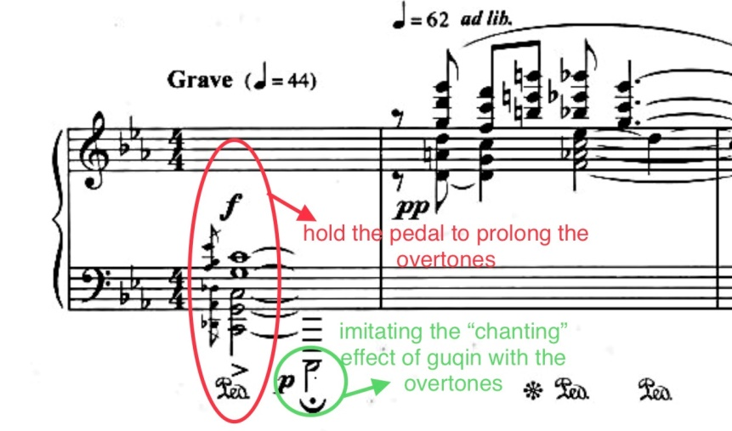

Example 4.2. Xu Zhenmin, Song on Youzhou Terrace, mm. 1–5.
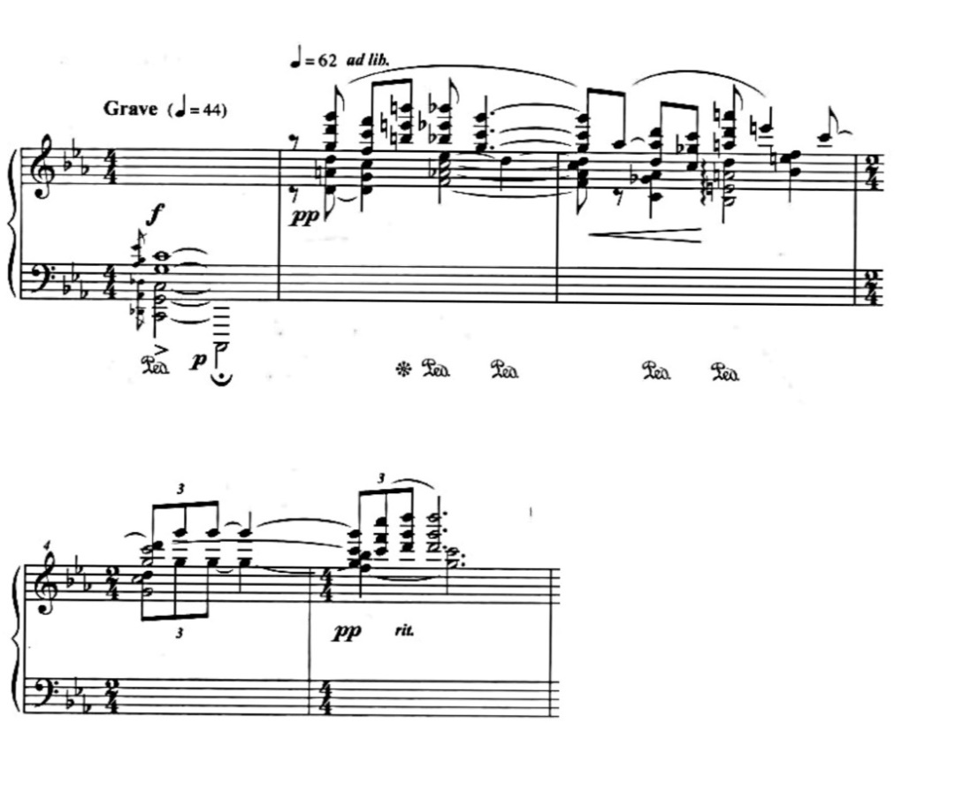

Example 4.3. Xu Zhenmin, Songs on Youzhou Terrace, A section, mm. 1–14.
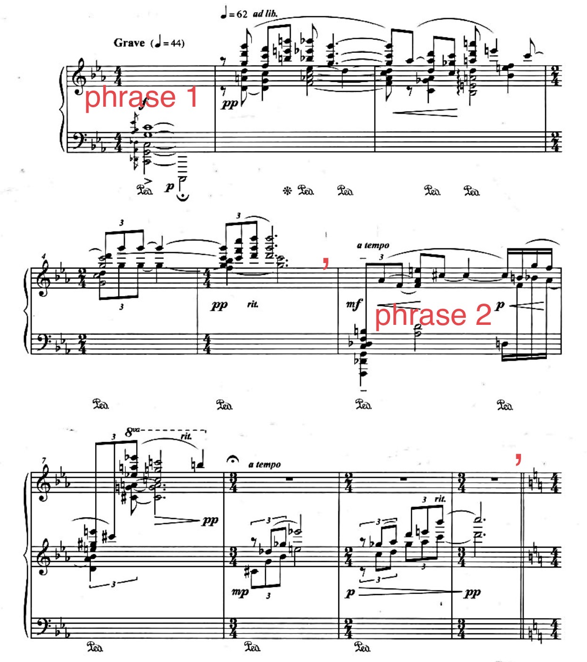
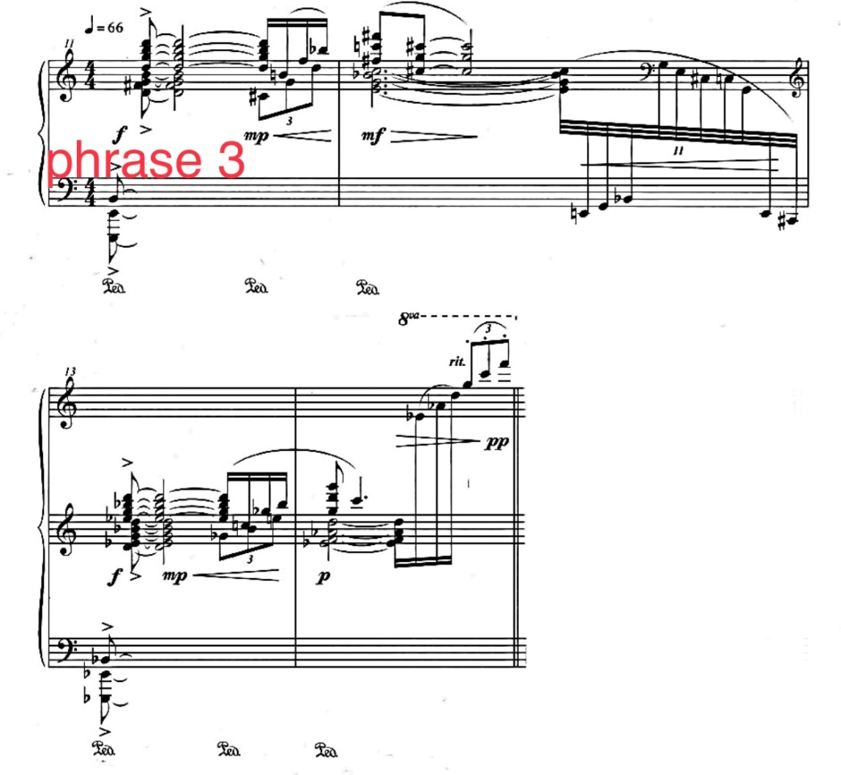
The B section (mm. 15–24) contains three phrases and has a brighter tonality, but the atmosphere is foggy, as the many parallel fifths create emptiness. Also, the climbing gesture at the beginning of each phrase create intensity and anxiousness. There appears a rhythmic motive in measure 15, and each of the three phrases is based on this motive (see example 4.4), which imitates the questions the poet keeps asking in the first two lines of the poem. This section was written with traditional Chinese pentatonic scales and modulates frequently. The music arrives at the climax in m. 23 with an extended chord, formed by E♭7 and G♭7, with a fff dynamic. From measure 20, the dynamic suddenly switches to mf and begins a crescendo. However, the moods of the harmonies remain tragic.
Example 4.4. Xu Zhenmin, Song on Youzhou Terrace, mm. 15–22.
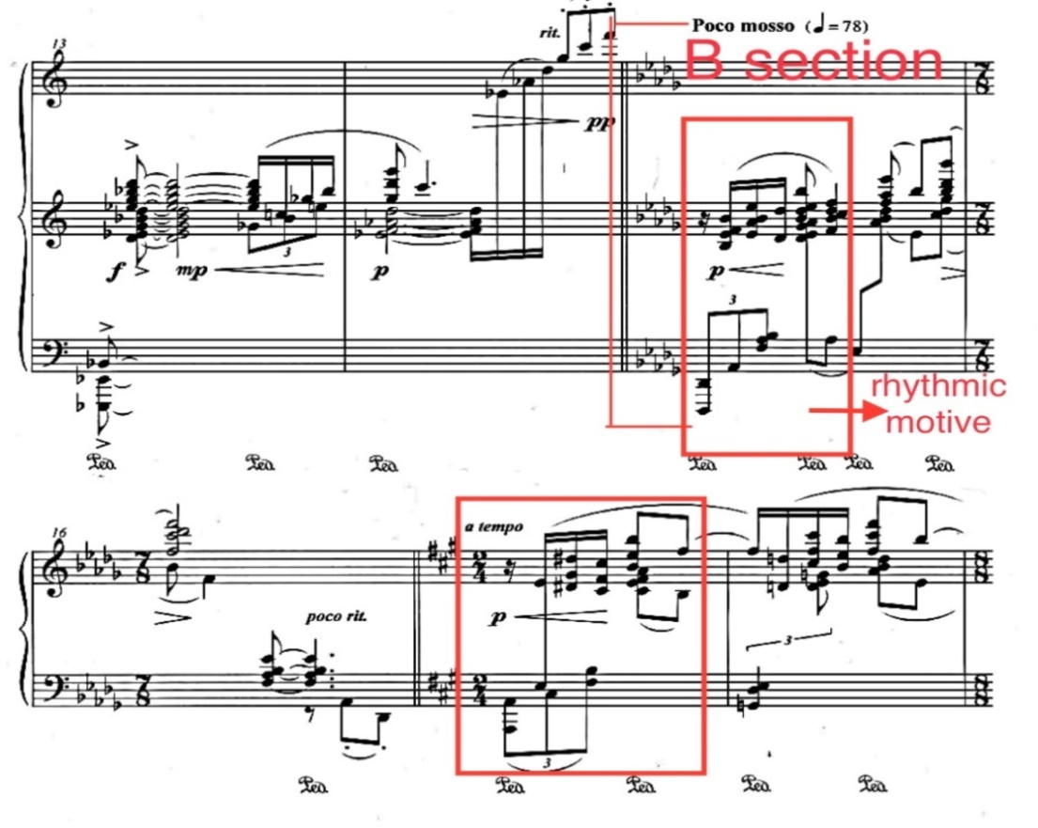
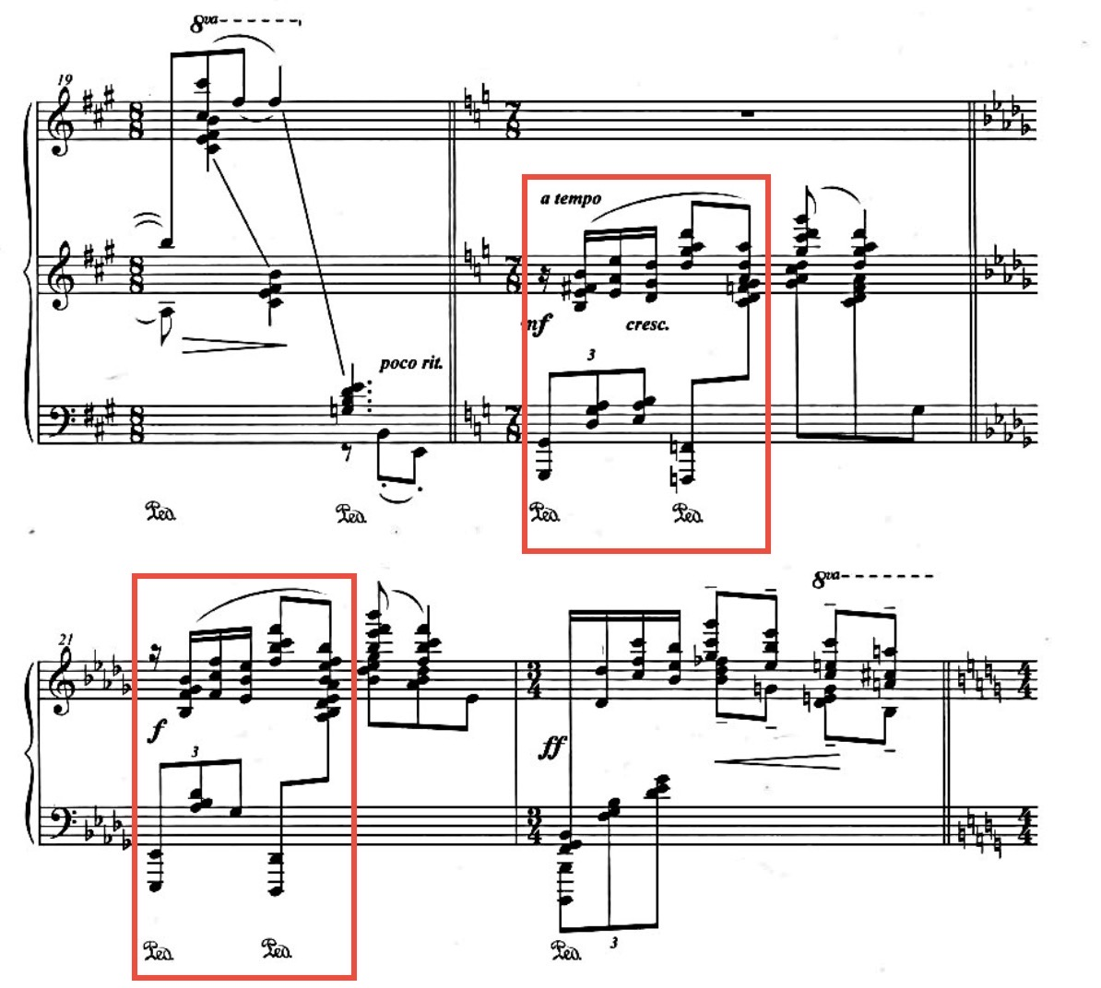
After the B section, there is another transition (mm. 25–34). This section is marked Lento, and it features a series of stepwise descending gestures which symbolize the poet’s shedding tears, while the harmonic progression emphasizes the sadness (see example 4.5). The slow tempo and the rhythmic pattern cause the musical effects of murmuring or plucking the guqin strings, and the blurry harmonies produce the sound effect of 吟yin as well. The A’ section begins in measure 34 with the recapitulation of the opening phrase. The entire section is based on a soft dynamic and the piece ends quietly.
Example 4.5. Xu Zhenmin, Song on Youzhou Terrace, mm. 29–34.
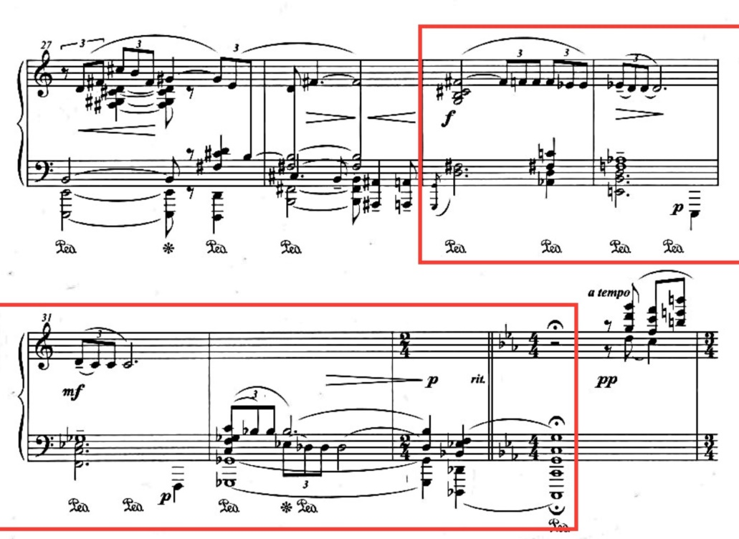
Throughout the piece, the composer applies numerous fermata and rit. marks to lengthen the distance between phrases. The lingering sounds can be sustained even longer through the use of long pedals. These approaches create a sense of spaciousness and evoke the vastness of time and space. The overall dynamic of the work is mainly concentrated in pp and mp, which emphasize the quiet and misty atmosphere. There are a few chords mainly in the bass and middle registers marked with strong dynamics, which when coupled with the muddy sense of harmony create an ancient and desolate feeling. The minor tone of the whole work, along with some decrescendo gestures, bring the audience a feeling of melancholy. The overall yijing of the work reflects the vastness, desolation, and sadness of the original poem. Xu also incorporates the values advocated by ancient Chinese literati through the sense of coolness and quietness in the music.
Some performance interpretations are worth explaining. First, to maintain the ethereal and wispy mood without devolving into a weak sound, the player should employ a sensitive touch. The performer must control the power of the arm and finger in order to reflect the lightness of the piece. Second, pedal control is important. To ensure clarity and create different tones, the performer needs to listen carefully to the harmonies and lines of the music, adjusting the pedal changes and depths of the pedals accordingly. Third, because of the overall slow tempo and the amount of fermata and ritardando, it is imperative to maintain good pacing and breathing. The fermatas and ritardando should be interpretated within limits so as not to drag and disturb the musical development. It also requires the performer to read the rhythms correctly and stay true to them, in order to keep the continuous pulse. A strict adherence to the complex rhythmic patterns, such as the long suspensions and the four-against-three rhythms, helps to convey the characters accurately. For example, the section (mm. 29–34) that imitates the chanting, tears, and guqin strumming, especially requires the player to play the triplets and suspensions strictly and calculate the ritardando carefully in order to avoid a desultory sound. In addition, it is important to control the intensity of the strong chords. The chords marked with strong dynamics in this work mainly reflect the weighty mood. The performer needs to control the power so as to avoid a sharp sound effect when playing these chords. The musical atmosphere created by this piece should feel distanced, solemn, and quiet, which fits the original poem’s lonely, pathetic musical atmosphere, and contemplative aesthetic.

Written on the Meditation Garden Behind Broken Mountain Temple
The poem Written on the Meditation Garden Behind Broken Mountain Temple was written by Chang Jian, a poet in the high Tang period. Chang had an unsuccessful political career and finally lived in seclusion. Most of his poems were on the themes of landscape and seclusive life, which mainly expressed the poet’s desire to escape from the reality of society. Written on the Meditation Garden Behind Broken Mountain Temple describes the leisurely and comfortable sentiment felt when visiting the Buddhist temple on a peaceful morning. The poem text is as follows:
清晨入古寺，初日照高林。
竹径通幽处，禅房花木深。
山光悦鸟性，潭影空人心。
万籁此都静，但余钟磬音。
At clear dawn entering the ancient temple, First sunlight shines high in the forest.
A bamboo path leads to a hidden spot, A meditation chamber deep in the flowering trees.
The mountain light cheers the natures of birds, Reflections in pool void the hearts of men.
All nature’s sounds here grow silent, All that remains are the notes of temple bells.
This poem is very straightforward. The whole poem depicts a serene poetic landscape with the bamboo groves, Zen garden, pool, and birds. The overall yijing of the poem is cool, breezy, and refreshing, evoking a green landscape which allows the reader to forget worldly worries.
The composer, Xu Zhenmin, recognized the atmosphere of Zen meditation in this poem and the poetic world that is created with the “lightness” and “quietness” that were advocated by the ancient Chinese literati. Thus, Xu pairs this poem in stark contrast with the previous one in the piano set, as the peaceful character of the poem comforts the sadness left by the previous one.
The piece is in ABA form. It starts and ends with the tonal center F-sharp, but it keeps modulating during the entire piece, all within the Chinese pentatonic scale system. In addition, the composer adopts the traditional Chinese music theoretical concept—the same gong system—for modulating.
The A section (mm. 1–11) starts with a bright C-sharp zhi pentatonic scale, which belongs to the F-sharp gong system. It modulates to G-sharp zhi, which belongs to the B gong system, in the second measure (see example 4.6), and the remainder of the piece continues to modulate. The bright tone colors and the swift scales and arpeggios, along with the light dynamic, create the atmosphere of a delightful morning in the bamboo forest with the gentle breeze and sunshine.

Example 4.6. Xu Zhenmin, Written on the Meditation Garden Behind Broken Mountain Temple, mm. 1–2.
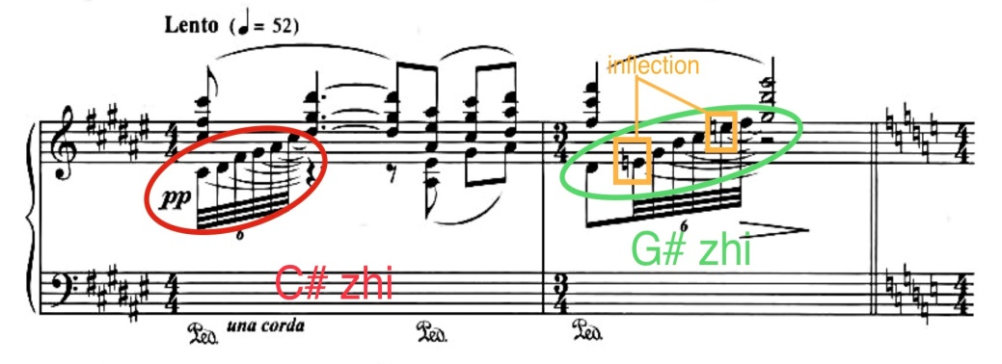

The B section (mm. 12–31), marked Allegro, is characterized by continuous sextuplets which produce the “waves,” and these waves create the images of the lights and shadows, watery scene, and flower scent in the breeze. Almost the entire section is formed by various pentatonic scales. There is a Lento section (mm. 18–20) in the middle of the B section, which could be reminiscent of the Buddhist meditation room (see example 4.7). At the end of the B section, the tempo slows down with the ornamented intervals (mm. 30–31), which depict the bird’s singing (see example 4.8).

Example 4.7. Xu Zhenmin, Written on the Meditation Garden Behind Broken Mountain Temple, mm. 18–20.
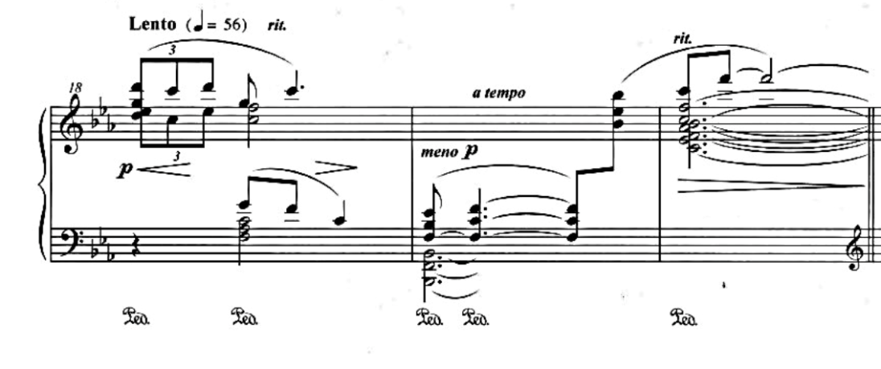
Example 4.8. Xu Zhenmin, Written on the Meditation Garden Behind Broken Mountain Temple, mm. 30–31.
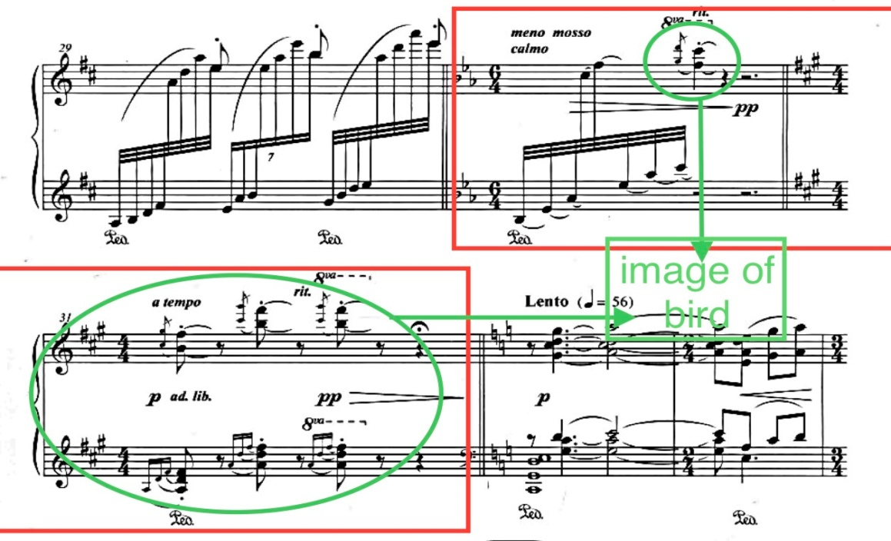
The A section recapitulates from measure 32 to the end. The main theme returns in C (mm. 32–34), throughout which there is a series of low chords with long pedals (see examples 4.9-1 and 4.9-2). This approach generates the sound of the temple bell, which is deep and long lasting. Then, the non-legato chords in measures 40 and 41 reflect the bell’s echo (see example 4.9-2).
Example 4.9-1. Xu Zhenmin, Written on the Meditation Garden Behind Broken Mountain Temple, mm. 32–36.
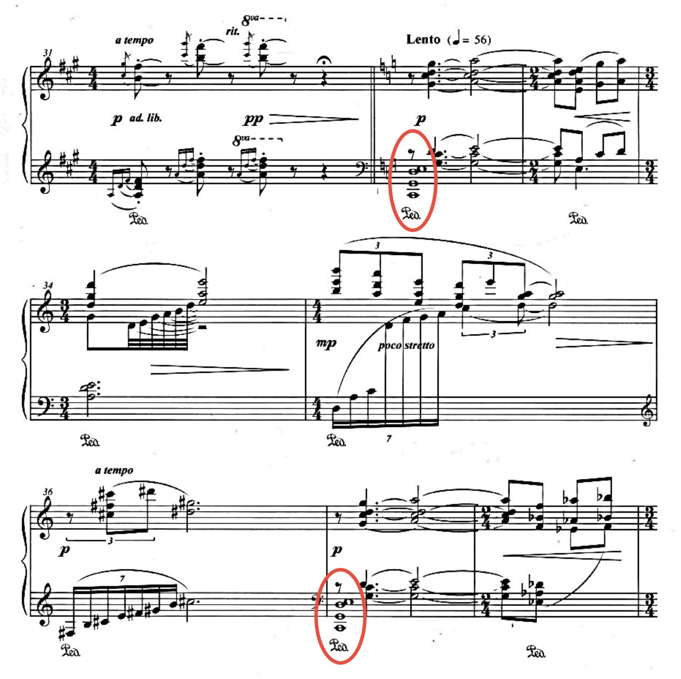
Example 4.9-2. Xu Zhenmin, Written on the Meditation Garden Behind Broken Mountain Temple, mm. 39–50.
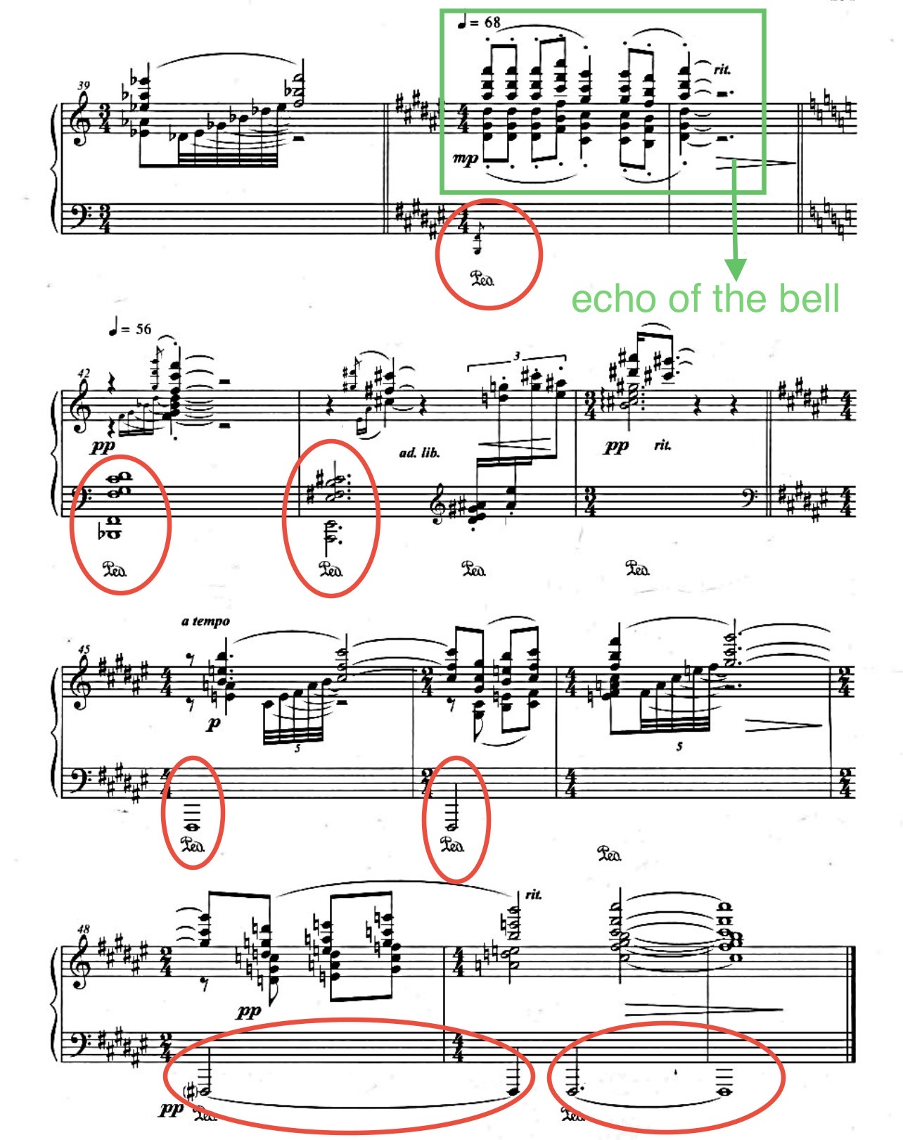

The overall sound effect of this piece is borrowed from the traditional Chinese zither instrument—古筝 guzhen, especially prominent in the swiftly sweeping arpeggios in the B section (see examples 4.10-1 and 4.10-2) and similar patterns in other sections. The dynamic range for this piece is between pp and mp. However, different than the first piece of the set which depicts a sense of vicissitude and loneliness, the piece Written on the Meditation Garden Behind Broken Mountain Temple emphasizes the clear and lucid atmosphere of the refreshing scene, the quiet and peaceful yijing of Zen, and the characteristics clean and quiet, which are the musical elements that were favored by the ancient Chinese literati. Thus, the player must be sure to pay attention to the tone quality they are producing in order to reflect this ambience. In order to maintain the crystal-like sound quality, it is necessary to control the power of the arms and fingers and keep listening to the sound so as to adjust the pedal accordingly.
The melodic lines in the B section are grouped in the top notes of the sextuplets (see examples 4.10-1 and 4.10-2). Therefore, it is important to keep track of the rhythmic pattern and balance the tone quality and the dynamics, so that the melodic lines can be brought out. Also, the large intervals between some notes in these sextuplets and the alternations between the two hands may cause unintended accents. To avoid this and keep the line smooth and even, the player should keep the wrists relaxed and flat (neither uplifted nor downfallen), and the hand should move with horizontal motion.

Example 4.10-1. Xu Zhenmin, Written on the Meditation Garden Behind Broken Mountain Temple, mm. 12–17.
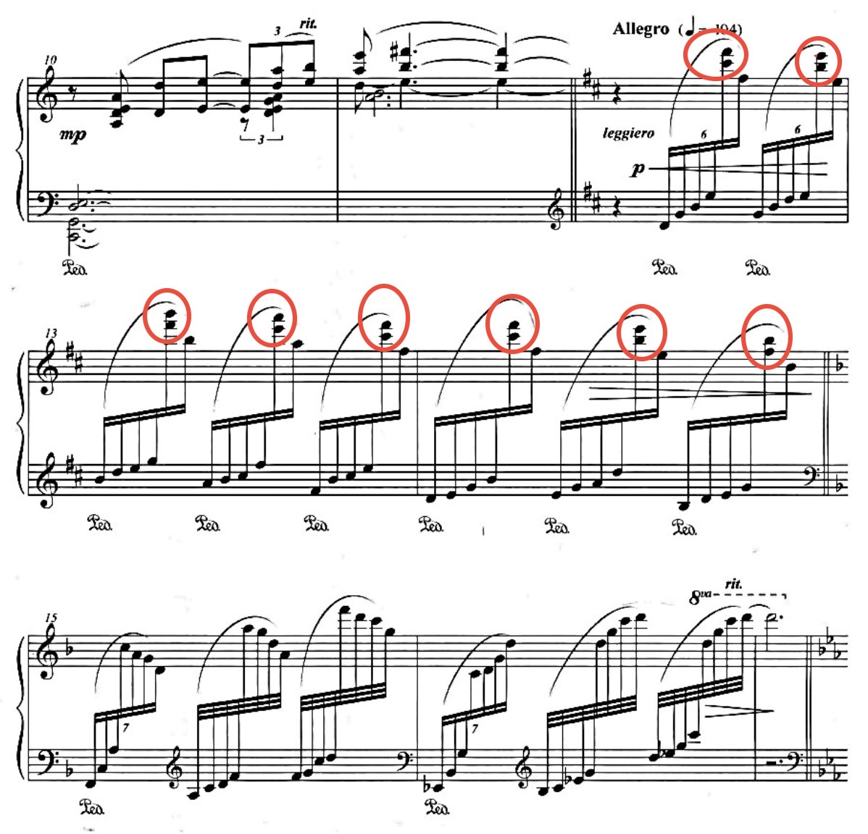

Example 4.10-2. Xu Zhenmin, Written on the Meditation Garden Behind Broken Mountain Temple, mm. 21–27.
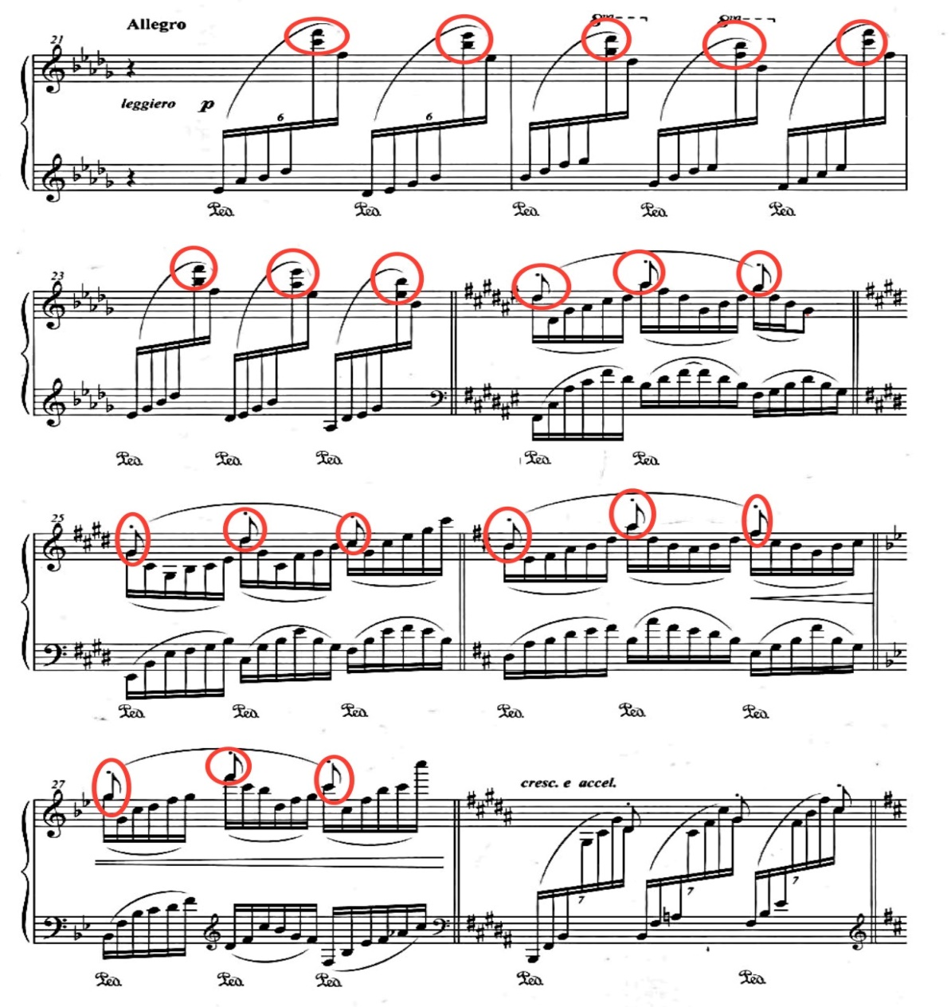

The two piano pieces in this set are good examples of bringing out the yijing in the ancient Chinese poems. In Songs on Youzhou Terrace, Xu creates a lonely and sad character through the empty sound, blurry tonality, and chanting effect. In Written on the Meditation Garden Behind Broken Mountain Temple, the composer uses different sound effects to simulate the corresponding image, creating a serene landscape of the Zen garden and expressing the poet's inner peace and indifference. The musical interpretation of these poem brings the imagery to life, builds the yijing of the text, and enriches the atmosphere of the poem beyond the limits of the text itself.

CHAPTER 5: Gong Xiaoting and Three Preludes
Gong Xiaoting (1970– ) is a composer and professor at the Central Conservatory of Music at the time of this writing. Gong entered the pre-school of the Central Conservatory of Music in 1985 and received her bachelor’s, master’s, and doctoral degrees from the school. In 1995, she started to teach composition and music theory in the conservatory. Gong was deeply influenced by the Impressionism from her young age.

Gong’s Musical Style
Gong writes for many genres, including vocal music, instrumental music, chamber works, and orchestral works. Gong likes to combine the Chinese pentatonic scale, traditional Chinese drama music, and folk tunes with the styles of impressionism and atonalism, which are present in most of her works. For example, the piano works 即兴曲六首—望舒诗选 Six Impromptus—Poems by Wangshu, 幻想曲 Fantasia, 赛啰赛 Sailuosai, Sketches of Southwestern China, and 童戏 Children’s Games are all written with Chinese tunes and blended with impressionist or atonal techniques.
Gong is knowledgeable about ancient Chinese literati poetry and painting. She believes that both impressionism and atonal music convey the “implication” and “ambiguity” that were pursued by ancient Chinese literati. Her piano works 淡彩五帧 Five Paintings in Light Colors and 水中云 Clouds Reflected in Water, as well as her choral work 黄河夜月 The Moon on the Yellow River, are closely related to Chinese classical painting and literature. The piano set discussed in the following section, Three Preludes, adopts three typical cipai of the Song dynasty and exhibits the corresponding characteristics of the three cipai.

Three Preludes
Three Preludes was written in 1999 and the work adopts three typical词牌 cipai as the title of each piece: 如梦令Rumeng Ling (Like a Dream), 浪淘沙 Lang Taosha (Sand-Sifting Waves), and 绮罗香 Qiluo Xiang (Fragrance of Silk Brocade). In general, the contents of ci works were not necessarily related to the literary meaning of the cipai. Occasionally, however, poets also wrote works that corresponded to the origins of the specific cipai and intended to reflect an impression of its literal meaning. Similarly, Gong intends to pursue the specific characteristics and atmospheres of each cipai through the music. The names of the three preludes, 梦令 Mengling, 淘沙 Taosha, and罗香 Luoxiang, keep the same meanings and impressions of the original cipai names.

Mengling
The cipai (tune) Rumeng Ling (Like a Dream) is short in format, and its specific meter and articulation make it sound delicate, graceful, and elegant. 李存勖Li Cunxu, a poet in the late Tang dynasty, created this tune and wrote the first ci for it: To the Tune “Like a Dream” — Once In the Cavern of the Peach-Blossom Fountain. The poem describes the poet’s imaginary journey to a dreamy fairyland. The name Like a Dream was taken from a repeated phrase in this poem: “如梦, 如梦,” (“like a dream, like a dream,”) which is the signature phrasing for this tune. Its exquisite and limber characteristics fit the taste of the 婉约派 wanyue school. Thereafter, many poets in the Song dynasty wrote ci for this tune. Some of the works depicted a cozy, idyllic life and created a quiet and leisurely atmosphere—for example, one of the works from the female poet of the Song dynasty 李清照 Li Qingzhao: To the Tune “Like a Dream”— Last Night the Rain Was Sparse But the Wind Buffeted. Other works were about farewell or reminiscence, which highlighted the sentimental and dreamy atmosphere, such as To the Tune “Like a Dream”— I Always Recall the Pavilion by the Creek at Sunset, which was also written by Li Qingzhao. The overall character of the tune name Like a Dream is quiet and dimly discernible.
Generally speaking, Gong’s interpretation of the tune Like a Dream tends to be dreamy and plaintive. It is illustrated by the blurry tonality and the expressive musical markings such as “Largo e mesto” (broad, sad, and gloomy), “arioso dolente” (serious, dramatic, and plaintive), and “sentimentale” (expressive).
The prelude Mengling is in strophic form, with an introduction and a coda. The main body of the piece consists of a melodic idea with an ostinato accompanying line. The basic unit of the accompaniment line is formed by three tritones. The entire piece is based on intervals and does not belong to an identifiable key. However, with the help of some modern theoretical methods such as Hindemith’s “two-voice framework” and “melody degree progression,” it can be inferred that the tonal center for this piece is D. The melodic idea is in the D shang mode which belongs to the C gong system, and it is repeated in different registers a total of three times.
The piece is marked Largo e mesto. The introduction (mm. 1–5) unfolds with a special time signature “サ” (see example 5.1) that is borrowed from traditional Chinese music. This symbol functions similarly to “ad libitum” or “sanza misura,” indicating that the tempo of this section can be determined by the performer and should be interpreted freely. This section is formed by a series of parallel eighths and tritones, and the basic rhythmic motive of two half notes and a whole note is the enlarged form of the ostinato accompaniment in the body of the piece (see examples 5.2-1 and 5.2-2). The atmosphere for this section is dreamy but also dark and bleak.

Example 5.1. Gong Xiaoting, Mengling, m. 1.
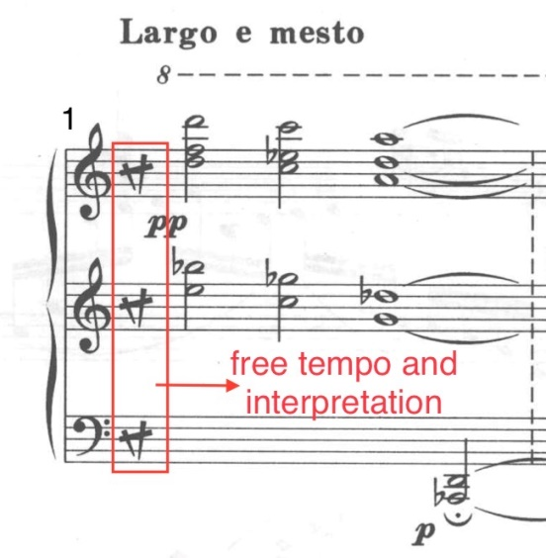

Example 5.2-1. Gong Xiaoting, Mengling, mm. 1–2.
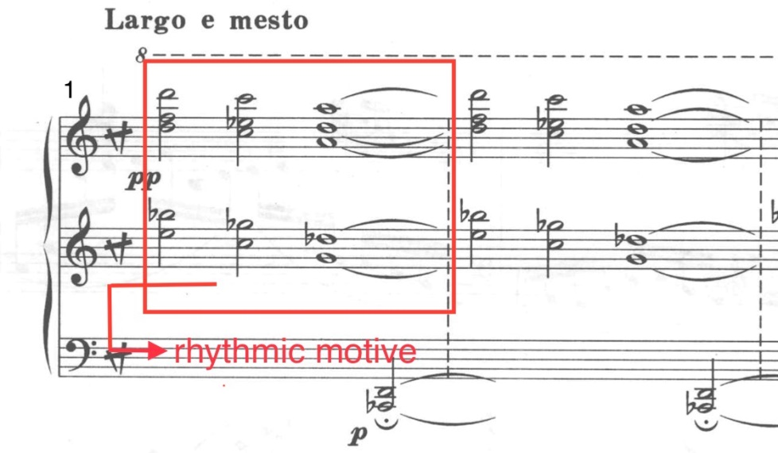

Example 5.2-2. Gong Xiaoting, Mengling, the first appearance of the theme, mm. 5–14.
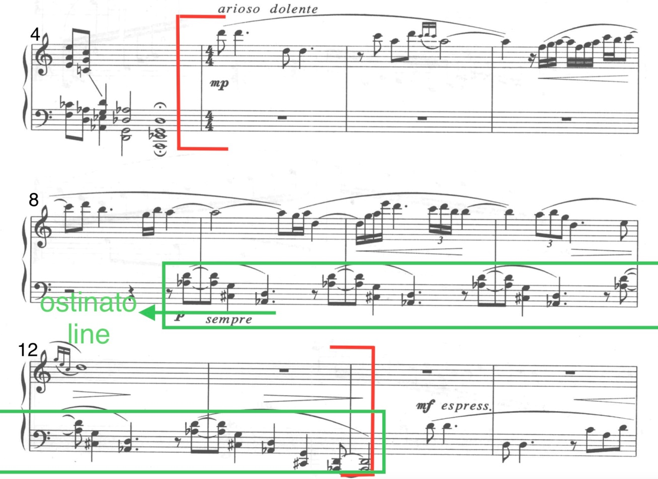
The main body of the prelude is marked arioso dolente. The through-composed melodic idea (mm. 5–12) is in D shang mode, and the circuitous melodic shape creates a feeling of “being lost” (see example 5.2-2). The theme begins with a motive (see example 5.3) that imitates the repeated phrase pattern from the tune Like a Dream. The left-hand ostinato accompaniment consists of three tritones, the third an octave below the first (see example 5.2-2), and keeps repeating. The harmonic effect of this approach feels both quirky and eerie. Also, the syncopated rhythms in the left hand make the right-hand melody and the left-hand accompaniment sound misaligned and irrelevant (see example 5.2-2).
Example 5.3. Gong Xiaoting, Mengling, m. 5.
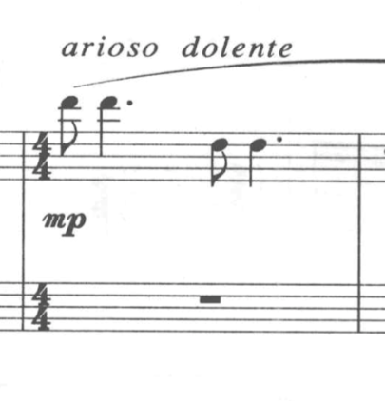
The theme is then repeated in the lower register (mm. 14–21) and returns to the higher register (mm. 22–28), during which the ostinato accompaniment is shifted to the hand that is not playing the theme. The theme appears for the last time, this time as intervals (see example 5.4), and the dynamic shifts to forte, which enforces the “misaligned” impression. The coda (mm. 31–34) adopts the elements of the introduction (see example 5.5), and it ends quietly.

Example 5.4. Gong Xiaoting, Mengling, mm. 22–31.
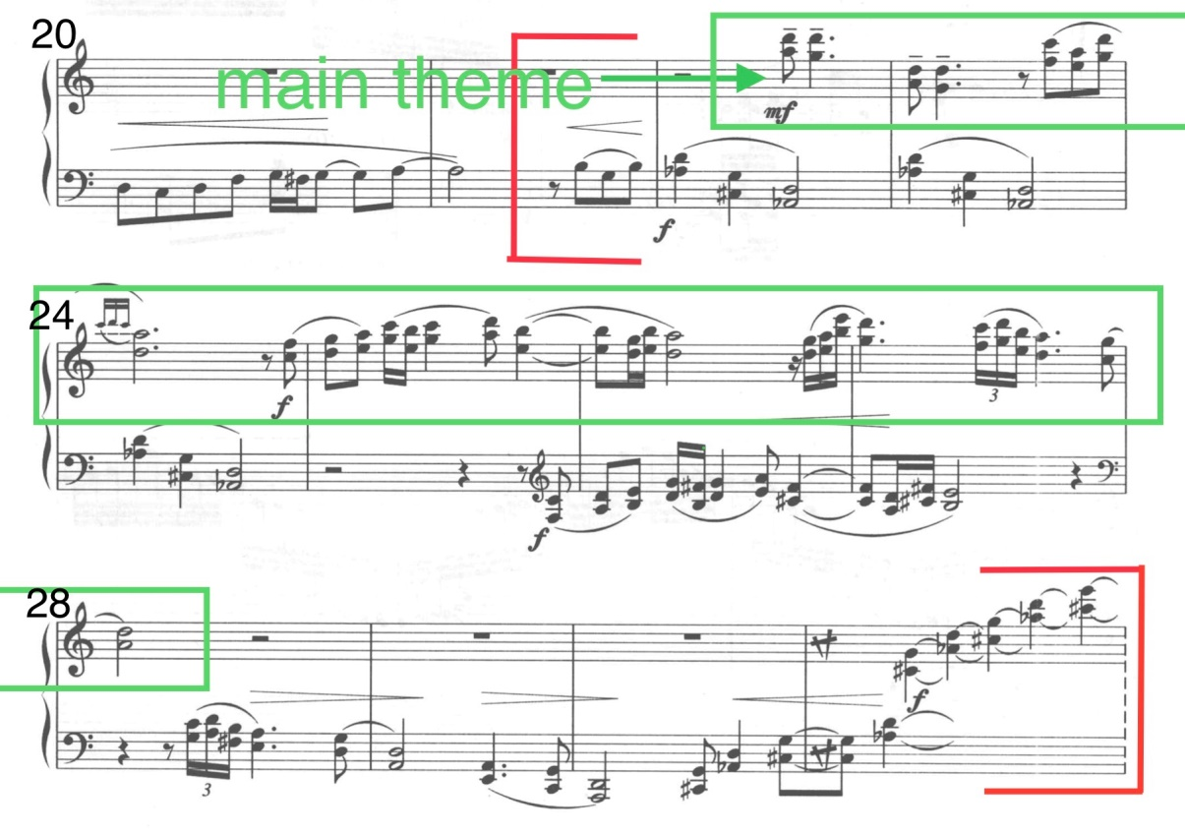
Example 5.5. Gong Xiaoting, Mengling, coda, mm. 32–34.
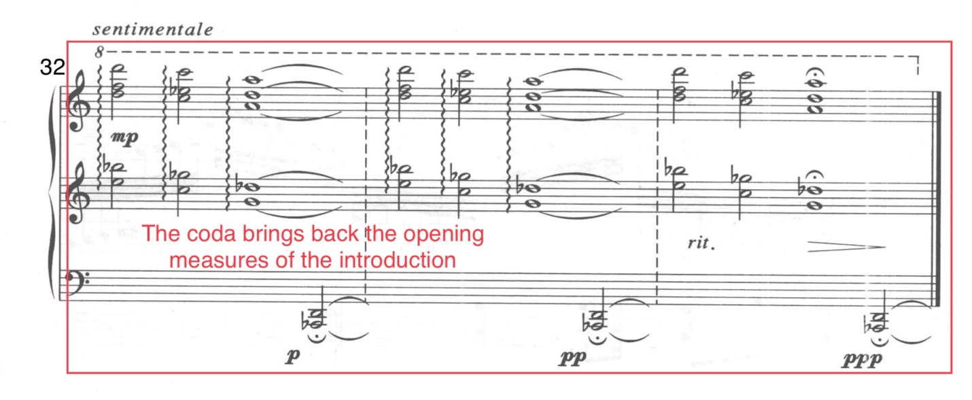

The challenge for interpreting this piece is to evoke the mysterious atmosphere of a dream. One of the essentials is to keep the arms and wrists relaxed in order to avoid a too-intense sound quality. Also, the tricky rhythmic patterns and coordination between the two hands, such as in measures 8–12, might need specific subdivision practice in order to make the irregular patterns secure.
As the composer did not provide pedaling markings, the player will need to adjust the use of the pedals according to the harmonic changes and the sound qualities. Most of the piece is smoke-like which is airy, so it requires the sound to be unbroken, but not blurry. The player should determine which lines should be carried on via the use of the pedal. For example, the pedal should be lifted for each chord in the introduction. But, when using the pedal for the low intervals in measure 1 and measure 2, the player should keep in mind that the sound for these two intervals should not be interrupted by the pedal changing for the upcoming chord. Therefore, the player should hold the pedal for the first beats of measure 2 and measure 3 and adjust the pedal for the remaining beats of the measures according to the sound (see example 5.6).
Example 5.6. Gong Xiaoting, Mengling, mm. 1–3.
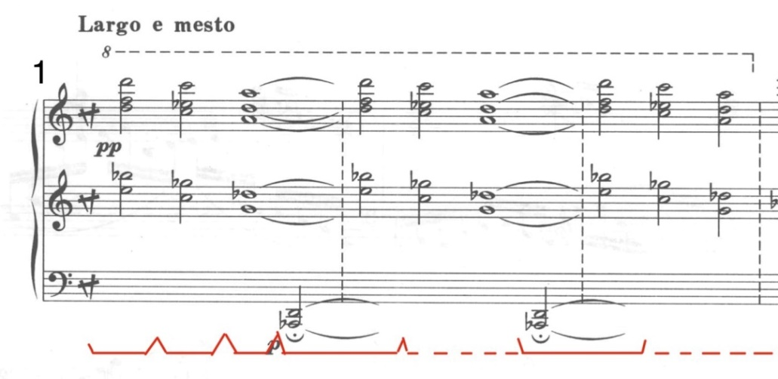
For most of the main body of the piece, the player could try starting out with long pedals, and use this opportunity to clear the sound as needed. For example, one possible solution is that each of the ostinato units could occupy one held pedal, and it could be changed on the eighth note rests (see example 5.7).

Example 5.7. Gong Xiaoting, Mengling, mm. 8–11.
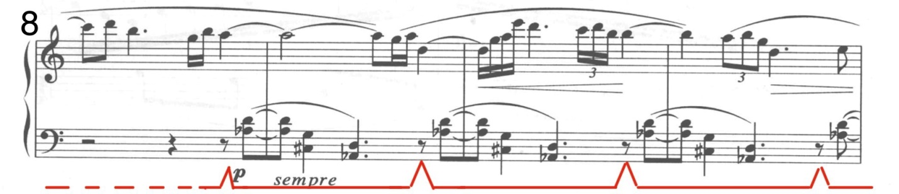

The overall yijing for this prelude is a mixture of dreamy, elusory, unearthly, and sorrowful. Once the performer grasps these intentions, the interpretation should be close to what the composer desires.

Taosha
The tune Lang Taosha (Sand-Sifting Waves) originated in the late Tang dynasty. When the tune originated, it was sung by the gold miners along the southern coast, and the lyrical content of the original tune was about their work. Generally, it described the magnificent scene of surging waves and shifting sand, and the painstaking labor of the gold miners. In the Song dynasty, this tune took on a fixed form. Some ci works that were written to this tune contained images related to water and waves and expressed metaphors about the rise and fall of life-like waves. Examples of this include To the Tune “Sand-Sifting Waves”—the Curtain Cannot Keep Out the Patter of Rain written by the late Tang dynasty poet 李煜Li Yu, and To the Tune “Sand-Sifting Waves”—The Autumn River by the Song dynasty poet 张炎Zhang Yan. In linguistic context, when read in Chinese, the tune name Lang Taosha gives the reader the image of something surging, and the flavor of tragedy. Gong has adopted these typical characteristics of the tune Sand-Sifting Waves for the prelude Taosha.
While the other two preludes (the first one and the third one) in the set exemplify the lightness and quietness of ancient Chinese aesthetics, the second piece, Taosha, is the exception. In general, the sound effect of Taosha is furious, but its heroism and tragic temperament are also in line with a typical style of Song ci— the 豪放派 haofang (roughly translatable as “brash”), which tended to advocate bold and vigorous emotions. The entire piece is based on rapid arpeggios and scales which create the image of boiling waves, and the continuous chords that are played by alternating hands imitate the rainstorm. There is a coda, which is extinguishing and quenching. The tonality is ambiguous and creates a dark atmosphere.
The prelude Taosha has two main contrasting sections, following the standard form of the tune Sand-Sifting Waves. After a series of striking dotted chords which imitate the thunder (m. 1), the A section (mm. 2–13) starts. The main theme is in the left hand, which is formed by a motive that begins on the offbeat with three eighth notes, followed by a sixteenth note with a dotted eighth note suspended to a quarter note, and ends with two half notes (see example 5.8). Meanwhile, the right hand plays rapid arpeggios and scales for the entire A section. This section embodies the scene of struggle against the storm through the different patterns and tonalities between both hands (see example 5.9).

Example 5.8. Gong Xiaoting, Taosha, mm. 2–3, left-hand section.
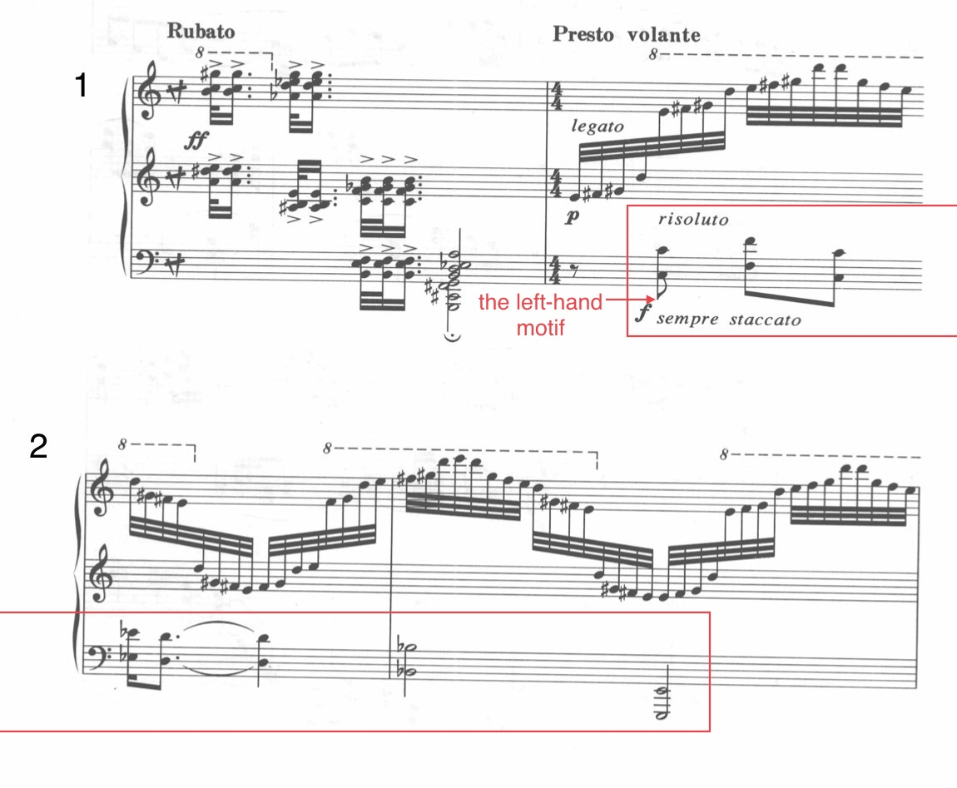
Example 5.9. Gong Xiaoting, Taosha, A section (with the one-measure introduction), mm. 1–13.
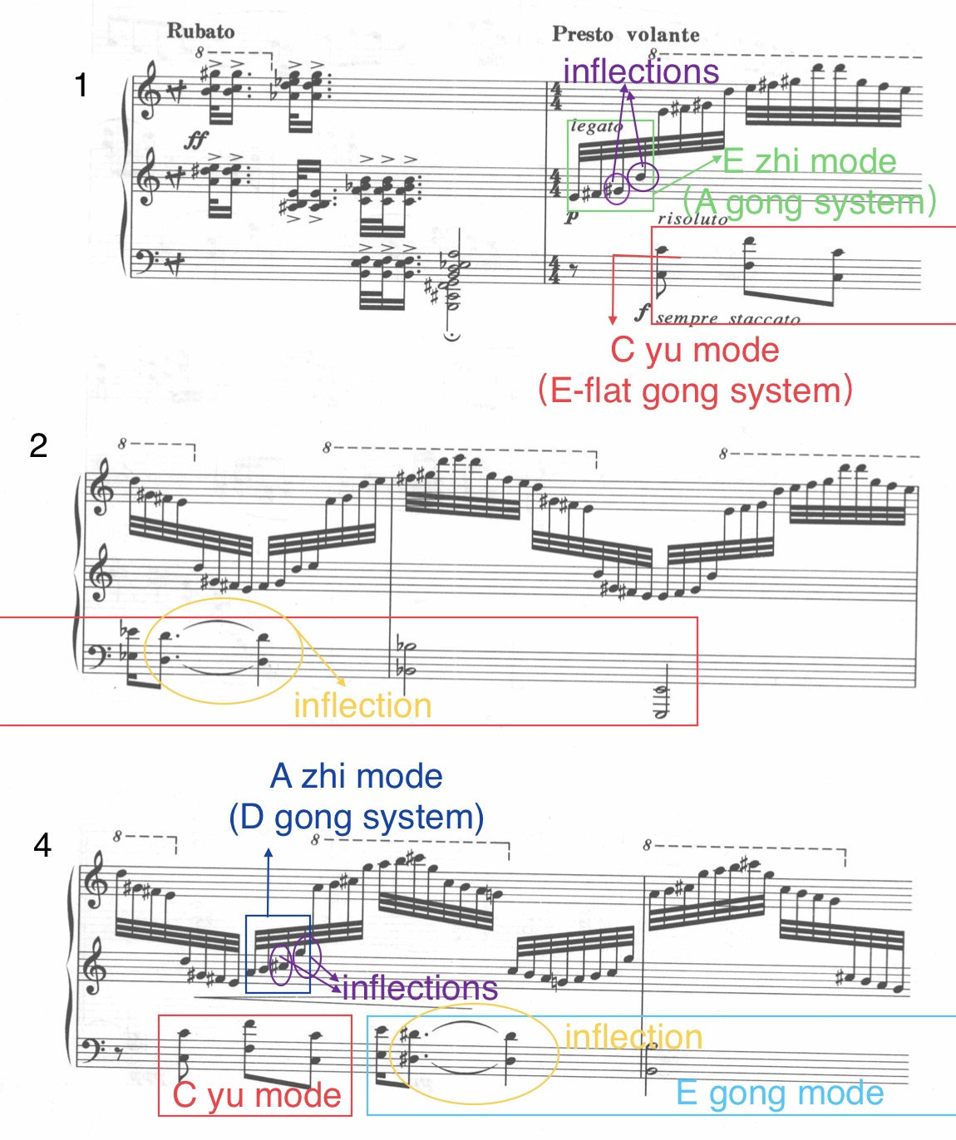
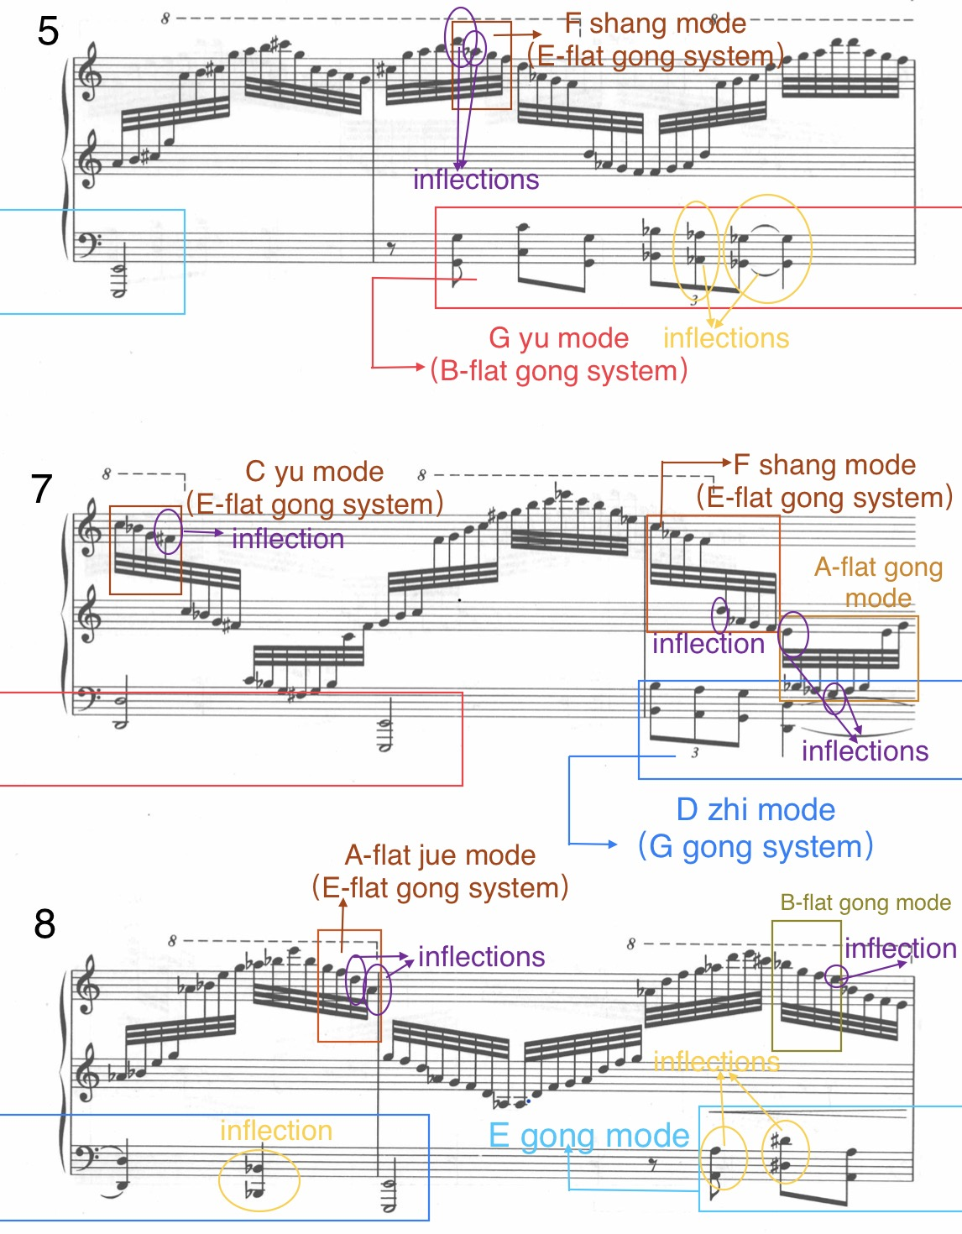

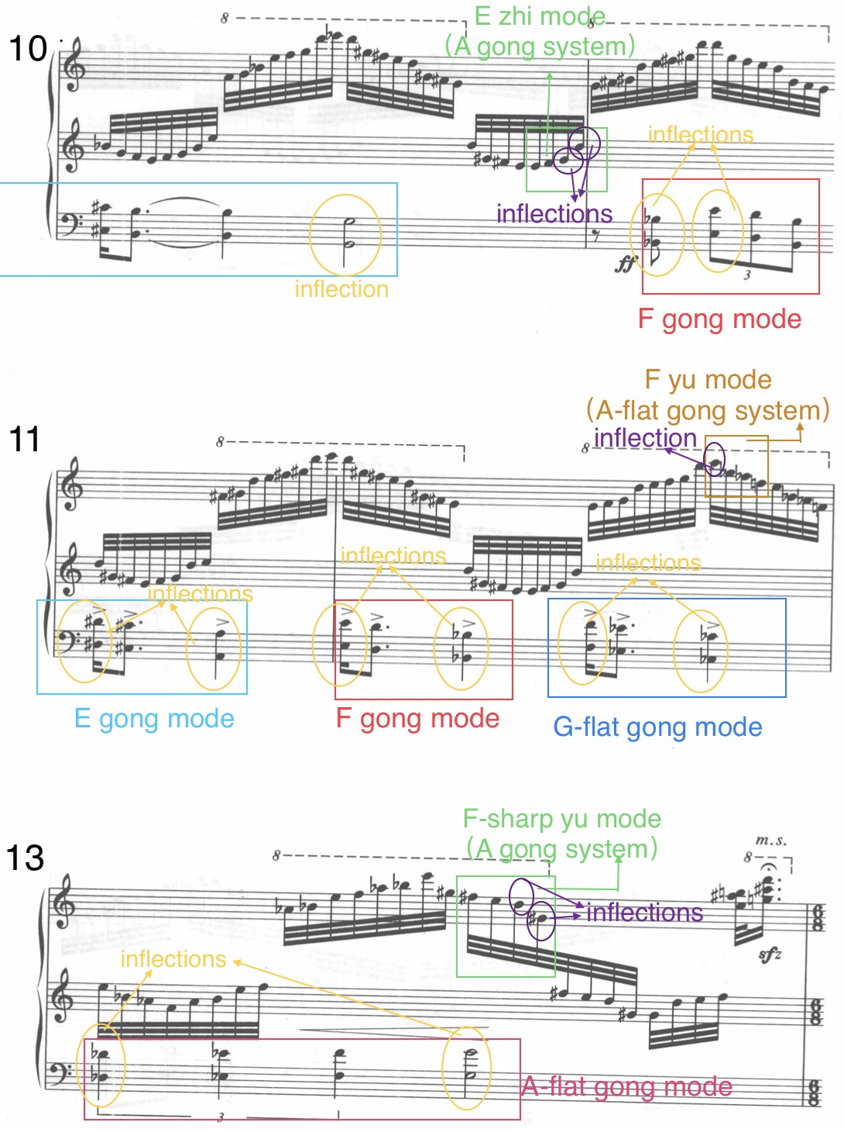
Table 5.1. The Tonalities and Modulations in the A section (mm. 2–13) of Gong Xiaoting, Taosha.
 | Left-hand motive | Right-hand scale
mm. 2–3 | C yu mode (E-flat gong system), with D as biangong | E zhi mode (A gong system), with D as qingjue and G-sharp as biangong
mm. 4–5 | C yu mode — E gong mode with D-sharp | A zhi mode (D gong system), with G and C-sharp
mm. 6–9 | G yu mode (B-flat gong system) — D zhi mode (G gong system) — E gong mode | [F shang mode— C yu mode — F shang mode (E-flat gong system)— A-flat gong mode — A-flat jue mode (E-flat gong system)— B-flat gong mode
mm. 9–10 | E gong mode with A and D-sharp | B-flat gong mode — E zhi mode (A gong system)
m. 11 | F gong mode with B-flat and E—  E gong mode with A and D-sharp | E zhi mode (A gong system)
m. 12 | F gong mode with B-flat and E — G-flat gong mode with C-flat and F | E zhi mode (A gong system) — F yu mode (A-flat gong system)
m. 13 | A-flat gong mode with D-flat and G | F zhi mode (A-flat gong system) —F-sharp yu mode (A gong system)
Gong adopts the poly-tonal technique and blends it with the pentatonic modes for this section, also adding two inflections to the pentatonic modes for the pentatonic scales. The left hand plays the motive five times in this section, each time in a different mode. The rapid scales played by the right hand modulate frequently, and the tonalities are entirely different from those in the left-hand motives. Table 5.1 provides a summary of the tonalities and modulations in each hand.
The B section (mm. 14–40) creates the image of heavy raindrops by using continuous short and accented chords. There is a new motif in the section, and it keeps repeating (see example 5.10). This section could be separated into three parts, wherein each part starts with the same motif in a different way. The first part (mm. 14–22) has the motif in the right hand, and the phrase could be divided as 2+2+5 (see example 5.10). The second part (mm. 23–33) shifts the motif to the lower register, and the phrase could be divided as 3+8 (see example 5.11). From measure 26, the rhythm of the motif is expanded, and the dynamic crescendos. The music arrives at its climax during measures 32–40.

Example 5.10. Gong Xiaoting, Taosha, mm. 14–22.
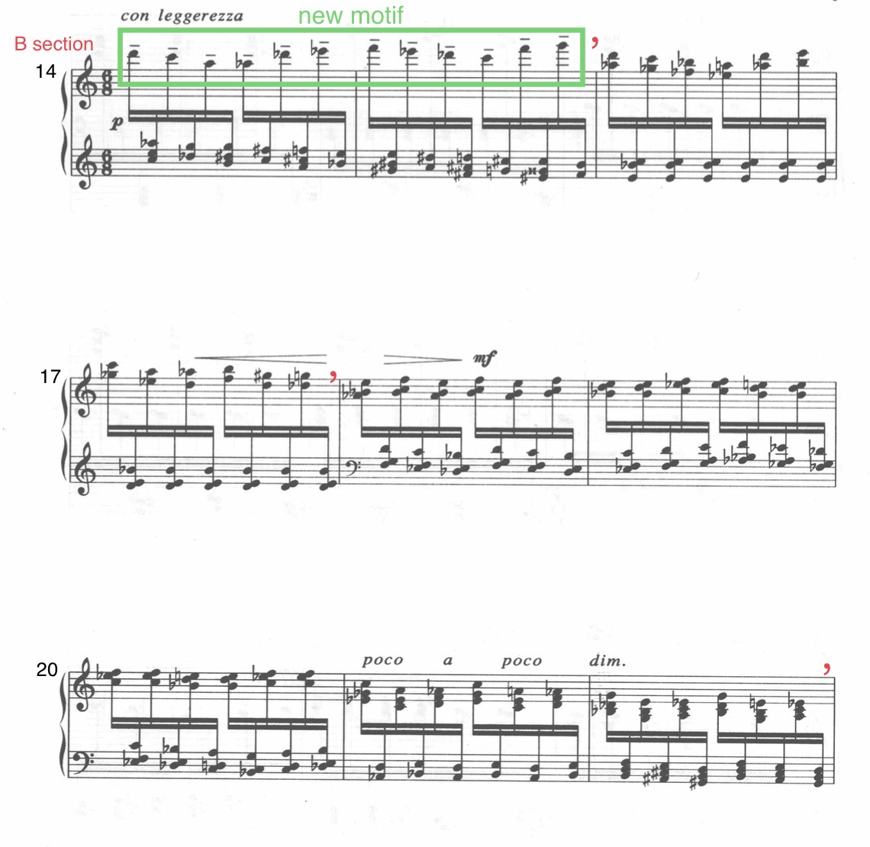

Example 5.11. Gong Xiaoting, Taosha, mm. 22–33.
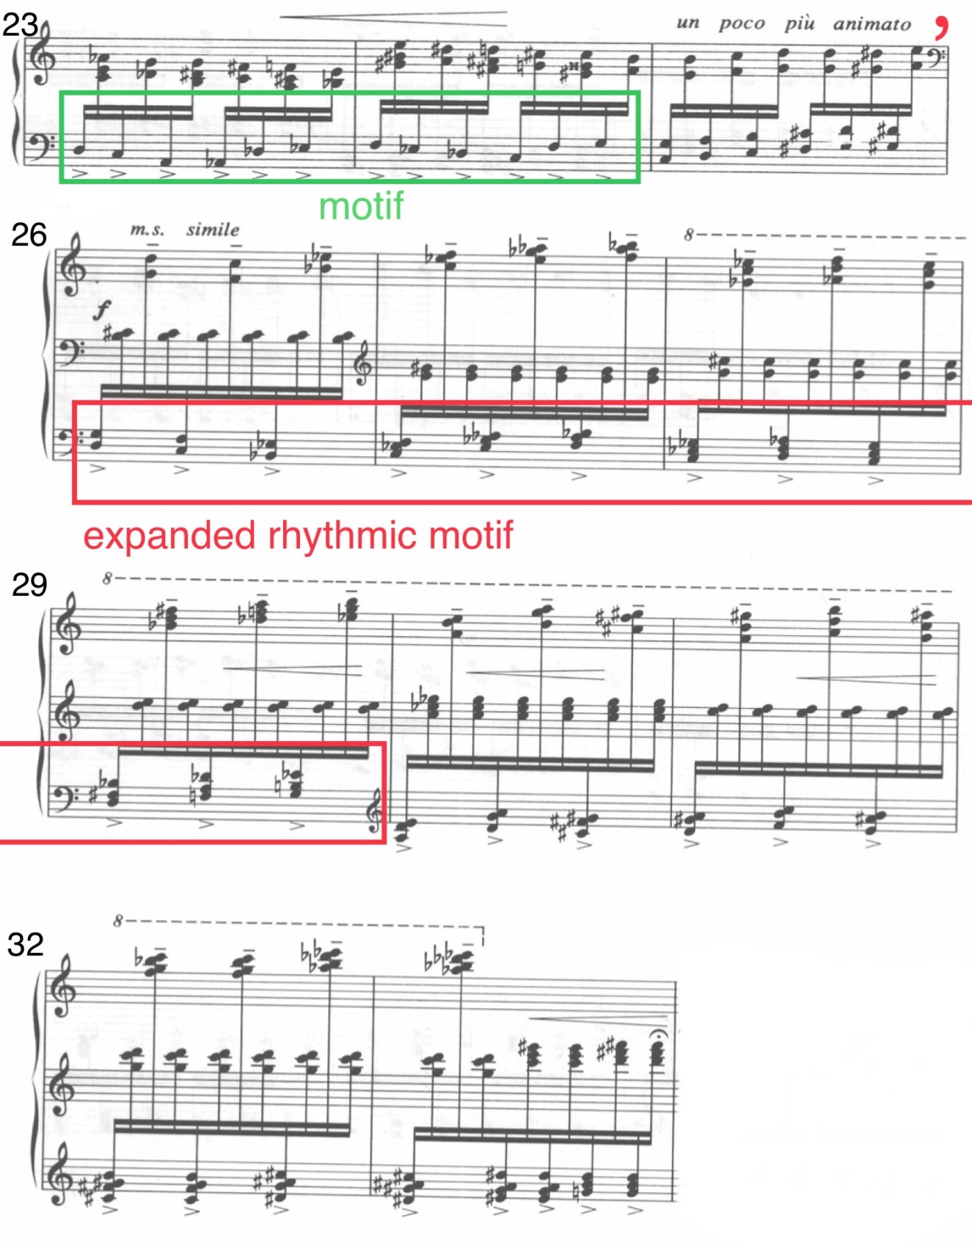

The coda starts at measure 41 with the recapitulation of the left-hand motive of the A section via transformation (see example 5.12). From measure 44, the strain and anxious mood retreats. The left hand plays the motif with reduced force and the right hand plays the triplets instead of the rapid scales of the A section. The decreased tension indicates the storm is ending (see example 5.13).
Example 5.12. Gong Xiaoting, Taosha, mm. 41–43.
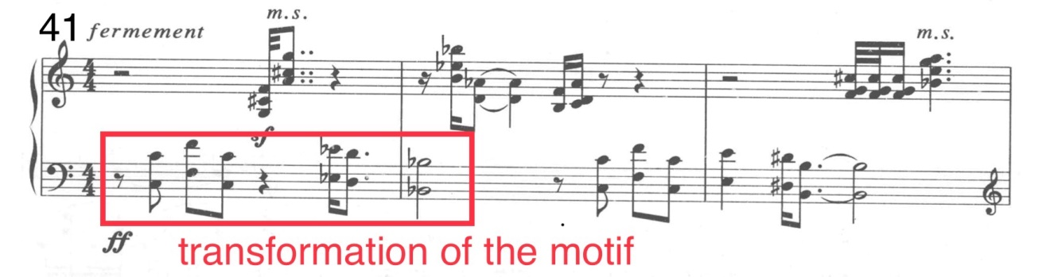

Example 5.13. Gong Xiaoting, Taosha, mm. 44–48.
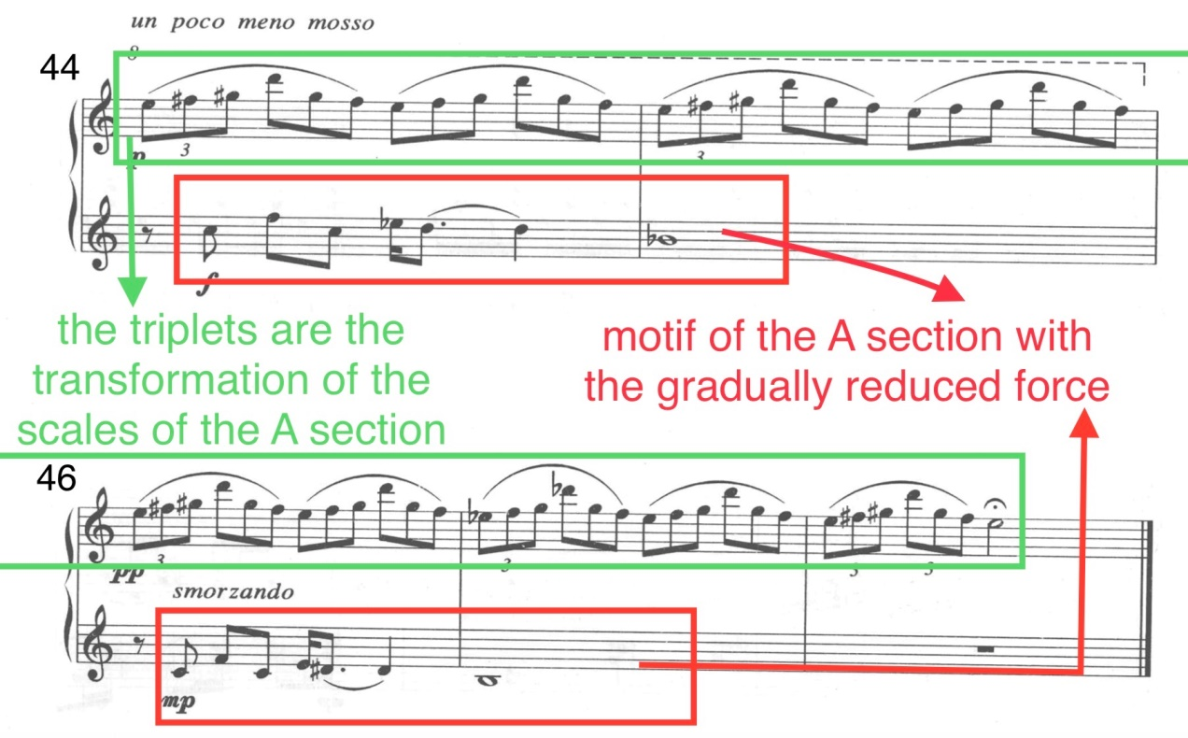
The main difficulty in the piece is the rapid arpeggios and scales. The right-hand pattern for the A section is very similar to Chopin’s Etude Op. 25, No. 12, and the approach for the coordination of both hands is similar to Chopin’s Etude Op. 10, No. 1. Making the running notes clear and even and bringing out the left-hand intensity is the priority in both Chopin pieces and in Taosha. Thus, practicing with grouping of four thirty-second notes might be helpful for this section. For the B section, to achieve the effect of the heavy rain beats, the performer should keep the alternation between the two hands even and make each sixteenth note recognizable and clear.
Long pedals are not suggested for this piece. For the A section, the pedal should be adjusted with the left-hand motives in order to make the left-hand staccato distinctive. In places where the left hand has long notes, the player should adjust the pedal frequently according to the sound in order to maintain the right-hand running passage clear and legato (see example 5.14). To maintain the clarity, the pedal should be reduced for the B section. It is better to not use the pedal at all for some parts of the section, such as the first (mm. 14–22) and the last (mm. 34–40) portions of the section. From measure 26 to 33, the pedal should be changed for every accent in the left hand.

Example 5.14. Gong Xiaoting, Taosha, mm. 1–3.
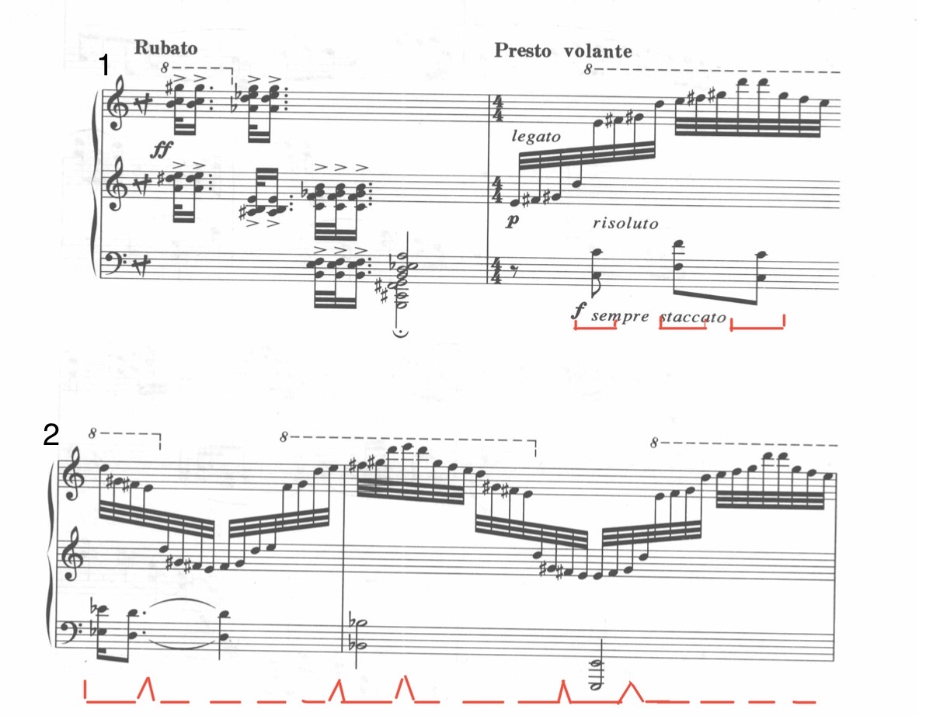

The overall sound effect of the prelude Taosha evokes the image of the tumbling river, with the dark and raging emotions advocated by many Song ci works.

Luoxiang
The tune name Qiluo Xiang (Fragrance of Silk Brocade ) was taken from the line “蓬门未识绮罗香” (“In thatched hut I know not fragrant silks and brocade”) in the seven-syllable regulated verse 贫女A Poor Maid, written by 秦韬玉Qin Taoyu, a poet in the Tang dynasty. The content of the original poem is about the hard life of a spin maid and expresses the poet’s deep sympathy for this pitiful woman:
蓬门未识绮罗香，拟托良媒益自伤。
谁爱风流高格调，共怜时世俭梳妆。
敢将十指夸针巧，不把双眉斗画长。
苦恨年年压金线，为他人作嫁衣裳。
In thatched hut I know not fragrant silks and brocade, to be married I can’t find a good go-between.
Who would love and uncommon fashion through self-made, all pity my simple makeup and humble mien.
I dare boast my finger’s needlework without peer, but I won’t vie with maidens painting eyebrows long.
I regret to stitch golden thread from year to year, but to make wedding gowns which to other belong.
Later, Fragrance of Silk Brocade was used as the name of a tune that was created in the Song dynasty. It is a long tune written to two paragraphs of text. In the Chinese language, the tune name and the specific rhyme of the tune make the tune sound floaty and sad. Some representative ci works that were written to this tune, such as To the Tune “Fragrance of Silk Brocade”—Spring Rain by the Song dynasty poet 史达祖Shi Dazu and To the Tune “Fragrance of Silk Brocade”—Red Leaves by the Song dynasty poet 张炎 Zhang Yan, maintain the graceful and sorrowful characteristics of the tune.
The prelude Luoxiang takes the general idea of the tune name and creates a silky and melancholy atmosphere. The piece has two large sections, with a two-measure introduction and a coda. The introduction is formed by a series of arpeggios, which have a misty tone color and embody the graceful character of the title. The A section (mm. 2–17) has three distinctive musical figures which create the scene of the original poem: a spin maid who is weaving and at the same time talking to herself. An ostinato line in the middle voice imitates the rotative pedal of the spinning wheel. The upper voice resembles the self-talking of the spin maid, which sounds soft and pensive. The bass line has a darker tone which indicates the woman’s helplessness and inward disappointment. From measure 12, the timbre becomes weighty, hinting at the woman’s somberness (see example 5.15).

Example 5.15. Gong Xiaoting, Luoxiang, mm. 27–29.
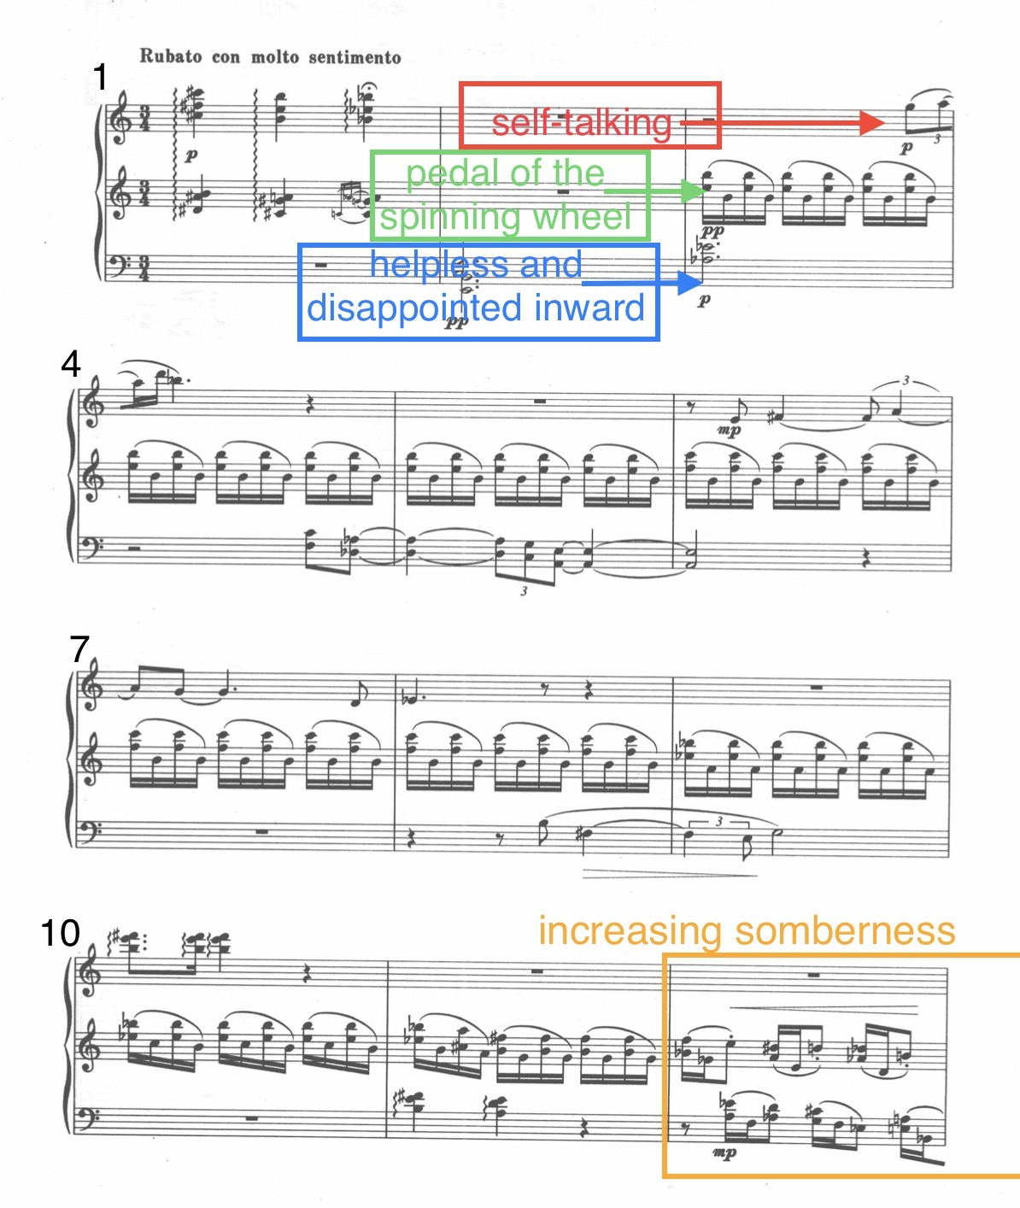
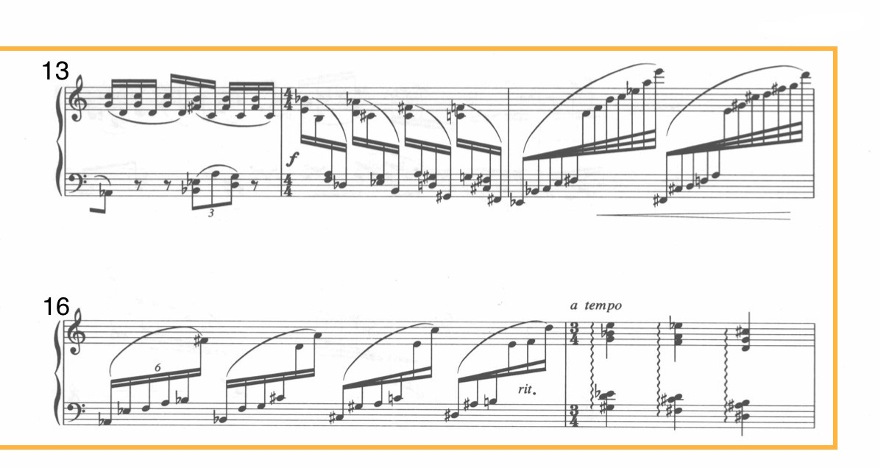

The B section is marked Con vaghezza, which suggests charm and grace. It starts with a silky and ethereal tone that resembles the fragrance and the silk. From measure 22, the rhythm becomes complicated and irregular, and the dynamic keeps increasing (see example 5.16). Intricate rhythmic patterns and regrouping occurs, such as groups of five, six, or seven against eight. This rhythmic intensity, along with the strong dynamic and the rephrased syncopation and triplets (see example 5.16), symbolize the woman’s indignation when thinking about her own life, as written in the poem: “I regret to stitch golden thread from year to year, but to make wedding gowns which to other belong.” The chromatic approach for this section enforces the negative emotion (see example 5.16).

Example 5.16. Gong Xiaoting, Luoxiang, mm. 18–29.
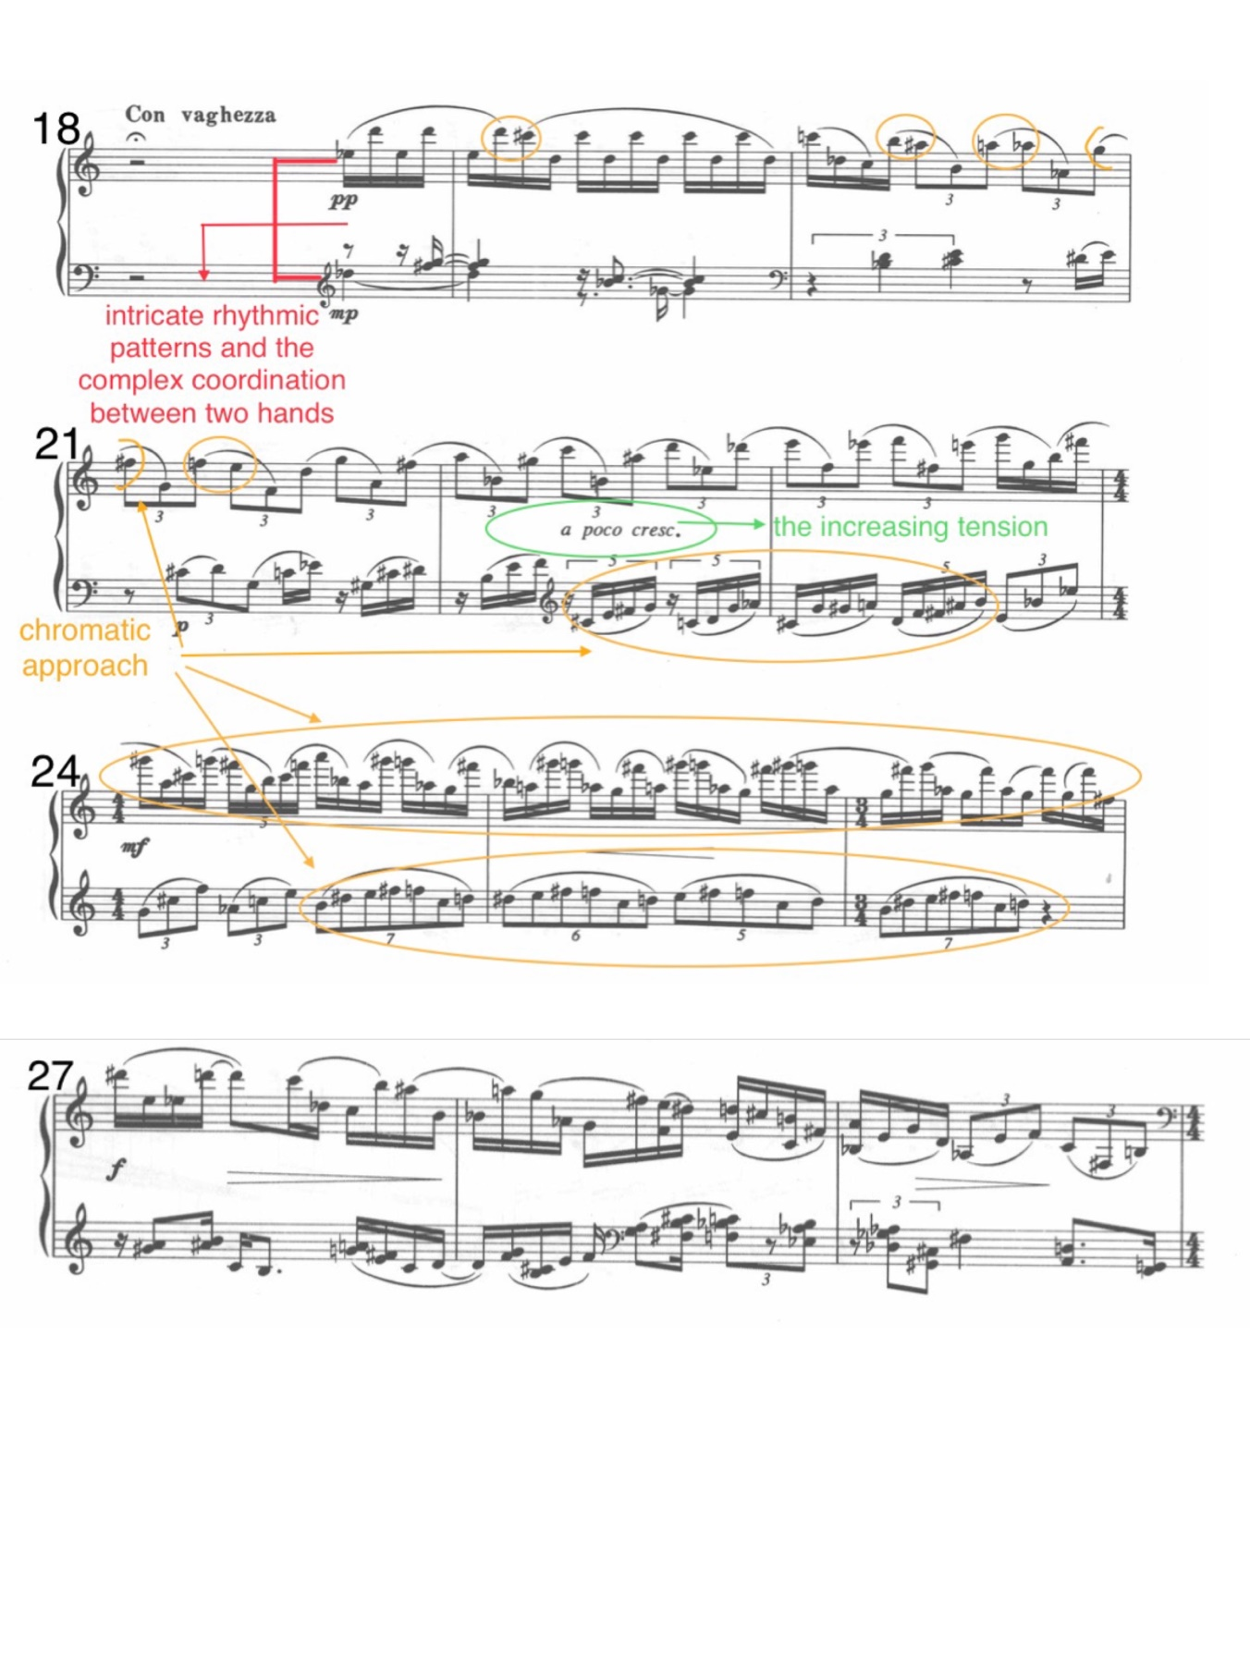
The coda brings back the ostinato elements of the A section, indicating that the woman starts to weave again. The rhythms in the right hand are complicated. The complexity here, such as the staggered pattern between the two hands, and the triplets and quintuplets that cross the bar line, represent her sad and tangled heart.
This prelude needs a sensitive tone for almost the entire piece. The repeated patterns, such as the ostinatos and the continuous triplets, should feel steady but not mechanical. The rhythms need to be practiced separately and assembled bit by bit, especially for the B section. These intricate rhythms should sound natural and organic without being disturbed. Overall, the sound effects of Luoxiang should evoke the lightness and quietness advocated by the ancient Chinese literati.
Taken together, the three preludes of Gong’s piano set bring out the different characters of the two traditional styles of the Song ci. Both Mengling and Luoxiang show the delicate and soft characteristics of the wanyue school, while Taosha exhibits the vigorous and unrestrained features of the haofang school. The three preludes also highlight the spirits of the three cipai (tune names): Rumeng Ling, Lang Taosha, and Qiluo Xiang, and are somewhat associated with melancholy emotions, which were the main aesthetic tendency of Song ci.

CHAPTER 6: Conclusion
This document has explored in depth two piano works: the piano set Two Poem Classics of the Tang Dynasty by Xu Zhenmin and Three Preludes by Gong Xiaoting. In giving context for understanding and performing these works, the previous chapters have provided an introduction to the principles and aesthetics of ancient Chinese poetry and literati music, drawn connections between these historical genres and contemporary piano works, and provided guidance for interpretation of the poetic text through performance.
As embodied in the two pieces studied in the previous chapters, contemporary piano music inspired by ancient Chinese music or poetry often focuses on highlighting elegance, delicacy, quietness or calmness, and most of the time they also embody the melancholy, which was a fashion in ancient China. In particular, many titles of these piano pieces, or titles of the poems that the pieces reference, include imagery that symbolizes a quiet and contemplative atmosphere, such as the moon, autumn, clouds and mist, bamboo, the plum blossom, a water scene, temples, the guqin, and bells. Players of these piano works should, above all, highlight the three elements widely used in Chinese literati music and art as symbols of good education and morality: antiquity, lightness and quietness. These elements are prevalent in most Chinese piano works related to ancient Chinese poetry.
Xu Zhenmin’s Two Poem Classics of the Tang Dynasty and Gong Xiaoting’s Three Preludes are among the most distinctive Chinese contemporary piano works, and they are becoming known to the public as concert and competition repertoire in China. They combine modern western composition styles such as the atonal technique, the use of irregular rhythmic patterns, and the impressionist style with the Chinese pentatonic mode and the styles that are associated with Chinese literati music. These two styles of music blend well and depict the “complex” and “inexplicable” emotional states of yijing effectively, making the two piano collections radiate with traditional Chinese flavor and at the same time sound very trendy. As successful examples of the fusion of Chinese and western musical styles, these two Chinese works deserve the attention of international professional and advanced piano players.
By studying the influence of traditional Chinese culture on Chinese contemporary piano works, the author of this document has analyzed and explored the musical style and performance characteristics of these two works. In the analysis, the author combines the musical analysis with the corresponding content of the poetic works, excavates the cultural influence of the works from a deeper level, and provides theoretical support for the interpretation of the music from another perspective. Therefore, through this document, the author hopes to promote contemporary piano music with Chinese characteristics and also provide reference and guidance for piano teachers and students in the future.

APPENDIX: Suggestions for Further Reading
There are many Chinese piano works related to ancient Chinese poetry. In addition to the works mentioned in this article that directly reference certain poems, there are some works that use the characteristic titles to imply that the work is related to ancient Chinese poetry. For example, the titles of the piano works 平湖秋月 Autumn Moon Over the Lake, 梅花三弄 Three Stanzas of Plum Blossoms, 空山鸟语 Birdsong in Pathless Hills, 彩云追月 Clouds Chasing the Moon, and 春江花月夜 A Moonlit Night on the Spring River provide artistic images reminiscent of ancient Chinese poetry. These works do not refer to any poem, but provide an imaginary space with the flavor of ancient Chinese poetry for the performer and audience.
Successful interpretation of these types of Chinese piano works benefits from a basic understanding of ancient Chinese poetry and an aesthetic appreciation of ancient Chinese literati music. Readers interested in how to interpret ancient Chinese poetry can explore Michael A. Fuller’s An Introduction to Chinese Poetry— From the Canon of Poetry to the Lyrics of the Song Dynasty and Zong-Qi Cai’s How to Read Chinese Poetry in Context, which provide basic approaches for understanding ancient Chinese poetry of different periods. In addition, the sinologist Stephen Owen has published many studies of ancient Chinese poetry of various dynasties, which are helpful for understanding ancient Chinese history and culture and how they influenced the poets. Among Owen’s works, The Poetry of the Early T’ang, The Great Age of Chinese Poetry; The High T’ang, The Late Tang: Chinese Poetry of the Mid-Ninth Century; and Just a Song: Chinese Lyrics from the Eleventh and Early Twelfth Centuries are particularly illuminating for understanding the poetry of the Tang and Song dynasties.
Reliable translations of ancient Chinese poetry are important for accurate interpretation. Chinese translator 许渊冲Xu Yuanchong has translated countless ancient Chinese poems of different dynasties and poets, which restore the artistic beauty of the ancient Chinese poetry into English. Among them, 300 Tang Poems and 300 Song Lyrics cover most of the representative poems from the Tang and Song dynasties. Furthermore, western scholars such as Arthur Waley, Ezra Pound, Steven Owen, and William Fletcher all have good selections of translated ancient Chinese poetry of different periods as well.

BIBLIOGRAPHY

Books

Books on the Topic of Ancient Chinese Poetry:
Fuller, Michael A. An Introduction to Chinese Poetry: From the Canon of Poetry to the Lyrics of the Song Dynasty. Cambridge, MA: Harvard University Press, 2017.
Hightower, James R. and Florence Chia-ying Yeh. Studies in Chinese Poetry. Cambridge, MA: Harvard University Asia Center, 1998.
Lin, Geng 林庚. 唐诗综论 [The Pandect of Tang Poetry]. Beijing: The Commercial Press, 2011.
Lin, Shuen-fu and Stephen Owen, eds. The Vitality of the Lyric Voice: Shih Poetry from the Late Han to the Tang. Princeton, NJ: Princeton University Press, 2016.
Liu, James J. Y. The Art of Chinese Poetry. Chicago: The University of Chicago Press, 1962.
Owen, Stephen. The Poetry of the Early T’ang. New Haven, CT: Yale University Press,1977.
Owen, Stephen. The Great Age of Chinese Poetry: The High T’ang. New Haven, CT: Yale University Press, 1981.
Owen, Stephen. Just a Song, Chinese Lyrics from the Eleventh and Early Twelfth Centuries. Cambridge, MA: The Harvard University Asia Center, 2019.
Owen, Stephen Owen. Remembrances: The Experience of the Past in Classical Chinese Literature. Cambridge: Harvard University Press, 1986.
Rickett, Adele Austin, trans. 王国维: 人间词话 [Wang, Guowei: Poetic Remarks on the Human Word]. Hongkong: Hongkong University Press, 1977.
Sun, Kang-I Chang and Stephen Owen, eds. The Cambridge History of Chinese Literature. New York: Cambridge University Press, 2010.
Sun, Kang-I Chang. The Evolution of Chinese Tz’u Poetry from Late Tang to Northern Sung. Princeton NJ: Princeton University Press, 1980.
Watson, Burton, trans. The Complete Works of Chuang Tzu. New York: Columbia University Press, 2013.
Xu, Yuanchong许渊冲, trans. 300 Song Lyrics. Beijing: China Translation & Publishing House, 2021.
Xu, Yuanchong许渊冲, trans. 300 Tang Poems. Beijing: China Translation & Publishing House, 2021.
Xu Yuanchong许渊冲, trans. 道德经 [Laws Divine and Human]. Beijing: Wuzhou Publishing House, 2012.
Yang, Haiming 杨海明. Tang Song ci shi唐宋词史 [The History of Ci from Tang to Song]. Nanjing: Jiangsu Guji Publishing House.
Yang, Zhong 杨忠. 辛弃疾词选译 [Selected Lyrics and Interpretations of Xin Qiji]. Sichuan: Bash Publishing House, 1991.
Ye, Jiaying 叶嘉莹, Zhou Ruchang 周汝昌, Yu Pingbo 俞平伯, Shi Zhecun 施蛰存…etc., eds.唐诗赏析辞典 [The Dictionary of Tang Poetry]. Shanghai: Shanghai Cishu Publishing House, 1983.

Books on the Topic of Music:
Bian, Meng 卞萌. 中国钢琴音乐文化 [Piano Music and its Development in China]. Beijing: Huayue Publishing House, 1996.
Gu, Jie 谷杰, Sun Xiaohui 孙晓辉, Tong Zhongliang 童忠良, and Zhou Yun 周耘. 中国传统音乐学 [Traditional Chinese Music]. Fujian: Fujian Education Publishing House, 2004.
Reti, Rudolph. Tonality, Atonality, Pantonality: A study of Some Trends in Twentieth Century Music. London: Barrie and Rockliff, 1958.
Wang, Yaohua王耀华. 中国传统音乐概论 [Introduction to Traditional Chinese Music]. Fujian: Fujian Educational Publishing House, 2004.

Journal Articles

Journal Articles on the Topic of Ancient Chinese Poetry:
Gao, Junqiang. “Research on the ‘Sad and Resentful Beauty’ in Ancient Chinese Literature.” Advances in Social Science, Education and Humanities Research, 194, no. 4 (ETMHS 2018): 118–120, accessed March 31, 2022,
https://www.atlantis-press.com/proceedings/etmhs-18/25893248.

Guo, Shanshan郭珊珊. “中国古代词牌名的文化起源及翻译 [The Origins of cipai and Their English Translation].” Journal of Xuzhou Institute of Technology 21, no. 4 (April 2006): 45.
Zhang, Wei 张薇, Li, Tianxian 李天贤. “视觉化框架下宋词词牌名英译研究—以许渊冲和卓振英译本为例 [A study on the English Translation of the Cipai of the Song Lyrics—Take the English Version of the Selected Song Lyrics by Xu Yuanchong and Zhuo Zhenying as Examples].” 现代语文Modern Chinese 9 ( September 2017): 125.

Journal Articles on the Topic of Chinese Music:
Liu, Chenghua 刘承华. “古琴的文化审美内涵 [The Aesthetic Connotation of Guqin],” 黄钟 （武汉音乐学报） [Huangzhong (Journal of Wuhan Music Concervatory)] 1999, no.2 (February, 1999): 34-41.
Liu, Chenghua刘承华. “文人音乐美学思想的价值取向 [The Value Orientation of Literati Music].”中国音乐 [Chinese Music] 2020, no.1 (February, 2020): 78.
Wang, Zujun 王祖君. “民族性旋律与现代音响组建方式的巧妙糅合 [The Ingenious Blending of National Tune and the Modern Musical Language—an Analyses of Gong Xiaoting’s Three Preludes].” 音乐创作 Musical Works 8 (December 2019): 88–95.
Xu, Weiya 徐维雅. “徐振民《唐人诗意两首》音高结构关系 [The Compositional Analysis of Xu Zhenmin’s Two Poem Classics of the Tang Dynasty].” 乐府新声 The New Voice of Yuefu (The Academic Periodical of Shenyang Conservatory of Music) 3, (May, 2013), 19–22.
Yu, Qian. “Impressionistic Music Features in Chinese Piano Works.” Cross-Cultural Communication 10, no.6 (November 2014): 195–205.

Theses and Dissertations

Theses on the Topic of Ancient Chinese Poetry:
Li, Jing 李晶, “唐宋山水田园诗之比较 [A Study of Landscape Pastoral Poetry in the Tang and Song Dynasties].” Master’s thesis, Xibei University, 2010.
Mao, Desheng 毛德胜, “论中晚唐咏史诗 [A Study of Historic Remembrance Poetry in the Mid and Late Tang Dynasty].” Master’s thesis, Central China Normal University, 2003.
Zhang, Gaili张改莉, “唐宋词浪淘沙研究 [Research on ci Written to the Tune Lang Taosha of the Tang and Song Dynasties].” Master’s thesis, Lanzhou University, 2014.

Theses and Dissertations on the Topic of Chinese Music:
Ding, Yang 丁阳. “唐诗题材中国钢琴作品研究 [A Study About the Tang Poetry’s Influences on Modern Chinese Piano Works].” Master’s thesis, Qufu Normal University, 2020.
Duan, Xiaoyue 段晓月. “古琴元素在中国钢琴创作中的运用与发展—以《梅花三弄》，《升F商调：书法与琴韵》，和《高古》为例 [The Embodiment and Development of Guqin Music Elements in Chinese Piano Works—Take Plum Blossom, Mode F# Shang: Calligraphy and Guqin, and High Ancient as Examples].” Master’s thesis, Fujian Normal University, 2017.
Goh, Yen-Lin. “Reimagining the Story of Lu You and Tang Wan: Ge Gan-Ru’s Wrong, Wrong, Wrong! and Hard, Hard, Hard!.” DMA diss., Bowling Green State University, 2012.
Liu, Zhe 刘喆. “徐振民钢琴作品创作研究 [A Study on Xu Zhenmin’s Pinao Works From Different Compositional Period].” Master’s thesis, Shoudu Normal University, 2008.
Ling, Li 凌俐. “龚晓婷钢琴套曲《淡彩五帧》研究 [The Research of Gong Xiaoting’s Piano Cycle Five Paintings in Light Color].” Master’s thesis, Central China Normal University, 2013.
Tang, Jialu 唐嘉璐. “龚晓婷钢琴作品《水中云》的创作及演奏研究[A Study on Gong Xiaoting’s Piano Work Clouds Reflected in Water].” Master’s thesis, Nanjing University of Arts, 2016.
Zhang, Bing张冰. “徐振民钢琴作品研究 [A Study on Xu Zhenmin’s Piano Works].” Master’s thesis, Shandong Normal University, 2010.

Musical Scores
中国钢琴独奏作品百年经典A Century of Piano Solo Works by Chinese Composers, vol. 7. Ed. Li Minqiang 李名强, Yang Yunlin 杨韵琳, Cao Zhijue 曹志珏 and Yao Shizhen 姚世真, Shanghai: Shanghai Music Publishing House, 2015.
Gong, Xiaoting 龚晓婷. 夜是. 水中云—龚晓婷抒情钢琴新音乐 Night is Clouds Reflected in Water—New Lyrical Piano Works by Gong Xiaoting. Ed. Wang Yu 王雨, Hunan: Hunan Literature and Art Publishing House, 2001.

Lecture
Xu, Zhenmin 徐振民. “谈《枫桥夜泊》的写作 [Some thoughts on Mooring by Maple Bridge at Night].” (Lecture, 中国乐派 Chinese Music, Beijing, April 5, 2017).

Websites
“Xu Zhenmin: Memories of the Past at Jinling (Guo-wei Wang, Shanghai Orchestra, Peng Cao).” Naxos, accessed April 31, 2022. https://www.naxos.com/mainsite/blurbs_reviews.asp?item_code=82097&catNum=82097&filetype=About%20this%20Recording&language=English
“Gong Xiaoting.” Central Conservatory of Music Website. accessed April 31, 2022. https://www.ccom.edu.cn/jxyx/zqx/zqxxyls/201603/t20160303_39251.html.

GLOSSARY

Ci (lyrics): a style of fixed-form poetry in the Song dynasty (960–1200) written as lyrics to the existing fixed tunes at the time. Ci became an independent literary genre to be sung with music.
Cipai (tune name): the title of a fixed tune with ci (lyrics). The cipai’s title is comprised of the original fixed tune name along with the title of the ci. Each of the fixed tunes to which poets wrote ci has its own title, and cipai is the joint name of the titles.
Guqin: a type of plucking instrument with seven strings.
Guzhen: a type of stringed instrument that is played by plucking. It should not be confused with the guqin. It has a warm, bright, and round-shaped sound quality which is very suitable for depicting the watery character of a poem.
Literati: the traditional intellectuals in the Confucian cultural circle. In general, they were writers and poets with a certain literary accomplishment. Most of the literati were highly artistic, and they were proficient in music, painting, and calligraphy.
Literati music: the music created by intellectuals (especially poets) in ancient Chinese dynasties.
Pipa: a traditional Chinese four-stringed instrument similar to a lute.
Sorrow as beauty: the aesthetic psychology in ancient China that advocated the emotions of sad, melancholy, and tragic.
Tang poetry: a style of poetry in the Tang dynasty (600–900).
Yin: a type of guqin playing technique that creates a humming or chanting sound effect.
Yijing: the poetic worlds created by the poet through the artistic language, intended so that readers could be involved in and perceive the poet’s mood at the time of writing.
Yun: a musical concept that refers to changing pitches and timbres slightly and subtly, and it is usually achieved through special playing techniques.

The scores for the musical examples of Xu Zhenmin’s Two Poem Classics of the Tang Dynasty are from A Century of Piano Solo Works by Chinese Composers, vol. 7; the scores for the musical examples of Gong Xiaoting’s Three Preludes are from Night is Clouds Reflected in Water—New Lyrical Piano Works by Gong Xiaoting.
Bian Meng 卞萌, 中国钢琴音乐文化之形成与发展 [Piano Music and its Development in China] (Beijing: Huayue Publishing House, 1996), 8–12.
Ibid., 8-10.
Ibid., 14-15.
Ibid., 21.
中国钢琴独奏作品百年经典A Century of Piano Solo Works by Chinese Composers, vol. 7, ed. Li Minqiang 李名强, Yang Yunlin 杨韵琳, Cao Zhijue 曹志珏 and Yao Shizhen 姚世真 (Shanghai: Shanghai Music Publishing House, 2015), 271.
夜是. 水中云—龚晓婷抒情钢琴新音乐 Night is Clouds Reflected in Water—New Lyrical Piano Works by Gong Xiaoting, ed. Wang Yu 王雨 (Hunan: Hunan Literature and Art Publishing House, 2001).
The title of the poem was translated by Stephen Owen in The Poetry of the Early T’ang (New Haven, CT: Yale University Press, 1977), 175.
Chen Zi’ang 陈子昂 (659–702) was a literateur and poet in the early Tang dynasty.
The title was translated by Steven Owen in The Great Age of Chinese Poetry: The High T’ang (New Haven, CT: Yale University Press, 1981), 89.
Chang Jian 常建 (708–765) was a poet in the high Tang dynasty.
A detailed discussion about the concept cipai will be provided in Chapter Two.
Zhang Wei 张薇, Li Tianxian 李天贤, “视觉化框架下宋词词牌名英译研究—以许渊冲和卓振英译本为例 [A study on the English Translation of the Cipai of the Song Lyrics—Take the English Version of the Selected Song Lyrics by Xu Yuanchong and Zhuo Zhenying as Examples],” 现代语文Modern Chinese 9 ( September 2017): 125.
Ibid., 125.
Ibid., 126.
Ancient Chinese literati music refers to the music created by intellectuals (especially the poets) in ancient Chinese dynasties. A detailed discussion will be provided in Chapter Three.
Ancient Chinese literati was a group concept of Confucianism, which referred to the traditional intellectuals in the Confucian cultural circle. In general, they were writers and poets with a certain literary accomplishment. Most of the literati were highly artistic, and they were proficient in music, painting, and calligraphy.
Liu Chenghua刘承华, “文人音乐美学思想的价值取向 [The Value Orientation of Literati Music],”中国音乐 [Chinese Music] 2020, no.1 (February, 2020): 78.
中国当代钢琴曲选（1980年以后） The Selection of the Contemporary Chinese Piano Music After 1980, ed. Zou Xiangping 邹向平 (Beijing: Central Conservatory of Music Press, 2006).
中国钢琴独奏作品百年经典A Century of Piano Solo Works by Chinese Composers, ed. Li Minqiang 李名强, Yang Yunlin 杨韵琳, Cao Zhijue 曹志珏 and Yao Shizhen 姚世真 (Shanghai: Shanghai Music Publishing House, 2015). Xu Zhenmin’s Two Poem Classics of the Tang Dynasty is collected in Volume VI.
徐振明作品选 A Collection of Xu Zhenmin, ed. Xu Zhenmin (Beijing: Central Conservatory of Music Press, 2014).
夜是. 水中云—龚晓婷抒情钢琴新音乐 Night is Clouds Reflected in Water—New Lyrical Piano Works by Gong Xiaoting, ed. Wang Yu 王雨 (Hunan: Hunan Literature and Art Publishing House, 2001).
Zhang Bing张冰, “徐振民钢琴作品研究 [A Study on Xu Zhenmin’s Piano Works],” (master’s thesis, Shandong Normal University, 2010).
Liu Zhe 刘喆, “徐振民钢琴作品创作研究 [A Study on Xu Zhenmin’s Pinao Works From Different Compositional Period],” (master’s thesis, Shoudu Normal University 2008).
Wang Zujun 王祖君, “民族性旋律与现代音响组建方式的巧妙糅合 [The Ingenious Blending of National Tune and the Modern Musical Language—An Analysis of Gong Xiaoting’s Three Preludes],” Yinyue chuangzuo 音乐创作 Musical Works 8 (December 2019): 88–95.
“Xu Zhenmin: Memories of the Past at Jinling (Guo-wei Wang, Shanghai Orchestra, Peng Cao),” Naxos, accessed April 31, 2022, https://www.naxos.com/mainsite/blurbs_reviews.asp?item_code=82097&catNum=82097&filetype=About%20this%20Recording&language=English.
Yu Qian, “Impressionistic Music Features in Chinese Piano Works,” Cross-Cultural Communication 10, no.6 (November 2014): 195–205.
中国钢琴独奏作品百年经典A Century of Piano Solo Works by Chinese Composers, vol. 7, ed. Li Minqiang 李名强, Yang Yunlin 杨韵琳, Cao Zhijue 曹志珏 and Yao Shizhen 姚世真 (Shanghai: Shanghai Music Publishing House, 2015), 271.
Zhang Bing张冰, “徐振民钢琴作品研究 [A Study on Xu Zhenmin’s Piano Works],” (master’s thesis, Shandong Normal University, 2010).
Liu Zhe 刘喆, “徐振民钢琴作品创作研究 [A Study on Xu Zhenmin’s Pinao Works From Different Compositional Period],” (master’s thesis, Shoudu Normal University 2008).
Xu Weiya 徐维雅, “徐振民《唐人诗意两首》音高结构关系 [The Compositional Analysis of Xu Zhenmin’s Two Poem Classics of the Tang Dynasty],” 乐府新声 The New Voice of Yuefu (The Academic Periodical of Shenyang Conservatory of Music) 3, (May, 2013), 19–22.
“Gong Xiaoting,” Central Conservatory of Music, accessed April 31, 2022, https://www.ccom.edu.cn/jxyx/zqx/zqxxyls/201603/t20160303_39251.html.
Preface to 夜是. 水中云—龚晓婷抒情钢琴新音乐 Night is Clouds Reflected in Water—New Lyrical Piano Works by Gong Xiaoting, ed. Wang Yu 王雨 (Hunan: Hunan Literature and Art Publishing House, 2001), i–ii.
Ling Li 凌俐, “龚晓婷钢琴套曲《淡彩五帧》研究 [The Research of Gong Xiaoting’s Piano Cycle Five Paintings in Light Color],” (master’s thesis, Central China Normal University, 2013).
Tang Jialu 唐嘉璐, “龚晓婷钢琴作品《水中云》的创作及演奏研究[A Study on Gong Xiaoting’s Piano Work Clouds Reflected in Water],” (master’s thesis, Nanjing University of Arts, 2016).
Yen-Lin Goh, “Reimagining the Story of Lu You and Tang Wan: Ge Gan-Ru’s Wrong, Wrong, Wrong! And Hard, Hard, Hard!,” (DMA dissertation, Bowling Green State University, 2012).
Ding Yang 丁阳, “唐诗题材中国钢琴作品研究 [A Study About the Tang Poetry’s Influences on Modern Chinese Piano Works],” (master’s thesis, Qufu Normal University, 2020).
Duan Xiaoyue 段晓月, “古琴元素在中国钢琴创作中的运用与发展—以《梅花三弄》，《升F商调：书法与琴韵》，和《高古》为例 [The Embodiment and Development of Guqin Music Elements in Chinese Piano Works—Take Plum Blossom, Mode F-sharp Shang: Calligraphy and Guqin, and High Ancient as Examples],” (master’s thesis, Fujian Normal University, 2017).
Lin Geng 林庚, 唐诗综论 [The Pandect of Tang Poetry], (Beijing: The Commercial Press, 2011), 104–115.
James J. Y. Liu, The Art of Chinese Poetry, (Chicago: The University of Chicago Press, 1962), 81–90.
James R. Hightower and Florence Chia-ying Yeh, Studies in Chinese Poetry (Cambridge MA: Harvard University Asia Center, 1998), 497–499.
Kang-I Sun Chang, The Evolution of Chinese Tz’u Poetry from Late Tang to Northern Sung, (Princeton NJ: Princeton University Press, 1980), 96.
The Vitality of the Lyric Voice: Shih Poetry from the Late Han to the Tang ed. Shuen-fu Lin and Stephen Owen (Princeton, NJ: Princeton University Press, 2016), 339.
Wang Guowei 王国维, 人间词话 [Poetic Remarks on the Human Word], trans. Adele Austin Rickett, (Hongkong: Hongkong University Press, 1977), 42.
To the Tune “Green Jade Cup”: The Lantern Festival Night is a ci (another type of poem) by the poet Xin Qiji from the Song dynasty.
According to traditional interpretation of this poem, this sentence depicts random ladies in the Lantern Festival, rather than a particular person.
300 Song Lyrics, trans.许渊冲 Xu Yuanchong (Beijing: China Translation & Publishing House, 2021), 2:878–881.
Yang Zhong 杨忠, 辛弃疾词选译 [Selected Lyrics and Interpretations of Xin Qiji], (Sichuan: Bash Publishing House, 1991), 137–140.
Lin and Owen, 384–385.
Ibid., 374.
Taoism is a school of philosophical thought that originated during the Spring-Autumn period (770–453 BCE) and the Warring States period (475–221 BCE), represented by Laozi (570–470 BCE) and Zhuangzi (369–286 BCE). It also refers to a religion formed in the Wei-Jin and Northern-Southern periods (202–589 CE). In this paper, Taoism refers to the philosophical thought.
道德经 [Laws Divine and Human], trans.许渊冲 Xu Yuanchong (Beijing: Wuzhou Publishing House, 2012), 113.
The complete work is known by the author’s name—the Zhuangzi—which contains anecdotes, allegories, parables, and fables that exemplify Taoist ideas.
Burton Watson, The Complete Works of Chuang Tzu (New York: Columbia University Press, 2013), 233.
Lin Geng 林庚, 唐诗综论 [The Pandect of Tang Poetry], (Beijing: The Commercial Press, 2011), 1-2.
Solstice day was as important as New Year’s Day during the Tang Dynasty.
Handan is a city in Hebei province.
300 Tang Poems, trans.许渊冲 Xu Yuanchong (Beijing: China Translation & Publishing House, 2021), 1:499–500.
唐诗赏析辞典 [The Dictionary of Tang Poetry], ad. Ye Jiaying 叶嘉莹, Zhou Ruchang 周汝昌, Yu Pingbo 俞平伯, Shi Zhecun 施蛰存…etc., (Shanghai: Shanghai Cishu Publishing House, 1983), 879–880.
Xu Yuanchong 许渊冲, 1:348–350.
Ye Jiaying 叶嘉莹, Zhou Ruchang 周汝昌, Yu Pingbo 俞平伯, Shi Zhecun 施蛰存…etc., 300–302.
James J. Y. Liu, 81–90.
A multi-character poem is a type of poem that contains short and long sentences.
The Cambridge History of Chinese Literature, ed. Kang-I Sun Chang and Stephen Owen (New York: Cambridge University Press, 2010), 435.
Michael A. Fuller, An Introduction to Chinese Poetry: From the Canon of Poetry to the Lyrics of the Song Dynasty (Cambridge, MA: Harvard University Press), 351.
300 Song Lyrics, trans.许渊冲 Xu Yuanchong (Beijing: China Translation & Publishing House, 2012), 64.
Stephen Owen, Just a Song, Chinese Lyrics From the Eleventh and Early Twelfth Centuries (Cambridge, MA: The Harvard University Asia Center, 2019), 197.
Yang Haiming 杨海明, Tang Song ci shi唐宋词史 [The History of Ci from Tang to Song] (Nanjing: Jiangsu Guji Publishing House), 563–568.
Kang-I Sun Chang and Stephen Owen, 434–439.
Junqiang Gao, “Research on the ‘Sad and Resentful Beauty’ in Ancient Chinese Literature,” Advances in Social Science, Education and Humanities Research, 194, no. 4 (ETMHS 2018): 118–120, accessed March 31, 2022, https://www.atlantis-press.com/proceedings/etmhs-18/25893248.
Wang Yaohua王耀华, Zhongguo chuantong yinyue gailun 中国传统音乐概论 [Introduction to Traditional Chinese Music] (Fujian: Fujian Educational Publishing House, 2004), 82.
The guqin is a traditional pluck instrument in China which originated sometime between 1050 BCE and 771 BCE, and is further discussed later in this chapter.
There are four different inflections in the traditional Chinese heptatonic scale (take the key of C, for example: F (清角qingjue), F-sharp (变徴bianzhi), B (变宫biangong), and B-flat (闰run)), which would be added to the music in various ways. There are three main types of heptatonic scales: 1) the basic pentatonic scale with the inflections F and B added; 2) the basic pentatonic scale with F and B-flat added; 3) the basic pentatonic scale with F-sharp and B added.
The pitch names “C, D, E, G, A,” as well as the pitch names of all twelve semitones, did not exist in ancient China, and instead there was another set of pitch names written in Chinese. While the twelve semitones, known as equal temperament in western music theory, did exist in ancient China, the formation of the scales was different.
Wang Yaohua王耀华, 82–83.
Liu Chenghua刘承华, “Wenren yinyue meixue sixiang de jiazhi quxiang 文人音乐美学思想的价值取向 [The Value Orientation of Literati Music],” Zhongguo yinyue 中国音乐 [Chinese Music] 2020, no.1 (February, 2020): 78.
Stephen Owen, Remembrances: The Experience of the Past in Classical Chinese Literature (Cambridge: Harvard University Press, 1986), 1–15.
Empty mind is a concept that combines Taoist and Buddhist thought. The main idea is to let go of the obsession in order to get rid of worldly distractions.
Liu Chenghua刘承华, 78-90.
Liu Chenghua 刘承华, “古琴的文化审美内涵 [The Aesthetic Connotation of Guqin],” 黄钟 （武汉音乐学报） [Huangzhong (Journal of Wuhan Music Concervatory)] 1999, no.2 (February, 1999): 34-35.
Guiqulai ci was a guqin piece which was composed by Song dynasty Taoism scholar 俞琰 Yu Yan according to the poem of the same name by the Estern Jin (317–420 CE) poet 陶渊明Tao Yuanming.
Qian chibi fu was a guqin piece which was composed by the Song dynasty poet 苏轼 Su Shi.
Guanshan yue was a guqin piece that was composed by the late Qing dynasty (1840–1912) musician 王宾鲁 Wang Binlu, and it was influenced by the poem with the same name by Tang dynasty poet 李白Li Bai.
Yangguan sandie was a guqin piece that was composed in the Ming dynasty; the composer was unknown. The piece was based on Tang dynasty poet 王维 Wang Wei's poem 送元二使安西Seeing off the Ambassadors to Anxi, which is a farewell poem.
Gu Jie 谷杰, Sun Xiaohui 孙晓辉, Tong Zhongliang 童忠良, and Zhou Yun 周耘, 中国传统音乐学 [Traditional Chinese Music] (Fujian: Fujian Education Publishing House, 2004), 18–22.
Liu Chenghua刘承华, “文人音乐美学思想的价值取向 [The Value Orientation of Literati Music],” Zhongguo yinyue 中国音乐 [Chinese Music] 2020, no.1 (February, 2020): 78-85.
Liu Chenghua 刘承华, “古琴的文化审美内涵 [The Aesthetic Connotation of Guqin],” 黄钟 （武汉音乐学报） [Huangzhong (Journal of Wuhan Music Concervatory)] 1999, no.2 (February, 1999): 37-39.
Gu Jie 谷杰, Sun Xiaohui 孙晓辉, Tong Zhongliang 童忠良, and Zhou Yun 周耘, 中国传统音乐学 [Traditional Chinese Music] (Fujian: Fujian Education Publishing House, 2004), 18-22.
Duan, Xiaoyue 段晓月, “古琴元素在中国钢琴创作中的运用与发展—以《梅花三弄》，《升F商调：书法与琴韵》，和《高古》为例 [The Embodiment and Development of Guqin Music Elements in Chinese Piano Works—Take Plum Blossom, Mode F# Shang: Calligraphy and Guqin, and High Ancient as Examples]” (Master’s thesis, Fujian Normal University, 2017), 1-2.
Chou Wen-chung 周文中 (1923–2019) was a Chinese American composer and teacher. He immigrated to the United States in 1946 and studied with Nicolas Slonimsky, Edgard Varèse, and Otto Luening. He wrote for many genres including orchestral works, instrumental works, and ensemble works. His notable students include Chen Yi, Bright Sheng, Tan Dun, and Zhou Long.
Li Yinghai 黎英海 (1927–2007) was a Chinese composer, theorist, and educator. He contributed significantly to research on Chinese traditional and folk music.
Wang Lisan 汪立三 (1933–2013) was a Chinese composer and educator. Wang was the director of the Ha’erbing Conservatory of Music.
Lin Hua 林华 (1942– ) is a Chinese composer, music theorist, and educator. Lin is teaching in the Shanghai Conservatory of Music at the time of this writing.
Luo Zhongrong 罗忠鎔 (1924–2021) was a Chinese composer, theorist, and teacher. He was a student of Tan Xiaolin who studied with Paul Hindemith. He devoted himself to study the theory of Paul Hindemith and translate Hindemith’s works, including The Craft of Musical Compositions (Books 1 and 2) and A Concentrated Course in Traditional Harmony (Books 1 and 2). Luo also translated other treatises including Serial Composition and Atonality by George Perie and Simple Composition by Charles Wuorinen. Based on his study of Hindemith, Luo developed his own compositional approach: the pentatonic twelve-tone theory.
Chen Peixun 陈培勋 (1922–2007) was a professor in the Central Conservatory of Music. Chen devoted himself to study the theory of Paul Hindemith.
中国钢琴独奏作品百年经典A Century of Piano Solo Works by Chinese Composers, vol. 7, ed. Li Minqiang 李名强, Yang Yunlin 杨韵琳, Cao Zhijue 曹志珏 and Yao Shizhen 姚世真 (Shanghai: Shanghai Music Publishing House, 2015), 271.
As some of Xu’s teachers studied Paul Hindemith’s compositional theory, it is likely that Xu was influenced by Hindemith’s theory as well.
The concept of yun was discussed in Chapter 3, and it refers to the special sound effects of the traditional Chinese instruments. Modern Chinese composers sometimes will imitate these sound effects on western instruments.
Mooring by Maple Bridge at Night was based on the poem with the same name by the Tang poet Zhang Ji.
Song of a Pipa Player was a long narrative poem by the Tang poet Bai Juyi.
A pipa is a traditional Chinese four-stringed instrument similar to a lute.
Prelude to Water Melody is based on the ci work To the Tune “Prelude to Water Melody”: How Long Will the Full Moon Appear.
Memory of Jiangnan is a poem by the Tang poet Bai Juyi.
Xu Zhenmin 徐振民, “谈《枫桥夜泊》的写作” [Some Thoughts on Mooring by Maple Bridge at Night] (lecture, 中国乐派 Chinese Music, Beijing, April 5, 2017).
300 Tang Poems, trans.许渊冲 Xu Yuanchong (Beijing: China Translation & Publishing House, 2021), 1:572–591.
中国钢琴独奏作品百年经典A Century of Piano Solo Works by Chinese Composers, vol. 7, ed. Li Minqiang 李名强, Yang Yunlin 杨韵琳, Cao Zhijue 曹志珏 and Yao Shizhen 姚世真 (Shanghai: Shanghai Music Publishing House, 2015), 272.
Mao Desheng 毛德胜, “论中晚唐咏史诗 [A Study of Historic Remembrance Poetry in the Mid and Late Tang Dynasty],” (master’s thesis, Central China Normal University, 2003), 16–24.
Li Jing 李晶, “唐宋山水田园诗之比较 [A Study of Landscape Pastoral Poetry in the Tang and Song Dynasties],” (master’s thesis, Xibei University, 2010), 18–20.
As described in the second chapter, 意境 yijing refers to the artistic world formed by the integration of thoughts and emotions expressed in the scenes depicted in poetry.
Frontier poetry is a poem about the life and natural scenery in frontier areas.
Youzhou Terrace is a ruined site of the Warring States Period (475–221 BCE). According to legend, the King of Yan rewarded wise and talented scholars here. It moved Chen to such sadness when he compared his own experience to the historical allusion.
唐诗赏析辞典 [The Dictionary of Tang Poetry], ad. Ye Jiaying 叶嘉莹, Zhou Ruchang 周汝昌, Yu Pingbo 俞平伯, Shi Zhecun 施蛰存…etc., (Shanghai: Shanghai Cishu Publishing House, 1983), 46–47. The concept of yun was discussed in Chapter 3, and it refers to the special sound effects of the traditional Chinese instruments. Modern Chinese composers sometimes will imitate the effects on western instruments.
300 Tang Poems, trans.许渊冲 Xu Yuanchong (Beijing: China Translation & Publishing House, 2021), 1:506–508.
Zhang Bing张冰, “徐振民钢琴作品研究 [A Study on Xu Zhenmin’s Piano Works],” (master’s thesis, Shandong Normal University, 2010), 25.
The intervallic approach is a compositional method associated with Paul Hindemith.
Rudolph Reti, Tonality, Atonality, Pantonality: A Study of Some Trends in Twentieth Century Music (London: Barrie and Rockliff, 1958), 108.
Yin is a sound effect of the guqin which was discussed in the third chapter.
Yin is a sound effect of the guqin which was discussed in the third chapter.
Stephen Owen, The Great Age of Chinese Poetry, The High T’ang (New Haven: Yale University Press, 1981), 89.
Ye Jiaying 叶嘉莹, Zhou Ruchang 周汝昌, Yu Pingbo 俞平伯, Shi Zhecun 施蛰存…etc., 750–751.
The concept “the same gong system” was explained in the third chapter.
Guzhen is a type of stringed instrument that is played by plucking. It should not be confused with the guqin. It has a warm, bright, and round-shaped sound quality which is very suitable for depicting the watery character of the poem.
Preface to 夜是. 水中云—龚晓婷抒情钢琴新音乐 Night is Clouds Reflected in Water—New Lyrical Piano Works by Gong Xiaoting, ed. Wang Yu 王雨 (Hunan: Hunan Literature and Art Publishing House, 2001), i–ii.
Ling Li 凌俐, “龚晓婷钢琴套曲《淡彩五帧》研究 [A Research of Gong Xiaoting’s Piano Cycle Five Paintings in Light Color],” (master’s thesis, Central China Normal University, 2013), 14–17.
Cipai are poems set to fixed tunes from the Song dynasty. The concept was discussed in the second chapter.
It is worth mentioning that Gong simplifies each cipai of the prelude set from three Chinese characters into two. The reason for this is unclear. For example, Gong’s first prelude of the set, Mengling, is written from the tune Rumeng Ling.
As mentioned in the second chapter, technically, a cipai is a tune. The following will use the word “tune” instead of cipai for the sake of convenience.
Guo Shanshan郭珊珊, “中国古代词牌名的文化起源及翻译 [The Origins of Cipai and Their English Translation],” Journal of Xuzhou Institute of Technology 21, no. 4 (April 2006): 45.
Ibid., 45
As discussed in Chapter Two, the wanyue school tended to employ roundness, softness, and elegance of tone and wording.
Michael A. Fuller, An Introduction to Chinese Poetry: From the Canon of Poetry to the Lyrics of the Song Dynasty (Cambridge, MA: Harvard University Press), 412.
Ibid., 413.
Zhang Gaili张改莉, “唐宋词浪淘沙研究” [“Research on ci Written to the Tune Lang Taosha of the Tang and Song Dynasties] (master’s thesis, Lanzhou University, 2014), 5.
Selected Ci From Li Yu, trans.许渊冲 Xu Yuanchong (Beijing: China Translation & Publishing House, 2012), 152–156.
Zhang Gaili, 35.
The concept of the haofang school was discussed in the second chapter.
The note biangong is the note si in a diatonic scale.
The note qingjue is the note fa in a diatonic scale. This concept was discussed in the third chapter.
The concept of inflections added to modes was discussed in the third chapter. Besides the two main inflections qingjue (fa) and biangong (si), Gong also adds some other additional inflections (as marked on the music score, see example 5.9) which will not be discussed in detail in this document.
100 Selected Poems, ed. Yao Renxiang 姚任祥, trans. Xu Yuanchong 许渊冲 (Beijing: China Translation &Publishing House, 2021), 177–180.
Autumn Moon Over the Lake was a traditional Chinese folk tune and was arranged for piano by composer陈培勋 Chen Peixun in 1975.
Three Stanzas of Plum Blossoms was a guqin piece which appeared in the early fifteenth century. It was arranged for piano by composer 王建中 Wang Jianzhong in 1973.
Birdsong in Pathless Hills was a piece for the traditional Chinese string instrument erhu which was composed by 刘天华 Liu Tianhua in 1918. It was arranged for piano by composer 崔世光 Cui Shiguang in 1998, and it was collected in the piano cycle 刘天华即兴曲三首 Three Liu Tianhua Impromptus.
Clouds Chasing the Moon was a traditional Cantonese tune. It was arranged for piano by 王建中Wang Jianzhong in 1975.
A Moonlit Night on the Spring River was a piece for pipa which was written in the early nineteenth century, and it was arranged for piano by coposer 黎英海 Li Yinghai in 1972.
Michael A. Fuller is professor of East Asian Languages and Literature at the University of California. He specializes in classical Chinese poetry and poetics, the cultural and intellectual contexts for poetry, literary history, aesthetic theory, linguistic issues in classical Chinese, and neuroscience of memory, emotion, and selfhood.
Zong-Qi Cai is professor of East Asian Languages and Cultures at the University of Illinois at Urbana-Champaign.
Stephen Owen (1946– ) is an American sinologist specializing in ancient Chinese literature. He teaches at Harvard University.
Xu Yuanchong 许渊冲 (1921–2021) was a Chinese translator who taught at Beijing University. He was known for translating ancient Chinese poetry into English and French.
Arthur Waley (1889–1966) was an English orientalist and sinologist who translated ancient Chinese poems and ancient Japanese poems into English. His influential works including A Hundred and Seventy Chinese Poems and Chinese Poems.
Ezra Pound (1885–1972) was an American poet and critic who was a major figure in the modernist poetry movement. In addition, he was also a translator of classic Chinese poetry and philosophy. His translation collection Cathay is the modernist translation for classic Chinese poetry which is very uncommon.
William Fletcher (1879–1933) was British consul at Haikou, China. He was also a translator, and he translated many ancient poems into English. His books Gems of Chinese Verse and More Gems of Chinese Verse marked the emergence of translation collection of Tang poetry.

