University of Oklahoma

Graduate College

the Effect of The Carrera adolescent pregnancy prevention Program on student achievement

A Dissertation

submitted to the Graduate Faculty

in partial fulfillment of the requirements for the

Degree of

Doctor of Education

By

Todd c. nelson
Norman, Oklahoma
2017

THE EFFECT OF THE CARRERA ADOLESCENT PREGNANCY PREVENTION PROGRAM ON STUDENT ACHIEVEMENT

A Dissertation approved for the
Department of Educational Leadership and Policy Studies

By

______________________________
Dr. Patrick Forsyth, Chair

______________________________
Dr. Diane Horm

______________________________
Dr. Beverly Edwards

______________________________
Dr. Curt Adams

______________________________
Dr. Timothy Ford

© Copyright by Todd C. Nelson 2017
All Rights Reserved.
Dedicated in memory of Carolyn Jacobson, my mother, who faithfully gave of herself to raise three boys as a single parent for several years, and whose legacy as an educator and life-long learner both inspired this work and made it possible

Acknowledgements
To those who have encouraged and supported me in various ways toward the completion of this project, please accept my sincere gratitude.
Dissertation Committee: Dr. Patrick Forsyth, committee chair, you have been a constant advisor, necessary critic, and faithful guide. Dr. Curt Adams, your personal support and availability kept me moving forward. Dr. Beverly Edwards, your encouragement reminded me of why I am an educator and the importance of completing this task. Dr. Timothy Ford and Dr. Diane Horm, your thoughtful words and insights have shaped the content and direction of this study.
Colleagues and Friends: Steve Pittman and Dr. Shannan Bittle, you are editors who deserve a raise, but wouldn’t take anything. Doctoral Cohort, each of you added something special to my understanding of education and appreciation for the different contexts of school leadership. Union Family, so many of you should be named that that this page won’t hold it. Thank you for your constant encouragement and support. Derrick Zamora, Doug Smith, and many others at Courtyard Church, for stepping up in my place, checking on my progress, and offering kind thoughts and prayers.
My Family: Nathan, Caleb and Michaela, and Larissa, you let go of my time and attention, so I could study and offered encouragement in return. Rachelle, you gave me steady support, encouragement, and love on a daily basis; I know you sacrificed the most. I deeply love you all.
Finally, in keeping with Proverbs 3:5-6, I joyfully acknowledge the Lord’s amazing work in transforming my life and making my paths straight. But for You, this never would have happened.

Table of Contents
Acknowledgements iv
List of Tables viii
List of Figures ix
Abstract x
Introduction 1
Chapter 1: Review of Literature 3
Motivation and Self-Determination Theory 3
Satisfying the Psychological Needs of Students 5
Programs Satisfying the Psychological Needs of Students 7
Types of Programs 7
Evidence of Positive Effects 7
Practices Associated with Positive Effects 9
Effect of Satisfying Psychological Needs on Student Achievement 11
Self Determination Theory and Student Achievement 11
Self-Regulation and Student Achievement 13
Programs Satisfying Psychological Needs and the Effect on Student Achievement 14
Carrera Program, Psychological Needs, and Student Achievement 16
History, Adoption, and Implementation 16
Components of the Carrera Program and Self-Determination Theory 22
Family Life and Sexuality Education Component 23
Mental Health Component 25
Job Club Component 27
Self-expression Component 29
Lifetime Individual Sports Component 30
Medical Support Component 31
Educational Support Component 32
Additional Programmatic Support 34
Theory of Action 35
Chapter 2: Conceptual Framework 39
Research Questions 42
Chapter 3: Method 43
General Description of Evaluation Design 43
Context of Program 44
Data Source 46
Measures 49
Analysis 52
Determination of Carrera Cohorts and Matched Groups 52
Addressing Research Questions 54
Chapter 4: Results 57
Carrera Cohorts and Matched Groups 57
Research Questions 59
Question 1: Do Carrera Program participants achieve at a different level as compared to nonparticipants? 59
Question 2: Do students who participate in the Carrera Program believe that the environment supports their psychological needs and self-regulation? 68
Question 3: What is the relationship between the psychological needs fulfillment and academic performance among Carrera Program participants? 71
Question 4: Are student characteristics (ethnicity/race, gender, ELL, and SES) related to the effects on student achievement? 73
Chapter 5: Discussion 81
Findings of the Study 81
Potential Explanations for Results 84
Suggestions for Further Research 88
References 91
Appendix A: Carrera Program Descriptive Flyer 99
Appendix B: Union Carrera Program Recommendation Criteria 101
Appendix C: Sample Individual Academic Plan 103
Appendix D: School Health Indicators Student Survey Items 105

List of Tables
Table 1. Carrera Program Participation from 2011-2016 19
Table 2. Carrera 9th Grade Cohort and Matched Group Demographics 57
Table 3. Carrera 8th Grade Cohort and Matched Group Demographics 58
Table 4. Comparison of Mean Scores on State Tests for Carrera 9th Grade Cohort 60
Table 5. Comparison of Mean Grades for Carrera 9th Grade Cohort 61
Table 6. Comparison of Mean Scores on State Tests for Carrera 8th Grade Cohort 63
Table 7. Comparison of Mean Grades for Carrera 8th Grade Cohort 65
Table 8. ANOVA Results for Carrera 9th Grade Cohort and Matched Group 67
Table 9. ANOVA Results for Carrera 8th Grade Cohort and Matched Group 68
Table 10. Perceived Support for Psychological Needs for Carrera 9th Grade Cohort 70
Table 11. Perceived Support for Psychological Needs for Carrera 8th Grade Cohort 71
Table 12. Psychological Needs and Achievement for Carrera 9th Grade Cohort 72
Table 13. Psychological Needs and Achievement for Carrera 8th Grade Cohort 72
Table 14. Achievement and Demographics for Carrera 9th Grade Cohort 74
Table 15. Achievement and Demographics for Carrera 9th Grade Cohort 74
Table 16. Test Scores and Grades by Demographic for Carrera 9th Grade Cohort 76
Table 17. Test Scores and Grades by Demographic for Carrera 8th Grade Cohort 77
Table 18. ANOVA Results by Demographic for Carrera 9th Grade Cohort 79
Table 19. ANOVA Results by Demographic for Carrera 8th Grade Cohort 80

List of Figures
Figure 1. Effect of Carrera Program on Student Achievement Concept Map 39
Figure 2. Graph of State Math Test Scores for Carrera 9th Grade Cohort 60
Figure 3. Graph of State Reading Test Scores for Carrera 9th Grade Cohort 61
Figure 4. Graph of Math Grades for Carrera 9th Grade Cohort 62
Figure 5. Graph of ELA Grades for Carrera 9th Grade Cohort 62
Figure 6. Graph of State Math Test Scores for Carrera 8th Grade Cohort 64
Figure 7. Graph of State Reading Test Scores for Carrera 8th Grade Cohort 64
Figure 8. Graph of Math Grades for Carrera 8th Grade Cohort 65
Figure 9. Graph of ELA Grades for Carrera 8th Grade Cohort 66

Abstract
This study evaluates the effect of the Carrera Adolescent Pregnancy Prevention Program, as implemented at a mid-sized, urban-suburban school system, on student achievement. The Carrera Program offers seven components of support, including academics, to address various needs of students in a holistic way. Further investigation included an examination of student beliefs regarding support for their psychological needs, the relationship between such beliefs and student achievement, and demographic analysis of achievement data.
Program participant data from sixth through ninth grades were compared to those of matched groups of non-participants with similar demographic characteristics and prior achievement. Comparison data showed that the performance of Carrera Program participants was generally similar or slightly lower than the matched groups’ performance on state test scores and grades with minimal statistical significance. Although Carrera Program participants tended to report higher rates of support for their psychological needs, the correlation to achievement was small. A demographic analysis of the achievement data revealed no statistically significant differences between the scores of Carrera Program participants and matched groups within demographic subgroups.

Introduction
Education has, as its primary mission, to serve students through the process of learning. The unique needs of students make serving them toward the accomplishment of the mission a complex task. This is particularly true when students present needs that go beyond the immediate realm of the classroom experience. If not addressed through holistic approaches, those needs and the problems associated with them can impede or even prevent learning.
Union Public Schools is a district of approximately 16,000 students that has been growing in diversity with students increasingly being affected by economic stress. The mostly suburban district of 15% free or reduced lunch in 1998 has seen the economic status of the student population shift to 70% free or reduced lunch in 2016. In response, the district has adopted a community schools philosophy and approach to supporting students that includes a host of partners and services that provide support to various needs of students such as medical care, food, clothing, counseling, after school activities, parent classes, and additional academic support.
In keeping with the community schools philosophy, the district partnered with the Children’s Aid Society, the Community Service Council, and various philanthropic partners led by the George Kaiser Family Foundation in order to provide student and family support through the Carrera Program. The Carrera Program brought a similar community schools approach to meeting needs of middle school students that would follow them as they matriculated into high school. The program offers seven components of support that provide for various student needs including academics. As the program grew and expanded its efforts through the addition of a new cohort of students each year, the assessment of how the program affects student achievement has been included in program self-evaluative processes. It is anticipated that the program would have a measurable, positive effect, especially for students who participated for multiple years. However, a formal study of the academic outcomes has not occurred. In an effort to provide such an evaluation of the Carrera Program at Union Public Schools, this study examines achievement indicators over time. Since the Carrera Program takes on some unique features, structures, and design elements at each school it serves, this evaluation is a study of an adaptation of the Carrera Program to the Union Public Schools context.
The study examines the achievement trends of Carrera students in comparison to similar students who did not participate in the program over a period of years. The study also investigates why students are motivated to achieve. By examining achievement and relating it to factors of motivation, it is the intent of the study to evaluate the effectiveness of the Carrera Program in supporting student achievement and learn how students perceive that they are motivated toward academic gains.

Chapter 1: Review of Literature
The review of literature begins with the broad concept of motivation and the satisfaction of psychological needs of students followed by an examination of programs associated with psychological need satisfaction of students and the relationship between psychological need satisfaction and student achievement. The focus narrows as specific programs that are related to satisfying psychological needs and their connections to student achievement are discussed. Finally, the design and implementation of the Carrera Program at Union Public Schools is described, and the literature regarding the satisfaction of psychological needs and student achievement is applied to the components and features of the Carrera Program. The literature review is concluded with the theory of action that could be applied to support the use of the program with students.

Motivation and Self-Determination Theory
“The foundations of self-determination theory reside in a dialectical view which concerns the interaction between an active, integrating human nature and social contexts that either nurture or impede the organism’s active nature” (Ryan & Deci, 2002, p. 6). Similarly, the recognition that human beings are capable of independent decision making that can be informed and empowered by the social environment, particularly an environment designed to accomplish such a task, is a foundational value of education. The school environment is ideally one in which students are expected to learn and grow as individuals as the faculty and staff act consistently for the benefit of those students in an effort to contribute to their growth into independent adulthood. The belief that students can act on their own volition while still being influenced to do so by the environmental conditions raises the question of how to best motivate students to act in the interests of their personal well-being and development.
Self-determination theory asserts that people have three fundamental psychological needs related to motivation: autonomy, competence, and relatedness. Social environments that allow for the satisfaction of those needs are predicted to support a person’s healthy functioning and social environments that deprive or interfere with need-meeting are predicted to work against healthy functioning (Ryan & Deci, 2002). Since social environments tend to be complicated systems, building mechanisms that allow for need-satisfaction into a system like a school presents challenges. Since the primary instruments of need-satisfaction are people, the support system itself is a dynamic force that presents needs of its own. Thus, the complex nature of providing support for autonomy, competence, and relatedness is multi-layered. Nevertheless, “By evoking needs and applying appropriate criteria, self-determination theory research has been able to pinpoint and examine factors in social environments that facilitate self-motivation and well-being, and those that thwart initiative and positive experience across diverse settings, domains, and cultures” (Ryan & and Deci, 2002, p. 9). By applying the tenants of self-determination theory to the context of the educational environment, the complex work of motivating students may be focused on specific strategies that have proven to be effective in providing support for psychological needs.

Satisfying the Psychological Needs of Students
Self-determination theory proposes that the satisfaction of three innate psychological needs –autonomy, competence, and relatedness –results in enhanced self-motivation and mental health (Ryan & Deci, 2000). Motivation enhanced by the satisfaction of psychological needs is associated with high quality learning. “Such contexts are ones that are characterized by the provision of choice, optimal challenge, informational feedback, interpersonal involvement, and acknowledgment of feelings” (Deci, Ryan, & Williams, 1996, p. 165). When applied to education, self-determination theory “…is concerned primarily with promoting in students an interest in learning, a valuing of education, and a confidence in their own capacities and attributes. These outcomes are manifestations of being intrinsically motivated and internalizing values and regulatory processes” (Deci, Vallerand, Pelletier, & Ryan, 1991, p. 325). The evidence attests to the fact that enhanced motivation provided by the support of psychological needs contributes to optimal learning, academic performance, and student wellbeing (Niemiec & Ryan, 2009).
When teachers use strategies that support autonomy, competence, and relatedness needs of students, there is a positive effect on student motivation. For example, teachers who find ways to nurture student inner motivational resources provide autonomy support (Reeve, 2006). When autonomy support is combined with structure, a form of competence support, students are encouraged to be self-regulated learners, learners who reflect on learning goals and self-evaluate progress in attaining them (Sierens, Vansteenkiste, Goossens, Soenens, & Dochy, 2009). The combination of autonomy support and structure communicates clear expectations and reduces problem behavior (Vansteenkiste et al., 2012). Liu et al. (2009) found that student perceived needs satisfaction is related to their experience of project work and learning that occurs in that context, as project work can provide support for autonomy and competence. While certain motivational factors are outside of teacher control, teachers have a role in influencing motivation in spite of those factors. For example, Gillet et al. (2012) found that although motivation began to decrease among late elementary aged students until middle school, not increasing until high school, teacher autonomy support mediated the relationship.
Positive teacher relationships with students are associated with an increase in student motivation and related constructs. In a review of studies that conducted analyses of teacher-student relationships and higher levels of student psychological engagement, Quin (2017) concluded that the majority of investigations found positive associations with medium to large effect sizes. Even when controlling for a range of factors that have been demonstrated to be associated with student engagement, Chiu et al. (2012) found a positive association between teacher-student relationships and psychological engagement. In the same study that included a sample of over 275,000 students in 41 countries, they found that teacher-student relationships were associated with school-belonging and attitude.
Beyond the classroom, adults affect student motivation in school. Parents can facilitate the autonomous self-regulation for education by providing autonomy, competence, and relatedness support as well. “Research across a wide range of ages and cultures suggests the importance of three dimensions of parenting – autonomy support, involvement, and structure – for children’s school-related self-regulation and adjustment” (Grolnick, 2009, p. 170). While teachers and parents are generally the primary providers of motivational support in the lives of young people, other adults may also provide motivational support. This may include familial or informal friendships, but it may also include institutional programmatic approaches as intentional ways of satisfying the psychological needs of students.

Programs Satisfying the Psychological Needs of Students

Types of Programs
Programs or institutional efforts that can be examined with respect to the way they meet the psychological needs of students take on various forms and generally seek to improve the well-being and future trajectory of the youth they serve. They include community and school-based programs as well as national programs such as Boy Scouts, Campfire, 4-H, YMCA, and Boys and Girls Clubs of America. Although Roth & Brooks-Gunn (2003) operationally defined youth development programs by examining three features: program goals, atmosphere, and activities, this study refers to programs without using those specific criteria. Most programs have purposes or goals to prevent negative life outcomes, facilitate the development of positive life outcomes, or both.

Evidence of Positive Effects
Some youth development programs explicitly address the psychological needs of the students they serve. In a study of 25 evaluations of youth development programs which met study design and analysis criteria, including adequate study design, outcome measures, and description of research methodologies, the programs were found to have significant effects on the behavioral outcomes of youth. The study considered multiple constructs including self-determination, social competence, and self-efficacy (Catalano, Berglund, Ryan, Lonczak & Hawkins, 2004). Lerner et al. (2009) found support for positive youth development theory which asserts that structured program involvement, among other “ecological developmental assets” such as family and school, can help improve youth development when the assets are aligned with the strengths of adolescents.
Additional support is found in a meta-analysis of 73 independent evaluations of mentoring programs from 1999-2010 indicating that mentoring is effective for improving outcomes across behavioral, social, emotional, and academic domains for the youth who participated. The relationship formed with a mentor seems to be associated with satisfying the psychological need for relatedness and the motivational benefits. Mentoring relationships served to both promote positive outcomes and prevent negative ones (DuBois, Portillo, Rhodes, Silverthorn, & Valentine, 2011). Several other mentoring programs were associated with positive effects in behavior, attitude, motivation, engagement, or relational connectedness (Converse & Lignugaris/Kraft, 2008; Dappen & Isemhagen, 2006; Eby, Allen, Evans, Ng, & DuBois, 2008; Grolnick, Farkas, Sohmer, Michaels, & Valsiner, 2007; Grossman & Tierney, 1998; Karcher, 2008; King, Vidourek, Davis, & McClellan, 2002).

Practices Associated with Positive Effects
Certain characteristics of program design and implementation are related to satisfying psychological needs resulting in positive motivation and other desirable effects. When examining the work of 25 successful programs, Catalano et al. (2004) found that a broad range of strategies produced the results. The common themes involved:
methods to strengthen social, emotional, behavioral, cognitive, and moral competencies; build self-efficacy; shape messages from family and community about clear standards for youth behavior; increase healthy bonding with adults, peers, and younger children; expand opportunities and recognition for youth; provide structure and consistency in program delivery; and intervene with youth for at least nine months or longer. (p. 117)
In their review of 55 youth mentoring programs, which could be seen as supporting the psychological need of relatedness, Dubois et al. (2002) found that subjects benefitted modestly, but results improved when empirically-based practices were used such as monitoring of program implementation, using mentors with a background in a helping profession, providing ongoing training to mentors, structuring activities, parental involvement, and an expectation of frequent contact. Students from disadvantaged backgrounds tended to benefit most. Practices that had little to no effect included matching mentors and students by relevant criteria (gender, race/ethnicity, or interests).
While not necessarily designed around self-determination theory, practices with youth mentoring programs seem to provide support for competence and relatedness. Durlak et al. (2010) suggest four practices associated with effective skill training in mentoring programs: sequenced activities, active learning, at least one focused component on social skills, and an explicit targeting of a personal or social skill. Sequenced activities and active learning support competence and the social skills training may support relatedness. In a study that examined practices also related to strategic planning and structure, Wheeler et al. (2010) concluded that results can be enhanced by using evidence-based decision-making and taking into account programmatic and methodological influence.
Program practices that support the relationship between adult and student participants increase the positive effects systematically (Rhodes & DuBois, 2008). The quality of the bond between mentor and student predicted relational outcomes (Thomson & Zand, 2010), and adequate time spent between mentor and student, along with the level of trust led to consistent, positive effects (Gaddis, 2012). It is important for the mentor to persevere in the relationship, even when the student goes through a less responsive stage (Rhodes, Spencer, Keller, Liang, & Noam, 2006). These effects may be connected to relatedness support.
There is some evidence suggesting that when youth development programs are school-based, the satisfaction of psychological needs of students increases when certain practices are implemented. Gottfredson & Gottfredson (2002) found that through integration of the activities into normal school operations, local planning and involvement with implementation decisions, leadership support, and standardization of methods and materials, the effects of a program can be maximized. Randolph and Johnson (2008) suggest that “…evidence demonstrating the benefits of school-based mentoring programs among youths is beginning to accumulate” (p. 177).

Effect of Satisfying Psychological Needs on Student Achievement
The following reviews the evidence related to a connection between satisfying the psychological needs of students and academic outcomes. Through satisfying the student needs of autonomy, competence and relatedness, student motivation is enhanced which in return fosters student self-regulated behavior. This self-regulation leads to increased achievement.

Self Determination Theory and Student Achievement
First, as mentioned earlier, Deci et al. (1991) claim that satisfaction of psychological needs is related to high quality learning. Consistent with this claim, Katz et al. (2009) found that teacher support of student psychological needs was a mediating factor in autonomous motivation for completing homework. In an examination of achievement motivation, career planning and autonomy support were associated with achievement-related beliefs (Kenny, Walsh-Blair, Blustein, Bempechat, & Seltzer, 2010). Further, intrinsic motivation, the product of psychological needs fulfillment, was associated with higher grades (Hayenga & Corpus, 2010) and self-determined school motivation influenced student achievement (Guay & Vallerand, 1995). Additionally, teacher controlling strategies in supporting self-determination in math class affected not only student intrinsic interest in math and math self-concept, but also academic performance.
Second, competence support is offered through structures that build student self-efficacy and acknowledge student progress in learning. Providing structure to support competence and autonomy by teachers (Fortier, Vallerand, & Guay, 1997) and parents (Farkas & Grolnick, 2010) had a positive effect on school performance. Student psychological needs are also met through school climate and structures affecting student motivation and achievement. Wang & Holcombe (2010) found that middle school student perceptions of school characteristics influenced academic achievement the following year. Haynes et al. (1997) claimed that the interactions that students experience in school have lasting effect on their academic success and psychosocial adjustment into adulthood. As Covington (2000) concluded,
…the quality of student learning as well as the will to continue learning depends closely on an interaction between the kinds of social and academic goals students bring to the classroom, the motivating properties of these goals and prevailing classroom reward structures. (p. 171)
Third, the influence of relationships between adults and students is connected to student achievement. The importance of belonging and interpersonal support provided by teachers has played a significant role in fostering academic motivation and achievement (Goodenow, 1993). In a meta-analysis of 61 studies including over 50,000 students, Roorda et al. (2011) found small to medium associations between positive student-teacher relationships and achievement. Similarly, both teacher and parent support were directly related to student achievement for Hong Kong adolescents (Chen, 2005). In a longitudinal study, the association between student grade point average to positive relationships along with opportunities, skills, values, and self-perceptions indicated that a broad range of support for youth development may contribute to academic success (Scales, Bensen, Roehlkepartain, Sesma, & van Dulmen, 2006). Further supporting the evidence for the influence of positive relationships, Wooley and Bowen (2007) found that students who reported the existence of supportive adults in their lives also indicated higher levels of psychological and behavioral engagement at school. In addition, positive relationships with teachers and parents were associated with higher functioning at school (Ryan, Stiller, & Lynch, 1994), and relatedness to teachers, parents, and fellow students affected student engagement and grades in language arts and math (Furrer & Skinner, 2003). Finally, in a New Zealand study Farruggia et al. (2012) found that the presence of a “very important nonparental adult” in the life of the student was associated with a majority of achievement variables. The “warmth of relationships” construct correlated to all achievement variables in the study.

Self-Regulation and Student Achievement
Self-regulation refers to “…the control of one’s present conduct based on motives related to a subsequent goal or ideal for an individual has set for him- or herself (English & English, 1958/2012, p. 1). When applied to the educational context self-regulation may be more specifically referred to as self-regulated learning. Schunk and Zimmerman define self-regulated learning (or self-regulation) as “…the process by which learners personally activate and sustain cognitions, effects, and behaviors that are systematically oriented toward the attainment of learning goals” (2012, p. vii). Those behaviors include such things as studying when there are other interesting activities available, concentrating, taking useful notes, effectively planning and organizing schoolwork, motivating oneself to study, and participating in discussions (Pajares, 2008/2012). In a context in which student psychological needs are supported self-regulated learning behaviors are encouraged. The result is the development of intrinsic motivation which leads students to pursue behaviors that support the attainment of their learning goals (Reeve, Ryan, Deci & Jang, 2008/2012). Self-regulatory behaviors are effective in a variety of academic areas. They result in stronger self-efficacy and higher achievement in a variety of settings (Pajares, 2008/2012).

Programs Satisfying Psychological Needs and the Effect on Student Achievement
The previous discussion suggests that self-determination theory may be a useful lens through which youth development programs and their outcomes can be understood. Since the satisfaction of student psychological needs is shown to increase student achievement, programs that provide such support should promote achievement. A review of the studies of programs that appear to address the psychological needs of students suggests that structured programmatic efforts can have a positive effect on academic outcomes.
There is large-scale evidence that academic gains are associated with program implementations that include sufficient monitoring and duration of student-time in the program. A study of Big Brothers and Big Sisters programs serving students from 71 schools across the nation found that when the mentor-student relationship stayed intact, the mentored students showed significant academic improvement compared to non-mentored students (Grossman, Chan, Schwartz, & Rhodes, 2012). Additionally, a review of 35 out-of-school-time programs, Lauer et al. (2006) found that programs can increase math and reading achievement even without a focus on academic activities, if leaders monitor implementation strategies and student learning. They also found that one-on-one tutoring for at-risk students was effective. Opposing evidence comes from an evaluation of the U.S. Department of Education’s student mentoring program which indicated that there was no significant effect on outcomes as a whole. However, mentors in the program met with students for only one hour per week for a duration of sixth months (National Center for Education, 2009). The minimal contact time between adult and student would be expected to seriously diminish the effects (Gaddis, 2012).
Evidence from other, non-national studies showed a connection between youth programs and psychological benefits with better grades in school. Johnson (1999) found that the Sponsor-A-Scholar program, a youth mentoring initiative involving 180 students in Philadelphia, resulted in significant grade increases when the mentors frequently communicated with the youth and became acquainted with the family of the student. The students who benefitted most were those with the least support and lowest grades at the beginning of the study. Similar effects were found with the YouthFriends mentoring program, in which student increases in sense of school membership, community connectedness, and goal setting were associated with increased academic performance (Portwood, Ayers, Kinnison, Waris, & Wise, 2005). Further, students participating in the Investigators' Club, an after school science initiative, were found to have increased engagement in school as well as higher science grades (Grolnick, Farkas, Sohmer, Michaels, & Valsiner, 2007). Additional support comes from an evaluation of an 18 month mentoring intervention program. High school freshmen who were assigned mentors reported significantly more positive perceptions of teacher support and classmate acceptance. They also earned higher grades in mathematics and language arts than similar students who did not participate (Clarke, 2009). Finally, in an after-school program for Latino middle school students, increases in student grade point average were also associated with higher intrinsic motivation and self-efficacy (Neihaus, Rudasill, & Adelson, 2011).
Other evidence shows that programs designed to include one-on-one adult-student relationships have been associated with academic gains. The Minnesota Reading Corps, a tutoring program for over 1,300 kindergarten through third grade students in 23 schools led to reading gains for the younger students and positively affected the growth of reading proficiency for older students over several years (Markovitz, Hernandez, Hedberg, & Silberglitt, 2014). Further, the Helping One Student to Succeed tutoring program served 129 elementary students in six schools with a positive effect on reading achievement for students identified as at-risk (Burns, Senesac, & Symington, 2004). Additionally, Hock et al. (2001) found that at-risk students earned higher grades and scored better on quizzes and tests, if they had the support of trained adult tutors. Also supporting the claim is a small study of a Big Brothers program showing significant gains on a standardized achievement test by a group of students who were mentored (Thompson & Kelly-Vance, 2001).

Carrera Program, Psychological Needs, and Student Achievement

History, Adoption, and Implementation
The Carrera Adolescent Pregnancy Prevention Program began in Harlem in 1984 as the work of Dr. Michael Carrera and, since its inception, has served over 10,000 students in 20 states and Washington, D. C. The initial implementation of the program primarily included classes on sexuality provided to students after school. Based on Dr. Carrera’s observations of students and their reported needs, the program was expanded over time to include seven components (Carrera, 2014). The components include family life and sexuality education, mental health support, job club, self-expression through the arts, lifetime individual sports, academic support, and medical support (Appendix A). Each of the components is intended to meet specific needs of students and contribute to the development of the capacity and motivation to make healthy decisions, avoid pitfalls, and provide increasing opportunities in continuing education, career attainment, and relationship building.
The Carrera Program was introduced to Union Public Schools during the summer of 2011. After meetings that included representatives from the school district, the Children’s Aid Society, and philanthropic partners, it was determined that all parties supported an implementation of the program at Union’s Sixth and Seventh Grade Center. Similar to other implementations of the Carrera Program, Union’s model of the program would begin with sixth grade students. However, while other implementations of the program typically include all students in the sixth grade at a particular school, the student population of about 1100 sixth grade students at Union’s Sixth and Seventh Grade Center was too large to fund the inclusion of all students. Based on the funding limitations, and in order to keep the implementation to a manageable scale, it was determined that approximately 20% of the student population would be included in the program implementation.
Students were selected for the first cohort using recommendations made by elementary school principals. The general criteria used to recommend students for the program are provided in Appendix B, although in the first year the criteria were not as clearly defined. The criteria include such factors as the need for a mentor, academics, mental health, medical, and social aspects. Those students and their parents were then invited to a meeting early in the fall of 2011 where the benefits of the program were presented by Dr. Carrera and district leaders. Parents and students were invited to participate in the program at no cost. Parents chose to have their students participate and signed permission forms to indicate such and release pertinent information to Carrera staff. Participation in the program continued each subsequent year unless students moved or in rare cases ceased to participate for various reasons. The target number for the sixth grade cohort was between 220 and 250 students. New students were added to cohorts in subsequent years, as attrition allowed, through eighth grade. The participation of students in the Carrera Program at Union Public Schools for the five year period of study is shown in Table 1.

 | 2011-12 Carrera Cohort | 2012-13 Carrera Cohort | 2013-14 Carrera Cohort | 2014-15 Carrera Cohort | 2015-16 Carrera Cohort
6th Grade | 218 | 228 | 244 | 219 | 244
7th Grade | 195 | 206 | 228 | 204
8th Grade | 177 | 184 | 213
9th Grade | 165 | 174
10th Grade | 153
Table 1. Carrera Program Participation from 2011-2016

During the most recent three years of implementation, the staffing model at Union Public Schools included seven professionals and two or three paraprofessionals who worked with the Carrera students in each grade level. The professional team consisted of two family life and sexuality educators, two licensed mental health counselors, a job club coordinator, an academic specialist, an activity specialist, and either two or three academic tutors that worked fulltime with each grade-level cohort of students. In addition, the program was staffed with a director, a fidelity manager, a community organizer, and a health navigator who served all students in the program. Descriptions of each position are provided later in this section. In the last two years of the study, additional positions were added to support the growing program. They included an event and data coordinator, a secretary to the director, and an assistant director. At the completion of the fifth year of the program, about 1,100 students were participating.
The particular implementation of the Carrera Program at Union Public Schools delivered instructional content for five of the components (family life and sexuality education, mental health support, job club, self-expression through the arts, and lifetime individual sports) in an elective class as a part of the school day. Each of those five components was featured in class once per week to ensure proper long-term dosage for the students. During the eighth and ninth grades, approximately 20 to 30 students at each grade level received the instructional content in a shortened period during the school day or after school due to scheduling conflicts based on the students’ interests. The Carrera elective class was exclusive to students who participate in the program.
Two exceptions to the instructional model as stated occurred in the first two years of implementation. First, during the initial year of implementation (one cohort in sixth grade) instructional content related to the Carrera Program was delivered two days per week during the students’ social studies class time. Second, during the first two years of implementation participating students were placed in two instructional teams exclusively (about 110 students per team) for the sixth grade year in which they received instruction for four core courses (math, English, social studies, and science) from the same four teachers. The intent of this design was to provide the Carrera students with intensified support through smaller core class sizes and highly trained teachers. The design was abandoned after two years and Carrera students were interspersed among all eight instructional teams such that they were integrated among all students in the general population in sixth grade. In all other grade levels the students were dispersed among the general student population for all classes except the Carrera elective course which was for participating students only. Adjustments to the implementation design were made in consultation and with the approval of Dr. Carrera.
Outside of the Carrera elective class experience, but during the school day, the staff had contact with students through periodic appointments to monitor and provide additional support when needed. The family life and sexuality educators and mental health counselors met in one-on-one sessions with students to add informational, relational, or therapeutic support with increased frequency when student conditions indicated the need. The academic support was provided throughout the day to students who need it most based on prior student achievement and current progress. Students who presented academic need were pulled routinely from the Carrera class and occasionally another elective to receive tutoring support for core subjects. Tutors also supported students on a caseload basis by assisting them during core classes with understanding and completing their assignments.
In addition to the classroom setting and supports that take place during the school day, the Carrera Program offered students additional experiences through field trips, after school programming, and activity sessions offered during spring break and in the summer. The experiences outside of school support all seven of the Carrera components in various ways. For example, after school sessions include activities that support students in learning the arts and sports along with social development and academic assistance. Field trips include such things as college and career visits as well as appointments with an optometrist.
Program-wide resources include the work of the community organizer and the health navigator. The community organizer is responsible for coordinating parent outreach events such as family dinners before school events as well as working with individual families to identify social needs and connect them with appropriate community resources. The health navigator supports the development and maintenance of regular health care for Carrera students. This includes facilitating the parental and student establishment of a primary care physician along with equipping families with the knowledge of and access to resources to support family healthcare. The health navigator also coordinates vision and dental screenings with follow-up care for all students included in the program. In addition, student medical needs that arise are addressed when families are unable to secure funds.
The program director and fidelity manager provide leadership and oversight to the program. The program director manages all aspects of the program at Union Public Schools and acts as liaison between the Carrera Program staff and school leaders. The fidelity manager is responsible for assisting the program director in monitoring the implementation of the program. Together, they review program practices and budgetary matters, along with operational and outcome data, in order to determine the effectiveness of the program and ensure implementation according to the prescribed Carrera model with adaptations to the Union Public Schools context.

Components of the Carrera Program and Self-Determination Theory
Each component of the Carrera Program was included as a part of a systems approach to support the students’ ability to make independent, healthy decisions in daily living and create opportunity for success in school, relationships, and career. While a specific and direct application of the self-determination theory was not intentional as the program developed, it can be argued that the philosophy and design of the program are consistent with the theory. The program’s components and approach are built around equipping and empowering students to make the best decisions for themselves and pursue worthy goals in relationships, education, and work. As Dr. Carrera has stated frequently to program staff, “We don’t prevent pregnancy, the students do” (Carrera 2014). A comparison of self-determination theory with the theory of action and components of the Carrera Program at Union Public Schools suggests that the program might support the psychological needs of autonomy, competence, and relatedness of the students who participate. Further, a comparison of the Carrera Program components with practices of programs that claim to address the psychological needs of students reveals common elements. What follows is an examination of the components and features of the Carrera Program at Union Public Schools through the lens of self-determination theory.

Family Life and Sexuality Education Component
This component functions primarily in two ways. In the classroom environment it is a course for the students in the program and on an individual basis the family life and sexuality education (FLSE) instructor works with students one-on-one. The course is taught once per week in the Carrera elective period using age and stage appropriate information and materials that address topics related to family and sexuality including puberty, hygiene, human biology, relationships, sexually transmitted infections, contraception, and safe and healthy sexual decisions. Outside of class, students meet one-on-one with the FLSE instructor periodically throughout the year on a rotation or by request. The one-on-one sessions occur primarily during the school day; they are customized to the student interest and needs, and are initiated by either student or instructor. The one-on-one setting functions as a personalized continuation of the educational aspect of the class. For example, the student may have a question that he or she does not feel comfortable asking in class or wants to discuss a situation or relationship with the instructor. Students who exhibit needs for further discussion or support are provided with more time through repeated one-on-one sessions. The two FLSE instructors share the cohort of students, with each taking half as a caseload for one-on-one sessions. While the FLSE component delivers the content and specific guidance in the area of sexuality, it is believed that it is the combination of the seven components that empower students to make choices and take actions that prevent pregnancy in the second decade of life.
The three basic psychological needs of self-determination theory seem to contribute to a reasonable explanation of how the FLSE component contributes to motivating students. The FLSE instructors use several strategies consistent with what self-determination theory calls autonomy support. The instructional setting is responsive, encourages students’ voice, calls for perspective-taking statements, and includes independent work time with seating arrangements that encourage action and active engagement with learning materials (Reeve, Ryan, Deci & Jang, 2008/2012). Although the one-on-one sessions provide some educational content, the FLSE instructor also spends the time listening, acknowledging student perspectives, providing rationales or hints, and asking questions. The intent is to assist students in developing a deeper understanding of the relevant information for their particular stage and situation in life and establish decision-making processes that reflect students’ appreciation of the short-term and long-term consequences of their actions (Reeve, Ryan, Deci, & Jang, 2008/2012).
Carrera strategies consistent with what self-determination theory calls competence support include a focus of the students’ mastery of the classroom content for the process of learning in order to make relevant life choices rather than primarily for outcomes such as test scores or grades. Teacher feedback is accurate and informational in focus which, according to Urdan & Turner (2005/2007), are strategies associated with supporting competence development.
The FLSE component can be seen as contributing social support, thus addressing the psychological need for relatedness. Such opportunities to support relatedness occurred through the provision of one-on-one time spent discussing situations of personal interest to the students. The strategies used, including strengthening social and behavioral competencies, increasing healthy bonding with adults, and intervening with youth, were among those shown to be successful by Catalano et al. (2004).

Mental Health Component
The mental health component functions similarly to the FLSE component in that it is primarily composed of a regular classroom time and one-on-one meetings. A licensed mental health professional leads both the classroom and one-on-one sessions with students. The weekly classroom session, called “Power Group,” provides instructional activities designed to help students learn about themselves and others, build self-esteem and confidence, and develop skills to manage their emotions and challenging life situations. The one-on-one time between students and the mental health professional is tailored to the needs of students with two mental health professionals serving each grade level cluster of Carrera students. The session may consist of a simple check on the mental health status of a student or a more directed time of mental health coaching or therapy. Some students meet in one-on-one sessions with a mental health professional on a regular basis due to their ongoing need for support. The mental health professionals also help manage crises in the students’ lives as they arise. They provide mental and emotional support and serve as liaisons for the students and families to social service agencies.
Self-determination theory can be related to the mental health component in ways similar to the FLSE component. The mental health professionals use strategies that may be seen as autonomy support including a responsive instructional setting, encouragement of students’ voice, calls for perspective-taking statements, and independent work time with seating arrangements that encouraged action and active engagement with learning materials (Reeve, Ryan, Deci & Jang, 2008/2012). The one-on-one sessions included the mental health professional listening and acknowledging student perspectives which are also associated with autonomy support (Reeve, Ryan, Deci & Jang, 2008/2012).
The mental health component might also support competence through a focus on the students’ mastery of the classroom content for the purpose of learning to make relevant life choices. This approach toward mastery, rather than teaching for outcomes such as test scores or grades, has been shown to support competence (Urdan & Turner, 2005/2007). The social skills instruction provided in class and explicit training in strategies to promote mental health in one-on-one sessions have the potential to provide additional competence support (Durlak et al., 2010).
Support for the psychological need of relatedness might be provided through the provision of structured, healthy peer interaction in class and one-on-one time spent discussing issues relevant to the student. The strategies used in the mental health component, including strengthening social and behavioral competencies, increasing healthy bonding with adults, and intervening with youth, were among those shown to be successful by youth development programs (Catalano et al., 2004).

Job Club Component
The job club component educates students about college and career opportunities in order to build educational aspirations, teaches personal financial literacy skills, and exposes students to entrepreneurial and internship experiences in order to create realistic expectations of adult work. The classroom experience provides weekly exposure to a work-like environment by giving students the opportunity to earn stipends through participation, use the earnings to open bank accounts, explore career choices, and participate in entrepreneurial projects. Students study budgeting and spending practices that included the benefits of saving and the process of lending money. The job club component extends the classroom experience through after-school and evening activities related to the entrepreneurial projects that students create. For example, students planned, prepared, and ran a concessions booth to provide refreshments for those who attended a Carrera Program-sponsored health fair for families and community members. College and career visits, led by the job club coordinator, occur during the school day and summer camp each year. The exposure to the higher education and work environments is designed to enable students to develop a vision for their future and see a pathway to reach that vision.
The potential for support for student psychological needs is present in several ways through the job club component. In addition to similar classroom interactions that are found with the components mentioned above, the component uses strategies that have been associated with providing autonomy support such as empowering students through the investigation of educational and career choices, financial literacy, and the building of a personal bank account (Kenny, Walsh-Blair, Blustein, Bempechat, & Seltzer, 2010).
Potential support for competence might be found in practicing financial management, conducting entrepreneurial projects, and the pursuit of challenging but achievable goals. Such activities have been associated with motivating students (Urdan & Turner, 2005/2007).
Job Club might also provide support for the psychological need for relatedness. Coordinators lead students through teamwork activities on projects, provide opportunities for recognition, and have students work with supportive adults. Wooley & Bowen (2007) found that students who reported to have supportive adults in their lives also reported higher levels of psychological and behavioral engagement with their schooling.

Self-expression Component
The self-expression component exposes students to various forms of the arts through study and participation. This happens primarily during the weekly class, but opportunities for exposure also occur after school and during the spring break and summer camps. The curriculum includes various forms of music, dance, painting, crafts, and drama. Students also have opportunities to work with local artistic professionals in order to see the arts expressed at well-developed levels. For example, a professional dance instructor conducted a demonstration and then taught students basic dance steps, and a professional theatre actor led the students through a process of using poetry to express their ideas and feelings which was followed by expressive reading of their work in front of their peers. Additionally, a talent show is conducted annually to provide a venue for students to exhibit their artistic abilities. Staff members recruit and encourage students to participate.
The self-expression component uses similar strategies that may meet student psychological needs in the classroom as the components mentioned above. In addition, autonomy support might be provided through the variety of artistic experiences in which students participate, as they likely spark student interest and developed existing talent. Student interest has been shown to lead to increased autonomous self-regulation (Hidi & Ainley, 2008/2012). Competence support may be provided through the instruction to students using strategies that promote creative effort which is closely associated with intrinsic motivation (Runco, 2005/2007). Relatedness may be supported through strategies that include positive adult and peer relationships and opportunities to learn and practice new skills in a safe environment.

Lifetime Individual Sports Component
The lifetime individual sports component provides students with instruction and experience in various sports, with particular emphasis on those that students could continue to learn and practice throughout their lives. The instruction occurs primarily during the weekly class with additional opportunities for students to participate in activities after school and during the spring break and summer camps. The curriculum across grade levels includes bocce ball, kickball, swimming, chess, archery, soccer, croquet, basketball, hacky sack, bowling, ultimate Frisbee, tennis, and rock climbing among other sports or activities. The activities and instruction are designed to increase engagement, personal fitness, and competence and enjoyment in physical exercise. In addition, the purpose for the extended exposure to certain sports such as archery, for example, is to develop of self-discipline and self-control through repeated practice to increase precision. The intention of such experience is to apply the principles of self-discipline, self-control, and perseverance to other areas of life.
The application of self-determination theory to the lifetime individual sports component is similar to the self-expression component with a few alternate facets. The teacher attempts to provide a classroom environment that encourages students to try new sports and support each other in the development of new skills. Support for autonomy may be associated with teachers and fellow students encouraging students in their participation (Reeve, Ryan, Deci & Jang, 2008/2012).
Perhaps the area of most potential that the lifetime individual sports component has for addressing psychological needs is through competence support. Students had a variety of opportunities to develop an interest and experience varying levels of competence in sport which Duda (2005/2007) related to motivation toward achievement goals. The component might provide some relatedness support through the enjoyment of activities in a recreational environment with a supportive adult and peers, as Wooley & Bowen (2007) found that students who reported to have supportive adults in their lives also reported higher levels of psychological and behavioral engagement with their schooling.

Medical Support Component
Student medical needs are addressed by the health navigator with a short-term goal of keeping students healthy and in school and the long-term goal of educating students to maintain consistent healthcare and a healthy lifestyle. The health navigator works with families to ensure students establish a primary care physician or clinic and have the financial means to provide for medical expenses through personal, employment related, or state/federal healthcare coverage. Students receive vision and dental screenings through partnerships with local providers. Screenings take place within the Carrera class period to ensure all students participate. When parents are unable to afford follow-up care, students are provided with glasses and dental treatment when the need was presented through the screening. As necessary, the health navigator also provides assistance to students for minor medical emergencies through access to medical care and/or funding.
Applying the self-determination theory to the medical support component, the psychological needs for autonomy and competence are potentially addressed. Students might receive autonomy support though the establishment of a medical home or primary physician. This act enables them to make appointments and begin to practice routine care for themselves. Students who receive glasses received a greater sense of independence and the ability to access information that was previously difficult to see. Competence is potentially supported through teaching students how to care for themselves and others. Routine illnesses and dental pains that are addressed provide students with a more positive outlook on a daily basis and remove barriers to learning.

Educational Support Component
The educational support component provides direct services to students who present academic need. The academic team, consisting of a teacher and two or three tutors, provide small-group and one-on-one academic support to students through help with current studies as well as remediation of prerequisite skills. The team provides instructional expertise and encouragement to students through supportive relationships. The academic team develops an Individual Academic Plan (IAP) for each student that summarizes past student performance on several academic indicators and documented goals for academic progress. Indicators include a history of state and district test scores along with grades. A sample of an IAP is provided in Appendix C. Academic specialists and tutors monitor student progress in classes and on assessments in order to provide homework support, intervention, and remediation in a prescribed routine through caseload work. The tutors and academic specialists serve students by assisting and encouraging them during their core (English, math, science, and social studies) classes and by pulling the students out of the Carrera elective in order to work on specific assignments or skills.
The psychological needs of students might be addressed by the academic component in all three areas considered by self-determination theory. Autonomy support strategies that are used by teacher and tutors include praise as informational feedback, providing rationales, offering encouragement, and using a gradual release of responsibility from tutors to students as students began to succeed at completing work effectively. Although students may have felt controlled when they are pulled from class in order to make up work, which may impede their sense of autonomy (Reeve, Ryan, Deci & Jang, 2008/2012), one-on-one tutoring was found to be effective when student learning is monitored (Lauer et al., 2006).
Strategies used in the education component that might support competence include providing appropriate challenge, involving students in academic goal setting, and providing informational competence feedback. Urdan and Turner (2007/2005), found evidence that such practices enhance students’ perceived competence.
Relatedness is potentially supported by the education component through a consistent relationship with an assigned tutor, specific encouragement, and regular interactions of personal interest in the students’ life outside of school. There is evidence that consistent and structured tutoring or mentoring by adults for students has a positive effect on student achievement (Hock et al., 2001; Thompson & Kelly-Vance, 2001).

Additional Programmatic Support
While the Carrera components individually offer some potential to support the psychological and academic needs of students, there are other ways that the program as a whole might provide additional support to students. The design of the program calls for adults in helping professions (counselors, teachers, and tutors) to begin with the cohort of students when they are selected at sixth grade and move with them to the next grade level each year until graduation. This creates the opportunity for students to have several supportive adult relationships with consistent interaction that spans several years of adolescence. The Carrera staff members are provided training to help them capitalize on the long-term effects of their relationships with the students. And although the Carrera Program is not designed to be a mentoring program, many aspects of the program resemble features of mentoring programs that have been shown to have positive effects. Dubois et al. (2002) found that results of mentoring programs improved when the following features were included: mentors from the helping professions, training for mentors, structured activities, and frequent contact between mentor and student.
Parental outreach occurs through personal contact from staff, parent classes on sexuality, evening events, and occasional home visitations. Parents are encouraged to participate in the program process and have multiple opportunities of exposure to program goals. Johnson (1999) found that significant increases in student grades occurred among the Sponsor-A-Scholar program when the mentors frequently communicated with and became acquainted with the students’ families.
Administrative features of the program provide additional support. Based on the selection criteria (Appendix B), the students invited to participate in the Carrera Program at Union Public Schools are those that present one or more needs of which the program would address. In a review of 55 youth mentoring programs, Dubois et al. (2002) found that students from disadvantaged backgrounds tended to benefit the most from participation in the programs. The Carrera Program provides administrative support and accountability to ensure consistent implementation and evaluation of progress based on evidence. Also, the Carrera Program at Union Public Schools is integrated into normal school operations and includes district and school staff in leadership, planning, and decision-making. The school-based integration, local involvement of leadership, and the standardization of methods and materials has promise to increase the satisfaction of student psychological needs (Gottfredson & Gottfredson, 2002).

Theory of Action
Union Public Schools chose to implement the Carrera Program as an effort to support student well-being and progress in school. The design of the program is consistent with the philosophy of the district in that it provides a community of adults to support students in various, holistic ways, both academic and non-academic. The district goal of one hundred percent graduation calls for the implementation of multiple support systems to “bridge” gaps that might impede student progress toward graduation and success in education and life beyond high school. Although the Carrera Program is designed primarily as a pregnancy prevention program, its holistic nature has the potential to motivate students to make better decisions in all areas of life. Since many features of the Carrera Program appear to meet and support the psychological needs of students as identified in self-determination theory, there is reason to expect that the program might promote motivation and self-regulation which is at the center of the Carrera philosophy (Carrera, 2014). The hope is that the program would enhance the motivation and academic performance of participating students.
An examination of the components and features of the Carrera Program reveals at least a partial consistency with self-determination theory, the latter motivational explanation can be said to be implicitly included in the Carrera Program. The various features of the program show promise for satisfying the psychological needs of autonomy, competence, and relatedness presented by self-determination theory. The satisfaction of those psychological needs are shown to be related to high quality learning (Deci et al., 1991). A connection to motivation derived from the satisfaction of psychological needs and learning is an increase in student self-regulated behaviors related to learning (Schunk, 2008/2012). When students engage in self-regulated learning behaviors, it leads to increases in academic achievement outcomes (Zimmerman & Schunk, 2008/2012).
Though the Carrera Program is expanding to various parts of the country, it is still small in the scope of the national effort to address teen pregnancy and related issues. There is a need to learn more about the effects of the program in order to provide data to support and guide its expansion and implementation. Research conducted on the Carrera Program has been primarily focused on the effects of reducing teen pregnancy and associated risky behaviors while addressing a limited number of student achievement indicators. Studies conducted on the Carrera Program showed an effect of reducing teen pregnancy (Philliber, Kaye, Herrling & West, 2002; Philliber, Kaye, & Herrling, 2011) and increasing access to healthcare, bank accounts, and supportive adults. However, the specific design and methods of the 2011 study are not available to the public. Additionally, the Carrera Program is among the teen pregnancy prevention programs that are approved as evidence-based programs by the U. S. Department of Health and Human Services (Office of Adolescent Health, n.d.). Since school-aged pregnancy is known to impede educational progress, particularly among urban minority youth (Basch, 2011), the effects of the program seemed to increase educational attainment. A review panel report from the Coalition for Evidence Based Policy on promising findings indicates that students in the Carrera Program from 1997-2004 were 30% more likely to graduate or earn a GED and 37% more likely to attend college than a control group of similar students (Top Tier Evidence Initiative, 2012). Although the Carrera Program is associated with a reduction in teen pregnancy and an increase in the likelihood of high school graduation, there is reason to expect that the program has a positive effect on academic outcomes.
In summary, the literature reviewing the effects of satisfying the psychological needs of students and youth development programs that are designed to meet those needs reveals a connection to positive effects on student achievement. It is evident that the features of the Carrera Program show promise of similarly satisfying the psychological needs of students leading to increased self-regulation and a positive effect on student academic outcomes. To the extent that the Carrera Program meets the psychological needs of students and provides academic support, it will have a positive effect on student achievement. The purpose of this study is to examine the effect of the Carrera Program on student achievement at Union Public Schools and analyze the perceived satisfaction of psychological needs of the students as mediating factors.

Chapter 2: Conceptual Framework
The implicit theory of action for the Carrera Program as implemented at Union Public Schools suggests that specific features of the program meet the psychological needs of students and subsequently develop the autonomy, competence, and relatedness of students. The satisfaction of psychological needs leads to an increase in self-regulation resulting in an increase in academic performance. Figure 1 below illustrates the relationship among the concepts.

Mediating Process
Participation in Carrera
Program

Class Instruction
One-on-One Time
Tutoring Time
Extended Activities
Health Support
Student Achievement

State Math Test
State Reading Test
Student Grades
Student Characteristics
Ethnicity/Race
Gender
Socio-Economic Status
Special Education
English Language Learner
Support for
Psychological Needs

Autonomy Support
Competence Support
Relatedness
Self-
Regulation
(Self-Regulated Learning)

Figure 1. Effect of Carrera Program on Student Achievement Concept Map

The model illustrates the constructs considered and their relationship to each other. Participation in the Carrera Program exposed students to the instructional class time support of five components, additional academic support with tutoring time, focused adult-student time in one-on-one sessions with FLSE staff and counselors, activities that extend beyond the school day and calendar, and healthcare support and intervention. All Carrera students received a similar amount of class time exposure of approximately one hour per day, five days per week. The amount of time that each student was provided with academic tutoring support varied according to the student’s apparent need for support based on past or current academic performance. The one-on-one sessions with an FLSE staff member or counselor varied in frequency and depth of content based on the specific issues that students were facing or wanted to discuss when they met with the applicable adult. Extended activities occurred after school, during spring break camp, and during summer camp. Students were recruited and to some extent expected to participate, but the extended activities were not required. Therefore, exposure to those opportunities varied among students, but most students participated in one or more extended activity each year. All students received a minimal amount of health support through vision and dental screenings and verification of having insurance or other source of medical care. The additional support was provided to certain students at varying levels according to need.
Although never attached to formal theory, student participation in the Carrera Program at Union Public Schools was expected to provide various benefits resulting in improved well-being and increased academic outcomes. In applying self-determination theory to the Carrera Program model at Union, the expected benefits would provide support for the psychological needs of students (autonomy, competence, and relatedness) which, in-turn, would result in increased motivation for student self-regulation. Autonomy support may be defined as “…the degree to which students perceive that teachers allow criticism, encourage independent thinking, foster relevance, and provide choice (Forsyth et al., 2015). Competence support promotes agentive beliefs in students through the reflection of an environment in which students perceive an experience of academic success as opposed to failure (Adams, Forsyth, Dollarhide, Miskell, & Ware, 2015; Adams, Ware, Miskell, & Forsyth, 2016). Support for relatedness “…emerges through student-teacher interactions that foster strong student attachments to teachers and to learning” (Adams, Ware, Miskell, & Forsyth, 2016). Such a relationship also promotes feelings of security and belonging in the student (Adams, Forsyth, Dollarhide, Miskell, & Ware, 2015). As mentioned previously, self-regulation or self-regulated learning is “…the process by which learners personally activate and sustain cognitions, effects, and behaviors that are systematically oriented toward the attainment of learning goals” (Schunk & Zimmerman, 2012, p. vii). Satisfaction of psychological needs and the development of increased self-regulation together make up the mediating process through which the change in student achievement occurs.
The self-regulated behaviors exhibited by the intrinsically motivated students were expected to lead to increased student achievement. Student achievement was measured by state math and reading tests and student grades. The study examines differences in achievement between students who participated in the Carrera Program and students who did not participate. It is expected that the features of the Carrera Program which are likely to provide autonomy support, competence support, and relatedness combined with additional academic support resulted in increases in student achievement for participating students.
A further examination of student characteristics and their connection to the mediating process may reveal that certain characteristics are related to variation in student achievement. The characteristics that will be examined are demographic (ethnicity, gender, and socioeconomic status) as well as educational (special education and English language learner status). It is currently not known which characteristics are most closely related to positive outcomes in the Carrera Program. Obtaining more information about student characteristics and academic outcomes could help inform the selection process for student participation.

Research Questions
The purpose of the study viewed through the conceptual framework leads to the following research questions.
- Do Carrera Program participants achieve at a different level as compared to nonparticipants?
- Do students who participate in the Carrera Program believe that the environment supports their psychological needs and self-regulation?
- What is the relationship between the psychological needs fulfillment and academic performance among Carrera Program participants?
- Are student characteristics (ethnicity/race, gender, Special Ed., ELL, and SES) related to the effects on student achievement?

Chapter 3: Method

General Description of Evaluation Design
The evaluation of the Union adaptation of the Carrera Program could be approached using various methods. One approach might consider the achievement of the Carrera students as a group prior to program participation and compare it to achievement of the same group at the end of the study to determine academic growth. Data on mediating conditions could be correlated to examine the relationship between student-perceived support of psychological needs and academic achievement of the Carrera students. A second approach might compare the student achievement of the Carrera group to that of the general population prior to and after program participation. This would allow for a relationship between the perceived support for psychological needs and achievement gaps to be examined.
A third approach would create a matched group of students from the general population that compares to the Carrera group in demographics and achievement prior to student participation. Student achievement data, after a significant duration of student participation, could then be compared from group to group. The relationship between student-perceived support for psychological needs and achievement of the Carrera students could be examined to provide insight into the role of the mediating conditions. The comparison of groups with similar characteristics would allow some potential outside factors to be mitigated. Since the primary intention of the study is to determine whether or not student achievement is affected by student participation in the Carrera Program, using a matched groups approach would most help determine that achievement has been affected by program participation as opposed to other student-related factors.
The decision was made to conduct the study using matched groups in order to examine relationships between comparable groups of students who did and did not participate in the Carrera Program. Three data sets were examined: student characteristics, student-perceived mediating conditions, and student achievement. The student-characteristic data set was determined by establishing the criteria that define participation in the Union Carrera Program. Upon establishing the participating student data set, a matched set of students from non-participants at each grade level was created for comparison purposes by using demographic characteristics, educational characteristics, and prior achievement. The data on student-perceived mediating conditions were collected through a survey of participating students and non-participating students. All program participants were surveyed and a sample of the non-participating students was surveyed. The student achievement data consisted of state tests scores in math and reading along with student grades. Student characteristics were also examined for their relationship to achievement among participants in the Carrera Program.

Context of Program
During the time period covered by this study, the Carrera Program served approximately 200 of 1150 students at each grade level from sixth grade through tenth grade at Union Public Schools. The schools were comprised of grade-level centers that house sixth and seventh grade students in one building with eighth and ninth grade students in grade-level schools. Although data were collected for all students who participated in the program, the study will be limited to data of students who entered the program at the beginning of sixth grade and participated for at least three or four school years with uninterrupted enrollment. In addition, the students in the first cohort of participating students, those that entered sixth grade in 2011-12 (in tenth grade at the time of the study), were not selected for participation based on the same criteria as succeeding cohorts and did not begin to experience services until the late fall of 2011. Therefore, the study included the 231 Carrera Program students with continuous participation from the beginning of sixth grade and completed eighth and ninth grades during the 2015-16 school year.
In order to compare the effects of participation in the program to non-participation, a matched group of students was created for each grade level from among the students who did not participate. A total of 225 students were selected for the matched groups based on demographic criteria including gender, race/ethnicity, socio-economic status, special education status, English language learner status, and prior achievement. To help ensure consistent enrollment in school, a student was excluded from the study if any data associated with that student was missing from the test scores and grades that were used each year to measure achievement.
Achievement data included student scores in state math and reading assessments. Student grades in math and language arts classes served as additional achievement indicators. Survey data on affective constructs related to the psychological needs of the students were gathered for all Carrera Program participants and a sample of non-participants in order to examine the student-perceived support of psychological needs and determine which constructs are associated with achievement gains. Student demographic data was used to examine which student characteristics were related to achievement among Carrera Program participants.

Data Source
As mentioned above, participation in the Union Carrera Program is defined as entering the program as a sixth grade student with continuous enrollment at least through the eighth or ninth grade. Therefore, all students included in the study participated in the Carrera Program for at least three and up to four school years. This established minimum of participation ensures that Carrera students experience the effect of program features for at least three school years. Student participation in the Carrera Program is determined by a field in the district student information system. The field is coded to indicate the starting and ending year of participation as well as any break in enrollment. Non-participation will be defined as attending Union Public Schools during sixth grade and for at least three and up to four years without a break in enrollment or participation in the Carrera Program.
Demographic data gathered on students included ethnicity/race, gender, free/reduced lunch status, special education program status, and English language learner (ELL) program status. The demographic data were provided by the school district as the students were identified in each category during the 2015-16 school year. Free/reduced lunch status was used as a proxy for socio-economic status. A student was identified as economically disadvantaged if he or she qualified for free or reduced lunch. A student was determined to have special education status if he or she was on an individual education plan (IEP). English language learner status identified students that were not yet fluent in the English language. ELL students were provided additional support for language learning whether or not they were participants in the Carrera Program. The relationship between each of the five characteristics and student achievement was examined individually in order to determine the extent to which the characteristics related to student achievement among Carrera Program participants.
Four affective variables in the mediating process, autonomy support, competence support, relatedness, and self-regulation, were defined conceptually as follows and operationally through student perceptions measured by a survey. Autonomy support is defined as “…the degree to which students perceive that teachers allow criticism, encourage independent thinking, foster relevance, and provide choice (Forsyth et al., 2015). Competence support promotes agentive beliefs in students through the reflection of an environment in which students perceive an experience of academic success as opposed to failure (Adams, Forsyth, Dollarhide, Miskell, & Ware, 2015; Adams, Ware, Miskell, & Forsyth, 2016). Support for relatedness “…emerges through student-teacher interactions that foster strong student attachments to teachers and to learning” (Adams, Ware, Miskell, & Forsyth, 2016). Such a relationship also promotes feelings of security and belonging in the student (Adams, Forsyth, Dollarhide, Miskell, & Ware, 2015). Self-regulation or self-regulated learning is “…the process by which learners personally activate and sustain cognitions, effects, and behaviors that are systematically oriented toward the attainment of learning goals” (Schunk & Zimmerman, 2012, p. vii). Satisfying psychological needs and the development of increased self-regulation together make up the mediating process through which the change in student achievement occurs. The four affective variables that comprise the mediating process were derived by assessing student perceptions through a School Health Indicators survey developed by the Oklahoma Center for Education Policy. The survey was administered to a sample of approximately 100 Union Public School students at each grade level from 6th through 12th grades. In addition to the sample of the general population, all Carrera students were included in the survey process during the 2014-15 and 2015-16 school years.
Student achievement was defined operationally as the measure of progress on state tests and grades. Multiple ways to measure achievement were used in order to provide a balance of data and mitigate the weaknesses of each measure. The data included scores on state tests in math and reading. State test scores on fifth grade tests were used to establish prior achievement and scores on tests in sixth, seventh, eighth, and ninth grades were compared within cohorts of matched students to indicate levels of achievement. At the ninth grade level, the state tests did not include a reading test. Most students were administered an Algebra end-of-instruction exam based on the math course they took in ninth grade. Therefore, scores for that test were used in the study. Scores for other math tests taken in ninth grade were not included due to their limited number. State test reports provided an objective, universally administered, and validated measure of achievement for the grade-level curriculum. Student second semester grades in math and language arts courses were compared in the matched cohort groups. While grades may reflect teacher bias, with the exception of the Carrera Program elective, students in the Carrera Program attended classes with all other students in a relatively even distribution among teachers. Therefore, it was expected that the bias among teachers was also relatively distributed among the students included in the study.

Measures
The four affective variables that comprise the mediating process: autonomy support, competence support, relatedness, and self-regulation were measured using a student survey developed by the Oklahoma Center for Education Policy. The student survey is part of a collection of surveys administered to teachers, administrators, parents, and students to measure and report on school health indicators.
The student survey developed for Union Public Schools asks students to respond to items assessing 13 constructs on a Likert scale from one to four. The scale included the responses “strongly disagree,” “disagree,” “agree,” and “strongly agree.” The results from items pertaining to the four constructs that are included in this study were extracted from the survey data. A complete list of items used to assess each of the affective variables can be found in Appendix D.
The seven items on the survey that measured autonomy support included statements such as, “Teachers allow students to decide things for themselves,” and “Teachers listen to the opinions and ideas of students.” Reliability for this instrument, as measured using Cronbach’s alpha, was .71 with factor loadings ranging from .37 to .63. The items show face validity and their association with the concept definition provides construct validity.
The seven items on the survey that measured competence support included items such as “Teachers in this school really make students think,” and “Teachers in this school expect students to do their best all of the time.” Reliability ranged from .79 to .93 on Cronbach’s alpha. The items show face validity and their association to the concept definition provides construct validity.
Relatedness was measured using items designed to measure the construct “Student Trust in Teachers,” which is defined in the survey as “the quality of relationships between teachers and students” (Forsyth et al., 2015, page v). The 10 survey items included statements such as “Teachers are always ready to help at this school,” and “Teachers at this school are easy to talk to.” Reliability on this instrument was .90, as measured be Cronbach’s alpha. The construct validity was supported by the structure of the factor analysis and concurrent and predictive validity procedures.
Finally, self-regulation was measured by six items including statements such as “I do my classwork because I think it is important,” and “I do my classwork because I want to learn new things.” Scores on the items show internal consistency with alpha coefficients ranging from .78 to .84 (Forsyth et al., 2015). The items show face validity and their connection to the concept definition provides construct validity.
The Oklahoma Core Curriculum Tests (OCCT) for math and reading were administered to all students included in the study each year from the students’ respective fifth year through either the eighth or ninth grade year during the 2015-16 school year. The fifth through seventh grade math and reading tests, administered to the respective groups in 2011-12, 2012-13, and 2013-14 were composed of 50 multiple-choice items (with the exception of 2011-12 math which had 49 items) based on Oklahoma State Standards in those subjects. The reliability, as measured by Cronbach’s alpha, ranged from .89 to .92 for each of the tests. To establish validity, Exploratory Factor Analysis and Confirmatory Factor Analysis were used in 2012-13 and 2013-14. Content validation was informed by the process of aligning items to standards with committees reviewing items for alignment, appropriateness, and bias. Raw scores were converted to scale scores ranging from 400 to 990. The scale scores were used in the analysis (Pearson, Inc. and SDE Confidential, 2012; CTB/McGraw-Hill LLC, 2013; CTB/McGraw-Hill LLC, 2014). The 2014-15 and 2015-16 math and reading tests for seventh and eighth grade students were composed of 50 multiple-choice items each with reliability, as measured by Cronbach’s alpha, ranging from .88 to .92. To establish validity, item pre-equating was used along with a post-equated check of the data. Content validation was informed by the process of aligning items to standards with committees reviewing items for alignment, appropriateness, and bias (Measured Progress, 2015; Measured Progress, 2016). The state math test administered to most ninth grade students is the Algebra I end-of-instruction exam. Due to the very small number of Carrera Program students who were administered state math exams in Geometry or Algebra II, the study was limited to students who were administered the Algebra I exam. The exam consisted of 55 operational items. The reliability coefficient, measured was .92, as measured by Cronbach’s alpha. Validity was also established using item pre-equating along with a post-equated check of the data. Content validation was informed by the process of aligning items to standards with committees reviewing items for alignment, appropriateness, and bias (Measured Progress, 2016). The raw scores were scaled ranging from 490-999. The state of Oklahoma did not administer a reading test to ninth grade students during the time of the study.
Math and English grades for the final semester of each year were reported on the “A, B, C” letter scale and by percentage using the “90, 80, 70” percent scale. The percentage grades were used in order to obtain more accurate grades for each student and provide a finer distinction between grades of the same letter value.

Analysis

Determination of Carrera Cohorts and Matched Groups
Two cohorts of Carrera Program students were selected for analysis, the ninth and eight grade cohorts during the 2015-16 school year. The tenth-grade cohort, the initial cohort, was not included in the study. The students in the initial 2011-12 cohort were selected using different criteria than the successive cohorts and the students did not begin participating in the program components until late fall of the first year. All available demographic, assessment, grades, and survey data were gathered for students in each of the two selected cohorts. Cohorts were then narrowed to include only those students who participated in the Carrera Program, had recorded test scores, and earned final grades for the spring semester of each of the four years or three years, respectively. For clarity, the cohorts will be identified as “Carrera 9th grade cohort” and “Carrera 8th grade cohort,” corresponding to the grade level of the students during the 2015-16 school year.
By narrowing the selection of the Carrera 9th grade cohort of students to include only those with the four years of participation and complete data, the study included a final count of 98 students. The process of creating the matched group began by selecting the students who attended all for years of school at Union public Schools with a complete set of state test scores and final grades for the spring semester for each year. There were 346 students who met the criteria along with non-participation in the Carrera Program. In effort to eliminate threats to validity, students were selected for the matched group with a consistent procedure. Beginning with ethnicity/race, students were selected according to the closest correspondence in prior achievement using the state math and reading test scores for 5th grade. First, a one-to-one match in scores was sought followed by the closest available match. In some cases two students were selected that had scores that were near, but above and below, the corresponding Carrera student scores in order to provide a balanced selection. The initial selection included 90 students with a similar representation of demographics and mean scores of 719 for math and 699 for reading which were slightly above the Carrera 9th grade cohort means of 717 for math and 692 for reading. A review of the selected students indicated that there were four demographic groups that needed additional representation (African American, Hispanic, economically disadvantaged, and ELL). Additional students were selected for the matched group if they met the criteria of having three of the four demographic characteristics with test scores that were lower than the means in order to contribute to a generally closer demographic correspondence to the Carrera 9th grade cohort. Three students fit the criteria and were added to the group making final matched group of 93 students with means of 718 for math and 698 for reading.
The Carrera 8th grade cohort and matched groups were established using a similar procedure with the final count of three-year Carrera participants of 133 students. There were 326 students who met the criteria of consistent enrollment with test scores and grades with non-participation in the Carrera Program. Following the same steps of analysis and selection by demographic group, the initial selection of potential matching students included 121 students with a similar representation of demographics and mean scores of 724 for math and 709 for reading which were slightly above the Carrera 8th grade cohort means of 718 for math and 707 for reading. A review of the selected students indicated that there were two demographic groups that needed additional representation (economically disadvantaged or IEP) with ethnicity/race from among African American, Hispanic, or Caucasian. Additional students were selected for the matched group if they met the criteria characteristics with test scores that were lower than the means in order to contribute to a generally closer demographic correspondence to the Carrera 8th grade cohort. Eleven students fit the criteria and were added to the group making final matched group of 132 students with means of 717 for math and 703 for reading.

Addressing Research Questions
Do Carrera Program participants achieve at a different level as compared to nonparticipants? To address this question, means were calculated for state test scores in math and reading and grades in math and English language arts classes for each of the years that students participated in the Carrera Program. The means were calculated using the results for final Carrera cohorts and their corresponding matched groups. A perspective of potential trends was provided by including data for each year of participation. Analysis of variance was used to test the differences in the means for statistical significance for the final two years of data.
Do students who participate in the Carrera Program believe that the environment supports their psychological needs and self-regulation? This question was addressed using descriptive statistics for Carrera student responses to the School Health Indicators survey of the four affective constructs that is designed to measure perceived psychological needs satisfaction: autonomy support, competence support, relatedness, and self-regulation. Mean scores were determined for both final Carrera cohorts for the last two years of participation. To provide additional perspective, the overall Carrera means along with mean scores of a sample from the general student population were included.
What is the relationship between the psychological needs fulfillment and academic performance among Carrera Program participants? To answer this question, a bivariate correlation was conducted between the four affective variables that measure perceived support for psychological needs satisfaction (autonomy support, competence support, relatedness, and self-regulation) and student performance data from state math and reading tests as well as student grades in math and English language arts. The bivariate correlation was conducted for each final Carrera cohort using the most recent year (2015-16) of survey and performance data.
Are student characteristics (ethnicity/race, gender, Special Ed., ELL, and SES) related to the effects on student achievement? To answer this question, a bivariate correlation was conducted to examine the relationship between each of the demographic characteristics and the student results on performance measures (state math test, state reading test, math grades, and English language arts grades). The correlation data was examined to determine which correlations among the data showed evidence of strongest relationships. Then, to compare the results of Carrera students with their corresponding matched groups within demographic characteristic subgroups, mean scores were calculated for each of the subgroups for each cohort and matched group. After review of the tables of mean data, certain means scores with observable differences were tested for statistical significance using analysis of variance.

Chapter 4: Results

Carrera Cohorts and Matched Groups
The Carrera 9th grade cohort and corresponding matched group demographic data is shown in Table 2. While the number of students and representation of characteristics is generally balanced, there is a slight discrepancy in the economically disadvantaged and English language learner subgroups with the Carrera cohort having a higher percentage of each. The mean scores on fifth grade math and reading tests are relatively close with the range of scores being greater for both tests for the Carrera cohort.

 | Carrera 9th Grade Cohort |  | Matched Group
 | Number | Percent | Number | Percent
All | 98 | 100.0% | 93 | 100.0%
Female | 46 | 46.9% | 45 | 48.4%
Male | 52 | 53.1% | 48 | 51.6%
Hispanic | 53 | 54.1% | 49 | 52.7%
Native American | 6 | 6.1% | 5 | 5.4%
Asian | 1 | 1.0% | 2 | 2.2%
African American | 20 | 20.4% | 18 | 19.4%
Caucasian | 15 | 15.3% | 16 | 17.2%
More than One Race | 3 | 3.1% | 3 | 3.2%
IEP | 3 | 3.1% | 5 | 5.4%
Econ Disadvantaged | 82 | 83.7% | 70 | 75.3%
ELL or Exited ELL | 53 | 54.1% | 46 | 49.5%
Mean 5th Math | 717 |  | 718
Range 5th Math | 400-840 |  | 492-840
Mean 5th Reading | 692 |  | 698
Range 5th Reading | 479-864 |  | 600-813
Table 2. Carrera 9th Grade Cohort and Matched Group Demographics

The Carrera 8th grade cohort and corresponding matched group demographic data is shown in Table 3. The numbers and representation of each demographic are generally equivalent with the exception of the economically disadvantaged subgroup having a higher percentage of students in the Carrera cohort.

 | Carrera 8th Grade Cohort |  | Matched Group
 | Number | Percent | Number | Percent
All | 133 | 100.0% | 132 | 100.0%
Female | 64 | 48.1% | 66 | 50.0%
Male | 69 | 51.9% | 66 | 50.0%
Hispanic | 61 | 45.9% | 60 | 45.5%
Native American | 4 | 3.0% | 3 | 2.3%
Asian | 2 | 1.5% | 3 | 2.3%
African American | 25 | 18.8% | 25 | 18.9%
Caucasian | 29 | 21.8% | 28 | 21.2%
More than One Race | 12 | 9.0% | 13 | 9.8%
IEP | 8 | 6.0% | 3 | 2.3%
Econ Disadvantaged | 105 | 78.9% | 86 | 65.2%
ELL or Exited ELL | 56 | 42.1% | 58 | 43.9%
Mean 5th Math | 718 |  | 717
Range 5th Math | 527-949 |  | 505-889
Mean 5th Reading | 707 |  | 703
Range 5th Reading | 513-915 |  | 487-860
Table 3. Carrera 8th Grade Cohort and Matched Group Demographics

The number of students represented in certain demographic subgroups such as Native American, Asian, and IEP were too small to be considered for individual analysis. Their representation will be considered in the analysis for the group as a whole. It was determined that the relative equivalence in prior achievement and balance of the demographic representation was sufficient for each cohort and corresponding matched group to proceed with the analysis of student achievement and survey data.

Research Questions
In order to answer the research questions, the data were gathered according to the plan and steps outlined in the previous chapter. Each question is addressed below with a description and presentation of findings relevant to the question. Additional analysis of variance (ANOVA) procedures were conducted in certain cases where the initial data could further be illuminated by the test for significance.

Question 1: Do Carrera Program participants achieve at a different level as compared to nonparticipants?
The comparison of mean state test scores in math and reading for the Carrera 9th grade cohort and corresponding matched group are shown in Table 4. The prior achievement scores, represented by the fifth grade math and reading scale scores, were very close for math and relatively close for reading. A small gap emerged in the sixth grade math data showing higher scores for the matched group that was sustained throughout the four year period of the study. While the scores for both groups dropped from the initial fifth grade year, the relative grade-level difficulty of the tests has not been established as equivalent, so it would not be appropriate to state that the apparent drop indicates a loss of learning progress over time. The reading scores showed a similar gap developing over time, with the matched group having slightly higher scores and a mild increase in the final year. (The state does not administer a reading test at the ninth grade level.)

Mean State Test Scale Scores for Math and Reading
 | 5th Math | 6th Math | 7th Math | 8th Math | 9th Alg | 5th Rdg | 6th Rdg | 7th Rdg | 8th Rdg
Carrera 9th Grade Cohort | 717 | 678 | 694 | 696 | 729 | 692 | 688 | 697 | 718
Matched Group | 718 | 703 | 706 | 704 | 739 | 698 | 696 | 708 | 737
Table 4. Comparison of Mean Scores on State Tests for Carrera 9th Grade Cohort

Figure 2 and Figure 3 show graphs of mean state math and reading scores for the Carrera 9th grade cohort and the corresponding matched group. While the scores were relatively close on the scale for the tests, the matched group scored slightly higher each year after the initial prior achievement year.

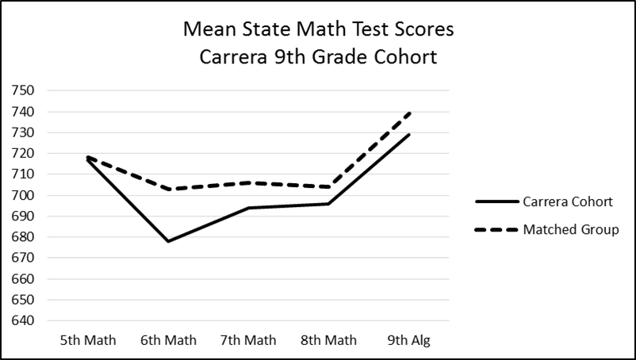
Figure 2. Graph of State Math Test Scores for Carrera 9th Grade Cohort

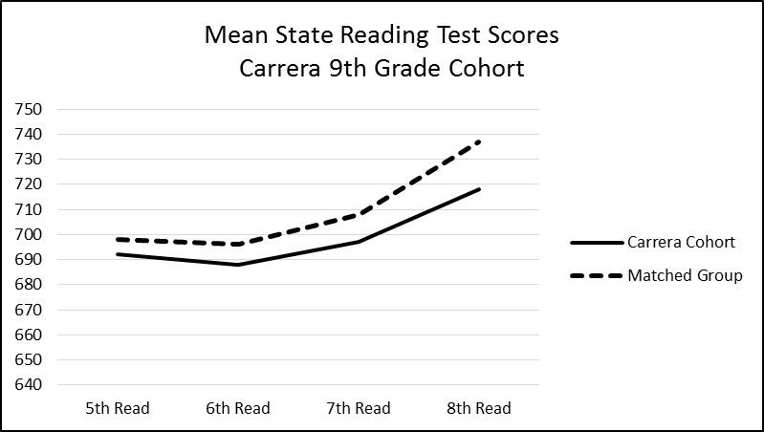
Figure 3. Graph of State Reading Test Scores for Carrera 9th Grade Cohort

The comparison of mean grades in math and English language arts courses for the Carrera 9th grade cohort and corresponding matched group are shown in Table 5. In sixth grade the Carrera cohort had a higher mean math grade and mean reading grades were equal. While the mean grades in each subject remained relatively close for succeeding years, the matched group had slightly higher mean grades in both subjects.

Mean Grades by Percent for Math and ELA
 | 6th Math | 6th Reading | 7th Math | 7th ELA | 8th Math | 8th ELA | 9th Math | 9th ELA
Carrera 9th Grade Cohort | 87 | 81 | 75 | 78 | 79 | 77 | 77 | 75
Matched Group | 80 | 81 | 77 | 83 | 80 | 79 | 79 | 79
Table 5. Comparison of Mean Grades for Carrera 9th Grade Cohort

Figure 4 and Figure 5 show graphs of mean math and English language arts grades for the Carrera 9th grade cohort and the corresponding matched group. The visual representation shows the initial gap in math during the sixth grade year followed by means that maintain a small difference. The English language arts mean grades also sustain a small difference over the four years.

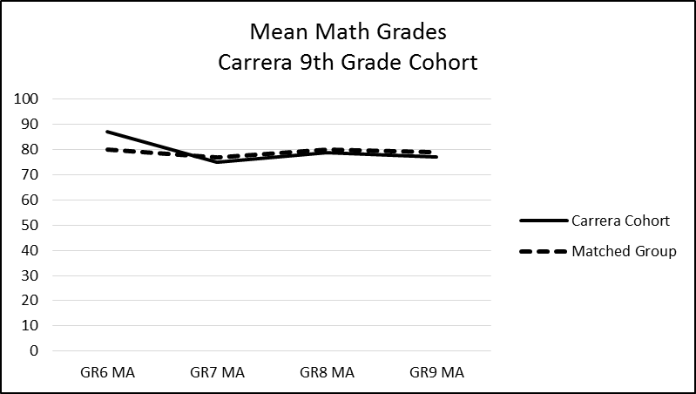
Figure 4. Graph of Math Grades for Carrera 9th Grade Cohort

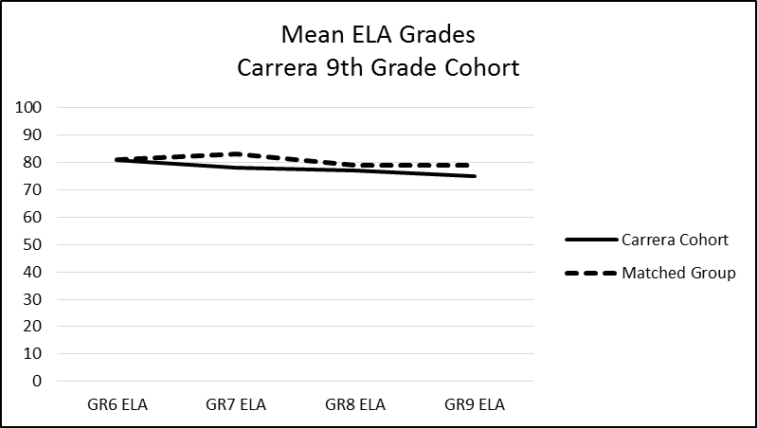
Figure 5. Graph of ELA Grades for Carrera 9th Grade Cohort

The comparison of mean state test scores in math and reading for the Carrera 8th grade cohort and corresponding matched group are shown in Table 6. The prior achievement scores, represented by the fifth grade math and reading scale scores, were very close for math and relatively close for reading. A small gap emerged in sixth grade math with the matched group having a higher mean score that remained through the eighth grade. Reading mean scores stayed relatively close until the eighth grade year in which the matched group scored slightly higher.

Mean State Test Scale Score
 | 5th Math | 6th Math | 7th Math | 8th Math | 5th Reading | 6th Reading | 7th Reading | 8th Reading
Carrera 8th Grade Cohort | 718 | 704 | 692 | 708 | 707 | 705 | 705 | 731
Matched Group | 717 | 718 | 707 | 720 | 703 | 704 | 706 | 741
Table 6. Comparison of Mean Scores on State Tests for Carrera 8th Grade Cohort

Figure 6 and Figure 7 show graphs of mean state test scores in math and reading for the Carrera 8th grade cohort and the corresponding matched group. The graph of the mean math scores shows the slight sustained gap in which the matched cohort scored higher. The graph of the mean reading scores shows the relatively close reading scores at each grade level until the eighth grade year in which there is a slightly higher mean for the matched group.
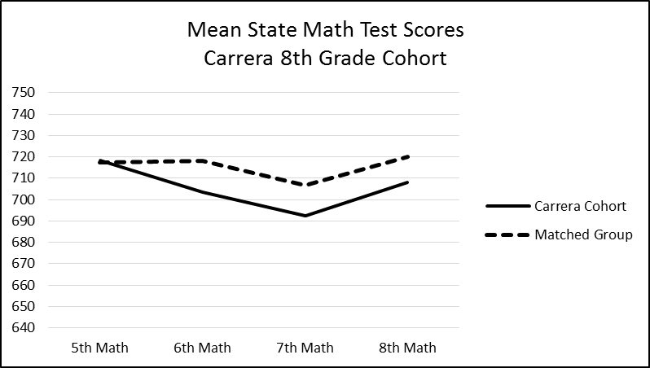
Figure 6. Graph of State Math Test Scores for Carrera 8th Grade Cohort

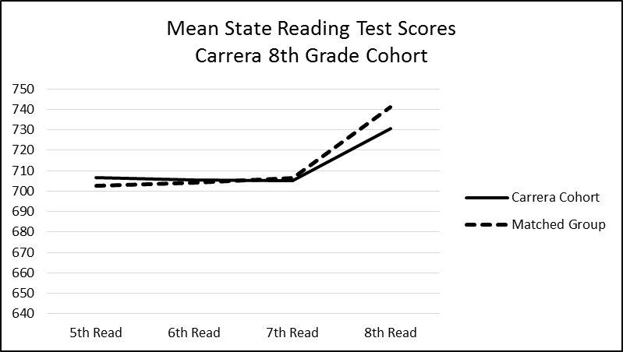
Figure 7. Graph of State Reading Test Scores for Carrera 8th Grade Cohort

The comparison of mean grades in math and English language arts for the Carrera 8th grade cohort and the corresponding matched group are shown in Table 7. The mean math grades of the matched group were slightly higher for each of the three years. The mean English language arts grades showed very little difference for all three years of the study.

Mean Grades by Percent
 | 6th Math | 6th Reading | 7th Math | 7th ELA | 8th Math | 8th ELA
Carrera 8th Grade Cohort | 82 | 83 | 75 | 76 | 78 | 80
Matched Group | 84 | 84 | 78 | 77 | 80 | 80
Table 7. Comparison of Mean Grades for Carrera 8th Grade Cohort

Figure 8 and Figure 9 show graphs of mean grades in math and English language arts for the Carrera 8th grade cohort and the corresponding matched group. The difference is small, but sustained, for math and very small for English language arts for each year.

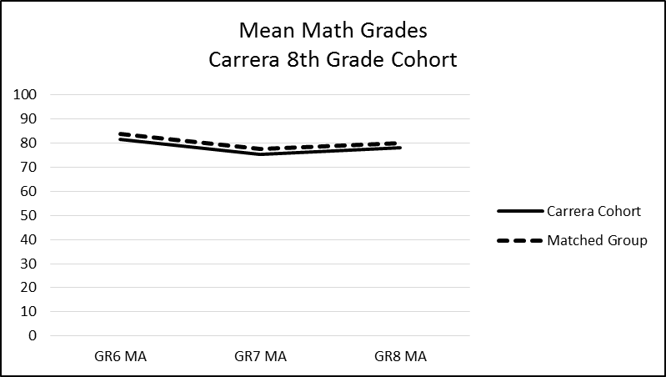
Figure 8. Graph of Math Grades for Carrera 8th Grade Cohort

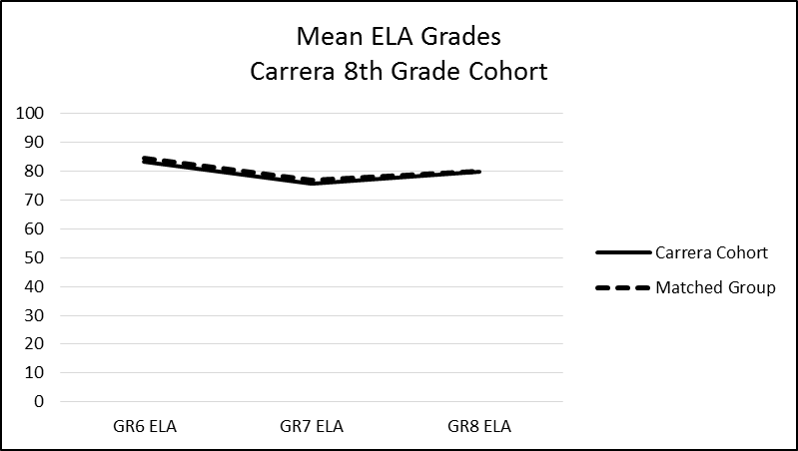
Figure 9. Graph of ELA Grades for Carrera 8th Grade Cohort

An analysis of variance (ANOVA) was conducted to investigate the statistical significance of the differences in the mean test scores and mean grades between Carrera cohorts and the corresponding matched groups. ANOVA was used rather than a t-test for the purpose of curtailing inflation of type one errors. Table 8 shows the data for ANOVA conducted for the final two years of state tests and grades for the Carrera 9th grade cohort and corresponding matched group. The table is organized with state test scores first, beginning with most recent scores, followed by grades, beginning with most recent. The ANOVA revealed that among two years of test scores and grades in two subjects only two of the mean differences proved to be statistically significant. The mean differences in the eighth grade reading test scores and ninth grade English language arts grades were statistically significant at the p<.05 level with mild F ratios. However, the partial eta squared figures for each are small, indicating little effect size. Therefore, while the matched group’s scores and grades were higher with statistical significance in these two areas, the amount of variance that can be explained by participation or non-participation in the Carrera Program is very little.

ANOVA Results for Carrera 9th Grade Cohort and Matched Group
 | Mean | Std. Dev. | F | Sig. | Partial Eta Sq.
Carrera Algebra I Test | 728.92 | 50.83 | 2.656 | .105 | .014
Matched Group Algebra I Test | 739.38 | 36.24
Carrera 8th Math Test | 696.05 | 58.92 | .931 | .336 | .005
Matched Group 8th Math Test | 703.57 | 47.88
Carrera 8th Reading Test | 717.68 | 58.93 | 6.162 | .014* | .032
Matched Group 8th Reading Test | 737.20 | 48.99
Carrera 9th Math Grade | 77.22 | 15.01 | .441 | .507 | .002
Matched Group 9th Math Grade | 78.60 | 13.69
Carrera 9th ELA Grade | 75.07 | 15.36 | 4.36 | .038* | .023
Matched Group 9th ELA Grade | 79.33 | 12.58
Carrera 8th Math Grade | 78.86 | 10.91 | .751 | .387 | .004
Matched Group 8th Math Grade | 80.19 | 10.37
Carrera 8th ELA Grade | 77.31 | 11.23 | 1.964 | .163 | .010
Matched Group 8th ELA Grade | 79.50 | 10.26
Table 8. ANOVA Results for Carrera 9th Grade Cohort and Matched Group
*= p < .05, Note that all variances between groups were equal.
The data for the ANOVA conducted for the final two years of state test scores and grades for the Carrera 8th grade cohort is shown in Table 9. Although apparent differences in the means exist, none of them prove to be statistically significant at the p<.05 level. This is supported by the corresponding small F ratios and effect sizes noted by the partial eta squared figures. The data show that there is no statistical difference in the achievement scores of the Carrera 8th grade cohort and the corresponding matched group among the achievement data in the final two years of the study.

ANOVA Results for Carrera 8th Grade Cohort and Matched Group
 | Mean | Std. Dev. | F | Sig. | Partial Eta Sq.
Carrera 8th Math Test | 708.14 | 57.88 | 2.712 | .101 | .010
Matched Group 8th Math Test | 720.16 | 60.87
Carrera 8th Reading Test | 730.62 | 68.31 | 1.797 | .181 | .007
Matched Group 8th Reading Test | 741.09 | 58.46
Carrera 7th Math Test | 692.27 | 70.79 | 3.281 | .071 | .012
Matched Group 7th Math Test | 706.86 | 59.86
Carrera 7th Reading Test | 705.00 | 51.51 | .047 | .828 | .000
Matched Group 7th Reading Test | 706.43 | 55.76
Carrera 8th Math Grade | 77.90 | 13.65 | 1.498 | .222 | .006
Matched Group 8th Math Grade | 79.90 | 12.85
Carrera 8th ELA Grade | 79.53 | 10.89 | .322 | .571 | .001
Matched Group 7th ELA Grade | 80.29 | 10.89
Carrera 7th Math Grade | 75.39 | 12.74 | 1.766 | .185 | .007
Matched Group 7th Math Grade | 77.55 | 13.63
Carrera 7th ELA Grade | 75.63 | 12.64 | .505 | .478 | .002
Matched Group 7th ELA Grade | 76.83 | 14.95
Table 9. ANOVA Results for Carrera 8th Grade Cohort and Matched Group
Note that all variances between groups were equal.

Question 2: Do students who participate in the Carrera Program believe that the environment supports their psychological needs and self-regulation?
Student responses on the School Health Indicators survey on items related to the four constructs were used to determine student perceptions of support for psychological needs. The items are scored on a Likert scale with four being the highest possible score. A mean score of three or higher indicates that the average response is at or above the “agree” rating. It is important to note that students responded to the items with all teachers in mind. So Carrera Program participants may have included many teachers other than their Carrera teachers in their consideration of their response for each item in the survey.
The mean scores for the Carrera 9th grade cohort are shown for the spring of 2015 and the spring of 2016 in Table 10. To provide perspective, the mean scores for all Carrera students in the same grade level (the selected cohort students and other participating students who started after sixth grade) are included along with the mean scores for the sample of the general population of Union Public Schools students in the same grade level that were surveyed each year. In 2015, the Carrera cohort scored the highest for autonomy support at 3.07 and competence support at 3.05, while the district sample scored highest for student trust in teachers (relatedness) at 2.98 and self-regulation at 2.96. In 2016, the district sample scored highest in all four constructs. The greatest difference in scores occurred in 2016 for self-regulation, with a difference of .29, although all groups scored above the threshold of three and highest on that construct. The results of the survey analysis indicate that Carrera 9th grade cohort students generally have the same or slightly lower perceived levels of support for their psychological needs as the general population of students in their grade level and the same or slightly higher levels than Carrera Program students who have not participated in the program as long as the cohort students. This may indicate that longer participation in the Carrera Program increased student perceptions of support for psychological needs.

 | Student Perceived Support Mean Scores for Carrera 9th Grade Cohort
 |  | n | Autonomy Support | Competence Support | Student Trust in Teachers | Self- Regulation
Carrera Study Cohort 2015 |  | 86 | 3.07 | 3.05 | 2.94 | 2.88
All Carrera 8th 2015 |  | 179 | 2.95 | 2.99 | 2.96 | 2.84
Union 8th 2015 |  | 42 | 3.00 | 3.01 | 2.98 | 2.96
Carrera Study Cohort 2016 |  | 67 | 2.78 | 2.82 | 2.67 | 3.08
All Carrera 9th 2016 |  | 102 | 2.71 | 2.81 | 2.64 | 3.08
Union 9th 2016 |  | 100 | 2.89 | 3.02 | 2.89 | 3.37
Table 10. Perceived Support for Psychological Needs for Carrera 9th Grade Cohort

The mean scores for the perceived support of psychological needs for the Carrera 8th grade cohort are shown for the spring of 2015 and the spring of 2016 in Table 11. As with the previous table, the mean scores for all Carrera students in the same grade level are included along with the mean scores for the sample of the general population of Union Public Schools students for the same grade level that were surveyed each year. In both years, the Carrera Program students scored highest in all four constructs with the selected cohort students scoring higher than “all” Carrera students in 2016 in all constructs, with the exception of self-regulation in which the scores were equal. All scores for the cohort were above the threshold of three with competence support and self-regulation scoring the highest in 2016. The differences between the Carrera cohort and the general population sample ranged from .14 to .25. The Carrera 8th grade cohort showed higher perceived support for psychological needs than the general population for all four constructs and the students with the longest participation in the program indicating the highest perceived support for psychological needs.

 | Student Perceived Support Mean Scores for Carrera 8th Grade Cohort
 |  | n | Autonomy Support | Competence Support | Student Trust in Teachers | Self- Regulation
Carrera Study Cohort 2015 |  | 123 | 3.07 | 3.21 | 3.14 | 3.03
All Carrera 7th 2015 |  | 205 | 3.13 | 3.29 | 3.16 | 3.07
Union 7th 2015 |  | 94 | 2.83 | 3.02 | 3.02 | 2.87
Carrera Study Cohort 2016 |  | 103 | 3.15 | 3.23 | 3.17 | 3.23
All Carrera 8th 2016 |  | 176 | 3.10 | 3.19 | 3.14 | 3.23
Union 8th 2016 |  | 81 | 2.90 | 3.07 | 2.95 | 3.07
Table 11. Perceived Support for Psychological Needs for Carrera 8th Grade Cohort

Question 3: What is the relationship between the psychological needs fulfillment and academic performance among Carrera Program participants?
The relationship between the psychological needs fulfillment and academic performance was analyzed by finding the correlation between the four measures of student perceptions of psychological needs fulfillment and student performance on state tests and grades. Using the 2015-16 data, Table 12 shows the Pearson correlation coefficients for each relationship for the Carrera 9th grade cohort. While none of the correlations is strong, the relationships between autonomy support and grades, with .27 for the ELA grade showing statistical significance, were among the strongest. Competence support also had a stronger relationship to the achievement variables than the other two constructs (student trust in teachers and self-regulation). In all cases the relationship between perceived support for psychological needs was greater with grades than the state Algebra I test.

Carrera 9th Grade Cohort Perceived Support for Psychological Needs Relationship to Achievement Measures
 | Autonomy Support | Competence Support | Student Trust in Teachers | Self-Regulation
9th Alg I Test | .05 | .16 | .05 | .09
9th Math Grade | .18 | .17 | .11 | .14
9th ELA Grade | .27* | .20 | .14 | .14
Table 12. Psychological Needs and Achievement for Carrera 9th Grade Cohort
*= p < .05
The Pearson correlation coefficients showing the relationship between the measures of perceived psychological needs fulfillment and academic performance indicators for the Carrera 8th grade cohort are shown in Table 13. The correlation coefficients show less strength in the relationship between the variables than the Carrera 9th grade cohort. The strongest relationship was between self-regulation and student grades in math and ELA, with the .22 for math showing statistical significance. Autonomy support showed a mild positive relationship to the ELA grade but a negative one with the state reading test, which assessed related content. Other very weak and negative relationships were present with competence support and student trust in teachers (relatedness), indicating that those constructs did not relate much to the academic performance of the Carrera 8th grade cohort.

Carrera 8th Grade Cohort Perceived Support for Psychological Needs Relationship to Achievement Measures
 | Autonomy Support | Competence Support | Student Trust in Teachers | Self-Regulation
8th State Math Test | .01 | -.06 | -.03 | .14
8th State Reading Test | -.13 | -.09 | -.05 | -.08
8th Math Grade | .12 | .00 | .04 | .22*
8th ELA Grade | .18 | -.01 | .06 | .16
Table 13. Psychological Needs and Achievement for Carrera 8th Grade Cohort
*= p < .05

Question 4: Are student characteristics (ethnicity/race, gender, ELL, and SES) related to the effects on student achievement?
The analysis of the relationship between Carrera student characteristics and student achievement follows in three forms. The forms include a correlational analysis of student performance indicators and student characteristics, followed by a table of mean scores and grades by student demographic groups, and finally an analysis of variance (ANOVA) for the mean scores with notable differences.
The correlation coefficients are shown for the Carrera 9th grade cohort in Table 14 and the Carrera 8th grade cohort in Table 15. Since the variables were dichotomous, a non-parametric correlation was conducted. The tables provide data relating the final year of state tests and grades with an additional year of state tests for the Carrera 9th grade cohort in order to include analysis on a state reading test. The correlations were low for both cohorts with the strongest being female to ELA grade on each table, both showing statistical significance. Also having higher correlations was the Caucasian to eighth grade reading test, with the Carrera 9th grade cohort coefficient of .23 showing statistical significance. It is notable that ELL, economically disadvantaged, and Hispanic students all had predominantly mild negative correlations to performance indicators with the ELL to eighth grade reading test for the 9th grade cohort coefficient of -.22 showing significance. The number of participants for Native American Asian, and “More than one Race” students was too low to make inferences from the data.

Relationship between Achievement and Demographic Characteristics
Carrera 9th Grade Cohort
 | N | 8th State Math Test | 8th State Reading Test | State Algebra I Test | Math Grade | ELA Grade
Female | 46 | -.02 | .05 | -.03 | .11 | .25*
ELL | 53 | -.08 | -.22* | -.16 | -.02 | -.11
Econ Disadvantaged | 82 | -.02 | -.14 | -.14 | -.06 | -.03
Hispanic | 53 | -.07 | -.18 | -.09 | .03 | -.05
African American | 20 | -.09 | -.03 | -.05 | -.12 | .01
Caucasian | 15 | .10 | .23* | .12 | .10 | .07
Table 14. Achievement and Demographics for Carrera 9th Grade Cohort
*= p < .05

Relationship between Achievement and Demographic Characteristics
Carrera 8th Grade Cohort
 | N | 8th State Math Test | 8th State Reading Test | Math Grade | ELA Grade
Female | 64 | .03 | -.03 | .08 | .17*
ELL | 56 | .00 | -.08 | -.01 | .02
Econ Disadvantaged | 105 | -.10 | -.05 | -.03 | -.08
Hispanic | 61 | -.05 | -.06 | -.06 | -.02
African American | 25 | .01 | -.02 | .09 | -.05
Caucasian | 29 | .02 | .10 | -.04 | .07
Table 15. Achievement and Demographics for Carrera 9th Grade Cohort
*= p < .05

Based on the correlation data, it appears that Caucasian and female students tended to have higher achievement. An examination of the prior achievement data helps illuminate where the program might have an influence. Mean scores on state tests and mean student grades, including scores on the fifth grade math and reading tests, for the Carrera 9th grade cohort are displayed by demographic characteristic in Table 16. While the measures of prior achievement, fifth grade scores, of Caucasian students were several scale points higher than the mean scores for the cohort, the mean scores on the fifth grade tests for females were lower in math and only five scale points higher in reading. Thus, the correlation between Caucasian and higher state test scores and grades might be expected based on prior achievement, while the correlation between females and higher grades might be less attributed to prior achievement and more attributed to other factors, one of which may be participation in the Carrera Program.
Additional data to be noted on the table are the differences in scores and grades for certain demographic characteristics. The matched group mean scores for several demographic groups were higher than the Carrera 9th grade cohort on state tests. Female, male, ELL, economically disadvantaged, Hispanic, African American, and Caucasian matched groups scored higher on the eighth grade state reading test and Algebra I test. Male, ELL, Hispanic, and Caucasian matched groups scored higher on the state math test. Mean grades had smaller differences with the greater difference being with the ELL, Hispanic, and Caucasian mean grades in which the matched groups also were higher. The Native American, Asian, and More than One Race subgroups were composed of small numbers ranging from one to six.

Mean Test Scores and Grades by Demographic for
Carrera 9th Grade Cohort and Matched Group
 | 5th State Math Test | 5th State Reading Test | 8th State Math Test | 8th State Reading Test | State Algebra I Test | Math Grade | ELA Grade
Female | 710 | 697 | 697 | 719 | 732 | 79 | 79
Female Matched | 708 | 697 | 698 | 744 | 740 | 82 | 82
Male | 724 | 687 | 695 | 716 | 726 | 76 | 72
Male Matched | 727 | 699 | 708 | 731 | 739 | 75 | 77
ELL | 715 | 682 | 690 | 707 | 723 | 76 | 73
ELL Matched | 715 | 789 | 704 | 735 | 738 | 78 | 80
Econ Disadvantaged | 716 | 688 | 695 | 715 | 727 | 77 | 75
Econ Disadvantaged Matched | 711 | 697 | 695 | 731 | 734 | 77 | 78
Hispanic | 715 | 683 | 691 | 709 | 725 | 77 | 73
Hispanic Matched | 717 | 691 | 699 | 738 | 737 | 78 | 79
Native American | 721 | 735 | 725 | 727 | 741 | 82 | 76
Native American Matched | 739 | 740 | 711 | 781 | 745 | 89 | 86
Asian | 762 | 706 | 739 | 714 | 760 | 76 | 66
Asian Matched | 715 | 679 | 746 | 666 | 709 | 55 | 83
African American | 703 | 686 | 689 | 712 | 723 | 75 | 77
African American Matched | 696 | 699 | 694 | 723 | 735 | 73 | 73
Caucasian | 750 | 721 | 710 | 750 | 744 | 81 | 79
Caucasian Matched | 747 | 713 | 723 | 754 | 757 | 85 | 85
More than One Race | 657 | 655 | 697 | 727 | 732 | 73 | 79
More than One Race Matched | 672 | 680 | 688 | 701 | 720 | 81 | 82
Table 16. Test Scores and Grades by Demographic for Carrera 9th Grade Cohort

Mean scores on state tests and mean student grades for the Carrera 8th grade cohort are displayed by demographic characteristic in Table 17. The pattern in the data is similar in that the matched group scored higher than the Carrera cohort on state tests in most demographic characteristics. The exception is in the African American subgroup in which the Carrera cohort scored slightly higher on both state tests. However, the prior achievement of the Carrera cohort was also slightly higher. The only difference in grades that seemed to be significant is with the “more than one race” subgroup in math in which the matched group had a higher mean. The Native American and Asian subgroups were composed of small numbers ranging from two to four.

Mean Test Scores and Grades by Demographic for
Carrera 8th Grade Cohort and Matched Group
 | 5th State Math Test | 5th State Reading Test | 8th State Math Test | 8th State Reading Test | Math Grade | ELA Grade
Female | 705 | 710 | 709 | 731 | 79 | 82
Female Matched | 717 | 703 | 715 | 744 | 82 | 82
Male | 731 | 704 | 708 | 731 | 77 | 78
Male Matched | 718 | 702 | 725 | 738 | 77 | 78
ELL | 723 | 685 | 707 | 721 | 78 | 80
ELL Matched | 718 | 686 | 723 | 741 | 79 | 80
Econ Disadvantaged | 718 | 704 | 705 | 729 | 78 | 79
Econ Disadvantaged Matched | 704 | 684 | 713 | 733 | 78 | 79
Hispanic | 718 | 693 | 705 | 725 | 77 | 79
Hispanic Matched | 719 | 690 | 722 | 743 | 78 | 79
Native American | 706 | 732 | 668 | 710 | 60 | 72
Native American Matched | 716 | 705 | 720 | 766 | 83 | 86
Asian | 815 | 652 | 779 | 748 | 96 | 93
Asian Matched | 788 | 714 | 763 | 756 | 92 | 94
African American | 720 | 712 | 709 | 725 | 82 | 79
African American Matched | 708 | 709 | 703 | 721 | 78 | 79
Caucasian | 708 | 720 | 712 | 747 | 78 | 81
Caucasian Match | 714 | 719 | 723 | 747 | 81 | 81
More than One Race | 729 | 737 | 715 | 738 | 76 | 79
More than One Race Matched | 720 | 714 | 730 | 747 | 84 | 81
Table 17. Test Scores and Grades by Demographic for Carrera 8th Grade Cohort

In order to investigate the potential statistical significance of the differences in the means, ANOVA was completed for several of the data sets for both cohorts and their corresponding matched groups. ANOVA was used rather than a t-test for the purpose of curtailing inflation of type one errors. The criteria used to select data sets for the ANOVA was a difference in mean state test scores that was greater than 10 scale points and a difference in mean grades that was greater than five percentage points. Data sets for demographic groups that were composed of six or fewer students were excluded from the ANOVA. The selection criteria yielded 17 data sets to examine for the Carrera 9th grade cohort and eight data sets to examine for the Carrera 8th grade cohort. Tables 18 and 19 show the results of the ANOVA which revealed that none of the mean differences for the demographic groups tested as statistically significant at the p<.05 level. This is supported by the corresponding small F ratios. The effect sizes, noted by the partial eta squared figures, were all very small ranging from .000 to .007. Therefore, there does not appear to be a notable difference between Carrera student performance and that of the matched students for any of the characteristic groups.

ANOVA Results for Carrera 9th Grade Cohort and Matched Group by Demographics
 | Mean | Std. Dev. | F | Sig. | Partial Eta Sq.
Carrera Female 8th Rdg Test | 719.54 | 64.80 | .396 | .530 | .002
Match Female 8th Rdg Test | 744.13 | 42.67
Carrera Male 8th Math Test | 695.48 | 63.01 | .523 | .471 | .003
Match Male 8th Math Test | 708.46 | 49.24
Carrera Male 8th Rdg Test | 716.04 | 53.80 | .396 | .530 | .002
Match Male 8th Rdg Test | 730.71 | 53.90
Carrera Male Alg I Test | 726.29 | 60.02 | .128 | .721 | .001
Match Male Alg I Test | 738.90 | 39.59
Carrera ELL 8th Math Test | 689.96 | 66.34 | .820 | .366 | .004
Match ELL 8th Math Test | 704.02 | 51.52
Carrera ELL 8th Rdg Test | 707.11 | 58.97 | 1.338 | .249 | .007
Match ELL 8th Rdg Test | 734.72 | 51.27
Carrera ELL Alg I Test | 722.72 | 50.44 | .618 | .433 | .003
Match ELL Alg I Test | 737.65 | 35.99
Carrera ELL ELA Grade | 72.66 | 17.52 | 2.48 | .117 | .013
Match ELL ELA Grade | 79.92 | 12.89
Carrera Econ Dis 8th Rdg Test | 714.51 | 59.10 | .134 | .715 | .001
Match Econ Dis 8th Rdg Test | 730.63 | 50.24
Carrera Hispanic 8th Rdg Test | 709.3 | 59.41 | 1.496 | .223 | .006
Match Hispanic 8th Rdg Test | 737.67 | 47.46
Carrera Hispanic Alg I Test | 724.74 | 50.93 | .128 | .721 | .001
Match Hispanic Alg I Test | 737.24 | 33.36
Carrera Hispanic ELA Grade | 73.21 | 17.73 | .506 | .478 | .003
Match Hispanic ELA Grade | 78.87 | 12.20
Carrera Afr Am 8th Rdg Test | 711.75 | 62.35 | .277 | .599 | .001
Match Afr Am 8th Rdg Test | 722.89 | 53.36
Carrera Afr Am Alg I Test | 723.00 | 57.03 | .006 | .941 | .000
Match Afr Am Alg I Test | 734.78 | 45.63
Carrera Caucasian 8th Math Test | 709.53 | 46.26 | .139 | .710 | .001
Match Caucasian 8th Math Test | 723.25 | 48.38
Carrera Caucasian Alg I Test | 744.07 | 34.43 | .031 | .861 | .000
Match Caucasian Alg I Test | 756.69 | 32.52
Carrera Caucasian ELA Grade | 78.57 | 12.71 | .164 | .686 | .001
Match Caucasian ELA Grade | 84.59 | 11.04
Table 18. ANOVA Results by Demographic for Carrera 9th Grade Cohort
Note that all variances between groups were equal.

ANOVA Results for Carrera 8th Grade Cohort and Matched Group by Demographics
 | Mean | Std. Dev. | F | Sig. | Partial Eta Sq.
Carrera Female 8th Rdg Test | 730.63 | 62.60 | .126 | .723 | .000
Match Female 8th Rdg Test | 743.89 | 65.48
Carrera Male 8th Math Test | 707.75 | 62.63 | .520 | .471 | .002
Match Male 8th Math Test | 725.03 | 62.62
Carrera ELL 8th Math Test | 707.32 | 66.34 | .145 | .704 | .001
Match ELL 8th Math Test | 722.52 | 59.54
Carrera ELL 8th Rdg Test | 721.30 | 74.06 | 1.022 | .313 | .004
Match ELL 8th Rdg Test | 741.01 | 53.10
Carrera Hispanic 8th Math Test | 704.82 | 63.35 | .414 | .521 | .002
Match Hispanic 8th Math Test | 721.97 | 62.30
Carrera Hispanic Rdg Test | 724.52 | 75.47 | .937 | .334 | .004
Match Hispanic Rdg Test | 743.25 | 52.24
Carrera More than One Race  8th Math Test | 714.83 | 51.24 | .017 | .895 | .000
Match More than One Race  8th Math Test | 729.77 | 77.67
Carrera More than One Race Math Grade | 76.37 | 16.22 | 1.045 | .308 | .004
Match More than One Race Math Grade | 83.52 | 12.62
Table 19. ANOVA Results by Demographic for Carrera 8th Grade Cohort
Note that all variances between groups were equal.

Chapter 5: Discussion
The discussion of the results of the study includes information that may help in a review of the findings, provides consideration of potential explanations for the results, and suggests areas for further related research. As with all programmatic endeavors, consideration of expense and effort of the school system and its partners is a factor along with the results in determining a program’s relative effectiveness. It is important to note that the Carrera Program is designed to serve a holistic effort that includes more than an academic emphasis. At the same time, academic results are clearly an important goal for a school system and a certainly an intended byproduct of a school-based, student-support effort. It is hoped that the results may help inform the school system and its partners about the academic achievement of the students who participated in the Carrera Program at Union Public Schools for an extended period of time compared to similar students who do not participate.

Findings of the Study
The comparison of student achievement of the Carrera students with corresponding matched groups indicates that the effect on the cohort of participants yielded little or no difference in student achievement. The mean state test scores for both math and reading in the final two years of the study varied little with the differences favoring the matched groups. Only one of the differences in the mean state test scores was shown to be statistically significant, and that was for the eighth grade reading test between the Carrera 9th grade cohort and the corresponding matched group. On that measure, the matched group outperformed the Carrera cohort. The mean grades for the final two years of the study were also very close, with the minor differences again favoring the matched groups. The one difference that was statistically significant was in the mean grades in English language arts between the Carrera 9th grade cohort and corresponding matched group. The matched group outperformed the Carrera cohort on this indicator as well. It should be noted that the eighth grade reading test and ninth grade ELA grades are in related subject matter.
The primary implication of the findings on achievement indicators is that the students in the Carrera cohorts did not perform as expected in comparison to the matched groups, given the systematic, multi-component support that was made available to the Carrera students for three to four consecutive years. While there may be reasons for the achievement results being less than expected, some of which are mentioned below, an evaluative perspective would state that the evidence in this study supports the null hypothesis. Secondary implications may raise questions about the level of motivational and academic support provided to the students in the Carrera cohorts. Perhaps the combined effect of the seven components did not provide the level of support for student psychological needs to motivate the students sufficiently in the academic domain in order to lead to significantly increased academic gains. Additionally, the specific design of the academic component may be a factor to examine more deeply to determine its effectiveness.
Carrera student perceptions of the support for psychological needs and self-regulation varied in comparison to the general population for students in the Carrera 9th grade cohort but were consistently higher than the general population for students in the Carrera 8th grade cohort. The scores between cohorts also varied when comparing the scores at the point in which each cohort was in the eighth grade. The difference in trends between the cohorts makes drawing broad inferences about Carrera student perceptions in comparison to the general population difficult. Since the Carrera student population tended to have lower grades and test scores than the general population, it is reasonable to consider that one might expect the perceived support for psychological needs to be initially lower among the Carrera students, at least prior to entering the program. Therefore, when higher scores among the Carrera cohorts occur, it may indicate that the students are perceiving additional support for psychological needs that is being provided through the program components.
A consistent trend among the Carrera student perceptions of support for psychological needs is the higher scores among the selected cohort students in comparison to the Carrera student population as a whole. In the second year of the study, the selected cohort students scored higher on autonomy support, competence support, and student trust in teachers (relatedness) while scoring the same for self-regulation. This may indicate that longer participation in the program contributes to higher perceived support for psychological needs, or a growing perception of such support. Unfortunately, even though Carrera students indicated that they perceived higher levels of support for psychological needs than the general population, there does not seem to be associated academic performance for the Carrera students.
The analysis of the relationship between the perceived fulfillment of psychological needs and student achievement yielded only mild correlations. The data between cohorts was not consistent with two of the constructs. While the correlations for competence support and student trust in teachers (relatedness) were positive for the Carrera 8th grade cohort, they were not for the Carrera 9th grade cohort. The most consistent relationships emerging among data for both cohorts is the connection between grades with autonomy support and self-regulation. This may indicate that students who are earning higher grades are doing so as a result of the support for autonomy and self-regulation. Autonomy and self-regulation are related in the sense that they are based on the learner being the agent who activates choice and selects behaviors that lead to academic success. This is associated with one of the core philosophical approaches of the Carrera Program which asserts that students make the decisions that will prevent pregnancy and determine their future, and that it is the staff’s role to provide choices and empower students to make better decisions.
The examination of the relationship between student characteristics (ethnicity/race, gender, ELL, and SES) and the effects on student achievement revealed that there is very little association between any particular subgroup performance indicators and student achievement for Carrera students. While there were mild correlations at some points and differences in the means that tended to favor the matched group performance, the further investigation of mean differences through ANOVA showed that none of the differences had statistical significance. Therefore, the participation in the Carrera Program does not seem to be associated with enhanced academic performance based on student characteristics.

Potential Explanations for Results
The results of this study indicate that participation in the Carrera Program was not associated with significant academic gains for students when compared to a matched group of similar students over a period of three to four years. In an effort to suggest why the Carrera student cohorts did not outperform the matched groups as expected, the following explanations are offered. While the five factors mentioned below may have contributed to the findings, they have not been explored through measurement and analysis, so the explanations represent only plausible conjecture for consideration.
First, while the students participating in the Carrera Program received the systemic support of the components of the program, the non-participating students may have received other interventions that could have provided similar support. The Union Public Schools system offers several interventions for middle and high school students such as math or reading enrichment courses, after school tutoring, an intervention period during the school day, and summer school. Those types of interventions are applied to students on an as-needed basis throughout the year and across years. They may be applied for short or long periods of time depending on student needs and available resources. While the Carrera students are included among the students receiving interventions, the fact that a student is receiving support through the Carrera Program is considered by educators when prioritizing which students receive the interventions in cases where there are limited opportunities. For example, while Carrera students who need additional support in reading are not excluded from the reading enrichment course, a student who is not in the Carrera Program with equal need for reading support may be selected ahead the Carrera student, because he or she is not already benefiting from the support that the Carrera Program provides. As a result, it is possible or even likely that many of the students in the matched groups received additional academic support of some kind during the years that the study was conducted. In addition, the participation in the Carrera Program may have precluded a student from receiving a particular intervention that occurred at the same time as a Carrera Program class or activity. While none of the interventions that the schools offer are nearly as comprehensive in nature or resource-intense as the systemic approach of the seven components of the Carrera Program, they might have affected the academic performance of the matched group students in a positive way.
Second, in spite of the effort to create an equivalent matched group of students to correspond to the Carrera student cohorts, there may still be a selection bias that is affecting the results. Carrera students are recruited for participation on the basis of presented need for additional support according to the recommendation criteria in Appendix B. Therefore, the matched groups of students may be composed not only of students whose parents declined the invitation to participate but also students who did not exhibit the same level of need for support as the Carrera students. If so, the Carrera students may have faced personal challenges that affected their academic performance in negative ways, such that those challenges offset the effects of some of the support that was provided through the components of the Carrera Program. This threat to validity underscores the importance of the inclusion of prior achievement data in the process of creating the matched groups. While the groups were relatively equivalent in demographic makeup, the match in prior achievement was an attempt to mitigate the effect of external variables in the lives of students that may influence student achievement.
Third, the matched group of students experienced some type of support and social stability in order to stay in school for the duration of the study. The study included only students who either participated in the Carrera Program for the duration of the study or matched group students that attended Union Public Schools for the duration of the study. Therefore, all of the students included had a certain level of support and stability provided to them that led to the completion of three of four continuous years of school at the same location. It may be argued that some of the Carrera students were able to maintain consistent attendance in school largely because of the support they received through their participation in the Carrera Program. In the same way, the matched group students may have also received some type of comparable support in order to also maintain consistent attendance at the same school for the duration of the study. While it is speculative to assert, it is possible that some comparable students did not qualify for the matched groups, because they did not continue in attendance due to mobility factors that were mitigated in the case of Carrera students by the support provided through program components.
Fourth, the Carrera Program staff are not directly trained to apply the principles of self-determination theory to their work with the students. While the components of the program can be viewed through the lens of self-determination theory and the features of support provided by those components can be associated with potential for satisfying the psychological needs of students, the program itself was not explicitly designed with self-determination theory as a basis for action. So while the actions of the staff and many strategies applied in the execution of the classes, meetings with students, and activities may address the psychological needs of students, the staff have not had specific instruction or training of how to apply the principles of self-determination theory with students. Although Carrera students indicated some higher levels of perceived support for their psychological needs, the support provided may have been greater had the staff possessed more awareness of the specific actions and strategies they could use to provide such support. In the same way, the training could have provided an increased awareness of the actions and strategies that impede the satisfaction of the psychological needs of students. The increased awareness and planning efforts of the staff may have, in turn, increased the effect on student motivation resulting in higher student achievement.
Fifth, the Carrera Program, although holistic in nature, is not specifically designed to increase student achievement as a primary goal. It is primarily designed as a pregnancy prevention program and the components are designed to support the student in making good decisions in several areas of life. While the academic component is present to assist students when skills or motivation are lacking, only a portion of the resources of the program are spent on this area of student support, thus limiting its effect. However, since the Carrera Program has developed the various components in an effort to provide holistic support that leads to better decision making, it may be counter-argued that an expected outcome of the influence on student behavior would include better decision making in academic areas leading to increases in achievement.

Suggestions for Further Research
Suggestions for further research include more specific examination of student achievement factors and further study of the connection between the perceived support for psychological needs and academic progress for students in the Carrera Program. The first suggestion is to examine the rate of student mobility and the dropout rate for students in the Carrera Program in comparison to students who do not participate. These two factors may be related to student achievement variables that could not be measured in this study. Students with incomplete participation in school due to mobility or dropping out of school could not be included in the longitudinal analysis of student achievement. However, it is possible that participation in the Carrera Program may be related to a reduction in mobility and school dropout rates compared to those for non-participating students with similar risk factors. Such a study will provide important information about the potential fate of students who did not participate in the program, should evidence show that mobility and dropout rates were likely reduced.
A second suggestion of further research is to analyze graduation rates for students with similar prior achievement to determine if participation in the Carrera Program tends to increase graduation rates for participating students. The extended relationships that Carrera students develop with staff members show promise for having a positive effect on the longevity of student participation in school. The Union Public Schools’ mission of one hundred percent graduation, college and/or career ready places primary importance on an awareness of any support system that increases the graduation rate.
A third suggestion for additional research is to conduct a more detailed examination of academic gains of students in relation to the time they receive specific academic support through the Carrera Program’s educational support component. The component staff work with students based on student needs and pre-determined strategic planning. Through a pre- and post-analysis of academic measures along with the logged data of services for each student, a more direct analysis could be conducted to inform the specific efforts and programming strategies of the Carrera educational support staff.
A fourth and related suggestion for further research is to examine academic outcomes in connection to the one-on-one meetings between students and the mental health and FLSE staff. Although meetings occur intentionally on a limited basis for all students, they recur at staff discretion or by student request. Since the frequency and duration of meetings vary among students, further research could help reveal the connection between the time spent providing services to students in one-on-one sessions and the change in academic performance.
Finally, it is suggested that additional research related to perceived support for psychological needs be conducted in order to determine how the perceived support for autonomy, competence, relatedness, and self-regulation are influencing academic gains when they occur. This may include using a measure of academic gains over time in order to associate the perceived support for each psychological need with the measured progress of students. Such a study may inform the program directors and staff where the program efforts have been effective, provide insight into why the efforts lead to positive outcomes, and where further resources would be best applied.

References
Adams, C. M., Forsyth, P. B., Dollarhide, E., Miskell, R., & Ware, J. (2015, February). Self-reglatory climate: A social resource for student regulation and achievement. Teachers College Record, 117, 1-28.

Adams, C. M., Ware, J. K., Miskell, R. C., & Forsyth, P. B. (2016). Self-regulatory climate: A positive attribute of public schools. The Journal of Educational Research, DOI: 10.1080/00220671.2014.934419

Basch, C. E. (2011). Teen pregnancy and the achievement gap among urban minority youth. Journal of School Health, 81(10), 614-618.

Burns, M. K., Senesac, B. V., & Symington, T. (2004). The effectiveness of the hosts program in improving the reading achievement of children at-risk for reading failure. Reading Research and Instruction, 43(2), 87-104.

Carrera, M. A. (2014, September 12). [Personal interview by the author].

Catalano, R. F., Berglund, M. L., Ryan, J. A. M., Lonczak, H. S., & Hawkins, J. D. (2004). Positive youth development in the United States: Research findings on evaluations of positive youth development programs. The ANNALS of the American Academy of Political and Social Science, 591(98), 98-124.

Chen, J. J.-L. (2005). Relation of academic support from parents, teachers, and peers to Hong Kong adolescents' academic achievement: The mediating role of academic engagement. Genetic, Social, and General Psychology Monographs, 131(2), 77-127.

Chiu, M. M., Pong, S.-L., Mori, I., & Chow, B. w.-Y. (2012). Immigrant students’ emotional and cognitive engagement at school: A multilevel analysis of students in 41 countries. Journal of Youth and Adolescence 41, 1409-1425.

Clarke, L. O. (2009). Effects of a school-based adult mentoring intervention on low income, urban high school freshmen judged to be at risk for drop-out: A replication and extension (Unpublished doctoral dissertation). Rutgers, New Brunswick, NJ.

Converse, N., & Lignugaris/Kraft, B. (2008). Evaluation of a school-based mentoring program for at-risk middle school youth. Remedial and Special Education, (July), 1-14.

Covington, M. V. (2000). Goal theory, motivation, and school achievement: An integrated review. Annual Review of Psychology, 51, 171-200.

CTB/McGraw-Hill LLC. (2013). Oklahoma school testing program Oklahoma core curriculum tests grades 3 to 8 assessments 2012-2013 technical report. Retrieved from the Oklahoma State Department of Education website: http://sde.ok.gov/sde/documents/2014-08-29/occt-technical-manuals-archive

CTB/McGraw-Hill LLC. (2014). Oklahoma school testing program Oklahoma core curriculum tests grades 3 to 8 assessments 2013-2014 technical report. Retrieved from the Oklahoma State Department of Education website: http://sde.ok.gov/sde/documents/2014-08-29/occt-technical-manuals-archive

Dappen, L., & Isemhagen, J. C. (2006). Urban and nonurban schools: Examination of a statewide student mentoring program. Urban Education, 41(151), 151-168.

Deci, E. L., Ryan, R. M., & Williams, G. C. (1996). Need satisfaction and the self-regulation of learning. Learning and Individual Differences, 8(3), 165-183.

Deci, E. L., Vallerand, R. J., Pelletier, L. G., & Ryan, R. M. (1991). Motivation and education: The self-determination perspective. Educational Psychologist, 26(3 & 4), 325-346.

DuBois, D. L., Holloway, B. E., & Valentine, J. C. (2002). Effectiveness of mentoring programs for youth: A meta-analytic review. American Journal of Community Psychology, 30(2), 157-197.

DuBois, D. L., Portillo, N., Rhodes, J. E., Silverthorn, N., & Valentine, J. C. (2011). How effective are mentoring programs for youth? A systematic assessment of the evidence. Psychological Science in the Public Interest, 12(2), 57-91.

Duda, J. L. (2007). Motivation in sport. In A. J. Elliot & C. S. Dweck (Eds.), Handbook of competence and motivation (Paperback ed., pp. 318-335). New York, NY: The Guilford Press. (Original work published 2005)

Durlak, J. A., Weissberg, R. P., & Pachan, M. (2010). A meta-analysis of after-school programs that seek to promote personal and social skills in children and adolescents. American Journal of Community Psychology, 45, 294-309.

Eby, L. T., Allen, T. D., Evans, S. C., Ng, T., & DuBois, D. L. (2008). Does mentoring matter? A multidisciplinary meta-analysis comparing mentored and non-mentored individuals. Journal of Vocational Behavior, 72, 254-267.

English, H. B., & English, A. C. (2012). A comprehensive dictionary of psychological and psychoanalytical terms. In B. J. Zimmerman & D. H. Schunk (Authors), Motivation and self-regulated learning: Theory, research, and applications (pp. 1-30). New York, NY: Routledge. (Original work published 1958)

Farkas, M. S., & Grolnick, W. S. (2010). Examining components and concomitants of parental structure in the academic domain. Motivation and Emotion, 34, 266-279.

Farruggia, S. P., Bullen, P., & Davidson, J. (2012). Important nonparental adults as an academic resource for youth. Journal of Early Adolescence, 33(4), 498-522.

Forsyth, P. B., Adams, C. M., Ford, T. G., Ware, J. K., Dollarhide, E. A., Miskell, R. C., Olsen, J. J., & Lepine, J. A. (2015). 2015 school health indicators: The path to performance, quality, & capacity. Tulsa, OK: The Oklahoma Center for Education Policy.

Fortier, M. S., Vallerand, R. J., & Guay, F. (1995). Academic motivation and school performance: Toward a structural model. Contemporary Educational Psychology, 20, 257-274.

Furrer, C., & Skinner, E. (2003). Sense of relatedness as a factor in children's academic engagement and performance. Journal of Educational Psychology, 95(1), 148-162.

Gaddis, S. M. (2012). What's in a relationship? Social Forces, 1-33.

Gillet, N., Vallerand, R. J., & Lafreniere, M.-A. K. (2012). Intrinsic and extrinsic school motivation as a function of age: The mediating role of autonomy support. Social Psychology of Education, 15, 77-95.

Goodenow, C. (1993). Classroom belonging among early adolescent students: Relationships to motivation and achievement. The Journal of Early Adolescence, 13(1), 21-43.

Gottfredson, D. C., & Gottfredson, G. D. (2002). Quality of school-based prevention programs: Results from a national survey. Journal of Research in Crime and Delinquency, 39(3), 3-35.

Grolnick, W. S. (2009). The role of parents in facilitating autonomous self-regulation for education. Theory and Research in Education, 7(2), 164-173.

Grolnick, W. S., Farkas, M. S., Sohmer, R., Michaels, S., & Valsiner, J. (2007). Facilitating motivation in young adolescents: Effects of an after-school program. Journal of Applied Developmental Psychology, 28, 332-334.

Grossman, J. B., Chan, C. S., Schwartz, S. E. O., & Rhodes, J. E. (2012). The test of time in school-based mentoring: The role of relationship duration and re-matching on academic outcomes. American Journal of Community Psychology, 49, 43-54.

Grossman, J. B., & Tierney, J. P. (1998). Does mentoring work? An impact study of the Big Brothers Big Sisters Program. Evaluation Review, 22(3), 403-426.

Guay, F., & Vallerand, R. J. (1997). Social context, student's motivation, and academic achievement: Toward a process model. Social Psychology of Education, 1, 211-233.

Hayenga, A. O., & Corpus, J. H. (2010). Profiles of intrinsic and extrinsic motivations: A person-centered approach to motivation and achievement in middle school. Motivation and Emotion, 34, 371-383.

Haynes, N. M., Emmons, C., & Ben-Avie, M. (1997). School climates as a factor in student adjustment and achievement. Journal of Educational and Psychological Consultation, 8(3), 321-329.

Hidi, S., & Ainley, M. (2012). Interest and self-regulation: Relationships between two variables that influence learning. In D. H. Schunk & B. J. Zimmerman (Eds.), Motivation and self-regulated learning: Theory, research, and application (pp. 77-109). New York, NY: Routledge. (Original work published 2008)

Hock, M. F., Pulvers, K. A., Deshler, D. D., & Schumaker, J. B. (2001). The effects of an after-school tutoring program on the academic performance of at-risk students and students with LD. Remedial and Special Education, 22(3), 172-186.

Johnson, A. W. (1999, December). Sponsor-a-scholar: Long-term impacts of a youth mentoring program on student performance. Mathematica Policy Research.

Karcher, M. J. (2008). The study of mentoring in the learning environment (SMILE): A randomized evaluation of the effectiveness of school-based mentoring. Prevention Science, 9, 99-113.

Katz, I., Kaplan, A., & Gueta, G. (2009). Students' needs, teachers' support, and motivation for doing homework: A cross-sectional study. The Journal of Experimental Education, 78(2), 246-267.

Kenny, M. E., Walsh-Blair, L. Y., & Blustein, D. L. (2010). Achievement motivation among urban adolescents: Work hope, autonomy support, and achievement-related beliefs. Journal of Vocational Behavior, 77, 205-212.

King, K. A., Vidourek, R. A., Davis, B., & McClellan, W. (2002). Increasing self-esteem and school connectedness through a multidimensional mentoring program. Journal of School Health, 72(7), 294-299.

Lauer, P. A., Akiba, M., Wilkerson, S. B., Apthorp, H. S., Snow, D., & Martin-Glenn, M. L. (2006). Out-of-school-time programs: A meta-analysis of effects for at-risk students. Review of Educational Research, 76(2), 275-313.

Lerner, R. M., von Eye, A., Lerner, J. V., & Lewin-Bizan, S. (2009). Exploring the foundations and functions of adolescent thriving within the 4-H study of positive youth development: A view of the issues. Journal of Applied Developmental Psychology, 30, 567-570.

Liu, W. C., Wang, C.K. J., Tan, O. S., Koh, C., & Ee, J. (2009). A self-determination approach to understanding students' motivation in project work. Learning and Individual Differences, 19, 139-145.

Markovitz, C. E., Hernandez, M. W., Hedberg, E. C., & Silberglitt, B. (2014). Impact evaluation of the Minnesota Reading Corps K-3 Program. Chicago, IL: NORC at the University of Chicago.

Measured Progress. (2015). Oklahoma core curriculum tests (OCCT grades 3-8) 2014-15 technical report. Retrieved from the Oklahoma State Department of Education website: http://sde.ok.gov/sde/documents/2014-08-29/occt-technical-manuals-archive

Measured Progress. (2016). Oklahoma core curriculum tests (OCCT grades 3-8) 2015-16 technical report. Retrieved from the Oklahoma State Department of Education website: http://sde.ok.gov/sde/documents/2014-08-29/occt-technical-manuals-archive

Measured Progress. (2016). Oklahoma end-of-instruction assessments (OK EOI) 2015-16 technical report. Retrieved from the Oklahoma State Department of Education website: http://sde.ok.gov/sde/documents/2014-08-29/occt-technical-manuals-archive

National Center for Education Evaluation and Regional Assistance, Institute of Education Sciences. (2009). Impact evaluation of the U.S. Department of Education's student mentoring program (Research Report No. NCEE 2009-4047) (L. Bernstein, C. D. Rappaport, L. Olsho, D. Hunt, & M. Levin, Authors). Washington, D. C.: U.S. Department of Education.

Neihaus, K., Rudasill, K. M., & Adelson, J. L. (2011). Self-efficacy, intrinsic motivation, and academic outcomes among Latino middle school students participating in an after-school program. Hispanic Journal of Behavioral Sciences, XX(X), 1-19.

Niemiec, C. P., & Ryan, R. M. (2009). Autonomy, competence, and relatedness in the classroom: Applying self-determination theory to educational practice. Theory and Research in Education, 7(2), 133-144.

Pajares, F. (2012). Motivational role of self-efficacy beliefs in self-regulated learning. In D. H. Schunk & B. J. Zimmerman (Eds.), Motivation and self-regulated learning: theory, research, and applications (pp. 111-139). New York, NY: Routledge. (Original work published 2008)

Pearson, Inc. and SDE Confidential. (2012). Oklahoma school testing program Oklahoma core curriculum tests grades 3 to 8 assessments 2012 technical report. Retrieved from the Oklahoma State Department of Education website: http://sde.ok.gov/sde/documents/2014-08-29/occt-technical-manuals-archive

Philliber, S., Kaye, J., & Herrling, S. (2011, May). National evaluation of the Children's Aid Society Carrera model program to prevent teen pregnancy. Retrieved from National Criminal Justice Reference Services Abstract Database. (Accession No. NCJ237263)

Philliber, S., Kaye, J. W., Herrling, S., & West, E. (2002). Preventing pregnancy and improving health care access among teenagers: An evaluation of the children's aid society-Carrera Program. Perspectives on Sexual and Reproductive Health, 34(5), 244-251.

Portwood, S. G., Ayers, P. M., Kinnison, K. E., Waris, R. G., & Wise, D. L. (2005). YouthFriends: Outcomes from a school-based mentoring program. The Journal of Primary Prevention, 26(2), 129-145.

Quin, D. (2017). Longitudinal and contextual associations between teacher-student relationships and student engagement: A systematic review. Review of Educational Research, 87(2), 345-387.

Randolph, K. A., & Johnson, J. L. (2008). School-based mentoring programs: A review of the research. Children & Schools, 30(3), 177-185.

Reeve, J. (2006). Teachers as facilitators: What autonomy-supportive teachers do and why their students benefit. The Elementary School Journal, 106(3), 225-236.

Reeve, J., Ryan, R., Deci, E. L., & Jang, H. (2012). Understanding and promoting autonomous self-regulation. In D. H. Schunk & B. J. Zimmerman (Eds.), Motivation and self-regulated learning: theory, research, and applications (pp. 223-244). New York, NY: Routledge. (Original work published 2008)

Rhodes, J. E., & DuBois, D. L. (2008). Mentoring relationships and programs for youth. Current Directions on Psychological Science, 17(4), 254-258.

Rhodes, J. E., Spencer, R., Keller, T. E., Liang, B., & Noam, G. (2006). A model for the influence of mentoring relationships on youth development. Journal of Community Psychology, 34(6), 691-707.

Roorda, D. L., Koomen, H. M. Y., Split, J. L., & Oort, F. J. (2011). The influence of affective teacher-student relationships on students' school engagement and achievement: A meta-analytic approach. Review of Educational Research, 81(4), 493-529.

Roth, J. L., & Brooks-Gunn, J. (2003). What exactly is a youth development program? Answers from research and practice. Applied Developmental Science, 7(2), 94-111.

Runco, M. A. (2007). Motivation, competence, and creativity. In A. J. Elliot & C. S. Dweck (Eds.), Handbook of competence and motivation (Paperback ed., pp. 609-623). New York, NY: The Guilford Press. (Original work published 2005)

Ryan, R. M., & Deci, E. L. (2000). Intrinsic and extrinsic motivations: Classic definitions and new directions. Contemporary Educational Psychology, 25, 54-67.

Ryan, R. M., & Deci, E. L. (2002). Overview of self-determination theory: An organismic dialectical perspective. In Deci, E. L., & Ryan, R. M. (Eds.), Handbook of self-determination research (pp. 3-33). Rochester, NY: University of Rochester Press.

Ryan, R. M., Stiller, J. D., & Lynch, J. H. (1994). Representations of relationships to teachers, parents, and friends as predictors of academic motivation and self-esteem. Journal of Early Adolescence, 14(2), 226-249.

Scales, P. C., Bensen, P. L., Roehlkepartain, E. C., Sesma, A., Jr., & van Dulmen, M. (2006). The role of developmental assets in predicting academic achievement: A longitudinal study. Journal of Adolescence, 29, 691-708.

Schunk, D. H. (2012). Attributions as motivators of self-regulated learning. In D. H. Schunk & B. J. Zimmerman (Eds.), Motivation and self-regulation: Theory, research, and applications (pp. 245-266). New York, NY: Routledge. (Original work published 2008)

Schunk, D. H., & Zimmerman, B. J. (2012). Motivation and self-regulated learning: Theory, research, and application. New York, NY: Routledge.

Sierens, E., Vansteenkiste, M., Goossens, L., Soenens, B., & Dochy, F. (2009). The synergistic relationship of perceived autonomy support and structure in the prediction of self-regulated learning. British Journal of Educational Psychology, 79, 57-68.

Thompson, L. A., & Kelly-Vance, L. (2001). The impact of mentoring on academic achievement of at-risk youth. Children and Youth Services Review, 23(3), 227-242.

Thomson, N. R., & Zand, D. H. (2010). Mentee's perceptions of their interpersonal relationships: The role of the mentor-youth bond. Youth & Society, 41(3), 434-445.

Top tier evidence initiative: Evidence summary for Carrera Adolescent Pregnancy Prevention Program. (2012). Washington, D. C.: Coalition for Evidence-Based Policy.

Urdan, T., & Turner, J. C. (2007). Competence motivation in the classroom. In A. J. Elliot & C. S. Dweck (Eds.), Handbook of competence and motivation (Paperback ed., pp. 297-317). New York, NY: The Guilford Press. (Original work published 2005)

Vansteenkiste, M., Sierens, E., Goossens, L., Soenens, B., Dochy, F., Mouratidis, A., . . . Beyers, W. (2012). Identifying configurations of perceived teacher autonomy support and structure: Associations with self-regulated learning, motivation and problem behavior. Learning and Instruction, 22, 431-439.

Wang, M.-T., & Holcombe, R. (2010). Adolescents' perceptions of school environment, engagement, and academic achievement in middle school. American Educational Research Journal, 47(3), 633-662.

Wheeler, M. E., Keller, T. E., & DuBois, D. L. (2010). Review of three recent randomized trials of school-based mentoring: Making sense of the results. Social Policy Report, 24(3), 1-27.

Wooley, M. E., & Brown, G. L. (2007). In the context of risk: Supportive adults and the school engagement of middle school students. Family Relations, 56, 92-104.

Zimmerman, B. J., & Schunk, D. H. (2012). Motivation. In D. H. Schunk & B. J. Zimmerman (Eds.), Motivation and self-regulated learning: Theory, research, and applications (pp. 1-30). New York, NY: Routledge. (Original work published 2008)

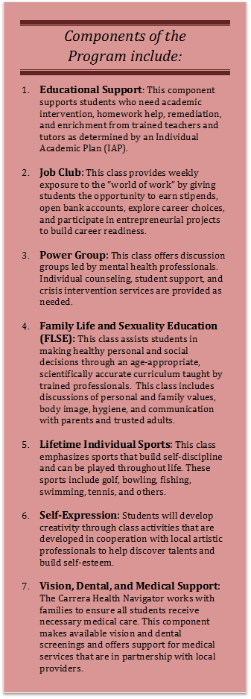
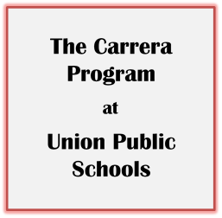
Appendix A: Carrera Program Descriptive Flyer
The Carrera Adolescent Pregnancy Prevention Program is in partnership with Union Public Schools and the Community Service Council of Tulsa. This research-based program employs a long-term, holistic approach to empower and educate our youth. The Union Carrera initiative is a replication of a successful national model that selects students entering the sixth grade and serves them through high school graduation and college admission. Guided by the philosophy that identifies youth as "at promise" rather than "at risk," the program is designed to enhance students’ social, emotional, and academic capacity by fostering a decision and plan to avoid teen pregnancy. Extended learning opportunities are offered before and after school, during school breaks, and in the summer to provide continuity and enrichment throughout the year.

At Union, the Carrera Program currently serves a total of 850 students in the Sixth, Seventh, Eighth, and Ninth grades (220 students per grade). The program will progress with students each year and will ultimately reach students in 6-12th grades, serving approximately 1500 students. The students are recommended by elementary staff as candidates who could benefit from the extraordinary emotional and educational support available to program participants. After attending informational meetings, parents choose the opportunity for their student to be a part of the Carrera Program and they are invited to participate in parent programming throughout the year.

The Carrera staff of educators, mental health, family life, and job club experts bond with their cohort group in 6th grade and stay with them through high school graduation to provide a continuous support system. These additional Carrera staff members magnify the impact of Union teachers to ensure that students progress by providing additional adults to care for and guide them through adolescence.

Adolescence is a time of enormous change for all young people and many students are uniquely challenged to deal effectively with physical, emotional, family, and/or academic issues. At Union, we realize that a quality educational experience, enhanced by additional resources, can help "at promise" students succeed and thrive. Without the additional staff, time, and enrichment, the traditional school experience can be insufficient to help students overcome barriers to success.

The Carrera Program at Union is making a difference in the lives of students. Data being collected are expected to verify the impact of this model on the behaviors, decisions, and learning outcomes of our students. However, the experiences of our students already tell the story. Due to the influence of the staff and program, students are maturing, developing better adaptive behaviors, coping with their anger in more appropriate ways, learning to trust adults, and making healthier personal decisions. The Carrera Program is a strong model, because it focuses on the specific issue of pregnancy prevention by dealing with sexuality education from the waist up, by supporting and educating the whole child to make good decisions, and by providing an environment of care and support throughout the secondary school experience.

We are grateful to the Carrera Program, the Community Service Council, and the George Kaiser Family Foundation for making this program possible for students in Union Public Schools.
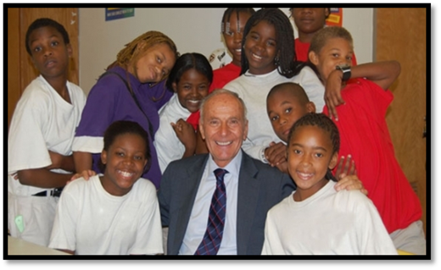

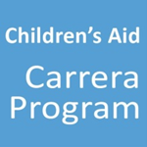


Appendix B: Union Carrera Program Recommendation Criteria
The criteria below are intended to serve as guidelines to help identify students who would most benefit from the Union Carrera Program.

General Criteria
- A need for positive adult mentors
- Would benefit from receiving engaging life experiences and may not have any other way to receive them
- Needs assistance with regular medical, dental, or vision care
- Must be cognitively capable of grasping program curriculum
- May be natural leader/role model and provide positive influence for peers

Academic Factors to Consider
- Receives Tier 2 or Tier 3 intervention but does not qualify for special services
- Consistently does not show skill mastery on the CRTs or CFAs
- Below level in reading
- Scored limited knowledge or unsatisfactory on the previous year’s OCCT
- Needs consistent one-on-one, small group, or focus group intervention

Family Life and Sexuality Education Signs to Consider
- Dating older people/ dating at all
- Very inquisitive about relationships
- Early on-set of puberty/ development
- Low self-esteem/ body conscious
- Lots of unsupervised time at home
- Has parents who were teen parents or have a sibling that is/was a teen parent
- Disengaged parents or very little positive adult influences at home

Mental Health Signs to Consider
- Known history of trauma (domestic violence, abuse, separation from family, natural disasters, instability at home, multiple losses, etc.)
- Exhibits emotional challenges via bullying, getting bullied, emotional breakdowns in class, emotional immaturity or self-harming behaviors
- Withdrawn or with low self-esteem
- Attention seeking behaviors or those that may present as overly sexualized or promiscuous
- Lacking an understanding of the value of a quality education

In order for the components of the Carrera Program to be effective, students must be present in class and generally able to function in relationships with teachers and students.

Characteristics that are generally not a good fit:
- Severe behavioral issues that prevent the student from attending class with some regularity or function as a class member even when provided with appropriate teacher support
- Need for a higher level of care than what can be provided at school (i.e. intensive outpatient therapy or inpatient services)
- Severe mental health disorders that create extreme instability or cause frequent absences

Appendix C: Sample Individual Academic Plan
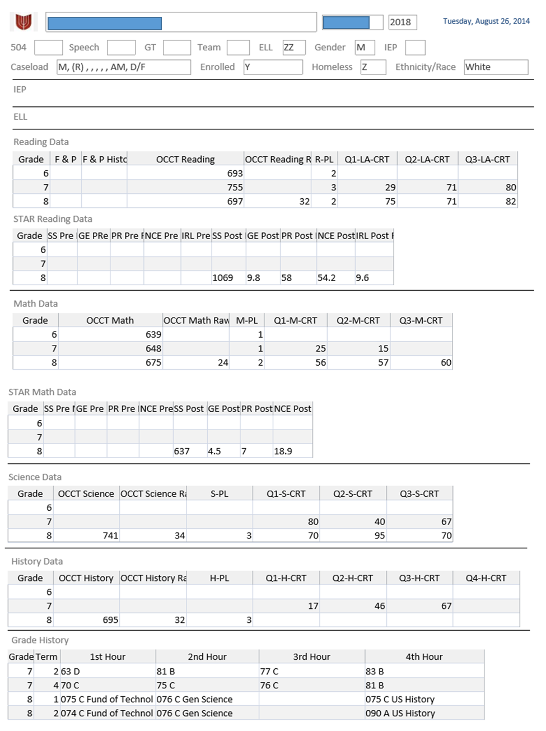
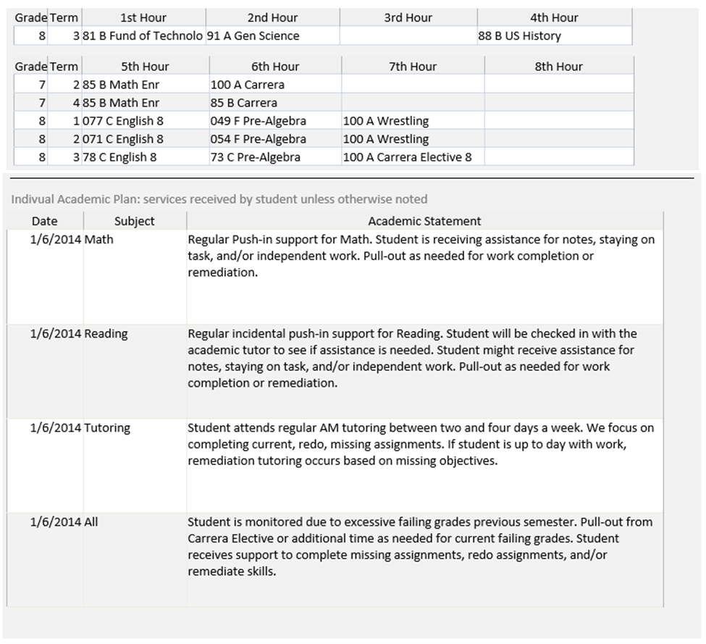

Appendix D: School Health Indicators Student Survey Items
Autonomy Support
7 items, 1-4 scale, strongly disagree (score 1) to strongly agree (score 4), student respondent
1. Teachers encourage students to work in their own way.
2. Teachers talk about the connection between what is studied in school and what happens in real life.
3. Teachers allow students to decide things for themselves.
4. Teachers listen to the opinions and ideas of students.
5. Teachers respect students when they share what they really think.
6. Teachers explain why it is important to study certain subjects in school.
7. Teachers show students how to solve problems themselves.

Competence Support
7 items, 1-4 scale, strongly disagree (score 1) to strongly agree (score 4), student respondent
1. Teachers in this school really make students think.
2. Teachers in this school expect students to do their best all of the time.
3. Teachers in this school expect students to work hard.
4. Teachers in this school challenge students to achieve academic goals.
5. Teachers in this school help students with difficult assignments.
6. Teachers in this school celebrate the achievement of students.
7. Teachers in this school make learning interesting.
Student Trust in Teachers (Relatedness)
10 items, 1-4 scale, strongly disagree (score 1) to strongly agree (score 4), student respondent
1. Teachers are always ready to help at this school.
2. Teachers at this school are easy to talk to.
3. Students are well cared for at this school.
4. Teachers at this school always do what they are supposed to.
5. Teachers at this school really listen to students.
6. Teachers at this school are always honest with me.
7. Teachers at this school are good at teaching.
8. Students at this school can believe what teachers tell them.
9. Students learn a lot from teachers at this school.
10. Students at this school can depend on teachers for help.

Self-Regulated Learning
6 items, 1-4 scale, strongly disagree (score 1) to strongly agree (score 4), student respondent
1. I do my classwork because I think it is important.
2. I do my classwork because I want to learn new things.
3. I do my classwork because doing well in school is important to me.
4. I try to do well in school because I like doing a good job on my work.
5. I do my homework because I want to learn new things.
6. I do my homework because I want to understand the subject.

