University of Oklahoma

Graduate College

The Visualization of the american southwest:
Ethnography, tourism, and american indian souvenir arts

A Dissertation

submitted to the Graduate Faculty

in partial fulfillment of the requirements for the

Degree of

Doctor of Philosophy

By

Caroline jean fernald
Norman, Oklahoma
2017

the visualization of the american southwest:
ethnography, tourism, and american indian souvenir arts

A Dissertation approved for the
School of Visual Arts

By

______________________________
Dr. W. Jackson Rushing, III, Chair

______________________________
Mr. B. Byron Price

______________________________
Dr. Alison Fields

______________________________
Dr. Kenneth Haltman

______________________________
Dr. David Wrobel

© Copyright by caroline jean fernald 2017
All Rights Reserved.
For James Hagerty

Acknowledgements
I wish to extend my most sincere appreciation to my dissertation committee. Your influence on my work is, perhaps, apparent, but I am truly grateful for the guidance you have provided over the years. Your patience and support while I balanced the weight of a museum career and the completion of my dissertation meant the world! I would certainly be remiss to not thank the staff, trustees, and volunteers at the Millicent Rogers Museum for bearing with me while I finalized my degree. Your kind words, enthusiasm, and encouragement were greatly appreciated. I know I looked dreadfully tired in the weeks prior to the completion of my dissertation and I thank you for not mentioning it. The Couse Foundation, the University of Oklahoma’s Charles M. Russell Center, and the School of Visual Arts, likewise, deserve a heartfelt thank you for introducing me to the wonderful world of Taos and supporting my research. A very special thank you is needed for Ginnie and Ernie Leavitt, Carl Jones, and Byron Price. I would not have made it this far if not for your help. Finally, I would like to thank my quirky little band of interdisciplinary friends and colleagues at the University of Oklahoma, my musical friends in Taos, Norman, Chicago, and beyond, my family, Nat, Oskar J. Kittistein, and Lil’ Bill. I love and like you all very much.

Table of Contents

Acknowledgements iv
Abstract vi
Chapter 1: Introduction 1
Chapter 2: Collected Works: The Development of American Anthropology and the Diffusion of Scientific Imagery in the Long Nineteenth Century……………………...13
Chapter 3: Artifacts and Fictions in Ethnographic Portraiture: Frank Hamilton Cushing, John K. Hillers, and Elbridge Ayer Burbank…………………………………………..70
Chapter 4: Curating the Southwest: Museum Anthropology and the Santa Fe Railway…………………………………………………………………………………91
Chapter 5: Survivance and Souvenirs: Native Epistemologies and the E. Irving Couse Collection of Pueblo Pottery………………………………………………………….113
Chapter 6: Conclusion………………………………………………………………...129
References 133
Appendix: Figures…………………………………………………………………….146

Abstract
This dissertation addresses the visualization, or artistic documentation, of the American Southwest in the nineteenth and early twentieth centuries. Artistic images in the form of drawings, paintings, photographs, and prints shaped the way Americans conceptualized and understood the Southwest and its Indigenous inhabitants, and through their circulation in popular texts, scientific reports, and marketing materials, were effective in establishing the region as a distinct cultural and geographic zone ripe for tourism. I focus on the interconnections and exchanges between ethnographic texts and images, such as the publications of the Bureau of American Ethnology, Native American and European American artworks produced by Pueblo potters, Nampeyo, John K. Hillers, Elbridge Ayer Burbank, and E. Irving Couse, and the marketing materials of the Santa Fe Railway, the main promoter and creator of the tourist industry in the region. The visualization of the Southwest in scientific reports, artistic renderings, and promotional literature presented the region as a space that existed outside of modernity. Anthropologists, artists, and the Indigenous subjects of their ethnographic inquiry attempted to transcend the passage of time by documenting, in text and image, the memory of the art, culture, and people of the region. I suggest that this documentation was intended to give permanence to a time, place, and culture that was believed to be slipping away. By recording this information in the form of anthropological reports and artistic images and objects, the original source was given a form of permanence that allowed phenomenological resonances of the Indigenous cultures of the Southwest to extend beyond the confines of the region and the temporality of the period. Finally, through an analysis of the interconnectivity of anthropological reports and practices, ethnographic portraiture, and promotional imagery for the tourist market, I argue that American Indians were also engaging in auto-ethnography and self-preservation for the sake of future generations by replicating their culture through the acts of sharing protected knowledge and materials with anthropologists, modeling for artists, and producing traditional arts en masse for sale to tourists.

Chapter 1: Introduction
On March 4th, 2004, the Art Institute of Chicago purchased a set of eight paintings by Elbridge Ayer Burbank, an artist from Harvard, Illinois known for creating an encyclopedic visual record of American Indians in the late 1800s (Figures 1-8). Each of the paintings represents a member of the Hopi Snake Dance society, a sacred ceremonial order responsible for preserving and protecting the details of the ritual performance. Burbank completed the portraits in 1898 after observing the dance and convincing eight members of the society to allow their likenesses to be documented. The portraits were accessioned into the permanent collection of the Field Columbian Museum in Chicago shortly after their creation and were displayed at the museum alongside photographs of the ceremony’s progression and various items relating to the dance. Like the photographs and ceremonial objects, Burbank’s paintings assisted museum visitors in visualizing the dance, yet at the same time, these images stood in for the dancers themselves in that their presence in the museum acted as an extension of Hopi cultural knowledge. After all, one had to be initiated into the Snake Dance society, and despite the public performance of the dance, a popular tourist attraction at the turn of the century, only members of the order knew the true meaning and purpose of the ceremony.
After the Native American Graves Protection and Repatriation Act (NAGPRA) was passed by Congress in 1990, museums like the Field were required by law to return and remove from public view any human remains, grave goods, and significant ceremonial objects of Native American origin. Over the course of several years, many items in the Field Museum’s collection were repatriated and one of their exhibition cases (Figure 9) was covered by request of the tribal nation whose cultural patrimony was stored inside, thus creating a visual display about NAGPRA’s role in contemporary museum practice. Items eligible for repatriation did not include, however, photographic or artistic representations of burials, sacred sites, or ceremonial dances. In 2004, the Burbank Snake Dance portraits were not deaccessioned from the Field Museum’s collection on account of their association with Hopi religion. Instead, they were formally removed from the collection along with several other nineteenth-century painted portraits of American Indians and sold as a means to raise $15 million in funds for the institution’s general operating budget. Curators at the Field Museum determined that the paintings had no ethnographic value, and yet photographs created at the same time as Burbank’s portraits remain in the museum’s collection.
The shifting identity of Burbank’s portraits from objects of ethnographic value to works of fine art worthy of prominent display in the Art Institute’s American wing (Figure 10) acts as a point of departure for discussing the central themes, methodologies, and arguments of this dissertation. By the time Burbank had created his Snake Dance images, ethnologists, oftentimes affiliated with American museums, had been studying the Indigenous cultures of North America and collecting ethnographic material to support their research for almost a decade. Early anthropological methods of ethnographic documentation, collection, and representation emphasized and categorized American Indians as racial types with physiognomic traits distinct to each geographic region in the United States. The American Southwest was of particular interest as a site for ethnographic research due to its distinct cultures and customs as well as the region’s Indigenous residents’ presumed resistance to assimilation and modernization.
In this dissertation, I address the visualization, or artistic documentation, of the Southwest in the nineteenth and early twentieth centuries. These artistic images in the form of drawings, paintings, photographs, and prints shaped the way many Americans conceptualized and understood the Southwest and its Indigenous inhabitants and were effective in establishing the region as a distinct cultural and geographic zone ripe for tourism. I focus on the anthropological precedents evident in illustrated scientific texts and their influences on artistic representations of American Indians in the Southwest. The following chapters address the interconnections and exchange between ethnographic texts and images, Native American and European American art, and the marketing materials of the Atchison, Topeka, and Santa Fe Railway, the main promoter and creator of the tourist industry in the region. I focus additionally on the documentation of significant cultural information in scientific texts, artworks, and Santa Fe Railway advertisements, the multivalent modes of reproduction of culture and art in the establishment of a tourist market, and the replication of Native American traditional arts in the form of souvenirs. My research into these visual and textual influences on artistic representation should further the academic understanding of how artistic images shape perceptions of Indigenous cultures.
In addition to demonstrating the various modes of cyclical exchange and reciprocity between anthropology and European American and Native American art, I examine why certain scenes and subjects were emphasized by ethnographers and artists working in the Southwest, what manner of visual vocabulary was established through ethnographic photography, how that vocabulary influenced subsequent artistic representations of similar subjects, and in what ways the combination of ethnographic imagery and anthropological prose informed and reinforced the authority of both mediums. Despite an abundance of information regarding anthropological influences on artists such as Burbank, the majority of scholarship on works depicting the Southwest has focused solely on the biographical details of the individual artists. In contrast, I address the relationship between artworks produced by European American artists and the Native American art objects they collected and depicted in their work. By applying a biographical approach to the study of these objects, I analyze the cultural content present in certain designs and motifs in Native American art by taking these objects into serious consideration as primary documents and visual records.
In chapter two, I trace the history of anthropological theories and practices in the United States, how they were represented in illustrated scientific reports, and how the circulation of this information influenced subsequent publications and the images used to illustrate them. This chapter presents a theme recurrent throughout my dissertation regarding the blurred distinction between art and ethnography in the visual documentation of the Southwest. In addition, an underlying theme present in this chapter addresses the technological advancements in image production and reproduction as evidenced in scientific texts and how these advancements inspired and, at times, delayed new discoveries. Chapter three delves into the collecting practices of artist ethnographers, the stylistic influences of anthropological precedents in the production of their images, and the mediation of the artists in the staged presentation of their own artifact collections in ethnographic portraiture. Just as the previous chapter addresses the blurred distinction between art and ethnography, this section focuses on the shifting ethnographic value of photographic and painted portraits of American Indians and their use in anthropological museum displays. Chapter four focuses on the relationships that formed between the Santa Fe Railway and the anthropological institutions that relied on the former’s cooperation and access to Indigenous communities for the collecting purposes of the latter. As a result of this exchange, the exhibition styles practiced by anthropological museums influenced the promotional efforts of the Santa Fe Railway and the images produced for their marketing purposes. In chapter five, I discuss changes to the function of pottery created by Pueblo communities in the Southwest in response to the introduction of tourism to the region. Despite some potters adapting their styles to meet the demands of potential buyers of their wares, I contend that many of the techniques and designs employed during this period predate tourism and were continuously reproduced in the form of souvenir arts as a way to maintain and preserve the religious beliefs and world views associated with their manufacture. My dissertation concludes with an analysis of the impact of anthropological research and tourism on the Indigenous communities of the Southwest and how recent events and museum exhibitions demonstrate the evolving dialogue regarding cultural patrimony and intellectual property.
Numerous scholars from a variety of academic disciplines have addressed the themes of railroad history, tourism, artistic representation of American Indians, and the market for Indigenous souvenir arts. For example, Keith L. Bryant, Jr.’s History of the Atchison, Topeka, and Santa Fe Railway (1974) and Carlos A. Schwantes’s and James P. Ronda’s The West the Railroads Made (2008) both trace the history of the transcontinental railroads and their impact on the landscape, commerce, and culture of the West. The body of scholarship on tourism in the United States is vast, but some key works are essential to note. Earl Pomeroy’s In Search of the Golden West (1957), Daniel J. Boorstin’s The Image: A Guide to Pseudo-Events in America (1961), and Dean MacCannell’s The Tourist: A New Theory of the Leisure Class (1976) address the various motives and expectations of tourists traveling in the West. Tourists had a significant influence on the Southwest and were integral to shaping the market for American Indian art. Pomeroy, Boorstin, and MacCannell additionally address the reasons why tourists were compelled to travel in a quest for American identity, authenticity, and, in some cases, inauthenticity.
The themes of authenticity, identity, and artificiality are important to understanding the larger historical and sociocultural context for the production of art at the turn of the century, and several works that examine the antimodernist movement prove to be relevant. Lee Clark Mitchell’s Witness to a Vanishing America: The Nineteenth-Century Response (1981) addresses the lack of a distinctly American culture and argues that travel provided a way for Americans to discover and shape their own identity at the same time that they were reconciling the destructive and violent nature of the nation’s past. In other words, Americans were lamenting the loss of the frontier as they were taking advantage of the advancements in technology and industry in the West that expedited its destruction. Antimodernism, a term coined by T.J. Jackson Lears in No Place of Grace: Antimodernism and the Transformation of American Culture, 1880-1920 (1981), defines the desire for travel in the West as a form of escapism from the industrial, urban centers of the East. However, Lears contends that the same social hierarchies and respective issues were simply replicated in the West. This perspective is important when considering the numerous connections between the industrial center of Chicago and the tourist market of the Southwest.
Marguerite Shaffer’s See America First: Tourism and National Identity, 1880-1940 (2001), Robert L. Dorman’s Hell of a Vision: Regionalism and the Modern American West (2012), and Hal K. Rothman’s Devil’s Bargains: Tourism in the Twentieth-Century American West (1998) all address the quest for a distinctly American identity at the turn of the century. The authors also discuss American tourist attractions, such as national parks and the environments built around them for tourist accommodations, as spaces to experience and create American identity. Native American art, history, and culture were also appropriated as a part of America’s history and antiquity and were oftentimes linked to tourists’ experiences while traveling to parks. In many ways, appropriation acted as a form of preservation and allayed tourists’ anxieties regarding the presumed disappearance of the frontier West.
The development of anthropological practices during the nineteenth century and concerns over the disappearance of Native American cultures has been discussed in a variety of texts. Curtis M. Hinsley’s The Smithsonian and the American Indian (1981), Leah Dilworth’s Imagining Indians in the Southwest: Persistent Visions of a Primitive Past (1996), and Don D. Fowler’s A Laboratory for Anthropology: Science and Romanticism in the American Southwest, 1846-1930 (2000) address the history of anthropology in the Southwest, and Dilworth’s text frames the appropriation and preservation of Native American art, history, and culture within the larger context of the antimodernist movement. Hinsley and Fowler trace the theoretical background and methodological approaches of anthropologists working in the Southwest and provide a useful historical context for understanding the style and content of ethnographic imagery published in scientific reports.
Artistic representations of American Indians are the most significant resource for understanding the stylistic influences and established conventions of scientific and artistic imagery, and several notable works address the larger historical context of the production of said images. William H. Goetzmann and William N. Goetzmann’s The West of the Imagination (2009) provides a general survey of the art of the American West and focuses on the history of representations of American Indians by European American artists. Very few of the artists addressed in the text have been given significant scholarly attention. Therefore, The West of the Imagination is useful for placing specific artists within a larger art historical context. Martha A. Sandweiss’s Print the Legend: Photography and the American West (2002) also provides a thorough overview of photographic representations of American Indians, their historical context, and their connections to stylistic conventions in American art. Her work is important to my dissertation research because she emphasizes the agency of American Indian subjects in the production of photographic portraiture. She argues that the images were largely received by viewers as containing factual information when, in reality, they were oftentimes manipulated according to the photographer’s motives. Furthermore, the technological limitations and stylistic conventions of the medium determined the appearance of the compositions. Acknowledging the process of creating artistic images is an important factor to consider when examining representations of American Indians because the figures posing for the photographer have some degree of control over how they are portrayed.
Judith Barter’s Window on the West (2003), Charles C. Eldredge’s Art in New Mexico, 1900-1945: Paths to Taos and Santa Fe (1986), and Dean Porter’s Taos Artists and Their Patrons (1999) focus on the influences of the Santa Fe Railway and its connections to patrons and cultural institutions in Chicago. Barter’s text discusses the influences of the anthropological practices at the Chicago World’s Fair and the Field Museum on the growing interest in American Indians as artistic subjects, which is significant because many of the artists, such as Burbank, and the Santa Fe Railway’s headquarters were based in Chicago. “Science and Sentiment: Indian Images at the Turn of the Century,” William H. Truettner’s essay in Art in New Mexico, also addresses the influences of the World’s Fair and anthropological practices on the modes of representation in artistic images of American Indians, and stresses the connections between the Santa Fe Railway and anthropological methods. Porter’s text analyzes the commercial motives for the production of paintings depicting American Indians and the influences of patronage on the establishment of stylistic conventions in the Taos Society of Art (TSA). Many of the artists in the TSA produced work for the Santa Fe Railway’s promotional use, and the repetitive compositional structure in many of their paintings indicates that these artists almost certainly had commercial reproduction in mind when creating their images.
The agency of Native American subjects in artistic images produced by European Americans and the cultural incentives for selling traditional arts for the tourist market are subjects that have not been directly addressed in relation to the promotional imagery of the Santa Fe Railway and the souvenir trade in the American Southwest. The majority of scholarship focuses on colonial and European American influences on traditional arts and the economic opportunities that tourism provided Indigenous artists. For example, Jonathan Batkin’s The Native American Curio Trade in New Mexico (2008) recounts the history of the tourist trade, but does not address the stylistic continuities in Native American art from the Southwest that exist despite external influences. Both Elizabeth Hutchinson’s The Indian Craze: Primitivism, Modernism, and Transculturation in American Art, 1890-1915 (2009) and Ruth B. Phillips’s Trading Identities: The Souvenir in Native North American Art from the Northeast, 1700-1900 (1998) discuss the production of traditional arts for the tourist market from a postcolonial perspective as processes of transculturation and hybridity. Souvenir arts, as objects that transcend the expectations of the tourist market, blend tradition, function, and aesthetics, and the framework for understanding this process provided by Hutchinson and Phillips is useful for establishing a more nuanced perspective in regards to the production of tourist art in the Southwest. In addition, the arguments presented in Joy Kasson’s Buffalo Bill’s Wild West: Celebrity, Memory, and Popular History (2000), Sascha T. Scott’s A Strange Mixture: The Art and Politics of Painting Pueblo Indians (2015), and Shamoon Zamir’s The Gift of the Face: Portraiture and Time in Edward S. Curtis’s The North American Indian (2014) are applicable to my own claims regarding the desire by Native American individuals to engage in auto-ethnography by performing their culture for European American audiences, posing for artists, producing and selling traditional wares, and sharing protected information with outsiders.
Finally, three art historical texts provide methodological influences on the shaping of the arguments presented in my dissertation. Thomas Crow’s The Intelligence of Art (1999) proposes that the phenomenon of the acknowledged ending to a period in art production or the anticipation of significant change in a culture can provide a useful model for analysis in that the artist, whether consciously or not, anticipates this sense of an ending in the creation of their work. Alexander Nemerov’s Acting in the Night: Macbeth and the Places of the Civil War (2010) suggests that the creation of souvenirs allowed for ephemeral experiences to be given a form of permanence. Like souvenirs, technological advancements in communication and the reproduction and circulation of images allowed for individuals to have a greater presence through the dissemination of their likeness and memory. The Melancholy Art (2013) by Michael Ann Holly suggests that melancholic writing as a method in art history gives precedence to an object or individual’s resonances and phenomenological presence more so than interpreting its meaning and social context. In that regard, it is equally important to address an art object’s place in history as it is to acknowledge the presence of the past in an object, how it is remembered, and how its identity shifts and alters over time.
The visualization of the Southwest in scientific reports, artistic renderings, and promotional literature presented the region as a space that existed outside of modernity. Anthropologists, artists, and the Indigenous subjects of their ethnographic inquiry attempted to transcend the passage of time by documenting, in text and image, the memory of the art, culture, and people of the region. I suggest that this documentation was intended to give permanence to a time, place, and culture that was believed to be slipping away. By recording this information in the form of anthropological reports and artistic images and objects, the original source was given a form of permanence that allowed phenomenological resonances of the Indigenous cultures of the Southwest to extend beyond the confines of the region and the temporality of the period. Finally, through an analysis of the interconnectivity of anthropological reports and practices, ethnographic portraiture, and promotional imagery, I argue that American Indians were also engaging in auto-ethnography and self-preservation for the sake of future generations by replicating their culture through the acts of sharing protected knowledge and materials with anthropologists, modeling for artists, and producing traditional arts en masse for sale to tourists.

Chapter 2: Collected Works

The Development of American Anthropology and the Diffusion of Scientific Imagery in the Long Nineteenth Century
The Smithsonian’s National Museum of the American Indian, George Gustav Heye Center in New York City houses, among its vast collection of cultural artifacts, a ceramic bowl (Figure 11) featuring a mirrored interior design of twin deer paired with charismatic macaw heads against a field of complex geometric patterns. Jesse Walter Fewkes, an archaeologist in the employ of the Smithsonian’s Bureau of American Ethnology (BAE), collected the bowl in 1914 on an expedition to the American Southwest and later sold the vessel to Heye. The bowl originates from the artistic traditions of the Mimbres people, an ethnographic subsect of the larger Mogollon culture, who resided primarily along the Mimbres River in southwestern New Mexico from C.E. 1000-1150. It was excavated shortly before Fewkes’ arrival in the Mimbres Valley by E. D. Osborn, a rancher and amateur archaeologist who wrote to Fewkes at the BAE about the discoveries on his family’s ranch. Prior to these discoveries, the existence of the Mimbres culture, their societal practices, artistry, and history within the region was completely absent from the archaeological record of the Southwest. In fact, no comparable society or logical, descendent culture could be linked to the Mimbres. A report on the findings at Osborn’s ranch, penned by Fewkes and published by the Smithsonian in the year that Heye purchased the aforementioned Mimbres vessel, notes the abundance of archaeological material unearthed in the Mimbres Valley and the subsequent mounting evidence of a complex society separate from all other known groups in the region. Furthermore, due to the absence of both a satisfactory dating method and a written historical record of the Southwest prior to the sixteenth century, anthropologists lacked a solid understanding of the history of human occupation in the area.
At the time that the BAE was founded in 1879, the popularity of Charles Darwin’s evolutionary theory within the scientific community and the writings of social theorist Lewis Henry Morgan among anthropologists resulted in the dominant emphasis on social evolution as a methodological framework for anthropological research in the Southwest. Through the lens of social evolution, cultures were believed to advance through a series of incremental stages of development with each step becoming increasingly sophisticated. Per Morgan, cultures advanced from savagery to barbarism to civilization at different rates, yet not all societies demonstrated development through all three stages. Australian Aborigines, for example, were thought to be incapable of social development beyond the level of savagery, and contemporary Pueblo Indians were considered to have advanced only to the stage of middle barbarism. Due to their perceived evolutionary limitations, the latter could only develop further by assimilation and integration, through intermarriage and reproduction, with the European American race.
From its founding, the BAE aligned its research methodologies with Morgan’s theory of social evolution, and so Fewkes’ archeological work in the Southwest, the content of his Mimbres report, and his interpretation of Mimbres material culture reflect the influences of this approach. By Morgan’s model, contemporary Indigenous communities in the Southwest were at their developmental peak in the chain of social evolution. Therefore, all ancestral societies in the region would, by default as the precursors to Pueblo and Hopi people, demonstrate increasingly archaic cultural practices and artistic abilities as they were traced backwards in time. In material culture, for example, the use of naturalism in artistic representation was deemed an essential step toward social advancement as it indicated a long history of a sedentary lifestyle and multiple generations of continuously evolving artistic traditions. Upon its discovery and identification as a society that predated the earliest known cultures in the Southwest, Mimbres material culture should have demonstrated an absence of naturalism, a lack of advanced artistic skill, and an identifiable cultural link to contemporary American Indians from the region. On the contrary, Mimbres pottery is renowned for its crisp, clean lines, naturalistic and dynamic figures, and complex compositional arrangements that have only indirect associations with known Puebloan histories.
Despite the lack of evidence for a direct link between the Mimbres and any contemporary American Indian groups in the Southwest, Fewkes’ report connects the images represented in Mimbres material culture to the customs, artistic traditions, and oral histories of the Hopi. Any evidence to the contrary simply did not fit within the BAE’s understanding of the social evolution of tribal communities in the Southwest, and Fewkes’ 1914 publication reflects the discrepancies in his viewpoint. For example, Fewkes’ report classifies Mimbres pottery as a mere precursor and rudimentary stage toward the development of the more advanced Sikyatki style—a prehistoric pottery type dating to approximately 1300 to 1600 that was first identified by Fewkes in 1895. In his Mimbres report, Fewkes notes, “Although these decorations are, as a rule, inferior to those of the Hopi ruin, Sikyatki, the figures of animals are more numerous, varied, and realistic.” In this statement, Fewkes, in effect, contradicts himself and the social evolution model by acknowledging the advanced use of naturalism in Mimbres pottery, and his report offers no further explanation for the inferiority of Mimbres to Sikyatki pottery styles beyond his use of the phrase “as a rule.” Instead, Fewkes repeatedly interprets the former’s ceramic motifs as identifiable precursors to the cultural practices of the latter as an essential stage in the social evolution of the Hopi.
This analysis of Fewkes’ critique of Mimbres ceramics is not intended to counter his judgment of quality, but, rather, it presents an example of the multiple ways in which dominant anthropological theories informed and limited the interpretation of ethnographic materials collected in the Southwest. This chapter focuses on the development of these theories in relation to the professionalization of anthropology as an academic discipline in the United States during the long nineteenth century. Although vast quantities of ethnographic objects were collected during this time, this chapter does not directly address the physical objects or ethnographic subjects collected and studied by anthropologists working in the Southwest. The emphasis, instead, is on their representation in text and image and their interpretation in scientific reports as markers of intellectual shifts in anthropological thought. This chapter also provides a framework for understanding subsequent sections of my dissertation and the visual, theoretical, and methodological precursors that influenced fin-de-siècle artistic representations of the Southwest. The establishment of this groundwork is important to fully understand the lack of distinction between art and ethnography at the turn of the nineteenth century and the significance of its blurred boundaries to the establishment of anthropology as an academic discipline. By focusing on publications significant to the development and professionalization of anthropology, this chapter addresses the various schools of thought, dominant theories, intellectual shifts, and diffusions of knowledge within assorted scientific circles through the circulation of illustrated scientific reports.
To effectively present this information, it is important to note the basic tenets of anthropology and its own developmental history. The field of anthropology is divided into four branches: sociocultural anthropology, or ethnology, physical anthropology, linguistics, and archaeology. However, these four branches and their respective methodologies were not formally defined in the United States until 1899 when Franz Boas, an anthropologist working for the American Museum of Natural History (AMNH), published a paper outlining this program of study as a “science of man.” Boas further defined the unique role of anthropology within the field of science by stating “these subjects are not taken up by any other branch of science and in developing them anthropology fills a vacant place in the system of sciences.”
Up until that point, and, to a certain degree, continuing for several decades, the field of anthropology as well as its professional methods were being invented at the same time that they were being practiced. Many of the first, most influential anthropologists had received no formal training, and several of these figures could be best described as self-taught, having come to anthropology from other disciplines. Fewkes, for example, was trained as a marine zoologist and changed his vocation after being fired from his position at the Harvard zoology museum due to accusations of plagiarism. Due, in part, to Fewkes’ past history and notoriety as a plagiarist, it is almost certain that much of the content in his 1914 Mimbres report is lifted from Osborn’s own observations and correspondence. In the early years of American anthropology, especially as it was practiced in the Southwest, the work of so-called professionals was supported and sometimes reliant on the discoveries of amateurs. However, what separated most professional anthropologists from amateurs was little more than an affiliation with a scientific institution and a regular paycheck.
Although the professionalization of the field dates to the late nineteenth century, the consistent themes and ongoing arguments in American anthropology can be traced back to the United States’ third president, Thomas Jefferson, and are aligned with the history of the development of the nation. In 1787, Jefferson submitted Notes on the State of Virginia as a counter argument to Georges Louis-Leclerc, Comte de Buffon’s 1749 L’Histoire Naturelle, a treatise that proposed both European Americans and American Indians were underdeveloped and incapable of greatness due to the influences of their surrounding environment. According to Buffon, the wild environment of America stifled intellectual and physical growth, which accounted for the lack of great civilizations in the Americas both past and present and the diminutive size and inferior quality of American flora and fauna. An incensed Jefferson personally delivered his text in response to Buffon’s polemic along with specimens of America’s most impressive wildlife, the panther and the moose, as visual examples to counter Buffon’s argument regarding environmental influences on growth.
Notes on the State of Virginia is curiously devoid of images and instead relies solely on a series of charts to illustrate the author’s points. In reference to his argument with Buffon regarding the size and quality of their respective nations’ flora and fauna, Jefferson’s text includes a chart (Figure 12) comparing the range of species native to Virginia that are non-existent in Europe, which presents a striking visual example to emphasize his point as the list of European species is quickly outnumbered by the wide array found in the Americas. In addition, Jefferson’s text, among many subjects, expounds the great merits of Virginia society and governance and examines the history and origins of its native peoples, which led to a century-long debate about the progenitors of the massive earth mounds found across the Midwest and Southeast and their possible modern descendants.
During Jefferson’s time, the racial difference in humans was explained through the biblical perspective of monogenesis or the creation of man by the Christian God. From this viewpoint, racial difference was the result of the proliferation and migration throughout the world of the biblical figure Noah’s three sons, Japheth, Shem and Ham, creating the three respective races of man, Caucasian, Ethiopian, and Mongolian. American Indians were believed to be the descendants of the latter. Science was used to supplement biblical teachings, and the growing popularity of Enlightenment scientific thinking and rationalism among educated elites as well as the application of the classification models in Carl Linnaeus’ 1735 Systema Naturae influenced a shift toward an understanding of the origins of man and the separation of the races that combined both science and religion. Linnaeus’ model identified three kingdoms within the natural world, animal, vegetable, and mineral. Each kingdom was further classified by order, genus, and species creating a hierarchy within each category.
When applying Linnaeus’ method to the various races of man, this established a taxonomy and hierarchical order with Caucasians as a racially superior species above all others. Inspired by this approach, various American museums in the early nineteenth century began amassing vast collections of human remains in an effort to demonstrate the racial superiority of Caucasians through exhibits of physical evidence and to provide a further taxonomic order within each race that showed the degeneration of character caused by various forms of ethnic mixing. The primary sources for supporting this argument resided in variations in skull shape and volume, the latter providing evidence for larger brain capacity, superior intelligence, and greater character.
This emphasis on racial superiority can be attributed to the increased expansion of European American settlers into the nation’s interior and the need for scientific evidence that supported the racial inferiority of American Indians and their inevitable decline, like other races before them, in the wake of colonialist expansion. In other words, racial inferiority excused imperialism as colonized societies were biologically predestined to fail. Colonial subjugation, therefore, rescued what would otherwise be failed societies from potential extinction. In addition, the predominant view at the turn of the eighteenth century explained racial difference as the result of environmental influences over time. Within this viewpoint, temperate, as opposed to extreme, climates and environments allowed societies to flourish rapidly and develop advanced agriculture whereas harsh conditions stifled cultural progress and forced these groups to focus primarily on survival. Americans also needed to distinguish themselves from European races to further support their superiority and justify their expansion as a nation. In 1823, the Monroe Doctrine provided a government policy to assert the dominance of European Americans, as opposed to other colonial powers, in the Americas. Furthermore, the burgeoning ideology of Manifest Destiny attributed the success of the United States in gaining independence and rapidly expanding its territory to divine intervention by God. European Americans were preordained to settle the Americas and bring civilizing forces to its most undeveloped regions.
In 1839, Samuel George Morton, a Philadelphia-based physician and natural scientist, published Crania Americana, a large, illustrated volume that provided detailed comparisons of a range of skulls from the Americas. The skulls came primarily from Morton’s personal collection and his specimens from North America were obtained largely from battlefields and burial sites adjacent to military forts. Many of the skulls featured in Morton’s text still bore the markings of the recent violence that led to the victim’s demise. For example, Plate 22 of Crania Americana (Figure 13) displays an incomplete, fractured skull with a prominent bullet hole next to the left temple. The skull, identified as a Seminole prototype beneath the image, is pictured in three-quarter view as a means to illustrate the flattened facial features Morton’s text associates with North American Indians. Just two years prior to the publication of Crania Americana, the Seminole nation was involved in a heated battle with U.S. troops in Florida. In the Battle of Lake Okeechobee, the Seminoles successfully resisted forced relocation to Indian Territory, if only temporarily, and a minimal amount of Seminole life was lost. Several of the individuals who did perish, however, were collected at Morton’s request, added to his archive of skulls, and included as an illustration in his text.
Morton’s views of race were highly influenced by Johann Friedrich Blumenbach, a German anatomist, who expanded the three races traced to Noah’s inexplicably racially diverse sons to include Caucasian, Ethiopian, Mongolian, Malay, and American. Blumenbach also provided extensive studies regarding the significance in skull length and profile to comparisons of race. However, Morton’s concerns were focused largely on cranial capacity among the various races as the principal indicator of superior and inferior intelligence. When comparing modern North American Indian skulls to ancient specimens from Meso- and South America, for example, Morton asserted that the flattened facial features, small size, and shallow posterior lobes of North American skulls indicated inferior cranial capacity and intelligence. Skulls from Meso- and South America, however, were elongated with extended posterior lobes, and he provided extreme visual examples in his text (Figure 14), that were certainly the result of deliberate skull shaping in childhood, to emphasize this difference and argue for the degradation in intelligence evidenced by North American Indian skulls.
To further stress this point, Morton labeled ancient North American skulls as “found in mound” as opposed to Meso- and South American skulls, which were labeled as “found in tomb.” This distinction provided Morton with an opportunity to suggest that the earth mounds of North America’s Midwest and Southeast were not the product of modern American Indians or their ancestors due to their perceived incapability to construct the sites, but, rather, were almost certainly created by descendants of the racially superior Toltec, Aztec, and Inca civilizations of Meso- and South America prior to their migration to the south. The racial difference between the various groups and their ancestors was predetermined by God and could not be altered by external influences, such as the environment, which was evidenced by the ability of the ancestors of the Toltecs, Aztecs, and Inca to thrive in multiple geographic regions. Therefore, the differences in race, even in the Americas, was predestined through biological limitations. As biologically inferior, North American Indians were incapable of creating the earth mounds and, consequently, had no ancestral ties to the region, which helped justify government policies enacted in the 1830s to enforce the removal of American Indians from the Southeast into Indian Territory.
In the years leading up to the Civil War, scientific evidence in support of racial determinism, or the innate biological limitations associated with race, gained popularity, particularly among supporters of slavery. Morton’s specific arguments regarding racial determinism, as outlined in Crania Americana, moved slowly in the public domain, as the text, due to its size and lofty price, hindered its popularity. Despite the slow circulation of Crania Americana, the Enlightenment-inspired systems of classification combined with Morton’s theories of racial determinism resulted in the bolstering of a taxonomic hierarchy of race in favor of Caucasians or, more specifically, European Americans. Morton himself never explicitly stated that European Americans were racially superior, but it is greatly implied in his text and it influenced subsequent publications, which note Morton as the originator of this concept. The dissemination of these combined modes of thought is most aptly exemplified by Josiah Clark Nott and George R. Gliddon’s 1854 text, Types of Mankind, which the authors dedicated in the book’s frontispiece to “the memory of Samuel George Morton, M.D.” along with a portrait of the recently deceased scholar.
In Nott and Gliddon’s text, the authors draw comparisons to stylized artistic renderings of race, oftentimes within a culture’s own historic artistic traditions, to the unique characteristics of skull shapes of each category. For example (Figure 15), the authors compare a Caucasian skull to nothing less than a Roman sculpture of Apollo while African skulls are compared to artistic renderings of chimpanzees and orangutans, representations of Africans in historic European art, and several modern caricatures that exaggerate the African facial features identified in the text. Nott and Gliddon also present a Linnaean-style chart of the taxonomy of man grouped in categories by race and region (Figure 16). Caucasians are illustrated next to American Indians; Malaysians are pictured next to Aboriginal Australians. The chart positions an artistic representation of prototypes of each race in profile view above their respective skulls along with a variety of mammals unique to each region below. Scientific images, such as the illustrations featured in Crania Americana and Types of Mankind, were not focused on the individual details of the subject, but on the subject’s representation as an archetype of all species within that order. Although Types of Mankind presents the different races of man as equal, the authors argue that most races are only suited to thrive in their native environment. Any exceptions to this rule, due to migration, immigration, colonization, or enslavement, require interference by the Caucasian race to prevent self-destruction. In reference to Morton’s ideas concerning racial determinism, the fixed biological order of each, non-white race predestined their inferiority, inevitable failure, and reliance on Caucasians to survive. By interpreting difference in skull shape and cranial capacity from the perspective of racial determinism, Morton, Nott, and Gliddon ostensibly proved the racial inferiority of non-whites. Furthermore, their assertion that the biological limitations associated with race were predetermined by God validated colonial expansion and proved that domination by the white race was predestined.
In the United States, Manifest Destiny, the justification for Westward expansion and subjugation of American Indians in the wake of European American advancement into the interior West, was both inevitable and preordained due to the inferior biological restrictions God put in place upon his creation of the various types of mankind. Past triumphs by colonizing forces provided useful models for how to efficiently take control over disparate Indigenous populations. William H. Prescott’s popular 1843 History of the Conquest of Mexico, for example, presented a detailed account of the military defeat of the Aztecs by Spanish troops. In the text, the author places great emphasis on the architectural ruins and ethnographic details relative to the Aztecs at the time of conquest and repeatedly refers to them as the “ancient Aztecs” despite their coexistence with the Spanish conquistadors during the sixteenth century. Prescott’s use of the term “ancient” when describing the Aztecs allowed the author to draw comparisons to racially distinct ancient societies that had long been viewed as being in a post-conquest state of degeneration, such as the ancient Egyptians and the ancient Greeks. American Indians, like contemporary Mexicans, were deemed equally incapable of advanced civilization, but had no identifiable precursors akin to the Aztecs. Prescott references the North American mounds in his text, but argues that the skeletal remains unearthed at those sites are more in line with the skulls found interred in Aztec architectural ruins thereby inferring, like Morton, that the progenitors of the mounds were not American Indian but Mexican in origin.
Throughout the text, Prescott places very little emphasis on the Aztecs’ pre-conquest history, but in a short appendix, he discusses the possible origins of the Indigenous peoples of the New World. In this section, the author links Aztec teocalli architecture, which is best described as a stepped pyramid made of stone with a central stairway leading to a temple, to Mongolian counterparts thus implying the Asian origins of the races of the New World. Prescott also notes the prevalence of destructive floods, similar to the flood relating to Noah, in mythologies around the world as well as similarities in an Aztec legend to the biblical story of the Tower of Babel, which followed Noah’s flood in spreading the races throughout the world. In the Aztec story, the few people left behind after a catastrophic flood began construction on a monumental teocalli in the Aztec city of Cholula with the intention of reaching the heavens. The gods were offended by the attempt of those spared the flood to attain divine status and sent a conflagration to stop the completion of the temple. From this perspective, scientific explanations for the origins of the races of mankind is not in conflict with Christian views of monogenesis because the two theories can be combined.
According to Prescott’s text, the various races, flora, and fauna were resettled across the different continents after the flood by God’s design to “places for which they were clearly intended by constitution and habit.” Indigenous people were naturally suited to their environment, but harsh climates often stunted their intellectual growth and prevented even the most advanced societies, such as the Aztecs, from flourishing. He additionally notes the emphasis on traditions and nature-based, primitive religions as a further prohibition to their progressive development in comparison to Europe. Despite Prescott’s assertions regarding the superiority of the ancient Aztecs to modern day Mexicans, he notes that the former’s crude form of pictographic writing demonstrates their lack of intellectual advancement at the time of conquest due to the absence of a phonetic writing system. He postulates that, if the Aztecs had not been conquered and allowed to thrive for several more centuries, they would have surely advanced almost to the civilization stage of the Spanish colonizers. These biological limitations, whether internal or caused by external forces, resulted in the inevitable decline and subjugation of Indigenous populations by racially superior nations.
Inspired by Prescott’s History of the Conquest of Mexico, the artist Emanuel Leutze created a monumental history painting titled Storming of the Teocalli by Cortez and His Troops in 1848 (Figure 17). Leutze cited passages from Prescott’s text as inspiration for the ethnographic and historic details of the event and pieced together architectural elements of Yucatecan Maya ruins from Frederick Catherwood’s 1844 publication Views of the Ancient Monuments in Central America, Chiapas, and Yucatan. For example, the curved architectural elements jutting from the teocalli (Figure 18), the stone face a woman clings to as she slips into death (Figure 19), and the serpent’s head in the painting’s foreground (Figure 20) all derive from illustrations in Catherwood’s text. Although the Maya sites depicted in Catherwood’s report were approximately 1,000 miles from the Aztec homelands and predated the conquest of Mexico by over 300 years, Leutze had no other visual reference to cite in his painting as Prescott’s text is devoid of illustrations and many of the Aztec ceremonial structures were destroyed by the Spanish in the sixteenth century. Perhaps Leutze was not interested, concerned, or even aware of the ethnographic inaccuracies in his presentation of Aztec culture and simply relied on the closest visual resources available to him at the time.
Leutze’s painting coincides with Prescott’s assertion regarding the Aztecs’ dependence on primitive traditions as a reason for both their failure to advance as a civilization and their inevitable downfall. This is emphasized by the artist in the distinctions between Spanish and Aztec weaponry and clothing, in the dying Aztec warrior who turns away from the cross held by the kneeling friar, and in the despair of the Aztec women praying to a faceless deity at the top of the temple. The conquest of the Aztecs was due, ultimately, to their non-Christian beliefs. Spain as a Christian nation, therefore, had the divine right and duty to take control. If Prescott’s text is the primary reference for Leutze’s painting, then it is possible that the artist is also combining mythological and historic events by representing the previous downfall of the Aztecs after their attempt to build a temple to reach the heavens, thus establishing the myth of the Cholula teocalli as a prophecy of their predestined defeat at the hands of the Spanish and the latter’s association with a superior deity.
One year prior to the completion of Leutze’s painting, American troops reenacted a similar turn of events at the Battle of Chapultepec. The United States had been at war with Mexico since 1846 and Mexican troops ceded control of Chapultepec, an eighteenth-century Spanish castle built atop a hill significant to Aztec history, after a bloody battle. In a declaration of victory, the American flag was raised and flew from the highest point of the castle, which is possibly referenced in the brandishing of the Spanish flag at the top of the teocalli in Leutze’s painting. Just as the Spanish were enacting their divine right by conquering the Aztecs, America also had a preordained duty to fulfill. The nationalistic drive of the Monroe Doctrine, the predetermined fate of Manifest Destiny, and the biological superiority of European Americans combined to prove the inevitable outcome of the United States’ conquest of the New World.
After the Mexican-American War ended in 1848, Prescott’s text gained new audiences as American soldiers returning from war corroborated the author’s accounts of ruined cities and toppled empires. It was also a well-known source among troops due to its detailed analysis of Spanish military strategies in effectively conquering Indigenous populations. The United States’ victory in the Mexican-American War resulted in the accession of new territory stretching from west Texas to California and as far north as southern Utah and Colorado or, with the exclusion of California, the area commonly referred to as the American Southwest. Reconnaissance of these newly acquired lands began immediately as a means to assert control over these hard-won territories. Awe-inspiring geographic features, an abundance of natural resources, and open lands for potential settlement were made available to the growing nation, but aggressive bands of Native tribes posed a threat to the exploitation of the region. Although Hispanic settlers had lived in the Southwest since the sixteenth century, mounting evidence in the form of massive ruined structures suggested that the region had been occupied prior to the arrival of the Spanish.
Between 1838 and 1863, the U.S. Army commissioned expeditions throughout the nation and its potential new territories that were led by officers in the Army’s Corps of Topographical Engineers. Among its leaders’ many responsibilities included surveying the general topography of the lands, recording information about the customs and behaviors of any Indigenous groups encountered by the expedition teams, documenting flora, fauna, and geologic features, and mapping the best sites for establishing military bastions, settlements, and transportation routes. Prior to the accession of new lands after the Mexican-American War, several surveys had traversed the American Southwest, but a concerted effort to study and map the territory did not occur until after the war. Notable expeditions include Colonel John N. Washington and James H. Simpson’s 1849 journey through New Mexico and Arizona in a military campaign against the Navajos, Lorenzo Sitgreaves’ reconnaissance across Arizona in 1851, and the U.S. and Mexico Boundary Survey led by William H. Emory from 1848-1855. Each expedition was followed by a heavily illustrated report intended, like Prescott’s Conquest of Mexico, for a popular audience. Many of the officers leading the topographical surveys were graduates of West Point and were trained in the art of scientific illustration, which balances information with aesthetics. The latter point is noteworthy, considering the intended audiences for these reports and their purpose, in part, of encouraging settlement in the West and furthering the agenda of Manifest Destiny.
Brothers Richard, Edward, and Benjamin Kern accompanied one of the earliest expeditions to traverse the region as survey artists on John C. Frémont’s 1848 mission to map a route to the Pacific along the 35th Parallel. Benjamin died after an Indian attack and the other brothers were abandoned by Frémont in New Mexico. They subsequently joined Washington and Simpson’s reconnaissance against the Navajos and produced numerous sketches that were later reproduced under the mediation of lithographers in the survey party’s 1852 expedition report. In selecting his survey team, Simpson was adamant about the need for artists, as opposed to photographers, in documenting the sites and scenes of the expedition. Photography was an available tool at the time, but was used almost exclusively as a reference for the translation of images into easily reproducible formats that were more effective at conveying visual information. After the invention in 1837 and subsequent popularization of the daguerreotype process, photography began to be used as a means of documenting visual information for painters and printmakers, but the technological limitations and unreliability of this process prohibited its use as a successful and essential tool for image making on expeditions across the rough and unknown terrain of the Southwest. Daguerreotypes were best suited for studio portraits and close-range shots, and lacked the capacity to document terrain and geographic features with the same degree of sharpness and accuracy achieved by trained survey artists, such as the Kerns. Reproducibility was not the primary disadvantage of daguerreotypes, however, as the original sketches produced by the Kerns had to be reworked by lithographers in order to quickly print multiple copies of each illustration in Simpson’s expedition report.
The text’s frontispiece (Figure 21), for example, features an eye-catching adaptation of one of the Kerns’ original watercolor sketches that reimagines the simple frontal view of the figure in their Navajo Costume (Figure 22) as a fierce and heroic warrior. Presented in contrapposto position, the Navajo warrior in the text gazes intensely at a distant horizon with his spear and shield at the ready. His tunic and feathered headpiece billow in the wind as his muscular frame dominates the mountainous terrain at his back. Conversely, the Kerns’ figure appears static. His clothing and weaponry are merely documented and appear ill-suited for the figure. Perhaps the Kerns, well-aware of the necessary reproduction process, simply represented the details of the figure’s dress as straightforward as possible to aid the lithographers in their reinterpretation of this information in response to the text. After all, the Kerns’ images were produced in the field, but Simpson’s text was not finalized until its publication several years later. Despite the discrepancies in the presentation of the two figures, both images depict attire distinct from similar images of Navajo subjects. In Simpson’s report, the figure’s clothing reflects more accurately the garb and plumed helmet of an ancient Roman soldier or a Spanish conquistador—both civilizations known to have conquered and absorbed the customs of the cultures they vanquished. Prescott drew similar comparisons in his text that likely influenced the presentation of Navajo dress in Simpson’s report as the former’s work, as noted, was quite familiar to survey parties in the Southwest. In addition, Simpson addresses The Conquest of Mexico throughout the text of his report, and attempts to prove several of Prescott’s arguments regarding the location of the Aztec’s historic homelands in the Southwest.
Simpson’s party, in their pursuit of the Navajos, visited the ruins at Chaco Canyon and Canyon de Chelly, documented, partially excavated and attempted to reconstruct the sites, and ultimately determined that the scale of the structures and architectural style did not relate to any existing tribes in the area. According to Simpson, the ruins represented “a combination of science and art which can only be referred to a higher stage of civilization and refinement than is discoverable in the works of Mexicans or Pueblos of the present day.” Based on information from both Prescott and one of Simpson’s guides, he determined that the ancestors of the Aztecs and Toltecs, therefore, almost certainly constructed the sites and other ruins encountered on the expedition before migrating south after being ousted by the ancestors of the contemporary American Indians in the region. If not the Aztecs and Toltecs, then the ruins revealed a new discovery of “a race of men superior to the natives of New Mexico.” Just as Morton and others had successfully argued that the mound builders of the east were likely to have been Aztec in origin, Simpson’s assertions regarding the location of the Aztecs’ historic homeland in the American Southwest presented a comparable justification for removing American Indians, if necessary, from lands in the region since they were believed to have no ancestral connections to the societies that built the surrounding ruin sites.
As the government-sponsored survey parties asserted control over the region through mapping and documentation, they increased knowledge and awareness of available sites for settlement, and the information they gathered on Indigenous populations of the area proved beneficial to the development of strategies for military domination of aggressive groups. The perceived biological inferiority of American Indians combined with the lack of ancestral ties to the region provided an opportunity for the racially superior European Americans to appropriate the lands as well as its ancient past for their exclusive use. When Simpson’s survey party visited the ruins at Canyon de Chelly in search of a Navajo encampment, they marveled at the geological wonder and the architectural feat of the former inhabitants of the site. A detailed illustration of the precarious positioning of the ruins at Canyon de Chelly (Figure 23) from Simpson’s report presents essential visual information that, at the time, would have been impossible to capture in a photograph. The combination of the image and text details the best route to get through the canyon for the transportation of troops and supplies, the exact location of a Navajo encampment located on top of the mesa that conceals the ruins site, the unique geographic qualities of the site and their importance to future study, and the advanced architectural techniques of the ancient creators of the ruins and the stylistic link to the ruins at Chaco Canyon.
Throughout his report, Simpson struggled to understand the origins of the Navajos and entertained the possibility of a distant hereditary connection to the Aztecs that was evidenced by their war-like behavior and advanced skill at weaving and blanket manufacture. In comparison to the temporary structures built by the Navajo near the ruins site, Simpson questioned “how is it that they have retrograded in civilization in respect to their habitations, when they have preserved it in their manufacture.” If they were distant descendants of a more biologically superior race, then perhaps that would explain their notable skill at weaving while maintaining their failings in other signs of advanced civilization associated with the Aztecs. Documenting sites, such as Chaco Canyon and Canyon de Chelly, was a way of assuming control over the antiquity of the land despite its recent acquisition by the United States. The defeat of the Aztecs by the Spanish meant that the creators of the ruins had no modern descendants remaining in the Southwest, and the successful military reconnaissance of the Navajos had the potential to truly make the land open and available for new settlement.
In addition to the survey team’s assertion of control over the land, Indigenous people, and ancient past, Simpson claimed ownership of the more recent history of the region by visiting many of the same sites explored by Spanish parties. For example, at Inscription Rock, the site of a natural source of water near present day El Morro National Monument in New Mexico, the Kerns documented the engravings covering the rock face that were made by Spanish explorers. These images were reproduced in Simpson’s report alongside full translations of the Spanish text. One of the images (Figure 24) depicts the inscriptions on the south wall of the rock, which include both Spanish and prehistoric American Indian markings. The engraving was carved by the “Adelantado” Don Juan de Oñate in 1605 and is the oldest non-Indigenous inscription at the site. Oñate’s message notes his accomplishments and surrounds a preexisting pictograph of a human figure as well as several other markings. However, the Kerns’ image and its printed copy in the report emphasize the Spanish text and only include one of the American Indian pictographic images that, from this perspective, appears to be dominated by a part of the Spanish signature. Knowing the influence of Conquest of Mexico on Simpson’s team, perhaps the presentation of this image is in response to Prescott’s assertion regarding the pictographic writing of the Aztecs. Like the Aztecs, if the creators of the pictographic symbols had been allowed to thrive, they could have attained the advanced writing system of their conquerors.
However, just as Prescott argued that the Aztecs were doomed to fail due to their reliance on pagan beliefs, Simpson linked the downfall of the creators of the markings at Inscription Rock and the ruins at Chaco Canyon and Canyon de Chelly to the absence of Christianity. According to Simpson, the aridity of the areas surrounding the ruin sites was not the result of natural causes, but the direct result of “the wickedness of the people who inhabit it.” Citing both passages from Prescott and the Old Testament of the Bible, Simpson argued that reliable sources of water could only be found in Christianized locales, such as Santa Fe. Many of the engravings at Inscription Rock note the accomplishments of the Spanish explorers who were driven to the site under the direction of God for the purpose of spreading Christianity. By including an illustration that emphasizes the juxtaposition of a Spanish signature on top of an American Indian pictograph, Simpson’s report emphasizes the dominance of Christianity over paganism.
Although not included in the final survey report, Simpson and the Kerns left their own inscription (Figure 25) at the site positioned high above all the other markings, which extolls their survey party’s deeds as recorders and translators. By leaving a visual record of their presence and contributions to the site’s history through its thorough documentation, they effectively asserted control over both the Indigenous and Spanish past. The positioning of their text above all other inscriptions is, therefore, tantamount to the raising of a victorious nation’s flag from the highest point claiming the land for the United States. Furthermore, just as the Spanish explorers’ inscriptions and their link to the higher purpose of Christianity superseded the presence of the site’s prehistoric pagan inhabitants, European Americans had finally taken control of what was rightfully and predestined to be theirs.
Simpson’s survey party’s pursuit of the Navajos brought them, among other sites, to Chaco Canyon, Canyon de Chelly, and then Inscription Rock on their return east. The text and accompanying images in the expedition report replicate the progression of their journey in sequential order. This structure as well as the abundant use of images to illustrate the report proved influential to future survey teams. It is also worth noting that Richard Kern accompanied two other topographical surveys in 1851 and 1853 as an illustrator, which certainly added to the consistency of the influential method applied in Simpson’s text. Simpson embarked on a second expedition of the Great Basin region in 1859. However, since the topographical surveys were under the purview of the War Department and the U.S. Army, the advent of the Civil War delayed publication of his final report, and the diversion of funds into post-war reconstruction postponed a full publication of his second survey until 1876. By the time of its publication, many of his findings were redundant or obsolete, and the technological advancements of photography after the war allowed for greater precision and reproducibility of original images making his reliance on field sketches, in his previous publication, appear outdated. The post-war years saw a renewed interest by the U.S. Government in surveying the Southwest, but limited resources and skilled officers to lead the surveys resulted in fierce competitions and bitter rivalries among crews. In addition, the Department of the Interior, founded the year of Simpson’s Southwest reconnaissance, began to commission expeditions into the West, which had markedly different motives in the purpose of its survey routes.
Three major expeditions embarked for the West as part of the “great surveys”: Clarence King’s Geological Exploration of the 40th Parallel from 1867-1874, John Wesley Powell’s 1869 survey of the Colorado River and the Grand Canyon, Ferdinand V. Hayden’s trek through the future site of Yellowstone National Park in 1871, and George M. Wheeler’s 1872-1879 attempt to map the region west of the 100th Meridian. King and Wheeler’s surveys were sponsored by the War Department while the Powell and Hayden surveys were sponsored by the Department of the Interior, which had a less militant approach in its stance toward the documentation of American Indian populations. Rivalries between the parties also created a competitive drive toward the accomplishments of previous surveys, such as Simpson’s, which is most evident in the route and published report produced by the Wheeler survey.
After the Civil War, the U.S. Government resumed its enthusiasm for westward expansion, and photographic images of the nation’s newly acquired and unchartered lands proved to be the most persuasive method for convincing Congress to financially support the surveys’ missions. By the end of the war, the daguerreotype process had been supplanted by the collodion, or wet plate, process, which unlike the previous technology was easy to develop into reproducible prints. With the new technology came advances in the methods for which information could be conveyed through photography. Images produced through the collodion process could be printed on paper multiple times over, mounted, and framed by captions thereby making it possible to create narrative sequences that were both visual and textual. Additionally, the linear style of survey photography proved effective for creating visual metaphors for the inevitability of westward expansion by relaying the intended visual narratives to viewers as a steady, westward progression across the land. Furthermore, the development of the stereographic camera brought images from expeditions and surveys to a wider audience due to the popularity of stereocards as home entertainment.
Between 1867 and 1879, photographers working for the “great surveys” found a variety of ways to use the medium as a tool for spreading knowledge that, like the work of artists employed by the topographical surveys, combined information with aesthetics. Each of the four post-war surveys was accompanied by a photographer, if not two, and each expedition published illustrated reports that followed the sequence of the journey. King’s survey included Timothy O’Sullivan and Carleton Watkins. Powell’s journey through the chasm of the Colorado River was first documented by E.O. Beaman followed by John K. Hillers, who would later join Powell as a photographer for the BAE. William Henry Jackson accompanied the Hayden Expedition, and later photographed many of the ruin sites recorded in Simpson’s reconnaissance through the Southwest. O’Sullivan also joined the Wheeler expedition and proceeded to produce some of the most influential images of the Southwest that simultaneously built upon the preexisting visual record of the region. All of the surveys had separate missions, but the agendas of each overlapped and, therefore, their routes often intersected, which may have been, at times, deliberate due to the competition between government departments for funding.
Much like the topographical surveys, the teams were charged with mapping unchartered territories, documenting natural resources, and evaluating the viability of open lands for settlement. In addition, they were to record any pertinent information about Indigenous populations and provide suggestions for military interference to improve the safety of future transportation routes. However, the two government offices sponsoring the expeditions had vastly different views in regards to enforcing Indian policy and were both in competition for government funding. Wheeler, a West Point-trained officer in the U.S. Army, held a firm stance of contempt and disdain toward the other parties and their policy of “peace-at-any-cost.” He viewed American Indians as an impediment to Westward expansion and the progress of civilization. Furthermore, as an officer as opposed to a civilian scientist, the term used to describe the leaders of the Department of the Interior’s sponsored surveys, he felt he had an advantage over his rivals due to his rigorous training in cartography, and considered a thorough mapping of the Southwest as an integral step toward complete control of the “Indian problem.”
Wheeler was likewise dismissive towards the achievements of pre-war surveys, and was driven to improve upon Simpson’s discoveries. Just as Simpson visited many of the same sites as the Spanish conquistadors, Wheeler’s team visited many of the same sites as Simpson’s survey party with the intention of documenting them with advanced photographic techniques, reevaluating Simpson’s conclusions about ruin sites, and reconfiguring better routes for the transportation of the military and their supplies. Between 1872 and 1889, Wheeler published a full report on his discoveries in seven separate volumes, multiple preliminary, progress, and annual reports, and several photographic volumes presented as a series of stereographs replicating the team’s progressive journey. For a stereographic series published in 1873, for example, Wheeler selected two O’Sullivan images that have striking similarities to illustrations from Simpson’s expedition report.
In a view of the ruins at Canyon de Chelly (Figure 26), O’Sullivan framed his image from the exact same angle as the Kerns, but in order to show the fine details of the ruins and the striations in the surrounding rock, he cropped the scene significantly, which highlights the inaccuracies in the image printed in Simpson’s report. The walls of the multi-roomed structure tucked beneath the rock face are not as worn in the photographic image as they are in the reproduction of the Kerns’ original watercolor sketch (Figure 23). Furthermore, it appears that the Kerns did not render a careful study of the ruins at all and merely replicated the worn and uneven walls that they documented at both Pecos Pueblo and Chaco Canyon. The camera was proving to be a more accurate and reliable method for the precise documentation of visual information. Advancements in technologies in the photographic process also allowed for multiple views of the same sites, and the stereographic series includes images of the ruins at Canyon de Chelly from two separate angles.
Despite the competitive air in Wheeler’s motives for visiting the site, his conclusions about its origins are not far removed from those printed in Simpson’s report. The verso of the stereocard includes a caption that states “The present race of Indians know nothing of the age of these buildings or who occupied them.” It also promotes Wheeler’s forthcoming report, which provided additional analysis of the sites and attributed each to the Aztecs. Jackson, on an excursion to document ancient ruin sites as part of Hayden’s survey, made a similar assertion in regards to the creators of the ruins as “. . . a civilization and intelligence far beyond that of any of the present inhabitants of the adjacent territory.” In an earlier publication prior to Wheeler’s survey of the 100th Meridian, he argued that “The ruins of the famous Aztec tribes . . . were met in many localities [and they] were doubtless driven from their accustomed habitations by the Apaches,” which resulted in their creation of shelters beneath the rock face at Canyon de Chelly. As an officer in the employ of the War Department, his interpretations of the site were framed by a military agenda to contain aggressive Apache, Navajo, and Mohave bands in the region. By placing the Apaches in the same time period as the creators of the ruins at Canyon de Chelly, he refutes Simpson’s theory regarding the possible hereditary connections of existing tribes in the Southwest to the Aztecs. Wheeler and several of his rival survey leaders visited the Pueblos at Zuni, Acoma, and Taos, all sites that feature similar architectural styles rendered in adobe bricks instead of sandstone, yet they repeatedly claimed that the contemporary Indigenous communities knew nothing of these traditions or histories.
In the same stereographic series, Wheeler and O’Sullivan included another view that revisited a site included in Simpson’s expedition report (Figure 27). As noted in the addition to the engravings at Inscription Rock by Simpson and the Kerns, one of the survey team’s great accomplishments was to record and translate all of the markings at the site. By using photography to document the same scenes, O’Sullivan’s images once again challenge the veracity of the Kerns’ drawings. In O’Sullivan’s view, the photographer arranged his image at a time when the natural light hitting the rock face emphasized the older, prehistoric markings and, perhaps from a manipulation with his camera, obscured the Spanish inscriptions. Instead of acknowledging the Spanish domination of the site, the image ignores it as does each of Wheeler’s reports. In addition, Hispanic settlements in the Southwest are seldom addressed in any of the surveys and this history is completely omitted from Wheeler’s record.
O’Sullivan proved to be capable of meeting Wheeler’s needs due to the exacting quality of his photographic style. His photographs present clear visual information that are also pleasant to view, making his images ideal for an illustrated scientific report. Prior to his work with the King and Wheeler surveys, he had studied under Mathew Brady and worked with Alexander Gardner in crafting popular images of the aftermath of the Civil War. Like Gardner, he was suspected of manipulating the scenes he photographed, which demonstrates his penchant for balancing information with aesthetics and his skill at adapting scientific images to pre-established visual conventions. He carried this technique with him on the Wheeler survey, and it is most apparent when comparing his photographic views to the lithographic illustrations based on his images. In an attempt to compete with Powell’s expedition through the Grand Canyon and the popular accounts of his adventures, Wheeler traveled upriver through the canyon under the auspices of plotting the most advantageous route for moving the military.
O’Sullivan documented the party’s Native guides in a series of images initially published as a stereographic set. A solitary figure wearing a western-style jacket and holding a bow and arrow in Maiman, A Mohave Indian (Figure 28) is presented resting on a pile of gear for the excursion up the river while the two figures in Mohave Indians, Panambora and Mitiwara (Figure 29) are dressed in breechcloths and shown posing near rocks along the river bank. Just as the Kerns anticipated the mediation of lithographers for the publication of their images in Simpson’s report, perhaps O’Sullivan presented multiple views of the Mohave guides that accompanied the trip so there would be an array of images that the lithographers could use as visual references for the illustrations in published reports. For example, in an 1875 publication on the progression of the survey, Wheeler included a lithographic image that combines information from both photographs (Figure 30). Maiman is depicted in the same pose as in the original photograph, but his attire has been replaced by garb that fulfills the viewers’ expectations of what an Indian should wear. Instead of presenting the figure as a guide and essential member of the survey party, the image represents him as the archetype for a typical Mohave. In addition to the removal of any signs of his appropriation of western attire, the gear surrounding him in the original photograph has been replaced by the rocks from the image of Panambura and Mitiwara, yet the rock on which he rests still maintains the boxy form of the supply trunk. He displays his bow and arrow to the viewer, which emphasizes Wheeler’s presentation of certain Native groups as a threat to the safety of the region and a hindrance to westward progress.
Over time, Wheeler’s interpretations of some of O’Sullivan’s images changed to meet the needs of his multiple publications. In two separate volumes of photographic images from the survey, Wheeler included two of O’Sullivan’s images of a Navajo woman weaving. In the published report, the first photograph (Figure 31) was framed by the insignia of the War Department positioned above the image as a visual metaphor for the domination of the figures pictured beneath the department’s seal. The weaver’s activities are obscured by a seated male figure in the foreground who is pictured with a bow and arrow and two figures in the background are shown observing the scene. In the second photograph (Figure 32), rendered as a stereoscopic view, O’Sullivan removed two of the figures from the scene and rearranged the hair, pose, and blanket wrapped around a seated male figure. A third image (Figure 33) shows a different weaver and arrangement of surrounding figures, and was closely copied in a lithographic illustration (Figure 34) for one of Wheeler’s publications with a few exceptions. The lithographer eliminated one of the figures, simplified the scene, switched the weaver’s attire with the striped tunic from the first set of images, and lengthened the standing male figure’s hair. Although these changes are slight, they demonstrate the effective use of photography as a tool for stitching images together from multiple visual resources as well as the need to make a single image illustrate multiple points printed in the accompanying text.
Throughout his varied publications, Wheeler made use of these images to illustrate different arguments. In one report, for example, he disparages a Navajo type that he refers to as “blanket Indians” who don blankets as their “. . . principal article of dress, and to whom labor is unknown.” This point is emphasized in the first image by the seated male figure wearing a blanket and the presentation of the three men in the photograph that are resting while a woman labors on the loom (Figure 31). Its framing by the War Department’s seal further stresses Wheeler’s assertion that nomadic tribes, such as the Navajo, are biologically predisposed to aggression, will inevitably fall prey to the advancement of western civilization, and can be saved, if only temporarily, by the military enforcement of containment on reservations. In another text, he describes Navajo weavers as “. . . an intelligent and fierce people by nature [who have made] good progress toward civilization” through their craft. All of the images illustrate this point in the juxtaposition of the docile and industrious weavers with the surrounding men presented either with weapons, long hair, or the “blanket Indian” mode of dress. By omitting any form of weaponry in the latter three images, these scenes illustrate the safety of the region as the Navajo have abandoned aggressive behavior for more artistic, sustainable, and productive tasks. Wheeler’s view of mapping as an essential step toward taking possession of the Southwest additionally applied to the photographic documentation of the region’s Indigenous populations as a form of control.
The thorough documentation of the American Southwest through the texts and images included in scientific reports expanded Americans’ knowledge of the region at the same time that it demonstrated the nation’s dominance over its expanding territory. A significant indicator of the importance of these reports to the United States’ expansionist agenda is the substantial investment the government made in their publication. Up to a third of the federal budget was reserved for the advancement of science, an expense that was likely justified due to the link between many of the surveys and its leaders’ military training, association with the War Department, and contribution toward reconnaissance efforts against aggressive bands of American Indians. Funding for expeditions and their published reports was not guaranteed and great efforts were made by its leaders to ensure that the content of survey reports proved persuasive for securing future funding from government authorities. It was equally important for the reports to be visually stimulating, informative, and enjoyable to read as the efforts of survey leaders needed the support of the American public just as much as they needed the financial backing of the government. The popular appeal of these texts and the circulation of their accompanying illustrations shows how pervasive this information was in the mid-nineteenth century. For example, between 1843 and 1863, over 25 million images from survey reports were in circulation in the United States from the publication of approximately 400,000 texts. These figures differ dramatically from those of the scientific texts produced during the early 1800s, such as Morton’s Crania Americana, due to the technological disadvantages in the production of images and the prohibitive costs of purchasing or producing illustrated reports. Although the Civil War disrupted the momentum in the production of scientific texts, the publication of survey reports and the circulation of their accompanying images swiftly resumed after the war ended.
Both the pre-war topographical surveys and the post-war expeditions of King, Powell, Hayden, and Wheeler set the precedent for all subsequent illustrated scientific reports, established the visual style and expectations for images, and introduced the consistent themes for scientific study, such as the influences of the environment on racial difference, the biological evidence for racial hierarchy, and the connections between archaeological ruins and ancestral ties to American Indians. In addition, previously accepted theories regarding the origins of American Indians became increasingly insufficient and led to the development of new ideas about the antiquity of the Southwest and the links between modern day American Indians and the past. Furthermore, the advancements in science and technology presented in illustrated reports expedited the settlement of the region and the assimilation of its Indigenous inhabitants to European American culture, thereby creating a sense of urgency for documenting the wealth of information to be garnered from the presumed living relics of the nation’s ancient past.
Competition for government funding continued to increase between the War Department and the Department of the Interior. However, in 1879, Congress transferred the authority of all survey work to the Department of the Interior, renamed the project the United States Geological Survey (USGS), and designated King as its first director. Due to its abundant ethnographic content, Powell’s very popular expedition report of his trek through the Grand Canyon had earned him a reputation as an expert on American Indian customs. As a result, he was appointed the first director of the BAE, which was also formed in 1879, in an attempt to separate the duties of the USGS from the previous agendas of the surveys. The BAE fulfilled multiple functions as an offshoot of the Bureau of Indian Affairs within the Department of the Interior, and likewise reflected the values of its government office in regards to Indian policy. For example, its purpose was to complete research on American Indians, supply the National Museum with additional materials for its collection, organize past research and publications, prepare new reports on the BAE’s findings, and develop the best methods for assimilating Indigenous populations into American culture.
Under Powell’s direction, the BAE encouraged hiring American Indian laborers, the commodification of traditional Indigenous art forms, and education for Native youth with a strong emphasis on learning the English language. However, Powell’s methods were rife with contradictions. He lauded the skill and self-sufficiency of Native potters and weavers who created work for the burgeoning tourist market in the Southwest and lamented the changes in traditional art forms as a sign of their increasing inauthenticity and adulteration by western influences. He was also passionate about documenting Indigenous languages at the same time that he advocated for the policies that would endanger them. As noted previously, the BAE changed its name from the Bureau of Ethnology to the Bureau of American Ethnology in 1897 to define the geographical parameters of its research agenda. Upon its founding, Powell laid out the bureau’s three main research programs: to investigate the origins of the mound builders, determine the antiquity of American Indians’ presence in the United States, and explain why the Indigenous populations of the Southwest were distinct from the Indians of the East.
Each year, the BAE published reports on the findings of its researchers and these texts followed the pre-established formats of the survey reports of the previous decades. Powell hired Hillers, a photographer who had documented his expedition through the Grand Canyon, as the official photographer for the BAE. Heavily illustrated and written for popular audiences, these reports were published quickly and circulated widely. Technological advancements in image reproduction processes allowed for photographs to be printed in texts, but in an effort to appeal to popular audiences, the BAE employed a variety of methods for reproducing images from the field in a manner that met viewers’ expectations of Indian life and made the unfamiliar familiar through their adherence to pictorial conventions and references to visual precursors from previous survey reports.
Between 1879 and 1914, over half of the BAE’s publications focused on the Southwest, which is likely due to the mass appeal and popularization of the region by the tourist promotions of the Santa Fe Railway. The predominance of reports on the Southwest was likewise the result of the merger of the BAE with the USGS in 1881 after King resigned and Congress appointed Powell the additional title of head of both organizations. Securing government funding for his programs was a constant struggle, and the production of highly visual reports on a region that had piqued the curiosity of the nation certainly proved beneficial to his cause. The USGS had significantly more funding than the BAE, however, and when Powell could not convince Congress to increase the latter’s budget, he simply moved essential staff, such as Hillers and several ethnographers, to the payroll of the former. Despite the creation of two separate programs, the reports of the USGS and the BAE both tended to provide general overviews of topography, geology, and ethnology similar to the format of the surveys of previous decades, and the lack of trained anthropologists and archaeologists in the BAE resulted in a wide variety of applied methods that combined techniques from other disciplines.
In addition to the influence of past survey reports on the practices and publications of the BAE, the Western expeditions had accumulated massive collections of natural history and ethnographic materials that were all being stored in the newly created National Museum in Washington, D.C. James Smithson, a wealthy British scientist, left a gift of $500,000 to the United States for the “increase and diffusion of knowledge” that was used for the creation of the museum, which was later renamed the Smithsonian Institution in 1881. One of the many responsibilities of the BAE was to organize the existing collection at the National Museum and contribute significant new holdings through the efforts of its researchers. Beginning in the 1880s, the BAE added to the Smithsonian’s collection by sending train cars full of tens of thousands of pounds of ethnographic material from the Southwest to Washington. Organizing and cataloguing this massive amount of material took decades, and the categorization of the variety of items being shipped to Washington resulted in the development of many of the same departments and specializations used in the field today.
Powell’s direction for the BAE and the framework for structuring its research was heavily influenced by Morgan’s Ancient Society, Systems of Consanguinity and Affinity and the Human Family, and Houses and House-Life of the American Aborigines. The increasing evidence for the ancestral link between contemporary Puebloans and the ruin sites of the Southwest, the popularity of Darwin’s theory of evolution, and the insufficiencies in racial determinism created a need for a new intellectual shift explaining both racial and societal difference. Morgan’s theory of social evolution proved to be a convenient solution for explaining the presumed lack of social advancement by American Indians. Through Morgan’s framework, American Indians were not a distinct racial category bound by their biological limitations, but living relics of a stage of human development arrested in time due to environmental and historic factors. In the Southwest, Morgan’s three-tiered system of determining social advancement from savagery to barbarism to civilization allowed researchers to quickly categorize the different Native groups in the region by their level of progress. Pueblo Indians, for example, had advanced to the stage of middle barbarism because they had developed complex, permanent architecture, agriculture, and pottery. Plains Indians, however, had only advanced to the stage of upper savagery due to their migratory habits, rudimentary weapons, and transportable shelters. Navajos, Apaches, and other semi-migratory tribes from the Southwest were placed somewhere in the middle with their status contingent upon their willingness to abandon warlike behavior and adopt self-sufficient lifestyles through the commodification of traditional art forms. Powell applied this method in the BAE’s research practices and explained all of its findings through this framework even if the evidence contradicted Morgan’s approach.
The assimilationist policies of the BAE expedited the process of Morgan’s social evolution in the Southwest. As a result, BAE anthropologists rushed to record the customs of Native people in the region before they were irrevocably changed and frantically collected as much ethnographic material as possible to establish a record of what would soon swiftly disappear. Through their research, more and more archaeological sites were discovered in the Southwest, but the BAE refrained from embarking on any major excavations in the first two decades since its founding in the belief that “archaeological material will stay preserved and buried for future researchers but information from American Indians will rapidly disappear.” Based on the methods proposed by John Lubbock, a British naturalist who suggested that modern species provided information on ones that were extinct, the BAE applied a direct historical approach in their research with the intention of tracing history in reverse to garner information about past societies from modern ones. Through this method, the mythologies, customs, and artistic traditions of the present day could provide valuable information about the past. As indirect descendants of the creators of the ruin sites in the Southwest, Indigenous groups in the region demonstrated the peak of social advancement. All previous findings and archaeological materials would then be increasingly archaic thereby creating a rough, object-based timeline of human occupation and advancement.
For his first BAE expedition, Powell sought to test these methods in the field. In 1879, anthropologists Frank Hamilton Cushing, James and Matilda Coxe Stevenson and Hillers, the bureau’s photographer, set out for Zuni Pueblo charged with the mission to collect materials for the Smithsonian and establish a connection between the contemporary inhabitants of the site and nearby ruins. The Stevensons reportedly collected 20,000 pounds of material to send back to Washington before continuing on to Hopi and amassing another 10,000 pounds of objects. While the Stevensons and Hillers ventured farther afield, Cushing remained at Zuni in an attempt to immerse himself in the culture and test the validity of Morgan’s theory as a member of the tribe.
As the only member of the party to have previously traveled through the region on a survey, Hillers’ photography most directly demonstrates the visual and intellectual link to past expeditions and their accompanying reports. He understood the importance of appealing to one’s audience and presented his materials in a manner that was both informative and visually interesting. Just as O’Sullivan’s images on the Wheeler survey show the continuity of research at many of the same sites in the Southwest that the Kerns documented on Simpson’s expedition, several of Hillers’ photographs contain deliberate visual references to past illustrations in scientific reports. By referencing these images, he continued the practice of guiding viewers through unfamiliar territory by presenting information in a familiar format. Unlike his predecessors, he did not receive formal training in art or in the technical aspects of photography. Instead, he learned his trade while working in the field, and the development of his technique and style was very likely the result of a close study of previously published scientific reports, which, as established, were readily available and in heavy circulation.
Hillers’ views of Zuni Pueblo, for instance, indicate his close study of topographical sketches. His photographs were captured from a bird’s eye view and document the surrounding landscape and geographic features at the same time that they record the architecture of the Pueblo and its inhabitants. When compared with a sketch of the same site by the Kerns (Figure 35), it is apparent that Hillers even attempted to set up his camera at the same vantage point (Figure 36). A ceramic jar repurposed as a chimney in the foreground overlooks the scene of stacked and interconnected structures dotted with figures, chimneys, and ladders as seen in the Kerns’ image. In the far distance, a large mesa looms over the Pueblo, and although it is presented in a similar section of the composition as in the Kerns’ sketch, the geographic feature varies significantly in size and shape demonstrating the greater accuracy and reliability of photographic images versus artistic renderings.
Unlike the Kerns’ image, Hillers’ photograph does not emphasize the Pueblo’s church, a remnant of the introduction of Catholicism by the Spanish. Taken from a slightly different angle, the structure’s cross and bell tower would have been visible, but are instead obstructed by a tree. From the perspective of social evolution, researchers no longer focused on the divine intervention of the Christian God in the pagan Southwest. The presence of the church and the introduction of Christianity were not indicators of a fulfilled prophecy, but rather evidence of the disruption of a society’s social development. Zuni Pueblo presented an archetype of a community prohibited from developing further. The inclusion of a historic church would have disrupted that view.
Hillers’ image captured this perspective so succinctly that it was used as an illustration in Houses and House-Life of the American Aborigines, Morgan’s final text before his death. The photographic view of Zuni Pueblo brought together two of Morgan’s main theories presented in Systems of Consanguinity and Affinity of the Human Family and Ancient Society. At Zuni, kinship structures influenced the development of a close-knit community resulting in shared communal spaces and interconnected homes. Permanent, complex structures, the use of pottery, and the cultivation of agriculture, as seen in Hillers’ photograph, demonstrated a society that had advanced from savagery to the stage of middle barbarism.
Additional photographs taken at Zuni in 1879 and 1880, when the Stevenson’s and Hillers returned to the Pueblo after their trek to Hopi, depict a variety of individuals from the community. Hillers photographed a Zuni woman carrying a ceramic water jar on top of her head (Figure 37), which was also reproduced as the frontispiece in Morgan’s Houses and House-Life. In Morgan’s text, Hillers’ original bird’s eye view of Zuni Pueblo is reproduced with no alterations, but his image of the water carrier was presented through the mediation of a lithographer (Figure 38). In the text’s frontispiece, the image was altered to coincide with some of the points Morgan makes. The author argues that Zuni’s progression towards social advancement was blighted by European contact and their potential for development was only further damaged by increased exposure to European American culture. Pottery at Zuni, as an indicator of social evolution from savagery to barbarism, is emphasized in the image and additional vessels are presented to the left of the central figure. However, Morgan notes that the Zuni people have “retrograded in some arts” due to their exposure to outside influences, and the fine details and woven designs in the woman’s clothing visible in the photograph are omitted from the lithographic reproduction. Morgan also discusses the use of hornos, or outdoor ovens, and notes their additional function as a children’s playhouse when not in use. Instead of illustrating this point, the horno has been supplanted by a partially clothed boy playing in the dirt with an idol. Throughout his text, Morgan seems dubious of the Zuni people’s conversion to Catholicism and the addition of a non-Christian religious object draws attention to this point.
Apart from the array of images from Zuni, the BAE crew collected the pot featured in the photograph of the water carrier (Figure 39). The designs on the vessel represent the Zuni water bird in its most abstract form. Two circular motifs at the vessel’s rim and in the center of the body are suggestive of the bird’s curving beak and the motif is additionally dotted by the creature’s eye surrounded by a white field. The ornamentation of this water jar is one of the most common designs in historic Zuni pottery from 1870 to 1880, and this jar was one of over a thousand ceramic pieces collected between 1879 and 1880 by the BAE. Due to the immense amount of materials collected in this short period, the jar was not accessioned or catalogued into the Smithsonian’s collection until 1905. As noted, the team quickly collected 20,000 pounds of ethnographic material from Zuni that was then freighted back to Washington. The BAE’s method of tracing history in reverse in order for the present to shed light on the past created discrepancies and inaccuracies when dating objects, especially if said objects were not added into the museum’s records until two decades after they were collected.
One of the many tasks of the BAE was to determine the antiquity of American Indian settlements in the United States, which necessitated the creation of a reliable timeline. Through the methodological framework of social evolution, objects could be used to illustrate the passage of time as societies were believed to progressively advance in skill as they developed through the lower, middle, and upper stages of savagery, barbarism, and civilization. Many American museums, including the Smithsonian, adopted this model for presenting an object-based timeline, but no exact or precise method for dating objects existed. As a result, most Southwest sites were dated through rough estimates based on presumptions about the rate of social evolution in the region as well as information from past expedition reports and Spanish records. Chaco Canyon, for example, was thought to be at its developmental peak in the sixteenth century making some of the earliest known American Indian sites in the Southwest no more than three hundred years old.
In the BAE’s second annual report, based on research completed during the 1879-1880 field season, James Stevenson included a heavily illustrated catalogue of items collected at Zuni and Hopi; however, not all of the items were recorded in time for inclusion in the report. Illustrations of collected objects are interspersed throughout the text, but the majority of the images are presented as a taxonomic chart of variations in assorted types of items. For example, the text includes multiple pages illustrating the variety found in ceramic baskets from Zuni (Figure 40). Stevenson’s accompanying text provides limited descriptions and identifications of the use or purpose of the objects, which is likely due to his ignorance in regards to their function or significance. A greater emphasis was placed on amassing and categorizing objects than on their analysis and cultural significance. Cushing, however, had altered the purpose of the expedition and remained at Zuni while the Stevensons and Hillers continued on to other sites to add to the Smithsonian’s collection.
Cushing theorized that nothing of value could be gained by merely amassing ethnographic material without a thorough knowledge of an item’s history and cultural significance. He also wanted to find solid evidence of Morgan’s system of social evolution by analyzing the environmental factors that influenced changes in Zuni architecture and material culture over time. Cushing immersed himself in Zuni culture, learned the language, and gained the trust of the Pueblo’s governor. He adopted a pseudo-Indigenous style of dress by combining various articles of clothing and accoutrements from Zuni, which earned him the name “Many Buttons.” Upon the return of the rest of the BAE party from Hopi, Hillers photographed Cushing’s exotic attire against a backdrop of artfully draped Navajo textiles that had probably been obtained at Keam’s trading post near the Hopi mesas (Figure 41).
Cushing remained at Zuni but continued to contribute to the BAE’s publications and included an essay titled “Zuni Fetishes” in the second annual report. In the text, he combined his extensive knowledge of Zuni language, customs, and mythology to analyze the various purposes and meanings of fetishes, or carved figurines that contained special powers associated with the animal spirits they represented. Cushing’s thorough understanding of the symbolism of each piece was the result of his successful initiation into the Priesthood of the Bow, a prestigious ceremonial order at Zuni. As part of his initiation, he was charged with the protection of a specific fetish type associated with the order and presented with a shield depicting the sacred beings venerated by the Priesthood, which he documented in his report (Figure 42). His unconventional method allowed him to acquire intimate knowledge of Zuni culture and established him as an expert on all aspects of their society.
Despite the wealth of information to be garnered from this process, the BAE simply did not have enough time to slowly study the cultural idiosyncrasies of every Indigenous community in the nation and continued to instruct its researchers to amass as much information and material culture as possible. If the direct historical method truly worked, they would be able to interpret and understand these objects at a later date, but the objects themselves and knowledge of their manufacture would swiftly disappear if they did not act fast. The actions of the BAE and their frenzy to collect as much material as possible expedited the loss of cultural knowledge within Indigenous communities by removing those items en masse and sending them to Washington to be studied. Furthermore, the BAE’s agenda regarding effective methods for self-sufficiency and assimilation resulted in many Indigenous groups becoming reliant on the tourist market, which caused traditional arts to change over time to meet the demands of its audience. In addition, this method to collect as much material as possible caused a major backlog of items at the Smithsonian that remained undocumented for years. For example, archaeological material collected on the Hemenway expedition between 1881 and 1889, a privately funded research project originally headed by Cushing and later turned over to Fewkes, remained unstudied until the 1930s. Until then, the Hohokam, one of the three major ancestral cultures in the Southwest, was unknown. Delays in the publication of the BAE’s annual reports also prohibited the progressive advancement of anthropological theories and the dissemination of knowledge, resulting in a reliance on Morgan’s social evolution model until the early twentieth century.
Fewkes, for instance, excavated an archaeological site at Hopi in 1895. He discovered and identified the distinct Sikyatki pottery style that expanded the chronology of Hopi social evolution. However, his findings were not thoroughly processed or published until 1919 in the BAE’s 33rd annual report—five years after Fewkes had published his analysis of Mimbres ceramics. Fewkes’ report included illustrations of individual pottery motifs as opposed to images of complete vessels (Figure 43). Although naturalistic representations of animals were an indicator of social advancement per the prevailing method of social evolution in the BAE’s practices, the examples included in Fewkes’ essay are all heavily abstracted images of birds with few other animals represented. In his 1914 report on Mimbres ceramics, Fewkes took advantage of the variety of image reproduction technologies and included multiple views of several of the same bowls. A photographic representation of the Mimbres bowl discussed at the beginning of this chapter was captured by Osborn and submitted to Fewkes in their correspondence (Figure 44). The majority of the images in the text are sketches of the original bowls, and an identical image of the previous vessel (Figure 45) presents a simplified view in order to render the pot in a more legible format. For example, the irregular form of the bowl, which is visible in the photograph, has been perfected to appear as a perfect circle. In addition, the cracks in the vessel’s interior as well as the “kill hole” have been omitted. As a result of the alterations, the designs in the bowl are easier to read, but are flattened significantly, which devalues the artistry and skill required to paint such a complex design on a concave surface.
Images such as this combined with Fewkes’ interpretation of Mimbres ceramics as an inferior stage toward the development of more advanced pottery styles influenced interpretations of this tradition for decades. The rush by the BAE to amass as much ethnographic material from living communities as possible created delays in cataloguing and researching the newly acquired materials and the BAE’s early postponement of any archaeological research prohibited cultures such as the Mimbres from being fully understood at the time. Despite the delays in discovery, the backlog of collections records, and the inaccuracies presented in some of the BAE’s reports, the images and information presented in the texts circulated widely and proved to be highly influential to the artistic representation of American Indians.

Chapter 3: Artifacts and Fictions in Ethnographic Portraiture

Frank Hamilton Cushing, John K. Hillers, and Elbridge Ayer Burbank
In 1895, Philadelphia-based artist Thomas Eakins rendered a largescale portrait of BAE anthropologist Cushing (Figure 46) as his subject chose to be professionally represented. The two became acquainted after Cushing approached one of Eakins’ studio mates for consultation on how best to repair pottery he had collected at Zuni. In addition, both Eakins and Cushing were connected through friendships with Stewart Culin, the curator of the University of Pennsylvania’s Free Museum of Science and Art. Through his personal and professional relationships, Eakins had become associated with the scientific community in Philadelphia, and completed numerous portraits d’apparat of the city’s leading intellectual figures. Eakins’ portrait of Cushing depicts the ethnologist in his Zuni costume, a conglomeration of Native-made attire and various accessories meant to fulfill his vision of Zuni aesthetics, authenticity, and identity. He can be viewed wearing a similar outfit in a photograph by Hillers taken at Zuni in approximately 1879 (Figure 41).
Various artifacts, much like the items collected at Zuni during the BAE’s first expedition to the Southwest (Figure 40), are strewn about the room in Eakins’ portrait of Cushing, which has been designed to appear as a kiva, or semi-subterranean, ceremonial chamber used for religious purposes in the Puebloan Southwest. In addition, the same shield (Figure 42) presented to Cushing upon his initiation into the Priesthood of the Bow can be viewed hanging from a pair of antlers on the rear wall. The shield was under Cushing’s care while at Zuni, but was possibly never his full property and may have only been part of the BAE’s anthropological record as an illustration in his essay on Zuni Fetishes, not as an ethnographic object added to the Smithsonian’s collection.
Prior to Eakins’ career as an artist, he had studied painting techniques under Jean-Léon Gérôme and Léon Bonnat while attending the École des Beux-Arts in Paris. His rigorous training included intensive studies of human anatomy, a predilection that would later plague his own teaching career, and the technique of using photography, especially motion studies, as visual references for his paintings. In preparation for his portrait of Cushing, he took numerous photographs of the ethnologist in a variety of poses while donning his Zuni garb. Perhaps due to his training as well as Cushing’s scientific background, each of the artist’s photographic studies of his sitter present his subject in an anthropometric style, or frontal (Figure 47), three-quarter (Figure 48), and profile views (Figure 49) used to show the full range of features in a specific racial type, as shown in a photograph by Hillers of a group of Hopi girls demonstrating all three poses (Figure 50).
Cushing certainly had an influence of the content and style of his portrait in the inclusion of the Zuni shield, ceramic prayer meal bowl, plumed fan, and war club as visual signifiers of his status as a member of the Priesthood of the Bow. The objects featured in his portrait additionally signify his expertise on Zuni culture as an ethnologist for the BAE and his designation as the Pueblo’s First War Chief, a title he earned after producing an enemy’s scalp that was possibly attained from the collection of the Army Medical Museum in Washington. He also chose to be represented in his Zuni attire in the portrait and created the rustic wooden frame that was used for the painting. The original frame only exists in images, but an oil sketch in preparation for the final work now located in the collection of the Hirshhorn Museum and Sculpture Garden in Washington D.C. includes an almost identical frame (Figure 51), also completed by Cushing, that features an insignia of a macaw carved into the lower bar, the symbol for his clan at Zuni.
Upon Cushing’s premature death in 1900, his widow loaned the portrait, along with his Zuni attire (Figure 52) and a set of Kiowa-style arrows (Figure 53) manufactured by Cushing, to Culin at the Free Museum, which were later transferred to the Brooklyn Institute of Arts and Sciences when Culin accepted a position there in 1903 as the curator of the museum’s Department of Ethnology. The portrait, outfit, and an array of items collected by Culin from Zuni were exhibited together in 1905 in a display intended to rival the collections of competing scientific institutions, such as the Smithsonian, AMNH, and Field Columbian Museum. Two decades after Culin’s death in 1928, the Brooklyn Museum’s Department of Ethnology deaccessioned the portrait of Cushing and sold it to the Gilcrease Museum in Tulsa, Oklahoma because it was deemed to be fine art and not within the purview of the department’s collections scope. Cushing’s outfit and arrows, however, remain in the permanent collection of the Brooklyn Museum.
In this chapter, I address the blurred boundary between science and art as signified by the shifting delineation of Eakins’ portrait of Cushing from ethnographic portraiture to fine art, the anthropometric study of the artist’s subject in preparation for the final painting, and the inclusion of Cushing’s invented traditional Zuni attire and Kiowa-style arrows as ethnographic art objects in the collection of the Brooklyn Museum. In response to the BAE’s rush to record the customs and material culture of Indigenous populations before they assimilated to western culture or ostensibly lost their traditional knowledge and artistry, numerous American museums and scientific institutions competed to collect as much information and as many objects as possible. As the field of anthropology became professionalized, the parameters and methodologies of the discipline were rooted in the collecting of ethnographic objects for museum displays. Cultural information, such as language, mythologies, and ceremonial dances, were also compiled, but the goal of the BAE and museums specializing in ethnographic art was to amass object-based collections that could later be interpreted by the descendants of contemporary Indigenous groups or understood by anthropologists through a careful study of similar works. I argue that photographic and painted images of ethnographic subjects and objects were conceptualized within the same framework as the individuals and physical objects themselves, and were likewise appreciated for their ethnographic value. In addition, these images provided context for visualizing how similar objects were used, worn, and produced. In that regard, this chapter examines the lack of a distinction between the anthropological value of ethnographic objects collected in the field and the artistic images produced by individuals working for scientific institutions.
Although Culin was in competition with other museum curators, he developed close relationships within the scientific community. For example, he visited Cushing at the 1893 Chicago World’s Fair where the anthropologist had been charged with organizing the Smithsonian’s ethnographic displays. Boas, who would later work for the AMNH, was appointed the director of anthropological exhibitions at the fair, and permanently altered the way museums displayed ethnographic objects. Inspired by Boas’ technique, institutions, such as the Brooklyn Museum, began separating material culture by various tribes and organizing it by region, thereby acknowledging the existence of cultural distinctions. In addition, both Cushing and Boas employed the use of the “life group” in exhibition designs or the display of lifelike mannequins dressed in real ethnographic attire and positioned so that viewers could see how articles of clothing were worn and various tools were employed. A large amount of the objects on display at the fair were moved to the collection of the Field Museum, which was founded after the fair to permanently house the varied ethnographic materials. George Dorsey, one of the Field Museum’s first curators, as well as one of the first anthropologists to earn a professional degree in the discipline, became acquainted with Culin when he worked for the University Museum in Philadelphia, and accompanied him on several collecting expeditions to the Southwest.
Edward Everett Ayer, the Field Museum’s first president, who secured the initial endowment gift from the museum’s namesake, Marshall Field, established the museum’s early exhibition styles and collecting strategies that were largely inspired by the Chicago fair. Ayer himself was an avid collector of American Indian material culture and donated over $500,000 worth of objects to the museum. Having made his fortune in the booming Chicago lumber industry as a supplier of railroad ties for most of the major rail companies, Ayer sought to use his wealth for advancing the study of American Indians. After purchasing his first text, Prescott’s Conquest of Mexico, while serving in the military in the Southwest during the 1860s, Ayer set out to compile a comprehensive library of historic texts and documents relating to early encounters between Europeans and Indians in the Americas. He gave this collection to Chicago’s Newberry Library, where he served as a founding trustee, along with a massive art collection, which included works by several artists that had attempted to create a comprehensive visual documentation of American Indians. He financially supported and commissioned pieces by contemporary artists whose work employed a documentary and ethnographic style, but was not interested in backing the endeavors of photographer Edward Curtis because he did not consider him to be an artist ethnographer working in the field and living among his subjects like an anthropologist. He also dismissed Curtis for his artful mediations in the dreamlike quality of his work, his lack of knowledge of the vast library of resources that preceded his North American Indian project, and his method of working alone instead of relying on a professional affiliation with a scientific institution. Despite Ayer’s disdain for Curtis, it is also worth noting his general dismissive attitude toward photography as a medium. The collection he gave to the Newberry includes only a few photographic prints by Hillers yet over 200 drawings and paintings by George Catlin.
In 1897, Ayer commissioned his nephew, the artist Elbridge Ayer Burbank, to travel to Fort Sill, Oklahoma Territory to document the likeness of Geronimo, the famed Chiricahua Apache leader imprisoned at the site. After multiple arrests and escapes from military forces over the span of ten years, Geronimo was captured in 1886, and in 1894, he and the Chiricahua band of the Apache nation were relocated to a prison camp at Fort Sill. Images of him were highly collectible and he was depicted in photographs and paintings on numerous occasions in his lifetime. During Burbank’s first night at the fort, he locked the door to his quarters due to his fear of the surrounding Indians, and told his uncle in a letter that “the whole fort knows of it and joke me about it . . . they say that is the first door that has been locked here in twenty years.” He further explained his fascination with meeting a dangerous “renegade” such as Geronimo and reassured his uncle that “a person is safer here among these Indians than he is in Chicago . . . I believe he would get killed in Chicago sooner than here.” Burbank’s experience at Fort Sill, as well as continuous financial support from his uncle, inspired the artist to create a series of works depicting as many Native American tribes as time would allow. In a letter to his uncle, the artist expressed concern that “the Indian will lose his identity” from continuous pressures by government entities, such as the BAE, which encouraged American Indians to “do away with his feather costumes.” Until recently, eight of these works were housed in the permanent collection of the Field Museum, and twenty-five paintings and over a thousand drawings remain in the collection of the Newberry Library.
Prior to his focus on Indigenous subjects, Burbank had earned substantial accolades and renown for his sentimental and stereotypical depictions of African Americans, which was a popular genre in the late nineteenth century and was also explored by Eakins during his career. His interest in racial typology, as evidenced by his subject matter, was influenced presumably by the historic anthropological studies and texts accessed in his uncle’s library as well as his uncle’s affiliation with the Field Museum. As noted, numerous photographs of Geronimo were in circulation prior to Burbank’s arrival at Fort Sill, and after his imprisonment, many of these images depicted him in western-style attire as opposed to Native dress (Figure 54). Ayer could have commissioned a photographer to capture the likeness of Geronimo, but instead, he sent a painter to depict the notorious prisoner, which suggests that he valued the latter medium’s capacity to bring life to a portrait. Unlike his peers who would often paint their portraits in the comfort of a studio, Burbank emphasized the fact that he had painted Geronimo “from life” while in the field, and much like a photographer, he and his subject had to be present at the same time. By close proximity to his subject, his likeness would be more faithful to the original because it contained some element of Geronimo’s life force, or phenomenological resonance.
As a means to reify his relationship with his subject and associate his work with the fidelity and authenticity ascribed to photography, Burbank applied the visual vocabulary of the medium to his paintings. Three of his portraits of Geronimo (Figures 55, 56, and 57) depict the figure in anthropometric views, closely cropped above the waist, against an austere backdrop, and with his name, tribal affiliation, location, and the date labeled directly onto the painting’s surface. Furthermore, some of the images include replications of Geronimo’s signature to suggest his approval and participation in the creation of Burbank’s work. As discussed in regards to Eakins’ photographs in preparation for his portrait of Cushing, Burbank’s work demonstrates strong visual ties in the subject matter, posing, cropping, use of a backdrop, and labeling of the figures to the ethnographic portraiture of Hillers and the BAE (Figure 58 and 59). By replicating this photographic style, Burbank’s work encompasses the taxonomic practice of separating racial groups through the identification and classification of specific features common in various ethnic types. His portraits are meant to convey as much information as possible in regards to racial typology through the use of anthropometric style and ethnographic labeling. When describing his process to Ayer, Burbank notes Geronimo’s “fine head” and comments on his completion of multiple frontal and profile views suggesting that he was following directions from his uncle in line with the established standards of ethnographic portraiture.
In addition, the regional distinctions in Indigenous groups was just as important to Burbank as racial identity and tribal affiliation. In that regard, there needed to be consistency in how Chiricahua Apache men were portrayed to visually relate to their general physical type. Although Geronimo had been photographed in western-style dress, Burbank depicted him in attire that he deemed to be more fitting and identifiable with his subject’s ethnographic subsect. Prior to completing his series of portraits, Burbank described his plans to his uncle by stating that “[Geronimo] is to fix himself up in native dress” and will be painted with “his correct costume on.” Although Geronimo’s fame is undeniable, Burbank was clearly more concerned with documenting his subject as a racial type within the realm of the ethnographic present, or the period before his captivity when he was more pure, unadulterated, and untouched by modernity. Burbank remained in Oklahoma Territory for several months and became enraptured by his Native subjects. However, his correspondence with his uncle consistently laments the infiltration of external influences on the dress and customs of American Indians. His letters note the relationship he formed with the military leaders in charge of the fort and their willingness to procure older and more authentic types of clothing for the various ethnic groups Burbank painted while working at Fort Sill. He was even loaned historic Comanche attire because he was warned that they had ceased to wear their “correct” mode of traditional dress.
While at Fort Sill, Burbank also painted multiple portraits of Naiche, another Chiricahua Apache leader (Figure 60). His paintings present his subject in a style and mode of dress identical to his portraits of Geronimo, and additionally include the replication of the figure’s signature, which features a reversed “s” in his identification as a Christian. A letter to his uncle reports on the necessity to borrow clothing from Captain Scott to dress Naiche, as he typically donned a military uniform, and is possibly seen in the same head wrap and blanket used in the portraits of Geronimo. Burbank also began to collect articles of clothing and material culture from his Native subjects for his own use as well as for his uncle’s ethnographic collections for the Field Museum and the Newberry Library. He purchased several pictorial deer hide paintings by Naiche that depict Apache ceremonies, which were very likely added to the collections of both institutions.
After his experience at Fort Sill, Burbank set out to paint as many Indians as possible, and so he traveled to the Crow Agency in Montana and various sites in the Southwest before returning to Oklahoma in April of 1898. Upon his return, he painted Hawgone, a Kiowa warrior exiled at Fort Sill, and collected numerous drawings from his subject for inclusion in his uncle’s art collection. In his correspondence, he notes his intention to paint several tribes in Oklahoma, but the hot weather prohibited him from completing satisfactory portraits, as his Native sitters did not want the discomfort of buckskin clothing in high temperatures. In his portrait of Hawgone (Figure 61), the figure is shown wrapped in a red blanket similar, if not identical, to the garment worn by his sitters in the paintings of Geronimo and Naiche. Hawgone’s head is capped by an elaborate headdress featuring horns, eagle feathers, weasel skins, and a beaded band. Although the headdress may have been owned by Hawgone’s family, it is probable that it was loaned by Captain Scott for inclusion in the portrait, as Burbank had noted his issues with dressing his subjects. Once Burbank began to travel more broadly throughout the American West, he no longer described the need to dress his models in “correct” attire, which suggests that he did not find the practice necessary or perhaps omits this information deliberately in order to bolster his own sense of authenticity in his paintings. Furthermore, his letters tend to relegate any conversations about “costumes” and the collecting of ethnographic material to the realm of business transactions on his uncle’s behalf. When asked to document older styles of Kiowa dress, Hawgone produced a series of images for the artist that depict his figures from the rear (Figure 62). In one example, the figure’s headdress is not as elaborate as the one pictured in Burbank’s painting and the physiognomic features of the subject, due to his representation from the rear, are not the focus of the image.
Burbank obsessively collected clothing, textiles, baskets, pottery, and other materials for his own private use in addition to the museum and library’s collections. He also briefly kept a studio in downtown Chicago where he displayed his American Indian materials in a manner not unlike the exhibits featured at natural history museums. He used an image of the American Indian collection in his studio (Figure 63) to illustrate articles about his work, which demonstrates his need to establish himself as an authority on Native American cultures. His motive for collecting was to identify himself as an expert on American Indians who was well-informed on the subject of the Indigenous cultures he depicted in his paintings. His drive to assert his authority on the subject inspired a visit to the Field Museum on one of his increasingly rare return trips to Chicago. A letter to his uncle mentions several errors in the labels at the Field Museum regarding Navajo and Apache basketry and boldly makes note of several gaps in the collection. The more ensconced he became in his work, the more Burbank began to identify with his subjects, and like Cushing, believed he was inclined toward “Indian life.” He expressed this sentiment to his uncle three months before closing his Chicago studio, selling off his collection, and leaving his wife by stating “I believe I would rather be with Indians than with white people as [I] have more fun with them and I get along so nice with them.” In fact, the artist increasingly distanced himself from his life in Chicago, and only returned to the city to organize the exhibition and sale of his work.
Fueled by an urge to document the various indigenous groups of each region of North America before they disappeared, a sentiment shared by the BAE, Culin, and multiple ethnologists working for major scientific institutions, Burbank traveled to the Southwest to paint, and created works there that continued to illustrate the strong influence of anthropological precedents. In the spring of 1899, the Santa Fe Railway negotiated the sale and reproduction of several of Burbank’s works in advertisements, and later that same year a painting he produced at Zuni Pueblo (Figure 64) was used in one of the railway’s promotional calendars (Figure 65). Beneath the reproduction of Burbank’s painting, the calendar provides detailed instructions on how one could travel to Zuni to see figures, such as the one pictured, by traveling along the railway’s line. Just as the BAE facilitated the assimilationist policies they were racing against, the use of Burbank’s images for commercial purposes in the promotion of travel to the Southwest made him implicit in the rapid changes that were brought to the region.
The scientific authority, ethnographic accuracy, and pre-established fame of Burbank’s works was further reinforced by an 1899 essay published in the arts magazine Brush and Pencil. In the article, Fewkes, a BAE anthropologist and self-proclaimed expert on the Hopi Snake Dance, discussed a series of Burbank’s paintings that depict Snake dancers in ceremonial dress (Figures 1-8). In the essay, Fewkes describes the symbolic meaning behind each element of the ritual attire donned by participants of the dance and uses one of Burbank’s paintings to illustrate his points as he guides the reader through the ceremony. The article was based on the anthropologist’s experiences while witnessing the dance two years prior with Burbank.
In his letters, Burbank claimed that he convinced all of the principal dancers to sit for him the next day in their ceremonial attire. He expressed little concern for any alterations that the dancers would make to their regalia due to the sanctification of the attire after it had been used in a ceremony, but said that he gradually persuaded the dancers to wear the “correct” clothing. For members of the Snake Dance society, secrecy was of the utmost importance, and yet the dances were held publicly well into the early 1900s. Moreover, the artist experienced resistance from a member of the Snake Clan after being criticized for attempting to document his ritual attire because it revealed protected information to the uninitiated. According to Burbank,
“the Antelope order of the Snake Dance came in the room when was painting the Snake Dancer and he just raised thunder told the Indian there wouldn’t be any rain that their crops would be ruined that the Gods wouldn’t do anything further etc. but the Indian who was sitting thought more of the $2.00 a day he was getting than of what the old chief was telling him after he went out he said not to let him in again.”

Despite his insistence that his standard rate of paying his models $2 a day was enough to defy the protocols of a society’s long-established religious order, he notes that his sitters fasted before donning the attire and applying the requisite face paint for their portraits, spread sacred corn meal around the room, and sprinkled corn meal in all of the room’s vessels as offerings to the water serpent.
Scholarship on Burbank’s work generally supports his claims about income being the central factor motivating the dancers to pose for the artist. For example, Barbara Dayer Gallati asserts that Burbank’s subjects posed for him as a form of “self-commodification . . . whose only motive for posing may have been monetary gain.” The author argues that this accounts for the sitters’ “uniformly stoic faces” due to the presumed passivity and compliance of the subjects. Burbank’s letters do, in fact, note multiple occasions where his sitters, such as Geronimo, attempted to negotiate higher rates. However, this interpretation does not account for the heavy-handed mediation that an artist employs when creating a portrait. As previously noted, Burbank often dressed his subjects in attire that he deemed more “correct” or appropriate. He insisted on painting the members of the Snake Dance society in their ritual garb, not their everyday clothing, and several of his letters describe having to persuade sitters to wear ceremonial regalia or remove articles of clothing that signaled western influence. He additionally omitted any element of a background in his portraits by consistently presenting his subjects in an austere setting.
It is worthwhile to consider a more nuanced perspective of why his sitters chose to give permanence to what was intended to be an ephemeral event by posing for the artist in their ritual attire. After the turn of the century, Burbank’s efforts to quickly document the Indigenous cultures of the Southwest became more apparent in his work. He altered his technique by switching from oil on canvas to red conté crayon on paper, which allowed him to produce numerous drawings in a shorter span of time. Completed less than five years after his Snake Dance series, Burbank produced a portrait of Ho-Mo-Vi (Figure 66), one of the same Hopi men who posed for the artist in his regalia (Figure 7), and presents the model in profile view with almost all of the detail in the portrait assigned to the subject’s facial features. The complete absence of a background and the presence of western-style clothing in the image emphasizes Burbank’s acknowledgement of the swift disappearance of an old way of life. Unlike his paintings, the artist avoids documenting the details of his subject’s clothing, and instead, allows the marks of his pencil to gradually fade from the surface of the paper. For Burbank, the erasure of the figure’s body is comparable to the concept of the vanishing race, one which I contend was considerably more prescient when considering it from the perspective of his subjects, who daily faced the pressures of assimilation from the presence of tourists, the encroachment of modernity, and the actions of the BAE.
Just as Cushing’s Zuni outfit and Kiowa-style arrows remain in the ethnographic collection of the Brooklyn Museum, ethnographic portraiture, such as the works by Burbank, continues to be exhibited alongside collections of Native American art. According to Nemerov, “when an image loses the time and place in which it was made—when it loses the sense that it was made at all—it becomes reified, or mistaken for what it represents.” Both painters and photographers create fiction, and yet viewers find truth in their work as a firsthand, or insider’s, perspective. The documentary quality of these works lends themselves to a sense of authority akin to the work of anthropologists, such as Cushing and Fewkes, who first salvaged cultural resources in the area. However, as more and more cultural material was removed from the communities visited by anthropologists, artists, and tourists, perhaps allowing one’s likeness to be documented acted as both a substitute for selling the ceremonial regalia and as a way to replicate and preserve the presence and spiritual significance of the dance.
At the time that Burbank completed his paintings of the Snake Dance society, photography and other forms of visual documentation were still allowed at the ceremony and were not banned until 1913. Based on Burbank’s description of the resistance and ritual he witnessed by tribal members concerned with the documentation of the Snake Dance society in their regalia, it can be assumed that images of the dancers contained just as much power as the dance itself. In a letter written to his uncle while working in Oklahoma, Burbank recounted an exchange with a sitter who had heard that “[the artist’s] pictures were sent to Washington and poison rubbed on the faces and the Indians . . . became sick and died.” Original images and their reproductions spread information that the dancers and the ceremony could not and made an ephemeral experience more permanent through its visual documentation. For example, in a photograph of the interior of a home at Hopi (Figure 67), prints of two paintings by Burbank can be viewed in the upper left adjacent to a girl seated in an entryway leading to the next room. On the other side of the portal, several katsintithu, or figurines representing mostly benevolent spirit beings significant to Hopi religion, can be seen displayed on the wall. The images of Burbank’s paintings (Figures 68 and 69) depict Tah-Bo-Ho-Ya (Figure 6) and Ho-Mo-Vi (Figure 7), who are both shown standing in their full regalia, and their prominent display inside the home demonstrates the cultural value of having religious figures, like the katsintithu, on view.
Burbank also found value in reproductions of his images as the ethnographic information documented in his paintings could be replicated and exhibited in more scientific institutions. For example, in 1899, the Peabody Museum of Ethnology arranged for the purchase of dozens of photographs of Burbank’s paintings, and approximately half of the photographs were to be painted over by the artist himself (Figure 70). While working in Darlington, Oklahoma a few months prior to the sale, Burbank wrote to his uncle about the arrangement with the Peabody and asked permission to use works already in his uncle’s possession, such as his paintings of the Snake Dance society (Figure 1), in order to replicate the correct coloring of the portraits. Painting the photographs allowed the artist to charge more for the images, but it also added more ethnographic value to the portraits in that they more accurately depicted the details of the subjects’ attire by rendering them in full color. Through the replication and reproduction of his ethnographic portraits, both the subjects of the paintings and the artist were able to spread elements of the original source, be it a Hopi Snake Dancer or an artwork painted from life, and preserve cultural information that was in danger of being lost.

Chapter 4: Curating the Southwest

Museum Anthropology and the Santa Fe Railway
Beginning in 1916, the American Lithographic Company, a publishing firm responsible for printing the marketing materials for numerous companies, entered into an agreement with the painter Eanger Irving Couse to reproduce several of the artist’s works in promotional calendars advertising their services. The series of calendars featuring Couse’s work that followed continued until a year after the artist’s death in 1936. Couse was no stranger to producing commercial art for promotional calendars. Between 1909 and 1912, he was under contract with the American Colortype Company, who held the exclusive rights to reproduce his work on their annual calendars, and between 1914 and 1938, he was the only artist featured in the calendars for the Santa Fe Railway. Decorating the War Shield (Figure 71), one of Couse’s paintings used by the American Lithographic Company, was later altered by the artist to replace the bird featured on the war shield. His revised painting depicts the same central motif on the shield presented to Cushing upon his initiation into the Priesthood of the Bow, illustrated in his “Zuni Fetishes” essay in the BAE’s second annual report (Figure 42), and displayed in Eakins’ 1895 portrait of the ethnographer (Figure 46).
The design from the shield was also appropriated for use by the Santa Fe Railway. Beginning in 1876, Fred Harvey, a nascent restaurateur and hotelier, signed an exclusive contract with the Santa Fe Railway to be the sole provider of luxury lodging and dining at many of the depots along the railway’s route. The Fred Harvey Company and the Santa Fe Railway became synonymous in advertisements, and anywhere the railway’s lines reached, travelers could expect to find the same dependable Harvey Co. service at one of several Harvey Houses along the way. In addition to good food in a clean, safe atmosphere, the Harvey Co. sold Native-made crafts and a host of souvenir items, such as books, postcards, and other products, at stops along the railway line. The demand for Native American art grew and in 1902, the Harvey Co. established the headquarters for its Indian Department, headed by John Frederick Huckel and managed by Herman Schweizer, at the railway’s Alvarado Hotel in Albuquerque, New Mexico. That same year, Mary Jane Colter, an architect and interior designer, began working for the Harvey Co., and further developed the Santa Fe Railway’s trademark image. In addition, the Harvey Co. opened an ethnographic museum-cum-gift shop in 1904 called the Indian and Mexican Building at the Alvarado Hotel, which was designed by Colter to resemble a combination of a natural history museum, a frontier trading post, and the rudimentary interior of a Pueblo-style structure. The façade of the Indian Building featured a large reproduction of Cushing’s Zuni war shield at its entrance (Figure 72), which would have been viewed by travelers on the Santa Fe Railway’s line upon their arrival in Albuquerque.
Native artists sold their wares to tourists in front of the building and also performed craft-making demonstrations inside the salesroom (Figure 73), a practice that was inspired by the “life group” exhibition style employed in the ethnographic displays at the Chicago World’s Fair. Dorsey, the Field Museum’s curator of ethnographic collections, possibly assisted in the design of the Indian Building’s “life group” displays, as he was familiar with this exhibition style and had previously collaborated with the Santa Fe Railway in the publication of a promotional text in 1903 titled Indians of the Southwest (Figure 74). Dorsey’s fees for writing the text were paid partially in rail travel—an incentive that certainly reduced the cost of the numerous trips he took to the Southwest to collect ethnographic materials for the museum. Through his collaboration with the company, Dorsey was instrumental in establishing the scientific authority of the Indian Department, and his name and title were regularly used in Harvey Co. publications to validate the authenticity of the Indian-made wares in their shops. His claims of authenticity were further reinforced by the fact that Dorsey, likewise, collected material for the Field Museum directly from the Harvey Co.’s Indian Department, a practice he alludes to in Indians of the Southwest.
This chapter examines the symbiotic relationship between museum anthropologists and the promotional efforts of the Harvey Co. and the Santa Fe Railway. By focusing largely on the artistic works of Couse and the railway’s marketing materials, I will demonstrate the influences of anthropological texts, images, exhibition styles, and collecting practices on Couse and the two companies. I argue that these influences resulted in the curation of the Southwest to meet the marketing needs of the railway. In other words, the company promoted the region using only the work of carefully selected artists and Indigenous artisans, marketed cultural attractions that were accessible exclusively through travel along the railway’s line, and engaged the services of respected anthropologists in reifying the quality and authenticity of Native-made merchandise made available through the railway’s Indian Department. Just as the previous chapters addressed the blurred distinction between art and ethnography, this chapter builds on those claims by examining the convergence of anthropology and tourism in the Southwest in the early 1900s.
Born in Saginaw, Michigan in 1866, Couse became fascinated by the cultural traditions of local Ojibwe bands at an early age and researched and collected American Indian art throughout his lifetime. Like many artists of his day, he received his artistic training in Europe and studied under the illustrious William-Adolphe Bouguereau at the Académie Julian, which placed great emphasis on academic painting traditions, diligence in artistic technique, advanced skill in representing human anatomy, and the documentation of domestic genre scenes. Couse took his academic training to heart, and his early paintings completed in France demonstrate an inclination toward quiet scenes of self-reflection and the simplicity of domestic tasks (Figure 75). While studying abroad, Couse also cultivated an artistic practice that he would continue throughout his career. He purchased a camera and produced numerous photographs of working class families residing in the countryside and coastal areas of southern France (Figure 76). His photographs were not intended as works of fine art and function more as ethnographic studies that reveal his training and interest in human anatomy, domestic genre scenes, and skilled labor. Furthermore, by using photography as a tool, Couse expedited his artistic process by reducing the need for extensive preparatory sketches for his paintings.
Couse’s time in France provided him with a strong background in artistic training and opportunities to show his work in juried exhibitions, exposed him to fellow artists who would become lifelong colleagues, and set the stage for him to meet Virginia Walker, who would go on to become his wife, model, and constant companion. France was not nearly as palatable to Walker as it was to her future husband, and letters to her family back in the Columbia River region of Washington state detail her displeasure with the challenges of living abroad. After their marriage in 1889, Couse struggled to establish himself as a successful artist in Paris and his wife encouraged him when he expressed interest in returning to the United States to produce an Indian picture for the forthcoming World’s Fair in Chicago. Like many of his contemporaries, Couse was searching for a distinctly American art form, which he found in American Indian art, antiquity, and culture.
Between 1891 and 1892, Couse traveled to his wife’s family’s ranch in Washington where her parents had built a studio for his use. By 1880, the United States had multiple transcontinental railway routes that extended across the farthest corners of the American West and allowed passengers to travel great distances in a significantly shorter period of time. The aptly named Great Northern and Northern Pacific railways stretched across the upper Plains to the Northwest Coast and the Santa Fe Railway spread the many branches of its route across the Southwest into California. Expansion by the railways into the West resulted in the dispossession of tribal lands, which is quite poignantly illustrated in the characterization of the Northern Pacific’s route across the prone body of a Native American man—his feathered headdress and braids marking the railway’s spurs to Vancouver and San Francisco (Figure 77). Upon Couse’s arrival in Washington, the surrounding region of the Columbia River Valley provided him with Umatilla, Yakama, Warm Springs, and Klickitat models in need of new economic opportunities due, in part, to disruption by the expansion of the railways who posed for the artist’s paintings inside his new studio.
In the late nineteenth century, many American artists were inspired by the fictional works of James Fenimore Cooper and by Henry Wadsworth Longfellow’s epic poem Hiawatha, but perhaps due to his training in the ateliers of Paris and his careful study of history paintings in European museums, Couse expressed a keen interest in presenting an Indian picture that depicted an historical event. The Captive (Figure 78), completed in 1891, portrays an event that transpired in the aftermath of the 1847 killing of Marcus and Narcissa Whitman, two missionaries in the Columbia River region, that sparked the Cayuse War and a series of conflicts between the Indigenous groups of the region and white settlers. Couse’s wife acted as the artist’s model for Lorrinda Bewley, a seventeen-year-old girl who was kidnapped during the Whitman massacre and appears as the lifeless figure at the feet of her captor Chief Five Crows. The artist made extensive use of photography in preparation for his painting and his model for Chief Five Crows was photographed in a similar pose as pictured in the final scene (Figure 79). In The Captive, Couse simplified the patterns on the blanket worn by his model in order to draw attention to the figure’s beaded accoutrements and the ominous red handprint over the left side of his body. Due to the inclusion of identifiably “Indian” objects strewn about the composition, Couse was clearly interested in American Indian material culture, but unlike several of his contemporaries, such as Burbank, he does not appear to have been concerned with ethnographic accuracy. Instead, he was attempting to create a recognizably Indigenous aesthetic that would be an asset to the development of a distinct form of American art. Although Couse ultimately did not submit The Captive for exhibition at the Chicago World’s Fair, he did successfully enter it in the 1892 Paris Salon and returned to France for the show.
During his stay in Washington, Couse began amassing his own collection of Native American art in order to use the pieces as studio props for his paintings. Dressing his models afforded Couse more control over his compositions and allowed for better consistency, and as noted with regards to Burbank, many artists who focused on American Indian subject matter dressed their models in pieces from their own collection as a way to emphasize their idea of accuracy and authenticity. Couse also kept his expenses for hiring models low because he could arrange a scene in his studio, take a variety of photographs of the same model in an array of poses and costumes, and work from the final prints. Unlike Burbank and other artist ethnographers, Couse was more concerned with cultivating a certain aesthetic than with accuracy, which is most evident in a painting he completed upon his return to France. Mourning the Chief of the Tribe (Figure 80) features two Italian models posing as American Indians while donning articles of clothing from the artist’s growing collection. For example, the moccasins worn by the grief-stricken woman prostrating herself before the deceased chief were purchased in Washington and remain in the collection of the Couse family (Figure 81).
The Couses made several return trips to the Walker Ranch in Washington and moved back to the United States permanently in 1898 when Couse established a studio in New York. In a photograph of the artist posing in his new studio (Figure 82), pieces from his Native American art collection can be viewed on display on the rear wall behind the stacks of his framed paintings of French pastoral and domestic scenes. Compared to Burbank’s studio, it is further apparent that Couse was not presenting himself as an expert on Indians or as an artist ethnographer, but rather as an academic painter trained in the European tradition. He did, however, continue to create Indian pictures using the limited studio props he had on hand, but a Manhattan studio did not provide the environmental inspiration found in Western landscapes nor did it allow for consistent access to either appropriate models or new Indian items to add to his collection. Couse’s interest in American Indians as subjects for his paintings and his desire to develop a distinctly American art form would soon lead him to the American Southwest and establish him as one of the region’s most prevalent and prolific artists due to his commercial endeavors.
Like its competitors, the Santa Fe Railway had completed their transcontinental track construction by the late 1800s, and the railway’s marketing department illustrated their advancements in transportation and their ability to swiftly take passengers across the country in an 1890 advertisement (Figure 83) that features Uncle Sam, characterized as the “star of empire,” conquering the large distances between points on a route map in one, long step. The various rail companies in the United States and their complex and sprawling route maps and timetables required a method for the regulation of time, and consequently, on November 18th, 1883, time became standardized. Despite the recent standardization of time for the benefit and advancement of the railroads, the Southwest occupied a liminal space between the major urban centers located at either end of the Santa Fe’s route. Its transition into the prevailing modes of modernity, progress, and industry was inevitable due to the advancing “star of empire,” and yet, this period of stasis in a land predominantly believed to be untouched by time was what made it unique—its temporal suspension ideal for preservation by interested parties, such as the BAE.
As the nineteenth century drew to a close, the passing of time was a major concern for Americans who were fed up with the pressures of industrialization and viewed the Southwest as a pre-industrial paradise. Although the “Uncle Sam” advertisement notes the speed and technological advancements of the Santa Fe Railway’s services, the manner in which the region was conceptualized and represented in many of the company’s marketing materials positioned it in the ethnographic present or a constructed, pre-industrial time when Indigenous cultures remained pure, untouched, closer to nature, and essentially anti-modern. Due to a growing inferiority complex in comparison to the long history of European culture, American artists, such as Couse, developed an acute identity crisis. As a result, tourists, anthropologists, and artists, as visitors to the Southwest, appropriated the region’s cultures and history as distinctly American features while at the same time maintaining its characterization as a space that was separate, foreign, and savage—a sentiment emphasized in many of the Santa Fe Railway’s advertisements.
Early marketing materials featuring reproductions of original artworks tended to replicate the ethnographic style that predominated BAE and other comparable forms of scientific literature and imagery. For example, the influences of the BAE are evident when comparing a Hillers photograph of a Navajo man weaving (Figure 84) and the corresponding color plate that was used in a BAE report on traditional regional crafts (Figure 85) to a railway advertisement (Figure 86). In the advertisement, the designer reproduced the arrangement of Hillers’ composition in reverse. A seated male figure is shown in all three images facing a suspended loom as he pulls his batten through the warp threads of his weaving. His attire is identical in all three scenes, which is most apparent in the striped patterns of the blanket wrapped around his waist. In order to make the figure more identifiably “Indian,” the designer of the advertisement altered the man’s appearance by adding a headband and long braid that extends down his back, the tip of which echoes the tilted insignia of the Santa Fe Railway that is being woven onto the blanket.
From 1900-1933, William Haskell Simpson headed the railway’s marketing campaigns and created a trademark image in their promotions that associated the rail line with the Indigenous people of the Southwest. Simpson began commissioning original artworks from popular painters, such as Burbank and Couse, to be reproduced in promotional materials as a way to assist potential travelers in visualizing the region, and the majority of the paintings he commissioned depict American Indians and/or the Grand Canyon—two features distinct to the Southwest that are both emphasized in the Navajo weaving advertisement. Although Burbank’s work had been used in the railway’s promotional calendars prior to Simpson’s employment by the company, his work continued to be ideal for the image the rail line was attempting to curate in their advertisements. However, Burbank’s partnership with the railway only lasted until 1910 and purchases by Simpson were irregular. The latter’s ledger book of his transactions with the artist (Figure 87) notes the date, title, and price paid for each artwork purchased for the railway’s purposes, and also identifies when the value of said artworks were exchanged for rail travel. Like Dorsey, travel to the various sites that Burbank needed to visit to complete his research for his paintings and to collect works for his uncle required rail travel and the exchange of artwork for rail fare kept his expenses low, so he could afford to hire more models for his ethnographic portraits. Over the course of Simpson’s career with the Santa Fe Railway, he purchased over a thousand works of art, and although his intentions were predominantly, if not exclusively commercial, the railway proved to be one of the largest patrons of, and advocates for, American art. As one of the main promoters of tourism in the American West, the Santa Fe Railway supported the careers of numerous artists who made significant contributions to the development of a uniquely American art form, albeit one steeped in anthropological precedents.
Just as the Santa Fe Railway’s advertising department exchanged rail travel for artworks by Burbank and promotional literature by Dorsey, Couse was approached to embark on a research trip to potential tourist attractions along the railway’s route. In 1902, Ernest Blumenschein, a colleague of Couse’s from the Académie Julian, encouraged the artist to visit Taos, New Mexico where he quickly established a summer studio and returned there almost every year to paint. He accepted Simpson’s offer in 1903 and set off on a trip accompanied by his wife and young son to the Grand Canyon and back. His trip also included a lengthy stop at Hopi to view the ceremonial dances as possible subjects for future artworks produced for the railway’s promotional purposes. For example, Moki Snake Dance (Figure 88), a painting completed for the railway upon his return, was reproduced in over 55,000 copies of a tourist booklet promoting the dance.
While in attendance at Hopi, the artist took numerous photographs of the Snake Dance (Figure 89) and made studies for a final composition to be used for the railway’s promotion of the event. The technological advancements in photography by the early 1900s as well as Couse’s proficiency with a camera allowed for an immediacy and efficiency that field sketching could not provide and he produced dozens of images during his trip throughout the Southwest that he used as studies later in his career. For example, Couse combined a variety of scenes from his photographs of the Flute Dance for a painting that he completed twenty years later (Figure 90) that was also reproduced in the railway’s 1923 calendar (Figure 91). Throughout his career, he produced over 8,000 negatives of the Southwest landscape, Native American dances, and models in his studio. These photographs were solely intended for personal use in preparation for his paintings, and he would often sketch directly onto the prints to plot out his compositions (Figure 92). Taking photographs, as opposed to relying on sketches, was more efficient and allowed Couse to produce a large volume of paintings during his lifetime by rearranging and stitching together figures from his images. Furthermore, the high contrast of his black and white prints made the three-dimensionality of the figures’ bodies easier to represent in his work. Perhaps, like Eakins, his academic training in the ateliers of Paris inspired his predilection for anatomical studies. As a result, he often rendered his male models with limited clothing.
Couse’s images taken at Hopi are more documentary and ethnographic in nature than the majority of his photographic studies, such as the ones he produced while living in France. However, in addition to collecting Indian art as studio props, Couse was an avid researcher of Native American cultures, and his library included works ranging from popular novels set in the American West, such as Owen Wister’s The Virginian, Adolph Bandelier’s The Delight Makers, and both volumes of Catlin’s North American Indians to copies of almost every BAE annual report, which suggests that he was well-versed in the visual standards for ethnographic imagery and documentary photography at the time. For example, a painting produced after his return from Hopi (Figure 93) includes a depiction of the same Snake Dancer photographed by Couse as a study for Moki Snake Dance, with the molded, low benches of a kiva and two ceramic vessels added to the scene. In the upper left, the artist added a label featuring the subject’s name, spelled phonetically, the location, and his identification as a “Snake Chief,” details which have visual resonances from anthropological precedents in the ethnographic portraiture of both Hillers and Burbank. Furthermore, like a seasoned ethnographer, the series of photographs he took of the Snake and Flute Dances follow the progression of the ceremonies from start to finish in a thorough documentation of the entire process.
Unlike the ethnographic images Couse took of the dances at Hopi, his photographic studies of his subjects typically feature an artful arrangement of a model surrounded by studio props. At Hopi, he took multiple images of the same girl and changed the arrangement of the pots to suit his needs (Figure 94) for his final painting of the scene (Figure 95). Although his photographs of the girl were taken while visiting Hopi, the interior scenes of a figure surrounded by pots are typical of much of his staged studio scenes that he photographed in Taos. He also began to collect Southwest pottery on this trip, as one of the pots of a miniature ogre katsina positioned above the fireplace remains in the Couse collection (Figure 96). During their stay at Hopi, the Couse’s met Nampeyo, a Hopi potter who reportedly revived the Sikyatki style (Figure 43) due to the encouragement of Fewkes, who met her while completing archaeological excavations for the BAE nearby. The Couse’s purchased several pieces directly from the artist, and buyers for the Santa Fe Railway regularly collected works from her to add to the inventory of the Indian Department. Shortly after her encounters with the Couse family, she began working for the Santa Fe Railway in 1905 as the company’s first artist in residence at Hopi House (Figure 97), a structure designed by Colter to resemble prehistoric Southwest architecture and function, like the Indian and Mexican Building, as a curio shop and living museum, replete with “life group” displays (Figure 98).
According to Dilworth, the exoticization of the Indigenous people of the region was a combination of both desire and fear in that the viewer “desires what the other possesses and fears the other’s subjectivity, which represents a potential threat.” This growing sentiment was largely powered by the prevailing influence of primitivist ideals in relation to the notion of the exotic “Other” in the form of the Indigenous cultures of the Southwest, who were believed to represent a more authentic version of American identity than what could be found in urban industrial centers. For European Americans, the rapid progression of modernity had a disorienting and dissociative effect, and the allure of traveling to the anti-modern Southwest provided a space for escapism. According to Thomas J. Harvey, “like Said’s Orientalism, American Occidentalists were, as they moved through Native spaces, engaged in a form of imperialism [that] exposed a hollow longing, an unremembered past, an emptiness at the heart of the very culture that modernization had helped to produce.” Claude Lévi-Strauss contends that miniaturization in Indigenous art, such as the Hopi ogre katsina collected by Couse, allows the maker to assert or take control of power over what has been rendered. Likewise, I suggest that the established dichotomy of desire and fear in regards to the Indigenous cultures on display in the Harvey Co.’s showrooms and in the Santa Fe Railway’s advertisements effectively miniaturizes, or marginalizes, the subjects. The marketing of Indigenous cultures in promotional materials as a commoditized good results in the objectification of the Indigenous subject and renders it powerless as an object to be consumed.
According to Renato Rosaldo, “imperialist nostalgia” is a desire for “the colonized culture as it was ‘traditionally’ [or when it was] first encountered.” Rosaldo asserts that “agents of colonialism long for the very forms of life they intentionally altered or destroyed.” The encroachment of modernity was the very thing urban expatriates and artists, such as Couse, who flocked to the region were trying to escape, yet the same vehicle that ushered in these idealists via the railway also brought economic progress and rapid changes to the landscape, people, and cultures of the Southwest. Likewise, Phillips states that the “quest for the authentic experience and the authentic object are always doomed, their futility repeatedly revealed as the very industries that supply experiences of travel and that make exotic objects readily available are seen to be themselves instruments of modernization.” “Imperialist nostalgia” and the “quest for the authentic” relate to the symbiotic relationship of anthropology and tourism in the Southwest, and likewise resulted in the expedited processes of assimilation and modernization.
For example, in an advertisement from c. 1910 (Figure 99), a well-dressed, upper class female is shown gazing out of a passenger car window at adobe structures, sunny skies, and Indigenous figures cloaked in highly-patterned blankets. The exterior setting, a foreign and exotic locale, is framed by recognizable place names, such as Santa Fe, Chicago, and California, known to exist within America’s contemporary borders, and yet, the familiarity of these sites is disrupted by the presence of the unfamiliarity of the Pueblo scene. Furthermore, the fashionably modern attire of the woman in the foreground offsets the anti-modern clothing of the three figures in the distance. By emphasizing difference in the juxtaposition of the two scenes, the advertisement effectively situates the Indigenous figures in a separate temporal zone at the same time that they are being presented as desirable, admirable, and distinctly American. According to Philip J. Deloria, “by imagining Indian Others as a kind of us rather than a them, one could more easily gain access to those Indian/American qualities and make them one’s own.” Furthermore, the positioning of American Indians in a spatial and temporal zone outside the interiority of the train car marks the figures as an exotic “Other” in comparison to both the female observer and the viewer of the advertisement. Johannes Fabian, likewise, stresses the necessity of the “Other” to the field of anthropology by stating that the “denial of coevalness” between the “West” and its “Other” not only creates difference, but reifies the existence of a real “distance in space and Time.” The advertisement objectifies the Indigenous subjects and simultaneously denies their contemporaneity to the viewer. When the view is flipped, as shown in a photograph (Figure 100) taken by Couse near Laguna Pueblo upon his return trip from the Grand Canyon, one sees how Native communities are disrupted by both railways and tourism. The economic opportunities of selling traditional wares to rail passengers, as shown in Couse’s photo, fulfilled the travelers’ expectations due to the presence of the Indigenous women at the station, their mode of dress, and the presentation of their pottery made available for sale.
Charles F. Lummis, a journalist and amateur ethnographer, found the perceived lackadaisical character of the Indigenous people of the Southwest admirable and used this trait to counter the frenetic rush of modernity’s progress in his book on the region, The Land of Poco Tiempo, which translates idiomatically as “The Land of Pretty Soon” and literally as “The Land of Little Time.” In regards to the Pueblos of New Mexico, Lummis states “they are picturesque . . . ask no favors of Washington [and] have been at peace for two centuries.” Lummis’ laudatory comments about Indians who “ask no favors of Washington” are reminiscent of Wheeler’s disparaging remarks about the Navajo and represent a point stressed in both Santa Fe Railway promotional literature and anthropological reports produced by the BAE. For example, First Families of the Southwest, a booklet published by the Harvey Co.’s Indian Department, emphasizes a distinction between good and bad Indian traits in a section titled “Indians Who Work and Have Never Asked for Aid” and draws comparisons between the docile and picturesque Pueblo Indians and the aggressive and inauthentic Apaches.
Like the survey reports of the nineteenth century, Dorsey’s Indians of the Southwest and First Families of the Southwest both replicate the journeys one would take on the Santa Fe’s route from Chicago to California and the Indigenous cultures to be experienced along the way. Each section of the text provides detailed information about a variety of Southwestern tribes, but only focuses on the merits of cultures that were accessible via the railway’s service. For example, First Families of the Southwest showcases fine specimens of pottery and weaving and informs readers where they can purchase comparable goods along the way. By celebrating the traditional crafts of the Indigenous people of the Southwest, the promotional text further reinforces the notion of the Indians of the region as “good” due to their self-sufficiency, economic independency, and adaptability to change.
American Indians were consistently promoted as a site to see along the railway’s path, a point further stressed in an additional Santa Fe Railway advertisement (Figure 101), which presents yet another European American female figure, now accompanied by her family, at the upper left of the composition. The tourist family is shown craning their necks over the backside of the rail car toward the group of presumably Hopi individuals gathered behind the train. Once again, the stacked adobe architecture unique to the region is visible in the distance and placed at the base of a mesa. The positioning of the Hopi figures in the foreground replicates the proximity to Indigenous cultural attractions that the railway can provide, as shown in Couse’s photograph, thus eliminating the spatial distance at the same time that the advertisement highlights the temporal difference between the present and the past.
An additional Santa Fe Railway advertisement (Figure 102) effectively reverses the timeline of the Southwest as presented through the framework of Morgan’s social evolution. In the image, the cultural distinctions unique to the region are presented through the inclusion of a team of wagons led by a row of armor-clad Spanish conquistadors against a backdrop of the railway’s path through New Mexico. An acknowledgement of the region’s colonial past only adds to the authenticity and antiquity of the American Southwest by presenting a familiar history, Spanish colonization, with the unfamiliar, American Indian ceremonial dances. It is worth noting that a visual dichotomy is evident in the marked difference in the attire of the Spanish versus the Indigenous figures, several of whom don little to no clothing. These elements of difference have long been employed in the visual record of Spanish and Indigenous encounters in the Americas as a way to portray the civilization of Europeans and the savagery of American Indians. For example, a sixteenth-century engraving by Theodor de Bry (Figure 103) draws attention to the civilization/savagery paradigm by placing the fully clothed Spanish in the center and on the far left and the partially nude Indigenous figures on the right. The Europeans stand firm and steadfast and display the symbols of their authority and dominion over the land. On the right, the Indians are presented as a tangle of limbs, as the figures express their amazement with the presumed superiority of the foreigners by offering lavish gifts. However, unlike the de Bry image, the Santa Fe Railway advertisement depicts a central Indigenous figure bearing a dance standard as the dividing line between civilization and savagery, as well as European colonization and American antiquity. The figure’s significance is additionally stressed by his direct placement under the background map’s marker for Santa Fe, the railway’s namesake, thus further associating the rail company with the region’s Indigenous and, therefore, American past.
Like the illustrated scientific reports of the topographical surveys, USGS, and BAE, the Santa Fe Railway’s advertisements and promotional texts were in heavy circulation and their marketing materials presented a consistent visualization of the Southwest in line with the railway’s needs. These visual precursors created a model for subsequent publications to follow, and influenced the way the region and its Indigenous people were depicted in artistic representations. The blurred distinction between art and ethnography, as well as the convergence of anthropology and tourism due to the partnerships and professional relationships between the Santa Fe Railway and scientific institutions, such as the Field Museum, resulted in the combined practices of an academic discipline with a commercial industry that inspired the market for American Indian art in the Southwest.

Chapter 5: Survivance and Souvenirs

Native Epistemologies and the E. Irving Couse Collection of Pueblo Pottery
The E. Irving Couse and Joseph Henry Sharp Historic Site in Taos, New Mexico houses a collection of over 161 pots from the Southwest that were collected by Couse over the course of his career. Couse’s collection remains important due to its association with the artist and the identifiable inclusion of specific pieces in his paintings (Figures 80 and 95). However, I argue that these pots are additionally important due to the fact that they represent a specific transitional period in the Southwest, as they were created between 1870 and 1910 during an era of swift and abrupt change for Indigenous communities in the region. With the introduction of tourism via the Santa Fe Railway, the influx of new materials and a growing demand for Pueblo pottery as a souvenir led to a shift in the motivating factors behind the creation of ceramics in the Southwest. The commodification of the medium led some potters to adapt the style and techniques employed in its production in order to appeal to the tastes of potential buyers; yet, I contend that many of the pots in Couse’s collection depict specific motifs that predate tourism. Furthermore, I suggest that the functionality of the pots is not limited to the storage and transportation of materials, but can be expanded to encompass the Indigenous conceptualization of the animistic properties inherent in clay and the spiritual significance in the manufacture, use, and external ornamentation of pottery.
In this chapter, I use Couse’s pottery collection as a point of departure to discuss the materials, designs, and religious symbolism in Pueblo ceramics, and argue that the ritual associations of motifs in vessels sold as tourist objects act as a form of “survivance,” a term coined by Gerald Vizenor that combines the words “survival” and “resistance” as an alternative to the predominance of conquest and declension narratives in scholarship on American Indians. From this perspective, pottery makers were not simply replicating the designs preferred by outsiders, but were asserting the survival of their cultural knowledge and traditions through the continuous production and sale of ceramics while resisting assimilation through the replication of sacred motifs.
In the Couse pottery collection, there are twelve examples that originate from the far northern Pueblo region. These vessels vary in size, but maintain a relatively consistent form, color, and simplistic style of ornamentation, which includes appliquéd rope work around the neck (Figure 104). Pottery from the northern Pueblos of Taos and Picuris is neither slipped nor burnished, and the mica-rich clay native to northern New Mexico, which acts as a natural binding agent, lends itself to vessels that appear to be roughly hewn. However, the heavily textured surfaces of Taos and Picuris Pueblo pots from this region allow for light to reflect off of the flecks of mica, which creates a subtly pleasant visual effect, and some mica flecks create small pits in the body of the vessel providing it with a stippled surface (Figure 105). When James Stevenson was conducting fieldwork for the BAE, he noted that potters at Taos were not producing considerable amounts of work and were mostly importing polished blackware vessels from an adjacent community, presumably Ohkay Owingeh Pueblo (Figure 106). Although some of the examples in the Couse collection from Ohkay Owingeh contain micaceous clay in the slip used on the polished upper regions of the vessels, Taos and Picuris pots are distinct due to the large flecks of mica embedded in the surface of the clay. If the strong presence of Ohkay Owingeh traded vessels continued into the early years of the twentieth century, it would account for the predominance of over twenty-five Ohkay Owingeh, in comparison to twelve Taos/Picuris, pieces in the Couse collection—a noteworthy distinction considering that Taos Pueblo is only two miles from the artist’s home and studio.
Historic Jicarilla Apache ceramics are quite similar in style and incorporate the same type of micaceous clay that is sourced from the Sangre de Cristo mountains. According to Felipe V. Ortega, a Jicarilla Apache potter, the use of micaceous clay in pottery making has a mythic history. The micaceous clay sources in northern New Mexico and pottery making techniques were revealed to the Jicarilla Apache people by Hactin, a spiritual essence or being inherent in all things. One Hactin being in particular is present within the clay that potters use for their work, and provides sustenance for the people by being transformed into ceramic vessels. Furthermore, Ortega states that “because micaceous clay is the body of White Shell Woman [the region of northern New Mexico personified as a woman], blessed with the power of the clay Hactin, every clay pit is taken care of by the community that uses it.” Vessels constructed from this material are thereby imbued with a sacred quality and life-giving force. The fact that these pieces once had a primarily functional, as opposed to ceremonial or aesthetic, purpose only bolsters their value as objects of utility because the clay is being used as instructed by the Hactin. At the time that Couse purchased the Taos and Picuris vessels in his collection, the commodification of ceramic wares from northern New Mexico as a form of tourist art sustained its producers as a source of income, therefore, further serving its intended purpose.
Couse featured the commodification of ceramics in several of his paintings. For example, in a photographic study (Figure 107) for The Pottery Vendor (Figure 108), one of the Taos/Picuris vessels (Figure 104) as well as an Ohkay Owingeh piece (Figure 106) can be seen to the right of the model. As previously noted, Couse stitched together multiple photographic references in addition to completing careful studies of his studio props when developing his final compositions for his paintings. Although he did not present himself as an expert on American Indian cultures, his association with ethnographic tourism due to his commercial work for the Santa Fe Railway and his familiarity with anthropological literature and imagery established staged images, such as The Pottery Vendor, as accurate representations of the Southwest. It is worth noting that even though the subject matter of the painting is meant to represent a common scene encountered by tourists in the region, it is very unlikely that a potter would be displaying styles distinct to at least six different Pueblos at once and it was far more common for women to be responsible for selling pots in the early 1900s (Figure 100).
In the United States, the increase in wealth of the middle class had not only made travel more affordable, but decorating the home as well. Domestic accessorizing had become important as a means to create an escape from the pressures of urban life. The principles of the Arts and Crafts Movement, which valued the pleasure found in manual labor and handmade materials over those manufactured by industrial machines, influenced the American market and created an opportunity for Indian-made crafts to gain mass appeal. Primarily inspired by the writings of John Ruskin and William Morris, the Arts and Crafts Movement saw the growing separation in the relationship between craftsmanship and the finished product, due to industrialization, as a detrimental effect of modernity. Many Americans, in need of a unique national identity, valued American Indian art for its aesthetic appeal in addition to its association with a distinctly American character. With the opening of the Santa Fe Railway and Harvey Co.’s Indian Building, the two companies’ Indian Department became perfectly positioned to take full advantage of the growing interest in handcrafted American Indian art.
Just as the commodification of utilitarian wares in northern New Mexico altered the vessels’ original functionality, ollas, or water jars, produced by potters from the western Pueblos evolved into a substantial source of income as a highly collectible art object purchased as souvenirs by tourists for home décor. In western Pueblo ceramics, a pottery piece is considered to take on a spirit of its own and houses attributes in its form and external design that symbolize the substance it is intended to contain. Furthermore, the shape of the pots and the design motifs are created in a prescribed and conventionalized manner, which is additionally emblematic of the jar’s contents. Late nineteenth and early twentieth-century Acoma and Laguna Pueblo water vessels (Figure 109), for example, have various design features that make the pots ideal for their purpose of storing and gathering water. The shape of most water vessels, a wide shoulder and narrow base, prevents spillage, and the rim is narrower than the shoulder to decrease evaporation. In addition, the clay body is semi-porous, which aids in cooling the contents of the pot, and inspired individuals, such as Josephine Foard, to encourage Pueblo potters to glaze the interiors of their vessels in an attempt to make them more marketable as domestic accessories. A further functional aspect in the design of water jars is the indented base, which allows the pot to be carried on top of a water gatherer or pottery seller’s head (Figure 100).
Unlike Taos and Picuris ceramics, western Pueblo water vessels are painted with a vibrant range of colors, and the surface designs often depict naturalistic and abstract representations of lush vegetation, flowers, rainbows, birds, clouds, and rain (Figure 110). Acoma water jars are adorned with symbols related to water as a way for the surface designs to be in harmony with the substance contained in the vessel. Art historian Aby Warburg refers to the iconographic use of such motifs as a “symbolic language of images” similar to pictographic writing. Warburg states that “a bird . . . may be dissected into its essential component parts to form a heraldic abstraction . . . . it becomes a hieroglyph, not simply to be looked at, but read.” Exposure to European artistic traditions and styles through cultural exchange with Spanish colonizers in the late sixteenth and seventeenth centuries and extensive contact with Spanish Jesuits during the eighteenth century affected the naturalism present in figurative representations in western Pueblo ceramics. In his text on the region, Warburg took note of the encroachment of external influences by referring to ceremonial practices at Zuni and Hopi as “contaminated” because they had been “layered over twice” by the infiltration of Spanish Catholicism and American assimilationist policies, such as those advocated by the BAE. However, purely abstract and geometric pieces predominate the artistic record despite external influences. Although abstract and figurative designs on ollas are visually pleasing, the aim of the artist was not necessarily to imitate the beauty found in nature, but to create a functional object specific to its purpose as a container for water.
At Acoma Pueblo, for example, water birds, specifically scarlet macaws, are customarily depicted on vessels used for gathering water. This tradition was possibly influenced by the connection between the sacrifice of real macaws, a luxury trade good imported from Mexico, and rainmaking ceremonies in the Southwest. Scarlet macaws began to appear in kiva murals and pottery with increased frequency in the Southwest as a substitute for the actual birds after Spanish and Apache interference in the eighteenth century disrupted the trade connections between the Pueblos and Mexico. Although archaeological evidence supports the existence of scarlet macaws in the Pueblo region, the birds were exceedingly difficult to obtain, and substitutes, such as other bird species or figurative representations, are likely. I suggest that the ideological associations of the birds were not divorced from or supplanted by its physical presence. Furthermore, I contend that scarlet macaws appear on Acoma water vessels as a similar substitute, which is supported by their cultural significance at Acoma and their associations with water sources.
In the prehistoric Southwest, scarlet macaws were ritually sacrificed at specific times of year that related to the start of the agricultural cycle and ceremonies associated with both rainmaking and the water serpent, a spiritual being believed to reside in sources of still water imbued with sacred properties. Like scarlet macaws, artistic representations of water serpents have a long history in the Southwest, and one of the earliest known examples (Figure 111) can be found in prehistoric rock art dating from C.E. 1000-1150 that depicts the being with a checkerboard pattern around his neck and stepped fret symbols on his body. Salado vessels (Figure 112), created between C.E. 1250-1450, often represent similar iconography in the interlocking stepped frets, checkerboard patterns, and horned serpents that are present in the swirling motifs adorning the vessel’s exterior. Acoma water jars from the late nineteenth and early twentieth century also demonstrate these motifs (Figure 113), and the designs are often combined with stylized representations of flowers, which indicate a fusion of preexisting iconography with colonial influences. At Acoma, the process of pottery making and the symbolic motifs on the vessels’ exteriors further reinforces their function as objects of utility because ceremonies associated with gathering water are considered to be a necessary component of daily existence.
The Couse collection contains eight water jars from Acoma and one wedding vase (Figure 114), a Pueblo pottery form characterized by having a narrow base, high, wide shoulders, and two spouts that are often connected by a bridge. In the central design of the Couse wedding vase, two water serpent motifs that are similar in appearance to Figures 112 and 113 curve outwardly from the center and are connected to stepped fret elements that are fitted with fine line designs. The stepped frets, interlacing fine line designs, and abstracted motifs are all associated with water and rainmaking as abstract representations of mountains, clouds, and rain, and the exterior ornamentation functions both as a signifier of its contents to the viewer and as a form of visual communication with the spirit beings present in water sources. Similar fine line, stepped fret, and abstract motifs are present in one of Couse’s Acoma water jars (Figure 109) and are combined with figurative elements that represent a mirrored water bird. This particular motif is of interest because the curved beaks of the birds closely resemble a motif seen in Ancestral Pueblo and Salado pottery (Figure 115) that symbolizes water birds, or the ceremonial properties associated with the birds.
The twinning of the image could be representing the ideological concepts related to the surface of water sources, particularly mountain springs and vessels that contain water from them, as a liminal space between the present world and the spiritual realm occupied by sacred beings associated with water, such as the water serpent. Although the vessel’s location in the Couse collection indicates that this piece was clearly sold to a buyer outside of the Acoma community, the object’s utility as a container for water and as a form of visual communication with spiritual beings is reinforced by the continuous repetition of abstract representations of macaw, water, and water serpent motifs in vessels made for sale despite the fact that it was not being used by the Acoma community.
This is further supported by an analysis of yet another Acoma pot in the Couse collection (Figure 116), which represents a vessel form that demonstrates a strong influence from sources outside the Southwest. It is not certain when or how this form, a long neck terminating in a scalloped rim with two incised handles along the vessel’s body, was introduced into the region, but it was clearly adopted as a way to appeal to potential buyers during the period of heavy tourism in the region. Despite its intended purpose as a commoditized souvenir, the vessel was constructed out of locally sourced clay using a traditional coiling technique and the external ornamentation is quite similar to previous Acoma pieces discussed in this chapter. In particular, the stepped frets, fine line designs, and abstracted bird located near the rim are all associated with ideological concepts that predate tourism.
The majority of Pueblo pottery made for sale in the early 1900s was sold at trading posts and tourist sites, such as the Harvey Co.’s Indian Building, and the names of the potters were seldom recorded with the bills of sale. However, two potters, Nampeyo and Maria Martinez attained a mild degree of fame and success due, in large part, to their exposure by the promotional campaigns of the Santa Fe Railway. Couse’s collection contains several Nampeyo pieces from his family’s 1903 trip to Hopi (Figure 117) and one polychrome pot that is possibly an early work by Martinez and her husband Julian (Figure 118). The Martinez piece is a wide-shouldered, low-bodied vessel typical of the seed pot form, and features a band of abstracted rain cloud motifs around the circumference of the vessel. The opening for the pot is surrounded by a red-orange starburst with six large, abstract motifs evenly spaced between the points of the star. However, it should be noted that a similar, if not identical, motif is present in one of the Acoma water jars in the Couse collection (Figure 109). Although the religious symbolism ascribed to specific pottery motifs is unique to each Pueblo, the religious connotations associated with water are present in many of the artistic traditions throughout the Southwest, and Indigenous communities exchanged ideas and artistic styles in the same way that they engaged in exchange with European and European American outsiders.
In addition to the Martinez vessel, Couse collected twenty pots that originate from San Ildefonso and are representative of the two major pottery styles in early twentieth-century ceramics from the Pueblo: black-on-red wares (Figure 119) and polychromes (Figure 120). The black-on-black pieces popularized by and typically associated with Martinez are not represented in the collection. Most of the pieces in the Couse collection can be labeled as water jars, and are identifiable as San Ildefonso based on the forms, colors, arrangement of designs, and motifs. With few exceptions, the majority of the San Ildefonso jars feature a glossy red band near the base of the vessel, which can be seen in both red wares and polychromes and appears in comparable vessels that date before and after the pieces represented in the Couse collection.
Po-woh-ge-oweenge, the Tewa name for San Ildefonso, translates in English as “where the water cuts through” due to its location along the Rio Grande, which quite literally “cuts through” the center of the Pueblo. Water, as an essential resource and an integral part of San Ildefonso, contains sacred properties for many Pueblo communities, and as noted, water jars were intended to be used in quotidian water gathering as well as rituals associated with the divine properties of water and the spiritual beings believed to reside beneath its surface. Evidence of the ceremonial aspects of water are, in part, referenced in the motifs that adorn the exterior surface of many ceramic vessels. For example, the main motif in one of Couse’s San Ildefonso ollas (Figure 120) is repeated four times around the body of the vessel and represents a glyphic symbol for water in the stacked clouds and abstracted water bird. Couse collected the San Ildefonso vessel to be used as a studio prop for the paintings he produced for the Santa Fe Railway’s advertisements, and it can be viewed in Wal-si-El, or Good Medicine (Figure 121), Pueblo Indian Grinding Corn (Figure 122) and The Smoke Ceremony (Figure 123), three paintings that were reproduced by the tens of thousands in the form of promotional calendars, as indicated by the addition of the railway’s logo.
The artificial replication of both Couse’s artworks and the San Ildefonso jar featured in all three paintings provides them with an alternate “social life” that extends beyond the confines of the original objects. This concept is in line with the ideas presented in Walter Benjamin’s The Work of Art in the Age of Mechanical Reproduction in which the author contends that the act of reproduction fundamentally alters the “aura” of the original object in that it “substitutes a plurality of copies for a unique existence.” Each additional copy, therefore, contains an element of the original’s “aura.” Furthermore, Benjamin asserts that replication has the ability to dissolve the temporal and spatial distance that exists between the viewer and the original work by the sheer accessibility of a copy, which affords the object, through reproduction, an eternal existence.
Couse’s work, like many of the ceramic vessels in his collection, was marketed to tourists and tourist industries, such as the Santa Fe Railway, but I suggest that the replication of the motifs present on the San Ildefonso vessel, in pottery, paint, and print, reinforces its sacred properties by ensuring its continuity. He collected Native American art as reminders of his travels throughout the Southwest, and in that regard, are representative of souvenirs, or a memory made manifest in a portable object. According to Phillips, “the souvenir, whether picture postcard or decorative object [is] necessary as a ‘marker,’ or concrete evidence, of the ephemeral experience that has been consumed.” Phillips states “as souvenirs, Aboriginal objects did not act only as signs of personal travel experiences [but] increasingly commemorated the anticipated imminent disappearance of Indians themselves.” The replication of motifs, vessel forms, and concepts by Pueblo potters, as well as by Couse in the form of his paintings, spread the memory associated with the object that originated from a specific time and place. The persistence of certain motifs in Pueblo ceramics sold as tourist objects provides evidence that pottery makers were asserting the survival of their culture and traditional crafts through the continuous production and sale of ceramics. Advertisements by the Santa Fe Railway, ethnographic information published in BAE reports, and artworks promoting travel to the Southwest depicted Native subjects in the past, and Couse included pieces from his pottery collection that were, in some cases, representative of a time that had disappeared.
The presence of these works in Couse’s collection and in his work for the Santa Fe Railway created a desire for comparable objects, and assisted in the establishment of a market for Pueblo ceramics at the turn of the century. By helping to establish this market, he indirectly promoted the consistent production of pottery outside of its original purpose as utilitarian vessels by making its presence known to a wide audience through his calendar images. However, the tradition of Pueblo ceramics acknowledges, allows, and accounts for change as a vital part of its history and its role in both religious and artistic practices supersedes the influences of tourist industries. Denying the use of objects outside of their original function denies the continuity of tradition in a changing environment. Although the interconnected history of Couse and his pottery collection is important, the agency of the pots outside of the artist’s studio attests to their significantly broad functionality as objects of survivance that extend beyond their use as souvenirs, studio props, and simple containers for material storage.

Chapter 6: Conclusion
The Origin Myth of Acoma Pueblo, a text republished by Penguin Classics in 2015, features an image of a large polychrome water jar from the collection of the Art Institute of Chicago on the cover (Figure 124). The vessel originates from Acoma Pueblo and features a scarlet macaw surrounded by flowers and rainbows across its surface (Figure 110). It was purchased in the 1880s and the information included in The Origin Myth of Acoma Pueblo was collected in the late 1920s by Matthew W. Stirling, head of the BAE, from Edward Proctor Hunt, Stirling’s informant at Acoma Pueblo. Peter Nabokov contributed an introductory essay to the text, which primarily includes biographical information about Hunt and the history of the story’s development and ultimate publication by Stirling. After it was collected in 1928, portions of the story were published in the BAE’s Forty-Seventh Annual Report in 1932 and the full account was later published in 1942. Along with the recent republication, Nabokov released a new book focusing on Hunt’s life, his work as an ethnographic informant, and his possible motivations for sharing protected information with outsiders. After the publication of the two texts, a delegation from the governor’s office at Acoma Pueblo staged a protest at a public reading by Nabokov at a bookstore in Albuquerque, New Mexico. The republication of the Acoma creation account was deemed to be deeply offensive as the details of the story are considered to be the intellectual property of the Acoma people and were never meant to be shared outside the community.
Like the story collected by Stirling, many pots similar to the one pictured on the cover of The Origin Myth of Acoma Pueblo were collected by museums and anthropologists in a rush to salvage existing cultural knowledge and ethnographic material before they disappeared due to the assimilation of Native communities into western culture. However, removing mass quantities of material culture, such as pottery, expedited this process. At Zuni, for example, anthropologists working for the BAE removed 20,000 pounds of ethnographic material from the Pueblo between 1879 and 1880. According to census figures from around the same period, the population at Zuni was less than 2,000 and the majority of residents were under the age of eighteen. By removing such a massive amount of material culture from a single community over a short period, the BAE potentially erased those traditions and memories from Zuni culture. Through the collection of ethnographic material in mass quantities, anthropologists working for the BAE intended to preserve the traditional arts and cultural knowledge of Indigenous communities, and through the methods of social evolution, interpret the cultural significance of the pieces at a later date through information garnered from tribal consultants, such as Hunt. However, the BAE did not anticipate that, generations later, Indigenous communities would be making claims of ownership of these items as cultural patrimony and requesting their return.
In 2016, Pojoaque Pueblo’s Poeh Cultural Center opened a new exhibit featuring nine ceramic vessels on loan from the Smithsonian. The works originate from the Tewa-speaking Pueblos of New Mexico and were collected by BAE anthropologists in the late nineteenth century. As part of an ongoing collaboration with the Smithsonian’s National Museum of the American Indian in Washington, D.C., the Coming Home Project is meant to return Tewa cultural history back to the communities of the Rio Grande Pueblos through the long-term loan and public exhibition of historic pottery. By 2018, the Poeh Cultural Center plans to have one hundred vessels in total on view at the site and the works will be made accessible to contemporary potters for research purposes. Although these items were removed and have been separated from their communities for over a century, their return allows for contemporary Tewa artists to reconnect with their past and incorporate the cultural knowledge embedded in the clay into the present.
Both the republication of the Acoma creation story and the temporary return of Pueblo pottery from the Smithsonian’s collection are attempts to recover information that was lost. Hunt shared information with anthropologists just as the creators of the pots included in the Coming Home Project shared and presumably sold their wares to anthropologists working for the BAE. Just as Zuni Pueblo accepted Cushing into their secret societies, Hillers’ and Burbank’s subjects allowed their likenesses to be documented, oftentimes in violation of a community’s preexisting protocols for sharing information with outsiders and the uninitiated. Ethnographic museums collected materials from Indigenous communities in the Southwest and the Santa Fe Railway expedited this process through their connections with anthropologists and their exclusive access to certain regions. Artists like Couse helped facilitate the promotion of tourism in the Southwest through their ethnographic imagery, and the inclusion of traditional arts in their images inspired a market for American Indian souvenir arts, such as the items pictured in the Santa Fe Railway’s advertisements. After enduring years of intrusion and disruption by anthropologists, artists, and tourists, perhaps Hunt and the Tewa potters anticipated a sense of an ending to their current way of life and shared their cultural knowledge, in the form of traditional histories and artistry, as a means to create a permanent record of their past and present for future generations. By protesting the republication of Acoma Pueblo’s intellectual property and bringing Pueblo cultural history back to its communities through the Coming Home Project, Native groups in the Southwest are reclaiming their past, asserting their sovereignty, and determining their own future.

References
Anderson, Duane. All That Glitters: The Emergence of Native American Micaceous Art Pottery in Northern New Mexico. Santa Fe: School of American Research Press, 1995.
Anderson, Nancy K. “‘The Kiss of Enterprise’: The Western Landscape as Symbol and Resource.” In The West as America: Reinterpreting Images of the Frontier, 1820-1920, edited by William H. Truettner, 237-284. Washington: Smithsonian Institution Press, 1991.
Appadurai, Arjun. “Introduction: Commodities and the Politics of Value.” In The Social Life of Things: Commodities in Cultural Perspective, edited by Arjun Appadurai, 3-63. Cambridge: Cambridge University Press, 1986.
Art Institute of Chicago. Archival Record for Elbridge Ayer Burbank, Ho-Mo-Vi/Moqui, 1898.
Art Institute of Chicago. Archival Record for Elbridge Ayer Burbank, Kah-Kap-Tee//Moqui, 1898.
Art Institute of Chicago. Archival Record for Elbridge Ayer Burbank, Ko-Pe-Ley/Moqui, 1898.
Art Institute of Chicago. Archival Record for Elbridge Ayer Burbank, Pah-Puh/Moqui, 1898.
Art Institute of Chicago. Archival Record for Elbridge Ayer Burbank, Shu-Pe-La/Moqui, 1898.
Art Institute of Chicago. Archival Record for Elbridge Ayer Burbank, Tah-Bo-Ho-Ya/Moqui, 1898.
Art Institute of Chicago. Archival Record for Elbridge Ayer Burbank, Wick-Ah-Te-Wah/Moqui, 1898.
Art Institute of Chicago. Archival Record for Elbridge Ayer Burbank, Wick-Ey/Moqui, 1898.
Barter, Judith A. Window on the West: Chicago and the Art of the New Frontier, 1890-1940. Chicago: Art Institute of Chicago, 2003.
Batkin, Jonathan. The Native American Curio Trade in New Mexico. Santa Fe: Wheelwright Museum of the American Indian, 2008.
Benjamin, Walter. “The Work of Art in the Age of Mechanical Reproduction.” In Illuminations, edited by Hannah Arendt, 217-252. New York: Schocken Books, 1969.
Berke, Arnold. Mary Colter: Architect of the Southwest. New York: Princeton Architectural Press, 2002.
Berlo, Janet C. and Ruth B. Phillips. Native North American Art. Oxford: Oxford University Press, 1998.
Boorstin, Daniel J. The Image: A Guide to Pseudo-Events in America. New York: Athenaeum, 1961.
Braddock, Alan C. Thomas Eakins and the Cultures of Modernity. Berkeley: University of California Press, 2009.
Brantlinger, Patrick. Dark Vanishings: Discourse on the Extinction of Primitive Races, 1800-1930. Ithaca: Cornell University Press, 2003.
Brody, J.J. Mimbres Painted Pottery. Santa Fe: School of American Research Press, 2004.
Brooks, James F. Mesa of Sorrows: A History of the Awat’ovi Massacre. New York: W.W. Norton and Company, 2016.
Browne, Charles Francis. “Elbridge Ayer Burbank: A Painter of Indian Portraits.” Brush and Pencil 3 (1898): 16-35.
Bryant, Keith L., Jr. History of the Atchison, Topeka, and Santa Fe Railway. Lincoln: University of Nebraska Press, 1974.
Bsumek, Erika. Indian-Made: Navajo Culture in the Marketplace, 1868-1940. Lawrence: University Press of Kansas, 2008.
Burbank, E.A. “Studies of Art in American Life-III: In Indian Tepees.” Brush and Pencil 7 (1900): 75-91.
Burke, Flannery. A Land Apart: The Southwest and the Nation in the Twentieth Century. Tucson: University of Arizona Press, 2017.
Catherwood, Frederick. Views of the Ancient Monuments in Central America, Chiapas, and Yucatan. London: F. Catherwood, 1844. Kindle edition.
Coeur d’Alene Art Auction, Auction Catalogue, 2014.
Couse Family Archives, Tucson, Arizona.
Creel, Darrell and Charmion McKusick. “Prehistoric Macaws and Parrots in the Mimbres Area, New Mexico.” American Antiquity 59 (1994): 510-524.
Crow, Thomas. The Intelligence of Art. Chapel Hill: University of North Carolina Press, 1999.
Crown, Patricia L. Ceramics and Ideology: Salado Polychrome Pottery. Albuquerque: University of New Mexico Press, 1994.
Cushing, Frank Hamilton. “Zuni Fetishes.” In Second Annual Report of the Bureau of Ethnology to the Secretary of the Smithsonian Institution, 1880-1881, edited by John Wesley Powell. Washington: Smithsonian Institution, 1883. Kindle edition.
Danly, Susan and Cheryl Leibold. “Eakins and the Photograph: An Introduction.” In Eakins and the Photograph: Works by Thomas Eakins and His Circle in the Collection of the Pennsylvania Academy of the Fine Arts, edited by Susan Danly and Cheryl Leibold, 1-22. Washington: Smithsonian Institution Press, 1994.
Darnell, Regna. “Toward Consensus on the Scope of Anthropology: Daniel Garrison Brinton and the View from Philadelphia.” In Philadelphia and the Development of Americanist Archaeology, edited by Don D. Fowler and David R. Wilcox, 21-35. Tuscaloosa: University of Alabama Press, 2003.
Deloria, Philip J. Playing Indian. New Haven: Yale University Press, 1998.
Dillingham, Rick and Melinda Elliot. Acoma and Laguna Pottery. Santa Fe: School of American Research Press, 1992.
Dilworth, Leah. “Tourists and Indians in Fred Harvey’s Southwest.” In Seeing and Being Seen: Tourism in the American West, edited by David M. Wrobel and Patrick T. Long, 142-164. Lawrence: University Press of Kansas, 2001.
Dilworth, Leah. Imagining Indians in the Southwest: Persistent Visions of a Primitive Past. Washington: Smithsonian Institution Press, 1996.
Dippie, Brian W. The Vanishing American: White Attitudes and U.S. Indian Policy. Lawrence: University Press of Kansas, 1991.
Donaldson, Thomas. Moqui Pueblo Indians of Arizona and Pueblo Indians of New Mexico, 11th Census, 1890. Washington: United States Census Printing Office, 1893.
Dorman, Robert L. Hell of a Vision: Regionalism and the Modern American West. Tucson: University of Arizona Press, 2012.
Dorsey, George A. Indians of the Southwest. Chicago: Passenger Department, Atchison, Topeka, and Santa Fe Railway System, 1903.
Elbridge Ayer Burbank Letters, Newberry Library, Chicago, Illinois.
Elmore, Steve. In Search of Nampeyo: The Early Years, 1875-1892. Santa Fe: Spirit Bird Press, 2015.
Fabian, Ann. The Skull Collectors: Race, Science, and America’s Unburied Dead. Chicago: University of Chicago Press, 2010.
Fabian, Johannes. Time and the Other: How Anthropology Makes Its Objects. New York: Columbia University Press, 1983.
Fane, Diana. “New Questions for ‘Old Things’: The Brooklyn Museum’s Zuni Collection.” In The Early Years of Native American Art History, edited by Janet Catherine Berlo, 62-87. Seattle: University of Washington Press, 1992.
Fane, Diana. “The Language of Things: Stewart Culin as Collector.” In Objects of Myth and Memory: American Indian Art at the Brooklyn Museum, edited by Diana Fane, et al., 13-28. Seattle: University of Washington Press, 1991.
Fane, Diana. “The Southwest.” In Objects of Myth and Memory: American Indian Art at the Brooklyn Museum, edited by Diana Fane, et al., 45-160. Seattle: University of Washington Press, 1991.
Fernald, Caroline Jean. “Trading Stories: Mesoamerican Influences on Pottery Motifs at Acoma Pueblo.” M.A. thesis, University of Oklahoma, 2013.
Fewkes, Jesse Walter. “Designs on Prehistoric Hopi Pottery.” In Thirty-Third Annual Report of the Bureau of American Ethnology to the Secretary of the Smithsonian Institution, 1911-1912, edited by F.W. Hodge. Washington: Smithsonian Institution, 1919. Kindle edition.
Fewkes, Jesse Walter. Archaeology of the Lower Mimbres Valley, New Mexico. Washington: Smithsonian Institution Press, 1914.
Fewkes, Jesse Walter. “Kopeli, Snake Chief at Walpi.” Brush and Pencil 4 (1899): 164.
Field Museum of Natural History. Financial Statements, 2004 and 2005.
Fowler, Don D. A Laboratory for Anthropology: Science and Romanticism in the American Southwest, 1846-1930. Albuquerque: University of New Mexico Press, 2000.
Fowler, Don D. The Western Photographs of John K. Hillers: Myself in the Water. Washington: Smithsonian Institution Press, 1989.
Fowler, Don D. and David R. Wilcox. Introduction to Philadelphia and the Development of Americanist Archaeology, edited by Don D. Fowler and David R. Wilcox, xi-xxii. Tuscaloosa: University of Alabama Press, 2003.
Frank, Larry and Francis H. Harlow. Historic Pottery of the Pueblo Indians, 1600-1880. Boston: New York Graphic Society, 1974.
Fred Harvey Company. First Families of the Southwest. Chicago: Passenger Department, Atchison, Topeka, and Santa Fe Railway System, 1908.
Gallati, Barbara Dayer. “Blurring the Lines between Likeness and Type: E.A. Burbank’s Portraits of Indians.” In American Indian Portraits: Elbridge Ayer Burbank in the West (1897-1910), edited by Melissa Wolfe, 23-33. Youngstown: Butler Institute of American Art, 2000.
Ganteaume, Cécile R. “The Collections of the National Museum of the American Indian.” In Infinity of Nations: Art and History in the Collection of the National Museum of the American Indian, edited by Cécile R. Ganteaume, 275-286. Washington: National Museum of the American Indian, 2010.
Goetzmann, William H. and William N. Goetzmann. The West of the Imagination. Norman: University of Oklahoma Press, 2009.
Goetzmann, William H. Exploration and Empire: The Explorer and the Scientist in the Winning of the American West. Austin: Texas State Historical Association, 2000.
Grafe, Steven L. Eanger Irving Couse on the Columbia River. Goldendale: Maryhill Museum of Art, 2013.
Harvey, Thomas J. Rainbow Bridge to Monument Valley: Making the Modern Old West. Norman: University of Oklahoma Press, 2011.
Hayden, F. V. Annual Report of the United States Geological and Geographic Survey of the Territories, Embracing Colorado and Parts of Adjacent Territories: Being a Report of Progress of the Exploration for the Year 1874. Washington: Government Printing Office, 1876. Kindle edition.
Hays-Gilpin, Kelley. “Hopi and Ancestral Hopi Bird Imagery.” Archaeology Southwest 2 (2007): 14.
Hinsley, Curtis M., Jr. Savages and Scientists: The Smithsonian Institution and the Development of American Anthropology, 1846-1910. Washington: Smithsonian Institution Press, 1981.
Hinsley, Curtis M., Jr. The Smithsonian and the American Indian: Making a Moral Anthropology in Victorian America. Washington: Smithsonian Institution Press, 1981.
Holly, Michael Ann. The Melancholy Art. Princeton: Princeton University Press, 2013.
Howard, Kathleen L. and Diana F. Pardue. Over the Edge: Fred Harvey at the Grand Canyon and in the Great Southwest. Tucson: Rio Nuevo Publishers, 2016.
Howard, Kathleen L. and Diana F. Pardue. Inventing the Southwest: The Fred Harvey Company and Native American Art. Flagstaff: Northland Publishing, 1996.
Hoxie, Frederick E. “Businessman, Bibliophile, and Patron: Edward E. Ayer and His Collection of American Indian Art.” Great Plains Quarterly 9 (1989): 78-88.
Hutchins, Megan. “Survey of the Macaw: Distribution, Habitat, Handling, and Ritual Use in the Greater Southwest.” In Mesoamerican Influences in the Southwest: Kachinas, Macaws, and Feathered Serpents, edited by Glenna Nielsen-Grimm, 35-44. Provo: Museum of Peoples and Cultures, 2008.
Hutchinson, Elizabeth. “Taos and Its Other Neighbors: Intertribal Visiting in Taos School Painting.” In Branding the American West, Paintings and Films, 1900-1950, edited by Marian Wardle and Sarah E. Boehme, 136-161. Norman: University of Oklahoma Press, 2016.
Hutchinson, Elizabeth. The Indian Craze: Primitivism, Modernism, and Transculturation in American Art, 1890-1915. Durham: Duke University Press, 2009.
Jacknis, Ira. “Refracting Images: Anthropological Display at the Chicago World’s Fair, 1893.” In Coming of Age in Chicago: The 1893 World’s Fair and the Coalescence of American Anthropology, edited by Curtis M. Hinsley and David R. Wilcox, 261-336. Lincoln: University of Nebraska Press, 2016.
Jacknis, Ira. “The Road to Beauty: Stewart Culin’s American Indian Exhibitions at the Brooklyn Museum.” In Objects of Myth and Memory: American Indian Art at the Brooklyn Museum, edited by Diana Fane, et al., 29-44. Seattle: University of Washington Press, 1991.
Jacknis, Ira. “Franz Boas and Exhibits: On the Limitations of the Museum Method of Anthropology.” In Objects and Others: Essays on Museums and Material Culture, edited by George W. Stocking, Jr., 75-111. Madison: University of Wisconsin Press, 1985.
Jefferson, Thomas. Notes on the State of Virginia. Richmond: J.W. Randolph, 1787. Kindle edition.
Kabotie, Fred. Designs from the Ancient Mimbreños with Hopi Interpretation. Flagstaff: Northland Publishing, 1982.
Kasson, Joy S. Buffalo Bill’s Wild West: Celebrity, Memory, and Popular History. New York: Hill and Wang, 2000.
Kastner, Carolyn. “Collecting Mr. Ayer’s Narrative.” In Acts of Possessions: Collecting in America, edited by Leah Dilworth. New Brunswick: Rutgers University Press, 2003. Kindle edition.
Kelsey, Robin. Archive Style: Photographs and Illustrations for U.S. Surveys, 1850-1890. Berkeley: University of California Press, 2007.
Kramer, Barbara. “Nampeyo, Hopi House, and the Chicago Land Show.” American Indian Art Magazine 14 (1988): 46-53.
Lamar, Howard R. “An Overview of Westward Expansion.” In The West as America: Reinterpreting Images of the Frontier, 1820-1920, edited by William H. Truettner, 27-54. Washington: Smithsonian Institution Press, 1991.
Lanmon, Dwight P., et al. Josephine Foard and the Glazed Pottery of Laguna Pueblo. Albuquerque: University of New Mexico Press, 2007.
Lanmon, Dwight P. and Francis H. Harlow. The Pottery of Acoma Pueblo. Santa Fe: Museum of New Mexico Press, 2013.
Lears, T.J. Jackson. No Place of Grace: Antimodernism and the Transformation of American Culture, 1880-1920. Chicago: University of Chicago Press, 1994.
Leavitt, Virginia Couse. Eanger Irving Couse: Image Maker for America. Albuquerque: Albuquerque Museum, 1991.
LeBlanc, Steven A. Painted by a Distant Hand: Mimbres Pottery from the American Southwest. Cambridge: Peabody Museum Press, 2004.
Lee, Ronald F. “The Origins of the Antiquities Act.” In The Antiquities Act: A Century of American Archaeology, Historic Preservation, and Nature Conservation, edited by David Harmon, Francis P. McManamon, and Dwight T. Pitcaithley, 15-34. Tucson: University of Arizona Press, 2006.
Lekson, Stephen H. A History of the Ancient Southwest. Santa Fe: School for Advanced Research Press, 2008.
Lesage, Jean-Claude and Virginia Couse Leavitt. Eanger Irving Couse: Un Peintre Photographe Américain à Étaples en 1893. Étaples-sur-Mer, Pas-de-Calais : Musée de la Marine, 1998.
Lévi-Strauss, Claude. The Savage Mind. Chicago: University of Chicago Press, 1966.
Lummis, Charles F. The Land of Poco Tiempo. New York: Charles Scribner’s Sons, 1893.
MacCannell, Dean. The Tourist: A New Theory of the Leisure Class. New York: Schocken Books, 1976.
McKusick, Charmion R. “Casas Grandes Macaws.” Archaeology Southwest 21 (2007): 5.
McVicker, Donald. “Patrons, Popularizers, and Professionals: The Institutional Setting of Late Nineteenth-Century Anthropology in Chicago.” In Coming of Age in Chicago: The 1893 World’s Fair and the Coalescence of American Anthropology, edited by Curtis M. Hinsley and David R. Wilcox, 375-404. Lincoln: University of Nebraska Press, 2016.
Merrill, William L. and Richard E. Ahlborn. “Zuni Archangels and Ahayu:da: A Sculpted Chronicle of Power and Identity.” In Exhibiting Dilemmas: Issues of Representation at the Smithsonian, edited by Amy Henderson and Adrienne L. Kaeppler, 176-205. Washington: Smithsonian Institution Press, 1997.
Miller, Christopher L. and George R. Hamell. “A New Perspective on Indian-White Relations: Cultural Symbols and Colonial Trade.” The Journal of American History 73 (1986): 311-328.
Minge, Alan Ward. Acoma: Pueblo in the Sky. Albuquerque: University of New Mexico Press, 1991.
Mitchell, Lee Clark. Witnesses to a Vanishing America: The Nineteenth-Century Response. Princeton: Princeton University Press, 1981.
Morgan, Lewis Henry. Houses and House-Life of the American Aborigines. Washington: Government Printing Office, 1881. Kindle edition.
Morgan, Lewis Henry. Ancient Society: Researches in the Lines of Human Progress from Savagery, through Barbarism to Civilization. New York: Henry Holt and Company, 1877. Kindle edition.
Morgan, Lewis Henry. Systems of Consanguinity and Affinity and the Human Family. Washington: Smithsonian Institution Press, 1871. Kindle edition.
Morton, Samuel George. Crania Americana. Philadelphia: J. Dobson, 1839. Kindle edition.
Nabokov, Peter. How the World Moves: The Odyssey of an American Indian Family. New York: Penguin Books, 2015.
Nabokov, Peter. Introduction to The Origin Myth of Acoma Pueblo by Edward Proctor Hunt. New York: Penguin Classics, 2015
Nemerov, Alexander. Acting in the Night: Macbeth and the Places of the Civil War. Berkeley: University of California Press, 2010.
Nemerov, Alexander. “‘Doing the ‘Old’ America’” The Image of the American West, 1880-1920.” In The West as America: Reinterpreting Images of the Frontier, 1820-1920, edited by William H. Truettner, 285-344. Washington: Smithsonian Institution Press, 1991.
Nott, Josiah Clark and George R. Gliddon. Types of Mankind. Philadelphia: Lippincott, Grambo, and Company, 1854. Kindle edition.
Ortega, Felipe V. “Ceramics for the Archaeologist: An Alternate Perspective.” In Engaged Anthropology: Research Essays on North American Archaeology, Ethnobotany, and Museology, edited by Michelle Hegmon and B. Sunday Eiselt. Ann Arbor: University of Michigan Museum of Anthropology, 2005.
O’Sullivan, Timothy. “Stereo Cards No. 68-70.” War Department, Corps of Engineers, U.S. Army, 1873.
O’Sullivan, Timothy. “Stereo Card No. 21.” War Department, Corps of Engineers, U.S. Army, 1873.
Padget, Martin. Indian Country: Travels in the American Southwest, 1840-1935. Albuquerque: University of New Mexico Press, 2004.
Pardue, Diana F. “Marketing Ethnography: The Fred Harvey Indian Department and George A. Dorsey.” In The Great Southwest of the Fred Harvey Company and the Santa Fe Railway, edited by Marta Weigle and Barbara A. Babcock, 102-109. Phoenix: Heard Museum, 1996.
Patterson, Thomas C. Toward a Social History of Archaeology in the United States. Fort Worth: Harcourt Brace College Publishers, 1995.
Peck, James F. “A Defining Moment: William Bouguereau and the Education of Eanger Irving Couse.” In In the Studios of Paris: William Bouguereau and His American Students, edited by James F. Peck. Tulsa: Philbrook Museum of Art, 2006.
Penney, David W. North American Indian Art. New York: Thames and Hudson, Inc., 2004.
Phillips, Ruth B. Trading Identities: The Souvenir in Native North American Art from the Northeast, 1700-1900. Seattle: University of Washington Press, 1998.
Poeh Cultural Center. “Coming Home Project.” Accessed April 30, 2017. http://poehcenter.org/museum/exhibits/
Pomeroy, Earl. In Search of the Golden West: The Tourist in Western America. New York: Knopf, 1957.
Porter, Dean A., Teresa Hayes Ebie, and Suzan Campbell. Taos Artists and Their Patrons, 1898-1950. Albuquerque: University of New Mexico Press, 1999.
Prescott, William H. History of the Conquest of Mexico. New York: The Modern Library, 1843. Kindle edition.
Redman, Samuel J. Bone Rooms: From Scientific Racism to Human Prehistory in Museums. Cambridge: Harvard University Press, 2016.
Rosaldo, Renato. “Imperialist Nostalgia.” Representations 26 (1989): 107-122.
Rothman, Hal K. Devil’s Bargains: Tourism in the Twentieth-Century American West. Lawrence: University Press of Kansas, 1998.
Said, Edward. Orientalism. New York: Vintage Books, 1979.
Sandweiss, Martha A. “The Necessity for Ruins: Photography and Archaeology in the American Southwest.” In The New World’s Old World: Photographic views of Ancient America, edited by May Castleberry, 62-85. Albuquerque: University of New Mexico Press, 2003.
Sandweiss, Martha A. Print the Legend: Photography and the American West. New Haven: Yale University Press, 2002.
Sandweiss, Martha. “The Public Life of Western Art.” In Discovered Lands, Invented Pasts: Transforming Visions of the American West, edited by Jules David Prown, et al., 117-134. New Haven: Yale University Press, 1992.
Schaafsma, Polly. “Quetzalcoatl and the Horned and Feathered Serpent of the Southwest.” In The Road to Aztlan: Art from a Mythic Homeland, edited by Virginia M. Fields and Victor Zamudio-Taylor, 138-149. Los Angeles: Los Angeles County Museum of Art, 2001.
Schaafsma, Polly. “Tlalocs, Kachinas, Sacred Bundles, and Related Symbolism in the Southwest and Mesoamerica.” In The Casas Grandes World, edited by Curtis F. Schaafsma and Carroll L. Riley, 164-192. Salt Lake City: University of Utah Press, 1999.
Schele, Linda and Mary Miller. The Blood of Kings: Dynasty and Ritual in Maya Art. Austin: University of Texas Press, 1986.
Schimmel, Julie. “From Salon to Pueblo: The First Generation.” In Art in New Mexico, 1900-1945: Paths to Taos and Santa Fe, edited by Charles C. Eldredge, et al., 43-58. Washington: Smithsonian Institution Press, 1986.
Schwantes, Carolos A. and James P. Ronda. The West the Railroads Made. Seattle: University of Washington Press, 2008.
Scott, Sascha T. A Strange Mixture: The Art and Politics of Painting Pueblo Indians. Norman: University of Oklahoma Press, 2015.
Shaffer, Marguerite S. See America First: Tourism and National Identity, 1880-1940. Washington: Smithsonian Institution Press, 2001. Kindle edition.
Simpson, James H. Journal of a Military Reconnaissance from Santa Fé, New Mexico, to the Navajo Country. Philadelphia: Lippincott, Grambo, and Co., 1852. Kindle edition.
Smithsonian Museum of Natural History. Zuni Pueblo, “Kiawinikyitehli” Water Vase, c. 1879.
Solnit, Rebecca. River of Shadows: Eadweard Muybridge and the Technological Wild West. New York: Penguin Books, 2004.
Spivey, Richard L. The Legacy of Maria Poveka Martinez. Santa Fe: Museum of New Mexico Press, 2003.
Stegner, Wallace. Beyond the Hundredth Meridian: John Wesley Powell and the Second Opening of the West. Boston: Houghton Mifflin, 1954.
Stevenson, James. “Illustrated Catalogue of the Collections Obtained from the Indians of New Mexico in 1880.” In Second Annual Report of the Bureau of Ethnology to the Secretary of the Smithsonian Institution, 1880-1881, edited by John Wesley Powell. Washington: Smithsonian Institution, 1883. Kindle edition.
Stirling, Matthew W. “Origin Myth of Acoma and Other Records.” In Bureau of American Ethnology, Bulletin 135, edited by the Bureau of American Ethnology. Washington: Government Printing Office, 1942. Kindle edition.
Stocking, George W., Jr. Introduction to A Franz Boas Reader: The Shaping of American Anthropology, 1883-1911, edited by George W. Stocking, Jr., 1-20. Chicago: University of Chicago Press, 1974.
Thomas, David Hurst. Skull Wars: Kennewick Man, Archaeology, and the Battle for Native American Identity. New York: Basic Books, 2000.
Trachtenberg, Alan. The Incorporation of America: Culture and Society in the Gilded Age. New York: Hill and Wang, 2007.
Trachtenberg, Alan. Reading American Photographs: Images as History, Mathew Brady to Walker Evans. New York: Hill and Wang, 1989.
Trigger, Bruce G. A History of Archaeological Thought. Cambridge: Cambridge University Press, 2006.
Truettner, William H. “Prelude to Expansion: Repainting the Past.” In The West as America: Reinterpreting Images of the Frontier, 1820-1920, edited by William H. Truettner, 55-96. Washington: Smithsonian Institution Press, 1991.
Truettner, William H. “Science and Sentiment: Indian Images at the Turn of the Century.” In Art in New Mexico, 1900-1945: Paths to Taos and Santa Fe, edited by Charles C. Eldredge, et al., 17-42. Washington: Smithsonian Institution Press, 1986.
Truettner, William H. “Dressing the Part: Thomas Eakins’s Portrait of Frank Hamilton Cushing.” The American Art Journal 17 (1985): 48-72.
Tyler, Ron. “Illustrated Government Publications Related to the American West, 1843-1863.” In Surveying the Record: North American Scientific Exploration to 1930, edited by Edward C. Carter, II, 147-172. Philadelphia: American Philosophical Society, 1999.
Van Keuren, Philip. Confluent Passions: Eanger Irving Couse’s Collection of Historic Pueblo Pottery and Related Photographic Studies for Paintings. Dallas: Southern Methodist University, 1998.
VanPool, Christine S., Todd L. VanPool, and Marcel Harmon. “Plumed and Horned Serpents of the American Southwest.” In Touching the Past: Ritual, Religion, and Trade at Casas Grandes, edited by Glenna Nielsen-Grimm and Paul Stavast, 47-58. Provo: Museum of Peoples and Cultures, 2008.
Villela, Khristaan D. “Controversy Erupts over Peter Nabokov’s Publication of ‘The Origin Myth of Acoma Pueblo’.” Santa Fe New Mexican, January 15, 2016. Accessed April 30, 2017. http://www.santafenewmexican.com/pasatiempo/columns/viajes_pintorescos/controversy-erupts-over-peter-nabokov-s-publication-of-the-origin/article_1bcbe12b-b5c2-527e-93e9-1759fec994c5.html
Vizenor, Gerald and A. Robert Lee. Postindian Conversations. Lincoln: University of Nebraska Press, 1999.
Warburg, Aby M. Images from the Region of the Pueblo Indians of North America. Ithaca: Cornell University Press, 1995.
Wheeler, George M. Report upon the United States Geographical Surveys West of the One Hundredth Meridian, Volumes 1-7. Washington: Government Printing Office, 1876-1889. Kindle edition.
Wheeler, George M. Report upon United States Geographical Surveys West of the One Hundredth Meridian, Vol. 1. Washington: Government Printing Office, 1875. Kindle edition.
Wheeler, George M. Preliminary Report Concerning Explorations and Surveys, Principally in Nevada and Arizona. Washington: Government Printing Office, 1872. Kindle edition.
White, Leslie A. “The Acoma Indians.” In Forty-Seventh Annual report of the Bureau of American Ethnology, edited by the Bureau of American Ethnology. Washington: United States Government Printing Office, 1932. Kindle edition.
Wilcox, David R. “Anthropology in a Changing America: Interpreting the Chicago ‘Triumph’ of Frank Hamilton Cushing.” In Coming of Age in Chicago: The 1893 World’s Fair and the Coalescence of American Anthropology, edited by Curtis M. Hinsley and David R. Wilcox, 125-152. Lincoln: University of Nebraska Press, 2016.
Wilcox, David R. “Restoring Authenticity: Judging Frank Hamilton Cushing’s Veracity.” In Philadelphia and the Development of Americanist Archaeology, edited by Don D. Fowler and David R. Wilcox, 88-112. Tuscaloosa: University of Alabama Press, 2003.
Wilcox, David R. and Curtis M. Hinsley. Introduction to The Southwest in the American Imagination: The Writings of Sylvester Baxter, 1881-1889, edited by Curtis M. Hinsley and David R. Wilcox, xi-xvii. Tucson: University of Arizona Press, 1996.
William Haskell Simpson Papers, Burlington Northern Santa Fe Headquarters, Fort Worth, Texas.
Wolfe, Melissa. “Calling the Shots: Negotiating Photographic Authority in the Paintings of Frederic Remington and Elbridge Ayer Burbank.” In Shared Intelligence: American Painting and the Photograph, edited by Barbara Buhler Lynes and Jonathan Weinberg, 43-57. Berkeley: University of California Press, 2011.
Wolfe, Melissa. “‘Out West Where I Belong’: A Biography of Elbridge Ayer Burbank.” In American Indian Portraits: Elbridge Ayer Burbank in the West (1897-1910), edited by Melissa Wolfe, 13-22. Youngstown: Butler Institute of American Art, 2000.
Wolfe, Melissa. “Posed, Composed, and Imposed: Defining the Indian in the Portraits of E.A. Burbank.” In American Indian Portraits: Elbridge Ayer Burbank in the West (1897-1910), edited by Melissa Wolfe, 37-52. Youngstown: Butler Institute of American Art, 2000.
Woloshuk, Nicholas. E. Irving Couse, 1866-1936. Santa Fe: Santa Fe Village Art Museum, 1976.
Worster, Donald. A River Running West: The Life of John Wesley Powell. Oxford: Oxford University Press, 2001.
Wyckoff, Kristina Celeste. “Mimbres-Mesoamerican Interaction: Macaws and Parrots in the Mimbres Valley, Southwestern New Mexico.” M.A. thesis, University of Oklahoma, 2009.
Zamir, Shamoon. The Gift of the Face: Portraiture and Time in Edward S. Curtis’s The North American Indian. Chapel Hill: University of North Carolina Press, 2014.

Appendix: Figures
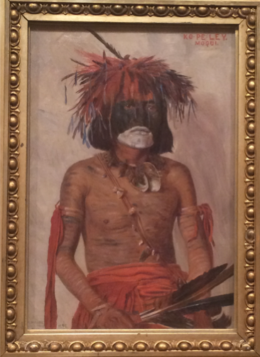
Figure 1—Elbridge Ayer Burbank, Ko-Pe-Ley/Moqui, 1898, Art Institute of Chicago, image by Caroline Jean Fernald.
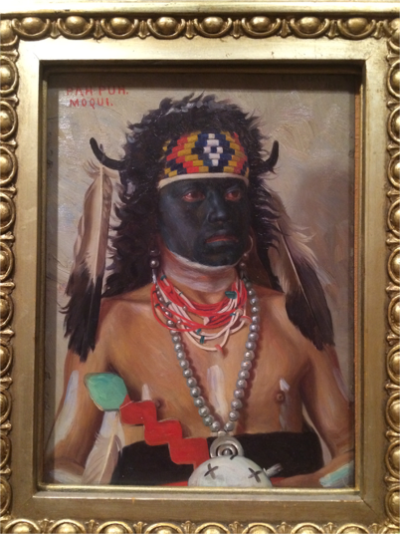
Figure 2—Elbridge Ayer Burbank, Pah-Puh/Moqui, 1898, Art Institute of Chicago, image by Caroline Jean Fernald.
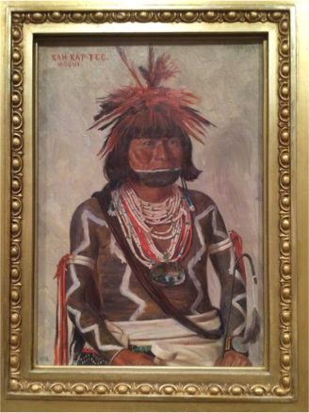
Figure 3—Elbridge Ayer Burbank, Kah-Kap-Tee/Moqui, 1898, Art Institute of Chicago, image by Caroline Jean Fernald.
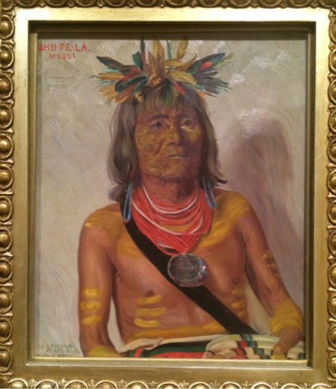
Figure 4—Elbridge Ayer Burbank, Shu-Pe-La/Moqui, 1898, Art Institute of Chicago, image by Caroline Jean Fernald.
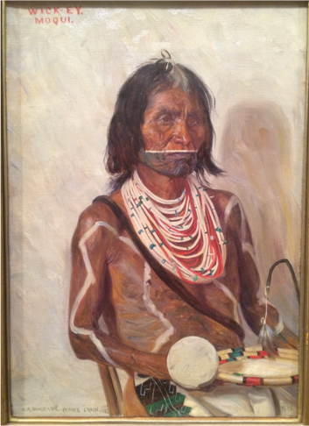
Figure 5—Elbridge Ayer Burbank, Wick-Ey/Moqui, 1898, Art Institute of Chicago, image by Caroline Jean Fernald.
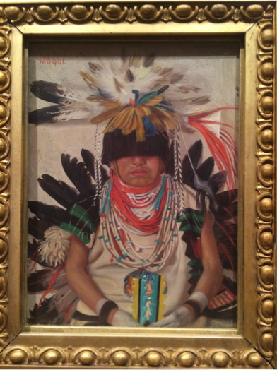
Figure 6—Elbridge Ayer Burbank, Tah-Bo-Hoy/Moqui, 1898, Art Institute of Chicago, image by Caroline Jean Fernald.
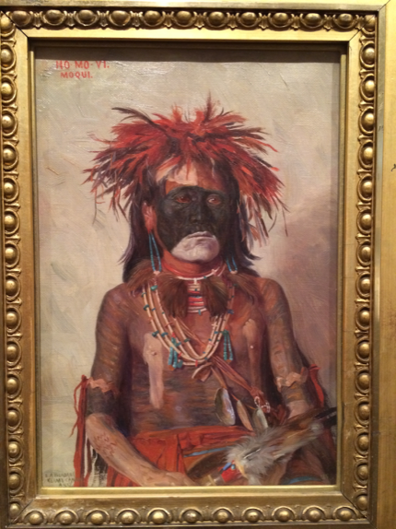
Figure 7—Elbridge Ayer Burbank, Ho-Mo-Vi/Moqui, 1898, Art Institute of Chicago, image by Caroline Jean Fernald.
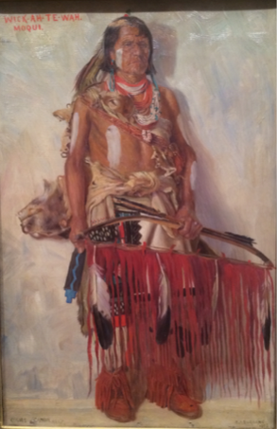
Figure 8—Elbridge Ayer Burbank, Wick-Ah-Te-Wah/Moqui, 1898, Art Institute of Chicago, image by Caroline Jean Fernald.
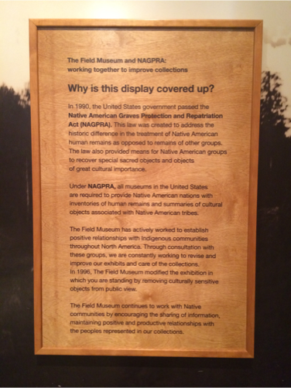
Figure 9—Field Museum of Natural History NAGPRA label for exhibition case, Chicago, Illinois, image by Caroline Jean Fernald.
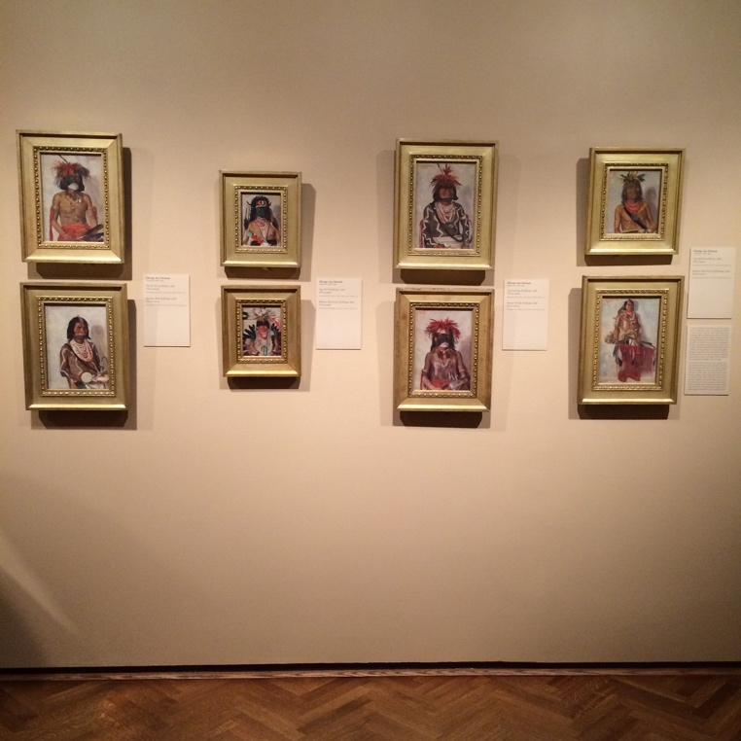
Figure 10—Art Institute of Chicago display of Elbridge Ayer Burbank paintings, image by Caroline Jean Fernald.
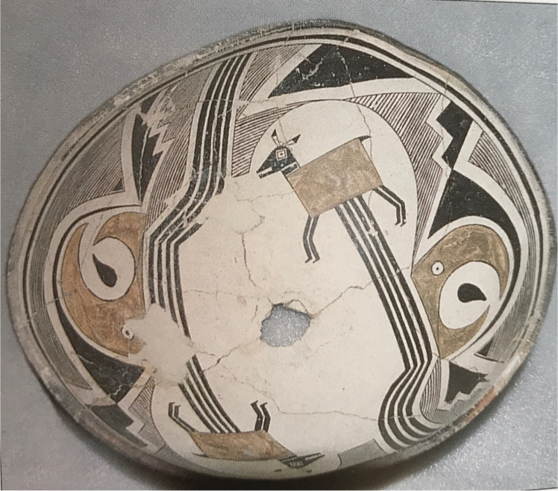
Figure 11—Mimbres vessel as pictured in J.J. Brody, Mimbres Painted Pottery (Santa Fe: School of American Research Press, 2004), 53.
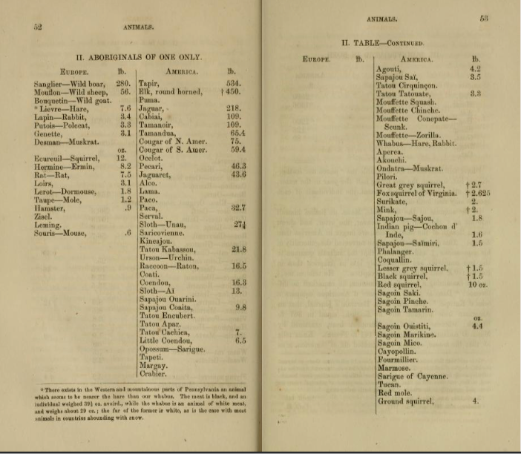
Figure 12—Chart from Thomas Jefferson, Notes on the State of Virginia (Richmond: J.W. Randolph, 1787).
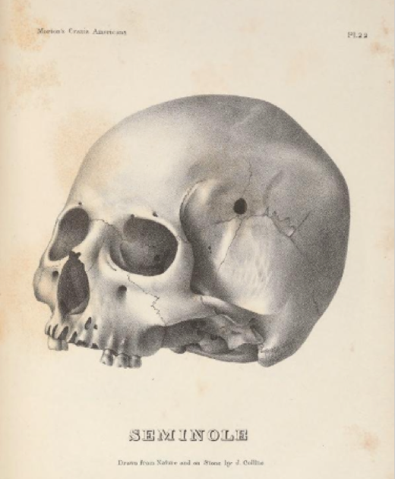
Figure 13—Seminole skull from Samuel George Morton, Crania Americana (Philadelphia: J. Dobson, 1839).
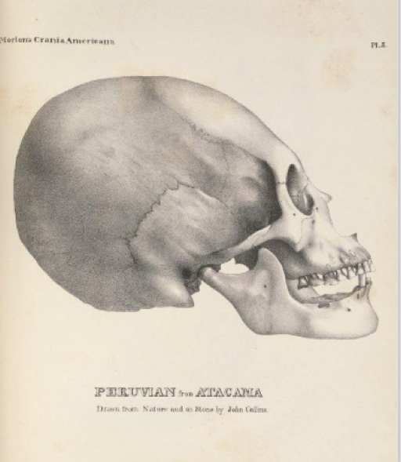
Figure 14—Peruvian skull from Samuel George Morton, Crania Americana (Philadelphia: J. Dobson, 1839).
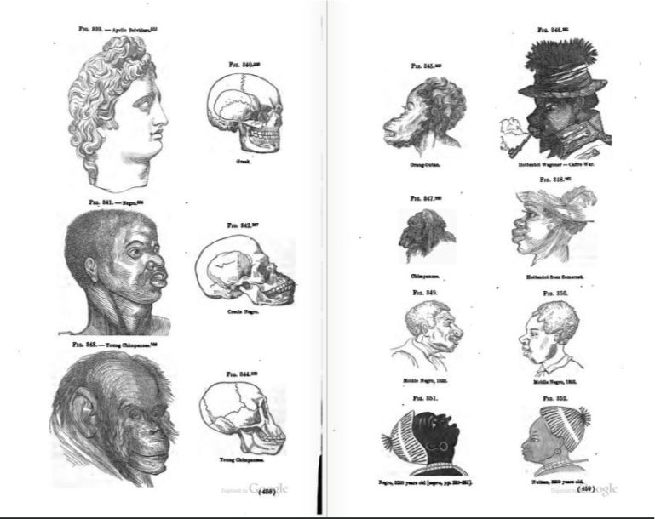
Figure 15—Chart from Josiah Clark Nott and George R. Gliddon, Types of Mankind (Philadelphia: Lippincott, Grambo, and Company, 1854).
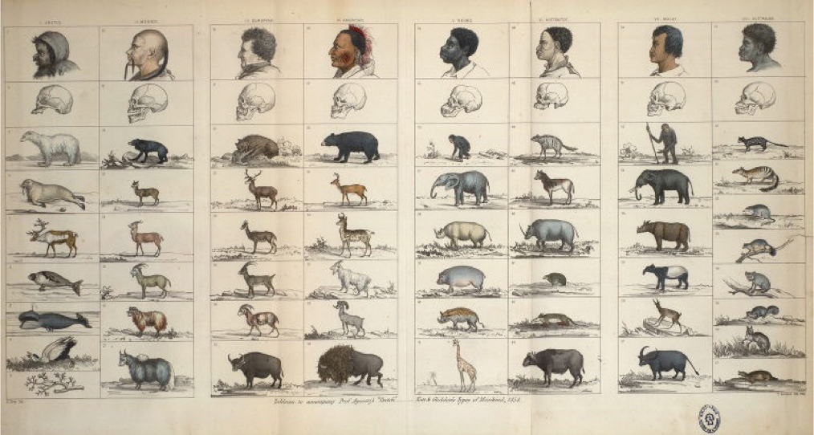
Figure 16—Chart from Josiah Clark Nott and George R. Gliddon, Types of Mankind (Philadelphia: Lippincott, Grambo, and Company, 1854).
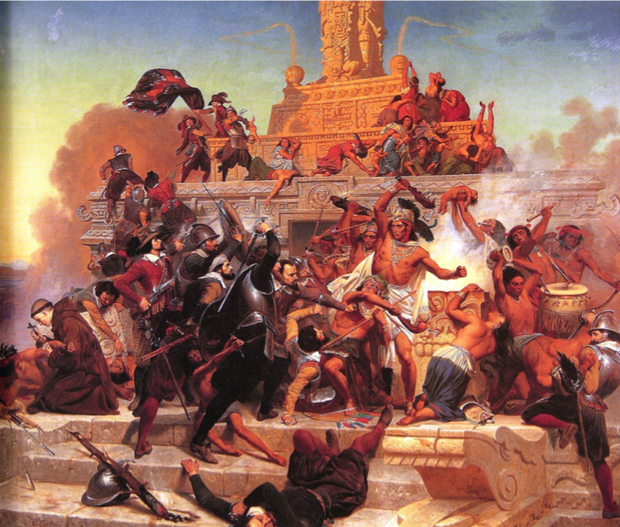
Figure 17—Emanuel Leutze, Storming of the Teocalli by Cortez and His Troops, 1848 as pictured in William H. Truettner, “Prelude to Expansion: Repainting the Past,” in The West as America: Reinterpreting Images of the Frontier, 1820-1920, ed. William H. Truettner (Washington: Smithsonian Institution Press, 1991), 60.
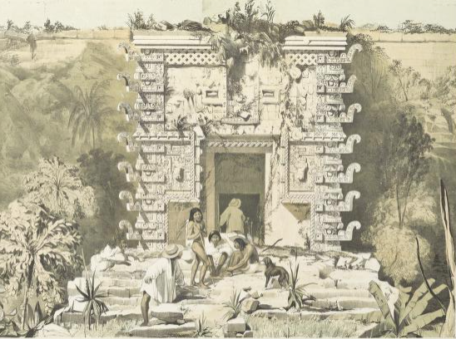
Figure 18—Maya architectural feature as pictured in Frederick Catherwood, Views of the Ancient Monuments in Central American, Chiapas, and Yucatan (London: F. Catherwood, 1844).
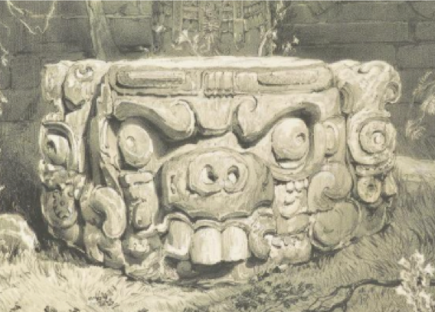
Figure 19—Maya architectural feature as pictured in Frederick Catherwood, Views of the Ancient Monuments in Central America, Chiapas, and Yucatan (London: F. Catherwood, 1844).
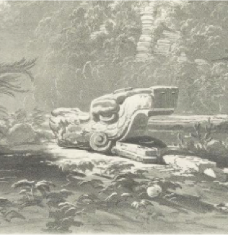
Figure 20—Maya architectural feature as pictured in Frederick Catherwood, Views of the Ancient Monuments in Central American, Chiapas, and Yucatan (London: F. Catherwood, 1844).
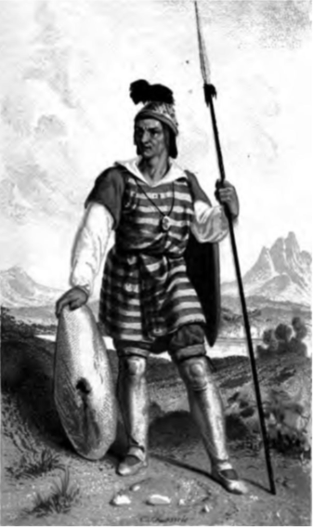
Figure 21—Frontispiece for James H. Simpson, Journal of a Military Reconnaissance from Santa Fé, New Mexico, to the Navajo Country (Philadelphia: Lippincott, Grambo, and Company, 1852).
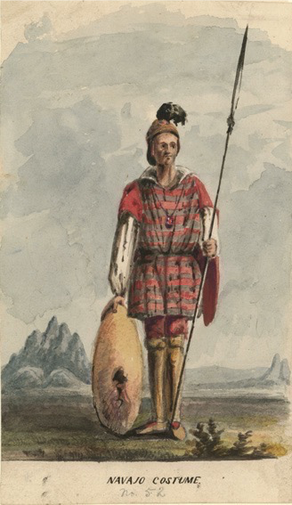
Figure 22—Richard and Edward Kern, Navajo Costume, c. 1849, as pictured in Martha Sandweiss, “The Public Life of Western Art,” in Discovered Lands, Invented Pasts: Transforming Visions of the American West, ed. Jules David Prown, et al. (New Haven: Yale University Press, 1992), 122.
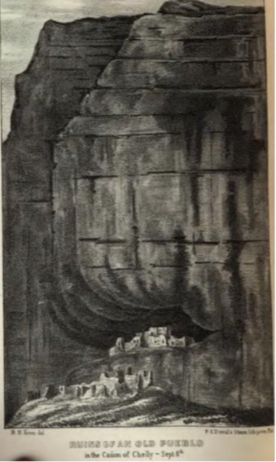
Figure 23—Illustration of Canyon de Chelly in James H. Simpson, Journal of a Military Reconnaissance from Santa Fé, New Mexico, to the Navajo Country (Philadelphia: Lippincott, Grambo, and Company, 1852).
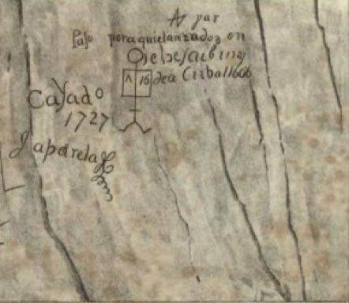
Figure 24—Illustration of engravings at Inscription Rock in James H. Simpson, Journal of a Military Reconnaissance from Santa Fé, New Mexico, to the Navajo Country (Philadelphia: Lippincott, Grambo, and Company, 1852).
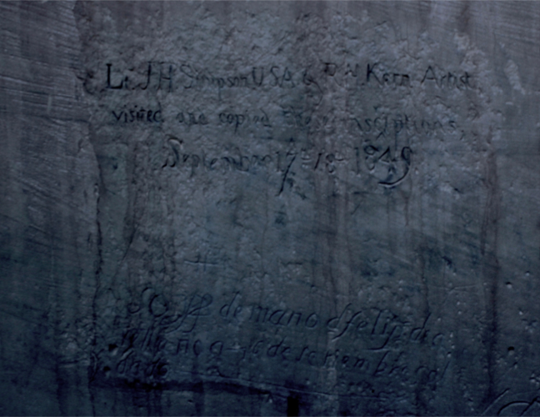
Figure 25—Richard and Edward Kern and James H. Simpson engraving at Inscription Rock, El Morro National Monument, New Mexico, image by Caroline Jean Fernald.
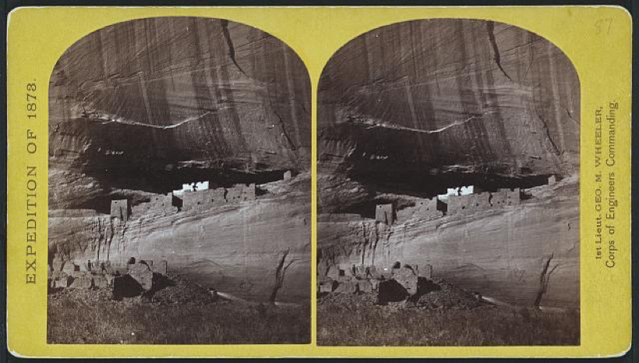
Figure 26—Timothy O’Sullivan, Canyon de Chelly, Stereo Card No. 21, War Department, Corps of Engineers, U.S. Army, 1873.
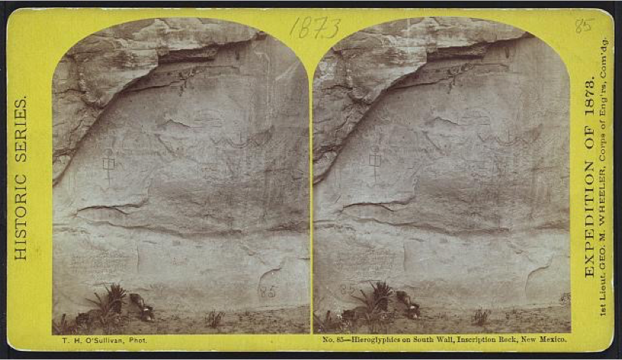
Figure 27—Timothy O’Sullivan, Hieroglyphs on South Wall, Inscription Rock, New Mexico, Stereo Cards Nos. 68-70, War Department, Corps of Engineers, U.S. Army, 1873.
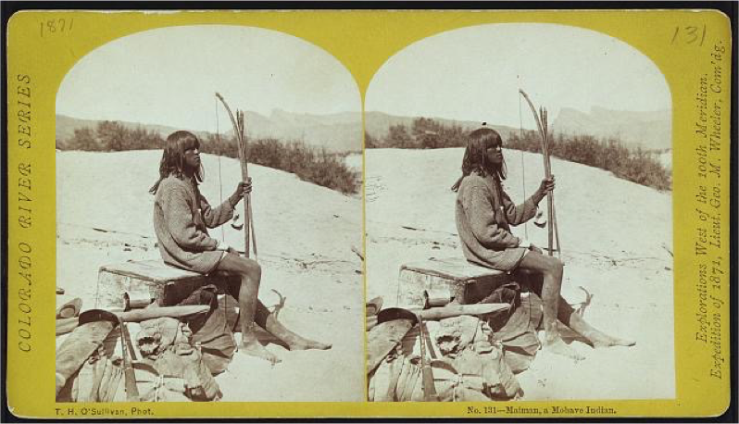
Figure 28—Timothy O’Sullivan, Maiman, a Mohave Indian, Stereo Cards Nos. 68-70, War Department, Corps of Engineers, U.S. Army, 1873.
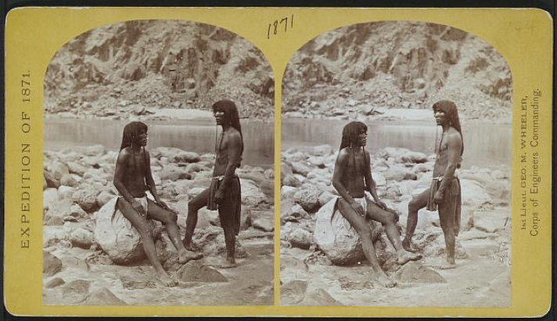
Figure 29—Timothy O’Sullivan, Panambora and Mitiwara, Stereo Cards Nos. 68-70, War Department, Corps of Engineers, U.S. Army, 1873.
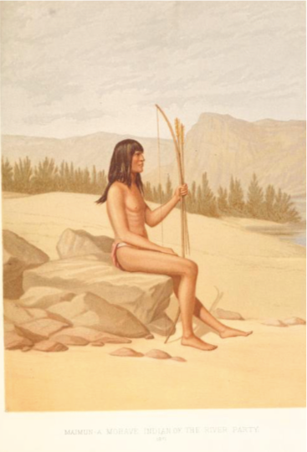
Figure 30—Illustration in George M. Wheeler, Report upon United States Geographical Surveys West of the One Hundredth Meridian, Vol. 1 (Washington: Government Printing Office, 1875).
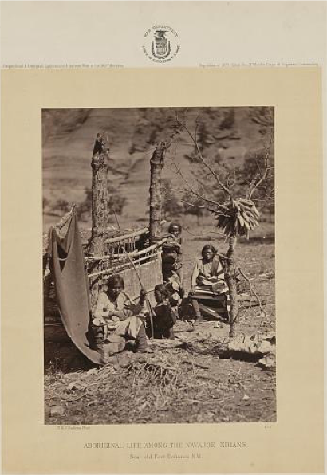
Figure 31—Illustration in George M. Wheeler, Report upon United States Geographical Surveys West of the One Hundredth Meridian, Vol. 1 (Washington: Government Printing Office, 1875).
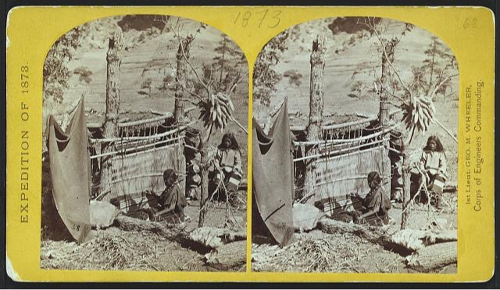
Figure 32—Timothy O’Sullivan, Stereo Card, War Department, Corps of Engineers, U.S. Army, 1873.
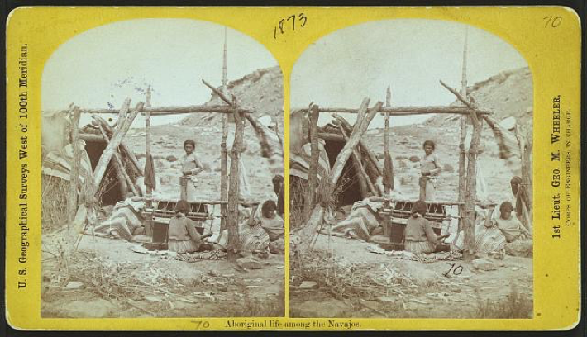
Figure 33—Timothy O’Sullivan, Aboriginal Life among the Navajos, Stereo Card, War Department, Corps of Engineers, U.S. Army, 1873.
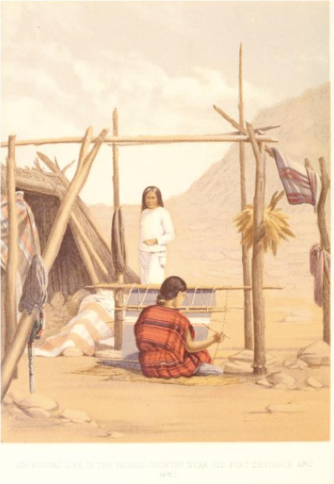
Figure 34—Illustration in George M. Wheeler, Report upon United States Geographical Surveys West of the One Hundredth Meridian, Vols., 1-7 (Washington: Government Printing Office, 1876-89).
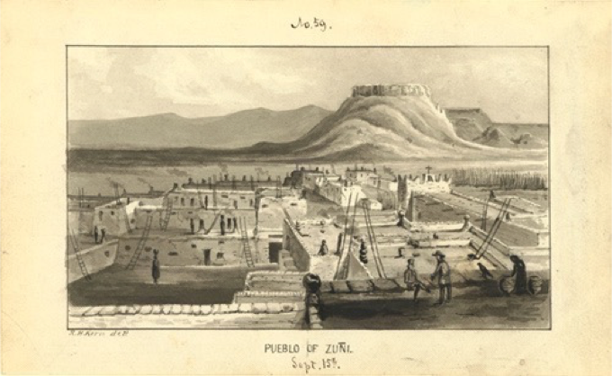
Figure 35—Richard and Edward Kern, Pueblo of Zuni, 1849, Kern Drawings of the American Southwest, Academy of Natural Science of Philadelphia.
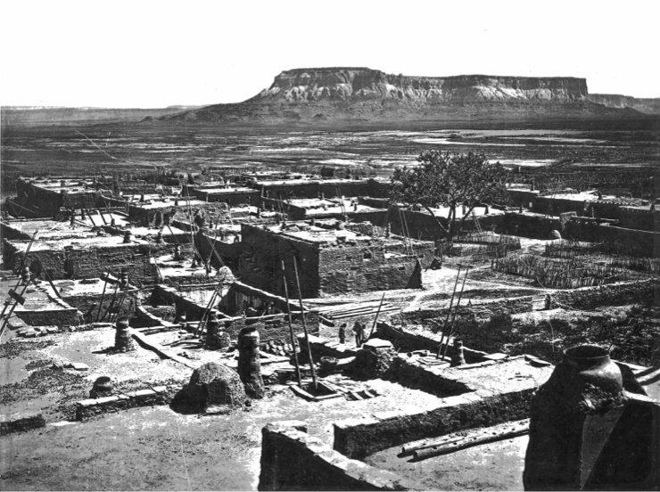
Figure 36—John K. Hillers, View of Zuni Pueblo, as pictured in Lewis Henry Morgan, Houses and House-Life of the American Aborigines (Washington: Government Printing Office, 1881).
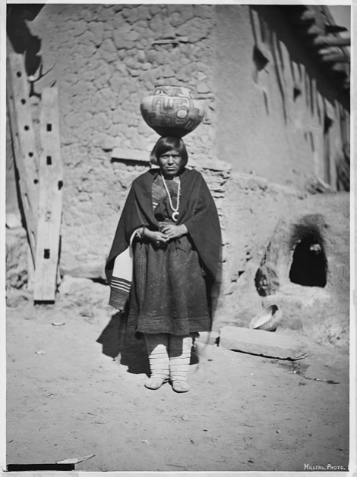
Figure 37—John K. Hillers, Zuni Water Carrier, c. 1879, Bureau of American Ethnology Archives.
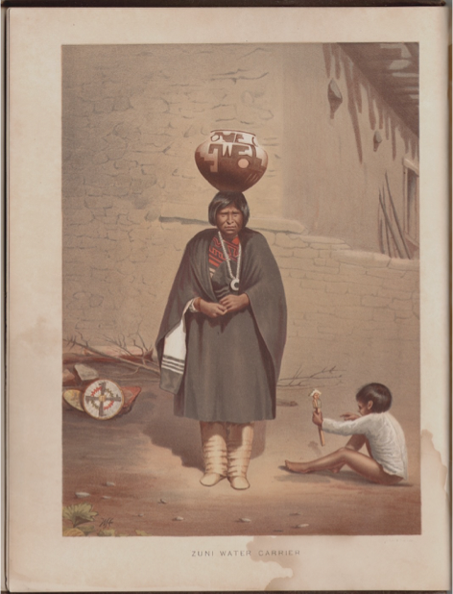
Figure 38—Frontispiece for Lewis Henry Morgan, Houses and House-Life of the American Aborigines (Washington: Government Printing Office, 1881).
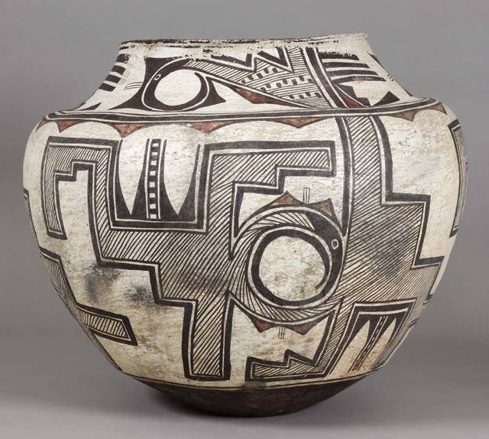
Figure 39—Zuni Pueblo, “Kiawinikyitehli,” Water Vase, c. 1879, Smithsonian Museum of Natural History.
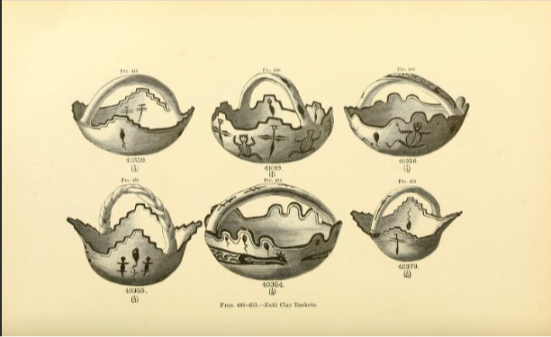
Figure 40—Illustration of “Zuni Clay Baskets” as pictured in James Stevenson, “Illustrated Catalogue of the Collections Obtained from the Indians of New Mexico in 1880,” in Second Annual Report of the Bureau of American Ethnology to the Secretary of the Smithsonian Institution, 1880-1881, ed. John Wesley Powell (Washington: Smithsonian Institution, 1883).
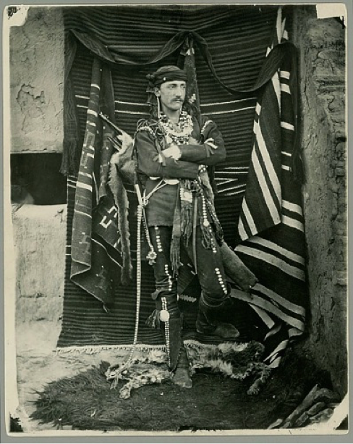
Figure 41—John K. Hillers, Frank Hamilton Cushing at Zuni, c. 1879, Bureau of American Ethnology Archives.
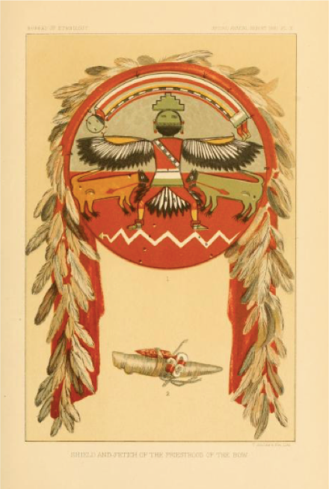
Figure 42—Priesthood of the Bow Shield and Fetish as pictured in Frank Hamilton Cushing, “Zuni Fetishes,” in Second Annual Report of the Bureau of Ethnology to the Secretary of the Smithsonian Institution, 1880-1881, ed. John Wesley Powell (Washington: Smithsonian Institution, 1883).
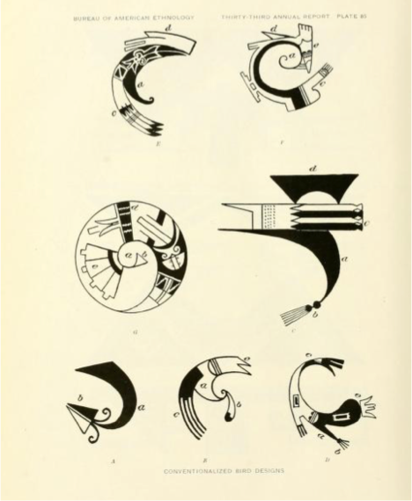
Figure 43—Sikyatki pottery designs as pictured in Jesse Walter Fewkes, “Designs on Prehistoric Hopi Pottery,” in Thirty-Third Annual Report of the Bureau of American Ethnology to the Secretary of the Smithsonian Institution, 1911-1912, ed. F.W. Hodge (Washington: Smithsonian Institution, 1919).
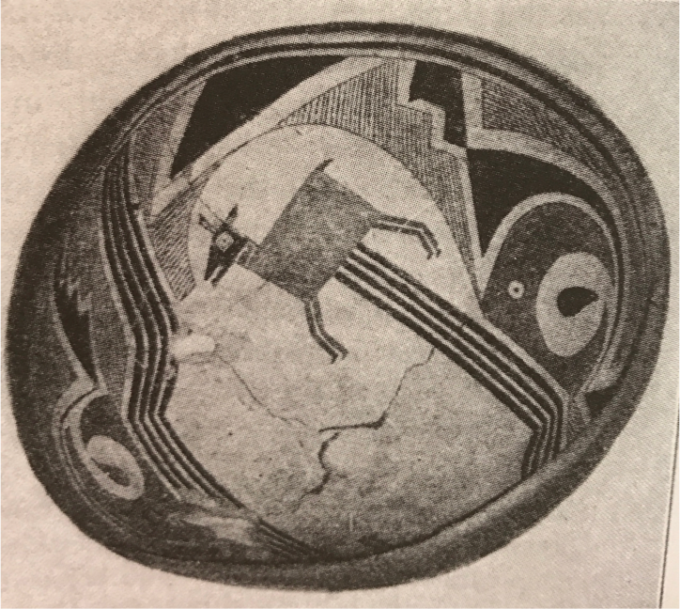
Figure 44—Mimbres bowl as pictured in Jesse Walter Fewkes, Archaeology of the Lower Mimbres Valley, New Mexico (Washington: Smithsonian Institution Press, 1914).
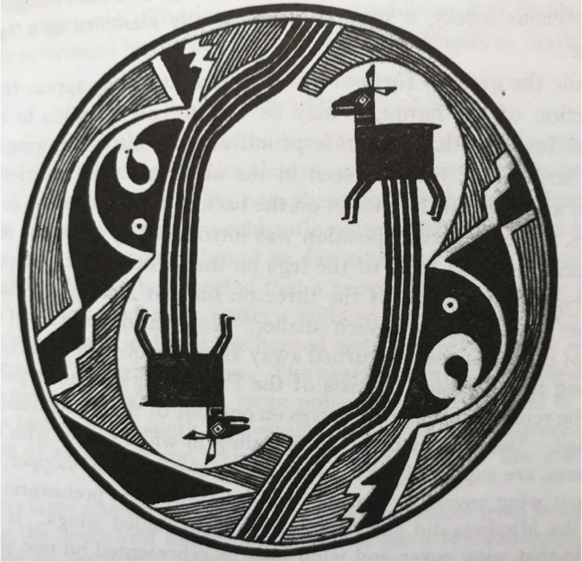
Figure 45—Mimbres bowl as pictured in Jesse Walter Fewkes, Archaeology of the Lower Mimbres Valley, New Mexico (Washington: Smithsonian Institution Press, 1914).
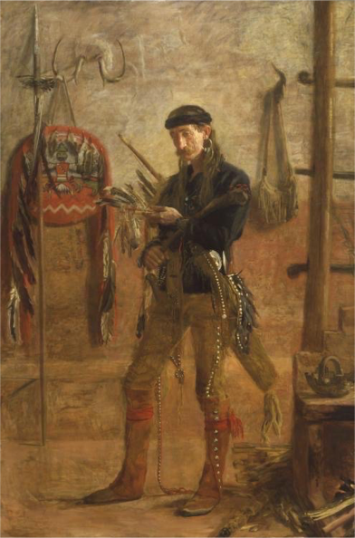
Figure 46—Thomas Eakins, Frank Hamilton Cushing, 1895, Gilcrease Museum, Tulsa, Oklahoma.
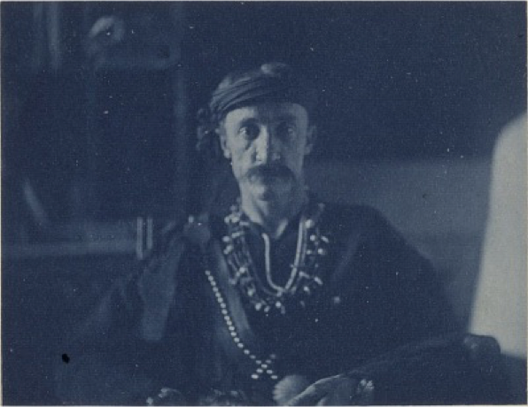
Figure 47—Thomas Eakins, Photographic Study of Frank Hamilton Cushing, c. 1895, Hirshhorn Museum and Sculpture Garden, Washington, D.C.
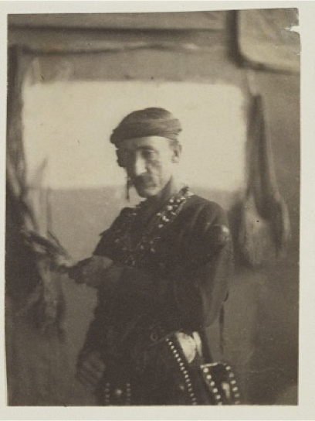
Figure 48—Thomas Eakins, Photographic Study of Frank Hamilton Cushing, c. 1895, Hirshhorn Museum and Sculpture Garden, Washington, D.C.
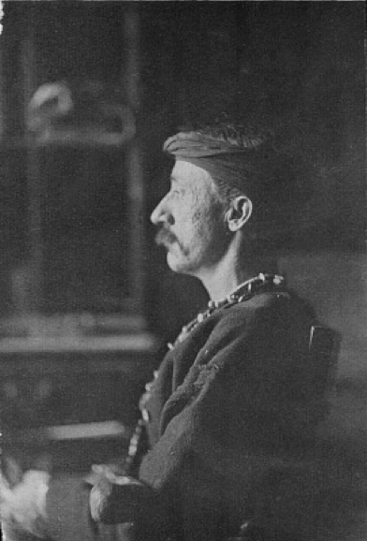
Figure 49—Thomas Eakins, Photographic Study of Frank Hamilton Cushing, c. 1895, Hirshhorn Museum and Sculpture Garden, Washington, D.C.
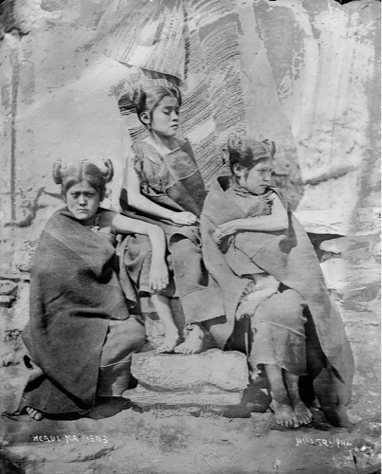
Figure 50—John K. Hillers, Moqui Maidens, c. 1879, Bureau of American Ethnology Archives.
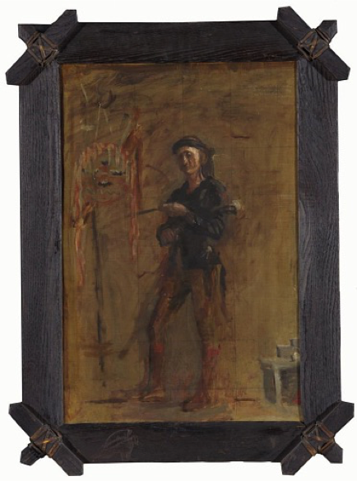
Figure 51—Thomas Eakins, Preparatory Painting for Frank Hamilton Cushing, c. 1895, Hirshhorn Museum and Sculpture Garden, Washington, D.C.
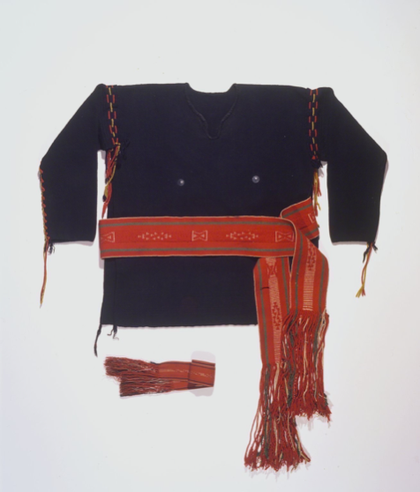
Figure 52—Frank Hamilton Cushing’s Zuni outfit, c. 1879, Brooklyn Museum.
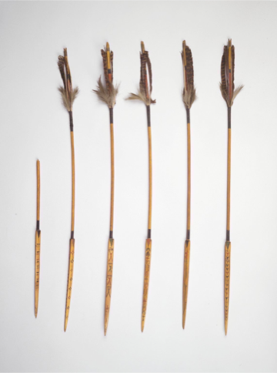
Figure 53—Frank Hamilton Cushing, Kiowa-Style Arrows, c. 1880, Brooklyn Museum.
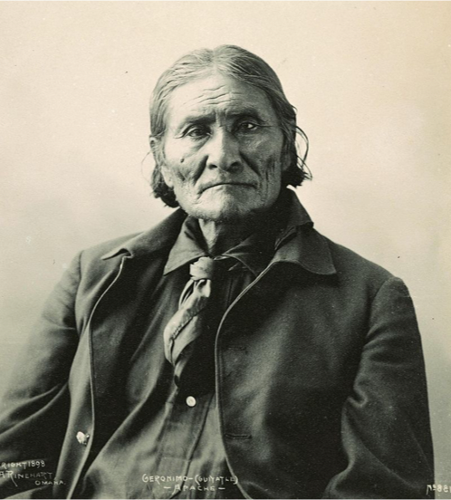
Figure 54—Frank A. Rinehart, Geronimo, 1898, Haskell Indian Nations University.
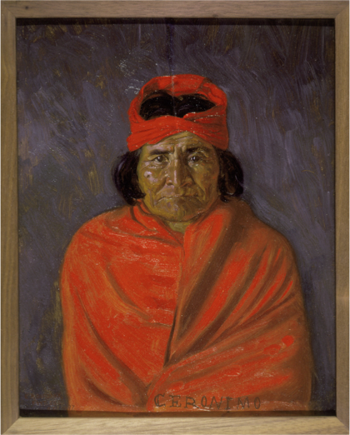
Figure 55—Elbridge Ayer Burbank, Geronimo, c. 1897, Smithsonian American Art Museum.
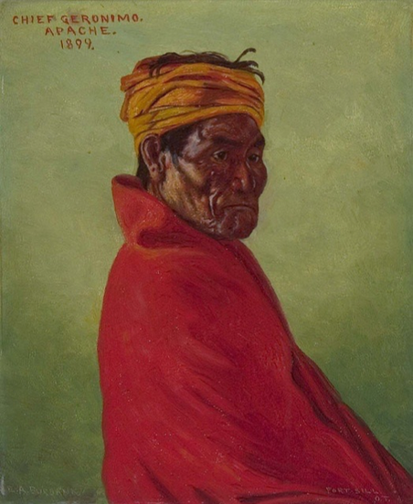
Figure 56—Elbridge Ayer Burbank, Geronimo, c. 1897, Butler Institute of American Art, Youngstown, Ohio.
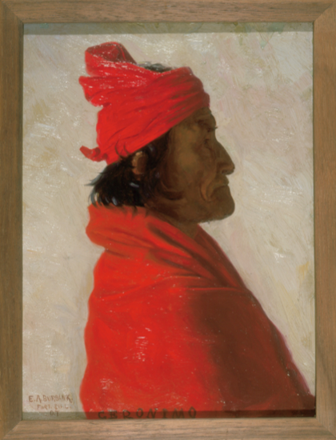
Figure 57—Elbridge Ayer Burbank, Geronimo, c. 1897, Newberry Library, Chicago, Illinois, image by Caroline Jean Fernald.
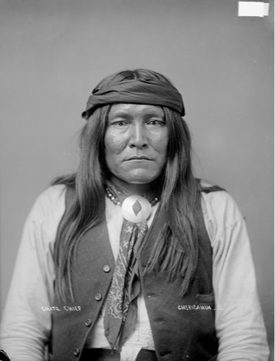
Figure 58—John K. Hillers, Chato Chief/Chiricahua, c. 1879, Bureau of American Ethnology Archives.
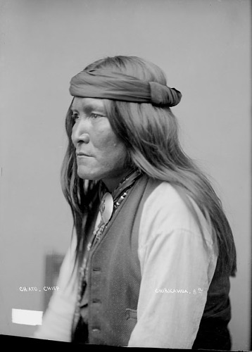
Figure 59—John K. Hillers, Chato Chief/Chiricahua, c. 1879, Bureau of American Ethnology Archives.
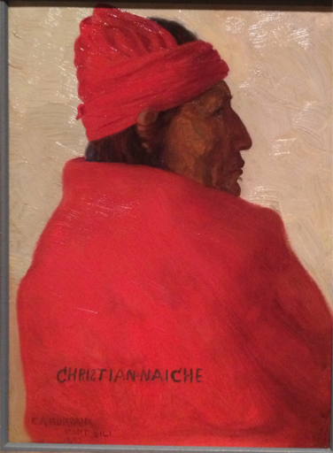
Figure 60—Elbridge Ayer Burbank, Christian Naiche, c. 1879, Denver Art Museum, image by Caroline Jean Fernald.
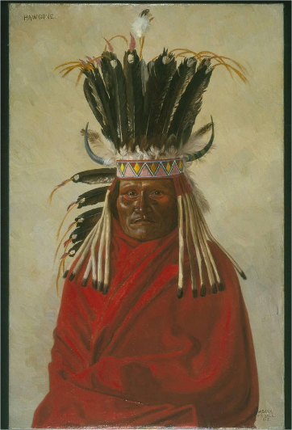
Figure 61—Elbridge Ayer Burbank, Hawgone, c. 1879, Newberry Library, Chicago, Illinois.
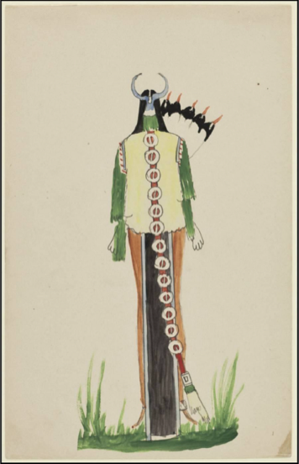
Figure 62—Hawgone, Kiowa Figure, c. 1897, Newberry Library, Chicago, Illinois.
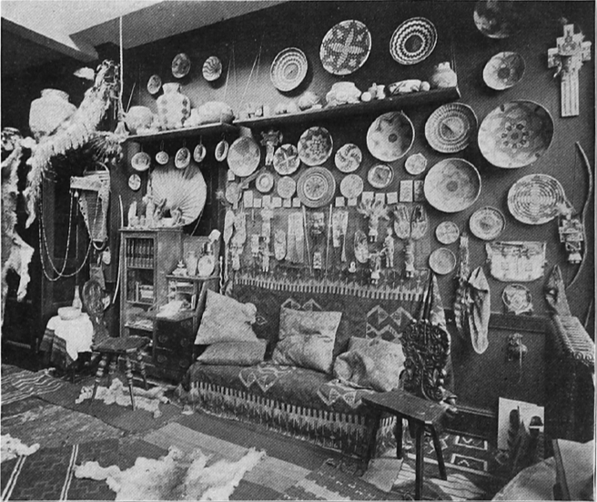
Figure 63—Photograph of Elbridge Ayer Burbank’s studio in the Fine Arts Building on Michigan Avenue in Chicago as pictured in E.A. Burbank, “Studies of Art in American Life-III: In Indian Tepees,” Brush and Pencil 7 (1900).
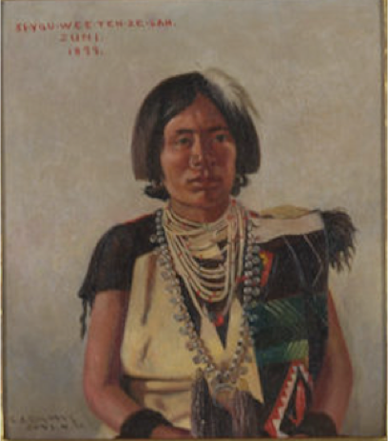
Figure 64—Elbridge Ayer Burbank, Copy of Zuni, 1898, Newberry Library, Chicago, Illinois.
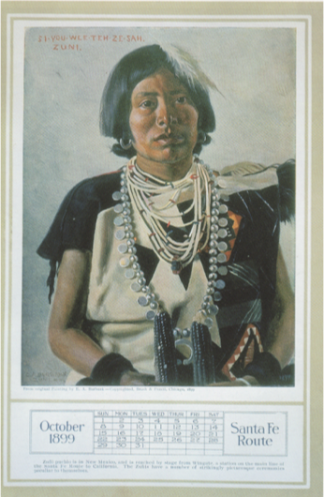
Figure 65—Santa Fe Railway promotional calendar, 1899, Newberry Library, Chicago, Illinois.
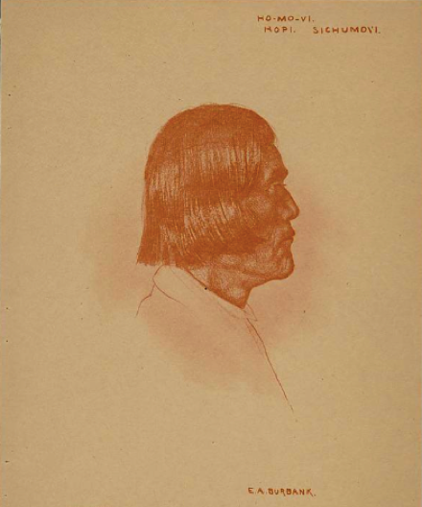
Figure 66—Elbridge Ayer Burbank, Ho-Mo-Vi, c. 1904, Newberry Library, Chicago, Illinois.
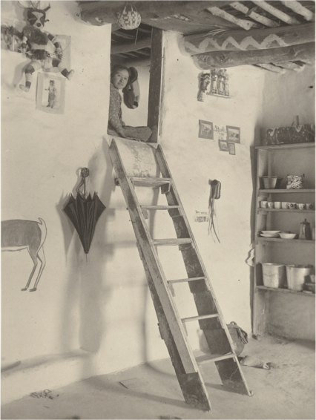
Figure 67—A.C. Vroman, Interior of Hooker’s House, Sichimovi, 1902, Seaver Center for Western History Research, Los Angeles County Museum of Natural History.
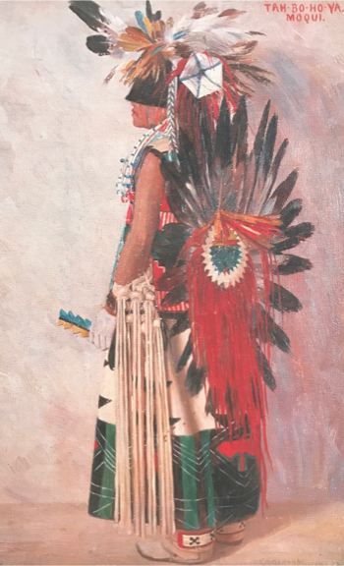
Figure 68—Elbridge Ayer Burbank, Tah-Bo-Ho-Ya/Moqui, 1898, Butler Institute of American Art, Youngstown, Ohio.
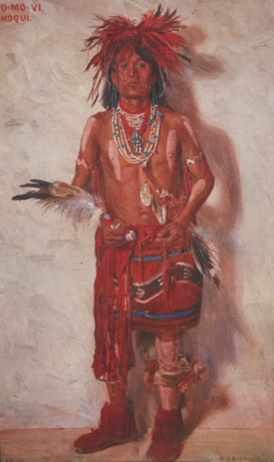
Figure 69—Elbridge Ayer Burbank, Ho-Mo-Vi, 1898, Butler Institute of American Art, Youngstown, Ohio.
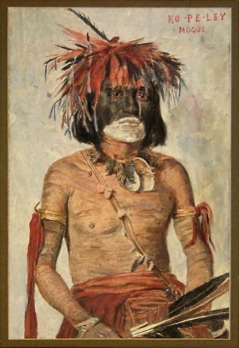
Figure 70—Elbridge Ayer Burbank, Painted Photograph, Ko-Pe-Ley/Moqui, 1899, Peabody Museum of Ethnology.
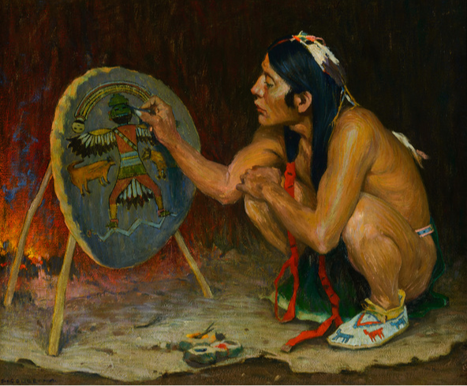
Figure 71—E. Irving Couse, Decorating the War Shield, c. 1916, Coeur d’Alene Art Auction, auction catalogue, 2014.
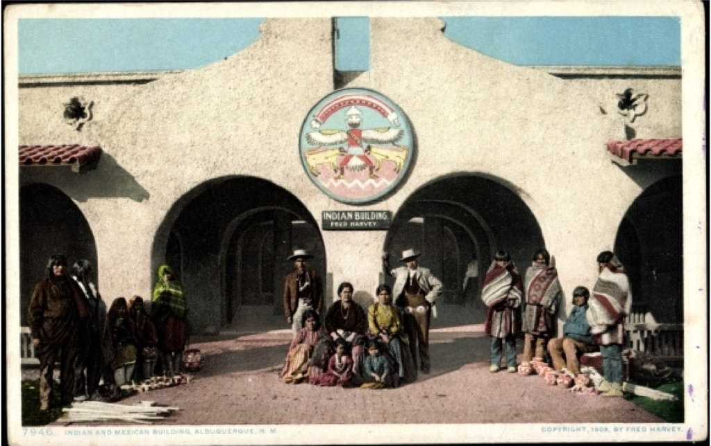
Figure 72—Fred Harvey Company postcard featuring Indian Building in Albuquerque, New Mexico, c. 1904, Heard Museum, Phoenix, Arizona.
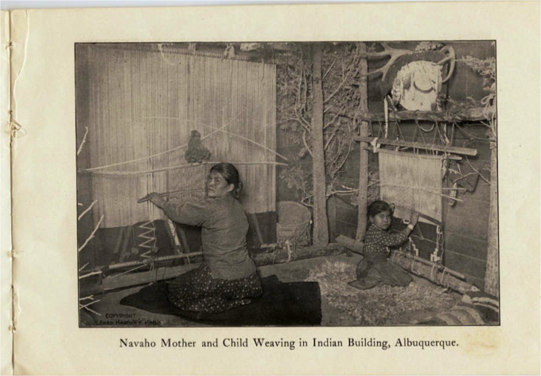
Figure 73—Illustration in Fred Harvey Company promotional publication, c. 1904, Heard Museum, Phoenix, Arizona.
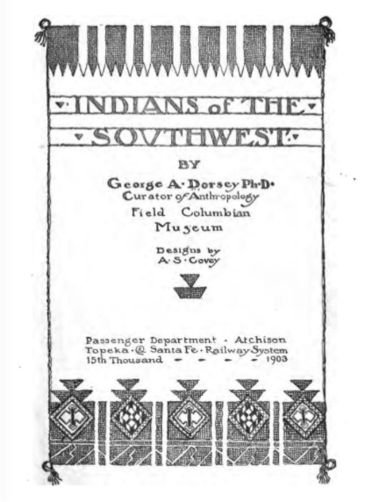
Figure 74—Title page for George A. Dorsey, Indians of the Southwest (Chicago: Passenger Department Atchison, Topeka, and Santa Fe Railway System, 1903).
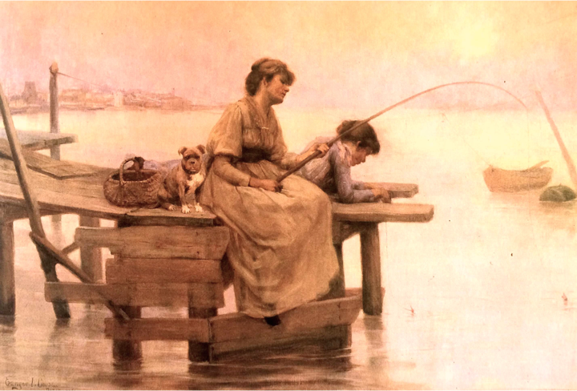
Figure 75—E. Irving Couse, Girls Fishing, 1890, Portland Art Museum.
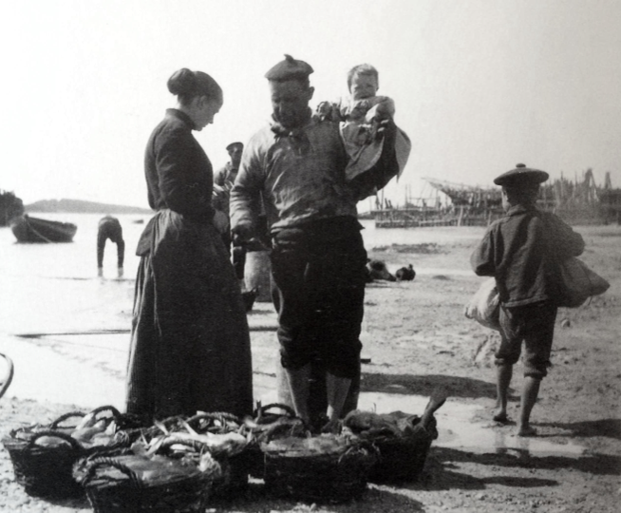
Figure 76—E. Irving Couse, Photographic Study of Southern France Family, c. 1890, Couse Family Archives, Tucson, Arizona.
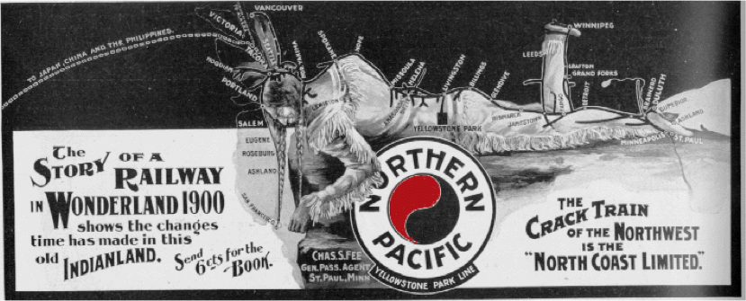
Figure 77—Northern Pacific advertisement as pictured in Michael E. Zega, “Advertising the Southwest,” Journal of the Southwest 43 (2001).
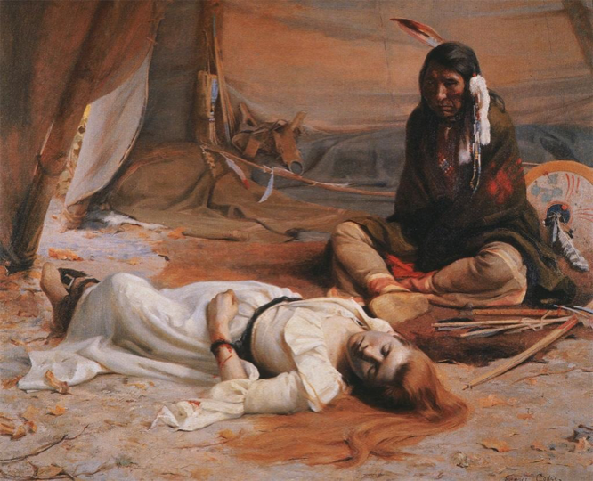
Figure 78—E. Irving Couse, The Captive, 1891, Phoenix Art Museum, image by Caroline Jean Fernald.
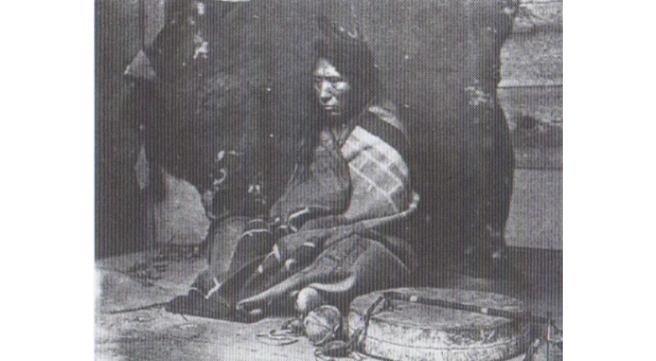
Figure 79—E. Irving Couse, Photographic Study for The Captive, c, 1891, Couse Family Archives, Tucson, Arizona.
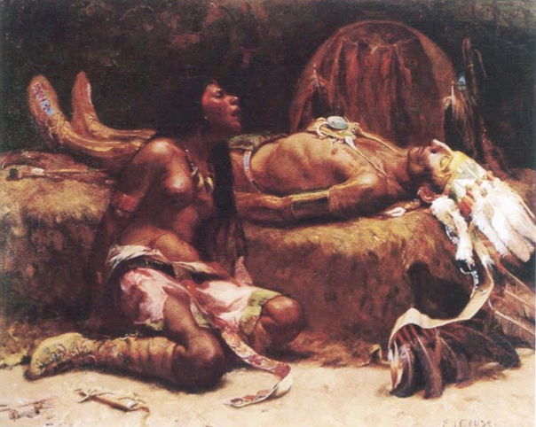
Figure 80—E. Irving Couse, Mourning the Chief of the Tribe, 1893, as pictured in Virginia Couse Leavitt, Eanger Irving Couse: Image Maker for America (Albuquerque: Albuquerque Museum, 1991), 76.
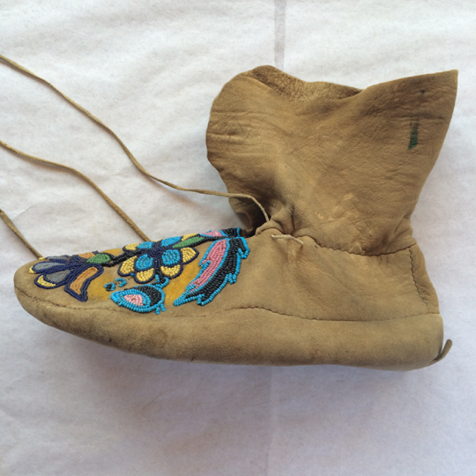
Figure 81—Plateau-style moccasin, E. Irving Couse and Joseph Henry Sharp Historic Site, Taos, New Mexico, image by Caroline Jean Fernald.
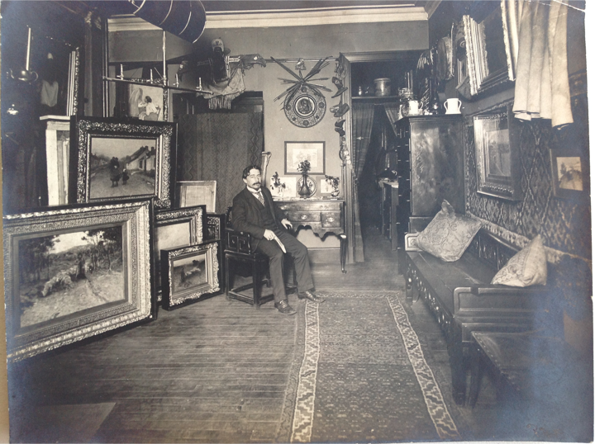
Figure 82—E. Irving Couse in his New York studio, c. 1898, Couse Family Archives, Tucson, Arizona.
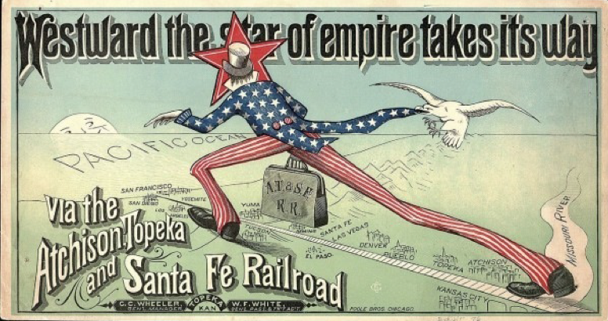
Figure 83—Atchison, Topeka, and Santa Fe Railroad advertisement as pictured in Michael E. Zega, “Advertising the Southwest,” Journal of the Southwest 43 (2001).
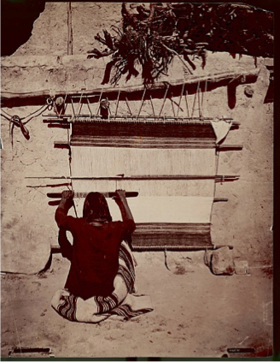
Figure 84---John K. Hillers, Navajo Weaver, c. 1879, Bureau of American Ethnology Archives.
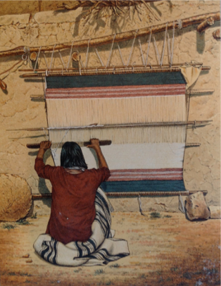
Figure 85—Lithograph based on photograph by John K. Hillers, c. 1879, Bureau of American Ethnology Archives.
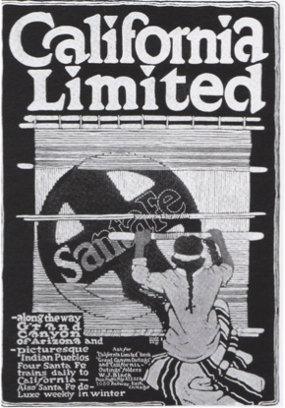
Figure 86—Santa Fe Railway advertisement, c. 1910, as pictured in Michael E. Zega, “Advertising the Southwest,” Journal of the Southwest 43 (2001).
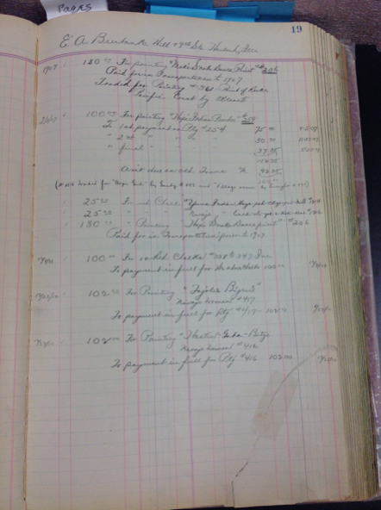
Figure 87—William Haskell Simpson Santa Fe Railway ledger book, Burlington Northern Santa Fe Railway archives, Fort Worth, Texas, image by Caroline Jean Fernald.
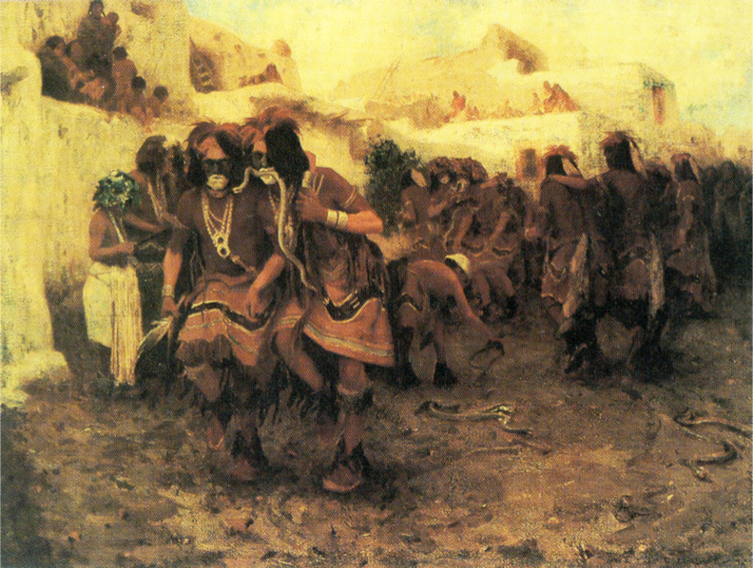
Figure 88—E. Irving Couse, Moki Snake Dance, 1903, Anschutz Collection, Denver, Colorado, image by Caroline Jean Fernald.
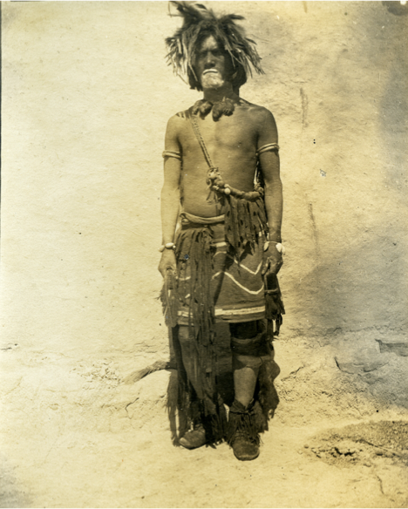
Figure 89—E. Irving Couse, Photographic Study for Moki Snake Dance, 1903, Couse Family Archives, Tucson, Arizona.
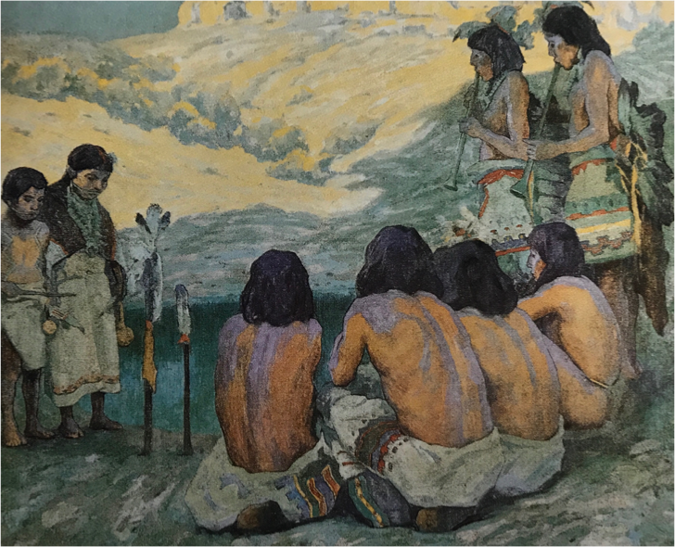
Figure 90—E. Irving Couse, Hopi Flute Ceremony, 1903, as pictured in Virginia Couse Leavitt, Eanger Irving Couse: Image Maker for America (Albuquerque: Albuquerque Museum, 1991), 201.
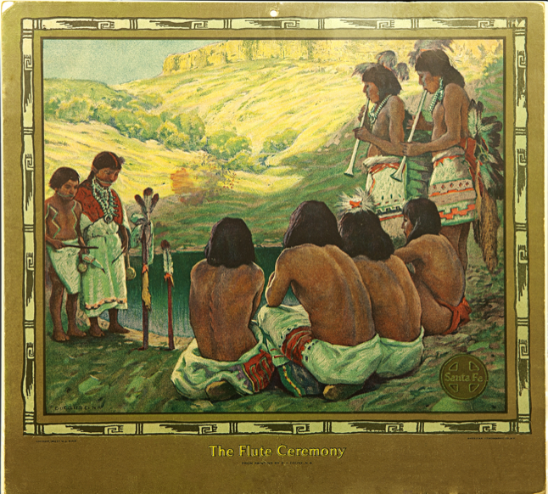
Figure 91—Santa Fe Railway promotional calendar, 1923, E. Irving Couse and Joseph Henry Sharp Historic Site, Taos, New Mexico, image by Caroline Jean Fernald.
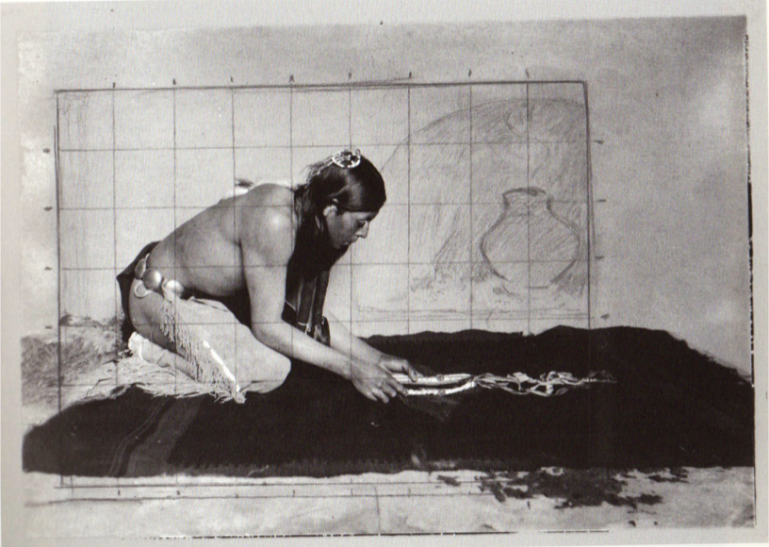
Figure 92—E. Irving Couse, Photographic Study, Couse Family Archives, Tucson, Arizona.
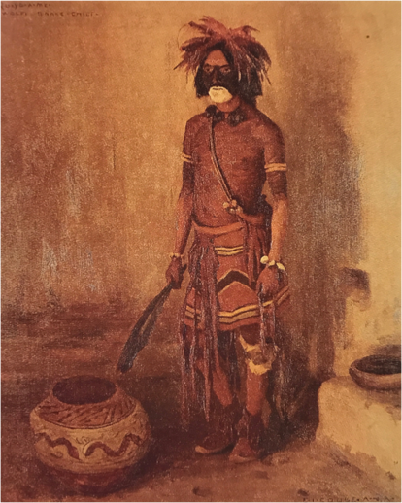
Figure 93—E. Irving Couse, Qu-Yo-A-Me, Walpi Snake Chief, 1903, as pictured in Virginia Couse Leavitt, Eanger Irving Couse: Image Maker for America (Albuquerque: Albuquerque Museum, 1991), 118.
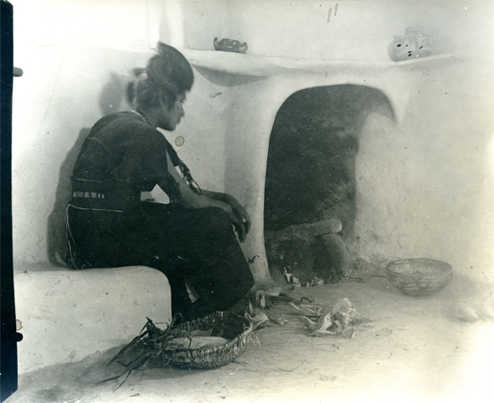
Figure 94—E. Irving Couse, Photographic Study of Hopi Girl, 1903, Couse Family Archives, Tucson, Arizona.
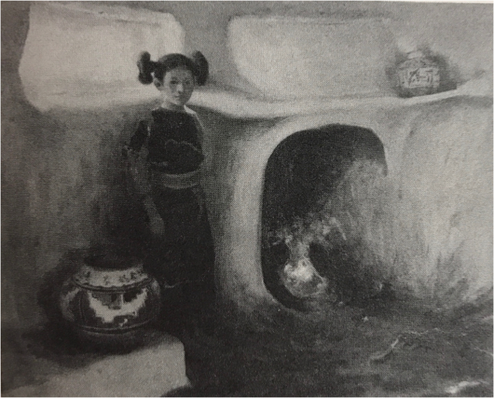
Figure 95—E. Irving Couse, Hopi Girl, c. 1903, as pictured in Nicholas Woloshuk, E. Irving Couse, 1866-1936 (Santa Fe: Santa Fe Village Art Museum, 1976).
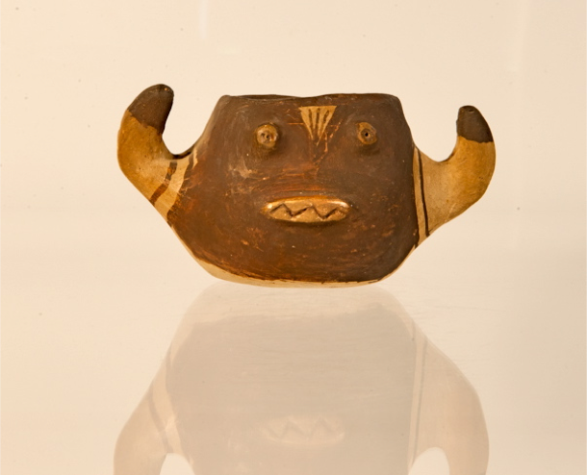
Figure 96—Hopi Ogre Katsina ceramic vessel, c. 1903, E. Irving Couse and Joseph Henry Sharp Historic Site, Taos, New Mexico.
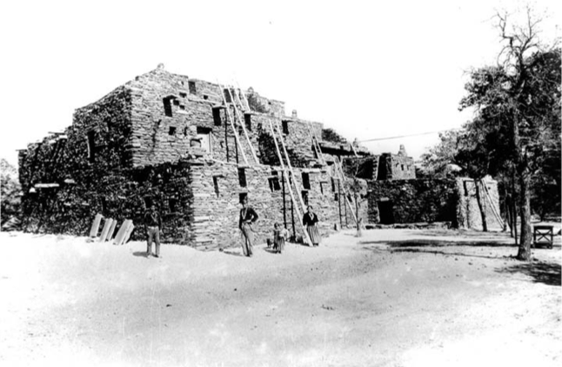
Figure 97—Hopi House, c. 1905, Grand Canyon National Park Archives.
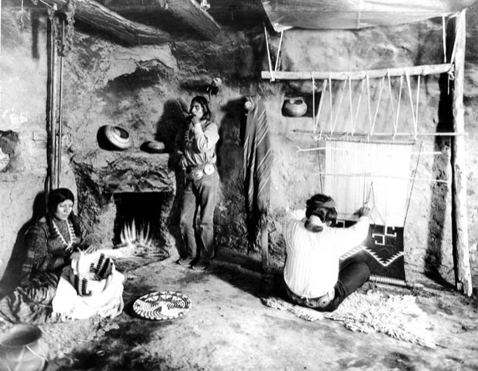
Figure 98—Interior view of Hopi House, c. 1905, Grand Canyon National Park Archives.
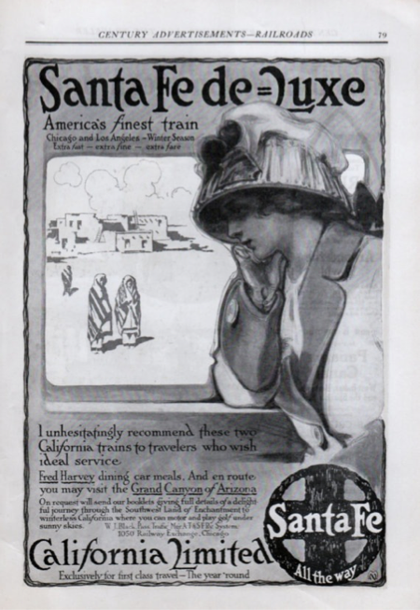
Figure 99—Santa Fe Railway advertisement, Heard Museum, Phoenix, Arizona.
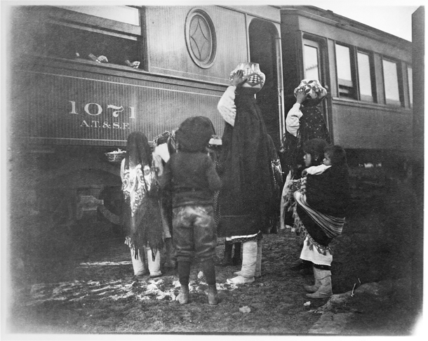
Figure 100—E. Irving Couse, Laguna Pueblo, New Mexico, c. 1903, Couse Family Archives, Tucson, Arizona.
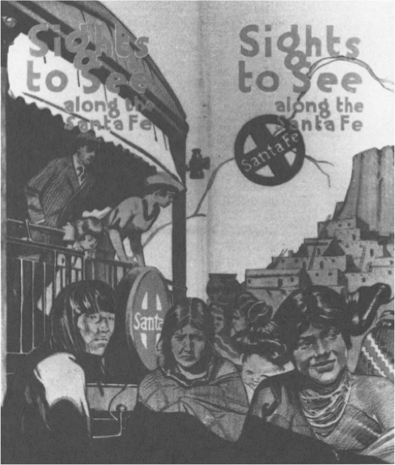
Figure 101—Santa Fe Railway promotional brochure as pictured in Michael E. Zega, “Advertising the Southwest,” Journal of the Southwest 43 (2001).
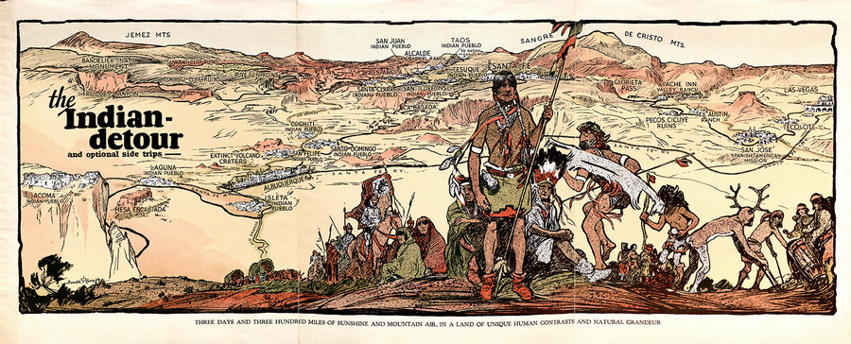
Figure 102—Santa Fe Railway advertisement, Heard Museum, Phoenix, Arizona.
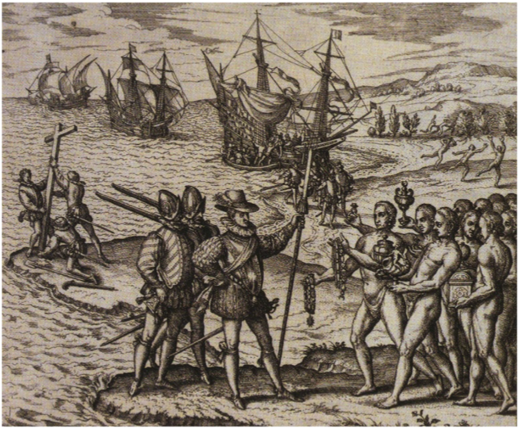
Figure 103—Theodor de Bry, The Landing of Española, 1594, British Museum, London.
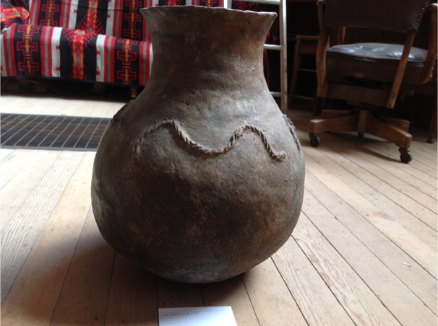
Figure 104—Taos Pueblo micaceous clay jar, E. Irving Couse and Joseph Henry Sharp Historic Site, Taos, New Mexico, image by Caroline Jean Fernald.
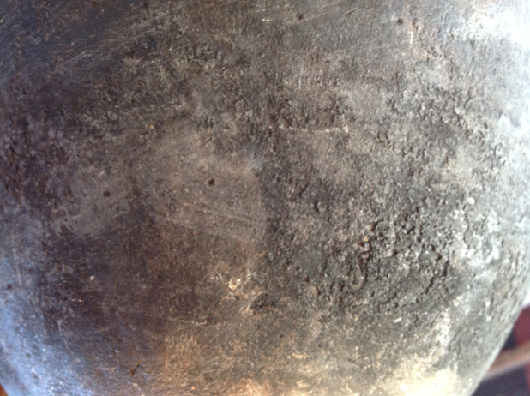
Figure 105—Detail of Taos Pueblo micaceous clay jar, E. Irving Couse and Joseph Henry Sharp Historic Site, Taos, New Mexico, image by Caroline Jean Fernald.
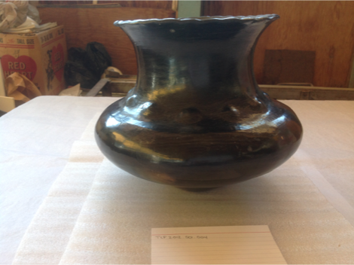
Figure 106—Ohkay Owingeh vessel, E. Irving Couse and Joseph Henry Sharp Historic Site, Taos, New Mexico, image by Caroline Jean Fernald.
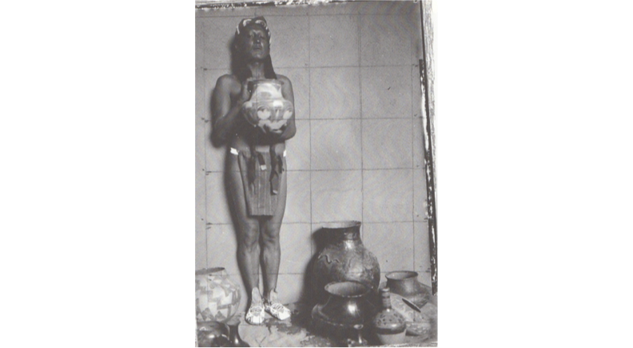
Figure 107—E. Irving Couse, Photographic Study for the Pottery Vendor, c. 1916, Couse Family Archives, Tucson, Arizona.
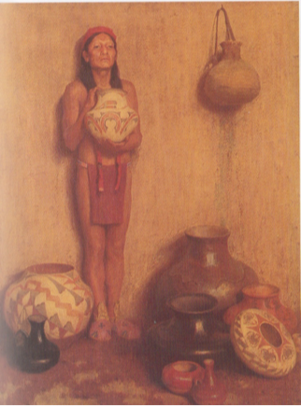
Figure 108—E. Irving Couse, The Pottery Vendor, 1916, Philbrook Museum of Art, Tulsa, Oklahoma.
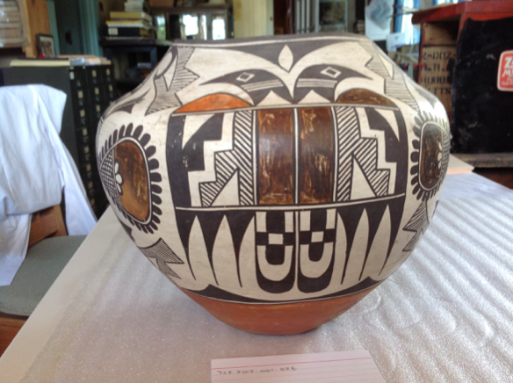
Figure 109—Acoma Pueblo water jar, E. Irving Couse and Joseph Henry Sharp Historic Site, Taos, New Mexico, image by Caroline Jean Fernald.
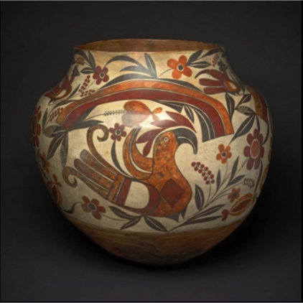
Figure 110—Acoma Pueblo water jar, Art Institute of Chicago.
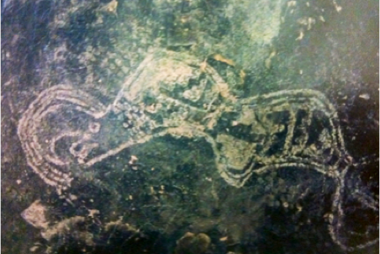
Figure 111—Water serpent petroglyph as pictured in Polly Schaafsma, “Quetzalcoatl and the Horned and Feathered Serpent of the Southwest,” in The Road to Aztlan: Art from a Mythic Homeland, ed. by Virginia M. Fields and Victor Zamudio-Taylor (Los Angeles: Los Angeles County Museum of Art, 2001).
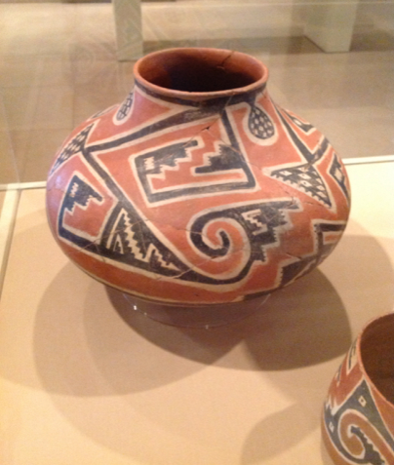
Figure 112—Salado vessel, Dallas Museum of Art, image by Caroline Jean Fernald.
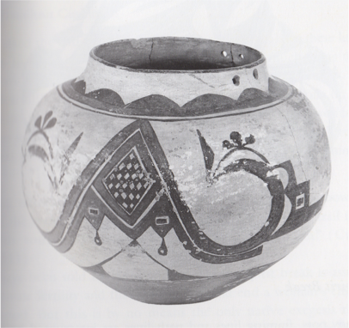
Figure 113—Acoma Pueblo water vessel as pictured in Jonathan Batkin, Pottery of the Pueblos of New Mexico, 1700-1940 (Colorado Springs: Taylor Museum of the Colorado Springs Fine Arts Center, 1987).
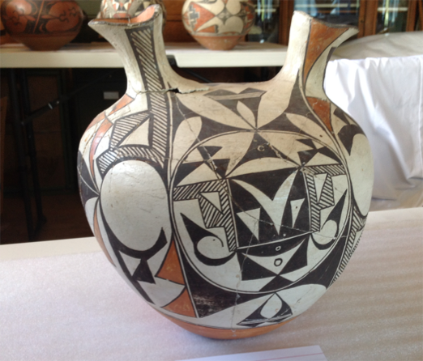
Figure 114—Acoma Pueblo wedding vase, E. Irving Couse and Joseph Henry Sharp Historic Site, Taos, New Mexico, image by Caroline Jean Fernald.
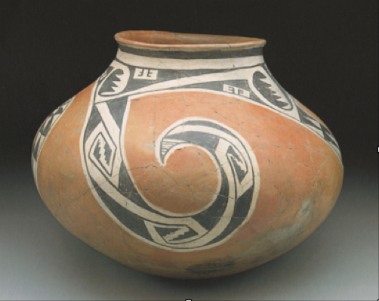
Figure 115---Salado vessel as pictured in Polly Schaafsma, “Tlalocs, Kachinas, Sacred Bundles, and Related Symbolism in the Southwest and Mesoamerica,” in The Casas Grandes World, ed. by Curtis F. Schaafsma and Carroll L. Riley (Salt Lake City: University of Utah Press, 1999).
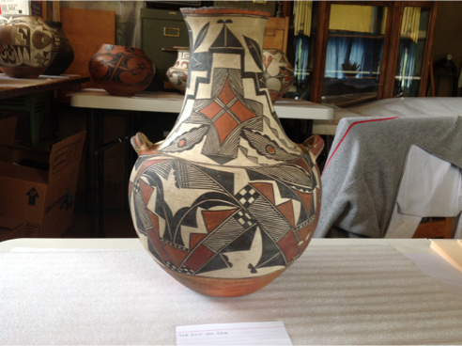
Figure 116—Acoma Pueblo vessel, E. Irving Couse and Joseph Henry Sharp Historic Site, Taos, New Mexico, image by Caroline Jean Fernald.
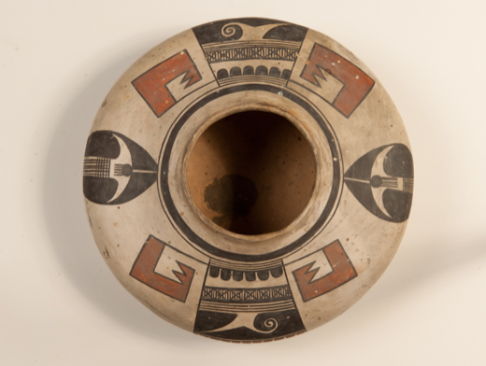
Figure 117—Nampeyo, ceramic vessel, E. Irving Couse and Joseph Henry Sharp Historic Site, Taos, New Mexico.
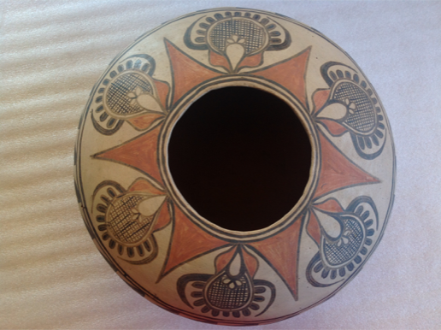
Figure 118—San Ildefonso Pueblo ceramic vessel, E. Irving Couse and Joseph Henry Sharp Historic Site, Taos, New Mexico, image by Caroline Jean Fernald.
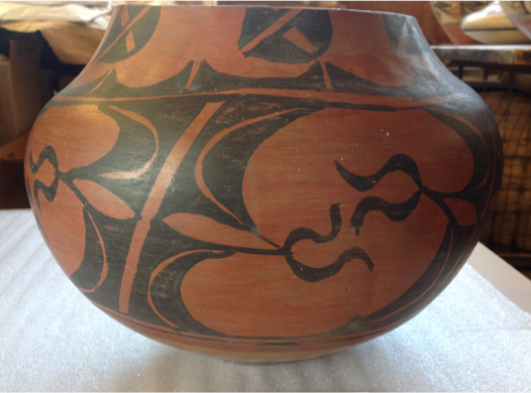
Figure 119—San Ildefonso Pueblo ceramic vessel, E. Irving Couse and Joseph Henry Sharp Historic Site, Taos, New Mexico, image by Caroline Jean Fernald.
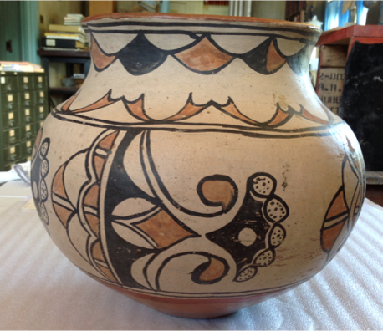
Figure 120—San Ildefonso Pueblo ceramic vessel, E. Irving Couse and Joseph Henry Sharp Historic Site, Taos, New Mexico, image by Caroline Jean Fernald.
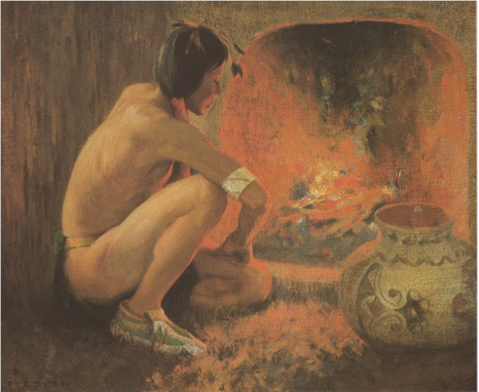
Figure 121—E. Irving Couse, Wal-Si-El/Good Medicine, 1914, Santa Fe Railway promotional calendar, E. Irving Couse and Joseph Henry Sharp Historic Site, Taos, New Mexico, image by Caroline Jean Fernald.
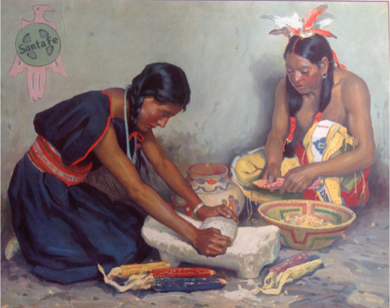
Figure 122—E. Irving Couse, Pueblo Indians Grinding Corn, 1927, Burlington Northern Santa Fe Railway Headquarters, Fort Worth, Texas, image by Caroline Jean Fernald.
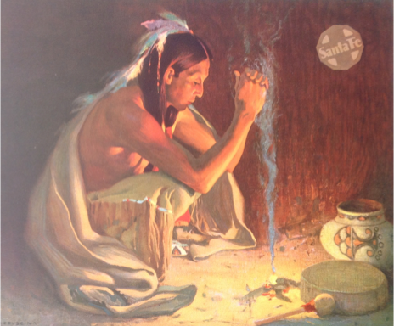
Figure 123—E. Irving Couse, The Smoke Ceremony, 1934, Santa Fe Railway promotional calendar, E. Irving Couse and Joseph Henry Sharp Historic Site, Taos, New Mexico, image by Caroline Jean Fernald.
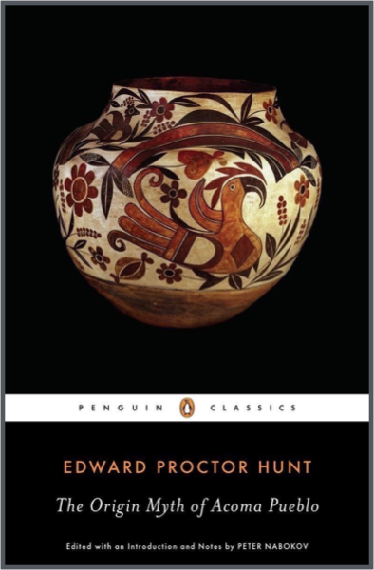
Figure 124—Book cover for Edward Proctor Hunt, The Origin Myth of Acoma Pueblo (New York: Penguin Classics, 2015).

Art Institute of Chicago, Archival Records for Elbridge Ayer Burbank, Ko-Pe-Ley/Moqui, 1898, Pah-Puh/Moqui, 1898, Kah-Kap-Tee/Moqui, 1898, Shu-Pe-La/Moqui, 1898, Wick-Ey/Moqui, 1898, Tah-Bo-Ho-Ya/Moqui, 1898, Ho-Mo-Vi/Moqui, 1898, and Wick-Ah-Te-Wah/Moqui, 1898.
Field Museum of Natural History, Financial Statements, 2004 and 2005.
For more information about the development of George Gustav Heye’s collection and the institutional history of the Heye Center, see Cécile R. Ganteaume, “The Collections of the National Museum of the American Indian,” in Infinity of Nations: Art and History in the Collections of the National Museum of the American Indian, ed. Cécile R. Ganteaume (Washington: National Museum of the American Indian, 2010), 275-286.
In 1879, the Bureau of Ethnology was established by Congress to develop and increase the collections at the United States National Museum. The name was changed to the Bureau of American Ethnology in 1897 in order to define the geographical limitations of its research endeavors. See J.J. Brody, Mimbres Painted Pottery (Santa Fe: School of American Research Press, 2004), 5, Don D. Fowler, A Laboratory for Anthropology: Science and Romanticism in the American Southwest, 1846-1930 (Albuquerque: University of New Mexico Press, 2000), 104, and Curtis M. Hinsley, Jr., Savages and Scientists: The Smithsonian Institution and the Development of American Anthropology, 1846-1910 (Washington: Smithsonian Institution Press, 1981), 147.
Brody, Mimbres Painted Pottery, xxiii.
J. Walter Fewkes, Archaeology of the Lower Mimbres Valley, New Mexico, (Washington: Smithsonian Institution, 1914), 8 and Steven A. LeBlanc, Painted by a Distant Hand: Mimbres Pottery from the American Southwest (Cambridge: Peabody Museum Press, 2004), 5.
Fewkes, Archaeology of the Lower Mimbres Valley, New Mexico, 50-53.
From the 1910s to the 1930s, archaeologists working in the Southwest relied on stratigraphy, the linking of archaeological material to approximate dates based on increasingly deeper, and therefore older, layers of soil. Dendrochronology, or tree ring dating, was not widely used to date Southwest sites until after 1930. Prior to the use of stratigraphy, no reliable dating method was applied in the development of a Southwest chronology. Stephen H. Lekson, A History of the Ancient Southwest (Santa Fe: School for Advanced Research Press, 2008), 51 and 71 and Fowler, A Laboratory for Anthropology, 32.
Fowler, A Laboratory for Anthropology, 95 and David Hurst Thomas, Skull Wars: Kennewick Man, Archaeology, and the Battle for Native American Identity (New York: Basic Books, 2000), 44.
Fowler, A Laboratory for Anthropology, 97, Lekson, A History of the Ancient Southwest, 35, and Lewis Henry Morgan, Ancient Society: Researches in the Lines of Human Progress from Savagery, through Barbarism to Civilization (New York: Henry Holt and Company, 1877), Kindle edition.
Fowler, A Laboratory for Anthropology, 97, Lekson, A History of the Ancient Southwest, 35, and Morgan, Ancient Society.
Thomas, Skull Wars, 49.
Morgan, Ancient Society.
Brody, Mimbres Painted Pottery, 99 and LeBlanc, Painted by a Distant Hand, 23. For an analysis of Mimbres ceramics from a Hopi perspective, see Fred Kabotie, Designs from the Ancient Mimbreños with Hopi Interpretation (Flagstaff: Northland Publishing, 1982).
Fewkes, Archaeology of the Lower Mimbres Valley, New Mexico, 23-24.
This term was first coined by historian Eric Hobsbawm. Per his model, the long nineteenth century spans the years 1789 to 1914.
Regna Darnell, “Toward Consensus on the Scope of Anthropology: Daniel Garrison Brinton and the View from Philadelphia,” in Philadelphia and the Development of Americanist Archaeology, ed. Don D. Fowler and David R. Wilcox (Tuscaloosa: University of Alabama Press, 2003), 21 and Fowler, A Laboratory for Anthropology, 93.
Boas’ original structure for the parameters of anthropology as an academic discipline did not include archaeology. However, he added it at a later date recognizing its methodological separation from the three other branches. Thomas, Skull Wars, 62 and 97. For more information about the development of the field and shifts in Boas’ anthropological writings, see George W. Stocking, Jr., introduction to A Franz Boas Reader: The Shaping of American Anthropology, 1883-1911, ed. George W. Stocking, Jr. (Chicago: University of Chicago Press, 1974) and Bruce G. Trigger, A History of Archaeological Thought (Cambridge: Cambridge University Press, 2006).
Thomas, Skull Wars, 97.
Darnell, “Toward Consensus on the Scope of Anthropology,” 23-24 and David R. Wilcox, “Restoring Authenticity: Judging Frank Hamilton Cushing’s Veracity,” in Philadelphia and the Development of Americanist Archaeology, ed. Don D. Fowler and David R. Wilcox (Tuscaloosa: University of Alabama Press, 2003), 89.
Fowler, A Laboratory for Anthropology, 161 and James F. Brooks, Mesa of Sorrows: A History of the Awat’ovi Massacre (New York: W.W. Norton and Company, 2016), 17 and 23.
Lekson, A History of the Ancient Southwest, 32 and 50.
Thomas C. Patterson, Toward a Social History of Archaeology in the United States (Fort Worth: Harcourt Brace College Publishers, 1995), 17 and Trigger, A History of Archaeological Thought, 117 and 187.
Thomas Jefferson, Notes on the State of Virginia (Richmond: J.W. Randolph, 1787), Kindle edition, Ann Fabian, The Skull Collectors: Race, Science, and America’s Unburied Dead (Chicago: University of Chicago Press, 2010), 16, Don D. Fowler and David R. Wilcox, introduction to Philadelphia and the Development of Americanist Archaeology, ed. Don D. Fowler and David R. Wilcox (Tuscaloosa: University of Alabama Press, 2003), xv, Thomas, Skull Wars, 31-33, and Trigger, A History of Archaeological Thought, 178.
William H. Goetzmann and William N. Goetzmann, The West of the Imagination (Norman: University of Oklahoma Press, 2009), 6 and Jefferson, Notes on the State of Virginia.
Thomas, Skull Wars, 37 and Trigger, A History of Archaeological Thought, 114.
Trigger, A History of Archaeological Thought, 158.
Samuel J. Redman, Bone Rooms: From Scientific Racism to Human Prehistory in Museums (Cambridge: Harvard University Press, 2016), 5.
Thomas, Skull Wars, xxx and 41.
Fowler and Wilcox, introduction, xiv and Trigger, A History of Archaeological Thought, 158.
Trigger, A History of Archaeological Thought, 159 and 165.
Ibid., 167.
Howard R. Lamar, “An Overview of Westward Expansion,” in The West as America: Reinterpreting Images of the Frontier, 1820-1920, ed. William H. Truettner (Washington: Smithsonian Institution Press, 1991), 6 and 13.
Samuel George Morton, Crania Americana (Philadelphia: J. Dobson, 1839), Kindle edition and Trigger, A History of Archaeological Thought, 169.
Redman, Bone Rooms, 30.
Ibid., 91.
Ibid.
Fabian, The Skull Collectors, 14 and Trigger, A History of Archaeological Thought, 168.
Fabian, The Skull Collectors, 15 and Fowler and Wilcox, introduction, xiv.
Redman, Bone Rooms, 17 and 24 and Thomas, Skull Wars, 38.
Linda Schele and Mary Miller, The Blood of Kings: Dynasty and Ritual in Maya Art (Austin: University of Texas Press, 1986), 148.
Morton, Crania Americana.
Fabian, The Skull Collectors, 38 and Thomas, Skull Wars, 39 and 41.
Fabian, The Skull Collectors, 82, Thomas, Skull Wars, 42, and Trigger, A History of Archaeological Thought, 166.
The text is just under 500 pages and features dozens of engraved plates. Its original cost was $20, which according to Ann Fabian, would be approximately $500 today. Fabian, The Skull Collectors, 82-83.
Morton, Crania Americana, Redman, Bone Rooms, 25, and Trigger, A History of Archaeological Thought, 165.
Josiah Clark Nott and George R. Gliddon, Types of Mankind (Philadelphia: Lippincott, Grambo, and Company, 1854), Kindle edition and Trigger, A History of Archaeological Thought, 169.
Nott and Gliddon, Types of Mankind.
Patterson, Toward a Social History of Archaeology in the United States, 17.
Fowler, A Laboratory for Anthropology, 34 and 66, Lekson, A History of the Ancient Southwest, 219, Patterson, Toward a Social History of Archaeology in the United States, 28-29, and William H. Prescott, History of the Conquest of Mexico (New York: The Modern Library, 1843), Kindle edition.
Prescott, History of the Conquest of Mexico.
Ibid. For an analysis of the conceptual removal in time and space of anthropologists from their subjects as a methodology, see Johannes Fabian, Time and the Other: How Anthropology Makes Its Objects (New York: Columbia University Press, 1983).
Lekson, A History of the Ancient Southwest, 37.
Fowler and Wilcox, introduction, xv and Prescott, History of the Conquest of Mexico.
Prescott is referring to the Asian race, not Mongolia as a separate nation. Mongolia was one of the three races of man originating from Noah’s three sons, which was then extended to five separate races.
Prescott, History of the Conquest of Mexico. The unfinished teocalli still exists in Cholula.
Trigger, A History of Archaeological Thought, 159.
Prescott, History of the Conquest of Mexico.
Trigger, A History of Archaeological Thought, 178.
Patterson, Toward a Social History of Archaeology in the United States, 29.
Prescott, History of the Conquest of Mexico.
For more information about dominant early to mid-nineteenth century theories regarding the origins of American Indians and how they could have advanced further if given more time, see Trigger, A History of Archaeological Thought, 178.
Frederick Catherwood, Views of the Ancient Monuments in Central America, Chiapas, and Yucatan (London: F. Catherwood, 1844), Kindle edition and William H. Truettner, “Prelude to Expansion: Repainting the Past,” in The West as America: Reinterpreting Images of the Frontier, 1820-1920, ed. William H. Truettner (Washington: Smithsonian Institution Press, 1991), 59.
Truettner, “Prelude to Expansion,” 61.
Lamar, “An Overview of Westward Expansion,” 13.
Fowler, A Laboratory for Anthropology, 34 and Lekson, A History of the Ancient Southwest, 219.
Fowler, A Laboratory for Anthropology, 38 and 40, Goetzmann and Goetzmann, The West of the Imagination, 145-146, and Martha A. Sandweiss, Print the Legend: Photography and the American Southwest (New Haven: Yale University Press, 2002), 128.
Goetzmann and Goetzmann, The West of the Imagination, 147, Sandweiss, Print the Legend, 255, and Martha A. Sandweiss, “The Public Life of Western Art,” in Discovered Lands, Invented Pasts: Transforming Visions of the American West, ed. Jules David Prown, et al. (New Haven: Yale University Press, 1992), 128. For the number of survey images and publications in circulation in the mid-nineteenth century, see Ron Tyler, “Illustrated Government Publications Related to the American West, 1843-1863,” in Surveying the Record, North American Scientific Exploration to 1930, ed. Edward C. Carter, II (Philadelphia: American Philosophical Society, 1999).
Sandweiss, Print the Legend, 128.
Goetzmann and Goetzmann, The West of the Imagination, 150.
William H. Goetzmann, Exploration and Empire: The Explorer and the Scientist in the Winning of the American West (Austin: Texas State Historical Association, 2000), 272, Goetzmann and Goetzmann, The West of the Imagination, 151, and James H. Simpson, Journal of a Military Reconnaissance from Santa Fé, New Mexico, to the Navajo Country (Philadelphia: Lippincott, Grambo, and Co., 1852), Kindle edition.
Sandweiss, Print the Legend, 49.
Ibid., 129.
Fowler, A Laboratory for Anthropology, 61-63, Goetzmann, Exploration and Empire, 326, and Martha A. Sandweiss, “The Necessity for Ruins: Photography and Archaeology in the American Southwest,” in The New World’s Old World: Photographic Views of Ancient America, ed. May Castleberry (Albuquerque: University of New Mexico Press, 2003), 70-71.
Simpson, Journal of a Military Reconnaissance.
Sandweiss, “The Necessity for Ruins,” 70 and Simpson, Journal of a Military Reconnaissance.
Fowler and Wilcox, introduction, xv, Lekson, A History of the Ancient Southwest, 34-35, Patterson, Toward a Social History of Archaeology in the United States, 28, and Sandweiss, Print the Legend, 255.
Goetzmann, Exploration and Empire, 274-275.
Simpson, Journal of a Military Reconnaissance.
Ibid.
Ibid. Simpson’s text notes the majority of the inscription as “indecipherable” and inaccurately presents the date in both the text and the illustration as 1606, not 1605.
Ibid.
Sandweiss, Print the Legend, 292.
Goetzmann and Goetzmann, The West of the Imagination, 153.
Ibid., 147 and Sandweiss, Print the Legend, 131.
Fowler, A Laboratory for Anthropology, 81.
Ibid., 81-88.
Nancy K. Anderson, “‘The Kiss of Enterprise’ The Western Landscape as Symbol and Resource,” in The West as America: Reinterpreting Images of the Frontier, 1820-1920, ed. William H. Truettner (Washington: Smithsonian Institution Press, 1991), 256, Goetzmann and Goetzmann, The West of the Imagination, 147 and 149, and Sandweiss, Print the Legend, 183.
Robin Kelsey, Archive Style: Photographs and Illustrations for U.S. Surveys, 1850-1890 (Berkeley: University of California Press, 2007), 89 and 115 and Sandweiss, Print the Legend, 183.
Sandweiss, Print the Legend, 293.
Anderson, “‘The Kiss of Enterprise’,” 255, Fowler, A Laboratory for Anthropology, 80-88, Kelsey, Archive Style, 79 and 84, Sandweiss, Print the Legend, 180 and 182, and Alan Trachtenberg, Reading American Photographs: Images as History, Mathew Brady to Walker Evans (New York: Hill and Wang, 1989), 121.
Goetzmann, Exploration and Empire, 578 and Kelsey, Archive Style, 79.
Kelsey, Archive Style, 109-110.
Goetzmann, Exploration and Empire, 392 and 477 and George M. Wheeler, Report upon United States Geographical Surveys West of the One Hundredth Meridian, Vol. 1 (Washington: Government Printing Office, 1875), Kindle edition.
Sandweiss, Print the Legend, 187.
Fowler, A Laboratory for Anthropology, 84, Goetzmann, Exploration and Empire, 392 and 476, and Kelsey, Archive Style, 76.
Goetzmann and Goetzmann, The West of the Imagination, 250 and Sandweiss, Print the Legend, 257.
George M. Wheeler, Report upon the United States Geographical Surveys West of the One Hundredth Meridian, Volumes 1-7 (Washington: Government Printing Office, 1875-1889), Kindle edition.
Sandweiss, “The Necessity for Ruins,” 71 and 72.
Timothy O’Sullivan, “Stereo Card No. 21,” War Department, Corps of Engineers, U.S. Army, 1873.
F.V. Hayden, Annual Report of the United States Geological and Geographic Survey of the Territories, Embracing Colorado and Parts of Adjacent Territories: Being a Report of Progress of the Exploration for the Year 1874 (Washington: Government Printing Office, 1876), Kindle edition.
George M. Wheeler, Preliminary Report Concerning Explorations and Surveys, Principally in Nevada and Arizona (Washington: Government Printing Office, 1872), Kindle edition.
Although O’Sullivan produced numerous images of the American Indian and Spanish engravings at Inscription Rock, they were not included in any of Wheeler’s survey reports and were only published for public view in stereographic volumes. For a detailed analysis of O’Sullivan’s images of Inscription Rock, see Kelsey, Archive Style, 105-108.
Goetzmann and Goetzmann, West of the Imagination, 248, Kelsey, Archive Style, 82-84, and Trachtenberg, Reading American Photographs, 119.
Kelsey, Archive Style, 83-84 and 103.
Goetzmann, Exploration and Empire, 470 and 477, Kelsey, Archive Style, 103, and Sandweiss, Print the Legend, 191-194.
Sandweiss, Print the Legend, 191-194 and Wheeler, Report upon United States Geographical Surveys West of the One Hundredth Meridian, Vol.1.
Wheeler, Report upon United States Geographical Surveys West of the One Hundredth Meridian, Vol. 1.
O’Sullivan, “Stereo Card No. 68-70,” War Department, Corps of Engineers, U.S. Army, 1873.
Kelsey, Archive Style, 107 and 110.
Sandweiss, “The Public Life of Western Art,” 120 and Tyler, “Illustrated Government Publications Related to the American West, 1843-1863,” 156 and 158.
Kelsey, Archive Style, 79 and Sandweiss, Print the Legend, 295.
Goetzmann, Exploration and Empire, 147 and 149, Kelsey, Archive Style, 79-80, Sandweiss, “The Public Life of Western Art,” 119-120, and Tyler, “Illustrated Government Publications Related to the American West,” 170-171.
Fabian, The Skull Collectors, 82.
Hinsley, Savages and Scientists, 147, Kesley, Archive Style, 43, Redman, Bone Rooms, 21, Wallace Stegner, Beyond the Hundredth Meridian: John Wesley Powell and the Second Opening of the West (Boston: Houghton Mifflin, 1954), 240, Trachtenberg, Reading American Photographs, 121, and William H. Truettner, “Science and Sentiment: Indian Images at the Turn of the Century,” in Art in New Mexico, 1900-1945: Paths to Taos and Santa Fe (Washington: Smithsonian Institution Press, 1986), 21.
Fowler, A Laboratory for Anthropology, 88, Redman, Bone Rooms, 21, and Donald Worster, A River Running West: The Life of John Wesley Powell (Oxford: Oxford University Press, 2001), 384. For more information on the significance of the year 1879 to the professionalization of American anthropology, see Ronald F. Lee, “The Origins of the Antiquities Act,” in The Antiquities Act: A Century of American Archaeology, Historic Preservation, and Nature Conservation, ed. David Harmon, Francis P. McManamon, and Dwight T. Pitcaithley (Tucson: University of Arizona Press, 2006), 15-17.
Alan Trachtenberg, The Incorporation of America: Culture and Society in the Gilded Age (New York: Hill and Wang, 1982), 31.
Hinsley, Savages and Scientists, 147, Fowler, A Laboratory for Anthropology, 92, Trigger, A History of Archaeological Thought, 184, Truettner, “Science and Sentiment,” 21, and Worster, A River Running West, 398.
Hinsley, Savages and Scientists, 149 and Trachtenberg, The Incorporation of America, 31.
Fowler, A Laboratory for Anthropology, 104 and Hinsley, Savages and Scientists, 147.
Patterson, Toward a Social History of Archaeology in the United States, 54.
Sandweiss, Print the Legend, 295.
Ibid., 319-320.
Goetzmann, Exploration and Empire, 595.
Fowler, A Laboratory for Anthropology, 94, Goetzmann, Exploration and Empire, 595 and 599, Stegner, Beyond the Hundredth Meridian, 248, and Worster, A River Running West, 393 and 419.
Trachtenberg, The Incorporation of America, 35 and Worster, A River Running West, 399-400.
Hinsley, Savages and Scientists, 17.
Patterson, Toward a Social History of Archaeology in the United States, 54.
Hinsley, Savages and Scientists, 68 and Redman, Bone Rooms, 52.
Lewis Henry Morgan, Ancient Society, Systems of Consanguinity and Affinity and the Human Family (Washington: Smithsonian Institution, 1871), Kindle edition, and Houses and House-Life of the American Aborigines (Washington: Government Printing Office, 1881), Kindle edition.
Sandweiss, “The Necessity for Ruins,” 69 and 72.
Fowler, A Laboratory for Anthropology, 97, William L. Merrill and Richard E. Ahlborn, “Zuni Archangels and Ahayu:da: A Sculpted Chronicle of Power and Identity,” in Exhibiting Dilemmas: Issues of Representation at the Smithsonian, ed. Amy Henderson and Adrienne L. Kaeppler (Washington: Smithsonian Institution Press, 1997), 183, Lekson, A History of the Ancient Southwest, 35, Morgan, Ancient Society.
Morgan, Ancient Society and Patterson, Toward a Social History of Archaeology in the United States, 55.
Fowler, A Laboratory for Anthropology, 95.
Morgan, Ancient Society.
Trigger, A History of Archaeological Thought, 171. The name for this method was not coined until the twentieth century. In the field of ethnohistory, this process is also called upstreaming.
Fowler, A Laboratory for Anthropology, 106-107, and Hinsley, Savages and Scientists, 194-195, and Merrill and Ahlborn, “Zuni Archangels and Ahayu:da,” 184-185.
Patterson, Toward a Social History of Archaeology in the United States, 54.
Don D. Fowler, The Western Photographs of John K. Hillers: Myself in the Water (Washington: Smithsonian Institution Press, 1989), 21.
Fowler, A Laboratory for Anthropology, 97.
Morgan, Houses and House-Life.
Ibid.
Smithsonian Museum of Natural History, Zuni Pueblo, “Kiawinikyitehli” Water Vase, c. 1879.
James Stevenson, “Illustrated Catalogue of the Collections Obtained from the Indians of New Mexico in 1880,” in Second Annual Report of the Bureau of Ethnology to the Secretary of the Smithsonian Institution, 1880-1881, ed. John Wesley Powell (Washington: Smithsonian Institution, 1883), Kindle edition.
Fowler, A Laboratory for Anthropology, 119.
Ibid., 120.
Frank Hamilton Cushing, “Zuni Fetishes,” in Second Annual Report of the Bureau of Ethnology to the Secretary of the Smithsonian Institution, 1880-1881, ed. John Wesley Powell (Washington: Smithsonian Institution, 1883), Kindle edition.
Hinsley, Savages and Scientists, 192.
David R. Wilcox and Curtis M. Hinsley, introduction to The Southwest in the American Imagination: The Writings of Sylvester Baxter, 1881-1889, ed. Curtis M. Hinsley and David R. Wilcox (Tucson: University of Arizona Press, 1996), xv.
Wilcox and Hinsley, introduction, xv.
Jesse Walter Fewkes, “Designs on Prehistoric Hopi Pottery,” in Thirty-Third Annual Report of the Bureau of American Ethnology to the Secretary of the Smithsonian Institution, 1911-1912, ed. F.W. Hodge (Washington: Smithsonian Institution, 1919), Kindle edition.
Fewkes, Archaeology of the Lower Mimbres Valley, New Mexico, 8.
William H. Truettner, “Dressing the Part: Thomas Eakins’s Portrait of Frank Hamilton Cushing,” The American Art Journal 17 (1985): 54.
Alan C. Braddock, Thomas Eakins and the Cultures of Modernity (Berkeley: University of California Press, 2009), 175-176 and 191, Diana Fane, “The Language of Things: Stewart Culin as Collector,” in Objects of Myth and Memory: American Indian Art at the Brooklyn Museum, ed. Diana Fane, et al. (Seattle: University of Washington Press, 1991), 16, and Ira Jacknis, “Refracting Images: Anthropological Display at the Chicago World’s Fair, 1893,” in Coming of Age in Chicago: The 1893 World’s Fair and the Coalescence of American Anthropology, ed. Curtis M. Hinsley and David R. Wilcox (Lincoln: University of Nebraska Press, 2016), 261.
Truettner, “Dressing the Part,” 59.
Jacknis, “Refracting Images,” 326 and Truettner, “Dressing the Part,” 57.
Cushing, “Zuni Fetishes.”
Braddock, Thomas Eakins and the Cultures of Modernity, 64.
Susan Danly and Cheryl Leibold, “Eakins and the Photograph: An Introduction,” in Eakins and the Photograph (Washington: Smithsonian Institution Press, 1994), 3-4. For more information on the artistic techniques taught at the École des Beaux-Arts and comparable institutions during the nineteenth century, see Julie Schimmel, “From Salon to Pueblo: The First Generation,” in Art in New Mexico, 1900-1945: Paths to Taos and Santa Fe, ed. Charles C. Eldredge, et al. (Washington: Smithsonian Institution Press, 1986).
Fowler, A Laboratory for Anthropology, 119.
Truettner, “Dressing the Part,” 59.
Diana Fane, “The Southwest,” in Objects of Myth and Memory: American Indian Art at the Brooklyn Museum, ed. Diana Fane, et al. (Seattle: University of Washington Press, 1991), 62 and 144.
The Brooklyn Institute of Arts and Sciences was later renamed the Brooklyn Museum and the Field Columbian Museum was likewise later renamed the Field Museum of Natural History. Diana Fane, “New Questions for ‘Old Things’: The Brooklyn Museum’s Zuni Collection,” in The Early Years of Native American Art History, ed. Janet Catherine Berlo (Seattle: University of Washington Press, 1992), 77.
Braddock, Thomas Eakins and the Cultures of Modernity, 208, Fane, “The Southwest,” 144, and Truettner, “Dressing the Part,” 64.
Curtis M. Hinsley, The Smithsonian and the American Indian: Making a Moral Anthropology in Victorian America (Washington: Smithsonian Institution Press, 1981), 147 and Truettner, “Dressing the Part,” 54.
Robert Dorman, Hell of a Vision: Regionalism and the Modern American West (Tucson: University of Arizona Press, 2012), 69-70, Ira Jacknis, “Franz Boas and Exhibits: On the Limitations of the Museum Method of Anthropology,” in Objects and Others: Essays on Museums and Material Culture, ed. George W. Stocking, Jr. (Madison: University of Wisconsin Press, 1985), 81, and Lee Clark Mitchell, Witness to a Vanishing America: The Nineteenth-Century Response (Princeton: Princeton University Press, 1981), 238.
This practice remains influential and is often used to separate the cultural zones of Native North America in contemporary ethnographic museum displays as well as in textbooks on Native American art and cultures. See David W. Penney, North American Indian Art (New York: Thames and Hudson, Inc., 2004) and Janet C. Berlo and Ruth B. Phillips, Native North American Art (Oxford: Oxford University Press, 1998).
Jacknis, “Franz Boas and Exhibits,” 101 and David R. Wilcox, “Anthropology in a Changing America: Interpreting the Chicago ‘Triumph’ of Frank Hamilton Cushing,” in Coming of Age in Chicago: The 1893 World’s Fair and the Coalescence of American Anthropology, ed. Curtis M. Hinsley and David R. Wilcox (Lincoln: University of Nebraska Press, 2016), 132. The ethnographic displays in the American Indian wing of the Field Museum and the AMNH still employ this method.
Fane, “The Language of Things,” 17, Jacknis, “The Road to Beauty,” 29, and Diana F. Pardue, “Marketing Ethnography: The Fred Harvey Indian Department and George A. Dorsey,” in The Great Southwest of the Fred Harvey Company and the Santa Fe Railway, ed. Marta Weigle and Barbara A. Babcock (Phoenix: Heard Museum, 1996), 103.
Fowler, A Laboratory for Anthropology, 223 and Carolyn Kastner, “Collecting Mr. Ayer’s Narrative,” in Acts of Possession: Collecting in America, ed. Leah Dilworth (New Brunswick: Rutgers University Press, 2003), Kindle edition.
Donald McVicker, “Patrons, Popularizers, and Professionals: The Institutional Setting of Late Nineteenth-Century Anthropology in Chicago,” in Coming of Age in Chicago: The 1893 World’s Fair and the Coalescence of American Anthropology, ed. Curtis M. Hinsley and David R. Wilcox (Lincoln: University of Nebraska Press, 2016), 398.
Judith A. Barter, Window on the West: Chicago and the Art of the New Frontier, 1890-1940 (Chicago: Art Institute of Chicago, 2003), 2 and Frederick E. Hoxie, “Businessman, Bibliophile, and Patron: Edward E. Ayer and His Collection of American Indian Art,” Great Plains Quarterly 9 (1989): 78.
Barter, Window on the West, 23 and Fowler, A Laboratory for Anthropology, 223.
Hoxie, “Businessman, Bibliophile, and Patron,” 78-80 and Kastner, “Collecting Mr. Ayer’s Narrative.”
Barter, Window on the West, 24.
Hoxie, “Businessman, Bibliophile, and Patron,” 81-82.
Martin Padget, Indian Country: Travels in the American Southwest, 1840-1935 (Albuquerque: University of New Mexico Press, 2004), 137.
The original spelling, grammar, and punctuation in Burbank’s correspondence with his uncle is presented exactly as written. Elbridge Ayer Burbank to Edward Everett Ayer, Fort Sill, Oklahoma Territory, March 14, 1897, Elbridge Ayer Burbank Letters, Newberry Library, Chicago.
Burbank to Ayer, Fort Sill, Oklahoma Territory, March 12, 1897.
Barter, Window on the West, 30.
Elbridge Ayer Burbank to Edward Everett Ayer, Crow Agency, Montana, July 29, 1887, Elbridge Ayer Burbank Letters, Newberry Library, Chicago.
Hoxie, “Businessman, Bibliophile, and Patron,” 85.
Braddock, Thomas Eakins and the Cultures of Modernity, 13-15 Barbara Dayer Gallati, “Blurring the Lines Between Likeness and Type: E.A. Burbank’s Portraits of Indians,” in American Indian Portraits: Elbridge Ayer Burbank in the West (1897-1910), ed. Melissa Wolfe (Youngstown: Butler Institute of American Art, 2000), 26.
Melissa Wolfe, “Calling the Shots: Negotiating Photographic Authority in the Paintings of Frederic Remington and Elbridge Ayer Burbank,” in Shared Intelligence: American Painting and the Photograph, ed. Barbara Buhler Lynes and Jonathan Weinberg (Berkeley: University of California Press, 2011), 51.
Fowler, The Western Photographs of John K. Hillers, 135 and Melissa Wolfe, “Posed, Composed, and Imposed: Defining the Indian in the Portraits of E.A. Burbank,” in American Indian Portraits: Elbridge Ayer Burbank in the West (1897-1910), ed. Melissa Wolfe (Youngstown: Butler Institute of American Art, 2000), 37.
Burbank to Ayer, March 14 and 21, 1897,
Ibid.
Burbank to Ayer, March 25 and 28, 1897.
Burbank to Ayer, April 28, 1897.
Barter, Window on the West, 34-35.
Ibid., 34-35. One of Naiche’s hide paintings was deaccessioned from the Edward Everett Ayer Collection at the Newberry Library in approximately 1990.
E.A. Burbank, “Studies of Art in American Life-III: In Indian Tepees,” Brush and Pencil 7(1900): 91 and Hoxie, “Businessman, Bibliophile, and Patron,” 86.
Burbank to Ayer, April 21, 1898, Fort Sill, Oklahoma Territory.
Charles Francis Browne, “Elbridge Ayer Burbank: A Painter of Indian Portraits,” Brush and Pencil 3(1898): 19 and Burbank, “Studies of Art in American Life-III: 76.
Burbank to Ayer, September 28, 1898, Chicago, Illinois.
Burbank to Ayer, December 26, 1898, Darlington, Oklahoma Territory.
Burbank to Ayer, May 1, 1899, Pine Ridge, South Dakota. Burbank’s patronage by the Santa Fe Railway continued until 1910. William Haskell Simpson Papers, Burlington Northern Santa Fe Corporate Headquarters, Fort Worth, Texas.
Padget, Indian Country, 147.
Jesse Walter Fewkes, “Kopeli, Snake Chief at Walpi,” Brush and Pencil 4 (1899): 164.
The Snake Dance was traditionally held every other year during the spring. Burbank to Ayer, December 23, 1897, Keams Canyon, Arizona.
Burbank to Ayer, December 23, 1897, Keams Canyon, Arizona.
Burbank to Ayer, January 2, 1898, Keams Canyon, Arizona.
Gallati, “Blurring the Line Between Likeness and Type,” 30.
For example, Burbank produced at least 1,000 paintings during his lifetime and 4,000 drawings. Melissa Wolfe, “‘Out West Where I Belong’: A Biography of Elbridge Ayer Burbank,” in American Indian Portraits: Elbridge Ayer Burbank in the West (1897-1910), ed. Melissa Wolfe (Youngstown: Butler Institute of American Art, 2000), 17.
Alex Nemerov, “Doing the ‘Old America’: The Image of the American West, 1880-1920,” in The West as America: Reinterpreting Images of the Frontier, 1820-1920, ed. William H. Truettner (Washington: Smithsonian Institution Press, 1991), 290.
Dean A. Porter, Teresa Hayes Ebie, and Suzan Campbell, Taos Artists and Their Patrons, 1898-1950 (Albuquerque: University of New Mexico Press, 1999), 24.
Burbank to Ayer, January 26, 1899, Gray Horse, Oklahoma.
Katsintithu are more commonly referred to as kachina dolls.
Burbank to Ayer, December 10, 1898, Darlington, Oklahoma.
Virginia Couse Leavitt, Eanger Irving Couse: Image Maker for America (Albuquerque: Albuquerque Museum, 1991), 40.
Leavitt, Eanger Irving Couse, 48.
Ibid., 38.
Coeur d’Alene Art Auction, auction catalogue, 2014 and Nicholas Woloshuk, E. Irving Couse, 1866-1936 (Santa Fe: Santa Fe Village Art Museum, 1976), 98.
Kathleen L. Howard and Diana F. Pardue, Inventing the Southwest: The Fred Harvey Company and Native American Art (Flagstaff: Northland Publishing Company, 1996), 81.
Leah Dilworth, “Tourists and Indians in Fred Harvey’s Southwest,” in Seeing and Being Seen: Tourism in the American West, ed. David M. Wrobel and Patrick T. Long (Lawrence: University Press of Kansas, 2001), 145.
Howard and Pardue, Inventing the Southwest, 102-103.
Arnold Berke, Mary Colter: Architect of the Southwest (New York: Princeton Architectural Press, 2002), 56-57.
Dilworth, “Tourists and Indians in Fred Harvey’s Southwest,” 148.
George A. Dorsey, Indians of the Southwest (Chicago: Passenger Department, Atchison, Topeka, and Santa Fe Railway System, 1903).
Pardue, “Marketing Ethnography,” 103.
Howard and Pardue, Inventing the Southwest, 28.
Dorsey, Indians of the Southwest, 72.
Leavitt, Eanger Irving Couse, 12.
James F. Peck, “A Defining Moment: William Bouguereau and the Education of Eanger Irving Couse,” in In the Studios of Paris: William Bouguereau and His American Students, ed. James F. Peck (Tulsa: Philbrook Museum of Art, 2006) and Schimmel, “From Salon to Pueblo,” 45.
Jean-Claude Lesage and Virginia Couse Leavitt, Eanger Irving Couse: Un Peintre Photographe Américain à Étaples en 1893 (Étaples-sur-Mer, Pas-de-Calais : Musée de la Marine, 1998).
Steven L. Grafe, Eanger Irving Couse on the Columbia River (Goldendale: Maryhill Museum of Art, 2013), 5.
Grafe, Eanger Irving Couse on the Columbia River, 5.
Philip J. Deloria, Playing Indian (New Haven: Yale University Press, 1998), 2 and Marguerite S. Shaffer, See America First: Tourism and National Identity, 1880-1940 (Washington: Smithsonian Institution Press, 2001), Kindle edition.
Grafe, Eanger Irving Couse on the Columbia River, 7.
For an in-depth analysis of the relationship between time, technological advancements, modernity, and art, see Rebecca Solnit, River of Shadows: Eadweard Muybridge and the Technological Wild West (New York: Penguin Books, 2004).
Leavitt, Eanger Irving Couse, 13.
Ibid., 66. For an overview of sentimental views toward American Indians in the late nineteenth and early twentieth century, see Brian W. Dippie, The Vanishing American: White Attitudes and U.S. Indian Policy (Lawrence: University Press of Kansas, 1991).
Nemerov, “Doing the ‘Old America’,” 309.
For an analysis of The Captive as representative of Americans’ fears of miscegenation in response to an increase in racial diversity in the nineteenth century, see Nemerov, “Doing the ‘Old America’,” 306-309.
Leavitt, Eanger Irving Couse, 66.
Couse Family Archives, Virginia Couse to Elizabeth Walker, 1890, Tucson, Arizona.
Keith L. Bryant, Jr., History of the Atchison, Topeka, and Santa Fe Railway (Lincoln: University of Nebraska Press, 1974), 123.
Leah Dilworth, Imagining Indians in the Southwest: Persistent Visions of a Primitive Past (Washington: Smithsonian Institution Press, 1996), 16.
Shaffer, See America First.
Kathleen L. Howard and Diana F. Pardue, Over the Edge: Fred Harvey at the Grand Canyon and in the Great Southwest (Tucson: Rio Nuevo Publishers, 2016), 32.
William Haskell Simpson Papers, Burlington Northern Santa Fe Headquarters, Fort Worth, Texas.
Porter, Hayes-Ebie, and Campbell, Taos Artists and Their Patrons, 24.
Ibid., 24.
Philip Van Keuren, Confluent Passions: Eanger Irving Couse’s Collection of Historic Pueblo Pottery and Related Photographic Studies for Paintings (Dallas: Southern Methodist University, 1998), 10.
Steve Elmore, In Search of Nampeyo: The Early Years, 1875-1892 (Santa Fe: Spirit Bird Press, 2015), 35.
Howard and Pardue, Inventing the Southwest, 108.
Berke, Mary Colter: Architect of the Southwest, 64 and Barbara Kramer, “Nampeyo, Hopi House, and the Chicago Land Show,” American Indian Art Magazine 14 (1988): 47.
Dilworth, Imagining Indians in the Southwest, 99.
Thomas J. Harvey, Rainbow Bridge to Monument Valley: Making the Modern Old West (Norman: University of Oklahoma Press, 2011), 7.
Claude Lévi-Strauss, The Savage Mind (Chicago: University of Chicago Press, 1966), 23-24.
Renato Rosaldo, “Imperialist Nostalgia,” Representations 26 (1989): 107.
Rosaldo, “Imperialist Nostalgia,” 108.
Ruth B. Phillips, Trading Identities: The Souvenir in Native North American Art from the Northeast, 1700-1900 (Seattle: University of Washington Press, 1998), 8.
Deloria, Playing Indian, 103.
This analysis is in line with the Hegelian concept of the Self/Other dichotomy as well as points laid out in Edward S. Said, Orientalism (New York: Vintage Books, 1979).
Fabian, Time and the Other, 147 and 150.
Charles F. Lummis, The Land of Poco Tiempo (New York: Charles Scribner’s Sons, 1893).
Lummis, The Land of Poco Tiempo, 7.
Fred Harvey Company, First Families of the Southwest (Chicago: Passenger Department, Atchison, Topeka, and Santa Fe Railway System, 1908).
At least two of the figures are identifiable as Hopi due to the distinct side-whorl hairstyles traditionally donned by unmarried women, which can be seen in Couse’s photographs of the Hopi girl posing next to a fireplace.
In the summer of 2014, I worked as the collections intern for the E. Irving Couse and Joseph Henry Sharp Historic Site and was responsible for cataloguing and researching Couse’s extant pottery collection.
Gerald Vizenor and A. Robert Lee, Postindian Conversations (Lincoln: University of Nebraska Press, 1999), 93.
Jonathan Batkin, Pottery of the Pueblos of New Mexico, 1700-1940 (Colorado Springs: Taylor Museum of the Colorado Springs Fine Arts Center, 1987), 17.
Batkin, Pottery of the Pueblos of New Mexico, 197.
Stevenson, “Illustrated Catalogue of the Collections Obtained from the Indians of New Mexico in 1880.”
Larry Frank and Francis H. Harlow, Historic Pottery of the Pueblo Indians, 1600-1880 (Boston: New York Graphic Society, 1974), 27.
For more information about Taos Pueblo as a trade center in relation to European American artist colonies in the area, see Elizabeth Hutchinson, “Taos and Its Other Neighbors: Intertribal Visiting in Taos School Painting,” in Branding the American West: Paintings and Films, 1900-1950, ed. Marian Wardle and Sarah E. Boehme (Norman: University of Oklahoma Press, 2016).
Duane Anderson, All That Glitters: The Emergence of Native American Micaceous Art Pottery in Northern New Mexico (Santa Fe: School of American Research Press, 1999), 5.
Felipe V. Ortega, “Ceramics for the Archaeologist: An Alternate Perspective,” in Engaged Anthropology: Research Essays on North American Archaeology, Ethnobotany, and Museology, ed. Michelle Hegmon and B. Sunday Eiselt (Ann Arbor: University of Michigan Museum of Anthropology, 2005), 3.
Ortega, “Ceramics for the Archaeologist,” 3.
Hal K. Rothman, Devil’s Bargains: Tourism in the Twentieth-Century American West (Lawrence: University Press of Kansas, 1998), 80.
Elizabeth Hutchinson, The Indian Craze: Primitivism, Modernism, and Transculturation in American Art, 1890-1915 (Durham: Duke University Press, 2009), 19.
T. J. Jackson Lears, No Place of Grace: Antimodernism and the Transformation of American Culture, 1880-1920 (Chicago: University of Chicago Press, 1994), 61.
Lears, No Place of Grace, 62-63.
Deloria, Playing Indian, 99 and 101.
Howard and Pardue, Inventing the Southwest, 102-103.
Alan Ward Minge, Acoma: Pueblo in the Sky (Albuquerque: University of New Mexico Press, 1991), 91.
Rick Dillingham and Melinda Elliot, Acoma and Laguna Pottery (Santa Fe: School of American Research Press, 1992), 9.
Dillingham and Elliot, Acoma and Laguna Pottery, 70.
For more information about Josephine Foard’s brief role in the commodification of Pueblo pottery, see Dwight P. Lanmon, et al., Josephine Foard and the Glazed Pottery of Laguna Pueblo (Albuquerque: University of New Mexico Press, 2007).
Aby M. Warburg, Images from the Region of the Pueblo Indians of North America (Ithaca: Cornell University Press, 1995), 7.
Warburg, Images from the Region of the Pueblo Indians of North America, 7.
Batkin, Pottery of the Pueblos of New Mexico, 17.
Warburg, Images from the Region of the Pueblo Indian of North America, 2-3.
See Caroline Jean Fernald, “Trading Stories: Mesoamerican Influences on Pottery Motifs at Acoma Pueblo,” (M.A. thesis, University of Oklahoma, 2013).
Kelley Hays-Gilpin, “Hopi and Ancestral Hopi Bird Imagery,” Archaeology Southwest 21 (2007): 14 and Lekson, A History of the Ancient Southwest, 158.
For a discussion of a similar transference or transubstantiation of spiritual meaning in luxury trade goods, see Christopher L. Miller and George R. Hamell, “A New Perspective on Indian-White Relations: Cultural Symbols and Colonial Trade,” The Journal of American History 73 (1986): 311-328.
Darrell Creel and Charmion McKusick, “Prehistoric Macaws and Parrots in the Mimbres Area, New Mexico,” American Antiquity 59(1994): 516-518, Megan Hutchins, “Survey of the Macaw: Distribution, Habitat, Handling, and Ritual Use in the Greater Southwest,” in Mesoamerican Influences in the Southwest: Kachinas, Macaws, and Feathered Serpents (Provo: Museum of Peoples and Cultures, 2008), 38, Charmion R. McKusick, “Casas Grandes Macaws,” Archaeology Southwest 21(2007): 5, Christine VanPool, Todd VanPool, and Marcel Harmon, “Plumed and Horned Serpents of the American Southwest,” in Touching the Past: Ritual, Religion, and Trade at Casas Grandes, ed. Glenna Nielsen-Grimm and Paul Stavast (Provo: Museum of Peoples and Cultures, 2008), 47, and Kristina Celeste Wyckoff, “Mimbres-Mesoamerican Interaction: Macaws and Parrots in the Mimbres Valley, Southwestern New Mexico,” (M.A. thesis, University of Oklahoma, 2009), 4.
Polly Schaafsma, “Quetzalcoatl and the Horned and Feathered Serpent of the Southwest,” in The Road to Aztlan: Art from a Mythic Homeland, ed. Virginia M. Fields and Victor Zamudio-Taylor (Los Angeles: Los Angeles County Museum of Art, 2001), 142.
Patricia L. Crown, Ceramics and Ideology: Salado Polychrome Pottery (Albuquerque: University of New Mexico Press, 1994), 166.
For a comparable study of reflective, watery surfaces as liminal spaces, see Polly Schaafsma, “Tlalocs, Kachinas, Sacred Bundles, and Related Symbolism in the Southwest and Mesoamerica,” in The Casas Grandes World, ed. Curtis F. Schaafsma and Carroll L. Riley (Salt Lake City: University of Utah Press, 1999).
For a detailed discussion on Acoma clay, see Dwight P. Lanmon and Francis H. Harlow, The Pottery of Acoma Pueblo (Santa Fe: Museum of New Mexico Press, 2013).
For a comparable study of the marketing of Navajo textiles, see Erika Bsumek, Indian-Made: Navajo Culture in the Marketplace, 1868-1940 (Lawrence: University Press of Kansas, 2008).
See Richard L. Spivey, The Legacy of Maria Poveka Martinez (Santa Fe: Museum of New Mexico Press, 2003), 13.
Spivey, The Legacy of Maria Poveka Martinez, 25.
For more information on materiality and postcolonial views on the agency of objects, see Arjun Appadurai, “Introduction: Commodities and the Politics of Value,” in The Social Life of Things: Commodities in Cultural Perspective, ed. Arjun Appadurai (Cambridge: Cambridge University Press, 1986).
Walter Benjamin, “The Work of Art in the Age of Mechanical Reproduction,” in Illuminations, ed. Hannah Arendt (New York: Schocken Books, 1969), 221.
Phillips, Trading Identities, 7.
Phillips, Trading Identities, 8.
Peter Nabokov, introduction to The Origin Myth of Acoma Pueblo by Edward Proctor Hunt (New York: Penguin Classics, 2015), xxi.
Leslie A. White, “The Acoma Indians,” in Forty-Seventh Annual Report of the Bureau of American Ethnology, edited by the Bureau of American Ethnology (Washington: United States Government Printing Office, 1932), Kindle edition and Matthew W. Stirling, “Origin Myth of Acoma and Other Records,” in Bureau of American Ethnology, Bulletin 135, edited by the Bureau of American Ethnology (Washington: Government Printing Office, 1942), Kindle edition.
Peter Nabokov, How the World Moves: The Odyssey of an American Indian Family (New York: Penguin Books, 2015).
Khristaan D. Villela, “Controversy Erupts over Peter Nabokov’s Publication of ‘The Origin Myth of Acoma Pueblo’” Santa Fe New Mexican, January 15, 2016, accessed April 30, 2017, http://www.santafenewmexican.com/pasatiempo/columns/viajes_pintorescos/controversy-erupts-over-peter-nabokov-s-publication-of-the-origin/article_1bcbe12b-b5c2-527e-93e9-1759fec994c5.html.
Merrill and Ahlborn, “Zuni Archangels and Ahayu:da,” 182-188 and Patterson, Toward a Social History of Archaeology in the United States, 54.
Thomas Donaldson, Moqui Pueblo Indians of Arizona and Pueblo Indians of New Mexico, 11th Census, 1890 (Washington: United States Census Printing Office, 1893) 92 and 94. For more information about declining Indigenous population records and their link to cultural genocide, see Patrick Brantlinger, Dark Vanishings: Discourse on the Extinction of Primitve Races, 1800-1930 (Ithaca: Cornell University Press, 2003).
Poeh Cultural Center, “Coming Home Project,” accessed April 30, 2017, http://poehcenter.org/museum/education/coming-home-project/.

