UNIVERSITY OF OKLAHOMA
GRADUATE COLLEGE

“Local Lunacy: A Legal, Political, and Spatial History of the Early British Psychiatric System and the Causes for the Lunacy and County Asylums Acts of 1845”

A THESIS
SUBMITTED TO THE GRADUATE FACULTY
in partial fulfillment of the requirements for the
Degree of
MASTER OF ARTS in HISTORY OF SCIENCE, TECHNOLOGY, AND MEDICINE

By
RIVERS COFFMAN
Norman, Oklahoma
2022
LOCAL LUNACY: A LEGAL, POLITICAL, AND SPATIAL HISTORY OF THE EARLY BRITISH PSYCHIATRIC SYSTEM AND THE CAUSES FOR THE LUNACY AND COUNTY ASYLUMS ACTS OF 1845

A THESIS APPROVED FOR THE
DEPARTMENT OF HISTORY OF SCIENCE, TECHNOLOGY, AND MEDICINE

BY THE COMMITTEE CONSISTING OF

Dr. Kathleen Crowther, Chair
Dr. Piers Hale
Dr. Rebecca Loraamm

© Copyright by Rivers Coffman 2022
All Rights Reserved.

TABLE OF CONTENTS

Abstract v
Acknowledgements vi
Introduction 1
Chapter 1: Background 10
Chapter 2: Centralized Authority, Standardized Treatment, and the Lunacy Act of 1845 21
Chapter 3: Local Lunacy and the County Asylums Act of 1845 37
Maps and Figures for Chapter 3 60
Conclusion 68
Bibliography 73

Abstract
Between 1774 and 1845, British social outlook towards mental health changed drastically and a new wave of prominent medical people revolutionized the field. Quaker beliefs and Enlightenment philosophy influenced ideas of madness, treatment methods used to combat the affliction, and technologies implemented within mental healing spaces. These new techniques and philosophies eventually became the preeminent orthodoxy of the Victorian Age in Britain known as the “non-restraint” movement. These new ideas simultaneously occurred when British society shifted from mental healing in the home and local spaces to specialized institutions designed to care for Britons suffering from mental afflictions. Controversy and scandal followed in its wake, and many Britons petitioned Parliament to create a legal framework for patient protections, mental health institution oversight, and the creation of new institutions to treat pauper patients. Through observation and empirical data, Parliament conducted a three-year inquiry into the full state of insanity in Britain to find a solution to reform the struggling system. Parliament used three institutions and their techniques as a template for the new psychiatric system with standardized treatments and records overseen by the Lunacy Commission, a group of physicians, barristers, and layfolk. The Lunacy Commission and all the standards that Parliament created would coalesce into the Lunacy Act of 1845. However, another problem remained unresolved: the need for more facilities. Through demographic and geospatial analysis of one institution’s admissions, death, and discharge register, this paper reveals that the main causes for County Asylums Act of 1845 were spatial.

Acknowledgements
It is extremely important for any academic to recognize those who assisted them on their journey through research and discovery. It is arrogant for anyone to credit only themselves for their accomplishments and equally egregious to omit those who molded and mentored them. Humility is imperative to have as a person and as a scholar, otherwise pride will consume oneself. Listening to differing perspectives and experience levels is vital to personal and academic growth, and this section is to show my personal appreciation for those who led and assisted me on my scholarly journey.
I would first like to show my appreciation to all the archivists and librarians who assisted me at the various archives that provided the primary source material that drove this work into the creation that it has become. Without their help and expertise, I may not have found the necessary work that allowed me to reach the conclusions within this text. I often relied on the archivists at the London Metropolitan Archives and Wellcome Library to help me find additional material and navigate their systems. The last major group of archivists and librarians that I want to acknowledge are the group of people at the West Yorkshire Library in Wakefield. I was only able to work in the archives for one full day, and they were more than accommodating and helpful with consistently and expediently rotating registers and records out when I finished them. With their help, I managed to get pictures of every record for West Riding Lunatic Asylum in the first half of the nineteenth century. Those wonderful people recognized an anxious American trying to do in one day that most researchers do within a week (or two) and gave me special attention to ensure that I accomplished my nearly impossible task. From the moment the doors opened until ten minutes after close, these empathetic individuals continuously ensured that my needs were maintained and assisted me in every capacity while still aiding two other researchers within the archives. That experience was unforgettable, and you all have my sincerest and humblest gratitude.
This thesis would not be the refined work it is without the various faculty of the University of Oklahoma’s History of Science, Technology, and Medicine Department, especially Dr. Kathleen Crowther’s continuous support and guidance. Your mentorship helped mold me into the precise scholar that I am at the time I write this. Your knowledge of early modern British medical history became essential to discovering answers to questions that plagued me for years. You showed me the path to success and often demonstrated what is expected of me as both a student and a future professor. The one thing I wish to focus though is that you truly listened to my anxieties and frustrations with my work, my research, and my conclusions. On many occasions I felt unable to truly express myself in the world of academic writing because of the current political environment in America, but your assurances that you would stand behind me and my work is, in my opinion, the greatest honor any student can receive from their mentor.
Dr. Piers Hale was the first faculty member from OU to hear and recognize the potential of my research. I am glad that we happened to be at the same place at the same time to discuss my subject when I was an undergraduate going into my last year. You were the first OU faculty that believed in my abilities as a scholar and historian, even encouraging me to apply. Though we never had a class together, your knowledge, advice, and candor aided me on my journey. Your optimism in my work always made me feel like I belonged in a graduate environment whenever I struggled with imposter syndrome, and it helps more than you may understand.
Dr. Peter Soppelsa became the most prominent intellectual influence for me during my time as a graduate student at OU. His endless knowledge in the History of Technology and analytical frameworks helped me view my subject through various modes and often challenged me intellectually that few have. Though I may have frustrated Dr. Soppelsa on many occasions with either continuously asking questions or accidentally jumping the proverbial gun on certain matters, he never once stopped encouraging me to search for answers, question consensus, or willing to be ambitious with my writing or research. Lastly, without our continuous interaction as student and professor, I honestly believe that many of my conclusions would not be as precise or definitive.
Dr. Hunter Heyck worked exclusively with me as a mentor for my future as an educator, and he too, like Dr. Hale, encouraged me to apply to OU’s graduate program after listening to a presentation of my work. Career development is just as crucial as intellectual and scholarly influences, and Dr. Heyck often tested my abilities as an educator. He cared enough for his assistant to listen to the many personal issues that plagued me in the Fall of 2021 and took the time to listen to my frustrations and anxieties. Small acts such as those—which includes his unflinching assistance in the creation of an argument and narrative for a term paper—made me only wish that I had a longer opportunity to work with him.
Dr. Peter Barker helped me refine my writing and my argument long before this thesis began. His work as an editor for a publication helped me understand many key aspects of my writing and argumentation that needed refinement in the world of academia. Dr. Barker’s ability to properly articulate certain aspects that require attention shaped me into a significantly superior writer and reader. He also mentored me as a future educator and showed, in many ways, to be unafraid of controversial subjects that challenge my students’ preconceived ideas and to be assertive whenever necessary around my peers. His swift expectation that I wished to lead lecture for one week also demonstrated his ability to recognize passion and a wanton need for self-improvement; practice—as the proverb goes—makes perfect after all.
Though we may have only interacted for this thesis, Dr. Rebecca Loraamm proved to be an invaluable resource for my geospatial analysis. Her willingness to take part in this paper not only showed how important interdisciplinary work can be in the History of Medicine, but also the willingness of scholars to take part and offer perspective in alien subject matter. Her inclusion in the thesis committee is truly a privilege that I hope others within the History of Science, Technology, and Medicine department will have in the future.
I wish to finish my acknowledgements of intellectual, scholarly, and career mentors with my first mentor, Dr. Jessica Sheetz-Nguyen from the University of Maryland and professor emerita from the University of Central Oklahoma. Dr. Sheetz-Nguyen is an extraordinary woman with a career path similar to mine (albeit that our careers started later than many), and sometimes I wonder if she chose to mentor me because of our similarities. Initially, she simply needed someone with skills in digital mapping to assist in her research on unwed mothers that petitioned the Foundling Hospital; however, as our time progressed, she pushed me to pursue research of my own. Though apprehensive, I took the opportunity. After listening to my evidence and the conclusions made from the evidence, she pushed me even further despite myself still not fully accepting the idea of continuing my research. I eventually found a passion in both my subject and in archival research (and an appreciation of the smell of old paper and parchment). Though Dr. Sheetz-Nguyen only suggested that I look into the possibility of graduate school, it changed one day when I presented my work at a conference and later led a lecture about the Anglo-Afghan Wars. Her words that afternoon will never leave me: “If you do not follow in my footsteps, it would be an egregious waste of your talents.” That was truly the first time I ever heard such kind words from a professor, and you often ensured that I did not squander my abilities. Her words truly mark the beginning of this long journey, and I will always remember them whenever I despair.
Lastly, the person whom I give the most acknowledgement and to which I dedicate this thesis to is my wife, Sarah Coffman. Without her continuous dedication, support, and love, I would not be here. My choice to pursue advanced degrees is the direct result of her support and encouragement. Much of my initial apprehension with this career path came from my own expectations as a spouse to assist financially, and I did not want my beloved to be over-encumbered with financial responsibility while I spent many years to become a professor. Her unflinching support and encouragement humble me daily, and I do whatever I can to reciprocate; however, having so much faith and calm dedication is something that I do not believe that I can fully possess, even in myself. As we approach our tenth year of marriage, I still find myself smiling and wonder where I would be without you. This paper is dedicated to one decade of your love and support and to many more decades to come.
Again, thank you—all of you. Though many pieces of my thesis required multiple rewrites, whether self-inflicted or requested by reviewers, this section required the most. It is difficult to fully express gratitude in words that feel truly genuine.
Introduction
Many historians focus on the late-eighteenth century and the first half of the nineteenth century in British medicine and psychiatry—many cover various subjects that demarcate a rapid reformation in the treatment and management for the mentally ill. Between 1774 to 1845, Parliament passed five laws designed to reform a disjointed and disorganized system of mental healing in Britain. In an effort to standardize this burgeoning psychiatric system, these five laws changed how the various institutions operated. These reforms include the treatment and care of patients; the central authorities that would oversee these institutions; how admission, death, and discharge registers would be recorded and disseminated; technologies prohibited and permitted within the institutions; the process to verify the legitimacy of a patient’s sanity and insanity; how an admitted patient’s wealth and estate would be handled, which central authority would oversee the estate, and who would be the recipient; and the creation of more localized institutions outside London.
During the rapid transition period between 1774 and 1845, there were a multitude of influential practitioners, philosophies, religious beliefs, scandals, and government officials. This seventy-one years within this era includes a complex network of institutions that serves as the basis for this essay and its purpose. The laws passed by Parliament shaped this complex network multiple times and often created new issues that MPs would later address in additional legislation. All of led to a massive and widespread restructuring of the system with the Lunacy Act of 1845 and the County Asylums Act of 1845, two bills that would remain relatively unamended for forty-five years. I argue that the main causes and motivations for Parliament to pass the Lunacy and County Asylums Acts of 1845 were: first, many practitioners pushed for widespread reform and oversight of the treatment and management of lunatics, deriving from Enlightenment principles, Quaker influences, and empirical observation; second, the Metropolitan Commissioners of Lunacy and other lawmakers understood spatial discrepancy with patient distribution and centralization within London in stark contrast to the counties. Many historians have examined the first topic; however, the second remains relatively unexplored by scholars. Chris Philo, Graham Mooney, and Leonard Smith have published work that spatially examine small aspects of the early psychiatric system in Britain and are localized to specific regions, cities, or asylums; however, only one of the three articles created contain a map.
Chapter 1, “Background,” provides an overview of the early British psychiatric system up to the first two decades in this period of reform. Many causes for the reforms created by the five laws derive directly from the issues that existed in the Georgian Period and persisted into the Victorian Age. Additionally, much of the social pressure that Britons placed on MPs to reform the psychiatric system came from ideas, people, and institutions that started during that point in time—or, at the very least, evolutions of those things. Chapter 1, therefore, offers historical context and assists in understanding British desires for reform within the sphere of mental health.
Chapter 2, “Centralized Authority,” examines the Quaker and Enlightenment influences on practitioners and the lay populace. Specifically, the chapter evaluates the scale and scope of these influences and how the influenced individuals assisted in the creation of the Lunacy Act of 1845. Chapter 2 also explores the historiography of this subject in which I argue that Quakers, Quaker belief, and Quaker practices in treatment and management influenced the provisions within the Lunacy Act of 1845 more than many scholars have acknowledged.
Lastly, Chapter 3, “Local Lunacy,” demonstrates the necessity for a geospatial analysis of this subject through the use of archival material and information provided by Chris Philo’s, Graham Mooney’s, and Leonard Smith’s work. Geospatial analysis provides connective tissue that is needed to fully understand the minds of the MPs that created the County Asylums Acts of 1845. Lawmakers and representatives within a legislative body often think and analyze public health issues spatially, even without necessarily consulting or creating a map. The maps and analysis in Chapter 3 help us see through the eyes and minds of these MPs and offer a new perspective on this law.
Before further discussion, it is important to explain some key terms and features within this text. Firstly, this text will contain words and phrases that are essential to the full understanding of this subject, many of which carry negative connotations or are pejoratives in today’s language. Madness, the term used interchangeably with insanity and lunacy during this period, is best to start within this essay. I use madness more than “mental health” within this text because of the layered implications, its history, and the vast difference between our current understanding of mental illness, mental disorder, and mental disability today. The term “mental health” in its current iteration is a relatively recent one, and Britons of the eighteenth and nineteenth centuries saw madness as a binary rather than its current view as a spectrum that fluctuates and requires maintenance. The British viewed “sanity” and “insanity” as binary states of being (though many medical professionals of this period struggled with this idea), and madness was used as the term for having a lack of reason, or “sanity.” For madness, the British physicians designated three different states (two of which are still utilized currently within medical terminology): mania, melancholia, and idiocy.
Mania was described as a form of madness that tended to be outwardly manifested. Individuals suffering from a form of mania tended to see and perceive things in their environment differently than those who were “sane.” A medical dictionary from 1809 described mania as a “chronic disease” that perceived certain sensations outside the body incorrectly or perceived things outside the body that did not exist. Mania did not necessarily make a patient violent, though various media in the Georgian and Victorian Periods often equivocated it to only “violent” forms of madness in which a person would cause harm to others. One example from the medical dictionary, Sanguin Mania, involved anger or violent outbursts towards others caused by mood swings. The British viewed Melancholy/Melancholia as an inwardly directed disease. Melancholic persons would be solitary, depressed, or would conduct self-harm. Someone who suffered from a failed relationship with a significant other that exercised self-harm or exhibited self-destructive behavior like alcoholism (“drunkenness”), for example, would be diagnosed with melancholia. The last—and arguably the most offensive of these three terms—is idiocy. Anyone deemed an “idiot” in Georgian-Victorian Britain had a mental disability, strange bodily quirks, or a dislike for social interaction. The British viewed idiocy as a state of being within the realm of madness; particularly, idiocy tended to be utilized as a “miscellaneous” category for people who had mental disabilities, introverted personalities, or eccentricities deemed beyond the pale for ordinary society. Strangely, the aforementioned medical dictionary places idiocy within the definition of mania, but explicitly states that it is neither a form of mania nor melancholia because it can display both. The loose and extremely vague definition of idiocy only demonstrates that medical people used the term to diagnose someone who displayed low intellectual performance, did not act according to social and cultural norms, or exhibited abnormal behaviors (such as an irregular bowel movements, insomnia, or lacked a sense of hunger). All of these terms are necessary to use within this work as the social and cultural influences that created these terms help identify underlying issues that affected the British perception of certain individuals and the diagnosis and treatment (both in the medical and non-medical sense of the word) of said persons.
I use lunatic and lunacy liberally throughout this text despite its current use as a pejorative. The British used lunatic to describe anyone suffering from a perceived form of madness, whether mania, melancholia, or idiocy. A lunatic would be in a perpetual state of madness or lunacy. The British used the terms lunacy and madness interchangeably, though lunacy tended to be the legal term and more of a state of being rather than madness, typically utilized as a term to describe a bodily disease in which its three forms were symptoms or subtypes. Because lunacy fell under the broad umbrella of madness, it is important to recognize that British ideas of lunacy and lunatics involved many people who did not suffer from a legitimate mental illness or disorder. Many people suffered in the early British psychiatric system, and to only label them as “patient” or “inmate” would serve as a great injustice to those who were wrongfully labeled as “insane” or “mad.” Lunatic not only helps maintain consistent legal language of the period, but also helps reinforce that many alleged lunatics were placed in these asylums simply because they did not fit the strict, idealized form of a Briton in the late-eighteenth and early-nineteenth century. Many Britons persecuted their fellow countrymen and countrywomen by labelling them as a lunatic simply because they did not fit the British definition of “normal” or “sane.”
I also utilize insanity and insane throughout this essay. Though many may see it as interchangeable with madness and lunacy, there appears to be a separation between the other two. While lunacy tended to be a legal term and madness tended to be more vernacular, medical professionals liberally used insanity during this period. George Man Burrows, an influential and controversial physician of the early-nineteenth century utilized insanity at significantly higher rates than lunacy or madness. Other prominent physicians of the nineteenth century like Drs. John Conolly, Caleb Crowther, and Robert Gardiner Hill did so as well.
Lastly, I use madhouses, asylums, and mad-doctors throughout. These are terms that the British used to describe specific things in the eighteenth and nineteenth centuries. Though the prefix of doctor (Dr.) is utilized as a title given to someone with a medical degree from a university, contemporaries and historians use mad-doctor to describe any male medical professional who worked in the early British psychiatric system whether an apothecary, surgeon, or physician. Robert Gardiner Hill first started his career as an apothecary-surgeon in the Lincoln Lunatic Asylum until he received an honorary medical degree from the College of Physicians because of his work on reducing and abolishing mechanical restraints within the asylum’s walls. The British used asylum as a label for government-funded or charity-funded institutions that treated lunatics, though the British sometimes used the prefix of “charity” to specify a singular institution not funded by taxes—typically, the British utilized this prefix in detailed reports between the various types of institution. I utilize the last term, madhouse(s), in two different ways: first, the British used the word in eighteenth century legal language to describe any institution not funded strictly by taxes; second, with the prefix of “private” in the nineteenth century, the word described any institution that treated and cared for lunatics for profit. The terms “charity asylum” and “madhouse” become blurred during the early years of the nineteenth century when these definitions transitioned for institutions like St. Luke’s Hospital for Lunatics. Before the nineteenth century, Britons labelled it as a madhouse, but after the turn of the century, the British labelled it as a “charity asylum” in legal documents, technical and professional publications from mad-doctors, and in newspapers. Why this change occurs is a bit of a mystery and it takes many years before universal acceptance. For the sake of clarity, I use the more recent historical term “charity asylum” or the simplified “asylum” for institutions run by charities like St. Luke’s. I use “private madhouse” only to label an institution that operated for profit unless the eighteenth century term “madhouse” appears within a quotation. Whenever I use the eighteenth century term of “madhouse,” I ensure that I explain which version of “madhouse” that I use to ease confusion. Language is essential to any written or spoken work and establishing proper parameters early alleviates confusion between the reader and the author.

Chapter 1: Background
Introduction
Many historians and sociologists—Roy Porter, Andrew Scull, and Jonathan Andrews being a few of the most prominent—have examined the early history of mental healthcare in England and Britain. Porter’s Mind Forg’d Manacles (later re-released posthumously as Madmen: A Social History of Madhouses, Mad-Doctors & Lunatics) became a classic; its thematic narrative explored British ideas of madness, treatment methods, administrative management, and public health. But even Porter claimed that his “basic aims in this book are those of exposition and synthesis” and that he wished to “recover the internal coherence of now unfamiliar beliefs about the mind and madness, and to set them in their wider frames of meaning” within the period. He also admitted “I am acutely aware that this book does little more than skim the surface of many critical topics.” In Madness in Civilization: A Cultural History of Insanity, From the Bible to Freud, from the Madhouse to Modern Medicine, Andrew Scull focused on demonstrating madness’ unique place as both a fear and fascination observed within society instead of separated from it. Specifically, Scull wished to demonstrate how much madness existed within culture and was defined by culture (the fine arts and literature were the center of his evidence). Scull’s work is broad (it covers several millennia) and mostly focuses on Western cultures while Porter’s field of view narrowed to the British Isles and the eighteenth and nineteenth centuries; however, Scull’s examples within the eighteenth and nineteenth century views of madness are British within Madness in Civilization, something that Porter described as “parallel, but significantly different [compared to] other nations.”
Jonathan Andrews’ scholarship in early British psychiatry is extremely thorough and varied, covering a multitude of subject matter and analytical frameworks both spatially and temporally. His extensive work explores treatment methods, the material, art history, institutional history, the history of transportation, architectural history, healing spaces, historical geography, and the history of disability. Andrews also collaborated with both Porter on The History of Bethlem as part of a large team involving and with Scull on Customers and Patrons of the Mad-Trade. Leonard Smith has studied madness in the Georgian Period of Britain and before. Andrews designed Lunatic Hospitals in Georgian England, 1750-1830 to help the reader understand that much of the later-Victorian network of asylums came from a “continuing evolutionary process” that began in the Georgian period and how they created the foundation for the expansion of the asylum network and reforms to treatment methods within the second half of the nineteenth century. Specifically, Smith argues that “[h]istorians of psychiatry, including even Roy Porter, have generally under-played their significance, allocating them a relatively minor role in the developing fabric of provision for the insane” and that “[t]hey represented a critical development not only in actual material provision, but also in philosophy, attitudes, and policy in relation to the treatment and management of mental disorder and its victims.” Understanding history is equally the knowledge of development, the insight to see what came before the development, and how it placed said development down a particular pathway. I agree that historians have underestimated the role of late-Georgian and early-Victorian asylums in the development of understanding and treatment of mental illness. I also build on Smith’s work, especially his essay “The Pauper Lunatic Problem in the West Midlands, 1815-1850,” in which he demonstrates the importance of rural asylums as well as the significance of the late-Georgian developments (and problems) that led to the Victorian reforms.
Their work (among many others) serves as the historiographical basis for this chapter. I also utilize the publications of nineteenth century mad-doctors. The decades that led up to and the events, people, and ideas that began in this reform period are essential to fully understanding this subject and content of later chapters. In this chapter, I provide the historical context for the shift in social views and interactions with the early British psychiatric system—from apathy to advocacy, from indifference to outrage, from stagnation to reform.
Bring Out Your Mad
Before the eighteenth century, most Britons cared for their local lunatics within homes and communities. Institutions for lunatics like Bethlem Royal Hospital existed as outliers, making the home, the church, and the town square as primary diagnostic and healing spaces. Many Britons understood madness as a supernatural affliction before the eighteenth century. One pertinent example of this viewpoint on the supposed supernatural origins of madness exists in Robert Burton’s The Anatomy of Melancholy from 1621. However, by the late-seventeenth and eighteenth centuries, many regarded madness as a disease that could be treated and cured like any other physical affliction. Specifically, most medical men and women believed that madness came from a bodily imbalance, which is why many hospitals in the seventeenth and eighteenth centuries like St. Peter’s Hospital in Bristol also contained a ward or wing for lunatics. In the nineteenth century, Britons viewed madness an affliction of the mind and intellectual faculties caused by bodily imbalance.
Private madhouses proliferated in the mid-eighteenth century. Many of these private madhouses interned lunatics in small structures designed to be prisons for undesirables in everything but name. Many from the literate public saw them as nefarious institutions operated by equally shady businessmen, and literature reflects this. Eliza Haywood wrote a novel in 1726 named The Distress’d Orphan; or, Love in a Madhouse that tells a story of a wealthy heiress and her avaricious cousin and uncle conspiring to maliciously incarcerate her in a madhouse to obtain her estate. The publisher re-released the book twice during the eighteenth century, showing the relative relevance of the book and how it played to gentry and aristocratic fears surrounding the private madhouse.
Before the Madhouses Act of 1774, the only way to determine the sanity (or insanity) of a wealthy individual incarcerated in any institution involved the lunatico de inquirendo, or “lunacy inquisition.” Essentially, the lunacy inquisition operated similarly to a criminal trial, but the alleged lunatic and their sanity served as the defendant and the prosecution consisted of individuals entitled to the alleged lunatic’s estate. The lunacy inquisition started in the fourteenth century and persisted well into the nineteenth century, and many legal precedents affected proceedings, rulings, and language within each trial. In her study of lunacy law in the medieval and early modern period, Helen M. Hickey explained how the long-standing tradition of the lunacy inquisition affected courtroom etiquette and proceedings centuries later.
The language concerning the mentally ill changes to a less medical and more punitive tone in the early modern period. The English barrister John Tracy Atkyns, relying on the writings of Matthew Hale (jurist) and William Hawkins (sergeant-at-law), places a caveat on the type of lunatic that requires incarceration as ‘care’. Those who commit outrages are to be “apprehended and kept safely locked up in some secure place within the county, or […] Parish or plash shall lie […]. Then such dangerous lunatick shall be sent to the last legal settlement by pass (mutatis mutandis) […]. And shall be locked upor chained by warrant of two justices of the court to which such person is so sent.”
The “court” mentioned refers to the Chancery. The Chancery oversaw the estates of wealthy individuals, and fears of malicious incarceration occurred long before the eighteenth century. Lunacy inquisitions also did not occur in traditional courtrooms. According to Sarah Wise, lunacy inquisitions typically occurred in the largest local tavern, pub, inn, or other space of social interaction—sometimes to attract the public’s attention, other times to allow enough room for witnesses or friends and family members of the alleged lunatic.
With little protection from the law—as lunacy inquisitions only served the wealthy—many Britons sought to reform private madhouses of ill-repute that could incarcerate their friends or family without question (or outright conspire to maliciously incarcerate a lunatic). Pauper families especially found themselves between the proverbial “rock and hard place;” the “rock” being the miniscule number of asylums that housed paupers for free like Bethlem, St. Luke’s Hospital for Lunatics, and the Asylum at York and the “hard place” being the odious private madhouse that required payment and offered little-to-no care. Many paupers chose the “rock,” but would come to learn that the “rock” would be just as cruel as the “hard place.”
Bedlam at Bethlem
The long history of Bethlehem Royal Hospital (later shortened to “Bethlem”) is mired in controversy, intrigue, and suffering. The History of Bethlem provides a thorough examination of the institution’s long-standing prominence in London and the numerous scandals throughout its multi-century history. Andrews, Porter, and their co-authors explained that Bethlem utilized many techniques to obtain more funding throughout the early modern period, public visitation to view the residing lunatics as entertainment being the most prominent. Christine Stevenson argued that the governors’ maneuver to allow public visitation came with mixed feelings and results. Specifically, Stevenson noted that the casual visitors “were, by long tradition, encouraged to make a donation to charity as they left (hence the myth of an entrance fee, the penny to see the lunatics), something which the Bridewell and Bethlem governors came to hope would discourage the ‘lewd and disorderly’[.]” Many of the philanthropic elite’s disapproval towards the Bethlem governors’ plan revealed a tone-deaf approach that ultimately achieved the exact opposite. The “lewd and disorderly” dominated the number of casual visitors at the institution while many religious leaders and individuals from the higher social classes demonstrated their discontent.
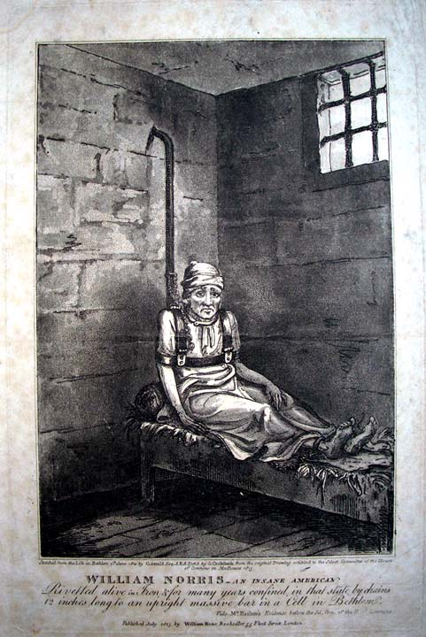
This is not, unfortunately, the worst controversy to reside within the walls of Bethlem. Arguably, the colossal outrage that surrounded James Norris in 1814 was the biggest lunacy scandal in the modern period. A Bethlem patient named James Norris (mistakenly called “William” by many) resided in the Royal Hospital for twelve years, nine under inhumane levels of restraint—even by Georgian standards. Norris was an American pressed into service by the Royal Navy during the Napoleonic Wars. Supposedly disorderly, Norris’ back “had been liberally scored by the lash.” According to the governors, Norris became violent with both a patient and a male caretaker, was placed in mechanical restraints, and remained there for nine years because of his violent nature. Edward Wakefield, a Quaker gentleman and wealthy philanthropist, discovered Norris in 1814 while touring Bethlem (and other asylums) to determine if the institution deserved his donations. The Bethlem caretakers used irons on his ankles, connected by a chain to an apparatus around his torso and shoulders. The contraption was then affixed to a pipe behind his bed, which allowed for only about twelve inches of space between Norris’ back and the pipe. Norris could only sit up with his legs straight or stand next to his bed. Mortified, Wakefield took this information to the Press and to Parliament. Disgusted and shocked by Wakefield’s words, journalists and MPs visited Norris at Bethlem. The men took careful notes, sketched the scene, and later commissioned an etching of the sketch to visualize the inhumane conditions Norris experienced daily (Figure 1).
Figure 1: Etching of William [James] Norris by George Cruikshank
The outrage surrounding Norris’ confinement at Bethlem assisted in the creation of the Select Committee of the House of Commons in 1814 that investigated the state of asylums and private madhouses in England, clearly targeting the old institution of Bethlem (as well as the York Lunatic Asylum) in comparison to the exemplary Retreat at York, a Quaker institution. Founded in 1796, The Retreat became known for its modern and humane treatment and management methods. The authors of The History of Bethlem especially noted that the Committee’s report consistently compared Bethlem to the Retreat at York to vilify the aging hospital and used it as an antithesis to the modern sensibilities that the Quakers exemplified.
Quite Neat at the Quiet Retreat
The Retreat at York became a unique healing space in the late-eighteenth century. Founded by William Tuke and other Quakers, The Retreat served as a model asylum for future institutions in Britain. The Retreat’s origins started with the controversy surrounding Hannah Mills at the York Lunatic Asylum (also known as “The Asylum at York”) in 1791. Some Quakers—Tuke being one of them—tried to visit Mills, but the governors and caretakers of the York Asylum refused visitation. Shortly after, Mills died. Many Quakers, Tuke included, believed that Mills died from maltreatment and malnourishment, the main reason why the asylum refused visitation. Appalled by this abhorrent event, Tuke and his daughter, Ann, began the creation of what would later become the Retreat. Originally, the father-daughter duo wanted the Retreat to treat only Quakers and be operated only by the Society of Friends; this would change by its opening in 1796 to include staff and patients of all religious beliefs.
Tuke and the other Quakers involved in the construction and creation of the Retreat took inspiration from other asylums in the 1790s. Tuke visited St. Luke’s Hospital for Lunatics in 1792 to observe treatment at the asylum. Unfortunately, the treatment and management of the patients at St. Luke’s horrified Tuke when he witnessed a female patient chained to the wall of her cell, dirty and without clothes. Seeing this unknown woman completely altered his preconceived ideas of British orthodoxy in the treatment of the mad. Tuke originally believed the conditions at the York Asylum to be abnormal, but the visit to the second-most exemplary asylum in Britain (Bethlem considered as the greatest during that time) pushed him to see the necessity of the Retreat as a humane institution, emboldening him to finish the project. As part of the Society of Friends leadership in Yorkshire, Tuke influenced the future treatments and management of patients at The Retreat during its construction.
Once the Retreat opened in 1796, the Quaker influence in early British psychiatry began. The Retreat would become a haven for pauper lunatics in northern England and Quaker lunatics throughout Britain to receive humane care. The medical and administrative staff did not implement restraint as a standard treatment. Instead, the medical personnel saw restraint as an extreme method for only the most violent of patients experiencing the worst of paroxysms. An 1855 tribute to Tuke in the Journal of Psychological Medicine and Mental Pathology discusses the restrained approach to restraint:
Considerable investigation into the early practice [of moral treatment] pursued at the Retreat induces us to think that the amount of restraint employed was remarkably small, and fully justifies the general description given of it by Dr. Conolly, when he says, “Certainly, restraint was not altogether abolished by them [the early managers of the Retreat], but they undoubtedly began the new system of treatment in this country, and the restraints they did continue to resort to were of the mildest kind.”
Tuke acted as de facto superintendent of the Retreat in its first year, made appointments to specific positions, and focused on how to implement what would later be called moral treatment and moral management. Tuke’s administrative work (the “management”) focused mainly on patient needs such as a proper diet with meat, clean clothes, and long periods outside in fresh air. The mad-doctors appointed by Tuke shared similar sensibilities with him, which created a mostly homogeneous staff of caretakers and ensured that certain aspects of Quaker beliefs became part of treatment. The most important aspects of Tuke’s moral treatment was regimented days with religious activities throughout each day. Tuke believed that the lunatics within the Retreats’ walls needed self-discipline and a sense of routine to have their mental faculties return to their original state.
Tuke and his followers wanted to implement Quaker practices that included self-discipline within the space of mental healing, and the Retreat became a model asylum. During the Special Committee on the State of Madhouses in 1814, Tuke answered several questions relating to the treatment and management methods used at The Retreat. The Committee Chair, the Right Honorable George Rose, Christchurch’s MP, seemed especially intrigued that “very little medicine is used” at the Retreat. Additionally, Tuke explained that the administrative practices at the Retreat—annual rotations of governors, consistent visitation by mad-doctors, and the uncorrupted self-governance of its administrators and staff—all came from Tuke and the other governors visiting other asylums and madhouses to witness the inhumane conditions and creating new practices from those experiences. Within a few decades, The Retreat went from small, upstart Quaker asylum to the premier mental healing institution in Britain, overtaking Bethlem and St. Luke’s in reputation and stature. Principles and ideas from the Enlightenment can be seen throughout Quaker beliefs and practices, and Quakers translated these beliefs into a reformed, more humane form of mental healing at the Retreat. However, other influences arrived in Britain that borrowed or evolved from the Retreat’s methods.

Chapter 2: Centralized Authority, Standardized Treatment, and the Lunacy Act of 1845
Introduction
Of the five laws passed between 1774 and 1845, two of the most important passed simultaneously: the Lunacy Act of 1845 and the County Asylums Act of 1845. Parliamentary debate over these bills eventually required both to pass for either to receive Royal assent. In Chapter 2, I examine the Lunacy Act of 1845. I argue that the law was the culmination of decades of ideological evolution in the proper treatment of the insane, as well as growing concern about the lack of standardized treatment, management, and recordkeeping throughout British asylums and private madhouses. New ideas about the causes and treatment of madness started in the 1790s with Quakers and other staff at the Retreat at York; the “moral treatment” and “moral management” that the mad-doctors and lay staff conducted at the Retreat eventually evolved into the non-restraint movement in the 1830s. The non-restraint movement led to a large cadre of medical and lay people petitioning Parliament to standardize and reform the British psychiatric system in the 1840s. Parliament established an inquiry to observe and investigate the entire psychiatric system in England, and in 1845 decided to separate the new psychiatric reforms into two separate bills.
The County Asylums Act of 1845 covered the mandatory creation and organization of county asylums (a topic that I examine in Chapter 3) while the Lunacy Act of 1845 reformed the psychiatric system as a whole and reorganized the authoritative body that oversaw the system. The Lunacy Act of 1845 attempted to restructure the entire psychiatric system in Britain. In this chapter, I summarize these provisions, the existing infrastructure that Parliament utilized to create a smooth transition in overseeing the network of institutions, and the reasoning behind these changes. I do not cover every provision in this bill; rather, I summarize the three most important sections of the legislation, provide historical context by illustrating issues that these sections attempt to remedy, and demonstrate who and what influenced the Commissioners of Lunacy and Parliament to create these provisions. Specifically, this chapter explores why Parliament chose to create a centralized authority, as well as standardized recordkeeping, treatment, and management methods. My main source for this chapter is the Report to the Commissioners of Lunacy of 1844. The Lunacy Act of 1845 was the final result of extensive investigation and deliberation; the underlying motivations and influences that led to the legislation can be found in the 1844 report.
Georgian Laissez Faire Lunacy
Throughout the Georgian Period and the Regency, the Crown and Parliament hoped that central oversight of asylums and private madhouses could be minimal. The Madhouses Act of 1774 and the County Asylums Act of 1808 provided nominal oversight but emphasized self-regulation and voluntarism by the institutions and counties. The liberal Whigs wanted to ensure that local and medical authorities regulated asylums and private madhouses rather than a large, bureaucratic, centralized authority. This original intent can be seen with the provisions of each law. The Madhouses Act of 1774 required that private madhouses and asylums (excluding Bethlem) obtain and hold an annual license from the Royal College of Physicians to practice psychiatry, not from a government official. Specifically, whenever any person or house holds more than one lunatic, the law considered the building “concealing or confining” a lunatic to be deemed as a madhouse, the owner of the building its proprietor, and under the purview of the Home Office or county authorities. Parliament intentionally left the accreditation of asylums and private madhouses to the Royal College of Physicians in order to follow liberal principles of a government that does not intervene in industry, and early British mental healing—much like the rest of medicine of the period—worked as a business.
The Georgian Period witnessed the founding and proliferation of private madhouses. The rapid growth in the number of madhouses aroused fears of false or malicious incarceration. The financial incentive present for private madhouses to incarcerate as many lunatics as possible allowed proprietors to conspire with the friends and relatives to institutionalize wealthy men and women. Additionally, many of the buildings converted into private madhouses could only hold a small number of patients, which led to many of these institutions purposefully overcrowding to maximize profits. William Lloyd Parry-Jones explains in The Trade in Lunacy that the Madhouses Act of 1774 allowed for overseers in the Home Office (and subsequently, historians) to have more accurate information on the size and scale of the “Mad-Trade;” many private madhouses did not keep records prior to the legislation. Many private madhouses did not exist in any records until after the registration and certification requirements in the 1774 law. By the 1814 and 1815 Select Committee Inquiry into the state of Madhouses, thirty-four London Metropolitan and thirty-eight provincial private madhouses existed on record. Parry-Jones explains that this number is lower than the true number of private madhouses that operated prior to the 1845 Lunacy Act; many private madhouses operated without a license in secret (or sometimes, publicly) without recourse or oversight for decades.
Some private madhouses conducted specialized mental care while others simply offered confinement and incarceration (regardless of care) for the insane in both urban and rural areas. Before the Lunacy Act of 1845, private madhouses outnumbered all other asylums (charity and county) by a factor greater than seven-to-one (239 private madhouses to 32 asylums). Typically, mad-doctors created or operated as proprietors of these private madhouses (sometimes both). George Man Burrows, a mad-doctor, created two private madhouses, one in Chelsea that went defunct after seven years (1816-1823) and the Clapham Retreat, a private madhouse designed to house wealthy lunatics on the northeast outskirts of London in a resort-like environment (1824-43). This massive disparity between the number of private madhouses and asylums also created a disparity in the treatment, management, and confinement of paupers.
Both the 1774 Madhouses Act and the County Asylums Acts of 1808 and 1828 did very little to provide oversight of private madhouses. The 1774 Madhouses Act only created a mode of certification for any facilities that treated or cared for the insane and a requirement for the certification of an alleged lunatic’s insanity prior to admission. Many conspiratorial scandals existed despite the insanity certification requirements in the 1774 Madhouses Act. Three of the most famous malicious incarceration scandals of this period consisted of groups of people conspiring to establish or continue the confinement of wealthy men in private madhouses—one at George Man Burrows’ Clapham Retreat. The County Asylums Acts of 1808 and 1828 carried provisions that required record-keeping and reporting for any licensed organization, but little else. This laissez faire lunacy of the Georgian Period persisted until the 1845 Acts that increased restrictions for the admission of the insane.
Centralized Victorian Oversight, Reformist Mad-Doctors, and Standardization
Georgian laissez faire lunacy persisted until the royal assent to the 1845 Lunacy Act, particularly in treatment and management methods. Prior to 1845, treatment and management varied widely. Bethlem Royal Hospital, which had remained excluded from most reform legislation in the Georgian and Regency periods, continued methods deemed by many within medical and lay circles as inhumane. Much of this resentment persisted from the 1814 scandal involving James Norris, his confinement, and the nature of his restraints for almost a decade.
St. Luke’s Hospital for Lunatics also found itself losing favor with medical and lay populations by the 1840s. The asylum’s last secretary and historian, Brigadier C.N. French attributed this to the governors’ and medical superintendent’s consistent recruitment of former Bethlem administrators and staff throughout the first half of the nineteenth century.
The long service of the Mansfields, the Dunstons and the three generations of Websters is testimony of the good relations and mutual esteem between the Governors and their servants, and of the spirit of loyalty to the hospital that must have existed, and which indeed has always been a feature not only of St. Luke’s but of all hospitals in this country. Long service may, however, sometimes have its disadvantages and result occasionally in a certain rigidity of outlook and practice, particularly when, as in the case of St. Luke’s, some of the Consulting Physicians on the medical and several of the Treasurers on the administrative side held their posts for many years. The deliberation with which, in the middle of the nineteenth century, changes were made in St. Luke’s not only on the recommendations of the Commissioners in Lunacy but of their own Medical Officers, is perhaps an indication of such conservativism.
The Matron and Master (the leaders of lay caretakers) are the “Dunstons” mentioned, and the governors recruited them after they worked at Bethlem for eight years. Typically, the Master and Matron consisted of a husband-wife duo who lived on-site and formed the administrative backbone of an asylum. At St. Luke’s, the Matron would record admissions and discharges, hired (and fired) nurses and maids, and oversaw the female wing. The Master hired (and fired) servants and non-medical male “caretakers” (male nurses did not exist in this period), ensured cleanliness in the dormitories (to include frequent replacement of straw in beds and the cleaning of any bodily fluids), and led the operation of the kitchen.
With Bethlem and St. Luke’s losing public favor, other asylums became the model for Parliament on the standardized treatment and management methods mandated by the 1845 Lunacy Act. In 1842, the House of Commons passed the Lunacy Inquiry Act, which granted powers to the Metropolitan Commission of Lunacy to investigate the state of private madhouses, asylums, and pauper lunatics in England and Wales. The Metropolitan Commissioners became the Commissioners in Lunacy (a precursor to the Lunacy Commission created by the 1845 Act) as a national investigative committee rather than its original jurisdiction of the London Metropolitan area. With the creation of the new investigative Commissioners of Lunacy, the House of Commons created a special committee to gather all the data necessary for the Commissioners of Lunacy to draft legislation. Between 1842 and 1844, these committee members thoroughly investigated the state of psychiatric care in England and Wales and generated a lengthy report. The committee’s report to the Commissioners of Lunacy in 1844 outlined the new model asylums that they recommended as templates for certain provisions of the legislation, but each treated and managed patients differently. The three most-lauded asylums within the report were Middlesex County Asylum at Hanwell overseen by Dr. John Conolly, the Retreat at York operated by Quakers and Samuel Tuke, and Lincoln Lunatic Asylum with Dr. Robert Gardiner Hill at the helm.
The first section of this report consists of the committee’s “Preliminary Observations,” essentially a summary of conclusions and suggestions detailed in the text. The committee alludes to the “moral treatment” and “moral management” that originated in the Retreat at York and how it should be a model for the care of the insane. The second section, “County Asylums,” detail Lincoln and Hanwell’s methods of administration and treatment, as well as the facility’s construction and organization. Dr. John Conolly, a moderate of the reformist “non-restraint” faction of mad-doctors that started in the 1830s, is highlighted throughout the report and lauded for his work on the removal of mechanical restraints at Hanwell and the usage of padded rooms and seclusion to mitigate violent patient paroxysms. Dr. Robert Gardiner Hill is also highlighted in this section for its work on the complete abolition of restraints and seclusion, though the committee seemed doubtful that this method could be readily replicable on a larger scale (Lincoln Lunatic Asylum only held around one hundred patients). Dr. Hill belonged to the radical faction of the non-restraint movement and believed that Dr. Conolly’s use of seclusion was another form of restraint. Tuke’s, Conolly’s, and Hill’s beliefs and methods are summarized in the “Medical Treatment” section with additional commentary on the effectiveness of each method.
Local Yorkshire Quakers led by William Tuke opened the Retreat at York in 1796. Originally designed in 1791 to be an asylum for Quakers and operated by Quakers, the Retreat allowed and employed many non-Quakers by its opening. Though much of the Retreat’s staff consisted of Anglican, Catholic, and other Evangelical denominations, the administration and modes of treatment derived from Quaker beliefs. Quakers believed in the Inner-Light (also called the Inward-Light). The Inner-Light refers to the belief that a small bit of God exists within every person. “Meetings” (the Quakers rejected traditional masses and services) between Friends would require quiet, meditative introspection of their own Inner-Light. This silent introspection would be broken by one person explaining what they believed to be divine knowledge, or some form of information given to them via the Holy Spirit. This would be rationally discussed in a dialectic between all the participants to judge the validity of this person’s conclusions. Rationality and equality became the foundational principles created by George Fox in the Society of Friends, and this became a large part of how the Retreat operated and treated its patients. Treatment through empirical observation became the key aspect of medical practice at the Retreat. In the 1814 and 1815 Parliamentary Inquiries, William Tuke gave testimonial about the Retreat to the House of Commons. Unlike the two main asylums under scrutiny, Bethlem and York Lunatic Asylum, Tuke’s testimony proved to be rather brief, but informative about the inner-workings at the Retreat. The Right Honorable George Rose in the Chair asked a question about the use of medicine in the treatment of the insane. Tuke’s answer provides insight into how Quaker belief found its way into the treatment and management methods utilized at the Retreat.
Can you speak from your personal knowledge, to the effect of the medicine, in cases of mental derangement?—In cases of mental derangement, from what I have learnt, it is thought very little can be done; but when the mental disorder is accompanied by bodily disease of one kind or another, the removal of the complaint has frequently recovered the patient; this comes within my personal observation, having frequently enquired into the effect of medical treatment. […] Do you know enough of the medical treatment of the patients at the Retreat, to enable you to inform the Committee, whether the patients in the house are periodically physicked, bled, vomited, and bathed?—No such thing[.] […] None of those operations are periodical?—No; in fact very little medicine is used.
Tuke specifically used the term “observation,” and according to his observations, medicine does very little to mental derangement, ergo, very little medicine is used at the Retreat.
Anne Digby describes this empirical approach to mental healing as “a distinctive lay therapy” in her history of the Retreat. Digby explains that faith and religion became the focal point of administration and operation at the Retreat because of the incident involving “familiar remedies” used by York Lunatic Asylum that resulted in the death of Hannah Mills, a local Quaker. Quakers refused to participate in established authorities (oaths of loyalty and recognition of nobility through heredity, to name a few), and this rejection of established hierarchy, authority, and knowledge coalesced into the Retreat’s treatment of lunatics: the Quakers employed mad-doctors and administrators that did not follow medical orthodoxy. Additionally, the larger concentration of laymen that worked at the Retreat produced “unremarkable” results, “but their pragmatic therapy was distinctive precisely because it was imbued with the values of the Society of Friends.”
Quakers believe(d) in self-discipline, meaning that every Friend is a disciple of the Holy Trinity and must therefore practice their religion often and with self-motivation rather than the heavily regimented and regulated days for masses or other church services created by clergies. This, Digby explains, became the cornerstone for moral treatment and moral management used at the Retreat. The second superintendent and layman, George Jepson, held a deep religious connection as a Quaker and sought to ensure that the Retreat’s patients practiced religion often, regardless of denomination. “Caring for the insane was seen as a practical expression of religion.” The administration, staff, and governors at the Retreat believed that treatment did not require medicines or physick, but instead designed it to create a comfortable and stable environment for those suffering from mental afflictions. This method known as “moral treatment” and “moral management,” would evolve and be mimicked in various forms throughout the nineteenth century. Above all else, William Tuke explained at the 1814 and 1815 inquiry that, at the Retreat, “every thing [sic] is done by those that have the management of them, the Superintendent, and his wife, who has the care of the female part, to make the patients as comfortable as they can, and to endeavor to impress upon their minds, the idea that they will be kindly treated.”
Once the Retreat established moral treatment and moral management in Britain, it would evolve in the 1830s with the introduction of the non-restraint movement. Prior to the 1830s, some mad-doctors like John Conolly advocated for the reduction or removal of restraint in the treatment and management of the insane, but it took the work and empirical observations of Dr. Robert Gardiner Hill to give the non-restraint movement the catalyst it needed. In 1834, the governors of Lincoln Lunatic Asylum employed Hill as a surgeon for the asylum. In the following year, the governors gave Hill the task of continuing the work of his predecessor, Dr. Edward Charlesworth with the reduction of restraints in the treatment and management of the insane. Over the course of three years, Hill would reduce all restraint by ninety percent and presented his findings in a travelling lecture series in 1838. Hill and his employers at Lincoln printed a transcript of the lecture presented in Lincoln along with statistical tables and published it the same year. Unfortunately, Hill expressed concerns about the necessity to hire more specialized and disciplined caretakers at Lincoln to fully abolish the use of restraints at the asylum, but the governors refused to acquiesce his request due to budget constraints. Animosity grew between Hill and the governors to the point where he quit his position in 1840.
John Conolly visited Lincoln Lunatic Asylum and viewed Hill’s work on non-restraint just one month before being appointed as the medical superintendent of Middlesex County Asylum at Hanwell in 1839. After seeing physical evidence that proved his non-restraint theories, he ensured that Hanwell would follow in Lincoln’s example and began working to ensure Hanwell’s status as the premier asylum in Britain. Conolly understood Hill’s need for disciplined lay caretakers and consistently performed inspections to maintain a strict regimen for both his patients and staff. Akihito Suzuki notes Conolly’s penchant for inspections at odd and random hours of the day (or night). Suzuki explains that Conolly used “special slippers” to quietly walk around the asylum at late hours to catch unsuspecting caretakers napping in the middle of the night. Though Suzuki argues that Conolly used non-restraint as a means to have a large amount of control at Hanwell, Conolly’s own writing in An Inquiry—which he wrote almost a decade prior to his appointment to Hanwell—explained his hypothesis that an efficient and disciplined cadre of caretakers would be necessary for an asylum to implement a non-restraint system. With patients having few or no fetters, they had the ability to create mischief, cause harm to other patients or staff during violent paroxysms, or attempt escape caused by delusions. Only an alert, motivated, and disciplined workforce, Conolly explained, could achieve a non-restraint system at an asylum.
Conolly and Hill disagreed on what constituted a “non-restraint” asylum. Hill, a radical, believed that all patients could be rationally convinced to do what others required of them and even considered coercion—the act of tricking an asylum inmate to do something despite the consequence of doing the action not being true—as a form of restraint. Hill’s more radical approach and interpretation of restraint became a focal argument in both his and Conolly’s publications in the mid-to-late-nineteenth century. Conolly defined restraint only as the use of mechanical devices that held someone in position. Handcuffs, leather straps, and the straight waistcoat, but Hill went further in his understanding of restraint and its abolition.
Though Conolly and Hill both saw the necessity to remove mechanical restraints from the treatment and management of lunatics, their different ideologies created a vast difference in the type of care their patients received. Though moral management and moral treatment became the medical orthodoxy by 1845, many still practiced the use of restraints and did not align themselves with the non-restraint movement in the same fashion as the Retreat. Additionally, some asylums and mad-doctors did not practice moral treatment and moral management, opting for traditional methods of restraint and other modes of treatment deemed inhumane by the non-restraint movement. One part of moral management adopted by the Tukes at the Retreat and others that mimicked their system was a strong, hearty diet that included meat every day. Asylums that did not adopt moral management would not give patients meat, either because it was too expensive or because the mad-doctors implemented emetic treatments like Dr. Joseph Cox’s “spinning chair.” This variety in the quality of treatment became a contentious point in the 1844 Report to the Commissioners of Lunacy.
A great difference prevails, in this respect, in different classes of Lunatic Asylums. […] In some Asylums, the whole system of management appears to have been constituted less with regard to the cure of insanity, and to the restoration of lunatics to health and society, than to their seclusion and safe custody.
Additionally, the committee utilized observation and empirical evidence to conclude about which forms of treatment that should be made standard. The committee noticed certain treatment methods and management patterns at more “successful” institutions; these practices would become the standard in all institutions.
The foregoing remarks upon the medical treatment practised [sic] in various Asylums must be understood to apply principally to recent cases. In chronic forms of disease, although medicine alone is found to be of less efficacy, much is still accomplished by skilful [sic] medical superintendence, combined with judicious moral treatment.
How would standardization be implemented and maintained within this system? The committee saw the success of the already established Metropolitan Commission of Lunacy and the oversight infrastructure that it created in the regulation of London-based asylums and private madhouses. The Lord Chancellor and Parliament decided to utilize the existing infrastructure but to expand its scope, scale, and powers—first through the Lunacy Inquiry Act of 1842 and then later with the Lunacy Act of 1845. One recommendation in the Report that would later become part of the Lunacy Act of 1845 was that all institutions should be subject to official visitation at least once a year. Another was that, “That the Official Visitors have power to fix and alter the Dietary of Pauper Patients in all Lunatic Asylums.” Finally, the committee recommended standardized records to allow for more efficient oversight so that bureaucrats in the Home Office and the new Lunacy Commissioners could recognize issues present at certain asylums or private madhouses.
That in all Asylums, Public and Private, Registers and Medical Records be required to be kept, in a specified and uniform shape; and that annual statements of admissions and discharges, in a form to be prescribed, be made up to the 31st of December in each year, and transmitted to the Metropolitan Board.
Uniformity in records would allow for uniformity in treatment and management. The standards created by the medical and lay people of the Lunacy Commission created by the 1845 Lunacy Act would set a minimum standard for the quality of care and management of lunatics with special attention to the care of paupers.
Conclusion
The 1845 Lunacy Act created a national, centralized oversight organization—the Lunacy Commission—which would ensure standardized record-keeping and standardized treatment and management for the insane. The vast disparities between the quality of care—even among reformist mad-doctors—became contentious to the MPs and Commissioners who worked as members of the inquiry committee. The operation between institutions became so disparate that it alarmed Parliament. Championed by the Anthony Ashley-Cooper, the 7th Earl of Shaftesbury and Metropolitan Commissioner (this also made him a Commissioner in Lunacy during the 1842-44 inquiry), the Lunacy Act of 1845 ultimately generated a system designed for all British lunatics to receive quality care from professional medical institutions that specialized in mental healing.
Quaker moral treatment and management alongside the non-restraint movement created a chasm between traditional orthodoxy and the more modern and humane mental healing institutions created in the early nineteenth century. One of the most important provisions of the 1845 Lunacy Act was the minimized use of restraint in the standardization of mental healthcare. Restraints would be forbidden unless the lead medical person (either the Resident Physician or by the medical superintendent). The use of restraint would be thoroughly documented with the length of time the asylum or private madhouse restrained the patient and the reason(s) why.
The treatment and management methods outlined in the provisions of the 1845 Lunacy Act demonstrated how much Quaker moral treatment and management influenced the early psychiatric system in Britain. The modes and methods implemented at the Retreat—a focus on patient well-being and using restraints only when necessary—became the standard for British asylums and private madhouses. Though the non-restraint movement became widely popular among mad-doctors in the 1830s and 1840s, many other mad-doctors opposed the radical abolition of restraint in its entirety. The Tory MPs of the 1845 government clearly understood this clash between practitioners and established a median to use as a template. It is no coincidence that the standards established in the 1845 Lunacy Act mirror the methods of the Retreat in most provisions. Lastly, thorough and uniform records allowed for efficient centralized oversight to ensure standardized care in the entire psychiatric network in Britain, but the geographic distribution of patients required the exact opposite change: it needed to be altered from a mostly centralized network that utilized London as a main hub to a more widespread and localized network of small, efficient, interconnected nodes.

Chapter 3: Local Lunacy and the County Asylums Act of 1845
Introduction
The nominal oversight and aid from the three major reforms of 1774, 1808, and 1828 did little to assist overcrowding in the two major London asylums, St. Luke’s Hospital for Lunatics and Bethlem Royal Hospital. While Chapter 2 focused primarily on the underlying causes of the Lunacy Act of 1845, this chapter primarily examines the causes of the County Asylums Act of 1845. I review the overcrowding of asylums and explain how the subscriber system of Georgian asylums became unsustainable with the proliferation of specialized care in institutions for the insane.
My primary purpose is to demonstrate that when MPs and the Commissioners of Lunacy read lists of existing institutions in the 1844 Report, they recognized geographic gaps in the care for the insane. Pauper families had to either choose between a local private madhouse, a small asylum within or adjacent to their county (sometimes two or three counties away), or travel for days to admit their lunatic loved ones to one of the London-based asylums or private madhouses. Visitation, therefore, would prove to be difficult for pauper or lower-class families (and friends). Bureaucrats within the Home Office prior to 1845 reviewed registers from asylums and private madhouses outside London and would see similar outcomes. Some families in the Midlands would likely choose other subscriber charity asylums like the York Lunatic Asylum or West Riding Lunatic Asylum at Wakefield to reduce travel to admit and visit their insane relative or friend, but many families would not have this kind of luxury and would still cause geographic gaps in the care for the insane.
I highlight the spatial perspective bureaucrats and policymakers held by geospatially and demographically analyzing the St. Luke’s Hospital for Lunatics Curable Patients Book for the year 1822. I explain the origins and reasoning for the County Asylums Act of 1845 by analyzing the information provided by this singular admissions, death, and discharges register. Carefully mapping patient resident locations helps to examine and demonstrate the issues faced by the few county asylums and London-based asylums. These maps will also show the extent to which families and friends of lunatics traveled for specialized care and how it could be detrimental to the mental healing of the patient. Using geospatial analysis, I argue that the motivations and influences that led to the County Asylums Act of 1845 involved the spatial disparities of asylum locations with respect to patient residences.
Previous historiography surrounding the County Asylums Act of 1845 examines the proliferation of specialized care that created a higher demand for mental health institutions and a need to mandate the creation of more facilities. Historians have argued that the demand for specialized care and treatment grew more rapidly than the supply of facilities that provided such care to pauper and lower-class lunatics, and that rising demand caused overcrowding in asylums. The problem of overcrowded asylums was, according to these historians, the main factor motivating the passage of the County Asylums Act, which mandated the creation of more asylums outside London. It is true that some asylums were overcrowded. The 1844 Report linked overcrowding to higher death rates at certain asylums, and the Home Office received complaints about overcrowding at specific asylums. However, overcrowding was not the sole or even the main cause of the County Asylums Act. In fact, the 1844 Report stated that many asylums operated at capacity or lower—especially the previously mentioned model asylums of Hanwell, Lincoln, and the Retreat. The asylums with higher death rates were not just overcrowded, they also lacked adequate heating, proper patient diet, air circulation, properly sized dormitories, or large enough “airing courts” (places for patients to wander and receive fresh air). Overcrowding was only one concern for the Commissioners and MPs, but it was not why they recommended counties be legally obligated to create and operate asylums of their own. The reasons for drafting the County Asylums Act of 1845 were spatial in nature.
Methods
I chose to use St. Luke’s Curable Patients Book of 1822 for three reasons. Firstly, the year is fourteen years after the County Asylums Act of 1808, which allows for a close inspection of changes to patient demographics with the creation of the few county asylums that existed. Secondly, 1822 is seven years after the Parliamentary enquiry into Bethlem (and other asylums) and six years before the County Asylums Act of 1828, making it a median year between the two. This allows for a view into the asylum’s inner workings in this interim period and how the failed proposed regulations in 1815 would appear nominally in 1828 and again in 1845 with greater efficacy and mandatory county participation. Third, the year 1822 is between the County Asylums Acts of 1808 and 1845. This offers a great cross-section of the first half of the nineteenth century; the growing pains of asylum reformation; and how Regency and early-Victorian Britain unsuccessfully attempted to use the free market (private madhouses), the charity and philanthropy of Georgian subscription-like hospitals and asylums, and incentivized—but not mandated—county participation as both a solution and stop-gap for these growing pains. I will explore the issues that the County Asylums Act of 1845 attempted to remedy through close examination of specific sections (columns) of the St. Luke’s Curable Patients Book. I will use demographic and geospatial analysis to help strengthen the historical context and the motivations for the 1845 County Asylums Act.
The geospatial analysis conducted for this chapter observed multiple aspects of the register beyond patient location and the concentration of patients within specific distance radii. The analysis reveals the chaotic nature of this peculiar asylum for pauper lunatics by exploring other factors involved. Specifically, digital mapping of “parish poor” paupers; frequent “recommenders” from St. Luke’s Georgian subscriber system and the patient locations from the repeat recommenders; frequency by county; patient location within or outside London; and utilization of historical geographic data will help strengthen conclusions from the demography and historical context which will offer additional perspective that may be lost without spatial analysis. All of the maps presented here were authored in QGIS 3.16 (Hannover), an open-source GIS (Geospatial Information System) program with the aid of openly accessible ArcGIS Online basemaps and community shapefiles.
The digital maps especially are not analyzed singularly. Each map offers only a piece of the total spatial historiography present at the study area. Additionally, the flaws of each map are considered throughout. These flaws mostly pertain to the lack of information provided by the register. Patient residences are recorded with only city and county—or in the case of the London Metropolitan area, parish and possibly county if the parish is outside of the formal city limits or south of the Thames in Surrey. To determine whether a patient resided within or outside London, I utilized a digitally scanned map from 1822 titled A New Map of London and its Environs, From the Original Survey Extending 8 Miles, East and West, 6 ¼ Miles, North & South, in which All New and Intended Buildings, Improvements, &c., Are Carefully Inserted that a “Mr. Thompson” created. This map provided a basis for what contemporaries considered to be the London Metropolitan area. The map creator, “Mr. Thompson,” highlighted the formal boundaries of Old London, Westminster, and the Civil Parishes of Southwark in Surrey (Christchurch, St. Savior’s, St. George the Martyr, St. Olave, St. Thomas, St. John Horsleydown, and Liberty of the Mint) that contemporaries considered an unincorporated part of South London (Figure 1.3 and 1.8). For the sake of expediency and historical context, I included the areas as part of London when determining a patient’s residence inside or outside the capital city’s metropolitan area.
Background
In 1786, St. Luke’s Hospital for Lunatics moved from its Moorfields location to Old Street between Bath Street and City Road. The old location, which the governors called “The Foundry” (because it was a repurposed cannon foundry), could only hold about fifty pauper patients. From 1750 to 1780, the asylum’s population grew to more than seventy patients. Once the Old Street Hospital opened in the parish of St. Luke’s Old Street, St. Luke’s Hospital for Lunatics had the ability to admit three-to-four times more patients than the Foundry location. At the turn of the century, St. Luke’s Hospital for Lunatics had nearly two hundred pauper lunatics (its approximate capacity) within its walls and would remain steady until 1916. St. Luke’s became a unique institution within Britain’s asylum system. It initially cared only for pauper patients; however, by the middle of the nineteenth century, St. Luke’s oversaw the care of pauper, working class, and middle-class patients. The Old Street location operated during the proliferation of lunatic asylums, reforms over the governance and administration of asylums, and legislation on the treatment of lunatics.
After the Madhouses Act of 1774, Parliament created and passed the County Asylums Act of 1808. By this point in time, only eleven asylums existed. These eleven consisted of the three London asylums of Bethlem Royal Hospital, St. Luke’s Hospital for Lunatics, and The Lunatic House of Guy’s Hospital; Haslar Hospital, an asylum for military lunatics; and seven Georgian subscriber asylums “supported wholly, or in part, by charitable contributions” named St. Peter’s Hospital in Bristol (the County of Pembroke Workhouse in 1696 incorporated into it), St. Thomas’s Asylum in Exeter, Liverpool Lunatic Asylum, Manchester Lunatic Asylum, Bethel Hospital in Norwich, the York Asylum, and the Retreat at York. According to William Lloyd Parry-Jones, forty-five private madhouses had been established in England by 1808, seventeen of them in London. Even with the addition of these private madhouses, the three London asylums were filled to their maximum population capacities by 1822—Bethlem relocated from its Moorfields location to a much larger building in St. George’s Fields in Southwark in 1815 and it had filled to capacity by 1822.
The Georgian System: Patients from Far and Wide
In 1822, St. Luke’s Hospital for Lunatics on Old Street operated to its population capacity of two hundred pauper patients. The founders of the asylum in 1751 wanted a place for paupers to receive ethical treatment separate from Bethlem because of its eighteenth century infamy as a center for entertainment viewing rather than curing madness. The founders organized and designed St. Luke’s like other hospitals of the Georgian Period: funding for the hospital would come through either one-time charitable donations or through a yearly subscription that the wealthy would contribute after the new year and would be led by a group of volunteer subscribers called “governors.” Many pauper lunatics at St. Luke’s were “Casual Poor” according to the Old Poor Law (employed paupers that received less funds than the Parish Poor to supplement rent or food). The founders of St. Luke’s designed the charity to use its funds to pay for a Casual Poor patient’s “maintenance” (the amount of money required to house, feed, and treat a patient) so that the lunatic’s families could still use the funds received by the Poor Law “dole” for rent and food.
The surge of requests for admissions grew in the early nineteenth century as St. Luke’s reputation as a desirable asylum became more widespread. London asylums had always admitted patients from outside of the city, but with industrialization—and subsequently urbanization—St. Luke’s and other London asylums’ ability to take in patients from outside of the metropolitan area became less feasible as the city’s population exploded to one million by 1800. In the year 1822, St. Luke’s Curable Patients Book recorded 117 patients admitted from outside London (66 male and 51 female) and 89 patients that resided within one of London’s parishes (36 male and 56 female), as visible in Figures 1.1, 1.2, and 1.3. One might assume that a London asylum would mostly care for patients from London, but pauper patients from outside London exceeded those from the capital. The number of patients from the counties labelled as “Parish Poor” (unemployed or disabled paupers who relied solely on parish assistance) within the register outnumbered their Londoner counterparts by a factor of ten in 1822 (Figure 1.5). For clarification, St. Luke’s Hospital in 1822 predominantly treated pauper patients, which meant all of them could be labelled “Parish Poor.” But the label seems to have been used for paupers who did not have any employment and received a “pension” or “outdoor relief.”
Those who recommended alleged lunatics to St. Luke’s exacerbated the issue with non-London patients outnumbering their Londoner counterparts. In the third column of the Curable Patients Book, a list of names appears under “Recommended by.” Some names reoccur frequently throughout the year (and other years), some names appear less than ten times, and others appear only once. Several aristocratic names within the recommenders’ column offer insight into the main cause for the disproportionate number of non-London lunatics. The Marquess of Ailesbury recommended the 169th patient admitted to St. Luke’s in 1822. The patient, Sarah Tuck, resided in Marlborough in Wiltshire, the very constituency for the Marquess as an MP. The Marquess, Charles Brudenell-Bruce, was the great-nephew of St. Luke’s first president (1750-1790), George Brudenell-Montagu. Furthermore, the Earl of Clarendon, Thomas Villiers, appears in the register just four entries before the Marquess of Ailesbury. It is highly possible that the Marquess and the Earl knew each other through the third physician at St. Luke’s, Dr. Samuel Foart Simmons, the same physician who treated George III in his later years. The Earl’s brother, John Villiers, served on George III’s privy council and became envoy to Portugal during the years Dr. Simmons cared for the king. Additionally, the Earl of Abingdon, Montagu Bertie, recommended a lunatic from his constituency that shared a border with Brudenell-Bruce’s. John Perring Sr., the former Lord Mayor of London recommended another non-London lunatic to the asylum. These aristocrats—all of whom were subscribers to the St. Luke’s charity—contributed to the higher population of patients admitted from outside London.
Leonard Smith explains that the main reason the asylums of this period adopted a similar system to voluntary hospitals like the Bristol Infirmary involved their efficacy and their ability to attract more recent wealthy industrialists and financiers, all of which allowed “an updated expression of noblesse oblige, reinforc[ed] authoritarian paternalist structures whereby the privileged fulfilled their duty to provide for casualties of the poorer classes.” Before the subscription charities of Georgian England, Britons were expected to contribute charitable or philanthropic donations regardless of social class. Linda Colley demonstrates this in her account of the emergency relief pushed by the Crown through local dioceses of the Anglican Church for the ransoms of Barbary Pirate captives in the late-Stuart period.
Those individuals who remained unnamed [when donating to the fund] were expected and encouraged to feel shamed. Even live-in servants, who generally paid no taxes, were urged on this occasion to give alongside their employers. […] In Tavistock, Devon, congregations dipped into their pockets for North African captives on over thirty different occasions between 1660 and 1680. The breadth of the response was sometimes staggering. In 1680, 730 of Tavistock’s citizens—a substantial part of the town’s adult population—clubbed together to raise over £16 for the captives. As this suggests, most could not give very much, but almost everybody gave something, from Lady Mary Howard who topped this list of donors with ten shillings, down to poor Elizabeth Harris who could only afford a single penny.
This demonstrates that the Crown—and subsequently the Church—influencing British culture towards donations became “closer to being an additional tax than a strictly voluntary donation.” The geographically wider base of subscribers helps demonstrate this evolution from Britons of all socio-economic classes being expected to give to charity and philanthropy in a local area to the paternal subscription system of the Georgian Period by only interested wealthy parties.
Interestingly, the three recommenders who recommended the most patients recommended Londoners to be admitted to St. Luke’s, but they still recommended many lunatics that lived outside London. These three helped admit 35 Londoner patients and 29 non-Londoner patients (Figure 2.4). One of them, Nathaniel Finn, recommended a woman from Ireland—the only lunatic admitted to St. Luke’s in 1822 that did not live in England. Nathaniel Finn focused heavily on alleged lunatics north of London in 1822, accounting for more than two-thirds of his recommendations (Figure 2.1). John C. Powell, the second-most frequent recommender, focused mainly on alleged lunatics in the London Metropolitan area, accounting for 11 of the 89 patients from the capital—approximately 12% of the total patients from London admitted that year, accounting for nearly three quarters of his clients (Figure 2.2). Thomas Davis, the most frequent person in this column for 1822, recommended 20 of the 89 patients (approximately 22%) who resided in London and 14 non-London patients (Figure 2.3).
Over one-third of the lunatics admitted to St. Luke’s Hospital as patients who lived in London came from these three recommenders, and it is not a coincidence. Nathaniel Finn, John C. Powell, and Thomas Davis all volunteered to be governors of the asylum. Mary E. Fissell found similar information at Bristol’s Infirmary: the recommendations came mostly from the governors, not subscribers. Finding any biographical information on these gentlemen (Esq. being the suffix of every man’s name on the rollcall sheets) outside of St. Luke’s records could not be found, and it is likely that the concentrations of patient residences coincide with areas they were from or familiarized (political, religious, and social connections could also be a factor). 45% of approved petitions from Finn, Powell, and Davis came from alleged lunatics who lived in the counties—in many cases outside of the aristocratic subscribers’ constituencies. It is reasonable from this evidence to reach two conclusions: Finn, Powell, and Davis, despite recommending many London lunatics, still made significant contributions to the larger non-London patient population at St. Luke’s; second, many traveled to London on their own accord (or at the will of their friends and family) to seek treatment without being admitted because many areas outside the capital had few options (or none) for pauper lunatic treatment.
These conclusions can be confirmed by the days that St. Luke’s received applications for patients, the days the governors met weekly, and the dates of patient admissions compared to the days St. Luke’s received applications. The founders and governors used Fridays to receive applications open to the public and not through the typical recommendation process with subscribers. Most of the non-London patients recommended by these men turned in applications on Fridays. In most of these cases, the patient would be admitted on the next Friday. Since the governors met on Saturdays on a weekly basis (holidays excluded), it is most likely that they discussed these last-minute applications and decided who would be accepted for treatment. This is mostly confirmed by the Minutes Book for the governors’ meetings in 1822; however, the Minutes Book does not specify what the section labelled “discussion of applications” exactly entails—though it is reasonable to assume that it is discussion about the previous day’s petitions for admission. In the rule book for the duties of various administrative and medical positions at St. Luke’s, rule XXXII states that every petition must be signed by at least one of the governors of the hospital. This rule creates two outcomes: first, the governors would be an obvious choice to seek out for a last minute petition on Fridays; second, the governors would know to a high degree whether or not a patient would be a good candidate (or in the very least, eligible) for admission and would be a natural choice to aid in the admissions process. This means that patients would come from great distances with only the hope of being admitted. Many would be admitted, but it is uncertain the true number of patients who attempted to be admitted into St. Luke’s since no records of the type exist.
One reason for the smaller number of London patients, though the impact cannot be fully determined, may be that other rules set by the charity regarding admissions forced many residents of London to seek treatment elsewhere, particularly the provision that barred admission to anyone who had received treatment elsewhere for more than twelve months and been deemed “uncured.” According to the founders, St. Luke’s was a place for curable patients and would only house a small number of incurable patients that required continuous care. The few incurables who remained at St. Luke’s more than likely had no family or friends and also could not—for any number of reasons—receive the dole from the Poor Law, but records that explain which incurables stayed do not exist, and case files or journals belonging to mad-doctors do not exist during this period.
The large inflow of patients from the counties to St. Luke’s, arguably the second most well-known London asylum, demonstrated the necessity of county asylums and localization for mental healing. Those that lived outside the capital in southern and eastern England had little or no access to county or charity asylums, forcing patients to essentially migrate across England in order to receive care. This majority of non-London patients at St. Luke’s Hospital demonstrates why Parliament ultimately passed the County Asylums Act of 1845 to make the creation of asylums mandatory. The first recommendation given by the Select Committee of 1844 in section titled “Suggestions for the Amendment of the Law” states “[t]hat there be provided for the Insane Poor of every County some proper and convenient Hospital or Hospitals for the reception of all recent cases.” The use of “proper and convenient” is not accidental. Members of Parliament knew and understood this mass migration.
Geospatial analysis of all patients admitted to St. Luke’s in 1822 further elucidates the chaotic nature of this interim period of mostly Georgian subscriber hospitals and a select few county asylums. Figure 1.1 demonstrates the concentration of lunatics by county, showing a widespread selection of patients. Maps detailing more accurate locations of the patients (Figures 1.2 and 1.3) show a concentration in southern and eastern England, one from Ireland, one from Yorkshire, and eleven from the Midlands: four in Warwickshire, four in Northamptonshire, one in Herefordshire, one in Shropshire, and one in Lincolnshire. Based on an Isochrone Map of stagecoaches in 1830 (Figure 1.4), most patients lived within fifteen hours of travel time by stagecoach (approximately two to three days of travel). Much of this concentration can be attributed to the locations of subscribers mentioned previously and to the locations of existing asylums in Liverpool, Bristol, Exeter, Manchester, Norwich, Stafford, Bodmin, Lancaster, Wakefield, Nottingham, Lincoln, and York. The other asylums in England sit within voids of patient locations within proximity to the cities they reside. Norwich, Bristol, Lincoln, Bedford, and Bodmin are the only exceptions. One patient, Mary Davies, resided in Burgh, approximately sixteen kilometers from Norwich. Elizabeth Middleton who lived in Iron Acton and Mary Porter lived in Newington Bagpath, fourteen and twenty-nine kilometers from Bristol, respectively. Samuel Cooper lived in Tattershall, twenty-seven kilometers southeast of Lincoln. Three patients lived near Bedford (only one of which lived in Bedfordshire): Elizabeth Gentle lived in Biggleswade, fifteen kilometers southeast; William Clark lived in Emberton, Buckinghamshire, sixteen kilometers west of Bedford; and Elizabeth Pool lived in Kimbolton, Huntingdonshire, seventeen kilometers north of Bedford. Both Clark and Pool lived outside of Buckinghamshire, making the reason for non-admission to the county asylum in Bedford obvious, but it is worthy of discussion given the geographic nature of this study. Lastly, James Belling resided in Bodmin in Cornwall, the exact city that already contained an asylum. All other patients near another non-London asylum are at least thirty kilometers away from the nearest asylum (Figure 1.6). The proximity of many patients within sixty kilometers of Bristol may likely be caused by failed admission due to lack of space for lunatics in Bristol or connections with a subscriber.
Local Lunacy: The Northern English, Midlands, and Welsh Voids
One important conclusion from this geographic study involves the massive void in Northern England and in the Midlands. Though not as populous as southern and eastern English counties, the Midlands and northern England built far more asylums (both county and charity) which allowed for more localized care within rural areas. By relying on London to carry most of the burden to care for the insane, much of southern and eastern England needed to travel for many days to cure lunatics in their communities (Figure 1.7).
Though not necessarily mentioned within the 1844 Special Committee Report, the authors describe the geographic disparity between southern and eastern England compared to the Midlands and northern England in Section VII “Statistics of Insanity.” The committee explains that most asylums and private madhouses operated at patient capacity, and many held large percentages of incurable patients. In Appendix A, a table of County Asylums showed MPs that many county asylums admitted pauper patients from outside their county for inpatient care and with charges to the lunatic’s county of origin (always at a higher price than patients who resided within the county). Additionally, pauper lunatics dominated the county asylums’ demographics. All the county asylum populations held at least 80% pauper lunatics with the exceptions of Gloucester (opened in 1823; 74%), Nottingham (opened 1812; 71%), and Stafford (opened 1818; 75%). Nottingham and Stafford both existed in 1822 and both exist within a large void in the Midlands (Figure 1.7).
The Bedford Asylum, known as the “Three Counties Asylum,” demonstrates the transition between the Georgian subscription system and the more localized county system implemented by the 1845 County Asylums Act. Bedford Asylum was designed to take lunatics from three counties: Bedfordshire, Hertfordshire, and Huntingdonshire. Interestingly, according to Chris Philo, Bedford Asylum also took in patients from Cambridgeshire, another neighboring county that did not have an asylum—so many that the Cambridgeshire patients outnumbered the Huntingdonshire patients almost two-to-one by 1840. Philo utilizes a geographic theory known as “Jarvis’ Law,” which involves the concept of “distance decay.” According to the geographer Lilian S.C. Pun-Cheng, “the term distance decay has been used to describe the effect of distance on interactions between two separate locations.” Jarvis’ Law reflects distance decay and how patients are likely to interact with medical facilities based on their distance from them. Jarvis’ Law helps explain why patients at St. Luke’s Hospital typically lived with 15 hours of travel time; however, as Chris Philo explained, the law makes a lot of assumptions:
[…] it should be underlined here that Jarvis was prepared to generalize about the spatial regularities being uncovered, and in so doing to state a weak behaviouralist “law” to the effect that “the people in the vicinity of lunatic hospitals send more patients to them than those at a greater distance.”
The plotting of St. Luke’s patient residences reinforces this idea that many within southern England traveled long distances to receive proper care despite some being close to another asylum. Jarvis’ Law also reinforces the conclusions made about the Midlands and northern England but is not the only reason for this result. More numerous asylums and the closer distances between asylums played a significantly greater role in the patient residential demographics at St. Luke’s than distance alone. Furthermore, distance seemed to be less of a factor in why patients travelled from the southwestern parts of England that would require the same amount or even higher travel time as patients from the Midlands and northern England (Figures 1.4, 1.6, 1.7). Digital mapping makes this conclusion clear.
Yorkshire and Lancashire in northern England contain three asylums each. In Yorkshire, West Riding Lunatic Asylum at Wakefield, York Lunatic Asylum, and the Retreat all operated by 1822 and accommodated 400, 130, and 50 patients, respectively. Though the Retreat admitted patients from all over England—as far south as Cornwall and as far west as Ireland—most non-Quaker patients at the Retreat came from Yorkshire (61.1% over the course of the long nineteenth century). York Lunatic Asylum’s patients consisted mostly of lunatics from Yorkshire (86.7%). West Riding also admitted mostly lunatics from Yorkshire (approximately 72%). In Lancashire, the Manchester Lunatic Hospital had over 90 patients, the Liverpool Lunatic Asylum around 50 patients, and Lancaster Moor Hospital had a capacity of about 400 and housed near capacity by the end of the decade. The two counties that contained six asylums, their demographics, and the geographic expediency both in distance from population centers and distance between each other to house lunatics demonstrated the necessity and efficacy of the county asylum system that the 1845 County Asylums Act would implement. Even though the York Lunatic Asylum, the Retreat, the Manchester Lunatic Hospital, and the Liverpool Lunatic Asylum all operated as Georgian-subscriber hospitals, they focused on more local and regional lunatics rather than St. Luke’s wider geographic base. Despite York Lunatic Asylum’s issues during the Regency, the institution still played a large part in the overall efficiency of Yorkshire County’s ability to treat and house lunatics (for better or worse).
A lack of any geographic information in this study regarding Wales shows that much of the Principality neglected its lunatics. Though this study focuses on only one asylum, the 1844 Special Committee Report demonstrates one of the reasons why Wales had no asylums and no patients that successfully petitioned to St. Luke’s Hospital.
With the exception of the small Asylum [sic] at Haverfordwest (so totally unfit for its purpose) before adverted to, there was no Asylum throughout the whole of the Principality until last year, when a House was licensed for Pauper and Private Patients, in Glamorganshire. In 1843 there were in Wales 1177 Pauper Lunatics, according to the Poor Law Returns recently printed by the House of Commons. Of these 1177 Pauper Lunatics, it appears that thirty-six were in English County Asylums, forty-one in English Licensed Houses, ninety in Union Workhouses, and 1010 boarded with their friends and elsewhere.
Digital maps do not represent Haverfordwest “asylum” despite its opening in September of 1822 because it did not receive a license from the Royal College of Physicians as required by the 1808 County Asylums Act (“Wynn’s Act”). The asylum housed only twenty patients, all of whom lived in the exact conditions as a gaol. Despite the local populace deeming the gaol as an asylum, the 1844 committee simply stated that it was “unfit” to be an asylum, and this is before the much higher restrictions and regulations within the 1845 County Asylums Act. Even though Wales had a significantly smaller population (according to the 1844 report, 944,461 total) compared to England (again, according to the 1844 report, 15,535,621), the complete lack of specialized mental care by mad-doctors in asylums demonstrated that Wales existed in the complete opposite spectrum compared to the Midlands and northern England. The Welsh geographic void existed because institutions and the medical personnel needed to run these institutions did not coalesce within the Principality.
Spatial Awareness: The 1844 Special Committee Recommendations
The emptiness present in Wales, the efficient dominance of localized systems like in Yorkshire and Lancashire, and the inefficient geography of St. Luke’s patients ultimately demonstrate the reasons for some of the key recommendations that the 1844 Special Committee put forward for the 1845 County Asylums Act. In the first recommendation, the committee wished “that there be provided for the Insane Poor of every County some proper and convenient Hospital or Hospitals for the reception of all recent cases.” The committee intentionally used the term “convenient” when describing the mandatory creation of county asylums that would appear in the 1845 Act. Family and friends of lunatics placed in asylums wanted the ability to visit the patients, and sending them to asylums two or three days’ worth of travel away from their home would be prohibitive to many, especially those that utilized the dole to pay for rent or food (or both). The paternal care for the poor by the wealthy seen through St. Luke’s Georgian subscriber system demonstrates the inability for many to see their lunatic friends or relatives in an asylum. Explaining the geographic location of patients in many of these Georgian subscriber establishments in Section VIII: Statistics of Insanity, coupled with the first recommendation shows an internal spatial awareness about patient migrations to a select group of asylums placed far from each other.
Bedford’s “Three Counties Asylum,” despite always operating at capacity, seemed to make an impression on the committee. Specifically, the ability for patients from neighboring counties to be admitted into a county asylum seemed necessary, which led to the second recommendation.
That the provisions of the Law, enabling Counties to unite for the formation of Asylums, be extended to parts of Counties, Towns, and places with separate jurisdictions; and also to the union of Counties and Districts having no Asylums with others possessing such Institutions.
It is highly probable that this may also come from the larger counties like Yorkshire where a single asylum would create too much distance from population centers. This would allow for patients to be admitted to asylums that might be closer but in another county. This may also explain the higher concentration of Cambridgeshire patients at the Three Counties Asylum compared to the third county, Huntingdonshire. Cambridge is nearly equidistant from Bedford as Huntingdon and had a significantly higher population; this disparity of population and equality in distance from Bedford made it clear that a county like Cambridgeshire would need its own county asylum and could also allow for Huntingdonshire patients to be admitted. Cambridge is a shorter distance from Huntingdon than Bedford, which would be more convenient for visiting families and friends for lunatics placed in the asylum. Additionally, the asylum population cap created by the 1845 County Asylums Act via the fourth recommendation of the 1844 committee required numerous and geographically proximal institutions.
That in any County Asylum or Hospital hereafter to be erected, into which curable Lunatics (either alone, or together with incurable Patients,) shall be received, the number of Patients shall not exceed 250 in the whole.
The main reason stated for this population cap despite Hanwell’s exemplary reputation as a model institution with a capacity of about 1,000 patients came earlier in the summarized report from the 1844 committee.
Another point connected with the construction of county Lunatic Asylums, and which requires much attention is the size to which each should be limited. Out of fifteen county Lunatic Asylums already erected, ten have accommodation for not more than 200 patients[.] […] From the best opinions that we have been able to collect, and from the result of our own observations and experience, we think it is desirable that no asylum for curable lunatics should contain more than 250 patients, and that 200 is perhaps as large a number as can be managed with the most benefit, to themselves and the public, in one establishment.
By restricting the number of patients to 250, the committee hoped that it would force populous counties to create multiple asylums in close proximity for the convenience of both patients and visitors as well as for the asylums to provide proper care and attention to patients in the hopes of higher cure rates.
Conclusion
The spatial analysis of patient locations and other evidence present in the St. Luke’s register in the decades prior to the 1845 County Asylums Act demonstrates that the main cause for the law’s creation was the lack of choice in institutions that offered specialized care to pauper patients. The lack of choice forced many pauper patients to receive care across long distances and centralized mental healing in certain regions in England (London, the Midlands, Yorkshire, and Lancashire). By mandating counties to create asylums of their own, MPs and the Commissioners hoped that shared responsibility across England and Wales would reduce patient migrations across the union, increase cure rates at institutions, and allow for densely populated urban centers like London to treat local lunatics. The County Asylums Act of 1845 showed the British need for more institutions with a wide geographic spread. The social shift to specialized care in the late-eighteenth and early-nineteenth century created a new paradigm in early British psychiatry that required more institutions that could offer care to all social classes. Private madhouses and subscriber charity asylums provided some relief to Britons suffering from madness through the Georgian laissez faire system, but the overall state of the psychiatric network required a stronger legal foundation to enforce the necessary changes needed in the Victorian Age.
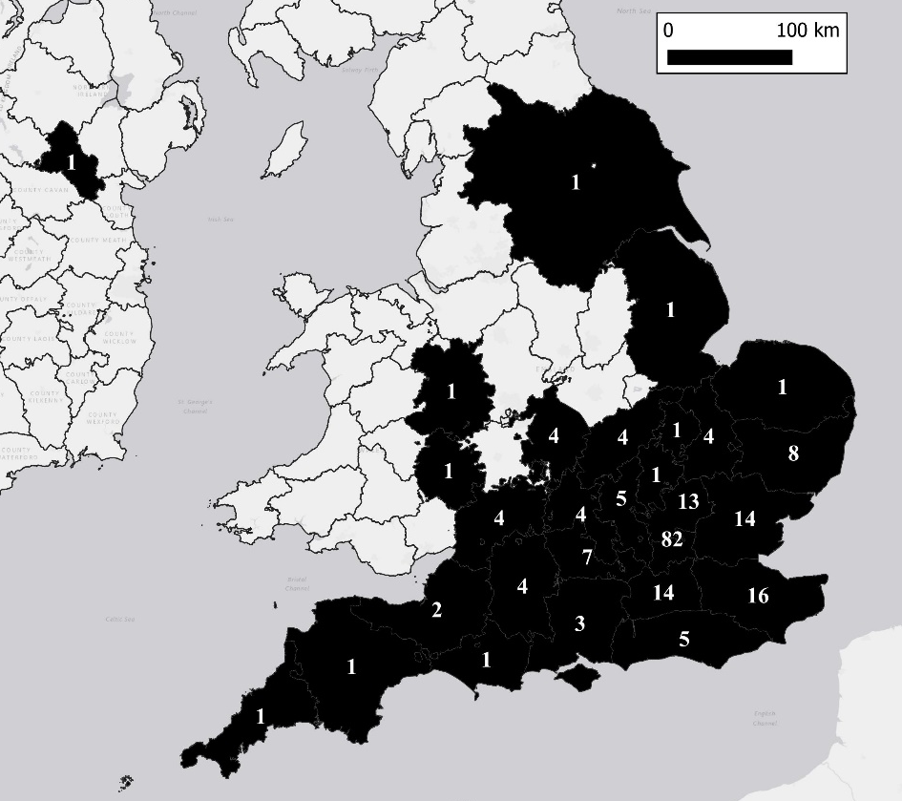
Figure 1.1: 1822 Patients by County.

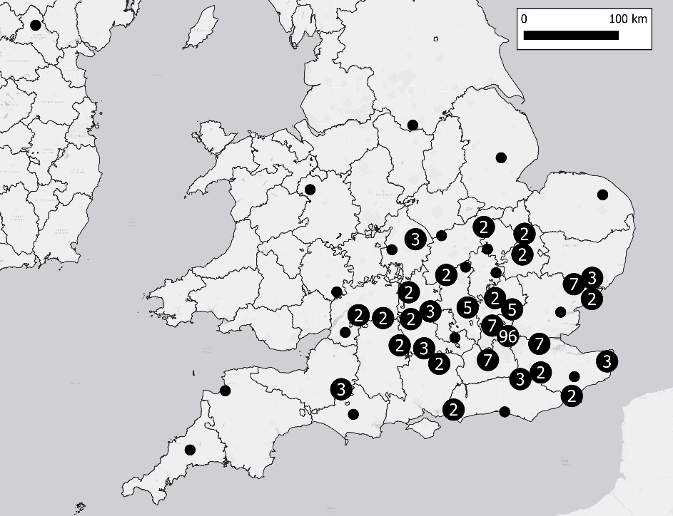
Figure 1.2: All St. Luke’s Patients by Place of Abode.

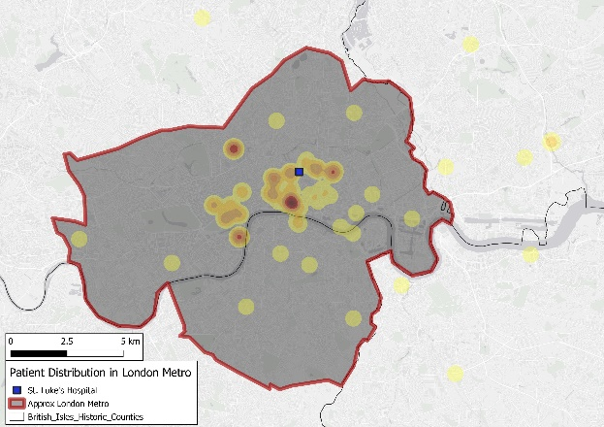
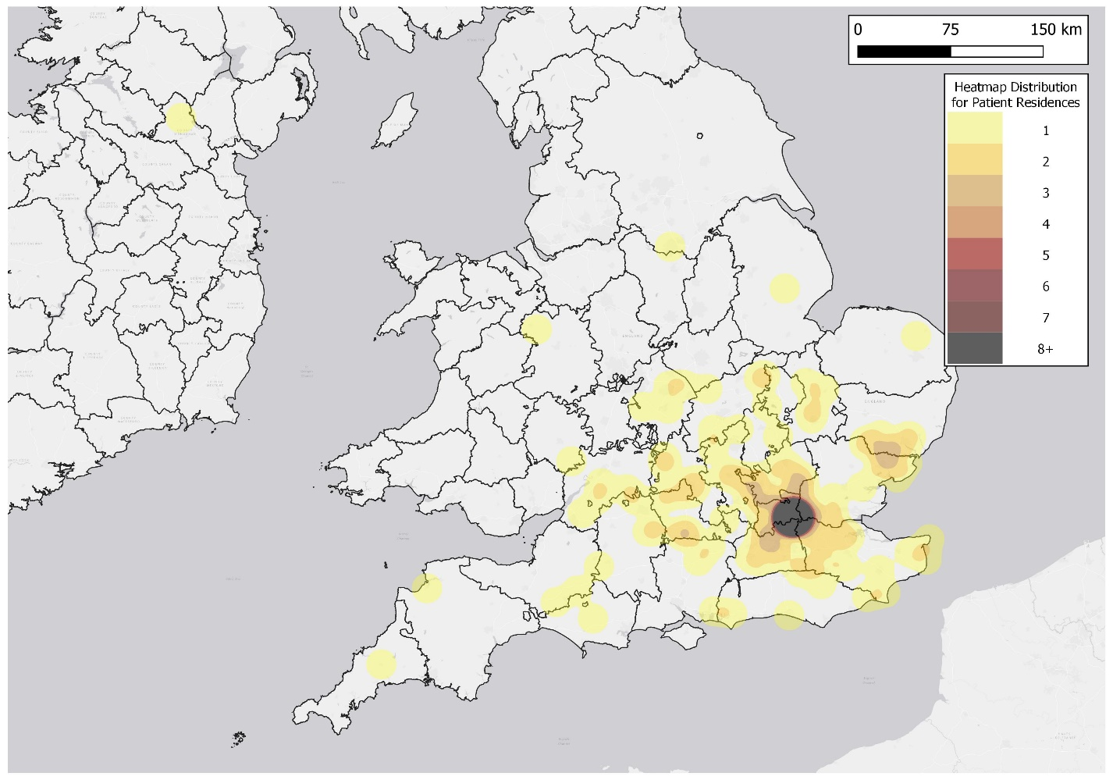
Figure 1.3: A Heatmap of St. Luke’s patient places of abode, 1822. Heatmaps assist in visually demonstrating the density of points within a certain radius. The largest concentration exists in the London Metropolitan area, but patients are more numerous outside London.

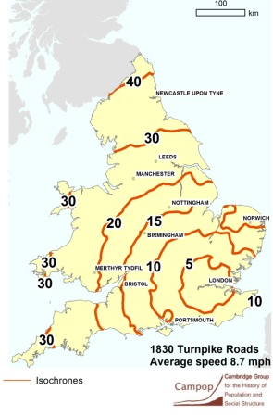
Figure 1.4: An isochrone map of England and Wales for stagecoaches in 1830. An isochrone map demonstrates distances that can be travelled over a length of time from a single point (London). This map is not my creation.
Source: Leigh Shaw-Taylor and Xuesheng You, “The Development of the Railway Network in Britain 1825-1911,” The Cambridge Group for the History of Population and Social Structure, 2018.

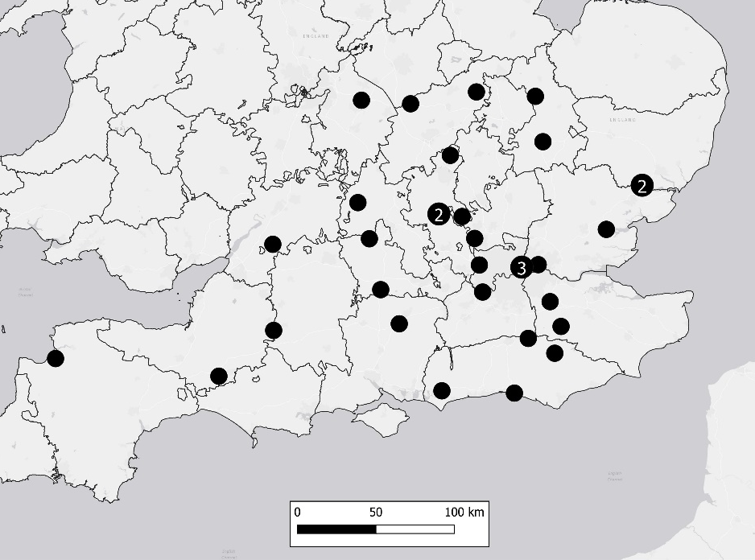
Figure 1.5: St. Luke’s parish poor patients by location for 1822. Only 3 parish poor patients came from London despite the city’s population exceeding 1 million by 1822.

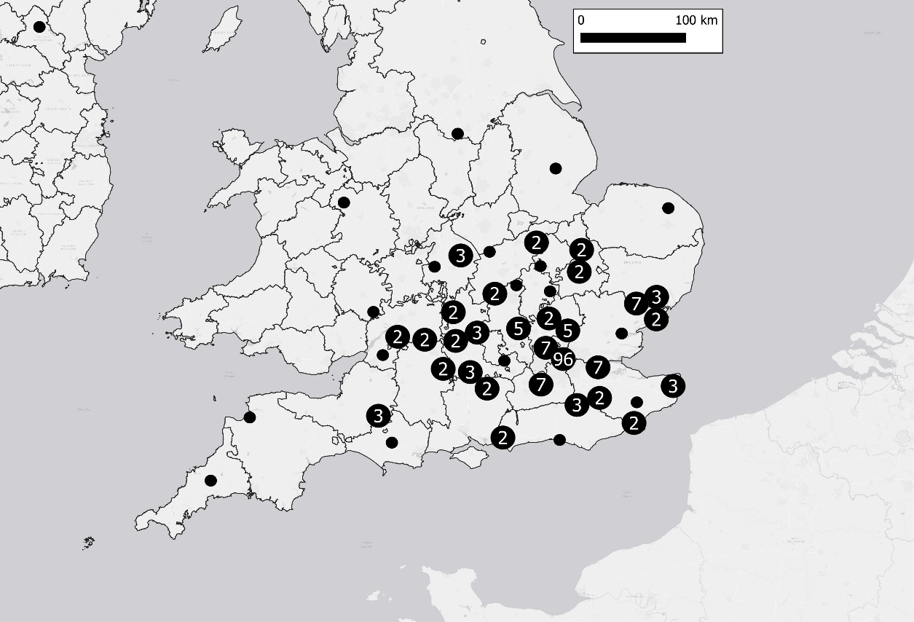

Figure 1.6: St. Luke’s patient locations in respect to locations of other non-London asylums (red). Only eight patients resided within 30 km of five asylums: Norwich, Bristol, Bedford, Lincoln and Bodmin.

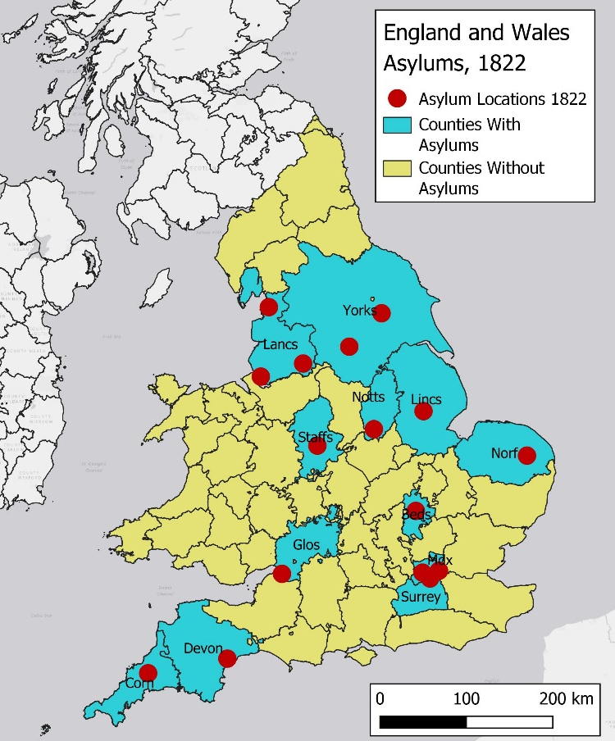
Figure 1.7: A reference map for all counties in England and Wales. Counties in cyan contain at least one asylum (county or charity, red points) and counties in yellow do not contain an asylum. Many of these counties without asylums had private madhouses, but many did not offer care to many pauper lunatics or required financially prohibitive payments.

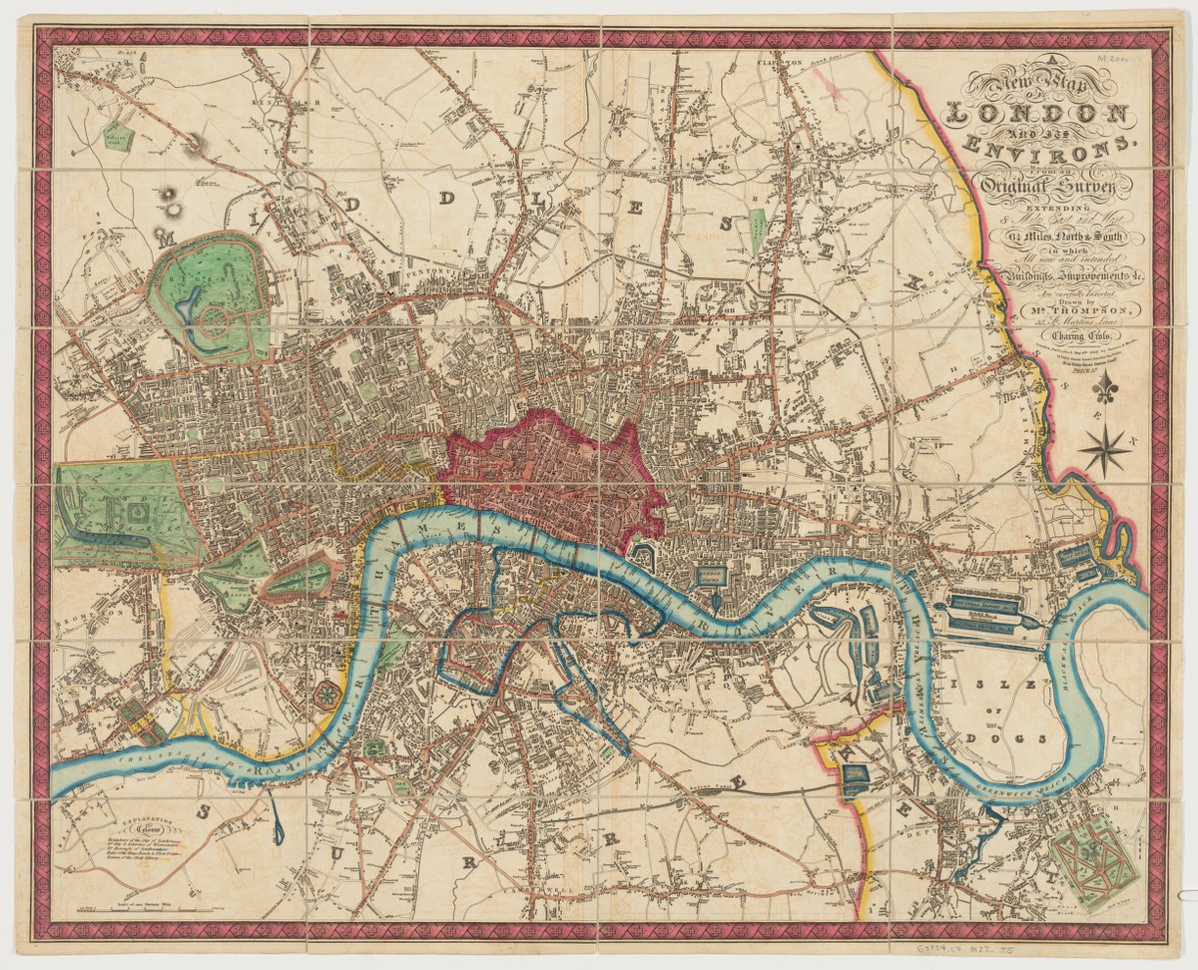
Figure 1.8: The 1822 map created by “Mr. Thompson” that shows the perceived metropolitan area of London at the time with a highlighted area of the Old City (highlighted and filled in red), Westminster (highlighted in yellow west of the Old City), and the Borough of Southwark (highlighted in blue south of the Thames). Source: Harvard University, Harvard Map Collection, G5754_L7_1822_T5_2032909628, https://curiosity.lib.harvard.edu/scanned-maps/catalog/44-990102030990203941.
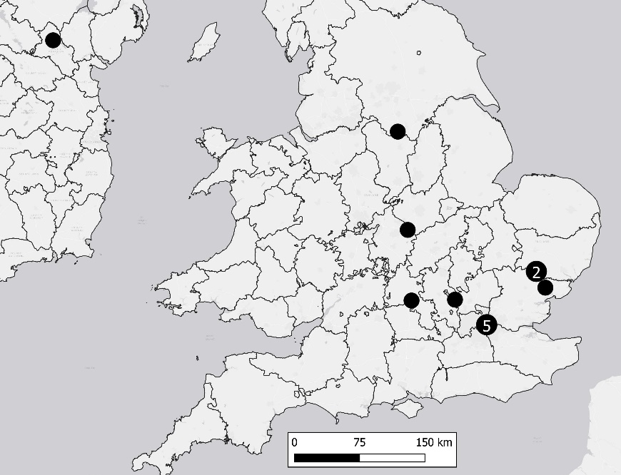
Figure 2.1: Patient places of abode for recommender Nathaniel Finn.
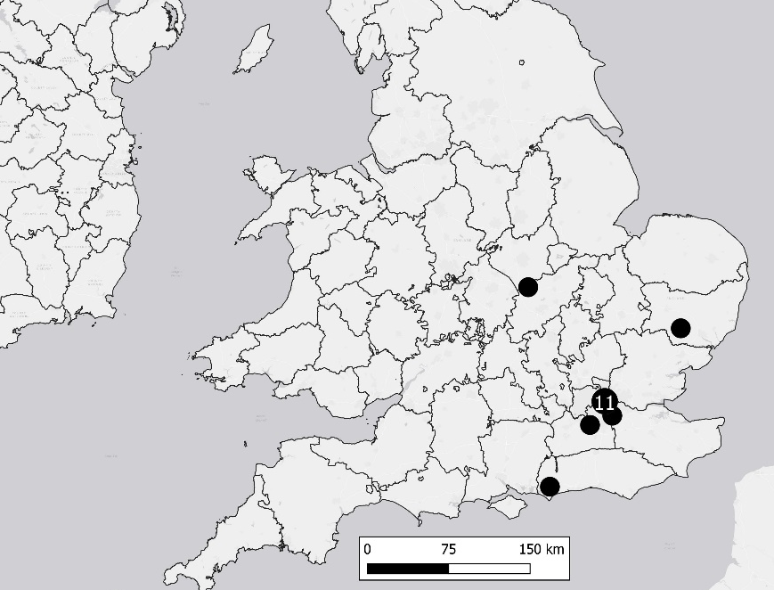
Figure 2.2: Patient places of abode for recommender John C. Powell.

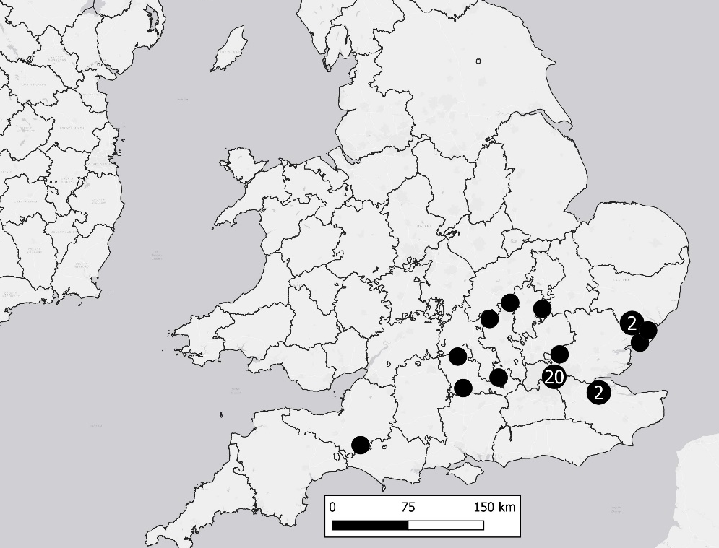
Figure 2.3: Patient places of abode for recommender Thomas Davis.
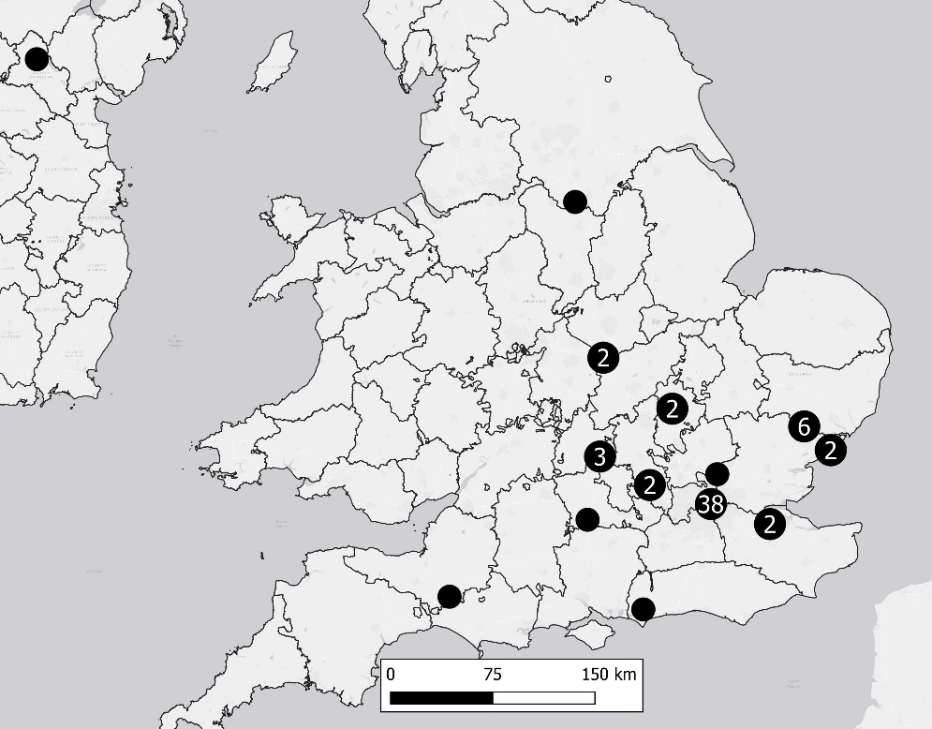
Figure 2.4: Patient places of abode for the top three recommenders.
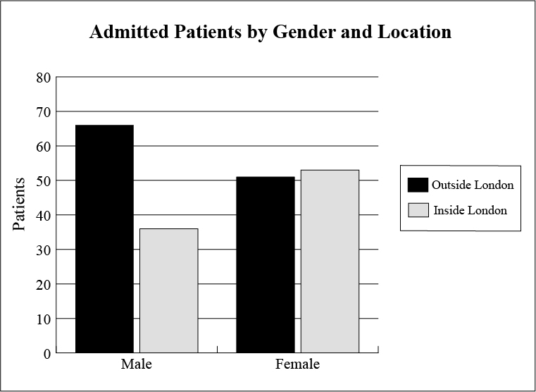
Figure 3: A bar graph depicting patients by gender and their place of abode. Females outnumbered males by only two (102 males, 104 females). Females were evenly spread between residence within and outside London (53 and 51, respectively). Males that lived outside London almost outnumbered their Londoner counterparts 2:1 (66 and 36, respectively).

Conclusion
The era of lunacy reform in Britain (1774-1845) began as a slow process built on small legal measures that each did little in the overall scope of the system. The Madhouses Act of 1774, the County Asylums Act of 1808, and the County Asylums Act of 1828 all sought to incentivize or allow for self-regulation in the Mad-Trade, but all ultimately failed to achieve conservative expectations. The social shift to institutional, specialized care in the treatment of the insane in Georgian Britain created a plethora of issues in the first half of the nineteenth century for many Britons that wanted or needed treatment.
The psychiatric paradigm shifted twice during this transitional period. The first shift occurred at the Retreat at York in the late-eighteenth century in the form of moral treatment and moral management; the second shift started in the late 1830s with the non-restraint movement in many asylums. These new paradigms created a wide range of treatment and management quality across the entire network of asylums and private madhouses. Britons suffering from madness could either experience constant humiliation in the form of nakedness in cold, windowless rooms, restrained by metal chains and handcuffs for most hours of the day while others would spend their days in quiet meditation, religious services, or working in a garden. This dichotomy in the British Isles required standardization to alleviate the public’s fears of these institutions. The undeniable variation in treatment and management would be addressed in the provisions within the Lunacy Act of 1845 where standards for the treatment and management of lunatics in British institutions were created. The Act created the Lunacy Commission, a national, centralized authority that oversaw all the institutions of the Mad-Trade in Britain. The Act also required all institutions to standardize their records to ensure that the Lunacy Commission held accurate information to enforce the treatment and management standards. After 1845, friends and relatives of lunatics knew the minimum level of care the lunatic would receive and that each institution would be inspected yearly to ensure these standards were met.
The Retreat at York and the Quaker principles of self-discipline, equality, and contempt for authority by overcoming orthodoxy through rational, empirical observation, served as the template for British treatment and management methods in the 1845 Lunacy Act. The Commissioners of Lunacy saw the Retreat’s humane care for the insane and the moderately higher cure rates than many of its counterparts as the standard for care. The Commissioners saw non-restraint asylums like Hanwell and Lincoln Lunatic Asylum as too radical—or, in the case of Hanwell, too populated—compared to other asylums that did not implement either moral treatment or non-restraint practices. The Retreat served as a perfect median between the ends of the spectrum in psychiatric care, making the Friends and their beliefs extremely influential in British psychiatry.
This new standardized treatment needed to be available to all Britons and the spatial distribution of patients prior to 1845 demonstrated a need for a larger and more widespread network of institutions in the care for lunatics of all socio-economic classes. The geographic voids where care for the mad poor needed to be filled with institutions funded by taxes to ensure fair and equitable treatment. Prior to 1845, Parliament incentivized—but did not mandate—the creation of county asylums. Both the 1808 and 1828 County Asylums Acts proved to be ineffective, and the Commissioners understood that county asylums needed to be mandated to ensure that the geographic voids would be filled with the County Asylums Act of 1845. A few counties tried to circumvent the mandate but would ultimately submit to the law.
The two 1845 Acts restructured the early psychiatric system and remained mostly untouched until 1890 when Parliament implemented more restrictions on institutions and offered more patient rights. The forty-five year gap between major legislation demonstrates the efficacy of the two laws and the provisions provided.
It is also important to note that this essay is not a historical account with a geographic supplement; this text is both a history with geographic context and geospatial analysis with historical context. Chris Philo argues that geographic analysis of medical care (historical or otherwise) often overlooks the “environmental, social[,] and intellectual contexts” that are necessary to properly understand why individuals may choose to admit (or not admit) themselves (or at the behest of others) into a medical institution. Philo understands that historical geography and geospatial analysis of a historical subject requires context to ascertain the multicausal factors that led to certain events, discoveries, or individual choices. In this same fashion, the causes for Lunacy and County Asylums Acts of 1845 are both historical and geographic. One could not achieve royal assent without the other—just as the spatial issues of the early psychiatric system cannot be separate and disparate from the societal alterations that formed the basis for Victorian treatment. Ian Gregory and Alistair Geddes state that one of the most important challenges in historical GIS (HGIS) is the scholar’s determinization of information stored and presented in GIS databases how it can “turn into new scholarship that advances our knowledge of the past.”
The geospatial analysis of this subject advances our knowledge of early British psychiatry by allowing any person to glimpse into the mind of the MPs and Lunacy Commissioners who drafted the 1845 Acts and see how they mentally constructed the spatial discrepancies present in the asylum system. These lawmakers understood spatially where certain institutions existed, patient residence locations, and the large swathes of land in England and Wales that did not have specialized facilities that allowed for paupers to be treated without placing their families at financial risk. Even if a reader of this text may understand the general locations of places mentioned, digital maps that explain and demonstrate the geographic disparities helps the reader tackle the scale of disparity. Parliament saw the social demand for more asylums to treat paupers with universal standards as a public health issue. The 1844 Report to the Commissioners of Lunacy accurately conducted a census of the insane in both England and Wales; MPs and the Commissioners saw a massive rise in the number of lunatics in the Union and explained that it was their duty to assist paupers to find proper treatment because the number of pauper lunatics far surpassed even the most liberal estimates prior to the Report. Without historical knowledge, the creation of a digital maps pertaining to all patient residences for an asylum in 1822 holds no purpose or significance. Without geospatial analysis and geographic understanding of the system prior to legislation, scholars lack the proper context that explains why MPs and the Lunacy Commissioners viewed overcrowding in asylums as a persistent issue in the treatment of the insane rather than a reason for the mandatory creation of county asylums. The ultimate purpose for the methods in this essay is to demonstrate that large systems and networks require cooperation between the spatial and the historical and how each contribute to the other.

Bibliography
Primary Sources
Archival Collections
“Administration: General Court Minutes Book, 1812-1841.” H64/A/01/003. London Metropolitan Archives.
“‘Considerations upon the usefulness and necessity of establishing an Hospital’: proceedings, reasons, rules and orders including instructions to persons admitting patients and other proformas (1751).” H64/A/08/001. London Metropolitan Archives.
Cruikshank, George. William Norris: an Insane American. Rivetted Alive in Iron, & for Many Years Confined, in that State, by Chains 12 Inches Long to an Upright Massive Bar in a Cell in Bethlem. Colored etching on copper, copied from a sketch by George Arnald in 1814, 1820. Wellcome Collection, London, UK.
“Register of Admissions 1845-1856 West Riding Lunatic Asylum.” C85/589. West Yorkshire Archives.
“Register of Curable Patients No. 1 St. Luke’s Hospital 1822-1826.” H64/B/01/009. London Metropolitan Archives.
“Register of Discharges, Removals, and Deaths No. 6 Middlesex Lunatic Asylum at Hanwell.” H11/HLL/B10/6. London Metropolitan Archives.
“Register of Female Admissions 1831-1841, Hanwell Asylum (Later Saint Bernard’s Hospital).” H11/HLL/B/01/001. London Metropolitan Archives.
Saint Luke’s Hospital for Lunatics, Instructions for Persons Applying for the Admission of Patients into St. Luke’s Hospital for Lunatics, Old Street, City Road, London, 1845, the British Library.
Saint Luke’s Hospital for Lunatics. “Reasons for establishing and further encouragement of St. Luke’s Hospital for Lunaticks; together with the rules and orders for the government thereof.” ESTC T170115. The Wellcome Collection.
St. Luke’s Hospital for Lunatics. “Rules and Orders to be Observed by the Resident Officers and Servants, with Amendments.” H64/A/8/006. London Metropolitan Archives.
“St. Luke’s Hospital Registry of Admissions, 1863-1871.” H64/B/01/018. London Metropolitan Archives.
“Stanley Royd Hospital, Wakefield (Formerly the West Riding Pauper Lunatic Asylum): Register of Admissions 1828-1845.” C85/588. West Yorkshire Archives.
“West Riding Lunatic Asylum Register of Admissions, 1845-1856.” C85/589. West Yorkshire Archives.

Publications and Miscellaneous
Burrows, George Man. Commentaries on the Causes, Forms, Symptoms, and Treatment, Moral and Medical, of Insanity. London: Thomas and George Underwood, 1828.
Burton, Robert. The Anatomy Of Melancholy: What it is, with all the kinds causes, symptomes, prognostickes, cures of it. In three Partitions, with their severall Sections, members & subsections. Philosophically, Medicinally, Historically, opened & cut up. By Democritus Junion.[pseud.] With a Satyricall Preface, conducing to the following Discourse. Oxford: Henry Cripps, 1621.
Conolly, John. An Inquiry Concerning the Indications of Insanity With Suggestions for the Better Protection and Care of the Insane. London: John Taylor, 1830.
_____. The Treatment of the Insane without Mechanical Restraints. London: Smith, Elder & Co., 1856.
Crowther, Caleb. Observations on the Management of Madhouses, Illustrated by the Occurrences in the West Riding and Middlesex Asylums. London: Simpkin Marshall, and Co., 1838.
Cruden, Alexander. “The London-Citizen exceedingly injured: or, a British Inquisition display’d, in an account of the unparallel’d case of a Citizen of London, Bookseller to the late Queen, who was in a most unjust and arbitrary Manner sent to the 23d of March last, 1738, by one Robert Wightman, a mere Stranger, to a Private Madhouse.” London: T. Cooper at Globe and Mrs. Dodd at Peacock. 1798.
Hill, Robert Gardiner. A Concise History of the Entire Abolition of Mechanical Restraint In the Treatment of the Insane; And of the Introduction, Success, and Final Triumph of the Nonrestraint System. London: Longman, Brown, Green, and Longmans, Paternoster Row, 1857.
Houses of Parliament. “Report from the Select Committee Appointed to Enquire into the State of Lunatics.” House of Commons Parliamentary Papers. House of Commons. 1807.
_____. “Report from the Select Committee on the State of Licensed Houses, 1824.” House of Commons Parliamentary Papers. House of Commons, 1824.
_____. “Report to the Commissioners in Lunacy.” House of Commons. London: Bradbury and Evans, Printers, 1844.
Parr, Bartholomew. The London Medical Dictionary; Including Under District Heads Every Branch of Medicine, viz. Anatomy, Physiology, and Pathology, the Practice of Physic and Surgery, Therapeutics, and Materia Medica; with Whatever Relates to Medicine in Natural Philosophy, Chemistry, and Natural History. Whitefriare: T. Davison, 1809.
Paternoster, Richard. The Madhouse System. London, Richard Paternoster, 1841.
Sabine, T. The Distress’d Orphan, or Love in a Madhouse. London: The Ship and Crown, 1790.
Thompson, Mr. A new map of London and its environs : from an original survey extending 8 miles east and west, 6 1/4 miles north & south, in which all new and intended buildings, improvements, &c. are carefully inserted. Map. London: Reeves & Hoare. 1822. Harvard University, Harvard Map Collection. https://iiif.lib.harvard.edu/manifests/view/ids:8982541.
Tuke, Daniel Hack. “William Tuke: the founder of The Retreat.” Journal of Psychological Medicine and Mental Pathology 8, (1855): 507-12.
Secondary Sources
Andrews, Johnathan. “Monro, Thomas (1759-1833).” The Oxford Dictionary of National Biography. Oxford: Oxford University Press, 2010.
_____. “The (un)dress of the mad poor in England, c.1650-1850, Part 1.” History of Psychiatry 18, No. 1 (2007): 5-24.
_____. “The (un)dress of the mad poor in England, c.1650-1850, Part 2,” History of Psychiatry 18, No. 2 (2007): 131-56.
Andrews, Jonathan, Briggs, Asa, Porter, Roy, Tucker, Penny and Waddington, Keir. The History of Bethlem. London: Routledge, 1996.
Andrews, Jonathan and Scull, Andrew. Customers and Patrons of the Mad-Trade: The Management of Lunacy in Eighteenth-Century London with the Complete Text of John Monro’s 1766 Case Book. Berkeley: University of California Press, 2003.
Dandelion, Pink. An Introduction to Quakerism. Cambridge: Cambridge University Press, 2007.
Daunton, Martin. Progress and Poverty: An Economic and Social History of Britain, 1700-1850. Oxford: Oxford University Press, 1995.
Digby, Anne. Madness, Morality and Medicine: A Study of the York Retreat, 1796-1914. Cambridge: Cambridge University Press, 1985.
_____. “Tuke, William (1732-1822).” The Oxford Dictionary of National Biography, online ed., ed. David Cannadine. Oxford: OUP, 2004.
French, C.N. The Story of St. Luke’s Hospital 1750-1948. Southwark: Chiswick Press, 1951.
Gregroy, Ian and Geddes, Alistair, eds. Toward Spatial Humanities: Historical GIS & Spatial History. Indianapolis: Indiana University Press, 2014.
Hickey, Helen M. “The Lexical Prison: Impairment and Confinement in Medieval and Early Modern England.” Parergon 34, No. 2 (2017): 133-57.
Jones, Colin and Porter, Roy, eds. Reassessing Foucault: Power, Medicine and the Body. London: Routledge, 1994.
Jones, Denzil. “The Development of the Glamorgan County Lunatic Asylum and Mental Hospital 1830-1930.” Master’s Thesis. University of Wales Trinity Saint David. 2017.
Kibria Ayisha A. and Metcalfe, Neil H. “A biography of William Tuke (1732-1822): Founder of the modern mental asylum.” Journal of Medical Biography 24, No. 3 (2014): 384-8.
McGlynn, Margaret. “Idiots, Lunatics and the Royal Prerogative in Early Tudor England.” The Journal of Legal History 26 (2005): 1-24.
Mercier, Charles. “The Lunacy Certificate and the Liberty of the Subject.” Transaction of the Medico-Legal Society for the Year 1910. The Medico-Legal Society, Vol. 7, No. 1 (1910): 170-6.
Mooney, Graham. “Diagnostic Spaces: Workhouse, Hospital, and Home in Mid-Victorian London.” Social Science History 33, No. 3 (Fall 2009): 357-90.
Mooney, Graham and Reinarz, Jonathan. “Hospital and Asylum Visiting in Historical Perspective: Themes and Issues.” Clio Medica 86 (2009): 7-30.
Newman, Gerald, ed. Britain in the Hanoverian Age, 1714-1837. London: Garland Publishing Inc., 1997.
Odonoghue, Edward Geoffrey. The Story of Bethlehem Hospital from its Foundation in 1247. London: T. Fisher Unwin, 1914.
Parry-Jones, William Lloyd. “English Private Madhouses in the Eighteenth and Nineteenth Centuries.” History of Medicine 66 (July 1973): 659-64.
_____. The Trade in Lunacy: A Study of Private Madhouses in England in the Eighteenth and Nineteenth Centuries. London: Routledge, 1972.
Philo, Chris. “Journey to Asylum: A Medical-Geographical Idea in Historical Context.” Journal of Historical Geography 21, No. 2 (1995): 148-68.
Porter, Roy. London: A Social History. Cambridge: Harvard University Press, 1995.
_____. Madmen: A Social History of Madhouses, Mad-Doctors & Lunatics. Stroud: Tempus, 2006.
Pun-Cheng, Lilian S.C. “Distance Decay.” International Encyclopedia of Geography: People, the Earth, Environment and Technology. Hoboken: John Wiley & Sons, 2016.
Scull, Andrew. Madness in Civilization: A Cultural History of Insanity, From the Bible to Freud, from the Madhouse to Modern Medicine. Princeton: Princeton University Press, 2015.
_____. The Most Solitary of Afflictions: Madness and Society in Britain, 1700-1900. New Haven: Yale University Press, 2005.
Shaw-Taylor, Leigh and You, Xuesheng. “The Development of the Railway Network in Britain 1825-1911.” The Cambridge Group for the History of Population and Social Structure. 2018.
Smith, Catherine. “Parsimony, Power, and Prescriptive Legislation: The Politics of Pauper Lunacy in Northamptonshire, 1845-1876.” Bulletin of the History of Medicine 81, No. 2 (2007): 359-85.
Smith, Leonard. Lunatic Hospitals in Georgian England, 1750-1830. London: Routledge, 2014.
_____. “The Pauper Lunatic Problem in the West Midlands, 1815-1850.” Midland History 21, no. 1 (2016): 101-18.
_____. “Welcome Release: Perspectives on Death in the Early County Lunatic Asylums, 1810-50.” History of Psychiatry 23, No. 1 (2012): 117-28.
Spedding, Patrick. A Bibliography of Eliza Haywood. London: Pickering & Chatto, 2004.
Stevenson, Christine. “Robert Hooke’s Bethlem.” Journal of the Society of Architectural Historians 55, No. 3 (September 1996): 254-75.
Suzuki, Akihito. “Hill, Robert Gardiner (1811–1878).” Oxford Dictionary of National Biography, online ed., ed. David Cannadine. Oxford: OUP, 2004.
_____. “The Politics and Ideology of Non-Restraint: the Case of Hanwell Asylum.” Medical History 39, (1995): 1-17.
Wade, Nicholas J. “Cox’s Chair: ‘A Moral and Medical Mean in the Treatment of Maniacs.’” History of Psychiatry16, No. 1 (2005): 73-88.
Williams, W.R. “Villiers, John Charles, third earl of Clarendon.” Oxford Dictionary of National Biography. Vol. 58 (1899).
Wise, Sarah. Inconvenient People: Lunacy, Liberty, and the Mad-Doctors in England. Berkeley: Counterpoint, 2012.
Yearly Meeting of the Religious Society of Friends, The. Quaker Faith & Practice, Fourth Edition. London: The Yearly Meeting of the Religious Society of Friends (Quakers) in Britain, 2005.

Lunacy Act, 1845 8 & 9 Vict., c. 100.
County Asylums Act, 1845 8 & 9 Vict., c. 126.
The Madhouses Act, 1774 14 Geo. 3, c. 49. County Asylums Act, 1808 48 Geo. 3, c. 96. County Asylums Act, 1828 9 Geo. 4, c. 40. Lunacy Act, 1845 8 & 9 Vict., c. 100. County Asylums Act, 1845 8 & 9 Vict., c. 126. There are two citation suggestions for Acts of Parliament in the Chicago Manual of Style. The first suggestion says to use the commonly used title of a law followed by the regnal year and chapter and any additional information if necessary. The second suggestion refers to Parliament’s own citation methods. The parliamentary guide states that it may be cited by the year and chapter number only with the caveat that Acts passed before 1963 must be referenced with the “regnal year.” Since I explicitly use the common name for all these laws throughout this essay, I use the simplified version that Parliament suggests for my citations after this one.
8 & 9 Vict., c. 100. 8 & 9 Vict., c. 126. Lunacy Act, 1890 53 Vict., c. 5. The Lunacy Act of 1890 essentially “modernized” much of what already existed within the 1845 Acts. The biggest change enacted by the 1890 Act surrounds legal safeguards for private patients admitted to lunatic asylums. Parliament renewed and made small amendments to the 1845 Acts before 1890, but these amendments and renewals often included previous legislation into the purview of the 1845 Acts or minor alterations to provisions in the 1845 Acts. The Chancery Lunatics Act of 1853 (16 & 17 Vict., c. 70) included Chancery Lunatics as part of the national Registrar of patients for the Lunacy Commission that the 1845 Lunacy Act created. The 1853 Lunacy Amendment Act (16 & 17 Vict., c. 96) allowed for counties and boroughs to dictate a cap on expenses for asylums. The Lunatic Asylums Act of 1853 (16 & 17 Vict., c. 97) repealed the exception for Bethlem Royal Hospital in the 1845 Acts which allowed the Lunacy Commission to oversee Britain’s oldest mental institution. Parliament also passed laws in the 1880s that reclassified certain types of lunatics: criminal lunatics (47 & 48 Vict., c. 38) and idiots (49 & 50 Vict., c. 16). Parliament also passed the Inebriates Act of 1888 (51 & 52 Vict., c. 19) to allow mental health institutions to appoint a deputy to oversee a “drunkard’s” progress to sobriety—the deputy was subject to the 1845 Acts and considered as staff of the licensed institution. These amendments between 1845 and 1890 did not reorganize the system in the same fashion as the 1845 and 1890 Acts.
Chris Philo, “Journey to Asylum: a medical-geographical idea in historical context,” Journal of Historical Geography, vol. 21, no. 2 (1995), 148-68. This is the only article containing a map. Graham Mooney and Jonathan Reinarz, “Hospital and Asylum Visiting in Historical Perspective: Themes and Issues,” Clio Medica, vol. 86 (2009), 7-30. Leonard D. Smith, “The Pauper Lunatic Problem in the West Midlands, 1815-1850,” Midland History, vol. 21, no. 1 (2016), 101-18.
Dr. George Man Burrows, an influential (and controversial) British physician in the early-psychiatric system, discussed his struggle with understanding sanity as a binary in many chapters of his 1828 book, Comments On the Causes, Forms, Symptoms, and Treatment, Moral and Medical, of Insanity. Other physicians who either struggled to agree or disagreed with this binary concept of sanity include Philippe Pinel, an Enlightenment philosopher and physician from Paris, and Dr. William Battie, the lead physician for St. Luke’s Hospital for Lunatics in the late-eighteenth century.
Bartholomew Parr, The London Medical Dictionary; Including Under District Heads Every Branch of Medicine, viz. Anatomy, Physiology, and Pathology, the Practice of Physic and Surgery, Therapeutics, and Materia Medica; with Whatever Relates to Medicine in Natural Philosophy, Chemistry, and Natural History (Whitefriare: T. Davison, 1809), 122-4.
Ibid., 124-5.
Ibid., 186.
Ibid., 123.
George Man Burrows, Commentaries On the Causes, Forms, Symptoms, and Treatment, Moral and Medical of Insanity (London: Thomas and George Underwood, 1828), 1-8. Dr. Burrows used “lunatic” far more often than “lunacy,” instead using “insanity” at much higher frequency and consistency. His use of “lunatic” is less common than other physicians of the time, who tended to strictly use “insane” and “insanity.” Additionally, Burrows only used “lunatic” when discussing laws, but “insane” during more medical discussion in his writing. 8 & 9 Vict., c. 100. The Lunacy Act of 1845 is one example in which “lunatic” and “lunacy” are used thoroughly within its text. “Madness” is used, but in a slightly lesser degree. Margaret McGlynn, “Idiots, Lunatics and the Royal Prerogative in Early Tudor England,” The Journal of Legal History, vol. 26 (2005), 1-24. Laws passed during the early modern period typically used the older spelling, lunatick.
Burrows, Commentaries, 260-98. This chapter labelled “Character of Insanity” discusses various quirks and observations about “insanity” in an extremely professional and technical way, filled with medical jargon. “Lunatic” is only used when legal language is used. Other chapters regarding treatment, rather than management, use “insane” and “insanity” rather than “lunacy” and “lunatic.” John Conolly, The Treatment of the Insane without Mechanical Restraints (London: Smith, Elder & Co., 1856). Dr. Conolly only used “lunatic” or “lunacy” whenever the words were used in a quotation or the name of a law, such as the Lunacy Act of 1845. Conolly’s writing tended to be technical and intended for an audience of medical professionals, not the general public, though his writing did influence the government and the public. Caleb Crowther, Observations on the Management of Madhouses, Illustrated by the Occurrences in the West Riding and Middlesex Asylums (London: Simpkin, Marshal, and Co., 1838), 4-5, 11, 13, 17-8, 21-5, 27, 30, 32-5, 38, 41-2. Typically, Crowther only used “lunatic” when using a proper name (West Riding Lunatic Asylum at Wakefield) or when using legal language. When discussing treatment, Crowther always used “insane” or “insanity.” Robert Gardiner Hill, A Concise History of the Entire Abolition of Mechanical Restraint In the Treatment of the Insane; And of the Introduction, Success, and Final Triumph of the Nonrestraint System (London: Longman, Brown, Green, and Longmans, Paternoster Row, 1857). Like Conolly, Dr. Hill only used “lunatic” and “lunacy” when it pertinent. Otherwise, Dr. Hill used “insane” and “insanity.”
Alexander Cruden, “The London-Citizen exceedingly injured: or, a British Inquisition display’d, in an account of the unparallel’d case of a Citizen of London, Bookseller to the late Queen, who was in a most unjust and arbitrary Manner sent to the 23d of March last, 1738, by one Robert Wightman, a mere Stranger, to a Private Madhouse” (London: T. Cooper at Globe and Mrs. Dodd at Peacock, 1798).
Akihito Suzuki, “Hill, Robert Gardiner, 1811-1878,” Oxford Dictionary of National Biography Online, 2004, https://www.oxforddnb.com/view/10.1093/ref:odnb/9780198614128.001.0001/odnb-9780198614128-e-13294;jsessionid=9E30955CED2C653821349DF8060FBDF8.
Crowther, Observations. Dr. Crowther used “madhouse” to essentially describe any institution besides Bethlem Royal Hospital in London. He is one of the last prominent figures within this period to utilize the older eighteenth century term and definition. The main reason for this may derive from the intended audience of most of his publications. Most of Dr. Crowther’s books were calls-to-action for the public and electorate, meaning that “madhouse” may have been more commonly used outside of medical and legal circles in the 1830s. Burrows, Commentaries, 125, 235-45, 667-95. Burrows did not utilize “asylum” within his writing and instead used “hospitals” (despite many of them not existing as actual hospitals) and “private madhouses” for all institutions operating for profit. “Report from the Select Committee Appointed to Enquire into the State of Lunatics,” House of Commons Parliamentary Papers, “Appendix,” House of Commons, 1807. This is an early instance of the term “private madhouse,” but still holds some artifact of the older eighteenth century definition, as St. Luke’s Hospital for Lunatics is labelled as a “charity madhouse,” not a “charity asylum.” When describing all charities, they are simply labelled as “charitable institutions.”
Roy Porter, Mind Forg’d Manacles (New York: Penguin Books, 1987). Roy Porter, Madmen: A Social History of Madhouses, Mad-Doctors & Lunatics (Stroud: Tempus, 2006), 6, 8.
Porter, Madmen, 7.
Andrew Scull, Madness in Civilization: A Cultural History of Insanity, From the Bible to Freud, from the Madhouse to Modern Medicine (Princeton: Princeton University Press, 2015), 10-2.
Porter, Madmen, 8.
There are far too many published works to name, but the largest contributors to Andrews’ success include the following: Jonathan Andrews, “The (un)dress of the mad poor in England, c.1650-1850, Part 1,” History of Psychiatry, vol. 18, no. 1, 5-24; Jonathan Andrews, “The (un)dress of the mad poor in England, c.1650-1850, Part 2,” History of Psychiatry, vol. 18, no. 2, 131-56; Jonathan Andrews, “Letting Madness Range: Travel and Madness, c1700-1900,” Pathologies of Travel (Amsterdam: Rodopi, 2000), 25-88; Jonathan Andrews, “Identifying and providing for the mentally disabled in early modern London,” In: David Wright and Anne Digby, eds., Historical Perspectives on People with Learning Difficulties (London: Routledge, 1996), 65-92.
Jonathan Andrews, Asa Briggs, Roy Porter, Penny Tucker, and Keir Waddington, The History of Bethlem (London: Routledge, 1996); Jonathan Andrews and Andrew Scull, Customers and Patrons of the Mad-Trade: The Management of Lunacy in Eighteenth-Century London with the Complete Text of John Monro’s 1766 Case Book (Berkeley: University of California Press, 2003).
Leonard Smith, Lunatic Hospitals in Georgian England, 1750-1830 (London: Routledge, 2014), 1.
Smith, Lunatic Hospitals, 2.
Leonard D. Smith, “The Pauper Lunatic Problem in the West Midlands, 1815-1850,” Midland History, vol. 21, no. 1 (July, 2016), 101-118.
Graham Mooney, “Diagnostic Spaces: Workhouse, Hospital, and Home in Mid-Victorian London,” Social Science History, vol. 33, no. 3 (Fall 2009), 358.
Scull, Madness in Civilization, 86-97.
Robert Burton, That Anatomy Of Melancholy: What it is, with all the kinds causes, symptomes, prognostickes, cures of it. In three Partitions, with their severall Sections, members & subsections. Philosophically, Medicinally, Historically, opened & cut up. By Democritus Junion.[pseud.] With a Satyricall Preface, conducing to the following Discourse (Oxford: Henry Cripps, 1621), 51-2.
Houses of Parliament, “Report to the Commissioners of Lunacy, 1844,” House of Commons, (London: Bradbury and Evans, 1844), 210.
Eliza Haywood, The Distress’d Orphan; or, Love in a Madhouse (London: T. Sabine, 1726).
Patrick Spedding, A Bibliography of Eliza Haywood (London: Pickering & Chatto, 2004), 21.
Helen M. Hickey, “The Lexical Prison: Impairment and Confinement in Medieval and Early Modern England,” Parergon, Vol. 34, no. 2 (2017), 135-6, 137-9, 140-6.
Hickey, “The Lexical Prison,” 145.
Sarah Wise, Inconvenient People: Lunacy, Liberty, and the Mad-Doctors in England (Berkeley: Counterpoint, 2012), 21-2.
Andrews et al., The History of Bethlem, 11, 130.
Christine Stevenson, “Robert Hooke’s Bethlem,” Journal of the Society of Architectural Historians, vol. 55, no. 3 (September 1996), 254-75.
Stevenson, “Robert Hooke’s Bethlem,” 254.
Ibid.
Edward Geoffrey Odonoghue, The Story of Bethlehem Hospital from its Foundation in 1247 (London: T. Fisher Unwin, 1914), 321.
Odonoghue, The Story of Bethlehem, 320-1.
George Cruikshank, William Norris: an Insane American. Rivetted Alive in Iron, & for Many Years Confined, in that State, by Chains 12 Inches Long to an Upright Massive Bar in a Cell in Bethlem, colored etching on copper, copied from a sketch by George Arnald in 1814, 1820, Wellcome Collection, London, UK.
Andrews et al., The History of Bethlem, 416-8.
Ayisha A. Kibria and Neil H. Metcalfe, “A biography of William Tuke (1732-1822): Founder of the modern mental asylum,” Journal of Medical Biography, June 18, 2014, 2.
Kibria and Metcalfe, “A biography of William Tuke,” 2.
Ibid., 2-3.
DH Tuke, “William Tuke: the founder of The Retreat,” Journal of Psychological Medicine and Mental Pathology, vol. 8, October 1, 1855, 511.
Anne Digby, “Tuke, William (1732-1822),” The Oxford Dictionary of National Biography, September 23, 2004.
“Report, from the Committee of the House of Commons, on Madhouses in England; Together with the Minutes of Evidence, and an Appendix,” House of Commons, July 11, 1815 (London: Baldwin, Cradock, and Joy, 1815), 161.
Ibid., 160-2.
8 & 9 Vict., c. 100. 8 & 9 Vict., c. 126.
Houses of Parliament, “Report to the Commissioners of Lunacy, 1844,” House of Commons (London: Bradbury and Evans, Printers, 1844).
14 Geo. 3 c. 49. 48 Geo. 3, c. 96, s. 26.
14 Geo. 3 c. 49. In this instance, the term “madhouse” is in the Georgian context: any institution that held and/or attempted to cure lunatics, excluding Bethlem Royal Hospital.
Mary E. Fissell describes this Georgian medical business as the “marketplace of medicine” in Patients, Power, and the Poor in Eighteenth-Century Bristol (Cambridge: Cambridge University Press, 1991), Chapter 3 “The Marketplace of Medicine” (37-73).
I explain these fears in more detail in Chapter 1.
Houses of Parliament, “Report from the Select Committee on the State of Licensed Houses, 1824,” House of Commons, Parliamentary Papers, 1-12.
William Lloyd Parry-Jones, The Trade in Lunacy: A Study of Private Madhouses in England in the Eighteenth and Nineteenth Centuries (London: Routledge, 1972), 1-3.
Parry-Jones, The Trade in Lunacy, 29-31.
Ibid., 92.
14 Geo. 3 c. 49. Richard Paternoster, The Madhouse System (London, Richard Paternoster, 1841), 9-10.
Sarah Wise, Inconvenient People: Lunacy Liberty and the Mad-Doctors in England (Berkeley: Counterpoint, 2012), 1-32, 64-78. Paternoster, The Madhouse System, 5-8.
9 Geo. 4, c. 40, s. 51. 2 & 3 Will. 4., c. 107.
Odonoghue, The Story of Bethlehem, 320-1. Andrews, et al., The History of Bethlem, 333-41.
French, The Story of St. Luke’s, 24.
Ibid.
St. Luke’s Hospital for Lunatics, “Rules and Orders to be Observed by the Resident Officers and Servants, with Amendments,” H64/A/8/006, London Metropolitan Archives.
5 & 6 Vict., c. 87.
Houses of Parliament, “Report, 1844,” 1-9, 10-29, 113-7.
Ibid.
Anne Digby, Madness, Morality and Medicine (Cambridge: Cambridge University Press, 1985), 10-13.
Pink Dandelion, An Introduction to Quakerism (Cambridge: Cambridge University Press, 2007), 19-24. The Yearly Meeting of the Religious Society of Friends, Quaker Faith & Practice, Fourth Edition (London: The Yearly Meeting of the Religious Society of Friends (Quakers) in Britain, 2005), 1.02.
Houses of Parliament, “Report Together with Minutes of Evidence, and an Appendix of Papers, 1815,” House of Commons, House Parliamentary Papers (London: J. M’Creery, 1815), 162.
Digby, Madness, Morality and Medicine, 25.
Ibid., 25-6.
Dandelion, An Introduction to Quakerism, 53-4.
Digby, Madness, Morality and Medicine 27.
Houses of Parliament, “Report Together with Minutes of Evidence, and an Appendix of Papers, 1815,” House Parliamentary Papers, 160.
John Conolly, An Inquiry Concerning the Indications of Insanity With Suggestions for the Better Protection and Care of the Insane (London: John Taylor, 1830), 478-96. In Chapter XI (the last chapter of the publication) “Suggestions for the Better Protection and Care for the Insane,” Conolly explained that it is up to the medical men to reduce or abolish restraint for treatment. Conolly, like many other mad-doctors of time, believed that excitement and stimuli became a major factor in the process of losing mental faculties and becoming insane. Restraints would cause additional (and unnecessary) stress and excitement, exacerbating the very affliction that they tried to cure. Conolly published this work four years before Hill’s work at Lincoln Lunatic Asylum and is an indication of Conolly’s reformist non-restraint ideals before non-restraint’s widespread popularity.
Robert Gardiner Hill, Total Abolition of Personal Restraint in the Treatment of the Insane: A Lecture on the Management of Lunatic Asylums and the Treatment of the Insane, Delivered at the Mechanics’ Institution, Lincoln, on the 21st of June, 1838: with Statistical Tables, Illustrative of the Complete Practicability of the System Advocated (London: Simpkin, Marshall and co., 1838).
Akihito Suzuki, “Hill, Robert Gardiner, 1811-1878,” Oxford Dictionary of National Biography Online, 2004, https://www.oxforddnb.com/view/10.1093/ref:odnb/9780198614128.001.0001/odnb-9780198614128-e-13294;jsessionid=9E30955CED2C653821349DF8060FBDF8.
Akihito Suzuki, “The Politics and Ideology of Non-Restraint: the Case of Hanwell Asylum,” Medical History, vol. 39 (1995), 1-17.
Ibid., 9-14.
Conolly, An Inquiry, 361-75. Suzuki, “The Politics of Non-Restraint,” 14-5.
John Conolly, The Treatment of the Insane Without Mechanical Restraints (London: Smith, Elder & Co, 1856), 43-5. Robert Gardiner Hill, A Concise History of the Entire Abolition of Mechanical Restraint In the Treatment of the Insane; And of the Introduction, Success, and Final Triumph of the Nonrestraint System (London: Longman, Brown, Green, and Longmans, 1857), 75-82.
Nicholas J Wade, “Cox’s Chair: ‘A Moral and Medical Mean in the Treatment of Maniacs,’” History of Psychiatry vol. 16, no. 1, 73-88. Dr. Cox believed, like many mad-doctors at the end of the Georgian Period, that the humors effected mental health. The use of emetics (techniques that induce vomiting) became commonplace by the end of the Regency, and Dr. Cox’s designed his spinning chair to help with emetic therapies for insane patients. Because Cox used his chair as an emetic with his patients so often, inmates at his asylum never received meat as sustenance.
Houses of Parliament, “Report, 1844,” 113-4.
Ibid., 121.
5 & 6 Vict., c. 87. 8 & 9 Vict., c. 100.
Houses of Parliament, “Report, 1844,” 206. The 1845 Lunacy Act excluded Bethlem, though it would be amended in 1853 to include Bethlem (The Lunacy Amendment Act, 1853 16 & 17 Vict., c. 97).
Ibid., 207.
Ibid., 208.
8 & 9 Vict., c. 100.
14 Geo. 3, c.49. 48 Geo. 3, c.96. 9 Geo. 4, c.40. C.N. French, The Story of St. Luke’s Hospital 1750-1948 (Southwark: Chiswick Press, 1951), 22-40. French explains within this text that the second St. Luke’s Hospital in St. Luke’s Old Street had a capacity of 200 patients, but between its founding in 1786 and 1845, the asylum typically operated beyond capacity between 200 to 250 patients. After about 1850, it remained just under its intended capacity of 200 until 1916.
8 & 9 Vict., c. 100 8 & 9 Vict., c. 126
“Register of Curable Patients No. 1 St. Luke’s Hospital 1822-1826,” H64/B/01/009, London Metropolitan Archives.
Andrew Scull, The Most Solitary of Afflictions: Madness and Society in Britain, 1700-1900 (New Haven: Yale University Press, 2005), 267-333. Leonard Smith, “Welcome Release: Perspectives on Death in the Early County Lunatic Asylums, 1810-50,” History of Psychiatry, vol. 23, no. 1 (2012), 117-28. Catherine Smith, “Parsimony, Power, and Prescriptive Legislation: The Politics of Pauper Lunacy in Northamptonshire, 1845-1876,” Bulletin of the History of Medicine, vol. 81, no. 2 (Summer 2007), 359-85.
Smith, “Welcome Release,” 118.
Houses of Parliament, “Report to the Commissioners of Lunacy, 1844,” House of Commons (London: Bradbury and Evans, Printers, 1844), 183-90.
Houses of Parliament, “Report, 1844,” 1-9, 46-79.
Ibid., 187-90, 194.
The ArcGIS basemap and the community shapefiles are available upon request. The basemap is the ArcGIS Light Gray (Simple) basemap. The community shapefiles utilized are the Historic British Counties layer and a georeferenced London survey map from 1822 made into a layer.
Mr. Thompson, A New Map of London and its Environs, From the Original Survey Extending 8 Miles, East and West, 6 ¼ Miles, North & South, in which All New and Intended Buildings, Improvements, &c., Are carefully Inserted, [map], Scale Not Given (London: Hoare & Reeves, 1822).
French, The Story of St. Luke’s, 22-40.
“St. Luke’s Hospital Registry of Admissions, 1863-1871,” H64/B/01/018, London Metropolitan Archives.
Houses of Parliament, “Report, 1844,” 209-10
William Lloyd Parry-Jones, “English Private Madhouses in the Eighteenth and Nineteenth Centuries,” History of Medicine, Vol. 66, July 1973, 659-64. Parry-Jones, “Table 1,” The Trade in Lunacy, 30. This information came from the Report of the Select Committee in 1807. Parry-Jones, “Appendix B,” The Trade in Lunacy, 304-9.
Houses of Parliament, “Report, 1844,”210.
French, The Story of St. Luke’s, 4-5.
Gerald Newman, ed., Britain in the Hanoverian Age, 1714-1837 (London: Garland Publishing Inc., 1997), 339-40.
Before the Reform Acts of 1832 and 1834 (known colloquially as “The Poor Laws” or “New Poor Law”), paupers were officially titled “Parish Poor” to distinguish them as individuals who received assistance from their parish or county. This designation came from the many “Old Poor Law” Acts of 1601 (Act for the Relief of the Poor 1601), the Poor Relief Act of 1662, Workhouse Test Act 1723, Relief of the Poor Act 1782, Poor Removal Act 1795, Select Vestries Acts, and the Poor Employment Act 1817. The three main forms of assistance were “pension” (the pauper only obtained financial compensation and basic necessities like clothing; also referred as “outdoor relief”), the “workhouse” (the pauper worked in a government subsidized or funded factory or other institution to receive financial compensation, food, and housing; also called “indoor relief”), and “casual” (the pauper received a monetary supplement to help pay for rent or food but still maintained employment).
French, The Story of St. Luke’s, 6.
Roy Porter, London: A Social History (Cambridge: Harvard University Press, 1994), 205.
“Register of Curable Patients No. 1 St. Luke’s Hospital 1822-1826,” H64/B/01/009, London Metropolitan Archives.
Ibid.
French, The Story of St. Luke’s, 16-7.
French, The Story of St. Luke’s, 23.
W.R. Williams, “Villiers, John Charles, third earl of Clarendon,” Oxford Dictionary of National Biography, Vol. 58, 1899, 352. Odonoghue, The Story of Bethlehem Hospital, 321.
“Administration: General Court Minutes Book, 1812-1841,” H64/A/01/003, London Metropolitan Archives. “Index to Unknown Volumes ‘Book 3’ and ‘Book 4’ Giving Names and Folio Numbers,” H64/B/20/002. This particular book appears to be a list of subscribers for the St. Luke’s charity and the “folio” probably referring to financial books that have not survived with subscriber donations. John C. Powell, a subscriber, frequent recommender, and governor for St. Luke’s appears in this list. It appears to be later than the 1822 register as others like Powell who held the same position such as Nathaniel Finn are not present (these men are explained later in the narrative).
Smith, Lunatic Hospitals in Georgian England, 10.
Linda Colley, Britons: Forging the Nation 1707-1837 (New Haven: Yale University Press, 1992), 43-5. Linda Colley, Captives: Britain, Empire, and the World, 1600-1850 (New York: Anchor Books, 2002), 75-81.
Colley, Captives, 77.
Ibid.
“Register of Curable Patients No. 1 St. Luke’s Hospital 1822-1826,” H64/B/01/009, London Metropolitan Archives.
Mary E. Fissell, Patients, Power, and the Poor in Eighteenth-Century Bristol (Cambridge: Cambridge University Press 1991), 114.
“Administration: General Court Minutes Book, 1812-1841,” H64/A/01/003, London Metropolitan Archives.
Saint Luke’s Hospital for Lunatics, “Reasons for establishing and further encouragement of St. Luke’s Hospital for Lunaticks; together with the rules and orders for the government thereof,” ESTC T170115, The Wellcome Collection.
Saint Luke’s Hospital for Lunatics, Instructions for Persons applying for the Admission of Patients into St. Luke’s Hospital for Lunatics, Old Street, City Road (London: Saint Luke’s Hospital for Lunatics, 1845).
“’Considerations upon the usefulness and necessity of establishing an Hospital’: proceedings, reasons, rules and orders including instructions to persons admitting patients and other proformas (1751),” H64/A/08/001, London Metropolitan Archives.
“Saint Luke’s Hospital {Woodside Hospital},” H64, London Metropolitan Archives.
8 & 9 Vict., c. 100; 8 & 9 Vict., c. 126. Houses of Parliament, “Report, 1844,” 204.
Leigh Shaw-Taylor and Xuesheng You, “The Development of the Railway Network in Britain 1825-1911,” The Cambridge Group for the History of Population and Social Structure, 2018, 4.
“Register of Curable Patients No. 1 St. Luke’s Hospital 1822-1826,” H64/B/01/009, London Metropolitan Archives.
“Register of Curable Patients No. 1 St. Luke’s Hospital 1822-1826,” H64/B/01/009, London Metropolitan Archives. Houses of Parliament, “Report, 1844,” 209-10.
Houses of Parliament, “Report, 1844,” 187-9.
Ibid., 209.
Chris Philo, “Journey to Asylum: a Medical-Geographical Idea in Historical Context,” Journal of Historical Geography, vol. 21, no. 2 (1995), 157.
Lilian S.C. Pun-Cheng, “Distance Decay,” International Encyclopedia of Geography: People, the Earth, Environment and Technology (Hoboken: John Wiley & Sons, 2016), 1.
Philo, “Journey to Asylum,” 153.
Houses of Parliament, “Report, 1844,” 209-10. “Report, with Minutes of Evidence, 1815,” House of Commons Parliamentary Papers, 16. Digby, Madness, Morality and Medicine, 174-83, 203. Smith, Lunatic Hospitals in Georgian England, 107.
Digby, Madness, Morality and Medicine, 180.
Smith, Lunatic Hospitals in Georgian England, 121.
“Stanley Royd Hospital, Wakefield (Formerly the West Riding Pauper Lunatic Asylum): Register of Admissions 1828-1845,” C85/588, West Yorkshire Archives. Admissions Registers before 1828 cannot be found. Deaths and discharges can be found after 1821 (C85/688). It can be assumed that very little changed in the demographics of the asylum between 1822 and 1828 because no other neighboring counties had constructed new asylums during this period. Additionally, the other two asylum’s demographics remained relatively stable during the 1820s, which allows for this conclusion to be accurate enough to be considered a majority.
Smith, Lunatic Hospitals in Georgian England, 108-9. Houses of Parliament, “Report, 1844,” 209.
Smith, Lunatic Hospitals in Georgian England, 10-2.
Houses of Parliament, “Report, 1844,” 200.
Denzil Jones, “The Development of the Glamorgan County Lunatic Asylum and Mental Hospital 1830-1930,” Master’s Thesis, (University of Wales Trinity Saint David, 2017), 12.
Houses of Parliament, “Report, 1844,” 193.
Ibid., 204.
8 & 9 Vict., c. 126.
Houses of Parliament, “Report, 1844,” 194.
Ibid., 204.
Ibid.
Ibid., 23-4.
14 Geo. 3, c.49. 48 Geo. 3, c.96, s.26. 9 Geo. 4, c.40, s.51.
Caleb Crowther, Observations on the Management of Madhouses, Illustrated by the Occurrences in the West Riding and Middlesex Asylums (London, Simpkin Marshall, and Co., 1838), 11-3, 32-3.
8 & 9 Vict., c. 100.
Houses of Parliament, “Report, 1844,” 204.
48 Geo. 3, c.96, s.26. 9 Geo. 4, c.40, s.51. 8 & 9 Vict., c. 126.
Catherine Smith, “Parsimony, Power, and Prescriptive Legislation: The Politics of Pauper Lunacy in Northamptonshire, 1845-1876,” Bulletin of the History of Medicine, vol. 81, no. 2 (Summer 2007), 359-85. Smith’s article focuses on Northamptonshire’s attempts to circumvent the 1845 County Asylums Act by claiming its Georgian subscriber asylum as a county asylum despite it only being charity funded. Some Georgian subscriber asylums were grandfathered into the system with the Lunacy Commission’s permission, but only because those asylums were only supplemented by a subscriber charity and primarily funded by taxes.
53 Vict., c. 5.
Chris Philo, “Journey to Asylum: a Medical-Geographical Idea in Context,” Journal of Historical Geography, vol. 21, no. 2 (1995), 150.
8 & 9 Vict., c. 100. 8 & 9 Vict., c. 126
Ian Gregroy and Alistair Geddes, eds., Toward Spatial Humanities: Historical GIS & Spatial History (Indianapolis: Indiana University Press, 2014), xii.
Houses of Parliament, “Report, 1844,” 178-9.

