UNIVERSITY OF OKLAHOMA
GRADUATE COLLEGE

EDUCATION REFORM FOR THE EVERYMAN PHILOSOPHER:
THEMES IN MONTESSORI PEDAGOGY AND THEIR IDEOLOGICAL RESONANCE

A THESIS

SUBMITTED TO THE GRADUATE FACULTY

in partial fulfillment of the requirements for the

Degree of

MASTER OF ARTS

By

ADAM P. SHEPARDSON

Norman, Oklahoma

2024

EDUCATION REFORM FOR THE EVERYMAN PHILOSOPHER:
THEMES IN MONTESSORI PEDAGOGY AND THEIR IDEOLOGICAL RESONANCE

A THESIS APPROVED FOR THE
DEPARTMENT OF POLITICAL SCIENCE

BY THE COMMITTEE CONSISTING OF

Dr. Deven Carlson, Chair

Dr. Charles Finocchiaro

Dr. Scott Lamothe

© Copyright by Adam P. Shepardson 2024
All Rights Reserved.

Table of Contents
Abstract ………………………………………………………………………………………….. v
Acknowledgments ……………………………………………………………………………… vi
Introduction ……………………………………………………………………………………… 1
The Montessori Method: An Eclectic Teaching Philosophy Gaining Ground ………………….. 3
Discipline, Order, and Freedom: Implications for Education Policy ……………………………. 6
Public Values and Nonprofit Advocacy………………………………………………………... 13
Analytical Strategy I: National Survey on Education Policy…………………………………… 23
Data …………………………………………………………………………………….. 24
Methods ………………………………………………………………………………… 28
Results and Discussion ………………………………………………………………… 33
All-Model Results: Overall Index and Marketized Schools ….……………...… 34
Interactions and Appendix E ………………………………………………..….. 38
Supplemental Analysis: Individual Montessori Questions ……..……………… 41
Limitations, Future Directions, and Conclusions ……………………………… 43
Analytical Strategy II: Text Analysis of Modern Montessori Advocacy ……………………… 46
Data …………………………………………………………………………………….. 46
Methods ………………………………………………………………………………… 53
Results and Discussion ……………………………………………………………….... 55
Limitations, Future Directions, and Conclusions ……………………………… 61
Tables and Figures ……………………………………………………………………………... 64
References ……………………………………………………………………………………… 80
APPENDIX …………………………………………………………………………………….. 93

Abstract
The progressive education movement broadly elevates reforms centered around individualized instruction and social consciousness. Montessori schooling presents a uniquely successful case where organized nonprofits have facilitated notable expansion in recent years, thus begetting two intertwined questions: could contentious education politics harm the Montessori movement going forward? Moreover, what specific values guide leading proponents’ advocacy? I engage in exploratory research to address these topics. First, I draw upon national survey results to uncover ideological and demographic determinants of Montessori support. This work unearths a consistent inverse association between conservative political ideology and favorability toward key aspects of the Montessori method. Secondly, I leverage conceptual categories derived from Moral Foundations Theory in the quantitative content analysis of prominent Montessori nonprofits’ website-based public communications. Relative moral term usage across organizations exhibited some high-level similarities but was often significantly different in formal comparisons. Together, both analytical strategies highlight and contextualize the emergent need to determine whether specific teaching methods evoke meaningful ideological reactions from stakeholders.

Acknowledgements
My sincere gratitude to Drs. Carlson, Finocchiaro, and Lamothe for their service on the present thesis committee, as well as their invaluable instruction during my time at OU. I am amazed by, and thankful for, the profound insights into research design that arose from each seminar, project, and discussion throughout the MA. Moreover, the following thesis paper could not have been possible without Dr. Carlson’s generous offer to host my (very niche) Montessori questions within his recent education policy survey, and I would like to thank him a second time for that incredible kindness.

Introduction
As increasingly divisive politics expand their dominion over American K-12 education (Houston 2024), the intersections between voters’ ideological convictions and specific educational innovations bear ever more importance. The following research integrates this phenomenon into the exploratory examination of Montessori principles— an unorthodox focus amidst education discourses often driven by school choice initiatives (e.g., Betts and Tang 2011; Angrist, Pathak and Walters 2013; Egalite and Wolf 2016), including classic debates over charter schools and, more recently, nontraditional practices like homeschooling (Bartholet 2020; Chen, Hinton, and VanderWeele 2021; Dee 2023). Perhaps captivated by these and other discussions, few scholars or commentators have followed the comparatively marginal Montessori movement closely (see Whitescarver and Cossentino 2008; Debs 2021; Murray et al. 2022 for notable exceptions). Sparing references certainly emerge here and there when discussing decentralized microschooling communities (McDonald 2022; Valley 2023), reforms to existing public school curricula (Sanden 2007; Green 2022), demographic influences on Montessori knowledge and support (Murray 2008), or the socio-cultural factors associated with school choice (Nieves and Dougherty 2006; Parker 2007; Barnum 2019), but acknowledgments such as these keep quite lonesome company. Furthermore, many such research projects are relegated to theses and dissertations or the non-academic press.
When and where Montessori transcends student initiatives, white papers, and news articles to grace peer-reviewed journal pages or government databases, researchers have not yet inquired into the method’s implications for a pluralistic and contentious national politics. Rather, extant studies frequently stick to program evaluations and curricular fidelity analyses (Lillard et al. 2017; Marshall 2017; Culclasure, Fleming and Riga 2018; Murray, Daoust, and Chen 2019), or float possible integrations with other pedagogical approaches (Mavric 2020; D’Cruz 2022; Phillips 2022). Some less conventional papers present readers with sweeping, predominantly normative treatises on virtues embedded within the method’s high-minded philosophy (Wasson and Boyles 1998; Colgan 2020), while still others explore the relationships between Montessori schooling and voucher programs (DeAngelis 2020) or student body diversity (Debs 2016). And yet, the aforementioned foci— among even narrower topics— do not make Montessori’s underlying ideological suppositions conversant with real world political implications for public support. Instead, the most relevant prior study can be found in the marketing literature, where Jung and Mittal (2021) explore political values’ impact on consumer preferences for “independence” or “conformance” pedagogy. Although this article powerfully illuminates ideological distinctions between two broad categories of educational programs, no measure in the authors’ survey or complementary experiments tailors itself to Montessori specifically. Additional research customized for specific teaching methods is much needed, as it is self-evident that not all forms of progressive (or “independence”) education are equivalent.
For the present study, Montessori’s compatibility with other teaching methods, its effectiveness, and the remaining host of typical research topics are better suited to education studies than political science. Instead, the most pertinent implications which arise from the Montessori case are twofold. On one hand, it would behoove the Montessori movement to determine how well the ideology it honors through classroom guiding principles aligns with prevailing political attitudes on educational goals and methods. After all, every classroom model whose execution hinges upon public funding has, for better or worse, inherently activated the scrutiny of politically-motivated actors with competing visions as to the scope, function, and form of public services. Of equal import is the extent to which Montessori activists elevate a unified and politically salient message during their advocacy. When first seeking information from organizations devoted to the cause, would encountering narratives from different Montessori organizations cause curious parents, legislators, or policy analysts to associate the Montessori method with divergent underlying value structures?
The following research project opens novel windows into both core questions. I begin by theoretically motivating, and then constructing and analyzing, two nationally-representative survey batteries that describe respondent ideology and reactions to the key concepts which undergird Montessori classrooms. Secondly, I build an original text dataset comprising public website contents from five Montessori advocacy nonprofits, as well as select historical texts in the public domain (Project Gutenberg n.d.), to identify dominant moral concepts advanced by thought leaders within the Montessori movement. The combination of these synergistic strategies offers a descriptive picture of the current policy environment faced by Montessori schools, activists, taxpayers, and prospective consumers. OLS regression and large n content analysis are employed to a) determine associations between ideology and Montessori support measures, and b) uncover cross-organizational differences and similarities in the philosophical values promoted by major Montessori advocates. In this manner, I enhance extant scholarship concerning the influence of core beliefs over policy preferences with insights into the priorities of a niche, but growing, education ecosystem.

The Montessori Method: An Eclectic Teaching Philosophy Gaining Ground
Montessori praxis extolls distinctly ideological concepts (e.g., ordered freedom, individuality, peace education, whole-child learning, and choice within limits) that, while broad in the abstract, may offer the potential for varied reactions among education stakeholders if tied to concrete statements about classroom goals. Although Montessori has, on occasion, come under fire for its reputation as a haven for vanishingly small pockets of suburban elites (Winter 2022), my research assumes that Montessori schooling is unlikely to remain locked away within society’s upper strata. Not only has the method gained traction in both public and private schools as an alternative approach to traditional K-12 and charter models (Debs and Brown 2017; Hilty et al. 2021; Montessori Census n.d.), but open advocacy for Montessori also features within recent media from prominent D.C. think tanks (Murray 2017; Hirsh-Pasek and Hadani 2020; Brown 2023), and in philanthropic activities by the ultra-rich (Hess 2023). The meteoric rise of vouchers, education savings accounts, and other school choice programs throughout many— typically conservative (Greene and Paul 2021)— U.S. states likewise ensures that numerous private Montessori schools will ultimately receive public funding (Cierniak, Stewart and Ruddy 2015; Lueken 2021). Inquiry into popular support for Montessori education as a policy innovation is thus clearly germane to government financial accountability and political efficacy.
Before contextualizing the political landscape faced by Montessori proponents, it is necessary to identify the mythology and practices that their marquee teaching method inhabits. On the former, Montessori pedagogy comprises the life’s work of an eponymous Italian physician, Dr. Maria Montessori, who sought to scientifically develop a classroom structure suited to special needs children, and eventually, to the needs of all children (Danner and Fowler 2015). The Montessori method gained popularity in America during the Progressive Era of the early 1900s, though several circumstances prevented any one centralized organization from rallying the cause thereafter: contested business arrangements around teaching materials (Gutek and Gutek 2016, Ch. 8), ideological purity conflicts between American supporters and Maria Montessori (Whitescarver and Cossentino 2008, p. 2580), and critiques from prominent progressive education reformers (Hiles 2018, p. 1) all played fundamental roles. Although there has existed an ebb and flow of Montessori school enrollment over time, it is still the case that no single entity possesses ownership over the Montessori name or instruction method within the United States (Lillard and McHugh 2019, p. 2). Accordingly, school quality control has historically been relegated to soft enforcement structures, such as approval from external nonprofit associations like the Association Montessori Internationale and American Montessori Society— whose relationships and interpretations of true Montessori pedagogy have at times been adversarial (Whitescarver and Cossentino 2008, p. 2586-2588). The modern era, however, represents what is arguably the greatest period of cooperation between major Montessori advocates in American history, with multiple formal organizations now participating in substantial joint initiatives (e.g., MPPI n.d.) to popularize the broader teaching community surrounding Montessori.
In theory, Montessori education accurately identifies critical points in child development and uniquely stimulates children’s capacities for personal and intellectual growth. This process, achieved through (literally) hands-on learning, activates the mind, the body, and one’s emotions in self-directed, uninterrupted work cycles (Long, Westerman, and Ferranti 2022). Such emphasis on the “whole child” causes Montessorians to gravitate toward systematic, or activity performance-based, assessments to an extent that conflicts with the traditional K-12 focus on standardized tests (Block 2015, p. 44). Ideally, teachers assume the role of scientific observers who record the child’s spontaneous behavior in activities modeled after the real world, or the “Practical Life” lived by adults in the child’s culture, and chosen by the child him or herself (Taggart, Fukuda, and Lillard 2018, p. 2). These insights are then incorporated into carefully tailored and supposedly non-coercive plans for fostering individual growth (Mavric 2020, p. 16, 18-19). During the entire process, students are neither compared to peers nor excluded from working alongside them, including across ages, but do ultimately learn at their own pace.
The high level of agency afforded to children under Montessori instruction begs for assurances as to students’ motivation, work quality, and socialization with others. On these matters, the Montessori framework insists that children are best motivated if the classroom environment offers engaging activity choices that, in and of themselves, stimulate intrinsic curiosity and a drive toward self-improvement (Rathunde and Csikszentmihalyi 2005, p. 345). Respect for others’ interests, emotions, and cooperative contributions throughout the course of the school day will then instill strong classroom values generalizable to the global community. This latter axiom is often described by Montessori proponents as peace education (Debs 2022; de Brouwer, Klaver, and van der Zee 2023, p. 36), though the social element embedded within Montessori may also envelope other, more complex, dimensions like a “spiritual benefit” derived from environmental stewardship (Lillard and McHugh 2019, p. 8). While by no means exhaustive, the overview thus provided attests to Montessori advocates’ veneration for freedom within set limits, as well as their complementary view that children can only gain true independence and eventually contribute their greatest self to society when teachers act as helpful guides rather than strict authorities (de Brouwer, Klaver, and van der Zee 2023, p. 34).

Discipline, Order, and Freedom: Implications for Education Policy
Existing ideological cleavages may either derail or accelerate Montessori philosophy’s lurch toward the mainstream if core political values surrounding the behavior of children, parents, and society conflict with Montessori prescriptions. For instance, many conservative Protestants, a key American voting bloc, endorse disciplinarian approaches to parenting (Hoffman, Ellison, and Bartkowski 2017), while fathers who are politically conservative exhibit more confidence in their own parenting than liberal counterparts (Elder and Greene 2016). Several longitudinal surveys have further uncovered positive relationships between restrictive parenting and the subjected child’s adult political conservatism (Fraley et al. 2012; Wegemer and Vandell 2020). One popular thread spanning linguistic and psychological research has taken these findings and merged their implications with cognitive science— framing the values separating liberals from conservatives as a parenting metaphor via George Lakoff’s Moral Politics Theory, or MPT (Feinberg and Wehling 2018). In essence, this theory argues that all individuals comprehend intangible concepts through comparisons to lived experiences. It logically follows that each side of the conventional ideological divide demands governance which mimics their preferred family structure, given the centrality of this social unit to daily life. Liberals and conservatives, then, both center the nation as an amorphous family, and the state as either a “Nurturing Parent” or “Strict Father,” respectively (Lakoff 2002, p. 13).
Within MPT, the Nurturant model demands laws that center community and encourage empathetic and active care for others, while Strict Father governments implement ironclad rules in pursuit of building a self-disciplined public (Knackmuhs and Knapp 2020). These principles spiral outward into a host of other axioms. For liberals, cooperation, communication, and free-flowing childhood exploration are moral imperatives essential to sculpting a defined “social conscience” from the cognitive material of every person’s innate human goodness (Lakoff 2002, p. 109-111, 113). Concurrently, individuals still possess clear needs that Nurturing Parents must address lest hardships undermine the child’s social conscience (p. 119, 121). It is perhaps for this reason that liberals consider “protection from external dangers” a noble and fulfilling form of care (p. 109), and when internal or personal failings are acknowledged, these moral weaknesses are still largely defined through a community orientation (p. 127). For conservatives, humanity is viewed as corrupt by default, and when left unconstrained, humans are presumed to foment a dangerous world. However, “tough love” from legitimate authorities (see p. 70, 96-97), well-designed and fair punishments, and competitive social structures can correct the deficient self-discipline that plagues human nature (Barker and Tinnick 2006; Feinberg and Wehling 2018). The sanctity of these social roles, naturally, breeds deep resentment against any “illegitimate” moral authorities who seek to co-opt similar duties (Lakoff 2002, p. 79).
Many other components of MPT further define each ideology’s approach to order and authority, as well as their expected impact on the individual. The Strict Father worldview condemns weak rules and undeserved rewards as roads to permanent dependence, and fundamentally distrusts the child (or citizen). Meanwhile, the Nurturant model sees all rules as a mutual bargain between parent and child, and effectively contends, in its purest form, that actions undertaken to meet “needs” cannot be undeserved (Feinberg and Wehling 2018). MPT additionally contrasts the two moral foundations by positing that the Strict Father assumes a non-interventionist position once children develop an independent sense of morals (see Feinberg and Wehling 2018). Morality, of course, is narrowly defined as one’s ability to exercise restraint and discipline (Lakoff 2002, p. 73) against both internal flaws and external pressures (p. 75). Progressives instead expect cradle-to-grave empathetic intervention (Feinberg and Wehling 2018). The possibility for only conditional paternalism on the ideological right perhaps helps smooth over distinctions between libertarians and conservatives, and Lakoff (2002) argues that these two fellow-travelers operate from the same priorities despite the former’s much greater preference for limited government (p. 295).
Overall, the dichotomy presented here is merely illustrative, and MPT acknowledges that not all political actors are equivalent or cognitively consistent. The two overarching models, therefore, describe the coherent ideologies advanced by “strict” conservatives and liberals, such as political elites, who consistently apply one model and attempt to foster greater consistency within their own side (Lakoff 2002, p. 15-16). Even these individuals may vary in belief intensity when compared to the broader group (see Ch. 17), though true political moderates are much less explored than archetypical liberals and conservatives in the original framework. In Lakoff’s view, the political “middle” simply comprises those who either strongly adopt both moral framings and change specific positions based on policy framings (see Feinberg et al. 2020), or a subset of liberals and conservatives who “are willing to compromise for pragmatic purposes” (Lakoff 2002, p. 393).
MPT can thus be understood as a fairly comprehensive, but likely imperfect, theory of political moral reasoning. Encouragingly, its predictions are broadly consistent with correlations between Strict Father attitudes and conservative political ideology in several surveys (e.g., Barker and Tinnick 2006; Janoff-Bulman, Carnes, and Sheikh 2014; Feinberg and Wehling 2018; Feinberg et al. 2020), qualitative interviews concerning participants’ life experiences (McAdams et al. 2008), and content analyses of political advertisements (Ohl et al. 2013; Moses and Gonzales 2015). Feinberg et al. (2020) likewise uncover evidence for the rarely-tested hypotheses that political moderates strongly embrace both worldviews simultaneously, and are malleable to policy framings that expressly use either form of moral reasoning. It is worth noting, still, that the assumed liberalism-Nurturance link has occasionally been called into question (see Janoff-Bulman, Carnes, and Sheikh 2014), with Ohl et al. (2013) also discovering that Republican presidential candidates actually do leverage Nurturant Parent narratives with some frequency. Albeit, one can imagine that such behavior might primarily attempt to reach non-conservative voters.
Earlier critiques of MPT have questioned the relationship between Lakoff’s theory and his politics (Higgins 1998), or noted that his argument insufficiently accounts for social and historical factors that may influence understandings of family as a concept (Sebberson 1997). Lindke and Oppenheimer’s recent (2022) helicopter parenting surveys imply another potential issue: some MPT-consistent effects may result from an unknown latent variable driving paternalism in both parenting and politics. Finally, one additional psychological framework, Moral Foundations Theory or MFT (Graham, Haidt, and Nosek 2009), might deepen MPT’s insights by providing a more parsimonious set of basic liberal and conservative characteristics that help further facilitate group comparisons. Empirical researchers from this tradition have observed some basic overlap between each ideological faction along fairness and harm reduction dimensions (Weber and Federico 2013), but have also argued that conservatives weigh these values against three competing concerns— respect for authority, moral purity, and ingroup bias or loyalty (Haidt and Graham 2007)— which are strikingly similar to key Strict Father precepts. Regardless of one’s preference for either MPT, MFT, or simply a grab-bag approach to political psychology, there seem to exist multiple converging research trends that emphasize the premium American conservatives place on authority and a traditional social order.
Thus, Montessori and other highly philosophical teaching methods may become victims or beneficiaries of the downstream effects produced by political actors’ implicit moral reasoning. After all, Montessori inherently activates concerns about, and visions for, the proper social roles and behaviors exhibited by children— merging these micro-level prescriptions with progressive societal goals. If right-leaning Americans elevate a series of political narratives (e.g., the value of rewards and punishments to manually instill discipline, the need for strong authorities, etc…) that lend themselves to discipline, order, and complementary values as basic motivating concepts, Montessori may appear far too nurturing and permissive. Moreover, this specific analytical framing benefits from several studies with varying theoretical inspirations but similar conclusions to how MPT and MFT each describe core conservative impulses. For instance, conservatives’ general disposition toward social order over alternative values may mediate personality contributors to their ideological convictions (Xu et al. 2019). In a similar vein, scholars have stressed distinctions between the moral priorities of self-regulation and inhibition on the right, and self-exploration and sympathy toward active change on the left (Janoff-Bulman 2009; McAdams, Hanek, and Dadabo 2013). The latter of these findings quite naturally fits the permissive nature of Montessori pedagogy, and thus contrasts the conservative insistence on a constrained humanity (e.g., Sowell 2002, Ch. 2).

H1: Greater sympathy toward conservative values will depress support for Montessori teachings.

Still, imposing solely a liberal-conservative measurement system onto the public commits an injustice to many Americans’ multi-dimensional political thinking; several research agendas would challenge the common practice of ordering individuals from left to right. As an example, Cultural Theory instead constructs diverse value groups, including but not limited to “hierarchs” who favor clear lines of authority and order in social arrangements, “egalitarians” who embrace horizontal collective choice and subject freedom to community standards, and “individualists” who reject social conformity for maximal independence (Swedlow 2002, p. 269, 271). Other work merely expands outward the standard left versus right framework to similar effect. Public opinion researchers have classified libertarians as distinct from both conservatives and liberals in their preferences for (negative) freedom over order (Swedlow 2008) and perhaps all other values (Iyer et al. 2012), while left-wing authoritarians exhibit commonalities with counterparts on the right (Costello et al. 2022). Similar nuances, though often overlooked in modern political debates, might have a tangible impact on the coalitions that could drive continued Montessori expansion. I pay special heed to the glowing Montessori profiles produced by several libertarian organizations over the last few decades (Powell 1995; Enright 2010; Meany 2020; Kirby 2022) despite the teaching method’s historical ties to progressivism. In my view, these anecdotes complement the political values literature in reiterating a need to empirically distinguish, at the very least, libertarians or individualists from order-ideating traditional conservatives.

H2: Higher preference for libertarianism will generate greater support for Montessori teachings.

As discussed previously, it is clear that Montessori education implicates many nurturant or progressive attitudes: a (global) community focus, an emphasis on cultural competency and emotional growth, the absence of strict disciplinarians within the classroom, and more. Simultaneously, however, the method channels a libertarian spirit through its reverence for spontaneous choice and individualized learning— even if the appeal of these features to some on the right is likely blunted by direct overtures to liberal rallying cries like social justice and environmentalism. I contribute to past work that has uncovered differential support for permissive education programs between liberals and conservatives (Jung and Mittal 2021) by examining whether any specific Montessori sub-components become deal breakers for libertarians who might otherwise appreciate a laissez-faire classroom. Indeed, the theoretical line separating libertarians from conservatives exists within a political context where the former often participate in Republican party politics (Boaz and Kirby 2006), indicating some tolerance of broadly conservative stances on hot-button cultural issues. I propose that distinguishing between permissive classroom practices and the ultimate social goals advanced by Montessori proponents will thus yield important insights for future coalition-building efforts. Montessori advocates would benefit from learning which actors on the broadly-defined right, if any, may be potential allies by virtue of their most fundamental principles. Conversely, if conservatives do indeed oppose Montessori as a replacement for traditional schooling models, the elite representatives who embody and voice such concerns would likely desire to understand whether libertarians require additional convincing to tow the coalition line.

H3: Higher preference for libertarianism will decrease support for specific classroom goals that further progressive causes.

Public Values and Nonprofit Advocacy
Public policy theories and the concepts they bring to bear, such as the importance of political actors’ core values in coalition building, are sparingly integrated into work on nonprofit advocacy narratives (Ward et al. 2023), with some notable exceptions (Vaughan and Arsneault 2008, Fyall and McGuire 2015). And yet, voters’ and other political actors’ most fundamental beliefs ultimately influence individual susceptibility to policy framings (Jones, Baumgartner and True 1998, p. 23; Druckman, Peterson, and Slothuus 2013, p. 58) that exploit the preference sets made manifest through ideology. This gap between the need to understand signals conveyed by politically-active nonprofits to both subject matter experts and the public, and the need to identify whether such messages implicate public opinion and policy change, presents a significant, broadly unmet challenge for mapping nonprofit activities onto specific political movements.
The three-tiered value system articulated by the Advocacy Coalition Framework, or ACF (Jenkins-Smith et al. 2018), presents an especially promising complement to analysis of the Montessori case as well as future work describing nonprofit activism. ACF hypothesizes that political activity within policy subsystems causally derives from a nested series of ideological convictions: an issue-transcendent “deep core” of philosophical axioms, the somewhat more malleable “policy core” that envelopes the bundle of normative and positive claims relevant to a specific policy arena, and at last, the relatively weak “secondary beliefs” concerning narrow mechanics (Jenkins-Smith and Sabatier 1994). These concepts are manifestly consequential for describing and predicting which political actors nonprofit advocates may engage with collegiality or hostility. To wit: ACF assumptions declare subsystem coalitions to be rooted in ideology, often at the policy core level (Weible, Sabatier, and McQueen 2009, p. 122-123), and further stipulate that the deep core and policy core are unlikely to change without strong external shocks (Jenkins-Smith and Sabatier 1994).
Within this discussion, it should be noted that ACF’s “coalitions” are not mass political coalitions in the sense of allied voting blocs, but rather expert or elite networks directly engaged in the policy making process. However, as fluctuations in public opinion are downstream from elite signals (Levendusky 2010; Druckman, Peterson, and Slothuus 2013), insights into public or constituent values almost certainly reflect many of the causes that elites take on with greater ideological intensity. It is accordingly a valuable exercise to consider Montessori in terms of the multiple levels at which the method operates. On one hand, Montessori pedagogy is merely a policy instrument, but on the other, it puts into practice claims about human nature, aims for child mental and emotional development, and societal-level goals that blur together empirics with unabashed moralizing. For this reason, Montessori principles are perhaps best attributed to the policy core, given that nonprofit advocates will likely seek out allies based upon shared visions about what values to advance through the classroom as a tool.
Public opinion research utilizing the nonprofit-driven Montessori movement also serves a second purpose beyond broadly categorizing potential supporters and antagonists. If Montessori principles exist within the policy core, then another set of values must govern any one person’s likelihood to embrace the method (or recoil in horror). Therein lies a strong opportunity to partially assess the broad predictions suggested by MPT’s parenting metaphor, which may help indicate the theory’s suitability for characterizing deep core values. While MPT may tend toward oversimplification, it nevertheless paints a believable picture of the motivations behind left-wing and right-wing perspectives. If continually supported and, accordingly, more widely adopted, the Strict Father and Nurturant Parent models may assist public policy scholars in forming credible hypotheses surrounding political behavior within coalitions.
Montessori, of course, conveniently allows for the parenting metaphor to be taken more or less literally. One can easily imagine a world in which simply asking the public for responses to specific Montessori principles would activate otherwise hidden understandings of best practices for raising properly socialized children. Such is the motivating premise behind my first analytical strategy, taking the form of a national survey that weaves a common thread through past work on moral reasoning and core values. Although the project does not compile survey respondents’ general parenting attitudes and regress them on ideology (or vice versa) like past MPT survey work, Montessori convictions are instead used as objects of ideological judgment. Through incorporating both liberal-conservative ideology and libertarianism as independent variables, my project thus puts a multi-dimensional spin on an indirect test of MPT. Couching this endeavor within the Montessori context enhances the literature around a critically under-studied education policy innovation, and further enables a secondary strategy which recognizes the nonprofit sector’s influential role in American public policy.
Regarding the latter, prior work makes clear that nonprofit advocates serve as powerful mediators in the democratic expression of popular sentiments. These organizations can leverage their resources and institutional advantages to amplify or address constituents’ concerns (Smith and Pekkanen 2012), though such activities are nuanced and may take on many forms: ranging from populist delegation of constituent demands, to mere public education, and even a more paternalistic trustee strategy featuring policy activism with limited constituent consultation (Yoshioka 2014). The divide distinguishing practices which empower constituents to express their own values, and those which “speak for” constituents within more narrow, elite settings, has elsewhere been categorized as a methodological chasm between “mobilization” and “representation” (Leroux and Goerdel 2009). Crucially, attempts to pool resources and political strength across multiple organizations may also necessitate funneling policy goals upward from the grassroots through multiple layers of bureaucracy; some nonprofit associations specifically represent other nonprofits, and in this manner, play incisive roles in communicating members’ preferences to policymakers (see Balassiano and Chandler 2010).
Regardless of its functional form, nonprofit advocacy hinges upon service to a focal constituency— sometimes to the detriment of more general populations (Fyall 2016, p. 946). Wide-ranging factors then implicate nonprofits’ abilities to achieve their particular goals: access to coalitions, cross-sector intermediaries, and public employees (Mosley 2014; Fyall 2016; MacIndoe and Beaton 2019), organizational managers’ perceptions of political opportunities (MacIndoe and Beaton 2019), and advocacy’s potential risks and benefits to financial resource flows (Chaves, Stephens and Galaskiewicz 2004; Fyall and McGuire 2015), along with a host of other influences (see Lu 2018). The success of advocacy activities may, in turn, tangibly alter which framings around any one policy begin to dominate the public imagination. For example, Vaughan and Arsneault (2008) utilize co-occurrences of news coverage and legislative change over multiple decades to argue that exceptional nonprofit advocates may force previously unimportant issues onto the national policy agenda. More recent experimental work (e.g., Bell, Fryar and Johnson 2021) likewise highlights that public reactions to policies may shift when nonprofit involvement becomes known, though the overall effect may depend on whether or not an issue generates controversy.
The peculiarities of the Montessori space, from its niche (but growing) market to its uniquely conceptual precepts, make leading proponents prime candidates for uncovering a novel interplay between public values, public communications, and nonprofit advocacy. While the internal mechanics that dictate Montessori advocates’ managerial practices, motivations, and ambitions are unknown, many prominent associations maintain well-developed public websites that lay bare all dimensions of their common teaching philosophy. In this manner, key actors within the Montessori movement have effectively archived the universe of concepts which they deem important for the public to understand. These guiding principles— whether contained in blog posts, press releases, quotes, training presentations, or other documents advising schools, teachers, and lawmakers— comprise an overarching worldview that cannot be separated from Montessori praxis. It is thus crucial to identify whom the Montessori movement represents; extracting the underlying moral values that filter up into the Montessori policy core may help determine the method’s general appeal, or lack thereof, and its resultant prospects for reshaping elite and mass opinion about K-12 instruction.
With an eye toward capturing the breadth of Montessori advocacy while still imposing reasonable limits on the project, I have identified five prominent policy entrepreneurs within this unconventional space: The American Montessori Society (AMS), the National Center for Montessori in the Public Sector (NCMPS), the Association Montessori Internationale (AMI), the Association Montessori Internationale USA (AMI USA), and the Montessori Public Policy Initiative (MPPI). These advocates maintain their own brands, training courses, and other features while still convening under the MPPI— an apparent advocacy melting pot formed in 2013 to wrangle together national leaders, state-level Montessori organizations, schools, and educators (MPPI n.d.). The co-existence of the MPPI alongside distinct parent organizations which still run separate accreditation and training activities raises more questions about unity within the movement than it provides answers. Differential foci across organizations provide an additional reason to explore the Montessori case. As one example, it could be possible that the public sector orientation implicit in NCMPS conflicts with the organizational and pedagogical interests of private Montessori schools. Distinct logics often govern private and public sector norms and management structures (Thornton and Ocasio 2008), and the impact of coercive pressures on public Montessori school teachers forced to reckon with standardized testing requirements has already been observed (Block 2015).
These initial few thoughts are merely speculatory, though the Montessorians’ parallel lives marked by sporadic cross-communication inspire much ambiguity about messaging coordination. Perhaps the MPPI constrains itself solely to the values and topics where all members agree, with each supporting organization then branching off to advance its own separate agenda. Conversely, the loose coalition may instead enable participating Montessori leaders to uncover new information through inter-organizational communication, and thus converge toward a unified front. Such behavior could take the form of ACF’s policy-oriented learning where policy core or secondary beliefs change as unforeseen data emerge, but it may also reflect MPT’s less restrictive expectation that elites will press allies to iron out moral reasoning inconsistencies.
In line with a general recognition that substantive communication may breed some form of value convergence— however fundamental or shallow— my project advances the related hypothesis that modern Montessori advocacy most likely reflects the outcome of several normalizing effects. Some compelling justifications are rooted in conventional logic: common fora like the MPPI may offer a structured environment to promote learning, though more broadly, marginalized reformers hungry for greater influence likely find strength in numbers. Rich guidance from the written work of Maria Montessori, the teaching method’s founder, may further place hard limits on any one organization’s potential to stray from the values and detailed classroom prescriptions that gave rise to today’s network of Montessori schools.
Three related phenomena from the literature provide more concrete bases in favor of the normalization hypothesis. For one, partnerships or alliances between nonprofits may enhance the likelihood of successfully attaining proactive policy changes, which involve the creation of wholly new policies (Buffardi, Pekkanen, and Smith 2017, p. 1239). Collaborations have also been shown to generate more advocacy activity in general (e.g., Lu 2018), and accordingly, seasoned activists and practitioners who seek to implement a fundamentally different K-12 education system may be conscious of maintaining what political assets they have through minimizing disagreement. Second, “mimetic” and “normative” pressures emphasized under institutional theory (DiMaggio and Powell 1983) predict that organizations will imitate perceived luminaries and conform to a prevailing professional identity to ensure their long-term viability. Put simply: organizations facing strong reputational threats from nonconformance should continually modify internal practices to avoid becoming the black sheep of the flock. In the present case, this logic might imply that even Montessori advocates who harbor different beliefs in private will develop their public communications strategies around areas of peer overlap.
Third and finally, the ACF contends that expert coalitions within subsystems form around shared “normative and causal beliefs” (Jenkins-Smith and Sabatier 1994, p. 180). It is admittedly unclear how one should (or could) describe the policy subsystem in which allied Montessori organizations operate, and where any specific bounds (geographic, jurisdictional, or otherwise) may be drawn. Moreover, the actual agency of Montessori advocates is unknown; the recent spread of Montessori schools may well be happenstance borne from a political environment amenable to school choice and experimentation in education. Still, it is reasonable to assume that each Montessori organization wishes to operate within a meaningful K-12 policy subsystem, or expert network, and have identified one another as potential stepping stones. In this way, the current presence of similarities across each organization’s online communications would offer a snapshot into where these advocates stand in their (probable) move toward unity. Simultaneously, a comparison between the modern Montessorians and their philosophy’s originating texts would help determine whether progress toward this goal has required a departure from the movement’s prior foundations.

H4: Montessori advocates will articulate similar themes throughout their online, text-based communications.
H5: These commonalities should also extend to Maria Montessori’s historical writings, which in theory form the basis for all modern Montessori advocacy.

To fully understand nonprofit advocacy narratives, one must embark on a journey to the source. The thesis project’s second analytical strategy provides a comprehensive overview— subject to time restraints and coding rules— of public website contents for every relevant policy entrepreneur as well as several historical texts written by Maria Montessori. After amassing over three and a half million tokens in a large n text dataset, I was ultimately faced with a subjective judgment concerning the specific form of analysis that would best address H4 and H5 while remaining feasible. Unfortunately, there does not yet exist a formal coding dictionary, to the best of my knowledge, that can facilitate automated content analysis of the practices, terms, and discrete language unique to Montessori praxis or to progressive pedagogy more generally. And yet, the insights from public behavior and social psychology which motivate my project clearly imply that generalizable value systems rage beneath the mundane; grounded directives and specific policy instruments are not the only concepts of interest in political advocacy.
It follows that H4 and H5 can be well-served through an analysis that centers its focus on the fundamental convictions which guide political aspirations. While much of the preceding discussion has elevated Moral Politics Theory and the intuitive applications of its parenting metaphor, a slight shift in purview better suits the practical realities inherent to exploring Montessori nonprofit advocacy. Indeed, scholars who perform work on the alternative and widely-cited Moral Foundations Theory have created an accessible coding dictionary with recent claims to psychometric validation (Frimer et al. 2019). This research product suits both the exploratory nature of my thesis, and the project’s overarching fascination with the ties that bind ideology to K-12 education. MFT contends a broad liberal attraction to two “individualizing” moral bases of “care” and “fairness” that elevate nurturant behavior, reciprocal altruism, sensitivity toward others’ harm, and the deep-rooted good in humanity (Graham, Haidt, and Nosek 2009). Conservatives, then, primarily view themselves as subject to “binding” pressures from “authority,” “sanctity,” and “loyalty,” which may dominate liberal foundations (Kugler, Jost and Noorbaloochi 2014). In theory, a moral conservative should favor purity, stable traditions, obedience to respected authorities, deference to in-group members, and political structures that curb flawed human impulses (Graham, Haidt, and Nosek 2009; Kivikangas et al. 2021). Some prior work has characterized conservatives as attuned to all five philosophical dimensions (e.g., Haidt and Graham 2007), though negative associations between conservatism and the care and harm bases are common across various U.S. surveys (see Kivikangas et al. 2021 for a review).
These broad descriptors, alongside the earlier introduction of MFT, render obvious how Strict Father or disciplinarian attitudes roughly align with conservative moral foundations. An especially strong resonance clearly emerges in MFT’s and MPT’s common insistence that conservatives deify personal restraint, and often turn to sanctified social institutions as agents who impose this condition. At the same time, the frameworks do seem to diverge somewhat over the extent to which conservatives or liberals more fully embody a community orientation. For example, liberal social consciousness as a social endeavor not solely rooted in individual rights logic may receive more detailed treatment in MPT. One seminal piece on survey validation using MFT instead posits that liberals view the individual as “the locus of moral value,” while conservatives tend to emphasize the family and well-ordered communities (Graham et al. 2011). Compared to such a framing, MPT’s insistence that all politics stem from internal conceptualizations surrounding ideal families appears transgressive.
Whether one views liberalism and conservatism as individualistic or communitarian is a lesser issue for the Montessori case than the more fundamental notions of control, discipline, and liberal nurturance— conveniently, areas where both frameworks express broad agreement. The project anticipates that conservative support for any one Montessori advocacy organization would primarily rest upon the authority dimension (or its absence), with theoretical predictions for other foundations less obvious. Although this final hypothesis is not formally testable within the bounds of the project, it is nonetheless worth considering as a theme that links together both the survey research and text analysis strategies. Appendix A replicates the second version of the Moral Foundations Dictionary, which serves as my measurement tool for the latter endeavor.

Analytical Strategy I: National Survey on Education Policy
The first stage of the thesis produced several components of an original survey instrument that, together, constituted quality national data on the Montessori method. Key questions spanned public perceptions of Montessori principles, respondent ideology, and rich demographic characteristics, with the non-demographic data split across two survey batteries. All questions were administered on the Education Policy Attitudes Survey conducted by the University of Oklahoma Institute for Public Policy Research and Analysis through external survey provider Verasight in late March 2024. Panel members were recruited by Verasight using random address-based sampling, random person-to-person text messaging, and dynamic online targeting with additional verification procedures. The sampling strategy targeted U.S. adults with an intentional oversample of parents and reported a sampling error of +/- 2.9 percent.
For those individuals who ultimately received invitations, Montessori and ideology batteries were presented at the conclusion of a roughly 18 minute survey (median completion time: 15 minutes) covering various education policy topics. My first relevant question set comprised nine Montessori support measures in addition to an exploratory bonus question that captured participants’ reactions to schools which embrace market logic in their public communications (see Bezos Day One Fund n.d.). The second question set briefly explored respondent liberalism and conservatism alongside two core elements of libertarian thought. Human subjects research approval was obtained through the University of Oklahoma Institutional Review Board on January 26, 2024 (IRB No. 8639, Reference No. 758838).
Data
Logically following from the research design hitherto discussed, I combined my nine core pedagogical questions to build an overall Montessori index representative of the defining beliefs that a typical outside observer would meaningfully distinguish from traditional K-12 education or other alternatives. These principles included: the child’s independence from strict teacher control (especially concerning choice of activities), the integration of mind, body, and emotions in the learning process, environmental stewardship, an emphasis on practical activities relevant to the real world, culturally responsive teaching, skepticism of standardized assessments, a preference for fostering intrinsic rather than extrinsic motivation, belief in global citizenship, and a focus on social justice sentiments described earlier in this paper as “peace education.” Appendix B contains the text for each survey item, all of which were measured via a Likert-type scale (Croasmun and Ostrom 2011) where 1 represented strongly agree and 5 represented strongly disagree with the provided statement. Such that lower scores on sub-items would consistently represent closeness to the Montessori method when collapsed into the overall index, one item describing support for standardized testing was reverse coded in the final analysis dataset.
Strident Montessorians might consider the above list truncated, or note that it lacks blow-by-blow details about specific classroom practices. I instead argue that the resultant index realistically captures what most consumers— perhaps bombarded by various educational options, though more importantly, subject to time, information, and attention constraints (Jones, Baumgartner and True 1998)— would reasonably gather that a Montessori school offers. From the simplified components on the survey (itself subject to resource constraints), one can easily understand that Montessori takes pride in cultivating choice and bounded freedom in the classroom and combines these overarching values with claims toward socio-cultural consciousness and student-centered education. This framing is likely the most depth with which the typical person will examine Montessori, and some prior work even suggests that, as matters presently stand, members of the public may largely have an incomplete understanding of Montessori classroom practices (Murray 2008, p. 50-51). Nonetheless, curious minds will certainly find value in other reviews that articulate the granular activities which effectuate Montessori classroom fidelity (e.g., Murray, Daoust, and Chen 2019).
Beyond offering survey respondents opportunities to reveal their preferences for or against Montessori’s most important distinguishing features, I devised a complementary pair of ideology measures that enabled respondents to express multi-dimensional politics. The uniquely philosophical nature of Montessori— and more generally progressive— pedagogy might belie a simple liberal-conservative scale by activating deeper beliefs, such as values for decentralization and individual choice in opposition to the dictates of external authorities. I attempt to nuance my analysis beyond merely the traditional scale through gauging respondents’ faith in laissez-faire as well as their trust in government’s efficacy at ameliorating “bad situations.” These measures approximate respondent libertarianism (contrasted with communism) along ordinal Likert scales in much the same manner as Montessori support and liberal-conservative ideology. At the same time, the paucity of libertarians within the American public relative to liberals, conservatives, and moderates (Boaz and Kirby 2006), and the related possibility that weak libertarians may be indistinguishable from conservatives, motivated an alternative operationalization: participants who provided the strongest possible response to both measures were dichotomously coded as committed libertarians, with all those who submitted weaker responses to one or both measures determined non-committed.
The multi-dimensional approach struck me as an especially worthwhile endeavor after considering how some Montessori elements, like its permissiveness and emphasis on student choice of activities, align closely with libertarian economists’ profound faith that spontaneous individual behavior inherently generates positive social outcomes (e.g., Hayek 1945, p. 526-527). At the same time, the primacy of globalism, social justice, environmentalism, and related concepts to modern Montessori advocacy harbor popular associations with left-leaning priorities whose greatest champions may favor central planning as an organizing principle for society. Thus, my project was motivated by more than curiosity about the Montessori method in and of itself. Beneath this interest churned further questions regarding whether the public draws any connections between political philosophy and pedagogy, and if so, which specific values (laissez-faire, distrust in collective action, or both) drive partial effects on Montessori index scores. Any insights into the link between public values and preferred classroom structures could help build a useful foundation to thoughtfully contextualize the modern politics of education.
Table 1 contributes to this discussion through descriptive statistics for the survey sample’s key demographic characteristics and responses to the Montessori and ideological measures. 2,250 respondents made up the final sample, though not all participants entered valid responses for every question. Notably, every Montessori principle (except for its anti-test orientation) exhibited an ability to draw more positive reactions than ambivalence on average. This result was especially meaningful when considering how the survey sample achieved a near-even balance between both liberals and conservatives at just under 40 percent each, with realistic proportions of Democrats and Republicans. Parents were overrepresented as expected (58 percent), and while the panel skewed toward men, metropolitans and the college-educated, other factors such as race/ethnic diversity and 2020 Biden/Trump vote reasonably reflected the voting public. Moreover, any areas of discrepancy with the nation at large were, in theory, addressable through weights that survey provider Verasight benchmarked to the population; my regression models controlled for all variables used in calculating these weights to eliminate bias and help generalize to the U.S. population. Other complementary descriptive strategies like various graphs and differences in means simply contextualized the sample’s responses.
Montessori support and other characteristics within the unweighted sample are still likely of interest to education reformers, who may need to target similar communities while pursuing policy changes. Readers may wish to know, for instance, that the cushion available to each Montessori concept varied: elements such as practical “real world” lessons and classroom interactions with nature achieved respective means of 1.97 and 1.94, indicating more than slight support, whereas student-driven activity choices and the bonus measure reflecting business-like “students as customers” schooling generated more controversy at means of 2.77 and 2.76, each. Given the accurate ideological and partisan balances, it is likewise interesting to note that about 10 percent of individuals who responded to both libertarianism measures qualified for the committed libertarian category, constituting just over 9.8 percent of all survey respondents. This appeared consistent with past, similarly cautious estimates that libertarians account for 7 to 11 percent of the American population (Cox, Navarro-Rivera, and Jones 2013; Kiley 2014). Thus, additional confidence might be had in the related findings that respondents on average leaned toward laissez-faire (mean: 2.37) and generalized distrust in government (mean: 2.67).
[See Table 1]
Methods
Prior to performing OLS regression via several models, I first evaluated the internal consistency of the Montessori and libertarianism indices using Cronbach’s alpha (Tavakol and Dennick 2011). The alpha measure is commonly deployed in psychological, medical, and social scientific survey research to calculate an index reliability statistic via correlations between each sub-item and the parent index. Results were quite encouraging for the overall Montessori index, as the 95 percent confidence interval around alpha (following Feldt, Woodruff and Salih 1987) ranged between 0.67 and 0.71 (point estimate: 0.69), where one is the maximum possible alpha. Researchers generally aim for an ideal 0.70 reliability threshold, though scholars have on occasion labeled considerably lower alphas as “good” or “acceptable” with some controversy (Taber 2018). Appendix C demonstrates that poor alignment between opposition to standardized testing and endorsement of Montessori principles depressed the above alpha: all elements hung decently on one underlying factor, or latent construct, with which testing opposition alone was negatively correlated. Survey participants thus did not perceive skepticism of standardized testing as necessary to support other Montessori principles and responded accordingly. Upon removing the testing question from the overall support index, alpha was bounded [0.77, 0.79] with a 0.78 point estimate, indicating high reliability.
On libertarianism, questions describing free market capitalism and generalized distrust in government together produced an alpha bounded [0.38, 0.47] with a 0.43 point estimate, possibly indicating poor to moderate reliability. This may reflect the two measures’ imperfections but could also merely result from the small number of items at play (see Tavakol and Dennick 2011). Indeed, there are several other important components to libertarian thought that would help to distinguish libertarians from the market-oriented right more broadly. Among potential future considerations, respondents’ opposition to government intervention in private life, rather than just collective decisions, stands out as a particularly salient addition. So, too, does a measure more explicitly focused on the philosophical distinction between individualist and collectivist (or community) orientations.
Nevertheless, I still considered the two present items to possess strong theoretical credibility in their succinct representation of a) laissez-faire capitalism, and b) revulsion toward collective choice through government, respectively. Few would deny the centrality of these themes to libertarian politics and activist movements. As previously mentioned, libertarianism was also dichotomized such that the most extreme respondents (i.e., capitalism and distrust scores of one) were considered committed libertarians, and all others non-libertarians. This operationalization more clearly addressed the project’s research goals and was the preferred measurement that carried through every model. After all, the sliding scale from libertarianism to communism inherently described a narrow choice among these alternatives and was not quite equivalent to identifying libertarians as a cohesive group; only the most ardent anti-communist respondents should be assumed to qualify as plausible libertarians.
Statistical associations between political values and Montessori support were uncovered using multivariate OLS regression analyses with robust standard errors and extensive demographic controls. My basic linear model (1) took on the following form:
- MontessoriOutcome_{i} = B₀ + B₁ Ideology_{i} + B₂ Libertarianism_{i} + B₃ Controls_{i} + ɛ_{i}
Where the left side of the equation captures predicted values of the overall Montessori index and its sub-components, as well as the marketization bonus question, for respondent i. B₀ then represents the model intercept, Ideology represents the sliding scale of respondent liberalism or conservatism and B₁ its partial effect, Libertarianism represents either the sliding scale from libertarianism to communism or membership among committed libertarians, and B₂ the corresponding partial effects, Controls represent a vector of demographic characteristics that cover survey weighting criteria and B₃ their partial effects, and finally, ɛ_{i} reflects the error term. All terms on the equation’s right-hand side describe their respective phenomena for respondent i.
Although naive regression estimates would produce biased coefficients on the measures of interest for the general public, the above strategy was rendered credible through several contingencies. The partial associations between ideology and Montessori support among Americans at large should be unbiased provided that all regression models condition on the weighting criteria, and that the weighting criteria, or controls broadly speaking, encompass the universe of endogenous influences on the ideology-Montessori relationship. To these ends, I not only accounted for the survey’s weighting variables (age, race/ethnicity, sex, income, education, region, metropolitan status, parental status, partisanship, and 2020 vote), but also supplemented them with indicators for a) whether respondents attended a private K-12 school, and b) whether respondents enrolled at least one child in private K-12 schools at the time of survey response. These variables may help account for prior experiences with Montessori and/or private schooling, which, if unaddressed by the model, could introduce bias from specific liberal or conservative participants recognizing that some questions described the Montessori method.
Additional models were developed after exploring the data for theoretically meaningful sources of heterogeneity in ideology’s effect on the overall index and marketization outcomes. Appendix D visualizes some interesting “best fit line” trends in scores on the overall Montessori index and the bonus marketization question by most categorical and indicator variables. Many such interactions appeared small, or only exceeded the bounds of a 95 percent confidence interval at fairly extreme values for ideology. However, the core dependent variables seemed to beget at least some heterogeneity in their relationship with ideology for several groups within the sample, implying the need for an alternative specification (2) that explored theoretically notable conditional effects:
- MontessoriOutcome_{i} = B₀ + B₁ Ideology_{i} + B₂ Libertarianism_{i} + B₃ Controls_{i} + B₄ [Ideology_{i}*ImportantCovariates_{ki}] + ɛ_{i}
Where the lefthand side of the equation once again represents the predicted Montessori support measures for respondent i, B₀ reflects the model constant, Ideology represents demeaned ideology and B₁ its partial effect, Libertarianism represents the dichotomous committed libertarian indicator and B₂ its partial effect, Controls represent the demographic controls and B₃ their partial effects, and the interaction term represents several interactions between demeaned ideology and key categories or indicators k, with B₄ describing their partial effects and ɛ_{i} the error term, all for respondent i. The primary specification for this model only explored the interactions between (demeaned) ideology and libertarianism, ideology and parenting status, ideology and having attended a private school, and ideology and currently sending one’s child to a private school. These interactions appeared especially noteworthy for the marketization question, though more broadly speaking, the education policy literature would benefit from learning how individuals’ market orientations, past educational experiences, and lived experiences as parents mediate their ideological preferences for Montessori within a political environment amenable to school choice. Appendix E expands this analysis by providing regression results for overall Montessori support and marketization when models include every interaction between ideology and the categorical and dichotomous variables (i.e., only age is not interacted).
Figure 1 attempts to parse out potential nonlinearities using several scatterplots, inspiring a third model tailored specifically to the marketization question. Here, a smooth LOESS line fit to the data revealed that strong liberals dipped slightly closer in the aggregate to a “children as customers” position than moderates, with support thereafter increasing (moving toward one) more rapidly as conservatism grew salient. To explore this phenomenon in greater detail, I allowed for demeaned ideology to act as a polynomial in the following model (3):
- Marketization_{i} = B₀ + B₁ Ideology_{i} + B₂ Ideology²_{i} + B₃ Libertarianism_{i} +
B₄ Controls_{i} + ɛ_{i}
Where the lefthand variable represents favorability toward “children as customers” for respondent i, and B₀ represents the y-intercept. The two Ideology terms then reflect components of the n = 2 polynomial for demeaned ideology, and B₁ and B₂ their partial effects, Libertarianism represents the familiar indicator for libertarianism and B₃ its partial effect, Controls represent the control vector and B₄ each demographic characteristic’s partial effect, and ɛ_{i} represents the error term. This model was admittedly simplistic but nevertheless served as a satisfactory test to determine whether the ties that bound “children as customers” philosophy with liberal-conservative ideology were truly nonlinear.
[see Figure 1]
Results and Discussion
As a starting point from which to contextualize my empirical analyses, Figure 2 segments respondents into three ideological factions and presents mean responses for overall Montessori support, the marketization question, and individual Montessori precepts. Several results were strikingly unambiguous, and one could be forgiven if moved to naively declare H1 supported from this simple visualization alone. Survey respondents who exceeded an ideological ranking of four (slight conservatives to strong conservatives) scored farther away from aggregated Montessori principles, on average, than either survey respondents with ideology lower than four (slight liberals to strong liberals), or “middle-of-the-road” respondents (ideology equal to four). A clear linear progression from liberal, to moderate, to conservative, emerged across the overall index and most Montessori sub-components—reflecting an increasing, statistically significant, but substantively small distaste towards Montessori as the sample shifted to the political right. The exploratory marketization question, then, broke the linear trend observed elsewhere, instead adopting a slightly lopsided quadratic shape whereby conservatives moved closest toward business-like education, followed by liberals, whose top 95 percent error bar marginally overlapped with moderates.
[see Figure 2]
Libertarians painted a slightly more complex picture. Contrary to the prediction laid out in H2, the committed libertarians identified earlier were less supportive (farther away) from the overall Montessori worldview than non-libertarians, and statistically indistinguishable from this same group regarding several classroom practices, such as practical lessons and even student choice. At the same time, H3 received some support from libertarians’ revealed preferences against key progressive social goals relative to non-libertarians, which appeared especially pronounced on matters like social justice and classroom aspirations toward a global community. Even then, these unweighted sample responses implied that the average libertarian surveyed was marginally more receptive to such concepts than ambivalence.
Referring back to the motivating hypotheses in this manner neglects some important caveats. Beyond a clear need to account for weighting factors that would help the sample achieve parity with Americans at large, one must also contend with the study’s few libertarians (comprising only 221 respondents). Less-than-ideal statistical power may assist in explaining the unintuitive initial finding that mean unweighted libertarian support for marketized schools was not statistically different from mean support among non-libertarians, despite a (very) slightly lower point estimate in-line with theory.
All-Model Results: Overall Index and Marketized Schools
The above expedition into within-sample mean responses by ideological factions portended several similar findings and some interesting clarifications in the more rigorous regression analyses. Table 2 situates model (1) coefficients using the libertarianism index (Panel A) alongside those that incorporate the alternative indicator (Panel B). Results across the two panels pointed in a common direction, though remaining specifications will solely focus on plausibly identifiable libertarians given difficulties in attaching a substantive and practical meaning to the libertarianism-communism scale. Model (1) explained a similar proportion (roughly 0.14 to 0.15) of the variance in aggregate Montessori support with and without the standardized testing question, and similar variance when estimating the marketization measure.
[see Table 2]
Meanwhile, Table 3 details results from the second model including key interactions. Panel C reveals that any explanatory benefits from these new terms were minor: adjusted R² rose by less than a hundredth for the overall index and just over a hundredth for the marketization question. Extensive, robust evidence below will attest that several political factors impacted essential dimensions of Montessori support at the margins, but I must first qualify these results due to the notable variance unexplained in my models. Characteristics extending beyond those captured in typical political science survey research, although presently unknown, clearly have some relation to Montessori teachings, and future work should build upon the present study by identifying and quantifying these mysteries. And yet, even if portions of Montessori support may be intrinsically non-political, I argue that marginal effects driven by ideological values may make or break wider Montessori adoption in marketplaces where parents have access to several schooling alternatives— and where some options may expressly promote conflicting beliefs.
[see Table 3]
Consistent with H1, a one-point increase in self-reported conservatism, all else remaining equal, shifted research subjects over half a point away from the worldview of an ideal Montessorian without regard to model specification. A significant effect, however, was not uncovered when switching partisan affiliation from Democrat to Republican in either model (1) or (2), holding all other terms constant. This perhaps resulted from the reduced ideological salience of party identification after accounting for conservatism, libertarianism, and voting habits, which extracted the meaningful core values that undergird at least Democrat and Republican affiliations. For instance, respondents’ recalled 2020 candidate choice relative to voting for Joe Biden manifested as an important force, with a Trump vote associated with accumulating anti-Montessori responses and reacting more favorably toward business-like schooling. Perhaps ought might be gained by more deeply exploring linkages between strongman-style politics and Strict Father anxieties in education or other policy domains. At present, it is clear that Montessori’s nurturant guiding philosophy reduced its appeal to Trump voters on the margins.
Greater interpretive hesitation is likely warranted when approaching H2. Model (1) in Panel A suggested that gradually becoming less libertarian, or more communist, moved respondents closer to the ideal Montessori position. Switching to the committed libertarian category was separately associated with a shift away from Montessori support in the aggregate, but this impact ceased to meet conventional significance thresholds when key interactions were incorporated via model (2). The deleterious partial impact of libertarian beliefs on aggregate Montessori support helps address H2 by suggesting that the two concepts are inversely related. Furthermore, even the coefficient on libertarianism produced by model (2) exhibited the same directionality as the significant result from model (1), possibly indicating that the analysis merely suffers from power issues with respect to libertarians.
Several other fascinating policy dynamics leapt from the approaches that models (1) and (2) applied to the exploratory marketization question. Unsurprisingly, libertarianism was robustly associated with favorability toward the “children as customers” proposition. Switching from non-libertarian to committed libertarian status always correlated with a 0.2 (or more) ordinal point swing towards “strongly support” regardless of model. Even these two tenths can be considered quite meaningful when mulling over how a) marketization was measured on a five-point scale, b) the estimated effect accounted for libertarianism in isolation from other influences, and c) mass publics are less ideologically consistent than policymakers or other elites, who may transform similar directional preferences into public consequences of far more extremity than any single consumer choice.
Some less intuitive questions were raised by conservatism’s tenuous relationship with this same outcome. I argue that Panel D in Table 3 clarifies the null coefficients on ideology in Table 2’s marketization columns through its statistically significant polynomial terms. Indeed, model (3) produced negative and statistically significant coefficients on demeaned ideology when using marketization as the dependent variable— thus demonstrating how the marketization-ideology relationship trended downward along a nonlinear and concave path as respondents neared strong conservatism. Combining these insights with the bottom right scatterplot in Figure 1 and the mean plots in Figure 2 yields that null ideology coefficients in some linear specifications probably failed to capture the distinction between two important stages: the slight arc upwards (against) marketization when ideology moves from strongly liberal to slightly liberal ideology, and the notable downward curve after approaching moderate ideology.

Interactions and Appendix E
As previously discussed, Panel C in Table 3 affirmed that significant and logically coherent coefficients for important variables largely withstood incorporating key interactions. With respect to the interactions themselves, libertarianism and parenting status struck me as the most informative. Positive and significant coefficients on the “ideology X libertarianism” interactions for both overall Montessori support and marketization demonstrated how libertarianism moderated the relationship between ideology and these dependent variables— driving the predicted outcome upward when ideology became more conservative. The overall index effect was much more intuitive; earlier partial effects already implied that, on balance, libertarian principles must juxtapose Montessori. Uncovering how a libertarian who grows more conservative, all else remaining equal, may experience amplified opposition to the aggregated Montessori elements further justified my tentative decision to reject H2.
Regarding the second libertarianism interaction, an adverse contingent effect on ideology’s partial influence over support for marketized schools was certainly odd at first glance. Figure 3 relaxes the assumption that this interaction conformed to linearity, and charts LOESS lines of the movement in overall Montessori favorability and marketization as ideology shifted rightward for both libertarians and non-libertarians. Limited power due to the sample’s few libertarians made it impossible to preclude the linearity assumed in model (2), though at the least, the figure’s rightmost chart opened up the possibility that strong liberals and slight conservatives were motivated toward marketized schooling by libertarian leanings, while the overall upward (i.e., anti-market) effect was concentrated around strong conservatives. In this manner, the analysis raised a suspicion that some traditionalist conservatives who are not strictly libertarian may sort into the indicator due to its foci on economics and government rather than authority per say. Crucially, walking this chart (or its linear equivalent from Figure 2) backwards showed that libertarianism likely contributed to more pro-market attitudes as liberalism increased, which clarified the general finding and roughly reconciled its implications with established theory.
[see Figure 3]
Although enrolling one’s child in private K-12 schools did not produce any significant interaction effects with ideology, parenting status more broadly significantly decreased the rate at which conservative ideology disposed survey respondents against the overall Montessori method. Moreover, the positive and significant coefficient on this interaction term when predicting the marketization question also suggested that parenthood pulled incremental changes upward (away from “children as customers”) as ideology became more conservative. Perhaps raising children inspires an otherwise absent sensitivity toward the need for nurturance or independence in the classroom among some conservatives, impelling hesitation at the thought of business-like schools. The mechanism by which parenting status— as well as the parent having attended a private school— drove conservatives’ support away from marketization is ultimately unknown; of equal importance, too, are the apparent inverse effects as ideology became more liberal, which were particularly evident in Figure 2. A critical observer might suggest that parenthood simply normalizes or defuses polarized views on this issue at both ideological extremes. However, one should exercise strong caution in constructing hypothetical explanations given that no motivations are known.
Enriching these considerations, Appendix E interacted demeaned ideology with all dichotomous and categorical variables, though the added value of doing so remains unclear. Little additional variation in the dependent variables emerged upon running the corresponding regression models, as adjusted R² for each of the main outcomes only rose by roughly another hundredth relative to model (2). Nevertheless, it may be worth considering how metropolitan status mediated conservative ideology to reduce the extent to which veering rightward moved respondents away from overall Montessori support. Other statistically significant interactions with categorical variables could bear fruit in subsequent projects, but these were laden with interpretive difficulties due to unclear explanations at present. It may instead be more useful to specifically develop research designs that extract and cleanly describe heterogeneity in education preferences by some of the factors identified in Appendix E, such as region of the United States or race/ethnicity. Qualitative research into specific group members’ motivations and educational aspirations vis-à-vis Montessori principles may unearth particularly valuable insights.
Appendix E provides its greatest service in testifying to the robust partial effects of several demographic variables hitherto unmentioned. Within every model, it was notable that reporting male gender relative to female produced significant effects similar in magnitude for the same dependent variables. The male category cut against Montessori support and towards marketization, possibly lending credence to the explicitly gendered framing of the Strict Father model (i.e., respondents who report male gender are more likely to identify with disciplinarian attitudes). Comparably salient was the pro-Montessori and pro-market partial impact from currently enrolling a child in a private school; these parents may simultaneously identify more strongly than other respondents with a progressive reform mindset and be more likely to view the private sector as an innovation generator. Finally, the partial effect of obtaining at least an undergraduate education relative to only completing high school or less was, across all models, unrelated to overall Montessori support and significantly supportive of business-like schools. This result tempts an analyst to wonder if college graduates have greater faith in business as a social institution than individuals with less education. Once again, though, any stories told from simple associations are merely speculative, and would benefit from deeper research whether quantitative or qualitative.
Supplemental Analysis: Individual Montessori Questions
The aggregate Montessori index adequately captures public favorability toward the bundle of important themes advanced by modern advocates, though its very nature obscures greater variation in preferences on an issue-by-issue basis. Such is the premise that motivates H3, which demands fine measurement of at least Montessori’s social goals to tease out specific points of contention between libertarians and Montessorians. I briefly complement and extend the main analyses through estimating models (1) and (2) for all nine Montessori sub-elements contained within my survey instrument. Tables 4 and 5 compile the respective results, demonstrating how the most important question-level effects, or general takeaways, for both conservatism and libertarianism were robust to specifications that included key interactions previously noted.
[see Tables 4 and 5]
Drawing upon Panels E and F, one can clearly see that the overall inverse association between Montessori support and conservatism was mostly driven by subject matter reasonably classified as progressive social goals: environmentalism in the classroom, social justice, and a belief in global communities. Conservatism’s tendency toward inverse associations also slightly spilled over into more granular classroom practices, like culturally responsive pedagogy and whole child (mind, body, emotions) learning, and possibly even the measure for greater student choice over activities. In general, the supplemental findings for liberal-conservative ideology illustrated that increased political conservatism may lend itself to broad-based Montessori opposition, independent of other influences, and despite the fact that certain widely supported elements (e.g., practical lessons and intrinsic motivation) did not activate underlying liberal or conservative values.
The marginal effect of libertarianism coincided with conservative attitudes against some obvious progressive rallying cries— once again, consistently moving in the opposite direction of support for social justice in the classroom as well as the global community ideal. Less consistent results appeared in opposition to culturally competent pedagogy and whole child learning, which lost conventional statistical significance (but retained the same directionality) when ideology was held at its mean due to the construction of model (2). Overall, it requires no great stretch of the imagination to declare support for H3, which predicted a cultural alliance between libertarians and conservatives that would rear its head when and where Montessori values evangelized progressive causes. At the same time, libertarianism did break away from these general trends on at least the student choice question, where switching to committed libertarian status shifted a respondent closer to the pro-Montessori position, all else equal. Such a finding may help clarify why some libertarian activists have expressed positive views toward Montessori pedagogy (Enright 2010; Kirby 2022). It is also worth questioning whether the negative (i.e., pro-Montessori) coefficients on libertarianism for practical lessons and intrinsic motivation would be consistently significant if the sample size among this group— and therefore the indicator’s statistical power— were improved.
The above supplemental section makes no claim to have exhaustively explored every variable’s partial effect on every question. It instead merely highlights how specific Montessori sub-components were more ideologically polarizing than others, especially to the extent that such heterogeneity implicated H3. Reform advocates and reform opponents can find further, unaddressed relationships throughout Panels E and F. These, in turn, may inspire pathways for crafting novel framing strategies; creatively emphasizing different Montessori elements may stimulate marginal opinion changes and political activity among liberals, conservatives, libertarians, parents, or other stakeholder groups.
Limitations, Future Directions, and Conclusions
Regression models (1), (2), and (3) addressed multiple aspects of the roles that ideology and other education policy determinants play in public perceptions of Montessori education. Across various specifications utilizing comprehensive controls, I discovered that the unique effect of conservatism on overall Montessori support was always statistically significant and in the same direction— resoundingly against the reform. Delving into conservative ideology’s partial impact on individual Montessori questions strengthened this interpretation. While political ideology had no association with some such measures (e.g., practical classroom lessons), greater conservatism was never significantly associated with a shift closer to the Montessori position for any sub-component. In this manner, my thesis project has contributed strong support for H1, which distilled the Strict Father and Nurturant Parent ideals from Moral Politics Theory into relevant issue dimensions of authority, order, and discipline. These Strict Father values may indeed characterize conservative preferences (at the margins) when and where policy content holds clear implications for family dynamics and childhood development.
Concomitantly, one could reasonably contend that the relationship between libertarianism and permissive pedagogy, such as Montessori schooling, would benefit from further interrogation. My strongest contribution to this domain associated libertarianism with increased opposition to structuring classrooms around major progressive social causes. Indeed, libertarianism may even alter the partial impact of left-right ideology: opposition to overall Montessori principles was amplified as a libertarian’s self-reported conservatism increased, assuming no other variables changed. Similar effects appeared among several questions detailing progressive visions for either classroom practices (e.g., culturally responsive teaching) or the sweeping societal changes embodied through concepts like social justice and global communities.
While such findings across models supported H3, I uncovered complex evidence regarding H2. Key exceptions to the negative libertarianism-Montessori relationship emerged within the student choice question— and perhaps even internal motivation— where libertarianism actually moved respondents closer toward the Montessori position, all else equal. Although significant coefficients on committed libertarian status and liberal-conservative ideology pointed in the same direction for other survey questions, the student choice measure partially validated theoretical predictions that libertarians would experience greater sensitivity to individual freedom or autonomy than conservatives. Still, while the spirit of H2 called for broad Montessori sympathies, this important finding amounted to only slight overlap between the Montessori and libertarian philosophies. Nuanced results ultimately welcome new research designs which, moving forward, might challenge or reiterate these associations with increased power from exceptional subject recruitment efforts.
At last, my exploratory marketization question harbored noteworthy political implications despite merely tangential relevance to Montessori praxis. On this point, the “children as customers” philosophy does motivate some Montessori preschools funded through billionaire philanthropy (Bezos Day One Fund n.d.), though the concept more generally represents a striking marriage of private sector values with social service delivery. I contributed a tentative first look at how this framing might facilitate disruptive ideological partnerships. While few would be surprised to find that stronger support was consistently associated with libertarianism, synergy between various data visualizations and a polynomial regression also uncovered how some sympathetic strong liberals may help drive the significant, nonlinear relationship between liberal-conservative ideology and marketized schooling. This unexpected result welcomes additional work centered around replication, mechanisms, or relevance in specific contexts rather than solely the present, abstract framing.

Analytical Strategy II: Text Analysis of Modern Montessori Advocacy
National survey responses made manifest a rich portrait of the political actors amenable to Montessori activism, but further information concerning the present state of such advocacy must be gleaned from major proponents themselves. With this goal in mind, I systematically extracted pdf documents and written text from web pages maintained by five Montessori organizations: the Association Montessori Internationale (AMI) and its U.S. subsidiary (AMI USA), the American Montessori Society (AMS), the National Center for Montessori in the Public Sector (NCMPS), and finally, the Montessori Public Policy Initiative (MPPI), which performs lobbying and public outreach work in concert with all nonprofits previously mentioned. The bulk of my data collection was performed between October 2023 and February 2024, though some final pdfs and organizational sub-pages were recorded in early March 2024. This portion of my thesis project employed strictly public data and was declared exempt from University of Oklahoma Institutional Review Board oversight on October 10, 2023.
Data
During the project timeframe, I cycled through every link contained within each organization’s website header and footer, allowing the collection process to unfold across the paths embedded inside each section. Upon securing all non-member restricted online text and pdf data a) contained on main websites, and b) consistent with several coding rules detailed below, I then proceeded to record qualifying content from any subdomains or affiliated websites displayed on the primary pages. For instance, the AMI dedicates unique websites to several organizational subdivisions— notably including its “Montessori for Dementia” and “Aid to Life” initiatives— while the AMS describes training course contents on its learn.amshq.org domain and hosts information concerning the annual “Montessori Experience” event separately from the main website. In perhaps the most interesting design choice, multiple header tabs presented to users on the NCMPS home page directed to distinct sites rather than pathing to locations within the original web domain.
My thesis project was designed to approximate the universe of modern advocacy narratives utilized by five major Montessori proponents as well as public domain historical writings from Maria Montessori. Although admittedly a select cohort, the chosen nonprofit activist organizations were assumed to possess unparalleled knowledge of Montessori pedagogy, employ credible staff, and have access to extensive (and in the case of AMI, global) networks that could facilitate substantial evangelizing. In this manner, my selection strategy mimicked the qualitative traditions of elite and expert case studies spanning diverse methods (e.g., Hyett, Kenny, and Dickson-Swift 2014; Doringer 2021), where purposive sampling identifies theoretically and substantively valuable subjects who are explored through research tools befitting the context. The focal actors in such work tend to exercise meaningful influence over socio-cultural or political change and may reveal uncommon insights through their expertise. At present, it is reasonable to assume that the five organizations captured within my study play dominant roles in defining Montessori education: the selected organizations actively intervene in the market for Montessori schooling, as AMI, AMI USA and AMS recognize or accredit schools, and along with NCMPS, appear to coordinate (separate) teacher and school administrator trainings. MPPI then assists national organizations and several regional and smaller actors with activism and lobbying efforts, all of which constitute direct political action.
Close attention to construct validity governed both my case selection, as noted above, and my inclusion criteria for the web pages and pdf documents that comprised my analytical dataset. While much of the text content contained within each nonprofit’s website seemed to pertain directly to their own advocacy activities, and thus, their organizational understanding of goals, strategies, and progressive pedagogy, this did not hold as an unflinching axiom for every online paragraph or pdf. Various web pages, text chunks, and documents instead reflected the personal biographies of individual speakers, writers, or employees, job postings and advertisements solicited from Montessori schools and external training centers (including some pages that these parties were encouraged to claim for themselves), and materials lacking clear internal authorship or branding. These potential threats to construct validity existed on a risk magnitude spectrum, with individuals’ biographies occupying the most ambiguous space, followed by external job and organizational advertisements, and at last, external documents (pedagogical or non-pedagogical) presented to the public for reference or general discussion.
The third category most explicitly made obvious the need for clear guidelines regarding data collection, else my entire analysis dataset could have been contaminated with observations wholly irrelevant to organizational activities and philosophies on education. To illustrate this point in brief: consider that the MPPI uploaded the entire Congressional bill for the Paycheck Protection Program within its list of COVID-19 resources (MPPI n.d.a.), the text from which would have plainly drowned out any Montessori advocacy whatsoever. Similar choices from other organizations, spanning numerous topics, implied that a naive solution involving the analysis of all text without basic screening where feasible would inject untenable error into my measurement scheme.
I instead developed a rough initial curation framework subsequently refined with new criteria whenever a confounding choice unaddressed by existing rules arose. The collection process was limited to web pages and pdf documents unrestricted to paid or account-holding members, congruent with the project’s focus on public-facing communications. I further trimmed user interface elements that did not convey substantive page content, such as navigational sidebars and visible paths, but I did transcribe informational charts and pictographs where appropriate. The final set of coding/collection criteria took on the following form:
- Links to external organizations’ websites were not followed.
- Video titles were recorded if contained on the web page itself, but videos were not transcribed.
- Spaces and/or punctuation were added into the text data if needed to facilitate recognition of distinct tokens in R.
- Web page titles that were not jpegs were included in the text data.
- Excluded text conveyed in jpegs that reflected organizational logos, third party promotions, event or other advertisements, or posts presented entirely as photos.
- Excluded Spanish-only web pages.
- Persistent web page banners and footers (e.g., for the entire website) were only counted once.
- Excluded individual person (e.g., speaker, staff, lecturer, trainer, etc…) or external organizational (e.g., school, partner, training center, etc…) biographies observed in web pages due to ambiguities around authorship.
- Excluded job and course listings and/or descriptions for external organizations, but included job and course listings and/or descriptions for the target Montessori advocates themselves.
- Attempts were made to exclude search bar placeholder text.
- Allowed for duplication of web pages that appeared in separate sections, or navigational tabs, of an organization’s website (i.e., articles with separate paths but repeated content).
- Excluded generic cookie and privacy policies.
- Excluded Captchas and text solely related to Captchas.
- Included abbreviated posts, quotes, or news blurbs on landing pages, though a few landing pages that entirely duplicated all linked content were treated as collections of unique web pages, rather than double-counted. Within specific articles, included blurbs from “next up” or “you may like” sections after the article if such web page features terminated without replicating entire archives.
- Could print a web page as a pdf in the rare case that the user interface prohibited consistently highlighting text for copying and pasting (only occurred once).

Separately, I developed criteria for preparing the Maria Montessori text files and obtaining and handling pdf documents with consistent standards. As the historical comparison was only a minor component of the project, corresponding rules are provided in Appendix G. The pdf rules, meanwhile, took on the following form:
- Included solely documents likely authored or endorsed by the target Montessori organization (i.e., letterhead, logo, or direct mention of the organizational name in a manner that seemed to imply authorship).
- Documents were only recorded if both publicly accessible and presented without a copyright notice prohibiting non-classroom use.
- Pdfs qualified as contained within the website whether or not they appeared to be direct Wordpress uploads or stored in Google Drive.
- Qualifying .doc or .docx files were printed as pdfs and then collected normally.
- Every qualifying pdf was downloaded regardless of whether duplication was suspected, though duplicates were removed from the analysis data folder post-hoc on the basis of document names. In other words, same-name documents were saved with the extensions “_2”, “_3” and so on when downloaded, then manually checked later. One pdf folder with duplicates and one without have each been maintained.
- Allowed for duplication of web page content where and when content was offered in both web page and pdf format, as these texts were assumed to be especially important to the organization.

Given the scope of the project and the desire to obtain as much data that represented Montessori advocacy as possible, there were likely accuracy tradeoffs at play. Human error is certainly one consequence of original data collection performed by a single researcher, though I developed straightforward coding rules to reduce its impact to the greatest extent possible. Of course, by simply setting such rules the project inherently risked a) including data that did not reflect target organizations’ institutional understandings of Montessori principles, and b) excluding data that one could reasonably attribute to this same institutional knowledge base. Combining pdf and web page data illustrated this catch-22 particularly well; the former medium was relatively inflexible in terms of making editorial choices about text inclusion compared to the latter, which was highly flexible but accordingly demanded numerous subjective judgments. All such judgements are open to scrutiny and opinions likely vary as to which rules were worth imposing, though I am confident that my rationale has been sufficiently established.
With organizational advocacy data in hand, several R objects that would facilitate my analysis were created via quanteda (Benoit et al. 2018) using insights from Puschmann and Haim (2019) alongside an archived presentation from the package maintainer (see Benoit 2019). In brief, I was able to more or less painlessly merge web page text saved across several spreadsheets and over two thousand cells with pdf contents extracted through readtext (Benoit et al. 2024). When unique objects, or “corpa,” had been constructed for all five Montessori organizations and the historical writings, I collapsed each dataset’s documents such that my analysis data were structured in an organization-by-full text contents form. Then, these collapsed datasets were tokenized to treat every individual word as an observation. Retaining a separation between each organizational dataset at this stage enabled both basic descriptive statistics and separate application of dictionary keys to each organization’s (and Maria Montessori’s) tokens.
The scope of all data contained within my sample was large prior to quanteda’s default screening procedures, which eventually removed punctuation, urls, numbers, stopwords, and symbols. Table 6 compiles the token sums across all documents for each organizational dataset, with individual sets ranging from 70,174 tokens (MPPI) to 960,153 tokens (NCMPS). It should be further noted that five out of six datasets exceeded a half million tokens, resulting in a cumulative sample sum of 3,822,123. Such an expansive sample provided considerable assurance that the research design could adequately capture the tenor and content of Montessori advocacy among the selected organizations and historical texts. Additional descriptors beyond tokens have been relegated to the table, which tallies both the unique tokens, or “types,” and sentences observed by quanteda, and shows that the number of observations/documents per organization ranged from five (the Historical texts) to 1,780 (AMI). Despite the impressive latter figure, observation counts in Table 6 are not strictly related to token sums; AMI offered website visitors a large number of single-page Maria Montessori quotes and advocacy posters in pdf format, which inflated its raw document tally despite accounting for little of the organization’s actual token content.
[see Table 6]
Methods
Constructing the analytical dataset smoothly followed from the cleaning and preparation previously discussed. First, I loaded the Moral Foundations Dictionary (MFD) 2.0 (Frimer et al. 2019) as a dictionary class object in R. The quanteda package provides users with a copy of the MFD among several other dictionaries tailored to specific research areas, and my project assumed that this tool was broadly trustworthy. I then split the dictionary into two stratified levels detailing a) the highest degrees of moral abstraction achieved by the MFD (care, loyalty, authority, fairness, sanctity), and b) the specific “virtue” and “vice” valences enclosed inside these five overarching categories. In Moral Foundations Theory, each dimension of moral reasoning is actually bipolar— manifesting through either venerated concepts and attributes or anxieties around core ideal noncompliance (Haidt and Graham 2007; Graham and Haidt 2012, p. 17-18). Some prior work that draws upon MFD terms in various text analysis strategies has employed one or both levels depending on the research question (e.g., Graham, Haidt, and Nosek 2009; Bowe 2018), though the present study chooses to dedicate most of its attention to the five overarching foundations.
Large n text analysis using topical dictionaries leverages individual tokens, or words, nested into substantively meaningful categories. The researcher’s interests may lead to a focus on emotional sentiments obtained through complex machine learning methods, or just the frequencies of certain terms or concepts, though all strategies enable automated text coding that assists with mitigating fallible human judgment in the identification stage. Despite the consistency benefits from automation, it remains true that human error may still creep in through data inclusion criteria, as previously mentioned. The need for pdf reading tools in the Montessori case does additionally open doors to some computer-driven errors (e.g., processing glitches) beyond the researcher’s control. At the same time, my attempt to describe modern Montessori advocacy still represents an evolution of the techniques historically used in quantitative content analysis (White and Marsh 2006), whereby the researcher references terms and/or categories from a coding dictionary while counting their occurrence within the sample by hand. Applying the MFD dictionary via a quanteda token lookup was clearly superior; the software instantly scanned through all available text, rather than the small subset feasible under manual coding, thus tallying frequency counts at a scale comprising several million words.
The project’s final stage then demanded a statistical test to help glean concrete insights into whether relative areas of moral emphasis differed across organizations. This goal was facilitated through the document-feature matrix produced from my dictionary-coded tokens, which I subsequently converted into a data frame of frequency counts and within-dataset proportions for all moral foundations. My analysis naturally gravitated toward an equality test between each pair of organizations and their corresponding moral foundations. For all comparisons, I utilized two-tailed z-tests, or differences in proportions, that determined significance via Pearson’s chi-squared statistic (see McHugh 2013). The tests relied upon conventional confidence levels, though I have also made special note of results where p > 0.01 in a table presented further into the discussion.
It is important to note that the chosen tests were non-parametric and thus agnostic about the distribution of the data. Even better, the null hypothesis under each two-proportion z-test reflected an assumption that the proportion of a group’s successful trials/observations accounted for by a categorical variable was equivalent to that of another group. When applied to the Montessori context, this baseline condition states that if the proportion difference in a moral category across two Montessori organizations is indistinguishable from zero, this would provide some evidence in favor of H4, and with regards to the historical texts, H5. Proceeding to my quantitative evaluation also required deciding whether the data should continue to separate the AMI and AMI USA. Reasonable debate could perhaps tilt the scales in either direction, though I ultimately judged it highly likely that AMI USA communications received direct influence from the AMI, and thus, that retaining a separation would arbitrarily truncate AMI data and bias relative frequencies. After all, the AMI runs several initiatives that likewise have their own identities, such as “Montessori for Dementia,” “Aid to Life,” and others, and I made no organizational distinctions in these prior cases during data collection.
Results and Discussion
The project’s scalable content analysis produced fruitful results. Figure 4 and Table 7 illustrate the final dictionary category frequencies for all organizational datasets as well as the within-dataset proportions of coded terms allocated to each moral foundation. Some basic similarities and differences revealed themselves through these initial findings. For one, the care dimension dominated advocacy narratives for the AMI, AMS, Historical, and MPPI datasets, and although the NCMPS and AMS USA data elevated loyalty slightly higher, care still rose to become their second most frequent moral basis for public website communications. Further, both the AMS and AMI ranked loyalty second after care, whereas the MPPI and historical data instead chose to emphasize authority. The specific thought processes, internal managerial directives, and cross-organizational discussions that governed each data source’s communications strategies are unknown, but the descriptive canvas produced by these observations indicates some overlapping understandings of Montessori pedagogy with slight differences regarding which values best complement either care or loyalty. These differences became even less apparent after combining the AMI and AMI USA datasets, in which case the AMI and AMS placed nearly identical priorities on each foundation. NCMPS alone could be said to rank loyalty above care.
[see Table 7 and Figure 4]
Perhaps congruent with the desire to put one’s best foot forward when representing a professional organization, “vice” terms lagged “virtue” terms for every moral foundation across every organization, and this chasm was virtually always large (see supplementary Figure 4A). It was similarly intuitive to find that Maria Montessori discussed sanctity far more often than modern advocates: at a 19 percent rate relative to a maximum of seven percent among the nonprofits. Many sanctity terms are explicitly religious, and this faith-based dimension suits the profound religiosity of early 1900s Europe and America, as well as Dr. Montessori’s personal conviction that her method advanced a Catholic mission (Winter 2022). The diminished presence of this moral category in modern activism may uncover an observably lesser role for faith and spirituality within contemporary progressive education circles. On this point, Figure 5 offers a detailed treatment of the most frequent individual terms from each moral category. Within the sanctity “top 50” list, dictionary keys covering esoteric subject matter like “souls,” and the “divine” proliferated alongside “catholic” and “christian.” Several relatively ambiguous terms including “body” and “food” also appeared often, though it is important to recall that Montessori incorporates healthy lifestyle practices and exercise into classroom praxis. Granted, the mere act of speculating about word meaning illustrates a frustration in large n content analyses that use frequency counting— context evaporates, with the ability to perform and compile convenient statistics left in its place.
[see Figure 5]
In general, how one chooses to interpret the ideological implications inherent to each term category is probably a function of their belief in the MFD’s validity, and their familiarity with the research context. It is notable and possibly controversial, for example, that references to “community,” “families,” “allies,” and derivations on these terms contributed to the loyalty category. Not only might such concepts benefit from outsized use in education policy relative to other domains, but both the Montessori aspiration toward a global community and progressive views on allyship with minority groups are apt to harbor liberal-leaning connotations. When attempting to evaluate these complexities, the divide between MFT’s and MPT’s assumptions surrounding left-right values and community orientation may be more salient than originally anticipated. Future coding dictionaries might consider categories that better acknowledge the nuances in how liberals and conservatives socially construct this key moral foundation, or perhaps more clearly articulate the collectivism-individualism moral dimension (and to whom it truly belongs).
The likewise surprising prevalence of authority terms invites simple explanations: “guides” commonly replace the teacher job title among Montessori educators, and Montessorians believe that freedom, independence, and consistent-but-limited rules within the classroom create “order” in and of themselves. These nuances might threaten some core assumptions that support MFT. When piecing together prior knowledge about progressive pedagogy with the national survey results indicating how conservatism may depress support for Montessori, it is reasonable to challenge why the MFD ascribes some conservative foundations to a progressive movement. The most obvious response is, perhaps, that the Montessori data lack ideological comparison groups for this particular policy domain; it is near impossible to thoroughly discuss K-12 education without mentioning concepts such as “order,” “respect,” “leadership,” “leaders,” and so on, but a conservative organization might emphasize these aspects of teaching more than the present collection of self-identified progressives. Productive research extensions might select educational thought leaders or prominent activists who promote ideas clearly antithetical to Montessori, and merge these individuals’ text data onto the present set. This strategy would more closely mimic the first MFD application, which coded and compared known liberal and conservative sermons (Graham, Haidt, and Nosek 2009).
At present, though, the primary concern is unity among supposedly like-minded activists. To this end, a final look at the remaining two moral categories reveals why care is so consistently resonant within the Montessori worldview. The top terms reflecting care and fairness described aspects of the method that, respectively, intend to nurture children and pursue societal change. Moreover, the “child” term nested inside care dominated every term in every category before even tallying frequencies for “childhood,” “childcare,” and similar concepts; the fundamental Montessori claim to promote child-centered education could not ring truer in the data. Fairness, meanwhile, underperformed relative to other categories if one expects the target nonprofits to overwhelmingly utilize liberal foundations.
These initial insights into Montessori public communications captured theoretically salient, overarching themes in the data while acknowledging quirks of the toolset employed. Building upon the latter point, another layer of caution is warranted given that only a small fragment of the text sample constituted moral language at all. Figure 6 demonstrates how no Montessori dataset allocated more than three percent of its total tokens to moral foundation terms included within the MFD. This finding is logical, however, when considering that the quanteda MFD’s five categories accounted for 2,103 terms when combined, which appears diminutive when placed alongside the sample’s range between 6,151 unique tokens at the global minimum (MPPI), to a global maximum of 38,028 (AMS).
Frimer et al. (2019) contend that the MFD instrument has undergone psychometric testing and validation procedures, including applications to prompted essays where research subjects were randomly assigned to write about each moral foundation’s virtue and vice conditions. Lending these validation efforts their due, it is also likely true that much of the collected Montessori text could encompass no philosophical content by its nature or its authors’ design. For instance, grand moral implications may be few and far between in documents that instruct partner schools on grant access, inform teachers about specific classroom activities, blog about concrete organizational achievements, or detail other topics with clear value-added for practitioners. It simply requires no great stretch of the imagination to assume that many observations covered much mundane text.
[see Figure 6]
With all relevant data elements defined, the project recognizes that a purely descriptive analysis would undersell its compatibility with statistical evaluations leveraging the moral category proportions within each organization’s advocacy narratives. Table 8 presents results from 55 equality of proportions tests using Pearson’s chi-square statistic. Here, the fact that any organizations communicated moral foundations at relative frequencies indistinguishable from zero was fairly remarkable; the coded documents reflected wide-ranging materials produced over multiple years and encompassing highly diverse topics. It stands out, then, that five tests revealed equivalent foundation proportions: the AMS and historical texts on care, the MPPI and historical texts on authority, the AMS and AMI on both fairness and authority, and the AMI and MPPI on care. Although the 50 remaining tests exhibited statistically significant differences in category proportions, even these differences were often substantively small. Both the left and right bounds for most of the 95 percent confidence intervals in Table 8 were less than one tenth removed from zero, meaning that absolute values for proportion difference point estimates were often lower than 0.10.
[see Table 8]
The statistical tests, taken as a whole, were informative of some narrative similarities despite essentially rejecting H4 and H5 in a strict sense. Importantly, it may be unwise to use statistical equivalency as the most important standard by which to judge the Montessori advocates as morally or philosophically similar. Relatively small differences in many proportions when compared at the organization-category level, and some congruences in rankings of specific moral foundations, also demand consideration. To this end, when balancing clear proportion differences in most cases against a near-consensus around the importance of the care dimension specifically, it seems that there exists room for re-considering measurement strategies while rejecting the plausibility of H4 and H5 for the data at hand. The Montessori organizations did not act and speak in perfect lockstep, but instead advanced their common cause with some important but not irreconcilable divergences. Unity was nearest at hand between communications collected from the AMI and AMS, whose proportion differences were either statistically insignificant or failed to meet a 99 percent significance threshold along four out of five dimensions.
In sum, even though my Montessori content analysis primarily contributes descriptive information, it fulfills an exploratory promise by breaking new ground; the ideological underpinnings of modern Montessori communications, praxis, and recent growth have not yet been thoroughly characterized and evaluated in mainstream education policy research. Each study within this thesis plays a complementary role in floating possible ties between the Montessori case, political psychology, and public opinion, while leaving pathways open for more concrete testing regarding H4 and H5 by other means. Unfortunately, it remains unclear whether Montessori organizations attempt to strategically align value-laden public communications to bolster their existing alliances, preserve access to resources, or advance common values. The relatively less ambitious modern unity and historical fidelity hypotheses also require firmer tests and more precise identification strategies before reaching confident conclusions.
Limitations, Future Directions, and Conclusions
The thesis aims and strategies have been justified by strong theoretical grounding, rich data, and analyses that extracted relevant information from both the survey and nonprofit communication samples. Like any other project, aspects of this work still possess several important limitations spanning both sub-components. It is worth reiterating that the Moral Foundations Dictionary represents a general instrument which only becomes germane to the specific Montessori case through a theoretical relationship between political ideology and Montessori philosophy. Despite some demonstrated empirical backing through promising survey findings, and a symbiotic relationship with recent work associating ideology and education programs (Jung and Mittal 2021), the core project assumptions are admittedly tenuous. It has not been “proven,” after all, that Montessori is intrinsically political— or from the public’s perspective, that the method’s politics render it more (or less) desirable than alternatives.
Montessori advocates and opponents may also demand a more granular description than provided in the present research of specific classroom elements that engender political division or unity. I address some such concerns through the survey, uncovering what appeared to be robust inverse associations between conservative ideology and many principles elevated by the typical Montessori classroom, an implied positive association between liberalism and Montessori, and somewhat more complex results for libertarians. Resource and time constraints, as well as a political science rather than pedagogy focus, have made intractable the possibility for a blow-by-blow dive into all things Montessori; a perfect project would never deliver a thesis. Necessary constraints were then compounded by the absence, to my knowledge, of Montessori and progressive pedagogy coding dictionaries that would help directly link narrow instructional elements from the text sample’s web-based advocacy narratives to equally narrow survey questions. Although one can imagine a machine learning strategy that draws upon manual document coding to automatically identify Montessori elements within text data, this is again unfeasible, and belies my emphasis on core ideological values as opposed to pedagogy alone.
Finally, the overall project faced concept operationalization challenges that could help motivate new measurement tools in the future. With respect to the education survey, a reassuring representation of the proportion of libertarians likely in the American public does not fully compensate for the corresponding index’s low reliability, and the more conceptually compelling indicator’s limited power. Associations between libertarian ideology, opposition to progressive social goals in pedagogy, and support for marketized schooling, along with possible favorability toward student-driven classroom activities, should be interpreted with caution. Moreover, these effects deserve further investigation under conditions that cleanly separate libertarians from conservatives (although this difficulty has been observed elsewhere; see Lizotte and Warren 2021, p. 657). Measurement challenges extended slightly beyond the aforementioned issues, as my standardized testing question sacrificed some of the Montessori index’s reliability and, when omitted, the index’s concept coverage. Still, even this complication bore fruit, unwittingly drawing attention to what seemed a legitimate disagreement between Montessori-sympathetic survey respondents and the method’s true believers. Proponents of Montessori education and progressive pedagogy more broadly should perhaps consider new strategies for convincing potential supporters that standardized tests do not, actually, “do a good job of measuring individual student progress.” Conversely, opponents may now possess a meaningful weapon: exploiting this cleavage when putting forward alternative visions for K-12 classroom praxis.
All education policy stakeholders would do well to heed the general findings that explicate salient ideological divisions in support for permissive education practices, liberal social orientations in schools, and business-like social service provision. To these ends, the underlying value incongruities steeped in everyday Americans’ implicit, heterogeneous aspirations for their children and society cannot be divorced from K-12 education. Polarization has been most obvious in contemporary uses of public schooling as the nation’s cultural coliseum, but growing and unprecedented access to private alternatives may carve out spaces for more fundamental discussions. There exist blossoming avenues by which stakeholders might meaningfully contest the way educational content is delivered, rather than solely debate what content students access through the familiar channels, testing implements, and teaching methods. No doubt, American pluralism will continue to shape and disrupt how parents and policy advocates approach the curricular marketplace; it is incumbent upon researchers to elucidate the public’s options in terms of the values that Americans from various walks of life hold dear.

Tables and Figures
Table 1: Descriptive Statistics
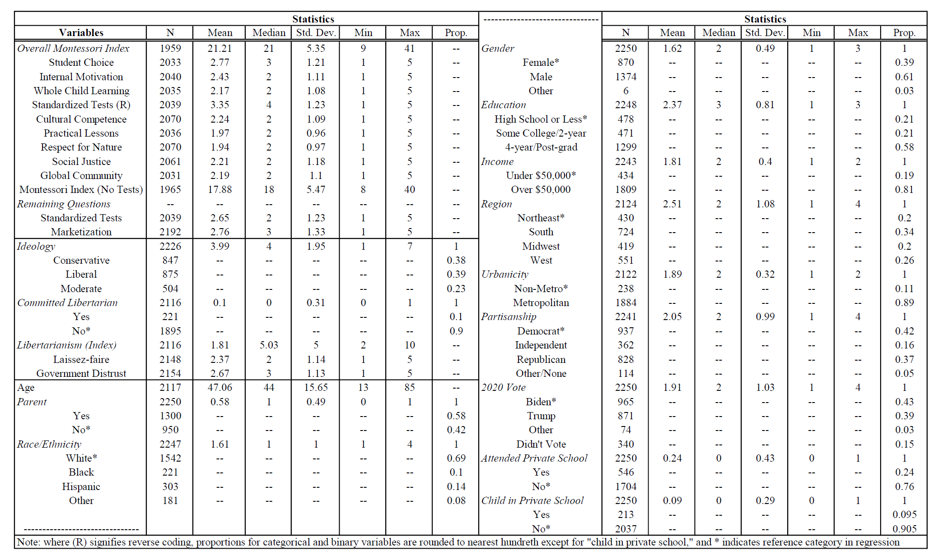

Figure 1: Montessori Support Trends
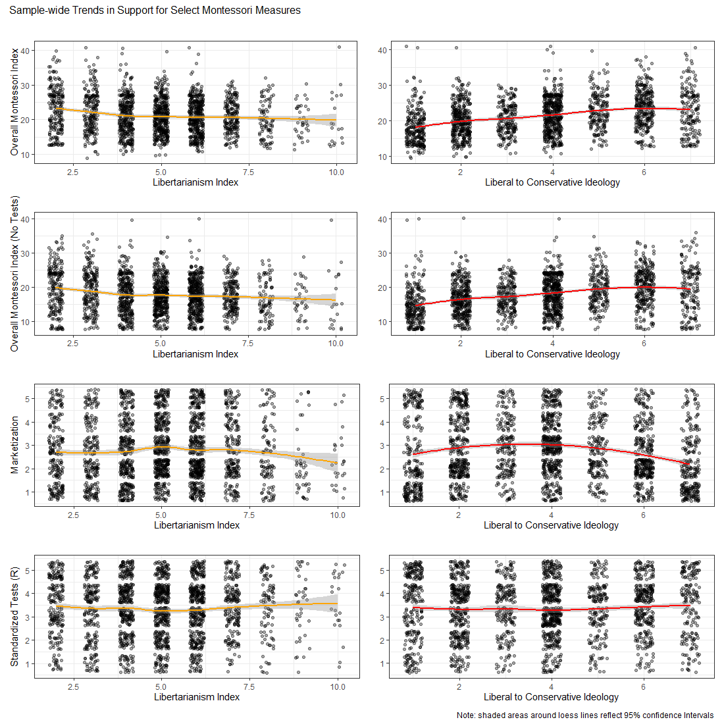

Figure 2: Mean Plots for Ideological Groups (Non-Weighted, Within Sample)
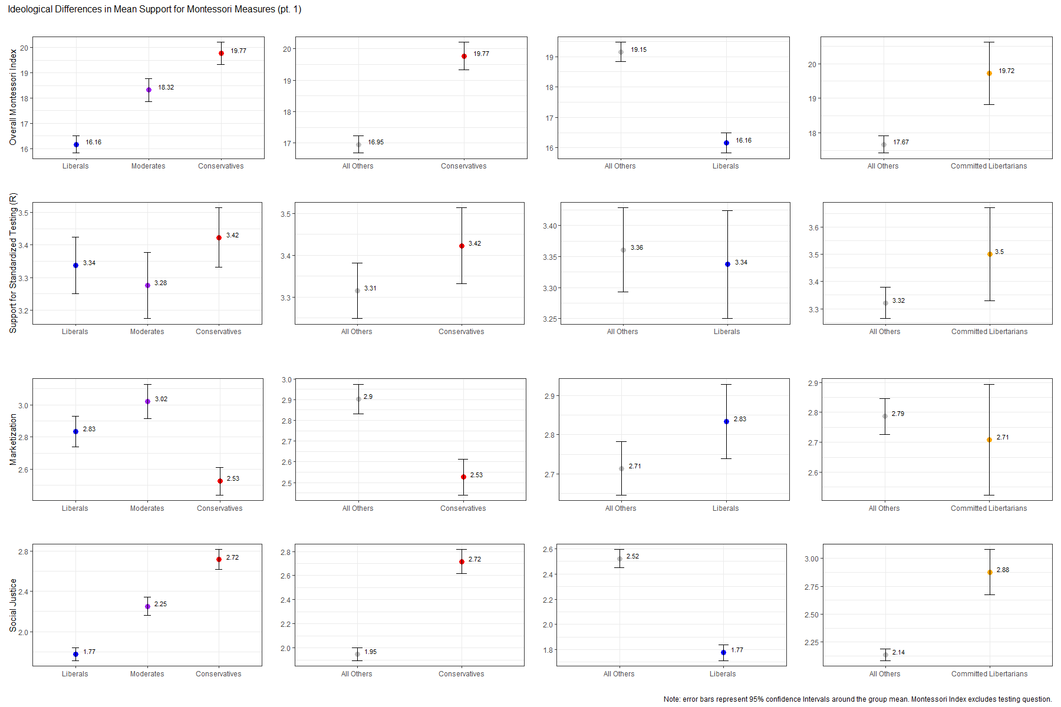

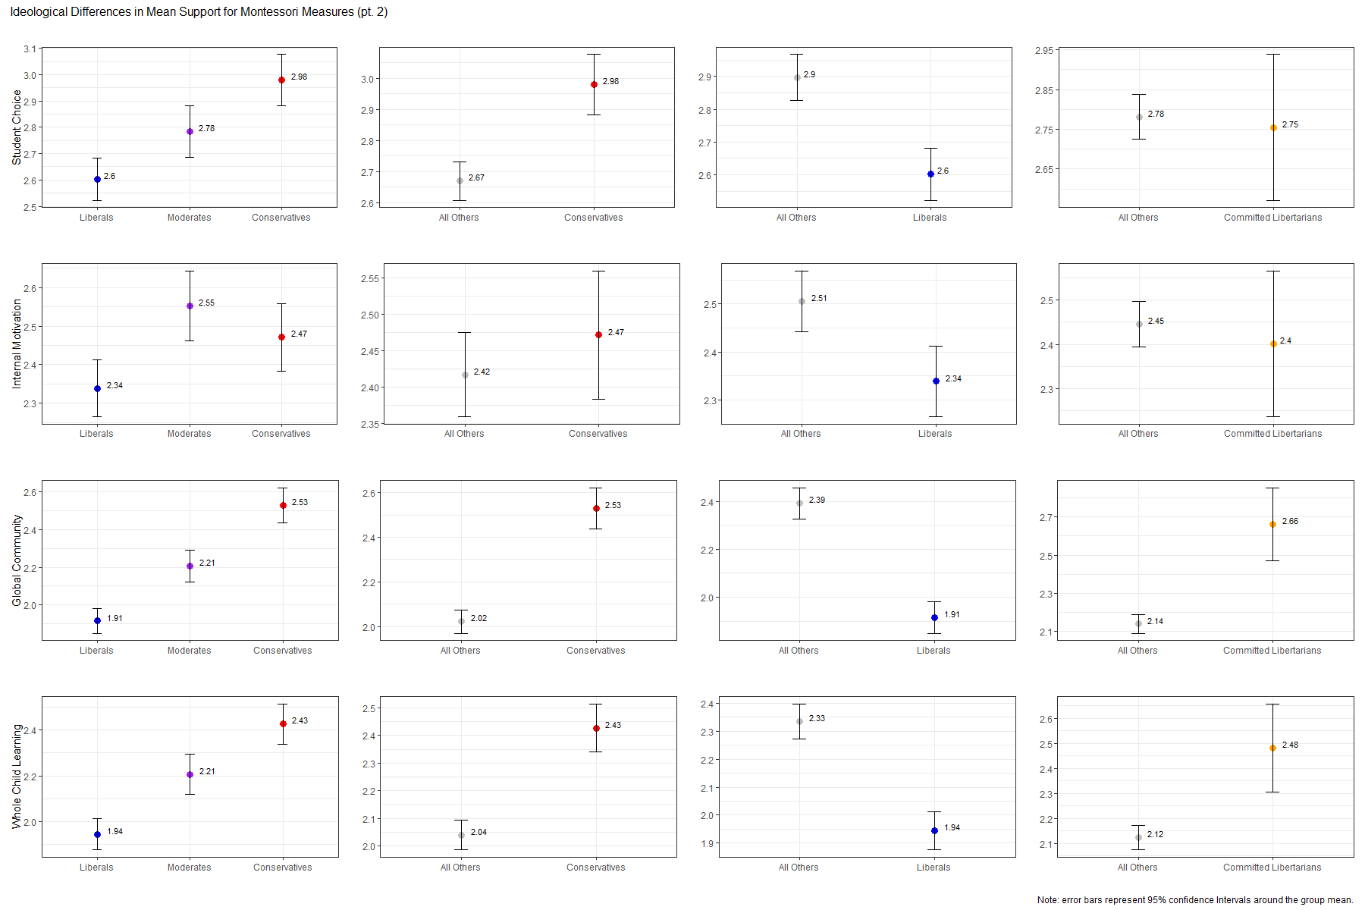

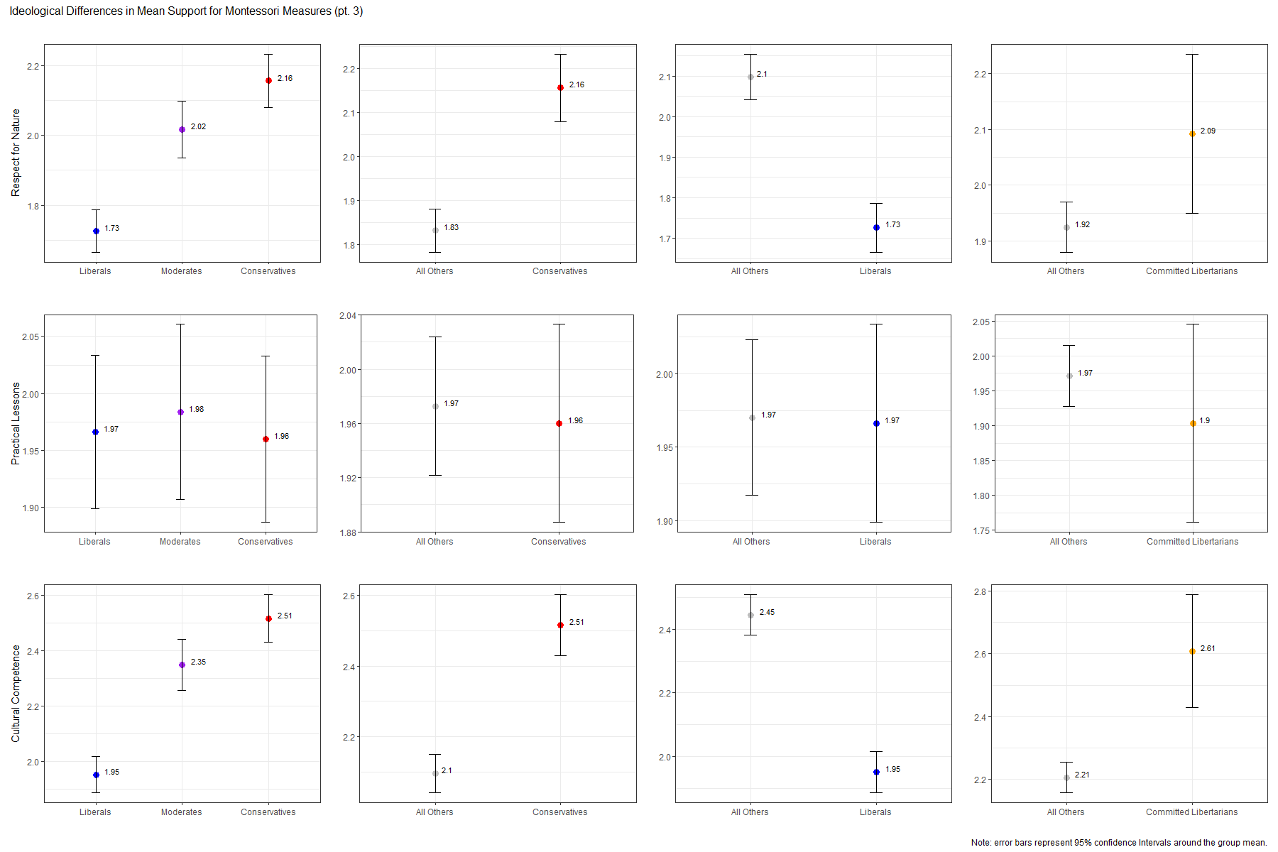
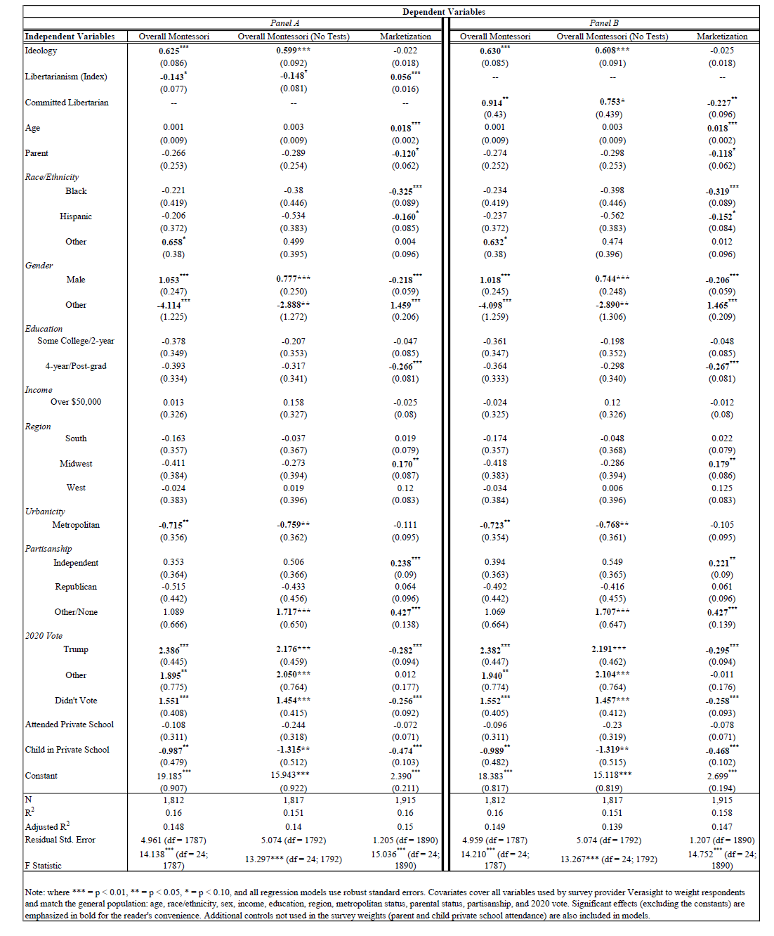
Table 2: OLS Regression Results for Specification (1)

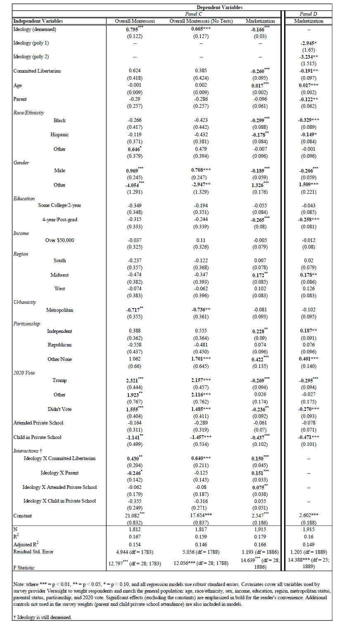
Table 3: OLS Regression Results for Specifications (2) and (3)

Figure 3: Re-visiting the Libertarianism Interaction

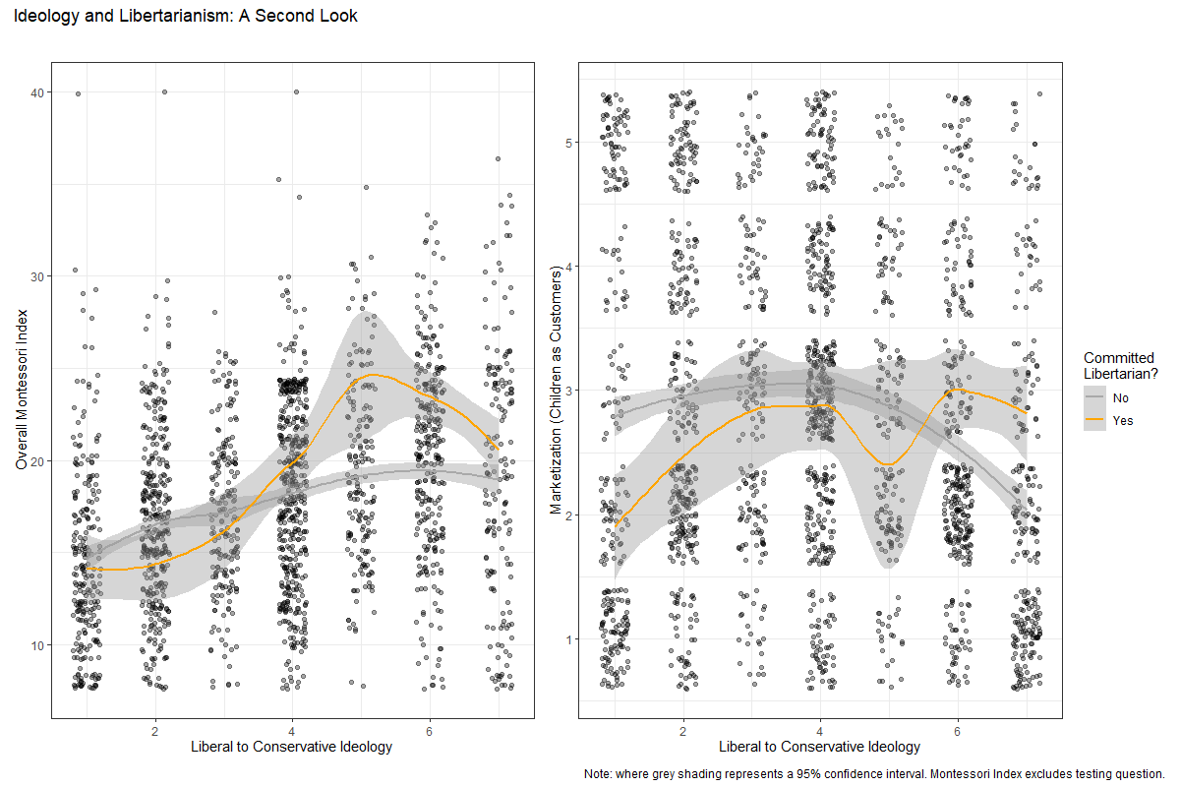
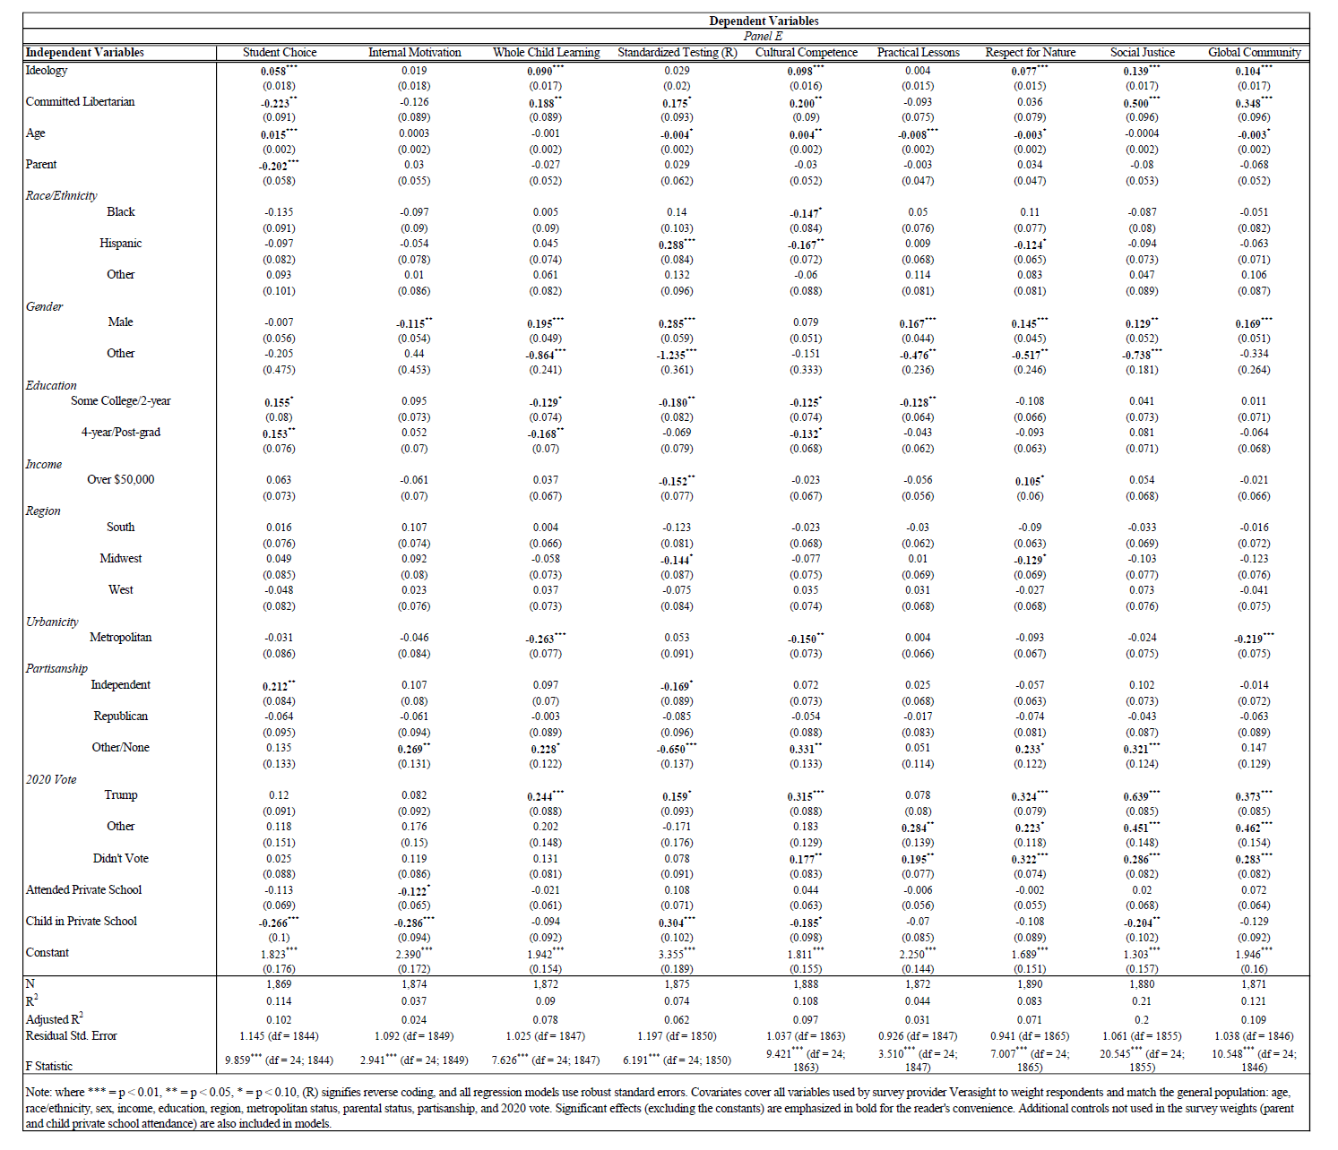
Table 4: OLS Regression Results for Individual Questions Using Model (1)

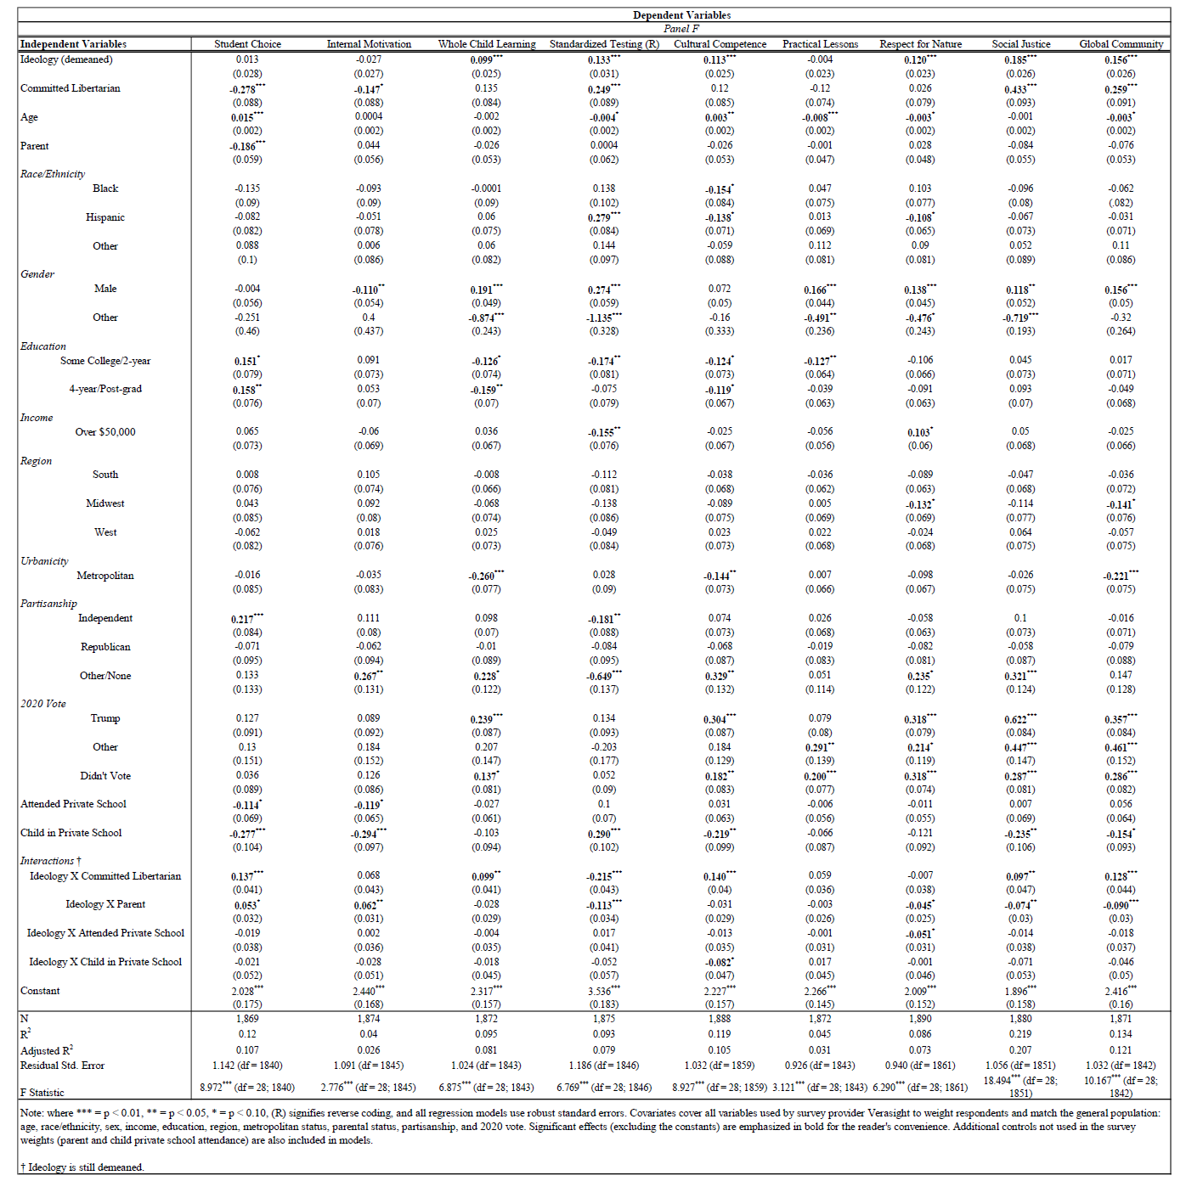
Table 5: OLS Regression Results for Individual Questions Using Model (2)

Table 6: Token Universe for Montessori Datasets
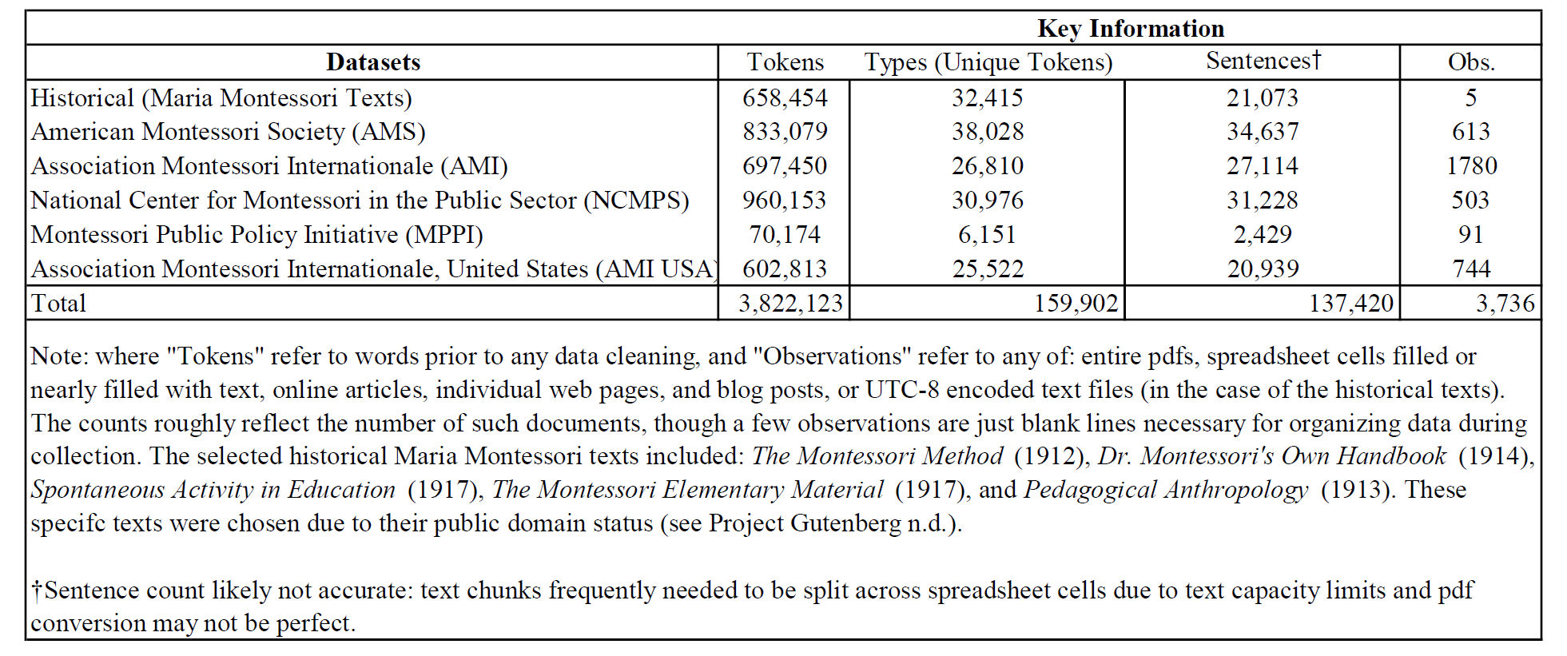

Figure 4: Moral Foundations Coded through “Bag-of-words” Approach
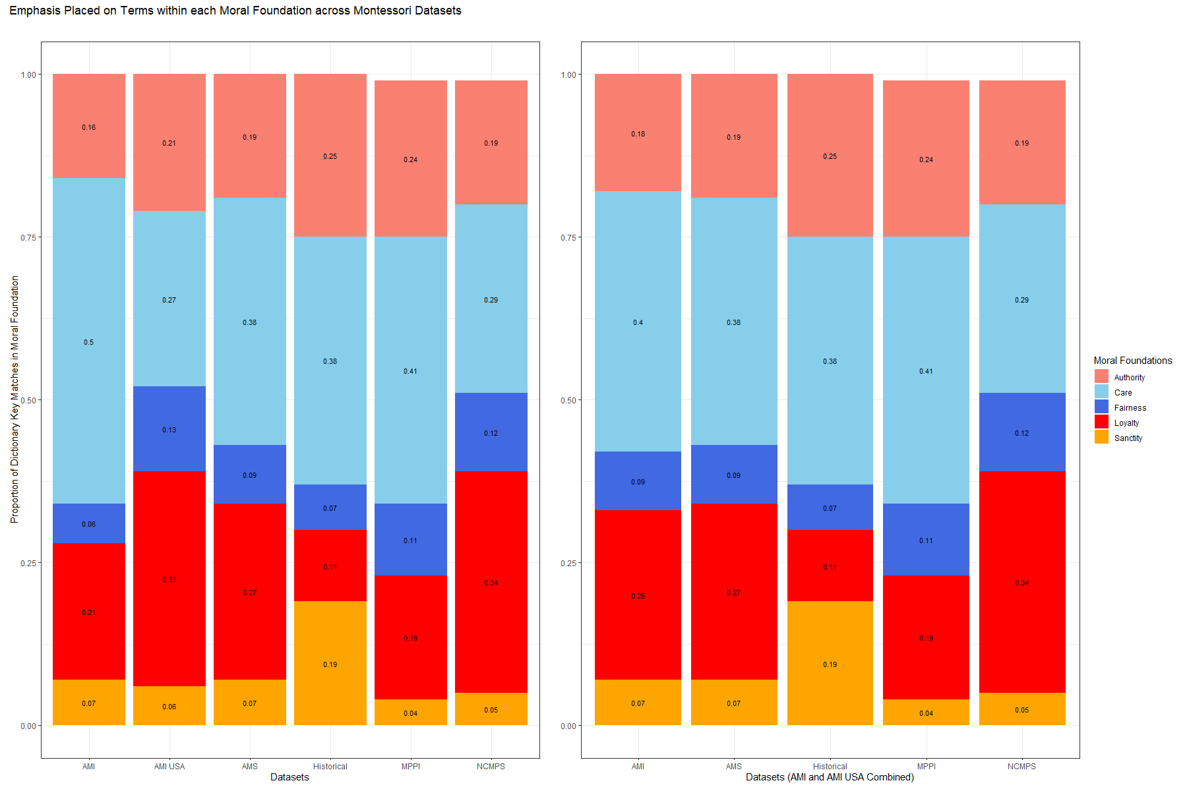
Table 7: Moral Foundation Counts and Proportions

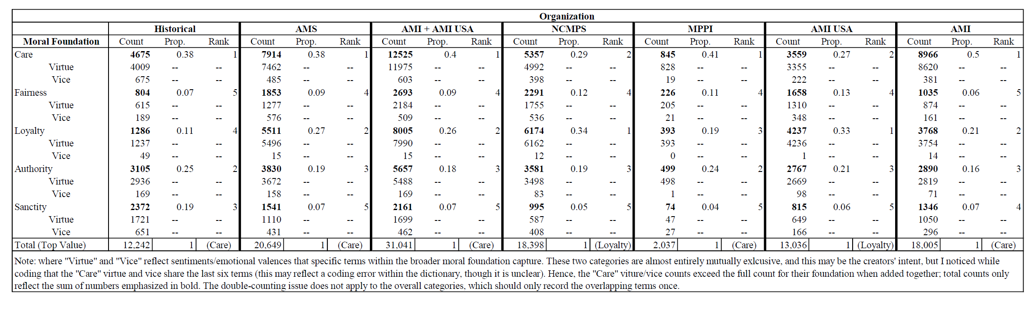

Figure 4A: Moral Foundations with all Valences

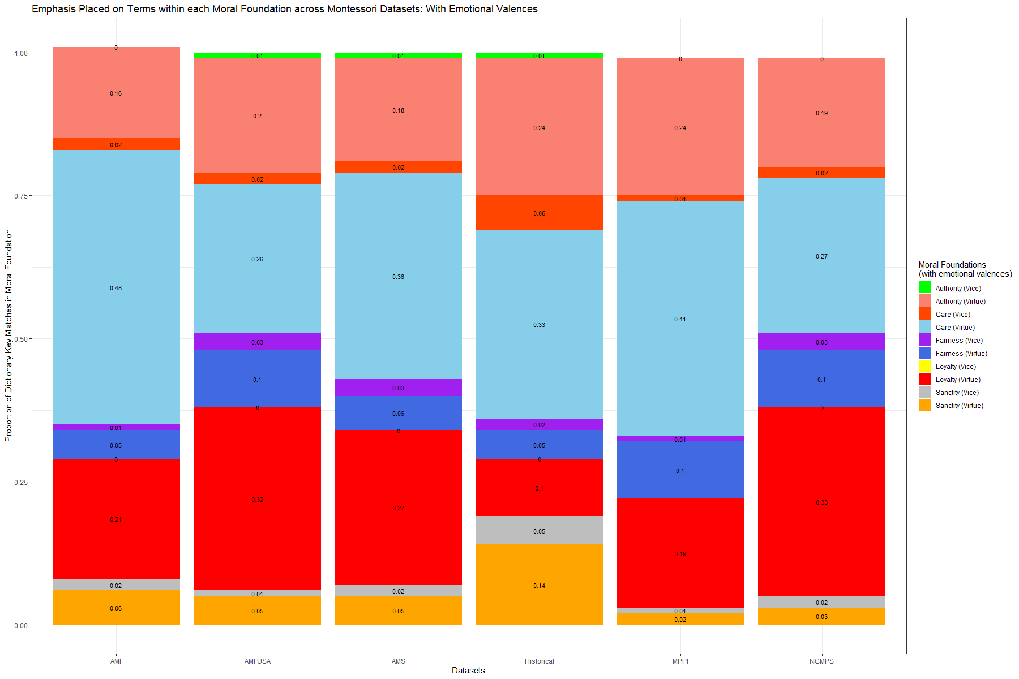
Figure 5: Top 50 Observed Terms from Each Moral Foundation
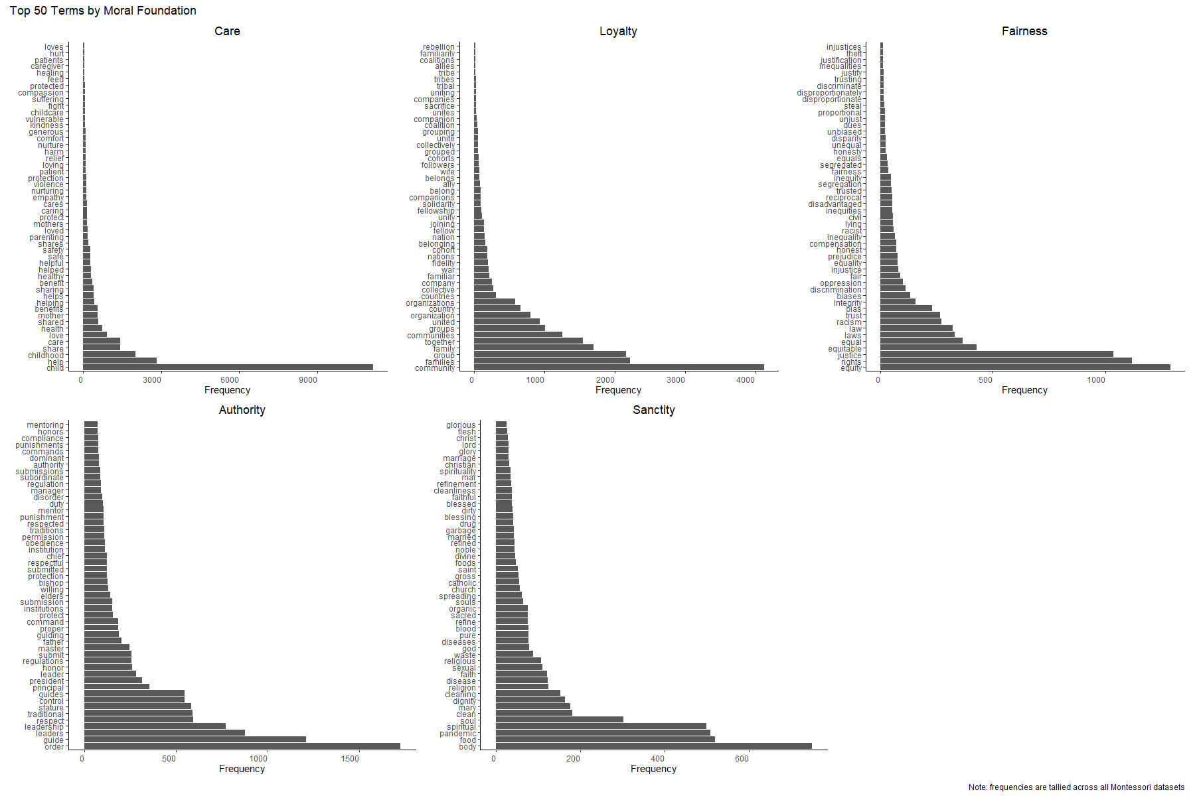
Figure 6: Scope of Montessori Text Data and Moral Language
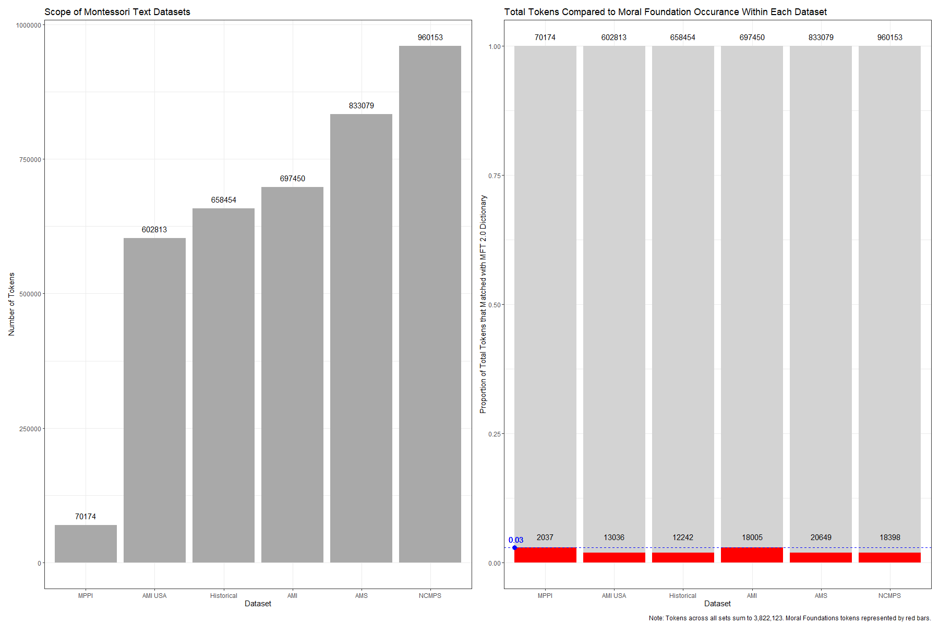
Table 8: Equality of Proportions

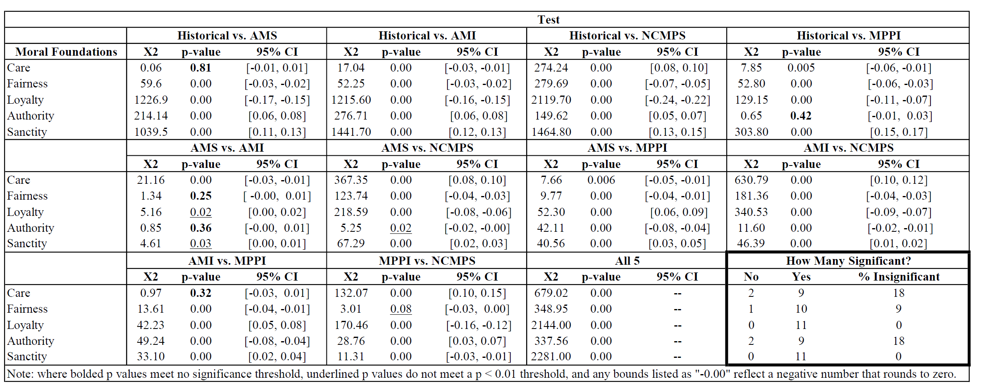

References
Angrist, Joshua D., Parag A. Pathak, and Christopher R. Walters. 2013. “Explaining Charter School Effectiveness.” American Economic Journal: Applied Economics 5 (4): 1-27. Available from: https://www.aeaweb.org/articles?id=10.1257/app.5.4.1

Balassiano, K. and S. M. Chandler. 2010. “The Emerging Role of Nonprofit Associations in Advocacy and Public Policy: Trends, Issues, and Prospects.” Nonprofit and Voluntary Sector Quarterly 39 (5): 946-955. https://doi.org/10.1177/0899764009338963

Barker, David C., and James D. Tinnick. 2006. “Competing Visions of Parental Roles and Ideological Constraint.” The American Political Science Review 100 (2): 249–63. http://www.jstor.org/stable/27644348.

Barnum, Matt. 2019. “What does Montessori mean in the age of school choice? Researcher Mira Debs explains.” Chalkbeat. April 30. https://www.chalkbeat.org/2019/4/30/21121031/what-does-montessori-mean-in-the-age-of-school-choice-researcher-mira-debs-explains (Accessed 8/26/2023).

Bartholet, Elizabeth. 2020. “Homeschooling: Parental Rights Absolutism vs. Child Rights to Education and Protection.” Arizona Law Review 62 (1). http://nrs.harvard.edu/urn-3:HUL.InstRepos:40108859

Bell, Elizabeth, A. H. Fryar, and T. Johnson. 2021. "Exploring Public Perceptions of Nonprofit Policy Advocacy." Nonprofit Policy Forum 12 (2): 311-340. https://doi.org/10.1515/npf-2019-0052

Benoit, K. 2019. “Quantitative Text Analysis using R and Quanteda.” University of Munster, June 2018, 27-28. Available from: https://www.uni-muenster.de/imperia/md/content/ifpol/grasp/2019-06-27_muenster.pdf (Accessed 2/10/24).

Benoit K., A. Obeng, K. Watanabe, A. Matsuo, P. Nulty, and S. Muller. 2024. “readtext: Import and Handling for Plain and Formatted Text Files.” R Cran. Available from: https://cran.r-project.org/web/packages/readtext/index.html

Benoit K, K. Watanabe, H. Wang, P. Nulty, A. Obeng, S. Müller, A. Matsuo. 2018. “quanteda: An R package for the quantitative analysis of textual data.” Journal of Open Source Software 3 (30): 774. doi:10.21105/joss.00774, https://quanteda.io.

Betts, Julian R. and Y. Emily Tang. October 2011. “The Effect of Charter Schools on Student Achievement: A Meta-Analysis of the Literature.” National Charter School Research Project. Eric Number: ED526353. Available from ERIC: https://eric.ed.gov/?id=ED526353

Bezos Day One Fund. n.d. “Day 1 Academies Fund.” Retrieved from: https://www.bezosdayonefund.org/day1academiesfund (Accessed 3/10/24).

Block, Corrie Rebecca. 2015. “Examining a Public Montessori’s Response to the Pressures of High-Stakes Accountability.” Journal of Montessori Research 1 (1): 42-54. Available from https://files.eric.ed.gov/fulltext/EJ1161298.pdf

Boaz, David and David Kirby. 2006. “The Libertarian Vote.” Cato Institute Policy Analysis Series No. 580, Available at SSRN: https://ssrn.com/abstract=975672 or http://dx.doi.org/10.2139/ssrn.975672

Bowe, B. J. 2018. “Permitted to Build? Moral Foundations in Newspaper Framing of Mosque-Construction Controversies.” Journalism & Mass Communication Quarterly 95 (3): 782-810. https://doi.org/10.1177/1077699017709253

Brown, Caleb O. 2023. “Building Confidence and Competence through Montessori Education.” Cato Institute Daily Podcast. August 23. https://www.cato.org/multimedia/cato-daily-podcast/building-confidence-competence-through-montessori-education (Accessed 8/26/2023).

Buffardi, A. L., R. J. Pekkanen, and S. R. Smith. 2017. “Proactive or Protective? Dimensions of and Advocacy Activities Associated with Reported Policy Change by Nonprofit Organizations.” Voluntas 28: 1226–1248. https://doi.org/10.1007/s11266-017-9849-x

Cierniak, Katherine, Molly Stewart, and Anne-Maree Ruddy. March 2015. “Mapping the Growth of Statewide Voucher Programs in the United States.” Indiana University Center for Evaluation and Education Policy. Available from: https://scholarworks.iu.edu/dspace/bitstream/handle/2022/23273/Statewide%20Vouchers%20EPB_03.31.15.pdf?sequence=1&isAllowed=y

Chaves, Mark, Laura Stephens, and Joseph Galaskiewicz. 2004. “Does Government Funding Suppress Nonprofits’ Political Activity?” American Sociological Review 69 (2): 292–316. http://www.jstor.org/stable/3593088.

Chen, Ying, Christina Hinton, and Tyler J. VanderWeele. 2021. “School types in adolescence and subsequent health and well-being in young adulthood: An outcome-wide analysis.” Plos ONE 16 (11): e0258723. https://doi.org/10.1371/journal.pone.0258723

Colgan, Andrew D. 2020. “The Epistemology Behind the Educational Philosophy of Montessori: Senses, Concepts, and Choice.” Philosophical Inquiry in Education 23 (2): 125-140. https://doi.org/10.7202/1070459ar

Comtois, D. 2022. “summarytools: Tools to Quickly and Neatly Summarize Data.” Available from R CRAN: https://cran.r-project.org/package=summarytools

Costello, T. H., S. M. Bowes, S. T. Stevens, I. D. Waldman, A. Tasimi, and S. O. Lilienfeld. 2022. “Clarifying the structure and nature of left-wing authoritarianism.” Journal of Personality and Social Psychology 122 (1): 135–170. https://doi.org/10.1037/pspp0000341

Cox, D., J. Navarro-Rivera, and R. P. Jones. 2013. “In Search of Libertarians in America.” Public Religion Research Institute. http://www.prri.org/research/2013-american-values-survey/

Croasmun, J. T. and L. Ostrom. 2011. “Using Likert-Type Scales in the Social Sciences.” Journal of Adult Education 40 (1): 19-22. ERIC Number: EJ961998. Available from: https://eric.ed.gov/?id=EJ961998

Culclasure, Brooke T., David J. Fleming, and Ginny Riga. 2018. “An Evaluation of Montessori Education in South Carolina’s Public Schools.” Riley Institute. ERIC Number: ED622145. Available from ERIC: https://files.eric.ed.gov/fulltext/ED622145.pdf

Danner, Natalie, and Susan Fowler. 2015. “Montessori and Non-Montessori Early Childhood Teachers’ Attitudes Towards Inclusion and Access.” Journal of Montessori Research 1 (1): 28-41. https://doi.org/10.17161/jomr.v1i1.4944.

D’Cruz, Genevieve. 2022. “Culturally Sustaining Practices in Public Montessori Schools: A Landscape of the Literature.” Journal of Unschooling and Alternative Learning 16 (31). Available from: https://jual.nipissingu.ca/wp-content/uploads/sites/25/2022/02/v14292.pdf

DeAngelis, Corey A. 2020. “Regulatory Compliance Costs and Private School Participation in Voucher Programs.” Journal of School Choice 14 (1): 95-121. https://doi.org/10.1080/15582159.2019.1673954

de Brouwer, J., L. Klaver, and S. van der Zee. 2023. “Montessori’s Perspective on Citizenship Education: A View From the Netherlands.” Journal of Montessori Research 9 (2): 28-43. https://doi.org/10.17161/jomr.v9i2.19418

Debs, M. C. 2022. “BOOK REVIEW The Best Weapon for Peace: Maria Montessori, Education and Children’s Rights.” Journal of Montessori Research 8 (1). https://doi.org/10.17161/jomr.v8i1.17113

Debs, Mira. 2021 “Diverse Families, Desirable Schools: Public Montessori in the Era of School Choice.” United States: Harvard Education Press. Available from: https://www.google.com/books/edition/Diverse_Families_Desirable_Schools/RhklEAAAQBAJ?hl=en&gbpv=0

Debs, Mira C. 2016. “Racial and Economic Diversity in U.S. Public Montessori Schools.” Journal of Montessori Research 2 (2): ERIC Number EJ1161353. Available from: https://files.eric.ed.gov/fulltext/EJ1161353.pdf

Debs, Mira, and Katie E. Brown. 2017. “Students of Color and Public Montessori Schools: A Review of the Literature.” Journal of Montessori Research 3 (1): 1-15. https://doi.org/10.17161/jomr.v3i1.5859.

Dee, Thomas S. February 2023. “Where the Kids Went: Nonpublic Schooling and Demographic Change during the Pandemic Exodus from Public Schools.” Urban Institute. Available from: https://www.urban.org/sites/default/files/2023-02/Where%20the%20Kids%20Went-%20Nonpublic%20Schooling%20and%20Demographic%20Change%20during%20the%20Pandemic%20Exodus%20from%20Public%20Schools_0.pdf

DiMaggio, Paul J., and Walter W. Powell. 1983. “The Iron Cage Revisited: Institutional Isomorphism and Collective Rationality in Organizational Fields.” American Sociological Review 48 (2): 147-160. https://doi.org/10.2307/2095101

Döringer, S. 2021. “‘The problem-centred expert interview’. Combining qualitative interviewing approaches for investigating implicit expert knowledge.” International Journal of Social Research Methodology 24 (3): 265–278. https://doi.org/10.1080/13645579.2020.1766777

Druckman, J. N., E. Peterson, and R. Slothuus. 2013. “How Elite Partisan Polarization Affects Public Opinion Formation.” The American Political Science Review 107 (1): 57–79. http://www.jstor.org/stable/23357757.

Egalite, Anna J. and Patrick J. Wolf. 2016. “A Review of the Empirical Research on Private School Choice.” Peabody Journal of Education 91 (4): 441-454. https://doi.org/10.1080/0161956X.2016.1207436

Elder, L. and S. Greene, 2016. “Red Parents, Blue Parents: The Politics of Modern Parenthood.” The Forum 14 (2): 143-167. https://doi.org/10.1515/for-2016-0013

Enright, Marsha. 2010. “Montessori, Dewey, and Capitalism.” The Atlas Society. December 31. https://www.atlassociety.org/post/montessori-dewey-and-capitalism (Accessed 8/30/2023).

Feinberg, M., E. Wehling, J. M. Chung, L. R. Saslow, and I. Melvær Paulin. 2020. “Measuring moral politics: How strict and nurturant family values explain individual differences in conservatism, liberalism, and the political middle.” Journal of Personality and Social Psychology 118 (4): 777–804. https://doi.org/10.1037/pspp0000255

Feinberg, M., E. Wehling. 2018. “A moral house divided: How idealized family models impact political cognition.” PLoS ONE 13(4): e0193347. https://doi.org/10.1371/journal.pone.0193347

Feinerer, I., and K. Hornik. 2024. “tm: Text Mining Package.” R package version 0.7-12, https://CRAN.R-project.org/package=tm

Feldt, L. S., D. J. Woodruff, and F. A. Salih. 1987. “Statistical inference for coefficient alpha.” Applied Psychological Measurement 11 (1): 93–103. https://doi.org/10.1177/014662168701100107

Fox, J. and S. Weisberg. 2019. “An R Companion to Applied Regression.” Third edition. Sage, Thousand Oaks CA. https://socialsciences.mcmaster.ca/jfox/Books/Companion/.

Fraley, R. Chris, Brian N. Griffin, Jay Belsky, and Glenn I. Roisman. 2012. “Developmental Antecedents of Political Ideology: A Longitudinal Investigation From Birth to Age 18 Years.” Psychological Science 23 (11): 1425–31. http://www.jstor.org/stable/23484547.

Frimer, J. A., R. Boghrati, J. Haidt, J. Graham, and M. Dehgani, M. 2019.
“Moral Foundations Dictionary for Linguistic Analyses 2.0”
Unpublished manuscript. DOI: https://doi.org/10.17605/OSF.IO/EZN37

Fyall, Rachel. 2016. “The Power of Nonprofits: Mechanisms for Nonprofit Policy Influence.” Public Administration Review 76 (6): 938–48. http://www.jstor.org/stable/26649012.

Fyall, R., and M. McGuire. 2015. “Advocating for Policy Change in Nonprofit Coalitions.” Nonprofit and Voluntary Sector Quarterly 44 (6): 1274-1291. https://doi.org/10.1177/0899764014558931

Graham, J., B. A. Nosek, J. Haidt, R. Iyer, S. Koleva, and P. H. Ditto 2011. “Mapping the moral domain.” Journal of Personality and Social Psychology 101 (2): 366-385. doi:https://doi.org/10.1037/a0021847

Graham, J., and J. Haidt. 2012. “Sacred values and evil adversaries: A moral foundations approach.” In M. Mikulincer and P. R. Shaver (Eds.), The social psychology of morality: Exploring the causes of good and evil.11-31. Washington, DC, Washington: American Psychological Association, American Psychological Association. DOI: https://psycnet.apa.org/doi/10.1037/13091-001

Graham, Jesse, Jonathan Haidt, and Brian A. Nosek. 2009. “Liberals and conservatives rely on different sets of moral foundations.” Journal of personality and social psychology 96 (5): 1029-1046. https://psycnet.apa.org/doi/10.1037/a0015141

Greene, Jay P. and James D. Paul. September 2021. “Does School Choice Need Bipartisan Support? An Empirical Analysis of the Legislative Record.” American Enterprise Institute. Available from: https://www.aei.org/wp-content/uploads/2021/09/Does-School-Choice-Need-Bipartisan-Support.pdf?x91208

Green, Brenda. 2022. “Integrating Montessori Curriculum with State Standards in a Public Montessori School.” St. Catherine University SOPHIA. Available from: https://sophia.stkate.edu/cgi/viewcontent.cgi?article=1472&context=maed

Gutek, Gerald L. and Patricia A. Gutek. 2016. “Bringing Montessori to America: S. S. McClure, Maria Montessori, and the Campaign to Publicize Montessori Education.” United States: University of Alabama Press, Chapter 8: The Montessori-McClure Breakup. Available from: https://www.google.com/books/edition/Bringing_Montessori_to_America/MiCNCwAAQBAJ?hl=en

Haidt, J., and J. Graham. 2007. “When Morality Opposes Justice: Conservatives Have Moral Intuitions that Liberals may not Recognize.” Soc Just Res 20: 98–116. https://doi.org/10.1007/s11211-007-0034-z

Hayek, F. A. 1945. “The Use of Knowledge in Society.” The American Economic Review 35 (4): 519–30. http://www.jstor.org/stable/1809376.

Hess, Frederick. 2023. “Bezos’s Bold Bet on Montessori Preschool.” Forbes Magazine. March 14. https://www.forbes.com/sites/frederickhess/2023/03/14/bezoss-bold-bet-on-montessori-preschool/?sh=2deebb4f1e3a (Accessed 8/26/2023).

Higgins, M. 1998. [Review of Moral Politics: What Conservatives Know That Liberals don’t, by G. Lakoff]. Language 74 (2): 425–426. https://doi.org/10.2307/417918

Hirsh-Pasek, Kathy, and Helen Shwe Hadani. 2020. “A new path to education reform: Playful learning promotes 21st-century skills in schools and beyond.” Brookings Institution. Available from: https://www.brookings.edu/wp-content/uploads/2020/10/Big-Ideas_Hirsh-Pasek_PlayfulLearning.pdf

Hiles, Elisabeth. 2018. “Parents’ Reasons for Sending Their Child to Montessori Schools.” Journal of Montessori Research 4 (1): 1-13. https://doi.org/10.17161/jomr.v4i1.6714.

Hilty, Rowan, P. Boddicker-Young, D. Hegseth, J. Thompson, E. Bultinck, J. Fojut, D. Early. 2021. “Understanding Equitable Access to Public Montessori Pre-K: A Case Study of Montessori Recruitment and Enrollment Practices Executive Summary.” Child Trends. Available from: https://cms.childtrends.org/wp-content/uploads/2021/03/EquitableAccessMontessoriExecSummary_ChildTrends_March2021.pdf

McHugh ML. 2013. “The chi-square test of independence.” Biochem Med (Zagreb) 23 (2): 143-9. doi: 10.11613/bm.2013.018.

Hlavac, M. 2022. “stargazer: Well-Formatted Regression and Summary Statistics Tables.” Social Policy Institute, Bratislava, Slovakia. R package version 5.2.3, https://CRAN.R-project.org/package=stargazer.

Hoffmann, John P., Christopher G. Ellison, and John P. Bartkowski. 2017. "Conservative Protestantism and attitudes toward corporal punishment, 1986–2014." Social Science Research 63: 81-94. https://doi.org/10.1016/j.ssresearch.2016.09.010.

Hornik, K, D. Meyer, and C. Buchta. 2022. “slam: Sparse Lightweight Arrays and Matrices.” Available from R CRAN: https://cran.r-project.org/package=slam

Houston, D. M. 2024. “Polarization, Partisan Sorting, and the Politics of Education.” American Educational Research Journal 0 (0). https://doi.org/10.3102/00028312241228280

Hyett N, Kenny A, Dickson-Swift V. 2014. “Methodology or method? A critical review of qualitative case study reports.” Int J Qual Stud Health Well-being 7 (9): 23606. doi: 10.3402/qhw.v9.23606.

Iyer R, S. Koleva, J. Graham, P. Ditto, and J. Haidt. 2012. “Understanding Libertarian Morality: The Psychological Dispositions of Self-Identified Libertarians.” PLoS ONE 7 (8): e42366. https://doi.org/10.1371/journal.pone.0042366

Janoff-Bulman, Ronnie, Nate C. Carnes, and Sana Sheikh. 2014. “Parenting and Politics: Exploring Early Moral Bases of Political Orientation.” Journal of Social and Political Psychology 2 (1): 43-60. https://doi.org/10.5964/jspp.v2i1.243.

Janoff-Bulman, Ronnie. 2009. “To Provide or Protect: Motivational Bases of Political Liberalism and Conservatism.” Psychological Inquiry 20 (2-3): 120-128. DOI: 10.1080/10478400903028581

Jenkins-Smith, Hank C., Daniel Nohrstedt, Christopher M. Weible, and Karin Ingold. 2018. "The advocacy coalition framework: An overview of the research program." Theories of the policy process 4: 135-171. DOI: 10.4324/9780429494284-5

Jenkins-Smith, Hank C., and Paul A. Sabatier. 1994. “Evaluating the Advocacy Coalition Framework.” Journal of Public Policy 14 (2): 175–203. http://www.jstor.org/stable/4007571.

Jones, Bryan D., Frank R. Baumgartner, and James L. True. 1998. “Policy Punctuations: U.S. Budget Authority, 1947-1995.” The Journal of Politics 60 (1): 1–33. https://doi.org/10.2307/2647999.

Jung, Jihye, and Vikas Mittal. 2021. “Political Identity and Preference for Supplemental Education Programs.” Journal of Marketing Research 58 (3): 559-578. https://doi.org/10.1177/00222437211004

Kiley, Jocelyn. 2014. “In search of Libertarians.” Pew Research Center. August 25. https://www.pewresearch.org/short-reads/2014/08/25/in-search-of-libertarians/ (Accessed 2/19/24).

Kirby, David. 2022. “Maria Montessori’s ‘Libertarian View of Children.’” Reason Magazine. January 30. https://reason.com/2022/01/30/maria-montessoris-libertarian-view-of-children/ (Accessed 8/29/2023).

Kivikangas, J. M., B. Fernández-Castilla, S. Järvelä, N. Ravaja, and J. Lönnqvist. 2021. “Moral foundations and political orientation: Systematic review and meta-analysis.” Psychological Bulletin 147(1): 55-94. doi:https://doi.org/10.1037/bul0000308

Knackmuhs, E., L. Farmer, and D. Knapp. 2020. “The Interaction of Policy Narratives, Moral Politics, and Criminal Justice Policy Beliefs.” Politics and Policy 48: 288-313. https://doi.org/10.1111/polp.12343
Kugler, M., J. T. Jost, and S. Noorbaloochi. 2014. “Another Look at Moral Foundations Theory: Do Authoritarianism and Social Dominance Orientation Explain Liberal-Conservative Differences in “Moral” Intuitions?” Soc Just Res 27: 413–431. https://doi.org/10.1007/s11211-014-0223-5

Lakoff, George. 2002. “Moral politics: how liberals and conservatives think.” United Kingdom: University of Chicago Press. Available from: https://www.google.com/books/edition/Moral_Politics/R-4YBCYx6YsC?hl=en&gbpv=0

Leroux, K., and H. T. Goerdel. 2009. “POLITICAL ADVOCACY BY NONPROFIT ORGANIZATIONS: A Strategic Management Explanation.” Public Performance & Management Review 32 (4): 514–36. http://www.jstor.org/stable/40586771.

Levendusky, M.S. 2010. “Clearer Cues, More Consistent Voters: A Benefit of Elite Polarization.” Polit Behav 32: 111–131. https://doi.org/10.1007/s11109-009-9094-0

Lillard, Angeline S, and Virginia McHugh. 2019. “Authentic Montessori: The Dottoressa’s View at the End of Her Life Part I: The Environment.” Journal of Montessori Research 5 (1): 1-18. https://doi.org/10.17161/jomr.v5i1.7716.

Lillard, Angeline S., Megan J. Heise, Eve M. Richey, Xin Tong, Alyssa Hart and Paige M. Bray. 2017. “Montessori Preschool Elevates and Equalized Child Outcomes: A Longitudinal Study.” Frontiers in Psychology 8. https://doi.org/10.3389/fpsyg.2017.01783

Lindke, Christian A., and Daniel M. Oppenheimer. 2022. “Hovering at the polls: Do helicopter parents prefer paternalistic political policies?” Journal of Experimental Psychology: General 151 (12): 3154-3176. DOI: https://doi.org/10.1037/xge0001251

Lizotte M-K, and T. Warren. 2021. “Understanding the appeal of libertarianism: Gender and race differences in the endorsement of libertarian principles.” Analyses of Social Issues and Public Policy 21: 640–659. https://doi.org/10.1111/asap.12237

Long, T., C. Westerman, and N. Ferranti. 2022. “Children with Disabilities Attending Montessori Programs in the United States.” Journal of Montessori Research 8 (2): 16-32. https://doi.org/10.17161/jomr.v8i2.18639

Lu, J. 2018. “Organizational Antecedents of Nonprofit Engagement in Policy Advocacy: A Meta-Analytical Review.” Nonprofit and Voluntary Sector Quarterly 47 (4_suppl): 177S-203S. https://doi.org/10.1177/0899764018769169

Lueken, Martin F. October 2021. “Education Savings Accounts: How ESAs Can Promote Educational Freedom for New York Families and Improve State and Local Finances.” Manhattan Institute. Available from: https://files.eric.ed.gov/fulltext/ED615235.pdf

Heather MacIndoe and Erynn Beaton. 2019. “Friends or Foes? How Managerial Perceptions of the Political Opportunity Structure Shape Nonprofit Advocacy.” Public Performance & Management Review 42 (1): 59-89, DOI: 10.1080/15309576.2018.1498362

Marshall, Chloe. 2017. “Montessori Education: a review of the evidence base.” npj Science of Learning 2: https://doi.org/10.1038/s41539-017-0012-7

Mavric, Marusa. 2020. “The Montessori Approach As a Model of Personalized Instruction”. Journal of Montessori Research 6 (2). https://doi.org/10.17161/jomr.v6i2.13882.

McAdams, D. P., M. Albaugh, E. Farber, J. Daniels, R. L. Logan, and B. Olson. 2008. “Family metaphors and moral intuitions: How conservatives and liberals narrate their lives.” Journal of Personality and Social Psychology 95 (4): 978–990. https://doi.org/10.1037/a0012650

McAdams, Dan P., Kathrin J. Hanek, and Joseph G. Dadabo. 2013. “Themes of Self-Regulation and Self-Exploration in the Life Stories of Religious American Conservatives and Liberals.” Political Psychology 34 (2): 201–19. http://www.jstor.org/stable/23481742.

McDonald, Kerry. 2022. “How Microschool Networks Are Activating Education Entrepreneurs.” Forbes Magazine. November 14. https://www.forbes.com/sites/kerrymcdonald/2022/11/14/how-microschool-networks-are-activating-education-entrepreneurs/?sh=2398d8c21e38 (Accessed 8/26/2023).

Meany, Paul. 2020. “Libertarianism at School: Maria Montessori.” Libertarianism.org: Portraits of Liberty Podcast. July 2. https://www.libertarianism.org/podcasts/portraits-liberty/libertarianism-school-maria-montessori (Accessed 8/29/2023).

Montessori Census. n.d. “About the Montessori Census.” Retrieved 5/01/23 from: https://www.montessoricensus.org/about-the-montessori-census/

Montessori Public Policy Initiative. n.d. “Who We Work With.” Retrieved 5/02/23 from: https://montessoriadvocacy.org/our-work/who-we-work-with/

Montessori Public Policy Initiative. n.d.a. “Coronavirus Policy and Advocacy Information.” Retrieved 3/01/24 from: https://montessoriadvocacy.org/resources/coronavirus-policy-and-advocacy-information/

Moses, J. F. and M. H. Gonzales. 2015. “Strong Candidate, Nurturant Candidate: Moral Language in Presidential Television Advertisements.” Political Psychology 36: 379-397. https://doi.org/10.1111/pops.12160

Mosley, J. E. 2014. “Collaboration, Public-Private Intermediary Organizations, and the Transformation of Advocacy in the Field of Homeless Services.” The American Review of Public Administration 44 (3): 291-308. https://doi.org/10.1177/0275074012465889

Murray, Angela K. 2008. “Public perceptions of montessori education.” Ph.D. diss., University of Kansas, https://search.proquest.com/openview/5323bee6aca0d7c4c49c4c13631e3272/1?pq-origsite=gscholar&cbl=18750
(accessed March 18, 2024).

Murray, A. K., C. J. Daoust, and J. Chen. 2019. “Developing Instruments to Measure Montessori Instructional Practices.” Journal of Montessori Research 5 (1): 75-87. https://doi.org/10.17161/jomr.v5i1.9797. Available from: https://files.eric.ed.gov/fulltext/EJ1216885.pdf

Murray, Angela K., M. Miller, E. L. Postlewaite, and K. Clark. 2022. "Implementing the Montessori approach in an undergraduate marketing course: A case study." Frontiers in Education 7. DOI: 10.3389/feduc.2022.1033752

Murray, Jeff. 2017. “Montessori preschool vs. business-as-usual.” Thomas B. Fordham Institute. November 1. https://fordhaminstitute.org/national/commentary/montessori-preschool-vs-business-usual
(Accessed 8/27/2023).

Nieves, Nivia, and Jack Dougherty. 2006. “Latino Politicians, Activists, and Parents: The Challenge of Implementing City-Suburban Magnet Schools.” Conference Paper presented at the American Educational Research Association annual meeting. San Francisco, CA, April 10. Available from the Trinity College Digital Repository: http://digitalrepository.trincoll.edu

Ohl, Jessie J., Damien S. Pfister, Martin Nader, and Dana Griffin. 2013. “Lakoff's Theory of Moral Reasoning in Presidential Campaign Advertisements, 1952–2012.” Communication Studies 64 (5): 488-507, DOI: 10.1080/10510974.2013.832340

Parker, Deborah Evans. 2007. “Navigating the social /cultural politics of school choice: ‘Why do parents choose Montessori?’: A case study.” The University of North Carolina at Greensboro. Available from ProQuest Dissertations & Theses Global. (304842789): https://search.proquest.com/openview/9482e23a7f69befb363bf9115653cdd3/1?pq-origsite=gscholar&cbl=18750&casa_token=qkydbW5gny4AAAAA:OZkAvqkUMpnMtrEjX3hz4Yvfuf-eKB1G8qZYZ7maPOyvdzayfoNeQP9uNo6lEQEe94CfE4EXDfo

Pedersen T. 2024. “patchwork: The Composer of Plots.” R package version 1.2.0.9000, https://github.com/thomasp85/patchwork, https://patchwork.data-imaginist.com.

Phillips, Bernadette. 2022. “The Montessori Method and the Neurosequential Model in Education (NME): A Comparative Study.” Journal of Montessori Research 8 (2): 33-43. Available from ERIC: https://eric.ed.gov/?id=EJ1372151

Powell, Jim. 1995. “Maria Montessori, Who Gave Children Everywhere Freedom to Achieve Independence.” Foundation for Economic Education. August 1. https://fee.org/articles/maria-montessori-who-gave-children-everywhere-freedom-to-achieve-independence/ (Accessed 8/30/2023).

Puschmann, Cornelius, and Mario Haim. 2019. “Automated Content Analysis in R.” Retrieved 9/11/23 from: https://content-analysis-with-r.com/0-introduction.html

Project Gutenberg. n.d. “Books by Montessori, Maria.” Available from: https://www.gutenberg.org/ebooks/author/26701 (Accessed 3/25/2024)

R Core Team. 2022. “R: A language and environment for statistical computing.” R Foundation for Statistical Computing, Vienna, Austria. https://www.R-project.org/.

Rathunde, Kevin, and Mihaly Csikszentmihalyi. 2005. “Middle School Students’ Motivation and Quality of Experience: A Comparison of Montessori and Traditional School Environments.” American Journal of Education 111 (3): 341–71. https://doi.org/10.1086/428885.

William Revelle. 2024. “psych: Procedures for Psychological, Psychometric, and Personality Research.” Northwestern University, Evanston, Illinois. R package version 2.4.3, https://CRAN.R-project.org/package=psych.

Sanden, Brooke. 2007. “The Possibility of Public Montessori Schools: Examining the Montessori philosophy and its prospect in American public schools.” Peabody College, Vanderbilt University. Available from: https://ir.vanderbilt.edu/bitstream/handle/1803/256/BrookeCapstone.doc?sequence=1

Sebberson, David. 1997. [Review of Moral Politics: What Conservatives Know that Liberals Don’t by George Lakoff] Rhetoric Society Quarterly 27 (3): 91–94. http://www.jstor.org/stable/3886206.

Smith, Steven Rathgeb, and Robert Pekkanen. 2012. “Revisiting advocacy by non-profit organisations.” Voluntary Sector Review 3 (1): 35-49. https://doi.org/10.1332/204080512X632719

Sowell, Thomas. 2002. “A conflict of visions : ideological origins of political struggles.” United Kingdom: Basic Books, Chapter 2: Constrained and Unconstrained Visions. Available from: https://www.google.com/books/edition/A_Conflict_of_Visions/Ngl_4jPv8M0C?hl=en&gbpv=1

Swedlow, Brendon. 2008. “Beyond liberal and conservative: Two-dimensional conceptions of ideology and the structure of political attitudes and values” Journal of Political Ideologies 13 (2): 157-180, DOI: 10.1080/13569310802075969

Swedlow, Brendon. 2002. “Toward cultural analysis in policy analysis: Picking up where Aaron Wildavsky left off.” Journal of Comparative Policy Analysis, Research and Practice 4 (3): 267-285. https://doi.org/10.1080/13876980208412683

Taber, K.S. 2018. “The Use of Cronbach’s Alpha When Developing and Reporting Research Instruments in Science Education.” Res Sci Educ 48: 1273–1296. https://doi.org/10.1007/s11165-016-9602-2

Taggart, Jessica, Eren Fukuda, and Angeline Stoll Lillard. 2018. “Children’s Preference for Real Activities: Even Stronger in the Montessori Children’s House.” Journal of Montessori Research 4 (2): 1-9. https://doi.org/10.17161/jomr.v4i2.7586

Tavakol M. and Dennick R. 2011. “Making sense of Cronbach's alpha.” Int J Med Educ. 27 (2): 53-55. doi: 10.5116/ijme.4dfb.8dfd. PMID: 28029643; PMCID: PMC4205511.

Thornton, Patricia H. and William Ocasio. 2008. “Chapter 3: Institutional Logics.” In The SAGE
Handbook of Organizational Institutionalism. SAGE Publications Ltd.
https://doi.org/10.4135/9781849200387

Valley, Jackie. 2023. “Rise of the microschool: Small, student-centered learning spaces take off.” The Christian Science Monitor. August 14. https://www.csmonitor.com/USA/Education/2023/0814/Rise-of-the-microschool-Small-student-centered-learning-spaces-take-off (Accessed 8/26/2023).

Vaughan, S.K. and S. Arsneault. 2008. “Not-for-Profit Advocacy: Challenging Policy Images and Pursuing Policy Change.” Review of Policy Research 25: 411-428. https://doi.org/10.1111/j.1541-1338.2008.00344.x

Ward, K. D., D. P. Mason, G. Park, and R. Fyall. 2023. “Exploring Nonprofit Advocacy Research Methods and Design: A Systematic Review of the Literature.” Nonprofit and Voluntary Sector Quarterly 52 (5): 1210–1231. https://doi.org/10.1177/08997640221131747

Wasson, Winton Lann, and Deron R. Boyles. 1998. “A Democratic Phenomenon: Emerging Adolescent Programs in Montessori Schools.” Philosophy of Education. Available from: https://educationjournal.web.illinois.edu/archive/index.php/pes/article/view/2150.pdf

Weber, Christopher R., and Christopher M. Federico. 2013. “Moral Foundations and Heterogeneity in Ideological Preferences.” Political Psychology 34 (1): 107–26. http://www.jstor.org/stable/23481157.

Wegemer, Christopher M., and Deborah L. Vandell. 2020. “Parenting, temperament, and attachment security as antecedents of political orientation: Longitudinal evidence from early childhood to age 26.” Developmental psychology 56 (7): 1360-1371. https://doi.org/10.1037/dev0000965

Weible, C. M., P. A. Sabatier, and K. McQueen. 2009. “Themes and Variations: Taking Stock of the Advocacy Coalition Framework.” Policy Studies Journal 37: 121-140. https://doi.org/10.1111/j.1541-0072.2008.00299.x

White, Marilyn Domas, and Emily E. Marsh. Summer 2006. “Content Analysis: A Flexible Methodology.” Library Trends 55 (1): https://doi.org/10.1353/lib.2006.0053

Whitescarver, Keith, and Jacqueline Cossentino. 2008. “Montessori and the Mainstream: A Century of Reform on the Margins.” Teachers College Record 110 (12): 2571-2600. https://doi.org/10.1177/016146810811001202. Available from: https://maysandsmontessori.com/wp-content/uploads/montessori-mainstream.pdf

Wickham, H. 2016. “ggplot2: Elegant Graphics for Data Analysis.” Springer-Verlag New York. ISBN 978-3-319-24277-4, https://ggplot2.tidyverse.org.

Wickham H, and J. Bryan. 2023. “readxl: Read Excel Files.” https://readxl.tidyverse.org, https://github.com/tidyverse/readxl.

Wickham H, R. François, L. Henry, K. Müller, D. Vaughan. 2023. “dplyr: A Grammar of Data Manipulation.” R package version 1.1.4, https://github.com/tidyverse/dplyr, https://dplyr.tidyverse.org.

Wickham H, M. Averick, J. Bryan, W. Chang, L. D. McGowan, R. François, G. Grolemund, A. Hayes, L. Henry, J. Hester, M. Kuhn, T. L. Pedersen, E. Miller, S. M. Bache, K. Müller, J. Ooms, D. Robinson, D. P. Seidel, V. Spinu, K. Takahashi, D. Vaughan, C. Wilke, K. Woo, H. Yutani. 2019. “Welcome to the tidyverse.” Journal of Open Source Software 4 (43):1686. doi:10.21105/joss.01686.

Winter, Jessica. 2022. “The Miseducation of Maria Montessori.” The New Yorker. March 3. https://www.newyorker.com/books/under-review/the-miseducation-of-maria-montessori (Accessed 8/26/2023).

Xu, Xiaowen, Annika K. Karinen, Hanah A. Chapman, Jordan B. Peterson & Jason E. Plaks. 2020. “An orderly personality partially explains the link between trait disgust and political conservatism.” Cognition and Emotion 34 (2): 302-315, DOI: 10.1080/02699931.2019.1627292

Yoshioka, T. 2014. “Representational Roles of Nonprofit Advocacy Organizations in the United States.” Voluntas 25: 1062–1090. https://doi.org/10.1007/s11266-013-9385-2

Zeileis A, Köll S, Graham N. 2020. “Various Versatile Variances: An Object-Oriented Implementation of Clustered Covariances in R.” Journal of Statistical Software, 95 (1): 1–36. doi:10.18637/jss.v095.i01.

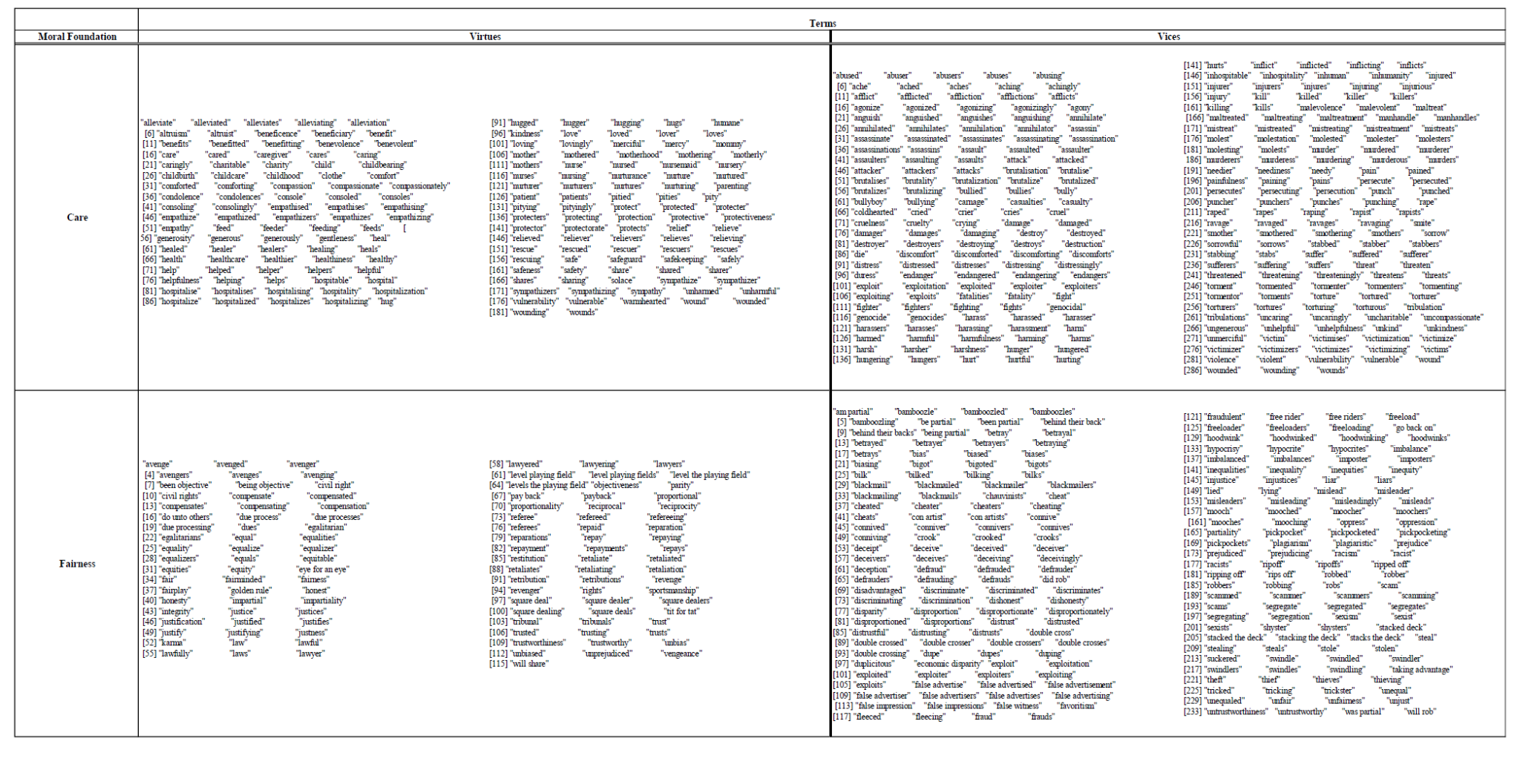
APPENDIX A. Moral Foundations Terms
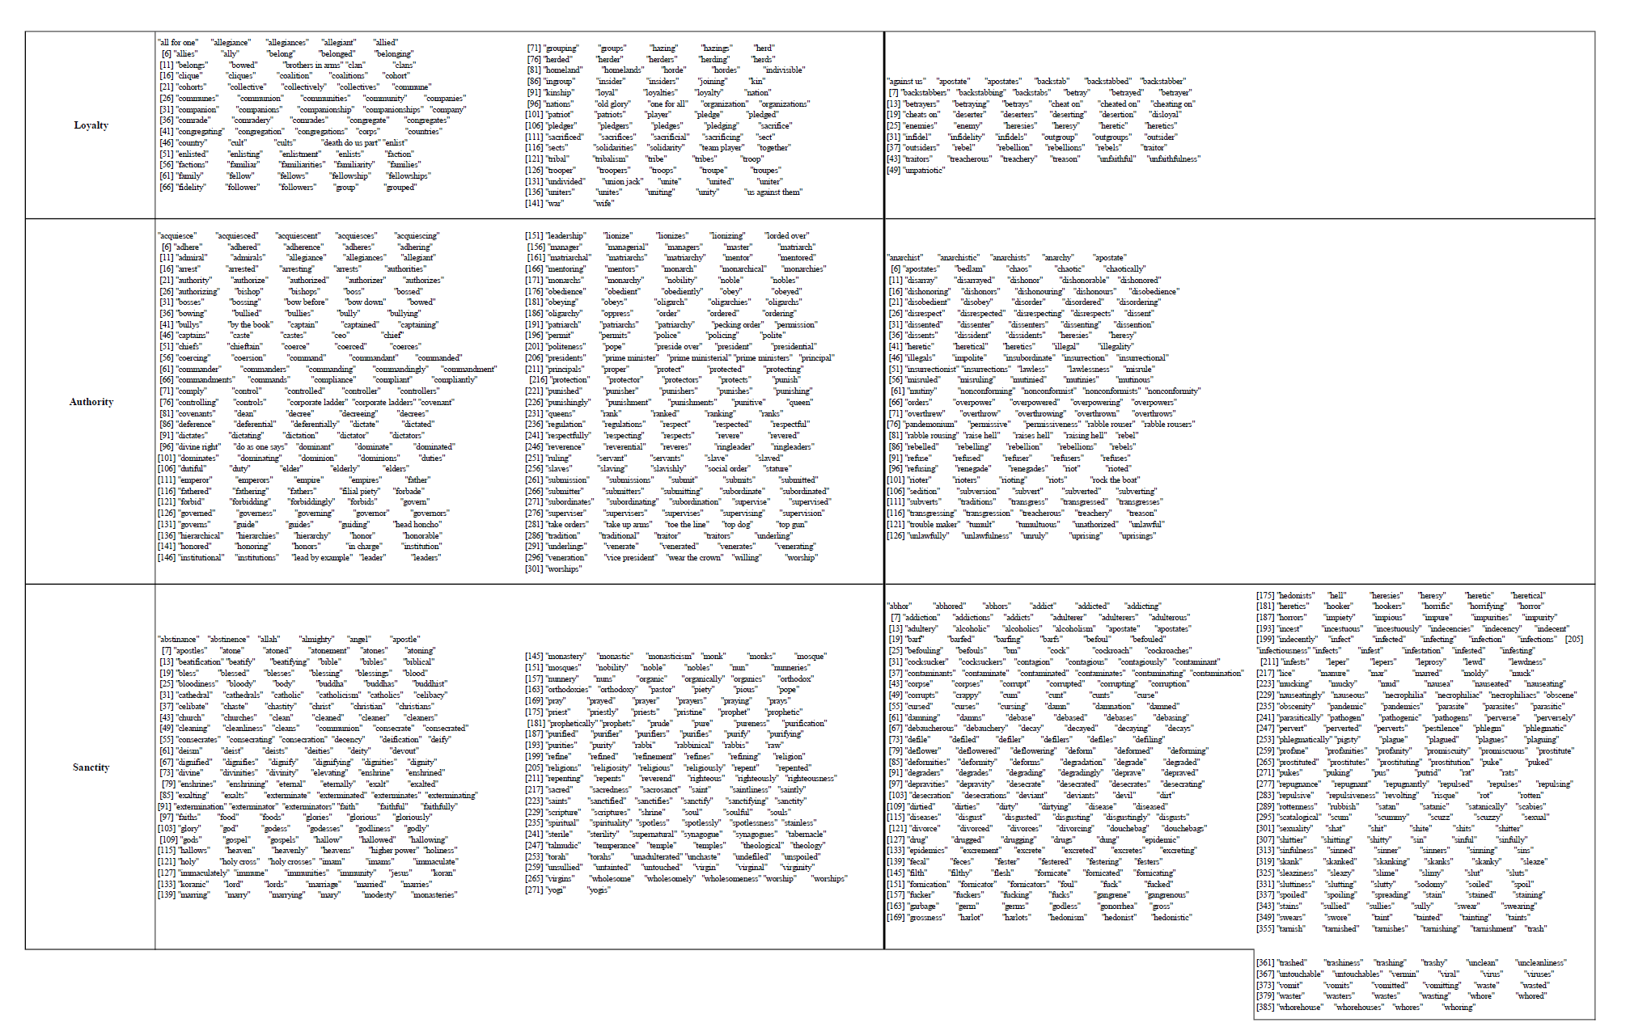

APPENDIX B. Key Survey Elements
Overall Montessori Index
Student Choice: It is better for students to choose their own learning activities than to strictly follow a teacher’s plans

Internal Motivation: External rewards (i.e., prizes, trophies, etc…) are less effective than internal motivation at encouraging student engagement

Whole Child Learning: K-12 education should include mind, body, and emotions as part of the learning process

Standardized Testing: Standardized tests do a good job of capturing individual student progress

Cultural Competence: The typical classroom would benefit from lessons that encourage students to relate activities to their own cultural backgrounds

Practical Lessons: K-12 classrooms should make sure that lessons mimic “real world” situations and teach practical skills

Respect for Nature: The typical classroom would benefit from lessons that encourage students to respect and interact with nature

Social Justice: The typical classroom would benefit from lessons that encourage students to value social justice

Global Community: K-12 education should encourage students to view themselves as members of a global community
[1 through 5] [Strongly Agree through Strongly Disagree]

Marketization: Some private schools advertise that they treat children as customers and, accordingly, have a customer focus. Would you support or oppose more schools adopting this business-like mindset?
[1 through 5] [Strongly Support through Strongly Oppose]

Ideology: On a scale of political ideology, individuals can be arranged from strongly liberal to strongly conservative. Which of the following categories best describes your views?
[1 through 7] [Strongly Liberal through Strongly Conservative]

Laissez-faire: From the following choices, please select the position closest to your views about how markets and the government should fit into the economy:
1 – Free markets are the best method available for getting people what they want
2 – Markets are often good at getting people what they want, but require some limited government oversight
3 – Markets are only good at getting people what they want if strong government regulations are in place
4 – Markets are sometimes good at getting people what they want, but government ownership of industry is often better
5 – Government ownership of industry is the best method available for getting people what they want

Government Distrust: From the following choices, please select the position that most closely describes your level of trust in the government's ability to address bad situations:
1 – Government almost always makes bad situations worse when it gets involved
2 - Government mostly makes bad situations worse when it gets involved
3 - Government is equally likely to make a bad situation better or worse when it gets involved
4 - Government mostly makes bad situations better when it gets involved
5 – Government almost always makes bad situations better when it gets involved

APPENDIX C. Supplemental Factor Analysis
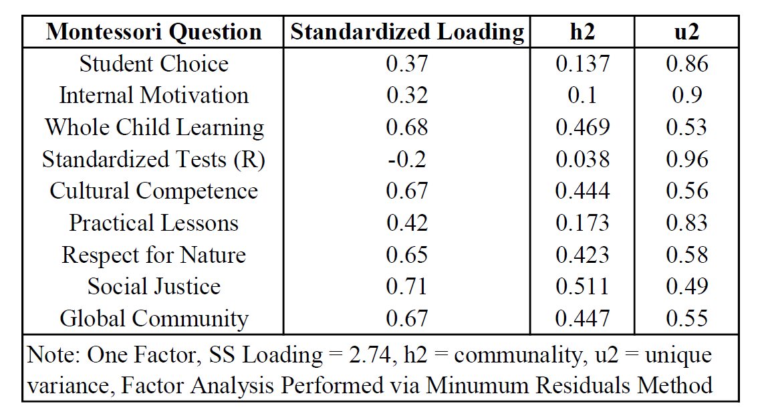
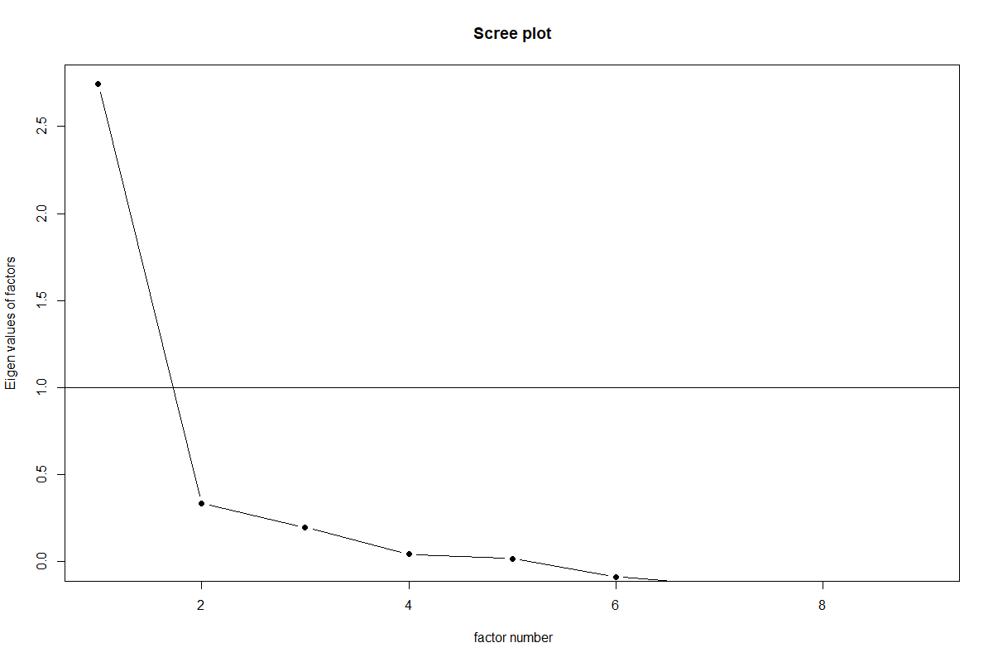

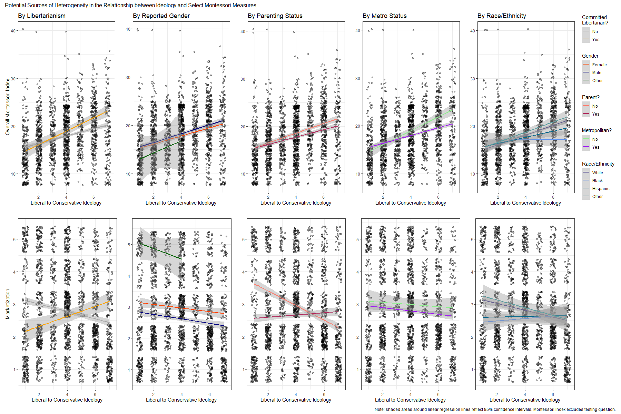
APPENDIX D. Trends in Montessori Support by Group
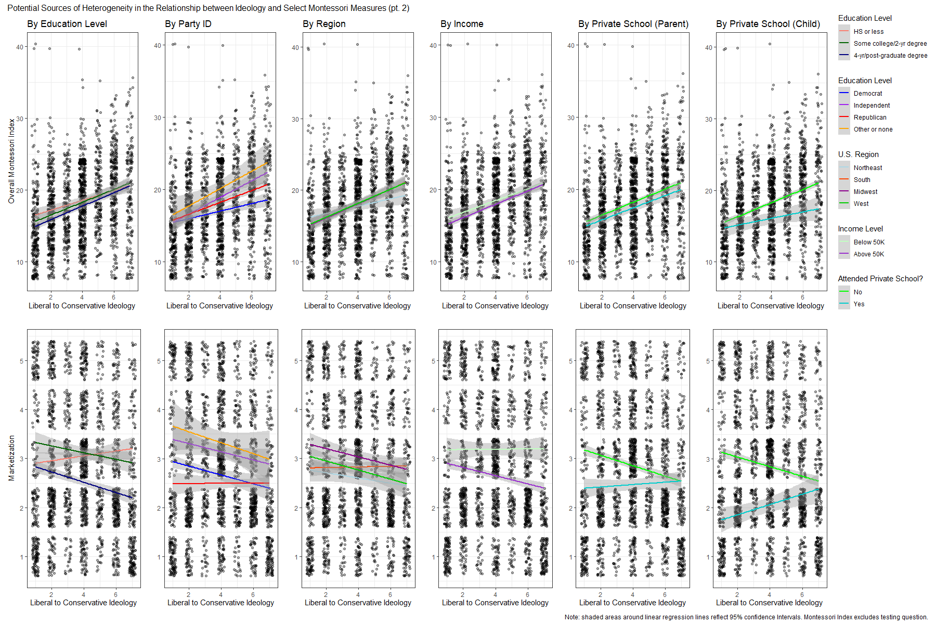

APPENDIX E. Supplementary Regression Table
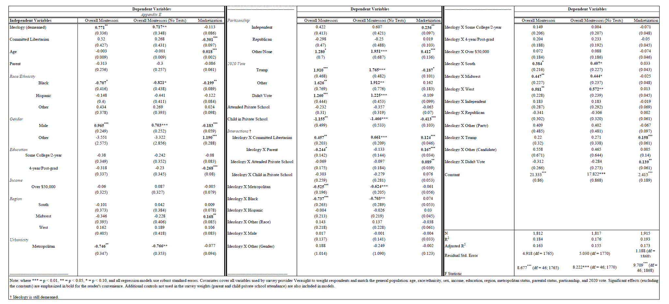

APPENDIX F. Interaction for Student Choice
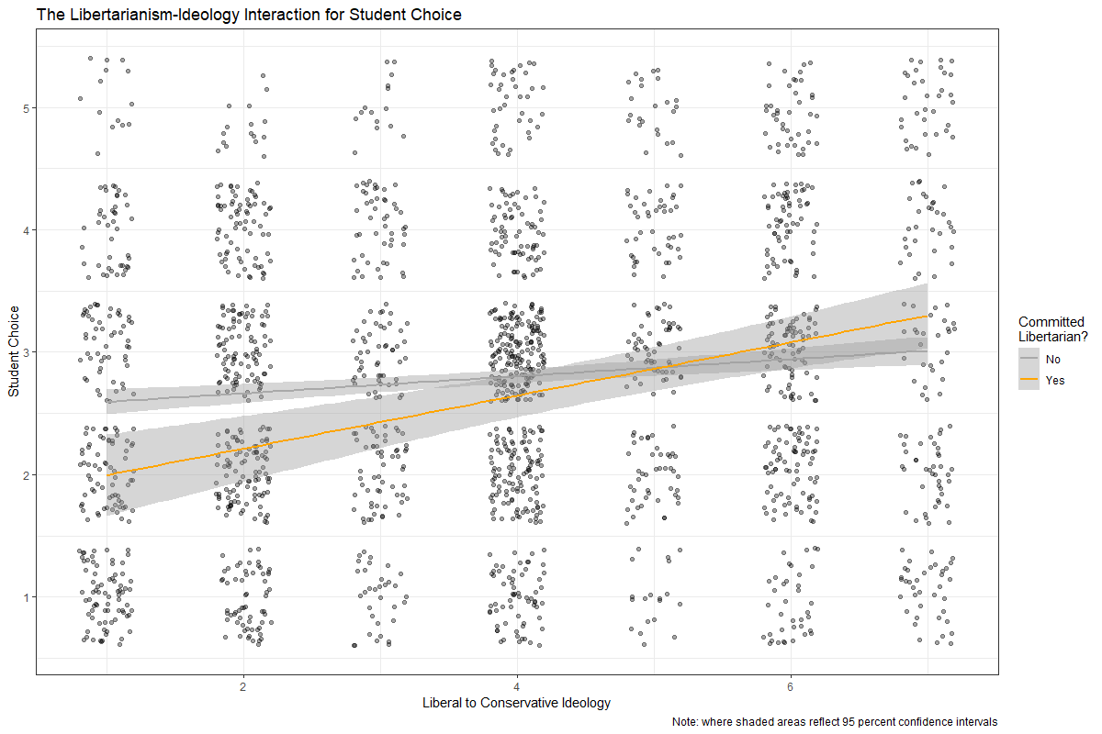

APPENDIX G. Inclusion Criteria for Elements of Maria Montessori Text Files

1. Removed Project Gutenberg credits and license info
2. Removed Title Pages and Tables of Contents
3. Removed Transcriber's Notes
4. Removed "The END" signifier
5. Removed repeat of book name at beginning of book
6. Removed (brief) Acknowledgements

* Kept: Prefaces, Notes from the author, Footnotes, Illustration descriptions where present in text itself, Translator's Notes, Appendices.

APPENDIX H. Technical Documentation
Statistical analyses, data management and handling, and graph construction were all performed in the programming language R (R Core Team 2022) using a wide variety of open source packages: tidyverse (Wickham et al. 2019), dplyr (Wickham et al. 2023), stargazer (Hlavac 2022), patchwork (Pedersen 2024), psych (Revelle 2024), summarytools (Comtois 2022), sandwich (Zeileis, Koll, and Graham 2020), car (Fox and Weisberg 2019), tm (Feinerer and Hornik 2024), slam (Hornik, Meyer, and Buchta 2022), ggplot2 (Wickham 2016), quanteda (Benoit et al. 2018) and its associated sub-packages, readtext (Benoit et al. 2024), and readxl (Wickham and Bryan 2023).

As accessed through the quanteda package in R.
Respondents who failed to answer one or both of the libertarianism measures were coded as “NA.”
The support measures for internal motivation, opposition to standardized testing, and practical lessons also displayed nonlinear patterns in their raw means, but unlike the marketization question, unweighted mean differences between liberals and conservatives were not statistically significant.
As articulated later, libertarianism was associated with greater support for student choice in both Panels E and F, illustrating that caution is warranted when interpreting the unweighted means.
Note that higher values on the libertarianism index indicated ordinal steps taken away from libertarianism, much like the measurement scheme used for the Montessori index. As such, the coefficients on both libertarianism measures pointed in the same theoretical directions despite their different signs.
Libertarianism’s statistical insignificance was previously mentioned. Moreover, some complications could arise from model (2)’s significant coefficient on demeaned ideology for the marketization question, which was not present in model (1)’s comparable, though untransformed, ideology coefficient. This still pointed in the expected direction and may simply reflect that demeaned ideology’s marginal impact behaved in a more linear fashion when holding libertarianism, parenting status, and child and parent private school attendance at zero.
This effect was in the same direction, but was no longer significant, when the Montessori index excluded respondent opposition to standardized testing.
Support/opposition to standardized testing may also fit into this description. The positive, statistically significant association between demeaned ideology and the reverse-coded testing measure in Panel F only described a pro-testing marginal effect of ideology for respondents who were not libertarians, not parents, did not attend private K-12 schools, and did not have children enrolled in such schools. This, needless to say, describes a quite specific person (though not a completely uncommon one). I contend that Panel E better reflected the marginal effect of increased conservatism in a general sense.
The ideology interaction surprisingly cuts in the opposite direction, amplifying conservative opposition. Appendix F shows that this is likely driven by the fact that libertarians who are also strong liberals are more supportive of student choice than non-libertarian strong liberals, resulting in a steeper slope as one moves to the right.
The interaction terms from Model 2 and Appendix E admittedly lent themselves to less-than-clear interpretations, though my earlier discussion clarified that libertarianism may push strong liberals closer to a pro-market orientation.
In quanteda, the user can apply dictionaries to either a “tokens” or “document-feature matrix” (dfm) object. However, tokens objects preserve word locations within the original source documents, whereas dfms trade this granularity for the ability to accommodate statistical analyses. To the best of my understanding, multi-word keys within a dictionary can be accurately and automatically coded at the “tokens” stage, thus motivating my selection.

