University of Oklahoma

Graduate College

Multi-Scale Hybrid Data-Driven Framework for Electric Energy Flow: Transient Analysis and Resiliency Solution for Next-Generation Power Grid

A Dissertation

submitted to the Graduate Faculty

in partial fulfillment of the requirements for the

Degree of

Doctor of Philosophy

By

Reza SaeedKandezy
Norman, Oklahoma
2024

Multi-Scale Hybrid Data-Driven Framework for Electric Energy Flow: Transient Analysis and Resiliency Solution for Next-Generation Power Grid

A Dissertation approved for the
School of Electrical and Computer Engineering

BY THE COMMITTEE CONSISTING OF

Dr. John Jiang, Chair

Dr. Choon Yik Tang, Member

Dr. J. R. Cruz, Member

Dr. Sina Khanmohammadi, Outside Member

© Copyright by Reza Saeed Kandezy 2024
All Rights Reserved.

To Khazar and Artemis

Acknowledgment
During my research work over the past several years, I have received a great deal of support, assistance, and encouragement from a great number of individuals. First of all, I would like to express my sincere gratitude to my advisor, Dr. John Jiang, whose consistent support and guidance have been invaluable throughout my study at OU since May 2021. Without his persistent support, the goal of this dissertation would not have been realized. His creative insights and profound knowledge not only steered me through this research but also set an excellent example, which motivates me to strive for excellence in the future.
I would also like to extend my truthful thanks to all my committee members, Dr. Cruz, Dr. Tang, and Dr. Khanmohammadi for their insightful comments, suggestions, and inspirations, which enabled me to improve my research from a variety of perspectives.
I also thank Dr. Di Wu and Dr. Peter Huang, who shared valuable thoughts and recommendations on my research during the collaborations on the projects.
Special thanks go to the faculties, staff, and classmates in the School of Electrical and Computer Engineering and all my colleagues in my research group.
Last but not least, I would love to express my deepest gratitude to my family. This work would not have been possible without their endless love and unconditional support. I am incredibly grateful to my wife. She is incredibly supportive and has made countless sacrifices to help me focus on the research. I am so lucky to be graciously helped and supported by many people.

Reza Saeed Kandezy

Table of Contents

Acknowledgment v
Table of Contents vi
List of Figures ix
List of Tables x
Abstract xi
1 Introduction 1
1.1 Problem description: 1
1.2 Current challenges 3
1.3 Motivation and objectives: 6
1.4 Contribution of dissertation research 9
1.5 Organizations 10
2 Fundamentals of Power Grid Resiliency and Reliability Analysis 12
2.1 Current major methodologies 14
2.1.1 Electric circuit theory-based analytics 14
2.1.2 Numerical simulation methods 15
2.1.3 Complex network theory-based analytics 17
2.2 Uncertainty behavior in transitional and established states 22
2.3 Inadequacy of resiliency and reliability method addressing stochastic uncertainties 26
2.4 IBRs integration in the grid and stochastic uncertainties 28
2.5 Resiliency functions to address the stochastic uncertainties 30
3 The System-Level Nonlinearity in Multi-Scale Power Grid 32
3.1 Multi-scale dynamic of IBRs and modulation uncertainty 32
3.2 Collective system-level impacts of multi-scale coupled heterogeneous dynamic among IBRs 33
3.3 Varietal complexity due to system-level nonlinearity 35
3.4 Identification of the system-level nonlinear dynamics 36
4 Rationales for Multi-Scale Hybrid Data-Driven Framework 39
4.1 Random-walk-on-graph perspective of network power flow 40
4.2 Decomposition of graph dynamics into source-load particles 44
4.3 Drawing parallels between the dynamics of diatomic molecules and the power grid 47
5 Multi-Scale Hybrid Data-Driven Analytic 50
5.1 Understanding multi-scale fast and slow dynamics 50
5.2 Multi-scale hybrid numerical method: 53
5.3 Network-based data-driven methods: 57
5.4 Fundamental method 61
5.4.1 Realistic of curse of dimensionality and its impact on system dynamics: 62
5.5 Enhanced hybrid method 68
6 Demonstration of Multi-Scale Hybrid Data-Driven Algorithm 72
6.1 Demonstration study 73
6.1.1 Investigation setup: 74
6.1.2 Case study on SINDY algorithm in power system analysis: 77
6.2 Case study on multi-scale hybrid data-driven framework: 88
7 Conclusion 91
7.1 Conclusions: 91
7.2 Publications: 93
7.3 Future works: 95
8 List of Abbreviations 97
9 References 98

List of Figures
Figure 1 Illustration of the graph decomposition into source-load particles. 46
Figure 2 The relation seep between the parabolic and hyperbolic FDMs. 57
Figure 3 Single-line diagram of the implemented IEEE 15 bus network. 73
Figure 4 The actual measurement and generic algorithm approximation during a) steady state, b) fault and c) load change in power system supplied by SG. 78
Figure 5 Colormap of the dynamical terms identified by SINDY method for the IEEE 15-bus system supplied by basic SG sources. 80
Figure 6 Colormap of the dynamical terms identified by SINDY method for the IEEE 15-bus system supplied by 7th-order SG sources. 81
Figure 7 The actual dynamic and SINDY algorithm approximation during steady state in power system supplied by SG and IBRs. 83
Figure 8 Colormap of the dynamical terms identified by SINDY method for the IEEE 15-bus system supplied by basic model SG sources and IBRs. 84
Figure 9 Colormap of the dynamical terms identified by SINDY for the IEEE 15-bus system supplied by IBRs. 86
Figure 10 The normalized impact of the activated first-order and high-order terms in the dynamic of the variables for the scenarios with SG, a combination of SG and IBRs, and IBRs. 87
Figure 11 The actual measurement and mixed algorithm approximation during a) steady state and b) transient state in power system supplied by IBR. 89
Figure 12 Approximation of slow dynamics in power system supplied by SG and IBRs. 90

List of Tables
Table 1 The implemented IEEE 15 bus network configuration. 75

Abstract
Illustrating by compelling case studies, this study discusses the challenges to the design of resilient power grid with inverter-based renewable energy resources posed by curses of dimensionality and heterogeneity in the complex multi-scale interactive dynamics by utilizing the network-based data-driven approaches, and further explains the essentiality of having hybrid data analytics with multi-scale stochastic autocovariance analysis to overcome those newly recognized curse of varietal complexity in next-generation power grids. It underscores the necessity for resilient functions beyond traditional reliability, explores essential resiliency aspects of power grids integrated with renewable resources, emphasizing proactive mechanisms to ensure stability during disruptions.
By integrating numerical methods and differential embedding techniques, the framework enables precise modeling of energy flow dynamics across temporal and spatial scales, crucial for accurate transient analysis. Simulation case studies further illustrate its capability in distinguishing nonlinear dynamics induced by IBRs from traditional synchronous generators, showcasing robustness and accuracy even under varying penetration levels of IBRs. This innovative approach not only enhances modeling accuracy and prediction capabilities but also provides insights essential for managing and controlling the complex dynamics of modern power grids.
Keywords: Multi-Scale Hybrid Data-Driven Framework, Electric Energy Flow, Transient Analysis, Power Grid Resiliency, Inverter-Based Resources

Chapter 1

Introduction

Problem description:
Understanding energy transfer dynamics necessitates a multi-scale analytical framework, which is essential due to the "curse of heterogeneity." This curse refers to the complexity introduced by the diversity in components and behaviors within modern power systems, particularly with the integration of intermittent and rapid-response inverter-based resources (IBRs). Unlike traditional power grids, which often rely on consistent and predictable energy sources, these IBRs can cause significant variations in power flow, leading to uncertainties and fluctuations. These variations disrupt the recognized symmetries, or predictable patterns, that traditional grids depend on for stability. Consequently, this disruption can result in unpredictable disturbances and cascading failures, where small issues propagate and magnify through the system, potentially leading to widespread outages. Therefore, a multi-scale analytical approach, which examines these dynamics at different levels of detail and time scales, is crucial for accurately modeling, predicting, and mitigating these risks.
The uncertainties in power systems arise from various sources, such as the variability of renewable energy sources and the rapid control responses in inverters [1-3]. These uncertainties lead to unpredictable disturbances and cascading failures, where minor issues can escalate into significant problems. Resiliency functions play a vital role in this context, as they are designed to adapt to stochastic dynamics—random and unpredictable variations—and address the challenges of cascading failures. These functions help ensure system stability during transitional states, particularly during the transient period when different dynamic behaviors interact and overlap. By incorporating resiliency functions, power systems can better manage the inherent uncertainties and maintain stability in the face of fluctuating conditions.
The convoluted interaction between the coupled dynamics, caused by modulation uncertainties, significantly amplifies the non-linearity of the overall system dynamics from the local module-level to the global system-level, potentially leading to chaotic behavior [4,5]. Modulation uncertainties in each IBR result in fluctuations in the amplitude and phase of injected harmonics. These fluctuations cause complex, non-linear interference between harmonic components from different IBRs. As these interactions accumulate and propagate throughout the system, they exacerbate the non-linear characteristics, making the overall behavior of the power grid increasingly unpredictable and challenging to manage. This heightened non-linearity can push the system towards chaotic dynamics, where small changes in initial conditions lead to vastly different outcomes, complicating efforts to maintain stability and reliability.
Convoluted non-linear interference leads to the emergence of new frequency components (intermodulation) and a tangled web of frequency components, not directly related to the fundamental frequency or the original harmonic frequencies, propagating through the grid, raising the level of non-linearity to system-level [6].The complexity of power system dynamics is further compounded by the integration of IBRs, which introduce multi-scale spatiotemporal dynamics between electrical and magnetic fields [7]. This integration results in unpredictable emergent behaviors, amplifying the dimensionality problem in circuit-based analytics and introducing heterogeneity in the analytical framework.
Understanding the distinctions between synchronous generators (SGs) and the interactions within systems that combine SGs and IBRs or rely exclusively on IBRs is vital for system operators [8]. Synchronous generators, traditionally used in power grids, operate based on predictable rotational inertia, providing stability to the system. In contrast, IBRs, which include renewable energy sources like solar and wind, exhibit rapid response times and intermittent outputs, leading to different interaction dynamics within the grid. These differences significantly impact power system analysis and management, particularly in real-time operations where precise mathematical models of system dynamics are often unattainable. The inability to develop exact models complicates the operators' tasks in ensuring stability and reliability, as they must manage the system with less predictable and more variable inputs. Therefore, a deep understanding of these distinctions is crucial for effectively balancing and maintaining modern power systems [9].

Current challenges
Current analyses fail to capture the multi-scale spatiotemporal complexities in power grids with IBRs during transient states. This shortcoming arises because these analyses inherently rely on certainty regarding the weak averaging principle and gluing conditions. The weak averaging principle assumes that the system can be approximated by averaging its behaviors over time, while gluing conditions refer to the linear or quasi-linear dependencies and compatibility between subsystems. However, these assumptions do not hold true in the presence of IBRs, whose rapid response and intermittent nature introduce significant non-linearities and complex interactions across different spatial and temporal scales. As a result, traditional analytical methods fall short in accurately modeling and predicting the dynamic behaviors of modern power grids during transient states, leading to potential oversights in stability and reliability assessments.
The latest analytical frameworks, primarily categorized into electric circuit theory-based and complex network theory-based analytics, exhibit adequate performance in modeling and analyzing both linear and component-level nonlinear systems, however, challenges arise in coupled multi-scale systems, where strong interactions cause high-order system-level non-linearity have not been adequately considered; thus, a hybrid multi-scale data-driven framework for electric energy flow analysis is necessary [10].
The foundational framework of circuit theory-based analytics includes deterministic numerical simulation methods, using electro-mechanical dynamic models represented by Differential Algebraic Equations (DAEs), and direct energy function methods, which construct scalar Lyapunov or energy functions to analyze dynamic stability [11-19]. However, several intrinsic challenges are associated with this framework:
- Transient Analysis: This involves examining the system's behavior after disturbances and the time-dependent nature of electrical quantities and their uncertainties to understand system stability. Transient analysis is critical for assessing how the system responds to sudden changes or faults.
- Predictable Uncertainties: These uncertainties have consistent characteristics over time, allowing the development of deterministic models in conventionally defined steady and transient states. Such models can accurately predict system behavior under normal and disturbed conditions.
- Stochastic Uncertainty: The temporal variation of uncertainty, known as stochastic uncertainty, causes the system's dynamics to change unpredictably. This makes the system's behavior inherently random and difficult to predict, posing significant challenges for ensuring stability and reliability.
While circuit theory-based analytics provide a robust framework for understanding and modeling power systems, they struggle to address the complexities introduced by stochastic uncertainties, requiring more advanced methods to ensure accurate and reliable system analysis [11-13].
Machine learning algorithms and artificial intelligence have improved system analysis by overcoming the limitations of conventional models in capturing the intricate nonlinear dynamics of power systems, the incorporation of IBRs with interconnected multi-scale dynamics requires a thorough analysis and characterization of the nonlinearity in the system [20-23]. The systemic nonlinearity conundrum is a central focus in power system operation due to the intricate dynamics within modern power grids [24]. As these grids increasingly incorporate diverse energy sources, including IBRs, conventional linear models fail to capture the complex web of nonlinear interactions, feedback loops, and emergent behaviors [25]. The recognition and comprehensive examination of system-level (second order) nonlinearity are paramount for safeguarding the resilience, stability, and efficiency of contemporary electrical grids.
Recent studies emphasize the transformative impact of IBR integration on power system dynamics. A work by Mishra et al. (2022) uncovers the intrinsic nonlinearities within conventional power grids, highlighting the challenge of maintaining stability amid dynamic interactions among synchronous generators and intricate load profiles [26]. Ekomwenrenren et al. (2021) empirically demonstrate deviations from conventional linearized frequency control in IBR grids, revealing nuanced nonlinear frequency responses unique to these systems [27]. Orihara et al. (2021) delve into the pivotal dynamics of virtual inertia in IBR grids, offering insights into nonlinear control mechanisms [28]. Keyon et al. (2020) examine the impact of varying IBR penetration levels on power system dynamics, illustrating the transition from first-order to high-order behavior [29].
Measurement-based methodologies, rooted in observed data and supported by advanced monitoring technologies and data analytics, provide a solution for real-time decision support. These techniques empower grid operators to make informed decisions that ensure the continuity of electrical power systems stability and reliability of evolving energy landscapes characterized by nonlinear dynamics and grid architectures [30]. Integrating sparsity methods in analyzing dynamical systems became a significant advancement, employing compressed sensing and sparse regression techniques to identify concise and accurate models representing the underlying nonlinear dynamics [31].
On the other hand, complex network theory-based analytics present promising avenues for understanding and managing power system dynamics by leveraging concepts from network science. These analytics can be applied to long-term planning, real-time stability assessment, and vulnerability analysis [33-40]. However, the convoluted interplay between coupled IBRs and the system-level non-linearity introduces significant challenges. These challenges are known as the curses of heterogeneity and dimensionality [38-40]. The course of dimensionality involves a vast number of variables and interactions that need to be considered. These factors hinder the performance of network-based frameworks, making it difficult to accurately model and predict the behavior of modern power systems. Despite these challenges, complex network theory remains a valuable tool for addressing the dynamic and interconnected nature of power grids, though it requires further refinement to effectively manage the complexities introduced by IBRs [33].

Motivation and objectives:
The impacts of IBR integration in the modern power grid require dynamic mechanisms to ensure stability, reliability, and resilience. Resiliency functions play a crucial role in proactively preparing power systems for potential disturbances by leveraging monitoring and control systems, predictive analytics, and automated response mechanisms. These functions detect anomalies and deviations from expected behavior, enabling operators to anticipate disruptions and take proactive measures [41-43].
Predictive analytics and machine learning employ predictive models and neural networks to forecast potential disturbances, while optimization algorithms identify the most cost-effective response strategy. While by implementing resiliency functions, power system operators can reduce the risk of widespread disruption and maintain stability and reliability amidst evolving challenges. By analyzing real-time data and historical patterns, these systems can detect anomalies or deviations from expected behavior, providing early warnings of potential disturbances. This early detection allows operators to anticipate disruptions and take proactive measures to mitigate their impact in daily grid operations, while the analytical framework will enhance the simulations in planning and designing processes.
Furthermore, resiliency functions utilize predictive analytics techniques to forecast potential disturbances and their likely impact on system performance. By analyzing historical data and system parameters, predictive models can anticipate variations in renewable energy generation, demand fluctuations, or equipment failures [44]. Predictive analytics and machine learning employ predictive models and neural networks trained on historical data to anticipate future system behavior.
These functions employ optimization algorithms to determine the optimal response strategy to disturbances. These algorithms consider various factors such as cost, reliability, and system constraints to identify the most effective course of action. For example, during periods of high renewable energy variability, optimization algorithms can optimize the dispatch of generation resources to maintain grid stability while minimizing costs. Robust optimization seeks control inputs that minimize the maximum possible cost over a defined uncertainty set.
However, Traditional approaches often approximate higher-order interactions as noise or neglect their influence, leading to inaccuracies in system modeling for high-order nonlinearity, and is very limited to apply to the chaotic operating conditions. Therefore, in modern power grids integrated with IBRs, even primary interactions between components can lead to the emergence of higher-order terms, capturing the effects of collective coupling processes with different temporal dimensions [27-29]. The departure from linearity induces the curse of heterogeneity in high-order terms [45], make it not only necessary but also essential to the adoption of appropriately integrated several conventional nonlinear analytics, such as multi-scale network-based data-driven analytics into a unitary multiple-scale framework, such as those recently derived based on the Dirichlet Distribution-based mathematical frameworks that couples the regular nonlinear machine learning methods and convoluted neural network, to better address the extensive dimensionality and complexity inherent in power system dynamics in two time-spaces, than the heuristic ones used based on users’ experiences.
Inspired by the multi-scale dynamics of a double pendulum and the interatomic interaction model, the proposed framework introduces a novel approach by incorporating fast dynamic represented in higher-dimensional phase space of φ-x and ξ-x, alongside slow dynamic represented by the original dimensions of t-x. The proposed method extends Taken’s Embedding theory by utilizing higher-dimensional representations, φ and ξ, derived from the differential in time to capture system fast dynamics, strategically utilizes common eigenvalues within temporal scales and analyze their eigenstructure to predict slow dynamics. The proposed method analyzes the energy diffusion equation in complex space and decomposes it into two second-order differential equations (in φ-x and ξ-x), using the properties of Cauchy-Reimann theorem and Fubini's theorem, to capture rapid changes and interactions within the complex system.

Contribution of dissertation research
This dissertation delves into three main aspects regarding the resiliency of power grids integrated with renewable resources, particularly IBRs. Firstly, it discusses the concept of resiliency and its distinction from reliability, emphasizing the proactive integration of mechanisms to address system stability during disruptions. Secondly, it will highlight the challenges posed by dimensionality and heterogeneity in resiliency-related analytics due to the unique operation technology of IBRs that the conventional rotary machine-based resources do have.
Moreover, using the finite difference method and discrete computations, the approach discretizes complex partial differential equations, facilitating their solution in algebraic forms, thus enabling the study of energy flow dynamics across time and space with numerical precision. The proposed experimental method utilizes discrete measurements and employs differential embedding during transient analysis to construct higher-dimensional representations, capturing fast dynamics based on the rate of change over time, and identifies eigenstructures within sub-cycle time fractions to predict slow dynamics. The proposed analytics framework, leveraging stochastic autocovariance analysis among harmonic components, presents a robust methodology for modeling strongly coupled multi-scale dynamics in power systems, offering enhanced accuracy in modeling, prediction, and control.
As the main contribution, this study develops the Multi-scale Hybrid Data-Driven Framework for power systems, which investigates a wide range of conditions including abrupt faults and gradual load variations. This approach ensures robustness and potential for broad applicability, facilitating the identification of key dynamical features with minimal measurements and advancing our theoretical understanding of power system dynamics. The results highlight a paradigm shift in system behavior with the integration of IBRs, revealing system-level nonlinearities compared to the module-level nonlinearities observed in traditional generators. By introducing higher-order polynomial function libraries to model IBR integration, the study departs significantly from conventional modeling approaches, reflecting the evolving landscape dominated by renewable energy sources in power grid analysis. These findings contribute to a deeper understanding of power system complexities and offer practical pathways for developing more resilient and efficient grids.
Further, it postulates the necessity of network-based hybrid data-driven analytics for designing resilient next-generation power grids, offering explanatory examples and evidential case studies.

Organizations
The dissertation comprises six chapters aimed at advancing understanding and management of modern power grids integrated with IBRs. Chapter 2 critically examines current methodologies in power system analysis, highlighting their limitations, especially in addressing the complexities introduced by IBRs. Chapter 3 focuses on the system-level nonlinearity inherent in multi-scale dynamical power grids with IBRs, emphasizing challenges like heterogeneity and dimensionality that affect stability and modeling accuracy. Chapter 4 discusses the graph representation of the power grid and introduces the theoretical foundations and rationales behind the proposed multi-scale hybrid data-driven framework. Chapter 5 will develop the multi-scale hybrid data-driven framework, which integrates concepts from network science and multi-scale dynamics to overcome existing methodological shortcomings. Chapter 6 demonstrates the proposed framework performance in comparison to generic methodology through multiple simulation case studies. Chapter 7 concludes with a synthesis of findings, offering insights into future research directions to further enhance power grid management in the era of IBR integration.
Chapter 2

Fundamentals of Power Grid Resiliency and Reliability Analysis

Maintaining stability in power systems during disruptions relies heavily on resilience [1]. The resilience level can be quantified as the cumulative discrepancy in the system's state from the desired level over the period between two stable states. While hardware solutions, such as augmenting system capacity, aim to minimize this discrepancy, our focus lies on software solutions that compress the time interval between states, thereby bolstering resilience levels. By identifying vulnerabilities within the intricate network of power systems, mechanisms can be put in place to tackle cascading challenges that may occur [43]. By pinpointing vulnerabilities within the complex network of power systems, proactive mechanisms can be implemented to mitigate potential cascading failures. This proactive stance not only helps in averting widespread disruptions but also ensures smoother transitions between operational states, thereby bolstering overall system reliability and sustainability in the face of dynamic challenges.
These measures prevent or mitigate the propagation of disturbances that could lead to cascading failures. Specifically with the integration of renewable energy and inverter-based resources, the surge of complex uncertainties, from various sources, creates such conditions during the disturbances that result in their propagation in the shape of cascading disruptions. The complex uncertainties resulting from the unpredictable behavior of renewable energy and inverter-based resources during disturbances can lead to cascading disruptions [7]. On the other hand, Reliability and resilience both depend on established states where system behavior is deterministic and involves predictable uncertainty. Resiliency aims for rapid recovery following disturbances, and reliability is concerned with maintaining consistent performance, both rely on established states, where the phasor has been shaped and system behavior is deterministic and involves predictable uncertainty. However, in the presence of stochastic uncertainty where the uncertainties in the power grid form an altering and unpredictable behavior the power system has a void of actions that the resiliency functions will address. Therefore, resiliency functions are crucial in ensuring rapid recovery following disruptions, enabling the power grid to remain stable and consistent in its performance [1-7].
The integration of renewable energy and inverter-based resources has created a surge of complex uncertainties that can cause unpredictable behavior in the power grid during disturbances. The resiliency functions address this by providing a void of actions to ensure rapid recovery following disruptions. Resiliency functions incorporate mechanisms aimed at tackling the emergence of cascading challenges while safeguarding system stability during disruptions. These mechanisms are designed to identify vulnerabilities within the intricate network of power systems and implement strategies to either prevent or mitigate the propagation of disturbances that could lead to cascading failures [7].
Modulation uncertainties in each IBR cause fluctuations in the amplitude and phase of injected harmonics. This can lead to convoluted non-linear interference between harmonic components from different IBRs, resulting in the emergence of new frequency components (intermodulation), propagating through the grid, raising the level of non-linearity to system-level. These interactions between harmonic components can propagate through the grid and create a tangled web of frequency components that are not directly related to the fundamental frequency or the original harmonic frequencies.
In power systems, modulation uncertainties contribute to the convolution of harmonic components, amplifying the non-linear characteristics across various system levels. These uncertainties stem from factors such as noise, imperfections in control algorithms, and variations in component characteristics, which collectively influence the switching behavior of semiconductor devices within power electronic converters. At the module level, these uncertainties manifest as deviations from the intended modulation patterns, leading to distortions in the output waveform and the introduction of harmonic content. These harmonic components, when propagated through the power grid, interact with the system's inherent dynamics, exacerbating non-linearities and complicating system-level responses.

Current major methodologies
In this section, we review two primary analytical frameworks for assessing resiliency and dynamic stability in power grids. One approach is based on electric circuit theory, while the other utilizes complex network theory.

Electric circuit theory-based analytics
Despite the integration of more direct current (DC) energy systems like DC transmissions and storage, the power grid remains predominantly an alternating current (AC) interconnection operating at frequencies around 50Hz or 60Hz. This AC grid exhibits various transient energy phenomena and power flows, which are mathematically described using electric circuit-based models grounded in classical physics theory.
Current electric circuit theory-based analytics of power grid dynamic stability can be broadly classified into two main approaches: 1) deterministic numerical simulation methods [14-17], and 2) direct methods [18,19].

Numerical simulation methods
The most sophisticated models for analyzing power systems are electro-mechanical dynamic models, typically represented by a set of DAEs as follows:

$\dot{x}=f\left(x,y,λ\right)$ (1)

$0=g\left(x,y,λ\right)$ (2)

where x is a vector of state variables (e.g., machine dynamics), y represents network variables such as bus voltages, and $λ$ includes parameters subject to change (e.g., loads, generation, transmission line impedances).
These electro-mechanical dynamic models are essential for capturing the intricate and nonlinear behaviors of power system components such as generators, control systems regulating voltage and frequency, various types of loads, and the operation of Flexible Alternating Current Transmission (FACT)s which enhance grid flexibility. They play a crucial role in predicting how the system will respond under different operational scenarios, ranging from steady-state conditions to transient disturbances. Simulation-based methods in power system dynamics leverage these detailed models to construct comprehensive grid representations that account for the diverse array of components and economic considerations influencing system operation.
Currently, ensuring operational stability heavily relies on conducting offline dynamic stability analyses through time-domain simulations. This approach is necessary due to the wide range of time constants observed across different components within the system, spanning from the rapid responses of power electronics like FACTs, measured in milliseconds, to the slower adjustments of governor systems controlling generator output, which operate on timescales of seconds. To accurately model these dynamics, it is crucial that models accurately capture both static characteristics (such as the steady-state behavior of components) and dynamic behaviors (such as how components respond to disturbances) [13-15].
However, solving the DAEs that describe these dynamic behaviors poses significant challenges. The sheer number of equations required—each generator, exciter, governor, load, and transformer typically necessitating multiple DAEs—can lead to computational complexities and potential errors. While simulation approaches provide comprehensive insights into system behavior, they may not meet the stringent real-time demands of power system operation, particularly during rapid control actions required to mitigate dynamic events [13-18].
For stability assessments, techniques such as maximum rotor angle deviation and Critical Clearing Time (CCT) are employed, which involve computationally intensive simulations. These methods, while effective, do not directly provide stability margin outputs, necessitating additional simulations to refine results and ensure accuracy in decision-making processes. Therefore, ongoing research focuses on developing streamlined representations and faster computational frameworks that can enhance real-time decision-making capabilities in managing power system dynamics effectively and efficiently [18].
Recent research underscores the effectiveness of trajectory sensitivity approaches as a complement to traditional time-domain simulations in power system dynamics analysis. These approaches offer significant advantages in evaluating system limits and adapting to changes in operational conditions and parameters. Despite these advancements, several challenges persist within the conventional framework based on DAEs [15-19]:
Firstly, the determination of security boundaries continues to require multiple iterations of time-domain simulations across varying operating scenarios, a process that remains time-intensive and resource-demanding. Secondly, conventional methods heavily rely on the accuracy of assumed component models, which can introduce inaccuracies due to simplifying assumptions and uncertainties in state and parameter estimation.
Moreover, the interconnected nature of variables and states complicates systematic problem investigation, making it challenging to isolate and analyze specific issues within the system. Additionally, the foundational electric circuit-based models used in traditional approaches are rooted in presumed physics models, which may not fully capture the complex electromagnetic behaviors and interactions in modern power networks.
Addressing these challenges is crucial for advancing the accuracy and efficiency of power system analysis, prompting ongoing efforts to integrate trajectory sensitivity methods alongside traditional simulations to enhance robustness and reliability in predicting system behaviors and operational limits.

Complex network theory-based analytics
Complex network theory offers a distinct approach from electric circuit theory-based analytics, introducing innovative perspectives. Applying complex network theory has garnered significant attention in power engineering for its transformative potential in network analysis and understanding. Early studies demonstrate applications in converting raw or processed data to support long-term planning and accurate visualization of power grid layouts [35,36]. Leveraging successes in analyzing complex systems like the worldwide web, internet, biological, and social networks, complex network methods hold promise for addressing long-standing challenges such as preventing and mitigating cascading failures. These methods aim to rapidly identify stability issues in real-time operating conditions, minimizing the need for extensive modeling efforts.
Organizations have shown substantial interest in identifying universal network properties applicable to modeling, predicting, and managing networks, leveraging complex network theory to unlock new insights and technological breakthroughs.
The widespread applicability of complex network theory across diverse scientific and engineering domains underscores its potential to uncover universal structural properties essential for modeling, predicting, and addressing dynamic transient energy flow challenges [33,34]. Studies, including previous work, have extensively applied complex network theory to investigate cascading failures and vulnerability assessments [35,36] in power grid dynamics and network resilience.
Extensive research in the past decade has focused on understanding energy flow dynamics and their impact on cascading failures, utilizing fundamental properties of interdependent networks to illustrate potential cascading failures involving dependent nodes [35,36], including prior research [37].
Complex network theory-based analytics differ fundamentally from electric circuit theory-based analytics. The application of complex network theory in the development of new analytics has garnered substantial attention in both the electric power engineering industry (for fast technology development) and network sciences (for deeper understanding). Early research has shown that complex network methods can convert raw or processed information to support long-term power grid planning and visualize its layout with satisfactory accuracy. Given the success in analyzing real complex systems like the world-wide web, the internet, and biological and social networks, complex network theory holds promise for addressing high-complexity challenges such as cascading failure prevention and mitigation. This approach demands new analytical methods that do not rely on non-time-domain simulations, enabling rapid stability identification based on real-time operating conditions with minimal modeling effort [37].
Organizations are significantly interested in discovering universal network properties that can aid in understanding and managing networks, potentially surpassing current technology capabilities. The application of complex network theory is expected to provide profound insights and inspire scientific and technological breakthroughs. The ubiquity of complex network theory in various scientific and engineering fields has spurred efforts to exploit universal structural network properties, known or to be discovered, for better modeling, prediction, and resolution of dynamic transient energy flow problems in power grids [38]. Research, including previous work, has focused on using complex network theory to study cascading failures, vulnerability assessments, and resiliency related to energy transients in power grids. For over a decade, understanding the dynamics of energy flow and its impact on cascading failures by applying interdependent network properties has been a focal point.
The foundation of complex network theory-based analytics is graph connections. Recent studies have used network science and graph theory concepts to understand power system network behavior and link topological structure to network vulnerabilities. The electric power system structure can be represented by a graph $G=\left(V,E\right)$, where $V$ denotes nodes and $E$ denotes edges. This graph can be described using matrices: incidence matrix M, adjacency matrix A, and Laplacian matrix L [33]. The connection of nodes and transmission lines in the power system is represented by the un-normalized Laplacian matrix, which does not contain any weight. The Laplacian matrix and adjacency matrix are related as $L=D-A=M^{T}M$, where D is the degree matrix. By analyzing the sign structure of the Laplacian square $L^{2}$, the network topology can be identified. For example, the adjacency matrix A can be constructed from $L^{2}$, allowing the representation of power distribution networks using the sign structure of the $L^{2}$matrix. Recent studies have also explored network classification, centrality measures, and electrical betweenness measures to understand power system network structure and vulnerabilities [33].
Complex network theory-based analysis focuses on power system stability based on the grid's structure, independent of electric-circuit models and time-domain simulations. Traditional methods have computational limitations for real-time applications. Therefore, complex network theory-based analysis offers an alternative by quantifying relationships between power transfer limits and dynamic transient stability using a structural approach. This methodology estimates transient stability interface limits and identifies weak grid links for stability margin estimation and controlled compensation decisions [33-36].
Complex network theory-based analysis embeds power grid information into undirected graphs and matrices, applies coordinate transformation, and uses fundamental physics principles to analyze energy flow. This approach involves standard matrix operations, reducing computational burden and providing reliable numerical results. It connects power system engineering with fundamental physics, offering insights into energy flow over the network.
In complex network theory-based analysis, matrices representing graph properties are used to calculate energy exchanges and stability degrees without time-domain simulations. For example, the transient energy automaton (TEA) models energy processing at each vertex in a network as fast or slow actions, with rules governing energy absorption and reflection based on graph geometry and vertex properties [34].
Complex network theory-based methods provide insights into failure mechanisms and network vulnerability. However, integrating more engineering variables, such as power flow direction and magnitude, can improve the practical applicability of these methods for power grid operations. Despite the promise shown in addressing transient energy influx problems like cascading failures, the real-world application of complex network theory continues to face challenges [37-40].
Ongoing research seeks to refine these methods for better dynamic description and prediction of critical power grid components. However, practical applications reveal limitations, such as difficulties in incorporating network heterogeneity and critical variables impacting transient energy flow. While complex network theory-based methods offer insights, they may not always provide significant advantages over existing engineering methods.
Maintaining stability in power systems during disruptions relies heavily on resilience [1]. The resilience level can be quantified as the cumulative discrepancy in the system's state from the desired level over the period between two stable states. While hardware solutions, such as augmenting system capacity, aim to minimize this discrepancy, our focus lies on software solutions that compress the time interval between states, thereby bolstering resilience levels. By identifying vulnerabilities within the intricate network of power systems, mechanisms can be put in place to tackle cascading challenges that may occur [1-4]. These measures prevent or mitigate the propagation of disturbances that could lead to cascading failures. Specifically with the integration of renewable energy and inverter-based resources, the surge of complex uncertainties, from various sources, creates such conditions during the disturbances that result in their propagation in the shape of cascading disruptions. The complex uncertainties resulting from the unpredictable behavior of renewable energy and inverter-based resources during disturbances can lead to cascading disruptions [8]. On the other hand, Reliability and resilience both depend on established states where system behavior is deterministic and involves predictable uncertainty. Resiliency aims for rapid recovery following disturbances, and reliability is concerned with maintaining consistent performance, both rely on established states, where the phasor has been shaped and system behavior is deterministic and involves predictable uncertainty. However, in the presence of stochastic uncertainty where the uncertainties in the power grid form an altering and unpredictable behavior the power system has a void of actions that the resiliency functions will address. Therefore, resiliency functions are crucial in ensuring rapid recovery following disruptions, enabling the power grid to remain stable and consistent in its performance [1-7].
The integration of renewable energy and inverter-based resources has created a surge of complex uncertainties that can cause unpredictable behavior in the power grid during disturbances. The resiliency functions address this by providing a void of actions to ensure rapid recovery following disruptions. Resiliency functions incorporate mechanisms aimed at tackling the emergence of cascading challenges while safeguarding system stability during disruptions. These mechanisms are designed to identify vulnerabilities within the intricate network of power systems and implement strategies to either prevent or mitigate the propagation of disturbances that could lead to cascading failures [8].

Uncertainty behavior in transitional and established states
Transitional states in power systems denote stochastic uncertainty, lasting until the system settles into determined or established states that involve predictable uncertainty in response to disturbances, encompassing both steady-state and transient conditions [41]. Predictable uncertainties exhibit consistent characteristics over time, empowering engineers to develop deterministic models for power grid analysis. By identifying and quantifying these uncertainties, engineers can develop models that capture the underlying trends and variability in the system, enabling them to develop more effective solutions that optimize the system's performance. This predictability allows analysts to identify and quantify uncertainties, facilitating the development of models that capture the underlying trends and variability in the system [46].
In steady-state conditions, the system has reached a stable equilibrium, with parameters such as voltage levels and power flows remaining within the tolerance margin over time. Despite this stability, there is still uncertainty in the system due to factors like fluctuating demand patterns or variable energy generation. However, this uncertainty is predictable, allowing engineers to model and analyze the system deterministically [42]. The general dynamic of the system in a steady state could be represented with the following equation:

$\frac{dv}{dt}​=μ\left(v\right)+σ\left(v\right)\frac{dW}{dt}​$ (3)

where μ(v) represents the deterministic part of the system dynamics, σ(v) represents the uncertainty or volatility function, and dW represents a Wiener process that introduces random fluctuations. The volatility function σ(v) characterizes the predictability of uncertainties, as it describes how uncertainty varies with the vector variables v. In a fully stable system where the system settles in the equilibrium point and does not have any dynamic, the μ(v) goes to zero. While in a real-life situation, i.e., stable dynamical system, the μ(v) will represent how the system works throughout the grid [43,44].
For example, in a power transmission network, the steady-state power flow represents the balanced distribution of electrical power throughout the system. This power flow is influenced by various factors such as network topology, generator outputs, and load demand. Despite the stable equilibrium, there are uncertainties in the system. The load flow equation can be expressed as

$P_{i}​-P_{j}​=\sum_{k=1}^{n}{​V_{i}V_{k}​\left(G_{ik}​\cos\left(θ_{ik}​\right)+B_{ik}​\sin\left(θ_{ik}​\right)\right)}$ (4)

where P_{i​} and P_{j}​ are the active power injections at buses i and j, V_{i}​ and V_{j}​ are the voltage magnitudes at buses i and j, G_{ik}​ and Bik​ are the real and imaginary parts of the admittance between buses i and k, and θ_{ik}​ is the phase angle difference between buses i and k. We can introduce uncertainty by adding random variations to the power injections or network parameters using statistical distributions. Let's consider a simple probabilistic load model where the uncertainty in active power injections at bus i is represented by a Gaussian distribution with mean $P_{i}^{0}$​ (scheduled power) and standard deviation σi​:

$P_{i}​=P_{i}^{0}​+σ_{i}​⋅Z_{i}​$ (5)

where $P_{i}^{0}$​ is the scheduled or expected active power injection at bus I, σ_{i}​ is the standard deviation representing the uncertainty in the active power injection at bus I, and Z_{i}​ is a random variable following a standard normal distribution.
In the load flow equation, the deterministic part μ(v) represents the expected or scheduled power flow based on known parameters (e.g., $P_{i}^{0}$, Vi​, G_{ik}​, θ_{ik}​). The uncertainty part σ(v) represents the variability or unpredictability in the power flow due to stochastic factors (e.g., σ_{i}​, Z_{i}​). In the example provided, the uncertainty in the active power injection is represented by the standard deviation σ_{i}​. Although we cannot predict the exact value of P_{i}​, we can quantify the variability around the mean $P_{i}^{0}$, ​ using σ_{i}​. By assuming a Gaussian distribution for the uncertainty, we can estimate the probability of different outcomes within a certain range.
In other words, when we say the uncertainty is predictable in this context, we mean that we can statistically characterize its behavior and incorporate it into our modeling and analysis framework. This allows us to make probabilistic assessments about system behavior and performance under uncertain conditions, even though we cannot precisely predict individual outcomes. Therefore, in the power flow equation example, the uncertainty represented by σ(v) is considered predictable in the sense that we can model its statistical properties and incorporate it into our analysis to assess the system's behavior probabilistically.
In transient conditions, the system is undergoing dynamic changes in response to sudden disturbances, such as faults or switching operations. During these transient events, the system's behavior may be highly variable, however, predictable uncertainties arise from factors that exhibit consistent behavior or trends in response to disturbances [42]. We can model these predictable uncertainties using stochastic differential equations:

$\frac{dv}{dt}​=f\left(v,u,t\right)+g\left(v,u\right)\frac{dW}{dt}$ (6)

where u represents the vector of inputs or control variables, f(v,u,t) represents the deterministic part of the system dynamics, g(v,u) represents the uncertainty or volatility function, and dW represents a vector of Wiener processes introducing random fluctuations. Similar to the steady-state case, the volatility function g(v,u) characterizes the predictability of uncertainties in the transient state [41,42].
A compelling example of predictable uncertainty in transient states is the behavior of specific system parameters or components. Take, for instance, the X/R ratio—a critical parameter representing the ratio of reactance to resistance in transmission lines. Despite the inherent variability of transient events, the X/R ratio often adheres to discernible patterns dictated by factors such as line length and conductor material. Understanding these predictable trends enables engineers to anticipate how the X/R ratio—and by extension, transient stability—will respond to disturbances. By incorporating this insight into transient-state models, engineers can enhance the precision of their analyses. Thus, in the perspective of predictability of uncertainties dynamics, we categorize the conventionally defined steady state and transient state as the established state.
The time-dependency of the uncertainty functions g and σ are a crucial factor in determining whether the uncertainties in the system are stochastic or predictable. When the uncertainty or volatility function varies with time, it implies that the uncertainties affecting the system's dynamics are themselves changing over time. In this case, the system experiences stochastic uncertainty because the magnitude or characteristics of the uncertainties fluctuate unpredictably as time progresses. Stochastic uncertainty introduces randomness into the system's behavior, making its evolution inherently unpredictable [14]. Conversely, when the uncertainty function is independent of time, the system experiences predictable uncertainty because the magnitude and characteristics of the uncertainties remain consistent over time [14].

Inadequacy of resiliency and reliability method addressing stochastic uncertainties
The resilience metric quantifies the system's ability to recover from disturbances and return to a stable steady-state condition. Mathematically, it is defined as the limit of the distance between the system state at time t and the steady-state solution as time tends to infinity. The equation,

$\underset{t→∞}{Lim}{∥v\left(t\right)-v_{steady-state}​∥}$ (7)
represents the distance between the system state at time t and the steady-state solution $v_{steady-state}$​. This distance measures how far the system deviates from its desired equilibrium. In established states, the system exhibits deterministic behavior, and $v_{steady-state}$​ represents the predictable and stable solution. However, persistent uncertainty exists due to factors such as fluctuating demand and variable energy generation, leading to variations in the system state over time. Therefore, the resilience metric inherently incorporates both deterministic behaviors, represented by the steady-state solution, and persistent uncertainty, reflected in the variations of the system state over time.
On the other hand, reliability refers to the probability that the system operates within specified limits over a given time interval. Mathematically, it is expressed as the integral of the probability density function (PDF) of the system state over time.

$\int_{t_{0}}^{∞}{p\left(v\left(t\right)\right)dt}$ (8)

Equation 6 represents the cumulative probability of the system state $v(t)$ remaining within specified limits from the initial time $t_{0}$​ to infinity. The probability density function $p(v(t))$ captures the variability and uncertainty in the system state over time. In established states, while the system's behavior is deterministic, persistent uncertainty is accounted for in the probability density function $p(v(t))$. Fluctuations and variations in the system state contribute to the overall probability of system reliability over time. Hence, the reliability metric inherently incorporates both deterministic behaviors, characterized by the specified limits, and persistent uncertainty, represented by the probability density function $p(v(t))$.

IBRs integration in the grid and stochastic uncertainties
The uncertainties and fluctuations, caused by the nature of renewable resources and rapid control responses in inverters, translate to uncertainty in modulations and complex interactions between the fast-switching dynamics and slow 60Hz dynamics, as multi-scale dynamical interaction, and emerging unpredictable frequent disturbances or cascading failures. The complex interconnected nature of grid dynamics can amplify propagated uncertainties triggering a chain reaction and leading to destabilizing effects such as frequent disturbances or cascading failures [7], [47].
In power systems integrated with IBRs, dynamics occur across different frequencies, with fast switching dynamics typically operating at frequencies much higher than the fundamental grid frequency, often in the kilohertz range. These dynamics are associated with the rapid transitions of semiconductor devices within converters. In contrast, the slow 60Hz dynamics govern the overall behavior of the grid, encompassing phenomena such as power flow, voltage regulation, and frequency control. This multi-scale behavior becomes particularly pronounced during abnormal operating conditions or when IBRs constitute a larger percentage of the generation mix, exacerbating the uncertainties and challenges faced by power system operators and planners [47].
The interaction between fast switching dynamics and slower grid dynamics presents additional challenges. High-frequency harmonics introduced by fast switching can interact with slower grid dynamics or exacerbate resonance phenomena in power systems, where the natural frequencies of system components coincide with the frequencies of harmonic content. Conversely, variations in grid conditions or disturbances can influence the operation of power electronic converters, altering their switching behavior and potentially impacting system stability [44].
To ensure stability in power systems integrated with renewable energy sources and advanced power electronic devices, it's crucial to manage the compatibility between fast and slow dynamics. Modulation signals serve as critical tools for regulating the switching of semiconductor devices within converters, enabling the compatibility between fast and slow dynamics. The modulation technique employed, whether it's pulse-width modulation, phase-shift modulation, or others, dictates the specific switching patterns and waveform characteristics of the output voltage [42]. The precise timing and shape of the modulation signals are essential for achieving desired converter performance, including accurate voltage regulation, harmonic mitigation, and efficient energy conversion. However, uncertainties in modulations can lead to deviations from desired patterns, potentially introducing distortion or instability. Fluctuations in modulation signals can introduce variations in output phase or frequency, affecting the dynamic response of the converter and its ability to regulate power flow or react to grid disturbances. In extreme cases, uncertainties in modulation signals lead to oscillations in the converter output, posing risks to system stability [7]. These deviations from desired modulation patterns can propagate through the power system and trigger a series of destabilizing effects [48]:
- Amplification of Harmonics: The uncertainty in modulation signals may lead to the generation of high-frequency harmonics in the output waveform. These harmonics can interact with the slower dynamics of the grid, including power flow, voltage regulation, and frequency control. The amplification of harmonics can interfere with voltage regulation mechanisms, causing voltage fluctuations and potential instability.
- Resonance Phenomena: The uncertainties in modulation signals can exacerbate resonance phenomena in power systems. Resonance amplifies voltage and current levels, posing a risk of equipment damage and system instability.
- Dynamic Response Variations: Fluctuations in modulation signals can introduce variations in the dynamic response of converters. This affects the converter's ability to regulate power flow or respond to grid disturbances. Inconsistent or unpredictable dynamic responses can disrupt the balance between generation and load, leading to system instability.
As uncertainty propagates through the system, it creates a collective effect, where the combined impact of multiple uncertainties exacerbates the overall stochastic behavior. The collective effect of uncertainty sets off a chain reaction of destabilizing effects, where each disturbance or failure triggers subsequent disturbances or failures in a domino-like fashion. The stochastic nature of uncertainties within chain reaction can escalate rapidly, leading to widespread disruptions in the power system, such as voltage collapses, blackout events, or equipment damage. Ultimately, frequent disturbances or cascading failures occur as a result of this chain reaction, highlighting the interconnected and interdependent nature of power system dynamics.

Resiliency functions to address the stochastic uncertainties
The impacts of IBR integration in the modern power grid require dynamic mechanisms to ensure stability, reliability, and resilience. Resiliency functions play a crucial role in proactively preparing power systems for potential disturbances by leveraging monitoring and control systems, predictive analytics, and automated response mechanisms. These functions detect anomalies and deviations from expected behavior, enabling operators to anticipate disruptions and take proactive measures [41,43].
Predictive analytics and machine learning employ predictive models and neural networks to forecast potential disturbances, while optimization algorithms identify the most cost-effective response strategy. While by implementing resiliency functions, power system operators can reduce the risk of widespread disruption and maintain stability and reliability amidst evolving challenges. By analyzing real-time data and historical patterns, these systems can detect anomalies or deviations from expected behavior, providing early warnings of potential disturbances. This early detection allows operators to anticipate disruptions and take proactive measures to mitigate their impact in daily grid operations, while the analytical framework will enhance the simulations in planning and designing processes.
Furthermore, resiliency functions utilize predictive analytics techniques to forecast potential disturbances and their likely impact on system performance. By analyzing historical data and system parameters, predictive models can anticipate variations in renewable energy generation, demand fluctuations, or equipment failures [44]. Predictive analytics and machine learning employ predictive models and neural networks trained on historical data to anticipate future system behavior.
These functions employ optimization algorithms to determine the optimal response strategy to disturbances. These algorithms consider various factors such as cost, reliability, and system constraints to identify the most effective course of action. For example, during periods of high renewable energy variability, optimization algorithms can optimize the dispatch of generation resources to maintain grid stability while minimizing costs. Robust optimization seeks control inputs that minimize the maximum possible cost over a defined uncertainty set.

Chapter 3

The System-Level Nonlinearity in Multi-Scale Power Grid

Multi-scale dynamic of IBRs and modulation uncertainty
Modulation uncertainties in each IBR cause fluctuations in the amplitude and phase of injected harmonics. This can lead to convoluted non-linear interference between harmonic components from different IBRs, resulting in the emergence of new frequency components (intermodulation), propagating through the grid, raising the level of non-linearity to system-level. These interactions between harmonic components can propagate through the grid and create a tangled web of frequency components that are not directly related to the fundamental frequency or the original harmonic frequencies.
In power systems, modulation uncertainties contribute to the convolution of harmonic components, amplifying the non-linear characteristics across various system levels. These uncertainties stem from factors such as noise, imperfections in control algorithms, and variations in component characteristics, which collectively influence the switching behavior of semiconductor devices within power electronic converters. At the module level, these uncertainties manifest as deviations from the intended modulation patterns, leading to distortions in the output waveform and the introduction of harmonic content. These harmonic components, when propagated through the power grid, interact with the system's inherent dynamics, exacerbating non-linearities and complicating system-level responses.
The fluctuating nature of harmonic distortions causes interference that negatively impacts power system equipment, resulting in inaccuracies in measurements and posing significant challenges for precise detection and monitoring. Moreover, these distortions pose obstacles for control and protection systems in extracting phase/frequency data from grid voltage, crucial for ensuring stable and reliable power transmission [43]. Real-time estimation of harmonic distortion can be achieved through diverse methods such as waveform analysis, spectrum analysis, and signal processing techniques. Total harmonic distortion serves as a commonly utilized metric for assessing levels of harmonic distortion, calculated as the ratio of the L² norm of harmonic component amplitudes to the fundamental component amplitude [50]. It's important to acknowledge that methodologies like minimum absolute deviation/error estimation (L¹ norm) or minimum square deviation/error estimation (L² norm) are built on the assumption of linear interaction among components, the predominance of fundamental components, and the insignificance of harmonic components in the overall system. Essentially, these methods approximate either linear structure or linear processes and cannot simultaneously account for the nonlinearity present in both structure and processes [42].

$THD=\frac{\sqrt{\sum_{k=2}^{∞}{A_{k}^{2}}}}{A_{1}}$ (9)

Collective system-level impacts of multi-scale coupled heterogeneous dynamic among IBRs
At the system level, the aggregation of harmonic components generated by multiple converters and distributed energy resources intensifies the complexity of the power grid's non-linear behavior. The interaction between these harmonic components creates a convolution effect, where the combined influence of individual uncertainties results in amplified non-linear responses across the grid [6].
The curse of heterogeneity poses significant challenges for grid operators and researchers in understanding and managing grid dynamics effectively. As the power grid operates under diverse and dynamic conditions the system exhibits a wide range of behaviors that contribute to its complexity. The inclusion of non-linearities further exacerbates this complexity, introducing additional layers of intricacy to the dynamic’s identification process. This heterogeneity complicates the modeling and analysis of grid dynamics, as each component may exhibit unique characteristics and behaviors. One significant factor is the variability in energy source characteristics, such as those exhibited by renewable energy technologies like solar and wind power. These sources introduce fluctuations in generation output due to factors like weather patterns and diurnal cycles, adding a layer of uncertainty to grid operations. Additionally, the diverse nature of grid infrastructure, including transmission lines, substations, and distributed energy resources, further exacerbates heterogeneity by introducing varied system configurations and operating conditions [6,7].
The complex interdependencies among various components within the power grid, coupled with the emergence of new frequency components increase the complexity and intricacy of the system and result in the curse of dimensionality. Dimensionality pertains to the multitude of variables and parameters influencing grid dynamics, which include factors like power flow, voltage regulation, and frequency control.
At the core of the curse of dimensionality lies the interconnectedness of power grid components, encompassing generators, transmission lines, transformers, and loads. These components interact in intricate ways, influencing each other's behavior and contributing to the overall system dynamics. As the number of interconnected components increases, the dimensionality of the system grows exponentially, rendering it increasingly challenging to accurately analyze and model system behavior [51].
Furthermore, the emergence of new frequency components, such as intermodulation products resulting from nonlinear interactions among harmonic components, further compounds the curse of dimensionality. These additional frequency components in the form of ultra-high and heterogeneous orders of dynamics introduce extra dimensions to the system's state space so that the resulting global interactive dynamics that are hardly modelled, complicating system identification, control design, and optimization procedures in practice [51-54].

Varietal complexity due to system-level nonlinearity
The convolution effect resulting from harmonic component interference gives rise to the emergence of new frequency components, known as intermodulation products, within the power grid. These intermodulation products represent a complex amalgamation of frequency components that are not directly related to the fundamental frequency, or the original harmonic frequencies generated by individual IBRs. These intermodulation products propagate through the grid, intertwining with existing frequency components and creating a tangled web of frequency content. Consequently, the level of non-linearity within the power grid is elevated to the system-level, as the intermodulation products interact with other frequency components, creating a complex and dynamic frequency landscape [6,7].
The system-level non-linearity introduces the curse of varietal complexity, in addition to already existing curses of heterogeneity and dimensionality, in grid dynamics identification during transient. The complex interdependencies among various components within the power grid, coupled with the emergence of new frequency components increase the complexity and intricacy of the system and result in the curse. The system-level non-linearity on diverse and intricate nature of the interactions between different components introduces a level of unpredictability leading to a multitude of possible outcomes and responses to disturbances. This unpredictability arises from the complex and nonlinear nature of the relationships between different system elements, which can exhibit emergent behaviors not easily captured by traditional linear models. Small changes in system conditions or external factors can lead to large-scale disruptions or unexpected behaviors, highlighting the importance of robust and adaptive control strategies to maintain system stability and reliability.

Identification of the system-level nonlinear dynamics
Here we try to proceed with examples showcasing the effectiveness, and later the essentiality of having a unified two different nonlinear analytics using convolution-based algorithms. Multi-scale hybrid data-driven approaches are essential for capturing temporal relationships, inherently accommodating high-level non-linearity, and identifying system dynamics in multi-scale power grids during transient. These approaches leverage the inherent flexibility of hybrid operations to model complex interactions between different grid components over time, allowing for the representation of high-level non-linearity and dynamic behavior [5].
Conventional network-based data-driven analytics typically employ machine learning algorithms, statistical modeling, and network theory and focus on identifying global patterns and relationships within the data as a whole. These approaches leverage the interconnected nature of data points to identify overarching trends and dependencies that exist across the entire network. Statistical modeling is another key component of conventional network-based analytics, providing a framework for quantifying uncertainty and variability in the data. Statistical techniques such as regression analysis, time series analysis, and hypothesis testing enable analysts to assess the significance of observed patterns and make inferences about underlying processes. Additionally, network theory provides a conceptual framework for understanding the structure and dynamics of complex systems. By representing data as networks of interconnected nodes and edges, analysts can apply graph-based algorithms to analyze the topology of the network, identify key nodes and clusters, and uncover emergent properties [55-57].
In contrast, multi-scale hybrid data analysis operates by applying convolutions (kernel over the input data) to decompose the data into localized segments to capture spatial or temporal dependencies within the multi-scale data and dynamics. While multi-scale hybrid data analysis aims to identify patterns and relationships across the entire dataset, the power reconfiguration and protection system may indeed require isolating faulty areas to ensure the continued operation of the rest of the system. By convolving input data with appropriate filters or kernels, these methods can extract relevant features and patterns that capture the temporal evolution of system variables such as voltage, current, and frequency. This enables the detection of transient phenomena, such as voltage spikes, frequency deviations, and oscillations, which are indicative of dynamic changes in grid conditions [55].
Moreover, multi-scale hybrid approaches inherently accommodate high-level non-linearity by allowing for the combination of input signals through convolutional operations. This enables the modeling of complex relationships and interactions between different system parameters, which may exhibit nonlinear behavior under transient conditions [56].
Multi-scale hybrid data analysis leverages the concept of locality, focusing on the relationship between nearby data points or observations. By applying convolutions over small windows of the input data, this approach can identify spatial patterns in images, time series data, or other multidimensional datasets. One of the key advantages of convolution-based data analysis is its ability to capture hierarchical representations of data. By applying convolutions at multiple layers of abstraction, this approach can extract features at different levels of granularity, allowing for the detection of both fine-grained and coarse-grained patterns within the dataset. By decomposing data into localized segments and capturing spatial or temporal dependencies, convolutional approaches can effectively model the underlying dynamics of complex systems and extract meaningful insights from large-scale datasets [5].

Chapter 4

Rationales for Multi-Scale Hybrid Data-Driven Framework
The proposed framework elucidates the dynamic interplay between slow and fast oscillations in power grid dynamics by drawing an analogy to the coupling of energy levels in quantum systems. In quantum mechanics, the wave function Ψ describes the probability amplitude of a particle's position and momentum, encapsulating complex behaviors and interactions at the atomic level. Similarly, this framework introduces a multi-dimensional wave function Ψ (ϕ, ξ, t, x) that captures rapid changes and interactions within complex power systems. Here, Ψ represents the state of the power system, with variables ϕ and ξ corresponding to ancillary dimensions of system fast behavior, t representing time corresponding to system slow behavior, and x denoting spatial coordinates.
A double pendulum exhibits complex, chaotic motion due to its coupled dynamic equations, while interatomic interactions involve forces that change rapidly over small distances. By incorporating these higher-dimensional representations, the framework can model the swift, intricate dynamics present in power grids. The framework leverages common eigenvalues across temporal scales within Takens' Embedding Theory to predict slower dynamics. Takens' Embedding Theory, a method in dynamical systems, helps reconstruct a system's state space from time-series data, facilitating the prediction of slower, more gradual changes in the power grid.
The framework further advances by shifting its analysis into a complex space, incorporating the Cauchy-Riemann theorem and second-order PDEs. The Cauchy-Riemann theorem is a fundamental result in complex analysis, establishing conditions under which a function is holomorphic (complex differentiable). By using this theorem and second-order PDEs, the framework can reflect power grid dynamics across various dimensions, providing a more robust and versatile analytical tool. This shift enhances the framework's ability to handle the intricate interactions and transient scenarios that occur in power grids.
Using Fubini's theorem and partial derivatives in new dimensions, the framework extends its applicability to transient scenarios. Fubini's theorem allows the interchange of integration order in multiple integrals, which is crucial for analyzing complex, multi-dimensional integrals that describe transient events in power grids. This comprehensive approach enables the framework to offer valuable predictions and strategies for enhancing power grid stability and efficiency, addressing both rapid fluctuations and long-term trends in energy transfer.
The following sections will delve deeper into the rationale behind the proposed multi-scale hybrid framework. First, we will introduce the graph representation of the power grid and explain the concept of its equivalent complete graph which brings the intrinsic electrical distance as the key variable to analyze the dynamic of the system. The chapter also will introduce the decomposition of the complete graph dynamics into source-load particles and introduce the stability criteria for reliability analysis based on the interaction between source and load. Inspired by the concepts of potential well in diatomic molecule where the attracting and repulsing forces act like fast dynamic and create the morse potential as the slow dynamic, the chapter will introduce the multi-scale framework by defining the fast interactions as the new ancillary dimensions which the integrated of their dynamic will create the slow dynamic in t dimension.

Random-walk-on-graph perspective of network power flow
The power grid is often conceptualized as a complex network where nodes represent components like generators, transformers, and loads, and edges denote the transmission lines connecting these nodes. This network-based representation provides a comprehensive view of how electricity is distributed and managed within the grid. Traditional methods model power flow using electrical circuit equations, but recent studies have introduced an innovative perspective: representing the power grid as a random walk model. This approach interprets energy flow as random movements on a graph, transforming the traditional power flow model into a probabilistic framework [58].
Traditionally, power flow in a grid is described using Kirchhoff's laws and Ohm's law. The power flow equations for a node iii in a network of n nodes are given by [58]:

$P_{i}=V_{i}\sum_{j=1}^{n}{V_{j}(G_{ij}\cos{θ_{ij}+B_{ij}\sin{θ_{ij})}}}$ ( 10)

$Q_{i}=V_{i}\sum_{j=1}^{n}{V_{j}(G_{ij}\sin{θ_{ij}-B_{ij}\cos{θ_{ij})}}}$ ( 11)

where:
- $P_{i}$ and $Q_{i}$ are the real and reactive power injections at node i.
- $V_{i}$ and $V_{j}$​ are the voltage magnitudes at nodes i and j.
- $θ_{ij}$ = $θ_{i}$- $θ_{j}$is the phase angle difference between nodes i and j.
- $G_{ij}$​ and $B_{ij}$​ are the conductance and susceptance of the line connecting nodes i and j.

Recent mathematical studies have shown that the power flow model can be equivalently represented as a random walk model [59, 60]. This perspective offers a novel interpretation of energy flow in the power grid, contrasting with traditional views that consider the electric power grid as a delocalized energy system.
Recent research explores new network properties that capture the structural complexities of real-world networks. Concepts like random walk on general networks and graph/resistance distances have been extensively discussed in the mathematics community [61-63].
Specifically, the power grid can be conceptualized as a unified system. For instance, in [59], it was demonstrated that a fundamental power flow model can be precisely transformed into a probabilistic random walk on a graph representation. In this model, power flow is viewed as random flows on a complete graph, where probabilities depend on associated electric distances. The resulting node or bus angles in the power grid, governing energy flow across transmission lines, correspond to a probabilistic state involving simultaneous and random energy exchanges between all pairs of nodes, as if they were connected through a complete graph. The resulting probabilistic distributions are characterized by Laplacian weights or electric distances described in the Laplacian interconnection matrix and its inverse.
Moreover, the probability distribution of state transitions is typically represented by the transition matrix of a fundamental Markov chain [61-63], constructed based on the Laplacian and its inversion method described in [63]. The effective electric distance used in computing the Markov chain [61-63], representing system states (such as power angles), depends on the connectivity of all vertex pairs, akin to the complete graph representation of the grid. These relationships between transition matrix probabilities and graph/resistance distances associated with complete graphs are also extensively discussed in the mathematics community [61-63].
A complete graph is a graph where each pair of distinct nodes is connected by a unique edge. For a power grid represented as a complete graph:

$G = (V, E$) ( 12)
- V is the set of nodes (e.g., buses, generators).
- E is the set of edges (e.g., transmission lines).
The probability of a random walk moving from node i to node j can be defined using the electric distance (or resistance distance) between nodes i and j. The electric distance $d_{ij}$​ is related to the elements of the Laplacian matrix L of the graph.
In the context of connected graphs, the generalized inverse of the Laplacian matrix can be expressed in terms of the resistance matrix, representing link strengths that depend on all vertex pairs. The Laplacian matrix L of a graph is defined as:

$L = D – A$ ( 13)

where D is the degree matrix (a diagonal matrix where each element $D_{ij}$ represents the degree of node i), and A is the adjacency matrix of the graph. The electric distance between nodes i and j can be calculated using the Moore-Penrose pseudoinverse of the Laplacian matrix, $L^{+}$:

$d_{ij}=L_{ii}^{+}+L_{jj}^{+}-2L_{ij}^{+}$ ( 14)

In the random walk model, the transition probability from node i to node j is inversely proportional to the electric distance. Node or bus angles, which govern energy flow across transmission lines, are represented as probabilistic states, involving simultaneous and random energy exchanges between all nodes, akin to connections in a complete graph. These probabilistic distributions are characterized by Laplacian weights and electric distances.
The Laplacian matrix L and its pseudoinverse $L^{+}$ play a crucial role in defining these distributions. The steady-state distribution of the random walk can be obtained from the eigenvalues and eigenvectors of the Laplacian matrix. The probability distribution of state transitions, characterized by the transition matrix, governs how energy flows probabilistically in the grid.

Decomposition of graph dynamics into source-load particles
By decomposing the complete graph of the power grid into distinct components, specifically sources (generators) and loads (consumers), we can perform a detailed analysis of the interactions between these components. This decomposition is essential for designing protective measures, optimizing control strategies, and ensuring long-term stability. This decomposition simplifies the complex network into manageable interactions, enabling detailed analysis and modeling. Source particles are nodes in the grid where power is generated, such as power plants or generators, characterized by their generation capacity, response time, and control mechanisms. Load particles, on the other hand, are nodes where power is consumed, such as industrial loads or residential areas, characterized by their demand profiles, load elasticity, and responsiveness to changes in supply.
The interactions between source and load nodes are critical for understanding the grid's behavior under different conditions. These interactions can be influenced by various factors such as load variations, generation fluctuations, and transmission line conditions. To analyze resilience and stability, we can simulate disturbances, monitor node interactions, develop control strategies, and enhance protective measures. Additionally, optimizing long-term planning efforts by incorporating these findings ensures that future expansions and upgrades to the grid consider the dynamic interactions between sources and loads, thereby maintaining stability and improving overall grid resilience.
The interactions between source and load particles can be modeled using principles from network theory, control systems, and electrical engineering. To begin, the power grid is represented as a graph $G(V,E)$ where V is the set of vertices (nodes) and E is the set of edges (transmission lines). This graph is then decomposed into subgraphs representing source-load pairs. The power flow and dynamics of each source-load pair are described using differential equations.
For example, consider a simple power grid with one generator (source particle S) and one major load (load particle L). The dynamic equations for the generator and load might be:

$\frac{dP_{G}}{dt}=α(P_{G-set}-P_{G})$ ( 15)

for the generator, where $P_{G-set}$ is the setpoint power and α is a proportional control constant, and:

$\frac{dP_{L}}{dt}=β(P_{demand}-P_{L})$ ( 16)

for the load, where $P_{demand}$​ is the demanded power and β is a proportional control constant. The power flow between the generator and load can be modeled as:

$P_{SL}=V_{G}V_{L}Y_{SL}\cos\left(θ_{G}-θ_{L}\right)$ ( 17)

Stability analysis involves ensuring that $P_{G}≈P_{L}$​ and $θ_{G}≈θ_{L}$​ under various conditions, maintaining the desired power balance and voltage levels.

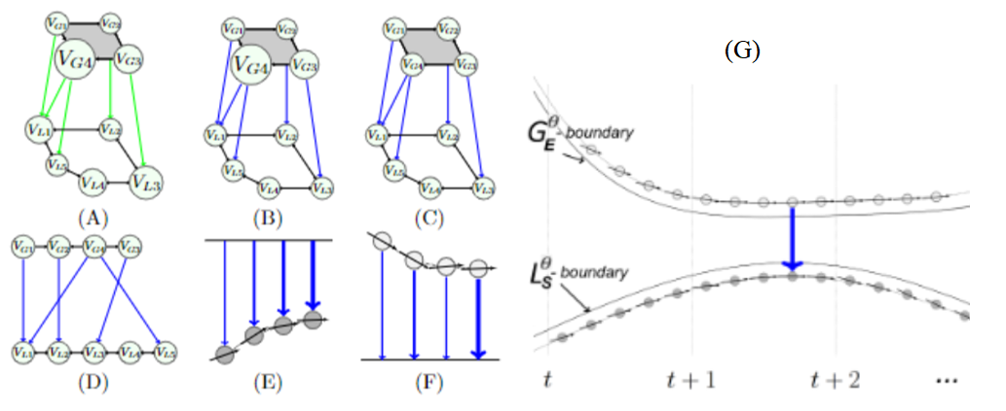
Figure 1 Illustration of the graph decomposition into source-load particles, (A) original graph, (B) normalization of the loads, (C) normalization of the sources, (D) incorporation of the normalization factors in DEA, (E) incorporation of sources dynamic into DEA, (F) incorporation of loads dynamic into DEA, (G) cross interaction of (E) and (F), i.e., the Source-Load particles.

The interactions between source and load particles significantly impact the overall stability of the power grid. Balancing power generation and consumption is critical, as any imbalance can lead to frequency deviations and instability. Proper management of source-load interactions helps in dynamically adjusting generation and consumption to maintain this balance. Voltage regulation is also affected by these interactions; maintaining stable voltages at all nodes is essential, and reactive power support from generators and load compensation devices plays a crucial role. The dynamic response of source-load pairs to disturbances determines the transient stability of the grid, and effective control strategies, such as fast-acting load shedding and generator tripping, can enhance this stability. Additionally, analyzing the intrinsic electrical distance and source-load interactions helps in designing a more resilient power grid capable of withstanding and quickly recovering from disturbances.
The multi-scale framework for power grids, considering both fast and slow processes, provides a more realistic and comprehensive representation of the grid's behavior. By recognizing the complexity and dynamics of power grids at multiple time scales, this approach enhances our understanding and prediction of the system's behavior, contributing to improved grid management and overall performance.

Drawing parallels between the dynamics of diatomic molecules and the power grid
The dynamics of diatomic molecules provide a useful analogy for understanding the complex behavior of power grids. In diatomic molecules, potential wells and Morse potentials describe the interactions between atoms, capturing both fast and slow dynamic behaviors. These concepts can be extended to the power grid, where interactions between sources and loads exhibit similar characteristics.
In diatomic molecules, the potential energy of the system as a function of the interatomic distance can be visualized using potential wells. A potential well represents the region where two atoms are bound together by attractive forces at short distances and repulsive forces at very short distances. The depth of the well corresponds to the bond energy, and the shape of the well determines the vibrational characteristics of the molecule.
In the context of diatomic molecules, two primary forces act between atoms: attractive and repulsive forces. The attractive force, which dominates at larger interatomic distances, is due to the electrostatic attraction between the positively charged nuclei and the negatively charged electron cloud. The repulsive force, which becomes significant at very short distances, is due to the Pauli exclusion principle, which prevents electrons from occupying the same quantum state. The balance between these forces creates a stable equilibrium at a specific interatomic distance, minimizing the potential energy of the system.
Morse potential captures both the attractive and repulsive forces, with the equilibrium point representing the minimum potential energy. The dynamics of a diatomic molecule within this potential involve fast oscillations (vibrations) around equilibrium, superimposed on slower changes in the bond length due to external influences.
The concepts of potential wells and Morse potentials in diatomic molecules can be analogized to the dynamics of power grids, where similar fast and slow interactions occur between sources and loads. In power grids, fast dynamics correspond to rapid changes in power flow and voltage levels between sources (generators) and loads (consumers). These interactions can be likened to the attractive and repulsive forces in diatomic molecules. For instance, an increase in load demand creates an "attractive force," drawing more power from generators, while protective mechanisms and control systems generate "repulsive forces" to prevent overloading and instability. These fast dynamics involve immediate responses to changes in demand and supply, such as voltage regulation and frequency control.
The slow dynamics in power grids are analogous to the overall behavior of the system as it evolves over longer periods. These dynamics are influenced by the integrated effects of the fast interactions. For example, the gradual adjustment of generation schedules, load forecasting, and long-term stability assessments reflect the slow dynamics. Similar to the Morse potential, which describes the overall energy landscape of a diatomic molecule, the slow dynamics in a power grid represent the aggregated effect of numerous fast interactions, leading to a stable operating point over time.
Drawing from the analogy with diatomic molecules, we can introduce a multi-scale framework for analyzing power grid dynamics. This framework distinguishes between the fast interactions (analogous to the attracting and repulsing forces) and the slow dynamic behavior (analogous to the Morse potential).
In the multi-scale framework, fast dynamics are treated as ancillary dimensions, capturing the immediate, rapid interactions between sources and loads. These dimensions include real-time adjustments in power flow, voltage regulation, and frequency control. The integration of these fast dynamics over time forms the slow dynamics, which represent the long-term stability and reliability of the power grid.
By applying this multi-scale framework, we can better understand and manage the power grid's behavior. The fast dynamics provide insights into immediate responses and stability measures, while the slow dynamics offer a comprehensive view of the system's long-term performance. This approach allows for more effective control strategies, ensuring both short-term stability and long-term reliability.

Chapter 5

Multi-Scale Hybrid Data-Driven Analytic

Understanding multi-scale fast and slow dynamics
By distinguishing between fast and slow interactions, multi-scale hybrid framework offers a detailed perspective on how immediate, rapid changes in the grid's state accumulate over time to affect its long-term stability and reliability. This approach is grounded in mathematical modeling and system dynamics, providing a robust analytical foundation.
Ancillary dimensions are introduced in the multi-scale framework to capture the fast dynamics of the power grid. These dimensions represent the rapid, short-term interactions that occur within the grid. By modeling these fast interactions separately, we can better understand and control the immediate responses to changes in demand and supply. These ancillary dimensions are essential for isolating the fast dynamics from the overall behavior of the system. They enable a more detailed analysis of how rapid adjustments, such as reactive power compensation and frequency regulation, contribute to maintaining the grid's stability in real-time.
The integration of fast dynamics over time results in the formation of slow dynamics. In the multi-scale framework, the cumulative effect of numerous fast interactions is analyzed to understand how they influence the grid's behavior over longer periods. This integration process involves aggregating the short-term adjustments and responses to form a comprehensive view of the system's long-term stability and performance.
Fast interactions in the power grid, represented by the ϕ and ξ dimensions, capture rapid changes in power flow and transient events such as faults, sudden load changes, or fluctuations in renewable energy generation. These interactions are akin to kinetic energy in classical mechanics and are crucial for ensuring grid stability during dynamic events and disturbances. Mathematically, these fast dynamics can be expressed as:

$\frac{dV}{dϕ}=g(ϕ,x)$ ( 18)

$\frac{dV}{dξ}=h(ξ,x)$ ( 19)

where $g$ and $h$ are functions representing the rapid adjustments in power flow and generation.
Conversely, slow dynamics are represented by the t dimension, analogous to potential energy. This dimension captures slower processes within the grid, such as gradual load growth, adjustments in generation capacity, and long-term system evolution due to changes in energy policies or infrastructure upgrades. These steady-state responses are critical for long-term planning and grid management. The slow dynamics can be described as:

$\frac{dV}{dt}=f(t,x)$ ( 20)

Ancillary dimensions ϕ and ξ are introduced to capture the fast dynamics of the power grid. These dimensions represent the rapid, short-term interactions that occur within the grid. For instance, ϕ may represent the immediate response to a sudden load increase, while ξ could signify the rapid adjustments in power generation to stabilize the grid. By isolating these fast dynamics, we can better understand and control the immediate responses to changes in demand and supply.
The integration of fast dynamics over time results in the formation of slow dynamics. This integration process involves aggregating the short-term adjustments and responses to form a comprehensive view of the system's long-term stability and performance. Mathematically, this can be represented by integrating the fast dynamic equations:

$f\left(t,x\right)=\int_{0}^{t}{g\left(ϕ,x\right)dϕ+\int_{0}^{t}{h\left(ξ,x\right)dξ}}$ ( 21)

This integral shows how the cumulative effect of fast interactions influences the slow dynamics.
To illustrate how fast dynamics integrate to form slow dynamics, consider the power balance equation for a node i:

$\frac{dP_{i}}{dt}=P_{G,i}-P_{L,i}-\sum_{j}{P_{ij}}$ ( 22)

where $P_{G,i}$​ is the generated power, $P_{L,i}$is the load, and $P_{ij}$ is the power flow between node i and neighboring nodes j. Over time, the integration of this equation leads to:

$P_{i}\left(t\right)=\int_{0}^{t}{(}P_{G,i}-P_{L,i}-\sum_{j}{P_{ij}}) dτ$ ( 23)

This integrated equation shows how the power balance at node i evolves, reflecting the cumulative effect of fast dynamics on the slow dynamics.
The multi-scale framework has significant practical implications for power grid stability and reliability:
- Improved real-time control of voltage and frequency, reducing the risk of blackouts and equipment damage.
- Better long-term planning for infrastructure investments and upgrades based on observed trends in slow dynamics.
- More efficient load balancing by understanding the short-term fluctuations and their long-term impacts.
- Optimized generation scheduling that takes into account both immediate demand and long-term trends.
- Faster and more accurate detection of faults by analyzing fast dynamics.
- More effective response strategies that mitigate the impact of faults on long-term grid stability.
- Enhanced ability to withstand and recover from disturbances by understanding the integrated effects of fast dynamics.
- Development of more robust contingency plans based on comprehensive analyses of both fast and slow interactions.

Multi-scale hybrid numerical method:
Integrating the finite difference method and the generalized distributed algorithm creates a seamless blend of theoretical principles and advanced computational techniques, offering exceptional clarity in exploring power grid dynamics and revealing complex behaviors during transient states. Derivatives are approximated using differences between neighboring points, translating power system dynamics to trace energy propagation, interactions, and changes across the grid during transient events. By progressively introducing higher-order terms, the model can effectively represent intricate interactions within these brief time fractions, vital for comprehending system behavior nuances, especially in nonlinear systems where minor initial changes yield notable outcome disparities.
Incorporating the finite difference method (FDM) alongside the generalized distributed algorithm (GDA) establishes a robust framework for analyzing power grid dynamics. This combination bridges theoretical principles with advanced computational techniques, enhancing our understanding of complex behaviors during transient states. This chapter explores the integration of these methods to transform intricate PDEs into manageable algebraic forms, facilitating a profound exploration of energy flow dynamics across temporal and spatial domains.
The finite difference method approximates derivatives using differences between neighboring points, allowing for the translation of power system dynamics into a visual trace of energy propagation, interactions, and fluctuations. The generalized distributed algorithm further refines these approximations, enhancing computational efficiency and accuracy.
Considering the function $f\left(t,x\right)$ as the solution to the Fokker-Planck (FP) equation ($f_{t}=γf_{xx})$, it can be redefined with new dimensions in complex space. In complex mathematics, the Cauchy-Riemann theorem indicates that if a complex function $f\left(t,x\right)$ is differentiable, there are a pair of real-valued and differentiable functions U and V such that:

$f=U+iV$ ( 24)

where,

$U\left(t,x\right)=\int_{0}^{t}{g\left(ϕ,x\right)dϕ}$ ( 25)

$V\left(t,x\right)=\int_{0}^{t}{h\left(ξ,x\right)dξ}$ ( 26)

The Cauchy-Reimann equations will develop as,

$\left\{\begin{aligned}\frac{∂U}{∂ζ}=\frac{∂V}{∂ϕ} \\ \frac{∂U}{∂ϕ}=-\frac{∂V}{∂ζ}\end{aligned}\right.$ ( 27)

By differentiating f with respect to time and applying Fubini's theorem and considering time t as a function of new dimensions ζ and ϕ, we can rewrite:

$$\frac{∂U}{∂t} + i\frac{∂V}{∂t}=\frac{∂^{2}U}{∂ζi∂ϕ} + i\frac{∂^{2}V}{i∂ϕ∂ζ} = \\ -i\frac{∂\left(\frac{∂U}{∂ζ}\right)}{∂ϕ} + \frac{∂\left(\frac{∂V}{∂ϕ}\right)}{∂ζ}=-i\frac{∂\left(\frac{∂U}{∂ζ}\right)}{∂ϕ} + \frac{∂\left(\frac{∂V}{∂ϕ}\right)}{∂ζ}=$$$-i\frac{∂\left(\frac{∂V}{∂ϕ}\right)}{∂ϕ} + \frac{∂\left(\frac{∂U}{∂ζ}\right)}{∂ζ} =\left(\frac{∂^{2}U}{{∂ζ}^{2}} - i\frac{∂^{2}V}{{∂ϕ}^{2}}\right) \underset{⇒}{ }f_{t}={(U}_{ζζ}-iV_{ϕϕ})$ ( 28)

Including the new dimensions developed previously, the FP equation could be rewritten as,

${(U}_{ζζ}-iV_{ϕϕ}) =γ{ P}_{xx}=γ(U_{xx}+iV_{xx})$ ( 29)

Decomposing the complex equation 28 into real plane ($ζx)$ and imaginary plane ($ϕx)$ we would have a system of PDEs in the real space.

$\left\{\begin{aligned}U_{ζζ}=γU_{xx} \\ V_{ϕϕ}=-γ V_{xx} \end{aligned}\right.$ ( 30)

The state space representation of a system can be equivalently described by an nth-order differential equation. The response of state variables in such a system corresponds to solving a set of homogeneous differential equations. The two-state systems are formulated through a system of differential equations presented equation 30.

$\frac{U_{k+1,j}-{2U}_{k,j}+U_{k-1,j}}{{∆ζ}^{2}}= \frac{U_{k,j+1}-{2U}_{k,j}+U_{k,j-1}}{2{∆x}^{2}} in ζx-plane$ ( 31)

$\frac{V_{m+1,j}-{2V}_{m,j}+V_{m-1,j}}{{∆ϕ}^{2}}= -\frac{V_{m,j+1}-{2V}_{m,j}+V_{m,j-1}}{2{∆x}^{2}} in ϕx-plane$ ( 32)

The Figure 2 illustrates the relationship between the parabolic framed FDM (in $tx$ plane) and the hyperbolic framed FDMs (in $ζx$ and $ϕx$ planes). In other words, to estimate the solution in next step of the t direction, the solution for all the point in $ζx$plane and $ϕx$plane should be calculated. A full oscillation in $ζ$ and $ϕ$ would result in marching one step foe energy in t direction.

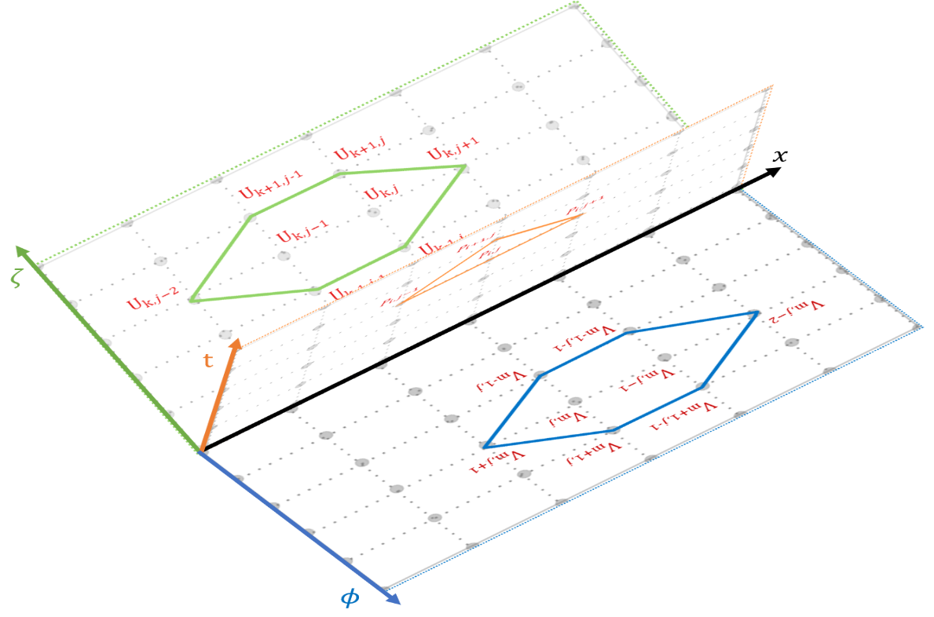
Figure 2 The relation seep between the parabolic and hyperbolic FDMs.

Network-based data-driven methods:
It has been discussed that the intricate and interactive network of multi-scale dynamical sources introduced varietal complexity, intensified the dimensionality issue in circuit-based analytics and introduced heterogeneity in the analytical framework due to intricate nonlinear interactions of high-order terms. In the modern power grid with IBRs, system has multi-spatiotemporal-scale dynamic with fast-slow coupled stochastic characteristics represented through stochastic differential equation,

$\frac{dv}{dt}=f\left(v,t\right)+g\left(v,t\right)w\left(t\right)$. (33)

Here, $v$ is the state vector, $f\left(v,t\right)$ represents deterministic dynamics, $g\left(v,t\right)$ is the sensitivity to random perturbations, and $w\left(t\right)$ is a Wiener process. Primary interactions between n components lead to the emergence of up to $n^{2}$-order terms in the system dynamics (i.e., system-level nonlinearity) [6].
Classical approaches struggle with scalability and real-time processing, particularly in the context of intricate dynamics within modern power grids. Recent works have been focused on applying either discriminative boundaries or generative distributions to reveal the governing functions of the dynamics in the space defined by the existing datasets [64,64]. The fundamental assumption of these techniques is that a fast-slow complex system whose globally slow dynamics can be adequately characterized by a finite number of governing functions and their weight distributions, $\dot{X}=A Θ\left(X\right)$ where $\dot{X}$ represents matrix of variables dynamic, A represent the spars deterministic weights of dynamical behavior and $Θ\left(X\right)$ is the library of possible dynamics, thus a less biased prediction can be reasonably obtained with the Bayesian framework. Such standard techniques are still posterior prediction methods because the underlying governing functions and their weight distributions ($w_{i}$s) are embedded explicitly or implicitly in a space pre-determined by the existing dataset or the dataset generated by the underlying mathematical models. This necessitates a shift towards network-based data-driven analytics for the design of resilient next-generation power systems [6].
By employing compressed sensing and sparse modeling principles, network-based data-driven methods aim to identify the system's critical harmonic components and inherent structural properties, tackling the curse of dimensionality. This involves partitioning the global dynamics into fundamental components (linearizable term), decaying harmonic components (typically up to the 15th harmonic), and noise. However, it excludes inter-modulated harmonics and the collective behavior of harmonic components in the convoluted multi-scale dynamic.
Delay-embedding solutions attempt to decompose the outcomes of complex harmonic component interactions, representing the system's behavior in a higher-dimensional phase space. Here, a finite number of dominant eigen-harmonics can be identified to address the curse of heterogeneity. Nevertheless, the convoluted interaction between these harmonics hinders the isolation of individual harmonics in the coupled multi-scale system, preventing the identification of two-by-two component interactions.
By promoting sparsity, sparse modeling techniques enable efficient representation, interpretation, and manipulation of high-dimensional data, offering insights into the underlying structure and dynamics of complex systems.
Analyses of nonlinear dynamics in electric power systems typically rely on a set of first-order ordinary differential equations that accommodate various scales, expressed as [66]:

$\frac{du}{dt} = F\left(u,β,γ\right)$ (34)

In this equation, $β$ and $γ$ denote two parameters representing independent inputs steering the system. These inputs encompass rapidly changing factors, such as active IBRs, and slowly changing elements, such as passive loads [50,51]. With a slight modification of the function F to incorporate passive loads ($γ$), the equation aligns with those characterizing general dissipative energy systems:

$\frac{du}{dt} = F\left(u,β\right)$ (35)

Here, u signifies the system states, typically observable, and $β$ denotes the inputs actively driving the system [67]. Considering the voltage as the observable variable, the dynamics of power system can be described by the following general form [68]:

$\frac{dv\left(t\right)}{dt} = f\left(v\left(t\right)\right)$ (36)

where $v\left(t\right)∈ R^{n}$ represents the system's voltage at time $t$ and $f\left(v\left(t\right)\right)$ encompasses the dynamic constraints governing the system's equations, including parameters, time dependence, and external forcing.
Integrating sparsity methods in analyzing dynamical systems has emerged as a significant advancement, employing compressed sensing and sparse regression techniques to identify concise and accurate models representing the underlying nonlinear dynamics [66].
Leveraging recent progress in compressed sensing and sparse regression, the sparsity perspective enables the identification of the nonzero terms in $f$ without computationally demanding brute-force searches. Convex methods that scale well with Moore's law allow for identifying sparse solutions with high probability, striking a balance between model complexity and accuracy, thereby avoiding overfitting the model to the available data [66].
Network-based approaches leverage the inherent interconnectedness and dependencies within a system to extract meaningful information. While these techniques are powerful, they may encounter disturbances during the extraction process that could potentially introduce misleading information. To address this concern, our algorithm incorporates robust optimization methods and data validation techniques to ensure the reliability of the extracted information. By iteratively refining the model and validating the results against ground truth data, our algorithm can effectively tolerate and mitigate the impact of any misleading information, thereby enhancing its overall accuracy and reliability. These methods treat the system as a network of nodes and edges, where nodes represent variables or components, and edges denote relationships or interactions between them. By analyzing the network topology, dynamics, and connectivity patterns, network-based methods uncover underlying structures, emergent behaviors, and critical components within complex systems.

Fundamental method
By representing the system dynamics as a sparse linear combination of basic functions, the method efficiently captures nonlinear interactions and dependencies, enabling model discovery and analysis in diverse applications. To determine the function $f$ from available data, a time history of the system's state, denoted as $v\left(t\right)$, is collected. The derivative of $v\left(t\right)$, denoted as $\dot{v}\left(t\right)$, is directly or numerically approximated. The data is sampled at various time instances, ${\{t}_{1},t_{2}, …, t_{m}$} and organized into $V$ and $\dot{V}$ matrices. The matrix $V$ is constructed as:

$V = {\left[\begin{matrix}| \\ v\left(t_{1}\right), \\ |\end{matrix}\begin{matrix}| \\ v\left(t_{2}\right) \\ |\end{matrix}, …, \begin{matrix}| \\ v\left(t_{m}\right) \\ |\end{matrix}\right]}^{T}$ (37)
and the matrix $\dot{V}$ is constructed as:

$\dot{V} = {\left[\begin{matrix}| \\ \dot{v}\left(t_{1}\right) \\ |\end{matrix}, \begin{matrix}| \\ \dot{v}\left(t_{2}\right) \\ |\end{matrix}, …,\begin{matrix}| \\ \dot{v}\left(t_{m}\right) \\ |\end{matrix}\right]}^{T}$ (38)

Realistic of curse of dimensionality and its impact on system dynamics:
The curse of dimensionality refers to the exponential increase in data volume and computational complexity as the number of variables or dimensions grows. This phenomenon poses significant challenges in data-driven analysis, where traditional methods struggle to handle high-dimensional datasets effectively. Network-based data-driven methods offer a promising solution to mitigate the curse of dimensionality by exploiting the underlying structure and sparsity present in many real-world systems.
The SINDY approach to answer the curse of dimensionality involves defining a library of candidate functions, denoted as $Θ\left(V\right)$, where $V$ is the data matrix that contains observed data points of the system variables [66-79]. The library is constructed by carefully selecting relevant nonlinear functions based on prior knowledge and theoretical considerations. These functions can include polynomials, trigonometric functions, exponentials, logarithmic functions, and other suitable nonlinear expressions [66].

$Θ\left(V\right)= \left[1, V,{ V}^{2}, V^{3}, …, cos\left(V\right), sin\left(V\right), …\right]$ (39)

Higher-order polynomials are denoted as $V^{2}$, $V^{3}$, and so on. Each column in the $Θ\left(V\right)$ matrix represents a candidate function for the right-hand side of the dynamical equation [66]. Assuming that only a few of these nonlinearities are active in each row of $f$, a sparse regression problem is formulated to determine the sparse vectors of coefficients,

$Ξ =\left[\begin{matrix}| \\ ξ_{1} \\ |\end{matrix}, \begin{matrix}| \\ ξ_{2} \\ |\end{matrix}, …, \begin{matrix}| \\ ξ_{n} \\ |\end{matrix}\right]$ (40)

which indicate the active nonlinearities. Mathematically, this can be expressed as:

$\dot{V} = Θ\left(V\right)Ξ.$ (41)

Each column, $ξ_{k}$, of the $Ξ$matrix corresponds to a sparse vector of coefficients that determines the active terms in the right-hand side of one of the row equations, $v_{k} = f\left(v\right)$ [7], [66]. Given the data matrix $V$ and the library of candidate functions $Θ\left(V\right)$, the method formulates the sparse regression problem as follows:

$minimize {\left|\left|\dot{V} - Θ\left(V\right)Ξ\right|\right|}_{2} + λ {\left|\left|Ξ\right|\right|}_{1}$ (42)
where $Ξ$ is the sparse vector of coefficients representing the importance or relevance of each term in the library, ${\left|\left|.\right|\right|}_{2}$ denotes the L² norm, ${\left|\left|.\right|\right|}_{1}$ represents the L¹ norm, and $λ$ is a regularization parameter that controls the trade-off between data fidelity and sparsity. The first term in Equation 17 ensures that the model predictions, obtained by multiplying $Θ\left(V\right)$ with $Ξ$, are close to the observed data, while the second term encourages a sparse solution by promoting a minimal number of nonzero coefficients [66].
The sparsity principle is central to this approach, as it seeks to select a subset of functions from the candidate library that is most relevant to the system's dynamics. By incorporating regularization techniques, such as L¹ regularization (or the Lasso), the model achieves sparsity by encouraging the coefficients of irrelevant terms to be zero, thereby emphasizing the significant functions while minimizing the overall number of terms [67]. This strategy simplifies the representation of system dynamics, leading to improved interpretability and a more concise model.
Once the Ξ matrix is determined, a model for each row equation can be constructed using the library of candidate functions and the corresponding sparse coefficients. Specifically, the $k_{th}$ row equation, $v_{k} = f\left(v\right)$, can be expressed as:

$v_{k} = Θ\left(v\right)ξ_{k},$( 43)
where $Θ\left(v\right)$ is a vector of symbolic functions of the elements of v. It is important to note that $Θ\left(v\right)$ differs from $Θ\left(V\right)$ in that it represents symbolic functions of the state variables, unlike $Θ\left(V\right)$, which represents a data matrix. Consequently, the overall representation of the system dynamics can be written as follows:

$\dot{v }= f\left(v\right)= Ξ^{T} Θ\left(v\right)$ ( 44)

Each column requires a separate optimization procedure to determine the sparse vector of coefficients, $ξ_{k}$, for the corresponding row equation. It is also possible to normalize the columns of $Θ\left(V\right)$, particularly when the entries of $V$ are small.
However, the method has limitations. The proposed method is sensitive to noise and requires careful model selection to balance sparsity and accuracy [68]. Its application to densely coupled dynamics poses challenges as disentangling individual contributions becomes difficult [67]. Furthermore, while the proposed method captures dynamics from data, it does not explicitly incorporate physical constraints, necessitating additional techniques or prior knowledge incorporation to ensure compliance with fundamental principles [6], [67]. Awareness of these limitations is essential for effective and informed utilization of the method.
The proposed three-section data analysis structure represents a notable evolution in data analysis, particularly within the framework. The initial two sections focus on identifying linearizable and nonlinear dynamics within the system [58]. The addition of the third section substantially enhances the overall data analysis process by categorizing and managing negligible data, often regarded as noise, which significantly improves the precision and accuracy of system modeling. The inclusion of the third section underscores the adaptability and versatility of the methodology, allowing for a more nuanced examination of complex system dynamics, a critical component of contemporary data-driven research.
The first section of the proposed data analysis framework plays a fundamental role in identifying and characterizing first-order impacts within the system. Its unique focus lies in evaluating the nonlinearities across nodes, with a particular emphasis on those that are trivial or readily linearizable. This systematic approach dissects the system dynamics to isolate elements that exhibit straightforward and manageable nonlinearities amenable to linear approximations. This categorization enhances the precision and tractability of the data analysis process, providing insights into complex system behaviors encompassing both linear and nonlinear components, particularly in applications spanning diverse domains, including power systems.
The second section within the outlined data analysis structure takes a central role in the comprehensive examination of system dynamics. It is dedicated to discerning and categorizing true nonlinearity, which differs significantly from the more straightforward and readily linearizable elements identified in the first section. True nonlinearity represents intricate and non-trivial characteristics that defy simple linearization, delving deep into complex system behaviors. Focusing on these inherently nonlinear dynamics offers profound insights into the intricate interdependencies and feedback loops characterizing real-world systems, transcending linear approximation constraints.

Algorithm 1:
Input:
Time history of the system's state, denoted as v(t), where v(t)∈R^{n}.
Regularization parameter λ.
Library of candidate functions, Θ(V), where V is the data matrix that contains observed data points of the system variables.
Step 1: Data Collection
Initialize empty matrices V and $\dot{V}$, where $\dot{V}$ represents the time derivatives of V.
For each time instance t in the set of time instances:
Collect data at time t and store it in v(t).
Compute the derivative of v(t) at time t, denoted as $\dot{v}$ (t).
Append v(t) to the V matrix.
Append $\dot{v}$(t) to the $\dot{V}$ matrix.
Step 2: Construct Library of Candidate Functions
Initialize an empty list for the library of candidate functions.
For each candidate function in the set of candidate functions:
Compute the values of the candidate function using data matrix V.
Append the function values to the library.
Step 3: Sparse Regression
Initialize an empty list Ξ to store the sparse coefficient matrices for each variable.
For each system variable k:
Perform sparse regression using data matrices V, $\dot{V}$, the library Θ(V), and regularization parameter λ to obtain Ξk​.
The sparse regression problem for variable k can be expressed as:
$$minimize {\left|\left|\dot{V} - Θ\left(V\right)Ξ\right|\right|}_{2} + λ {\left|\left|Ξ\right|\right|}_{1}$$
where Ξk​ represents the sparse coefficient matrix for system variable k.
${\left|\left|.\right|\right|}_{2}$ denotes the L2 norm.
${\left|\left|.\right|\right|}_{1}$​ represents the L1 norm.
λ is a regularization parameter that controls the trade-off between data fidelity and sparsity.
Step 4: Model Construction
Initialize an empty list for the models representing the system dynamics.
Construct the model for variable k using the library of candidate functions Θ(v) and the corresponding sparse coefficient Ξk​.
The model for system variable k can be expressed as:
$v_{k} = Θ\left(v\right)ξ_{k}$​
Output:
The list of models represents the system dynamics for each system variable, providing concise and accurate descriptions of the underlying nonlinear dynamics.

The third section within the data analysis structure serves a role in isolating and addressing components of system dynamics categorized as negligible. These elements include tolerable errors, inherent noise, and other factors exerting minimal influence on the overall system behavior. While individually minor, their cumulative impact can introduce variations and perturbations in the system's dynamics. However, by considering these factors within a dedicated section, they can be managed and refined effectively, enhancing the overall modeling accuracy of the system. This meticulous categorization offers a framework for researchers and system operators, allowing them to discern essential dynamics from negligible ones, ensuring a more accurate representation of system behavior. This process is fundamental for optimizing system models and is highly relevant to applications in various domains, with particular significance in power system analysis.

Enhanced hybrid method
The integration of delay-embedding solutions with data-driven methods has emerged as a potent approach to tackle the curse of heterogeneity in system analysis. By breaking down complex harmonic components and representing system behavior in a higher-dimensional phase-space, this fusion offers insights into dominant eigen-harmonics, thereby alleviating the challenges posed by system heterogeneity. In this discourse, we delve into the significance of this integration, drawing from its performance within the context of the provided paper, to elucidate its efficacy and implications.
The multi-scale hybrid data-driven aims to deconstruct the outcomes of complex harmonic component interactions by portraying system behavior in a higher-dimensional phase-space. This method entails constructing delay-embedding vectors, which encapsulate delayed measurements of system variables at various time points. Through Singular Value Decomposition (SVD) on these vectors, multi-scale hybrid data-driven decomposes the system's dynamics into dominant eigen-harmonics, thus uncovering underlying structures and interactions within the system.
Integration of Koopman theory and real-time data covariance analysis further bolsters the method's capacity to extract meaningful structures and patterns from the data, facilitating a more succinct and interpretable representation of the dynamics. The data covariance structure furnishes crucial insights into statistical relationships between variables, including singularities indicative of abrupt changes, discontinuities, or unusual patterns in the system's behavior. These singularities offer valuable insights into the system's coupled dynamics, aiding in the development of tailored monitoring, analysis, and control strategies.
The concept entails constructing a higher-dimensional space by incorporating delayed measurements of a system's variables. Consider a single variable v(t), for which we generate a delay embedding vector denoted as V(t). This vector comprises delayed measurements of v(t) at different time points and can be formally expressed as:

$V\left(t\right)= {\left[v\left(t\right), v\left(t - τ\right), v\left(t - 2τ\right), …, v\left(t - \left(m-1\right)τ\right)\right]}^{T}$ (45)

where τ denotes the time delay between measurements and m corresponds to the embedding dimension. By capturing these delayed measurements, we gain insights into hidden dynamics and extract pertinent information regarding the system's behavior.
The primary aim of the multi-scale hybrid data-driven method is to linearize the system's dynamics, particularly for linear or weakly nonlinear systems, while also providing an approximation for chaotic systems. This is accomplished by establishing a diffeomorphism that connects a delay-embedded attractor to the original attractor in the original coordinate system. To achieve this, we conduct the Singular Value Decomposition (SVD) of the Hankel matrix H, which is constructed from the time series of a single measurement variable v(t) to obtain intrinsic measurement coordinates. The Hankel matrix H is defined as:

$H = {\left[v\left(t\right), v\left(t + τ\right), v\left(t + 2τ\right), …, v\left(t + \left(n-1\right)τ\right)\right]}^{T}$ (46)

where n denotes the number of time points in the time series. The SVD of H yields the following decomposition:

$H = YΣU^{*}$ (47)

Here, Y and U denote orthogonal matrices, the $∙^{*}$ symbol represents the conjugate transpose, and Σ is a diagonal matrix containing singular values. The columns of Y correspond to the eigen-time-delay coordinates, which encapsulate the fundamental structure of the system's dynamics. These coordinates establish a Koopman invariant coordinate system, where the dynamics exhibit approximate linearity. The resulting linear model within the multi-scale hybrid data-driven method can be succinctly expressed as [39]:

$\frac{d}{dt} u\left(t\right)= Au\left(t\right)+ Bu_{r}\left(t\right)$ (48)

where $u\left(t\right)$ signifies a vector comprising the first $r-1$ eigen-time-delay coordinates, $A$ denotes a matrix capturing the linear dynamics, and $B$represents a matrix characterizing the coupling between the eigen-time-delay coordinates and the forcing term $u_{r}\left(t\right)$. In the case of chaotic systems, the linear model based on the first $r-1$ terms provide a commendable approximation, while the forcing term effectively encapsulates the nonlinear and chaotic behavior that a linear model cannot wholly represent [39].
It's essential to note that in scenarios where the intervals between time constants of multi-scale dynamics significantly differ, the need for sampling becomes notably demanding. This stems from the computational complexity involved in data acquisition and model fitting for extensive datasets. To address this challenge and enhance the efficiency of SINDY method, a sampling strategy called burst sampling was proposed. By employing burst sampling, the data requirements for SINDY method remain relatively consistent, even as temporal scales diverge. The fundamental concept underlying this strategy involves maintaining a small interval between samples while collecting data in short bursts dispersed over an extended duration. This approach effectively reduces the sampling rate, which proves particularly advantageous when limitations exist on the number of samples that can be acquired due to bandwidth restrictions. In multiscale dynamic conditions, SINDY method enhanced by multi-scale hybrid data-driven decomposition was applied. Crucial parameters such as the number of samples per burst (1000 samples per burst), the optimal hard threshold value for singular values ($\frac{4}{\sqrt{3}}$), and the sampling time interval (50 microseconds) play significant [39].

Chapter 6

Demonstration of Multi-Scale Hybrid Data-Driven Algorithm
The conducted simulation case studies not only demonstrate the effectiveness of detecting various nonlinear dynamics in power systems but also demonstrate the promising capability of the mixed algorithm to separate the nonlinear dynamics induced by coupled IBRs from those caused by synchronous machines.
The case study employs the IEEE 15-bus power grid model which examines a power system solely driven by SGs. The framework demonstrates remarkable accuracy in replicating system dynamics, both in steady-state and transient conditions. The algorithm accurately identifies the terms governing system dynamics and their associated coefficients with deviations within a remarkable 0.03%, while demonstrating resilience to transient changes, swiftly recovering its accuracy even amidst minor fluctuations.
The investigation will analyze two scenarios: the first will test the same IEEE 15-bus system supplied by both the basic SG model and IBRs, each supplying 50% of the load demand; the second will examine the same power system under full penetration of IBRs, with 100% of the load demands supplied by IBRs. The integration of IBRs into the power grid challenges SINDY algorithms due to multi-scale nonlinear dynamics, yet the hybrid algorithms successfully identify fast dynamics and track dynamics in steady-state and transient states while accurately approximating slow changes in the system.

Demonstration study
In this study on an IEEE 15-bus power grid, we employed the SINDY and proposed algorithm to analyze voltage waveforms and identify system dynamics under various complex operational scenarios. The choice of the experimental configuration was deliberate, aligning it with similar studies conducted by other researchers. The system architecture consists of 15 buses interconnected through branches representing power transmission lines, each with unique parameters and attributes governing power flow dynamics, as shown in Figure 3. Our discussion also encompasses the test scenarios, including abrupt changes and gradual load variations in the context of conventional SG and IBR at 50% and 100% integration. Our analysis serves as the foundation for introducing the Volterra-based Nonlinearity Index as a novel tool for assessing the order of nonlinearity in dynamic systems, offering significant insights into system dynamics.

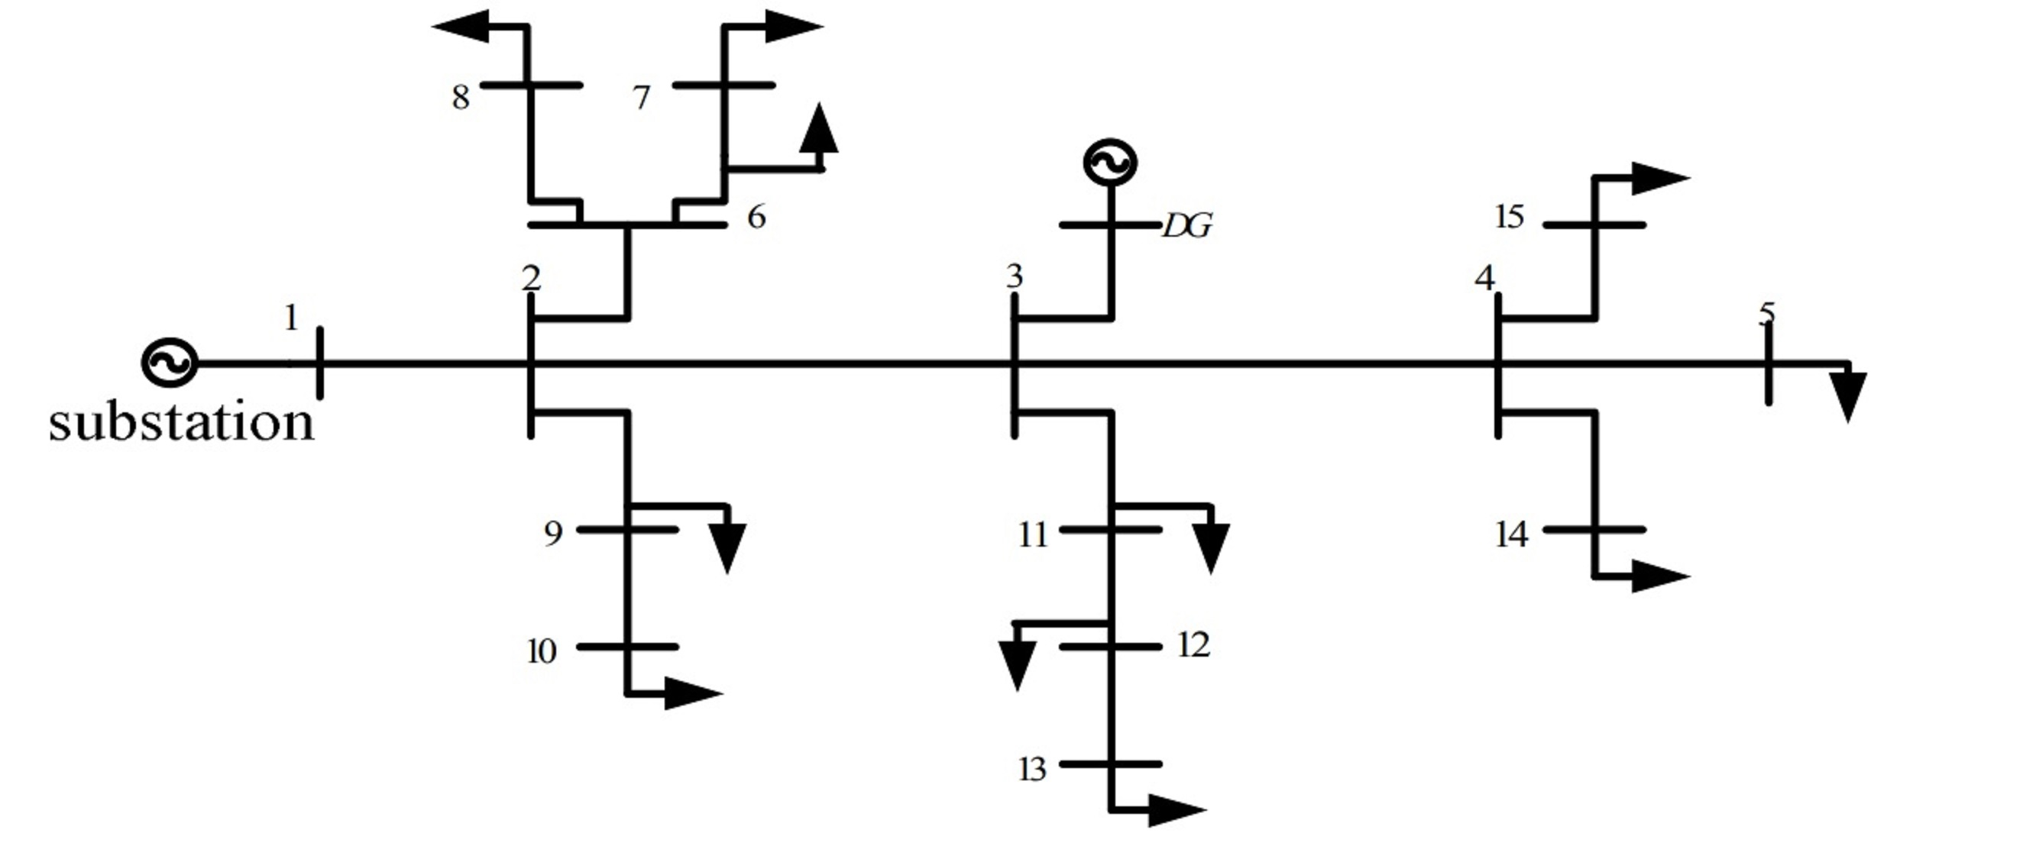
Figure 3 Single-line diagram of the implemented IEEE 15 bus network.

Investigation setup:
The system architecture consists of 15 buses, representing distinct nodes within the power system network, and these buses are interconnected through branches that represent the power transmission lines. Each bus in the IEEE 15-bus system has a unique set of parameters and attributes and is connected to neighboring buses via branches characterized by specific impedance, which govern the dynamics of power flow among the interconnected buses. Table 1 provides a comprehensive overview of the network configuration and branch parameters of the IEEE 15-bus system.
This investigation explores a comprehensive set of power system conditions, encompassing both abrupt changes (faults) and gradual changes (load variations), in the context of conventional SG and IBRs. The study encompasses three distinct scenarios, representing both single- and multi-dynamic systems. The first scenario examines a system solely supplied by a synchronous generator at Bus 1, with all other generators disconnected from the network. The second scenario incorporates the integration of an IBR at Bus 3, sharing the load demand equally with the synchronous generator at Bus 1. In the third scenario, the network is subjected to a 100% penetration of IBRs, where the demand is supplied by two IBRs located at Bus 1 and Bus 3. Each scenario spans 10 seconds, with the synchronous generators and IBRs initiated at $t=0s$. At $t=3.3s$, a three-phase-to-ground fault occurs at Bus 10, cleared after four cycles of the fundamental frequency (60 Hz). Furthermore, at $t=7s$, a significant load is connected to Bus 14, only to be disconnected at $t=8s$.

Table 1 The implemented IEEE 15 bus network configuration.
Line index | From bus | To bus | r+jx (Ω) | Node index | Pload+jQload (kW+jkVAR)
1 | 1 | 2 | 1.53+j1.778 | 2 | 100+j60
2 | 2 | 3 | 1.037+j1.071 | 3 | 90+j40
3 | 3 | 4 | 1.224+j1.428 | 4 | 120+j80
4 | 4 | 5 | 1.262+j1.499 | 5 | 60+j30
5 | 5 | 9 | 1.176+j1.335 | 6 | 60+j20
6 | 6 | 10 | 1.1+j0.6188 | 7 | 200+j100
7 | 7 | 6 | 1.174+j0.2351 | 8 | 200+j100
8 | 8 | 7 | 1.174+j0.74 | 9 | 60+j20
9 | 9 | 8 | 1.174+j 0.74 | 10 | 60+j20
10 | 10 | 11 | 1.15+j 0.065 | 11 | 45+j30
11 | 11 | 12 | 1.274+j1.522 | 12 | 60+j35
12 | 12 | 13 | 1.274+j1.522 | 13 | 60+j35
13 | 13 | 14 | 1.075+j1.522 | 14 | 120+j80
14 | 14 | 15 | 1.075+j 1.522 | 15 | 60+j10

The developed method, described in Algorithm 1, analyzed the acquired voltage waveforms, demonstrating promising system identification and modeling capabilities. Employing a refined computational approach, we consider essential parameters and algorithms to facilitate a comprehensive analysis. Careful consideration is given to the sampling rate (20,000 samples per second) and fundamental frequency (60 Hz) to ensure a high-fidelity representation of electrical phenomena. The simulation duration (10 s) and total sample count (200,000) are determined to capture temporal dynamics faithfully. By leveraging the Hilbert transform, converting voltage waveforms into complex numbers, and subsequent computation of instantaneous phase angles, we gain profound insights into the intricate behavior of the system.
Furthermore, the simulation methodology incorporates theAalgorithm1, wherein a polynomial library is constructed with a up to third-order polynomial and regularization parameter (0.8). The ensuing coefficients derived from this process are then employed to solve the system's ordinary differential equation, thus elucidating the underlying dynamics.
Applying polynomial function libraries up to the third order in the context of inverter-based resources signifies a notable departure from traditional modeling approaches. In power grid modeling, mainly when dealing with inverter-based resources, these higher-order polynomial functions allow for a more intricate representation of the dynamic behavior within the system. Unlike first-order models that may oversimplify the interactions between various components, including polynomial functions up to the third order enables the capture of nonlinearities and interactions characteristic of inverter-based resources. These functions provide a flexible framework to model the complex interplay between inverter controllers, grid conditions, and the response of renewable energy sources to changing environmental factors.
The application of these polynomial function libraries has theoretical and practical implications. Theoretically, it acknowledges the importance of capturing higher-order dynamics and interactions. It aligns with the principles of complex systems theory, emphasizing the significance of nonlinear dynamics and the emergence of complex behaviors in systems like power grids with significant inverter-based resource penetration. From a practical standpoint, this approach facilitates more accurate modeling, enabling grid operators and planners to understand better and predict the behavior of inverter-based resources. The practical advantages are particularly evident when renewable energy integration is critical. By accommodating higher-order dynamics, these models enhance the ability to simulate, analyze, and optimize the grid's performance, ultimately contributing to a more resilient and efficient power system.
Our investigation introduces a three-section data analysis structure, offering an enhanced approach to analyzing system dynamics. The initial two sections focus on identifying linear and nonlinear dynamics within the system, categorizing elements that are linearizable and those that are inherently nonlinear. The addition of the third section allows for managing negligible data components, ensuring improved modeling accuracy. This approach provides a more profound understanding of intricate nonlinear behaviors across various domains.

Case study on SINDY algorithm in power system analysis:
This investigation explores a wide array of power system conditions, covering both sudden changes (faults) and gradual changes (load variations), within the context of conventional SG and IBRs. The study encompasses three distinct scenarios, representing single- and multi-dynamic systems. In the first scenario, the system is solely supplied by a synchronous generator at Bus 1 and Bus 3. The second scenario integrates an IBR at Bus 3, which shares the load demand equally with the synchronous generator at Bus 1. In the third scenario, the network experiences a 100% penetration of IBRs, where the demand is met by two IBRs located at Bus 1 and Bus 3. Each scenario spans 10 seconds, with the synchronous generators and IBRs initiated at t=0s. At t=3.3s, a three-phase-to-ground fault occurs at Bus 10, cleared after four cycles of the fundamental frequency (60Hz). Additionally, at t=7s, an extra load is connected to Bus 14, disconnected at t=8s.
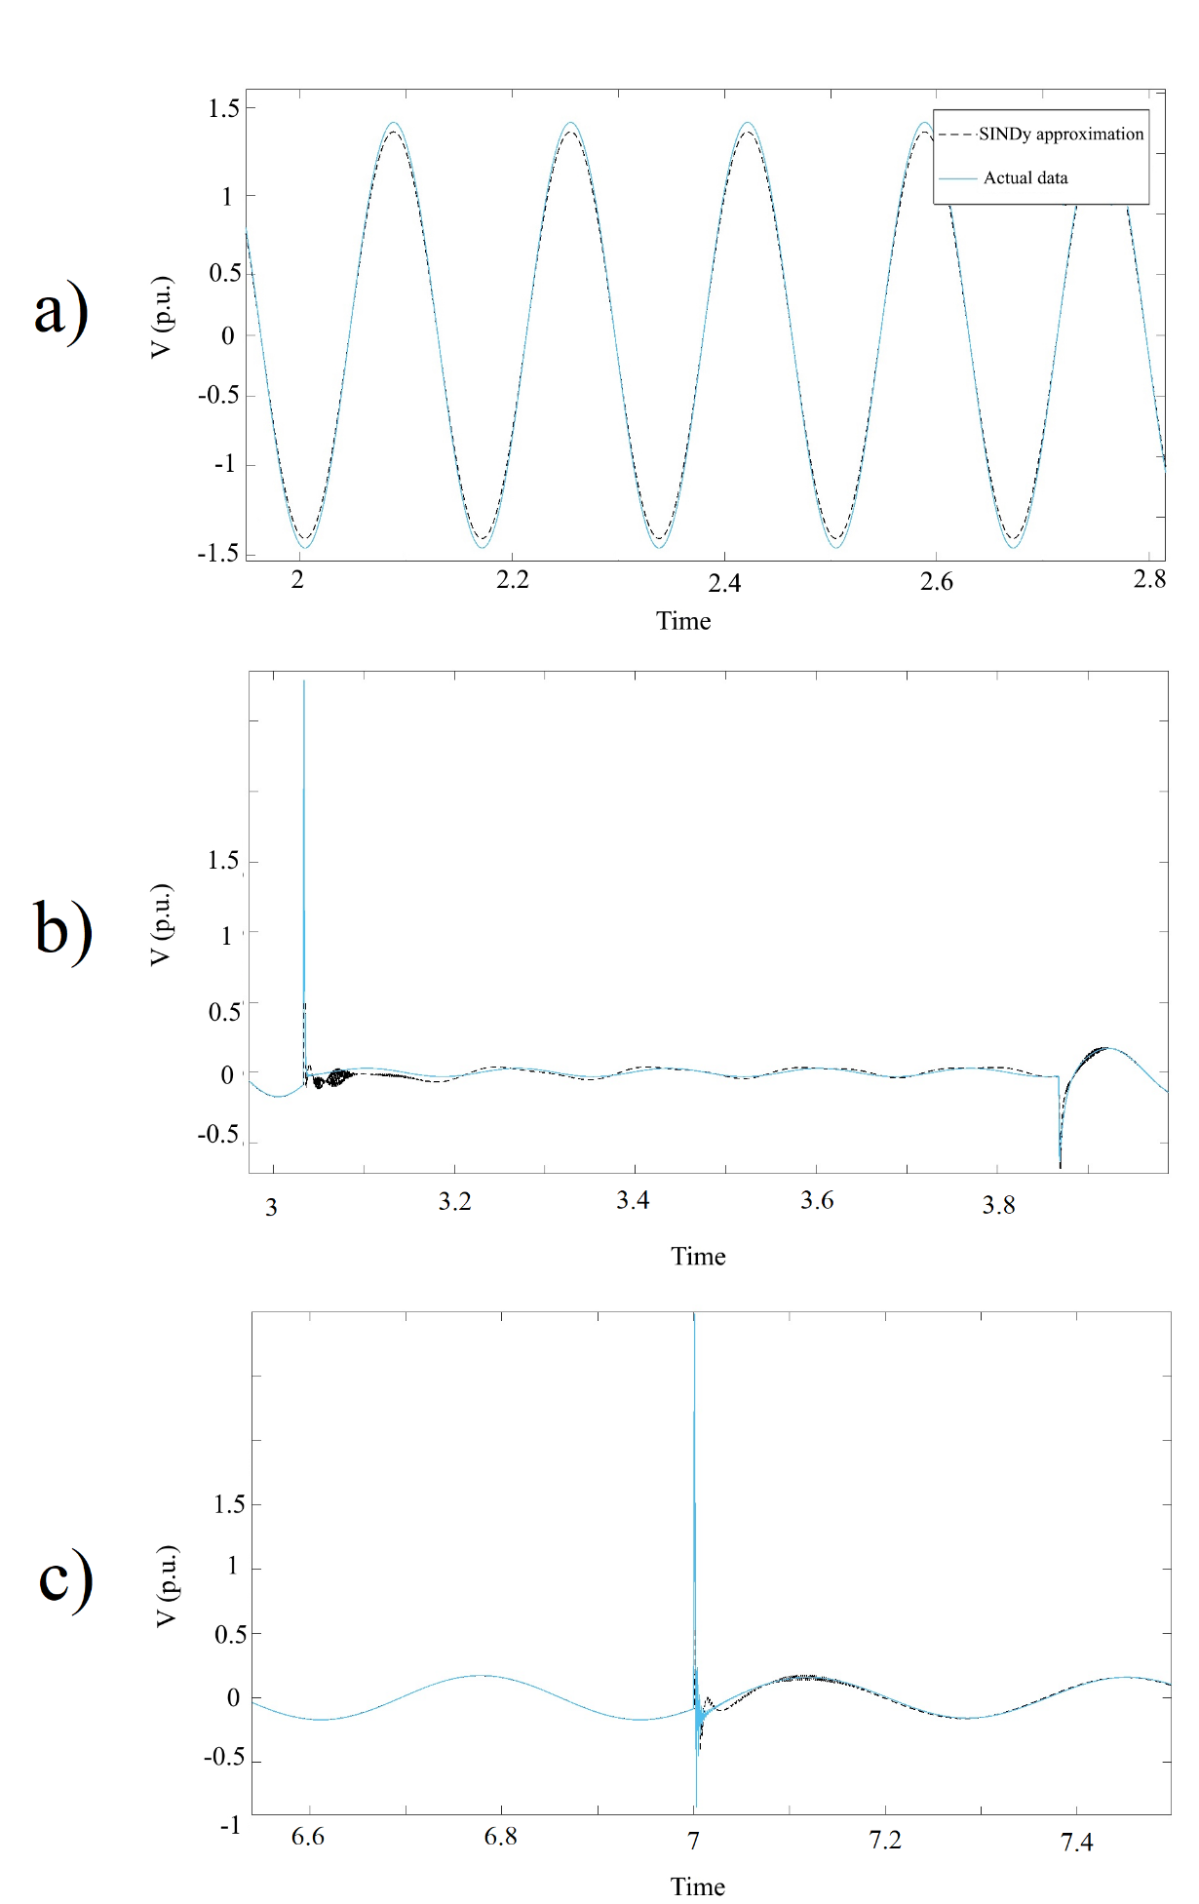
Figure 4 The actual measurement and generic algorithm approximation during a) steady state, b) fault and c) load change in power system supplied by SG.
The simulation duration of 10 seconds and a total sample count of 200,000 (20,000 samples per second) are selected to faithfully capture temporal dynamics. Additionally, a polynomial library is constructed with a precise third-order polynomial and a regularization parameter of 0.8.
The results from the first scenario illustrate the accuracy of SINDY method in estimating the system model. In the steady-state dynamics of the power system supplied by SG, the sparse model effectively reproduces the observed dynamics in measurements. As shown in Figure 4.a, the reconstructed waveform resulting from the identified model closely matches the actual data collected from the power network, all presented per unit. Remarkably, the algorithm not only correctly identifies the terms governing the dynamics but also accurately determines the associated coefficients, with deviations well within an impressive 0.03%.
Continuing in this scenario, involving sudden and gradual changes to system parameters in transient states, the SINDY algorithm captures the system's nonlinear dynamics and tracks changes, albeit experiencing minor fluctuations during these transitions, leading to slight increases in approximation errors. However, the results indicate that the SINDY algorithm swiftly regains its accuracy once changes are detected, as evidenced in faults and load variations, as shown in Figure 4.b and Figure 4.c, respectively.
The analysis underscores the prevalence of first-order terms in the expansive 15-dimensional system. Second-order terms exhibit minimal influence, while third-order terms hover close to zero, validating the accuracy with an exceptionally low error rate in capturing both short-term and long-term dynamics. Figure 5 illustrates the predominance of first-order terms throughout the entire 15-dimensional system. Specifically, when modeling the SG resources with the basic model, second-order and third-order term coefficients are deemed negligible, and approximated to zero through MATLAB calculations.

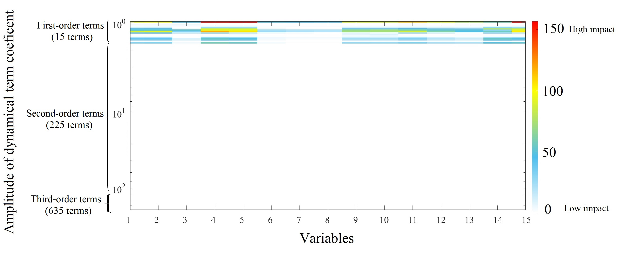
Figure 5 Colormap of the dynamical terms identified by SINDY method for the IEEE 15-bus system supplied by basic SG sources.

In order to mitigate potential bias stemming from our initial selection of the SG model, the case study replicated the investigation utilizing a 7th-order SG model. This deliberate adjustment enabled us to examine the influence of higher-order terms, particularly second-order terms, on the system's overall dynamics. The outcomes depicted in Figure 6, reveal that the system's dynamics remain predominantly governed by first-order terms, with second-order term coefficients being minimal, amounting to less than 1 percent of the smallest first-order term. Furthermore, third-order term coefficients are even more negligible, approximated to zero by MATLAB.
It is worth noting that the emergence of second-order terms did not produce any significant effects, consistent with the expectations outlined by existing theoretical frameworks. Conventional understanding of power systems suggests that higher-order terms, particularly second-order, typically play a minor role in system behavior, especially when compared to the prominence of first-order terms. This observation underscores the alignment of our findings with established theoretical principles, thereby reaffirming the accuracy and reliability of our analysis.

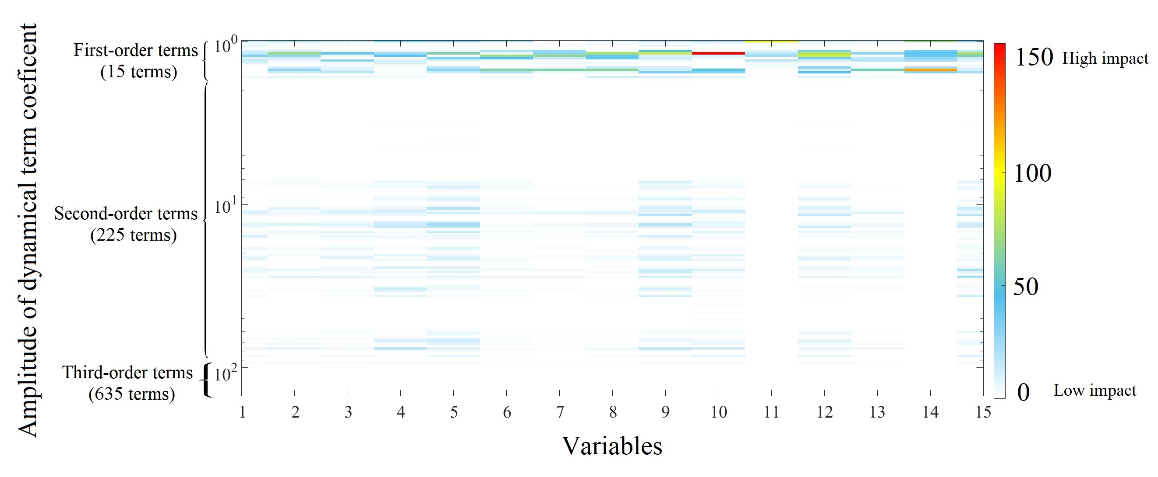
Figure 6 Colormap of the dynamical terms identified by SINDY method for the IEEE 15-bus system supplied by 7th-order SG sources.

From a Fourier series analysis perspective, the prevalence of first-order terms in the system underscores the fundamental influence of fundamental-frequency components on system dynamics. This dominance implies that the system's behavior is primarily shaped by these fundamental oscillations, with higher-order contributions playing a secondary role, resulting in minimal harmonic distortion.
From a system analysis standpoint, the significance of first-order terms suggests that the non-diagonal eigenvalues of the system are non-critical. Consequently, the system exhibits limited system-level interactions and can be characterized as linear or quasi-linear. This linearity implies that the system is linearly stabilizable from both monitoring and control perspectives. Moreover, this linearity extends to the system's response, indicating that it is proportional to applied inputs and adheres to the principle of superposition. This linearity facilitates analysis and control design, enabling the use of linear control strategies without resorting to nonlinear or complex control approaches. Additionally, these dominant terms govern the rate of disturbance decay or growth, directly influencing system stability and reflecting its ability to withstand disturbances and recover stability.
However, when IBRs are introduced into the power grid, the performance of SINDY method in model identification deteriorates, as it struggles to discern the multi-scale nonlinear dynamics. In this scenario, the algorithm's errors notably increase. The investigation will analyze two scenarios: the first will test the same IEEE 15-bus system supplied by both the basic SG model and IBRs, each supplying 50% of the load demand; the second will examine the same power system under full penetration of IBRs, with 100% of the load demands supplied by IBRs.
A closer examination reveals that the SINDY algorithm fails to distinguish the nonlinearity caused by fast dynamics in coupled multi-scaled dynamics when comparing the voltage variations approximated through the SINDY algorithm with actual measurements. As shown in Figure 7, the SINDY algorithm overlooks the fast dynamics in the voltage. Detailed analysis of the approximated voltage indicates the inclusion of harmonic distortions in the final result, contrasting with the voltage waveform approximation in the previous scenario, which represented a first-order system. Furthermore, the phase, frequency, and amplitudes of the approximated voltages deviate from cycle to cycle.

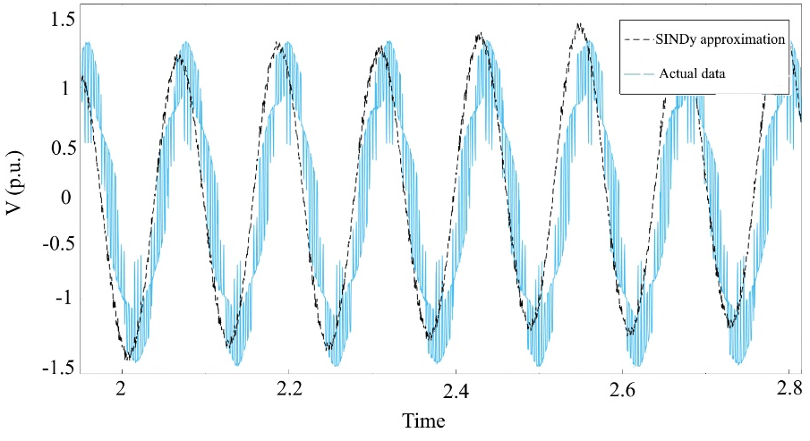
Figure 7 The actual dynamic and SINDY algorithm approximation during steady state in power system supplied by SG and IBRs.

In the first scenario, where 50% integration of inverter-based resources into the power grid equalizes their role with SGs in supplying load demands, the SINDY algorithm was employed to identify the underlying dynamics using measured data. As depicted in Figure 8, it was observed that second-order terms became more significant in the dynamic model. This heightened influence of second-order terms indicates that the data-based model, i.e., the underlying model within the measurements, possesses a more nonlinearizable nature, reflected in higher coefficient values for second-order terms. However, the third-order terms, representing negligible data (noise), remain in the same condition.
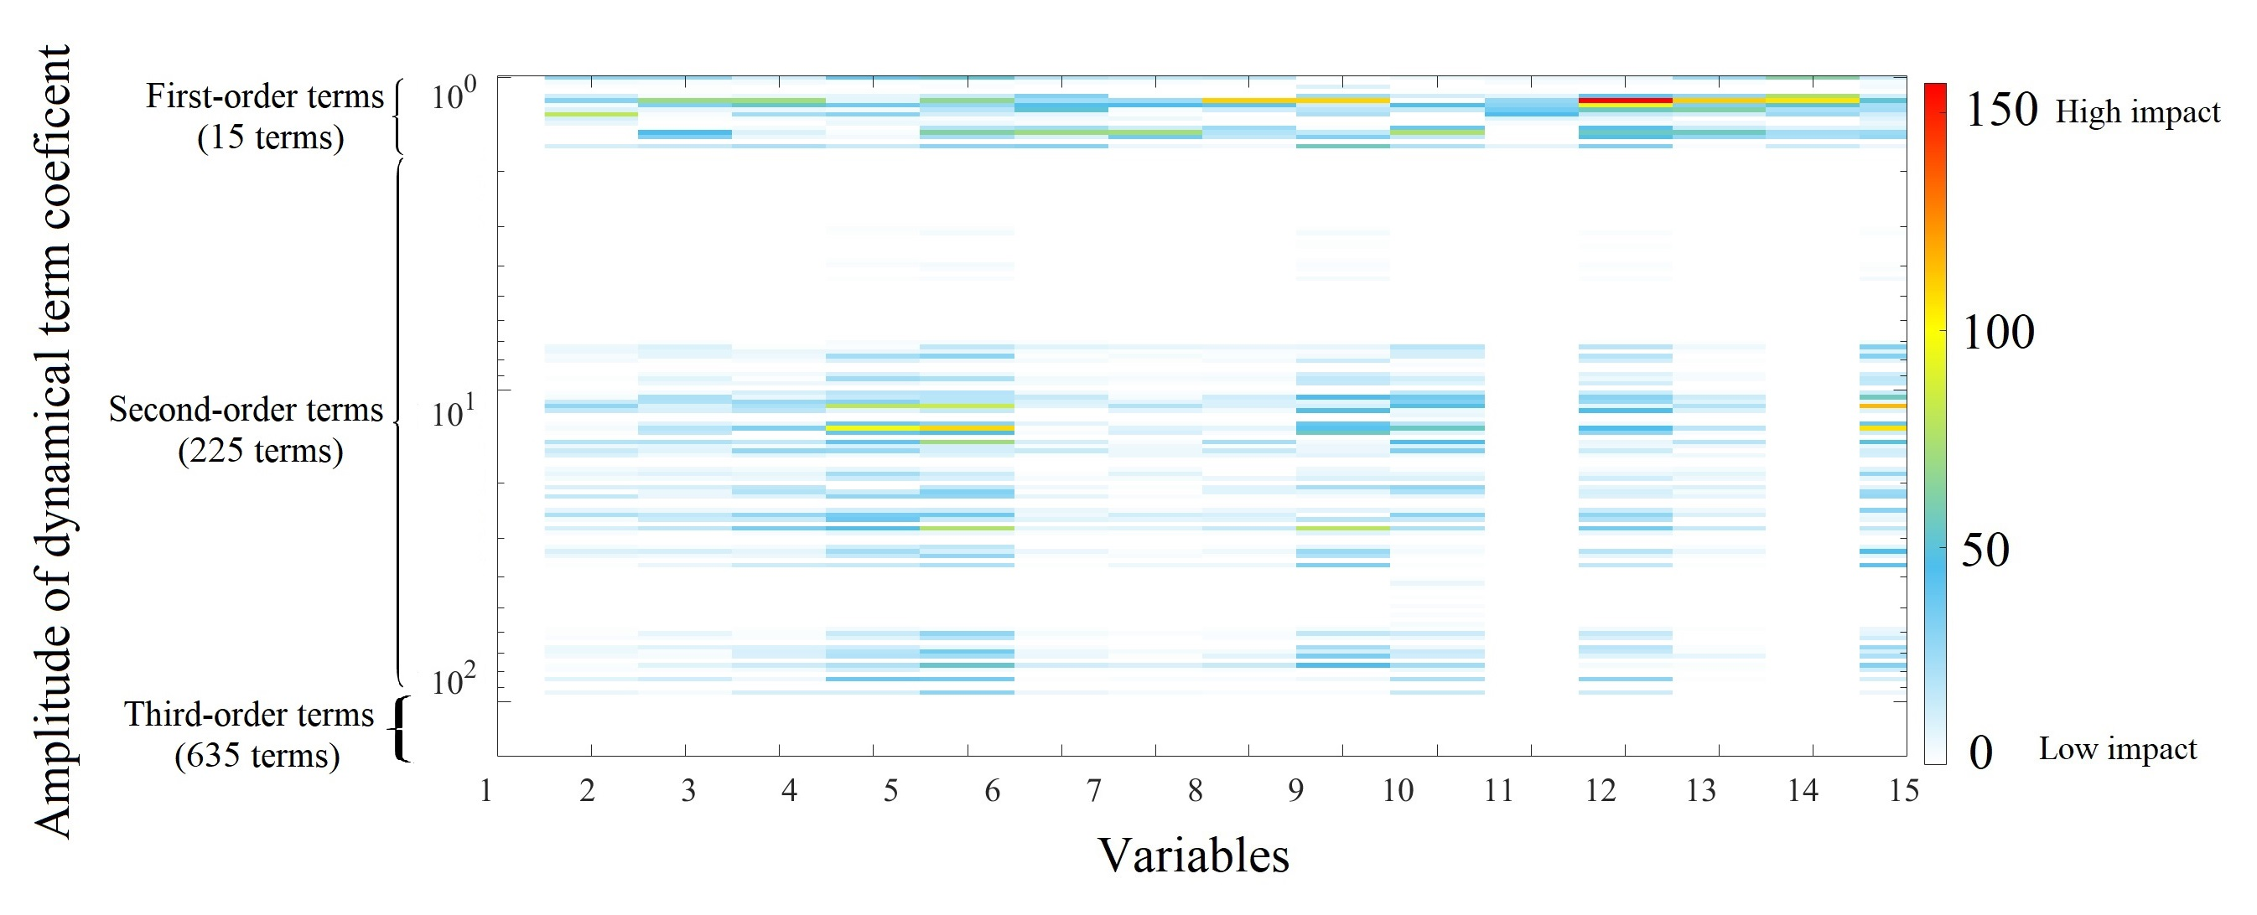
Figure 8 Colormap of the dynamical terms identified by SINDY method for the IEEE 15-bus system supplied by basic model SG sources and IBRs.

The results reveal a significant transformation in power grid dynamics as we explore IBR integration. What becomes apparent is not only the heightened influence of second-order terms (characterizing nonlinear dynamics) on the system's overall behavior across all individual buses but also the activation of more terms in the second-order region, thereby emphasizing the unmistakable imprint of system-level nonlinearity on the outcomes. This intriguing shift underscores the intricate interplay of components in the network and the inherent variability in each source, collectively contributing to the observed system-level nonlinearity. Compared to previous scenarios, this outcome signifies a fundamental difference, illuminating how power grids evolve when IBRs are introduced, revealing dynamics that transcend mere module dynamics and delve into the realm of complex, system-wide nonlinear interactions.
In the subsequent scenario, where load demands were exclusively supplied by IBRs, our model identification analysis, as depicted in Figure 9, notably underscored the dominance of second-order terms. This shift in the composition of dominant terms is a pivotal result that warrants in-depth discussion. The prominence of second-order terms in this context carries profound implications for understanding power grid dynamics.
This outcome signifies the profound impact of IBR-related nonlinearity on the power grid, emphasizing the necessity for more nuanced modeling to accurately represent these complex interactions. The dominance of second-order terms suggests that these nonlinear behaviors significantly influence the system's dynamics. In the context of IBRs, it becomes evident that second-order terms play a crucial role in capturing and representing the system's response to these nonlinear effects. This underscores the importance of explicitly considering and modeling the nonlinearity introduced by IBRs, as first-order models may need revision to accurately represent these intricate interactions.
Furthermore, from a theoretical standpoint, this finding aligns with established principles of nonlinear system dynamics. In complex systems, higher-order nonlinearities are anticipated, particularly when interactions among system components are intricate. These second-order terms can arise from various factors, including feedback mechanisms, nonlinear component characteristics, and complex system interactions.
A noteworthy observation emerges when comparing the level of involvement of second-order terms in scenarios of 100% IBR penetration to those with 50% and zero penetration. This comparison, as illustrated in Figure 10, highlights a significant shift, indicating the substantial impact of variable interactions compared to the direct effects of individual variables on the system's dynamics.

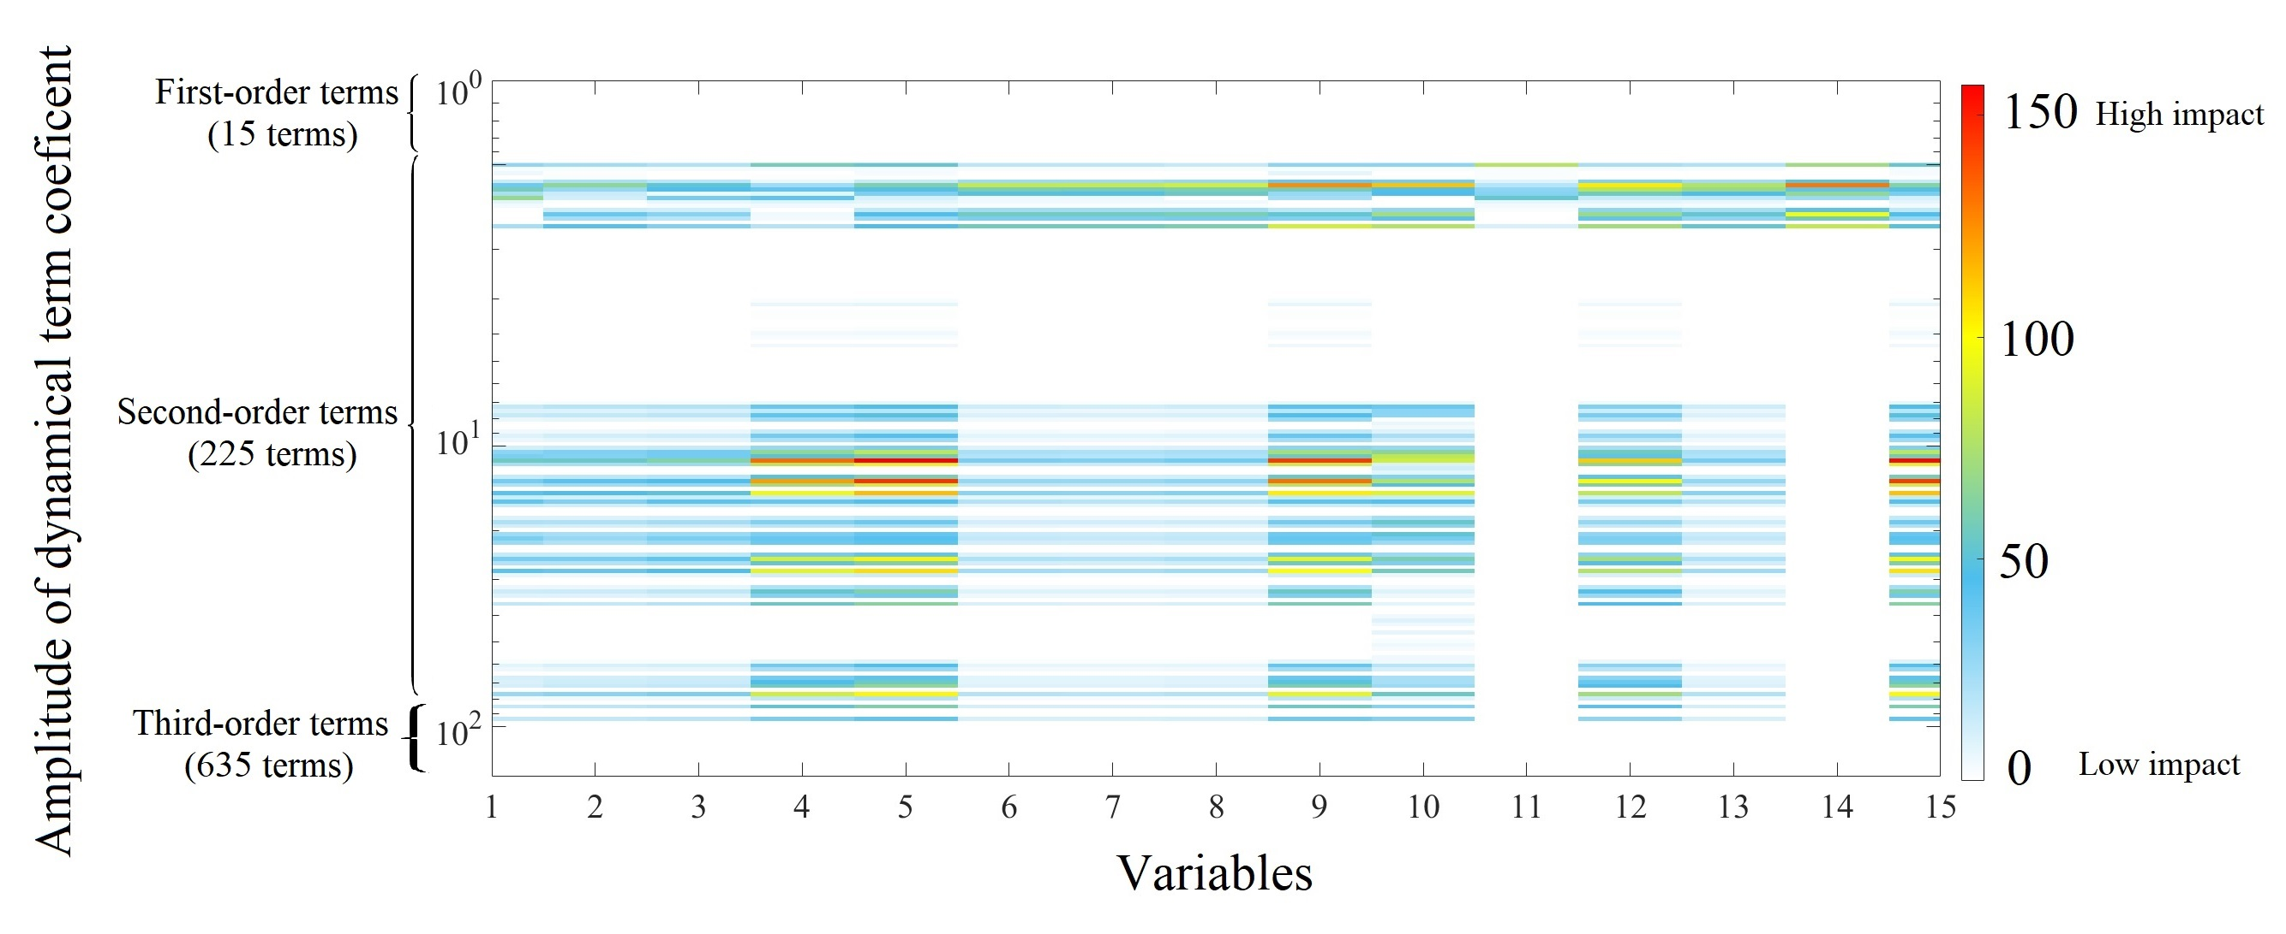
Figure 9 Colormap of the dynamical terms identified by SINDY for the IEEE 15-bus system supplied by IBRs.

As observed, the analysis of the 7th-order SG model emphasizes the predominance of first-order terms, suggesting linearizable dynamics within the measured data. The limited influence of high-order terms and noise in this model permits their neglect without significantly affecting the model's accuracy. Furthermore, the nonlinearity in this context primarily pertains to the individual buses connected to SG sources, suggesting a module-level nonlinearity.
In scenarios involving 50% and 100% integration of IBRs, a noticeable increase in nonlinearity is evident, as reflected by higher coefficients for second-order terms. It is noteworthy that the integration of IBRs activates a greater number of terms, and these activated terms are not directly associated with the buses connected to IBR sources, indicating the emergence of system-level nonlinearity resulting from network interactions. The graphical depiction vividly illustrates the escalating nonlinearity and the growing influence of second-order terms as IBR penetration increases from 50% to 100%, ultimately leading to the dominance of nonlinear dynamics in the overall system behavior.
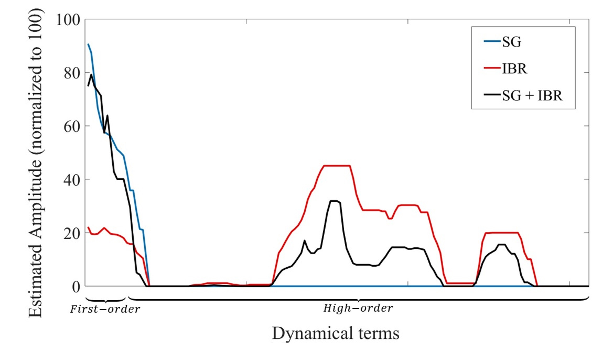
Figure 10 The normalized impact of the activated first-order and high-order terms in the dynamic of the variables for the scenarios with SG, a combination of SG and IBRs, and IBRs.

From a Fourier series analysis perspective, the ascendancy of high-order terms reveals a more intricate system response characterized by a broader spectrum of frequency components, leading to a richer harmonic content in the system's response. This phenomenon enriches the harmonic content within the system's response, aligning with previous findings. Such heightened complexity underscores the necessity for comprehensive frequency-domain analysis to fully comprehend the breadth of system behavior.
From a system analysis standpoint, the prevalence of high-order terms in dynamics signifies a departure from the conventional understanding associated with the predominance of first-order terms. In such scenarios, the system's nondiagonal eigenvalues become pivotal indicators of system behavior. The dominance of high-order terms indicates heightened complexity and nonlinearity in system dynamics, potentially resulting in more pronounced system-level interactions and a deviation from linear or quasi-linear behavior. Consequently, the eigenvalues linked to these high-order dynamics play a critical role in determining system stability, with their characteristics influencing stability margins and critical clearing times. It becomes imperative to understand and analyze these eigenvalues thoroughly for assessing system stability and designing effective control strategies.

Case study on multi-scale hybrid data-driven framework:
In this case study, the second and third scenarios from the previous case study were repeated using the multi-scale hybrid data-driven. The voltage was approximated using the mixed algorithm and compared to the actual data in both scenarios. Figure 11 presents the approximated voltage and the actual measurement for the voltage in the third scenario (100% penetration of IBRs) for both steady and transient states. The errors calculated for the second and third scenarios were 1.14 and 1.79 times the base error.
The results illustrate a significant improvement in the approximation of the power system with second-order nonlinearity. The mixed algorithm successfully identified the fast dynamics within the coupled multi-dynamic systems. The enhanced algorithm effectively captured and tracked the dynamics in both steady-state and transient states, as depicted in Figure 11.a and Figure 11.b respectively. It's noteworthy that the absence of voltage fluctuations during the fault incident is attributed to the limitations of IBRs in providing fault current, resulting in rapid and scarcely recognizable impulses. This suggests that the combined method can characterize the complex interactions and dynamics present in the system.
Moreover, the results indicate that the multi-scale hybrid data-driven approach accurately approximates and recognizes the slow changes occurring in the system, as demonstrated in Figure 12. This implies that the combined method is proficient at capturing and representing the dynamics occurring at different timescales, which is particularly pertinent in systems where various components or processes exhibit varying response rates.
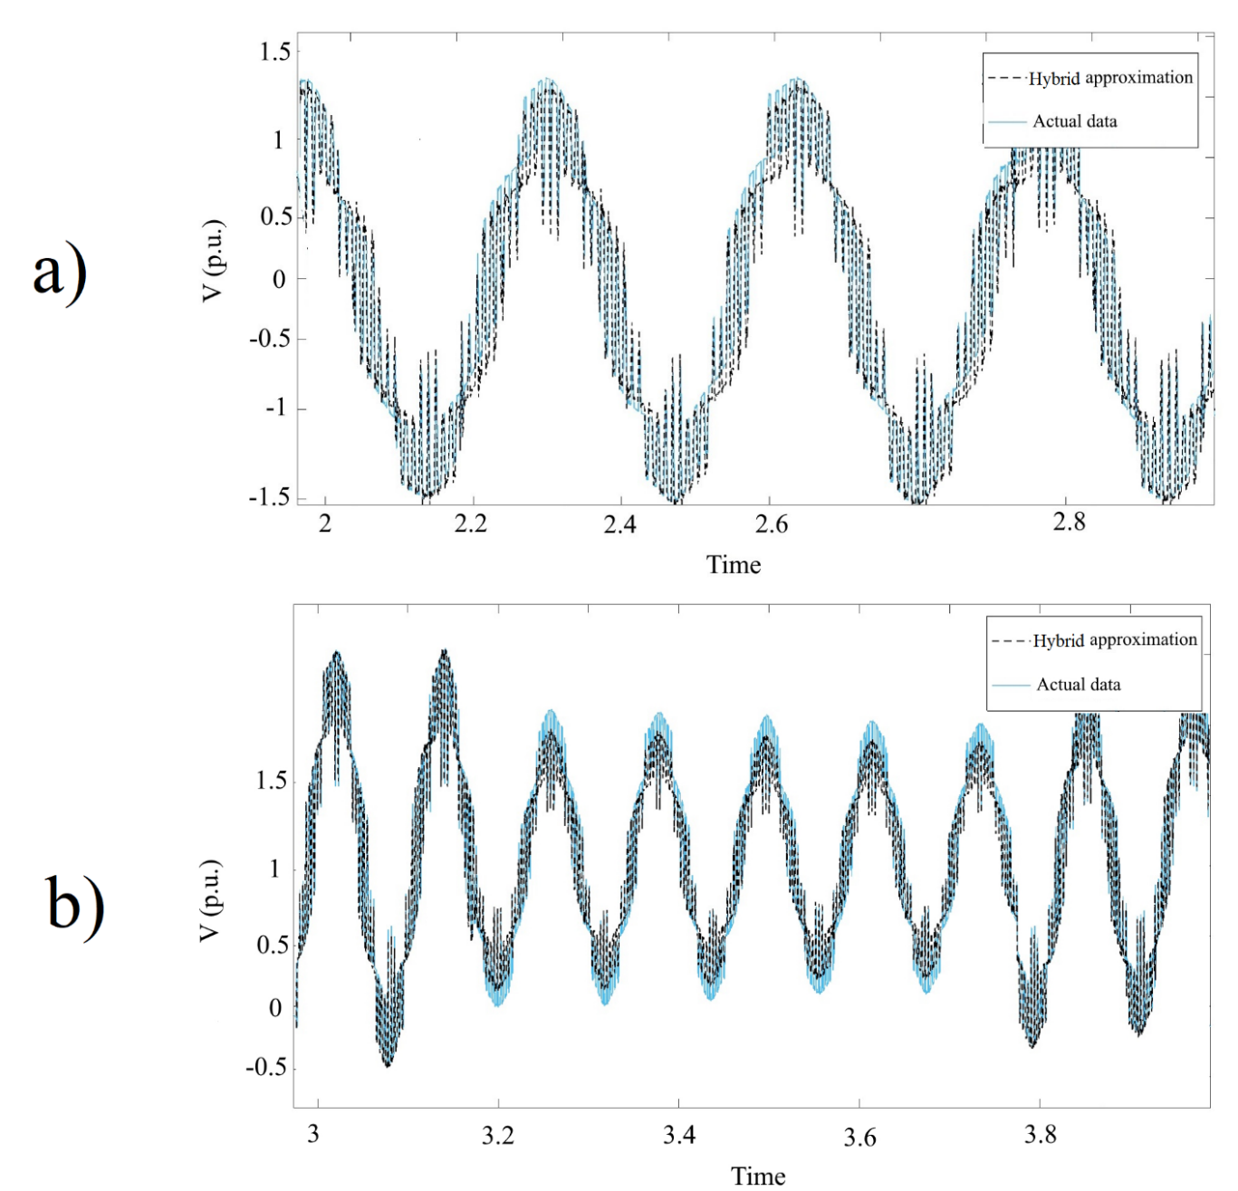
Figure 11 The actual measurement and mixed algorithm approximation during a) steady state and b) transient state in power system supplied by IBR.
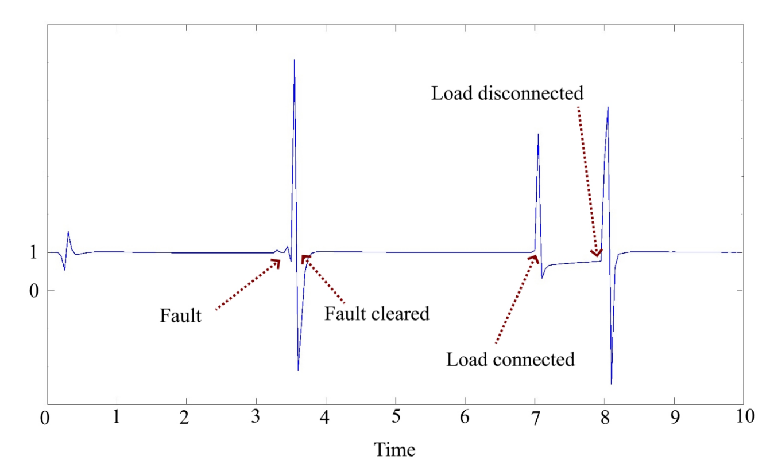
Figure 12 Approximation of slow dynamics in power system supplied by SG and IBRs.

Chapter 7

Conclusion

Conclusions:
This dissertation highlights the essential need for resilient functions that extend beyond traditional reliability measures to address the challenges presented by transient events in the next-generation power grid, particularly with the integration of distributed IBRs. As power grids become more complex, maintaining their structural and operational integrity in response to nonlinear, multi-scale dynamic disturbances caused by IBRs necessitates a focus on resilience during transient states.
Conventional power system analytics, which rely primarily on reliability criteria, are inadequate for handling the complexities introduced by transient events. Therefore, novel hybrid data-driven approaches are crucial for designing resilient grid systems. These approaches enable the identification of grid dynamics during transient conditions, characterized by high nonlinearity and complex interactions within multi-scale coupled physics. The emergence of convolution-based methods represents a significant shift from traditional data analytics, emphasizing the need for innovative approaches tailored to the unique challenges posed by transient events in power grids.
Multi-scale hybrid data-driven analytics, leveraging stochastic autocovariance analysis between harmonic components, provides a robust framework for modeling strongly coupled multi-scale dynamics in power systems. By uncovering complex patterns and dependencies among harmonic components, these methods offer valuable insights into system behavior, enabling more accurate modeling, prediction, and control. As power systems evolve with the integration of renewable energy sources and smart grid technologies, convolution-based analytics will be crucial in ensuring the reliability, resilience, and efficiency of modern electrical grids.
Furthermore, the use of stochastic autocovariance analysis within network-based data-driven multi-scale hybrid methods presents a promising avenue for identifying intricate patterns and dependencies between harmonic components in strongly coupled and complex multi-scale power systems. This signifies a new frontier in power system analytics, where conventional approaches fall short, necessitating the development of innovative techniques drawing from disciplines such as artificial intelligence, machine learning, and model identification.
This methodology ensures robustness, generalization potential, and the identification of key dynamical features using voltage measurements, thereby advancing our theoretical understanding of power system analysis. The results indicate a fundamental shift in system dynamics as power sources transition to IBRs, revealing system-level nonlinearity compared to module-level nonlinearity in conventional generators. The introduction of higher-order polynomial function libraries to model IBR integration marks a significant departure from traditional approaches, reflecting the evolving needs of power grid analysis as renewable energy takes center stage.
The relevance of findings regarding the influence of dominant terms on system eigenvalues extends to established methodologies such as dynamic phasor modeling, state estimation, and optimal power flow. Dynamic phasor modeling, which approximates the dynamic behavior of power systems using phasor representations, relies on accurate characterization of system eigenvalues to capture transient stability and dynamic response. By understanding the impact of dominant terms on eigenvalues, dynamic phasor models can better simulate system behavior under varying operating conditions, enhancing stability assessment and control design. Similarly, in state estimation, accurate estimation of system states and parameters is crucial for real-time monitoring and control. Knowledge of dominant terms aids in refining state estimation algorithms, improving the accuracy of system state estimates, and enhancing situational awareness. Furthermore, in optimal power flow studies, where the objective is to optimize power system operation while satisfying operational constraints, considering system eigenvalues influenced by dominant terms enables a more precise assessment of system stability limits and helps identify optimal operating points that maximize efficiency and reliability.

Publications:
This research has resulted in the following publications.
- [Book Chapter] "Network-Based Multi-scale Hybrid Data-Driven Analytics for Designing Resilient Next-Generation Power Grids", Reza Saeed Kandezy, John Jiang, Design for Reliability and Resilience of Power Systems, Elsevier, 2024, (Under publication)

- “Mixed Algorithm of SINDy and HAVOK for Measure-Based Analysis of Power System with Inverter-based Resource”, Reza Saeed Kandezy, John Ning Jiang (2024), International Journal of Innovative Science and Research Technology (IJISRT) IJISRT24MAR1279, 1677-1684.

- "On SINDy Approach to Measure-Based Detection of Nonlinear Energy Flows in Power Grids with High Penetration Inverter-Based Renewables", Saeed Kandezy, Reza, John Jiang, and Di Wu. Energies 17, no. 3 (2024): 711.

- "Refined convolution‐based measures for real‐time harmonic distortions estimation in power system dominated by inverter‐based resources", Reza Saeed Kandezy, Masoud Safarishaal, Rasul Hemmati, and John Ning Jiang. IET Power Electronics, 2023.

- “K means++ for Critical Component Identification: Power Grid Case Study using Measurement based Analysis”, Reza Saeed Kandezy, John Ning Jiang, Metrology, (Under review)

- Steele, B., Saeed Kandezy, R., Huang, P., & Jiang, J. N., 2022, IEEE Kansas Power and Energy Conference (KPEC), Manhattan, KS, USA, 2022, pp. 1-6, doi: 10.1109/KPEC54747.2022.9814783.

- "Nonlinear Impact of Topological Configuration of Coupled Inverter-Based Resources on Interaction Harmonics Levels of Power Flow." Masoud Safarishaal, Rasul Hemmati, Reza Saeed Kandezy, John Jiang, Chenxi Lin, and Di Wu. Energies 17, no. 11 (2024): 2512.

- "Impact of Phase Displacement among Coupled Inverters on Harmonic Distortion in MicroGrids," R. Hemmati, R. S. Kandezy, M. Safarishaal, M. Zoghi, J. N. Jiang and D. Wu, 2023 IEEE Transportation Electrification Conference & Expo (ITEC), Detroit, MI, USA

- “Impact of Inverter Dynamics during System Restoration Period on Protection Schemes in Grid Connected Solar PV Systems”, Almir Ekic; Manisha Maharjan; Di Wu; Matthew Boese; Reza Saeed Kandezy, 2022, IEEE Power & Energy Society General Meeting (PESGM). IEEE.

Future works:
This chapter highlights the importance of convolution-based data analysis and hybrid data-driven approaches in addressing the challenges posed by transient events in power grids integrated with IBRs. It underscores the necessity for continuous research and innovation to develop robust methodologies that ensure the resilience of next-generation power systems amidst dynamic and complex disturbances.
The intricacies of modern power systems call for ongoing research and development to refine analytical tools and methodologies. Future investigations should focus on enhancing real-time detection and identification of oscillation sources, a critical step towards maintaining the stability and reliability of power grids. This dissertation opens several avenues for future research that can significantly advance the field:
- Framework Model Applications: The proposed framework model for networks offers numerous potential applications. Immediate efforts will concentrate on developing interfaces that incorporate real-time data. By continuously assessing and updating the network structure with real-time estimation models, this approach ensures operational decisions are based on the most current network configuration and dynamics, rather than outdated planning models.
- Real-Time Dynamic Analysis: There is a plan to shift from static data derived from models to dynamic data obtained through direct measurement for real-time dynamic analysis. Utilizing dynamic data aims to refine real-time estimations of system behavior, which can differ significantly from static model predictions. This approach is crucial for accurately capturing and responding to the dynamic nature of power grids and electromagnetic stability, thereby enhancing operational reliability and resilience.
Exploring these approaches promises to advance understanding and application in power grid dynamics and electromagnetic stability analysis. By integrating physics-based analytical frameworks with real-time data and dynamic modeling, future research can contribute to more precise and adaptive strategies for managing and optimizing complex energy systems. These efforts aim to enhance system performance, reliability, and responsiveness in the face of evolving operational challenges and uncertainties.

List of Abbreviations
AC- Alternating Current
CCT- Critical Clearing Time
DC- Direct Current
DEA- Differential Algebraic Equation
FACT- Flexible Alternating Current Transmission
FDM- Finite Difference Method
FP- Fokker-Planck
GDA- Generalized Distributed Algorithm
IBR- Inverter-Based Resources
IEEE- Institute of Electrical and Electronics Engineers
PDF- Probability Density Function
SINDY- Sparse Identification of Nonlinear Dynamic
SG- Synchronous Generators
TEA- Transient Energy Automaton

References
- Kenyon, R. W., Bossart, M., Marković, M., Doubleday, K., Matsuda-Dunn, R., Mitova, S., ... & Hodge, B. M. (2020). Stability and control of power systems with high penetrations of inverter-based resources: An accessible review of current knowledge and open questions. Solar Energy, 210, 149-168.
- Tabatabaei, N. Mahdavi, S. Najafi Ravadanegh, and Nicu Bizon. "Power systems resilience." Switzerland: Springer (2018).
- Lin, Yanling, Zhaohong Bie, and Aici Qiu. "A review of key strategies in realizing power system resilience." Global Energy Interconnection 1, no. 1 (2018): 70-78.
- Ilves, Kalle, Antonios Antonopoulos, Staffan Norrga, and Hans-Peter Nee. "Steady-state analysis of interaction between harmonic components of arm and line quantities of modular multilevel converters." IEEE transactions on power electronics 27, no. 1 (2011): 57-68.
- Kandezy, Reza Saeed, Masoud Safarishaal, Rasul Hemmati, and John Ning Jiang. "Refined convolution‐based measures for real‐time harmonic distortions estimation in power system dominated by inverter‐based resources." IET Power Electronics 16, no. 16 (2023): 2708-2723.
- Kandezy, Reza Saeed, John Jiang, and Di Wu. "On SINDy Approach to Measure-based Detection of Nonlinear Energy Flows in Power Grids with High Penetration IBR-based Renewables." (2023).
- Jiang, John N. Protection and Restoration Solutions to Reliable and Resilient Integration of Grid-connected PV Installations and Distributed Energy Resources: Design, Testbed, Proof of Work and Impact Studies. No. DOE-OU-11111-1. Univ. of Oklahoma, Norman, OK (United States), 2022.
- Impram, Semich, Secil Varbak Nese, and Bülent Oral. "Challenges of renewable energy penetration on power system flexibility: A survey." Energy Strategy Reviews 31 (2020): 100539.
- Karangelos, Efthymios, Patrick Panciatici, and Louis Wehenkel. "Whither probabilistic security management for real-time operation of power systems?." 2013 IREP Symposium Bulk Power System Dynamics and Control-IX Optimization, Security and Control of the Emerging Power Grid. IEEE, 2013.
- Ji, G. (2020). Many-Body Delocalization and Evidential Study in Power Grid.
- P. W. Sauer and M. A. Pai, Power system dynamics and stability. Prentice hall Upper Saddle River, NJ, 1998, vol. 101.
- B. Stott, “Power system dynamic response calculations,” Proceedings of the IEEE, vol. 67, no. 2, pp. 219–241, 1979.
- J. Geremia, J. K. Stockton, and H. Mabuchi, “Real-time quantum feedback control of atomic spin-squeezing,” Science, vol. 304, no. 5668, pp. 270–273, 2004.
- A. Pizano-Martinez, C. Fuerte-Esquivel, and D. Ruiz-Vega, “Global transient stability-constrained optimal power flow using an OMIB reference trajectory,” Elect. Journal, vol. 25, no. 1, pp. 392–403, Feb 2010.
- D. Gan, R. Thomas, and R. Zimmerman, “Stability-constrained optimal power flow,” IEEE Trans. Power Syst., vol. 15, no. 2, pp. 535–540, 2000.
- A. Bettiol et al., “Transient stability-constrained optimal power flow,” in IEEE Budapest Powertech., Sept 1999.
- V. Vittal, E. Zhou, C. Hwang, and A. Fouad, “Derivation of stability limits using analytical sensitivity of the transient energy margin,” IEEE Trans. Power Syst., vol. 4, no. 4, pp. 1363–1372, 1989. 114
- M. Pai, Power system stability: analysis by the direct method of Lyapunov. North- Holland, 1981, vol. 3.
- M. Pavella and P. Murthy, “Transient stability of power systems: theory and practice,” 1994. D. J. Watts and S. H. Strogatz, “Collective dynamics of ‘small-world’networks,” nature, vol. 393, no. 6684, p. 440, 1998.
- Deng, Zhuofu, Binbin Wang, Yanlu Xu, Tengteng Xu, Chenxu Liu, and Zhiliang Zhu. "Multi-scale convolutional neural network with time-cognition for multi-step short-term load forecasting." IEEE Access 7 (2019): 88058-88071.
- Hong, Seng-Phil. "Different Numerical Techniques, Modeling and Simulation in Solving Complex Problems." Journal of Machine and Computing (2023): 058-068.
- Viberg, Mats. "Subspace-based methods for the identification of linear time-invariant systems." Automatica 31, no. 12 (1995): 1835-1851.
- Caponetto, Riccardo. Fractional order systems: modeling and control applications. Vol. 72. World Scientific, 2010.
- Corning, Peter A. "Synergy and self‐organization in the evolution of complex systems." Systems Research 12.2 (1995): 89-121.
- Vu, Thanh Long, and Konstantin Turitsyn. "A framework for robust assessment of power grid stability and resiliency." IEEE Transactions on Automatic Control 62.3 (2016): 1165-1177.
- Brunton, Steven L., Joshua L. Proctor, and J. Nathan Kutz. "Discovering governing equations from data by sparse identification of nonlinear dynamical systems." Proceedings of the national academy of sciences 113, no. 15 (2016): 3932-3937
- Mishra, Akhilesh Kumar, et al. "Maiden Application of Integral-Tilt Integral Derivative with Filter (I-TDN) Control Structure for Load Frequency Control." IFAC-PapersOnLine 55.34 (2022): 72-77.
- Ekomwenrenren, Etinosa, et al. "Hierarchical coordinated fast frequency control using inverter-based resources." IEEE Transactions on Power Systems 36.6 (2021): 4992-5005.
- Orihara, Dai, et al. "Contribution of voltage support function to virtual inertia control performance of inverter-based resource in frequency stability." Energies 14.14 (2021): 4220.
- Teti, Roberto, et al. "Advanced monitoring of machining operations." CIRP annals 59.2 (2010): 717-739.
- Fasel, Urban, Eurika Kaiser, J. Nathan Kutz, Bingni W. Brunton, and Steven L. Brunton. "SINDy with control: A tutorial." In 2021 60th IEEE Conference on Decision and Control (CDC), pp. 16-21. IEEE, 2021.
- Kaheman, Kadierdan, J. Nathan Kutz, and Steven L. Brunton. "SINDy-PI: a robust algorithm for parallel implicit sparse identification of nonlinear dynamics." Proceedings of the Royal Society A 476, no. 2242 (2020): 20200279.
- C. Song, S. Havlin, and H. A. Makse, “Self-similarity of complex networks,” Nature, vol. 433, no. 7024, p. 392, 2005.
- X. Li, “Design of transient energy automaton and study of energy flows on lattice graph,” 2018.
- S. V. Buldyrev, R. Parshani, G. Paul, H. E. Stanley, and S. Havlin, “Catastrophic cascade of failures in interdependent networks,” Nature, vol. 464, no. 7291, p. 1025, 2010.
- Y. Yang, T. Nishikawa, and A. E. Motter, “Small vulnerable sets determine large network cascades in power grids,” Science, vol. 358, no. 6365, p. eaan3184, 2017.
- D. Wu, F. Ma, M. Javadi, K. Thulasiraman, E. Bompard, and J. N. Jiang, “A study 115 of the impacts of flow direction and electrical constraints on vulnerability assessment of power grid using electrical betweenness measures,” Physica A: Statistical Mechanics and its Applications, vol. 466, pp. 295–309, 2017.
- M. E. J. Newman, “The structure and function of complex networks,” SIAM Review 45:2, vol. 45, no. 2, pp. 167–256, 2003.
- R. Albert and A. Barabasi, “Statistical mechanics of complex networks,” Reviews of Modern Physics, vol. 74, pp. 47–97, 2002.
- R. Zárate-Miñano, T. Van Cutsem, F. Milano, and A. J. Conejo, “Securing transient stability using time-domain simulations within an optimal power flow,” IEEE Transactions on Power Systems, vol. 25, no. 1, pp. 243–253, 2009.
- Gao, J., Barzel, B. & Barabási, A.-L. Universal resilience patterns in complex networks. Nature 530, 307–312 (2016).
- Machowski, Jan, Zbigniew Lubosny, Janusz W. Bialek, and James R. Bumby. Power system dynamics: stability and control. John Wiley & Sons, 2020.
- Caponetto, Riccardo. Fractional order systems: modeling and control applications. Vol. 72. World Scientific, 2010.
- Zhu, L., Zhao, Y., Cui, Y., You, S., Yu, W., Liu, S., Yin, H., Chen, C., Wu, Y., Qiu, W. and Mandich, M., 2021. Adding power of artificial intelligence to situational awareness of large interconnections dominated by inverter‐based resources. High Voltage, 6(6), pp.924-937.
- Yu, Peixin, Shiyong Wu, Ruitong Liu, Peng Yang, and Feng Liu. "Distributed Stability Indices of a Cluster of Nonlinear Heterogeneous Dynamical Devices: Aggregation and Correction." In 2023 42nd Chinese Control Conference (CCC), pp. 7212-7218. IEEE, 2023.
- Howard, Ronald A. "System analysis of semi-Markov processes." IEEE transactions on military electronics 8, no. 2 (1964): 114-124.
- Steele, Brenden, Reza SaeedKandezy, Peter Huang, and John N. Jiang. "Study on impact of modulational instability of inverters on electrical energy systems." In 2022 IEEE Kansas Power and Energy Conference (KPEC), pp. 1-6. IEEE, 2022.
- Moutsinas, G. & Guo, W. Node-level resilience loss in dynamic complex networks. Sci. Rep. 10, 1–12 (2020).
- Geiser, Juergen. Multicomponent and Multiscale Systems. Springer International Publishing, 2016.
- Lakshminarayana, Subhash, Saurav Sthapit, and Carsten Maple. "Application of physics-informed machine learning techniques for power grid parameter estimation." Sustainability 14, no. 4 (2022): 2051.
- Corning, Peter A. "Synergy and self‐organization in the evolution of complex systems." Systems Research 12.2 (1995): 89-121.
- Deng, Zhuofu, Binbin Wang, Yanlu Xu, Tengteng Xu, Chenxu Liu, and Zhiliang Zhu. "Multi-scale convolutional neural network with time-cognition for multi-step short-term load forecasting." IEEE Access 7 (2019): 88058-88071.
- Hong, Seng-Phil. "Different Numerical Techniques, Modeling and Simulation in Solving Complex Problems." Journal of Machine and Computing (2023): 058-068.
- Viberg, Mats. "Subspace-based methods for the identification of linear time-invariant systems." Automatica 31, no. 12 (1995): 1835-1851.
- Ko K, Choi H, Yi Y, Kim W, Kim J, Hwang J, Ko E, Cho G. ‘Discrete Convolution-Based Energy Spectrum Configuring Method for the Analysis of the Intrinsic Radiation of 176Lu. Sensors.’, 2021 Oct 23;21(21):7040.
- Jeruchim MC, Balaban P, Shanmugan KS. ‘Simulation of communication systems: modeling, methodology and techniques.’, Springer Science & Business Media; 2006 Apr 11.
- Shao, Q., He, W., Wei, D., Chen, M. and Zhang, X., 2020, February. A convolution neural network for reconstructing microgrid polarimeter imagery. In MIPPR 2019: Multispectral Image Acquisition, Processing, and Analysis (Vol. 11428, pp. 60-64). SPIE.
- Machowski, Jan, Zbigniew Lubosny, Janusz W. Bialek, and James R. Bumby. Power system dynamics: stability and control. John Wiley & Sons, 2020.
- A. Malyscheff, D. Wu, F. Ma, and J. Jiang, “A probabilistic perspective for power flow and its implication to power network analysis,” in The 50th North America, Power Symposium (NAPS), Fargo, 2018.
- K. Lerman and R. Ghosh, “Network structure, topology, and dynamics in generalized models of synchronization,” Physical Review E, vol. 86, no. 2, p. 026108, 2012.
- D. J. Klein and M. Randic, “Resistance distance,” Journal of mathematical chemistry, vol. 12, no. 1, pp. 81–95, 1993.
- D. J. Klein, “Resistance-distance sum rules,” Croatica chemica acta, vol. 75, no. 2, pp. 633–649, 2002.
- K. E. Avrachenkov, J. Filar, and M. Haviv, “Singular perturbations of Markov chains and decision processes,” in Handbook of Markov Decision Processes. Springer, 2002, pp. 113–150.
- Wen, Long, Xinyu Li, Liang Gao, and Yuyan Zhang. "A new convolutional neural network-based data-driven fault diagnosis method." IEEE Transactions on Industrial Electronics 65, no. 7 (2017): 5990-5998.
- Kan, Guangyuan, Cheng Yao, Qiaoling Li, Zhijia Li, Zhongbo Yu, Zhiyu Liu, Liuqian Ding, Xiaoyan He, and Ke Liang. "Improving event-based rainfall-runoff simulation using an ensemble artificial neural network based hybrid data-driven model." Stochastic environmental research and risk assessment 29 (2015): 1345-1370.
- Fasel, Urban, J. Nathan Kutz, Bingni W. Brunton, and Steven L. Brunton. "Ensemble-SINDy: Robust sparse model discovery in the low-data, high-noise limit, with active learning and control." Proceedings of the Royal Society A 478, no. 2260 (2022): 20210904.
- Lu, Qiang, Yuanzhang Sun, and Shengwei Mei. Nonlinear control systems and power system dynamics. Vol. 10. Springer Science & Business Media, 2001.
- Ajjarapu, V. A. B. L., and B. Lee. "Bifurcation theory and its application to nonlinear dynamical phenomena in an electrical power system." IEEE Transactions on Power Systems 7, no. 1 (1992): 424-431.
- Champion, Kathleen P., Steven L. Brunton, and J. Nathan Kutz. "Discovery of nonlinear multiscale systems: Sampling strategies and embeddings." SIAM Journal on Applied Dynamical Systems 18, no. 1 (2019): 312-333.

