University of Oklahoma

Graduate College

Investigation of bioactivities and induction of new metabolites in fungi

A thesis

submitted to the Graduate Faculty

in partial fulfillment of the requirements for the

Degree of

Master of Science

By

Krzysztof Bielak
Norman, Oklahoma
2016

Investigation of bioactivities and induction of new metabolites in fungi

A thesis approved for the
Department of Chemistry and Biochemistry

By

______________________________
Dr. Robert Cichewicz, Chair

______________________________
Dr. Daniel Glatzhofer

______________________________
Dr. Robyn Biggs

© Copyright by Krzysztof bielak 2016
All Rights Reserved.
To my friends and family. Especially to my parents and brother who were always there to believe in me and help me get through my most difficult times.

Acknowledgements
I would like to thank everybody that has supported me and helped me reach this point in my academic journey. The people who have been there for both the good and bad times in my life and the ones who have helped me develop a passion for science. I would like to particularly thank Mrs. Armbruster (Lake Zurich High School) who was an amazing science mentor for me, laying the foundations for my love of chemistry. I would also like to thank Dr. Faltynek and Dr. Friesen for being amazing professors, furthering my chemistry education as well as providing me the opportunity to develop my laboratory, research, and presentation skills. I would also like to thank all of the members of the Natural Products Discovery Group that I had the blessing to work with and develop amazing friendships with; without their friendship and support I do not think I would have been able to make it this far in my studies. I would especially like to thank Dr. Robert Cichewicz for giving me the opportunity to develop as a researcher, to allow me to think through complex scientific problems, and to excel as a scientist. He also always pushed me to work harder, to never give up, and to never leave the lab. I would also like to thank Jarrod for testing all of my compounds for activity in the trichomonas assay, Dejie Lu and Bianca Moreno, for working so hard in developing the traumatic injury assay with me. Also, I need to thank all of my committee members, past and present, for providing advice to guide me in my development as a scientist. Finally, I would like to thank the Department of Chemistry and Biochemistry for providing me the opportunity to pursue my studies. Without all of you this work and thesis would not have been possible. Thank you.

Table of Contents

Acknowledgements iv
List of Tables ix
List of Figures x
Chapter 1 Introduction 1
1.1 Overview of Natural Products 1
1.1.1 What are Natural Products 1
1.1.2 Applications of Natural Products 3
1.1.2.1 Applications as Drugs 3
1.1.2.2 Applications of Medicinal Chemistry in Natural Products 5
1.1.2.3 Discovery of Taxol 6
1.2 Drug Resistance and Natural Products 8
1.3 Utility of Fungi in Natural Products 10
1.5 Project Objectives 12
Chapter 2 Fungal Metabolites Active Against Trichomonas vaginalis 13
2.1 Introduction 13
2.2 Wailua PDA-3 Contaminant 14
2.2.1 Isolation of Dinapinones from Trichoderma citrinoviride 15
2.2.2 Dereplication of compounds 3, 4, and 5 15
2.2.3 Dinapinone AB1/2 and Dinapinone A1/2 16
2.2.4 Summary 18
2.2.5 Experimental Methods 18
2.2.5.1 Instrumentation 18
2.2.5.2 Extraction and isolation of compounds 19
2.2.6 Experimental Data 20
2.3 Tracy MEA-2 21
2.3.1 Isolation of a xanthoquinodin from Humicola grisea var. grisea 21
2.3.2 Dereplication of compound 6 21
2.3.3 Xanthoquinodins 23
2.3.4 Summary 24
2.3.5 Experimental Methods 24
2.3.5.1 Instrumentation 24
2.3.5.2 Extraction and Isolation of Compounds 24
2.3.6 Experimental Data 26
2.4 Boars Tusk PFA-1 26
2.4.1 Isolation of Microsphaerin D and Unidentified Compound from Uncultured Pleosporales clone 165 27
2.4.2 Dereplication of compounds 7 27
2.4.3 Microsphaerin D 27
2.4.4 Summary 28
2.4.5 Experimental Methods 29
2.4.5.1 Instrumentation 29
2.4.5.2 Extraction and isolation of compounds 29
2.4.6 Experimental Data 31
Chapter 3 Induction of New Secondary Metabolites Using Volatile Oils 32
3.1 Introduction 32
3.2 Fungal Smoker 34
3.2.1 Instrumentation 34
3.2.2 1-Octanol Quantification Studies 35
3.3 Methods 38
3.3.1 Selection of Fungi and Volatile Oils 38
3.3.2 Experimental Protocol 39
3.4 Fungal LCMS Results 41
3.5 Conclusions 45
Chapter 4 Development and Initial Testing of a Traumatic Injury Assay 47
4.2 Development of Protocol 49
4.2.1 Cannon and Projectiles 49
4.2.2 Test Subjects 51
4.2.2 Test Subjects 52
4.3 Troubleshooting Brine Shrimp 54
4.4 Cannon Velocity Studies 57
4.5 Initial Assay Results 59
4.5.1 Pure Compound Results 59
4.5.2 Plate 141 Extract Results 60
4.5.3 Summary of Results 61
4.6 Future Directions 62
4.7 Conclusions 63
References 64
Appendix 68
A.1 NMR spectra for Dinapinone AB1/2 68
A.2 HRESIMS for Dinapinone A1/2 71
A.3 ¹H NMR (400MHz) in CDCl₂ for Dinapinone A2 72
A.4 ¹H NMR Table for 3 and 5 and ¹³C NMR Table for 3 72
A.5 ¹H NMR (400 MHz) in CDCl₃ for the isolated xanthoquinodin 74
A.6 ¹H NMR table for the isolated xanthoquinodin 74
A.7 NMR and IR Spectra for Microsphaerin D 75
A.8 ¹H NMR table for microsphaerin D 78
A.9 NMR Spectra for the unidentified structure 78
A.10 Trichomonas Assay results for the dinapinonesª 82
A.11 Trichomonas assay results for the Xanthoquinodinsª 84
A.12 Trichomonas assay results for dinapinones and xanthoquinodins in an anaerobic chamberª 86
A.13 Trichomonas assay results for microsphaerin D and the unidentified compoundª 87
A.14 TI values from the trichomonas assay for all of the identified compounds ª 88

List of Tables

Chapter 2 FUNGAL METABOLITES ACTIVE AGAINST TRICHOMONAS VAGINALIS
Table 2. 1 Key for identification of compounds from the Wailua PDA-3 Contaminant fungus 14
Table 2. 2 Key for identification of compounds from the Tracy MEA-2 fungus 21
Table 2. 3 Key for identification of the compound from the Boars Tusk PFA-1 fungus 26
Chapter 3 INDUCTION OF NEW SECONDARY METABOLITES USING VOLATILE OILS
Table 3. 1 Masses of the cartomizer cartridge after each burn 36
Table 3. 2 Changes in the mass of the cartomizer after each burn 36
Table 3. 3 Amounts of 1-octanol isolated from three burns of a 5 M 1-octanol solution 36
Table 3. 4 Retention of 1-octanol from vaporization to quantification of collected oil 37
Chapter 4 DEVELOPMENT AND INITIAL TESTING OF A TRAUMATIC INJURY ASSAY
Table 4. 1 Average velocities over a range of launch pressures 57

List of Figures
Chapter 1 INTRODUCTION
Figure 1. 1 Natural product pain reliever 4
Figure 1. 2 Natural product immunosuppressive compounds 4
Figure 1. 3A prodrug pain reliever and the metabolized active compound 6
Figure 1. 4 A natural product anti-cancer therapeutic compound 6
Figure 1. 5 One of the drugs of last resort 9
Figure 1. 6 A new natural product antibiotic drug candidate 10
Figure 1. 7 A fungal anti-bacterial natural product 11
Chapter 2 FUNGAL METABOLITES ACTIVE AGAINST TRICHOMONAS VAGINALIS
Figure 2. 1 Structure of Compounds 1, 2 14
Figure 2. 2 Structures of Compounds 3 and 4 16
Figure 2. 3 Monomer units that make up 3 and 4 17
Figure 2. 4 Structure of Compound 5 18
Figure 2. 5 Separation flow chart for Compounds 3, 4, and 5 20
Figure 2. 6 Assay results for the isolated compound (64F) compared to all of the identified xanthoquinodins 22
Figure 2. 7 Structure of Compound 6 23
Figure 2. 8 Units that make up xanthoquinodins 23
Figure 2. 9 Separation flow chart for Compound 6 26
Figure 2. 10 Structures of Compound 7 28
Figure 2. 11 Separation flow chart for Compound 7 31
Chapter 3 INDUCTION OF NEW SECONDARY METABOLITES USING VOLATILE OILS
Figure 3. 1 Labeled diagram of the Fungal Smoker 34
Figure 3. 2 LCMS comparison of Dubuque CZ-2 fungal flasks 41
Figure 3. 3 LCMS comparison of TX00268 TV8-2 fungal flask 42
Figure 3. 4 LCMS comparison of MD2404 fungal flasks 43
Figure 3. 5 LCMS comparison of NM6332 fungal flasks 44
Chapter 4 DEVELOPMENT AND INITIAL TESTING OF A TRAUMATIC INJURY ASSAY
Figure 4. 1 Labeled diagram of the traumatic injury inducing cannon 49
Figure 4. 2 A) Set up of brine shrimp traumatization projectile B) Different projectile designs tested 51
Figure 4. 3 A) Brine shrimp hatching flask on orbital shaker B) Orbital shaker with the hatchery 55
Figure 4. 4 Graph of the average velocity of the projectile using different launch pressure 57
Figure 4. 5 Pre-treatment assay results using select pure compounds 58
Figure 4. 6 Post-treatment assay results using select pure compounds 58
Figure 4. 7 First part of the pre-treatment assay results using fungal extracts 59
Figure 4. 8 Second part of the pre-treatment assay results using fungal extracts 59
Figure 4. 9 First part of the post-treatment assay results using fungal extracts 59
Figure 4. 10 Second part of the post-treatment assay results using fungal extracts 60
Abstract
In these studies, three different problems are looked at: the need for new compounds to treat infections caused by the Trichomonas vaginalis parasite, the development of methodology to induce production of new metabolites, and the development of methods to screen for compounds that protect or repair damage caused by traumatic injury.
In the first set of studies, the extraction, isolation, and elucidation of compounds from three different fungi was done. Dinapinones AB1/2, dinapinone A2, microsphaerin D, and a xanthoquinodin were found to show activity against the T. vaginalis parasite. The compounds were characterized using a combination of 1D and 2D NMR, mass spectrometry, infrared spectroscopy, and polarimetry. In the second set of studies, methodology was developed to try to induce production of new metabolites in fungi. Protocols to use new instrumentation capable of vaporizing microbial volatile oils over fungi were developed. Experiments to quantify the amounts of oil being delivered to fungal flasks were done as well. In the last study, a new assay to screen fungal extracts for activities in repairing or preventing damage from a traumatic injury was developed. In the development, multiple variables including, organism used, the pressure the cannon was fired at, and the distance the cannon was from the target were determined as part of the protocol for the assay. Initial results using pure compounds and fungal extracts were obtained and analyzed as well.

Chapter 1
Introduction

1.1 Overview of Natural Products

1.1.1 What are Natural Products
Throughout history, people have utilized different biological sources for applications in medicine, weaponry, and cosmetics among others. The earliest discoveries in natural products were made through observations of organisms interacting with their environments. These observations helped mankind’s earliest ancestors determine that certain plants could be used to reduce pain, while other plants could be used for other purposes such as disinfecting wounds or healing infections without the use of sophisticated scientific techniques.¹ Through the better understanding of these plants, the basis for many herbal and traditional medicines was developed. Within plants like the ones mentioned earlier, as well as other organisms, small compounds known as natural products can be found. Natural products play a wide range of roles in nature, and can be exploited by scientists for uses in medicine.
New scientific techniques and technologies have benefited the field of natural products by streamlining the discovery of new compounds. Bioassay guided fractionation is typically used for the discovery of natural products and contains four main steps. First, a large number of extracts from different biological sources are tested in available assays. Common assays screen for toxicity towards cancers, parasites, and bacterial infections, but may also measure other activities of interest as well. The biological source of the active samples is then gathered in larger quantities for a large scale extraction. The extract is separated orthogonally by vacuum liquid chromatography (VLC) or high performance liquid chromatography (HPLC). Assay results guide the separations until active compounds are isolated. These isolated compounds are analyzed with instruments like mass spectrometers (MS) for molecular weights and formulas, infrared spectroscopy (IR) for functional groups, and nuclear magnetic resonance (NMR) to construct the structure of the natural product using 1 and 2D experiments as necessary.
Unfortunately, since the 1980s, there has been a decline in natural products discovery due to the discovery process being costly, as well as having a large portion of active primary metabolites discovered.² Secondary metabolites, which are often produced in miniscule amounts, are beginning to be explored more as the quality and capabilities of analytical instrumentation continues to improve. New advancements in research technology also allow for better understanding of drug targets, faster dereplication of known compounds, and more efficient high-throughput screenings of natural products in more specific assays.³ Overall, improvements in instrumentation streamlines the discovery process by saving time and money while increasing the confidence of the proposed structures for active compounds. With continual improvements in technologies and instrumentation, the decline in natural products research is slowly being reversed.³

1.1.2 Applications of Natural Products

1.1.2.1 Applications as Drugs
Natural products play roles as treatments for a wide range of diseases and disorders; there are examples of compounds that have been discovered that treat both gram-positive and negative bacterial infections, as well as drug resistant infections, and Trichomonas vaginalis infections. Compounds have also been discovered that work as pain relievers as well as immunosuppressants. One well known pain reliever is morphine (1), a benzylisoquinoline alkaloid, of the opiate type. Morphine is mainly isolated from the poppy straw of the opium poppy and is highly addictive. Cyclosporin A (2) is an example of an immunosuppressant drug on the market used to prevent rejection after organ transplant surgeries. Cyclosporin A is a cyclic nonribosomal peptide consisting of 11 amino acids, isolated from the Tolypocladium inflatum fungus.⁴ The drug has shown low toxicity levels in organ transplant patients helping them to improve their quality of life significantly.⁵ Phainanoid F (3) is a recently discovered highly modified triterpenoid from the Chinese shrub, Phyllanthus hainanensis that has shown promising immunosuppressive activities.⁶ Phainanoid F shows good potential as a drug candidate due to it being 7 and 221 times more active than cyclosporin A against proliferation of both T and B lymphocytes respectively.⁶ These examples highlight the important utility of several natural products to the medical field.
Figure 1. 1 Natural product pain reliever

Figure 1. 2 Natural product immunosuppressive compounds

1.1.2.2 Applications of Medicinal Chemistry in Natural Products
There are many cases where some discovered natural product compounds show promise through activity, but other properties hinder them as a drug candidate. Common properties include poor solubility, therapeutic index (the ratio of LD₅₀ to ED₅₀), absorption, bioavailability, and non-ideal protein binding.⁷ Therefore, analogues of the natural compounds, where different functional groups can be changed on a scaffold, are synthesized by medicinal chemists to improve the drug-like qualities of a candidate. When multiple analogues and their activities are compared, it is called a structure activity relationship (SAR). The ultimate goal is to find a derivative of the original drug candidate that improves its effectiveness as a drug. Alternatively, computational studies can be used to predict structures that would bind better with proteins. A third option is to synthesize the drug candidate as a prodrug, where after administration, the human body metabolizes the compound into the pharmacologically active drug.⁷ One example of a commonly used prodrug is aspirin. With aspirin, acetylsalicylic acid (4) is converted to salicylate (5) in the stomach.⁸ The salicylate is responsible for the majority of the analgesic and anti-inflammatory effects of aspirin.⁸ Salicylic acid itself is a natural product found in willow bark, which has been used medicinally for centuries to treat aches, pains, and to reduce fevers.⁹ There are multiple other prodrugs available on the market currently, with ones like Prilosec, Tamiflu, and Plavix being blockbusters for the companies that patented them. Tamiflu is also based off of a natural product.
Figure 1. 3A prodrug pain reliever and the metabolized active compound

1.1.2.3 Discovery of Taxol
Taxol (6) is an anticancer drug, and has been used to treat metastatic carcinoma of the ovary, metastatic breast cancer, and non-small cell lung cancer.¹⁰ Applications for the use of the drug outside of cancer treatment are still being studied and expanded.¹⁰
Figure 1. 4 A natural product anti-cancer therapeutic compound
Taxol was originally isolated from the wood bark of the yew tree, Camptotheca acuminata, and is one of the most prominent examples of a natural product that has become a leading anticancer drug.¹¹ Taxol was found to work through a unique mechanism, where the compound would bind to tubulin protein. Tubulin forms microtubules, proteins of cellular cytoskeletons, which are integral to cell division. The binding to tubulin prevents cancer cells from dividing and therefore impedes cancer growth.¹¹ Taxol has been found in the bark of several other tree species as well, but it is found in low concentrations in even the most productive source, Taxus brevifolia.¹⁰ In order to acquire 1 kg of taxol,10,000 kg of Taxus bark, or approximately 300 yew trees, would be required.¹⁰ Due to its success as an anti-cancer drug, there is a high demand for taxol, which in turn places a high level of pressure on the trees that produce the compound.
Several different approaches have been taken in order to overcome the low yield of taxol from Taxus bark, including synthesis, discovery of alternate sources, and bioengeneering. Synthesis has been the most studied method for obtaining more taxol, in fact Holton, Nicolaou, and Danishefsky, have all developed independent total synthesis routes to obtain the compound. Unfortunately, none of the developed total syntheses can be commercialized since the methods require over twenty steps with a low yield.¹² An alternative approach began development in 1993, when it was discovered that there were taxol-producing endophytic fungi. The different fungi were found to be capable of producing between 24 ng and 70 μg of taxol per liter of culture. Although the amount of the drug obtained is low from this method, the fungi's rapid growth would help reduce the strain on the yew tree forests caused by the demand for taxol.¹² The last approach that has been looked at in order to obtain taxol is through bioengineering. In this method, the genes required to biosynthesize taxol can be incorporated into other organisms in a similar way to how E. coli have been bioengineered to produce insulin, a hormone normally produced by the pancreas.¹³ The majority of the biosynthetic pathway has been elucidated, but the pathway is still not completely understood. With the advancement of this area, fast-growing organisms like E. coli can be engineered to over-express or suppress genes in order to maximize the production of taxol.¹² Bioengineering shows good potential to produce greater quantities of the drug, but at this time only several intermediates of taxol have been obtained.¹² Other natural products, like taxol, often face similar problems of low yields of material, but through troubleshooting methods like the ones shown here, it is possible to overcome these obstacles. Despite, the problems faced in producing taxol, in the past decades, natural products have continued to supply new sources for drugs and therapeutics.

1.2 Drug Resistance and Natural Products
As a population, mankind has recently arrived at a new dark age; cases have begun to show up of resistance to drugs of last resort. Until recently, colistin (7), one of the drugs of last resort used to treat multi-drug resistant infections, was known to not have any drug resistances.¹⁴ In 2015, reports were made that E. coli. and Klebsiella pneumoniae had developed resistances to colistin, in the first cases of plasmid-mediated resistance to a drug of last resort.¹⁴⁻¹⁵ This type of resistance occurs when a bacteria accumulates mutations on a plasmid that give it resistance and then passes the mutation on to other bacteria through a horizontal gene transfer.¹⁵ The problem is exacerbated by the fact that research has not been able to develop new drugs to keep up with the rate that bacteria have been developing resistance to antibiotics.
Figure 1. 5 One of the drugs of last resort
Natural products can help create solutions to the drug-resistance problem by providing new drug leads through the investigation of compounds from a variety of biological sources. One such lead that is currently in development, is a natural product discovered from the bacteria Eleftheria terrae, a previously unculturable bacteria that produces teixobactin (8).¹⁶ The compound has been found to have great minimal inhibitory concentration (MIC) values in the low μg/mL range for a range of pathogenic organisms including Methicillin-resistant Staphylococcus aureus (MRSA) (0.078-0.31 μg/mL), Enterococcus (0.31-0.63 μg/mL), Streptococcus (0.02-0.15 μg/mL), and M. tuberculosis (0.125-0.31 μg/mL) which are known to have multiple drug resistances.¹⁶ Teixobactin currently does not have any drug resistance and is unlikely to develop resistance rapidly based on studies done on the mechanism of action. These studies show that the compound appears to have a low susceptibility for resistances to develop.¹⁶ Compounds like teixobactin provide hope that there are other natural products that can help counter the resistances that are being developed to current available drugs.
Figure 1. 6 A new natural product antibiotic drug candidate

1.3 Utility of Fungi in Natural Products
Microbes are an effective source for the production of natural product drugs. Over 23,000 active compounds have been discovered; of those compounds fungi produce the most with 42% of the compounds, while filamentous bacteria produce 32%, and other types of microbes combine to produce the remaining 26%.¹⁷ Fungi provide a promising source for new compounds for several reasons. Currently only a small portion of the vast diversity of fungi has been explored; in fact, there are many genera and species that have yet to be discovered. New molecular methods and studies of environmental DNA samples estimate that between 3.5 and 5.1 million different species of fungi exist on this planet.¹⁸ Despite, the immense amount of species, only around 70,000 have been described at this time.¹⁸ With millions of fungal species yet to be discovered, there is potential for a wide range of new natural products.
One of the most famous fungal natural products is penicillin (9), which was discovered in 1928 from the Penicillium notatum fungus.¹⁹ Penicillin was discovered when Alexander Fleming found an inhibitory zone on a Staphylococcus plate coming from a Penicillium contamination.¹⁹ The discovery of penicillin has helped save millions of lives over the course of the years. Penicillin has also furthered the medical field by allowing for the isolation of new bacteria, further development of new types of penicillin derivatives, and has provided treatments for a large spectrum of bacterial infections, including the hard to treat gram-negative bacterial infections. Unfortunately, overuse and misuse of the penicillins has created strains of bacteria that are now resistant to this drug class, creating a further need for new antibiotics.
Figure 1. 7 A fungal anti-bacterial natural product
In addition to being a source of diversity and useful chemistry, fungi are also easy to culture in a laboratory setting. Reisolation of compounds can be a particularly difficult challenge with other types of organisms, like plants and marine sources, which may not be found producing the same materials if they are collected a second time, even if the samples are collected from the same place as the first time. Nutrients available at one time may change over periods and prevent certain metabolites from forming in those organisms. Therefore, consistency of culture is particularly important when obtaining a compound of interest. For fungi, inoculation on media requires only a single spore that is typically hardy and grows rapidly compared to plants and sponges.
Fungi display a wide range of biosynthetic pathways that can lead to new metabolites, and therefore new medicinal compounds. Fungi have many genes that lie dormant and unused, but can be activated through epigenetic modifications. Epigenetic modifications modulate genes depending on environmental triggers including nourishment of the fungus during growth as well as chemical signals.²⁰ By taking advantage of gene modulation in the fungi, opportunities to produce a wide range of metabolites are opened up.²¹ Epigenetic modifications can help lead to the discovery of new derivatives of known compounds as well as new scaffolds for drug candidates.

1.5 Project Objectives
The following studies in fungal natural products will be presented in three parts: applications in treating Trichomonas vaginalis infections using fungal metabolites, the induction of new secondary metabolites in fungi through the introduction of volatile oils commonly found in soil through a vapor vehicle, and the development of a traumatic injury assay to test fungal extracts and pure compounds. In the Trichomonas studies, the focus will be on the isolation, identification of active structures, and bioactivity testing. For the studies in induction of new metabolites in fungi; the development of the methodology, the design of the instrumentation, as well as the comparison of the compounds produced will be presented. Finally, with the traumatic injury assay; the focus will be the determination of organisms used, development of the methodology, design of the equipment, troubleshooting of variables, initial compound and extract testing, and future directions for the assay.

Chapter 2
Fungal Metabolites Active Against Trichomonas vaginalis

2.1 Introduction
Trichomonas vaginalis is an anaerobic, flagellated protozoan parasite that causes the infectious disease trichomoniasis.²² This disease is one of the most prevalent non-viral sexually transmitted infections in the United States, surpassing even chlamydia and gonorrhea.²³ Little attention is paid to trichomoniasis even though it is estimated that 5 million new cases appear annually.²³ This is partially due to the fact that T. vaginalis infections can be asymptomatic or have mild symptoms leading to the infection being undiagnosed.²⁴ When trichomoniasis does show symptoms, it is most frequently seen in women as pruritis, vaginitis, vulvitis, dysuria, dyspareunia, as well as occasionally colpitis macularis (strawberry cervix).²⁴ Occasionally, complications do arise as a result of T. vaginitis infections which can include inflammatory conditions, cervical erosion, cervical cancer, as well as infertility.²⁴ Trichomoniasis is not the only problem that is caused by T. vaginalis. There has recently been increasing amounts of data that has linked the parasite to human immunodeficiency virus (HIV) transmission, as well as perinatal morbidity.²⁵
In order to treat infections of T. vaginalis, doctors usually prescribe a nitroimidazole (Figure 2.1) such as metronidazole (1). The drug has been found to display activity against other anaerobic protozoa and bacteria in addition to its role in treating trichomoniasis.²⁶ The other nitroimidazole drug that is commonly used to combat T. vaginalis is tinidazole (2), which has similar safety worries and effectiveness as metronidazole but is more expensive and is also used in metronidazole-resistant trichomoniasis.²⁷ There are few alternative treatments as effective and safe as the nitroimidzoles against trichomniasis, and slowly T. vaginalis parasites are developing resistance to metronidazole.²⁵ With the lack of any other approved drugs to treat trichomoniasis besides the nitroimidazoles, there is a significant need for new compounds that show good efficacy against T. vaginalis as well as low toxicity to humans. The projects presented in this chapter, display results for compounds isolated from three different fungi showing the activity in killing the T. vaginalis parasite. For each of the projects, the isolation, elucidation, and activities of the active metabolites are discussed. The projects are the Wailua PDA-3 Contaminant, Tracy MEA-2, and Boars Tusk PFA-1 fungi.

Figure 2. 1 Structure of Compounds 1, 2

2.2 Wailua PDA-3 Contaminant
Table 2. 1 Key for identification of compounds from the Wailua PDA-3 Contaminant fungus
Compound # | Notebook Code | Compound Name
3 | 107KB26C | Dinapinone AB1/2
4 | 107KB26B | Dinapinone A1/A2
5 | 107KB42B | Dinapinone A2

2.2.1 Isolation of Dinapinones from Trichoderma citrinoviride
Six bags of fungi grown on Cheerios® were used for the extraction of these compounds. The compounds were extracted by blending the fungi and Cheerios® in ethyl acetate and allowing the mixture to sit overnight before evaporating the solvent to get a crude extract. Fractionation of the extract was done using vacuum liquid chromatography with silica gel before running bioactive fractions on HP20SS resin. Afterwards a Sephadex size exclusion column was run to separate compounds before further purification was done using Preparatory and Semi-Preparatory High Performance Liquid Chromatography (HPLC).

2.2.2 Dereplication of compounds 3, 4, and 5
Using a combination of mass spectrometry, as well as ¹H and ¹³C nuclear magnetic resonance (NMR) experiments, a range for the number of protons and carbons was determined and searched for in the online database, Dictionary of Natural Products© database. Mass spectrometry showed that compound 3, shown in Figure 2.2, had a m/z of 791 [M+H]⁺ while compound 4, shown in Figure 2.2, had a m/z of 835 [M+H]⁺. The 2-D experiments NMR experiments, heteronuclear single quantum coherence (HSQC) and heteronuclear multiple bond correlation (HMBC), were run for compound 3 and resulted in partial structures that were compared to a list of compounds found on the Dictionary of Natural Products. Compound 3 was found to be dinapinone AB1/2 (6.9 mg) with a molecular formula of C₄₄H₅₄O₁₃. The absolute configuration was not determined, since the atropisomers were not separated out, and optical rotation was not done. Compound 4 had an almost identical UV profile and was believed to be a derivative of compound 3. A search narrowed by molecular weight and suspected proton range on the Dictionary of Natural Products resulted in a dinapinone derivative suspected to be compound 4. After comparing ¹H NMR data with literature values, compound 4 was determined to be either dinapinone A1 or A2 (21.5 mg) with a molecular formula of C₄₆H₅₉O₁₄.²⁸⁻²⁹ Compound 4 was then separated further to produce a pure compound, 5, shown in Figure 2.4, with an optical rotation of +200°, matching that of dinapinone A2.
Figure 2. 2 Structures of Compounds 3 and 4

2.2.3 Dinapinone AB1/2 and Dinapinone A1/2
Dinapinone A1 and A2 (4) were originally reported as isolated from Penicillium pinophilum²⁹ while Dinapinone AB1 and AB2 (3) were originally reported to be isolated from Talaromyces pinophilus.²⁸ The compound similarity between the two fungi can be explained by the Talaromyces being a teleomorphic state of Penicillium.³⁰ These dinapinone compounds produced by the Penicillium fungus and its teleomorph are part of a series of new dihydronaptho-pyranone-containing compounds.²⁹ Both sets of isolated dinapinones, A1/A2 and AB1/AB2 are atropisomers, with 4 being a dimer made up of monopinone A, and 3 being made up of a combination of the monopinone A and B monomers, shown in Figure 2.3.
Figure 2. 3 Monomer units that make up 3 and 4
Both sets of atropisomers were originally found to be potent inhibitors of triacylglycerol synthesis in mammalian cells.²⁸⁻²⁹ In the current investigation, 3 and 4 were originally being isolated following weak activity in MIA PaCa cells, but were later found to have more potent activity against T. vaginalis (assay results are shown in Appendices A10, A12, and A14). Further separation was performed on compound 4 using a biphenyl column to separate the atropisomers. Specific rotation studies were done on the isolated compounds, which were determined to be [α]_{D}²⁶ of +200° and +80°. The rotation of +200° for the purified compound was similar to the literature value of +243.6° and was determined to be dinapinone A2 (5). The +80° rotation was not similar to the literature value for dinapinone A1, which should have been -190.1°, and it was not possible for a high resolution NMR spectrum to be taken. It appears that the second compound may have degraded, so the identity of the second compound remains unknown.
Figure 2. 4 Structure of Compound 5

2.2.4 Summary
Two sets of atropisomers were isolated from Trichoderma citrinoviride. Atropisomer mixture 4 was separated using a biphenyl column to isolate the atropisomers. A specific rotation experiment determined that 5 was dinapinone A2. The structure of the other isolated compound was not able to be determined. Both sets of atropisomers were found to be dinapinones with the AB1/AB2 (3) isomers being isolated along with dinapinone A2 (5). The isolated compounds were submitted for biological assays where it was found that 3 had a therapeutic index (TI) of approximately 5 while 5 had a TI of greater than 5. An unidentified compound, fraction 42C, showed stronger activity with a TI of 12.5. Further work was not done because it was discovered that the dinapinones lost activity in anaerobic conditions. For assay results see Appendices A.10, A.12, and A.14.

2.2.5 Experimental Methods

2.2.5.1 Instrumentation
Optical rotation data was determined on a Rudolph Research AUTOPOL III automatic polarimeter. NMR data was collected on a Varian 400 MHz NMR spectrometer. Accurate mass data was collected on an Agilent 6538 HRESI QTOF MS coupled to an Agilent 1290 HPLC. LCESIMS data was obtained on a Shimadzu LC-MS 2020 system (ESI quadrupole) coupled to a photodiode array detector, with a Phenomenex Kintex column (2.6 μm C18 column, 100 Å, 75 × 3.0 mm). The preparative HPLC system utilized SCL-10A VP pumps and system controller with a Gemini 5 μm C18 column (110 Å, 250 × 21.2 mm, 10 mL/min), and the analytical and semi-preparative HPLC system utilized Waters 1525 binary pumps with Waters 2998 photodiode array detectors and Gemini 5 μm C18 columns (110 Å, 250 × 4.6 mm, 1 mL/min and 110 Å, 250 × 10 mm, 4 mL/min) as well as Kinetex 5 μm Biphenyl columns (110 Å, 250 × 4.6 mm, 1mL/min and 100 Å, 250 × 10 mm, 4 mL/min .

2.2.5.2 Extraction and isolation of compounds
. The fractions used to isolate these compounds were generated from the extraction of six bags of Trichoderma citrinoviride fungus in ethyl acetate. The extract was fractionated over silica gel and eluted with hexane−CH₂Cl₂−MeOH (hexane, 50:50 hexane− CH₂Cl₂, CH₂Cl₂, 90:10 CH₂Cl₂−MeOH, MeOH). Fraction 15D was applied to an HP20ss column, and eluted with a MeOH−H₂O stepwise gradient (20%, 40%, 60%, 80%, 100% MeOH) with a 50:50 MeOH-CH₂Cl₂ wash. The fifth fraction (100% MeOH) was further separated over Sephadex LH₂0 (eluted with CH₂Cl₂) to yield eight subfractions. Subfraction 3 was separated by C18 preparative HPLC (gradient elution with MeOH−H₂O from 60:40 to 100% organic phase over 30 min) followed by C18 semi-preparative HPLC (isocratic MeCN− H₂O, 69:31) to obtain 3 (6.9 mg), and 4 (21.5 mg). Subfraction 2 was further separated using Biphenyl semi-preparative HPLC (isocratic MeCN-H₂O-HCOOH 0.1%, 55:45) to obtain 5 (2.1 mg). The full separation scheme is shown in Figure 2.5.
Figure 2. 5 Separation flow chart for Compounds 3, 4, and 5

2.2.6 Experimental Data
Dinapinone AB1/2 (3): pale brown powder (6.9 mg), ¹H and ¹³C NMR data: see Appendix A.1 for spectra and A.4 for table of values, LCESIMS m/z 789.35 ([M-H]⁻, calculated for C₄₄H₅₄O₁₃ 789.3492)
Dinapinone A2 (5): yellow powder (21.5 mg), [α]_{D}²⁶ +200 (c 0.1, methanol), ¹H and ¹³C NMR data: see Appendix A.3 for spectrum and A.4 for table of values, LCESIMS m/z 835.50 (M+H)⁺, formula C₄₆H₅₉O₁₄ 835.9540, see Appendix A.2 for HRESIMS)

2.3 Tracy MEA-2
Table 2. 2 Key for identification of compounds from the Tracy MEA-2 fungus
Compound # | Notebook Code | Compound Name
6 | 107KB64F & 77E | Xanthoquinodin

2.3.1 Isolation of a xanthoquinodin from Humicola grisea var. grisea
Three bags of fungi were grown on Cheerios and used for the extraction of the bioactive compound. The compound was extracted by blending the fungi and cheerios in ethyl acetate and allowing the mixture to sit overnight before evaporating the solvent to make the crude extract. Fractionation of the extract was done using vacuum liquid chromatography with silica resin before running bioactive fractions on HP20SS resin. Afterwards samples were further isolated and purified using Preparatory and Semi-Preparatory HPLC chromatography.

2.3.2 Dereplication of compound 6
Liquid chromatography-electrospray ionization-mass spectrometry (LC-ESI-MS) data and the University of Oklahoma Natural Products Discovery Group (NPDG) database of discovered compounds were used to determine the structure of 6. After running an HP20SS column on the active sample, the m/z of one of the peaks found in the LCESIMS PDA chromatogram matched with a class of compounds found in the NPDG database. Xanthoquinodins, shown in Figure 2.7, with a m/z of 573.25 [M+H]⁺, showed up as a match in retention time and UV. After isolating the active compound, a ¹H NMR spectra was taken of the isolated compound and was compared to the literature values for the xanthoquinodins. The shifts of the proton peaks matched and compound 6 was determined to be one of the xanthoquinodins. While optical rotation of the isolated compound was not taken due to the degradation , the assay data, shown in Figure 2.6, is most similar to xanthoquinodin A1 or B2
Figure 2. 6 Assay results for the isolated compound (64F) compared to all of the identified xanthoquinodins

Figure 2. 7 Structure of Compound 6

2.3.3 Xanthoquinodins
Xanthoquinodins are a heterodimer structure consisting of octaketide-derived xanthone and anthraquinone moieties (Figure 2.8) that are linked in a unique way.³¹ Xanthoquinodins were first reported in the literature as being part of a series of fungal metabolites isolated from Humicola sp. FO-888.³¹ The xanthoquinodins have been reported to exhibit anticoccidal activity in an in vitro assay using the Eimeria tenella parasite in BHK-21 host cells.³¹ 6 has now been found exhibit activity against T. vaginalis in an in vitro assay as well.
Figure 2. 8 Units that make up xanthoquinodins

2.3.4 Summary
One known compound was isolated from Humicola grisea var. grisea, compound 6, was isolated using a C18 semi-prep column. The compound was able to be dereplicated using a combination of ¹H NMR and the NPDG database. The pure compound was submitted for biological assays where it was found that compound 6 had a TI of approximately 5, which was retained when retested in anaerobic conditions. For assay results see Appendices A.11, A.12, and A.14. Further work was not done on the compound.

2.3.5 Experimental Methods

2.3.5.1 Instrumentation
NMR data was collected on a Varian 400 MHz NMR spectrometer. LCESIMS data was obtained on a Shimadzu LC-MS 2020 system (ESI quadrupole) coupled to a photodiode array detector, with a Phenomenex Kintex column (2.6 μm C18 column, 100 Å, 75 × 3.0 mm). The preparative HPLC system utilized SCL-10A VP pumps and system controller with a Gemini 5 μm C18 column (110 Å, 250 × 21.2 mm, 10 mL/min), and the analytical and semi-preparative HPLC system utilized Waters 1525 binary pumps with Waters 2998 photodiode array detectors and Gemini 5 μm C18 columns (110 Å, 250 × 4.6 mm, 1 mL/min and 110 Å, 250 × 10 mm, 4 mL/min).

2.3.5.2 Extraction and Isolation of Compounds
The fractions used to isolate these compounds were generated from the extraction of three bags of Humicola grisea var. grisea fungus in ethyl acetate. The extract was processed following a prefractionation protocol implemented for improved assay screening. The sample was fractionated over silica gel and eluted with hexane−CH₂Cl₂−MeOH (hexane, 50:50 hexane−CH₂Cl₂, CH₂Cl₂, 90:10 CH₂Cl₂−MeOH, MeOH). Subfraction 3 was applied to an HP20ss column, and eluted with a MeOH−H₂O stepwise gradient (30%, 50%, 70%, 90%, 100% MeOH) with a 50:50 MeOH-CH₂Cl₂ wash. A portion of the fifth fraction (100% MeOH) was further separated by C18 preparative HPLC (gradient elution with MeOH−H₂O from 80:20 to 100% organic phase with 0.1% formic acid in the aqueous phase over 30 min) followed by C18 semi-preparative HPLC (gradient elution with MeCN− H₂O with 0.1% formic acid from 60:40 to 100% organic phase with 0.1% formic acid in the aqueous phase over 15 minutes) on subfraction 6 to obtain compound 6 (3.8 mg). The full separation scheme is shown in Figure 2.9.
Figure 2. 9 Separation flow chart for Compound 6

2.3.6 Experimental Data
Xanthoquinodin (6): yellow powder (3.8 mg), ¹H NMR data see Appendix A.5 for spectrum and A.6 for table of values, LCESIMS m/z 573.30 ([M+H]⁺, calculated for C₃₁H₂₄O₁₁ 572.5157)

2.4 Boars Tusk PFA-1
Table 2. 3 Key for identification of the compound from the Boars Tusk PFA-1 fungus
Compound # | Notebook Code | Compound Name
7 | 107KB30A | Microsphaerin D

2.4.1 Isolation of Microsphaerin D and Unidentified Compound from Uncultured Pleosporales clone 165
Six bags of fungi grown on Cheerios were used for the extraction of these compounds. The compounds were extracted by blending the fungi and cheerios in ethyl acetate and allowing the mixture to sit overnight before evaporating the solvent to obtain the crude extract. Fractionation of the extract was done using vacuum liquid chromatography with silica resin before running bioactive fractions on HP20SS resin. Afterwards, samples were further purified using preparatory and semi-preparatory HPLC chromatography.

2.4.2 Dereplication of compounds 7
Using a combination of mass spectrometry, ¹H and ¹³C NMR, a range for the number of protons and carbons was determined and searched for in the Dictionary of Natural Products. Mass spectrometry showed that Compound 7 had a m/z of 547.30 [M+H]⁺. Using the HSQC and HMBC experiments run for compound 7, partial structures were pieced together and compared to a list of compounds on the Dictionary of Natural Products database. Compound 7 was found to be microsphaerin D (10.7 mg) as shown in Figure 2.10, with a molecular formula of C₃₀H₂₆O₁₀.

2.4.3 Microsphaerin D
Microsphaerin D (7) is one of four benzophenone dimers that were first isolated from two strains of the anamorphic fungus, Microsphaeropsis F2076 and F2078.³² These fungi were found in lake sediment collected from Singapore. Compound 7 was originally found to display antibacterial activity against MRSA in the low micromolar range.³² 7 has now been found to show activity against T. vaginalis in an in vitro assay as well.
Figure 2. 10 Structures of Compound 7

2.4.4 Summary
Two compounds were isolated from the Uncultured Pleosporales clone 165 fungus. Compound 7 was isolated using a C18 semi-preparatory column, and the unidentified compound was isolated along with a contaminant using a biphenyl semi-preparatory column. Using both 1D and 2D NMR experiments it was possible to determine that 7 was microsphaerin D. The unidentified compound was isolated with an impurity, but due to low amount of material the impurity could not be removed. Both 1D and 2D sets of NMR data were collected, but it was not possible to solve the structure of the compound. It appears that the unidentified compound has approximately 50 hydrogen and 31 carbons. Both compounds were submitted for biological assay and 7 was found to have a TI of 0.3. The unidentified compound showed good activity but a TI value was not determined. For assay results see Appendices A.13 and A.14.

2.4.5 Experimental Methods

2.4.5.1 Instrumentation
IR data were collected on a Shimadzu IR Affinity FTIR. NMR data was collected on Varian 400 and 500 MHz NMR spectrometers. Accurate mass data was collected on an Agilent 6538 HRESI QTOF MS coupled to an Agilent 1290 HPLC. LCESIMS data was obtained on a Shimadzu LC-MS 2020 system (ESI quadrupole) coupled to a photodiode array detector, with a Phenomenex Kintex column (2.6 μm C18 column, 100 Å, 75 × 3.0 mm). The preparative HPLC system utilized SCL-10A VP pumps and system controller with a Gemini 5 μm C18 column (110 Å, 250 × 21.2 mm, 10 mL/min), and the analytical and semi-preparative HPLC system utilized Waters 1525 binary pumps with Waters 2998 photodiode array detectors and Gemini 5 μm C18 columns (110 Å, 250 × 4.6 mm, 1 mL/min and 110 Å, 250 × 10 mm, 4 mL/min) as well as Kinetex 5 μm Biphenyl columns (110 Å, 250 × 4.6 mm, 1m mL/min and 100 Å, 250 × 10 mm, 4mL/min.

2.4.5.2 Extraction and isolation of compounds
The fractions used to isolate these compounds were generated from the extraction of six bags of Pleosporales clone 165 fungus in ethyl acetate. The extract was processed following the prefractionation protocol. For compound 7, the extract was fractionated over silica gel and eluted with hexane−CH₂Cl₂−MeOH (hexane, 50:50 hexane−CH₂Cl₂, CH₂Cl₂, 90:10 CH₂Cl₂−MeOH, MeOH). Subfraction 3 was applied to an HP20ss column, and eluted with a MeOH−H₂O stepwise gradient (30%, 50%, 70%, 90%, 100% MeOH) with a 50:50 MeOH-CH₂Cl₂ wash. A portion of the fifth fraction (100% MeOH) was further separated by C18 preparative HPLC (gradient elution with MeOH−H₂O from 90:10 to 100% organic phase with 0.1% formic acid in the aqueous phase over 30 min) followed by C18 semi-preparative HPLC (Isocratic MeCN− H₂O with 0.1% formic acid, 53:47) on subfraction 3 to obtain compound 7 (10.7 mg).
For the unidentified compound, subfraction 4 from the silica resin column was applied to an HP20ss column. The material on the HP20ss column was eluted with a MeOH−H₂O stepwise gradient (30%, 50%, 70%, 90%, 100% MeOH) with a 50:50 MeOH-CH₂Cl₂ wash. A portion of the sixth subfraction (50:50 MeOH-CH₂Cl₂ wash) was further separated by a second silica column using a hexane−ethyl acetate−MeOH−acetone gradient (hexane, 3:1 hexane−ethyl acetate, 1:3 hexane−ethyl acetate, ethyl acetate, MeOH, acetone wash) followed by C18 semi-preparative HPLC (isocratic MeCN− H₂O with 0.1% formic acid, 72:28) on subfraction 5. This was then followed by biphenyl semi-preparative HPLC (isocratic, MeCN− H₂O with 0.1% formic acid, 63:37) to obtain the unidentified compound in an impure state (2.3 mg). The full separation scheme is shown in Figure 2.11.
Figure 2. 11 Separation flow chart for Compound 7

2.4.6 Experimental Data
Microsphaerin D (7): yellow powder (10.7 mg), ¹H, ¹³C, and 2D NMR data Appendix A.7 for spectra and Appendix A.8 for table of values, LCESIMS m/z 547.30 ([M+H]⁺, calculated for C₃₀H₂₆O₁₀ 546.5214)

Unidentified Compound: yellow powder (2.3 mg, mostly pure compound), LCESIMS m/z 501, [M+H]⁺, formula not determined, see Appendix A.9 for spectra

Chapter 3
Induction of New Secondary Metabolites Using Volatile Oils

3.1 Introduction
In the past few decades, researchers have elucidated many primary metabolites from different organisms and as a result there has been a shift to exploration of secondary metabolites. This shift has resulted in increasing numbers of metabolites being discovered, making it more difficult to identify new natural products. As a result, there is a need to develop novel ways of inducing the production of new compounds in organisms.
All organisms have an integrated network of enzyme-mediated and carefully regulated chemical reactions.³³ Many of these metabolic pathways are involved in breaking down compounds so that they can be utilized as building blocks to synthesize specialized compounds used for energy, growth, and defense.³³ Many of these compounds are produced in lower quantities than primary metabolites and are known as secondary metabolites. Due to their low abundance, leading to difficulties in isolation and elucidation, secondary metabolites have seen limited discovery at this point in time. By making modifications to the biosynthetic pathways used by organisms, many of the less abundant metabolites can be made easier to obtain, and new compounds may be produced as well. For example, in the Fusarium oxysporum fungus, two new derivatives of fusaric acid, a compound normally found in the fungus, were produced when suberohydroxamic acid (SBHA), a competitive histone deacetylase (HDAC) inhibitor, was added to the growth medium.²¹ Production of the two derivatives was not seen without the addition of the SBHA.²¹ This example of the alteration of biosynthesis in the fungus was accomplished through the employment of epigenetic modification. This modification resulted in changes in metabolic pathways being activated or deactivated, producing the new derivatives.
Epigentic modification, like in the example before, occurs through the alteration of gene expression without affecting the DNA sequence of the organism.³⁴ Genome sequencing has revealed many different biosynthetic gene clusters that can be used for the production of new natural products.³⁵ There have even been cases where the modification of genes has resulted in the generation of structurally unique natural products. Two classes of compounds have been shown to work particularly well as epigenetic modifying agents, multiple histone deacetylase (HDAC) and DNA methyltransferase (DNMT) inhibiting compounds; although these two classes are not the only ones capable of epigenetic modification ³⁵⁻³⁶
In this study, it was believed that new metabolites could be produced by vaporizing microbial volatile oils over different fungi. The interactions that fungi had with these volatile compounds was expected to produce epigenetic modification in the fungi, resulting in new natural products being produced. To prove this concept, new methodology was developed for the use of a vaporizing instrument, oil quantification studies were performed, and initial studies with fungi were recorded.

3.2 Fungal Smoker

3.2.1 Instrumentation
For the studies in this project, an instrument was developed which can activate four e-cigarette cartomizers (dual coil, 1.5 mL, 510 thread type, 2.0 ohm) at the same time and then push the resulting vapors into fungus filled flasks. This instrument has been named the "Fungal Smoker". The Fungal Smoker uses an arduino board programmed to activate the Fungal Smoker at 3, 8, or 24 hour intervals. Upon activation, a current is run from the cartomizer housing on the top of the Fungal Smoker and through the heating coil inside the cartomizer, which vaporizes the propylene glycol, glycerine, and oil mixtures. At the same time, an aquarium pump is turned on, pumping air from an external air source through all four cartomizers in order to push the vapors into the fungus filled flasks. This method allows for a consistent application of volatile oils to the fungi at preset and regulated intervals. Figure 3.1 shows the external setup of the Fungal Smoker, as well as the setup of the experiment.
Figure 3. 1 Labeled diagram of the Fungal Smoker

3.2.2 1-Octanol Quantification Studies
In this study, the amount of 1-octanol being delivered by the Fungal Smoker was quantified. This experiment was done in order to determine if the oil distribution between flasks was consistent. The study also allowed for the determination of the percent of 1-octanol retained in the flask from the amount of the oil initially vaporized.
For this experiment, a 5 M concentration of 1-octanol in 1:1 propylene glycol:glycerine solution was prepared. The solution was then loaded into an e-cigarette cartomizer until the cartomizer was full. The mass of the full cartomizer was then obtained. At this point, the cartomizer was connected to the Fungal Smoker and two 1 liter Erlenmeyer flasks using Tygon tubing and a plastic Y-splitter. The Fungal Smoker was then turned on and activated for one cycle, after which the mass of the cartomizer was determined. This process was repeated two more times.
The 1-octanol needed to be isolated in order to determine the mass delivered by the Fungal Smoker. To do this, the sides of the flasks were rinsed with hexanes and water before the solvents were poured into a separatory funnel. The octanol-containing hexanes layer was collected in a scintillation vial, and the hexanes were evaporated on a rotary evaporator. The remaining water in the separatory funnel was mixed with hexanes again. The hexanes layer was collected and dried in the same scintillation vial before a drying agent was added to remove any remaining water. The dry 1-octanol was dissolved in hexanes one last time, and transferred to a tarred vial. The hexanes were then evaporated, leaving only 1-octanol in the vial, which was then weighed.

Table 3. 1 Masses of the cartomizer cartridge after each burn
Trial # | Full Cartridge (g) | After 1 Burn (g) | After 2 Burns (g) | After 3 Burns (g)
1 | 6.5728 | 6.5251 | 6.4789 | 6.4323
2 | 6.6337 | 6.5647 | 6.5156 | 6.4628
3 | 6.6398 | 6.5840 | 6.5335 | 6.4726

Table 3. 2 Changes in the mass of the cartomizer after each burn
Trial # | After 1 Burn (g) | After 2 Burns (g) | After 3 Burns (g)
1 | -0.0477 | -0.0462 | -0.0466
2 | -0.069 | -0.0491 | -0.0528
3 | -0.0558 | -0.0505 | -0.0609
Standard Deviation | 0.0108 | 0.0022 | 0.0072

Table 3.2 shows the difference in the masses of the cartomizer (cartomizer masses shown in Table 3.1) after every burn. The changes in the masses of the cartomizer show that they decrease at a similar rate between burns.
Table 3. 3 Amounts of 1-octanol isolated from three burns of a 5 M 1-octanol solution
Trial # | Flask 1 (mg) | Flask 2 (mg) | Standard Deviation (mg)
1 | 29.7 | 7.6 | 15.6
2 | 34.4 | 18.6 | 11.2
3 | 30.3 | 2.8 | 19.4
Table 3.3 shows how much 1-octanol was isolated in each flask after three burns. The collected results show that in each trial there was some disparity in the amount of 1-octanol present in each flask. The standard deviations range from 11.2 mg to 19.4 mg which is a large amount considering that in Flask 2 of Trial 3, only 2.8 mg of the 1-octanol was isolated. At this time the reason for the large deviation in the amounts is not understood, but several variables could be responsible, which include: the tightness of the seal at the mouth of the flask, whether or not there is equal flow of vapor into each flask, or the size of the collection flask employed.

Table 3. 4 Retention of 1-octanol from vaporization to quantification of collected oil
Trial # | Solution Vaporized (mg) | Expected 1-Octanol (mg) | Collected 1-Octanol (mg) | Percent Retention
1 | 140.5 | 111.0 | 37.3 | 33.6%
2 | 170.9 | 135.0 | 53.0 | 39.3%
3 | 167.2 | 132.1 | 33.1 | 25.1%

The data in Table 3.4 shows the percent retention of 1-octanol from the three burns that were done during the quantification experiment. It was calculated that the 5M solution was 79% 1-octanol by volume. Adding up the values presented in Table 3.2 for each trial, 79% of the total sum was taken to determine the amount of 1-octanol that was expected to be in the flasks. These values were compared to the total amounts of 1-octanol collected in each trial (values in Table 3.3) to determine the percent of 1-octanol retained during the entire collection process. The data shows that the percent of 1-octanol retained was low, ranging from 25-39%, but mostly consistent. It appears that the 1-octanol was either condensating on the tubing as the vapors were being pushed into the flask but not condensating on the sides of the flask, or only a small percentage of the 1-octanol was entering the gaseous state during each burn. This experiment should also be done with the other oils used in order to determine if low retention occurs as well.

3.3 Methods

3.3.1 Selection of Fungi and Volatile Oils
In these experiments, several fungi were chosen to be used with the Fungal Smoker. These fungi were selected based on their ability to produce compounds as well as their immediate availability at the time of the project. The Dictionary of Natural Products, as well as the OU NPDG compound database were used to help decide which fungi to use. The first fungus, called Dubuque CZ-2 (Aspergillus terreus isolate SYW), was chosen because at that time isolation and elucidation work had just been finished on the fungus, and several compounds had been identified. The other three fungi that were tested in this project were chosen from a list of fungi that were readily available. The genus, as well as the species, of all of the fungi on the list were searched for on the Dictionary of Natural Products to determine the number of compounds that had been isolated from each specific fungus. For the Fungal Smoker, fungi were chosen that already had multiple, but not too many known compounds to simplify analysis. In a case with a large amount of known compounds, determination of new metabolites would be difficult, but with too few being produced, it could mean that the fungus is not capable of biosynthetically producing many metabolites. The Absidia genus was found to produce 5 known compounds, the Paraconiothrium genus produced 14 compounds with the brasiliense species producing 4 of those compounds, and the Beauveria genus was shown to produce 83 compounds with 43 of the compound being produced by the bassiana species. As a result of this search, the three fungi that were chosen for initial tests were TX0 0268 (Absidia sp. LF-W7), MD24 04 (Paraconiothyrium brasiliense), and NM6332 (Beauveria bassiana).
Although there are many different volatile oils produced by soil microbes, six oils were chosen to be vaporized over the selected fungi to test this hypothesis. These studies have employed farnesol, 1-octen-3-ol, 1-octanol, 3-octanone, 3-methylbutanal, and heptanal. One of the reasons that these oils were chosen was due to the abundance of the oil produced by fungi, such as 1-octen-3-ol, which appeared in abundances ranging from 35-93% of all volatile compounds in several concentrated fungal distillates.³⁷ The other reason these oils were chosen was the bioactivities shown by these oils, such as quorum sensing induction, control of growth and development, and alteration of stress resistance.³⁸⁻⁴¹

3.3.2 Experimental Protocol
For the treatment of the fungi using the Fungal Smoker, three different concentrations of oils, a propylene glycol and glycerine control (1:1 mixture), as well as a "no treatment control" were used. The concentrations used were molar values for each oil relative to the amount of the propylene glycol and glycerine solution. Since there was only room on the Fungal Smoker to use three concentrations, 0.5 and 1.0 M were selected to test the effects of exposure at relatively low concentrations, while 5.0 M was chosen as an extreme condition. With the Fungal Smoker having options to burn at 3, 8, or 24 hour intervals, an appropriate time setting had to be chosen for these experiments. The 3 hour setting was not chosen because too much moisture was produced by the vapors. The 8 hour setting significantly reduced this problem and allowed for more exposure to the volatile oils than the 24 hour setting would provide. As a result the 8 hour setting was chosen.
Fungi were prepared in one liter Erlenmeyer flasks, on autoclaved cheerios and media. Ten flasks were prepared for each batch of experiments: two flasks were prepared for each of the three concentrations of oils tested, two flasks for the propylene glycol and glycerine control, and two flasks that did not receive any treatment. The fungi were allowed to grow in the flasks until a layer of fungus covered the tops of the cheerios. Most fungi took around one week to grow, with some growing faster than others. Once the fungus had covered the cheerios, the flasks were run on the Fungal Smoker for one week before being extracted with ethyl acetate. The resulting crude extracts were then analyzed using LCMS. The PDA chromatagrams of the extracts were compared to see if the there was a difference in the compounds produced between the control fungi and the fungi that received volatile oil treatments.

3.4 Fungal LCMS Results

With the Dubuque CZ-2 fungus, as shown in Figure 3.2, it appears that the production of two new metabolites was induced by the vaporization of the oils over the fungus. One new metabolite appears at around the 5.4 minute mark in the PDA chromatagram, while the other metabolite appears around the 6.8 minute mark. The m/z and UV maxima values for both compounds were compared to compounds known for Aspergillus terreus in the Dictionary of Natural Products. There were multiple compounds in the database that had similar m/z and UV values to the ones found for the newly produced metabolites, but none were found that completely matched what was shown in the LCMS data. It appears that these metabolites may be new compounds similar to some metabolites isolated from this genus.
Figure 3. 2 LCMS comparison of Dubuque CZ-2 fungal flasks
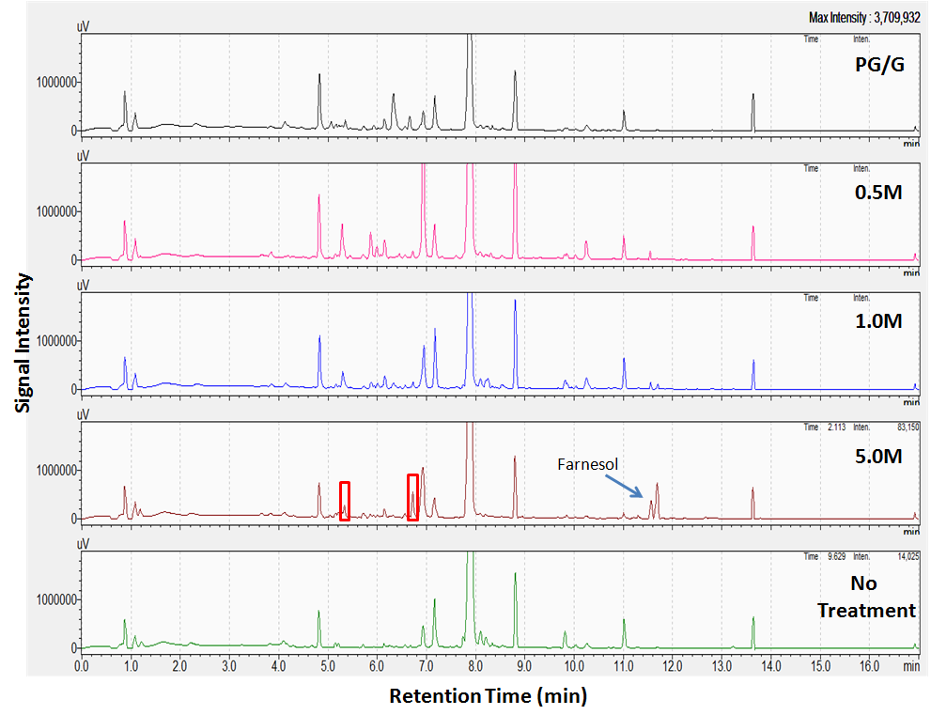

With the TX00268 TV8-2 fungus, in Figure 3.3, it appears that the different trials show the same compounds being produced. The only exceptions to this is that the 5.0 M and the "No Treatment" are missing a peak at approximately 12.9 minutes, and the signals between 3 and 7 minutes are much weaker. There does not appear to be any reason to pursue further chemistry with this fungus.

Figure 3. 3 LCMS comparison of TX00268 TV8-2 fungal flask
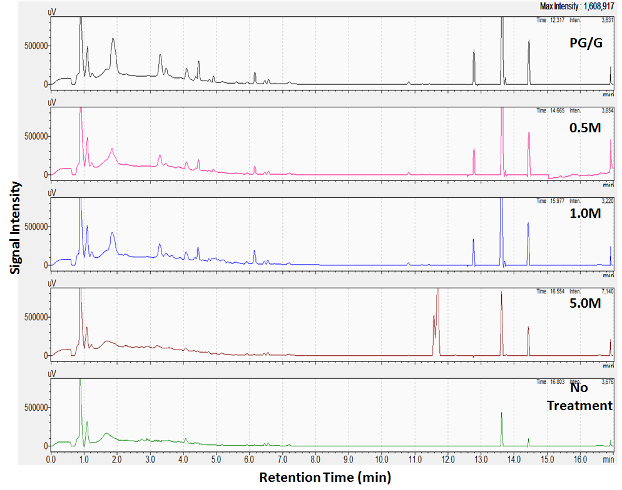
Looking at the LCMS comparison of the different concentrations for the MD2404 fungus, shown in Figure 3.4, there are some interesting results. In all of the treatments the compounds that are produced are the same outside of the 6.5 to 7.2 minute range, albeit with different intensities. In the 5.0 M treatment, within the 6.5 to 7.2 minute range there are three new compounds that are produced with a UV maximum of 241 nm, and the compounds have m/z values of 270, 272, and 320. These masses and UV value are similar to some brasilamide, pinthunamide, and isopimaradiene derivatives which have been previously isolated from this species of fungus. These induced metabolites may be new derivatives of these compounds.
Figure 3. 4 LCMS comparison of MD2404 fungal flasks
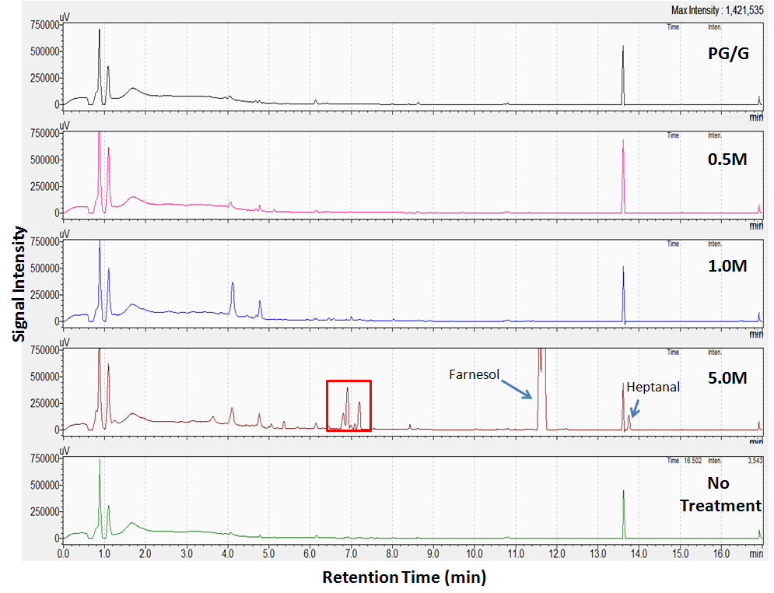

For the NM6332 fungus, the PDA chromatagrams, Figure 3.5, show some interesting results. Between the 10 and 15 minute marks, all of the treatments show the same compounds in present. Between the 3 to 7 minute marks, there appear to be several new compounds present in the 5.0 M treatment that do not show up in the chromatagrams for the other treatments. After comparing the UV data for each of the compounds to what was present in the Dictionary of Natural Products, there appear to be multiple known compounds that could be related to the ones that have been induced in the fungus. One compound in particular appears to be promising; the compound appears to have a molecular weight of 540 g/mole and has a UV maxima of 222 nm. These properties are similar to beauverolide B, which has a molecular weight of 543 g/mole and a UV maximum of 222 nm.
Figure 3. 5 LCMS comparison of NM6332 fungal flasks
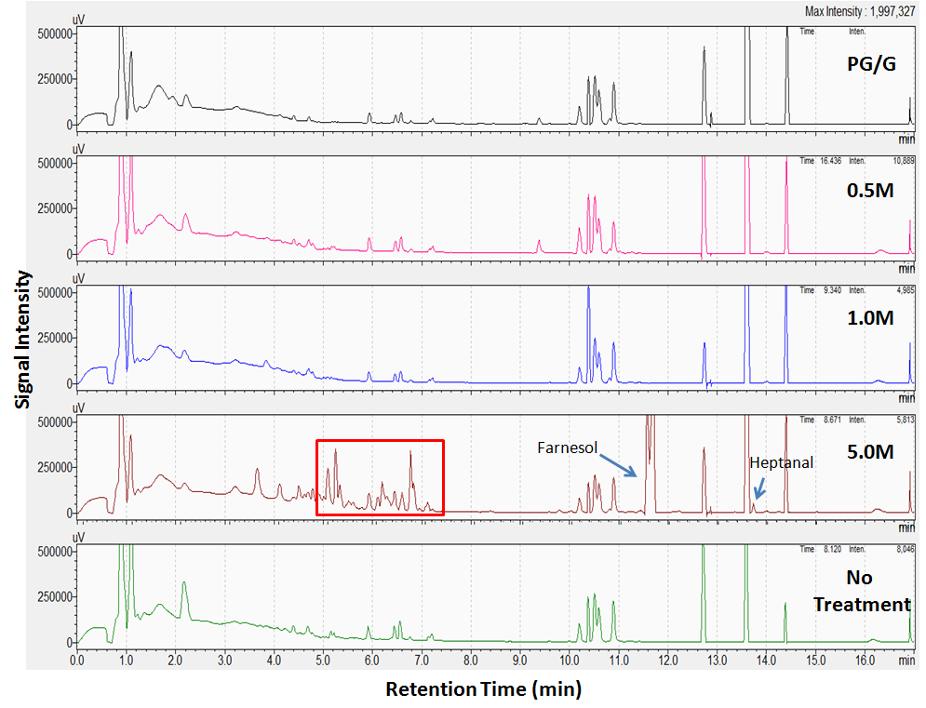

3.5 Conclusions
In conclusion, a protocol was developed to vaporize volatile oils from soil microbes onto fungi at different concentrations. The troubleshooting of the equipment, time settings, selection of volatile oils, set up of flasks, age of fungi at the start of use, length of time that the vapors were delivered, and quantification of 1-octanol delivered were determined as part of the protocol. Four different fungi were also tested as part of the initial tests. At this time, standardization of the amount of oils delivered to the flasks still needs to be done, as well as the quantification of 1-octanol delivered at different concentrations. The quantification should also be done with the remaining oils as well.
Three of the four fungi initially tested showed promising results for the production of new metabolites. The LCMS data showed that the Dubuque CZ-2, MD2404, and NM6332 have potential for producing new metabolites when exposed to the oil vapors. The first thing that would need to be done with these fungi, would be to confirm that these compounds are really being produced from the Fungal Smoker treatment by rerunning the experiment with these fungi. Upon any confirmations, the fungi should be grown in a large scale, extracted, and the new compounds should be isolated and elucidated. Finally, fungi should continue to be screened using the Fungal Smoker for the ability to produce new compounds when exposed to the vapors produced by the volatile oils. If new compounds are truly being produced it would be of interest to determine which oils are resulting in the production of new compounds.

Chapter 4
Development and Initial Testing of a Traumatic Injury Assay

4.1 Introduction
Traumatic injury, especially injury to the brain, has become an important field of study. With new insights into impacts on the body and head, groups such as the National Football League (NFL) and the United States Department of Defense (USDOD) have become interested in protecting athletes and soldiers, respectively. Traumatic injury is defined as an injury resulting from kinetic energy applied to a nerve or limb and can cause a range of physiological effects.⁴²As of 2011, it is believed that the number of service-men who suffered blast-related traumatic brain injuries is as high as 320,000 from the wars in Iraq and Afghanistan alone.⁴³ Many of the traumatic injuries in soldiers occur as a result of the shockwaves from blasts. These shockwaves can transfer kinetic energy to the central nervous system, causing lung injury and hemorrhage leading to hypoxia and ischemia, as well as blast-induced neurotrauma.⁴⁴ Symptoms from trauma have also been investigated in NFL athletes. In a study of retired NFL football players between the ages of 30 and 49, it was found that they were being diagnosed with dementia 20 times the rate of the age-matched population.⁴⁵ It was also found that there was decreased cerebral perfusion, higher incidences of depression, obesity, as well as attentional and memory problems in the retired NFL players compared to the general population .⁴⁵As a result of these types of serious symptoms associated with traumatic injuries, it is crucial to conduct research in order to discover new treatments and drugs that can prevent or repair damage done by these injuries.
With all of the new data that has surfaced pertaining to the effects of traumatic injuries, there are increased efforts to find new ways to try to prevent or repair damage on the body and head from these types of injuries. At this time, no viable treatment has been discovered, but multiple groups have begun to explore various aspects related to traumatic injury. Some of the approaches include targeting specific proteins and studying their physiological effects, as well as using higher level organisms, like mice, to understand the mechanisms of traumatic injuries. Only a few research groups are currently investigating the problem using lower level organisms, including, but not limited to, fruit flies, nematodes, and brine shrimp. The use of these types of organisms not only allow for lower costs and larger sample sizes in studying physiological effects, but also does not require extra approval from the government. Unfortunately, the results obtained in studying these organisms do not always transfer over to the higher level organisms. The Wassarman group is one of the groups that has been using lower level organisms for traumatic injury research. This research group has been using fruit flies to study the physiological and neurological effects of the injuries, as well as testing several compounds for the improvement of longetivity in injured flies.⁴⁶⁻⁴⁸ To test the aforementioned aspects of traumatic injury, the Wassarman group developed an assay that would consistently inflict traumatic injury to the fruit flies using a fly culture tube connected to a spring, which is pulled back to a set angle and released to impact a surface.⁴⁸ These studies looked at the survival of the flies at different ages, with different amounts of impacts, effects of gender, effects of different fly strains, and treatments with several compounds.
In this project, the goal was to develop an assay where traumatic injury can be induced into lower level organisms. Once injured, the organism would be treated with pure compounds and fungal extracts in order to screen for activity in preventing or repairing the traumatic injury. The development of the project focuses on the selection of an organism, developing a protocol for inducing the injury, troubleshooting problems with the method, and obtaining initial results from the pure compounds and fungal extracts.

4.2 Development of Protocol

4.2.1 Cannon and Projectiles
The cannon, shown in Figure 4.1, was set up so that the missiles angle of impact with the target was roughly between 77.5 and 85 degrees, resulting in an angle of reflection of 10 to 25 degrees. The target wall was positioned 7.5 feet away from the cannon. Once aimed, the cannon was loaded by pushing the projectile into the back of the barrel. At this point an external air pump was used to compress air into the holding area. A pressure gauge informed the operator of the air pressure in the cannon and was used between the lower and upper limits of 15 and 65 pounds per square inch (psi) respectively. When the operator had gone through the pre-firing checklist, the trigger was pulled, which released the air out of the holding area, into the barrel and the projectile was ejected at the target wall. Any residual air in the cannon was released through another pull on the trigger which allowed the cannon to be loaded again
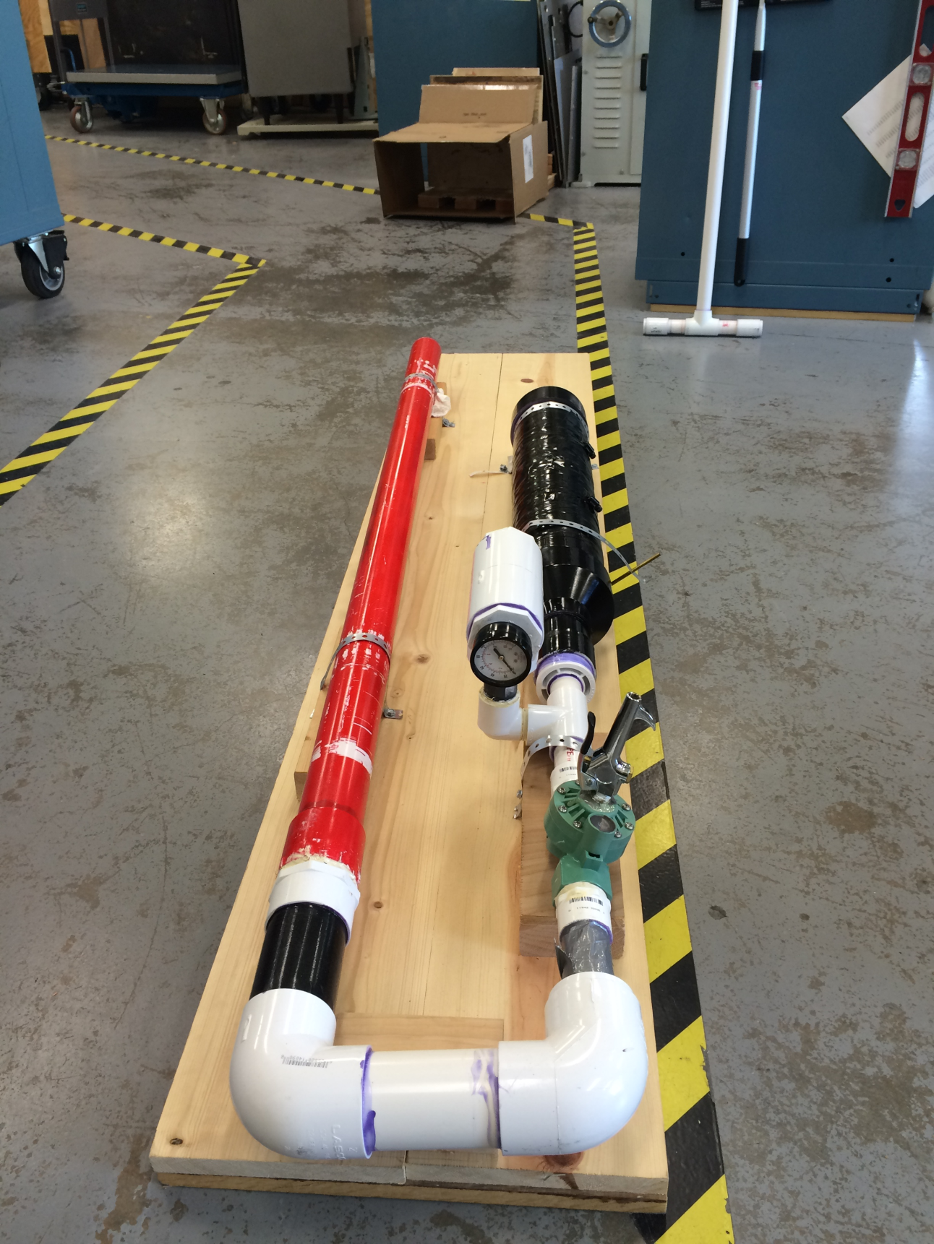
Figure 4. 1 Labeled diagram of the traumatic injury inducing cannon
Target
Barrel
Air
Reservoir
Pressure
Gauge
Trigger

4.2.2 Test Subjects
Once the protocol for using the cannon was developed, the next step was to figure out what kind of projectile would be used to deliver the traumatic injury, as well as to determine how to set up the vessels containing the test subjects. Microcentrifuge tubes, with a 1.5 mL volume, were chosen as the vessel for the test subjects due to them being small enough to fit multiple tubes into a projectile, their low cost, and their ability to hold organisms and liquids sealed within the tube. While doing the initial shots out of the cannon, it was realized that the Microcentrifuge tubes had a problem in that they would shatter upon impact; as a result multiple methods were tested to reduce the stress on the tubes to prevent them from shattering. At first different grains were used with minimal success; afterwards it was found that making a coozy with slots for the microcentrifuge tubes reduced stress on the tubes enough where they were able to withstand shots even at 65 psi, the highest pressure tested. Figure 4.2A shows how the microcentrifuge tubes (shown in red) fit into the foam coozy. The microcentrifuges and the coozy are slid into the projectile so that the caps of the tubes are facing the closed end of the projectile (the impact side).
Four different designs for the projectile were tested during the initial development of the procedure. The designs for projectiles 1 through 4 are shown in Figure 4.2B and each of them had its individual positive and negative qualities. With Projectile 1, the length was ideal for shooting three instead of two microcentrifuge tubes resulting in less shots required, also the metal top helped strengthen the missile. The problem with 1 was that the metal top increased the mass of the missile giving it more momentum and with the top having a smaller surface area, the amount of damage to the target upon impact was increased. Projectile 2 can hold 3 microcentrifuge tubes as well but has a flat, more spread impact surface, reducing the damage done to the target; without the metal top, 2 is a bit weaker than 1. Projectile 3 is probably the cheapest to make out of the four projectiles, but only two tubes can be fired at a time. Projectile 4 had by far the largest mass out of the four projectiles and the highest cost, and was only capable of holding two microcentrifuge tubes. 4 was also not capable of reaching the target completely and would damage the base of the target, but the design was the most sturdy out of all of the missiles.
Figure 4. 2 A) Set up of brine shrimp traumatization projectile B) Different projectile designs tested

4.2.2 Test Subjects
One of the first steps in designing the project was to determine the type of organism to use. The overall goal was to find an organism where multiple test subjects could be tested at the same time, with 40-60% of the subjects surviving the impact 48 hours after firing. Moreover, the organism needed to be hardy enough to withstand an impact at a certain pressure, but not too hardy to require an impact beyond the pressure capabilities of the cannon. Multiple organisms were tested for these characteristics, including wax worms, meal worms, crickets, fruit flies, nematodes, and brine shrimp.
Wax worms were the worst test specimen for this study because even under the lowest cannon pressure, the wax worms disintegrated. Meal worms mostly survived intact at low pressures, but after the impact they would die within 24 hours. Fruit flies were tested and a good percentage of the flies were able to survive. Although fruit flies survived the impact, they posed several problems. First, the fruit flies needed to be fed in order to keep them alive for multiple days, leading to more variables that would need to be controlled. Also, there was no reliable method to treat the flies with consistent amounts of the test materials. Finally, the reproductive speed of the flies also provided a problem since transfers would need to be performed to prevent inaccurate counts resulting from new fruit flies hatching. The next organism, crickets, were able to survive higher impacts than the rest of the organisms,however,the crickets posed problems due to difficulties in treating them with the test samples, and only one cricket could be fired at a time. Although crickets may not be a good option for initial screening, they could provide opportunities for higher level screenings.
In the end, two organisms, brine shrimp (Artemia salina) and nematodes (Caenorhabditis elegans), were determined to have the best potential for test specimens in this study. Since precedence exists for using both brine shrimp and nematodes in assays, growth protocols have been developed for both organisms. The maturation of brine shrimp and nematodes is relatively short and they are small enough where multiple subjects can be tested with each shot. Also, the treatment of both organisms with the test sample is as simple as injecting the materials into the solution with the test subjects. Although both organisms showed good potential for this project, brine shrimp were selected for initial work due to limited time allowed for developing the project, and the shrimp having fewer variables to account for. Even so, nematodes appear to be a better model for the project since more information pertaining to this organism is readily available and there are various mutants that can be applied to test a range of different variables. They show potential for future work but there are still many variables that need to be tested before a set protocol can be prepared for using the organism.

4.3 Troubleshooting Brine Shrimp
In the initial studies, samples treated with glucosamine showed activity in decreasing the fatal damage to the brine shrimp, represented by an increased survival percentage. Once the activity was confirmed, a concentration study was performed. The results of this study showed that there was no activity from glucosamine increasing the survival of brine shrimp. The study was then repeated and the results showed irregular data where certain samples showed activity while others showed none. At this point, the experimental design was adjusted in order to try to repeat the initial results.
The first test was related to the hatching conditions of the brine shrimp. Initially the brine shrimp were grown in a 500 mL Erlenmeyer flask with 300 mL of distilled water and Instant Ocean salt mixture at room temperature (~22°C). A Pasteur pipette was used to bubble house air into the growth flask to keep the solution aerated. This method required a 72 hour grow up and resulted with inconsistent yields of shrimp. The next test incorporated an intermediate flask that bubbled the house air through water before passing the air into the brine shrimp growth flask. This was done in order to remove any impurities that may have existed in the house air. This method did not improve the consistency of brine shrimp hatching. After the test failed, it was believed that the batch of brine shrimp eggs was compromised. Although a different batch of eggs was tested, there was no improvement. Finally, in the literature, a method was found that used an orbital shaker to hatch brine shrimp.⁴⁹ The flask with the brine shrimp eggs was placed into a New Brunswick Scientific, Innova®44 orbital shaker set at 28°C and 130 rpm as shown in Figure 4.3. After 48 hours there was an increased amount of hatched brine shrimp in the flask, which matched what was commonly shown in the literature. It should be noted that this method was consistently repeated in this project to hatch shrimp.
Figure 4. 3 A) Brine shrimp hatching flask on orbital shaker B) Orbital shaker with the hatchery

With the brine shrimp still not showing consistent results after impact, the procedure with the cannon was standardized. Several variables were analyzed related to the cannon including the average speed and standard deviation of the missiles, angle of impact on the target, and distance of the cannon from the target. To determine the initial velocity of the missiles, two photogates were employed to find the amount of time it took the missile to travel a set distance. Using Equation 1, where D represents distance and T represents time, the velocity and the standard deviation were calculated. This ensured the inconsistencies with firing of the cannon were not the source of the problems for the results. Next, the cannon was set to fire at a distance of 7.5 ft with an angle of impact of 77.5-85° to the target to ensure the impacts would be consistent. At this point the brine shrimp were tested with a glucosamine treatment one last time. Once again, the experimental results showed that the glucosamine was inactive and glucosamine was dropped as a hit in the assay.

Equation 1: Calculation to determine velocity of the missile
$$V=\frac{D}{T}$$

4.4 Cannon Velocity Studies
To determine whether the cannon was firing at a consistent velocity, an investigation into the velocity the projectiles were being launched at was conducted. In order to carry out this type of investigation, it was necessary to obtain two photogates attached to a timing mechanism. The elapsed time to travel a set distance was determined from the photogates by starting the timer when the infrared plane was broken at the first photogate and stopping the timer when the plane was broken on the second one. Using the time and the set distance between the two photogates, the velocity of the missile exiting the barrel was determined.
The photogates were connected to the timer and placed on a clipboard allowing for easy loading of the cannon while maintaining the same distance between the photogates. At this point, the outer and inner diameters between the two photogates were measured using calipers. The average of the diameters was used as the value for the travel distance of the projectile. The photogates were then placed in front of the cannon barrel, before ensuring they were perfectly aligned to prevent the projectile from hitting either one. At this point, the cannon was pressurized and fired. The measurements were done in triplicate at 15, 25, 35, 45, 55, and 65 psi. The results are shown in Table 4.1 and Figure 4.4.
Table 4. 1 Average velocities over a range of launch pressures
Pressure (psi) | Average Velocity (mph) | Standard Deviation (mph)
15 | 38.53 | 0.50
25 | 60.96 | 0.73
35 | 74.19 | 1.86
45 | 85.59 | 1.44
55 | 93.71 | 3.42
65 | 101.30 | 1.60

Figure 4. 4 Graph of the average velocity of the projectile using different launch pressure

4.5 Initial Assay Results

4.5.1 Pure Compound Results
Figure 4. 5 Pre-treatment assay results using select pure compounds
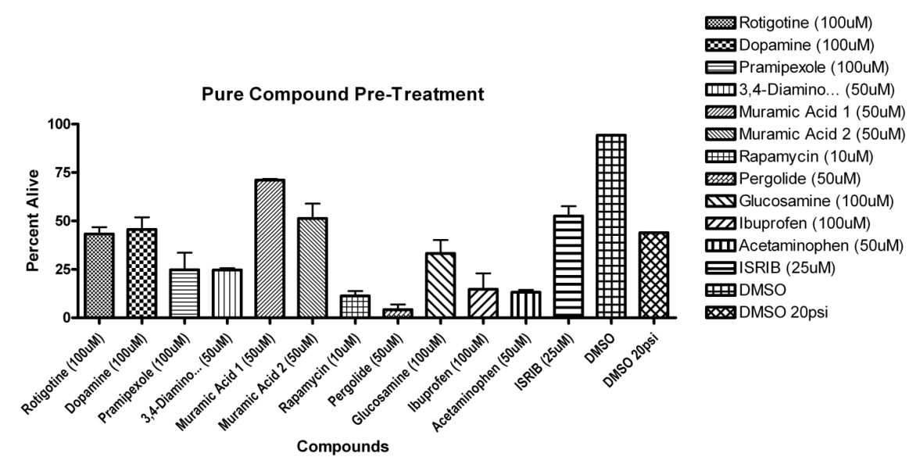
Figure 4. 6 Post-treatment assay results using select pure compounds
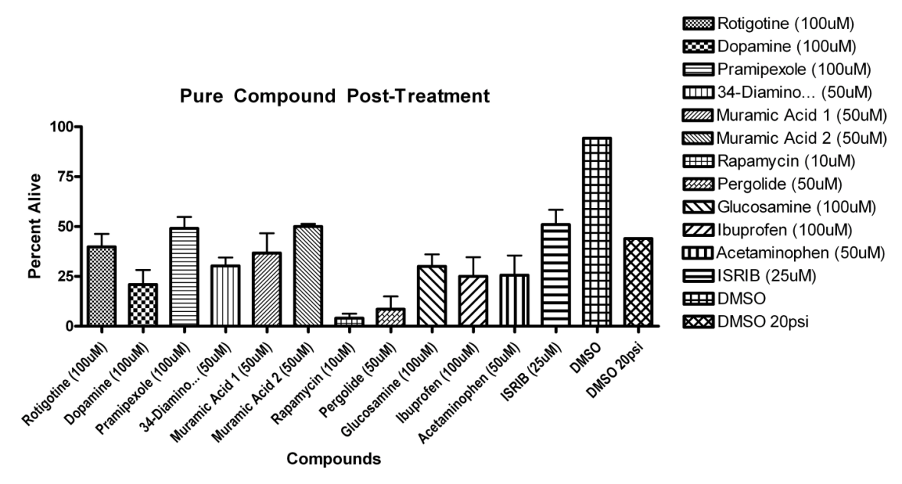

From the compounds that were tested for activity in preventing damage from traumatic injury, muramic acid appeared to initially show activity at a concentration of 50 μM. As observed from Figure 4.5, approximately 70% of brine shrimp survived from the initial test. When muramic acid was retested, activity was weaker, with about 55% of the brine shrimp surviving. ISRIB also showed slight activity at 25μM with approximately 55% of brine shrimp surviving. When the compounds were tested for activity in repairing damage from traumatic injury, it is observed from Figure 4.6 that none of the compounds showed exceptional activity.

4.5.2 Plate 141 Extract Results
Figure 4. 7 First part of the pre-treatment assay results using fungal extracts
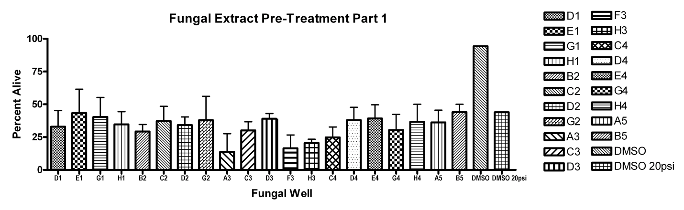
Figure 4. 8 Second part of the pre-treatment assay results using fungal extracts
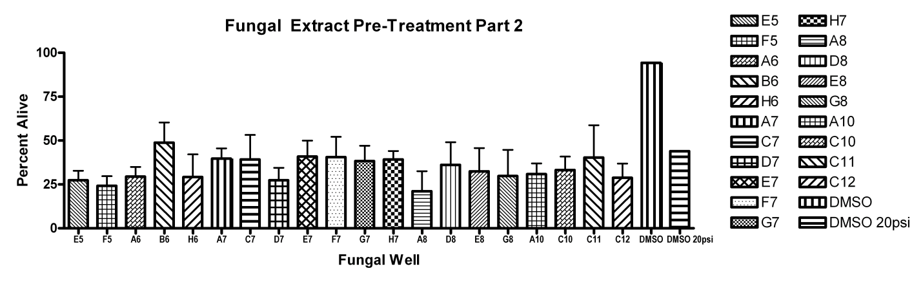
Figure 4. 9 First part of the post-treatment assay results using fungal extracts
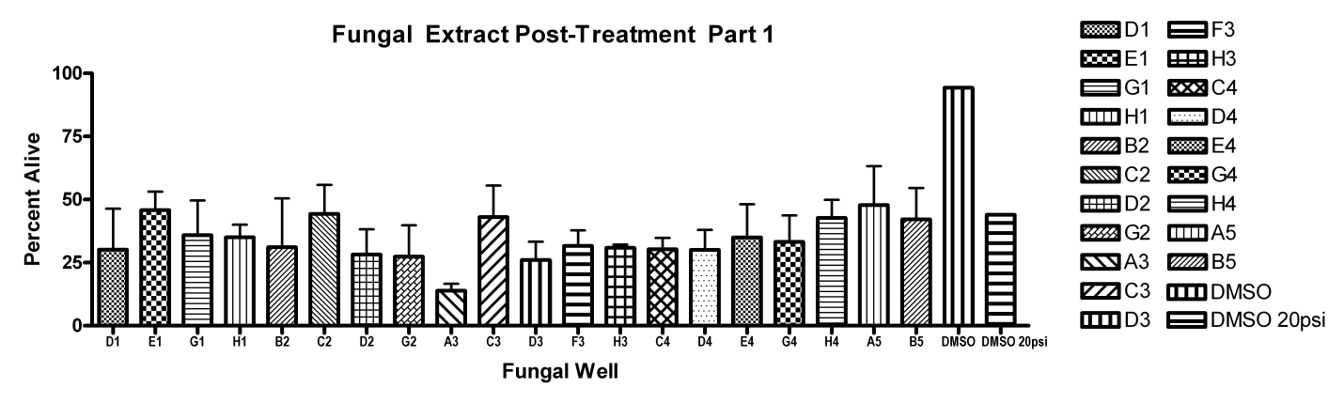
Figure 4. 10 Second part of the post-treatment assay results using fungal extracts
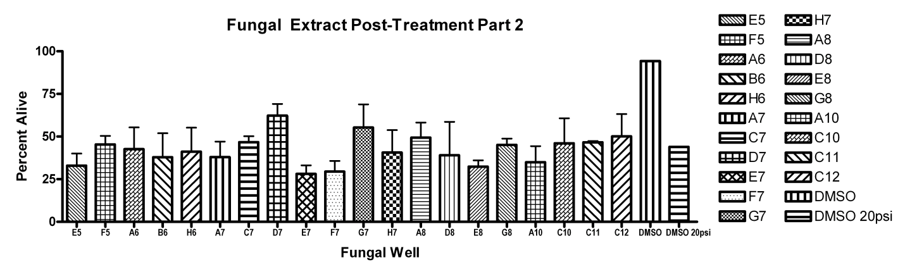

When the fungal extracts were tested for activity in preventing damage from traumatic injury, Figures 4.7 and 4.8 show there was no extract that increased the survival rate in brine shrimp. When the extracts were tested to determine if they repaired damage from traumatic injury, Figure 4.9 shows no extracts that increased survival for the brine shrimp, but from Figure 4.10, it is observed that wells D7 and G7 had about 60 and 55% survival respectively in brine shrimp. Wells D7 and G7 represent a slight increase in survival compared to the negative control for the post-treated shrimp.

4.5.3 Summary of Results
From the 12 pure compounds that were tested, it appears that muramic acid shows the most promise, while ISRIB shows some promise as well for preventing damage from traumatic injury. Several compounds did not show any activity in preventing or repairing damage while the remaining ones appeared to actually do more harm than good in regards to the survival rate of the shrimp.
Out of the 40 fungal extracts that were tested, a couple of the extracts appeared to do more harm than good with the brine shrimp while the majority showed no activity in preventing or repairing damage from traumatic injury. Although only the extracts in wells D7 and G7 showed potential to repair damage and increased the survival of the shrimp, a confirmation would need to be done first before further investigation into the active compounds would be done.

4.6 Future Directions
There are several directions in which this project can progress. First, more extract plates can be tested for activity, as there is only a small possibility that the extracts tested from only one 96-well plate would provide any active materials. A minimum of 100 extracts should be screened for this project, since screening more plates should increase the probability of finding an extract that exhibits preventative or reparative activities against traumatic injury. Also, with the brine shrimp, explorations in the effects of the extracts at a slightly lower launch pressure can be done by going from 20 psi to 15 psi. Lowering the pressure may help this project, considering that a higher pressure may lead to false negatives. Moreover, it is possible that the pure compounds are being tested at concentrations that are too high in this project, and it may be of value to retest them all at lower concentrations. Further improvement directly related to this project would be to conduct additional testing with muramic acid, which in the current studies has shown activity.
Another potential avenue for the project would be to develop a protocol to use nematodes with the cannon. There are two main variables required before the nematodes could be used for screening. The first variable is the optimal age of the nematodes after synchronization. An ideal age would be when the nematodes have high movement and liveliness and are hardy enough not to fragment upon impact. The second variable is the number of times that the nematodes would need to be fired at 65 psi to induce a traumatic injury. These two variables appear to be the last two pieces that need to be determined before nematodes can be used to test extracts and compounds.

4.7 Conclusions
Along with nematodes, brine shrimp were chosen as the best organisms for this assay. At this point a set protocol has been determined for the use of brine shrimp. With initial testing, most of the materials showed no activity in preventing or repairing damage done from the traumatic injuries in the brine shrimp. It appears that muramic acid as well as the fungal extracts in wells D7 and G7 (to a lesser degree) from plate 141 showed activity in preventing and repairing damage, respectively. Additional investigations should be conducted to confirm these activities and to observe activities at different concentrations. Finalizing a protocol for nematodes would also be of value at this point in the experiment.

References
1. Ji, H. F.; Li, X. J.; Zhang, H. Y., Natural products and drug discovery. Can thousands of years of ancient medical knowledge lead us to new and powerful drug combinations in the fight against cancer and dementia? 2009, 10 (3), 194-200.
2. Baltz, R. H., MbtH homology codes to identify gifted microbes for genome mining. Journal of Industrial Microbiology & Biotechnology 2014, 41 (2), 357-369.
3. David, B.; Wolfender, J.-L.; Dias, D. A., The pharmaceutical industry and natural products: historical status and new trends. Phytochemistry Reviews 2015, 14 (2), 299-315.
4. Borel, J. F., History of the discovery of cyclosporin and of its early pharmacological development. Wiener klinische Wochenschrift 2002, 114 (12), 433-7.
5. Kaminski, H. J., Myastenia Gravis and Related Disorders. Humana Press: 2009; p 302.
6. Fan, Y.-Y.; Zhang, H.; Zhou, Y.; Liu, H.-B.; Tang, W.; Zhou, B.; Zuo, J.-P.; Yue, J.-M., Phainanoids A–F, A New Class of Potent Immunosuppressive Triterpenoids with an Unprecedented Carbon Skeleton from Phyllanthus hainanensis. Journal of the American Chemical Society 2015, 137 (1), 138-141.
7. Lemke, T. W., David; Roche, Victoria; Zito, S., Foye's Principles of Medicinal Chemistry. 7th ed.; Lippincott Williams & Wilkins: Philidelphia, 2013.
8. Aspirin Pharmacokinetics. http://sepia.unil.ch/pharmacology/index.php?id=83 (accessed Aug 16).
9. Madan, R. K.; Levitt, J., A review of toxicity from topical salicylic acid preparations. Journal of the American Academy of Dermatology 2014, 70 (4), 788-792.
10. Malik, S.; Cusidó, R. M.; Mirjalili, M. H.; Moyano, E.; Palazón, J.; Bonfill, M., Production of the anticancer drug taxol in Taxus baccata suspension cultures: A review. Process Biochemistry 2011, 46 (1), 23-34.
11. Wall, M. E.; Wani, M. C., Camptothecin and Taxol: Discovery to Clinic—Thirteenth Bruce F. Cain Memorial Award Lecture. Cancer Research 1995, 55 (4), 753-760.
12. B.H. Guo, G. Y. K., H.B. Jin, K.X. Tang, Taxol Synthesis. African Journal of Biotechnology 2006, 5 (1), 5.
13. Goeddel, D. V.; Kleid, D. G.; Bolivar, F.; Heyneker, H. L.; Yansura, D. G.; Crea, R.; Hirose, T.; Kraszewski, A.; Itakura, K.; Riggs, A. D., Expression in Escherichia coli of chemically synthesized genes for human insulin. Proceedings of the National Academy of Sciences 1979, 76 (1), 106-110.
14. Liu, Y.-Y.; Wang, Y.; Walsh, T. R.; Yi, L.-X.; Zhang, R.; Spencer, J.; Doi, Y.; Tian, G.; Dong, B.; Huang, X.; Yu, L.-F.; Gu, D.; Ren, H.; Chen, X.; Lv, L.; He, D.; Zhou, H.; Liang, Z.; Liu, J.-H.; Shen, J., Emergence of plasmid-mediated colistin resistance mechanism MCR-1 in animals and human beings in China: a microbiological and molecular biological study. The Lancet Infectious Diseases 2016, 16 (2), 161-168.
15. Carattoli, A., Plasmid-mediated antimicrobial resistance in Salmonella enterica. Current issues in molecular biology 2003, 5 (4), 113-122.
16. Ling, L. L.; Schneider, T.; Peoples, A. J.; Spoering, A. L.; Engels, I.; Conlon, B. P.; Mueller, A.; Schaberle, T. F.; Hughes, D. E.; Epstein, S.; Jones, M.; Lazarides, L.; Steadman, V. A.; Cohen, D. R.; Felix, C. R.; Fetterman, K. A.; Millett, W. P.; Nitti, A. G.; Zullo, A. M.; Chen, C.; Lewis, K., A new antibiotic kills pathogens without detectable resistance. Nature 2015, 517 (7535), 455-459.
17. Demain, A. L., Importance of microbial natural products and the need to revitalize their discovery. Journal of Industrial Microbiology & Biotechnology 2014, 41 (2), 185-201.
18. Blackwell, M., The fungi: 1, 2, 3 ... 5.1 million species? American journal of botany 2011, 98 (3), 426-38.
19. Bennett, J. W.; Chung, K.-T., Alexander Fleming and the discovery of penicillin. In Advances in Applied Microbiology, Academic Press: 2001; Vol. Volume 49, pp 163-184.
20. Moore, D. S., The developing genome: An introduction to behavioral epigenetics. Oxford University Press: 2015.
21. Chen, H.-J.; Awakawa, T.; Sun, J.-Y.; Wakimoto, T.; Abe, I., Epigenetic modifier-induced biosynthesis of novel fusaric acid derivatives in endophytic fungi from Datura stramonium L. Natural Products and Bioprospecting 2013, 3 (1), 20-23.
22. Trichomoniasis - CDC Fact Sheet. Services, U. S. D. o. H. H., Ed. Centers for Disease Control and Prevention: Atlanta, GA, 2016.
23. Soper, D., Trichomoniasis: under control or undercontrolled? American Journal of Obstetrics and Gynecology 2004, 190 (1), 281-290.
24. Cudmore, S. L.; Delgaty, K. L.; Hayward-McClelland, S. F.; Petrin, D. P.; Garber, G. E., Treatment of infections caused by metronidazole-resistant Trichomonas vaginalis. Clinical microbiology reviews 2004, 17 (4), 783-93, table of contents.
25. Nanda, N.; Michel, R. G.; Kurdgelashvili, G.; Wendel, K. A., Trichomoniasis and its treatment. Expert Review of Anti-infective Therapy 2006, 4 (1), 125-135.
26. Ings, R. M. J.; McFadzean, J. A.; Ormerod, W. E., The mode of action of metronidazole in Trichomonas vaginalis and other micro-organisms. Biochemical Pharmacology 1974, 23 (9), 1421-1429.
27. Johnson, G. L. Tinidazole (Tindamax) for Trichomoniasis and Bacterial Vaginosis American Family Physician [Online], 2009, p. 102-105. http://www.aafp.org/afp/2009/0115/p102.html (accessed 11/27/2016).
28. Kawaguchi, M.; Uchida, R.; Ohte, S.; Miyachi, N.; Kobayashi, K.; Sato, N.; Nonaka, K.; Masuma, R.; Fukuda, T.; Yasuhara, T.; Tomoda, H., New dinapinone derivatives, potent inhibitors of triacylglycerol synthesis in mammalian cells, produced by Talaromyces pinophilus FKI-3864. The Journal of antibiotics 2013, 66 (3), 179-89.
29. Uchida, R.; Ohte, S.; Kawamoto, K.; Yamazaki, H.; Kawaguchi, M.; Tomoda, H., Structures and absolute stereochemistry of dinapinones A1 and A2, inhibitors of triacylglycerol synthesis, produced by penicillium pinophilum FKI-3864. The Journal of antibiotics 2012, 65 (8), 419-25.
30. Pitt, J. I., The genus Penicillium and its teleomorphic states Eupenicillium and Talaromyces. The genus Penicillium and its teleomorphic states Eupenicillium and Talaromyces. 1979.
31. Tabata, N.; Tomoda, H.; Matsuzaki, K.; Omura, S., Structure and biosynthesis of xanthoquinodins, anticoccidial antibiotics. Journal of the American Chemical Society 1993, 115 (19), 8558-8564.
32. Yoganathan, K.; Cao, S.; Crasta, S. C.; Aitipamula, S.; Whitton, S. R.; Ng, S.; Buss, A. D.; Butler, M. S., Microsphaerins A–D, four novel benzophenone dimers with activity against MRSA from the fungus Microsphaeropsis sp. Tetrahedron 2008, 64 (44), 10181-10187.
33. Dewick, P. M., Secondary Metabolism: The Building Blocks and Construction Mechanisms. In Medicinal Natural Products, John Wiley & Sons, Ltd: 2009; pp 7-38.
34. Hauser, A.-T.; Jung, M., Targeting epigenetic mechanisms: potential of natural products in cancer chemoprevention. Planta medica 2008, 74 (13), 1593-1601.
35. Du, L.; King, J. B.; Cichewicz, R. H., Chlorinated polyketide obtained from a Daldinia sp. treated with the epigenetic modifier suberoylanilide hydroxamic acid. Journal of natural products 2014, 77 (11), 2454-8.
36. Cichewicz, R. H., Epigenome manipulation as a pathway to new natural product scaffolds and their congeners. Natural product reports 2010, 27 (1), 11-22.
37. Kaminski, E.; Stawicki, S.; Wasowicz, E., Volatile flavor compounds produced by molds of Aspergillus, Penicillium, and Fungi imperfecti. Applied Microbiology 1974, 27 (6), 1001-1004.
38. Hung, R.; Lee, S.; Bennett, J. W., Fungal volatile organic compounds and their role in ecosystems. Applied Microbiology and Biotechnology 2015, 99 (8), 3395-3405.
39. Bitas, V.; Kim, H.-S.; Bennett, J. W.; Kang, S., Sniffing on Microbes: Diverse Roles of Microbial Volatile Organic Compounds in Plant Health. Molecular Plant-Microbe Interactions 2013, 26 (8), 835-843.
40. Hung, R.; Lee, S.; Rodriguez-Saona, C.; Bennett, J. W., Common gas phase molecules from fungi affect seed germination and plant health in Arabidopsis thaliana. AMB Express 2014, 4 (1), 1-7.
41. Lee, S.; Hung, R.; Yap, M.; Bennett, J. W., Age matters: the effects of volatile organic compounds emitted by Trichoderma atroviride on plant growth. Archives of Microbiology 2015, 197 (5), 723-727.
42. Robinson, L. R., Traumatic injury to peripheral nerves. Muscle & Nerve 2000, 23 (6), 863-873.
43. Mac Donald , C. L.; Johnson , A. M.; Cooper , D.; Nelson , E. C.; Werner , N. J.; Shimony , J. S.; Snyder , A. Z.; Raichle , M. E.; Witherow , J. R.; Fang , R.; Flaherty , S. F.; Brody , D. L., Detection of Blast-Related Traumatic Brain Injury in U.S. Military Personnel. New England Journal of Medicine 2011, 364 (22), 2091-2100.
44. Cernak, I.; Noble-Haeusslein, L. J., Traumatic Brain Injury: An Overview of Pathobiology with Emphasis on Military Populations. Journal of Cerebral Blood Flow & Metabolism 2010, 30 (2), 255-266.
45. Amen, D. G.; Wu, J. C.; Taylor, D.; Willeumier, K., Reversing Brain Damage in Former NFL Players: Implications for Traumatic Brain Injury and Substance Abuse Rehabilitation. Journal of Psychoactive Drugs 2011, 43 (1), 1-5.
46. Katzenberger, R. J.; Chtarbanova, S.; Rimkus, S. A.; Fischer, J. A.; Kaur, G.; Seppala, J. M.; Swanson, L. C.; Zajac, J. E.; Ganetzky, B.; Wassarman, D. A., Death following traumatic brain injury in Drosophila is associated with intestinal barrier dysfunction. eLife 2015, 4, e04790.
47. Katzenberger, R. J.; Ganetzky, B.; Wassarman, D. A., The gut reaction to traumatic brain injury. Fly 2015, 9 (2), 68-74.
48. Katzenberger, R. J.; Loewen, C. A.; Wassarman, D. R.; Petersen, A. J.; Ganetzky, B.; Wassarman, D. A., A Drosophila model of closed head traumatic brain injury. Proceedings of the National Academy of Sciences 2013, 110 (44), E4152-E4159.
49. Gadd, G.; Chalmers, K.; Reed, R., The role of trehalose in dehydration resistance of Saccharomyces cerevisiae. FEMS Microbiology Letters 1987, 48 (1-2), 249-254.

Appendix

A.1 NMR spectra for Dinapinone AB1/2
a) ¹H NMR (400MHz) in CDCl₃
b)¹³C NMR (400MHz) in CDCl₃
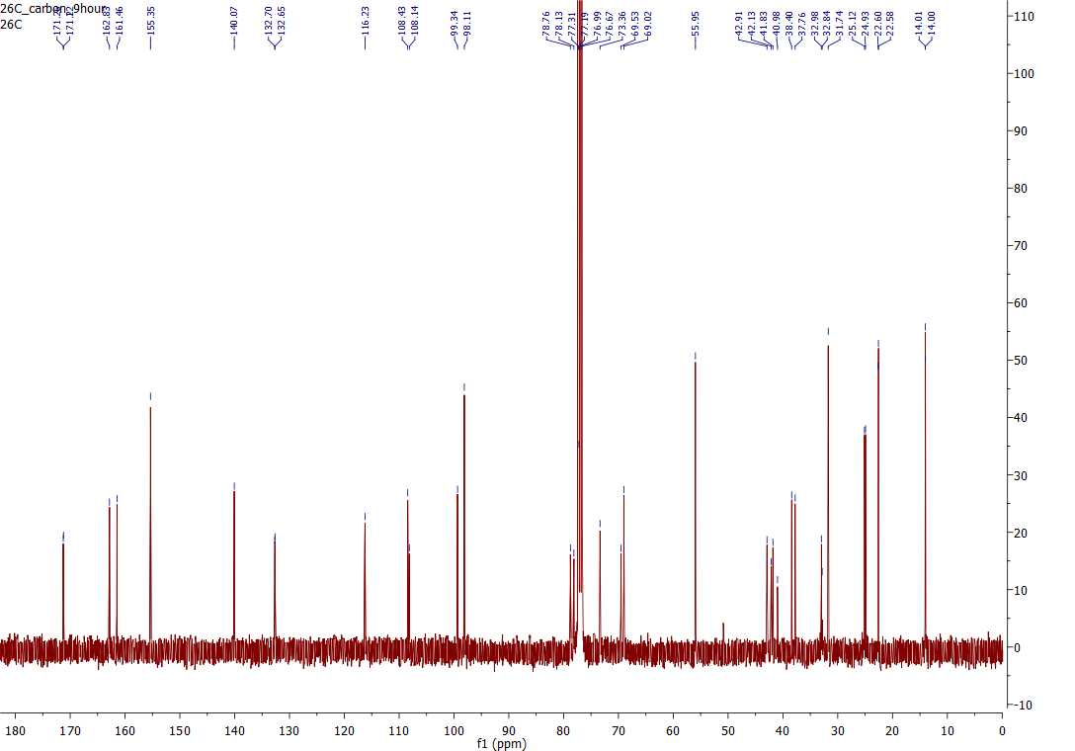
c) HSQC NMR (400MHz) in CDCl₃
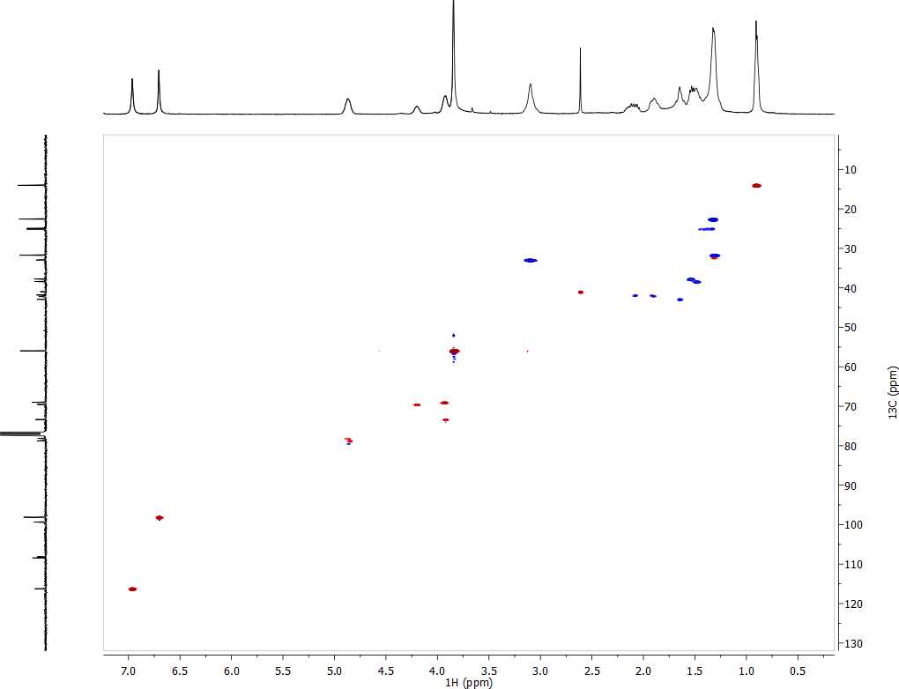
d) COSY NMR (400MHz) in CDCl₃
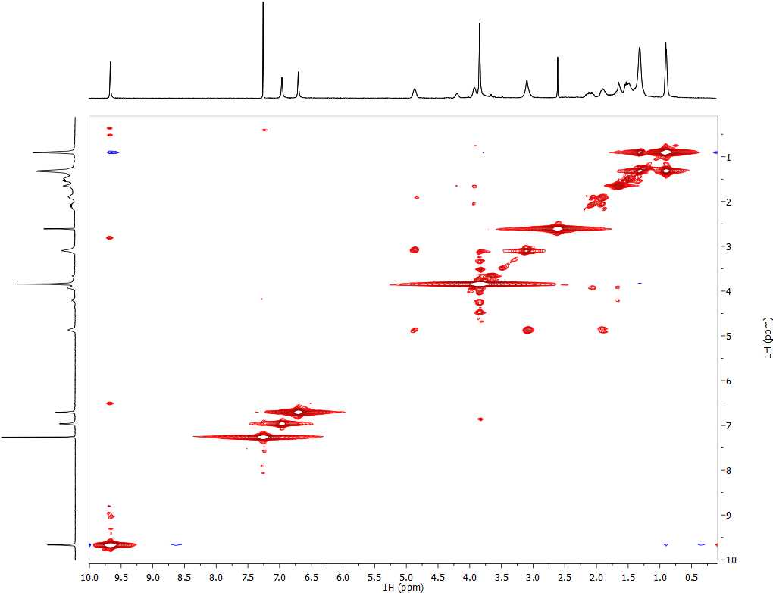

e) HMBC NMR (400MHz) in CDCl₃
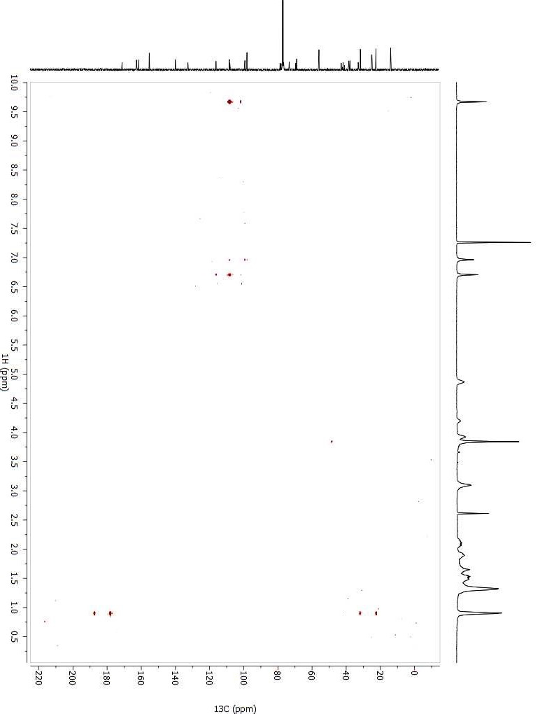

A.2 HRESIMS for Dinapinone A1/2

A.3 ¹H NMR (400MHz) in CDCl₂ for Dinapinone A2

A.4 ¹H NMR Table for 3 and 5 and ¹³C NMR Table for 3
¹H data for 3 and 5
3 |  |  |  | 5
No. | δ_{H}^{a,b,c} | Splitting | J (Hz) | No. | δ_{H}^{a,b,c} | Splitting | J (Hz)
1 | 1.3 | M |  | 1 | 0.89 | t | 6.49, 6.49
2 | 6.96 | S |  | 2 | 1.3 | m
3 | 9.67 | S |  | 3 | 1.46 | m
4 | 1.62 | ddd |  | 4 | 1.6 | ddd | 11.33, 20.79
5 | 0.9 | T | 3.21 | 5 | 1.68 | ddd
6 | 1.89 | ddd |  | 6 | 1.89 | ddd
7 | 1.34 | M |  | 7 | 2.11 | ddd | 13.13, 19.87
8 | 1.52 | M |  | 8 | 3.09 | dd | 14.23, 14.23
9 | 2.09 | ddd | 7.59, 15.48 | 9 | 3.83 | s
10 | 1.67 | ddd |  | 10 | 3.94 | m
11 | 3.84 | S |  | 11 | 4.19 | dddd
12 | 3.92 | M |  | 12 | 4.86 | dddd
13 | 4.2 | dddd |  | 13 | 6.69 | s
14 | 4.87 | dddd |  | 14 | 6.95 | s
15 | 6.7 | S |  | 15 | 9.66 | s
16 | 13.7 | S |  | 16 | 13.72 | s
17 | 3.1 | dd
18 | 1.32 | M
ª Measured in CDCl₃ ^{b} Measured on 400MHz instrument ^{c} δ in ppm

¹³C data for 3
3
No. | δ^{a,b,c} | No. | δ^{a,b,c}
1 | 14.0 | 24 | 98.11
2 | 14.01 | 25 | 98.1
3 | 22.58 | 26 | 99.3
4 | 22.6 | 27 | 99.34
5 | 24.93 | 28 | 108.14
6 | 25.12 | 29 | 108.4
7 | 31.73 | 30 | 108.43
8 | 31.74 | 31 | 116.23
9 | 32.84 | 32 | 116.26
10 | 32.98 | 33 | 132.65
11 | 37.76 | 34 | 132.7
12 | 38.4 | 35 | 140.07
13 | 41.83 | 36 | 140.08
14 | 42.13 | 37 | 155.35
15 | 42.2 | 38 | 155.4
16 | 42.91 | 39 | 161.4u u6
17 | 55.95 | 40 | 161.5
18 | 56.0 | 41 | 162.83
19 | 69.02 | 42 | 162.87
20 | 69.53 | 43 | 171.22
21 | 73.36 | 44 | 171.26
22 | 78.13 | 45
23 | 78.76 | 46
ª Measured in CDCl₃ ^{b} Measured on 400MHz instrument
c δ in ppm

A.5 ¹H NMR (400 MHz) in CDCl₃ for the isolated xanthoquinodin
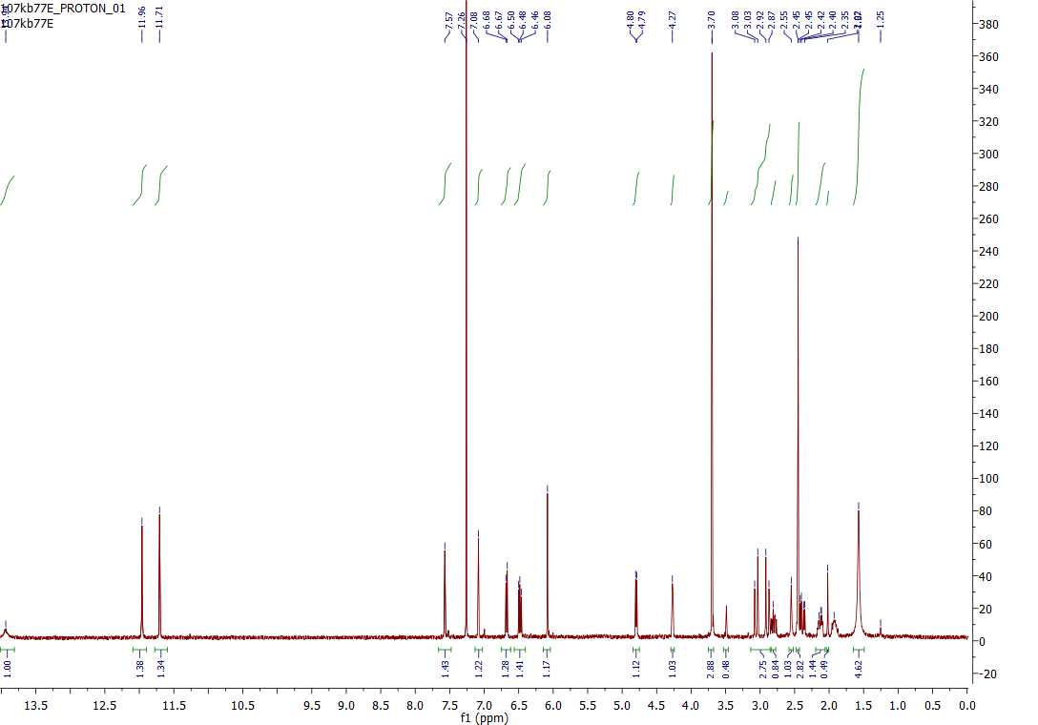

A.6 ¹H NMR table for the isolated xanthoquinodin
Xanthoquinodin (6)
No. | δ_{H}^{a,b,c} | Splitting | J (Hz)
1 | 1.57 | s
2 | 1.93 | m
3 | 2.39 | dd | 6.62, 19.66
4 | 2.45 | s
5 | 2.55 | s
6 | 2.89 | d | 17.82
7 | 2.98 | dd | 17.82, 64.91
8 | 3.06 | d | 17.81
9 | 3.7 | s
10 | 4.27 | dd
11 | 4.8 | dd | 6.19
12 | 6.08 | s
13 | 6.48 | dd
14 | 6.68 | dd | 7.68
15 | 7.08 | s
16 | 7.57 | s
17 | 11.71 | s
18 | 11.96 | s
19 | 13.94 | s
ª Measured in CDCl₃, ^{b} Measured on 400MHz instrument ^{c} δ in ppm

A.7 NMR and IR Spectra for Microsphaerin D
a) ¹H NMR (400MHz) in CD₃OD
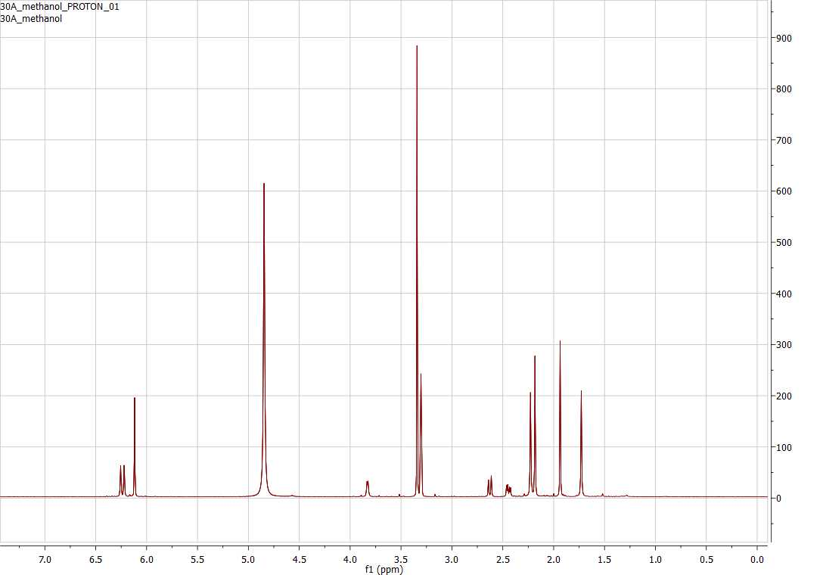
b) ¹H NMR (400MHz) in acetone-d6
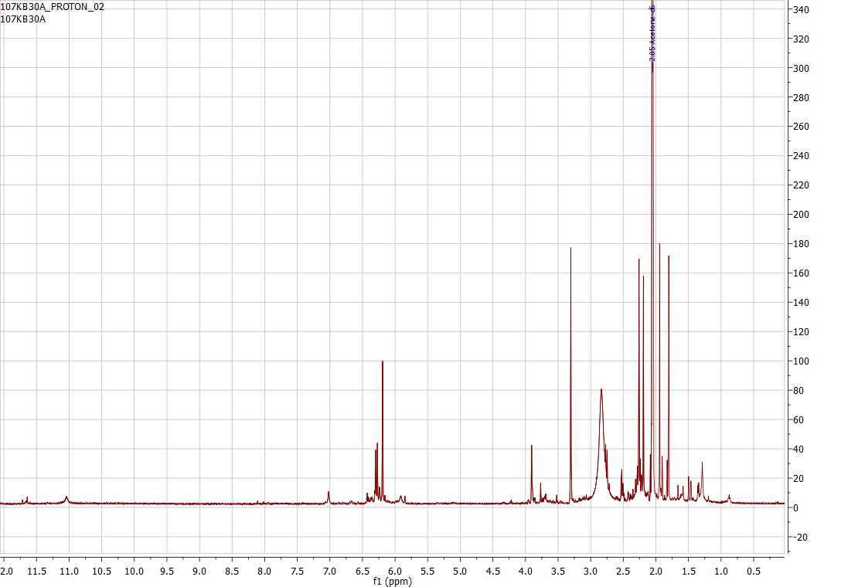

c) ¹³C NMR (400MHz) in acetone-d6
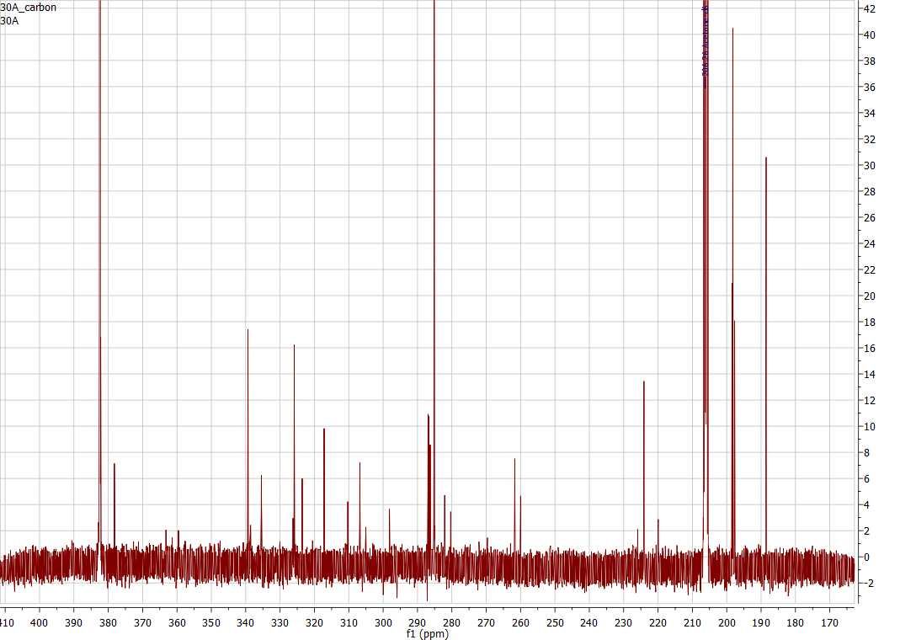
d) HSQC NMR (500MHz) in acetone-d6
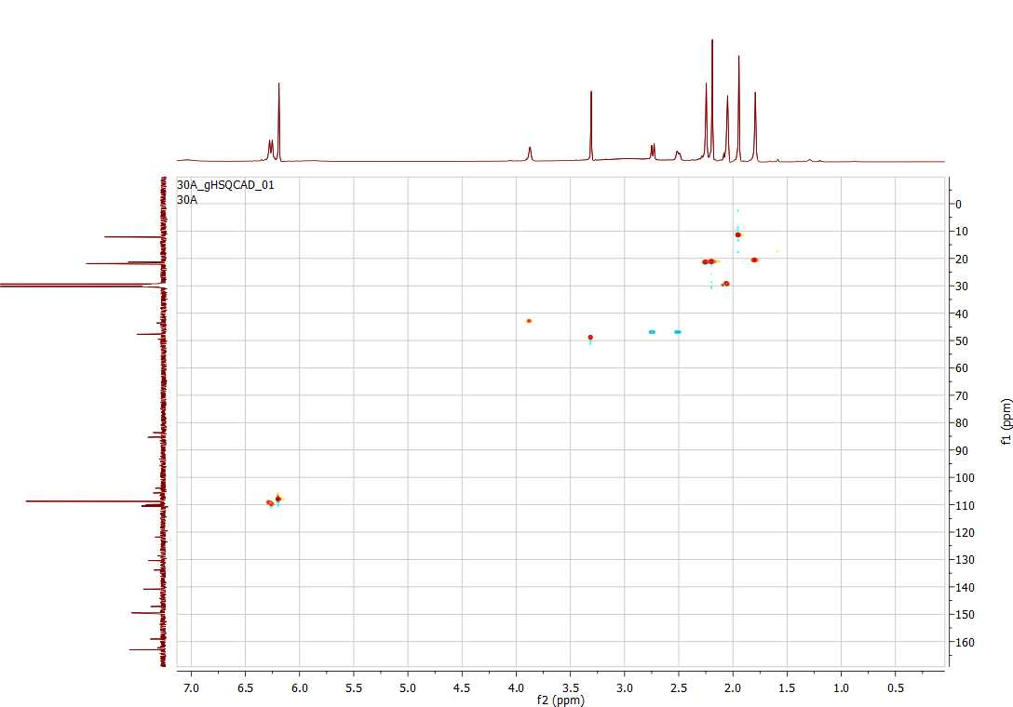

e) COSY NMR (500MHz) in acetone-d6
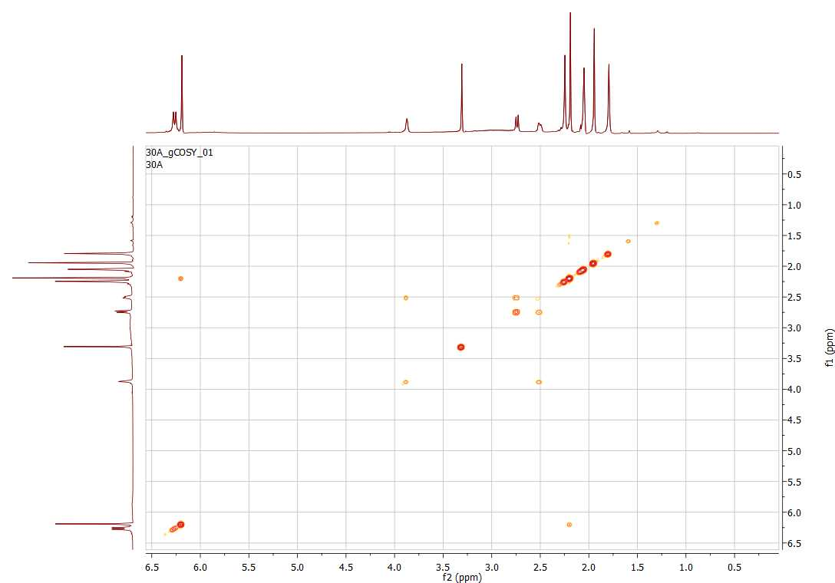
f) HMBC NMR (500MHz) in acetone-d6
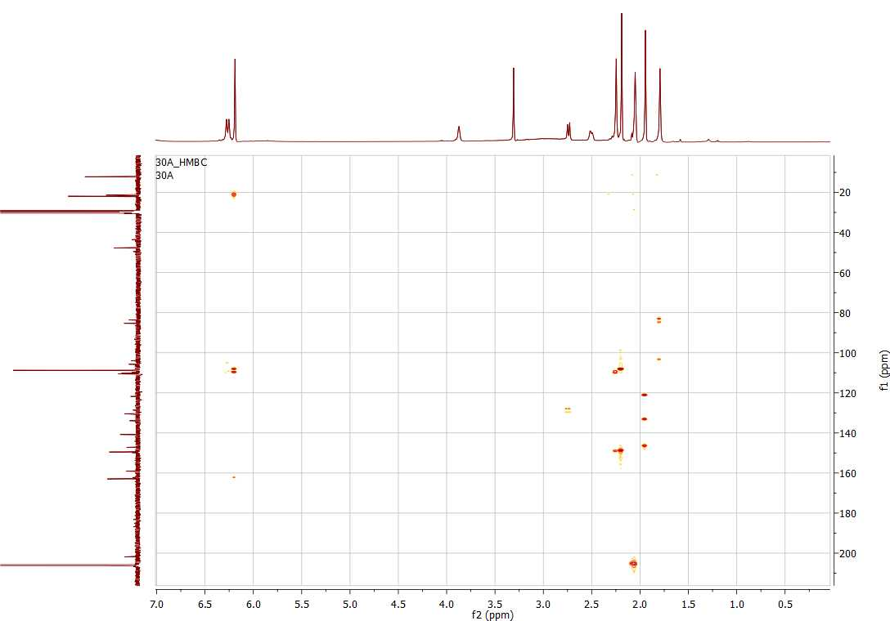

g) FTIR spectrum
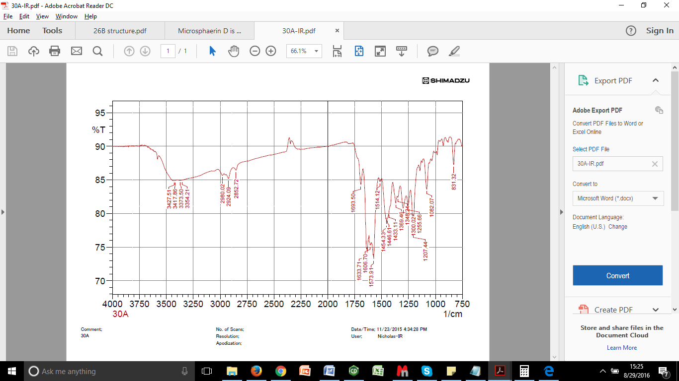

A.8 ¹H NMR table for microsphaerin D
Microsphaerin D
No. | δ_{H}^{a,b,c} | Splitting
1 | 1.75 | s
2 | 1.96 | s
3 | 2.21 | s
4 | 2.25 | s
5 | 2.48 | dd
6 | 2.66 | d
7 | 3.86 | s
8 | 6.14 | s
9 | 6.14 | s
10 | 6.22 | s
11 | 6.26 | s
ª measured in CD₃OD ^{b} measured on 400MHz Instrument ^{c} δ in ppm, J in Hz

A.9 NMR Spectra for the unidentified structure
a) ¹H NMR (400MHz) in CDCl₃
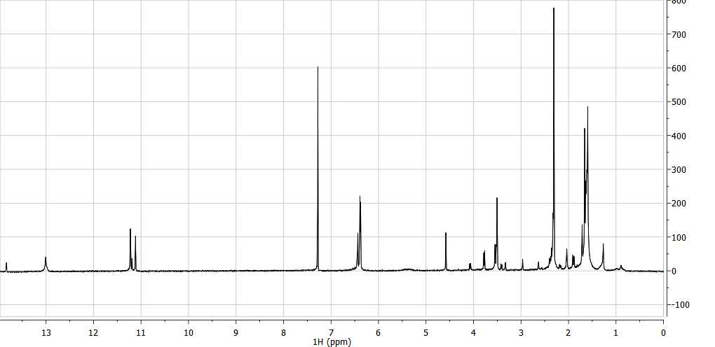
b) ¹³C NMR (400MHz) in CDCl₃
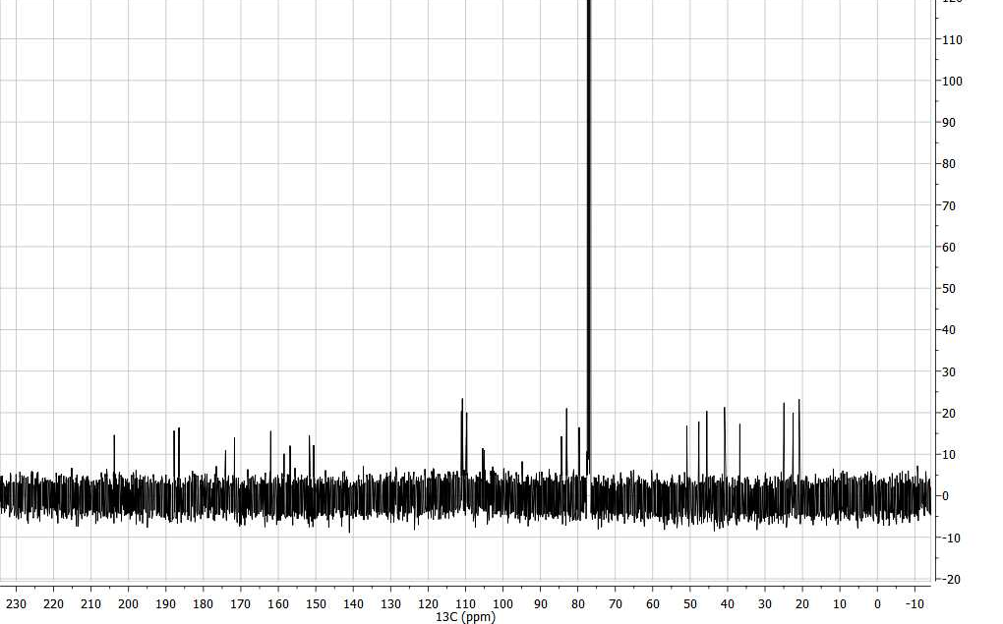

c) HSQC NMR (400MHz) in CDCl₃
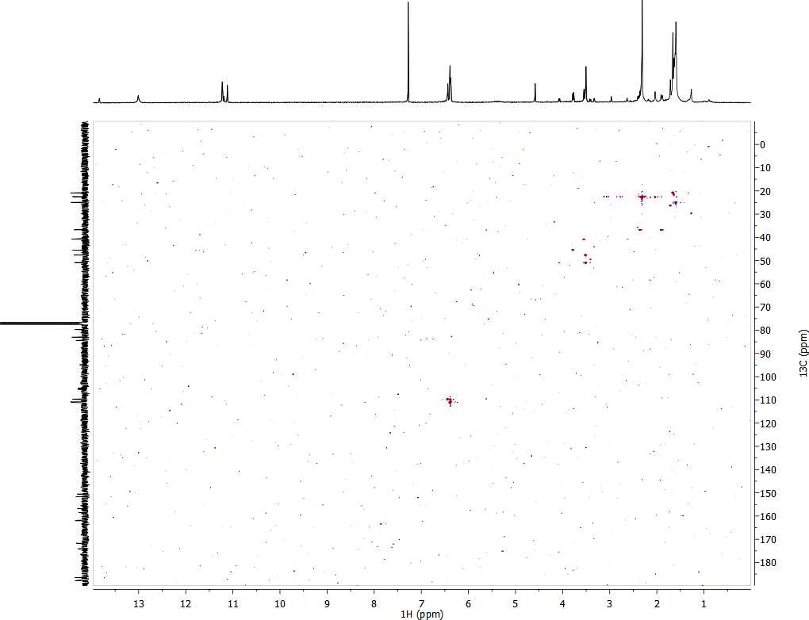
d) COSY NMR (400MHz) in CDCl₃
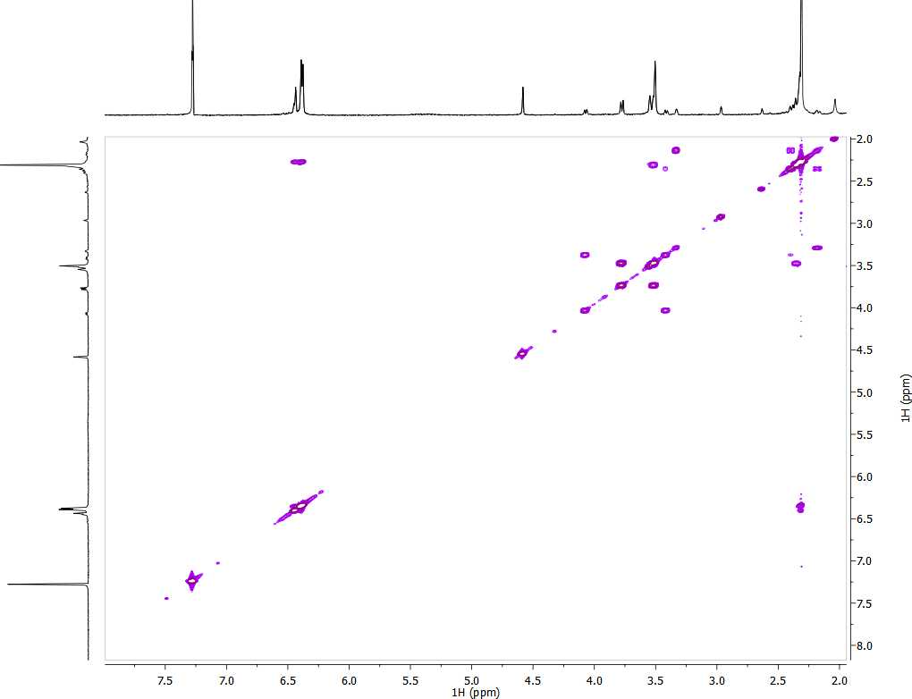
e) HMBC NMR (400MHz) in CDCl₃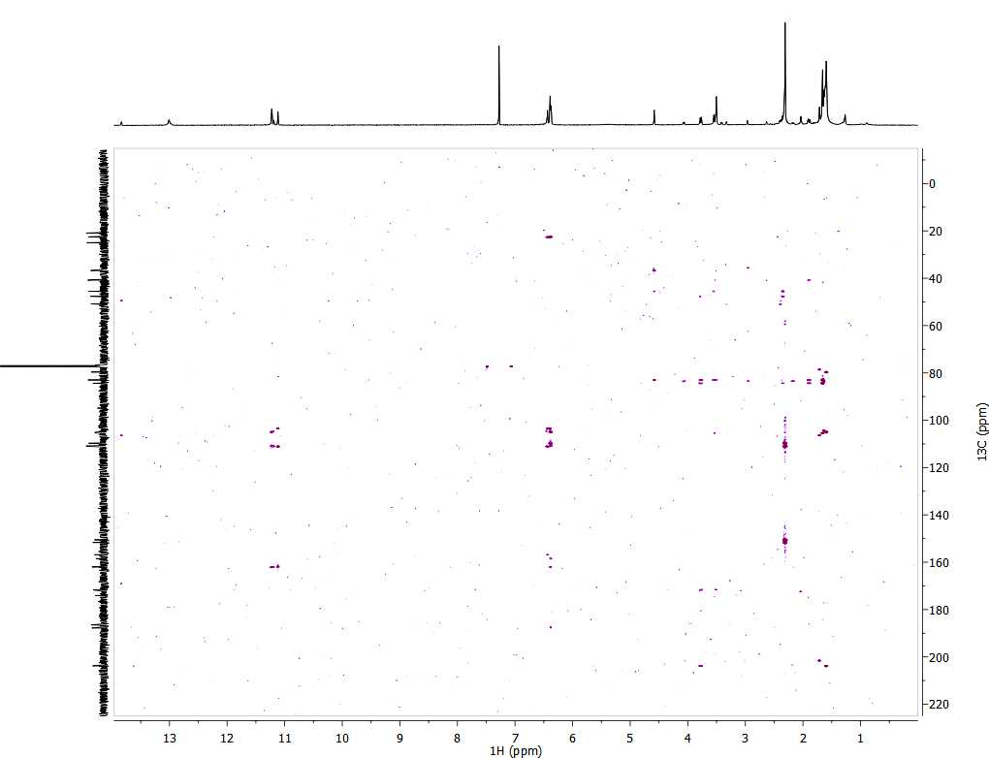

A.10 Trichomonas Assay results for the dinapinonesª
ª All assays done by Jarrod King (University of Oklahoma)

A.11 Trichomonas assay results for the Xanthoquinodinsª
ª All assays done by Jarrod King (University of Oklahoma)

A.12 Trichomonas assay results for dinapinones and xanthoquinodins in an anaerobic chamberª
ª All assays done by Jarrod King (University of Oklahoma)

A.13 Trichomonas assay results for microsphaerin D and the unidentified compoundª
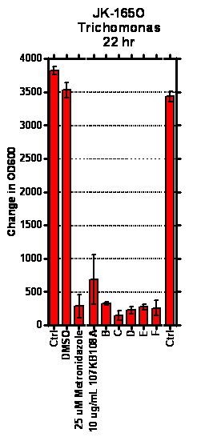
ª All assays done by Jarrod King (University of Oklahoma)

A.14 TI values from the trichomonas assay for all of the identified compounds ª

Compound | TI value | Project
Dinapinone A2 | 3 | Wailua PDA-3 Contaminant
Dinapinone AB1/AB2 | 5 | Wailua PDA-3 Contaminant
42C | 12.5 | Wailua PDA-3 Contaminant
42C (anaerobic) | 0 | Wailua PDA-3 Contaminant
Xanthoquinodin | 5 | Tracy MEA-2
Microsphaerin D | 0.3 | Boars Tusk PFA-1

ª All assays done by Jarrod King (University of Oklahoma)

