

Jude A. Okolie and Rogachuk, Brooke E.
Gallogly College of Engineering, University of Oklahoma, Norman United States

Introduction to Process simulation with Aspen Plus: Instructors Guide

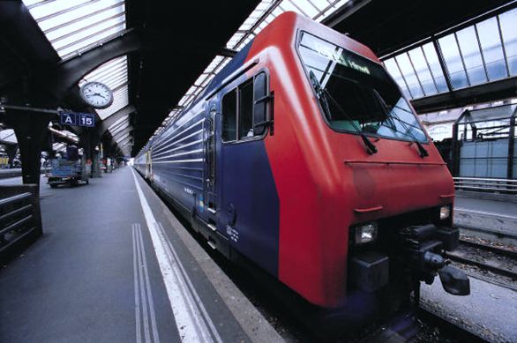

Dedication
To my late father, Peter Okolie who was a pillar of support during my academic training – Jude
To my parents, thank you for never failing to support me. To my sister, keep dreaming – Brooke

Preface
Process simulation entails the representation of a chemical process by using mathematical equations. Process simulation in Aspen Plus offers the advantages of optimizing plant performance, reducing operational costs, and improving product quality through precise modeling and analysis of chemical processes. It is very important for students, researchers and even industry practitioners to understand the basis of process simulation, this book provides an introductory process simulation course. Aspen Plus is a comprehensive process modeling tool used for simulating chemical processes, offering superior capabilities in accuracy, flexibility, and user-friendliness for optimizing plant design and operation. This book is written to educate the readers on how to use Aspen Plus process simulation process to model industrial processes as well as perform a preliminary economic evaluation. The book is divided into twelve (12) chapters covering a range of topics including unit operations and simple equipment design in Aspen plus, liquid-liquid extraction process, chemical reactions, sensitivity, and economic analysis. Towards the end, a case study is presented for the readers to follow along. Furthermore, readers are expected to acquire the follow skills following completion of the practical examples laid out in this book.
- Gain the practical skills and knowledge to begin modelling new and existing processes.
- Learn some practical techniques for building and troubleshooting flowsheet simulations.
- Determine optimal process conditions to improve current processes.
- Use the Workbook and Flowsheet interfaces for quick and effective modelling.
- Carry out properties analysis to know the best method to use as fluid package for simulations.
It should be mentioned that topics such as dynamic process simulation, optimization, integrating Aspen plus with MATLAB/excel sheet, electrolyte modelling are not covered in this book. However, these would be covered in the second series by the same authors. Regardless, the lessons and practical examples presented herein would be useful to teach basic process simulation.

Acknowledgement
The authors would like to extend their gratitude to the entire Engineering Pathways team at the University of Oklahoma for their constant support during the writing of this manuscript. Special thanks go to Professor Chukwuma Ogbaga of Philomath University for his assistance in reviewing several sections of the manuscript. We are also grateful to Dr. Emmanuel Epelle, Dr. Adeleke Adekunle, and Dr. Bilainu Oboirien for their valuable advice and suggestions during the initial preparation of the manuscript draft. Additionally, we would like to thank Meshach Tabat for his help with some of the process simulations.
Our heartfelt thanks go to Morgan Briles, Open Educational Resources Librarian at the University of Oklahoma Library, for her assistance during the funding application process and her guidance in navigating through open-access book publishing. We are also thankful to the University of Oklahoma Library for providing the Alternative Textbook Grant, which was instrumental in completing this project.

Contents
Dedication 1
Preface 2
Chapter 1: Introduction to process simulation 5
Chapter 2: Process simulation with Aspen Plus 9
2.2 Getting started with Aspen Plus 10
Chapter 3: Physical property environment and equation of state 13
Chapter 4: Unit operations Models 22
4.1 Worked Examples with Heat Exchangers 26
4.2 Worked Examples with Pressure Changers 34
4.3 Worked Examples with Columns 43
4.4 Worked Examples with REACTORS 50
4.5: Worked Examples with Manipulators 66
4.6: Worked Examples with Solids 78
4.7: Worked Examples with Solids Separation 88
Chapter 5: Liquid – Liquid Extraction 95
Chapter 6: BIOMASS GASIFICATION SIMULATION with sensitivity analysis 101
6.1 Biomass Pretreatment 102
6.2 Biomass Gasification 107
6.3 Product separation 109
6.4 Sensitivity analysis 111
Conclusions 115

Chapter 1: Introduction to process simulation
Process simulation plays a very important role in the chemical engineering domain including process engineering. It covers the entire lifecycle of a process from research and development through to conceptual design and operational management. It involves creating and experimenting with an operational model of a system to understand its behavior or assess different strategies for its development or management.
Effective simulation must accurately replicate certain behaviors of the system being modeled. The essence of simulation lies in the creation and refinement of models based on experimental data, enabling the performance of 'virtual experiments.' Modeling, a fundamental component of simulation, often operates behind the scenes within software technologies. It's vital to remember that a simulation is an approximation of reality, capturing it with a certain level of precision, rather than being an exact duplicate. Therefore, it's critical for users to assess the reliability of a simulator's outcomes.
Process Engineering simulation demands specialized knowledge, including methods for precisely describing the physical properties of both pure substances and complex mixtures, modeling a wide array of reactors and unit operations, and applying numerical methods to solve extensive sets of algebraic and differential equations. Figure 1.1 explains the three important steps in process simulation as well as the reason why simulation is considered one of the backbones of process engineering.
Process Engineers often adopt process simulations to either design new facilities or model existing facilities. The design of new facilities involves preliminary economic and environmental assessment to compare the proposed design with alternatives. These analyses are often supported with detailed process simulation. Furthermore, process simulations could help with the optimization of energy and material usage and study the impact of varying operating conditions on product yield.
Flowsheeting in process simulation is the visual representation of the process flow and equipment involved, used to model, analyze, and optimize chemical processes systematically. The relationship between process simulation and flowsheeting is fundamentally interconnected; flowsheeting provides the visual representation and framework for the process being analyzed, while process simulation uses this framework to model the behavior and interaction of components within the process. Essentially, flowsheeting lays out the physical arrangement of the process units and streams, and process simulation applies mathematical models to predict the performance of these units and streams under various conditions, facilitating the analysis, optimization, and scale-up of chemical processes.
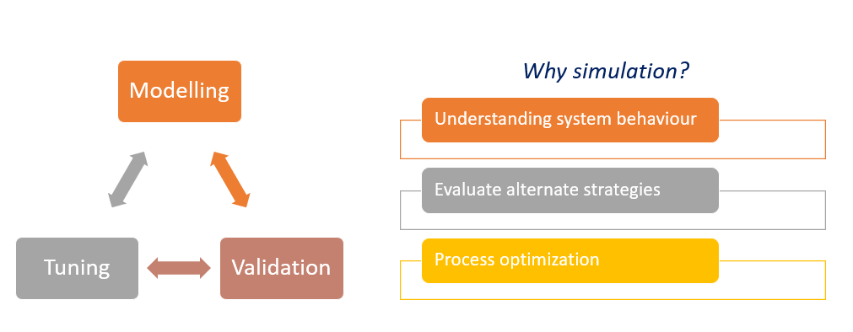Figure 1.1: Steps in process simulation and its importance.
Over the years, flowsheeting architecture is often determined by the method of computation. Three inherent methods have been identified over the years: Sequential-Modular (SM), Equation-Oriented (EO) and Simultaneous-Modular approaches. The SM approach processes individual unit operations in sequence based on material flows through the plant. It requires the user to specify a calculation order, and each unit operation is solved independently before passing its results to the next module in the sequence. SM is advantageous because of its simplicity and ease of understanding. Furthermore, this approach allows users to adjust the sequence of unit operations to manage simple recycle loops and converging sections. However, SM is often unsuitable for processes that have complex recycle streams or extensive integration. This is because it requires iterative solutions for such processes and these solutions are often inefficient. Moreover, there are always convergence issues when SM approach is used for systems with multiple recycle loops.
The EO approach represents process flowsheets with a combination of algebraic and differential equations all aggregated into a single, large set of equations that are solved simultaneously. This method is advantageous for handling complex recycle loops and for optimization tasks because it considers the process as a whole. EO is also suitable for process optimization, as it allows for direct integration of optimization algorithms with process models. However, the EO approach could be computationally intensive due to the need to solve large set of equations simultaneously. Furthermore, the application of EO approach to model a process requires detailed understanding of the process as well as the interactions between components, making it a complex process. The convergence of solutions could also be dependent on initial guesses and the numerical methods used.
The simultaneous-Modular method combines both the SM and EO approaches. It involves the division of the entire process into modules that are solved simultaneously. However, the calculations could also be sequential within each model. This approach facilitates better handling of recycle streams and converging solutions for complex networks without strictly defining a global sequence for the modules. While of these three approaches have its strengths, the choice of simulation is decided and is chosen based on the specific needs of the user. This decision could also be based on process complexity or whether there is a need for optimization, sensitivity analysis or large amount of recycle loops. Details of the software used for process simulation are presented in figure 1.2. This book will focus on Aspen Plus simulation which is a sequential approach. The next chapter presents historical background and overview of Aspen Plus simulation.
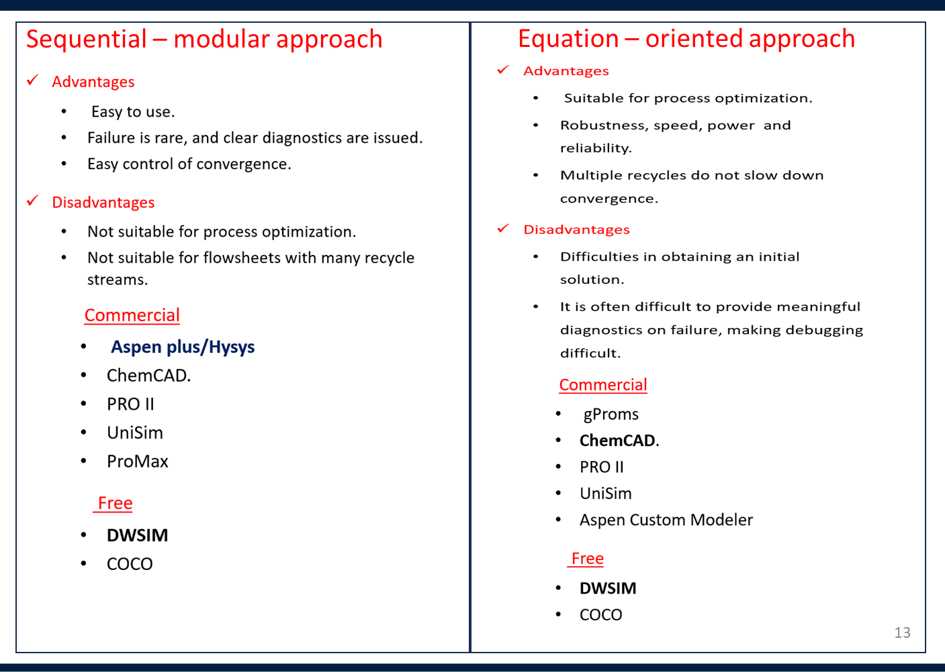
Figure 1.2: Comparison between sequential and equation-oriented simulation approaches

Chapter 2: Process simulation with Aspen Plus
Aspen Plus is a process simulation software grounded in techniques initially used for developing flowsheets in the chemical engineering industry years ago. These early methods were suited for designing standalone units, requiring engineers to manually calculate and adjust each unit one by one within a flowsheet. Challenges arose when dealing with recycle streams, as iterative manual adjustments were needed until the output of the last unit matched the input conditions, a process that did not guarantee convergence. The sequential modular simulator approach evolved to address this issue by creating individual unit models, which could be interconnected through software to manage the recycle loops more effectively. Over time, Aspen Plus, while retaining its core as a sequential modular simulator, has incorporated a range of advanced functionalities, including detailed heat exchanger design, dynamic simulation, and batch process modeling. These enhancements allow for a more detailed and flexible design process that can handle tighter specifications and integrate process optimization effectively within the modeling and simulation framework.
Aspen Plus traces its history to the 1970s, when the need for advanced process simulation became evident during the energy crisis, prompting an initiative at the Massachusetts Institute of Technology (MIT) known as the ASPEN Project (Advanced System for Process Engineering). This initiative aimed to provide a comprehensive simulation tool for chemical processes to enhance efficiency and reduce costs. The success of this project led to the commercialization of the technology through the founding of AspenTech in 1981. Building on the foundational work of the sequential-modular simulation approach exemplified by Monsanto Corporation’s Flowtran software, Aspen Plus evolved to become a robust process modeling platform. Over the decades, Aspen Plus has expanded to incorporate a wide range of functionalities and is now integral to process optimization, design, and analysis in the chemical engineering industry, establishing itself as a leader in the field.

2.2 Getting started with Aspen Plus
Figure 2.1 presents the initial interface encountered upon launching Aspen Plus, version 11. This home screen displays the most recently accessed simulation models, facilitating quick navigation and continuation of ongoing simulations. The "Open" tab stands as a means to access previously saved simulations, offering an efficient retrieval method for older projects. Conversely, the "New" tab is designed for initiating fresh simulations. Selecting this tab reveals an array of pre-configured templates, tailored to accommodate a diverse range of chemical processes such as refining operations or pharmaceutical manufacturing. This variety ensures that users can jumpstart their simulation projects with a foundation that closely matches their specific process requirements.
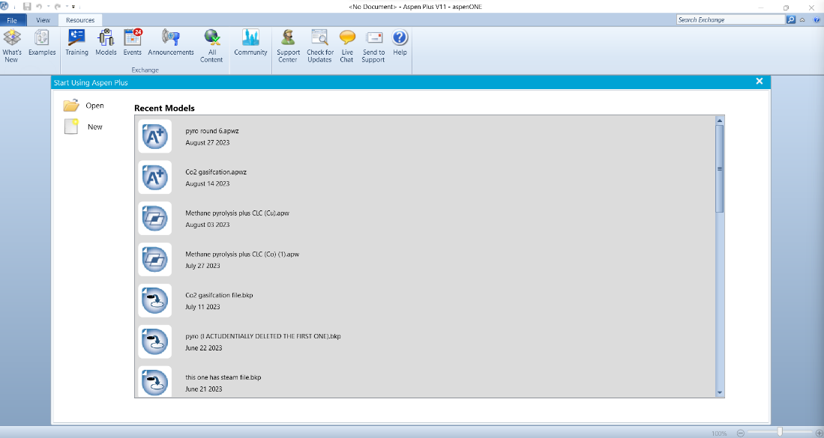
Figure 2.1: Aspen Plus home screen (Aspen Plus Version 11)

Located at the upper left corner of the screen are essential navigation tabs including "File", "View", and "Resources". The "File" tab is particularly beneficial for new users, as it houses various training materials alongside a selection of Aspen Plus templates. These templates span a broad spectrum of process simulations, including but not limited to chemical production, gas processing, mining, minerals processing, and refinery operations. Users can also create customized simulations to suit unique process requirements. The "Resources" tab is a comprehensive hub containing several invaluable tools and references. The "What's New" feature keeps users abreast of the latest software updates and enhancements. For practical, hands-on learning, the "Examples" section offers a curated collection of demonstrations. The extensive documentation and manuals provide thorough insights into the functionalities of Aspen Plus, enabling users to delve deep into the software's capabilities. Additionally, online communities and forums foster a collaborative environment for knowledge sharing and support. AspenTech's training and educational programs are designed to elevate user proficiency, collectively equipping users with the tools and knowledge needed to optimize their simulation endeavors effectively.
To create a new file, navigate to the "New" tab and select a blank template from the options presented under the "Blank and Recent" tab (Figure 2,2). Opting for a blank simulation is the first step for users intending to develop a new simulation from scratch. Depending on the envisioned process, users have the liberty to choose from an extensive list of processes including air separation, various chemical processes, electrolytes, gas processing, metallurgy, pharmaceuticals, polymers, refinery operations, solids processing, and user-defined processes. Upon selecting the "Create" option, users are introduced to the initial setup screen for a new simulation, as illustrated in Figure 2.3. Notably, a red semi-circle adjacent to the "Components" tab indicates unmet requirements, signaling the need for users to define the system's components. This definition can be achieved by either entering the chemical name directly into the "Component ID" box or utilizing the "Find" button to search for the required chemical by its CAS number, name, or alias. Furthermore, when inputting "biomass" as a component, Aspen Plus offers various definition options, such as blend, polymer, non-conventional, among others. The specifics of selecting a non-conventional biomass will be elaborated in subsequent chapters.
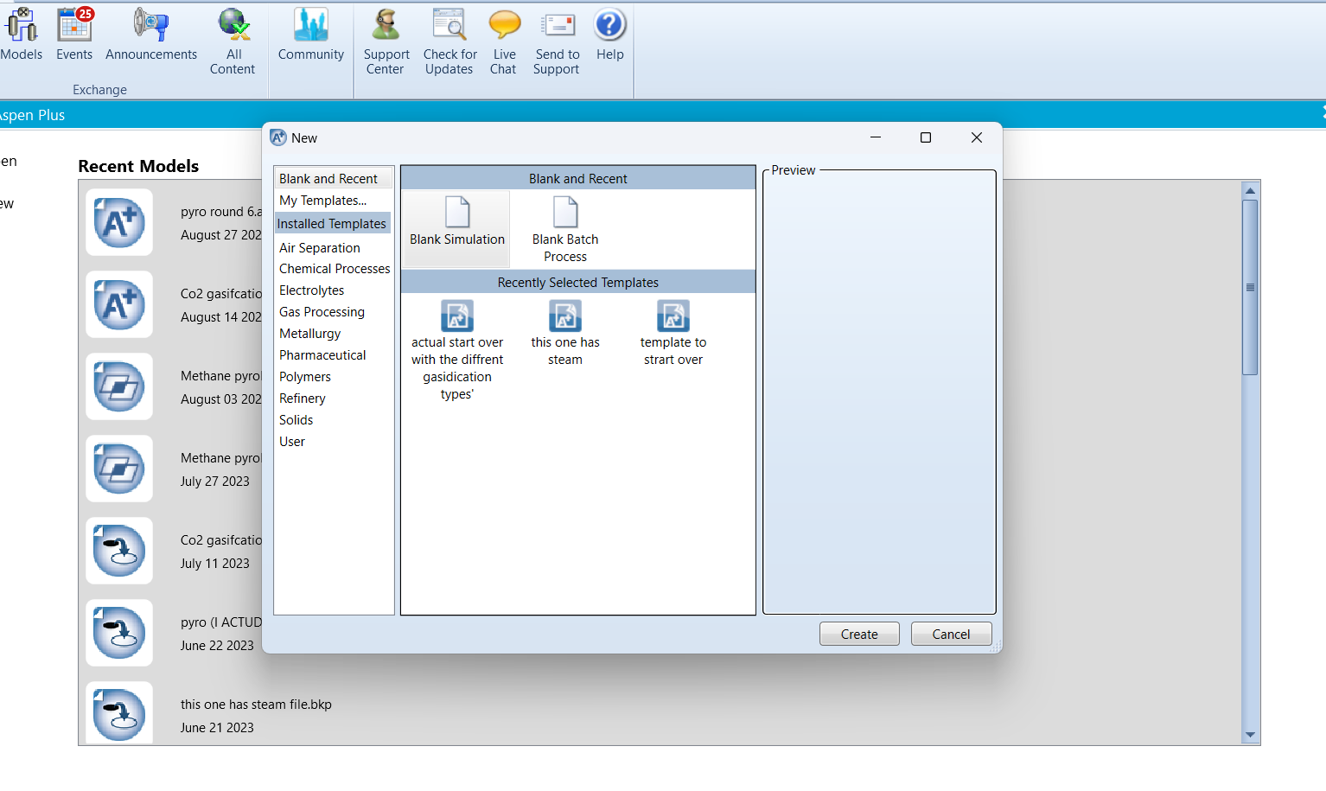 Figure 2.2: Setting up a new simulation and available options.

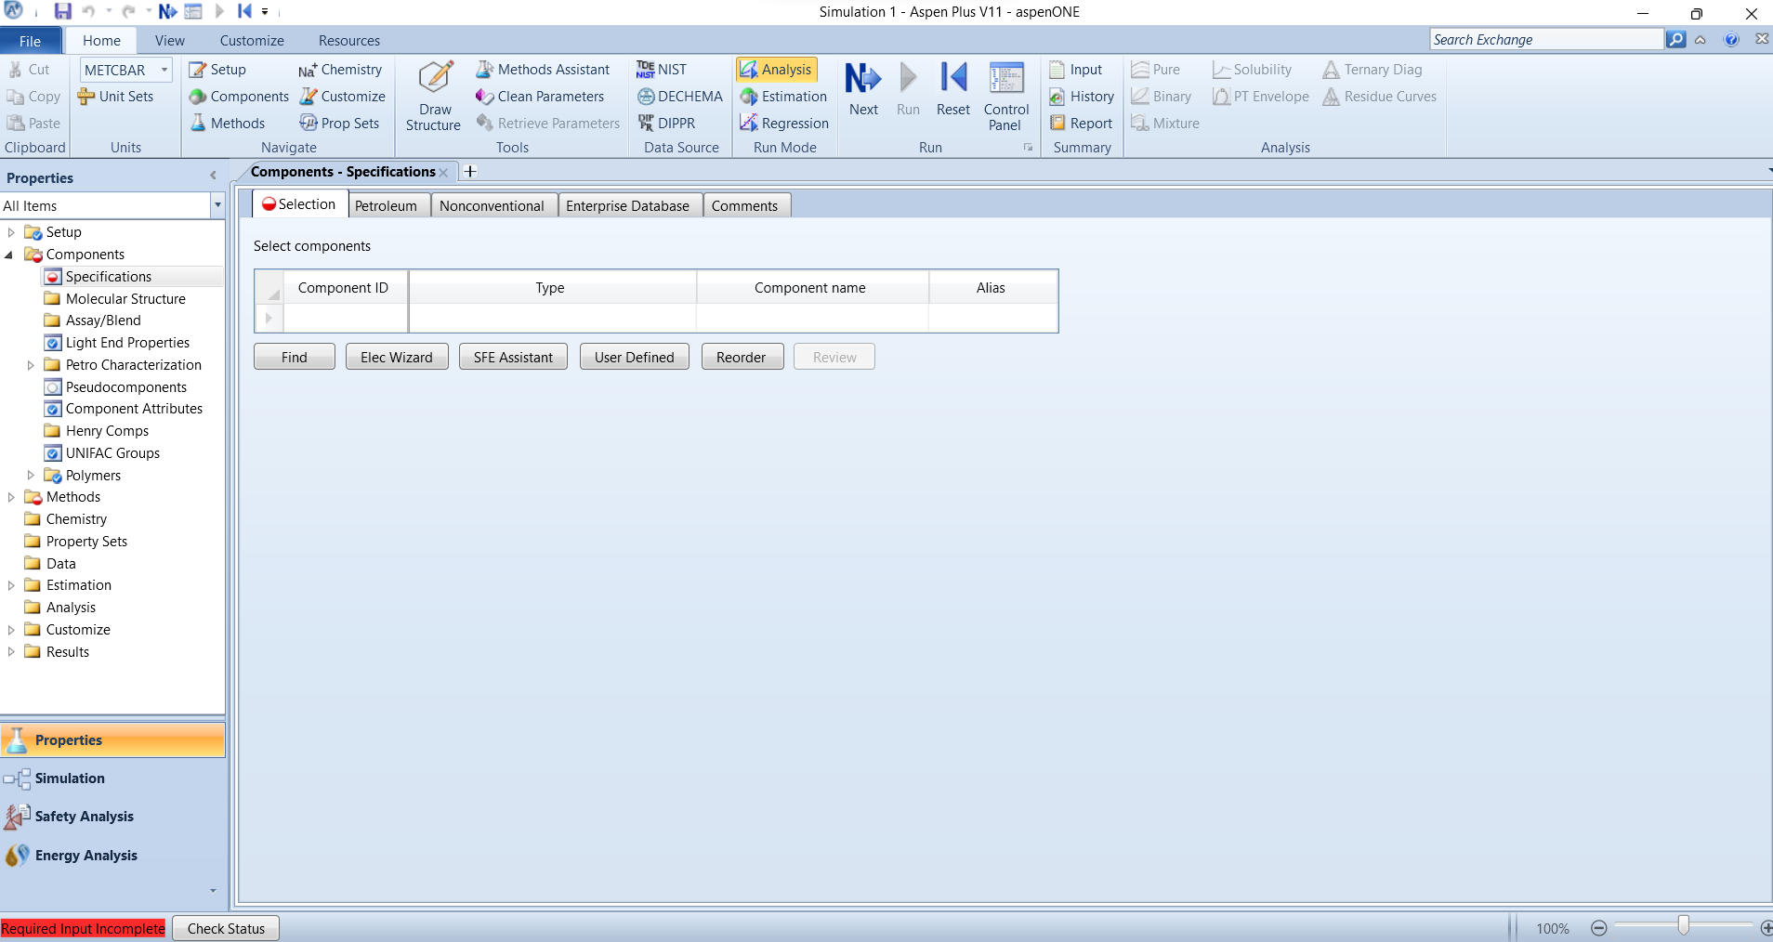
Figure 2.3: Component selection screenshot.

In Aspen Plus, defining a hypothetical compound or biomass involves a few steps to accurately represent these materials in your simulation. For hypothetical compounds, which are not present in the Aspen Plus database, you'll use the "Hypothetical Components" feature. Start by navigating to the "Components" section and then to "Hypotheticals". Here, you input the compound's properties, such as molecular weight, boiling point, and specific heat, among others. These properties can be estimated or obtained from literature if not known. For defining biomass, which is a complex mixture rather than a single compound, the process is slightly different. You go to the same "Components" section, but instead of creating a single hypothetical component, you define the biomass as a non-conventional component. This involves specifying the composition of the biomass, such as the percentage of cellulose, hemicellulose, lignin, etc., depending on the type of biomass and the level of detail needed for your simulation. Aspen Plus allows for the customization of these components, enabling you to simulate processes involving biomass accurately.
After completing the component inputs and observing the red semi-circle transform into a blue checkmark, users can proceed to the "Methods" tab by clicking the "Next" button located at the top middle of the screen. This section is crucial for selecting the computational methods Aspen Plus will employ. For those uncertain about which method to choose, the "Methods Assistant" provides a guided quiz tailored to the user's simulation objectives, with the Peng-Robinson model being a popular choice. Detailed discussions on the physical property environment and equations of state utilized in Aspen Plus will be covered in Chapter 3.

Chapter 3: Physical property environment and equation of state
Before developing a flowsheet or a simulation it is important to select the appropriate property method to analyze your process. The selection of property methods is crucial because it directly affects the accuracy of the simulation results. Property methods determine how thermodynamic and physical properties of substances are calculated within the simulation environment. These properties include but are not limited to:
- Phase equilibria (vapor-liquid, liquid-liquid, solid-liquid, etc.).
- Enthalpy and entropy values.
- Heat capacities.
- Vapor pressure.
- Density.
- Viscosity.

Different property methods have different levels of accuracy and applicability depending on the substances being modeled, the range of conditions involved, and the specific requirements of the simulation. Generally, there are four property method choices available in Aspen Plus. These include the Ideal model, Equation of state model, Activity coefficient model and other models.
- Ideal Model: This model assumes perfect mixing and no interactions between molecules, making it suitable for simulating systems where components behave ideally, usually at low pressures and non-polar mixtures. It should be noted that this model follows the ideal gas laws.
- Equation of State Model: Utilizes equations that relate state variables (pressure, temperature, and volume) to describe the thermodynamic properties of fluids, both gases and liquids, under various conditions, particularly useful for high-pressure systems.
- Activity Coefficient Model: Accounts for non-ideal behavior in mixtures by introducing activity coefficients to correct deviations from Raoult's law, ideal for mixtures with strong molecular interactions or significant differences in volatility.
- Other Models: This category includes a variety of specialized models designed to handle specific chemical engineering challenges, such as electrolyte systems, polymer solutions, and solid-phase reactions, providing tailored approaches for complex systems.Table 3.1 summarizes the situation under which each of the property methods are preferred.
Table 3.1: Summary of property methods
Model Type | Preferred Situations / Uses
Ideal Model | Used for low-pressure and non-polar mixtures, ideal for gases and solutions where interactions between molecules are negligible.
Equation of State Model | Suitable for high-pressure systems and for accurately describing both gas and liquid phases, especially when dealing with non-ideal gases.
Activity Coefficient Model | Ideal for mixtures with strong molecular interactions, significant differences in volatility, and where deviations from ideal behavior are significant.
Other Models | Applied to specific scenarios like electrolyte systems, polymer solutions, solid-phase reactions, or any complex system requiring a tailored approach.

The equation of state models and activity coefficient method are the two commonly used non-ideal methods. The Equation of States is deemed suitable for modeling both the vapor phase and liquids that exhibit low polarity. But it may not be the best fit for non-ideal liquids, where interactions between molecules significantly affect the phase behavior. A notable advantage of the Equation of States is that it requires fewer binary parameters, which simplifies the modeling process. Furthermore, it allows for the extrapolation of data, meaning predictions can be made beyond the measured data range. This model is also particularly effective in the critical region where the properties of the vapor and liquid phases converge.
On the other hand, the Activity Coefficients method is recommended for liquid phase modeling, especially when dealing with non-ideal liquid mixtures. Such mixtures often involve strong interactions between molecules, necessitating a model that can account for deviations from ideality. However, this method requires the use of binary interaction parameters specifically for liquid-liquid systems, which may complicate the modeling process. The accuracy of the Activity Coefficients method is restricted to the temperature range for which the model parameters have been determined. Unlike the Equation of States, the Activity Coefficients method does not perform well in the critical region and should be avoided for such conditions.
Details on how to select a property method is outlined below:
- Open Simulation Environment: Open your Aspen Plus simulation. 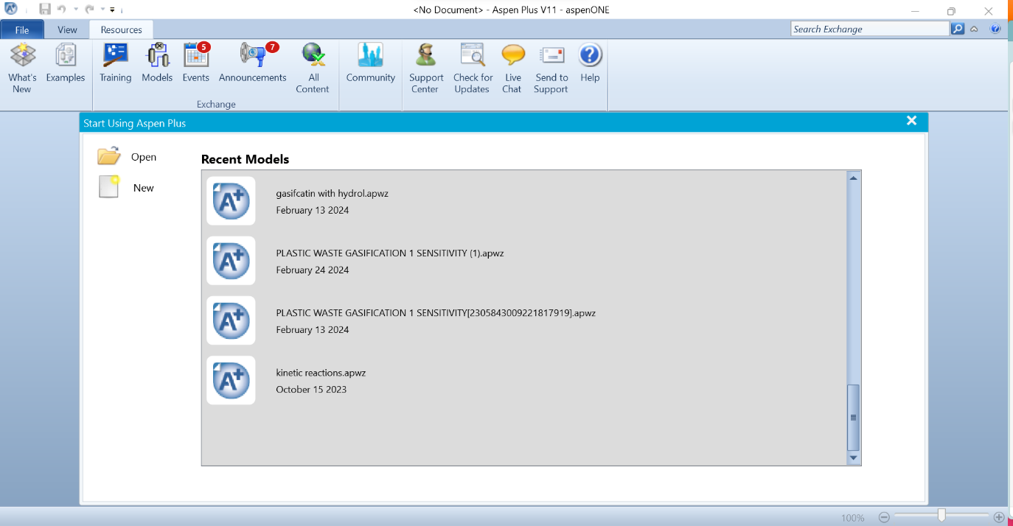
Figure 3.1: Opening simulation Tab
- Define Components: Specify the components in your simulation, including the substances involved and their respective compositions.
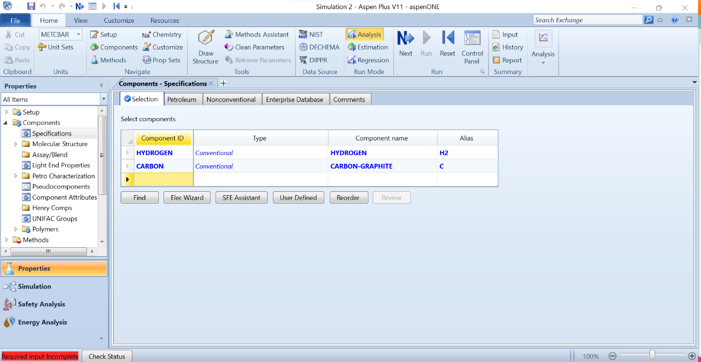Figure 3.2: Defining components in simulation
- Access Property Methods: Go to the "Simulation" menu and select "Options." This will open a dialog box where you can specify various options, including property methods.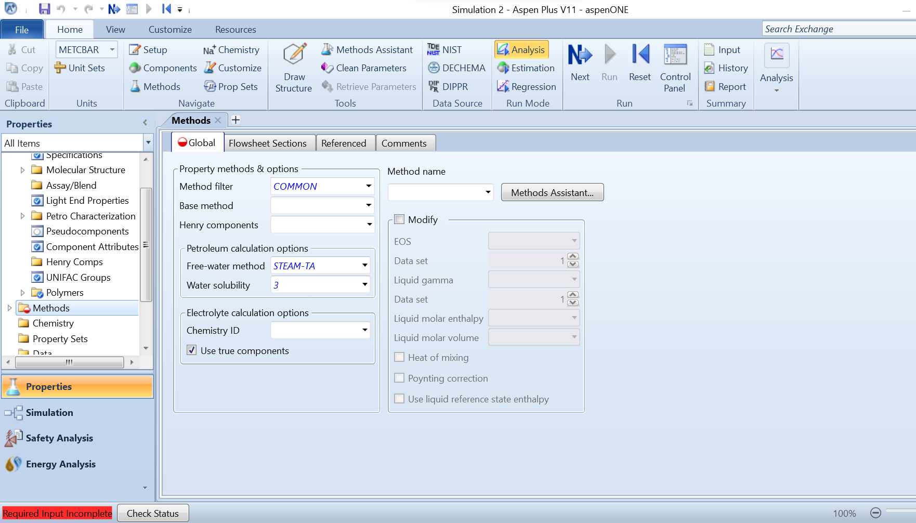
Figure 3.3: Assessing property methods
- Select Property Methods: Within the Options dialog, navigate to the "Property Method" tab. Here, you'll find options to select property methods for different types of properties such as vapor-liquid equilibrium, liquid-liquid equilibrium, and mixture enthalpy. Aspen Plus typically offers a variety of methods such as NRTL, UNIQUAC, Peng-Robinson, etc.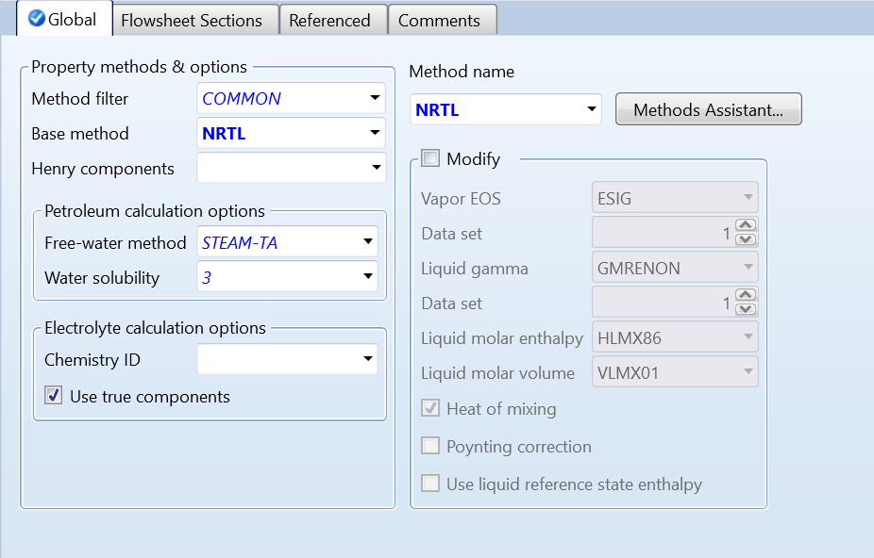
Figure 3.4: Selecting and defining property methods
- Evaluate and Confirm: Evaluate the available property methods and select the one that best suits your simulation needs. This selection should be based on factors such as the accuracy required, the substances being modeled, and the range of conditions in your process.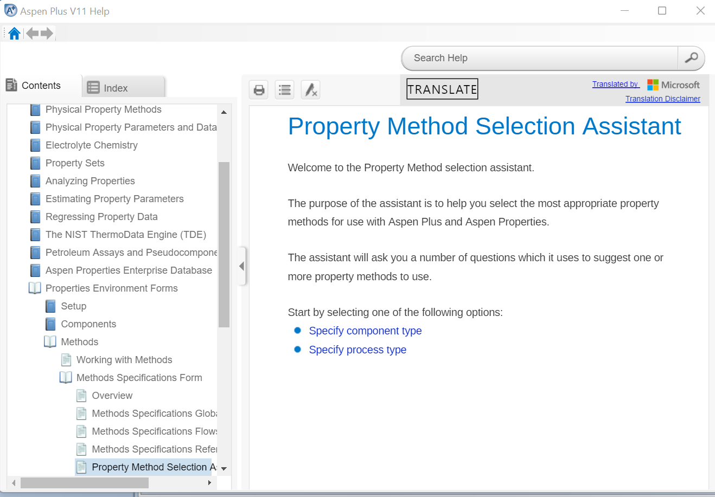
Figure 3.5: Property method assistant
Factors to consider when selecting property methods include:
- Accuracy: Different methods have different levels of accuracy, especially across various temperature and pressure ranges. Ensure that the selected method provides the necessary accuracy for your simulation.
- Applicability: Some methods are more suitable for certain types of mixtures or phase equilibria. Consider the substances involved and the phase behavior expected in your process.
- Computational Efficiency: More accurate methods may require more computational resources and time to converge. Balance the need for accuracy with computational efficiency.
- Experimental Data Availability: If experimental data is available for your system, compare the predicted properties using different methods against the experimental data to validate the chosen method.
- Model Validation: Ensure that the selected property method has been validated for similar systems and conditions to those in your simulation.

Chapter 4: Unit operations Models
This chapter would provide an overview of the following unit operation design in Aspen Plus:
- Mixers/ Splitters
- Separators
- Heat exchangers.
- Pressure changers
- Reactors and Column
- Manipulator
- Solids
- Solid Separators
Mixers and Splitters
Mixers and splitters are basic unit operations used to simulate the combination and separation of material streams. Splitters could also be used for purge streams. Moreover, mixers are employed to combine two or more input streams to create a single output stream with a uniform composition, simulating processes like blending and homogenization. This is crucial in ensuring consistent downstream processing and product quality. On the other hand, splitters are used to divide a single input stream into multiple output streams based on specified ratios or split fractions, without any change in the thermodynamic conditions or material properties of the streams. This is essential for distributing process flows into different process paths or for extracting portions of a feed for recycling or further processing, thereby enabling a precise control over the flow distribution within a chemical process network.
Separators
In Aspen Plus, separators are used to model the separation of a feed stream into two or more product streams based on phase differences. These unit operations are vital for processes where components need to be divided according to their physical properties, such as boiling point, density, or solubility. A separator in Aspen Plus can represent a variety of physical separation equipment, including flash drums, decanters, and three-phase separators.
The separator unit operation takes into account the thermodynamic equilibrium to determine how the feed will be split into a vapor phase, a liquid phase, or even multiple liquid phases (for example, oil/water systems). Users can define the operating conditions such as pressure and temperature, and Aspen Plus uses built-in thermodynamic models to calculate the equilibrium stages and the composition of each phase. This allows for accurate predictions of the separation performance and is fundamental for the design, optimization, and analysis of separation processes within the chemical, petrochemical, and related industries. The separator models are essential for simulating processes like distillation, liquid-liquid extraction, and gas-liquid separation, forming the backbone of many industrial separation processes modeled in Aspen Plus.
In Aspen Plus, separators are categorized based on the type of separation process they are designed to simulate. These separation processes are based on the physical and thermodynamic properties of the components in the mixture. Here are some of the common types of separators available in Aspen Plus:
- Flash Separators (Flash2, Flash3):
  - Used to separate a feed into vapor and liquid phases at a specified pressure and temperature. Flash3 can separate into two liquid phases and one vapor phase.
- Decanters:
  - Employed for liquid-liquid separation where two immiscible liquid phases are present and need to be separated due to differences in density.
- Gravity Separators:
  - These simulate the separation of phases by the force of gravity, typically used for gas-liquid separation where the gas rises and the liquid settles.
- Centrifugal Separators:
  - These use centrifugal force to enhance phase separation, often used for emulsions or fine suspensions where gravity separation is not effective.
- Absorbers and Strippers:
  - While not separators in the traditional sense, absorbers and strippers are used to separate components by selectively absorbing one component from a gas stream into a liquid or desorbing it from the liquid to the gas phase.
- Distillation Columns (RadFrac):
  - Used for component separation based on differences in volatility. This rigorous column model can simulate trays and packing with a variety of internal configurations.
- Liquid-Liquid Extraction Columns (LLE):
  - These are used to simulate the separation of components based on their differing solubilities in two immiscible liquid phases.
- Three-Phase Separators:
  - Designed to split a feed into three separate streams, one for each phase: vapor, oil (liquid hydrocarbons), and water.
Each type of separator in Aspen Plus is associated with specific algorithms and methods that describe the phase equilibria and the mass transfer between phases. Users select a separator type based on the characteristics of the mixture to be separated and the operational context within the process flow diagram. Aspen Plus provides the flexibility to model complex separation processes by allowing these different separator types to be integrated into a comprehensive process simulation.
Heat Exchangers
In Aspen Plus, heat exchangers are simulated to represent the equipment used for the transfer of heat between two or more fluids at different temperatures that are separated by a solid wall. Heat exchangers are crucial in process engineering as they enable energy recovery, heating, cooling, and temperature control within various processes. In Aspen Plus, you can model various types of heat exchangers, each corresponding to different industrial applications and design considerations:
- Simple Heaters and Coolers:
  - These units are used to heat or cool process streams using utility streams such as steam or cooling water. They are simple in design and operation, typically modeled as being adiabatic with no heat loss to the environment.
- Shell and Tube Heat Exchangers:
  - One of the most common types of heat exchangers in the industry, characterized by one fluid flowing through tubes and another fluid flowing over the tubes within a shell. Aspen Plus can simulate various configurations and can accommodate designs for multi-pass and multi-shell exchangers.
- Double-Pipe Heat Exchangers:
  - Consist of one pipe within another, with two fluids flowing in opposite directions. They are used for small-scale heat exchange with one fluid heating or cooling the other.
- Plate Heat Exchangers:
  - Made up of multiple, thin, slightly separated plates that have large surface areas and fluid flow passages for heat transfer. Aspen Plus can simulate plate exchangers which are often used when a compact design is needed.
- Air Coolers:
  - Utilize ambient air to cool a fluid, typically used when cooling water is scarce. They are often modeled in Aspen Plus for processes requiring significant cooling capacities.
- Fired Heaters:
  - Directly apply heat to a fluid, usually through combustion. These are complex units that can be modeled in Aspen Plus to represent furnaces or boilers.
- Condensers and Reboilers:
  - Specialized heat exchangers for phase-change operations, such as condensing vapor into liquid or boiling liquid into vapor, which are key components in distillation processes.
- Multi-Stream Heat Exchangers:
  - Can involve more than two fluid streams interacting, allowing for complex heat integration strategies within a process.
Aspen Plus provides rigorous heat exchanger design and rating capabilities, including the ability to simulate the heat exchanger performance based on specified geometry and construction details. The software uses detailed heat transfer coefficients and pressure drop calculations, which are essential for the accurate design and analysis of heat exchanger units. It also allows for the simulation of heat exchanger networks for process integration, enabling the optimization of energy usage across an entire process plant.

4.1 Worked Examples with Heat Exchangers
In this chapter, we will explore the fundamental principles and operations of the two most basic types of heat exchangers. To begin setting up our simulation, we will adjust the system to a vapor-liquid-liquid equilibrium under the 'Setup' table. This adjustment is necessary for the specific method we plan to use in this demonstration.
The components defined for inclusion in our system are ethylbenzene, benzene, styrene, water, and nitrogen. After defining these components, we will select our simulation method. For our purposes, we have chosen the NRTL-RK method, which is the Non-Random Two-Liquid Redlich-Kwong equation of state, supplemented by Henry's law to handle vapor-liquid equilibria.
Before moving forward, it is crucial to run the simulation to ensure that there are no errors. Once confirmed, we can proceed to the 'Simulation' tab. From there, click on the 'Exchangers' tab in the model palette to view various heat exchangers, each designed to heat, cool, or condense substances. Go to the setup” tab in the left paty
For the first part of our simulation, we will focus on heating. Drag a heater from the 'Exchangers' tab into the simulation environment, along with an inlet and an outlet flow stream. To give a basic explanation of its operation, we will simulate the heating of water into vapor, as detailed in figure 4.1. The initial state properties of the water will be set at 25°C, 1 bar, and a flow rate of 100 kg/hr.
Next, we configure the heater settings. By right-clicking on the heater and selecting the 'Input' tab, as shown in figure 4.2, you can input the desired temperature and pressure changes. In this scenario, we will adjust the temperature to 100°C while maintaining the pressure at 1 bar.
After setting up the heater, run the simulation again and click on the results of the outlet stream. Under the 'Phase' tab of the results, you will observe that the output is vapor. This confirms that our heater is functioning correctly.
Following this, we will move on to the 'HeatX' unit operation block, which will be covered in detail in figure 4.3. This block will provide deeper insights into the operation and critical role of heat exchangers in process engineering simulations.
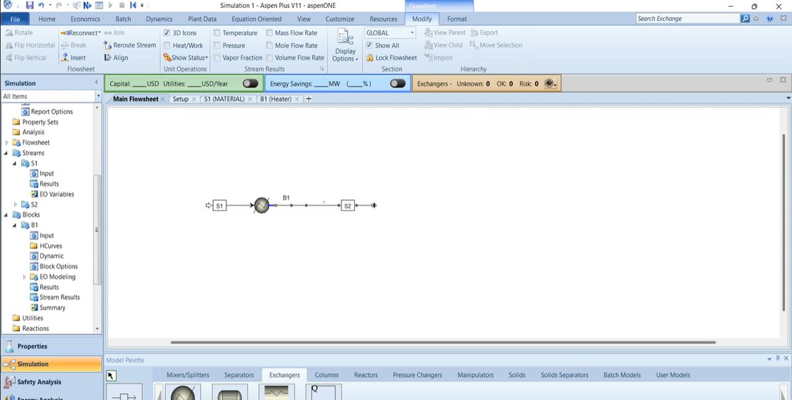
Figure 4.1: Selection of the heat exchanger
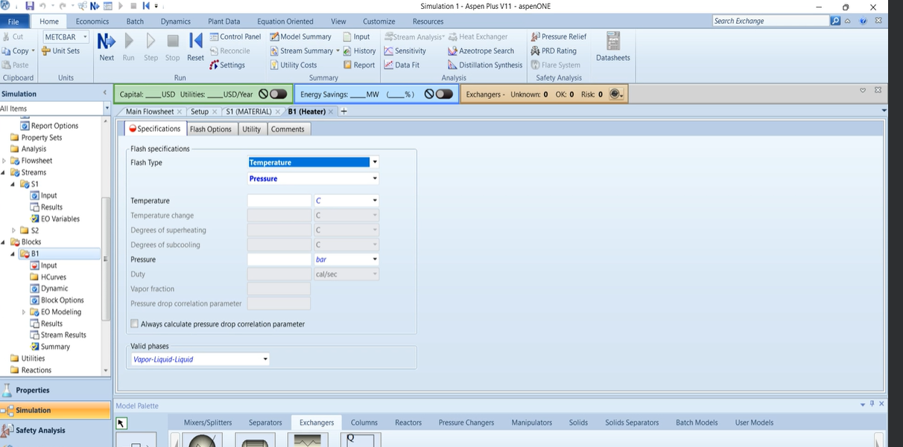

Figure 4.2: Defining the heat exchanger properties.

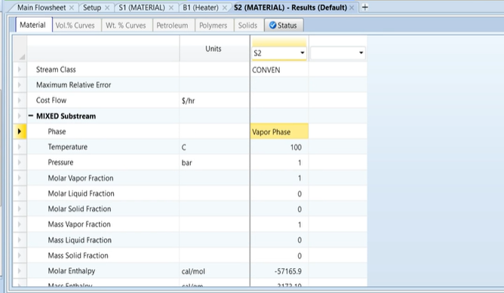
Figure 4.3: Heater results

The HeatX operation block in Aspen Plus is considerably more complex than a traditional heater. It necessitates the integration of four streams, as depicted in Figure 4.4. To avoid entering incorrect values for the different feeds, it is crucial to carefully hover over the red input arrow when connecting these feeds to the operation block and to assign appropriate names to each stream. To change the name of a stream outlet, right-click on the stream you want to rename and select the "Rename Stream" button. Type the new name and click "Okay." Alternatively, you can double-click on the box where the name appears to rename streams. The cold inlet stream should be defined as follows: 20°C, 10 bar, and 60,000 kg/hr of water (see Figure 4.5). The hot inlet stream parameters are set at 200°C, 4 bar, and 10,000 kg/hr, comprising 50% benzene, 20% ethylbenzene, 20% styrene, and 10% water.
Proceeding with the HeatX operation, the model is configured to use a shortcut approach with a countercurrent flow direction. The specified operation involves reducing the hot stream's vapor fraction to zero, implying that the mixed liquid will be cooled until no vapor remains, resulting in a purely liquid phase (see Figure 4.6). It is essential to then navigate to the block options and alter the physical property method on the cold side to Steam-TA to ensure accurate calculations.
After running the simulation and examining the thermal results, it is observed that the hot outlet stream has been sufficiently cooled to maintain only the vapor phase. The details of the exchanger's performance can be assessed under the 'Exchanger Details' tab, where the area efficiency is displayed. Here, one will notice that the required exchanger area and the actual exchanger area often match. However, if the required exchange area exceeds the actual (see Figure 4.7), adjustments will be necessary. This may involve adding additional heat exchangers or reducing the flow rate entering the block to ensure optimal performance and efficiency. This detailed step-by-step approach ensures that the HeatX operation is executed correctly and efficiently, aligning with the stringent requirements of industrial heat exchange processes.
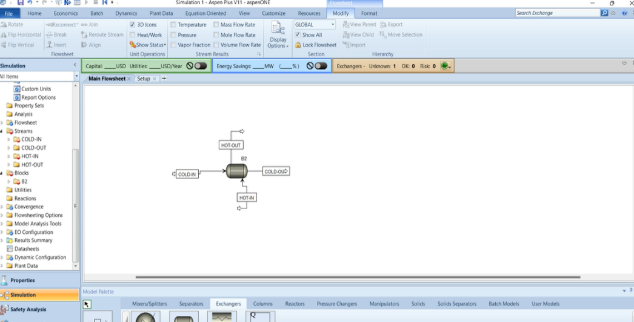
Figure 4.4: Representation of the Heat-x block

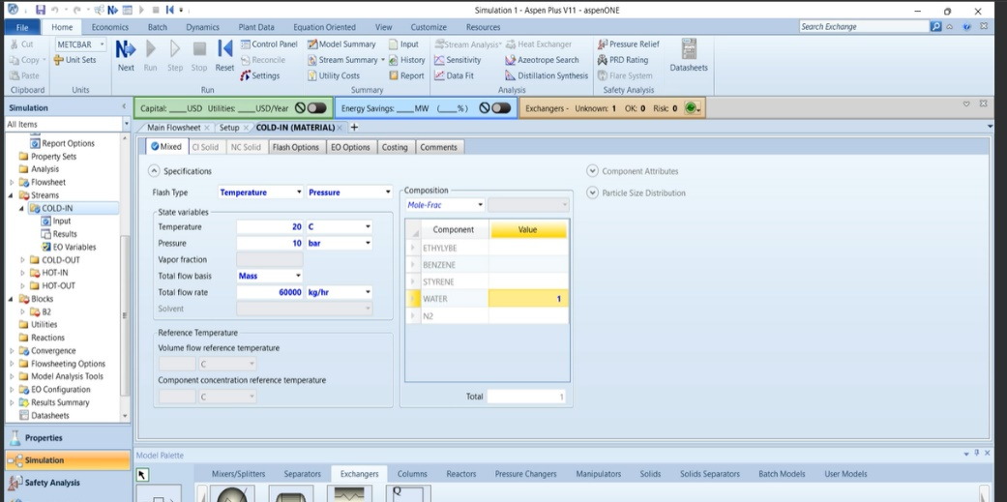
Figure 4.5: Defining the heat exchanger properties.

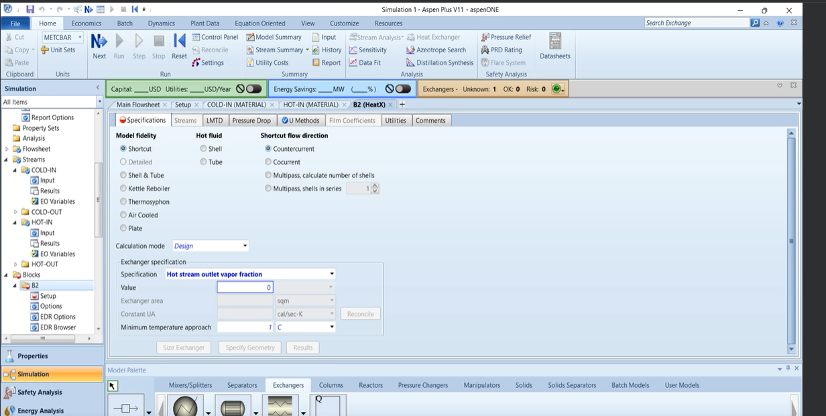
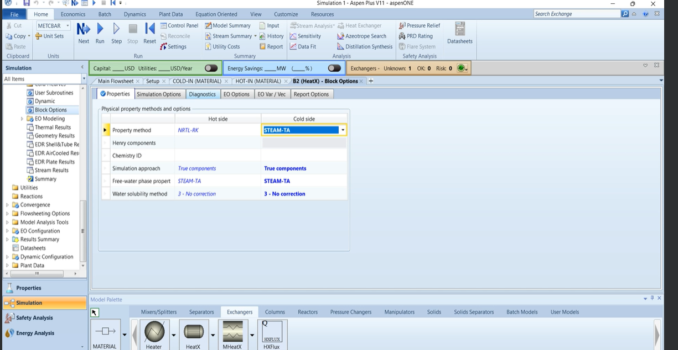
Figure 4.6: Heat exchanger specifications
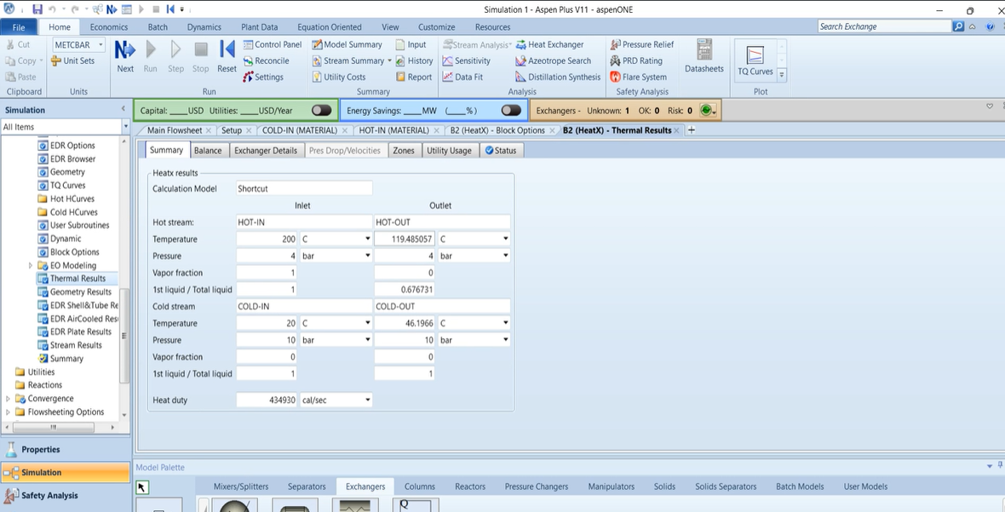
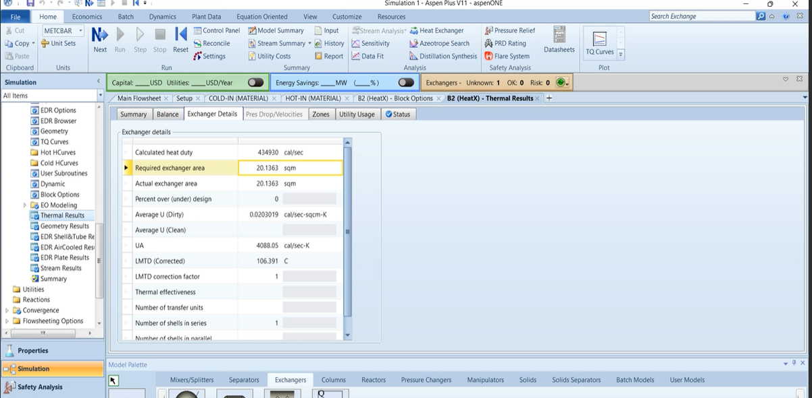
Figure 4.7: Heat exchanger results
Next, in the same simulation, we are going to change the HeatX block to be rigorous. Within the HeatX block, change the calculation mode to "rating" and the model fidelity to "shell and tube." A pop-up will appear; click the "convert" button, followed by the "okay" button, which will take you to equipment sizing. These changes are significant because they transition the heat exchanger analysis from a simplified approach to a more detailed and accurate assessment.
In the equipment sizing section, change the calculation mode to "rating." This choice shifts the focus to evaluating the heat exchanger's performance based on specified design parameters, such as heat transfer coefficients and surface areas, rather than relying on default assumptions.
Begin by adjusting the tubes' outer diameter (OD) to 0.025 meters. The selection of this diameter has a direct correlation to heat transfer efficiency. A larger tube diameter can enhance heat transfer rates but may require more material and space, while a smaller diameter increases surface area for heat exchange but can lead to higher pressure drops.
Scroll down to the Shell OID/OD inter diameter, set the units to meters, and specify the closest column as 1. This step is essential for optimizing fluid flow patterns and heat transfer efficiency within the shell side of the exchanger. The chosen OID/OD ratio influences flow distribution and thermal performance, ensuring optimal operation of the heat exchanger.
Set the tube length to 3 meters, the baffle spacing to 0.25 meters, the number of baffles to 5, and the number of tubes per pass to 300 (all of these changes can be seen in figure 4.8). These adjustments are strategic, as they control fluid flow, turbulence, and residence time within the heat exchanger. A longer tube length and appropriate baffle spacing promote efficient heat transfer by enhancing mixing and preventing stagnant zones, while the number of baffles and tubes per pass affects flow distribution and pressure drop across the exchanger.
After making these adjustments, click on "size" in the bottom left corner and then click on "accept design." This finalizes the equipment sizing calculations based on the specified parameters. Running the simulation. Then go to the thermal results, under the results folder for the block, as we did previously. The results will provide insights into the actual performance of the heat exchanger. Clicking on the Heat Exchanger Details will reveal the actual exchange area, which should be slightly larger than the required exchange area, indicating a well-sized and slightly over-engineered heat exchanger, which is beneficial for ensuring optimal performance under varying operating conditions.

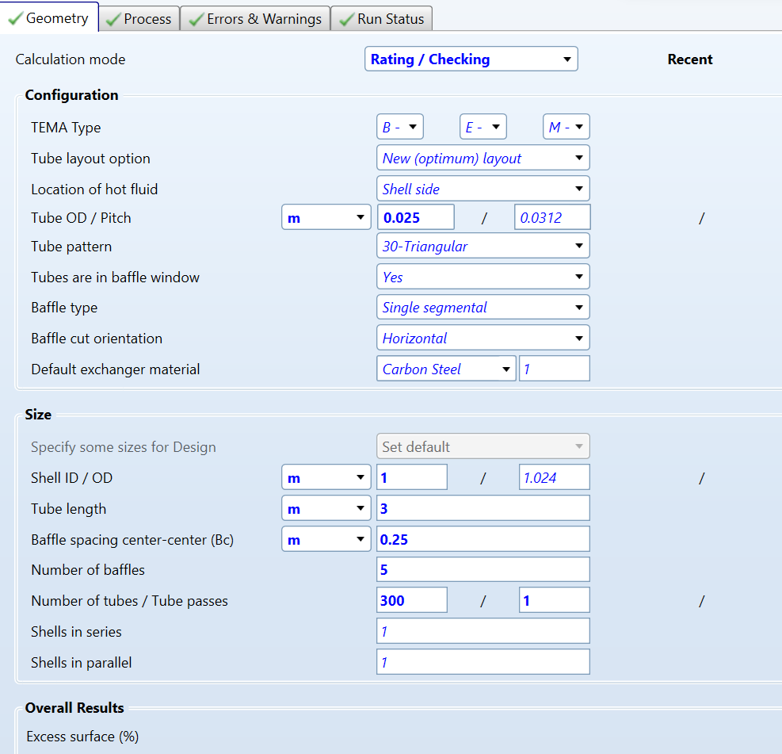
Figure 4.8: Correct geometry set up

4.2 Worked Examples with Pressure Changers
In Aspen Plus, pressure changers are modeled to simulate equipment that alters the pressure of process streams. These are essential components in chemical engineering processes were controlling or modifying the pressure is necessary for operations like compressing gases, vacuum distillation, or simply overcoming friction losses in piping systems.
Types of Pressure Changers in Aspen Plus:
- Compressors:
  - Purpose: Used to increase the pressure of a gas by mechanically compressing it.
  - Types: Various compressor types can be modeled, including centrifugal, axial, and reciprocating compressors. Each type has specific characteristics suitable for different operational requirements, such as flow rate and compression ratio.
- Pumps:
  - Purpose: Employed to increase the pressure of liquids. Pumps are critical for moving liquids through a system, especially in scenarios where the fluid needs to be transported to a higher elevation or through a long distance.
  - Types: Aspen Plus allows modeling of centrifugal pumps, positive displacement pumps, and other specialized types depending on the viscosity and flow characteristics of the liquid.
- Expanders:
  - Purpose: Used to decrease the pressure of a gas while extracting mechanical work or cooling the gas. This is often used in power generation or refrigeration cycles.
  - Types: Turbine expanders and other types of expanders can be simulated, which are used to decrease pressure in a controlled manner.
- Valves:
  - Purpose: Utilized to control flow rate and pressure in piping systems. While primarily used for flow control, valves inherently change the pressure of a fluid passing through them due to resistance and other dynamic effects.
  - Types: Includes control valves, safety valves, and throttle valves, each serving specific functions such as maintaining pressure, preventing overpressure, or managing flow rates dynamically.
- Ejectors and Venturi Scrubbers:
  - Purpose: These devices use a high-speed jet of fluid to entrain a secondary fluid, effectively reducing the pressure of the secondary fluid through the venturi effect.
  - Types: Ejectors can be modeled for scenarios where mixing and pressure reduction of two different streams are required, often used in vacuum systems or where pumping of a secondary fluid is needed without moving parts.
Aspen Plus allows for the detailed simulation of these pressure changers by considering thermodynamic properties, fluid dynamics, and operational conditions. This capability is critical for designing systems that are energy efficient and meet process requirements, providing engineers with tools to optimize the performance and cost of their processes.
In this section we will look at the pump, compressor, valve and the multistage compressor. To begin setting up these simulations we will create a new blank simulation. The components for the simulation are ethylbenzene, benzene, styrene water and nitrogen. The simulation method will be NRTL-RK for the handling of vapor-liquid equilibria. Make sure to run the simulation before proceeding to the simulation design tab. Once in the main flowsheet click on the ‘pressure changers’ tab you will see 6 different pressure exchanges. They are in order the pump, the compressor, the multistage compressor, value, pipe and pipeline.
For the first part of the simulation, we will focus on the use of the pump. When you hover over the pump in Aspen, you'll receive a brief description of its functions. The pump block is utilized for increasing or decreasing the pressure of liquids. You can configure this pump to function either as a turbine or as a pump. However, in this example, we will focus on exploring the pump option to compress water. Drag one of the pumps from the ‘pressure changers’ tab and add it to the simulation flowsheet. Click on the materials button and add an inlet and outlet to the pump by hovering over the arrows that go into and edit the option block. Change the inlet stream's name by right-clicking on it, selecting the rename button, and renaming it to "water." Then, right-click on the "water" stream and input its standard properties as 25°C, 1 bar, and a flow rate of 100 kg/hr of water. Next, click into the pump block. Ensure that you select the pump as your choice under the model specifications. Once that is complete you will see a variety of pump outlet specifications.
In Aspen, the pump outlet specifications determine how the fluid behaves upon leaving the pump. These settings include options such as discharge pressure, temperature, isentropic efficiency, and flow rates (mass or volumetric). Discharge pressure is key for controlling downstream system pressures, while temperature control is important for processes requiring specific thermal conditions. Isentropic efficiency reflects the pump's energy conversion performance, and flow rates are critical for overall process control and optimization.
For this exampled we will choose the discharge pressure option and set the discharge pressure to be 20 bar (as shown in figure 4.10). Return to the main flowsheet and run the simulation. When you examine the results of the outlet stream, you will notice that the water pressure has increased to 20 bar. You can observe this change by either clicking on the outlet stream's results button or by accessing the 'modify' button at the top of the Aspen flowsheet and then checking the pressure checkbox in the stream results section.
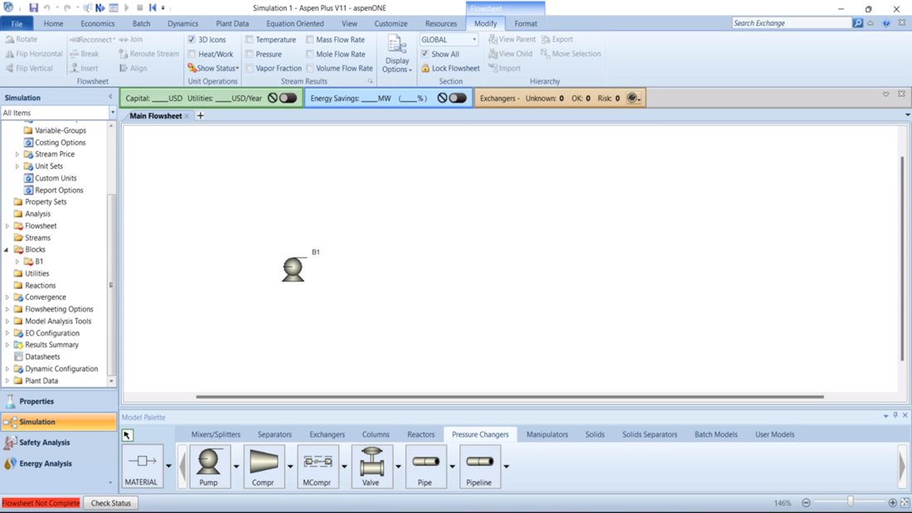
Figure 4.9: Representation of the pump block
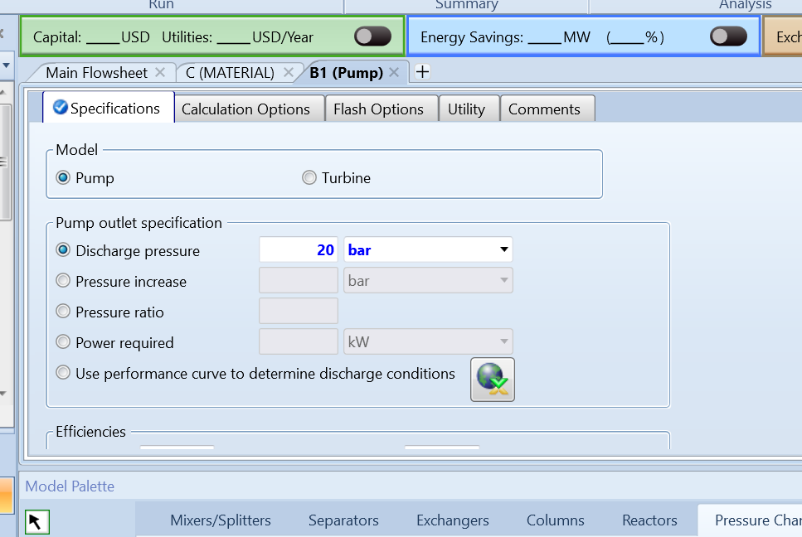
Figure 4.10: Pump specifications
The Compressor block is very similar to the pump however this device is only for gases. In the same pressure changers tab and simulation drag a compressor into the main flow sheet. Add its inlet feed stream and its product outlook stream. Double click into the input stream and specify the composition by clicking the drop-down tab under composition and selecting mass fractions. Add a one in for the value next to nitrogen to show the inet stream is pure nitrogen pet the temperature to be 25 C the pressure to be 1 bar and the total flow to be kg/h with a flow rate of 50. Click into the compressor and you’ll see it’s very similar to the pump. With one key change being that you must specify the type of compressor method you want.
These methods include ones like isentropic efficiency, which shows how efficiently a compressor works without considering any losses. The ASME (American Society of Mechanical Engineers) and GPSA (Gas Processors Suppliers Association) methods follow industry standards and consider factors like adiabatic efficiency and stage efficiency. Polytope efficiency looks at both ideal and actual performance factors. For positive displacement compressors, Aspen Plus lets you model them in parts, which is helpful for different operating conditions. These methods help you accurately simulate how different compressors perform under different situations in your processes. The most common choice for compressors is going to be isentropic which is what we will select for the method.
Next go to the outlet specification and pick discharge pressure and specify the discharge pressure to be 20 bar ( as seen in figure 4.12). Run the simulation and view the results.
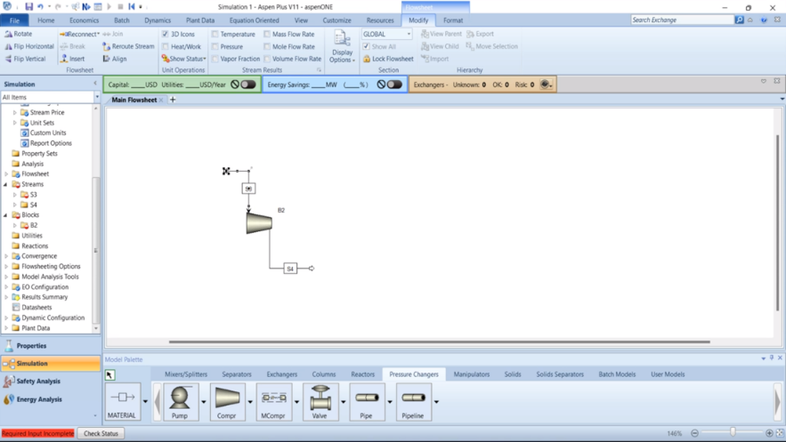
Figure 4.11: Representation of the compressor

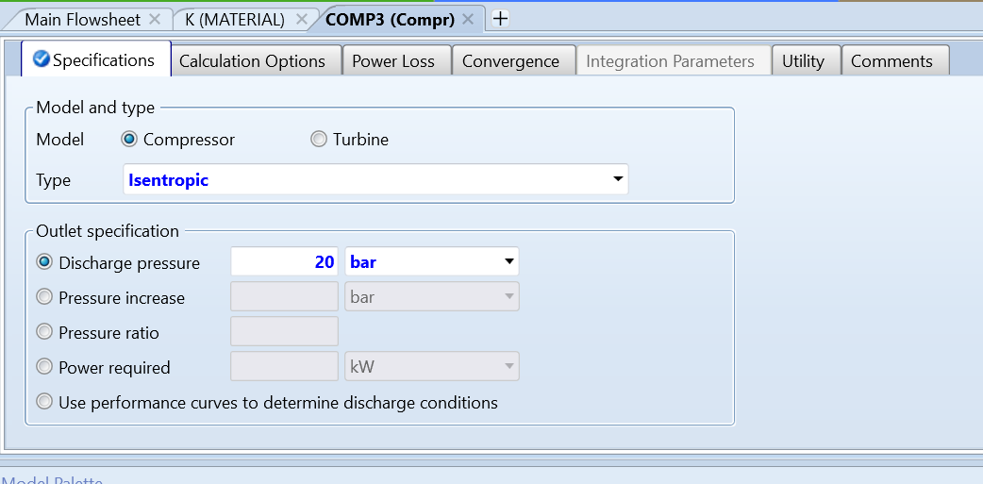
Figure 4.12: Compressor specifications

The multistage compressor is the most involved unit operation block in the pressure exchangers subsection. The multistage compressor/turbine models multistage polytropic or isentropic compressors. Add a multistage compressor to the simulation followed by its required materials streams. Open the inlet stream and specify it to be 25 C 1 bar of pressure and 5kg/hr of nitrogen.
Next, double-click on the multistage compressor to open the block. First, choose the number of stages, which can be any number depending on your compressor needs but for our example we will pick 2. Next, select the same compressor model as in the compressor example and choose isentropic efficiency. Then, set the fixed discharge pressure for the last stage to be 200 bar. You'll have the option to choose between equal pressure ratio and equal head. Equal pressure ratio maintains a consistent pressure increase regardless of conditions, while equal head provides the same energy per unit weight even with changing conditions. We'll go with an equal pressure ratio for this setup (as seen in figure 4.14).
Next, navigating to the "cooler" tab within the compressor block. In this tab, you'll find a table where you can specify the number of stages. Locate the "stage" row in the table and input '1' in the column next to the units, then press enter. Repeat this step for the next column, entering '2' for the second stage. After setting the stages, focus on the specifications below the table. Here, you can choose between outlet temperature, duty, and temperature ratio. Select "outlet temperature" for both stage one and stage two. Set the outlet temperature to 25°C for stage one and 75°C for stage two, following the settings shown in figure 4.15.
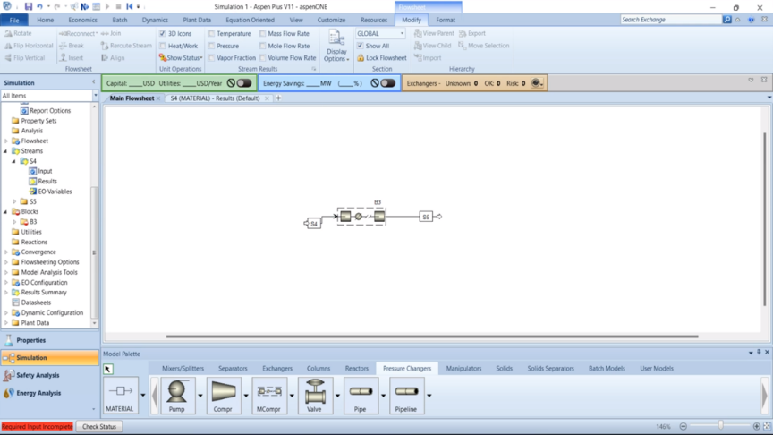
Figure 4.13: Representation of a multistage compressor

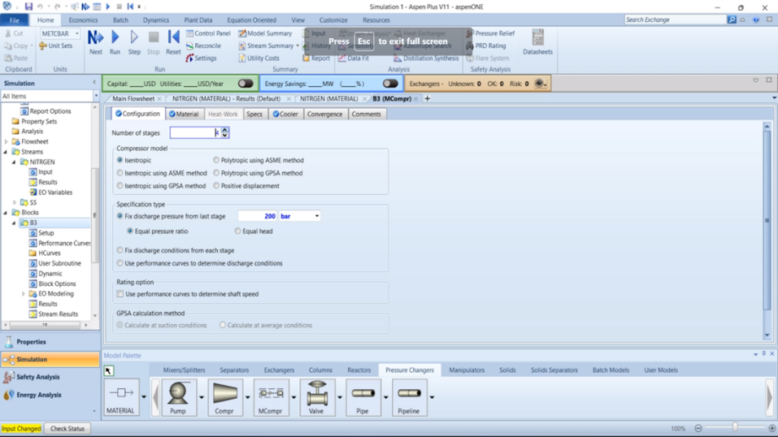
Figure 4.14: A multistage compressor specification

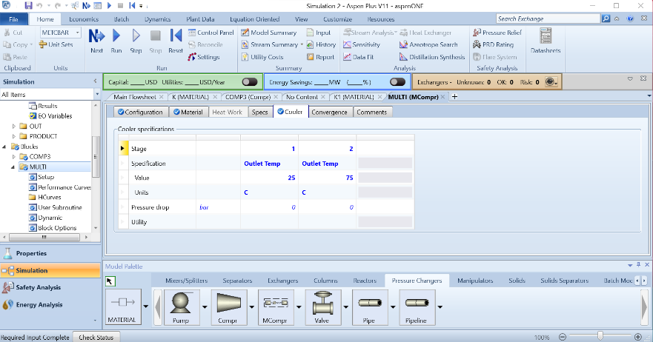
Figure 4.15: A multistage compressor cooler specification.

Lastly, let's explore the valve. Select the valve and add it to the main flowsheet, attaching it to the compressor as shown in Figure 4.16. To do this, click on the outlet stream of the multistage connector, then right-click to see the reconnect option. Reconnect it to the inlet stream of the valve, add an outlet, and click into the valve block. You'll find three different calculation types there.
The first one is adiabatic flash, which is used for specified outlet pressure to understand how a mixture behaves at a certain pressure without heat transfer. Calculating the valve flow coefficient for specified outlet pressure is all about designing valves to control flow at a specific pressure. And calculating outlet pressure for a specified valve helps us see what pressure we'll get at the outlet with a known valve.
For our example, select adiabatic flash. Then, in the pressure specifications, choose the outlet pressure option and change it to 100 bar, which halves the pressure. Run the simulation and view the results.
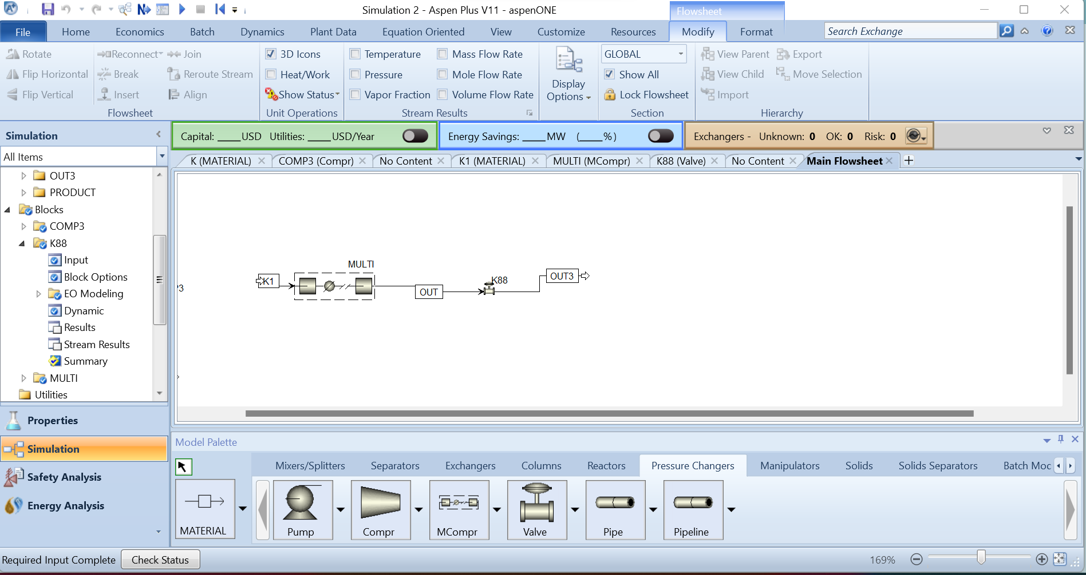Figure 4.16: A representation of a valve

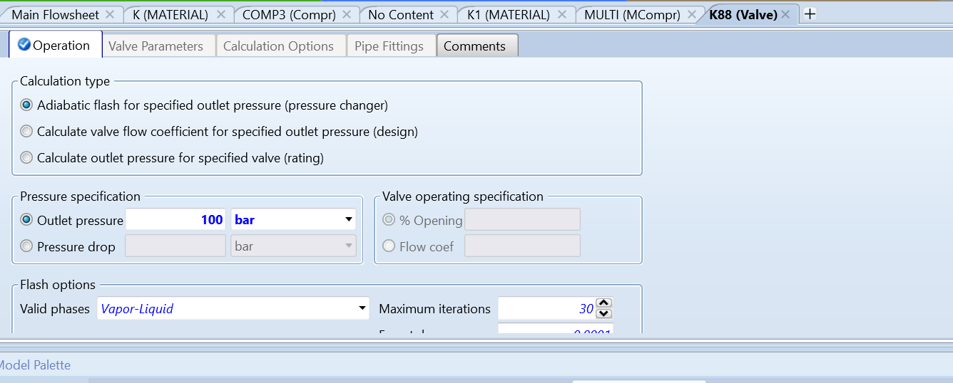Figure 4.17: Valve specifications

4.3 Worked Examples with Columns
Columns in Aspen Plus are essential for simulating various distillation processes. They are the most common separators of liquid-vapor processes in industry. Distillation works by applying and removing heat to separate different mixtures based on their boiling points. Because they are widely used in industry, understanding how to model distillation columns in Aspen Plus is crucial for process engineers and designers.
Types of Columns in Aspen Plus:
- Shortcut distillation design using the Winn-Underwood-Gillan method (DSTWU):
  - Purpose: provide as good starting point for distillation columns with the following assumptions: constant relative volatilities and constant molar overflow
  - Uses: it can calculate the minimum number of stages, the minimum reflux ration and relates the actual number of stages to the reflux ratio. It's especially effective if you have a single feed, two product distillation.
- Shortcut distillation rating using Edmister Method (Distil):
  - Purpose: Creating an approximate result with minimum data in a quick and efficient way as long as it has constant relative volatiles and constant molar overflow
  - Uses: calculating the composition of distillation columns for a given number of stages and reflux ratio. It's helpful in the early stages of design where you might have limited information
- Rigorous 2 or 3 phase fractionation for single columns (RADFRAC):
  - Purpose: preform detailed calculations and accurately simulate phase behavior in the column where multiple phases can coexist
  - Uses: Handling complex simulations and it can model systems with non-ideal thermodynamics such as those involving azeotropes
- Rigorous counter-current extraction of a liquid with a solvent (Extract):
  - Purpose: to remove one or more solutes from one liquid phase by transferring them to another liquid phase (or a solvent)
  - Uses: separating material that may decompose or denature at elevated temperatures. Its expectational useful when separating penicillin from broth and separating aromatic ring hydrocarbons from paraffins.
- Rigorous fractionation for complex columns such as crude units (multiFrac):
  - Purpose: Complex column that involves the separation of crude oil into various fractions, heat exchanges and the removal of certain components
  - Uses: Simulate petroleum refineries and separate crude old into naphtha, kerosene, diesel and gasoline
- Shortcut Distillation for complex columns (SCFrac):
  - Purpose: to provide a simplified and faster method for the design and analysis of distillation columns, particularly useful in multicomponent distillation. Its purpose is to enable preliminary calculations for main design variables like reflux ratio and number of theoretical stages, and to visualize achievable splits at different pressures and reflux ratios.
  - Uses: SCFrac is particularly useful in multicomponent distillation. It allows you to see the splits that can be achieved at different pressures, with different reflux ratios, and with a different number of stages. It can also preform column divisions
- Rigorous fractionation for petroleum refining applications (PetroFrac):
  - Purpose: Separate crude into different more useful hydrocarbon products based on molecular weights.
  - Uses: uses to model reflash towers and it considers the main separation process and the first step on processing crude oil
Aspen Plus offers rigorous simulations and optimization capabilities for distillation columns, enabling detailed analysis of petroleum refineries, general liquid-vapor processes, and the separation of solvents and solutes. Understanding these capabilities is greatly beneficial for comprehending the plant design of petroleum products and other separation processes.
In this section, we will explore two common distillation column models: DSTWU and RADFRAC. These models represent typical scenarios encountered in simulations and are widely used in distillation processes.
To begin, let's look at setting up the DSTWU distillation column in Aspen Plus. Start a new simulation using the NRTL-RK method and define methanol and water as the components. Run the simulation and then navigate to the simulation environment. In the model palette, click on the ‘columns’ tab and locate the DSTWU column and drag it into the simulation workspace. Add your feed, and your output feeds including the top and bottom distillate outputs (as seen in figure 4.18). Click into the input stream and specify the operating conditions by setting the pressure to 18.4 psi the temp to 25 C and the flow rate to 4400 kg/hr, with a mass fraction of 0.632 for water and 0.368 for methanol (as seen in figure 4.19).
Once the initial setup is complete, access the distillation column to define a reflux ratio. For this example, set it to –1.3, but in practice, determine a desired reflux ratio based on your separation needs. Calculate the minimum reflux ratio using the Underwood equation (Aspen can assist with this) and aim for a reflux ration within 1.2 to 2 times the minimum value for optimal performance. Then you will specify the condenser and reboiler pressures to ensure that the condensation pressure is equal to or less than the reboiler pressure; for this example, set both to 1 atm.
Identify the component with the lower boiling point or higher volatility, known as the “light key.” Conversely, the “heavy key” is the opposite. In this scenario, methanol serves as the light key, and water is the heavy key. Aim for recovery key percentages within specific ranges: set the light key recovery percentage to 98.1% (in practice set yours to be between 95-98% for purity), and the heavy key recovery percentage to 7.7% (in practice set yours to be between 5-10%) as illustrated in figure 4.20. After running the simulation, right-click on the column and select the ‘results’ tab to review the outcomes, which should mirror those shown in figure 4.21. Pay close attention to the number of stages and the reflux ratios as we'll use this information for configuring the RADFRAC distillation column.
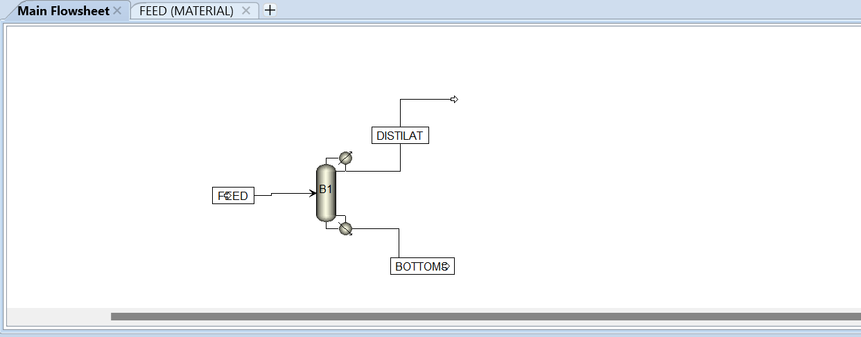Figure 4.18: representation of DSTWU
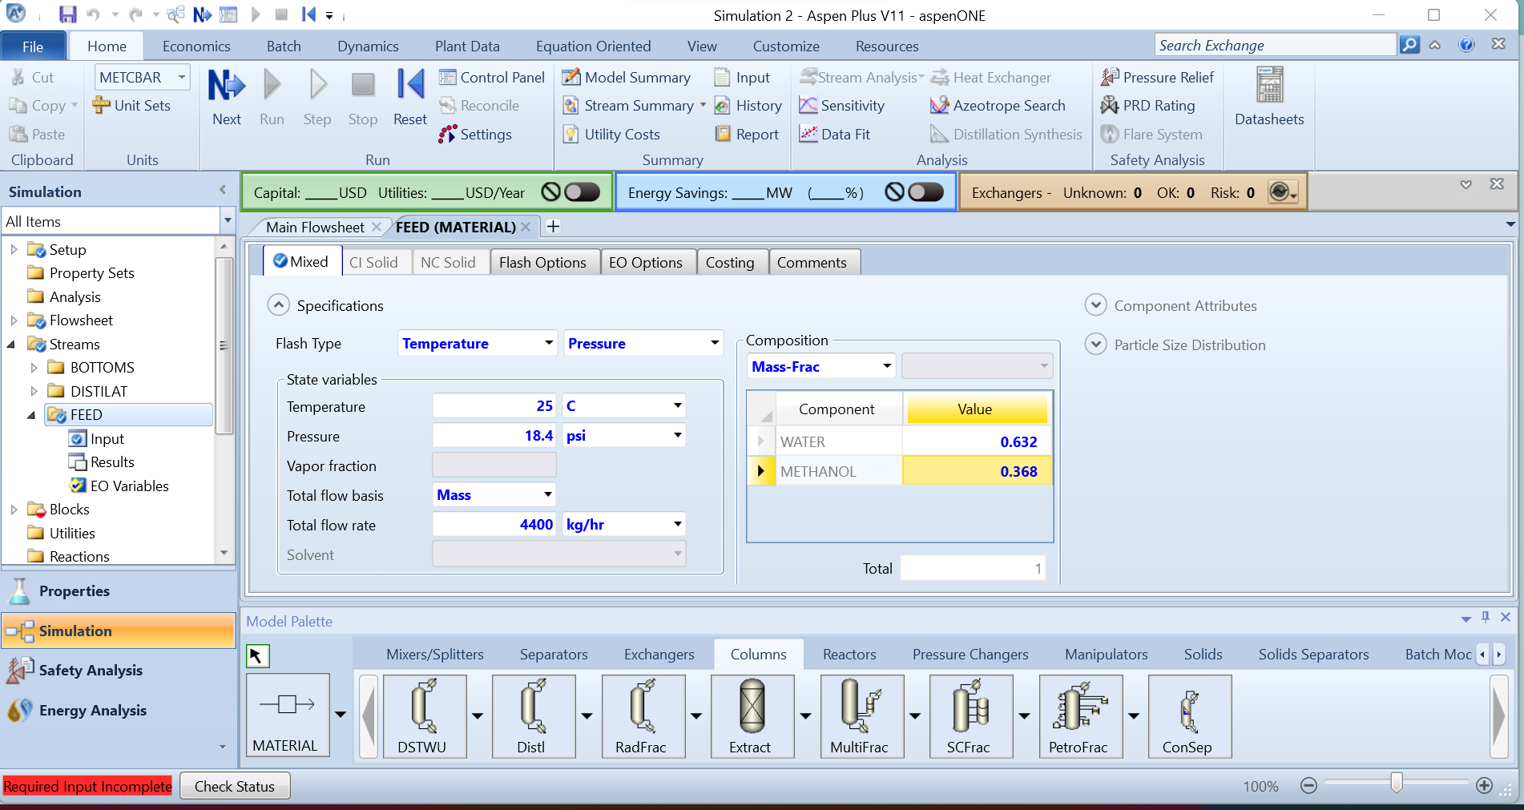Figure 4.19: feed stream inputs for the DSTWU
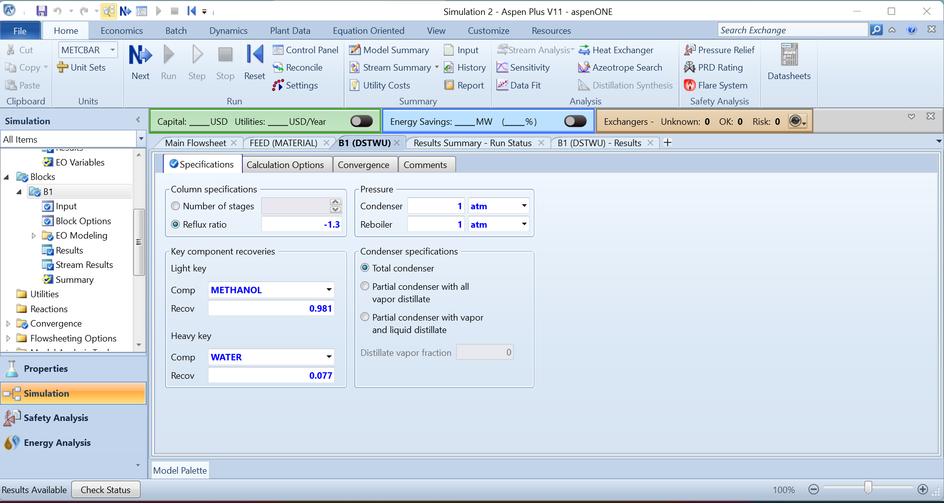Figure 4.20: DSTWU specifications
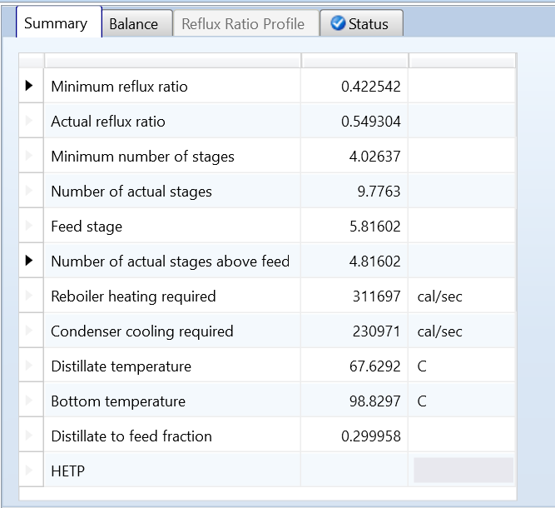
Figure 4.21: DSTWU Results
The RADFRAC unit operation block is more intricate than the DSTWU column but provides a broader range of modeling options. It can handle various column types such as extractive, azeotropic, and reactive distillation, making it versatile for different processes. Additionally, RADFRAC can manage multiple feeds and outlet streams, adding to its flexibility. To begin, drag the RADFRAC block into the simulation workspace. We are going to follow the same specifications for the feed and outlet streams as in the previous example. When you add the outlet stream you will see two red arrows at the top of the block. You want to make sure that you pick the lower arrow it should say liquid distillate when you hover over it.
In practice, selecting the liquid distillate option means that the desired product is taken from the liquid phase at the top of the distillation column. This is typically done when the product of interest is more concentrated in the liquid phase or when the liquid product is required for downstream processes. The vapor distillate arrow would be used if the product extracted from the top is pulled sat the vapor stage This is common when the product is more concentrated in the vapor phase or when a gas-phase product is needed for further processing.
Once you have set up the RADFRAC column, specify the number of stages as 10, as this is the nearest whole number to the actual number of stages resulting from the DSTWU column. Choose the condenser to be total and set the reflux ratio to 0.549304, which matches the actual reflux ratio from the DSTWU results.
The distillate rate in a RADFRAC unit operation refers to the rate at which the desired product is withdrawn from the distillation column as either a liquid or vapor distillate. It's important to note that increasing this rate can lead to higher operating costs in simulation due to increased energy consumption, larger equipment sizing, and longer processing times. However, setting the distillate rate appropriately high is crucial for achieving efficient separation. For this example, set the distillate rate to be 100 kmol/hr to balance efficiency with operational costs.
Next go to the stream and specify the number of above stages to be 4. In practice you should consider running simulations with different numbers of stages and evaluate the separation efficiency, product purity, and operational costs for each scenario.
Go to the ‘pressure’ tab and set the top stage/ condenser pressure to be 1 atm. Run the simulation and view the results of both streams and the results of the distillation column.
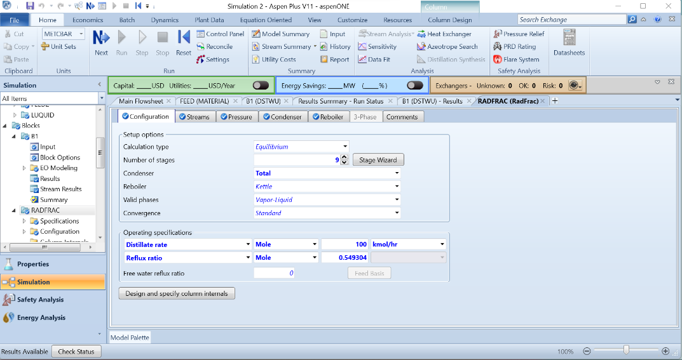
Figure 4.22: configuration set up in the RADFRAC
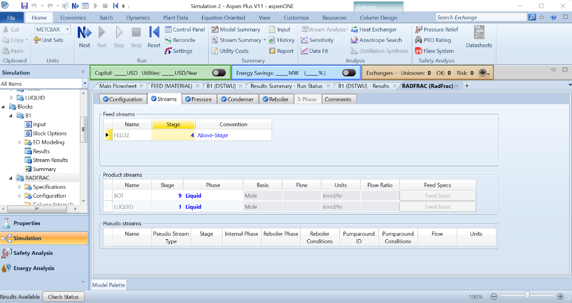
Figure 4.23: streams set up on the RADFRAC

4.4 Worked Examples with REACTORS
In Aspen Plus, reactor blocks are computational units used to model chemical reactions and physical processes within a process simulation. These blocks represent reactors where chemical reactions occur or physical transformations take place. They are among the most complex and versatile blocks in Aspen Plus, allowing for the simulation of a wide range of reaction types, including solids handling and complex kinetics. This section focuses on exploring how to handle solids and complex kinetics within these reactor blocks. In Aspen Plus, you can model various types of reactors based on the required reactions. The types of reactor blocks in Aspen Plus are detailed below:
- Stoichiometric Reactor (RStoic)
- This reactor is used when the conversion rates and the extent of the reaction are known or can be estimated.
- Conversion Reactors (RYield)
  - This nonstoichiometric reactor is based on known yield distributions. It is used to model chemical reactions based on the conversion rates or yield of products.
- Gibbs Reactor
  - Rigorous reactor and or multiphase equilibrium based on Gibbs free energy minimization
- Equilibrium Reactor (REquil)
  - This reactor simulates chemical reactions that reach a state of chemical equilibrium. At equilibrium, the rates of the forward and reverse reactions are equal, resulting in constant concentrations of reactants and products.
- Plug Flow Reactor (RPlug)
  - Used to model continuous-flow chemical reactions with short residence times, very efficient in reactor volume.
- Continuous Stirred Tank Reactor (RCSTR)
  - Used for continuous flow reactors where reactants can turn into products and vice versa.
- Batch Reactor (RBatch)
  - A batch reactor used in chemical engineering for studying reversible reactions in a batch-wise manner. Unlike continuous-flow reactors, batch reactors operate by filling the reactor with reactants, allowing the reaction to proceed, and then emptying the reactor after a set reaction time.

In Aspen Plus, all reactor models, except for RPLUG and RBATCH, can accommodate any number of material feed streams, which are mixed internally within the reactor. The rigorous models available can incorporate built-in kinetics models such as power law or Langmuir-Hinshelwood-Hougen-Watson kinetics. Additionally, users can define custom kinetics through Fortran subroutines or Excel worksheets, allowing for detailed and customized reaction modeling within the simulation environment. The types of reactors can be categorized based on several criteria: whether they require stoichiometry information, whether they involve kinetics, the type of feedstock they can accommodate, and their level of rigor. A detailed breakdown of these categories can be found in Table 4.1.
We will focus on exploring the RStoic, RYield, RGibbs, and RPlug reactors. However, we will begin by examining reactors that do not require kinetics information, as they are simpler to use.

Table 4.1: Summary of different reactor block characteristics in Aspen Plus.
Model | Kinetics | Feedstock | Stoichiometry | Rigorous
RStoic | No | Any | Yes | No
RYield | No | Any | No | No
RGibbs | No | Any | No | No
REquil | No | Any | No | No
RPlug | Yes | 1 | Yes | Yes
RCSTR | Yes | Any | Yes | Yes
RBatch | Yes | 1 | Yes | Yes

The RStoic reactor is ideal for managing chemical equations with known stoichiometry. In this example, we will simulate a double replacement reaction. However, it is versatile enough to handle various types of reactions and even multiple reactions within a single reactor if required. Start by creating a blank simulation with the components sodium sulfide (Na₂S), hydrogen chloride (HCl), hydrogen sulfide (H₂S), and sodium chloride (NaCl), using the Peng-Robinson equation of state (PENG-ROB). The PENG-ROB method is a widely used thermodynamic model in chemical engineering and fluid dynamics. Named after its developers, D.Y. Peng and D.B. Robinson, it is used to predict the behavior of fluids, especially hydrocarbons and their mixtures, under different conditions of temperature and pressure. We will use this method frequently in the following examples. Once the setup is complete, run the simulation and go to the "Simulation" tab. Navigate to the "Reactors" tab and drag an RStoic reactor into the simulation, as well as a component separator from the "Separators" tab. Add a material feed stream to the RStoic, an outlet stream from the RStoic to the separator, and two different streams out of the separator (as seen in Figure 4.24).
Click on the input stream and add the following specifications: 25°C, 1 bar, total flow basis set to mass at 50 kg/hr, and the mass fractions set to 0.5 for Na₂S and 0.5 for HCl. Then, click on the RStoic reactor. Set the temperature to 25°C and the pressure to 1 bar. Next, click on the "Reactions" tab. Click the "New" button under the blank table, and you should see a table with the reaction number in the top left corner. Now, specify the stoichiometry of the reaction by placing the two reactants, Na₂S and HCl, on the left side with coefficients of 1 for Na₂S and 2 for HCl. Then, add the products, NaCl and H₂S, with coefficients of 2 and 1, respectively. Set the fractional conversion to 0.99 for Na₂S (as seen in Figure 4.26). In practice, you determine the fractional conversion based on how much of a component you want to convert to the product, especially if there are multiple reactions involving a common reactant. Ensure that the conversion factors do not exceed 1. Next, navigate to the Sep Block and select NaCl from the top drop-down menu. Scroll down to find NaCl in the table and set the split fraction to 1. Run the simulation and examine the results by right-clicking and accessing the results tab. You should see pure NaCl in the NaCl stream and most of the H₂S, along with leftover reactants, in the other stream.

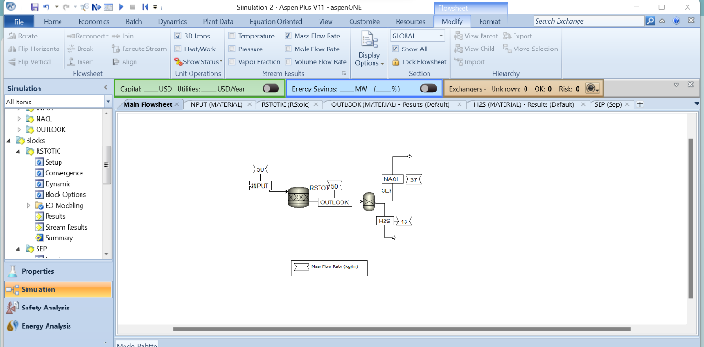.
Figure 4.24: RStoic representation with a separator
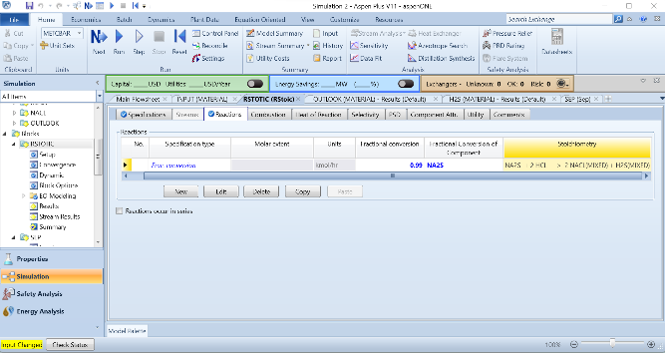
Figure 4.25: Configuring the RStoic reactor block
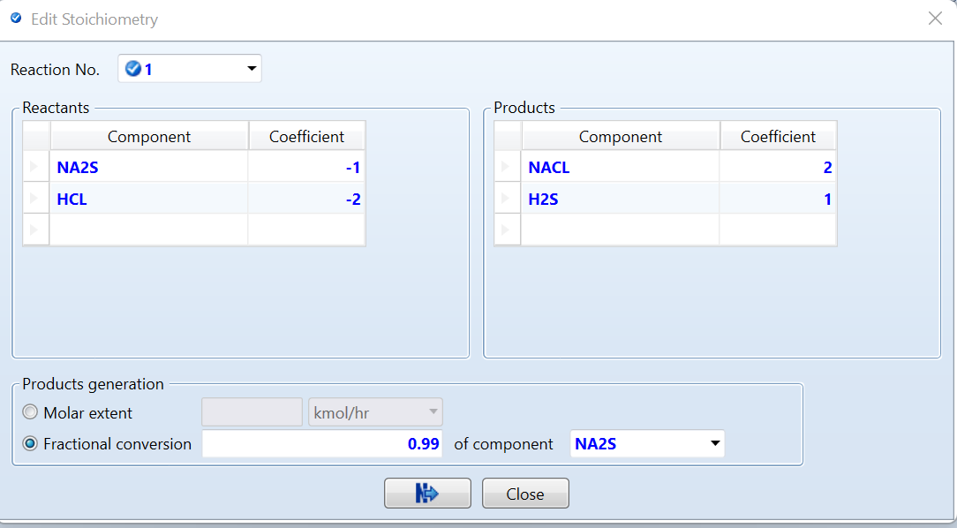
Figure 4.26: The Reaction set up
A Yield Reactor is utilized to either adjust the material balance when yield distribution is known or to decompose unconventional substances into their fundamental elements when their yields are known. This type of reactor does not need stichometry or kinetics as inputs. When handling non-conventional components, the RYield allows you to specify the expected yield distribution of products from a reaction. For non-conventional components where the products are not easily predictable, specifying the yield distribution helps in modeling and predicting the output more accurately.
For this example, let's model coal decomposition and define our first non-conventional components in Aspen Plus. Start a blank simulation and proceed to define the components. Initially, add oxygen, carbon monoxide, carbon dioxide, hydrogen, hydrogen sulfide, nitrogen, water, methane, and benzene as normal components. Then, add carbon and sulfur as usual, but next to them, you will see the term "conventional." Double-click on it, and a drop-down option will appear; choose "solid" for both carbon and sulfur to represent them conventionally. Depending on your simulation's needs, you can define your components in various ways from the drop-down options.
Next, add the non-conventional components in a similar manner. Assign names to each non-conventional component by typing them under the "Component ID" section. Enter the names "coal" and "char," hitting enter after each component. Go to the same drop-down tab as you did for carbon and sulfur, but this time select "non-conventional." Whenever you input biomass or a component that Aspen Plus doesn't have predefined, you will choose "non-conventional" to accurately represent these components in your simulation (as seen in Figure 4.27).
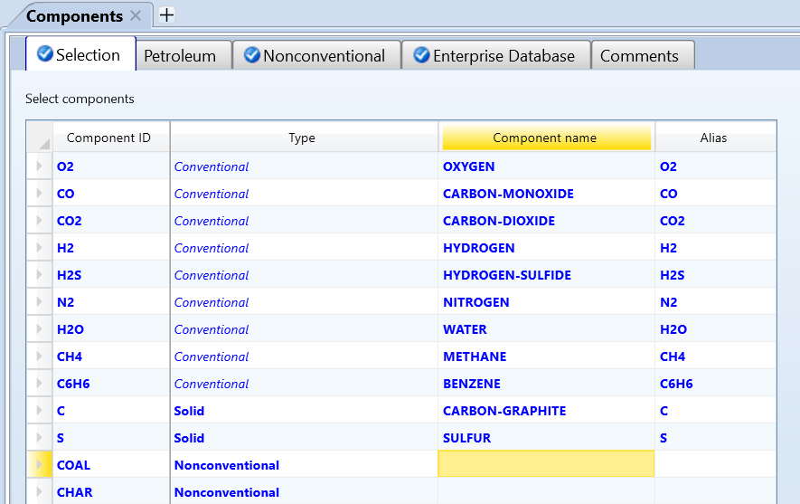
Figure 4.27: A representation of the components used in the coal decomposition example
Next go to methods and select “RK-SOAVE” to be your method. The RK-SOAVE method, also known as the Redlich-Kwong-Soave equation of state, is a thermodynamic model. It's an extension of the Redlich-Kwong (RK) equation of state, incorporating modifications introduced by Soave to improve accuracy, especially for systems involving non-ideal behavior such as polar components or high pressures. Hit the “next” button in the run section of the home banner until it takes you to “NC props”
When defining non-conventional components in Aspen Plus, you specify how Aspen should treat these components in terms of properties such as enthalpy and density. Start by selecting "coal" from the component dropdown menu. Then, under the enthalpy dropdown tab, choose the "HCOALGEN" option. You will see four numbers associated with this option; adjust the first number to 6, keep the second at 1, set the third to 2, and leave the last as 1 (as seen in Figure 4.28). These numbers define the enthalpy properties of coal in Aspen.
Next, under the density dropdown, select the "DCOALIGT" method. Here, you will see options like proxanal, ultanal, and sulfanal, which are used to specify the density properties of coal. Repeat these steps for the other non-conventional component, ash, maintaining similar settings for enthalpy and density properties as appropriate, but leave the numbers for this component as 1, 1, 1, 1.
By configuring enthalpy and density settings in this manner, you inform Aspen about how to handle the thermodynamic and physical properties of these non-conventional components within the simulation. After making these selections, run the simulation to ensure that the settings have been applied correctly and that the simulation behaves as expected.
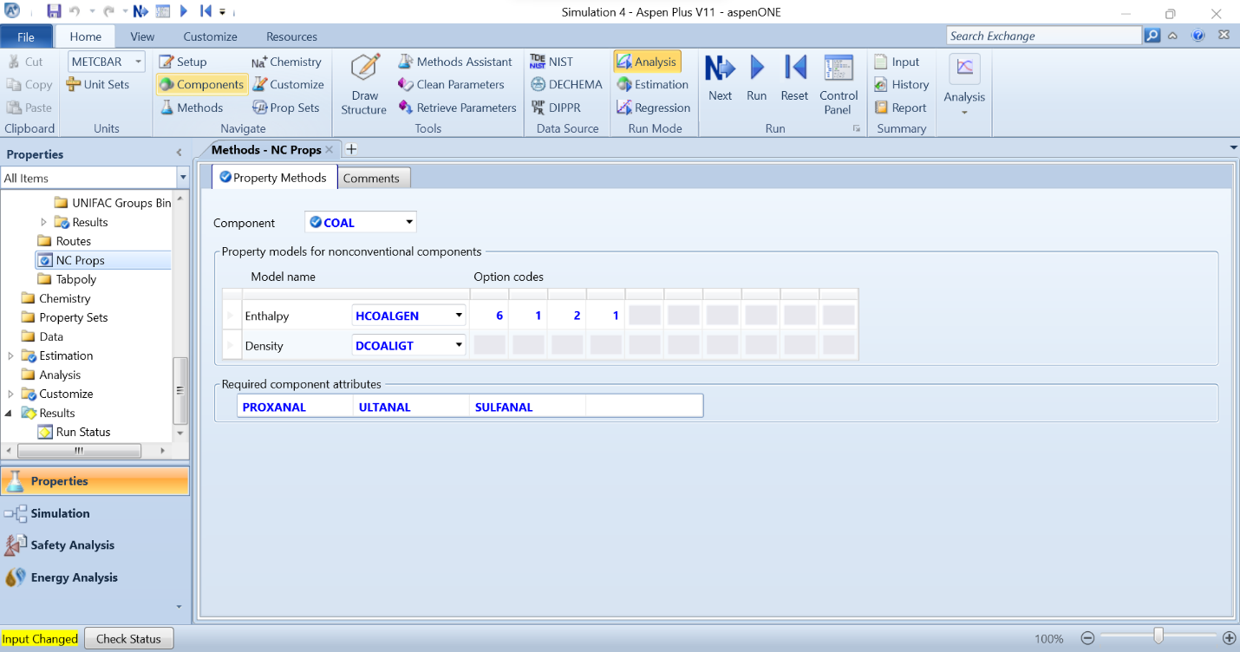Figure 4.28: Representation of coal NC property values.
Once the simulation is complete, navigate to the "Simulation" tab. On the left side of the screen, you'll find an option labeled "Setup" at the top left corner. Click on "Setup," and it will open the setup options for the simulation. Here, you can adjust your units and modify global settings. In the setup options, locate the "Stream Class" dropdown menu. Change the stream class to "MIXCINC." This setting is crucial for handling solids within Aspen Plus, allowing you to incorporate solid components seamlessly into your simulation. By selecting "MIXCINC," you ensure that Aspen Plus understands how to manage the properties and behavior of solid materials in your process simulation.
Once completed with that step, go back to the main flowsheet. Go to the "Reactors" tab and add an RYield reactor to the simulation screen. Add an inlet stream and an outlet stream. Then, click on the inlet stream. You should see three different tabs labeled with three incomplete circles next to them. Navigate to the "NC Solid" tab since we are dealing with a non-conventional solid. Set the temperature to 25°C and the pressure to 23 atm, with a mass flow of 275 kg/hr. Now, focus on the component attribute section. Ensure the component ID is coal, and let's start with the attribute ID of Proxanal. Set the moisture to 0.2, Fixed Carbon (FC) to 58.01, Volatile Material (VM) to 26.46, and ash to 15.53. It is crucial to ensure that the Proxanal values of FC, VM, and ash add up to 100%, which you can verify using data from literature or online sources for biomasses and other non-conventional materials. The moisture content is not part of the amount that needs to add up to 100. Next, move to Ultanal. Set the ash value to match Proxanal at 15.53, carbon to 74.05, hydrogen to 6.25, nitrogen to 0.71, chlorine to 0.37, sulfur to 1.77, and oxygen to 1.32. Again, ensure all values sum up to 100, and the ash values from Proxanal must match those in Ultanal. Finally, switch to the Sulfanal tab and set each value to 0.59. It is crucial that the sum of all these values equals the sulfur content seen in Ultanal. In practice, you can search for the Proxanal, Ultanal, and Sulfanal in literature for whatever component you are trying to model. Next, click into the RYield reactor. Set the temperature to 850°C at a pressure of 3 atm and ensure the valid phases at the bottom are set to "vapor only." Then, click on the "Yield" tab. This is where we will input the percentages of the products expected to be output. Start by adding CO, CO₂, H₂, H₂S, H₂O, N₂, CH₄, C₆H₆, and CHAR in the "Component" column. Change all the options in the "Basis" column to "mass," then enter the basis yield to match Figure 4.29: 0.0059 for CO, 0.003 for CO₂, 0.0084 for H₂, 0.0094 for H₂S, 0.0079 for H₂O, 0.0035 for N₂, 0.1637 for CH₄, 0.071 for C₆H₆, and 0.7272 for CHAR. All of the basis yield values must sum up to equal 1.
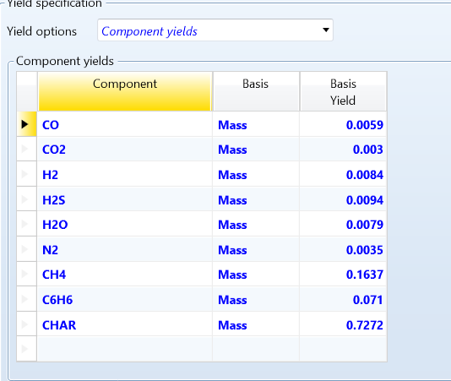
Figure 4.29: RYield input value
Additionally, we have not defined the component of char. Therefore, click on the “comp. Attr.” button on the banner next to the “yield” tab. Pick the sub stream ID to be “NC” The component ID to be “char” the attribute ID to be “proxanal” and we will define our second nonconventional component. Pick the moisture to be 0 FC =75.3035, VM=3.38329 ASH= 21.3132. Next, we will set up the “ultanal” tab to be: ASH=21.31317, CARBON=75.30354, HYDROGEN=0.84217, NITROGEN=0.49311, CHLORINE= 0.50778, SULFUR=1.21319, and OXYGEN=0.32704. Finally, the “sulfanal” tab should be: PYRITIC=0.40441, SULFATE=0.40439, and ORGANIC=0.40439. Run the simulation and congratulations! The yield block and non-connectional components are not easy! Check out the results and you'll see the percentage yield of the given components aligns with the information that was put into the RYield.
Next, we will work on an example using the RGibbs block, which is helpful when the stoichiometry and kinetics of a reaction are unknown. Let's consider a water gas shift reaction, which is a relatively common chemical reaction. To model this, create a blank document with water, hydrogen, carbon monoxide, and carbon dioxide as your components. Choose the Peng-Robinson method. In the main flowsheet, add an RGibbs reactor with an inlet and outlet stream. Click into the inlet stream and specify the temperature to be 850°C at 1 bar.
Next, go to the composition table and change the drop-down bar to "mole-flow." Set 3 moles of "H₂O" and 3 moles of "CO." Then, click into the RGibbs reactor. It will appear simpler than the previous reactors. Set the temperature to 850°C and 1 bar. Now, run the simulation and click on the results tab. Click the "mole flow" dropdown menu (as seen in Figure 4.30). You'll notice that we have equal amounts of water and carbon monoxide, as well as equal amounts of hydrogen and carbon dioxide. This demonstrates that the water gas shift equation was completed correctly.
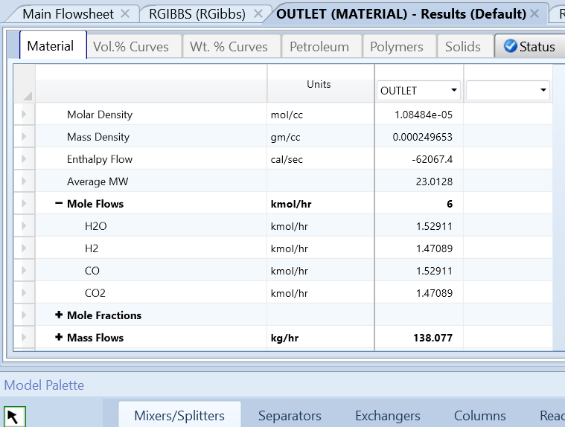
Figure 4.30 : The results of the water gas shift simulation
The RPlug is one of the more involved blocks because it requires kinetics, but we will explore its usage with a simple example. Create a blank simulation with acetone (C₃H₆O-1), Ketene (C₂H₂O) and Methane (CH₄). Go to the methods tab and select the Ideal method. Click on the “simulations” tab and go to the main flowsheet. Click on the “reactors” tab in the model palette and add RPlug and an inlet and outlet stream as shown in figure 4.31. Set the feed stream to be pure acetone at 1,00kg/hr temperature at 850 C and 1 atm. Go into the RPlug select the reactor type to be reactor with specified temperature and constant at inlet temperature (as seen in figure 4.32). Next, click the “configuration” tab and select the checkbox for a multitube reactor. Set the number of tubes to 2.
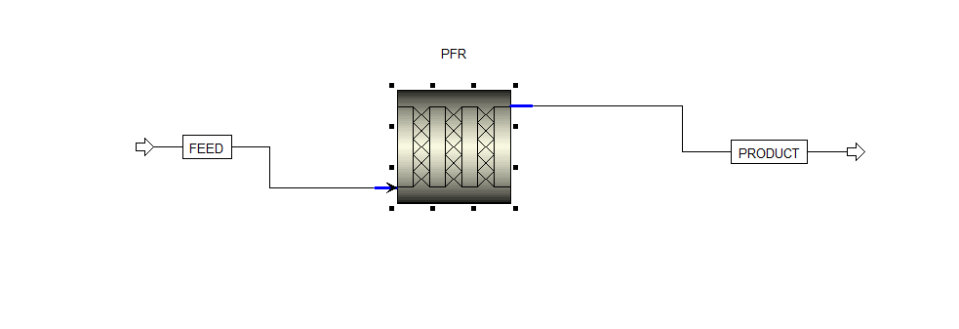
Figure 4.31: RPlug representation
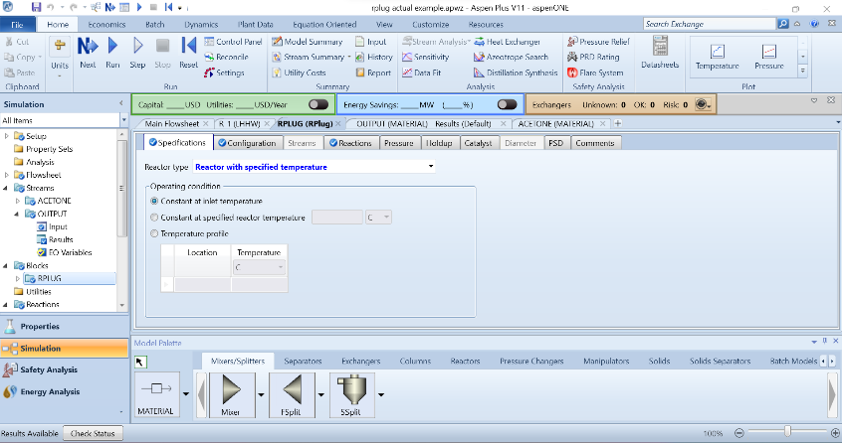
Figure 4.32: RPlug set up
A multitube reactor consists of multiple parallel tubes through which reactants flow and undergo chemical reactions. Each tube acts as a separate reaction vessel, and the overall reactor system is designed to enhance heat and mass transfer, improve mixing, and increase surface area for reactions. Next, we will input tube dimensions. Typically, larger tubes result in longer residence times and smaller surface areas, which can benefit catalyst and reactant interactions. Conversely, smaller tubes may have higher convective heat transfer rates, facilitating heat removal from the system, but they can also lead to higher flow velocities and pressure drops.
Add the tube length to be 3 meters with a diameter of 0.75 meters. Then go to the “reactions” tab you will notice that there aren’t any reactions to add this is where we will need to define a new reaction with kinetics. On the left scroll down till you see the “reactions” folder (as pictured in figure 4.33). Click on it and hit the new button on the middle left.
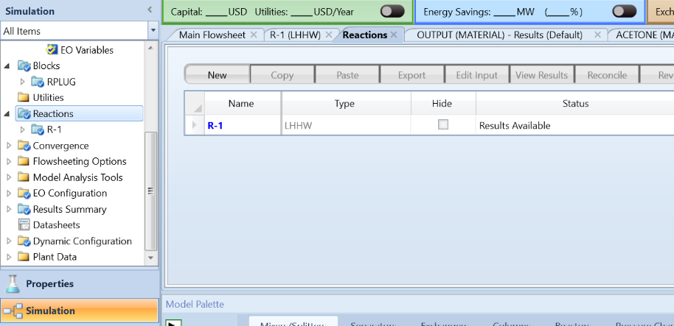
Figure 4.33: The reaction folder on the left and the new button on the top middle
Once you click the "New" button, you will first be prompted to name your reaction and select the reaction type. For this example, we will select LHHW. Following this, we will provide a brief introduction to kinetics.
In chemical kinetics, the pathway through which reactants transform into products can vary in complexity. Simple kinetics often involves a straightforward production pathway, where reactants directly convert into the desired products. However, in systems with complex kinetics, particularly those involving multiple reactants, intermediates, or competing reactions, several pathways can exist. These additional pathways, known as side pathways or secondary reactions, can lead to the formation of various products alongside the main desired product.
To model such complex kinetics, particularly in heterogeneous catalysis and surface reactions, the Langmuir-Hinshelwood-Hougen-Watson (LHHW) method is commonly used. This method is referred to as non-conventional kinetics due to its consideration of multiple elementary steps and intermediate species in the reaction mechanism. The LHHW method introduces four main equations to model a kinetic reactor effectively. The rate of reaction (denoted as "r") is expressed as a function involving several key factors. The kinetic factor (often denoted as "k") represents the rate constant or rate coefficient for the reaction, influenced by temperature, catalyst properties, and the specific reaction mechanism. The driving force term indicates the thermodynamic driving force for the reaction to occur, such as concentration gradients or partial pressures. Additionally, the adsorption term accounts for the adsorption of reactants onto the catalyst surface, which is crucial in heterogeneous catalysis. The equations for these factors can be found in Figure 4.34.
.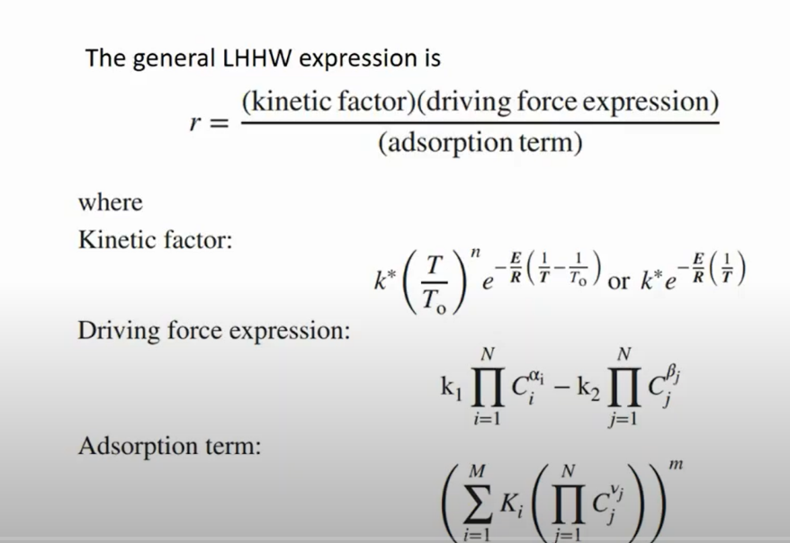
Figure 4.34: LHHW equations
However, we won't be delving into super complex kinetics for this example. Since the example doesn't involve a catalyst, there won't be any adsorption calculations. Additionally, we're dealing with a straightforward reaction without any side products or secondary pathways. In the "Stoichiometry" tab, click the "New" button and enter acetone as the reactant with a coefficient of 1, and the products being ketene and methane, each with coefficients of 1 (as seen in Figure 4.35).
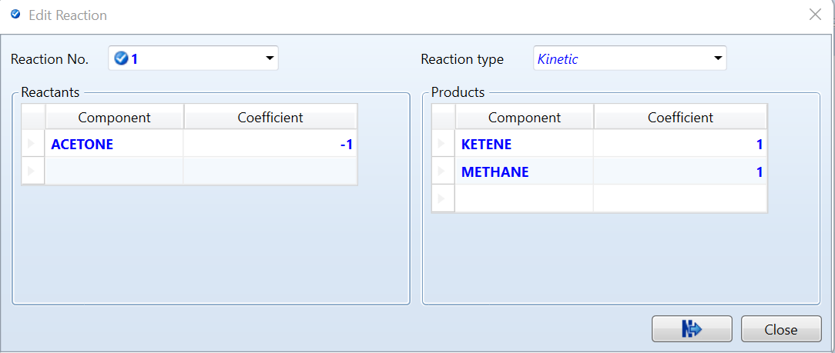
Figure 4.35: The Reaction 1 in the RPlug example
Next, in the “Kinetic” tab, set the reacting phase to vapor. Adjust the parameters as follows: k=1.5 for the rate constant, n=0 for reaction order (indicating independence from reactant concentrations), E=68500 cal/mol for activation energy (representing the energy barrier), and T₀​=800°C for the initial temperature. Now, click on the “Driving Force” button. A pop-up window will appear. Change the exponent of acetone to 1. For ketene, methane, and all the coefficients for the driving force constant, set them to zero as shown in Figure 4. 36.
Next, go to the drop-down menu under "Term 1" and select "Term 2." Set everything to zero except for the coefficient A in the driving force constant, which should be set to 1,000,000.
These adjustments modify how driving forces are calculated in the simulation. The exponent determines the mathematical relationship between driving forces and species concentrations, with an exponent of 1 representing a linear relationship. Setting the coefficients to zero for ketene, methane, and other species implies that their concentrations do not directly contribute to the driving force calculation.
The driving force constant, particularly the coefficient A, plays a significant role in determining the magnitude of the driving force. Higher value for the coefficient A increases the driving force, potentially accelerating reactions or promoting mass transfer processes.
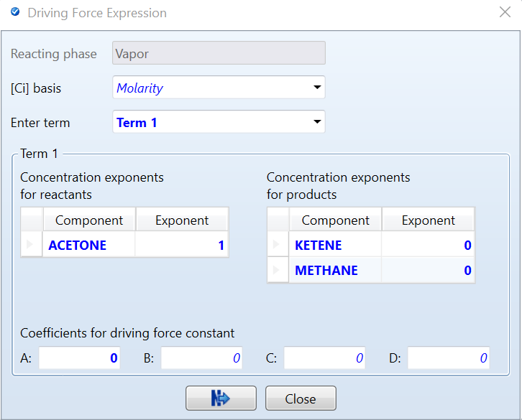
Figure 4.36: The driving force expression for term 1
Click the blue "next" button, then navigate back to the RPlug “reactions” tab. Add your new reaction by clicking on it and then hitting the “>” button. Run the simulation and check the results. You can vary the configuration by changing the number of tubes and their volume to observe how it affects the product yield.
Additionally, change the specifications to have the reactor be adiabatic, and observe how this alteration impacts the products. If you make this change you will see a larger variation in how tube volume and number effects the product. Make sure to save the simulation.

4.5: Worked Examples with Manipulators
Manipulator blocks in Aspen Plus are used to perform various mathematical operations and logical operations on variables. They can be used to define relationships between different variables, perform calculations, and manipulate data in various ways. Here is a list of manipulator blocks in Aspen Plus:
- Stream Multiplier:
  - Purpose: Used to multiply the flow rates of streams and their components by a specified factor.
  - Usage: Can be applied when scaling up or down the entire process or adjusting the flow rates of specific streams.
- Stream Duplicator:
  - Purpose: Copies each stream to any number of blocks.
  - Usage: Useful for creating multiple identical streams from a single source stream, often used in parallel processing or splitting operations.
- Stream Class Changer:
  - Purpose: Changes the class of a stream.
  - Usage: Converts streams from one type to another, such as changing a material stream to an energy stream or vice versa.
- Stream Analyzer:
  - Purpose: Analyzes the properties and composition of a stream.
  - Usage: Provides detailed information about the stream's characteristics, such as temperature, pressure, composition, and phase.
- Stream Selector:
  - Purpose: Selects material, heat, or work streams for specific operations.
  - Usage: Allows you to choose which streams to manipulate or analyze within the simulation.
- Load Stream Manipulator:
  - Purpose: Used for charge balance and other load calculations.
  - Usage: Ensures that mass and energy balances are maintained by adjusting the flow rates and compositions accordingly.
- Measurement Block:
  - Purpose: Measures specific properties or variables within the simulation.
  - Usage: Can be used to track and report on key performance indicators, such as temperature, pressure, or flow rates.
- Design-Spec (Feedback Controller):
  - Purpose: Imposes a design specification on the simulation.
  - Usage: Used to control the process by adjusting variables to meet specific design criteria, such as achieving a target purity or yield.
- Calculation Block:
  - Purpose: Allows the insertion of custom FORTRAN, MATLAB, or Excel code into the flowsheet computations.
  - Usage: Enables complex calculations that are not covered by standard unit operations, providing flexibility for advanced modeling and control.
- Transfer Block:
  - Purpose: Copies block or stream variables from one part of the simulation to another.
  - Usage: Useful for transferring data between different parts of the simulation, ensuring consistency and facilitating complex interactions
In Aspen Plus, manipulator blocks are primarily designed to improve user experience within the simulation by automating repetitive tasks and simplifying complex operations. These blocks help users avoid manually changing or inputting the same information multiple times, thereby enhancing efficiency and accuracy.
In this section we will cover calculator blocks with both excel and Fortran, transfer blocks, stream multiplier and duplicators and stream selectors. First, we will be focusing on calculating the amount of water needed to dilute hydrofluoric acid (HF) to an 80% concentration. We will utilize Aspen's calculator block and Excel to achieve this.
First, set up the simulation by creating a new simulation in Aspen Plus. Add hydrofluoric acid (HF) and water (H₂O) as components and set the property method to NRTL (Non-Random Two-Liquid model). Move to the flowsheet and, from the Mixers/Splitters tab, add a Mixer block. Define two feed streams: the first stream is water at 25°C, 1 bar, with an initial flow rate of 50 kg/hr; the second stream is HF at 25°C, 1 bar, with a flow rate of 300 kg/hr and a composition of 98% HF and 2% water by mass fraction. Name this second stream "HF". Connect both streams to the Mixer block, add an outlet stream, and run the simulation to verify the initial setup as seen in figure 4.37
Next, add and configure a Calculator block to perform custom calculations that might not be directly achievable through standard simulation blocks. The Calculator block is useful when specific mathematical formulas or logic depend on the simulation's intermediate or final results.
To begin, navigate to the Manipulators tab and add a Calculator block to the flowsheet (ensure it is not connected to any other blocks). Open the Calculator block and define the necessary variables. Define WWATER, the mass flow rate of water needed to achieve the desired dilution, as a stream variable (Stream-var) that takes its value from the mass flow rate of the water stream. This variable will be calculated and exported to the flowsheet. Define MHF, the mass flow rate of HF in the feed stream, which is an important input because it indicates how much pure HF is being fed into the system. This variable is defined as a mass flow stream variable and is imported into the Calculator block. Lastly, define WHF, the total mass flow rate of the HF stream, which includes both HF and any other components present (e.g., water in the 98% HF solution). This variable is necessary to determine the total mass flow entering the mixer and is defined as a stream variable (Stream-var), which is also exported to the flowsheet. This variable can be seen in Figure 4.38.
In the Calculator block configuration, go to the "Calculate" tab, select the calculation method as Excel, and click the "Open Excel Spreadsheet" button. In Excel, set up the following labels in the first column: Mass flow of HF in feed, Mass fraction of HF in dilute product, Total mass flow of feed HF solution, and Mass flow of water. In the column next to each label, define the corresponding calculations.
For Mass flow of HF in feed (MHF), use the Aspen Plus Add-in tab to import the MHF variable. For Mass fraction of HF in dilute product, enter the value 0.80 to achieve the desired 80% HF concentration. For Total mass flow of feed HF solution (WHF), use the Aspen Plus Add-in tab to import the WHF variable. For Mass flow of water (WWATER), use the formula = (cell for MHF / 0.80) - cell for WHF to calculate the required water mass flow as seen in Figure 4.39.
Return to Aspen Plus from Excel and run the simulation. The Calculator block will use the Excel-based calculation to determine the necessary mass flow of water. Check the output in Aspen Plus to see the required amount of water needed for the 80% HF solution, as seen in Figure 4.40.This process will help you determine the precise amount of water needed for diluting hydrofluoric acid to an 80% concentration using Aspen Plus and Excel. By using the Calculator block, you can seamlessly integrate custom calculations into the Aspen Plus simulation, ensuring accurate and specific results for complex scenarios such as diluting hydrofluoric acid.
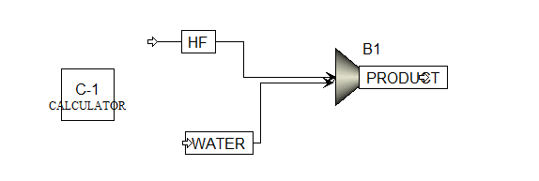
Figure 4.37: The calculator block representation
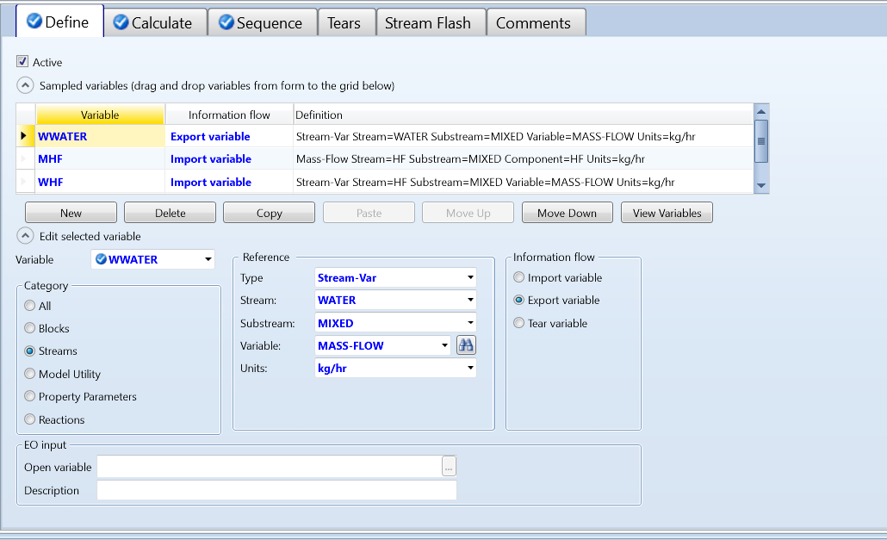
Figure 4.38: Variable definition

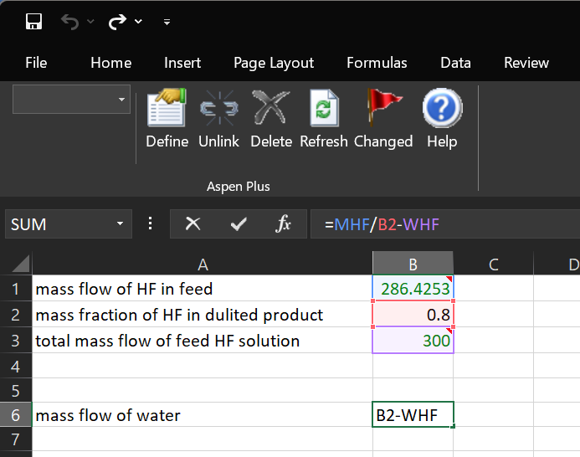
Figure 4.39: Excel input
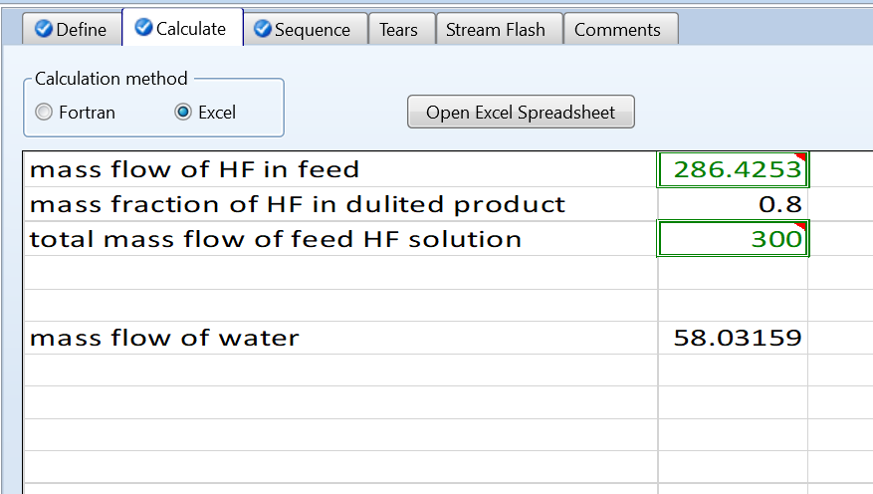
Figure 4.40: Calculator block result

Next, we will explore another use for the Calculator block, utilizing Fortran. We will practice with a new simulation that reinforces the handling of solids and examine some of the other manipulator blocks. First, we will simulate the drying of non-conventional materials controlled by a Calculator block.
Start a new simulation and define your components: nitrogen, oxygen, water, and non-conventional biomass. Select the method to be "Ideal" and navigate to the Simulation tab. Go to the Set-up menu in the top left corner and change the stream class to "MCINCPSD." Return to the main flowsheet, go to the Reactors tab, and add an RStoic block as well as a Flash2 block. Add two inlet streams to the RStoic and connect the outlet to the inlet of the Flash2 separator. Add the two outlets from Flash2 as shown in Figure 4.41.
Click on one of the inlet streams; this will be our hot air stream. Set its temperature to 135°C, pressure to 2 bar, and mass flow to 13,000 kg/hr. Then, set the composition to mole fraction with 0.78 for nitrogen and 0.22 for oxygen. Next, click on the other inlet stream, select the "NC Solids" tab, and add the following specifications: 25°C, 2 bar, and a mass flow rate of 4,500 kg/hr. Set the mass fraction to 1 for biomass. Fill in the component attributes as follows: Proxanal: MOISTURE = 25, FC = 54.2, VM = 35.6, and ASH = 10.2. Change the attribute ID to Ultanal and input the following: ASH = 10.2, CARBON = 66.2, HYDROGEN = 5.8, NITROGEN = 1, CHLORIDE = 0.1, SULFUR = 1.3, and OXYGEN = 15.4. Change the attribute ID to Sulfanal and input the following: PYRITIC = 0.4, SULFATE = 0.3, and ORGANIC = 0.6.
We will explore more examples with PSD (Particle Size Distribution) further in the next sections. For now, note that the PSD represents the weight fraction of different sizes of particles in a solid. To input the PSD in Aspen Plus, select "User Specified Value" for the populated PSD section. Click "Edit PSD Mesh" and ensure that the "No. of Intervals" column has 10 sections. Set the size unit to micrometers (µm) and then close the window. Navigate to the weight fraction section, scroll to interval 7, and set the weight fraction to 0.1, interval 8 to 0.2, interval 9 to 0.3, and interval 10 to 0.4, as illustrated in Figure 4.42.
Next, go into the RStoic and change the specification to Duty and Pressure. Set the pressure to 2 bar and the duty to 0. Then, go to the Reactions tab and create a new reaction. Set the reactant to be biomass with a coefficient of 1 and the product to be 0.05508 of water. Change the fractional conversion to 0.2 of the biomass components. Go to the "Components Attributes" tab, select NC streams, set the component to biomass, and then select Proxanal. Set this value to 10 (this will later be changed by the Calculator block). Then, in Flash2, set the flash type to Duty and Pressure, operating at 2 bar with a duty of 0 cal/sec. Return to the main flowsheet and run the simulation.
Once the simulation is complete, go to the Manipulators tab, add a Calculator block, and rename it "Water" by right-clicking and selecting "Rename." Double-click into it to define the variables. Click the "New" button and enter the variable name "H2Oin," select the category to be Streams, set the reference type to Compattr-Var, set the stream to be biomass, sub stream ID to NCPSD, the component to be biomass, the attribute to be Proxanal, and the element to be 1, as seen in Figure 4.42.
Add a new variable and name it "CONV." Select the category to be Blocks, set the reference type to Block-Var, select your block (e.g., "B1" for the RStoic reactor), and set the variable to CONV with an ID of 1, as seen in Figure 4.43. For the final variable, name it "H2ODRY," set the category to Blocks, the reference type to Block-Var, the block to "B1," and the variable COMPATT ID1 as NCPSD with Biomass and Proxanal as the following IDs. The element should be 1, as illustrated in Figure 4.44.
Then go to the calculator tab, select the calculation method to be Fortran and enter the following:
H2ODRY = 15.0
CONV = (H2OIN – H2ODRY) / (100 - H2ODRY)
Ensure that there are six empty spaces before the code as well as the capitalization and spacing is exactly as follows. Then click the next button in the top banner. It will take you to the sequence tab. Set the calculator block execution sequence as "Execute Before" with the block type as "Unit Operation" and the block name to be B1. Then run the simulation. Go to the results section in the exchange stream and note the amount of water present in the results. Then go back to the calculation block and change in the Fortran code `H2ODRY = 10.0` and run the simulation again. You will notice an increase in the amount of water in the results tab. This is because the calculator block told the RStoic reactor to pull more water out of the biomass.

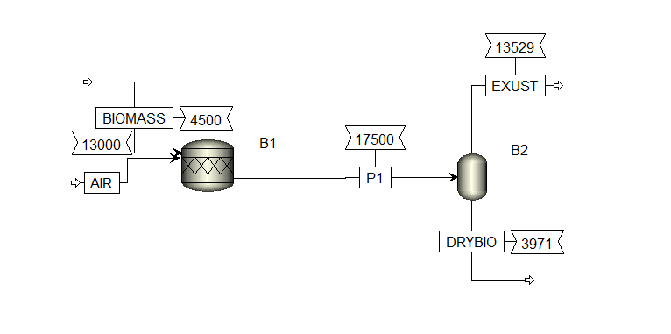
Figure 4.41: Representation of biomass drying
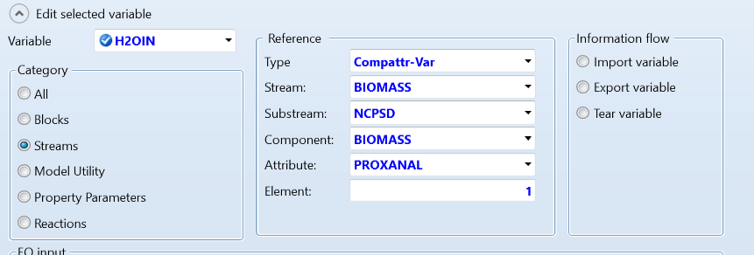
Figure 4.42: H2OIN variable input
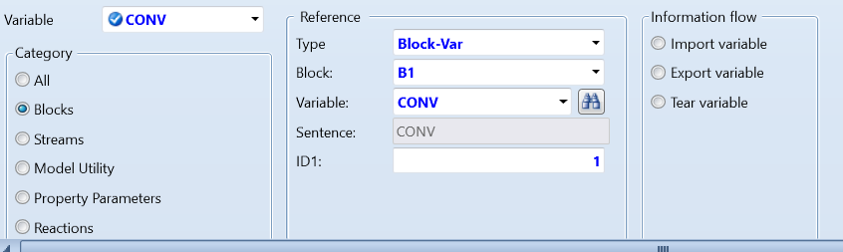
Figure 4.43: CONV variable input
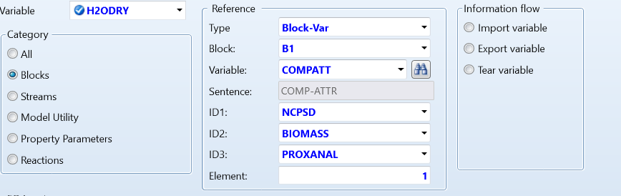
Figure 4.44: H2ODRY variable input

Now, we are going to look at some similar manipulator blocks. In the same simulation, we will first examine the Mult block. Suppose we wanted twice the amount of the outlet stream from the RStoic and the Flash2 block. We can achieve this by adding a Mult block.First, add a Mult block from the model palette between the RStoic and the Flash2 block. Reconnect stream “P1” as the inlet of the Mult block, then add an outlet and connect it to Flash2, as shown in Figure 4.45. Click into the Mult block and set the multiplication factor to 2. Return to the main flowsheet, ensure that the mass flow rate box is checked in the Modify tab, and run the simulation. You will notice that the mass flow rate doubled after the Mult block.
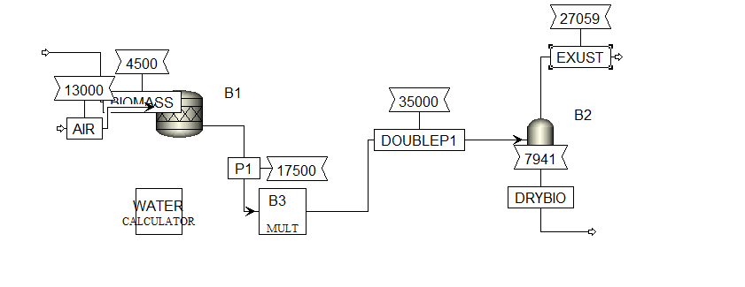
Figure 4.45: Representation of the Multiplier block
Now, let's pretend that we need the dried biomass for three separate blocks instead of just one. We will use the DUPL block for this purpose.
Add a DUPL block to the simulation after the dry biomass stream. Connect the dry biomass stream to the DUPL block, then create three outlet streams from the DUPL block. Run the simulation. You can click into each of the three extra streams, and you will see that all of them contain the same product.
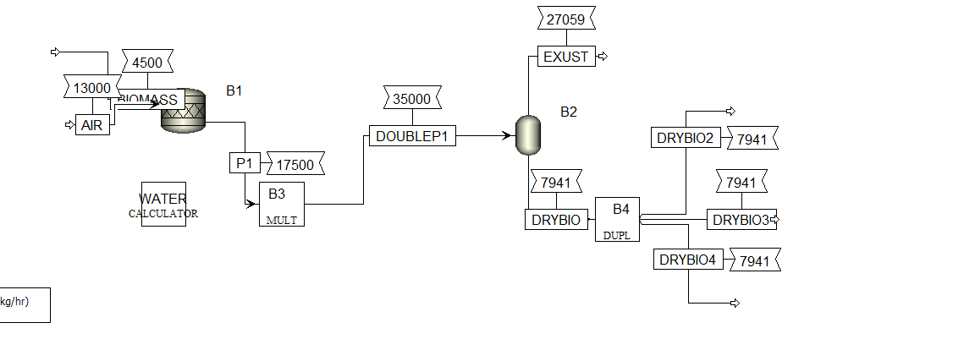Figure 4.46: DULP Block representation
Now we will look at the selector block. Using the selector block can be particularly useful in Aspen for several reasons. It allows you to simulate a stream under different phase conditions to evaluate how phase behavior impacts the overall process. Different components or streams might require different property methods for accurate simulation, such as using one method for heavy hydrocarbons and another for light gases. It also enables you to simulate various scenarios where specific streams need tailored physical property calculations, such as those with unique chemical compositions or operating conditions
For this example, we will change one of the biomass duplicate streams to have a different property method and different free-water phase properties. Add a selector block to the simulation, connect one of the streams to it, and add an outlet. Then click into the block and add the specifications to be the stream inlet ID of what your inlet name is called; in my case, it's called drybio4. Next, go over to the properties tab and change the properties method drop-down menu to NRTL-RK and the free water to be STEAMNBS. Hit the "Next" button, and you'll be brought to the Comp-group tab. Add water to the selected components, then change the sub stream to NC PSD and add biomass. Then run the simulation. You will not notice a difference, but if you were using very different components in the simulation, you would.
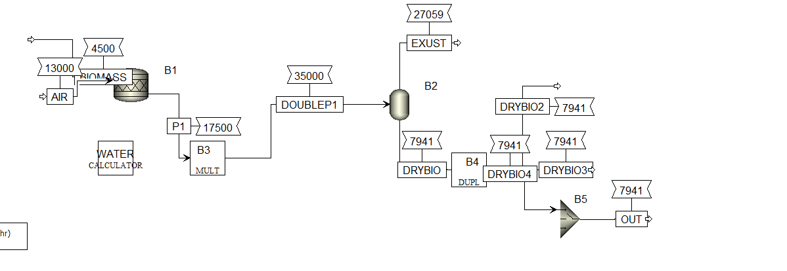Figure 4.47: A representation of a selector block.

4.6: Worked Examples with Solids
In Aspen Plus, solid blocks are specialized unit operations designed to handle processes involving solid materials. They can handle both conventional and non-conventional solids. These blocks are essential for modeling operations that involve the physical and chemical transformation of solid materials. Here are some common solid blocks in Aspen Plus:
- Crusher
  - Models the reduction of partials in a solid.
- Screen
  - Partial separation
- Crystallizer
  - Models’ crystal formation from a liquid substance to a solid as well as separating the two products
- Classifier:
  - classifies solid partials on size or density
- Single stage solids washer (SWash)
  - Separate solids from liquids like in filtration
- Multistage solids washer and counter current decanter (CCD)
  - Makes a solid a slurry where solids settle at the bottom and liquid overflows
- Dryer
  - Remove moisture from solids
- Granulator
  - Form granules from powders and small particales
- Fluid bed
  - Simulates the behavior of a fluidized bed as well as catalysis deactivation and solids circulation
These solid blocks are essential for accurately simulating processes that involve solid materials in various industries, including mining, chemical processing, pharmaceuticals, and food processing. They help in designing, optimizing, and analyzing operations that involve solids handling and processing.
Let's begin by examining the screen, crusher, and classifier. The differences between the blocks are as follows: A crusher is used to reduce the size of solid materials by applying mechanical force, typically resulting in smaller particles. A classifier is designed to separate particles based on size or other characteristics, directing them into different outlets such as coarse and fine fractions. A screen, on the other hand, specifically focuses on separating particles by size, allowing smaller particles to pass through while retaining larger ones.
Start by creating a new simulation and specifying the components as water, nitrogen, oxygen, and "NCSOLID" as a non-conventional type. Set the method to NRTL and proceed to the NC properties tab. Define the NC properties of "NCSOILD" as HCOALGEN and DCOALIGT. Continue by clicking "Next" until you receive the successfully set up message. Move to the simulation tab and add a dulp block. Connect one inlet stream, name it NCSOLID, to the unit operation block and three outlet streams, pick whatever name you would like for these. Then, go to the set-up tab and change the stream class to MCINCPSD, which handles multi-component, incompressible streams with particle size distribution data. Then, return to the main flowsheet.
Next, let's configure the NC Solid stream. Double-click on it and navigate to the "NC SOLID" tab. Set the temperature to 25°C and the pressure to 1 bar. Adjust the mass flow rate to 100 kg/hr. Then, define the component attributes as follows: 20 for Moisture, 70 for FC, 25 for VM, and 5 for ASH. Move to the "Ultanal" tab and set the ash content to 5, carbon to 50, hydrogen to 5.8, nitrogen to 1.5, chlorine to zero, sulfur to 0.5, and oxygen to 37.2. Finally, set the sulfanal values to 0.1 for pyritic sulfate and 0.2 for organic sulfate.
Now we will define the partial size distribution (PSD). Particle size distribution refers to the range of particle sizes within a substance. It's crucial for understanding material properties, controlling quality in industries, and assessing environmental impacts. Techniques like microscopy and laser diffraction measure this distribution, which directly affects properties such as flowability, reactivity, and pollutant behavior. You can typically find these values in literature and online. In pharmaceuticals, for instance, it's critical for drug effectiveness and bioavailability. Overall, particle size distribution is key across various fields for optimizing processes and ensuring desired outcomes. We'll configure the particle size distribution (PSD) of the NCSOLID to match figure 4.48. Set the values for intervals 4 to 10 as follows: 4 at 0.02, 5 at 0.1, 6 at 0.2, 7 at 0.25, 8 at 0.23, 9 at 0.1, and 10 at 0.1.
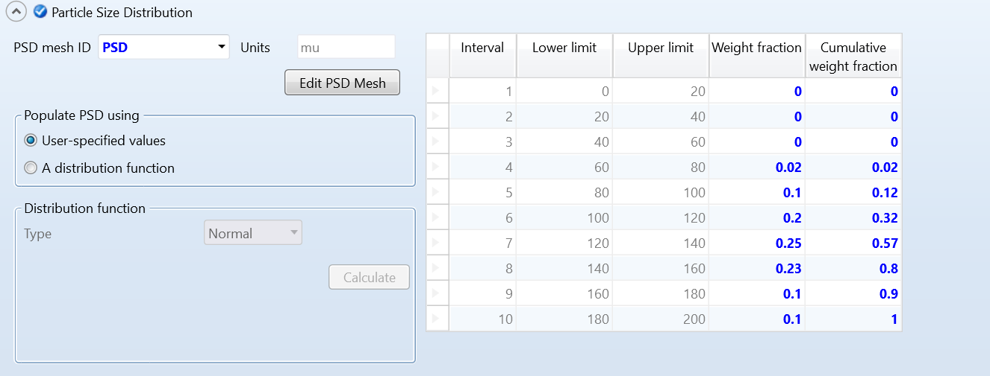Figure 4.48: Particle size distribution representation.
Let's return to the main flowsheet and add a crusher into the simulation. Reconnect one of the three outlet streams to the crusher and include an additional outlet, which we'll rename as "SMALLER." Inside the crusher block, select the "Select Equipment" option and specify the type as gyratory. Set the selection and breakage functions to "US Bureau of Mines" to optimize the crushing process. Next, navigate to the breakage function parameters and configure them to target a particle size of 150 microns as seen in figure 4.49. This setup is designed to ensure effective reduction in particle size within the solid material, optimizing its processing characteristics. Run the simulation and access the results for the "Smaller" stream by right-clicking and selecting "Results." In the "SMALLER (material) - Results" tab, click on the dropdown menu next to "SMALLER" and choose the NCSOLID stream. This will display the results of both streams side by side. Scroll down to the NCPSD (particle size distribution) sub stream and click the plus sign next to its name to reveal the results. Navigate to the PSD tab and click the plus button to compare the particle size distribution before and after the crusher. Observe how many particles have been broken down to smaller sizes, as illustrated in figure 4.50. This comparison provides valuable insights into the effectiveness of the crushing process in reducing particle sizes.
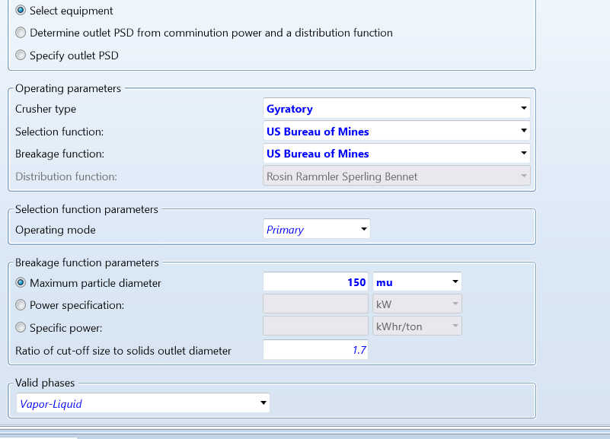
Figure 4.49: crusher block representation
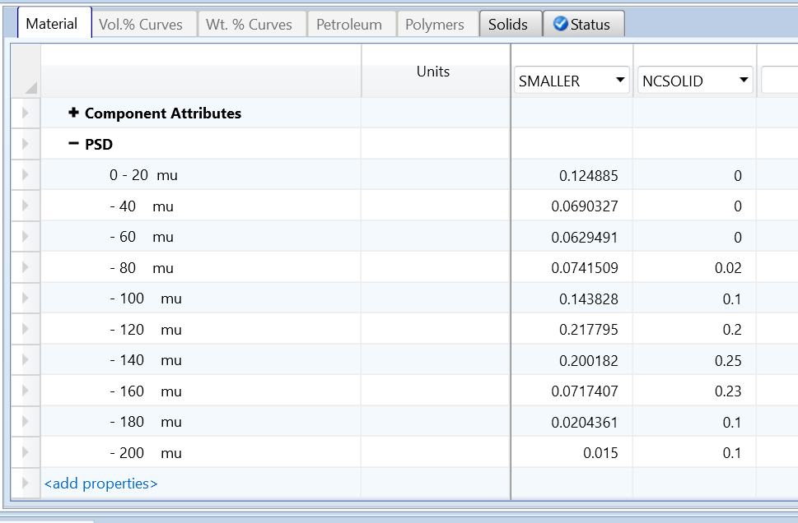
Figure 4.50: PSD results after the crusher
Next, let's set up a screen. Return to the main flowsheet and position a screen near one of the two unoccupied dulp outlets. Connect one of the outlets as the inlet into the screen and add the outlet stream from the overflow exit, naming it "OVERFLOW." Then, add the outlet at the bottom of the screen and name it "UNDERFLOW." The overflow stream will contain the larger particles, while the underflow will contain the smaller particles.
Open the screen block and, under the "Select Function" column, choose "Ideal" from the dropdown menu. Set the cut size at 150 microns, as shown in figure 4.51. Run the simulation, then access the results of the "UNDERFLOW" stream. Pull up the results of the overflow stream and the NCSOLID tab alongside it, as illustrated in figure 4.52.
Navigate to the NCPSD stream results and scroll down to the PSD results. Here, you'll observe that in the screen block, some particles change sizes slightly. This can be attributed to the separation process within the screen, where particles above the cut size are directed to the overflow stream, while those below it go to the underflow stream.

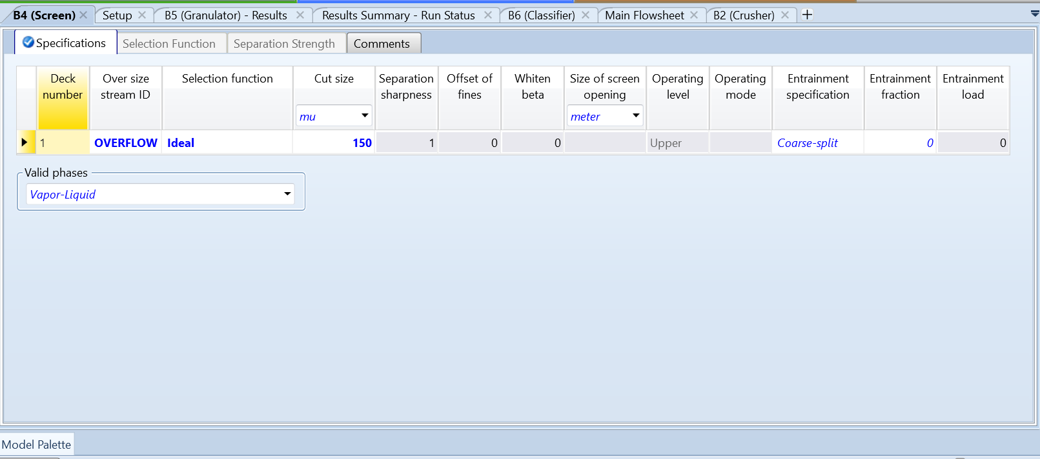
Figure 4.51: Screen representation
Finally, for the last block of this simulation, let's add a classifier. Add a classifier block and connect the final outlet stream of the dulp block as the inlet. Then add the coarse outlet and name it "COARSE," and add the fine outlet and name it "FINES." Click into the classifier block and set the method to "Use a classification function." Choose "Rogers" as the function, specify "particle size" as the characteristic, set the cut size to 150 microns, and adjust the separation sharpness to 0.9. The Rogers function is a mathematical model used to determine particle separation based on size, with a focus on optimizing sharpness and efficiency in the classification process. Separation sharpness refers to the effectiveness of a separation process in distinguishing between different particle sizes, with higher values indicating a more distinct separation. This configuration optimizes the classifier's performance in separating particles based on size, with the coarse outlet receiving larger particles and the fines outlet handling smaller particles. Run the simulation and analysis the results of the fines stream and the Coarse stream as seen in figure 4.53.
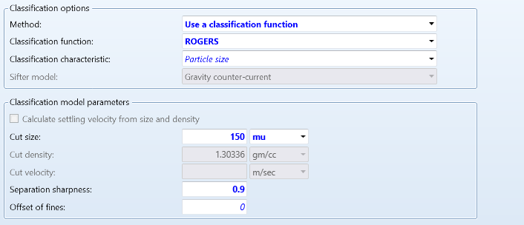
Figure 4.52: Classifier set up
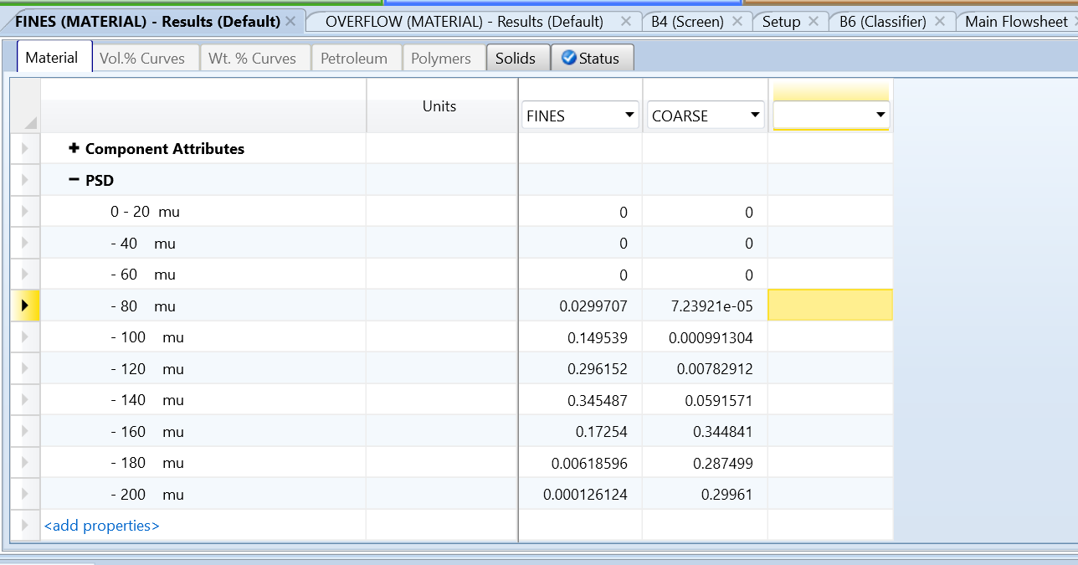
Figure 4.53: Results of the classifier block stream

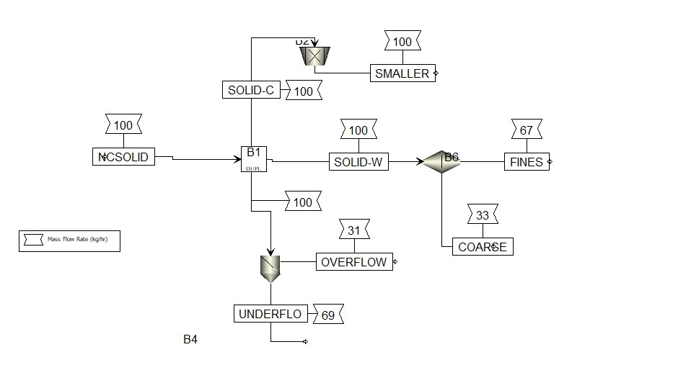Figure 4. 54: Representation of the crusher (top) classifier, (Middle) and screen (Bottom)
Next, we will look at a crystallizer. We are going to crystallize salicylic acid out of benzene. Open a new simulation and define benzene (C6H6) and then salicylic acid (C7H6O3). Rename the first salicylic acid component as “AQ(SALI)” by double-clicking the component ID, entering the new name, and selecting the rename option. Add another C7H6O3 and rename it to "S(SALI)," changing the type to solid. This setup is necessary because this example will deal with both solid and aqueous forms of the acid. Select the method to be solid and go to the simulation tab.
Go to the setup tab in the simulation and change the stream class to “MIXCIPSD” and the flow basis to mass. Then, add a crystallizer block from the “Solids” tab in the model palette. Add the inlet stream and name it "Input," then add an outlet stream at the required red arrow and name it "Product."
Go to the input stream and double click set the temperature to be 60 C at 1 bar and a mass flowrate of 4000kg/h. Then specify the mass fraction to be 0.5 of the AQ(SALI) and .95 of benzene. Then click into the crystallizer in the specification set the temperature to be 5 C and the pressure to be 2 bar. Then click on the “Crystallization” tab. Click on the reactant components dropdown menu and select AQ(SALI) as the reactant, setting its coefficient to 1. Then select the crystal product as S(SALI) with a coefficient of 1, as shown in figure 4.55. Navigate to the “Solubility” tab, set the solubility basis to solvent, and choose benzene as the solvent. Next, add the solubility data to match the table in figure 4.56. In the temperature column, enter the values 11.7, 25, 30.5, 49.4, and 64.2. For the concentration column, enter 0.00404, 0.0068, 0.00087, 0.021, and 0.039.
Finally, click on the “PSD” tab to specify the solid salicylic acid particle size distribution. Set the PSD calculation option to user-specified PSD with a crystallizer volume of 100 liters. Then, go to the distribution function ID, click on the dropdown menu, hit the "New" button, name it "one," and click "Okay." Set the distribution function to normal, select parameters to D50 with standard deviation, set the D50 to 100 microns (µm), and the standard deviation to 10 microns (µm). Then run the simulation and go to the results tab for the outlet stream. Check the mass flows result, and you'll see that the majority of the salicylic acid is in the solid state.

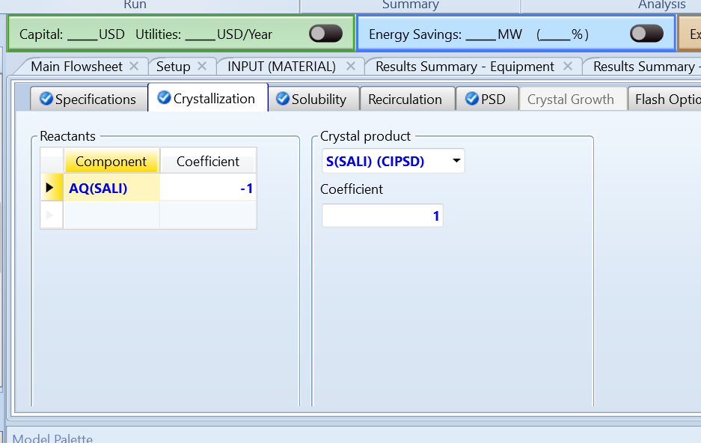
Figure 4.55: Crystallization specifications
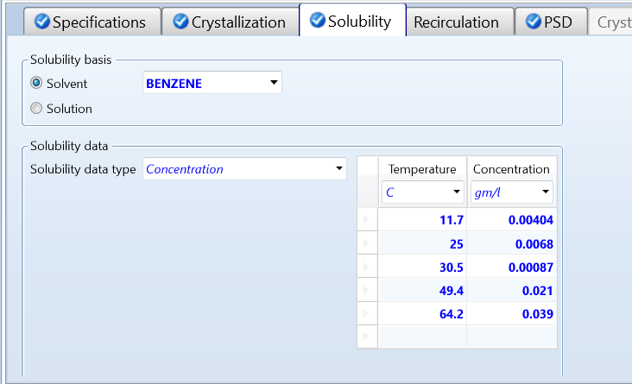
Figure 4.56: Solubility specification

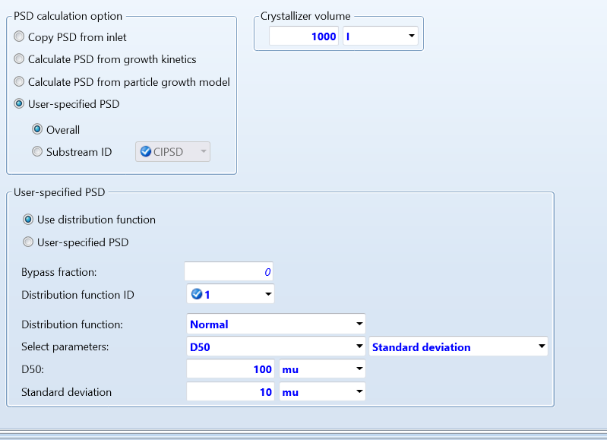

Figure 4.57: PSD specifications

4.7: Worked Examples with Solids Separation
Similar to solids, solid separators are used to separate solid particles from a mixture or to classify particles based on size or other properties. Common types of solid separator blocks in Aspen include:
- Cyclones: Separate gas from solids based on size and density
- Venturi Scrubbers: models' gas solid separators using venturi scrubbers
- Filters: Employed to separate solids from liquids or gases by passing the mixture through a medium that traps the solid particles.
- Cross flow filter: flowing mixture in Parrell with the filter allowing for removal of the filtrate
- Centrifuges: Separate particles from liquid based on size shape and density using centrifugal force
- Hydro cyclones: Like cyclones but typically used for liquid-solid separations, employing centrifugal forces to separate particles based on size and density.
In addition to these six, there are two additional types: gas-solid separators, with one using fabric filters and the other using dry electrostatic precipitators. These blocks are essential for processes involving solid-liquid or solid-gas mixtures, enabling efficient separation and classification of particles for various industrial applications.
We will first look at separating solids and gases. Start a new blank simulation and set your components to be air, water and solid carbon, with "IDEAL" as your method. Go to the simulation tab, then the setup tab, and change the stream class settings to MIXCIPSD. Go back to the main flowsheet and add a cyclone from the model palette under the “Solids Separators” tab. Add the inlet stream and name it “feed,” and then add the gas outlet stream and the solids outlet stream.
Go into the feed stream and under the "Mixed" tab, set the temperature to 30°C and the pressure to 1 bar, and set it to have a mass flow rate of 10,000 kg/hr of air. Then, in the same stream setup, go to the “CI Solids” tab and set the same temperature (30°C) and pressure (1 bar) with a mass flow rate of 500 kg/hr of solid carbon. Next, click into the PSD setup as seen in Figure 4.58.
For the Particle Size Distribution (PSD) setup, ensure you define the PSD for the solid carbon with an interval of 10 micrometers. Create a PSD table specifying the weight fractions for each interval, for example: 0-10 micrometers: 0.05, 10-20 micrometers: 0.10, 20-30 micrometers: 0.15, 30-40 micrometers: 0.20, 40-50 micrometers: 0.15, 50-60 micrometers: 0.10, 60-70 micrometers: 0.10, 70-80 micrometers: 0.05, 80-90 micrometers: 0.05, and 90-100 micrometers: 0.05.
Then navigate to the cyclone. Set the model to "Cyclone," the calculation method to "Muschelknautz," and the type to "Stairmand-HE." The Muschelknautz method is a widely used for predicting cyclone performance, including pressure drop and collection efficiency. It is based on experimental data and provides accurate results for various cyclone designs. The Stairmand-HE (High Efficiency) type is a specific design of cyclone known for its high collection efficiency, particularly for fine particles. Scroll down and set the diameter to 3 meters, which is an important parameter affecting the cyclone's performance, influencing both the separation efficiency and pressure drop.
Then run the simulation. Click into the solids outlet stream and notice that the molar solid fraction is one, indicating that the simulation successfully separated the solids.
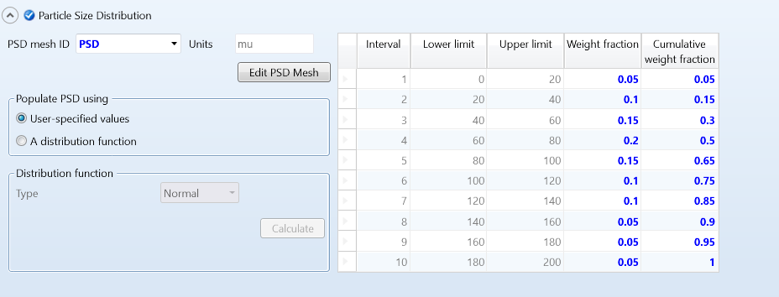
Figure 4.58: PSD specifications
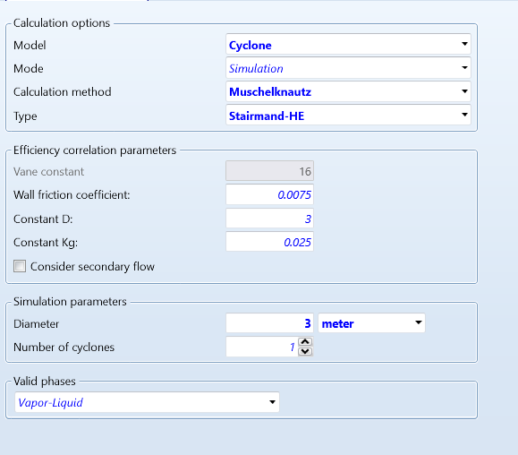
Figure 4.59: Cyclone specifications
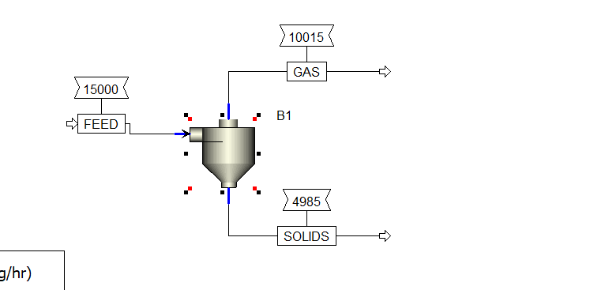
Figure 4.60: Representation of a cyclone.

In the same simulation, add a hydrocyclone to the flowsheet. Add the feed stream and the liquid and solids outlet streams. Go into the feed stream and define it to have 5000 kg/hr of water at 30°C and 1 bar. Then go to the "CI Solids" tab and add 5000 kg/hr of carbon with the same temperature and pressure.
Next, go to the PSD setup and set the weight fractions as follows: 0.04 for 60-80 microns, 0.56 for 80-100 microns, 0.3 for 100-120 microns, and 0.1 for 120-140 microns.
Then go to the Hydro cyclone and set the model to "Hydro Cyclone," the mode to "Design," the efficiency correlation to "Bradley," and the type to "Bradley-round." The Bradley model for hydrocyclones is an empirical correlation method used to predict separation efficiency and pressure drop based on design parameters and particle characteristics. Bradley Round specifically refers to this model's adaptation for round or cylindrical hydrocyclones, optimizing predictions for such geometries. Set the diameter of solid particles to 100 microns with a separation efficiency of 0.98. Additionally, set the maximum diameter to 1.5 meters and the maximum pressure to 5 bar. Finally, run the simulation and view the results.
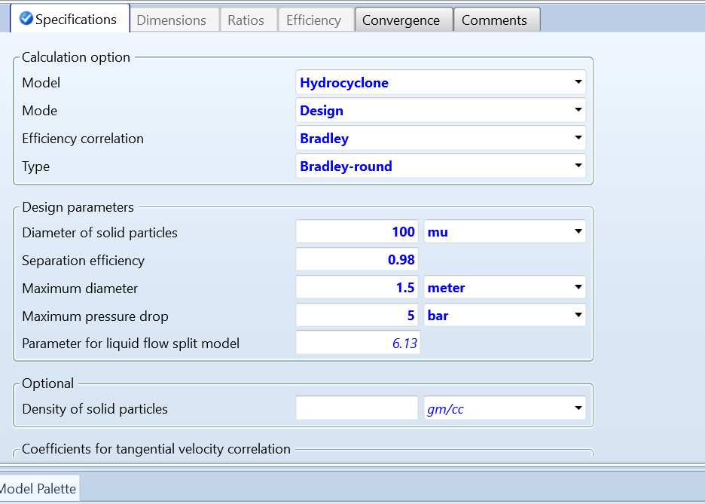
Figure 4.61: Hydro cyclone set up
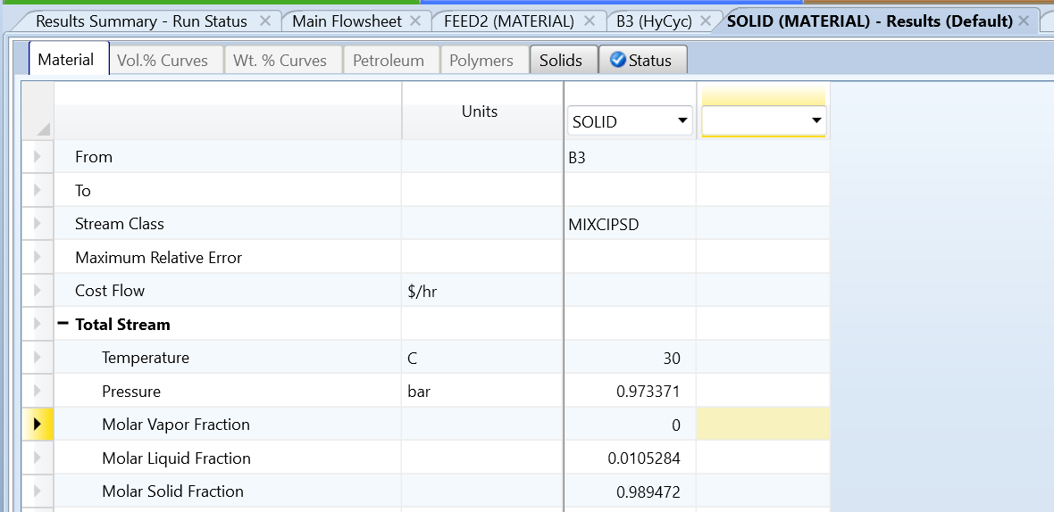
Figure 4.62: Results of the solids outlet of the hydro cyclone

Next, we will look at the filter in the same simulation. begin by duplicating the inlet stream that feeds into the hydro cyclone. This can be done by right-clicking on the inlet stream and selecting “Copy” from the menu options. Once copied, navigate to an empty area within your simulation layout and right-click again, choosing “Paste.” This action creates a duplicate of the inlet stream in the new location.
Upon pasting, a pop-up window will appear displaying the copied stream. Click on this copied stream to select it. Within the pop-up window, locate and click on the “Edit ID” button. This step is crucial because Aspen Plus does not permit two streams with identical names in a simulation.
In the “Edit ID” window, modify the name of the copied stream to ensure it is unique. This distinction is vital for clarity and to avoid any conflicts or errors within the simulation. Choose a name that clearly identifies this copied stream, making it distinct from the original one feeding into the hydro cyclone.
Once you have added the copied stream, proceed to the model palette and incorporate a filter into your simulation. Connect your newly added stream to the inlet of the filter and ensure that all necessary outlets are included. Inside the filter, select the model type as “solid separator.”
Next, configure the specified phase separator settings within the filter. Set the fraction of liquid to liquid outlet to be 0.999 and the fraction of solid to solids outlet to be 0.98. Additionally, adjust the pressure within the filter to 2 bars.
After setting these parameters, run the simulation and examine the results, particularly focusing on the solids outlet stream. This step allows you to observe how the filter operates and how it separates solids from liquids based on the specified settings.
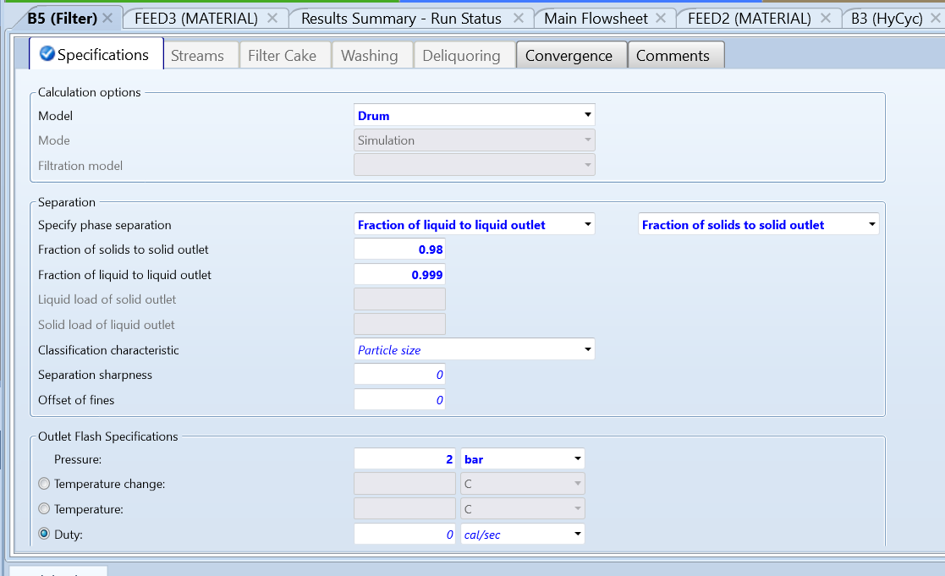
Figure 4.63: Input specifications of the filter

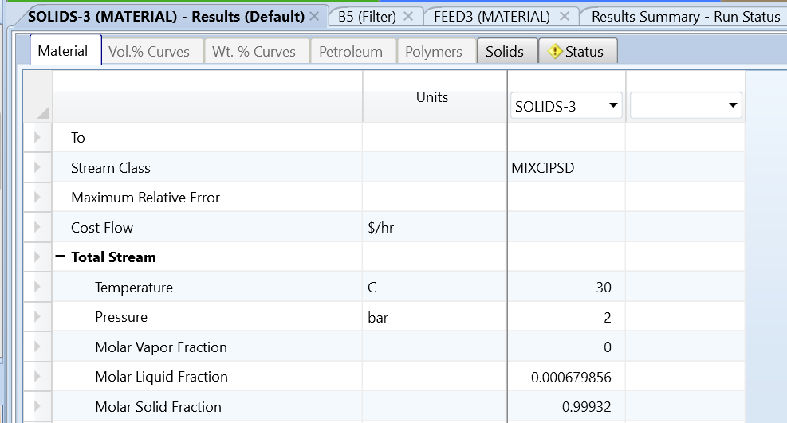

Figure 4.64: Results of the solids stream out of the filter
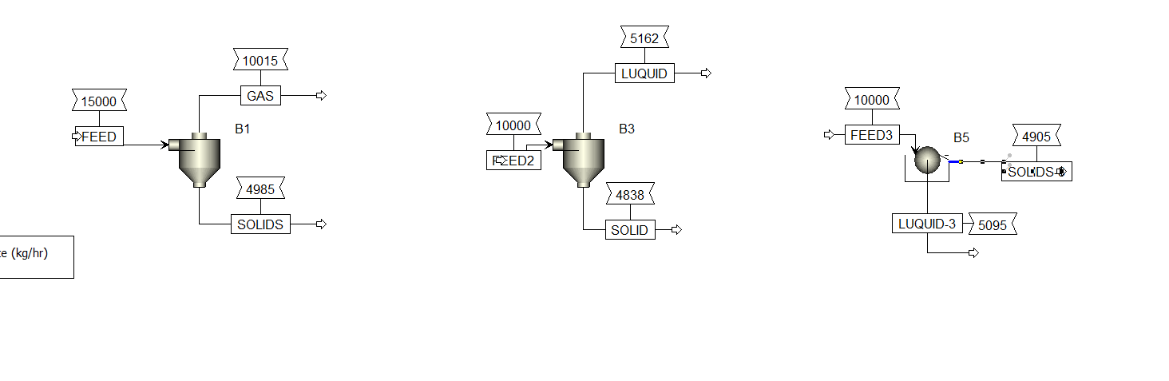 Figure 4.65: Representation of cyclone (left) hydro cyclone (middle) and filter (right)

Chapter 5: Liquid – Liquid Extraction
Liquid-liquid extraction, also known as solvent extraction or partitioning, is a separation process widely used in chemical engineering and various industries to extract a desired component from a liquid mixture. This method relies on the differences in solubility or distribution coefficients of components between two immiscible liquid phases, such as oil and water since they do not dissolve but form separate layers.
The process begins with the selection of a suitable solvent that can selectively dissolve the desired component while leaving unwanted components in the original liquid mixture. The solvent chosen should be immiscible with the original mixture to facilitate phase separation later.
The liquid mixture containing the desired component, known as the feed phase, is then brought into contact with the solvent phase. This contact allows for mass transfer between the phases, enabling the desired component(s) to transfer from the feed phase into the solvent phase based on their solubility or distribution coefficients. Meanwhile, the unwanted components remain in the feed phase.
After sufficient contact time, the two liquid phases are separated. The solvent phase, now enhanced with the desired component, is referred to as the extract, while the remaining liquid mixture is called the raffinate. The extract phase undergoes further processing to recover the desired component, often through evaporation or distillation of the solvent. On the other hand, the raffinate phase may undergo additional treatments or be recycled back into the process.
Liquid-liquid extraction has several applications across industries. In the chemical industry, it is used for the separation and purification of organic compounds, while in pharmaceuticals, it aids in the isolation of active pharmaceutical ingredients (APIs) from complex mixtures. Environmental applications include the removal of pollutants from wastewater, while in the food industry, it is used for extracting flavors, essential oils, and bioactive compounds from natural sources. In mining and metallurgy, liquid-liquid extraction facilitates the recovery of metals from ores or solutions using suitable extractants.
The efficiency of liquid-liquid extraction depends on various factors such as solvent selection, contact time, temperature, and phase ratios. Despite its complexity, it remains a versatile and essential separation technique, offering precise control over component separation in complex mixtures.
In order to get a better understanding of liquid-liquid extraction we will be looking into separating water (H₂O) from acetone (C₃H₆O-1) with 3-Methylhexane (C₇H₁₆-3) as the solvent. Start a blank simulation and define the components mentioned above. Go to the methods and select “UNIQ-RK”, or UNIQUAC/Redlich-Kwong, as the method and hit next until there is no more inputs required. Next, we are going to view a Ternary diagram to ensure that 3-Methylhexane is indeed immiscible from water. A ternary diagram is a graphical representation of a three-component system, typically used in chemistry and engineering. It displays the relative proportions of three components in different phases, such as solid, liquid, and gas, or in immiscible liquid phases.
Make sure you are still in the properties tab and click the drop-down analysis button on the far right of the home banner and select the Ternary diagram button. Sometimes a pop-up might show up just click the bottom option “continue to Aspen Plus ternary diagram” It should eventual open make sure to change the pressure to 1 bar and the click the “run analysis” button
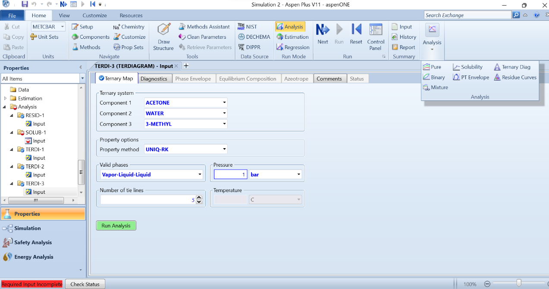
Figure 5.1: Representation of the ternary diagram button in the upper right corner and the run analysis button
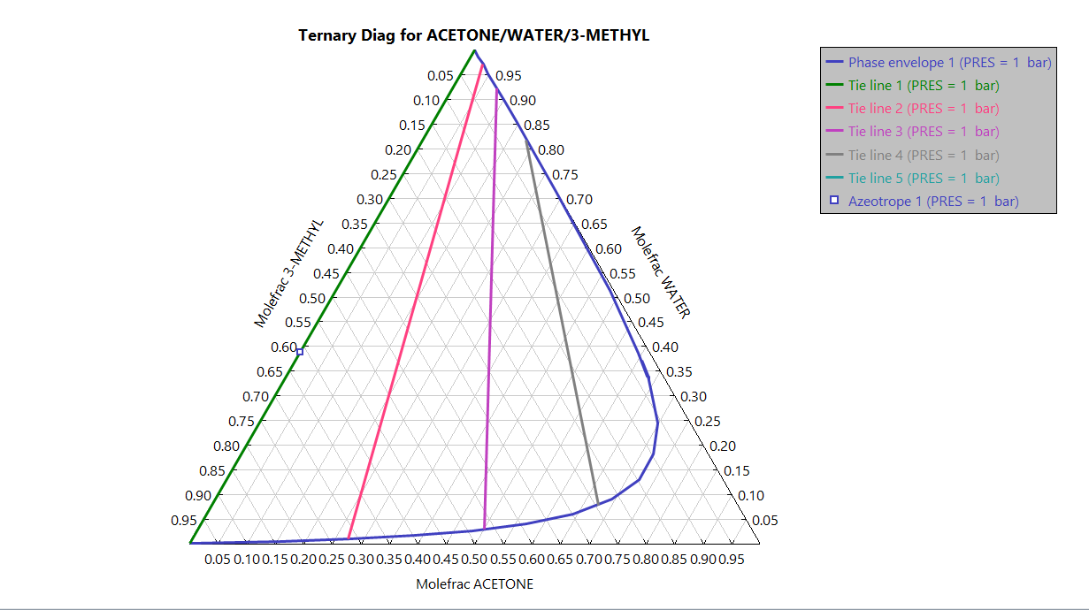
Figure 5.2: Ternary Diagram

Navigate to the simulation screen go to the “columns” tab and add an Extract column to the main flowsheet. Add the two inlet streams, the top one being the two immiscible liquids we are trying to separate the bottom being the solvent. Then add the two outlet streams (as seen in figure 5.3).
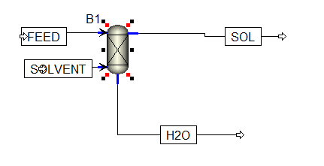
Figure 5.3: Representation of the Extraction column

For the top inlet stream, set the temperature to 25°C at 1 bar with a mass flow rate of 200 kg/hr and a mass fraction of 0.5 for both water and acetone. Then, for the solvent stream, set the temperature to 30°C at 1 bar with a mass flow rate of 300 kg/hr of 3-Methylhexane.
Next, navigate to the Extraction column. The extraction column, also known as an extractor, plays a crucial role in liquid-liquid extraction processes. It's a unit operation designed to separate components from a liquid mixture based on their solubilities in different phases, typically using a solvent.
Set the number of stages to be 8. In the key components tab, select water as the key component in the first liquid phase (representing the substance to be dissolved), and 3-Methylhexane as the key component in the second liquid phase (representing the solvent). This setup indicates that acetone will be the substance circulating inside the extractor, which will eventually be extracted.
Moving on to pressure, since it's an isobaric reaction, define the stage pressure to be 1 bar throughout the extraction column. Click the "Next" button, and you'll be prompted to estimate the extraction temperature. Set it to be the same as the inlet stream temperature (25°C) for the first stage.
Proceed to hit the next buttom again, where you'll be taken to the Solute and Solvent table. The Solute and Solvent table specifies the components involved in the extraction process. Add water as the solute and 3-Methylhexane as the solvent, as shown in Figure 5.5.
Run the simulation and review the results. You'll observe that water is the bottom product, and the acetone mixture is now present in the top stream. This setup simulates an extraction process where water is separated from the acetone mixture using 3-Methylhexane as the solvent in an extraction column with specified stages and conditions. The extraction column's function is crucial for achieving effective separation and is a key component in liquid-liquid extraction processes.

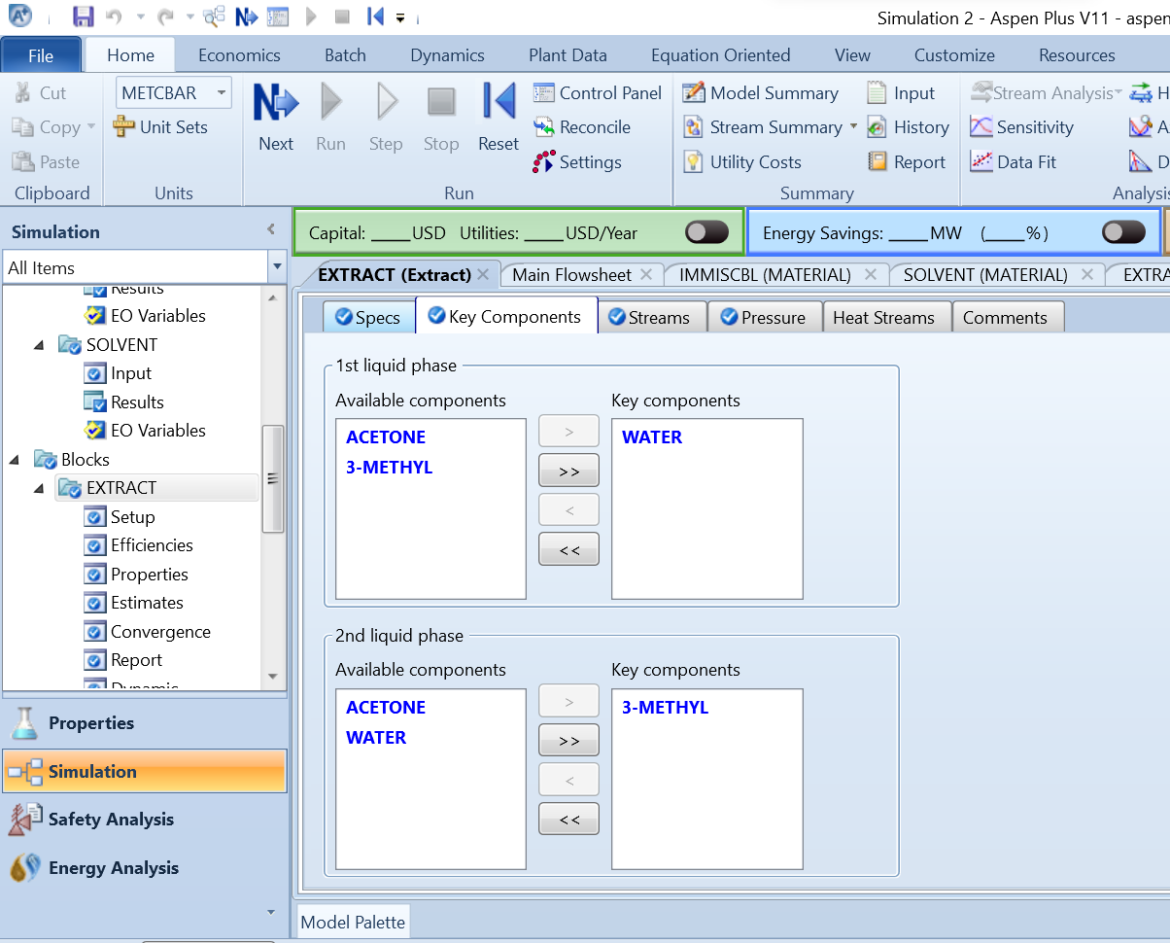
Figure 5.4: Key components set up

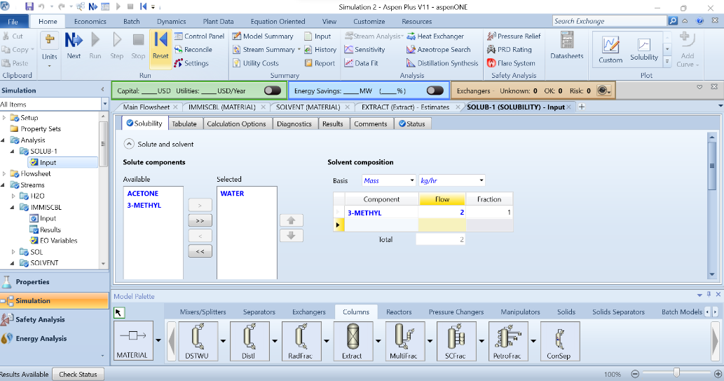
Figure 5.5: Solute Solvent table

Chapter 6: BIOMASS GASIFICATION SIMULATION with sensitivity analysis
Biomass gasification is a process that converts biomass, such as wood, agricultural residues, or organic waste, into a gaseous fuel known as syngas (synthetic gas). This syngas is primarily composed of hydrogen (H₂), carbon monoxide (CO), carbon dioxide (CO₂), methane (CH₄), and small amounts of other gases. The process involves drying the biomass, followed by pyrolysis to break it down into volatile compounds and char. The volatile compounds are then converted into syngas through partial oxidation and reduction reactions in a gasifier. The resulting syngas can be used for various applications, including power generation and as a feedstock for chemical production.
In our biomass gasification case study, we'll explore a diverse range of components, each with its unique elemental composition. The non-conventional components include biomass and Ash which represents the inorganic residue left after biomass combustion. Additionally, we'll consider solid carbon (C) and sulfur (S) as significant constituents in the gasification process.
Moving to conventional components, we'll incorporate hydrogen (H₂), methane (CH₄), ethylene (C₂H₄), ethane (C₂H₆), carbon monoxide (CO), and carbon dioxide (CO₂) as key gases produced during gasification. Oxygen (O₂), nitrogen (N₂), ammonia (NH₃), hydrogen sulfide (H2_{S}), water (H₂O), chlorine (Cl₂) and hydrogen chloride (HCl) are also included to cover a wide range of chemical reactions and interactions within the gasification system. This comprehensive set of components will enable us to simulate and analyze the complex processes involved in biomass gasification thoroughly.
Select the method to be peng Robbins and go to the main flowsheet. Go to the setup tab and change the stream class to “MIXNCPSD”.
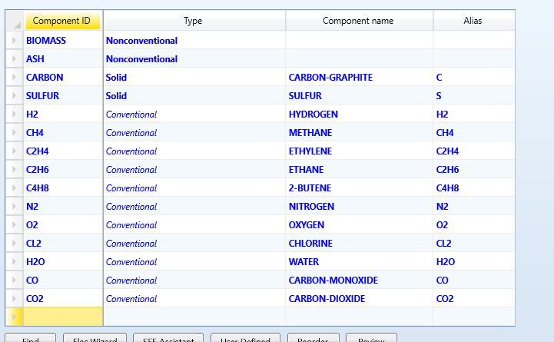
Figure 6.1: Components needed in the case study

6.1 Biomass Pretreatment
The pretreatment of biomass before gasification are essential preparatory steps that significantly enhance the efficiency and effectiveness of the process. Drying biomass reduces its moisture content, which is crucial because moisture can absorb a substantial amount of the heat energy required for gasification. This heat, otherwise, would be used to convert the biomass into syngas, making the overall process more efficient. Additionally, dry biomass allows for more consistent and predictable gasification conditions, as excess moisture can lead to fluctuations in temperature and gas composition, complicating process control. Furthermore, reducing moisture content results in cleaner syngas production, with fewer impurities like tar.
Crushing the biomass into smaller particles increases its surface area, facilitating better contact with the gasifying agent and enhancing reaction rates. Smaller, uniform-sized particles ensure a more consistent feed into the gasifier, leading to stable operation and efficient conversion, while large chunks can cause blockages and uneven feeding. Moreover, the improved heat transfer achieved with smaller particles ensures that the entire feedstock reaches the necessary gasification temperature more uniformly and quickly, reducing the residence time needed in the reactor. This preprocessing ensures that the biomass is in an optimal state for gasification, resulting in better performance, higher efficiency, and improved quality of the produced syngas.
We will first simulate biomass drying. Add a Rstotic reactor to the main flowsheet and two inlet stream, name on of them “biomass” by right clicking the stream and selecting the rename option. Rename the other to be air. We will first set up the air stream click into the air stream and set the specifications to be 200 C 3 bar and 1000 kg/hr of air. Then go to the biomass stream.
The biomass we will pick today will be the woodchips. Wood chips are derived from various types of wood, such as hardwoods and softwoods, and are commonly used due to their availability and relatively uniform size. They typically consist of cellulose, hemicellulose, and lignin, along with smaller amounts of extractives and ash. Set the temperature to be 25 C and 1 bar of 5000 kg/hr of biomass.
Next, we will set up the proximate analysis. Wood chips can hold a lot of moisture, so let's assume the moisture content to be 15%. Set the Fixed Carbon (FC) to be 18.5%, Volatile Matter (VM) to be 78.74%, and ash to be 2.76%. Next, change the attribute ID to "Ultanal." Set ash to be 2.76%, carbon to be 47.21%, hydrogen to be 5.73%, nitrogen to be 0.42%, chlorine to be 0%, sulfur to be 0.05%, and oxygen to be 43.83%. Then, go to the sulfur analysis (sulfanal) drop-down menu and set it to be 0.05% organic.
Now we will set up the particle size distribution (PSD) of the wood chips. Since wood chips are typically large particles, we need to adjust the table to accurately reflect their size distribution. Click “Edit PSD mesh” Then change the number of intervals to 5 and the size units to mm. Then go to the particle size distribution table on the left and change the first interval to have a lower limit of 0 and an upper of 5 then the 2nd to be 5-10 the 3rd to be 10-20, the 4th to be 20-50 and the 5th to be between 50-70. Then hit the close button at the bottom. Now we will set the weight fractions to be 0.08 for the first interval, 0.2 for the second, 0.39 for the third, 0.26 for the 4th interval and 0.07 for the final interval.
Now we will set up the dryer. Click into it and set the flash types to be "Pressure and Duty." Then set the pressure to 5 bar and the duty to 0 cal/sec. Create a new reaction and set the reactant to be biomass with a coefficient of 1 and the product to be H2O with a coefficient of 0.0555093. This coefficient was found by dividing the molar weight of biomass (1) by the molar mass of water, which is 18.015 kg/kmol. Then set the fractional conversion to be 0.15 of the component biomass. Now go to the component attribute tab and set the substream id to be biomass with the attribute id to be proxonal then set the moisture to be zero.
Navigate back to the main flowsheet and add a flash 2 block after the rstotic add the required outlet streams and reconnect the outlet stream from the rstotic to be the inlet stream of the flash set the specification to be 150 C to ensure that all the liquid turns to vapor and can be extracted efficiently and the pressure to be 1 bar .
Run the simulation and save your progress. Do this by going to the "File" tab in the banner and selecting "Save As," then save it as a component file. This is important to ensure we don’t lose all our work.
Next, view the solid stream out of the Flash2 block and ensure the molar fraction is set to one for solid. Once that is complete, we will add the crusher block. Find the crusher block under the "Solids" tab in the model palette and add it to the main flowsheet. Reconnect the solids outlet stream to be the inlet of the crusher and add an outlet. Double-click into the crusher block and set the outlet PSD calculation method to be “Select Equipment.” Set the crusher type to be “Gyratory” with both the selection function and breakage function set to “US Bureau of Mines.” Then, set the maximum particle diameter to 15 mm. After setting up the crusher as described, run the simulation, and view the results of the crusher outlet stream. Then, save the simulation again. You can do this by either going to the "File" menu and clicking the “Save” button or by clicking the printer icon in the top right corner next to the Aspen logo.

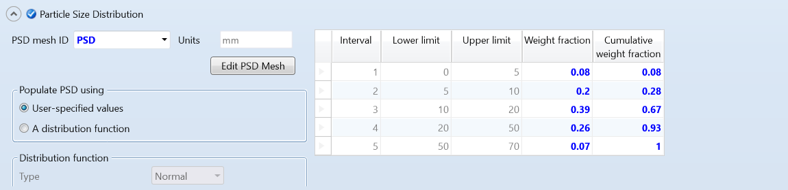
Figure 6.2: Particle size distribution of the woodchips

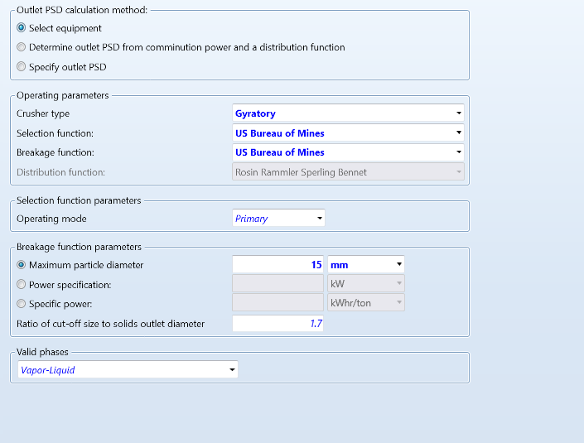
Figure 6.3: Crusher specifications

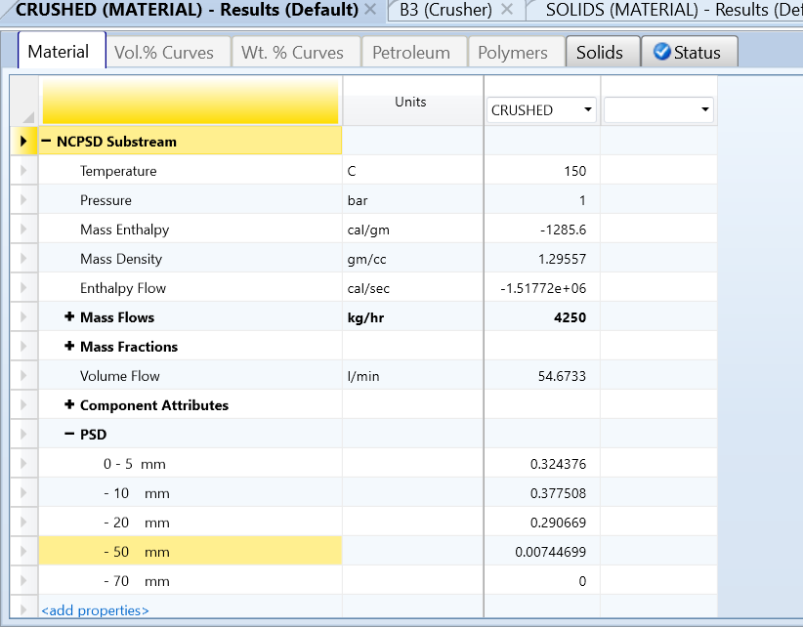
Figure 6.4: Crusher outlet stream results
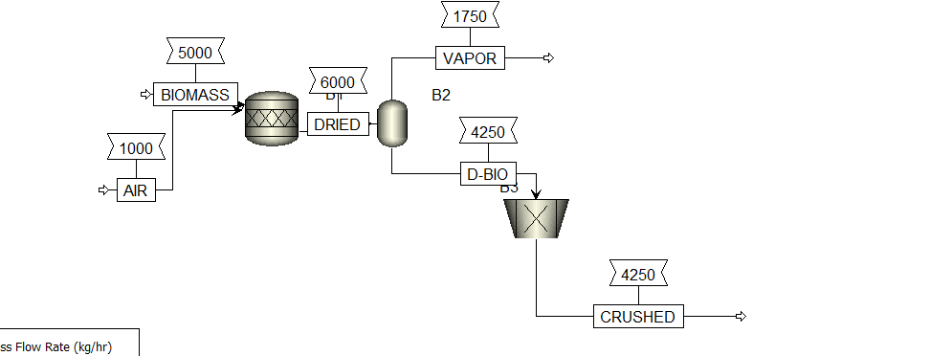
Figure 6.5: Representation of the biomass pretreatment

6.2 Biomass Gasification
The gasification section of the simulation will consist of an RYield and an RGibbs. The RYield reactor was chosen for its capability to break down or decompose woodchips into their elemental materials effectively. This step is important because it provides Aspen with the necessary information to handle these materials appropriately. By understanding the elemental composition, Aspen can accurately simulate the subsequent gasification process, ensuring accurate results and insights into the overall gasification system's behavior.
Add an "RYield" block from the model palette to the simulation, connecting the "crushed" outlet stream to the inlet of the RYield block. Create an outlet and name it "decomp." Inside the RYield block, set the temperature to 400°C and the pressure to 3 bar. In the "yield" tab, specify the components as ash, carbon, sulfur, nitrogen, hydrogen, and oxygen. Set all the basis columns to mass and enter the basis yields as follows: 0.0276 for ash, 0.4721 for carbon, 0.0005 for sulfur, 0.0042 for nitrogen, 0.0573 for hydrogen, and 0.4383 for oxygen. These values are in decimal form, corresponding to the elemental composition percentages. The total basis yields should sum up to one.
Move to the "COMP. ATTR." tab to set the specification for ash. Set the sub stream ID to be "NCPSD," the component ID to be "ASH," and the proxanal values to be 100 for ash and zero for all other components. In the "Ultanal" tab, set the ash value to 100 and zero for all other components. Finally, ensure that the sulfanal values are all set to zero. Run the simulation and save your work.
Let's set up the gasification unit. First, add an "RGIBBS" reactor to the simulation, using the "Decomp" stream as its inlet and creating the required outlet. Rename the Rgibbs to be “gasifier” by right clicking on the block and selecting the rename button. Now, let's focus on the gasifying agent, which refers to the gas present in the reactor during gasification. In this case study, the gasification agent will be steam, a common choice for biomass gasification due to its controlled oxygen content.
The ratio of gasifying agent to biomass typically ranges from 1 to 2 units of gasifying agent per unit of biomass. To achieve this ratio, we'll add a water stream and a heater. The output steam from the heater will serve as an inlet into the RGIBBS reactor, as depicted in Figure 6.7. Set the water conditions to 25°C and 1 bar, with a flow rate of 8000 kg/hr. This flow rate ensures that we are within the desired ratio range of 1-2 times the amount of biomass.
Next, configure the heater to raise the water temperature to 200°C and the pressure to 3 bar. This heating process prepares the water to be converted into steam, which will act as the gasification agent in the RGIBBS reactor.
Then click into the Rgibbs reactor and set the temperature to be 750 C with 3 bar as the pressure. This high temperature is typically for gasification as the standard temperature range for gasification typically falls between 700°C to 1200°C. This range was chosen because it allows for efficient conversion of biomass or other feedstocks into syngas gas while ensuring proper chemical reactions and minimal tar formation. But more on that later. Then run the simulation.
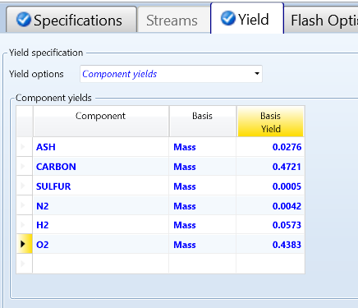
Figure 6.6: The yield set up
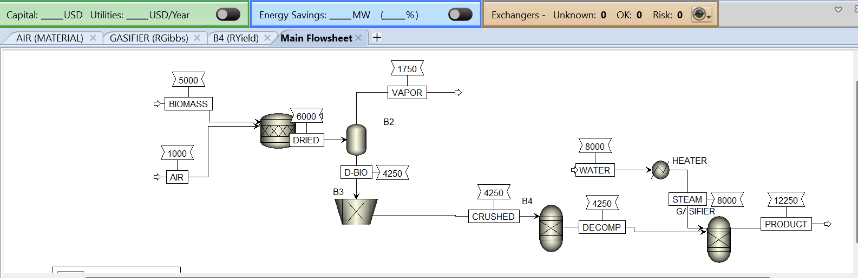
Figure 6.7: A representation of the simulation thus far

6.3 Product separation
The final part of the case study focuses on product separation, Product separation is a crucial step in gasification processes for several compelling reasons. Firstly, it ensures the purity of the desired product, such as syngas composed of hydrogen and carbon monoxide. This purity is essential for maintaining high performance and quality in subsequent uses of the product, as any impurities can negatively impact its properties and functionality.
Secondly, separation enhances the efficiency of the overall system by focusing on extracting and utilizing the valuable gases. By removing unwanted components like water, ash, and sulfur, the process becomes more streamlined and effective, leading to improved resource utilization and reduced waste generation.
Moreover, product separation allows for better process optimization. It enables operators to adjust specific parameters such as temperature, pressure, and flow rates to maximize the yield and quality of the target product, leading to improved overall performance and operational control.
To start this separation process, begin by incorporating an SSplit component after the Rgibbs. Add the two outlet streams, "gas" and "solids," within the SSplit. Assign "solids" in the table by marking a 1 next to NCPSD. Subsequently, alter the stream name to "gases" and assign a 1 next to "mixed" in the value column.
Following the SSplit, it's essential to cool down the gas stream to separate water from it. Add a heater and a flash2 separator into the simulation. Connect the "gas" stream as the inlet to the heater, then link an outlet from the heater to the flash2. Configure the heater's temperature to 65°C and pressure to 2 bar. In the flash2, set the temperature to 25°C with a pressure of 2 bar. Execute the simulation afterward.
Next, add a separator block connected to the gas outlet stream of the flash2. Add two outlet streams to the block name one of the “syngas”. Within the separator, adjust the fractional conversions to 0.8 for hydrogen and carbon monoxide, representing the components of syngas, assuming an 80% efficiency in separation. Execute the simulation again to complete the gasification section.

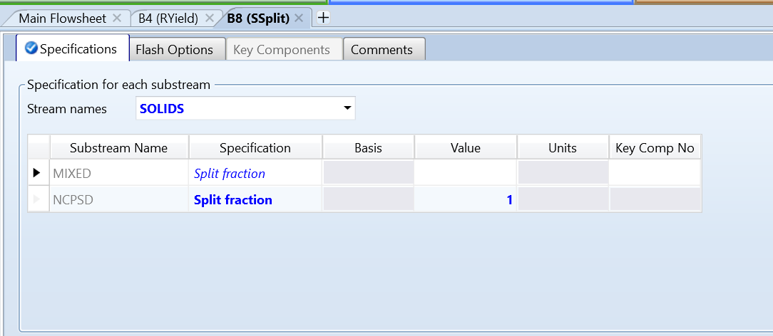
Figure 6.8: SSpilt set up
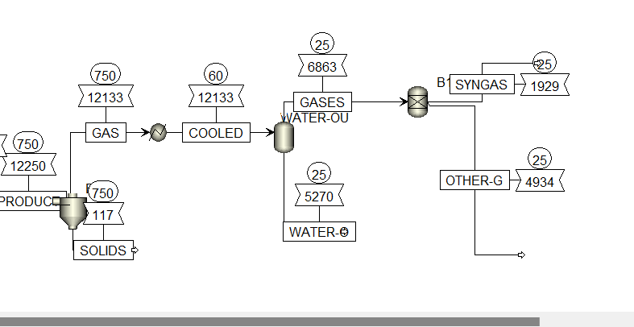
Figure 6.9: Representation of the separation section

6.4 Sensitivity analysis
Achieving a yield of 1929 kg/hr of syngas is a good result, but there's potential to optimize further through sensitivity analysis. This analysis involves systematically varying parameters within the simulation to understand their impact on the yield. By running sensitivity analyses, we can identify key factors that influence the yield of syngas and explore how adjustments in these parameters can potentially lead to a higher yield output.
The variable we will be looking into is the temperature in the RGibbs and the resultant yeild of syngas. Aspen Plus offers a convenient way to conduct sensitivity analysis directly within the software. Navigate to the "model analysis tool" folder on the left side of the screen, scroll down until you find the "sensitivity" option, and click on it. Then, click the "new" button to begin setting up the sensitivity analysis for the temperature in the RGibbs reactor.
Once you hit the new button it will ask to enter an ID, I left mine to say S-1 then click the “okay” button. It wil bring you to the “Vary” tab this is where you'll define the variables in the simulation you would like to change. In our case we want to vary the input temperature of the rgibbs to let the simulation know this we will first click the “new” button and set the variable name to 1, the type to “block-var” which means we want to change the input of a block then select the block to be the “gasifier” block. Then set the variable to be “TEMP”. Next in the manipulated variable limits select the method to be “Equidistant” the start point to be 700 C and the end point to be 1250 C select the increments option and set it to be 50. The reason for the range is because the standard range for gasification temperatures is between 700-1250, the increment of 50 should allow us to see a change and draw conclusions.
Next go to the “define” tab this is where you set the dependent variable, which in our case is the mass flow rate in the syngas stream. To set this up click the “new” tab and name its hydrogen set the category to be streams. Then set the reference type to be “stream-var” the stream to be syngas the sub stream to be mixed and the variable to be mass flow rate. Then go to the “tabulate” tab and select the “fill variables” button. Then hit the run button.
After running the analysis, return to the Model Analysis Tools folder. Click the dropdown on "sensitivity" and then on "S-1." Finally, click on the results button to access a table showing the relationship between temperature and mass flow rates. You'll observe that as the temperature increases, the mass flow rate of syngas also increases. This indicates that to achieve a higher yield, adjusting the mass flow rate to be higher would be beneficial.

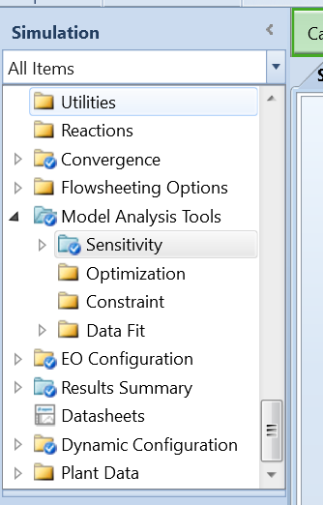
Figure 6.10: Folder containing the Sensity analysis button
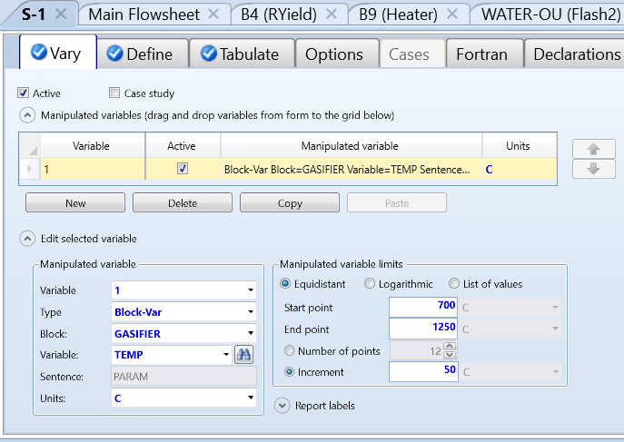
Figure 6.11: Set up of the independent variable
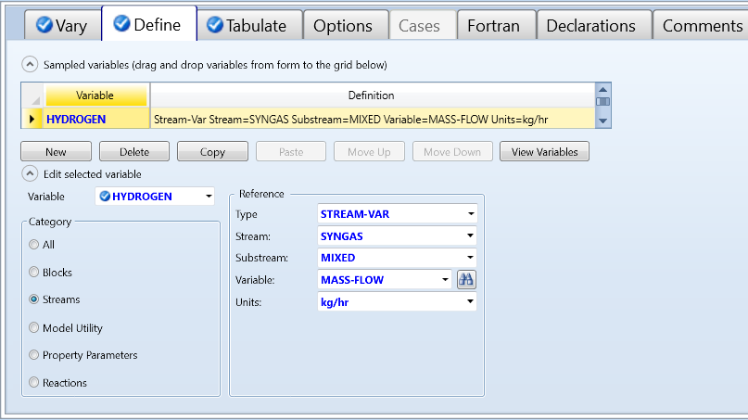
Figure 6.12: Set up of the dependent variable
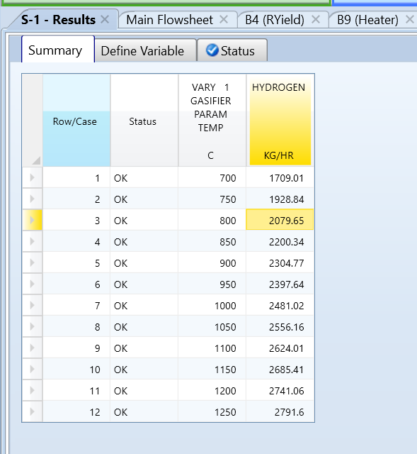
Figure 6.13: The sensitivity analysis. Results.

Conclusions
The authors of this book intend to introduce the fundamentals of Aspen plus to readers with little or no experience in process simulation. It is expected that on completion the following skills will be acquired:
- Learn some practical techniques for building and troubleshooting flowsheet simulations.
- Determine optimal process conditions to improve current processes.
- Use the Workbook and Flowsheet interfaces for quick and effective modelling.
- Carry out properties analysis to know the best method to use as fluid package for simulations.
- Gain the practical skills and knowledge to begin modelling new and existing processes.
While the concepts covered herein are basic, readers are advised to use them as a starting point in order to explore more challenging simulations. For instance, pinch analysis and heat exchangers optimization were not covered. Furthermore, the use of Aspen economic analyzer was not discussed as well as in-depth sensitivity analysis. Energy and exergy analysis with Aspen plus are also not covered. Regardless, the skills and knowledge acquired herein would be useful for students and industry practitioners.

