University of Oklahoma

Graduate College

COLLECTING DURING THE INDIAN CRAZE:
Analyzing the HARRY L. GEORGE COLLECTION
OF NATIVE AMERICAN ART

A thesis

submitted to the Graduate Faculty

in partial fulfillment of the requirements for the

Degree of

MASTER OF ARTS IN ART HISTORY

By

KERRIE L. MONAHAN
Norman, Oklahoma
2018

COLLECTING DURING THE INDIAN CRAZE:
ANALYZING the HARRY L. GEORGE COLLECTION
OF NATIVE AMERICAN ART

A thesis approved for the
SCHOOL OF VISUAL ARTS

By

______________________________
Dr. W. Jackson Rushing III, Chair

______________________________
Mr. B. Byron Price

______________________________
Dr. Alison Fields

______________________________
Dr. Daniel C. Swan

© Copyright by KERRIE L. MONAHAN 2018
All Rights Reserved.
This thesis is dedicated to my parents, Michael and Dr. Janean Carter Monahan.

Acknowledgements
This research is an extension of paper I presented at the Native American Art Studies Association in Tulsa on October 27, 2017. There are many people throughout my short career that I owe for their intellectual and personal support. This list is only as comprehensive as space allows. There are many people in my life who I owe my gratitude to.
I am grateful to my thesis chair, Dr. W. Jackson Rushing III for taking me on as a student and the support, advice, mentorship, and thorough copy-editing he has given me during my time at the University of Oklahoma. I would also like to thank my committee members, Dr. Alison Fields, Dr. Daniel Swan, and Mr. B. Byron Price; all of whom shared with me ideas and time to discuss concepts of my research and helped me develop it into what it is today. Thank you for always being available to guide me through this process and your continued interest in my work. And thank you for giving me the space and conversations necessary to develop and mature my ideas.
I also wish to acknowledge the wonderful staff in the School of Visual Arts, Reagan Schreier, Katelynn Knick, and the late Jennifer Gourley. Thank you for giving the space to unwind and the constant support. Thank you to the incredible professors I had the opportunity to work with: Dr. Robert Bailey, Dr. Erin Duncan-O’Neil, and Dr. Allison Palmer. And of course, the staff at the Fred Jones Jr. Museum of Art: heather ahtone, Hadley Jerman, and Tanya Denton for your continued support and advice throughout my final semester.
I also wish to acknowledge my cohort here at OU in the Art History, Native American Studies and Anthropology departments including (but not limited to): Monique Moglika, Mark Esquivel, Ashley Holland, Ashlea Espinal, Mac Jones, Lauren Ross, Laura Clark, Chelsea Herr, Alicia Harris, Francesca Giani, Mac Jones, and Michelle Lanteri. Thank you all for your friendship, sincere conversations, and support through my coursework. Thank you for making Norman my home away from home.
Several people outside of OU assisted me with this journey: Jill Ahlberg-Yohe, Adriana Greci-Green, Dakota Hoska, Iris Colburn, and Joanna C. Scherer. Thank you for sharing my enthusiasm for the project and offering me words of advice and reassurance when I need it.
I am particularly grateful to the wonderful staff at the St. Joseph History Museum, especially Sara Elder, who took the time to share her expertise with the collection. Thank you for your rapid-fire responses to my emails and having an invested interest in my research.
I would not have had the opportunity to study at OU without the unwavering support of my family. Thank you, Mom and Dad, Erin and Phil, Matt and Jonese, my Grandparents, Ted and Marilyn, Mary-Jane and Charlie. Thank you for instilling in me the values of hard work, education, compassion, and giving me the support to follow my dreams.
And last, but not least, thank you John Peterson for sticking by my side through this entire process. Thank you for your constant encouragement, being my source of strength, and reminding me there is a world beyond my pile of research books. Thank you for always feigning interest whenever we go to museums or visit with collectors. Without you, this journey would not be worth it. I am beyond grateful to have you as my best friend and partner.

Table of Contents

Acknowledgements iv
List of Figures and Illustrations viii
Abstract ix
Introduction: Why Lakota Material Culture? 1
What is “The Indian Craze”? 3
State of the Literature 4
Terms and Definitions 7
Goals of this Case Study 11
Argument and Structure 11
Chapter I: The Indian Craze and Harry L. George 14
Accumulating Collections in the 20th Century and the Rise of Curio Dealers 15
Who Is Harry? 23
Conclusion 28
Chapter II: Primary Contact Zones 30
Catalog Dealers and Wild West Performances as Contact Zones 31
Curio Catalogs 33
Wild West Performances and World’s Fairs 39
Harry L. George and Luther Standing Bear 41
Transculturation in the Primary Contact Zone 42
Conclusion 44
Chapter III: Secondary Markets as Secondary Contact Zones 45
An Overview of Secondary Markets 49
The Network of Collector-Dealers 51
N.E. Carter, Elkhorn, Wisconsin 51
H.S. Rounds, Rounds Curio Company, Sioux City, Iowa 53
Vern Thornburgh, Lincoln, Nebraska 54
Additional Exchanges 55
Networks of Exchange and Potential Secondary Contact Zones 57
Final Remarks 59
Bibliography 61

List of Figures and Illustrations

Figure 1: Harry L. George Indian Corner 18
Figure 2: Harry L. George Indian Corner 19
Figure 3: Image of Harry L. George 23
Figure 4: Newspaper Front Page from the St. Joseph Gazette (February 15, 1914) 25
Figure 5: Detail of the Strong Curio Company Catalog, 1915 37
Figure 6: Detail of the L.W. Stilwell Catalog, 1904 45
Figure 7: Correspondences Discussing the Sale or Exchange of Lakota Material Culture to Harry L. George 48

Abstract
This thesis examines the concepts of primary and secondary markets utilized by artists and collectors of Native American art at the turn of the 20th century. This time period was coined by art historian Elizabeth Hutchinson as “the Indian Craze.” It describes the time period in which large quantities of Native American material culture was collected by anthropologists, museums, and private collectors, who feared the Indigenous artists and their cultures would certainly perish.
Missouri collector Harry L. George systematically collected material culture from a variety of Indigenous cultures around the United States. However, for the scope of this project, my research investigates how George acquired Lakota material culture from primary markets (curio catalogs and directly from artists) and secondary markets (other collectors and dealers). My personal interest in Lakota material culture, paired with what I feel is a gap in the literature, adds to this case study. As I demonstrate, Lakota materials were discussed and described in a unique manner that resonated with collectors because of the Lakota peoples complicated history with the United States government and their romanticized image within popular culture. Lakota artists were able to mediate this imagined expectation by promoting their material culture in a way that worked to their advantage.
My study is supported by archival research, visual analysis, and textual examination. Utilizing archived correspondences between George and other collectors, curio-dealers, and Lakota artists, I explore how artists and collectors mediated their and other people’s identities in order to drive market demands for Indigenous material culture. I argue the George collection gives scholars important access to understanding the understudied networks for collecting Indigenous material culture during the Indian Craze.

Introduction: Why Lakota Material Culture?
“At the end of the nineteenth century, the Lakota were still extremely prolific producers of art, even under such profoundly changed circumstances. In fact, so prolific was their output that the eminent Plains scholar John C. Ewers observed that is a museum has only one piece of Native American art it is likely to be made by a Lakota” – Marsha C. Bol, “Defining Lakota Tourist Art”

This project, for me, began out of frustration. While I was conducting an independent research project at the Sam Noble Museum of Natural History in the Spring of 2017, I came across a pair of stunning Lakota moccasins. They were what I would consider “eye dazzlers” --- a term that I borrow from Navajo textiles to describe any form of vibrantly-colored beadwork that would stop me in my tracks. These moccasins were fully beaded on the vamp and sole, and appeared to be in perfect condition. I had the preconceived assumption that any beautiful material object found in an ethnographic collection have been be worn or had an exciting life before it was locked away into a museum storage system. So as a naïve graduate student, I went to learn more about these moccasins by heading to the provenance records. Thus, the source of my frustration: the provenance of these shoes did not answer where they came from, the year they were made, or the any biographical information I desired.
The epigraph by art historian Marsha C. Bol highlights an interesting and ironic point: Lakota material culture is prominent in many museums with Native American collections. The output of these materials from the reservation to collections is astonishing. What I find more interesting, however, is how can one know very little about how these materials were produced in such great numbers and how were they dispersed so widely around the world? How were these artists encouraged to create a large quantity of materials to sell to collectors?
But much like the moccasins in the collection of the Sam Noble Museum of Natural History, how can one know how it ended up in the collection? Furthermore, why are there so many beaded Lakota materials, such as moccasins, pipe bags, and shirts, in museum collections? My interest and research up until this point focused on historic Northern Plains material culture, especially beadwork. Beadwork, I argue, exemplifies the innovation of artists in the wake of colonialism and the Reservation era (1880-1915). Although beads were used a currency between traders and Indigenous communities on the Northern Plains, artists were able to use manipulate this currency to create art and actively continue community traditions, such as giveaways and embellishing ceremonial clothing. Beadwork gradually replaced the more labor-intensive porcupine quill embroidery. As communities were coerced into living in government-monitored reservations, beaded embroidery on moccasins, pipe bags, and hide shirts were a source of cultural and artistic continuance. Although communities, especially the Lakota, were urged to assimilate to western culture, the continuance of beadwork techniques persisted. Beadwork today continues as a way for Lakota people (and other Indigenous artists) to connect to their ancestors and continue to be active in cultural practices such as giveaways. This is one method of survivance, defined by Anishinaabe scholar, Gerald Vizenor, survivance is described as “an active sense of presence. Not a mere reaction [to dominance].” Beadwork continues as a mode of artistic expression and artists adapt new techniques and new designs to their artwork.
Beaded material culture, such as moccasins, pipe bags, clothing, and other utilitarian objects were (and are continually) gifted within Lakota communities. However, as Lakota people were forcibly confined to reservations, these materials were created, sold, and distributed to outside markets. The money earned through these exchanges afforded Lakota people the materials they needed to survive. As Lakota people were distributing their beaded materials, they asserted their active presence to consumers outside of their communities. Lakota people were able to supply the demand for Indigenous-made material objects during a time of rapid collecting. This particular period of rapid collecting, known as “The Indian Craze”, began shortly after the beginning of the Reservation Era.

What is “The Indian Craze”?
The term Indian Craze was coined by the art historian Elizabeth Hutchinson in her study of primitivism, modernism, and transculturation in American art between 1890-1915. She explains:
The term comes from articles on the widespread passion for collecting Native American art, often in dense, dazzling displays called “Indian corners.” This collecting trend stemmed from the increased availability of Native American art [at the beginning of the twentieth century] …This was possible because of the dramatic increase in the production of art for sale, both on reservations and, surprisingly, in venues dedicated to the eradication of Native culture such as government boarding schools.

Furthermore, Hutchinson’s research looks into the development of Native art forms as symbiotic with American art history, challenging the traditional cultural separation between the two. The Indian Craze, then, is more than just the interest in rapid collecting of Native American art. The Indian Craze is the period when hybridization and exchange of ideas between Native artists and Anglo-American consumers lead to the development of a unique, commoditized art form. This exchange supports Indigenous participation in modernity, meaning that Indigenous artists were playing an active role in the supply and demand for their material culture. This participation, I feel, allowed Native artists to have a role in the development of American art, thus, allows their material culture to be viewed, valued, and collected as art. Consumers collected Native American art and material culture at this time because such objects were appreciated both for their aesthetic value and cultural importance.

State of the Literature
Literature discussing the phenomenon of collecting Native American material culture is not new. Anthropologists, tourists, and serious collectors sought value in Native American-made goods. Scholar Margaret Dubin summarized two centuries of collecting Native American art. She notes the history of collecting began with Lewis and Clark through contemporary annual markets such as the Santa Fe Indian Market (SWAIA) and The Heard Museum Guild Indian Fair and Market. Her text, however, primarily examines the elite circles of collectors and only summarized the historical information of collecting. Additional anthologies and collected texts also give case studies about collecting. Collecting Native America, 1870-1960 (1999) edited by Krech and Hail, contains nine chapters based on influential Native American art collectors, such as George Gustav Heye and Phoebe Hearst, both of whom collected during the “Indian Craze.” Books and articles written by art historian Ruth Phillips have been published in a number of occasions, including Trading Identities: The Souvenir in Native North American Art from the Northeast, 1700-1900 (1999), and in the collected volumes, Unpacking Culture: Art and Commodity in Colonial and Postcolonial Worlds (co-edited with Christopher B. Steiner, 1999) and an essay in The Anthropology of Art (2006). Her contributions in these publications (and the larger field of art history), examine the role of “tourist art” created by Indigenous artists of the northeastern and Great Lakes regions of the United States and Canada.
The term “tourist art” is the commonly accepted term for Indigenous material culture that is created as a commodity. Nelson Graburn defines tourist art as
Those arts made for an external, dominant world; these have often been despised by connoisseurs as unimportant, and are sometimes called “tourist” or “airport” arts. They are, however, important in presenting to the outside world an ethnic image that must be maintained and projected as a part of the all-important boundary defining system.

Therefore, the “tourist art” has little or no internal cultural importance for the community from which it came. Bol discussed this concept of Lakota “tourist art” in her article published in Unpacking Culture. She argued the term is somewhat ironic, since tourists did not see South Dakota or Nebraska as a tourist destination. She noted “there were and continued to be private individuals who actively collected Lakota arts”, but these collectors “probably…inhibited the development of innovations in art forms among the Lakota.” Although the term “tourist art” is problematic for describing some Lakota art, I think Lakota artists were innovative in their beaded creations and how these materials were marketed in primary markets (as I explore in chapter two of this thesis). Her article, offered several leads on how one might understand the diffusion of Lakota art and material culture to collectors. She mentioned briefly the existence of curio catalogs and the exchange of materials at Wild West Shows, but does not offer detailed insight into secondary markets and does not discuss the possibility of transculturation or artistic innovation. However, Bol does make a valid point in her conclusion when she notes
Although many museum collections are indeed filled with Lakota arts made for sale, we have not recognized them as such because they look the same as arts made for Lakota use. The only difference is that they have never been used.

This statement circles back to my original frustration: so how can one tell whether or not Lakota material culture (such as a pair of moccasins) were created for an Anglo-American market? One may never know. However, the pair I discovered in the collection of the Sam Noble Museum did not have a footprint in them, every bead on the shoe was tightly sewn, and the beads themselves were spotless. Based on this visual analysis, I consider them to be created for a non-Native collector. But these distinctions are not always clear-cut. Perhaps one is not supposed to know the motivations behind the creation of these materials because that is not how Lakota art was marketed to collectors. The footprint within a pair of moccasins could be an intentional patina, trying to make the object look older than it actually is at the time of collection. This would separate the art from the stereotypical “tourist art” classification, something that would downplay its value for collectors.
As I demonstrate in this research, collectors of Indigenous art, such as George, valued “authentic” Lakota material that was old and once served a utilitarian purpose. Even if a pair of moccasins were worn once by a person, they would leave a footprint within the shoe, thus, giving them a higher market value. George, a collector from Missouri whose collection is the foundation of my study, began his collection as a tourist. His development as a collector is similar to those mentioned in Krech and Hail’s Collecting Native America. In fact, George corresponded with George Gustav Heye on several occasions. Within these archived correspondences with collectors, collector-dealers, and curio-dealers, I believe there are signs that suggest the inventiveness of Lakota people when creating and distributing their art to consumers.
Very few studies have been conducted on George. There were several St. Joseph Missouri newspaper clippings recount the reputation of his collection. However, the meticulous records he kept are ripe for primary archival research.

Terms and Definitions
Throughout this thesis, I use several terms when describing the various people who interacted with George throughout his collecting. These terms, I believe, are applicable to those who are active in collecting, selling, and dispersing Native American material culture during this time. These terms may have overlap based on the situation. For example, George was a tourist at a Wild West Show; however, he established a relationship with a performer and received material from the performer to add to his collection. I define these terms based on how they are applicable to the George collection.
I define a tourist in the context of this thesis as one who purchases material culture as a memento during a trip. The tourist is away from what they consider “their home base” and could include a businessman, a family traveling to the Southwestern United States, or one who is at a spectator event (such as World’s Fair, Wild West Show, etc.). A tourist could purchase a souvenir of this experience as an afterthought. This purchase, although not pre-mediated, is a nostalgic representation of the vacation. Tourists can range from one who buys one object to one who buys an object to begin procuring a large collection. Collectors such as George and Heye began their collections as tourists.
In this thesis, a tourist is one who purchases material culture that was made solely for the benefit of selling to tourists would be buying tourist art. An example of tourist art would be Pueblo pots George purchased at the Santa Fe railroad station. Tourists usually purchase tourist art from the artist or a member of their community. Tourist art also served as a memento of that experience, and meaning is applied to that object based on the consumers’ nostalgia.
A commodity is material culture that is being sold or traded. Commodities could be considered tourist art or could be materials that were used or repurposed for monetary value or trade. Commodities could also be something that were produced for distribution through sales catalogs. Commodities can also be shipped to the customer and do not require direct contact with the producers.
Material culture is found in private and public collections. In this sense, material culture in the George collection could be either tourist art or a commodity. In museum collections, these lines are blurred, and the categories of tourist art and commodity are less defined. Without thorough provenance, it is difficult to categorize “tourist art” or “commodity,” therefore, the objects are given the comprehensive term “material culture.”
A collector is one who obtains material culture for private enjoyment. A collector could also be one who is collecting on behalf of an institution, ethnologist, or on behalf of another collector. Collectors are generally focused on going out of their way to buy material to own. They can travel to procure their collections, or they can order their objects through dealers or catalogs. Collectors primarily have an idea of what they would like to add to their assemblages. They are also invested in the aesthetic and perhaps meanings behind the objects. Collectors may even be interested in quality over quantity. Collectors are likely to donate their materials to museums after their death to ensure their legacy.
Collectors sometimes acquire their commodified material culture from curio-dealers. Curio-dealers are those people who collects for their own personal benefit as well as collecting with clients in mind. Collector dealers are often open to trading their material for other material or services (instead of a monetary exchange). Collector-dealers may also serve as a middle-man or collecting agent for the collector. Collector-dealers see their collections as fluid and adaptable based on their needs or the needs of their clients. Collector-dealers are also interested in relationship-building with clients to ensure repeat customers.
A curiosity dealer, or curio-dealer is a person who procures and distributes material culture. Curio-dealers may self-identity as collector dealers. Curio-dealers often create and distribute catalogs to their clients, indicating their material may be made-to order or they have enough back stock to supply their customers. Curio-dealers may also supply at wholesale to curiosity store fronts, department stores, general stores, etc. Curio-dealers see the sale and distribution of material culture from a strictly business standpoint. Curio-dealers may also sell materials such as fossils, and other “natural history” specimens.
Throughout my research, George and his network of collector-dealers refer to Lakota beaded materials they traded as coming from the “Sioux Tribe.” This terminology, up until the latter half of the 20th century, was widely accepted as a distinction for the northern Plains people based in North and South Dakota. When directly quoting the primary sources, I remain historically accurate. By offering the preferred terms of the members of the community, I am acknowledging their continued presence. The term “Sioux” comes from the Anishinaabe term “enemy” or “little snake” and was adopted by French fur traders in the 17th century. When paraphrasing or discussing the materials in my own voice, I use the term Lakota. This term refers to the 7 Bands of Tetonwan. When referring to the larger group of communities based in the Northern Plains region, I use term “Oceti Sakowin,” the Seven Council Fires, which unify the Lakota, Dakota, and Nakota people. This approach, I believe, is important, because it acknowledges the label “Sioux” as derogatory and inaccurate. It also demonstrates the importance of self-representation and cultural continuance.

Goals of this Case Study
This case study sheds light on a small network of curio-dealers and collectors buying, selling, and exchanging Lakota material culture between 1904-1920. As a case study, it is not an exhaustive list of connections between major collectors during this time. However, I hope this research will be a small stepping stone towards understanding the complex networks of collectors and dealers during this time. For the scope of this project, I purposely focus on George’s correspondences regarding the procurement of Lakota material culture. I do this purposefully not only because of the scope of the project, but it is where my personal research interests lie and it is where I feel there is a biggest gap in the literature.
My methods rely primarily on extensive archival research and visual analysis of printed images found within the collection. The images I study were printed and distributed to consumers who purchased Lakota material through curio catalogs.

Argument and Structure
I argue the George collection gives scholars important access to understanding networks of collecting Indigenous material culture during the Indian Craze. This thesis teases out, in particular, the various primary and secondary markets by which collectors acquired, sold, and traded Lakota material culture. I will demonstrate this through archival, textual, and visual analysis.
My first chapter examines George’s collecting habits and situates him within the period between 1880-1920 known as “The Indian Craze.” My intention with this chapter is to explain that George was one of many collectors who systematically acquired Native American material culture for private use. What sets George apart from his contemporaries are the extensive records and correspondences he kept with curio-dealers, other collectors and artists. The following two chapters then discuss the contents of these correspondences and how one can utilize them to understand the various networks by which Lakota material culture was discussed, negotiated, and sold.
The second chapter examines how George collected his materials through “primary sources” or “primary contact zones.” I demonstrate the acquisition and transfer of materials was mostly carried out through middlemen. These middlemen, also known as curio-dealers, are men who had direct contact with Native artists and distributed materials in bulk through catalogs, curio stores, or department stores. In this chapter, I also demonstrate that event venues, such as Wild West Shows and World’s Fairs, are primary contact zones because they allow collectors to personally meet Native artists and purchase material directly from these encounters. Primary contact zones require some form of physical contact or relationship between Native artists with curio-dealers or Native artists with the collectors themselves.
The third chapter examines the inter-connected networks of collector-dealers and collectors. Specifically, I conduct analysis on the correspondences themselves, highlighting the efficiency and effectiveness of collector-dealers selling these materials on a secondary market. In these correspondences, I prove that collector-dealers often bolstered the provenance of the materials they sold, often connecting them to well-known Lakota chiefs. These connections, I argue, evoke the romantic imagery of the American West and market the materials as tangible connections to this former era.
However, as time progressed and the trade of the material continued, the ties between artist and object became loose, allowing collector-dealers to take liberties when describing their provenance to consumers. With time, the history of the object became lost. This thesis serves as an example of how one can utilize the George collection to recover some understanding about the networks and diffusion of Indigenous material culture during the “Indian Craze.”

Chapter I: The Indian Craze and Harry L. George

St. Joseph, Missouri is a port town along the Missouri River, roughly fifty miles northwest of Kansas City. It was officially established in 1843 by fur trader Joseph Robidoux. The town’s strategic location along the Missouri allowed it to be the largest distribution town for settlers heading west. There, consumers could purchase the supplies they needed for the journey to Oregon Territory. St. Joseph was also one of the main terminus for the Pony Express. By the 1870s, the town’s population had grown, making it one of the largest cities in the state of Missouri. In 1874, the town built a large hospital complex to the east of town. The building is situated on a hill near a cluster of old government-sanctioned buildings east of downtown. This sanitarium is now inactive and has been repurposed as the Glore Psychiatric Museum, one of several institutions overseen by the St. Joseph History Museum system. It currently contains exhibitions discussing the original facility, as well as local history. The museum also has a large section devoted to Native American art, which was collected by a local salesman, Harry Lewis George, at the turn of the 20th century. Although this collection may seem out of place to the average museum-goer, it is significant for a number of reasons. Most notably, it contains one of the most well-documented Native American art collections in the country. The collection contains over 4,000 Indigenous works of art and material culture, as well as extensive correspondences and invoices with collectors, dealers, and noted anthropologists and art scholars between 1904-1920.
In this chapter, I explain how George collected his Native American material and how his collecting practices offer valuable insight into the “Indian Craze.” The beginning of this chapter offers an overview of collecting Native American material culture in the United States. This background information is important because it gives context for the time period when George collected. The next section explains who George was and where he came from. This sets the tone for my following chapters, which stress the importance of his records and their significance in understanding his collecting strategy, as well as the unique national network of collectors, traders, and scholars he constructed. George amassed a remarkably wide array of material culture that, although somewhat well known, offers a valuable insight into specific trends within collecting that have never been analyzed.

Accumulating Collections in the 20th Century and the Rise of Curio-Dealers
Collections containing Native American material culture, such as clothing, moccasins, pipes, and bags began with the Age of Exploration. European traders brought back the “spoils” of the “New World” and exoticized them in curio cabinets. The first major collection of Native material in the United States was that of Thomas Jefferson, who received Native American materials collected by Lewis and Clark in 1804. Motivations for collecting Native material varied. However, by the mid-1880s, Native peoples took advantage of the commercial opportunities presented to them by supplying the demand for Indigenous-made material culture. Native peoples found an opportunity to sell their material culture in order to gain access to better opportunities, earn money, and ensure the continuity of their material culture at the hands of museums and other collectors. In some cases, those creators of material culture were able to travel outside of the reservations to sell their material at numerous venues including World’s Fairs, Wild West Performances or even along the nearest transcontinental railroad station. There are various avenues that Indigenous art and material culture (such as moccasins, pipe bags, baskets, etc.) passes through before it becomes deposited into a museum. In this diagram, we can see how the material was collected originally by salvage anthropologists (such as Frances Densmore and Franz Boas), who were working under the vanishing race paradigm. Materials were also distributed by Wild West performers and curio-dealers. I want to note that in most cases, the sale of beaded material to white collectors was a mode of survival for the Lakota people. In relinquishing their family heirlooms, Lakota men and women confined to reservations were able to exchange material culture for money to spend on food or even healthcare. For those performers who sold their beaded possessions to audiences in the Wild West Shows, that money often afforded them a way to return home and hopefully have some extra money to purchase goods for their families. Another method by which collectors received material culture was directly from other collectors and curio-dealers. These curio-dealers either sold material through catalogs or through direct correspondence with the collector.
The art collected by patrons and consumers in the 19th and early 20th century was often displayed and kept in an area of one’s home known as “an Indian Corner.” (Fig. 1, Fig. 2) Hutchinson notes this was a common phenomenon especially among upper-middle class white males, such as George and the industrial elite, like Heye. Hutchinson defines the concept of the “Indian Corner” as “the dense and vibrant installations of collections that typically appeared in dens, porches or living rooms of the period.” These corners serve as a venue that Indigenous material culture can be appreciated for their aesthetic beauty, thus, elevating these objects to be classified as art. Although these objects are viewed as art, it does not necessarily pay credit to the artist or their cultural affiliation. Dubin argues: “[these] objects replace people, just as the material culture removed from reservations has replaced its creators. Museums are full

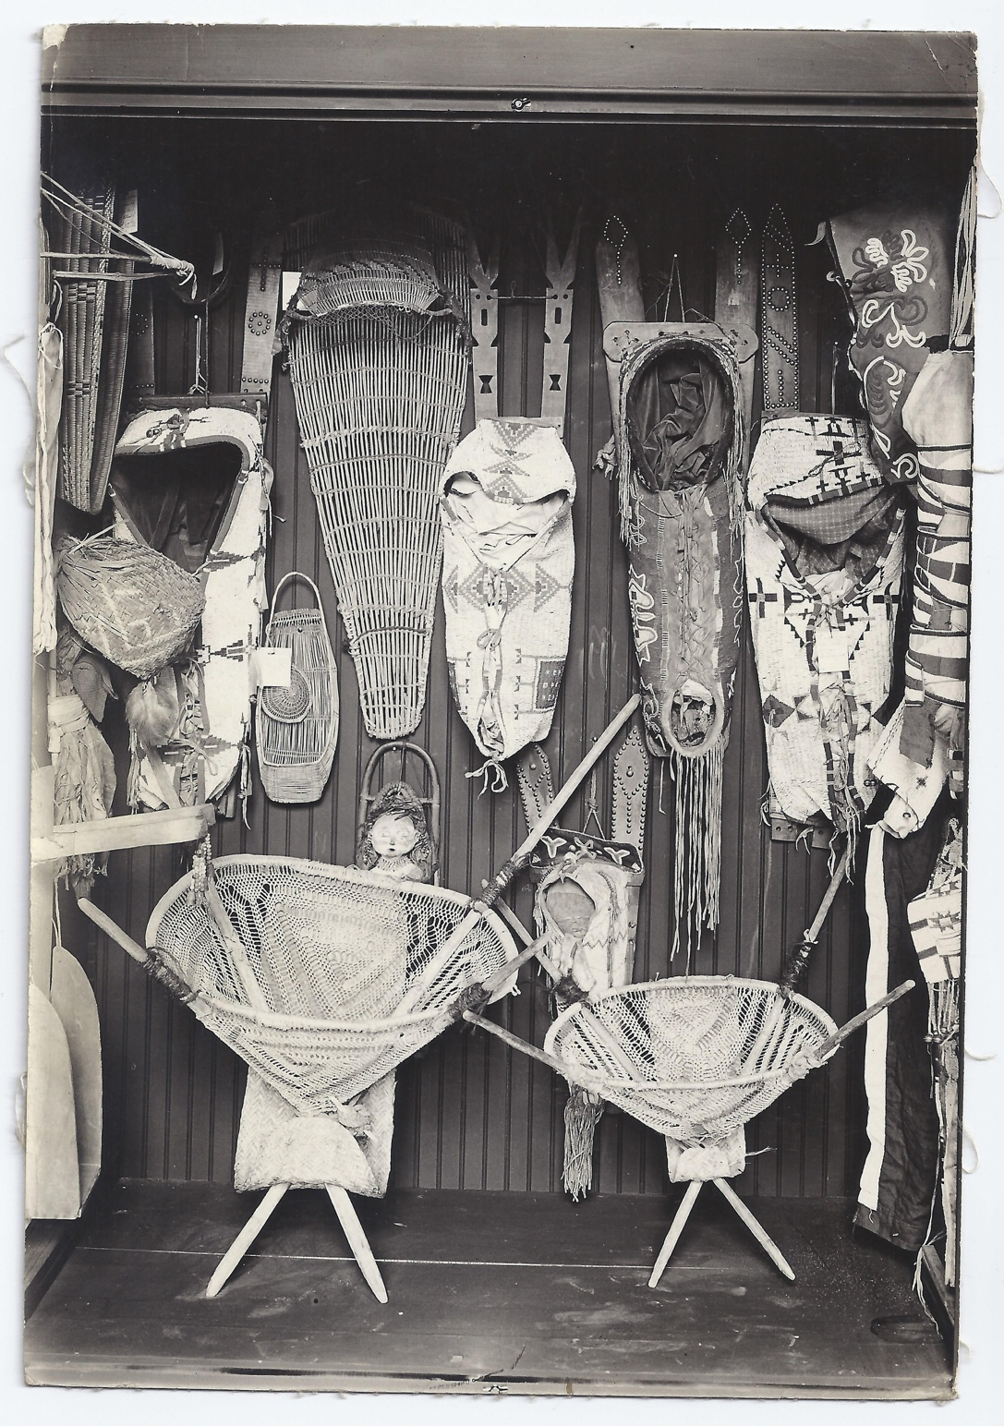
Figure 1: Harry L. George Indian Corner
Image Courtesy of the Collections of the St. Joseph Museums, Inc., St. Joseph, Missouri

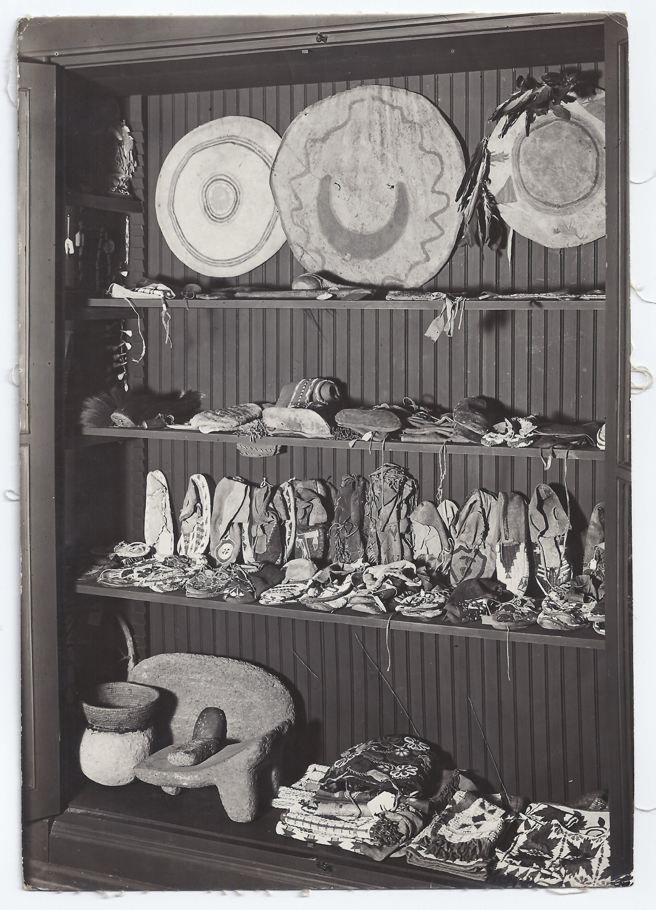
Figure 2: Harry L. George Indian Corner
Image Courtesy of the Collections of the St. Joseph Museums, Inc., St. Joseph, Missouri

of objects created by eighteenth- and nineteenth-century Indians who have long since passed away.” Once the materials were collected by patrons, she argued, the materials are decontextualized from the cultural environment from which they came. This process of distortion comes from the collector and the process of removing the material from its original context. Once the meaning behind the materials are gone, collectors then, in turn, project their own value upon it. This value could be an aesthetic value or a perceived connection to a seemingly “primitive past” that is long gone. Cultural anthropologist Renato Rosaldo refers to this phenomenon as imperialist nostalgia, or “an innocent yearning both to capture people’s imaginations and to conceal its complicity with often brutal domination.” Removing these materials from their context would then conceal the complexity as to why Native peoples had to sell their material culture to patrons, or just a complete erasure of their Indigenous culture in the wake of American expansionism.
Surrounding oneself with Native art could also reflect one’s ability to remove themselves from the busy life of the Industrial Revolution and physically situate themselves among natural material produced by peoples of the past. Historian T.J. Jackson Lears, identified the arts and crafts movement as a response to industrialism, coining the term “antimodernism” as a “recoil from overcivilized modern existence to more intense forms of physical or spiritual experience.” Hutchinson utilized this statement to explain one of the motivations why collectors felt the need to connect material culture to a preindustrial (and romanticized) Indigenous culture. Furthermore, collecting Native material could reflect and reinforce class and the idea of “refined cultured luxury” during the late 19th century. Travel to exotic places for business or pleasure was considered an upper-class and masculine endeavor. Wealthy industrialists and high-ranking government officials (including Indian agents and military men) could purchase Native-made art as souvenirs of these travels at an affordable price, then bring them back to their homes and they were able to show off their ‘refined taste’ and ‘worldliness.’ By creating a space where men could physically surround themselves with Native material culture, they could encircle themselves with materials and art considered worldly, exotic, and aesthetically pleasing.
These Indian corners were decorated by what art historian Ruth Phillips describes as two different types of commodities created by Native peoples: utilitarian wares and art commodities. Utilitarian objects, she explains, are works that are minimally decorated “workday” objects such as moccasins and ax handles. Art commodities, however, are accessories that may also be considered as an “everyday artifact,” yet possess decorative and aesthetic properties that may be attractive and marketable to collectors and tourists. Objects such as pipe bags have a religious and utilitarian purpose; however, when decorated with elaborate quillwork or beadwork, they have a “refinement of form [that] elicits the visual, tactile and intellectual pleasure” that aesthetically pleases the viewer. As previously mentioned, materials that were displayed in Indian Corners came from a variety of sources, including entertainment venues, tourist destinations, and department stores. By the 1890s, however, curio-dealers also began distributing their own publications to interested collectors. These magazines advertised an assortment of Native American materials such as moccasins, pipe bags, or weavings. Curio-dealers and collectors distributed both art commodities and every day artifacts, often blurring these lines by labeling these objects as “Indian Curiosities” that were comparable to natural history specimens or relics of a primitive way of life. This tactic furthermore reinforced the anonymous identity of the creators of the material. Indigenous artisans were then reduced to their culture, allowing collectors to acquire materials based on ethnographic and scientific classifications.
The materials distributed through traders, department stores and their catalogs stressed authenticity. This offers a stark contrast to the other materials sold in these catalogs because the Native-made goods were created far from the industrial city and fed into the mythology of western America. Curio-dealers such as The Strong Curio Company of Gordon, Nebraska and LW. Stilwell of Deadwood, South Dakota were two of many wholesale dealers who distributed Native-made goods to curio shops around the country and Europe. Both curio-dealers sold products to fellow wholesale trader George. In the following section, I explain how George’s role within the rapid collection of Native American material culture.

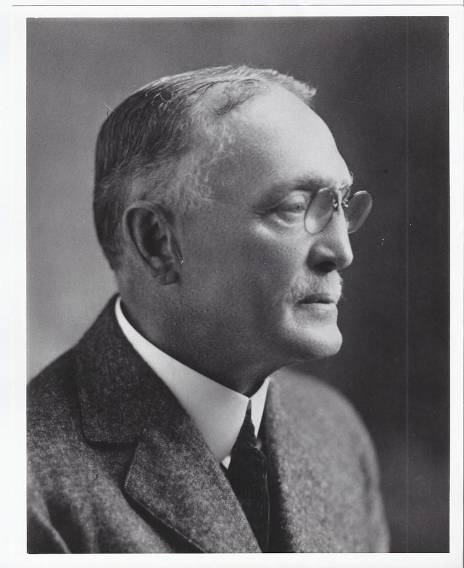
Figure 3: Image of Harry L. George
Image Courtesy of the Collections of the St. Joseph Museums, Inc., St. Joseph, Missouri

Who Is Harry?
George was born on November 2, 1848 in Philadelphia, Pennsylvania. As a young man, he had numerous jobs, including clerking in a local grocery store, working for a medicine laboratory, and working for a wholesale company that specialized in women’s accessories, such as undergarments, hosiery, and gloves. Through this job he gained experience working with wholesale distributors, a skill that would prove beneficial in his professional and personal achievements. At age 21, he arrived in St. Joseph, Missouri and began to work for the distributor, R.L. McDonald & Company. On January 23, 1884, George married Maggie Beattie McDonald, the daughter of his employer, and they had three children (two of whom died in infancy). In 1896, he started his own company which represented fabric mills.
In 1904, George went on a business trip to the southwestern United States and came into contact with California basket makers. From this experience, he decided he was going to collect baskets from all Native communities in North America. His collecting ambitions captured the attention of the people in St. Joseph. This article, pictured in Fig. 3, and published in 1914, praises the quality and size of George’s collection. It also called for the establishment of a museum in St. Joseph. Another article published by the Kansas City Star from 1914 noted:
because of a small basket, purchased ten years ago from an Indian reservation, merely as a souvenir of his Western trip, turned out to be a rare specimen, Harry L. George of St. Joseph, Missouri realized that the original Indian types of industry and art were rapidly passing and he began his collection of specimens of the North American tribes’ handiwork, which is recognized as one of the most complete private collections in the United States.

George’s primary interest in collecting was not unique. As previously noted, anthropologists and government-sponsored entities believed Native American communities would not last in the storm of American expansionism and the restrictive reservation systems. Native peoples were forced either to assimilate willingly to American life or be forced to do so. However, scientists also saw the value in preserving these fading cultures. Anthropologists such as Franz Boas, Frances Densmore, Clark Wissler, and many more saw the value in documenting the lifeways
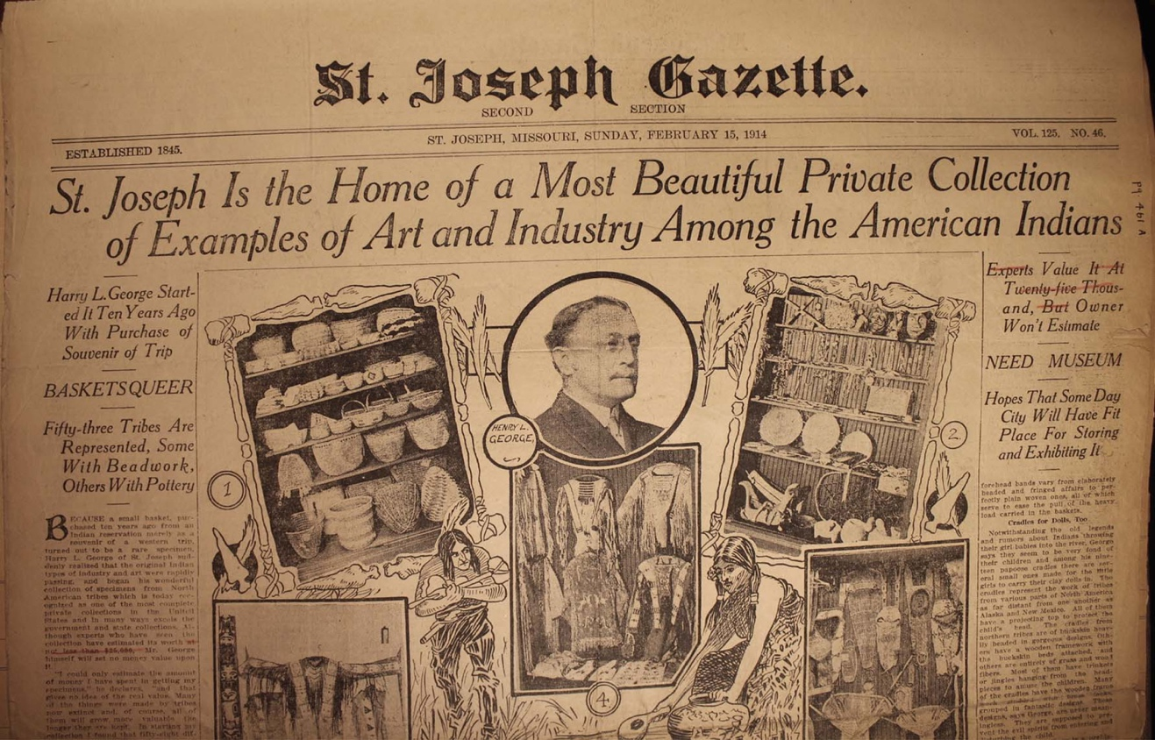
Figure 4: Newspaper Front Page from the St. Joseph Gazette (February 15, 1914)
Image Courtesy of the Collections of the St. Joseph Museums, Inc., St. Joseph, Missouri

and material culture of Native American communities before they vanished. These anthropologists saw it as their role in society to save the very culture the expanding country sought to extinguish. Furthermore, collecting Native American material culture became a trend amongst an industrial elite, such as Edward Ayer (whose collection founded The Field Museum in Chicago) and Heye (whose collection is the basis of the National Museum of the American Indian). By 1890, the demand for Native-made material culture grew and Native artisans were able to supply this demand through various means. One such mode was the emerging tourist industry and railroad companies. Railroad lines, such as the Atchison-Topeka-Santa Fe, contracted with the famous Fred Harvey Company to offer restaurants, lodging, and souvenir shops for passengers traveling to the southwestern United States. In all likelihood, this is where George was introduced to Native American material culture.
After George purchased his first basket in the West, he continued to collect at a slow pace. Two years after he began collecting, he began to archive his correspondences and invoices from various curio-dealers around the United States. The first sales record in his archives dates to July 31, 1906. In the receipt, from M.J. Kohlberg, manager of “The Mexican & Indian Curio Company” based in Denver, George purchased eleven different baskets from communities in Arizona, New Mexico, California, Washington and Mexico. He continued to collect baskets from as many geographic regions he could, often sending letters directly to Indian Agents assigned to various Reservations around the country. His enthusiasm for woven materials continued for several years until he received a response that forced him to reevaluate his collecting goals. In 1908, he received a response from the Indian Agent at the Standing Rock Reservation that confirmed the Lakota people on the reservation did not produce baskets. This response amazed him, and challenged him to understand more about the Indigenous cultures of the United States. Similar responses flooded in from various other geographic regions around the United States. As. George widened his collecting goals, he increased the sources he went to. By 1910, he began to contact various curio-dealers, collectors and government agencies to increase his collection. Drawing exclusively on the archival correspondences he left behind, scholars can understand the magnitude and scope of George’s network.
George continued to collect Native American material culture until his death in 1923. In nineteen years, he managed to collect over 4,000 objects, 200 books, several McKinney and Hall portraits of Native peoples, numerous photographs, and kept hundreds of pages of correspondences which detailed his collecting practices. According to Sara Elder, curator of collections at the St. Joseph History Museum, George aimed to stay away from collecting “mass produced souvenir goods.” This is most likely because George, much like other collectors during “The Indian Craze” valued “authentic” objects and art because they were tangible connections to the past. These objects would serve an educational purpose for future generations. George’s initial goal was to make his collection accessible to public audiences. Although this goal did not come to fruition within his lifetime, it did become a public collection after his death.
The collection was sent to the State of Missouri Historical Society in Jefferson City in 1924, where it was loaned in five-year contractual increments, with the option to renew the agreement after each term. While in Jefferson City, the collection was re-cataloged and George’s papers were glued into two massive ledger books. In 1944, board members of the State Museum decided to cease their loan agreement. All of the materials were returned to St. Joseph where they were purchased by the Goetz Brewing Company and donated the collection to the St. Joseph History Museum. The George Collection of Native American art was transferred to the museum’s current location at the Glore Psychiatric Museum.

Conclusion
George was not unique in that he collected material culture during the Indian Craze. He was one of hundreds, if not thousands, of successful businessmen to invest in the nostalgia of America’s romanticized Native past. However, as we will see, his preserved records set him apart from his fellow collectors because they explain his collecting methodology and unveil the complex networks that show Native American material culture was diffused around the United States.
In the following two chapters, I highlight the strengths of George’s archival records. My primary goal is to fill two voids that I recognize in the current literature: (a) investigating the networks of curio-dealers and collectors of Native American material culture between 1904-1920 and (b) explaining how the George collection serves as a case study to explain how Lakota-specific material culture was exchanged amongst collectors and collector-dealers. Both of these sections within the text may not completely fill the gaps in museum provenance records; however, these sections offer ways of understanding how collectors discuss, negotiate, and exchange material culture and how Native artists maintained a presence within these dialogues.

Chapter II: Primary Contact Zones

Harry L. George collected over 4,000 of Indigenous art from various regions around the United States through different methods. One method was through mail-order catalogs and through direct contact with the artists. This chapter focuses on how George acquired his collection of Lakota material culture though catalogs and government agencies. The following chapter concentrates on his personal relationship with his network of other collectors, which I argue is how George acquired a majority of his collection and what I believe is largely a common method of collecting Native American material such as beadwork, basketry and pottery. Although my primary focus in chapters two and three is how George collected Lakota art, I also embellish these examples with other culturally-specific and material items he collected. This is because throughout his collecting, George acquired a wide assortment of material. It was not until 1914 that he amassed the largest quantities of Lakota material for his collection.
I divide the following two chapters based on their classification as a primary or secondary collection method. This chapter examines materials that were originally collected by dealers and agents who had direct contact with their makers. This process, I hope to argue, creates direct communication between buyers and sellers/producers. In this process, I believe there is a mediation of identities and that adjustment alters the marketability of certain materials. Furthermore, this chapter communicates the complex power relations in play while acquiring Lakota art during this time.

Catalog Dealers and Wild West Performances as Contact Zones
Linguist Mary Louise Pratt coined the term contact zone in a speech she gave as a keynote speaker at the Modern Language Association’s 1991 meeting. In this groundbreaking discourse, she defines the term as the
Social spaces where cultures meet, clash, and grapple with each other, often in contexts of high asymmetrical relations of power, such as colonialism, slavery, or their aftermaths as they are lived out in many parts of the world today.

In the case of Indigenous communities and their interaction between Anglo-American consumers of Native American material culture, a contact zone can be the physical place in which these cultures convene. An example of this physical space could be where one sells material items such as beadwork and other art forms. A contact zone is furthermore, a place where ideas can be mediated. Questions and dialogues between cultures revolve around issues of commodification based on marketability of such material items. I believe that the interaction of catalog dealers and the Native people they “employ” through cottage-type industries is one such example. Another example is the physical location of a venue such as a World’s Fair or Wild West Show, both of which were popular form of entertainment between 1880-1915. In these exchanges, one notes the transference of physical materials as well as ideas. Pratt furthermore notes the process of transculturation, in which, she explains, the members of the subordinated group “determines to varying extents what gets absorbs into their own” culture. As I demonstrate later in this chapter, Lakota beadworkers were able to meet the demands of their consumers in a way that was unique and marketable to American consumers.
Pratt’s concepts can furthermore be adapted to explain collecting practices during “The Indian Craze.” On a fundamental level, contact zones are places where Native American material culture can be exchanged. But in order for materials to be sold on a secondary market (as discussed in the following chapter), there has to be that initial exchange. This initial exchange within the contact zone, I believe, can be defined as a “primary market.” With a primary market, the catalog buyer or tourist consumer has to make contact and negotiate an exchange with the creator of the material. This exchange can either be a trade for other goods or a monetary exchange. Communication between the consumer and artist allows for both figures involved to benefit from the deal. The power dynamics are still in play; however, it allows for some negotiation and agency for the Indigenous producer. The Anglo-American consumer may have the monetary power; nevertheless, they must negotiate that power in order to achieve a transaction. The primary market is also where the creator of the object is not entirely anonymous. Catalog dealers and Buffalo Bill performers knew where the materials were made and possibly they knew exactly who made them. This knowledge of who made the material culture has unfortunately been lost in a majority of cases and requires extensive analysis to discover these artists. However, the visual records of these contact zones prove there is a physical space where exchange occurs.

Curio Catalogs
Native American material culture, such as pipe bags, moccasins and other beaded art forms, most commonly entered the market through curio-dealers that were supplied by catalog distributors or through Native American artists themselves. These exchanges were enacted within a primary contact zone, meaning that these distributors often obtained their Native American-produced goods directly from their producer. In this relationship, the distributors often set standards for the materials they purchased from the artist in order to meet the needs of the catalog consumers. When materials had set standards (such as size, amount of decoration, quality, etc.), their distributor could set fixed prices for their consumers. This practice was not uncommon. According to anthropologist Patricia Pierce Erikson, the Makah people in northwest Washington would often create baskets and trade them to the local general store owner to sell to tourists passing by on freight ships. Through interviews conducted through fieldwork, Erikson noted the women on the reservation would create baskets in the sizes and patterns the shop owner deemed appropriate. Erikson explains though her interviews: “[the store owner] standardized basket sizes, shapes, and designs in order to establish fixed, trading value.” Curiosity shop keepers and curio catalog distributors often kept a close watch on the production of material objects in order to maintain high standards in the products they were marketing.
Strong Curio Company, based in Gordon, Nebraska, was one of the leading suppliers of Lakota material culture in the United States. The introduction of their 1915 annual price list catalogs welcomes new customers and notes the relationship between the catalog dealers and their artists:
To our new customers we will say that we buy these goods direct from the Pine Ridge and Rosebud, Sioux Indians here---pay them cash---speak their language---thereby buying the goods for as little money as they can be bought, consequently can see for as little money as they can be sold.

The introduction to the Strong Curio Company catalog highlights their relationship with the Lakota suppliers: they claim to communicate with them in Lakota, and they also “pay them cash.” The language in the statement seems altruistic in a way that benefited both curio-dealer and the Native people that supply him. However, this tone of the language takes a sharp turn towards the consumers which explains these relationships imply the Strong Curio Company can obtain these materials at a lesser price. Strong Curio Company thus transition their relationship with their suppliers to one that relies on acute business acumen. The producers of the catalog understand a solid relationship with their artists was good for business; however, at what cost is this to the Lakota artists? The relationship between the Strong Curio Company and their artist suppliers was complicated. Although there is archival evidence of the catalogs, they allow for a seemingly one-sided understanding of these power dynamics. The curio-dealer publishes the stock lists and advertises these materials to consumers. His words stressed their dealings with the Lakota artists are legitimate, and yet, avoided paying them the wages they deserved.
Strong Curio Company furthermore stresses the “authenticity” of the materials they sell to their consumers. In the catalog, they noted:
Our goods that are made of buckskin and rawhide are beaded and sewn with sinew. Only the old [generations] know the art or have the patience of beading with sinew and when they have passed away sinew bead work will be a thing of the past. We find that it is growing a little more scarce every year.

The “authenticity” of the material culture is supported by the beadwork knowledge of the older, pre-Reservation generation. The language employed in the catalog creates a romanticized visual for the Industrialized consumer. 1915 was a year of acute global awareness: World War I was raging in Europe, threatening to involve the United States. The United States also recently opened and controlled the Panama Canal, thus making the country one of the most powerful countries in the world. With rapid industrialization, consumers believed the Indigenous populations were going to fade. Strong claimed the original creators of these beaded materials were “passing away” and younger generations did not have the patience or understanding to create art for non-Native consumers. Beaded materials would thus become “a thing of the past” and supplies would be limited. This sense of urgency combined with the idea of value created an ideal marketing strategy for the Strong Curio Company. Consumers could purchase items such as beaded moccasins by the dozen based on quality.
The power dynamics within this structure; however, were complicated. Although the Strong Curio Company highlighted the positive aspects of a relationship with their Lakota suppliers, there is an unevenness in the power relations. In the 1915 publication, Strong Curio Company published an image of a cluster of tents near the Gordon Fair Grounds, that are approximately fifteen miles south of the Pine Ridge Reservation (Fig. 5). The photograph, titled “Indians in camp at Gordon Fair,” was taken by James A. Miller, one of the three owners of the Strong Curio Company. The photo shows a large cluster of white cloth tents in the middle of a field. There are no people in the photograph, only several grazing horses and empty makeshift carts. The scene resembles something of an abandoned ghost town. The caption at the bottom of the photograph furthermore reinforces the anonymity of the producers of their products. The caption reads “Our factory: this is where our goods are made.” This image complicates the relationship between the Strong Curio Company and their Lakota suppliers. The Lakota people, although their presence is implied through the amount of housing structures within the image, are nowhere to be seen. Perhaps these people are off participating in the fair. Another way to interpret this scene is described through the text as “our factory,” implying the producers of the material are most likely hard are work within these structures and their identities are omitted for the sake of mechanical production. One could also gather these artists are not visible in the scene because they are creating material within the tents, and being exploited at the hands of the catalog dealers. The Lakota artisans are purposely kept out of the location of the photographer. Miller’s caption is written in the first person, implying “our goods” as a possession. The Lakota artists beyond the chain-linked fence work for the Curio Company and are contained within a space, purposefully left out of the conversation.
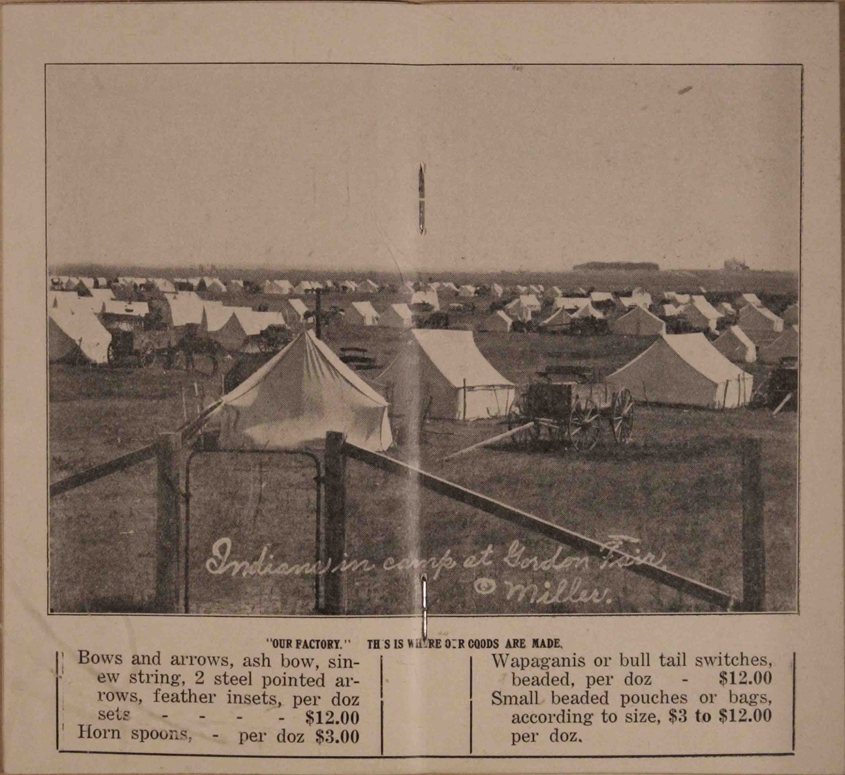
Figure 5: Detail of the Strong Curio Company Catalog, 1915
Image Courtesy of the Collections of the St. Joseph Museums, Inc., St. Joseph, Missouri

The relationship between curio-dealers and their producers reinforces the notion of “othering.” People are reduced to being machines of production. Cottage industries were popular means of production prior to the Industrial Revolution. This system allowed producers to work from their home base. In the case of Native American artisans, a majority of producers would create their materials for sale at home, then bring them to the appropriate location for sale through curio-dealers. As previously demonstrated, these dealers would have a dialogue with their producers about what they wanted from them and standardized means of production would develop. These standards were set by the dealer for the artist to follow. The artist would then return home to make materials that would meet those standards. In the case of the aforementioned image, however, this mediation is ignored. Although the tent structures in the photograph are temporary, the scene is referred to as a factory. This cottage industry was controlled by the Strong Curio Company. The Lakota people who created the materials were, in the eyes of the commodities and curio industry, were conceived as industrialized machines.
The producers are also located beyond a fence, further reinforcing the idea of “other.” Fences are symbolic for many reasons. They express ownership over land and create boundaries. They also are used to contain and control something that is deemed threatening or at risk. In this image, the fence can be interpreted many ways. On the one hand, the encampment could be viewed as a “factory.” On the other hand, audiences are encouraged to examine the Lakota encampment as a spectacle, a unique culture for entertainment.
It is also important to note the photo was taken at a fair. Circuses, World’s Fairs, and especially wild west shows, were popular forms of entertainment. These primary contact zones allowed collectors and tourists to obtain beaded material culture, such as moccasins, pipe bags and clothing, from the producer. These materials, therefore, were obtained through direct contact with the producer, or a representative from that culture.
Although there is no archival evidence George obtained parts of his collection from circuses or World’s Fairs, he did cross paths with Lakota performers at a Wild West performance in St. Joseph, Missouri in 1914. This interaction is discussed later on in this chapter.
Government agencies were also responsible for distributing Native-made material culture. “Arts and Handicraft of the Indian,” a stock list created by the Indian Crafts Department at the United States Indian School in Carlisle, Pennsylvania, devoted a section to sale of Lakota/Sioux moccasins. The list states “only the best are made by the Sioux” and gave customers the option of having a pair with a beaded toe for $2.50 or an “extra elegant” pair for $4.37 The irony of this particular catalog is apparent: Carlisle and other government boarding schools were designed to assimilate Indigenous youths to Anglo-American society by forcing them to abolish their ties to their home community. In the case of the Oceti Sakowin students at Carlisle, they were encouraged to produce their material culture for sale to white consumers. This action complicates the urgency marketed by the Strong Curio Company. Ironically, although Strong expressed concern for the passing of older generations and the rarity of beaded Lakota materials within the coming years, Carlisle encouraged the creation of beaded moccasins to younger generations.

Wild West Performances and World’s Fairs
Buffalo Bill Cody Shows were one venue where Northern Plains imagery and material culture was mediated for a white audience. Physical contact between Lakota people and general audiences occurred most frequently at World’s Fairs and Wild West Shows. Lakota performers in Wild West shows were agents in the circulation of Native material culture. There were various points of contact in which they were able to sell their material. The Buffalo Bill Cody shows were one such venue. In Steve Friesen’s 2017 publication, Lakota Performers in Europe, he notes that Lakota performers often sold the material they wore in the performances to white patrons in order to purchase new western style clothing for themselves. Art historian Emily Burns also traces the provenance of a buckskin vest and leggings displayed in numerous silent French films created in the Camargue region to a Wild West performer from the 1907 Paris Exposition. As of yet, there are few records found recording the practice of selling Lakota material to patrons at performance venues within the United States. It was customary that these materials were exchange by barter. Furthermore, Native artists and their patrons began written communication after the Wild West show moved to their next town.
World’s Fairs were another venue where Lakota peoples could sell beaded material to consumers. It was a place where they were expected to play a role in order to meet the expectation of audiences. However, World’s Fairs, like Wild West Shows, allowed Lakota people to travel outside of the Reservation and interact with public audiences. The anthropologists Nancy Parezo and Don Fowler explained in their research on the 1904 Louisiana Purchase Exposition that Lakota men, women, and children were brought down from the Pine Ridge and Rosebud Reservations to St. Louis to act in dioramas and interact with audiences in a way that would meet the expectations of the audiences. The location of these performances and the interactions between Lakota performer and audience is another example of a contact zone, where identity and stereotypes can be mediated in order to produce a unique outcome. For the Anglo-American audiences, Wild West Shows were a glimpse into a romanticized past. For the Lakota performers, it was a venue where they could play into imagined expectations of Northern Plains people that would meet the expectations of the audience. From 1883-1917, Buffalo Bill and his performers participated in hundreds of performances around the world. The Buffalo Bill Cody performances were an additional primary market where audiences could interact with the performers and purchase their very own beaded souvenir.

Harry L. George and Luther Standing Bear
On August 14, 1914, Buffalo Bill and performer Luther Standing Bear made an appearance at a Wild West show in St Joseph, Missouri. While there, Standing Bear became acquainted with a local textile salesman, George. Shortly after the men meet, Standing Bear returned to Los Angeles and sent a letter his new contact:
Dear Sir,
On this day I send you a porcupine tail
It is the kind that Indians used for comb their hair with. And it is one of oddity
…
I am sure yours very respectively,
Luther S. Bear

Although George did not receive the comb directly from Standing Bear at the time of the performance and we don’t know if he paid or it, it reiterates the point that some performers were selling their material culture to white patrons. In this instance (at least), we have example of a Native artist, who for reasons unknown, chooses to send his material to a white collector.

Transculturation in the Primary Contact Zone
Lakota beadworkers have countered this power relation through transculturation. Pratt explains that transculturation “is a phenomenon of the contact zone.” She explains that “while subordinate peoples do not usually control what emanates from the dominant culture, they do determine to varying extents what gets absorbed and what it gets used for.” In the case of curio catalogs and performances, Lakota people were able to assert their culture in a way that intentionally promoted their image, and thus, their ability to make a profit off their material culture. Lakota people were very much aware that their image and their culture were being commodified and reduced to a stereotype. They took advantage of this phenomenon to resist and survive in a society that believed Indigenous cultures were fading.
The Strong Curio Company 1915 Catalog advertises materials that are common among Anglo-European consumers; however, these materials were decorated by Lakota artists. The catalog advertises materials such as “Horsehair braided watch chains” and “Sioux Indian beaded neckties” by the dozen. Lakota artists absorbed and adapted materials in a way they deemed appropriate, and thus, marketable. Scholars notice this type of transculturation in other beaded material culture items such as pipe bags, moccasins, and scout coats that employ American flag imagery.
The use of beaded American flag images on Lakota-made material culture was one way Lakota people could utilize an Anglo-American image to their advantage. Flag imagery is unique because Lakota artists repurpose the design in a way that they deem appropriate for their own culture, yet it can also be sold to collectors. According to Howard Bad Hand Bull, the American flag started to appear in Lakota art and design in clothing and regalia in the late 1880s. According to Bad Hand Bull, The American flag, although it could represent the subjugation of the Lakota people by the United States government, also could represent victory in battle, bravery and glory. He continues,
The flag enjoys widespread utilization as a symbol to show beauty and attractiveness, lend meaning to the warrior tradition, and more importantly, as a reminder of the relationship between the Lakota and the American people.

The American flag motif not only was adopted as a symbol within Lakota culture, but it was also used to decorate art that was for sale for white collectors. As noted in this image from the L.W. Stilwell catalog from 1904, American flag beaded designs were one of many design motifs distributed by the Deadwood, South Dakota curio-dealer (Fig. 6). The beaded American flag design exemplifies transculturation because the Lakota people redefined the American flag, a colonial image, in a way that would be useful to their culture. Furthermore, the design was also used to embellish material that could be sold to Anglo-American patrons.

Conclusion
The archives of George’s collection give valuable insight into collecting Lakota art from curio catalogs and entertainment venues in what I refer to as a “primary contact zone.” These interactions, I argue, are valuable because they allow the Native artists to mediate directly how they produce their material and how it becomes distributed to collectors. Lakota beadworkers and Lakota performers were viewed as “other” and often the power dynamics were complicated, but the relationships the Lakota artists made with collectors and the catalog dealers were invaluable. As noted with the example of Luther Standing Bear and the creation of American-flag beaded motifs, Lakota people and beadworkers were active agents in controlling their image (and accommodating that image) to a white audience.
In the following chapter, I highlight the concept of a “secondary contact zone,” where Lakota identity was mediated at the hands of Anglo-American collectors and dealers. This “secondary contact zone” is connected to a secondary collector’s market. George amassed a majority of his collection through this method. The following chapter highlights major collector-dealers at the time that were actively selling, trading, and marketing Lakota material culture.

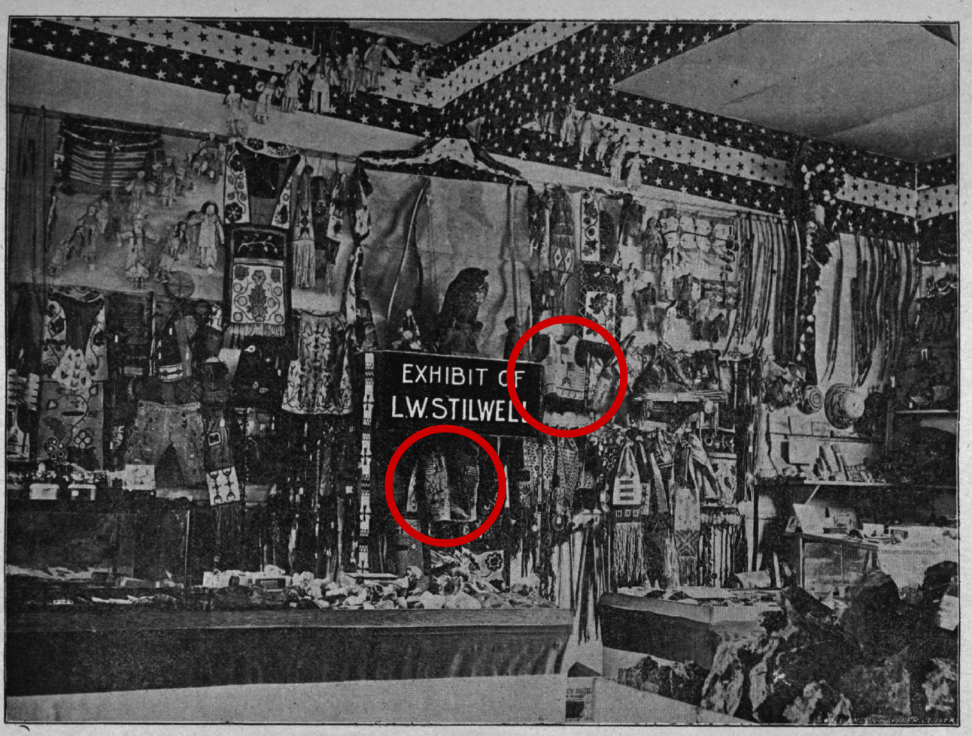
Chapter III: Secondary Markets as Secondary Contact Zones
Figure 6: Detail of the L.W. Stilwell Catalog, 1904
Materials with American Flag imagery are circled in red.
Image Courtesy of the Collections of the St. Joseph Museums, Inc., St. Joseph, Missouri

Harry L. George acquired several Lakota materials from catalogs and direct contact with Luther Standing Bear. However, I would like to note that he acquired the majority of his beaded Lakota material from other collectors or collector-dealers, who acquired their material from a secondary market. In the previous chapter, I noted several examples of what I consider material culture exchange within a “primary contact zone.” In this third and final chapter, I highlight the relationships between George and several of the collector-dealers he worked with. A collector-dealer is a person who collects material, as well as sells or trades that material to other collectors in a secondary market. A majority of his Lakota material culture was sold and purchased in a secondary market, when George was actively collecting between 1909-1920. This could prove that collectors, including George, were looking at this time for older material because it was more scarce than commodified material culture, such as moccasins and pipe bags that were distributed through catalogs. These collectors believed older material culture was ‘more authentic’ than ‘made to order’ materials that were produced for a tourist market.
A majority of the Lakota material culture bought and sold by George and his contemporaries at this time were exchanged in a secondary market. This is furthermore applicable to collectors of other Indigenous material culture throughout the United States during “The Indian Craze.” This could be due to a number of reasons: most collectors were looking for “authentic” artifacts and not commodities made for a tourist market. Collectors, for the most part, were looking for “historic” material. The well-known collector, George Gustav Heye, for example, aimed solely to purchase “early objects…organic items or precontact technologies.” Early objects, Heye believed, reflected a true, authentic Indigenous culture prior to American subjugation. This idea is applicable to other collectors, including George, because it suggests a romanticized past and harkens back to cottage crafts from a pre-Industrial era. Although noted in the previous chapter, George did, in fact, purchase commodified “craft” or “souvenir” materials from catalogs. However, as noted on Fig. 7, the majority of the materials George acquired was from other collectors, or “collector-dealers,” meaning those collectors who were actively collecting, trading, and selling their collection to other collectors.
This chapter aims to tease out the complex network of collector-dealers with whom George corresponded. The study in this chapter looks exclusively at George’s acquisition of Lakota material culture. As noted in my earlier sections, he collected material culture from an exhaustive list of Indigenous communities. However, for the scope of this project, I examine Lakota material culture, which I feel is the most understudied. I hope the several relationships I highlight within the archives shed a valuable light on the complex dealings of collectors and collector-dealers during “The Indian Craze.” These archival records, correspondences, and invoices present an intriguing glimpse into these complex networks of communication and exchange regarding Native American (specifically Lakota) material culture.
Figure 7: Correspondences Discussing the Sale or Exchange of Lakota Material Culture to Harry L. George
Image Courtesy of the Author

George developed close relationships with other collectors around the world, from California, New York, Oklahoma, Nebraska and South Dakota. These networks are important, as are the marketing techniques employed by the collector-dealers to describe the materials they are selling.

An Overview of Secondary Markets
A secondary market is one where an object re-enters the marketplace. This term originated from the financial jargon, where stocks are sold between traders, as opposed to being sold at a fixed price on a primary market. The key difference between a secondary and primary markets is how one controls the marketing and price of the materials the broker wishes to sell. As mentioned with a primary market, prices are often non-negotiable and set at a fixed price. In a secondary market, materials are sold at a price deemed appropriate by a dealer based on supply and demand. The dealer may also decide to promote the worth of an object through marketing. In the curio business, curio-dealers or collector-dealers purchase their stock from another source (perhaps a primary market or even another secondary market). This chain of events allows the curio-dealer or collector-dealer to sell or trade their stock for whatever monetary amount they see fit. George corresponded primarily with secondary market dealers because these dealers were able to negotiate prices. George, a businessman himself, most likely understood that secondary dealers were able to negotiate, thus, able to give him the best price for the materials he purchased. George also preferred to work with collector-dealers because they sold a variety of materials from a variety of Indigenous communities, as opposed to catalog dealers who, for the most part, worked with one or perhaps just a few tribal communities. With large inventory of Native American material culture, curio collector-dealers could then sell more material in bulk to collectors, such as George, who were looking for a variety of material.
Secondary markets were also based on networking and reputations. In this chapter, I note one occurrence where George was contacted by an unsolicited collector who was looking to sell their material. George was also known to offer parts of his collection to other dealers (such as Heye). Furthermore, what I wish to note in this chapter is that the transfer and acquisition of Indigenous material culture between private collectors was fluid. As with some art and material culture, objects continued to circulate among collectors until they were accessioned by an institution or museum. Unless the museum decided to deaccession an object, that object remains in one place. The provenance of these materials is a topic that, unfortunately, remains undocumented. By examining three relationships between George and his primary collector-dealers of Lakota material culture, I hope to shed light on these networks. This chapter focuses on George’s relationships with the collector-dealers: N.E. Carter from Elkhorn, Wisconsin, H.S. Rounds (Rounds Curio Company, Sioux City, Iowa), and Vern Thornburgh (Lincoln, Nebraska). All of these men were from the Midwest. Their correspondences highlight their preferences for collecting older material culture with notable provenance. George’s collecting habits furthermore developed a reputation in the upper Midwest. As noted towards the end of this chapter, George received unsolicited sales opportunities from collectors who wished to downsize their own private collections.

The Network of Collector-Dealers

N.E. Carter, Elkhorn, Wisconsin
George bought and traded Lakota material culture with various curio-dealers and dealer-collectors throughout the Midwest. One dealer in particular, N.E. Carter, sold material to George several times between 1912 and 1920. Carter, a “Dealer in Ancient and Modern Indian Relics,” distributed an assortment of goods including pistols, arrowheads, carved ivory, Navajo rugs and “Indian Bead Work and Weapons.” Although Carter dealt with “used” material culture and sold materials through catalogs (including unused moccasins), he noted to collectors that he had a wide selection of material on hand and would send additional information about these items to collectors who are looking for “the real thing.” George, a client of his, kept several records of correspondences with Carter. On March 27, 1920, Carter wrote to George describing an incoming collection he recently purchased for his own collection and was looking to sell to his client:
I am listing a collection of Indian relics I just purchased, the lot is mine, bought and paid for, but is not here yet, but will be by the time this [letter] reaches you. If interested in any of the items reply at once, as they will not remain with me long, if I am any judge, for such lots as this turn up about once in 20 years. Collected over 30 years ago by Mr. James H. Finlay, Pine Ridge Agency, So. Dak. History of each is what Mr. Finlay believed to be correct-cannot vouch for it, but believe it to be correct.

Carter had a legitimate reason to assume the provenance of each item in the collection was correct. Finlay was the postmaster and post trader at Pine Ridge in the 1890s. Each item on the sales inventory connects the object to a notable Lakota chief.
A scalp shirt containing 123 scalps owned by Chief Fellow Bear; a war bonnet, 2 blanket belts heavily beaded, a pipe bone bead necklace, said to have been owned and used by Chief Red Cloud; war bonnet, full length very old, with horns attached (Chief Thunder Bear); beaded very old game bag, “finest beaded pipe and tobacco bag I ever looks at a marvel, extra long, and covered with horses in bead work, worth $100, as these pieces are from old Sitting Bull.

Carter continued to describe several more Lakota materials he had sold, linking them to well-known Lakota chiefs including, Chief Rain in the Face, and a beaded vest owned by American Horse.
The detailed provenance and descriptions of each object in the letter emphasizes the rarity and uniqueness of each object in the collection. By linking the aforementioned materials to notable Reservation-era Lakota chiefs, Carter fortifies the authenticity and rarity of the material he was trying to sell. In regards to the three items owned by Sitting Bull, Carter gave more detail than on the other objects for sale. By suggesting the beaded pictorial pipe bag would sell for $100, Carter amplifies the importance of the beaded pipe bag, based on quality and provenance. The items in the collection also served as tangible connections to the past. The Lakota men and women who were cited in the itemized list most likely had passed away by the time the collection was acquired by Carter in 1920. The names of the Lakota men and women were familiar to George. At this time, he was almost 72 years old. For his generation of collectors, these figures were tangible connections to younger years, and perhaps, evoked a nostalgia for a former time.

H.S. Rounds, Rounds Curio Company, Sioux City, Iowa
Connecting Indigenous material culture, especially Lakota material culture, to notable chiefs was a marketing technique employed by many collectors and collector-dealers hoping to sell their stock to interested patrons. Some brokers went so far as to offer a notarized statement with the object, proving the history of the material they were selling was legitimate. Rounds received a painted “history” muslin from a man from Crookston, Nebraska, which is approximately five miles south of the Rosebud Reservation. When discussing the muslin with George, Rounds sent him the original notarized statement that legitimized the provenance of the object by tracing it back to its creator, Hollow Horn Bear. The notarized document stated:
I, Perry E. Serby, of Crookston, Nebraska, being duly sworn depose and say: that I have this day sold to Rounds Curio Co what is known as an “Indian History” the same being painted on muslin; this was secured by my mother some time about 1870, she having traded for it with Hollow Horn Bear, the maker, he being a Chief of the Pine Ridge Sioux Indians at that time; when my mother died my father James H. Serby of Crookston came into possession of it; later he gave the History to me.
Dated Sioux City, Iowa, April 24, 1915 [signed]

This notarized statement is interesting for a number of reasons. Serby, the man to whom the painted muslin originally belonged, stated that his mother received the muslin from Hollow Horn Bear around 1870. According to archival records, his mother, Jessie Anne Lazenby, was born in Iowa in 1862. If she had obtained the muslin from Hollow Horn Bear (b. 1850) when he claims she did, she would have been eight years old. It is plausible, however, that she obtained the painted muslin after she married Serby and they moved to Crookston, Nebraska. This is much more plausible because Crookston, located several miles south of the Rosebud Reservation, was also the main government warehouse hub for supplies going to the Reservation. Aside from the validity of the statement, it is necessary to note why such a statement was needed. Curio-dealers were notorious for bolstering and elaborating the provenance of the materials they sold in order to increase the prestige of an object and benefit for selling the object at a higher profit. This practice was common, as noted in the invoices and object descriptions authored by Carter. By noting that the muslin came from a well-known Brulé Lakota leader, Serby and Rounds could obtain a greater profit. Hollow Horn Bear died while representing the Lakota people in Washington, D.C. in 1913. His life and legacy were well-known throughout the United States, and his image was featured on a postage stamp in 1922. Much like the marketing tactics of Carter, both collector-dealers were among the many traders who portrayed the material they sold as tangible, “authentic” connections to a past.

Vern Thornburgh, Lincoln, Nebraska
George collected over half of his Lakota material culture from a collector based Vern Thornburgh. The men had many things in common. For example, both men moved from the East Coast to work for large companies in the Midwest. While George managed a wholesale textile warehouse, Thornburgh worked for The Beatrice Creamery Company, which by 1912, was the largest manufacturer of cream-based butter in the United States. The men were also interested in collecting material from a wide range of Plains communities, and would often discuss trading materials between their collections. According to George’s records, he corresponded with Thornburgh at least 200 times. Thirty-three of these correspondences discussed the acquisition, sales and trade of Lakota material culture. Thornburgh noted in a letter to George dated December 8th, 1915, that he was planning to sell several shields in his collection to the American Museum of Natural History in New York. He wrote to George, “of course anything that I sold to these Institutions would be on a cash basis, but if I could make some satisfactory arrangement with you I think we could deal together satisfactorily.” This exchange not only revealed to George the competition he had in securing materials, but also noted that collector-dealers were also selling their collections to major museums on a cash basis.

Additional Exchanges
Illustrious collectors, such as George, attracted notice. On August 12, 1912, he received an unexpected letter from a woman in South Dakota:
Dear Sir – while visiting Minneapolis Minnesota [sic] I made an inquiry at the [local] hotel newsstand for someone who might be interested in a fine collection of Sioux Indian curios, and was referred to you. The said collection are all choice goods, made and used by the Indians and not for trade. I shall be glad to give you any further information should you feel interested.
I am very respectfully, Mrs. R.H. Goodrich

At this point, one could argue that George’s collecting habits allowed him to develop a reputation in the Midwest. After an exchange of letters, Mrs. Goodrich, sent George a two-page list of items in the collection, which she explained was “a rare collection made by her late husband.” The list contained several items, including “one large history blanket painted by Sitting Bull’s Son-In-Law, several pencil drawings, one bear claw necklace (very rare)” and various other beaded materials. Whether or not George purchased materials from this collection remains a mystery. Several weeks after sending the list, Mrs. Goodrich requested he send the inventory list back to her so she could share it with other collectors. The fact that this inventory remains in George’s collection proves that he did not adhere to her request. However, the urgency in her plea and remark of other interested clients highlighted the worth of the collection to encourage a fast sale. In her letter, she also stressed the authenticity of the material, pointedly noting that they “were not made for trade.” Goodrich’s late husband, R.H. Goodrich was a surgeon based in Chamberlain, South Dakota. Evidence from local newspapers suggested the surgeon accepted Lakota material from his patients in lieu of money. This brings the transfer of material culture full circle: opportunities presented themselves to George as he collected.

Networks of Exchange and Potential Secondary Contact Zones
Although the aforementioned examples are somewhat brief, there are striking commonalities in the language and sentence structure employed by collectors and collector-dealers hoping to sell or exchange objects in their collections. A majority of the materials described within these lists describe materials in terms of their authenticity and legitimacy among the Lakota people. Connecting materials to important Lakota people bolstered provenance and inflated their worth. The sense of urgency in each correspondence reflect the high market demands for such materials. Whether the competition was other collectors or powerful museums, George was presented with a plethora of opportunities to expand and refine his collection.
Carter, Rounds, Thornburgh, and Goodrich were several of many dealers looking to distribute their collection to other collectors. In this process of exchange, provenance and perhaps the identity of Lakota people were mediated. In the case of Rounds and the descriptive notarized exchange of the Hollow Horn Bear muslin with his supplier’s mother, several truths were exaggerated. In the description, for example, he notes the exchange in a way that could be viewed as a contact zone: a direct producer to patron exchange. However, I believe the exaggerated truth and distorted history of the muslin could be considered a secondary or indirect contact zone. In a secondary or indirect contact zone, liberties are taken by the dominant culture to stretch truthful information in order to exploit the subjugated “other” (in this instance, Hollow Horn Bear). The other may not be able to speak out against the appropriation because they are either unaware of the situation (since these correspondences were private) or the subject had died. A secondary or indirect contact zone gives the dominant culture the ability to rewrite a narrative that would work in their favor and further alienating the subjugating culture.
A secondary or indirect contact zone reinforces the racial hierarchy in a way that exploits the minority culture. This culture, then, becomes personified within that object, thus alienating the object itself from the culture and the motivations for its creation. In a secondary or indirect contact zone, one can also see the idea of “tourist art” or material distributed through made-to-order curio catalogs as less of a threat. Since the context of the object for the collector was lost, the line between “authentic” and “tourist” becomes blurry. After a certain point, correspondences between collectors and collect-dealers rarely addressed the provenance of the material because these materials passed through so many collections that this information had become lost. Secondary and indirect contact zones are therefore separated from the original point of contact and exchange due to the passing of time.

Final Remarks
Besides select materials that have distinguished provenance, the history of most of Lakota material culture becomes lost with the physical exchange from collector to collector-dealer and other participants within this secondary market. Unfortunately, this information is difficult to recover. Beaded Lakota material culture (as well as material from other Indigenous communities) theoretically remains within this cycle of exchange until they are accessioned by a museum or have a less fortunate fate. At this point, the information about the maker or the context in which the work was produced is lost. George was one of the rare collectors that circumvented this phenomenon. Through his foresight and intentional record keeping, one can begin to understand the marketing and sales of Indigenous material culture. His collection gives proof that the networks of exchange are fascinating and complex.
Throughout this thesis, I demonstrated that George, like many of the collectors in his network accumulated his collection of Native American (specifically Lakota) art through primary contact zones that rely on relationships with artists (whether direct or indirect through middlemen). I also demonstrated that he accumulated the majority of his collection through secondary markets that allowed for monetary negotiation, as well as a “negotiation” of provenance to bolster market value and the prestige of the objects. This phenomenon proves that collectors, such as George, preferred to obtain objects with historical significance (i.e. significant provenance) as opposed to the “tourist art” promoted in primary contact zones. Within both modes of collection, Native identities are negotiated and mediated by collectors and collector-dealers according to the end result: the sale of art. While entertainment venues such as World’s Fairs and Wild West Shows allowed Lakota (and other Indigenous) performers to interact directly with collectors, middlemen, such as curio catalog dealers, began to manipulate their power relations. The further the art is removed from the original creator, the weaker their influence over the materials becomes. However, as materials enter a secondary market, artists may inform curio-dealers and collector-dealers that these particular materials may have important provenance or that these materials were worn to create a convincing “patina” on the art.
Understanding the conditions by which objects, such as the beaded moccasins at the Sam Noble Museum, became part of museum collections is not an easy task. I hope by demonstrating how one collector acquired his collection of Native American art, we can begin to understand the methods by which George and other collectors built their collections. There is much work to be done to understand the relationships of artists, collectors, curio-dealers, and collector-dealers during the “Indian Craze.” However, the George collection can lead scholars in the right direction to tease out this information and begin to untangle these networks.

Bibliography
Ahlberg-Yohe, Jill and Janet Catherine Berlo. Plains Indian Art of the Early Reservation Era: The Donald Danforth Jr. Collection at the Saint Louis Art Museum. St Louis: Saint Louis Art Museum, 2016.

Bad Hand, Howard, “The American Flag in Lakota Tradition.” In The Flag in American Indian Art, edited by Toby Herbst and Joel Kopp, Seattle: University of Washington Press and New York State Historical Association, 1993.

Belden, W.L, “Letter from W.L. Belden to Harry George,” The Harry L. George Collection, http://harrylgeorgecollection.omeka.net/items/show/1114

Bol, Marsha C. “Defining Lakota Tourist Art, 1880-1915.” in Unpacking Culture: Art and Commodity in Colonial and Postcolonial Worlds, ed. Ruth B. Phillips and Christopher B. Steiner, 214-228. Berkeley: University of California Press, 1999.

Burns, Emily. “The American West in the Camargue: Film, Material Culture and Regionalist Primitivism, c. 1912." Presentation at The University of Oklahoma, Norman, OK, September 29, 2017.

Carter, N.E., “Letter from N.E. Carter to Harry George,” The Harry L. George Collection, http://harrylgeorgecollection.omeka.net/items/show/1282

Carter, N.E., “Catalog from N.E. Carter to Harry George,” The Harry L. George Collection, http://harrylgeorgecollection.omeka.net/items/show/1515)

Cartwright, Lisa and Marita Sturken, Practices of Looking: An Introduction to Visual Culture. Oxford: Oxford University Press, 2009

“Crookston—A Semi-Ghost Town,” Legends of America, 2018. https://www.legendsofamerica.com/ne-crookston/

Deloria, Philip. Indians in Unexpected Places. Lawrence, Kansas: University of Kansas Press, 2004.

Deloria, Philip. Playing Indian. New Haven: Yale University Press, 1998.

Dubin, Margaret. Native America Collected: The Culture of an Art World. Albuquerque: The University of New Mexico Press, 2001.

Friesen, Steve. Lakota Performers in Europe. Norman: The University of Oklahoma Press, 2017.

Goodrich, Mrs. R.H., “Item list from Mrs. R.H. Goodrich to Harry George,” The Harry L. George Collection, http://harrylgeorgecollection.omeka.net/items/show/1663

Goodrich, Mrs. R.H., “Letter from Mrs. R.H. Goodrich to Harry George.” The Harry L. George Collection, http://harrylgeorgecollection.omeka.net/items/show/1659

Goodrich, Mrs. R.H., “Letter from Mrs. R.H. Goodrich to Harry George.” The Harry L. George Collection, http://harrylgeorgecollection.omeka.net/items/show/1661

Graburn, Nelson H.H., ed. Ethnic and Tourist Arts: Cultural Expressions from the Fourth World. Berkeley: University of California Press, 1976.

Hutchinson, Elizabeth. The Indian Craze: Primitivism, Modernism, and Transculturation in American Art, 1980-1915. Durham: Duke University Press, 2009.

“Jessie Anne Lazenby.” Ancestry.com, 2018. https://www.ancestry.com/genealogy/records/jessie-anne-lazenby_14484732

Kohlberg, M.J., “Invoice from M.J. Kohlberg to Harry George,” The Harry L. George Collection, http://harrylgeorgecollection.omeka.net/items/show/2085

Krech, Sherpard III and Barbara A. Hail, ed. Collecting Native America. Washington: Smithsonian Institution Press, 1999.

McMullen, Ann. “Reinventing George Gustav Heye.” In Contesting Knowledge: Museums and Indigenous Perspectives, edited by Susan Sleeper Smith, 77 Lincoln: University of Nebraska Press, 2009.

Moore, Sarah J. Empire on Display: San Francisco's Panama-Pacific International Exposition of 1915. Norman: University of Oklahoma Press 2013.

Parezo, Nancy J. and Don D. Fowler. Anthropology Goes to the Fair: The 1904 Louisiana Purchase Exposition. Lincoln: The University of Nebraska Press, 2007.

Pierce Erikson, Patricia “Welcome to This House: A Century of Makah People Honoring Identity and Negotiating Cultural Tourism,” in Ethnohistory, Vol. 50, No. 3, 523-547.

Phillips, Ruth. Trading Identities: The Souvenir in Native North American Art from the Northeast, 1700-1900. Seattle: University of Washington Press, 1999.

Phillips, Ruth and Christopher Steiner, ed. Unpacking Culture: Art and Commodity in Post-Colonial Worlds. Berkeley: University of California Press, 1999.

Pratt, Mary Louise. "Arts of the Contact Zone." Profession, 1991, 33-40. http://www.jstor.org/stable/25595469.

Rosaldo, Renaldo. "Imperialist Nostalgia," in Representations, no. 26 (1989): 107-122.

Rounds, H.S., “Statement from H.S. Rounds to Harry George,” The Harry L. George Collection, http://harrylgeorgecollection.omeka.net/items/show/692 .

Standing Bear, Luther “Letter from Luther Standing Bear to Harry George,” The Harry L. George Collection http://harrylgeorgecollection.omeka.net/items/show/1189.

Strong, Allen, James A. Miller, and Ralph A. Baker, Strong Curio Co.: Genuine Sioux Indian Curios and Beadwork. Gordon, Nebraska, 1915.

The Beatrice Foods Story. Chicago: Beatrice Foods Co, 1975, 8. http://www.beatriceco.com/pdf/bfc_history_1975.pdf.

The Editors of Encyclopaedia Britannica, “Saint Joseph,” Encyclopaedia Britannica, January 19, 2016, https://www.britannica.com/place/Saint-Joseph-Missouri

Thornburgh, Vern, “Letter from Vern Thornburgh to Harry George,” The Harry L. George Collection, http://harrylgeorgecollection.omeka.net/items/show/949.

“To See Their Messiah.; The Indians Strive in Their Dances to Produce Unconsciousness.,” The New York Times, November 22, 1890. https://www.nytimes.com/1890/11/22/archives/to-see-their-messiah-the-indians-strive-in-their-dances-to-produce.html

“Understanding the Great Sioux Nation,” Akta Lakota Museum & Cultural Center: an Outreach of St. Joseph’s Indian School, http://aktalakota.stjo.org/site/News2?page=newsArticle&id=9017

United States Indian School, “Catalog from United States Indian School to Harry George,” The Harry L. George Collection, http://harrylgeorgecollection.omeka.net/items/show/1488.

Vizenor, Gerald Robert. Manifest Manners: Narratives on Postindian Survivance. Lincoln: University of Nebraska Press, 1999.

Williams, Walter. A History of Northwest Missouri: Volume 3. Chicago: Walter Lewis Publishing Company, 1915.

Elizabeth, Hutchinson, The Indian Craze: Primitivism, Modernism, and Transculturation in American Art, 1890-1915. (Durham: Duke University Press, 2009).
Marsha C. Bol “Defining Lakota Tourist Art, 1880-1915,” in Unpacking Culture: Art and Commodity in Colonial and Postcolonial Worlds, ed. Ruth B. Phillips and Christopher B. Steiner (Berkeley: University of California Press, 1999) 214-228.
See Jill Ahlberg-Yohe and Janet Catherine Berlo, Plains Indian Art of the Early Reservation Era: The Donald Danforth Jr. Collection at the Saint Louis Art Museum (St. Louis: Saint Louis Art Museum, 2016).
Gerald Robert Vizenor, Manifest Manners: Narratives on Postindian Survivance (Lincoln: University of Nebraska Press, 1999).
Hutchinson, 3
Ibid., 6.
Margaret Dubin, Native America Collected: The Culture of an Art World (Albuquerque: The University of New Mexico Press, 2001).
Shepard III Krech and Barbara Hail, ed. Collecting Native America, 1870-1960. (Washington, D.C.: Smithsonian Institution Press, 1999).
Nelson H.H. Graburn. ed. Ethnic and Tourist Arts: Cultural Expressions from the Fourth World. (Berkeley: University of California Press, 1976), 5.
Bol,” Defining Lakota Tourist Art,” 223.
Ibid., 228.
“Understanding the Great Sioux Nation,” Akta Lakota Museum & Cultural Center: An Outreach of St. Joseph’s Indian School, http://aktalakota.stjo.org/site/News2?page=newsArticle&id=9017
See Phil Deloria, Playing Indian (New Haven: Yale University Press, 1998); Phil Deloria, Indians in Unexpected Places (Lawrence: University of Kansas Press, 2007); or Reel Injun, directed by Neil Diamond, Catherine Bainbridge, and Jeremiah Hayes (2009; Montreal: National Film Board of Canada, 2009), DVD.
For a percentage breakdown of the sources George used to acquire his collection, see Fig. 7
“Saint Joseph,” Encyclopedia Britannica, January 19, 2016, https://www.britannica.com/place/Saint-Joseph-Missouri
Hutchinson, The Indian Craze, 7.
Dubin, Collecting Native America, 11
, Renato Rosaldo. "Imperialist Nostalgia," Representations, no. 26 (1989): 107-122.
Hutchinson, The Indian Craze, 16.
Ruth Phillips, Trading Identities: The Souvenir Trade in Native North American Art from the Northeast, 1700-1900, (Seattle: University of Washington Press, 1999). 4.
Ibid.
Walter Williams, A History of Northwest Missouri: Volume 3. (Chicago: Walter Lewis Publishing Company, 1915), 1357.
M.J. Kohlberg, “Invoice from M.J. Kohlberg to Harry George,” (The Harry L. George Collection), http://harrylgeorgecollection.omeka.net/items/show/2085.
W.L. Belden, “Letter from W.L. Belden to Harry George,” (The Harry L. George Collection) http://harrylgeorgecollection.omeka.net/items/show/1114.
Sarah Elder (Curator of Collections, St Joseph History Museums) in discussion with the author, September 2017.
Mary Louise Pratt, “Arts of the Contact Zone.” In Professions (1991), 34.
Ibid., 36.
Art historian Bol notes the creator of several Lakota beaded dresses in her article, “Lakota Tourist Art,” 218-220.
Roads were not completed on the Makah reservation until 1931.
Patricia Pierce Erikson, “Welcome to This House: A Century of Makah People Honoring Identity and Negotiating Cultural Tourism,” in Ethnohistory, (2003) Vol. 50, No. 3, p 535.
Allen Strong, James A. Miller, and Ralph A. Baker, “Strong Curio Co.: Genuine Sioux Indian Curios and Beadwork” (Gordon, NE, 1915), 1.
Ibid. 3
The “Vanishing Race” paradigm was not a new concept, as we know. However, this “Indian Craze” and attempts to preserve Indigenous cultures and material cultures grew out of favor after World War 1, when the generation of collectors during this time period passed away.
This situation is not necessarily the case. For the younger generations in boarding schools, they learned beadwork techniques from their kin on the reservation, and would go to their Indian boarding schools and create beaded materials to sell and distribute through government-sponsored catalogs
“Moccasins, 1st grade, fully beaded” were sold for $21 per dozen. “Moccasins, 2nd grade, full beaded” were sold for $18 per dozen. “Strong Curio Company,” pg. 4.
Strong Curio Company, 4.
For further reading on Indigenous cultures on display in entertainment venues between 1880-1920, consider: Lisa Cartwright and Marita Sturken, Practices of Looking: An Introduction to Visual Culture (Oxford: Oxford University Press, 2009); or Sarah J. Moore, Empire on Display: San Francisco's Panama-Pacific International Exposition of 1915 (Norman: University of Oklahoma Press 2013).
Emily Burns, “The American West in the Camargue: Film, Material Culture and Regionalist Primitivism, c. 1912." (presentation, The University of Oklahoma, Norman, OK, September 29, 2017.
The National Museum in Scotland collected material directly from Buffalo Bill performers when they toured Great Britain. The exchange of materials at Wild West shows within the United States (not exclusively Buffalo Bill Shows) is something I plan to investigate in future research.
Nancy J. Parezo and Don D. Fowler, Anthropology Goes to the Fair: The 1904 Louisiana Purchase Exposition (Lincoln: University of Nebraska Press, 2007), 130-134.
Ibid., 130.
The Buffalo Bill Wild West Show declared bankruptcy in 1913. From this time until his death in 1917, William Cody made guest appearances in other Wild West performances and often attended Civic Openings. In 1913, Cody was the honorable guest of the Pony Express monument dedication in St. Joseph, Missouri.
Luther Standing Bear, “Letter from Luther Standing Bear to Harry George,” (The Harry L. George Collection) http://harrylgeorgecollection.omeka.net/items/show/1189.
Pratt, “Arts of the Contact Zone,” 36
Ibid.
Strong Curio Company, 5.
For more information, read Tony Herbst and Joe Kopp “The Flag in American Indian Art.” (Seattle: University of Washington Press, 1999).
Howard Bad Hand, “The American Flag in Lakota Tradition” in The Flag in American Indian Art ed. Tony Herbst and Joel Kopp (Seattle: University of Washington Press, 1999), 11
Ibid.
Ann McMullen, “Reinventing George Gustav Heye” in Contesting Knowledge: Museums and Indigenous Perspectives, ed. Susan Sleeper Smith (Lincoln: University of Nebraska Press, 2009), 77.
N.E.Carter., “Catalog from N.E. Carter to Harry George,” (The Harry L. George Collection), http://harrylgeorgecollection.omeka.net/items/show/1515), pg. 24
N.E. Carter., “Letter from N.E. Carter to Harry George,” (The Harry L. George Collection), http://harrylgeorgecollection.omeka.net/items/show/1282 .)
“To See Their Messiah.; The Indians Strive in Their Dances to Produce Unconsciousness.,” The New York Times, November 22, 1890. https://www.nytimes.com/1890/11/22/archives/to-see-their-messiah-the-indians-strive-in-their-dances-to-produce.html
N.E. Carter., “Letter from N.E. Carter to Harry George,” (The Harry L. George Collection), http://harrylgeorgecollection.omeka.net/items/show/1282
H.S. Rounds., “Statement from H.S. Rounds to Harry George,” (The Harry L. George Collection), http://harrylgeorgecollection.omeka.net/items/show/692 .
“Jessie Anne Lazenby.” Ancestry.com, 2018. https://www.ancestry.com/genealogy/records/jessie-anne-lazenby_14484732
“Crookston—A Semi-Ghost Town,” Legends of America, 2018. https://www.legendsofamerica.com/ne-crookston/
The Beatrice Foods Story. (Chicago: Beatrice Foods Co, 1975.), 8. http://www.beatriceco.com/pdf/bfc_history_1975.pdf.
Vern Thornburgh, “Letter from Vern Thornburgh to Harry George,” (The Harry L. George Collection), http://harrylgeorgecollection.omeka.net/items/show/949.
Mrs. R.H., Goodrich, “Letter from Mrs. R.H. Goodrich to Harry George,” (The Harry L. George Collection), http://harrylgeorgecollection.omeka.net/items/show/1661
Mrs. R.H Goodrich., “Letter from Mrs. R.H. Goodrich to Harry George,” (The Harry L. George Collection), http://harrylgeorgecollection.omeka.net/items/show/1659.
Mrs. R.H.Goodrich, “Item list from Mrs. R.H. Goodrich to Harry George,” (The Harry L. George Collection), http://harrylgeorgecollection.omeka.net/items/show/1663.
In a “General Session,” Railway Surgical Journal Volumes 17-18: 93-94 Dr. R.H. Goodrich writes an excerpt about compensation from his patients and how he is not rightfully compensated. How can someone who complains about money collect Lakota material for 25 years if he is broke? It is likely he accepted material culture from his patients in lieu of payment.

