UNIVERSITY OF OKLAHOMA

GRADUATE COLLEGE

HUMAN-CENTERED OPTIMIZATION OF WELL CONTROL: IMPLICATIONS FOR DRILLING SAFETY

A THESIS

SUBMITTED TO THE GRADUATE FACULTY
in partial fulfillment of the requirements for the
Degree of

MASTER OF SCIENCE

By

SYED ALI MEHDI NAQVI
NORMAN, OKLAHOMA
2019

HUMAN-CENTERED OPTIMIZATION OF WELL CONTROL: IMPLICATIONS FOR DRILLING SAFETY

A THESIS APPROVED FOR THE

MEWBOURNE SCHOOL OF PETROLEUM AND GEOLOGICAL ENGINEERING

BY

Dr. Saeed Salehi

Dr. Catalin Teodoriu

Dr. Ramadan Ahmed

© Copyright by SYED ALI MEHDI NAQVI 2019

All Rights Reserved.

Acknowledgement
I would like to thank my committee chair, Dr. Saeed Salehi and my committee co-chair Dr. Catalin Teodoriu for their constant support and guidance throughout this work. I found their doors open, whenever I needed an answer to any problem. They consistently allowed this to be my work but steered me in the right direction whenever I was stray. To Dr. Ramadan Ahmed for being the third chair to my committee and a critical reader for this thesis.
I would also like to thank Gulf Research Program of National Academy of Sciences, Engineering and Medicine for supporting this work. To all the team members I had the privilege to work with, which includes Dr. Edward Cokely, Dr. Raza Azeem, Raj Kiran, Vimlesh Bavadiya, Vincent Ybarra and Jeon Jiwon. I am also grateful to all the supporting staff at the Mewbourne School of Petroleum and Geological Engineering, as this wouldn’t have been easy without them.
I would also thank my parents and wife for their unwavering support and continuous encouragement throughout my years of study and research. Lastly, I would express my profound gratitude to everyone who was kind to me.
BOOMER SOONER!
Syed Ali Mehdi Naqvi. Class of 2019.

Table of Contents
Acknowledgement iv
Table of Content v
List of Tables vii
List of Figures viii
Abstract ix
1. Introduction 1
1.1. Research Motivation 1
1.2. Human Factors 2
1.3. Problem Statement 5
1.4. Methodology 7
1.5. Objectives 8
2. Well Control and its Dependence on Humans 9
2.1. Early Kick Indicators 9
2.2. Kick Detection 11
2.3. Well Control Methods 12
2.3.1. Driller’s Method 13
2.3.2. Engineer’s Method 13
2.3.3. Volumetric Method 14
2.4. Discussion 14
3. Drilling Simulators 15
3.1. DrillSim 50 Simulator 18
3.1.1. BOP Console 18
3.1.2. Drilling Console 19
3.1.3. Standpipe and Choke Manifold 20
3.1.4. Remote Choke Control 21
3.2. Virtual Reality Drilling Simulator 21
4. Eye Tracking 24
4.1. Methodology 25
4.1.1. Participants 27
4.1.2. Eye Tracking Precision, Accuracy and Calibration 27
4.1.3. Experiment Design 30
4.1.4. Tobii Eye Tracking Software 35
4.1.4.1. Gaze Plot 35
4.1.4.2. Heat Plot 35
4.2. Analysis and Results 35
4.2.1. Driller’s Performance and Heat Plots 36
4.2.1.1. Comparative Analysis of Drillers 38
4.2.2. Supervisor’s Performance and Gaze Plots 40
4.2.2.1. Comparative Analysis of Supervisors 45
4.3. Discussion 47
5. Content Analysis 49
5.1. Methodology 51
5.1.1. Participants 52
5.1.2. Experiment Design 52
5.2. Analysis and Results 53
5.3. Discussion 57
6. MPD 59
6.1. Methodology 62
6.2. Experiment Design 62
6.3. Analysis and Results 63
6.3.1. Engineer’s Method 63
6.3.2. Dynamic Well Control 65
6.4. Discussion 67
7. Summary and Implications 69
8. Conclusion 72
9. Recommendations 74
References 75
10. Appendix 1 80
11. Appendix 2 82

List of Tables
Table 1: Well configration for the simulation………………………………………………...29
Table 2: Main events and TOIs during the simulation………………………………………..32
Table 3: Binary performance matrix for all the groups……………………………………….35
Table 4: Example of meaning unit being condensed into codes………………………………50
Table 5: % distribution of psychological and operational time performance…………………55

List of Figures
Figure 1: Framework for underlying (human factors) and immediate causes (human error) of an accident (Gordon 1998) 4
Figure 2: Current Simulation Based Evaluation Criteria (Naqvi et al. 2018) 7
Figure 3: The first flight simulator (Henry 2018) 16
Figure 4: Showing the DrillSim 50 simulator setup (DrillSim 2005) 18
Figure 5: Showing a subsea BOP (DrillSim 2005) 19
Figure 6: Showing the drilling console (DrillSim 2005) 20
Figure 7: Showing the standpipe and choke manifold (DrillSim 2005) 20
Figure 8: Showing the remote choke control panel (DrillSim 2005) 21
Figure 9: Virtual Reality Drilling Simulator infrastructure at University of Oklahoma (Dadmohammadi et al. 2017) 22
Figure 10: Eye tracking over air traffic radar monitor (Kang 2019) 24
Figure 11: Gaze pattern of a participant (Kiran et al. 2018) 26
Figure 12: Pupil dilation comparison of two participants (Salehi et al. 2018) 26
Figure 13: Eye Tracking Accuracy and Precision (Tobii 2019) 28
Figure 14: Eye Geometry (Tobii 2019) 28
Figure 15: Showing the target selection process for calibration 29
Figure 16: Tobii eye tracking glasses (Tobii 2018) 31
Figure 17: Important AOIs for driller along with their legend 36
Figure 18: Heat plot for the expert participant 37
Figure 19: Heat plot for novice 6 participant 38
Figure 20:% time fixated at drilling parameters and AOIs’ during 1st TOI 39
Figure 21: Kick detection time vs no. of fixations on return flow indicators 40
Figure 22: Important AOIs for supervisor along with their legend 41
Figure 23: Gaze plots for expert supervisor for 3rd TOI (left) & 4th TOI (right) 43
Figure 24: Gaze plots for novice 6 supervisor for 3rd TOI (left) & 4th TOI (right) 43
Figure 25: Radar plot for supervisors’ fixation percentage during 3rd TOI 45
Figure 26: Fixation % for supervisor during 4th TOI 46
Figure 27: Number of fixations of BOP, CPC and CPI for 4th TOI 47
Figure 28: VRDS cyber chair (left) and its control knob (right) (Naqvi et al. 2018) 53
Figure 29: Semantic map for expert 1 (Naqvi et al. 2018) 54
Figure 30: Semantic map for expert 2 (Naqvi et al. 2018) 55
Figure 31: Semantic map for novice 1 (Naqvi et al. 2018) 55
Figure 32: Semantic map for novice 2 (Naqvi et al. 2018) 56
Figure 33: Operational time vs muddled state percentage (Naqvi et al. 2018) 57
Figure 34: Narrow mud window drilling using MPD vs conventional drilling (Air-Drilling 2019) 60
Figure 35: Generalized well control risk matrix (Rajabi et al. 2014) 62
Figure 36: Kick detection and circulation using engineer’s method 64
Figure 37: DrillSim 50 setup to imitate MPD. (L to R) BOP, manifold and remote choke 66
Figure 38: Dynamic well control using MPD 67
Figure 39: Proposed well control training and evaluation criteria (Naqvi et al. 2018) 70

Abstract
Today 70% of incidents in offshore and marine environment are due to human factors (HF). Among all such incidents, loss of well control can have tremendous damage to human life, well, rig, underground reserves and to the environment. To reduce risk for such an incident, one needs to enhance process safety by integrating human factors in all elements design and training curriculums. The primary objective of this work is to investigate a human centered approach for reducing the risk for loss of well control events. A dual approach has been adopted which involves enhancing the computational abilities of the human and simplifying the task environment itself to promote enhanced performance. Techniques like eye tracking and content analysis has been discussed and analyzed to showcase how they can be incorporated for better training and evaluation to enhance human computational abilities. While for creating an unconvoluted task environment, dynamic well control approach through Managed Pressure Drilling (MPD) will be discussed.
DrillSim 50 simulator was used to design experiment to test and validate how eye tracking can be incorporated in the current well control training and evaluation criteria. While the Virtual Reality Drilling Simulator (VRDS) was used to conduct the content analysis experiment. As compared to rather simple binary measure of performance we get from conventional evaluation criteria. The insights on participants performance from both these techniques helped to identify areas for targeted feedback for the participants to improve on. Secondly the benchmark maps or plots from the experts generated through these techniques can be used for better evaluation of the candidates.
For creating an unconvoluted environment, dynamic well control from MPD was compared with the conventional well control method on the DrillSim 50 simulator. The comparison showed many ways in which the task environment can be simplified and made better in terms of reduced time, mental stress and physical labor. Together, this can help to create a system where task environment and abilities of the actor are complimented, resulting in optimal system performance and safety.

- Introduction
  - Research Motivation
Loss of Well Control (LOWC) and drilling safety has been one of the most challenging aspect of drilling since its beginning. The sensitive integration of several factors forming the safety envelope is jeopardized by the slightest weak point. Today with several advancements and automation in technical aspects of drilling, most of the failure curve falls on the human aspect. Recent offshore and marine analysis reveal that 70% of accident are due to human failures while less than 30% is contributed by technical failures (Cai et al. 2013, Wang and Trbojevic 2007).
The magnitude of consequences resulting from these failures are detrimental. Deepwater Horizon explosion on the Macondo well is a recent example of this where 11 people lost their lives and caused the largest oil spill in the US history (National Oil Spill Commission 2011). The incident cost British Petroleum more than 61 billion in court fees, penalties, environment restoration and loss of revenue (Graham et al. 2011). Through analysis up to 25 errors within the human category were recognized which culminated to allow the incident to occur (Smith et al. 2013).
Another more recent example of human error is the Pryor Trust gas well blowout in Pittsburg, Oklahoma, which killed five workers. Forty minutes before the blowout, a cumulative gain of more than 100bbls in the mud pits went unnoticed by the crew, which resulted in an explosion at surface (CBS 2018).
The Exprosoft has identified 156 well control events over the period of 2000-2015 (Holand 2017). Out of which 54 resulted in surface blowouts while another 47 cases of well release were noted. There was a total of 74 fatalities during this period. The report goes on to acknowledges that 50% of these incidents were due to late detection of the kick by humans and emphasis the need for better skills, procedures and practices.
Such incidents highlight the complex socio-technical system which is dependent on technical, human, social, organizational, managerial and environment factors (Gordon 1998) and if left unchecked, they will continue to cause potentially catastrophic events. Given the huge footprint of human factors in the oil and gas industry, the current scenario fails to incorporate them into enough consideration.
Other industries are also not immune to HF and offers the guidance in pursuit of this endeavor. There have been several catastrophic disasters like Chernobyl, Three Mile Island, Challenger and Tenerife where HF were deemed to be their root cause. However, these incidents were able to catalyze the importance of incorporating HF research and regulation in their respective domains. For example in aviation 75% of all incidents have been attributed to human error, but over the years, incidents have seen a constant decline from 1960s till 1990s and haven’t increased since then (Kelly and Efthymiou 2019). This asserts the fact that optimization of HF is the only possible solution as they cannot be eliminated. They can only be optimized in how they affect the performance and safety of the system. Some might argue that the automation can one day reduce the footprint of HF. However, with the increase in automation the required expertise and situation awareness also increases, making HF more critical than ever.
The current vacuum in HF research in the oil and gas scenario and room for considerable reduction in incidents due to their optimization, provides an opportunity for a study of this kind. This motivation drives to look into the crucial HF at work in the oil and gas scenario and to explore various methods that can help the industry towards their optimization, enhancing personnel safety, environment protection, system output and gain in revenues.
  - Human Factors
Human Factors (HF) is defined by the International Ergonomics Association as the scientific discipline of understanding and optimizing the interaction between humans and the elements of the system (IEA 2018). This includes all physical, psychological and social characteristics of humans which influence the socio-technical systems they are operating in or get influenced by (Badke-Schaub et al. 2012). The term HF is thus multi-disciplinary and involves ergonomics, human-machine interface, organizational structures, personnel competencies and safety management (Thorogood et al. 2015).
Others have gathered six non-technical skills (NTS) like decision making, communication, teamwork, leadership, situational awareness and performance influencing factors within the realm of HF (Hsieh 2014). In perspective of planning and operational activities in the oil and gas industry, each of these skills is of crucial importance. During well planning stages, a lot of communication and teamwork among different disciplinary engineers from client and contractor companies is necessary to avoid any unanticipated operational and executional issues. Secondly a lot of real time communication and decision making between the head office and field operations team take place on day to day and situational basis. The on-site crew is always expected to stay vigilant of well response and condition, as this help in attaining or maintaining proper situational awareness in adverse situations like well control and will promote better and timely decision making (Kiran et al. 2018) while keeping the performance influencing factors like startle effects to minimum. The crew at the rig-site operates with proper hierarchy and in daily shifts of 8 to 12 hours with work continuing 24x7 and this can cause mental and physical fatigue issues requiring good crew management and leadership skills at various levels. There are a lot more operations and steps that involves intermingling of human aspects at all levels in oil and industry. This makes the safe working envelope thin and any disharmony among the various human aspects can initiate a domino effect which can lead to a catastrophic engineering failure, as we saw in the Macondo incident.
Going forward into this work, addressing a small prevailing misconception in the oil and gas industry would be beneficial. The term “human factors” and “human errors” are often wrongly assumed to be same and used interchangeably without clear distinction. Human errors are used to determine the immediate cause of an incident, while human factors define the underlying cause of the incident (Gordon 1998). In short, the human error is a subset of human factors, which is studied to determine the actual HF behind that incident. Optimizing the HF in the system, will reduce the frequency of human errors in that system. The figure 1 highlights the relationship between the two and how every human error, relates to the parent human factor.
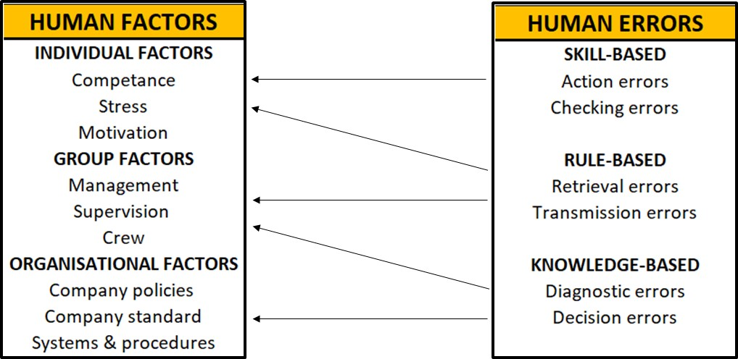
Figure 1: Framework for underlying (human factors) and immediate causes (human error) of an accident (Gordon 1998)
The hefty share of HF in oil and gas incidents has been long conceived. The problem persists in more ways than catastrophic. HF are also associated with non-productive time (NPT) and lost time injuries (LTI), which are more frequent and common events on the drilling rig then a blowout. A study in 1990 provided the analysis where stuck pipe issues where successfully correlated with HF like: time from a crew change, rotation day of drilling supervisors & crew and deviations from the standard procedures (Thorogood et al. 2015). However, the effect of HF in a well control situation was first discussed by Paul Sonneman in 1992 (Sonneman 1992). He noted that “strictly analytic, technical and ever more sophisticated approaches to well control is unlikely to succeed as long as human needs, fears and perceptual or cognitive limitations are permitted to dominate behavior in actual well control situations”.
The HF subject had been under focus in United Kingdom following the Piper Alpha Disaster were the role of human and organizational factors came to attention during the inquiry (Cullen 1993). This was followed by several works where questionnaires and interviews were used to establish the perceptions of risk, decision making, situational awareness, safety and organizational factors among the oil and gas workers and the results were correlated to available incidents data (Flin, Mearns, et al. 1996, Mearns et al. 2001, Sneddon et al. 2006, Flin, Slaven, et al. 1996, Wilson and Stanton 2004).
However, following the events like Montara 2009 (Borthwick 2010) and Macondo 2010 (National Oil Spill Commission 2011), there has been an increased stress towards the understanding and optimization of HF in oil and gas around the world. Even though this cognizance lack dangerously behind other industries like aviation, nuclear and military, the vacuum has catalyzed several endeavors in search for inspiration, literature and tools to effectively optimize the HF. To name a few, these includes the white paper from Society of Petroleum Engineers (SPE 2014) covering a wide spectrum of HF issues, several reports from International Association of Oil and Gas Producers (OGP 2014) which deals with HF likes crew resource management, non-technical skills and cognitive engineering. The North Sea Offshore Authorities Forum conducted a survey related to HF for well control preparedness (NSOAF 2014) and similarly in parallel several operators, drilling contractors and training organizations incorporated some aspects of HF elements into their standards and training programs (Odgaard and Morton 2017, IWCF 2018). However, translating these works into planning and operations in the oil & gas sector towards the optimization of HF, remains the challenge.
  - Problem Statement
HF consists of non-tangible and abstract components or NTS like communication, decision making, communication, teamwork, leadership, situational awareness and performance influencing factors. Such dynamic and fluid aspects on individual and organizational level are difficult to measure and evaluate which make them impossible to be optimized through the current industry practices. The offered well control trainings and evaluations by IWCF (IWCF 2018) and IADC (IADC 2019) are mostly skill and content based and required once every two years. Those trainings used a simplistic qualifying criterion (i.e. successful well control simulation completion, simple theoretical knowledge) with no measurements and evaluation of HF (Naqvi et al. 2018, Sookdeo et al. 2017). This lacking was exposed in several post Macondo analysis. The Oil Spill Prevention and Response Advisory Group (OSPRAG 2011) recommended in their final post Macondo report, that better competencies for supervisory levels need to be established and properly assessed. The Chief Counsel’s Report also highlighted the insufficient training of the rig crew in kick detection (Bartlit et al. 2011). In addition, a recent analysis on well control incidents in US Gulf of Mexico over the period of 2000-2015, stated “late kick detection” as a primary contributing factor in incidents (Holand 2017). This boils it down to better training and evaluation criteria where representative stress environments can be simulated to train participants (Dadmohammadi et al. 2017) as lack of training is one of the common reason for human errors (Islam et al. 2017).
The current well control training and evaluation criteria is very binary and fails to incorporate any insights into the participant performance. The figure 2 highlights this criterion, where the participants goes through the well control simulation and the successful candidates are certified for two years while the unsuccessful candidates are not certified. At the end none of them gets any feedback for improvement or insights into their performance.
To optimize the current well control training and evaluation criteria, we must incorporate various psychological and physiological tools than can somehow allow us to measure and evaluate the essence of the intrinsic HF present in that human-system interaction. This will allow for a non-binary measure of performance while also revealing critical insights into the participants performance. Absence of these insights result in minimum to no feedback, let it be targeted or customized, for the participants. This hampers the continuous improvement process and divide participants in two distant and equal level, with nothing required to improve for the one while everything to learn for the other. This creates an inefficient atmosphere for learning and might leave some participants delusional.
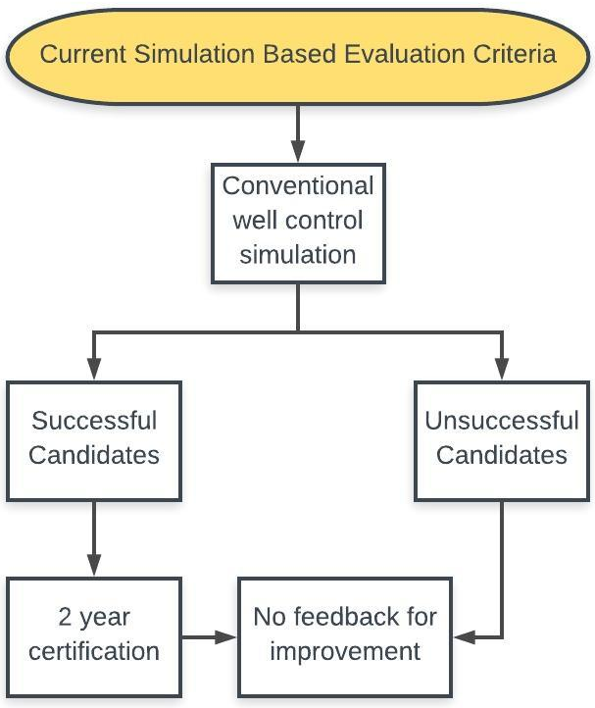
Figure 2: Current Simulation Based Evaluation Criteria (Naqvi et al. 2018)
  - Methodology
Before we go deep in searching for the tools, we must understand the human rationality and system it operates in. Human rational behavior is shaped by a scissors whose two blades are the structure of task environments and the computational capabilities of the actor (person of interest) (Simon 1990). As per Simon, the task environment must complement the abilities of the person to extract optimal performance from the system. Any lack in human abilities or a convoluted task environment beyond the human comprehension, the performance from the system gets compromised, and optimal workings of HF get hampered.
The human abilities can be increased through different training and experiences resulting in expertise in his domains, while the task environment can be unconvoluted through advanced cognitive engineering and simpler engineering methods and techniques. Together this unison will help to create a safe and sound environment, optimizing the interaction between the humans and the system.
In this study we will use drilling simulators to simulate routine and relatively exceptional drilling activities with the aim to help increase the computational limits of the actor through improved training and evaluation criteria. Simulators will also be used to test how improved and advanced technologies can help to decrease the convolution of the task environment. Although both are separate domains but must complement each other during an adverse situation to get the optimal performance from any socio-technical system.
  - Objectives
To increase the computational limits of the actor, we will explore different psychological and physiological tools which have been proven to be beneficial in other domains of science. Two such tools are content analysis and eye tracking, where the former can be used to understand the psychological states of the participant through their communication, while the latter can be used to analyze the information acquisition patterns over displays. We will attempt to build the case for the validation of these techniques within the oil and gas infrastructure and how they can be incorporated in the current well control training and evaluation scenario.
On the task environment end, recent and advanced technology like managed pressure drilling (MPD) will be discussed and analyzed with respect to the conventional well control technique. This will be done to compare how the task environment can be simplified and well control situation can be dealt with relative simplicity.
However, this is just the beginning towards optimization of HF in oil and gas industry and there is still a long way to go. With this research we want to introduce the idea on how through a combination of enhanced actor abilities and unconvoluted task environment, the system performance and safety can be enhanced.

- Well Control and its Dependence on Humans
Well Control deals with avoiding any uncontrolled flow of the formation fluids into to the well. While drilling when bit enters a permeable formation that has a pressure higher than the hydrostatic pressure exerted by the mud, the imbalance causes the mud in the well to be displaced out by the formation fluid. This flow of formation fluids into the well is called kick. If undetected, the kick can grow and upon reaching the surface can cause a blowout. Blowout is the worst disaster that can occur during drilling operations (Bourgoyne Jr et al. 1986). It can cause the loss of life, well, rig, underground reserves and damage to the environment. Thus, the timely execution of well control equipment and procedure in event of a kick is very important.
The current well control scenario is mostly dependent on the performance of the humans. Starting with the primary well control that deals with the mud gradient being higher than the pore pressure gradient. The planning engineers and crew ensures that the hydrostatic pressure from the mud remains higher than the formation pressure. Factors such as lack of data for exploratory well, or inaccurate predictions while planning or lack of monitoring in mud properties can jeopardize this primary barrier. Once failed the secondary well control method is initiated which deals with shutting the well at the surface using a BOP. The execution of this steps depends on the detection of the failure of the primary barrier. If the kick remains undetected by the driller and crew and the secondary well control is not initiated, the blowout will be inevitable. The human remains an integrated part during the aversion, detection and control of kick and their performance becomes a critical factor in the fate of a well control event. This chapters discusses various phases in kick detection and control and the reliance on humans for safe operations.
  - Early Kick Indicators
Early kick detection is of paramount importance in avoiding any unfavorable well control events. There are various early kick indicators which the driller and the crew must be aware off. Those indicators include:
Increase in ROP: With the increase in depth and given the normal wear of the bit, a decrease in ROP occurs, given the drilling parameters remain constant. However, if the differential pressure between the mud hydrostatic and the formation fluid decreases, the drilling rate increases due to a decrease in the chip hold down effect. A general trend in the increase in ROP can be due to a transition zone between formations, but a sharp increase can indicate an abnormal pressure zone or an underbalanced condition. At times the changes in ROP can also be due to a drilling break, where a softer formation is encountered while drilling. The crew must confirm the reason for the increase in ROP is not due to a kick before continuing drilling.
Decrease in shale density: The density of shale increases with the depth. A decrease in density is indicative of an abnormal pressure zone being drilled. A lesser density could be due to high pressure pore fluids supporting the overburden. The density of the formation can be measured at the surface.
Increase in cutting size and shape: Normally pressurized shales produces small and flat cuttings with rounded edges while in over pressurized zone the cutting are long, splintery with angular edges (School 2002). The increase in the cutting size and shapes for shales is an indication of underbalanced conditions downhole.
Mud property changes: When the formation fluids flow into the wellbore, the mud properties will change. There can be water cut or gas cut depending on the fluid type, while concentration for chlorides, calcium and other salts can change. Viscosities, temperature and PH are also affected.
Connection gas: Gas can enter the mud, when pumps are off, while making the connection. This reduction in ECD can temporarily create the imbalance of formation pressure being greater than the mud hydrostatic pressure. This is an indication of near balanced downhole.
Decrease in D-exponent: D-exponent is the normalized ROP in relation to drilling parameters. The value is also normalized for any mud weight and ECD changes. The trend in D-exponent increases with respect to depth, expect in abnormal zones where it decreases.
Given the occurrence of a kick as not an isolated event happening suddenly, the human aspect becomes an important factor in detecting it. These early indicators help in recognizing the changes happening downhole and can alert the crew in being more vigilant or proactive by ensuring the hydrostatic pressure remains above the formation pressure. These early kick indicators doing unnoticed by the crew, is one of the human factors that keeps getting highlighted in various post incident reports and the current infrastructure fails to incorporate training and evaluation of these indicators during well control simulations.
  - Kick Detection
Kick occurs when the mud hydrostatic pressure is less than the formation pressure. The mud inside the well starts getting displaced by the incoming influx from the formation. This flow into the wellbore, causes two changes.
- Increase in the active mud system
- The return flow increases higher than the mud flow in
This again requires the visual alertness of the crew to keep vigilant about these pit levels. To confirm the influx, the driller must shut the pumps off, and perform the flow check. If the flow continues from the well, this ensures the presence of influx coming from the formation and into the well. The driller must then initiate the well control barriers. The earlier the kick is detected, the easier it is to initiate the kick control procedures. The later the kick gets detected, the flow gains the momentum and there are chances of the kick becoming uncontrollable. Again here, the kick detection is solely upon the humans, among all the daily drilling and rig operations. This is where the human factors are of critical importance and not just one or two, but all of them.
The driller and crew should also be aware of situations and activities that can result in masking the signs for the kick. When performing such activities, they can stop all other operations to avoid any confusion and must have secondary means, independent of effected measure for kick detection. Some of those masking activities can include:
- Mud transfer while drilling
- Undetected spills and leaks in surface equipment
In the case of Macondo blowout, transferring of the mud was one of the main culprit human factor. As the gain in the mud tank was masked by this simultaneous operation. Choosing an independent and smaller tank to observe the pit level changes ensures timely detection of influx while critical monitoring is required.
Similarly, some downhole events can also mask the kick. The crew must be aware of the conditions downhole and must not reply solely on what they see on surface. Two such events can be:
- Partial loss circulation
- Soluble kick influx in base fluid of the mud
The loss-kick scenario makes it impossible to continue drilling without technologies like MPD. While conventional drilling, the crew fears about increasing the mud weight and creating any overbalanced, which makes the well prone to kicks. In other case if the losses are initiated the, underbalanced conditions are created due to the drop in the hydrostatic, which can lead to kicks. The crew must be trained effectively to deal with such situations and must been assisted by risk matrix to help decision making under such circumstances. Any lacking in these measures from the organization can put the safety of the personnel and environment in danger, since the well control remains dependent on how humans perform. Moreover, oil based muds, have the tendency to dissolve the gas influx, which makes it difficult to get detected at the time of influx. It is only near the surface when the pressure reaches the bubble point and the gas starts to make its own phase and expand. The crew must be alert enough to quickly be able to control this type of kick.
  - Well Control Methods
The purpose of the well control methods is to circulate the kick influx out and displace the well with the new kill mud. The methods initiate after the kick is detected and the well has been secured by shutting the BOP. Most common well control methods are constant bottom hole pressure methods which works by keeping the bottom hole pressure constant and above the reservoir pressure. The three commonly used methods are:
- Driller’s
- Engineer’s
- Volumetric
All three methods are quite similar and differ in respect of when the kill mud is pumped.
    - Driller’s Method
This is simplest of methods and requires least arithmetic. The method is very useful when limited information is available about the well conditions. The method involves two separate circulation for distinct purposes. In the first circulation the kick circulated out of the hole and in the second circulation the old mud is displaced with the new kill mud. The method starts after shutting the well and noticing the shut-in drill pipe pressure (SIDPP) till it becomes constant. Once the pressure is constant, the pumps are brought to a slow circulating rate and kick is circulated out by maintaining the SIDPP constant around the initial circulating pressure (ICP) value. ICP is calculated before starting the first circulation by adding the SIDPP and the slow circulating pressure calculated beforehand. In this circulation the kick is circulated out, while the kill mud is prepared for the second circulation. Before the second circulation can begin, final circulating pressure (FCP) is calculated for the kill mud and the strokes required to bring the ICP to FCP are noted on the kill sheet. The formulas for these calculations can be found in appendix A. In the second circulation the kill mud is pumped again at slow circulating rate and the SIDPP is maintained accordingly with the strokes Vs SIDPP trend calculated in the kill sheet. Once the required strokes are pumped, the well is displaced with the new kill mud. A flow check is performed to confirm no more influx coming into the well and drilling can resume.
    - Engineer’s Method
This method is also called “Wait and Weight” method. It kills the well and displace the old mud with the new kill mud in just one circulation. After well shut-in and the SIDPP stabilized, the kill mud is calculated, and mud is prepared. The kill sheet calculations are done to find ICP, FCP and the strokes Vs SIDPP trend, as shown in appendix A. The circulation begins at slow circulating rate and the SIDPP is maintained accordingly with the number of strokes till the FCP is achieved. Then circulation continues while maintaining the FCP till the complete well is displaced with the new kill mud. The well is then open and flow check is performed. If there are no signs from influx into the well, the drilling is resumed.
This method is preferred over driller’s method as it results in lower wellbore circulating pressures and lower on choke time because of just one circulation. However, the initial longer wait time before circulation can cause gas migration issues if the mud weighting time is too long.
    - Volumetric Method
This method is mostly used during workover and production phases. This method works by allowing the gas to migrate to surface under control. To keep the bottom pressure constant, casing pressure is bled while also allowing for the bubble to expand. The process continues till the bubble reaches the surface. The method is used when circulation through the BHA is not possible either due to plugging of the string or BHA not in hole.
Once the gas reaches the choke, the lubrication process begins. The small amount of kill mud is pumped from the kill line into the well and time is given to allow the mud to settle through the gas. Then the increased hydrostatic pressure is bled from the annulus. This process is repeated till all the gas is replaced by the mud.
  - Discussion
All these methods are long and tiring and can go up to days and weeks. The crew and engineers have to go over long physical and mental fatigues while all other team dynamics involving communication, leadership, crew resource management, decision making, and organizational structure are put to test. To perform better during these events, the crew is required to maintain high levels of situational awareness, as full comprehension is necessary for a timely and accurate decision under pressure. Right from detecting early kick indicator and the kick itself, the well control is entirely dependent on the humans. After detection, they have to initiate the secondary well control by shutting the BOP and then evaluate which well control method to execute and execute it properly for days at times. With humans being at the center of well control, their training and preparation for such an event is of critical importance. Drilling simulators have been is use for just that purpose.

- Drilling Simulators
Simulators are used to for trainings, to learn and develop different skills. The computerized models are used to emulate variety of real phenomena and processes (Marcano et al. 2019). Research indicates that simulation training helps for close transfer, due to the context similarity and better connection between the reproduced task environment and the application (Spetalen and Sannerud 2015).
Today simulators are used in various industries like aviation, military, medicine, automobile and drilling as a tool for education and training in procedural skills. Firstly, the simulator allows for safe and cheap operations with no risk to the personnel, equipment and environment. Secondly the simulators are flexible to allow appropriate environments to be simulated to test or train from beginner’s skillset to complex integrated procedural scenarios (Shanks et al. 2010). Lastly they provide learners with the opportunity for deliberate practice, which is an important factor for acquisition of skills and expertise (Ericsson et al. 1993).
The history of simulator goes back to the origin of the Monte Carlo method back in 1777 and with the electronic computer around in mid 1940s, scientist combined the two to solve various problems in mathematical physics. Since then a formative period started till 1970 where several simulators were made for industrial application. During this time the contributions of Douglas Tocher was prominent. He developed the General Simulation Program, to simulate the operations in an industrial plant and wrote the first text book in simulation The Art of Simulation (Goldsman et al. 2010). Then we saw some major programs for simulation coming to surface. Noteworthy of them were the General Purpose System Simulator (GPSS) by IBM, SIMSCRIPT and SIMULA. With time the simulations kept getting better and enhanced modelling and analytical tools got introduced.
The use of simulators for training has grown exponentially in the last two decades, mostly because of the improvements in technology. However the idea of simulator training goes back to the 20th century (Henry 2018). Aviation industry has led the use of simulator for training. In 1910 the first flight simulator was created as shown in figure 3. It was made with two wooden barrel halves, one on the pedestal and other used as swinging cockpit. With the pilot sitting on the upper barrel, men manually moved the barrel from outside to create various on flight atmosphere scenarios (Henry 2018).
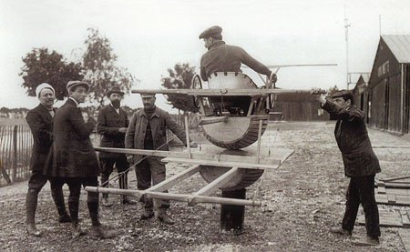
Figure 3: The first flight simulator (Henry 2018)
After world war II, the flight simulators were introduced in the civil aviation industry. Initially they were just ground models but by 1960s they incorporated the up-down motion to simulate turbulence, takeoff and landing. Today computer generated 3D graphics are used to precisely create the flight environment for various operations.
Simulators in other industries have also followed the same path with humble beginning but today they are the main equipment for advanced training and evaluations (Ybarra et al. 2019). Some of the common fields that use the simulator trainings are:
- Healthcare
- Military
- Aviation
- Law Enforcement
- Transportation
- Athletics
- Offshore Drilling
- And Countless Others
Today with virtual reality taking over to make the simulator experience more realistic than ever. The future of simulator for training in not going away any soon. With more advanced systems, automation and ever changing and continuously complicated technology taking over, the need for simulator trainings for enhanced performance and safety remains paramount.
Realizing their importance, the oil and gas industry being incorporating them for training and evaluation. Today oil and gas industry have some of the most expensive simulators, which are used to familiarize the drilling crew (especially drillers) with a specific offshore rig before they are sent on field to operate it. Initially the idea was to avoid any operational blunders that can result in non-productive time (NPT) or lost time injury (LTI), causing millions to the company and putting safety of personnel at risk. However, as the drilling got aggressive with development of deeper & challenging reservoirs, simulators slowly found their way into training & evaluation of people for important drilling operations like stuck pipe & well control. For some time now, they have also been in use in several well control evaluations around the world and professionals are required to renew their well control certification every two year by successfully controlling a kick on drilling simulators. Today again with events like Montara 2009 (Borthwick 2010) & Macondo 2010 (Spill et al. 2011), drilling simulators are the focus of attention to study the HF linked with these catastrophic collapse of engineering implementations.
Drilling simulators can be used to design the representative experiments where actual drilling environment can be simulated while maintaining the intrinsic integrity of the HF. However, easier said than done, the scarcity of the such costly and sophisticated infrastructure required to simulate the drilling environment has been one of the biggest hinderance in widespread and comprehensive research on HF. This makes University of Oklahoma as one of the rarest of places to in-house a Virtual Reality Drilling Simulator and a DrillSim 50 simulator, where experiments can be designed to incorporate and validate tools from other fields to optimize the HF in drilling operations.

  - DrillSim 50 Simulator
This is a drilling and well control simulator. The simulator comes with the similar range of simulated consoles, equipment and manifolds which closely resemble those on a modern rig floor. The digitally reproduced and synchronized sound effects are used to increase the representation of the task environment. The simulator is also aided through a high resolution touch monitor which provides the real time graphic representation for hoisting and rotary system equipment and movements, along with other rig floor operations. The interactive touch screen also allows the user to accomplish other tasks that are not performed on the rig floor e.g. changing mud weight.
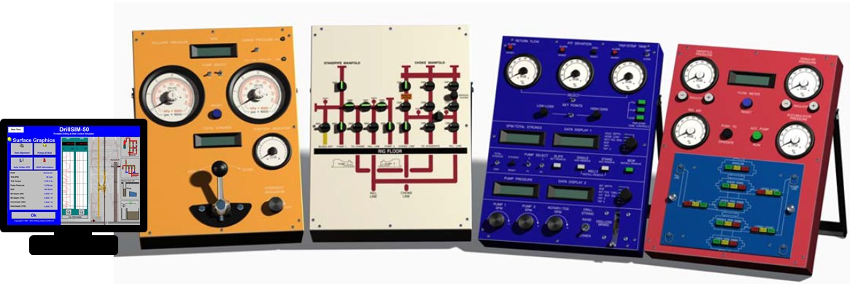
Figure 4: Showing the DrillSim 50 simulator setup (DrillSim 2005)
The simulator employs a mathematical model to simulate operations and downhole characteristics. The signals are initiated through the interaction with the consoles and panels and are fed to the computer after going through the input/output interface. The interface converts the signals from the console, so they are meaningful to the computer, which then makes the calculations to predict the response of the process. The feedback from the computer is then displayed to gauges through the input/output interface (Drilling Systems 2018).
    - BOP Console
This console is used to perform the various shut-in procedures required for the well control operations. It has various rams to shut the well around different pipe size and for different purposes. Firstly, we have the annular rams that are used to shut the well around various pipe sizes. It has a rubber element that allows it to be compressed around all sort of pipe and can still shut the well with no pipes inside the well. Blind/shear rams are used to cut the drill pipe and then shut the well or can also be used when no pipes are inside the well. The upper/lower pipe rams can only shut the well around the certain size of drill pipe and are replaced every time the drill pipe outside diameter changes. There are also choke and kill line connected to the BOP, which allows for entry and exit of the mud from the annuals with the well shut.
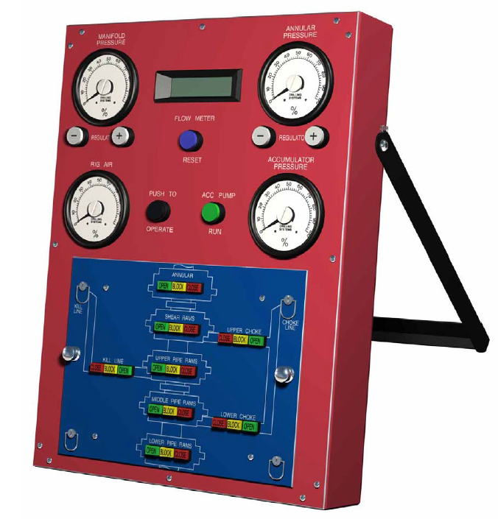
Figure 5: Showing a subsea BOP (DrillSim 2005)
    - Drilling Console
This console is used to perform all the operations that a driller is required off. The console allows the driller to select the pumps and their SPM. There is also a knob to set the top drive RPM. Then a brake on the console allows the driller to control the WOB while drilling. The console also has several analog and digital gauges to allow the driller to be aware of the important drilling parameters and then are buttons to performs other surface operations like tripping.
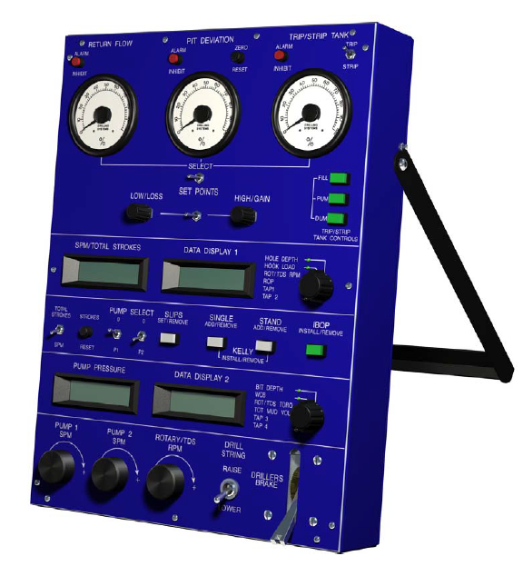
Figure 6: Showing the drilling console (DrillSim 2005)
    - Standpipe and Choke Manifold
This manifold gives us the options on how to line up the well. The standpipe manifold on this panels allows to connect different pumps to the standpipe or to the kill line. The different well pumping configurations can be achieved through the use of various valves on the manifold. The choke manifold allows to line up the hydraulic or manual choke, to circulate the returns out under a certain back pressure, during well control situations. Using this manifold, we can create a combination of different pump and choke lineup to perform various operations. The remote choke is also placed on this manifold but is controlled by another console for precise control of the back pressure, as practiced in the field.
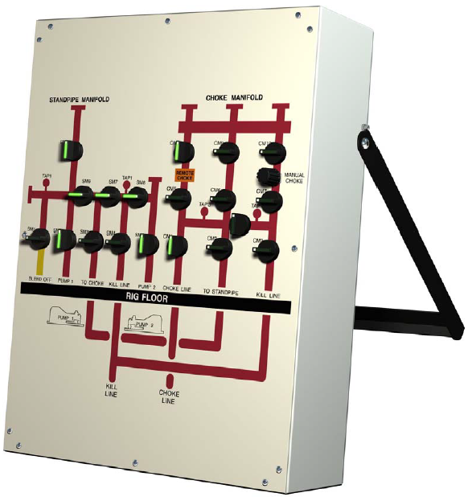
Figure 7: Showing the standpipe and choke manifold (DrillSim 2005)
    - Remote Choke Control
This is controller of the hydraulic choke placed on the choke manifold. The separate controller is placed on the rig floor to allow the precise opening of the choke to maintain the required back pressure. The choke control panel is also equipped with SIDPP, SICP and stroke counter to allow the supervisor to precisely follow the kick circulation trend. A lever on this panel is used to control the opening of the choke, while a position indicator on the panel shows the choke opening.
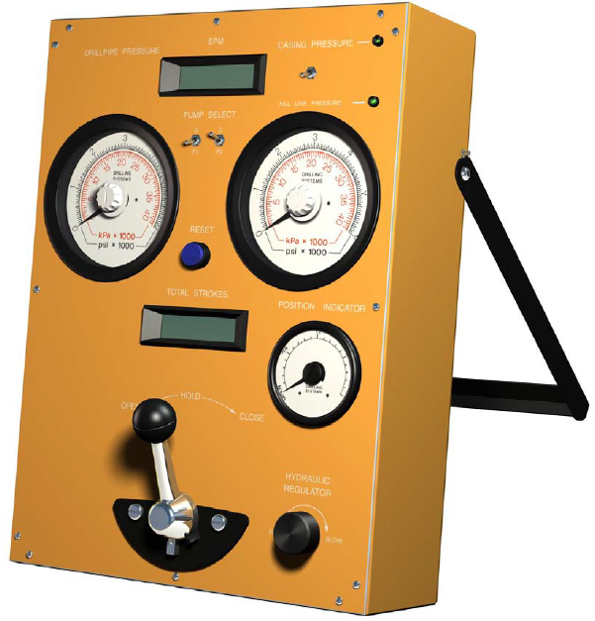
Figure 8: Showing the remote choke control panel (DrillSim 2005)
  - Virtual Reality Drilling Simulator
The virtual reality drilling simulator (VRDS) is state of the art multi-million dollar offshore simulator at University of Oklahoma. The setup resembles the rig floor with three cyberspace drilling chairs equipped with control panels and graphic interface resembling a semisubmersible offshore rig. The cyber chairs have two displays monitors, keypads, roller mouse, 2 joysticks and mode switch knob, to control the equipments and perform various operations. Each cyber chair has 20,1” LCD TFT displays and fulfill all requirements for visual inputs. The display screen has 12 monitors featuring the Mitsubishi Digital Light Processing (DLP) technology and produces visualization at 65 frames per second (Kiran et al. 2018). The system has advanced Hardware In Loop (HIL) technology with Programmable Logic Controllers (PLC) at its heart.
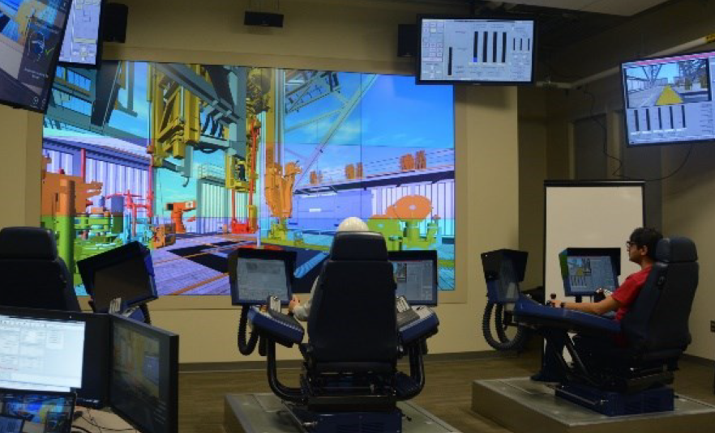Figure 9: Virtual Reality Drilling Simulator infrastructure at University of Oklahoma (Dadmohammadi et al. 2017)
The simulator is capable of simulating the function of various rig floor equipment. Some of them are listed as below:
- Top Drive
- Main and Auxiliary Pipe Racking System
- Main and Auxiliary Automated Roughneck
- Drawworks
- Fox Hole A & B
Having the above variety of rig tools, the simulator is able to perform the following type of operations:
- Stand building – This procedure allows the user to make up stands of drill pipe and store them in the fingerboard.
- Tripping in – This procedure picks the stands from the fingerboard and run them in the hole
- Tripping out – This procedure pulls the stands out of hole and rack them back in the fingerboard
- Drilling – Actual drilling operation is simulated along with all the parameters. It allows for controlling and monitoring various drilling parameters like rate of penetration (ROP) and weight on bit (WOB)

- Eye Tracking
One of the first studies on eye tracking was performed in 1950s to better design military airplane cockpits (Fitts et al. 1950, Merwe et al. 2012). Since then eye tracking has been in use to study mental workload (Harris Sr et al. 1986), expertise (Bellenkes et al. 1997), cognitive engineering (Thomas and Wickens 2004), information acquisition strategy (Sarter et al. 2007) and situational awareness (Merwe et al. 2012). The figure 10 highlights the eye tracking applications in air traffic radar display (Kiran et al. 2018). The green spot shows the eye fixation and the green line points to the fixation pattern used by the observer.
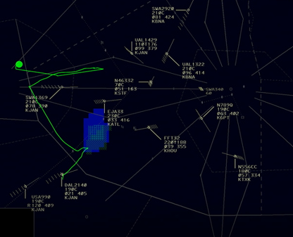
Figure 10: Eye tracking over air traffic radar monitor (Kang 2019)
Perceptual human errors amount to 75% of HF in information rich display systems like airplane cockpit or offshore drilling console (Jones and Endsley 1996). This makes eye tracking suitable for such an application where it can reveal critical insights into human performance to allow the further optimization of the environment or human capabilities. As compared to other methods used for the same purpose like questionnaires, verbal protocol analysis or information search displays, eye tracking is not prone to confabulation nor there are any chances of deliberate information sampling (Glaholt and Reingold 2011).
Eye is the preeminent sense for acquiring information. The rapid gaze of eye up to three to four per second are called saccades and between saccades where the eye is relatively still are called fixations. It is during the eye fixations when the information is acquired. Since visual information is acquired and processed during fixations, eye fixations are a window into cognitive processes (Just and Carpenter 1980, Schulte-Mecklenbeck et al. 2011). Eye movements are extremely fast, metabolically cheap and quickly corrected which gives them a low threshold for triggering (Spivey et al. 2009). Furthermore, they are automatic, difficult to sensor and provide a detailed trace of acquired information.
By observing the sequence of eye fixations we can measure (Schulte-Mecklenbeck et al. 2011):
- Area of interests (AOIs) over the display
- Frequency of fixations over AOIs
- Order of fixation
- Total time of fixation or mean duration
- Subsequence of fixations
There are two types of eye movements, saccades & non-saccadic. Saccadic movements are rapid and voluntary movements over one object to another and are crucial for cognitive studies (Glaholt and Reingold 2011). However due to suppression of vision during these movements, information acquisition process is hampered. Non-saccadic movements on the other hand involves vergence or nystagmus movements which allow the observer to track an object in a trajectory or relative motion. Although important for daily life, non-saccadic movements are not important for research purpose.
  - Methodology
Although eye tracking is new to the field of oil and gas but there has been some application in industry recently (Salehi et al. 2018). In other studies eye tracking was used to see how participants are going over various real time logs and what their information acquisition pattern can reveal about their performance. The figure 11 shows the gaze pattern of a participant from that study (Kiran et al. 2018).
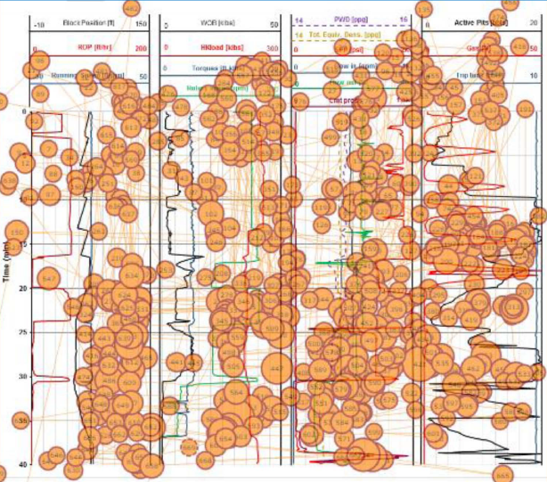
Figure 11: Gaze pattern of a participant (Kiran et al. 2018)
The other study has done the pupillogram analysis involving the pupil dilation. The pupil dilation was then correlated with the situational awareness of the participants. The figure 12 shows the comparison of pupil dilation among the two participants (Salehi et al. 2018).
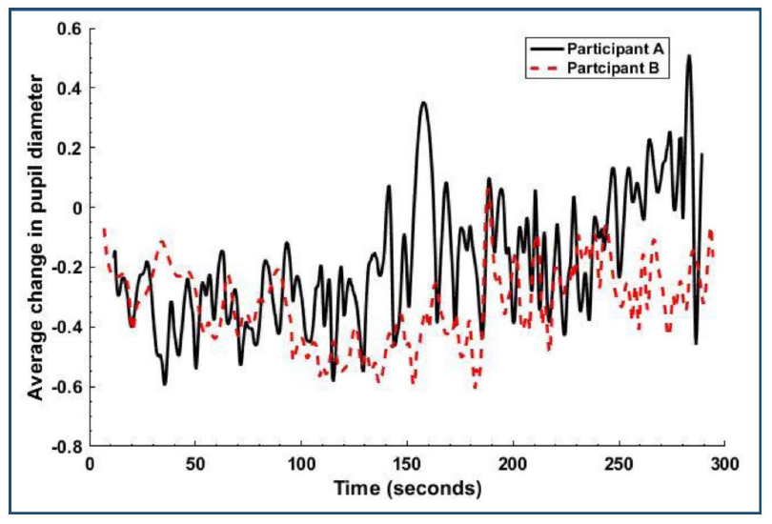
Figure 12: Pupil dilation comparison of two participants (Salehi et al. 2018)
In this study we wanted to see how eye tracking can be used in a simulator setup and how the results from eye tracking can be used for better training and evaluation. To achieve this, we designed a well control simulation, and made participants wear eye tracking glass to record their information acquisition pattern over the simulator during the simulation. This insight was then compared/linked to their performance to validate how eye tracking can help to optimize well control training and evaluations. This methodology was important because we wanted the application of the work to remain practical. Through this work, with little addition of infrastructure, the eye tracking can be incorporated in the current well control training and evaluation criteria to optimize safety and performance. Below is the description about how the study was conducted and involving participants, experiment design and analysis.
    - Participants
A total of 14 graduate and senior undergraduate students with at least past enrollment in two drilling courses, participated in this simulation. Among them two participants were classified as experts and rest as novices due to their relative exposure to drilling and well control. The expert participants had several years of experience as drilling engineers along with IWCF surface level 4 certification, wild well control certification and multi-year experience with drilling simulators. The novice participants were trained for three consecutive weeks during a three hour weekly class on the simulator before the experiments. Randomly seven novice groups were made comprising a pair of novice participants while one expert group was formed comprising of both the expert. Among each group one participant was assigned the role of a driller and the other of the supervisor. In this research, the term novice 1 driller or novice 1 supervisor is used to represent participants of 1st group of novices and so on. Additionally, the word “experts” doesn’t intend to represent the current pool of industry expertise but is only used in the figurative sense to distinguish the more experienced sample of the population from the novices.
    - Eye Tracking Precision, Accuracy and Calibration
The data validity of eye tracking is established through the precision and accuracy of the data collected. Accuracy is defined as the average difference between the real stimuli position and measured gaze position. While the precision deals with the ability of the eye tracker to reliability produce the same gaze point position.
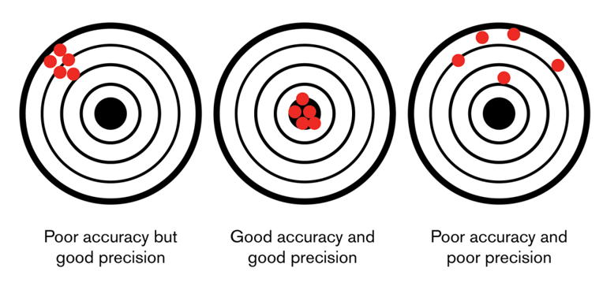
Figure 13: Eye Tracking Accuracy and Precision (Tobii 2019)
Since every individual’s eye is different, Tobii eye trackers uses an individual calibration procedure to optimize its gaze estimation algorithm. The main purpose of the calibration is to fine tune the geometry to get close to the fovea of the participant. The figure 14 shows this geometry for the visual and optical axis, fovea and the center of the pupil (CP).
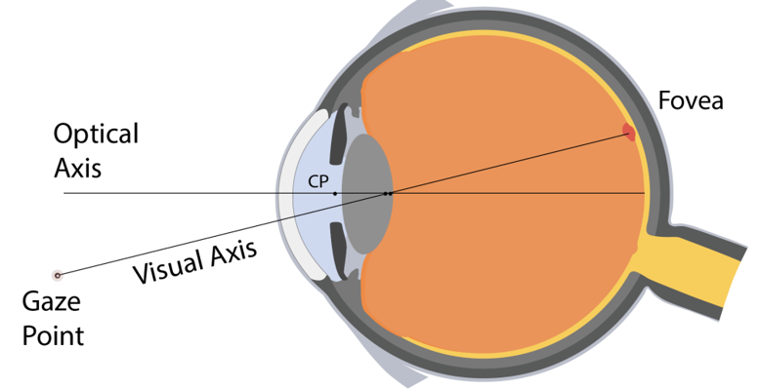
Figure 14: Eye Geometry (Tobii 2019)
The calibration involves three steps, where only the first step is visible to the participant and the operator, while the next two steps happen under the hood. These three steps are:
- Data collection phase: Participants are made to sequentially look at certain number of targets selected by the operator. These could be gauges or buttons on the displays and can be in the range of 3 to 9 points. Four separate calibration points are collected just for the validation in the last phase.
- Optimization phase: Here part of the data collected is used to optimize the 3D eye model. In this phase the mapped locations by the model is compared with the location of the calibration targets. Based on the distance between them, the model is updated. The process is repeated till there is no improvement in the results.
- Validation phase: Here the remaining data points are used to test the 3D eye model and data quality measures are reported. The optimized 3D model is used to map the remaining data, which is compared with the calibration targets location. The precision and accuracy is then reported.
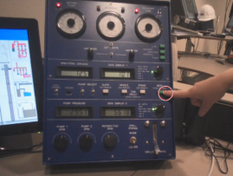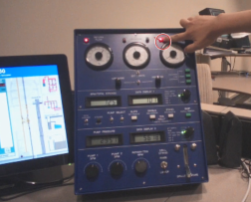
Figure 15: Showing the target selection process for calibration
The figure 15 shows the process where the researcher is asking the participant to look at various targets. The eye tracking fixation of the participant can also be seen as a circle over the researcher’s finger. If the fixation is offset from the finger, the 3D eye model is updated, and updated model is then validated over other target points.

    - Experiment Design
A well control simulation, analogous to the one used in well control trainings by international bodies (IWCF, IADC), was designed on the DrillSim 50 simulator. The driller was in control of the drilling console and manifold, while the supervisor had choke manifold, BOP and a kill sheet in his vicinity. The overall task for the team was to successfully detect, control and circulate the kick out. The simulation begins with drilling commencing in the reservoir section. The well configuration specifically designed for this simulation is given in Table 1.
Table 1: Well configuration for the simulation
Well Information
Open hole size | 8.5”
Current MD/TVD | 5620 ft
Last casing OD | 9-5/8”
Casing shoe depth | 3950 ft
Current mud weight | 10.5 ppg

Before the start of the simulation, both the participants were made to wear eye-tracking glasses, and the glasses were calibrated with the eyes of the participants. The figure 16 shows summary of how the eye tracking technology works. The main camera on the glasses records the scene in front of the participant, while the eight illuminators direct the near infrared light on to the eye. The pupil corneal reflection principle takes place, where the lights falling on the pupil is absorbed while the light is reflected from the cornea. The reflected light is detected by two high resolution cameras installed on each eye and image processing algorithms are used to find the position of the eye. Then sophisticated 3D space algorithms are used to find the fixation of the participant on the scene in front of him which is recorded by the main camera.
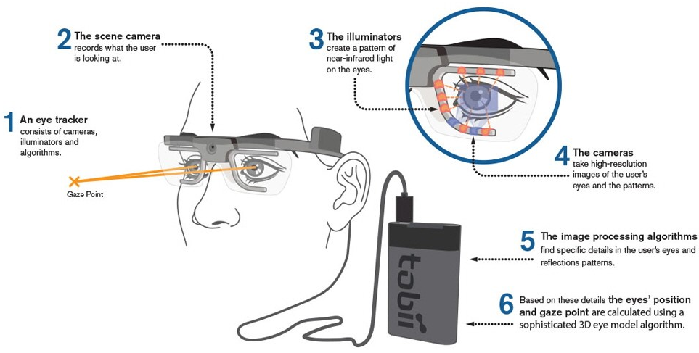
Figure 16: Tobii eye tracking glasses (Tobii 2018)
Below is the detailed description of the scenario design along with typical actions expected of the participants:
- Simulation Starts: The simulated scenario starts on the DrillSim50 simulator.
- Shift Starts: The driller and supervisor perform the shift starting protocols to ensure system integrity and proper line up.
- The driller performs the slow circulating rate (SCR) and communicates the slow circulating pressures to the supervisor.
- The supervisor notes down the SCR in the kill sheet.
- Drilling Commences: The driller starts drilling and must maintain the drilling parameters constant (WOB, SPM, RPM).
- Drilling Break Initiation: To test the knowledge and vigilance of the driller, a drilling break is simulated after first few meters of drilling. During this break, the driller should perform flow-check, since an increase in ROP is also a reaction associated with a kick. After few meters of drilling break, the normal drilling resumes.
- Kick Initiation: After further drilling for few more meters, a gas kick is initiated in the simulation. The gas kick causes a sudden increase in influx and ROP.
- Kick Detection: The driller should observe the changes in influx and ROP. The driller should perform the flow-check & communicate the supervisor about the possibility of a kick.
- Well shut-in: The team must shut the well based on positive confirmation of the kick.
- Kick Circulation: With the well shut-in, the supervisor needs to begin the kick circulation protocol as follows:
- The supervisor must wait for the shut-in pressures to get stabilized. Here the fixations on the shut-in pressures are critical as wrong pressures can sabotage the complete well killing process.
- Once the pressures get stabilized, the supervisor must note SIDPP and SICP on the kill sheet to calculate the kill mud weight and the required pressure/strokes trend for kick circulation.
- The supervisor should reset the stroke’s count and communicate to the driller to lineup the kill mud and begin pumping at SCR.
- The supervisor must follow the calculated pressure/strokes trend in his kill sheet to maintain a constant bottom hole pressure. To achieve this, the supervisor must divert his gaze & attention back and forth on the kill sheet and the pressure gauges while simultaneously making subtle changes in the choke opening to compensate for BHP, if required.
- Resume Drilling: Once the kick is circulated out, the supervisor must open the well and after confirmation of a negative flow check, the drilling should commence again.
These steps correspond to a successful kick detection and control. However, if the kick is not properly detected or controlled, it can result into a surface or underground blowout, in either case the simulation stops automatically.
To optimize the recording times, participants were advised to use the engineer’s method to circulate the kick out. They were also provided with a partially solved kill sheet, with basic well information, drill string and well volumes and strokes calculations. The kill sheet used is shown in appendix 1. The table 2 below summarizes the main events of the simulation and times of interest (TOIs) that will be selected for analysis.
Table 2: Main events and TOIs during the experiment
# | Event | Performed by |  | TOIs
# | Event | Driller | Supervisor | TOIs
1 | Shift starting protocols
2 | Drill with constant parameters |  |  | 1st Time of interest
3 | Detect drilling break |  |  | 1st Time of interest
4 | Perform flow-check |  |  | 1st Time of interest
5 | Resume drilling |  |  | 2nd Time of interest
6 | Detect kick |  |  | 2nd Time of interest
7 | Perform flow-check |  |  | 2nd Time of interest
8 | Prepare for shut-in
9 | Shut-in well |  |  | 3rd Time of interest
10 | Wait for SIDP & SICP to stabilize |  |  | 3rd Time of interest
11 | Kill sheet calculations
12 | Line up the new kill mud
13 | Stroke reset & consider surface volume |  |  | 4th Time of interest
14 | Circulate out the kick |  |  | 4th Time of interest
15 | Open well & perform flow check |  |  | 4th Time of interest
16 | Resume drilling

The four TOIs are defined to provide insights on participant situational awareness, knowledge, and information acquisition pattern based on their eye fixations & saccades analysis. The 1st TOI is important, as the driller must stay alert to detect any changes in well response. He must also possess the understanding to keep the drilling parameters constant to notice any changes. The drilling break, which is a significant increase in ROP, is a phenomenon which is also associated with a possible kick situation. Upon detection, the driller must perform a flow-check to confirm stable well conditions before continuing drilling. The 2nd TOI is also driller focused and involves the measurement of driller’s vigilance on return flow gauges along with the drilling parameters. Once the kick is initiated in the simulation, it causes an increase in return flow and ROP. The driller upon detection, must perform a flow-check to confirm if there is any flow from the reservoir.
The 3rd and the 4th TOI deals with the supervisor. Once the kick is confirmed the team will shut-in the well and during the 3rd TOI the supervisor will notice the increase in shut-in drill pipe (SIDPP) and shut-in casing pressure (SICP). These stable shut-in pressures are important to calculate the kill mud which will be used in the 4th TOI to kill the well. So, during the 3rd TOI supervisor must wait patiently for the shut-in pressures to stabilize before taking them to the kill sheet for calculations. This wait is required to allow the influx from the well, with the well shut-in at surface, so the bottom hole pressure (BHP) inside the well becomes equal to the reservoir pressure. This stops any further influx from the reservoir, and SIDPP gives the correct representation of the reservoir pressure. Once the shut-in pressures are stabilized, they will remain constant for a while and will then gradually start to increase again as the gas will start migrating up the annulus. Supervisor must recognize the momentarily stabilized pressures as significant delays will cause the shut-in pressures to keep on increasing, which can result in higher kill mud weight, circulation pressures and underground blowout in worst cases. Higher fixations on SIDPP and SICP during 3rd TOI will help the supervisor to identify the stabilized state. Using the stabilized pressures, the supervisor calculates the kill mud weight. Finds out the initial and final circulation pressures and prepare the strokes Vs SIDPP trend for the circulation procedure. 4th TOI begins with the group lining up the well for the circulation of the kick. The team starts pumping at the SCR and the supervisor uses the remote choke manifold to adjust the BHP as per the calculated trend. This allow the BHP to remain constant and above the reservoir pressure while the kick is circulated out with the well shut-in from the surface. During this TOI the supervisor is required to maintain a regular eye saccades and fixations between the SIDPP and strokes counter to allow him to follow the strokes Vs SIDPP trend. Once the required strokes are pumped, enough to circulate the kick out and displace the hole volume with the kill mud, the 4th TOI ends with the supervisor opening the well to perform the flow check. These TOI were marked in the Tobii software for simulation of every group and eye tracking analysis was performed on these TOIs.
    - Tobii Eye Tracking Software
Tobii software offer a platform to record and analyze the eye gaze data to interpret the human behavior, consumer response and psychology (Tobii 2018). It has three modules: Design, Record & Analysis, which combines to offer advanced visualization & analysis for comparison, interpretation & presentation. All the analysis presented in this study is derived from this software which is partially presented through gaze & heat plots for individual comparison, while for combined analysis the results were imported in excel and have been displayed through graphs and radar plots for easy comprehension.
      - Gaze Plot
A gaze plot shows the sequence & the fixation duration on an image, showing the location, order and time spent looking at different locations. The size of the dot indicates the duration while the fixation order is represented by the number inside the dot. The lines are used to connect the successive fixations illustrating the complete gaze pattern of the participant throughout the recording or for selected times of interest (Tobii 2018).
      - Heat Plot
Heat plot summarize large data in an intuitive way and uses different colors to illustrate the number of fixations participant made or how long they fixated within the certain areas. Red indicates the highest number of fixations and the green the least, with varying levels in between (Tobii 2018).
  - Analysis and Results
The analysis begins by describing the areas of interest (AOI) for both the driller & the supervisor on their respective displays to analyze their fixations during different times of interest (TOI). The table below summarize the performance of all the participants during different events in the simulation.

Table 3: Binary performance matrix for all groups
Event | Participant Group Binary Performance Results
Event | Group 1 | Group 2 | Group 3 | Group 4 | Group 5 | Group 6 | Group 7 | Expert
1 | 1 | 1 | 1 | 0 | 1 | 1 | 1 | 1
2 | 0 | 0 | 0 | 0 | 1 | 0 | 1 | 1
3 | 0 | 0 | 0 | 0 | 0 | 0 | 1 | 1
4 | 0 | 0 | 0 | 0 | 1 | 0 | 1 | 1
5 | 1 | 1 | 1 | 1 | 1 | 1 | 1 | 1
6 | 1 | 1 | 1 | 1 | 1 | 1 | 1 | 1
7 | 1 | 1 | 1 | 1 | 1 | 1 | 1 | 1
8 | 1 | 1 | 1 | 1 | 1 | 1 | 1 | 1
9 | 1 | 1 | 1 | 1 | 1 | 1 | 1 | 1
10 | 0 | 1 | 1 | 0 | 1 | 1 | 0 | 1
11 | 0 | 0 | 1 | 0 | 0 | 1 | 0 | 1
12 | 1 | 1 | 1 | 1 | 1 | 1 | 1 | 1
13 | 0 | 1 | 1 | 1 | 1 | 1 | 0 | 1
14 | 0 | 0 | 0 | 0 | 0 | 0 | 0 | 1
15 | 0 | 0 | 0 | 0 | 0 | 0 | 0 | 1
16 | 0 | 0 | 0 | 0 | 0 | 0 | 0 | 1

    - Driller’s Performance and Heat Plots
For driller it is necessary to maintain drilling parameters and maintain a good situational awareness over drilling parameters to notice any anomalies. This is why the selected AOIs for the driller are related to the drilling parameters. The figure 17 highlights the various AOIs selected for the driller from his display during the simulation.
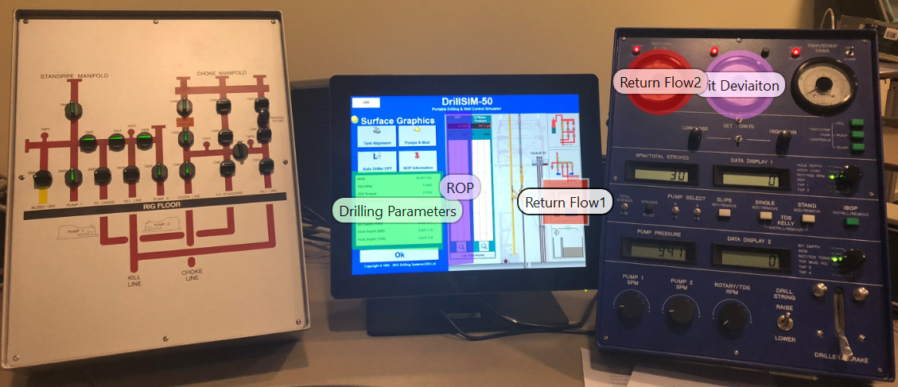
Figure 17: Important AOIs for driller along with their legend
Although all areas are important, these AOIs were selected based on the consequences following their oblivion while sufficient cognition on these parameters is considered enough to get satisfactory performance from the driller in this simulation. As discussed, the first two TOIs are related to driller where he is required to detect drilling break (1st TOI) and kick (2nd TOI). During these the fixation order is trivial but the no. of fixation on the AOIs is important, which advocates the use of heat plots. The information acquisition pattern of the driller will remain constant during drilling, so one heat plot is generated incorporating both the TOIs.
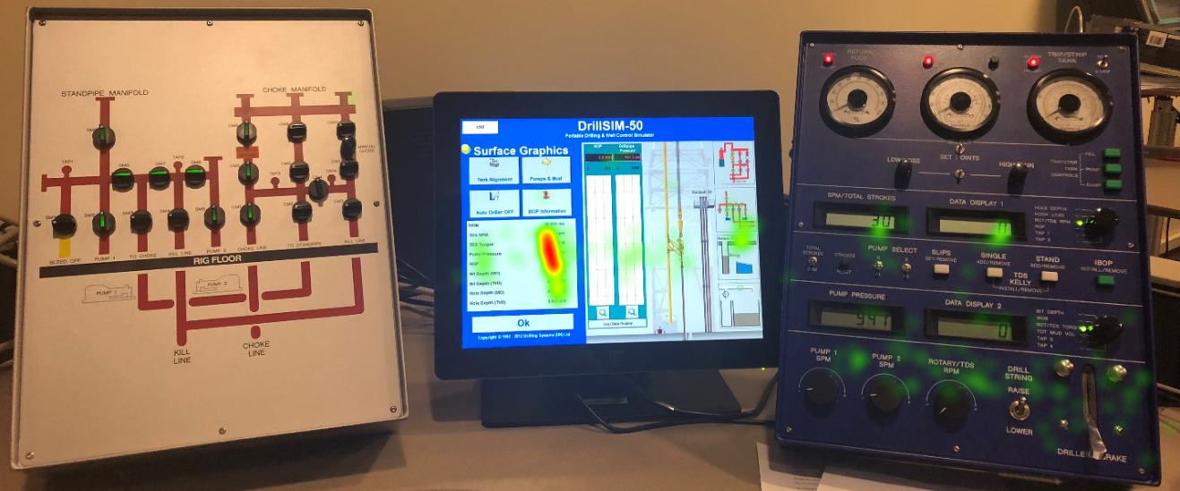
Figure 18: Heat plot for the expert participant
In figure 18 we can notice fixations on the drilling console, mainly on the knobs used to control SPM, RPM and around the brake to apply WOB. We can also see concentration of fixations on the digital displays of these parameters. Next on the monitor we can notice a major concentration of fixations are distributed along the drilling parameters AOI. This allowed the expert driller to maintain the drilling parameter constant which assisted him in detecting the changes in the ROP during the drilling break and permitted him to ensure save operation by confirming this drill break following a negative flow check. On the monitor we can also see some green area (fixations) over the digital return flow indicator, which was necessary to detect any losses or kick inside the well. Overall the fixation patterns seem sufficient to acquire all the necessary information to perform operations safely in this scenario. Next, we shall compare this heat plot with one of the novice participants during the same TOIs.
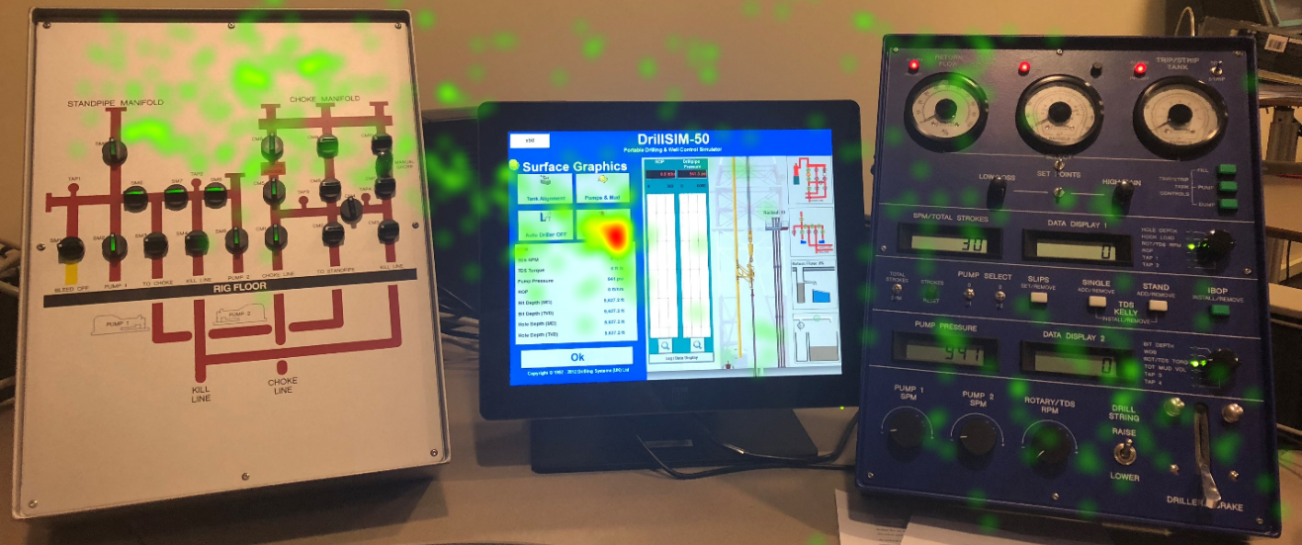
Figure 19: Heat plot for novice 6 participant
Figure 19 shows the heat plot for the novice participant during the 1st and 2nd TOI. From the first look we can see that the fixations are chaotic & more scattered over the scenario, relative to the expert participant. Starting with the drilling console we can see some disarray of fixations on the SPM, RPM knobs, brake and digital displays. On the monitor we can see a concentration of fixations on the drilling parameters but mostly on the top portion covering only WOB and RPM. There are very few to no fixations on the ROP, which explains the driller inability to follow the changes in ROP resulting in no detection of the drilling break. Lastly, we can see an ataxia of dispersed fixations on the manifold and the background which suggest the lack of purpose & awareness in the information acquisition pattern from the novice driller.
      - Comparative Analysis of Drillers
Fixation data of all the drillers was exported in excel from the Tobii software to perform the analysis. The aim here is to compare the total AOI fixation percentage and tie it with their performance. The area outside the AOIs will be referred as AOIs’.

Figure 20:% time fixated at drilling parameters and AOIs’ during 1st TOI
From figure 20 we can see the highest percentage time fixated at the drilling parameters was done by expert, followed by novice participants 3 and 7. Among them as seen in table 3, expert and novice 7 participant were able to detect the drilling break while novice 3 was able to notice these changes in ROP. This was due to the fact that novice 3 participant was unable to maintain the parameters constant while drilling which masked the drilling break. For other participants we can see lesser percentage of time fixated at the drilling parameters which is corresponded by higher fixation percentage at AOIs’. This resulted in marginal levels of situation awareness and lead to non-detection of drilling break from these participants.
For the 2nd TOI, we noticed with minimal difference in time, all participants were able to detect the kick. However, techniques like eye tracking allow us to further investigate the differences among the participants. From figure 21 we can see there is power relation between the kick detection time & the number of fixations on the return flow indicators, with the R-squared measure of 77%. Axiomatically, the kick detection time decreases with the number of fixations on the return flow indicators, but such an insight can be valuable for training, evaluation and incident investigation. In figure 21 we can see that most participants detected the kick within reasonable time, but expert had more than double fixations on the return flow indicators as compared to novices, which highlights his supervisor performance in terms of vigilance and alertness.

Figure 21: Kick detection time vs no. of fixations on return flow indicators
    - Supervisor’s Performance and Gaze Plots
Again, for the supervisor, defined TOI were selected in the Tobii software for analysis. For the selected TOIs gaze plots were generated and compared among the novices and expert supervisors. The gaze plot will allow us to trace the information acquisition patterns utilized by the participants through what areas where of most attention and what was the sequence of fixation adopted by the participants. For the statistical analysis of the fixations, the area of interests (AOIs) were defined and for selected times of interest, fixation data was exported from the software. The figure 22 show the AOIs that were selected for the supervisor.
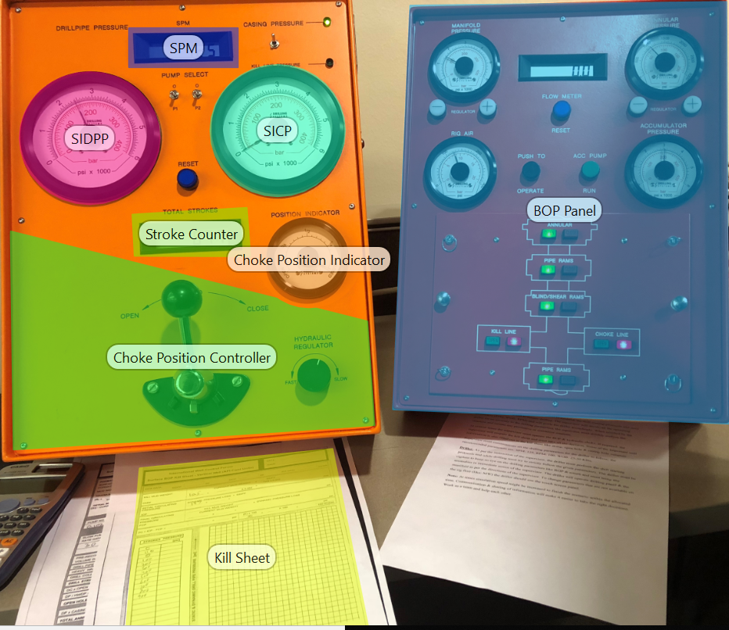
Figure 22: Important AOIs for supervisor along with their legend
The 3rd TOI starts with the positive flow check following a kick and form the gaze plot we can trace the immediate stimuli of the expert supervisor is on the BOP. In figure 23 (left), early fixations 1-6 can be found on the BOP around the annular ram area, which highlights the first action on confirmation of the kick was to shut-in the well. Next the fixations are distributed on several locations of importance. We can see a cluster of relatively larger fixations on the SIDPP, where the supervisor is trying to follow the increase in the shut-in pressure and waiting for it to get stabilized. Similarly, there are fixations on SICP as they both will get stabilized when the influx is stopped for the reservoir. There are also some fixations on the choke line valve on the BOP panel, which must have been opened to prepare for the circulation of the kick. This must have also made him to ensure that the remote choke on the choke manifold is fully closed during this shut-in period and hence some fixations on the choke position indicator and on the choke position control lever. We can also see some fixations on the stroke counter, as strokes are required to be reset before the circulation is resumed. These fixations highlight that the expert supervisor is able to foresee his upcoming steps and is utilizing his waiting time on the shut-in pressures to ensure everything is ready for a quick action once the pressure gets stabilized. Lastly some fixations can be seen on the kill sheet which are in accordance to carry the observed pressures on the kill sheet to make quick calculations and initiate the well killing procedure.
Figure 23 (right) shows the gaze plot of the expert supervisor for the 4th TOI where he is required to circulate out the kick by following the stroke Vs SIDPP trend calculated in the kill sheet. Before circulation can begin and kill mud is lined up, the supervisor must reset the strokes counter, as strokes are indicative of the kill mud position inside the well. Here we can see some fixations at the SPM which were necessary to ensure that the driller has primed the pump to the desired SCR. As per industry practice the supervisor must keep SICP constant using the hydraulic choke, which explains for his fixations on the SICP. Once the pumps are brought to the required SCR, the attention of the expert supervisor shifts to the SIDPP and the strokes counter. For the first few strokes he is required to keep the SIDPP constant to compensate for the surface volume strokes. After the surface volume strokes, the kill mud reaches the top of the drill string and the supervisor can follow the strokes Vs SIDPP trend from his kill sheet. To follow that trend, he makes use of the hydraulic choke to apply or release back pressure ensuring that BHP at all times is greater than the reservoir pressure and lesser than the formation fracture pressure. To safely execute this, the supervisor attains maximum situational awareness by utilizing a fixation pattern covering all important areas like SIDPP, strokes counter and choke position indicator. The lines connecting the fixation points at SIDPP, strokes counter and choke position indicator, are indictive of the to and fro movement of the eye fixations among these areas & the cluster of lines especially among the SIDPP & stroke counter, highlights how frequently and successively this to and fro gaze pattern was repeated. This allowed the expert supervisor to successfully follow the strokes Vs SIDPP trend, as a slight lack of attention on these parameters would have either caused the well to intake another kick or trigger an underground blowout following a fracture, which can both sabotage the whole well killing operation. After successfully circulating out the kick & displacing the well with the new kill mud, the supervisor opened the well and ensured the overbalanced condition of the well by doing a flow check. With the well stable, drilling was commenced, and simulation was ended.

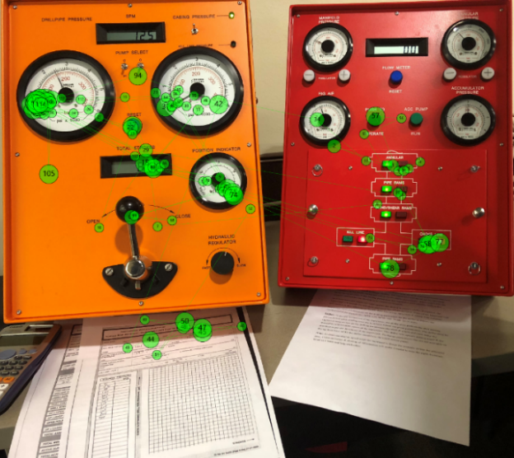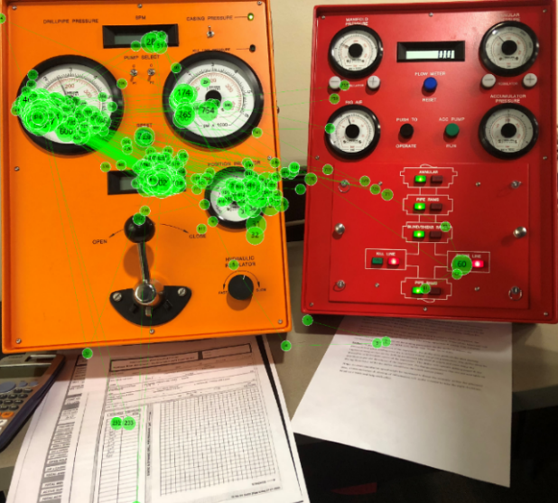
Figure 23: Gaze plots for expert supervisor for 3rd TOI (left) & 4th TOI (right)
Now let’s compare the expert supervisor gaze plots with one of the novices as we attempt to trace the difference in fixation patterns and relate them to their respective performances. This is important because information acquisition patterns are related to situational awareness and comprehension of the exact well situation at all times, which is critical during well killing operations.
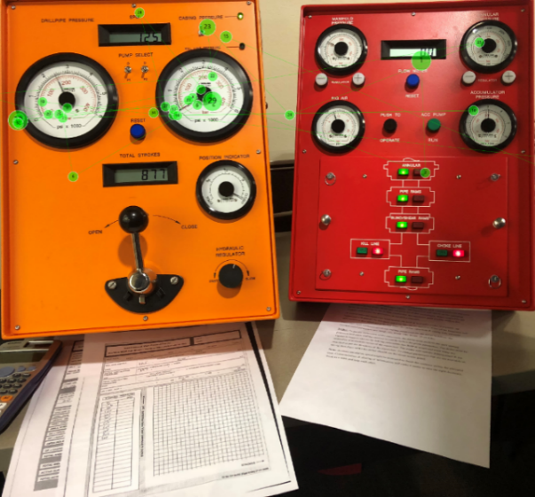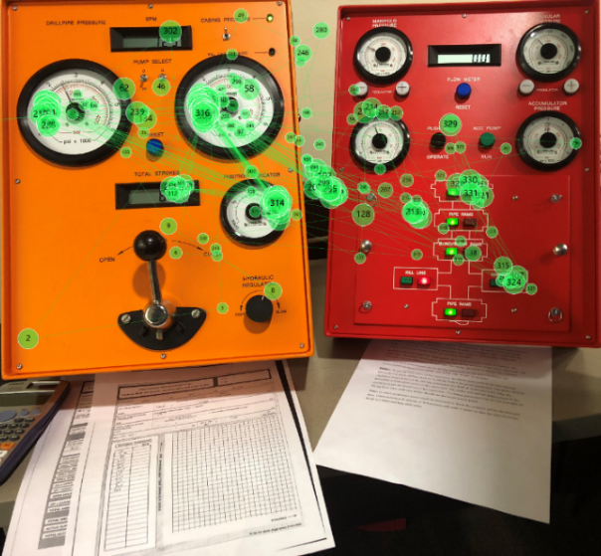
Figure 24: Gaze plots for novice 6 supervisor for 3rd TOI (left) & 4th TOI (right)
Remembering that the 3rd TOI starts with the kick confirmation, so the first fixations of the supervisor on figure 24 (left) can be traced on the BOP panel with 2nd fixation right on the annular ram, which indicates the immediate stimuli to shut the well. Next, we can observe some fixations on the SIDPP and SICP. Although this novice supervisor was able to get the correct shut-in pressures, there seems a little more emphasis on the SICP, rather than SIDPP.
In the 4th TOI, figure 24 (right) we can see the initial gazes of the novice supervisor are around the choke position controller and then from there the four main areas of his attention are SICP, SIDPP, strokes counter and choke position indicator. From the gaze plot we can again notice that SICP had more attention of the supervisor. From the lines connecting successive fixations we can see several successive fixations connected between SICP and strokes counter and almost none between the SIDPP and the strokes counter. This suggest that the supervisor was using SICP as a reference to keep the BHP constant, which is not a recommended practice as the mud inside the annulus gets contaminated by the influx from the reservoir. However, the mud inside the drill pipe remains uncontaminated and hence provide a true representation of the BHP which is why SIDPP is used to calculate the kill mud weight. Secondly all kill sheet calculation like ICP, FCP and the strokes Vs pressure trend are calculated with reference to SIDPP. Although supervisor performed these kill sheet calculations but lost this realization and wrongly applied the calculated SIDPP trend to SICP during circulation. Another thing to notice is density of fixations which is apparently lesser than the expert supervisor. The novice supervisor after reaching the FCP (around 900 strokes), assumed that the circulation is complete, and the well has been displaced with the new mud. However, as per the configuration of the well, around 3500 strokes were required (see appendix 1). After reaching the FCP at 900 strokes, the novice supervisor asked driller to stop the pumps and hence the fixation number “302” is to confirm that the SPM have been reduced to zero. Then post 300, the fixations are distributed on the BOP panel, to close the choke line and open the annular ram to perform a flow check. As the kick was still inside the annuals, opening the well, resulted in a surface blowout and the simulation was ended unsuccessfully.
      - Comparative Analysis of Supervisors
The fixation data over all AOIs of supervisors was exported from the Tobii software for comparative analysis. During the 3rd TOI, fixations at SIDPP are important as the stabilized SIDPP is required to calculate the kill mud weight. The figure 25 shows the percentage time fixated at different AOIs by the supervisors.
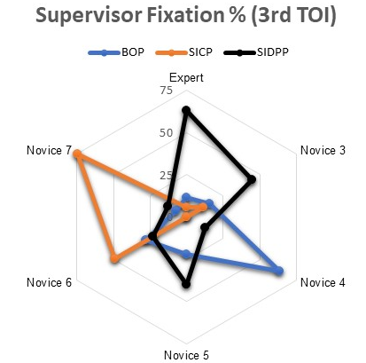
Figure 25: Radar plot for supervisors’ fixation percentage during 3rd TOI
From figure 25 we can observe the main AOI during the 3rd TOI for the expert supervisor was the SIDPP. For other novice supervisors the fixations percentage on SIDPP are relatively less and scattered over other areas like BOP or SICP. These dispersed fixations translated into erroneous readings of shut-in pressures, which caused wrong calculations of kill mud weight and subsequent blowout for some participants.
Figure 26 compares the fixation percentage on SIDPP, SICP and strokes counter for the 4th TOI. In this TOI, to successfully circulate the kick out, successive fixations on SIDPP and stroke counter were required. Some supervisor spent more time on SICP (novice 6) or strokes counter (novice 3) and for novice 7, the stroke counter percentage is almost zero. This resulted in lower situational awareness for the participants and poor understanding of the actual condition of the well. Some novice supervisor like novice 4, novice 5, and novice 7 had similar SIDPP fixation as the expert supervisor, however their poor performance in 3rd TOI was subsequently carried over or they lacked the basic knowledge/skills to solve and comprehend the kill sheet.

Figure 26: Fixation % for supervisor during 4th TOI
Figure 27 compares the fixation counts of participants on BOP, CPC (Choke position controller) and CPI (Choke position indicator) during the 4th TOI. Choke is used during the circulation process to maintain a constant BHP to avoid further kicks or losses in the wellbore. In the figure we can observe the high fixation count on the CPI from the expert supervisor, which indicates the intention to look for a stabilized choke position for this circulation. From novices, except novice 3 we observed very few fixations on the CPI. While a larger number of fixations at the CPC from some novices indicates their unfamiliarity with the CPC/choke panel, as they had to repeatedly look at the CPC to find which way it closes. Furthermore, a couple of novices had high fixations on the BOP which reflects their poor information acquisition strategy and could be attributed to lack of knowledge and training.
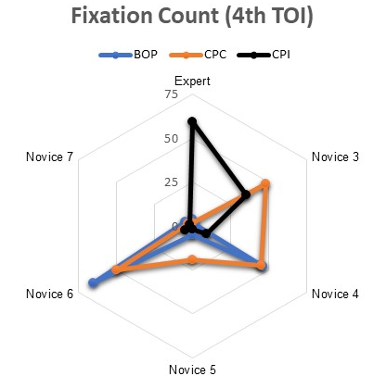
Figure 27: Number of fixations of BOP, CPC and CPI for 4th TOI
  - Discussion
In this research, through eye tracking we observed a lack of perceptual skills from novices which translated into their unsatisfactory performance. While experts on the other hand, were able to focus more on the AOIs for each TOI which allowed them to better comprehend the situation and subsequently to efficiently allocate their cognitive resources to successfully complete the task.
These insights during the training and evaluation process can help to identify the primary factors behind individual performances, which can then be used to provide targeted feedback for optimized learning and training process. Eye tracking can allow us to see the magnitude of difference among the performance of experts and novices and can act as bridge to reduce that gap through personalized feedback. As mere experience is not the key to expertise but how the experience is used as a learning mechanism by the individual (Ferry and Ross-Gordon 1998, Daley 1999) and such techniques can help in turning mere experiences into deliberate learning mechanisms. Additionally, through these assessments we can track the progress of candidates by comparing their successive heat or gaze plots before and after the feedback. Furthermore, a database of candidate’s past performance can be maintained which can help in investigating their retention memory (long & short) and on these grounds the recertification period for well control training can be curtailed on individual basis, rather than keeping the same 2 years certification validity for every candidate.
From the fixation data we can conclude that the novices were unable to focus on the important AOIs during the TOIs, which might highlight the lack of factual knowledge, training or the inefficient retrieval of stored knowledge. However, in other cases the lack in performance could be dominated by other human factors like stress or startle effect, decision making, lack of communication or planning etc. These factors must be first identified before they can be eliminated or optimized to enhance the performance of the system and techniques like eye tracking can play a role in pin-pointing just that.
Incorporating tools like eye tracking in the evaluation and training programs can also help in creating additional evaluation sieves for the candidates, where benchmark fixation (heat and gaze) plots of the experts in various situations can be used to compare with other participants. This will allow to probe the human aspect which has been missing in current well control training and evaluations programs. On the fronts of cognitive engineering, eye tracking can help to compare how performance is affected by different displays and system designs during similar simulations. These types of analysis can also reveal that different displays or their positions are optimal at individual levels and in future can lead us to customize important displays at individual basis.

- Content Analysis
Communication is necessary for almost all intellective task and becomes of primary importance in projects requiring multi-disciplinary interactions. Rail Safety and Standard Board has pointed that almost one-third of the incidents are at least partly caused by communication failure (RSSB 2008). Similarly, communication was one off the HF which allowed the Macondo blowout.
In oil and gas industry, the interactive nature, diverse crew and amalgam of several disciplines and expertise make effective communication crucial for success. A series of correspondence among engineers is required during the planning phase and continuous interaction among the crew is vital during the execution phase of the project. Analyzing those communication in real time can help in providing insights into the readiness of the crew, risk perceptions, individual and team confidence levels, and the cognitive processes during the tasks.
The infamous email “But, who cares, it’s done, end of story, [we] will probably be fine and we’ll get a good cement job”, written by the BP engineer four days before the Macondo well explosion, has been quoted multiple times in commentary after the incident to highlight their bias towards the commercial risk rather than towards safety (Hopkins 2012). So instead of analyzing such communications after the incident, content analysis can help to analyze these communications in real time and can provide feedback to inform the engineers towards using a safer approach.
Over other techniques like VPA or questionnaire content analysis results in no interference during the operations or experiment which allows maintain the integrity and representativeness of the environment. Additionally, it has the potential to analyze the electronic communication during the planning phase and make proactive interventions to provide feedback.
Content Analysis (CA) is a research technique used for making replicable and valid inference from data to their context, with the purpose of providing new insights, understanding of the phenomena and a practical guide to action (Krippendorff 2004). The main goal is to get a condensed and broad description of the phenomena, and the outcome of the analysis is concepts or categories describing the phenomena model, conceptual system, conceptual map or categories (Elo and Kynga¨s 2008). It was first used in the 19th century to analyze hymns, newspaper, magazine articles, advertisements and political speeches, but today CA has a long history of use in journalism, sociology, psychology and business (Neuendorf 2002, Harwood and Garry 2003). Content analysis offer several benefits, one of those is that it is a content-sensitive method, and another is its flexibility in terms of research design (Harwood and Garry 2003). It is also much more than a naive technique that results in a simplistic description of data or a counting game (Downe‐Wamboldt 1992). On the other side one challenge of content analysis is the fact that it is very flexible and there is no simple, ‘right’ way of doing it (Elo and Kynga¨s 2008). Researchers must judge what variations are most appropriate for their particular problems (Weber 1990), and this makes the analysis process most challenging and interesting. To increase the validity the researchers has to achieve a certain degree of triangulation in their results. An enormous amount of work is required during the process (Polit and Beck 2004).
Despite being a hectic and time-consuming activity, the potential of CA has been well known over decades. In 1971 Bernard Berelson highlights the vast diversity of application of CA and the magnitude of impact it can make in several fields. Some of the relevant uses as described by Bernard (Berelson 1971) are reproduced here:
- To describe trends in communication content
- To audit communication content against objectives
- To aid in technical research operations (to code open-ended questions in survey interviews)
- To secure political and military intelligence
- To identify the intentions and other characteristics of the communicators
- To describe attitudinal and behavioral responses to communications
- To determine the psychological state of persons or groups
In this study we attempt to evaluate how CA can be used in the oil and gas scenario to optimize the human aspect by analyzing the communication.
  - Methodology
CA can either be qualitative or quantitative (Graneheim and Lundman 2004). In both the methods, units are selected, which could be words, thoughts, paragraphs, interactions or just relevant bits and parts of the data. These units are then condensed into “code”. Through this a large though group consisting of words is represented by a small code while the intrinsic properties are preserved. Table 4 (Naqvi et al. 2018)presents this process of condensation of meaning units into codes.
Table 4: Example of meaning unit being condensed into codes
Meaning unit | Condensed meaning unit | Code
there is a curious feeling in the head in some way, empty in some way | curious feeling of emptiness in the head | emptiness in the head
it is more unpredictable so to say, you can never be sure about anything | An unpredictable and unsure situation | uncertainty

Next the categories are created to which these codes can be assigned. Researchers create these categories relevant to the research, and develop a scheme to guide coders when assigning them to the codes (Hsieh and Shannon 2005). The categories or their summative analysis can then be used to compare, support, infer or provide critical insights into the data.
Qualitative analysis involves more subjective categories which are defined by careful reading of the data, rather than to use search algorithms to apply the preexisting coding system as seen in quantitative analysis (Morgan 1993). This allows the analyst to create categories based on their interpretations of the data. Secondly, the use of the word count that results from the coding is another crucial difference between the two techniques. In the quantitative CA, the counts and tables summarize what is to be known about the data but for qualitative CA, counting & tables lead to the interpretation of the patterns found in the data (Morgan 1993). Based on the need to look for patterns to infer critical insights and provide feedback on the performance, qualitative CA will be used in this study.
    - Participants
4 participants took part in this experiment. Among them two were classified as experts and two as novices. The novices were randomly selected, petroleum engineering graduate student at the University of Oklahoma. The experts were industry professionals with more than 5 years of relevant field experience. The word expert isn’t analogous to the current pool of industry expertise but is only used in the figurative sense to distinguish the more experienced sample of the population. All four participants were assigned the role of an assistant driller and were paired with one driller, had extensive experience on drilling simulator.
    - Experiment Design
The experiment was designed on VRDS, where the participants were required to trip-in single stand of drill pipe. Each pair of assistant driller and driller was required to effectively communicate and work as a team to successfully trip-in the drill pipe stand.
During the experiment an anomaly was initiated to promote intensive communication and add a surprise element in the simulation. The oddity is representative and analogous to facing a non-routine or infrequent drilling problem (e.g. a well control situation or stuck pipe). The anomaly arises soon after the trip-in begins with the driller cyber chair getting malfunctioned and assistant is asked to finish the job using his cyber chair. The assistant has to switch over the mode of the cyber chair between driller and assistant driller to perform all the required steps. The figure 28 shows the VRDS cyber chair along with the control knob. The driller remains available to guide and supervise the operations through verbal support. To maintain consistency in experiment the same driller was used for all the participant paring and a checklist was used by the driller to provide the same minimum level of guidance to all participants. This interaction become the main data for analysis.
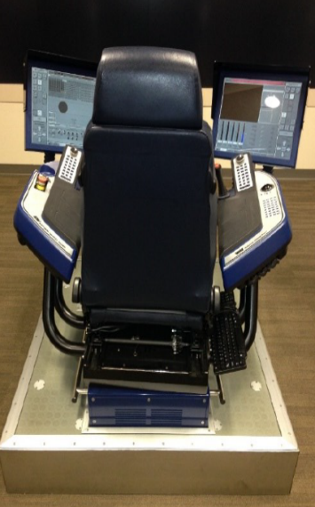
Figure 28: VRDS cyber chair (left) and its control knob (right) (Naqvi et al. 2018)
  - Analysis and Results
The communication that occurred between the participants during the experiment was recorded and later logged for analysis. The logging procedure was assiduously carried out to make sure it includes all the expressions of the participants. The assistant part of the conversation was selected for analysis and the logs was scrutinized to look for words and expressions that define the state of mind of the participants (assistant driller).
The categories were derived out of the data itself as the qualitative CA technique was used. Based on how the experiment was designed, the three common categories were found to be as “Soliciting”, “Muddled” and “Endorsing” (Naqvi et al. 2018).
Soliciting: A state where the subject is looking for more information from the driller or asking questions. The state was defined by the words/codes like “what”, “does”, “then”, “now” etc. Red color is used to highlight the state.
Muddled: A state where the subject is confused. This state includes words/expressions/codes such as “oh”, “oops”, “ahem”, “guess”, “sorry”, etc. Yellow color is used to highlight the state.
Endorsing: A state where the subject is acknowledging the input from the driller and reacts with words/codes like “okay”, “yup”, “alright”, “done”, etc. Green color is used to highlight the state.
A coded scheme was prepared to allot the codes to the categories. The scheme directed the coder to analyze the tone, context, expression and the sequence of operations before assigning the codes to a certain category. The coder who assigned the words/codes to each category, as per the coding scheme, was a surface level 4, IWCF certified drilling engineer with 3 years of industry experience.
Once the words/codes were assigned to different categories, the frequency of those words within the transcribed log was calculated using simple computer programs. The frequency output from the programs was then converted into semantic maps using the Pajek software (Vlieger and Leydesdorff 2011). The semantic map gives the visual description of various psychological states that the participant was going through during the experiment.
The figures 29, 30, 31 and 32 show the semantic maps for the participants. Red color is used to highlight the soliciting sate, while yellow and green are used for muddled and endorsing state. The circle of each word represents its frequency in the log, while the connecting lines represent how different words/codes were connected in the log.
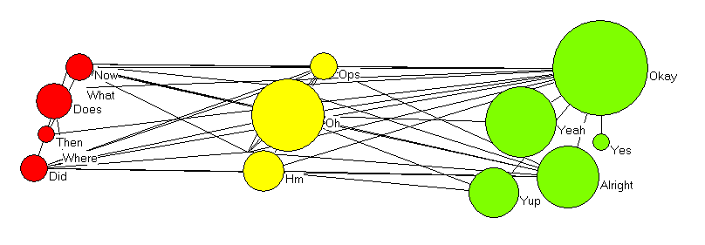
Expert 1
Figure 29: Semantic map for expert 1 (Naqvi et al. 2018)
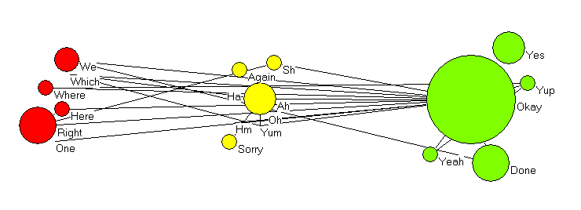
Expert 2
Figure 30: Semantic map for expert 2 (Naqvi et al. 2018)
The semantic maps for two experts look very similar, which highlights the similar cognitive experience of the two experts during the simulation. From the figures 29 and 30 we can notice, that the experts were mostly in the endorsing state. This suggests their better comprehension of situation and that they were able to understand most of the directions given by the driller. The lesser soliciting state is indicated of the same behavior and highlights that they rarely requested for any further elaboration for the driller, while had a little state of confusion during these activities (smaller muddled state). The higher endorsing state can be attributed to their higher comfort, comprehension and greater confidence levels during the task.
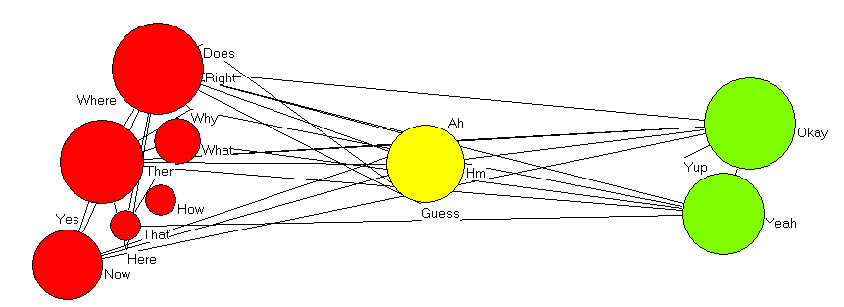
Novice 1
Figure 31: Semantic map for novice 1 (Naqvi et al. 2018)

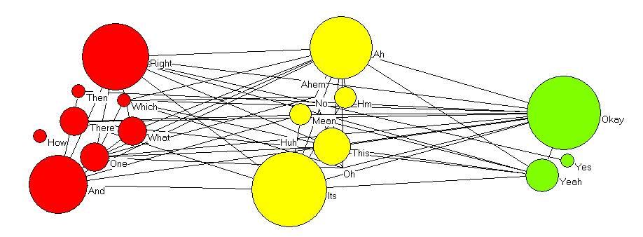
Novice 2
Figure 32: Semantic map for novice 2 (Naqvi et al. 2018)
In figure 31 and 32, which shows the semantic maps for the novice participants, we can notice a higher soliciting state and relatively smaller endorsing state. The higher soliciting state points to the higher need of elaboration or directions required by the novices to get through the simulation. While the lesser endorsing state highlights the lesser level of comfort and certainty among the novice participants.
The table 5 below summarize the percentage distribution of the participants in various states along with the operational time performance of the participants. Again, for the experts we can see the similar state distribution, which also corresponds to the similar operational time performance. While for the novices a larger soliciting and smaller endorsing state can be noticed. However, there is a larger difference in the muddled state between the two novices, which can be attributed to the individual cognitive and training differences among the participants.
Table 5: % Distribution of Psychological States and Operational Time Performance
Participants | Psychological States (%) |  |  | Operational Time Performance (minutes)
Participants | Soliciting | Muddled | Endorsing | Operational Time Performance (minutes)
Expert 1 | 13 | 23 | 64 | 16.3
Expert 2 | 16 | 16 | 68 | 16
Novice 1 | 54 | 13 | 33 | 14.5
Novice 2 | 34 | 42 | 24 | 18

From table 5 (Naqvi et al. 2018), we can also notice that novice 1 completed the task in the shortest time while novice 2, took the largest time to complete the task. On closer look we can observe the relation between the operational times with the muddled state. Figure 33 highlights the relation, where the participant with the largest muddled state took the highest time, while the one with the shortest state took the least amount of time to finish the experiment.

Figure 33: Operational time vs muddled state percentage (Naqvi et al. 2018)
  - Discussion
Through this analysis we can limit the muddled state that ends up on the rig site while the feedback from these insights can be used to provide better feedback. In real time this can help to predict the stress or confusion levels among the workers by analysis the muddled state and can be instructed to distress or request for additional help before continuing. Additionally, the lesser muddled state present at the rig site can be crucial in critical time dependent events like well control and stuck pipe.
During evaluation and training, benchmark semantic maps of industry experts can be used to compare the performance of candidates and the difference between the maps can be used to generate the feedback for further improvement in performance.
The CA can also be used during planning stage where it can skim the employee’s emails to not only detect different states but also attitudes that go in conflict with the ideology of the company. Again, referring to the infamous email from the Macondo engineer, CA could have blown the whistle when noticing words like “probably” or “who cares” connected with the same though group of an important well integrity activity like “cement job”. Moreover, CA can be used to motivate safe behavior and attitudes using psychologically wise interventions and bringing up relevant company policies for quick reference for engineers.

- MPD
As introduced in the section 1.4, the second phase of this work deals with the use of an unconvoluted task environment to optimize the interaction between the elements of the system and the humans (HF). An unconvoluted environment can help in complementing the computational abilities or skills of the actor to safely and soundly perform the job without any risk of unnecessary cognitive and physical overloading. Otherwise the optimal working of HF gets hampered and safety can be compromised.
Managed pressure drilling (MPD) is a technique that allows to precisely control and vary the annular pressure profile (Rehm et al. 2013). Through this the pressure inside the well is maintained within the mud window and above the reservoir pressure, otherwise its application is called underbalanced drilling. Main advantages of the technology involve lesser NPT and drilling cost and better operational safety.
There are different ways in which the technology is applied. Firstly, we have constant bottom-hole pressure (CBHP) which uses a choke to apply back pressure to maintain the wellbore pressure within the mud window. As highlighted in figure 34, this requires a use of lighter mud, giving a steeper mud gradient and the application of a surface pressure to keep the BHP above the reservoir pressure. Pressurized mud-cap drilling (PMCD) is another variety which maintains a column of fluid above the loss zone in the annulus, while the injected mud along with the cuttings goes to the loss zone and drilling continues without returns on surface. Dual gradient (DG) is another technique, where gross overbalanced conditions are eliminated or the equivalent circulating density (ECD) is reduced to drill depleted formations. Lastly, we have the return flow control (RFC) which allows for partial applications of managed pressure drilling to incorporate its safety features while drilling with conventional fluids program.
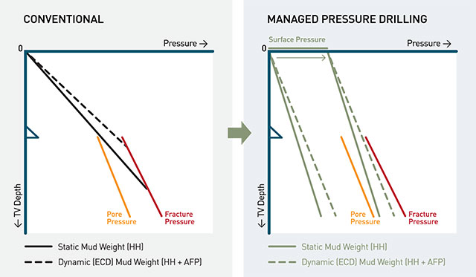
Figure 34: Narrow mud window drilling using MPD vs conventional drilling (Air-Drilling 2019)
Before establishing how task environment can be unconvoluted by the MPD, we have to look at the equipment that is used for this technique. Below we have the list of the main equipment, along with its description.
- RCD (Rotating Control Device) creates the closed loop drilling required for MPD. It is placed over the BOP and shuts the well around the drill pipe, by also allowing the pipe to rotate. With the well shut on surface the returns from the well are directed under the pressure towards the MPD manifold. There are two types of RCD, active & passive. The active RCD is tightened across the drill pipe and use the wellbore assistance pressure to further tighten the seal. For the passive RCD, the separate hydraulic pressure is used to seal the elastomer around the drill pipe and is not wellbore pressure assisted.
- MPD Choke is another crucial part of closed drilling loop. The choke is used to apply a surface back pressure which is used to keep the annular pressure within the mud window. The choke makes the pressure management dynamic and quick which makes MPD also ideal for well control applications.
- Drill pipe non-return valves are required as the back pressure can cause the annular pressure to be more than the drill string pressure. These valves stop any flow due to this U-tube effect. These valves are installed inside the drill string, below the BHA to also keep various BHA equipment save.
- Coriolis flowmeter is an important part of MPD equipment as it used to precisely measure the return flow, which is also laden with cuttings. The flow measurements of Coriolis meter are crucial for early detection of kick and losses during the well and assist in quick reaction for adjusting the back pressure accordingly.
With this equipment the well can be shut at surface using the RCD while the returns can be lined up through the MPD choke. Choke can manipulate the BHP inside the well, allowing to dynamically control and circulate the kick out without even stopping to drill. However, the surface handling volumes must be considered, and early kick detection is important to keep the influx volumes to minimum by adjusting the choke. Once the kick is detected, MPD allows for four different responses to safely control the kick (Smith and Patel 2012, Vajargah and van Oort 2015).
- Increasing the pump rate
- Increasing the annular backpressure
- Combination of the first two
- Shut-in the well
Before the response can be selected, maximum surface pressure (MASP) and lowest fracture pressure in the open hole must be considered. If influx volumes are large, then a conventional well shut-in will be preferred as there will be a risk of reaching MASP or underground blowout. The figure 35 shows the common risk matrix that in used to further assist the crew in optimal decision making during well control situation.
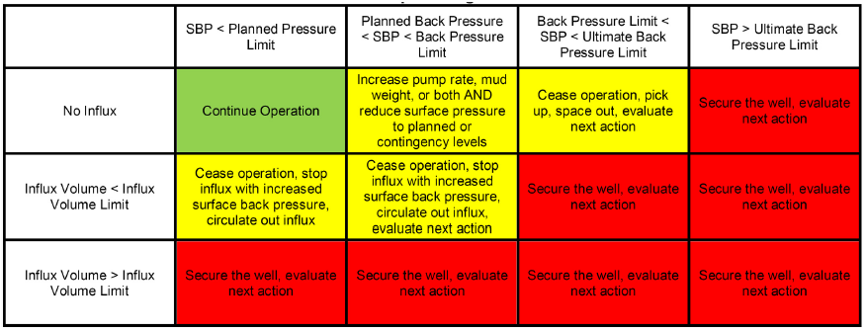
Figure 35: Generalized well control risk matrix (Rajabi et al. 2014)
  - Methodology
In this work we will see how the environment task can be unconvoluted through the application of MPD. Throughout this work, well control has been the main task of our analysis and again we will attempt to see how through MPD this task environment can be unconvoluted. DrillSim 50 simulator will be used to simulate a well control scenario and different well control methods will be applied separately to control and circulate the kick out. By this we can have an actual comparison between different techniques and the convolution of the task environment during each method. These methods will include the conventional Engineer’s method and dynamic well control imitating MPD (CBHP). Furthermore, testing a new technique like MPD under real kick situations can lead to catastrophic results by complicating the well control procedure in many ways. For example, there could be overlapping of dual interests to test the tool & killing the well. Additionally, the crew will have to adopt to a new procedure and a certain tool behavior can be miss-interpreted by the crew as a well response, due to their lack of exposure.
  - Experiment Design
A vertical well was designed with 9 5/8” casing at 3950 feet. The scenario begins with drilling 8 ½” hole at 5580 ft in the reservoir section. The initial formation pressure was 3000psi and mud weight of 10.5ppg is required to achieve the overbalance. After few feet of drilling, 3500psi kick was initiated. In two separate simulations, kick was controlled and circulated out using Engineer’s method and MPD, to have a comparative analysis of the two environments.
  - Analysis and Results
To really understand how the task environment is simplified, we will have to go through every step that needs to be done with both the methods to control and circulate the kick out. To compare the environments, we have generated simulation plots from the Drillsim 50 simulator for various parameters that help to understand the convolution of each method.
The plot has two sections A and B. The section A in the plot comprises of non-pressure related parameters. The ROP trend helps to compare the how the drilling is affected during each environment in response to the kick. The SPM are important to compare as, the flowrate to circulate out the kick is dependent on them. Higher SPM will allow to circulate the kick out faster, resulting in less NPT. The choke positing is shown to relate the pressure variations inside the well, during circulation. As the choke have to be used to maintain and regulate the back pressure accordingly.
The section B of the plot comprises of all the pressure related parameters with the plot y-axis in the section ranging from 0 to 5300 psi. The formation pressure trend is necessary to see when the kick formation is encountered. This identifies the exact position of the kick and allow us to compare who the formation pressure varies with the bottom hole pressure. The bottom hole pressure trend is important to see how quickly and smoothly the two methods were able to maintain the bottom hole pressure above the formation pressure to avoid any more kicks. The shoe fracture is the maximum limit of the annuals pressure and if the casing shoe pressure, increase above shoe fracture pressure the casing shoe will fracture and there will be an underground blowout. Lastly, another two important pressures during kick circulation are drill pipe and casing pressure. There values must be kept below the maximum allowable surface pressures and they are used as an indication of downhole pressure regimes during kick control and circulation.
    - Engineer’s Method
Engineer’s method is a widely used method to circulate the kick out. The method initiates after the kick has been detected and controlled by shutting the BOP. This method requires only one circulation to circulate the kick out and displace the well with the new kill mud. While for Driller’s method two separate circulations are required to circulate the kick out and displace the well with the kill mud. Table 2 highlights the events that take place once kick is encountered during drilling, and engineer’s method is employed.
Now let’s summarize the events for the engineer’s method to allow for a quick comparison with the dynamic well control through MPD. Once the kick is detected, the drilling needs to stop and well is shut-in. Drilling gets halted and NPT (nonproductive time) starts to occur. With the well shut-in, drill pipe pressure gets stabilized and kill mud weight is calculated. The crew must prepare the new kill mud and begins to circulate the well at SCR following the SIDPP vs the strokes trend. Appendix 2 presents the kill sheet that was prepared to carry out this circulation. The circulation time depends on the depth of the well and how the BHP is maintained constant during the entire process to avoid taking any more kicks inside the well. It is not uncommon to take several days to a week to control the well and displace it with new kill mud (Darwesh et al. 2017). Such tiring and long method with high potential to adverse consequences hanging over this entire time, makes the environment tough and demands for not only high computational abilities of the actors, but also test their decision making, risk awareness, situational awareness and team communication. The figure 36 shows an application of engineer’s method on the Drillsim 50 simulator, from detection to circulation. The x-axis of the plot shows the duration of the simulation in minutes.
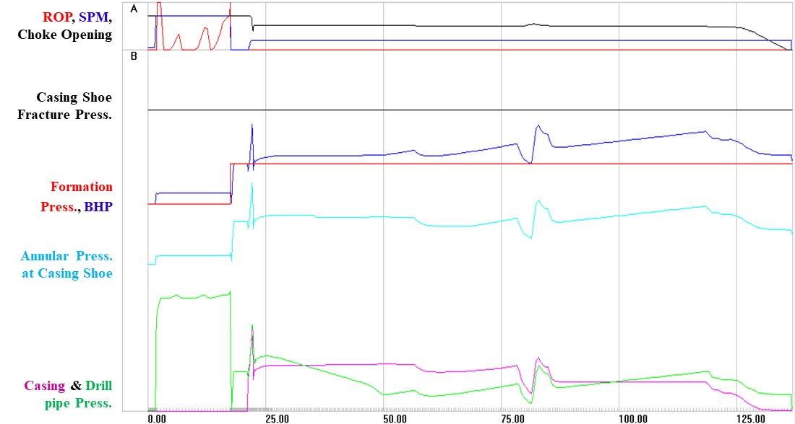
Figure 36: Kick detection and circulation using engineer’s method
In figure 36, the graph is divided in two sections A and B. The A sections show drilling parameters like ROP (red), SPM (blue) and remote choke position (black), while section B shows the trend of various important pressures like BHP (blue), reservoir pressure (red), drill pipe pressure (green), casing pressure (magenta), shoe fracture pressure (black) and casing shoe annulus pressure (cyan). For the initial first 15 minutes we can see the BHP is above the reservoir pressure and drilling in going on with several red peaks in the A section. At around 15 mins an over pressured formation in contacted and the reservoir pressure jumps to 3500psi. At this point the kick is detected and pumps are shut off, as the blue line drops to zero in the A section. The well is shut, and the BHP is allowed to stabilize and the SIDPP (green) rises from zero to a stabilized shut-in drill pipe pressure. After lining up the kill mud weight the pumps are brought to SCR and kick is circulation begins with the returns flowing through the restricted opening in the remote choke (black). With continued circulation and keeping the BHP (blue) above the reservoir pressure (red) to avoid any further kicks, the influx reaches the surface around 80 minutes in the simulation, which can be identified in the plot as a sudden fluctuation in wellbore pressures. With the influx out, the pumping is continued to displace the old mud with the new kill mud. The circulation stops when the kill mud reaches the surface. The well is opened, and flow check is performed to confirm the over balanced condition in the well.
So, after eliminating time taking surface activity like preparing kill mud and making sure no more kicks are taken during the circulation, the simulation took about 135 mins with at least two hours of NPT. During this time the crew is required to stay alert and precisely execute all the killing operations with no room for slightest of negligence. Now let’s compare how the same kick can be handled in the MPD environment.
    - Dynamic Well Control
Here we will see how the environment is unconvoluted by the use of MPD to control and circulate the same kick scenario. The figure 37 shows the how the MPD environment was imitated on the Drillsim 50 simulator.
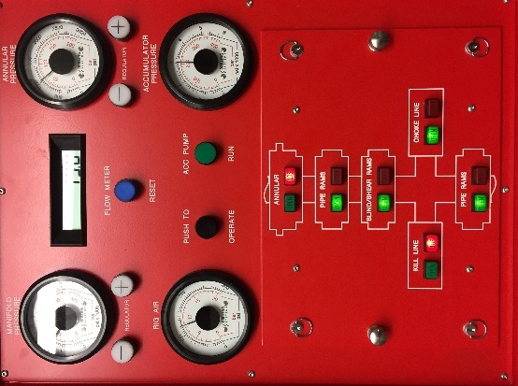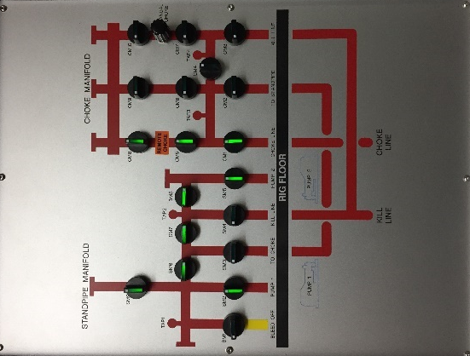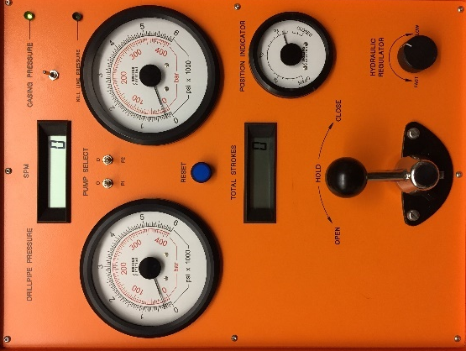
Figure 37: DrillSim 50 setup to imitate MPD. (L to R) BOP, manifold and remote choke
The initial state of the system involves the wellbore being shut-in using the annular rams which imitates the function of RCD. The choke line was lined up to pass the returns through the choke manifold, as can be seen on BOP and manifold. The remote choke on the choke manifold was used to apply a certain back pressure to keep the BHP above the reservoir pressure. 9ppg mud was used, with the back pressure of 400psi to achieve the overbalanced conditions while drilling the formation with 3000psi of pressure. The figure 38 shows how the same kick in the same scenario was circulated out in MPD environment.
Again, in figure 38, the plot is divided in two sections A and B. The A section show drilling parameters like ROP (red), SPM (blue) and remote choke position (black), while section B shows the trend of various important pressures like BHP (blue), reservoir pressure (red), drill pipe pressure (green), casing pressure (magenta), shoe fracture pressure (black) and casing shoe annulus pressure (cyan). In figure 38 we can see that the combination of 9ppg mud and 400psi back pressure kept the BHP (blue) above the reservoir pressure (red) of 3000psi. Soon after drilling few feet, the kick is encountered and the reservoir pressure (red) shoots to 3500psi. Once the kick is detected at surface, the choke (black) is slightly closed to increase the back pressure to take the BHP (blue) above the new reservoir pressure (red). This will instantaneously stop the influx, as compared to engineer’s method where after shut-in the influx continues till the BHP equalizes the reservoir pressure. With BHP (blue) above the reservoir pressure (red), the pumping continues at the same higher flowrate, which brings the influx quicker to the surface. While for engineer’s method you are required to pump at SCR (10, 20 or 30 SPM) which takes a longer time to circulate the kick out and displace the well with the kill mud.
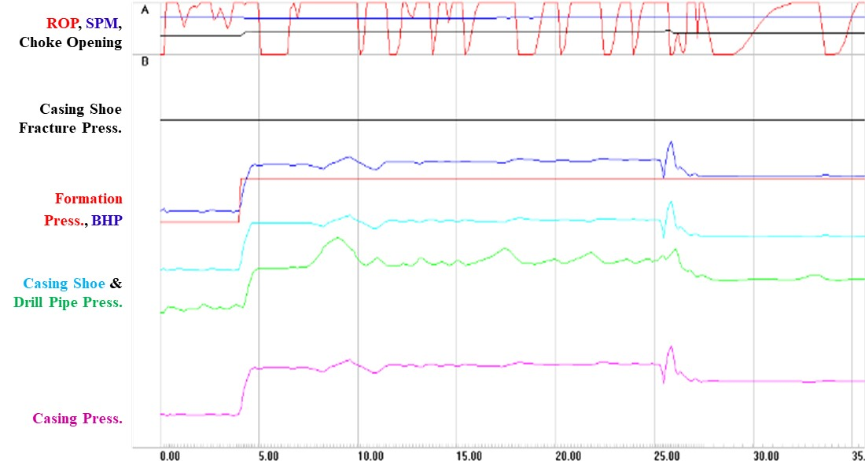
Figure 38: Dynamic well control using MPD
Furthermore, with the well shut-in at surface, there is no need to stop pipe rotation and drilling can continue. We can see the ROP (red) trend in the A section of the graph and can notice that drilling continued through this kill control and circulation process. This results in no NPT and kick is circulated out of the hole quicker, smoother and easily as compared to engineer’s method. There was also no need to weight up the mud or perform long kill sheet calculations. Everything stayed the same, only choke opening was reduced to increase the back pressure and the influx was out of the well in 20 minutes with zero NPT and hassle.
  - Discussion
For optimization of safety and performance, unconvoluted task environment shares the equal weightage as the computational abilities of the actor. The industry must look into how various troublesome process and methods can be made easier through better use and application of the technology. In this section we saw how MPD can be used to reduce the cognitive load on the crew by keep the well shut at all times and initiating a dynamic well control in case of a kick. With the wellbore being shut and MPD able to precisely regulate the annular pressure, there is a lesser risk of uncontrolled release of formation fluids into the well. However, if it does happen there won’t be any immediate risk for a surface blowout as the returns are always carried away from the surface.
Other than well control, MPD also assists in various other well integrity issues. The precise annular pressure control helps to make the well design simpler with lesser casing seats and cement jobs required. Secondly the induced losses into the formations are reduced, which helps to keep the well filled with mud at all times, reducing the risk for kicks into the well.
Although MPD is relatively expensive but given the operational benefits and reduction in NPT due to losses or kicks, the application of MPD becomes justified. MPD is just one technology that helps in creating an unconvoluted environment. There are many more technologies that can help towards making the task environment simpler. This in return will also make the training and evaluation process more rigorous and effective, resulting in even better optimization of safety and performance.

- Summary and Implications
This work presented the case on how well control and drilling safety can be optimized by integration of human factors. We discussed how either by increasing the human computational abilities or by un-convoluting the task environment we can optimize the performance and safety of the system. In that endeavor we went through the tools like eye tracking and content analysis to see how they can be incorporated at various stages of planning and execution to reduce the risk of incidents. We discussed how they can act as a whistle blower to nudge people towards risk averse attitude or how they can be of assistances to cognitively engineering the displays systems.
In terms of increasing the computational abilities of the actor, eye tracking and content analysis can be incorporated into the current well control training and evaluation criteria with very little to no change in the current infrastructure. The figure 39 presents the optimized simulation based evaluation criteria based on the several implications of having such tools as a part of the process:
- The insights from these tools can be used to trace the reason behind particular performance. This can assist in providing the targeted feedback to the participant to make the learning process more efficient.
- The insights from these tools can help in tracking the progress of the candidates. Comparison of successive plots (heat/gaze/semantic) can reveal the degree of improvements in the participant’s performance.
- The fixation data can allow us to do a direct quantitative comparison of performance with that of an expert. This can help towards training candidates till they closely match performance levels of an expert.
- Qualitative levels of different psychological states can help in identifying the degree of confidence/confusion the participant experienced during the simulation. This can help towards reducing the amount of muddled state that ends up on the rig site.
- These insights can help in improving the binary evaluation criteria, as benchmark results of expert can be used to measure the level of performance. This can add an additional sieve to optimize the evaluation criteria.
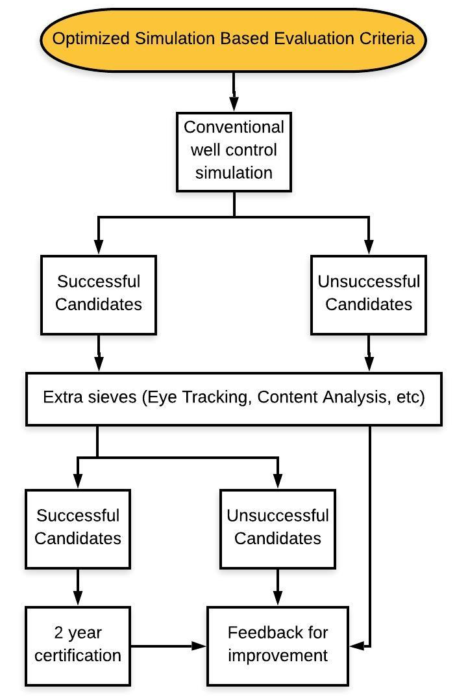
Figure 39: Proposed well control training and evaluation criteria (Naqvi et al. 2018)
On the task environment aspect, we see how MPD can allow us to create relatively unconvoluted task environment by using the dynamic well control technique. As compared to conventional well control methods, the implications on the task environment are summarized as:
- Zero non drilling time
- BOP remains shut the entire time
- Returns directed away from the rig floor
- Reservoir influx can be instantaneously stopped by increasing back pressure
- No need to wait for SIDPP to stabilize
- No need to perform long kill sheet calculations
- No need to prepare kill mud
- No need to pump at slow circulating rates
- Continue pumping at same higher flowrate
- Kick circulated out of well in less time
- No need to displace the system with new kill mud
Given these implications, the well control can be a shorter, safer, less fearful and a lesser demanding task physically and mentally. This along with better human computational abilities can create a pleasant harmony to extract the optimum performance with a lesser risk of human error.

- Conclusion
The stats have highlighted the large footprint of human factors in recent incidents in the oil and gas industry. With well control incidents being the most catastrophic, it is still largely dependent on optimal human performance. From kick detection, control and circulation, humans are required to perform under stress and fatigue with no room for error. To optimize human performance, this study presented a dual approach involving humans and the system they operate in. The work was built around how the human abilities can be enhanced through better trainings, while at the other end the task environment can be simplified and made less challenging to optimize safety and performance.
The need for better training and evaluation of rig crew to reduce well control incidents in the future was highlighted in several post Macondo reports and analysis. In that endeavor we analyzed how tools like eye tracking and content analysis can be incorporated in the current training and evaluation setup. Well control and routine drilling exercises were designed on DrillSim 50 and virtual reality drilling simulators to validate these tools. From analysis we found that these techniques can reveal several insights which are not available in the current binary evaluation criteria in practice. Although not limited to, the insights can help in targeted feedback for efficient learning. The various data plots can provide one look pictorial summaries of the performance and can be used to measure progress. The fixation data on participants can be compared with those of an expert can provide quantitative measure of difference from expert performance.
Similarly, human factors being an interaction of human with the elements of the system, the un-convolution of the task environment becomes equally important to optimize this interaction. For this cause, the application of dynamic well control through MPD was analyzed and compared with a conventional well control environment on the DrillSim 50 simulator. The results show that the task environment was simplified in several ways to optimize the performance and safety during a well control event. The MPD always allowed to keep the well shut due to the close loop application and in case of an influx, allowed for a timely detection of kick. No lengthy kill sheet calculations were required, and the BHP was precisely increased through the choke. The pumping and drilling continued at the same rate and the kick was out of the well without any stops or the need for a kill mud.
Together the better abilities of the crew and simplified task environment, the interaction between the elements of the system and the human can be optimized achieving enhanced safety and performance.

- Recommendations
Optimizing the interaction between the elements of the system and the humans is an ongoing process. Through further research, more techniques like galvanic skin response or heartbeat measurement can be incorporated in the well control training criteria to get more insights into human performance. While the task environment can be further simplified by techniques like automated kick detection and blow out preventers. Although there is still a long way to go and a lot more to be done, but with continued commitments we can make this process more efficient and useful.

References

Air-Drilling. Drilling Services, https://airdrilling.com/drilling-services/.
Badke-Schaub, Petra, Hofinger, Gesine, and Lauche, Kristina. 2012. Human Factors. Human Factors: 3-20.
Bartlit, FH, Sankar, S, and Grimsley, S. 2011. Macondo—The Gulf Oil Disaster.
Bellenkes, Andrew H, Wickens, Christopher D, and Kramer, Arthur F. 1997. Visual scanning and pilot expertise: the role of attentional flexibility and mental model development. Aviation, space, and environmental medicine 68 (7): 569-579.
Berelson, Bernard. 1971. Content analysis in communications research. 866 Third Avenue, New York, N.Y. 10022: Hafner Publishing Company, INC
Borthwick, David. 2010. Report of the Montara Commission of Inquiry.
Bourgoyne Jr, Adam T, Millheim, Keith K, Chenevert, Martin E et al. 1986. Applied drilling engineering. Volume 2.
Cai, Baoping, Liu*, Yonghong, Zhang, Yunwei et al. 2013. A dynamic Bayesian networks modeling of human factors on offshore blowouts (in English). Journal of Loss Prevention in the Process Industries 26 (4): 639-649. <Go to ISI>://WOS:000319794200007.
CBS. 2018. CSB Releases Factual Update on Blowout and Fire at Pryor Trust Gas Well in Pittsburg County, Oklahoma U.S. Chemical Safety Board (CSB) (Reprint). https://www.csb.gov/csb-releases-factual-update-on-blowout-and-fire-at-pryor-trust-gas-well-in-pittsburg-county-oklahoma-/.
Cullen, Lord W Douglas. 1993. The public inquiry into the Piper Alpha disaster. Drilling Contractor;(United States) 49 (4).
Dadmohammadi, Y, Salehi, S, Kiran, R et al. 2017. Integrating Human Factors into Petroleum Engineering's Curriculum: Essential Training for Students. Proc., SPE Annual Technical Conference and Exhibition.
Daley, Barbara J. 1999. Novice to Expert: An Exploration of How Professionals Learn. Adult Education Quarterly 49 (4): 133-147. http://journals.sagepub.com/doi/abs/10.1177/074171369904900401.
Darwesh, Ali K, Maack Rasmussen, Thorkild, and Al-Ansari, Nadhir. 2017. Kicks controlling techniques efficiency in term of time. Engineering 9 (5): 482-492.
Downe‐Wamboldt, Barbara. 1992. Content analysis: method, applications, and issues. Health care for women international 13 (3): 313-321.
Drilling Systems. 2018. DrillSim50. Drilling Systems (UK) Ltd, https://www.drillingsystems.com/DrillSim_502018).
DrillSim. 2005. Drilling & Well Control Simulator Operator's Manual (Reprint).
Elo, Satu and Kynga¨s, Helvi. 2008. The qualitative content analysis process. Journal of Advanced Nursing 62(1), 107–115.
Ericsson, K Anders, Krampe, Ralf T, and Tesch-Römer, Clemens. 1993. The role of deliberate practice in the acquisition of expert performance. Psychological review 100 (3): 363.
Ferry, Natalie M and Ross-Gordon, Jovita M. 1998. An inquiry into Schön's epistemology of practice: Exploring links between experience and reflective practice. Adult Education Quarterly 48 (2): 98-112.
Fitts, Paul M, Jones, Richard E, and Milton, John L. 1950. Eye movements of aircraft pilots during instrument-landing approaches. Aeronautical engineering review 9 (2): 24-29.
Flin, Rhona, Mearns, Kathtyn, Gordon, Rachael et al. 1996. RISK PERCEPTION BY OFFSHORE WORKERS ON UK OIL AND GAS PLATFORMS. Safety Science 22: 131-145.
Flin, Rhona, Slaven, Georgina, and Stewart, Keith. 1996. Emergency decision making in the offshore oil and gas industry. Human Factors 38 (2): 262-277.
Glaholt, Mackenzie G and Reingold, Eyal M. 2011. Eye movement monitoring as a process tracing methodology in decision making research. Journal of Neuroscience, Psychology, and Economics 4 (2): 125.
Goldsman, David, Nance, Richard E, and Wilson, James R. 2010. A brief history of simulation revisited. Proc., Proceedings of the winter simulation conference567-574.
Gordon, Rachael P. E. 1998. The contribution of human factors to accidents in the offshore oil industry. Reliability Engineering & System Safety 61 (1): 95-108. http://www.sciencedirect.com/science/article/pii/S0951832098800033.
Graham, Bob, Reilly, William K., Beinecke, Frances et al. 2011. Deep Water The Gulf Oil Disaster and the Future of Offshore Drilling.
Graneheim, U.H. and Lundman, B. 2004. Qualitative content analysis in nursing research: concepts, procedures and measures to achieve trustworthiness. Nurse Education Today (24): 105–112.
Harris Sr, Randall L, Glover, Bobby J, and Spady Jr, Amos A. 1986. Analytical techniques of pilot scanning behavior and their application.
Harwood, Tracy G. and Garry, Tony. 2003. An Overview of Content Analysis The Marketing Review 3 (4): 479-498.
Henry, Amanda. A Brief History of Simulation Training. Industrial Training International, https://www.iti.com/blog/a-brief-history-of-simulation-training-.
Holand, Per. 2017. Loss of Well Control Occurrence and Size Estimators, Phase I and II, Exprosoft.
Hopkins, Andrew. 2012. Disastrous Decisions: The Human and Organisational Causes of the Gulf of Mexico Blowout, 15-16: CCH Australia Limited.
Hsieh, Hsiu-Fang and Shannon, Sarah E. 2005. Three Approaches to Qualitative Content Analysis. Qualitative Health Research.
Hsieh, Linda. Human factors: the next safety frontier, http://www.drillingcontractor.org/human-factors-the-next-safety-frontier-30554.
IADC. INTERNATIONAL ASSOCIATION OF DRILLING CONTRACTORS, http://www.iadc.org/well-control-institute/.
IEA. International Ergonomics Association https://www.iea.cc/whats/index.html.
Islam, Rabiul, Yu, Hongyang, Abbassi, Rouzbeh et al. 2017. Development of a monograph for human error likelihood assessment in marine operations. Safety science 91: 33-39.
IWCF. International Well Control Forum, http://www.iwcf.org/ (accessed May 15, 2018.
Jones, Debra G. and Endsley, Mica R. 1996. Sources of situation awareness errors in aviation. Aviation, Space, and Environmental Medicine 67 (6): 507-512.
Just, Marcel A and Carpenter, Patricia A. 1980. A theory of reading: From eye fixations to comprehension. Psychological review 87 (4): 329.
Kang, Ziho. Human Factors & Simulation, https://humanfactors.oucreate.com/research.html.
Kelly, Damien and Efthymiou, Merina. 2019. An analysis of human factors in fifty controlled flight into terrain aviation accidents from 2007 to 2017c. Journal of Safety Research.
Kiran, Raj, Salehi, Saeed, Jeon, Jiwon et al. 2018. Real-Time Eye-Tracking System to Evaluate & Enhance Situation Awareness & Process Safety in Drilling Operations.
Kiran, Raj, Salehi, Saeed, and Teodoriu, Catalin. 2018. Implementing Human Factors in Oil and Gas Drilling and Completion Operations: Enhancing Culture of Process Safety. Proc., ASME 2018 37th International Conference on Ocean, Offshore and Arctic EngineeringV008T11A022-V008T11A022.
Krippendorff, Klaus. 2004. Content Analysis An Introduction to its Methodology, Second edition.
Marcano, Laura, Haugen, Finn Aakre, Sannerud, Ronny et al. 2019. Review of simulator training practices for industrial operators: how can individual simulator training be enabled? Safety science 115: 414-424.
Mearns, Kathryn, Flin, Rhona, Gordonhona, Rachael et al. 2001. Human and organizational factors in offshore safety. Work & Stress 15:2: 144 - 160.
Merwe, Koen van de , Dijk, Henk van , and Zon, Rolf. 2012. Eye Movements as an Indicator of Situation Awareness in a Flight Simulator Experiment. The International Journal of Aviation Psychology 22 (1): 78-95. https://doi.org/10.1080/10508414.2012.635129.
Morgan, David L. 1993. Qualitative Content Analysis: A Guide to Paths Not Taken. Qualitative Health Research 3 (1): 112-121.
Naqvi, Syed Ali Mehdi, Raza, Muhammad, Ybarra, Vincent T et al. 2018. Using Content Analysis through Simulation-Based Training for Offshore Drilling Operations: Implications for Process Safety. Process Safety and Environmental Protection.
National Oil Spill Commission. 2011. Deep Water: The Gulf Oil Disaster and the Future of Offshore Drilling: Report to the President, National Commission on the BP Deepwater Horizon Oil Spill and Offshore Drilling, Washington DC (Reprint). https://www.gpo.gov/fdsys/pkg/GPO-OILCOMMISSION/pdf/GPO-OILCOMMISSION.pdf.
Neuendorf, Kimberly A. 2002. The Content Analysis Guidebook: SAGE Publications.
NSOAF, North Sea Offshore Authorities Forum. 2014. Human and Organisational Factors in Well Control.
Odgaard, Jacob and Morton, Tim. 2017. Integrating Human Factors into Well Control. Presented at the SPE/IADC Drilling Conference and Exhibition, The Hague, The Netherlands. 2017/3/14/.
OGP. 2014. Crew Resource Management for Well Operations teams, International Association of Oil & Gas Producers
OSPRAG. 2011. Strengthening UK Prevention and Response, Oil Spill Prevention and Response Advisory Group.
Polit, Denise F and Beck, Cheryl Tatano. 2004. Nursing research: Principles and methods: Lippincott Williams & Wilkins.
Rajabi, Mehdi Mir, Hannegan, Don M, and Moore, Dennis Derrick. 2014. The MPD Well Control Matrix; What is Actually Happening. Proc., SPE Annual Technical Conference and Exhibition.
Rehm, Bill, Schubert, Jerome, Haghshenas, Arash et al. 2013. Managed pressure drilling: Elsevier.
Understanding Human Factors – a guide for the railway industry, 2008: Rail Safety and Standards Board.
Salehi, S., Kiran, R., Kang, Z. et al. 2018. Using Virtual Simulator in Developing an Eye Tracking-Based Framework for Improving Safety in Offshore Operation. Safety.
Salehi, Saeed, Kiran, Raj, Jeon, Jiwon et al. 2018. Developing a cross-disciplinary, scenario-based training approach integrated with eye tracking data collection to enhance situational awareness in offshore oil and gas operations. Journal of Loss Prevention in the Process Industries.
Sarter, Nadine B., Mumaw, Randall J., and Wickens, Christopher D. 2007. Pilots' Monitoring Strategies and Performance on Automated Flight Decks: An Empirical Study Combining Behavioral and Eye-Tracking Data. Human Factors 49 (3): 347-357. http://journals.sagepub.com/doi/abs/10.1518/001872007X196685.
School, Aberdeen Drilling. 2002. Well control for the rig-site drilling team. Training Manual.
Schulte-Mecklenbeck, Michael, Kuehberger, Anton, and Ranyard, Rob. 2011. A Handbook of Process Tracing Methods for Decision Research: A Critical Review and User’s Guide. 270 Madison Avenue New York, NY 10016: Psychology Press.
Shanks, David, Wong, Roger Y, Roberts, James M et al. 2010. Use of simulator-based medical procedural curriculum: the learner's perspectives. BMC medical education 10 (1): 77.
Simon, Herbert A. 1990. Invariants of human behavior Annual Reviews
Smith, John R. and Patel, Bhavin M. 2012. A Proposed Method for Planning the Best Initial Response to Kicks Taken During Managed-Pressure-Drilling Operations. SPE Drilling & Completion 27 (02): 194-203. https://doi.org/10.2118/143101-PA.
Smith, Patrick, Kincannon, Haley, Lehnert, Ryan et al. 2013. Human error analysis of the Macondo well blowout. Process Safety Progress 32 (2): 217-221.
Sneddon, Anne, Mearns, Kathryn, and Flin, Rhona. 2006. Situation awareness and safety in offshore drill crews. Cognition, Technology & Work 8 (4): 255-267.
Sonneman, Paul. 1992. The Psychology of Well Control. Presented at the IADC Well Control Conference Houston, TX.
Sookdeo, Terrance, Craig, Steven, Fernandes, Mary et al. 2017. The Critical Flaws of Current Well Control Drills. Presented at the SPE/ICoTA Coiled Tubing & Well Intervention Conference & Exhibition Houston, TX, USA.
SPE. 2014. SPE Technical Report, Society of Petroleum Engineers.
Spetalen, Halvor and Sannerud, Ronny. 2015. Experiences with the use of simulation as transfer strategy.
Spill, National Commission on the BP Deepwater Horizon, Drilling, Offshore, Graham, Bob et al. 2011. Deep water: the gulf oil disaster and the future of offshore drilling: report to the president: The Commission.
Spivey, MJ, Richardson, Daniel, and Dale, Rick. 2009. The movement of eye and hand as a window into language and cognition. Oxford handbook of human action 2: 225.
Thomas, Lisa C and Wickens, Christopher D. 2004. Eye-tracking and individual differences in off-normal event detection when flying with a synthetic vision system display. Proc., Proceedings of the human factors and ergonomics society annual meeting1, 223-227.
Thorogood, J.L., Lauche, K., Crichton, M. et al. 2015. Getting to Grips with Human Factors in Drilling Operations Presented at the SPE/IADC Drilling Conference and Exhibition London, UK.
Tobii, Pro Lab. 2018. Tobii Pro Lab User’s manual v.1.89 - (Reprint).
Tobii, Pro Lab. Performing a calibration and validation in Pro Lab, https://www.tobiipro.com/learn-and-support/learn/steps-in-an-eye-tracking-study/run/performing-a-calibration-and-validation-in-pro-lab/.
Vajargah, Ali Karimi and van Oort, Eric. 2015. Early kick detection and well control decision-making for managed pressure drilling automation. Journal of Natural Gas Science and Engineering 27: 354-366.
Vlieger, Esther and Leydesdorff, Loet. 2011. Content Analysis and the Measurement of Meaning: The Visualization of Frames in Collections of Messages. The Public Journal of Semiotics.
Wang, Jin and Trbojevic, Vladimir. 2007. Design for safety of marine and offshore systems.
Weber, Robert. 1990. Basic Content Analysis: Sage Publications, Newburry Park, CA.
Wilson, JA and Stanton, NA. 2004. Safety and Performance Enhancement in Drilling Operations by Human Factors. UK Health and Safety Executive Research Report 264.
Ybarra, V. , Raza, M. , Ghazal, S. et al. 2019. Using Process Tracing and Simulated Scenarios to Validate Oil Well Operator Assessment. Presented at the International Conference on Ocean, Offshore & Arctic Engineering (OMAE), Glasgow, Scotland, UK

(Kiran, Salehi, and Teodoriu 2018),(Kiran, Salehi, Jeon, et al. 2018), (Salehi, Kiran, Jeon, et al. 2018), (Salehi, Kiran, Kang, et al. 2018)

- Appendix 1
Partially filled kill sheet provided to the participants for the eye tracking experiment.
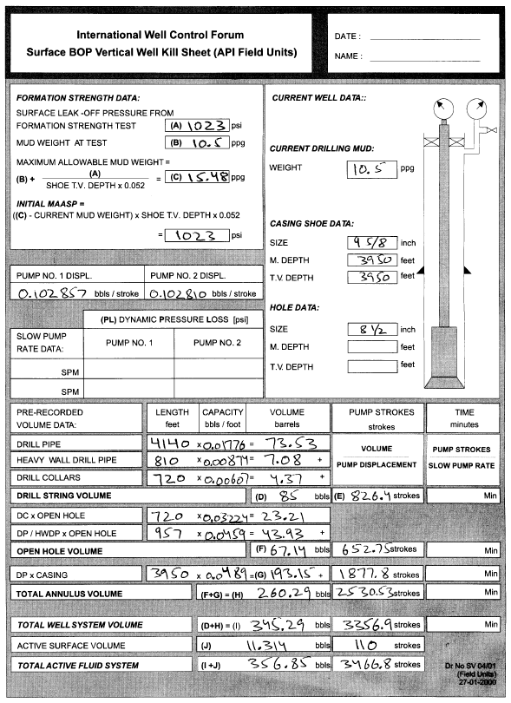
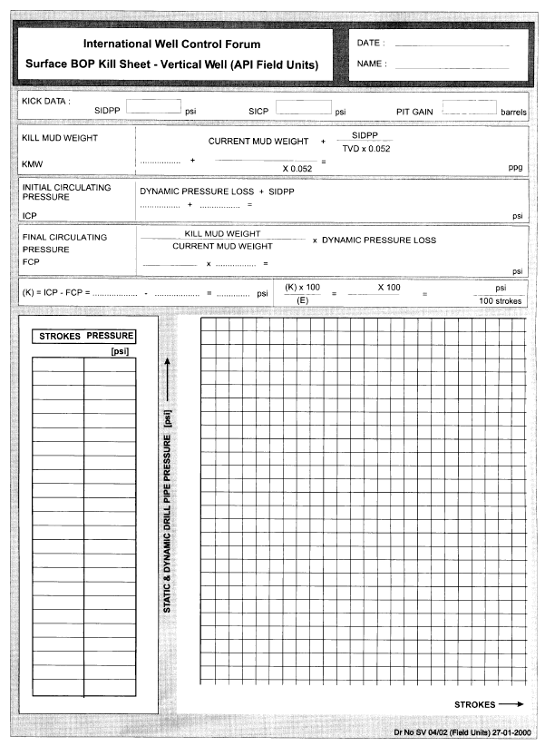

- Appendix 2
The below kill sheet was prepared to carry out the engineer’s method circulation for the conventional convoluted environment.
