UNIVERSITY OF OKLAHOMA
GRADUATE COLLEGE

Implementation of a Digital Sucker Rod Pumping Unit for Research and Educational Purposes

A THESIS
SUBMITTED TO THE GRADUATE FACULTY
In partial fulfillment of the requirements for the
Degree of
MASTER OF SCIENCE

By
Erik Jonathan Pienknagura Dolberg
Norman, Oklahoma
2019

Implementation of a Digital Sucker Rod Pumping Unit for Research and Educational Purposes

A THESIS APPROVED BY
MEWBOURNE SCHOOL OF PETROLEUM AND GEOLOGICAL ENGINEERING

BY

Dr. Catalin Teodoriu, Chair
Dr. Xingru Wu
Dr. Hamidreza Karami

© Copyright by Erik Jonathan Pienknagura Dolberg 2019
All Rights Reserved.
Table of Contents
Abstract VI
1.Introduction 1
1.1 Importance of Sucker Rod Pumps 1
1.1.1 Why Sucker Rod Pumps are relevant? 1
1.1.2 History 3
1.2 Problems with Sucker Rod Pumps 7
1.2.1 Deviated Wells 8
1.2.2 Gas Interference 10
1.2.3 Technology Not Reaching Class 13
2.Sucker Rod Pump Theory 14
2.1 Pumping Units (Pumping Geometries) 15
2.1.1 Conventional Motion 15
2.1.2 Unconventional Units 22
2.2 Sucker Rod Pump Theoretical Models 24
2.2.1 Early Model 25
2.2.2 API RP 11L 26
2.2.3 Wave Equation 27
2.4 Industry answer and OU machine 29
2.4.1 Industry Solutions 29
2.4.2 OU Approach 31
3.Proposed Setup 33
3.1 Proposed Laboratory Setup 34
3.2 Linear Actuator 38
3.3 Casing and Rod 43
3.4 Data Acquisition System 44
3.5 Load Cell 45
3.6 Liquid System 47
3.7 Sensors 50
4. Use as a Research Platform 51
4.1 Pumping Unit in Motion 52
4.2 Sensor data 57
4.2 Simulations of Wave Equation 59
4.5 Dynamometer Cards 62
4.6 Educational setting 66
4.7 Recommendations 68
5. Conclusion 68
6. References 71
7.Index 74

Abstract
Sucker rod pumps are one of the most popular solutions for artificial lift since its inception in the 19th century and its design has not changed much since then. In the present, companies are deploying digital technology in the field and, there has been a big push for a networked oilfield in recent years. This means technology is now able to control machines in remote places, calculate its performance and control safety operating parameters. But these digital solutions are still not available in universities, where there is a technological and technical gap for students and researchers in some respects.
The main objectives in this thesis is to first, highlight how to build a digital sucker rod pump in the lab, mimic different rod string motions in the well under a single unit, help students understand the digital and mechanical aspects of this sucker rod pump, and to create a research platform with the generated data for analysis. The approach is to build a digital sucker rod pump and have a system like the ones in the field. The software selected for the system is LabVIEW that will control all the necessary equipment. Also, data output from the sensors could be used in the same software to make dynamometer calculations and graph the data without the need to export to other programs.
In the last year, a lot of work has been put in selecting the right equipment, solving build issues and somewhat testing different hardware. But now there is a clear path on how to make this machine work properly by choosing solutions like LabVIEW, servomotors, digital control units, and sensors in a single system. This system can build personalized dynocards graphs, intake live data and can export the data to other programs live Excel, MATLAB, R, etc.…
As a result, this digital machine will help researchers create dynocards corresponding to different pumping units, create a new platform to test gas lock or friction in deviated wells, use the data the machine produces for educational purposes and have a digital platform that can be automated and controlled like modern sucker rod pumps in the field.

1.Introduction

1.1 Importance of Sucker Rod Pumps

1.1.1 Why Sucker Rod Pumps are relevant?
Artificial lift is one of the most influential segments in the Oil and Gas industry. Recovering crude oil and gas efficiently is one of the main objectives in the 21st century to reduce costs. Sucker Rod Pumping (SRP), also called Walking Beam Pumping or Beam Pumping Unit (BPU), is the oldest and one of the most used pumping methods in the market today. SRPs tend to look as simple machines, but behind the scenes, complex calculations and simulations must be performed to understand their behavior. For this, technology has influenced new models of pumping units that are digital, so that data acquirement and processing can be done remotely. The advantage of networked units is the real-time control of the operations which means they can run at optimal conditions. Due to this, if there are operational problems, engineers are notified and know where to go to fix it, instead of checking every well to see if there is any interruption in operations. Therefore, networking and digitalization of SRPs can achieve an economic advantage that is being exploited by big companies to produce more fluids with fewer resources and minimal downtime.
Economic factors make SRPs a popular candidate for many wells. Some of the advantages are reliability, availability, and efficiency. They tend to run mostly unsupervised for long periods and without much maintenance compared to other lifting solutions. It has been known that even if an operator was negligible with it, they run for long periods and can be fixed at low costs. The adaptability of the machine is another economic incentive as it can be done by changing operating parameters in the power unit and the balancing weights. Another important difference is that because the pumping unit is on the surface, a lot of the operational problems can be solved without the need for retrieval of the pump or rod string. This leads to reduced maintenance cost, as they tend to be straight forward and does not require big rigs to fix them. In the end, economic and safety factors are some of the strong points for choosing SRPs, and if an appropriate engineered solution for a well is developed, it can decrease downtime.
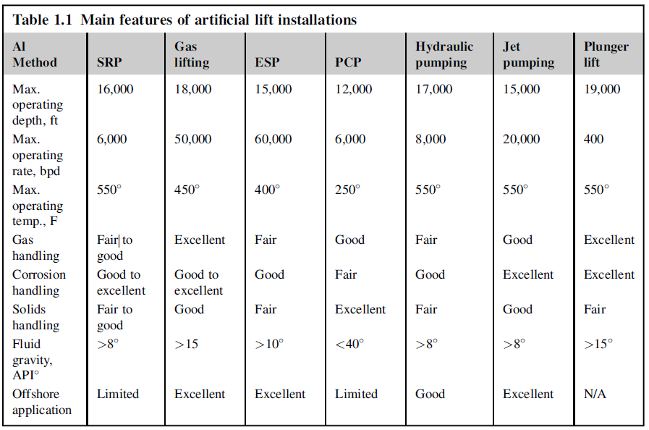
Table 1 Artificial Lift Table Comparing Pumping Features (Takacs 2015)
SRPs compared to other solutions in the market, have great flexibility, and all-around specs as seen in Table 1. SRPs have a significant advantage in gas, corrosion, and solids handling. It can produce low API crude oils (high viscosity) and have a high-temperature rating. This adaptability to different well scenarios makes the SRP a popular candidate and even an economically viable solution when reaching the end of life in a well. Furthermore, they are cheap to operate and can be even moved to new wells once they are done in one location. In the grand scale, there are two general classifications when talking about rod pumping units, conventional and unconventional. In section 1.1.3, discussion of different pumping geometries and their importance for the project will be explained. For now, it makes sense to research more about this type of artificial lift, and because of the recent advancements in technology, it is useful to have a digital research platform in the University of Oklahoma to keep up with the market.
The objectives of this new project will be:
- To mimic different pumping units that are already available in the market under a single unit.
- Bring new technology into the university.
- Develop a new research platform.
- Build a state-of-the-art educational tool.
In this paper, we will discuss how each unit delivers power to the bottom hole pump and how loads affect the rod string in the well. This project aims to eliminate their physical limitations and mimic the rod string motion. This kinematic approach is important because of how each pumping unit movement is inherently different as their mechanisms and/or structures differ greatly. However, to achieve this, I used a software/hardware approach by using LabVIEW for equipment control and dynamometer card display.

1.1.2 History
During the 19th century, when percussion drilling was used, SRP was initially the best/only method available at the time. Steam engines were used to power drill shallow reservoirs, and the well would produce for many months until a decline in reservoir energy hampered fluids to flow naturally (Takacs 2015). It was common for operators to leave the steam engines used for drilling on site until an SRP was placed to restart or increase production. As new machines were developed decades later, rotary tools took hold in the industry, so rotary pumps suddenly became available to many, and it was suggested it would end up replacing SRPs. In the present, SRPs are still a widely used artificial lift method and part of the reason is that it found a range of well candidates where it is economically and logically viable to use it. Adding to this, digitalization of the pumping unit has given rod pumping strategical importance as control and well performance can be done remotely.
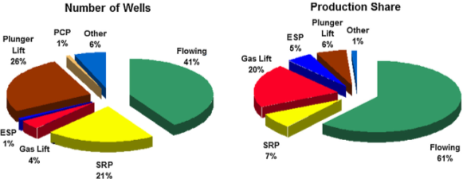
Fig. 1 Data of SRP Influence by the Number of Wells (Left) and Production Share (Right) Based on the World’s Total Oil Production (Takacs 2015)
In Fig. 1, it can be seen how SRPs still have a great market share by the number of wells serviced being about 21% of total wells in the world. Compared to others, it is one of the most common lifting methods available today. Relatively, SRPs are good for low to moderate daily production and on the right side of the pie chart in Fig. 1, it shows why its production share is low with only a 7% of global production share despite their popularity. However, in some instances, they can also produce as high as 8,000-barrel fluid per day (BFPD) (Takacs 2015), but it is not recommended.
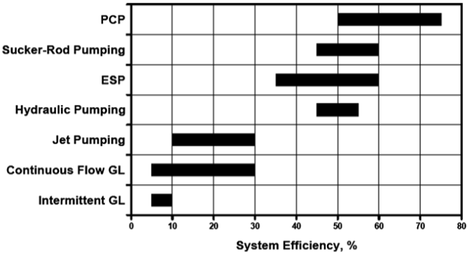
Fig. 2 System Efficiency on various Artificial lifting methods (Takacs 2015)
Other technical reasons for the importance of SRP are reliability and efficiency. The total efficiency of an artificial lift installation is the combined amount of energy required to operate and the hydraulic power spent on lifting fluid to surface. This main efficiency is the product of individual efficiencies of the components of the system. Overall, efficiency is based on the effectiveness of the lifting mechanism, geometry, power losses in well and surface (Takacs 2015). Therefore, in Fig. 2, there is a range of common efficiencies and SRP is still one of the most efficient methods available and its range of efficiency is relatively short, making it more predictable than its peers. So as companies tailor their operations on each well, SRP offers a cost-effective tool with clear advantages for its market segment.
Advances in technology and new pumping methods also influenced the change of SRPs into a highly defined application sector. In the last decades, because of limitations in material properties and increased well complexity, a drawback for SRP in the industry is the tendency of increased depth in wells. This is a major limiting factor as production decreases in response to increased loads in the rod string, where stretching becomes a serious problem. Production decreases exponentially with depth, and rod string material needs to be stronger but also lighter, tailored for cyclic stresses. While this requires a different approach, new materials are being developed to counter high reservoir depths and allow the SRP to increase their reach regardless of increased load conditions while sustaining reliability.
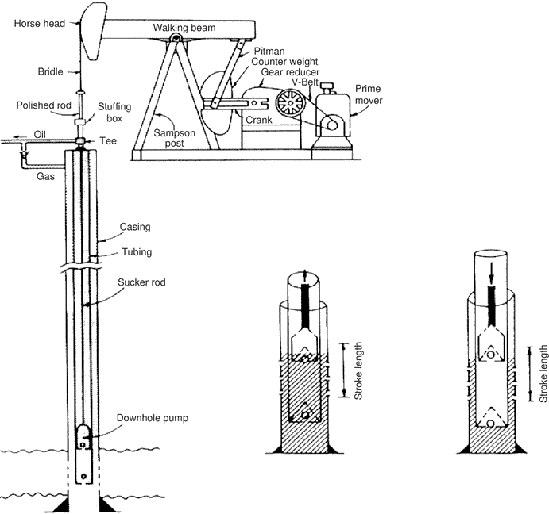
Fig. 3 SRP Main System Elements (Teknik 2019)
To understand more about SRPs, characterization of the equipment will be split into two sections as seen in Fig. 3. One is the surface equipment that includes the pumping unit, stuffing box, and wellhead. The next section is the downhole equipment that encompasses the rod string, anchor, pump and any other extra equipment such as downhole separators. The pumping unit is normally composed of a Horsehead, walking beam, Sampson post, a gearbox, and a prime mover. In the power categories, there are two main segments that are Conventional and Unconventional pumping units, and in chapter 2.1 the most relevant ones for this project will be shown. Switching to the downhole equipment, the rod string is composed of several rod elements connected through couplings to the required depth. Later, the rod string interaction with the fluids in the well is shown and how it affects the kinematic motion of the system in chapter 2.2 where friction interaction is discussed. The final element is the pump, that is composed of a barrel, plunger, standing valve, and traveling valve. All these components in the pump interact with each other depending on the motion, let this be upstroke or downstroke. The fluid that will be transient or above the pump is also a concern when designing equipment, as first fluid creates a hydrostatic load in the string, and in the upstroke, this load is increased with dynamic motion. This load will concentrate on the standing valve promoting the elongation of the rod string. Instead, in the downstroke and with the condition of no tubing anchor, the traveling valve will open, and the downhole valve will close supporting the weight of the fluid and will elongate in a similar fashion. As mentioned, dynamic load changes will affect elongation, and pumping geometries will affect stretching in varying degrees as a result, this will lead to a reduced effective stroke length. Therefore, identifying pumping geometries, stretching characteristics and pump limitations become important when selecting a solution for any client.

1.2 Problems with Sucker Rod Pumps
As with many tools and procedures in the oilfield, there are still many problems to solve, old and new. For this project, there is going to be 3 main problems to discuss, deviated wells, gas interference and finally technology reach. A lot of these changes are being adopted along with the advent of the shale revolution, as companies are still trying to update models and equipment, to be compatible with modern techniques and production operations. Starting with one of the biggest changes in well construction, deviated wells make a great candidate to study and research for sucker rod pumps. There is a need to adapt to new well completion guidelines and maintain an economic advantage relative to other pumping methods. Another important topic regarding SRPs is to continue research into gas interference. As a lot of wells must be analyzed for gas production and handling to prevent or plan for future gas production. But well and fluid analysis sometimes fails because there are other interactions not previously accounted for occurring in the reservoir, increasing gas production. These wells will develop gas problems, so researching solutions for gas interference in the lab is something that is still sought after. Finally, a lot of companies today are embracing digital tools and networks that can produce great amounts of information through remote sensors, so later this data can be used for analysis, calculation of production in real time, and to solve operational problems.

1.2.1 Deviated Wells
In the modern oilfield deviated wells are very common, especially with unconventional reservoirs becoming so popular in the US. The demand for longer laterals is one of the main reasons for improved technology, so companies can stay competitive and keep up with their client's demands. It is known horizontal wells cost more to drill, but statistically, they will produce more hydrocarbons and because fewer wells are required for the same draining area, efficiency increases. To check this, in 2017 vertical wells with a production range of 100 to 3200bbl/d accounted for only 1% of total vertical wells. Instead, horizontal wells with the same range of production have 30% of the total active horizontal wells (Tsai et al. 2017). Not only does horizontal wells most of the times have better production because of better reservoir contact, but they are also becoming more popular. While some problems persist with cementing, completion, drilling or other treatment that is relatively simple in vertical wells, horizontal technology is being developed at a fast pace to overcome obstacles. This trend is only going to grow, and sucker rod pumps will have to adapt to these new conditions and methodologies to be able to produce this type of wells.
The way to plan the production of a conventional reservoir is by understanding the well limitations, production rate, and production potential. The problem in unconventional wells is answering “how do we measure well deliverability and production rate changes” in time? So, by adding a sucker rod pump element, it complicates the model of well performance (Orji 2016). Other problems arise from deviated wells, as careful planning in the borehole deviation is necessary to avoid severe doglegs, as they are one of the greatest problems in rod pumping deviated wells (Gibbs 1992). In many situations, rod pumping installation is limited in the vertical section where it is predictable and has “less” operational problems either when installing, doing maintenance or producing. The problem arises when trying to install the pump in the horizontal section especially if it has a dogleg or high build angle, so it won’t be able to come through or even if it passed that section, retrieval might be a problem. Simplifying discussion, a sucker rod pump installed in the horizontal or curved section of a well is a liability until better well construction guidelines are put in place or new rod pump models are used. But even with good well construction and quality, the other problem notorious in horizontal rod pumping is friction.
Normally in vertical wells, friction losses tend to be somewhat negligible and commonly ignored in formulas as they are too complicated to calculate unless the company software accounts for it. In the other hand, horizontal wells with rod pumps located in the horizontal section are different, mainly because friction dictates rod motion and dynamometer cards shapes are distorted, making them in extreme cases useless when trying to use reference cards. In Addition to the problem, measuring friction in a deviated well is extremely difficult to account for, so only approximations can be performed, and modified formulas are used, but there is still a lot of work to be done. Because of friction, new mathematical models need to include mechanical wear in the rod string, fatigue, tubing wear or coupling wear as they will get damaged. More research in this area is needed to select the appropriate pumping unit so studies of different geometries need to be performed.
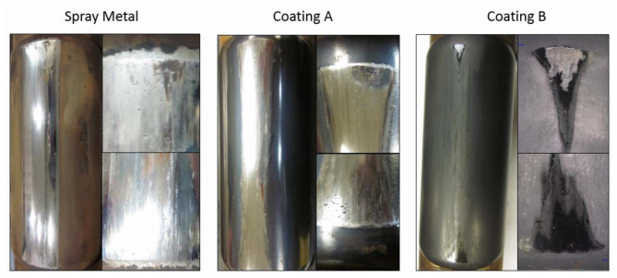
Fig. 4 Rod Couplings (Left) and Cut Tubing (Right) of Spray Metal, Coat A and Coat B in the Couplings (Jackson 2019)
As a horizontal rod pump would be connected to the surface pumping unit, the rod string will suffer compression and tension forces differently than a vertical profile. In a normal vertical string, it is assumed the rod string and tubing are in constant tension. This changes in the horizontal section as the rod string would rest on the tubing during the downstroke. Here compression becomes a problem, so deflection of the sting is expected in many directions, creating different points of contact/friction, complicating mechanical and pump models. Stroking efficiency will also be affected as a full stroke cannot be achieved with the deflection of the rod in the downstroke. In the upstroke instead, the rod string stretches and pulls the plunger inside the pump, but because of the curvature in the well contact between the couplings and the tubing is common, so it is another area of interest. Big companies like ExxonMobil are looking into different coatings for couplings to fix friction wear in the well and they can be seen in Fig. 4. Regardless of well, this technology already promises improvements in vertical wells as field test was performed to measure durability and effect in the couplings and tubing to prevent early failure. Couplings with a different generation of the coating, like in Fig. 4 (Coat B) showed a significant increase in time between well interventions and alleviated side loading in the well (Jackson 2018). This type of technology can really make an impact in the future to protect equipment in the well.
There are still many solutions to be found in horizontal wells, and when related to SRPs a new approach in dynamometer cards and friction wear need to be developed. Here is where a digital SRP might be able to find solutions for these problems. Even though the initial proposed well has only a vertical section, deviated sections can be added in the future. With the addition of components like sensors, pressure pads in the curvature and maybe visual pattern recognition software that is also available with LabVIEW through a network camera. Studying load data and creating a database is one side of the solution because by studying all these movements and running for hours may be overlapped and cycle patterns may appear so modified dynamometer cards can be created or find a way to create new patterns to recognize pumping problems.

1.2.2 Gas Interference
In the last chapter, the importance of deviated wells was explained, but there is still another big problem that plagues SRPs, and it is gas interference. Gas Locking or Gas Interference dependent on the reservoir fluid and how they release soluble gases or free gas into the well. Indications of this problem may be seen in the surface cards and it will happen gradually. In the past, the action of banging bottom may have solved the gas problem but only momentarily and by causing wear in the rod string and pump elements. Many inventions have tried to solve this problem and by adding special release valves or spring actuated elements (Spears 1988) they sought to solve the problem, but the need for enhanced solutions is wanted.
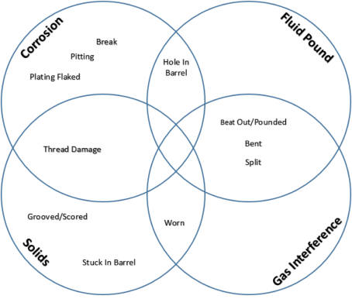
Fig. 5 Common Downhole Issues in Sucker Rod Pumps
The modern take on the problem is to mainly study the reservoir fluids and understand their characteristics at different pressures. This means doing tests like bubble point, gas in solution, and their factional content. As seen in Fig. 5, common issues related to gas interference ranges from worn elements, bends, splits and pounding issues. This all depends on many elements and situations affecting the pump. Gas breakout in the pump causes the plunger to avoid going into the barrel resulting in valve rod and rod guide wear (Dove 2016). Impact in the barrel can send destructive waves along the rod string and this is mostly because the constant tension that allows the waves to travel to the surface.
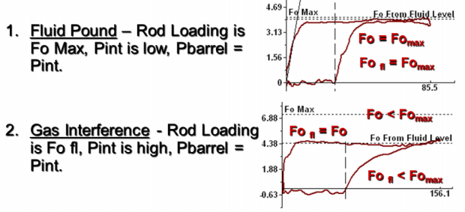
Fig. 6 Dynamometer Card with Gas Interference (Rowlan 2015)
Gas in the rod pump doesn’t need free gas to enter the well, as while pumping the pressure difference between the lower outer section of the pump and barrel area in the upstroke may create the ideal condition for gas dissolution. This problem occurs from either low downhole pressure and ideal conditions for the liquid to expel gas, but also may occur when pumping at a very high rate or high Strokes Per Minute (SPM). This is another possibility that needs to be considered and dealt with appropriately. Seen in Fig. 6, three scenarios where gas may affect the pumping cycle, where there is a fluid pound, gas interference or the flow in the intake is blocked. Fluid pound means that in the downstroke, the load in the rod string that is the liquid weight above in the start of the down motion the load will stay almost the same for a portion of the displacement, this means gas is being compressed and absorbing all the load. This occurs until the pressure is so high suddenly the gas opens momentarily the traveling valve and the load gets transferred to the liquid section in the barrel. This occurs normally when there is not enough liquid in the annulus and gas gets introduced into the barrel. This can be seen by the sharp change in load as weight transfers to the tubing, but it also creates a shock wave that may damage the pump and/or surface units in time.
Another situation is when the pump is above the reservoir, allowing for gas to build up but not completely filling the barrel. This is seen in #2 of Fig. 6, where the gas slowly accumulates in the pump intake and in the upstroke, it is introduced in the barrel. The behavior in the dynamometer card is different in this scenario than in fluid pound as the gas slowly carries some of the load until the traveling valve opens momentarily releasing the gas from the pump but with some liquid still inside it continues working normally until the next cycle it occurs the same. If there is a gas rate increase after each pumping cycle, there is a possibility for gas to completely dominate the pump barrel leading to gas lock and tagging. While there are many solutions for this gas problem further research is needed to find ways to manage and deal with unexpected gas interference.

1.2.3 Technology Not Reaching Class
Technology in the modern oilfield is advancing at a fast pace, as devices become smaller and more reliable there is a big push from companies to develop software that can extract data at a lower cost and then being processed through the server or cloud solutions. The advancements in artificial lift technologies have created a new skill gap for a new and experienced engineer. As solutions are becoming less mechanical centric and more digital-focused, the need to understand how data is gathered and processed is now an important factor in the engineer’s toolbox. Learning how to code and apply mathematical models is now a desired skill for the development of data processing software.
Modern improvements in infrastructure like 4G/Radio networks allows for companies to control SRP and to receive data from the site. As data is retrieved from a pumping unit, it is processed in a server and then it can be displayed to any user in the network for analysis. Data like dynamic load in the string, pumping rate, pressures, displacement, and motor properties are sent. Once the surface pump cards are retrieved, downhole cards are also being calculated. While this process is like other industries, it is unknown for students and some engineers how these systems work and how data is managed. It is normally taken as a service or as a hardware/software package. This means that the owner of a well or engineer does not have a lot of knowledge in what is happening aside of general assumption.
Petroleum engineering students are missing the digital side push of the field, and it seems somehow, they are avoiding contact with technology. The need for better understanding of digital hardware must be filled and steps must be created for people in the program to progressively understand how electronics like sensors work and how they can be used or troubleshoot. With software like LabVIEW, the user can easily plug hardware and in a few minutes control it via licensed devices which make the process easier because of automatic drivers or other solutions which can be manually programmed to work in a certain way. This developmental program will have a great impact on the ability of students to recognize problems and find solutions with a new engineering field that is electrical engineering and automation.
In the end, the problem is technology is not reaching either students or researchers in practical ways. The students view the oilfield must be changed now as the future engineers need to learn how to use digital tools and services for their personal challenges. Digitalization of the field will make engineering work more manageable and the engineer can focus on solving problems instead of repetitive tasks or wasteful tasks that are visiting wells just to check on the equipment. As engineers are at the forefront of this technological change and solutions from this generation will make a difference in production, drilling and reservoir analysis in the next decades. Companies will look for qualified personnel that can understand the science behind oil and gas production but also being able to do something about it by utilizing digital and physical solutions.

2.Sucker Rod Pump Theory
It is imperative to understand first the theories that make the modern SRP such a reliable and precise piece of equipment. Starting with the different SRP models and their geometries to learn they affect load in the polished rod and the pumping unit. The general classifications are conventional and unconventional pumping units, and especially in conventional units, their movements have different signatures because of their mechanical differences. The next topic will be about the different mathematical models and how they have evolved from the Early Models to the well-known Sam Gibbs Wave Equation. But also, how the wave equation had to be simplified to be used on older hardware because initially, it is a second order linear differential equation. Finally, a small chapter of how the oil and gas industry evolved in the last years to include new digital equipment and networked systems into their operations is discussed. This is to highlight the software they use and the hardware implementations they achieved to be able to control and monitor equipment from anywhere and analyze the dynamometer cards in real time.

2.1 Pumping Units (Pumping Geometries)
Before talking about the proposed setup, we need to know how pumping geometries can be modeled to build a digital SRP, and it is clear mechanical input influence the rod string displacement. As there are in the market many types of pumping units there will be two main categories known as conventional and unconventional units. The first type will be variations of the oldest and most common model in the market, the Type-C or Type Conventional, that count on a system of counterbalance, the lever principle and the use of motors and gearboxes to transform rotational motion to linear motion. In the other hand, unconventional pumping units are the ones that also use rods to connect to the pump downhole but are not considered part of the original conventional group. Because of this, the unconventional classification has a lot of models that keep this group constantly growing. In either case, there is a need to understand these motions regardless of the type and we will use this to program our machine.

2.1.1 Conventional Motion
Pumping units are the heart of the operation in SRPs and the most recognized models’ conventional units, which they are the Type-A, Type-M and finally, the Type-C. All these models can be seen next to each other in Fig. 8. The conventional unit is the oldest and most common beam-type pumping unit and it works on the same principle as the original cable-tool drilling rig. The walking beam acts as double lever arms that connect the polished rod and the transmission or driver in the back. It utilizes counterweights positioned on either rear end of the beam or in the crank arm and they can be used in both rotational directions (Takacs 2015).
Weight distribution is very important in the conventional category and pumping cycles are describes as being balanced, underbalanced and overbalanced distribution. These the balance differences can be seen in the pump cards and this affects the way the rod string stretches, so the operator must calibrate the equipment, so the rod string doesn’t stretch too far so tagging occurs, but also not sacrificing stroke length. If tagging is a problem in a well, abnormal wear will occur, eventually damaging components earlier than expected. In the other hand, if the string is not stretching as planned, the pumping capacity or also denominated effective stroke is reduced, and this implies less production per cycle. This can be seen in Fig. 7 wherein case one ideal perfectly counterbalanced unit can be seen, without any operational distortion. Displacement, velocity, and acceleration in different quadrants marked from 1 through 4 can be seen and if it is up or downstroke. Depending on the case, symmetry in the X-axis can be checked and they reflect what is expected from normal operations.
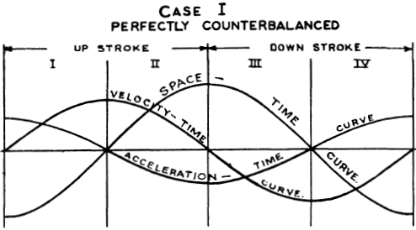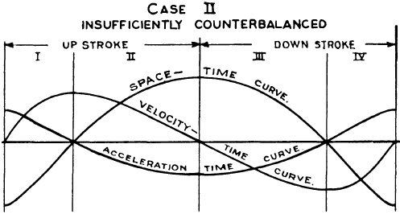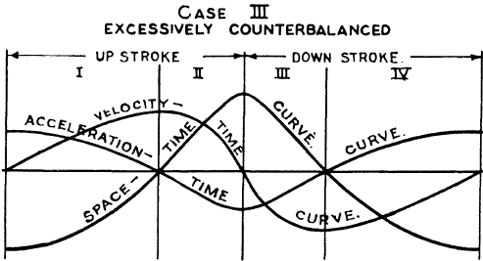
Fig. 7 Motion Curves of Pumping Cycle of a Type-C Pumping Unit (Lake and Brett 1928)
Balance, on the other hand, cannot be always achieved so it is important to understand the other case in which the unbalance of weight can affect operations as it can be seen in Fig. 7. In case two it is shown that quadrant one and four are smaller in size and quadrants two and three have smoother transitions. The reverse state can be observed in case three where instead quadrants 2 and three have smaller periods and forces are concentrated in these locations. The problem with both situations is the uneven load distribution, so the string and mechanical components in the pumping unit will have these spikes and increased rate of force changes. Mechanical components, especially in the joints, feel these changes in load as the angles where they connect are not in an ideal position. Rod string wear is also a problem as early failure may occur. This situation may be seen in other conventional units.
\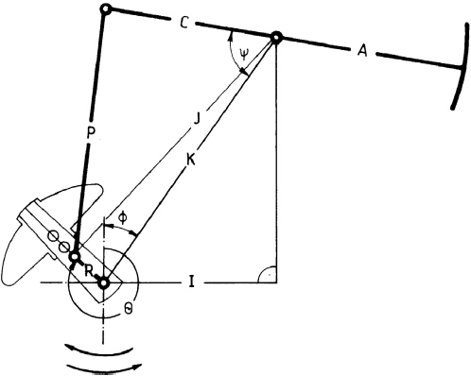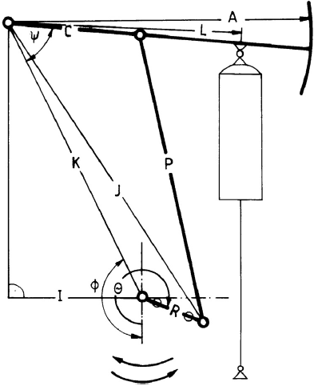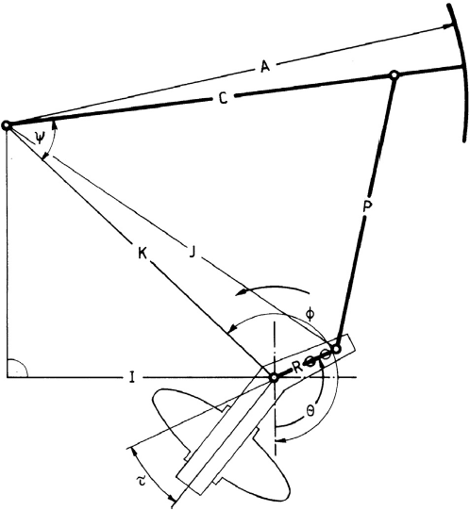
Fig. 8 Different types of conventional pumping units. From left to right: Type C, Type A, Type M. (Takacs 2015)
The other conventional pumping units accomplish the same objective as the type-c that is fluid production, but they have different characteristics. Model A or Air Compressed Unit uses an air compressed cylinder where the operator can regulate the pressure in the cylinder that will balance the machine with a simple adjustment of a valve. This model was developed in the 1920s and instead of being fixed in a central position like Type C, it is fixed in the backend of the beam. The balancing element in this unit is an air cylinder, replacing the heavy counterweights. They tend to be lighter and shorter than Type C, making them great for portable applications, like production testing. This unit can also be used in both rotational directions, clockwise and counter-clockwise.
Type M or Mark II is instead a complex model designed in the late 1950s (Takacs 2015). The main objectives of this pumping units are to decrease torque and power requirements when compared with a Type C. The structural changes are that the fixed beam is on the rear, while near the horse head the motion is translated via the pitman's arm. Comparing different units in Fig. 8, a relationship between lengths C and I can be seen. This relationship in Type C and A are similar and C is normally shorter than I, but in type M there is a much larger C than I. This change in lengths are the main reason why there is an efficiency increase as it improves performance of previous geometries. Also, the counterweights are phased normally in a 24 degrees angle so load distribution is more uniform along the pumping cycle. Finally, another difference in this unit is that it can only rotate in one direction, counterclockwise. A small variation of Type M was also developed in the 1980s by R. Gault, and it is known as the TorqMaster or Reverse Mark. This unit resembles the fixed positions of the A-type but the relationship of the I and C lengths are reversed. We can see a schematic of this unit in the index.
In all these conventional units there are similarities and the way they work are similar as they use the principle of leverage in different ways. But Kinematics are inherently different because of the operating mechanisms. Velocity and acceleration of the polished rod movements must be known. All the equations of the kinematics influencing motion can be seen in Takacs book displayed in the references, but there is a need to simplify the content as this thesis do not focus on all the mechanical components but specifically on the rod string movements.
$v\left(θ\right)=\frac{ds\left(θ\right)}{dθ}\frac{dθ}{dt}=\frac{s}{2}ωSinθ=\frac{SN}{229}Sinθ$ Eq. 1
s ($θ$)= polished rod displacement, in
S=Polished Rod stroke length, in
$θ$=Crank Angle, rad
$ω=\frac{N π}{30}$=angular frequency, 1/s
v ($θ$)=polished rod velocity, ft/s
N= pumping Speed, Strokes Per Minute (SPM)
$a\left(θ\right)=\frac{SN^{2}}{2189}Cosθ$ Eq. 2
a ($θ$)= polished rod acceleration, ft/s²

These are considered simple harmonic functions of the crank angle and they are part of the Early models. Assumptions are that it is perfectly balanced, and the max and min acceleration occur at the start of the upstroke and downstroke (Takacs 2015). Later, a better approach was developed named crank and pitman motion. This model assumes constant angular motion of the crank arm and that the crankshaft and equalizer bearing fall on the same vertical line, but only holds in Type C units.
$s\left(θ\right)=\frac{A}{C}[P+R\left(1-Cosθ\right)-\sqrt{P^{2}-R^{2}Sin^{2}θ}]$ Eq. 3
$v\left(θ\right)=\frac{A*R}{12*C}ωSinθ[1+\frac{R Cosθ}{\sqrt{P^{2}-R^{2} Sin^{2}θ}}]$ Eq. 4
A, C, P, R= Dimensions can be found in Fig. 8
$ω$=angular frequency, 1/s
$θ$=Crank Angle, rad
For Eq. 3 and Eq.4 it can be appreciated more variables are being used to calculate the motion, and they depend on the dimensions of the structures they are working in. Because of this, the max and min acceleration are of different magnitude. The up and downstroke crank angle ranges are equal, max acceleration occurs in the start of upstroke and is greater than the minimum acceleration (Takacs 2015).
Other mechanical methods can be considered for the rod string motion, and so-called Exact Methods include the API Spec.11E, that takes derivations from the polished rod position and crank angle.
$s(θ)=A\left(ψ_{b}-ψ\right)$ Eq. 5
$S=A\left(ψ_{b}-ψ_{t}\right)$ Eq. 6
$PR(θ)=\frac{ψ_{b}-ψ}{ψ_{b}-ψ_{t}}$ Eq. 7
s ($θ$)= Polished Rod Position (displacement), in
S= Polished Rod Stroke Length, in
A= Dimensions in Fig. 8
$ψ_{b},ψ_{t}$=angle at max value at start upstroke, at the angle at min value downstroke
$Ψ$= variable angle
PR ($θ$)= Position of Rods
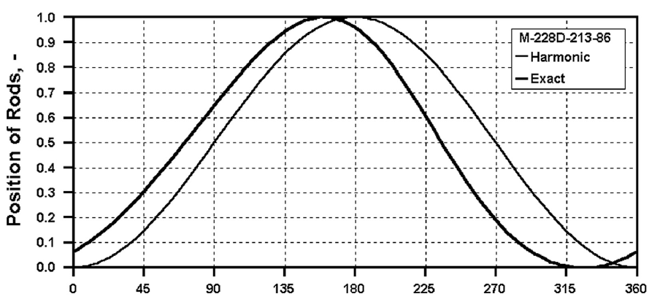
Fig. 9 Comparison of Movements Between Harmonic (Early Calculations) and Exact Method (Takacs 2015)
Eq.5, Eq.6, and Eq.7 are applicable to all conventional pumping geometries and they can be seen more in-depth in the API Spec. 11E. The variations in the values of both methods can be seen in Fig. 9, and it shows the differences in the angle’s locations and max/min values. The chart uses dimensionless units, so it can be applied to many stroke lengths. To use different pumping units, there are corrections to be done like see in Table 2. So as one model was developed, upgrades to include angles of the machine have helped keep the accuracy and increase the precision of the motion closer to real-life conditions of a Type C unit, but a modification to the formulas allows for further analysis of type A, M, and TorqueMaster.
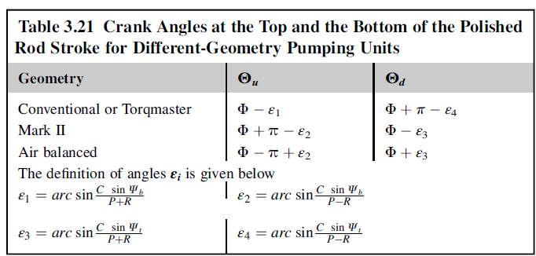
Table 2 Crank Angle Correction for other Pumping Geometries (Takacs 2015)

2.1.2 Unconventional Units
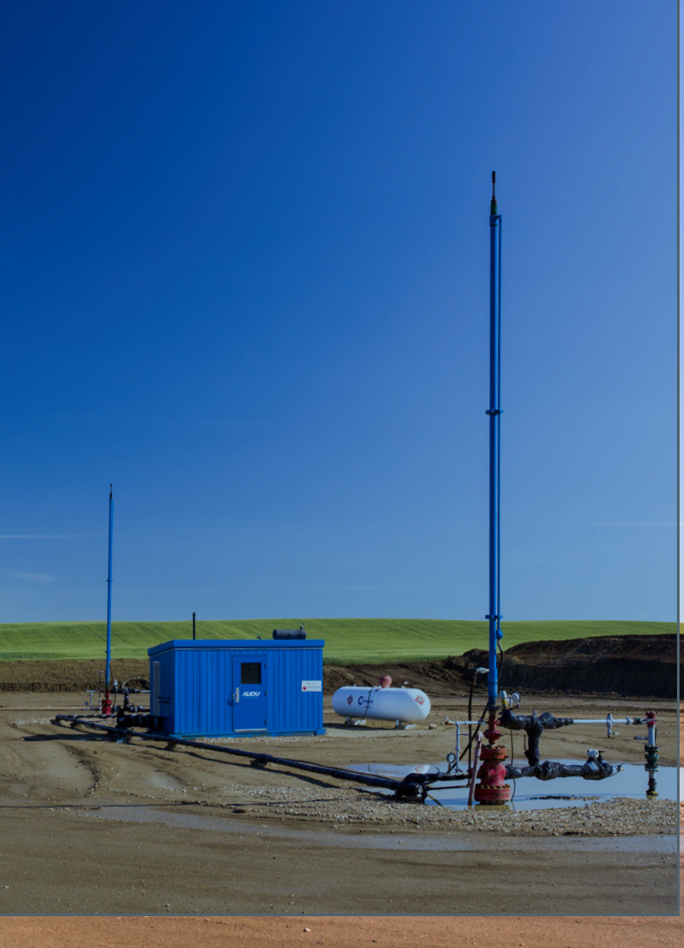
Fig. 10 Unconventional Pumping Units in order: Long Stroke (Weatherford 2013), Hydraulic (Schlumberger 2016) and Rack and Pinion (Unico 2018)
For the second group called unconventional units, the aim is to simulate initially 3 pumping units. We can see each unit in Fig. 10, Long Stroke, Hydraulic and Rack and Pinion units. The long stroke unit increases the stroke length, so pumping capacity and the pump life is minimized while keeping fatigue to a minimum (Weatherford 2013). Hydraulic pumping instead consists of a hydraulic generator and a hydraulic cylinder like the ones used in heavy machinery. User control over the motion is very high and can deliver precise strokes in both speed and acceleration. In some implementations it can even eliminate the stuffing box as the cylinder itself can isolate the top wellhead and lubricate itself (Schlumberger 2016). Finally, the Rack and Pinion is used with an electric motor and a gear system to move the rod string. The motion can be controlled thanks to the addition of a Variable Frequency Drive (VFD), so again acceleration and speed can be changed, but also the length of the stroke in real time.
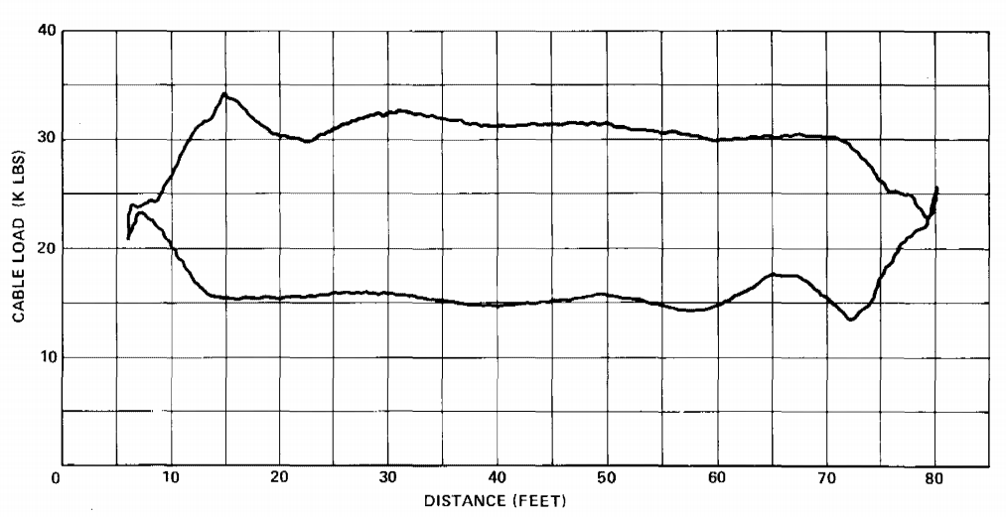
Fig. 11 Long Stroke Machine, Cable Operated Pump (Hollenbeck 1980)
Physical simulation of these geometric models is one of the main objectives of the laboratory setup. By using an electric Linear Actuator as the prime mover, initially, simulation of simpler geometries like the unconventional models such as Long Stroke, Hydraulic, and Rack and Pinion pumping units can be achieved. As seen in Fig. 11, an example of a Long Stroke unit dynamometer card is shown, and visually from the data, it can be assumed it moves mostly at a constant speed. In the card’s end’s, acceleration changes are seen to change direction and that is why we have slopped lines. The main reason for the card to be this way is because of linear movement and control during the strokes, making them simple and predictable. Fig. 11 can be representations of other unconventional units as they are known to use linear motions. For the conventional models, increased mathematical work is required as complexity in the way power is being transmitted from the motor to the polished rod is non-linear and depends on several factors. Mechanically the components convert a rotating motion to a linear one with pulleys, a transition, pitman arms, beam and horse head. For this reason, torque and balance must be tracked and simulated in the rod string to make sure the OU machine is as close as possible in speed, acceleration, and displacement to the field machines.
In oversight, there are still many problems to solve for sucker rod pumping, and while it is a technology that is more than 200 years old, well complexity and increased production requirements make the SRP a great candidate to study and innovate. For the foreseeable future SRPs will end up in many declining wells as all of these at some point will stop producing. Therefore, the market trend to use automation and data mining has become a big topic related to production. This is a reason for universities like OU to develop and create a research platform into these technologies, for the future. Engineers must learn data analysis in their companies, and this means early failure detection, production enhancement and reduced operational costs for companies. This machine is designed to give an edge to students as once in the field they will understand not only surface cards, but also look for trends with a complete understanding of the concepts behind data processing.

2.2 Sucker Rod Pump Theoretical Models
Understanding how SRP intermingle in the oil and gas industry is very important to determine their use and application. In addition to their mechanical background, it is important to determine their shortcomings and future requirements. Therefore, this thesis is focused on the creation of a scaled SRP system with modern equipment that can simulate any rod pumping unit in the field, output data, and teach operators in the inner workings of the machine.
For the digital sucker rod pump, it is necessary to associate the most important theories about SRPs in the field, so they can be compared in the laboratory and by extension in the class. What makes this project different from other scaled models is the ability to mimic different pumping units and the ability to perform custom movements. Students in different classes like production 1 and completion will be able to visit the laboratory or via webcam see the machine up close. Students will be allowed to calculate the loads and pumping requirements with different theoretical methods and compare to the laboratory system as the machine will output the surface cards.
By linking the physical with the theoretical, students will be able to study how SRPs work and learn some design considerations. The software program will need to calculate the surface cards to effectively output data, so different models can be used to obtain Peak Polished Rod Load (PPRL), Minimum Polished Rod Load (MPRL) and Peak Torque (PT). the models that can be used are:

2.2.1 Early Model
It is one of the first method available and it uses simplified mechanical models. Assumptions are that is a concentrated mass moved by the polished rod, it has a movement like a spring, and it has a conventional pumping geometry. As seen in Eq. 8-17 the model uses several factors to determine the complete values of PPRL, MPRL, and PT. The laboratory setup with slow speeds and thicker rods should retain qualities of this model as there is no much elastic influence. This is a very simplified and straightforward model, but it is also known to be the least accurate as it is shown when calculating the parameters.
Rod String Weight in Air $Wr=45ft*1.135\frac{lb}{ft}=51.08lb$ Eq. 8
Acceleration Factor $δ=\frac{24in*(4SPM^{2})}{70500}=0.0027$ Eq. 9
Liquid Load on Plunger $F_{o}=0.433HA_{p}SG=0.433*45ft*3.167in^{2}=61.71lbm$ Eq. 10
Peak Polished Rod Load $PPRL=F_{o}+W_{r}\left(1+δ\right)=61.71lbm+51.08lbm\left(1+0.0027\right)=112.92lb$ Eq. 11
Min Polished Rod Load $MPRL=W_{r}\left(1-0.128*SG-δ\right)=51.08lbm\left(1-0.128*1-0.0027\right)=44.40lbm$ Eq. 12
Peak Net Torque $PT=\left(PPRL-MPRL\right)\frac{S}{4}=\left(113lb-44lb\right)\frac{12in}{4}=205.8lbf$ Eq. 13
Rod Stretch $e_{r}=F_{o}E_{r}L=61.71lb*45ft*{1.262}_{x{10}^{-6}}=0.0035in$ Eq. 14
Tubing Stretch $e_{t}=F_{o}E_{t}L_{t}=45ft*61.71lb*{5.37}_{x{10}^{-10}}=0.000001in$ Eq. 15
Plunger Overtravel $e_{o}={1.36}_{x{10}^{-6}}*L^{2}*δ={1.36}_{x{10}^{-6}}*{45}^{2}*0.0027=0.000015in$ Eq. 16
Plunger Stroke $Sp=S-\left(e_{r}+e_{t}\right)+e_{o}=12-\left(0.0035+1x{10}^{-6}\right)+0.000015=11.99in$ Eq. 17

2.2.2 API RP 11L
The API RP11L was developed by Sucker Rod Pumping Research Inc. (Takacs 2015) which was a company founded in 1954 and the model was published in 1967. The idea was that the more complex or encompassing the simulation of the rod string is, the more accurate it would be. For this model the assumptions are that it uses a conventional geometry (Type-C), perfectly counterbalanced, perfectly vertical well, anchored tubing, low prime mover slippage, mechanical friction between rods and tubing surfaces are not considered and there is normal friction due to viscous damping.
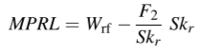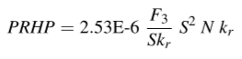
$$F_{2}/S/K_{r}=Dependent Variable chart in Left \\ F{}_{3}/S/K_{r}=Dependent Variable chart Right$$
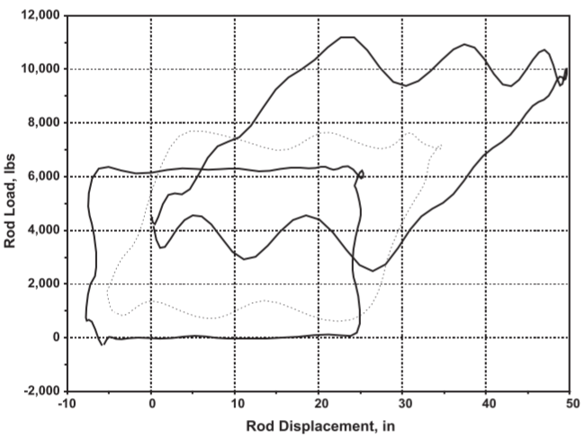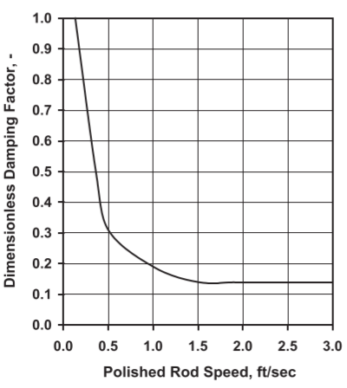
Fig. 12 Example of API RP11L charts used (Takacs 2015)
Thousands of physical simulations were performed to develop different charts. With the use of unitless and nondimensional parameters in formulas, they manage to make them compatible with different unit systems. Different plunger sizes, pumping speeds and stroke lengths where used and considered. This method reduces the computing power required in the field to process as most of the information is already calculated through the carts, so only by intersecting values, instant results can be obtained. This can be seen in Fig. 12. The main problem of this method is due to the nature of the charts. As it requires an interpretation of the engineer the error builds up and it can be subjective in most cases. This is one of the main reasons a new technique was needed to calculate load in the well.

2.2.3 Wave Equation
As the development of SRP continued, it was clear the early model and the API RP11L was not enough to predict accurately the load in the well. A better solution needed to be developed and developing a better model meant complicating the formulas. The key to the proper description of the pumping system is the exact simulation of the rod strings behavior (Takacs 2015). Starting with the most important feature, elasticity, which dampens the loads and is affected by either surface or pump intakes. This is thanks to the tensioning of the rod string and the depth which makes the metal rods great for transmitting impulses. All the generated waves will affect the pump and because of its errors in the calculations can be seen in Fig. 13 where error between the conventional calculations (Early) and the RP 11L. In some instances, these variances can make a big difference when choosing the equipment.
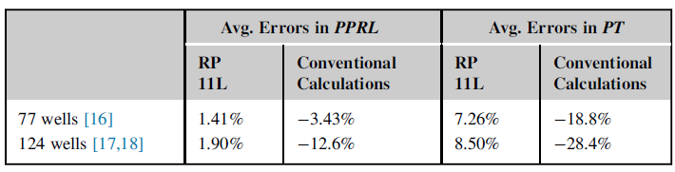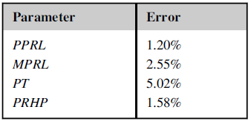
Fig. 13 Errors in PPRL and PT, the top is Research by Griffin FD and bottom by Takacs with 25 Wells and RP11L Model (Takacs 2015)
Wave Equation $\frac{∂^{2}y(x,t)}{∂t^{2}}=v^{2}\frac{∂^{2}y(x,t)}{∂x^{2}}-\frac{∂y(x,t)}{∂t}+g$ Eq. 18
u=Displacement of rods
t=Time
v=Velocity
y=Load
g=Gravity
Velocity in Rods $v=\sqrt{\frac{144 E g_{c}}{ρ}}$ Eq. 19
$ρ$=density of rods=490 lbm/ft³
E= 30,000,000psi Young’s Modulus
Friction $c=\frac{144c^{'}g_{c}}{ρA}$ Eq. 20
Wave Equation Norton $\frac{∂F}{∂x}-cρAv=Aρ\frac{∂v}{∂t}$ Eq. 21
Wave Equation Bastian et.al. $\frac{∂F}{∂t}=EA\frac{∂^{2}u}{∂x∂t}=EA\frac{∂v}{∂x}$ Eq. 22
Accuracy was one of the reasons for Sam Gibbs to form the wave equation. The inclusion of friction and gravity to model the elastic behavior of the rod string is one of the clear advantages of the model. Another important factor is how fast waves are propagated, and it may be around 16000ft/s in steel rods (Gibbs 2012). As seen in Eq.18-20, this is the most widely used form of the wave equation and it is a linear second-order hyperbolic partial differential equation. The problem is that solving a second order differential equation requires more time and processing power, therefore Norton and Bastian et al. developed Eq.21 and Eq.22 respectively. It is a pair of first order differential equations.
To solve the wave equation, it must be done either by an analytical solution or by numerical methods, but it will be discussed in section 4.2. For now, the focus will be on the two analysis that can be done with the wave equation, diagnostic and predictive. With the diagnostic, displacement and forces in the surface (surface pump cards) are used. For the predictive analysis instead, it tries to predict surface conditions based on descriptions of the sucker rod pump operations. So, when using, for example, the Gibbs wave equation, two initial and boundaries condition is required, and these are preferably selected when the velocities and position are zero, this is only used in predictive. For both diagnostic and predictive boundary conditions are required and they must be at either side of the rods, in surface or downhole.

2.4 Industry answer and OU machine

2.4.1 Industry Solutions
As in many industries, automation is taking a foothold in the oil and gas industry, while in other segments technology has been present for decades, it is common for new technologies to take many years to reach the oil field. A good example is the automation of SRPs as it has taken time for them to become the norm or widely used. The control units need to be tested and the technology needs to be robust enough to invest, as any sign of trouble might cost the operator thousands of dollars to replace or fix. This is also not including production costs that are common when new technologies are being developed.
The way data is obtained is also important when developing new machines or upgrading existing ones. It is a challenge for fabricators to meet operator demands to increase control over their technologies with the internet of things and do so with economic advantages. This means data can be sent anywhere where it’s needed, and further analysis and comparisons can be performed in each well. But understanding SRPs and identifying their shortcomings is important for research as planning and designing a model needs to accommodate immediate research questions and future ones if possible. Therefore, not only making the SRP machine is important but what can be accomplished from it in the future. One of these interest topics is friction, as many new wells are deviated engineers must account for mechanical and fluid friction in the rod string, as it depends on the coupling, depth and well angular change in the well build section. These mentioned characteristics will affect load in the rod string so elongation and load in the string will affect surface cards to the point of being not recognizable. So, there is a haste to qualify equipment that may solve many of these problems.
New technologies require a long process of qualifications and testing, but the difference in the oil industry is the robustness and durability these machines need to endure. Being in open areas, deserts, tundra, mountains, rainforests, seashores, they must be weather resistant and temperature resistant. New next step is ensuring even in failure the machine can shut down safely, avoiding injuries or costly repairs. This is one of the strong suits of automation, and when it works well, it can save the company millions of dollars in repairs and preventive maintenance. But this technology push is also supported by infrastructure in wireless communication of machines.
The idea of controlling different elements of a machine remotely is not a new concept, and it has been around for a while, but cost and location of SRP have made their use limited or not influential. As technologies advance and new mobile networks such as 5G will help close the technological gap and reliability, the ability to send or receive information and commands to machines will only get better. This is another reason to closely study automation and as a petroleum engineer, this is something desirable for students in the next decades.
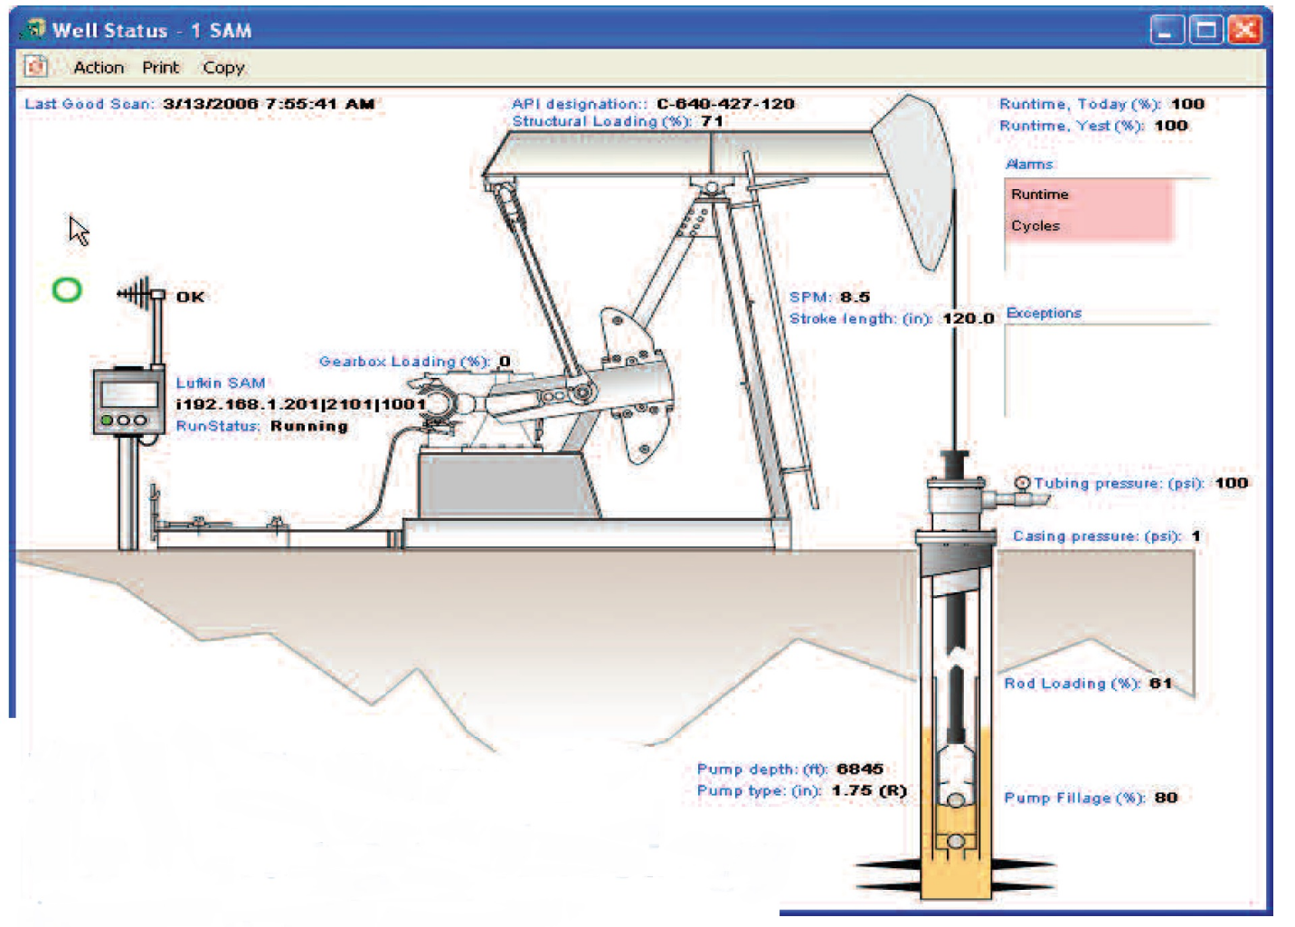
Fig. 14 Norris+Theta (Apergy company) software, showing SRP control and data
As technology develops and changes every aspect of fieldwork is bound to create a revolution in our industry, and by doing so, smart machines will help facilitate data to operators, so they can focus on solving problems instead of finding it. Apergy, previously known as Dover Artificial Lift has developed new technologies related to automation and monitoring. SMARTEN™ Total Asset Manager is Apergy’s main monitoring and control software, allowing connection of SRPs via WIFI or remote internet connection (Apergy 2019). This software is shown in Fig. 14, where there is an API designation, pump fillage information, pressure information and many other details regarding operational data. It can create dynamometer cards in surface and via mathematical models in the bottom hole. It can predict different operational problems and alert the user of problems being experienced by the machine. Also, by knowing this it can safely shut down and protect the operators, the environment and the equipment.
This is something students do not see in class and on rare occasions like technical courses they get to see this type of software. While in class descriptions, images and direct explanations from engineers that work with it, there is nothing else students can do about this as there are no tools for them to learn and because of the gap in knowledge even important questions are being avoided or completely missed. Not only for sucker rod pumps but for any digital operated equipment in the field. Understanding the importance of the knowledge gap that has been created by technology will only help more students realize the importance of such systems and their need to learn about digital tools and the internet of things.

2.4.2 OU Approach
The digital SRP in OU is meant to fill in a gap that technology has created. By making people participate in this project and allowing students to see real operation with digital components, they can see the implementation and some design guidance. One of the problems faces by me is that when the project started, it was hard for me to choose an electric motor, select sensors, or even digital (on/off) and analog signals (variating signals). So, the transmission of this knowledge can be useful in class as petroleum engineers are not exposed to electronic classes.
The main purpose of this project is to create a machine that will be built and programmed at The University of Oklahoma. The first objective is to create technology like the ones in the field. By building a rod pump system with a programmable pumping unit, simulations of different pumping units and problematic scenarios that occur in the field can be performed. Like big companies and their systems, the operator will be able to operate at different rates, positions, and conditions. The second objective is to mimic different pumping geometries and create a universal motion machine so when studying loads for example in a Type-C unit, the user can just change the motion and study a Long Stroke machine in one click. Thirdly, the machine can create a pump database and save it to share with students and data researchers in OU for further statistical analysis, pattern recognition or data mining. Finally, by adding different elements like a curved section on the bottom, or injecting air in the tubes, researchers can study well phenomena that affect production and mechanical components.
The first and most important element of the project is going to be the pumping unit. As they transmit power to the rest of the elements they will affect how fluids are produced and how the components react to such loads. Instead of choosing a single type of pumping unit like it has been done in the past by other universities, this research aims to simulate different units in a single linear actuator. This is possible thanks to advancements in technology such as digital power delivery, data acquisition systems (DAQ), sensors and powerful electric motors. While the heart of the operation relies on the linear actuator the fluid system is also an integral component of the project.
The structure of the system is intended to be modular, so the ends can be changed accordingly. An example is the possibility to add a deviated structure in the bottom section, a gas injection line, and modifications to use the annular section. This will help the study of frictional losses in the well, mechanical/frictional wear, and level influence in all conditions. With the data acquired by these modes or operating conditions, it can also help to develop new representations as in many mathematical models when liquid or side loading friction is high they cannot be accurately used. Also, if gas influence wants to be studied It can be done by either direct gas injection into the liquid at the bottom of the well or by forming controlled bubbles. Solutions to prevent and deal with gas interference can be performed as the casing and tubing are transparent so aside of load measurements, visual observations can be done to analyze different patterns.
Finally, all the previous ties into the third objective that is to make this an educational machine. All the data produced via the load cell and the servo motor is going to be sent to a LabVIEW program where it can be used to create dynamometer cards. As the cards are created they can be stored in files that can be used later in LabVIEW, Excel, MATLAB and even R that is a popular statistical tool. This element of the machine makes it a great platform for research and the data gathered can also be used in an educational setting where students can not only see the inner workings of the machine but also understand how to use hardware via software, data processing from physical elements, and solve problems the machine outputs.

3.Proposed Setup
First, establishing a modular design where different elements of the system can be upgraded and modified in a small amount of time is necessary. The top section will accommodate a digital Linear Actuator, Load Cell, Wellhead, and a production line. The modular construction gives the user flexibility when operating or testing a specific set of characteristics of a given sucker rod pump. One example is the selection of the top motor, as there can be different power units moving the rod string. The unit one chosen for this application is an electric model Kollmorgen with a load capacity of 810lbs. Other models can fit in the top section if they measure 56-60in in length when they are completely extended and installed on top of the wellhead along the rod string. Longer stroke lengths can be achieved when installing in a parallel position or at a certain angle with the addition of a pulley or gear system.
The addition of sensors is possible and because of the nature of LabVIEW, it is not time-consuming to code new hardware into an existing layout. The most important sensors in the machine are the load cell, liquid level, and motor driver. The load cell will require a live signal that will be managed through a digital output to turn on or off, and an analog input port to decode the data that is being measured from the sensor. This element is one of the most important pieces of data as it will be used to form the dynamometer cards in the surface. As with many sensors, consideration for noise reduction must be performed. A low-pass, high-pass or bandpass filter must be added to the signal input line as the data must be processed and be as clear as possible. This must be tested for interference and data acquisition frequency and sample rate as needed.
The liquid level sensor can be placed in different locations and used with other sensors of the same type. One of the locations where liquid levels are important to measure in this machine is the annular liquid level as this will affect loads in the pump and rod string. Another interesting point is the water level in the return line. The return line can build up some pressure as hydrostatic pressure thanks to a control valve in the bottom of the pipe. In the future, controlling the liquid level in the annulus can be achieved via a two-way valve that can be regulated. A different bottom hole encasing must be designed and used for this element.

3.1 Proposed Laboratory Setup
The University of Oklahoma has a laboratory with an inner structure in the shape of a tower, where it houses a 45ft transparent casing and tubing. In Fig. 15, the main structure and important components used in the system are shown. In the Upper Frame, the Linear Actuator, Load Cell, The Return Line, Polished Rod, and the Wellhead are located. In the Middle Section, the Rod String and Return Line are present. Finally, in the Bottom Section, the Liquid Tank and Rod Pump are located. Each section is a level inside the lab, so the Middle Section is the entrance and it has access to the other areas via a ladder.

Upper Frame
Linear Actuator
Load Cell
& Polished Rod
Rod String
Return Line and
Upper and Middle Tank
Rod Pump
Bottom Section
Middle Section

Liquid Tank
Fig. 15 University of Oklahoma Diagram of Experimental SRP System dedicated to Machine Learning Applications
The main element of the operation will be the Linear Actuator and the motor. Transmitting linear forces like acceleration will affect the dynamometer cards and this is how modeling of the different pumping units will be mainly modeled. Starting with the simulation of unconventional units as they are linear models under load, it can be achieved relatively easily via a panel that required the user to click just a button for the machine to mimic. So, there are different operation modes that the machine can work on like 1. Calibration, 2. Automatic, 3. Manual and 4. Graph Builder.
The most important mode is “Calibration”, where the machine can compare to a recognizable previous state. Data is compared to normal and extreme operating conditions and recorded each time the mode is working. Data is stored in a file where it can later compare machine performance on different workloads, fluid type or a specific test procedure. The result of the calibration is then stored in another file where other modes in the machine can use as limitation and safety procedures. The software will have to levels of operation, one with the calibration data and one with operating parameters. The operating parameters or operator selection level can’t be higher than the calibration mode as it would be exceeding the safety ranges of the machine. Therefore, calibrating the machine is important for reliable operation. This is what similar systems employ in the oilfield to promote safe operations with the SRPs.
The next mode is the Automatic mode, where it will have predefined motions based on theoretical models and perfectly balanced geometry. Based on information from “Calibration” mode the machine now knows the limitations in speed, displacement, acceleration, static and dynamic loads. This helps the operator when selecting desired conditions and knowing any limiting factor in the physical simulation. An example of this is using a linear model like in a Long Stroke motion where acceleration is mostly ignored but speed is the main element as it will be mostly constant throughout the up or down stroke. Calculating the limiting factors is very simple in this case, but when a type-C geometry is used, the range of velocity is decreased as in the same distance, changes in acceleration and speed reduce top speed, and depending on the hardware, it can lower the maximum SPM.
One of the main concepts of the machine is flexibility, so even in Automatic mode, there will be some form of control where the motion can be changed while the machine is running. Selecting a running speed, a time interval and even a balance problem that can be simulated. The balance issue can be seen in a chart as an initially perfect sine wave, but the balance is lost to overbalanced or underbalanced pumping unit, the sine wave gets displaced as resulting forces make the machine reach the peak at different times. This is a very helpful tool for students to visualize and learn about common dynocards and how they are affected by common factors.
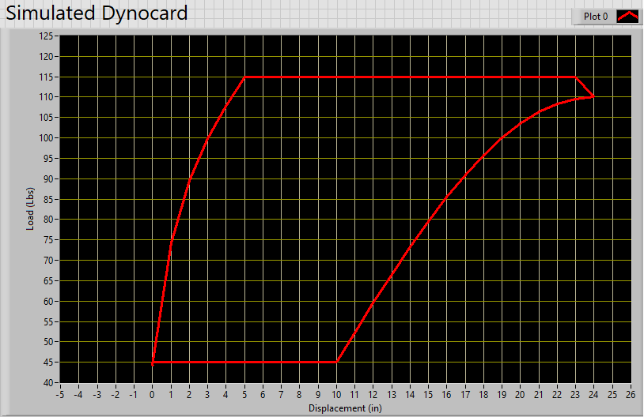
Fig. 16 Simulated Dynamometer Card with Gas Interference in LabVIEW
The next step in the process was to allow for the operator to manually control the machine or to pre-program a desired order of movement. For this, an array of information is laid out and data like speed, or acceleration, a function, time interval and finally a predefined displacement interval can be chosen in a pump cycle. For example, in Fig. 16 a dynamometer card has been created from a graph builder application. This mode allows for two possibilities, a live version where the card is drawn in real time or a drawn dynamometer card for reference. The live version is restricted mainly to the stroke displacement and average time of a full cycle depending on the calculated calibration values. Now a control function over displacement or time can be performed. With displacement control once a position in achieved the motor will move differently in each designated section. Instead, with a time constraint, the program would show the time interval of a full cycle and upper or lower stroke time for completion. With time, it would limit a movement based on this and change it accordingly. This way the operator can control movement and simulate any situation with a few commands.
In the second mode, the graph builder is instead a visual reference for the live version. As a graph is built using the same tools as the previously mentioned live graph, a segmented line is plotted in a few seconds and can be changed accordingly to match a specific situation. Fig. 16 shows a displacement from 0 to 10 a constant load, followed by a sine function to 10 in, then a constant value of 115lbs back to 5in displacement and a tangent function to the origin. This is a simple way to once drawn, put in the background in the live version chart to compare a specific theoretical case to real-life operation.

3.2 Linear Actuator
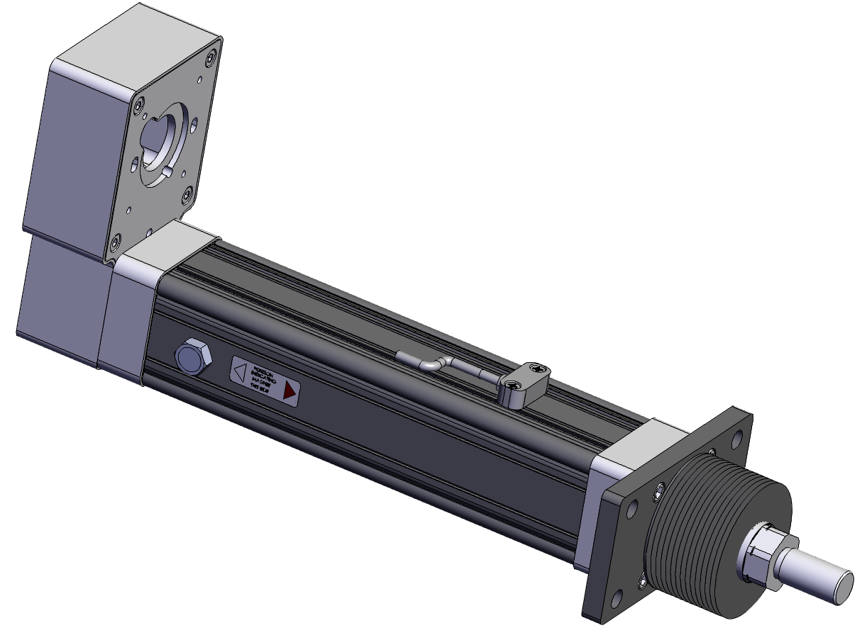
Fig. 17 Kollmorgen Linear Actuator EC2 (Kollmorgen 2019)
The main component and heart of the operation will be the Linear Actuator (Fig. 17), as it is going to be programmed to mimic several pumping units. Based on calculations with the Early Model and the API RP11L, the Peak Polished Rod Load (PPRL) will be 113lbs, Minimum Polished Rod Load (MPRL) is 45lbs and the Peak Net Torque is 206lbf. Considering loads, availability, and a future proof factor, the machine chosen was an 810 pounds actuator. The Specifications are:
Mechanical Specifications | Ball Screw Version
Max. Stroke Length, mm (in) | 750 (29.53)
Screw Lead, mm | 16,5
Screw Diameter, mm | 16
Unit Backlash, mm (in) | 0.25 (0.010)
Dimensional Standard | Metric ISO6431
Bore Size, mm | 50
Motor Mount | parallel or inline
Performance Specifications | Travel Life Std. 1 Million inch
Max. Thrust Force, N (lbf) | 3600 (810)
Max. Velocity, m/s (in/s) | 1.27 (50)
Max. Rated Duty Cycle | 100
Std. Operating Temp Range, °C (°F) | 30 to +70 (-22 to +158)
Environment | IP54 Std. IP65 Opt.
The reason a higher capacity actuator is needed is that this will allow for future testing, as the extra load can be added at the bottom or with a deviated well attachment to test higher friction. Based on the market availability and specifications, the stroke length will be 10in. The desired SPM will be between 3 and 8 SPM but if the situation requires it can go up to 10 SPM. A maximum speed of 8 inches per second can be achieved. The machine works with a 24-volt power source and up to 10 amps depending on the model. Because the motor is a servomotor, signal processing and input will be through a driver that connects to the computer through MODBUS with RJ45.
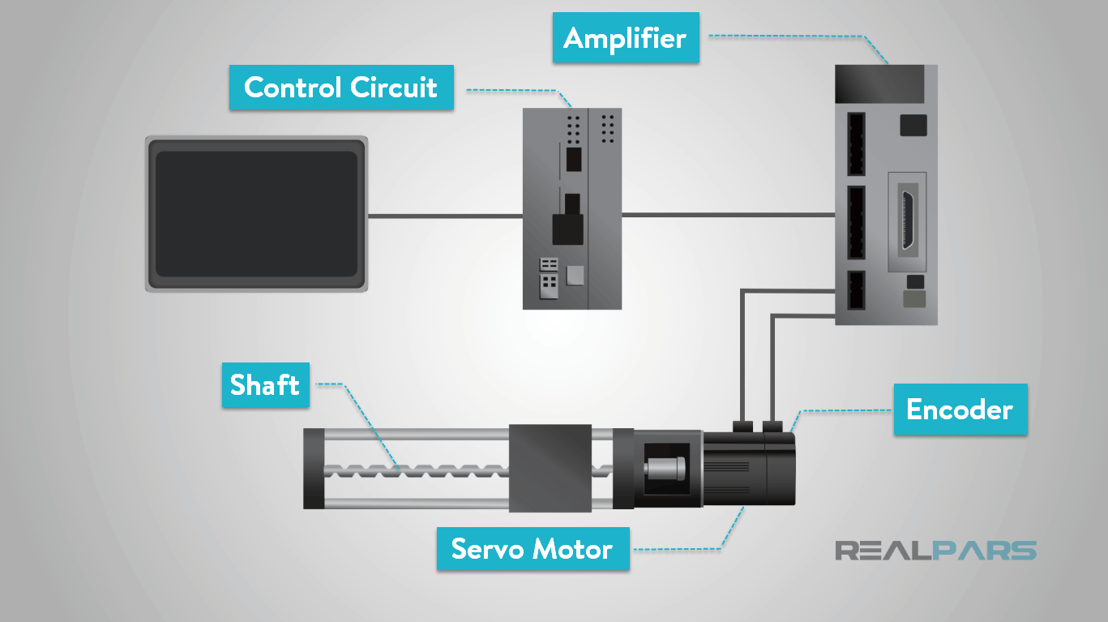
Fig. 18 Servo Motor System (REALPARS)
A servomotor was chosen because of its advantages as they are good for closed-loop systems, where precise position control is necessary (Gastreich). The system is comprised of a Drive (control circuit), servomotor, amplifier and an encoder as seen in Fig. 18. The motor can be controlled to move to a location (when connected to the linear actuator), angle, and velocity required. The way the motor understands commands and know what it is doing is because of the encoder, as it sends position and speed signals to the driver were rotation and displacement can be controlled. The output signal from the controller the motor can be analog or digital. In this case, it will be digital as it allows for speed variation without loss in torque (Progressive Automations). Other considerations when a motor was selected were AC current, Brushless design, and Asynchronous. AC current was chosen as there would not be a need for a DC power source, it can be simply plugged into a wall and can be used with higher currents (Meaning it can handle bigger loads in our case). A brushless design is going to be used as it reliable, has higher efficiency and lower noise output. Finally, the AC Asynchronous motor was chosen because of user-friendliness, price, and availability at the time of purchase.
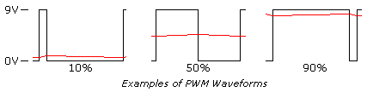
Fig. 19 PWM 10%, 50% and 90% Waveform Examples (Kuphaldt 2006)
The digital signal is a Pulse with Modulation (PWM) which will send a signal for an amount of time of a predetermined period. As an example, in
Fig. 19, it can be seen in the right a 10% signal, meaning 10% of the time in a period is on, but with a source of 9v. In this case, let's imagine using a 24-volt source, where instead of using an analog signal, which to go at half speed without load it would need to decrease the voltage to 12 volts. The problem with this scenario is that the moment there is a load in the motor shaft, the load will not be the same as inducing 12-volts is not the same as 24-volts. This problem is why in the industry, PWM motors are used because if half speed is needed, the pulses would go from a constant line of 24-volts to a 50% on and off cycle. The advantage is that there is no torque loss as when it is on it is supplying all 24-volts of power. This signal will be encoded and controlled by Modbus.
Modbus is a protocol designed as a messaging structure by Modicon in 1979 (Modbus). It organized devices as master-slave/client-server communication between intelligent devices and is the oldest and the most popular automation protocol in the field of process automation or SCADA (Supervisory Control and Data Acquisition). It is an open protocol and LabVIEW can manage this communication without a problem. One advantage of this technology is the communication of devices from different manufacturers without any modification as they use a common language.
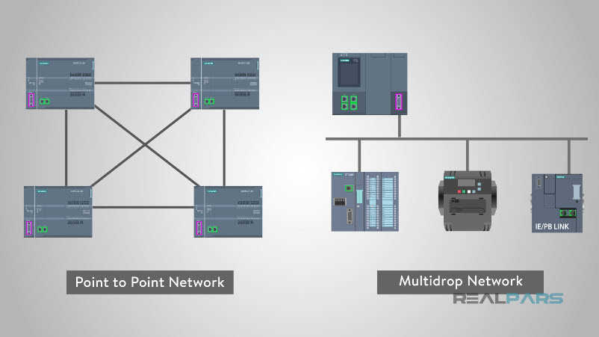
Fig. 20 Modbus Network Examples (Gastreich)
The way Modbus works is by establishing a master device which will send requests to the slave device. The device will instead send data back to the master as needed. There may be different levels of communication for big systems as they can relay the master command further and to more devices. The message speed and distance from a source can be different depending on the connector type, and an example is RS-485 which was a great upgrade from the RS-232 connector. In this case, an RJ45 will be used which uses an Ethernet TCP/IP but Modbus allows for this communication by encoding the messages first when sent in the ethernet line and knows how to decode at the other end. Another advantage is the network setup like in Fig. 20, wherein the left side it can be seen a Peer to Peer connection (Physical connection between devices) and a Multidrop Network thanks to the communication structure. The way devices communicate is by the master sending queries and the slave reading them. The slave will never initiate an action so only by command. The signal can be directed to a single device or a major broadcast to report or if encoded, initiate an action like closing a valve or changing the speed of a motor.
The format of Modbus is divided into 4 parts. The segments in order are the slave address or broadcast address, function code, data and CRC Error Check (Gastreich). In the first segment, it will identify the slave for communication, then a function is sent with a read or write data command. In the third part if a write command was sent the data is encoded and sent back. Finally, an error check is initiated by the Master or slave device wherein the master is checked to verify if the contents are correct. If there is a problem or a command can’t be performed, then an error message is sent back. This communication system for our linear actuator is important as in the future when other valves or devices are connected to it, if they support Modbus it would be relatively easy to control without much programming.
As seen in Fig. 21, on the top of the Linear actuator a bolt will hold the machine to the upper structure through the cross-sectional bars. Almost reaching the bottom, two support arms will give stability and prevent the actuator from flexing or bending under load. At the end of the actuator, a cage will hold the load cell which will also be connected to the data acquisition system and the rod string to measure.
Main Support Bolt
Linear Actuator
Support and Alignment Arms
Cross-Sectional Bars
Wellhead
Rod String
Load Cell
Production Line
Fig. 21 Upper Structure Setup for Linear Actuator

3.3 Casing and Rod
A transparent casing is being used in the lab with an OD of 2 13/32” (63mm) and ID of 2” (51mm). Several sections of the casing are connected through couplings to allow a simpler installation and access. The estimated length is of 45 feet from top to bottom, wellhead to the bottom tank. Supporting the weight of the casing will be the wellhead and cable lines at different levels to distribute weight.
The rods that are going to be used for the machine are going to be 3/4, 5/8, or 1/2. Depending on the flexibility and application more rod sizes might be considered for future experiments. As an example, the 5/8in rod string should weigh 51 pounds by using the highest reference value available for this size (Novanitek, 2018).

3.4 Data Acquisition System
The Measurement Computing Data Acquisition (DAQ) shown in Fig. 22, is a system that can support up to 8 analog inputs, 10-bit analog output, 16 digital I/O signals and one 32-bit external event counter. It has two modes of operation like the single ended mode where eight analog channels are available where the input signal is referenced to signal ground and delivered through 2 wires. The other mode, the differential configuration uses 4 analog channels in which the input signal is measured with respect to the low input and delivered through 3 wires. It is dependent on the sensors installed. With incoming analog signals, measurements with variable signals, for example, voltage from the load cell, can be measured.
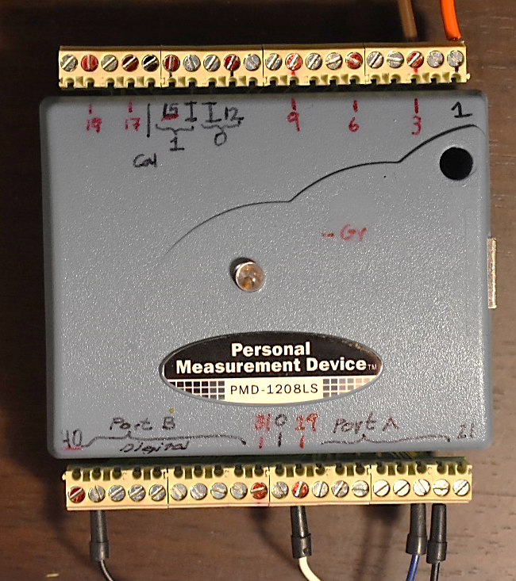
Fig. 22 Data Acquisition System from Personal Measurement Device
Digital signals are also going to be used for other types of equipment. If a switch system will be used to identify the upper and lower stroke limits these would allow the software to determine the position at the ends. Also, other devices if added like a water level safety shut down, a gas injection valve operation can also be controlled through the DAQ.

3.5 Load Cell
For the load measurements, a Load Cell from Spirit Global Energy Solutions (Now Apergy) is going to be used. The device is displayed in Fig. 23. It has a load capacity of fifty thousand pounds, an excitation voltage of 5-15 is required, the input resistance of 725 +/-25, and output resistance of 700 +/-5. It also has an IP69 certification sealing that it is a high level of protection against foreign objects, water, and access. The code is decoded as 6 Dust-tight, 9-High pressure and temperature water jet and against access to hazardous parts with back of the hand, finger, tool or wire.
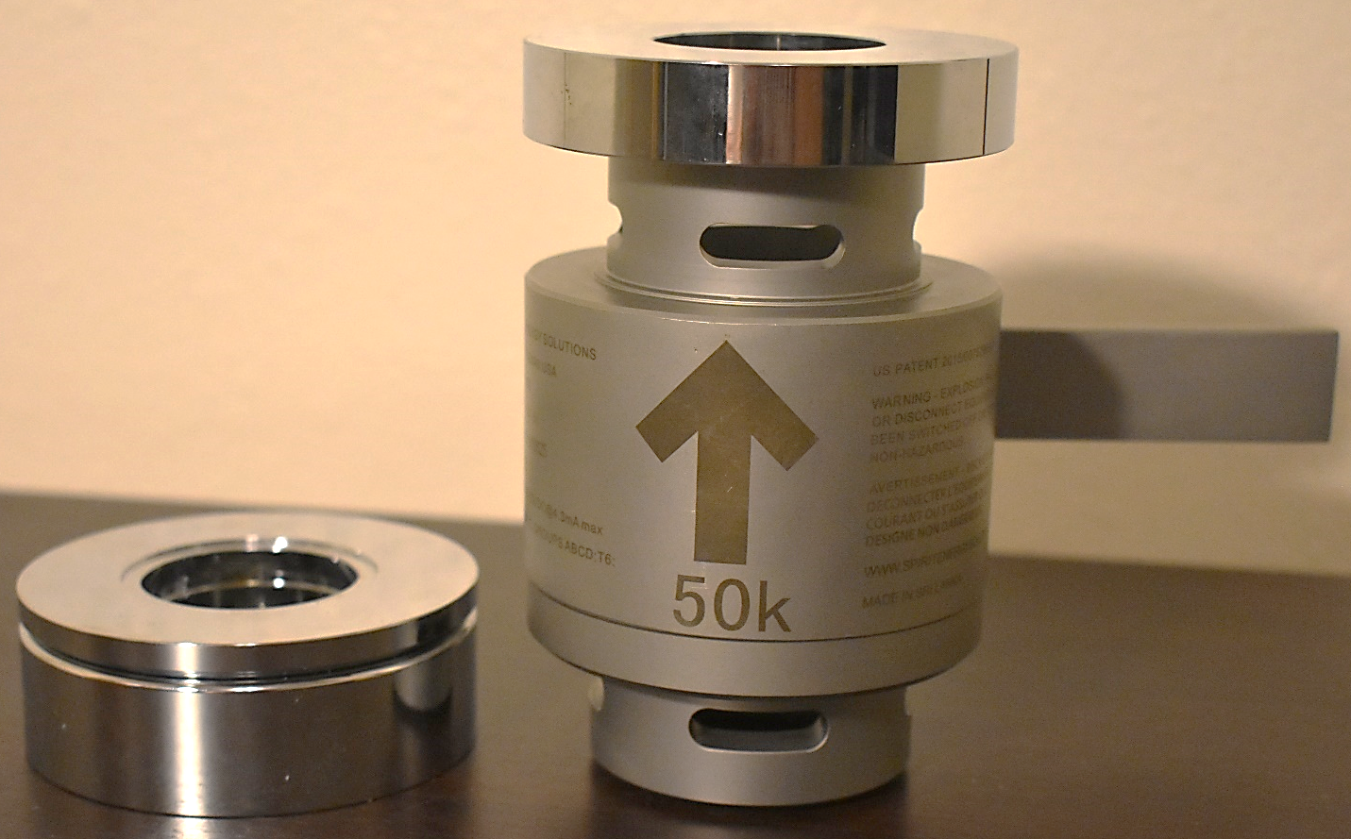
Fig. 23 Laboratory Load cell selected for the SRP Digital Machine
The high quality of this piece of equipment makes measurements very accurate and precise with a combined error of +/-0.05 and an output of 2.01+0.03 mV/V. As the excitation signal powers, the device, the output will be measured by the DAQ hardware. The DAQ will use a digital port (on/off) wireline to turn on the device either by directly connecting to the device or via a relay, as it must be tested because the device range goes from 5-15 volts but the DAQ can only output up to 5V. With a relay connected a secondary power source/power adapter can be plugged with a +5 volt to make sure no voltage fluctuations can affect measurements. The measurement circuit will be instead connected to an input analog port (fluctuating current) where it will send signals to LabVIEW. The output must be measured in mV/V (microvolt/volt) and in a 100% scale. So, if 100% equals 2.1mV/V at 50 thousand pounds, then a 200lbs measurement should be around 0.00804mV/V and fluctuate accordingly. We aim for a delay of 1ms for the software, but it could be up to 5ms if the machine can’t keep up with the measurement or calculations.
Holding Nut
Load Cell
Measurements Circuit
Power Circuit
Polished Rod
Fig. 24 Schematic of the Load Cell in the SRP String
In Fig. 24, all previous characteristics can be seen such as the measurement and power circuit. The load cell measures compression not tension, so to make the device work it must allow the polished rod to pass to the upper section of the device. Once there a conventional or purposely built washer must be added to hold up more than 860lbs that is the limit of the linear actuator frame. Another function of this segment is to keep the polished rod centered and diminish any vibrations so there just be a track in the modified washer or two different radius washers to hold weight and center respectively. A nut is added in the top to secure the polished rod from releasing and a nut may be added if possible on the interior side to add stiffness to the assembly. As constant tension is assumed, it might not be necessary in the end.

3.6 Liquid System
A water control system must be put in place to make the water flow as required to different tanks or to diver to different sections as required. In Fig. 25 the water system layout is shown, where 3 liquid tanks will handle either water production, supply or safety. Starting at the top, with produced liquid, the Tank 1 setup will be used to store water if needed and an electrical pump may be added to the system to fill it up and put water back in the tubing for cases like when tubing fillage is needed such as maintenance and initial column for when the system is empty. The tank 1 valve will allow water to ingress the tank and this is very useful as when producing water and gas this tank can work as a separator and a gas flow meter can be added to the setup if needed. This might work for other experiments but if the system can measure gas injection flow in the bottom, adding a flow meter on top can be discarded.
Casing/Tubing
Wellhead
Tank 1
Tank 2
Safety Tank
Air/Gas Line
Tank 1 Valve Bypass
Tank 2 Valve Bypass
Control Tube Valve
Valve Flow Control 1
Bottom Hole Pipe Assembly
Control Tube
Tank 1 Valve
Gas Line Outlet
Valve Flow Control 2
Tank 2 Valve
Fig. 25 Flow System Diagram for Digital SRP
The other upper valves like the bypass will be used to divert flow to the tank if an only liquid production is performed. Finally, a flow control valve is placed to avoid any liquids from flowing as needed. The control tube is going to be initially used as a volume measuring device. By adding a laser sensor on top of the control tube, the water level can be measured in time. While not a precise way to measure volume indefinitely it is useful for a controlled run of a few strokes. This control tube can be used in synchrony with tank 1 as when the tube is emptying water can be diverted to the tank and when is empty producing water can be then diverted to the control tube to make new measurements. At the time the system is measuring flow, it will need a depressurized water source, so water from tank 1 can be feeding the system or diverted to tank 2 to feed the system. This will allow a continuous run of the SRP and many flow measurements of the running system.
Tank 2 will be an active water source for the system under normal operating conditions, but it will always need a tube or line to atmospheric pressure. This will avoid the SRP to build negative pressure that may damage equipment such as pipes, tanks, and valves. A final flow control valve is added in the bottom, this is mostly to control liquids when performing maintenance on either side as when functioning the valve must always stay open. The valve system can be either manual, remote operated or a mixture of 2. The best practice is to operate all remote valves, as there will be always a real-time status on the valves and minimal safety/integrity threats. The problem is cost as these types of valve tend to cost more than manual valves. The best practice for this situation might be to use a mixture of manual and remote valves. In places like the flow control valve 2, there is no need for immediate control, but in the control tube system, remote operation is necessary as coordination and simultaneous valve operation are needed.
Finally, in the last section between tank 2 and the tubing, a gas line can be added to simulate gas interference in the well. The way gas can be injected is also important as there can be direct injection or a device that can produce bubbles for better distribution and different gas pattern accumulation. In case there is any catastrophic failure in the machine or depressurization and leaks occurs in the tubing or casing, all the fluid can be retained in the safety tank. With a volume of x3 the amount in the upper sections, the equipment in the lower section is safe.
In the end, economical limitations might affect the proposed liquid system and simplification might be needed with the right equipment such as a professional grade liquid flow meter. As other experiments may be performed in the future the system can be adapted to supply those needs.

3.7 Sensors
The initial proposal for the sensor technology was based on an analog linear actuator or digital with Pulse with Modulation (PWM). As more options appear during the research phase of the motor, options like a servo motor, stepper motor and linear actuator with resistors appeared. The stepper motor can count how many degrees it turns based on the phase change and it could have been translated to the position with the values of the mechanical gear. The next option was to use a resistor included with the linear actuator, and the way it works is that the resistance has a range based on the displacement of the actuator. The actuator can be positioned almost automatically to any point in the frame as once a resistance value is encoded to a position value, the motor moves until it reaches that value. The problem with these actuators where the quality and work duty (percentage of an established value of time where a device can be on). The problem faced was that many devices in the higher range didn’t have a resistor as a measuring device as other options had to be explored.
Laser Sensor
Linear Actuator Extended Cylinder

Laser Level Plate

End of Linear Actuator
Load Cell
Draw-wire displacement Sensor

Wire

Draw-wire Holding Plate

Servo Motor Encoder
Fig. 26 Linear Actuator Complementary Sensor Technology

For any of the initial options, a supplementary measuring device needed to be added. In this case, a laser measuring sensor and a draw-wire displacement sensor were looked upon. In Fig. 26 it is shown the different sensor that can be attached to the linear actuator. The draw-wire sensor is precise for the application and in the lab, some machines use this as a measuring device. One of the problems of the sensor is first to attach to the machines, either by modifying the casing or gluing a hold-down plate in the exterior case, but also adding a draw-wire holding plate in a location in the extended actuator. This means accuracy may be affected as any deflection of the holding plate may give wrong values, and by adding the dynamic motion of a device that is supposed to move at high rates of 7in/s it could increase the total error in the measurement. For the laser option, these physical constraints are non-existent, but because of using a separate sensor it means using a different port for measuring and then the question is how data can be synced or be accounted for in time. For a light program, this is not a problem, but when heavy calculations are performed it must add a “wait for” function so all data in the program can be processed, as in many cases the program/computer may not be able to cope with the workload.
In the end, a Servo Motor was selected for many reasons and not only for the power it can produce, and the displacement rate the system needed, but also these motors have an encoder in one end that measures the rotation of the shaft inside the linear actuator. As the motor comes with a drive, it will perform automatic calculations of speed, acceleration, and position. Inside the program, once a device is connected, the LabVIEW driver can be created or if available downloaded. Acceleration can be controlled, and displacement can be traced so, in the end, this option allows for the operator to focus on more pressing issues in the software or in the dynamometer cards.

4. Use as a Research Platform
LabVIEW is engineering software for applications that require testing, measuring and control with rapid access to data. Created by National Instruments, it is data flow programming that uses visual feedback to a program called graphical block diagram. The user will use the modules and wires to visually connect and program the software instead of command lines or complicated drivers to connect or control equipment.
In the laboratory, this software can be connected to equipment like a linear actuator through a DAQ (Data Acquisition System) to send or receive signals. Development and calibration are still a work in progress to analyze and simulate SRPs. The DAQ or Drive unit will output a constant voltage to control the linear actuator through digital signals (PWM). At the same time, the load cell at the polished rod will be sending analog signals to the DAQ to be used for building graphs in the software to show the load vs displacement. Other sensors like rate, temperature, bottom hole load cell, displacement sensor, switches, and fluid level equipment must be selected and prioritize depending on the application.
The first objective in LabVIEW will be to control the motor that comes with the linear actuator. By understanding how acceleration, velocities and position control work with LabVIEW, the Drive or control unit can start creating scripts for the established movements of the conventional and unconventional pumping units. The next step is to connect come sensors and start measuring points to understand their data output and make sure there is no signal interference that is common and needs to be addressed.
Once the machine is working and measuring data correctly, formulas are added for testing and figuring out the best method for calculations, either in the same control cycle or parallel to the data gathering loop. Here is where questions about the timing of the events and how they will slow the data process are considered. Once a good interval of a loop process timing is known, the machine must be tested to see if it can process an x amount of data through the formulas. Finally, this will lead to the construction of a live graph of the movement cycle via the data gathered from the sensors.

4.1 Pumping Unit in Motion
In this section, the need to tailor each type of SRP is discussed, and to do so, different mathematical models can be used. As an example, speed can be changed with acceleration to reach a position in the stroke. To achieve constant velocity, a constant voltage needs to be used, but the machine must translate it into an established scale. This is possible via the encoder on top of the linear actuator that sends signals as it rotates as on/off. As it is connected through a gear system to the main shaft that displaces the actuator, it can establish a counter that measures rotation and translates it in linear motion, in/angle of rotation. Also, another feature it must be cleared is if there is a need to learn if the actuator driver uses reference counts (meaning each click/signal detected is only an on/off) or if it assigns a constant value to each signal, like a zero to 10,000, meaning no calibration is needed each time the machine is turned on.
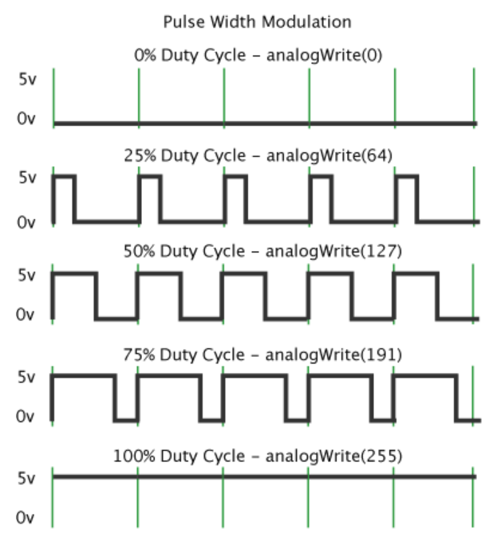
Fig. 27 Digital Control with the used of PWM (Hirzel 2019)
The technical details need to be analyzed when the machine is tested, as there is an option to build an in house driver for the motor, download the company driver or look for drivers made by the LabVIEW community. The first advantage of the digital motor vs an analog motor is the efficiency. As talked in the subchapter of the proposed laboratory set up in 3.2, a constant voltage, for example, 5v will have pulses that are the “on” time in a period. This happens so fast that the equipment cannot notice the difference and the advantage is that virtually no torque is lost, and the power source doesn’t need to accommodate for changing voltages. The reason this is more efficient is that by using voltage variations in a power unit, it must transform the unnecessary voltage into heat through heatsinks, making the device heavier and wasteful as it needs to dissipate the non-used voltage. Instead in the servo motor, the digital signals are counted as values from 0 to 255 (In Arduino) so by choosing 127 it gets half power and the signal is on only 50% of the time like seen in Fig. 27.

V₁

V₂

V₃

V₃

V₂

V₁

V₁

V₂

V₁

Fig. 28 Different Linear Actuator Motions with Variable Speed and Acceleration
Once constant voltages in the machine are controlled, testing for acceleration can be performed. By measuring the limits of the machine at top speeds and accelerations the user can have a clear idea on how to create and model the motions. This process can be seen in Fig. 28, starting from the left it is shown an accelerating downwards motion, next is an accelerating upwards motion and in the right, a mix of both motion that is accelerating until the middle is reached and then deaccelerating before reaching the end of the stroke. The last actuator represents the movement of the rod string in a Type-C SRP. This is because of how the circular motion is transformed into linear motion through the beam, and as it has been explained before, velocities, displacement, and acceleration move in a similar tendency as a sine or cosine wave. But physical limitations of the machine must be known.
A significant factor the programmer must understand is how loads affect the machine movements as with heavier load speed decreases. In general, with a machine with a load capacity of 810lbs and a load requirement of 115lbs in dynamic load, there shouldn’t be much disparity in unloaded speeds and testing is advised. The main reason for testing is the difference in loads when in the upstroke and downstroke. As in the upstroke, all the weight of the fluid is in the rod string, the machine may move slower as there is an opposing force. In the downstroke, the load is transferred to the tubing as the traveling valve opens and the standing valve closes. In this situation the load of the rods is the only weight pulling down and because there is no mechanical hold down like in a normal pumping unit so there is a possibility that in this period the rods may move faster if kept at the same value of PWM. The way to understand this phenomenon is to assemble and test the motor performance at different speeds going up and then down and compare data. If corrections need to be made they should be relatively easy as there is total control of the motor.
L=76.15mm
L=76.15mm
ID=14.4mm
Polished Rod Base
Polished Rod
Diam=15.8mm
L= 900mm or
35.43in
Fig. 29 Polished Rod and Polished Rod Base
Another possible problem may be the restriction of produced water. We still need to account for the top production and if there is any restriction on how fast it can produce liquids. The polished rod base can be seen in Fig. 29, where the dimensions are shown and specifically a 14.4mm exhaust is displayed, that means a ½ inch pipe is going to be used. The problem with the actual rod base is size, but in the future, a machined based may be created to make a greater exhaust for liquids in the well. For now, testing will be required, and operational data needs to be done to compare to our estimations of production.
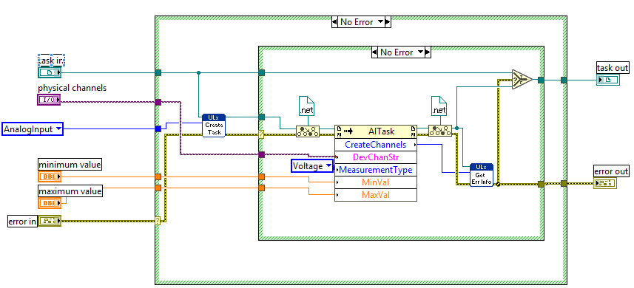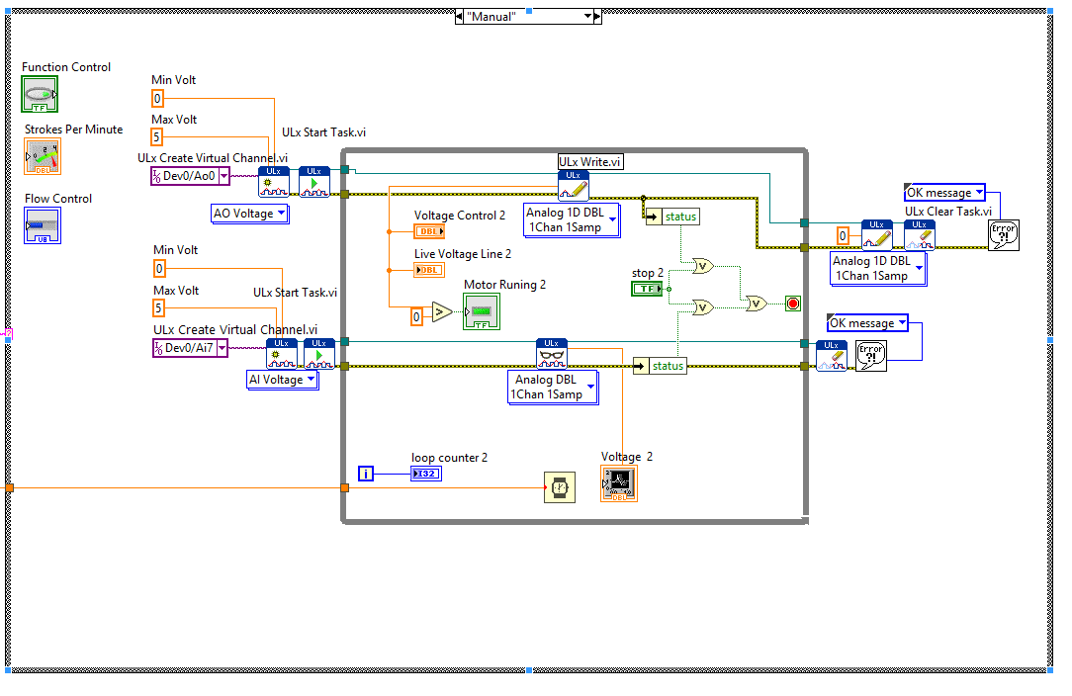
Fig. 30 LabVIEW VI (Top Left) and Sub-VI (Bottom Right) of an Analog Driver for the First Actuator
In the end, these questions need to be solved for the machines specifically and with different speeds, limitations need to be found regarding production rate, load effect of liquid/rods/backpressure and the motor limitations when working in a completed setup. Like seen in Fig. 30, it shows an example of a program that can output voltage in the DAQ system and it was going to be initially used with the first linear actuator available. Also next to it are the drivers that oversee the control in the DAQ device, similarly can be done in a program and then pack it in what’s called a sub-VI to be used in many cases and programs.

4.2 Sensor data
Once the motor and the linear actuator is working, the data gathering process can be started. First, understanding how our equipment works and how it measures signals incoming from a sensor must be studied. With analog signals, a constant voltage is traveling to the DAQ device, but it is impossible for the device to gather data in real-time, in a constant stream. This is normal, and these are limitations of the hardware used everywhere, there is always going to be spaces in between data points. It all depends on how data is going to be used and how frequent the user wants to do so.
In our DAQ model USB-1208LS there are different gathering modes, based on software, hardware, and BURSTIO. In software mode, samples are limited to the fact that USB connections require a 20ms round trip to send/receive data, this means only 50 signals per second (50 S/s) can be obtained. In the hardware pace mode, there is a buffer that can send data up to 1.2kS/s in all input channels. This means that if 3 sensors are used, only 400S/s can be done per sensor. Finally, BURSTIO mode uses the full DAQ capacity as can compilate 4K samples, but it is limited to only capture that number of signals as the data transfer to the computer cannot handle the speed. This is for specific cases only. From all these cases either software or hardware acquisition will be chosen.
In this system, there is no need for very high sampling rate as the focus is not small interactions, but at least 50 samples per seconds are recorded making it very accurate for our purpose. The data resolution must be good, and graphs must look smooth. We also do not want too many samples as then the size of the data becomes too large to process. For a 1h minute run, 180 thousand samples are produced, and it is a manageable size compared to a 4k sampling rate that is 14.5 million samples. Loading problems may occur and the computer resources might get overwhelmed with that amount of data in the RAM. So, a balance must be met starting with software paced acquisition and later trying the hardware mode that can top 4.3 million points in an hour.
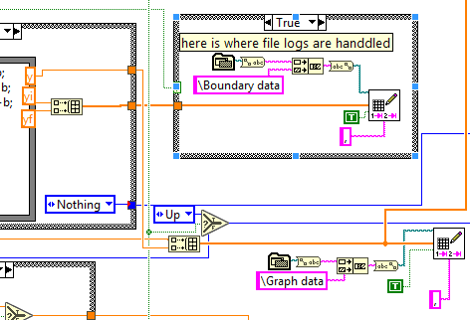
Fig. 31 LabVIEW Example of Data Storage in Different Scenarios, Continuous Vs Selective
So, by now, data points are gathered properly and have a balance between quality and size. Now the data can be stored in a file either by building on top of previous data, creating a personalized file or just plotting the points in the graphs. The type of data can also be selected, so each iteration of the program can store data like voltage values, results from formulas, plotting points, time stamps and in which scenario they are in depending on the coding performed. In Fig. 31 it can be seen how this happens. In the left side of the figure, boxes labeled y, yi, and yf. The yi and yf are grouped into a 1D array of data and sent to the Case Structure on the right. This case structure has a True/False activator, so only when a signal of true appears, it gathers the data and stores it. Here the initial and final points are gathered in the extremes of the function ranges. If no case structure would be used, the same data points would be calculated100 times, instead of once.
In the case of y points that are the load in the rod string, it is desired to calculate points as much as possible. The closer a point is calculated from the previous one, the smoother the graphs will look. This will result in better resolution of data. In Fig. 31, y can be seen heading a path downwards to another point where it will be grouped with an x point (displacement value). This data is instead stored in every iteration and as fast as possible. Normally in LabVIEW, data can be exported via a coma separated-value, so these files can be opened either by LabVIEW, Notepad, Excel, and R.
Finally, data gathering is not an easy process and requires the operator to test the DAQ hardware, the computer where it’s going to be used and the software. This is not an exact operation, so it is common to try to go faster until there is an error message where data cannot be acquired faster, then turn down the signal gathering to a safe level where it will work continuously without problems.

4.2 Simulations of Wave Equation
The idea of simulating the rod string behavior is not new. Based on different mathematical models this has been done differently thought the decades until standardized models appeared. The key to proper description of the pumping system is the simulation of the rod string’s behavior, and the most influencing factor in the rod string is elasticity (Takacs 2015). Because of the nature of the system, the constant tension and the loads, impulses from the surface affect the pump downhole. This transmittance of energy is why the system is modeled with a wave equation. In the same way, surface equipment can affect downhole, the signals from downhole can affect the pumping unit. Sam Gibbs developed the first universal method for solving the damped equation. As seen in Fig. 32, forces induced in a rod string are explained, and in Eq. 23-26 the mathematical calculations are performed.
Sum of forces $m\frac{∂^{2}u}{∂t^{2}}=Fx-F_{x+∆x}+W-Fd$ Eq. 23
W=Weight Rod Element
Fd=Damping Force Opposing Mvt. (Fluid and Mech. Friction of Rod Surface)
Rod load in section x $Fx=S_{x}*A [psi]$ Eq. 24
A= Cross-Sectional Area of Rod String, sq in
Sx and S_{x+Δx}= Rod Stresses in section x and x+Δx, psi
Rod load in section x+Δx $F_{x+∆x}=Sx+∆x*A$ Eq. 25
Hook’s Law $S=E\frac{∂u}{∂x}$ Eq. 26
S=Mechanical Stress, psi
E= Youngs Modulus of Elasticity for Rod Material, psi

Fig. 32 Forces Acting on a Rod String (Takacs 2015)
Substituting Expressions $m\frac{∂^{2}u}{∂t^{2}}=(S_{x+∆x}-S_{x})A-Fd$ Eq. 27
From Eq. 23 forward, including Hooke’s Law and rod stress, with the second derivative of displacement u with respect to distance x. Also expressing mass m with volume and density of rod element:
$\frac{∆x*A*ρ}{144 gc}\frac{∂^{2}u}{∂t^{2}}=E*A*∆x\frac{∂^{2}u}{∂x^{2}}-F_{d}$ Eq. 28
ρ=Density of Rods, lbs./ft³
gc=32.2 gravity constant
To get to the final form of Gibbs wave equation, the damping force needs to be determined. This force normally constitutes a force against movement and in many situations, it can be difficult to obtain in the field. The forces acting against the movement are fluid friction and mechanical friction. The fluid friction is composed of fluid interacting with the rods, couplings, and tubing. The mechanical forces instead are composed of friction of stuffing box, polished rod, tubing and rods contact and/or couplings along with the tubing, and plunger and barrel friction. The difference of the power induced at the polished rod and power at the pump is equal to power lost by the dampening effect. But the problem becomes now simulating each type of force correctly and depending on vertical and deviated wells. Normally in vertical wells, the dampening forces don’t play a big part in the overall performance and mechanical or coulomb forces are theoretically negligible. In deviated wells, this is now a problem where mechanical friction plays a bigger part and simulating this becomes a specific problem of each well and the bending conditions of the rods and mechanical frictional forces.
After considering all the mentioned elements and simplifying the wave equation, the final form is shown in Eq.29. This is the most widely used form of the one-dimensional equation. It is a linear second-order hyperbolic partial differential equation.
$\frac{∂^{2}u(x,t)}{∂t^{2}}=v_{s}^{2}\frac{∂^{2}u(x,t)}{∂x^{2}}-c\frac{∂u(x,t)}{∂x^{2}}$ Eq. 29
u (x, t) =Rod Displacement, ft
x=position of rods, ft
t=time, s
c= viscous damping factor, 1/s
Vs=Sound Velocity in rod material, ft/s= $\sqrt{\frac{144*gc*E}{ρ}}$
Solving the wave equation is very important as it can be used to diagnose or to predict operating parameters. For the numerical solution, a modified solution will be used following Takacs procedure.
$\frac{∂u}{∂t}≈\frac{u\left(x,t+∆t\right)-u(x,t)}{∆t}$ Eq. 30
$\frac{∂^{2}u}{∂t^{2}}≈\frac{u\left(x+∆x,t\right)-2u\left(x,t\right)+u(x-∆x,t)}{∆x^{2}}$ Eq. 31
$\frac{∂^{2}u}{∂t^{2}}≈\frac{u\left(x,t+∆t\right)-2u\left(x,t\right)+u(x,t-∆t)}{∆t^{2}}$ Eq. 32

To get to Eq.30 with difference quotients replaced derivatives are used, and this means there is an approximation, not a definitive answer. This is going to be a finite difference solution. For Eq.31 and Eq.32 a Taylor series approximation neglecting the higher order expansions is shown. In the end, by replacing these equations into the wave equation we get:
$u\left(x,t+∆t\right)=\frac{\left\{\frac{∆t^{2}v^{2}}{∆x^{2}}\left[u\left(x+∆x,t\right)-2u\left(x,t\right)+u(x-∆x,y)\right]+2u\left(x,t\right)-u\left(x,t-∆t\right)+c∆tu(x,t)\right\}}{1+c∆t}$ Eq. 33
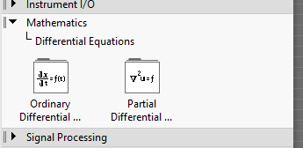
Fig. 33 LabVIEW Mathematical Solutions
This is a possible form of a finite difference solution formula for the predictive case, which is the one going to be used. Once with the machine working and the motions solved, calculating the pump cards are performed and how they will compare to the surface ones. For this, LabVIEW has different tools that can achieve the calculations either by formula nodes, MATLAB script nodes, and even differential equations solver line Ordinary and partial differential equations like seen in Fig. 33. So once the data is flowing, the mentioned parameters can be used, and incoming data can either be calculate live or from a data set.

4.5 Dynamometer Cards
In this section initially, the Dynamometer Cards are going to be formed as a personalized function builder and later with the wave equation they could be simulated with live data. It is important for the operator to know the stroke size and loads that are going to be used to create a dynamometer card. Next, to this an iteration timer to select a delay for each calculation and a live tracker where the actual displacement is shown. In Fig. 34, it is shown the process where the stroke size is selected, and step size is also selected, the step size means the size of each interval of data points. Is a 1 interval is selected it will calculate y in X=1, 2, 3, … or if the interval is 0.5 it will get values at X=0.5,1, 1.5, …. Until the stroke length is reached and then a return path is calculated. The axis in the graph is Y=load in rod string and X= displacement of the rod string.
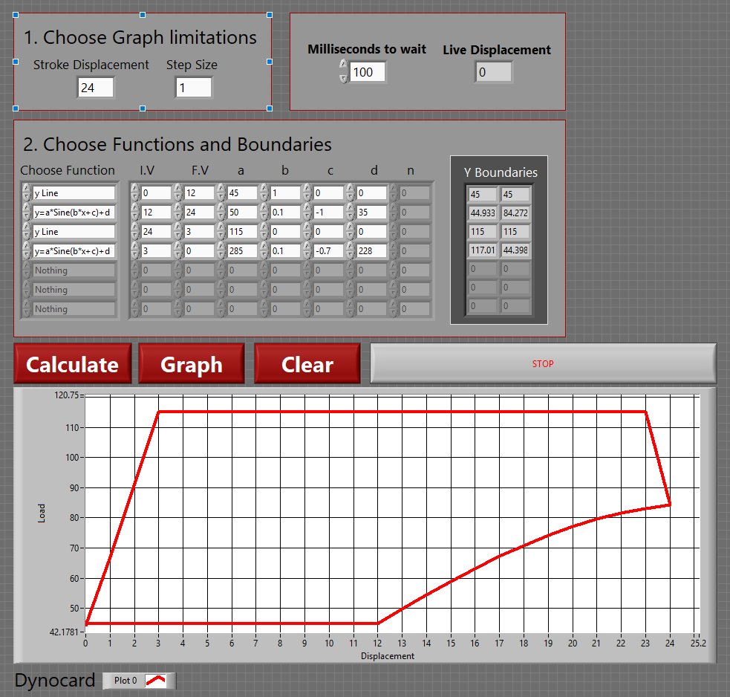
Fig. 34 User Interface for Personalization of Surface Cards
In part 2 of Fig. 34, instead the user selects a function and the X range. The functions included are basic ones like line, to exponential, trigonometric and others. If a user needs a new function it can be done by adding a case to the LabVIEW structure. Like in Fig. 34, the first function is a line, that starts in 0 to 12, with a Y displacement of 45. In the right side of the program a “Y Boundaries” is displayed where the initial and end values of Y are shown to the user can adjust the function. In row 2, a complex function is selected so more options are available to the user to modify. Finally, in the bottom different buttons are shown, so functions can be processed, so when the user clicks “Calculate”, Y boundaries are processed. Once the plot points are stored/processed a graph can be created by clicking Graph. And importantly, to clean any data in the program the “Clean” button resets all data to zero, so the user can create a new function. The last button simply stops the graph creator. This is a summary of the user interface, but behind the User Interface (UI), a complex process is running every time a graph is created.
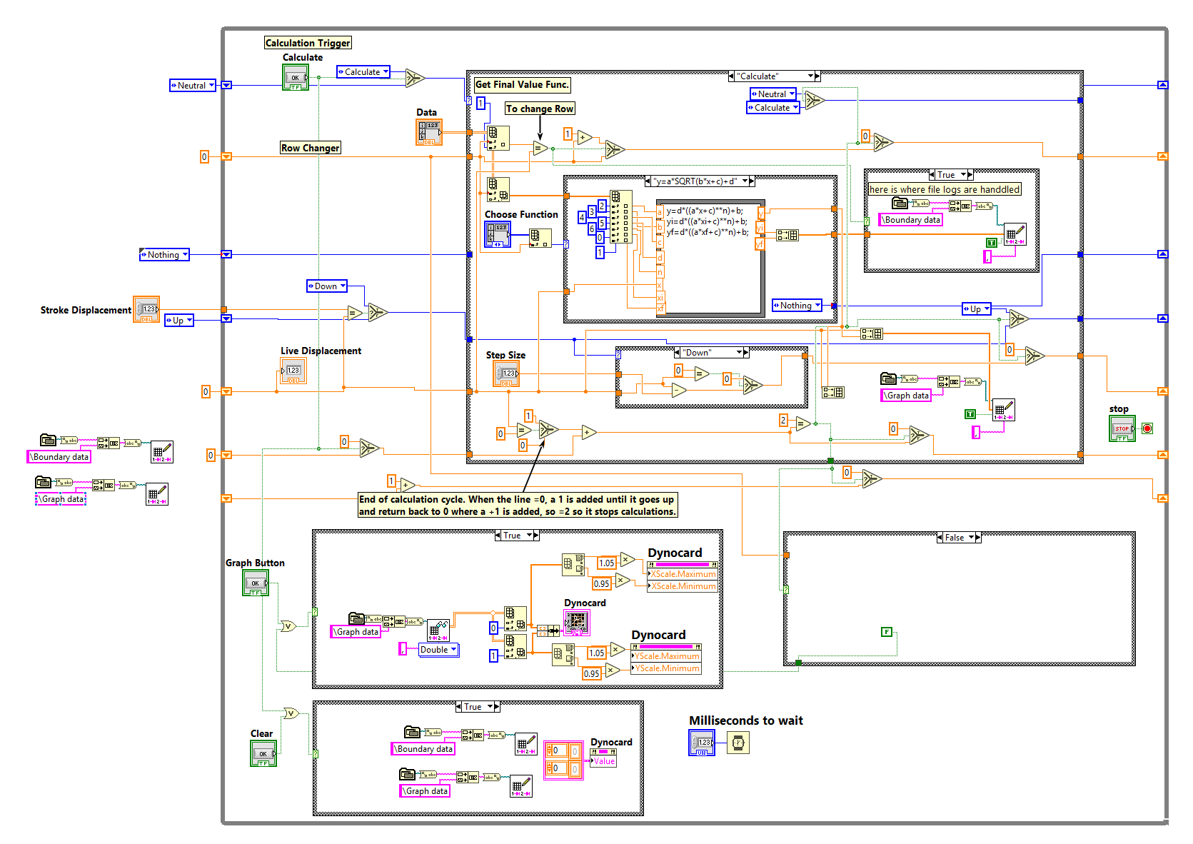
Fig. 35 LabVIEW Block Diagram Example of the Graph Builder
In the background or also called the Block Diagram in LabVIEW the data is being calculated in different lines as seen in Fig. 35. To control the main processes in the graph builder several counters are used to keep track of displacement, function row, the total number of calculations performed, state of the machine and data reader track to get each row into the graph. The first counter, the displacement is controlled by the top value that is maximum displacement and step size as it will only add a value dependent on step size. Once the addition of the step sizes equals the maximum length, the program will start the return path to zero. The values in this line are shared with the case structure that will calculate the function and is taken as X-Values.
The next control line is related to the user input. The function row line is tied to part 2 of the UI where it obtains the data in a row and sends it to the function calculator as an array. The array is divided into sections, firstly choosing a function to use and then the other data is relayed to get the Y boundary values or also known in the program as Yi and Yf. The third function with variable X is calculated and it depends on the live displacement, so Y values are fed into the array that is being created for the chart. Once a function reached Xf the program sends a signal to add a 1 to the line so in the next iteration the program will read from the next row. This process occurs until zero is reached in X.
The next counter line is the state of the machine, where the data of the process is stored. If there are no calculations a “Neutral” state is selected where no calculation or process is run. Once the operator clicks calculate it will change state to calculate and it retrieves values until the ends are reached where it returns to a neutral state. The last control line is the data reader, where the data is read from an array to the graph. It is fed in a per row basis until the end is reached and here is where the total calculations counter plays its role so only the numbers calculated are processed and not more. This reduces load and computer resources.
At the end of the program, the X and Y values are grouped into a 1-dimension (1-D) line where it is stored in a file. This file is a comma delimited file where it can be read in LabVIEW, Excel, and Notepad if required. The accumulation of 1-D array becomes a 2-dimensional data set. We can set the data for graphing inside LabVIEW or store in a file where other programs can use with ease.
Finally, If the user decides to use the data inside LabVIEW then, then like explained previously the data must be extracted from the file. The data is now a 2-D array, so it needs to either feed part all the data set to see how different strokes overlap or just use data from a single stroke. This approach will only make the lines appear instantly for the user. If the user wants to simulate the motion, a data file must be imported and cut the set into 1D arrays that would be fed one by one in each iteration. By adding a “wait” tool, time can be controlled delaying the data points appear in the chart, so different SPM can be simulated. This data management helps the operator use stored data instantly or also control the speed of the data being animated for further research. For reference, in the index section, there is a lot of pump cards available to compare and diagnose any problem in the rod pump.

4.6 Educational setting
The final step for the digital SRP will be the usage of its data. For this, two categories are created, one for research use, and the other for class use. After each stroke is adding a signal in the data, it will allow the user to differentiate each stroke or it can also set a predefined size for the stroke but that will need more information on how much data points per stroke are needed. Once the data is stored, the file can be loaded later.
The process to decode data from a file needs to be established as the data is now a 2D file, and it needs to be decomposed into sets of 1D data and fed in order. 1D arrays will have to be sent to a loop. This is necessary to know how many data point the program needs to decode from the main 2D array. For example, with 1000 points per stroke, the program can load a single stroke and then segment the data into 1000 size blocks. But another interesting aspect of LabVIEW is the possibility of adding many signals into one graph. This idea comes from many modern software that is to overlap data into your main subject. This means adding data from a previous and after stroke. In this situation, the program needs to calculate 3000 points and then split them into 3 tracks of data. Once fed into the graph, the user can change the coloring and shapes of the lines to differentiate and see for example how progressively the gas affects the pumping cycle.
There are many ways in which data can manage for research in the system, and that makes this a great platform. With millions of data points over long periods of time, the user can measure different effects in the pump and the linear actuator. One possible research topic might be linear actuator or pump performance over time and with a predictive model try to find when it is going to break. But this is limited to the sensors currently being used, so in the future with more specific sensors like pressure, temperature, volumetric flow and gas injector system can add up with more data.
So, for research, this laboratory setup might end up not only digitalizing data but later this data can be used to prove new models for gas effect. If the user can later use statistical tools in Excel or R, the user can identify the most traveled path in the load vs displacement chart by analyzing each displacement point in “x” and then getting all the values in y either in the lower or superior load section of the stroke. If the operator does this to every point, a signal that represents the others can be identified and assumptions can be done to identify the best path.
For class use, a few cycles of data that represent a specific case can be used, per say high friction in the barrel, so students receive the data from a professor and they must analyze the data, build their own graphs and if necessary correct some noise from the data as field data is always interlaced with some interference. Also, by using other software they can predict pumping performance and other formulas used in the production class. This way students can practice some of the ideas used in the field like predicting until when an SRP can be used for a well with the certain condition before there is gas interference and how to manage production rate to avoid the release of gas in solution.
Homework’s and projects can also be used with the machine. Another possible exercise might be to find operational parameters for the well and rod pump. Things like the weight of liquids, the weight of rods, loads calculation by any of the three methods described and production estimation can also be performed. Basically, making the same calculations done previously to get PPRL, MPRL, and PT. This way the can determine or prove the machine has the correct specification.
Finally, this machine can also be used to teach students about the technology of the project and how they can apply it to another project they might be thinking about. If they can learn about software like LabVIEW, how to process signals and control hardware, it might be setting the next great step needed in every university that is the introduction of digital tools to our class and feels confident on how to use them even when they graduate. By expressing different ways in which data can be used the user can now see the benefits of a digital machine inside the University of Oklahoma. While our initial scope is mostly to build a machine, the aftermath of these tools is to teach and make petroleum engineers confident about working with the electronic component.

4.7 Recommendations
Planning to build a machine with some of the best technology available in 2019 has been a big investment especially in the linear actuator, but by doing so I am trying to future proof the equipment as much as possible. With the actuator being completely new the user can rest assured he can use the best techniques to communicate and control the motor and as result, he will be able to mimic as close as possible to the real pumping units in the market. But not all the equipment in the lab has been tailored for this project.
For now, the transparent casing pipes in the lab where bought previously for another project and they have already been there for a few years. For the initial testing and data collection, this setup is more than necessary to being able to practically certify the machine for our objectives, but if further research is to be done with more aggressive pumping rates and gas interference, then a tougher pipe must be chosen to increase safety and operational parameters.
Talking about artificial lift, the pipe structure can also be modified to accommodate a different type of pump in the same lab. By adding a parallel pipe that connects to the main pipe section researchers can test for example an electric submersible pump (ESP). They can work individually and be switched with just a click. Also, a deviated section can be added in the bottom with a specific angle and length. With upgrades like liquid pressure sensors, liquid pressure pads, and gyroscopes the user can measure what is going on with a rod pump in a horizontal well and how friction may affect the rods or the tubes.
So, there may be a lot of upgrades ready to be made depending on future research objectives, so there is a lot of room to grow and expand into even other machines as this tool can be used as a reference to build other digital equipment in the University of Oklahoma.

5. Conclusion
In recent years as technology advanced, to the point where companies have sensors everywhere they can put one, remote connections to these machines in the field and the how system infrastructure to being able to control and analyze from everywhere. The times where engineers had to go to many sites to inspect and check for failure is almost over as with technology engineers can do this remotely. Even engineers can fix many of the problems remotely like changing SPM to correct for vibrations or gas interference. Basically, only when there is a failure or a procedure must be done, and the engineer needs to be on site. This saves time and money for companies, so it is something that is only going to grow in time as the technology get cheaper and becomes more widespread.
This digital push from oil and gas companies is changing the already complicated situation for many engineers as either there is a generational difference where technology is not viewed the same way, and recently graduated student that need training in electronic equipment as in many schools do not include this type of classes because they are considered too different to petroleum engineering. This train of thought must be changed as digital tools will only be more popular in the future and training the next generations of engineers to solve physical problems with technology will be an important factor when companies must decide who to hire.
The first objective of this machine is to build similar technology that is seen in the field to the university. By making a sucker rod pump as large as this one, the system is helping future students who want to do research into more mechanical topics. With the original theories being able to be used and displayed in the machine, field conditions can be simulated in the lab. The operator can control, monitor and test different safety procedures. The data produced can also be used to analyze the performance of the SRP.
The second objective was not only to build a sucker rod pump machine but to build a digital tool that is able to mimic different pumping units. With the great technology from Kollmorgen the linear actuator can withstand up to 810lbs of weight, and the system can reach up to 10 SPM. On top of this the addition of a load cell that can manage 50k lbs. There is more than enough capacity to measure each load with a low combined error of +/-0.05%. With the motor and the sensors, the linear actuator can test and compare to reference pumping unit movements in LabVIEW, as it can compare different theoretical models.
Finally, dynamometer cards can be obtained on the surface to later export or process the data in LabVIEW. This makes this machine able to be used either as a research platform or as a class tool depending on how the data can be used. By using the initial sensors, gas interference can be tested, load changes at different SPM and data from different pumping units. For classes, this machine can produce data that resembles field SRP cards, so students can calculate and obtain operating parameters of the machine, but it will also expose these students to the digital component of sensors and control units for hardware, and in doing so they should have a better time when they start working in the field with similar equipment.

6. References

Apergy. Apergy. Delivering support solutions aimed at boosting production efficiency and lowering lifting costs , https://www.apergyals.com/brands/spirit-global-energy-solutions/(accessed 03 March 2019).
Treiberg, T. 2017. XSPOC: Powerful computing technology for the oilfield. Norris + Theta.

API Spec. 11E Specification for pumping units. 18th ed. Washington, DC: American Petroleum Institute; 2008.
Dove, J., & Smith, Z. D. (2016, October 17). Using Sucker Rod Pump Repair Data to Optimize Rod Lift Design. Society of Petroleum Engineers. doi:10.2118/181211-MS

Gastreich, W. REALPARS. WHAT IS A SERVO MOTOR AND HOW IT WORKS?, https://realpars.com/servo-motor/(accessed 02 March 2019).
Gastreich, W. REALPARS. WHAT IS MODBUS?, https://realpars.com/modbus/ (accessed 01 March 2019).

Gibbs, S. G. (1992, July 1). Design and Diagnosis of Deviated Rod-Pumped Wells. Society of Petroleum Engineers. doi:10.2118/22787-PA

Gibbs, S.G. 2012. Derivation of the Wave Equation. In Rod Pumping: Modern Methods of Design, Diagnosis and Surveillance Chapter 2.

Guo, B., Lyons, W., and Ghalambor, A. 2007. Sucker Rod Pumping. In Petroleum Production Engineering - A Computer-Assisted Approach, first edition Chapt. 12. Burlington, Massachusetts: Elsevier.

Guo, B., Lyons, W., and Ghalambor, A. 2007. Sucker Rod Pumping. In Petroleum Production Engineering, first edition Chapt. 12. Lafayette, Louisiana: Elsevier Science.

Hirzel, T. Arduino. PWM, https://www.arduino.cc/en/Tutorial/PWM(accessed 15 April 2019).

Hollenbeck, A.L. 1980. AN ALTERNATE APPROACH TO HIGH VOLUME, A LONG STROKE PUMPER. Presented at the 55th Annual Fall Technical Conference and Exhibition of the Society of Petroleum Engineers of AIME, Dallas, Texas, 21—24 September. SPE-9216. http://dx.doi.org/10.2118/9216.

Jackson, M. S., Howell, D. A., Bailey, J. R., Rajagopalan, S., Ozekcin, A., Inglish, G., & Allen, C. (2018, September 24). Wear Resistant, Friction Reducing Coatings Reduce Tubing Wear in Sucker Rod Couplings Application: Lab Testing and Field Trial Results. Society of Petroleum Engineers. doi:10.2118/191617-MS

Kollmorgen. Kollmorgen. EC2 Series, https://www.kollmorgen.com/en-us/products/linear-actuators/electric-cylinders/ec2-series/(accessed 12 April 2019).

Kuphaldt, T. 2006. Vol. III - Semiconductors. In Lessons in Electric Circuits, first edition Chapt. 3. Design Science License.

Lake, F.W. and Brett, A. 1928. Chapter VI. Sucker-Rod Strains and Stresses. Presented at the New York Meeting, San Antonio, Texas. SPE-927337. http://dx.doi.org/10.2118/927337.

Liu, Y., Li, Y., Li, Z., Fan, X., & Zhou, X. (2007, January 1). New Tubingless Sucker Rod Pump System in Slim Holes. Society of Petroleum Engineers. doi:10.2118/106568-MS

Modbus. Modbus Organization. Modbus FAQ: About The Modbus Organization, http://modbus.org/faq.php(accessed 25 February 2019).

Orji, E., Lissanon, J., & Omole, O. (2016, October 17). Sucker Rod Lift System Optimization of an Unconventional Well. Society of Petroleum Engineers. doi:10.2118/181242-MS

Progressive Automations. Progressive Automations. PULSE WIDTH MODULATION VS VARIABLE VOLTAGE CONTROL, https://www.actuatorzone.com/blog/about-actuators/pulse-width-modulation-vs-variable-voltage-control-2/(accessed 02 April 2019).

Rowlan, O. L., & McCoy, J. N. (2015, March 1). Pump Card Reference Load Lines Used for Analysis and Troubleshooting. Society of Petroleum Engineers. doi:10.2118/173614-MS

Schlumberger. 2016. KUDU HSU Hydraulic pumping unit Brochure. Schlumberger.
SPE, I. PetroWiki. Sucker-rod lift, https://petrowiki.org/Sucker-rod_lift?rel=1(accessed 14 January 2019).

Spears, H.L. 1988. A Tool to Eliminate Common Sucker Rod Pump Problems. Presented at the SPE Permian Basin Oil and Gas Recovery, Midland, Texas, 10—10 March. SPE-17319. http://dx.doi.org/10.2118/17319.

Takacs, G. 2015. Sucker Rod Pumping System Components and their Operations. In Sucker Rod Pumping Handbook. Waltham, MA: Gulf Professional Publishing.
Teknik, S. Wordpress. Prinsip Kerja Sucker Rod Pump, https://pappareta.wordpress.com/2011/03/31/prinsip-kerja-sucker-rod-pump/(accessed 03 April 2019).

Tsai, K., Perrin, J., and Coleman, M. eia. U.S. crude oil and natural gas production increased in 2017, with fewer wells, https://www.eia.gov/todayinenergy/detail.php?id=37492#tab2(accessed 04 April 19).

UNICO. 2018. Linear Rod Pump Brochure. UNICO-Worldwide.

Wang, D. F., Cui, X. M., Gao, G. Y., Huang, Z. Z., & Hu, B. Z. (1995, January 1). A New Long Stroke Pumping Unit with High Speed. Society of Petroleum Engineers. doi:10.2118/29532-MS

Weatherford. Rotaflex® Long-Stroke Pumping Unit. Weatherford.

7.Index
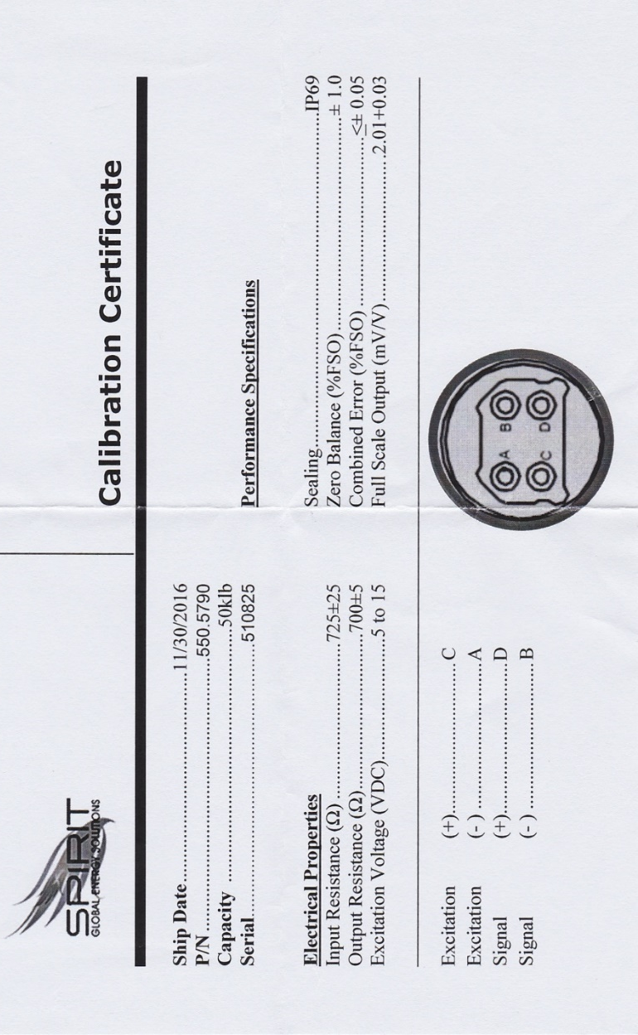
Fig. 36 Load Cell Calibration Certificate
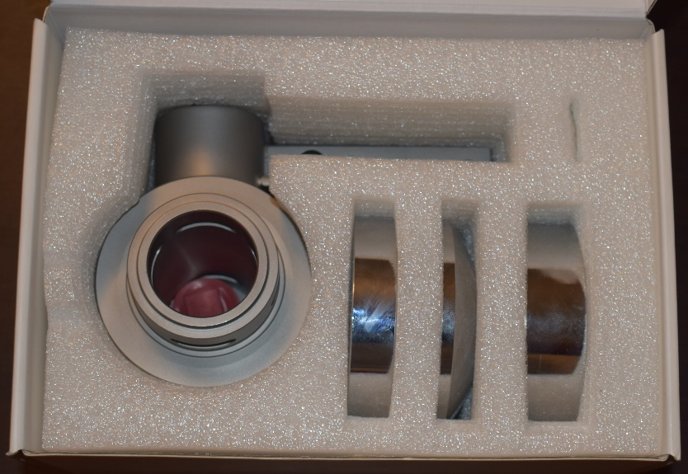
Fig. 37 Load Cell Packaging
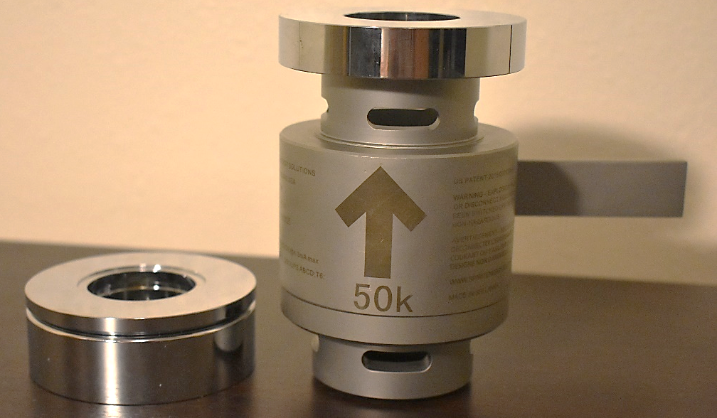
Fig. 38 Load Cell and Components
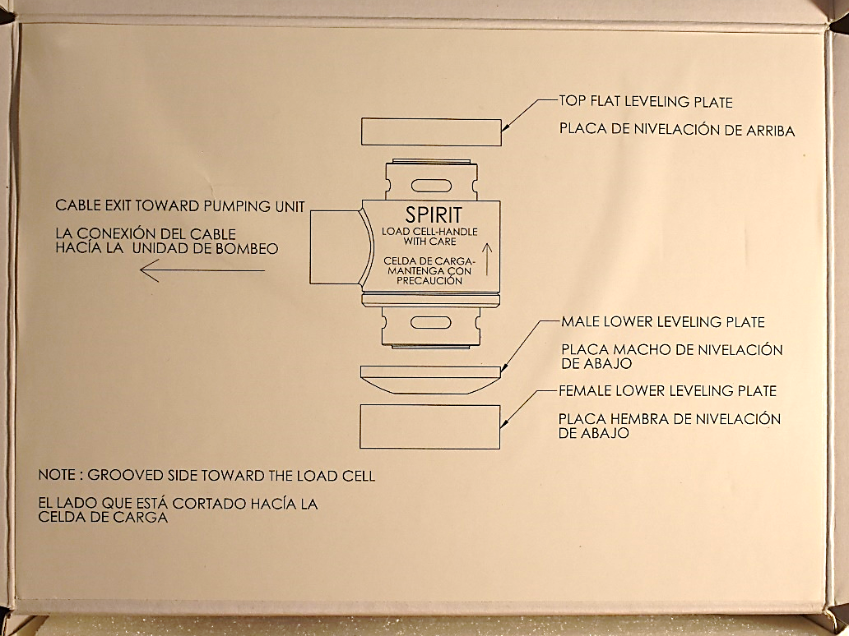
Fig. 39 Load Cell Instructions
Fig. 40 Reverse Mark (Takacs 2015)

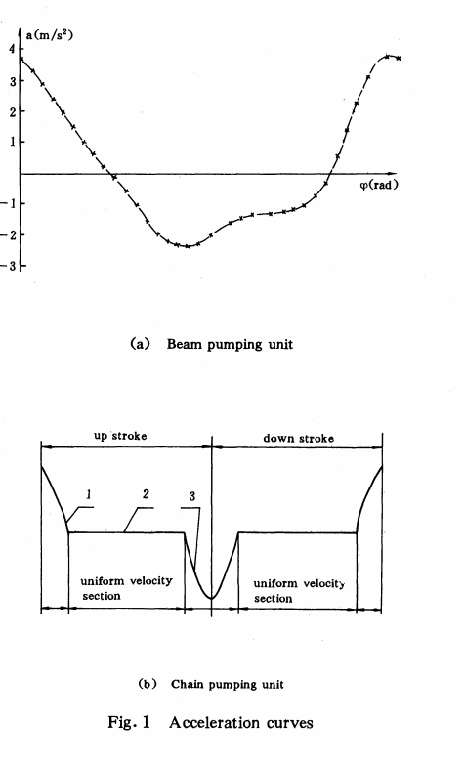
Fig. 41 DF Wang
Wellhead
Diam= 77.9mm
Diam= 63mm
ID= 62.3-65.1mm
Big Cross Pipe
Diam= 63.4 -65.5mm
*Small Cross Pipe
Diam= 58.6- 60.2mm
ID= 52mm
ID= 56.7mm
Fig. 42 Top Section Wellhead and Adapters
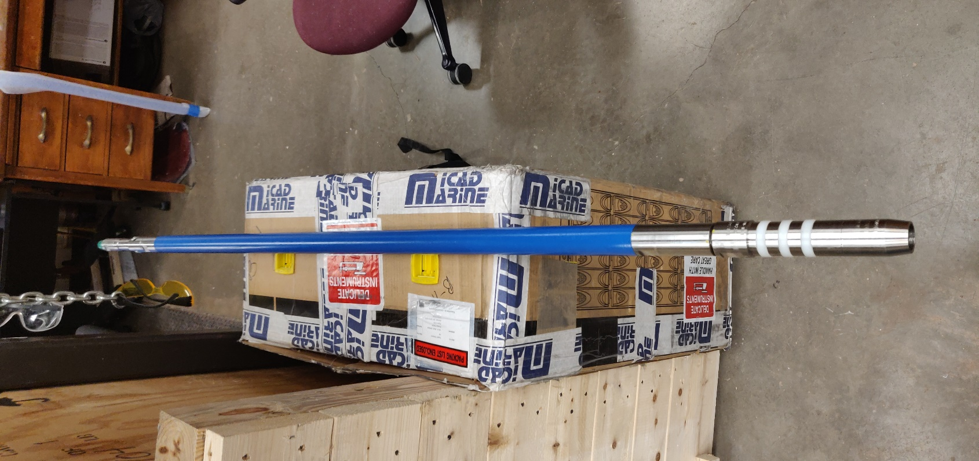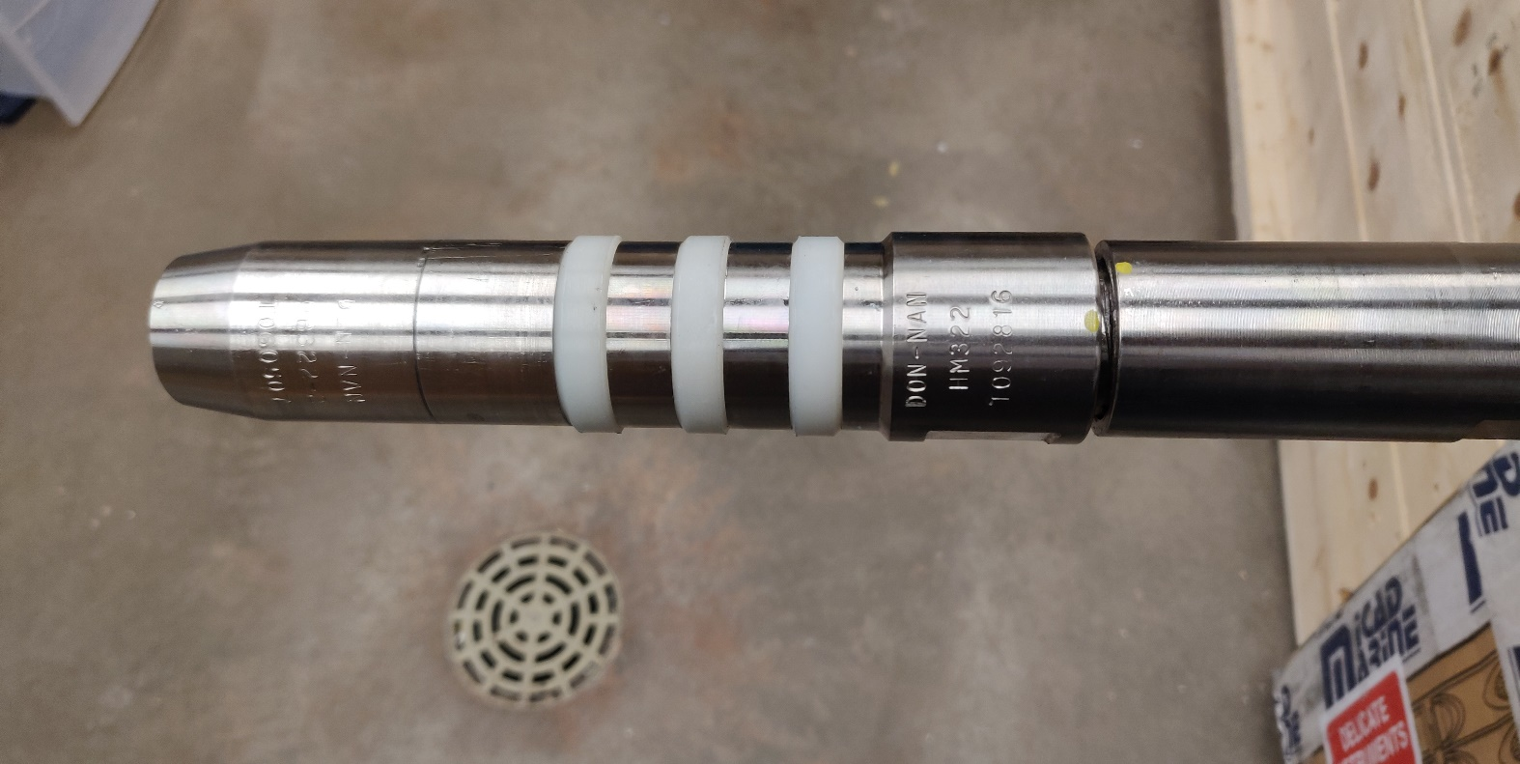
Fig. 43 Rod Pump
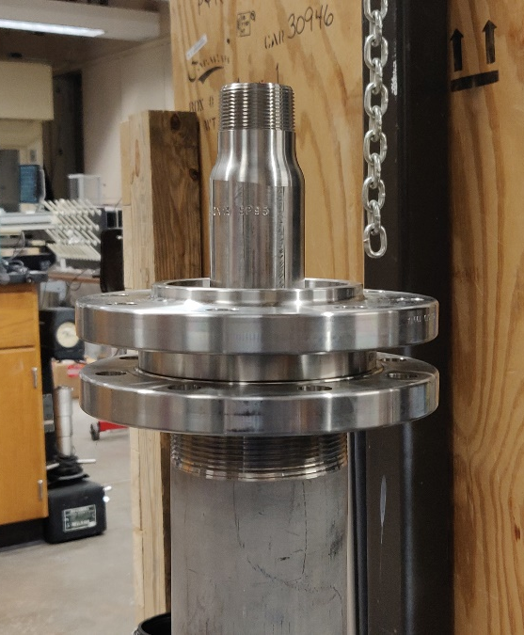
Fig. 44 Rod Pump Hold-Down Flanges

ODT=47.6mm
ODB=48.8mm
ID Top=38mm
Diam=60.4mm
ID=49.2mm
Adapter and pump seat
Flange
ID=19.16mm x4
Diam=1.12mm
Diam=0.68mm
L=23 5/8in
L=52 1/4in
Diam=1.5mm
Diam=38.6-38.78mm
Diam=36.6mm
Hold-down
Lt=69 3/8in
ID=19.25mm x8
ID=116.2mm
ID=102.3mm
OD=343mm
Adapter Flange
Rod Pump
Hold-Down Flange
Pipe Flange
Fig. 45 Rod Pump Sketch and Hold-Down Design
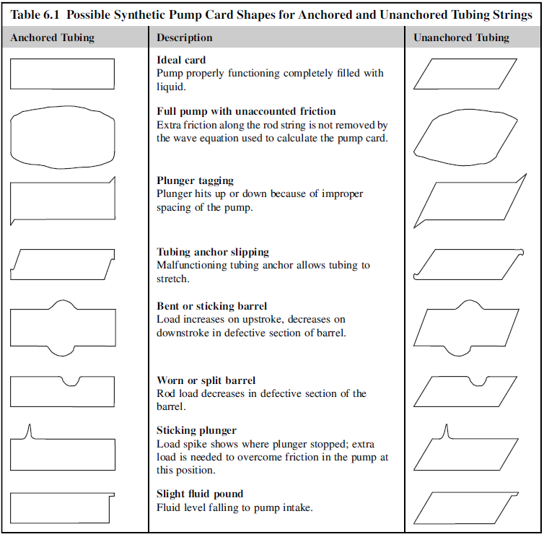
Fig. 46 Common Dynamometer Cards Part 1
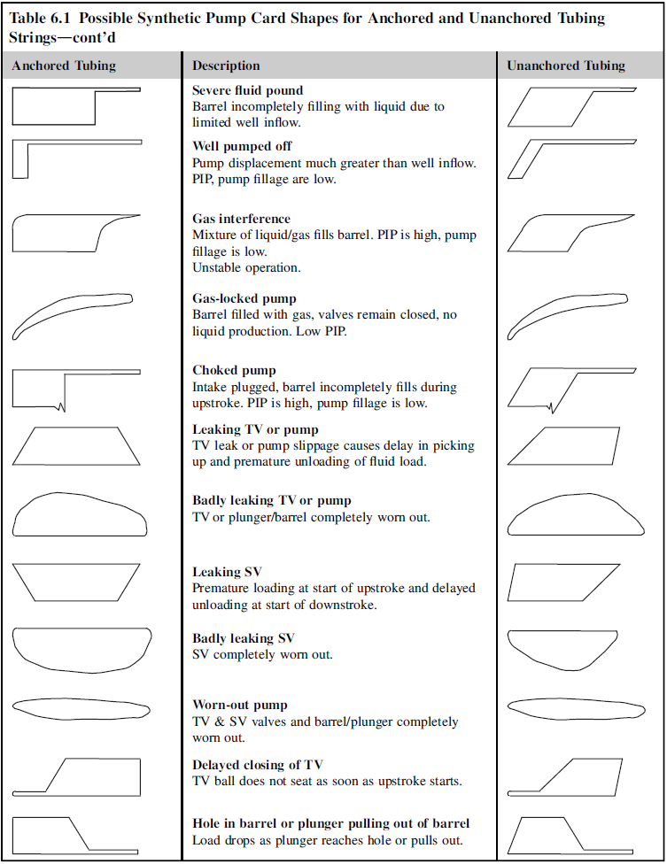
Fig. 47 Common Dynamometer Cards Part 2

