UNIVERSITY OF OKLAHOMA
GRADUATE COLLEGE

CHANGES IN SURFACE ELECTROMYOGRAPHY CHARACTERISTICS AND FOOT-TAPPING RATE OF FORCE DEVELOPMENT AS MEASURES OF SPASTICITY IN PATIENTS WITH MULTIPLE SCLEROSIS

A DISSERTATION
SUBMITTED TO THE GRADUATE FACULTY
in partial fulfillment of the requirements for the
Degree of
DOCTOR OF PHILOSOPHY

By
BRIAN ANDREW PRIBBLE
Norman, Oklahoma
2023

CHANGES IN SURFACE ELECTROMYOGRAPHY CHARACTERISTICS AND FOOT-TAPPING RATE OF FORCE DEVELOPMENT AS MEASURES OF SPASTICITY IN PATIENTS WITH MULTIPLE SCLEROSIS

A DISSERTATION APPROVED FOR THE
DEPART MENT OF HEALTH AND EXERCISE SCIENCE

BY THE COMMITTEE CONSISTING OF

Dr. Rebeca D. Larson, Chair

Dr. Daniel J. Larson

Dr. Christopher D. Black

Dr. Michael Bemben

Dr. Hairong Song

© Copyright by BRIAN ANDREW PRIBBLE 2023
All Rights Reserved.
Acknowledgements

I would like to start by first thanking all my friends, family, and peers. You have all been such a huge support throughout my time here at the University of Oklahoma. Without you y’all I don’t know how I would have made it. I would like to especially thank my mentor and committee chair, Dr. Rebecca Larson, who taught me so much and helped guide me through this entire process.
Special thanks go to Dr. Bobbette Miller and Dr. Shirley James for including me in their MS First study and their assistance with securing the data I used for this dissertation project. I would also like to thank my other committee members, Dr. Christopher Black, Dr. Dan Larson, Dr. Mike Bemben, and Dr. Hairong Song for their help during everything. Thank you all for your time and effort. Each one of you made a profound impact on my learning experience here at OU and helped make me the person I am today.
To everyone I’ve worked with over the years in the Human Performance and Body Composition laboratory, thank you. You all have become like a second family to me. We’ve all come from different walks of life and will likely each go our own separate ways again when we graduate. Despite this, I hope that we stay in contact and remain lifelong friends.
Although I did not interact with them face to face, I would also like to thank the MS First study participants who gave their time and effort in making the study a success. Without y’all’s commitment, studies like this would not be possible.

Table of Contents
Acknowledgements iv
List of Tables viii
List of Figures x
Abstract xii
Chapter I: Introduction 1
Purpose 3
Research Questions 4
Hypotheses 5
Significance 5
Assumptions 6
Delimitations 7
Limitations 7
Operational Definitions 8
Chapter II: Review of Literature 10
Introduction 10
Defining Spasticity 12
Spasticity Pathophysiology 14
Populations with Spasticity 17
The Assessment of Spasticity 22
Subjective Measures 23
Objective Measures 32
Treatment of Spasticity 42
Complexity Analysis and its use in Spasticity 48
Summary 51
Chapter III: Methodology 53
Introduction 53
Original Dataset 53
Experimental Design 54
Intervention Methodology 56
Procedures for Original Data Acquisition 57
Reanalysis of the Data in the Present Study 62
Data Management and Analysis 67
Chapter IV: Results and Discussion 70
Subject Characteristics and Functional Measures 70
Acute Changes in Heel Raise sEMG Characteristics 72
Chronic Changes in sEMG Characteristics Following Intervention 85
Absolute Changes in Foot-Tapping Rate of Force Development 90
Relative Changes in Foot-Tapping Rate of Force Development 97
Effect Size Calculations 102
Discussion 104
Chapter V: Conclusion 119
Purpose 119
Hypotheses 119
Strengths and Limitations 122
Significance 124
Conclusions 125
Future Research Directions 125
References 126
Appendix A: 137

List of Tables
Table 1. Protocol Outline 55
Table 2. Changes in Subject Characteristics and Functional Measures from Pre- to Post-
Intervention 71
Table 3. Acute Changes in sEMG Measures Pre-needling, Post-needling and Post-Functional
Electrically Stimulated Walking in Involved vs. Non-Involved Legs 74
Table 4. Pre-needling, Post-needling, and Post-Functional Electrically Stimulated Walking
sEMG Repeated Measures Correlations 79
Table 5. Acute (Within Visit) Changes in sEMG Measures Pre- and Post-Functional
Electrically Stimulated Walking in Involved vs. Non-involved Legs 80
Table 6. Pre- and Post-Functional Electrically Stimulated Walking sEMG Repeated Measures
Correlations 85
Table 7. Chronic (Between Visit) Changes in sEMG Measures at Pre, Mid, and
Post-Intervention Timepoints 86
Table 8. Chronic (Between Visits) sEMG Repeated Measures Correlations in Involved
and Non-Involved Legs 90
Table 9. Chronic (Between Visits) Changes in Foot-Tapping Rate
of Force Development 92
Table 10. Percent Difference Between Legs at Pre- and Post-Intervention 98
Table 11. Percent Change from Pre to Post Intervention in the Involved vs.
Non-Involved Legs 98
Table 12. Foot-Tapping and Functional Measures Repeated Measures Correlations (Pre- to
Post-Intervention 101
Table 13. Acute (Within Visit) Changes in sEMG Measures Effect Sizes 102
Table 14. Chronic (Between Visit) Changes in sEMG and Foot-Tapping Measures
Effect Sizes 103

List of Figures
Figure 1. sEMG Sample Entropy at Pre-Needling, Post-Needling and Post-Functional
Electrically Stimulated Walking in the Involved and Non-involved Legs 75
Figure 2. sEMG Mean Amplitude at Pre-Needling, Post-Needling and Post-Functional
Electrically Stimulated Walking in the Involved and Non-involved Legs 76
Figure 3. sEMG Mean Frequency at Pre-Needling, Post-Needling and Post-Functional
Electrically Stimulated Walking in the Involved and Non-involved Legs 77
Figure 4. sEMG Median Frequency at Pre-Needling, Post-Needling and Post-Functional
Electrically Stimulated Walking in the Involved and Non-involved Legs 78
Figure 5. sEMG Sample Entropy at Pre-Functional Electrically Stimulated Walking
and Post-Functional Electrically Stimulated Walking in the Involved
and Non-involved Legs 81
Figure 6. sEMG Mean Amplitude at Pre-Functional Electrically Stimulated Walking and Post-
Functional Electrically Stimulated Walking in the
Involved and Non-involved Legs 82
Figure 7. sEMG Mean Frequency at Pre-Functional Electrically Stimulated Walking and Post-
Functional Electrically Stimulated Walking
in the Involved and Non-involved Legs 83
Figure 8. sEMG Median Frequency at Pre-Functional Electrically Stimulated Walking and Post-
Functional Electrically Stimulated Walking in the
Involved and Non-involved Legs 84
Figure 9. sEMG Sample Entropy at Pre-Intervention, Mid-Intervention, and Post-Intervention in
the Involved and Non-involved Legs 87
Figure 10. sEMG Mean Amplitude at Pre-Intervention, Mid-Intervention, and Post-Intervention
in the Involved and Non-involved Legs 87
Figure 11. sEMG Mean Frequency at Pre-Intervention, Mid-Intervention, and Post-Intervention
in the Involved and Non-involved Legs 88
Figure 12. sEMG Median Frequency at Pre-Intervention, Mid-Intervention, and Post-
Intervention in the Involved and Non-involved Legs 89
Figure 13. Foot-Taps Performed at Pre-Intervention and Post-Intervention in the Involved and
Non-involved Legs 93
Figure 14. Foot-tapping Area Under the Curve at Pre-Intervention and Post-Intervention in the
Involved and Non-involved Legs 94
Figure 15. Foot-tapping Peak Force at Pre-Intervention and Post-Intervention in the Involved and
Non-involved Legs 95
Figure 16. Foot-tapping Time to Peak and Time to Base 96
Figure 17. Foot-tapping Percent Time to Peak and Time to Base 97
Figure 18. Percent Difference in Foot-tapping between legs in the Involved vs. Non-involved
Legs 99
Figure 19. Percent Change in Foot-tapping from Pre to Post Intervention in the Involved vs.
Non-involved Legs 100

Abstract
Spasticity is a common symptom experienced by individuals with upper motor neuron lesions such as those with stroke, spinal cord injury, traumatic brain injury, cerebral palsy, amyotrophic lateral sclerosis, and multiple sclerosis. Although the etiology and progression of spasticity differs between these clinical populations, it shares many of the same consequences: muscle pain, weakness, fatigue, increased disability, depression, medication side effects, and a reduced quality of life. For this reason, there has been increased interest in the measurement and treatment of spasticity symptoms.
Subjective measures of spasticity like the Modified Ashworth Scale (MAS) and Tardieu Scale have shown questionable validity/reliability and poorly correlate to functional outcome measures but continue to be used in clinical and research settings. Objective measures like myotonometry, electrogoniometry, and inertial sensors on the other hand provide much more reliable measures but at the expense of increased costs, time, and equipment. Therefore, to properly assess and treat spasticity symptoms, a timelier and cost-effective objective measure of spasticity is needed. PURPOSE: To reexamine a previously collected dataset from a sample of patients with multiple sclerosis before and after dry-needling and functional electrically stimulated walking spasticity treatments. Specifically, we wished to know whether there were: 1.) Acute (within visit) and chronic (between visit) changes in sEMG and Foot-tapping rate of force development measures after treatment, 2.) Between leg differences before and after treatments, 3.) significant correlations between EMG, foot-tapping, and functional outcome measures. METHODS: 16 MS patients (10 relapsing-remitting and 6 progressive MS) participated in the original study. The study consisted of 14 visits: 2 pre/post visits, 4 visits of dry-needling + functional electrically stimulated walking (FESW), and 8 visits with FESW only. The more spastic leg (involved leg) was given the treatment, making the other the control. Dry-needling was performed on the involved leg’s gastrocnemius medial and lateral heads by inserting monofilament needles and electrically stimming the muscles until visible twitches occurred. Dry-needling was done 30 seconds on and 30 seconds off for a total of 90 seconds of treatment. FESW was performed on the involved leg by attaching electrodes to the tibialis anterior and gastrocnemius muscles. Patients walked 20-minutes at a self-selected pace while the involved leg was stimmed. sEMG was collected before and after each treatment by having the patient perform a single maximal heel raise. Foot-tapping ability was assessed using the 10-second foot-tapping test (FTT) and a small force plate. Functional measures also included the 25-foot walk test (25FWT) 6-minute walk test (6MWT), modified fatigue impact score (MFIS), and number of heel raises performed. RESULTS: No significant between leg differences were noted for any of the sEMG measures (p>0.05). No significant chronic changes occurred in any of the sEMG measures. For the Dry-needling + FESW visits, sEMG sample entropy was significantly increased in the involved leg at post-needling (p = 0.035) and post-FESW (p = 0.027). The non-involved leg’s sample entropy was significantly higher at post-FESW only (p = 0.017). The non-involved leg’s, mean frequency was significantly higher at post-FESW compared pre-needling (p = 0.033) and post-needling (p = 0.032). For the FESW only visits, there were no significant changes in the involved leg. The Non-involved leg’s mean frequency was significantly higher at Post-FESW (p = 0.006). Median frequency was significantly higher at Post-FESW (p = 0.009). The number of foot-taps was significantly increased from Pre to Post-intervention in both the Involved (p = 0.006) and Non-involved legs (p 0.002). There was a significantly higher number of foot-taps in the Non-involved leg compared to the Involved leg at both Pre (p =0.008) and Post (p = 0.015) timepoints. AUC was significantly higher in the Involved leg at Post-treatment (p = 0.030). Time to peak was found to be higher in the Involved leg compared to the Non-involved leg at both Pre (p = 0.037) and Post-intervention (p = 0.019). Time to base was higher in the Involved leg compared to the Non-involved leg at both Pre (p = 0.031) and Post-intervention (p = 0.004). Total tap time was higher in the Involved leg at both Pre (p = 0.010) and Post-intervention (p = 0.007). Percent time to peak was significantly lower in the involved limb at Pre-intervention (p = 0.026) and Post intervention (p = 0.037). Percent time to base was significantly higher in the Involved leg at Pre-intervention (p = 0.026) and Post intervention (p = 0.037). The sEMG measures tended to poorly or non-significantly correlate with the functional outcome measures. The foot-tapping measures, especially the involved leg, tended to exhibit stronger correlations with the functional outcome measures. CONCLUSION: sEMG Sample entropy and foot-tapping ability are significantly improved by dry-needling treatments and walking. sEMG measures did not tend to correlate well with functional outcome measures but the foot-tapping measures did. This suggests that foot-tapping rate and related measures may be a useful measure of spasticity and treatment effects.
Chapter I: Introduction

Spasticity is a symptom commonly experienced by persons with neurological disorders such as stroke1,2,8,34,57,66,68,74,79,90,91,116,146,150,166,170, spinal cord injury (SCI)^{3,39,45,111,129,168}, traumatic brain injury^{9,27,28,49,153}, cerebral palsy^{18,19,29,60,156,167}, amyotrophic lateral sclerosis (ALS)^{15,80,101,160,163} and multiple sclerosis (MS)1,20,75,78,100,102,110,143,152,167. Spasticity results in muscle pain, tightness, fatigue, joint shortening (contractures); which dramatically impacts activities of daily living (ADL), reduces muscle function, reduces mobility, and ultimately a decrease in quality of life (QOL)^{112,157}. It is for this reason that there’s been much interest in the assessment and treatment of spasticity in these populations^{42,95,110,158}.
Before spasticity can be treated however, there should be a valid and reliable way to assess it. Several different techniques have been utilized to assess spasticity in affected patients. While useful in a controlled lab environment, their implementation in a clinical setting are impeded by the need for expensive equipment, advanced training, and the burdens of patient care. The use of simplified spasticity scales like the Ashworth Scale (AS)^{24,118,119}, Modified Ashworth Scale (MAS)^{9,69,118,119} and Tardieu Scale^{1,6,51,119} are advantageous because they require only a pen and paper. Physicians can quickly and noninvasively assess a patient’s spasticity by manipulating the affected limb and rating its resistance to movement. Despite their usefulness in a clinical setting, these scales may be too subjective, making them prone to error or bias^{26,51,66}.
Spasticity rating scales like the MAS or Tardieu have been previously criticized for being too subjective and unreliable^{6,8,51}. When assessed by different raters (Kendall tau-b correlation of 0.62, p=0.461)²⁵ or across time (kendall tau-b of 0.567, p<0.001)²⁵, reliability of these scale has been seen to be poor to moderate at best^{25,53,114}. Previous studies have cited poor correlations between spasticity scales, objective spasticity measures (EMG, elastography, or myotonometry), clinical scales (MFIS, EDSS, CGI, PSFS) and performance scales (i.e. toe tapping, balancing or walking scales) (Pearson’s R of 0.38- 0.47, p<0.05) ^{8,9,57,102}. The weak correlations of these scales suggest that they are not capturing the full picture of spasticity’s effect on disability and function. Despite their drawbacks, researchers and clinicians continue to use such scales without regards to their validity or reliability.
Dry-needling^{13,39,94,102,107,116} and functional electrical stimulation (FES)^{7,102,109} are two examples of non-pharmacological treatments, that have been used with some success to relieve spasticity in clinical populations. Despite showing some success in treating spasticity, many studies are overly reliant on the interpretation of spasticity scales such as the MAS or Tardieu to determine the efficacy of the treatment. When scales like the MAS or Tardieu are the only measures used, it’s hard to say with certainty whether the results are attributable to an actual treatment effect, random error, or tester bias. These problems suggests a need for a more objective measure of spasticity; an assessment that is valid, reliable, and realistic for implementation in the average clinic. By increasing the precision of the assessments physicians can better treat spasticity symptoms resulting in enhanced patient care and quality of life.
Recently, there has been increased interest in the assessment of complexity (randomness) measures in populations with neurological deficits^{4,40,41,125,154,159,172,173} . When compared to healthy populations, it has been shown that neurologically impaired individuals exhibit a decreased level of complexity in measures of surface electromyography (sEMG)^{4,40,154}, handgrip force¹⁷², gait/movement kinematics^{41,125,159}, and fNIRS¹⁷³. Known as the loss of complexity hypothesis, it has been posited that aging and various disease states are associated with a reduction in biological structure and signal complexity⁶². A loss of complexity results in impaired transmission of information or altered physiological function, leading to disease. Several studies have shown reductions of various complexity measures in clinical populations compared to healthy controls^{31,37,64,89,165,166}. Unlike traditional analyses of signal frequency or amplitude, complexity analysis is time sequence invariant. This means that complexity analysis is sensitive to non-linear changes at different timescales^{62,115,149}. When applied to clinical measures of surface electromyography (sEMG) and rate of force development, complexity may prove a useful measure of changes in spasticity before and after treatment^{40,123,172}.
The use of muscle sEMG and rate of force have been previously used to assess spasticity in clinical populations^{9,21,52,93,161,166} . Though few studies have examined the relationship between complexity and spasticity^{40,74,166,171}, it reasons that a debilitating symptom like spasticity would be accompanied by changes of signal complexity. When applied to measures of sEMG or rate of force development, complexity analysis may provide a more sensitive and objective measures of spasticity compared to traditional analyses. Although sEMG systems may not be easily implemented in clinics, measures of force development can easily be obtained from devices like dynamometers and force plates. The mobility and low costs of a small force plate ^{102,128}, would make it the ideal measurement tool for quickly and non-invasively assessing spasticity.

Purpose
The purpose of this study was to reexamine a previously collected dataset from a sample of patients with multiple sclerosis (PwMS) before and after dry-needling and functional electrically stimulated walking treatments. We wished to know: (1) whether there was an acute (within visit) change in sEMG measures (sample entropy, amplitude and frequency) following dry-needling and FESW treatments, (2) whether there was chronic (between visit) changes in sEMG measures and foot-tapping rate of force development following repeated treatments (3) whether the sEMG and rate of force development measures differed between the Involved (treatment) and Non-involved (control) leg, and finally whether the sEMG and rate of force development measures significantly correlated with the functional outcome measures (6-Min walk test, 25-ft walk test, foot-taps, heel raises, MFIS).

Research Questions
- Do either the dry-needling or FESW interventions result in acute (within visit) changes of sEMG sample entropy, amplitude, or frequency?
- Are there chronic (between visits) changes in either the sEMG or rate of force development measures following the interventions?
- Are there significant differences in sEMG and rate of force development measures between the Involved and Non-involved legs at Pre-treatment and how did those differences change Post-treatment?
- Are there significant acute and chronic correlations between sEMG, rate of for development, and functional outcome measures at the Pre and Post intervention timepoints?

Hypotheses
- Following dry-needling and FESW treatments, there will be a within visit reduction of sEMG sample entropy and frequency, and an increase in amplitude.
- There will be a chronic increase in sEMG sample entropy and frequency, and a decreased amplitude. The number of foot-taps performed, and the rate of force development will increase following the dry-needling and FESW intervention.
- The involved leg will exhibit a lower sEMG complexity and frequency, and an increased amplitude compared to the Non-involved leg. Foot-tapping and rate of force development will similarly be reduced in the Involved-leg. Following treatment, there will be an improvement in function leading to a reduced between leg differences in foot-tapping.
- The sEMG measures will not significantly correlate with the functional outcome measures, but foot-tapping and the rate of force development measures will.

Significance
Previous studies have used several different methods to assess spasticity in individuals with neurological disorders. Subjective scales like the MAS or Tardieu are often utilized because they are fast, non-invasive, and do not require any expensive equipment. Despite their advantages, such scales may be too subjective and prone to human error and bias. Therefore, more objective measures of spasticity are needed if meaningful advancements in treatment are to be made. The use of sEMG and muscle force measurements have become increasingly more common in clinical settings and may be a useful measure of the effectiveness of spasticity treatments. With more precise measurement of spasticity, physicians can provide better treatment leading to improved patient outcomes and quality of life. Further investigation is needed to determine the usefulness of sEMG measures and rate of force development measures as a measure of spasticity. If found to have a strong correlation with spasticity and functional performance measures, the rate of fore development measures may be especially useful. Compared to many other methods, a force plate could be a much simpler, faster, and inexpensive means of assessing spasticity.

Assumptions
The assumptions of the study are as follows:
- The tester and testing procedures of the study remained consistent throughout the entire study.
- The MAS assessment were done by an experienced PT and was done as objectively as possible.
- Participants provided accurate health history, medical, and fatigue questionnaire information.
- Participants complied with directions and guidelines provided prior to testing including any guidance regarding diet, exercise, and medications.
- Participants gave maximal effort during the heel raise tasks and functional testing.

Delimitations
The delimitations of the current study are as follows.
- The data used for these analyses comes from a secondary dataset collected at the Oklahoma Medical Research Foundation consisting of sixteen PwMS.
- Of the sixteen PwMS; six had progressive MS and ten had relapsing MS.
- Patients were required to have a confirmed case of MS and must be able to walk 25-feet before participating in the study.
- Patients were free from relapse and did not experience any changes in disability status during the study.
- Patients had not received botulinum toxin treatment or experienced deep vein thrombosis in the last 6-months.
- The findings of this study are applicable only to the assessment of leg spasticity in persons with multiple sclerosis ages 25-63 who have been free of relapse for the last 3-months.

Limitations
- The results of this study come from a small sample of PwMs and from the legs only. It may therefore not be representative of all PwMS, limbs, or other spasticity disorders.
- No control sample was used for comparison.
- The presence of spasticity is velocity and muscle length dependent, neither of which were measured or controlled for during testing.
- Because testing occurred over several visits, individual visit results may be influenced by day-to-day changes in fatigue.
Operational Definitions
- Ashworth Scale: A scale that is used by clinicians to assess spasticity of a single or series of muscles. The test requires the clinician to manipulate the patient’s limb/muscle at a set speed resulting in a quick stretch of the muscle(s) of interest. The resistance to stretching is then subjectively rated by the physician on a 0 to 4 scale¹¹⁸.
- Modified Ashworth Scale: A modified version of the original Ashworth scale in which a 6th score was added with the intention of increasing sensitivity. The (1+) score was added between (1) and (2)¹¹⁸.
- Modified Tardieu Scale: A scale similar to the Ashworth used by clinicians to assess spasticity. Unlike the Ashworth and modified Ashworth, the Tardieu scale is performed at varying slow and fast speeds. This increases sensitivity of the scale and allows for the differentiation between neural and biomechanical contributors to spasticity¹¹⁰.
- Spasticity: A motor disorder characterized by a velocity dependent increase in tonic stretch reflexes (muscle tone) with exaggerated tendon jerks, resulting from hyperexcitability of the stretch reflex⁸⁴.
- Subjective measure: A scientific measurement that is assigned a score or rating by a skilled/qualified individual that is dependent upon personal perceptions of a sign/symptom. Subjective measures can also be given from the patient’s perspective.
- Objective measure: A scientific measurement that is assigned a score or rating based on the output of device that is not subject to personal bias or human error.
- Signal complexity: In this context, complexity refers to the non-stationarity and non-linearity of biological signals and structure. A more complex signal will appear more random and have greater availability than a less complex signal. It has been suggested that complexity decreases with age and disease meaning that these signals become more regular or non-variable⁶².
- Entropy: The degree of disorder or randomness of a system. Entropy rate is a measure of the average rate of generation of new information from a signal (e.g. sEMG or EKG)^{5,33,70}.
- Fractals or Fractal Dimensions: A descriptor of the complexity of a signal. Specifically, it refers to a type of self-repeating or branching type of signal/structure often seen in nature (heart rhythm, EEG, bronchi structure, etc.)^{38,149}.
- Modified Fatigue Impact Scale (MFIS): A patient-reported scale used in patients with MS to assess changes in fatigue. The MFIS is a multidimensional scale that reports the physical, psychological, and cognitive aspects of fatigue experienced by the patient⁸⁸.
- 6-minute walk test (6MW): A test that has been used in clinical populations to assess disability and physical function. The 6MW has been used to assess gait, the benefits of rehabilitation, and study the relationship between fatigue and physical function. The 6MW is a shortened version of the 12MW^{54,63}.
- 25-foot walk test (25FW): The 25FW is a test used in persons with MS as a standardized measure of walking performance. The test has the patient walk 25-feet as quickly as possible. Often used alone or as a group of measures, the 25FW is one part of the multiple sclerosis functional composite (MSFC) test score ^{22,126}.
- Foot Tapping Test (FTT): The FTT is a measure used to assess upper motor drive and performance of the legs. The test has subjects tap their foot as quickly as possible for 10-seconds^{102,128}.

Chapter II: Review of Literature
Introduction
Spasticity is a common symptom in individuals with upper motor neuron (UMN) lesions¹⁷ like those who’ve suffered from a stroke^{1,34,146}, spinal cord injury^{3,45,129}, traumatic brain injury^{9,27,28,49,153}, cerebral palsy^{18,19,29,156,167}, multiple sclerosis^{17,110,130,167} or amyotrophic lateral sclerosis^{15,98,101,160,163}. Although the underlying disease process differs between these disorders, they all exhibit a similar increase in muscle tone resulting from a hyperexcitability of the stretch reflexes ¹⁵⁷. It has been hypothesized that hyperexcitability of the stretch reflexes is the result a dysregulation of both inhibitory and excitatory supraspinal inputs. Over time, chronic shortening of soft tissue (i.e., contractures) may further worsen symptoms of spasticity creating a vicious cycle¹⁵⁸. Spasticity has been shown to negatively impact acts of daily living (AoDL), reduce quality of life (QoL)^{23,119,158} and has even been described as worse than death¹⁵².
Several different spasticity assessments have been previously utilized in clinical populations. The assessment of spasticity could be broadly divided into two categories: objective and subjective measures. Objective measures involve the use of one or more specialized devices to assess muscle tone providing a more quantitative and standardized measure of spasticity. The use of such measurement devices are less prone to tester bias or error, hence making them an objective measure. Often a costly investment, these devices also require advanced training to operate or interpret results. Subjective measures of spasticity however often do not rely on sophisticated equipment. Pen and paper spasticity scales such as the Modified Ashworth Spasticity (MAS) and Tardieu can easily be performed by manipulating a patient’s limb and rating the resistance to movement. Subjective measures like these are advantageous in clinics where time, money, and space for equipment are a concern. However, scales like the Tardieu and MAS do not control for contraction velocity, range of motion or what constitutes a resistance to stretch, making their reliability and validity questionable^{39,51,73,110,119,132,140}. Therefore, when designing treatment studies, clinicians must carefully decide whether to use subjective measures, objective measures, or a combination of the two.
The treatment of spasticity is difficult because of inherent problems in its measurement. Despite this, studies have shown evidence of improvements in spasticity following various drug, physical therapy, assistive devices, surgical and other treatments^{2,20,59,68,77,101,111,157}. Dry-needling and functional electrical stimulation for have been used with some success to treat spasticity^{13,32,102,116}. Overuse of subjective scales like the MAS however make it difficult to say with certainty whether results are due to an actual treatment effect, random or systematic error, or tester bias. To effectively treat spasticity, we must first ensure our assessments are valid and reliable.
One solution to assessing spasticity in clinical population may be through the application of complexity analysis⁶² of sEMG and rate of force development metrics. The loss of complexity hypothesis posits that with age and disease there is a breakdown in biological complexity resulting in impaired function. Several studies have found a reduced complexity in neurologically impaired populations that commonly suffer from spasticity^{31,37,64,89,159,165,166}. It has been suggested that surface (EMG) sEMG may be a useful means of assessing complexity in clinical populations^{40,74,154,166}. It has been found that there is a strong negative correlation between muscle sEMG/force complexity and spasticity (MAS) scores (-0.82-.0900)^{40,74,166}. However, not every clinic is equipped to measure sEMG which suggests the need for an easier, cheaper alternative to assess spasticity. The assessment of rate of force development and complexity with cheaper force plates or dynamometer might be one such viable option.
The first half of this literature review will expand upon 1.) the definition of spasticity, 2.) pathophysiology of spasticity, 3.) populations that experience spasticity, 4.) the measurement of spasticity, 5.) the treatment of spasticity, 6.) introduction to rate of force development and complexity analysis in assessing spasticity. The search process for this review included using several different databases (MEDLINE, SportsDiscus, Academic Search Premier, Google Scholar, etc.). The search included, but was not limited to, the following terms: define spasticity, spasticity assessment, spasticity treatment, subjective spasticity, objective spasticity, populations with spasticity, complexity analysis, surface electromyography (sEMG), force kinematics, etc.

Defining Spasticity:
One of the earliest definitions described spasticity as a resistance to movement during a passive stretch which was associated with an increased amplitude of the stretch reflex⁴⁴. Later, spasticity would be further defined as a velocity dependent increase in muscles stretch reflex and tendon jerk because of upper motor neuron (UMN) damage and a disinhibition of the stretch reflex⁸⁴. In other words, the presence of spasticity is dependent upon how quickly the muscle is stretched.
Spasticity can further be defined by its contributing factors: Intrinsic tonic, intrinsic phasic, and extrinsic spasticity^{3,42}. Intrinsic tonic spasticity was defined as spasticity that is the result of the tonic component (sustained stretch) of the stretch reflex. Whenever a passive stretch is held, muscle spindles are activated resulting in the contraction of the stretched muscle. It has been suggested that the hyperexcitability of the tonic stretch reflex may be the result of a lowering of neuron threshold and/or an increased gain of the stretch reflex and can be seen as an increased muscle stiffness or tone at rest. The intrinsic phasic portion refers to increases in tendon hyper-reflexia and clonus which can cause painful cramps and spasms at rest and during physical activity. Extrinsic spasticity is spasticity that can be caused by noxious stimuli outside of the muscle. Dysregulation of skin, subcutaneous tissue, muscle and joint sensory receptors can cause hyperexcitability of the flexion withdrawal reflex^{3,42} , worsening spasticity.
An extensive review was conducted by Malhotra and Pandyan comparing spasticity definitions used in several different studies⁹⁶. It was found that 31% of studies examined failed to define spasticity in their study and 35% simply defined spasticity as an increase in muscle tone without addressing the underlying mechanism. Another 31% of the studies used the definition proposed by Lance⁸⁴ which describes spasticity as an increase in the stretch reflex-mediated muscle activity and exaggerated tendon jerk felt during a passive stretch. The final 3% of studies used varying terms such as ‘abnormal tone’, ‘hypertonia’, and ‘hyperreflexia’ to define spasticity⁹⁵.
How a spasticity is defined in a study is important because different assessment techniques will assess different mechanisms or contributors (tonic, phasic and extrinsic spasticity) to a patient’s overall spasticity. Subjective spasticity scales such as the MAS lack precision as they are incapable of differentiating between the contributors to spasticity and only assess overall spasticity. Some objective measures of spasticity may be useful for differentiating between contributors of spasticity; however, the required time, money and training remains a barrier to their implementation. This means that the effectiveness of a spasticity treatment is entirely dependent on the type of assessment used. Therefore, careful consideration must be given on how we define spasticity prior to study design to ensure accurate assessment and interpretation of the results.

Spasticity Pathophysiology
Spasticity is inherently difficult to treat due it’s complex nature. Although many individuals with spasticity share a lot of the same symptoms, their etiology and progression can be dramatically different. The following sections will explore some of the proposed mechanisms of spasticity in UMN disorders.

Stretch Reflex Hyperexcitability
The stretch reflex is an involuntary muscle contraction that results from the activation of muscle spindles during a passive stretch¹³⁰. In individuals with UMN disorders, the sensitivity of these receptors can be increased leading to altered or exaggerated muscle activation following a stretch. Increased stretch receptor sensitivity may be due to the dysregulation of the presynaptic terminals of spindle afferents or the spinal neuron membrane because of reduced post-synaptic inhibition or denervation supersensitivity¹⁵⁸.
A study looking at rats with spinal transection (SCI) showed an increase in muscle spasticity (stretch reflex) and hyper-reflexia (H-reflex) following transection¹⁶⁸. Interestingly, increased stretch reflex appeared much later (~8 weeks) than changes in h-reflex (~2 weeks). In this study, stretch reflex was measured as a windup in sEMG and force when mechanically stretched. When passive exercise was applied one week following transection, changes in stretch reflex were attenuated in a dose respondent manner. The same effect was seen when transected mice were given modafinil, a drug found to increase electrical coupling between neurons. Findings with modafinil suggest that in the case of SCI, dysregulation of electrical coupling of neurons may be involved in spasticity symptoms¹⁶⁸.

Velocity Dependent
In a healthy subject, a quick stretch of a muscle results in stimulation of muscle spindles, Ia fibers, and an alpha motor neuron resulting in a shortening muscle contraction. Under normal conditions, the stretch reflex can only be invoked in healthy individuals at very high speeds (>200° per second). In patients with spasticity however, activation of the stretch reflex is evident in contraction speeds as low as 60-180° per second. It is for this reason that spasticity tests like the Tardieu and MAS will typically be conducted using several different speeds. If done correctly, a healthy subject would not show a stretch response regardless of the speed used during the test. An individual with spasticity however may have their stretch reflex triggered anywhere between the 60 - 180° range. Individuals with spasticity will tend to exhibit an increased stretch reflex response at lower contraction speeds resulting in increased resistance to a passive stretch and an increase in sEMG amplitude¹⁵⁸. Despite being velocity dependent, it has been shown that spasticity can be present during a sustained isometric contraction where the velocity is equal to zero. This suggests that spasticity is more than just velocity dependent.

Exaggerated Deep Tendon Reflexes
During the knee jerk reflex test, striking the patellar tendon causes a stretch in the quadriceps muscle. Stretch receptors known as muscle spindles are activated resulting in activation of agonistic motor units and a shortening of the muscle. In healthy individuals, the normal result is a single immediate contraction of the muscle. In spasticity however, it is common to find an increase in deep tendon reflexes. Also referred to hyper-reflexia, the tendon reflex can become oversensitive resulting in hyperactive or repeating (clonus) reflexes. An abnormal tendon reflex can present itself as an absence of reflex, exaggerated/stronger reflex, or result in several repeating reflex contractions (clonus). Hyper-reflexia can be indicative of interruption (lesional damage) of the corticospinal and descending pathways and typically affects spinal reflex pathways below the level of the lesion^{72,135}.

Location and Length Dependent
It has been observed that a muscle’s spasticity can be altered by changing the length of the muscle at the time of testing. This suggests that spasticity is not uniform throughout the entire range of motion (ROM) of the joint. In the quadriceps for example, spasticity appears to be greatest when the muscle is shortened (either resting length or contracted) but is lower at longer muscle lengths (stretched)^{30,156,158}. This feature is commonly known as the clasp knife phenomenon because of its resemblance to how a pocketknife is met with resistance when opening but easily pops open once a greater ROM is achieved. Although the clasp-knife phenomenon is not yet fully understood in spasticity, it has been suggested that it may in part be mediated by the central inhibitory effects of the non-spindle afferents (Group II, II, and IV) which are also activated during a muscle stretch¹³⁷. Interestingly, not all spastic muscle groups have been found to share the same clasp-knife features. Unlike the quadriceps muscles, the elbow flexors⁷⁹ and ankle extensors¹⁵⁶ appear to exhibit a more spasticity at longer muscle lengths as opposed to shorter.

Soft Tissue Changes (Contractures)
With disease progression and/or chronic disuse, a spastic limb can develop a permanent shortening (contracture) of soft tissues like muscle, tendon, and ligaments. These changes can result in a reduction of joint range of motion (ROM), pain, fatigue, worsening disability, and reduced quality of life (QoL). During testing, contractures can result in similar increases in muscle tone and resistance and are not easily distinguishable from true spasticity. It has been observed that contractures are not velocity dependent and are therefore referred to as nonreflex hypertonia. Rather than altering muscle spindle properties (excitation/inhibition), contractures likely influence muscle tone by altering the mechanical properties of the tissue. By shortening the length of the muscle and reducing extensibility, the pulling force of a contraction is more readily transmitted to muscle spindles, indirectly influencing spasticity. The chronic disuse of certain muscle groups following UMN damage (e.g., a stroke or lesional damage) likely contributes to the soft tissue remodeling and formation of contractures^{65,158}.

Populations with Spasticity
Spasticity is a common component of UMN dysfunction and can be found in several different clinical populations. Despite exhibiting similar signs and symptoms, the causes of spasticity likely differ between patient groups making a one size fits all approach to symptom assessment and management difficult. The following sections will introduce some of the clinical populations that are known to exhibit spasticity.

Stroke
Stroke, or a brain aneurism, is an acute cerebrovascular event that results in tissue hypoxia due to one or more blockages of the brain’s major arteries. Tissue damage can occur resulting in severe mental and physical impairment depending on the site and severity of the trauma. Damage to the pyramidal and parapyramidal tracts for example can result in positive symptoms such as abnormal posture and spasticity¹⁴⁶. There is no consensus regarding the number of patients that develop spasticity post stroke. It has been estimated that as much as 19-39% of individuals develop spasticity post-stroke¹⁴⁶. According to previous EMG studies, spasticity may not be immediately evident post stroke. It has been suggested that reflex-mediated muscle tone reaches its maximum within 1 – 3 months post stroke and any further increases in muscle tone are likely due to intrinsic tissue changes (i.e. contractures). Unlike other causes of spasticity, stroke related spasticity is most evidence in the early post-stroke phase and gradually declines with recovery^{90,146}.
Post stroke, neurological impairments tend to affect one side of the body more than the other. Spastic hemiparesis is a type of spasticity that affects predominantly on one side of the body and is accompanied by weakness^{34,90}. One advantage of studying spasticity in hemiparetic stroke patients is that the unaffected limb can serve as a control. In a study of 95 stroke patients, it was found that 21% experienced spasticity of one or more muscle groups. Six were spastic in both the arms and legs, 13 in the arms only, and 1 in the legs only¹⁴⁶. The higher prevalence of arm spasticity in stroke patients is interesting given that other UMN disorders tend to exhibit more leg spasticity. Overall, the correlation between muscle tone (MAS) and motor and activity scores in stroke patients was low and similar results were found between patients with and without reported spasticity¹⁴⁶.

Spinal Cord Injury (SCI)
Spinal cord injury (SCI) can result in numerous motor and sensory deficits like paralysis, anesthesia, hyper-reflexia and spasticity^{45,168}. It has been estimated that 65-78% of SCI sample populations have experienced symptoms of spasticity at some point in their life. Interestingly, in models of SCI, hyper-reflexia does not occur immediately following spinal or nerve transection. As much time as one week or more is typically needed to start seeing changes in spinal cord excitability. This suggests that with SCI, spasticity may be the result of reorganization of the CNS structure and function, rather than the absence of presynaptic inputs due to lesion damage³. Previous studies looking at SCI patients found low correlations between Ashworth spasticity score and clinical examination scores (Clonus score, patellar deep tendon reflex, Achilles deep tendon reflex, Adductor deep tendon reflex, and plantar stimulation response) (0.20-0.55) ^{3,129}.
One study examining SCI patients with spasticity found that the MAS was negatively correlated with femoral artery blood flow (r=-0.59, P<0.01)⁴⁵ suggesting a relationship between the two. When divided into non spastic, low spasticity and high spasticity groups, it was found that the non-spastic group had significantly higher blood flow rate than low and high spasticity groups (﻿high 78.9 ± 16.7, low 98.3 ± 39.8, no 142.5 ± 24.3 ml/minute/kg, p=0.001). These findings suggest that in SCI changes in muscle blood flow may be involved in the pathophysiology of spasticity⁴⁵. It is unclear however if a blood flow limitation causes spasticity or if the contraction of spastic muscles cause occlusion of muscle tissue.

Traumatic Brain Injury (TBI)
Traumatic brain injury (TBI) is a term used to describe several different types of injuries resulting from external force to the head¹⁵³. TBI can result in several different physical, cognitive, and behavioral issues among which is muscle spasticity. It’s estimated that between 30-50% of individuals with TBI suffer from some form of spasticity¹⁵³. Spasticity treatments for TBI patients are often different from other populations due to behavioral and cognitive deficits that prevent them from participating in or tolerating treatments^{49,153}. For that reason, much of what is known about TBI induced spasticity is generalized from studies of children with cerebral palsy and adults with stroke⁴⁹. When measuring spasticity in TBI, MAS is most preferred method due to ease of use in patients¹⁵³. In one study of spasticity in TBI patients, leg MAS and toe tapping ability were assessed. It was found that MAS scores mildly correlated with toe tapping ability (Spearman’s Rho: -0.4197, p=0.001). As spasticity levels increased, toe tapping ability other variables tended to decrease significantly(p<0.05) indicating a loss of speed and coordination⁹.

Cerebral Palsy (CP)
Spasticity can occur in patients with cerebral palsy (CP) and is a major factor in the development of contractures and bone deformities in children with CP¹⁸. In a study of spasticity in children with CP, the medial hamstring (MEH) and gastrocnemius (GAS) muscles were assessed¹⁸. Spasticity was assessed using sEMG and joint/torque velocities at low and high testing speeds. This was done under the assumption that a spastic muscle would result in an increased sEMG amplitude (EMG onset) at lower speeds. Spasticity was additionally measured using the MAS and modified Tardieu scale (MTS). For the CP group, EMG onset was detected in 3 of 28 GAS muscles and 14 of 28 MEH muscles at the low velocity. At high velocity, EMG onset was detected in 24 of 28 GAS and 27 of 28 MEH muscles. Measures from the passive stretches displayed a high level of within and between visit reliability except for the velocity_{max} of the gastrocnemius muscle at the low velocity. According to the Bland-Altman plots, there was no evidence of a systematic bias taking place.
The MAS scores of the MEH and GAS muscles were found to moderately correlate with the changes in EMG, torque, and work (r = 0.444 - 0.638). The MTS correlated poor to fairly with measures of the GAS muscle (r = 0.098 - 0.219) and fair to good in the MEH muscle (r = 0.275 – 0.809). The fact that the MAS and MTS were only moderately correlated with the GAS and MEH muscle measures suggests that such scales are not appropriate for detecting changes in spasticity. Despite using similar stretching movements to the MAS/MTS in this study, the use of sEMG, torque, and joint angle measures provided additional information on the performance and repeatability of the stretch reflex response¹⁸.

Amyotrophic Lateral Sclerosis (ALS)
Unlike the other spasticity diseases discussed, individuals with ALS typically experience both upper and lower motor neuron dysfunction¹⁶⁰. ALS patients with upper motor neuron dysfunction can experience the same muscle weakness and increases in spasticity. Despite being a common symptom experienced by patients, spasticity and spasticity related pain is poorly characterized in amyotrophic lateral sclerosis (ALS)^{160,163}. In a cohort study of 150 ALS patients, 36% presented symptoms of spasticity. Of those with spasticity, 42.5% reported the pain to be mild and 16.7% reported significant pain¹⁶⁰.

Multiple Sclerosis (MS)
Spasticity is commonly reported in patients with multiple sclerosis (PwMS) and affects 60-90% of PwMS over the course of the disease^{73,75,94}. Among PwMS, spasticity has been associated with a greater level of disability, an increased risk of falls, abnormal gait patterns, sleep disturbances, worsening of MS symptoms and a reduced quality of life^{31,75}. In a survey of PwMS, 20% of participants with spasticity went as far as to rate their quality of life as “worse than death”^{75,152}.
Spasticity in PwMS is thought to occur due to demyelinating damage and axon degeneration of descending inhibitory pathways resulting in the disinhibition of muscle contractions⁷⁵. Due to the transitory nature of MS, spasticity can vary within and between days due to factors such as the circadian rhythm, fatigue, medication, temperature, and activity. Although most of the focus in MS has been on lower limbs, spasticity can occur in any muscle group(s) and is relative to the location and magnitude of the lesional damage. In the case of MS, spasticity typically increases over time and during periods of relapse.

The Assessment of Spasticity
The assessment of spasticity can be difficult due to the diverse presentation of signs and symptoms such as muscle spasms, myoclonic jerks, increased resistance to passive movements, clonus, muscular coactivation, stiffness, heaviness, pain sleep, disturbances, fatigue, weakness, poor motor control, incoordination, loss of dexterity, and slowed movements. The measurement of spasticity is further complicated by its transient nature which causes it to change within or between days due to factors such as relapse, fatigue, stress, and environmental factors.
The assessment of spasticity could be broadly categorized as being either subjective or objective in nature. Subjective assessments rely on the physician, researcher, or patient to assess the level of spasticity based on their perceived performance of a task. Instead of using an instrument or measurement device, these assessments rely on the subjective opinions of the rater. Unfortunately, this introduces potential error and bias which limits its reliability and validity. These scales are advantageous in the average clinic where time, money and resources are a concern. Additionally, subjective measures allow for a qualitative measure of spasticity and can incorporate a subject’s own perceptions and feelings of spasticity.
The objective assessment of spasticity relies upon the use of different instruments to assess spasticity. The use of instruments to assess spasticity can greatly reduce the amount of bias and human error. The cost and training needed for to properly implement these measures however remains a barrier to their widespread implementation⁷⁵.
The following sections will describe in detail the various subjective and objective measures of spasticity.

Subjective Measures
A subjective measure is one that is based upon the observation of one or more raters. In spasticity assessment, examples would be a clinician rating resistance to a movement (MAS) or a patient rating their perceived stiffness, pain, or dysfunction. Several different subjective measures have been used to assess spasticity, but the Modified Ashworth Scale (MAS) tends to be the most used⁷⁵. Unfortunately, several studies suggest that the reliability of the MAS is low to moderate at best. The following sections will serve as an introduction to the types of subjective measures used to assess spasticity.

Ashworth (AS) and Modified Ashworth Scales (MAS)
The Ashworth scales are some of the most utilized measures of spasticity in clinical practice and research^{17,174}. Initially consisting of a 5-point scale, the Ashworth scale (AS) involves manipulating a subject’s limb and scoring its resistance from 0 to 4. The Modified Ashworth Scale (MAS) was later adopted and added an additional point (+1) to the scale allowing for a wider range of descriptors and greater sensitivity. It’s important to note that the AS and MAS only assess whether the muscle tone is abnormally high and not whether there is abnormal decrease in tone or spindle sensitivity^{17,61,73,75}. The Ashworth scales have been previously utilized in several different clinical populations such as stroke, SCI, TBI, ALS, and MS. Despite being initially used in PwMS, the Ashworth scales are sometimes not recommended due to a lack of established reliability and validity in this population⁷⁵.
The MAS has the advantage of being quick, easy, not requiring expensive equipment or extensive training. The lack of protocol standardization however threatens the reliability, validity, and overall usefulness of the MAS. It is well known that spasticity is velocity and length dependent, and yet the MAS does not strictly control for either. If either can affect spasticity, a patient’s score would be largely determined by how the tester conducts the assessment. Raters must use their best judgement on what constitutes an abnormal resistance to movement using a very limited (0 to 4) scale. To further complicate matters, the MAS is not capable of distinguishing between increased resistance elicited by tissue adaptations (e.g., contractures), spasticity, or other tonus disorders^{75,94}. It is no surprise then that the Ashworth scales have been criticized for their poor interrater and inter muscle reliability^{17,75}.
In a study of its intra rater reliability, the MAS was assessed in 23 patients with either stroke or MS related spasticity. A trained physiotherapist assessed the hip adductors, knee extensors, and ankle plantar flexors one day and then again two days later. Intra rater reliability of the MAS was found to be moderate (kappa=0.45), good (kappa=0.62), and very good (kappa=0.85) for each muscle group respectively⁶¹. Although the study was meant to assess test-retest reliability, it could be argued that it assessed day-to-day reliability considering how two days separated the measures. In clinical populations like stroke or MS, it’s not uncommon to have within-day or day-to-day variability in spasticity scores⁶¹. The authors also suggest that the stability of the MAS could also have been influenced by the testing environment as spasticity is known to be affected by environmental and emotional triggers. The differences in reliability between hip (kappa=0.45) and ankle (kappa=0.85) scores suggests an effect of body mass on the reliability of scores. Due to the larger mass, testing a muscle group like the hip abductors/adductors would be inherently more difficult than the ankle flexors leading to a decreased reliability. There is also the issue of how to properly blind testers so that they are not biased by previous scores or desired study outcome.
In another study, the inter-rater reliability of the MAS was assessed between two raters²⁶. The sample consisted of 30 individuals with spasticity symptoms (1 MS, 5 TBI, and 24 stroke). The raters took turns assessing each patient’s elbow spasticity using the MAS. The elbow was assessed by each rater 5 to 8 times each with several minutes between each “blind” test. It was found that the raters agreed on 26 of 30 ratings (86.7%) and their scores never differed by more than by a single point (Kendall’s tau = 0.847, p<0.001). Despite showing a high level of reliability, it’s worth noting that only the elbow joint was assessed. Findings might not reflect the reliability of the MAS when assessed in areas like the legs. Certain clinical populations are more prone to upper limb spasticity whereas others are more prone to lower limb spasticity. Given that the MAS is a limited, 5-point scale, it’s not all that surprising to find such a high level of agreement in scores²⁶.

Tardieu (TS) and Modified Tardieu Scales (MTS)
Like the MAS, the Tardieu (TS) and Modified Tardieu Scales (MTS) can assess muscle spasticity using a series of passive limb movements. Rather than using a single velocity, the Tardieu scale is conducted at three semi-standardized velocities: V1 = as slow as possible, V2 = the speed of the limb falling against gravity, and V3 = moving the limb as fast as possible. This allows resistance to movement to be rated at different velocities and ranges of motion (ROM). Two angles are notated during the test; the angle at which resistance is felt during the V3 trial (R1) and the angle of the entire ROM from V1 trial (R2). The two angles are then subtracted (R2 – R1) and the result represents the proportion of resistance contributed by the active (spastic) component as opposed to the passive (contractures) component¹⁷. It could be argued that the Tardieu scale is superior to the Ashworth because it can differentiate between active and passive contributors to muscle tone. Like the MAS however, the Tardieu scale fails to adequately control for contraction velocity, range of motion and the subjectivity of rating resistance to movements⁷⁵.
In a study utilizing the MTS in PwMS, it was found that the intra-rater reliability of the MTS was low to moderate at best when a physical therapist with no previous experience with the MTS was used for each assessment. When tested seven days apart, the MTS was found to have moderate agreement for the rating of resistance (kappa=0.72) and poor agreement for the angles of R1 and R2 (kappa = 0.45-0.83)^{75,110}. Although the ratings were not compared to experienced PT’s, the results would suggest that the MTS is not reliable when conducted by an unfamiliar practitioner and should be therefore used with caution.
A modified version of the Tardieu scale was developed that uses torque, inertial, and sEMG sensors^{18,19} in conjunction with the traditional scale. The instrumented Tardieu scale showed a moderately-high reliability and good to moderate correlation with the traditional MTS and MAS ratings. When used to assess the efficacy of botulinum toxin treatments, the IMTS was found to have a greater sensitivity than traditional MAS and MTS techniques^{18,19}. Given the positive results, further investigation is needed to determine the usefulness of sEMG and inertial sensors in detecting spasticity in other populations like PwMS.
Babinski Sign
Although not a sign of spasticity per se, many physicians include the Babinski sign test when assessing UMN disorders⁷⁵. The Babinski sign is an assessment of disinhibition of the motor reflexes in the leg. Given that one of the proposed mechanisms of spasticity is disinhibition of excitatory inputs, it makes sense to use the Babinski sign to assess spasticity in UMN disorders⁷⁵. To test for the Babinski sign, a physician will stroke the lateral aspect of the plantar surface of patient’s foot. In healthy individuals, the typical response is for the toes to point downward. Abnormal disinhibition would result in dorsiflexion and/or a fanning out of the toes^{75,83}.
When used to assess corticospinal tract lesions, the Babinski sign was found to a have lower sensitivity (49.6%) and specificity (85.8%) than finger and foot tapping combined (79.5% and 88.4% respectively)¹⁴. The interobserver reliability of the Babinski sign (kappa=0.45) was also less than that of foot and finger taping combined (kappa=0.83)¹⁴. The Babinski sign and Ashworth score were assessed in a study of 81 children with cerebral palsy related spasticity. It was found that that the Babinski sign was present in 75% of cases and had a significant negative correlation with Ashworth scores (-0.3674, p<0.01)⁶⁰. Although the Babinski sign and spasticity symptoms are often seen together, that is not always the case. Experimental lesions made in human and feline pyramidal tracts for example suggest that hyper-reflexia and Babinski sign can occur even in the absence of spasticity symptoms¹⁴².

Pendulum Test
As a measure of spasticity, the pendulum test is used to visually evaluate the stretch reflex of the extensor muscles in either the upper or lower limbs. It involves the rater supporting the upper portion of limb and dropping the lower portion of the limb allowing it to swing freely. The clinician then rates the speed of the limb dropping and the degree of oscillations back and forth⁷⁵. In healthy individuals, the limb acts like a dampened pendulum, swinging and eventually coming to a stop. In a spastic individual, the kinematics are altered resulting in 1.) a reduced first swing after release, 2.) reduced number of oscillations (swings), and 3.) a less vertical resting angle at cessation¹⁶⁴. A distinct advantage of the pendulum test is that it can be simultaneously conducted in both limbs allowing for the direct comparison between limbs⁷⁵.
Like other visually rated assessment, the pendulum test relies upon the subjective observations of the rater and is therefore prone to error and bias. The application of video analysis, sEMG, or inertial sensors however provide an objective rating of the reliability⁷⁵. Caution must be used when using limb mounted devices however as they may change limb weight/balance significantly altering the pendulum effect of the limb. A study by Stillman et al used video analysis to objectively assess the pendulum test in a group of healthy individuals^{75,151}. It was found that the retest reliability of the instrumented pendulum test was high between visits (~26.8 days) with an ICC of 0.84. The results found thru video analysis were comparable to those seen in studies that utilized an electrogoniometer during the test. Additionally, it was found that younger individuals showed a greater relaxation index than older individuals¹⁵¹.

Tendon Jerk Reflex Test
The tendon jerk reflex test is performed by quickly striking a tendon causing a stretch of the muscle and a reflexive agonistic contraction. Neurological disorders can affect the normal reflex arc resulting in a diminished (hyporeflexia) or enhanced (hypereflexia) reflex response. The resulting contraction is graded from zero (no response; always abnormal) to 4+ (a tap elicits a repeating reflex; always abnormal) with 2+ being the normal healthy response (single brisk contraction). The most tested areas include the jaw, biceps, triceps, brachioradialis, finger, knee and ankle⁷². Both hyperreflexia and enhanced tendon jerk reflex are a common feature seen in populations with UMN disorders¹⁴².

Patient Reported Outcomes (PROs)
Although a clinician can feel the resistance to a stretch or muscle spasms, they cannot directly experience a patient’s experiences and perceptions of spasticity. Patient reported outcomes (PROs) are assessment tools that ask the patient about their experiences and feelings of spasticity⁷⁵. These types of measures can be useful when there is no apparent objective measure of spasticity or when the major outcome measure is a patient’s experience and or quality of life¹¹¹. Unfortunately, PROs tend to show poor correlation with clinical outcome measures⁷⁵. There have been many different types of PROs developed to assess spasticity in clinical populations such as the Penn Spasm Frequency Scale, Numeric Rating Scale (NRS), and the Multiples Sclerosis Spasticity Scale (MSSS88).

Penn Spasm Frequency Scale (PSFS)
The Penn Spasm Frequency Scale (PSFS) is a PRO that asks patients the number of muscle spasms they have in a period (usually 1-hour)⁷⁵. Each period is rated on a 0 to 4 scale with 0=no spasms, 1= mild induced by stimulation, 2= full spasms <1 per hour, 3 = spasms >1 per hour, and 4 = more than 10 spasms per hour. The perceived severity of said spasms can then be rated by the patient where 1 = mild, 2 = moderate, and 3 = severe⁷⁵.
The inter and intra rater reliability of the PSFS has been previously found to be very high¹⁰⁴. In a study of 66 SCI patients, the PSFS was administered by 1 of 3 testers over the phone at baseline (day 1), 5-10 days later, and again 4-6 weeks after baseline. The second tester followed up by administering the same PSFS over the phone within 3 days after each of the first rater’s contacts. Compared to baseline, the intra rater reliability was found to be 0.812 and 0.729 for days 5-10 and weeks 4-6 respectively. Likewise, the inter-rater reliability was found to be high at 0.862 and 0.857 respectively¹⁰⁴.
Because the PSFS only assesses the patient’s own perceptions, it captures only a limited component of the spasticity experience⁷⁵. Despite its drawbacks, use of the PSFS may be desirable when physical testing is not possible or safe (e.g., balance concerns, injury, disability, lack of equipment or time, offsite testing, etc.).

Numeric Rating Scale (NRS)
The numeric rating scale (NRS) assesses a patient’s own perceptions and feelings of spasticity using a 0 to 10 scale⁵³. The NRS was assessed in a group of 189 MS patients before and after treatment with an endocannabinoid system modulator. They found that the NRS was a valid and reliable measure of a patient’s perception of spasticity in PwMS. The test-retest reliability of the NRS was found to be higher than that of the Ashworth Scale (ICC of 0.83 and 0.53 respectively). A moderate to strong correlation (r=0.41-0.63 p<0.001) was found between the NRS and Spasm Frequency Scale (SFS). The Ashworth spasticity score showed a small correlation between the NRS and SFS (r= 0.24 and 0.28 respectively, p<0.001)⁵³. Although found to be a useful measure of patient perceived spasticity, it showed a low level of correlation to other spasticity scales. Study results suggest that the SFS may be a useful for tool for the diagnosis of spasticity but is not nearly as useful for assessing changes in spasticity due to treatment⁷⁵.

Multiple Sclerosis Spasticity Scale (MSSS-88)
The Multiple Sclerosis Spasticity Scale (MSSS-88) is an 88-item survey that evaluates the severity and impacts of spasticity from the patient’s perspective. It is divided into eight different sections: Muscle stiffness, pain and discomfort, muscle spasms, ADL, walking, body movements, emotional health, and social functioning⁷³. Authors suggest that the eight sections and 88 questions are needed for the right breadth, range, and precision of spasticity in PwMS. Their work suggests that 88 items is not too many items to be clinically relevant and does not significantly affect patient response rates⁷³. An advantage of the MSSS-88 is that its eight subscales may be further broken down allowing for a shorter survey and remain valid and reliable. Although not tested, authors assumed that MSSS-88 would show a weak correlation with scales such as the Ashworth spasticity scale given that they are fundamentally from two different perspectives. MSSS-88 may therefore be a useful addition to spasticity evaluation but should not be the sole measure⁷³.

Objective Measures
Objective measures of spasticity come from devices (e.g., sEMG, inertial sensors, force outputs, etc.) that can provide a quantitative assessment of spasticity rather than just personal observations. For this reason, objective measures tend to be less prone to human error and bias. Unlike subjective scales (e.g., MAS or Tardieu), objective measures use specialized equipment which requires additional time, training, and money that smaller clinics simply don’t have. Barriers such as these prevent the study and implementation of objective measures in the average clinic resulting in the use of measures like the MAS or Tardieu scales. The following sections will introduce some of the previously utilized objective measures of spasticity.

Force Assessment
Force assessment involves the assessment of a muscle’s ability to generate or maintain a forceful contraction. Peak or average force, time to peak, relaxation time, time to failure, etc. are all examples of types of force assessment. Although force production in not a direct measure of spasticity per se, it can be indicative of how spasticity impacts task performance. It follows that if a muscle is spastic and has difficulty lengthening or is actively spasming, the antagonistic muscle action would also be impaired. For example, if force was assessed in the biceps muscle during a biceps curl but the triceps muscle was experiencing spasticity, either the net torque force of the biceps would be reduced, or it would require a greater stimulus (increased MU recruitment or rate coding) to overcome the spastic triceps muscles.
In one study, force production was used to assess spasticity in the elbow flexors of 14 post stroke hemiparetic patients¹⁶¹. Using a motor rehab device for testing (HUMAC), maximal isometric force (MIVC) were recorded for the left and right limbs. It found that the weaker side showed a significantly lower peak torque, keep time, and a higher rise time than the stronger side (p<0.05). No significant correlations were noted between the force kinematics and MAS scores, but the authors did note that peak torque was almost significantly correlated with MAS (Spearman’s r = -0.503, p =0.061). Muscle stiffnesses was assessed by fitting a slope to the stress-stretch data from the MIVC tests and was found to significantly correlate to MIVC keep time (r=0.653, p=0.011). Although the correlations of this study were weak, the authors concluded that force kinematic testing may be a useful measure of spasticity when other equipment is not available, or the MAS would not be appropriate¹⁶¹.

Hoffman’s Reflex (H-reflex)
Often referred to as the electrical analogue of the tendon jerk reflex test, the Hoffman’s reflex (H-reflex) has been previously used as a measure of hyper-reflexia and spasticity¹⁶⁷. The H-reflex is an electromyographical response elicited by the reflexive activation of motor neurons by muscle afferents following peripheral nerve stimulation^{75,143,168}. Due to an increase in alpha motor neuron excitability, individuals with an increased muscle spasticity will show a greater latency and H-reflex amplitude^{99,145}. An additional response, the F-wave, can sometimes be elicited in muscles following supramaximal stimulation. The F wave amplitude and the F to M wave ratio tend to be increased in cases of spasticity and reflects an increase in motor neuron excitability^{75,117,145,168}.
One study sought to understand the association between spasticity and postural control. To examine spasticity of the lower limb they chose to look at the H-reflex of the soleus muscle in PwMS¹⁴⁷. Using the H-reflex, they were able to stratify participants into either the low or high spasticity groups. Low spasticity was defined as have a maximal H-wave/maximal M-wave ratio of 0.44 and the high spasticity group was defined as H/M ratio of 0.80 or more. Using a force platform, postural control was assessed as anterior-posterior sway range, medial-lateral sway range, and deviation in center of pressure (CoP). The high spasticity group exhibited a significantly greater COP area, velocity, and mediolateral sway compared to the low spasticity group. No significant group difference was found for the anterior-posterior sway. These results suggest that spasticity can play a significant role in postural deficits and increase the likelihood of falls/injury¹⁴⁷.
Most studies testing the H-reflex are done so with the muscle at rest. One study however sought to examine the soleus muscles’ H-reflex during gait in PwMS at different stimulus intensities¹⁴³. Compared to healthy controls, the PwMS displayed a decreased ability to modulate the H-reflex response during the different phases of gait. Even when a smaller stimulus (4% M_{max}) was administered to the MS group, they saw a larger (unmodulated) H-reflex response than when a larger stimulus (10% M_{max}) was used in the healthy group comparatively. Authors attributed the decrease in H-reflex modulation seen in MS patients to an enhanced excitability of the muscles in question. They hypothesized that reduced reflex inhibition could be the result of reduced presynaptic inhibition or a less hyperpolarized motoneuron pool. H-reflex has been previously proposed as a measure of muscle spasticity. In the current study however, no significant relationship was found between the Ashworth scale and H-reflex modulation. A lack of correlation could be easily explained by the subjective nature of the AS¹⁴³.
Measurement of the H-reflex has been reported to be precise and reliable but is not without its flaws. The H-reflex has been criticized for its inability to measure multiple muscle groups or precisely estimate maximal waveforms. It also demonstrates low correlation to clinical scales such as the MAS, and requires excess time, skill, and expertise to perform⁷⁵.
Tonic Stretch Reflex Threshold
The tonic stretch reflex threshold (TSRT) could be thought of as the electrical analog of the inspection of the stretch reflex in a spastic muscle. In one study, elbow flexor spasticity was assessed in 55 sub-acute stroke patients using the tonic stretch reflex threshold (TSRT)⁵⁷. The TSRT is the angle of spasticity at rest when velocity is equal to zero. To determine the TSRT, the biceps muscle was passively stretched by a physician at several different velocities according to the Montreal spasticity measure. Velocity, angular and EMG data were used to build a regression equation which extrapolates the TSRT. Two different raters were utilized for each subject and the TSRT showed a good inter-rater reliability across all subjects (ICC=0.65, p<0.01). The TSRT evaluations did not significantly correlate with the measured MAS scores across all subjects in testers 1 and 2 (Spearman’s Rho = -0.021, p=0.879 and 0.152, p=0.267 respectively). A subset of the participants additionally completed an interventional study that utilized upper limb stretching combined with virtual reality and transcranial direct current stimulation. Following intervention, a significant increase in the TSRT (99.6 ± 21.9 degrees to 108.4 ± 25.9 degrees, p=0.024) but no significant change was seen in the MAS (p=0.354). Authors determined the TSRT showed good reliability considering that the study took place at three different sites and with several different physicians⁵⁷.
In another study the stretch reflex was assessed with sEMG in patients with spinal cord injuries¹⁶⁸. This method was advantageous because a spike in sEMG could be used to estimate the velocity and muscle length at which spasticity was increased during a quick stretch. The study found that hyperexcitability of the stretch reflex emerged much later (~7 weeks) than depression of the H-reflex (~1-2 weeks) following spinal cord transection. The different time course suggests different mechanisms contributing to the development of spasticity¹⁶⁸. Instrumented versions of the stretch reflex test that use sEMG are arguably more objective than the traditional pen and paper methods like the MAS. However, like other instrumented assessments, it requires more advanced equipment and training than what might be seen in the average clinic.

Gait Kinematics
It’s common for clinicians to assess a patient’s gait while performing various tasks in order evaluate a disease’s impact, severity, or progression. In spasticity for example, toe walking or scissoring gait may become apparent¹²⁰. Visual inspection of these features would be considered a type of subjective measure because it relies on personal observation and scoring. These measures can be objectified through the application of techniques such video analysis, force measurement, balance metrics, or sEMG analysis to name a few.
In one study, a multi camera system was used to assess gait kinematics in 38 individuals with MS (19 with lower limb spasticity and 19 without)¹²⁰. Significant between group differences were noted for gait speed, stride length, cadence, stance phase, swing phase, and double support time(p<0.05). Two summary scores, the gait variable score and gait profile score were shown to be significantly impaired in the spastic group (p<0.05). Hip, knee, and ankle ROM were also shown to be affected (p<.05)¹²⁰.

Real-Time Ultrasound Muscle Elastography
Real-time ultrasound muscle elastography assesses muscle spasticity by examining the properties (tone) of the muscle with ultrasound. In studies by Illomei et al, an ultrasound device was used to estimate spasticity in 110 PwMS⁷⁶. Using an ultrasound device, muscle stiffness was estimated based on the color of the images. Red indicated soft tissue and blue indicated hard tissue. Typically, a muscle displays a mosaic like pattern and is composed of several different colors. Using images, the muscle was rated on a 5-point scale known as the Muscle Elastography MS Scale (MEMSs). Color analysis of the images was done using computer software to determine MEMSs. The scale estimates not only the level of elasticity, but also describes the distribution of the elastic fibers.
The MEMSs score was found to significantly correlate Ashworth scores (r=0.92, p<0.0001) and showed good agreement with the numeric rating scale (NRS) following treatment of spasticity with a THC: CBD oral spray⁷⁶. Following treatment with THC: CBD spray, 65% of patients saw a clinically significant (20% or 1.97 MEMSs) reduction in MEMS score (p<0.0001). The remaining 35% who did not see a clinically significant reduction, still saw a statistically significant reduction (0.8 MEMSs, p=0.002). Although results of the study seem promising, the other main outcomes were the AS and NRS, both of which are prone to reliability issues. Further investigation must be done comparing elastography to other objective measures of spasticity^{75,76}.

Myotonometry
Myotonometry is a technique that provides an objective assessment of spasticity by quantifying tissue displacement with respect to a perpendicularly applied compressive force⁹¹. Using a myotonometer, elbow flexor muscle stiffness was assessed in 14 patients with chronic hemiplegia. It was found that the more affected side had lower muscle displacement and compliance scores as well as an increased resistive torque force during stretching. Despite showing a significant difference between limbs (p<0.05), none of the myotonometry measures significantly correlated with the MAS (p>0.05). The authors were not surprised by the lack of correlation because they found a tendency for the myotonometry measures to vary wildly and MAS scores to cluster close together between patients⁹¹.

Foot-Tapping Test (FTT)
The foot-tapping test (FTT) is commonly used in clinical populations to assess central drive and lower limb function^{14,47,48,67,71,102,128}. The foot-tapping test simply has an individual tap their foot against the ground as many times as possible in 10-seconds while the number of taps is counted. Previous studies have shown a reduced foot-tapping ability in clinical populations that also suffer from spasticity, but few have examined the relationship between the two⁹.
Leg spasticity is a common feature of compression myelopathy patients and results in the slowing of repetitive lower limb movements (e.g., foot-tapping)⁴⁸. Although spasticity was not measured directly, function was assessed with the Nurick and Japanese Orthopedic Association (JOA) scales. FTT ability was found to significantly correlate with the Nurick (r=-0.566, p<0.0001) and JOA (r=0.520, p<0.0001) scores. Interestingly, foot-tapping ability was also significantly correlated with grip-and-release rate in this clinical population. Foot-tapping ability significantly correlated with performance measures like the 30-m walking time (r=-0.507, p<0.0001) and number of steps taken (r=-0.494, p<0.0001). A healthy control was also recruited and found to have a significantly higher FTT rate (23.5 ± 2.5) than non-wheelchair bound patients (18.9 ± 4.7) and wheelchair bound patients (11.0 ± 6.0) (p<0.05). Although spasticity was directly measured in this study, the significant correlations between FTT ability and functional measures suggests a relationship. At least in the case of compressive myelopathy, FTT ability may be a useful indicator of spasticity⁴⁸.
In patients with TBI spasticity, it has been found that toe tapping ability (analogous to foot tapping) is significantly correlated with lower limb MAS (Spearman’s r = -0.4197, p=0.001)⁹. Following treatment with Dry-needling and FES in people with MS, significant improvements were seen in both MAS scores and foot-tapping ability(p<0.05)¹⁰². Unfortunately, the correlational statistics between MAS and the FTT were not available for this study. In this study the FTT was assessed using a force plate to count the number of foot-taps. One aspect that was not analyzed however was how foot-tapping kinematics (e.g., time to peak, time to base, total tap time, etc.)¹⁰². Previous studies have used force measures (peak force, time to peak, relaxation time, etc.) to assess changes in spasticity, suggesting that force plate data obtained from the FTT may be a useful measure of changes in spasticity following treatment^{102,139}.

Surface Electromyography (sEMG)
One of the major flaws of many spasticity assessments is that they cannot elucidate the causes or mechanisms of spasticity. Tests using surface electromyography (sEMG) and electrical stimulation techniques however be a useful means of quantifying spasticity and provide insight into the potential mechanisms of spasticity¹⁶⁷. sEMG measures a muscle’s electrical activity via an electrode on the skin and can be a useful indicator of what’s going on in the muscle (e.g., spasms, co-contraction, potentiation, fatigue, etc.). sEMG mean amplitude has been used in several clinical population studies as a measure of muscular activation at rest and during contraction¹⁰⁵.
In a previous study of patients with MS, the mean amplitude of the gastrocnemius was compared at pre and post intervention (dry needling + functional electrical stimulation). sEMG activity was proposed to be used as a measure of spasticity under the assumption that a spastic muscle would show an increased EMG activity at rest. Furthermore, a decrease in spasticity following treatment would allow for the completion of a greater number of heel raises and a concomitant increase in sEMG amplitude. Although a significant change in sEMG amplitude was not found post intervention, 60% of individuals saw a positive increase in the number of heel-raises (p>0.05) and 66% of individuals saw a positive increase in sEMG amplitude (p<0.05)¹⁰².
When sEMG with Adaptive Neuro Fuzzy Inference System (ANFIS) was compared to the MAS in stroke patients¹⁷⁰, sEMG-ANFIS was found to be more accurate at detecting spasticity than the MAS and required less repetitions. The authors hypothesized that when using scales like the MAS, the number of passive stretches done can influence overall spasticity scores¹⁷⁰. It has also been demonstrated that sEMG fuzzy entropy (randomness) decreased with an increasing spasticity score. It was found that as RMS amplitude increased, complexity decreased. Authors suggested that there is a non-uniform increase in motor unit recruitment and synchronization throughout the muscle in the presence of spasticity¹⁶⁶.
One study examining arm task performance in PwMS vs healthy controls found that neither sEMG amplitude nor activation timing significantly differed in 13 of the 15 muscles assessed between the MS and control groups¹²¹. Only the rhomboid major and anterior deltoid muscles were found to be significantly altered in the MS group (p<0.001). When the muscles were assessed independently, the sEMG signal tended to not significantly differ between groups. When combining the signals of several muscles together (synergies), it was found that the muscle groups did not work together in synch. This was especially true during movements that required precise coordination of arm and shoulder muscles. It was also found that the MS group had a significantly higher level of antagonistic activation in the biceps and triceps muscles during task performance¹²¹. Although spasticity was not assessed directly in this study, it did compare the muscle synchronization between MS individuals (known to have spasticity) and normal individuals. The increased antagonistic co-activation of the arm muscles seen in the MS group could be suggestive of spasticity.
Although sEMG may be useful alone, it arguably works best when coupled with measures of force production, velocity, or position. One such study combined sEMG and inertial sensors to assess gait patterns in hemiparetic cerebral palsy patients^{93,105}. Researchers found that sEMG frequency analysis was not able to distinguish between hemiparetic and healthy walking patterns. However, they did develop a novel algorithm capable of detecting spasticity during gait. By measuring and weighting the sEMG activity of antagonistic muscle groups, it was possible to distinguish between a patient’s affected and unaffected limbs^{93,105}. Like all new technologies however, it is not without its faults. A false positive was detected in one patient, leading to an incorrect diagnosis. Additionally, during uncontrolled walking tasks such as this, it is impossible to distinguish between voluntary and involuntary muscular coactivation. This would therefore necessitate confirmation of spasticity with a secondary method such as the MAS¹⁰⁵.

Summary
Whether subjective or objective, evert spasticity measure has inherent flaws. Although subjective measures benefit from their low cost, ease of use and ability to incorporate a patient’s perceptions, they may be overly prone to error and bias. Objective measures offer a precise measure of spasticity but suffer from the need for advanced training and equipment. For each, there is also a lack of understanding of constitutes a meaningful change in spasticity. We don’t understand how changes in these measures meaningfully relate to patient functional and quality of life outcomes. Choosing the wrong type of test can lead to the wrong conclusion regarding spasticity treatments. It is therefore recommended that any comprehensive examination of spasticity should include multiple objectives and subjective measures. More research should be done to determine how subjective and objective measures of spasticity correlate with each other and what constitutes a meaningful change in those measures.

Treatment of Spasticity
Given the complex nature of spasticity, it can be difficult to pinpoint the cause or best treatment. Managing spasticity should be a patient centered, coordinated and multidisciplinary approach^{73,157}. Arguably the best treatment plan though is a coordinated effort between a patient’s caregivers and a combination of pharmacological and non-pharmacological treatments^{73,157}. The following sections will introduce some of the previously used treatments of spasticity. Treatment methods are mentioned in this review because the effectiveness of a treatment is determined directly by the type of assessment used (e.g., subjective or objective). Given the amount of time and money that is invested into treatment studies, especially drug trials, a solid measure of spasticity is essential.

Pharmacological Treatments
As previously mentioned, spasticity treatment should be a multifaceted approach (i.e., a combination of physical therapy, medications, etc.). Pharmacological treatment is one of the most common interventions used to treat spasticity in UMDs. Depending on the nature of the disease, a physician may choose either or a combination of general and focal treatments. General treatments are drugs which exert their effects systemically, whereas focal treatments are administered or affect a more discrete area.

Baclofen
Orally administered baclofen is an agonist of gamma-aminobutyric acid that is used to treat spasticity in several different clinical populations¹²². When patients don’t respond to oral baclofen, injections may be indicated. The lumbar spine is the most common site for intrathecal injection of baclofen. Rather than being injected into the muscle, fat, blood, or nerve; intrathecal injections are inserted directly into the spinal canal or subarachnoid space. With a pump, a constant regulated supply of baclofen can be delivered directly to spinal cord, allowing for a lower dosage and better symptom management.
A study was conducted to investigate the effectiveness of an intrathecal baclofen pump on treating spasticity in MS and SCI patients who did not respond to oral treatment. The average group MAS score decreased from 4.0 ± 1.0 to 1.2 ± 0.4 (p<0.0001). Eighteen of the nineteen patients also saw a significant reduction in the frequency of muscle spasms from 3.3 ± 1.2 to 0.4 ± 0.8 (p<0.0005). In a follow-up exam (mean 19.2 months), the group maintained a normal MAS score (1.0 ± 0.1) and spasms were reduced to a level that they no longer affected ADLs (0.3 ± 0.6). Over that time course, patients saw a successful reduction in spasticity scores and avoided any complications with the pump. Results suggest that intrathecal baclofen is a successful long-term treatment of spasticity symptoms¹²².

Intrathecal Phenol Injection
The use of phenol to treat spasticity is interesting because it results in the coagulation and the denaturing of proteins leading to cellular and axonal damage. When used in too high of doses, phenol results in severe widespread motor and sensory impairment. When administered selectively and at lower concentrations (5-8% phenol), phenol treatments have been shown to be effective at treating pain and spasticity symptoms⁷⁷. Several patients have reported bladder and bowel dysfunction following phenol treatments highlighting the need for alternative, non-pharmacological treatments.
In one study, 25 PwMS (progressive diagnosis) were treated with intrathecal injections of 5% phenol at the lumbar spine (L2-L4 area). Injections were selectively given so that one limb (targeted) was more affected than the other (non-targeted). Following treatment there were significant reductions in the median Ashworth scores of all muscles assessed. Following initial treatment, a significantly greater reduction in spasticity in the targeted limb than the non-targeted limb was observed (p<0.05). A subgroup of the sample were given serial treatments of phenol resulting in further improvements. By the end of the intervention, the serial treatment group no longer showed any interlimb differences. Of the 25 participants, 21 had a reduction in their spasms’ intensity and frequency and 11 reported a reduction in pain. On top of the patient outcomes, many of the patient’s caregivers reported an improvement in their ability to provide care post treatment⁷⁷.

Non-pharmacological Treatments
Exercise / Physical Therapy:
It has been previously suggested that exercise training may exacerbate spasticity symptoms in patients⁵⁶. Recently however, evidence has emerged to suggest that exercise does NOT exacerbate spasticity. Some have even suggested that exercise may provide relief from spasticity symptoms⁵⁰. In one study of 99 patients with MS, participants were put into either an exercise or control (no exercise) group. The exercise group received 12-weeks (36 sessions) of small-group fitness classes with a trained PT which consisted of flexibility, strength, balance, and coordination exercises. Post intervention, it was found that the exercise group saw significant improvements in the MAS of the hip, hamstrings, and Achilles as well as improvements in walking and stair climbing performance¹⁵⁵. Results of this study suggests that chronic exercise, even low intensity exercise, can result in significant improvements in spasticity (as rated by the MAS).
Another study looked at the acute effects of three different types of quadriceps exercises (isometric, isotonic, and isokinetic) in children with cerebral palsysly⁵⁶. Spasticity was assessed using an electrogoniometer and the pendulum test before and after 5 maximum (5-RM) repetitions of each of the three exercise types. It was found that there were no significant acute changes in spasticity following any of the exercises. The study suggests that exercise does not provide any immediate benefit to spasticity, but also that it doesn’t worsen it either⁵⁶.
Muscle weakness also tends to accompany spasticity making exercise difficult for some. With this in mind, one study had participants (mixed patients with spasticity) engage in motorized cycling exercise for 30 mins. When assessed post exercise, the F-wave mean amplitude and F / M ratios were significantly reduced suggesting a reduction in spasticity¹³⁴.
Dry needling (DN):
Dry-needling is a treatment that involves the insertion of needle into trigger points of a muscle. Dry-needling has been previously used to treat muscle pain but has seen an increase in its use to treat spasticity⁵⁸. It has been hypothesized that dry-needling exerts its effects by mechanically disrupting dysfunctional motor end plates causing relaxation the muscle. Dry-needling has been effectively used in several populations to treat muscle pain, although it’s effectiveness for improving spasticity related pain and ROM has been scarcely demonstrated^{58,94,102}.
In a case study of a single child with spastic tetraplegia, dry-needling was performed in the arm muscles. Spasticity was assessed pre and post treatment using the MAS and improved from 3 to 1+ following treatment⁵⁸. Although spasticity was reduced, the authors acknowledged the issue of using the MAS as their sole measure. Additionally, the MAS cannot differentiate between reduced resistance due to reduced spasticity and changes in viscoelastic properties (contractures)⁵⁸.
In another case study, dry-needling was used in a 54-year-old male post stroke with hemiplegia and spasticity¹⁰⁷. Dry-needling was performed for one minute on the dorsum of the hand of the affected side. Post-needling there was a reduction in wrist flexor MAS from 1 to 0. Finger tapping ability was also assessed while the patients received a fMRI pre and post treatment. Dry-needling resulted in an increase in affected and non-affected primary motor cortices, affected primary somatosensory cortex and affected supplementary motor cortex. This case study suggests a central mechanism (changes in brain cortices activity) to explain how dry-needling improves spasticity¹⁰⁸.

Functional Electrical Stimulation (FES):
Functional electrical stimulation (FES) involves the application of electrical current to a muscle through electrodes placed on the surface of the skin. Although FES can be used on almost any muscle group, its commonly used on the ankle dorsiflexors to aid in walking^{81,109}. FES has been successfully utilized in clinical populations to improve spasticity and physical performance^{7,102,109}.
In one study, the efficacy of FES for treating spasticity was assessed in 10 stroke patients. FES was applied to the tibialis anterior of the paretic side for 30 minutes 5 times a week for 5 weeks¹⁰⁹. Before and after treatment, muscle tone and stiffness was assessed with myotonometry in the medial and lateral heads of gastrocnemius. It was found that both muscle tone (Hz) and stiffness (N/m) were significantly reduced in the paretic side in both medial and lateral gastrocnemius heads. Despite assessing spasticity via myotonometry, the current study did not include any subjective assessment of the stretch reflex (e.g. MAS or Tardieu). All myotonometry measurements were taken while the patients were relaxed laying in a prone position; meaning the muscle velocity was zero. In that regard, this study completely neglects the velocity dependent aspect of spasticity, and it could be argued that they are only looking at resting muscle tone.
Summary
Previous spasticity treatment studies have been overly reliant on the interpretation of subjective scales likes the MAS or Tardieu. As previously discussed, these scales are too prone to human error and bias suggesting a need for more objective measures. When studies do objectively assess spasticity (e.g., force or sEMG assessment), these measures are often found to correlate poorly with subjective scales like MAS and Tardieu. Furthermore, objective measures of spasticity are often expensive, time consuming and difficult to replicate in a clinical setting. To properly treat spasticity, an assessment tool is needed that is both objective and easily implemented into the average clinic.

Complexity analysis and its use in spasticity
Signal complexity can be thought of as a measure of the nonlinear (random) information that a data series presents over time¹⁴⁹. A highly random signal without a discernable pattern (e.g., white noise) does not convey any meaningful information. Such signals would be said to have low complexity. Biological systems (e.g., the heart, brain, lungs, etc.) on the other hand show a higher level of organization and display more sophisticated non-linear structured signals at several different time scales. Such signals are said to be more complex¹¹⁵. Various time-frequency distributions and wavelet transforms have been used to assess biological signals; however, these analyses don’t work well at analyzing non-linear signals.
At first glance, complex signals (e.g., unfiltered EMG data) seem to exhibit completely random noise or fluctuations. However, in healthy biological systems, these complex fluctuations are not simply due to uncorrelated error¹¹⁵. These signals are seen even in systems whose purpose is to reduce variability and maintain a steady state (e.g., postural control systems and balance)³⁷. Goldberger and Lipsitz were the ones to develop the loss of complexity hypothesis to describe the breakdown of function with injury and disease³⁷. It has been hypothesized that various disease states are accompanied by a reduction in complexity which can be indicative of a reduced adaptability to respond to challenges³¹. Aging and disease has been associated with a reduction in complexity of postural sway. It is unclear how task performance may increase or decrease complexity in different disease states³⁷.
The following sections will introduce some types of complexity analysis and their application to biological signals.

Fractal Dimension (FD)
Fractal dimension (FD) is a descriptive parameter that can provide an index of the complexity of a non-linear pattern or signal. Fractals specifically refer to a type of pattern that repeats itself at several different non-linear scales or time series¹⁴⁹. It has been said that Euclidean geometry (e.g., circles and squares) poorly models the behavior or structure of observations in nature (e.g., tree branching, snowflakes, and lightning) or biology (e.g., vascular branching, neuron cell growth, and heart rate signal). Measures raised to a non-integer or fractional power however more completely describe the complex branching like structures seen in nature^{38,148,162}.
Fractal dimension has been previously utilized to study the structure and development of optic nerve glial cells¹⁴⁴. Using images, of cell cultures FD analysis was able to compare the changes in structural complexity during the development of oligodendrocytes and astrocytes from progenitor cells. According to the FD analyses, cells that became oligodendrocytes matured faster than astrocytes but ultimately, they both ended up showing the same level of complexity. When analyzed at different levels of magnification, FD remained constant over a 10-fold range. This again exhibits, the fractal like nature of cellular structures¹⁴⁴.
Fractal dimension has been previously used to examine the complexity of EEG signals and has been shown show to offer less redundant information than traditional EEG measures like signal variance or power¹². The Minkowski-Bouligan method is a computer-based approach which converts visual sway information into a regression line. The regression line can then be used to calculate fractal dimension¹⁴⁴.
In another study, FD analysis was used to assess the effectiveness of kinesiology and static tape (ST) on center of mass (CoM) variability in treatment vs control conditions¹². Only the ST condition saw a significant increase in FD (p=0.0048) compared to control. In the context of this study, an increase in CoM trajectory was associated with a greater activation of the sensorimotor system to maintain balance during dynamic movements. A higher fractal dimension indicated more complex movement patterns which would translate into better dynamic control and postural stability. It has been suggested that a decreased FD could be indicative of reduced somatosensory feedback^{12,37}.

Entropy
A measure with high entropy is said to be more complex. Entropy or entropy rate is a measure of the average rate in generation of new information coming from a signal¹¹⁵. A signal with high entropy (e.g., white noise) would be constantly oscillating in no discernable pattern and constantly generating new information. A signal with low entropy (e.g., an ECG recording of sinus rhythm) would be highly regular in rhythm and therefore produce no new information. Several different measures of entropy have been utilized such as the Shannon, Renyi, Kolmogorov, Kolmogorov-Sinai, Eckmann-Ruelle, aproximate, sample and multi-scale entropy. Approximate entropy (ApEn) and sample entropy (SampEn) are two of the most used entropy measures used in the assessment of biological signals¹¹⁵.
Multi-scale entropy (MSE) can be used to measure the complexity of physical and physiological signals with a limited number of data points over several different time scales. MSE was initially utilized to assess the variability of changes in center of pressure (COP)³⁷. In a study examining COP complexity with MSE, it was found that younger healthy individuals displayed a higher complexity than their older counterparts. Furthermore, when splitting the older groups between healthy and high-risk fallers, it was found that that the healthy individuals exhibited higher COP complexity than the fallers³⁷. With the use of stochastic-resonance-based therapy (balance training with auditory feedback), it was possible to increase signal complexity and improve COP in the elderly groups. No significant effect was found in the younger group who exhibited a higher COP complexity, suggesting that a young healthy individual’s feedback postural control mechanisms are already optimal and cannot be improved³⁷.
Range entropy (RangeEN) is a modification to ApEn and SampEn that has three major advantages: 1.) RangeEn is more robust to nonstationary amplitude changes, 2.) r is constrained between 0 (maximum entropy) and 1 (minimum entropy), and 3.) RangeEn is more sensitive to Hurst exponent changes. When the RangeEn method was applied to an EEG dataset from epileptic patients, it was more sensitive to self-similarity and better able to distinguish between normal and epileptic brain states³⁷.

Summary
The assessment of spasticity is inherently difficult due to the complex nature of the condition. Although the exact mechanisms of spasticity are still under investigation, its apparent that it’s a mix of both neurological (neuron excitability or inhibition) and structural (contractures) that contribute to the condition. Several different measures of spasticity have been utilized, but most can be classified as either subjective or objective. Subjective measures have the advantage of being cheaper, easier to administer, and consider a patient’s or clinician’s perceptions. However, because they rely on one or more person’s personal viewpoint, subjective measures may be overly prone to error and bias. Objective measures, which rely on one or more tools/devices, are capable of precise and quantifiable assessment of spasticity. However, their biggest drawbacks are the time, money, and resources necessary for their implementation.
For the sake of time and money, many studies simply opt to use subjective measures of spasticity like the MAS or Tardieu scales. However, previous spasticity studies have been too reliant on subjective measures for the interpretation of their results. Their subjective nature leaves too much room for error and bias considering the amount of money that is invested in pharmaceutical trials. Additionally, scales like the MAS and Tardieu likely lack the precision needed to detect small but meaningful changes in spasticity. Measures of sEMG and force development (e.g., force plate or dynamometer) have been previously used to assess spasticity. If demonstrated to be valid and reliable in clinical practice, they could potentially be used as objective measure of spasticity. Signal complexity could additionally be useful to analyze changes in muscle performance and spasticity.

Chapter III: Methodology

Introduction

This chapter presents an overview of the methodology for this study and is broken into two parts: 1.) Procedures of original data collection and 2.) Procedures for the new calculations of sEMG activity and foot-tapping rate of force development.

Original Dataset:
Participants:
The data was originally collected as part of the MS-First study done in conjunction with the OU Medical Center and Oklahoma Medical Research Foundation (OMRF) in Oklahoma City (OMRF IRB #19-21). The study sample consisted of sixteen individuals with confirmed diagnoses of multiple sclerosis (6 with progressive and 10 with relapsing MS). The mean age of the sample was 47.9 ± 10 years old and consisted of 10 females and 6 males. No participants experienced any significant changes in medications, disability, or disease status during the study. Sample size was calculated using a non-parametric repeated measures power analysis of the 6-minute walk test results with an effect size equivalent to a 15 meter increase in 6MWT performance, alpha of 0.05, and power of 80%.

Inclusion Criteria
Eligibility for the original study was based upon the following requirements. Participants were required to be:
- Ages 18-64 years old
- Have an MRI confirmed diagnosis with MS
- Be able to walk at least 25-feet without stopping
- Have spasticity of at least one leg

Exclusion Criteria
Individuals with the following characteristics were excluded from participating in the original study:
- Have had a blood clot within the last 6 months
- Has a bleeding disorder
- Has active cancer
- Has had Botox administered to the legs within last 6 months

Experimental Design
The study utilized a longitudinal study design with repeated measures. It consisted of 14 visits total: a Pre-intervention (Visit 1), 4 visits with dry-needling + functional electrically stimulated walking (FESW) treatments (Visits 2-5), 8 visits with only FESW treatment (Visits 6-13) and Post-intervention (Visit 14). Visits were performed bi-weekly until completion. An outline of the study visits can be seen in Table 1.

Table 1. Protocol Outline
Visit | Protocol | Measures
Visit 1 | Pre-Intervention Assessment | - MFIS  - MAS  - 6MWT  - 25FWT  - Berg Balance Scale  - FTT  - Heel Raises
Visits 2-5 | Dry Needling + FESW | - Pre-needling Assessment  - Heel-raise sEMG  - Modified Ashworth Scale  - Dry-Needling w/ electrical stimulation  - Post-needling Assessment  - Heel-raise sEMG  - Modified Ashworth Scale  - FESW  - Post-FESW assessment  - Heel-raise sEMG  - Modified Ashworth Scale
Visits 6-13 | FESW Only | - Pre-FESW Assessment  - Heel-raise sEMG  - Modified Ashworth Scale  - FESW  - Post-FESW assessment  - Heel-raise sEMG  - Modified Ashworth Scale
Visit 14 | Post-Intervention Assessment | - MFIS  - MAS  - 6MWT  - 25FWT  - Berg Balance Scale  - FTT  - Heel Raises
MFIS = modified fatigue impact scale, MAS = modified Ashworth scale, 6MWT = 6-minute walk test, 25FWT = 25-foot walk test, FTT = foot-tapping test, FESW = functional electrically stimulated walking

Intervention Methodology

Dry-Needling with Electrical Stimulation
Dry-needling is a technique that has been used to treat spasticity and involves inserting a small needle into trigger points of a spastic muscle. When combined with electrical stimulation, this technique allows for activation of localized motor units resulting in muscle twitches^{39,94,102,116}. Four sessions of dry-needling (DN) with electrical stimulation were conducted during sessions 2 through 5 by a single trained physical therapist. DN was performed on the gastrocnemius muscle by inserting single 30 mm monofilaments into both the lateral and medial heads. A single channel was used for both needles with output currents and pulse rates ranging from 0-20 mA and 2-50Hz respectively. Stimulation intensity was set so that it visually induced involuntary muscle contractions of the gastrocnemius muscle at a rate of 1 to 2 twitches per second. Stimulations were repeated three times for 30 seconds on and 30 seconds off.

Functional Electrically Stimulated Treadmill Walking
Functional electrical stimulation (FES) involves the stimulation of a muscle with electricity resulting in a contraction of the muscle. FES has previously been used to treat spasticity in clinical populations ^{81,102,109,132,150}. In the current study, FES was combined with dynamic exercise in the form of treadmill walking. FES with treadmill walking (FESW) was performed after the dry-needling sessions 2 through 5. FESW was also conducted by itself (without dry-needling) during visits 6 through 13. Two 2x2 inch electrodes were placed on the skin over the tibialis anterior and gastrocnemius muscles. An EMPI functional electrical stimulation unit equipped with a thumb switch was used to manually deliver stimulations to the muscles during walking. Participants walked for 20-minutes at a self-selected pace while supported by a harness system. The PT manually stimulated the gastrocnemius and tibialis anterior muscles during the stance and swing phases of gait respectively. A biphasic symmetrical waveform with a duration of 400 μs and stimulation frequency of 50 Hz was used during stimulation until visible contraction was achieved.

Procedures for original data acquisition

Pre and Post Intervention Visits (Visits 1 and 13):
The following measures were conducted at Pre-intervention (Visit 1) and Post-intervention (Visit 14) to assess the chronic, Pre – Post intervention effect and between leg differences:
Modified Fatigue Impact Scale (MFIS):
The modified fatigue impact scale is a shortened version of the 40-item Fatigue Impact Scale (FIS) and is a self-reported measure of fatigue and the impacts of fatigue^{86,88}. The MFIS looks at several different domains of fatigue and contains physical, cognitive, and psychosocial components for a total 84 points. A self-reported MFIS was completed by study participants at visits 1 and 14 to examine changes fatigue from pre to post treatment. The MFIS had participants report their levels of fatigue (0=Never to 4=Always) for the last four weeks in several different domains of life. The scores were added up for a total of 84 possible points with higher scores indicating a higher impact on quality of life.

6-minute walk test:
The 6-minute walk test (6MWT) is a performance measure used in clinical populations to assess disability and physical function. The test has participants walk as far as possible as quickly as they can in 6-minutes^{54,63}. Participants were asked to walk for six minutes, and the distance walked was recorded in meters. If needed, participants were permitted to use an assistive device such as a canes, brace, or orthotic device.

25-foot walk test:
The 25-foot walk test (25FWT) is a standardized walking test used to assess physical performance and disability in PwMS^{22,126}. Participants were asked to walk 25-feet as quickly as possible while the time was recorded in seconds. Participants were allowed to use assistive devices if needed.

Heel Raises to Fatigue
The maximum number of heel raises performed was used as a measure of leg functioning in the current study. The standing heel raise test assesses ankle muscle function as it involves continuous concentric and eccentric plantar flexions with maximum range of motion¹¹. Participants were asked to perform repeated unilateral heel raises until they reached fatigue and could no longer continue. Participants were allowed to use a wall to balance themselves during the heel raises if necessary. Restrictions were not placed on the speed or range of motion of the heel raises¹¹.

Foot-Tapping Test (FTT)
The foot-tapping test (FTT) serves as a test for central drive and lower limb function in persons with neurological disorders^{67,71,103,106,113,128}. In the present study, foot-tapping was used as a potential measure of spasticity. From a seated position, participants were asked to tap their foot against a force plate (Neulog) as many times as possible for 10-seconds. The test was performed in both the involved and non-involved legs twice with a 1–2-minute rest between trials. The maximum number of foot-taps performed was visually assessed by the PT during the as well as by using the force plate data. Several rate of force development measures were calculated from the force plate data to determine if the intervention had a significant effect on foot-tapping ability and spasticity. Prior to testing, patients were familiarized with the foot-tapping test to prevent the learning effect influencing results.

Intervention Sessions (Visits 2-12):
The following measures were conducted during every intervention visit (visits 2-13). For visits 2 through 5, both dry-needling and functional electrically stimulated walking (FESW) were done. For visits 6 through 13, only FESW was performed. Surface electromyography (sEMG) was recorded from the gastrocnemius muscles during heel raises performed before and after each visit’s interventions. The modified Ashworth scale (MAS) was used by the PT to assess spasticity at the Pre-needling, Post-needling, and Post-FESW timepoints of each visits.

Modified Ashworth Spasticity Scale (MAS)
The Modified Ashworth Scale (MAS) is a 6-point scale that is used to subjectively assess a patient’s level of muscle spasticity. The examination involves manipulating the patient’s limbs at various velocities to assess their resistance to movement. The MAS was used to assess dorsi and plantar flexor spasticity in of each of the limbs^{102,118}. A single trained physical therapist rated the level of resistance felt when stretching the plantar flexor muscles using a 0 to 4 scale. During visit 1, the MAS done in both legs and the leg with the most spasticity was named the Involved leg. During visits 2-13, only the involved leg would be given the intervention which allowed the non-involved leg to serve as a control. The MAS of the involved leg was assessed during each intervention visit at Pre, Post, and Post-Post intervention timepoints.

Heel-Raise with sEMG
A single “maximal” heel-raise was performed using bodyweight only to allow for the acquisition of sEMG from the gastrocnemius muscle. The single heel raise task was chosen because it results in the activation and contraction of the gastrocnemius muscle which is also the muscle that was targeted during dry-needling treatments. The heel raise task was chosen to be appropriate for this study because it’s relatively easy for PwMS, directly activates the gastrocnemius muscle and still allowed for patients to safely balance themselves or use assistive devices^{11,97,102}. Participants were asked to perform and hold a single “max” effort bilateral heel raise for at least 5 seconds. Participants were allowed to steady themselves by touching a nearby wall if needed. During the heel raise task, sEMG was recorded simultaneously in both limbs’ gastrocnemius muscle. Specifically, the sEMG data used for analysis was taken from a 3-second interval during the isometric portion of the heel raise task.
Surface Electromyography (sEMG)
Surface electromyography (sEMG) is a non-invasive means of assessing muscle activation during muscular contractions^{40,131,154}. Using sEMG, activation of the gastrocnemius muscles was assessed during a standing (bodyweight) heel-raise. Resting sEMG was also collected while participants sat on the exam table with their legs dangled over the end. sEMG of the gastrocnemius was assessed during heel-raises at the pre-needling, post-needling, and post-FESW timepoints of each visit. An electrode was placed over the muscle belly of the gastrocnemius medial head of both the involved and non-involved legs. The electrodes placement was done by palpating the gastrocnemius and placing the electrode on the most prominent portion of the muscle belly. The location was measured and noted for future visits’ electrode placement. sEMG was recorded and analyzed using Noraxon MR3 software. At least 5-seconds of data was recorded during each measurement, allowing researchers to take the best 3-second interval from the isometric portion of the heel-raise. All signal filtering was done post collection as described below.

Original Data Processing
This section serves as an overview of how the dataset was originally processed. This is relevant because the current study seeks to expand upon the old analyses by reassessing the sEMG data using amplitude, frequency, and complexity (sample entropy) calculations, as well as measures of tapping rate of force development before and after dry-needling/FESW treatments.

Muscle Surface Electromyography
For the original study, the surface electromyography (sEMG) data was saved in its raw format. Prior to analysis, it was cleaned and processed using Noraxon MR3 software. All subjects’ data was pre-processed using an infinite impulse response 10Hz Highpass and 500Hz Lowpass Butterworth filter. Mean signal amplitude was calculated using the root mean squared (RMS) method with a 100 ms window^{10,82}. A three second sample taken from the middle of the heel raise and used to calculate mean and peak signal amplitude in each limb.

Foot-tapping Test Count
The foot-tapping test (FTT) was conducted as previously described and visually assessed by the PT. During the test, a force plate was also used with a sampling rate of 100 samples/second. The force plate data was later used to objectively assess the number of foot-strikes performed by counting the number of peaks on the force tracing graphs. The force of each tap was measured in newtons (N) and could be distinguished as a large spike in force. No further analysis was done of the force plate data beyond counting the number of foot-taps¹²⁸.

Reanalysis of the Data in the Present Study

Muscle Surface Electromyography
The sEMG calculations used in the present study required the dataset to be analyzed in two different states, raw (unprocessed) and cleaned (processed). Following data collection, the sEMG data was saved in its raw format using Noraxon MR3 software. The sample entropy, mean frequency, and median frequency measures were calculated using the raw data format. Mean amplitude was calculated only after the data was cleaned and processed using Noraxon MR3 software. Prior to amplitude calculation the data was pre-processed using an infinite impulse response 10Hz Highpass and 500Hz Lowpass Butterworth filter and then rectified. A three-second interval of data from the isometric portion of the heel-raise was used for the following calculations:
Sample Entropy
Sample entropy was used as our measure of complexity in the current study. Using the raw data, 3-second samples from the left and right leg were copied into separate excel documents with the timeseries removed. Each excel document contained roughly ~6000 data points. Sample Entropy (SampEn) was calculated using MATLAB R2022a for Windows and the EntropyHub (Version 2) add-on package⁵⁵. SampEn represents the negative natural logarithm of the conditional probability that two sequences similar for m points remain similar to the next point, without counting self-matching sequences. Values range from 0 to 2 with values closer to 0 indicating a highly regular pattern (low complexity) and 2 indicating a highly random pattern (high complexity)¹³³. The probability that the two sequences are similar for m points defined as B^{m}. The probability that the two sequences are similar for m + 1 points is defined as A^{m}. Sample entropy is calculated using the following formula⁴³.

$$SampEn\left(m,r,N\right)=-log⁡[A^{m}(r)/B^{m}(r)$$

When computing SampEn, the embedding dimension (m), tolerance window (r), and N (number of data points) must be defined. An embedding dimension of 2 was used and r was set at 0.15*std. The stationarity of the data was assessed using the Reverse Arrangement test³⁵. If found to be non-stationary, the sample was detrended before performing the SampEn analysis.

Mean Amplitude
sEMG Mean amplitude (MnAmp) was calculated using the cleaned and processed format data using the 3-second samples as previously described. MnAmp calculations were done using MR3’s software which uses a formula based off the root mean squared (RMS) method with a 100 ms window^{10,82}.

Mean and Median Frequency
sEMG frequency was calculated using the raw data format and previously mentioned 3-second samples. Noraxon’s MR3’s software uses a fast-fourier transformation to calculate mean frequency (MnFreq) and median frequency (MdFreq) measures.

Foot-Tapping Rate of Force Development
The FTT was conducted in both legs at the first and last study visits. Data captured with the force plates were saved as an excel document and used for analysis. The following measures were calculated using Microsoft Excel:

Area under the curve (AUC)
The area under the curve (AUC) of each individual foot-tap was calculated by using the trapezoidal rule. Each tap created a force tracing that was roughly trapezoidal in shape which could be further divided into smaller trapezoids of equal width (h)¹⁶⁹. The area of each individual trapezoid was summed together according to the trapezoidal rule to calculate the total AUC for each foot-tap. The AUC of each foot-tap was expressed in an arbitrary measure of “units” ¹⁶⁹. AUC of each foot-tap was averaged together to provide a single value for each test.
Area under the curve = (h/2) [y₀ + 2 (y₁ + y₂ + y₃ + ..... + y_{n-1}) + y_{n}]

h = (b – a) / n

n = number of trapezoids

Peak Force
Peak Force (PF) is defined as the highest force exerted during each foot-tap and is given in Newtons (N). The peak force was determined by visually examining the data to determine the highest force output at the peak of each foot-tap. In some instances, there was a “plateauing” of force over several fractions of a second, and in others the force peaked but was not maintained. The peak force of each foot-tap was averaged together to provide a single value for each test.

Time to Peak Calculation
The time to peak (TTP) represents the average time spent during the plantar flexion movement of the foot-tapping test. The TTP was defined as the length of time in centiseconds (cs) it took for each tap’s force to go from baseline to peak force. Baseline was defined as when the force plate reads zero Newtons. In some instances, a force tracing would not start at zero due to the proceeding tap. In this case, baseline was defined as the lowest force reading at the beginning of the tap. Peak was defined as the highest force output obtained during an individual foot-tap. If there was a plateauing of force, TTP did not include the time of the plateau in the calculation. The TTP of each foot-tap was averaged together to provide a single value for each test.

Time to Base Calculation
The time to base (TTB) represents the average time spent during the dorsi flexion movement of the foot-tapping test. The TTB was defined as the length of time in cs that it took for each tap’s force to go from peak force to baseline. Again, peak and baseline were defined as timepoints of the highest and lowest force (N) values respectively. In the case of force plateauing, TTB includes any time spent during a plateauing of peak force.

Total Tap Time Calculation
Total tap time (TTT) was defined as the length of time in cs that it took for a foot-tap to go from baseline, to peak, and back to baseline. Total tap time was calculated as TTP + TTB.

Percent Time to Peak Calculation
Percent time to peak (% TTP) represents the proportion of time spent plantar flexing the foot relative to the total tap. % TTP was calculated in excel by dividing the total tap time by the time to peak and multiplying by 100.

% TTP = [(TTT/TTP) * 100]

Percentage Time to Base (% TTB)
Percent time to base (% TTB) represents the proportion of time spent dorsi flexing the foot relative to the total tap time. %TTB was calculated in excel by dividing the total tap time by the time to base and multiplying by 100.

% TTB = [(TTT/TTB) * 100]

Data Management and Analysis
All study documents of the original study were stored in a locked filing cabinet and/or password protected computer at the Oklahoma Medical Research Foundation (OMRF) building in OKC. The original consent and data collection process took place at the OMRF, but analyses of the sEMG activity and foot-tapping test were performed at the University of Oklahoma Norman Campus. Prior to receiving the dataset at the Norman Campus, the data was compiled into several documents with the identifying information removed. Some of the smaller files were able to be sent as encrypted and password protected documents via secure OU.edu emails. Some of the larger files had to be manually retrieved and were transported from the OMRF to OU-Norman campus via an encrypted/password protected flash drive. Any data that was brought to or generated at the OU Norman Campus location was kept on a personal password protected computer in the Human Performance and Body Composition Lab. It was determined by the OU Health Sciences center that this secondary data study does not meet the criteria for human research and requires no further IRB action (See appendix for outcome letter).

Statistical Analyses
All statistical analyses were performed using IBM Statistics (version 29; IBM Corp., Armonk, NY, USA). Paired samples t-tests were used to compare functional measures (MFIS, 6MWT, 25FWT, heel raises, foot-taps and MAS) at Pre-intervention (Visit 1) and Post-intervention (Visit 13) periods. Statistical analyses of the sEMG measures was split between looking at the acute (within visit) and chronic (between visits) effects.
To differentiate the effects of each intervention period (i.e. Dry-needling + FESW or FESW only visits), the acute (within visit) analyses were separated by the intervention type. Visits 2 through 5 which had dry-needling followed by FESW, were treated as one set of data analyses. Visits 6 through 13 which had FESW only, were treated as another separate set of analyses.
Initially, the acute (within visit) treatment effect analyses utilized a three-way (Visit x Time x Leg) repeated measures ANOVA. However, no significant interactions or major effects involving the Visit were detected. To simplify interpretation, it was therefore decided to collapse across visits when assessing the Pre-needling vs. Post-needling vs. Post-FESW or Pre- vs Post-FESW differences. Going from a three-way (Visit x Time x Leg) to a two-way (Time x Leg) resulted in a loss of statistical power, but ultimately did not affect interpretation of the analyses. Two-way repeated measures ANOVAs were utilized to assess the Time x Leg interaction for the sEMG measures (SampEn, MnAmp, MnFreq, and MdFreq) at the within visit timepoints for the Dry-needling. + FESW and FESW only visits. When significant interaction and effects were found, post hoc comparisons with Bonferroni corrections were performed when appropriate.
To assess the chronic effects of the interventions, two-way repeated measures ANOVAs (Visit x Leg) were utilized on the sEMG measures and foot-tapping rate of force development measures (Foot-taps, AUC, peak force, time to peak, time to base, % time to peak and % time to base). When significant interactions or effects were found, post hoc comparisons with Bonferroni corrections were performed when appropriate.
Paired samples t-tests were used to compare the % change of the rate of force development measures between the Involved and Non-involved legs. Paired samples t-tests were also used to compare the % difference between legs at Pre and Post timepoints. Values in tables and figures represent means ± SD. The units for each measure are displayed in their respective charts. Sample entropy and AUC are unitless measures and are represented as arbitrary units. Statistical significance for all tests were set at a value level of p ≤ 0.05.
Correlations between the sEMG measures, foot-tapping, and functional measures were calculated using repeated measures correlations (RMCORR)¹⁶. RMCORR is a web-based statistical program (https://lmarusich.shinyapps.io/shiny_rmcorr/) used correlate two variables across repeated measures. RMCORR is conceptually like a null multilevel model: a fixed slope and varying intercept by participant. Like Pearson’s r correlations, RMCORR values range from -1 to 1 with significance set at p ≤ 0.05.

Chapter IV: Results and Discussion

Subject Characteristics and Functional Measures
Sixteen patients with multiple sclerosis (10 females and 6 males) participated in the original intervention study. Of those sixteen subjects, 10 had relapsing remitting MS and 6 had progressive MS. Although the descriptive statistics and functional outcome measures (MFIS, 25FWT, 6MWT, etc.) were not the focus of the present study, the pre- and post- intervention changes are reported in Table 2 for reference.
Heel Raises
Following the intervention, results of the two-way repeated measures ANOVA indicated no significant Leg x Visit interaction (F = 0.652 ,p = 0.432, partial eta² = 0.042) for the number of heel raises performed till fatigue. There was a significant effect for Visit (F = 11.975, p = 0.003, partial eta² = 0.444) and Leg (F = 17.762, p < 0.001, partial eta² = 0.542). Post hoc analysis indicated that there was a significant increase in the number of heel-raises performed between pre- and post-intervention in the involved leg (p =0.021, partial eta² = 0.307) but no significant change in the Non-involved leg (p = 0.061, partial eta² = 0.215). Post hoc analysis also indicated that the Non-involved leg performed significantly more heel-raises than the Involved leg at both visit 1 (p <0.001, partial eta² = 0.586) and visit 14 (p = 0.024, partial eta² = 0.295) (See Table 2).
Foot-taps
Results of the two-way repeated measures ANOVA indicated no significant Leg x Visit interaction (F = 0.008 , p = 0.929, partial eta² = 0.001) for Foot-tapping rate following the intervention. There was a significant effect for Visit (F = 18.838, p < 0.001, partial eta² = 0.574) and Leg (F = 9.969 , p = 0.007, partial eta² = 0.416). Post hoc analysis indicated there was a significant increase in the number of foot-taps from visit 1 to visit 14 in both the Involved (p = 0.006, partial eta² = 0.433) and Non-involved legs (p 0.002, partial eta² = 0.508). Post hoc analysis also indicated there was a significantly higher number of foot-taps in the Non-involved leg compared to the Involved at both Pre (p =0.008, partial eta² = 0.405) and Post (p = 0.015, partial eta² = 0.354) timepoints (See table 2).
Paired samples t-tests indicated that the MAS was significantly reduced from pre- to post-intervention (p = 0.003, partial eta² = 0.445). Similarly, there was an improvement from pre- to post-intervention in the 25FWT (p = 0.006, partial eta² = 0.399) and 6MWT (p <0.001, partial eta² = 0.649) (See Table 2).

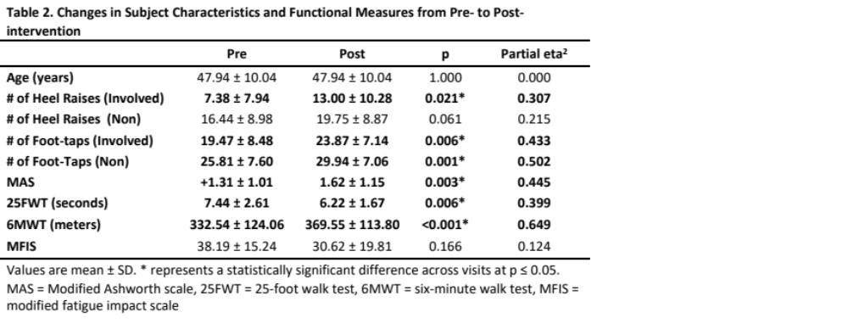

Acute Changes in Heel Raise sEMG Characteristics
The acute (within visit) changes in sEMG were split between the two intervention periods each patient received, the Dry-needling + FESW Visits (Visits 2-5) and FESW Only Visits (Visits 6-13). Initial analyses used three-way repeated measures ANOVAs which assessed the Leg x Visit x Time interactions which revealed no significant interactions or main effects for Visit for any of the sEMG variables (p>0.05). To simplify interpretation of the acute results, it was decided to collapse across visits resulting in a single averaged value for each subject’s Pre-needling, Post-needling, and Post FESW timepoints. Although statistical power was lost by switching to a two-way repeated measures model, it ultimately did not affect interpretation of subsequent analyses or results.

Dry-Needling + FESW Visits (Visits 2-5)
The averaged sEMG activity from heel-raises at each timepoint (Pre-needling, Post-needling, and Post-FESW) are presented in Table 3. Results from the two-way repeated measures ANOVA indicated no significant Leg x Time interactions or Leg effect for sample entropy, mean frequency, or median frequency (p>0.05) but found a significant Leg x Time interaction for amplitude (F = 3.695, p = 0.037, partial eta² = 0.198).There was a significant Time effect for sample entropy (F = 6.589, p=0.004, partial eta² = 0.305 ) and mean frequency (F = 4.031, p = 0.045, partial eta² = 0.212) but not for mean amplitude (F = 0.600, p = 0.555, partial eta² = 0.038) or median frequency (F = 2.460, p = 0.121, partial eta² = 0.141).
For sample entropy, the two-way repeated measures ANOVA indicated a significant effect for Time (F = 6.589, p = 0.004, partial eta² = 0.305) but not for Leg (F = 0.549, p =0.470, partial eta² = 0.035). Post hoc analysis indicated a significant increase in sample entropy in the involved leg at the post-needling (p = 0.035 partial eta² = 0.323) and post-FESW (p = 0.027, partial eta² = 0.323) compared to the pre-needling. In the non-involved limb, sample entropy was significantly higher at post-FESW compared to the pre-needling timepoint (p = 0.017, partial eta² = 0.436) (See Table 3 and Figure 1).
Results of the two-way repeated measures ANOVA for the mean amplitude indicated a significant interaction for Leg x Time (F = 3.695, p = 0.037, partial eta² = 0.198). When assessed with post hoc comparisons, there was a significantly higher mean amplitude in the non-involved limb compared to the involved limb’s mean amplitude (p = 0.043, partial eta² =0.245) at the post-needling timepoint. (See Table 3 and Figure 2).
The two-way repeated measures ANOVA for the mean frequency indicated a significant Time effect (F = 4.031, p = 0.045, partial eta² = 0.212) but not Leg (F = 0.185, p = 0.673, partial eta² = 0.012). Post hoc analysis indicated that the non-involved leg’s, mean frequency was significantly higher at post-FESW compared pre-needling (p =0.033, partial eta² =0.281) and post-needling (p = 0.032, partial eta² = 0.281) (See Table 3 and Figure 3.).
The two-way repeated measures ANOVA for the median frequency indicated no significant effects for Time (F = 2.460, p = 0.121, partial eta² = 0.141 or Leg (F = 0.404, p = 0.534, partial eta² =0.026. (See Table 3 and Figure 4).
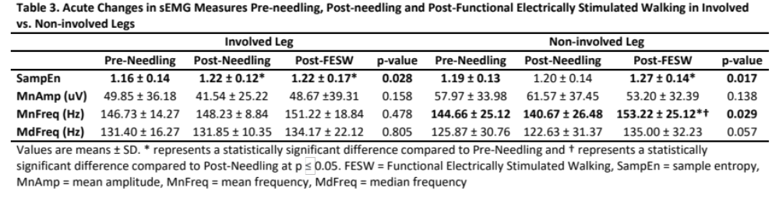
Figure 1. – sEMG Sample Entropy at Pre-Needling, Post-Needling and Post-Functional Electrically Stimulated Walking in the Involved and Non-involved Legs

Values are means ± SD. Sample entropy considered a unitless measure. + represents a statistically significant difference between respective timepoints for the Involved leg whereas # represents a significant difference for the Non-involved leg at p ≤ 0.05. FESW = functional electrically stimulated walking

Figure 2. – sEMG Mean Amplitude at Pre-Needling, Post-Needling and Post-Functional Electrically Stimulate Walking in the Involved and Non-involved Legs

Values are means ± SD. * represents a statistically significant difference at that timepoint between the Involved and Non-involve legs at p ≤ 0.05. FESW = Functional Electrically Stimulated Walking

Figure 3. – sEMG Mean Frequency at Pre-Needling, Post-Needling and Post-Functional Electrically Stimulated Walking in the Involved and Non-involved Legs

Values are means ± SD. # represents a statistically significant difference between respective timepoints for the Non-involved leg at p ≤ 0.05. FESW = Functional Electrically Stimulated Walking

Figure 4. – sEMG Median Frequency at Pre-Needling, Post-Needling and Post-Functional Electrically Stimulated Walking in the Involved and Non-involved Legs

Values are means ± SD. FESW = Functional Electrically Stimulated Walking

Pre-needling, Post-needling, and Post-FESW Correlation Statistics
The correlation statistics between the sEMG variables were calculated using repeated measures correlations (RMCORR) across the three timepoints (Pre-needling, Post-needling, and Post-FESW) for each leg. The results of RMCORR tests are displayed in Table 4 as the correlation coefficient, p value. Significance for the RMCORR statistics was set at p ≤ 0.05.
In the involved leg, sample entropy significantly correlated with mean frequency (r = 0.670, p < 0.001) and median frequency (r = 0.608, p < 0.001). In the non-involved leg, sample entropy also correlated with the mean frequency (r = 0.814, p < 0.001), median frequency (r = 0.756, <0.001) (See Table 4).
In the involved leg, mean amplitude did not significantly correlate with any of the other sEMG measures. In the non-involved leg, the mean amplitude was significantly negatively correlated with mean and median frequency.
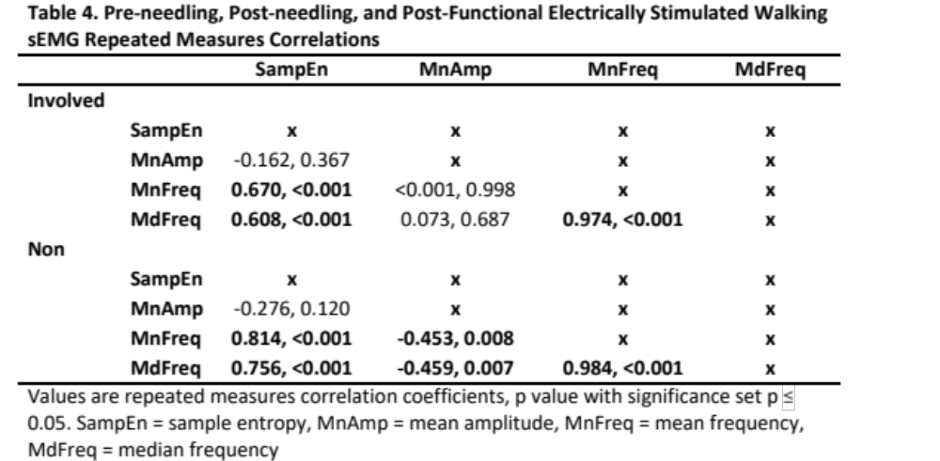

FESW Only Visits (Visits 6-13)
The averaged sEMG activity during heel-raises at Pre-FESW and Post-FESW from the Involved and Non-involved legs are presented in Table 5. The two-way repeated measures ANOVA indicated no significant Leg x Time interactions or main effects for Leg or Time in the measures of sample entropy (See Table 5 and Figure 5), mean amplitude (See Table 5 and Figure 6), or median frequency (See Table 5 and Figure 8) (p > 0.05). There was however a significant Leg x Time interaction for the mean frequency (F = 8.874, p = 0.01, partial eta² = 0.388). Post-hoc analysis indicated that the Non-involved leg’s mean frequency was significantly higher at Post-FESW compared to Pre-FESW (p = 0.006, partial eta² = 0.427) (See Table 5 and Figure 7). median frequency was significantly higher at Post-FESW compared to Pre-FESW (p = 0.009, partial eta² = 0.399). There was no significant between leg differences for any of the measures at either Pre or Post-FESW (p > 0.05).

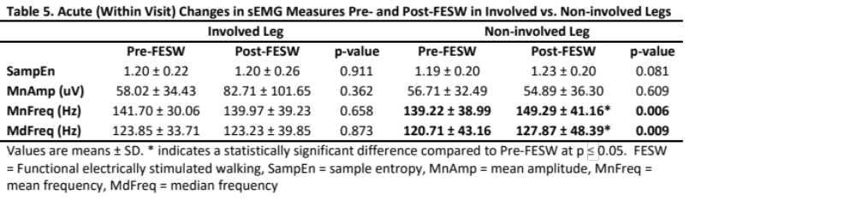

Figure 5. – sEMG Sample Entropy at Pre-Functional Electrically Stimulated Walking and Post-Functional Electrically Stimulated Walking in the Involved and Non-involved Legs

Values are means ± SD. FESW = Functional electrically stimulated walking

Figure 6. – sEMG Mean Amplitude at Pre-Functional Electrically Stimulated Walking and Post-Functionally Stimulated Walking in the Involved and Non-involved Legs

Values are means ± SD. FESW = Functional electrically stimulated walking

Figure 7. – sEMG Mean Frequency at Pre-Functional Electrically Stimulated Walking and Post-Functional Electrically Stimulated Walking in the Involved and Non-involved Legs
#

Values are means ± SD. # represents a statistically significant difference between Pre- and Post FESW in the Non-involved leg at p ≤ 0.05. FESW = Functional electrically stimulated walking

Figure 8. – sEMG Median Frequency at Pre-Functional Electrically Stimulated Walking and Post-Functional Electrically Stimulated in the Involved and Non-involved Legs

Values are means ± SD. # represents a statistically significant difference between Pre- and Post FESW in the Non-involved leg at p ≤ 0.05. FESW = Functional electrically stimulated walking

Pre-FESW and Post-FESW sEMG Correlation Statistics
The correlation statistics between the sEMG variables were calculated using repeated measures correlations (RMCORR) across Pre-FESW and Post-FESW for each leg. The results of the RMCORR tests are displayed in Table 6 as the correlation coefficient, p value. Significance for the RMCORR statistics was set at p ≤ 0.05.
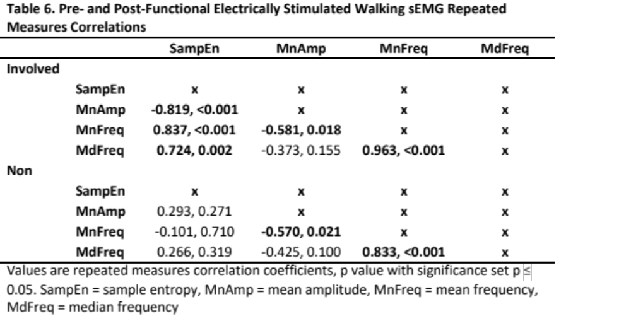

Chronic Changes in sEMG Characteristics Following Intervention
The pre-needling or pre-FESW heel-raise sEMG activity from the Pre-intervention (Visit 2), Mid-intervention (Visit 6), and Post-intervention (Visit 13) are presented in Table 7. Results from the two-way repeated measures ANOVA indicate that there were no significant effects for Leg, Visit, or Leg x Visit interaction for any of the measures (p>0.05). Post-hoc analyses further revealed no significant differences for any of the measures at any time point (p>0.05). (See Table 7 and Figures 9-12).
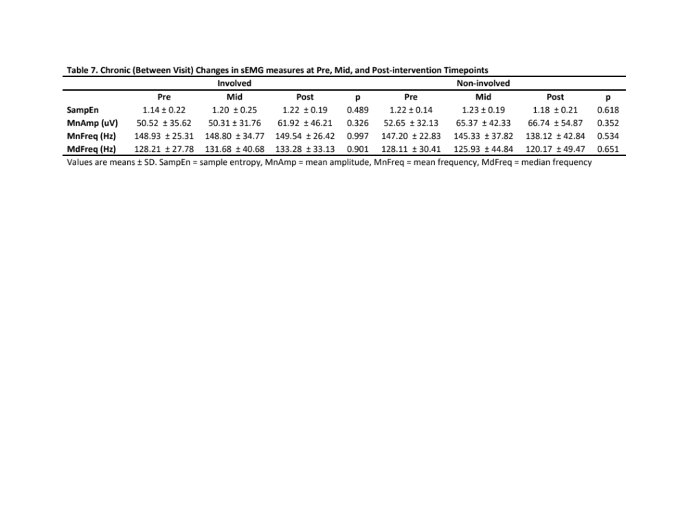
Figure 9. – sEMG Sample Entropy at Pre-intervention, Mid-intervention, and Post-intervention in the Involved and Non-involved Legs

Values are means ± SD.

Figure 10. – sEMG Mean Amplitude at Pre-intervention, Mid-intervention, and Post-intervention in the Involved and Non-involved Legs

Values are means ± SD.

Figure 11. – sEMG Mean Frequency at Pre-intervention, Mid-intervention, and Post-intervention in the Involved and Non-involved Legs

Values are means ± SD.

Figure 12. – sEMG Median Frequency at Pre-intervention, Mid-intervention, and Post-intervention in the Involved and Non-involved Legs

Values are means ± SD.

Pre-intervention and Post-intervention sEMG Correlation Statistics
The correlation statistics between the sEMG variables and functional measures (MFIS, 6MWT, etc.) were calculated using repeated measures correlations across Pre-intervention and Post-intervention for each leg. The results of repeated measures correlations tests are displayed in Table 8 as the correlation coefficient, p value. Significance for the repeated measures correlation statistics was set at p ≤ 0.05.

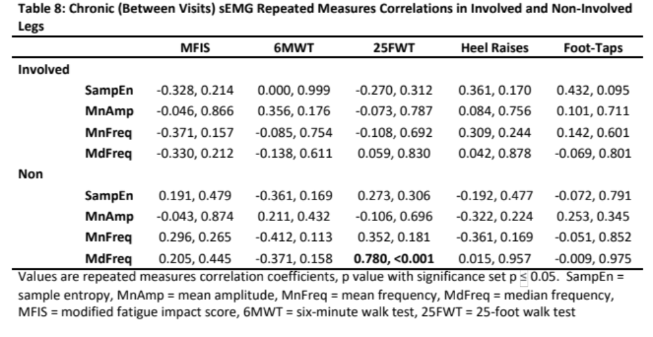

Absolute Changes in Foot-Tapping Rate of Force Development

The absolute mean change in Foot-tapping measures from Pre-intervention to Post-intervention are presented in Table 9. Results of the two-way repeated measures ANOVA indicated no significant Leg x Visit interaction (F = 0.008 , p = 0.929, partial eta² = 0.001) for Foot-tapping rate. There was a significant effect for Visit (F = 18.838, p < 0.001, partial eta² = 0.574) and Leg (F = 9.969, p = 0.007, partial eta² = 0.416). Post hoc analysis indicated there was a significant increase in the number of foot-taps from Pre to Post-intervention in both the Involved (p = 0.006, partial eta² = 0.433) and Non-involved legs (p 0.002, partial eta² = 0.508). Post hoc analysis also indicated there was a significantly higher number of foot-taps in the Non-involved leg compared to the Involved leg at both Pre (p =0.008, partial eta² = 0.405) and Post (p = 0.015, partial eta² = 0.354) timepoints (See table 9 and Figure 13).
AUC was found to have a significant effect for Leg (F = 5.459, p=0.035, partial eta² = 0.281). Post hoc analysis revealed AUC was not significantly different between legs at Pre-treatment (p = 0.088, partial eta² = 0.194) but was significantly higher in the Involved leg at Post-treatment (p = 0.030, partial eta² = 0.293) (See Table 9 and Figure 14). No significant effects or differences were found for peak force measures (p>0.05) (See Table 9 and Figure 15).
Time to peak was found to have a significant effect for leg (F = 7.233, p = 0.018, partial eta² = 0.341). Post-hoc analysis found time to peak was higher in the Involved leg compared to the Non-involved leg at both Pre (p = 0.037, partial eta² = 0.276) and Post-intervention (p = 0.019, partial eta² = 0.333) (See table 9 and Figure 16). Time to base was found to have a significant effect for leg (F = 10.581, p = 0.006, partial eta² = 0.430). Post-hoc analysis found time to base was higher in the Involved leg compared to the Non-involved leg at both Pre (p = 0.031, partial eta² = 0.290) and Post-intervention (p = 0.004, partial eta² = 0.464) (See Table 9 and Figure 16). Total tap time was found to have a significant effect for Leg (F = 10.967, p = 0.003, partial eta² = 0.478). Post-hoc analysis found total tap time was higher in the Involved leg at both Pre (p = 0.010, partial eta² = 0.386) and Post-intervention (p = 0.007, 0.415) (See Table 9 and Figure 16).
Percent time to peak was found to have a significant effect for leg (F = 9.709, p = 0.008, partial eta² = 0.410). Post-hoc analysis found that percent time to peak was significantly lower in the involved limb at Pre-intervention (p = 0.026, partial eta² = 0.306) and Post intervention (p = 0.037, partial eta² = 0.276) (See Table 9 and Figure 17). Percent time to base was found to have a significant effect for leg (F = 9.766 , p = 0.007, partial eta² = 0.411). Post-hoc analysis found percent time to base was significantly higher in the Involved leg at Pre-intervention (p = 0.026, partial eta² = 0.308) and Post intervention (p = 0.037, partial eta² = 0.276) (See Table 9 and Figure 17).

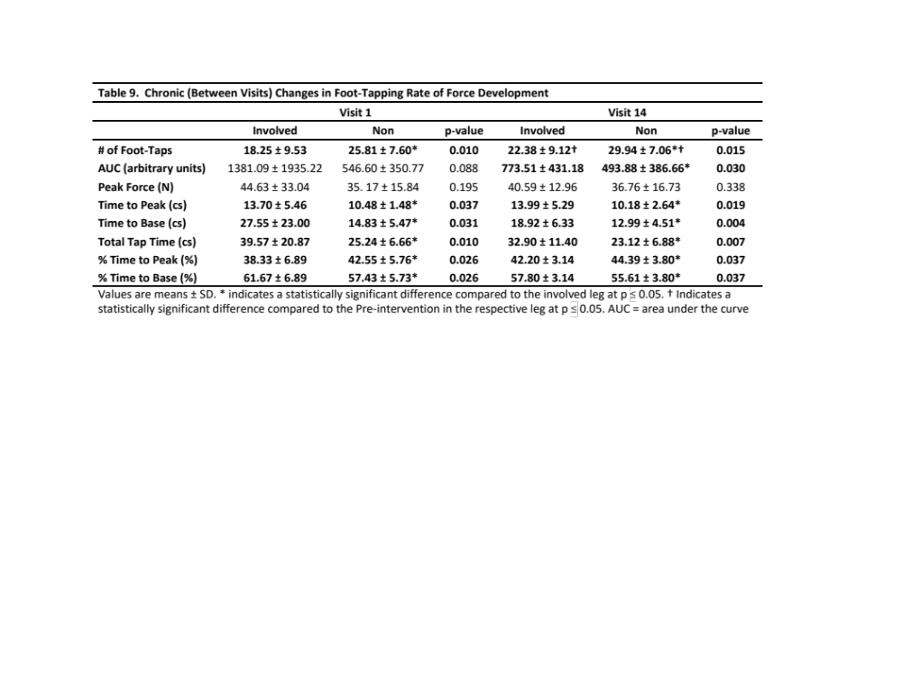

Figure 13. – Foot-Taps Performed at Pre-intervention and Post-intervention in the Involved and Non-involved Legs

Values are means ± SD. * represents a statistically significant difference between legs at the respective timepoints. + represents a statistically significant difference between Pre and Post intervention in the Involved leg. # represents a statistically significant difference between Pre and Post intervention in the Non-involved leg at p ≤ 0.05.

Figure 14 – Foot-tapping Area Under the Curve at Pre-intervention and Post-intervention in the Involved and Non-involved Legs

Value are means ± SD. * represents a statistically significant difference between legs at the respective timepoints at p ≤ 0.05.

Figure 15. – Foot-tapping Peak Force at Pre-intervention and Post-intervention in the Involved and Non-involved Legs

Values are means ± SD.

Figure 16. – Foot-tapping Time to Peak and Time to Base

Values are means ± SD. * represents a statistically significant difference between legs at the respective timepoints at p ≤ 0.05.

Figure 17. – Foot-tapping Average Percent Time to Peak and Time to Base

Values are mean percentage ± SD. * represents a statistically significant difference between legs at the respective timepoints at p ≤ 0.05.

Relative Changes in Foot-Tapping Rate of Force Development
The relative percent differences between the Involved and Non-involved legs at the Pre (Visit 1) and Post (Visit 14) timepoints are displayed in Table 10. Results of the paired samples T tests indicated no significant differences between the Pre and Post intervention timepoints (p>0.05) (Figure 18). The relative percent change from Pre (Visit 2) to Post (Visit 13) intervention for the Involved and Non-involved legs are presented in Table 11. Results from the paired samples T tests found no significant differences in the percent change between the involved and non-involved legs (p > 0.05) (Figure 19).

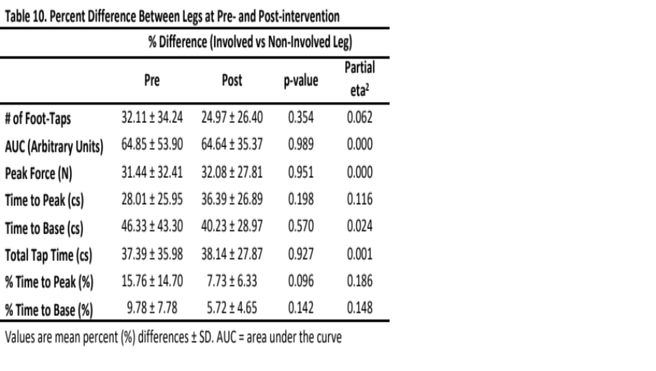

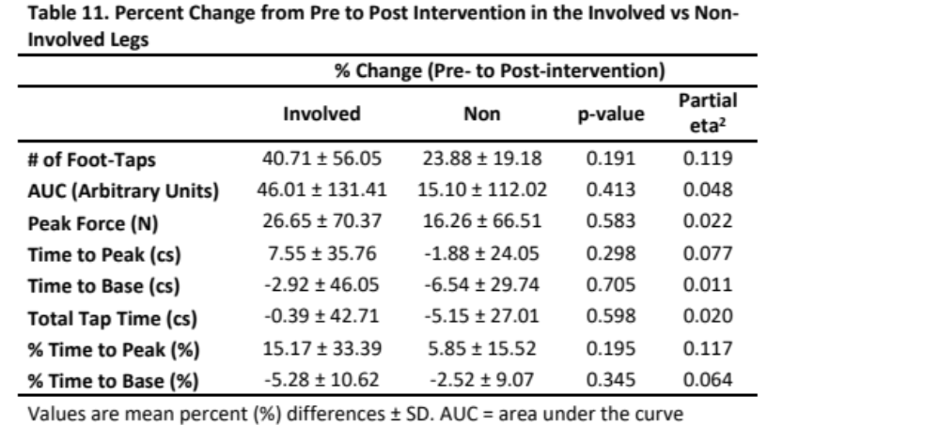

Figure 18. Percent (%) Difference in Foot-tapping between legs in the Involved vs. Non-involved Legs

Values are mean percentage ± SD. AUC = area under the curve

Figure 19. Percent (%) Change in Foot-tapping from Pre to Post Intervention in the Involved vs. Non-involved Legs

Values are mean percentage ± SD. AUC = area under the curve

Foot-Tapping and Functional Measures Correlations

The correlation statistics between the foot-tapping and functional performance measures (MFIS, 6MWT, etc.) were calculated using repeated measures correlations across Pre (Visit 2) and Post (Visit 13) timepoints for each leg. The results of repeated measures correlations tests are displayed in Table 12 as the correlation coefficient, p value. Significance for the repeated measures correlation statistics was set at p ≤ 0.05.

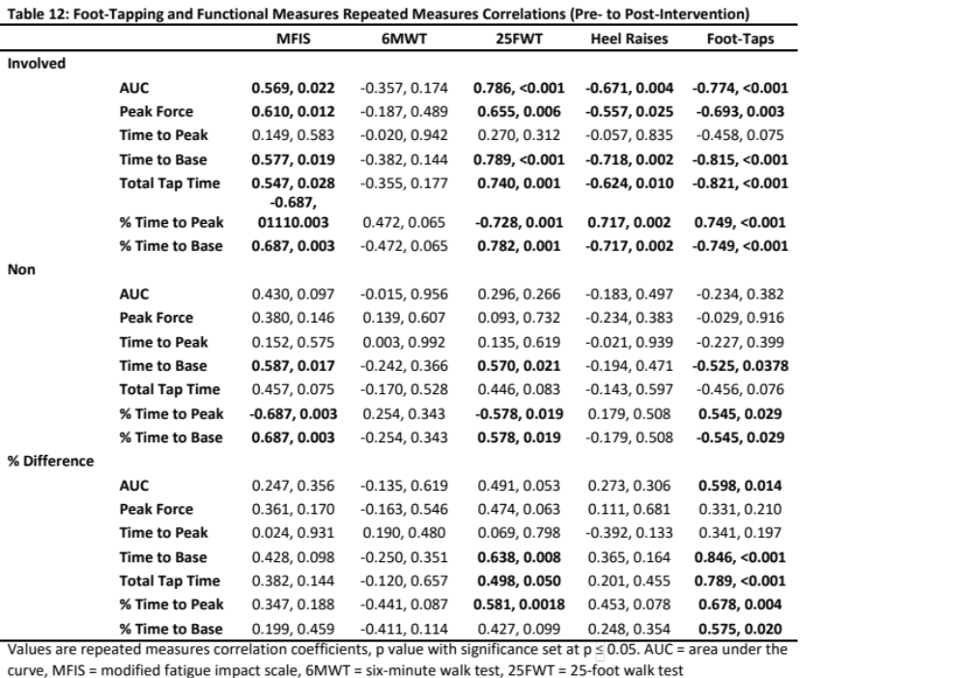

Effect Size Calculations
The partial eta squared effect sizes for the ANOVA statistics ran for the sEMG and foot-tapping measures are listed in Tables 13 and 14. A partial eta of 0.01, 0.06, and 0.14 are indicative of small, medium, and large effect sizes respectively.

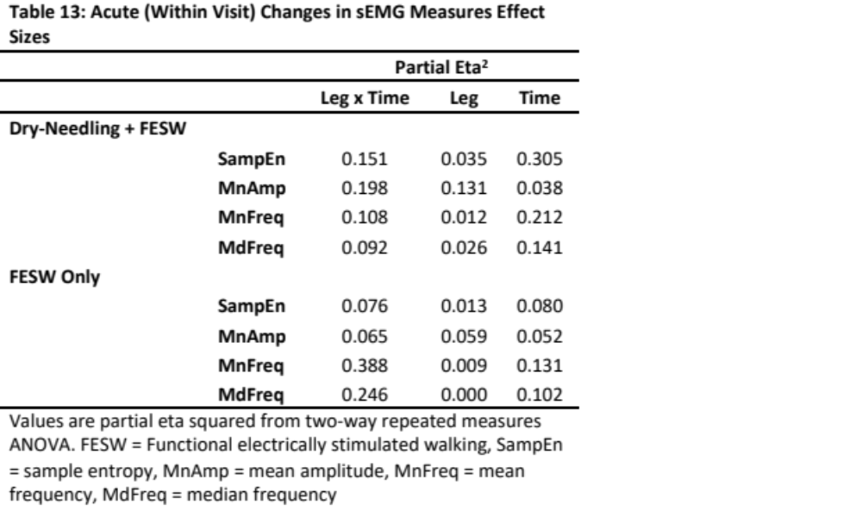
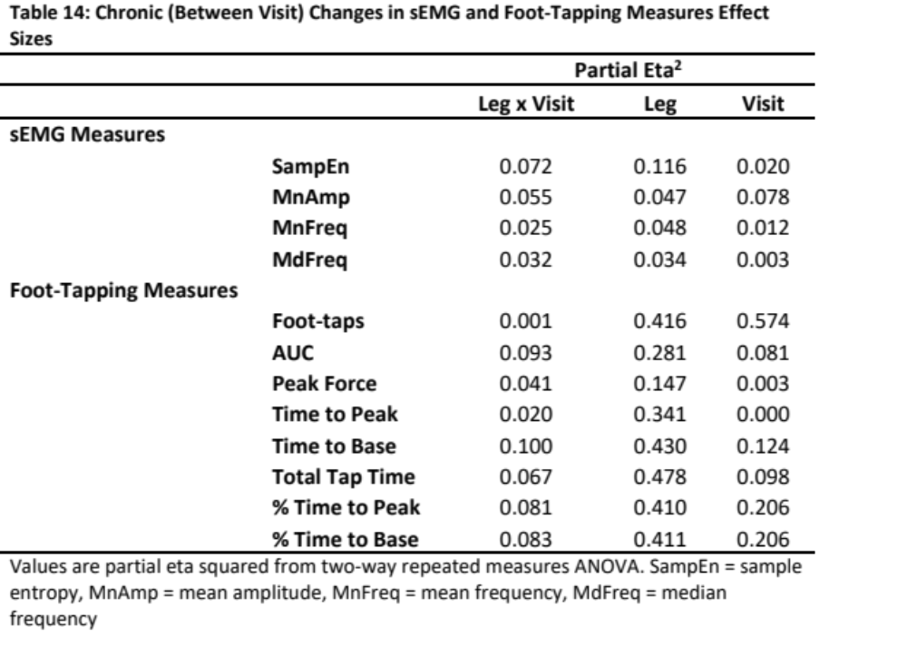

Discussion

The main findings of this study are as follows:
Acute (Within Visit) Changes in sEMG
- Dry-needling + FESW Visits (Visits 2-5):
  - Sample entropy was significantly higher following dry-needling and FESW compared to the Pre-needling timepoint for the involved leg. The non-involved leg however was only significantly higher at the Post-FESW timepoint compared pre-needling.
  - Mean frequency did not significantly change in the involved leg but was significantly higher in the non-involved leg at Post-FESW compared to Pre and Post-needling timepoints.
  - No significant changes occurred in the mean amplitude or median frequency at any of the timepoints for either leg.
  - No significant between leg differences were seen for any of the sEMG measures at any timepoint.
  - In the involved leg sample entropy significantly correlated with the mean frequency and median frequency. The mean amplitude did not significantly correlate to mean and median frequency.
  - In the non-involved leg sample entropy also significantly correlated with mean frequency and median frequency. Mean amplitude significantly correlated with both mean and median frequency.
- FESW Only Visits (Visits 6-13)
  - Neither sample entropy or mean amplitude significantly changed from Pre to Post FESW in both the involved and non-involved leg.
  - Mean and median frequency did not significantly differ from Pre to Post in the involved leg, but significantly increased in the non-involved leg at post-FESW.
  - No significant between leg differences were seen in any of the sEMG measures at either timepoints.
  - In the involved leg sample entropy significantly correlated with mean amplitude, mean frequency, and median frequency. Mean amplitude was significantly correlated with mean frequency.
  - In the non-involved leg mean amplitude and mean frequency were significantly correlated.
Chronic (Between Visits) Changes in sEMG
- Neither leg showed significant changes in sample entropy, mean amplitude, mean frequency or median frequency across visits.
- There were no significant between limb differences in sample entropy, mean amplitude, mean frequency or median frequency at any timepoints.
- The involved leg sEMG measures (sample entropy, mean amplitude, mean frequency, and median frequency) did not significantly correlate to any of the functional performance measures done at the Pre - Post assessments (MFIS, 6MWT, 25FWT, Heel Raises, or Foot-taps).
- The non-involved leg had significant correlations between the 25FWT and median frequency.

Chronic (Between Visits) Changes in Foot-Tapping
- There was a significant increase in the number of foot-taps performed from pre to post intervention in both legs.
- Peak force, time to peak, time to base, total tap time, % time to peak, and % time to base did not significantly change from pre to post intervention in either leg.
- AUC did not significantly differ between legs at the pre-treatment but was significantly higher in the involved leg at post treatment.
- No significant difference in peak force was found between the involved and non-involved legs.
- Time to peak, time to base and total tap time were significantly higher in the involved leg at both pre and post intervention.
- % time to peak was significantly higher in the non-involved leg at both pre and post intervention.
- % time to base was significantly higher in the involved leg at both pre and post intervention.
- When expressed as a percent difference between legs, there were no significant difference between the pre and post intervention timepoints for the foot-tapping measures.
- When expressed as a percent change from pre to post intervention, there was no significant difference between the pre and post intervention timepoints for the foot-tapping measures.
- In the involved leg AUC, peak force, time to base, total tap time % time to peak and % time to base were significantly correlated with the MFIS, 25FWT, # of heel raises, and # of foot-taps but not the 6MWT. Time to peak did not significantly correlate with any of the functional performance measures.
- In the non-involved leg time to base, % time to peak, and % time to base significantly correlated with the MFIS, 25FWT, and # of foot taps but not the number of heel raises. AUC, peak force, time to peak, and total tap time did not significantly correlate with any of the functional measures.
- When expressed as a percent difference between legs, the AUC significantly correlated with the # of foot-taps. Time to base, total tap time, % time to peak, and % time to base significantly correlated with the 25FWT and the # of foot-taps but not the MFIS, 6MWT, or number of heel raises. Peak force and time to peak did not significantly correlate with any of the functional measures. % time to base significantly correlated with the number of foot-taps but none of the other functional measures.

Acute (within visit) Changes in sEMG
During the dry-needling + FESW treatments visits, there was a significant acute increase in sEMG sample entropy in the involved leg which is in direct opposition with our hypothesis. In the non-involved leg there was no significant change in sample entropy at post-needling but there was a significant increase after walking. We originally hypothesized that both dry-needling and FESW would produce muscular fatigue or damage leading to a decreased sample entropy. A previous study using a rat model showed that acute muscle damage results in a decreased sample entropy⁴⁶. Following dry-needling treatments there was an acute increase in sample entropy in the damaged muscle. The results of the study agree with the current study which suggests that dry-needling results in an acute increase in sample entropy⁴⁶. Although we found no significant between leg differences, it’s worth noting that the non-involved leg (which didn’t receive treatment) saw no significant change in sample entropy from the pre to post dry-needling timepoint. At the Post-FESW timepoint there was a significant increase in both legs which suggests that it was not necessarily the FESW that is attributable for the increase in the involved leg’s sample entropy.
To our knowledge this is one of the first studies examining the changes in sample entropy following dry-needling and FESW treatments in humans. It is unknown why sample entropy increases following intervention in the present study. It has been hypothesized that dry-needling exerts its effects by altering sensory spinal processing thereby decreasing motor neuron excitability and spasticity symptoms. Another theory suggests that dry-needling acts as a noxious stimuli resulting in the activation of diffuse noxious inhibitory control systems and muscular relaxation⁹². The present study suggests that dry-needling and FESW treatments led to an increase in sample entropy via modulation of motor unit amplitude and frequency.
Within visit there were no significant changes in sEMG amplitude at post-needling or post-FESW timepoints. This was contrary to our hypothesis that there would be an acute increase in sEMG amplitude post-needling and post-FESW. Our hypothesis was that an increase in amplitude would occur due to either muscle fatigue or damage. Unfortunately, neither were assessed at the Pre- or Post-intervention timepoints within visit so we can’t say with any certainty that either happened. Although not significant in the current study, the mean amplitude appears to have decreased in the involved leg and increased in the non-involved leg post-needling. Had the results been significant, they would have agreed with previous research which showed a decrease in sEMG amplitude after dry needling of the gluteus medius muscle¹⁴¹. The study suggests that individuals with weakened muscles require a higher activation (amplitude) to perform a contraction than a non-weakened or affected muscle¹⁴¹. Therefore, the muscle activation (amplitude) needed to perform a contraction could be a useful measure of muscle function¹⁴¹. One of the major limitations of our study was the lack of a maximal contraction to normalize the sEMG measures to. Significant differences may have been found if it had been possible to normalize each heel raise to a maximal contraction to get a % activation value.
In the present study we hypothesized that the mean and median frequency would be significantly decreased in the involved leg following dry-needling and FESW. A drop in the sEMG frequency would be suggestive of muscular fatigue induced by the treatments. However, the involved leg showed no significant changes, whereas the non-involved leg showed a significant increase in mean frequency at post-FESW compared to both the pre needling and post-needling timepoints. It’s interesting that the non-involved leg showed a significant increase in mean frequency, but the non-affected leg did not. Differences in sEMG frequency changes over time could be indicative of a treatment effect or bilateral asymmetries during task performance. Previous research has suggested that PwMS may experience differences in glucose metabolism between legs while cycling¹³⁶. A difference in glucose metabolism between legs during the FESW may in part explain why we see between leg differences in the sEMG response over time.
Typically, with fatiguing or maximal tasks, sEMG amplitude and frequency are inversely related¹²⁷. As fatigue occurs there is an increase in sEMG amplitude and a decrease in frequency. Originally, we did not hypothesize how sEMG amplitude and frequency would relate to each because we had no reason to believe they would differ between legs. It was found that the involved leg’s amplitude did not significantly correlate with mean and median frequency but there was a medium negative correlation between amplitude and frequency in the non-involved leg. It is unclear why there was a lack of correlation in the involved leg between mean amplitude and frequency but a significant medium correlation in the non-involved leg. A lack of correlation in the involved leg could be indicative of higher spasticity, fatigue or even a treatment effect in that leg. It has been previously reported that fatigued muscles show a lower correlation between force and EMG values compared to non-fatigued muscles¹²⁷.
The current study exhibited strong positive correlations between sample entropy and the mean and median frequencies. Our study found as sample entropy increased, so did mean and median frequency. This is interesting because sEMG mean and median frequency measures have been previously used in research as fatigue measures^{124,127}. In these studies, it has been found that mean amplitude is increased, and mean/median frequency is reduced in fatigued muscle. This suggests sample entropy may also be a useful measure of fatigue in spastic muscles. Unfortunately, the current study did not assess fatigue at each timepoint, so it cannot be said with any real certainty how fatigue influenced sEMG measures. It does however makes sense that a spastic muscle could be more fatigued, leading to an increased sEMG frequency.
During the FESW only visits, there were no significant changes in sEMG sample entropy or mean amplitude in either the involved or non-involved legs. Again, mean and median frequencies significantly increased from pre to post-FESW in the non-involved leg but not the involved leg. It is unclear why the non-involved leg’s frequency increased post-FESW when the expected response would be for it to drop due to fatigue. Though not significant, there was a slight drop in the involved leg’s frequency post-FESW which could be explained by the combined e-stim and walking.
In FESW only visits sample entropy was negatively correlated with mean amplitude and positively correlated with mean/median frequency. Previous studies suggest that as fatigue occurs, there tends to be an increase in sEMG amplitude and a decrease in the frequency. The direction of the correlations between sample entropy and sEMG amplitude and frequencies suggests that as fatigue occurred during walking, there is a drop in sample entropy. These findings agree with another study done in stroke patients which found that mean amplitude and entropy were negatively correlated during a quick stretching movement¹⁶⁶.

Chronic (between visits) Changes in sEMG
The previous sections assessed changes in sEMG values within visit to assess the acute effects of dry-needling and FESW treatments. We were also interested in understanding how the interventions affected sEMG over several weeks. In order be useful measures of spasticity, sEMG measures should be able to detect chronic changes over time and not just acute changes in spasticity. A chronic change in sEMG measures (e.g. sample entropy or mean frequency) would be suggestive of a treatment effect of either the dry-needling or FESW interventions.
Our original hypotheses were that that sample entropy and mean/median frequency would be increased, and mean amplitude would be decreased across visits. When compared at Pre (visit 2), Mid (visit 6), and Post-intervention (visit 13) timepoints there were no significant differences in any of the sample entropy, mean amplitude, mean frequency, or median frequency measures across visits. Despite non-significance, there was a trend for sample entropy to be increased at Mid-intervention in both legs. Sample entropy continued to increase at Post-intervention for the involved leg but appears to have decreased in the non-involved legs. Both the involved and non-involved legs showed a small effect size for visit (partial eta² = 0.50 and 0.34 respectively).
When post-hoc comparisons were done, it was found that the sample entropy effect sizes between Pre-intervention and Mid-intervention were higher in the involved leg (partial eta² = 0.045) than in the non-involved leg. There was a very small effect size indicting an increase in the sample entropy from Mid-intervention to Post-intervention in the involved leg (partial eta² = 0.006) but a moderate effect size for a reduction in sample entropy in the non-involved leg (partial eta² = 0.091). Taken at face value, these results suggest that the dry-needling + FESW visits resulted in larger changes in sample entropy than the FESW only visits in the involved leg. It’s interesting that the non-involved leg saw a moderate effect size for a reduction in sample entropy suggesting that the leg got worse.
Although not significant, there appeared to be a trend towards the mean amplitude increasing across visits. This goes against our hypothesis which suggested that mean amplitude would decrease because of treatment. We initially thought that amplitude would decrease over time due to dry-needling and FESW reducing spasticity resulting in a lower activation (amplitude) needed to complete the heel-raise.
Our original hypotheses stated that mean and median frequency would be increased across visits. These hypotheses were formed under the assumption that sEMG amplitude and frequency are inversely related. We originally predicted that amplitude would increase, so it would only make sense for frequency to increase. Although not significant, there was a trend towards the mean and median frequencies increasing in the involved leg and decreasing in the non-involved leg. Despite not being significant, this finding is interesting as it suggests a possible treatment effect in the involved leg.
It was originally hypothesized that the sEMG measures would not significantly correlate with any of the functional performance measures (MFIS, 6MWT, 25FWT, Heel raises and Foot-taps). The findings of the study fully agreed with our hypothesis in the involved leg but not in the non-involved. It was found that none of the involved leg’s sEMG measures significantly correlated with either the MFIS, 6MWT, number of heel raises, or number of foot-taps. The final significant correlation was a large positive correlation between the median frequency and the 25FWT. A positive correlation suggests that as the 25FWT time was reduced there was also a decrease in the median frequency.

Chronic (between visit) Changes in Foot-tapping
The foot-tapping test was done at Pre-intervention and Post-intervention as a measure of spasticity. This study found that the number of foot-taps performed in 10-seconds was significantly increased in both legs from Pre-intervention to Post-intervention. There was also a significantly higher number of foot-taps performed in the non-involved leg at both Pre-intervention and Post-intervention. Even though foot-tapping rate increased, it’s hard to say with certainty that it was due to dry-needling and FESW or whether subjects just improved at doing the foot-tapping test. For that reason, several other measures from the force plate were examined.
Area under the curve (AUC) is a product of the amount of force and time that it takes to complete a foot-tap. The AUC was not significantly different between legs at pre-intervention but was significantly lower in the non-involved leg at Post-intervention. The peak force tended to be higher in the involved leg at both timepoints but was found to be non-significant. The time to peak, time to base, and total tap time were significantly higher in the involved leg at both Pre-intervention and Post-intervention.
The % time to peak and % time to base represent the proportion of time spent plantar flexing and dorsi flexing respectively during the FTT. Expressing them as a percentage made them easier to compare at pre vs. post and in the involved vs. non-involved legs. The % time to peak was significantly lower in the involved leg compared to non-involved at both Pre-intervention and Post-intervention. The difference was not significant, but there was a tendency for the % time to peak to increase from Pre-intervention to Post-intervention. The % time to base was significantly higher in the involved leg compared to non-involved at both Pre-intervention and Post-intervention.
The difference between % time to peak and % time to base in each leg were not statistically compared between visits, but the difference appears to be smaller at Post-intervention compared to Pre-intervention. At Pre-intervention, the involved leg’s time to base represents ~62% of the total tap time, whereas time to peak was ~38%, meaning there was a 24% difference between the two movement times. At Post-intervention, time to peak increased to ~42% and time to base decreased to ~58% of the total tap time, resulting in a 16% difference. At Pre-intervention the non-involved leg’s, time to peak represented ~43% of the total tap time, whereas time to base was ~57%, for a difference of 14% between movements. Post intervention the % time to peak increased to 44% and the % time to base decreased 56% of the total tap time, for a difference of 12% between movements. Not only was the difference greater in the involved leg, but it appears to have changed more than the non-involved leg at Post-intervention. It is unknown how much time the average healthy person spends during each portion of a foot-tap, but this study suggests that as spasticity is reduced, there is a shift towards time to peak and time to base each representing 50% of the total tap time.
The change in the time to base was of especial interest in this study because the targeted muscle for the dry-needling was the gastrocnemius. If there was an increased spasticity in the gastrocnemius, it would impede the antagonistic muscle (tibialis anterior) from quickly dorsiflexing the foot. In turn, this would result in a higher time to base and % time to base. We did not see a significant change in the current study, but it trended towards a reduced time to base. Another previous study that used foot-tapping in PwMS, found significant group differences between control individuals, patients with primary progressive MS, and relapsing remitting MS¹³⁹. The study found that the healthy controls had the shortest dorsiflexion time and fastest velocity followed by the relapsing remitting and the primary progressive MS groups. Both the dorsi and plantar flexion movements were significantly different between groups, but it was found that the dorsiflexion portion was an especially sensitive measure¹³⁹. The results of both studies suggests the foot-tapping test is a useful measure for assessing MS related leg deficits.
A study examining dry-needling in the trapezius muscles of healthy individuals found that contraction time differed immediately (30-minutes) post and 72 hours post needling¹³⁸. Their study showed that contraction time was significantly increased 30-mins post dry-needling but was then significantly decreased at 72-hours post-dry-needling. Although not significant, muscle tone and stiffness was also increased immediately post-needling and then significantly decreased 72-hours compared to pre-needling. Although we did not assess foot-tapping immediately post-needling, we would suspect a similar increase in the contraction time of foot-taps. The increased muscle tone, stiffness, and contraction time of the previously mentioned study supports our hypothesis that there will be some kind of localized muscle fatigue immediately post-dry-needling¹³⁸.
When the foot-tapping measures were assessed as a percent difference between legs, no significant changes were seen between Pre-intervention and Post-intervention. Despite non-significance, there were medium effect sizes for the difference in the number of foot-taps performed (partial eta² = 0.062) and time to peak (partial eta² = 0.116), and large effect sizes for the % time to peak (partial eta² = 0.186) and % time to base (partial eta² = 0.148). When expressed as a percent change from Pre-intervention to Post-intervention there were no differences between legs but there were medium effect sizes for the number of foot-taps (partial eta² = 0.119), time to peak (partial eta² = 0.077), % time to peak (partial eta² = 0.117) and % time to base (partial eta² = 0.064). The medium effect sizes suggest that although the changes were not statistically significant, there was still some kind of meaningful improvement in tapping performance between visits.
This study was unique because it applied an intervention unilaterally and tested patients using a bilateral movement (heel raises). Bilateral asymmetries in force production have been previously reported in PwMS^{36,85,87}. In affected patients, bilateral asymmetries can lead to balance and gait issues, decreased movement efficiency and increased risk of injury. The current study saw a ~31% difference in peak force between leg at Pre-intervention and did not significantly change at post assessment at ~32% difference. A 30% difference in force between legs is quite a large difference, especially when you consider we are looking at a movement that it done repetitively. If a leg is producing 30% more force than the other, it might explain why the same leg (presumably) fatigued and performed less taps.
Despite no significant change in the % difference of peak force, there was a medium effect size for the change in foot-taps and a large effect size for change in % time to peak and % time to base. This suggests that although the involved leg was still producing more force than non-involved, it became faster and/or more fatigue resistant because of the intervention.
The foot-tapping measures showed higher and more significant correlations to the functional performance measures compared to the sEMG measures.
The MFIS showed a positive medium/moderate correlation with the involved leg’s AUC, peak force, time to base, total tap time, and % time to base and a negative correlation with % time to peak. In the non-involved leg the MFIS positively correlated with the time to base and % time to base and negatively correlated with % time to peak. Although not significant, the MFIS also exhibited moderate positive correlations with the between leg differences of the time to base and the % time to peak. These findings suggest that as spasticity was reduced and foot-tapping improved, there was a decrease in perceived fatigue.
The 6MWT did not significantly correlated with any of the foot tapping measures but the 25FWT exhibited several significant correlations. In the involved leg the 25FWT had a large positive correlation with the AUC, peak force, time to base, total tap time, and % time to base and a negative correlation with % time to peak. The non-involved leg positively correlated with the time to base and % time to base and negatively correlated with the % time to peak. It’s interesting that the foot-tapping measures significantly correlated with the 25FWT but not the 6MWT. This suggests that the FTT is a useful measure of how PwMS will perform during shorter tasks (i.e. 6MWT) but not longer ones (i.e. the 6MWT).
The % between leg difference in time to base and % time to peak exhibited significant positive correlations with the 25FWT. The number of heel raises was significantly negatively correlated with the AUC, peak force, time to base, total tap time, % time to peak, and % time to base. The significant correlations between foot-tapping measures and functional performance measures suggests that the FTT could be a useful substitute for individuals who are not ambulatory.

Chapter V:

Purpose
The purpose of this study was to reexamine a previously collected dataset from a sample of patients with multiple sclerosis (PwMS) to see if there were significant differences in sEMG measures (sample entropy, mean amplitude, mean frequency, and median frequency) and foot-tapping rate (# of foot taps, AUC, peak force, time to peak, time to base, total tap time, % time to peak and % time to base) following dry needling and functional electrically stimulated walking. We also investigated the relationship between the sEMG measures and functional outcome measures (MFIS, 6MWT, 25FWT, # of heel raises and # of foot-taps.

Hypotheses

- Following dry-needling and FESW treatments, there will be a within visit reduction of sEMG sample entropy and frequency, and an increase in amplitude.
  - For the dry-needling + FESW visits, there was an increase in the involved leg’s sample entropy at post-needling and post-FESW compared to the pre-needling timepoint. The non-involved leg had a significant increase in sample entropy at post-FESW only. There were no changes in the mean amplitude in either leg following either treatment. There was no change in the mean frequency in the involved leg after either treatment. There was an increase in the mean frequency in the non-involved leg compared to pre- and post-needling timepoints. Median frequency did not significantly change following either treatment.
  - For the FESW only visits, there were no changes in the involved leg’s sample entropy, mean amplitude, mean frequency, or median frequency at post-FESW. In the non-involved leg there was no change in the sample entropy or mean amplitude but there was an increase in the mean and median frequency post FESW.
- There will be a chronic increase in sEMG sample entropy and frequency, and a decreased amplitude. The number of foot-taps performed, and the rate of force development will increase following the dry-needling and FESW intervention.
  - There was no changes in sample entropy, mean amplitude, mean frequency, or median frequency from Pre-intervention to Mid-intervention and Post-intervention in either leg.
  - There was an increase in the total number of foot-taps performed at Post-intervention compared to Pre-intervention in both legs. There was no change in the AUC, peak force, time to peak, time to base, total tap time, % time to peak, or % time to base from Pre-intervention to Post-intervention.
- The involved leg will exhibit a lower sEMG complexity and frequency, and an increased amplitude compared to the Non-involved leg. Foot-tapping and rate of force development will similarly be reduced in the Involved-leg. Post-intervention, there will be an improvement in function leading to a reduced between leg differences in foot-tapping.
  - There were no differences between legs for the sample entropy, mean amplitude, mean frequency, or median frequency measures at any timepoint.
  - There was a lower number of foot-taps performed in the involved leg compared to the non-involved leg at both Pre-intervention and Post-intervention. AUC was higher in the involved leg at Post-intervention, but not at Pre-intervention. There were no differences in peak force at either Pre-intervention or Post-intervention. Time to peak, time to base, and total tap time was higher in the involved leg at both Pre-intervention and Post-intervention. % time to peak was lower in the involved leg at both Pre-intervention and Post-intervention. % time to base was higher at Pre-intervention and Post-intervention.
  - When expressed as a percent difference between legs, there was no difference between Pre-intervention and Post-intervention for any of the foot-tapping measures.
- The sEMG measures will not significantly correlate with the functional outcome measures, but foot-tapping and the rate of force development will.
  - The Dry-needling + FESW visits’ sample entropy positively correlated with mean and median frequency. The mean amplitude was negatively correlated with the mean and median frequency in the non-involved leg but not in the involved leg.
  - The FESW Only visits’ sample entropy negatively correlated with mean amplitude and positively correlated with mean and median frequency in the involved leg but not the non-involved leg. The mean amplitude was negatively correlated with the mean frequency in both legs. The mean frequency was negatively correlated with the mean frequency in the non-involved leg but not the involved leg.
  - The involved leg’s sEMG measures did not correlate to any of the functional measures. The non-involved leg’s median frequency positively correlated with the 25FWT.
  - The AUC positively correlated with the MFIS and 25FWT and negatively correlated the # of heel raises and the # of foot-taps in the involved leg only. The peak force positively correlated with the MFIS and 25FWT and negatively correlated with the number of heel raises and number of foot-taps. The time to peak did not correlate with any of the functional measures. The time to base was positively correlated with the MFIS, 25FWT and negatively correlated with the number of foot-taps in the involved and non-involved legs. The time to base also negatively correlated to the number of heel raises in the involved leg but not the non-involved leg. The total tap time positively correlated the MFIS and 25FWT and negatively correlated with the number of heel raises and foot-taps in the involved leg but not the non-involved leg. The % time to peak negatively correlated with the MFIS and 25FWT and positively correlated with the # of foot-taps in the involved and non-involved legs. The % time to peak was also positively correlated with the number of heel raises in the involved leg but not the non-involved leg. The % time to base was positively correlated with the MFIS and 25FWT and negatively correlated with the number of foot taps in the involved and non-involved leg. The % time to base was also negatively correlated with the number of heel raises in the involved but not the non-involved leg.

Strengths and Limitations
The results of this study are limited to patients with multiple sclerosis who are between the ages of 18 to 64 and can walk at least 25-feet. Over the course of the study, none of the participants reported a relapse, change in medication, or change in disability over the entire course of the study. The study sample was composed of 10 patients with relapsing MS and 6 with progressive MS. Although not reported in the current study, the differences between the relapsing and progressive patients’ measures were investigated. The group difference was found to not be statistically significant for any of the measured variables. It is still possible that there may have been a clinical, but not statistically significant, difference between how the sEMG and foot-tapping measures changed in the relapsing vs progressive MS patients. A control group was not used for this study, but because one leg did not receive treatment it was able to serve as the control leg. The lack of a control group is a limitation, but having the control leg is an strength because it allows the direct comparison between legs for a movement that is done bilaterally. This allows the individual contribution of each leg to be identified.
One of the major limitations of the study was the study design which did not include a washout period between the dry-needling + FESW visits and the FESW only visits. The study would have been stronger and the difference between treatments more obvious had there been more time separating them. Even patient randomization of treatment order would have been preferable to nothing at all. It is well known that fatigue can differ from day to day in patients with MS, and unfortunately the current study did not have a measure of fatigue at each timepoint. It would have been interesting to see how fatigue affected the sEMG and foot-tapping measures’ response to treatment. The day-to-day changes in fatigue may have helped to explain some of the variability seen between visits. Another limitation was issue with how to normalize sEMG, in the current study. Normally, sEMG is normalized to a maximal contraction, however the current study did not include a maximal heel raise.
This is one of the first studies to examine how sEMG measures change acutely and chronically as the result of dry-needling and FESW treatments. The measurement of acute and chronic changes in sample entropy after treatment is also something that is potentially novel about this study. Not many previous studies have not shown how sEMG sample entropy changes as the result of an intervention. It’s also one of the first studies to use foot-tapping rate measures (time to peak, time to base, % time to peak %time to base, etc.) to assess the effectiveness of dry-needling and FESW treatments and between limb differences.
Significance
Except for mean frequency in the non-involved leg, sample entropy was the only sEMG measure to (significantly) acutely change as a result of dry-needling and FESW. The lack of significance highlights the need for sEMG measurements to be normalized to a maximal contraction. It’s possible that sample entropy achieved significance because it relies on nonlinear analysis as opposed to the calculations of amplitude and frequency. Had amplitude and frequency been normalized, it’s possible that a significant difference could have been detected. When assessed acutely, sample entropy significantly correlated with several of the sEMG measures suggesting it may yet be a useful measure for assessing acute changes in function after intervention. The fact that there was no chronic (between visit) changes in sEMG measures again highlight the importance of normalizing sEMG values if planning to compare contractions.
Although the number of foot-taps increased as result of the interventions, its individual measures (e.g. time to peak, time to base, etc.) did not significantly differ between visits. This could again be explained by differences in fatigue between visits. Several significant differences were seen between the involved and non-involved legs at both pre and post intervention. This suggests that they may still potentially be a useful measure of detecting bilateral asymmetries in patients with MS. There were also several significant correlations between the foot-tapping measures and the MFIS, 25FWT, and # of heel raises suggesting that they are still useful measures of physical function. The correlations between the foot-tapping measures and the functional measures tended to be higher in the involved leg than in the non-involved leg. This suggests that the more effected leg is a larger determinant of how patients with MS will perform on functional performance tests.
Conclusions
The results of this study suggest that sample entropy may be useful measure of acute sEMG changes in sEMG measures after an intervention in PwMS. Similarity, sample entropy positively correlated with mean and median frequency which could be indicative of fatigue. The lack of chronic differences highlights the need for normalizing sEMG when comparing different contractions across time. Foot-tapping rate measures did not significantly differ after the interventions, but they appear to be a useful measure for assessing the between leg differences at both pre and post intervention. Foot-tapping rate measures significantly correlated with the MFIS, 25FWT, # of heel raises, and # of foot-taps suggesting that they may be useful indicators of fatigue and task performance.

Future Research Directions
Future studies should include more sample entropy measures to assess changes in complexity before and after spasticity treatments. To assess its relationship to spasticity, there should also be more spasticity measures (besides the MAS) such as patient reported outcomes or myotonometry. When assessing the foot-tapping test, it would also be useful if it could be paired with video analysis or electrogoniometer to assess changes in range of motion during tapping. Finally, the impact of daily and hourly changes in fatigue should not be neglected in PwMS. Future studies should assess fatigue at every timepoint to see how fatigue affects the measures.

References

1. Abolhasani H, Ansari NN, Naghdi S, Mansouri K, Ghotbi N, Hasson S. Comparing the validity of the Modified Modified Ashworth Scale (MMAS) and the Modified Tardieu Scale (MTS) in the assessment of wrist flexor spasticity in patients with stroke: protocol for a neurophysiological study. BMJ Open. 2012;2(6). doi:10.1136/BMJOPEN-2012-001394
2. Abramovich SG, Drobyshev VA, Pyatova AE, Yumashev A V, Koneva ES. Comprehensive Use of Dynamic Electrical Neurostimulation and Botulinum Toxin Therapy in Patients with Post-Stroke Spasticity. J Stroke Cerebrovasc Dis. 2020;29(11):105189. doi:10.1016/j.jstrokecerebrovasdis.2020.105189
3. Adams MM, Hicks AL. Spasticity after spinal cord injury. Spinal Cord. 2005;43:577-586. doi:10.1038/sj.sc.3101757
4. Ahammed K, Ahmed MU. Determination of Neuromuscular Diseases Using Complexity of Electromyogram Signals. Neuroscience International. 2019;10(1):8-12. doi:10.3844/AMJNSP.2019.8.12
5. Ahammer H, Scheruebel S, Arnold R, et al. Sinoatrial beat to beat variability assessed by contraction strength in addition to the interbeat interval. Front Physiol. 2018;9(MAY). doi:10.3389/FPHYS.2018.00546
6. Akpinar P, Atici A, Ozkan FU, et al. Reliability of the Modified Ashworth Scale and Modified Tardieu Scale in patients with spinal cord injuries. Spinal Cord 2017 55:10. 2017;55(10):944-949. doi:10.1038/sc.2017.48
7. Alashram AR, Annino G, Mercuri NB. Changes in spasticity following functional electrical stimulation cycling in patients with spinal cord injury: A systematic review. Journal of Spinal Cord Medicine. 2022;45(1):10-23. doi:10.1080/10790268.2020.1763713
8. Alibiglou L, Rymer WZ, Harvey RL, Mirbagheri MM. The relation between Ashworth scores and neuromechanical measurements of spasticity following stroke. J Neuroeng Rehabil. 2008;5:18. doi:10.1186/1743-0003-5-18
9. Allison SC, Abraham LD, Allison SC, Abraham LD. Correlation of Quantitative Measures with the Modified Ashworth Scale in the Assessment of Plantar Flexor Spasticity in Patients with Traumatic Brain Injury. Vol 242.; 1995.
10. Amrutha N, Arul V. A Review on Noises in EMG Signal and its Removal. International Journal of Scientific and Research Publications. 2017;7(5):23.
11. André HI, Carnide F, Borja E, Ramalho F, Santos-Rocha R, Veloso AP. Calf-raise senior: a new test for assessment of plantar flexor muscle strength in older adults: protocol, validity, and reliability. Clin Interv Aging. 2016;11:1661. doi:10.2147/CIA.S115304
12. Andreo P, Khalaf K, Heale L, Jelinek HF, Donnan L. Effects of kinesiology tape on non-linear center of mass dispersion during the y balance test. Front Physiol. 2018;9(OCT):1527. doi:10.3389/fphys.2018.01527
13. Ansari NN, Naghdi S, Fakhari Z, Radinmehr H, Hasson S. Dry needling for the treatment of poststroke muscle spasticity: A prospective case report. NeuroRehabilitation. 2015;36(1):61-65. doi:10.3233/NRE-141192
14. Appasamy PT, Dan TA, Bandyopadhyay V, et al. Accuracy and reliability of Babinski sign versus finger and foot tapping in the diagnosis of corticospinal tract lesions. Neurol India. 2018;66(5):1377-1380.
15. Ashworth N, Satkunam L, Deforge D. Treatment for spasticity in amyotrophic lateral sclerosis/motor neuron disease. Cochrane Database Syst Rev. Published online July 15, 2002. doi:10.1002/14651858.CD004156/PDF/CDSR/CD004156/REL0001/CD004156/CD004156.PDF
16. Bakdash JZ, Marusich LR. Repeated measures correlation. Front Psychol. 2017;8(MAR). doi:10.3389/FPSYG.2017.00456
17. Balci BP. Spasticity Measurement. Noro Psikiyatr Ars. 2018;55(Suppl 1):S49-S53. doi:10.29399/npa.23339
18. Bar-On L, Aertbeliën E, Wambacq H, et al. A clinical measurement to quantify spasticity in children with cerebral palsy by integration of multidimensional signals. Gait Posture. 2013;38(1):141-147. doi:10.1016/J.GAITPOST.2012.11.003
19. Bar-On L, Van Campenhout A, Desloovere K, et al. Is an Instrumented Spasticity Assessment an Improvement Over Clinical Spasticity Scales in Assessing and Predicting the Response to Integrated Botulinum Toxin Type A Treatment in Children With Cerebral Palsy? Arch Phys Med Rehabil. 2014;95(3):515-523. doi:10.1016/J.APMR.2013.08.010
20. Beard S, Hunn A, Wight J. Treatments for spasticity and pain in multiple sclerosis: a systematic review. Health Technol Assess. 2003;7(40):iii, ix-x, 1-111.
21. Becker S, von Werder SCFA, Lassek AK, Disselhorst-Klug C. Time-frequency coherence of categorized sEMG data during dynamic contractions of biceps, triceps, and brachioradialis as an approach for spasticity detection. Med Biol Eng Comput. 2019;57(3):703-713. doi:10.1007/S11517-018-1911-3/FIGURES/5
22. Bethoux FA, Palfy DM, Plow MA. Correlates of the Timed 25 Foot Walk in a Multiple Sclerosis Outpatient Rehabilitation Clinic. doi:10.1097/MRR.0000000000000157
23. Bhimani R, Anderson L. Clinical Understanding of Spasticity: Implications for Practice. Rehabil Res Pract. 2014;2014:1-10. doi:10.1155/2014/279175
24. Biering-Srensen F, Nielsen JB, Klinge K. Spasticity-assessment: a review. doi:10.1038/sj.sc.3101928
25. Blackburn M, Van Vliet P, Mockett SP. Reliability of Measurements Obtained With the Modified Ashworth Scale in the Lower Extremities of People With Stroke. Phys Ther. 2002;82(1):25-34. doi:10.1093/PTJ/82.1.25
26. Bohannon RW, Smith MB. Interrater reliability of a modified Ashworth scale of muscle spasticity. Phys Ther. 1987;67(2):206-207. doi:10.1093/ptj/67.2.206
27. Bose P, Hou J, Nelson R, et al. Effects of Acute Intrathecal Baclofen in an Animal Model of TBI-Induced Spasticity, Cognitive, and Balance Disabilities. https://home.liebertpub.com/neu. 2013;30(13):1177-1191. doi:10.1089/NEU.2012.2740
28. Bose P, Hou J, Thompson FJ. Traumatic Brain Injury (TBI)-Induced Spasticity. Brain Neurotrauma: Molecular, Neuropsychological, and Rehabilitation Aspects. Published online January 1, 2015:155-166. doi:10.1201/b18126
29. Boyd RN, Graham HK. Objective measurement of clinical findings in the use of botulinum toxin type A for the management of children with cerebral palsy. Eur J Neurol. 1999;6(SUPPL. 4):s23-s35. doi:10.1111/J.1468-1331.1999.TB00031.X
30. Burke1 D, Gillies2 JD, Lance JW. The quadriceps stretch reflex in human spasticity. J Neurol Neurosurg Psychiat. 1970;33:216-223.
31. Busa MA, Jones SL, Hamill J, van Emmerik REA. Multiscale entropy identifies differences in complexity in postural control in women with multiple sclerosis. Gait Posture. 2016;45:7-11. doi:10.1016/J.GAITPOST.2015.12.007
32. Calvo S, Quintero I, Herrero P. Effects of dry needling (DNHS technique) on the contractile properties of spastic muscles in a patient with stroke: A case report. International Journal of Rehabilitation Research. 2016;39(4):372-378. doi:10.1097/MRR.0000000000000185
33. Chen W, Zhuang J, Yu W, Wang Z. Measuring complexity using FuzzyEn, ApEn, and SampEn. Med Eng Phys. 2009;31(1):61-68. doi:10.1016/J.MEDENGPHY.2008.04.005
34. Chen YT, Zhang C, Liu Y, et al. The Effects of Botulinum Toxin Injections on Spasticity and Motor Performance in Chronic Stroke with Spastic Hemiplegia. Toxins (Basel). 2020;12(8). doi:10.3390/toxins12080492
35. Cheynet E. ECheynet/stationaryTests: Sationarity tests for random process. Published online June 12, 2020. doi:10.5281/ZENODO.3891111
36. CHUNG LH, REMELIUS JG, VAN EMMERIK REA, KENT-BRAUN JA. Leg Power Asymmetry and Postural Control in Women with Multiple Sclerosis. Med Sci Sports Exerc. 2008;40(10):1717-1724. doi:10.1249/MSS.0b013e31817e32a3
37. Costa M, Priplata AA, Lipsitz LA, et al. Noise and poise: Enhancement of postural complexity in the elderly with a stochastic-resonance-based therapy. EPL. 2007;77(6):68008. doi:10.1209/0295-5075/77/68008
38. Croce P, Quercia A, Costa S, Zappasodi F. Circadian Rhythms in Fractal Features of EEG Signals. Front Physiol. 2018;9(NOV):1567. doi:10.3389/FPHYS.2018.01567
39. Cruz-Montecinos C, Núñez-Cortés R, Bruna-Melo T, et al. Dry needling technique decreases spasticity and improves general functioning in incomplete spinal cord injury: A case report. doi:10.1080/10790268.2018.1533316
40. Dash A, Dutta A, Lahiri U. Quantification of grip strength with complexity analysis of surface electromyogram for hemiplegic post-stroke patients. NeuroRehabilitation. 2019;45(1):45-56. doi:10.3233/NRE-192734
41. Decker L.M., Cignetti F. SN. Complexity and Human Gait. Rev Andal Med Deport. 2010;3(1):2-12.
42. Decq P. Physiopathologie de la spasticité. Neurochirurgie. 2003;49(2-3 II):163-184. doi:10.1016/s0035-3787(12)70045-0
43. Delgado-Bonal A, Marshak A. Approximate Entropy and Sample Entropy: A Comprehensive Tutorial. Entropy. 2019;21(6). doi:10.3390/E21060541
44. Denny-Brown D. The Cerebral Control of Movement. Liverpool : Liverpool university press; 1966.
45. Dhindsa MS, Merring CA, Brandt LE, Tanaka H, Griffin L. Muscle spasticity associated with reduced whole-leg perfusion in persons with spinal cord injury. J Spinal Cord Med. 2011;34(6):594-599. doi:10.1179/2045772311Y.0000000040
46. Ding CL, Ma YT, Huang QM, Liu QG, Zhao JM. [Effect of Dry Needling Stimulation of Myofascial Trigger Point on Sample Entropy of Electromyography of Gastrocnemius Injured Site in Rats]. Zhen Ci Yan Jiu. 2018;43(2):127-132. doi:10.13702/J.1000-0607.170155
47. Djuric-Jovicic M, Jovicic N, Radovanović S, et al. Finger and Foot Tapping Sensor System for Objective Motor Assessment. Vol 75.; 2016. doi:10.2298/VSP150502323D
48. Enoki H, Tani T, Ishida K. Foot tapping test as part of routine neurologic examination in degenerative compression myelopathies: A Significant Correlation between 10-sec Foot-tapping Speed and 30-m Walking Speed. Spine Surg Relat Res. 2019;3(3):207-213. doi:10.22603/ssrr.2018-0033
49. Enslin JMN, Rohlwink UK, Figaji A. Management of Spasticity After Traumatic Brain Injury in Children. Front Neurol. 2020;11:126. doi:10.3389/fneur.2020.00126
50. Etoom M, Khraiwesh Y, Lena F, et al. Effectiveness of Physiotherapy Interventions on Spasticity in People with Multiple Sclerosis: A Systematic Review and Meta-Analysis. Am J Phys Med Rehabil. 2018;97(11):793-807. doi:10.1097/PHM.0000000000000970
51. F. L, Y. W, X. L. Test-retest reliability and inter-rater reliability of the Modified Tardieu Scale and the Modified Ashworth Scale in hemiplegic patients with stroke. Eur J Phys Rehabil Med. 2014;50(1):9-15.
52. Falisse Id A, Bar-On L, Desloovere K, Jonkers I, De Groote F. A spasticity model based on feedback from muscle force explains muscle activity during passive stretches and gait in children with cerebral palsy. Published online 2018. doi:10.1371/journal.pone.0208811
53. Farrar JT, Troxel AB, Stott C, Duncombe P, Jensen MP. Validity, reliability, and clinical importance of change in a 0-10 numeric rating scale measure of spasticity: a post hoc analysis of a randomized, double-blind, placebo-controlled trial. Clin Ther. 2008;30(5):974-985. doi:10.1016/J.CLINTHERA.2008.05.011
54. Ferreira CR, Tallner A, Goldman MD, Chen S, Sierra S, Shin Y. Gait Speed Trajectory During the Six-Minute Walk Test in Multiple Sclerosis: A Measure of Walking Endurance. Frontiers in Neurology | www.frontiersin.org. 2021;1:698599. doi:10.3389/fneur.2021.698599
55. Floodid MW, Grimm B. EntropyHub: An open-source toolkit for entropic time series analysis. Published online 2021. doi:10.1371/journal.pone.0259448
56. Fowler EG, Ho TW, Nwigwe AI, Dorey FJ. The Effect of Quadriceps Femoris Muscle Strengthening Exercises on Spasticity in Children With Cerebral Palsy. Phys Ther. 2001;81(6):1215-1223. doi:10.1093/ptj/81.6.1215
57. Frenkel-Toledo S, Solomon JM, Shah A, et al. Tonic stretch reflex threshold as a measure of spasticity after stroke: Reliability, minimal detectable change and responsiveness. Clinical Neurophysiology. 2021;132(6):1226-1233. doi:10.1016/J.CLINPH.2021.02.390
58. Gallego PH. CASE STUDY A Case Study Looking at the Effectiveness of Deep Dry Needling for the Management of Hypertonia. Published online 2007. doi:10.1300/J094v15n02_09
59. Ghannadi S, Shariat A, Ansari NN, et al. The Effect of Dry Needling on Lower Limb Dysfunction in Poststroke Survivors. Vol 29.; 2020. doi:10.1016/j.jstrokecerebrovasdis.2020.104814
60. Ghosh D, Pradhan S. “Extensor toe sign” by various methods in spastic children with cerebral palsy. J Child Neurol. 1998;13(5):216-220. doi:10.1177/088307389801300504
61. Ghotbi N, Nakhostin Ansari N, Naghdi S, Hasson S. Measurement of lower-limb muscle spasticity: Intrarater reliability of Modified Modified Ashworth Scale. J Rehabil Res Dev. 2011;48(1):83-88. doi:10.1682/JRRD.2010.02.0020
62. Goldberger AL, Amaral LAN, Hausdorff JM, Ivanov PC, Peng CK, Stanley HE. Fractal dynamics in physiology: Alterations with disease and aging. Proc Natl Acad Sci U S A. 2002;99(Suppl 1):2466. doi:10.1073/PNAS.012579499
63. Goldman MD, Marrie RA, Cohen JA. Evaluation of the six-minute walk in multiple sclerosis subjects and healthy controls. Published online 2008. doi:10.1177/1352458507082607
64. Gomolka RS, Kampusch S, Kaniusas E, Thürk F, Széles JC, Klonowski W. Higuchi fractal dimension of heart rate variability during percutaneous auricular vagus nerve stimulation in healthy and diabetic subjects. Front Physiol. 2018;9(AUG):1162. doi:10.3389/FPHYS.2018.01162/BIBTEX
65. Gracies JM. Pathophysiology of spastic paresis. I: Paresis and soft tissue changes. Muscle Nerve. 2005;31(5):535-551. doi:10.1002/MUS.20284
66. Gregson JM, Leathley M, Moore AP, Sharma AK, Smith TL, Watkins CL. Reliability of the Tone Assessment Scale and the Modified Ashworth Scale as Clinical Tools for Assessing Poststroke Spasticity. Published online 1999.
67. Gunzler SA, Pavel M, Koudelka C, Carlson NE, Nutt JG. Foot-Tapping Rate as an Objective Outcome Measure for Parkinson Disease Clinical Trials. doi:10.1097/WNF.0b013e3181684c22
68. Guo J, Qian S, Wang Y, Xu A. Clinical study of combined mirror and extracorporeal shock wave therapy on upper limb spasticity in poststroke patients. Int J Rehabil Res. 2019;42(1):31. doi:10.1097/MRR.0000000000000316
69. Harb A, Kishner S. Modified Ashworth Scale. StatPearls. Published online May 8, 2022.
70. Hernandez LR, Camic CL. Fatigue-Mediated Loss of Complexity is Contraction-Type Dependent in Vastus Lateralis Electromyographic Signals. Sports 2019, Vol 7, Page 78. 2019;7(4):78. doi:10.3390/SPORTS7040078
71. Hinman MR. Validity and reliability of a 10-second foot-tap test in older adults. MOJ Gerontology & Geriatrics. 2019;4(1):42-46. doi:10.15406/mojgg.2019.04.00175
72. HK W. Deep Tendon Reflexes. Surface and Living Anatomy. Published online 1990:135-137. doi:10.1016/b978-0-7234-3261-6.50024-4
73. Hobart JC, Riazi A, Thompson AJ, et al. Getting the measure of spasticity in multiple sclerosis: the Multiple Sclerosis Spasticity Scale (MSSS-88). Brain. 2006;129(1):224-234. doi:10.1093/BRAIN/AWH675
74. Hu B, Zhang X, Mu J, et al. Spasticity Measurement Based on the HHT Marginal Spectrum Entropy of sEMG Using a Portable System: A Preliminary Study. IEEE TRANSACTIONS ON NEURAL SYSTEMS AND REHABILITATION ENGINEERING. 2018;26(7). doi:10.1109/TNSRE.2018.2838767
75. Hugos CL, Cameron MH. Assessment and Measurement of Spasticity in MS: State of the Evidence. Curr Neurol Neurosci Rep. 2019;19(10):79. doi:10.1007/S11910-019-0991-2
76. Illomei G, Spinicci • G, Locci • E, Marrosu • M G. Muscle elastography: a new imaging technique for multiple sclerosis spasticity measurement. 38. doi:10.1007/s10072-016-2780-x
77. Jarrett L, Nandi P, Thompson AJ. Managing severe lower limb spasticity in multiple sclerosis: does intrathecal phenol have a role? J Neurol Neurosurg Psychiatry. 2002;73(6):705. doi:10.1136/JNNP.73.6.705
78. Jørgensen LM, Nielsen JE, Ravnborg M. MEP recruitment curves in multiple sclerosis and hereditary spastic paraplegia. J Neurol Sci. 2005;237(1-2):25-29. doi:10.1016/j.jns.2005.05.002
79. Kamper DG, Schmit BD, Rymer WZ. Effect of Muscle Biomechanics on the Quantification of Spasticity. Published online 2001. doi:10.1114/1.1424918
80. Kent-Braun JA, Walker CH, Weiner MW, Miller RG. Functional significance of upper and lower motor neuron impairment in amyotrophic lateral sclerosis. Muscle Nerve. 1998;21(6):762-768. doi:10.1002/(SICI)1097-4598(199806)21:6<762::AID-MUS8>3.0.CO;2-5
81. Kesar TM, Perumal R, Reisman DS, et al. Functional Electrical Stimulation of Ankle Plantarflexor and Dorsiflexor Muscles. Stroke. 2009;40(12):3821-3827. doi:10.1161/STROKEAHA.109.560375
82. Konrad P. The abc of emg. A practical introduction to kinesiological electromyography. 2005;1(2005):30-35.
83. Lance JW. The Babinski sign. J Neurol Neurosurg Psychiatry. 2002;73(4):360-362. doi:10.1136/jnnp.73.4.360
84. Lance JW. The control of muscle tone, reflexes, and movernent: Robert Wartenbeg lecture. Neurology. 1980;30(12):1303-1313. doi:10.1212/wnl.30.12.1303
85. Lantis DJ. Ankle Dorsiflexion Asymmetry and the Relationship with Walking Performance in People with Multiple Sclerosis. https://ssrn.com/abstract=4231431
86. Larson RD. Psychometric Properties of the Modified Fatigue Impact Scale. Published online 2013. doi:10.7224/1537-2073.2012-019
87. Larson RD, Cantrell GS, Farrell JW, Lantis DJ, Pribble BA. Assessment, Consequence, and Clinical Implication of Asymmetry. Nutrition and Lifestyle in Neurological Autoimmune Diseases. Published online January 1, 2017:127-134. doi:10.1016/B978-0-12-805298-3.00013-X
88. Learmonth YC, Dlugonski D, Pilutti LA, Sandroff BM, Klaren R, Motl RW. Psychometric properties of the Fatigue Severity Scale and the Modified Fatigue Impact Scale. J Neurol Sci. 2013;331(1-2):102-107. doi:10.1016/J.JNS.2013.05.023
89. Lebiecka K, Zuchowicz U, Wozniak-Kwasniewska A, Szekely D, Olejarczyk E, David O. Complexity analysis of eeg data in persons with depression subjected to transcranial magnetic stimulation. Front Physiol. 2018;9:1385. doi:10.3389/FPHYS.2018.01385/BIBTEX
90. Levin MF. Interjoint coordination during pointing movements is disrupted in spastic hemiparesis. Brain. 1996;119(1):281-293. doi:10.1093/brain/119.1.281
91. Li X, Shin H, Li S, Zhou P. Assessing muscle spasticity with Myotonometric and passive stretch measurements: validity of the Myotonometer OPEN. Published online 2017. doi:10.1038/srep44022
92. Liu QG, Liu L, Huang QM, Nguyen TT, Ma YT, Zhao JM. Decreased Spontaneous Electrical Activity and Acetylcholine at Myofascial Trigger Spots after Dry Needling Treatment: A Pilot Study. Evidence-based Complementary and Alternative Medicine. 2017;2017. doi:10.1155/2017/3938191
93. Lueken MJ, Misgeld BJE, Leonhardt S. Classification of spasticity affected EMG-signals. 2015 IEEE 12th International Conference on Wearable and Implantable Body Sensor Networks, BSN 2015. Published online October 15, 2015. doi:10.1109/BSN.2015.7299365
94. Luque-Moreno C, Granja-Domínguez A, Moral-Munoz JA, Izquierdo-Ayuso G, Lucena-Anton D, Heredia-Rizo AM. Effectiveness of Dry Needling versus Placebo on Gait Performance, Spasticity, Electromyographic Activity, Pain, Range-of-Movement and Quality of Life in Patients with Multiple Sclerosis: A Randomized Controlled Trial Protocol. Brain Sci. 2020;10(12):1-11. doi:10.3390/BRAINSCI10120997
95. Malhotra S, Pandyan A. Spasticity, an impairment that is poorly defined and poorly measured. Clin Rehabil. 2009;23:651-658. doi:10.1177/0269215508101747
96. Malhotra S, Pandyan A. Spasticity, an impairment that is poorly defined and poorly measured. Clin Rehabil. 2009;23:651-658. doi:10.1177/0269215508101747
97. Mañago MM, Kline PW, Harris-Love MO, Christiansen CL. The Validity of the Single-Leg Heel Raise Test in People With Multiple Sclerosis: A Cross-Sectional Study. Front Neurol. 2021;12:650297. doi:10.3389/fneur.2021.650297
98. Marvulli R, Megna M, Citraro A, et al. Botulinum Toxin Type A and Physiotherapy in Spasticity of the Lower Limbs Due to Amyotrophic Lateral Sclerosis. Toxins (Basel). 2019;11(7). doi:10.3390/TOXINS11070381
99. Matthews WB. Ratio of maximum H reflex to maximum M response as a measure of spasticity. J Neurol Neurosurg Psychiat. 1966;29. doi:10.1136/jnnp.29.3.201
100. Meca-Lallana JE, de Mingo-Casado P, Amorin-Díaz M, Martínez-Navarro ML, Barreiro AF. Effects of glatiramer acetate on spasticity in previously interferon-β-treated and treatment-naive patients with relapsing-remitting multiple sclerosis: A prospective, nonrandomized, open-label, uncontrolled, observational pilot study. Clin Ther. 2010;32(6):1061-1066. doi:10.1016/J.CLINTHERA.2010.06.005
101. Meyer T, Funke A, Münch C, et al. Real world experience of patients with amyotrophic lateral sclerosis (ALS) in the treatment of spasticity using tetrahydrocannabinol:cannabidiol (THC:CBD). BMC Neurol. 2019;19(1):1-13. doi:10.1186/S12883-019-1443-Y/TABLES/2
102. Miller BJ, Kolobe THA, Larson RD, Pribble BA, Pardo G, James SA. Functional intermuscular reduction in spasticity for people with multiple sclerosis. Mult Scler J Exp Transl Clin. 2022;8(1). doi:10.1177/20552173211061547
103. Miller TM, Johnston SC. Should the Babinski sign be part of the routine neurologic examination? Neurology. 2005;65(8):1165-1168. doi:10.1212/01.wnl.0000180608.76190.10
104. Mills PB, Vakil AP, Phillips C, Kei • Lawrence, Kwon BK. Intra-rater and inter-rater reliability of the Penn Spasm Frequency Scale in People with chronic traumatic spinal cord injury. Spinal Cord. 2018;56:569-574. doi:10.1038/s41393-018-0063-5
105. Misgeld BJE, Luken M, Heitzmann D, Wolf SI, Leonhardt S. Body-Sensor-Network-Based Spasticity Detection. IEEE J Biomed Health Inform. 2016;20(3):748-755. doi:10.1109/JBHI.2015.2477245
106. Mitsumoto H, Ulug DsA, Pullman S, et al. Quantitative Objective Markers for Upper and Lower Motor Neuron Dysfunction in ALS.; 2007.
107. Mohammadpour F, Oghabian MA, Ansari NN, Naghdi S, Dommerholt J. Effects of dry needling on post-stroke brain activity and muscle spasticity of the upper limb: a case report. doi:10.1177/0964528420920294
108. Mohammadpour F, Oghabian MA, Ansari NN, Naghdi S, Dommerholt J. Effects of dry needling on post-stroke brain activity and muscle spasticity of the upper limb: a case report. doi:10.1177/0964528420920294
109. Moon SH, Choi JH, Park SE. The Effects of Functional Electrical Stimulation on Muscle Tone and Stiffness of Stroke Patients.
110. Naghdi S, Ansari NN, Ghorbani-rad S, Senobari M, Sahraian MA. Intra-rater reliability of the Modified Tardieu Scale in patients with multiple sclerosis. Neurological Sciences. 2017;38(1):93-99. doi:10.1007/s10072-016-2714-7
111. Nance PW, Bugaresti J, Shellenberger K, Sheremata W, Martinez-Arizala A. Efficacy and safety of tizanidine in the treatment of spasticity in patients with spinal cord injury. North American Tizanidine Study Group. Neurology. 1994;44(11 Suppl 9):S44-51; discussion S51-2.
112. Norbye AD, Midgard R, Thrane G. Spasticity, gait, and balance in patients with multiple sclerosis: A cross-sectional study. Physiotherapy Research International. 2020;25(1). doi:10.1002/PRI.1799
113. Numasawa T, Ono A, Wada K, et al. Simple foot tapping test as a quantitative objective assessment of cervical myelopathy. Spine (Phila Pa 1976). 2012;37(2):108-113. doi:10.1097/BRS.0b013e31821041f8
114. Nuyens G, de Weerdt W, Feys H, et al. Inter-rater reliability of the Ashworth scale in multiple sclerosis. Clin Rehabil. 1994;8(4):286-292. doi:10.1177/026921559400800403
115. Omidvarnia A, Mesbah M, Pedersen M, Jackson G. Range Entropy: A Bridge between Signal Complexity and Self-Similarity.
116. P Erez-Bellmunt A, Llurda-Almuzara L, Plaza-Manzano G, et al. Is Dry Needling Effective for the Management of Spasticity, Pain, and Motor Function in Post-Stroke Patients? A Systematic Review and Meta-Analysis. Phys Ther. doi:10.17605/OSF.IO/F89NT
117. Palmieri RM, Ingersoll CD, Hoffman MA. The Hoffmann reflex: Methodologic considerations and applications for use in sports medicine and athletic training research. J Athl Train. 2004;39(3):268-277.
118. Pandyan AD, Johnson GR, Price CIM, Curless RH, Barnes MP, Rodgers H. A review of the properties and limitations of the Ashworth and modified Ashworth Scales as measures of spasticity. http://dx.doi.org/101191/026921599677595404. 2016;13(5):373-383. doi:10.1191/026921599677595404
119. Patrick E, Ada L. The Tardieu Scale differentiates contracture from spasticity whereas the Ashworth Scale is confounded by it. Clin Rehabil. 2006;20(2):173-182. doi:10.1191/0269215506cr922oa
120. Pau M, Coghe G, Corona F, Marrosu MG, Cocco E. Effect of spasticity on kinematics of gait and muscular activation in people with Multiple Sclerosis. J Neurol Sci. 2015;358(1-2):339-344. doi:10.1016/j.jns.2015.09.352
121. Pellegrino L, Coscia M, Muller M, Solaro C, Casadio M. Evaluating upper limb impairments in multiple sclerosis by exposure to different mechanical environments. Scientific Reports 2018 8:1. 2018;8(1):1-14. doi:10.1038/s41598-018-20343-y
122. Penn RD, Savoy SM, Corcos D, et al. Intrathecal baclofen for severe spinal spasticity. N Engl J Med. 1989;320(23):1517-1521. doi:10.1056/NEJM198906083202303
123. Pethick J, Winter SL, Burnley M. Loss of knee extensor torque complexity during fatiguing isometric muscle contractions occurs exclusively above the critical torque. Am J Physiol Regul Integr Comp Physiol. 2016;310(11):R1144-R1153. doi:10.1152/AJPREGU.00019.2016/ASSET/IMAGES/LARGE/ZH60111690320004.JPEG
124. Phinyomark A, Thongpanja S, Hu H, Phukpattaranont P, Limsakul C. The Usefulness of Mean and Median Frequencies in Electromyography Analysis. Computational Intelligence in Electromyography Analysis - A Perspective on Current Applications and Future Challenges. Published online October 17, 2012. doi:10.5772/50639
125. Piovesan D, Melendez-Calderon A, Mussa-Ivaldi FA. Haptic recognition of dystonia and spasticity in simulated multi-joint hypertonia. IEEE Int Conf Rehabil Robot. 2013;2013:6650449. doi:10.1109/ICORR.2013.6650449
126. Polman CH, Rudick RA. The Multiple Sclerosis Functional Composite. Neurology. 2010;74(17 Supplement 3):S8-S15. doi:10.1212/WNL.0B013E3181DBB571
127. Poyil AT, Steuber V, Amirabdollahian F. Influence of muscle fatigue on electromyogram–kinematic correlation during robot-assisted upper limb training. J Rehabil Assist Technol Eng. 2020;7:205566832090301. doi:10.1177/2055668320903014
128. Pribble BA, Black CD, Larson DJ, Larson RD. An evaluation of the reliability of the foot-tapping test in a healthy sample. Foot. 2021;48. doi:10.1016/J.FOOT.2021.101851
129. Priebe MM, Sherwood AM, Thornby JI, Kharas NF, Markowski J. Clinical assessment of spasticity in spinal cord injury: A multidimensional problem. Arch Phys Med Rehabil. 1996;77(7):713-716. doi:10.1016/S0003-9993(96)90014-3
130. Puce L, Currà A, Marinelli L, et al. Spasticity, spastic dystonia, and static stretch reflex in hypertonic muscles of patients with multiple sclerosis. Clin Neurophysiol Pract. 2021;6:194-202. doi:10.1016/J.CNP.2021.05.002
131. Rampichini S, Vieira TM, Castiglioni P, Merati G. Complexity analysis of surface electromyography for assessing the myoelectric manifestation of muscle fatigue: A review. Entropy. 2020;22(5). doi:10.3390/E22050529
132. Rekand T. Clinical assessment and management of spasticity: A review. Acta Neurol Scand. 2010;122(SUPPL. 190):62-66. doi:10.1111/j.1600-0404.2010.01378.x
133. Richman JS, Moorman JR. Physiological time-series analysis using approximate and sample entropy. Am J Physiol Heart Circ Physiol. 2000;278(6 47-6). doi:10.1152/ajpheart.2000.278.6.h2039
134. Ro J, Sche È, Paulus C, et al. The E€ects of Therapy on Spasticity Utilizing a Motorized Exercise-Cycle.; 1997.
135. Rodriguez-Beato FY, Jesus O De. Physiology, Deep Tendon Reflexes. StatPearls. Published online July 26, 2021.
136. Rudroff T, Kindred JH, Kalliokoski KK. [18F]-FDG positron emission tomography - An established clinical tool opening a new window into exercise physiology. J Appl Physiol. 2015;118(10):1181-1190. doi:10.1152/JAPPLPHYSIOL.01070.2014/ASSET/IMAGES/LARGE/ZDG0101514160007.JPEG
137. Rymer WZ, Houk JC, Crago PE. Mechanisms of the Clasp-knife Reflex Studied in an Animal Model. Brain Res. 1979;37:93-113.
138. Sánchez-Infante J, Bravo-Sánchez A, Jiménez F, Abián-Vicén J. Effects of dry needling on mechanical and contractile properties of the upper trapezius with latent myofascial trigger points: A randomized controlled trial. Musculoskelet Sci Pract. 2021;56. doi:10.1016/j.msksp.2021.102456
139. Sato S, Lim J, Miehm JD, et al. Rapid foot-tapping but not hand-tapping ability is different between relapsing-remitting and progressive multiple sclerosis. Mult Scler Relat Disord. 2020;41. doi:10.1016/j.msard.2020.102031
140. Scale R. Test-retest reliability and inter-rater reliability of the Modified Tardieu Scale and the Modified Ashworth Scale in hemiplegic patients with stroke - European Journal of Physical and Rehabilitation Medicine (Europa Medicophysica) 2014 February;50(1):9-15. Eur J Phys Rehabil Med. 2014;50:9-15.
141. Schneider E, Moore ES, Stanborough R, Slaven E. Effects of Trigger Point Dry Needling on Strength Measurements and Activation Levels of the Gluteus Medius: A Quasi-Experimental Randomized Control Study. Int J Sports Phys Ther. 2022;17(7):1404. doi:10.26603/001C.55536
142. Sheean G. The pathophysiology of spasticity. European Journal of Neurology, Supplement. 2002;9(1):3-9. doi:10.1046/j.1468-1331.2002.0090s1003.x
143. Sinkjær T, Toft E, Hansen HJ. H‐reflex modulation during gait in multiple sclerosis patients with spasticity. Acta Neurol Scand. 1995;91(4):239-246. doi:10.1111/j.1600-0404.1995.tb06997.x
144. Smith TG, Behar TN. Comparative fractal analysis of cultured glia derived from optic nerve and brain demonstrate different rates of morphological differentiation. Brain Res. 1994;634(2):181-190. doi:10.1016/0006-8993(94)91921-6
145. Sohn MK, Cho H, Kim YJ, Hwang L. Spasticity and Electrophysiologic Changes after Extracorporeal Shock Wave Th erapy on Gastrocnemius. Published online 2011. doi:10.5535/arm.2011.35.5.599
146. Sommerfeld DK, Eek EUB, Svensson AK, Holmqvist LW, Von Arbin MH. Spasticity after Stroke: Its Occurrence and Association with Motor Impairments and Activity Limitations. Stroke. 2004;35(1):134-139. doi:10.1161/01.STR.0000105386.05173.5E/FORMAT/EPUB
147. Sosnoff JJ, Shin S, Motl RW. Multiple Sclerosis and Postural Control: The Role of Spasticity. Arch Phys Med Rehabil. 2010;91(1):93-99. doi:10.1016/J.APMR.2009.09.013
148. Souza França LG, Vivas Miranda JG, Leite M, et al. Fractal and multifractal properties of electrographic recordings of human brain activity: Toward its use as a signal feature for machine learning in clinical applications. Front Physiol. 2018;9:1767. doi:10.3389/FPHYS.2018.01767/BIBTEX
149. Spasić SZ, Kesić S. Editorial: Nonlinearity in living systems: Theoretical and practical perspectives on metrics of physiological signal complexity. Front Physiol. 2019;10(MAR):298. doi:10.3389/FPHYS.2019.00298/BIBTEX
150. Stein C, Fritsch CG assen, Robinson C, Sbruzzi G, Plentz RD ella M. Effects of Electrical Stimulation in Spastic Muscles After Stroke: Systematic Review and Meta-Analysis of Randomized Controlled Trials. Stroke; a journal of cerebral circulation. 2015;46(8):2197-2205. doi:10.1161/STROKEAHA.115.009633
151. Stillman B, McMeeken J. A video-based version of the pendulum test: Technique and normal response. Arch Phys Med Rehabil. 1995;76(2):166-176. doi:10.1016/S0003-9993(95)80026-3
152. Svensson J, Borg S, Nilsson P. Costs and quality of life in multiple sclerosis patients with spasticity. Acta Neurol Scand. 2014;129(1):13-20. doi:10.1111/ANE.12139
153. Synnot A, Chau M, Pitt V, et al. Interventions for managing skeletal muscle spasticity following traumatic brain injury. Cochrane Database of Systematic Reviews. 2017;2017(11). doi:10.1002/14651858.CD008929.PUB2
154. Tang X, Zhang X, Gao X, Chen X, Zhou P. A novel interpretation of sample entropy in surface electromyographic examination of complex neuromuscular alternations in subacute and chronic stroke. IEEE Transactions on Neural Systems and Rehabilitation Engineering. 2018;26(9):1878-1888. doi:10.1109/TNSRE.2018.2864317
155. Tarakci E, Yeldan I, Huseyinsinoglu BE, Zenginler Y, Eraksoy M. Group exercise training for balance, functional status, spasticity, fatigue and quality of life in multiple sclerosis: A randomized controlled trial. Clin Rehabil. 2013;27(9):813-822. doi:10.1177/0269215513481047
156. Tardieu G, Tardieu C, Colbeau-justin P, Raymond H. Effects of muscle length on an increased stretch reflex in children with cerebral palsy. Neurosurgery, and Psychiatry. 1982;45:348-352.
157. Thompson AJ, Jarrett L, Lockley L, Marsden J, Stevenson VL. Clinical management of spasticity. J Neurol Neurosurg Psychiatry. 2005;76(4):459-463. doi:10.1136/JNNP.2004.035972
158. Trompetto C, Marinelli L, Mori L, et al. Pathophysiology of spasticity: Implications for neurorehabilitation. Biomed Res Int. 2014;2014. doi:10.1155/2014/354906
159. Twose J, Licitra G, McConchie H, Lam KH, Killestein J. Early-warning signals for disease activity in patients diagnosed with multiple sclerosis based on keystroke dynamics. Chaos. 2020;30(11):113133. doi:10.1063/5.0022031
160. Verschueren A, Grapperon AM, Delmont E, Attarian S. Prevalence of spasticity and spasticity-related pain among patients with Amyotrophic Lateral Sclerosis. Rev Neurol (Paris). 2021;177(6):694-698. doi:10.1016/j.neurol.2020.08.009
161. Wang H, Huang P, Li X, Samuel OW, Xiang Y, Li G. Spasticity assessment based on the maximum isometrics voluntary contraction of upper limb muscles in post-stroke hemiplegia. Front Neurol. 2019;10(MAY):465. doi:10.3389/fneur.2019.00465
162. West BJ. Fractal physiology and the fractional calculus: A perspective. Front Physiol. 2010;1 OCT:12. doi:10.3389/FPHYS.2010.00012/BIBTEX
163. Wijesekera LC, Leigh N. Amyotrophic lateral sclerosis. Published online 2009. doi:10.1186/1750-1172-4-3
164. Willaert J, Desloovere K, Van Campenhout A, Ting LH, De Groote F. Movement History Influences Pendulum Test Kinematics in Children With Spastic Cerebral Palsy. Front Bioeng Biotechnol. 2020;8. doi:10.3389/fbioe.2020.00920
165. Wu Y, Chen Y, Ye Y, Yan T, Song R. Age-Related Differences in Complexity during Handgrip Control Using Multiscale Entropy. IEEE Access. 2018;6:45552-45561. doi:10.1109/ACCESS.2018.2861708
166. Xie T, Leng Y, Zhi Y, et al. Increased Muscle Activity Accompanying With Decreased Complexity as Spasticity Appears: High-Density EMG-Based Case Studies on Stroke Patients. Front Bioeng Biotechnol. 2020;8:1338. doi:10.3389/fbioe.2020.589321
167. Yamaguchi T, Hvass Petersen T, Kirk H, et al. Spasticity in adults with cerebral palsy and multiple sclerosis measured by objective clinically applicable technique. Published online 2018. doi:10.1016/j.clinph.2018.07.004
168. Yates C, Garrison K, Reese NB, Charlesworth A, Garcia-Rill E. Novel mechanism for hyper-reflexia and spasticity. Prog Brain Res. 2011;188:167. doi:10.1016/B978-0-444-53825-3.00016-4
169. Yeh ST. Using Trapezoidal Rule for the Area under a Curve Calculation. Proceedings of the 27th Annual SAS® User Group International. 2002;SUGI’02:1-5.
170. Yu S, Chen Y, Cai Q, Ma K, Zheng H, Xie L. A Novel Quantitative Spasticity Evaluation Method Based on Surface Electromyogram Signals and Adaptive Neuro Fuzzy Inference System. Front Neurosci. 2020;14:462. doi:10.3389/FNINS.2020.00462/BIBTEX
171. Yue GH, Brighina F, Zhang X, et al. Multi-scale complexity analysis of muscle coactivation during gait in children with cerebral palsy. Frontiers in Human Neuroscience | www.frontiersin.org. 2015;1:367. doi:10.3389/fnhum.2015.00367
172. Zhu P, Wu Y, Liang J, et al. Characterization of the Stroke-Induced Changes in the Variability and Complexity of Handgrip Force. Entropy 2018, Vol 20, Page 377. 2018;20(5):377. doi:10.3390/E20050377
173. Zhu Z, Zhao W, Sun Y, et al. Decreased resting-state brain signal complexity in patients with mild cognitive impairment and Alzheimer&#x2019;s disease: a multi-scale entropy analysis. Biomedical Optics Express, Vol 9, Issue 4, pp 1916-1929. 2018;9(4):1916-1929. doi:10.1364/BOE.9.001916
174. Zurawski E, Behm K, Dunlap C, et al. Interrater reliability of the modified ashworth scale with standardized movement speeds: A pilot study. Physiotherapy Canada. 2019;71(4):348-354. doi:10.3138/PTC-2018-0086

Appendix A:

