UNIVERSITY OF OKLAHOMA
GRADUATE COLLEGE

BIOPHILIC DESIGN CONTRIBUTIONS TO HEALTH AND WELLNESS IN COWORKING SETTINGS

A THESIS
SUBMITTED TO THE GRADUATE FACULTY
In partial fulfillment of the requirements for the
Degree of
MASTER OF SCIENCE IN INTERIOR DESIGN

By
DALAL NASSER ALAQEEL
Norman, Oklahoma
2019
BIOPHILIC DESIGN CONTRIBUTIONS TO HEALTH AND WELLNESS IN COWORKING SETTINGS

A THESIS APPROVED FOR THE
CHRISTOPHER C. GIBBS COLLEGE OF ARCHITECTURE

BY

Mrs. Mia Kile, Chair

Dr. Natalie Ellis

Dr. Suchismita Bhattacharjee

© Copyright by DALAL NASSER ALAQEEL 2019
All Rights Reserved

This paper is dedicated to my parents who paved the way to all my life achievements by believing in me. To my husband Ahmed, my backbone, friend, and companion in this journey. And to my supporters Dana and Abdulrahman. Without your unconditional love and support, none of this would’ve been possible.

Acknowledgments
The author would like to extend a special thank you to the American Society of Interior Designers Headquarters’ ASID in Washington, Little Diversified Architectural Consulting office in Charlotte, NC. WeWork, located in K Street, Washington, DC. for their assistance and providing me the chance to visit the workplaces and have access to floor plans.
Appreciation is owed to her thesis committee for all their help and guidance through this process my Chair Mia Kile for letting me see interior design through a passionate, kind eye, embracing the love of nature. For her support through this journey, I am grateful. I would like to thank Suchismita Bhattacharjee for always being there for me since the day I decided to become an OU student, her dedication to her students is unforgettable, last but certainly, not least I would like to thank Natalie Ellis for opening my eyes on the endless measures of interior design and the built environment. A special thanks to Elizabeth Pober for always believing in me. For everyone, I am grateful beyond words.

Table of Contents

List of Tables viii
List of Images ix
Abstract xi
Chapter 1 – Introduction 1
Background and Problem Statement 1
Purpose Statement 2
Research Questions 3
Research Objectives 3
Research Strategy 4
Research Methodology and Outcome 4
Research Limitations 5
Chapter 2: Literature Review 6
Workplace Design 6
Green Building 7
Leadership in Energy and Environmental Design (LEED) 8
Biophilic Design & Patterns 9
Pattern Language 12
WELL Building Standard® 13
Living Building Challenge 15
Chapter 3: Methodology 16
Workplace Selection 16
Workplace Analysis 17
Content Analysis 17
Case Study Analysis 18
Workplace Biophilic Design Assessment 20
Assessment Strategy 21
Data collection protocol 21
Conducting The Case Studies 22
Case (1): The American Society of Interior Designers 23
Case (2): Little Diversified Architectural Consulting 33
Case (3): WeWork Company 43
Chapter 4: Findings 53
Findings for Case Study (1) 53
Findings for Case Study (2) 55
Findings for Case Study (3) 57
Cross-Case Study Conclusions 61
Chapter 5: Recommendations 63
Chapter 6: Conclusions 68
Considerations for Further Research 69
References 70

List of Tables
Table 1 Some Examples of Green Building Initiatives affecting workplace design. 2
Table 2 Green Building Certifications’ Biophilic Design Integration. 18
Table 3 Data Collection Protocol. 22
Table 4 Visual connection with nature [P1] in ASID workplace. 52
Table 5 Thermal & Airflow Variability [P4] in ASID workplace. 53
Table 6 Dynamic and Diffused Light [P6] in ASID workplace. 53
Table 7 Biomorphic Forms and Patterns [P8] in ASID workplace. 53
Table 8 Material Connection to Nature [P9] in ASID Workplace. 53
Table 9 Visual connection with nature [P1] in Little workplace. 54
Table 10 Thermal & Airflow Variability [P4] in Little workplace. 54
Table 11 Dynamic and Diffused Light [P6] in Little workplace. 54
Table 12 Biomorphic Forms and Patterns [P8] in Little workplace. 54
Table 13 Material Connection to Nature[P9] in Little Workplace. 55

List of Images
Image 1: Johnson’s Wax Building in Wisconsin (Duffy & Powell, 1997). 7
Image 2: ASID Floor Plan (American Society of Interior Designers, 2017) 23
Image 3: Arrival / Reception Area, (American Society of Interior Designers, 2017) 24
Image 4: Work Café, (American Society of Interior Designers, 2017) 25
Image 5: Large Conference Room, (American Society of Interior Designers, 2017) 26
Image 6: Meeting Table,(American Society of Interior Designers, 2017) 27
Image 7: Open Office Space, (American Society of Interior Designers, 2017) 28
Image 8: Focus Rooms, (American Society of Interior Designers, 2017) 29
Image 9: Huddle Space, (American Society of Interior Designers, 2017) 30
Image 10: Library Room (American Society of Interior Designers, 2017) 31
Image 11: Circulation Space, (American Society of Interior Designers, 2017) 32
Image 12: Arrival Point at Little’s Workplace 34
Image 13: Monumental Stair Structure at Little 34
Image 14: Work Café, (Ashley Fahey, 2018) 35
Image 15: Large Conference Room at Little 36
Image 16: Meeting Table at Little 37
Image 17: Open Office Area at Little 38
Image 18: Focus Room Door at Little 39
Image 19: Focus Room at Little 39
Image 20: Huddle Room at Little 40
Image 21: Resource room at Little 41
Image 22: Staircase/ Circulation at Little 42
Image 23: WeWork’s Workplace Floor Plan, (WeWork Companies Inc., 2019) 44
Image 24: Reception Desk/ Area at WeWork, (WeWork Companies Inc., 2019) 45
Image 25: Work Café, (WeWork Companies Inc., 2019). 46
Image 26: Large Conference Room, (WeWork Companies Inc., 2019). 47
Image 27: Small conference room, (WeWork Companies Inc., 2019). 48
Image 28: private office spaces at WeWork, (WeWork Companies Inc., 2019). 49
Image 29 Huddle room, at WeWork, (WeWork Companies Inc., 2019). 50
Image 30: Printing Room at, WeWork, (WeWork Companies Inc., 2019). 51

Abstract
Workplace design has evolved throughout the years, not only did the 21st century change the workspace paradigms, technological advancement and urbanization have changed where and when people work as well. There is a raised awareness on how the built environment has a significant impact on the health, wellness, and well-being of people, hence, green building practices developed as a response (United States Green Building Council, 2019). As the world’s population continues to grow, and urbanization is at its highest, with more than 66% of people living and working in urban environments, their interaction with nature lacks in the modern societies (Un-Habitat, 2012). Research on biophilic design provides evidence on nature’s ability to improve people’s health, wellbeing, and cognitive functions within the built environment (Gillis & Gatersleben, 2015; S. R. Kellert, Heerwagen, & Mador, 2011; Ryan, Browning, Clancy, Andrews, & Kallianpurkar, 2014). The biophilic hypothesis is described as the human’s innate connection to nature and natural systems (S. R. Kellert et al., 2011). Because of the world’s population that continues to urbanize, it is more important now than ever to incorporate nature into the built environment so people may benefit from the effects of being in contact with nature and natural systems (S. R. Kellert et al., 2011).
The study’s purpose is to motivate workplace designers to take further efforts in creating not only beautiful designs but to account for the health, wellness and well-being of their workers through biophilic design elements. By identifying the common biophilic synergies found in certified green building practices such as Leadership in Energy and Environmental Design certification LEED, International WELL Building Standard, and the Living Building Challenge. Second by analyzing the presence of biophilic design patterns in green building certified workplaces through case study analysis and review of literature. Finally, providing recommendations to non-biophilic workplace designs in encouragement of creating healthy, regenerative workplace designs.
This study is based on a mixed method research design, content analysis and multiple-case study method. Two green building certified workplace designs were selected in order to study their biophilic workplace considerations; The first workplace design is American Society of Interior Designers (ASID) Headquarters’ in Washington, DC. The second workplace design is Little Diversified Architectural Consulting in Charlotte, NC. The results were then compared in a cross-case study analysis with a non-green building certified co-working workplace design, WeWork co-working company, in Washington, DC. The co-working company’s concept expanded to many branches located in the United States and globally. Wework continues to propose examples of environmental concerns and wellbeing of their workers. However, through research WeWork it is shown that, the sustainable coworking business has won many design awards, however, they have yet to earn certification from any of the wellness organizations.
Aiming to support the upcoming workplaces to expand in a proficient environmentally friendly matter, but first and foremost to focus on the human health and well-being throughout their workplaces. The results of this case study will be in a series of suggestions as to what can be added to existing workplace designs to make them healthier environment’s for employees and organizations as a whole. Key sampling WeWork coworking space as an example for comparison, but further expanding to other types of workplace designs for an applicable way of incorporating biophilic design concepts for workplace health, wellness and well-being.

Chapter 1 – Introduction

This chapter establishes the basis of this research including an overview of the impact of built environment on the human health and wellness, the importance of green building concepts, and different green initiatives affecting workplace design. This chapter then demonstrates the goal, objectives, and methodology for the study, concluding with case study limitations.

  - Background and Problem Statement
Research efforts prove that the built environment partakes a significant role on occupant’s health and well-being. Studies emphasize that the built environment can create conditions which support better health (MacNaughton et al., 2017). Designers are responsible for creating healthy environments for people to live and work. With demographical changes, industrialism revolution, technological advancement over the past years, humans are living and working in different conditions. This awareness has driven organizational efforts to create guidelines that ensure healthier environments for people (United States Green Building Council, 2019). Green building concepts such as Leadership in Energy and Environmental Design (LEED), International WELL Building Standard (WELL), Living Building Challenge (LBC), shown in Table 1. Are proposing significant efforts on how the built environment operates today.

CERTIFICATION | ORGANIZATION | PURPOSE
Leadership in Energy and Environmental Design (LEED) | US Green Building Council | Whole building rating for green building
WELL Building Standard (WELL) | International | Performance-based rating system for monitoring the built environment impact
Living Building Challenge (LBC) | International Living Building Institute | Performance standard for buildings for a regenerative built environment
Table 1: Some Examples of Green Building Initiatives affecting workplace design.
Green building concepts bridge the gap between the built environment and nature. By ensuring buildings propose less environmental impact. As well as enforce more nature interaction through these buildings. As nature connectedness remains an important biological need (S. R. Kellert et al., 2011). In support of organizational efforts, research on biophilic design emerged in evidence that nature connectedness develops cognitive function, relieves tension, increases creativity, and improves overall health and wellbeing (William Browning, 2014). Statistically, the average time people spend outdoors is less than 10%, and most of their time spent indoor is at work (US Environmental Protection Agency, 1989), (Karen Quintana, 2017). With people spending more time in the workplace, and extraordinary changes over the past years into how when and where people work. Measures which have guided researchers and designers for decades are now being questioned as new measures are taking place (Sam Grawe & Greg Parsons, 2016).

  - Purpose Statement
The study’s purpose is to identify common synergies of green building concepts share in regard to applications of biophilic design in certified workplace designs. Stephen Kellert, the social ecologist and researcher who was named the godfather of biophilia quotes: “Human advancement has led to damage the human nature connections in the built environment, however with a better understanding of biophilic design applications this can be reversed” (S. R. Kellert et al., 2011). Despite all the efforts and advancements towards health and well-being in the built environment, there are missing links on the stance of nature connectedness. Hence, biophilic design applications. This is particularly true when it comes to workplace designs which don’t integrate green building certification as part of their design process.
The goal of this study is to identify biophilic design patterns in certified, new construction, certified workplace designs. And evaluate the applications of the patterns in non-certified workplace designs.

  - Research Questions
- Can biophilic design applications found in certified workplaces create a framework for co-working settings?
- Can analyzed existing biophilic patterns inform design for future workplace settings?
- Can recommendations be made for implementing biophilic design through multiple case studies?
An answer to these questions are formulated through objectives listed below.

  - Research Objectives
The following objectives guide this study and help identify weather biophilic pattern can be adapted through case study analysis of existing workplace designs:
- Identify the common synergies in design standards found in the following green building concepts: LEED, WELL, and LBC which support biophilic design in the workplace.
- Analyze the common patterns of biophilic design in key workplace settings.
- Provide recommendations/ opportunities for integrating biophilic design in existing interior environments to support workplace health and wellness.
Many workplace designs aim to create the best interior design setting for their employees and company image. however, integrating biophilic design into the solutions can help in creating a healthy workplace environment through nature connectedness.

  - Research Strategy
This study is conducted using a mixed method approach.

- Objective 1 was achieved using content analysis.
- Objective 2 was achieved through multiple case-study analysis.
- Based on the data collected from Objective 1 and Objective 2, recommendations were provided.

Research Methodology and Outcome
The first workplace selection is an existing workplace design which had been recognized with LEED Platinum and WELL Platinum certifications was selected. The second workplace selection was in the process of earning LEED Silver and WELL Silver certifications. The third workplace selection is not in means of obtaining a green building certification.
The existing workplace designs are newly occupied and have all been designed in recent years. The size and occupancy load were not part of the case study selection intentionally, as the focus is to identify biophilic patterns in different workplace settings.
A rating strategy was developed to study biophilic design applications based on their presence’s strength in the space. Points were then compared in the three case studies to identify the most reoccurring biophilic patterns in throughout the three case studies. Finally, the strongest biophilic patterns in presence were then used to propose suggestions for applications in non-certified workplace designs.

It was concluded that even though biophilic patterns occurred briefly in non-certified workplaces, it shows much strength of presence when applied through green building certifications.

  - Research Limitations
Case studies (1) and (3) were visited for a walk-through analysis and floor plans were provided for further allocations of biophilic patterns. However, case study (2) was studied from afar, due to traveling implications. All materials were also obtained and approved to be included in this study. Due to time limitations, human subjects were not involved. Case study analysis was based on existing representations which help in identifying strengths and weaknesses in the design. This study was not focused on human interaction in the specific case studies, it was reliant on literature and research. The LEED, WELL, LBC certifications were chosen for their recognition, as well as their application in workplace design.

Chapter 2: Literature Review

This chapter presents background information relative to this study, this includes a history of the ever-evolving workplace, biophilic design patterns and the stance of biophilic design in parallel to these green building certifications. Brief background of green building certification designs and their credits are also introduced.
  - Workplace Design
In the 1980s, workplace design was rapidly changing; high-rise buildings were promising, and office spaces were spread amongst them. “The change was so fast I knew there would be consequences” (Duffy, 1998). While the workplace was evolving, modern technology helped in making time and space used within the workplace setting more creative, cutting away the restraints once in the workplace and providing more flexible changes in its design (Duffy, 1998). Looking back at the history of workplace design, architects like Frank Gehry and Frank Lloyd Wright were mostly concerned about the design style they were trying to apply than any other matters within the workplace settings (Duffy, 1998). However, taking inspiration from nature has always been where the great architects derived their designs from. An example of workplace design which is inspired by nature’s forms and patterns is Johnson’s Wax Building in Wisconsin, built between 1936-1939. "There in the Johnson Building you catch no sense of enclosure whatever at any angle, top or sides" (as Wright quoted in, Duffy, 1998). Johnson’s open office plan was first introduced, with the concept of mimicking a forest. The building was very well lit with a skylight, and Lloyd incorporated organically shaped columns shown in (image 1) (Duffy & Powell, 1997).

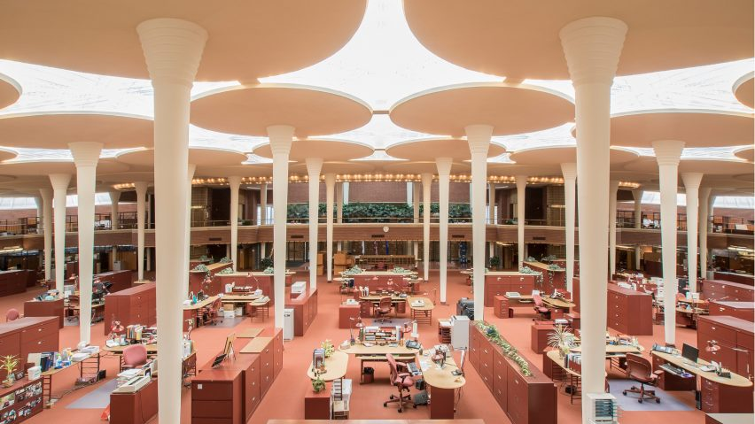
Image 1: Johnson’s Wax Building in Wisconsin (Duffy & Powell, 1997).
Workplace patterns have changed in the last two centuries from boxed cubical settings and defined spaces of place and time to more flexible, dynamic working styles (Vischer, 2007). A study by Herman Miller shows that a traditional floorplan is 97% of assigned workstation, however, the emerging workplace trends have only 40% of dedicated assigned workstations (Miller, 2016). Workplaces are now designed with dominantly open-plans, fostering collaborative work, and flexible furniture. However, looking back at history, it was not until the late 1930s that there were responsiveness and considerations for the end user in the workplace (Duffy & Powell, 1997).
  - Green Building
The United States Environmental Protection Agency (EPA) defined green building as: “the practice of maximizing the efficiency with which buildings and their sites use resources energy, water, and materials while minimizing building impacts on human health and the environment, throughout the complete building life cycle from citing, design, and construction to operation, renovation, and reuse.” (United States Environmental Protection Agency, 2016). Some of the environmental concerns of green building are waste, air pollution, water pollution, noise, etc. and some of the definitive concerns would be harmful to human health, environmental degradation and loss of resource. The overall concept of green building is to reduce the harmful impact on human health and the environment. The EPA’s main goal is to ease the process of adopting green building concepts, and an early revolutionary change to the built environment was the United States Green Building Council USGBC established in 1993 (United States Environmental Protection Agency, 2016). The USGBC had then established its Leadership in Energy and Environmental Design certification (LEED).
  - Leadership in Energy and Environmental Design (LEED)
Throughout the years research on the built environment’s effect on health and wellbeing has driven organizational efforts to create guidelines that ensure healthier environments for people (United States Green Building Council, 2019). The United States Green Building Council (USGBC) released a third-party certification in 1993 called Leadership in Energy and Environmental Design (LEED), which became the most recognized global green-building rating system (United States Green Building Council, 2019). LEED is a wholistic green building approach that extends further in sustainability. The rating system for LEED has encouraged building strategies that reduce the environmental impact as well as improve the Indoor Environmental Quality (IEQ) of the built environment. It Consists of five categories: sustainable sites, water efficiency, energy & atmosphere, materials & resources, and IEQ (Abbaszadeh, Zagreus, Lehrer, & Huizenga, 2006). The LEED certification rating system is established on a 100-based points scale; LEED Certified is 40-49 points, LEED Silver 50-59, LEED Gold 60-79, and LEED Platinum is 80 and higher. This rating system provides a roadmap for projects to follow. The LEED certification can be obtained for existing or new projects and is applicable for all the different commercial projects, schools, offices, hospitals, hotels etc. Once the certification is approved for a project, it then renews every five years as the system evolves and continues to address the most recent environmental and built environment issues. (United States Green Building Council, 2019)
Studies have shown that LEED certified buildings Studies have shown that people report healthier outcomes in LEED-certified buildings , when compared to non-LEED certified (MacNaughton et al., 2017). Findings from a study on the impact of working in a LEED-certified building shows that people working in the certified space reported 30% less sick building syndromes, had 6.4% higher sleeping scores, and almost 30% better cognitive functions (MacNaughton et al., 2017). These results create an incentive for more workplaces aiming to achieve the LEED certification. In specific to workplace design LEED Interior Design and Construction (ID+C). LEED ID+C has eight categories: Integrative Process, Location and Transportation, Water Efficiency, Energy and Atmosphere, Materials and Resources, Indoor Environmental Quality, Innovation, and Regional Priority (United States Green Building Council, 2019). The LEED certification approach is not seen as a wholistic one. Even though LEED addresses IEQ concerns, the weight of the certification’s focus remains on the environmental impact. There are missing links which foster the connection between the people and nature within the built environment. addresses to Referred to as, biophilic design (S. R. Kellert et al., 2011).
  - Biophilic Design & Patterns
Biophilic design is intentionally translating the understanding of biophilia, the innate human connection with nature, into applications within the built environment (S. R. Kellert et al., 2011). The biophilia hypothesis has gained its popularity in research throughout the past years, with research based evidence that being in contact with nature in its colors, forms and patterns has good effects on the cognitive functions, physical and emotional well-being (Gillis & Gatersleben, 2015) & (Ryan et al., 2014), (S. R. Kellert et al., 2011). Humans are connected to nature in different forms, process, and patterns, all of which can be simulated in interior spaces (Kellert, 2008), (William Browning, 2014). Looking to our natural surrounding as an inspirational drive for design is not new. For example, organic ornamentation such as the leaves used in Greek temples and other historic interior design styles like rococo and art nouveau have always had an appearance. Blending the indoor with the outdoor was accepted as the common practice (William Browning, 2014). Implementing biophilic design elements into workplace environments is especially important now because of urban sprawl. More than 60% of people live and work in urban environments, making them further away from nature and thus the natural connections experienced in nature (UN-Habitat, 2008). Furthermore, in the United States, the majority of Americans spend more than 90% of their time indoors, thus further minimizing the natural connectedness (US Environmental Protection Agency, 1989). Throughout the history of architecture, people were always inspired by nature and natural systems. Sadly, modern architecture and the urban lifestyle has deterred humans from nature and natural systems. For this reason it is more important than ever to incorporate biophilic design in the built environment and avoid isolating the indoor environment from nature (S. R. Kellert et al., 2011). Biophilia has measurable benefits on humans and the environment. First, research proved that biophilic design has true and measurable effects on human’s health, cognitive functions, mental and physical well-being. Second, biophilia nurtures an appreciation towards nature, thus leads to nature protection (S. R. Kellert et al., 2011).
Many organizations contributed to the understanding of biophilia in the built environment. For example, Terrapin Bright Green (TBG), is an environmental and strategic planning organization. Their efforts go into translating the biophilia hypothesis into applications of design elements within the space, also known as biophilic design. In their efforts to identify what biophilic design elements are, TBG developed the “14 patterns of biophilic design”. There are three categories in how biophilic design can be incorporated into the built environment:
- Nature in the space patterns
  - Visual Connection with Nature
  - Non-Visual Connection with Nature
  - Non-Rhythmic Sensory Stimuli
  - Thermal and Airflow Variability
  - Presence of Water
  - Dynamic and Diffused Light
  - Connection with Natural Systems
- Nature analogues patterns
  - Biomorphic Forms and Patterns
  - Material Connection with Nature
  - Complexity and Order
- Nature of the space (Ryan et al., 2014).
  - Prospect
  - Refuge
  - Mystery
  - Risk/ Peril
Each biophilic pattern is proven to have positive impacts on humans within various built environment settings educational, corporate, hospitality, and residential. The patterns are associated with empirical evidence on reducing stress, affecting cognitive performance and uplifting mood (Ryan et al., 2014). For example, visual connection with nature is linked to lowered blood pressure, stress reduction, heightened attentiveness, and overall more happiness (Ryan et al., 2014) (Capaldi, Passmore, Nisbet, Zelenski, & Dopko, 2015). A study showed the empirical effects of having a window with a view can have 1.6 times the benefits of a picture or a digital representation of nature, on people working in an office (Kahn Jr et al., 2008). A short amount of visual connection to nature between 5-20 minutes within an office building was enough to lower the stress levels of employees (Ryan et al., 2014) (Kahn Jr et al., 2008). Prospect is “the ability to see from one place to another” applying distances within the built environment has also been proved to be very restorative (Ryan et al., 2014). Prospect within the built environment provides a great sense of comfort and interest. Prospect for instance, can make people feel less stressed as they are able to view everything at a distance allowing enough instinct for both opportunity and danger (Herzog & Bryce, 2007). These are two pattern examples, demonstrating how the 14 biophilic patterns can be very restorative and beneficial for people within the built environment. In support of the biophilic design, there are two building rating systems in the United States which incorporate biophilic design to their rating systems: International Well Building Standard and The Living Building Challenge.

  - Pattern Language
The 19th century proposed drastic social and technological changes, which helped in the rise of architecture and design. However, these changes came along inhabitable and uncomfortable spaces. Alexander Christopher has dedicated his life research to developing the psychological benefits of patterns. A pattern is a practical guide to resolving any problem that occurs repeatedly. Alexander authored 253 patterns in his book A Pattern Language (Alexander, 1977) as cited in (Price, 1999). He explains for example, pattern 60 (accessible green) how if small patches of greenery around a home or neighborhood, reoccurring frequently can help in simulating the same psychological effect larger green fields have on people. This was his proposed solutions as to how a repeated pattern can have significant effects. Each pattern is part of a larger concept and set of patterns, as “no pattern is an isolated pattern” (Alexander, 1977). When Terrapin Bright Green authored the 14 biophilic patterns, they mentioned, that the patterns were a combination of over 500 publications on biophilic responses. These biophilic patterns are flexible enough to be applied to different project designs. Even though some patterns might not be feasible in a given project, for example, the presence of water [P5] the reoccurrence of other patterns can be sufficient to make the space stronger in regards to human nature connectedness (Ryan et al., 2014).
  - WELL Building Standard®
The WELL Building Standard ® (WELL) is a performance-based system which focuses exclusively on health and wellness within the built environment. The standard is managed by a global corporation, the International WELL Building Institute (IWSI). The corporation’s purpose is to enhance wellbeing and human health through the built environment. WELL performance-based certification requires for the space to be at least 50% occupied, depending on the building type and size, for the performance testing to be conducted. It is a system that measures, certifies and monitors the built environment’s impact on health and well-being. For this to be achieved, once a designed space gets the certification approved, measures must be made to ensure the certification persists. To maintain a WELL Certification, an annual report submittal of occupancy surveys, proof of maintenance, and continuous monitoring of environmental factors (e.g., air quality) (International WELL Building Institute, 2019).
WELL thrives for intentional design which ensures the built environment enhances the health and wellbeing better than ever before, the certification has 10 concepts, air, water, nourishment, light, movement/fitness, comfort, mind, and innovation. These concepts can be applied to diverse project types educational, corporate, institutional...etc. (International WELL Building Institute, 2019). WELL Certified™ spaces have proven to improve occupants’ mood, health, fitness, as well as productivity. The WELL certification incorporates biophilia through two metrics biophilia 1 and biophilia 2. Biophilia 1 metric is a more Qualitative approach to biophilic design and is divided into three parts. First through nature incorporating environmental elements in the space, dynamic and diffused lighting, and space layout. Second, through nature’s patterns throughout the design. Third, through nature interaction within the building and externally to the building (International WELL Building Institute, 2019). Biophilia 2 metric is more a quantitative goal parted into indoor, outdoor, and water features within the space. With at least 1% of potted plants per floor area, 2% plant wall per floor. 25% of the space to have an exterior connection to nature in the form of accessible landscape, rooftop gardens, outdoor areas. WELL’s intention with incorporating biophilia is to support occupant health and well-being by making the natural environment part of the built environment.
Some of the features of WELL that overlap with biophilic design patterns are for example Circadian lighting design, which translates under dynamic and diffuse light from TBG’s 14 patterns. Circadian systems are the biological rhythms throughout the human body that affects hormone levels and the sleep-wake cycle. A circadian lighting system is more in sync with the natural process of light and dark. This can be achieved by regulating the amount of artificial light and the type of lighting humans are exposed to within the built environment. The other example features of WELL that aligns with a few biophilic patterns is the olfactory comfort. Olfactory comfort translates into a multi-sensory experience in the space, thermal comfort and adaptable spaces which basically translate into non-rhythmic sensory stimuli. Olfactory comfort is related to the most sensitive sense, it is highly connected with how people perceive space positively or negatively. It can affect the occupant’s well-being and comfort in the built environment (von Kempski, 2006), (International WELL Building Institute, 2019). As mentioned, WELL is an addition to green building concepts in focusing on strategies that are correlated to human health, wellness, and well-being as a priority. However WELL compliments strategies for sustainability from LEED and The Living Building Challenge (LBD) rating systems.
  - Living Building Challenge
Living Building Challenge (LBD) is a certification which is granted through the International Living Future Institute (ILFI). ILFI a non-profit organization offering green building solutions to all project types with the purpose of providing support for communities to be socially fair, rich in culture, and environmentally restorative. The organization describes LBD as “the world’s most rigorous green building standard” (International Living Future Institute, 2019b). The rating system for the LBD certification is structured on seven performance petals: place, water, energy, health and happiness, materials, equity, and beauty. Each petal is subdivided into imperatives. Biophilic design is integrated through the imperatives because of its crucial role in health and well-being within the built environment. Due to the fact that implementing biophilic design is relatively new, the ILFI has dedicated an imperative towards the research and the adoption of biophilic design applications (International Living Future Institute, 2019a). The LBD requires biophilic design applications (imperative 09), under the health and happiness petal. The imperative must be met in order to obtain the certification. Biophilic design imperative focuses on the TBG categories of biophilic patterns: nature in the space, nature analogues and nature of the space patterns.

Chapter 3: Methodology

This chapter details the process which was followed to complete the investigation of this research. Methods to address the study’s objectives are outlined below.
  - Workplace Selection
The study began with the selection of existing workplace designs. The three spaces chosen for the case studies are located in the heart of their city, downtown and midtown areas, and they are all new workplaces, built and occupies in approximately the past five years. Case study (1). American Society of Interior Designers Headquarters’ ASID in Washington, Case study (2). Little Diversified Architectural Consulting located in Charlotte, NC. Case study (3). WeWork, located in Washington, DC.
Workplaces (1) and (2) were selected because of the certification they have/are seeking. They were also chosen because they are very similar in the design objectives and their aim to healthier well-being in the workplace. The results of these two buildings would be compared to building (3) which was selected because of the company’s noteworthy efforts in healthy workplace patterns. However, the workplace design is not aiming towards gaining green building certifications yet.
Case study (1) is an official organization, case study (2) is an architecture and engineering firm, and case study (3) is a coworking space. This workplace diversity also gives legibility to biophilic design patterns and their applications regardless of the organizational structure. After obtaining permission to study each workplace design, the case studies were conducted by a collection of site visits, floor plan analysis, images and online research. What made the selections distinctive and interesting was that Case study (1). Has already been certified LEED Platinum and WELL Platinum, however Case study (2) is looking to obtain the LEED Silver and WELL Silver certifications. And Case study (3) has yet to obtain any green building certifications.

  - Workplace Analysis

Content Analysis
The research term content analysis is defined as the collection of large amounts of data, into a simpler set of categories (Stemler, 2001). Content analysis is beneficial for this study because it can be useful for examining patterns (Stemler, 2001).
An example of a content analysis study is a study conducted to find an integrative definition of the “organizational innovation” as described by the team of researchers. A literature review presented a wide range of different definitions for the term “innovation”. The literature was a combination of literature and definitions from different disciplines (economics, business, management, technology, engineering), in order to have a broader understanding of the term, and articulate common synergies found to help make the definite definition for the study’s purpose (Baregheh, Rowley, & Sambrook, 2009).
Navigating through the selected green building concept’s LEED, WELL and LBC rating systems, categories, and qualifications to find biophilic design synergies will help identify green building efforts for implementing biophilic design. This analysis contributes to the importance of biophilic design patterns authored by Terrapin Bright Green TBG.
Since WELL and LBC both refer back to Terrapin Bright Green’s 14 patterns of biophilic design. The TBG 14 patterns were used as a guide to sift through LEED, WELL and LBC in order to find common synergies, and how these certifications integrate biophilic design patterns. Content analysis has contributed in creating Table 2 which identifies how each green building concept addresses biophilic design patterns, and under which goal within the certification is biophilic design encouraged or enforced.

Green Building Concept | Biophilic design initiative within certification
LEED | Through  - WELL BUILDING STANDARD v1.  - Indoor Environmental Quality IEQ  - LEED Sustainable Sites
WELL | Through Biophilia I- qualitative & biophilia II – quantitative  - Environmental elements  - Space layout  - Lighting  - Outdoor biophilia  - Indoor biophilia  - Water feature
LBC | Through Imperative 09 [Health & Happiness Petal]: biophilic environment  - Nature in the Space  - Nature Analogues  - Nature of the Space
Table 2: Green Building Certifications’ Biophilic Design Integration.

Case Study Analysis
Case study is an empirical research method which investigates the (case) in depth and within its real-world context. investigating existing cases in their real-world context allows for understanding the contextual conditions that help with the case study results. A case study relies on collecting multiple sources of evidence, and benefits from previous theoretical propositions to help navigate the data collection and analysis (Yin, 2017)
A multiple case study analysis was selected amongst many other case study designs because it allows for two or more case observations. Hence, allowing for a deeper understanding of biophilic pattern application in certified and non-certified workplace designs in real-life context.
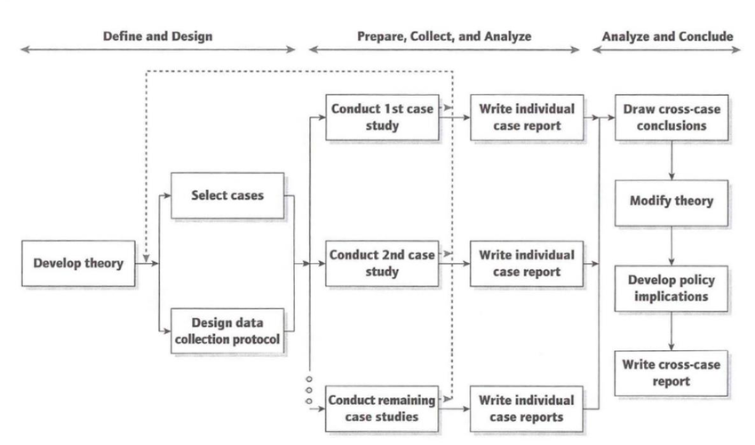
An interesting multiple case study method by (Lee, 2010) was implemented to investigate between five LEED-certified office buildings, the worker satisfaction and job performance in regard to privacy, acoustics, and interaction in personal work spaces. It examined if different types of offices which had the same LEED-certification provided the same levels of employee satisfaction levels. The multiple case study analysis help identify which features in the personal workspace among the five offices, coincided with higher or lower satisfaction levels. This case study method provided a specific understanding of an investigation in LEED-certified office spaces. And recommendations were specific to the study’s investigation. For the purpose of this multiple case study analysis the steps in Figure 1 were used as a template:
Figure 1: Multiple case study design (Yin, 2009, p. 57)

  - Workplace Biophilic Design Assessment
The theory to guide this multiple case study analysis is workplace designs which obtained or are in the process of obtaining green building certifications present more biophilic patterns when compared to non-certified workplace designs. Three case studies were selected based on their variability in size and green building certification stance are:
- Case study (1) ASID. Status: LEED Platinum and WELL Platinum. certified
- Case Study (2) Little. Status: seeking certification for LEED Silver and WELL Silver
- Case Study (3) WeWork. Status: non-certified by any green building concept
Then, the 14 patterns of biophilic design were rated in the spaces based on their presence. However, for an accurate case study analysis, the following common spaces across the case studies were selected:
- Arrival point/ reception
- Café/ dining
- Large conference room
- Small conference room
- Open office space
- Focus rooms
- Huddle rooms
- Copy printer rooms
- Library/ resource room
- Circulation space

Site visits were arranged for an overall space experience and note taking of the biophilic patterns present in the space. During the visits, a walk-through analysis, and photographs were taken of notable biophilic design patterns presented throughout each space. Any extra information was obtained through online research, as well as articles from each case study’s website. The content analysis list guided the observations, it helped to identify the biophilic patterns present in each case study. Reclaiming facts from the literature on the importance of these biophilic patterns and their applications within the various case studies help in clarifying the purpose of biophilic design applications.

  - Assessment Strategy
  - Data collection protocol
After researching the best assessment strategy for the case study analysis, the most applicable way for this particular study was to create a scoring system A scoring sheet for the biophilic patterns present in the each case was developed by referring to Terrapin Bright Green’s 14 patterns for biophilic design, and filled with the values (0, 3, 5) 0 being the lowest: no biophilic pattern present, 3 for being average :biophilic pattern exists minimally, and 5 being the highest: biophilic pattern exists abundantly in the space. An example would be if the lobby has large windows and daylight penetrating through but doesn’t have any plants it would score (3) because it has the Visual Connection Nature pattern, but it is missing a significant element which is plants and greenery. However, if the lobby space has plants in addition to the views it would score (5). The letter [P] in the schedule stands for Pattern.

Biophilic Pattern |  | (3) | (5)
[P1] Visual Connection with Nature | Biophilic pattern not present in the space | Biophilic pattern minimally present in the space | Biophilic pattern abundantly present in the space
[P2] Non-Visual Connection with Nature | Biophilic pattern not present in the space | Biophilic pattern minimally present in the space | Biophilic pattern abundantly present in the space
[P3] Non-Rhythmic Sensory Stimuli | Biophilic pattern not present in the space | Biophilic pattern minimally present in the space | Biophilic pattern abundantly present in the space
[P4] Thermal and Airflow Variability | Biophilic pattern not present in the space | Biophilic pattern minimally present in the space | Biophilic pattern abundantly present in the space
[P5] Presence of Water | Biophilic pattern not present in the space | Biophilic pattern minimally present in the space | Biophilic pattern abundantly present in the space
[P6] Dynamic and Diffuse Light | Biophilic pattern not present in the space | Biophilic pattern minimally present in the space | Biophilic pattern abundantly present in the space
[P7] Connection with Natural Systems | Biophilic pattern not present in the space | Biophilic pattern minimally present in the space | Biophilic pattern abundantly present in the space
[P8] Biomorphic Forms and Patterns | Biophilic pattern not present in the space | Biophilic pattern minimally present in the space | Biophilic pattern abundantly present in the space
[P9] Material Connection with Nature | Biophilic pattern not present in the space | Biophilic pattern minimally present in the space | Biophilic pattern abundantly present in the space
[P10] Complexity and Order | Biophilic pattern not present in the space | Biophilic pattern minimally present in the space | Biophilic pattern abundantly present in the space
[P11] Prospect | Biophilic pattern not present in the space | Biophilic pattern minimally present in the space | Biophilic pattern abundantly present in the space
[P12] Refuge | Biophilic pattern not present in the space | Biophilic pattern minimally present in the space | Biophilic pattern abundantly present in the space
[P13] Mystery | Biophilic pattern not present in the space | Biophilic pattern minimally present in the space | Biophilic pattern abundantly present in the space
[P14] Risk/ Peril | Biophilic pattern not present in the space | Biophilic pattern minimally present in the space | Biophilic pattern abundantly present in the space
Table 3: Data Collection Protocol.

  - Conducting The Case Studies
The following section demonstrates the biophilic design patterns, by analyzing the 10 common spaces amongst the three cases. An identification of workplace biophilic patterns which are present will give a clear allocation and representation of patterns in their context.
  - Case (1): The American Society of Interior Designers
Brief
The American Society of Interior Designers (ASID) headquarters in located in downtown Washington, D.C. it is approximately 8,500 sq. ft. What makes this workplace unique is that it is the first interior space internationally to achieve both Platinum Level Certification for the WELL Building Standard™ under WELL v1 and Leadership in Energy and Environmental Design (LEED), under the LEED Interior Design and Construction (ID+C) rating system, which is the highest acknowledgement awarded by the U.S. Green Building Council (American Society of Interior Designers, 2017) The workplace was designed by the worldwide interdisciplinary architecture firm, Perkins+Will in 2016. ASID’s workplace design is a great example for wellness in the workplace. The ASID society believes firmly that it showcases the ways in which design can be an advocate for better health and well-being in the built environment.
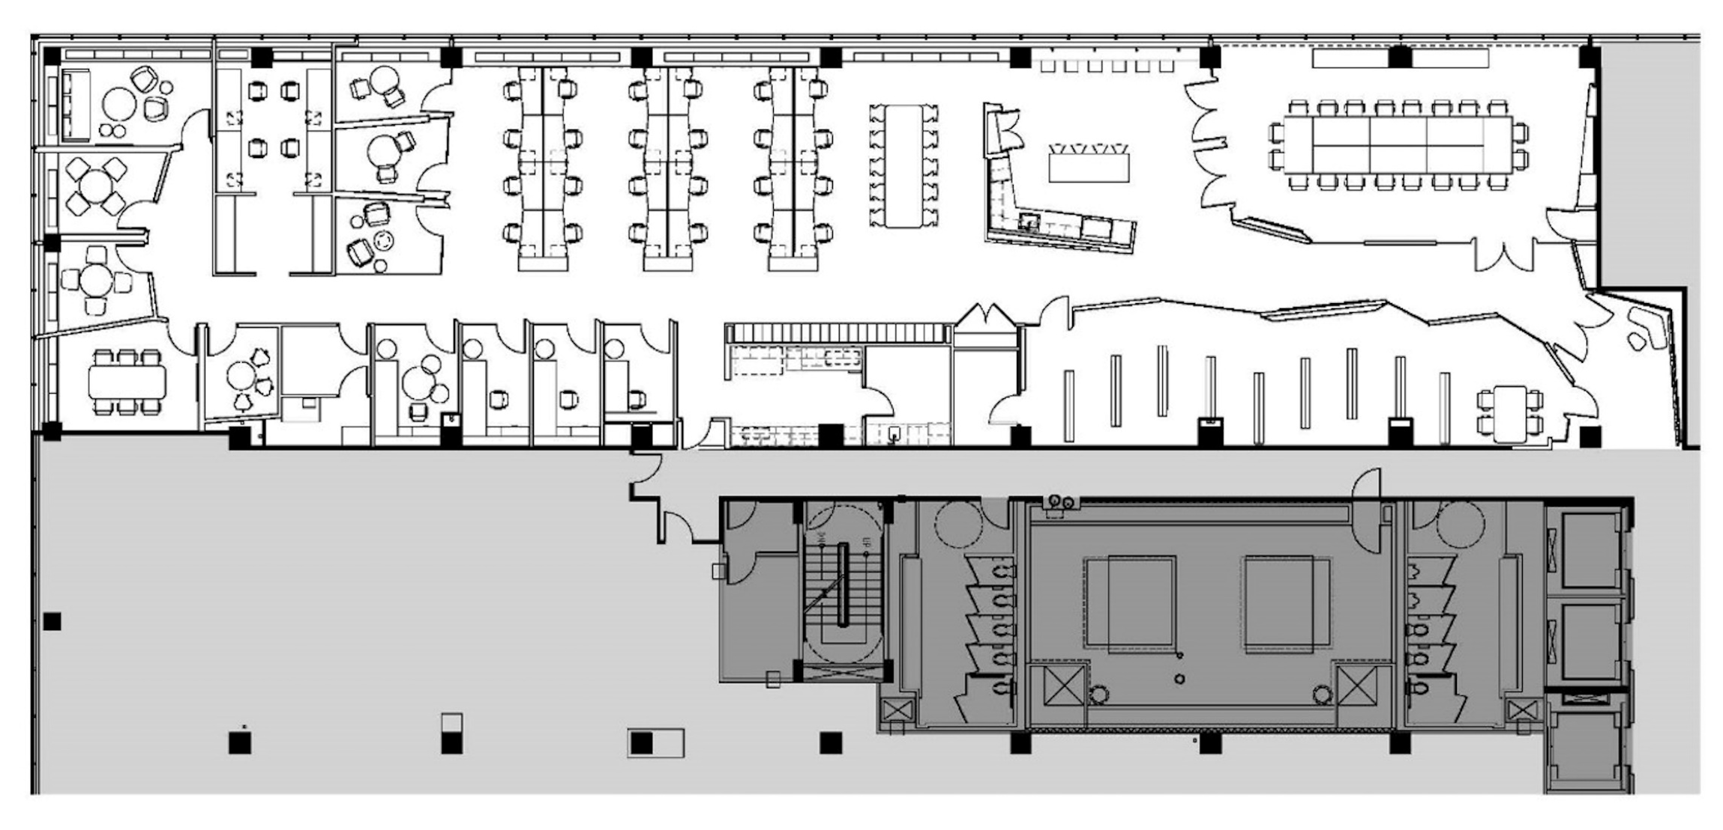
Floor Plan
Image 2: ASID Floor Plan (American Society of Interior Designers, 2017)

I
G
H
F
E
D
C
B
A

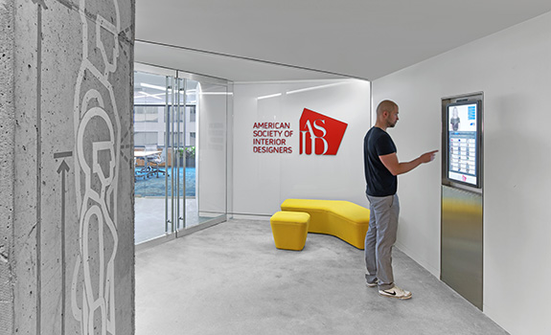
Arrival point / Reception Area
Image 3: Arrival / Reception Area, (American Society of Interior Designers, 2017)

As seen in (image 3), ASID’s workplace entrance is in a niche, part of the building’s floor. The way the entrance is cut out of the space portrays some essential biophilic design patterns as seen in the floor plan in (image 2, location A). The way the entrance is designed creates mystery [P13], anticipation and prospect [P11] as approaching the space. This is created by showing glimpses of what is approaching however not revealing the whole space as the two walls are solid and two are glass. The low ceiling in the arrival/ reception space helps in intensifying the mystery of the space as well. The yellow sofa placed in the waiting area is very organically shaped, disregarding any rigidness in its shape which connects to biomorphic forms and patterns [P8]. The play of lightness and darkness in such a small space emphasizes the use of dynamic and diffused light [P6], it becomes brighter not only because of the light beam in the ceiling but also by approaching the glass and sunlight that penetrates through.

Dining / Work Café
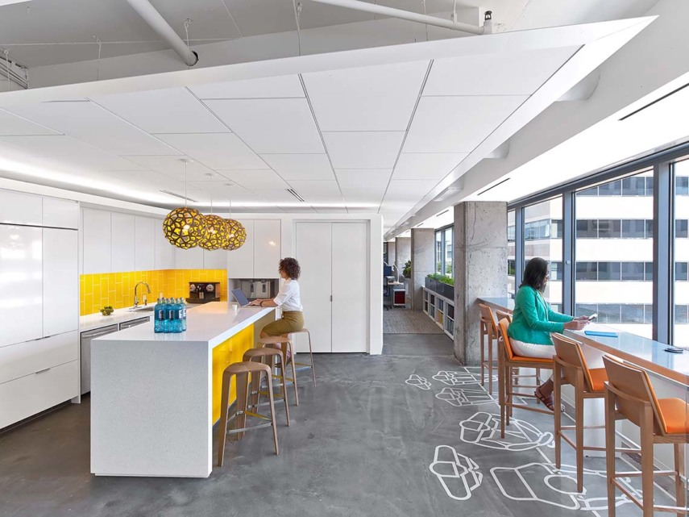
Image 4: Work Café, (American Society of Interior Designers, 2017)
The café area (location B) in the floor plan proposes many biophilic design patterns while still maintain a sophisticated setting. The positioning of the kitchen and counter all help in embracing visual connections to nature [P1] by being parallel to the window facade. The use of wood and organically formed stools help in emphasizing biomorphic patterns [P8] as well as the pendant over the kitchen bar which mimics a beehive pattern. All light fixtures in ASID’s workplace are connected to a circadian lighting sensor system.
A circadian lighting system allows the artificial light to mimic the color and temperature of sunlight, allowing for brighter hues during the daytime, allowing the employees to be more alert during the day, but as the day passes by it mimics later afternoon hues to allow for better rest and sleep (Hoffmann et al., 2008).

Large Conference Room
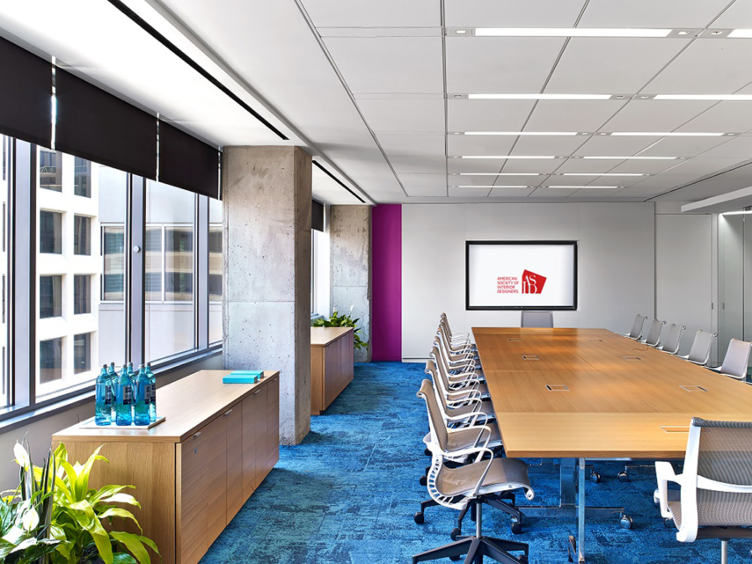
Image 5: Large Conference Room, (American Society of Interior Designers, 2017)

The large conference room is visible through the reception area, but also very open towards the workplace café and hallway. The main attraction in the large conference besides the large windows allowing for daylight and views, hence, visual connection with nature [P1], is the vibrant blue carpet tiles, the tiles are made of recycled fishnets, and the pattern is intended to mimic water [P8], especially that it is on a large scale as this setting. The window blinds throughout the ASID office are all connected to sensors placed on the window sills. The sensors respond to the natural sunlight coming through the large windows and adjust accordingly. This provides ultimate sunlight to penetrate but avoids unwanted glare in the workplace when the sun is at its highest, or during warmer seasons. The adjustable blinds feature, as well as the circadian lighting system enhances the dynamic and diffused light pattern [P6] throughout the ASID workplace.

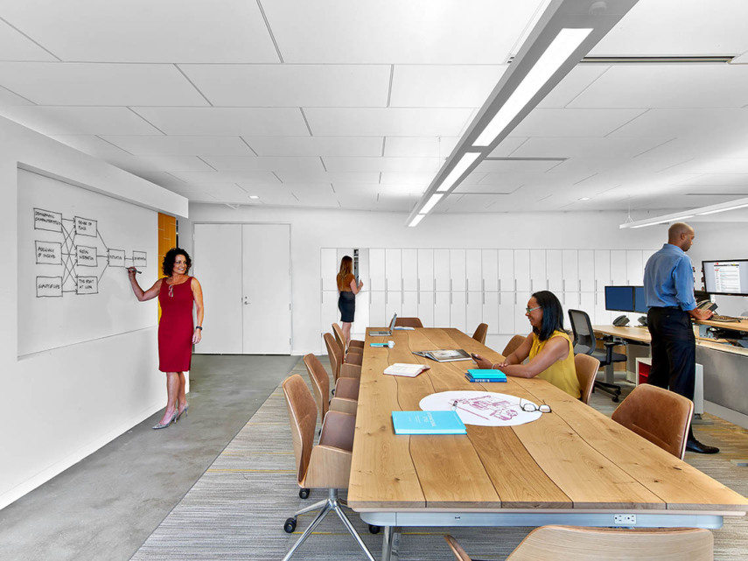
Small Conference Room / Meeting Table
Image 6: Meeting Table,(American Society of Interior Designers, 2017)
The meeting table for small staff gathering shown in (image 5, location D) displays large wood planks, the wooden surface is minimally processed showing the grains and texture of wood which enhances the non-visual connection with nature pattern [P2]. As well as enhancement of the material connection with nature pattern [P9]. The meeting table chairs form is organic, enriching the biomorphic form’s pattern [P8] that is reoccurring throughout the ASID office.

Open Offices
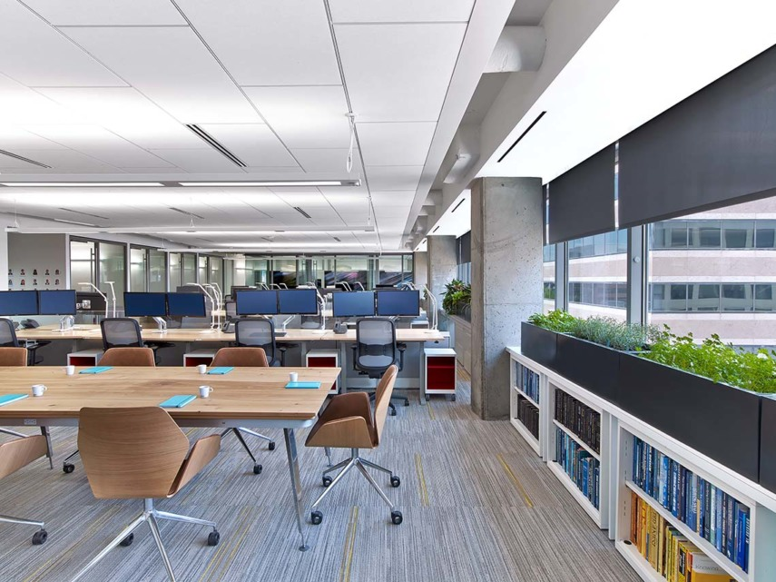
Image 7: Open Office Space, (American Society of Interior Designers, 2017)
The open office area in the ASID office is located along large windows as seen in (image2, location E, image 6,), this enhances the visual connection with nature pattern [P1]. Also, the plants located along the windows show a significant connection to natural systems [P7], the provided views to the outdoors as enhance this pattern as well. Plants also add a natural olfactory comfort [P2], through the aromatic scents of the natural plants incorporated into their office, such as rosemary. Enhancing the olfactory senses help with boosting the immune system of people in the workplace. Research findings propose that exposing the occupants to plants indoors has been linked to decreased stress levels and increased positive effects (Bratman, Daily, Levy, & Gross, 2015), (Ryan et al., 2014).

Focus Rooms
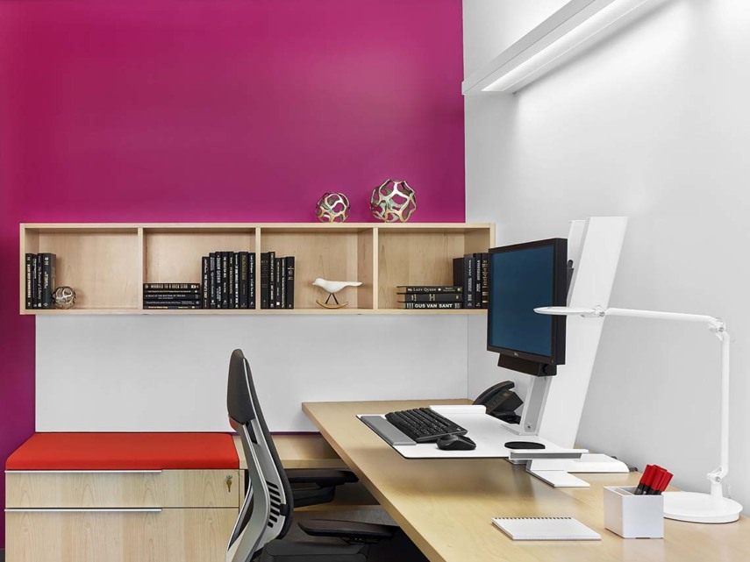
Image 8: Focus Rooms, (American Society of Interior Designers, 2017)
The work desks located the open office area and focus rooms (image 2, location F, image 8) are adjustable for both sitting and standing work positions. The anthropometric considerations allow employees to control their work space environment and may alleviate injuries in the caused by sedentary working conditions. The ASID office takes this consideration thoroughly as seen in the focus rooms, as well as desks and desk-chairs around the workplace. User control within the workplace in regards to lighting, demographics, movement and so on, contributes to user comfort, the success of the workplace design, and increase employee retention (Ryan et al., 2014). Task lighting is provided in the personal workstations for an enhanced user control as well as embracing the dynamic and diffused light pattern [P6].

Huddle Spaces
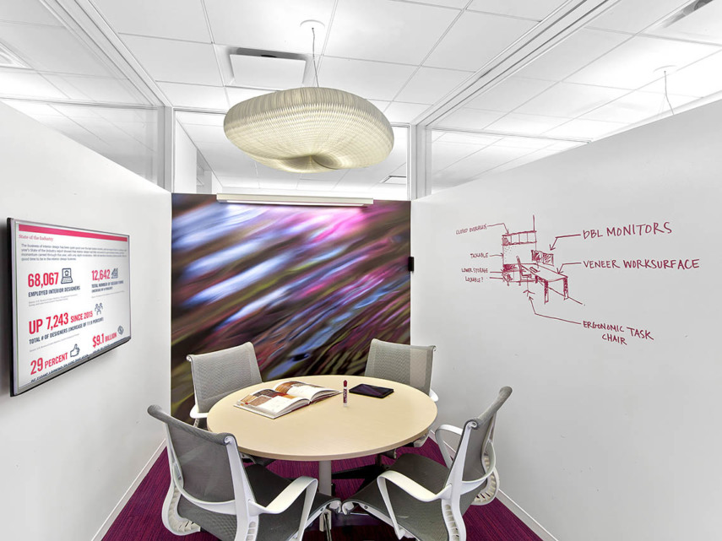
Image 9: Huddle Space, (American Society of Interior Designers, 2017)

The huddle space’s wall covering resembles water ripples, enhancing yet again the biomorphic forms and patterns in the ASID workplace. And as seen in (image 2, location G, image 9) in the floor plan the pendant lamp is also resembling an aquatic animal feature enhancing the biomorphic forms and patterns [P8] throughout the space, carrying the sea, water and ripple effect throughout the workplace design. Biomorphic patterns “are symbolic references to contoured, patterned, textured or numerical arrangements that persist in nature” (Ryan et al., 2014). Humans are biologically attracted to biomorphic forms and patterns. When applied to the built environment, they are known to reduce stress levels, as these patterns illustrate symbols of life (Vessel, Starr, & Rubin, 2012).
Printer Room
Located in the center of the workplace (image 2, location H) in the floor plan, it is very accessible. The waste bins are located in the printer room and are not available in personal work stations deliberately. This encourages people to walk which ultimately promotes better physical health. Having the wastebaskets at remote locations also allows for engagement with others during the workday. Informal interaction is better for mental health as employees gather to talk or collaborate in these common workspace areas.

Library / Resource Room
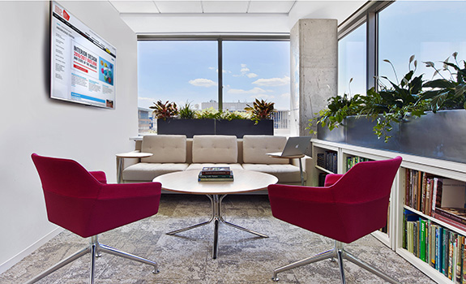
Image 10: Library Room (American Society of Interior Designers, 2017)
The space shown in (image 2, location H, image 10) is considered the ASID library room, people usually gather there to read, or discuss in groups new book and magazine releases. Even though it is relatively a small space for employee gathering, it has many biophilic patterns present which can enhance the health and well-being of the occupants. Such as visual connection with nature due to the large windows on the parameter of the room [P1], and non-visual connection [P2] with the plants filling the space up with an olfactory comfort as well as the color green.

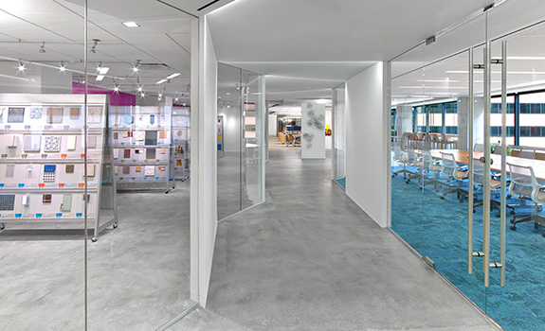
Circulation Space
Image 11: Circulation Space, (American Society of Interior Designers, 2017)
The ASID hallway promotes a sense of direction and special hierarchy linking to complexity and order pattern [P10], the diagonal walls supported with ceiling light beans are a geometric representation of a walk through a natural forest. Where excitement generates a sense of positivity in the space, [P10]. And a sense of prospect in anticipation of the next arrival points which relates to prospect pattern [P11], and mystery [P13] since not everything is in the open, but, it becomes more clear once approached closely. This flux of biophilic patterns relating back to TBG’s nature in the space patterns, gives an overall simulating experience when walking down the hallways of the workplace (image 2, location I, image 11).

  - Case (2): Little Diversified Architectural Consulting
Brief
Little is an international architecture and design firm; it is a complete-inhouse firm providing holistic architecture and engineering services. Focusing on sustainable and high-performance design, Little provides their clients with efficient and unique design outcomes (Little Diversified Architectural Consulting, 2019). The Little office located in Charlotte, North Carolina, is the newly owned space, where the company was eager to showcase their capabilities in engineering and architectural design to their clients. The workspace is located on the 14th,15th, and 16th floors of the building which is situated in uptown Charlotte. The office was designed by the firm and is approximately 58,000 square feet. Currently, the firm is seeking LEED Silver and the WELL™ Silver certifications.
Floor Plan
The floor plan was studied for the case study analysis. However, permission to publish it is in the process.

Arrival Point / Reception Area
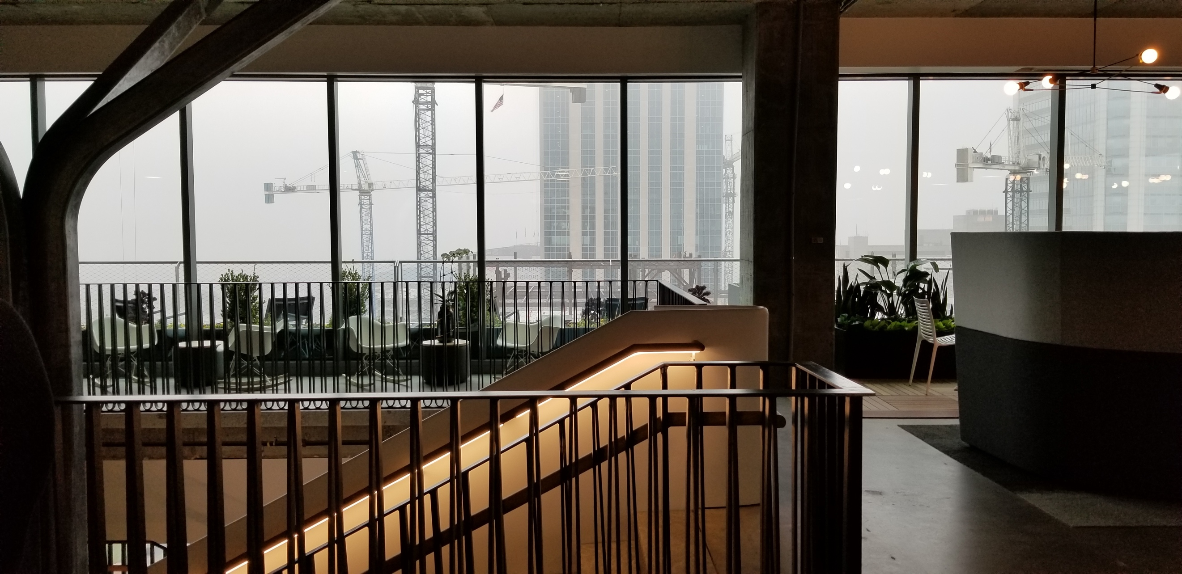
Image 12: Arrival Point at Little’s Workplace
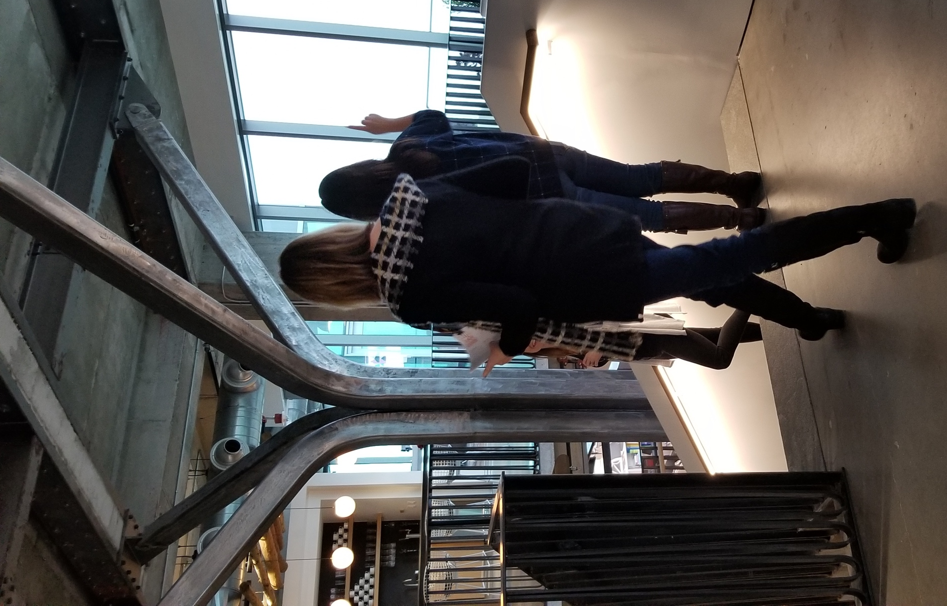
Image 13: Monumental Stair Structure at Little
The monumental staircase is the first thing seem when arriving on the 16th floor of the building (image 12). The Little office has designed the staircase to be the focal point of the workplace. Its supporting structure is held from the ceiling as seen in (image 13) and floats through the three floors. The structure is symbolic of a tree branch as seen in the photo, which adheres a strong connection to biomorphic forms and patterns [P8]. With the location of the staircase, there also is a strong sense of social hierarchy connecting back to the complexity and order pattern [P10]. According to research on biophilia, this creates visual interest and enhances a positive psychological response (Ryan et al., 2014).

Dining / Work Café
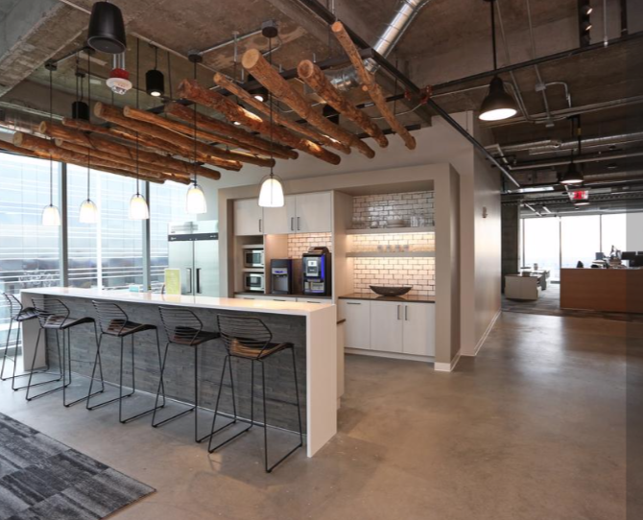
Image 14: Work Café, (Ashley Fahey, 2018)

Natural wood such as oak and maple, kept in the rawest state possible as seen in (image 14) to embrace the material connection with nature [P9], the wooden beams used as an overhear are used in several locations around Little’s workplace. Large windows allow for views and natural sunlight, enhancing the visual connection with nature [P1], there are sensors that adjust the blinds according to the sun temperature around the daytime to avoid discomfort from glare and overheating.
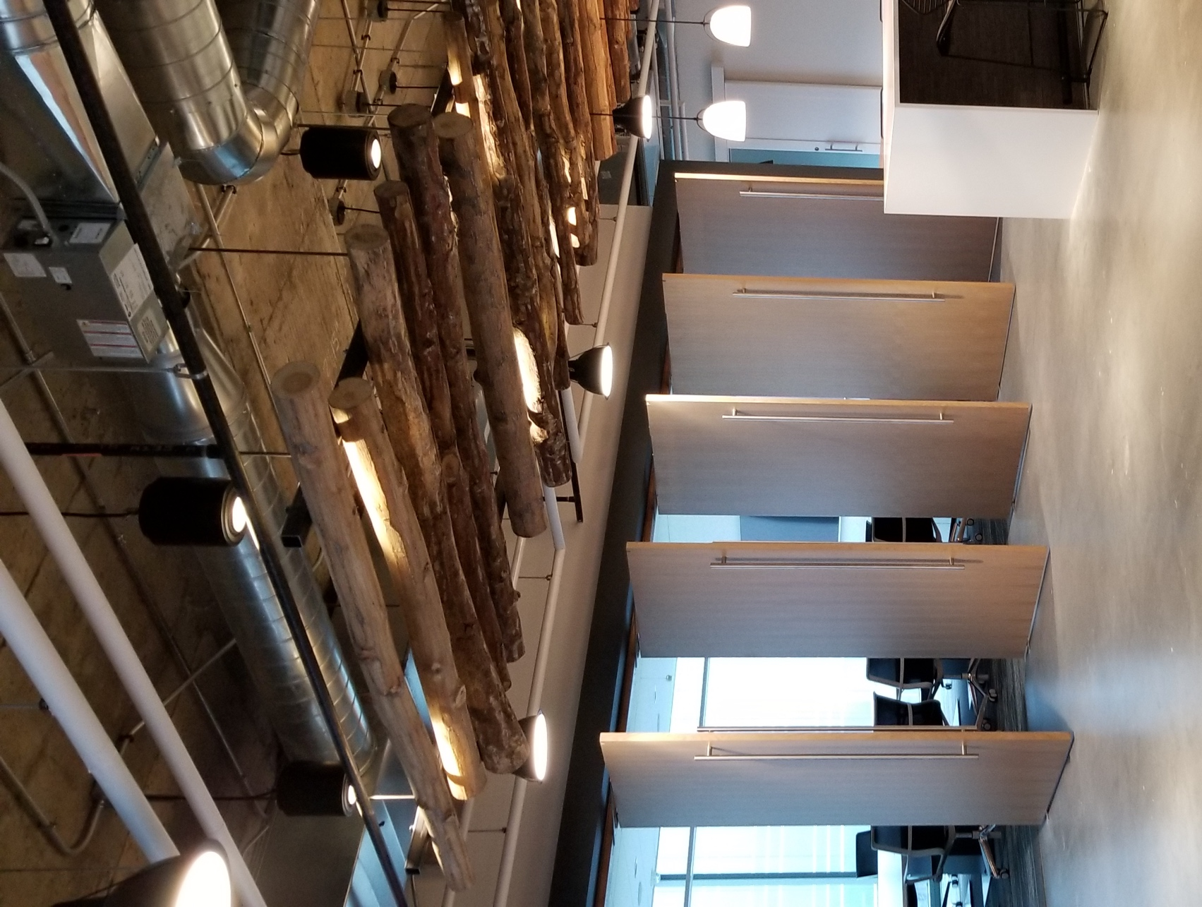
Large Conference Room

Image 15: Large Conference Room at Little
There are two large conference rooms in Little’s workplace, each are located along a glass walls to maximize the exposure to of views and natural daylight hence, embracing the visual connection with nature [P1], also large revolving doors are opened up to the rest of the workplace when the meeting is not in use, this helps in maintaining natural light flow through the space maximizing the dynamic and diffused light pattern [P6].

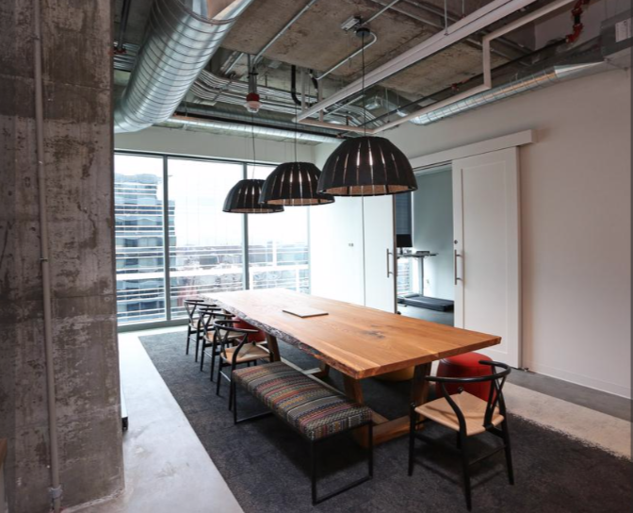
Small Conference Room / Meeting Table
Image 16: Meeting Table at Little
The meeting table located near the open workspaces is made with minimally processed wood planks, the surface incorporates two biophilic patterns. First, the non-visual connection with nature [P2] is the wooden table top surface seen in (image 16) where users are able to feel and touch the wood, which elevates their haptic stimuli. Second, through material connection with nature [P9], and the intention to use natural over artificial materials throughout the workplace for an increased human nature connectedness.
The pendant lights are made of recycled materials, as they are connected to sensors, they allow for light color variability, dynamic and diffused pattern enhanced [P6]. Depending on the time and day, the illumination differs. The shape with splits also helps in creating an interesting sensory experience when reflecting the light to the walls and table during this light and shadow play create a sort of fractal, and the human brain is attuned to moving fractals. This adds a more interesting dynamic feel to the space boosting the complexity and order pattern [P10] (Ryan et al., 2014).

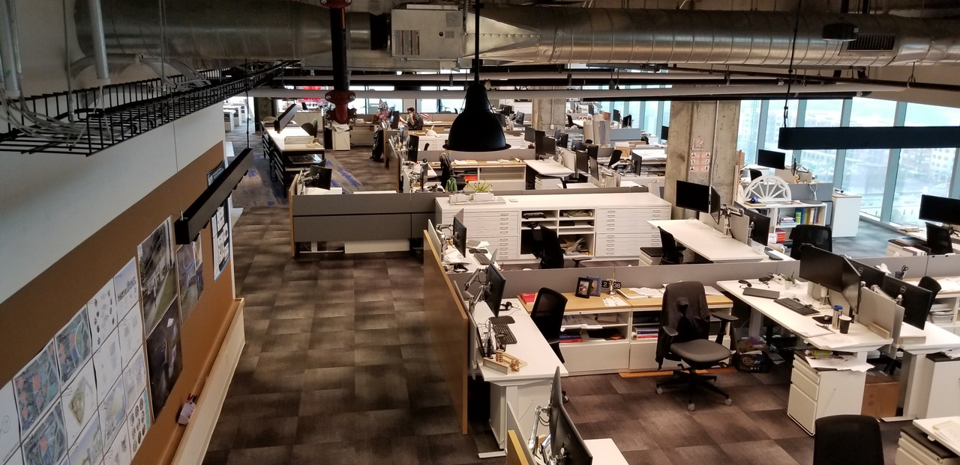
Open Offices
Image 17: Open Office Area at Little
The open office area in Little’s workplace again embraces the visual connection to nature [P1], and dynamic and diffused lighting pattern [P6]. Some desks are personalized by the addition of desk plants.

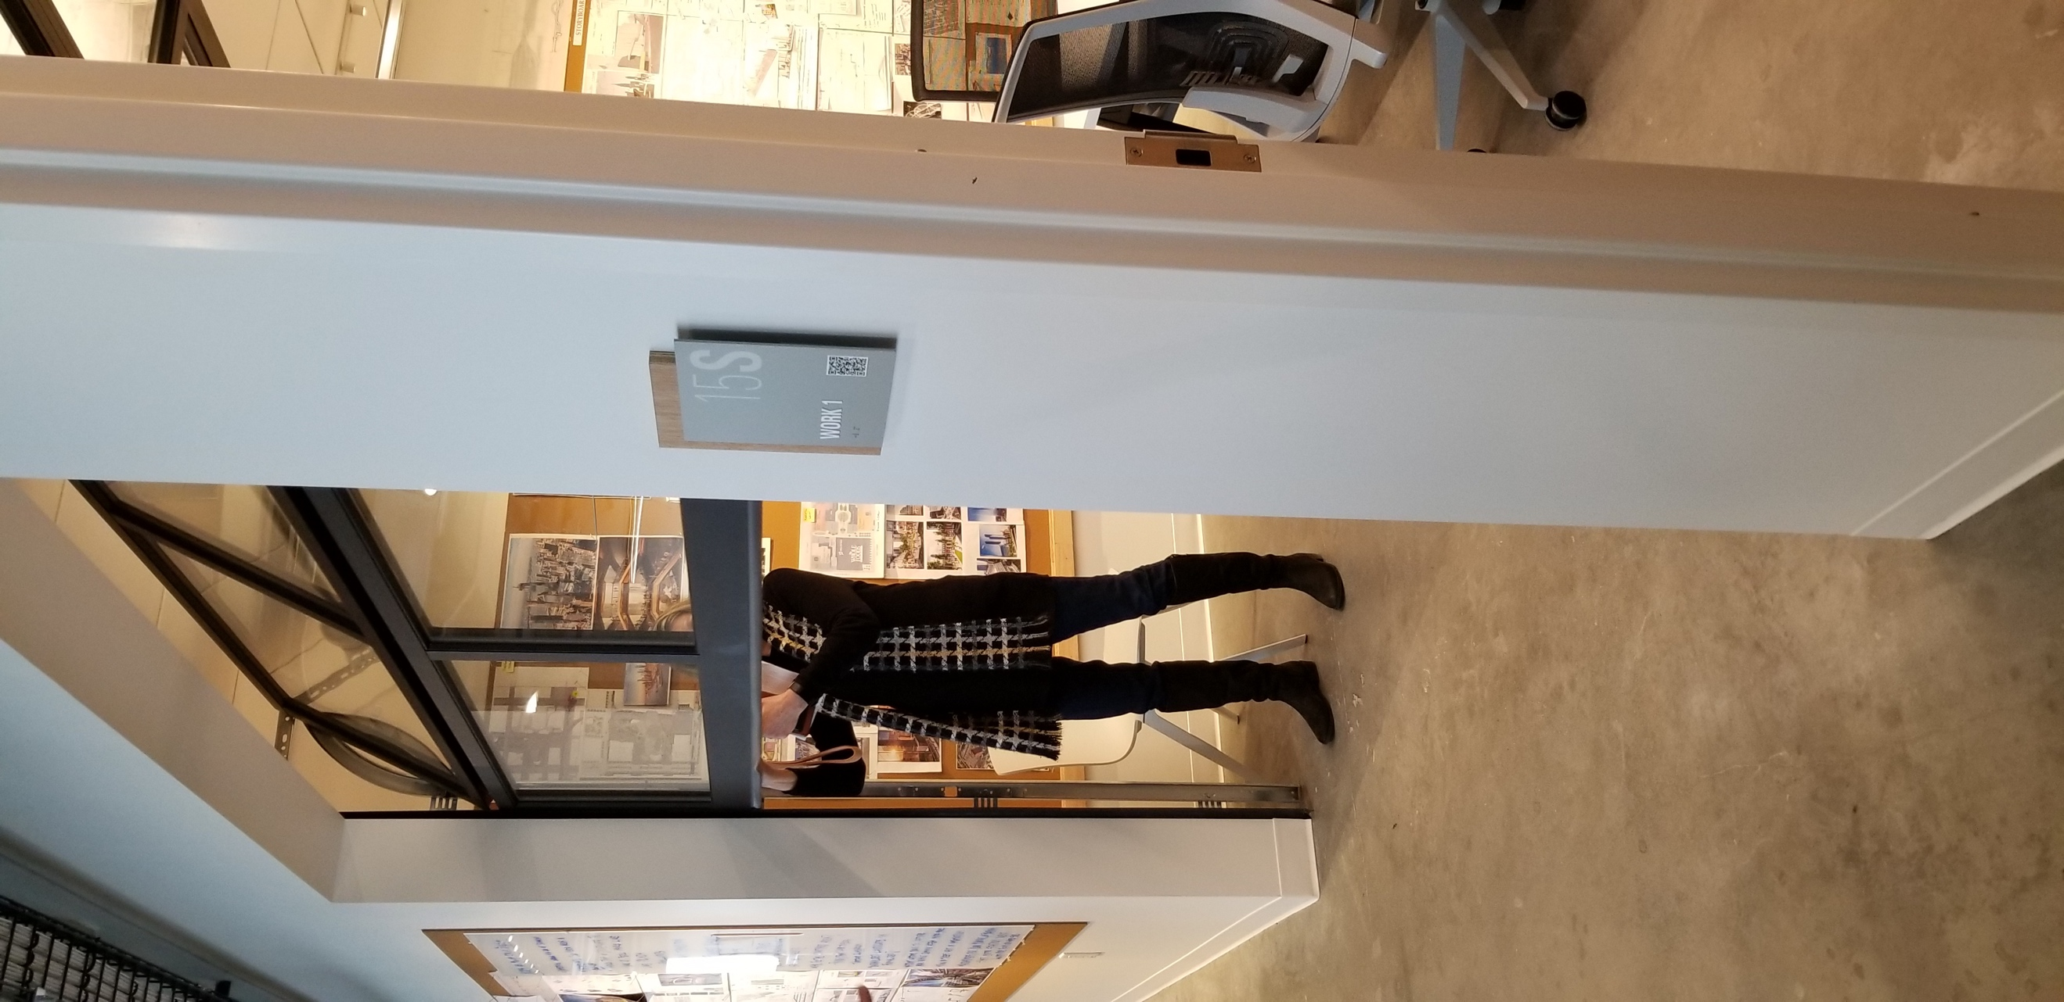
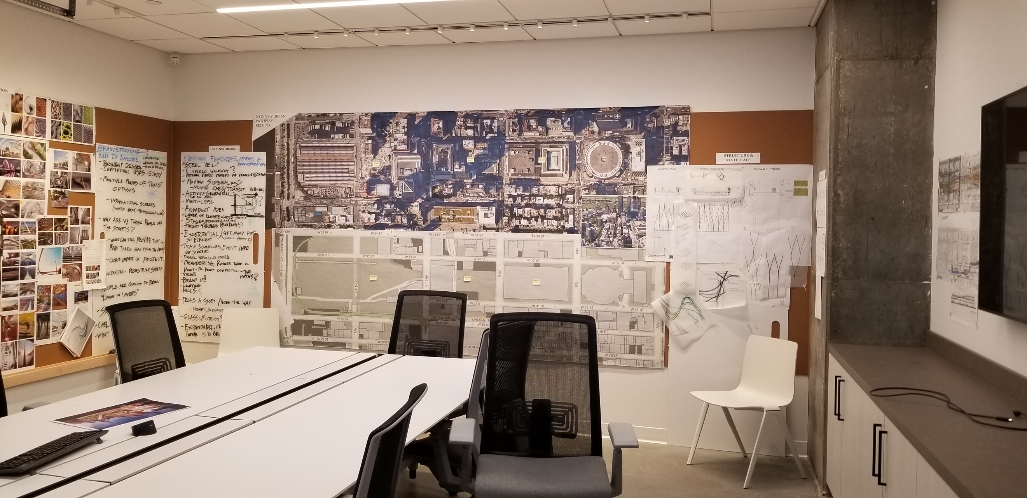
Focus Rooms
Image 18: Focus Room Door at Little
Image 19: Focus Room at Little
Focus rooms in Little’s workplace are intended to be very functional. However, there remains the important pattern of dynamic and diffused light [P6]. The glass garage door allows for natural light penetrates through as seen in (image 19). Similar to the huddle spaces shown in (image, 20).
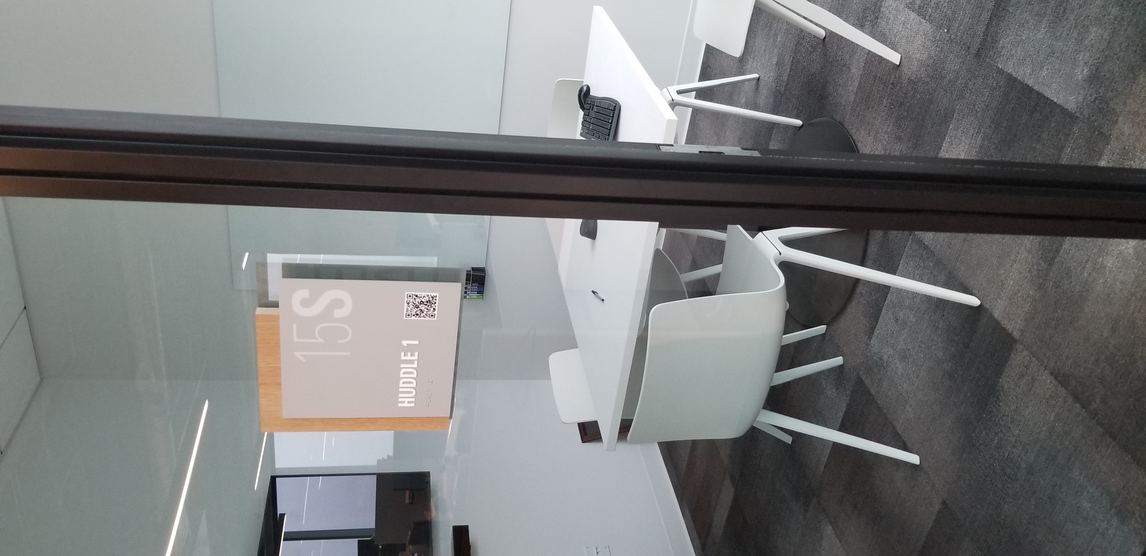
Huddle Spaces
Image 20: Huddle Room at Little

Printer Room
The printer rooms are located along with the premises of the open workspaces. Solid diagonal walls with a small opening for entry, in the Little office’s printing room, creates a sense of mystery pattern [P13] within the workplace. as to what is behind the walls and anticipation to approach the semi-enclosed space. The diagonal walls also compliment the main circulation path and give an adequate sense of movement throughout the space.
Library / Resource Room
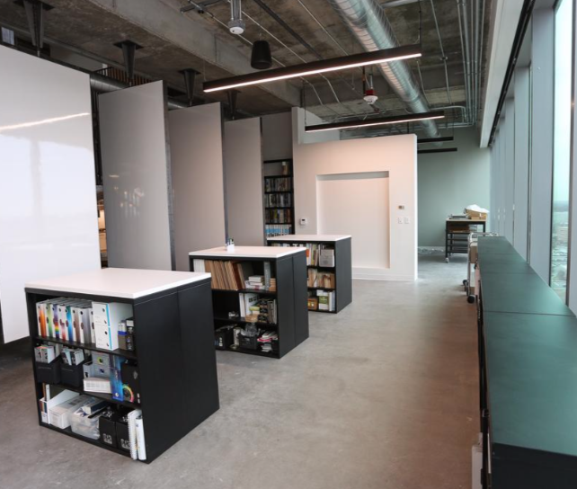
Image 21: Resource room at Little
The material and resource room in Little’s workplace maintains the simplistic design of the workplace as shown in (image 21) by incorporating simple finished, white surfaces to showcase the materials, and large windows for light to penetrate helps in allowing an accurate lighting temperature. The open ceiling shows depth and giving the space more height. The higher ceiling enhances the prospect pattern [P11].
Circulation Space
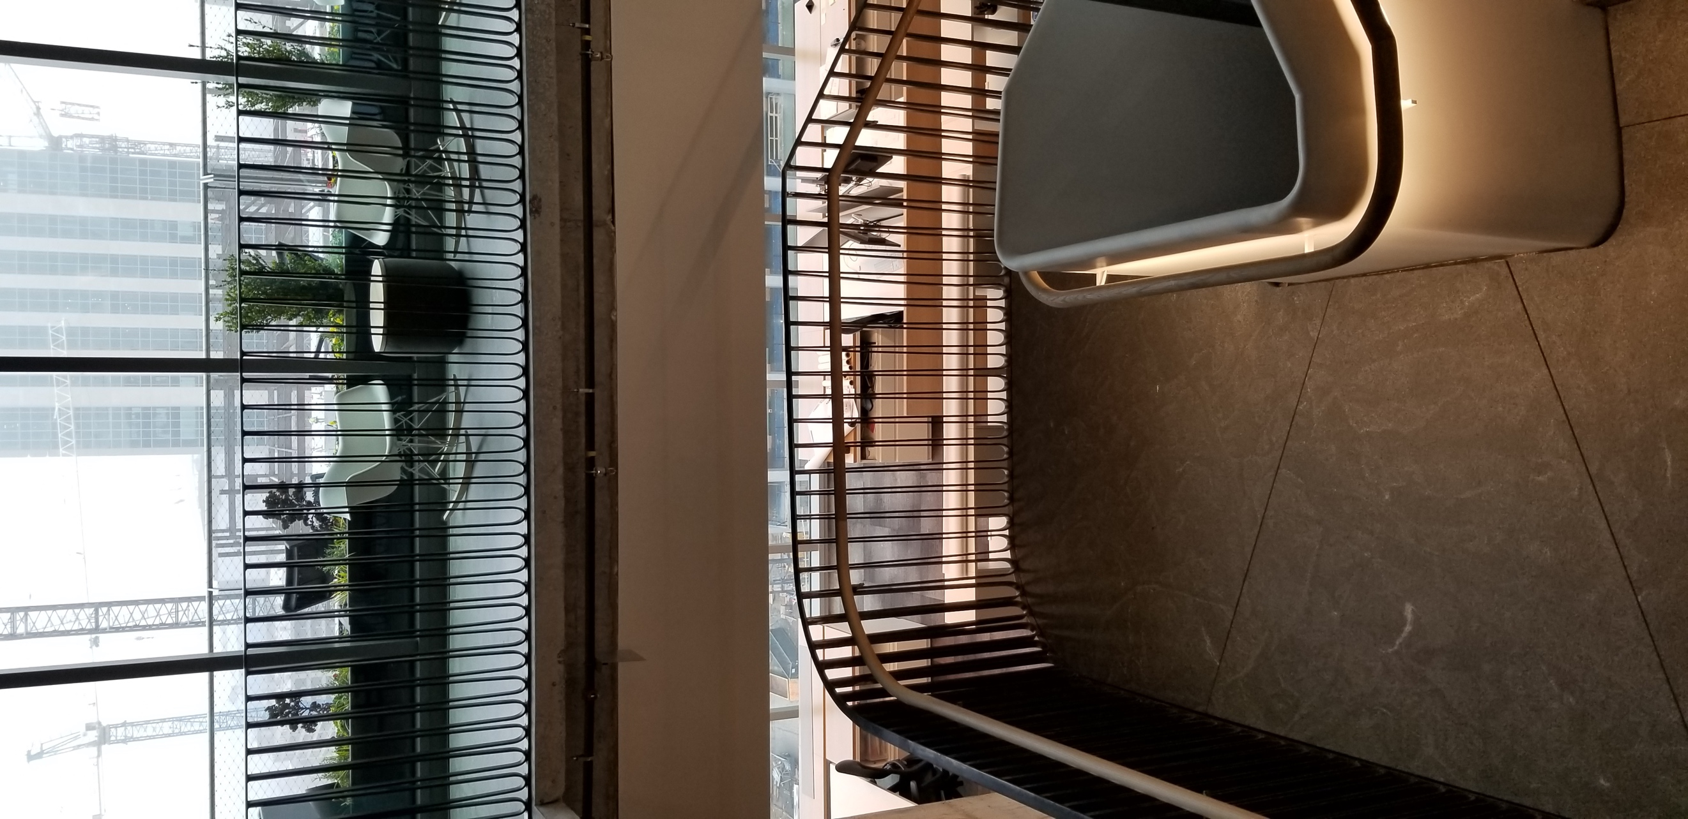
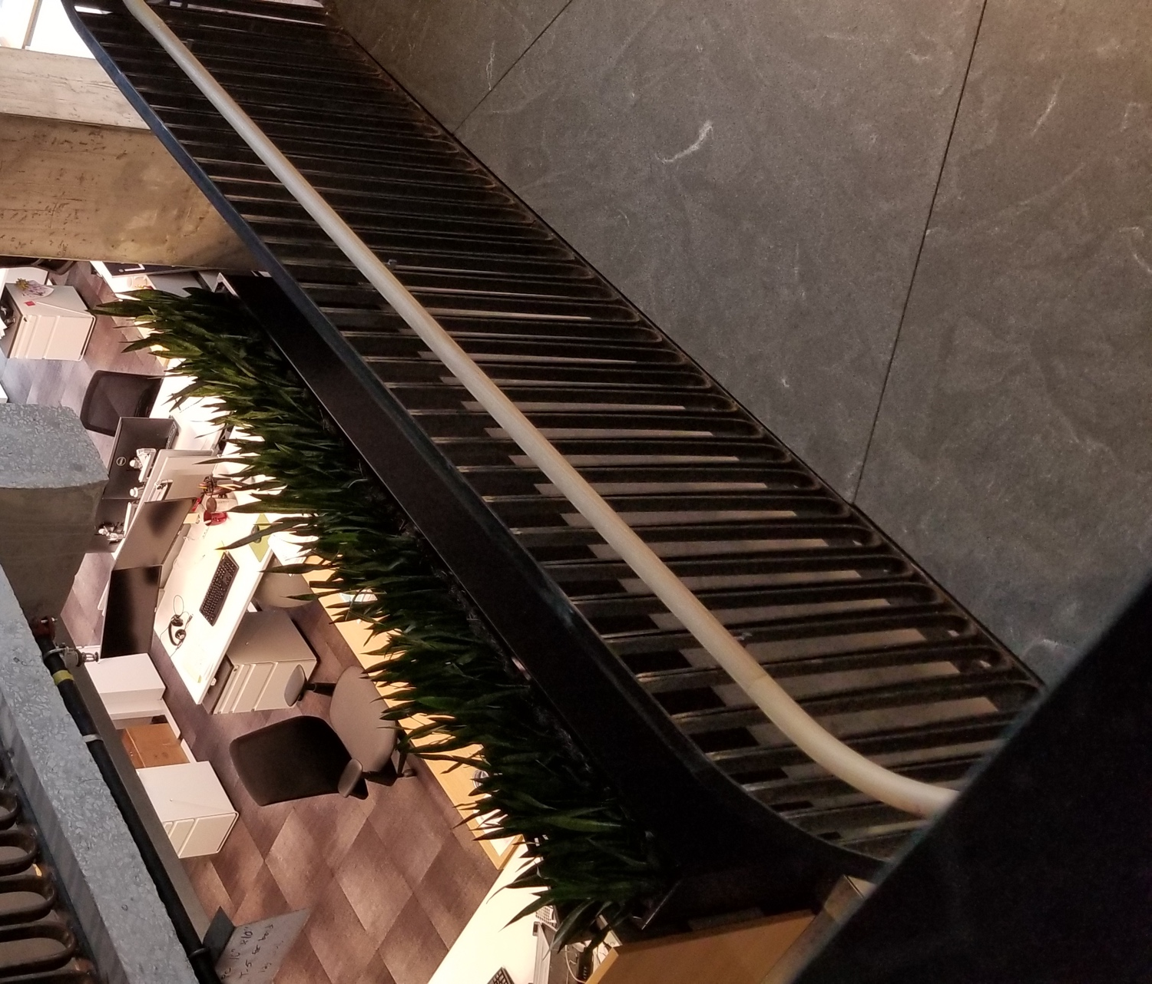
Image 22: Staircase/ Circulation at Little
Little’s workplace embraces organic shapes and biomorphic forms pattern [P8] through large architectural features as well as furniture pieces around the space. The staircase’s curvilinear shape seen in (image 22) is enhanced with the addition of natural plants which overlaps more two biophilic patterns in one setting. First, the visual connection to nature pattern [P1]. Second, the non-visual connection with nature pattern [P2], by stimulating the olfactory sense. Third, creating a natural air filtration system, relating back to the thermal and airflow variability pattern [P4].

  - Case (3): WeWork Company
Brief
WeWork is a New-York based coworking startup. It is a shared office space company for small business, entrepreneurs, and even larger corporations as they become a part of the community. The first location was opened in 2010 in Manhattan, Soho, and by 2016 WeWork had 178 locations, in 56 cities around the world (WeWork Companies Inc., 2019). The work space offers many of the needed amenities in a workspace such as printer rooms, meeting rooms, huddle spaces and more. Small companies, large corporations or just single working entrepreneurs, the space is designed to accommodate all variables or work structures. This coworking model eliminates the hassle and cost of opening and operating a workspace and provides extra amenities alongside for convenience. It is designed to host companies from 1 member to 100+ members, and not only do people get shared amenities like printers, receptionists and mailing services they also gain a supportive, collaborative community where your next-door co-worker is a photographer that you might acquire to work with at the next house renovation shoot.

Plan
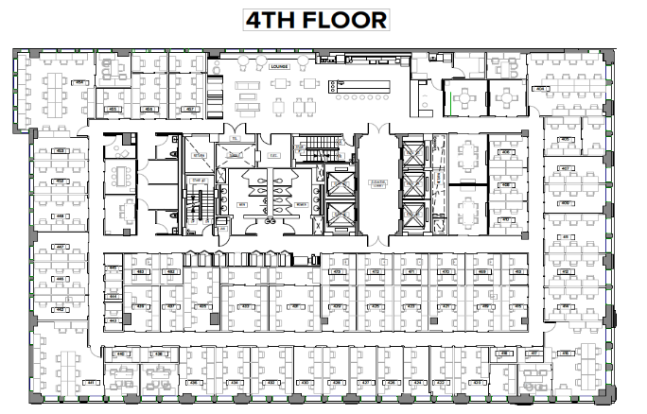
C
A
E
D
B
Image 23: WeWork’s Workplace Floor Plan, (WeWork Companies Inc., 2019)

Arrival Point / Reception Area
As seen in (image 23, location A, image 24) in the floor plan, WeWork’s reception desk area shows the vibrant color palette, the color scheme continues throughout the space enhanced with bold geometric patterns.
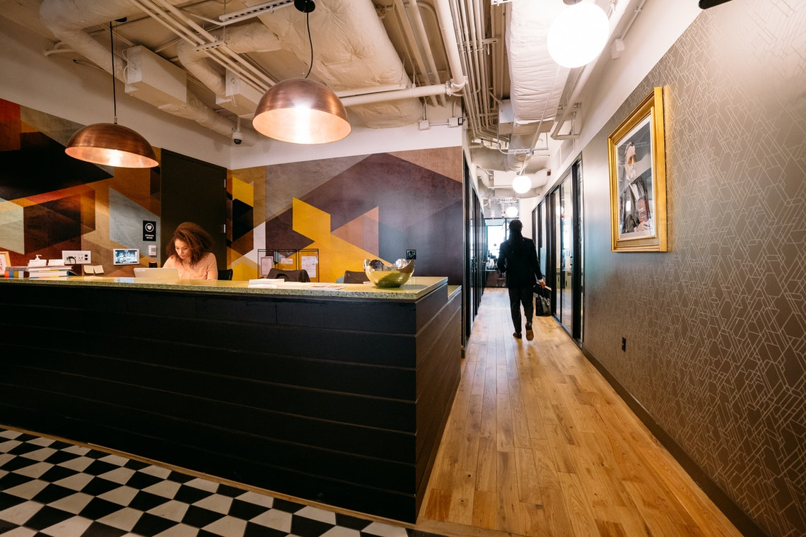
Image 24: Reception Desk/ Area at WeWork, (WeWork Companies Inc., 2019)
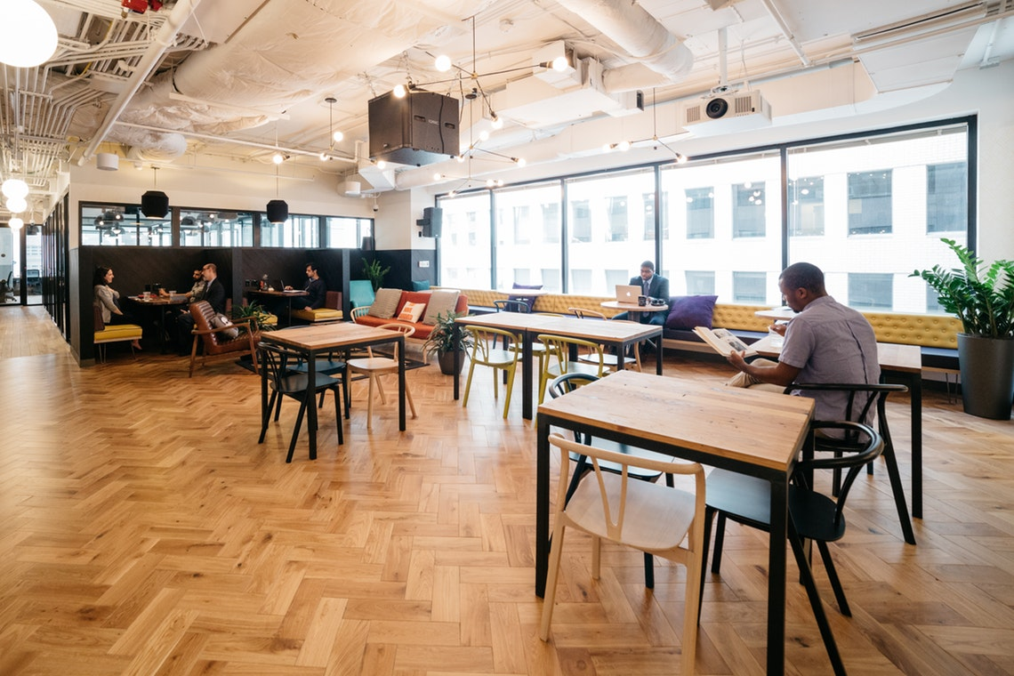
Dining / Work Café
Image 25: Work Café, (WeWork Companies Inc., 2019).
.
As the geometric shapes and vibrant colors take away from the biomorphic forms and patterns [P8] of the workplace. The work café, on the contrary, embraces visual connection with nature pattern [P1], the natural light penetrating through the large windows and the availability of artificial lighting also enhances the dynamic and diffused lighting pattern [P6] (image 23, location B, image 25) on the floor plan. Unfortunately, even with the wide range of electrical light in the space, the lighting system is manual and not connected to any sensors, hence not supporting the circadian system. The large windows shown in (image 25) are exposed and shading blinds are not installed in place, which means in warmer weather and sunny days, the glare can disrupt the activities taking place, making the space design less successful in this matter.

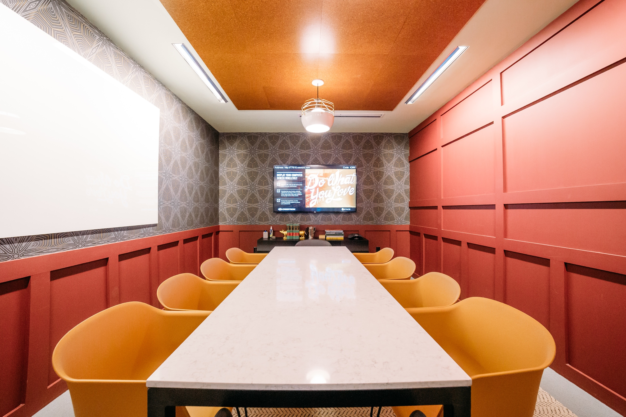
Large Conference Room
Image 26: Large Conference Room, (WeWork Companies Inc., 2019).
The large conference room, like other spaces throughout the WeWork spaces, celebrates vibrant colors and geometric shapes. Organically shaped furniture shown in (image 23, location C, image 26) enhances the space and breaks the rigidness of the wall panels and other hard surfaces by adding the biomorphic forms and patterns to the room [P8]. As seen in the image and location, there is not a direct connection to daylight or views from the conference room.

Small Conference Room 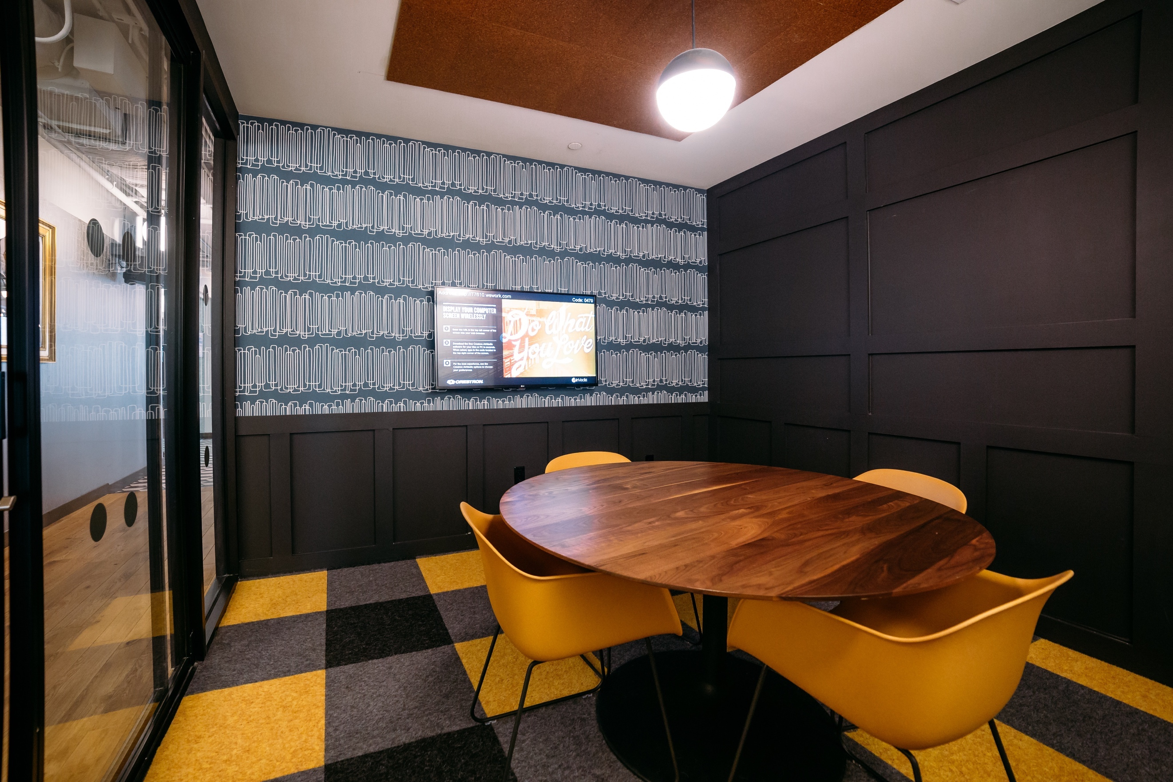
Image 27: Small conference room, (WeWork Companies Inc., 2019).
The wallpaper in the large conference room and smaller conference rooms located around WeWork’s workplace portray similar design elements. The wallpaper in the spaces have a resemblance to patterns seen in nature connecting to the biomorphic patterns [P8] in the space. The addition of wooden table tops seen in (image 27), even though it is not in the rawest condition, it still gives the visual satisfaction of wood because of the apparent wood grain, embracing the material connection with nature [P9] biophilic pattern. Large glass wall and door allows for visual connection to the workplace; however, the floor plan positioning (image 23, location D, image 27) of the conference rooms does not allow for natural light and views to penetrate freely in WeWork’s workplace.

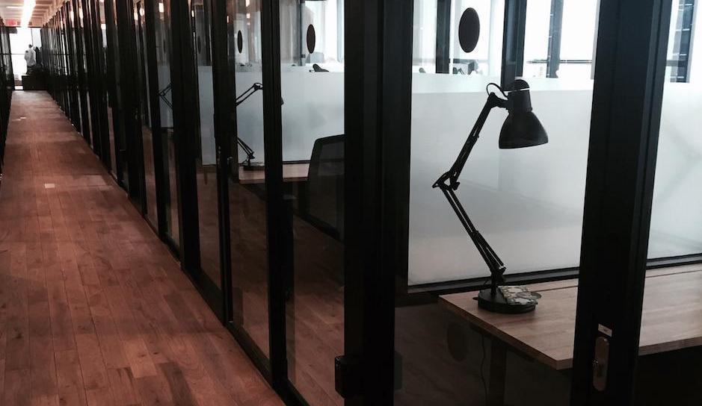
Private Offices
Image 28: private office spaces (pre occupation) at WeWork, (WeWork Companies Inc., 2019).

A biophilic analysis was not very accurate in regard to the private offices, as each office space was customizable (image 23, Location E, image 28) however, all the private office spaces were located along the premises of the building, with glass facades. which supported in enhancing the visual connection with nature [P1] pattern regardless of the customization of each office space.

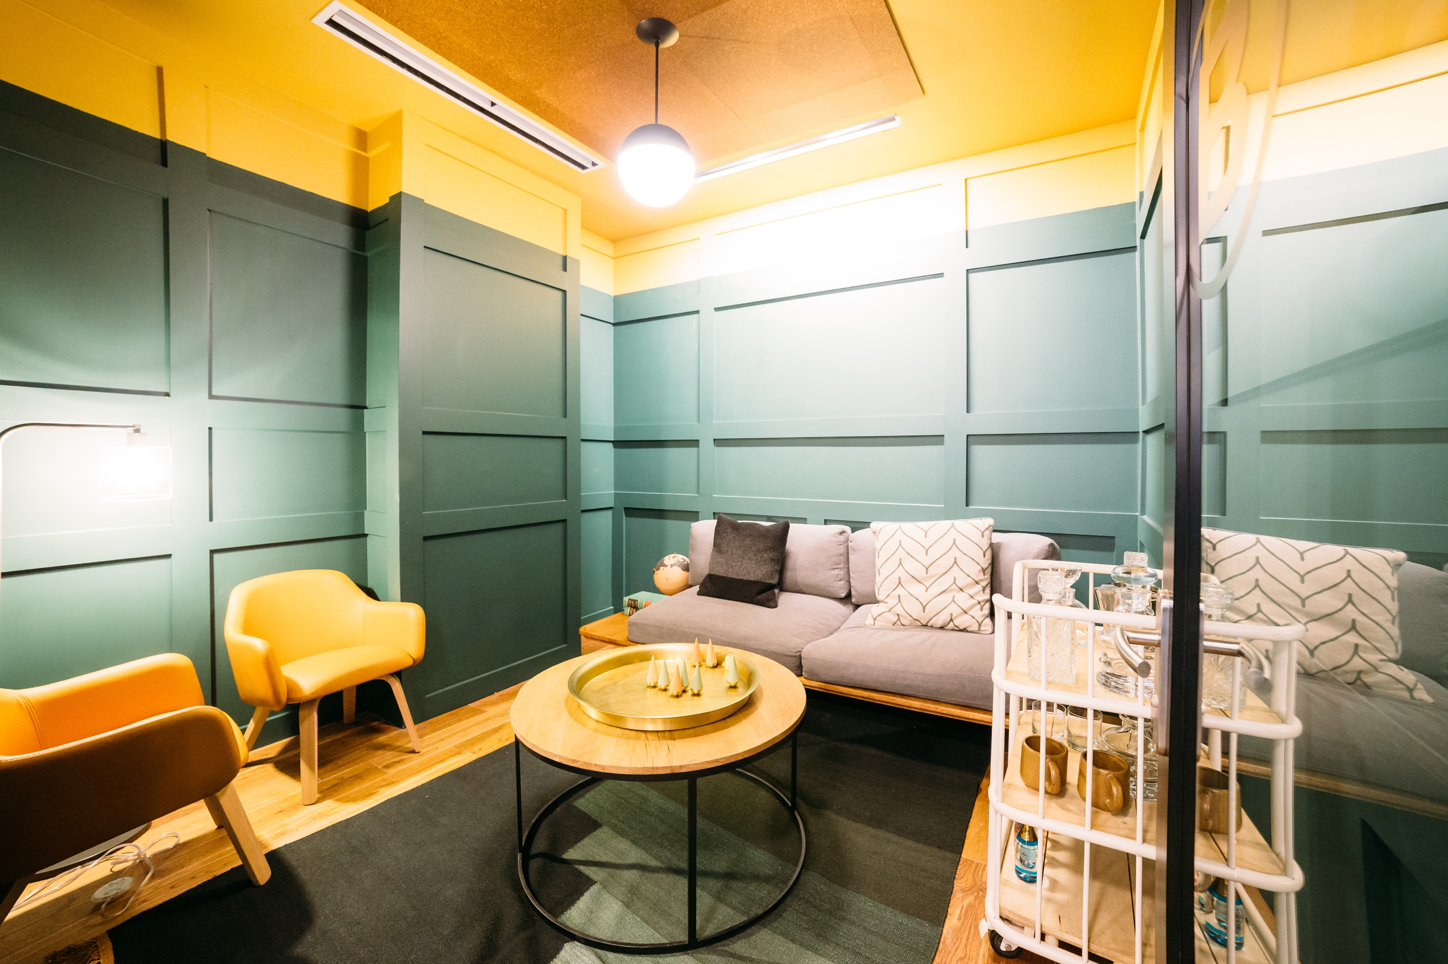
Focus Rooms and Huddle Rooms
Image 29 Huddle room, at WeWork, (WeWork Companies Inc., 2019).
Since most of the companies are smaller in scale, the focus room is considered the private office itself. And a few huddle spaces were located for brainstorming or relaxing sessions. There is a variety of task and ambient lighting as seen in (image 23, location F, image 29) and no natural lighting or views within the spaces. All companies are able to utilize the smaller meeting rooms for personal use, to work in a group, solely, or hold a meeting with a client.

Printer Room
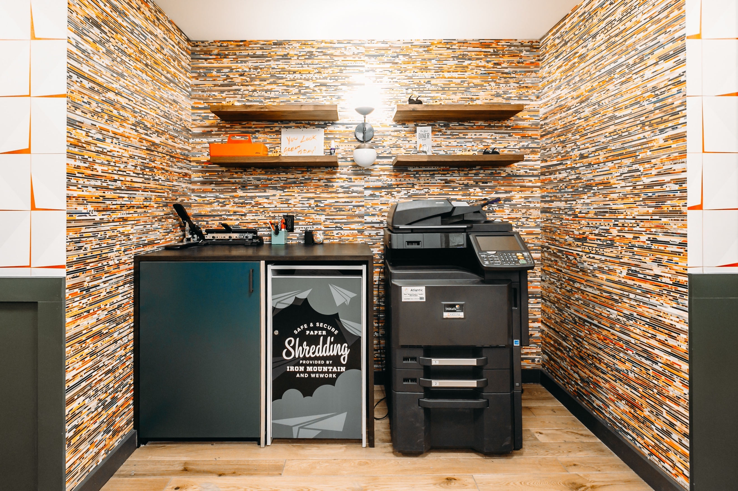
Image 30: Printing Room at, WeWork, (WeWork Companies Inc., 2019).
The wooden oak floors are a signature at all WeWork’s locations, it continues throughout the space as well adding warmth to the space and enhancing the material connection with nature pattern [P9] throughout their workplace.

Library / Resource Room
Each private office has its own storage and resource room.

Circulation Space
As seen in WeWork’s floor plan (image 23), the layout is very geometric and linear in shape taking away any means of prospect [P11] and refuge [P12]. According to the human biological response to biophilic design patterns, a monotonous space without the excitement factors of prospect, risk & refuge [Nature of the space] patterns, can result in boredom, irritation, fatigue and evoke a sense of danger (Herzog & Kropscott, 2004).

Chapter 4: Findings

This chapter provides individual case study reports, with preliminary explanations of the biophilic pattern scores.
  - Findings for Case Study (1)
Through the biophilic pattern analysis and site visit that the spaces with the strongest patterns are the more public areas. Such as the arrival point, circulation space, work cafe, large conference room, and the huddle spaces. These locations are amongst the first spaces people experience when being in the workplace. For example, Table 2 shows how most of the selected locations in the workplace have a strong Visual Connection with Nature [P1].
Biophilic Pattern | Arrival Point | Dining Area | Large Conference Room | Small Conference Room | Open Offices | Focus Room | Huddle Space | Printer Room | Library | Circulation Space | AVG
Visual Connection with Nature | 0 | 5 | 5 | 5 | 5 | 5 | 3 | 0 | 5 | 5 | 3.8
Table 4 Visual Connection with Nature [P1] in ASID Workplace.
Thermal and Airflow Variability [P4], Dynamic and Diffused light [P6], and Biomorphic Forms and Patterns [P8], were also amongst the strongest biophilic patterns throughout the ASID workplace. Obtaining the LEED and WELL certifications certainly partake a significant role in incorporating these biophilic patterns as seen in table 3, and table 4 in the space. Even though the ASID workplace has efficient thermal conditions and air quality are monitored through technological equipment installed in the space, it scores 4.5 as an average in [P4] because the arrival point is located outside the workplace premises and is part of the building the office occupies. LEED (ID+C) certification requires incorporating natural light to lower costs and optimize electricity usage through the Energy and Atmosphere category. Also, Indoor Environmental Quality category which promotes healthy airflow and the use of safe, non-toxic chemicals in the space.

Biophilic Pattern | Arrival Point | Dining Area | Large Conference Room | Small Conference Room | Open Offices | Focus Room | Huddle Space | Printer Room | Library | Circulation Space | AVG
Thermal & Airflow Variability | 0 | 5 | 5 | 5 | 5 | 5 | 5 | 5 | 5 | 5 | 4.5
Table 5 Thermal & Airflow Variability [P4] in ASID Workplace.

Biophilic Pattern | Arrival Point | Dining Area | Large Conference Room | Small Conference Room | Open Offices | Focus Room | Huddle Space | Printer Room | Library | Circulation Space | AVG
Dynamic and Diffused light | 5 | 5 | 5 | 5 | 5 | 5 | 5 | 5 | 5 | 5 | 5
Table 6 Dynamic and Diffused Light [P6] in ASID Workplace.
All the patterns, as mentioned in the ASID case study analysis were inspiration from nature, resembling biomimicry. Table 5 and 6 show the occurrence of the Biomorphic Forms and Patterns [P8].
Biophilic Pattern | Arrival Point | Dining Area | Large Conference Room | Small Conference Room | Open Offices | Focus Room | Huddle Space | Printer Room | Library | Circulation Space | AVG
Biomorp-hic Forms & Patterns | 5 | 5 | 5 | 5 | 5 | 5 | 5 | 5 | 5 | 5 | 5
Table 7 Biomorphic Forms and Patterns [P8] in ASID Workplace.

Biophilic Pattern | Arrival Point | Dining Area | Large Conference Room | Small Conference Room | Open Offices | Focus Room | Huddle Space | Printer Room | Library | Circulation Space | AVG
Material Connection with Nature | 0 | 0 | 5 | 5 | 3 | 5 | 3 | 3 | 5 | 0 | 2.9
Table 8 Material Connection to Nature [P9] in ASID Workplace.

  - Findings for Case Study (2)
Little Diversified is looking to obtain both LEED Silver and WELL Silver certification, however, the biophilic patter averages throughout the spaces is higher than ASID as seen in Table 7, Table 8. This can be due to the larger square footage, the space allowed for more biophilic patterns to be present. Also, the architectural features which allowed for an outdoor balcony space in Little which allowed more daylight, views and nature key biophilic elements to be incorporated into the space as seen in the case study analysis.
Biophilic Pattern | Arrival Point | Dining Area | Large Conference Room | Small Conference Room | Open Offices | Focus Room | Huddle Space | Printer Room | Library | Circulation Space | AVG
Visual Connection with Nature | 5 | 5 | 5 | 5 | 5 | 5 | 5 | 0 | 5 | 5 | 4.5
Table 9 Visual Connection with Nature [P1] in Little Workplace.
As for Airflow and Variability [P4], Little office had high average as seen in Table 8 because of their LEED and WELL considerations similar to the ASID office. Sensitive sensors were placed to detect the humidity and airflow of the workplace.

Biophilic Pattern | Arrival Point | Dining Area | Large Conference Room | Small Conference Room | Open Offices | Focus Room | Huddle Space | Printer Room | Library | Circulation Space | AVG
Thermal & Airflow Variability | 5 | 5 | 5 | 5 | 5 | 5 | 5 | 5 | 5 | 5 | 5
Table 10 Thermal & Airflow Variability [P4] in Little Workplace.
Biophilic Pattern | Arrival Point | Dining Area | Large Conference Room | Small Conference Room | Open Offices | Focus Room | Huddle Space | Printer Room | Library | Circulation Space | AVG
Dynamic and Diffused light | 5 | 5 | 5 | 5 | 5 | 5 | 5 | 5 | 5 | 5 | 5
Table 11 Dynamic and Diffused Light [P6] in Little Workplace.
Biophilic Pattern | Arrival Point | Dining Area | Large Conference Room | Small Conference Room | Open Offices | Focus Room | Huddle Space | Printer Room | Library | Circulation Space | AVG
Biomorphic Forms & Patterns | 5 | 5 | 3 | 3 | 3 | 3 | 3 | 3 | 3 | 5 | 3.6
Table 12 Biomorphic Forms and Patterns [P8] in Little Workplace.

Material connection to nature patterns could be seen throughout the workplace design abundantly, there are many uses of natural wood planks in the rawest conditions. As well as the use of natural materials in the furniture and pendant lights.

Biophilic Pattern | Arrival Point | Dining Area | Large Conference Room | Small Conference Room | Open Offices | Focus Room | Huddle Space | Printer Room | Library | Circulation Space | AVG
Material Connection with Nature | 5 | 5 | 5 | 5 | 3 | 5 | 5 | 5 | 5 | 5 | 4.8
Table 13 Material Connection to Nature [P9] in Little Workplace.

  - Findings for Case Study (3)
It is noticeable through the schedules that the averages are very low in private spaces but more dominant in common areas such as the entrance, and work café. The same table was used to compare the non-certified workplace; WeWork. However, a slight modification was made since there weren’t any open office spaces in the WeWork setting, only private offices, so that took place of it. Which in WeWork workplace doesn’t acquire a large part of the floor plan. There isn’t much integration of nature and natural elements within the private workplace areas. For example, Visual Connection with Nature [P1] shows in Table 12 has a very low average in the WeWork workplace. Much consideration for nature and view were for the common areas, and the office spaces which are located along the parameter of the space. Allowing for adequate sunlight and exposure.

Biophilic Pattern | Arrival Point | Dining Area | Large Conference Room | Small Conference Room | Private Offices | Focus Room | Huddle Space | Printer Room | Library | Circulation Space | AVG
Visual Connection with Nature | 5 | 5 | 0 | 0 | 5 | 3 | 0 | 0 | N/A | 3 | 2.3
Table 12 Visual connection with nature [P1] in WeWork workplace.

Thermal and Airflow Variability was an average 3 as seen in Table 13, the space did not have any particular considerations, however, site visit observations show that each space had its own control sensor and the occupants have the ability to modify the temperature based on their needs.

Biophilic 0Pattern | Arrival Point | Dining Area | Large Conference Room | Small Conference Room | Private Offices | Focus Room | Huddle Space | Printer Room | Library | Circulation Space | AVG
Thermal & Airflow Variability | 3 | 3 | 3 | 3 | 3 | 3 | 3 | 3 | N/A | 3 | 3
Table 13 Thermal & Airflow Variability [P4] in WeWork Workplace.
Similarly, to Airflow and Variability [P4], Dynamic and diffused light was an average of 3, because of layout, and glass walls, space has natural daylight, however many spaces has light penetrating from one wall only. Also, there are not any daylight sensors or circadian lighting systems installed.
Biophilic Pattern | Arrival Point | Dining Area | Large Conference Room | Small Conference Room | Private Offices | Focus Room | Huddle Space | Printer Room | Library | Circulation Space | AVG
Dynamic and Diffused light | 3 | 3 | 3 | 3 | 3 | 3 | 3 | 3 | N/A | 3 | 3
Table 14 Dynamic and Diffused Light [P6] in WeWork Workplace.
There wasn’t much consideration to Biomorphic forms and patterns [P8] as seen in Table 15. Even though, there is a large potential because of WeWork’s use of vibrant wallpapers in the focus, and huddle rooms. However, the choices of materials and fabrics were not in connection forms of nature. There was a good use of natural materials as seen in Table 16, of the WeWork workplace, raw wood was essentially the most pattern connecting the WeWork’s space to natural materials. As well as the countertops and café details which incorporated wood and brick. However, the averages are low in comparison to the first two workplace design, case study (1) & case study (2).

Biophilic Pattern | Arrival Point | Dining Area | Large Conference Room | Small Conference Room | Private Offices | Focus Room | Huddle Space | Printer Room | Library | Circulation Space | AVG
Biomorphic Forms & Patterns | 5 | 5 | 0 | 0 | 0 | 0 | 0 | 0 | N/A | 0 | 1.5
Table 15 Biomorphic Forms and Patterns [P8] in WeWork Workplace.

Biophilic Pattern | Arrival Point | Dining Area | Large Conference Room | Small Conference Room | Private Offices | Focus Room | Huddle Space | Printer Room | Library | Circulation Space | AVG
Material Connection with Nature | 5 | 5 | 3 | 3 | 3 | 3 | 3 | 0 | N/A | 0 | 2.8
Table 16 Material Connection to Nature[P9] in Little Workplace.

The case study analysis clearly shows that the biophilic patterns need to be intentionally incorporated in a designed space to allow for the human nature connection within the built environment. Whereas workspaces which aim to obtain certification of green building standards, such as LEED, WELL and Living Building Challenge, create a more diverse approach in incorporating biophilic design. This does not necessarily mean biophilic design should be associated with any other accreditation, it simply creates a great opportunity to learn biophilic design applications in similar work or living environments. Biophilic design applications differ depending on project type, scale, location, and many other types. In which Case Study (1) had higher certification values and points but less biophilic design elements, where are Case Study (2) had more biophilic elements relevant to its size. Aside from the square footage of the workspaces, there are identifiable common synergies in which biophilic patterns would be present in a workspace setting, and which would be easily applicable in a similar setting such as the WeWork’s example. While WeWork’s concept is very sustainable, the company is not seeking any green building recognition for their workplace designs.

  - Cross-Case Study Conclusions
In a comparison between the biophilic patterns present in the three sample offices the results vary, however, spaces with LEED and WELL certifications plan their spaces differently. Designing a LEED or WELL workspace could provide a clear framework for implementing biophilic patterns into the design for ultimate benefits on the health and well-being of the occupants. However, this doesn’t limit the use of the biophilic patterns to certification workplace designs. For example, the WeWork office had enough access to windows, daylight and views as the ASID and Little, however, it was not considered from an initial point of view to maximize daylight penetration through the space, as many of the huddle and meeting rooms had no access to light or views.

Figure 1 Demonstrating the Biophilic averages amongst the three case studies.
Nonetheless, the layout and lack of emphasis on views and natural light created more spaces lacking access to these biophilic patterns. Unlike the ASID and Little workspaces where the design and floor layouts were very deliberate to include natural light, views throughout most of the space. Providing clear views is very important to also maintain a connection with natural systems and be aware of seasonal changes, which has been proved to have enhanced positive health responses (S. R. Kellert et al., 2011). The case study analysis results showed that biophilic patterns are apparent in all workspaces. In the comparison between a LEED and WELL platinum certified, LEED and WELL silver certified, results were close. However, the weakness of applied biophilic patterns in non-LEED or WELL certifies spaces was clear in case study analysis.
WeWork company has been environmentally conscious in the past few years, there are many commitments and sustainable options that the company advocates. For example, their commitment to becoming fully carbon neutral by 2023. Also, WeWork has reduced the consumption of single-use plastic by the end of 2018. Specific incorporation of biophilic design in their workspace can help in creating more healthy work environments. Results indicate that the most important factor accounted for is daylight design, and as much as daylight in the workplace is important, many other biophilic features as discussed in the literature review can have significant benefits on the employees. After carefully evaluating the three case studies, it is shown that the strongest biophilic patterns occurring were different amongst each study. Findings on the biophilic patterns presented are applied to all three case studies. Some biophilic patterns were present in all three spaces.

Chapter 5: Recommendations

This chapter concludes recommendations for biophilic design incorporation or additions to existing workplace designs.
Biophilic design patterns are flexible to be adapted in any setting. Patterns can be interpreted in an existing space without significant cost or design changes. However, have a high impact and alleviate workplace performance. Overall, affecting workers health and well-being. As the case study findings show, there are a few patterns which are strongly present in workplace design, and these patterns kept on reoccurring throughout spaces, emphasizing on the pattern language of case studies which implemented green building certifications. This study recommends the following biophilic patterns to be introduced into current workplace designs:
- Increase Visual Connection with Nature pattern [P1] for an enhanced workplace.
Views to nature can enhance a person’s experience in the space, relieve stress and lower blood pressure, these are only a fraction of the benefits of visual contact with nature (S. R. Kellert et al., 2011).
  - Allowing more natural light into the space.
  - Enhancement of views to the outdoors.
  - Orienting desks intentionally in the direction of views.
  - Adding a green wall installation for greenery and plant connection.
    - Selecting native plants.
    - Selecting plants with scents for an olfactory experience as well.
    - Selecting moss wall installation for less water usage if the water is not regenerative in the building, to reduce water usage.
  - Increasing the amount of glass within the space so natural light can penetrate through.
  - Have different possible views and plants (diversity over quantity).
  - Adding adjustable light shades for glare control and minimizing the negative effects of large windows.
- Increase Thermal & Airflow Variability pattern [P4] in the space for reaching ultimate occupant satisfaction:
Thermal comfort is a very important factor when measuring occupant satisfaction in a space. Since thermal comfort is very subjective the best options would be to allow a variety and flexibility when designing a workplace so people can resort to their desired thermal comfort.
- Allowing for natural ventilation if possible, as some workplace designs are located in Highrise buildings with fixed windows.
- Allowing for thermal variation within the space, people are happier and less bored in spaces where there is a variation in temperatures (S. R. Kellert et al., 2011).
- Providing easy access to the outdoors for increasing the variability and allowing people to warm up or cool down, or just change their thermal condition during working hours.
- Allowing for user control in enclosed spaces of the workplace (huddle rooms, small meeting rooms, focus rooms, and private offices...etc.)
- Providing personal cooling or heating chairs and desks.
- Increase Dynamic & Diffuse Light pattern [P6] for maximum visual comfort and increased mood:
By allowing a space to have a good variety in light conditions it can express time and enhance feelings of calmness throughout the space (Ryan et al., 2014).
- Install circadian lighting systems as it mimics the natural colors and temperatures of the sunlight.
- Minimizing glare in the space, by installing shades, placing screens away from direct sunlight, and minimize the use of highly reflective materials.
- Have a variety of lighting options, ceiling, wall, task lighting can help in creating a more dynamic and personalized experience.
- Installing light shades which allow for interesting light and shadow play, in the common areas for adding interest and excitement to the workplace.
- Increase Biomorphic Forms & Patterns [P8] for enhanced interest and comfort in the workplace:
Being inspired by nature and applying it to workplaces can enhance the overall experience. Natural forms vary from simple to complex, not to mention the wide variety of forms and patterns. The use of nature-inspired forms and patterns adds diversity to a space and makes it more interesting (Ryan et al., 2014).
- Enhancing wall finishes with patterns inspired from nature.
- Minimizing geometric shapes and maximizing more organic shapes in walls, floors and ceiling patterns.
- Adding organic shapes and patterns as design accents to the space.
- Enhancing the space with organically shaped furniture.
- Using three-dimensional forms and patterns, for example, raw wood planks, or 3-D wallpaper that mimics natural forms for the simulating the haptic experience connecting to [P9].

- Increase Material Connection with Nature Pattern [P9] for interest and uniqueness:
By using materials minimally processed materials from nature to enhance the sense of place (Ryan et al., 2014).
- Using wood, brick, stone that is native to the workplace environment to enhance material connection as well as place-based relationships.
- Using a color palette that is inspired from nature in walls and accents throughout the workplace.
- Using real over synthetic materials in desks, wall cladding or wall coverings, and other surfaces.
There are many ways to incorporate biophilic design patterns, any effort to include these patterns can result in satisfying outcomes. Especially with the increased density of the urban environment, and most workplaces are located in the busy parts of the city, it becomes very important to add biophilic patterns o these workplace designs. Ideally, a space would consider biophilic design patterns as an initial part of the design process. However, this is not a setback for established workplace designs as many solutions are available and this conclusion to the case study suggestions is just a brief of the endless possibilities and applications. Prolonged hours of exposure to nature and natural systems is not required, as much as five minutes could have the potential of enhancing human nature connections, thus affecting the health and wellbeing of the occupants. It is important to be diverse in the applications of biophilic design patterns after understanding how each pattern affects the occupants and addressing the workplace’s specific needs.
The recommendations for this study were based on the most occurring biophilic patterns in the cases chosen, nevertheless, there are many more pattern design applications suggestions, Terrapin Bright Green’s 14 patterns of biophilic design has further information on each pattern (S. R. Kellert et al., 2011). ß

Chapter 6: Conclusions

This chapter introduces conclusions that can be drawn from multiple case study analysis. A case study analysis has been completed for the three selected workplace designs. Finally, the chapter provides future research recommendations.
Biophilic design is a pathway for designing workspaces that care for the health, mental and physical well-being of their employees. Biophilic design when applied successfully, can have a wide range of physical, mental and behavioral benefits (S. Kellert & Calabrese, 2015). When employees are well, absenteeism is decreased, work performance and employee retention are increased. Ultimately companies benefit through cutting costs and producing more valuable work outcomes. Even though this thesis focused more on the health and well-being in the workspace with biophilic incorporation; biophilic design has proven much more in enhancing cognitive functions, productivity and creativity (Ryan et al., 2014). Intentionally seeking interior design elements that embrace biophilic design within the space add beauty, aesthetic and interest. It also benefits the occupants while they are in the space embracing the natural connections humans find in nature and nature’s elements. Furthering the awareness on the importance of natural connections within the built environment can help benefit the occupants greatly in different settings, regardless of obtaining green building certifications. Biophilic design should be understood and applied as a philosophy rather than a list of rules and regulations to follow. It is more about shifting the design thoughts and processes to align with biophilic patterns and create better spaces for living and working.

  - Considerations for Further Research
Future research opportunities address human behavior toward biophilic patterns in certification spaces and compare them to non-certified workspaces for a more thorough view of the effects of biophilic patterns in both settings. A cross-cultural study would also be beneficial to understand how different cultures respond to the biophilic patterns in certification in opposed to non-certified spaces. Further studies may also include pre and post-occupancy evaluations of a WeWork location which incorporated biophilic design patterns to measure the success of the biophilic design applications.

References

Abbaszadeh, S., Zagreus, L., Lehrer, D., & Huizenga, C. (2006). Occupant satisfaction with indoor environmental quality in green buildings.
Alexander, C. (1977). A pattern language: towns, buildings, construction: Oxford university press.
American Society of Interior Designers. (2017). ASID Headquarters is First Space in the World to Earn Both LEED and WELL Platinum Certification under WELL Building Standard™ v1.
Ashley Fahey (Producer). (2018). Little debuts uptown office designed with new industry standard for health, well-being. [Photographs] Retrieved from https://www.bizjournals.com/charlotte/news/2018/12/10/photos-little-debuts-uptown-office-designed-with.html
Baregheh, A., Rowley, J., & Sambrook, S. (2009). Towards a multidisciplinary definition of innovation. Management decision, 47(8), 1323-1339.
Bratman, G. N., Daily, G. C., Levy, B. J., & Gross, J. J. (2015). The benefits of nature experience: Improved affect and cognition. Landscape and Urban Planning, 138, 41-50.
Capaldi, C. A., Passmore, H.-A., Nisbet, E. K., Zelenski, J. M., & Dopko, R. L. (2015). Flourishing in nature: A review of the benefits of connecting with nature and its application as a wellbeing intervention. International Journal of Wellbeing, 5(4).
Duffy, F., & Powell, K. (1997). The new office.
Gillis, K., & Gatersleben, B. (2015). A review of psychological literature on the health and wellbeing benefits of biophilic design. Buildings, 5(3), 948-963.
Herzog, T. R., & Bryce, A. G. (2007). Mystery and preference in within-forest settings. Environment and behavior, 39(6), 779-796.
Herzog, T. R., & Kropscott, L. S. (2004). Legibility, mystery, and visual access as predictors of preference and perceived danger in forest settings without pathways. Environment and behavior, 36(5), 659-677.
Hoffmann, G., Gufler, V., Griesmacher, A., Bartenbach, C., Canazei, M., Staggl, S., & Schobersberger, W. (2008). Effects of variable lighting intensities and colour temperatures on sulphatoxymelatonin and subjective mood in an experimental office workplace. Applied Ergonomics, 39(6), 719-728.
International Living Future Institute. (2019a). Biophilic Design.
International Living Future Institute. (2019b). INTERNATIONAL LIVING FUTURE INSTITUTE (ILFI). Retrieved from https://living-future.org/contact-us/faq/
International WELL Building Institute. (2019). Better buildings to help people thrive. Retrieved from https://v2.wellcertified.com
Kahn Jr, P. H., Friedman, B., Gill, B., Hagman, J., Severson, R. L., Freier, N. G., . . . Stolyar, A. (2008). A plasma display window?—The shifting baseline problem in a technologically mediated natural world. Journal of Environmental Psychology, 28(2), 192-199.
Karen Quintana. (2017). Workplace, meet WELL: Enhancing the employee experience through healthy buildings.
Kellert, S., & Calabrese, E. (2015). The practice of biophilic design. Retrieved from www. biophilic-design. com website.
Kellert, S. R., Heerwagen, J., & Mador, M. (2011). Biophilic design: the theory, science and practice of bringing buildings to life: John Wiley & Sons.
Lee, Y. S. (2010). Office layout affecting privacy, interaction, and acoustic quality in LEED-certified buildings. Building and Environment, 45(7), 1594-1600.
Little Diversified Architectural Consulting. (2019).
MacNaughton, P., Satish, U., Laurent, J. G. C., Flanigan, S., Vallarino, J., Coull, B., . . . Allen, J. G. (2017). The impact of working in a green certified building on cognitive function and health. Building and Environment, 114, 178-186.
Ryan, C. O., Browning, W. D., Clancy, J. O., Andrews, S. L., & Kallianpurkar, N. B. (2014). Biophilic design patterns: emerging nature-based parameters for health and well-being in the built environment. International Journal of Architectural Research: ArchNet-IJAR, 8(2), 62-76.
Sam Grawe & Greg Parsons. (2016). Living office, A human-Centered Approach to work and Workplace. Herman Miller.
Stemler, S. (2001). An overview of content analysis. Practical assessment, research & evaluation, 7(17), 137-146.
Un-Habitat. (2012). State of the World's Cities 2008/9: Harmonious Cities: Routledge.
United States Environmental Protection Agency. (2016). Green Building. https://archive.epa.gov/greenbuilding/web/html/about.html
United States Green Building Council. (2019). Leed certification is green building.
US Environmental Protection Agency. (1989). Report to Congress on indoor air quality, volume II: assessment and control of indoor air pollution. Technical Report EPA/400/1-89/001C.
Vessel, E. A., Starr, G. G., & Rubin, N. (2012). The brain on art: intense aesthetic experience activates the default mode network. Frontiers in human neuroscience, 6, 66.
Vischer, J. C. (2007). The concept of workplace performance and its value to managers. California management review, 49(2), 62-79.
von Kempski, D. (2006). OCA–a new approach for evaluating the environment of buildings. VOL. I-Indoor Air Quality (IAQ), building related diseases and human response, 81.
WeWork Companies Inc. (2019).
Yin, R. K. (2017). Case study research and applications: Design and methods: Sage publications.

