University of Oklahoma

Graduate College

Social media and ethics: the role of context and personality

A Dissertation

submitted to the Graduate Faculty

in partial fulfillment of the requirements for the

Degree of

Doctor of Philosophy

By

rahul s chauhan
Norman, Oklahoma
2015

social media and ethics: The role of context and personality

A Dissertation approved for the
Department of Psychology

By

______________________________
Dr. Shane Connelly, Chair

______________________________
Dr. Michael Buckley

______________________________
Dr. Michael Mumford

______________________________
Dr. Lori Snyder

______________________________
Dr. Mark Bolino

© Copyright by rahul s chauhan 2015
All Rights Reserved.

Table of Contents
List of Tables vii
List of Figures viii
Abstract viiii
Introduction 1
Background 1
Ethical Decision Making and Sensemaking 2
Ethical Decision Making and Moral Intensity 3
Ethical Decision Making and Social Media 6
Social Media and Perceptions of Moral Intensity 7
Moderators and their Interactive Effects 10
Method 14
Sample and Research Design 14
Procedures 15
Independent Variables 16
Media Context 16
Personality 17
Dependent Variables 17
Moral Intensity 17
Ethical Sensemaking 18
Ethical Decision Making Quality 20
Covariates 21
Need for Cognition 21
Social Desirability 21
Locus of Control 21
Moral Identity 22
Social Media Scales 22
Cynicism 22
Results 22
Social Media and Moral Intensity 23
Social Media and Problem Recognition, Sensemaking, and Overall EDM 23
Conscientiousness and Moral Intensity, Sensemaking Strategies, and Overall EDM 25
Narcissism and Moral Intensity, Sensemaking Strategies, and Overall EDM 28
Discussion 29
Key Findings 29
Theoretical Implications and Contributions 31
Practical Implications 35
Limitations 38
Conclusion 39
References 45
Appendix A: Online News Article Format 54
Appendix B: Social Media Format 55
Appendix C: Perceptgions of Moral Intensity Measure 56
Appendix D: Open-ended Response Cues 57

List of Tables
Table 1. Means, Standard Deviations and Correlations among Study Variables: Covariates, Personality, and Moral Intensity 40
Table 2. Means, Standard Deviations and Correlations among Study Variables: Covariates, Personality, Problem Recognition, Sensemaking Strategies, and Overall EDM 41

List of Figures
Figure 1. A graph of the two-way interaction between condition and conscientiousness on problem recognition 42
Figure 2. A graph of the two-way interaction between condition and conscientiousness on the number of causes identified .. 43
Figure 3. A graph of the two-way interaction between condition and conscientiousness on the criticality of causes identified . 44

Abstract
The present study examined the influence that social media presentation formats and personality characteristics have upon perceptions of the four aspects of Jones (1991) issue-contingent model of Moral Intensity, problem recognition, ethical sensemaking strategies, and overall ethical decision-making. The presentation formats were presented in either a more formal online news article context, an informal social media forum-style discussion context, or both and the personality characteristics of interest were conscientiousness and narcissism. The results of this study found that social media format does influence the social consensus aspect of moral intensity, with individuals perceiving social consensus to be higher when ethical information is presented in a news article context and lower when the same information is presented in a social media discussion context. Social media presentation format did not significantly influence the remaining aspects of moral intensity. Conscientiousness also interacted with social media presentation format to influence problem recognition and ethical sensemaking. Narcissism did not appear have either a direct or interactive effect on the dependent variables of this study. Implications and directions for future research are discussed.
Keywords: Social media, moral intensity, sensemaking, ethical decision making, ethics

Introduction
Background
Social media (SM) is a powerful modern trend that accounted for nearly 74% of online activity for adults in 2014, a dramatic increase from the 8% in 2005 (Forbes, 2012; Pew Research Internet Project, 2014). Social media websites (SMWs) are defined as websites where individuals can post content or information about themselves and others in the form of text, pictures, and/or videos that can then be shared with other users (Boyd & Ellison, 2007; Brandenburg, 2008). Popular examples include Facebook and Twitter.
There have been a number of research investigations into social media features, functions, and users from different scientific disciplines such as psychology, communication, and business (Boyd & Ellison, 2007; Brandenburg, 2008; Buffardi & Campbell, 2008; Chauhan, 2013; James, 2011; Kluemper & Rosen, 2009, Kluemper, Rosen, & Mossholder, 2012; Mehdizadeh, 2010; Noor Al-Deen, & Hendricks, 2011; Payette, Albreski, & Grant-Kels, 2013; Ryan & Xenos, 2011; Van Iddekinge et al., 2013). Despite the growing body of social media research, there has been a paucity of empirical or theoretical research with regard to social media and ethical decision-making (EDM). An initial exploratory survey investigated the extent of ethical information that social media users are exposed to in a social media context and the degree of influence that this information has upon them. Initial findings suggest that individuals encounter ethical information quite often in a social media context and that many of these individuals actively engage in dialogue about ethical topics with others in their social network (Bagdasarov et al., 2014).
Although this survey revealed the presence of ethical discussions on social media and ethics, there is still uncertainty with regard to whether and how social media contexts influence perceptions of ethical issues and ethical decision making. Social media contexts may influence the aspects of moral intensity (MI) of ethical situations in different ways than more traditional media formats such as online news articles. Similarly, ethical sensemaking and decision making could be influenced by social media contexts. Additionally, certain individual differences known to influence EDM, such as narcissism and conscientiousness, could moderate the way ethical information is perceived in social media contexts.
The goal of this project is to examine the unique and joint impact that social media and individual differences have on the perceptions of the MI of ethical issues and on EDM in two distinct contexts. These contexts in which ethical information will be presented will include both the high media rich format of social media and the low media rich format of an online news article. The Individual difference personality moderators of narcissism and conscientiousness will also be examined with regard to their influence on perceptions of MI and EDM in both formats due to their impact on related social media and EDM research.
Ethical Decision Making and Sensemaking
According to a number of authors that have examined MI in an EDM context, the EDM process begins with an individual’s recognition that a given action or situation has ethical content, leading to that individual to evaluate the action’s ethicality, and lastly forming behavioral intentions and engaging in the actual behavior (Dubinsky and Loken, 1989; Rest, 1986; Barnett, 2004). Although many studies have examined how both individual and situational characteristics influence this process of EDM, Jones (1991) suggests that the issue itself also influences EDM.
Ethical issues can be characterized as complicated dynamic situations where clear solutions may not be readily apparent due to multiple (and often competing) goals (Werhane, 2002). In a similar yet alternative approach, Mumford and colleagues (2008) suggest that the EDM process occurs through ethical sensemaking, or the process with which individuals deal with crisis situations that are characterized by equivocality and uncertainty, making sense of the competing streams of information into a mental framework that facilitates decision making (Weick, 1988). Sensemaking occurs via three primary stages including information gathering/scanning, integration/interpretation, and action or interpretation of an ethical problem (Mumford et al., 2008; Thomas, Clark, and Gioia, 1993). Mental frameworks are created during sensemaking and cognitive operations that include causal analysis, constraint analysis, and forecasting act to facilitate the accuracy of these frameworks. This sensemaking framework has been shown to be a valuable and critical component of successful EDM. It is important to note that successful sensemaking requires the acquisition of information through an understanding of causes, constraints, and contingencies and forecasting likely outcomes. These strategies help individuals to form a mental model to guide ethical decision-making. This information, however, is not easily gathered by novices who lack existing case-based knowledge (Johnson et al., 2012). This sensemaking framework proposed by Mumford et al. (2008) will be utilized to assess EDM in the current study.
Ethical Decision Making and Moral Intensity
The issue-contingent model of MI has a direct influence on the model of EDM originally proposed by Rest (1986) which is comprised of four primary stages including awareness, intent, judgment, and behavior. Rest (1986) suggests that the EDM process begins when an individual recognizes that a given action or circumstance has ethical content and continues as the individual evaluates the action’s ethicality, forms behavioral intentions, and engages in actual behavior (Barnett, 2002; Dubinsky and Loken, 1989). Although much of EDM research has focused on either the individual or the situational factors that affect this EDM process, Jones (1991) issue-contingent construct of MI suggest that ethical decisions are influences by the characteristics of the issue itself. There has been some degree of empirical evidence to support this notion of issue contingencies influencing ethical decisions about business and marketing-related scenarios (Barnett, 2001; Singhapakdi et al., 1996, 1999).
Jones (1991) initially defined the construct of Moral Intensity (MI) as “the extent of issue-related moral imperative in a situation” (p. 372). Jones (1991) furthered that that the moral intensity of an issue would affect the individual’s sensitivity though attention, specifically an issue’s salience and vividness. That is, moral issues that possess high intensity (more unethical) will be recognized more often than issues of low intensity (less ethical). MI is a multidimensional construct that is comprised of six aspects which are thought to increase or decrease the moral imperative inherent in a situation: magnitude of consequences, social consensus, probability of effect, temporal immediacy, proximity, and concentration of effect. Several studies have tested these aspects individually and found varying results, though recent literature has indicated that the following four aspects are have a particularly salient impact on MI and positively influence EDM: magnitude of consequences, social consensus, proximity, and temporal immediacy (Barnett et al., 1999).
The magnitude of consequences aspect is based on the moral philosophy of utilitarianism which posits that judgments of the morality of actions should be based on their consequences (Dubinsky and Loken, 1989). This aspect refers to the level of harm or benefit that an individual believes will occur from a given action (Jones, 1991). The social consensus aspect refers to the perceived degree of social agreement that an action is morally acceptable or unacceptable (Barnett, 2004; Jones, 1991). Proximity refers to the feelings of nearness that an individual decision-maker has for those affected by a specific action (Jones, 1991). Lastly, temporal immediacy refers to the perceived length of time that exists between an action occurring and the onset of its consequences (e.g. immediate vs. distant onset of consequences, Jones, 1991). It is important to note that previous MI research has found that higher perceptions of MI generally lead to greater ethical judgment and behavioral intentions (Karacaer et al., 2009; Leitsch, 2004, 2006).
There have been very few empirical studies examining the impact of issue contingencies on EDM, primarily due to measurement difficulties associated with the accurate measurement of MI aspects (Barnett, 2004). Singhapakdi et al. (1996) developed and proposed six items to measure each aspect of MI, resulting in two distinct factors being identified (after subsequent analyses): perceived potential harm and perceived social pressure. Barnett et al. (2001) assessed four dimensions of moral intensity (magnitude of consequences, social consensus, temporal immediacy, and proximity) using a process detailed by (Barnett, Brown, Bass, & Hebert, 1999) that utilized semantic-differential scales. Specifically, a pool of approximately 75 items were developed via a thorough review of the literature. After conducting an exploratory factor analysis, confirmatory factor analysis was used to finalize the items for each aspect, resulting in three-item measures of each of the four aspects which demonstrated internal consistency, unidimensionality, and nomological validity. These four aspects and their corresponding measures will be utilized in the current study to assess perceptions of moral intensity.
Ethical Decision-making and Social Media
There has been some investigation of social media and ethics in the communication literature. With regard to strategic communication, Noor Al-Deen and Hendricks (2011) suggest that descriptive analyses of unethical practices in a social media context may influence ethical decision-making by either reinforcing those practices, pressuring organizations to change them, or by simply revealing their existence. James (2011) discusses that social media may influence the ethical decision-making of professional communication organizations (such as news networks) through a series of unique limitations on their ethics codes. The first limitations involves taking into consideration only the creators of information rather than including the audience, the second mentions that unconventional employees such as bloggers may not be aware of these codes, and lastly that ethics codes for professional communication organizations are lacking in general because they do not specifically address social media.
In a medical context, research has been conducted on the use of social media for beneficial means such as promoting medical education, delivering direct-to-consumer advertising, and publishing and distributing medical information (Payette, Albreski, and Grant-Kels, 2013). Conversely, social media can also be used for detrimental means in this field such as practitioners publically posting inappropriate images, providing inaccurate information, and jeopardizing doctor-patient relationships. These contrasting consequences and uses of social media are likely to have an impact on the ethical decision-making procedures that are employed by medical practitioners with regard to their use of social media. While there has been some consideration of ethical uses of social media, there has been no empirical study of how social media contexts influence perceptions of ethical issues in general.
Social Media and Perceptions of Moral Intensity
The current study proposes that social media, as a moderately rich source of media, may have a unique influence on perceptions of MI. Originally proposed by Daft and Lengel (1986), Media Richness Theory (MRT) proposes that task performance will be improved when task needs are matched to a medium’s ability to convey information. Richer media constitutes those with a greater language variety (e.g. ability to convey natural language rather than just numeric information), a greater multiplicity of cues (e.g. the number of ways in which information could be communicated such as the tone of voice), a greater personalization (ability to personalize the message), and more rapid feedback. Media capable of sending “rich” information are better suited to equivocal tasks, or when there are multiple and possibly conflicting interpretations for the information or framework with which to interpret. Conversely, media that are less “rich” are best suited to tasks characterized by greater certainty (Daft and Lengel, 1986).
Social media has many of the elements that characterize richer sources of media. Unlike media low in richness, such as a standard news article, social media allows for greater variability in language variety, multiplicity of cues, and personalization. Unlike a standard news outlet which displays information from a limited perspective, social media has the potential for infinite variations of how information may be communicated as social media is generally an “unpoliced” and impersonal medium for the exchange of information. We argue that this variability in the way information can be shared significantly increases the media richness of social media compared to standard information outlets.
A similar theory that contributes to the amplified effect that social media may have on perceptions of MI was originally developed by Short, Williams, and Christie (1976) titled Social Presence Theory (SPT). This theory states that media differ in the degree of “social presence”, or the acoustic, visual, and physical contact that can be achieved, that emerges between two communication partners. Social presence is influenced by the intimacy (interpersonal vs. mediated) and immediacy (asynchronous vs. synchronous) of the medium, and can be expected to be lower for mediated (e.g., telephone conversation) than interpersonal (e.g., face-to-face discussion) and for asynchronous (e.g., email) than synchronous (e.g., live chat) communications. In essence, the higher the social presence, the larger the social influence that the communication partners have on each other’s behavior.
We propose that the perceptions of MI of an ethical issue will be amplified for each of the four aspects of interest in a social media context. Specifically, we predict that the social consensus aspect of MI will be particularly influenced by a social media context, as the perceived degree of social agreement or disagreement may be more salient in a medium where discussion can formulated there is personal exchange about the ethical topic.
Perceptions of proximity are also expected to increase as a result of being displayed in a social media outlet as opposed to an online news article outlet. Whereas an online news article could be designed potentially massive target audience in mind, viewing an ethical issue in a social media format could increase feelings of proximity for an individual as they would likely view the topic on their own social media news feed or that of a friends. Viewing the issue in a social media may therefore imply that the issue is more likely to affect them or that of a friends since a discussion over the issue is occurring on this interactive format.
With regard to the magnitude of consequences aspect, we propose that the decision-maker will perceive that the perceived potential for benefit or harm associated with a given scenario will be amplified based on the discussion of consequences they view on social media. If the discussion is viewed on an outlet that is high on media richness and social presence such as social media where discussion is occurring actively among a variety of known members of a decision-maker’s social network, then the perceived magnitude of consequences may be higher relative to a neutral information source.
Lastly, perceptions of the temporal immediacy aspect of MI is also expected to increase as a result of being displayed in a social media outlet vs. an alternative standard outlet due to the immediate access to a discussion that takes place over the issue or topic of interest. Indeed, the trending discussions that are quick to emerge on social media may also streamline perceptions of the timeframe associated with an action occurring and its associated consequences. This may be particularly likely if the discussion of the issue focuses on the potential consequences of the issue more so than the actual action. The following hypothesis addresses our predictions on these four key aspects of moral intensity:
Hypothesis 1: Information presented in a social media context will produce greater perceptions of MI than an online news article context.
Research Question 1: Will information presented in a social media format as opposed to a news format result in increased problem recognition, b) greater use of sensemaking strategies and c) produce more ethical decisions given the positive relationship between MI and EDM?
Moderators and their Interactive Effects
Previous research has found minimal support for the impact that the Five Factor Model of Personality (FFM) has upon EDM and social media usage (Antes et al., 2007; Ryan & Xenos, 2011). Specifically, Antes et al. (2007) found that the basic personality characteristics covered in the FFM (openness, conscientiousness, agreeableness, and neuroticism) had a minimal effect upon EDM in terms of data management, study conduct, professional practices, and business practices occurring in a research setting. Extraversion, however, did have a significant effect on EDM in terms of study conduct.
Although conscientiousness was found to have a small effect on EDM according to the studies conducted by Antes et al. (2007) and Mumford et al. (2006), we suggest that conscientiousness may still have some degree of merit with regard to its interactive effect with perceptions of MI and EDM in a social media context. Conscientiousness refers to individual qualities that include being dependable, responsible, consistent, reliable, and mature among other desirable characteristics (Goldberg, 1990). There are a few of reasons why conscientiousness may have unique effects on MI and EDM within a social media context. First, Antes et al. (2007) and Mumford et al. (2006) studies used graduate student samples that were likely already high in conscientiousness. Thus, range restriction could have limited effect sizes. Second, conscientious individuals pay greater attention to details such as causes, constraints, and likely outcomes when thinking about ethical issues. Third, several studies have found sizable positive relationships between conscientiousness and integrity, which may be related to ethical decision making (Murphy, 2000; Ones, Viswesvaran, & Schmidt, 1993). However, it is important to note that the link between conscientiousness and integrity may be largely due the behavioral basis of theintegrity measures (e.g., items relating to theft, sabotage, meeting deadlines, legitimacy of work absences). For example, individuals may be more likely to conform to social and organizational rules and norms when it be benefits them to do so. In light of this information, the following hypothesis is proposed:
Hypothesis 2: Conscientiousness will be positively correlated with a) perceptions of MI, b) recognition of ethical issues, c) use of sensemaking strategies, and d) better overall ethical decision-making.
Previous research suggests that highly conscientious individuals use social media to a lesser extent compared to individuals lower in conscientiousness (Ryan and Xenos, 2011). This reduced familiarity with and usage of social media, combined with the more responsible careful approach characterizing conscientious individuals may decrease the impact of media context for these individuals. Alternatively, we propose that the social media context will augment perceptions of MI and EDM in individuals lower in conscientiousness because of their greater familiarity with and use of social media. Considering this information, the following interaction is proposed:
Hypothesis 3: Conscientiousness will interact with social media context such that individuals high on conscientiousness will show a) no differences in MI, b) increased problem recognition, c) use of sensemaking strategies, and d) EDM quality across media contexts, whereas individuals low in conscientiousness will have higher perceptions of MI, greater problem recognition, better use of sensemaking strategies, and EDM quality in a social media context compared to an online news context.
Beyond basic personality characteristics such as those included in the FFM, narcissism is another individual difference that seems to influence both EDM and social media usage. Originally proposed by Kohut (1966), narcissism is an individual difference self-concept variable that represents an inflated or grandiose perceptions of oneself, experiencing a sense of entitlement, need for power, interpersonal insensitivity, exploitation of others, in some cases violent aggression, and a lack of empathy (Rhodewalt & Morf, 1995). Antes et al. (2007) found that narcissism (as comprised four elements including leadership/authority, self-absorption/self-admiration, superiority/arrogance, and exploitiveness/entitlement) consistently showed negative relationships with EDM. Considering this information, the following main effect is proposed:
Hypothesis 4: Narcissism will be negatively correlated with a) MI, b) problem recognition, c) use of sensemaking strategies, d) and overall EDM.
With regard to social media, Ryan & Xenos (2011) found that, with an effect similar to that of extraversion, social media users tend to be narcissistic and possess higher levels of leadership than social media nonusers. These findings were in line with the findings of previous research conducted (Buffardi and Campbell, 2008; Mehdizadeh, 2010), in that social media may serve to gratify narcissistic individual’s need or desire to engage in self-promotion and other superficial behavior. Social media research has also found evidence to support the notion that narcissistic individuals also tend to utilize asynchronous forms of online communication such as the “Wall” feature of Facebook, which is a generally public message board where a social media user’s followers and friends can post messages or links for anyone that has access to the wall to see. Considering that narcissism seems to have a significant impact upon both EDM and social media, we have also included it as a moderator in the current study.
Ryan and Xenos (2011) suggest that narcissistic individuals tend to utilize social media often as a means of tailoring their self-promoting efforts in a desirable manner among other related reasons. Considering that narcissistic individuals are particularly sensitive towards the threat of failure or negative feedback, it is very likely that they will try to promote an image that does not conflict with the opinion of others if it will allow for or amplify these undesirable threats to occur (Bushman & Baumeister, 1998). Thus, they are likely to pay careful attention to details presented in social media contexts. Considering this information, the following interaction is proposed:
Hypothesis 5: Narcissistic individuals will a) perceive MI to be higher, will demonstrate b) better recognition of ethical issues, c) greater use of sensemaking strategies, and d) will make better ethical decisions when scenarios are presented in the social media context than in an online news context.
Method
Sample and Research Design
The sample utilized consisted of 190 undergraduates recruited from a large Midwestern university via a psychology department human participant pool. A wide range of majors were represented in this pool due to the fact that the course in which credit was granted is a general education requirement. The participants’ mean age was 19.19 (SD = 1.42) with an average of 2.20 (SD = 1.35) years of work experience, 125 (65.8%) of the participants were female, and 75.3% of participants were Caucasian. 98.4% of participants had social media accounts, the average time spent on social media accounts was one to three hours daily, and the most frequently utilized social media website was Facebook with 93.2% of participants.
This study was conducted online. The design of this study is mixed-subjects research design with three conditions. The first condition presents participants with an ethical issue in a social media discussion format and the second condition presents the same issue in an online news article format. A third condition which presents both of these formats to participants is also included due to its realistic face-validity. When individuals log onto their social media accounts, they often view discussions of current issues, often including a link to a relevant article followed by comments from individuals expressing their opinions on the issue. This third condition which exposes participants to both the social media and news article contexts of the stimulus material acts to promote ecological validity and serves as a comparison group for each of the individual contexts. This comparison group subsequently provides information on the information that individuals are paying more attention to when viewing both social media discussions and news articles. This allows for the comparison of the patterns from this group (that views both of these contexts) to the patterns of those groups that view either the social media or news article contexts alone.
Procedures
Participants are required to obtain a specified amount of research credits or do an alternative assignment. They voluntarily signed up to take this study and were presented with a link that took them to the online study. Participants will first began by completing the need for cognition, social desirability, and locus of control covariate scales, subsequently proceeding to the experiment portion of this study. Participants received a case adapted from Johnson (2014) and were randomly assigned into either the social media context condition, an online news article context, or a condition that presents participants with both of these formats. After reading the case, participants then engaged in answering the dependent variables (DVs) of this study which will include the semantically-differentiated perceptions of MI scales developed by Barnett et al. (1999) as well as the six open-ended cues which act to address participants issue recognition, sensemaking, and overall quality of EDM.
After completing this portion of the experiment, participants completed the IPIP scale addressing their personality based on the FFM and the NPI-16 which is a measure of narcissism. Participants proceeded to complete the remaining covariate measures including demographics, moral identity, and three social media scales (engagement in ethical issues on SM, ethical influences on attitudes, exposure to ethical information). Participants received their respective compensation at the end of the experiment.
Independent Variables
Information context and personality moderators served as the independent variables (IV) in this study. The manipulated information context variable was a between-subjects component with three levels. The social media format served as the high media richness level, the online news article format served as the low media richness level, and the both condition will essentially act as an ecologically valid control.
Media Context
The stimulus material in this study was comprised of an ethical scenario that notifies participants of a situation where an organization’s popular laptop product may possess a malfunction that will affect a very small sample of its consumers. The stimulus material was presented in one of three main formats, with media richness acting as the primary differentiating factor between the social media and news presentation types and the third condition essentially acting as a control. The personality moderators of conscientiousness and narcissism are within-subjects factors and were measured accordingly.
In the high media richness format, the ethical scenario was presented in a manner that represents a typical interaction among social media users. In the alternative, low media richness format, the ethical scenario was presented in a standard online news article context. In the both condition, participants received either the news article or the social media format first, and immediately were then presented with the other afterwards. The content of the scenarios was very similar across both conditions and presentation formats. A pilot study was conducted to confirm this similarity as well as the face-validity of these formats. Additionally, independent raters completed a matching task to ensure strong similarity across the two formats. Please refer to Appendix A and Appendix B for the stimulus materials.
Personality
In order to assess personality, the IPIP scale developed by Goldberg (1990) was utilized. This scale has shown high reliability and validity, and has been frequently used throughout a variety of personality-related studies. Specifically, the personality variables assessed included 10 item scales (some reverse-scored) for each of the aspects of the FFM of personality which includes openness to experience, conscientiousness, extraversion, agreeableness, and neuroticism.
With regard to the assessment of narcissism, the 16-item Narcissistic Personality Inventory (NPI) was utilized in the current study. Modified from the original 40-item NPI proposed by Raskin and Terry (1988), this shortened version is a shorter measure that has been validated in over five studies, resulting in very close parallels in its relation to the both the NPI-40 and other personality measures.
Dependent Variables
Perceptions of MI, issue recognition, sensemaking strategies, and overall EDM quality were measured as the DVs of this study as a means to assess the impact of the IVs.
Moral Intensity
Perceptions of MI were assessed using a well-validated scale created by Barnett and colleagues (1999) that has been used in several subsequent studies. This scale was originally comprised of a pool of approximately 75 items, and was reduced to 12 semantically-differentiated items (three items each for the magnitude of consequences, social consensus, temporal immediacy, and proximity scales) after engaging in exploratory and confirmatory factor analysis. These items are randomly presented in no particular order. Reliability coefficients for each of these four scales ranged from .88 to .96. For example, the social consensus aspect of MI will be assessed by asking the participants: “Please indicate the degree to which you believe society as a whole considers the depicted action unethical-ethical, wrong-right, and inappropriate-appropriate” (Barnett et al., 2001, pp. 1044). Each response ranges from 1-9, with higher scores indicating greater ethicality, or in the case of social consensus, that society as a whole condones the action (Barnett et al, 2001). For preview of this scale, please refer to Appendix C.
Ethical Sensemaking Strategies (issue recognition, critical causes, critical constraints, and quality of forecasting)
A series of six open-ended free-response items were presented to participants after each scenario as a means of addressing issue recognition, moral sensitivity, ethical judgments, and behavioral intentions (respectively), all of which are often examined in studies of MI. Overall EDM quality was also assessed using two validated open-ended items adapted from Thiel et al. (2013) and Johnson (2014). Please refer to Appendix D for the complete list open-ended items used in the present study.
Issue recognition is an important component of the MI framework and has often been assessed by a single direct item on a Likert scale in previous studies (Barnett, 1999, 2001, 2002; Singhapadki, 1996, 1999). In the present study, issue recognition was assessed via a single open-ended item that will ask participants “Do you believe that there is a moral or ethical issue involved in this situation?”. Three ethical sensemaking strategies stemming from metacognitive reasoning were also assessed in this study via a series of validated open-ended questions adapted from Thiel et al. (2013) and Johnson (2014). Metacognitive reasoning strategies are actions or information-organization-oriented responses that have been positively linked to EDM (Theil, Connelly, & Griffith, 2011; Kilgyte et al., 2008; Mumford et al., 2008).
The utilization of ethical sensemaking strategies were assessed via expert raters on a 5-point Likert scale ranging from 1 (absent) to 5 (extremely prevalent). A modified frame-of-reference training served as the basis for training three senior level graduate students as raters in this experiment. Raters received several hours of instruction including a description of theoretical construct definitions, rater errors, and the appropriate benchmarks for each of the variable constructs. Raters were also given sample tasks to calibrate their ratings which includes a group discussion of the ratings before engaging in the remainder of the rating task.
Identifying critical causes or recognizing and considering circumstances are one of these ethical sensemaking strategies. In this strategy, thinking about the origins of the problem, the individuals involved, and the relevant principles, goals, and values are considered. Ratings were based on how closely related the causes are to the ethical problem at hand and with regard to the extent which causes led to the problem. The open-ended question that was used to assess critical causes is “List and describe the causes of the problem in this situation”. The second strategy involves the consideration of critical constraints and questioning judgment. Specifically, this process involves considering the reasoning errors that individuals often make when making ethical decisions, factoring in the notion that decisions are rarely perfect. The open-ended question that was used to assess the consideration of critical constraints is “What are the key factors and challenges of this situation?”. Ratings were based on how closely related the constraints were to the problem, the extent to which the constraint acted as an obstacle, and the amount that the constraint needed to be considered in order to make a decision. The last strategy involves the consideration of consequences and the quality of forecasting, including being mindful of others’ perceptions, concerns, and the impact of an individual’s actions on others in both a social and professional manner (Thiel et al., 2013). The open-ended question that was used to assess critical causes is “What are some possible outcomes of this situation?”. Ratings were based on the detail, complexity, and consideration of the critical elements in the participants’ prediction of potential outcomes.
Ethical Decision Making Quality
Two validated questions were used to assess overall EDM quality. Both items were adapted from Thiel et al. (2013) and Johnson (2014). Specifically participants were asked “What will your next steps be in this situation?” and “Why did you chose this course of action in this situation?”. Raters were trained to generate an overall EDM score based on participant responses to the aggregate of both items, including the use of sample benchmarks to signify varying levels of participant response quality on a 1 (low) to 5 (high) Likert scale.
Covariates
A number of covariates were utilized in this study including a basic demographics form that asks participants’ age, gender ethnicity, and social media usage among other personal factors.
Need for Cognition
An 18-item need for cognition scale developed by Cacioppo et al. (1984) which has also been used in subsequent studies of MI and EDM was utilized in this study (Singer, 1998). Need for cognition was chosen as a covariate in this study due to previous evidence indicating that individuals that are higher in need for cognition utilize issue-relevant information to a greater extent with regard to their EDM process.
Social Desirability
Social desirability is another covariate that was included due to its consistent use in MI and EDM literature. The 10-item scale (form X1) originally proposed by Crown and Marlowe (1960) has been used in subsequent studies and has shown to be a valid and reliable assessment of social desirability (Fischer and Fick, 1993).
Locus of Control
Locus of control has also been examined with respect to MI and EDM, and as such was also included as a covariate in this study (Trevino, 1986). The 28-item Internal Control Index (ICI) developed by Duttweiler (1984) has an estimated reliability of .84, the presence of a strong principal component, two replicable factors, and evidence for convergent validity. Furthermore, this scale corrects many of the criticisms that the original Rotter (1966) scale for locus of control possessed including questionable format, response set, dimensionality, and low reliability.
Moral Identity
A 10-item scale for moral identity was also included covariate in this study. Originally developed by Aquino and Reed (2002), this scale was developed through rigorous examination of the underlying factor structure and convergent, nomological, and discriminant validity analyses.
Social Media Scales
Three scales taken from an initial survey study on ethics in social media were also utilized including seven-item scale addressing engagement in ethical issues on social media, a two-item scale addressing ethical influences of attitudes, and a six-item scale addressing exposure to ethical information on social media.
Cynicism
There has been some evidence to imply that cynicism can be considered to be a fundamental algorithm of moral decision-making (Antes et al., 2007; Turner and Valentine, 2001). In order to control for the potential impact that cynicism may have on the dependent variables of this study, with particularly emphasis on sensemaking and overall EDM, a valid and reliable 11-item measure of cynicism (Turner and Valentine, 2001) was also included in the battery of covariate tests.
Results
Variable means, standard deviations, and intercorrelations are presented in Tables 1 and 2. In general, narcissism and the personality variable of conscientiousness did not correlate as expected with the dependent variables of moral intensity, sensemaking, or overall EDM. Theoretically meaningful covariates that were significantly correlated with a DV of interest (p < .05) were included in each analysis. A series of Multivariate Analysis of Covariance (MANCOVA) and Analysis of Covariance (ANCOVA) and tests were conducted to test all direct effects. Only those covariates significant in the initial MANCOVA were retained.
Social Media and Moral Intensity
To test Hypothesis 1, which proposed that information presented in a social media context will produce greater perceptions of MI than an online news article context, a one-way ANCOVA controlling for need for cognition and social desirability was conducted. A main effect for condition was observed for the social consensus aspect of moral intensity, F(2, 158) = 2.91, p = .05, η_{p}² = .036, with Fisher’s LSD post hoc comparisons indicating that social media context resulted in significantly lower social consensus (M = 4.01, SE = .17) than news context (M = 4.66, SE = .19), p = .02. In addition, the news context (M = 4.66, SE = .19) and both context (M = 4.2, SE = .19) conditions were marginally significantly different from each other, p = .10, with the news context condition showing a higher degree of social consensus than the both condition. There were no main effects for condition across the magnitude of consequences, F(2, 158) = .12, p = .88, temporal immediacy, F(2, 158) = .57, p = .57, or proximity aspects, F(2, 158) = .60, p = .55, of MI. Therefore, Hypothesis 1 was not supported.
Social Media and Problem Recognition, Sensemaking, and Overall EDM
To address Research Question 1, which asked will information in a social media format as opposed to a online news format result in increased a) problem recognition, b) greater use of sensemaking strategies, and c) produce more ethical decisions given the positive relationship between MI and EDM, one-way ANCOVAs controlling for locus of control was conducted for both problem recognition and overall EDM, and a MANCOVA controlling for gender and social desirability was conducted for sensemaking strategies. A main effect for condition was observed for problem recognition, F(2, 162) = 3.44, p = .03, η_{p}² = .041, with Fisher’s LSD post hoc comparisons indicating that the social media context resulted in lower problem recognition (M = 2.66, SE = .11) than the both context (M = 3.11, SE = .13), p = .01. In addition, the news (M = 2.75, SE = .13) and both (M = 3.11, SE = .13) contexts were marginally significantly different from each other, p = .06, with the both context condition resulting in better problem recognition. As with social consensus, it appears that presenting ethical situations simultaneously in a social media format and online news article format results in better recognition of ethical problems than either alone.
A main effect for condition resulted for sensemaking as well, F(7, 155) = 3.367 (Wilks’ Lambda), p < .001, η_{p}² = .132. Follow-up two-way ANCOVAs revealed that condition had a main effect on sensemaking with p < .05 for all of the sensemaking strategies with the exception of valence of forecasting (p = .30). Fisher’s LSD post hoc comparisons indicated that the social media context resulted in lower sensemaking than the news and both contexts for the number of causes identified. Specifically, the number of causes identified in the social media context (M = 1.26, SE = .10) was lower than the news (M = 1.78, SE = .11), p = .001 and the both context (M = 1.99, SE = .11), p < .001, the criticality of causes identified in the social media context (M = 1.93, SE = .10) was lower than the news (M = 2.23, SE = .11), p = .02 and the both context (M = 2.3, SE = .11), p = .01, the number of constraints identified in the social media context (M = 1.67, SE = .14) was lower than the news (M = 2.07, SE = .16), p = .07(marginal) and the both context (M = 2.26, SE = .16), p = .007, the criticality of constraints identified in the social media context (M = 2.09, SE = .12) was lower than the both context (M = 2.53, SE = .13), p = .01, the timeframe of forecasting in the social media context (M = 2.83, SE = .08) was lower than the news (M = 3.23, SE = .09), p = .001 and the both context (M = 3.04, SE = .09), p = .08 (marginal), and the quality of forecasting in the social media context (M = 2.15, SE = .09) was lower than the news (M = 2.65, SE = .12), p = .004 and the both context (M = 2.86, SE = .12), p < .001. Last, there was no main effect of condition on overall EDM, F(2, 162) = .17, p = .84. Overall, Research Question 1 showed the significant influence that condition has on problem recognition and sensemaking strategies, but not on overall EDM.
Conscientiousness and Moral Intensity, Sensemaking Strategies, and Overall EDM
To test Hypothesis 2, which proposed that conscientiousness will be positive correlated with a) perceptions of MI, b) problem recognition, c) sensemaking strategies, and d) better overall ethical decision-making, a correlational analysis was conducted. An analysis of variable correlations revealed no significant correlations (as seen in Tables 1-2). Thus, no support was found for Hypothesis 2.
With regard to Hypothesis 3, which proposed that conscientiousness will interact with social media context such that individuals high on conscientiousness will show no differences in MI, problem recognition, use of sensemaking strategies, and EDM quality across social media contexts, whereas individuals low in conscientiousness will have higher perceptions of MI, increased problem recognition, better use of sensemaking strategies, and EDM quality in a social media context compared to an online news context, a series of MANCOVAs were conducted. There were no interactive effects for condition and conscientiousness across the magnitude of consequences, F(2, 160) = .07, p = .93, social consensus, F(2, 160) = 1.10, p = .34, temporal immediacy, F(2, 160) = .37, p = .70, or proximity aspects, F(2, 160) = .87, p = .42, of MI.
A significant interaction was found for problem recognition, F(2, 159) = 3.55, p = .03, with individuals that were high in conscientiousness displaying increased problem recognition in the both condition (M = 3.19, SD = .79) as opposed to the social media (M = 2.69, SD = 1.02, CI_{.95} =.015,.985) and news (M = 2.58, SD = .91, CI_{.95} = .092, 1.135) conditions (see Figure 1). However, problem recognition did not differ across condition for individuals that were low in conscientiousness (M = 2.86, SD = 1.05) for the both condition, (M = 2.48, SD = 1.12, CI_{.95} = -.511, 1.286) for the social media condition, and (M = 3.25, SD = .91, CI_{.95} = -1.282, .515) for the news condition. Furthermore, individuals high in conscientiousness (M = 2.58, SD = .91) scored significantly lower on problem recognition when placed in the news (M = 3.25, SD = .91, CI_{.95} = .118, 1.220) condition than individuals low in conscientiousness. The differences between low and high conscientiousness individuals were not significant across the social media and both conditions. It is important to note that these results go against the hypothesized outcome.
With regard to sensemaking strategies, a significant interaction was found for the number of causes identified, F (2,158) = 3.55, p = .03, with individuals high in conscientiousness identifying more causes in the both (M = 1.94, SD = .74) condition than in the social media (M = 1.25, SD = .53, CI_{.95} = .326, 1.044) condition (see Figure 2). Individuals high in conscientiousness and in the news (M = 1.59, SD = .81) condition did not score significantly different than those in either the social media or both condition. Individuals low in conscientiousness and in the news (M = 2.29, SD = .83) and both (M = 2.15, SD = 1.47) conditions scored significantly higher than individuals that were low in conscientiousness and in the social media (M = 1.66, SD = .37, CI_{.95} = -1.971,-.279, CI_{.95} = -1.849,-.129) condition. Individuals high in conscientiousness (M = 1.59, SD = .81) scored significantly lower than those with low conscientiousness (M = 2.29, SD = .83, CI_{.95} = .206, 1.196) only in the news condition. Low conscientiousness and high conscientiousness individuals did not significantly differ in either the social media or both condition.
An additional significant interaction was found with regard to the criticality of causes identified, F(2,158) = 6.17, p = .003, with individuals high in conscientiousness identifying more causes in the both (M = 2.36, SD = .64) condition than in the social media (M = 1.98, SD = .71, CI_{.95} =.014, .750) condition (see Figure 3). Individuals high in conscientiousness and in the news (M = 2.08, SD = .76) condition did not score significantly different than those in either the social media or both condition. Individuals low in conscientiousness in the news (M = 2.79, SD = .78) condition scored significantly higher than those in the social media (M = 1.67, SD = .68, CI_{.95} = .397, 1.853) condition. Individuals in the both (M = 2.17, SD = 1.05) condition did not significantly differ than those in either the social media or the news condition. Those high in conscientiousness (M = 2.07, SD = .76) scored significantly lower than those low in conscientiousness (M = 2.79, SD = .79, CI_{.95} =.250, 1.181) only in the news condition. Low conscientiousness and high conscientiousness individuals did not significantly differ in either the social media or both condition.
There were no interactive effects for condition across the remaining sensemaking strategies of the number of constraints identified, F(2, 158) = 1.25, p = .29, the criticality of constraints identified, F(2, 158) = .78, p = .46, timeframe of forecasting, F(2, 158) = 1.61, p = .20, valence of forecasting, F(2, 158) = .15, p = .83, or quality of forecasting F(2, 158) = .74, p = .48. Thus, Hypothesis 3 was partially supported.
Narcissism and Moral Intensity, Sensemaking Strategies, and Overall EDM
To test Hypothesis 4, which proposed that narcissism will be negatively correlated with a) perceptions of MI, b) problem recognition, c) sensemaking strategies, and d) better overall ethical decision-making, a correlational analysis was conducted. An analysis of variable correlations revealed no significant correlations (as seen in Tables 1-2). Thus, No support was found for Hypothesis 4.
To test Hypothesis 5, which proposed that narcissistic individuals will perceive MI to be higher, will demonstrate better recognition of ethical issues, greater use of sensemaking strategies, and will make better ethical decisions when scenarios are presented in the social media context than in an online news article, a series of MANCOVAs were conducted. There were no interactive effects for condition and narcissism across the magnitude of consequences, F(2, 159) = .14, p = .87, social consensus, F(2, 159) = 2.125, p = .12, temporal immediacy, F(2, 160) = .08, p = .92, or proximity aspects, F(2, 159) = 1.15, p = .32, of MI. With regard to problem recognition, no significant interactive effects for condition and narcissism were found F(2, 159) = .45, p = .64. There were no interactive effects for condition and narcissism across the all of the sensemaking strategies of the number of causes identified, F(2, 159) = .16, p = .85, the criticality of causes identified, F(2, 159) = .13, p = .88, the number of constraints identified, F(2, 159) = 1.44, p = .24, the criticality of constraints identified, F(2, 159) = .11, p = .90, timeframe of forecasting, F(2, 159) = .08, p = .93, valence of forecasting, F(2, 159) = .54, p = .58, or quality of forecasting F(2, 158) = .41, p = .66. Lastly, there was no interactive effect for condition and narcissism for overall EDM, F(2, 159) = .02, p = .98. Hypothesis 5 was not supported.
Discussion
Key Findings
This study offers a new perspective on how ethical issues are perceived in online settings, examining the effects of a social media discussion format and an online news format on perceptions of moral intensity, sensemaking, and subsequent ethical decision-making. Findings showed that perceptions of social consensus are lower in the social media only condition compared to an online news format or both online news and social media discussion combined. This may be due to differing opinions, writing styles, and personalities of the different individuals that are involved in social media discussions. Conversely, social consensus was highest in the in news only condition. This may be because the news condition presents a standardized and objective picture of the ethical situation; removing the biasing influence that the differing opinions presented social media may have upon individual perceptions of social consensus. In comparison with the social media condition, social consensus was also higher in the both condition, though not as high as it was in the news condition. This may be because the news condition offers an additional reference point against which participants could compare the opinions presented in the social media discussion.
The social media context consistently and significantly produced lower scores on the sensemaking strategies (with the exception of valence) than the news only and both contexts. This may be due to the notion that, despite controlling for the actual stimulus content, information is easier to process with the sensemaking strategies when it is presented in a structured, concise, and objective manner as opposed to the generally disorganized, broad, and subjective conversation-style nature of social media interactions. Furthermore, individuals may be more likely discount social media opinions when a more objective source of information such as a news article is present. It is also important to note that although there were no statistically significant differences between the news and both contexts with regard to sensemaking strategy scores, the both context consistently retained the highest mean scores above and social media contexts with the exception of timeframe in forecasting.
This may be because problem recognition and sensemaking is enhanced when multiple types of perspectives are presented in the face of an ethical issue, regardless of whether they are presenting the same information. Ethical problem are often ill-defined, and as a result having multiple perspectives may act to improve an individual’s ability to make sense of the issue being presented to them. Additionally, this may also be due to the repeated exposure of information that individuals in the both condition have access to. Given that the matching task identified the content across all stimulus conditions to be identical; this repeated exposure of the same stimulus material may facilitate more thorough and comprehensive strategies to be utilized.
Theoretical Implications and Contributions
With regard to the Jones’ (1991) theory of Moral Intensity, it appears that the actual presentation format of ethical information may impact aspects of moral intensity differentially. This finding may warrant an expansion of the theory of Moral Intensity to account for those features of information presentation that act to impact perceptions of moral intensity, particularly with regard to the social consensus aspect of moral intensity. Furthermore, there may be alternative means of presenting information beyond the manipulations that were utilized in this study (including the social media and news contexts) that could act to influence the other dimensions of moral intensity including the magnitude of consequences, temporal immediacy, and proximity.
Whereas much of the previous moral intensity literature has focused on written forced-choice scenarios to present ethical issues (Barnett, 2001; Singhapakdi et al., 1996, 1999), other presentation formats such as online, in-person, or video/audio recordings may be worth investigating with regard to their impact on perceptions of moral intensity. The fidelity of these formats will likely vary with regard to the specific ethical issue presented, audience, and the nature of the presentation format itself (e.g. in-person may have the highest level of face-validity and audience buy-in). Presenting information in a video format may relay emotional reactions and ambiguities of the key individuals involved, which may consequently impact the magnitude of consequences, social consensus, temporal immediacy, and proximity aspects of moral intensity. Indeed, observing an individual’s physical, verbal, and emotional reactions to an ethical dilemma may trigger either a sense of identification with the victims of the unethical behavior, sympathy towards the transgressor, or a sense of severity (or lack thereof) associated with the potential impact that the consequences of the ethical issue may have in general.
The theory of sensemaking has scarcely been examined with respect to online contexts. The method through which multiple perspectives of an issue are presented is likely beneficial for sensemaking when more objective presentation formats are available. Presenting information with subjective and informal online discussions of ethical issues may not be beneficial for sensemaking, whereas the addition or stand-alone presentation of an online news element to this presentation substantially improves sensemaking. This elaborates on the research conducted in the communication and medical literature, which suggest that the use of social media to discuss ethical issues may impose a series of unique limitations on ethical codes or conversely promote the education, advertising, and the distribution of relevant information (Noor Al-Deen & Hendricks, 2011; James, 2011; (Payette, Albreski, & Grant-Kels, 2013). However, it is important to note that not all individuals may benefit equally when presented with these multiple perspectives of the same issue, particularly with regard to valence of forecasting outcome.
Personality is another construct that has seldom been examined in the context of sensemaking strategies. While this study found that narcissism does not appear to have a significant impact on sensemaking, conscientiousness does. Specifically, conscientiousness appears to aid individual problem recognition and sensemaking (specifically the number and criticality of causes that are identified by an individual) in a complex manner by helping people when multiple perspectives are presented, but not solely when the news perspective is presented.
Although it was originally hypothesized that individuals high on conscientiousness would not differ with regard to their ability to recognize problems, the number of causes identified, and the criticality of causes identified; the results of this study found that performance was lowest in the social media condition and significantly higher the both condition. This may be due to the notion of repeated exposure that participants in the both condition had access to; as reading and viewing the same ethical scenario (with the content being identical across conditions) may have allowed them to recognize an ethical issue in at least one of the two formats they were exposed to.
Perhaps a more likely reason is because individuals that are high in conscientiousness take the time and effort to process and potentially compare both perspectives presented. These findings somewhat coincide and elaborate on those of Antes et al. (2007), such that the conscientiousness aspect of personality do not seem to significantly influence overall EDM but do appear to impact some sensemaking strategies. The results of this study therefore suggest that, at least with regard to the number and criticality of causes identified sensemaking strategies, conscientiousness and the personality of an individual should be taken into consideration as these can interact with the method through which ethical dilemmas are presented, ultimately acting to either hinder or augment individual sensemaking.
Hypothesis 3 also suggested that individuals low in conscientiousness would have the greater problem recognition, the number of causes identified, and the criticality of causes identified when placed in the social media context condition. The results of this study found that performance was actually lowest in the social media context, and highest in the news context. This may be due to the structured, concise, and objective nature of the news format; which may act as a guide to individuals low in conscientiousness with regard to identifying ethical problems. This guiding effect of the news format may be especially prevalent without the hindering presence that exposure to the social media format may have had in the both condition. The news format provides individuals that are low in conscientiousness with a predigested format through which information about the ethical scenario is clearly outlined. This makes it easier for these individuals to assess and identify problems when compared to the increased effort required for them to extract this information from a conversation. Although this study did not find a significant correlation between EDM and conscientiousness, this may have been a result of the less direct format of the ethical decision-making task, relative to other more behaviorally-based measures of integrity.
With regard to narcissism, although overall narcissism or its interactive effect with condition did not significantly influence moral intensity, problem recognition, sensemaking, or overall EDM; it may be worth looking at whether the full NPI-40 scale has differing results compared to the significantly shorter NPI-16 scale used in this study. Specifically, examining the relationship between each of the four primary aspects of narcissism and their unique impact on moral intensity, problem recognition, sensemaking, or overall EDM will most certainly be better assessed when using a well-validated 8-item scale as opposed to a scarcely validated 4-item scale for each aspect. Furthermore, it may be worthwhile for future research to examine the impact that information presentation context, conscientiousness, and narcissism have upon alternative models of EDM beyond sensemaking.
Although no significant negative relationship was found between narcissism and EDM as predicted, there are a variety of potential explanations. First, considering that narcissists appear to be sensitive towards the threat of negative feedback, it may have been possible that the nature of our simulated social media format was not salient enough to promote the appropriate buy-in required for this experiment (Bushman & Baumeister, 1998). This may be because individuals through which the conversation was presented were not directly known to the participant, as the conversation was presented as a discussion that was forwarded to the participant by a close friend.While the salience of the social media format may have been greater if it were presented as a discussion that was occurring amongst their actual friends, the level of experimental control in the present effort would have been diminished. Previous research has found that narcissists may take greater caution to avoid offending their followers on social media as doing so allows threats of negative feedback (Bushman & Baumeister, 1998). Furthermore, since only a very small portion of the sample utilized in this study were comprised of narcissistic individuals, range restriction may have contributed for the lack of predicted findings associated with narcissism and the use of sensemaking strategies or overall EDM.
Practical Implications
Considering that the results of this study imply that the social consensus aspect of Jones’ (1991) model of Moral Intensity does appear to be influenced by the type of medium through which information was displayed, users of social media should take into consideration which type of medium or context would best present relevant information (given the scenario at hand). Although the results of this study implied that the magnitude of consequences, temporal immediacy, and proximity aspects of Jones’ (1991) model of Moral Intensity are not influenced by information context, it is important to note that only two different types of contexts were utilized in the current study. Future research may find greater support for the impact that information context has upon perceptions of Moral Intensity if additional and alternative information mediums are employed.
Although this study utilized a Facebook discussion thread and an online news article simulation, there are a variety of other online formats that may be worth exploring. LinkedIn, Twitter, Instagram, Podcasts, mobile apps, and popular online blogs are among these additional formats, and the method through which ethical information is presented within these formats may vary as well. For example, Facebook alone may present an ethical issue through individual’s post, group page, shared link, ad, or instant messaging. Further investigation into the unique impact and consequences that each of these alternative presentation formats may have on moral intensity and EDM overall is recommended as it may produce valuable findings that may act to inform the literature even further.
With regard to improving the use of problem recognition and sensemaking strategies, it appears that multiple types of perspectives are useful when determining best course of action to take when dealing with an ethical scenario, regardless of each of these multiple perspectives provide the same information about the scenario. Due to the ambiguous and complicated nature of many ethical scenarios, presenting multiple perspectives of a given ethical dilemma may act to improve an individual’s ability to engage in a beneficial sensemaking process before deciding on a course of action to address the situation. As mentioned previously, the repeated exposure of information that individuals view (when assessing information that contains the same content, despite the manner it is presented) may further promote their ability to detect problems within a given ethical scenario and also amplify their success of engaging in a more thorough sensemaking process for the situation. However, it is important to note that the use of multiple presentation formats with the intention of inducing repeated exposure alone may not be sufficient as a means of improving sensemaking or EDM. Rather, if ethical discussions are used as a presentation format, it is recommended that such discussions be grounded in an objective medium such as a news or journal article in order to improve sensemaking and EDM, as implied by the results of this study.
Individual characteristics such as personality characteristics also seem to moderate the impact of the format in which ethical information is presented. Considering that conscientious individuals appear to benefit from viewing ethical information from multiple perspectives, presenting ethical information in such a manner is further useful as it appears to amplify the probability of individuals (particularly those who are high in conscientiousness) successfully engaging in problem recognition and sensemaking strategies.
Narcissism did not seem to influence perceptions of moral intensity, problem recognition, sensemaking, or overall EDM, contrary to expectations. It could be that the simulated social media environment was not as salient or powerful for narcissistic individuals as an actual social media environment would be. Alternatively, there were no explicit opportunities for participants to focus on themselves or relay information about themselves which may have suppressed effects of narcissism within the responses to the ethical scenario. It is important to note that this may be due to the notion that the NPI-16 does not allow for the four primary facets of narcissism to be measured appropriately when compared to the full NPI-40 scale, despite some degree of validation evidence for the scale as a valid assessment for a unidimensional measure of narcissism.
Limitations
Although the present study contributed to the current moral intensity, EDM, and social media research in significant ways, there are some degree of limitations that should be noted. First, the experimental sample utilized in this study was comprised of undergraduate students, which may partially limit the workplace generalizability of the results of this study. However, it is once again important to note that all students included in this study were familiar with a variety of social media outlets (especially Facebook), had more than two years of work experience on average, and spent an average of one to three hours daily on social media websites.
The use of simulation as opposed to producing actual first-hand experiences could be considered a second limitation in this study. Although the majority of the relevant measures in this study examined their perceptions and intentions given the ethical scenario, it is worth noting that intentions and behavior often coincide (Ajzen, 2005). This may imply that the results of this study may in fact be generalizable to actual real-world scenarios, though future observational or archival research may be necessary in order to confirm this.
A final limitation may be that the ethical dilemma presented in the stimulus material was viewed as being generally unethical or one-sided across all conditions in general. This may imply that the stimulus material itself did not present a neutral-enough scenario in which multiple solutions or approaches may have been taken, as most participants did not launch the laptop and continued testing over potential profits within the scenario. The issue of range restriction may also have been prevalent as the most ethical outcome may have been too obvious, even for the most narcissistic participants of this study. However, it is critical to note that this limitation is not based on empirical statistical findings but rather a general observation of participants responses to the ethical scenario presented. Future research may find it worthwhile to replicate this study with the addition of looking at additional and alternative issues as a means of ensuring that the results of this study were not exclusive to the specific scenario utilized.
Conclusion
This was an initial exploratory investigation of how social media and online news contexts affect peoples’ perceptions of ethical issues, in terms of reading the moral intensity of the situation, making sense of the different facets of the situation, and making ethical decisions about the issue. Overall, the results of this study suggest that social media alone does not appear to be a good medium through which ethical scenarios and information can be processed and assessed. However, it can be beneficial when combined with more objective information presentation formats such as an online news article, and this effect may be particularly beneficial for individuals that are high in conscientiousness. We hope this stimulates additional research on how information presentation influences ethical reasoning.

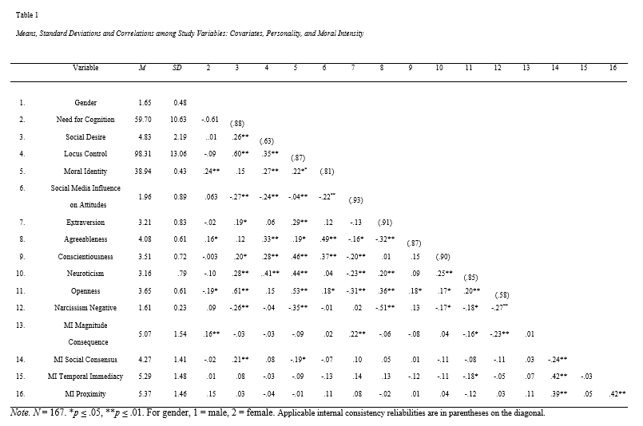

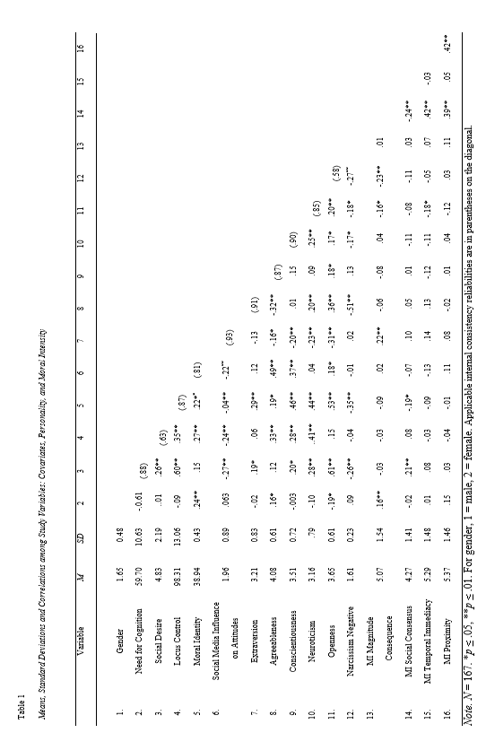
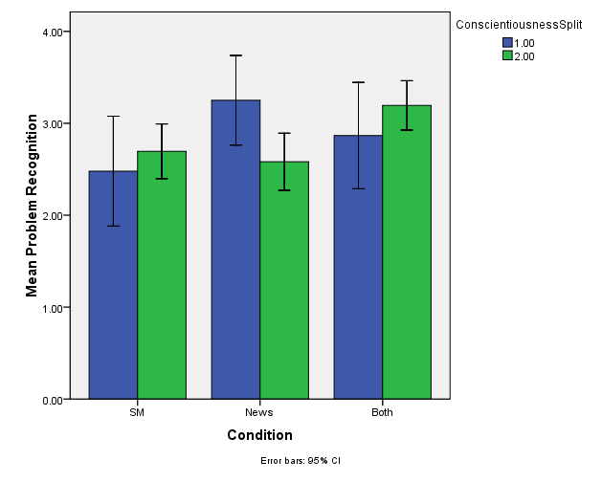
Low
High
Figure 1. A graph of the two-way interaction between condition and conscientiousness on problem recognition.
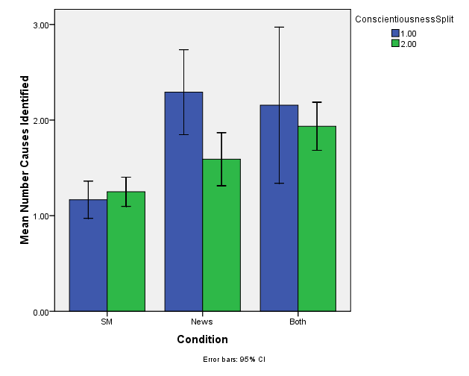
Low
High
Figure 2. A graph of the two-way interaction between condition and conscientiousness on the number of causes identified.
Low
High
Figure 3. A graph of the two-way interaction between condition and conscientiousness on the criticality of causes identified.

References
Ajzen, I. (2005). Attitudes, personality, and behavior. Buckingham, MK: Open University Press.
Ames, D. R., Rose, P., & Anderson, C. P. (2006). The NPI-16 as a short measure of
narcissism. Journal of Research in Personality, 40(4), 440-450.
Antes, L. A., Brown, R. P., Murphy, S. T., Waples, E. P., Mumford, M. D., Connelly,
S., & Devenport, L. D. (2007). Personality and ethical decision-making in
research: The role of perceptions of self and others. Journal of Empirical
Research on Human Research Ethics, 1, 15-34. doi:10.1525/jer.2007.2.4.15
Aquino, K., & Reed, A. II. 2002. The self-importance of moral identity. Journal of
Personality and Social Psychology, 83(6), 1423-1440.
Bagdasarov, Z., Martin, A., Chauhan, R. S., Connelly, M. (2015). College students’
perceptions of ethics information in social media. Unpublished manuscript.
Barnett, T. (2001). Dimensions of moral intensity and ethical decision-making: an
empirical study. Journal of Applied Social Psychology, 31, 1038-1057.
Barnett, T., Brown, G., Bass, K., & Hebert, F.J. (1999). New measures for proposed
dimensions of the moral intensity of ethical issues. Paper presented at the
Academy of Management, Chicago.
Barnett, T., & Valentine, T. (2004). Issue contingencies and marketers’ recognition of
ethical issues, ethical judgments, and behavioral intentions. Journal of Business
Research, 57, 338-346. doi:10.1016/S0148-2963(02)00365-X
Boyd, D.M., & Ellison, N.B. (2007). Social network sites: Definition, history, and
scholarship. Journal of Computer-Mediated Communication, 13, 210-230.
Brandenburg, C. (2008). The newest way to screen job applicants: A social networker’s
nightmare. Federal Communications Law Journal, 60, 597-626.
Buffardi, L. E., & Campbell, W. K. (2008). Narcissism and social networking websites. Personality and Social Psychology Bulletin, 34, 1303–1314.
doi:10.1177/0146167208320061
Baumeister, R. F., Bushman, B. J., & Campbell, W. K. (2000). Self-Esteem,
Narcissism, and Aggression Does Violence Result From Low Self-Esteem or
From Threatened Egotism? Current directions in psychological science, 9(1),
26-29.
Bushman, B. J., & Baumeister, R. F. (1998). Threatened egotism, narcissism, self-
esteem, and direct and displaced aggression: Does self-love or self-hate lead to
violence? Journal of Personality and Social Psychology, 75(1), 219-229.
Cacioppo, J. T, Petty, R. E., & Kao, C. F. (1984). The efficient assessment of the need
for cognition. Journal of Personality Assessment 48, 306-307.
Chauhan, R. S., Buckley, M. R., & Harvey, M. G. (2013). Facebook and personnel
selection: What’s the big deal? Organizational Dynamics, xx (x), 1-9. doi:
10.1016/j.orgdyn.2013.03.006
Crowne, D. P., & Marlowe, D. (1960). A new scale of social desirability independent of
psychopathology. Journal of Consulting Psychology, 24(4), 349-354. doi:
10.1037/h0047358.
Daft, R. L., & Lengel, R. H. (1986). Organizational information requirements, media
richness, and structural design. Management Science, 32(5), 554-571.
Dubinsky, A. J., & Loken, B. (1989). Analyzing ethical decision making in marketing.
Journal of Business Research, 19(2), 83-107.
Duttweiler, P. C. (1984). The internal control index: A newly developed measure of
locus of control. Educational and Psychological Measurement, 44, 209-221.
Easton, G. (1992). Learning from case studies (2nd ed.). New York, NY: Prentice-Hall.
Falkenberg, L., & Woiceshyn, J. (2008). Enhancing business ethics: Using cases to
teach moral reasoning. Journal of Business Ethics, 79, 213–217.
Fischer, D. G., & Fick, C. (1993). Measuring social desirability: Short forms of the
Marlowe-Crowne Social Desirability Scale. Educational and Psychological
Measurement, 53, 417-424.
Hill, K. (2012, March 5). Facebook can tell you if a person is worth hiring. Retrieved
from http://www.forbes.com/sites/kashmirhill/2012/03/05/facebook-can-tell-
you-if-a-person-is-worth-hiring/
Goldberg, L. R. (1990). An alternative "description of personality": The Big-Five factor
structure. Journal of Personality and Social Psychology, 59, 1216-1229.
James, B. (2011). Tweets, Blogs, Facebook and the Ethics of 21st Century Technology.
Johnson, J. F. (2014). The effect of leader moral disengagement and influence tactic on
follower cognitions and ethical sensemaking (Unpublished doctoral
dissertation). The University of Oklahoma, Norman, OK.
Johnson, J. F., Thiel, C. E., Bagdasarov, Z., Connelly, S., Harkrider, L., & Devenport,
L. D. (2012). Case-based ethics education: The impact of cause complexity
and outcome favorability on ethicality. Journal of Empirical Research on
Human Research Ethics, 7(3), 63–77.
Jones, T. M. (1991). Ethical decision-making by individuals in organizations: An issue-
contingent model. Academy of Management Review, 16 (2), 366–395.
doi:10.5465/AMR.1991.4278958
Karacaer, S., Gohar, R., Aygun, M., & Sayin, C. (2009). Effects of personal values on
auditor’s ethical decisions: A comparison of Pakistani and Turkish professional
auditors. Journal of Business Ethics, 88, 53–64. doi:10.1007/s10551-009-0102-
4.
Kilgyte, V., Marcy, R. T., Waples, E. P., Sevier, S. T., Godfrey, E. S., Mumford, M. D.,
& Hougen, D. F. (2008). Application of a sensemaking approach to ethics
training in the physical sciences and engineering. Science and Engineering
Ethics, 14, 251–278. doi: 10.1007/s11948-007-9048-z

Kohut, H. (1966). ‘Forms and transformations of narcissism’, Journal of the American
psychoanalytical association, 14, 243-272.
Kolodner, J. L. (1993). Case-based reasoning. San Mateo, CA: Morgan Kaufman
Kolodner, J. L. (1997). Educational implications of analogy: A view from case-based
reasoning. American Psychologist, 52, 57–66.
Kluemper, D.H., & Rosen, P.A. (2009). Future employment selection methods:
Evaluating social networking web sites. Journal of Managerial Psychology,
24(6), 567-580. doi:10.1108/02683940910974134
Kluemper, D. H., Rosen, P. A., & Mossholder, K. (2012). Social networking websites,
personality ratings, and the organizational context: More than meets the eye? Journal of Applied Social Psychology, 42, 1143-1172.

Leitsch, D. L. (2004). Differences in the perceptions of moral intensity in the moral
decision process: An empirical examination of accounting students. Journal of
Business Ethics, 53, 313–323. doi:10.1023/B:BUSI.0000039378.74446.df.
Leitsch, D. L. (2006). Using dimensions of moral intensity to predict ethical decision-
making in accounting. Accounting Education: An International Journal, 15(2),
135–149. doi:10.108/ 06939280600609151.
Lynn, L. (1999). Teaching and learning with cases: A guidebook. New York, NY:
Chatham House.
McMahon, J. M., & Harvey, R. J. (2007). Psychometric properties of the Reidenbach–
Robin multidimensional ethics scale. Journal of Business Ethics, 72(1), 27-39.
Mehdizadeh, S. (2010). Self-presentation 2.0: Narcissism and self-esteem on Facebook.
Cyber Psychology, Behavior, and Social Networking, 13, 357–364.
doi:10.1089/cyber.2009.0257.
Mumford, M. D., Devenport, L. D., Brown, R. P., Connelly, S., Murphy, S. T., Hill, J.
H. & Antes, A. L. (2006). Validation of ethical decision-making measures:
Evidence for a new set of measures. Ethics and Behavior, 16, 319–345.
Mumford, M. D., Connelly, S., Brown, R. P., Murphy, S. T., Hill, J. H., & Antes, A. L.
(2008). Sensemaking approach to ethics training for scientists: Preliminary
evidence of training effectiveness. Ethics and Behavior, 18, 315–339.
Mumford, M. D., Schultz, R. A., & Osborn, H. K. (2002). Planning in organizations:
Performance as a multi-level phenomenon. In F. J. Yammarino & F. Dansereau
(Eds.), Research in multi-level issues: The many faces of multi-level issues (pp.
3–63). Oxford: Elsevier.
Murphy, K. R. (2000). What constructs underlie measures of honesty or integrity? In R.
Goffin & E. Helmes (Eds.), Problems and Solutions in Human Assessment: A
Festschrift to Douglas N. Jackson at Seventy (pp. 265–284).London: Kluwer.
Noor Al-Deen, H. S., & Hendricks, J. A. (Eds.). (2011). Social media: Usage and
impact. Lanham, MD: Lexington Books. 328 pp.
Ones, D. S., Viswesvaran, C. & Schmidt, F. L. (1993). Comprehensive meta-analysis of
integrity test validities: Findings and implications for personnel selection and
theories of job performance. Journal of Applied Psychology, 78, 679–703.
Patalano, A. L., & Siefert, C. M. (1997). Opportunistic planning: Being reminded of
pending goals. Cognitive Psychology, 34, 1–36.
Payette, M. J., Albreski, D., & Grant-Kels, J. M. (2013). “You’d know if you ‘friended’
me on facebook”: Legal, moral, and ethical considerations of online social
media. Journal of the American Academy of Dermatology, 69, 305-307. doi:
10.1016/j.jaad.2013.02.024
Pew Research Center. (2014). Social networking fact sheet. Retrieved from
http://www.pewinternet.org/fact-sheets/social-networking-fact-sheet/
Raskin, R., & Terry, H. (1988). A principal-components analysis of the Narcissistic
Personality Inventory and further evidence of its construct validity. Journal of
Personality and Social Psychology, 54, 890–902.
Reidenbach, R. E., & Robin, D. P. (1988). Some initial steps toward improving the
measurement of ethical evaluations of marketing activities. Journal of Business
Ethics, 7, 871-879.
Reidenbach, R. E., & Robin, D. P. (1990). Toward the development of a
multidimensional scale for improving evaluations of business ethics. Journal of
Business Ethics, 9,639-653.
Rhodewalt, F. & Morf, C. C. (1995). Self and interpersonal correlates of the narcissistic
personality inventory: A review and new findings. Journal of Research in
Personality, 29, 1–23.
Rest, J. R. (1986). Moral development: Advances in research and theory. New York,
NY: Praeger.
Rotter, J. B. (1966). Generalized expectancies for internal versus external control of
reinforcement. Psychological Monographs, 80(1, Whole No. 699).
Ryan, T., & Xenos, S. (2011). Who uses facebook? An investigation into the
relationship between the big five, shyness, narcissism, loneliness, and facebook
usage. Computers in Human Behavior, 27, 1658-1664.
Short, J., Williams, E., & Christi, B. (1976). The social psychology of
telecommunications. Hoboken, NJ: John Wiley & Sons, Ltd.
Singer, M., Mitchell, S., & Turner, J. (1998). Consideration of moral intensity in
ethicality “judgments: Its relationship with whistle-blowing and need-for-
cognition. Journal of Business Ethics, 17 (5), 527-541.
doi:10.1016/j.chb.2011.02.004
Singhapakdi A. (1999). Perceived importance of ethics and ethical decisions in
marketing. Journal of Business Research, 45, 89-99.
Singhapakdi, A., Vitell, S. J., & Kraft, K. L. (1996). Moral intensity and ethical
decision-making of marketing professionals. Journal of Business Research, 36,
245–255.
Singhapakdi A, Vitell S. J., & Franke G. R. Antecedents, consequences, and mediating
effects of perceived moral intensity and personal moral philosophies. Journal of
Academy Marketing Science, 27, 19-36.
Singhapakdi A, Marta J. K,, Rallapalli K, C, & Rao C, P. (2000) Toward an
understanding of religiousness and marketing ethics: an empirical study. Journal
of Business Ethics, 27, 305-320.
Thiel, C. E., Connelly, S., & Griffith, J. A. (2011). The influence of anger on ethical
decision making: Comparison of a primary and secondary appraisal. Ethics and
Behavior, 21(5), 308-403. doi: 10.1080/10508422.2011.604295
Thiel, C. E., Connelly, S., Harkrider, L., Devenport, L. D., Bagdasarov, Z., Johnson, J.
F., & Mumford, M. D. (2013). Case-Based Knowledge and Ethics Education:
Improving Learning and Transfer Through Emotionally Rich Cases. Science and
Engineering Ethics, 19, 265-286. doi: 10.1007/s11948-011-9318-7
Thomas, J. B., Clark, S. M., & Gioia D. A. (1993). Strategic sensemaking and
organizational performance: Linkages among scanning, interpretation, action,
and outcomes. Academy of Management Journal, 36, 239–270.
Trevino, L. K. (1986). Ethical decision making in organizations: A person-situation
interactionist model, Academy of Management Review, 11(3), 601-617.
Trottier, D. (2012). Social media as surveillance: Rethinking visibility in a converging
world. Surrey, England: Ashgate. 213 pp.
Turner, J. H., & Valentine, S. R. (2001). Cynicism as a fundamental dimension of moral
decision-making: A scale development. Journal of Business Ethics, 34(2), 123-
136.
Urbanac, F. R. (1998). A business education resource for ethics sites on the web.
Journal of Education for Business, 73, 314–317.
Van Iddekinge, C. H., Lanivich, S. E., Roth, P. L., & Junco, E. (2013). Social media for
selection? Validity and adverse impact potential of a facebook-based
assessment. Journal of Management, xx (x), 1-25. doi:
10.1177/0149206313515524
Weick, K. E. (1988). Enacted sensemaking in crisis situations. Journal of Management
Studies, 25, 305–317.
Werhane, P. H. (2002). Moral imagination and systems thinking. Journal of Business
Ethics, 38, 33–42.

Appendix A: Online News Article Format
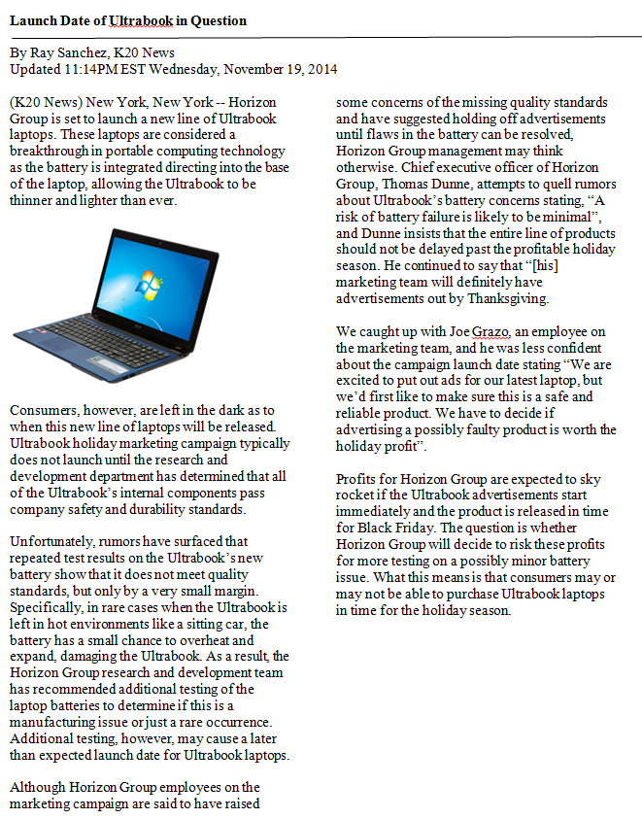

Appendix B: Social Media Format
A friend forward you the following discussion:
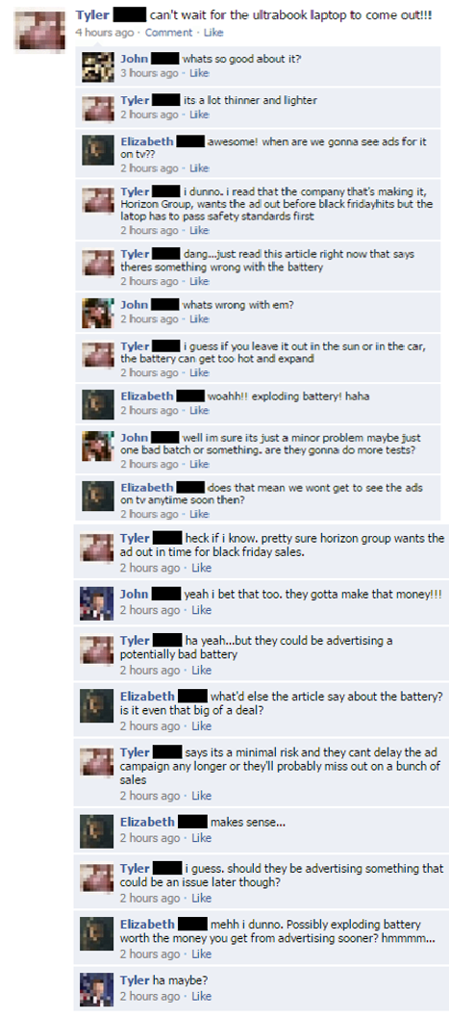
Appendix C: Perceptions of Moral Intensity Measure (Barnett et al., 1999)
- Magnitude of Consequences
  - Do you believe any harm resulting from the depicted action will be:
    - (Minor) 1 2 3 4 5 6 7 8 9 (Severe)
  - Do you believe any harm resulting from the depicted action will be:
    - (Insignificant) 1 2 3 4 5 6 7 8 9 (Significant)
  - Do you believe any harm resulting from the depicted action will be:
    - (Slight) 1 2 3 4 5 6 7 8 9 (Great)
- Social Consensus
  - Please indicate the degree to which you believe society as a whole considers the depicted action:
    - (Unethical) 1 2 3 4 5 6 7 8 9 (Ethical)
  - Please indicate the degree to which you believe society as a whole considers the depicted action:
    - (Wrong) 1 2 3 4 5 6 7 8 9 (Right)
  - Please indicate the degree to which you believe society as a whole considers the depicted action:
    - (Inappropriate) 1 2 3 4 5 6 7 8 9 (Appropriate)
- Temporal Immediacy
  - Do you anticipate that any consequences of the depicted action are likely to occur:
    - (After a Long Time) 1 2 3 4 5 6 7 8 9 (Immediately)
  - Do you anticipate that any consequences of the depicted action are likely to occur:
    - (Slowly) 1 2 3 4 5 6 7 8 9 (Quickly)
  - Do you anticipate that any consequences of the depicted action are likely to occur:
    - (Gradually) 1 2 3 4 5 6 7 8 9 (Rapidly)
- Proximity
  - Compared to yourself, do you believe those potentially affected by the depicted action are:
    - (Dissimilar) 1 2 3 4 5 6 7 8 9 (Similar)
  - Compared to yourself, do you believe those potentially affected by the depicted action are:
    - (Not Alike) 1 2 3 4 5 6 7 8 9 (Alike)
  - Compared to yourself, do you believe those potentially affected by the depicted action are:
    - (Different) 1 2 3 4 5 6 7 8 9 (Same)

Notes:
- Items are randomized across scales to reduce obviousness
- Responses to each scale are summed and divided by the number of items in the scale, resulting in scores that range from 1-9.

Appendix D: Open-ended Response Cues
The director of marketing has asked you to move forward with this marketing campaign. Please answer the following questions as if you were marketing professional in this company responsible for this product.

Do you believe that there is a moral or ethical issue involved in this situation?
____________________________________________________________________________________________________________________________________________________________________________________________________________________________________________________________________________________________________________________________________________________

List and describe the causes of the problem in this situation. ____________________________________________________________________________________________________________________________________________________________________________________________________________________________________________________________________________________________________________________________________________________

What are the key factors and challenges of this situation?
____________________________________________________________________________________________________________________________________________________________________________________________________________________________________________________________________________________________________________________________________________________

What are some possible outcomes of this situation?
____________________________________________________________________________________________________________________________________________________________________________________________________________________________________________________________________________________________________________________________________________________

What will your next steps be in this situation? ____________________________________________________________________________________________________________________________________________________________________________________________________________________________________________________________________________________________________________________________________________________

Why did you choose this course of action in this situation?
____________________________________________________________________________________________________________________________________________________________________________________________________________________________________________________________________________________________________________________________________________________

